
PRJ0012475 - BDO Insure Brokering System (BIBS) - Renewal: Interface Specification -
Release 1 / Drop 0
Prepared by: iorta TechNXT Project Team

Template Reference No. | D051
Document No. | PRJ0012475-RN-ICD
Prepared by: | iorta TechNXT Project Team
Drafting support: | iorta TechNXT Project Team
Creation Date: | 10/16/2026
Revision No. | 1.0
Last Updated by: | iorta TechNXT Project Team
Last Updated Date: | 10/16/2026

Document Revision Log
Date | Revision | Description | Updated by
16 Oct 2026 | 1.0 | First issue: CCM, MFT, insurer files, LAMD and BDOFC/SOLD reports and CLPC billing files of Renewal. | iorta TechNXT Project Team (drafting support); for review by the BDOI Product Owner

Table of Contents
Document Revision Log 3
Table of Contents 4
Introduction 5
IF-RN-01 CCM 6
IF-RN-02 and IF-RN-03 MFT 8
IF-RN-04 Insurer Files 9
Placement response (IF-RN-03, IF-RN-04) 9
Hold cover response (IF-RN-03, IF-RN-04) 9
Insurer disposition (IF-RN-04) 9
Insurer response (batch) (IF-RN-04) 10
E-policy numbers (IF-RN-04) 10
LAMD loan report (IF-RN-06) 10
LAMD CBG loans (IF-RN-06) 11
LAMD paid-off accounts (IF-RN-06) 11
BDOFC and BDOSOLD report (IF-RN-06) 11
IF-RN-05 CLPC Billing Files 13
IF-RN-06 LAMD and BDOFC / BDOSOLD Reports 14
Open Points 15

Introduction
This document specifies the interfaces of Renewal with systems outside BIBS. They are Integration scope (FRS v1.3, grey label). The links with other BIBS modules (New Business booking, Cashiering, Submitted Policies, Product Maintenance) are internal and not listed here.
Table 1: Interfaces
ID | Interface | Direction | Means | Frequency | Content
IF-RN-01 | CCM (client communications) | BIBS to CCM; status back | HTTPS JSON | On send; status every 15 min | Renewal Advice, letters, proposals, Insurance Advice, e-policies
IF-RN-02 | MFT outbound | BIBS to insurer folders | HTTPS file put | On send | Placement files, hold cover requests
IF-RN-03 | MFT inbound | Insurer folders to BIBS | Folder poll | Every 15 min | Placement and hold cover responses, e-policies
IF-RN-04 | Insurer files by upload or e-mail | Both | Excel / CSV | Per batch | Insurer request and disposition, placement and hold cover responses, e-policies
IF-RN-05 | CLPC billing to LMS | BIBS to LMS directory and recipients | CSV file | Daily; 10th, 25th | CBG Home and FFY Motor billing
IF-RN-06 | LAMD and BDOFC / BDOSOLD reports | Bank units to BIBS | Excel / CSV upload | Monthly | Loan status, paid-off accounts, BDOFC and BDOSOLD lists

IF-RN-01 CCM
• Each client document is queued Pending Transmission, protected with the password of its client (FRRN.024.01) and posted to CCM at <CCM address>/communications with the access key in the header X-Api-Key.
• CCM answers with its transaction reference; the message becomes Submitted to CCM. No reference, a refusal or an invalid recipient keeps the message Pending for the next attempt or fails it.
• The job RNW_CHANNEL_STATUS reads <CCM address>/communications/<reference> every 15 minutes and retries pending messages up to RNW_CHANNEL_MAX_ATTEMPTS (3).
• Settings: RNW_CCM_MODE (LIVE or SIMULATOR), RNW_CCM_ENDPOINT, RNW_CCM_CLIENT_ID, RNW_CCM_KEY_SETTING (name of the environment setting holding the key; the key is never stored in the database), RNW_CCM_TIMEOUT_SECONDS. RNW_DELIVERY_CHANNEL = EMAIL sends a protected e-mail instead.
Table 2: CCM request
Field | Content
clientId | Client identifier of BIBS at CCM (setting RNW_CCM_CLIENT_ID)
messageNo | Message number of BIBS
to, cc | Recipient and copy e-mail addresses
subject, body | Subject and text of the e-mail
attachment.fileName, content, password | File name, file (Base64) and its password

Table 3: CCM delivery status
CCM status | Status in BIBS
SENT | Sent
DELIVERED | Delivered
FAILED, BOUNCED | Failed
CANCELLED | Cancelled

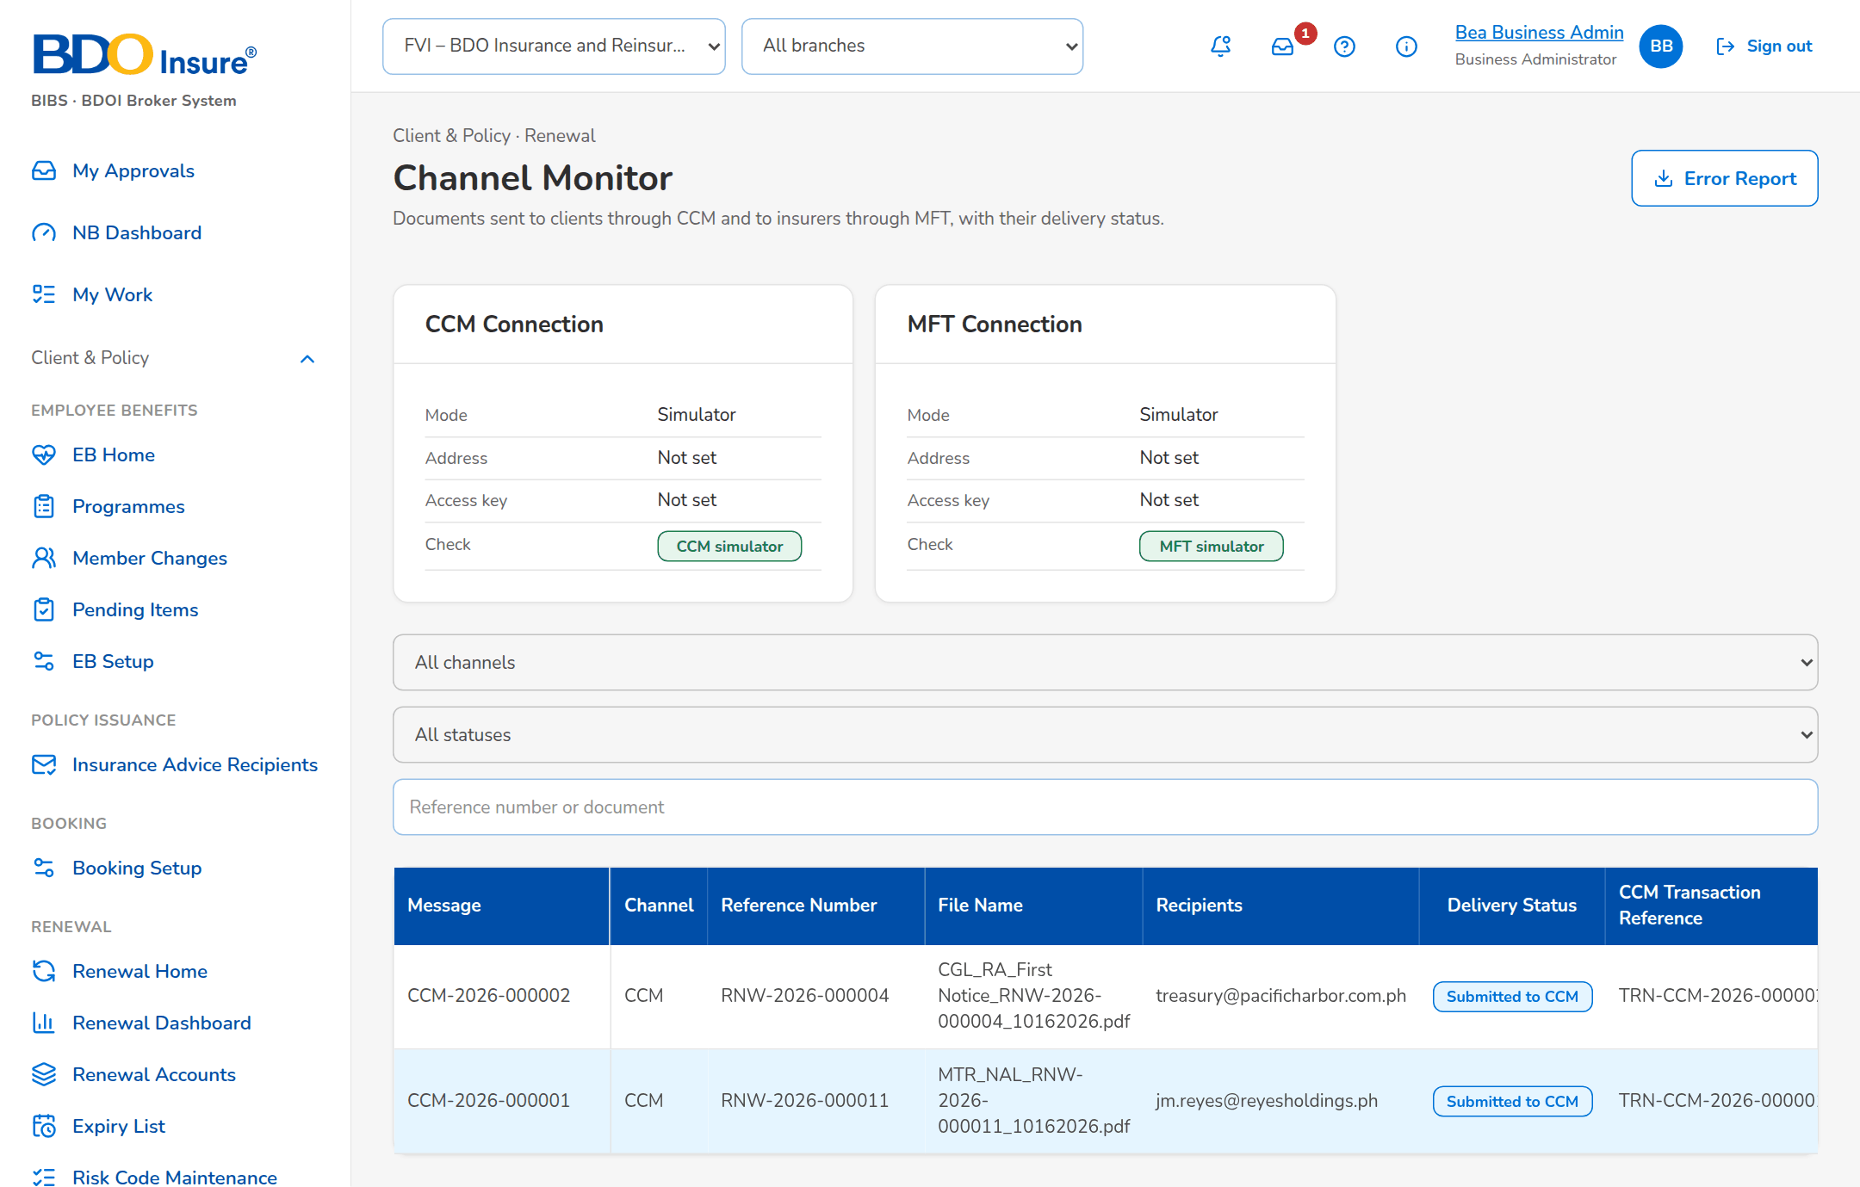
Figure 1: Channel Monitor (SCR-RN-33)

IF-RN-02 and IF-RN-03 MFT
• Outbound: a file for an insurer listed in RNW_MFT_ENROLLED_INSURERS (or whose placement channel is a file transfer) is put at <MFT address><RNW_MFT_OUTBOUND_FOLDER>/<insurer code>/<file name>; a put file is Delivered. Statuses: Pending Upload, Uploaded to MFT, Upload Failed (Processing Officer notified).
• Inbound: the job RNW_MFT_INBOX takes every 15 minutes the files of the folders placement-response, hold-cover-response and epolicy under the inbound folder, processes them as uploads by the user MFT, logs each as an inbound message (Received, Processed, Failed) and moves it to processed or refused.
• An e-policy summary file (.txt) waits for its ZIP file of the same name.
• Settings: RNW_MFT_MODE, RNW_MFT_ENDPOINT, RNW_MFT_KEY_SETTING, RNW_MFT_INBOUND_FOLDER, RNW_MFT_OUTBOUND_FOLDER, RNW_MFT_COMPANY_CODE.

IF-RN-04 Insurer Files
Table 4: Outbound and inbound insurer files
File | Name | Content
Insurer request | Excel per insurer batch | 28 columns of the BRD (Insurance Company to Packaged / Non-Packaged)
Placement slip | <Insurer>_<Line>_PlacementSlip_<ref>_MMDDYYYY.pdf | One per insurer per account
Placement file | <Insurer>_<Line>_PlacementFile_MMDDYYYY.xlsx | Packaged accounts of the insurer with each co-insurer's share
Hold cover request | Excel per insurer (CBG); PDF per account | Reference Number, Renewal Reference Number, Assured's Name, Expiring Policy No., Expiry Date, Hold Cover Start, Hold Cover End, Days, Share (%), Request
E-policy summary | .txt, fields separated by |, tab or comma | Sequence, reference, policy number, PDF file name, document tag; with a ZIP of the PDFs (at most 2,000 files, 200 MB)

Inbound files are checked row by row; each row is matched on its reference, and every upload is listed with its file-level outcome and record-level results. The columns of each template are below.

Placement response (IF-RN-03, IF-RN-04)
Column | Required | Type | Content | Example
Renewal Reference Number | Y | Text | Renewal reference number of the account | RNW-2026-000101
Insurer Code | N | Text | Insurer code, for an account placed with several insurers | -
Insurer Response | Y | Text | Approved or Rejected | Approved
Response Date | N | Date | Date of the insurer's response | -
Rejection Reason | N | Text | Reason of a rejection | -
Insurer Remarks | N | Text | Remarks of the insurer | -

Hold cover response (IF-RN-03, IF-RN-04)
Column | Required | Type | Content | Example
Reference Number | Y | Text | Reference number of the hold cover request | HCR-2026-000001
Insurer Response | Y | Text | Approved or Rejected | Approved
Hold Cover End Date | N | Date | Last day of the hold cover approved | -
Insurer Reference | N | Text | Reference of the insurer | HC-55012
Insurer Remarks | N | Text | Remarks of the insurer, required for a rejection | -

Insurer disposition (IF-RN-04)
Column | Required | Type | Content | Example
Item No. | N | Number | Sequence of the record | 1
Assured's Name | N | Text | Name of the assured | Juan Dela Cruz
Renewal Reference Number | N | Text | Renewal reference number | RNW-2027-000001
Expiring Reference Number | N | Text | Reference of the expiring account | INV-2026-000123
Expiring Policy No. | N | Text | Policy number of the expiring account | MC-2026-000123
Inception Date | N | Date | Start of the cover | 2027-03-01
Expiry Date | N | Date | End of the cover | 2028-03-01
Location Of Risk | N | Text | Address of the risk (property) | -
Unit Description | N | Text | Vehicle | 2024 SEDAN
Serial No. | N | Text | Serial number (motor) | -
Motor No. | N | Text | Motor number (motor) | -
Plate No. | N | Text | Plate number | -
Color | N | Text | Colour of the vehicle | -
TSI | N | Number | Total sum insured | 900000
Premium Rate | N | Number | Premium rate in percent | 2.376
Insurer | N | Text | Insurer | INS-MGIC
Insurer's Branch | N | Text | Insurer's branch | Head Office
Insurer's Approval | Y | Text | Insurer disposition | Renew As Is / Approved
Insurer Remarks | N | Text | Remarks of the insurer | -

Insurer response (batch) (IF-RN-04)
Column | Required | Type | Content | Example
Renewal Reference | Y | Text | Renewal reference | RNW-2027-000001
Policy No | N | Text | Expiring policy number | MC-2026-000123
Response | Y | Text | Response of the insurer | Renew As Is
Insurer Reference | N | Text | Insurer reference | REN-55012
Revised Premium | N | Number | Revised gross premium | -
Revised Sum Insured | N | Number | Revised sum insured | -
Revised Rate | N | Number | Revised rate in percent | -
Terms | N | Text | Revised terms | -
Received On | N | Date | Date received | 2027-08-15
Reject Action | N | Text | What follows a rejection; blank for Not for renewal | -
Remarks | N | Text | Remarks | -

E-policy numbers (IF-RN-04)
Column | Required | Type | Content | Example
Reference Number | Y | Text | Renewal reference number of the account | RNW-2026-000101
Policy Number | Y | Text | E-policy number issued by the insurer | MC-PC-2026-0012345

LAMD loan report (IF-RN-06)
Column | Required | Type | Content | Example
PN Number | Y | Text | PN number of the loan | PN-778812
Status Date | N | Date | Date of the loan status | 2027-05-31
Borrower | N | Text | Borrower name | Juan Dela Cruz

LAMD CBG loans (IF-RN-06)
Column | Required | Type | Content | Example
Original Source | N | Text | Source system of the loan record | LOANS
PN Number | Y | Text | Promissory Note number of the loan | 7001234567
Short name | N | Text | Short name of the borrower | DELA CRUZ J
Logical Branch PN | N | Text | Branch code of the PN | 123
Logical Branch Description PN | N | Text | Branch name of the PN | MAKATI MAIN
Product Type | N | Text | Loan product classification | 201
Product Description | N | Text | Description of the loan product | AUTO LOAN
Book Date | N | Date | Date the loan was booked | 2024-03-15
Maturity Date | N | Date | Date the loan matures | 2029-03-15
Amount Financed (Orig) | N | Text | Amount financed at booking | 1200000
O/S Bal. (LCYE) | N | Text | Outstanding balance at year end | 850000
Customer No. | N | Text | Customer number of the bank | 100200300
Park Branch | N | Text | Branch servicing the account | 123
Officer (AO Code) PN | Y | Text | Account Officer code of the loan | AO1234
AO Name PN | N | Text | Account Officer name | Ana Officer
IBG/CBG Tag | N | Text | IBG or CBG | CBG
Home Contact No. | N | Text | Home telephone | 028881234
Business Contact No. | N | Text | Business telephone | 028885678
Mobile No. | N | Text | Mobile phone | 09171234567

LAMD paid-off accounts (IF-RN-06)
Column | Required | Type | Content | Example
PN Number | Y | Text | Promissory Note number of the loan | 7001234567
IBG/CBG Tag | N | Text | IBG or CBG | CBG
Product Type | N | Text | Loan product classification | 201
Product Type Desc | N | Text | Description of the loan product | AUTO LOAN
Posting Date | N | Date | Date the payment was posted | 2027-05-31
Next Rate Review Date | N | Date | Next rate review | -
Home Contact No. | N | Text | Home telephone | 028881234
Business Contact No. | N | Text | Business telephone | 028885678
Mobile No. | N | Text | Mobile phone | 09171234567

BDOFC and BDOSOLD report (IF-RN-06)
Column | Required | Type | Content | Example
Location | N | Text | Location of the account | MAKATI
PN | Y | Text | Promissory Note number | 7001234567
Assured's Name | Y | Text | Name of the assured | Juan Dela Cruz
Inception Date | N | Date | Inception date | 2026-11-01
Expiry Date | N | Date | Expiry date | 2027-11-01
Remarks | Y | Text | Remarks of the report | Unit sold

IF-RN-05 CLPC Billing Files
• One CSV file per product line and kind (built-in for amortized accounts, non-built-in) with the date MMDDYYYY in its name, one per line and kind, from the job RNW_CLPC_BILLING or Generate Billing File.
• Each file is attached to its accounts, e-mailed to RNW_CLPC_BILLING_RECIPIENTS and written to the LMS directory (RNW_LMS_MODE LIVE, SIMULATOR or OFF); the upload status is Uploaded, Failed or Off.
Table 5: Columns of the CLPC billing file (dates dd-MMM-yyyy)
No. | Column
1 | No.
2 | PN #
3 | Account No.
4 | Assured's Name
5 | Loan Booking Date
6 | Loan Maturity Date
7 | Inception Date
8 | Expiry Date
9 | Loan Type
10 | Total Premium (1 Year)
11 | Logical Branch Description PN
12 | Insure Branch
13 | Enrolled Account Number

IF-RN-06 LAMD and BDOFC / BDOSOLD Reports
Uploaded on LAMD Reports by the LAMD user (layouts in IF-RN-04 above). PN is the matching key; serial and motor numbers are also matched for motor loans (RNW_LAMD_MOTOR_PRODUCTS).

Open Points
Table 6: Open points
ID | Point | Owner
D-RN-01 | BDOI IT gives the CCM address, client identifier and access key (ICD IF-RN-01). | BDO ITG
D-RN-02 | BDOI IT gives the MFT server, folders, key and the list of enrolled insurers (ICD IF-RN-02). | BDO ITG
D-RN-03 | BDOI IT gives the LMS directory and the billing file recipients (ICD IF-RN-05). | BDO ITG
D-RN-04 | LAMD gives the monthly loan reports in the agreed layout (ICD IF-RN-06). | BDO ITG
Q-RN-08 | CCM and MFT go-live dates; e-mail fall-back. | BDO ITG

