
PRJ0012475 - BDO Insure Brokering System (BIBS) - Renewal: Reports, Notifications and Outputs -
Release 1 / Drop 0
Prepared by: iorta TechNXT Project Team

Template Reference No. | D051
Document No. | PRJ0012475-RN-RNO
Prepared by: | iorta TechNXT Project Team
Drafting support: | iorta TechNXT Project Team
Creation Date: | 10/16/2026
Revision No. | 1.3
Last Updated by: | iorta TechNXT Project Team
Last Updated Date: | 10/16/2026

Document Revision Log
Date | Revision | Description | Updated by
16 Oct 2026 | 1.3 | First issue as a separate document of the Renewal set (taken out of the annexes of the FRS v1.2 and aligned with the system delivered). Numbered 1.3 to match the FRS. | iorta TechNXT Project Team (drafting support); for review by the BDOI Product Owner

Table of Contents
Document Revision Log 3
Table of Contents 4
Introduction 5
Reports 6
Letters and Documents 10
Exports 11
Notices and E-mails 12
Scheduled Jobs 14

Introduction
This document lists the reports, letters and documents, exports, notices and e-mails and the scheduled jobs of Renewal. Times are Manila time. Documents sent outside BIBS are password protected and the password follows separately (BR-RN-09).

Reports
Table 1: Renewal reports (Report Centre › Renewal)
ID | Report | BRD | Parameters | Content | Output
RPT-RN-01 | Renewal Status Report | BRRN.019; BRD 1.009 | Expiry range; the 20 criteria of the BRD | Status of every renewal per invoice; summary counters | Excel, PDF; saved variant
RPT-RN-02 | Renewal Listing with attention flags | BRRN.036 | Unit, segment, window, status | Days to expiry; ageing, overdue, high-risk flags | Excel, PDF, CSV
RPT-RN-03 | Expiry List Report | BRRN.002-008 | Expiry range, filters | The RMEL columns | Excel
RPT-RN-04 | Sanitation Report | BRRN.020 | Date range | Check results and classification changes | Excel, PDF
RPT-RN-05 | Decision Log | BRRN.031, 034 | Date range | System dispositions with matrix version and rule; overrides with reason | Excel, PDF
RPT-RN-06 | LAMD Match Report | BRRN.029 | Upload, month | Matched and unmatched loans | Excel
RPT-RN-07 | Insurer Extract | BRD 3.009 | Insurer, expiry range | The 28 fields of the BRD | Excel
RPT-RN-08 | Renewal Advice Dispatch (letter log) | BRRN.010 | Date range | Letters with recipient and delivery status | Excel, PDF
RPT-RN-09 | Workload Report | BRD 1.009.7 | Unit, officer | Open renewals by officer and status | Excel
RPT-RN-10 | Go-live Take-over Report | FRRN.045 | - | Taken-over accounts by expiry month; urgent | Excel
RPT-RN-11 | Package Remap Report | FRRN.046 | - | Package choices of migrated policies | Excel
RPT-RN-12 | Pipeline, Full Production, Audit Log Reports | FRRN.044.01 | Period, unit, segment | Pipeline by stage; booked production; audit entries | Excel, PDF
RPT-RN-13 | CLPC Billing Reports (three) | FRRN.044.01 | Period | Billed accounts, built-in and non-built-in | Excel, PDF
RPT-RN-14 | Outcome per Stage, Placement Summary, ePolicy Sent, RA Generated | FRRN.044.01 | Period | Successful and fall-out accounts; placements; e-policies; Renewal Advices | Excel, PDF
RPT-RN-15 | Penetration, Hold Cover, Booked Non-Bank, Booked PEP, No Policy Number | FRRN.044.01 | Period | As named | Excel, PDF
RPT-RN-16 | Insurer Scorecard, Unapplied Payment with Disposition | FRRN.044.01 | Period, insurer | Insurer response and placement figures; unapplied payments | Excel, PDF
RPT-RN-17 | LAMD reconciliation reports (five) | FRRN.044.01 | Month | RMU and submitted accounts against the bookings | Excel, PDF
RPT-RN-18 | Renewal and Processing Dashboard drill-downs | FRRN.002.02, 003.02 | Dashboard filters | Accounts behind a figure | Excel, PDF, CSV

Every report applies the user's data scope, is logged with the user, parameters and time, and can be saved as a variant.
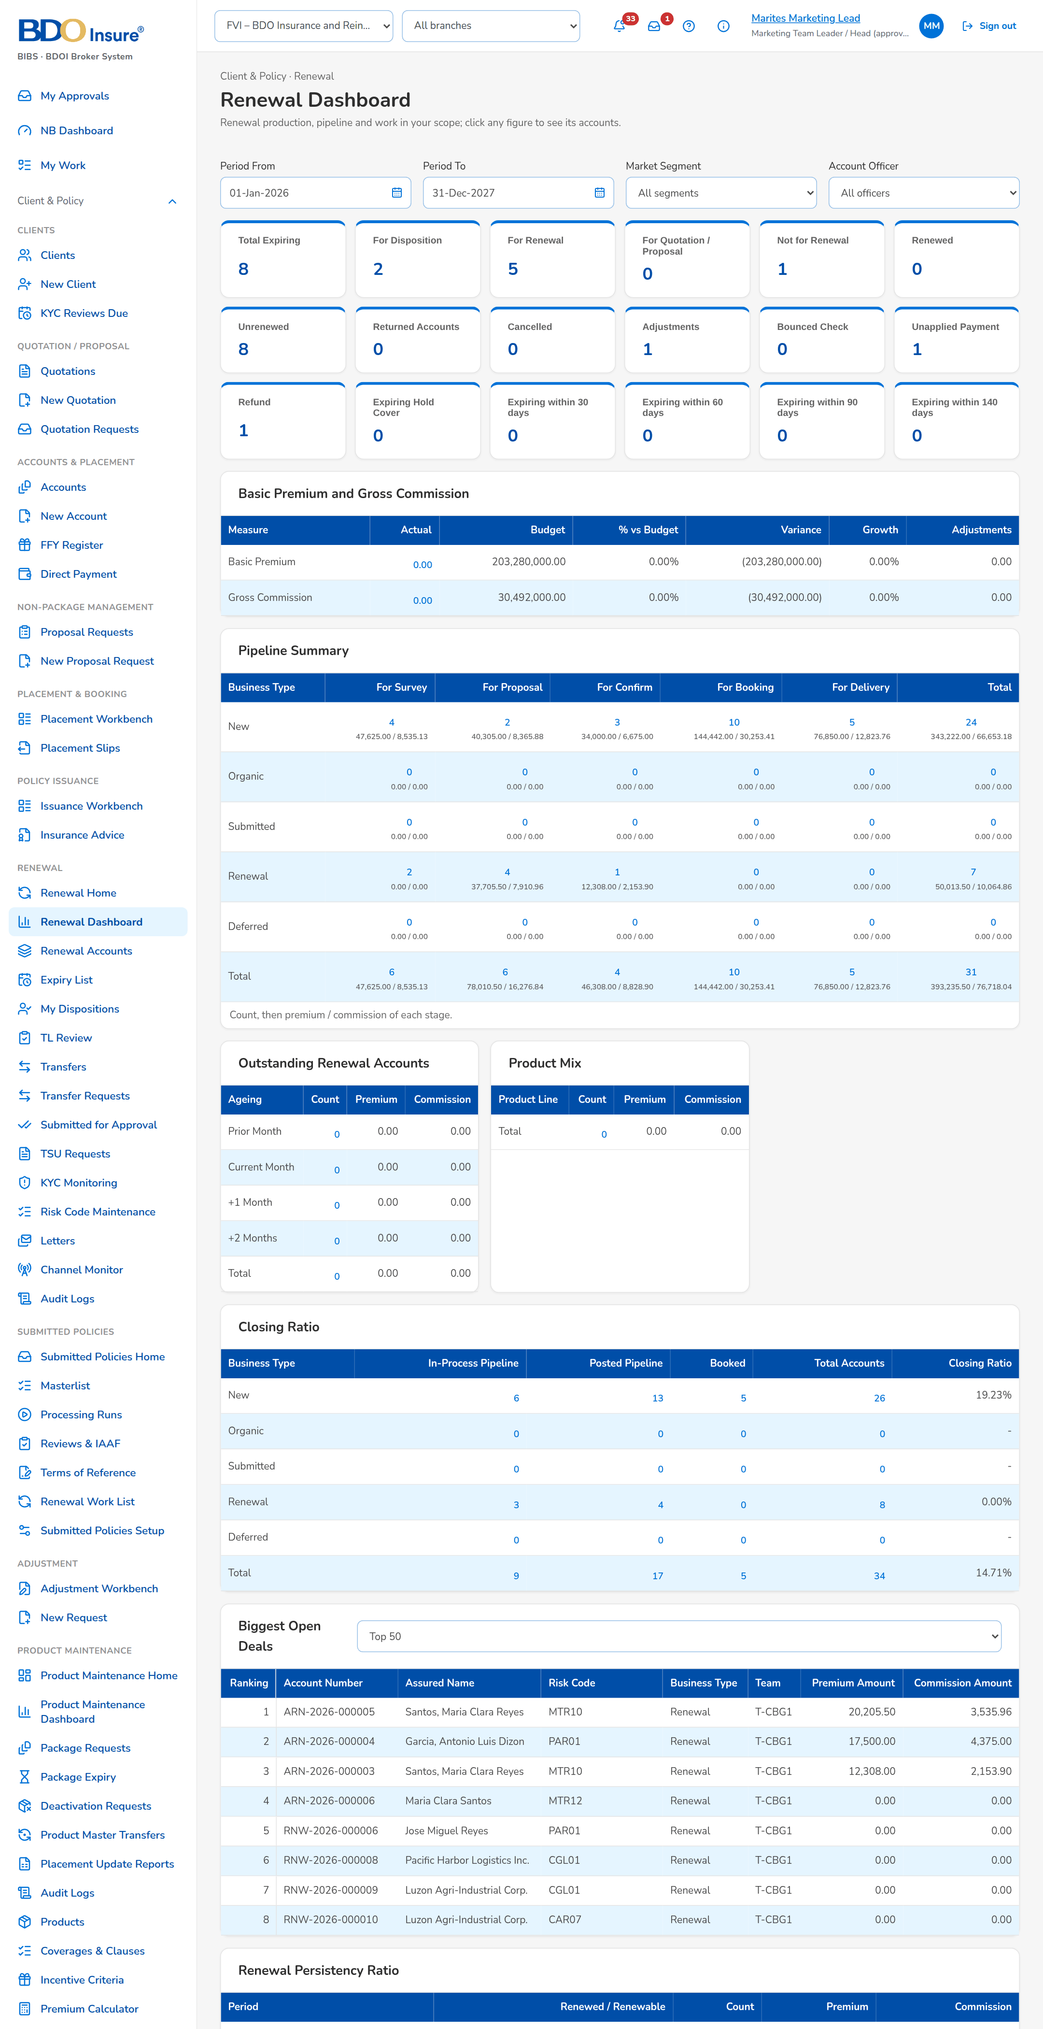
Figure 1: Renewal Dashboard (FRRN.002.02)
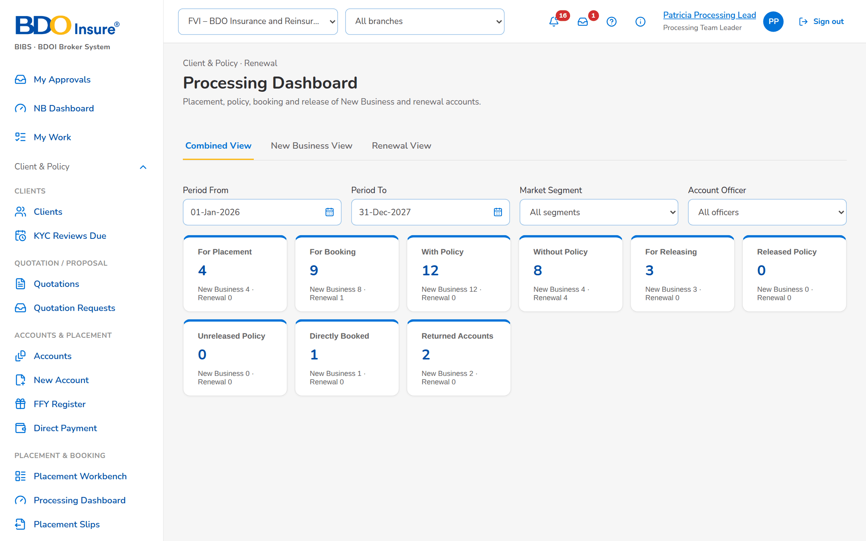
Figure 2: Processing Dashboard (FRRN.003)

Letters and Documents
Table 2: Letters and documents produced
ID | Document | Format and file name | Protection | FRRN
DO-01 | Renewal Advice (first, last notice; FFY Reminder) | PDF <Product>_RA_<Notice>_<Reference>_MMDDYYYY.pdf | Password protected | FRRN.022.01
DO-02 | No Advice, Non-Renewal, SFU, NRNS reminder, non-acceptance letters | PDF <Product>_<Letter>_<Reference>_MMDDYYYY.pdf | Password protected | FRRN.023.02
DO-03 | Insurer request (extract) | Excel, 28 columns, one per insurer batch | Password protected | FRRN.021.01
DO-04 | Quick and Full Proposal | PDF Renewal_QuickProposal_ / Renewal_FullProposal_<ref>_MMDDYYYY.pdf | Password protected | FRRN.017.01
DO-05 | Placement slip and placement file | PDF <Insurer>_<Line>_PlacementSlip_<ref>_MMDDYYYY.pdf; Excel <Insurer>_<Line>_PlacementFile_MMDDYYYY.xlsx | Password protected by e-mail | FRRN.029.02
DO-06 | Insurance Advice | PDF IA_<Reference>_MMDDYYYY.pdf | Password protected | FRRN.032.01
DO-07 | Hold cover request | PDF per account; Excel per insurer for CBG | Password protected by e-mail | FRRN.036.02, 036.04
DO-08 | CLPC billing file | CSV per product line and kind (built-in, non-built-in) with the date MMDDYYYY | LMS directory; protected by e-mail | FRRN.027.01
DO-09 | Renewal account details | PDF from the record | - | FRRN.014.06

Exports
Table 3: Exports
Output | Format | Where | Content
Renewal lists | Excel, PDF, CSV | Expiry List, My Dispositions, TL Review, Processing Worklist, Letters | Rows and columns shown with the filters; RMEL_<MMM>_<YYYY>_<MMDDYYYY>.xlsx
Upload results | Excel | Every upload | Each row with its outcome and message
Audit logs | Excel, CSV | Audit Logs | Filtered rows; Audit Logs_MMDDYYYY
Dashboard drill-downs | Excel, PDF, CSV | Renewal and Processing Dashboards | Accounts behind a figure

Notices and E-mails
Notices appear under the bell and, where shown, by e-mail; alerts on the Alerts screen. Text in angle brackets is filled in. Each user chooses the channels of the Renewal events on Notification Settings.
Table 4: Notices and e-mails
ID | Event | To | Text | Channel
NT-01 | Renewals are assigned (event Renewal assigned): to an Account Officer by the Team Leader, to a Processing Officer; a renewal turns Exception on a new check; a LAMD line routes a renewal | The officer assigned; on an Exception the Account Officer and the Processing Officer; on a LAMD line the Team Leaders of the unit | Title: <renewal ref> assigned to you, <renewal ref> assigned to you for processing, <renewal ref>: Exception or <renewal ref>: LAMD <loan status>. Text: Give the disposition of the renewal of <client>, expiring <expiry date>; <client>; A check failed on the renewal of <client>; or the routing | In-app
NT-02 | A renewal is transferred to another Marketing unit (event Renewal transfer requested) | The Team Leaders of the receiving unit | Title: <renewal ref> transferred to your unit. Text: Accept or decline the renewal of <client>: <remarks> | In-app, e-mail
NT-03 | The receiving unit accepts or declines a transfer (event Renewal transfer decided) | The user who requested the transfer | Title: <renewal ref>: transfer accepted or declined. Text: The transfer to <unit> was accepted, or was declined: <remarks> | In-app
NT-04 | A renewal is returned (event Renewal returned): by the Team Leader to the officer, by Processing to Marketing, or re-opened | The Account Officer (or the Team Leaders of the unit for a return to the Team Leader and a re-open) | Title: <renewal ref> returned to you, <renewal ref> returned by Processing or <renewal ref> re-opened. Text: <reason>: <remarks>, or Give a new disposition: <reason> | In-app, e-mail
NT-05 | The Team Leader posts a renewal For Renewal (event Renewal posted) | The users who assign the Processing Officers (Processing Team Leaders) | Title: <renewal ref> posted for processing. Text: <client> | In-app
NT-06 | An insurer response is recorded, by hand or from the insurer's file (event Insurer renewal response) | The Processing Officer of the renewal | Title: <renewal ref>: insurer response <response>. Text: Applied to the renewal, or Not applied: check the Insurer tab | In-app
NT-07 | The client accepts the renewal, and the accepted renewal account is ready for placement (event Renewal accepted) | The Account Officer and the Processing Officer of the renewal | Title: <renewal ref> accepted by the client, or <renewal ref>: ready for placement. Text: <client> accepted the renewal by <method>, or the progress of the renewal account | In-app
NT-08 | The renewal is booked, or the policy expired without renewal (event Renewal booked) | The Account Officer and the Processing Officer of the renewal | Title: <renewal ref> renewed, or <renewal ref> closed: expired without renewal. Text: Booked with invoice <invoice>, or The policy of <client> expired on <expiry date> | In-app
NT-09 | The go-live take-over of the migrated policies is completed (event Go-live renewal extraction completed) | The users who extract renewals (Team Leaders) | Title: Go-live renewals taken over (<n>). Text: <n> renewals, <n> urgent; by expiry month <month: count> | In-app, e-mail
NT-10 | A package choice of a migrated policy is approved or rejected (event Renewal package choice decided) | The user who proposed the package | Title: <renewal ref>: package choice approved or rejected. Text: <product version> applies to the renewal, or was rejected: <remarks> | In-app
NT-11 | An expiring account is not disposed or not accepted within the escalation days of its segment before expiry (Renewal at risk) | The administrators and Team Leaders who receive the alerts of Renewal | Renewal at risk: <renewal ref> of <client> expires on <expiry date> without a disposition or an acceptance | Alert
NT-12 | The daily extraction of expiring accounts fails (Renewal extraction failed) | The administrators who receive the alerts of Renewal | Renewal extraction failed: <reason>; the next run takes the missed dates | Alert
NT-13 | An insurer has not answered a renewal batch by its reply date (Insurer renewal batch overdue) | The administrators and the Processing Team Leaders who receive the alerts of Renewal | Insurer renewal batch overdue: <batch no> of <insurer>, reply due <date> | Alert
NT-14 | A Renewal Advice or renewal letter could not be sent to the client (Renewal letter not delivered) | The administrators who receive the alerts of Renewal | Renewal letter not delivered: <letter no> of <renewal ref> to <recipient>: <reason> | Alert
NT-15 | A renewal stays in the Exception classification longer than the allowed days, 5 working days by default (Renewal exception ageing) | The administrators and Team Leaders who receive the alerts of Renewal | Renewal exception ageing: <renewal ref> has been an Exception for <days> days | Alert
NT-16 | Send on the Letters screen (Renewal Advice, first or second notice) | The client's e-mail address | Subject: Renewal Advice <letter no> - <client>. Body: the renewal of policy <policy no> expiring on <expiry date>, the renewal terms and premium, the payment instructions and the BDOI contacts; the attachment is protected and the password follows in a separate e-mail | E-mail
NT-17 | Follows every protected Renewal Advice, letter and insurer extract e-mail | The same recipients | The password of the attachment of the e-mail <subject>, with the password hint for the recipient | E-mail
NT-18 | Send to Insurer on an insurer batch | The renewal e-mail addresses of the insurer | Subject: Renewal extract <batch no> - <insurer>. Body: the renewals expiring in <period> for the insurer's renewal terms, the reply date; the attachment is protected and the password follows in a separate e-mail | E-mail
NT-19 | Send Letters on the NAL / NFR tab; the NRNS reminder and the non-acceptance letter sent by the nightly letter run | The client's e-mail address | Subject: <letter type> <letter no> - <client>. Body: the letter (No Advice Letter, Not for Renewal Letter with its reason, NRNS reminder or non-acceptance notice); the attachment is protected and the password follows in a separate e-mail | E-mail

Scheduled Jobs
Table 5: Jobs
Job | When | What it does | Notices
RNW_EXTRACTION | Daily 01:00 | Extracts the policies at the lead days before expiry, one renewal account each. | NT-12
RNW_REEVALUATE | Daily 01:30 | Runs the checks of every open renewal again; reclassifies. | NT-01, NT-15
RNW_EXPIRY_SWEEP | Daily 00:15 | Closes renewals past expiry plus the non-acceptance days as expired without renewal. | NT-08
RNW_NRNS_LETTERS | Daily 06:00 | Tags NRNS at the checkpoint; sends reminders and non-acceptance letters. | NT-19
RNW_LETTER_BATCH | Hourly at :05 | Updates the delivery status of queued letters. | NT-14
RNW_HOLD_COVER | Daily 05:30 | Requests hold cover of Clean CBG accounts; CBG Home extensions on the 15th. | -
RNW_CLPC_BILLING | Daily 14:15 | CBG Home billing files daily; FFY Motor on the 10th and 25th. | -
RNW_KYC_MONITOR | Daily 13:40 | Refreshes the KYC status of open renewals. | -
RNW_MFT_INBOX | Every 15 minutes | Takes placement responses, hold cover responses and e-policies from MFT. | -
RNW_CHANNEL_STATUS | Every 15 minutes | Reads CCM and MFT delivery status; retries pending messages. | NT-14
RNW_GOLIVE_EXTRACTION | Once, at cut-over | Takes over the migrated policies expiring to 31-May-2028. | NT-09

Every run is recorded with its start, end, outcome and counts, and can be started at once from Operations › Jobs by a user with the job permission.

