
PRJ0012475 - BDO Insure Brokering System (BIBS) - Renewal: Screens and UX Design -
Release 1 / Drop 0
Prepared by: iorta TechNXT Project Team

Template Reference No. | D051
Document No. | PRJ0012475-RN-UXD
Prepared by: | iorta TechNXT Project Team
Drafting support: | iorta TechNXT Project Team
Creation Date: | 10/16/2026
Revision No. | 1.3
Last Updated by: | iorta TechNXT Project Team
Last Updated Date: | 10/16/2026

Document Revision Log
Date | Revision | Description | Updated by
16 Oct 2026 | 1.3 | First issue as a separate document of the Renewal set (taken out of the annexes of the FRS v1.2 and aligned with the system delivered). Numbered 1.3 to match the FRS. | iorta TechNXT Project Team (drafting support); for review by the BDOI Product Owner

Table of Contents
Document Revision Log 3
Table of Contents 4
Introduction 5
Menu by Persona 6
Screens 7
SCR-RN-01 Renewal Home 7
SCR-RN-02 Expiry List 8
SCR-RN-03 Renewal 15
SCR-RN-04 Renewal: Checks, Account History and Computations 18
SCR-RN-05 Renewal: Insurer, Letters, Documents, Remarks and History 23
SCR-RN-06 My Dispositions 26
SCR-RN-07 Set Disposition, Add Remark and Re-open 28
SCR-RN-08 TL Review 31
SCR-RN-09 Transfers 36
SCR-RN-10 Processing Worklist 38
SCR-RN-11 Insurer Batches 42
SCR-RN-12 Record Insurer Response 46
SCR-RN-13 Letters 48
SCR-RN-14 Record Acceptance 52
SCR-RN-15 Follow-ups 54
SCR-RN-16 LAMD Reports 57
SCR-RN-17 Renewal Setup: Non-renewable Risk Codes and Checks 59
SCR-RN-18 Renewal Setup: Classification Rules and Decision Matrix 64
SCR-RN-19 Renewal Setup: Package Map, Package Choices and Propose Package 67
SCR-RN-20 Renewal Setup: Go-live 71
SCR-RN-21 Renewal Dashboard 74
SCR-RN-22 Renewal Accounts 76
SCR-RN-23 Processing Dashboard 78
SCR-RN-24 Transfer Requests 80
SCR-RN-25 Submitted for Approval 82
SCR-RN-26 Submitted for Placement 84
SCR-RN-27 TSU Requests 86
SCR-RN-28 KYC Monitoring 87
SCR-RN-29 Risk Code Maintenance 89
SCR-RN-30 CLPC Billing Files 91
SCR-RN-31 E-Policies 93
SCR-RN-32 RMU Account Maintenance 95
SCR-RN-33 Channel Monitor 96
SCR-RN-34 Audit Logs 98
SCR-RN-35 Renewal Annual Budget 100
SCR-RN-36 Renewal: Hold Cover, Proposal & TSU, Acceptance & Approval, KYC, Placement and Audit Logs 102

Introduction
This document describes every Renewal screen of BIBS: purpose, users, access, rules and states, fields with their type, whether they are required, default, rule and message, and the actions. The requirements and rules are in the FRS v1.3. Each screen state is shown by one full-page screenshot on its own page, taken on a test environment with fictitious data.
Codes used: Y required, N optional, - display only. Dates show as dd-MMM-yyyy, times in Manila time, amounts with two decimals.

Menu by Persona
The screens are under Client & Policy › Renewal. A persona sees only its entries.
Table 1: Renewal menu by persona
Screen | Purpose | Personas
Renewal Home | Due dates, work queues, status, workload | Mkt TL, AO, Proc. TL, Proc. Officer, Contact Center, LAMD, Bus. Admin, Auditor
Renewal Dashboard | Marketing KPIs and drill-downs | Mkt TL, AO, Proc. TL, Proc. Officer, Bus. Admin, Auditor
Renewal Accounts | Clean, Review, Non-Renewable and All panels | Mkt TL, AO, Proc. TL, Proc. Officer, Bus. Admin, Auditor
Processing Dashboard | Processing KPIs and drill-downs | Proc. TL, Proc. Officer
Expiry List | Extraction, initiation, assignment, transfer | Mkt TL, AO, Proc. TL, Proc. Officer, Contact Center, LAMD, Bus. Admin, Auditor
My Dispositions | The Account Officer's renewals | Mkt TL, AO
TL Review | Review, return, override, post | Mkt TL
Transfers | Transfers to and from the unit | Mkt TL, AO
Transfer Requests | Referrals to another unit | Mkt TL, AO
Processing Worklist | Processing tabs, assignment, uploads | Proc. TL, Proc. Officer
Submitted for Approval | Accepted accounts to approve | Mkt TL
Submitted for Placement | Placement, responses, return | Proc. TL, Proc. Officer
TSU Requests | Quotation requests to TSU | Mkt TL, TSU
KYC Monitoring | KYC due, upcoming, completed | Mkt TL, AO, Proc. TL, Proc. Officer
Risk Code Maintenance | Renewable indicator of risk codes | Bus. Admin, Mkt TL, Proc. TL
CLPC Billing Files | Billing files to LMS | Proc. TL, Proc. Officer
E-Policies | E-policy receipts and sending | Proc. TL, Proc. Officer
Insurer Batches | Requests to the insurers | Proc. TL, Proc. Officer
Letters | Renewal Advice, closing letters | Mkt TL, AO, Proc. TL, Proc. Officer
Follow-ups | Contact Center follow-up | Contact Center
LAMD Reports | LAMD and BDOFC/SOLD uploads | LAMD
RMU Account Maintenance | RMU Account Officer codes | Bus. Admin, LAMD
Channel Monitor | CCM and MFT messages and connections | Mkt TL, Proc. TL, Proc. Officer, Bus. Admin, Sys. Admin
Audit Logs | Audit trail of Renewal | Mkt TL, Proc. TL, Bus. Admin, Auditor
Renewal Annual Budget | Budgets by year and hierarchy | Bus. Admin
Renewal Setup | Checks, rules, decision matrix, package map, go-live | Bus. Admin, Proc. TL, Proc. Officer

Screens

SCR-RN-01 Renewal Home
Item | Value
Purpose | The renewals of the user's scope at a glance: the renewals due in 30, 60, 90 and 140 days, the work queues that need attention (at risk, urgent, returned, NRNS, insurer reply overdue, letters failed), the renewals by status and by classification and the workload of the officers. Each tile and status opens the list behind it.
Access | Client & Policy › Renewal › Renewal Home
Requirements | FRRN.002, FRRN.003, FRRN.044
Outcome | The user sees what is due and opens the work waiting.

Rules and states:
• The counts cover the renewals of the user's scope: the own unit for Marketing, the processing stages for Processing.
• A renewal is at risk when it is not disposed or not accepted within the escalation days of its segment before expiry.
Table 2: SCR-RN-01 fields
Field | Type | Req. | Default | Rule | Message
Figures: Due in 30 days / Due in 60 days / Due in 90 days / Due in 140 days | Figure | - | - | Number of renewals expiring within the days; Source: Renewals of the user's scope; Editable: Read only | -
Work tiles: At risk / Urgent / Returned / NRNS / Insurer reply overdue / Letters failed | Tile | - | - | Title and live count; Needs attention when the queue needs action; Source: Renewals of the user's scope; Editable: Read only | -
By status: Status / Renewals | Column | - | - | Stage of the renewal and the number of renewals; Source: Renewals; Editable: Read only | No renewals
By classification: [Classification pill] / Renewals | Column | - | - | Clean, Review or Exception and the number of renewals; Source: Renewals; Editable: Read only | No renewals
Workload: Officer / Role / Open renewals | Column | - | - | Name of the officer; Marketing or Processing; number of open renewals; Source: Assignments; Editable: Read only | No renewals assigned

Table 3: SCR-RN-01 actions
Action | Who | Available when | What happens | Result
[Tile or status row] | Every Renewal user | Always | Opens the list and tab of those renewals (Expiry List, My Dispositions, Processing Worklist, Letters) | -

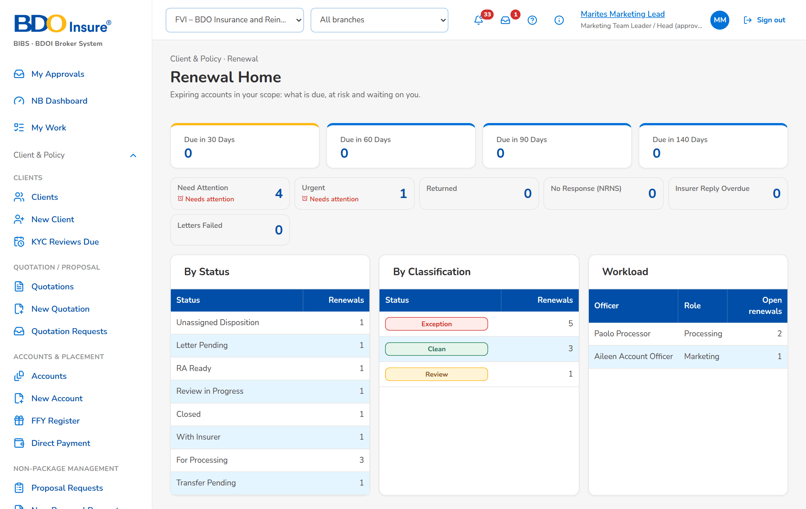
Figure 1: SCR-RN-01: Renewal Home of the Marketing Team Leader: due dates, work queues, renewals by status and classification, workload

SCR-RN-02 Expiry List
Item | Value
Purpose | The expiring accounts from extraction to disposition, by tab: extracted, unassigned, by disposition, exceptions, transfers pending and all. Generate Expiry List reads the accounts expiring in a range; Initiate starts the checks of the extracted renewals; Assign Disposition gives renewals to an Account Officer; Push sends the dispositioned ones to the Team Leader; Transfer moves one renewal to another unit.
Access | Client & Policy › Renewal › Expiry List; Renewal Home › At risk, Urgent or a status
Requirements | FRRN.004, FRRN.006, FRRN.010, FRRN.011, FRRN.045
Outcome | The expiring accounts are extracted, initiated and assigned for disposition.

Rules and states:
• An account is extracted once per policy year: a second extraction of the same range creates no duplicate.
• The daily extraction takes the policies at the lead days before expiry (140 by default); Generate Expiry List takes any range.
• Extraction does not start the renewal: the renewals are initiated explicitly, in bulk for the bulk segments and one by one for the others.
• Each filter accepts several values or all except the values chosen; the filters run on the whole list.
• A renewal is assigned to an officer of its own unit; a renewal on the loan-driven straight-through path needs no officer.
• A renewal has one open transfer request at a time, to another active unit.
Table 4: SCR-RN-02 fields
Field | Type | Req. | Default | Rule | Message
Tabs: Unassigned Disposition / Extracted / For Renewal / For Quotation / For Proposal / Not for Renewal / Lost Business / Exceptions / Transfer Pending / All | Tab | - | Unassigned Disposition | Source: Stage and disposition of the renewal | -
Toolbar: Search Renewal Ref / Policy / PN / Client | Text | N | Blank | Source: Renewals; Contains | -
List: Renewal Reference | Column | - | - | RNW-yyyy-nnnnnn with the flag tags next to it; Source: Renewals; Editable: Read only | No renewals to display
List: Client | Column | - | - | Name of the client with the client code under it; Source: Renewal; Editable: Read only | -
List: Expiring Policy / Invoice | Column | - | - | Policy number with the invoice under it; Source: Renewal; Editable: Read only | -
List: Risk / Insurance Company | Column | - | - | Product name with the insurer name under it; Source: Product catalogue, insurers; Editable: Read only | -
List: Unit / Officer | Column | - | - | Name of the owner unit with the officer's name under it; Source: Sales organisation, assignments; Editable: Read only | -
List: Expiry | Column | - | - | dd-MMM-yyyy with the days left under it; Source: Renewal; Editable: Read only | -
List: Status / Classification | Column | - | - | Stage pill with the Clean, Review or Exception pill under it; Source: Renewal; Editable: Read only | -
List: Disposition | Column | - | - | Disposition with the remarks under it; Source: Renewal; Editable: Read only | -
List: Gross Premium / Outstanding | Column | - | - | Two decimals; the outstanding of the expiring invoice family and the claims count under it (hidden for LAMD and Contact Center); Source: Expiring invoice, checks; Editable: Read only | -
Filters panel: Expiry From / Expiry To | Date | N | Blank | dd-MMM-yyyy | -
Filters panel: Unit Head, Business Origin, Account Type, Region, Department, Invoicing Branch, Risk Code, Segment, Account Officer, Insurance Company, Classification, Disposition, Status | Multi-select | N | All | Several values, or all except the values chosen; Source: Values of the renewals | -
Generate Expiry List dialog: Expiry From / Expiry To | Date | Y | Blank | dd-MMM-yyyy; the end on or after the start; Valid range | The end date must be on or after the start date
Assign Disposition dialog: Account Officer | Drop-down | Y | Blank | Name of the officer; Source: Officers of the Marketing units; Editable: Unassigned Disposition, For Disposition; Active officer of the unit of the renewal | Select the account officer
Assign Disposition dialog: Reason (re-assignment) | Drop-down | N | Blank | Renewal transfer reason list; Source: Renewal transfer reason; Editable: For Disposition | -
Transfer dialog: Receiving Unit / Reason / Remarks | Drop-down, drop-down, text area | Y / N / Y | Blank | Name of the unit; renewal transfer reason; up to 200 characters; Source: Marketing units, Renewal transfer reason; Editable: Unassigned Disposition, For Disposition; Another active unit | The receiving unit must be another unit
Recent extractions: Run / Expiry range / By / Read / New / Urgent / Status / Started | Column | - | - | The last five runs: the range or Daily run, the user's name, the counts, the status and the start time; Source: Extraction runs; Editable: Read only | No extraction yet

Table 5: SCR-RN-02 actions
Action | Who | Available when | What happens | Result
Generate Expiry List | Marketing and Processing Team Leaders | Always | Opens the dialog; Generate reads the accounts expiring in the range and creates their renewals once | Extracted
Initiate | Team Leaders (extract or assign permission) | Tab Extracted, renewals ticked | Starts the checks: each renewal gets its classification and the decision matrix proposes its disposition | Unassigned Disposition, For Processing or Letter Pending by the rules
Assign Disposition | Marketing Team Leader | Renewals ticked | Opens the dialog; Assign and Push gives the renewals to the officer | For Disposition; Renewal assigned (notice NT-01)
Push | Account Officers and Team Leaders (dispose permission) | Renewals ticked | Sends the dispositioned renewals to the Team Leader | Review in Progress
Transfer | Marketing Team Leader | One renewal ticked | Opens the dialog; Submit and Push requests the transfer to the receiving unit | Transfer Pending; Renewal transfer requested (notice NT-02)
Download | Users with the export permission | Always | Downloads the list as shown, with its filters, as a spreadsheet | -
[Row] | Every Renewal user | Always | Opens the renewal | -

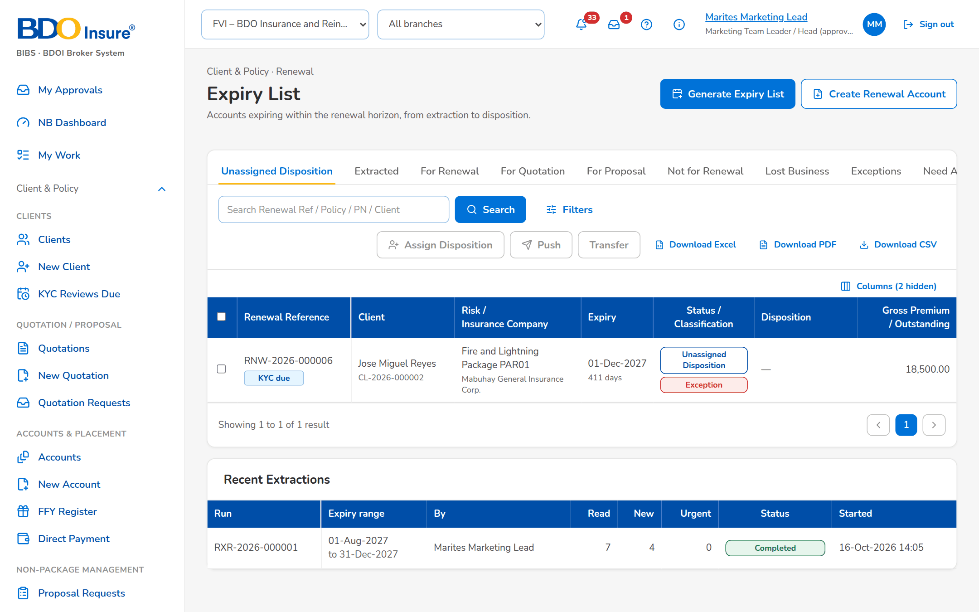
Figure 2: SCR-RN-02: Expiry List of the Marketing Team Leader, tab Unassigned Disposition: classification, flags and the actions of the tab
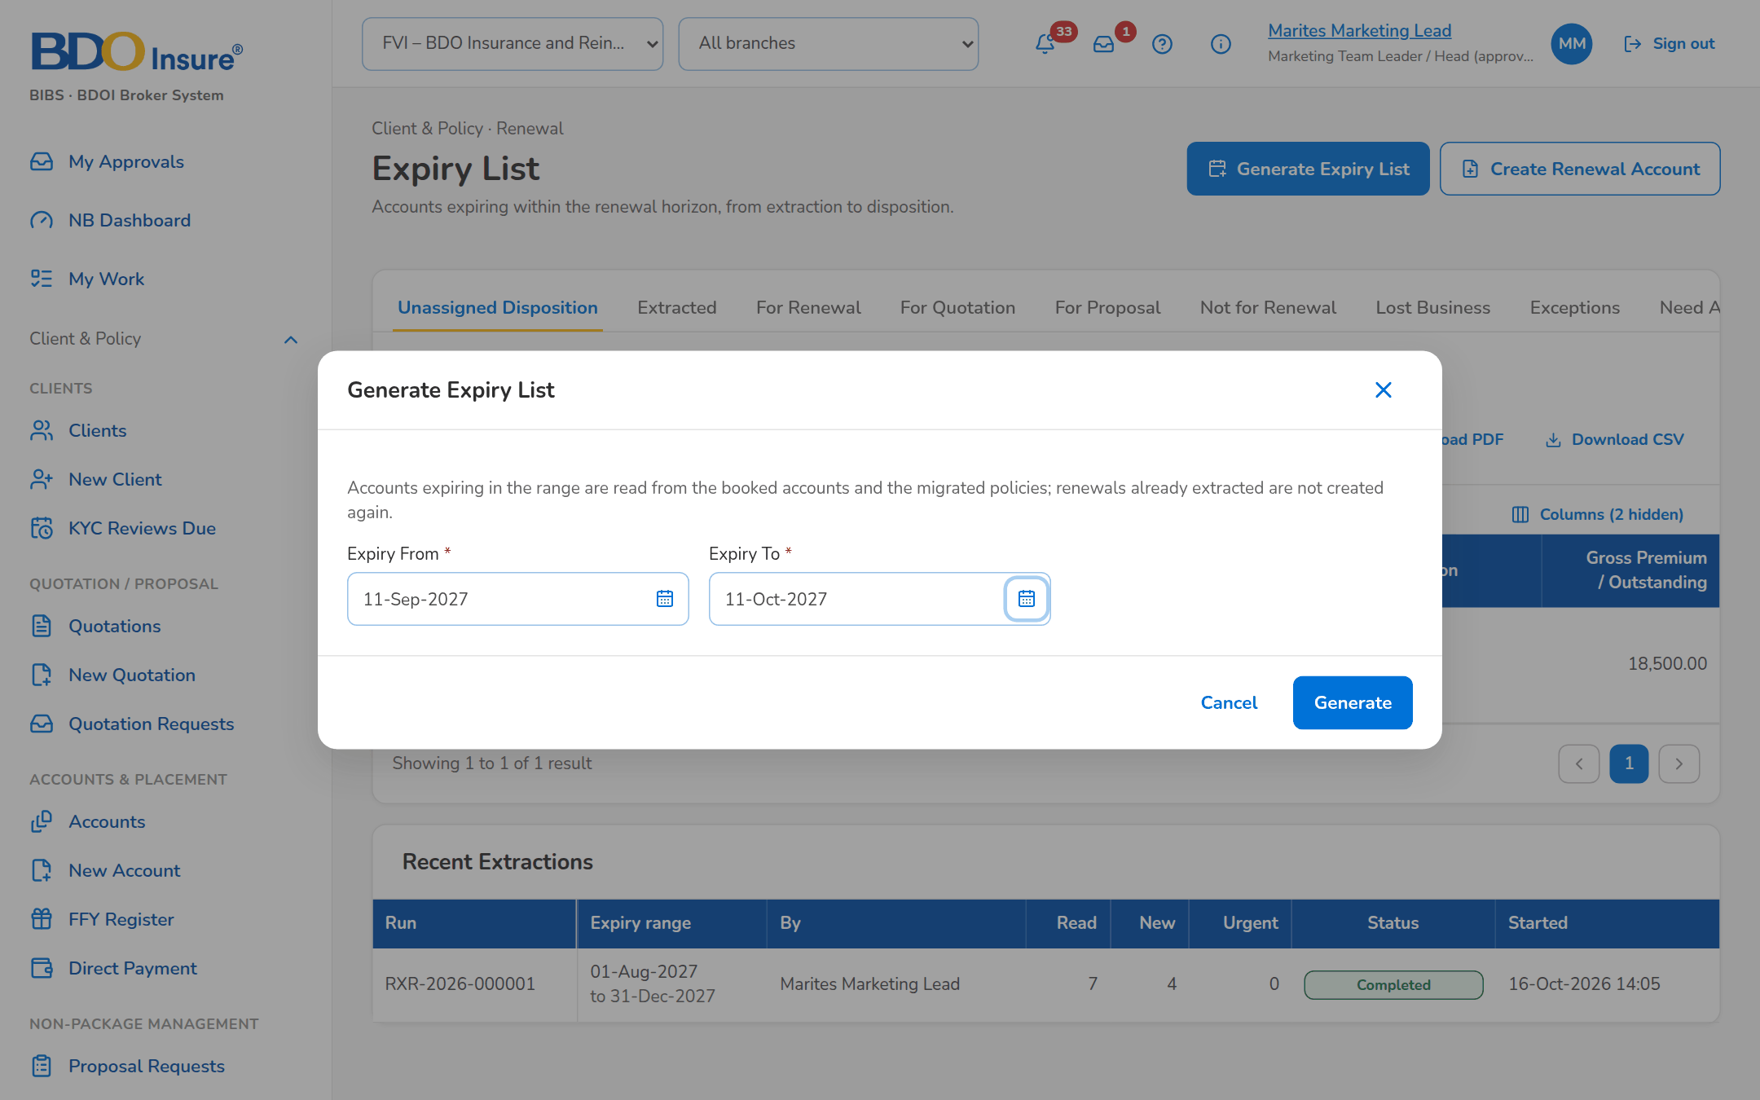
Figure 3: SCR-RN-02: Generate Expiry List dialog with the expiry range
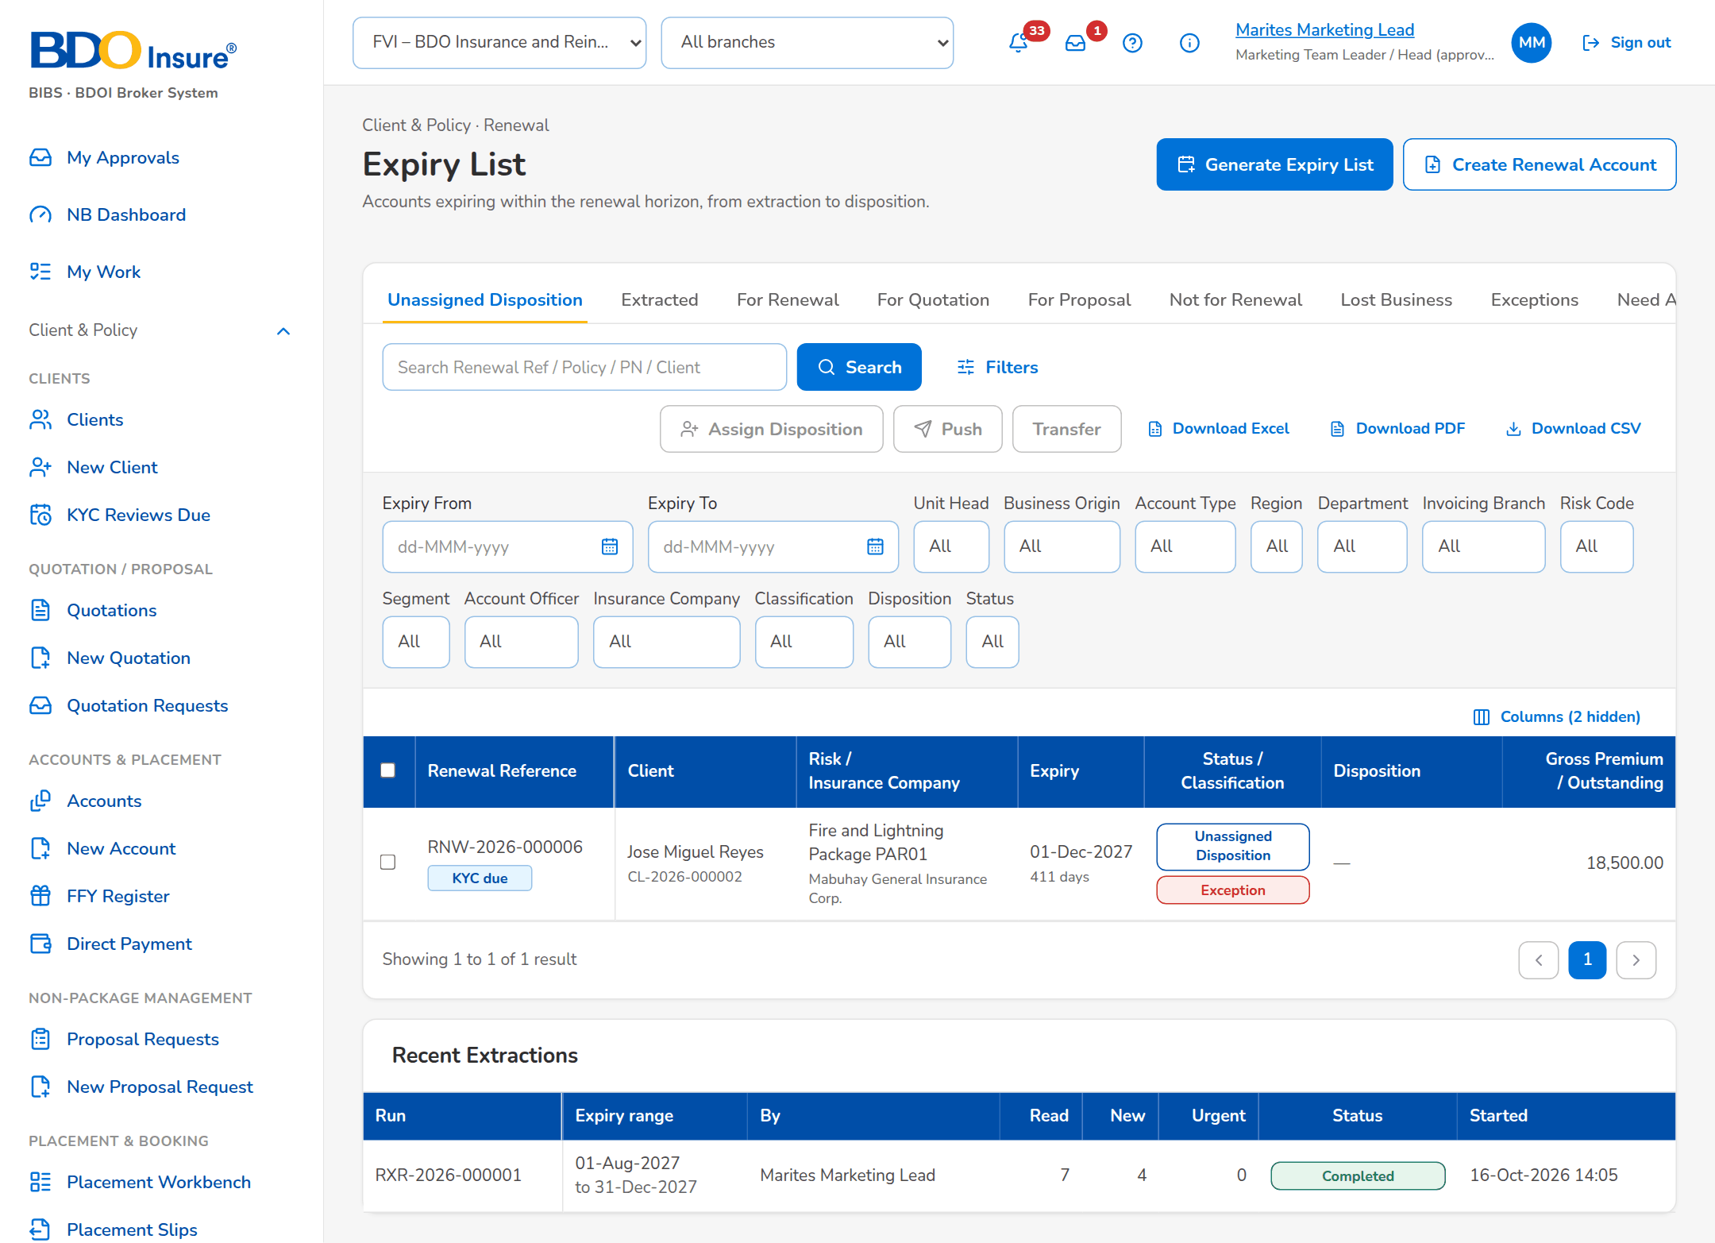
Figure 4: SCR-RN-02: The Filters panel: the expiry range and the multi-select criteria
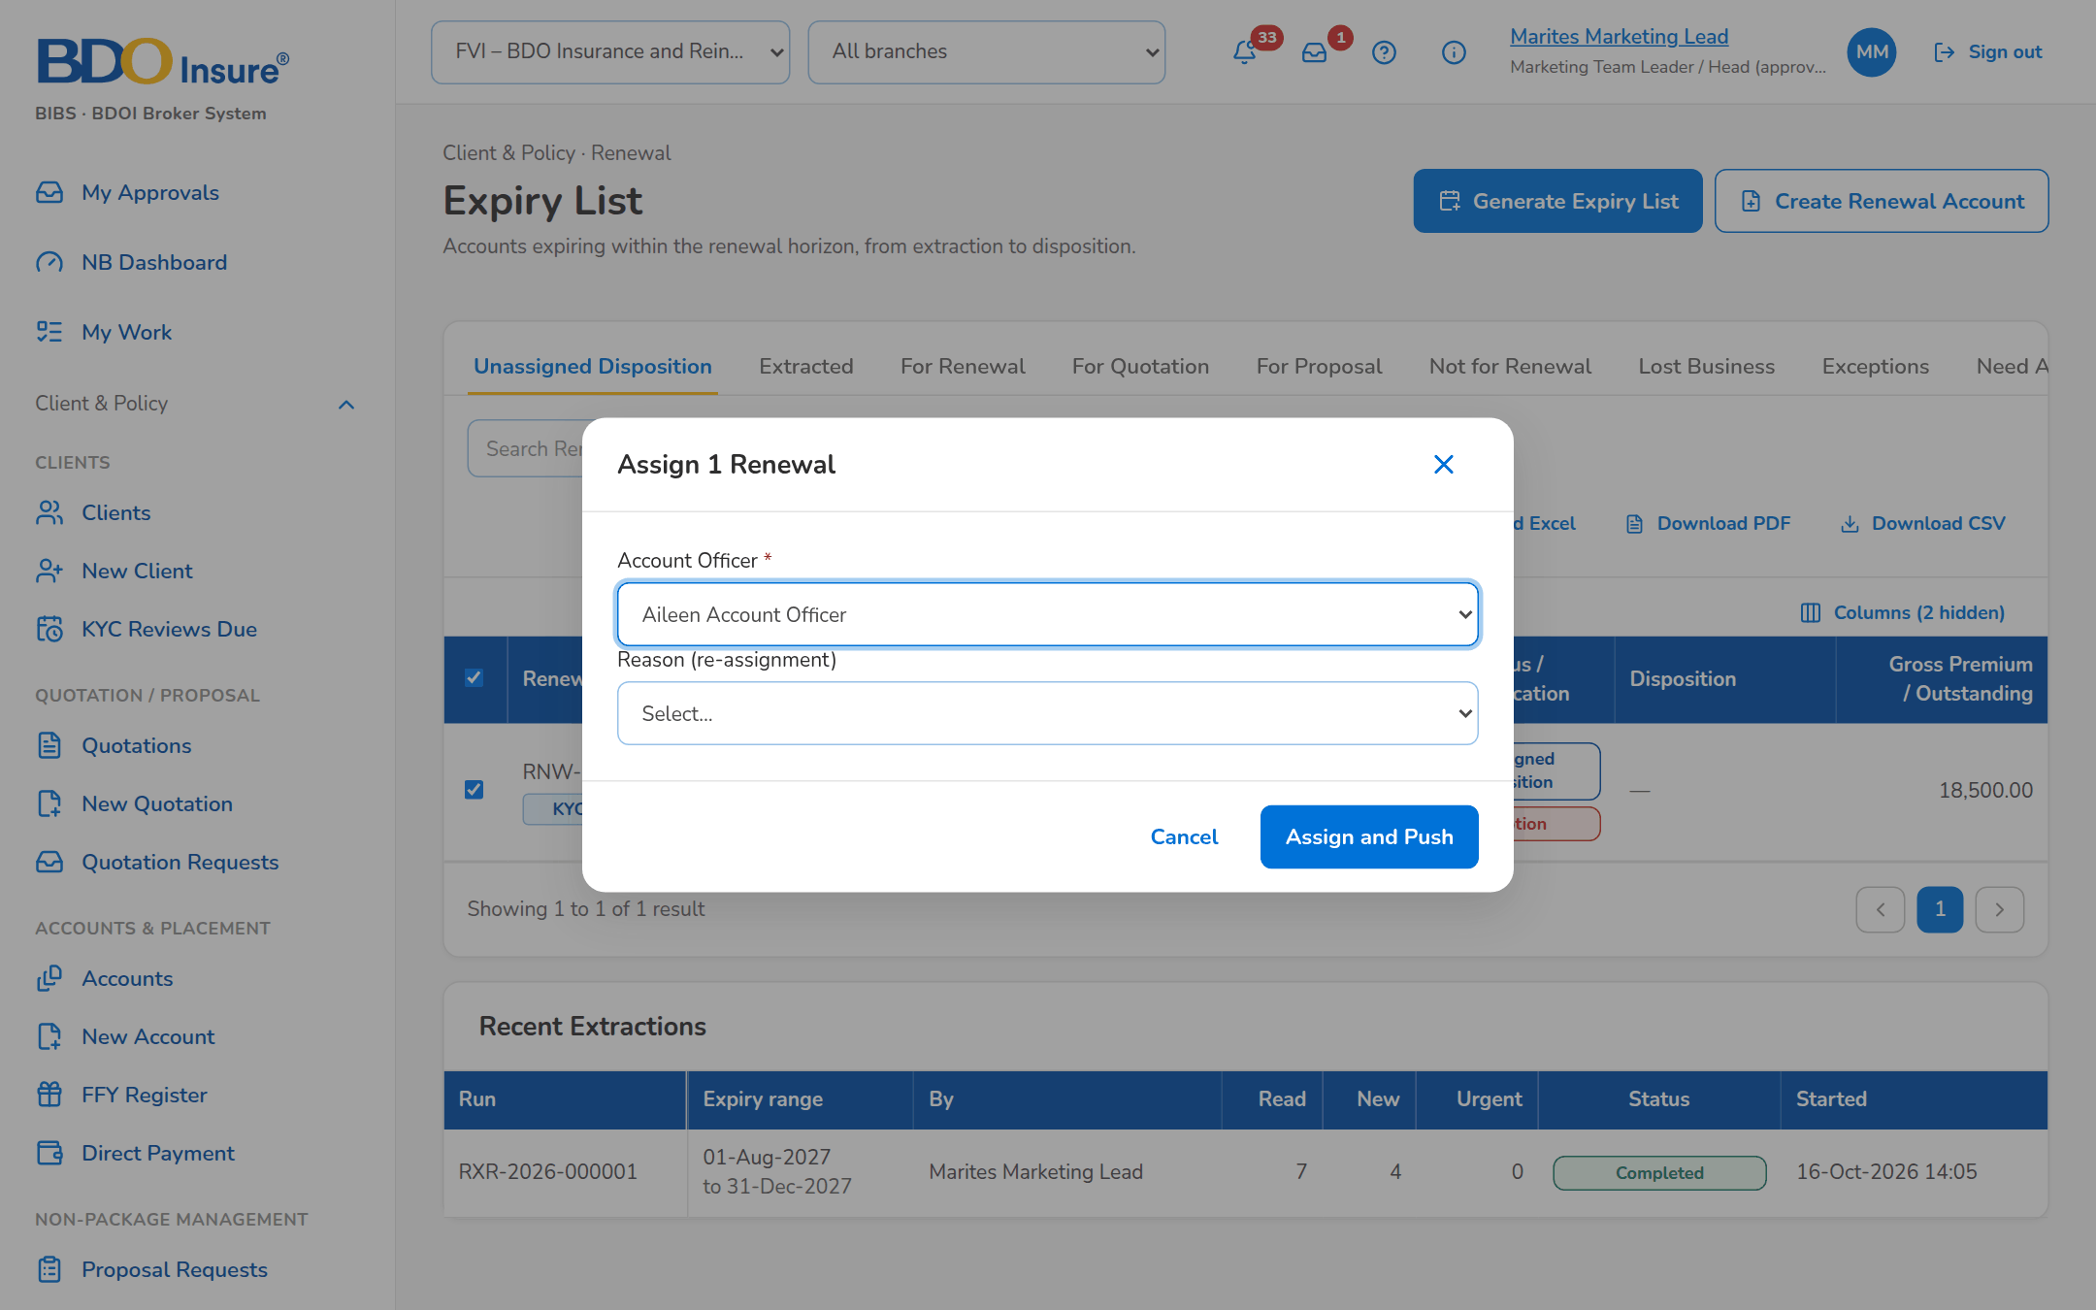
Figure 5: SCR-RN-02: Assign Disposition dialog: the Account Officer of the unit and the reason of a re-assignment

SCR-RN-03 Renewal
Item | Value
Purpose | One renewal: the client, the ARN chip, the status, classification and disposition, the flags and key facts, the blocking checks, the workflow header with the actions the user may take now, and the Details tab with the expiring account, the client and officers, the amounts and the renewal itself.
Access | Every Renewal user, from a list or a notice; the actions shown follow the stage and the permissions.
Requirements | FRRN.001, FRRN.009, FRRN.014, FRRN.039
Outcome | The user sees the whole renewal and the actions possible now.

Rules and states:
• Every user sees the renewals of the scope of the role; LAMD and Contact Center users see the renewal without the premium amounts.
• A renewal locks on the Marketing side when its Renewal Advice is generated.
Table 6: SCR-RN-03 fields
Field | Type | Req. | Default | Rule | Message
Header: [Client, ARN chip, status pill, classification pill, disposition tag, flags] | Reference chip, pills, tags | - | - | Source: Renewal; Editable: Read only | -
Facts: Client / Product / Insurer / Expiry / Gross premium / Unit | Display | - | - | Names; expiry dd-MMM-yyyy with the days left; amount with the currency; Source: Renewal; Editable: Read only | -
Blocking checks: [Amber notice with the failed checks] | Notice | - | - | One bullet per failed blocking check; Source: Latest checks; Editable: Read only | -
Workflow: [Renewal workflow header] | Stepper | - | - | The stages of the renewal with Current Stage, Since, Due and Assigned To and the history table; Source: Renewal workflow; Editable: Read only | -
Details tab: Expiring account: Source / ARN / Invoice / Policy No. / Cover No. / Product / Line / Insurance Company / Inception / Expiry / PN No. / Mortgaged / Legacy package | Display | - | - | Names of the product, line and insurer; dates dd-MMM-yyyy; Source: Expiring account or migrated policy; Editable: Read only | -
Details tab: Client and officers: Client / Assured / Segment / Business Origin / Account Type / Branch / Region / Department / Owner Unit / Unit Head / Account Officer / Processing Officer | Display | - | - | Names of the units and users; Source: Client, sales organisation, assignments; Editable: Read only | -
Details tab: Amounts: Currency / Basic Premium / Gross Premium / Sum Insured / Premium Rate / Commission Rate / Outstanding / Claims | Display | - | - | Two decimals; rates as keyed; Source: Expiring invoice, checks; Editable: Read only | -
Details tab: Renewal: Disposition / Reason / Proposed by the matrix / Renewal ARN / Quotation / Proposal / Renewed Invoice / Initiated / Closed | Display | - | - | Labels; the officer's name; dd-MMM-yyyy HH:mm; Source: Renewal; Editable: Read only | -

Table 7: SCR-RN-03 actions
Action | Who | Available when | What happens | Result
Details PDF | Users with the export permission | Always | Downloads the account details of the renewal as a PDF | -
[Actions of the stage] | By stage and permission | The renewal is in the stage | Set Disposition, Push, Start Quotation / Proposal, Create Renewal Account, Record Insurer Response, Record Acceptance, Add Follow-up, Add Remark, Propose Package, Re-open (SCR-RN-07, SCR-RN-12, SCR-RN-14, SCR-RN-15, SCR-RN-19) | -
Open Renewal Account | Every Renewal user | The renewal account exists | Opens the renewal account in New Business | -

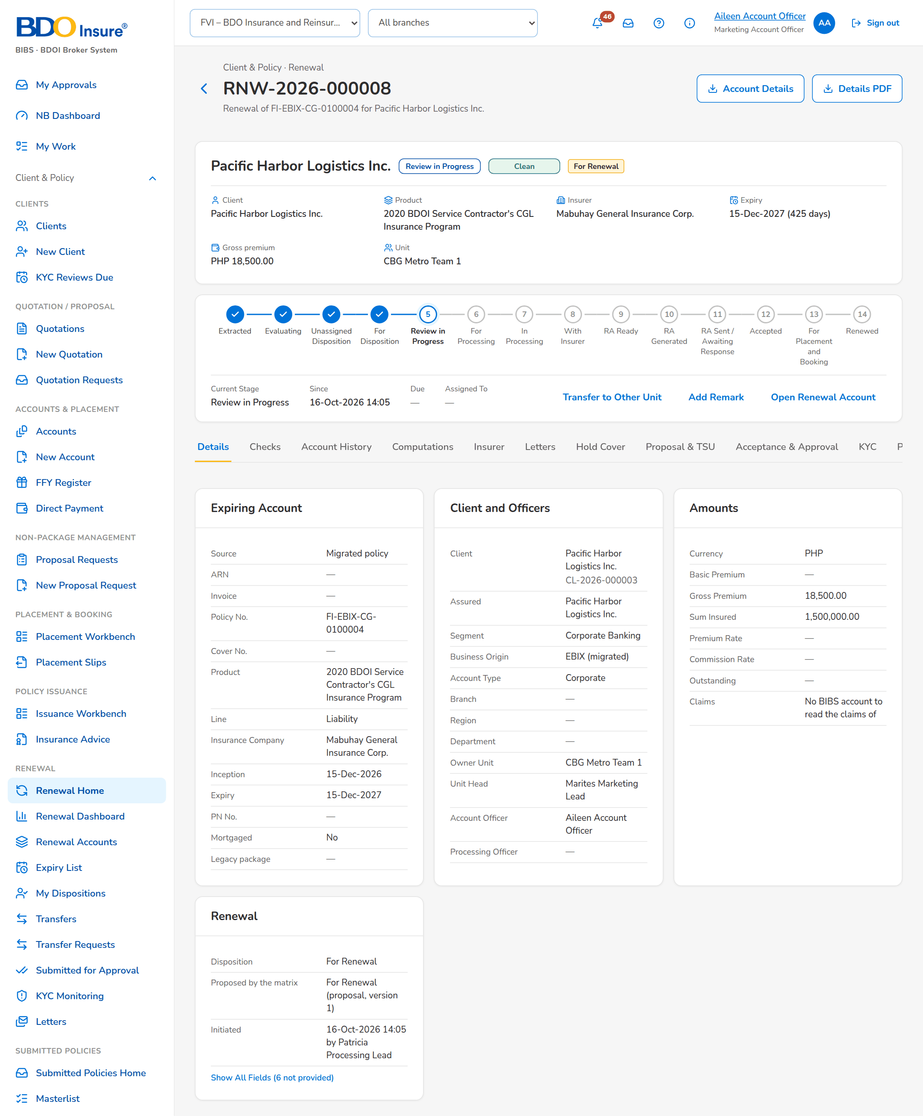
Figure 6: SCR-RN-03: A renewal in review: header, flags, workflow header and the Details tab

SCR-RN-04 Renewal: Checks, Account History and Computations
Item | Value
Purpose | The tabs the officers read before the disposition and the processing: the results of the sanitation checks with the classification history and the endorsements linked; the account history (prior renewals, endorsements, payments and claims), whose viewing is recorded and required before the disposition; the expiring and renewal terms side by side.
Access | Every Renewal user, on the renewal.
Requirements | FRRN.004, FRRN.006, FRRN.007, FRRN.008, FRRN.009, FRRN.014, FRRN.018
Outcome | The officer gives the disposition knowing the history and the checks of the account.

Rules and states:
• The disposition is refused until the officer has opened the account history of the renewal.
• A failed check never gives the Clean classification; the classification follows the active classification rules.
• A pending endorsement of the expiring policy fails its check until it is posted or cancelled.
• A difference between the renewal and the expiring terms beyond the tolerance is a financial impact.
Table 8: SCR-RN-04 fields
Field | Type | Req. | Default | Rule | Message
Check results: Check / Result / Severity / Message | Column | - | - | Name of the check; Pass, Warning, Fail, Information or Not applicable; severity as on Renewal Setup; the finding; Source: Latest check run; Editable: Read only | The checks have not run yet
Classification history: When / From / To / Cause / Remarks / By | Column | - | - | dd-MMM-yyyy HH:mm; classification pills; Classification rules or Override; the user's name; Source: Classification changes; Editable: Read only | No classification yet
Endorsements linked: Reference / Source / Status / Linked | Column | - | - | The endorsements of the term of the expiring policy; Source: Booking and Adjustment; Editable: Read only | No endorsements in the term
Account History: View Account History | Button | - | - | Records that the officer read the history | -
Account History: Prior renewals / Endorsements / Payments / Claims | Table | - | - | Renewal, Expiry, Expiring / Renewal ARN, Outcome; Invoice, Kind, Endorsement, Booked, Gross Premium; Invoice, Value date, Type, Component, OR No., Amount; the claims count; Source: Booking, Operations ledger, Claims; Editable: Read only | No prior renewals
Computations: Expiring / Renewal | Display | - | - | Currency, Net Premium, Charges, Gross Premium, Sum Insured, Commission Rate, Commission; Source: Expiring invoice, renewal account; Editable: Read only | -

Table 9: SCR-RN-04 actions
Action | Who | Available when | What happens | Result
View Account History | Every Renewal user | Always | Shows the history and records that it was viewed | -

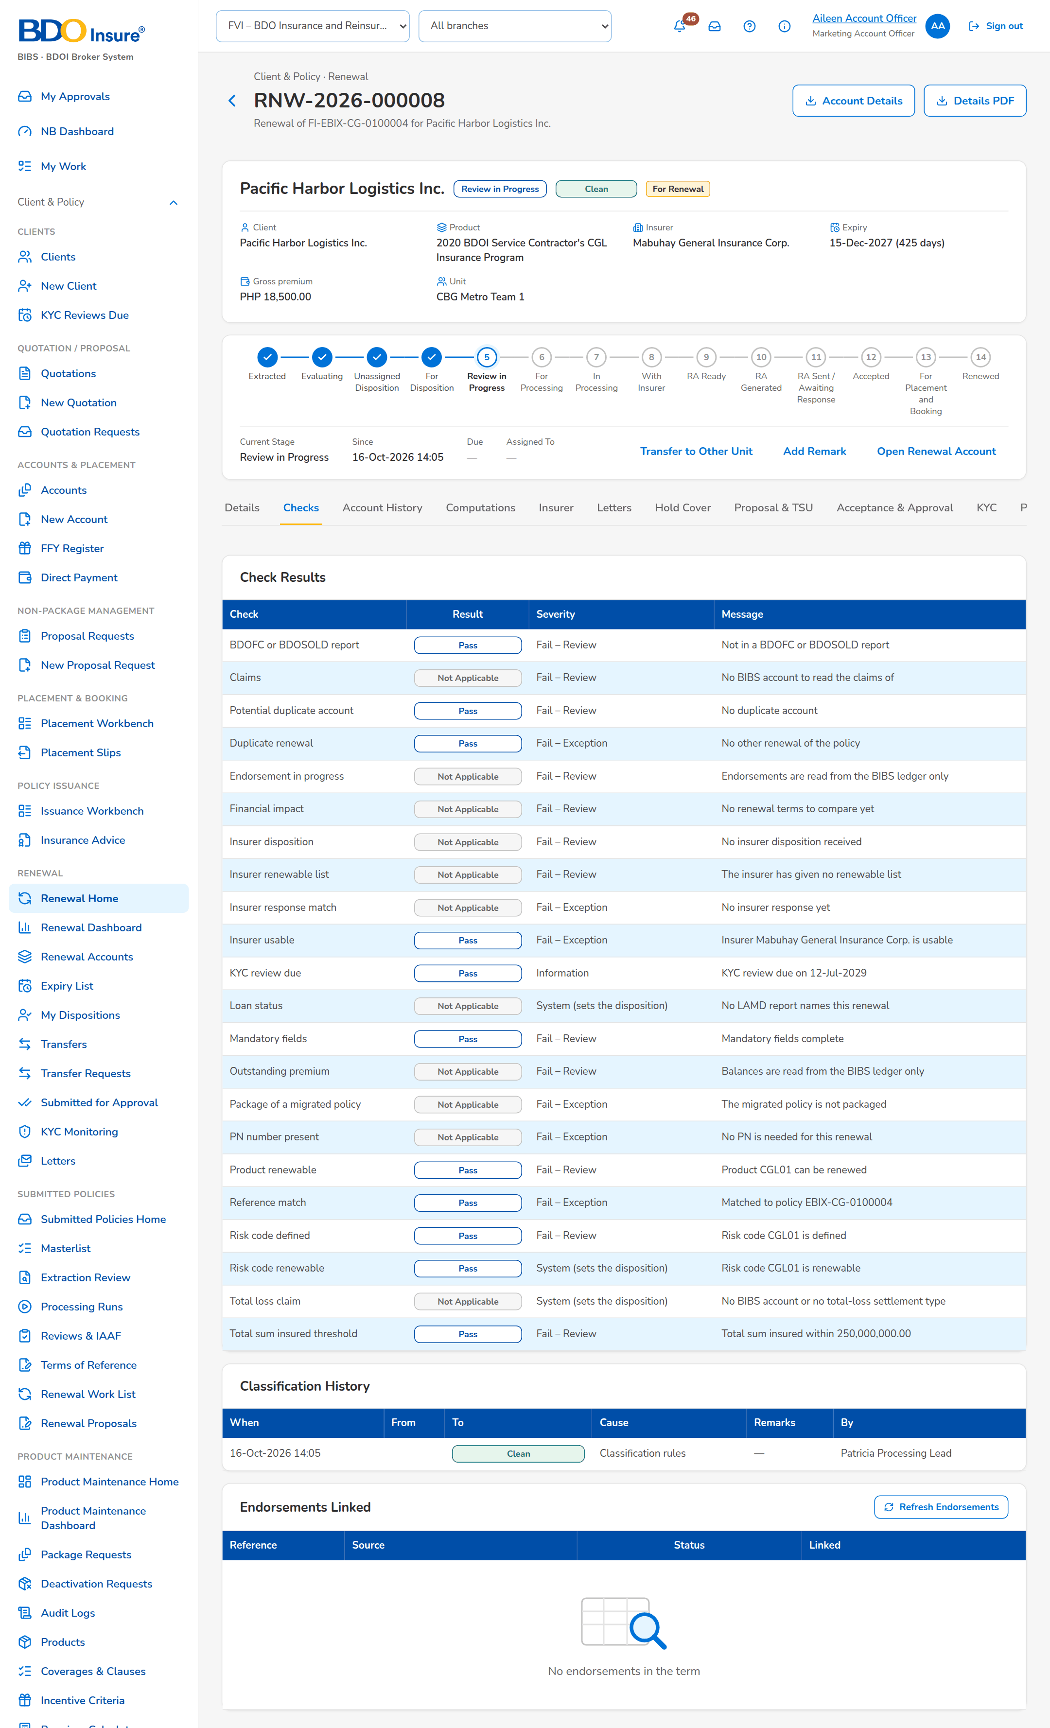
Figure 7: SCR-RN-04: Checks tab: the result of each check, the classification history and the endorsements
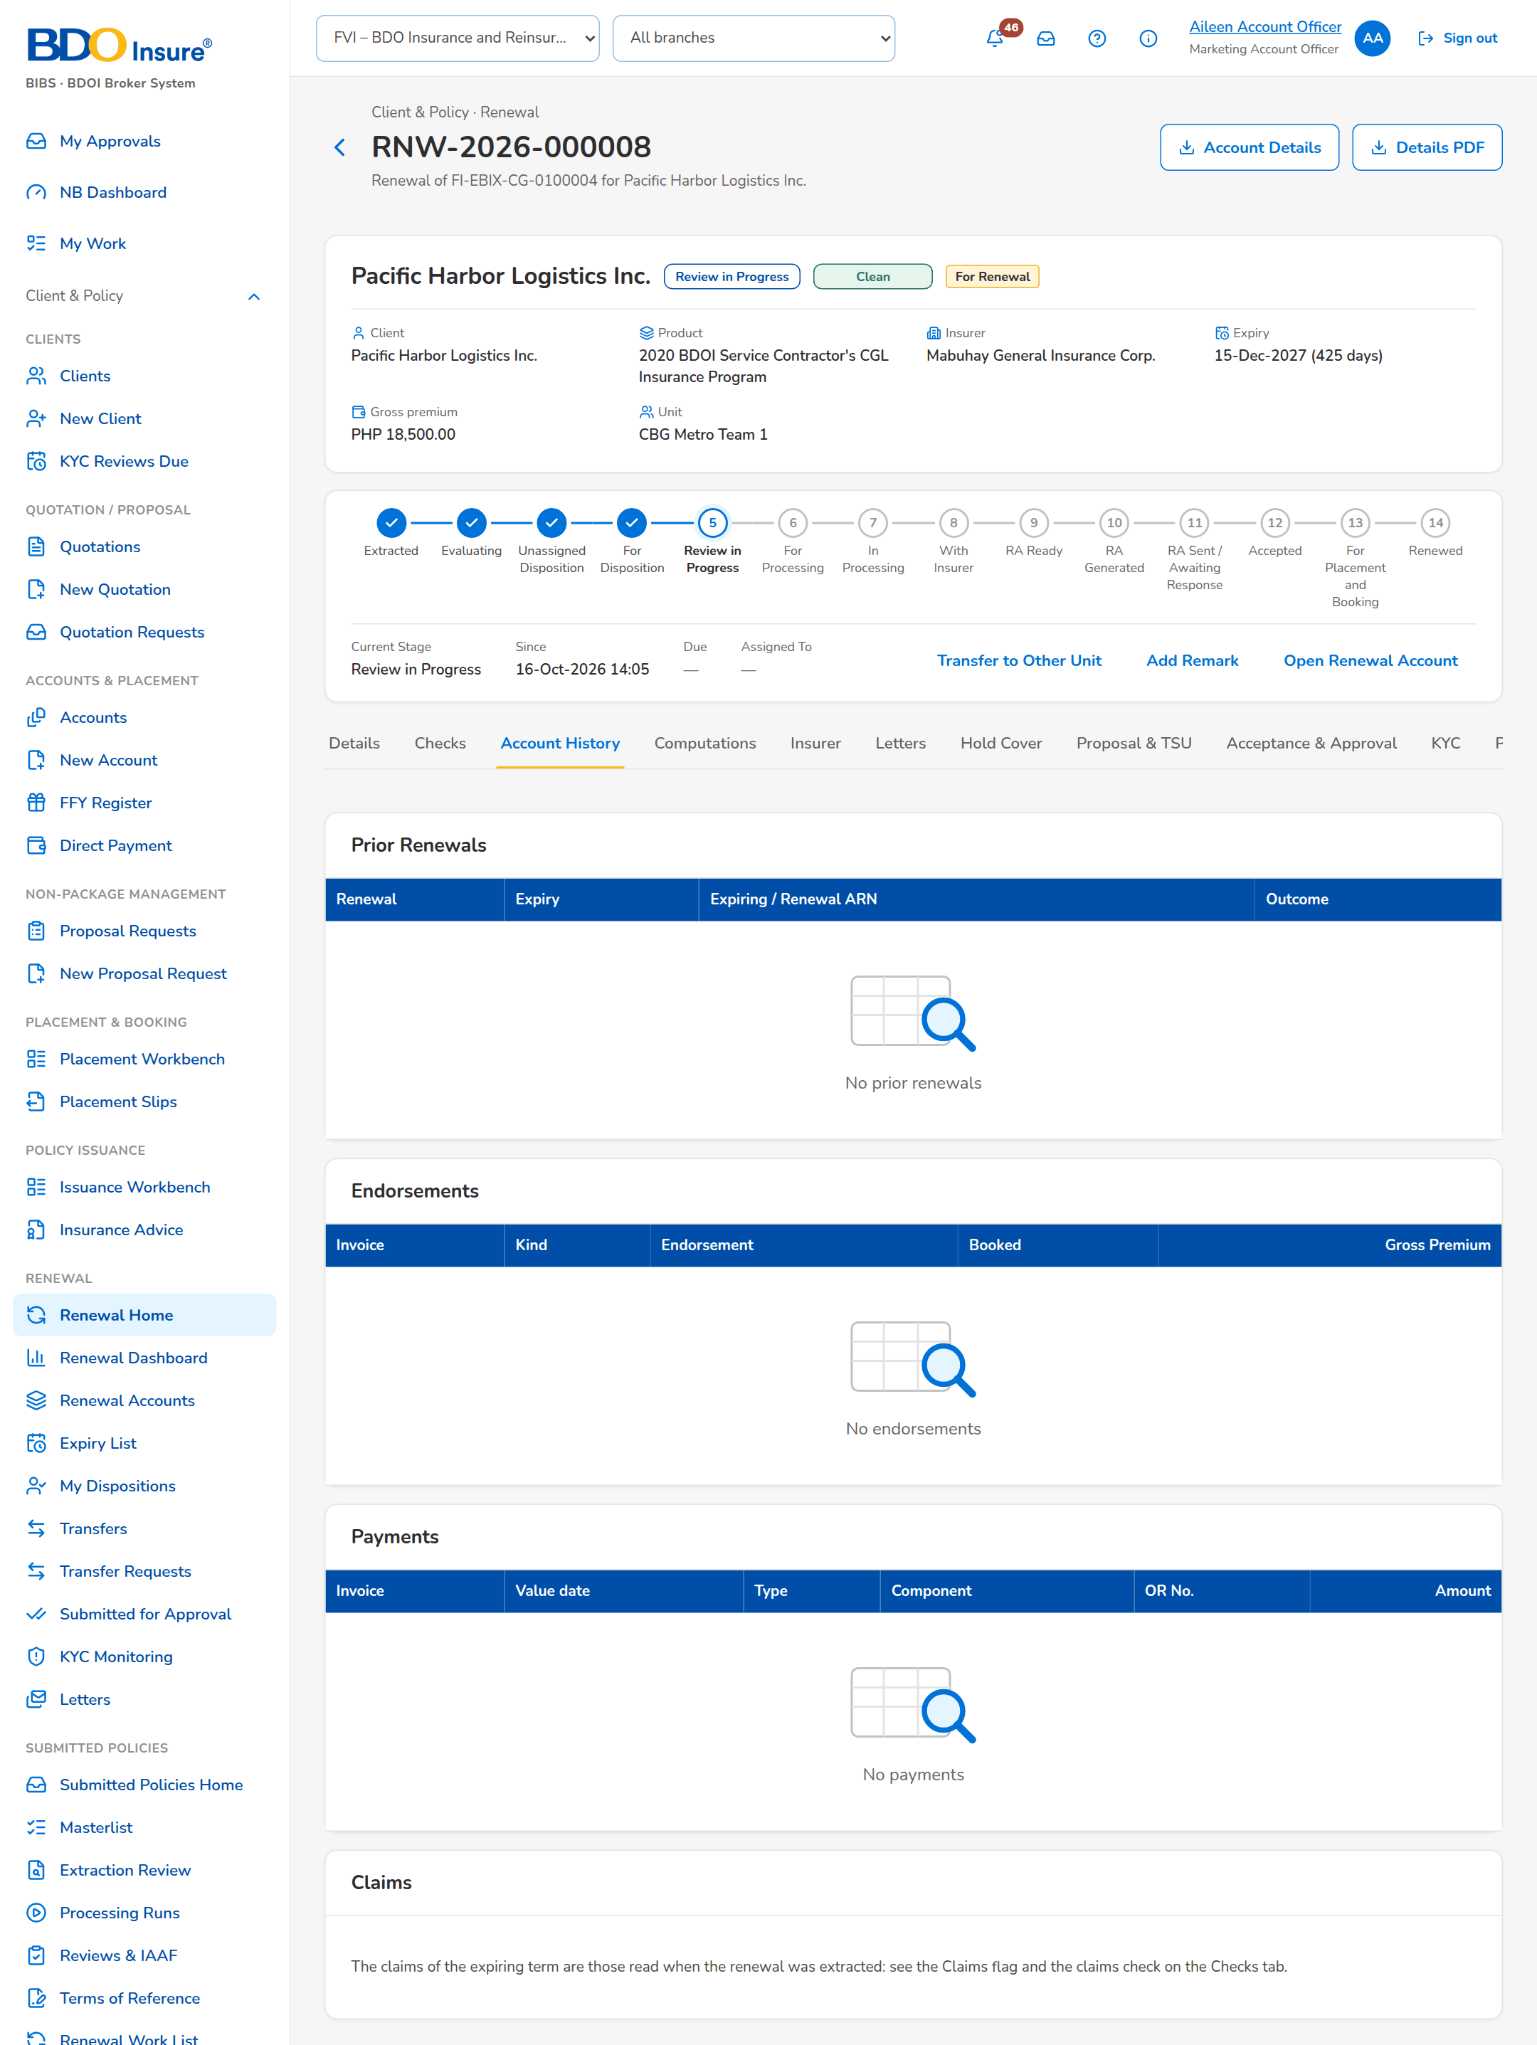
Figure 8: SCR-RN-04: Account History tab after View Account History: prior renewals, endorsements, payments and claims
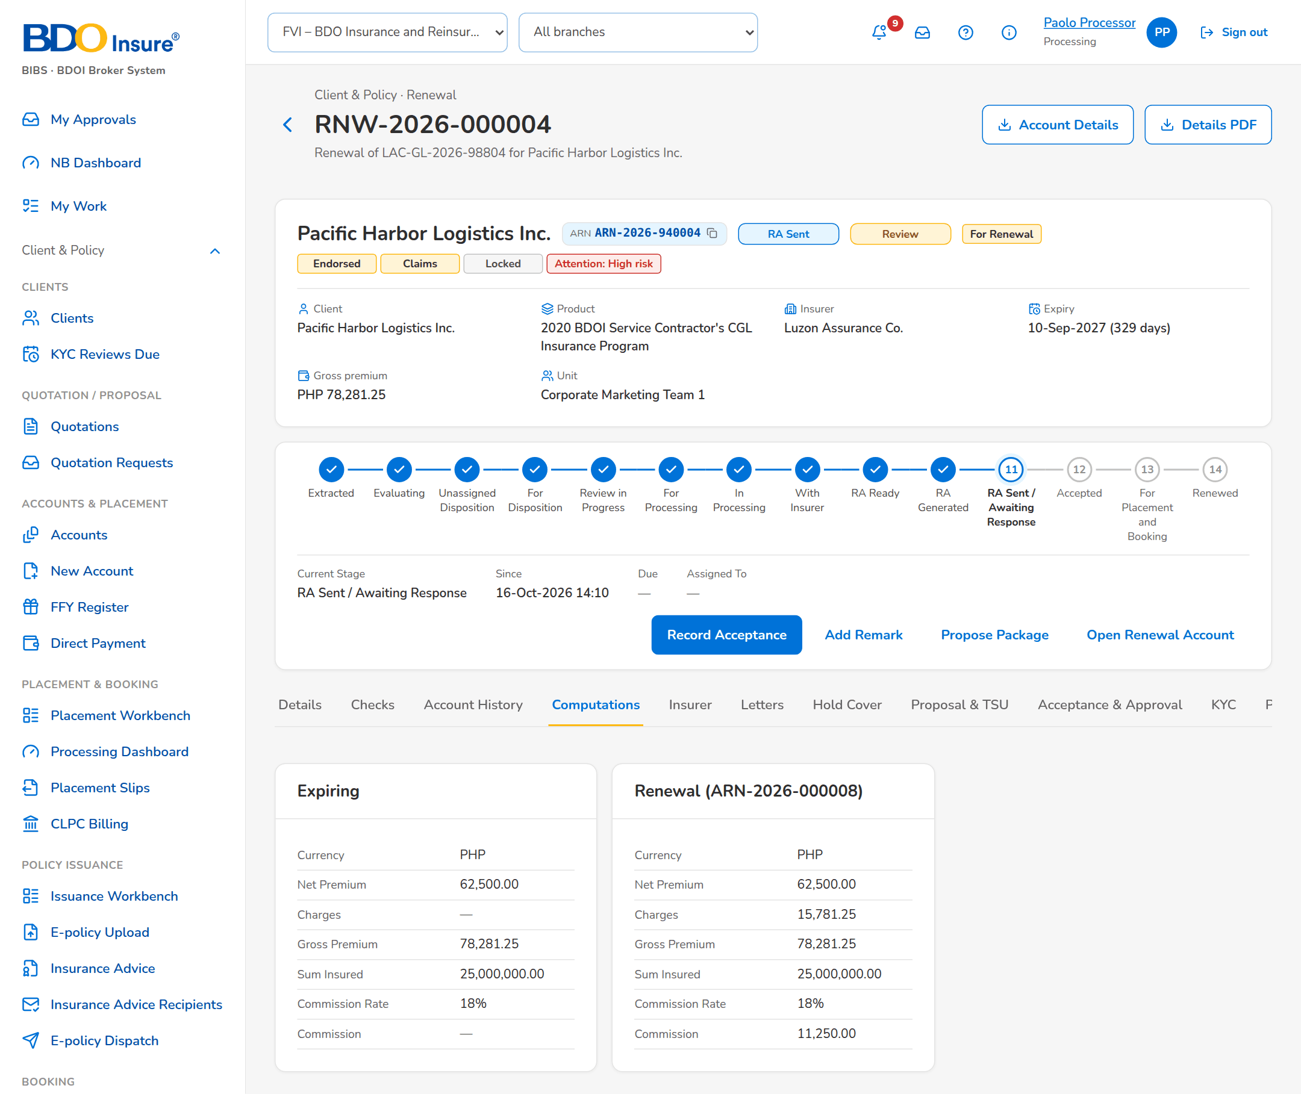
Figure 9: SCR-RN-04: Computations tab: the expiring terms and the renewal terms

SCR-RN-05 Renewal: Insurer, Letters, Documents, Remarks and History
Item | Value
Purpose | The tabs that keep the record of the renewal: the insurer responses (append-only, the latest valid one drives the renewal), the letters with their delivery and the acceptance, the documents of the renewal, the remarks and the Contact Center follow-ups, and the history of dispositions, assignments and overrides.
Access | Every Renewal user, on the renewal.
Requirements | FRRN.013, FRRN.014, FRRN.022, FRRN.023, FRRN.025, FRRN.043, FRRN.047
Outcome | The renewal keeps its full history for review and audit.

Rules and states:
• Every action on a renewal is recorded with the user and the time; no user can change the history.
• Insurer responses are kept; only the latest valid one drives the renewal.
• Every disposition is kept; a new one supersedes the previous one.
Table 10: SCR-RN-05 fields
Field | Type | Req. | Default | Rule | Message
Insurer responses: Received / Response / Insurer Ref / Revised Premium / Revised Sum Insured / Match / Used / Source / By | Column | - | - | dd-MMM-yyyy; Renew as is, Renew with revised terms or Declined; two decimals; Matched or the mismatch; Latest valid or Late; Manual or the upload; the user's name; Source: Insurer responses; Editable: Read only | No response from the insurer
Letters: Letter / Type / Status / Generated / Sent / Recipients | Column | - | - | Letter number; Renewal Advice with its notice, No Advice Letter, Not for Renewal Letter; status pill; dd-MMM-yyyy HH:mm; e-mail addresses or the failure; Source: Letters; Editable: Read only | No letters
Acceptance: Accepted on / Method / Reference / Financial impact acknowledged / By | Column | - | - | dd-MMM-yyyy; E-mail from the client, Signed Renewal Advice or Payment; Yes or No; the user's name; Source: Acceptances; Editable: Read only | No acceptance recorded
Documents: [Documents of the renewal] | Table | - | - | Type, file, uploaded by and when; Upload; Source: Documents | -
Remarks: When / By / Stage / Remark | Column | - | - | dd-MMM-yyyy HH:mm; the user's name; stage pill; Source: Remarks; Editable: Read only | No remarks
Follow-ups: When / Channel / Outcome / Remarks / Next action / By | Column | - | - | Labels of the follow-up channel and outcome; dd-MMM-yyyy; Source: Follow-ups; Editable: Read only | No follow-ups
History: Dispositions: When / Disposition / Reason / Source / Remarks / Current / By | Column | - | - | Labels; User, System check, Decision matrix, Upload, Insurer response or LAMD report; Source: Dispositions; Editable: Read only | No dispositions
History: Assignments: When / Role / Assigned to / Previous / By | Column | - | - | Account Officer or Processing Officer; users' names; Source: Assignments; Editable: Read only | No assignments
History: Overrides: When / Override / Change / Reason / Remarks / By | Column | - | - | What was overridden; the change in words (Review to Clean); the override reason; Source: Overrides; Editable: Read only | No overrides

Table 11: SCR-RN-05 actions
Action | Who | Available when | What happens | Result
Download PDF (row menu) | Every Renewal user | The letter has its PDF | Downloads the letter | -

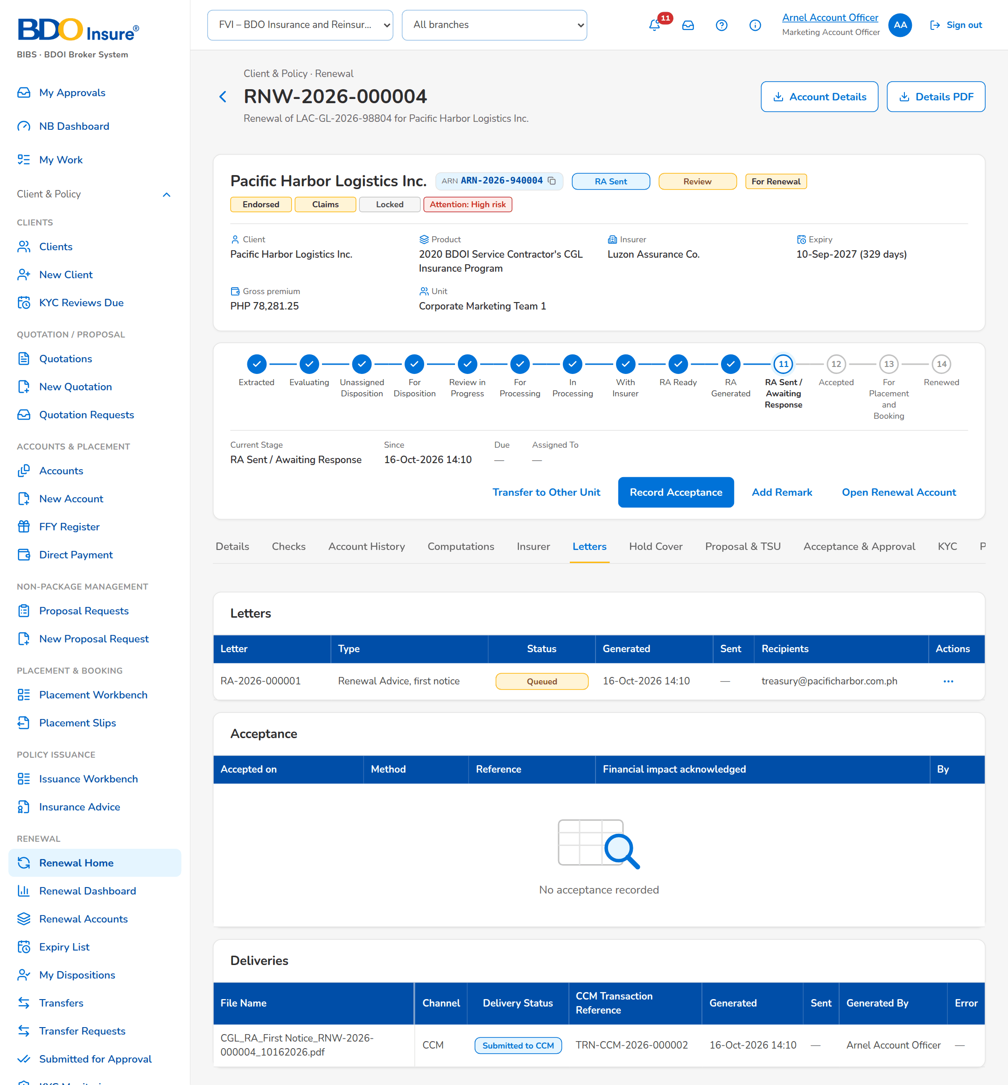
Figure 10: SCR-RN-05: Letters tab: the Renewal Advice sent to the client
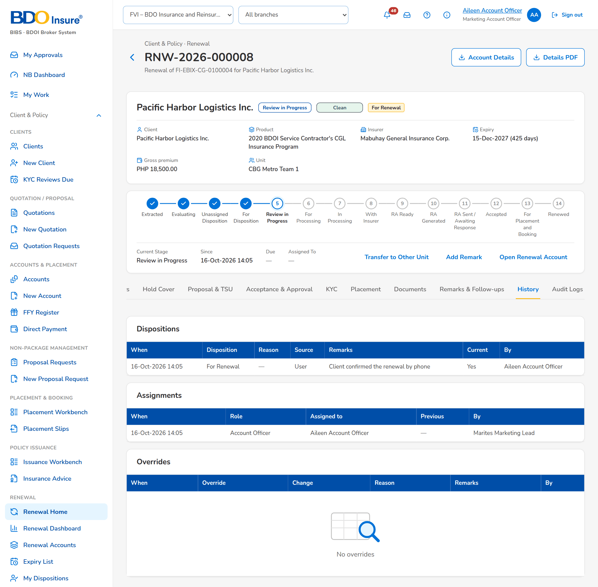
Figure 11: SCR-RN-05: History tab: the dispositions, assignments and overrides of the renewal

SCR-RN-06 My Dispositions
Item | Value
Purpose | The renewals assigned to the Account Officer, by disposition, with quick filters for the renewals to disposition, returned to the officer, due in 30 days and with no response (NRNS). The officer opens a renewal to read its history and give the disposition, pushes the dispositioned renewals to the Team Leader and transfers one to another unit.
Access | Client & Policy › Renewal › My Dispositions; Renewal Home › Returned; Notification Renewal assigned
Requirements | FRRN.002
Outcome | The officer works the assigned renewals and pushes them for review.

Rules and states:
• The officer sees the renewals assigned to him; a returned renewal carries the red Returned tag until it is pushed again.
• A renewal is pushed only with a complete disposition: Not for Renewal needs its reason.
Table 12: SCR-RN-06 fields
Field | Type | Req. | Default | Rule | Message
Tabs: All / For Renewal / For Quotation / For Proposal / Not for Renewal / Lost Business / Exceptions | Tab | - | All | Source: Disposition and classification | -
Quick filters: To disposition / Returned to me / Due in 30 days / NRNS | Toggle button | - | None | One at a time | -
List: [Columns of the renewal lists] | Column | - | - | As on the Expiry List (SCR-RN-02), the renewals assigned to the officer; Source: Renewals; Editable: Read only | No renewals assigned to you

Table 13: SCR-RN-06 actions
Action | Who | Available when | What happens | Result
Push | The Account Officer | Renewals ticked | Sends the dispositioned renewals to the Team Leader; each renewal without a complete disposition is refused with the reason | Review in Progress
Transfer | Users with the assign permission | One renewal ticked | Opens the Transfer dialog (SCR-RN-02) | Transfer Pending; Renewal transfer requested (notice NT-02)
Download | Users with the export permission | Always | Downloads the list as shown | -

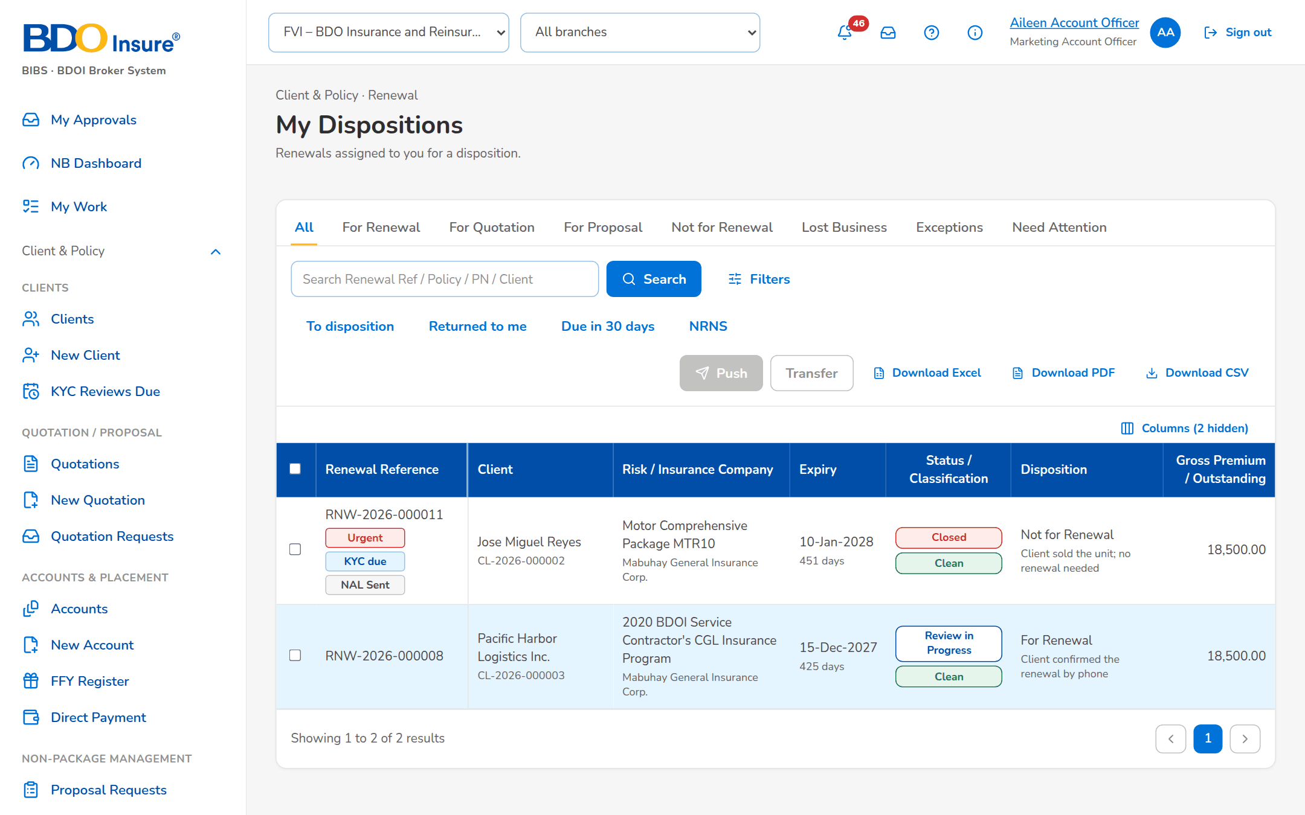
Figure 12: SCR-RN-06: My Dispositions of the Account Officer with the quick filters

SCR-RN-07 Set Disposition, Add Remark and Re-open
Item | Value
Purpose | The disposition of the renewal by the Account Officer (or the Team Leader): For Renewal, For Quotation, For Proposal, Not for Renewal with its reason, or Lost Business, with remarks; Push sends it to the Team Leader. Add Remark keeps a remark on the renewal. A renewal tagged Not for Renewal can be re-opened with a reason until the re-open days after expiry. A renewal posted For Quotation or For Proposal starts its quotation or proposal request here.
Access | Account Officer and Marketing Team Lead (dispose permission); Processing Team Lead to re-open.
Requirements | FRRN.014, FRRN.016, FRRN.018
Outcome | Each renewal has its disposition, with its reason and remarks.

Rules and states:
• The disposition needs the account history viewed first.
• Not for Renewal needs its reason; Booked to New Invoice needs the invoice and Transfer to Another Marketing Unit the receiving unit.
• A renewal with financial or structural changes is posted For Quotation or For Proposal and continues as a New Business quotation or proposal request.
• A Not for Renewal renewal can be re-opened until the re-open days after expiry (30 by default).
Table 14: SCR-RN-07 fields
Field | Type | Req. | Default | Rule | Message
Set Disposition dialog: Disposition | Drop-down | Y | The current disposition | For Renewal, Not for Renewal, For Quotation, For Proposal, Lost Business; Source: Renewal disposition list; Editable: For Disposition; Account history viewed | Select the disposition
Set Disposition dialog: Reason for Not for Renewal | Drop-down | Cond.: Not for Renewal | Blank | Reason for Not for Renewal list; Source: Reason for Not for Renewal; Editable: For Disposition | Select the reason for Not for Renewal
Set Disposition dialog: New Invoice No. | Text | Cond.: reason Booked to New Invoice | Blank | The invoice the policy was booked under; Source: Booking; Editable: For Disposition; Invoice of the ledger | Enter the new invoice number
Set Disposition dialog: Receiving Unit | Drop-down | Cond.: reason Transfer to Another Marketing Unit | Blank | Name of the unit; Source: Marketing units; Editable: For Disposition; Another active unit | Select the receiving unit
Set Disposition dialog: Remarks | Text area | N | Blank | Up to 200 characters; Editable: For Disposition; At most 200 characters | Remarks may have at most 200 characters
Add Remark dialog: Remark | Text area | Y | Blank | Up to 200 characters; Editable: Any open stage; Not blank | Enter the remarks
Re-open dialog: Reason | Text area | Y | Blank | Up to 200 characters; Editable: Letter Pending, Closed as not renewed; Within the re-open days after expiry | Only a renewal tagged Not for Renewal can be re-opened

Table 15: SCR-RN-07 actions
Action | Who | Available when | What happens | Result
Set Disposition | The assigned officer or a Team Leader | For Disposition | Opens the dialog; Save keeps the disposition, which supersedes the previous one | For Disposition
Push | The assigned officer or a Team Leader | For Disposition with a disposition | Sends the renewal to the Team Leader | Review in Progress
Start Quotation / Proposal | Account Officers and Team Leaders | Posted For Quotation or For Proposal, none started | Creates the quotation or the proposal request from the expiring account | For Proposal / New Business Path
Add Remark | Marketing, Processing and Contact Center users | Any open stage | Keeps the remark on the Remarks & Follow-ups tab | -
Re-open | Account Officers and the Processing Team Leader | Letter Pending or closed as not renewed | Asks for the reason and returns the renewal for a new disposition | For Disposition; Renewal returned (notice NT-04)

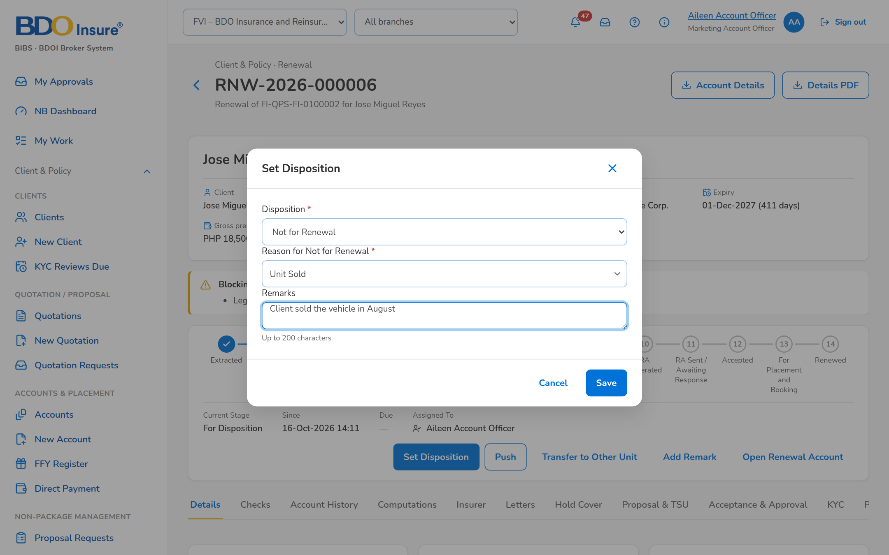
Figure 13: SCR-RN-07: Set Disposition dialog: Not for Renewal with its reason and remarks

SCR-RN-08 TL Review
Item | Value
Purpose | The dispositions of the unit waiting for the Team Leader, the exceptions, the unassigned renewals and the renewals on the quotation or proposal path. The Team Leader posts the reviewed renewals (each moves on by its disposition), returns them to the officer with a reason, overrides a failed check, the classification, the disposition or the outstanding balance with a reason, and re-assigns them.
Access | Client & Policy › Renewal › TL Review; Notification of a pushed renewal
Requirements | FRRN.016, FRRN.020
Outcome | The reviewed renewals move on by their disposition.

Rules and states:
• A renewal For Renewal or on the New Business path with a failing blocking check is not posted until the check passes or is overridden.
• Straight-through renewals (an automatic disposition of a Clean renewal) move on without review.
• The outstanding balance of the expiring invoice is overridden by the Team Leader with mandatory remarks.
• Not for Renewal is given through the disposition with its reason, never by an override.
Table 16: SCR-RN-08 fields
Field | Type | Req. | Default | Rule | Message
Tabs: For Review / Exceptions / Unassigned / Quotation / Proposal / All | Tab | - | For Review | Source: Stage and classification | -
List: [Columns of the renewal lists] | Column | - | - | As on the Expiry List (SCR-RN-02), the renewals of the unit; Source: Renewals; Editable: Read only | No renewals to display
Return dialog: Reason / Remarks | Drop-down, text area | Y / Y | Blank | Renewal return reason list; up to 200 characters; Source: Renewal return reason; Editable: Review in Progress | Select a reason for 'Return'
Override dialog: Override | Drop-down | Y | Blank | Outstanding balance, Failed check, Classification, Disposition, Insurer response mismatch, Unlock the Renewal Advice; Source: Fixed list; Editable: Any open stage | Select the kind of override
Override dialog: Check / New value | Drop-down | Cond.: failed check, classification or disposition | Blank | The failing check; the new classification or disposition; Source: Checks, classifications, dispositions; Editable: Any open stage; A failed check never turns Clean | An override never turns a failed check into Clean
Override dialog: Reason / Remarks | Drop-down, text area | Y / Y | Blank | Renewal override reason list; up to 200 characters; Source: Renewal override reason; Editable: Any open stage | Select the reason of the override

Table 17: SCR-RN-08 actions
Action | Who | Available when | What happens | Result
Post | Marketing Team Leader | Renewals ticked | Asks for confirmation; For Renewal goes to Processing, For Quotation and For Proposal to the New Business path, Not for Renewal to the letter step, Lost Business is closed | For Processing, For Proposal / New Business Path, Letter Pending or Closed; Renewal posted (notice NT-05)
Return | Marketing Team Leader | Renewals ticked | Opens the dialog; the renewal goes back to its officer with the Returned tag | For Disposition; Renewal returned (notice NT-04)
Override | Marketing Team Leader (override permission) | Renewals ticked | Opens the dialog; the override is kept with its reason in the history | The stage the override allows
Re-assign | Marketing Team Leader | Renewals ticked | Opens the Assign Disposition dialog (SCR-RN-02) | For Disposition; Renewal assigned (notice NT-01)

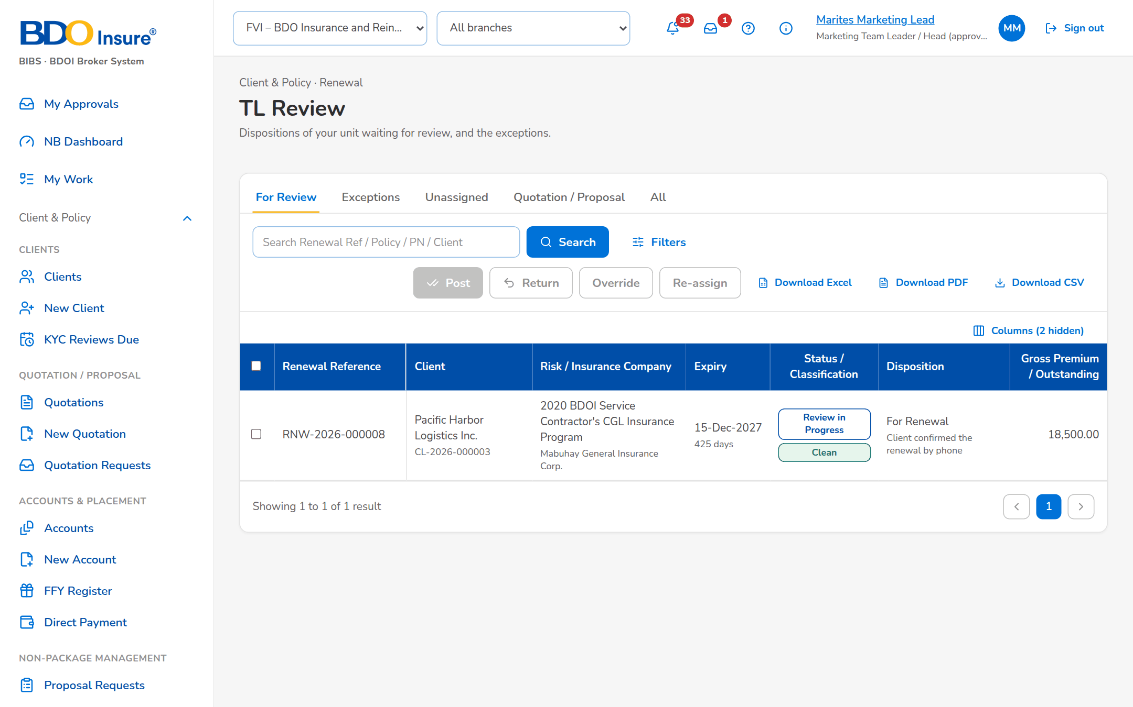
Figure 14: SCR-RN-08: TL Review: the dispositions of the unit waiting for review with the actions of the Team Leader
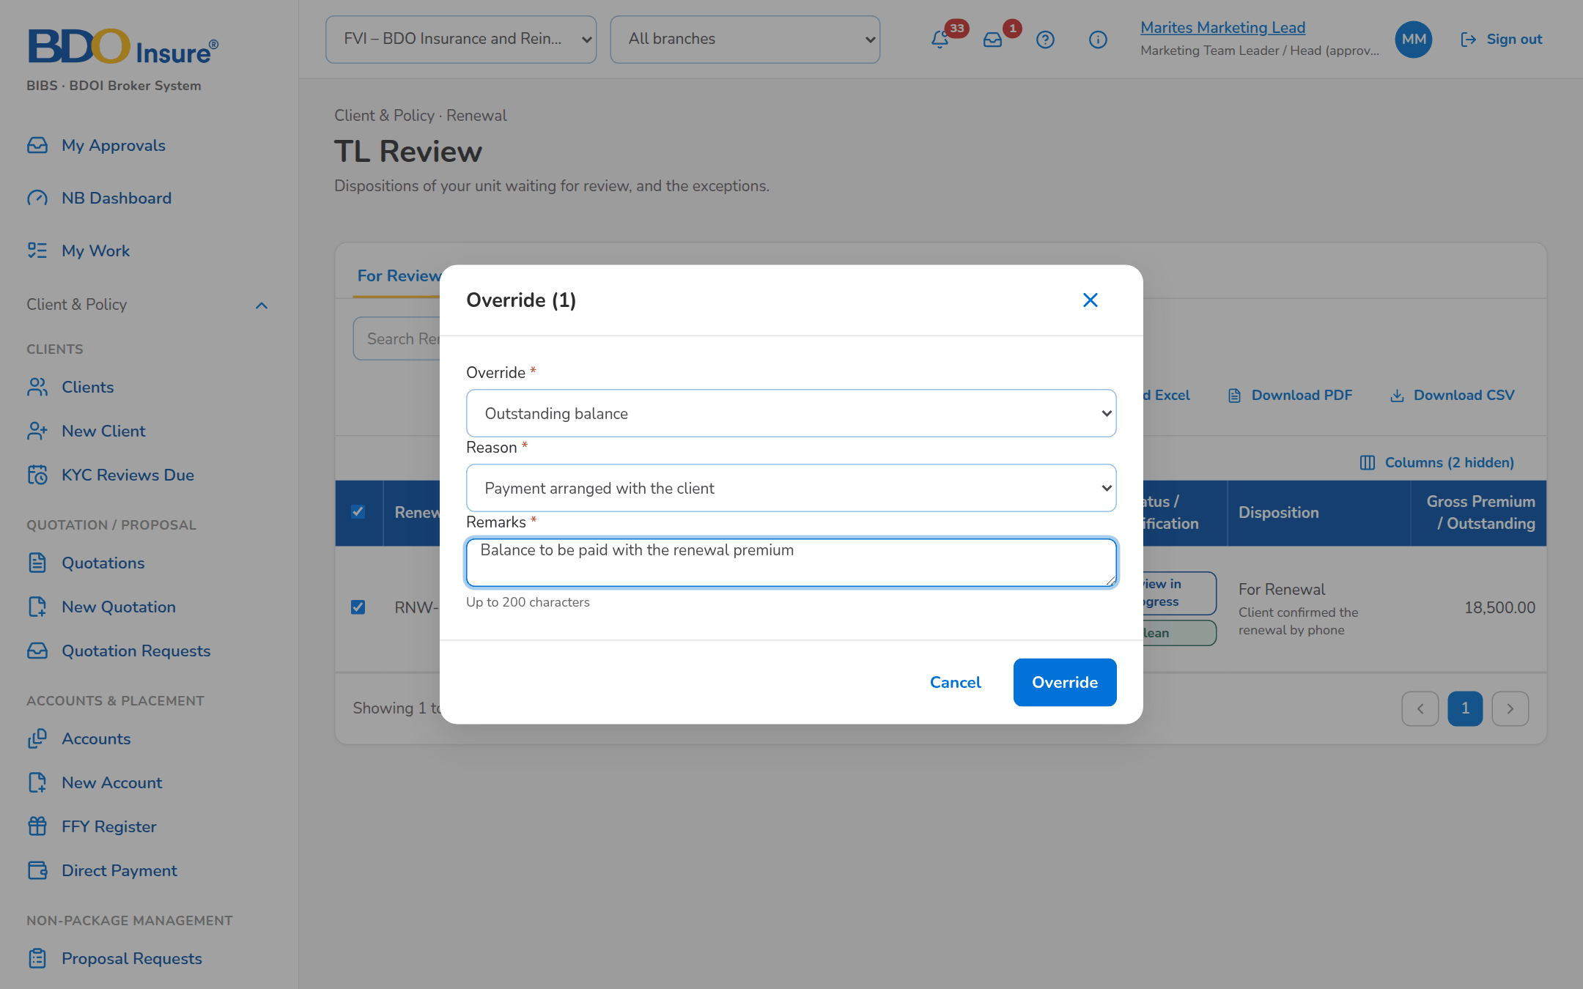
Figure 15: SCR-RN-08: Override dialog: the outstanding balance with the reason and remarks
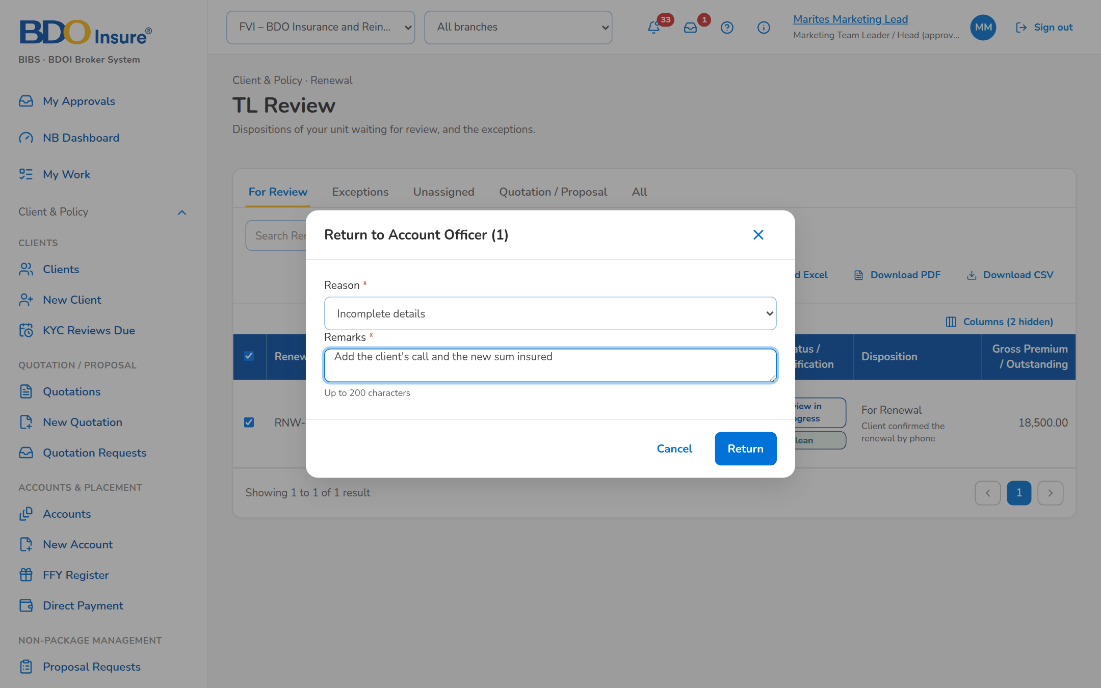
Figure 16: SCR-RN-08: Return to Account Officer dialog with the reason and remarks

SCR-RN-09 Transfers
Item | Value
Purpose | The requests to move a renewal to another Marketing unit: Incoming for the receiving Team Leader, who accepts or declines them with remarks; Outgoing for the requesting unit, which may cancel an open request.
Access | Client & Policy › Renewal › Transfers; Notification Renewal transfer requested
Requirements | FRRN.011
Outcome | The renewal is with the unit that handles the client.

Rules and states:
• Only a Team Leader of the receiving unit decides a transfer; only the requester cancels it.
• An accepted renewal waits in the Unassigned tab of the receiving unit for its Account Officer.
Table 18: SCR-RN-09 fields
Field | Type | Req. | Default | Rule | Message
Tabs: Incoming / Outgoing | Tab | - | Incoming | Source: Transfer requests | -
List: Renewal Reference / Client | Column | - | - | Reference; client with the expiry under it; Source: Transfers; Editable: Read only | No transfers
List: From / To | Column | - | - | Name of the sending unit with the receiving unit under it; Source: Sales organisation; Editable: Read only | -
List: Remarks / Requested / Status | Column | - | - | Remarks of the request; the requester's name with the time; Requested, Accepted, Declined or Cancelled; Source: Transfers; Editable: Read only | -
Accept or Decline dialog: Remarks | Text area | Cond.: decline | Blank | Up to 200 characters; Editable: Requested; Not blank to decline | Enter the remarks

Table 19: SCR-RN-09 actions
Action | Who | Available when | What happens | Result
Accept (row menu) | A Team Leader of the receiving unit | Requested | Asks for remarks; the renewal joins the unit, unassigned | Unassigned Disposition; Renewal transfer decided (notice NT-03)
Decline (row menu) | A Team Leader of the receiving unit | Requested | Asks for the remarks; the renewal returns to the sending unit | The stage before the request; Renewal transfer decided (notice NT-03)
Cancel Request (row menu) | The requester | Requested | Asks for confirmation; the renewal stays with the unit | The stage before the request

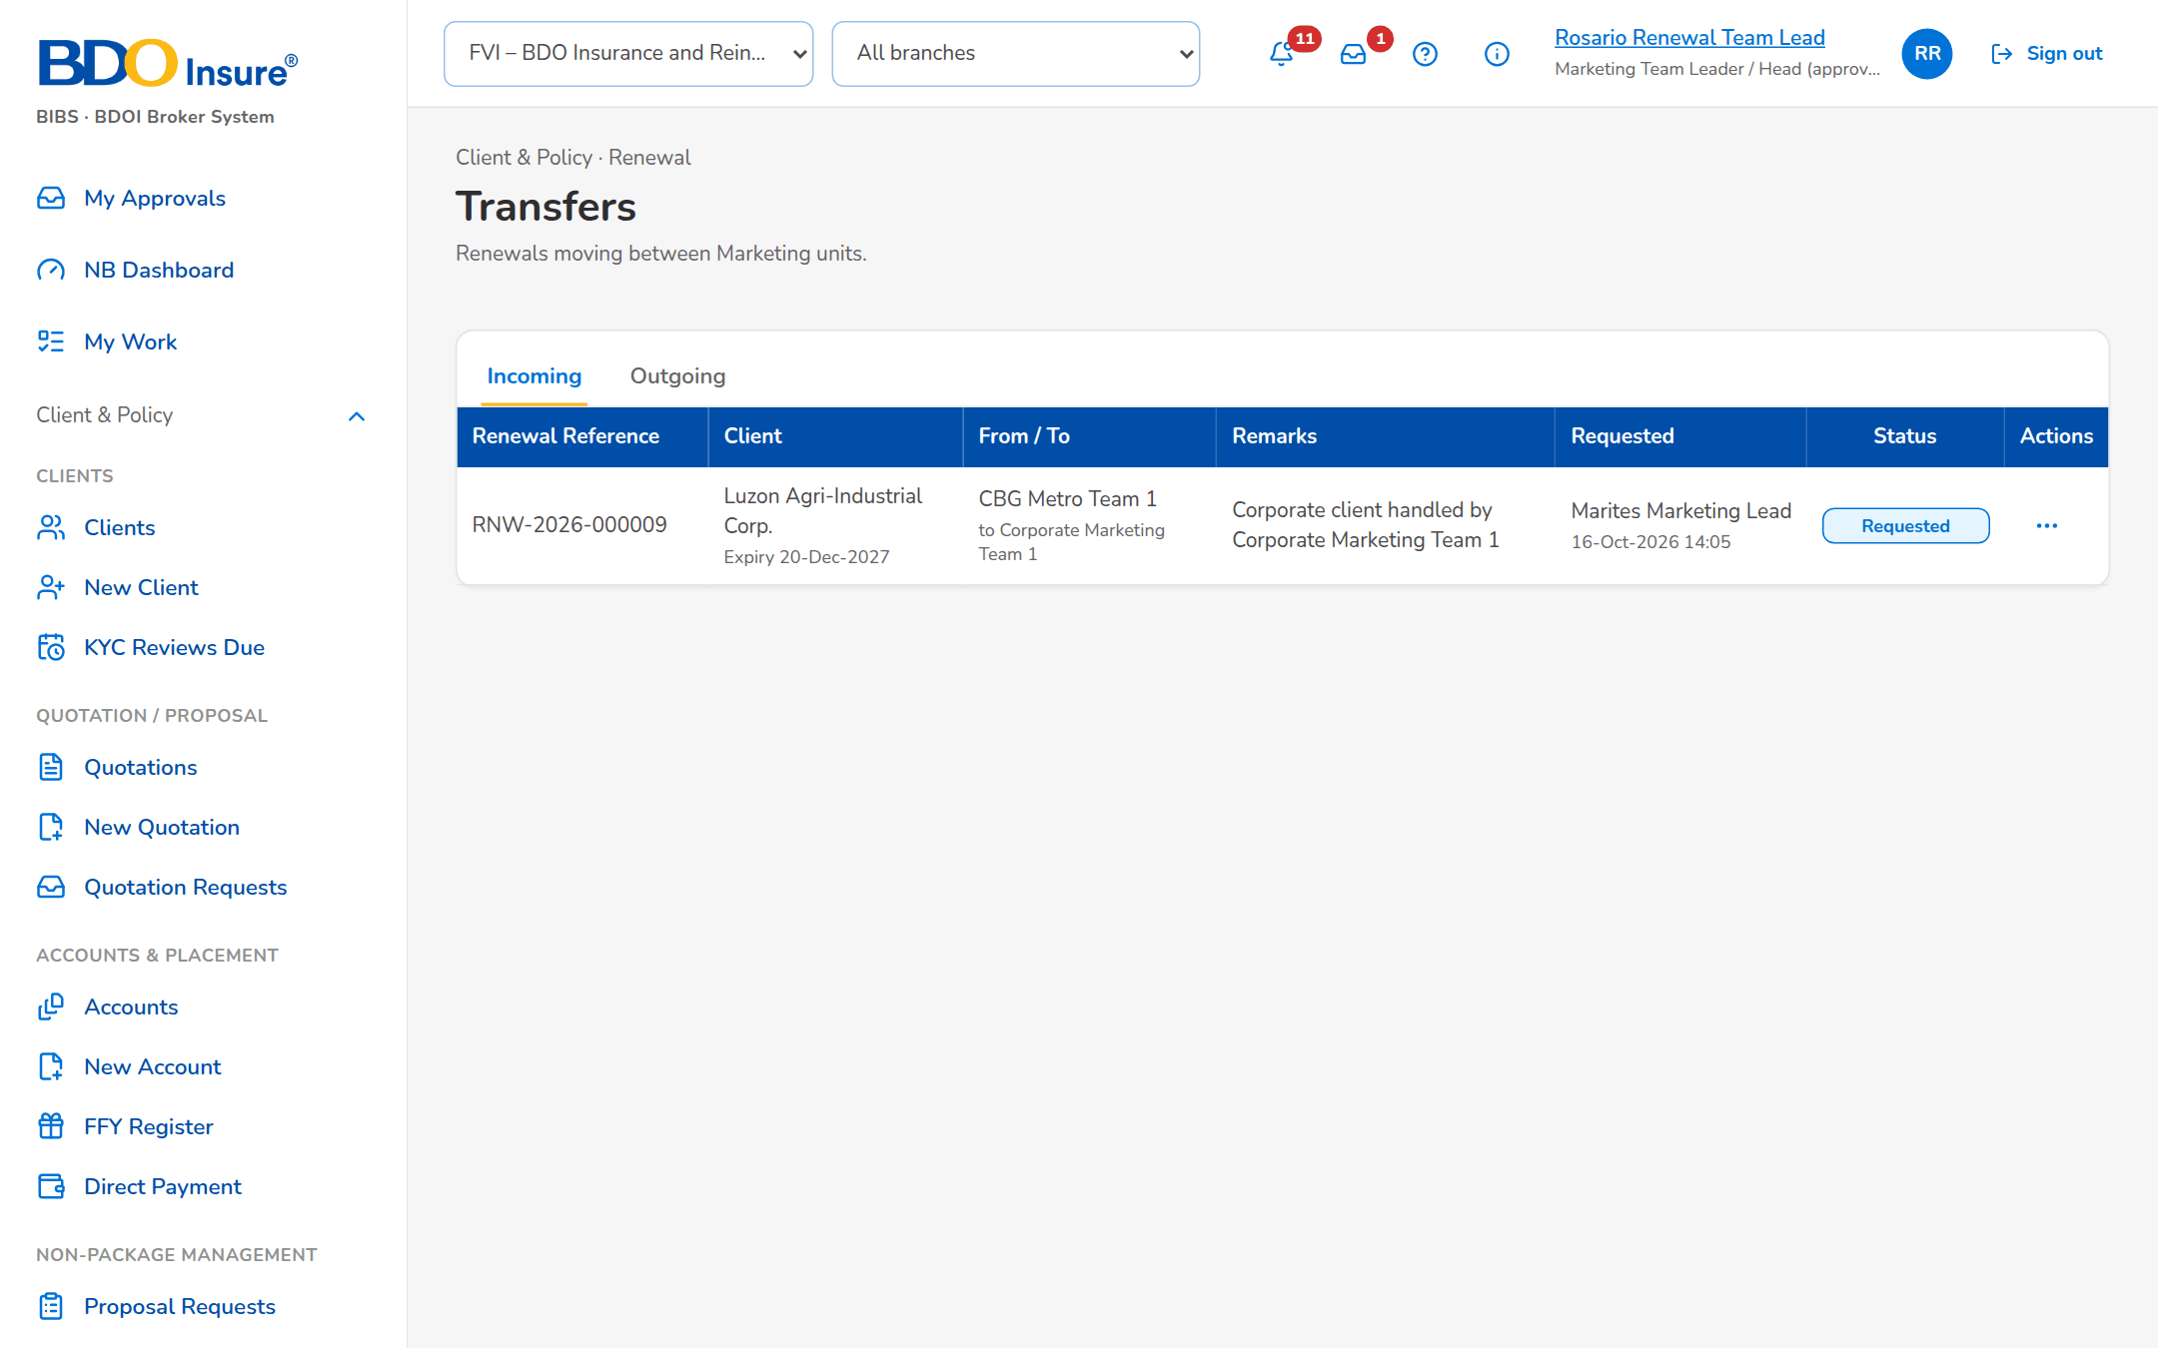
Figure 17: SCR-RN-09: Transfers, Incoming: the request from another unit with its row action menu

SCR-RN-10 Processing Worklist
Item | Value
Purpose | The renewals posted For Renewal, by tab: for processing, in processing, with the insurer, insurer responded and returned. The Processing Team Leader assigns a Processing Officer (or takes them); the officer creates the renewal account and works the renewal; a renewal that cannot proceed is returned to Marketing with a reason. The dispositioned file of Marketing is uploaded here.
Access | Client & Policy › Renewal › Processing Worklist; Renewal Home › Insurer reply overdue; Notification Renewal posted
Requirements | FRRN.003, FRRN.005, FRRN.010, FRRN.015, FRRN.031
Outcome | The posted renewals are processed by their officers.

Rules and states:
• A renewal is assigned to one Processing Officer at a time; the Team Leader may re-assign it.
• The renewal account is created once, from the expiring account, and books as business type Renewal.
• A return to Marketing needs a reason and remarks; the renewal goes back to the officer or to the Team Leader.
• A file declared complete tags the renewals of the range and unit missing from it as not in the file.
Table 20: SCR-RN-10 fields
Field | Type | Req. | Default | Rule | Message
Tabs: For Processing / In Processing / With Insurer / Insurer Responded / Returned | Tab | - | For Processing | Source: Processing stage | -
Quick filters: Assigned to me / Due in 30 days | Toggle button | - | None | One at a time | -
List: [Columns of the renewal lists] | Column | - | - | As on the Expiry List (SCR-RN-02); Source: Renewals; Editable: Read only | No renewals to display
Assign Processing Officer dialog: Processing Officer | Drop-down | Y | Blank | Name of the officer; Source: Processing Officers; Editable: For Processing, In Processing; Active Processing Officer | <officer> is not a Processing Officer
Return to Marketing dialog: Return to | Drop-down | Y | Account Officer | Account Officer or Team Leader; Source: Fixed list; Editable: For Processing, In Processing | -
Return to Marketing dialog: Reason / Remarks | Drop-down, text area | Y / Y | Blank | Renewal return reason list; up to 200 characters; Source: Renewal return reason; Editable: For Processing, In Processing | Select a reason for 'Return to Marketing'
Upload Dispositions: [Upload wizard: Renewal Reference, Disposition, Reason, New Invoice No, Remarks] | Upload | - | - | Template of the dispositioned file; Source: Renewals; Editable: For Disposition; Every row checked before anything is saved | Disposition <disposition> is not valid
Complete file: Expiry From / Expiry To / Unit | Date, date, text | Y | Blank | The expiry range and the unit the file covers; Editable: After the upload | Enter the expiry range and the unit of the complete file

Table 21: SCR-RN-10 actions
Action | Who | Available when | What happens | Result
Assign PO | Processing Team Leader | Renewals ticked | Opens the dialog; Assign gives the renewals to the officer | In Processing; Renewal assigned (notice NT-01)
Assign to Me | Processing Team Leader | Renewals ticked | Assigns the renewals to the user | In Processing
Return to Marketing | Processing Team Leader and Officers | Renewals ticked | Opens the dialog; the renewal goes back to the officer or the Team Leader | For Disposition or Review in Progress; Renewal returned (notice NT-04)
Upload Dispositions | Processing Team Leader and Officers (upload permission) | Always | Opens the upload of the dispositioned file; Declare Complete File tags the renewals of the range and unit missing from it | For Disposition with the dispositions of the file
Create Renewal Account (renewal) | Processing Officers | For Processing or In Processing without a renewal account | Creates the renewal account (business type Renewal) from the expiring account | -

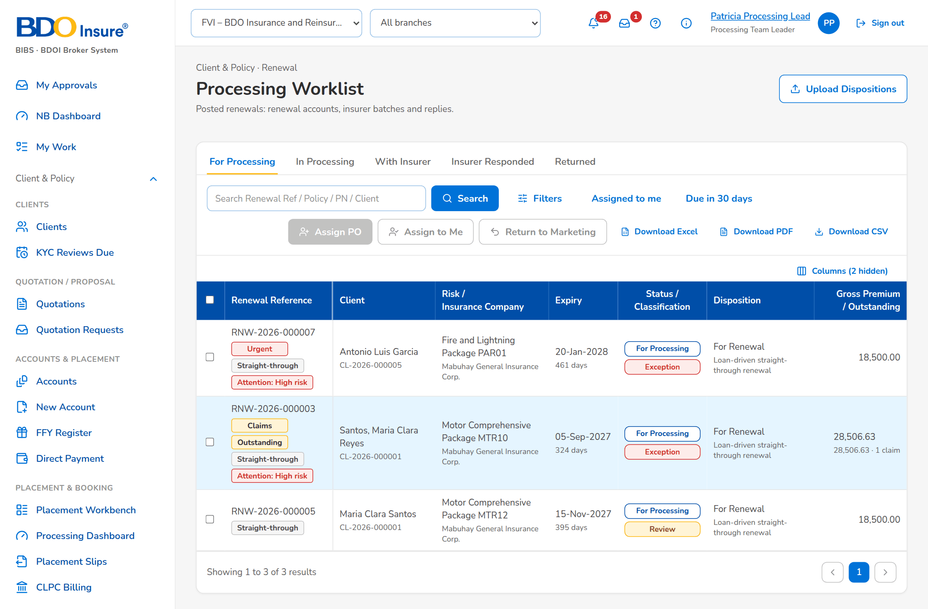
Figure 18: SCR-RN-10: Processing Worklist of the Processing Team Leader with the actions of the tab
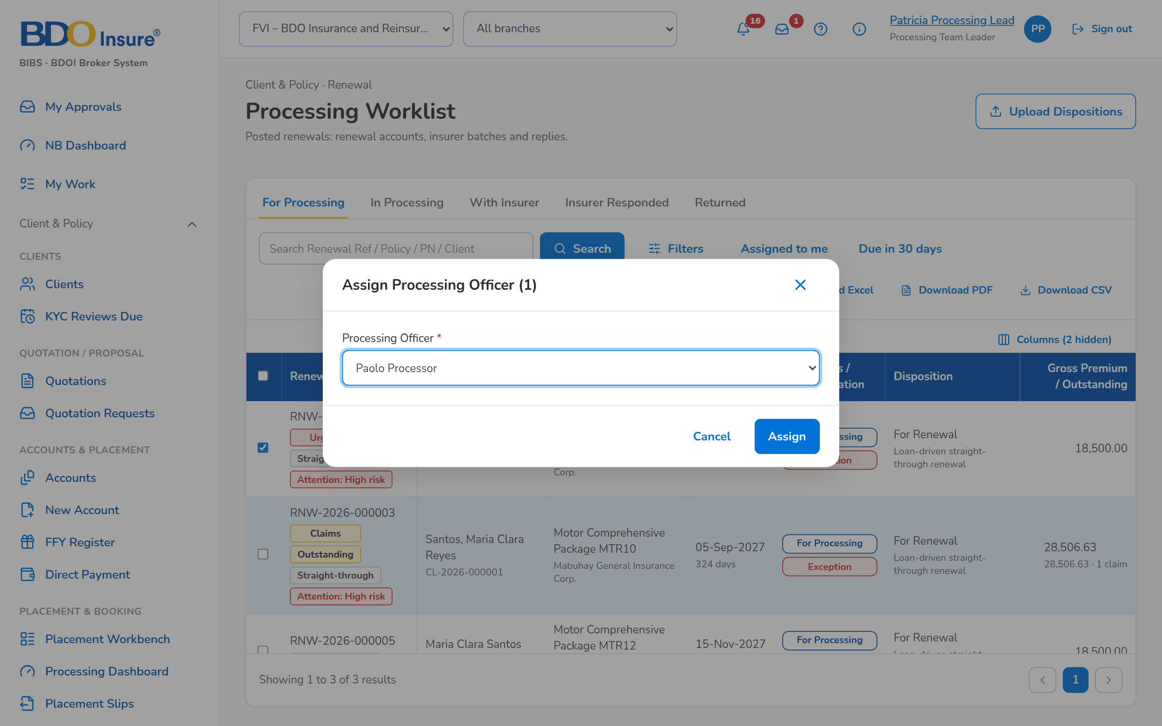
Figure 19: SCR-RN-10: Assign Processing Officer dialog
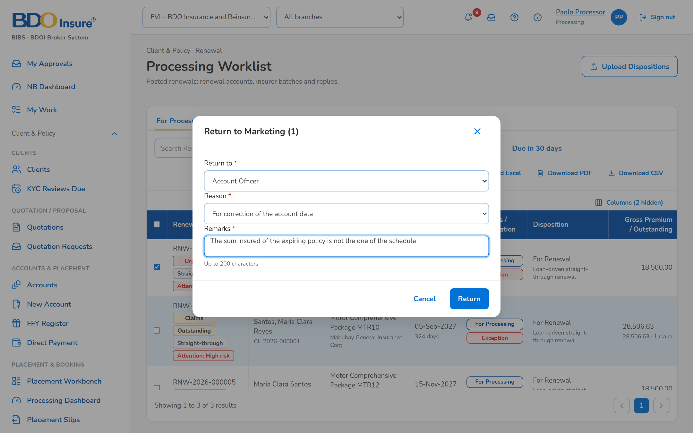
Figure 20: SCR-RN-10: Return to Marketing dialog: to the officer or the Team Leader, with the reason

SCR-RN-11 Insurer Batches
Item | Value
Purpose | The renewals sent to each insurer for its renewal terms: New Batch takes the renewals of an insurer in processing for an expiry range with the 28 columns of the insurer extract; the batch is downloaded or sent to the insurer, protected; Upload Insurer Responses records the replies of the insurer's file.
Access | Client & Policy › Renewal › Insurer Batches
Requirements | FRRN.013, FRRN.021
Outcome | The insurers receive the renewals and their decisions are recorded.

Rules and states:
• A batch takes the For Renewal renewals of one insurer in processing for the expiry range; a batch is sent once.
• The insurer has the reply days (10 by default) to answer; a batch past its reply date raises the insurer overdue alert.
• Responses are captured once and kept; Renew As Is with a match moves the renewal to the Renewal Advice without re-keying; a revision raises the financial impact; a rejection re-markets or closes the renewal.
Table 22: SCR-RN-11 fields
Field | Type | Req. | Default | Rule | Message
List: Batch / Insurance Company / Expiry range | Column | - | - | Batch number; name of the insurer; the range as a period; Source: Insurer batches; Editable: Read only | No insurer batches
List: Renewals / Sent / Reply due / Status | Column | - | - | Number of renewals; time and the sender's name; dd-MMM-yyyy; Draft, Sent, Partially Responded or Closed; Source: Insurer batches; Editable: Read only | -
Batch: Responded / [the 28 columns of the insurer extract] | Table | - | - | Yes or No for each renewal; Insurance Company, Invoice No, Assured Name, Risk Code, Inception Date, Expiry Date, Sum Insured, Premium Amount and the other columns of FRS section 6.4; Source: Renewals of the batch; Editable: Read only | -
New insurer batch dialog: Insurance Company | Drop-down | Y | Blank | Name of the insurer; Source: Insurers of the renewals; Editable: New | Select the insurer
New insurer batch dialog: Expiry From / Expiry To | Date | Y | Blank | dd-MMM-yyyy; the end on or after the start; Editable: New; Valid range | Enter a valid start and end date
Upload Insurer Responses: [Upload wizard: Renewal Reference, Policy No, Response, Insurer Reference, Revised Premium, Revised Sum Insured, Revised Rate, Terms, Received On, Reject Action, Remarks] | Upload | - | - | Template of the insurer responses; Source: Renewals with the insurer; Editable: With Insurer; Every row checked before anything is saved | Response <response> is not valid

Table 23: SCR-RN-11 actions
Action | Who | Available when | What happens | Result
New Batch | Processing (insurer permission) | Always | Opens the dialog; Create Batch takes the renewals of the insurer in the range | Draft
Download | Every user of the screen | A batch is open | Downloads the insurer extract | -
Send to Insurer | Processing (insurer permission) | Draft | Asks for confirmation; the extract is e-mailed protected to the insurer's renewal contacts | Sent; the renewals With Insurer; Insurer extract e-mail (notice NT-18)
Upload Insurer Responses | Processing (insurer permission) | Always | Opens the upload of the insurer's file; each response is matched to its renewal | Insurer Responded; Insurer renewal response (notice NT-06)
Close | Every user of the screen | A batch is open | Closes the batch | -

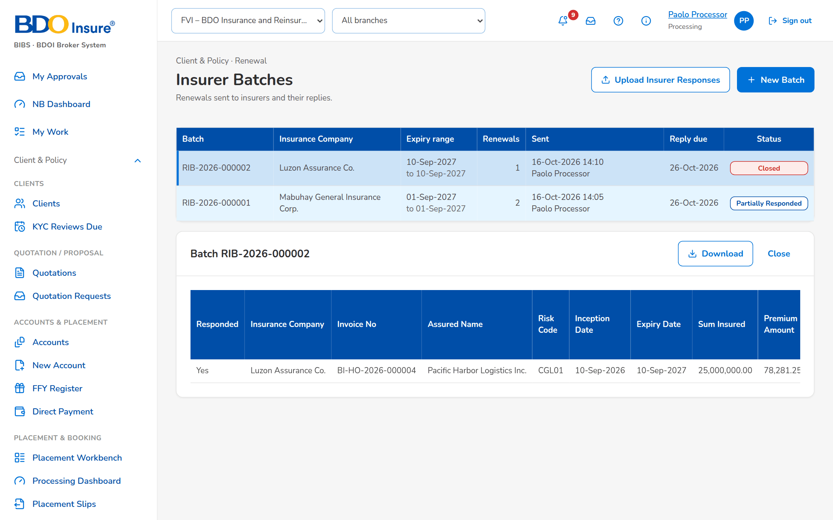
Figure 21: SCR-RN-11: Insurer Batches with the batch opened: the renewals and the columns of the extract
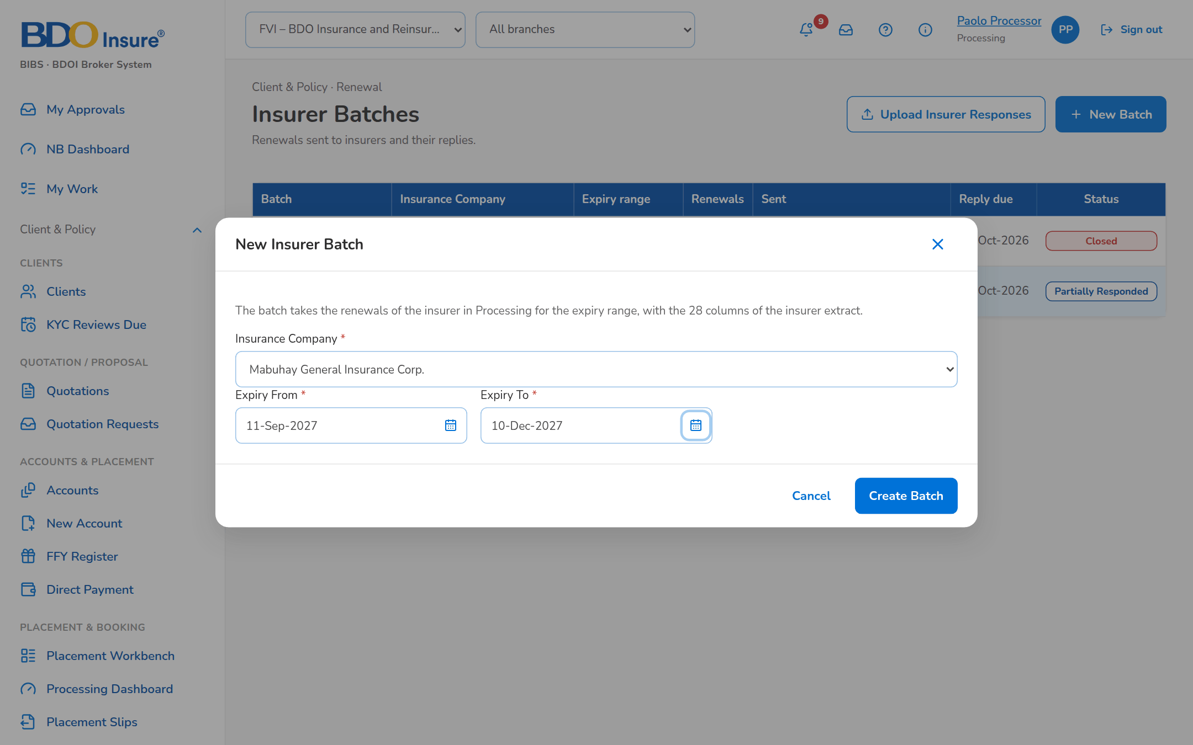
Figure 22: SCR-RN-11: New insurer batch dialog: the insurer and the expiry range

SCR-RN-12 Record Insurer Response
Item | Value
Purpose | The insurer's answer for one renewal, recorded by hand when it does not come in the insurer's file: renew as is, renew with revised terms (the revised premium and sum insured) or declined, with the insurer reference and the date received; a declined renewal is re-marketed to another insurer or goes to the No Advice Letter.
Access | Processing Team Lead and Officer (insurer permission).
Requirements | FRRN.013
Outcome | The insurer's decision drives the renewal without re-keying.

Rules and states:
• A late, conflicting or mismatched response does not move the renewal; the mismatch is overridden by the Team Leader with remarks.
• Revised terms are a financial impact: the client accepts them explicitly.
Table 24: SCR-RN-12 fields
Field | Type | Req. | Default | Rule | Message
Record Insurer Response dialog: Response | Drop-down | Y | Renew as is | Renew as is, Renew with revised terms, Declined; Source: Insurer renewal response; Editable: With Insurer | -
Record Insurer Response dialog: Insurer Reference | Text | N | Blank | Reference of the insurer; Editable: With Insurer | -
Record Insurer Response dialog: Revised Premium / Revised Sum Insured | Amount | Cond.: revised terms (premium) / N | Blank | Two decimals; Editable: With Insurer; Above zero | Enter the revised premium
Record Insurer Response dialog: Received On | Date | N | Today | dd-MMM-yyyy; Editable: With Insurer | -
Record Insurer Response dialog: Re-market to another insurer | Check box | N | Unticked | Declined only; Editable: With Insurer | -
Record Insurer Response dialog: Remarks | Text area | N | Blank | Up to 200 characters; Editable: With Insurer; At most 200 characters | Remarks may have at most 200 characters

Table 25: SCR-RN-12 actions
Action | Who | Available when | What happens | Result
Record Insurer Response | Processing (insurer permission) | With Insurer | Opens the dialog; Record keeps the response, which drives the renewal when it is the latest valid one | RA Ready, In Processing (revised terms), For Disposition (re-market) or Letter Pending (declined); Insurer renewal response (notice NT-06)

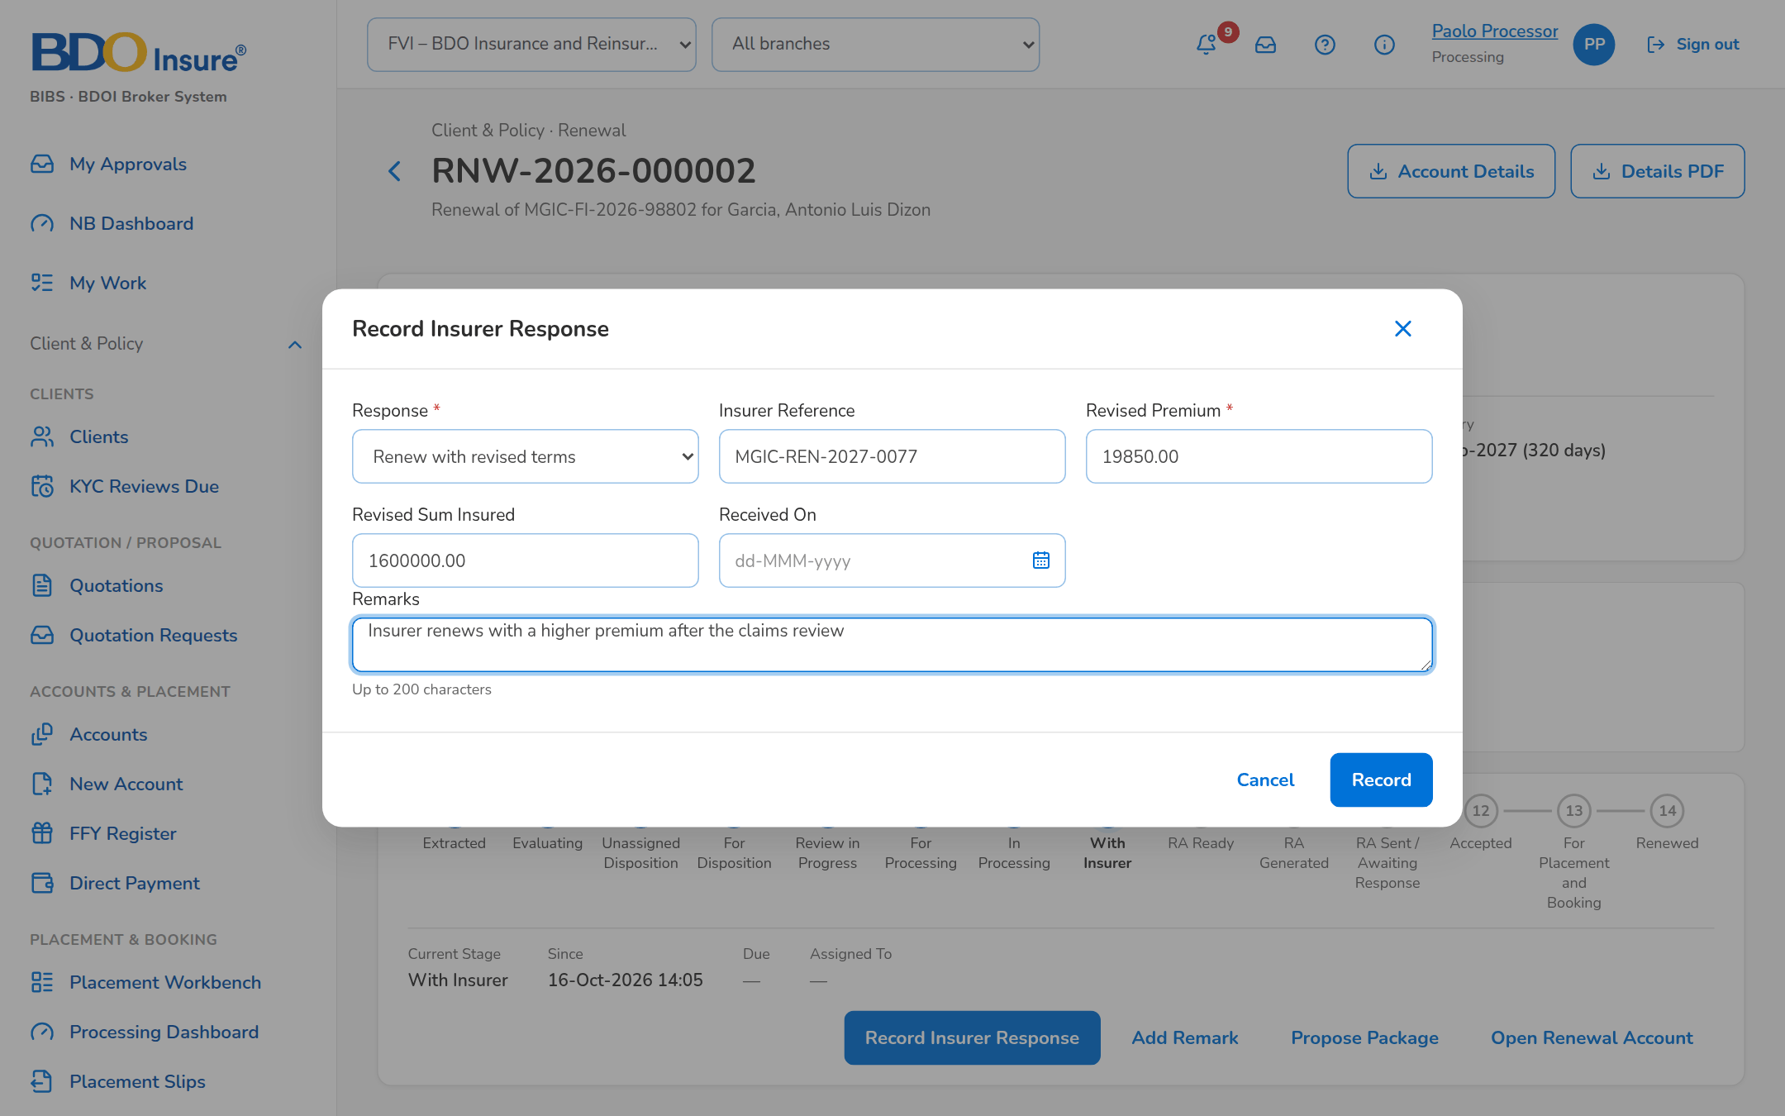
Figure 23: SCR-RN-12: Record Insurer Response dialog: renew with revised terms

SCR-RN-13 Letters
Item | Value
Purpose | The letters of the renewals by tab: RA Ready (generate the Renewal Advice, first or second notice), RA Generated (send it, protected, to the client), RA Sent, NAL / NFR (send the No Advice or Not for Renewal letter that closes the renewal) and NRNS (renewals with no response). Client acceptances are recorded on the renewal or uploaded here.
Access | Client & Policy › Renewal › Letters; Renewal Home › NRNS or Letters failed
Requirements | FRRN.022, FRRN.023, FRRN.024
Outcome | The clients receive their Renewal Advice or closing letter.

Rules and states:
• A Renewal Advice is generated only for renewals without a failing blocking check, from the latest approved template.
• A Renewal Advice generated fewer days than the minimum notice before expiry (30 by default) needs the confirmation, which is recorded.
• The second notice is offered the second-notice days (15 by default) after the first without acceptance.
• Renewal Advices are sent one protected e-mail per client with the password in a separate e-mail; every send and failure is recorded.
• A reason for Not for Renewal of the No Advice list is answered with the No Advice Letter, the others with the Not for Renewal Letter.
Table 26: SCR-RN-13 fields
Field | Type | Req. | Default | Rule | Message
Tabs: RA Ready / RA Generated / RA Sent / NAL / NFR / NRNS | Tab | - | RA Ready | Source: Letter stage of the renewal | -
List: [Columns of the renewal lists] | Column | - | - | As on the Expiry List (SCR-RN-02); Source: Renewals; Editable: Read only | No renewals to display
Generate Renewal Advice dialog: Notice | Drop-down | Y | First notice | First notice or Second notice; Source: Fixed list; Editable: RA Ready, RA Sent, NRNS; The second notice after the days from the first | The second notice of <renewal ref> is due <ra second notice days> days after the first
Generate Renewal Advice dialog: Generate also when the minimum notice before expiry has passed (the confirmation is recorded) | Check box | Cond.: fewer than 30 days to expiry | Unticked | Editable: RA Ready | Renewal <renewal ref> expires in <days> day(s): confirm the late Renewal Advice
Upload Acceptances: [Upload wizard: Renewal Reference, Method, Evidence Reference, Accepted On, Remarks] | Upload | - | - | Template of the client acceptances; Source: Renewals; Editable: RA Sent / Awaiting Response; Every row checked before anything is saved | Method <method> is not valid (E-mail or Payment)

Table 27: SCR-RN-13 actions
Action | Who | Available when | What happens | Result
Generate RA | Marketing and Processing (generate permission) | Tab RA Ready, RA Sent or NRNS, renewals ticked | Opens the dialog; Generate creates the Renewal Advice from the latest template and locks the renewal on the Marketing side | RA Generated
Send | Marketing and Processing (send permission) | Tab RA Generated, renewals ticked | Asks for confirmation; the Renewal Advice is e-mailed protected to the client | RA Sent / Awaiting Response; Renewal Advice e-mail and password (notice NT-16, NT-17)
Send Letters | Users with the generate and send permissions | Tab NAL / NFR, renewals ticked | Asks for confirmation; the No Advice or Not for Renewal letter is generated and e-mailed and the renewal is closed | Closed; Closing letter e-mail (notice NT-19)
Upload Acceptances | Users with the acceptance permission | Always | Opens the upload of the client acceptances | Accepted; Renewal accepted (notice NT-07)

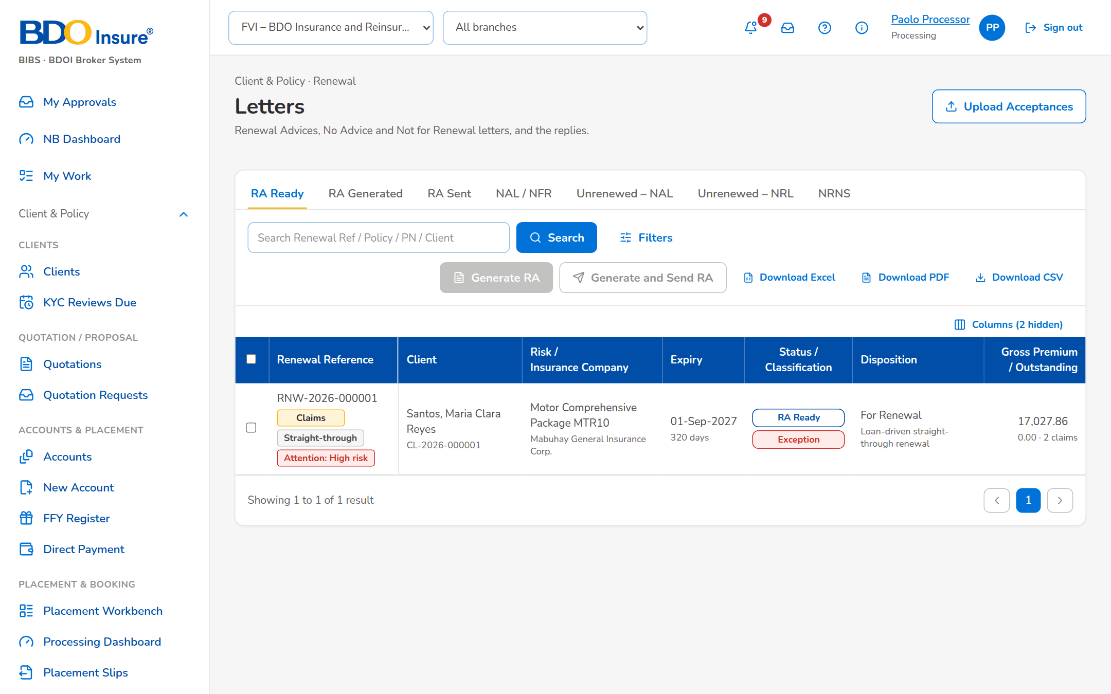
Figure 24: SCR-RN-13: Letters, tab RA Ready: the renewals whose Renewal Advice can be generated
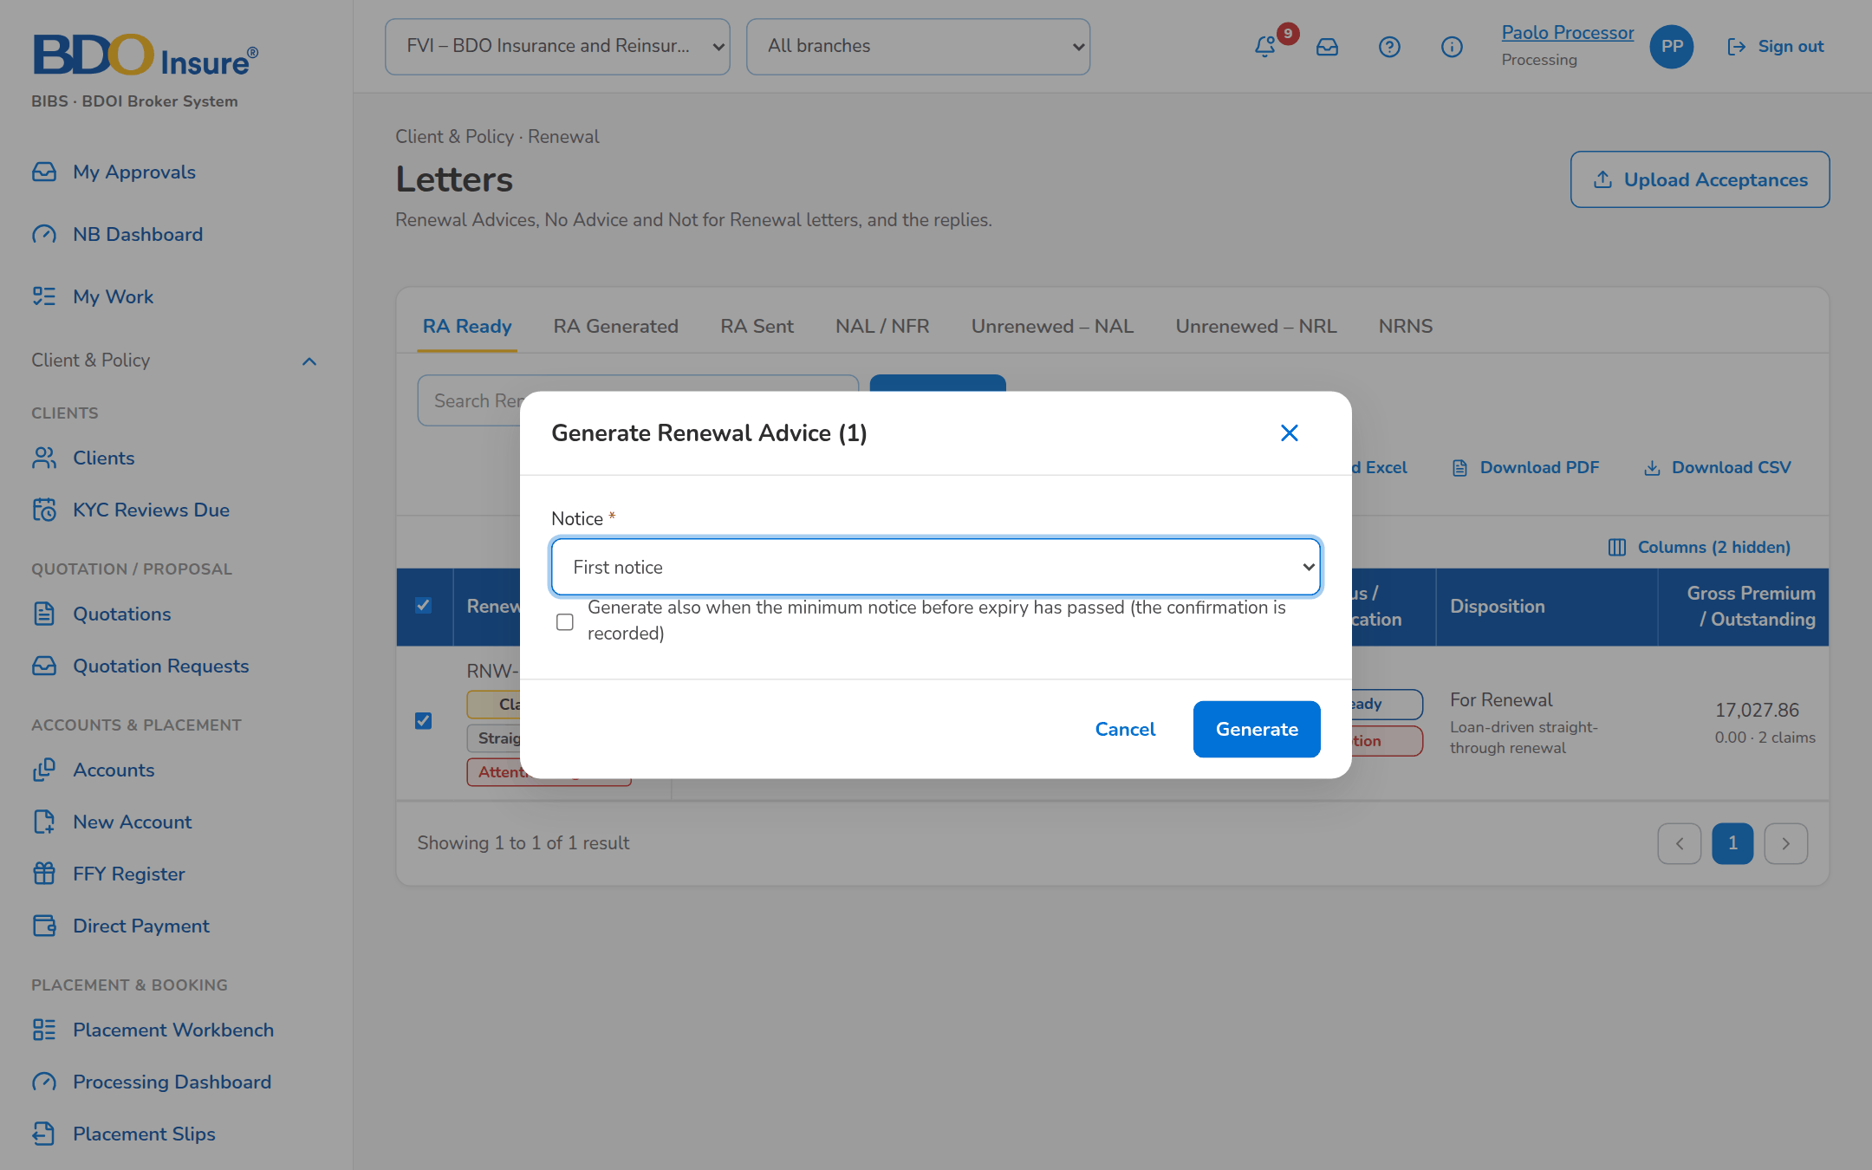
Figure 25: SCR-RN-13: Generate Renewal Advice dialog: first or second notice and the confirmation of a late Renewal Advice
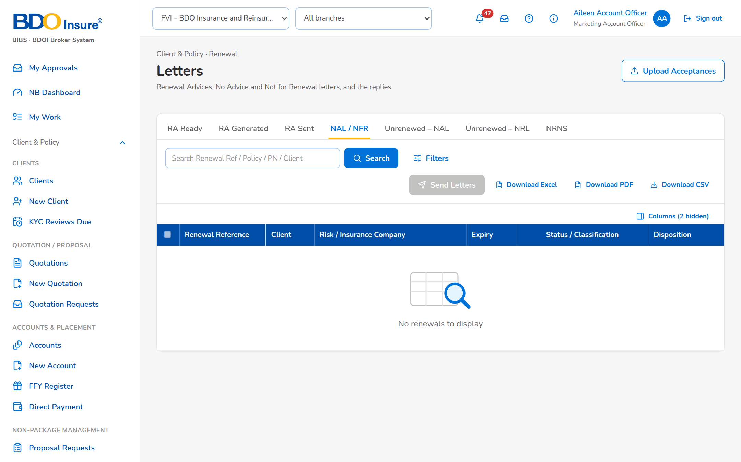
Figure 26: SCR-RN-13: Letters, tab NAL / NFR: the renewals waiting for their closing letter

SCR-RN-14 Record Acceptance
Item | Value
Purpose | The client's acceptance of the Renewal Advice: by e-mail or signed Renewal Advice (the file uploaded in the Documents tab first) or by payment (with its reference), with the date and remarks. When the renewal terms differ from the expiring terms, the user confirms that the client acknowledged the change. Once accepted, the renewal account goes to placement and booking without re-keying.
Access | Account Officer, Marketing Team Lead, Processing (accept permission).
Requirements | FRRN.025
Outcome | The accepted renewal goes to placement and booking.

Rules and states:
• The acceptance is refused while a blocking check fails.
• Acceptance moves the renewal account to placement and booking under the standard New Business payment rules; the renewal books as business type Renewal.
Table 28: SCR-RN-14 fields
Field | Type | Req. | Default | Rule | Message
Record Acceptance dialog: Method | Drop-down | Y | E-mail from the client | E-mail from the client, Signed Renewal Advice, Payment; Source: Fixed list; Editable: RA Sent / Awaiting Response | Select the acceptance method
Record Acceptance dialog: Evidence | Drop-down | Cond.: e-mail or signed Renewal Advice | Blank | A document of the renewal (Documents tab); Source: Documents of the renewal; Editable: RA Sent / Awaiting Response; A document of this renewal | The evidence is not a document of this renewal
Record Acceptance dialog: Payment Reference / Reference | Text | Cond.: payment | Blank | The payment or e-mail reference; Editable: RA Sent / Awaiting Response | -
Record Acceptance dialog: Accepted On | Date | N | Today | dd-MMM-yyyy; Editable: RA Sent / Awaiting Response; Not in the future | The acceptance date cannot be in the future
Record Acceptance dialog: The client acknowledged the change of premium from the expiring terms | Check box | Cond.: financial impact | Unticked | Editable: RA Sent / Awaiting Response | The renewal terms differ from the expiring terms: confirm that the client accepted them
Record Acceptance dialog: Remarks | Text area | N | Blank | Up to 200 characters; Editable: RA Sent / Awaiting Response | -

Table 29: SCR-RN-14 actions
Action | Who | Available when | What happens | Result
Record Acceptance | Marketing and Processing (acceptance permission) | RA Sent / Awaiting Response | Opens the dialog; Record keeps the acceptance and moves the renewal account on to placement and booking | Accepted, then For Placement and Booking; Renewal accepted (notice NT-07)

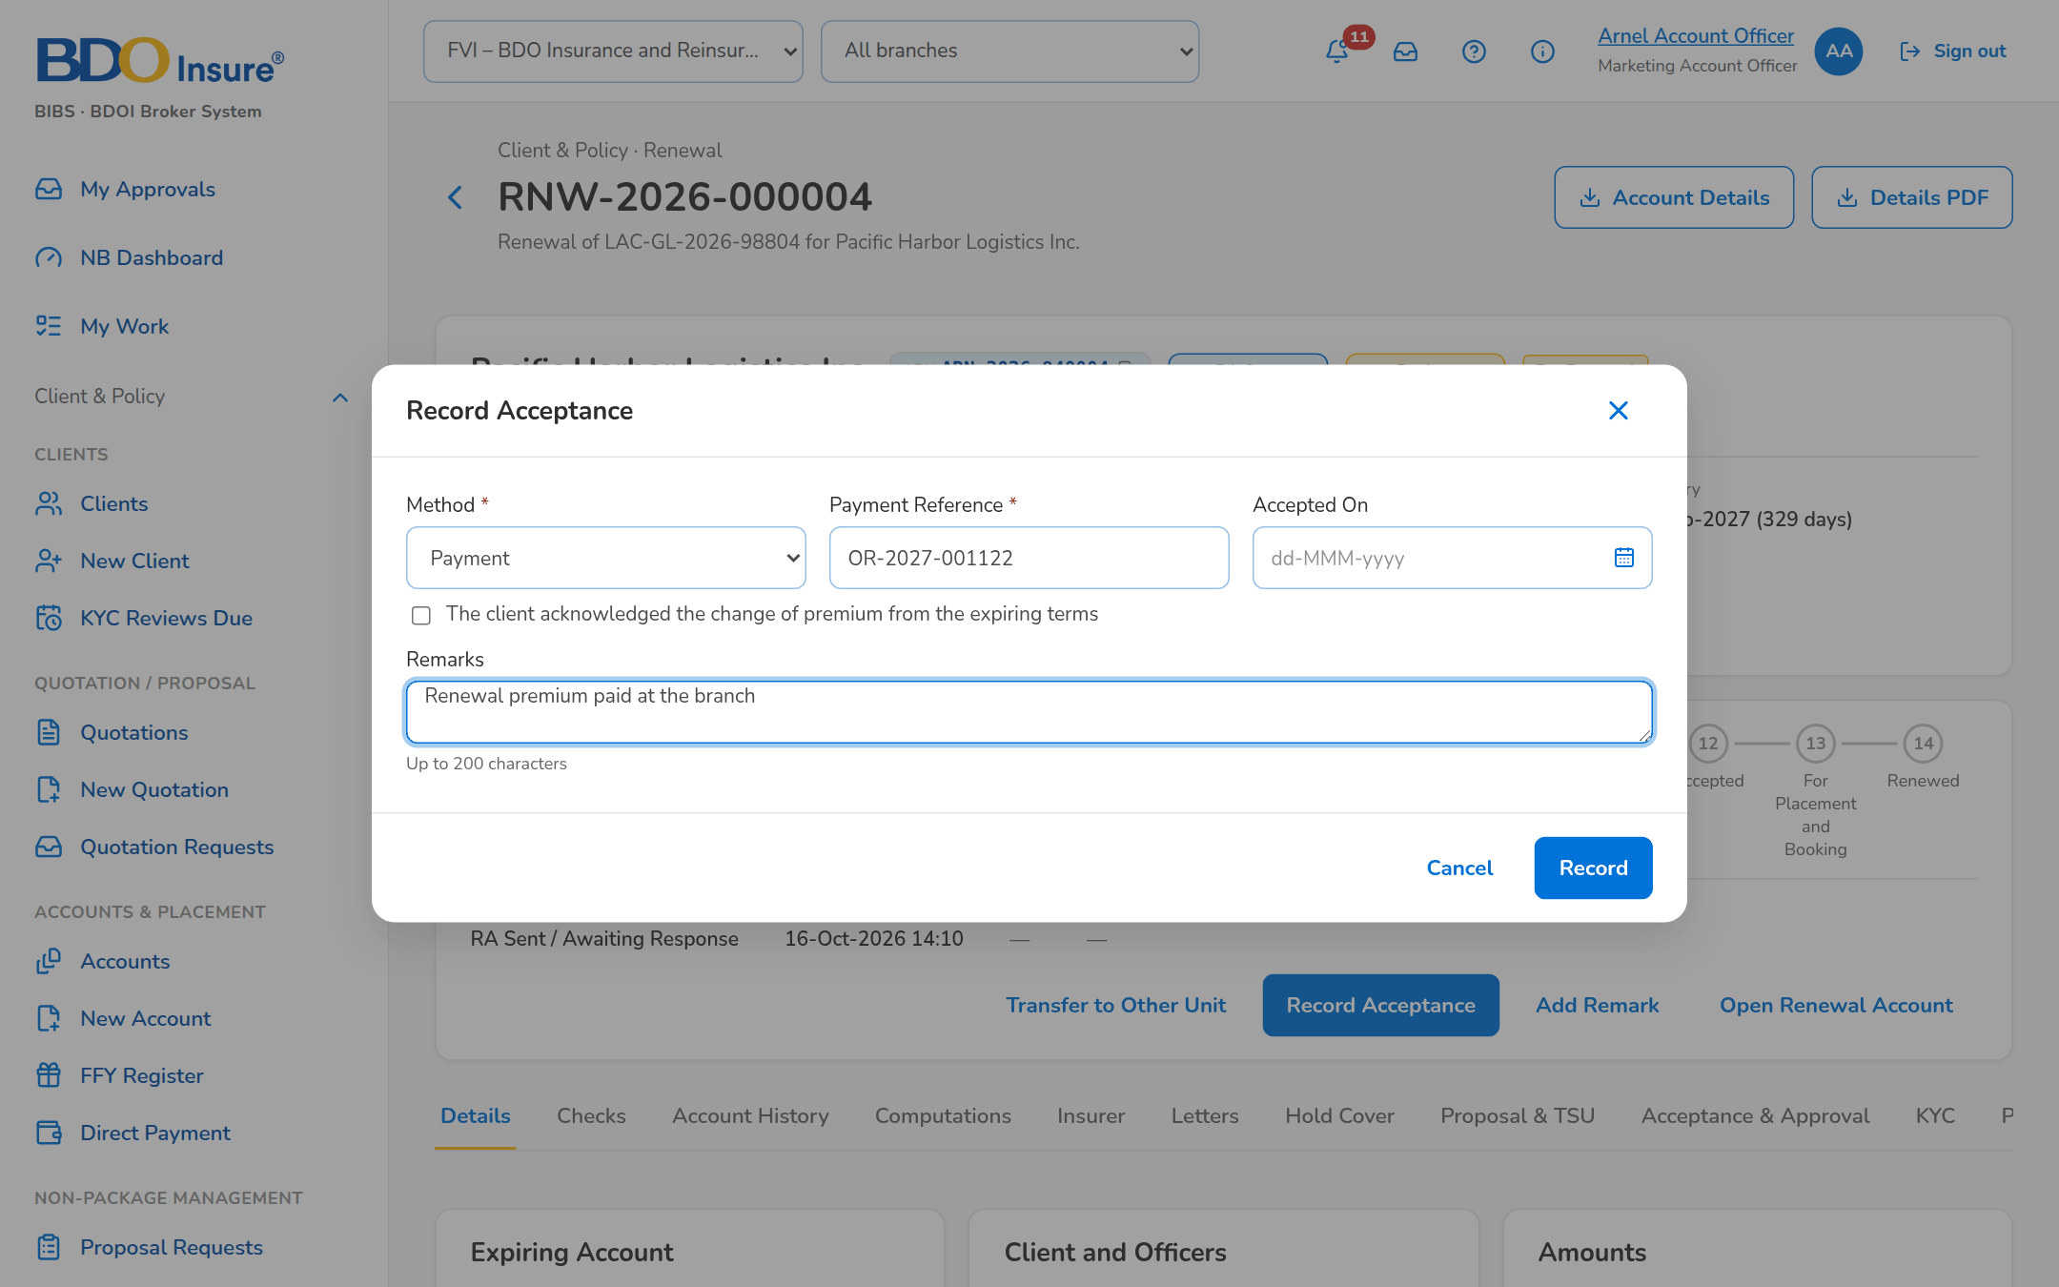
Figure 27: SCR-RN-14: Record Acceptance dialog: acceptance by payment with its reference

SCR-RN-15 Follow-ups
Item | Value
Purpose | The renewals waiting for the client's reply after the Renewal Advice, for the Contact Center, with the renewals with no response and those on the quotation or proposal path. The Contact Center user opens a renewal to record a call, e-mail or SMS with its outcome and next action date, and uploads the client's documents.
Access | Client & Policy › Renewal › Follow-ups
Requirements | FRRN.023, FRRN.047
Outcome | The client's replies are recorded for the officers.

Rules and states:
• The Contact Center sees the renewals without the premium amounts and never changes the disposition, the letters or the placement.
• A renewal not yet submitted at the reminder days before expiry (90 by default) is flagged NRNS and its reminder letter is sent.
Table 30: SCR-RN-15 fields
Field | Type | Req. | Default | Rule | Message
Tabs: RA Sent / NRNS / Quotation / Proposal | Tab | - | RA Sent | Source: Stage of the renewal | -
Quick filters: Due in 30 days / KYC due | Toggle button | - | None | One at a time | -
List: [Columns of the renewal lists] | Column | - | - | As on the Expiry List (SCR-RN-02), without the premium amounts; Source: Renewals; Editable: Read only | No renewals to follow up
Add Follow-up dialog: Channel / Outcome | Drop-down | Y / Y | Blank | Renewal follow-up channel; renewal follow-up outcome; Source: Lists of values; Editable: Any open stage | Select the channel and the outcome
Add Follow-up dialog: Next Action Date | Date | N | Blank | dd-MMM-yyyy, from today on; Editable: Any open stage; Not in the past | The next action date cannot be in the past
Add Follow-up dialog: Remarks | Text area | Y | Blank | Up to 200 characters; Editable: Any open stage; Not blank | Enter the remarks

Table 31: SCR-RN-15 actions
Action | Who | Available when | What happens | Result
Add Follow-up (renewal) | Contact Center | Any open stage | Opens the dialog; Save keeps the follow-up on the Remarks & Follow-ups tab | -
[Row] | Contact Center | Always | Opens the renewal | -

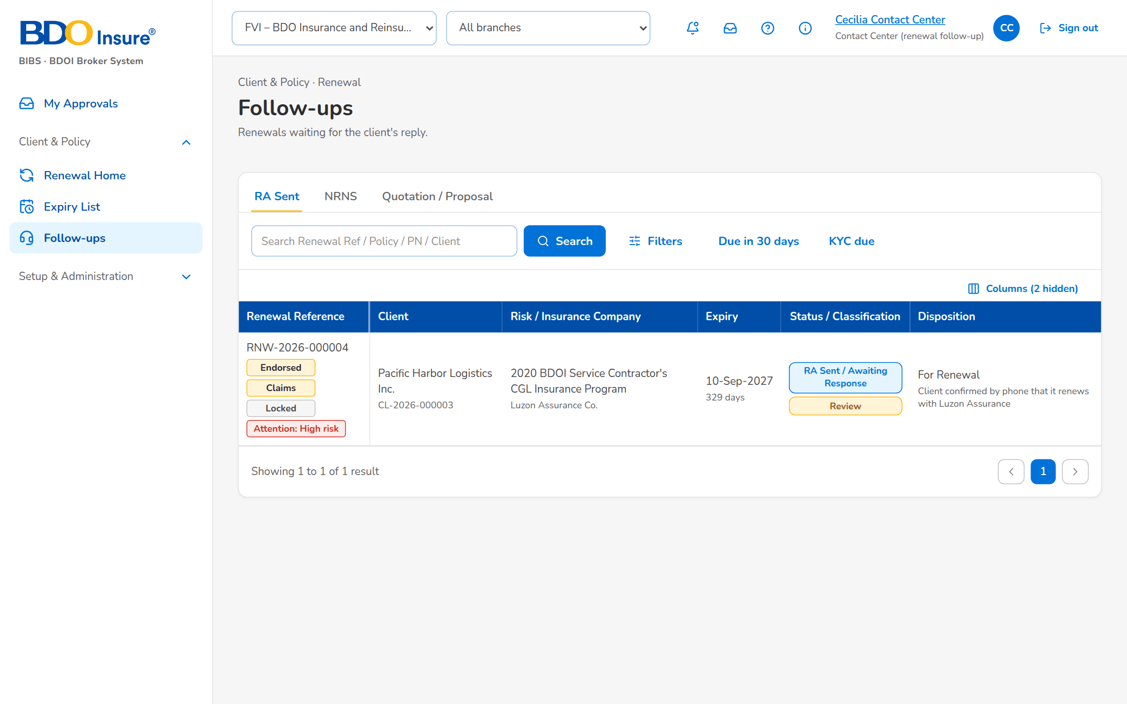
Figure 28: SCR-RN-15: Follow-ups of the Contact Center, tab RA Sent
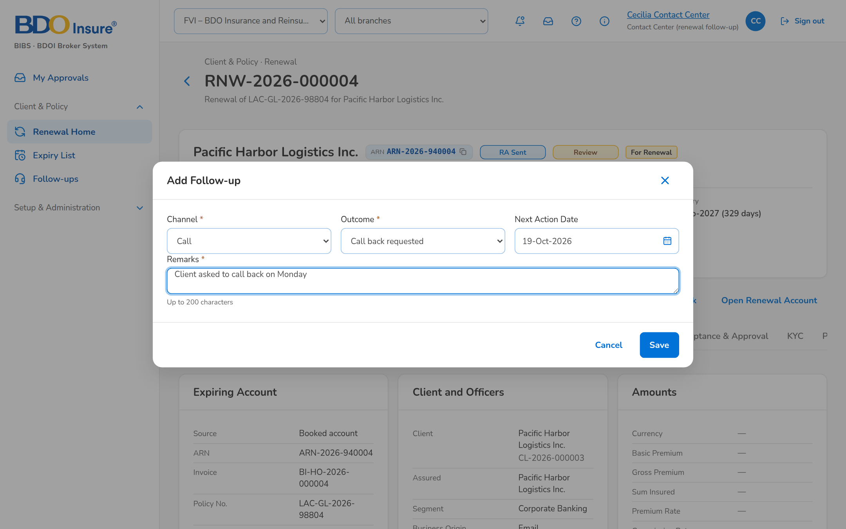
Figure 29: SCR-RN-15: Add Follow-up dialog: the channel, outcome, next action date and remarks

SCR-RN-16 LAMD Reports
Item | Value
Purpose | The monthly paid-off and past-due (RMU) loan reports of the Loan and Mortgage department. Each line is matched to the renewals by PN number: a paid-off loan proposes Not for Renewal, a past-due loan routes the renewal to the Team Leader of its unit.
Access | Client & Policy › Renewal › LAMD Reports
Requirements | FRRN.012
Outcome | The loan status of the mortgaged renewals is reflected before the disposition.

Rules and states:
• A paid-off loan proposes Not for Renewal (reason Loan fully paid); a past-due loan routes the renewal to the Team Leader.
• The LAMD role never places, books, sends letters or gives dispositions.
Table 32: SCR-RN-16 fields
Field | Type | Req. | Default | Rule | Message
Upload LAMD Report: Report / Month | Drop-down, month | Y / Y | Paid-off loans | Paid-off loans or RMU (past due); the month of the report; Source: Fixed list; Editable: New | Choose the period of the report
Upload LAMD Report: [Upload wizard: PN Number, Status Date, Borrower] | Upload | - | - | Template of the LAMD loan report; Editable: New; Every row checked before anything is saved | The row has no PN number
List: Report / Type / Month / Lines / Matched / Uploaded by / Uploaded | Column | - | - | Report number; Paid-off loans or RMU (past due); the month; counts; the user's name and the time; Source: LAMD reports; Editable: Read only | No LAMD reports uploaded
Lines: Row / PN / Borrower / Loan Status / Status date / Match / Renewal / Outcome | Column | - | - | The line of the report, the renewal matched and what followed; Source: LAMD lines; Editable: Read only | No lines

Table 33: SCR-RN-16 actions
Action | Who | Available when | What happens | Result
Upload LAMD Report | LAMD | Always | Opens the upload; each line is matched to the renewals by PN | Renewal assigned (notice NT-01) to the Team Leaders of the unit
[Row] | LAMD | Always | Opens the lines of the report | -

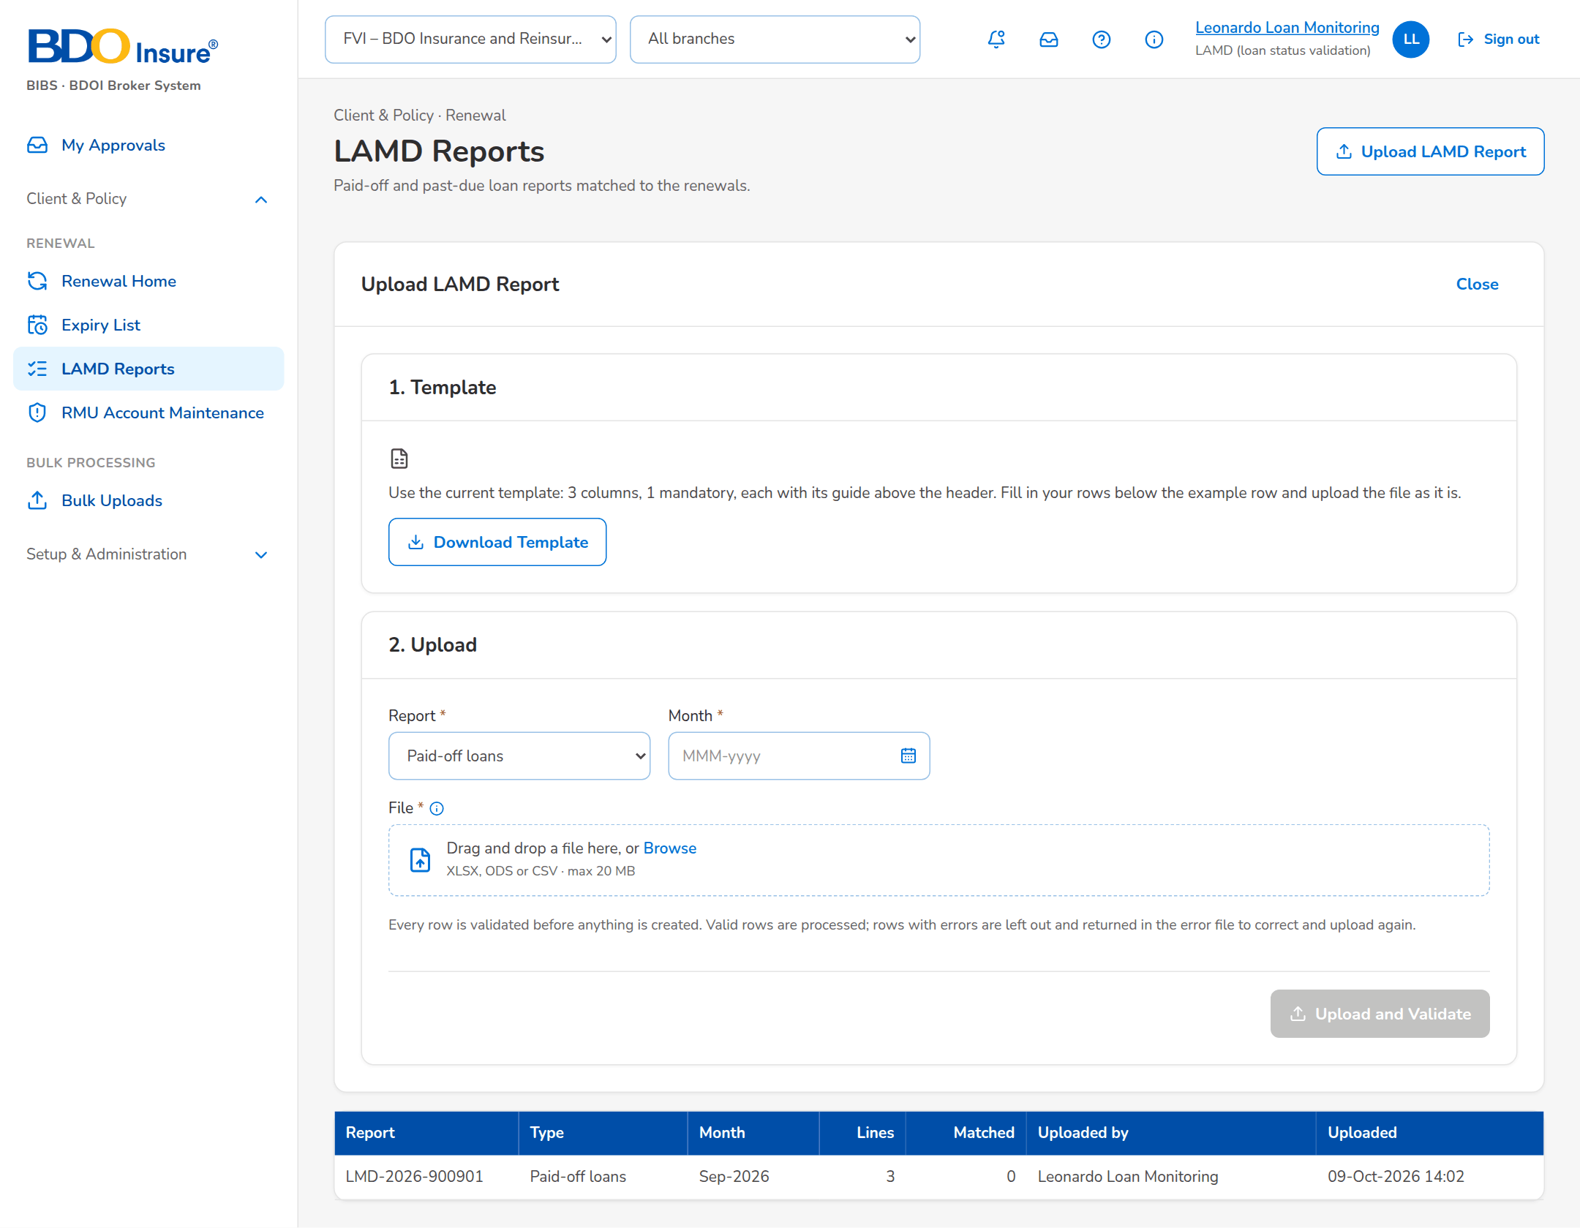
Figure 30: SCR-RN-16: LAMD Reports with the upload of a paid-off or past-due loan report

SCR-RN-17 Renewal Setup: Non-renewable Risk Codes and Checks
Item | Value
Purpose | The risk codes that are never renewed (the renewal gets Not for Renewal and the Not for Renewal Letter) and the sanitation checks with their severity and parameters. A new or changed risk code or check applies once another user authorizes it; a risk code is end-dated or deactivated, never deleted.
Access | Business Administrator; read only for the Team Leads.
Requirements | FRRN.006, FRRN.007, FRRN.038, FRRN.040
Outcome | The business keeps the non-renewable risk codes and the checks.

Rules and states:
• A renewal whose risk code is non-renewable gets Not for Renewal (reason Non-renewable Accounts) by the system and its Not for Renewal Letter.
• The checks run on initiation and again when the expiring account changes; their severity decides the classification through the classification rules.
• Maker-checker: the maker of a change cannot authorize it.
Table 34: SCR-RN-17 fields
Field | Type | Req. | Default | Rule | Message
Tabs: Non-renewable Risk Codes / Checks / Classification Rules / Decision Matrix / Package Map / Package Choices / Go-live | Tab | - | Non-renewable Risk Codes | Source: By permission | -
Risk codes: Risk Code / Line / Reason / From / To / Status | Column | - | - | Code; name of the line or All; dates dd-MMM-yyyy; Active, Pending Authorization or Inactive with the maker's name; Source: Non-renewable risk codes; Editable: Read only | No non-renewable risk codes
Risk code dialog: Risk Code / Line of Business | Text | Y / N | Blank | The risk code; the line, blank for every line; Source: Product catalogue; Editable: Pending, Active; Not blank | Enter the risk code
Risk code dialog: Effective From / Effective To | Date | Y / N | Blank | dd-MMM-yyyy; the end after the start; Editable: Pending, Active; The end after the start | The effective-to date is before the effective-from date
Risk code dialog: Reason | Text | Y | Blank | Up to 200 characters; Editable: Pending, Active; Not blank | Enter the reason and the effective date
Checks: Check / Active / Severity / Parameters / Status | Column | - | - | Name of the check; Yes or No; Fail – Exception, Fail – Review, Warning, Information or System (sets the disposition); the settings of the check; Source: Check settings; Editable: Read only | No checks
Check dialog: Active / Severity / Parameters | Check box, drop-down, text | N / Y / N | As set | Optional settings of the check, e.g. days=30; Source: Severities; Editable: Pending, Active | Choose the severity of the check

Table 35: SCR-RN-17 actions
Action | Who | Available when | What happens | Result
New Risk Code | Business Administrator | Always | Opens the dialog; Save for Authorization keeps the code waiting for a second user | Pending Authorization
Authorize (row menu) | Another Business Administrator than the maker | Pending Authorization | Asks for confirmation; the change takes effect | Active
Edit (row menu) | Business Administrator | Always | Opens the dialog; the change waits for authorization | Pending Authorization
Deactivate (row menu) | Business Administrator | Active | Asks for confirmation; the code is no longer used for new renewals | Inactive

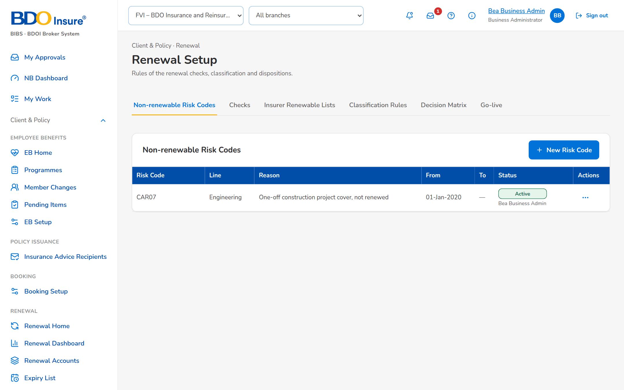
Figure 31: SCR-RN-17: Non-renewable Risk Codes with their row action menu
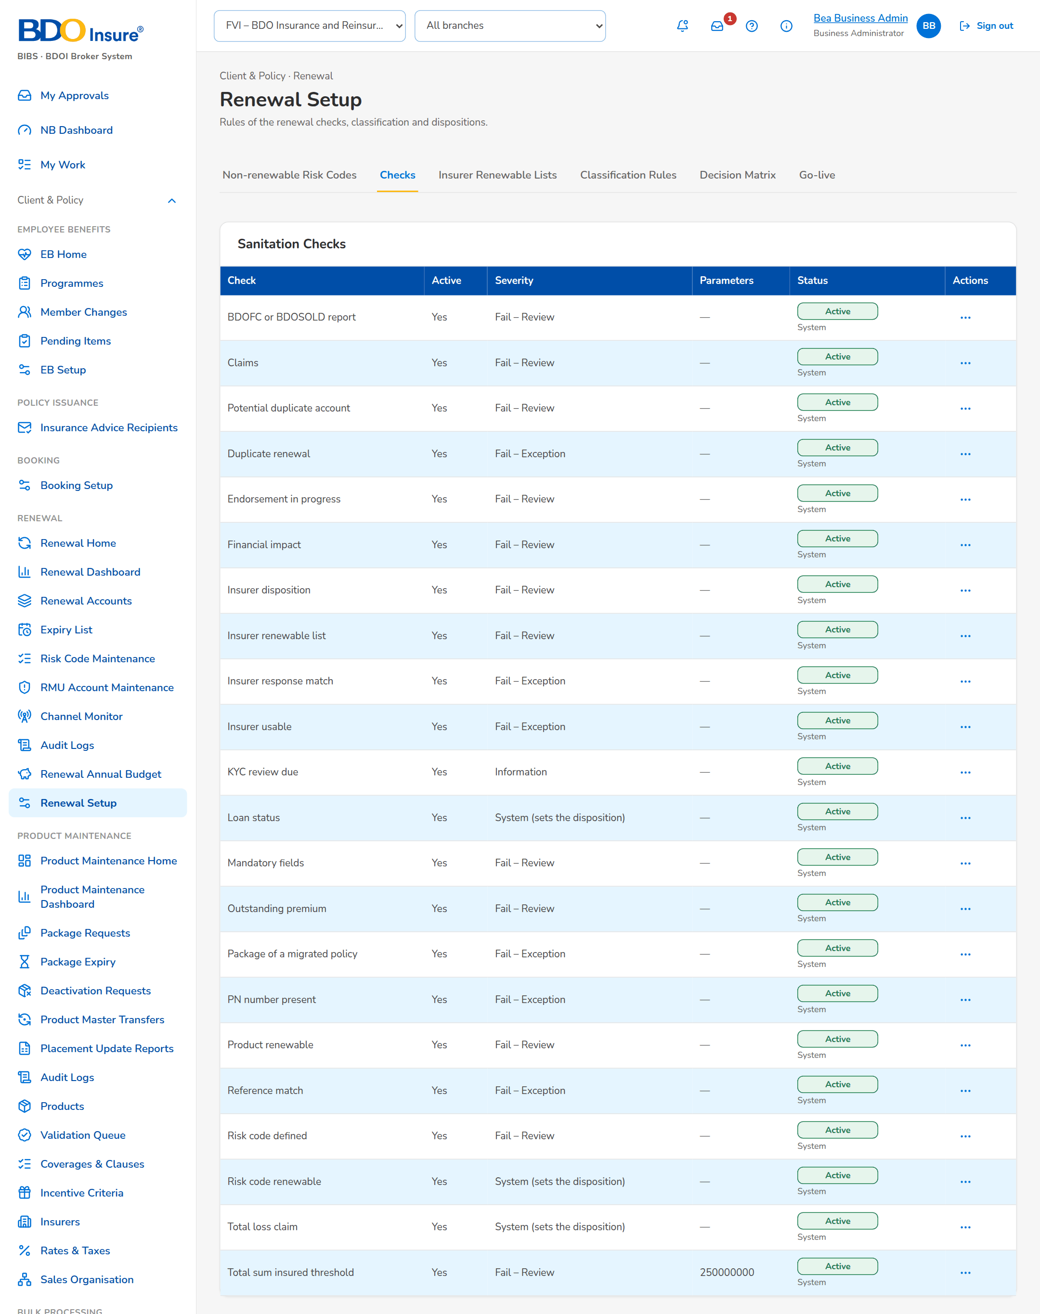
Figure 32: SCR-RN-17: Checks: the sanitation checks with their severity
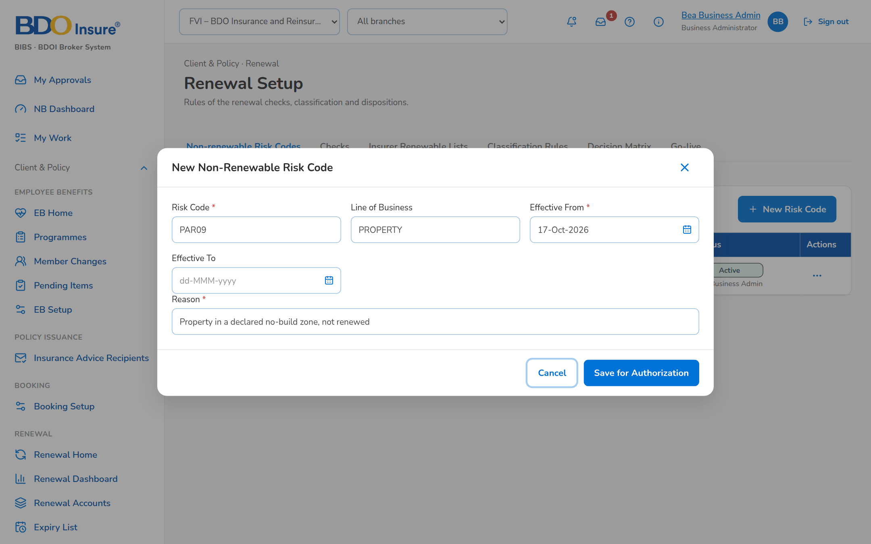
Figure 33: SCR-RN-17: New non-renewable risk code dialog

SCR-RN-18 Renewal Setup: Classification Rules and Decision Matrix
Item | Value
Purpose | The versioned rules: the classification rules turn the check results into Clean, Review or Exception; the decision matrix proposes the disposition by segment, line, product, mortgage, classification, claims, endorsement, payment and days to expiry, automatic or as a proposal to the officer, with the letter. A new version is a draft from the active one, submitted, then activated or rejected by another user; activation retires the active version.
Access | Business Administrator.
Requirements | FRRN.008, FRRN.040
Outcome | The rules agreed by the business classify the renewals and propose their dispositions.

Rules and states:
• A failed check never gives the Clean classification.
• The first matching rule of the active matrix proposes the disposition; an automatic rule on a Clean renewal disposes it without the officer.
• A version is activated by another user than its maker; activation retires the active version.
Table 36: SCR-RN-18 fields
Field | Type | Req. | Default | Rule | Message
Versions: Version / Status / Effective / Description / Maker / Approved by | Column | - | - | Number; Draft, Submitted, Active, Retired or Rejected; dd-MMM-yyyy; users' names; Source: Rule versions; Editable: Read only | No versions
Classification rules: Priority / Check / Severity / Outcome / Classification | Column | - | - | Order of the rule; the check or Any; the severity or Any; Failed or Warning; Clean, Review or Exception; Source: Classification rules; Editable: Read only | No rules
Decision matrix: Priority / Segment / Line / Product / Mortgaged / Classification / Claims / Endorsement / Payment / Days from / Days to | Column | - | - | The conditions of the rule; Any when blank; Source: Decision matrix; Editable: Read only | No rules
Decision matrix: Disposition / Automation / Letter | Column | - | - | The disposition proposed; Automatic or Proposal to the officer; Renewal Advice, Not for Renewal, No Advice Letter or None; Source: Decision matrix; Editable: Read only | -
New version dialog: Effective From / Description | Date, text | N / N | Blank | dd-MMM-yyyy; up to 200 characters; Editable: Draft | -
New version dialog: [The rules of the version, one row each, with Add Rule and Remove rule] | Table | Y | The rules of the active version | The columns of the rules; Editable: Draft; Each rule its own priority; a failed check never gives Clean | Two rules have the priority <p>

Table 37: SCR-RN-18 actions
Action | Who | Available when | What happens | Result
New Version | Business Administrator | Always | Opens the dialog with the rules of the active version; Save Draft keeps the draft | Draft
Submit (row menu) | Business Administrator | Draft | Submits the version for a second user | Submitted
Activate (row menu) | Another Business Administrator than the maker | Submitted | Asks for confirmation; the version replaces the active one from its effective date | Active
Reject (row menu) | Another Business Administrator than the maker | Submitted | Asks for the reason; the version returns to its maker | Rejected

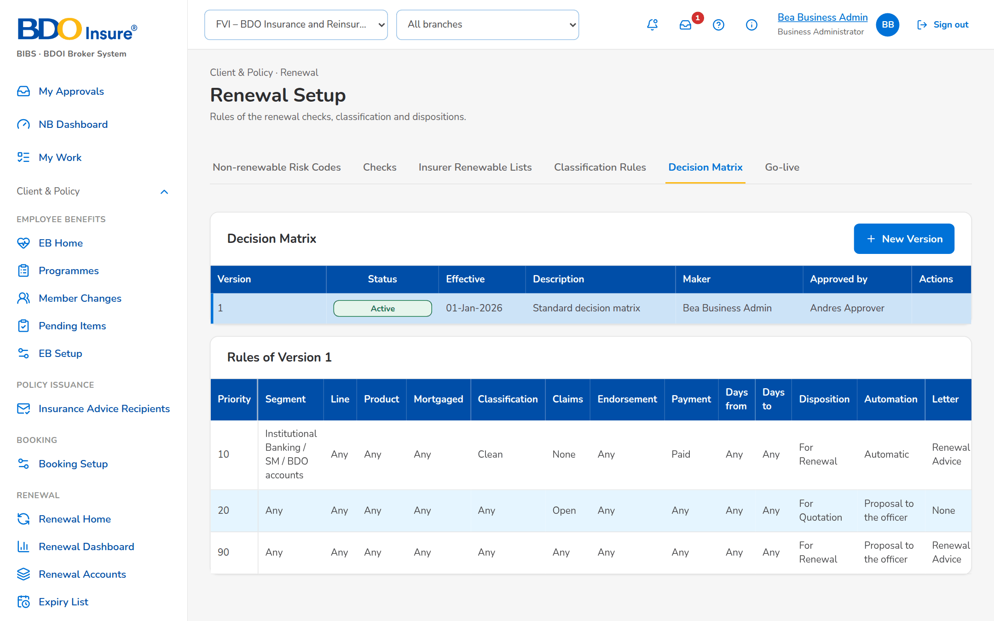
Figure 34: SCR-RN-18: Decision Matrix: the versions with their row action menu and the rules of the active version
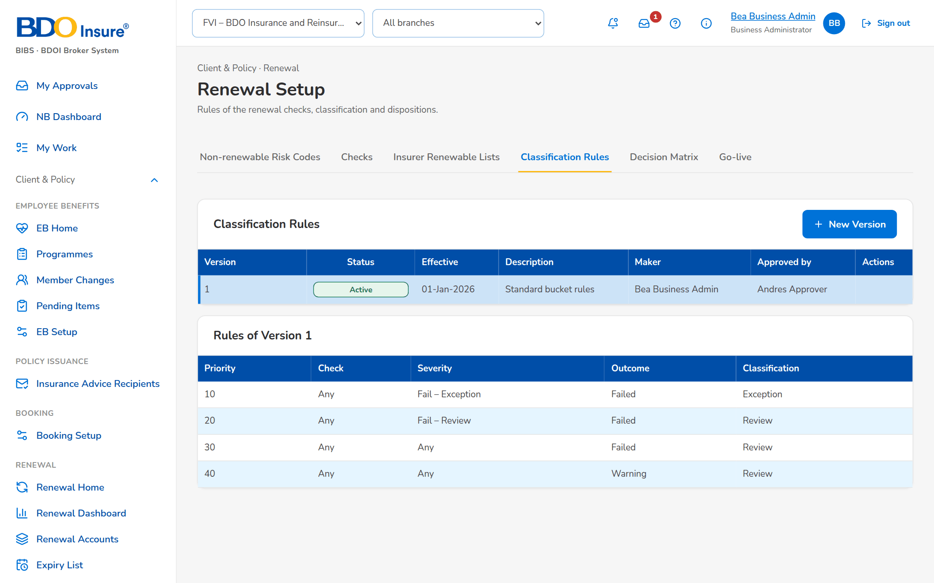
Figure 35: SCR-RN-18: Classification Rules: the versions and the rules of the active version

SCR-RN-19 Renewal Setup: Package Map, Package Choices and Propose Package
Item | Value
Purpose | The package of a migrated policy: the package map gives the BIBS product and version a legacy package renews on (or rejects it), by risk code, insurer and sum insured band; when the map gives no answer, a Processing Officer proposes the package on the renewal and another member of the team approves or rejects the choice.
Access | Processing Team Lead and Officer (package choice).
Requirements | FRRN.046
Outcome | Every migrated packaged policy renews on a BIBS package version.

Rules and states:
• A migrated packaged policy whose legacy package is not mapped, retired or ambiguous is an Exception until its package is chosen.
• A package choice is approved by another member of the team than its maker.
Table 38: SCR-RN-19 fields
Field | Type | Req. | Default | Rule | Message
Package map: Legacy Package / Risk / Insurer / Sum Insured band / Renews on / Source / Status | Column | - | - | Legacy code with its version; risk code and insurer name or Any; the band or Any; product name with its version, or Rejected (not renewable as is); Data migration, Entered on screen or Upload; the approval status; Source: Package map; Editable: Read only | No package mappings
Mapping dialog: Legacy Package Code / Legacy Package Version / Risk Code / Insurance Company / Sum Insured From / Sum Insured To | Text, amount | Y / N | Blank | The legacy package and its qualifiers, blank for any; Editable: Pending, Active | -
Mapping dialog: Product Code (blank to reject) / Product Version / Remarks | Text, number | N | Blank | The BIBS product and version; Source: Product catalogue; Editable: Pending, Active | -
Package choices: Renewal / Client / Legacy Package / Proposed / Reason / Proposed by | Column | - | - | Renewal reference; client; legacy package; product name with its version; the reason; the maker's name with the time; Source: Package choices; Editable: Read only | No package choices waiting
Propose Package dialog: Product Code / Product Version / Reason | Text, number, text area | Y / Y / Y | Blank | A product that can be sold for renewal; version 1 or more; up to 200 characters; Source: Product catalogue; Editable: Open renewal of a migrated packaged policy | Enter the reason of the choice

Table 39: SCR-RN-19 actions
Action | Who | Available when | What happens | Result
New Mapping | Processing (package permission) | Always | Opens the dialog; Save for Authorization keeps the mapping waiting for a second user | Pending Authorization
Upload | Processing (package permission) | Always | Opens the upload of the package map | Pending Authorization
Authorize, Edit, Deactivate (row menu) | Processing (package permission); Authorize by another user than the maker | By status | As for the risk codes (SCR-RN-17) | Active, Pending Authorization or Inactive
Approve, Reject (row menu) | Another member of the Renewal processing team than the maker | Choice waiting | Asks for remarks (mandatory to reject); an approved choice applies to the renewal | Approved or Rejected; Package choice decided (notice NT-10)
Propose Package (renewal) | Processing Officers | Open renewal of a migrated packaged policy | Opens the dialog; Submit for Approval keeps the choice waiting | Pending

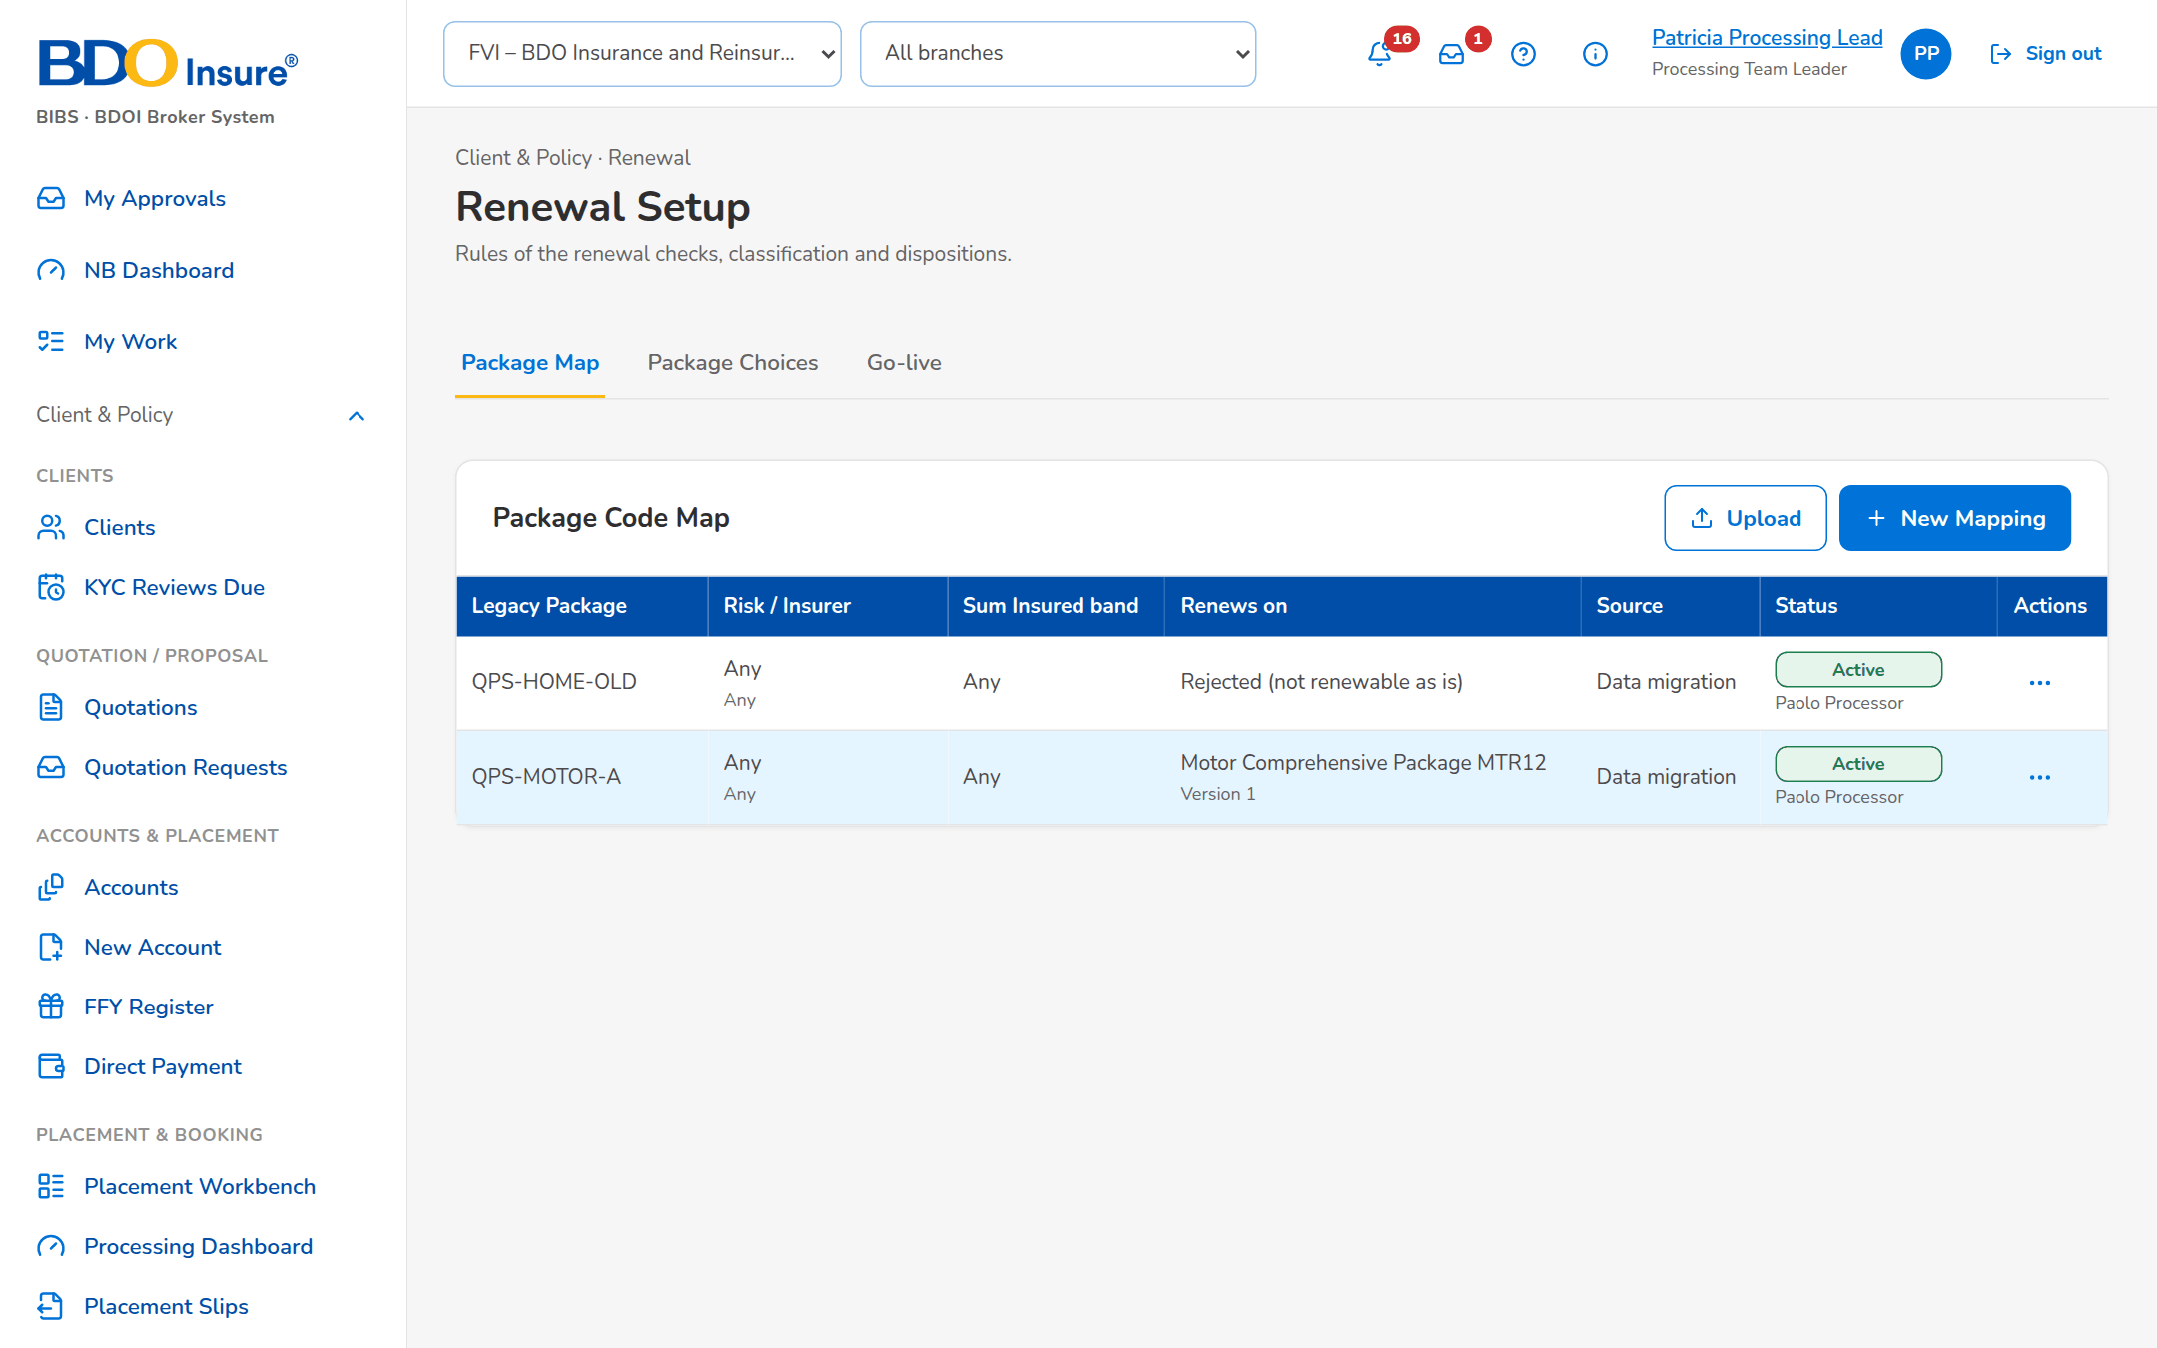
Figure 36: SCR-RN-19: Package Map of the migrated policies with the row action menu
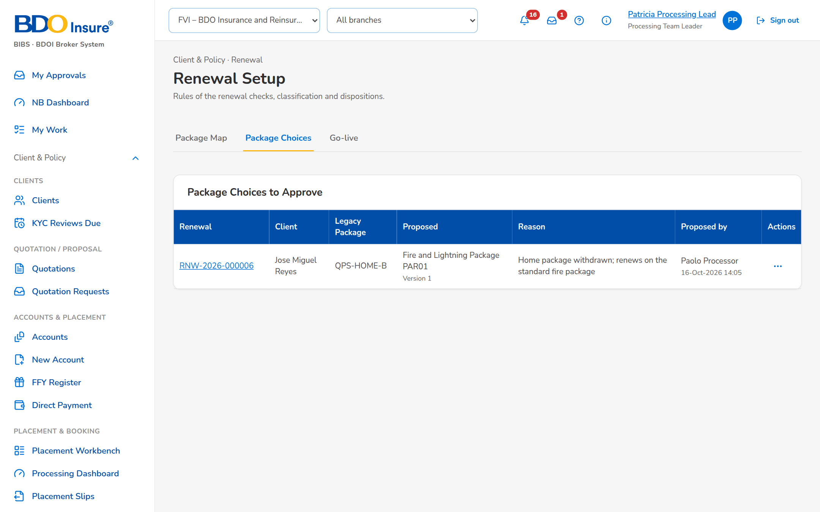
Figure 37: SCR-RN-19: Package Choices waiting for a second team member

SCR-RN-20 Renewal Setup: Go-live
Item | Value
Purpose | The take-over of the renewals of the migrated policies expiring from the go-live date within the renewal horizon, the upload of the migrated policies when the migration source is not connected, and the Renewal Advices sent by hand before go-live, recorded so they are never sent again, with the corrections approved by a second team member.
Access | Business Administrator; Processing Team Lead.
Requirements | FRRN.045
Outcome | The renewals of the go-live window continue in BIBS without a second Renewal Advice.

Rules and states:
• The renewals expiring from go-live to 31 May 2028 are taken over; those up to 31 January 2028 are Urgent.
• A Renewal Advice recorded as sent before go-live is never sent again.
Table 40: SCR-RN-20 fields
Field | Type | Req. | Default | Rule | Message
Go-live take-over: Go-live Date | Date | Y | Blank | dd-MMM-yyyy | -
Go-live take-over: [Migrated policies source: connected or loaded by upload] | Text | - | - | Source: Data migration; Editable: Read only | -
Uploads: Upload Migrated Policies / Upload RAs Already Sent | Upload | - | - | Templates of the expiring policies of the legacy systems and of the Renewal Advices sent before go-live; Every row checked before anything is saved | Legacy policy <legacy ref> is already a renewal
Corrections: Legacy Reference / RA Date / Correction / Upload / Prepared by | Column | - | - | The Renewal Advice recorded and the correction proposed; the upload and row; the maker's name; Source: Renewal Advices already sent; Editable: Read only | No corrections waiting

Table 41: SCR-RN-20 actions
Action | Who | Available when | What happens | Result
Run Take-over | Business Administrator | Go-live date entered | Takes over the renewals of the migrated policies expiring from the date within the horizon; expiries up to the urgent date are flagged Urgent | Extracted; Go-live renewal extraction completed (notice NT-09)
Upload Migrated Policies | Users with the extract permission | Always | Opens the upload of the migrated policies | -
Upload RAs Already Sent | Users with the send permission | Always | Opens the upload of the Renewal Advices sent by hand | -
Approve, Reject (row menu) | Another member of the Renewal processing team than the maker | Correction waiting | Asks for remarks (mandatory to reject) | Approved or Rejected

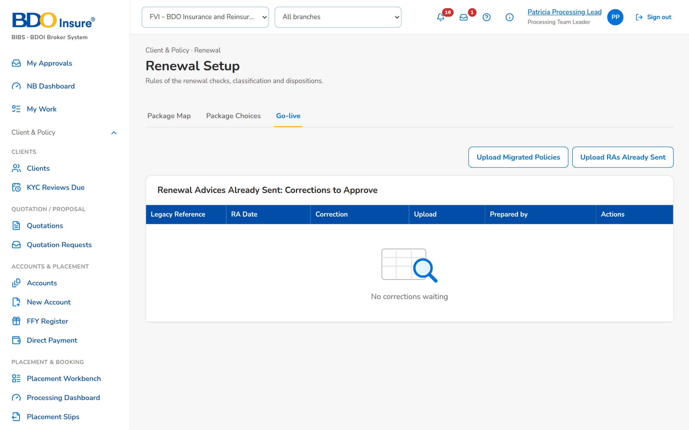
Figure 38: SCR-RN-20: Go-live tab of the Processing Team Leader: the uploads of the go-live and the corrections to approve
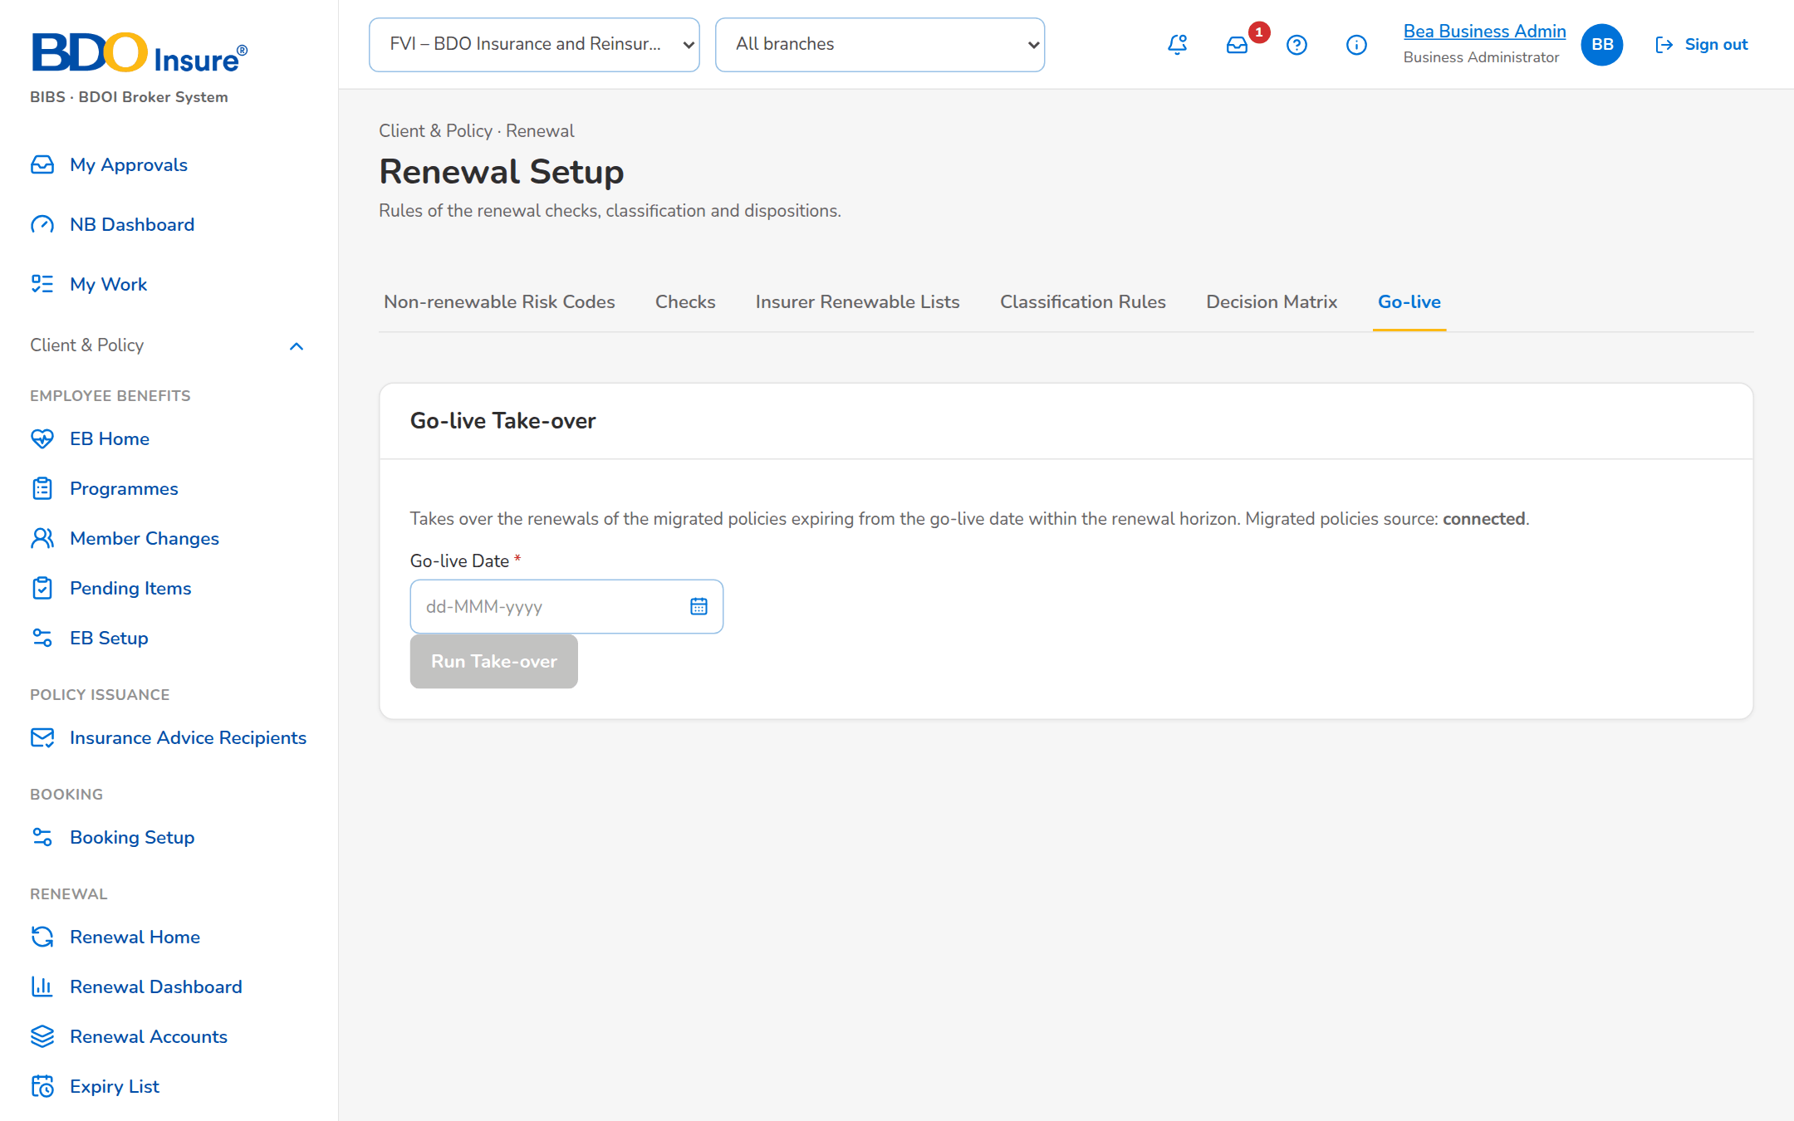
Figure 39: SCR-RN-20: Go-live tab of the Business Administrator: the take-over

SCR-RN-21 Renewal Dashboard
Item | Value
Purpose | The Marketing view of the renewals for a period: the KPI cards (basic premium and gross commission against the budget, pipeline, closing ratio, persistency), the outstanding renewal accounts by product, the biggest open deals, the insurer approval monitoring and the open renewal accounts per officer. Each figure opens the accounts behind it.
Access | Client & Policy › Renewal › Renewal Dashboard; Home after sign-in of the Marketing users
Requirements | FRRN.002, FRRN.042
Outcome | -

Table 42: SCR-RN-21 fields
Field | Type | Req. | Default | Rule | Message
Filters: Period From / Period To / Market Segment / Account Officer | Date, date, drop-down, drop-down | N | The current month; all | dd-MMM-yyyy; names; Source: Market segments; users of the unit; Editable: Always; Period To not before Period From | -
KPI summary cards: Basic Premium and Gross Commission / Pipeline Summary / Closing Ratio / Renewal Persistency Ratio | Card | - | - | Actual, Budget, % vs Budget, Variance, Growth; counts and amounts; Source: Renewals, budget; Editable: Read only | -
Biggest Open Deals: Ranking / Account Number / Assured Name / Risk Code / Team / Premium Amount / Commission Amount | Table | - | - | Two decimals; Source: Open renewals; Editable: Read only | No open deals
Insurer Renewal Approval Monitoring: Insurer Name / Number of Pending Accounts / % of Approval | Table | - | - | Counts and percentages; Source: Renewals with the insurer; Editable: Read only | No pending accounts
Open Renewal Accounts per Officer: Officer / Open Renewal Accounts | Table | - | - | Counts; Source: Assignments; Editable: Read only | No renewal accounts assigned
Drill-down: Reference Number / Premium / Commission / Assigned User / Expiry Date | Table in a dialog | - | - | Two decimals; dd-MMM-yyyy; Source: The accounts behind a figure; Editable: Read only | No records found.

Table 43: SCR-RN-21 actions
Action | Who | Available when | What happens | Result
[Figure or row] | Marketing users | Always | Opens the accounts behind the figure; a row opens the renewal | -

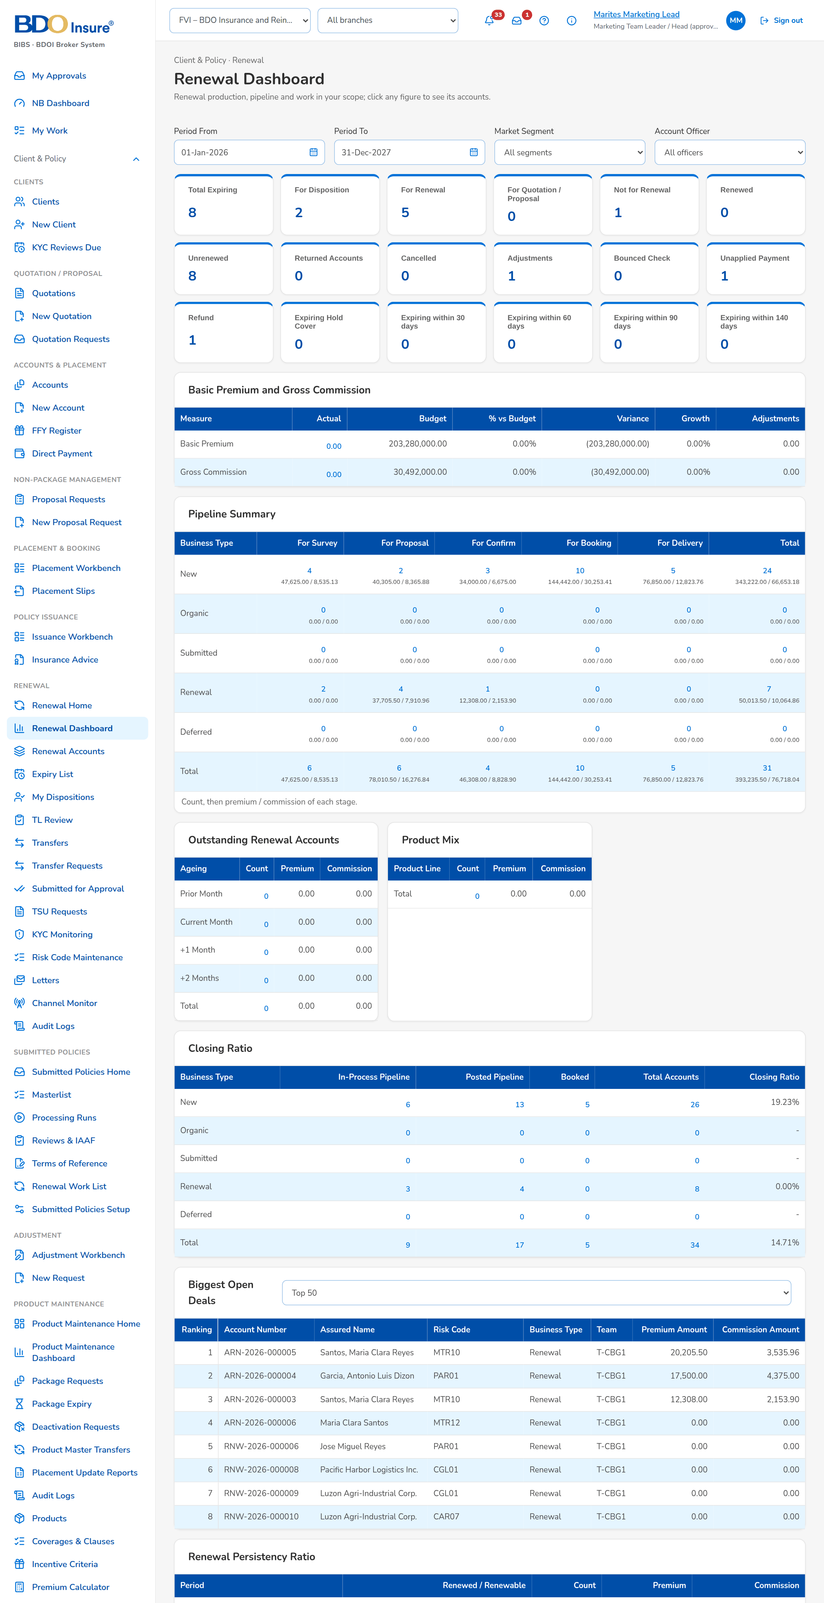
Figure 40: SCR-RN-21: Renewal Dashboard of the Marketing Team Leader: KPI cards, pipeline and the open accounts per officer

SCR-RN-22 Renewal Accounts
Item | Value
Purpose | The renewal accounts of the user's unit in BDOI's bucket panels: Clean, Review, the third panel of the setting (Non-Renewable by default) and All, with the expiring invoice, the renewal reference, the claim flag, the amounts and the disposition. The account tags of a file are uploaded here.
Access | Client & Policy › Renewal › Renewal Accounts; Renewal Dashboard › a figure
Requirements | FRRN.002, FRRN.008
Outcome | -

Table 44: SCR-RN-22 fields
Field | Type | Req. | Default | Rule | Message
Panels: Clean / Review / Non-Renewable / All | Tab | - | Clean | Count on each tab; Source: Bucket classification of the account | -
Search: Search the renewal accounts | Text | N | Blank | Reference, invoice, client or assured; Editable: Always | -
List: Expiring Invoice Number / Renewal Reference Number / With Claim / Invoice Number / Assured / Client / Expiry Date / Sum Insured / Premium Rate / Premium / Commission Rate / Commission Amount / Mailing Address / Mortgaged (Y/N) / Renewal Status / Renewal Disposition / Assigned User | Column | - | - | Two decimals; dd-MMM-yyyy; labels; Source: Renewal accounts; Editable: Read only | No renewal accounts in this panel
Upload Account Tags: [Upload of the file of account tags] | Upload | - | - | Template of the account tags; Source: Renewal accounts; Editable: Marketing users; Every row checked before anything is saved | -

Table 45: SCR-RN-22 actions
Action | Who | Available when | What happens | Result
Upload Account Tags | Marketing users (update permission) | Always | Uploads the tags of the accounts of the file (bulk update) | -
[Row] | Marketing users | Always | Opens the renewal | -

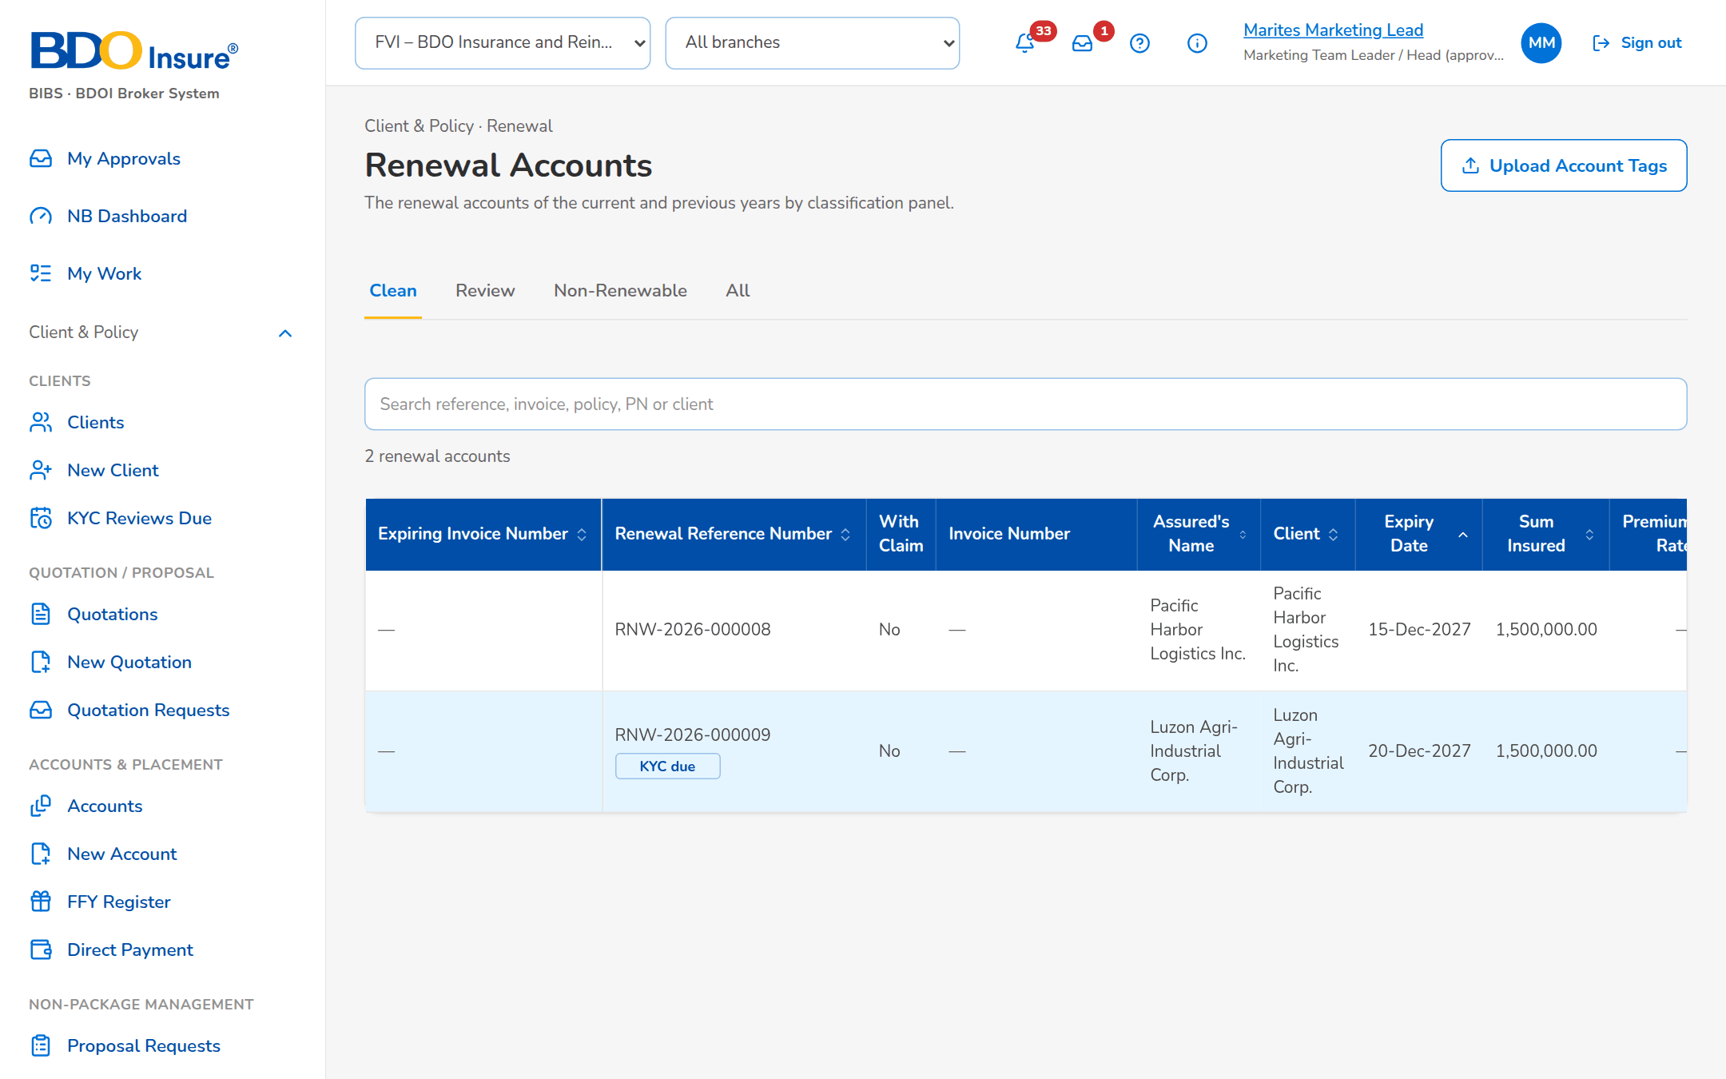
Figure 41: SCR-RN-22: Renewal Accounts, Clean panel: the accounts with their amounts, status and assigned user

SCR-RN-23 Processing Dashboard
Item | Value
Purpose | The Processing view of the month: KPI cards of the accounts to process, a combined, New Business or Renewal view, and the accounts by Placement Processor, assigned or unassigned.
Access | Client & Policy › Renewal › Processing Dashboard; Home after sign-in of the Processing users
Requirements | FRRN.003, FRRN.010
Outcome | -

Table 46: SCR-RN-23 fields
Field | Type | Req. | Default | Rule | Message
View: Combined View / New Business View / Renewal View | Toggle | - | Combined View | One at a time; Editable: Always | -
Processing KPI cards: Accounts by stage of processing | Card | - | - | Counts; Source: Renewals and New Business accounts; Editable: Read only | -
Filter: Placement Processor / Unassigned / Assigned | Toggle | - | All | One at a time; Source: Processing Officers; Editable: Always | -
List: Account Reference Number / Month and the counts of the stages | Table | - | - | Counts; Source: Accounts of the month; Editable: Read only | No records found.

Table 47: SCR-RN-23 actions
Action | Who | Available when | What happens | Result
[Figure or row] | Processing users | Always | Opens the accounts behind the figure | -

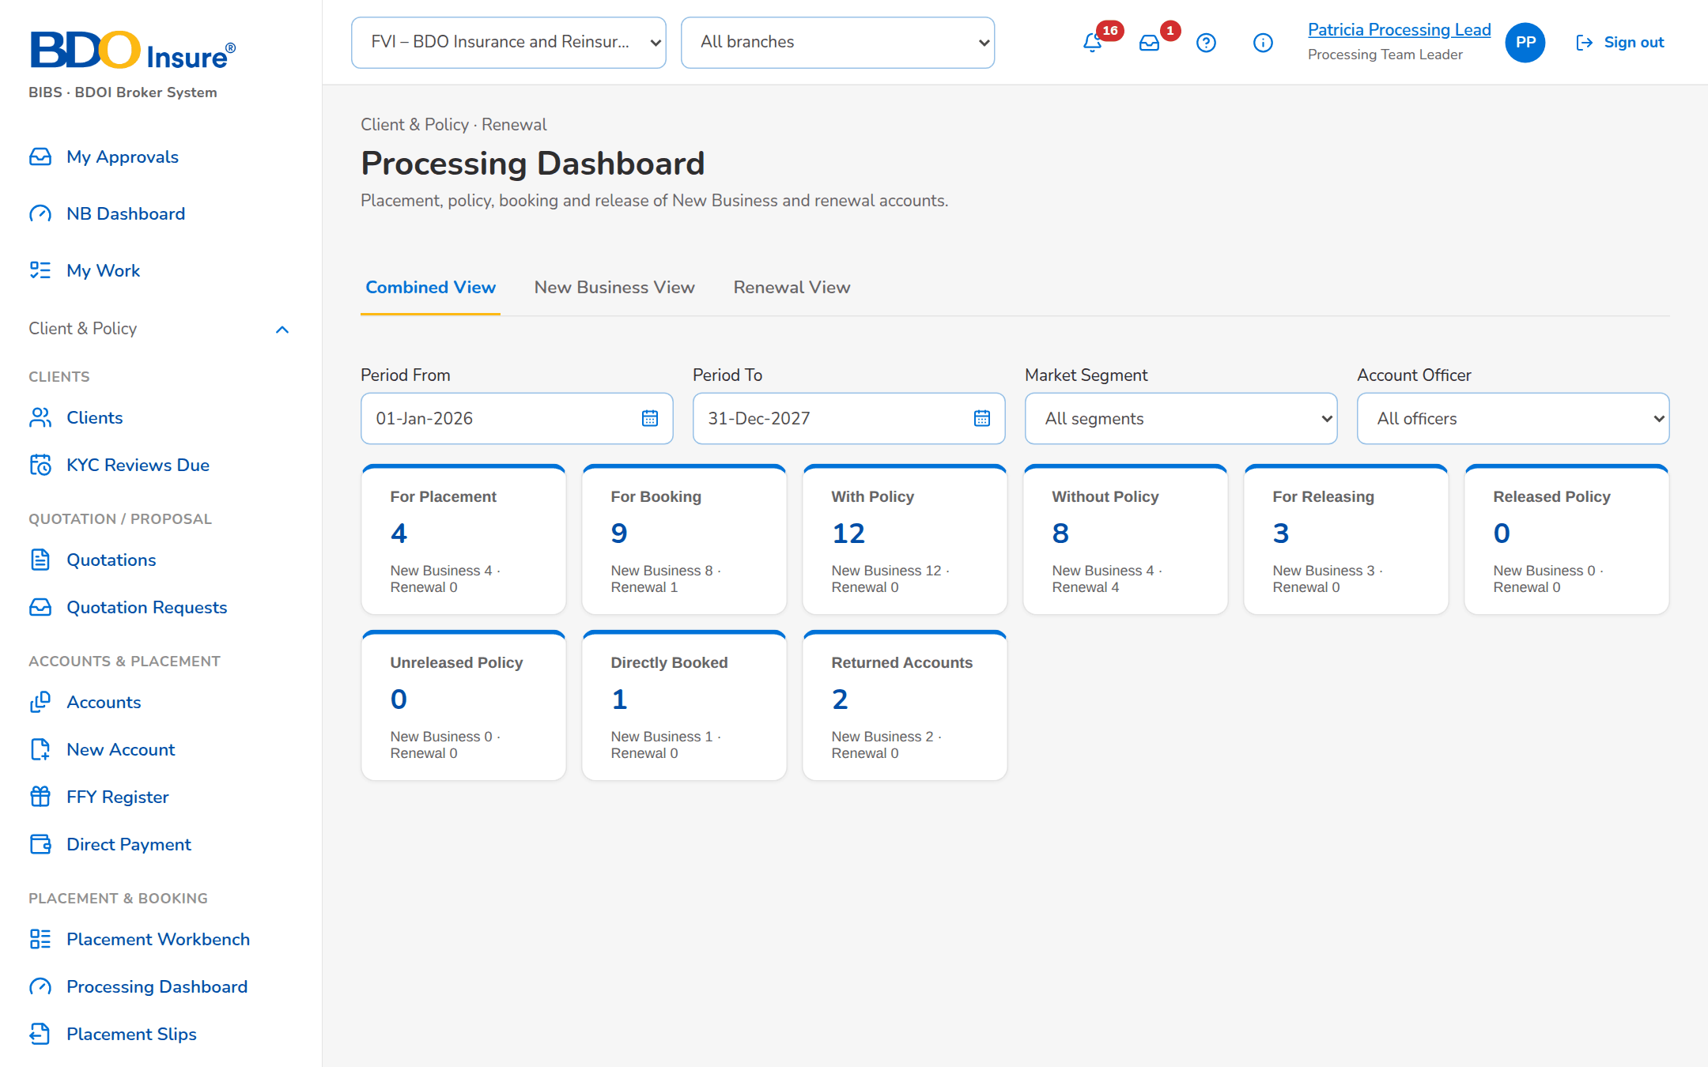
Figure 42: SCR-RN-23: Processing Dashboard of the Processing Team Leader: KPI cards and the accounts of the month

SCR-RN-24 Transfer Requests
Item | Value
Purpose | The requests to transfer a renewal account to another Marketing unit as a New Business opportunity: the source unit raises the request with a justification, the receiving unit accepts, rejects or returns it for clarification and creates the New Business account; the requester may cancel it while it is open.
Access | Client & Policy › Renewal › Transfer Requests; Renewal › Transfer to Another Unit
Requirements | FRRN.011
Outcome | -

Table 48: SCR-RN-24 fields
Field | Type | Req. | Default | Rule | Message
List: Transfer Request Number / Renewal Account Number / Assured / Source Marketing Unit / Receiving Marketing Unit / Request Date / Transfer Status / Accepted By / Remarks / New Business Account Number | Column | - | - | dd-MMM-yyyy; names of the units; Source: Transfer requests; Editable: Read only | No transfer request
Transfer request dialog: Receiving Marketing Unit / Business Justification | Drop-down, text area | Y / Y | Blank | Marketing units; up to 500 characters; Source: Marketing units; Editable: Renewal not yet transferred; Another unit than the source | Enter the business justification
Decision dialog: Remarks | Text area | Cond.: reject or return | Blank | Up to 500 characters; Editable: Request open | Enter the remarks
Create New Business Account dialog: Risk Code / Market Segment / Period From / Period To | Drop-down, drop-down, date, date | Y | From the renewal | Names; dd-MMM-yyyy; Source: Risk codes, market segments; Editable: Request accepted; Period To after Period From | -

Table 49: SCR-RN-24 actions
Action | Who | Available when | What happens | Result
Accept | Receiving unit (Team Leader) | Request open | Accepts the transfer | Accepted; Transfer accepted
Reject / Return for Clarification | Receiving unit (Team Leader) | Request open | Records the decision with the remarks | Rejected / Returned; Transfer decided
Create New Business Account | Receiving unit | Request accepted | Creates the New Business account of the opportunity; its number is shown on the request | Completed
Cancel Request | Source unit | Request open | Cancels the request | Cancelled

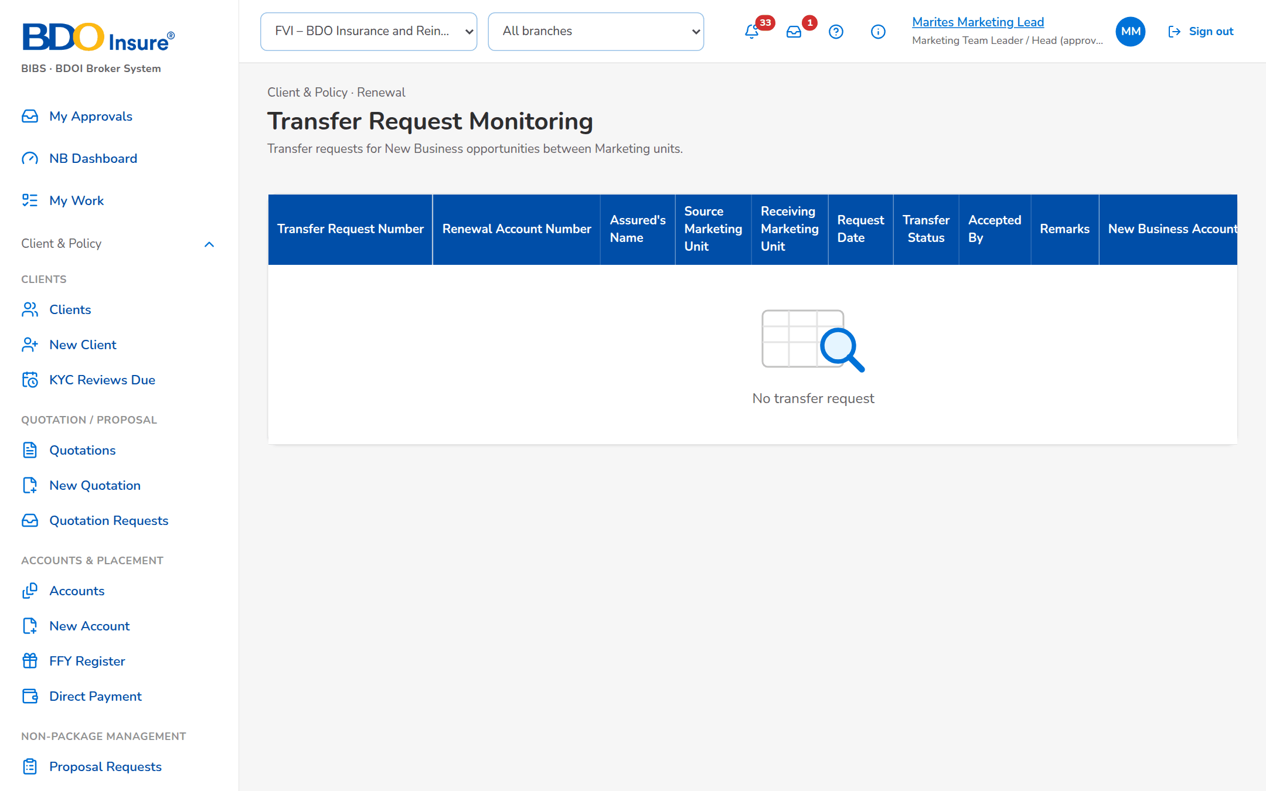
Figure 43: SCR-RN-24: Transfer Request Monitoring with the requests and their status

SCR-RN-25 Submitted for Approval
Item | Value
Purpose | The renewal accounts accepted by the client that wait for the second approval of the setting, with the client payment confirmation. The approver approves or rejects each account with the reason.
Access | Client & Policy › Renewal › Submitted for Approval; Notification Renewal submitted for approval
Requirements | FRRN.016, FRRN.026
Outcome | -

Table 50: SCR-RN-25 fields
Field | Type | Req. | Default | Rule | Message
List: Reference / Client / Disposition / Premium / Submitted by / Submitted on | Column | - | - | Two decimals; dd-MMM-yyyy; Source: Renewals Submitted for Approval; Editable: Read only | No renewal account is Submitted for Approval
Approve dialog: Client payment confirmation | Tick box | Cond.: payment before placement | Blank | Confirmed by the client; Editable: Submitted for Approval | -
Reject dialog: Reason or remarks | Text area | Y | Blank | Up to 500 characters; Editable: Submitted for Approval | Enter the reason

Table 51: SCR-RN-25 actions
Action | Who | Available when | What happens | Result
Approve | Approver (not the submitter) | Submitted for Approval | Approves the account; it goes to the payment check and placement | For Placement; Renewal approved
Reject | Approver (not the submitter) | Submitted for Approval | Returns the account to the Account Officer with the reason | Returned; Renewal returned

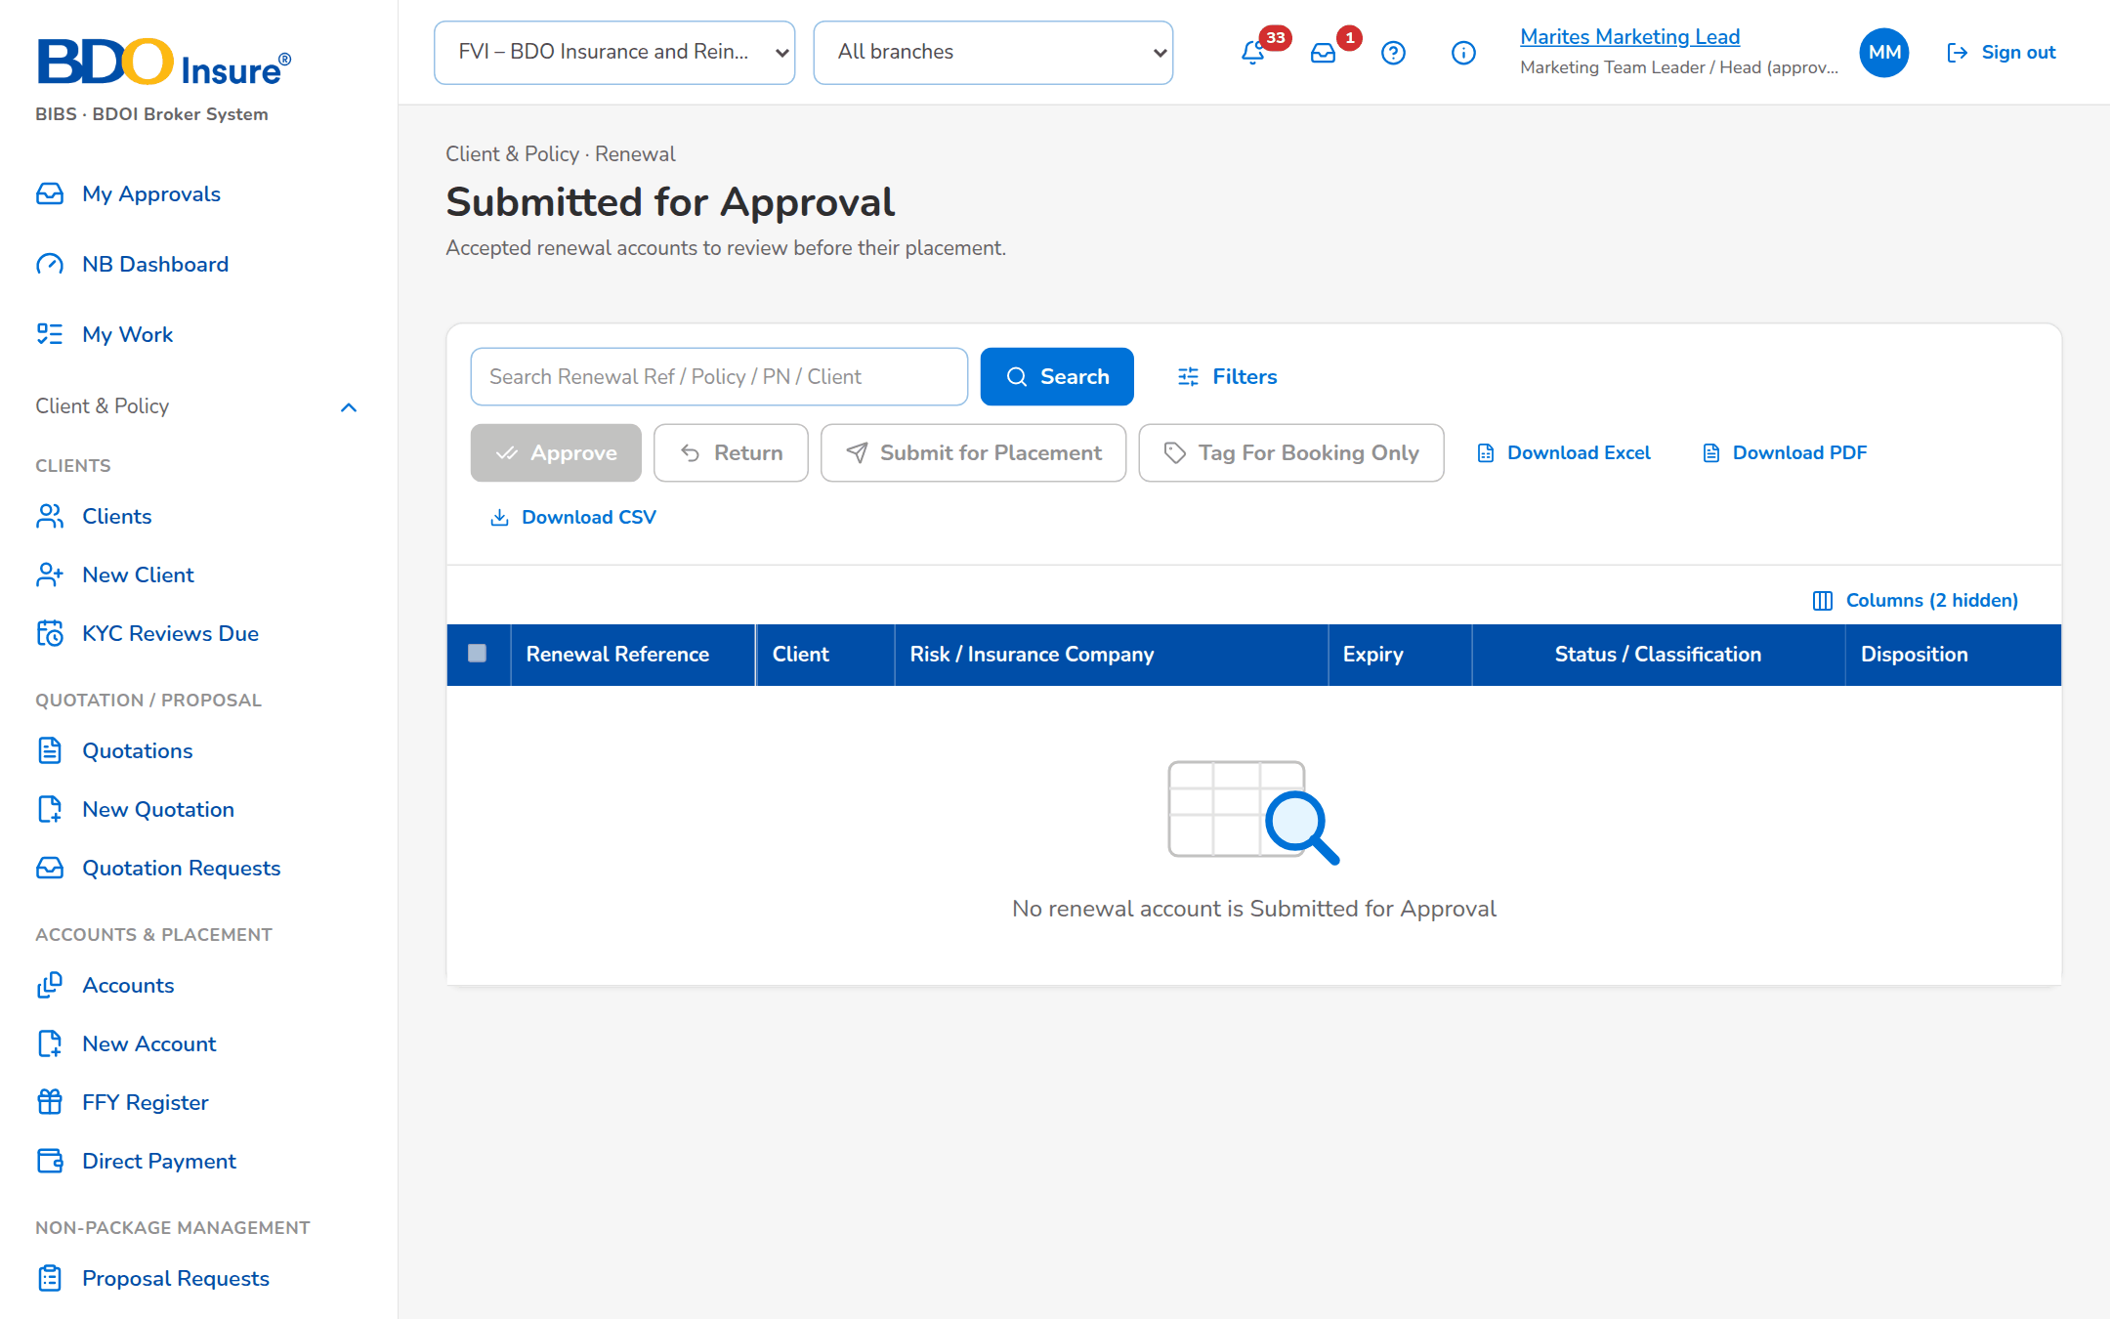
Figure 44: SCR-RN-25: Submitted for Approval with the accounts waiting for the approver

SCR-RN-26 Submitted for Placement
Item | Value
Purpose | The renewal accounts submitted for placement with the insurers: the Processing Officer sends the placement slip to each insurer through CCM or by protected e-mail (setting), records the insurer's response and returns an account that cannot be placed.
Access | Client & Policy › Renewal › Submitted for Placement
Requirements | FRRN.029, FRRN.030, FRRN.031, FRRN.032
Outcome | -

Table 52: SCR-RN-26 fields
Field | Type | Req. | Default | Rule | Message
List: Reference / Client / Insurer / Premium / Submitted / TAT (business days) / SLA | Column | - | - | Two decimals; dd-MMM-yyyy; Source: Renewals submitted for placement; Editable: Read only | No renewal account is submitted for placement
Send dialog: Recipients / CC recipients | E-mail addresses | Y / N | The insurer's placement contact | Separated by commas; Source: Insurer contacts; Editable: For Placement; Valid e-mail addresses | -
Return dialog: Return reason / Remarks | Drop-down, text area | Y / Y | Blank | Return reasons; up to 500 characters; Source: Renewal return reason; Editable: For Placement | Select a return reason

Table 53: SCR-RN-26 actions
Action | Who | Available when | What happens | Result
Send / Send via CCM | Processing Officers | For Placement | Sends the placement slip to the insurer by the channel of the setting | With Insurer
Record Insurer Response | Processing Officers | With Insurer | Opens the response of the insurer (SCR-RN-36, Placement tab) | Placed or Rejected
Return | Processing Officers | For Placement | Returns the account to Marketing with the reason | Returned; Renewal returned

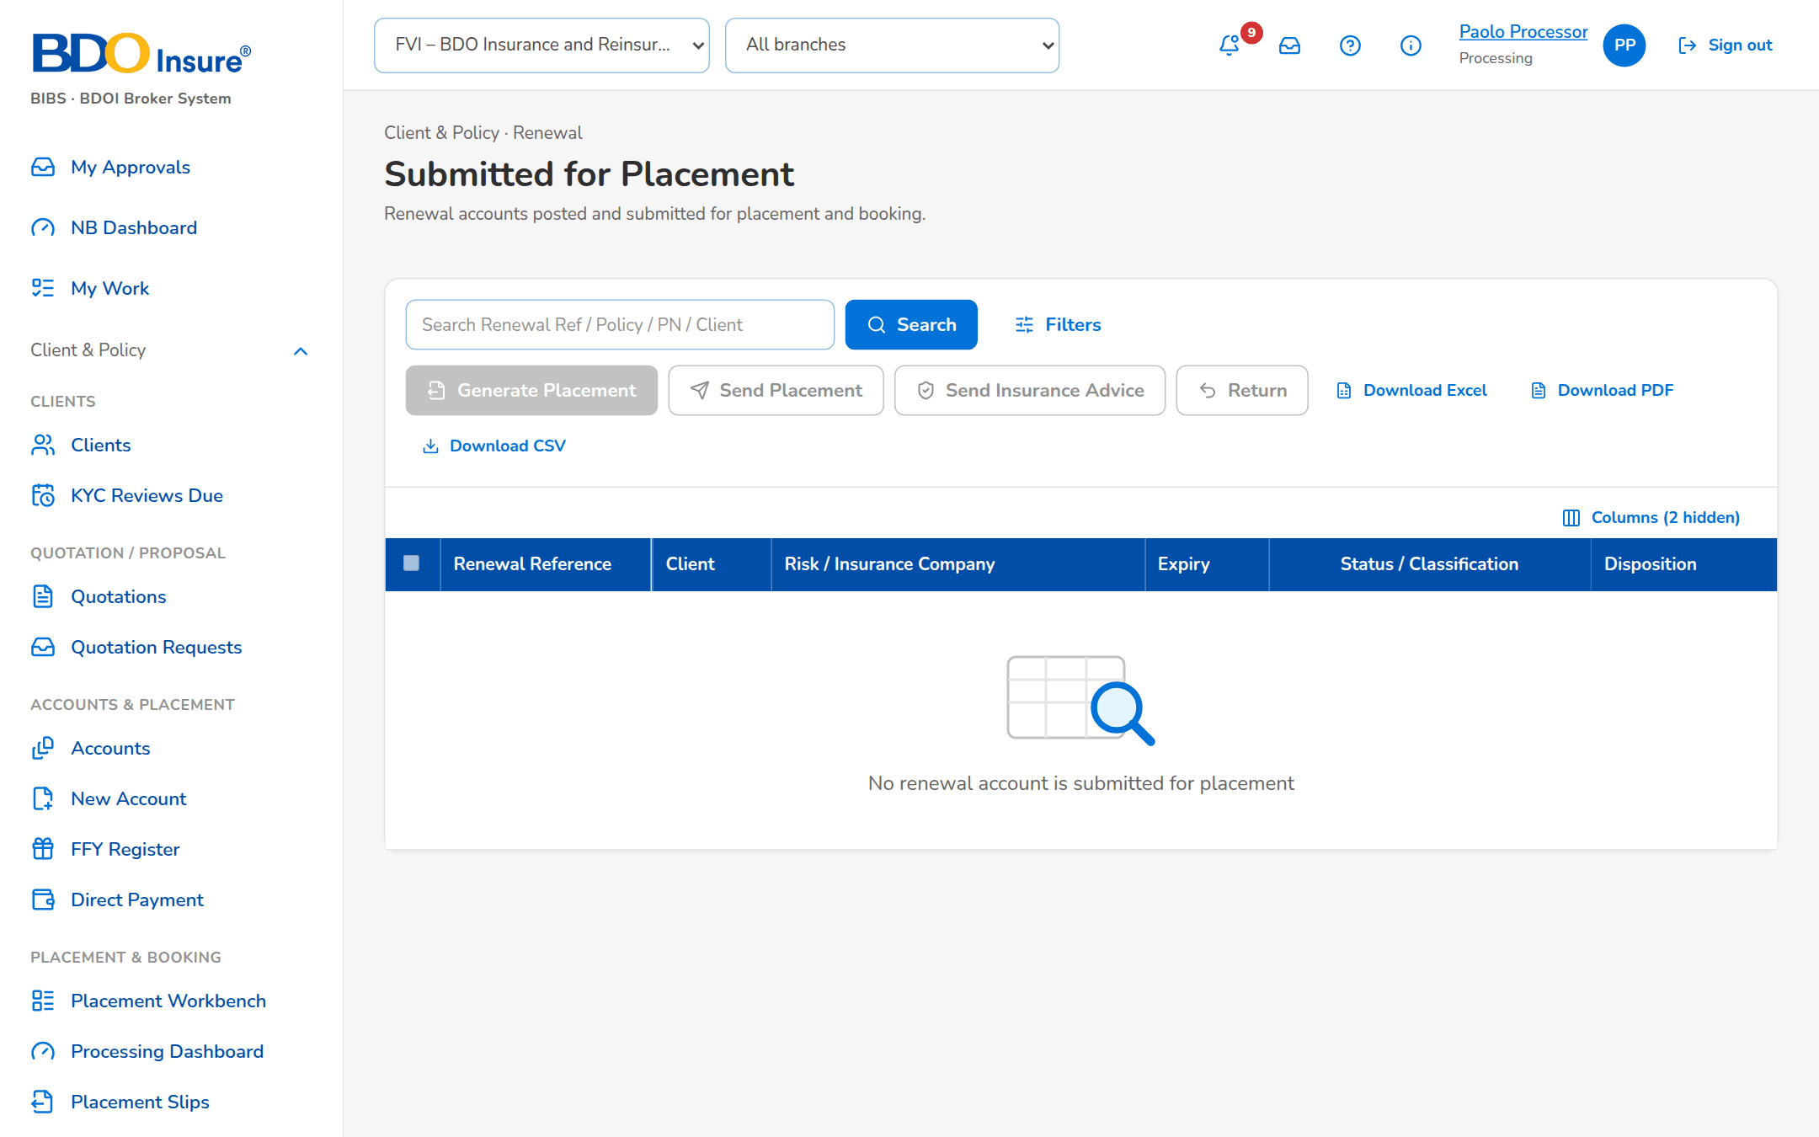
Figure 45: SCR-RN-26: Submitted for Placement with the accounts waiting for the insurers

SCR-RN-27 TSU Requests
Item | Value
Purpose | The requests of the Account Officers to the Technical Support Unit for a quotation or a proposal of a renewal, by status: pending the Team Lead's approval, approved, for TSU processing and completed.
Access | Client & Policy › Renewal › TSU Requests; Renewal › Proposal & TSU tab
Requirements | FRRN.017, FRRN.018, FRRN.019
Outcome | -

Table 54: SCR-RN-27 fields
Field | Type | Req. | Default | Rule | Message
Status tabs: Pending Team Lead Approval / Approved / For TSU Processing / Completed | Tab | - | Pending Team Lead Approval | Count on each tab; Source: TSU requests | -
List: Request / Reference Number / Client / Risk Code / Status / TSU Officer | Column | - | - | Names of the users; Source: TSU requests; Editable: Read only | No TSU request

Table 55: SCR-RN-27 actions
Action | Who | Available when | What happens | Result
[Row] | Marketing and TSU users | Always | Opens the renewal on its Proposal & TSU tab | -

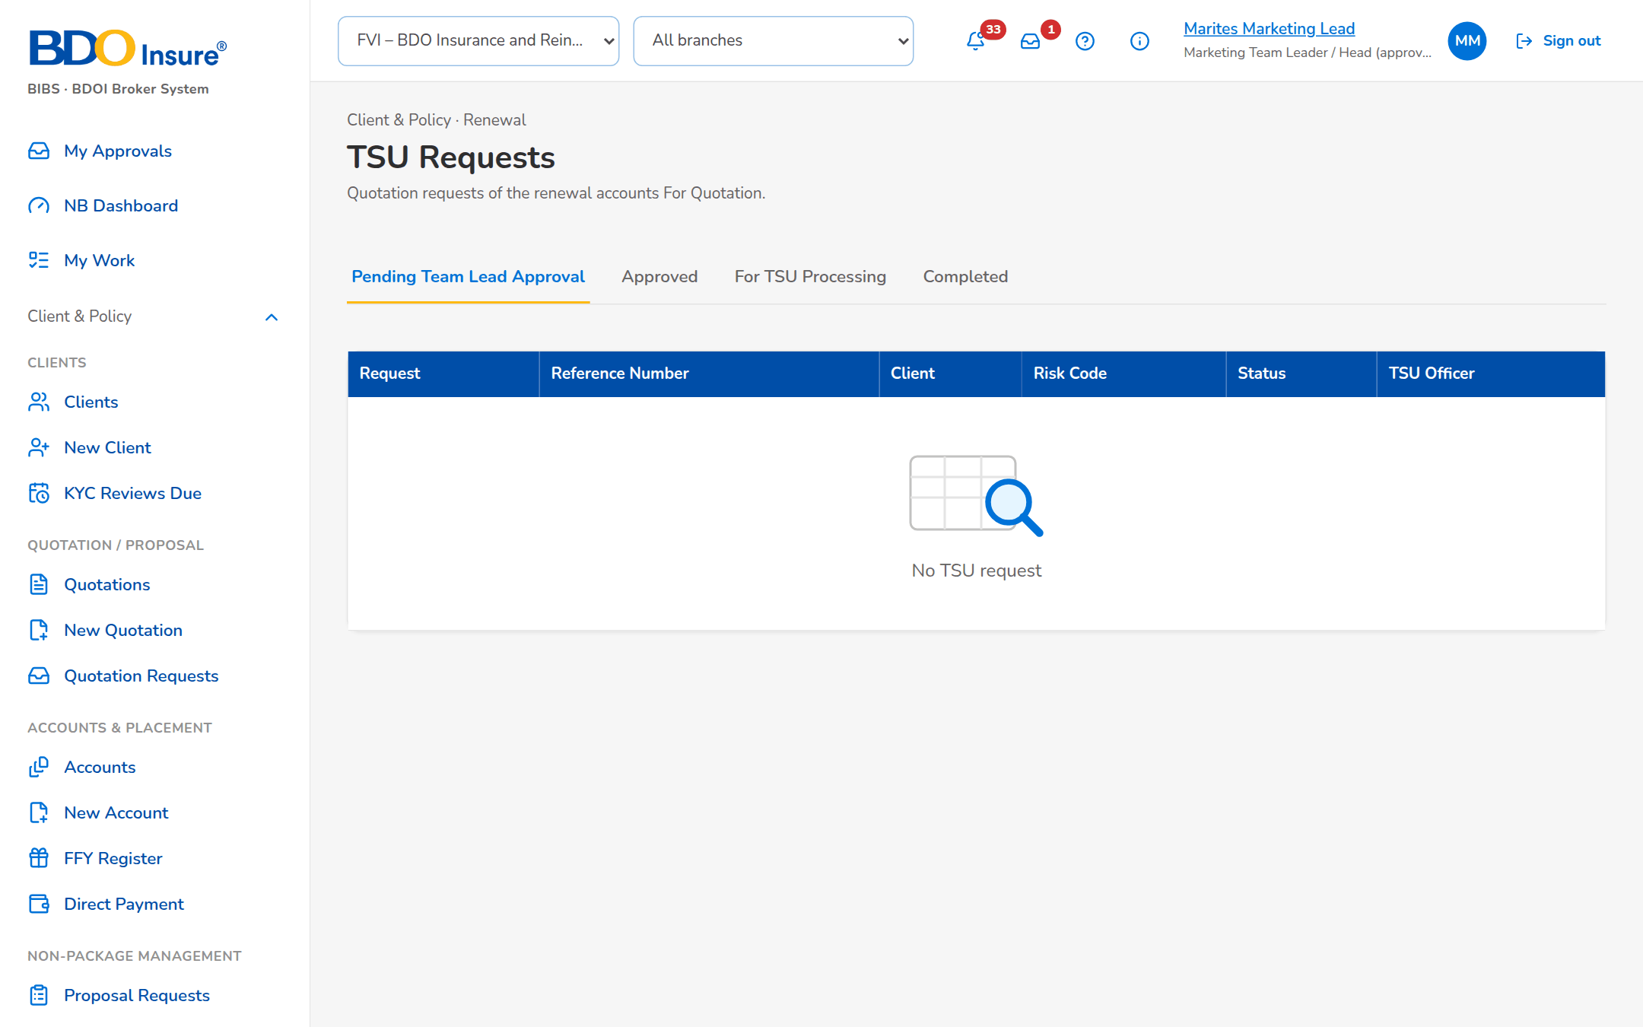
Figure 46: SCR-RN-27: TSU Requests with the requests of the unit by status

SCR-RN-28 KYC Monitoring
Item | Value
Purpose | The renewal accounts whose client is due for the KYC review: due, upcoming, completed and pending follow-up. KYC is for information and never blocks the renewal.
Access | Client & Policy › Renewal › KYC Monitoring
Requirements | FRRN.039
Outcome | -

Table 56: SCR-RN-28 fields
Field | Type | Req. | Default | Rule | Message
Counts: Total Accounts Due for KYC Review / Total Accounts with Upcoming KYC Reviews / Total Accounts Completed KYC / Total Accounts Pending Follow-up | Card | - | - | Counts; each opens its accounts; Source: KYC of the clients; Editable: Read only | -
List: Reference Number / Client / KYC Review Date / Expiry Date / Account Officer | Column | - | - | dd-MMM-yyyy; Source: Accounts of the card chosen; Editable: Read only | No account

Table 57: SCR-RN-28 actions
Action | Who | Available when | What happens | Result
[Card or row] | Marketing users | Always | Lists the accounts of the card; a row opens the renewal on its KYC tab | -

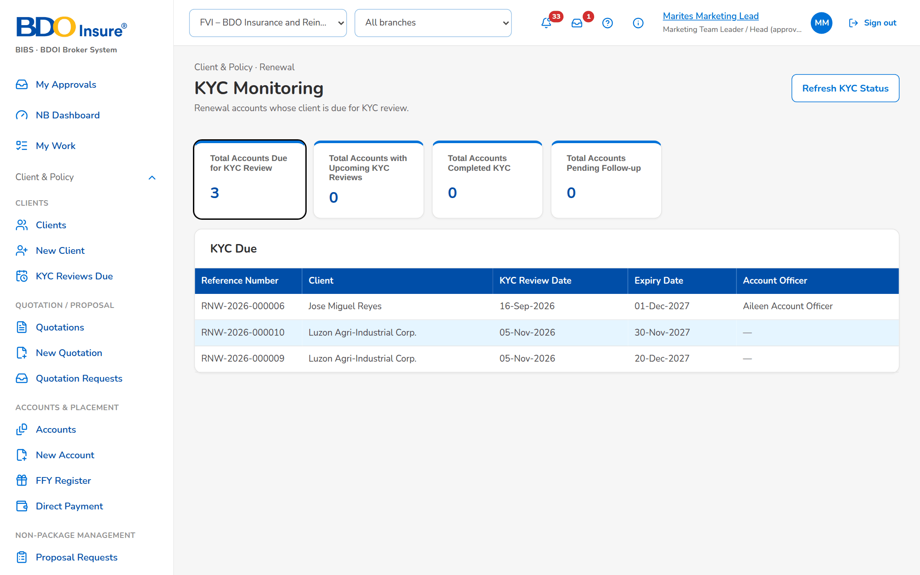
Figure 47: SCR-RN-28: KYC Monitoring with the counts and the accounts due for the KYC review

SCR-RN-29 Risk Code Maintenance
Item | Value
Purpose | The risk codes of Renewal with their renewable indicator: a non-renewable risk code keeps its accounts out of renewal. A change takes effect from its effective date once a second authorised user authorises it.
Access | Client & Policy › Renewal › Risk Code Maintenance
Requirements | FRRN.038
Outcome | -

Table 58: SCR-RN-29 fields
Field | Type | Req. | Default | Rule | Message
List: Risk Code / Risk Description / Product Line / Renewable Indicator / Effective Date / Status / Created By / Created Date / Last Updated By / Last Updated Date | Column | - | - | dd-MMM-yyyy; names; Source: Risk codes; Editable: Read only | No risk code
Risk code dialog: Risk Code / Risk Code Description / Product Line / Renewable Indicator / Effective Date / Remarks | Text, text, drop-down, Yes/No, date, text area | Y / Y / Y / Y / Y / N | Today | dd-MMM-yyyy; up to 500 characters; Source: Product lines; Editable: Business Administrator; Effective date today or later | -

Table 59: SCR-RN-29 actions
Action | Who | Available when | What happens | Result
Add / Update | Business Administrator | Always | Saves the risk code for authorisation | For Authorization
Authorize | Another Business Administrator | For Authorization | Authorises the change; it applies from the effective date | Active
Deactivate | Business Administrator | Active | Deactivates the risk code for authorisation | For Authorization

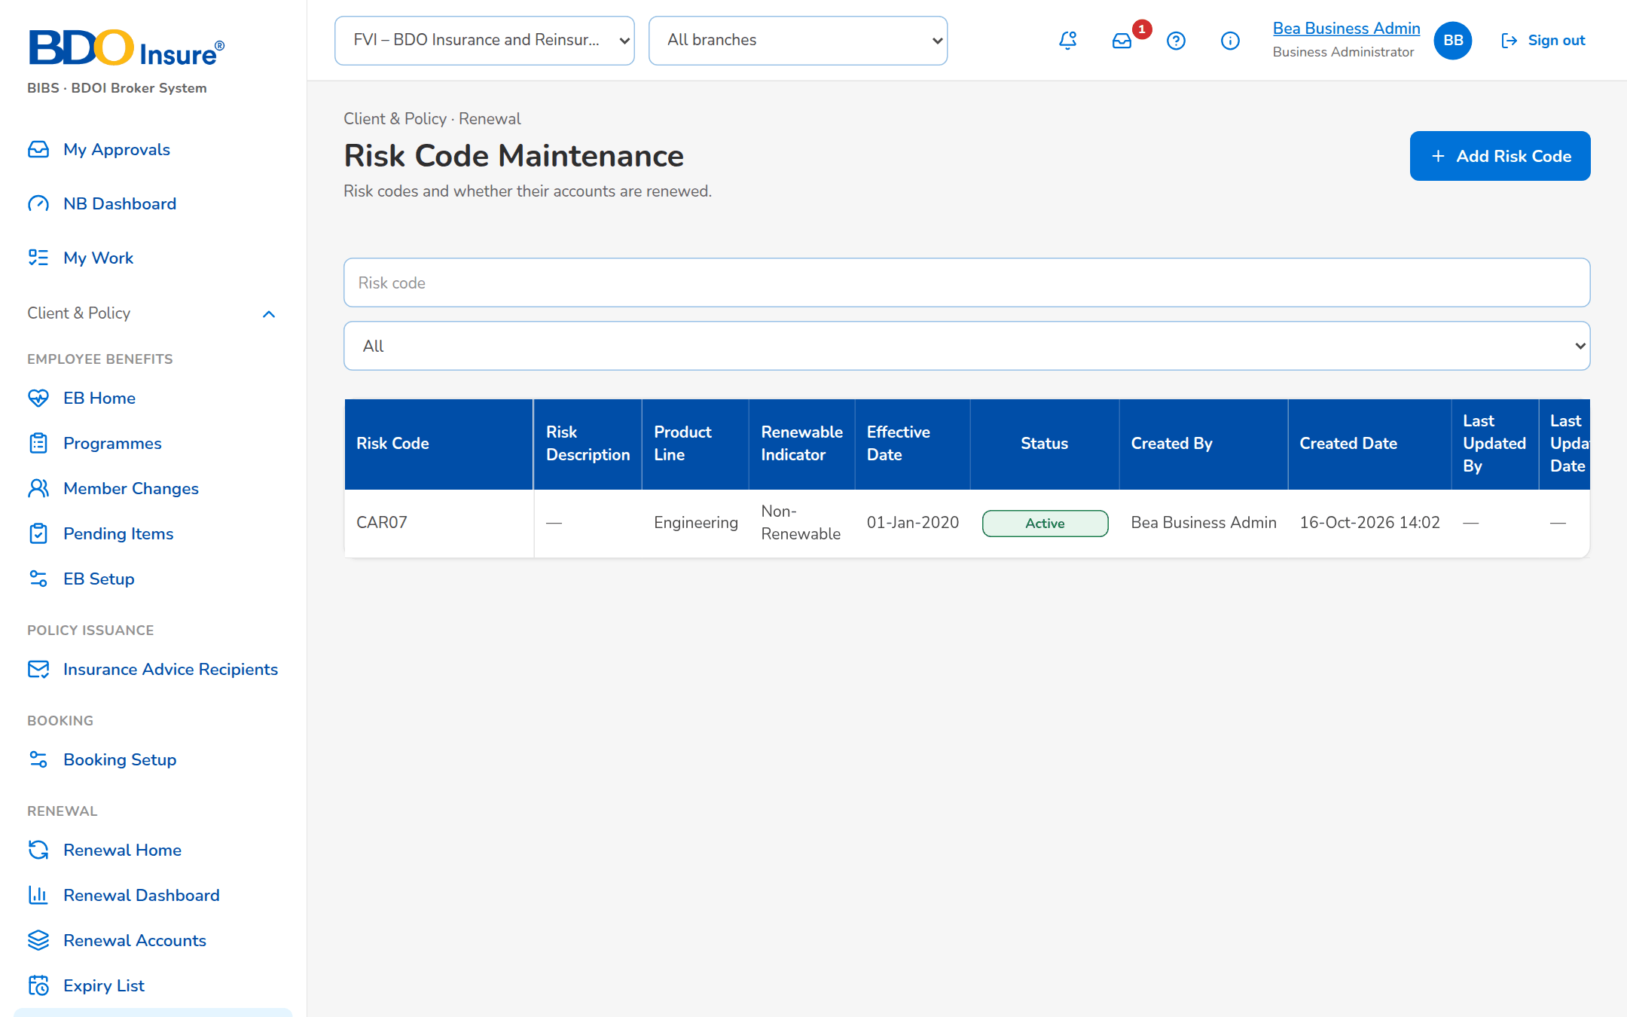
Figure 48: SCR-RN-29: Risk Code Maintenance with the risk codes and their renewable indicator

SCR-RN-30 CLPC Billing Files
Item | Value
Purpose | The billing files of the CLPC renewals: the file of the renewals billed through the loan of the client is generated for a period, sent to LMS and kept with its delivery status.
Access | Client & Policy › Renewal › CLPC Billing Files
Requirements | FRRN.027, FRRN.028
Outcome | -

Table 60: SCR-RN-30 fields
Field | Type | Req. | Default | Rule | Message
Generate Billing File dialog: From Date / To Date | Date | Y | The coming billing period | dd-MMM-yyyy; Editable: Always; To Date not before From Date | -
List: File Name / File Type / Generated By / Accounts / Delivery Status / Error Reason / LMS Upload / Generated On | Column | - | - | Names; dd-MMM-yyyy HH:mm; Source: Billing files; Editable: Read only | No billing file generated

Table 61: SCR-RN-30 actions
Action | Who | Available when | What happens | Result
Generate Billing File | Processing users | Always | Generates the file of the period and sends it to LMS | Generated
Download / Download As | Processing users | Always | Downloads the file under its name or another name | -

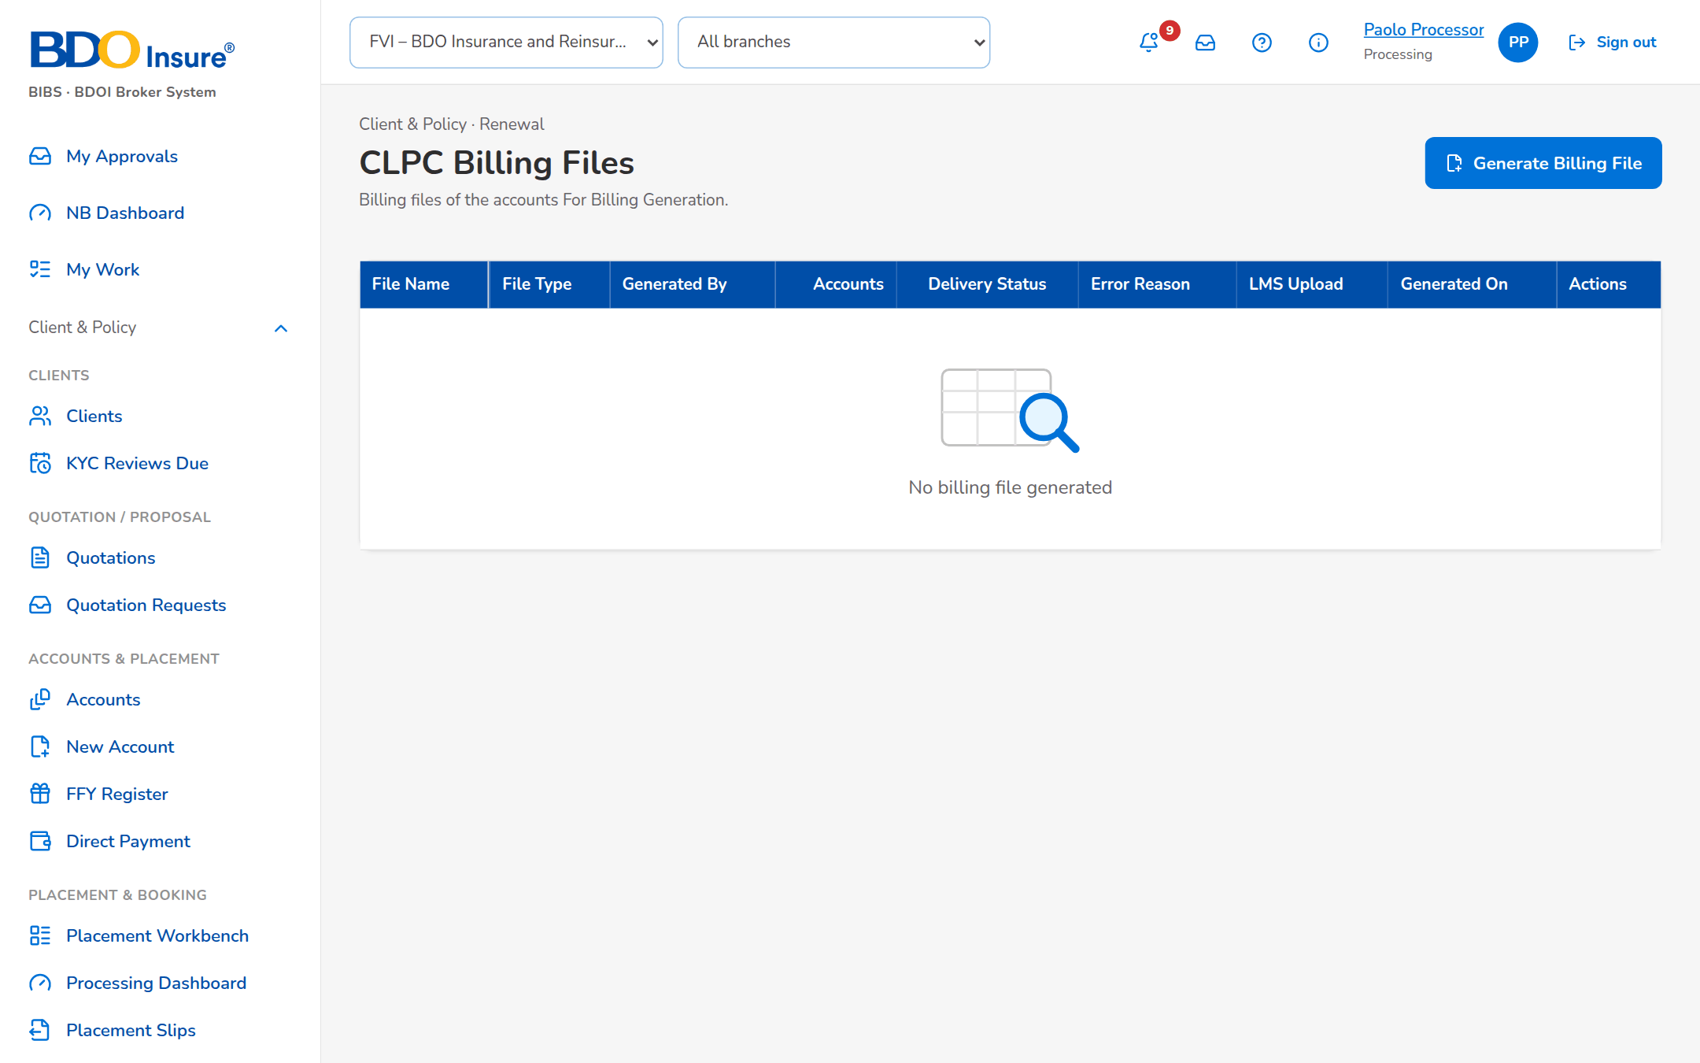
Figure 49: SCR-RN-30: CLPC Billing Files with the files generated and their delivery status

SCR-RN-31 E-Policies
Item | Value
Purpose | The e-policies of the insurers: the files received (summary file and ZIP of the policies) matched to the renewal accounts, the accounts For E-Policy Sending with the policy to send to the client, and the upload of the e-policy numbers.
Access | Client & Policy › Renewal › E-Policies
Requirements | FRRN.033
Outcome | -

Table 62: SCR-RN-31 fields
Field | Type | Req. | Default | Rule | Message
Tabs: E-Policy Receipts / For E-Policy Sending / Upload E-Policy Numbers | Tab | - | E-Policy Receipts | - | -
E-Policy Receipts: E-Policy Summary File (.txt) / E-Policy ZIP File | Upload | Y | - | The summary file and the ZIP of the policies of an insurer; Editable: Processing users; The ZIP holds the documents of the summary | -
Files received: ID / File Name / Receipt Date and Time / Receipt Type / Processing Status / Matched / Reason/Remarks | Column | - | - | dd-MMM-yyyy HH:mm; Source: E-policy files; Editable: Read only | No e-policy file received
Policies of a file: Sequence / Renewal Reference Number / Policy Number / Document / Matching Status / Remarks | Column | - | - | Matched, Not matched; Source: Lines of the file; Editable: Read only | No record
For E-Policy Sending: Select / Renewal Reference Number / Client / Policy Number / Client Email / E-Policy / Not Eligible / CC recipients | Column, tick box, e-mail | - | - | Source: Accounts with an e-policy; Editable: Processing users | No account is For E-Policy Sending

Table 63: SCR-RN-31 actions
Action | Who | Available when | What happens | Result
Upload | Processing users | Always | Receives the e-policy files and matches each policy to its renewal | Matched or Not matched
Send | Processing users | Accounts ticked | Sends the e-policy to the client by the channel of the setting | Sent

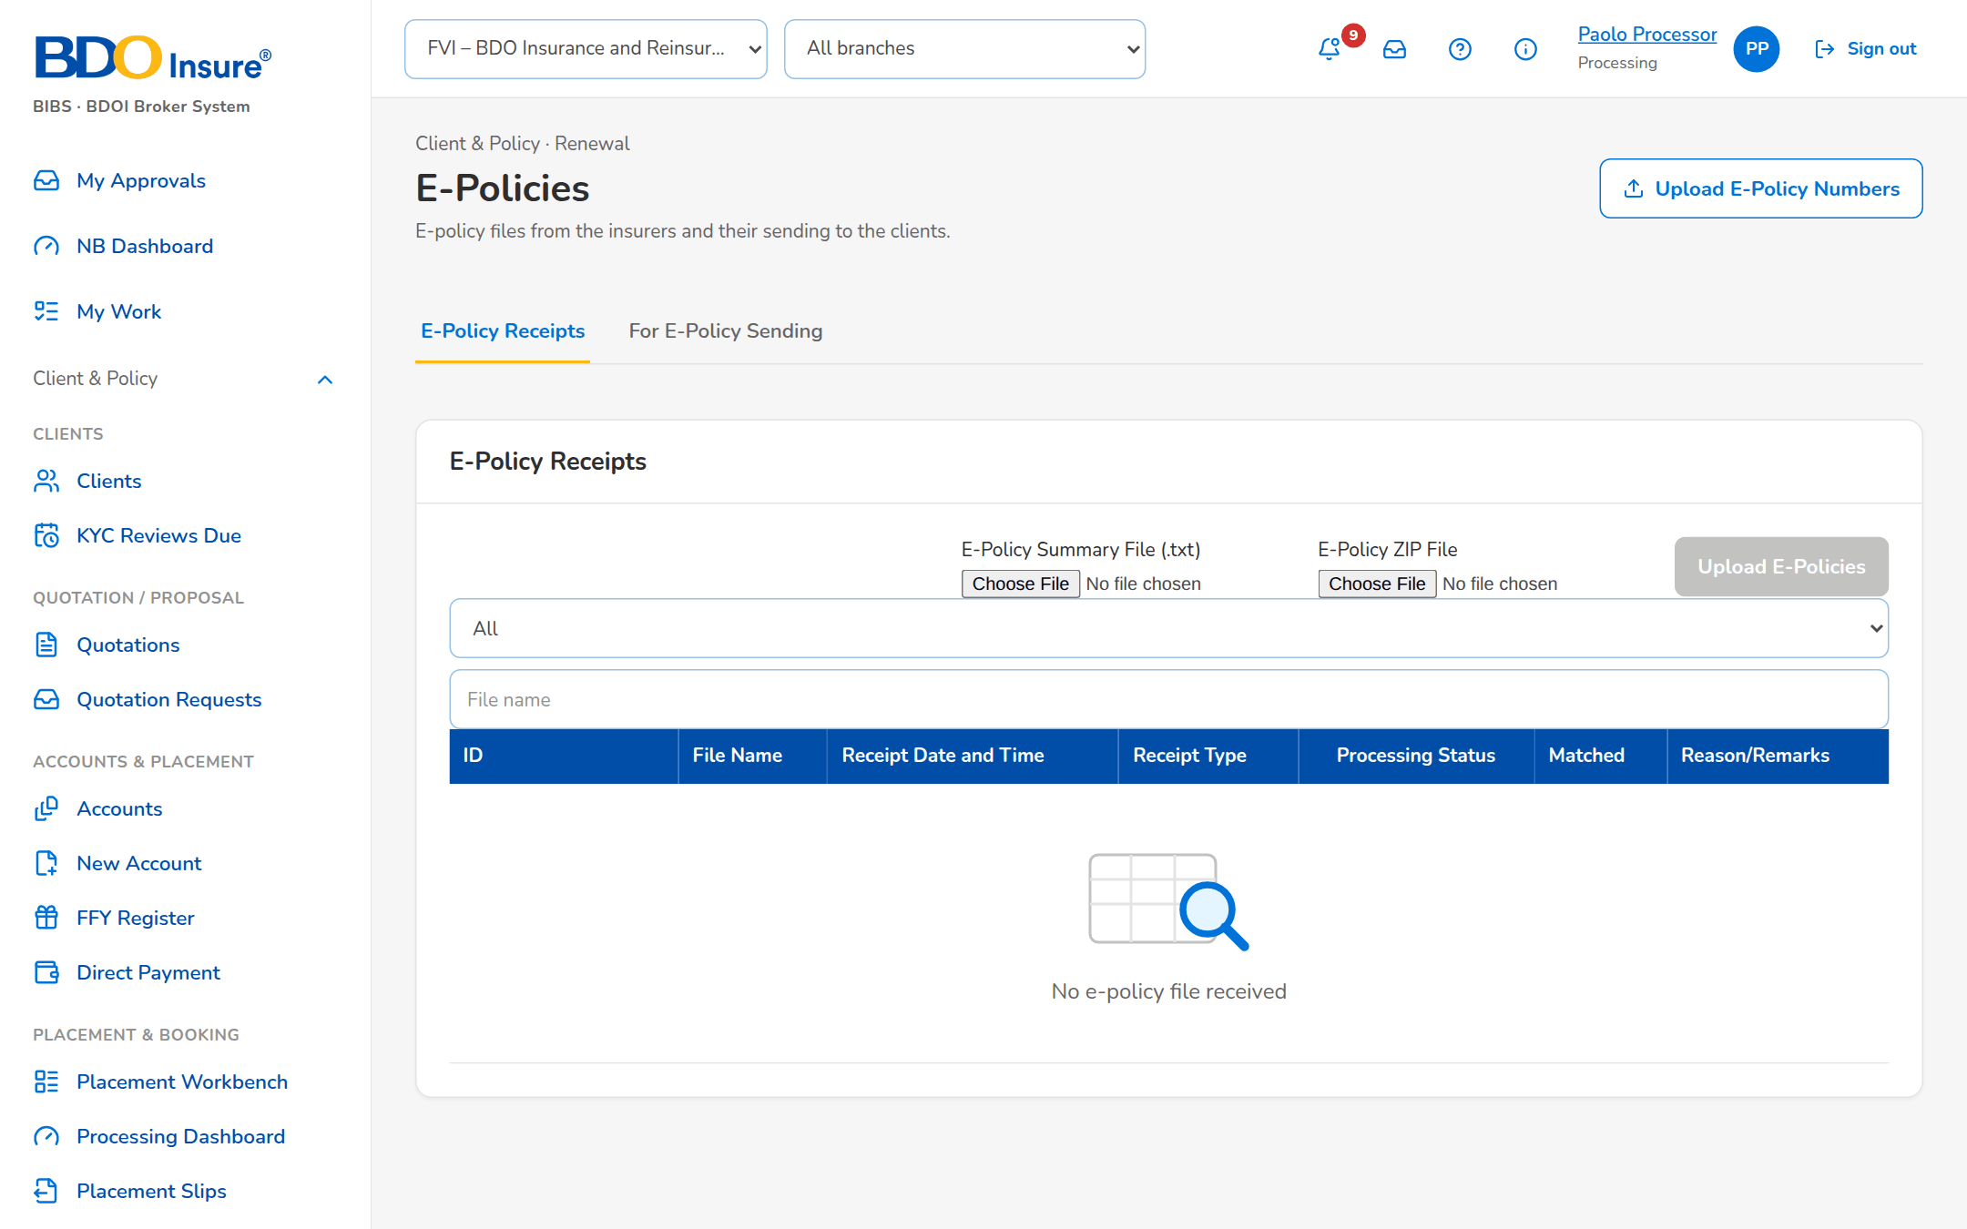
Figure 50: SCR-RN-31: E-Policies, E-Policy Receipts: the files received and the matching of each policy

SCR-RN-32 RMU Account Maintenance
Item | Value
Purpose | The Account Officers of the RMU (past-due loans) whose renewal accounts are handled apart, maintained by the Business Administrator.
Access | Client & Policy › Renewal › RMU Account Maintenance
Requirements | FRRN.041
Outcome | -

Table 64: SCR-RN-32 fields
Field | Type | Req. | Default | Rule | Message
List: AO Code / Account Officer Name / Status / Remarks / Updated By / Updated | Column | - | - | Names; dd-MMM-yyyy; Source: RMU Account Officers; Editable: Read only | No RMU Account Officer
RMU officer dialog: AO Code / Account Officer Name / Remarks | Text | Y / Y / N | Blank | Up to 500 characters; Editable: Business Administrator; AO code not yet listed | -

Table 65: SCR-RN-32 actions
Action | Who | Available when | What happens | Result
Add / Update | Business Administrator | Always | Saves the RMU Account Officer | Active

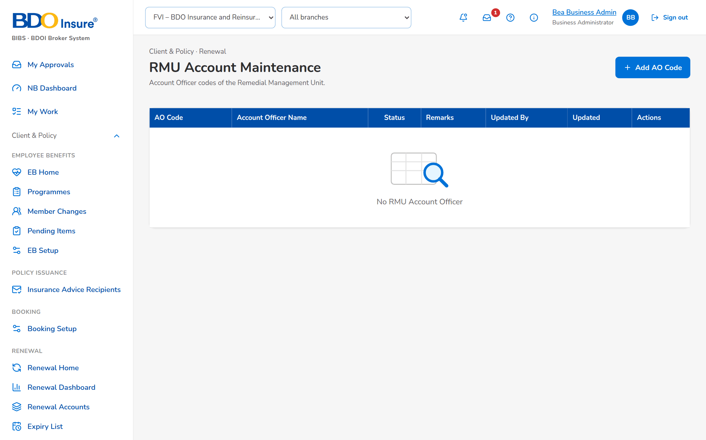
Figure 51: SCR-RN-32: RMU Account Maintenance with the RMU Account Officers

SCR-RN-33 Channel Monitor
Item | Value
Purpose | The documents of Renewal sent through the channels (CCM to the clients, MFT to the insurers, LMS for billing): each message with its status, reference, recipients and error, its delivery history and the connection of each channel. A failed message may be sent again.
Access | Client & Policy › Renewal › Channel Monitor
Requirements | FRRN.017, FRRN.022, FRRN.023, FRRN.024, FRRN.027
Outcome | -

Table 66: SCR-RN-33 fields
Field | Type | Req. | Default | Rule | Message
Filters: Channel / Delivery status / Search reference | Drop-down, drop-down, text | N | All | CCM, MFT, LMS; statuses; Editable: Always | -
List: Channel / Reference Number / File Name / Recipients / Delivery Status / CCM Transaction Reference / Error / Queued | Column | - | - | dd-MMM-yyyy HH:mm; Source: Messages of the channels; Editable: Read only | No message
Delivery History: When / Status / Detail / By | Table in a dialog | - | - | dd-MMM-yyyy HH:mm; Source: Events of the message; Editable: Read only | No status yet
Connection: Mode / Address / Access key | Display | - | - | The mode of the channel (live or simulator in SIT and UAT); Source: Settings of the channel; Editable: Read only | -

Table 67: SCR-RN-33 actions
Action | Who | Available when | What happens | Result
Resend | System Administrator | Message failed | Sends the message again | Queued
Cancel | System Administrator | Message queued | Cancels the message | Cancelled
Check | System Administrator | Always | Checks the connection of the channel | -

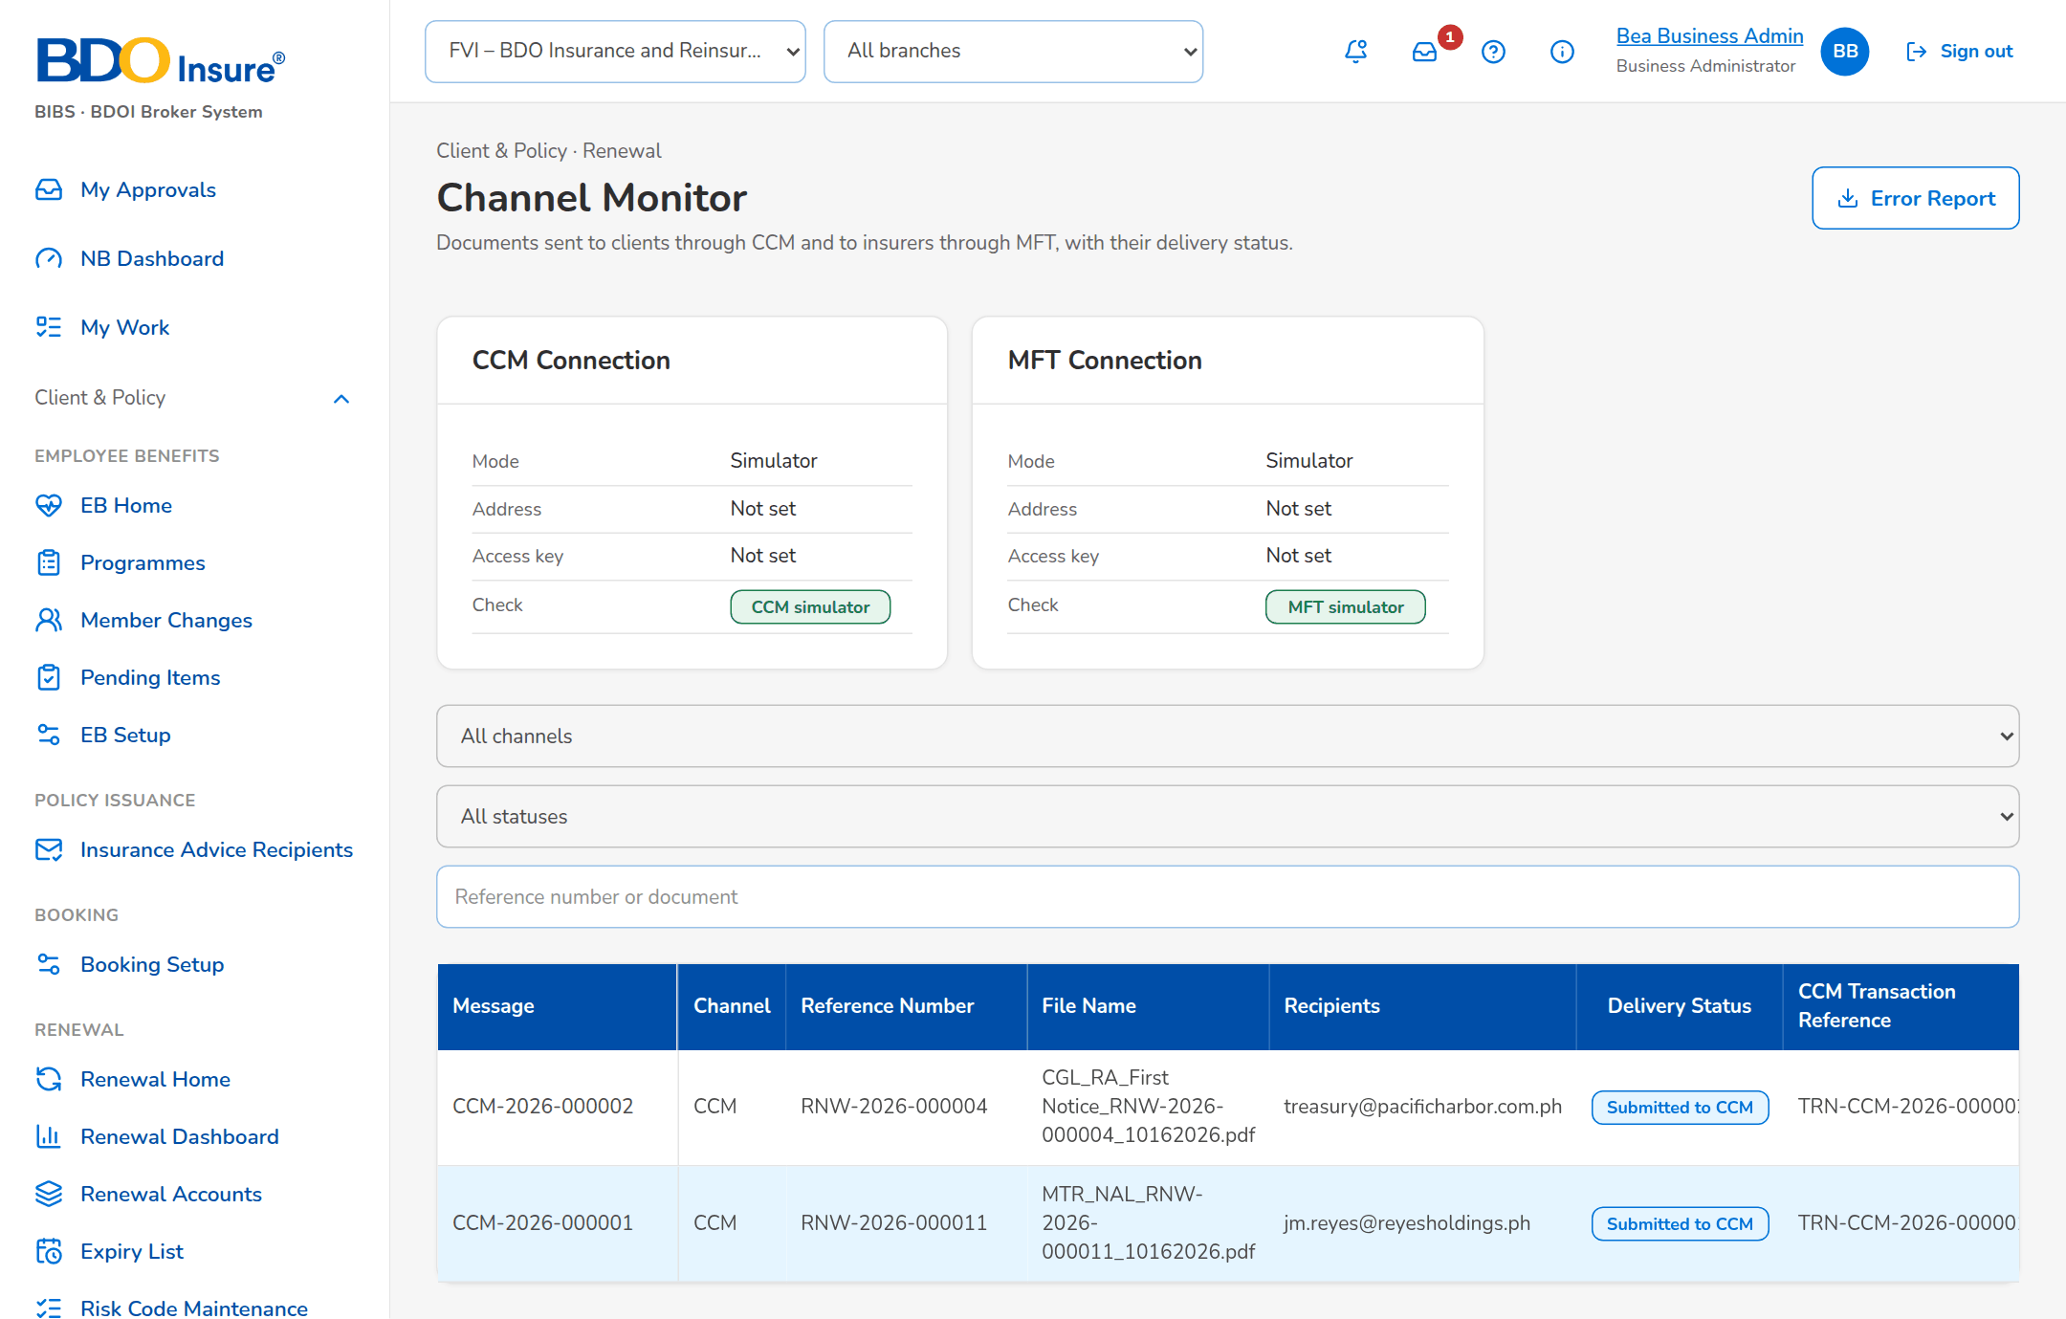
Figure 52: SCR-RN-33: Channel Monitor with the messages sent through CCM, MFT and LMS

SCR-RN-34 Audit Logs
Item | Value
Purpose | Every action on the renewal accounts with its old and new value, who did it and when, filtered by date, action type, reference and user. Nobody can change or delete an entry.
Access | Client & Policy › Renewal › Audit Logs; Renewal › Audit Logs tab
Requirements | FRRN.043
Outcome | -

Table 68: SCR-RN-34 fields
Field | Type | Req. | Default | Rule | Message
Filters: Date From / Date To / Action Type / Reference Number / User | Date, date, drop-down, text, drop-down | N | The current month | dd-MMM-yyyy; action types in words; names; Source: Action types; users; Editable: Always; Date To not before Date From | -
List: Timestamp / Module / Reference Number / Client / Assured / Action Type / Description / Old Value / New Value / Performed By / Remarks | Column | - | - | dd-MMM-yyyy HH:mm; values in words; Source: Audit trail; Editable: Read only | No audit log entries

Table 69: SCR-RN-34 actions
Action | Who | Available when | What happens | Result
Export | Auditor, Business Administrator | Always | Downloads the entries of the filters | -

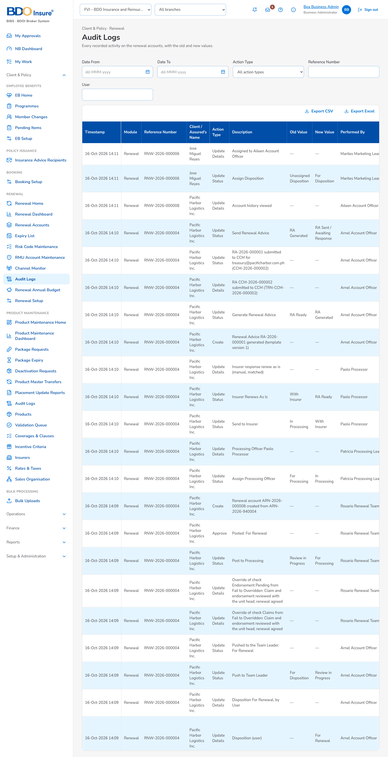
Figure 53: SCR-RN-34: Audit Logs of Renewal with the actions of the period

SCR-RN-35 Renewal Annual Budget
Item | Value
Purpose | The annual budget of the renewals per fiscal year, measure, market segment and team, uploaded and updated by month, with the history of every change. The Renewal Dashboard compares the actuals with it.
Access | Client & Policy › Renewal › Renewal Annual Budget
Requirements | FRRN.042
Outcome | -

Table 70: SCR-RN-35 fields
Field | Type | Req. | Default | Rule | Message
Filters: Fiscal Year / Measure / Market Segment / Team Lead | Drop-down | Y / N / N / N | The current year | Years; measures; segments; users; Editable: Always | -
Budget: Region / Team / Sub-Team / Section Head / Team Head / Team Lead / Account Officer / Annual New Budget / Annual Renewal Budget / Annual Organic Budget / Grand Total | Column | - | - | Two decimals; Source: Budget of the year; Editable: Read only | No budget for this fiscal year
Update Budget dialog: Month / Budget | Table | Y | The current budget | Two decimals; Editable: Business Administrator; Not negative | -
Budget History: Month / Previous Budget / Updated Budget / Modified By / Modification Date | Table in a dialog | - | - | dd-MMM-yyyy; Source: Changes of the budget; Editable: Read only | No changes since the budget was created

Table 71: SCR-RN-35 actions
Action | Who | Available when | What happens | Result
Upload Budget | Business Administrator | Always | Uploads the budget file of the fiscal year | -
Update Budget | Business Administrator | Budget loaded | Changes the budget of a month | -
View Budget History | Business Administrator | Always | Opens the history of the changes | -

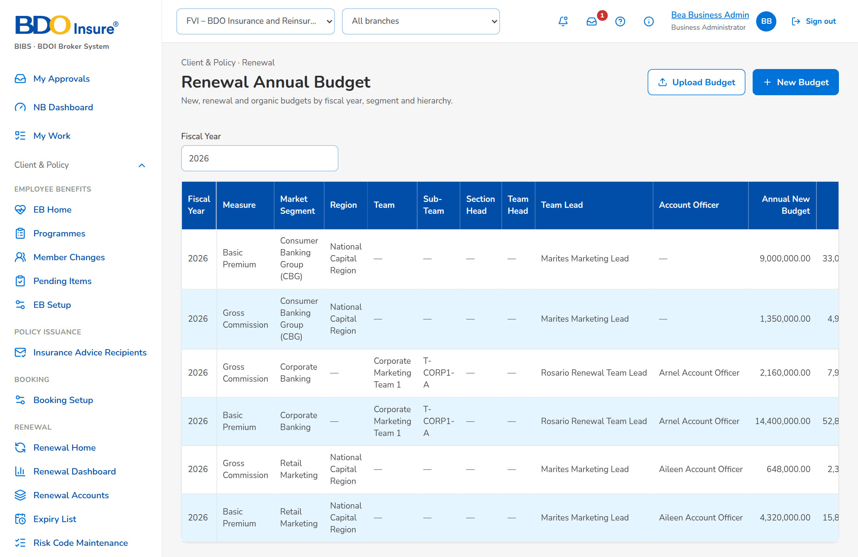
Figure 54: SCR-RN-35: Renewal Annual Budget of the fiscal year by team and month

SCR-RN-36 Renewal: Hold Cover, Proposal & TSU, Acceptance & Approval, KYC, Placement and Audit Logs
Item | Value
Purpose | The tabs of the renewal record added with the full coverage: the hold cover requests of the account with the insurers' shares, the proposals and the TSU request, the client's acceptance with the approval and the payment, the KYC status, the Insurance Advice and the placement with each insurer's response, and the audit trail of the renewal.
Access | Every Renewal user, on the renewal; the actions follow the stage and the permissions.
Requirements | FRRN.014, FRRN.016, FRRN.017, FRRN.025, FRRN.029, FRRN.032, FRRN.034, FRRN.036, FRRN.037
Outcome | -

Table 72: SCR-RN-36 fields
Field | Type | Req. | Default | Rule | Message
Hold Cover tab: Insurers: Insurer / Share (%) / Coverage / Premium | Table | - | - | Two decimals; Source: Insurers of the account; Editable: Read only | No insurer
Hold Cover tab: Hold Cover Requests: Reference Number / Request / Insurer / Share (%) / Start / End / Sent By / Status / Insurer Remarks | Table | - | - | dd-MMM-yyyy; Source: Hold cover requests; Editable: Read only | No hold cover request
Hold Cover tab: extension: Extension days | Number | Y | 30 | 15 or 30 days (setting); Editable: Hold cover approved; Within the extension window | -
Proposal & TSU tab: Proposals: File Name / Proposal / Status / CCM Message / Generated On | Table | - | - | dd-MMM-yyyy HH:mm; Source: Proposals of the renewal; Editable: Read only | No proposal generated
Proposal & TSU tab: TSU Request: TSU Officer / Remarks / Insurer / Premium / Terms and conditions / Proposal | Drop-down, text, drop-down, amount, text area, file | Y | Blank | Names; two decimals; Source: TSU officers, insurers; Editable: For Quotation, For Proposal | -
Acceptance & Approval tab: Client Acceptance Status / For Booking Only / Direct-to-Insurer Payment / Approval and Payment: Status / Remarks / Policy Number / OR Number / Override reason or justification / Option / Rejection reason | Drop-down, text | Cond. | Blank | Labels; Source: Acceptance statuses; Editable: After the Renewal Advice; An override needs a justification | -
KYC tab: Status / Activity / Remarks or follow-up note | Drop-down, drop-down, text area | N | From the client | Labels; Source: KYC statuses and activities; Editable: Always | -
Placement tab: Insurance Advice: Version / File Name / Generated By / Generated On / CCM Message | Table | - | - | dd-MMM-yyyy HH:mm; Source: Insurance Advices (mortgaged accounts); Editable: Read only | No Insurance Advice (mortgaged accounts only)
Placement tab: Placement: Insurer / Share (%) / Premium / Placement Slip / Status / Transmission / Submitted / TAT (business days) / SLA / With Issue / Insurer Response | Table | - | - | Two decimals; dd-MMM-yyyy; Source: Placement of each insurer; Editable: Read only | No placement generated
Record Insurer Response dialog: Insurer Response / Rejection Reason / Insurer Remarks | Drop-down, drop-down, text area | Y / Cond. / N | Blank | Approved, Rejected; rejection reasons; Source: Insurer responses; Editable: With Insurer; A rejection needs its reason | -
Audit Logs tab: Timestamp / Action Type / Description / Old Value / New Value / Performed By / Remarks | Table | - | - | dd-MMM-yyyy HH:mm; Source: Audit trail of the renewal; Editable: Read only | No audit log entries

Table 73: SCR-RN-36 actions
Action | Who | Available when | What happens | Result
Request Hold Cover / Record Approval | Account Officer; Processing Officer | Before expiry, payment pending | Sends the hold cover request to the insurers; records the insurer's approval with the extension | Hold cover requested / approved
Generate Proposal / Send via CCM / Download As | Account Officer | For Proposal | Generates the quick or full proposal and sends it to the client | Proposal sent
Submit to TSU | Account Officer | For Quotation or For Proposal | Sends the request to the TSU after the Team Lead's approval | Pending Team Lead Approval
Record Acceptance / Approve / Reject | Account Officer; approver | After the Renewal Advice | Records the client's acceptance and the second approval of the setting | Accepted / Submitted for Approval
Download Slip / Download Placement File / Record Insurer Response | Processing Officer | For Placement, With Insurer | Downloads the slip and records the insurer's response | Placed or Rejected

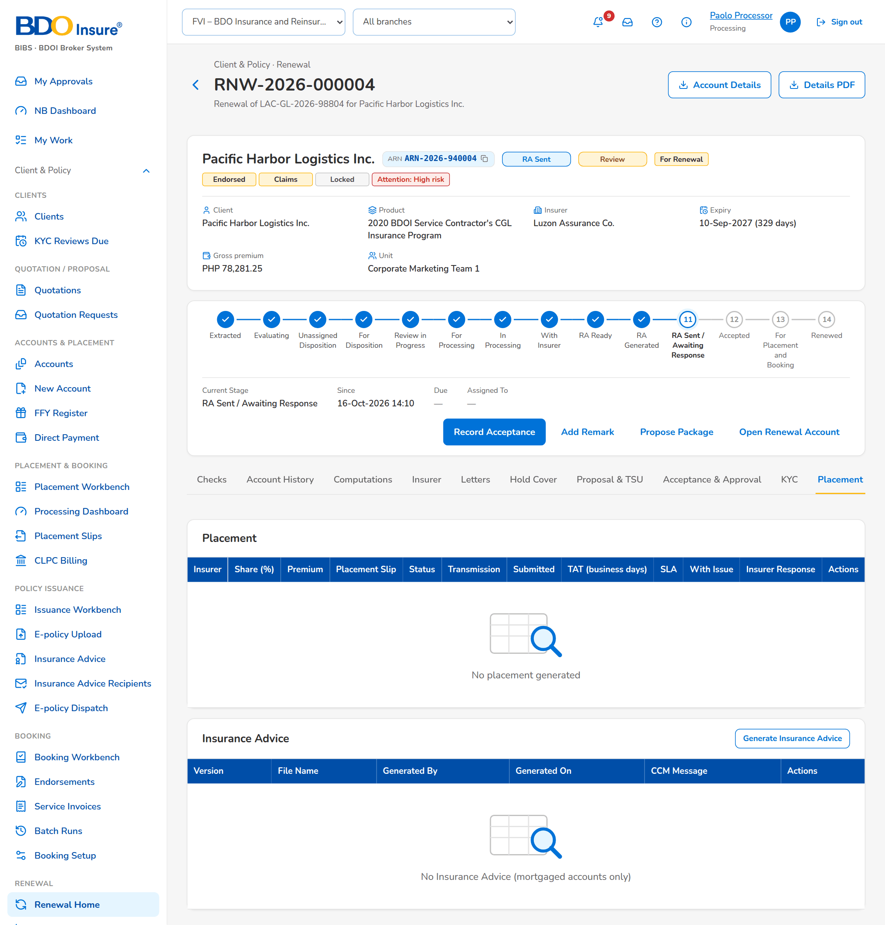
Figure 55: SCR-RN-36: Placement tab: the Insurance Advice and the placement slip of each insurer with its response

