
PRJ0012475 - BDO Insure Brokering System (BIBS) - User Access Maintenance: Reports, Notifications and Outputs -
Release 1 / Drop 0
Prepared by: iorta TechNXT Project Team (drafting support); for review by the BDOI Product Owner

Template Reference No. | D051
FR Document No. | PRJ0012475-RNO
Prepared by: | iorta TechNXT Project Team (drafting support); for review by the BDOI Product Owner
Drafting support: | iorta TechNXT Project Team (drafting support); for review by the BDOI Product Owner
Creation Date: | 10/16/2026
Revision No. | 1.6
Last Updated by: | iorta TechNXT Project Team (drafting support); for review by the BDOI Product Owner
Last Updated Date: | 10/16/2026

Document Revision Log
Date | Revision | Description | Updated by
16 Oct 2026 | 1.5 | First issue as a separate document of the User Access Maintenance set (taken out of the FRS v1.4 annexes and rewritten for the agreed access model). Numbered 1.5 to match the FRS. | iorta TechNXT Project Team (drafting support); for review by the BDOI Product Owner
16 Oct 2026 | 1.6 | Names of persons removed. References to the new Developer Specification, Data Dictionary, User Stories and the programme documents (NFR, Glossary, Decision and Observation Log). | iorta TechNXT Project Team (drafting support); for review by the BDOI Product Owner

Table of Contents
Document Revision Log 3
Table of Contents 4
Introduction 5
Reports 6
Certification Extract 8
Exports 10
Notices and E-mails 11
Scheduled Jobs 13
Withdrawn with Version 1.5 14

Introduction
This document lists the reports, the certification extract, the exports, the notices and e-mails and the scheduled jobs of User Access in BIBS. Only the current set is listed; those withdrawn with version 1.5 are named at the end.

Reports
Table 1: User access reports
ID | Report | BRD | Parameters | Fields
RPT-UA-01 | User Access Report | BRD 3.003.1 | As of date, business unit, status, group profile | User ID, name, Windows ID, business unit, user level, status, group profiles, date created, created by (UIDM-ISC with request number), date modified, modified by, last action
RPT-UA-02 | User Group Profile Report | BRD 3.003.2 | Group profile, module, active | Group profile name, module, task, With Access / No Access, date created, created by, date modified, modified by
RPT-UA-03 | Group Profile Membership | BRD 3.003.3 | Group profile, as of date | Group profile, user ID, user name, added on, added by (UIDM request number)
RPT-UA-04 | User Access Audit Log | BRD 4.003.1 | Date from / to, user, activity, log-ins and log-outs | Date and time, activity, record, from value, to value, done by, approved by, request or change number, source address
RPT-UA-05 | Group Profile Changes | BRD 1.008 (group profiles) | Date from / to, status, change | Change number, group profile, change, maker, checker, second approver, status, age in days

Each report is exported to PDF (landscape), Excel and CSV. The file is named after the report and the date: User Access Report_10162026.
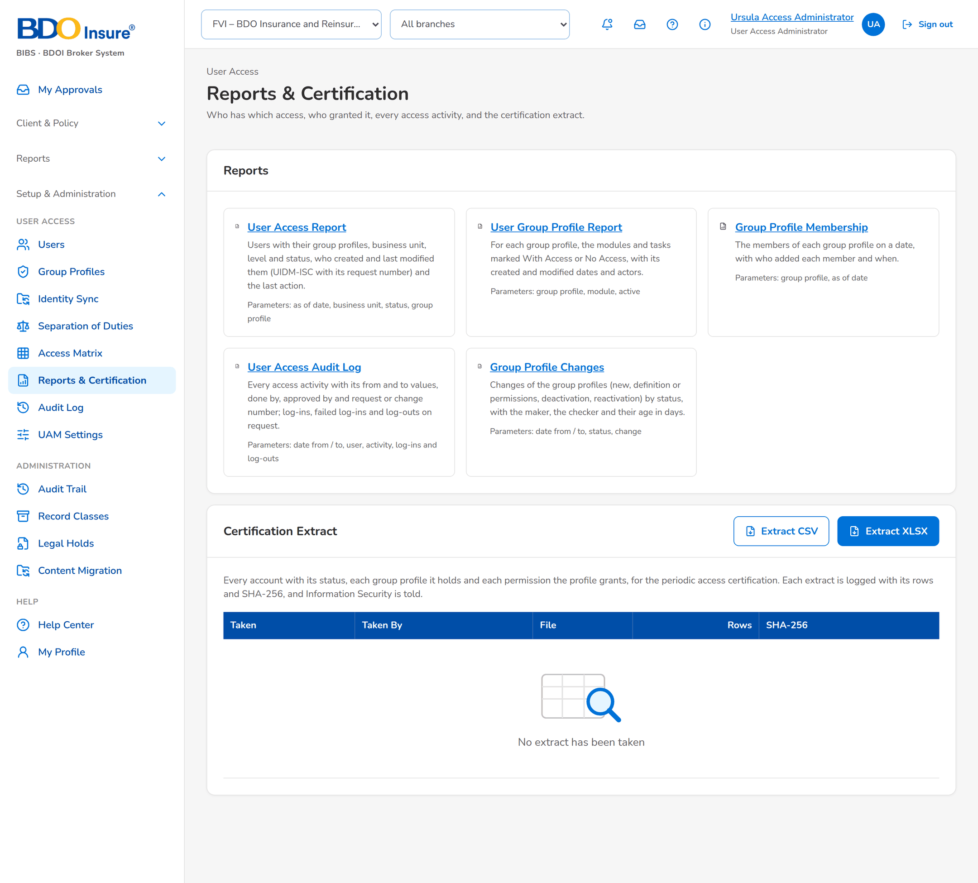
Figure 1: Reports & Certification

Certification Extract
The extract lists every account with each group profile and each permission, one row per permission. It is taken in CSV or XLSX from Reports & Certification. Each extract is logged with who took it, when, the number of rows and the SHA-256 of the file, and Information Security is told.
Table 2: Fields of the certification extract
Field
User ID
Windows ID
Name
E-mail
Business Unit
User Status
Last Login
Group Profile Code
Group Profile Name
Group Profile Active
Privilege Level
Permission
Permission Area
Source
UIDM Request No.

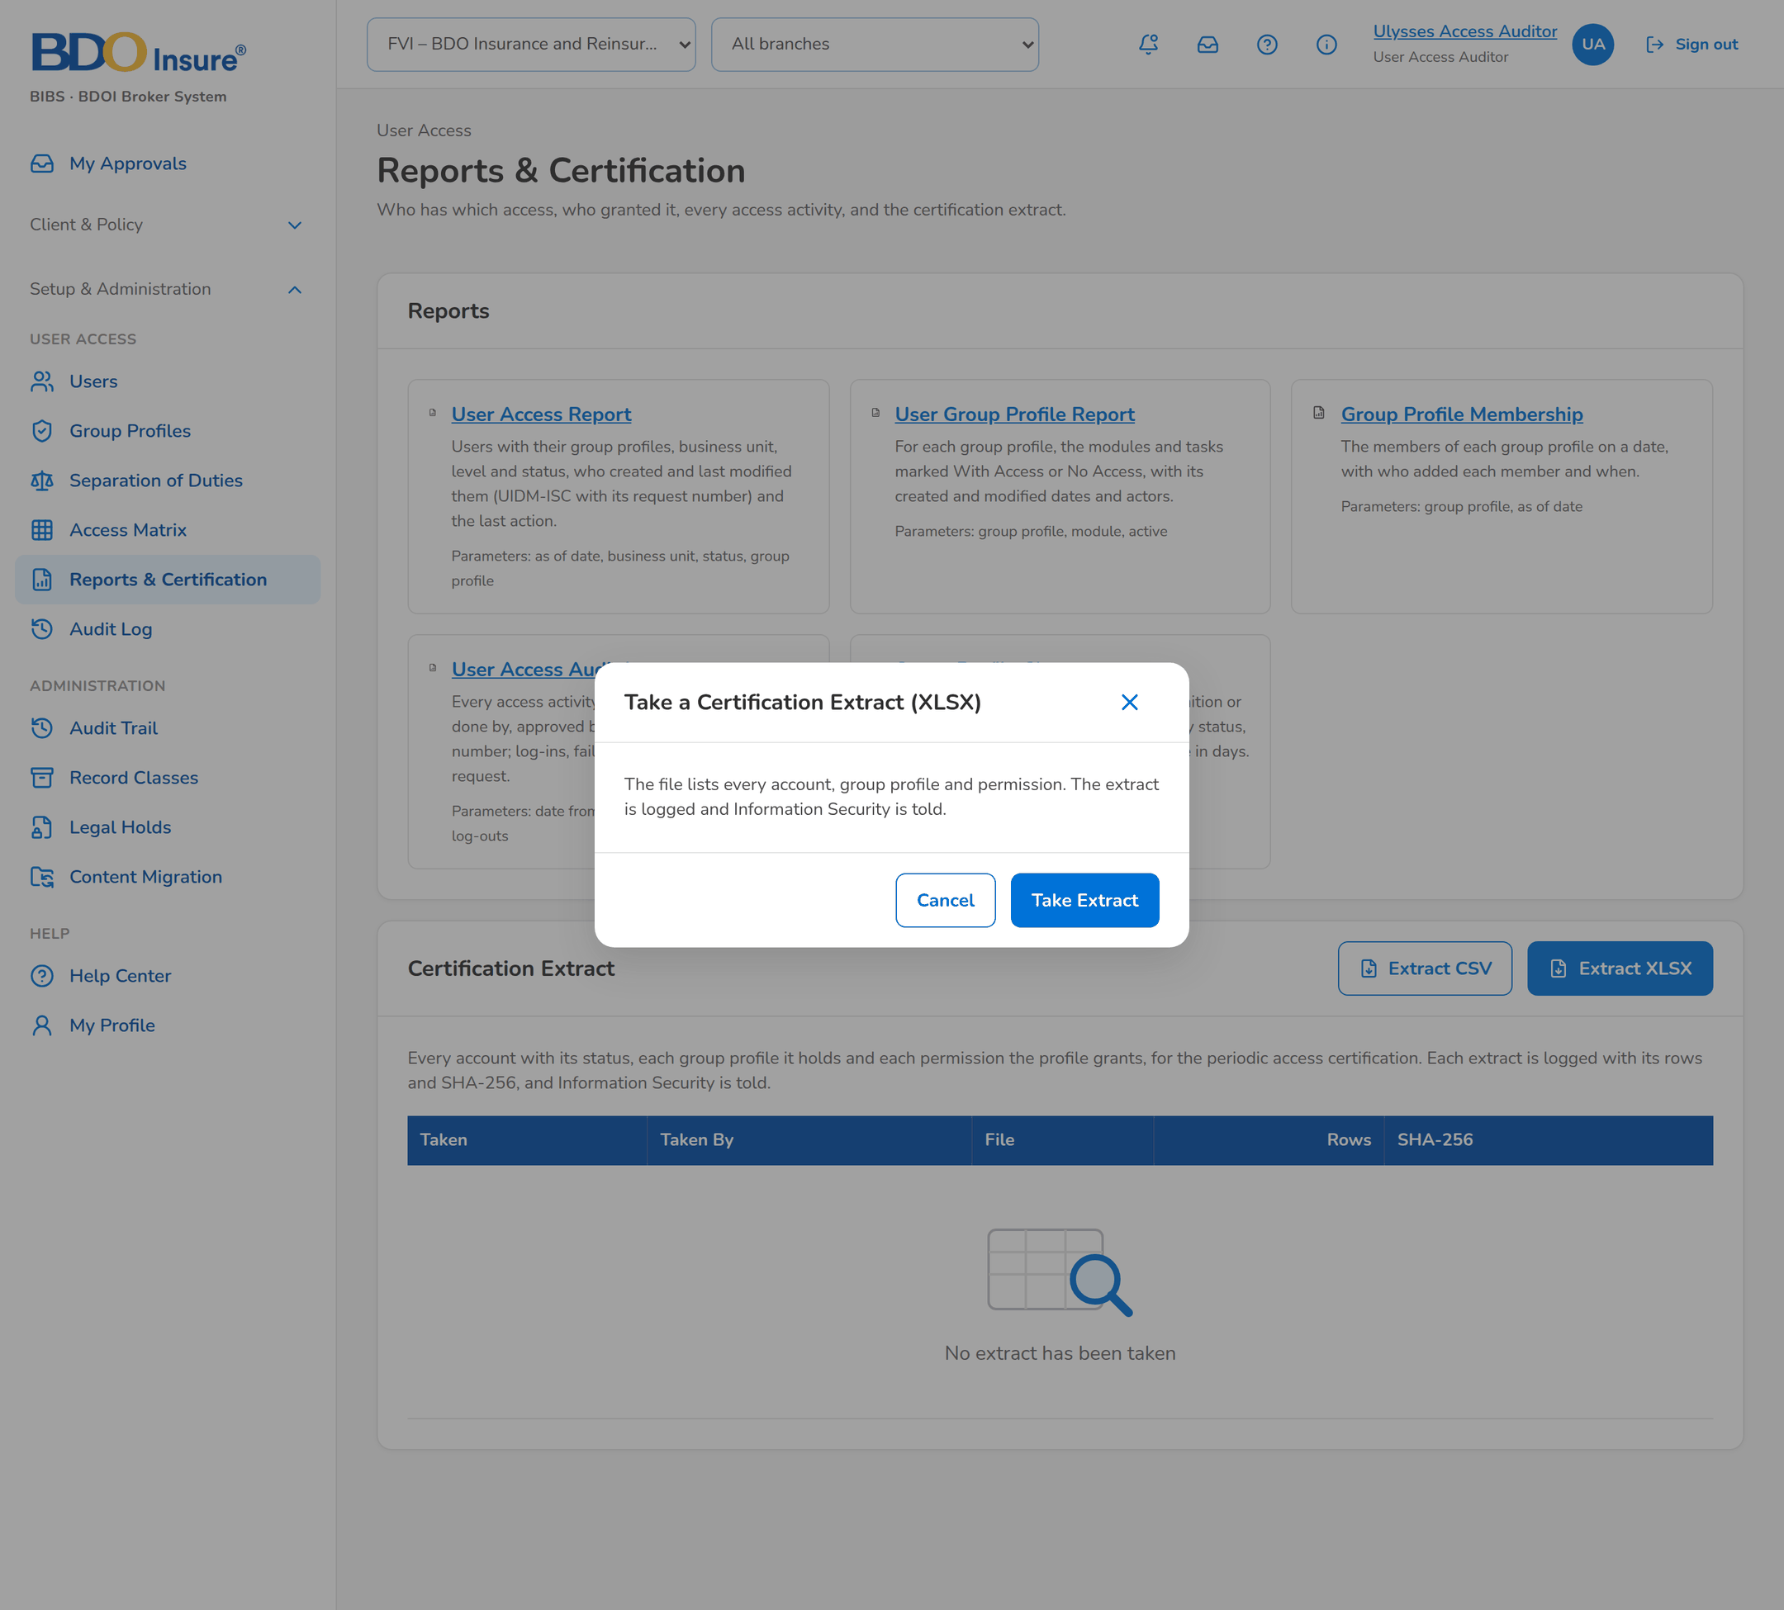
Figure 2: Taking the certification extract

Exports
Table 3: Exports
Output | Format | Where | Content
Users list | CSV | Users screen, Export | Columns of the list with the filters applied
Reports | PDF (landscape), Excel, CSV | Each report | File name <Report name>_MMDDYYYY
Access matrix | Excel | Access Matrix, Export | Profiles against permissions
Certification extract | CSV or XLSX | Reports & Certification, Take Extract | Logged with SHA-256
SoD violations | CSV | Separation of Duties › Violations, Export | Users who breach a rule
Audit log | CSV | Audit Log, Export | Events with the filters applied

Notices and E-mails
Notices appear under the bell and, where shown, by e-mail. Text in angle brackets is filled in. Notices of user access requests (to approve, returned, decided) are sent by UIDM-ISC.
Table 4: Notices and e-mails
ID | Event | To | Title | Text | Channel
NT-01 | Group-profile change submitted | Group Profile Checkers | Access request <no.> to approve | <Change description>. | In-app; e-mail by preference
NT-02 | Second approval needed | Second checkers | Access request <no.> for second approval | <Change description>. | In-app; e-mail by preference
NT-03 | Change approved, waiting for implementation | System Administrators | Access request <no.> to implement | <Change description>. | In-app; e-mail by preference
NT-04 | Change decided | Maker | Access request <no.> <approved / rejected / returned / implemented> | <Change description> (<checker remark>). | In-app; e-mail by preference
NT-05 | Group profile deactivated or reactivated, or permissions changed | Members of the profile | Your access changed | Your access changed: <change description> (request <no.>). | In-app and e-mail
NT-06 | Dormancy notice | The dormant user | Your account will be deactivated | You have not signed in to BIBS since <date>. Sign in before <date> to keep your account. | In-app and e-mail
NT-07 | Dormant users deactivated | User Access Administrators | Dormant users deactivated | <n> users without a sign-in for <days> days were deactivated. Disable them in UIDM-ISC too. | In-app and e-mail
NT-08 | Identity event refused | User Access Administrators | Identity event <no.> needs review | UIDM-ISC event <type> of Windows ID <id> was refused: <reason>. | In-app
NT-09 | Reconciliation mismatches | User Access Administrators | Identity reconciliation: <n> mismatch(es) | <n> users differ from the UIDM-ISC directory on <date>. Review them on the Identity Sync screen and ask UIDM-ISC to correct them. | In-app
NT-10 | New separation-of-duties breaches | Information Security | Separation of duties: <n> new breach(es) | Users who hold group profiles kept apart by an active rule; see Separation of Duties › Violations. | In-app
NT-11 | SoD rule proposed | Information Security | Separation-of-duties rule <no.> to authorise | <Profiles kept apart>: <reason>. | In-app
NT-12 | UAM setting proposed | Information Security | Security setting to approve: <setting> | <Maker> requests a change from '<old>' to '<new>'. | In-app
NT-13 | Certification extract taken | Information Security | Certification extract taken | Certification extract <format>, <rows> row(s), SHA-256 <hash>, taken by <user>. | In-app
NT-14 | Privileged group-profile change approved | Information Security | Privileged access change | <Change description> of a High or Admin group profile. | In-app

Scheduled Jobs
Table 5: Jobs
Job | When | What it does | Notices
UAM_DORMANT_USERS | Daily, 00:15 Philippine time | Notices users near the dormancy limit and deactivates those past it; tells the User Access Administrators. | NT-06, NT-07
UAM_IDENTITY_RECONCILIATION | Daily (every setting: Reconciliation every) | Compares users and group profiles with UIDM-ISC; lists mismatches. | NT-09
UAM_SOD_VIOLATIONS | Daily | Records new breaches of active rules. | NT-10
USER_SESSION_SWEEP | Every few minutes | Ends idle, expired, locked and disabled sessions. | -
PASSWORD_EXPIRY_NOTICE | Daily (DEV, SIT and UAT) | Warns local test accounts before their password expires. | -

Withdrawn with Version 1.5
Table 6: Notices withdrawn
v1.4 notice | Subject | Why
NT-05, NT-06 (v1.4) | Request returned; request cancelled | User access requests are in UIDM-ISC.
NT-08, NT-09 (v1.4) | Reset your password; password expires soon | Passwords of bank users are in Entra ID.
NT-12 (v1.4) | Scheduled access change failed | No effective dates.
NT-19, NT-20 (v1.4) | Second-factor reset to approve; authenticator app reset | Second factor is in Entra ID.
NT-22 (v1.4) | Break-glass sign-in | No break-glass account.
NT-13 (v1.4) | Role edited outside a request | Kept only with CR-UA-016 (emergency edit).

