

FUNCTIONAL REQUIREMENTS SPECIFICATION
Collections
BRD-4 Collections (Collection Management System BRD, renumbering addendum and Workshop Addendum)
BIBS – BDOI Broker System
Client | BDO Insurance and Reinsurance Brokers, Inc.
Document | BIBS-FRS-BRD-04
Version | 2.0
Date | 1 October 2026
Status | Issued for BDOI business sign-off
Classification | Confidential

Prepared by iorta TechNXT for BDOI 
iNXT BrokerVerse. This document is confidential to BDO Insurance and Reinsurance Brokers, Inc. and iorta TechNXT.
Document Control
Version | Date | Author | Reviewer | Approver | Change
0.9 | 18 Sep 2026 | iorta TechNXT Business Analysis | iorta TechNXT Solution Architect |  | Internal draft from the BRD-4 baseline
1.0 | 25 Sep 2026 | iorta TechNXT Business Analysis | iorta TechNXT Project Manager | BDOI Operations Head (pending) | First issue for BDOI review; aligned with the Collections screens and the cross-BRD decisions
2.0 | 1 Oct 2026 | iorta TechNXT Business Analysis | iorta TechNXT Project Manager | BDOI business units (sign-off) | Business sign-off pack: navigation by persona, 19 screen specifications with screenshots, five walkthroughs, messages, notifications, document outputs, the upload template, cross-BRD contract, sign-off and change control (chapters 12-20); proposed business rules and clarifications for confirmation extended with the screen presentation items (chapter 21); screen standards (appendix). Messages quoted as the screens show them. Issued 01-Oct-2026. Chapters 1-11 unchanged in substance; FR, BRD and test IDs kept

Distribution List
Name / Unit | Role | Organisation | Purpose
Shellah Marie C. Miranda, AVP, Product Owner | Approver | BDOI | Review and sign-off
Jose Melvin Jarin, AVP, Product Owner | Approver | BDOI | Review and sign-off of the addendum functions
Mark Joseph C. Makalintal (Combank and Corbank), Edmundante F. Ramirez and Roderick Lim (Retail Marketing) | Approver | BDOI | Review and sign-off for Marketing
Ronald Allan E. De Leon, Head - Comptrollership | Approver | BDOI | Review and sign-off of the commission receivable rows (section 4.10)
John Benedict S. Santos, VP and Head, BDOI Operations | Reviewer | BDOI | Review of the process with Operations and of the exports (caveat p.93)
Collections and Marketing Support, HO Marketing Support BBG, Marketing (Pia Grace M. Pinili, Maria Victoria Evangelista, Grace Tordesillas, Ma. Fides E. Rivera, Arra R. Rivera, Rhommel Mark Galler) | Business user | BDOI | Review of the screens and rows (input providers of the BRD)
Operations: Financial Transactions and Processing (Perjelyn Joy Gutierrez); Cashiering and Commission Receivables | Business user | BDOI | Review of the hand-offs, the requests on unapplied payments and the reversal files
Information Technology Group (IT Core Business Delivery; IT AIO Core Business Delivery - Insurance) | Reviewer | BDOI | Review of the scheduled runs, files, access and the Technical Specification
Dan Ace Cauton, Program Manager, and Zean C. Ibay, Business Analyst, ESG - Business Project Services | BRD owner | BDO Unibank ESG | Traceability check against the BRD
Project team | Delivery | iorta TechNXT | Delivery, test and UAT preparation

Contents

1 Introduction 8
1.1 Purpose 8
1.2 Scope 8
1.3 References 9
1.4 Definitions and acronyms 10
1.5 How to read the functional requirements 10
2 Business context and process overview 12
2.1 Business context 12
2.2 Process overview 12
2.3 Collection account statuses 14
3 Personas and roles 15
3.1 Personas 15
3.2 Permissions 16
3.3 Permissions matrix 16
4 Functional requirements 18
4.1 Access, audit and record lock 18
FR-CL-001 Restrict each Collections action to authorised roles 18
FR-CL-002 Show who encoded and who updated each record 19
FR-CL-003 Keep a field-level audit log of Collections changes 20
FR-CL-004 View and extract the Collections audit log 21
FR-CL-005 Lock a collection account while a user edits it 22
4.2 Outstanding PR worklist 23
FR-CL-010 Generate the outstanding PR list at invoice level 23
FR-CL-011 Apply the minimal balance threshold 24
FR-CL-012 Maintain the threshold and the Collections parameters 25
FR-CL-013 Exclude cancelled negative balances and keep other credits apart 26
FR-CL-014 Total the PR balance by account and by client 27
FR-CL-015 Filter the worklist by market segment, Unit Head and other criteria 28
FR-CL-016 Show the net PR and its breakdown 29
FR-CL-017 Refresh the worklist every day from the invoice ledger 30
FR-CL-018 Keep the history of accounts and dispositions 31
4.3 Assignment 32
FR-CL-020 Assign new accounts by rule 32
FR-CL-021 Reassign accounts permanently or temporarily 33
4.4 Collector dispositions and efforts 35
FR-CL-030 Maintain the PR collector disposition list and its rules 35
FR-CL-031 Record a PR collector disposition 36
FR-CL-032 Hand dispositions over to Cashiering and Commission 38
FR-CL-033 Log collection efforts, remarks and the tagging category 40
FR-CL-034 Update several accounts at once 41
4.5 Installments, promises and account views 43
FR-CL-040 Create installment plans for multi-year and installment accounts 43
FR-CL-041 Allocate payments to installments and show the payment history 45
FR-CL-042 Record and evaluate promises to pay 46
FR-CL-043 View policy, account, invoice and co-insurance information 48
FR-CL-044 View the complete transaction history of an account 49
4.6 Escalation 49
FR-CL-050 Maintain escalation rules 49
FR-CL-051 Escalate accounts automatically 51
FR-CL-052 Escalate accounts manually 52
FR-CL-053 Act on an escalation 54
4.7 Billing statements 55
FR-CL-060 Generate billing statements per billing cycle 55
FR-CL-061 Send or cancel a billing statement 56
FR-CL-062 Keep billing as monitoring only 57
4.8 Unapplied payments 58
FR-CL-070 View the list of unapplied payments as of today 58
FR-CL-071 Filter unapplied payments by market segment and disposition status 60
FR-CL-072 Maintain the unapplied payment disposition list 61
FR-CL-073 Record a collector disposition on an unapplied payment 62
FR-CL-074 Request Cashiering to apply, refund, reclass or transfer a payment 63
FR-CL-075 Validate the invoice of "for application to invoice" 64
FR-CL-076 Keep the history of unapplied payments and dispositions 65
FR-CL-077 Produce the daily "For Application To Invoice" file 66
4.9 Scheduled files, reports and home 67
FR-CL-080 Produce the "DP PR for reversal" files 67
FR-CL-081 Produce the "PR 2307 for reversal" files 68
FR-CL-082 Produce the weekly reversal files per unit and branch 69
FR-CL-083 Produce the daily PR report 70
FR-CL-084 Export lists on request without slowing the system 70
FR-CL-085 Show the Collections home 71
4.10 Commission receivable and incentives 72
FR-CL-090 Bill commission receivable only after the premium is confirmed paid 72
FR-CL-091 Keep regular commission and incentives as separate receivables 73
FR-CL-092 Bill incentive campaigns automatically 74
FR-CL-093 Handle commission refunds from negative adjustments apart 75
FR-CL-094 Bill only the collectible commission on mixed payments 76
5 Workflow and status model 77
5.1 Escalation workflow (CLX_ESCALATION) 77
5.2 Collection account statuses and hand-offs 78
5.3 Promises, installments and billing statements 79
5.4 Requests to Cashiering 80
6 Reports and documents 81
6.1 Reports 81
6.1.1 Account reports (CLX-OUTSTANDING-PR, CLX-FULL-PRODUCTION, CLX-COMPLETED-COLLECTIONS, CLX-INVOICES-WITH-DISPOSITION) 81
6.1.2 Reversal reports (CLX-DP-FOR-REVERSAL, CLX-PR2307-FOR-REVERSAL) 82
6.1.3 For Application To Invoice (CLX-APPLICATION-TO-INVOICE) 82
6.2 Documents 83
7 Interfaces and integration 84
8 Non-functional requirements 86
9 Configuration items owned by the business and the System Administrator 87
9.1 Parameters 87
9.2 Jobs 87
9.3 Lists of values 87
9.4 Alerts and notification events 88
9.5 Masters and rules maintained by the business 88
10 Assumptions, dependencies and open questions 89
10.1 Assumptions 89
10.2 Dependencies 89
10.3 Open questions 89
11 Traceability 91
12 Navigation 94
12.1 Screens of Collections 94
12.2 Screen flow 96
12.3 Menu by persona 98
12.3.1 Marketing Account Officer 98
12.3.2 Marketing Team Lead 98
12.3.3 Marketing Handler 99
12.3.4 Collection Handler 100
12.3.5 Collection Team Lead 100
12.3.6 Section Head (Corporate / Retail) 101
12.3.7 Unapplied Payment Handler 101
12.3.8 Processing Unit 102
12.3.9 Cashier (read access and exports) 103
12.3.10 Disbursement (read access and exports) 103
12.3.11 Comptrollership (read access) 104
12.3.12 Business Administrator 105
12.3.13 System Administrator 105
12.3.14 Auditor 107
12.3.15 Authorizer of master data 108
12.4 Common screen elements 109
13 Screen specifications 111
13.1 Home, PR worklist and collection account 111
13.1.1 SCR-CL-01 Collections Home 111
13.1.2 SCR-CL-02 PR Worklist 113
13.1.3 SCR-CL-03 Collection Account 121
13.1.4 SCR-CL-04 Client View 129
13.2 Installments, promises and billing statements 131
13.2.1 SCR-CL-05 Installment Plans 131
13.2.2 SCR-CL-06 Installment Plan 135
13.2.3 SCR-CL-07 Installments Due 139
13.2.4 SCR-CL-08 Promises to Pay 140
13.2.5 SCR-CL-09 Billing Statements 145
13.2.6 SCR-CL-10 Statement of Account 147
13.3 Escalation 151
13.3.1 SCR-CL-11 Escalations 151
13.3.2 SCR-CL-12 Escalation 155
13.3.3 SCR-CL-13 Escalation Rules 158
13.4 Unapplied payments 162
13.4.1 SCR-CL-14 Unapplied Payments 162
13.4.2 SCR-CL-15 Unapplied Payment 167
13.4.3 SCR-CL-16 Requests to Cashiering 171
13.5 Assignment, files and set-up 173
13.5.1 SCR-CL-17 Assignments 173
13.5.2 SCR-CL-18 Collections Files 178
13.5.3 SCR-CL-19 Collections Setup 181
14 End-to-end walkthroughs 186
14.1 WT-A A new outstanding account from the refresh of the worklist to the check pick-up in Cashiering 186
14.2 WT-B A promise to pay, the escalation of the account and its resolution 194
14.3 WT-C An unapplied payment applied to an invoice at the collector's request 200
14.4 WT-D An installment plan and the statement of account of its first cycle 205
14.5 WT-E Controls and the messages the user sees 210
15 Messages catalogue 217
16 Notifications catalogue 226
17 Document outputs 228
17.1 DO-01 Statement of account (SOA) 228
17.2 DO-02 Outstanding PR List 229
17.3 DO-03 Full Production Report 232
17.4 DO-04 DP PR for Reversal and PR 2307 for Reversal files 234
17.5 DO-05 For Application To Invoice file 236
18 Upload screens 237
18.1 Collections Bulk Update (CLX_BULK_UPDATE) 237
19 Cross-BRD dependencies and interface contract 238
20 Sign-off and change control 240
20.1 What is signed 240
20.2 How the review is recorded 240
20.3 What signing freezes 241
20.4 Change after sign-off 241
20.5 Proposed rules for confirmation 241
20.6 Signatures 242
21 Proposed business rules and clarifications for confirmation 243
22 Appendix: Screen standards 246

1 Introduction

1.1 Purpose
This Functional Requirements Specification (FRS) states how BIBS (BDOI Broker System, on iNXT BrokerVerse) meets the Collections business requirements of BDO Insurance and Reinsurance Brokers, Inc. (BDOI). It turns each BRD requirement into functional requirements with actors, flows, rules, validations, screens, fields, notifications, audit and acceptance criteria.
BDOI uses this document to confirm that the system behaves as the business expects. The project team uses it to test and to prepare user acceptance testing (UAT). Every functional requirement (FR) cites the BRD requirement it meets and the BRD page.
The FRs describe the proposed behaviour of the Collections screens. Where the proposed rule or screen differs from the BRD text, or needs a decision of BDOI, the FR says so in a note and chapter 21 lists each such point for confirmation. Chapters 12 to 19 give the business view of the system: the navigation, the specification of every screen with its screenshots, the walkthroughs, the messages, notifications, documents, the upload template and the contract with the other BRDs; chapter 20 describes the sign-off.

1.2 Scope
The scope is the follow-up of premium receivables (PR) and unapplied payments by Marketing: the collection worklist per invoice, assignment, collection efforts, collector dispositions, promises to pay, installments, escalation, billing statements, the collector side of unapplied payments, and the scheduled files that hand accounts to Operations. It also covers the commission receivable (CR) billing gate of the signed addendum and records the four draft rows on commission and incentives.
Table 1: Scope of this FRS
Area | In scope | Source
Access and audit | Role-based access, encoded-by and updated-by, field-level audit log and its extraction, record lock | BRCLXN.019-020, 043-044; NFR 3, 4, 9
Outstanding PR worklist | List at invoice level, threshold, exclusions, totals, filters, net PR breakdown, daily refresh, history of completed accounts | BRCLXN.001-015, 021-023, 046
Collector work | PR collector dispositions and their list, collection efforts, bulk update, reassignment | BRCLXN.016-018, 051, 052
Installments and promises | Installment plans, payment history, promises to pay and broken promises, policy and co-insurance view, transaction history | BRCLXN.053-057
Escalation | Escalation rules, automatic and manual escalation, escalation workflow | BRCLXN.049, 050, 055
Billing statements | Statements of account (SOA) per billing cycle; billing is monitoring only | BRCLXN.058, 060
Unapplied payments | Unapplied list, filters, disposition list, collector disposition, request application, invoice validation, history, daily application file | BRCLXN.030-042, 047, 048
Scheduled files and reports | Monthly and weekly "DP PR for reversal" and "PR 2307 for reversal" files, daily PR reports, Collections reports | BRCLXN.024-029, 045; p.59-61
Commission receivable | CR billing only after the premium is confirmed paid; draft rows on incentives, refunds and mixed payments | BRCLXN.059; 061-064 (draft)

Out of scope for this phase:
• Posting of money. Collections posts no journal and no ledger movement. Payments, BIR 2307 reversals, direct payment (DP) reversals and cancellations are posted by Cashiering, Commission and Adjustment (BRD-2).
• Holds, special remittances, the send-schedule request and the endorsement slip (MKTID.001-009). The CLXN BRD does not cover them; they stay in Operations as described in the BRD-2 FRS (OQ45).
• The Marketing Diary kept in ISYS (p.40-42). There is no FR ID for it; the panel is on hold until BDOI answers CQ20.
• Transport of the daily application file to the BDOI file server FS04. The file is kept in the list of extracts, from which the user downloads it, until OQ17 is answered.
• BRCLXN.061-064 as confirmed functions. They are in the unsigned draft addendum only (CQ01). Section 4.10 proposes them so that BDOI can confirm them.

1.3 References
Table 2: Reference documents
Ref. | Document | Version / date
R1 | Collection Management System (CMS) BRD, pages 35-61 of the BRD-4 pack (signed printout pp.66-93) | v1, 17-Jan-2025 to 10-Mar-2025; signed Feb to Mar 2025
R2 | Renumbering addendum (FRID-001-048 to BRCLXN.001-048), pages 23-34 | 17-Dec-2025; approved 19 to 22-Dec-2025
R3 | Collections Addendum (Workshop), signed version, pages 13-22 (BRCLXN.049-060) | v1.0, 10-Apr-2026; approved 16 to 17-Apr-2026
R4 | Collections Addendum (Workshop), draft version, pages 1-12 (BRCLXN.049-064; 061-064 only here) | v1.0 draft, 05 to 10-Apr-2026
R5 | BDOI Collections (BRD-4) requirements baseline | current
R7 | Cross-BRD decisions and answered questions | current
R8 | BRD-2 Operations FRS (Cashiering, Commission Receivables, Remittance) | v1.0
R9 | BDO UX guidelines (brand, screen patterns) | current

Page references in this document ("p.26") are pages of the BRD-4 PDF. For BRCLXN.001-048 the first page is the renumbering addendum (R2, the governing wording) and the second page is the FRID table of the CMS BRD (R1), for example "p.26 / 47". For BRCLXN.049-060 the page is the signed addendum (R3); for BRCLXN.061-064 the page is the draft (R4).

1.4 Definitions and acronyms
Term | Meaning
AO | Account Officer (Marketing)
AR | Acknowledgement Receipt issued by Cashiering for a payment
ARN | Account reference number of a booked account (one ARN, one or more invoices)
BRCLXN | Requirement ID prefix of the Collections BRD (BRCLXN.001-064)
CMS | Collection Management System, the name of the application in the CMS BRD (R1)
Collection account | The collection record of one booked invoice in the worklist
Collection Handler | Marketing staff who follow up premium receivables for an assigned market segment
CQnn | Open question on BRD-4 raised by the project team (section 10.3)
CR | Commission receivable, billed to insurers by the Commission Receivables Unit
CRU | Commission Receivables Unit (Operations)
CTE | Credit term extension requested from the insurer
CWT | Creditable withholding tax (2%) withheld by the client and evidenced by BIR Form 2307
DP | Direct payment, a premium the client paid directly to the insurer
DTIP | Due to insurer (premium payable to the insurer)
EBIX / QPS | Legacy booking and accounting systems named in the CMS BRD
FRID | Requirement ID of the CMS BRD before renumbering (FRID-001-048)
FS04 | BDOI file server named in BRCLXN.041-042
Hand-off | An item Collections places in its outbox for Cashiering or Commission (check pick-up, BIR 2307 tag, DP list)
LOV | List of values maintained by an authorised user
PR | Premium receivable (outstanding premium of a booked invoice)
PR2307 | The 2% of the premium receivable held open until the client's BIR 2307 certificate is received
SOA | Statement of account (billing statement per billing cycle)
Tagging owner | Whether the next action on an account is Marketing's or Operations' (p.41)
UH | Unit Head (Marketing)
UPP | Unapplied payment, a payment Cashiering received but could not apply to an invoice

1.5 How to read the functional requirements
Each FR in section 4 has the same parts:
• A header table with the BRD trace (requirement ID and page), the actor, the BRD priority and the screens where the user performs it.
• Description, preconditions, main flow and alternate and exception flows.
• Business rules. Configurable rules are maintained by an authorised user in BIBS (parameter, list of values or master record, section 9). Fixed rules are part of the system and change only through a change request.
• Validations and messages: the check, the message the user sees and its code. The code is the one BIBS returns for a business rule. A "-" marks a screen or platform check (for example a blank mandatory field); its message follows the same wording but has no business code. Text in angle brackets (<invoice>) is replaced by the value.
• Screens and fields: label, type, whether mandatory ("Cond." = mandatory when the condition in the Validation column applies), the source list and the validation.
• Notifications, audit and numbered acceptance criteria. The acceptance criteria are the basis of the test cases of the BRD-4 test plan.
The CMS BRD states that "unless otherwise stated, all requirements are considered high priority and committed for this phase" (p.37). BRCLXN.001-048 therefore carry the priority High. The signed addendum gives Must have for BRCLXN.049 and 051-060 and no priority for BRCLXN.050.
Note. Values marked "to confirm" (threshold, disposition values, effort codes, escalation defaults) are placeholders that BDOI confirms through the open questions in section 10.3. They are configuration, so a changed answer does not need a change to the system.

2 Business context and process overview

2.1 Business context
BDOI Marketing collects premium receivables from clients through Account Officers, Marketing Handlers and dedicated Collection Handlers, with Team Leads, Unit Heads and Section Heads. Today the work runs on EBIX and QPS, on a "Marketing Diary" in ISYS, on e-mail and on Excel lists (p.40-41). The CMS BRD asks for one application in which collectors record their dispositions on premium receivables and unapplied payments, and the workshop addendum adds escalation, bulk update, reassignment, installments, promises, billing statements and the commission receivable gate (p.13-20).
In BIBS the booked invoice and its PR balance by component already live in the Operations invoice ledger. Collections is therefore a BIBS module that reads the ledger and hands work to Cashiering and Commission inside the application. It never keeps a second copy of the money.
Table 3: Current and envisioned process (BRD p.40-42)
# | Current process (before) | Envisioned process in BIBS (after)
1 | The AO records the client's payment instruction in the Marketing Diary (ISYS) | The Marketing Diary stays in ISYS until CQ20 is answered; collection efforts and remarks are kept in BIBS
2 | The Collection Handler takes the outstanding-PR list for the segment from EBIX | BIBS lists every invoice with PR above the threshold each night and assigns it to a handler by rule
3 | The handler follows up new accounts within 10-15 days and secures a commitment within 60 days | The handler logs efforts and promises to pay; escalation rules flag aging and broken promises
4 | Commitments outside the credit term go to the AO and the insurer (CTE), then to the UH | Accounts are escalated automatically or by hand to the TL or UH through the escalation workflow
5 | On the 60th day the handler sets a disposition (cancel, coordinate further, bank AO help) and a category A / B / C | The handler records a collector disposition from the maintained list; its category and tagging owner follow the list
6 | Deposit, bills payment and direct payment are followed up with Cashiering and insurers | The handler sees payments and unapplied payments in BIBS and asks Cashiering to apply a payment
7 | 2% CWT stays a Marketing action until the BIR 2307 is collected | The disposition "PR 2307 for reversal" becomes an Operations action and is handed to Cashiering
8 | Operations extracts the Direct Payment Report every month | The disposition "DP PR for reversal" goes to the Commission DP list at once; monthly and weekly files are produced for audit

2.2 Process overview
The table lists the steps of the collection cycle, and Figure 1 shows them by actor.
Table 4: Process steps
# | Step | Owner | What happens in BIBS | BRD
1 | Booking | Processing (BRD-1) | The invoice is booked; its PR by component, DTIP, commission and co-insurance shares go to the invoice ledger | -
2 | Nightly refresh | System | New invoices with PR above the threshold become collection accounts; balances, aging and status are refreshed; paid accounts complete | BRCLXN.001-015, 046
3 | Assignment | System, Team Lead | New accounts go to a handler by rule, else to their AO; the TL reassigns permanently or temporarily | BRCLXN.052
4 | Follow-up | Collection Handler, AO | Efforts, remarks, category, promises to pay, installment plans and billing statements | BRCLXN.016-023, 053-058
5 | Escalation | System, handler, TL, UH | Rules raise escalations for aging, missing commitments, broken promises and overdue installments; users escalate by hand | BRCLXN.049, 050, 055
6 | Hand-off to Operations | Handler, then Cashiering / Commission | Check pick-up and BIR 2307 tags to Cashiering; DP accounts to the Commission DP list; cancellations raised in Adjustment | BRCLXN.024-029
7 | Unapplied payments | Collection Handler, Unapplied Payment Handler, then Cashiering | Collector disposition; a request to apply the payment to a valid invoice; daily application file | BRCLXN.030-042, 047, 048
8 | Files and reports | System | Daily PR reports, weekly and monthly reversal files, Collections reports | BRCLXN.024-029, 045
9 | Commission receivable | CRU (Commission) | CR billing only for DP accounts confirmed fully paid to the insurer | BRCLXN.059

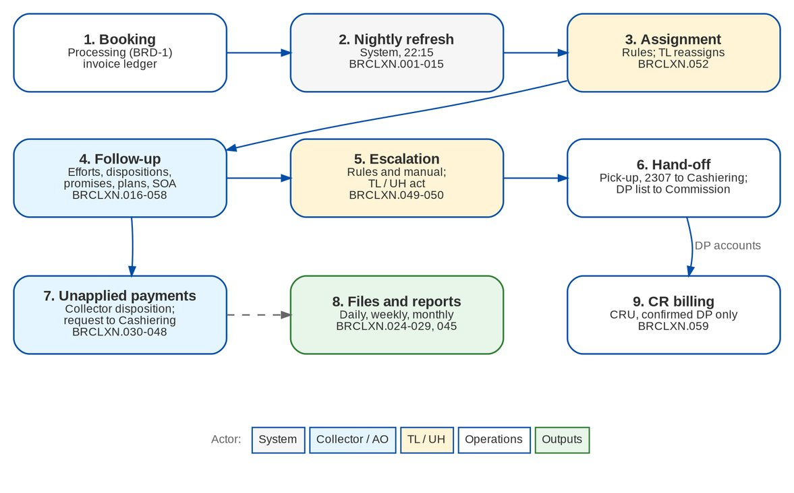
Figure 1: Collection cycle by actor (BRCLXN.001-060)

2.3 Collection account statuses
Each invoice that has ever been listed keeps one collection account. The refresh sets its status from the ledger; users never set it.
Table 5: Statuses of a collection account
Status | Meaning | Set when
OPEN | Premium to collect above the threshold | The total of the six PR components plus PR2307 is above CLX_MIN_BALANCE_THRESHOLD
COMPLETED | Paid, or at or below the threshold | The total falls to or below the threshold; the account reopens when the balance comes back
EXCLUDED_CANCELLED | Negative balance of a cancellation or return invoice | The total is negative on a cancellation or return invoice (BRCLXN.010)
CREDIT | Negative balance of any other invoice | The total is negative on another invoice (CQ04)

An invoice without a client receivable (payment status NOT_APPLICABLE: direct payment and return invoices) is never listed.

3 Personas and roles

3.1 Personas
Table 6: Personas and BIBS roles
Persona | BIBS role | Responsibilities in Collections | BRD
Marketing AO | MKT_AO | Follows up own accounts; efforts, dispositions, promises, manual escalation; unapplied dispositions | p.43
Marketing Team Lead | MKT_TL | As the AO, plus bulk update, assignment, billing statements and acting on escalations | p.43; BRCLXN.049-052
Marketing Handler | MKT_HANDLER | As the AO, plus bulk update | p.43
Collection Handler | MKT_COLLECTION | Works the assigned accounts, unapplied payments, installment plans and billing statements | p.43; BRCLXN.030-031
Collection Team Lead | CLX_TL | As the handler, plus assignment and acting on escalations | BRCLXN.049, 052, 055
Section Head (Corporate / Retail) | MKT_SECTION_HEAD | As the TL, plus Collections set-up (threshold, disposition options) and the audit log | p.44; BRCLXN.007, 017
Unapplied Payment Handler | UNAPPLIED_HANDLER | Dispositions and application requests on unapplied payments | BRCLXN.032-033 (CQ10)
Processing Unit | PROCESSOR | Disposition "no / missing policy number" only | p.44
Operations Cashiering | CASHIER, CASHIER_TL | Read access and exports; executes the application requests on its Incoming Requests screen | p.44
Disbursement, Comptrollership, ACSL | DISBURSEMENT, COMPTROLLERSHIP, ACSL_PROCESSOR, ACSL_TL, ACSL_HEAD | Read access and reports (Disbursement also exports) | p.45
Application Support, Business Administrator, DCO | APP_SUPPORT, BUSINESS_ADMIN, DCO | Collections set-up, audit log, interface (sync) view and job runs | p.45-46
System Administrator, Auditor | SYSADMIN, AUDITOR | Read access, set-up (SYSADMIN) and audit log | NFR 4

Every new Collections role also holds WORK_VIEW, ATTACHMENT_VIEW, REPORT_VIEW, CLIENT_VIEW, ACCOUNT_VIEW and OPS_VIEW, because the collection account links to Invoice 360. The roles are the project's proposal until BDOI confirms the access matrix (OQ48). Several roles per user are allowed (decision D5 of R7).

3.2 Permissions
Table 7: Collections permissions and action classes
Permission | Action class | Allows
CLX_VIEW | VIEW | Collections Home, PR Worklist, collection account, client view, completed accounts (read only)
CLX_WORK | CREATE / AMEND | Efforts, promises, PR dispositions and remarks; takes the edit lock of an account
CLX_BULK_UPDATE | AMEND | Update several accounts at once, in the grid or by upload (BRCLXN.051)
CLX_ESCALATE | CREATE | Manual escalation (BRCLXN.050)
CLX_ESCALATION_HANDLE | APPROVE | Acknowledge, escalate further, return or resolve an escalation
CLX_ASSIGN | AMEND | Assignment rules and reassignment (BRCLXN.052)
CLX_UNAPPLIED_WORK | CREATE | Collector disposition and application request on unapplied payments (BRCLXN.030-033)
CLX_BILLING | CREATE | Installment plans and billing statements (BRCLXN.053, 058)
CLX_SETUP | AMEND | Threshold and other parameters, disposition rules, Unit Heads, escalation rules (BRCLXN.007, 017, 037, 049)
CLX_EXPORT | VIEW | Download of scheduled files and exports
CLX_REPORT_VIEW | VIEW | Collections reports and the Files screen
CLX_AUDIT_VIEW | VIEW | Collections audit log (BRCLXN.044)

3.3 Permissions matrix
The table below is the role-to-permission matrix provided with the system ("Y" = granted). The System Administrator changes it through role-permission change requests; the User Access Matrix screen shows it by permission and by action class.
Table 8: Role-to-permission matrix for Collections (proposal until OQ48)
Permission | MKT AO | MKT TL | MKT Hdlr | Coll. Hdlr | CLX TL | Sect. Head | UPP Hdlr | Proc. | Cash-ier | Disb. / Compt. / ACSL | Admin / DCO
CLX_VIEW | Y | Y | Y | Y | Y | Y | Y | Y | Y | Y | Y
CLX_WORK | Y | Y | Y | Y | Y | Y |  | Y
CLX_BULK_UPDATE |  | Y | Y | Y | Y | Y
CLX_ESCALATE | Y | Y | Y | Y | Y | Y
CLX_ESCALATION_HANDLE |  | Y |  |  | Y | Y
CLX_ASSIGN |  | Y |  |  | Y | Y
CLX_UNAPPLIED_WORK | Y | Y | Y | Y | Y | Y | Y
CLX_BILLING |  | Y |  | Y | Y | Y
CLX_SETUP |  |  |  |  |  | Y |  |  |  |  | Y
CLX_EXPORT | Y | Y | Y | Y | Y | Y |  |  | Y | Disb.
CLX_REPORT_VIEW | Y | Y | Y | Y | Y | Y | Y |  | Y | Y
CLX_AUDIT_VIEW |  |  |  |  |  | Y |  |  |  |  | Y

"Admin / DCO" is APP_SUPPORT, BUSINESS_ADMIN and DCO; they also hold FLOWIN_MANAGE and SYSTEM_MONITOR for the interface and job views (APP_SUPPORT also LOV_MANAGE). SYSADMIN holds CLX_VIEW, CLX_SETUP, CLX_AUDIT_VIEW and CLX_REPORT_VIEW; AUDITOR holds CLX_VIEW, CLX_REPORT_VIEW and CLX_AUDIT_VIEW.
Segregation of duties enforced by the system: the maker of an escalation rule never authorises it; a disposition reserved to some roles (Disposition Rules) is refused for other roles; updating several accounts at once needs CLX_BULK_UPDATE whatever other permission the user holds.

4 Functional requirements

4.1 Access, audit and record lock

FR-CL-001 Restrict each Collections action to authorised roles
BRD trace | Stakeholder functions (p.43-46), NFR 3.01-3.05 (p.52) | Actor | System
Priority | High | Screens | All Collections screens; User Access Matrix

Description
Every Collections screen, button and action requires a permission (section 3.2). The permissions carry an action class (VIEW, CREATE, AMEND, APPROVE) in the area COLLECTIONS, so the User Access Matrix shows who may view, work, bulk update, assign, escalate and set up.
Menus show only the screens the user's roles allow. Collections is a section of the Finance group, listed before Cashiering.
Users log in with the platform log-in of BRD-1. After three consecutive failed attempts the account locks (NFR 1.04, 2.02); the lock-out applies to all BIBS users.
Preconditions
• The user is logged in.
Main flow
1. The user opens a Collections screen or starts an action.
2. BIBS checks the user's permissions for that screen or action.
3. BIBS shows the screen or performs the action.
Alternate and exception flows
• No permission. The screen is not in the menu; a direct link shows "You do not have access to this screen. Contact your administrator if you need it."; a direct request is refused and logged.
• Reserved disposition. A disposition value reserved to other roles is refused even when the user holds CLX_WORK (FR-CL-031).
Business rules
Rule | Statement | Kind | Maintained in
R1 | Roles are granted permissions as in section 3.3 until BDOI confirms the matrix (OQ48). | Configurable | Role-permission change request
R2 | A user may hold several roles. The BRD rule of one role per user (NFR 3.04) is not applied (decision D5; chapter 21, CLR-CL-18). | Fixed | -
R3 | Lock-out after LOGIN_MAX_FAILED_ATTEMPTS consecutive failed log-ins (default 3). | Configurable | Parameter LOGIN_MAX_FAILED_ATTEMPTS
R4 | BDO single sign-on with Windows credentials (NFR 1.01) is not part of this phase (Q42). | Fixed | -

Validations and messages
Check | Message shown | Code
Action without permission | You are not permitted to perform this action | ACCESS_DENIED
Account locked after failed log-ins (the same message as a wrong password; the lock shows to the System Administrator on Users) | Invalid user name or password | AUTHENTICATION_FAILED

Notifications
• None.
Audit
• Refused direct requests are logged with user, function and time; every log-in attempt is logged with its source address.
Acceptance criteria
1. A Disbursement user sees the PR Worklist read only and cannot record a disposition.
2. A Marketing AO does not see Collections Setup or Assignments.
3. The User Access Matrix lists the CLX_* permissions under the area COLLECTIONS with their action classes.
4. A user is locked after three consecutive wrong passwords; the correct password is then refused with the same message as a wrong password, and Users shows the lock to the System Administrator.

FR-CL-002 Show who encoded and who updated each record
BRD trace | BRCLXN.019 (p.28 / 48), BRCLXN.020 (p.28 / 48) | Actor | System
Priority | High | Screens | Collection account (Dispositions & Efforts, History); Promises to Pay; Installment Plans; Escalations; Unapplied Payment

Description
Every Collections record (disposition, effort, promise, plan, escalation, reassignment, unapplied disposition, application request) carries the user ID and time of creation and of the last update. The screens show them as "Recorded by" or "By" with the date.
Preconditions
• None.
Main flow
1. A user saves a Collections record.
2. BIBS stores the user ID and the time with the record.
3. The lists and tabs of the record show the user and time.
Business rules
Rule | Statement | Kind | Maintained in
R1 | The user ID is taken from the session; it cannot be entered or changed. | Fixed | -

Notifications
• None.
Audit
• The user and time are part of the record; field changes are also in the audit log (FR-CL-003).
Acceptance criteria
1. A disposition recorded by clxhandler shows clxhandler and the time on the Dispositions & Efforts tab.
2. A promise changed by another user shows that user as the last updater.

FR-CL-003 Keep a field-level audit log of Collections changes
BRD trace | BRCLXN.043 (p.32 / 49), NFR 4.03 (p.52) | Actor | System
Priority | High | Screens | Collection account (History); Collections Setup

Description
Every change a user makes to a Collections record is written as one audit row per field, with the field, the value before ("From"), the value after ("To"), the user ID, the time, the source IP address and, for a bulk change, the bulk reference. This covers accounts (handler, disposition, category, tagging owner, remarks), assignment rules, parameters, disposition rules, Unit Heads and unapplied dispositions.
The History tab of the collection account shows the field changes of that account in time order.
Preconditions
• None.
Main flow
1. A user changes a Collections record.
2. BIBS writes the change rows together with the change; one is never kept without the other.
3. The History tab and the audit log report (FR-CL-004) show the rows.
Alternate and exception flows
• Bulk change. Every account of a bulk update gets its own rows with the shared bulk reference (CLXBU-yyyy-n).
Business rules
Rule | Statement | Kind | Maintained in
R1 | Audit entries can only be added; no user can change or delete them. | Fixed | -
R2 | Changes made by the nightly refresh and by the inbox are system changes and carry the user SYSTEM. | Fixed | -

Notifications
• None.
Audit
• This FR is the audit.
Acceptance criteria
1. Changing the category of an account from A to B writes one row with From A, To B, the user, the time and the source IP.
2. Changing CLX_MIN_BALANCE_THRESHOLD on Collections Setup writes a row with the old and new value.
3. No screen or direct request allows an audit row to be edited or deleted.

FR-CL-004 View and extract the Collections audit log
BRD trace | BRCLXN.044 (p.32 / 49), NFR 4.05 (p.52) | Actor | Section Head; Application Support; Business Administrator; DCO; Auditor
Priority | High | Screens | Report Centre (Collections Audit Log)

Description
Authorised users run the report Collections Audit Log for a period on screen and export it to Excel, PDF, ODS or CSV. It lists every field change of FR-CL-003.
Preconditions
• The user has CLX_AUDIT_VIEW.
Main flow
1. The user opens the Report Centre and selects Collections Audit Log.
2. The user enters the company and the period.
3. BIBS shows the rows; the user exports them.
Business rules
Rule | Statement | Kind | Maintained in
R1 | Viewing and exporting the audit log need CLX_AUDIT_VIEW. | Fixed | -

Validations and messages
Check | Message shown | Code
Period end before start | The end date must be on or after the start date | -

Screens and fields: Collections Audit Log (parameters)
Field | Type | Mand. | Source / LOV | Validation
Company | List | Yes | Companies of the user | -
From / To | Date | Yes | - | Default: start of month to today

Notifications
• None.
Audit
• The run and each export are recorded in the report archive with user, time and parameters.
Acceptance criteria
1. A Section Head exports the audit log of a month to Excel with the columns Changed On, User ID, Source IP, Record, Reference, Field, From, To and Bulk Reference.
2. A Collection Handler cannot open the report.

FR-CL-005 Lock a collection account while a user edits it
BRD trace | NFR 9.03 (p.53) | Actor | Collection user; System
Priority | High | Screens | Collection account

Description
When a user with CLX_WORK opens a collection account, BIBS takes an edit lock on it for CLX_EDIT_LOCK_MINUTES. Another user who tries to change the account while the lock is held is refused with "<user> is editing <invoice>" and sees a banner on the account. The lock is released when the holder leaves the account or when it expires.
Preconditions
• The user has CLX_WORK.
Main flow
1. The user opens a collection account.
2. BIBS records the user and time as the lock holder.
3. The user records efforts, dispositions or remarks.
4. The user leaves the account; BIBS releases the lock.
Alternate and exception flows
• Another user holds the lock. The account opens read only with the banner "<user> is editing"; changes are refused.
• The lock expires. After CLX_EDIT_LOCK_MINUTES the next user takes the lock.
Business rules
Rule | Statement | Kind | Maintained in
R1 | Lock time CLX_EDIT_LOCK_MINUTES, default 15 (1-240). | Configurable | Parameter CLX_EDIT_LOCK_MINUTES
R2 | The nightly refresh and the inbox update a locked account; the lock applies to users only. | Fixed | -

Validations and messages
Check | Message shown | Code
Change while another user holds the lock | <user> is editing <invoice> | CLX_ITEM_LOCKED

Notifications
• None.
Audit
• The lock holder and time are stored on the account.
Acceptance criteria
1. While clxhandler has an account open, mkttl cannot record a disposition on it and sees "clxhandler is editing".
2. After 15 minutes without release, mkttl can take the lock.

4.2 Outstanding PR worklist

FR-CL-010 Generate the outstanding PR list at invoice level
BRD trace | BRCLXN.001 (p.26 / 47), BRCLXN.002 (p.26 / 47), BRCLXN.004 (p.26 / 47) | Actor | Collection user
Priority | High | Screens | PR Worklist; Collection account

Description
BIBS keeps one collection account per booked invoice with outstanding premium receivable. The PR Worklist lists them, one row per invoice, with client, assured, invoice, policy, ARN, booking and inception dates, aging and aging bracket, insurer, segment, sales unit, Unit Head, AO, handler, net outstanding, PR2307, current disposition, category, tagging owner, promise and escalation flags.
The outstanding PR comes from the Operations invoice ledger (booked + adjusted - applied + reversed - remitted - written off, per component). Collections reads it and never recalculates it.
Tabs group the accounts by status - Open Accounts, Credit Balances, Completed Collections, Excluded, All - with the count of each.
Preconditions
• The user has CLX_VIEW.
Main flow
1. The user opens the PR Worklist.
2. BIBS shows the Open Accounts tab, sorted by aging.
3. The user filters, searches or groups the list (FR-CL-014, FR-CL-015).
4. The user opens an account to see its details.
Business rules
Rule | Statement | Kind | Maintained in
R1 | One collection account per invoice; the key is the invoice number within the company. | Fixed | -
R2 | The list is at invoice level (BRCLXN.001); FRID-001 said cover-number level. The totals per account and client are FR-CL-014 (CQ02). | Fixed | -
R3 | Aging counts from the booking or inception date (CLX_AGING_BASIS) in the brackets of CLX_AGING_BRACKETS. | Configurable | Parameters CLX_AGING_BASIS and CLX_AGING_BRACKETS
R4 | Lists are paged on the server (at most 200 rows per page). | Fixed | -

Screens and fields: PR Worklist (filters)
Field | Type | Mand. | Source / LOV | Validation
Status tab | Tabs | Yes | Open Accounts, Credit Balances, Completed Collections, Excluded, All | -
Search | Text | No | - | Invoice, policy, ARN, client or assured

Notifications
• None.
Audit
• Read only; the exports of FR-CL-084 are recorded in the report archive.
Acceptance criteria
1. An invoice booked today with a premium of 25,000.00 appears on the Open Accounts tab after the nightly refresh, with its net outstanding of 25,000.00.
2. After a payment of 10,000.00 is applied, the account shows 15,000.00 outstanding.
3. A user with CLX_VIEW only can open the list and an account but has no work actions.

FR-CL-011 Apply the minimal balance threshold
BRD trace | BRCLXN.005 (p.26 / 47), BRCLXN.008 (p.26 / 47), BRCLXN.009 (p.26 / 47) | Actor | System
Priority | High | Screens | PR Worklist

Description
An invoice enters the worklist as OPEN when its total to collect (the six PR components plus PR2307) is above CLX_MIN_BALANCE_THRESHOLD. At or below the threshold, a new invoice is not listed and a listed account moves to COMPLETED. A completed account reopens when its balance comes back above the threshold (for example after a payment reversal).
Preconditions
• The threshold parameter exists (default 10.00).
Main flow
1. The refresh reads the total to collect of each invoice.
2. BIBS compares it with CLX_MIN_BALANCE_THRESHOLD.
3. BIBS lists the invoice as OPEN, completes it, or leaves it out.
Business rules
Rule | Statement | Kind | Maintained in
R1 | Included when the total to collect is above the threshold (strictly greater). | Fixed | -
R2 | Excluded when the total is zero or at or below the threshold; the account is not deleted (FR-CL-018). | Fixed | -
R3 | Threshold CLX_MIN_BALANCE_THRESHOLD, default 10.00, in the invoice currency; the value is to be confirmed (CQ03). | Configurable | Parameter CLX_MIN_BALANCE_THRESHOLD
R4 | The Collections threshold is separate from the Cashiering minimal-balance write-off rule (MIN_BALANCE_AUTO_MAX, OQ11). | Fixed | -

Notifications
• None.
Audit
• Status changes by the refresh are system changes on the account timeline.
Acceptance criteria
1. With the threshold at 10.00, an invoice with 10.01 outstanding is listed and one with 10.00 is not.
2. A listed account paid down to 8.00 moves to Completed Collections at the next refresh.

FR-CL-012 Maintain the threshold and the Collections parameters
BRD trace | BRCLXN.006 (p.26 / 47), BRCLXN.007 (p.26 / 47) | Actor | Section Head (Corporate); Application Support; Business Administrator; DCO; System Administrator
Priority | High | Screens | Collections Setup (Parameters)

Description
The minimal balance threshold and the other Collections parameters are stored in BIBS and changed by authorised users on Collections Setup. A change takes effect at the next refresh or immediately for the checks that read it (invoice pattern, lock time, export cap).
Preconditions
• The user has CLX_SETUP.
Main flow
1. The user opens Collections Setup, card Parameters.
2. The user changes a value and saves.
3. BIBS validates the value against the parameter's type and limits and stores it.
Alternate and exception flows
• Refresh now. The user starts a refresh of the worklist on demand (Refresh now) to apply a new threshold at once.
Business rules
Rule | Statement | Kind | Maintained in
R1 | Only the Collections parameters of section 9.1 can be changed on this screen. | Fixed | -
R2 | Aging brackets must be ascending ranges from-to or from+. | Fixed | -
R3 | The aging basis is BOOKING or INCEPTION. | Fixed | -

Validations and messages
Check | Message shown | Code
Parameter not of Collections | <key> is not a Collections parameter | CLX_PARAMETER_NOT_COLLECTIONS
Aging basis not BOOKING or INCEPTION | The aging basis is BOOKING or INCEPTION | CLX_AGING_BASIS
Bracket ends before it starts | Aging bracket '<text>' ends before it starts | CLX_AGING_BRACKETS_INVALID
Brackets not ascending | Aging brackets must be in ascending order: <value> | CLX_AGING_BRACKETS_INVALID
Value outside its limits | <parameter> must be between <min> and <max> | -

Screens and fields: Collections Setup, Parameters
Field | Type | Mand. | Source / LOV | Validation
CLX_MIN_BALANCE_THRESHOLD | Amount | Yes | - | 0-100,000
CLX_AGING_BASIS | List | Yes | BOOKING, INCEPTION | -
CLX_AGING_BRACKETS | Text | Yes | - | Ranges such as 0-30,31-45,121+
CLX_INVOICE_NO_PATTERN | Text | Yes | - | Regular expression
CLX_PROMISE_GRACE_DAYS | Number | Yes | - | 0-30
CLX_EXPORT_MAX_ROWS | Number | Yes | - | 100-1,000,000
CLX_EDIT_LOCK_MINUTES | Number | Yes | - | 1-240

Notifications
• None.
Audit
• Each change is a field change row with the old and new value (FR-CL-003).
Acceptance criteria
1. A Section Head changes the threshold to 100.00; after "Refresh now" accounts with 100.00 or less move to Completed Collections.
2. A Collection Handler does not see Collections Setup.
3. The change appears in the Collections Audit Log with From 10.00 and To 100.00.

FR-CL-013 Exclude cancelled negative balances and keep other credits apart
BRD trace | BRCLXN.010 (p.27 / 47) | Actor | System
Priority | High | Screens | PR Worklist (Excluded, Credit Balances tabs); Collections Home

Description
An invoice with a negative total to collect is never an open account. When it is a cancellation or return invoice (the BRD's transaction type C), its account is EXCLUDED_CANCELLED. Any other negative total (for example an overpayment) is CREDIT and appears on the Credit Balances tab and tile, so that the handler can follow it up with Cashiering.
Preconditions
• None.
Main flow
1. The refresh reads a negative total to collect.
2. BIBS sets EXCLUDED_CANCELLED for a cancellation or return invoice, else CREDIT.
Business rules
Rule | Statement | Kind | Maintained in
R1 | A negative cancellation or return invoice is never listed as OPEN. | Fixed | -
R2 | The treatment of other negatives (CREDIT view) waits for BDOI's answer to CQ04. | Fixed | -

Notifications
• None.
Audit
• Status changes are on the account timeline.
Acceptance criteria
1. The negative return invoice of a cancelled policy does not appear on the Open Accounts tab.
2. An overpaid invoice with -500.00 appears on the Credit Balances tab.
Difference from the BRD. BRCLXN.010 asks only to exclude cancelled negatives. BIBS also keeps other negatives visible as CREDIT so they are not lost (CQ04).

FR-CL-014 Total the PR balance by account and by client
BRD trace | BRCLXN.003 (p.26 / 47) | Actor | Collection user
Priority | High | Screens | PR Worklist (By Account, By Client); Client View

Description
The worklist adds up the PR balances across the invoices of an account (ARN) and of a client. "By Account" and "By Client" show one row per group with the number of invoices, the outstanding and the PR2307; the Client View shows every collection account of one client with the totals.
Preconditions
• The user has CLX_VIEW.
Main flow
1. The user switches the worklist grouping to By Account or By Client.
2. BIBS shows the groups with their totals, at most 200 groups per page.
3. The user opens a client to see the Client View.
Business rules
Rule | Statement | Kind | Maintained in
R1 | Totals are for information; the threshold is applied per invoice (CQ02). | Fixed | -

Notifications
• None.
Audit
• Read only.
Acceptance criteria
1. A client with three open invoices of 5,000.00, 7,000.00 and 3,000.00 shows 15,000.00 in By Client and in the Client View.

FR-CL-015 Filter the worklist by market segment, Unit Head and other criteria
BRD trace | BRCLXN.011 (p.27 / 47), BRCLXN.012 (p.27 / 47) | Actor | Collection user; Section Head (Unit Heads)
Priority | High | Screens | PR Worklist; Collections Setup (Unit Heads)

Description
The worklist filters on the server by market segment, sales unit, Unit Head, handler, AO, aging bracket, category, disposition, outstanding range, promise status and client. Only the accounts that match are returned and totalled.
The Unit Head of an account is the head of the invoice's sales unit, else the head of its department or region, from the sales organisation. Authorised users maintain the Unit Head of each sales unit on Collections Setup.
Preconditions
• The user has CLX_VIEW (filters); CLX_SETUP (Unit Heads).
Main flow
1. The user chooses the filters and applies them.
2. BIBS returns the matching accounts and their totals.
3. The user saves the filter set as a quick filter for later use.
Business rules
Rule | Statement | Kind | Maintained in
R1 | Every CLX_VIEW user sees every account and narrows it with the filters; a default scope per user is not proposed (CQ06; chapter 21, CLR-CL-03). | Fixed | -
R2 | Unit Head resolution: sales unit head, else department head, else region head. | Configurable | Collections Setup (Unit Heads)

Screens and fields: PR Worklist, filters
Field | Type | Mand. | Source / LOV | Validation
Market Segment | List | No | Market segments | -
Sales Unit | List | No | Sales units | -
Unit Head | Text | No | User names | -
Handler / Account Officer | Text | No | User names | -
Aging Bracket | List | No | CLX_AGING_BRACKETS | -
Category (A/B/C) | List | No | A, B, C | -
Disposition | List | No | LOV CLX_PR_DISPOSITION | -
Outstanding From / To | Amount | No | - | From <= To
Promise Status | List | No | Open, Kept, Partially kept, Broken | -
Client Code | Text | No | Client master | -

Notifications
• None.
Audit
• A change of a Unit Head is a field change row (FR-CL-003).
Acceptance criteria
1. Filtering on segment RETAIL and Unit Head clxuh returns only the accounts of that segment whose sales unit is headed by clxuh.
2. Changing the Unit Head of a sales unit changes the Unit Head of its accounts at the next refresh.
Difference from the BRD. BRCLXN.012 can be read as a data restriction per user. BIBS applies the selected filters only; whether handlers, AOs and UHs should see only their own accounts is open (CQ06). BRD-9 answered it for CSF agents only (all accounts).

FR-CL-016 Show the net PR and its breakdown
BRD trace | BRCLXN.046 (p.33 / 50) | Actor | Collection user
Priority | High | Screens | Collection account (Summary)

Description
The Summary tab of a collection account shows the net outstanding premium and how it is made up - booked premium, endorsements and adjustments, cancellations, payments applied, written off or reversed, and the net outstanding - in total and per component (basic premium, DST, VAT, LGT, other charges, PR2307). The figures are read live from the invoice ledger; the snapshot of the last refresh is kept on the account for the lists.
Preconditions
• The user has CLX_VIEW.
Main flow
1. The user opens a collection account.
2. BIBS shows the header figures (net outstanding, PR2307) and the Net PR Breakdown by Component.
3. The user opens Invoice 360 from the account for the full ledger view.
Business rules
Rule | Statement | Kind | Maintained in
R1 | Net outstanding = premium due + endorsements / adjustments - payments applied - written off / reversed. | Fixed | -

Notifications
• None.
Audit
• Read only.
Acceptance criteria
1. For an invoice of 50,000.00 with a negative endorsement of 5,000.00 and a payment of 20,000.00, the Summary shows 25,000.00 net outstanding and the three movements.
2. The component rows add up to the net outstanding.

FR-CL-017 Refresh the worklist every day from the invoice ledger
BRD trace | BRCLXN.013 (p.27 / 47), BRCLXN.014 (p.27 / 47), BRCLXN.015 (p.27 / 47; edit p.78) | Actor | System; Application Support / DCO (run log)
Priority | High | Screens | PR Worklist; Collection account ("Refresh from Ledger"); Operations > Interfaces and job runs (sync view)

Description
The job CLX_DAILY_REFRESH runs every night at 22:15 (Manila), after the 22:00 end-of-day. It creates accounts for new invoices above the threshold, updates the balances, aging, bracket, Unit Head and flags of the listed accounts, completes accounts at or below the threshold, sets excluded and credit statuses, assigns new accounts by rule (FR-CL-020) and ends expired temporary assignments.
Between runs, the balance of a listed account is refreshed after each committed ledger movement or flag change (for example a payment applied), so the worklist shows same-day payments. New invoices wait for the nightly run or "Refresh from Ledger".
The job run history (start, end, counts, result) is the "EBIX/QPS synchronization view" of Application Support and DCO (p.45-46).
Preconditions
• The invoice ledger holds the booked invoices.
Main flow
1. At 22:15 the job reads the ledger invoices of each company.
2. BIBS creates, updates, completes or excludes the collection accounts.
3. BIBS records the run with the counts of new, updated and completed accounts.
Alternate and exception flows
• Run failure. The run is recorded as failed and the alert CLX_REFRESH_FAILED is raised; the next run repeats the refresh.
• Refresh on demand. A CLX_SETUP user refreshes the whole worklist; a CLX_WORK user refreshes one account with "Refresh from Ledger".
Business rules
Rule | Statement | Kind | Maintained in
R1 | EBIX is replaced by the BIBS invoice ledger; the BRD's extraction becomes an in-app refresh. | Fixed | -
R2 | Schedule 22:15 Manila daily. | Configurable | Job schedule (System Administrator)
R3 | Running the refresh twice gives the same result. | Fixed | -

Notifications
• Alert CLX_REFRESH_FAILED to the alert recipients when a run fails.
Audit
• Each run is in the job run history with trigger (schedule or user), times and counts.
Acceptance criteria
1. An invoice booked during the day is on the worklist the next morning.
2. A payment applied at 10:00 reduces the account's outstanding before 10:05.
3. A failed run raises CLX_REFRESH_FAILED and is visible in the job run history.
Difference from the BRD. The BRD (p.27, FRID-015 as edited by hand on p.78) describes a nightly extraction from EBIX. In BIBS the booking is internal, so the refresh reads the BIBS ledger. Open EBIX items, their disposition history and unapplied items at go-live need a one-time migration; its scope and format are open (CQ07; chapter 21, CLR-CL-01).

FR-CL-018 Keep the history of accounts and dispositions
BRD trace | BRCLXN.021 (p.28 / 48), BRCLXN.022 (p.28 / 48), BRCLXN.023 (p.28 / 48) | Actor | System
Priority | High | Screens | PR Worklist (Completed Collections); Collection account (Timeline, Dispositions & Efforts, History)

Description
Collection accounts are never deleted. When the PR becomes zero or falls below the threshold, the account moves to COMPLETED and keeps its dispositions, efforts, promises, escalations, assignments and field changes. Dispositions are never changed - a new disposition supersedes the previous one, which stays in the history. Each balance change is noted on the account's Timeline.
Preconditions
• None.
Main flow
1. The PR of an account falls to zero.
2. The refresh completes the account.
3. Users still open the account from Completed Collections and see its whole history.
Business rules
Rule | Statement | Kind | Maintained in
R1 | No delete of accounts, dispositions, efforts or field changes. | Fixed | -
R2 | The current disposition is a pointer to the latest one; earlier dispositions stay. | Fixed | -

Notifications
• None.
Audit
• Every change remains in the history and the audit log.
Acceptance criteria
1. A fully paid account appears under Completed Collections with its three earlier dispositions.
2. Recording a new disposition leaves the previous one on the Dispositions & Efforts tab, marked superseded.

4.3 Assignment

FR-CL-020 Assign new accounts by rule
BRD trace | BRCLXN.052 (p.17) | Actor | System; Collection Team Lead (rules)
Priority | Must have | Screens | Assignments (Default Assignment Rules)

Description
Authorised users keep default assignment rules. Each rule has a priority, criteria (market segment, sales unit, client, outstanding range, aging range) and the handler. The nightly refresh gives each new open account without a handler to the first active rule that matches, else to its AO when the AO holds CLX_WORK.
Preconditions
• The user has CLX_ASSIGN (rules).
Main flow
1. The TL adds a rule with its priority, criteria and handler.
2. The refresh tries the active rules in priority order for each new account.
3. BIBS assigns the account permanently to the handler of the first matching rule.
Alternate and exception flows
• No rule matches. The account goes to its AO, or stays unassigned (Unassigned Accounts tile) when the AO cannot work collections.
• The TL deactivates a rule; it is no longer tried.
Business rules
Rule | Statement | Kind | Maintained in
R1 | Rules are tried in ascending priority; the first match wins. | Configurable | Assignments (rules)
R2 | The handler of a rule must be an active user holding CLX_WORK. | Fixed | -

Validations and messages
Check | Message shown | Code
Rule without name | Give the rule a name | CLX_RULE_NAME
Range ends before it starts | A range must start before it ends | CLX_RULE_RANGE
Handler not eligible | <user> is not an active collection handler | CLX_HANDLER_NOT_ELIGIBLE

Screens and fields: Default Assignment Rule
Field | Type | Mand. | Source / LOV | Validation
Name | Text | Yes | - | -
Priority | Number | Yes | - | Whole number
Market Segment | List | No | Market segments | -
Sales Unit | List | No | Sales units | -
Client Code | Text | No | Client master | -
Outstanding From / To | Amount | No | - | From <= To
Aging From / To (days) | Number | No | - | From <= To
Handler | List | Yes | Users with CLX_WORK | Active

Notifications
• CLX_REASSIGNED to the handler who receives accounts.
Audit
• Rule changes and assignments are field change rows; each assignment is on the account's history.
Acceptance criteria
1. With a rule "segment RETAIL to clxhandler", a new Retail account is assigned to clxhandler at the next refresh.
2. A new account without a matching rule goes to its AO.

FR-CL-021 Reassign accounts permanently or temporarily
BRD trace | BRCLXN.052 (p.17) | Actor | Collection Team Lead; Marketing Team Lead; Section Head
Priority | Must have | Screens | Assignments (Reassign by Criteria); PR Worklist (Reassign)

Description
A TL moves accounts to another handler to balance the workload, either by selecting them in the worklist or by criteria (client, sales unit, segment, aging, amount, current handler) after a preview of the affected accounts. The reassignment is PERMANENT, or TEMPORARY until an end date.
When a temporary assignment ends, the nightly refresh returns the account to the previous handler, unless a later assignment replaced it. Every reassignment keeps the previous handler, the reason and who made it, so accountability is not lost.
Preconditions
• The user has CLX_ASSIGN.
Main flow
1. The TL selects accounts or enters criteria and previews the matching accounts.
2. The TL chooses the new handler, the kind (Permanent or Temporary with an end date) and the reason.
3. BIBS reassigns the accounts; several accounts share a bulk reference CLXRA-yyyy-n.
4. BIBS notifies the new and the previous handlers.
Alternate and exception flows
• End of a temporary assignment. The refresh returns the account to the previous handler and notifies both.
Business rules
Rule | Statement | Kind | Maintained in
R1 | At most 2,000 accounts in one reassignment. | Fixed | -
R2 | A temporary reassignment needs an end date after today. | Fixed | -
R3 | The new handler must hold CLX_WORK. | Fixed | -

Validations and messages
Check | Message shown | Code
No account selected or matched | No account matches the selection | CLX_REASSIGN_EMPTY
Reason blank | Give the reason of the reassignment | CLX_REASSIGN_REASON
Kind not given | Choose a permanent or a temporary reassignment | CLX_REASSIGN_KIND
Temporary without a future end date | A temporary reassignment needs an end date after today | CLX_REASSIGN_END_DATE
New handler not eligible | <user> is not an active collection handler | CLX_HANDLER_NOT_ELIGIBLE

Screens and fields: Reassign Accounts
Field | Type | Mand. | Source / LOV | Validation
New Handler | List | Yes | Users with CLX_WORK | Active
Kind | Option | Yes | Permanent, Temporary | -
Until | Date | Cond. | - | Required for Temporary; after today
Reason | Text | Yes | - | -

Notifications
• CLX_REASSIGNED to the new and the previous handlers.
Audit
• Each reassignment is kept on the account (Assignments) and in the report Collection Reassignments (CLX-REASSIGNMENTS).
Acceptance criteria
1. A TL reassigns 40 accounts of one sales unit to mkthandler until the end of the month; after that date they return to their previous handler.
2. The history of an account shows the previous handler, the new handler, the kind, the dates, the reason and the TL.
3. A reassignment without a reason is refused.

4.4 Collector dispositions and efforts

FR-CL-030 Maintain the PR collector disposition list and its rules
BRD trace | BRCLXN.016 (p.27 / 47), BRCLXN.017 (p.27 / 47), BRCLXN.018 (p.28 / 48) | Actor | Section Head; Application Support; Business Administrator (LOV maker-checker)
Priority | High | Screens | Lists of Values (CLX_PR_DISPOSITION); Collections Setup (Disposition Rules)

Description
The PR collector dispositions are the list of values CLX_PR_DISPOSITION. Authorised users add values and deactivate them on the LOV screen with maker-checker and effective dates. Deactivated values cannot be selected.
Each value has rules kept on Collections Setup - the category (A, B or C), the tagging owner (Marketing or Operations), the Operations action (none, BIR 2307 reversal, DP reversal, check pick-up, cancellation request) and the roles allowed to use it.
Preconditions
• The user has LOV_MANAGE (values) or CLX_SETUP (rules).
Main flow
1. The user adds a value with its code, label and effective date; another user approves it.
2. The user sets its rules on Collections Setup, card Disposition Rules.
3. The value appears in the Record Disposition dialog for the roles allowed.
Alternate and exception flows
• Deactivate. The user sets an end date; after it the value is no longer offered and is refused on save, while old dispositions keep it.
Business rules
Rule | Statement | Kind | Maintained in
R1 | Values delivered, all to be confirmed by BDOI (CQ08): DP PR for reversal; PR 2307 for reversal; For check pick-up; Cancel account; Coordinate further; Request bank AO assistance; No / missing policy number; DP returned by insurer. | Configurable | LOV CLX_PR_DISPOSITION
R2 | Only active values within their effective dates can be selected. | Fixed | -
R3 | The category A / B / C of each value is not seeded until BDOI gives it (CQ08). | Configurable | Collections Setup (Disposition Rules)
R4 | No / missing policy number is reserved to Processing, the Collection Handler, the Collection Team Lead and the Section Head. | Configurable | Disposition Rules (Reserved To)

Validations and messages
Check | Message shown | Code
Unknown value | <code> is not a value of <type> | CLX_LOV_VALUE_UNKNOWN
Unknown attribute | <attribute> is not an attribute of <type> | CLX_LOV_ATTRIBUTE_UNKNOWN
Invalid attribute value | '<value>' is not a valid <attribute> | CLX_LOV_ATTRIBUTE_VALUE

Screens and fields: Collections Setup, Disposition Rules
Field | Type | Mand. | Source / LOV | Validation
Disposition | List | Yes | LOV CLX_PR_DISPOSITION | Existing value
Category | List | No | A, B, C | -
Tagging Owner | List | Yes | Marketing, Operations | -
Operations Action | List | Yes | None, BIR 2307 reversal, DP reversal, Check pick-up, Cancellation request | -
Reserved To | Check boxes | No | Roles | None ticked = every collector

Notifications
• Pending LOV changes appear in My Approvals.
Audit
• LOV changes are audited by the LOV module; rule changes are field change rows (FR-CL-003).
Acceptance criteria
1. A value added and approved on the LOV screen is offered in Record Disposition.
2. A value ended yesterday is not offered today and a direct call with it is refused.
3. A Collection Handler without an allowed role cannot choose "No / missing policy number" when the value is reserved.

FR-CL-031 Record a PR collector disposition
BRD trace | BRCLXN.016 (p.27 / 47), BRCLXN.018 (p.28 / 48), BRCLXN.021 (p.28 / 48); current process (p.40-41) | Actor | Collection Handler; Marketing AO / Handler / TL; Processing Unit (restricted value)
Priority | High | Screens | PR Worklist (Record Disposition); Collection account (Dispositions & Efforts)

Description
The handler records the outcome of the follow-up of one or several accounts as a disposition from the list, with remarks. The disposition sets the account's current disposition, category and tagging owner. When the value has an Operations action, BIBS hands the account to Operations (FR-CL-032) and asks for the details that hand-off needs.
A later disposition supersedes the current one; a hand-off of the superseded disposition that Operations has not taken yet is withdrawn.
Preconditions
• The user has CLX_WORK; several accounts at once need CLX_BULK_UPDATE.
• The account is OPEN and not locked by another user.
Main flow
1. The handler selects one or more accounts and clicks Record Disposition.
2. The handler chooses the disposition; BIBS shows what it hands to Operations and the detail fields it needs.
3. The handler enters the details and remarks and confirms.
4. BIBS records the disposition on each account, updates category and tagging owner, and queues the hand-off.
Alternate and exception flows
• Several accounts. All accounts get the same disposition and share a bulk reference CLXBU-yyyy-n; each account is validated on its own.
• Cancellation request. For "Cancel account" no feed is sent; the handler raises the cancellation endorsement in Adjustment (BRD-2).
Business rules
Rule | Statement | Kind | Maintained in
R1 | At most 500 accounts in one action. | Fixed | -
R2 | Only active values; values with allowed roles only for those roles. | Configurable | Disposition Rules
R3 | Dispositions are never changed or deleted (FR-CL-018). | Fixed | -

Validations and messages
Check | Message shown | Code
No account selected | Select at least one account | CLX_NO_ACCOUNT
More than 500 accounts | Select at most 500 accounts at once | CLX_TOO_MANY_ACCOUNTS
Several accounts without the bulk permission | You are not allowed to update several accounts at once | CLX_BULK_NOT_ALLOWED
Account not open | <invoice> is <status> | CLX_ITEM_CLOSED
Account of another company | <invoice> belongs to another company | CLX_ITEM_OTHER_COMPANY
Value reserved to other roles | This disposition is reserved to other roles | CLX_DISPOSITION_NOT_ALLOWED
Account locked by another user | <user> is editing <invoice> | CLX_ITEM_LOCKED

Screens and fields: Record Disposition
Field | Type | Mand. | Source / LOV | Validation
Disposition | List | Yes | LOV CLX_PR_DISPOSITION | Active value allowed for the user
Detail fields | Text / Date / Amount | Cond. | By Operations action (FR-CL-032) | Required fields of the hand-off
Remarks | Long text | No | - | -

Notifications
• None to Marketing; the hand-off appears in the Operations queue (FR-CL-032).
Audit
• Each disposition is kept with user, time and bulk reference; the changed fields are field change rows.
Acceptance criteria
1. A handler records "Coordinate further" on one account; it becomes the current disposition with tagging owner Marketing.
2. A handler with CLX_BULK_UPDATE records the same disposition on 20 accounts; all share one bulk reference.
3. A handler without CLX_BULK_UPDATE who selects two accounts is refused with CLX_BULK_NOT_ALLOWED.

FR-CL-032 Hand dispositions over to Cashiering and Commission
BRD trace | BRCLXN.024 (p.28 / 48), BRCLXN.026 (p.29 / 48); current process (p.40-41); MKTID.010 / 012 / 013 (BRD-2) | Actor | System; Cashiering; Commission Receivables Unit
Priority | High | Screens | Collection account (Hand-offs to Operations); Cashiering > Check Pick-up; Commission > DP Lists; Collections Home (DP Returned by Insurer)

Description
A disposition with an Operations action places an item in the Collections outbox for the module that owns the money effect. Cashiering and Commission take the items inside BIBS; the item keeps its status (PENDING, TAKEN, CANCELLED).
Check pick-up: an item for the Cashiering pick-up queue with the pick-up date, address, contact person, check amount, number and bank.
BIR 2307 reversal: an item for Cashiering's 2307 intake. It is queued when the tagging owner is Operations or when the path is CASH; the CERTIFICATE path needs the certificate number.
DP reversal: an item for the Commission DP list with the DP list columns and the invoicing branch.
When an insurer returns a DP account, Commission sends it back; BIBS reopens the account, records the disposition "DP returned by insurer" with the reason and notifies the handler.
Preconditions
• A disposition with an Operations action was recorded (FR-CL-031).
Main flow
1. BIBS creates the outbox item with a unique key (PU, CWT or DP, invoice and disposition).
2. BIBS publishes that the feed has pending items.
3. The consuming module takes the item and processes it with its own rules.
4. The account's Hand-offs to Operations panel shows the status of each item.
Alternate and exception flows
• Superseded. A later disposition withdraws a PENDING item (CANCELLED).
• Not taken. An item pending for more than a day raises CLX_OUTBOX_STALE.
• DP returned. The Commission return reopens the account (FR-CL-018) with the disposition DP_RETURNED.
Business rules
Rule | Statement | Kind | Maintained in
R1 | Collections posts no journal and no ledger movement; Cashiering and Commission post the effects. | Fixed | -
R2 | The pick-up date is today or later; the check amount is required. | Fixed | -
R3 | The 2307 path is a certificate received or a payment in cash. | Fixed | -
R4 | Stale threshold 1 day. | Configurable | Exception code CLX_OUTBOX_STALE

Validations and messages
Check | Message shown | Code
Pick-up date in the past | Give a pick-up date from today on for the check pick-up | CLX_PICKUP_DATE
Check amount missing | Give the check amount | CLX_PICKUP_AMOUNT
2307 path not one of the two paths | Choose the 2307 path: certificate received or paid in cash | CLX_CWT_PATH
Required detail missing | Give <detail> | CLX_DISPOSITION_DETAIL
Detail not a date | '<value>' is not a date (yyyy-mm-dd) | CLX_DISPOSITION_DETAIL
Detail not an amount | '<value>' is not an amount | CLX_DISPOSITION_DETAIL

Screens and fields: Record Disposition (detail fields)
Field | Type | Mand. | Source / LOV | Validation
Pick-up Date | Date | Cond. | - | Check pick-up; today or later
Pick-up Address | Text | Cond. | - | Check pick-up
Contact Person | Text | No | - | -
Check Amount | Amount | Cond. | - | Check pick-up; > 0
Check No. / Check Bank | Text | No | - | -
Path | List | Cond. | CASH, CERTIFICATE | BIR 2307 reversal
Certificate No. | Text | Cond. | - | Required for CERTIFICATE
Certificate Period From / To | Date | No | - | From <= To
2% Amount | Amount | No | - | >= 0

Notifications
• CLX_DP_RETURNED to the handler when an insurer returns a DP account.
• Alert CLX_OUTBOX_STALE when an item is not taken within a day.
Audit
• Outbox and inbox items keep their key, fields, status and times; the consuming module logs the take in its flow-in run.
Acceptance criteria
1. A "For check pick-up" disposition creates a request in Cashiering's Check Pick-up queue with the date and address given.
2. A "DP PR for reversal" disposition appears on the Commission DP list.
3. A DP account returned by the insurer is open again in the handler's worklist with the disposition "DP returned by insurer".
For confirmation. Cashiering takes the COLLECTION_CWT2307 items in its 2307 intake; an item not taken within one day raises CLX_OUTBOX_STALE (chapter 21, CLR-CL-06).

FR-CL-033 Log collection efforts, remarks and the tagging category
BRD trace | Stakeholder functions - manage collection effort transactions (p.43-46), Report fields Last Collection Effort Date, Code, Remarks (p.59), Categories A, B, C (p.41 / 61) | Actor | Collection Handler; Marketing AO / Handler / TL
Priority | High | Screens | PR Worklist (Log Effort, Update Remarks and Category); Collection account (Dispositions & Efforts)

Description
The handler logs each collection effort (call, e-mail, visit, SOA sent, others) with its date and time, channel, contact person and remarks. The latest effort's date, code and remarks appear on the worklist and in the reversal reports. The handler also keeps the account's remarks and its tagging category A, B or C.
Preconditions
• The user has CLX_WORK; several accounts at once need CLX_BULK_UPDATE.
Main flow
1. The handler selects accounts and clicks Log Effort.
2. The handler chooses the effort code and enters the time, channel, contact person and remarks.
3. BIBS records the effort on each account and updates its last effort.
Alternate and exception flows
• Remarks and category. The handler updates the remarks and the category with Update Remarks and Category.
Business rules
Rule | Statement | Kind | Maintained in
R1 | Effort codes delivered, to be confirmed (CQ08): Phone call; E-mail; Client visit; Statement of account sent; Others (see remarks). | Configurable | LOV CLX_EFFORT_CODE
R2 | An effort cannot be dated in the future. | Fixed | -
R3 | The category is A, B or C. | Fixed | -

Validations and messages
Check | Message shown | Code
Effort dated in the future | An effort cannot be in the future | CLX_EFFORT_FUTURE
Category not A B or C | The tagging category is A, B or C | CLX_CATEGORY
Several accounts without the bulk permission | You are not allowed to update several accounts at once | CLX_BULK_NOT_ALLOWED

Screens and fields: Log Collection Effort
Field | Type | Mand. | Source / LOV | Validation
Effort | List | Yes | LOV CLX_EFFORT_CODE | Active value
Date and time | Date-time | Yes | - | Not in the future
Channel | Text | No | - | -
Contact Person | Text | No | - | -
Remarks | Long text | No | - | -

Notifications
• None.
Audit
• Efforts are never changed and are kept with user and time; category and remarks changes are field change rows.
Acceptance criteria
1. A logged call appears on the Dispositions & Efforts tab and as the last effort on the worklist row.
2. An effort dated tomorrow is refused.
Capabilities without an FR ID. The Marketing Diary (p.40-42) and the credit term extension (CTE, p.38-41) appear only in the process diagrams. The CTE is recorded as an effort with remarks until BDOI decides whether it is tracked in BIBS; the Marketing Diary panel waits for CQ20.

FR-CL-034 Update several accounts at once
BRD trace | BRCLXN.051 (p.17) | Actor | Collection user with CLX_BULK_UPDATE
Priority | Must have | Screens | PR Worklist (bulk actions); Promises to Pay; Escalations; Bulk Uploads (Collections Bulk Update)

Description
Authorised users update several invoices at once. In the PR Worklist the selected accounts get the same disposition or effort (each with remarks) or are reassigned; on Promises to Pay and Escalations several invoices get the same promise or escalation. Each account is validated and saved on its own and the result lists the outcome per invoice.
The upload template "Collections Bulk Update" takes one row per invoice with a promise (date, amount, day of the promise), an escalation (Escalate = Y, level, user, reason) and worklist fields (disposition, effort code, remarks). Each row is validated and committed on its own; the upload number is the bulk reference of every record.
Preconditions
• The user has CLX_BULK_UPDATE (and CLX_ESCALATE for escalations).
Main flow
1. The user selects accounts in the worklist, or downloads the template and fills it.
2. The user runs the action, or uploads the file.
3. BIBS validates each account or row and applies the valid ones.
4. BIBS shows the outcome per invoice; the upload has a row report with the errors.
Alternate and exception flows
• Partial success. Invalid rows are rejected with their reasons; valid rows are saved.
Business rules
Rule | Statement | Kind | Maintained in
R1 | At most 500 invoices in one grid action. | Fixed | -
R2 | A row needs a promise, Escalate = Y or a worklist field. | Fixed | -
R3 | Before and after values of every affected record are logged with the bulk reference (FR-CL-003). | Fixed | -

Validations and messages
Check | Message shown | Code
Row with nothing to do | Fill a promise, Escalate = Y or a worklist field | -
Promise amount without date | A promise amount needs the promise date | -
Invoice not in the ledger | Invoice <no> is not in the ledger | -
Nothing to collect | Invoice <no> has nothing to collect | CLX_NOTHING_TO_COLLECT
Escalation without permission | You are not allowed to escalate accounts | -
USER escalation without user | Name the user in Escalate To for a USER escalation | -

Screens and fields: Collections Bulk Update (template)
Field | Type | Mand. | Source / LOV | Validation
Invoice No | Text | Yes | Invoice ledger | Collection account
Promise Date / Promise Amount / Promised On | Date / Amount / Date | No | - | Amount needs the date
Escalate | Yes/No | No | - | Default N
Escalation Level | List | No | TL, UH, SECTION_HEAD, USER | Default TL
Escalate To | Text | Cond. | Users with CLX_ESCALATION_HANDLE | Required for USER
Escalation Reason | List | No | LOV CLX_ESCALATION_REASON | -
Disposition / Effort Code / Remarks | List / List / Text | No | LOV CLX_PR_DISPOSITION, CLX_EFFORT_CODE | Applied to the account as in the worklist; remarks go with the effort

Notifications
• As for the single actions (CLX_ESCALATED, CLX_REASSIGNED).
Audit
• Each record carries the bulk reference; the upload keeps its row report.
Acceptance criteria
1. A TL logs the same effort on 30 accounts in one action; the result lists 30 successes and each account shows the effort.
2. An upload with 10 promise rows and 1 row for a paid invoice saves 10 promises and reports 1 error.
3. An upload row with a disposition and an effort with remarks records both on the account.
4. Every account of a bulk action shows the bulk reference in its History.

4.5 Installments, promises and account views

FR-CL-040 Create installment plans for multi-year and installment accounts
BRD trace | BRCLXN.053 (p.17-18) | Actor | Collection Handler; Collection / Marketing Team Lead; Section Head
Priority | Must have | Screens | Installment Plans (New Installment Plan); Installment Plan; Installments Due

Description
An installment plan gives the due dates and amounts an account is followed up on. It has one of three bases. POLICY_YEARS takes every policy-year invoice of a multi-year account (booked, or still scheduled in booking) and splits each year into the cycles of the billing frequency within its coverage year. GENERATED splits the outstanding of one invoice into N equal installments from a first due date. MANUAL takes installments entered by the user, which must add up to the outstanding.
Each installment is NOT_DUE, DUE, OVERDUE, PARTIAL or PAID. An installment past its due date and not fully paid is flagged overdue, can escalate the account (FR-CL-051) and appears on Installments Due. The plan completes when every installment is paid.
A plan is monitoring only. It changes neither the booking nor the GL (BRCLXN.060).
Preconditions
• The user has CLX_BILLING.
• The account or invoice has premium to collect (not paid directly to the insurer, not cancelled).
Main flow
1. The user clicks New Installment Plan and chooses the plan basis.
2. The user enters the ARN (policy years) or the invoice, the billing frequency and, for a generated plan, the first due date and the number of installments.
3. BIBS creates the installments and numbers the plan IPL-yyyy-n.
4. The plan appears in Installment Plans; its installments appear on Installments Due as they fall due.
Alternate and exception flows
• Cancel. The user cancels an active plan (for example to change the frequency) and creates a new one.
• Manual plan. The user enters each installment's due date and amount.
Business rules
Rule | Statement | Kind | Maintained in
R1 | One live plan per invoice and per policy-year account. | Fixed | -
R2 | Billing frequencies Annual, Semi-annual, Quarterly, Monthly. | Configurable | LOV CLX_BILLING_FREQUENCY
R3 | At most 120 installments in one plan. | Fixed | -
R4 | Installment terms are entered in Collections; taking them from the quotation or the account waits for CQ15. | Fixed | -

Validations and messages
Check | Message shown | Code
Account without a booked policy year | Account <ARN> has no booked policy year | CLX_PLAN_NOT_BOOKED
Invoice with nothing outstanding | Invoice <no> has no outstanding premium to schedule | CLX_PLAN_NOTHING_DUE
Invoice paid directly or cancelled | Invoice <no> is paid directly to the insurer / cancelled and has no premium to collect | CLX_INVOICE_NOT_COLLECTIBLE
Invoice not in the ledger | Invoice <no> is not in the ledger | CLX_INVOICE_UNKNOWN
Live plan exists | Plan <no> already schedules this account; cancel it first | CLX_PLAN_EXISTS
No installment entered | Enter at least one installment | CLX_PLAN_EMPTY
Manual amounts or dates invalid | Installment amounts must be positive and due dates increasing | CLX_PLAN_ENTRY_INVALID
Manual total differs from the outstanding | The installments add up to <sum> but the outstanding premium is <amount> | CLX_PLAN_TOTAL_MISMATCH
Frequency without a cycle length | Billing frequency <code> has no cycle length defined | CLX_FREQUENCY_UNSUPPORTED
Cancel a plan that is not active | Plan <no> is <status> and cannot be cancelled | CLX_PLAN_NOT_ACTIVE

Screens and fields: New Installment Plan
Field | Type | Mand. | Source / LOV | Validation
Plan Basis | Option | Yes | Policy years, Generated, Manual | -
Account Reference No. (ARN) | Text | Cond. | Accounts | Required for Policy years
Invoice No. | Text | Cond. | Invoice ledger | Required for Generated and Manual
Billing Frequency | List | Cond. | LOV CLX_BILLING_FREQUENCY | Policy years and Generated
First Due Date | Date | Cond. | - | Generated
Number of Installments | Number | Cond. | - | Generated; 1-120
Installments (due date, amount) | Table | Cond. | - | Manual; dates increasing, amounts > 0, total = outstanding

Notifications
• None.
Audit
• Creation and cancellation are recorded with user and time on the plan.
Acceptance criteria
1. A three-year account booked with annual policy-year invoices and a quarterly frequency gets a plan of 12 installments, four per coverage year.
2. A generated plan of 4 installments on an outstanding of 40,000.00 has four installments of 10,000.00.
3. A second live plan on the same invoice is refused with CLX_PLAN_EXISTS.
4. An unpaid installment past its due date is flagged overdue and listed on Installments Due.

FR-CL-041 Allocate payments to installments and show the payment history
BRD trace | BRCLXN.054 (p.18) | Actor | Collection user; System
Priority | Must have | Screens | Collection account (Payments); Installment Plan (Installments); Installment Plans (Refresh Allocation)

Description
The Payments tab of a collection account lists every payment movement of the invoice in date order - payments applied, reversals, 2307 reclassification, DP reversal and write-offs - with the AR / OR reference, and the summary of booked, paid and outstanding amounts.
For accounts with a plan, BIBS allocates the settled amount of each invoice (installments total less the ledger outstanding) to the installments, oldest due first. The allocation runs every night with the promise check, on Refresh Allocation and before a billing statement is generated.
Preconditions
• The user has CLX_VIEW (history); CLX_BILLING (Refresh Allocation).
Main flow
1. The user opens the Payments tab of an account.
2. BIBS lists the payment movements from the ledger with their dates and references.
3. For a planned account, the user opens the plan to see the paid amount and status per installment.
Business rules
Rule | Statement | Kind | Maintained in
R1 | Allocation is oldest due installment first. | Fixed | -
R2 | Every settlement counts: payments, reversals, 2307 reclass, DP reversal and write-offs. | Fixed | -
R3 | Policy years booked after the plan was made are linked to their invoice before allocation. | Fixed | -

Validations and messages
Check | Message shown | Code
Unknown billing cycle | Plan <no> has no billing cycle <n> | CLX_CYCLE_UNKNOWN

Notifications
• None.
Audit
• Read only; allocations are recalculated from the ledger each time.
Acceptance criteria
1. A payment of 15,000.00 on a plan with installments of 10,000.00 marks the first installment PAID and the second PARTIAL (5,000.00).
2. The Payments tab lists the payment with its AR number and date.

FR-CL-042 Record and evaluate promises to pay
BRD trace | BRCLXN.055 (p.18), BRCLXN.053 (p.17-18) | Actor | Collection user; System (promise check)
Priority | Must have | Screens | Promises to Pay (Record Promise, Withdraw Promise); Installment Plan (Promises)

Description
The handler records the client's promise to pay an invoice, or one installment of it - the day the promise was made, the promised payment date and the amount (blank = the whole outstanding). A new promise on the same invoice replaces the running one.
Every night the job CLX_PROMISE_CHECK (22:45) checks the promises whose promised date plus CLX_PROMISE_GRACE_DAYS has passed. It compares the payments applied between the day of the promise and that deadline with the promised amount - KEPT when the amount was paid or nothing is left to collect, PARTIALLY_KEPT when part was paid, else BROKEN. A broken promise notifies the recorder and the AO and triggers the broken-promise escalation rules (FR-CL-051).
Preconditions
• The user has CLX_WORK; several invoices need CLX_BULK_UPDATE.
Main flow
1. The handler clicks Record Promise and enters the invoice (or chooses an installment), the day of the promise, the promised date and the amount.
2. BIBS records the promise as OPEN.
3. After the promised date plus the grace days, the promise check sets KEPT, PARTIALLY_KEPT or BROKEN.
Alternate and exception flows
• Withdraw. The handler selects open promises and clicks Withdraw Promise; they become CANCELLED.
• New promise. A new promise on the same invoice evaluates an expired one or supersedes the running one.
Business rules
Rule | Statement | Kind | Maintained in
R1 | The day of the promise cannot be in the future; the promised date cannot be before it. | Fixed | -
R2 | The promised amount is positive and at most the outstanding. | Fixed | -
R3 | Grace days CLX_PROMISE_GRACE_DAYS, default 0 (0-30); the kept / broken rule is to be confirmed (CQ16). | Configurable | Parameter CLX_PROMISE_GRACE_DAYS
R4 | Schedule 22:45 Manila daily. | Configurable | Job schedule (System Administrator)

Validations and messages
Check | Message shown | Code
Promised date missing or day of promise in the future | Enter the promised date; the day of the promise cannot be in the future | CLX_PROMISE_DATES
Promised date before the day of the promise | The promised date cannot be before the day of the promise | CLX_PROMISE_DATES
Amount not positive | The promised amount must be positive | CLX_PROMISE_AMOUNT
Amount above the outstanding | The promised amount <amount> is above the outstanding <outstanding> | CLX_PROMISE_OVER_BALANCE
Nothing to collect | Invoice <no> has nothing to collect | CLX_PROMISE_NOTHING_DUE
Installment of another invoice | The installment does not bill invoice <no> | CLX_PROMISE_INSTALLMENT
Withdraw a closed promise | The promise of <invoice> is already <status> | CLX_PROMISE_CLOSED

Screens and fields: Record Promise to Pay
Field | Type | Mand. | Source / LOV | Validation
Invoice No. / Invoice Nos. | Text | Yes | Collection accounts | Several need CLX_BULK_UPDATE
Installment | List | No | Installments of the plan | Of the same invoice
Promised On | Date | Yes | - | Not in the future; default today
Promised Payment Date | Date | Yes | - | On or after Promised On
Promised Amount | Amount | No | - | > 0 and <= outstanding; blank = outstanding
Remarks | Text | No | - | -

Notifications
• CLX_PROMISE_BROKEN to the recorder and the AO when a promise is broken.
Audit
• Each promise keeps the recorder, the evaluation time, the amount paid in time and its final status.
Acceptance criteria
1. A promise of 10,000.00 by 15 October with 10,000.00 applied on 14 October is KEPT after the check of 15 October.
2. A promise with 4,000.00 applied in time is PARTIALLY_KEPT.
3. A promise with nothing applied is BROKEN, the AO is notified and the account is escalated to the team lead by the broken-promise rule.

FR-CL-043 View policy, account, invoice and co-insurance information
BRD trace | BRCLXN.056 (p.18-19) | Actor | Collection user
Priority | Must have | Screens | Collection account (Policy & Co-insurance, Summary); Invoice 360 (link)

Description
The Policy & Co-insurance tab shows, read only, the policy number and status, the account (ARN) and client, the booking date, the first AR date (shown as the receipt date), the invoice family (the original invoice with its endorsements and cancellations) and the co-insurance shares with lead insurer, share % and amounts. The Summary tab shows the invoice figures. The Open Invoice 360 link opens the Operations view of the invoice.
Preconditions
• The user has CLX_VIEW; Invoice 360 needs OPS_VIEW (granted to every Collections role).
Main flow
1. The user opens the Policy & Co-insurance tab of an account.
2. BIBS assembles the policy, account, invoice family and share data from the ledger, the account and the issuance records.
Business rules
Rule | Statement | Kind | Maintained in
R1 | The tab is read only; changes are made in the owning modules. | Fixed | -
R2 | Delivery date (e-policy dispatch or physical delivery) waits for CQ17 and is shown blank. | Fixed | -

Notifications
• None.
Audit
• Read only.
Acceptance criteria
1. A co-insured invoice shows each insurer, the lead flag and the share % adding up to 100.
2. An endorsed invoice shows the original and the endorsement invoice in Invoice Family.
Difference from the BRD. BRCLXN.056 names a delivery date and a receipt date. BIBS shows the first AR date as the receipt date and leaves the delivery date blank until BDOI says which date is meant (CQ17).

FR-CL-044 View the complete transaction history of an account
BRD trace | BRCLXN.057 (p.19) | Actor | Collection user
Priority | Must have | Screens | Collection account (Timeline)

Description
The Timeline tab merges in date order the ledger movements of the invoice (applied, adjusted, written off, DP reversal, 2307 reclass) and the Collections actions (assignments, dispositions, efforts, hand-offs, items received from Operations). Each entry shows its date, source, description, amount and user. The history is kept for audit and never deleted.
Preconditions
• The user has CLX_VIEW.
Main flow
1. The user opens the Timeline tab.
2. BIBS shows the merged entries, newest first, with their source (Ledger, Assignment, Disposition, Effort, Hand-off, From Operations).
Business rules
Rule | Statement | Kind | Maintained in
R1 | Entries are never edited or deleted. | Fixed | -

Notifications
• None.
Audit
• Read only.
Acceptance criteria
1. After a payment, a disposition and a reassignment, the Timeline shows the three entries in date order with their sources.

4.6 Escalation

FR-CL-050 Maintain escalation rules
BRD trace | BRCLXN.049 (p.16) | Actor | Collection Team Lead (maker, with CLX_SETUP); authoriser with MASTER_AUTHORIZE
Priority | Must have | Screens | Escalation Rules

Description
An escalation rule says when an account is escalated automatically and to whom. It has a code, name, basis and threshold, optional filters (segment, sales unit, product line, outstanding range), the target level (TL, UH, Section Head or a named user), the reason, the SLA in hours, whether to notify, and effective dates.
Rules are maker-checker - a new or changed rule waits for authorisation by another user with MASTER_AUTHORIZE and appears in My Approvals. Preview lists the accounts the rule would escalate today.
Preconditions
• The maker has CLX_SETUP; the authoriser has MASTER_AUTHORIZE and is not the maker.
Main flow
1. The maker clicks New Rule, enters the rule and saves.
2. BIBS stores it as pending authorisation.
3. The authoriser authorises it; the job and the broken-promise check use it from then on.
Alternate and exception flows
• Deactivate. The maker deactivates a rule instead of deleting it.
• Preview. The maker checks the accounts a rule matches before authorisation.
Business rules
Rule | Statement | Kind | Maintained in
R1 | Bases - aging from booking, aging from inception, no commitment by day N (no open promise), broken promises count, installment overdue days, amount over. | Fixed | -
R2 | Delivered rules, to be confirmed (CQ14) - broken promise to the team lead; 45 days from booking to the TL; 60th day from inception to the UH; installment overdue 15 days to the TL. | Configurable | Escalation Rules
R3 | The maker never authorises the rule. | Fixed | -

Validations and messages
Check | Message shown | Code
Company or code missing | Enter the company and the rule code | CLX_RULE_CODE
Threshold or SLA not positive | The threshold and the SLA hours must be positive | CLX_RULE_INVALID
USER target without user | Name the user who receives the escalations of this rule | CLX_RULE_TARGET
End before start | The rule cannot end before it becomes effective | CLX_RULE_DATES
Amount range reversed | The amount range ends below its start | CLX_RULE_AMOUNTS
Authoriser is the maker | A record cannot be authorized by the user who maintained it | MAKER_CHECKER_VIOLATION

Screens and fields: Escalation Rule
Field | Type | Mand. | Source / LOV | Validation
Code / Name | Text | Yes | - | Unique code
Basis | List | Yes | Bases of R1 | -
Threshold | Number / Amount | Yes | - | > 0 (days, count or amount)
Segment / Sales Unit / Product Line | List | No | Masters | -
Outstanding From / To | Amount | No | - | From <= To
Escalate To | List | Yes | TL, UH, SECTION_HEAD, USER | -
User | List | Cond. | Users with CLX_ESCALATION_HANDLE | Required for USER
Reason | List | Yes | LOV CLX_ESCALATION_REASON | -
SLA (Hours) | Number | Yes | - | > 0
Effective From / To | Date | Yes / No | - | To >= From

Notifications
• Pending rules appear in My Approvals of the authorisers.
Audit
• Create, change, authorise and deactivate are recorded with user, time and before / after values.
Acceptance criteria
1. A rule "aging from booking 45 days to the TL" is not applied until another user authorises it.
2. The maker cannot authorise their own rule.
3. Preview of the authorised rule lists the accounts over 45 days old.

FR-CL-051 Escalate accounts automatically
BRD trace | BRCLXN.049 (p.16), BRCLXN.055 (p.18) | Actor | System
Priority | Must have | Screens | Escalations; Escalation; Collections Home

Description
The job CLX_ESCALATION runs every night at 23:00, after the promise check. For each active rule it finds the accounts that meet the rule and raises one escalation per rule, invoice and month, unless an escalation of that rule is still open for the account. It then closes open escalations whose invoices are fully collected.
Broken-promise rules also run at once when a promise is broken, so a broken promise reaches the team lead the same night.
An escalation is numbered ESC-yyyy-n, kind AUTO, with the rule, reason and target, and starts the workflow CLX_ESCALATION (section 5.1).
Preconditions
• At least one authorised, effective rule.
Main flow
1. The job evaluates each rule against the open accounts.
2. BIBS raises an escalation for each new match and routes it to the TL or UH stage (or to the named user).
3. BIBS notifies the target (or every holder of CLX_ESCALATION_HANDLE when there is no named user) and the AOs of the invoices.
Alternate and exception flows
• Account collected. An open escalation whose invoices are collected closes automatically, with the action "Closed, account collected".
• Past the SLA. The alert job raises CLX_ESCALATION_OVERDUE for an escalation that stays in a stage beyond the SLA of its rule.
Business rules
Rule | Statement | Kind | Maintained in
R1 | One escalation per rule, invoice and month (one key), none while one of the rule is open. | Fixed | -
R2 | Schedule 23:00 Manila daily. | Configurable | Job schedule (System Administrator)
R3 | Without a designated user the escalation waits in the stage queue; resolving the TL or UH of an account from the sales organisation waits for BDOI (CQ14). | Fixed | -

Notifications
• CLX_ESCALATED to the target (or the stage queue) and the AOs.
• Alert CLX_ESCALATION_OVERDUE past the SLA.
Audit
• Escalations keep the rule, the reason, the kind AUTO and every workflow step.
Acceptance criteria
1. An account 46 days from booking is escalated to the TL by the 45-day rule, once in the month.
2. A broken promise raises an escalation to the team lead the same night.
3. An escalated account that is paid in full is closed automatically at the next run.

FR-CL-052 Escalate accounts manually
BRD trace | BRCLXN.050 (p.16) | Actor | Collection user with CLX_ESCALATE
Priority | Not stated in the BRD | Screens | Escalations (Escalate Accounts); PR Worklist

Description
A collection user escalates one or more invoices to the team lead, the unit / section head or a designated user, whatever their automated status. BIBS groups the selected invoices by account (ARN) and raises one escalation per account, kind MANUAL, with the reason and remarks. The escalation follows the same workflow as an automatic one.
Preconditions
• The user has CLX_ESCALATE.
Main flow
1. The user clicks Escalate Accounts and enters the invoice numbers.
2. The user chooses the level or a designated user, the reason and remarks.
3. BIBS raises one escalation per account and routes it.
4. BIBS returns the outcome per invoice.
Alternate and exception flows
• Invoice with nothing to collect. That invoice is reported as refused; the others are escalated.
Business rules
Rule | Statement | Kind | Maintained in
R1 | At most 500 invoices in one action. | Fixed | -
R2 | The invoices of one account are escalated together. | Fixed | -
R3 | The designated user must hold CLX_ESCALATION_HANDLE. | Fixed | -

Validations and messages
Check | Message shown | Code
Level or user missing | Choose the level, and the user for a designated authority | CLX_ESCALATION_TARGET
User cannot handle escalations | <user> does not handle escalations | CLX_ESCALATION_TARGET
Invoice with nothing to collect | Invoice <no> has nothing to collect | CLX_NOTHING_TO_COLLECT

Screens and fields: Escalate Accounts
Field | Type | Mand. | Source / LOV | Validation
Invoice Nos. | Text list | Yes | Collection accounts | 1-500 invoices
Escalate To | List | Yes | Team lead, Unit / section head, User | -
User | List | Cond. | Users with CLX_ESCALATION_HANDLE | Required for User
Reason | List | Yes | LOV CLX_ESCALATION_REASON | -
Remarks | Long text | No | - | -

Notifications
• CLX_ESCALATED to the target and the AOs.
Audit
• The escalation keeps the user who raised it, kind MANUAL and every workflow step; it is listed per account and in report CLX-ESCALATIONS.
Acceptance criteria
1. Escalating five invoices of two accounts raises two escalations.
2. A user without CLX_ESCALATE does not see Escalate Accounts.
3. An account already escalated by a rule can still be escalated by hand.

FR-CL-053 Act on an escalation
BRD trace | BRCLXN.049 (p.16), BRCLXN.050 (p.16) | Actor | Team Lead, Unit Head, Section Head (CLX_ESCALATION_HANDLE); handler (resubmit)
Priority | Must have | Screens | Escalations (inbox per stage); Escalation (workflow panel)

Description
The receiving level works its escalations from the Escalations inbox. It acknowledges an escalation (IN_ACTION), escalates it further to the unit / section head with a reason, returns it to the handler with an instruction, or resolves it with the resolution. A returned escalation is resubmitted by the handler once the instruction is done.
Preconditions
• The user has CLX_ESCALATION_HANDLE (resubmit - CLX_WORK or CLX_ESCALATE).
Main flow
1. The TL opens an escalation in WITH_TL and clicks Acknowledge.
2. The TL works the account and clicks Resolve, entering the resolution.
3. BIBS closes the escalation as RESOLVED and records it on the account.
Alternate and exception flows
• Escalate further. The TL escalates to WITH_UH with a reason from CLX_ESCALATION_REASON.
• Return to handler. The TL or UH returns it with a reason (RETURN_REASON); the handler resubmits it to the TL.
Business rules
Rule | Statement | Kind | Maintained in
R1 | Stages and actions are those of workflow CLX_ESCALATION (section 5.1). | Fixed | -
R2 | Stage SLA from the rule; default 24 hours at WITH_TL and WITH_UH, 72 at IN_ACTION, 48 at RETURNED. | Configurable | Escalation rule SLA / workflow stage

Validations and messages
Check | Message shown | Code
Resolve without resolution | Describe how the escalation was resolved | CLX_RESOLUTION_REQUIRED
Unknown action | '<action>' is not an escalation action | CLX_ESCALATION_ACTION
Escalate further or return without reason | Select a reason for '<action>' | WORKFLOW_REASON_REQUIRED

Screens and fields: Escalation (actions)
Field | Type | Mand. | Source / LOV | Validation
Reason | List | Cond. | LOV CLX_ESCALATION_REASON / RETURN_REASON | Escalate further and return
Resolution | Long text | Cond. | - | Resolve

Notifications
• CLX_ESCALATED to the unit / section head on escalate further; the handler on return.
Audit
• Every action is in the workflow history with user, time, reason and comment.
Acceptance criteria
1. A TL acknowledges and resolves an escalation with a resolution; it closes as RESOLVED.
2. A TL cannot resolve without a resolution.
3. A returned escalation shows in the handler's Escalations and can be resubmitted.

4.7 Billing statements

FR-CL-060 Generate billing statements per billing cycle
BRD trace | BRCLXN.058 (p.19) | Actor | Collection Handler; Team Lead (CLX_BILLING)
Priority | Must have | Screens | Billing Statements (Billing Run); Installment Plan (Statements of Account); Statement of Account

Description
BIBS generates a statement of account (SOA) for a billing cycle of a live installment plan. The SOA lists the installment of the cycle (CURRENT) with its coverage period and every earlier installment still unpaid (ARREARS), the payments allocated on the day (FR-CL-041) and the amount due. It is numbered SOA-yyyy-n and rendered to PDF from the template CLX_SOA, whose version is recorded.
A billing run generates the SOAs of every cycle of the live plans falling due in a period and not billed yet; a single cycle is billed from its plan.
Preconditions
• The user has CLX_BILLING; the plan is ACTIVE.
Main flow
1. The user opens Billing Statements and clicks Billing Run, entering the due period.
2. BIBS refreshes the allocation, then generates one SOA per plan cycle due in the period.
3. The user opens a statement and downloads the PDF.
Alternate and exception flows
• One cycle. From an installment plan the user generates the SOA of one cycle.
Business rules
Rule | Statement | Kind | Maintained in
R1 | One live SOA per plan and billing cycle. | Fixed | -
R2 | Amounts follow the installment of the policy period; multi-year and installment policies are supported. | Fixed | -
R3 | Layout, recipient and numbering are drafts until BDOI answers CQ18. | Configurable | Document template CLX_SOA

Validations and messages
Check | Message shown | Code
Cycle already billed | Cycle <n> of <plan> is billed by <SOA> | CLX_SOA_EXISTS
Plan cancelled | Plan <no> is cancelled | CLX_PLAN_NOT_ACTIVE
Period end before start | The period ends before it starts | CLX_SOA_PERIOD

Screens and fields: Billing Run
Field | Type | Mand. | Source / LOV | Validation
Due From / Due To | Date | Yes | - | To >= From

Notifications
• None until sent (FR-CL-061).
Audit
• Each SOA keeps the generating user, time and template version.
Acceptance criteria
1. For the three-year seed account with an annual plan, BIBS produces an SOA for each of its three billing cycles.
2. A second SOA for a billed cycle is refused until the first is cancelled.
3. The SOA shows the coverage period of the installment and any unpaid earlier installment as arrears.

FR-CL-061 Send or cancel a billing statement
BRD trace | BRCLXN.058 (p.19) | Actor | Collection Handler; Team Lead (CLX_BILLING)
Priority | Must have | Screens | Statement of Account (Send Statement of Account, Cancel Statement of Account, E-mails Sent)

Description
The user sends a generated SOA by e-mail. The PDF is password-protected and the password goes in a separate e-mail; the send log is kept on the statement (status SENT). A statement can be cancelled so the cycle can be billed again.
Preconditions
• The user has CLX_BILLING; the statement is GENERATED or SENT.
Main flow
1. The user opens a statement and clicks Send Statement of Account.
2. The user enters or confirms the recipients.
3. BIBS e-mails the protected PDF and the password separately and logs both.
Alternate and exception flows
• Cancel. The user cancels the statement with a reason; the cycle can be billed again.
Business rules
Rule | Statement | Kind | Maintained in
R1 | SOAs leave BIBS as password-protected PDF. | Fixed | -
R2 | Recipients (client, bank) are to be confirmed (CQ18). | Configurable | Statement recipient

Validations and messages
Check | Message shown | Code
No recipient | Enter at least one recipient | CLX_SOA_RECIPIENT
Statement cancelled | Statement <SOA> is cancelled | CLX_SOA_CANCELLED

Screens and fields: Send Statement of Account
Field | Type | Mand. | Source / LOV | Validation
Recipients | E-mail list | Yes | Client contacts | Valid e-mail addresses

Notifications
• The recipient receives the protected SOA and, separately, its password.
Audit
• Each e-mail is logged with recipient, time and attachment; cancellation with user and reason.
Acceptance criteria
1. Sending an SOA sends two e-mails (document and password) and sets the statement to SENT.
2. A cancelled statement cannot be sent.

FR-CL-062 Keep billing as monitoring only
BRD trace | BRCLXN.060 (p.20) | Actor | System; Collection user / Team Lead
Priority | Must have | Screens | Billing Statements; PR Worklist; Collection account

Description
Billing statements, invoice dates and policy periods are visible to support aging, monitoring and escalation. Generating an SOA creates no receivable, no collection account and no commission receivable billing; the receivable remains the booked invoice in the ledger. Aging counts from the booking or inception date (CLX_AGING_BASIS).
Preconditions
• None.
Main flow
1. A user generates an SOA (FR-CL-060).
2. BIBS stores the statement and its lines only.
3. The worklist and aging are unchanged.
Business rules
Rule | Statement | Kind | Maintained in
R1 | An SOA never creates a receivable or a CR billing. | Fixed | -
R2 | Aging basis BOOKING or INCEPTION; aging from the SOA due date is not proposed (CQ14; chapter 21, CLR-CL-16). | Configurable | Parameter CLX_AGING_BASIS

Notifications
• None.
Audit
• Read only.
Acceptance criteria
1. Generating an SOA of 10,000.00 changes no ledger balance and adds no worklist account.
2. The SOA list shows invoice references, due dates and amounts per account.
Difference from the BRD. BRCLXN.060 links aging to billing statements. BIBS ages accounts from the booking or inception date; the SOA due date as an aging basis waits for CQ14.

4.8 Unapplied payments
Cashiering owns the unapplied payment, its tabs, its disposition workflow OPS_DISPOSITION and the money effects (BRD-2). Collections adds the collector side: the list as of today, the collector disposition and the request to Cashiering. Collections reads the unapplied items from Cashiering and never copies them.

FR-CL-070 View the list of unapplied payments as of today
BRD trace | BRCLXN.034 (p.30 / 48), BRCLXN.036 (p.31 / 49) | Actor | Collection Handler; Unapplied Payment Handler; Marketing AO; Cashiering (read)
Priority | High | Screens | Unapplied Payments; Unapplied Payment (Payment & Account)

Description
The Unapplied Payments screen lists the payments Cashiering could not apply, with an open balance as of today, read live from Cashiering. Each row shows the payment date and age (today less the payment date), the payment file (upload batch reference), transaction no., amount and unapplied balance, payment type, payor, bank code, check no., payor reference, the matched client or invoice, the Cashiering tab ("processing stage") and the status of the Cashiering disposition or collector request.
For a matched invoice the row also shows the assured, PR balance, inception date, segment, sales unit, Unit Head, AO, insurer, invoice category (Regular or Direct Bill) and the collection handler, from the collection account or else from the invoice ledger. The invoice number is shown in its BIBS format.
Preconditions
• The user has CLX_VIEW.
Main flow
1. The user opens Unapplied Payments.
2. BIBS shows the tab Awaiting Disposition with the open payments.
3. The user opens a payment to see its payment and account details, dispositions, requests and history.
Business rules
Rule | Statement | Kind | Maintained in
R1 | Only payments with an unapplied balance above zero are listed. | Fixed | -
R2 | Cashiering tabs - Awaiting Disposition (UNAPPLIED), In Cashiering (MONITORING), For Approval, For Reversal, All Open. | Fixed | -

Screens and fields: Unapplied Payments (columns)
Field | Type | Mand. | Source / LOV | Validation
Payment Date / Age | Date / Number | - | Cashiering | Age in days
Payment File / Transaction No. | Text | - | Cashiering upload | -
Paid / Unapplied Amount | Amount | - | Cashiering | -
Payment Type / Payor / Bank / Check No. / Reference | Text | - | Cashiering | -
Client / Invoice matched | Text | - | Cashiering match | -
Assured / PR Balance / Inception / Segment / Unit Head / AO / Insurer / Invoice Category | Mixed | - | Collection account or ledger | -
Cashiering Tab / Status | Text | - | Cashiering | -
Collector Disposition | Text | - | Latest collector disposition | -

Notifications
• None.
Audit
• Read only.
Acceptance criteria
1. A payment received today and not matched appears on Awaiting Disposition with age 0.
2. A payment matched to an invoice shows the invoice's assured, AO and PR balance.
3. A payment fully applied by Cashiering is no longer listed.
Difference from the BRD. BRCLXN.036 asks for the Unit Head, AO and bank officer as names, the booker name, "Business Origin", "Client Code Match" and "System Generated Remarks". BIBS shows the UH and AO user names and the Cashiering tab as the processing stage; the other fields wait for their definitions (CQ11, CQ22).

FR-CL-071 Filter unapplied payments by market segment and disposition status
BRD trace | BRCLXN.035 (p.30 / 48) | Actor | Collection user
Priority | High | Screens | Unapplied Payments (filters)

Description
The user filters the unapplied list by market segment, collector disposition (including "none yet"), Cashiering tab, client, sales unit, payment dates and age, and searches by reference, payor, transaction, check or invoice. Text, client, unit, tab, date and age filters run in Cashiering; segment and disposition run in Collections.
Preconditions
• The user has CLX_VIEW.
Main flow
1. The user sets the filters.
2. BIBS returns the matching payments.
Business rules
Rule | Statement | Kind | Maintained in
R1 | The segment and disposition filters are applied to at most 2,000 payments at a time; narrow the other filters when there are more. | Fixed | -

Screens and fields: Unapplied Payments (filters)
Field | Type | Mand. | Source / LOV | Validation
Search | Text | No | - | Reference, payor, transaction, check or invoice
Market Segment | List | No | Market segments | -
Collector Disposition | List | No | LOV CLX_UPP_DISPOSITION, None yet | -
Paid From / To | Date | No | - | To >= From
Age Min / Max | Number | No | - | Min <= Max

Notifications
• None.
Audit
• Read only.
Acceptance criteria
1. Filtering on segment RETAIL and disposition "None yet" lists only Retail payments without a collector disposition.

FR-CL-072 Maintain the unapplied payment disposition list
BRD trace | BRCLXN.037 (p.32 / 49), BRCLXN.038 (p.32 / 49), BRCLXN.039 (p.32 / 49) | Actor | Section Head; Application Support; Business Administrator
Priority | High | Screens | Lists of Values (CLX_UPP_DISPOSITION); Collections Setup (Disposition Rules)

Description
The collector dispositions of unapplied payments are the list of values CLX_UPP_DISPOSITION, stored in BIBS and maintained by authorised users (add, deactivate, effective dates, maker-checker). Each value has two rules - whether it requires an invoice number, and the Cashiering action it asks for (apply to invoice, refund, reclass, transfer, none). Deactivated values cannot be selected.
Preconditions
• The user has LOV_MANAGE (values) or CLX_SETUP (rules).
Main flow
1. The user adds a value and another user approves it.
2. The user sets its rules on Collections Setup.
3. The value is offered in the unapplied Record Disposition dialog.
Business rules
Rule | Statement | Kind | Maintained in
R1 | Values delivered, to be confirmed (CQ08) - For application to invoice (requires invoice; APPLY_TO_INVOICE); For refund (REFUND); For reclass (RECLASS); For transfer to other unit (TRANSFER); Coordinate further (NONE); Handling fee (auto) for Submitted Policies (BRD-12). | Configurable | LOV CLX_UPP_DISPOSITION
R2 | Only active values within their effective dates can be selected. | Fixed | -

Validations and messages
Check | Message shown | Code
Unknown value | <code> is not a value of <type> | CLX_LOV_VALUE_UNKNOWN
Invalid rule value | '<value>' is not a valid <attribute> | CLX_LOV_ATTRIBUTE_VALUE

Screens and fields: Collections Setup, Disposition Rules (unapplied)
Field | Type | Mand. | Source / LOV | Validation
Disposition | List | Yes | LOV CLX_UPP_DISPOSITION | Existing value
Requires Invoice | Check box | Yes | - | -
Cashiering Action | List | Yes | APPLY_TO_INVOICE, REFUND, RECLASS, TRANSFER, NONE | -

Notifications
• Pending LOV changes appear in My Approvals.
Audit
• LOV changes are audited; rule changes are field change rows.
Acceptance criteria
1. A deactivated unapplied disposition is not offered and is refused on save.
2. A new value with Cashiering action NONE records a disposition without a request.

FR-CL-073 Record a collector disposition on an unapplied payment
BRD trace | BRCLXN.031 (p.29 / 48), BRCLXN.033 (p.29 / 48) | Actor | Collection Handler; Unapplied Payment Handler; Marketing AO / Handler / TL
Priority | High | Screens | Unapplied Payments (Record Disposition); Unapplied Payment (Collector Dispositions)

Description
The handler documents what should happen to an unapplied payment by recording a collector disposition with remarks. When the value has a Cashiering action, the disposition also sends a request to Cashiering (FR-CL-074). Dispositions are never changed and are kept after the payment is applied or refunded.
Preconditions
• The user has CLX_UNAPPLIED_WORK.
• The payment has an unapplied balance.
Main flow
1. The handler selects a payment and clicks Record Disposition.
2. The handler chooses the disposition, enters the invoice number when required, the amount (optional) and remarks.
3. BIBS records the disposition and, for a Cashiering action, sends the request.
Business rules
Rule | Statement | Kind | Maintained in
R1 | Only active CLX_UPP_DISPOSITION values. | Fixed | -
R2 | The amount is above zero and at most the unapplied balance; blank = the whole balance. | Fixed | -

Validations and messages
Check | Message shown | Code
Payment without balance | <ref> has no unapplied balance left | CLX_UNAPPLIED_NO_BALANCE
Amount out of range | The amount must be above zero and at most the balance <balance> | CLX_UNAPPLIED_AMOUNT
Invoice checks | See FR-CL-075 | CLX_INVOICE_REQUIRED, CLX_INVOICE_FORMAT, CLX_INVOICE_UNKNOWN

Screens and fields: Record Disposition (unapplied)
Field | Type | Mand. | Source / LOV | Validation
Disposition | List | Yes | LOV CLX_UPP_DISPOSITION | Active value
Invoice No. | Text | Cond. | Invoice ledger | Required when the value requires an invoice (FR-CL-075)
Amount | Amount | No | - | > 0 and <= unapplied balance
Remarks | Long text | No | - | -

Notifications
• None for a disposition without Cashiering action.
Audit
• Each disposition is kept with user and time and written as a field change row.
Acceptance criteria
1. A handler records "Coordinate further" on Juan Dela Cruz's payment; it shows on the Collector Dispositions tab and no request is sent.
2. A disposition on a payment already fully applied is refused.

FR-CL-074 Request Cashiering to apply, refund, reclass or transfer a payment
BRD trace | BRCLXN.030 (p.29 / 48), BRCLXN.032 (p.29 / 48) | Actor | Collection Handler; Unapplied Payment Handler; Cashier (accepts)
Priority | High | Screens | Unapplied Payments (Request Application); Requests to Cashiering; Cashiering > Incoming Requests (Collector Requests)

Description
A disposition whose value carries a Cashiering action sends a request to Cashiering with the key CLX-UPP-<disposition> and a snapshot of the payment fields. Cashiering refuses it at once when the payment is unknown, has no balance, the amount is above the balance or an application has no invoice; otherwise it queues it (CRQ-yyyy-n) on its Incoming Requests screen.
A cashier accepts the request - BIBS assigns a disposition of the Operations workflow OPS_DISPOSITION with the matching type (apply to other invoice, refund, reclass, transfer unit) and the fields the collector cannot give - or rejects it with a reason. The approvals of the disposition type still apply. The request moves to ACCEPTED, then APPLIED when the disposition is executed, or REJECTED.
The requester is notified of each decision; Requests to Cashiering lists every request with its status and Cashiering reference.
Preconditions
• The user has CLX_UNAPPLIED_WORK; the value has a Cashiering action.
Main flow
1. The handler records "For application to invoice" with a valid invoice (FR-CL-075).
2. BIBS sends the request; its status is SENT.
3. A cashier accepts it on Incoming Requests and completes the disposition; its approver approves it.
4. Cashiering applies the payment; the request becomes APPLIED and the handler is notified.
Alternate and exception flows
• Rejected. The cashier rejects the request with a reason; the handler sees REJECTED and the reason.
• Hand-off. When Cashiering cannot take the request at once, it is DEFERRED as a hand-off to the team CASH_DISPOSITION.
• Check status. The handler selects open requests and clicks Check Status to ask Cashiering again.
Business rules
Rule | Statement | Kind | Maintained in
R1 | One request per disposition; sending it again does not create a second request. | Fixed | -
R2 | Refunds follow the Cashiering refund path to Disbursement; a Payment Requests RRF is not raised (OQ15). | Fixed | -

Validations and messages
Check | Message shown | Code
Cashiering rejects | Rejected by Cashiering: <reason> | -
Reject without reason (cashier) | Enter the reason for rejecting | REJECT_REASON_REQUIRED
Request already decided (cashier) | <request> is already <status> | COLLECTOR_REQUEST_DECIDED
Disposition type does not match the action (cashier) | Disposition type <type> does not carry out a <action> request | COLLECTOR_REQUEST_TYPE_MISMATCH

Notifications
• The requester is notified when Cashiering accepts, rejects or executes the request.
Audit
• The request keeps its status history, Cashiering reference and decision note; Cashiering keeps its own disposition history.
Acceptance criteria
1. A request to apply Grace Villanueva's payment to an open invoice is accepted and executed by the cashier; the request shows APPLIED and the invoice's outstanding falls by the amount.
2. A rejected request shows REJECTED with the cashier's reason.
3. A refund request stays SENT until a cashier acts on it.

FR-CL-075 Validate the invoice of "for application to invoice"
BRD trace | BRCLXN.047 (p.33 / 50), BRCLXN.048 (p.33 / 50) | Actor | System
Priority | High | Screens | Record Disposition (unapplied)

Description
When the chosen disposition requires an invoice ("For application to invoice"), the invoice number is mandatory, must match the pattern CLX_INVOICE_NO_PATTERN and must exist in the invoice ledger of the company. The form checks the pattern before sending and the server checks all three; the disposition cannot be submitted otherwise.
Preconditions
• The disposition value is set to require an invoice (Disposition Rules).
Main flow
1. The handler enters the invoice number.
2. The form checks the pattern.
3. On save, BIBS checks presence, pattern and existence and records the disposition.
Business rules
Rule | Statement | Kind | Maintained in
R1 | Pattern default ^(I\d{8}|BI-.+)$ - the EBIX format I and 8 digits, or the BIBS format BI-...; whether EBIX numbers are still accepted after go-live is open (CQ13). | Configurable | Parameter CLX_INVOICE_NO_PATTERN
R2 | The invoice must exist in the BIBS invoice ledger. | Fixed | -

Validations and messages
Check | Message shown | Code
Invoice blank | Enter the invoice number to apply the payment to | CLX_INVOICE_REQUIRED
Invoice not in the pattern | Invoice number <no> does not have the expected format (<pattern>) | CLX_INVOICE_FORMAT
Invoice not in the ledger | Invoice <no> is not in the invoice ledger | CLX_INVOICE_UNKNOWN

Notifications
• None.
Audit
• Refusals are not stored; the accepted disposition is audited (FR-CL-073).
Acceptance criteria
1. A "For application to invoice" disposition without an invoice number is refused with CLX_INVOICE_REQUIRED.
2. The invoice number I1234567 (7 digits) is refused with CLX_INVOICE_FORMAT.
3. A well-formed invoice number that is not booked is refused with CLX_INVOICE_UNKNOWN.
Difference from the BRD. BRCLXN.047 fixes the format "I" followed by 8 digits, the EBIX format. BIBS invoice numbers are BI-<branch>-<yyyy>-n, so the pattern is a parameter that accepts both, and the invoice must exist in BIBS.

FR-CL-076 Keep the history of unapplied payments and dispositions
BRD trace | BRCLXN.040 (p.32 / 49) | Actor | System; Collection user (read)
Priority | High | Screens | Unapplied Payment (History, Collector Dispositions, Requests to Cashiering)

Description
The history of an unapplied payment merges Cashiering's events (intake, collector requests and decisions, dispositions, applied, refunded, reclassified, transferred, released, withdrawn, reversed, closed) with the collector dispositions, in time order. It stays available after the payment is applied or refunded; refunds reported by Cashiering are also recorded on the collector side.
Preconditions
• The user has CLX_VIEW.
Main flow
1. The user opens a payment, tab History.
2. BIBS shows the merged events with dates, users and notes.
Business rules
Rule | Statement | Kind | Maintained in
R1 | Collector dispositions and requests are never deleted. | Fixed | -

Notifications
• None.
Audit
• Read only.
Acceptance criteria
1. After a payment is applied through a collector request, its history shows the disposition, the request, the acceptance and the application.

FR-CL-077 Produce the daily "For Application To Invoice" file
BRD trace | BRCLXN.041 (p.32 / 49), BRCLXN.042 (p.32 / 49) | Actor | System; Section Head / user with CLX_EXPORT (manual run)
Priority | High | Screens | Requests to Cashiering (File column); Report Centre (For Application To Invoice)

Description
At 05:00 every day the job CLX_APPLICATION_FILE writes, per company, a pipe-delimited text file FOR_APPLICATION_TO_INVOICE_<yyyyMMdd>_<time>.txt of the application requests made up to the end of the previous day and not yet listed. The fields are payment date, payment file name, transaction no., paid amount, currency, payment type, payor, reference no., assured, invoice no., user ID of the disposition, unapplied reference and request key (p.60).
The file is kept in the list of extracts under FS04/CLX_APPLICATION_TO_INVOICE; each request records the file name. The report For Application To Invoice lists the same requests for any period.
Preconditions
• Application requests exist.
Main flow
1. At 05:00 the job selects the requests not yet listed.
2. BIBS writes the file and records it on each request.
3. Authorised users download the file or run the report.
Alternate and exception flows
• Manual run. A user with CLX_SETUP or CLX_EXPORT writes the file on demand.
• Failure. The alert CLX_FILE_NOT_PUBLISHED is raised.
Business rules
Rule | Statement | Kind | Maintained in
R1 | Schedule 05:00 Manila daily (before the BRD's 06:00). | Configurable | Job schedule (System Administrator)
R2 | A request is listed in one file only. | Fixed | -
R3 | The transfer to the BDOI file server FS04 waits for BDOI; the file stays in the list of extracts (OQ17, CQ12). | Fixed | -

Notifications
• Alert CLX_FILE_NOT_PUBLISHED on failure.
Audit
• Each file is recorded with its name, time and the requests it lists.
Acceptance criteria
1. A request made on Monday is in Tuesday's 05:00 file and not in Wednesday's.
2. The file has one pipe-delimited line per request with the user ID of the disposition.
Difference from the BRD. In BIBS the application is done in-app by Cashiering (FR-CL-074), so the text file is kept for audit and for any legacy hand-off. Whether BDOI still needs it, and its layout, are open (CQ12).

4.9 Scheduled files, reports and home

FR-CL-080 Produce the "DP PR for reversal" files
BRD trace | BRCLXN.024 (p.28 / 48), BRCLXN.025 (p.28 / 48) | Actor | System; Collection user, CRU (download)
Priority | High | Screens | Collections Files (Monthly); Report Centre (DP PR for Reversal)

Description
The job CLX_MONTHLY_FILES runs every day at 05:00 and, on the first working day of the month (head office holiday calendar), generates the Excel file "DP PR for Reversal" of the accounts tagged with that disposition in the previous month. The file is available from 08:00 that day and users with CLX_EXPORT are notified. The accounts themselves reached the Commission DP list when they were tagged (FR-CL-032); the file is the monthly record.
Preconditions
• Accounts were tagged DP PR for reversal in the previous month.
Main flow
1. On the first working day the job generates the file for the previous month.
2. BIBS archives it with "available from" 08:00 and notifies the CLX_EXPORT users.
3. Users download it from Collections Files.
Alternate and exception flows
• Failure. The file is recorded as failed and CLX_FILE_NOT_PUBLISHED is raised; a CLX_SETUP user generates the files of a date again.
Business rules
Rule | Statement | Kind | Maintained in
R1 | Generated once per report, period and scope. | Fixed | -
R2 | Not downloadable before its availability time. | Fixed | -

Validations and messages
Check | Message shown | Code
Download before availability | <file> is available from <time> | REPORT_FILE_NOT_AVAILABLE

Notifications
• CLX_FILE_READY to the CLX_EXPORT users.
Audit
• Each file is a GENERATE run of the report archive with its period, row count and availability.
Acceptance criteria
1. On 1 October (a working day) the file of September's DP tags is available at 08:00.
2. When 1 October is a holiday, the file is generated on the next working day.

FR-CL-081 Produce the "PR 2307 for reversal" files
BRD trace | BRCLXN.026 (p.29 / 48), BRCLXN.027 (p.29 / 48) | Actor | System; Collection user, Cashiering (download)
Priority | High | Screens | Collections Files (Monthly); Report Centre (PR 2307 for Reversal)

Description
On the first working day of the month the same job generates the Excel file "PR 2307 for Reversal" of the accounts tagged with that disposition in the previous month, available from 08:00. The columns are the p.59 fields BIBS holds, including the PR2307 amount and the difference between the premium balance and the PR2307.
Preconditions
• Accounts were tagged PR 2307 for reversal in the previous month.
Main flow
1. As FR-CL-080, for the report CLX-PR2307-FOR-REVERSAL.
Business rules
Rule | Statement | Kind | Maintained in
R1 | As FR-CL-080. | Fixed | -

Validations and messages
Check | Message shown | Code
Download before availability | <file> is available from <time> | REPORT_FILE_NOT_AVAILABLE

Notifications
• CLX_FILE_READY to the CLX_EXPORT users.
Audit
• As FR-CL-080.
Acceptance criteria
1. The October file lists every account tagged PR 2307 for reversal in September with its PR2307 amount.

FR-CL-082 Produce the weekly reversal files per unit and branch
BRD trace | BRCLXN.028 (p.29 / 48), BRCLXN.029 (p.29 / 48) | Actor | System; Collection user (download)
Priority | High | Screens | Collections Files (Weekly)

Description
Every Friday at 22:30, after the end-of-day, the job CLX_WEEKLY_FILES generates the "DP PR for Reversal" and "PR 2307 for Reversal" Excel files of the Saturday-to-Friday week, one file per sales unit and invoicing branch that has tagged accounts. They are available from 08:00 on the following Monday.
Preconditions
• Accounts were tagged in the week.
Main flow
1. On Friday the job generates the files per unit and branch.
2. BIBS archives them with "available from" Monday 08:00 and notifies the CLX_EXPORT users.
Business rules
Rule | Statement | Kind | Maintained in
R1 | Week = Saturday to Friday. | Fixed | -
R2 | Schedule Friday 22:30 Manila. | Configurable | Job schedule (System Administrator)
R3 | Which reports are weekly per unit per branch is partly answered - Report List #59 says daily or as needed with production-style columns (CQ09). | Fixed | -

Validations and messages
Check | Message shown | Code
Download before availability | <file> is available from <time> | REPORT_FILE_NOT_AVAILABLE

Notifications
• CLX_FILE_READY to the CLX_EXPORT users.
Audit
• As FR-CL-080.
Acceptance criteria
1. Accounts tagged between Saturday and Friday appear in that week's files, split by unit and branch, downloadable from Monday 08:00.

FR-CL-083 Produce the daily PR report
BRD trace | BRCLXN.045 (p.33 / 50) | Actor | System; Collection user (download)
Priority | High | Screens | Collections Files (Daily); Report Centre (Outstanding PR List, Full Production Report)

Description
Every day at 22:30, after the end-of-day, the job CLX_DAILY_FILES generates the "Outstanding PR List" (open accounts with their outstanding premium) and the "Full Production Report" (accounts of the invoices booked from the start of the month, any status), available at once.
Preconditions
• None.
Main flow
1. The job generates both files.
2. BIBS archives them and notifies the CLX_EXPORT users.
Business rules
Rule | Statement | Kind | Maintained in
R1 | Schedule 22:30 Manila daily. | Configurable | Job schedule (System Administrator)
R2 | The p.60-61 fields BIBS holds are filled; legacy fields (cover number, QPS reference, EBIX invoice number) wait for CQ22. | Fixed | -

Notifications
• CLX_FILE_READY to the CLX_EXPORT users.
Audit
• As FR-CL-080.
Acceptance criteria
1. Each morning Collections Files shows the previous evening's Outstanding PR List and Full Production Report.

FR-CL-084 Export lists on request without slowing the system
BRD trace | Stakeholder functions - export the disposition list and completed collections (p.43-46), Caveat of the Operations Head (p.93) | Actor | Collection user with CLX_EXPORT
Priority | High | Screens | PR Worklist (Export to Files); Collections Files (Exports); Report Centre (Collections reports)

Description
Users export the worklist with its filters as an Outstanding PR List file, and run and export the Collections reports (section 6.1). Exports of the worklist run in the background and appear under Collections Files, Exports; they are refused above CLX_EXPORT_MAX_ROWS. Downloading needs CLX_EXPORT.
Preconditions
• The user has CLX_EXPORT (download) and CLX_REPORT_VIEW (reports).
Main flow
1. The user filters the worklist and clicks Export to Files.
2. BIBS generates the file in the background and notifies the user.
3. The user downloads it from Collections Files.
Business rules
Rule | Statement | Kind | Maintained in
R1 | Export cap CLX_EXPORT_MAX_ROWS, default 50,000. | Configurable | Parameter CLX_EXPORT_MAX_ROWS
R2 | Exports are recorded in the report archive. | Fixed | -

Validations and messages
Check | Message shown | Code
Too many rows | <rows> accounts exceed the export limit of <cap>; narrow the filters | CLX_EXPORT_TOO_LARGE

Notifications
• CLX_FILE_READY when the export is ready.
Audit
• Each export is an archived run with user, time, parameters and row count.
Acceptance criteria
1. An export of 60,000 accounts is refused with CLX_EXPORT_TOO_LARGE; with a narrower filter it runs.
2. A user without CLX_EXPORT sees the files but cannot download them.

FR-CL-085 Show the Collections home
BRD trace | Stakeholder functions - view your dashboard (p.43-46), Report Dashboard (p.61) | Actor | Every Collections user
Priority | High | Screens | Collections Home

Description
Collections Home shows the user's work as tiles with counts and links - My Open Accounts, All Open Accounts, Unassigned Accounts, DP Returned by Insurer, Credit Balances, Files Ready This Week, and for unapplied-payment users Unapplied Awaiting Disposition and My Requests in Cashiering - and a chart of the open amounts per aging bracket, for all segments or one.
Preconditions
• The user has CLX_VIEW (or another Collections permission).
Main flow
1. The user opens Collections Home.
2. BIBS shows the tiles the user's permissions allow and the aging chart.
3. The user clicks a tile to open the filtered list.
Business rules
Rule | Statement | Kind | Maintained in
R1 | Dashboard content per role is to be confirmed (CQ21). | Fixed | -

Notifications
• None.
Audit
• Read only.
Acceptance criteria
1. A handler with 12 open accounts sees 12 on My Open Accounts; clicking it opens the worklist filtered to them.
2. A user without CLX_UNAPPLIED_WORK does not see the unapplied tiles.
Other tiles. Tiles for installments due, promises due, broken promises and escalations. These are are also possible for installments due, promises due, broken promises and escalations. These are reached from their own screens (Installments Due, Promises to Pay, Escalations); adding them to the home waits for CQ21.

4.10 Commission receivable and incentives
BRCLXN.059 is signed. BRCLXN.061-064 are only in the unsigned draft of the workshop addendum (p.8-12) and their scope is confirmed through CQ01. The Commission Receivables Unit is the Operations Commission team, so these rows belong to the Commission module of BRD-2, not to Collections. FR-CL-091 to FR-CL-094 are proposed for confirmation (chapter 21, CLR-CL-17); their messages are confirmed with the draft.

FR-CL-090 Bill commission receivable only after the premium is confirmed paid
BRD trace | BRCLXN.059 (p.19-20) | Actor | Commission Receivables Unit (reviewer)
Priority | Must have | Screens | Commission > DP Accounts; DP Billings

Description
Commission receivable is billed to the insurer on accounts the client paid directly to the insurer. An account enters Commission from the Collections DP list (FR-CL-032) or a DP list upload. The CRU reviewer confirms each account "fully paid to the insurer" (DP for billing) before it can be put on a billing; a billing is only made of confirmed accounts.
Tagging an account for reversal or generating a billing statement does not by itself create a CR billing (BRCLXN.060). Partially paid or adjusted accounts stay visible on DP Accounts with their tag until confirmed.
Preconditions
• The account is on the Commission DP list.
Main flow
1. The reviewer opens DP Accounts and checks the insurer's payment evidence.
2. The reviewer confirms the account as fully paid to the insurer.
3. The CRU sorts the confirmed accounts by insurer into billings (CMRID.009).
Alternate and exception flows
• Not confirmed. An account that is not confirmed cannot be billed.
Business rules
Rule | Statement | Kind | Maintained in
R1 | A CR billing contains only accounts confirmed fully paid to the insurer. | Fixed | -
R2 | An SOA or a disposition never creates a CR billing. | Fixed | -

Validations and messages
Check | Message shown | Code
Account not confirmed | Account <invoice> is not confirmed for billing (<tag>) | DP_ITEM_STATE
Nothing confirmed | No account is confirmed for billing | DP_NOTHING_TO_BILL

Notifications
• As in the BRD-2 Commission FRs.
Audit
• The confirmation is kept with the reviewer and time.
Acceptance criteria
1. A DP account not yet confirmed cannot be added to a billing.
2. After confirmation, the account is billed to its insurer.
Difference from the BRD. BRCLXN.059 asks for "Premium Receivable confirmation". BIBS enforces it through the CRU reviewer's confirmation on the DP account (CMRID.013); there is no separate automatic confirmation record from the ledger (OQ38).

FR-CL-091 Keep regular commission and incentives as separate receivables
BRD trace | BRCLXN.061 (p.8-9, draft) | Actor | System; Commission Receivables Unit
Priority | Must have (draft) | Screens | Commission > DP Accounts, Incentive Runs (to be extended)

Description
BIBS would manage regular commission and incentives as distinct receivable types, each with its own eligibility, billing and accounting. Regular commission is collectible only when the premium is fully paid or confirmed. Incentives are Other Income, generated only when eligibility is met, on an incentive receivable account apart from commission receivable. Negative endorsements recompute both.
Receivables would be traceable at policy, invoice, insurer and transaction level.
Preconditions
• BDOI confirms the draft row (CQ01) and the GL treatment (OQ07).
Main flow
1. A commission or incentive becomes due.
2. BIBS creates a receivable of the matching type with its own rule and account.
3. Billing and aging treat the two types separately.
Business rules
Rule | Statement | Kind | Maintained in
R1 | Incentives are Other Income, separate from commission (FRBS 3.1.2 of BRD-5). | Configurable | Accounting rules (Comptrollership)

Validations and messages
Check | Message shown | Code
Incentive billed before eligibility | The incentive is not eligible for billing | -

Notifications
• To be defined with CQ01.
Audit
• Receivable type and source kept on every line.
Acceptance criteria
1. A regular commission line and an incentive line of the same invoice appear as two receivables with different accounts.

FR-CL-092 Bill incentive campaigns automatically
BRD trace | BRCLXN.062 (p.9-10, draft) | Actor | User (Commission); System
Priority | Must have (draft) | Screens | Commission > Incentive Schemes (to be extended to campaigns)

Description
Incentives would be configured as campaigns with criteria - product or policy type, payment timing (within X days from booking or inception), payment status and exclusions such as pending negative adjustments. A campaign run would identify the qualified invoices, exclude those with unresolved adjustments, cancellations or partial payments, and bill the insurer through a system-generated service invoice with the applicable withholding tax, keeping the campaign and criteria on each line. No manual tagging.
Preconditions
• BDOI confirms the draft row (CQ01) and its relation to the early-remittance incentive (CQ24).
Main flow
1. A user sets up a campaign with its criteria.
2. The campaign run selects the qualified invoices.
3. BIBS generates the service invoice per insurer.
Business rules
Rule | Statement | Kind | Maintained in
R1 | Criteria reference the incentive criteria of Product Maintenance (PMADD07-08). | Configurable | Incentive criteria

Validations and messages
Check | Message shown | Code
Invoice with a pending negative adjustment | The invoice has an unresolved adjustment and is excluded | -

Notifications
• To be defined with CQ01.
Audit
• Each billed line keeps its campaign and criteria snapshot.
Acceptance criteria
1. An invoice paid within the campaign window is billed; one with a pending negative adjustment is excluded.

FR-CL-093 Handle commission refunds from negative adjustments apart
BRD trace | BRCLXN.063 (p.10-11, draft) | Actor | System; Commission Receivables Unit
Priority | Must have (draft) | Screens | Commission (to be extended)

Description
When a negative adjustment reduces the premium of an invoice whose commission is billed or collected, BIBS would recompute the commission on the final premium and create a commission refund linked to the original commission and the adjustment. Refunds would never be CR-collectible, would be excluded from the CR statement of account, and would be excluded from the CRU dashboards and aging.
Preconditions
• BDOI confirms the draft row (CQ01).
Main flow
1. Adjustment posts the commission delta (BRD-2).
2. Commission creates a refund line for a billed or collected commission.
Business rules
Rule | Statement | Kind | Maintained in
R1 | A refund is never a CR line. | Fixed | -

Notifications
• To be defined with CQ01.
Audit
• Each refund references the original commission line and the adjustment request.
Acceptance criteria
1. A negative endorsement on a collected commission creates a refund, not a negative CR line.

FR-CL-094 Bill only the collectible commission on mixed payments
BRD trace | BRCLXN.064 (p.11-12, draft) | Actor | System; Commission Receivables Unit
Priority | Must have (draft) | Screens | Commission (to be extended)

Description
When a client pays part of a premium to BDOI and part directly to the insurer, BIBS would compute the commission receivable only on the portion paid directly and confirmed, after PR confirmation. The statement of account, aging and escalation would include only confirmed collectible portions.
Preconditions
• BDOI confirms the draft row (CQ01) and how a partial direct payment is evidenced (CQ19).
Main flow
1. The partial direct payment is confirmed.
2. BIBS computes the collectible commission on the confirmed portion.
Business rules
Rule | Statement | Kind | Maintained in
R1 | Collectible CR = commission x confirmed direct portion / gross premium. | Configurable | To be confirmed (CQ19)

Notifications
• To be defined with CQ01.
Audit
• The confirmation and the portion are kept on the line.
Acceptance criteria
1. For a premium of 100,000.00 with 40,000.00 paid directly and confirmed, the collectible commission is 40% of the commission.

5 Workflow and status model

5.1 Escalation workflow (CLX_ESCALATION)
Figure 2 shows the workflow CLX_ESCALATION. Solid arrows are the main path, dashed arrows are returns and further escalation, and dotted arrows are the automatic closure when the account is collected.
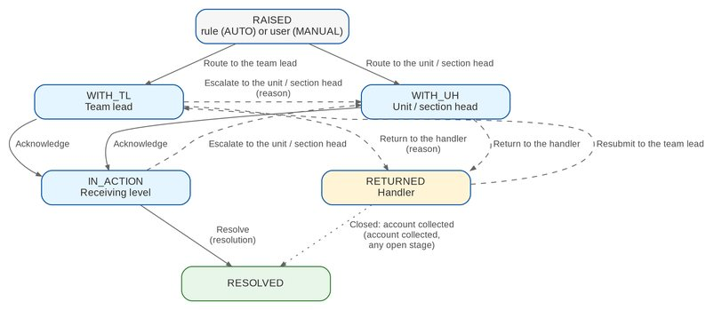
Figure 2: Workflow CLX_ESCALATION: stages and actions (BRCLXN.049, 050)
Table 9: Stages, owners and SLA
Stage | Owner (permission) | SLA hours (default) | Business actions
RAISED | System (no owner) | - | Route to the TL, or to the unit / section head
WITH_TL | Team lead (CLX_ESCALATION_HANDLE) | 24 | Acknowledge, escalate further, return to handler
WITH_UH | Unit / section head (CLX_ESCALATION_HANDLE) | 24 | Acknowledge, return to handler
IN_ACTION | Receiving level (CLX_ESCALATION_HANDLE) | 72 | Resolve, escalate further
RETURNED | Handler (CLX_WORK) | 48 | Resubmit to the team lead
RESOLVED | - | terminal | -

The rule's SLA hours replace the stage default for escalations raised by that rule.
Table 10: Transitions of CLX_ESCALATION
From | Action | To | Permission | Reason list
RAISED | Route to the team lead | WITH_TL | CLX_ESCALATE (system for rules) | -
RAISED | Route to the unit / section head | WITH_UH | CLX_ESCALATE (system for rules) | -
WITH_TL, WITH_UH | Acknowledge | IN_ACTION | CLX_ESCALATION_HANDLE | -
WITH_TL, IN_ACTION | Escalate to the unit / section head | WITH_UH | CLX_ESCALATION_HANDLE | CLX_ESCALATION_REASON
WITH_TL, WITH_UH | Return to the handler | RETURNED | CLX_ESCALATION_HANDLE | RETURN_REASON
IN_ACTION | Resolve | RESOLVED | CLX_ESCALATION_HANDLE | resolution text
RETURNED | Resubmit to the team lead | WITH_TL | CLX_WORK or CLX_ESCALATE | -
any open stage | Closed: account collected (automatic) | RESOLVED | - | -

5.2 Collection account statuses and hand-offs
Figure 3 shows how the refresh moves a collection account between statuses, and how a disposition with an Operations action becomes a hand-off.
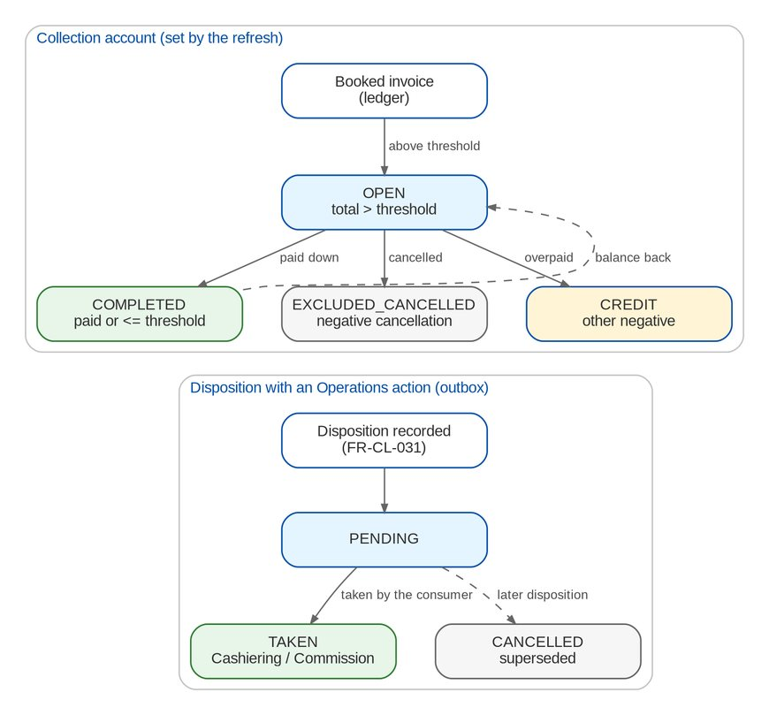
Figure 3: Collection account statuses and hand-offs to Operations
Table 11: Hand-off (outbox) statuses
Status | Meaning | Next
PENDING | Waiting for the consuming module | TAKEN when Cashiering or Commission takes it; CANCELLED when a later disposition supersedes it; CLX_OUTBOX_STALE after one day
TAKEN | Taken by the consuming module and logged in its flow-in run | -
CANCELLED | Withdrawn before it was taken | -

5.3 Promises, installments and billing statements
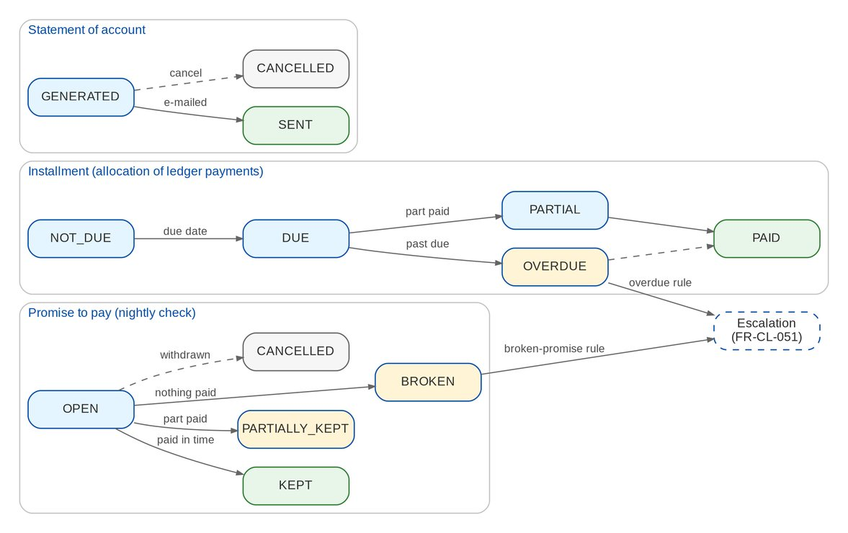
Figure 4: Promise, installment and statement statuses (BRCLXN.053, 055, 058)
Table 12: Statuses of plans, installments, promises and statements
Record | Statuses | Set by
Installment plan | ACTIVE, COMPLETED, CANCELLED | Creation; completion when every installment is paid; cancellation by a CLX_BILLING user
Installment | NOT_DUE, DUE, OVERDUE, PARTIAL, PAID | Allocation of the ledger payments (FR-CL-041) and the business date
Promise to pay | OPEN, KEPT, PARTIALLY_KEPT, BROKEN, CANCELLED | Recording; the nightly promise check; withdrawal or a newer promise
Billing statement | GENERATED, SENT, CANCELLED | Generation, e-mail, cancellation

5.4 Requests to Cashiering
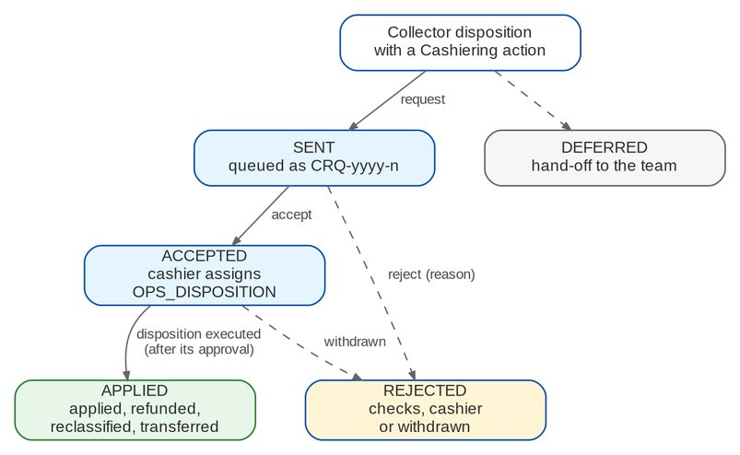
Figure 5: Collector request to Cashiering (BRCLXN.030-033)
Table 13: Statuses of an application request
Status | Meaning | Set by
SENT | Queued for Cashiering (CRQ number) | The collector disposition
DEFERRED | Handed over to the team CASH_DISPOSITION | Cashiering does not take the request at once
ACCEPTED | A cashier accepted it and assigned an Operations disposition | Cashiering
APPLIED | The disposition was executed (applied, refunded, reclassified or transferred) | Cashiering
REJECTED | Refused at once by Cashiering's checks, rejected by a cashier, or the disposition was withdrawn | Cashiering

6 Reports and documents

6.1 Reports
All Collections reports are in the report category Collections. Viewing needs CLX_REPORT_VIEW, exporting needs CLX_EXPORT (the audit log needs CLX_AUDIT_VIEW); they export to PDF, XLSX, ODS and CSV and are archived. The reports take the company and, where they cover a period, the dates; they filter by market segment, sales unit and invoicing branch. The layouts are those of p.59-61 with the fields BIBS holds; legacy-only fields wait for CQ22.
Table 14: Collections reports
Code | Name | Content | BRD
CLX-OUTSTANDING-PR | Outstanding PR List | Open collection accounts with the outstanding premium | BRCLXN.001-012, 045
CLX-FULL-PRODUCTION | Full Production Report | Accounts of the invoices booked in the period, any status | BRCLXN.045
CLX-DP-FOR-REVERSAL | DP PR for Reversal | Accounts tagged "DP PR for reversal" in the period | BRCLXN.024-029
CLX-PR2307-FOR-REVERSAL | PR 2307 for Reversal | Accounts tagged "PR 2307 for reversal" in the period | BRCLXN.026-029
CLX-COMPLETED-COLLECTIONS | Completed Collections | Accounts completed (paid or below the threshold) in the period | BRCLXN.008, 022
CLX-INVOICES-WITH-DISPOSITION | Invoices with Disposition | Open accounts with their current collector disposition | BRCLXN.016-021
CLX-REASSIGNMENTS | Collection Reassignments | Assignments and reassignments in the period | BRCLXN.052
CLX-ESCALATIONS | Escalated Accounts | Escalations raised in the period with target, reason and stage | BRCLXN.049, 050
CLX-BROKEN-PROMISES | Broken Promises to Pay | Promises broken or partially kept, by promised date | BRCLXN.055
CLX-INSTALLMENTS-DUE | Installments Due and Overdue | Unpaid installments of live plans falling due in the period | BRCLXN.053
CLX-APPLICATION-TO-INVOICE | For Application To Invoice | Collector requests to apply unapplied payments, with the file that listed them | BRCLXN.041
CLX-UNAPPLIED-DISPOSITIONS | Unapplied Payment Dispositions | Collector dispositions of unapplied payments with their Cashiering request | BRCLXN.031-040
CLX-AUDIT-LOG | Collections Audit Log | Field changes with from / to values | BRCLXN.043, 044

6.1.1 Account reports (CLX-OUTSTANDING-PR, CLX-FULL-PRODUCTION, CLX-COMPLETED-COLLECTIONS, CLX-INVOICES-WITH-DISPOSITION)
One row per invoice. The columns are shared by the four reports.
Table 15: Columns of the account reports
Column | Format | Content
Client Code / Name of Assured | Text | Client of the invoice and the assured
Invoice No. / Policy No. / Account (ARN) | Text | Keys of the invoice
Booking Date / Inception / Expiry | Date | Invoice dates
Aging / Aging Bracket | Number / Text | Days from the aging basis; bracket of CLX_AGING_BRACKETS
Invoicing Branch / Insurer / Product Line | Text | Classification from the ledger
Currency | Text | Invoice currency
Total Premium / Outstanding Premium / PR2307 Amount | Amount | Gross premium, net outstanding, open PR2307
Market Segment / Sales Unit / Unit Head / Account Officer / Collection Handler | Text | Organisation and people (user names)
Client Payment Status / Invoice Category | Text | Payment status of the ledger; Regular or Direct Bill
Disposition / Category (A/B/C) / Tagging Owner | Text | Current collector disposition and its attributes
Last Collection Effort Date / Code | Date / Text | Latest effort
Remarks / Status | Text | Account remarks and status

6.1.2 Reversal reports (CLX-DP-FOR-REVERSAL, CLX-PR2307-FOR-REVERSAL)
The account columns above, followed by:
Table 16: Additional columns of the reversal reports
Column | Format | Content
Date Tagged / Tagged By / Tag Remarks | Date / Text | The disposition that tagged the account
Basic Commission / VAT on Commission | Amount | Commission figures of the invoice
WTAX Rate | Percent | Withholding tax rate on commission
Diff (Premium Balance less PR2307) | Amount | Premium balance net of the PR2307 (p.59)

The p.59 fields that BIBS does not hold (booking category, corporate department, commission invoice no. / date / amount, CR team remarks, PR reversal date) are left out until CQ22 maps them.

6.1.3 For Application To Invoice (CLX-APPLICATION-TO-INVOICE)
Table 17: Columns of the application report and file
Column | Format | Content
Requested On | Date | Date of the collector request
Payment Date / Payment File Name / Transaction No. | Date / Text | Payment identification (p.60)
Paid Amount / Currency / Payment Type | Amount / Text | Payment figures
Payor / Reference No. / Name of Assured | Text | Payor and target account
Invoice No. | Text | Invoice to apply the payment to
User ID | Text | User of the disposition
Unapplied Reference / Status / Cashiering Reference / File | Text | Request tracking

6.2 Documents
Table 18: Collections documents
Template / file | Output | Content
CLX_SOA | PDF, e-mailed password-protected | SOA number and date; client and account; billing cycle and due date; installments billed (current and arrears) with policy year, coverage period, amount, paid and balance; amount due; generated by; template version. Draft layout until CQ18
FOR_APPLICATION_TO_INVOICE_<yyyyMMdd>_<time>.txt | Pipe-delimited text | One line per application request with the fields of the table above; folder FS04/CLX_APPLICATION_TO_INVOICE of the in-system repository
Collections Bulk Update | XLSX template | Columns of FR-CL-034 with descriptions and an example row

7 Interfaces and integration
Figure 6 shows the interfaces of Collections. Collections reads the Operations invoice ledger and exchanges work with Cashiering and Commission inside BIBS. It posts no accounting entry.
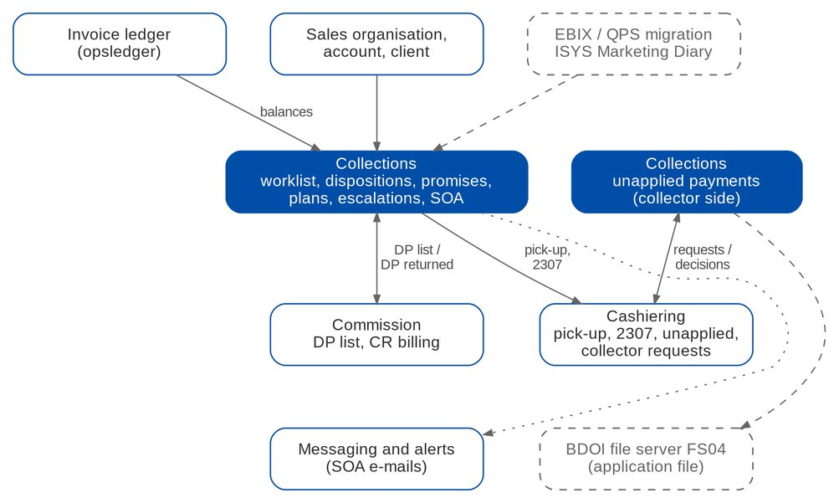
Figure 6: Interfaces of Collections (dashed = on hold)
Table 19: Interfaces
Interface | Direction | Content and trigger | BRD | Scope
Invoice ledger | In | Invoices, PR by component, movements, flags, shares; nightly refresh and after each movement | BRCLXN.001-015, 046 | IN SCOPE
Sales organisation | In | Unit Head of each sales unit, department or region | BRCLXN.011 | IN SCOPE
Account, issuance, client master | In | Policy, account and client data of the account page | BRCLXN.056 | IN SCOPE
Cashiering: check pick-up | Out | COLLECTION_CHECK_PICKUP, pulled by the pick-up queue | p.40 | IN SCOPE
Cashiering: BIR 2307 tags | Out | COLLECTION_CWT2307, taken by the Cashiering 2307 intake | BRCLXN.026 | IN SCOPE
Commission: DP list | Out | COLLECTION_DP_LIST, pulled by the DP list intake | BRCLXN.024 | IN SCOPE
Commission: DP returned | In | COLLECTION_DP_RETURNED reopens the account | CMRID.009 | IN SCOPE
Cashiering: unapplied items | In | Unapplied list, item and history | BRCLXN.034-036, 040 | IN SCOPE
Cashiering: collector requests | Out / In | Collector requests; status changes back to the collector | BRCLXN.030-033 | IN SCOPE
Cashiering: refunds | In | COLLECTION_REFUND recorded on the collector side | BRCLXN.040 | IN SCOPE
Messaging and alerts | Out | Notifications, SOA e-mails, alerts | BRCLXN.049-058 | IN SCOPE
BDOI file server FS04 | Out | Daily application file; list of extracts until OQ17 | BRCLXN.041-042 | ON HOLD
ISYS Marketing Diary | In | Client payment instructions | p.40-42 | ON HOLD
Legacy EBIX / QPS open items | In | One-time migration of open PRs and dispositions | BRCLXN.013-015 | ON HOLD

Interfaces on hold. The FS04 transfer (OQ17, CQ12), the Marketing Diary (CQ20) and the legacy migration (CQ07) wait for the answers of BDOI. Each is a new transfer or a one-time load, with no change to the Collections functions.

8 Non-functional requirements
Table 20: Non-functional requirements (BRD p.51-58)
Topic | BRD value | BIBS target and approach
Authentication | SSO with Windows credentials; masked password; friendly errors; all attempts logged; lock-out after 3 attempts (NFR 1-2) | Platform log-in of BRD-1; lock-out at 3 for all users (D5); SSO on hold (Q42)
Password rules | 8 / 12 characters, complexity, history 8, minimum age 1 day, change every 90 days (NFR 2) | Platform password policy of BRD-1
Access control | RBAC, custom roles, user maintenance; no multiple roles; IDOR protection (NFR 3) | RBAC and user administration exist; several roles per user allowed (D5)
Audit logging | Log-in / log-out, admin and configuration changes, record access and updates; timestamp, user, source IP, resource; exportable (NFR 4) | Platform audit plus the Collections change log with source IP (FR-CL-003, 004)
UI / UX | BDOI UI; copy / paste; smart search; record lock "<Username> is editing" (NFR 9) | BDO UX guidelines; search on every list; edit lock (FR-CL-005)
Session | Idle timeout 15 minutes set by the administrator; one session per device (NFR 10) | Timeout parameter exists; single session per device open (UQ09 / XQ11)
Batch security | Restricted execution; audit of origin, time and trigger (NFR 12) | ManagedJob run history with trigger and user; manual runs need CLX_SETUP
Operating hours and locations | 06:00-22:00 Monday to Friday and month-end weekends; head office and six provincial offices (NFR 17) | Web access from every BDOI location; jobs run after 22:00
Users and volumes | 130 users, 56 concurrent; 1,200 dispositions, applications and handler updates a day (NFR 15.01-15.05) | Worklist on indexed accounts; server-side paging
Response time | Screens under 5 seconds; daily report under 3 minutes; weekly under 10; monthly under 15 (NFR 15) | Online p95 under 3 seconds; files generated off-peak in the background
Exports | Caveat p.93: exports may slow the system | Background exports, row cap, separate permission (FR-CL-084)
Availability and recovery | RTO 4 hours, RPO 4 hours; DR server (NFR 18) | Same deployment as BRD-1 and BRD-2; one BIBS-wide NFR set is being agreed (XQ08, CQ25)
Retention | 5 years online, 15 years archive; backup every 4 hours, kept 5 years (NFR 16) | Retention framework of BRD-1; records never deleted in Collections

9 Configuration items owned by the business and the System Administrator
The items below are changed in BIBS without a release. Changes to parameters and lists are audited.

9.1 Parameters
Table 21: Collections parameters
Parameter | Default | Meaning
CLX_MIN_BALANCE_THRESHOLD | 10.00 | Total to collect above which an invoice is listed (to confirm, CQ03)
CLX_AGING_BASIS | BOOKING | Aging from BOOKING or INCEPTION
CLX_AGING_BRACKETS | 0-30, 31-45, 46-60, 61-90, 91-120, 121+ | Aging brackets in days
CLX_INVOICE_NO_PATTERN | EBIX I and 8 digits, or BIBS BI-... | Regular expression of the invoice number of "for application to invoice" (CQ13)
CLX_PROMISE_GRACE_DAYS | 0 | Days after the promised date before a promise is checked (0-30)
CLX_EXPORT_MAX_ROWS | 50000 | Row cap of a worklist export
CLX_EDIT_LOCK_MINUTES | 15 | Minutes after which the edit lock expires
LOGIN_MAX_FAILED_ATTEMPTS | 3 | Failed log-ins that lock a user (all users, D5)

9.2 Jobs
Table 22: Collections jobs (Manila time)
Job | Schedule | Purpose
CLX_DAILY_REFRESH | Daily 22:15 | Refresh the worklist from the ledger; assignment; end of temporary assignments
CLX_DAILY_FILES | Daily 22:30 | Outstanding PR List and Full Production Report
CLX_PROMISE_CHECK | Daily 22:45 | Evaluate promises; allocate payments to installments
CLX_ESCALATION | Daily 23:00 | Apply the escalation rules; close collected escalations
CLX_WEEKLY_FILES | Friday 22:30 | Weekly reversal files per unit and branch
CLX_APPLICATION_FILE | Daily 05:00 | Daily "For Application To Invoice" text file
CLX_MONTHLY_FILES | Daily 05:00 (generates on the first working day) | Monthly reversal files of the previous month

9.3 Lists of values
Table 23: Lists of values
List | Values delivered
CLX_PR_DISPOSITION | DP PR for reversal; PR 2307 for reversal; For check pick-up; Cancel account; Coordinate further; Request bank AO assistance; No / missing policy number; DP returned by insurer (all to confirm, CQ08)
CLX_UPP_DISPOSITION | For application to invoice; For refund; For reclass; For transfer to other unit; Coordinate further (to confirm, CQ08); Handling fee (BRD-12)
CLX_EFFORT_CODE | Phone call; E-mail; Client visit; Statement of account sent; Others (see remarks) (to confirm, CQ08)
CLX_BILLING_FREQUENCY | Annual; Semi-annual; Quarterly; Monthly
CLX_ESCALATION_REASON | No payment commitment; Broken promise to pay; Aging beyond the threshold; Installment overdue; Credit term extension refused by the insurer; Others (see remarks)
RETURN_REASON | Shared platform list (return of an escalation)

9.4 Alerts and notification events
Table 24: Alerts and notifications
Code | Kind | When
CLX_REFRESH_FAILED | Alert (high) | The daily refresh failed
CLX_FILE_NOT_PUBLISHED | Alert (high) | A scheduled file was not generated
CLX_ESCALATION_OVERDUE | Alert (medium) | An escalation stayed in a stage beyond its SLA
CLX_OUTBOX_STALE | Alert (medium) | A hand-off is pending for more than one day
CLX_ESCALATED | Notification (in-app, e-mail) | An account was escalated to the user or the user's team
CLX_REASSIGNED | Notification (in-app) | Accounts were assigned to or taken from the user
CLX_PROMISE_BROKEN | Notification (in-app) | A promise of the user's account was broken
CLX_DP_RETURNED | Notification (in-app) | An insurer returned a DP account
CLX_FILE_READY | Notification (in-app) | A scheduled file or export is ready

9.5 Masters and rules maintained by the business
Table 25: Masters and rules
Item | Maintained by (authorised by) | FR
Disposition values (PR, unapplied), effort codes, frequencies, reasons | LOV_MANAGE users (LOV approver) | FR-CL-030, 033, 072
Disposition rules (category, owner, action, allowed roles, requires invoice, Cashiering action) | CLX_SETUP users | FR-CL-030, 072
Unit Head per sales unit | CLX_SETUP users | FR-CL-015
Default assignment rules | CLX_ASSIGN users | FR-CL-020
Escalation rules | CLX_SETUP users (MASTER_AUTHORIZE) | FR-CL-050
SOA template CLX_SOA | System Administrator | FR-CL-060
Roles and permissions | Business Administrator via access request (approver) | FR-CL-001

10 Assumptions, dependencies and open questions

10.1 Assumptions
Table 26: Assumptions
ID | Assumption | Related
A-CL-01 | The renumbering addendum (p.23-34) is the governing wording of BRCLXN.001-048; the signed workshop addendum (p.13-22) governs BRCLXN.049-060 | R2, R3
A-CL-02 | BRCLXN.061-064 are not approved; they are proposed for confirmation by BDOI | CQ01
A-CL-03 | EBIX and QPS are replaced by BIBS booking and the Operations ledger; the BRD's extraction is an in-app refresh | OQ01
A-CL-04 | The list is kept at invoice level; account and client totals are for information | CQ02
A-CL-05 | Every CLX_VIEW user sees every account and uses filters | CQ06
A-CL-06 | "Transaction type C" (BRCLXN.010) means cancellation and return invoices | CQ04
A-CL-07 | Collections posts no accounting entry; the money effects stay in Cashiering, Commission and Adjustment | R6 principle 2
A-CL-08 | The Processing Unit's only Collections action is the disposition "No / missing policy number" | p.44

10.2 Dependencies
Table 27: Dependencies
ID | Dependency | Needed for
D-CL-01 | BDOI provides the disposition values, categories A / B / C, effort codes and the threshold value | FR-CL-011, 030, 033, 072 (CQ03, CQ08)
D-CL-02 | Cashiering takes the COLLECTION_CWT2307 hand-offs in its 2307 intake | FR-CL-032
D-CL-03 | BDOI confirms the upload columns for dispositions, efforts and remarks | FR-CL-034
D-CL-04 | BDOI provides the SOA layout, recipients and numbering | FR-CL-060, 061 (CQ18)
D-CL-05 | BDOI names the FS04 transport and confirms the application file layout | FR-CL-077 (OQ17, CQ12)
D-CL-06 | BDOI decides the EBIX migration scope and cut-off | FR-CL-017 (CQ07)

10.3 Open questions
Table 28: Open questions on BRD-4 (status from the cross-BRD decisions, R7)
ID | Question | Affects | Status
CQ01 | Are BRCLXN.061-064 (draft only) in scope, and who owns them? | FR-CL-091-094 | OPEN
CQ02 | Invoice level confirmed; do account or client totals decide the threshold? | FR-CL-010, 014 | OPEN
CQ03 | Value of the threshold; per currency; net of PR2307? | FR-CL-011 | OPEN
CQ04 | Treatment of negative balances that are not cancellations | FR-CL-013 | OPEN
CQ05 | Source of the Unit Head; bank officer and booker as names | FR-CL-015, 070 | OPEN
CQ06 | Data scope per user (own segment, unit, accounts) | FR-CL-015 | PARTIAL
CQ07 | Migration of EBIX open items and history at go-live | FR-CL-017 | OPEN
CQ08 | Values of the PR and unapplied dispositions, categories, effort codes | FR-CL-030, 033, 072 | OPEN
CQ09 | Which reports are weekly per unit per branch; what the "PR Report" is | FR-CL-082, 083 | PARTIAL
CQ10 | Who the Unapplied Payment Handler is | FR-CL-073, 074 | OPEN
CQ11 | Definitions of Processing Stage, Business Origin, Client Code Match, System Remarks | FR-CL-070 | OPEN
CQ12 | Is the daily application text file still needed, and its layout | FR-CL-077 | OPEN
CQ13 | Accept EBIX invoice numbers after go-live? | FR-CL-075 | OPEN
CQ14 | Default escalation rules, levels, targets and aging basis | FR-CL-050, 051, 062 | OPEN
CQ15 | Source of installment terms; booking per installment or in full | FR-CL-040 | OPEN
CQ16 | When a promise is kept; grace days; partial payment | FR-CL-042 | OPEN
CQ17 | Meaning of delivery date and receipt date | FR-CL-043 | OPEN
CQ18 | SOA layout, recipient, numbering, e-mail | FR-CL-060, 061 | OPEN
CQ19 | Evidence of a partial direct payment on a non-DP invoice | FR-CL-094 | OPEN
CQ20 | Marketing Diary in ISYS or in BIBS; CTE tracking | FR-CL-033 | OPEN
CQ21 | Dashboard content per role | FR-CL-085 | OPEN
CQ22 | Mapping of legacy report fields | Section 6.1 | OPEN
CQ23 | Single role, single session, lock-out at 3 | FR-CL-001 | ANSWERED
CQ24 | Relation of draft campaigns to the early-remittance incentive | FR-CL-092 | OPEN
CQ25 | NFR alignment (hours, RPO) across BRDs | Section 8 | OPEN

CQ23 is answered by BRD-11 (decision D5), except the single session per device (UQ09).

11 Traceability
Every BRD-4 requirement is met by at least one FR. The test cases are listed by test condition (TC-CL-nnn.n); the test plan workbook lists each case.
Table 29: BRD ID to FR, screen and test cases
BRD ID | FR | Screen | Test cases
BRCLXN.001 | FR-CL-010 | PR Worklist | TC-CL-010.1, 010.2, 010.3, 010.4 (5 cases)
BRCLXN.002 | FR-CL-010 | PR Worklist; Collection account | TC-CL-010.1, 010.2, 010.3, 010.4 (5 cases)
BRCLXN.003 | FR-CL-014 | PR Worklist (By Account / Client); Client View | TC-CL-014.1, 014.2 (3 cases)
BRCLXN.004 | FR-CL-010 | Collection account | TC-CL-010.1, 010.2, 010.3, 010.4 (5 cases)
BRCLXN.005 | FR-CL-011 | PR Worklist | TC-CL-011.1, 011.2, 011.3 (4 cases)
BRCLXN.006 | FR-CL-012 | Collections Setup | TC-CL-012.1, 012.2, 012.3, 012.4 (7 cases)
BRCLXN.007 | FR-CL-012 | Collections Setup | TC-CL-012.1, 012.2, 012.3, 012.4 (7 cases)
BRCLXN.008 | FR-CL-011, FR-CL-018 | PR Worklist (Completed) | TC-CL-011.1, 011.2, 011.3 (4 cases)
BRCLXN.009 | FR-CL-011 | PR Worklist | TC-CL-011.1, 011.2, 011.3 (4 cases)
BRCLXN.010 | FR-CL-013 | PR Worklist (Excluded, Credit Balances) | TC-CL-013.1, 013.2 (2 cases)
BRCLXN.011 | FR-CL-015 | PR Worklist; Collections Setup (Unit Heads) | TC-CL-015.1, 015.2, 015.3 (4 cases)
BRCLXN.012 | FR-CL-015 | PR Worklist | TC-CL-015.1, 015.2, 015.3 (4 cases)
BRCLXN.013 | FR-CL-017 | Job runs | TC-CL-017.1, 017.2, 017.3, 017.4 (6 cases)
BRCLXN.014 | FR-CL-017 | Job runs | TC-CL-017.1, 017.2, 017.3, 017.4 (6 cases)
BRCLXN.015 | FR-CL-017 | Collection account (Refresh from Ledger) | TC-CL-017.1, 017.2, 017.3, 017.4 (6 cases)
BRCLXN.016 | FR-CL-030, FR-CL-031 | Lists of Values; Record Disposition | TC-CL-030.1, 030.2, 030.3, 030.4, 031.1, 031.2, 031.3, 031.4 (14 cases)
BRCLXN.017 | FR-CL-030 | Lists of Values; Collections Setup | TC-CL-030.1, 030.2, 030.3, 030.4 (7 cases)
BRCLXN.018 | FR-CL-030, FR-CL-031 | Record Disposition | TC-CL-030.1, 030.2, 030.3, 030.4, 031.1, 031.2, 031.3, 031.4 (14 cases)
BRCLXN.019 | FR-CL-002 | Account tabs | TC-CL-002.1, 002.2 (3 cases)
BRCLXN.020 | FR-CL-002 | Account tabs | TC-CL-002.1, 002.2 (3 cases)
BRCLXN.021 | FR-CL-018, FR-CL-031 | Dispositions & Efforts | TC-CL-018.1, 018.2, 018.3, 031.1, 031.2, 031.3, 031.4 (10 cases)
BRCLXN.022 | FR-CL-018 | PR Worklist (Completed) | TC-CL-018.1, 018.2, 018.3 (3 cases)
BRCLXN.023 | FR-CL-018 | Timeline | TC-CL-018.1, 018.2, 018.3 (3 cases)
BRCLXN.024 | FR-CL-080, FR-CL-032 | Collections Files; Commission DP Lists | TC-CL-032.1, 032.2, 032.3, 032.4, 032.5, 080.1, 080.2, 080.3 (13 cases)
BRCLXN.025 | FR-CL-080 | Collections Files | TC-CL-080.1, 080.2, 080.3 (3 cases)
BRCLXN.026 | FR-CL-081, FR-CL-032 | Collections Files | TC-CL-032.1, 032.2, 032.3, 032.4, 032.5, 081.1, 081.2 (12 cases)
BRCLXN.027 | FR-CL-081 | Collections Files | TC-CL-081.1, 081.2 (2 cases)
BRCLXN.028 | FR-CL-082 | Collections Files (Weekly) | TC-CL-082.1, 082.2 (2 cases)
BRCLXN.029 | FR-CL-082 | Collections Files (Weekly) | TC-CL-082.1, 082.2 (2 cases)
BRCLXN.030 | FR-CL-074 | Unapplied Payments; Requests to Cashiering | TC-CL-074.1, 074.2, 074.3, 074.4 (6 cases)
BRCLXN.031 | FR-CL-073 | Unapplied Payment (Collector Dispositions) | TC-CL-073.1, 073.2 (4 cases)
BRCLXN.032 | FR-CL-074 | Unapplied Payments | TC-CL-074.1, 074.2, 074.3, 074.4 (6 cases)
BRCLXN.033 | FR-CL-073 | Unapplied Payments | TC-CL-073.1, 073.2 (4 cases)
BRCLXN.034 | FR-CL-070 | Unapplied Payments | TC-CL-070.1, 070.2, 070.3 (3 cases)
BRCLXN.035 | FR-CL-071 | Unapplied Payments (filters) | TC-CL-071.1, 071.2 (3 cases)
BRCLXN.036 | FR-CL-070 | Unapplied Payments | TC-CL-070.1, 070.2, 070.3 (3 cases)
BRCLXN.037 | FR-CL-072 | Lists of Values; Collections Setup | TC-CL-072.1, 072.2, 072.3 (3 cases)
BRCLXN.038 | FR-CL-072 | Record Disposition (unapplied) | TC-CL-072.1, 072.2, 072.3 (3 cases)
BRCLXN.039 | FR-CL-072 | Lists of Values | TC-CL-072.1, 072.2, 072.3 (3 cases)
BRCLXN.040 | FR-CL-076 | Unapplied Payment (History) | TC-CL-076.1, 076.2 (2 cases)
BRCLXN.041 | FR-CL-077 | Requests to Cashiering; Report Centre | TC-CL-077.1, 077.2, 077.3 (4 cases)
BRCLXN.042 | FR-CL-077 | - | TC-CL-077.1, 077.2, 077.3 (4 cases)
BRCLXN.043 | FR-CL-003 | History tab | TC-CL-003.1, 003.2, 003.3, 003.4 (4 cases)
BRCLXN.044 | FR-CL-004 | Report Centre | TC-CL-004.1, 004.2, 004.3 (4 cases)
BRCLXN.045 | FR-CL-083 | Collections Files (Daily) | TC-CL-083.1, 083.2 (2 cases)
BRCLXN.046 | FR-CL-016 | Collection account (Summary) | TC-CL-016.1, 016.2 (3 cases)
BRCLXN.047 | FR-CL-075 | Record Disposition (unapplied) | TC-CL-075.1, 075.2, 075.3 (4 cases)
BRCLXN.048 | FR-CL-075 | Record Disposition (unapplied) | TC-CL-075.1, 075.2, 075.3 (4 cases)
BRCLXN.049 | FR-CL-050, FR-CL-051, FR-CL-053 | Escalation Rules; Escalations | TC-CL-050.1, 050.2, 050.3, 050.4, 050.5, 051.1, 051.2, 051.3, 051.4, 053.1, 053.2, 053.3, 053.4 (21 cases)
BRCLXN.050 | FR-CL-052, FR-CL-053 | Escalations (Escalate Accounts) | TC-CL-052.1, 052.2, 052.3, 052.4, 053.1, 053.2, 053.3, 053.4 (12 cases)
BRCLXN.051 | FR-CL-034 | PR Worklist; Bulk Uploads | TC-CL-034.1, 034.2, 034.3, 034.4 (8 cases)
BRCLXN.052 | FR-CL-020, FR-CL-021 | Assignments | TC-CL-020.1, 020.2, 020.3, 020.4, 021.1, 021.2, 021.3, 021.4 (15 cases)
BRCLXN.053 | FR-CL-040, FR-CL-042 | Installment Plans; Installments Due | TC-CL-040.1, 040.2, 040.3, 040.4, 040.5, 042.1, 042.2, 042.3, 042.4 (24 cases)
BRCLXN.054 | FR-CL-041 | Collection account (Payments); Installment Plan | TC-CL-041.1, 041.2, 041.3 (4 cases)
BRCLXN.055 | FR-CL-042, FR-CL-051 | Promises to Pay | TC-CL-042.1, 042.2, 042.3, 042.4, 051.1, 051.2, 051.3, 051.4 (16 cases)
BRCLXN.056 | FR-CL-043 | Collection account (Policy & Co-insurance) | TC-CL-043.1, 043.2 (4 cases)
BRCLXN.057 | FR-CL-044 | Collection account (Timeline) | TC-CL-044.1, 044.2 (2 cases)
BRCLXN.058 | FR-CL-060, FR-CL-061 | Billing Statements | TC-CL-060.1, 060.2, 060.3, 061.1, 061.2, 061.3 (9 cases)
BRCLXN.059 | FR-CL-090 | Commission DP Accounts, DP Billings | TC-CL-090.1, 090.2, 090.3 (4 cases)
BRCLXN.060 | FR-CL-062 | Billing Statements | TC-CL-062.1, 062.2 (3 cases)
BRCLXN.061 | FR-CL-091 | - | TC-CL-091.1, 091.2 (2 cases)
BRCLXN.062 | FR-CL-092 | - | TC-CL-092.1, 092.2 (2 cases)
BRCLXN.063 | FR-CL-093 | - | TC-CL-093.1 (2 cases)
BRCLXN.064 | FR-CL-094 | - | TC-CL-094.1 (2 cases)

Table 30: Capabilities and NFRs without a BRCLXN ID
Source | FR / section | Note
Stakeholder functions (p.43-46), NFR 3 | FR-CL-001 | Role-based access
NFR 9.03 (record lock) | FR-CL-005 | Edit lock
Collection efforts, categories (p.41, 43-46, 59, 61) | FR-CL-033 | Efforts and categories
Exports and caveat (p.43-46, p.93) | FR-CL-084 | Background exports
Dashboard (p.43-46, p.61) | FR-CL-085 | Collections Home
Check pick-up (p.40) | FR-CL-032 | Hand-off to Cashiering
Marketing Diary, CTE (p.38-42) | FR-CL-033 note | On hold (CQ20)
NFR 1-18 (p.51-58) | Section 8 | NFR table

Table 31: Coverage summary
Group | BRD IDs | Covered
A. Outstanding PR list (001-012, 046) | 13 | 13
B. Daily refresh (013-015) | 3 | 3
C. Dispositions, tracking, audit (016-023, 043-044) | 10 | 10
D. Files and reports (024-029, 045) | 7 | 7
E. Unapplied payments (030-042, 047-048) | 15 | 15
F. Collection management (049-058, 060) | 11 | 11
G. Commission receivable (059, 061-064) | 5 | 5
Total | 64 | 64

12 Navigation
This chapter shows how each Collections user reaches the screens. The sidebar shows a screen only when the user's role holds its permission (section 3.2), so each persona sees a different menu. The tables follow the proposed role grants.

12.1 Screens of Collections
The 19 screens specified in chapter 13, with the menu path and the roles that can open them. A screen without its own menu entry (a record, a client view) is reached from the screen before it; its path ends with that screen.
Table 32: Collections screens
ID | Screen | Menu path | Personas
SCR-CL-01 | Collections Home | Finance › Collections › Collections Home | Marketing Account Officer, Marketing Team Lead, Marketing Handler, Collection Handler, Collection Team Lead, Section Head (Corporate / Retail), Unapplied Payment Handler, Processing Unit, Cashier (read access and exports), Disbursement (read access and exports), Comptrollership (read access), Business Administrator, System Administrator, Auditor
SCR-CL-02 | PR Worklist | Finance › Collections › PR Worklist | Marketing Account Officer, Marketing Team Lead, Marketing Handler, Collection Handler, Collection Team Lead, Section Head (Corporate / Retail), Unapplied Payment Handler, Processing Unit, Cashier (read access and exports), Disbursement (read access and exports), Comptrollership (read access), Business Administrator, System Administrator, Auditor
SCR-CL-03 | Collection Account | Finance › Collections › PR Worklist › Collection Account | Marketing Account Officer, Marketing Team Lead, Marketing Handler, Collection Handler, Collection Team Lead, Section Head (Corporate / Retail), Unapplied Payment Handler, Processing Unit, Cashier (read access and exports), Disbursement (read access and exports), Comptrollership (read access), Business Administrator, System Administrator, Auditor
SCR-CL-04 | Client View | Finance › Collections › PR Worklist › Client View | Marketing Account Officer, Marketing Team Lead, Marketing Handler, Collection Handler, Collection Team Lead, Section Head (Corporate / Retail), Unapplied Payment Handler, Processing Unit, Cashier (read access and exports), Disbursement (read access and exports), Comptrollership (read access), Business Administrator, System Administrator, Auditor
SCR-CL-05 | Installment Plans | Finance › Collections › Installment Plans | Marketing Account Officer, Marketing Team Lead, Marketing Handler, Collection Handler, Collection Team Lead, Section Head (Corporate / Retail), Unapplied Payment Handler, Processing Unit, Cashier (read access and exports), Disbursement (read access and exports), Comptrollership (read access), Business Administrator, System Administrator, Auditor
SCR-CL-06 | Installment Plan | Finance › Collections › Installment Plans › Installment Plan | Marketing Account Officer, Marketing Team Lead, Marketing Handler, Collection Handler, Collection Team Lead, Section Head (Corporate / Retail), Unapplied Payment Handler, Processing Unit, Cashier (read access and exports), Disbursement (read access and exports), Comptrollership (read access), Business Administrator, System Administrator, Auditor
SCR-CL-07 | Installments Due | Finance › Collections › Installments Due | Marketing Account Officer, Marketing Team Lead, Marketing Handler, Collection Handler, Collection Team Lead, Section Head (Corporate / Retail), Unapplied Payment Handler, Processing Unit, Cashier (read access and exports), Disbursement (read access and exports), Comptrollership (read access), Business Administrator, System Administrator, Auditor
SCR-CL-08 | Promises to Pay | Finance › Collections › Promises to Pay | Marketing Account Officer, Marketing Team Lead, Marketing Handler, Collection Handler, Collection Team Lead, Section Head (Corporate / Retail), Unapplied Payment Handler, Processing Unit, Cashier (read access and exports), Disbursement (read access and exports), Comptrollership (read access), Business Administrator, System Administrator, Auditor
SCR-CL-09 | Billing Statements | Finance › Collections › Billing Statements | Marketing Account Officer, Marketing Team Lead, Marketing Handler, Collection Handler, Collection Team Lead, Section Head (Corporate / Retail), Unapplied Payment Handler, Processing Unit, Cashier (read access and exports), Disbursement (read access and exports), Comptrollership (read access), Business Administrator, System Administrator, Auditor
SCR-CL-10 | Statement of Account | Finance › Collections › Billing Statements › Statement of Account | Marketing Account Officer, Marketing Team Lead, Marketing Handler, Collection Handler, Collection Team Lead, Section Head (Corporate / Retail), Unapplied Payment Handler, Processing Unit, Cashier (read access and exports), Disbursement (read access and exports), Comptrollership (read access), Business Administrator, System Administrator, Auditor
SCR-CL-11 | Escalations | Finance › Collections › Escalations | Marketing Account Officer, Marketing Team Lead, Marketing Handler, Collection Handler, Collection Team Lead, Section Head (Corporate / Retail), Unapplied Payment Handler, Processing Unit, Cashier (read access and exports), Disbursement (read access and exports), Comptrollership (read access), Business Administrator, System Administrator, Auditor
SCR-CL-12 | Escalation | Finance › Collections › Escalations › Escalation | Marketing Account Officer, Marketing Team Lead, Marketing Handler, Collection Handler, Collection Team Lead, Section Head (Corporate / Retail), Unapplied Payment Handler, Processing Unit, Cashier (read access and exports), Disbursement (read access and exports), Comptrollership (read access), Business Administrator, System Administrator, Auditor
SCR-CL-13 | Escalation Rules | Finance › Collections › Escalation Rules | Marketing Team Lead, Collection Team Lead, Section Head (Corporate / Retail), Business Administrator, System Administrator
SCR-CL-14 | Unapplied Payments | Finance › Collections › Unapplied Payments | Marketing Account Officer, Marketing Team Lead, Marketing Handler, Collection Handler, Collection Team Lead, Section Head (Corporate / Retail), Unapplied Payment Handler, Processing Unit, Cashier (read access and exports), Disbursement (read access and exports), Comptrollership (read access), Business Administrator, System Administrator, Auditor
SCR-CL-15 | Unapplied Payment | Finance › Collections › Unapplied Payments › Unapplied Payment | Marketing Account Officer, Marketing Team Lead, Marketing Handler, Collection Handler, Collection Team Lead, Section Head (Corporate / Retail), Unapplied Payment Handler, Processing Unit, Cashier (read access and exports), Disbursement (read access and exports), Comptrollership (read access), Business Administrator, System Administrator, Auditor
SCR-CL-16 | Requests to Cashiering | Finance › Collections › Requests to Cashiering | Marketing Account Officer, Marketing Team Lead, Marketing Handler, Collection Handler, Collection Team Lead, Section Head (Corporate / Retail), Unapplied Payment Handler, Processing Unit, Cashier (read access and exports), Disbursement (read access and exports), Comptrollership (read access), Business Administrator, System Administrator, Auditor
SCR-CL-17 | Assignments | Finance › Collections › Assignments | Marketing Team Lead, Collection Team Lead, Section Head (Corporate / Retail)
SCR-CL-18 | Collections Files | Finance › Collections › Collections Files | Marketing Account Officer, Marketing Team Lead, Marketing Handler, Collection Handler, Collection Team Lead, Section Head (Corporate / Retail), Unapplied Payment Handler, Cashier (read access and exports), Disbursement (read access and exports), Comptrollership (read access), System Administrator, Auditor
SCR-CL-19 | Collections Setup | Finance › Collections › Collections Setup | Section Head (Corporate / Retail), Business Administrator, System Administrator

12.2 Screen flow
How the screens link: from a list to its record, from a record action to the next screen, and from one area of Collections to the next. The walkthroughs of chapter 14 follow these links with real steps.
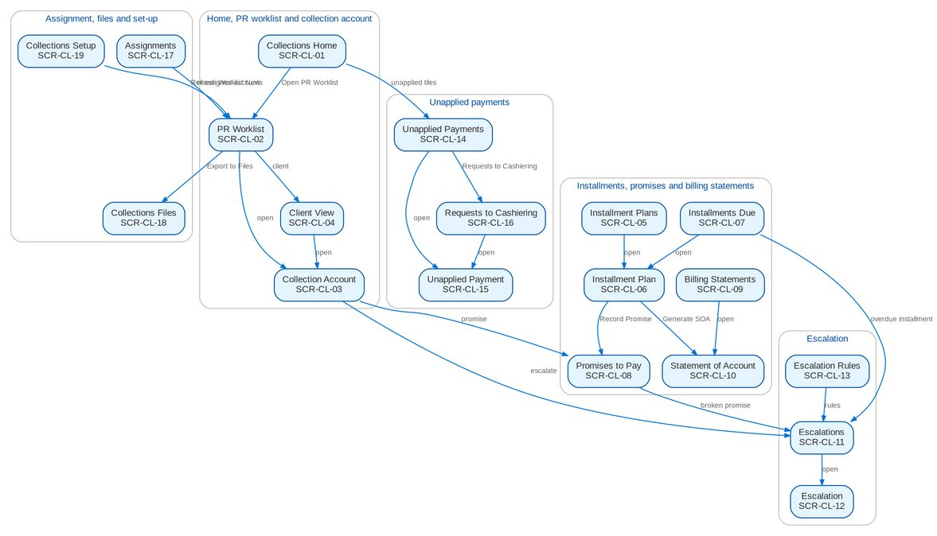
Figure 7: Screen flow of Collections: how the screens link (list, record, action, next screen)

12.3 Menu by persona
For each Collections persona, the SIT and UAT user of the seed data and the sidebar that user sees, section by section. The BRD column shows which BRD owns a section; entries of other BRDs are listed so the business unit sees the whole menu of its users.

12.3.1 Marketing Account Officer
SIT/UAT user ao. 61 menu entries, 10 of them Collections screens; the other entries belong to the BRD shown.
Table 33: Sidebar of the Marketing Account Officer
Group | Section | Screens | BRD
Home | Overview | My Approvals | Platform
Home | New Business Dashboard | NB Dashboard | BRD-1
Home | My Work | My Work | BRD-1
Client & Policy | Clients | Clients, New Client, KYC Reviews Due | BRD-1
Client & Policy | Quotation / Proposal | Quotations, New Quotation, Quotation Requests | BRD-1
Client & Policy | Accounts & Placement | Accounts, New Account, FFY Register, Direct Payment | BRD-1
Client & Policy | Non-Package Management | Proposal Requests, New Proposal Request | BRD-1
Client & Policy | Placement & Booking | Placement Workbench, Placement Slips | BRD-1
Client & Policy | Policy Issuance | Issuance Workbench, Insurance Advice | BRD-1
Client & Policy | Renewal | Renewal Home, Expiry List, My Dispositions, Transfers, Letters | BRD-6
Client & Policy | Submitted Policies | Submitted Policies Home, Masterlist, Extraction Review, Processing Runs, Reviews & IAAF, Terms of Reference, Renewal Work List | BRD-12
Client & Policy | Product Maintenance | Product Maintenance Home, Package Requests, Products, Coverages & Clauses, Incentive Criteria, Premium Calculator | BRD-3
Client & Policy | Bulk Processing | Bulk Uploads | BRD-1
Operations | Operations | Operations Home, Invoice Search, Hand-offs and Extracts, Notification Settings | BRD-2
Finance | Collections | Collections Home, PR Worklist, Installment Plans, Installments Due, Promises to Pay, Escalations, Billing Statements, Unapplied Payments, Requests to Cashiering, Collections Files | BRD-4
Finance | Refund & Cash Advance Requests | Requests Home, New Refund Request, New Cash Advance, Cancel a Check | BRD-5
Claims & Insurance | Claims Handling | Claims Reports | BRD-7
Reports | New Business Reports | New Business Reports | BRD-1
Reports | Reports | Report Centre | Platform
Setup & Administration | Help | Help Center, My Profile | Platform

12.3.2 Marketing Team Lead
SIT/UAT user mkttl. 72 menu entries, 12 of them Collections screens; the other entries belong to the BRD shown.
Table 34: Sidebar of the Marketing Team Lead
Group | Section | Screens | BRD
Home | Overview | My Approvals | Platform
Home | New Business Dashboard | NB Dashboard | BRD-1
Home | My Work | My Work | BRD-1
Client & Policy | Clients | Clients, New Client, KYC Reviews Due | BRD-1
Client & Policy | Quotation / Proposal | Quotations, New Quotation, Quotation Requests | BRD-1
Client & Policy | Accounts & Placement | Accounts, New Account, FFY Register, Direct Payment | BRD-1
Client & Policy | Non-Package Management | Proposal Requests, New Proposal Request | BRD-1
Client & Policy | Placement & Booking | Placement Workbench, Placement Slips | BRD-1
Client & Policy | Policy Issuance | Issuance Workbench, Insurance Advice | BRD-1
Client & Policy | Renewal | Renewal Home, Expiry List, My Dispositions, TL Review, Transfers, Letters | BRD-6
Client & Policy | Submitted Policies | Submitted Policies Home, Masterlist, Processing Runs, Reviews & IAAF, Terms of Reference, Renewal Work List, Submitted Policies Setup | BRD-12
Client & Policy | Adjustment | Adjustment Workbench, New Request | BRD-2
Client & Policy | Product Maintenance | Product Maintenance Home, Package Requests, Package Expiry, Products, Coverages & Clauses, Incentive Criteria, Premium Calculator | BRD-3
Client & Policy | Bulk Processing | Bulk Uploads | BRD-1
Operations | Operations | Operations Home, Invoice Search, Hand-offs and Extracts, Report Archive, Notification Settings | BRD-2
Finance | Collections | Collections Home, PR Worklist, Installment Plans, Installments Due, Promises to Pay, Escalations, Escalation Rules, Billing Statements, Unapplied Payments, Requests to Cashiering, Assignments, Collections Files | BRD-4
Finance | Cashiering | Cashiering Workbench, BIR 2307 | BRD-2
Finance | Remittance | Remittance Workbench, Remittance Holds, Special Remittance | BRD-2
Finance | Refund & Cash Advance Requests | Requests Home, Liquidation Accounts | BRD-5
Claims & Insurance | Claims Handling | Claims Reports | BRD-7
Reports | New Business Reports | New Business Reports, Production Targets | BRD-1
Reports | Reports | Report Centre | Platform
Setup & Administration | Help | Help Center, My Profile | Platform

12.3.3 Marketing Handler
SIT/UAT user mkthandler. 31 menu entries, 10 of them Collections screens; the other entries belong to the BRD shown.
Table 35: Sidebar of the Marketing Handler
Group | Section | Screens | BRD
Home | Overview | My Approvals | Platform
Home | New Business Dashboard | NB Dashboard | BRD-1
Home | My Work | My Work | BRD-1
Client & Policy | Clients | Clients, KYC Reviews Due | BRD-1
Client & Policy | Accounts & Placement | Accounts, FFY Register, Direct Payment | BRD-1
Client & Policy | Placement & Booking | Placement Workbench, Placement Slips | BRD-1
Client & Policy | Policy Issuance | Issuance Workbench, Insurance Advice | BRD-1
Client & Policy | Product Maintenance | Premium Calculator | BRD-3
Operations | Operations | Operations Home, Invoice Search, Hand-offs and Extracts, Notification Settings | BRD-2
Finance | Collections | Collections Home, PR Worklist, Installment Plans, Installments Due, Promises to Pay, Escalations, Billing Statements, Unapplied Payments, Requests to Cashiering, Collections Files | BRD-4
Reports | New Business Reports | New Business Reports | BRD-1
Reports | Reports | Report Centre | Platform
Setup & Administration | Help | Help Center, My Profile | Platform

12.3.4 Collection Handler
SIT/UAT user clxhandler. 40 menu entries, 10 of them Collections screens; the other entries belong to the BRD shown.
Table 36: Sidebar of the Collection Handler
Group | Section | Screens | BRD
Home | Overview | My Approvals | Platform
Home | New Business Dashboard | NB Dashboard | BRD-1
Home | My Work | My Work | BRD-1
Client & Policy | Clients | Clients, KYC Reviews Due | BRD-1
Client & Policy | Accounts & Placement | Accounts, FFY Register, Direct Payment | BRD-1
Client & Policy | Placement & Booking | Placement Workbench, Placement Slips | BRD-1
Client & Policy | Policy Issuance | Issuance Workbench, Insurance Advice | BRD-1
Client & Policy | Adjustment | Adjustment Workbench, New Request | BRD-2
Client & Policy | Product Maintenance | Premium Calculator | BRD-3
Client & Policy | Bulk Processing | Bulk Uploads | BRD-1
Operations | Operations | Operations Home, Invoice Search, Hand-offs and Extracts, Report Archive, Notification Settings | BRD-2
Finance | Collections | Collections Home, PR Worklist, Installment Plans, Installments Due, Promises to Pay, Escalations, Billing Statements, Unapplied Payments, Requests to Cashiering, Collections Files | BRD-4
Finance | Cashiering | Cashiering Workbench, BIR 2307 | BRD-2
Finance | Remittance | Remittance Workbench, Remittance Holds, Special Remittance | BRD-2
Reports | New Business Reports | New Business Reports | BRD-1
Reports | Reports | Report Centre | Platform
Setup & Administration | Help | Help Center, My Profile | Platform

12.3.5 Collection Team Lead
SIT/UAT user clxtl. 33 menu entries, 12 of them Collections screens; the other entries belong to the BRD shown.
Table 37: Sidebar of the Collection Team Lead
Group | Section | Screens | BRD
Home | Overview | My Approvals | Platform
Home | New Business Dashboard | NB Dashboard | BRD-1
Home | My Work | My Work | BRD-1
Client & Policy | Clients | Clients, KYC Reviews Due | BRD-1
Client & Policy | Accounts & Placement | Accounts, FFY Register, Direct Payment | BRD-1
Client & Policy | Placement & Booking | Placement Workbench, Placement Slips | BRD-1
Client & Policy | Policy Issuance | Issuance Workbench, Insurance Advice | BRD-1
Client & Policy | Product Maintenance | Premium Calculator | BRD-3
Operations | Operations | Operations Home, Invoice Search, Hand-offs and Extracts, Notification Settings | BRD-2
Finance | Collections | Collections Home, PR Worklist, Installment Plans, Installments Due, Promises to Pay, Escalations, Escalation Rules, Billing Statements, Unapplied Payments, Requests to Cashiering, Assignments, Collections Files | BRD-4
Reports | New Business Reports | New Business Reports | BRD-1
Reports | Reports | Report Centre | Platform
Setup & Administration | Help | Help Center, My Profile | Platform

12.3.6 Section Head (Corporate / Retail)
SIT/UAT user clxuh. 34 menu entries, 13 of them Collections screens; the other entries belong to the BRD shown.
Table 38: Sidebar of the Section Head (Corporate / Retail)
Group | Section | Screens | BRD
Home | Overview | My Approvals | Platform
Home | New Business Dashboard | NB Dashboard | BRD-1
Home | My Work | My Work | BRD-1
Client & Policy | Clients | Clients, KYC Reviews Due | BRD-1
Client & Policy | Accounts & Placement | Accounts, FFY Register, Direct Payment | BRD-1
Client & Policy | Placement & Booking | Placement Workbench, Placement Slips | BRD-1
Client & Policy | Policy Issuance | Issuance Workbench, Insurance Advice | BRD-1
Client & Policy | Product Maintenance | Premium Calculator | BRD-3
Operations | Operations | Operations Home, Invoice Search, Hand-offs and Extracts, Notification Settings | BRD-2
Finance | Collections | Collections Home, PR Worklist, Installment Plans, Installments Due, Promises to Pay, Escalations, Escalation Rules, Billing Statements, Unapplied Payments, Requests to Cashiering, Assignments, Collections Files, Collections Setup | BRD-4
Reports | New Business Reports | New Business Reports | BRD-1
Reports | Reports | Report Centre | Platform
Setup & Administration | Help | Help Center, My Profile | Platform

12.3.7 Unapplied Payment Handler
SIT/UAT user upphandler. 31 menu entries, 10 of them Collections screens; the other entries belong to the BRD shown.
Table 39: Sidebar of the Unapplied Payment Handler
Group | Section | Screens | BRD
Home | Overview | My Approvals | Platform
Home | New Business Dashboard | NB Dashboard | BRD-1
Home | My Work | My Work | BRD-1
Client & Policy | Clients | Clients, KYC Reviews Due | BRD-1
Client & Policy | Accounts & Placement | Accounts, FFY Register, Direct Payment | BRD-1
Client & Policy | Placement & Booking | Placement Workbench, Placement Slips | BRD-1
Client & Policy | Policy Issuance | Issuance Workbench, Insurance Advice | BRD-1
Client & Policy | Product Maintenance | Premium Calculator | BRD-3
Operations | Operations | Operations Home, Invoice Search, Hand-offs and Extracts, Notification Settings | BRD-2
Finance | Collections | Collections Home, PR Worklist, Installment Plans, Installments Due, Promises to Pay, Escalations, Billing Statements, Unapplied Payments, Requests to Cashiering, Collections Files | BRD-4
Reports | New Business Reports | New Business Reports | BRD-1
Reports | Reports | Report Centre | Platform
Setup & Administration | Help | Help Center, My Profile | Platform

12.3.8 Processing Unit
SIT/UAT user proc. 54 menu entries, 9 of them Collections screens; the other entries belong to the BRD shown.
Table 40: Sidebar of the Processing Unit
Group | Section | Screens | BRD
Home | Overview | My Approvals | Platform
Home | New Business Dashboard | NB Dashboard | BRD-1
Home | My Work | My Work | BRD-1
Client & Policy | Clients | Clients, KYC Reviews Due | BRD-1
Client & Policy | Quotation / Proposal | Quotations, Quotation Requests | BRD-1
Client & Policy | Accounts & Placement | Accounts, New Account, FFY Register, Direct Payment | BRD-1
Client & Policy | Placement & Booking | Placement Workbench, Placement Slips, CLPC Billing | BRD-1
Client & Policy | Policy Issuance | Issuance Workbench, E-policy Upload, Insurance Advice, E-policy Dispatch | BRD-1
Client & Policy | Booking | Booking Workbench, Endorsements, Service Invoices, Batch Runs, Booking Setup | BRD-1
Client & Policy | Renewal | Renewal Home, Expiry List, Processing Worklist, Insurer Batches, Letters, Renewal Setup | BRD-6
Client & Policy | Submitted Policies | Submitted Policies Home, Masterlist, Processing Runs, Reviews & IAAF, Terms of Reference, Renewal Work List | BRD-12
Client & Policy | Product Maintenance | Premium Calculator | BRD-3
Client & Policy | Bulk Processing | Bulk Uploads | BRD-1
Operations | Operations | Operations Home, Invoice Search, Hand-offs and Extracts, Notification Settings | BRD-2
Finance | Collections | Collections Home, PR Worklist, Installment Plans, Installments Due, Promises to Pay, Escalations, Billing Statements, Unapplied Payments, Requests to Cashiering | BRD-4
Reports | New Business Reports | New Business Reports | BRD-1
Reports | Reports | Report Centre | Platform
Setup & Administration | Help | Help Center, My Profile | Platform

12.3.9 Cashier (read access and exports)
SIT/UAT user cashier. 50 menu entries, 10 of them Collections screens; the other entries belong to the BRD shown.
Table 41: Sidebar of the Cashier (read access and exports)
Group | Section | Screens | BRD
Home | Overview | My Approvals | Platform
Home | New Business Dashboard | NB Dashboard | BRD-1
Home | My Work | My Work | BRD-1
Client & Policy | Clients | Clients, KYC Reviews Due | BRD-1
Client & Policy | Accounts & Placement | Accounts, FFY Register, Direct Payment | BRD-1
Client & Policy | Placement & Booking | Placement Workbench, Placement Slips | BRD-1
Client & Policy | Policy Issuance | Issuance Workbench, Insurance Advice | BRD-1
Client & Policy | Product Maintenance | Premium Calculator | BRD-3
Client & Policy | Bulk Processing | Bulk Uploads | BRD-1
Operations | Operations | Operations Home, Invoice Search, Hand-offs and Extracts, Report Archive, Notification Settings | BRD-2
Finance | Collections | Collections Home, PR Worklist, Installment Plans, Installments Due, Promises to Pay, Escalations, Billing Statements, Unapplied Payments, Requests to Cashiering, Collections Files | BRD-4
Finance | Cashiering | Cashiering Workbench, Receive Payment, Receipts, Unapplied Payments, Incoming Requests, Pre-booked Payments, Payment Uploads, PDC Warehouse, Check Pick-up, Batch Print, BIR 2307, Unapplied to Income, Legacy PR 2307 Reversal, Commission ORs, Receipt Series, Cashiering Setup | BRD-2
Finance | Commission Receivables | DP PR Legacy Reversal | BRD-2
Reports | New Business Reports | New Business Reports | BRD-1
Reports | Reports | Report Centre | Platform
Setup & Administration | Help | Help Center, My Profile | Platform

12.3.10 Disbursement (read access and exports)
SIT/UAT user disb. 54 menu entries, 10 of them Collections screens; the other entries belong to the BRD shown.
Table 42: Sidebar of the Disbursement (read access and exports)
Group | Section | Screens | BRD
Home | Overview | My Approvals | Platform
Home | New Business Dashboard | NB Dashboard | BRD-1
Home | My Work | My Work | BRD-1
Client & Policy | Clients | Clients, KYC Reviews Due | BRD-1
Client & Policy | Accounts & Placement | Accounts, FFY Register, Direct Payment | BRD-1
Client & Policy | Placement & Booking | Placement Workbench, Placement Slips | BRD-1
Client & Policy | Policy Issuance | Issuance Workbench, Insurance Advice | BRD-1
Client & Policy | Product Maintenance | Premium Calculator | BRD-3
Operations | Operations | Operations Home, Invoice Search, Disbursement Queue, Hand-offs and Extracts, Report Archive, Notification Settings | BRD-2
Finance | Collections | Collections Home, PR Worklist, Installment Plans, Installments Due, Promises to Pay, Escalations, Billing Statements, Unapplied Payments, Requests to Cashiering, Collections Files | BRD-4
Finance | Cashiering | BIR 2307 | BRD-2
Finance | Disbursement | Disbursement Workbench, Payees, Disbursement Uploads, Disbursement End of Day, Account Funding, Bank Accounts and Checks, Disbursement Reports | BRD-5
Finance | Tax & Statutory | Tax Calendar, VAT Worksheet, Withholding Tax, Documentary Stamp Tax, Premium Tax, LGT & FST, Tax Returns, BIR Form 2307, Certificates Received, BIR Forms & Books, IC Schedules, Tax Codes & Forms, Party Tax Profiles, IC Mapping | BRD-5
Reports | New Business Reports | New Business Reports | BRD-1
Reports | Reports | Report Centre | Platform
Setup & Administration | Help | Help Center, My Profile | Platform

12.3.11 Comptrollership (read access)
SIT/UAT user comptrol. 71 menu entries, 10 of them Collections screens; the other entries belong to the BRD shown.
Table 43: Sidebar of the Comptrollership (read access)
Group | Section | Screens | BRD
Home | Overview | My Approvals | Platform
Home | New Business Dashboard | NB Dashboard | BRD-1
Home | My Work | My Work | BRD-1
Client & Policy | Clients | Clients, KYC Reviews Due | BRD-1
Client & Policy | Accounts & Placement | Accounts, FFY Register, Direct Payment | BRD-1
Client & Policy | Placement & Booking | Placement Workbench, Placement Slips | BRD-1
Client & Policy | Policy Issuance | Issuance Workbench, Insurance Advice | BRD-1
Client & Policy | Product Maintenance | Premium Calculator | BRD-3
Operations | Operations | Operations Home, Invoice Search, Hand-offs and Extracts, Report Archive, Notification Settings | BRD-2
Finance | Collections | Collections Home, PR Worklist, Installment Plans, Installments Due, Promises to Pay, Escalations, Billing Statements, Unapplied Payments, Requests to Cashiering, Collections Files | BRD-4
Finance | Remittance | Remittance Deductions | BRD-2
Finance | Commission Receivables | Commission Workbench, BIR Certificates | BRD-2
Finance | Disbursement | Disbursement Workbench, Payees, Disbursement End of Day, Account Funding, Bank Accounts and Checks, Disbursement Reports | BRD-5
Finance | ACSL | ACSL Cases, Correction Entries, Insurer SOA Reconciliation, GL-SL Reconciliation | BRD-5
Finance | Accounting Reports | Report Pack, Account Schedules, Service Fee Runs, Service Fee Rates | BRD-5
Finance | General Ledger | Journals, Recurring Journals, Account Inquiry, Party Statement | BRD-5
Finance | Receivables & Banking | Receipts, Cheques & Deposits, PDC Received | BRD-5
Finance | Payables & Cash | Supplier Invoices, Payment Vouchers, PDC Issued, Petty Cash | BRD-5
Finance | Accounting Engine | Event Register | BRD-5
Data Migration | Data Migration | Migration Home, Data Objects, Code Maps, Layouts and Rules, Batches, Reconciliation, Opening Adjustments, Cutover, Run-off and Decommissioning, Sign-off | BRD-13
Reports | New Business Reports | New Business Reports | BRD-1
Reports | Reports | Report Centre | Platform
Setup & Administration | Help | Help Center, My Profile | Platform

12.3.12 Business Administrator
SIT/UAT user badmin. 84 menu entries, 11 of them Collections screens; the other entries belong to the BRD shown.
Table 44: Sidebar of the Business Administrator
Group | Section | Screens | BRD
Home | Overview | My Approvals | Platform
Home | New Business Dashboard | NB Dashboard | BRD-1
Home | My Work | My Work | BRD-1
Client & Policy | Employee Benefits | EB Home, Programmes, Member Changes, Pending Items, EB Setup | BRD-8
Client & Policy | Booking | Booking Setup | BRD-1
Client & Policy | Renewal | Renewal Home, Expiry List, Renewal Setup | BRD-6
Client & Policy | Product Maintenance | Product Maintenance Home, Package Requests, Package Expiry, Products, Validation Queue, Coverages & Clauses, Incentive Criteria, Insurers, Rates & Taxes, Sales Organisation | BRD-3
Client & Policy | Bulk Processing | Bulk Uploads | BRD-1
Operations | Operations | Operations Home, Invoice Search, Hand-offs and Extracts, Interfaces, Notification Settings | BRD-2
Finance | Collections | Collections Home, PR Worklist, Installment Plans, Installments Due, Promises to Pay, Escalations, Escalation Rules, Billing Statements, Unapplied Payments, Requests to Cashiering, Collections Setup | BRD-4
Finance | Accounting Reports | Account Schedules | BRD-5
Finance | General Ledger | Chart of Accounts, Financial Periods | BRD-5
Finance | Payables & Cash | Bank Accounts | BRD-5
Finance | Assets & Investments | Asset Categories, Asset Register, Depreciation Run, Investment Portfolios, Investments, Accrual & Amortization, Maturities & Sales | BRD-5
Finance | Accounting Engine | Event Types, Accounting Rules, Rule Simulator | BRD-5
Reports | New Business Reports | New Business Reports, Production Targets | BRD-1
Reports | Reports | Report Centre | Platform
Setup & Administration | Broking Setup | Lists of Values, Data Retention, Document Templates, Outbound Messages | BRD-1
Setup & Administration | Setup | Companies, Branches, Currencies & Rates, Dimensions, Business Partners, Employees, Cost-Centre Rules, Holiday Calendar | Platform
Setup & Administration | User Access | Access Requests, Group Profile Requests, Bulk Request, User Access Matrix, Separation of Duties, User Access Reports | BRD-11
Setup & Administration | Administration | Audit Trail, System Parameters, Scheduled Jobs, Record Classes, Legal Holds, Content Migration, Product Modules, Application Info | Platform / BRD-11
Setup & Administration | Help | Help Center, My Profile | Platform

12.3.13 System Administrator
SIT/UAT user admin. 122 menu entries, 12 of them Collections screens; the other entries belong to the BRD shown.
Table 45: Sidebar of the System Administrator
Group | Section | Screens | BRD
Home | Overview | My Approvals, Dashboard, Alerts | Platform
Home | New Business Dashboard | NB Dashboard | BRD-1
Home | My Work | My Work | BRD-1
Client & Policy | Sanction Screening | Screening Home, Cases, Matches, Screening Runs, High-risk Clients | BRD-10
Client & Policy | Employee Benefits | EB Home, Programmes, Member Changes, Pending Items | BRD-8
Client & Policy | Booking | Booking Setup | BRD-1
Client & Policy | Product Maintenance | Product Maintenance Home, Package Requests, Products, Coverages & Clauses, Incentive Criteria, Insurers, Rates & Taxes, Sales Organisation | BRD-3
Client & Policy | Bulk Processing | Bulk Uploads | BRD-1
Operations | Operations | Operations Home, Invoice Search, Hand-offs and Extracts, Interfaces, Report Archive, Notification Settings | BRD-2
Finance | Collections | Collections Home, PR Worklist, Installment Plans, Installments Due, Promises to Pay, Escalations, Escalation Rules, Billing Statements, Unapplied Payments, Requests to Cashiering, Collections Files, Collections Setup | BRD-4
Finance | Remittance | Remittance Deductions | BRD-2
Finance | Disbursement | Disbursement Workbench, Payees, Disbursement End of Day, Account Funding, Bank Accounts and Checks, Disbursement Reports | BRD-5
Finance | Refund & Cash Advance Requests | Requests Home | BRD-5
Finance | ACSL | ACSL Cases, Correction Entries, Insurer SOA Reconciliation, GL-SL Reconciliation | BRD-5
Finance | Accounting Reports | Report Pack, Account Schedules, Service Fee Runs, Service Fee Rates | BRD-5
Finance | General Ledger | Chart of Accounts, Financial Periods | BRD-5
Finance | Payables & Cash | Bank Accounts | BRD-5
Finance | Assets & Investments | Asset Categories, Asset Register, Depreciation Run, Investment Portfolios, Investments, Accrual & Amortization, Maturities & Sales | BRD-5
Finance | Accounting Engine | Event Types, Accounting Rules, Rule Simulator | BRD-5
Claims & Insurance | Claims Handling | Claims Home, Claims Worklist, My Diary, Claims Reports | BRD-7
Data Migration | Data Migration | Migration Home, Data Objects, Code Maps, Layouts and Rules, Batches, Reconciliation, Opening Adjustments, Cutover, Run-off and Decommissioning, Sign-off | BRD-13
Reports | New Business Reports | New Business Reports, Production Targets | BRD-1
Reports | Reports | Report Centre | Platform
Setup & Administration | Broking Setup | Lists of Values, Data Retention, Document Templates, Outbound Messages | BRD-1
Setup & Administration | Compliance Setup | Watchlist | BRD-10
Setup & Administration | Setup | Companies, Branches, Currencies & Rates, Dimensions, Business Partners, Employees, Cost-Centre Rules, Holiday Calendar | Platform
Setup & Administration | User Access | Access Requests, Group Profile Requests, Bulk Request, User Access Matrix, User Access Reports | BRD-11
Setup & Administration | Administration | Users, Roles & Permissions, Second Factor, Audit Trail, System Parameters, Exception Codes, Scheduled Jobs, Integration Events, Caches, Record Classes, Legal Holds, Content Migration, Product Modules, Application Info | Platform / BRD-11
Setup & Administration | Help | Help Center, My Profile | Platform

12.3.14 Auditor
SIT/UAT user auditor. 154 menu entries, 10 of them Collections screens; the other entries belong to the BRD shown.
Table 46: Sidebar of the Auditor
Group | Section | Screens | BRD
Home | Overview | My Approvals, Dashboard, Alerts | Platform
Home | New Business Dashboard | NB Dashboard | BRD-1
Home | My Work | My Work | BRD-1
Client & Policy | Clients | Clients, KYC Reviews Due | BRD-1
Client & Policy | Sanction Screening | Screening Home, Cases, Matches, Screening Runs, High-risk Clients, STR | BRD-10
Client & Policy | Quotation / Proposal | Quotations, Quotation Requests | BRD-1
Client & Policy | Accounts & Placement | Accounts, FFY Register, Direct Payment | BRD-1
Client & Policy | Employee Benefits | EB Home, Programmes, Member Changes, Pending Items | BRD-8
Client & Policy | Placement & Booking | Placement Workbench, Placement Slips | BRD-1
Client & Policy | Policy Issuance | Issuance Workbench, Insurance Advice | BRD-1
Client & Policy | Booking | Booking Setup | BRD-1
Client & Policy | Renewal | Renewal Home, Expiry List | BRD-6
Client & Policy | Product Maintenance | Product Maintenance Home, Package Requests, Package Expiry, Products, Coverages & Clauses, Incentive Criteria, Insurers, Rates & Taxes, Sales Organisation, Premium Calculator | BRD-3
Operations | Operations | Operations Home, Invoice Search, Hand-offs and Extracts, Report Archive, Notification Settings | BRD-2
Finance | Collections | Collections Home, PR Worklist, Installment Plans, Installments Due, Promises to Pay, Escalations, Billing Statements, Unapplied Payments, Requests to Cashiering, Collections Files | BRD-4
Finance | Remittance | Remittance Deductions | BRD-2
Finance | Disbursement | Disbursement Workbench, Payees, Disbursement End of Day, Account Funding, Bank Accounts and Checks, Disbursement Reports | BRD-5
Finance | Refund & Cash Advance Requests | Requests Home | BRD-5
Finance | ACSL | ACSL Cases, Correction Entries, Insurer SOA Reconciliation, GL-SL Reconciliation | BRD-5
Finance | Accounting Reports | Report Pack, Account Schedules, Service Fee Runs, Service Fee Rates | BRD-5
Finance | General Ledger | Journals, Recurring Journals, Account Inquiry, Party Statement, Chart of Accounts, Financial Periods | BRD-5
Finance | Receivables & Banking | Receipts, Cheques & Deposits, PDC Received, Receivables Reports | BRD-5
Finance | Payables & Cash | Supplier Invoices, Payment Vouchers, PDC Issued, Petty Cash, Bank Accounts | BRD-5
Finance | Assets & Investments | Asset Categories, Asset Register, Depreciation Run, Investment Portfolios, Investments, Accrual & Amortization, Maturities & Sales | BRD-5
Finance | Planning & Closing | Budget vs Actual | BRD-5
Finance | Tax & Statutory | Tax Calendar, VAT Worksheet, Withholding Tax, Documentary Stamp Tax, Premium Tax, LGT & FST, Tax Returns, BIR Form 2307, Certificates Received, BIR Forms & Books, IC Schedules, Tax Codes & Forms, Party Tax Profiles, IC Mapping | BRD-5
Finance | Accounting Engine | Event Types, Accounting Rules, Rule Simulator, Event Register | BRD-5
Claims & Insurance | Claims Handling | Claims Home, Claims Worklist, My Diary, Claims Reports | BRD-7
Data Migration | Data Migration | Migration Home, Data Objects, Code Maps, Layouts and Rules, Batches, Reconciliation, Opening Adjustments, Cutover, Run-off and Decommissioning, Sign-off | BRD-13
Reports | New Business Reports | New Business Reports, Production Targets | BRD-1
Reports | Reports | Report Centre | Platform
Setup & Administration | Broking Setup | Data Retention, Document Templates, Outbound Messages | BRD-1
Setup & Administration | Compliance Setup | Watchlist | BRD-10
Setup & Administration | Setup | Companies, Branches, Currencies & Rates, Dimensions, Business Partners, Employees, Cost-Centre Rules, Holiday Calendar | Platform
Setup & Administration | User Access | Access Requests, Group Profile Requests, User Access Matrix, User Access Reports | BRD-11
Setup & Administration | Administration | Audit Trail, System Parameters, Exception Codes, Scheduled Jobs, Record Classes, Legal Holds, Content Migration, Product Modules, Application Info | Platform / BRD-11
Setup & Administration | Help | Help Center, My Profile | Platform

12.3.15 Authorizer of master data
SIT/UAT user checker. 70 menu entries, 1 of them Collections screens; the other entries belong to the BRD shown.
Table 47: Sidebar of the Authorizer of master data
Group | Section | Screens | BRD
Home | Overview | My Approvals, Dashboard, Alerts | Platform
Client & Policy | Booking | Booking Setup | BRD-1
Client & Policy | Product Maintenance | Products, Coverages & Clauses, Insurers, Rates & Taxes, Sales Organisation | BRD-3
Finance | Collections | Escalation Rules | BRD-4
Finance | Cashiering | Receipt Series | BRD-2
Finance | Accounting Reports | Account Schedules | BRD-5
Finance | General Ledger | Journals, Recurring Journals, Account Inquiry, Party Statement, Chart of Accounts, Financial Periods | BRD-5
Finance | Receivables & Banking | Receipts, Receipt Approvals, Cheques & Deposits, PDC Received, Receivables Reports | BRD-5
Finance | Payables & Cash | Supplier Invoices, Payment Vouchers, PDC Issued, Petty Cash, Bank Accounts | BRD-5
Finance | Assets & Investments | Asset Categories, Asset Register, Depreciation Run, Investment Portfolios, Investments, Accrual & Amortization, Maturities & Sales | BRD-5
Finance | Planning & Closing | Budget vs Actual | BRD-5
Finance | Tax & Statutory | Tax Calendar, VAT Worksheet, Withholding Tax, Documentary Stamp Tax, Premium Tax, LGT & FST, Tax Returns, BIR Form 2307, Certificates Received, BIR Forms & Books, IC Schedules, Tax Codes & Forms, Party Tax Profiles, IC Mapping | BRD-5
Finance | Accounting Engine | Event Types, Accounting Rules, Rule Simulator, Event Register | BRD-5
Reports | New Business Reports | New Business Reports, Production Targets | BRD-1
Reports | Reports | Report Centre | Platform
Setup & Administration | Broking Setup | Lists of Values, Data Retention, Document Templates | BRD-1
Setup & Administration | Setup | Companies, Branches, Currencies & Rates, Dimensions, Business Partners, Employees, Cost-Centre Rules, Holiday Calendar | Platform
Setup & Administration | Administration | Exception Codes | Platform / BRD-11
Setup & Administration | Help | Help Center, My Profile | Platform

12.4 Common screen elements
Elements that behave the same on every Collections screen are described once here and not repeated in the screen specifications.
Table 48: Common screen elements
Element | What the user sees and does
Page header and company | Every page shows its section and title, a one-line description and its actions on the right. The company in the header decides the records shown; lists and files are always of that company.
Collections Home and work tiles | The Collections Home shows the collector's work queues as tiles: a Title Case label and the live count; a queue that needs action has a coloured bar and "Needs attention". A tile opens the list behind it. Under the tiles, the open amounts per aging bracket, for all market segments or one.
Work lists | Lists show status tabs, a search box, a Filters button for the other criteria and the paged table ("Showing 1 to n of N results"). Rows alternate white and Background Blue; a long list scrolls inside its card with the header row in view. A row opens its record. Dates show as dd-MMM-yyyy and times as dd-MMM-yyyy HH:mm in Philippine time. Selecting rows enables the actions of the tab, which apply to every selected row.
Collection account and reference chips | A collection account opens with the name of the assured, its reference chips (invoice, ARN), the collection status, the payment and remittance status of the invoice, its flags and the key facts (client, outstanding and PR2307, aging, insurer, handler, account officer and Unit Head). A reference chip copies the reference; Open Invoice 360 opens the invoice in Operations.
Statuses and flags of an account | Every collection account has a collection status (Open, Credit, Completed, Excluded) set by the nightly refresh, never by a user, and shows the payment status and the remittance status of its invoice as pills. Flags are tags: Direct Payment, 2% CWT, On Hold, Pending Negative Adjustment, Locked by the Operations team working on the invoice, and Marketing Action or Operations Action (who acts next on the account).
Record lock | A user who opens a collection account to work on it holds it for the edit-lock time (15 minutes by default). Another user sees "<name> is editing since <time>" above the account and cannot change it until the lock is released or expires.
Workflow header and history | An escalation shows the workflow header under the record header: a stepper of the stages in their order (passed stages ticked in blue, the current stage highlighted, the stages ahead in grey; a returned stage in amber, the last stage in green once reached), and one row with Current Stage, Since, Due (with the Overdue pill) and Assigned To, with the actions the user may take now on the right. The history table lists every step, newest first: Stage, From Stage, Action, By (the user's name; the role under it for the users who may read the roles of others: user administration, access review and audit), Date and Time, Remarks and Duration in Stage. "Workflow notice" in the action tables means the in-app notice NT-01.
Maker-checker | An escalation rule applies only once another user than its maker authorizes it; the maker cannot authorize it. A disposition reserved to some roles is refused for the other roles, and updating several accounts at once needs the bulk update permission, whatever other permission the user holds.
Status pills and tags | Statuses are outlined pills of one size and colour per state group; a pill never wraps. Statuses show their full label; an agreed short form, with the full label in the tooltip, is used only for a label longer than 21 characters. Dispositions are tags with the category under them.
Dates, amounts, periods and names | Dates are entered with one date picker and shown as dd-MMM-yyyy; times as dd-MMM-yyyy HH:mm in Philippine time. Amounts show two decimals and thousand separators, with the currency in the column header or before the amount. A period (a coverage, a billing cycle, the period of a file) is shown in lists on two lines, the start date and "to" the end date. Aging reads in days ("16 days") with its bracket. Lists of values show their labels, and users are shown by their names.
Hand-offs to Operations | A disposition with an Operations action is handed over inside BIBS: a check pick-up and a BIR 2307 tag to Cashiering, a direct payment account to the direct payment list of Commission Receivables; a cancellation is raised by the user in Adjustment. A request on an unapplied payment goes to the Incoming Requests of Cashiering. Collections posts no accounting entry; Operations does.
Notifications and help | The bell in the header shows the unread count and opens the notifications panel, grouped by day; each notice shows its title, a one-line summary, the record reference and the time, and opens its record. Mark Read, Mark All Read and View All are offered. Each user chooses the channels of the Collections events on Notification Settings. The Help button of each page explains the screen.
Messages | Every message follows one notice standard: a white notice with a thin bar and an icon in the colour of its kind (red error, amber warning, blue information, green success), a bold short title, then the business message with one bullet per missing item. Field errors appear under the field. A refusal by a business rule shows the business message only, without codes; only an unexpected system error offers Retry and a reference for support. Success is confirmed by a short message in the same standard.
Confirmations and bulk results | Every authorize, deactivate, cancel and resolve asks for confirmation in a dialog that names the record and the effect; actions that need a reason open a dialog with the reason and a comment. An action run on several selected accounts or invoices processes each on its own and lists the outcome of each, so one failure does not stop the others.
Files and exports | Scheduled files and exports are published on Collections Files with the time from which they may be downloaded; a file is never shown before that time. Exports run in the background so that the screens stay fast for the other users, and are capped at a maximum number of rows.

13 Screen specifications
One specification per screen, grouped by area: the home, worklist and collection account; installments, promises and billing statements; escalation; unapplied payments; assignment, files and set-up. Each gives:
• Purpose, who can open it (personas and the permission), navigation (menu path and the other ways in) and the related FRs;
• screenshots of the SIT environment with seed data; the numbered markers on the first screenshot match the No. column of the field table;
• the field table: section of the screen, label as shown, type, length or format, mandatory (Y, N or the condition), source list or master, default, the statuses in which the field can be changed, the validation and the message shown when it fails, word for word;
• the actions table: button, who sees it, when it is enabled, what happens, the resulting status and the notification sent;
• the business rules of the screen with their FRs, the expected outcome and the test cases of the test plan that run on the screen.
A message in angle brackets (<invoice>) is completed by the system with the value shown. "Workflow notice" means the in-app notification NT-01 of chapter 16.

13.1 Home, PR worklist and collection account

13.1.1 SCR-CL-01 Collections Home
Purpose | The landing page of Collections: the collector's work queues counted live (own open accounts, all open accounts, unassigned accounts, direct payments returned by insurers, credit balances, files ready this week, unapplied payments awaiting a disposition, own requests in Cashiering), each opening its list, and the open amounts per aging bracket for all market segments or one.
Who can open it | Marketing Account Officer, Marketing Team Lead, Marketing Handler, Collection Handler, Collection Team Lead, Section Head (Corporate / Retail), Unapplied Payment Handler, Processing Unit, Cashier (read access and exports), Disbursement (read access and exports), Comptrollership (read access), Business Administrator, System Administrator, Auditor (permission Clx view or Clx unapplied work or Clx setup or Clx report view or Clx audit view)
Navigation | • Menu: Finance › Collections › Collections Home  • Finance › Collections › Collections Home
FRs | FR-CL-085

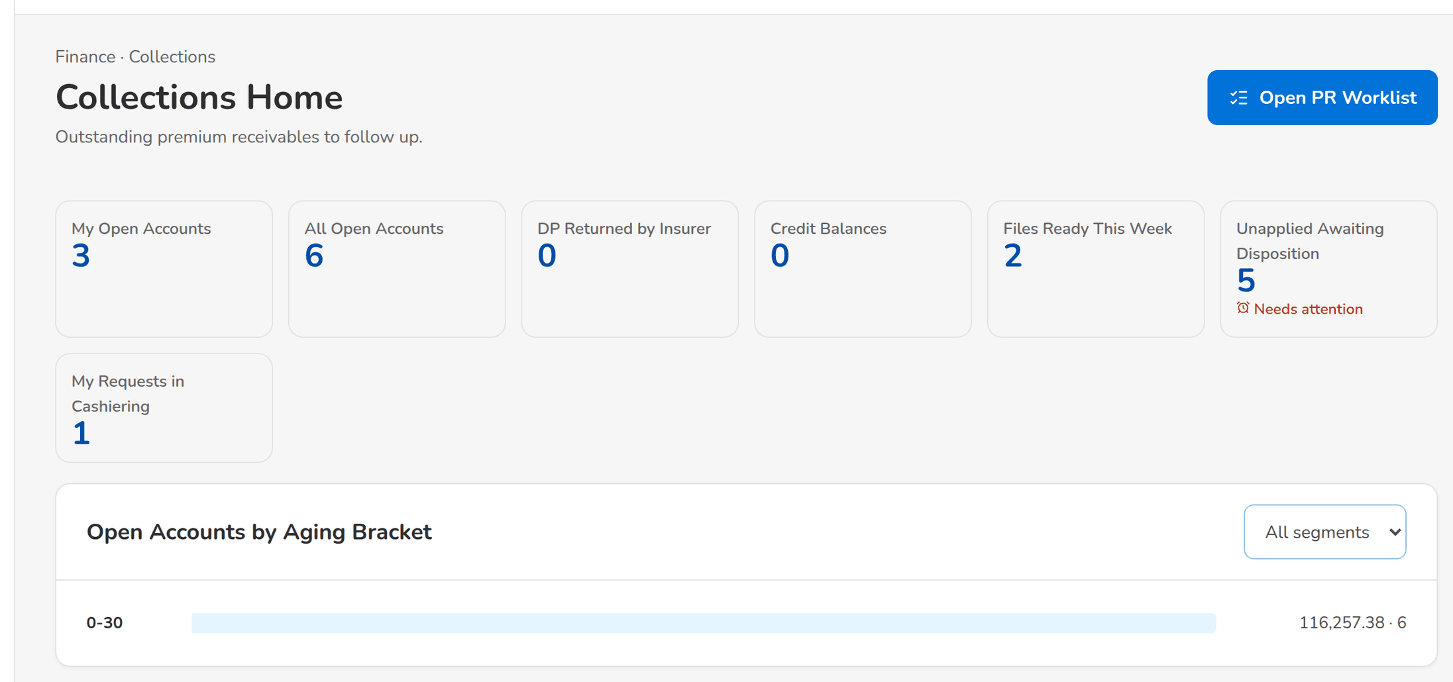
Figure 8: SCR-CL-01 Collections Home of the Collection Handler with the work tiles and the aging chart
1 | My Open Accounts, All Open Accounts, Unassigned Accounts, DP Returned by Insurer, Credit Balances, Files Ready This Week, Unapplied Awaiting Disposition, My Requests in Cashiering | 2 | Market segment | 3 | Aging bracket bar

Fields (No. = callout number on the first screenshot)
No. | Section | Field | Type | Length / format | Mand. | Source / list | Default | Editable in | Validation | Message when it fails
1 | Work tiles | My Open Accounts, All Open Accounts, Unassigned Accounts, DP Returned by Insurer, Credit Balances, Files Ready This Week, Unapplied Awaiting Disposition, My Requests in Cashiering | Tile | Live count; Needs attention on the queues waiting for action | - | Collection accounts, unapplied payments, files | - | Read only | A tile opens its list | -
2 | Open Accounts by Aging Bracket | Market segment | Drop-down | All segments or one segment | N | Segments of the open accounts | All segments | - | - | -
3 | Open Accounts by Aging Bracket | Aging bracket bar | Bar | Bracket (0-30, 31-45, 46-60, 61-90, 91-120, 121+), open amount and number of accounts | - | Collection accounts | - | Read only | Brackets of the aging brackets parameter | No open accounts

Actions
Button | Who | Enabled when | What happens | Resulting status | Notification
Open PR Worklist | Every Collections user | Always | Opens the PR Worklist on the Open Accounts tab | - | -
A work tile | Every Collections user | Always | Opens the list of the queue (for example the worklist filtered on the user's accounts) | - | -

Business rules
• The tiles are counted live from the collection accounts, the unapplied payments, the requests and the files of the company in the header (FR-CL-085).
• The aging chart counts the open accounts and their net outstanding per bracket of the aging brackets parameter (FR-CL-085, FR-CL-011).
Expected outcome
The collector sees the work waiting and opens it.
Test cases: TC-CL-013.2-01, TC-CL-085.1-01, TC-CL-085.2-01, TC-CL-085.2-02, TC-CL-085.3-01, TC-CL-SCR-01.

13.1.2 SCR-CL-02 PR Worklist
Purpose | One row per booked invoice with outstanding premium receivable above the threshold, refreshed nightly from the Operations invoice ledger: status tabs, search, the Filters panel, Only mine, and the actions on the selected accounts (log an effort, record a disposition, reassign). The totals under the list add up the filtered accounts by client or by account; Export to Files publishes the list on Collections Files.
Who can open it | Marketing Account Officer, Marketing Team Lead, Marketing Handler, Collection Handler, Collection Team Lead, Section Head (Corporate / Retail), Unapplied Payment Handler, Processing Unit, Cashier (read access and exports), Disbursement (read access and exports), Comptrollership (read access), Business Administrator, System Administrator, Auditor (permission Clx view)
Navigation | • Menu: Finance › Collections › PR Worklist  • Collections Home › Open PR Worklist or a work tile
FRs | FR-CL-010, FR-CL-011, FR-CL-013, FR-CL-014, FR-CL-015, FR-CL-017, FR-CL-021, FR-CL-031, FR-CL-033, FR-CL-034, FR-CL-084

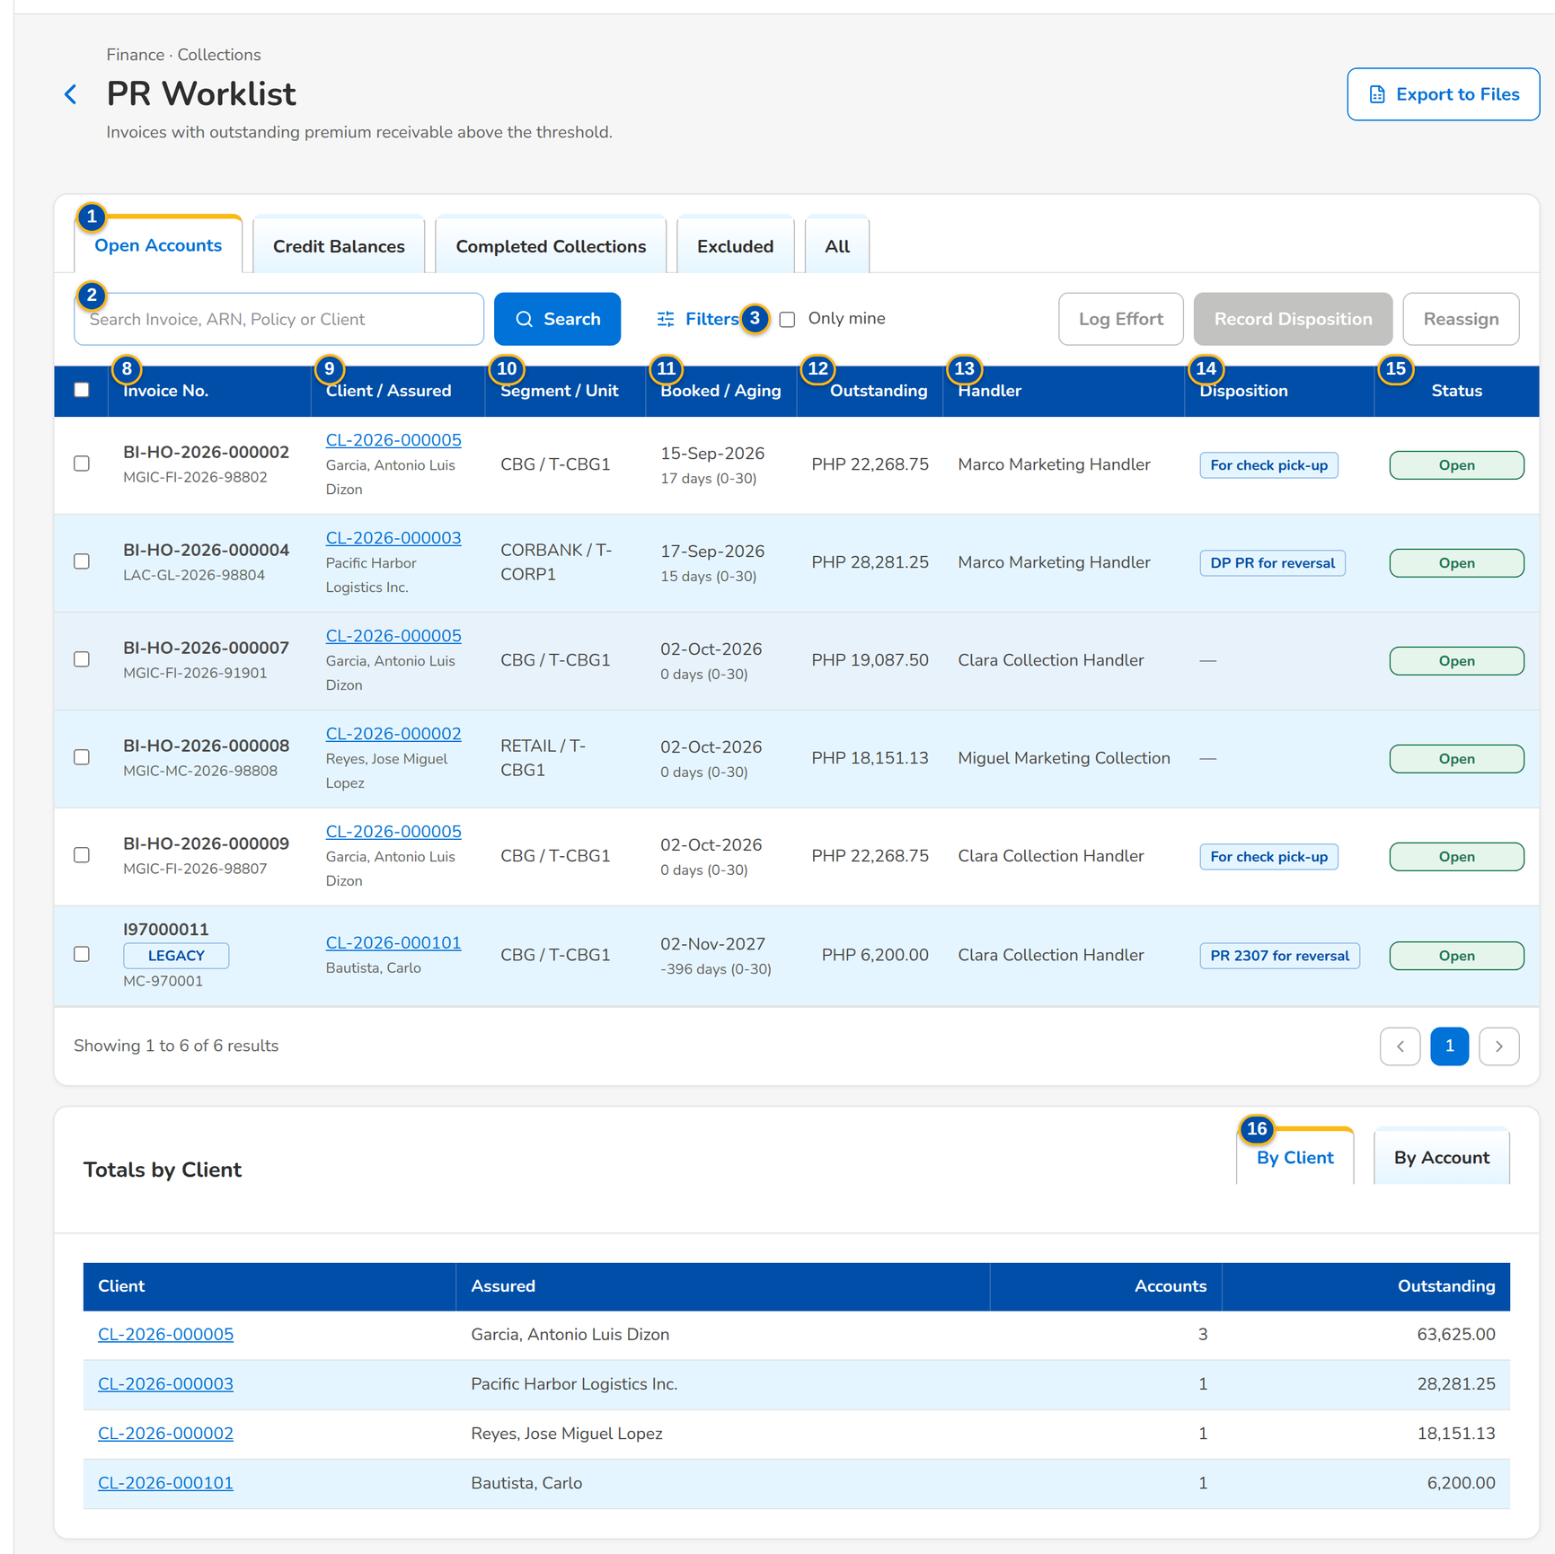
Figure 9: SCR-CL-02 PR Worklist of the Collection Team Lead: open accounts with handler, disposition and status
1 | Open Accounts / Credit Balances / Completed Collections / Excluded / All | 9 | Client / Assured | 17 | Disposition
2 | Search Invoice, ARN, Policy or Client | 10 | Segment / Unit | 18 | Pick-up Date / Pick-up Address / Contact Person / Check Amount / Check No. / Check Bank
3 | Only mine | 11 | Booked / Aging | 19 | 2307 Path / Certificate No. / Certificate Period From / Certificate Period To / 2% Amount
4 | Market Segment / Sales Unit / Unit Head / Handler / Account Officer | 12 | Outstanding | 20 | Remarks
5 | Aging Bracket / Category (A/B/C) / Disposition / Promise Status / Client Code | 13 | Handler | 21 | Effort / Channel / Contact Person / Remarks
6 | Outstanding From / Outstanding To | 14 | Disposition | 22 | New Handler / Kind / Until / Reason
7 | Unassigned only / Escalated only | 15 | Status
8 | Invoice No. | 16 | By Client / By Account

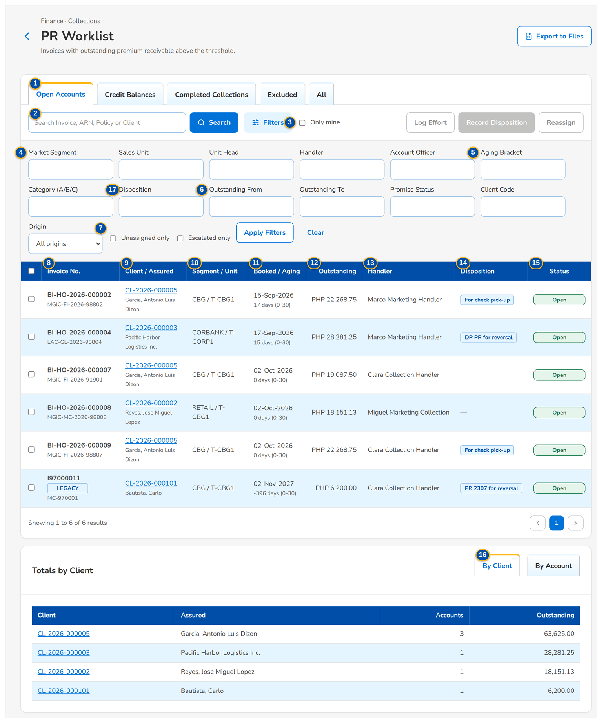
Figure 10: SCR-CL-02 PR Worklist with the Filters panel open

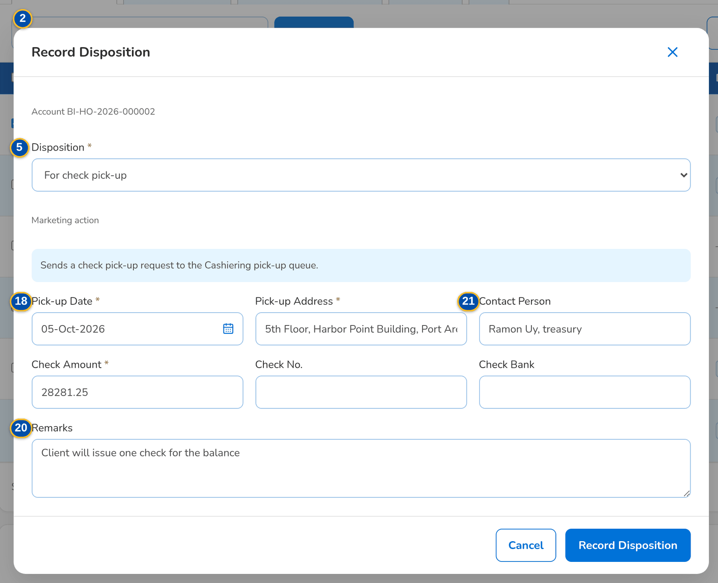
Figure 11: SCR-CL-02 Record Disposition of a selected account with the check pick-up details

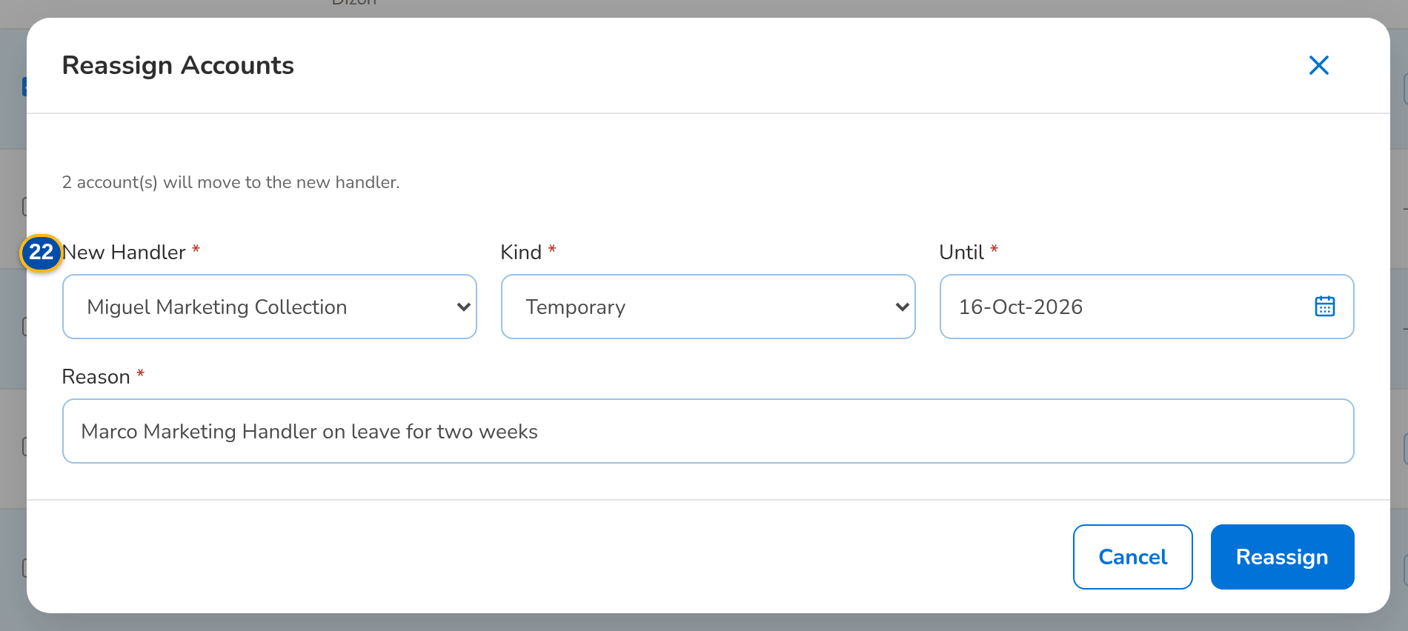
Figure 12: SCR-CL-02 Reassign Accounts dialog for two selected accounts, temporary until an end date
Fields (No. = callout number on the first screenshot)
No. | Section | Field | Type | Length / format | Mand. | Source / list | Default | Editable in | Validation | Message when it fails
1 | Tabs | Open Accounts / Credit Balances / Completed Collections / Excluded / All | Tab | - | - | Collection status | Open Accounts | - | - | -
2 | Toolbar | Search Invoice, ARN, Policy or Client | Text | Invoice, ARN, policy number or client code | N | Collection accounts | Blank | - | Contains | -
3 | Toolbar | Only mine | Check box | Accounts handled by the user | N | - | Unticked | - | - | -
4 | Filters | Market Segment / Sales Unit / Unit Head / Handler / Account Officer | Text | Code or user | N | Sales organisation, users | Blank | - | Equal | -
5 | Filters | Aging Bracket / Category (A/B/C) / Disposition / Promise Status / Client Code | Text | Bracket label, A, B or C, disposition, promise status, client code | N | Aging brackets, disposition list | Blank | - | Equal | -
6 | Filters | Outstanding From / Outstanding To | Number | Amount | N | - | Blank | - | Range | -
7 | Filters | Unassigned only / Escalated only | Check box | - | N | - | Unticked | - | - | -
8 | List | Invoice No. | Column | Invoice number with a Legacy tag for a migrated invoice; policy number or ARN under it | - | Invoice ledger | - | Read only | - | No accounts match the filters
9 | List | Client / Assured | Column | Client code (opens the client view) with the name of the assured | - | Clients | - | Read only | - | -
10 | List | Segment / Unit | Column | Market segment and sales unit | - | Sales organisation | - | Read only | - | -
11 | List | Booked / Aging | Column | Booking date; aging in days with its bracket | - | Invoice ledger, aging brackets | - | Read only | - | -
12 | List | Outstanding | Column | Currency and net outstanding premium receivable, two decimals | - | Invoice ledger | - | Read only | - | -
13 | List | Handler | Column | Name of the current handler, or Unassigned | - | Assignments | - | Read only | - | -
14 | List | Disposition | Column | Label of the current disposition as a tag, with its category | - | PR collector disposition list | - | Read only | - | -
15 | List | Status | Column | Open, Credit, Completed or Excluded | - | Nightly refresh | Open | Read only | - | -
16 | Totals | By Client / By Account | Tab | Totals by client or by ARN of the filtered accounts: Accounts and Outstanding | - | Collection accounts | By Client | Read only | - | -
17 | Record Disposition dialog | Disposition | Drop-down | Active values of the PR collector disposition list; the category, who acts next and the reserved roles show under it | Y | PR collector disposition list | Blank | Open, Credit | Value allowed for the user's role | Choose a disposition
18 | Record Disposition dialog | Pick-up Date / Pick-up Address / Contact Person / Check Amount / Check No. / Check Bank | Date, text, number | Shown for a disposition handed to the check pick-up | Y / Y / N / Y / N / N | - | Blank | Open | Date from today on; amount above zero | The pick-up date cannot be in the past
19 | Record Disposition dialog | 2307 Path / Certificate No. / Certificate Period From / Certificate Period To / 2% Amount | Drop-down, text, date, number | Shown for a disposition handed to BIR 2307: certificate received or paid in cash | Y / Cond.: certificate / N / N / N | - | Blank | Open | Certificate number for a certificate | A certificate tag needs the certificate number
20 | Record Disposition dialog | Remarks | Text area | Up to 1,000 characters | N | - | Blank | Open, Credit | - | -
21 | Log Collection Effort dialog | Effort / Channel / Contact Person / Remarks | Drop-down, text | Effort list; channel up to 30 and contact up to 120 characters | Y / N / N / N | Collection effort list | Blank | Open, Credit | - | Choose the effort
22 | Reassign Accounts dialog | New Handler / Kind / Until / Reason | Drop-down, text | Handlers by name; Permanent or Temporary; end date of a temporary reassignment | Y / Y / Cond.: temporary / Y | Active collection handlers | Permanent | Open | Temporary ends after today | A temporary reassignment ends after today

Actions
Button | Who | Enabled when | What happens | Resulting status | Notification
Search / Filters / Apply Filters / Clear | Every Collections user | Always | Filters the accounts on the server | - | -
Log Effort | Collectors with the work permission | One account selected; several with the bulk update permission | Logs the effort on each selected account under one bulk reference | - | -
Record Disposition | Collectors with the work permission | One account selected; several with the bulk update permission | Records the disposition on each selected account; an Operations action is handed to Cashiering or Commission | Disposition recorded | -
Reassign | Team leads and section heads (assignment permission) | Accounts selected | Moves the accounts to the new handler, permanently or until the end date | - | Account reassigned (NT-03)
Export to Files | Users with the export permission | Always | Publishes the Outstanding PR List of the filters on Collections Files in the background | - | Collections file ready (NT-06)
Row | Every Collections user | Always | Opens the collection account | - | -

Business rules
• An invoice is listed when the total of its premium receivable components and PR2307 is above the minimal balance threshold (10.00 by default); a negative balance of a cancellation is excluded and other credits show on Credit Balances (FR-CL-010, FR-CL-011, FR-CL-013).
• The worklist is refreshed every night from the invoice ledger and after each payment; paid accounts move to Completed Collections and reopen when the balance comes back (FR-CL-017, FR-CL-018).
• Updating several accounts at once needs the bulk update permission; at most 500 accounts per action, one bulk reference for all (FR-CL-034).
• A disposition reserved to some roles is refused for the other roles (FR-CL-031).
• Exports run in the background and are capped at the maximum number of rows of the export parameter (FR-CL-084).
Expected outcome
The collector finds the accounts to follow up and records the work on one or many at once.
Test cases: TC-CL-001.1-01, TC-CL-001.2-01, TC-CL-010.1-01, TC-CL-010.2-01, TC-CL-010.3-01, TC-CL-010.4-01, TC-CL-010.1-02, TC-CL-011.1-01, TC-CL-011.1-02, TC-CL-011.2-01, TC-CL-011.3-01, TC-CL-013.1-01, TC-CL-014.1-01, TC-CL-014.1-02, TC-CL-014.2-01, TC-CL-015.1-01, TC-CL-015.1-02, TC-CL-015.2-01, TC-CL-017.2-01, TC-CL-018.1-01, TC-CL-030.4-01, TC-CL-030.4-02, TC-CL-031.1-01, TC-CL-031.2-01, TC-CL-031.3-01, TC-CL-032.1-01, TC-CL-032.5-01, TC-CL-032.5-02, TC-CL-032.5-04, TC-CL-033.1-01, TC-CL-033.2-01, TC-CL-033.3-01, TC-CL-033.3-03, TC-CL-034.1-01, TC-CL-084.1-01, TC-CL-084.2-01, TC-CL-SCR-02, TC-CL-MSG-01, TC-CL-MSG-03.

13.1.3 SCR-CL-03 Collection Account
Purpose | One collection account: the assured, invoice and ARN chips, the collection, payment and remittance statuses, the flags and the key facts; the collector's actions (update remarks and category, log an effort, record a disposition) and the tabs Summary (net PR breakdown by component), Payments, Timeline, Policy & Co-insurance, Dispositions & Efforts (with the hand-offs to Operations) and History (assignments and field changes). Opening the account takes the edit lock.
Who can open it | Marketing Account Officer, Marketing Team Lead, Marketing Handler, Collection Handler, Collection Team Lead, Section Head (Corporate / Retail), Unapplied Payment Handler, Processing Unit, Cashier (read access and exports), Disbursement (read access and exports), Comptrollership (read access), Business Administrator, System Administrator, Auditor (permission Clx view)
Navigation | • Menu: Finance › Collections › PR Worklist › Collection Account  • PR Worklist › open a row  • Client View › open a row
FRs | FR-CL-002, FR-CL-003, FR-CL-005, FR-CL-016, FR-CL-018, FR-CL-031, FR-CL-032, FR-CL-033, FR-CL-041, FR-CL-043, FR-CL-044

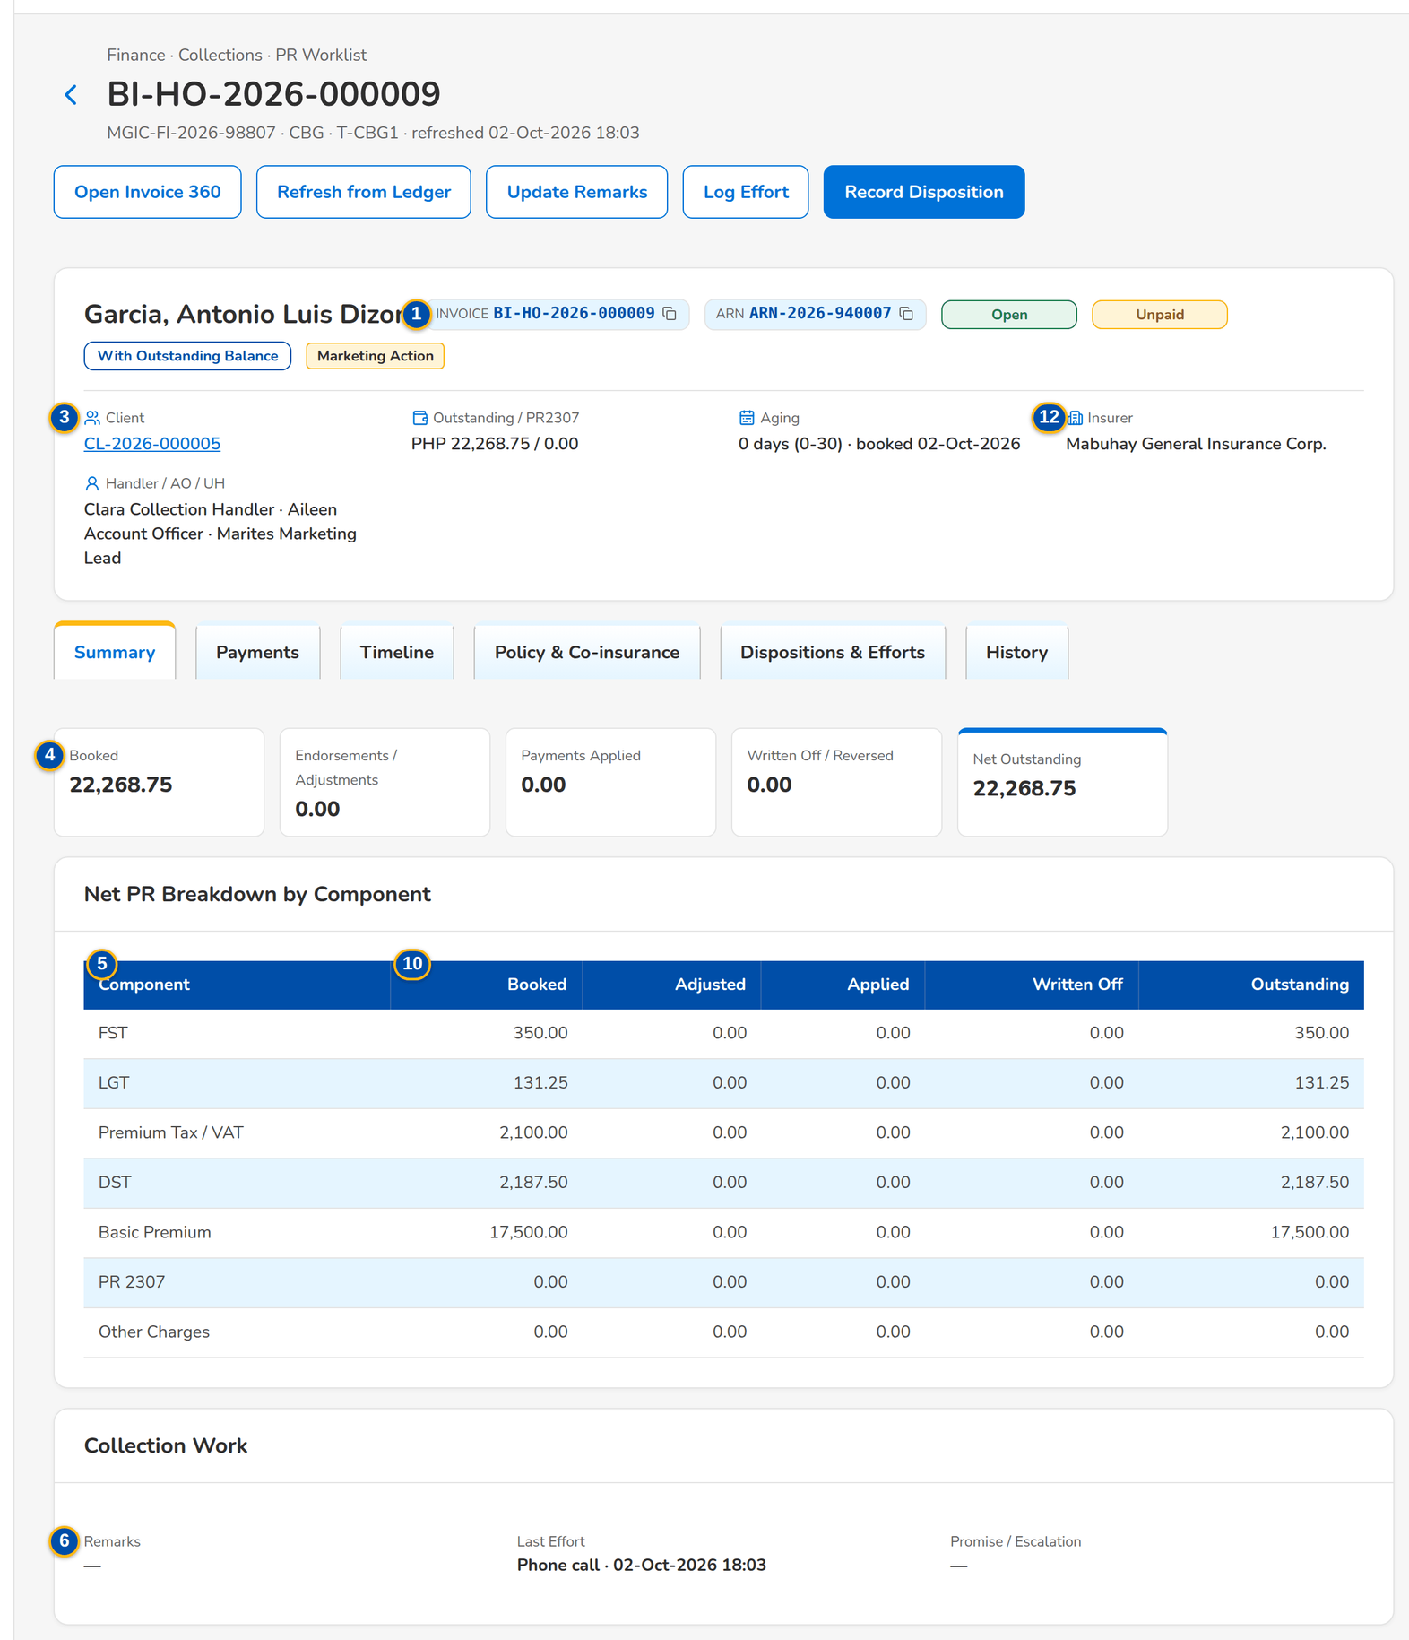
Figure 13: SCR-CL-03 Collection account: header, facts, actions and the net PR breakdown by component
1 | Invoice and ARN chips, status pills | 7 | Premium Due / Paid / Outstanding | 13 | Disposition / Remarks / Hand-off / Encoded By / Status
2 | Flags | 8 | Date / Type / AR / OR / Reference / Amount | 14 | When / Effort / Channel / Contact / Remarks / Encoded By
3 | Client / Outstanding / PR2307 / Aging / Insurer / Handler / AO / UH | 9 | Date and Time / Type / Event / By / Amount | 15 | Feed / Reference / Sent / Taken / Status
4 | Booked / Endorsements / Adjustments / Payments Applied / Written Off / Reversed / Net Outstanding | 10 | Invoice No. / Kind / Booked / Gross / Balance / Status | 16 | Date / Handler / Kind / Valid / Reason / By
5 | Component / Booked / Adjusted / Applied / Written Off / Outstanding | 11 | Policy / Product / Risk / Period / Booked / Receipt Date (first AR) | 17 | Changed / Field / From / To / User / Source IP / Bulk Ref.
6 | Remarks / Last Effort / Promise / Escalation | 12 | Insurer / Share % / Lead | 18 | Tagging Category / Remarks

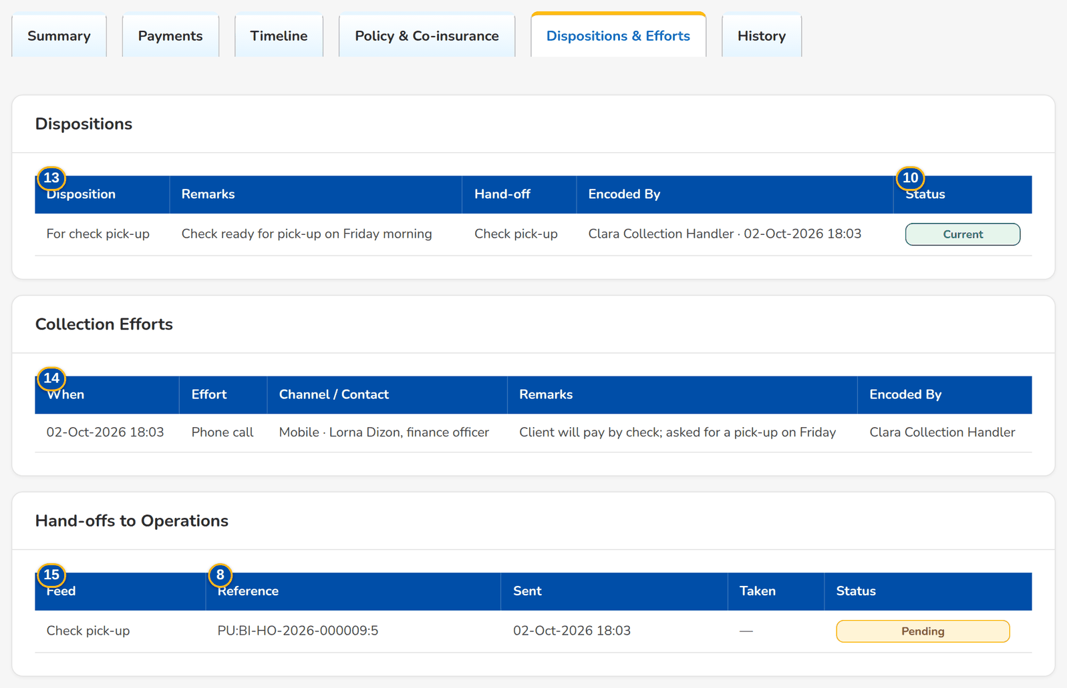
Figure 14: SCR-CL-03 Dispositions & Efforts tab with the hand-off to Cashiering
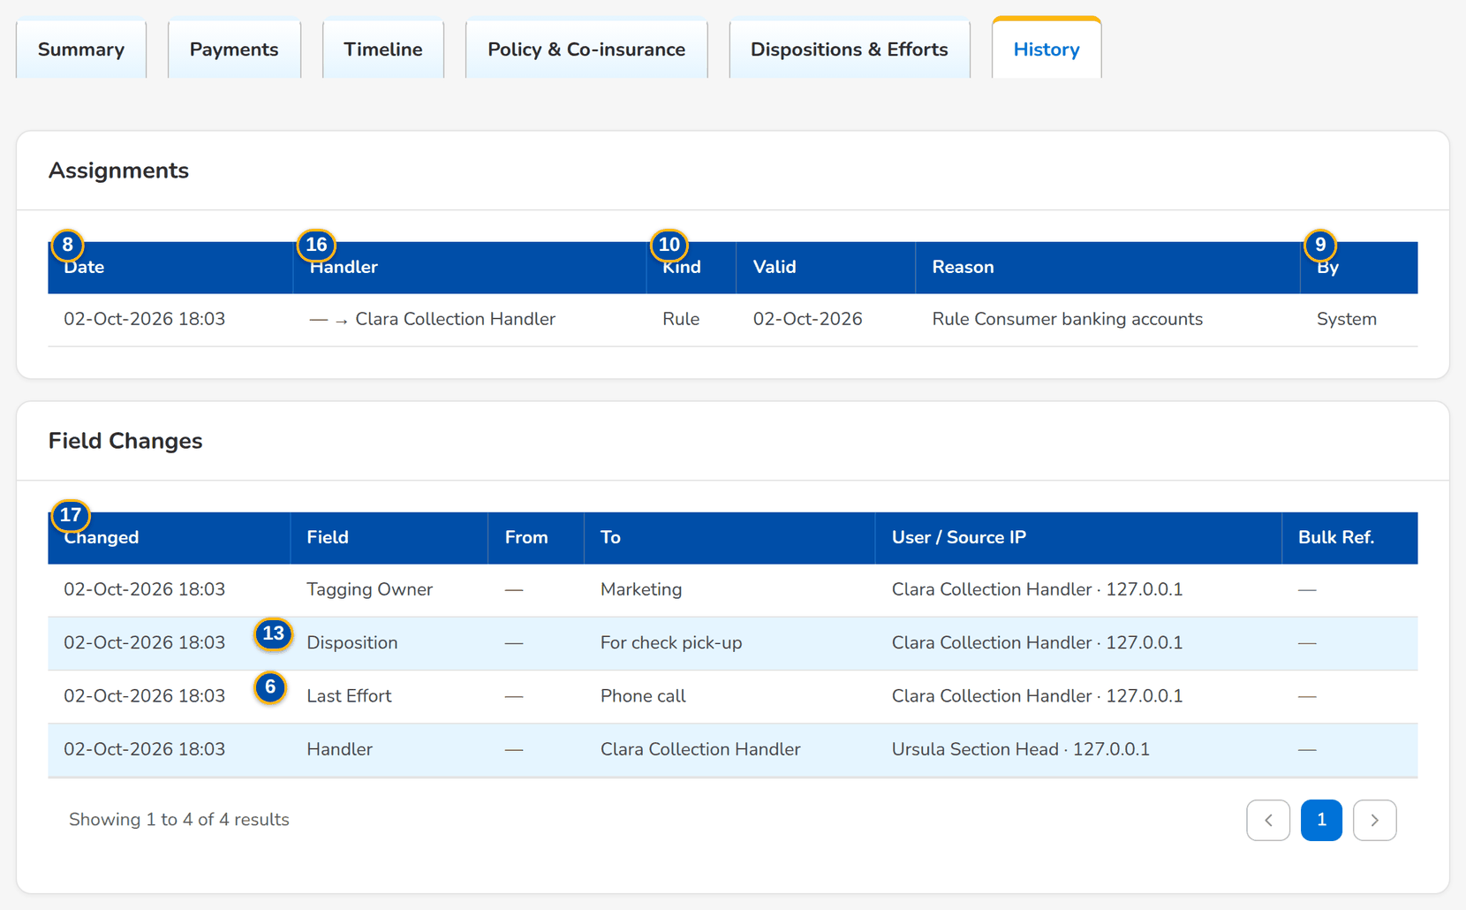
Figure 15: SCR-CL-03 History tab: assignments and the field changes with From, To, user and source

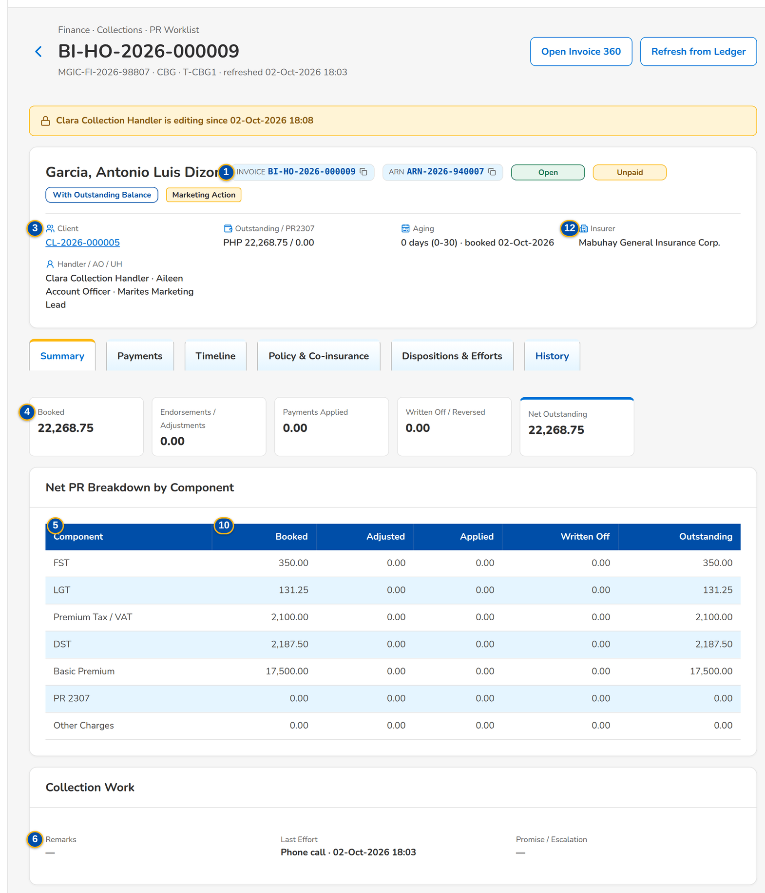
Figure 16: SCR-CL-03 The account while another user works on it: the editing notice and no actions

Fields (No. = callout number on the first screenshot)
No. | Section | Field | Type | Length / format | Mand. | Source / list | Default | Editable in | Validation | Message when it fails
1 | Header | Invoice and ARN chips, status pills | Reference chip, status pill | Collection status; payment status; remittance status | - | Collection account, invoice ledger | - | Read only | - | -
2 | Header | Flags | Tag | Direct Payment, 2% CWT, On Hold, Pending Negative Adjustment, Locked by <team>, Marketing Action or Operations Action | - | Invoice ledger, disposition | - | Read only | - | -
3 | Facts | Client / Outstanding / PR2307 / Aging / Insurer / Handler / AO / UH | Display | Client code; amounts with the currency; days with the bracket and the booking date; insurer name; names | - | Collection account | - | Read only | - | -
4 | Summary | Booked / Endorsements / Adjustments / Payments Applied / Written Off / Reversed / Net Outstanding | Total | Two decimals | - | Invoice ledger | - | Read only | - | -
5 | Summary | Component / Booked / Adjusted / Applied / Written Off / Outstanding | Column | One row per premium component by name (Basic Premium, DST, Premium Tax / VAT, LGT, FST, PR 2307, Other Charges) | - | Invoice ledger | - | Read only | - | The invoice is no longer in the ledger
6 | Summary | Remarks / Last Effort / Promise / Escalation | Display | Collector's remarks; label and time of the last effort; promise and escalation status | - | Collection account | - | Read only | - | -
7 | Payments | Premium Due / Paid / Outstanding | Total | Two decimals | - | Invoice ledger | - | Read only | - | -
8 | Payments | Date / Type / AR / OR / Reference / Amount | Column | One row per payment applied or reversed, with the module that applied it | - | Invoice ledger (Cashiering) | - | Read only | - | No payment applied yet
9 | Timeline | Date and Time / Type / Event / By / Amount | Column | Ledger movements and Collections actions, newest first | - | Invoice ledger, Collections | - | Read only | - | No history yet
10 | Policy & Co-insurance | Invoice No. / Kind / Booked / Gross / Balance / Status | Column | The invoice family of the policy year with the balance and payment status of each | - | Invoice ledger | - | Read only | - | -
11 | Policy & Co-insurance | Policy / Product / Risk / Period / Booked / Receipt Date (first AR) | Display | Policy with its year; period dd-MMM-yyyy to dd-MMM-yyyy | - | Booking (BRD-1) | - | Read only | - | -
12 | Policy & Co-insurance | Insurer / Share % / Lead | Column | Insurer name, share and the lead insurer | - | Booking (BRD-1) | - | Read only | - | -
13 | Dispositions & Efforts | Disposition / Remarks / Hand-off / Encoded By / Status | Column | Label of the disposition, current or superseded | - | Dispositions | - | Read only | - | No disposition yet
14 | Dispositions & Efforts | When / Effort / Channel / Contact / Remarks / Encoded By | Column | Label of the effort; names | - | Efforts | - | Read only | - | No effort logged yet
15 | Dispositions & Efforts | Feed / Reference / Sent / Taken / Status | Column | Hand-offs to Cashiering and Commission | - | Hand-offs | - | Read only | - | Nothing handed to Operations
16 | History | Date / Handler / Kind / Valid / Reason / By | Column | Assignments with the previous and new handler by name | - | Assignments | - | Read only | - | -
17 | History | Changed / Field / From / To / User / Source IP / Bulk Ref. | Column | One row per changed field: the field by name, the values by label and the handler by name | - | Collections audit log | - | Read only | - | -
18 | Update Remarks and Category dialog | Tagging Category / Remarks | Drop-down, text area | None, A, B or C; up to 1,000 characters | N | Fixed list | Current values | Open, Credit | Category A, B or C | The tagging category is A, B or C

Actions
Button | Who | Enabled when | What happens | Resulting status | Notification
Open Invoice 360 | Users with Operations view | Always | Opens the invoice in Operations | - | -
Refresh from Ledger | Collectors with the work permission | Always | Reads the balances of the invoice again from the invoice ledger | - | -
Update Remarks | Collectors with the work permission | Open or Credit, not locked by another user | Saves the remarks and the tagging category | - | -
Log Effort | Collectors with the work permission | Open or Credit, not locked by another user | Logs the effort with its channel and contact | - | -
Record Disposition | Collectors with the work permission | Open or Credit, not locked by another user | Records the disposition; the previous one is kept as superseded; an Operations action is handed over | Disposition recorded | -

Business rules
• The account is locked to the user who opened it to work on it for the edit-lock time (15 minutes by default); another user cannot change it meanwhile (FR-CL-005).
• Every change is recorded field by field with the old and new value, the user, the time and the source address (FR-CL-003).
• Dispositions are never deleted: a new one supersedes the previous one (FR-CL-018, FR-CL-031).
• The net PR breakdown is read live from the invoice ledger; Collections keeps no second copy of the money (FR-CL-016).
• A check pick-up and a BIR 2307 tag are handed to Cashiering, a direct payment account to Commission Receivables (FR-CL-032).
Expected outcome
The collector records the work on the account and sees everything that happened to it.
Test cases: TC-CL-002.1-01, TC-CL-003.1-01, TC-CL-003.3-01, TC-CL-005.1-01, TC-CL-005.1-02, TC-CL-005.2-01, TC-CL-005.3-01, TC-CL-016.1-01, TC-CL-016.2-01, TC-CL-016.2-02, TC-CL-017.4-02, TC-CL-018.2-01, TC-CL-021.3-01, TC-CL-032.2-02, TC-CL-032.3-01, TC-CL-041.1-01, TC-CL-043.1-01, TC-CL-043.1-02, TC-CL-043.1-03, TC-CL-044.1-01, TC-CL-044.2-01, TC-CL-SCR-03, TC-CL-MSG-02.

13.1.4 SCR-CL-04 Client View
Purpose | Every collection account of one client, open, completed or credit, with the number of open accounts, their net outstanding and the open PR2307.
Who can open it | Marketing Account Officer, Marketing Team Lead, Marketing Handler, Collection Handler, Collection Team Lead, Section Head (Corporate / Retail), Unapplied Payment Handler, Processing Unit, Cashier (read access and exports), Disbursement (read access and exports), Comptrollership (read access), Business Administrator, System Administrator, Auditor (permission Clx view)
Navigation | • Menu: Finance › Collections › PR Worklist › Client View  • PR Worklist › client code of a row, or a client of Totals by Client  • Collection Account › Client
FRs | FR-CL-014

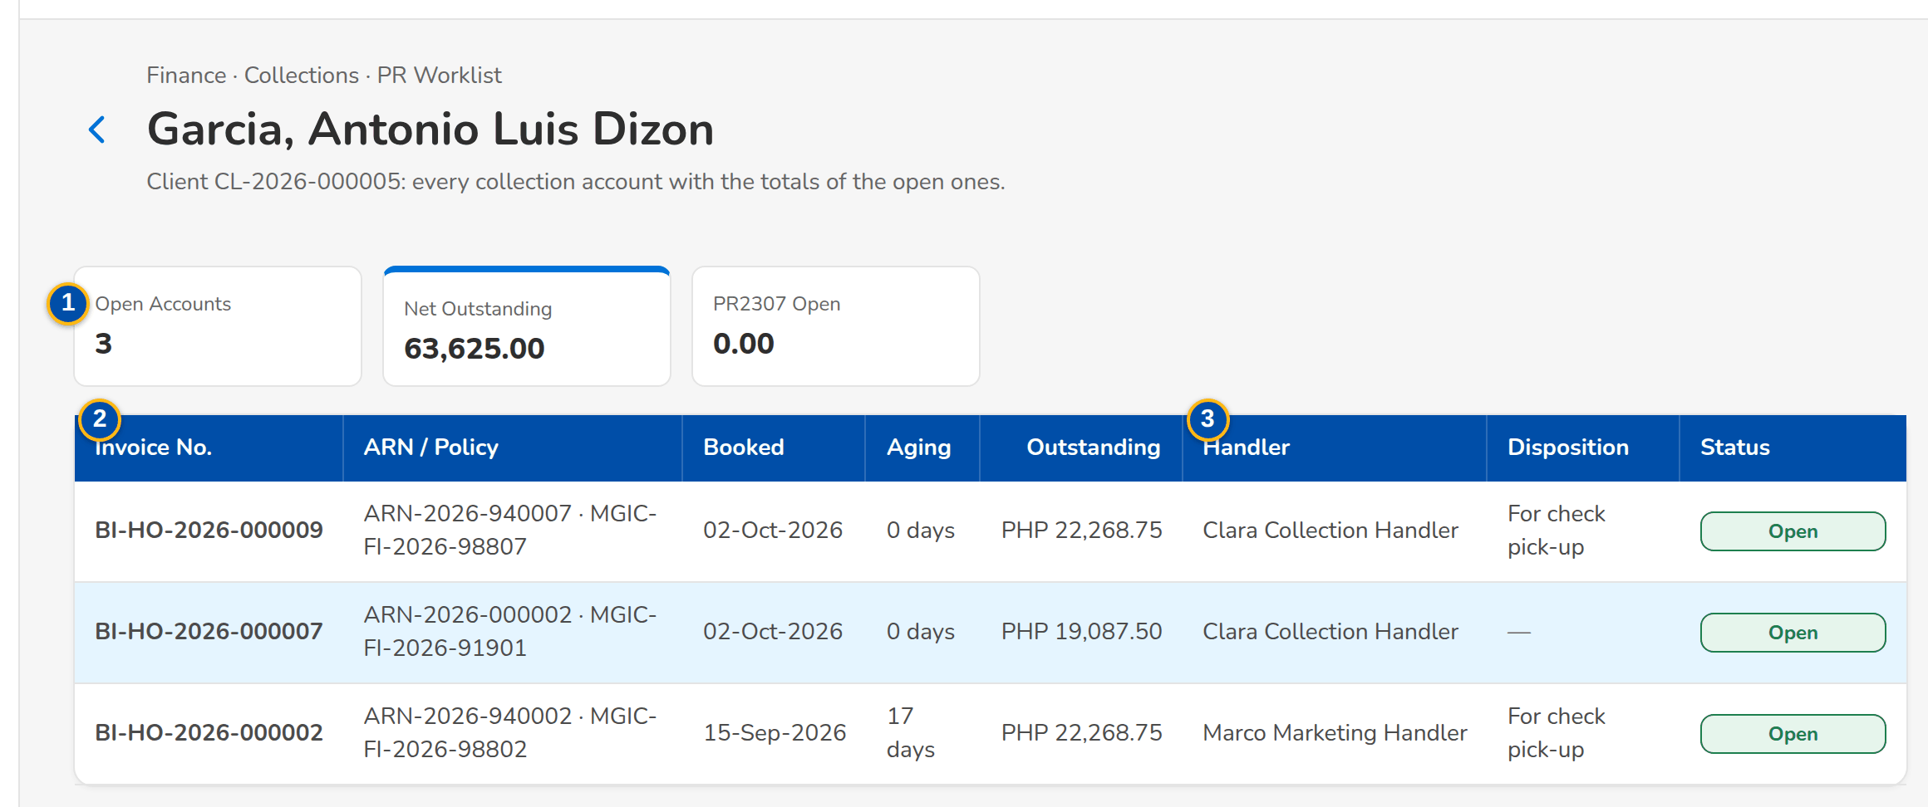
Figure 17: SCR-CL-04 Client View: the accounts of a client with the totals of the open ones
1 | Open Accounts / Net Outstanding / PR2307 Open | 2 | Invoice No. / ARN / Policy / Booked / Aging / Outstanding | 3 | Handler / Disposition / Status

Fields (No. = callout number on the first screenshot)
No. | Section | Field | Type | Length / format | Mand. | Source / list | Default | Editable in | Validation | Message when it fails
1 | Totals | Open Accounts / Net Outstanding / PR2307 Open | Total | Count; amounts with two decimals | - | Collection accounts | - | Read only | - | -
2 | List | Invoice No. / ARN / Policy / Booked / Aging / Outstanding | Column | Invoice, ARN and policy; booking date; days; currency and amount | - | Collection accounts | - | Read only | - | The client has no collection account
3 | List | Handler / Disposition / Status | Column | Handler's name or Unassigned; label of the disposition; collection status | - | Collection accounts | - | Read only | - | -

Actions
Button | Who | Enabled when | What happens | Resulting status | Notification
Row | Every Collections user | Always | Opens the collection account | - | -

Business rules
• The totals add up the open accounts of the client only (FR-CL-014).
Expected outcome
The collector sees the whole exposure of a client before calling.
Test cases: TC-CL-SCR-04.

13.2 Installments, promises and billing statements

13.2.1 SCR-CL-05 Installment Plans
Purpose | The installment plans of multi-year and installment accounts by status, and a new plan: over the policy years of a multi-year account, or the outstanding premium of one invoice split in equal installments.
Who can open it | Marketing Account Officer, Marketing Team Lead, Marketing Handler, Collection Handler, Collection Team Lead, Section Head (Corporate / Retail), Unapplied Payment Handler, Processing Unit, Cashier (read access and exports), Disbursement (read access and exports), Comptrollership (read access), Business Administrator, System Administrator, Auditor (permission Clx view)
Navigation | • Menu: Finance › Collections › Installment Plans  • Finance › Collections › Installment Plans
FRs | FR-CL-040, FR-CL-041

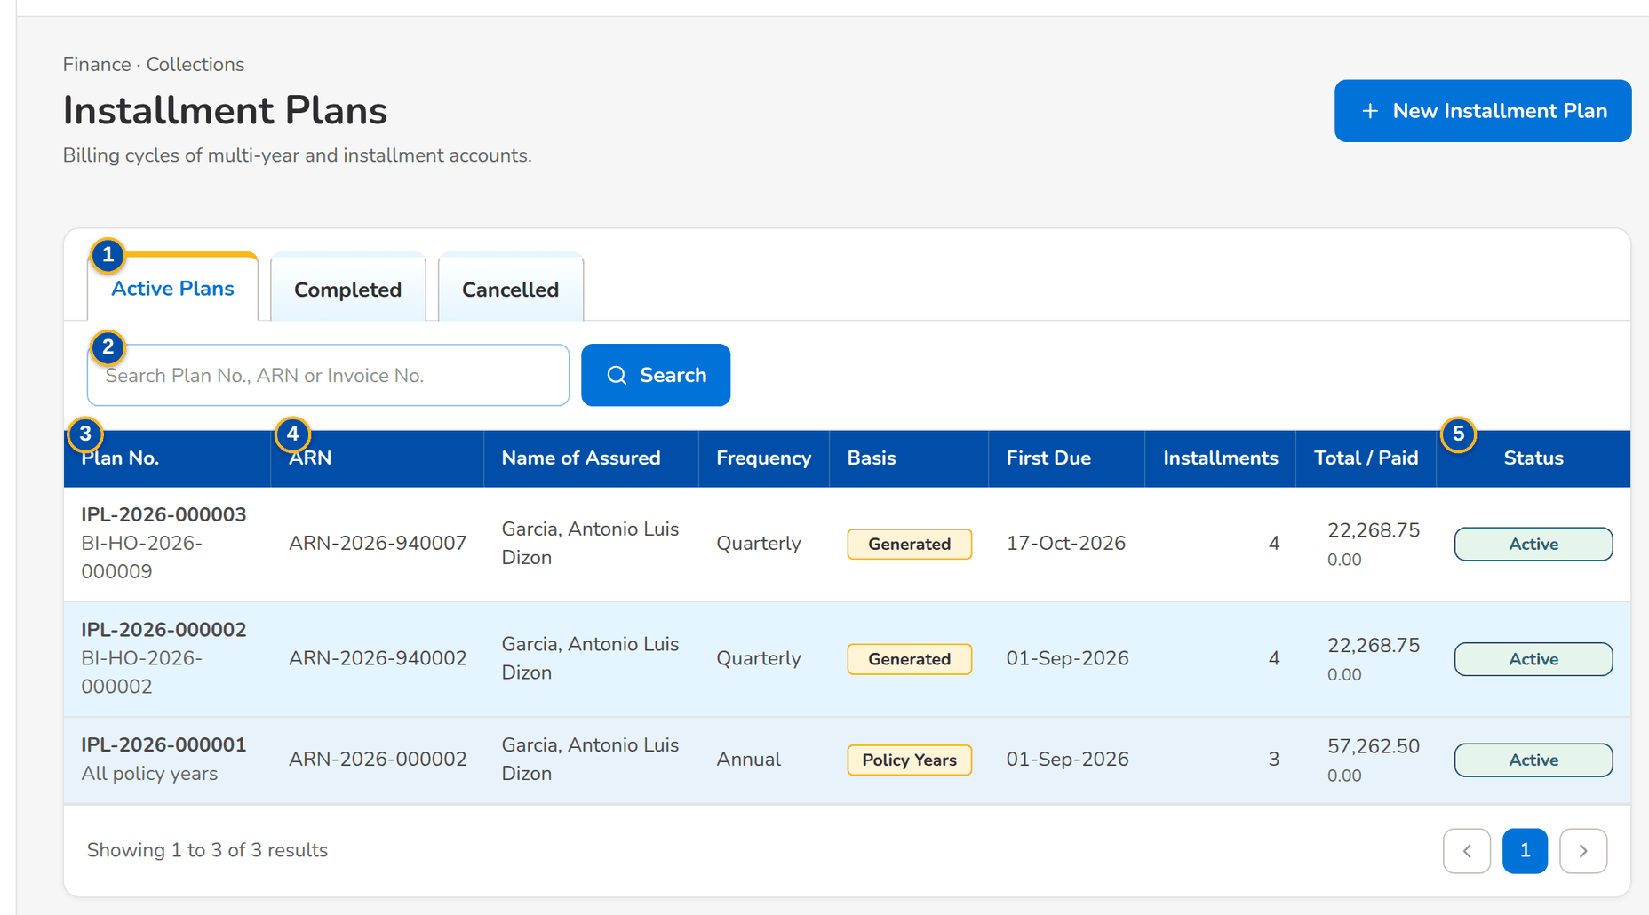
Figure 18: SCR-CL-05 Installment Plans: the active plans with their basis, total and paid
1 | Active Plans / Completed / Cancelled | 4 | ARN / Name of Assured / Frequency / Basis / First Due / Installments | 7 | Account Reference No. (ARN)
2 | Search Plan No., ARN or Invoice No. | 5 | Total / Paid / Status | 8 | Invoice No. / First Due Date / Number of Installments
3 | Plan No. / Invoice | 6 | Plan Basis | 9 | Billing Frequency / Remarks

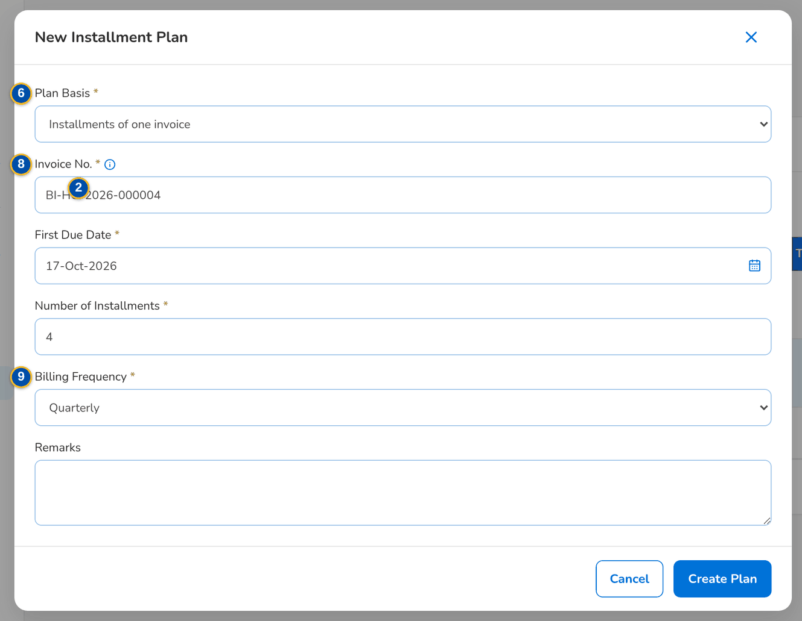
Figure 19: SCR-CL-05 New Installment Plan dialog: installments of one invoice
Fields (No. = callout number on the first screenshot)
No. | Section | Field | Type | Length / format | Mand. | Source / list | Default | Editable in | Validation | Message when it fails
1 | Tabs | Active Plans / Completed / Cancelled | Tab | - | - | Plan status | Active Plans | - | - | -
2 | Toolbar | Search Plan No., ARN or Invoice No. | Text | - | N | Plans | Blank | - | Contains | -
3 | List | Plan No. / Invoice | Column | IPL-yyyy-nnnnnn with the invoice, or All policy years | - | Plans | - | Read only | - | No installment plans to display
4 | List | ARN / Name of Assured / Frequency / Basis / First Due / Installments | Column | Frequency label; Policy Years, Generated or Entered | - | Plans | - | Read only | - | -
5 | List | Total / Paid / Status | Column | Two decimals; Active, Completed or Cancelled | - | Plans, invoice ledger | - | Read only | - | -
6 | New Installment Plan dialog | Plan Basis | Drop-down | Policy years of a multi-year account; Installments of one invoice | Y | Fixed list | Policy years | - | - | -
7 | New Installment Plan dialog | Account Reference No. (ARN) | Text | Shown for policy years | Cond.: policy years | Booked accounts | Blank | - | The account has a booked policy year | Enter the account reference number
8 | New Installment Plan dialog | Invoice No. / First Due Date / Number of Installments | Text, date, number | Shown for one invoice; 1 to 120 installments | Cond.: one invoice | Invoice ledger | Blank / today / 4 | - | Invoice with outstanding premium; 1 to 120 | Enter between 1 and 120 installments
9 | New Installment Plan dialog | Billing Frequency / Remarks | Drop-down, text area | Annual, Semi-annual, Quarterly, Monthly | Y / N | Billing frequency list | Annual | - | - | Choose the billing frequency

Actions
Button | Who | Enabled when | What happens | Resulting status | Notification
New Installment Plan | Users with the billing permission | Always | Opens the dialog | - | -
Create Plan | Users with the billing permission | The form is complete | Creates the plan with its installments and opens it | Active | -
Row | Every Collections user | Always | Opens the plan | - | -

Business rules
• A policy-year plan bills every policy year of a multi-year account per cycle; a generated plan splits the outstanding premium of one invoice in equal installments (FR-CL-040).
• One live plan per invoice or account: a second plan is refused until the first is cancelled (FR-CL-040).
• A plan changes neither the booking nor the accounting; payments are allocated from the invoice ledger (FR-CL-041).
Expected outcome
The account is billed per cycle on a plan the collector can follow.
Test cases: TC-CL-040.1-01, TC-CL-040.2-01, TC-CL-040.2-02, TC-CL-040.2-03, TC-CL-040.2-04, TC-CL-040.3-01, TC-CL-040.3-02, TC-CL-040.3-03, TC-CL-040.3-04, TC-CL-040.3-05, TC-CL-040.1-02, TC-CL-SCR-05, TC-CL-MSG-04.

13.2.2 SCR-CL-06 Installment Plan
Purpose | One plan: the account and its facts, the installments (billing cycles) with the payments allocated from the ledger and their status, the statements of account of the plan and the promises to pay on its invoices; the row menu of an installment generates its statement of account or records a promise.
Who can open it | Marketing Account Officer, Marketing Team Lead, Marketing Handler, Collection Handler, Collection Team Lead, Section Head (Corporate / Retail), Unapplied Payment Handler, Processing Unit, Cashier (read access and exports), Disbursement (read access and exports), Comptrollership (read access), Business Administrator, System Administrator, Auditor (permission Clx view)
Navigation | • Menu: Finance › Collections › Installment Plans › Installment Plan  • Installment Plans › open a row  • Installments Due › open a row  • Statement of Account › Open Installment Plan
FRs | FR-CL-040, FR-CL-041, FR-CL-042, FR-CL-060

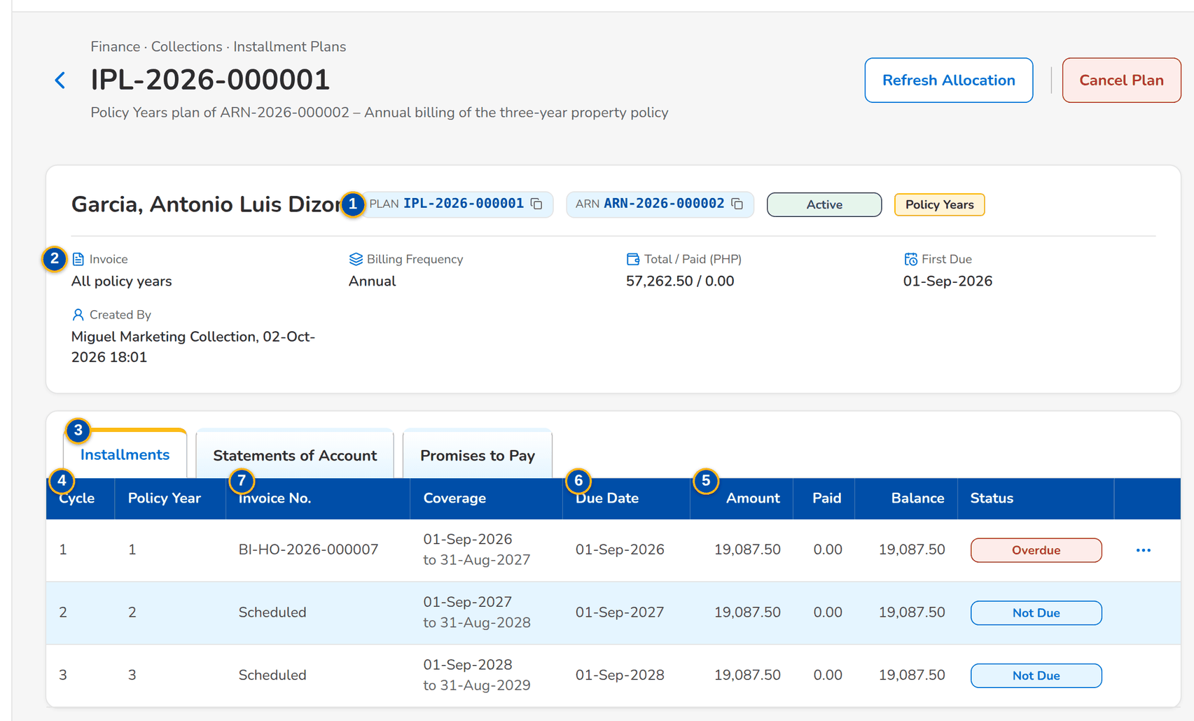
Figure 20: SCR-CL-06 Installment Plan: the installments with their coverage, due date, amounts and status
1 | Plan and ARN chips, status pill, basis tag | 4 | Cycle / Policy Year / Invoice No. / Coverage / Due Date | 7 | Invoice No. / Promised On / Promised Date / Promised / Paid in Time / Recorded By / Status
2 | Invoice / Billing Frequency / Total / Paid / First Due / Created By | 5 | Amount / Paid / Balance / Status | 8 | Reason
3 | Installments / Statements of Account / Promises to Pay | 6 | SOA No. / Cycle / Billing Cycle / Due Date / Amount Due / Status

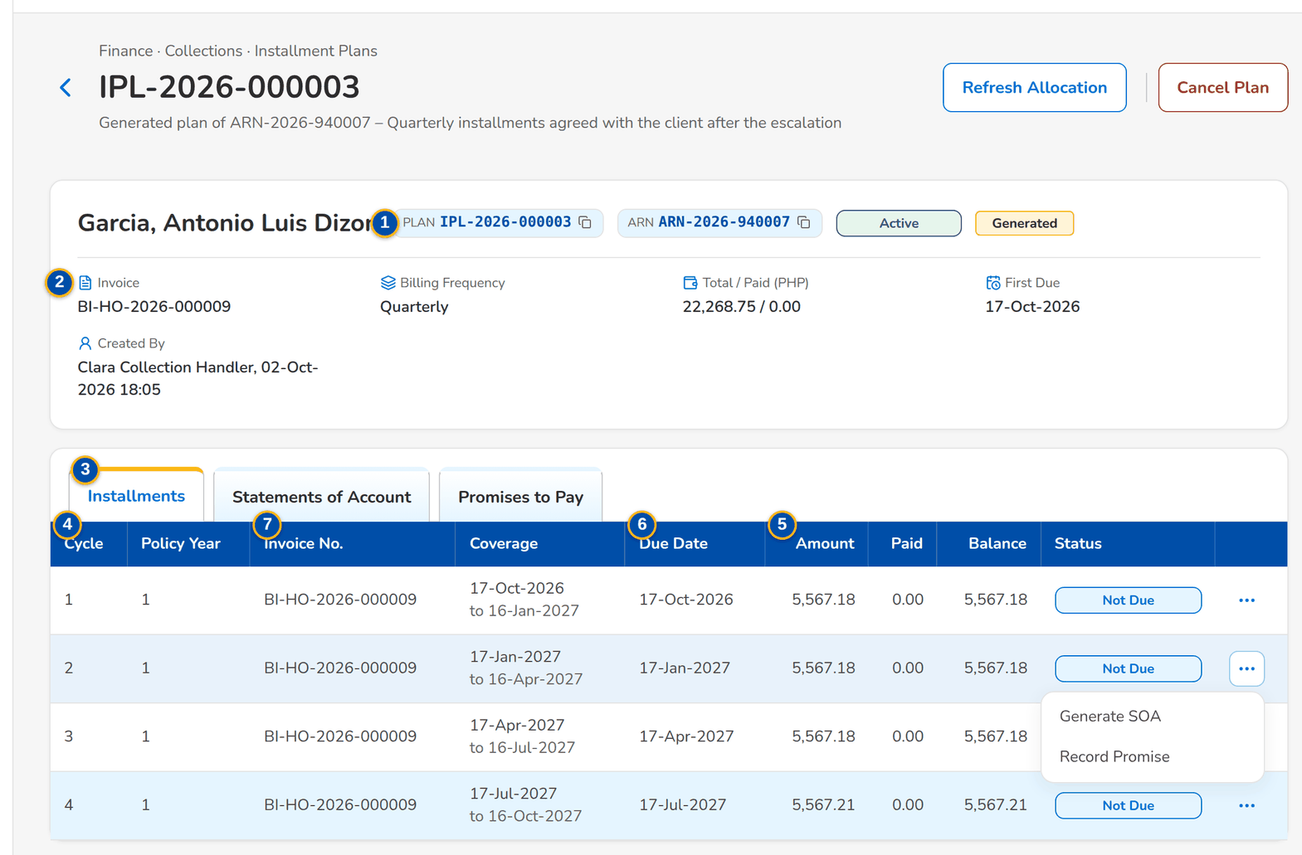
Figure 21: SCR-CL-06 The row menu of an installment: Generate SOA and Record Promise
Fields (No. = callout number on the first screenshot)
No. | Section | Field | Type | Length / format | Mand. | Source / list | Default | Editable in | Validation | Message when it fails
1 | Header | Plan and ARN chips, status pill, basis tag | Reference chip, status pill, tag | Active, Completed or Cancelled | - | Plan | - | Read only | - | -
2 | Facts | Invoice / Billing Frequency / Total / Paid / First Due / Created By | Display | Amounts with the currency; names | - | Plan | - | Read only | - | -
3 | Tabs | Installments / Statements of Account / Promises to Pay | Tab | - | - | Fixed | Installments | - | - | -
4 | Installments | Cycle / Policy Year / Invoice No. / Coverage / Due Date | Column | Coverage on two lines; Scheduled for a policy year not booked yet | - | Plan | - | Read only | - | No installments
5 | Installments | Amount / Paid / Balance / Status | Column | Two decimals; Not Due, Due, Overdue, Partial or Paid | - | Plan, invoice ledger | - | Read only | - | -
6 | Statements of Account | SOA No. / Cycle / Billing Cycle / Due Date / Amount Due / Status | Column | - | - | Statements | - | Read only | - | No statements generated yet
7 | Promises to Pay | Invoice No. / Promised On / Promised Date / Promised / Paid in Time / Recorded By / Status | Column | - | - | Promises | - | Read only | - | No promises to pay recorded
8 | Cancel Installment Plan dialog | Reason | Text area | Up to 1,000 characters | Y | - | Blank | Active | Not blank | Enter the reason

Actions
Button | Who | Enabled when | What happens | Resulting status | Notification
Refresh Allocation | Collectors with the billing or work permission | Active | Allocates the latest ledger payments to the installments | - | -
Cancel Plan | Users with the billing permission | Active | Asks for the reason and cancels the plan | Cancelled | -
Generate SOA (row menu) | Users with the billing permission | Cycle not billed yet | Generates the statement of account of the cycle | Statement To Send | -
Record Promise (row menu) | Collectors with the work permission | Booked installment not paid | Opens Record Promise to Pay for the invoice of the installment | Promise Open | -

Business rules
• Payments are allocated from the invoice ledger, oldest due installment first (FR-CL-041).
• An installment past its due date and not fully paid is Overdue and can escalate the account through the escalation rules (FR-CL-041, FR-CL-051).
• One live statement per plan and billing cycle (FR-CL-060).
Expected outcome
The collector follows each cycle of the plan, bills it and records the promises.
Test cases: TC-CL-040.5-01, TC-CL-041.2-01, TC-CL-041.2-02, TC-CL-060.3-01, TC-CL-060.3-03, TC-CL-SCR-06.

13.2.3 SCR-CL-07 Installments Due
Purpose | The unpaid installments of the live plans falling due up to today, oldest first, with the overdue ones on their own tab, for follow-up and escalation.
Who can open it | Marketing Account Officer, Marketing Team Lead, Marketing Handler, Collection Handler, Collection Team Lead, Section Head (Corporate / Retail), Unapplied Payment Handler, Processing Unit, Cashier (read access and exports), Disbursement (read access and exports), Comptrollership (read access), Business Administrator, System Administrator, Auditor (permission Clx view)
Navigation | • Menu: Finance › Collections › Installments Due  • Finance › Collections › Installments Due
FRs | FR-CL-041

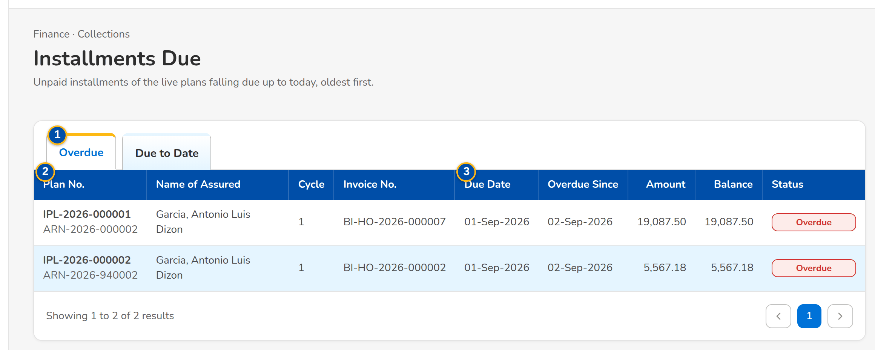
Figure 22: SCR-CL-07 Installments Due: the overdue installments of the live plans
1 | Overdue / Due to Date | 2 | Plan No. / ARN / Name of Assured / Cycle / Invoice No. | 3 | Due Date / Overdue Since / Amount / Balance / Status

Fields (No. = callout number on the first screenshot)
No. | Section | Field | Type | Length / format | Mand. | Source / list | Default | Editable in | Validation | Message when it fails
1 | Tabs | Overdue / Due to Date | Tab | - | - | Installment status | Overdue | - | - | -
2 | List | Plan No. / ARN / Name of Assured / Cycle / Invoice No. | Column | - | - | Plans | - | Read only | - | No installments due
3 | List | Due Date / Overdue Since / Amount / Balance / Status | Column | Dates dd-MMM-yyyy; two decimals | - | Plans, invoice ledger | - | Read only | - | -

Actions
Button | Who | Enabled when | What happens | Resulting status | Notification
Row | Every Collections user | Always | Opens the installment plan | - | -

Business rules
• An installment is due on its due date and overdue the day after when it is not fully paid (FR-CL-041).
Expected outcome
The collector sees the installments to chase today.
Test cases: TC-CL-040.4-01, TC-CL-SCR-07.

13.2.4 SCR-CL-08 Promises to Pay
Purpose | The promises made by clients to pay an amount by a date, checked every night against the payments applied in the invoice ledger: open, broken, kept and withdrawn promises; Record Promise on one invoice, or the same promise on several invoices with the bulk update permission; Withdraw Promise on the selected open promises.
Who can open it | Marketing Account Officer, Marketing Team Lead, Marketing Handler, Collection Handler, Collection Team Lead, Section Head (Corporate / Retail), Unapplied Payment Handler, Processing Unit, Cashier (read access and exports), Disbursement (read access and exports), Comptrollership (read access), Business Administrator, System Administrator, Auditor (permission Clx view)
Navigation | • Menu: Finance › Collections › Promises to Pay  • Finance › Collections › Promises to Pay  • Installment Plan › installment row menu › Record Promise
FRs | FR-CL-042, FR-CL-034

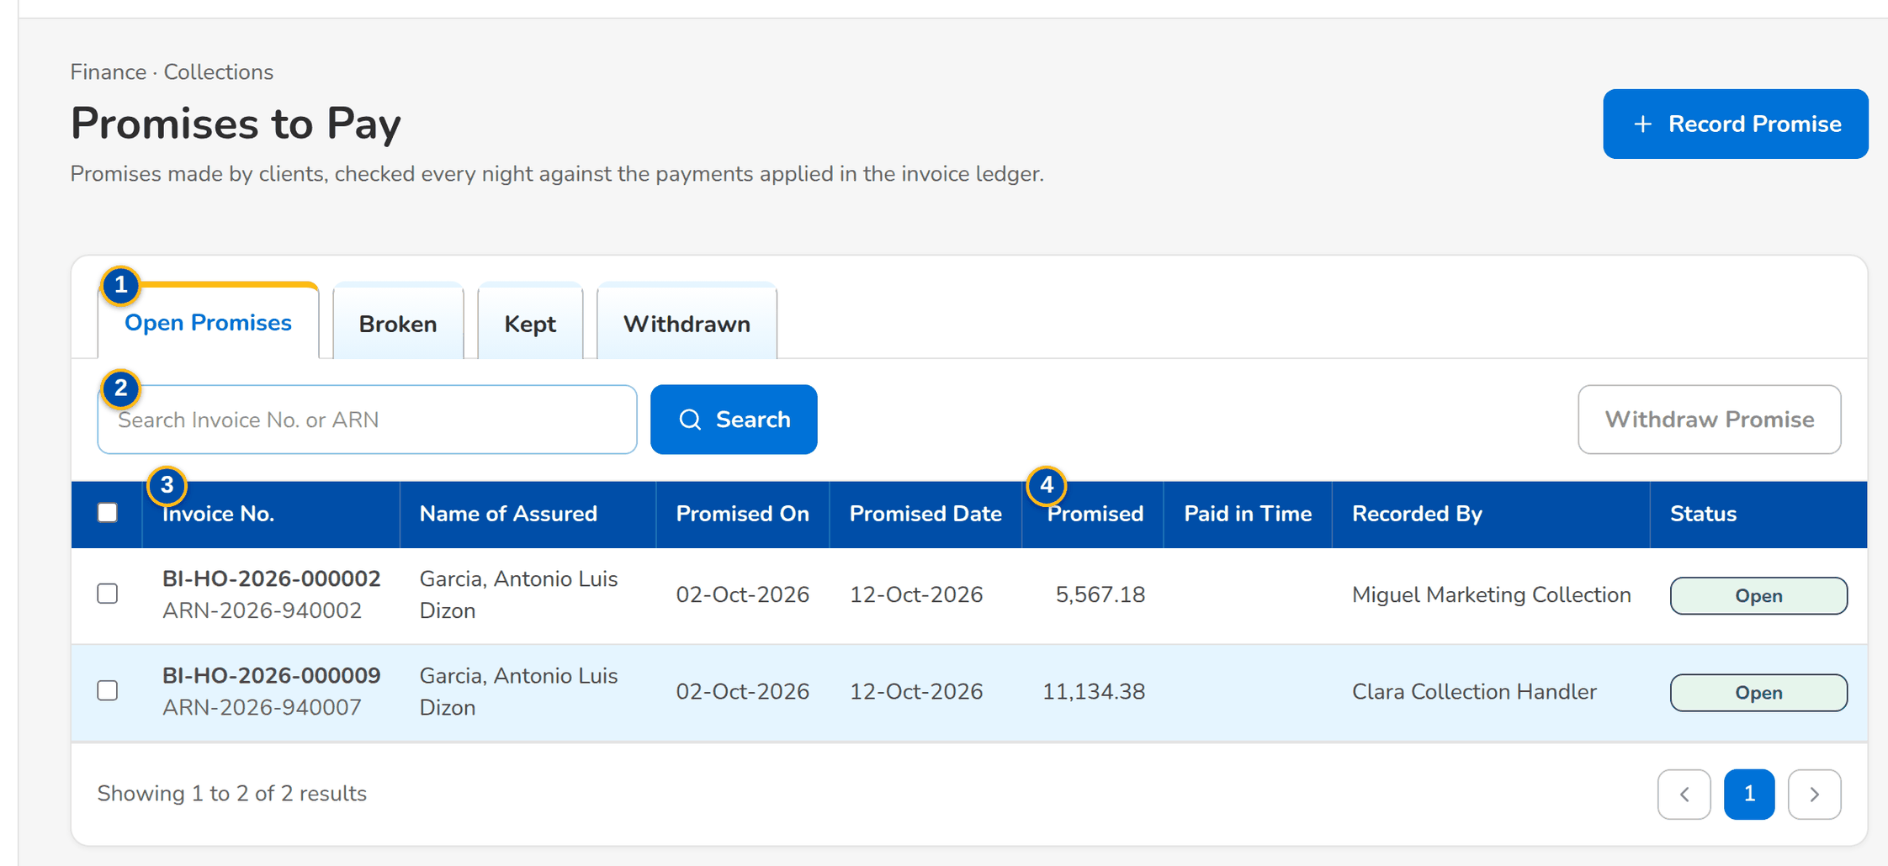
Figure 23: SCR-CL-08 Promises to Pay: the open promises with the promised date and amount
1 | Open Promises / Broken / Kept / Withdrawn | 4 | Promised / Paid in Time / Recorded By / Status | 7 | Promised Payment Date
2 | Search Invoice No. or ARN | 5 | Invoice No. / Invoice Nos. | 8 | Promised Amount / Remarks
3 | Invoice No. / ARN / Name of Assured / Promised On / Promised Date | 6 | Promised On | 9 | Reason

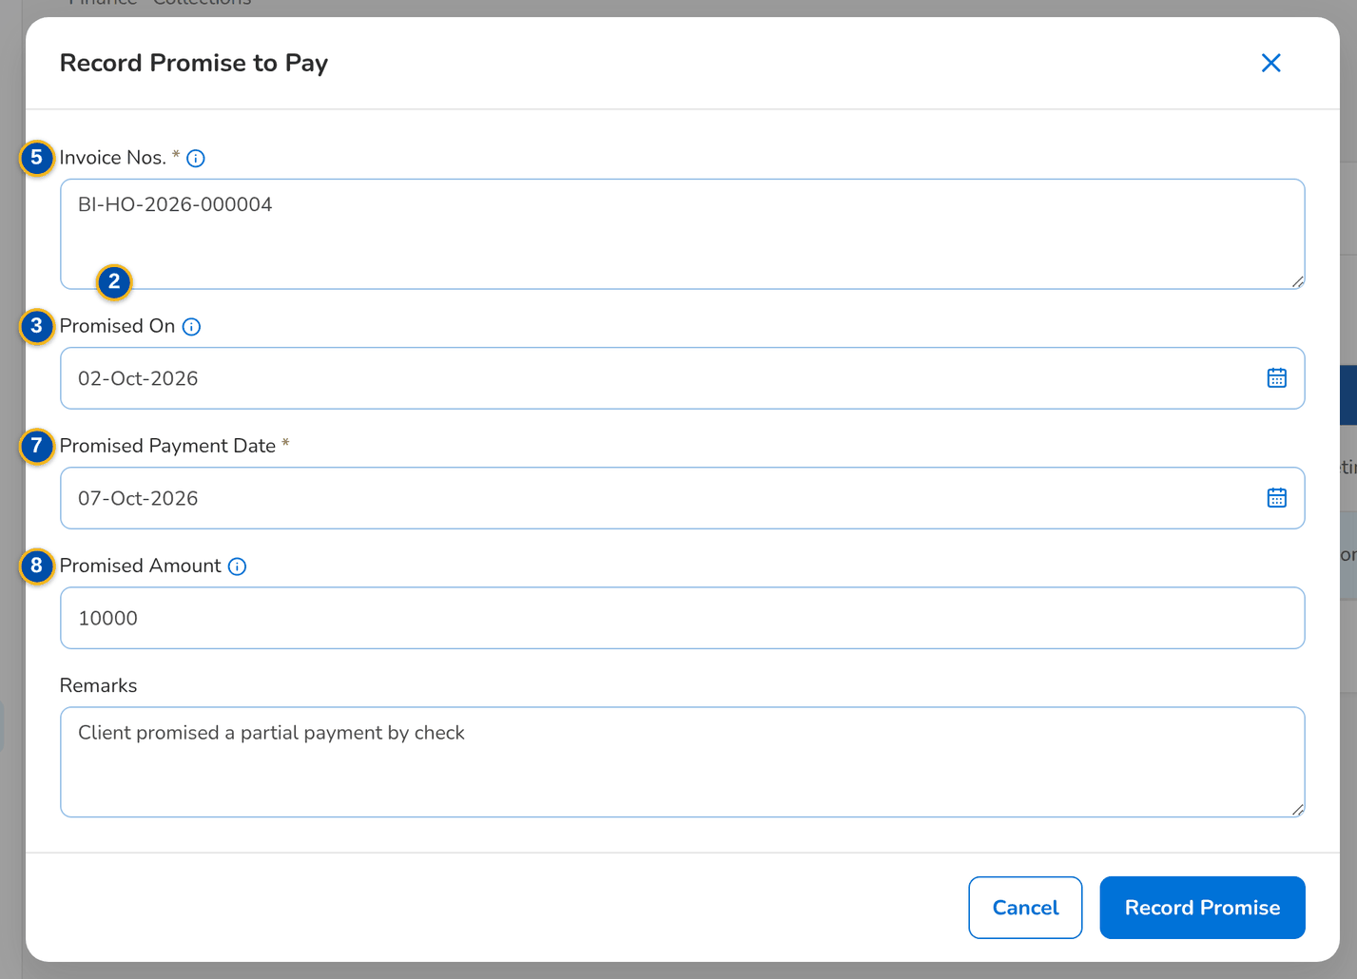
Figure 24: SCR-CL-08 Record Promise to Pay dialog
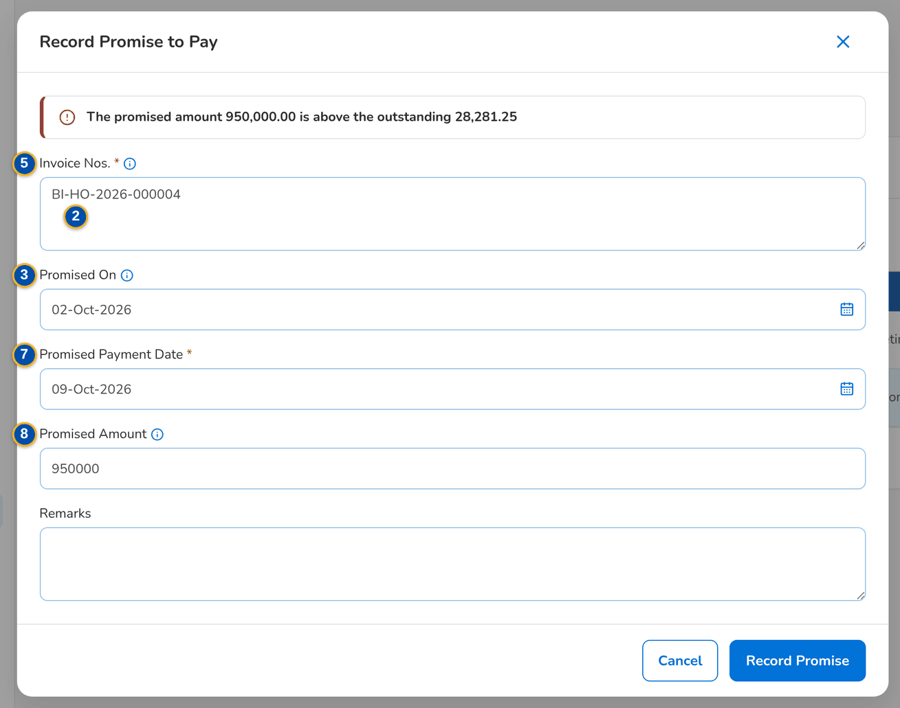
Figure 25: SCR-CL-08 A promised amount above the outstanding is refused, with the outcome per invoice
Fields (No. = callout number on the first screenshot)
No. | Section | Field | Type | Length / format | Mand. | Source / list | Default | Editable in | Validation | Message when it fails
1 | Tabs | Open Promises / Broken / Kept / Withdrawn | Tab | Kept includes partially kept | - | Promise status | Open Promises | - | - | -
2 | Toolbar | Search Invoice No. or ARN | Text | - | N | Promises | Blank | - | Contains | -
3 | List | Invoice No. / ARN / Name of Assured / Promised On / Promised Date | Column | - | - | Promises | - | Read only | - | No promises to pay to display
4 | List | Promised / Paid in Time / Recorded By / Status | Column | Two decimals; recorder's name with the bulk reference | - | Promises, invoice ledger | - | Read only | - | -
5 | Record Promise to Pay dialog | Invoice No. / Invoice Nos. | Text, text area | One invoice; several, one per line, with the bulk update permission | Y | Collection accounts | Blank | - | Account with something to collect | Enter at least one invoice number
6 | Record Promise to Pay dialog | Promised On | Date | The day the client made the promise | N | - | Today | - | Not in the future | The day of the promise cannot be in the future
7 | Record Promise to Pay dialog | Promised Payment Date | Date | dd-MMM-yyyy | Y | - | Blank | - | Not before the day of the promise | The promised date cannot be before the day of the promise
8 | Record Promise to Pay dialog | Promised Amount / Remarks | Number, text area | Empty for the whole outstanding | N | - | Blank | - | Above zero and at most the outstanding | Enter a positive amount, or leave it empty for the whole outstanding
9 | Withdraw Promise to Pay dialog | Reason | Text area | Up to 1,000 characters | Y | - | Blank | Open | Not blank | Enter the reason

Actions
Button | Who | Enabled when | What happens | Resulting status | Notification
Record Promise | Collectors with the work permission | Always | Records the promise on each invoice and lists the outcome per invoice | Open | -
Withdraw Promise | Collectors with the work permission | Open promises selected | Asks for the reason and withdraws them | Withdrawn | -

Business rules
• A promise is kept when the promised amount was paid by the promised date (plus the grace days, 0 by default) or nothing is left to collect, partially kept when part of it was paid, otherwise broken (FR-CL-042).
• A new promise on the same invoice replaces the running one (FR-CL-042).
• A broken promise notifies the collector and the account officer and escalates the account through the broken-promise rules (FR-CL-042, FR-CL-051).
Expected outcome
The collector records what the client promised and the system checks it.
Test cases: TC-CL-002.2-01, TC-CL-042.1-01, TC-CL-042.1-02, TC-CL-042.3-01, TC-CL-042.3-02, TC-CL-042.4-01, TC-CL-042.4-02, TC-CL-042.4-03, TC-CL-042.4-04, TC-CL-042.4-05, TC-CL-SCR-08, TC-CL-MSG-05.

13.2.5 SCR-CL-09 Billing Statements
Purpose | The statements of account (SOA) per billing cycle of the installment plans: to send, sent and cancelled; the Billing Run generates the statements of every billing cycle falling due in a period and not billed yet.
Who can open it | Marketing Account Officer, Marketing Team Lead, Marketing Handler, Collection Handler, Collection Team Lead, Section Head (Corporate / Retail), Unapplied Payment Handler, Processing Unit, Cashier (read access and exports), Disbursement (read access and exports), Comptrollership (read access), Business Administrator, System Administrator, Auditor (permission Clx view or Clx billing)
Navigation | • Menu: Finance › Collections › Billing Statements  • Finance › Collections › Billing Statements
FRs | FR-CL-060, FR-CL-061, FR-CL-062

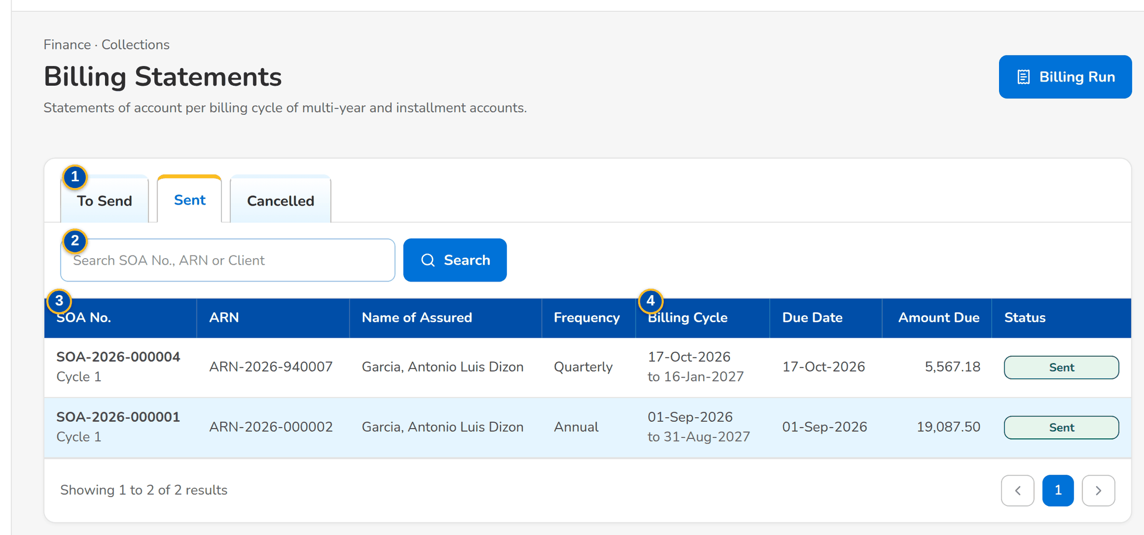
Figure 26: SCR-CL-09 Billing Statements: the statements sent to the clients
1 | To Send / Sent / Cancelled | 3 | SOA No. / Cycle / ARN / Name of Assured / Frequency | 5 | Due From / Due To
2 | Search SOA No., ARN or Client | 4 | Billing Cycle / Due Date / Amount Due / Status

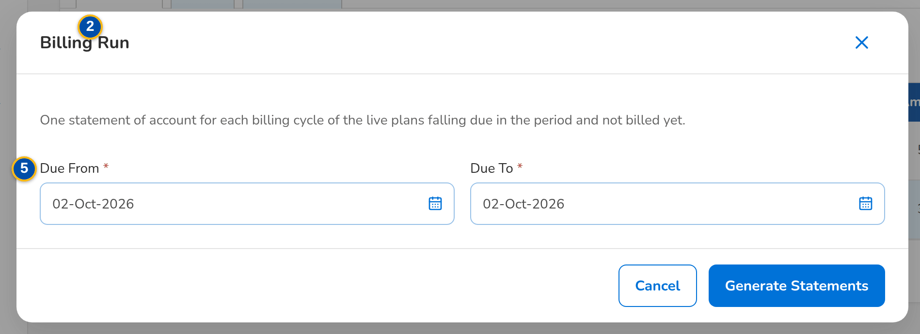
Figure 27: SCR-CL-09 Billing Run dialog: the due period of the cycles to bill
Fields (No. = callout number on the first screenshot)
No. | Section | Field | Type | Length / format | Mand. | Source / list | Default | Editable in | Validation | Message when it fails
1 | Tabs | To Send / Sent / Cancelled | Tab | - | - | Statement status | To Send | - | - | -
2 | Toolbar | Search SOA No., ARN or Client | Text | - | N | Statements | Blank | - | Contains | -
3 | List | SOA No. / Cycle / ARN / Name of Assured / Frequency | Column | SOA-yyyy-nnnnnn with the cycle | - | Statements | - | Read only | - | No statements of account to display
4 | List | Billing Cycle / Due Date / Amount Due / Status | Column | Billing cycle on two lines; two decimals | - | Statements | - | Read only | - | -
5 | Billing Run dialog | Due From / Due To | Date | dd-MMM-yyyy | Y | - | Today | - | The period does not end before it starts | The period ends before it starts

Actions
Button | Who | Enabled when | What happens | Resulting status | Notification
Billing Run | Users with the billing permission | Always | Opens the dialog | - | -
Generate Statements | Users with the billing permission | Both dates entered | Generates one statement per billing cycle due in the period and not billed yet | To Send | -
Row | Every Collections user | Always | Opens the statement | - | -

Business rules
• One live statement per plan and billing cycle; a cancelled statement frees the cycle to be billed again (FR-CL-060, FR-CL-061).
• Billing is monitoring only: a statement creates no receivable and no commission billing (FR-CL-062).
Expected outcome
The billing cycles due are billed to the clients.
Test cases: TC-CL-060.2-01, TC-CL-060.3-02, TC-CL-062.1-01, TC-CL-SCR-09, TC-CL-MSG-07.

13.2.6 SCR-CL-10 Statement of Account
Purpose | One statement of account: the billing cycle, the installments billed (the cycle and any arrears) with the payments allocated, the PDF from the statement template, the e-mails sent; Send via Email sends the protected PDF to the client, Cancel Statement frees the cycle.
Who can open it | Marketing Account Officer, Marketing Team Lead, Marketing Handler, Collection Handler, Collection Team Lead, Section Head (Corporate / Retail), Unapplied Payment Handler, Processing Unit, Cashier (read access and exports), Disbursement (read access and exports), Comptrollership (read access), Business Administrator, System Administrator, Auditor (permission Clx view)
Navigation | • Menu: Finance › Collections › Billing Statements › Statement of Account  • Billing Statements › open a row  • Installment Plan › Statements of Account tab
FRs | FR-CL-060, FR-CL-061, FR-CL-062

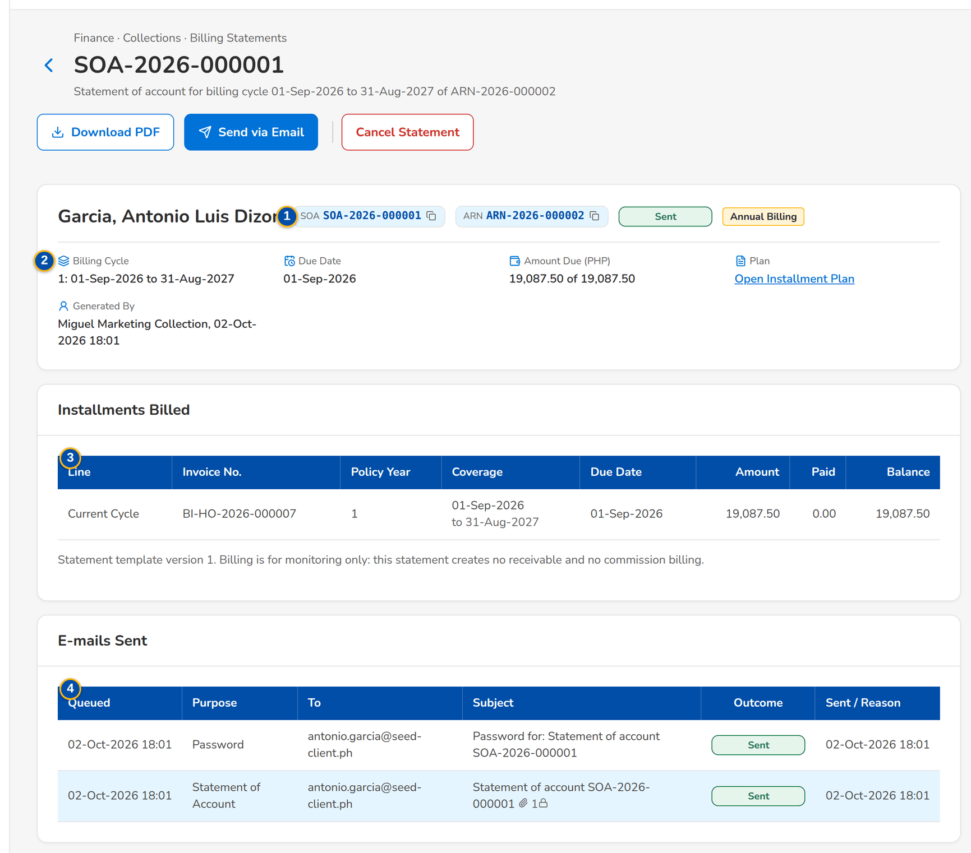
Figure 28: SCR-CL-10 Statement of Account with the installments billed and the e-mails sent
1 | SOA and ARN chips, status pill, billing tag | 4 | Queued / Purpose / To / Subject / Outcome / Sent / Reason | 7 | Reason
2 | Billing Cycle / Due Date / Amount Due / Plan / Generated By | 5 | To / Cc / Subject / Message
3 | Line / Invoice No. / Policy Year / Coverage / Due Date / Amount / Paid / Balance | 6 | Password hint for the recipient

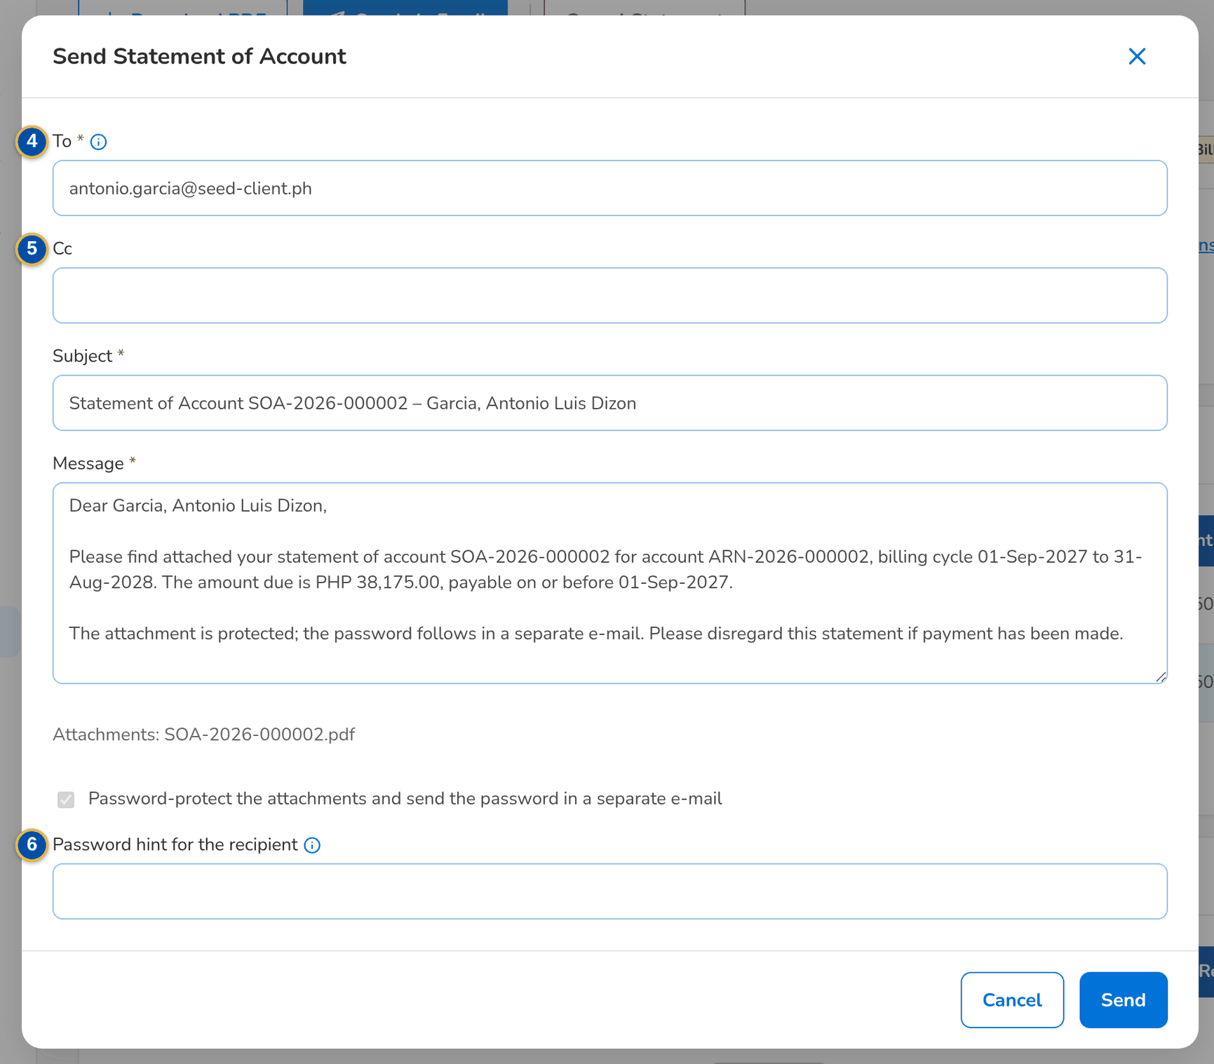
Figure 29: SCR-CL-10 Send Statement of Account: the e-mail to the client with the protected PDF

Fields (No. = callout number on the first screenshot)
No. | Section | Field | Type | Length / format | Mand. | Source / list | Default | Editable in | Validation | Message when it fails
1 | Header | SOA and ARN chips, status pill, billing tag | Reference chip, status pill | To Send, Sent or Cancelled | - | Statement | - | Read only | - | -
2 | Facts | Billing Cycle / Due Date / Amount Due / Plan / Generated By | Display | Cycle number and period; the amount due of the total | - | Statement | - | Read only | - | -
3 | Installments Billed | Line / Invoice No. / Policy Year / Coverage / Due Date / Amount / Paid / Balance | Column | Current Cycle or Arrears | - | Statement lines | - | Read only | - | -
4 | E-mails Sent | Queued / Purpose / To / Subject / Outcome / Sent / Reason | Column | One row per e-mail with the protected attachment marked | - | Mail log | - | Read only | - | -
5 | Send Statement of Account dialog | To / Cc / Subject / Message | Text, text area | The client's e-mail address proposed; subject and message proposed | Y / N / Y / Y | Client profile | Proposed | To Send, Sent | At least one recipient | Enter at least one recipient
6 | Send Statement of Account dialog | Password hint for the recipient | Text | The hint sent with the password | N | - | Blank | To Send, Sent | - | -
7 | Cancel Statement of Account dialog | Reason | Text area | Up to 1,000 characters | Y | - | Blank | To Send, Sent | Not blank | Enter the reason

Actions
Button | Who | Enabled when | What happens | Resulting status | Notification
Download PDF | Every Collections user | Always | Downloads the statement of account (PDF) | - | -
Send via Email | Users with the billing permission | Not cancelled | Sends the PDF, protected by a password sent in a separate e-mail, and records the e-mail | Sent | Statement of account e-mail (NT-11, NT-12)
Cancel Statement | Users with the billing permission | Not cancelled | Asks for the reason and cancels the statement; the cycle can be billed again | Cancelled | -

Business rules
• The PDF comes from the statement of account template and records the template version used (FR-CL-060).
• The PDF e-mailed to the client is password protected; the password follows in a separate e-mail (FR-CL-061).
Expected outcome
The client receives the statement of the cycle.
Test cases: TC-CL-060.1-01, TC-CL-061.1-01, TC-CL-061.2-01, TC-CL-061.3-01, TC-CL-061.3-02, TC-CL-SCR-10, TC-CL-MSG-08.

13.3 Escalation

13.3.1 SCR-CL-11 Escalations
Purpose | The accounts escalated to the team lead or to the unit / section head, automatically by the escalation rules (aging, no commitment, broken promises, overdue installments, amount) or by a user, by stage; Escalate Accounts escalates one or several invoices by hand.
Who can open it | Marketing Account Officer, Marketing Team Lead, Marketing Handler, Collection Handler, Collection Team Lead, Section Head (Corporate / Retail), Unapplied Payment Handler, Processing Unit, Cashier (read access and exports), Disbursement (read access and exports), Comptrollership (read access), Business Administrator, System Administrator, Auditor (permission Clx view)
Navigation | • Menu: Finance › Collections › Escalations  • Finance › Collections › Escalations
FRs | FR-CL-051, FR-CL-052, FR-CL-053

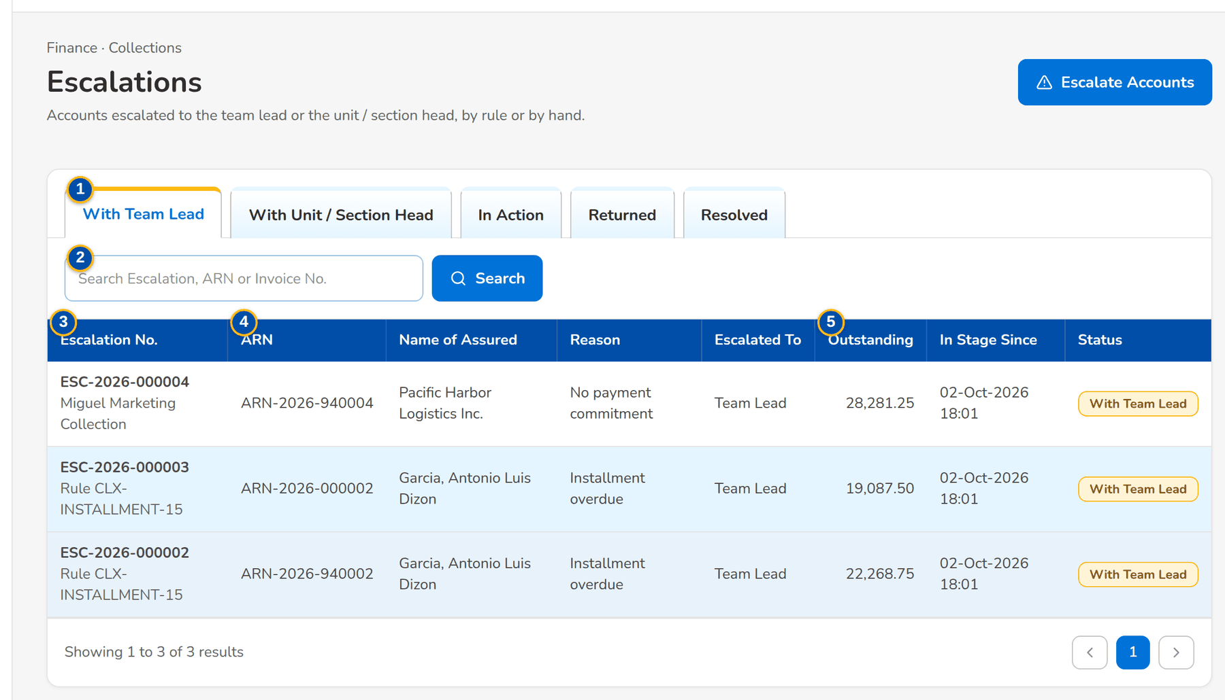
Figure 30: SCR-CL-11 Escalations with the team lead: by rule or by a user, with the reason and the time in stage
1 | With Team Lead / With Unit / Section Head / In Action / Returned / Resolved | 4 | ARN / Name of Assured / Reason / Escalated To | 7 | Escalate To / User
2 | Search Escalation, ARN or Invoice No. | 5 | Outstanding / In Stage Since / Status | 8 | Reason / Remarks
3 | Escalation No. | 6 | Invoice Nos.

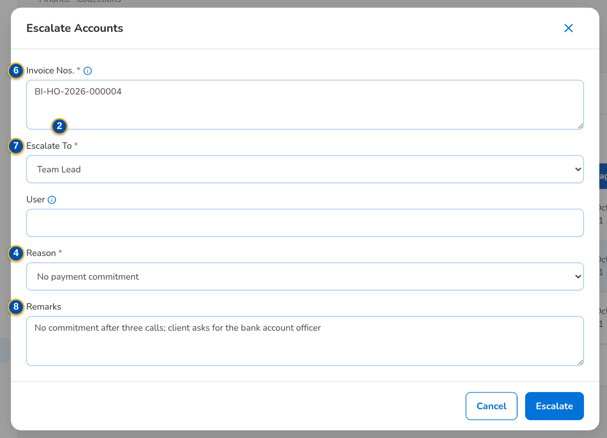
Figure 31: SCR-CL-11 Escalate Accounts dialog: the invoices, the level and the reason
Fields (No. = callout number on the first screenshot)
No. | Section | Field | Type | Length / format | Mand. | Source / list | Default | Editable in | Validation | Message when it fails
1 | Tabs | With Team Lead / With Unit / Section Head / In Action / Returned / Resolved | Tab | - | - | Escalation stage | With Team Lead | - | - | -
2 | Toolbar | Search Escalation, ARN or Invoice No. | Text | - | N | Escalations | Blank | - | Contains | -
3 | List | Escalation No. | Column | ESC-yyyy-nnnnnn; the rule or the name of the user who raised it under it | - | Escalations | - | Read only | - | No escalations to display
4 | List | ARN / Name of Assured / Reason / Escalated To | Column | Label of the reason; the level or the user's name | - | Escalations | - | Read only | - | -
5 | List | Outstanding / In Stage Since / Status | Column | Two decimals; date and time with Past SLA when overdue | - | Escalations | - | Read only | - | -
6 | Escalate Accounts dialog | Invoice Nos. | Text area | One per line; the invoices of one account are escalated together | Y | Collection accounts | Blank | - | Account with something to collect | Enter at least one invoice number
7 | Escalate Accounts dialog | Escalate To / User | Drop-down, text | Team Lead, Unit Head, Section Head or Designated User; the user for a designated user | Y / Cond.: designated user | Users who handle escalations | Team Lead | - | The user handles escalations | Name the user who receives the escalation
8 | Escalate Accounts dialog | Reason / Remarks | Drop-down, text area | Escalation reason list | Y / N | Escalation reason list | Blank | - | - | Choose the reason

Actions
Button | Who | Enabled when | What happens | Resulting status | Notification
Escalate Accounts | Collectors with the escalate permission | Always | Opens the dialog | - | -
Escalate | Collectors with the escalate permission | The form is complete | Raises one escalation per account and lists the outcome per invoice | With Team Lead or With Unit / Section Head | Account escalated (NT-02)
Row | Every Collections user | Always | Opens the escalation | - | -

Business rules
• The rules escalate an account once per rule and month; the escalation job runs every night after the promise check (FR-CL-051).
• A user escalates one or several invoices regardless of the rules; the invoices of one account become one escalation (FR-CL-052).
• Each stage has the SLA of its rule; past it the escalation shows Past SLA and the overdue alert is raised (FR-CL-053).
Expected outcome
Accounts that need a decision reach the team lead or the head.
Test cases: TC-CL-042.2-01, TC-CL-051.1-01, TC-CL-051.1-02, TC-CL-051.2-01, TC-CL-051.3-01, TC-CL-052.1-01, TC-CL-052.1-02, TC-CL-052.2-01, TC-CL-052.2-02, TC-CL-052.3-01, TC-CL-052.4-01, TC-CL-SCR-11, TC-CL-MSG-09.

13.3.2 SCR-CL-12 Escalation
Purpose | One escalation: the account, the reason, the receiving level or user, the outstanding and the SLA; the workflow header with the actions of the stage (acknowledge, escalate to the unit / section head, return to the handler, resubmit, resolve) and the history; the escalated invoices.
Who can open it | Marketing Account Officer, Marketing Team Lead, Marketing Handler, Collection Handler, Collection Team Lead, Section Head (Corporate / Retail), Unapplied Payment Handler, Processing Unit, Cashier (read access and exports), Disbursement (read access and exports), Comptrollership (read access), Business Administrator, System Administrator, Auditor (permission Clx view)
Navigation | • Menu: Finance › Collections › Escalations › Escalation  • Escalations › open a row  • Notification Account escalated
FRs | FR-CL-053

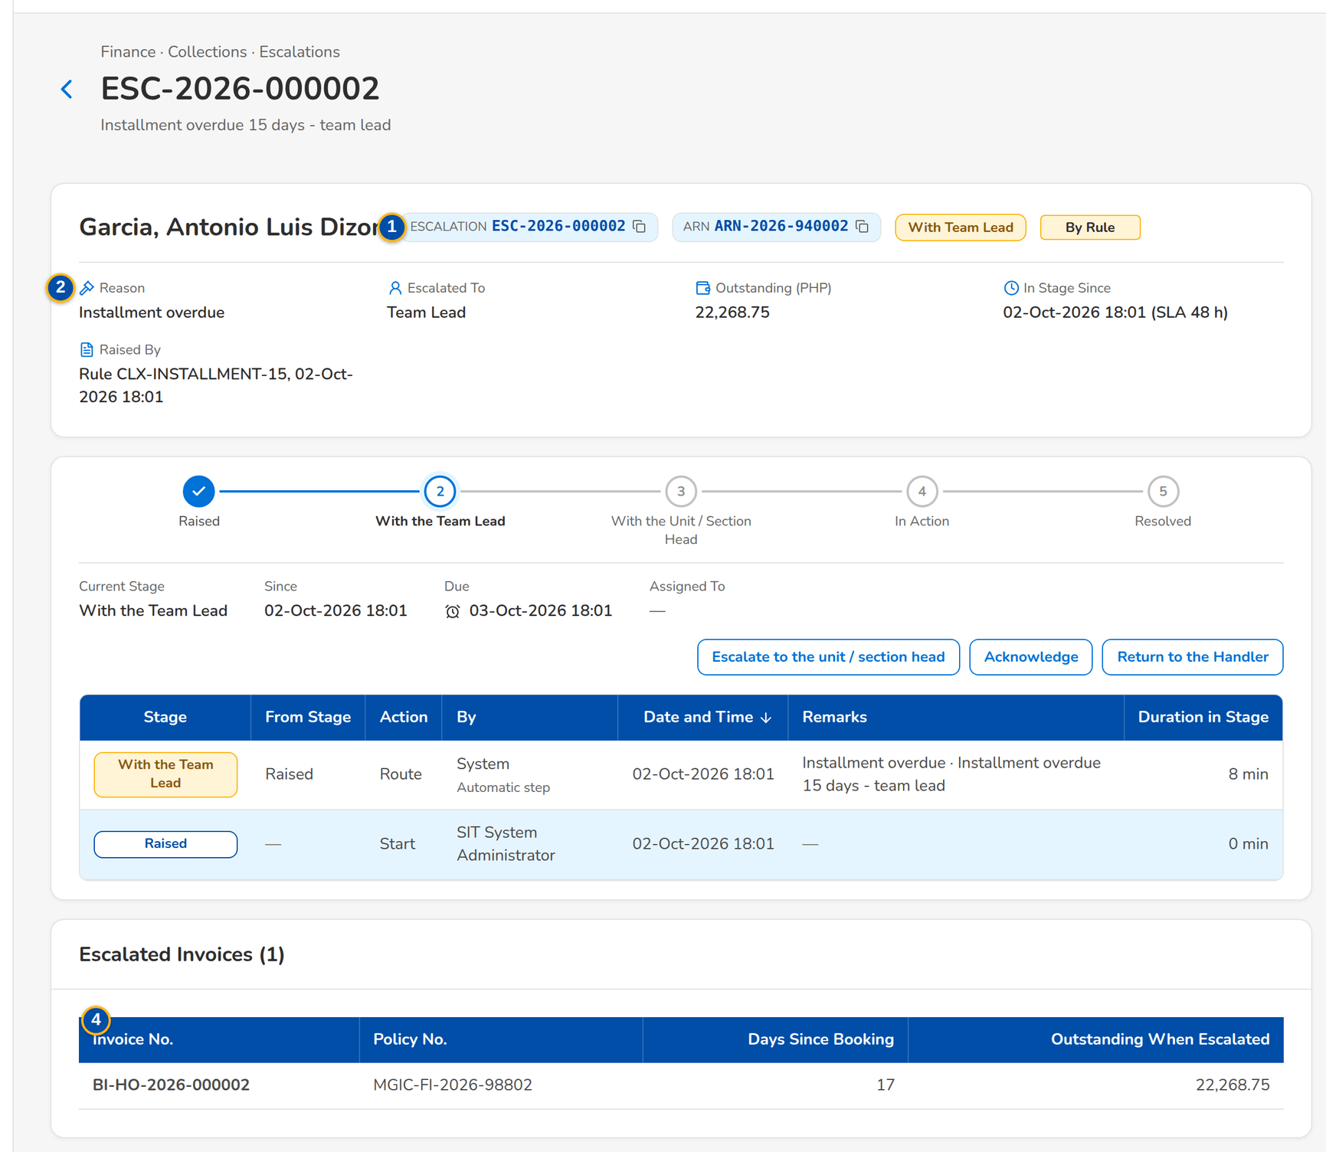
Figure 32: SCR-CL-12 Escalation with the team lead: workflow header, actions and the escalated invoices
1 | Escalation and ARN chips, status pill, By Rule or Manual tag, Past SLA | 3 | Escalation workflow header | 5 | Reason / Comment
2 | Reason / Escalated To / Outstanding / In Stage Since / Raised By | 4 | Invoice No. / Policy No. / Days Since Booking / Outstanding When Escalated | 6 | Resolution

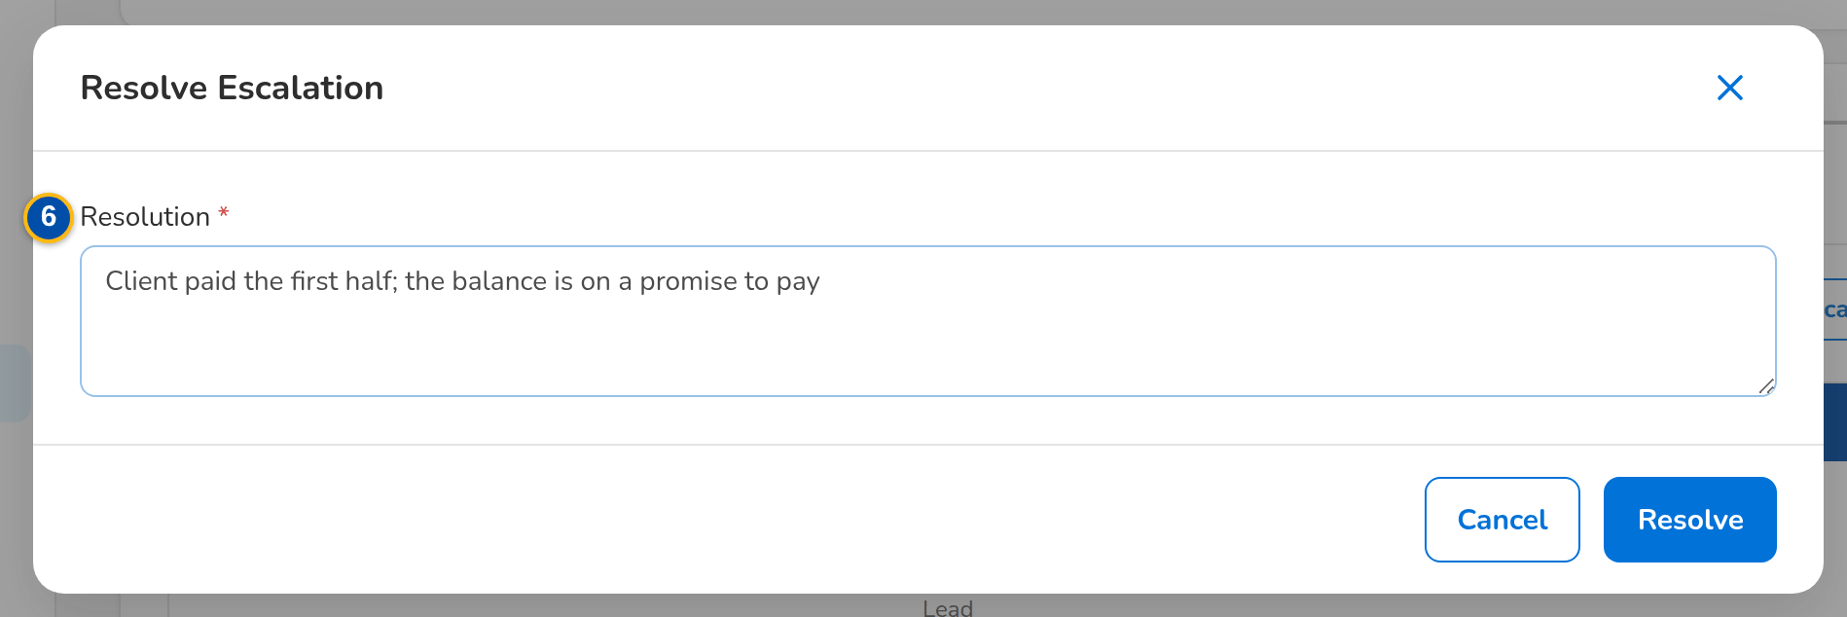
Figure 33: SCR-CL-12 Resolve Escalation dialog with the resolution, after the escalation is acknowledged
Fields (No. = callout number on the first screenshot)
No. | Section | Field | Type | Length / format | Mand. | Source / list | Default | Editable in | Validation | Message when it fails
1 | Header | Escalation and ARN chips, status pill, By Rule or Manual tag, Past SLA | Reference chip, status pill, tag | - | - | Escalation | - | Read only | - | -
2 | Facts | Reason / Escalated To / Outstanding / In Stage Since / Raised By | Display | Label of the reason; level or user's name; amount with the currency; time with the SLA in hours; the rule or the user's name | - | Escalation | - | Read only | - | -
3 | Workflow | Escalation workflow header | Stepper | Raised, With the team lead, With the unit / section head, In action, Returned to the handler, Resolved with the history table | - | Escalation workflow | - | Read only | - | -
4 | Escalated Invoices | Invoice No. / Policy No. / Days Since Booking / Outstanding When Escalated | Column | - | - | Escalation | - | Read only | - | -
5 | Action dialog | Reason / Comment | Drop-down, text area | Escalation reason list or return reason list | Y / N | Lists of values | Blank | With Team Lead, With Unit / Section Head, In Action | - | -
6 | Resolve Escalation dialog | Resolution | Text area | Up to 1,000 characters | Y | - | Blank | In Action | Not blank | Describe how the escalation was resolved

Actions
Button | Who | Enabled when | What happens | Resulting status | Notification
Acknowledge | Team leads and heads (escalation permission) | With Team Lead or With Unit / Section Head | Takes the escalation into action | In action | Workflow notice (NT-01)
Escalate to the unit / section head | Team leads and heads (escalation permission) | With Team Lead or In Action | Asks for the reason and moves it to the unit / section head | With the unit / section head | Workflow notice (NT-01)
Return to the handler | Team leads and heads (escalation permission) | With Team Lead or With Unit / Section Head | Asks for the reason and the instruction and returns it to the handler | Returned to the handler | Workflow notice (NT-01)
Resubmit to the team lead | The handler (work or escalate permission) | Returned | Sends it back to the team lead once the instruction is done | With the team lead | Workflow notice (NT-01)
Resolve | Team leads and heads (escalation permission) | In Action | Asks for the resolution and closes it | Resolved | Workflow notice (NT-01)

Business rules
• An escalation whose invoices are collected is closed automatically (FR-CL-053).
• Acting on an escalation needs the escalation permission; the target and the account officers are notified (FR-CL-053).
Expected outcome
The escalation is acted on and closed with its resolution.
Test cases: TC-CL-053.1-01, TC-CL-053.2-01, TC-CL-053.3-01, TC-CL-053.3-02, TC-CL-053.4-01, TC-CL-SCR-12.

13.3.3 SCR-CL-13 Escalation Rules
Purpose | What escalates an account automatically: the basis and threshold, the segment, the receiving level or user, the reason, the SLA in hours and the effective dates. Preview lists the accounts a rule escalates today. A new or changed rule applies once another user authorizes it.
Who can open it | Marketing Team Lead, Collection Team Lead, Section Head (Corporate / Retail), Business Administrator, System Administrator (permission Clx setup or Master authorize or Clx escalation handle)
Navigation | • Menu: Finance › Collections › Escalation Rules  • Finance › Collections › Escalation Rules  • My Approvals (a rule waiting for authorization)
FRs | FR-CL-050, FR-CL-051

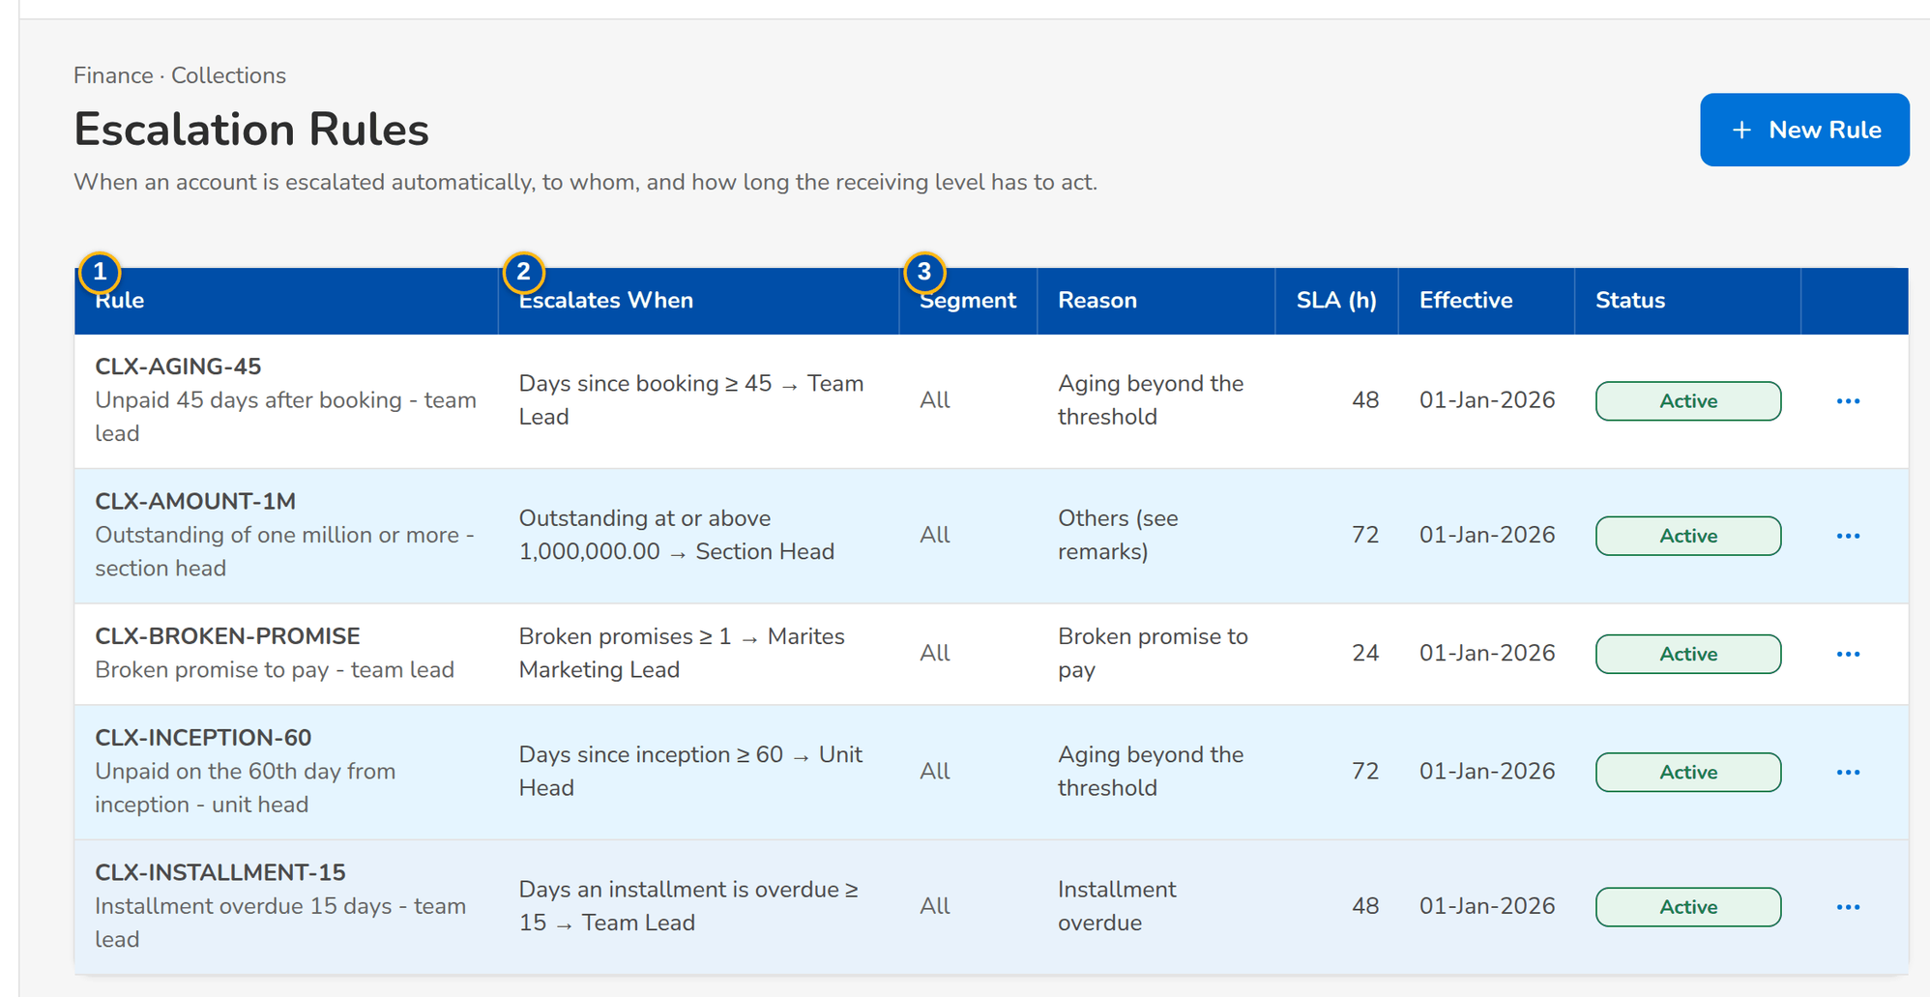
Figure 34: SCR-CL-13 Escalation Rules with their row menu: the rules in force and one waiting for authorization
1 | Rule | 4 | Code / Name | 7 | Segment / Escalate To / User
2 | Escalates When | 5 | Basis | 8 | Reason
3 | Segment / Reason / SLA (h) / Effective / Status | 6 | Threshold | 9 | SLA (Hours) / Effective From / Effective To

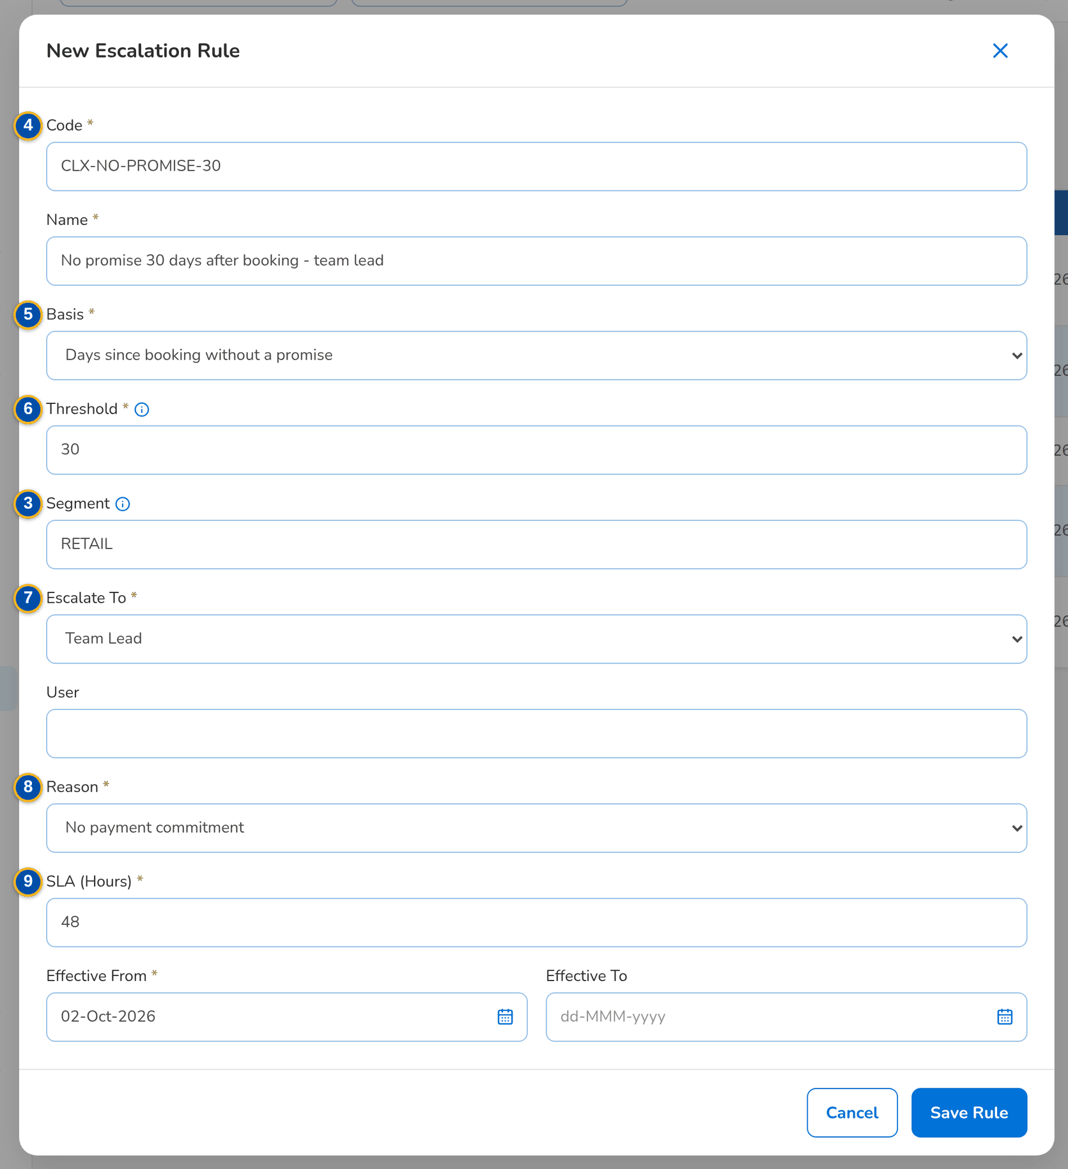
Figure 35: SCR-CL-13 New Escalation Rule dialog

Fields (No. = callout number on the first screenshot)
No. | Section | Field | Type | Length / format | Mand. | Source / list | Default | Editable in | Validation | Message when it fails
1 | List | Rule | Column | Code with the name under it | - | Escalation rules | - | Read only | - | No escalation rules
2 | List | Escalates When | Column | Basis, threshold and receiving level or user's name, for example Days since booking ≥ 45 → Team Lead | - | Escalation rules | - | Read only | - | -
3 | List | Segment / Reason / SLA (h) / Effective / Status | Column | All or the segment; label of the reason; hours; Active, Pending Authorization or Inactive | - | Escalation rules | - | Read only | - | -
4 | New Escalation Rule dialog | Code / Name | Text | Up to 60 characters; the code of a new rule only | Y | - | Blank | New | Not blank | Enter the rule code
5 | New Escalation Rule dialog | Basis | Drop-down | Days since booking; Days since inception; Days since booking without a promise; Broken promises; Days an installment is overdue; Outstanding at or above | Y | Fixed list | Days since booking | Pending, Active | - | -
6 | New Escalation Rule dialog | Threshold | Number | Days, a number of promises or an amount, depending on the basis | Y | - | 45 | Pending, Active | Above zero | Enter a positive threshold
7 | New Escalation Rule dialog | Segment / Escalate To / User | Text, drop-down | Empty for every segment; Team Lead, Unit Head, Section Head or Designated User | N / Y / Cond.: designated user | Sales organisation, users | Team Lead | Pending, Active | The user handles escalations | Name the user who receives the escalations
8 | New Escalation Rule dialog | Reason | Drop-down | Escalation reason list | Y | Escalation reason list | Blank | Pending, Active | - | Choose the escalation reason
9 | New Escalation Rule dialog | SLA (Hours) / Effective From / Effective To | Number, date | 1 to 720 hours; dd-MMM-yyyy | Y / Y / N | - | 48 / today | Pending, Active | The rule cannot end before it starts | Enter between 1 and 720 hours

Actions
Button | Who | Enabled when | What happens | Resulting status | Notification
New Rule | Users with the Collections set-up permission | Always | Opens the dialog | - | -
Save Rule | Users with the Collections set-up permission | The form is complete | Saves the rule; it applies once authorized | Pending Authorization | -
Preview (row menu) | Set-up and authorizing users | Always | Lists the accounts the rule escalates today | - | -
Change (row menu) | Users with the Collections set-up permission | Not inactive | Opens the rule; the change waits for authorization | Pending Authorization | -
Authorize (row menu) | Authorizers of master data, other than the maker | Pending Authorization | Asks for confirmation; the rule takes effect for new escalations | Active | -
Deactivate (row menu) | Users with the Collections set-up permission | Active | Asks for confirmation; the rule no longer applies | Inactive | -

Business rules
• Maker-checker: the maker of a rule cannot authorize it; pending rules also appear in My Approvals (FR-CL-050).
• The defaults of the process: 45 days after booking to the team lead, the 60th day from inception to the unit head, a broken promise to the team lead, an installment 15 days overdue to the team lead (FR-CL-050).
• A rule is deactivated, never deleted (FR-CL-050).
Expected outcome
The escalation rules agreed by the business apply every night.
Test cases: TC-CL-050.1-01, TC-CL-050.2-01, TC-CL-050.3-01, TC-CL-050.4-01, TC-CL-050.4-02, TC-CL-050.4-03, TC-CL-050.4-04, TC-CL-050.5-01, TC-CL-SCR-13, TC-CL-MSG-10.

13.4 Unapplied payments

13.4.1 SCR-CL-14 Unapplied Payments
Purpose | The payments Cashiering could not apply to an invoice, as of today, read from Cashiering (never copied), by Cashiering tab: the payment and its transaction, the unapplied balance, the matched account, the latest collector disposition and where the payment stands in Cashiering. The collector records a disposition on the selected payment, or asks Cashiering to apply it to an invoice.
Who can open it | Marketing Account Officer, Marketing Team Lead, Marketing Handler, Collection Handler, Collection Team Lead, Section Head (Corporate / Retail), Unapplied Payment Handler, Processing Unit, Cashier (read access and exports), Disbursement (read access and exports), Comptrollership (read access), Business Administrator, System Administrator, Auditor (permission Clx view or Clx unapplied work)
Navigation | • Menu: Finance › Collections › Unapplied Payments  • Finance › Collections › Unapplied Payments  • Collections Home › Unapplied Awaiting Disposition tile
FRs | FR-CL-070, FR-CL-071, FR-CL-072, FR-CL-073, FR-CL-074, FR-CL-075, FR-CL-076

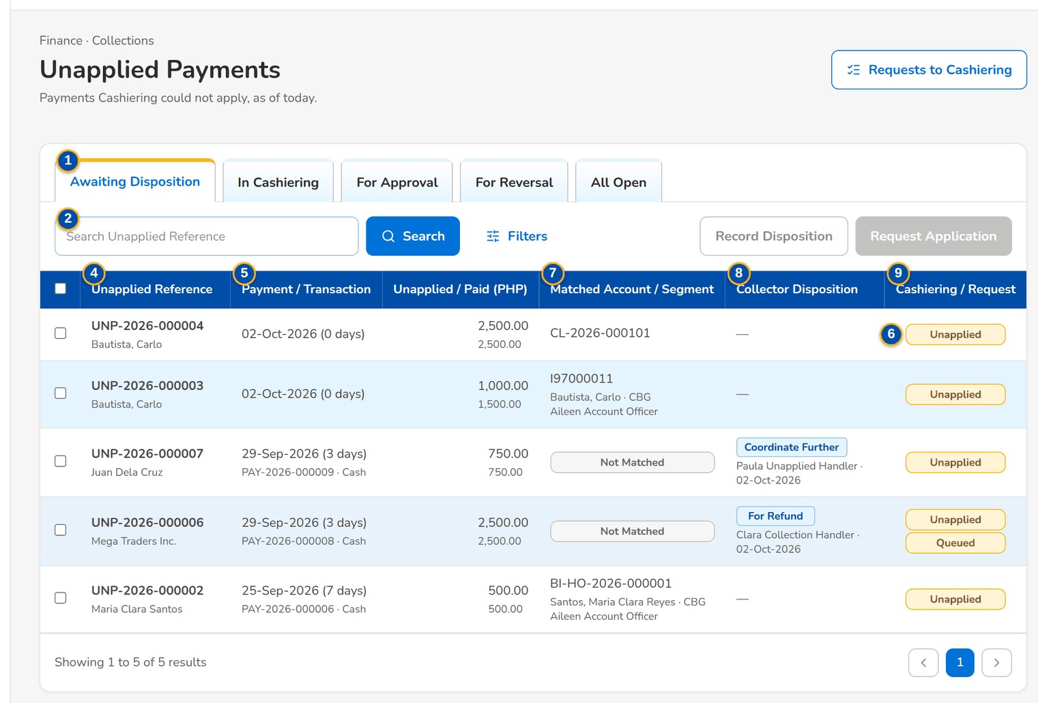
Figure 36: SCR-CL-14 Unapplied Payments awaiting a disposition, with the matched account and the Cashiering status
1 | Awaiting Disposition / In Cashiering / For Approval / For Reversal / All Open | 5 | Payment / Transaction | 9 | Cashiering / Request
2 | Search Unapplied Reference | 6 | Unapplied / Paid | 10 | Disposition
3 | Market Segment / Collector Disposition / Age | 7 | Matched Account / Segment | 11 | Invoice No.
4 | Unapplied Reference | 8 | Collector Disposition | 12 | Amount / Remarks

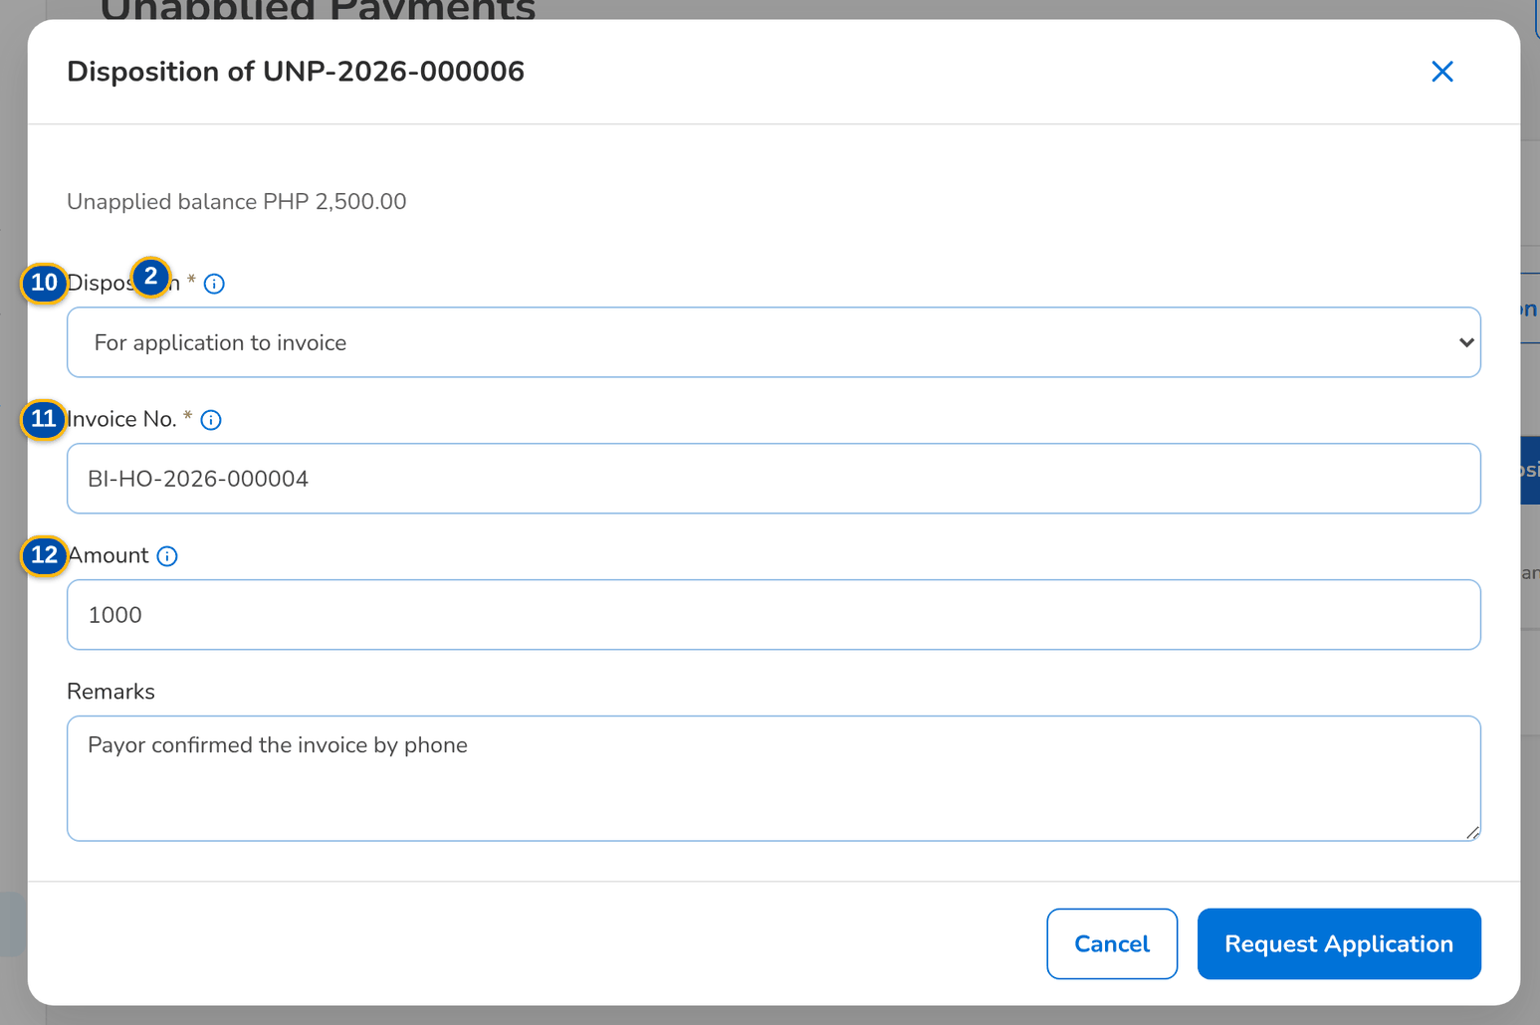
Figure 37: SCR-CL-14 Request Application: the disposition For Application to Invoice with the invoice number
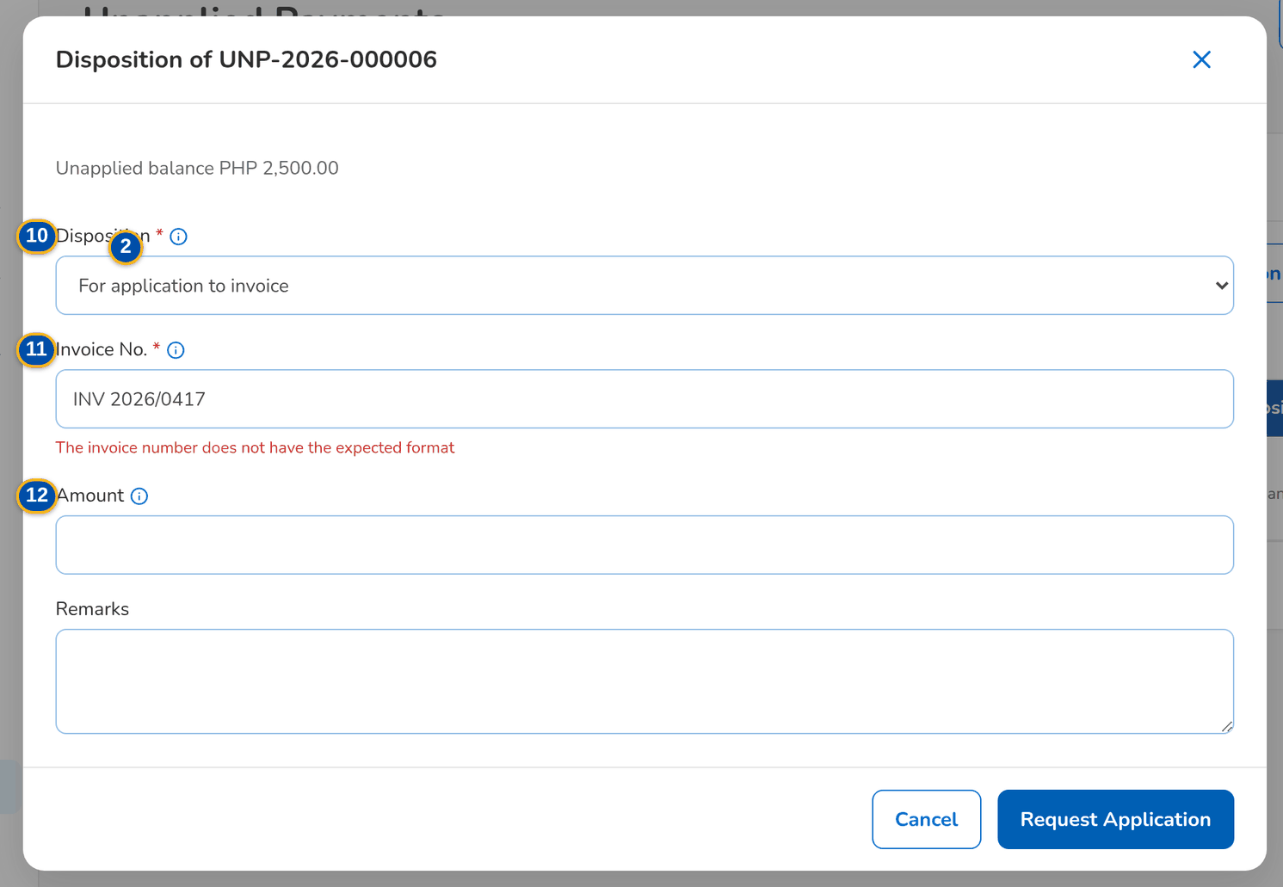
Figure 38: SCR-CL-14 An invoice number in the wrong format is refused under the field
Fields (No. = callout number on the first screenshot)
No. | Section | Field | Type | Length / format | Mand. | Source / list | Default | Editable in | Validation | Message when it fails
1 | Tabs | Awaiting Disposition / In Cashiering / For Approval / For Reversal / All Open | Tab | The Cashiering tab of the payment | - | Cashiering | Awaiting Disposition | - | - | -
2 | Toolbar | Search Unapplied Reference | Text | Reference, payor, transaction, check or invoice | N | Unapplied payments | Blank | - | Contains | -
3 | Filters | Market Segment / Collector Disposition / Age | Text, drop-down | Segment; any, no disposition yet or a value; up to 7, 8 to 30, 31 to 90, over 90 days | N | Unapplied payment disposition list | Any | - | - | -
4 | List | Unapplied Reference | Column | UNP-yyyy-nnnnnn with the payor | - | Cashiering | - | Read only | - | No unapplied payments to display
5 | List | Payment / Transaction | Column | Payment date with its age in days; transaction number, payment type, bank and check | - | Cashiering | - | Read only | - | -
6 | List | Unapplied / Paid | Column | Unapplied balance with the amount paid under it, in the base currency | - | Cashiering | - | Read only | - | -
7 | List | Matched Account / Segment | Column | Invoice or client matched, assured, segment and account officer; Not Matched | - | Invoice ledger | - | Read only | - | -
8 | List | Collector Disposition | Column | Label as a tag with the user's name and date | - | Collector dispositions | - | Read only | - | -
9 | List | Cashiering / Request | Column | Cashiering tab, and the status of the request sent | - | Cashiering, requests | - | Read only | - | -
10 | Disposition dialog | Disposition | Drop-down | Active values of the unapplied payment disposition list; what Cashiering is asked to do shows under it | Y | Unapplied payment disposition list | Blank | Balance above zero | - | Choose the disposition
11 | Disposition dialog | Invoice No. | Text | a legacy invoice I followed by eight digits or a BIBS invoice BI-…, checked against the invoice ledger | Cond.: For application to invoice | Invoice ledger | Matched invoice | Balance above zero | Format of the invoice number parameter; invoice in the ledger | The invoice number does not have the expected format
12 | Disposition dialog | Amount / Remarks | Number, text area | Empty for the whole unapplied balance | N | - | Blank | Balance above zero | Above zero and at most the balance | Enter an amount above zero and at most <balance>

Actions
Button | Who | Enabled when | What happens | Resulting status | Notification
Requests to Cashiering | Every Collections user | Always | Opens the requests sent to Cashiering | - | -
Record Disposition | Users with the unapplied work permission | One payment selected | Opens the disposition dialog | - | -
Request Application | Users with the unapplied work permission | One payment selected | Opens the dialog with For Application to Invoice chosen | - | -
Save Disposition / Request Application (dialog) | Users with the unapplied work permission | The form is complete | Records the disposition; a value with a Cashiering action sends a request to the Incoming Requests of Cashiering | Request Sent | -
Row | Every Collections user | Always | Opens the unapplied payment | - | -

Business rules
• Only active values of the unapplied payment disposition list can be chosen (FR-CL-072, FR-CL-073).
• For Application to Invoice needs an invoice number in the format of the invoice number parameter that exists in the invoice ledger (FR-CL-075).
• A value with a Cashiering action sends a request to Cashiering, which applies, refunds, reclassifies or transfers the payment with its own approvals (FR-CL-074).
• Dispositions are never deleted; the history stays after the payment is applied or refunded (FR-CL-076).
Expected outcome
Every unapplied payment has the collector's disposition and, where needed, a request to Cashiering.
Test cases: TC-CL-070.1-01, TC-CL-070.3-01, TC-CL-071.1-01, TC-CL-071.1-02, TC-CL-071.2-01, TC-CL-073.2-02, TC-CL-073.1-02, TC-CL-075.1-01, TC-CL-075.2-01, TC-CL-075.3-01, TC-CL-075.3-02, TC-CL-SCR-14, TC-CL-MSG-11.

13.4.2 SCR-CL-15 Unapplied Payment
Purpose | One unapplied payment as the collector sees it: the payment and the matched account, the collector dispositions, the requests sent to Cashiering with their status, and the whole history kept after the payment is applied or refunded.
Who can open it | Marketing Account Officer, Marketing Team Lead, Marketing Handler, Collection Handler, Collection Team Lead, Section Head (Corporate / Retail), Unapplied Payment Handler, Processing Unit, Cashier (read access and exports), Disbursement (read access and exports), Comptrollership (read access), Business Administrator, System Administrator, Auditor (permission Clx view or Clx unapplied work)
Navigation | • Menu: Finance › Collections › Unapplied Payments › Unapplied Payment  • Unapplied Payments › open a row  • Requests to Cashiering › open a row
FRs | FR-CL-070, FR-CL-073, FR-CL-074, FR-CL-076

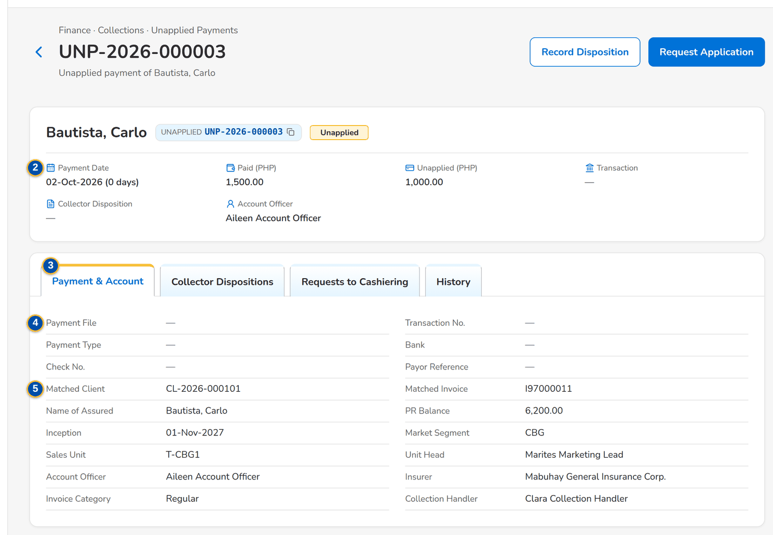
Figure 39: SCR-CL-15 Unapplied payment: the payment and the matched account
1 | Unapplied chip, Cashiering tab, request status | 4 | Payment File / Transaction No. / Payment Type / Bank / Check No. / Payor Reference | 7 | Unapplied Reference / Request / Amount / Requested By / Cashiering Reference / Application File / Status
2 | Payment Date / Paid / Unapplied / Transaction / Collector Disposition / Account Officer | 5 | Matched Client / Matched Invoice / Name of Assured / PR Balance / Inception / Market Segment / Sales Unit / Unit Head / Account Officer / Insurer / Invoice Category / Collection Handler | 8 | When / Event / Description / Amount / By / Reference
3 | Payment & Account / Collector Dispositions / Requests to Cashiering / History | 6 | Recorded / Disposition / Cashiering / Invoice No. / Amount / By / Remarks

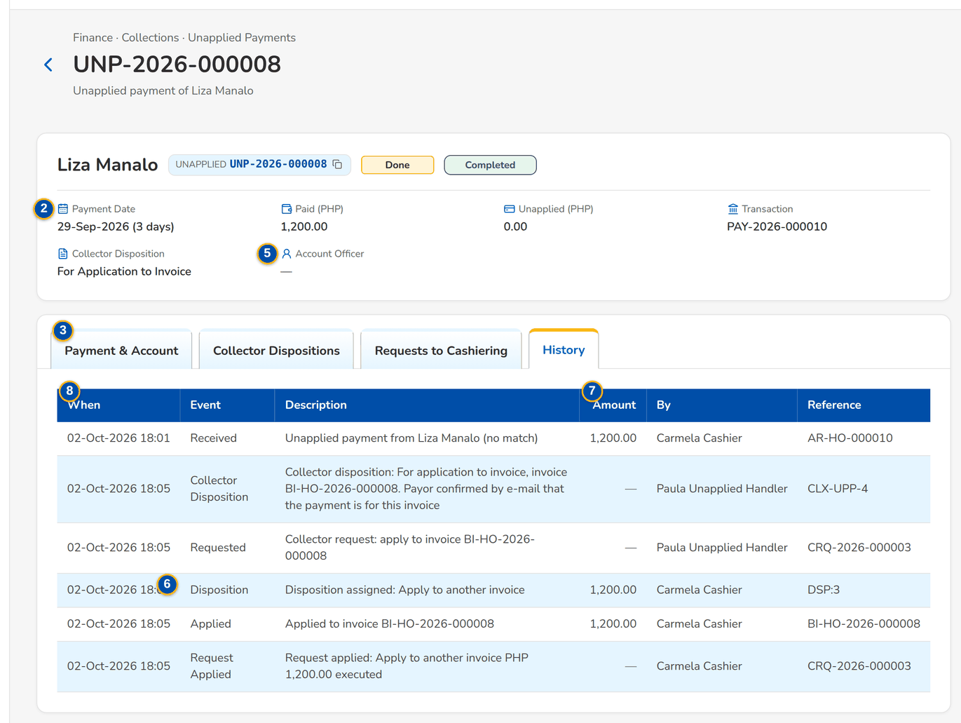
Figure 40: SCR-CL-15 History of an unapplied payment with the dispositions and the request to Cashiering
Fields (No. = callout number on the first screenshot)
No. | Section | Field | Type | Length / format | Mand. | Source / list | Default | Editable in | Validation | Message when it fails
1 | Header | Unapplied chip, Cashiering tab, request status | Reference chip, tag, status pill | - | - | Cashiering | - | Read only | - | -
2 | Facts | Payment Date / Paid / Unapplied / Transaction / Collector Disposition / Account Officer | Display | Date with the age; amounts with the currency; label; name | - | Cashiering, invoice ledger | - | Read only | - | -
3 | Tabs | Payment & Account / Collector Dispositions / Requests to Cashiering / History | Tab | - | - | Fixed | Payment & Account | - | - | -
4 | Payment & Account | Payment File / Transaction No. / Payment Type / Bank / Check No. / Payor Reference | Display | - | - | Cashiering | - | Read only | - | -
5 | Payment & Account | Matched Client / Matched Invoice / Name of Assured / PR Balance / Inception / Market Segment / Sales Unit / Unit Head / Account Officer / Insurer / Invoice Category / Collection Handler | Display | Names of the users; insurer name | - | Invoice ledger, collection account | - | Read only | - | -
6 | Collector Dispositions | Recorded / Disposition / Cashiering / Invoice No. / Amount / By / Remarks | Column | Whole balance when no amount | - | Collector dispositions | - | Read only | - | No collector disposition yet
7 | Requests to Cashiering | Unapplied Reference / Request / Amount / Requested By / Cashiering Reference / Application File / Status | Column | - | - | Requests | - | Read only | - | No request sent to Cashiering
8 | History | When / Event / Description / Amount / By / Reference | Column | - | - | Cashiering, Collections | - | Read only | - | No history

Actions
Button | Who | Enabled when | What happens | Resulting status | Notification
Record Disposition | Users with the unapplied work permission | Balance above zero | Opens the disposition dialog | - | -
Request Application | Users with the unapplied work permission | Balance above zero | Opens the dialog with For Application to Invoice chosen | Request Sent | -

Business rules
• The payment is read from Cashiering as of today; the collector never changes the payment itself (FR-CL-070).
• The history keeps every disposition and request after the payment is applied or refunded (FR-CL-076).
Expected outcome
The collector sees the payment, what was decided and where Cashiering is with it.
Test cases: TC-CL-070.2-01, TC-CL-073.1-01, TC-CL-076.1-01, TC-CL-SCR-15.

13.4.3 SCR-CL-16 Requests to Cashiering
Purpose | The status of every request sent to Cashiering on a collector disposition: sent, handed over, accepted, executed or rejected, with the Cashiering reference and message and the daily application file that listed it; Check Status asks Cashiering again for the selected open requests.
Who can open it | Marketing Account Officer, Marketing Team Lead, Marketing Handler, Collection Handler, Collection Team Lead, Section Head (Corporate / Retail), Unapplied Payment Handler, Processing Unit, Cashier (read access and exports), Disbursement (read access and exports), Comptrollership (read access), Business Administrator, System Administrator, Auditor (permission Clx view or Clx unapplied work)
Navigation | • Menu: Finance › Collections › Requests to Cashiering  • Finance › Collections › Requests to Cashiering  • Unapplied Payments › Requests to Cashiering  • Collections Home › My Requests in Cashiering tile
FRs | FR-CL-074, FR-CL-077

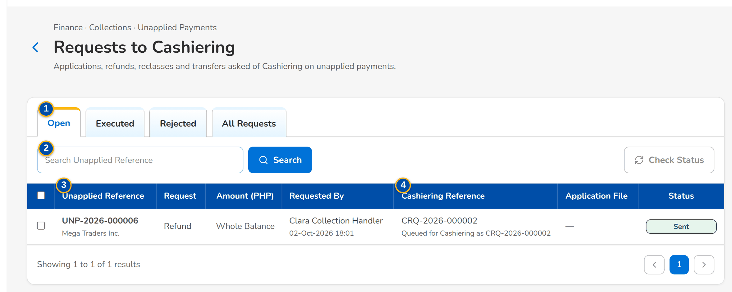
Figure 41: SCR-CL-16 Requests to Cashiering: the open requests with the Cashiering reference
1 | Open / Executed / Rejected / All Requests | 3 | Unapplied Reference / Request / Amount / Requested By
2 | Search Unapplied Reference | 4 | Cashiering Reference / Application File / Status

Fields (No. = callout number on the first screenshot)
No. | Section | Field | Type | Length / format | Mand. | Source / list | Default | Editable in | Validation | Message when it fails
1 | Tabs | Open / Executed / Rejected / All Requests | Tab | - | - | Request status | Open | - | - | -
2 | Toolbar | Search Unapplied Reference | Text | - | N | Requests | Blank | - | Contains | -
3 | List | Unapplied Reference / Request / Amount / Requested By | Column | Reference with the payor; Apply to Invoice, Refund, Reclass or Transfer to Unit with the invoice; amount or Whole Balance; name and time | - | Requests | - | Read only | - | No requests to display
4 | List | Cashiering Reference / Application File / Status | Column | Reference and message of Cashiering; the date of the daily file; Sent, Deferred, Accepted, Applied or Rejected | - | Cashiering | - | Read only | - | -

Actions
Button | Who | Enabled when | What happens | Resulting status | Notification
Check Status | Users with the unapplied work permission | Open requests selected | Asks Cashiering for the status of each selected request | - | -
Row | Every Collections user | Always | Opens the unapplied payment | - | -

Business rules
• The requester is notified when Cashiering accepts, rejects or executes a request (FR-CL-074).
• The daily For Application To Invoice file of the previous day lists the application requests before 06:00 (FR-CL-077).
Expected outcome
The collector follows each request to its execution.
Test cases: TC-CL-074.1-01, TC-CL-074.3-01, TC-CL-077.1-01, TC-CL-077.2-01, TC-CL-SCR-16.

13.5 Assignment, files and set-up

13.5.1 SCR-CL-17 Assignments
Purpose | Who handles new accounts by default: the assignment rules tried in priority order by the nightly refresh, each with its criteria and handler; and the reassignment of accounts by criteria after a preview, permanently or temporarily until an end date.
Who can open it | Marketing Team Lead, Collection Team Lead, Section Head (Corporate / Retail) (permission Clx assign)
Navigation | • Menu: Finance › Collections › Assignments  • Finance › Collections › Assignments
FRs | FR-CL-020, FR-CL-021

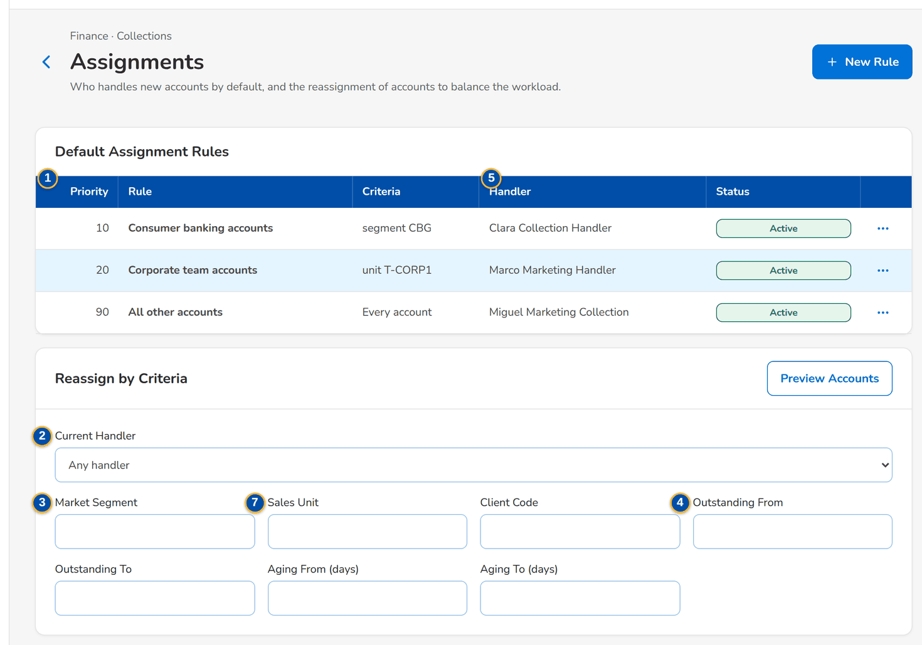
Figure 42: SCR-CL-17 Assignments: the default assignment rules with their row menu, and Reassign by Criteria
1 | Priority / Rule / Criteria / Handler / Status | 4 | Outstanding From / Outstanding To / Aging From (days) / Aging To (days) | 7 | Market Segment / Sales Unit / Client Code / Outstanding From / Outstanding To / Aging From (days) / Aging To (days)
2 | Current Handler | 5 | Invoice No. / Assured / Handler / Outstanding
3 | Market Segment / Sales Unit / Client Code | 6 | Priority / Name / Handler

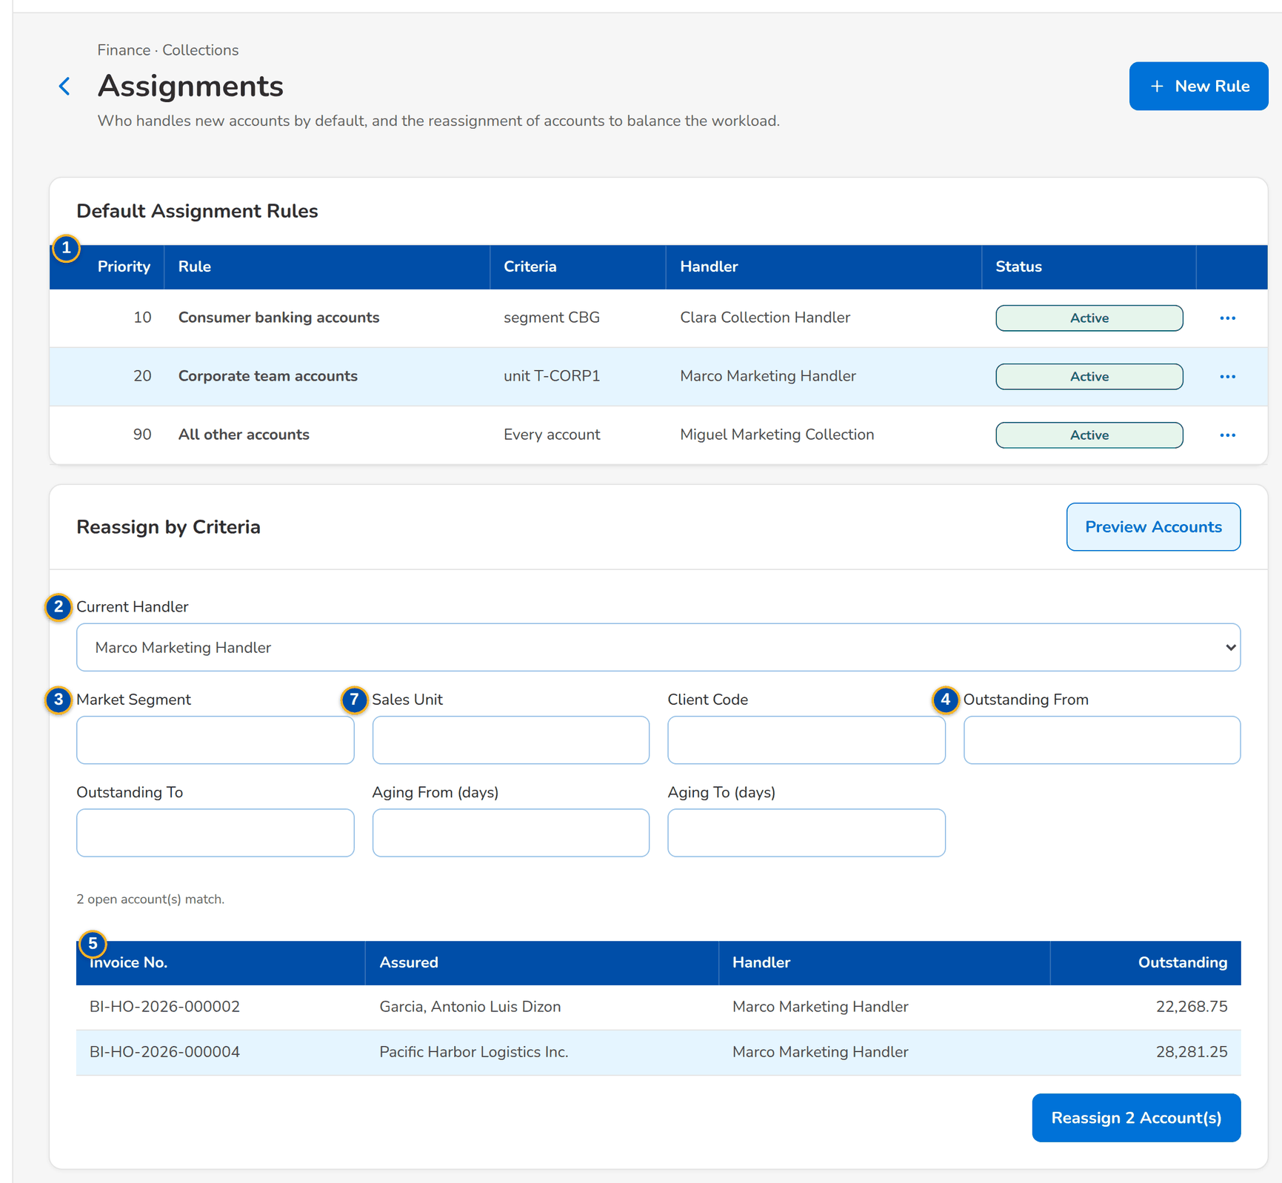
Figure 43: SCR-CL-17 Reassign by Criteria: the accounts of a handler found by the preview

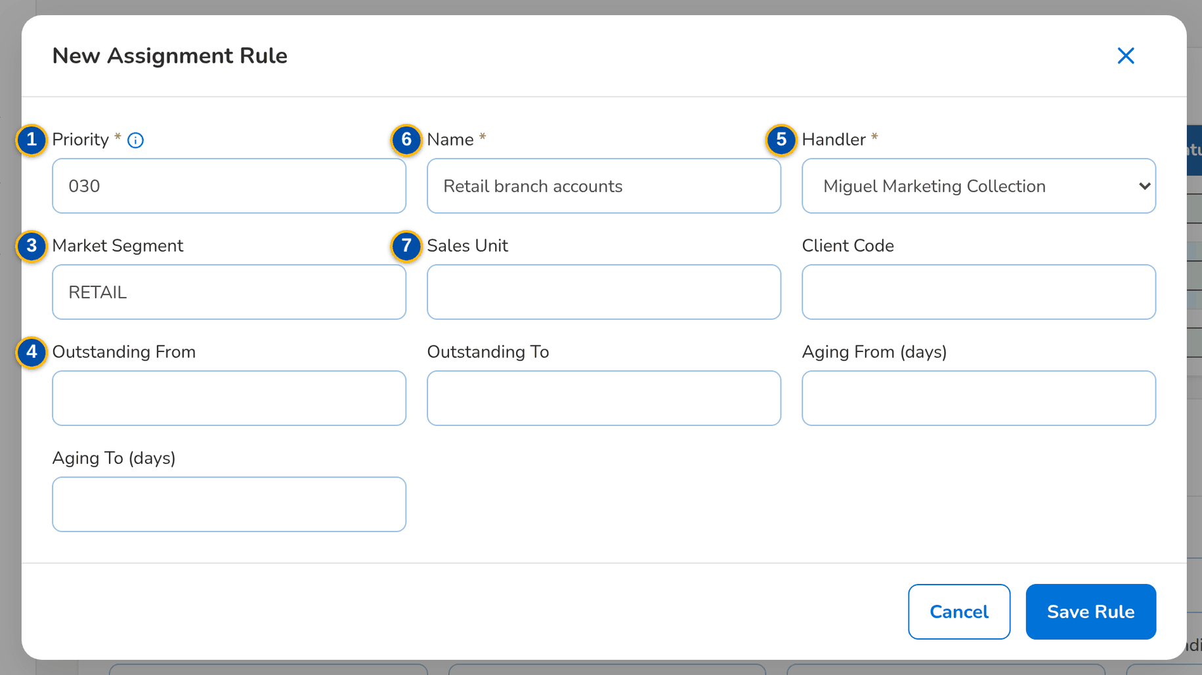
Figure 44: SCR-CL-17 New Assignment Rule dialog
Fields (No. = callout number on the first screenshot)
No. | Section | Field | Type | Length / format | Mand. | Source / list | Default | Editable in | Validation | Message when it fails
1 | Default Assignment Rules | Priority / Rule / Criteria / Handler / Status | Column | Lower numbers are tried first; criteria in words; handler's name; Active or Inactive | - | Assignment rules | - | Read only | - | No assignment rule: new accounts go to their account officer
2 | Reassign by Criteria | Current Handler | Drop-down | Handlers by name, or any handler | N | Active collection handlers | Any handler | - | - | -
3 | Reassign by Criteria | Market Segment / Sales Unit / Client Code | Text | Code | N | Sales organisation, clients | Blank | - | Equal | -
4 | Reassign by Criteria | Outstanding From / Outstanding To / Aging From (days) / Aging To (days) | Number | Amounts; days | N | - | Blank | - | A range starts before it ends | A range must start before it ends
5 | Reassign by Criteria | Invoice No. / Assured / Handler / Outstanding | Column | The first 20 accounts found, with the total | - | Collection accounts | - | Read only | - | No account matches the selection
6 | New Assignment Rule dialog | Priority / Name / Handler | Number, text, drop-down | Lower numbers are tried first; up to 120 characters; handlers by name | Y | Active collection handlers | 100 | - | Name not blank; a handler chosen | Give the rule a name
7 | New Assignment Rule dialog | Market Segment / Sales Unit / Client Code / Outstanding From / Outstanding To / Aging From (days) / Aging To (days) | Text, number | Empty criteria match every account | N | - | Blank | - | A range starts before it ends | A range must start before it ends

Actions
Button | Who | Enabled when | What happens | Resulting status | Notification
New Rule | Team leads and section heads (assignment permission) | Always | Opens the dialog | - | -
Save Rule | Team leads and section heads (assignment permission) | The form is complete | Saves the rule | Active | -
Change Rule (row menu) | Team leads and section heads (assignment permission) | Always | Opens the rule | - | -
Activate / Deactivate (row menu) | Team leads and section heads (assignment permission) | Inactive / Active | Switches the rule on or off | Active / Inactive | -
Preview Accounts | Team leads and section heads (assignment permission) | Always | Lists the open accounts of the criteria | - | -
Reassign n Account(s) | Team leads and section heads (assignment permission) | At least one account found | Opens Reassign Accounts for the accounts found | - | Account reassigned (NT-03)

Business rules
• New accounts go to the handler of the first active rule they meet, else to their account officer (FR-CL-020).
• The new handler must be an active collection handler; a temporary reassignment ends after today and the account returns to its handler on the end date (FR-CL-021).
• Every reassignment keeps its history on the account and notifies the handlers (FR-CL-021).
Expected outcome
The workload is spread over the handlers as the team lead decides.
Test cases: TC-CL-020.1-01, TC-CL-020.2-01, TC-CL-020.3-01, TC-CL-020.3-02, TC-CL-020.3-03, TC-CL-020.4-01, TC-CL-020.1-02, TC-CL-021.1-01, TC-CL-021.2-01, TC-CL-021.4-01, TC-CL-021.4-02, TC-CL-021.4-03, TC-CL-021.4-04, TC-CL-SCR-17, TC-CL-MSG-12.

13.5.2 SCR-CL-18 Collections Files
Purpose | The scheduled files and the exports of Collections, with the time from which each may be downloaded: the daily Outstanding PR List and Full Production Report, the weekly DP PR for Reversal and PR 2307 for Reversal files per unit and branch, the monthly ones of the previous month, and the exports of the users.
Who can open it | Marketing Account Officer, Marketing Team Lead, Marketing Handler, Collection Handler, Collection Team Lead, Section Head (Corporate / Retail), Unapplied Payment Handler, Cashier (read access and exports), Disbursement (read access and exports), Comptrollership (read access), System Administrator, Auditor (permission Clx report view or Clx export)
Navigation | • Menu: Finance › Collections › Collections Files  • Finance › Collections › Collections Files  • Collections Home › Files Ready This Week tile
FRs | FR-CL-080, FR-CL-081, FR-CL-082, FR-CL-083, FR-CL-084

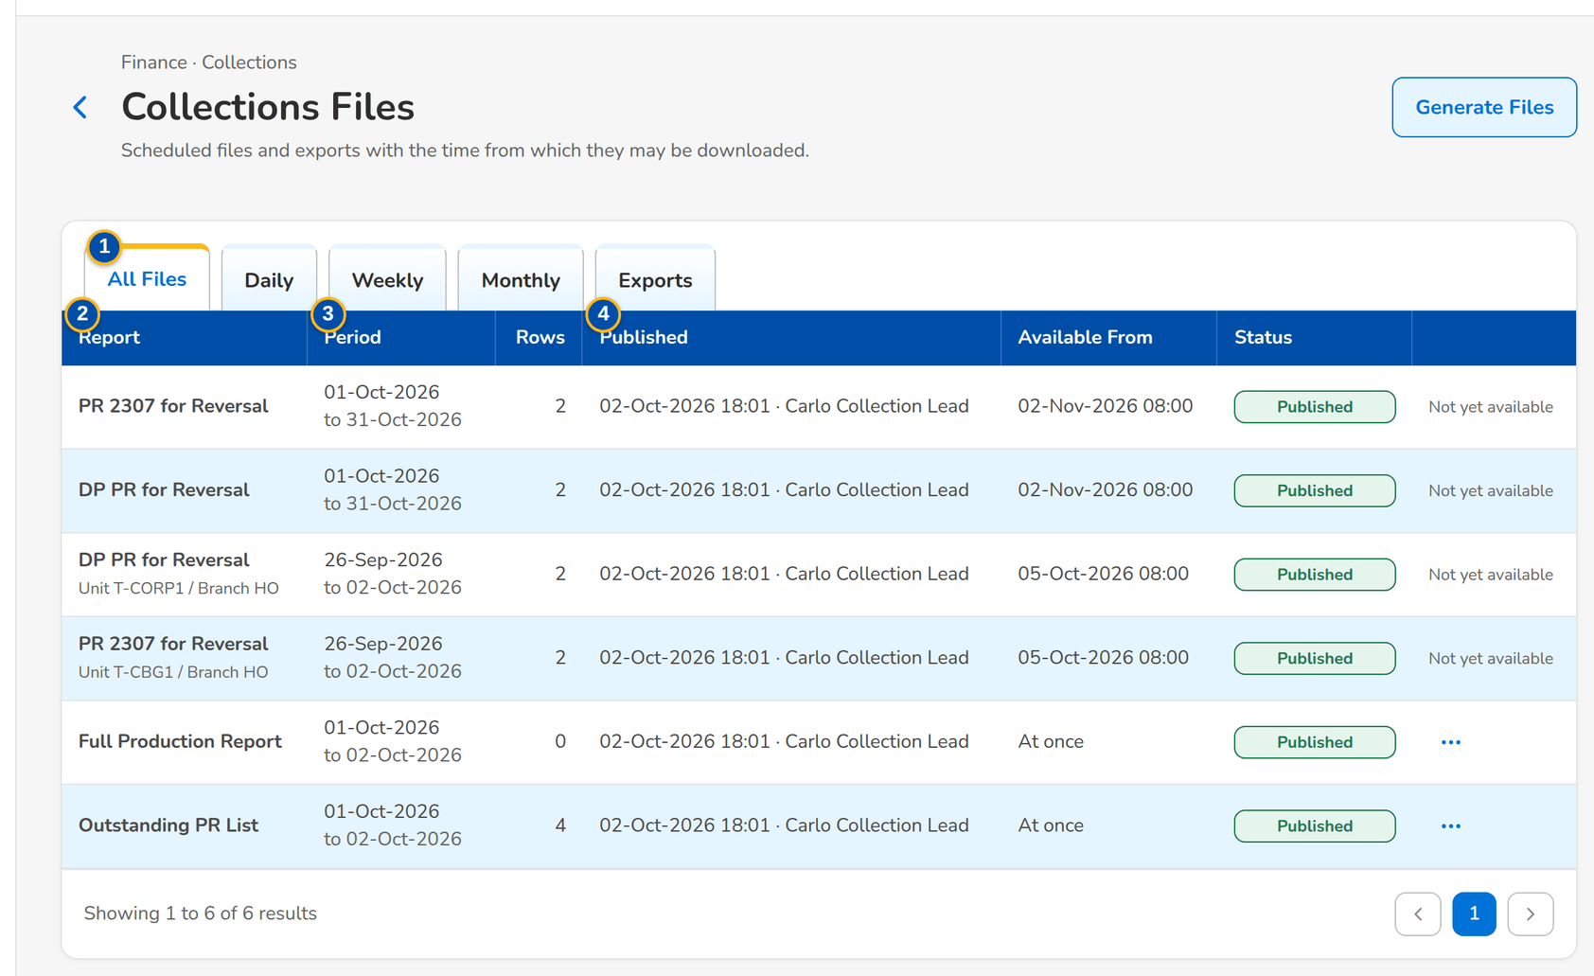
Figure 45: SCR-CL-18 Collections Files: the daily, weekly and monthly files with their availability
1 | All Files / Daily / Weekly / Monthly / Exports | 3 | Period / Rows | 5 | Files / Business Date
2 | Report | 4 | Published / Available From / Status

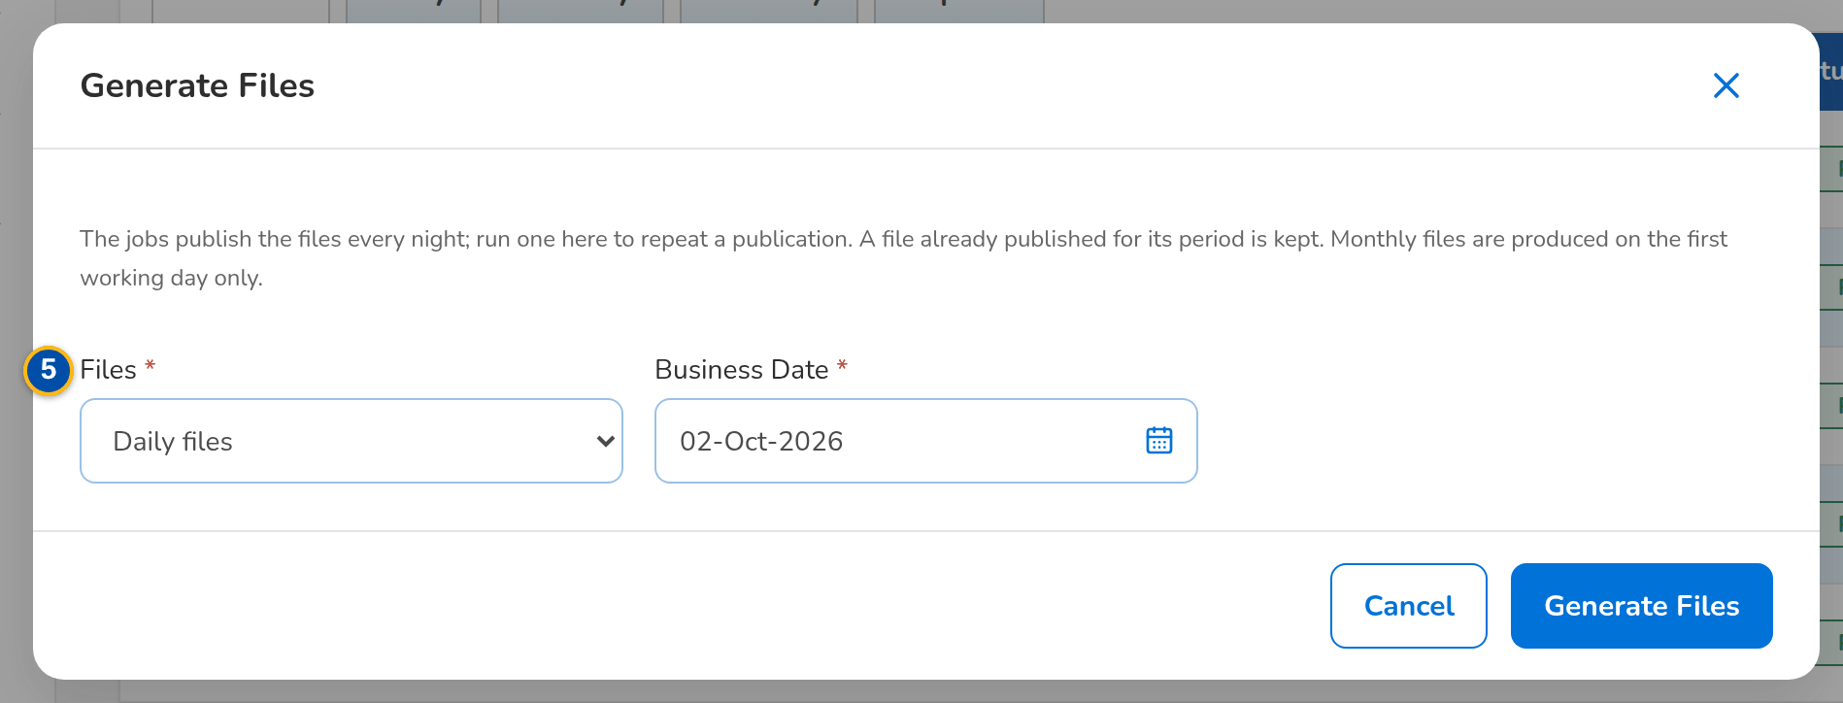
Figure 46: SCR-CL-18 Generate Files dialog of the set-up users
Fields (No. = callout number on the first screenshot)
No. | Section | Field | Type | Length / format | Mand. | Source / list | Default | Editable in | Validation | Message when it fails
1 | Tabs | All Files / Daily / Weekly / Monthly / Exports | Tab | - | - | Frequency | All Files | - | - | -
2 | List | Report | Column | Outstanding PR List, Full Production Report, DP PR for Reversal or PR 2307 for Reversal, with the unit and branch | - | Scheduled files | - | Read only | - | No file published yet
3 | List | Period / Rows | Column | Period on two lines; number of rows | - | Scheduled files | - | Read only | - | -
4 | List | Published / Available From / Status | Column | Date and time with the user's name; At once or the date and time; Published or Failed | - | Scheduled files | - | Read only | - | -
5 | Generate Files dialog | Files / Business Date | Drop-down, date | Daily files; Weekly files (week ending that Friday); Monthly files (previous month) | Y | Fixed list | Daily files / today | - | - | -

Actions
Button | Who | Enabled when | What happens | Resulting status | Notification
Download (row menu) | Users with the export permission | Available from its time | Downloads the file (Excel) | - | -
Generate Files | Users with the Collections set-up permission | Always | Publishes the files of the business date again; a file already published for its period is kept | Published | Collections file ready (NT-06)

Business rules
• A file cannot be downloaded before its availability time: daily at once, weekly on the Monday 08:00 after the week (Saturday to Friday), monthly on the first working day (FR-CL-080, FR-CL-081, FR-CL-082, FR-CL-083).
• A file that fails raises an alert to the administrators (FR-CL-083).
• Downloads need the export permission (FR-CL-084).
Expected outcome
The business takes the files it needs at the time agreed.
Test cases: TC-CL-080.1-01, TC-CL-080.2-01, TC-CL-080.3-01, TC-CL-081.1-01, TC-CL-081.2-01, TC-CL-082.1-01, TC-CL-082.2-01, TC-CL-083.1-01, TC-CL-083.2-01, TC-CL-084.3-01, TC-CL-SCR-18.

13.5.3 SCR-CL-19 Collections Setup
Purpose | The Collections parameters (minimal balance threshold, aging basis and brackets, export cap, edit-lock time, invoice number format, promise grace days), the attributes of each disposition value (category, tagging owner, Operations action, reserved roles, unapplied-payment attributes), the Unit Head of each sales unit and a refresh of the worklist on demand.
Who can open it | Section Head (Corporate / Retail), Business Administrator, System Administrator (permission Clx setup)
Navigation | • Menu: Finance › Collections › Collections Setup  • Finance › Collections › Collections Setup
FRs | FR-CL-003, FR-CL-012, FR-CL-030, FR-CL-072

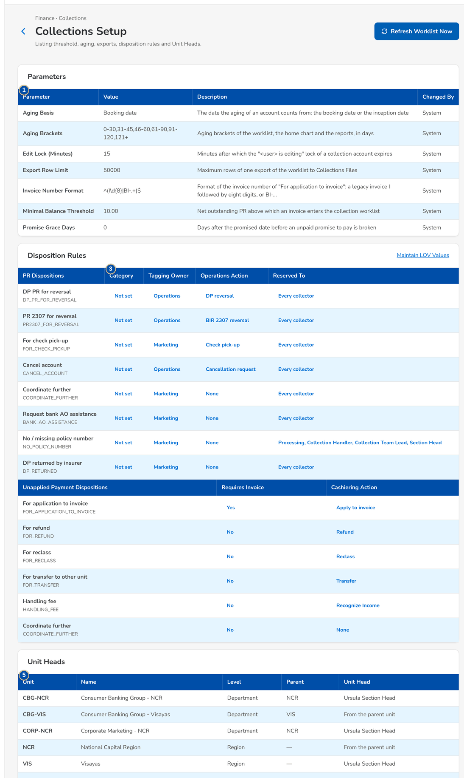
Figure 47: SCR-CL-19 Collections Setup: the parameters and the disposition rules
1 | Parameter / Value / Description / Changed By | 3 | Category / Tagging Owner / Operations Action / Reserved To / Requires Invoice / Cashiering Action | 5 | Unit / Name / Level / Parent / Unit Head
2 | PR Dispositions / Unapplied Payment Dispositions | 4 | Attribute value | 6 | Parameter value

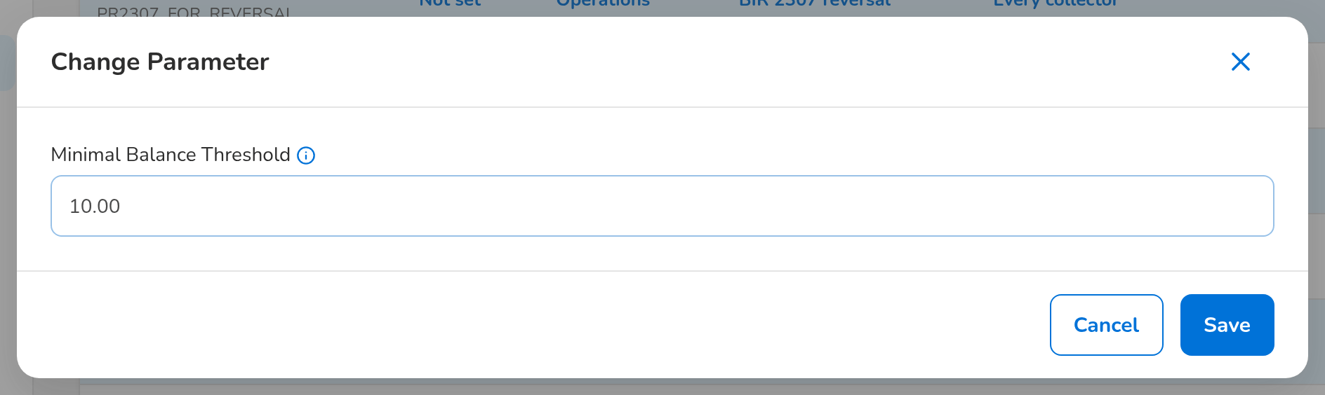
Figure 48: SCR-CL-19 Change Parameter dialog of the minimal balance threshold
Fields (No. = callout number on the first screenshot)
No. | Section | Field | Type | Length / format | Mand. | Source / list | Default | Editable in | Validation | Message when it fails
1 | Parameters | Parameter / Value / Description / Changed By | Column | The parameter by name, its value, what it does and the name of the last user who changed it | - | System parameters | Seeded defaults | - | Within the range of the parameter | -
2 | Disposition Rules | PR Dispositions / Unapplied Payment Dispositions | Table | One table per list: the label of each disposition value with its code under it | - | Lists of values | - | Read only | - | -
3 | Disposition Rules | Category / Tagging Owner / Operations Action / Reserved To / Requires Invoice / Cashiering Action | Column | Category A, B or C; Marketing or Operations; the Operations action; the roles the value is reserved to (Every collector when none); Yes or No; the Cashiering action; Not set when blank | N | Disposition attributes | Seeded defaults | - | A value of the attribute | '<value>' is not a valid <attribute>
4 | Attribute dialog | Attribute value | Drop-down / check boxes | The labels of the attribute's values; the reserved roles as check boxes, none ticked for every collector | N | Disposition attributes | Current value | - | A value of the attribute | -
5 | Unit Heads | Unit / Name / Level / Parent / Unit Head | Column | Sales unit with its level and parent; the Unit Head's name or From the parent unit | - | Sales organisation | - | - | An active user | -
6 | Change Parameter dialog | Parameter value | Text or drop-down | The value with its hint; the aging basis as a drop-down (Booking date or Inception date) | Y | - | Current value | - | Within the range of the parameter | -

Actions
Button | Who | Enabled when | What happens | Resulting status | Notification
Refresh Worklist Now | Users with the Collections set-up permission | Always | Runs the refresh of the worklist from the invoice ledger at once and shows its outcome | - | -
Parameter row | Users with the Collections set-up permission | Always | Opens Change Parameter | - | -
Attribute value | Users with the Collections set-up permission | Always | Opens the attribute of the disposition value | - | -
Maintain LOV Values | Users who maintain lists of values | Always | Opens the Lists of Values screen to add or deactivate disposition values | - | -
Unit row | Users with the Collections set-up permission | Always | Sets the Unit Head of the unit | - | -

Business rules
• Every change is kept in the Collections audit log with the old and new value (FR-CL-003, FR-CL-012).
• Disposition values themselves are added and deactivated on the Lists of Values screen with maker-checker; their rules are kept here (FR-CL-030, FR-CL-072).
• The minimal balance threshold is 10.00 by default; the business changes it here without a change request (FR-CL-012).
Expected outcome
The business keeps the Collections rules without a change request.
Test cases: TC-CL-001.2-02, TC-CL-003.2-01, TC-CL-012.1-01, TC-CL-012.2-01, TC-CL-012.2-02, TC-CL-012.2-03, TC-CL-012.3-01, TC-CL-012.4-01, TC-CL-015.3-01, TC-CL-017.4-01, TC-CL-030.3-01, TC-CL-030.3-02, TC-CL-062.2-01, TC-CL-072.3-01, TC-CL-SCR-19, TC-CL-MSG-13.

14 End-to-end walkthroughs
Five walkthroughs follow a case through the screens, persona by persona, with what the user does, what the user sees and the result of each step. They use seed data only and run in this order on the SIT environment: walkthroughs B, D and E work on the account that walkthrough A brings into the worklist. They are the script of the SIT review sessions of the Start Here guide.

14.1 WT-A A new outstanding account from the refresh of the worklist to the check pick-up in Cashiering
Two accounts booked by Processing are in the Operations invoice ledger, unpaid. The refresh of the worklist (every night; here run on demand from Collections Setup) lists their invoices and assigns them by the assignment rules. The Collection Handler finds the new account in her worklist, logs a phone call and records the disposition For check pick-up with the pick-up details; the pick-up request reaches Cashiering at once.
Seed data: accounts ARN-2026-940007 and ARN-2026-940008 booked by Processing (Mabuhay General Insurance Corp.); assignment rule Consumer banking accounts (segment CBG) to Clara Collection Handler
Step 1. Section Head (Corporate / Retail) – Collections Setup (SCR-CL-19)
Does | Clicks Refresh Worklist Now on Collections Setup
Sees | Message with the outcome of the refresh: the accounts listed and updated
Result | Worklist refreshed

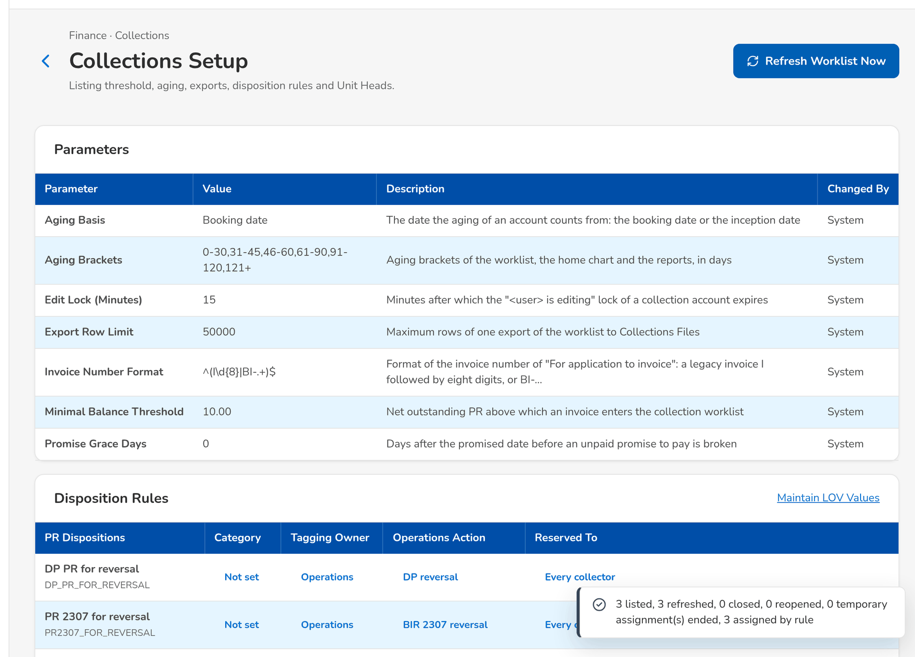
Figure 49: WT-A step 1: Collections Setup
Step 2. Collection Handler – Collections Home (SCR-CL-01)
Does | Opens Collections Home
Sees | My Open Accounts counts the new account assigned to her by the rule; the open amounts by aging bracket
Result | Assigned

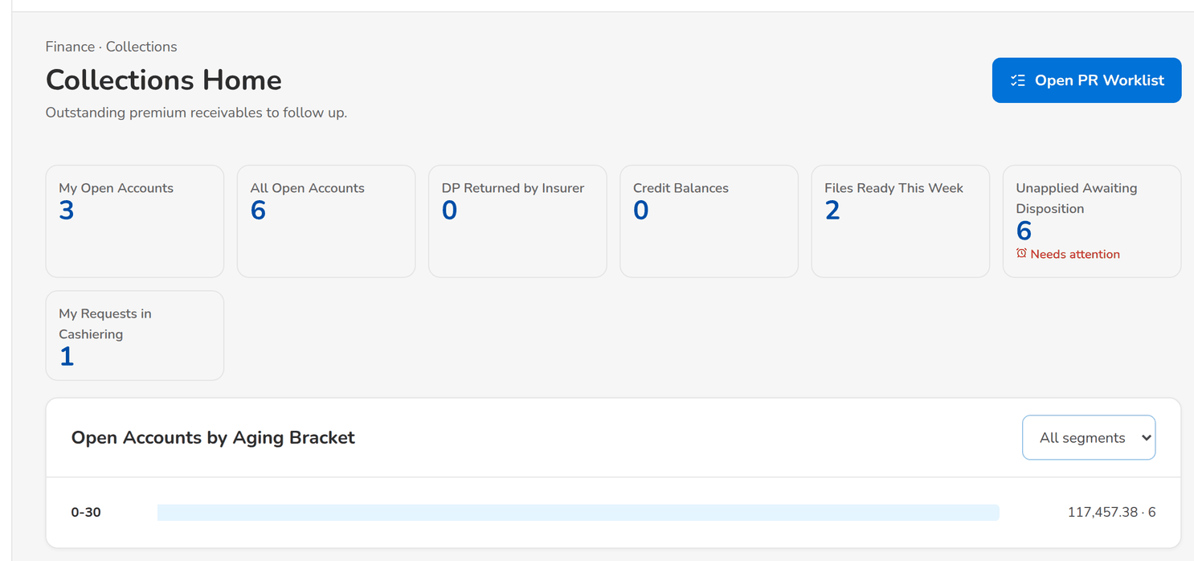
Figure 50: WT-A step 2: Collections Home
Step 3. Collection Handler – PR Worklist (SCR-CL-02)
Does | Opens the PR Worklist with Only mine ticked
Sees | The new invoice with the client, segment, booking date and aging, outstanding premium, her name as handler and no disposition yet
Result | In the worklist

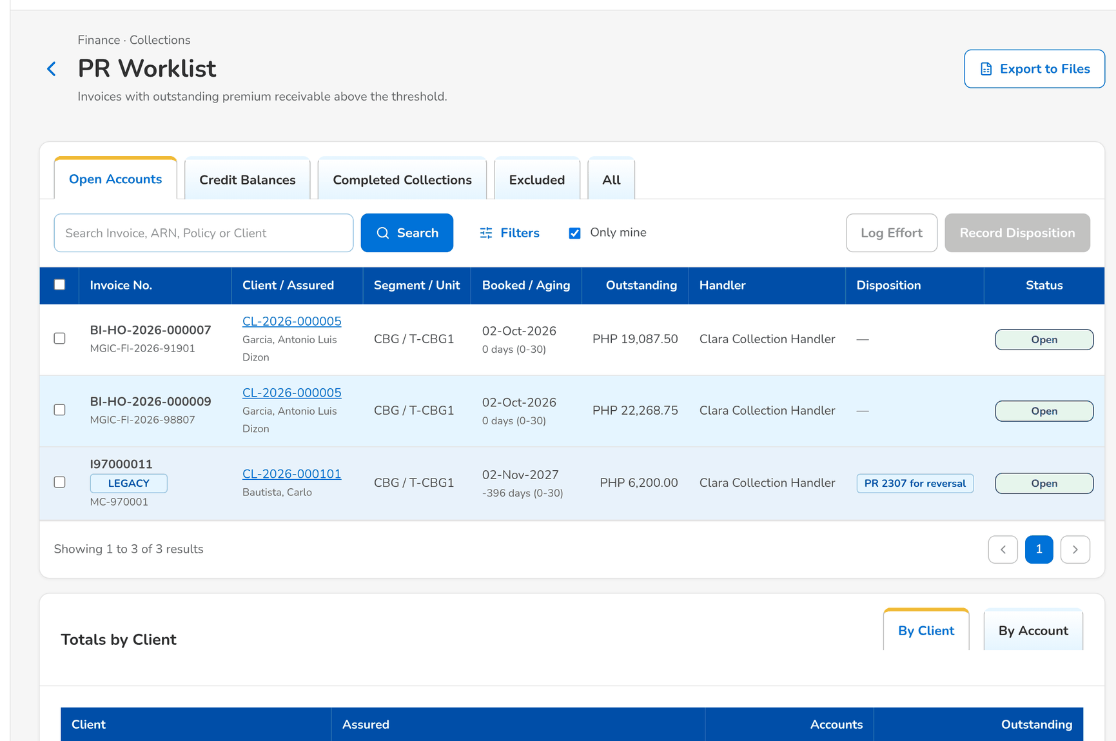
Figure 51: WT-A step 3: PR Worklist
Step 4. Collection Handler – Collection Account (SCR-CL-03)
Does | Opens the account and clicks Log Effort: Phone call to the client's finance officer
Sees | Message: Effort logged; the Summary tab shows the last effort
Result | Effort logged

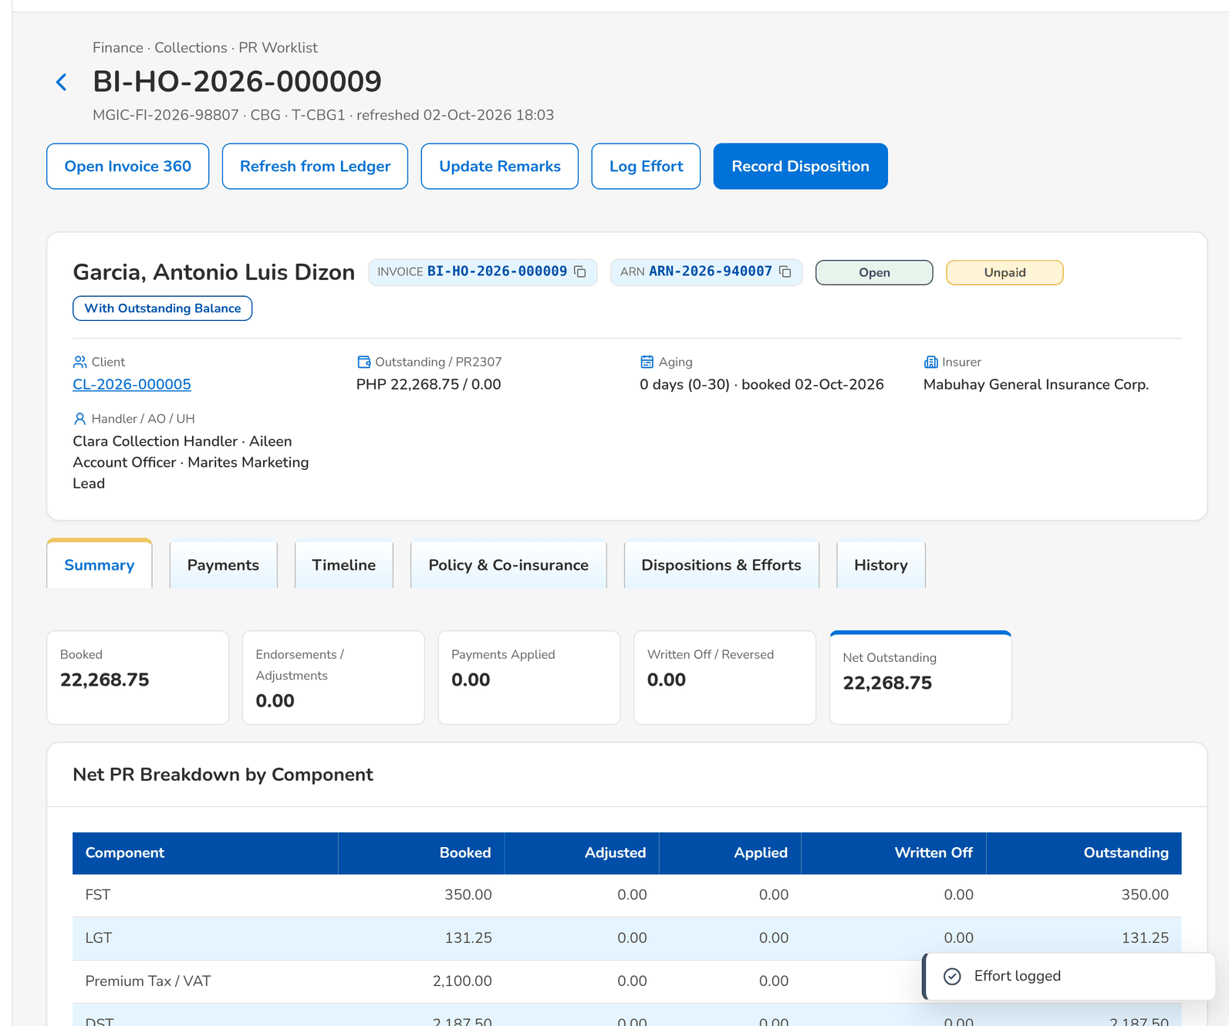
Figure 52: WT-A step 4: Collection Account
Step 5. Collection Handler – Collection Account (SCR-CL-03)
Does | Clicks Record Disposition, chooses For check pick-up and enters the pick-up date, address, contact person and check amount
Sees | Message: Disposition recorded; Dispositions & Efforts shows the disposition and the hand-off Check Pickup sent to Cashiering
Result | Handed to Cashiering

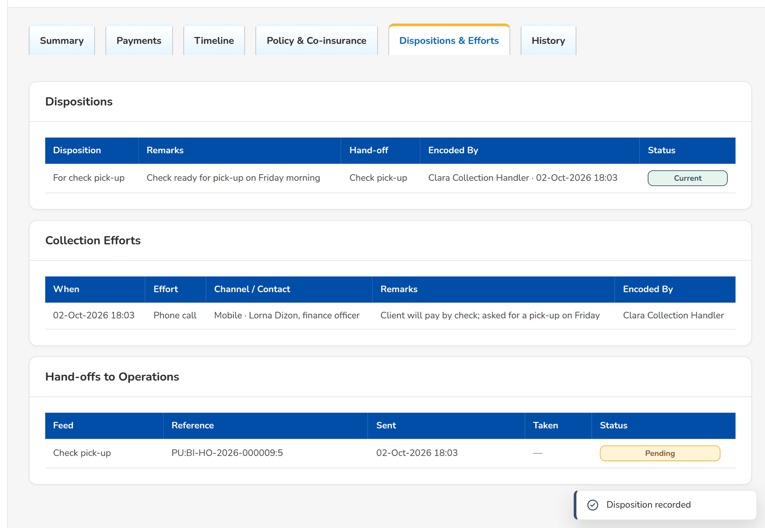
Figure 53: WT-A step 5: Collection Account
Step 6. Cashier (read access and exports) – Check Pick-up (SCR-OP-17)
Does | Opens Check Pick-up in Cashiering
Sees | The pick-up request of the account with its date, address, contact and amount, to be scheduled
Result | With Cashiering

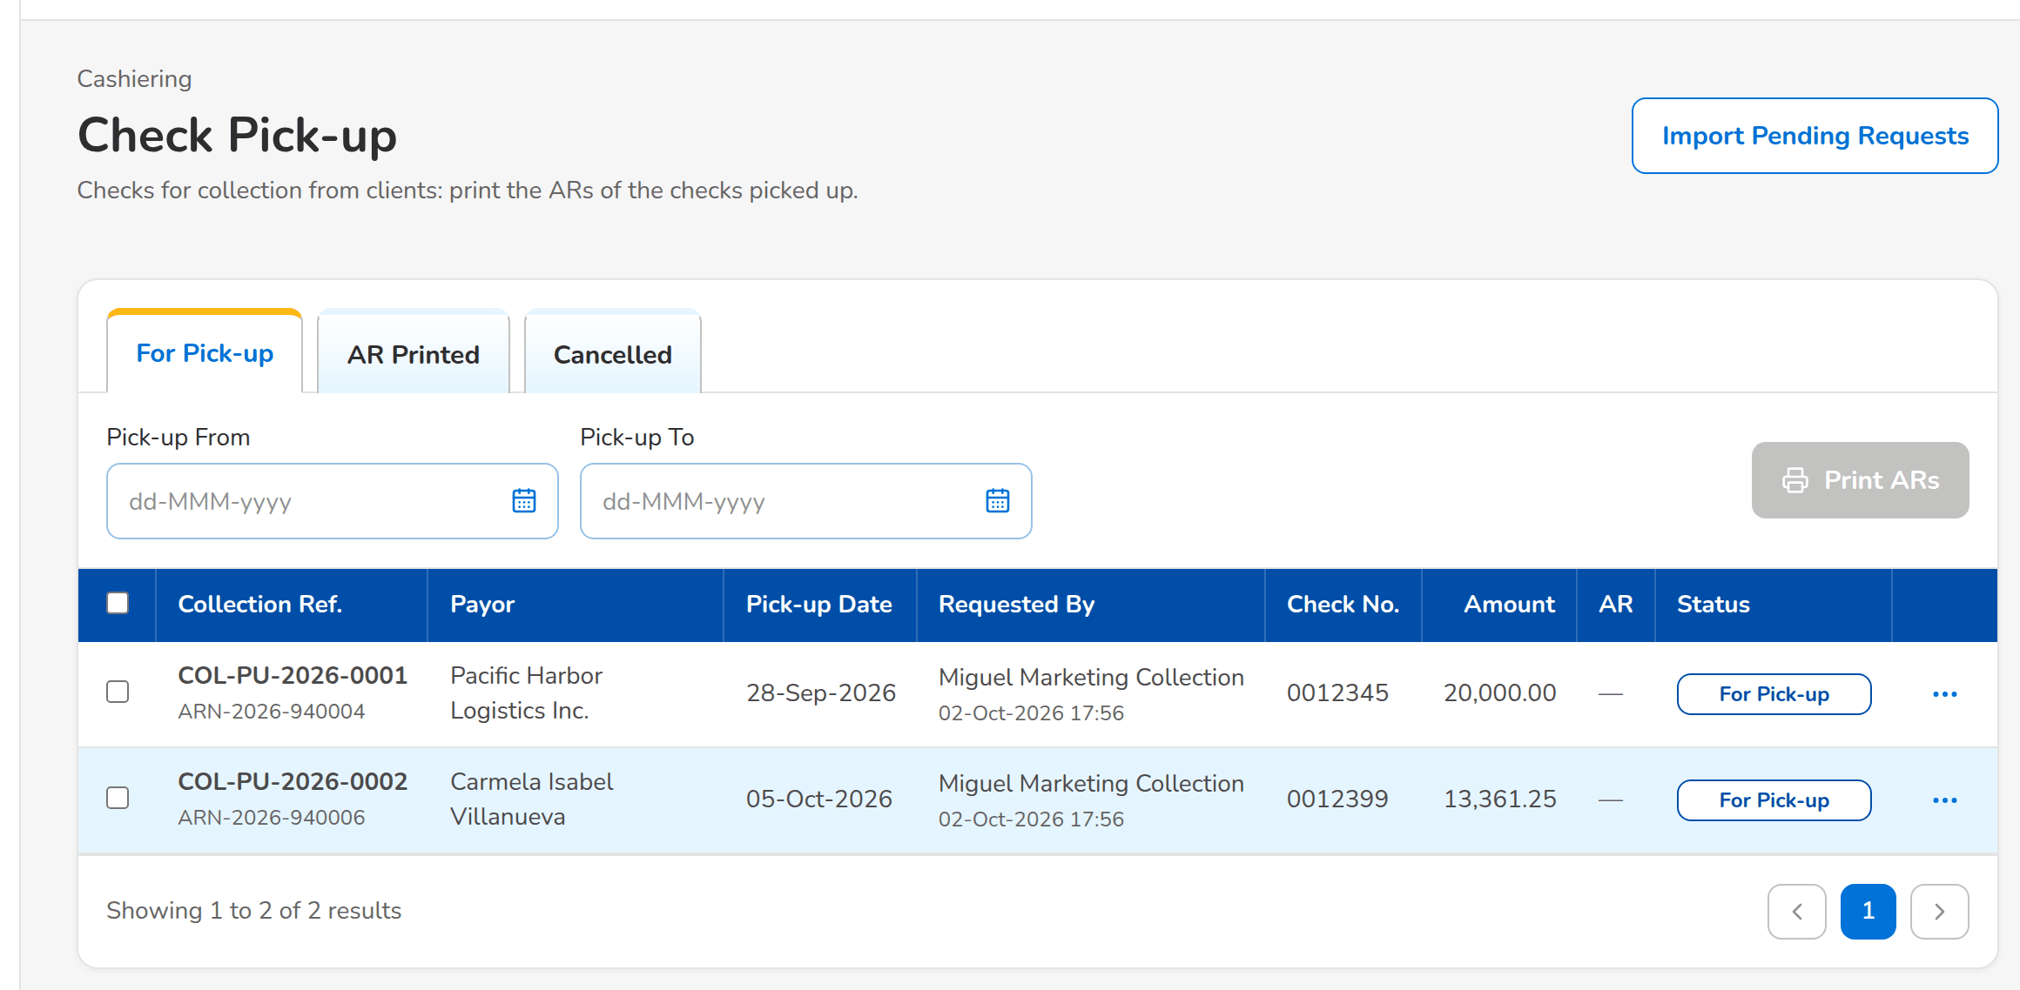
Figure 54: WT-A step 6: Check Pick-up
What happens next, downstream
• Cashiering prints the pick-up list, collects the check and receipts it; the payment is applied by component in the invoice ledger and the next refresh updates the outstanding of the account.
• When the account is paid, it moves to Completed Collections; it reopens if the balance comes back.

14.2 WT-B A promise to pay, the escalation of the account and its resolution
The client of walkthrough A promises to pay half of the premium in ten days. The insurer refuses a credit term extension, so the Collection Handler escalates the account to the Collection Team Lead, who acknowledges it and resolves it with the agreed arrangement. The authorizer of master data then authorizes the escalation rule for accounts of one million or more that the Business Administrator set up.
Seed data: the account of walkthrough A; escalation rule CLX-AMOUNT-1M waiting for authorization (made by the Business Administrator)
Step 1. Collection Handler – Promises to Pay (SCR-CL-08)
Does | Clicks Record Promise and enters the invoice, the promised payment date in ten days and half of the outstanding
Sees | Promises Recorded: the promise of the invoice recorded; it is on Open Promises
Result | Promise open

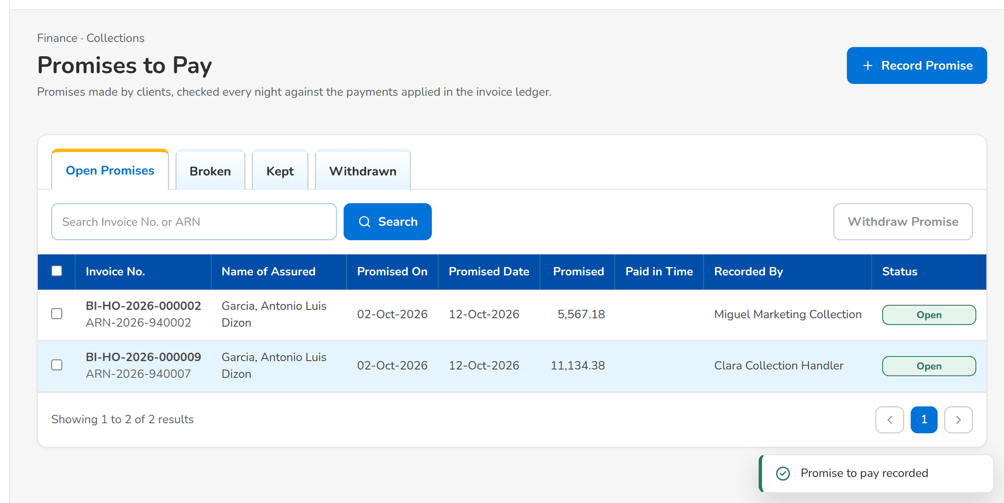
Figure 55: WT-B step 1: Promises to Pay
Step 2. Collection Handler – Escalations (SCR-CL-11)
Does | Clicks Escalate Accounts and enters the invoice, Team Lead and the reason Credit term extension refused by the insurer
Sees | Escalation Results: one escalation raised for the account
Result | Escalated

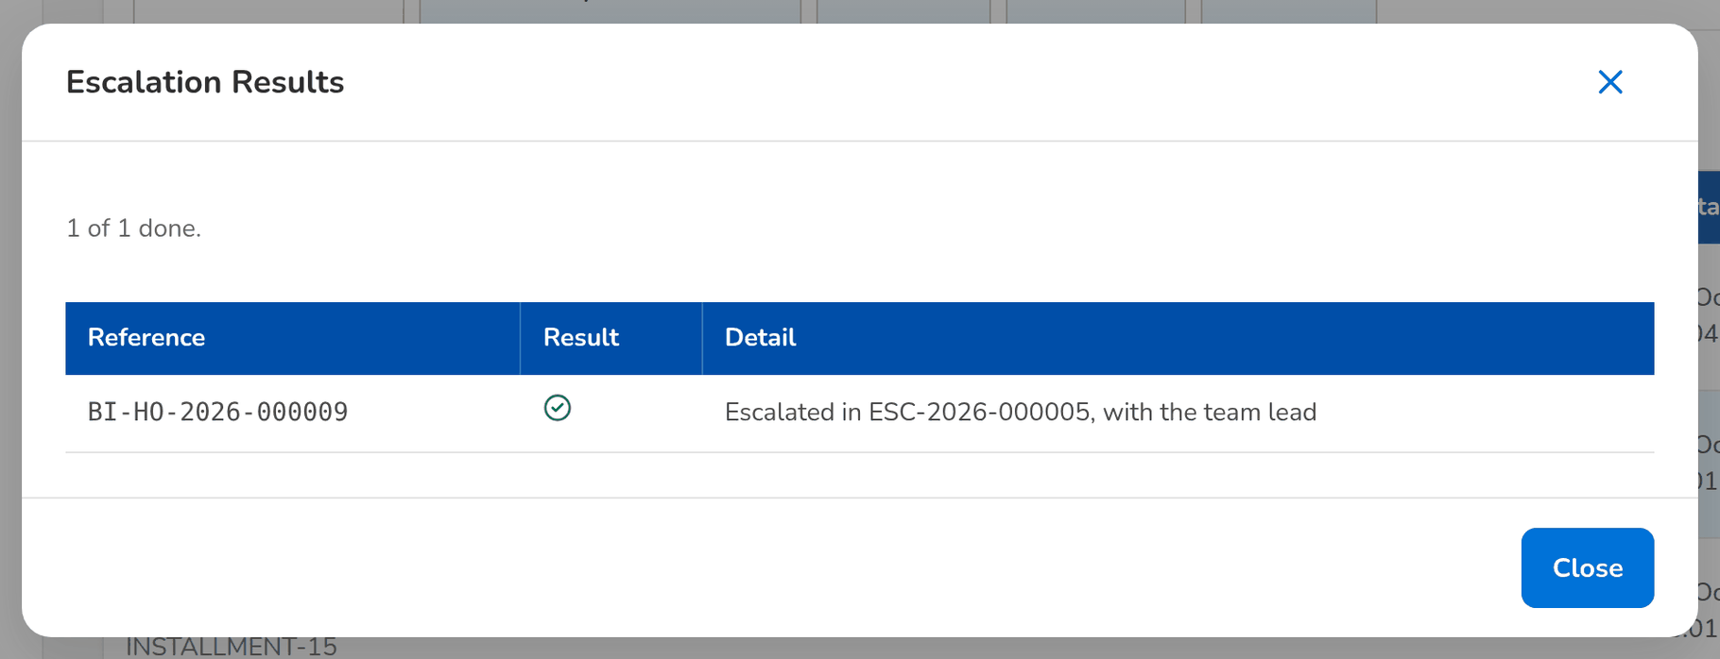
Figure 56: WT-B step 2: Escalations
Step 3. Collection Team Lead – Escalation (SCR-CL-12)
Does | Opens the escalation from With Team Lead and clicks Acknowledge
Sees | The escalation is In action with the step in its history
Result | In action

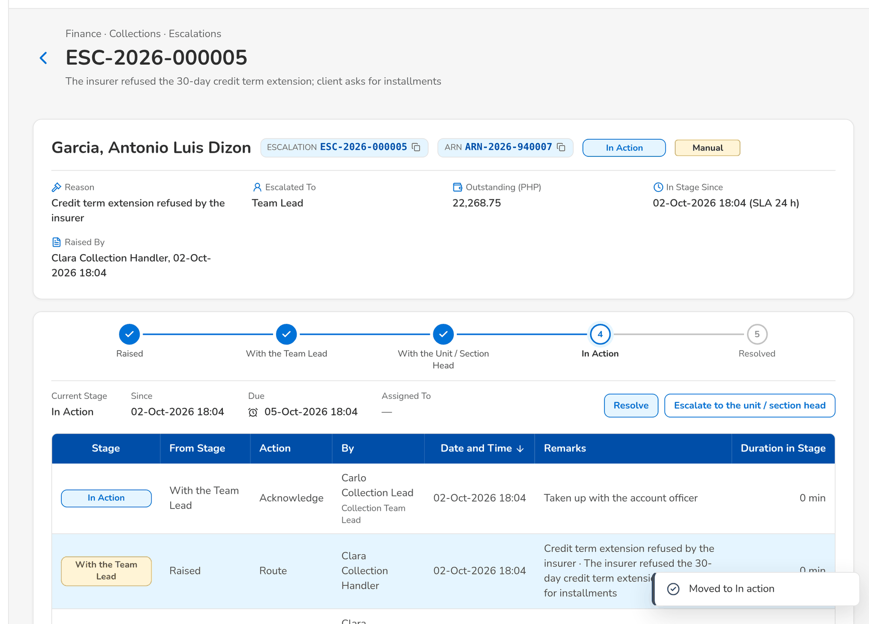
Figure 57: WT-B step 3: Escalation
Step 4. Collection Team Lead – Escalation (SCR-CL-12)
Does | Clicks Resolve and gives the resolution
Sees | The escalation is Resolved with the resolution
Result | Resolved

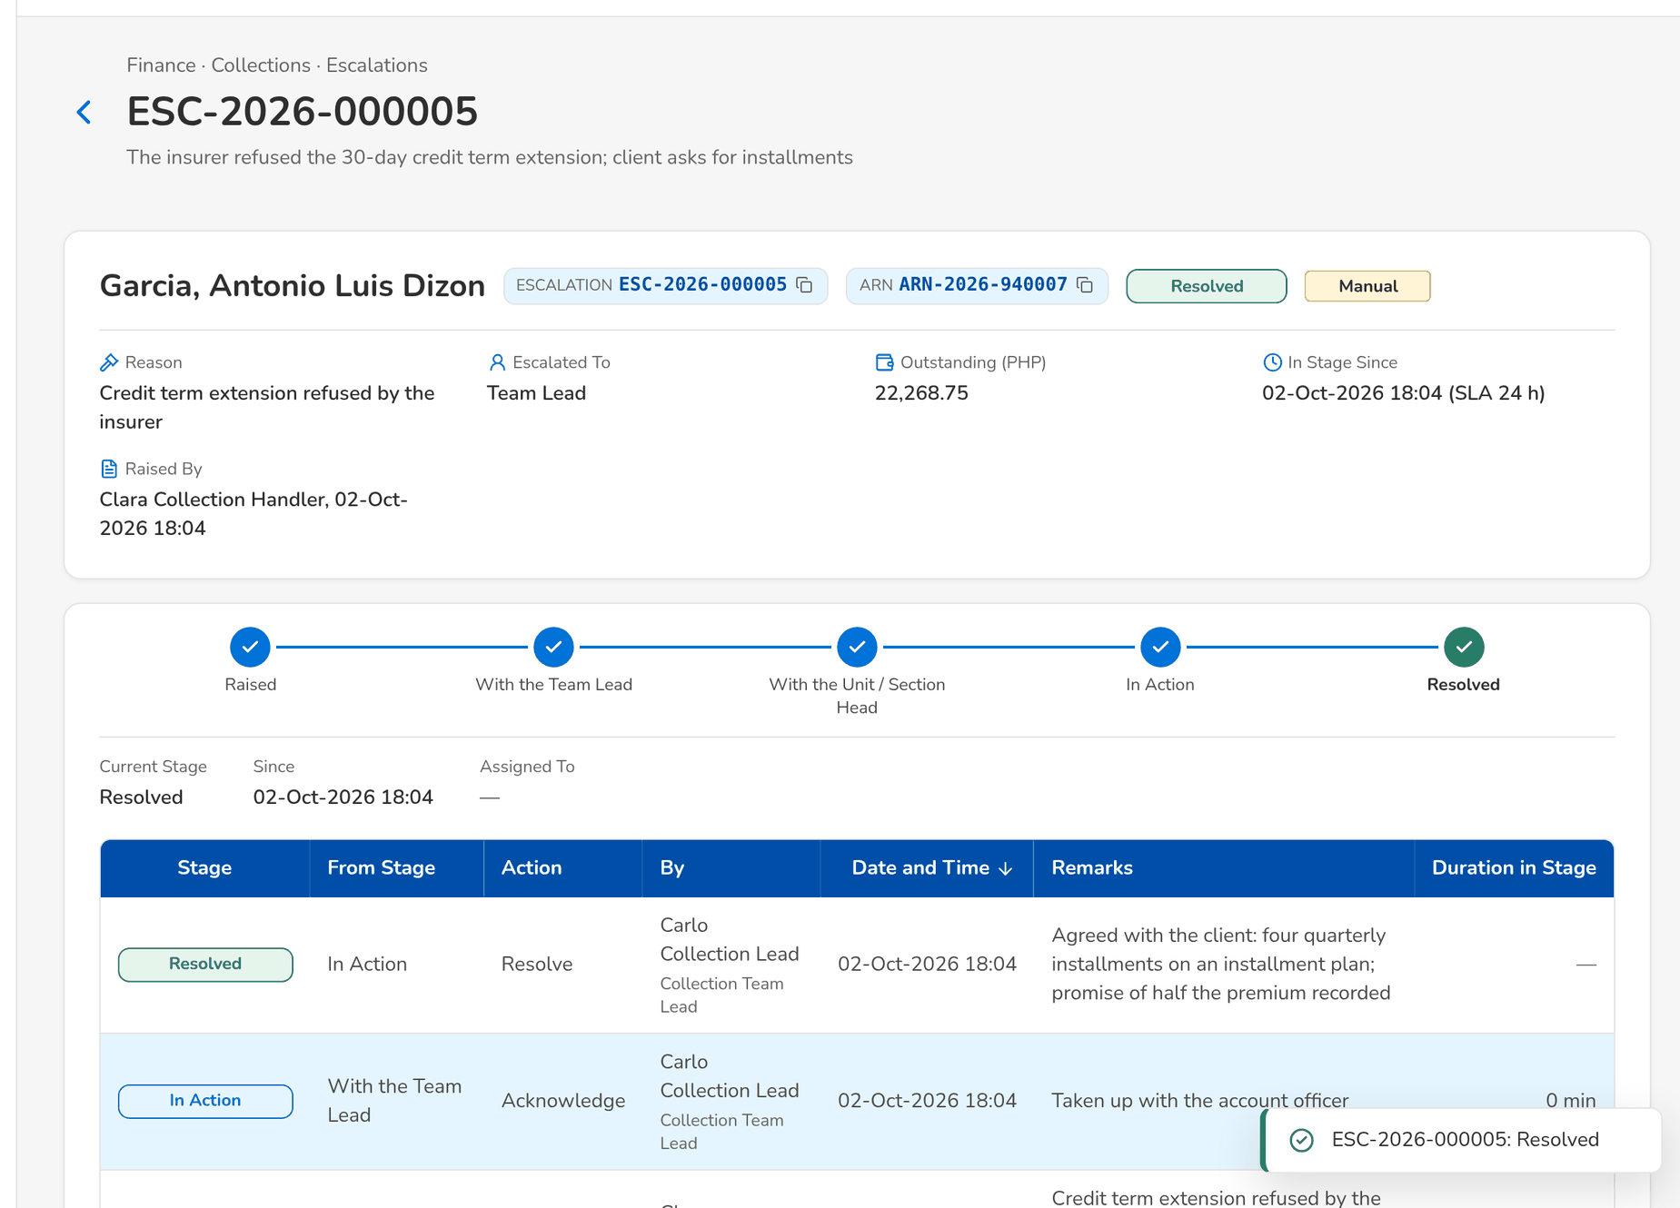
Figure 58: WT-B step 4: Escalation
Step 5. Authorizer of master data – Escalation Rules (SCR-CL-13)
Does | Opens Escalation Rules and, from the row menu of CLX-AMOUNT-1M, authorizes the rule made by the Business Administrator
Sees | The rule is Active
Result | Rule in force

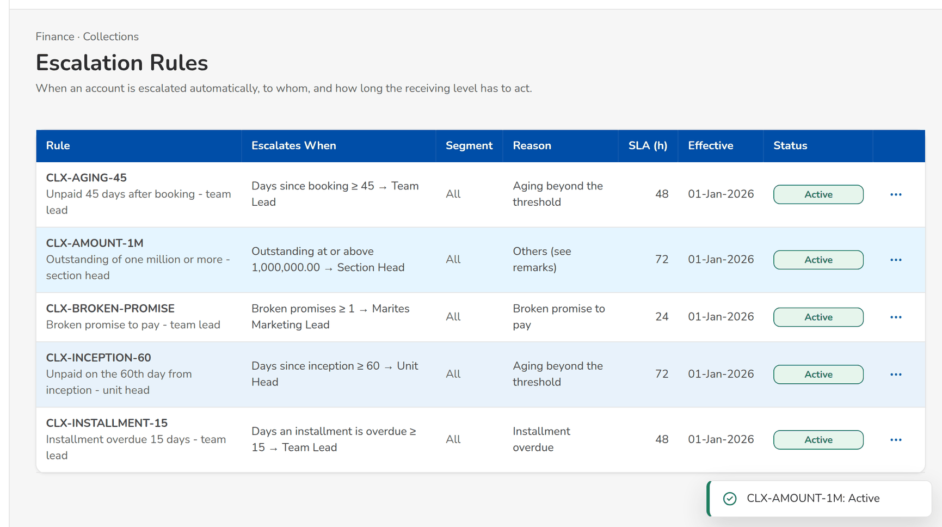
Figure 59: WT-B step 5: Escalation Rules
What happens next, downstream
• The nightly promise check marks the promise kept, partially kept or broken against the payments applied by the promised date; a broken promise notifies the handler and escalates the account through the broken-promise rule.
• From the next escalation run, an account of one million or more is escalated to the Section Head.

14.3 WT-C An unapplied payment applied to an invoice at the collector's request
A payment that Cashiering could not match waits in the unapplied payments. The Unapplied Payment Handler finds the invoice the client paid and requests its application; Cashiering accepts the request on its Incoming Requests and the payment is applied to the invoice; the collector sees the request executed and the whole history of the payment.
Seed data: unapplied payment UNP-2026-000008 (Liza Manalo, 1,200.00, not matched); the invoice of account ARN-2026-940008
Step 1. Unapplied Payment Handler – Unapplied Payments (SCR-CL-14)
Does | Selects the payment, clicks Request Application and enters the invoice number
Sees | Message: Disposition recorded; request sent to Cashiering
Result | Request sent

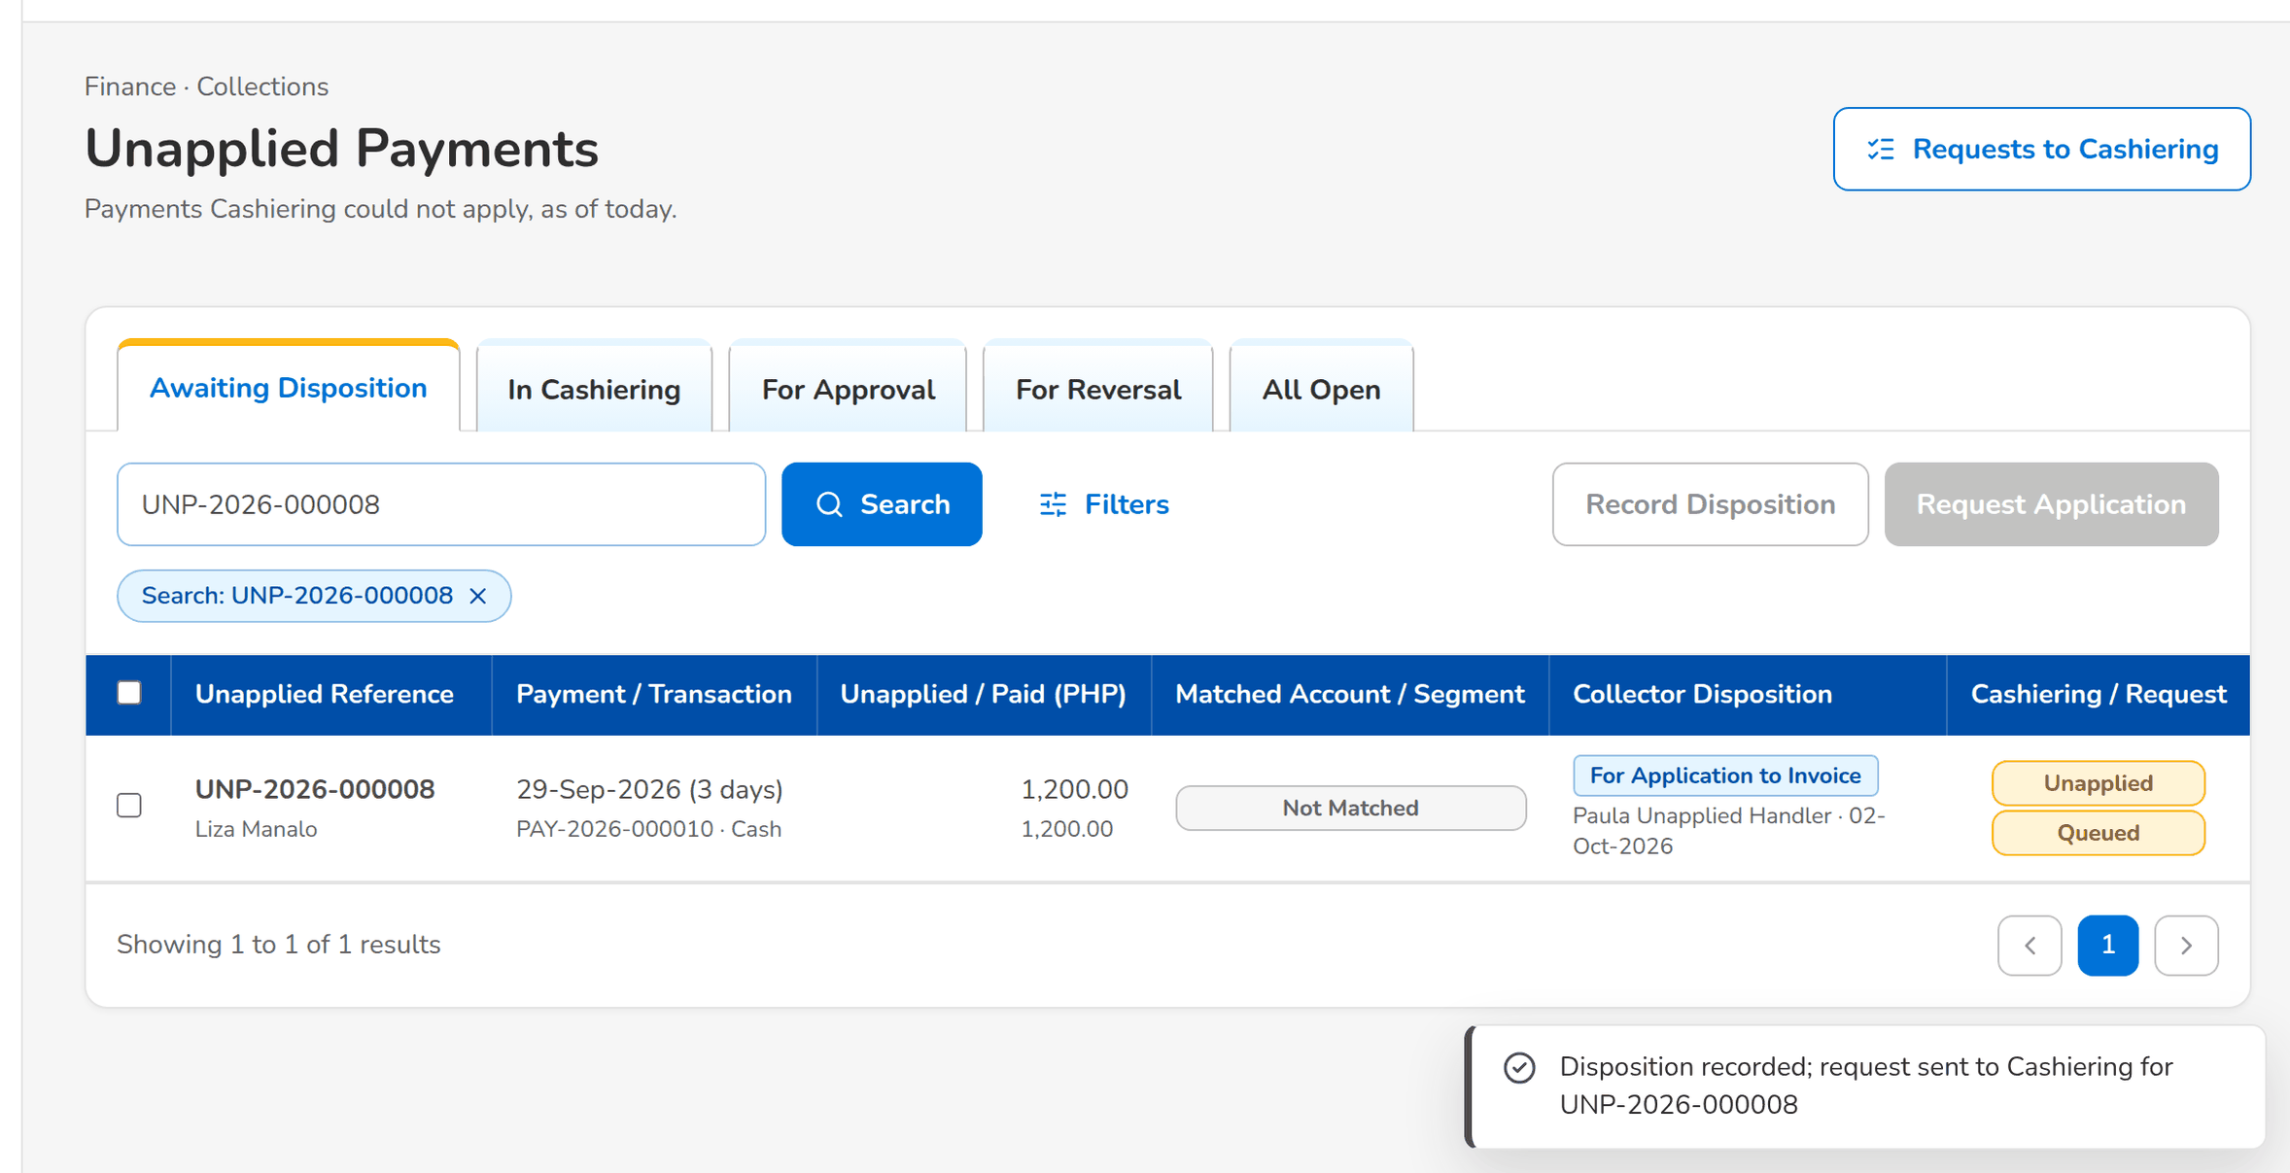
Figure 60: WT-C step 1: Unapplied Payments
Step 2. Unapplied Payment Handler – Requests to Cashiering (SCR-CL-16)
Does | Opens Requests to Cashiering
Sees | The request Sent with the Cashiering reference of the request
Result | With Cashiering

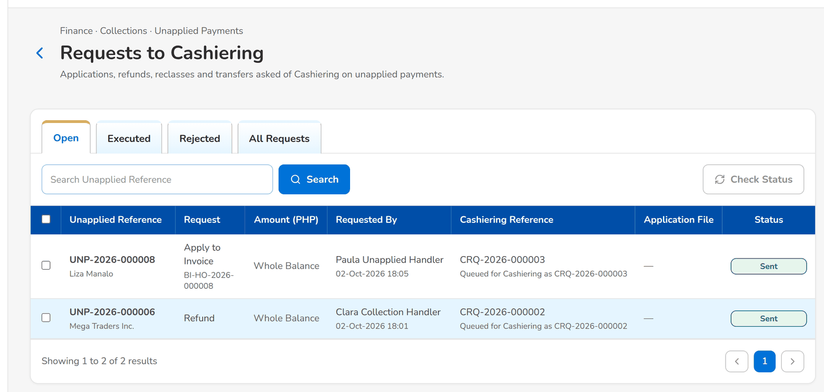
Figure 61: WT-C step 2: Requests to Cashiering
Step 3. Cashier (read access and exports) – Incoming Requests (SCR-OP-13)
Does | Opens Incoming Requests, selects the collector request and clicks Accept Request with Submit the disposition now
Sees | The request accepted; the application of the payment is processed at once
Result | Applied

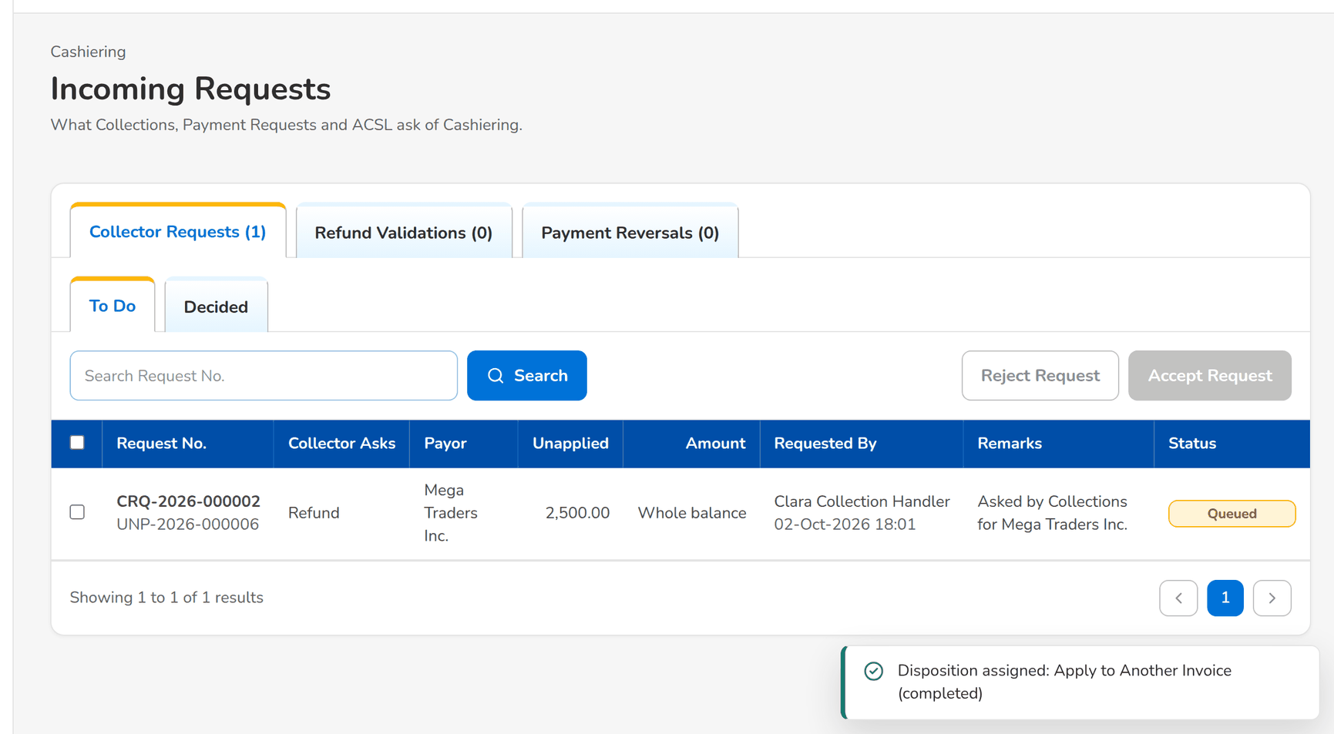
Figure 62: WT-C step 3: Incoming Requests
Step 4. Unapplied Payment Handler – Requests to Cashiering (SCR-CL-16)
Does | Opens the Executed tab of Requests to Cashiering
Sees | The request Applied with the Cashiering reference
Result | Executed

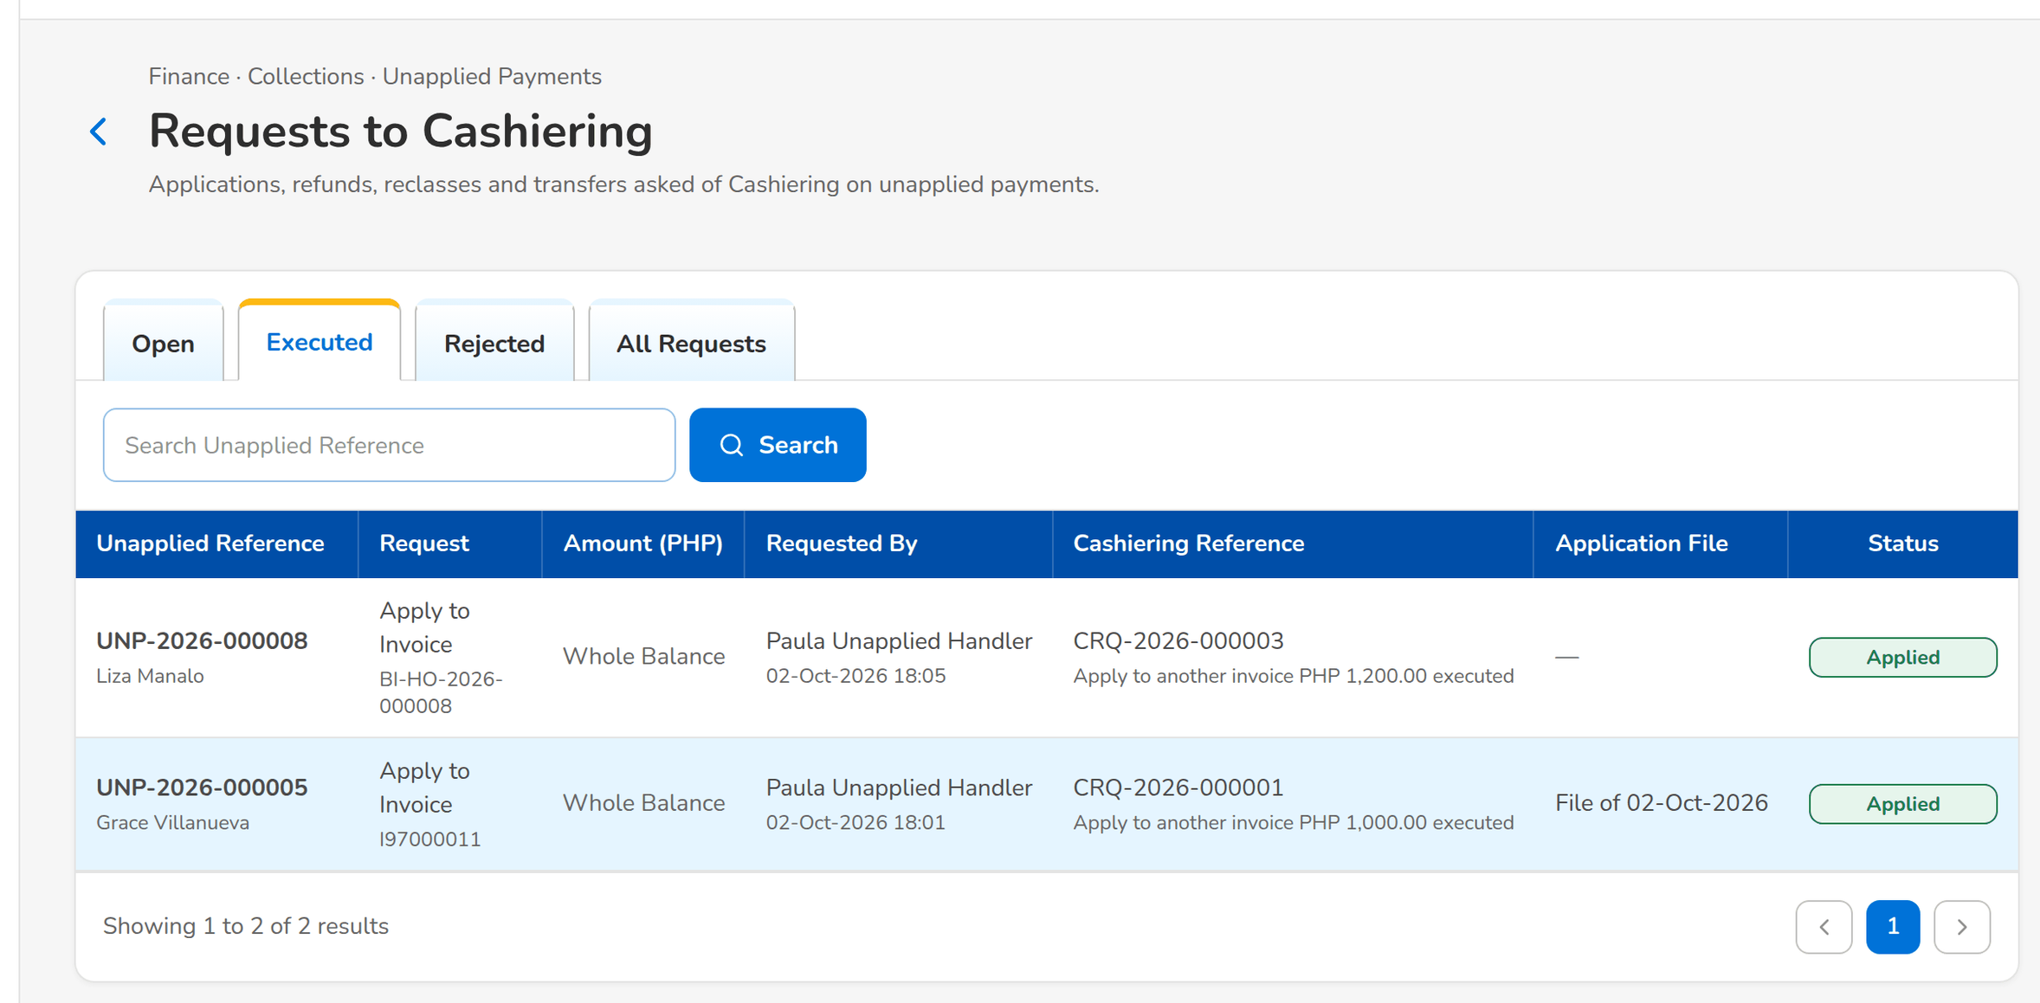
Figure 63: WT-C step 4: Requests to Cashiering
Step 5. Unapplied Payment Handler – Unapplied Payment (SCR-CL-15)
Does | Opens the unapplied payment, History tab
Sees | The payment, the collector disposition, the request and its application, kept after the payment is applied
Result | History kept

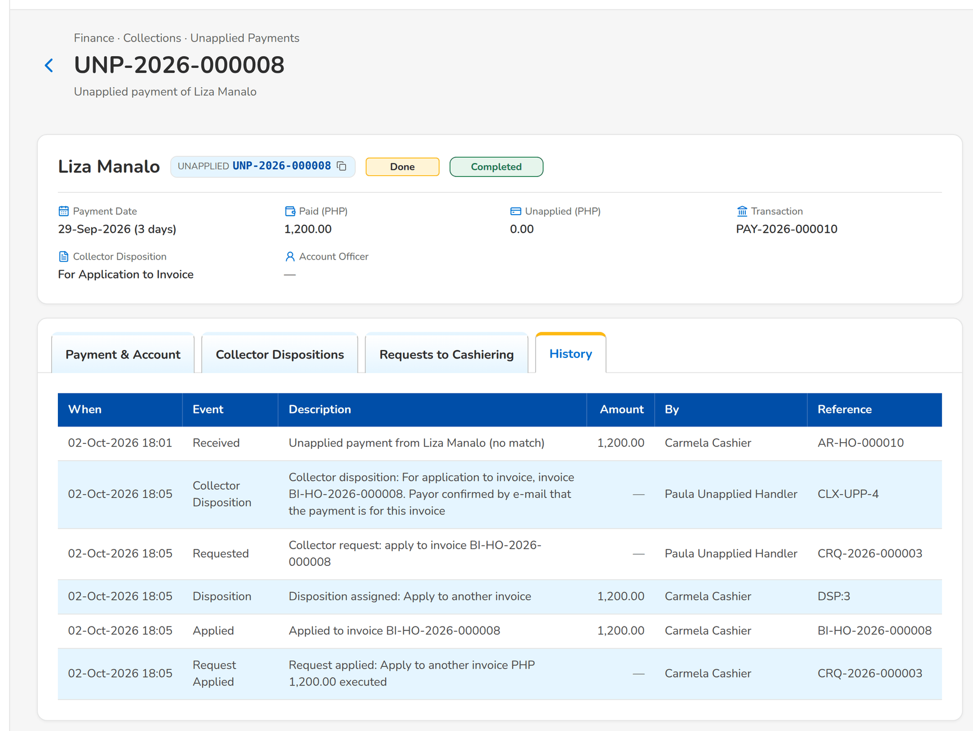
Figure 64: WT-C step 5: Unapplied Payment
What happens next, downstream
• The application reduces the outstanding of the invoice in the ledger; the next refresh updates the collection account.
• The daily For Application To Invoice file of the next morning lists the request.

14.4 WT-D An installment plan and the statement of account of its first cycle
The client of walkthrough A agrees to pay the premium in four quarterly installments. The Collection Handler creates the plan on the invoice, generates the statement of account of the first cycle and sends it to the client by e-mail, the PDF protected by a password sent separately.
Seed data: the invoice of walkthrough A; the client's e-mail address from the client profile
Step 1. Collection Handler – Installment Plans (SCR-CL-05)
Does | Clicks New Installment Plan: installments of one invoice, the invoice, the first due date, 4 installments, Quarterly
Sees | Message: <plan> created with 4 installments; the plan opens with its installments
Result | Plan active

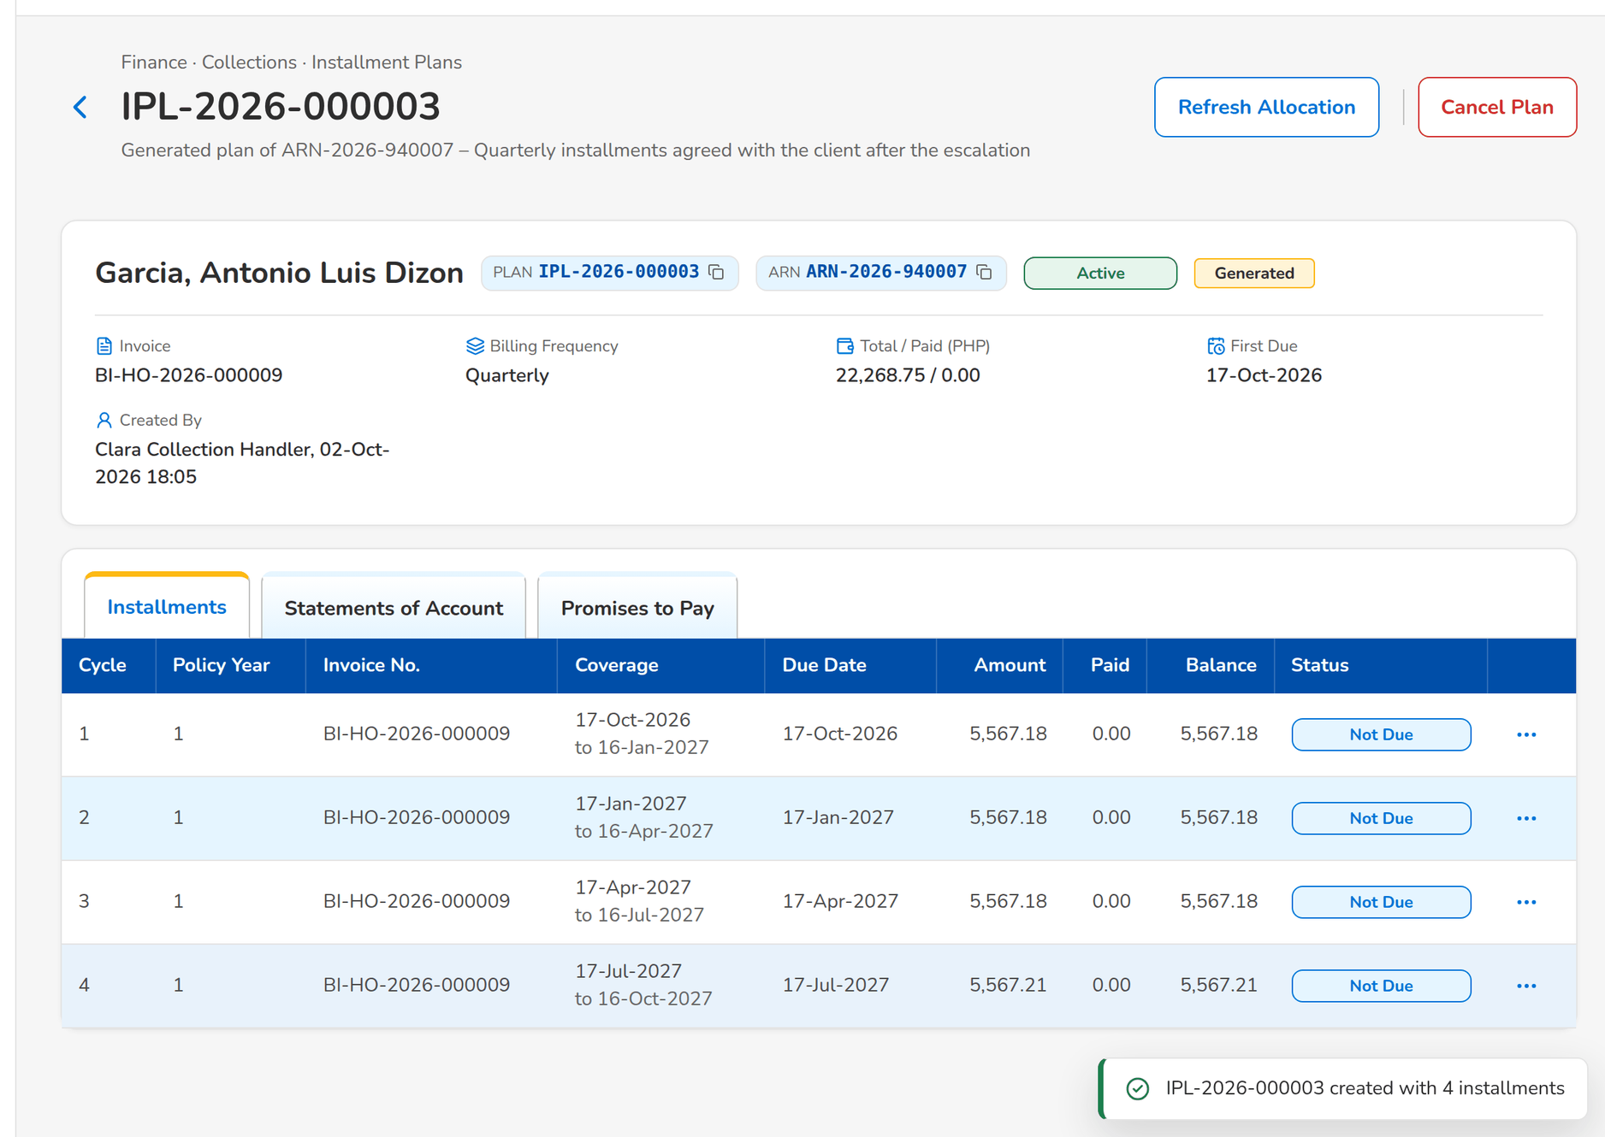
Figure 65: WT-D step 1: Installment Plans
Step 2. Collection Handler – Installment Plan (SCR-CL-06)
Does | Opens the row menu of cycle 1 and clicks Generate SOA, then the Statements of Account tab
Sees | Message: <SOA> generated; the statement of cycle 1 To Send
Result | Billed

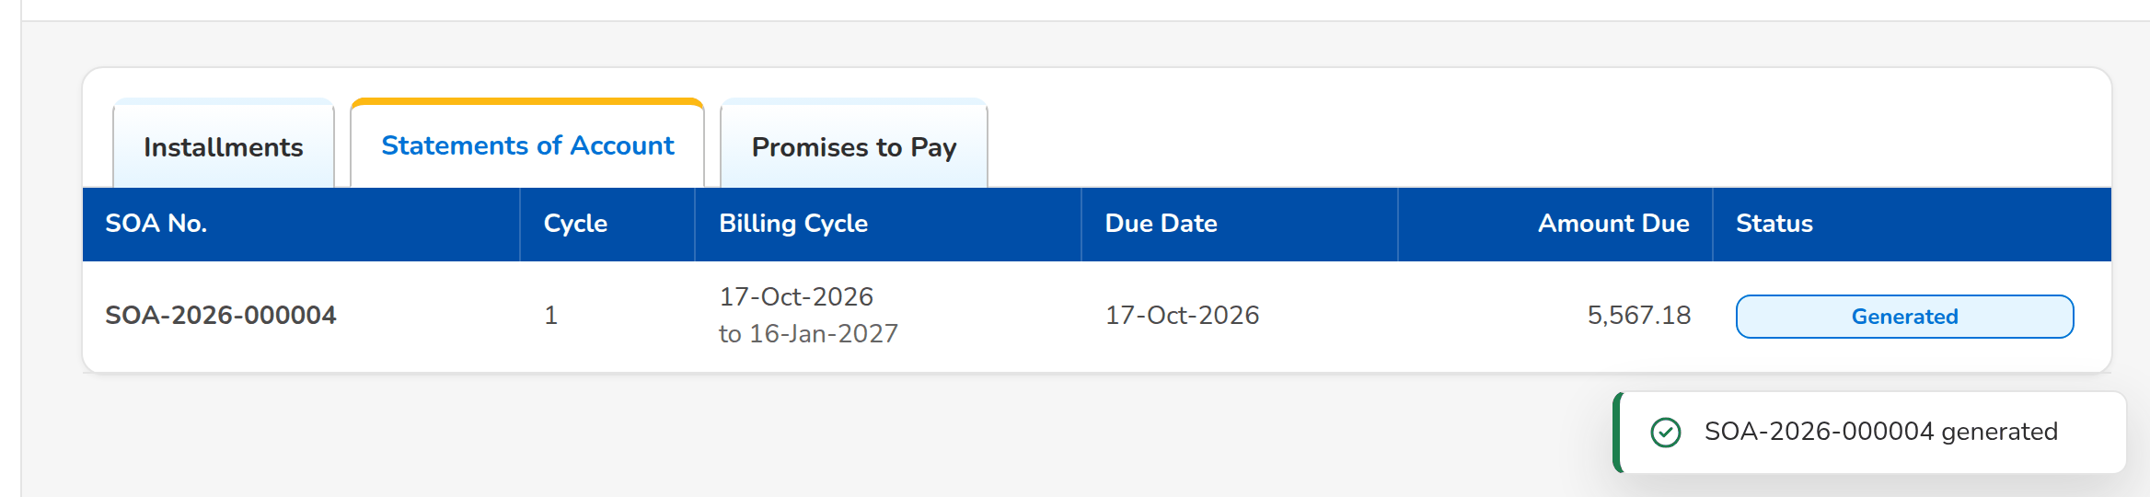
Figure 66: WT-D step 2: Installment Plan
Step 3. Collection Handler – Statement of Account (SCR-CL-10)
Does | Opens the statement and clicks Send via Email
Sees | The e-mail with the client's address, the proposed subject and message and the protected attachment
Result | Ready to send

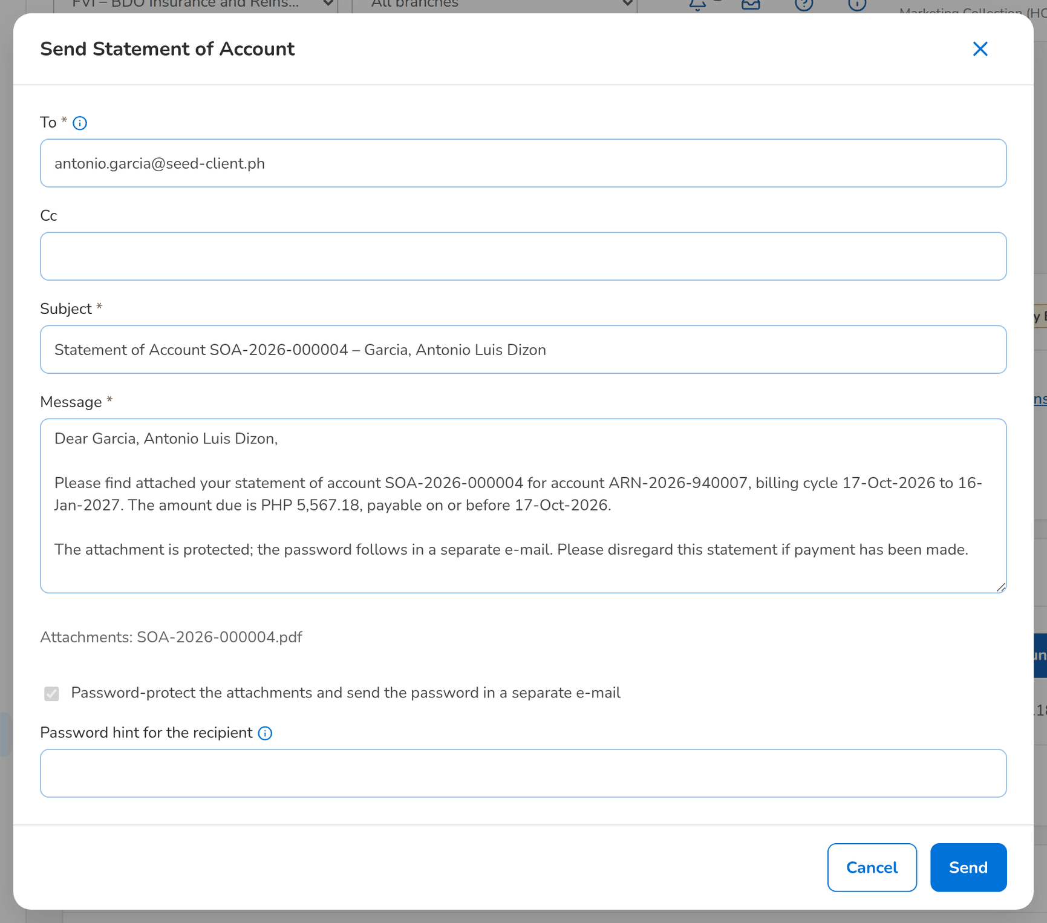
Figure 67: WT-D step 3: Statement of Account
Step 4. Collection Handler – Statement of Account (SCR-CL-10)
Does | Clicks Send
Sees | Message: <SOA> sent to <address>; the statement is Sent and E-mails Sent lists the e-mail
Result | Sent

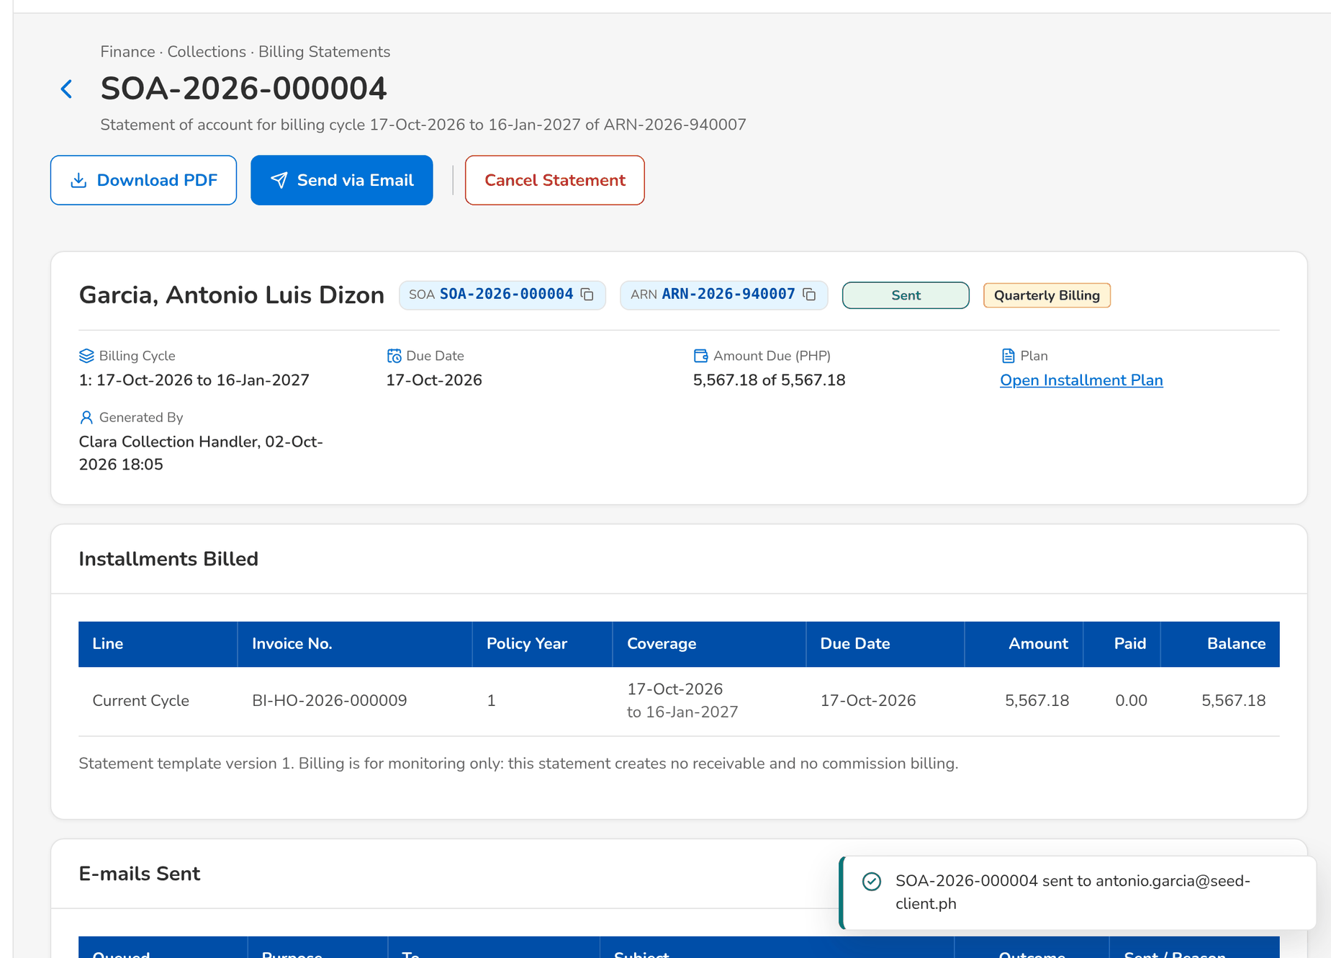
Figure 68: WT-D step 4: Statement of Account
What happens next, downstream
• The payments applied in the ledger are allocated to the installments, oldest first; an installment past its due date is Overdue and can escalate the account.
• Billing is monitoring only: the statement creates no receivable and no commission billing.

14.5 WT-E Controls and the messages the user sees
Four controls of Collections, each with the message the user sees: a disposition reserved to other roles, an account another user is working on, a promise above the outstanding, and an invoice number in the wrong format.
Seed data: the open accounts of the seed data; the account of walkthrough A held by the Collection Handler
Step 1. Marketing Account Officer – Collection Account (SCR-CL-03)
Does | The account officer records the disposition No / missing policy number on an account
Sees | The refusal: the disposition is reserved to other roles
Result | Refused

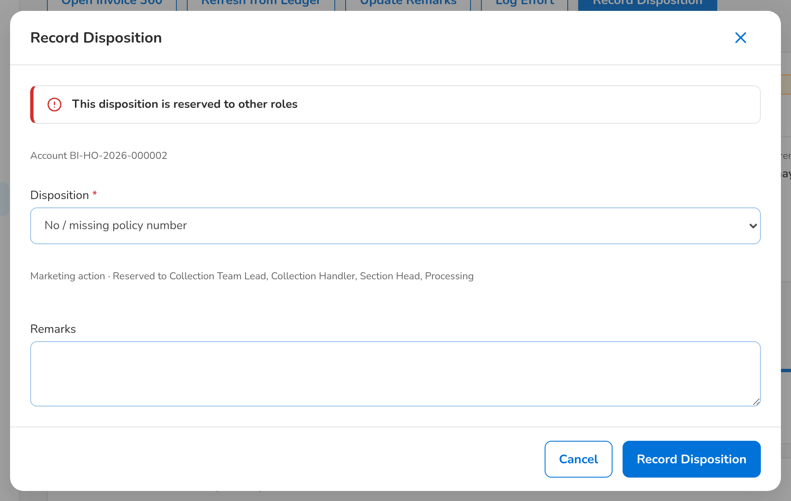
Figure 69: WT-E step 1: Collection Account
Step 2. Collection Team Lead – Collection Account (SCR-CL-03)
Does | Opens the account the Collection Handler is working on
Sees | <name> is editing since <time>; Update Remarks, Log Effort and Record Disposition are not offered
Result | Read only

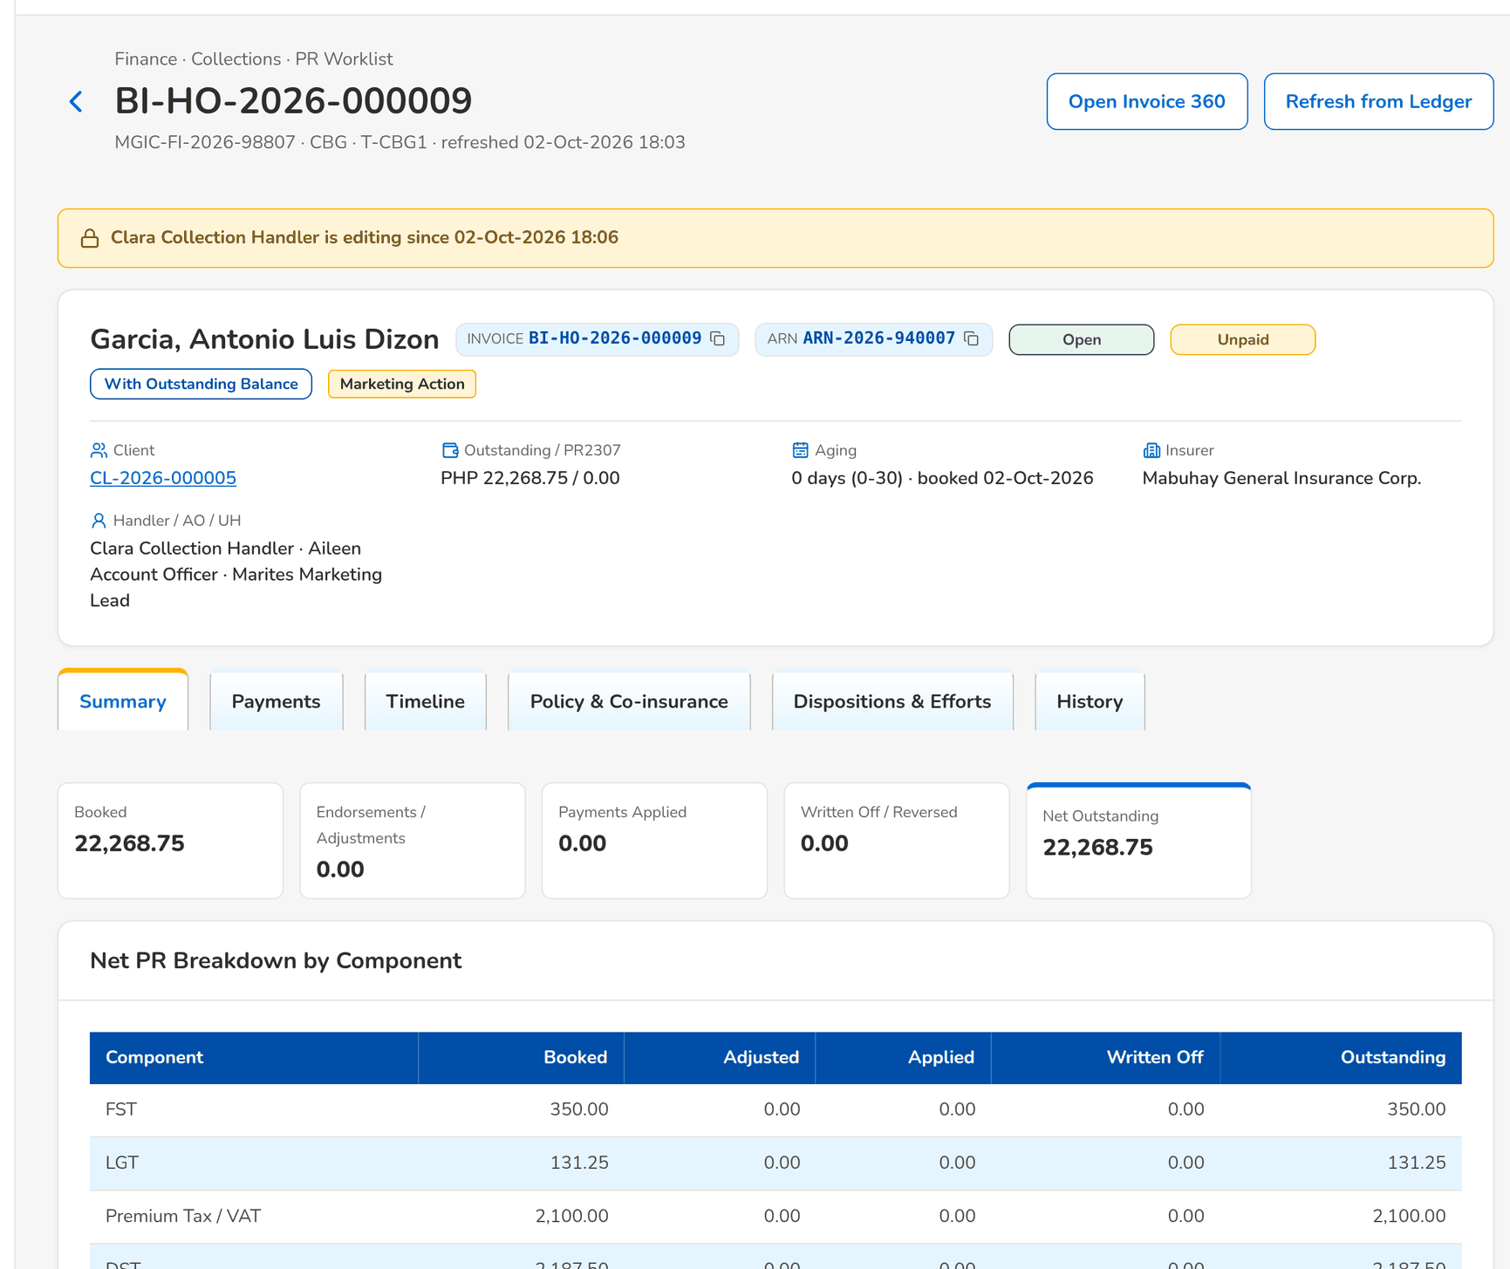
Figure 70: WT-E step 2: Collection Account
Step 3. Collection Handler – Promises to Pay (SCR-CL-08)
Does | Records a promise of an amount above the outstanding of the account
Sees | Promises Recorded with the outcome of the invoice: the promised amount is above the outstanding
Result | Refused

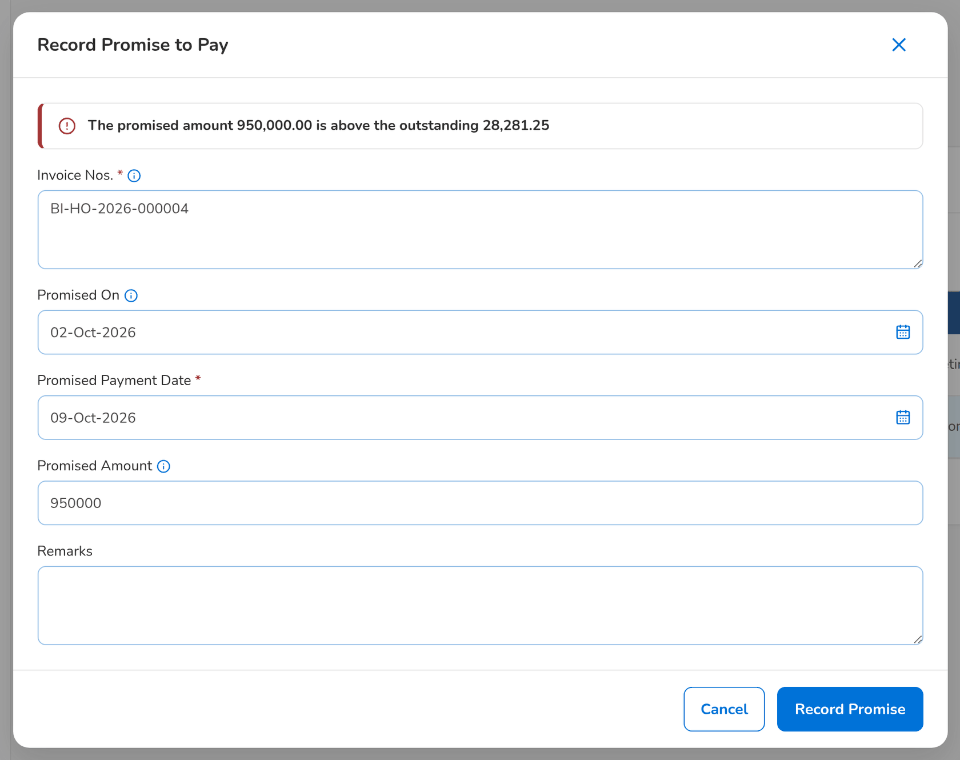
Figure 71: WT-E step 3: Promises to Pay
Step 4. Unapplied Payment Handler – Unapplied Payments (SCR-CL-14)
Does | Requests the application of a payment to an invoice number in the wrong format
Sees | Under the field: The invoice number does not have the expected format
Result | Refused

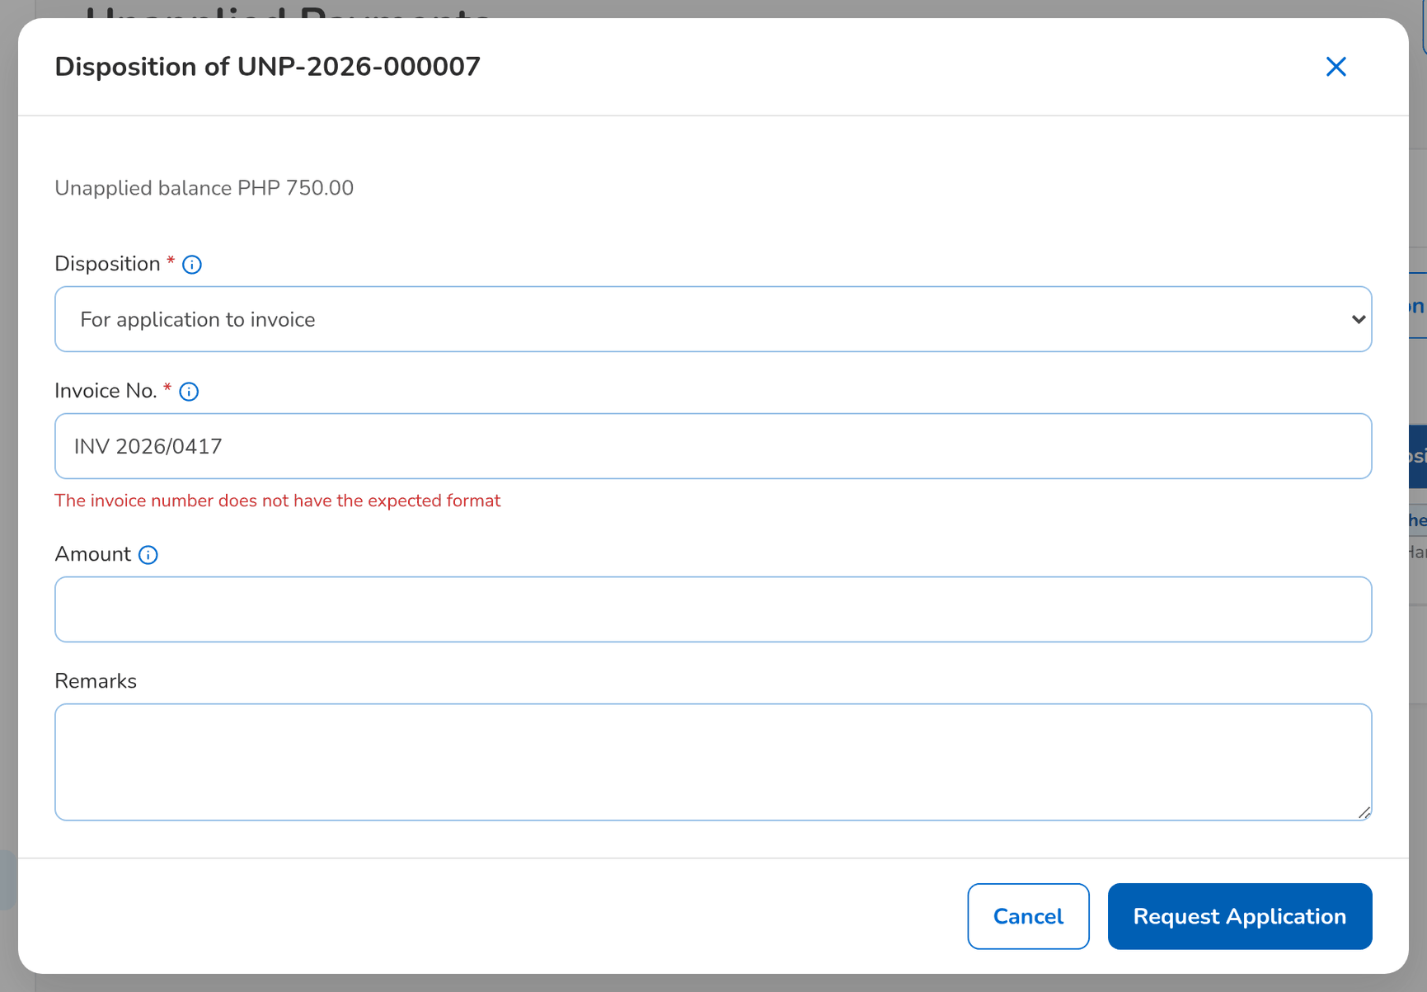
Figure 72: WT-E step 4: Unapplied Payments

15 Messages catalogue
Every message a Collections user can see, grouped by the screen or dialog that shows it, with its code, its type and what the user does. The texts are quoted exactly as the screens show them.
• Validation: shown on the screen while the user fills in a field or before the form is sent.
• Error: the system refused the action; nothing was saved. The code is shown under the message as the Reference.
• Warning: the action is possible, but the user should check something first.
• Confirmation and Information: the outcome of an action, or a hint on the screen.
148 messages: 10 confirmation, 75 error, 24 information, 39 validation. The text is quoted exactly as the system shows it; <name> marks a value filled in by the system. The user sees the message only, in the notice standard of the screen standards appendix; the code identifies the message for the project team and support and is not shown on the screen.

15.1 PR Worklist and its bulk actions (SCR-CL-02)
ID | Code (not shown) | Message | Type | What the user does
MSG-CL-001 | - | No accounts match the filters | Information | No action.
MSG-CL-002 | CLX_EXPORT_TOO_LARGE | <rows> accounts exceed the export limit of <cap>; narrow the filters | Error | Narrow the filters so that the export has fewer rows than the limit.
MSG-CL-003 | CLX_NOTHING_TO_COLLECT | Invoice <invoice no> has nothing to collect | Error | No action; the invoice has no premium left to collect.

15.2 Collection Account (SCR-CL-03)
ID | Code (not shown) | Message | Type | What the user does
MSG-CL-004 | - | No disposition yet | Information | No action.
MSG-CL-005 | - | No effort logged yet | Information | No action.
MSG-CL-006 | - | No payment applied yet | Information | No action.
MSG-CL-007 | - | Nothing handed to Operations | Information | No action.
MSG-CL-008 | - | The invoice is no longer in the ledger | Information | No action.
MSG-CL-009 | CLX_INVOICE_NOT_COLLECTIBLE | Invoice <invoice no> is paid directly to the insurer / cancelled and has no premium to collect | Error | No action; the invoice is paid directly to the insurer or cancelled.
MSG-CL-010 | CLX_INVOICE_UNKNOWN | Invoice <invoice no> is not in the ledger | Error | Check the invoice number; it must be an invoice of the ledger.
MSG-CL-011 | CLX_ITEM_LOCKED | <editing by> is editing <invoice no> | Error | Wait until the user named leaves the account, or until the edit lock expires.

15.3 Record Disposition, Log Collection Effort and Update Remarks dialogs (SCR-CL-02, SCR-CL-03)
ID | Code (not shown) | Message | Type | What the user does
MSG-CL-012 | - | A certificate tag needs the certificate number | Validation | Enter the BIR 2307 certificate number.
MSG-CL-013 | - | Check pick-up | Validation | Check pick-up.
MSG-CL-014 | - | Choose a disposition | Validation | Choose a disposition.
MSG-CL-015 | - | The pick-up date cannot be in the past | Validation | Enter a pick-up date from today on.
MSG-CL-016 | CLX_BULK_NOT_ALLOWED | You are not allowed to update several accounts at once | Error | Work on one account at a time, or ask the team lead to update the accounts together.
MSG-CL-017 | CLX_CATEGORY | The tagging category is A, B or C | Error | Choose A, B or C, or None.
MSG-CL-018 | CLX_CWT_PATH | Choose the 2307 path: certificate received or paid in cash | Error | Choose the 2307 path in the drop-down.
MSG-CL-019 | CLX_DISPOSITION_DETAIL | '<v>' is not a date (yyyy-mm-dd) | Error | Complete or correct the detail named in the message.
MSG-CL-020 | CLX_DISPOSITION_DETAIL | '<v>' is not an amount | Error | Complete or correct the detail named in the message.
MSG-CL-021 | CLX_DISPOSITION_DETAIL | Give <what> | Error | Complete or correct the detail named in the message.
MSG-CL-022 | CLX_DISPOSITION_NOT_ALLOWED | This disposition is reserved to other roles | Error | Choose another disposition, or ask a user of the roles named to record it.
MSG-CL-023 | CLX_EFFORT_FUTURE | An effort cannot be in the future | Error | Enter a date and time that is not in the future.
MSG-CL-024 | CLX_ITEM_CLOSED | <invoice no> is <status> | Error | No action; the account is no longer open. Refresh the list.
MSG-CL-025 | CLX_ITEM_OTHER_COMPANY | <invoice no> belongs to another company | Error | Change the company in the header, or remove the account from the selection.
MSG-CL-026 | CLX_NO_ACCOUNT | Select at least one account | Error | Select at least one account in the list.
MSG-CL-027 | CLX_PICKUP_AMOUNT | Give the check amount | Error | Enter the check amount.
MSG-CL-028 | CLX_PICKUP_DATE | Give a pick-up date from today on for the check pick-up | Error | Enter a pick-up date from today on.
MSG-CL-029 | CLX_TOO_MANY_ACCOUNTS | Select at most 500 accounts at once | Error | Select at most 500 accounts, or narrow the filters.

15.4 Client View (SCR-CL-04)
ID | Code (not shown) | Message | Type | What the user does
MSG-CL-030 | - | The client has no collection account | Information | No action.

15.5 Installment Plans and Installment Plan (SCR-CL-05, SCR-CL-06)
ID | Code (not shown) | Message | Type | What the user does
MSG-CL-031 | - | <plan no> cancelled | Confirmation | No action.
MSG-CL-032 | - | <plan no> created with <installment count> installments | Confirmation | No action.
MSG-CL-033 | - | <soa no> generated | Confirmation | No action.
MSG-CL-034 | - | No installment plans to display | Information | No action.
MSG-CL-035 | - | No installments | Information | No action.
MSG-CL-036 | - | No promises to pay recorded | Information | No action.
MSG-CL-037 | - | No statements generated yet | Information | No action.
MSG-CL-038 | - | Payments allocated from the invoice ledger | Confirmation | No action.
MSG-CL-039 | CLX_CYCLE_UNKNOWN | Plan <plan no> has no billing cycle <seq> | Error | Refresh the plan and choose a billing cycle shown on it.
MSG-CL-040 | CLX_FREQUENCY_UNSUPPORTED | Billing frequency <code> has no cycle length defined | Error | Choose another billing frequency, or ask the System Administrator to set up its cycle length.
MSG-CL-041 | CLX_PLAN_EMPTY | A plan needs at least one installment | Error | Enter at least one installment.
MSG-CL-042 | CLX_PLAN_EMPTY | Enter at least one installment | Error | Enter at least one installment.
MSG-CL-043 | CLX_PLAN_ENTRY_INVALID | Installment amounts must be positive and due dates increasing | Error | Enter amounts above zero and due dates in increasing order.
MSG-CL-044 | CLX_PLAN_EXISTS | Plan <plan no> already schedules this account; cancel it first | Error | Open the existing plan, or cancel it before creating a new one.
MSG-CL-045 | CLX_PLAN_NOTHING_DUE | Invoice <invoice no> has no outstanding premium to schedule | Error | No action; the invoice has no outstanding premium to schedule.
MSG-CL-046 | CLX_PLAN_NOT_ACTIVE | Plan <plan no> is <status> and cannot be cancelled | Error | No action; the plan is no longer active. Create a new plan if the account is still to be billed.
MSG-CL-047 | CLX_PLAN_NOT_BOOKED | Account <arn> has no booked policy year | Error | Check the ARN; a plan over the policy years needs at least one booked policy year.

15.6 Installments Due (SCR-CL-07)
ID | Code (not shown) | Message | Type | What the user does
MSG-CL-048 | - | No installments due | Information | No action.

15.7 Promises to Pay (SCR-CL-08)
ID | Code (not shown) | Message | Type | What the user does
MSG-CL-049 | - | <n> promise(s) withdrawn | Confirmation | No action.
MSG-CL-050 | - | No promises to pay to display | Information | No action.
MSG-CL-051 | - | Promise to pay recorded | Confirmation | No action.
MSG-CL-052 | CLX_PROMISE_AMOUNT | The promised amount must be positive | Error | Enter a promised amount above zero, or leave it empty for the whole outstanding.
MSG-CL-053 | CLX_PROMISE_CLOSED | The promise of <invoice no> is already <status> | Error | No action; the promise is already kept, broken or withdrawn.
MSG-CL-054 | CLX_PROMISE_DATES | Enter the promised date; the day of the promise cannot be in the future | Error | Enter the promised date; the day of the promise is today or earlier.
MSG-CL-055 | CLX_PROMISE_DATES | The promised date cannot be before the day of the promise | Error | Enter the promised date; the day of the promise is today or earlier.
MSG-CL-056 | CLX_PROMISE_INSTALLMENT | The installment does not bill invoice <invoice no> | Error | Record the promise on the invoice of the installment.
MSG-CL-057 | CLX_PROMISE_NOTHING_DUE | Invoice <invoice no> has nothing to collect | Error | No action; the invoice has nothing left to collect.

15.8 Dialogs with a reason (cancel a plan, a statement, withdraw a promise)
ID | Code (not shown) | Message | Type | What the user does
MSG-CL-058 | - | Enter the <label> | Validation | Enter the <label>.

15.9 Billing Statements (SCR-CL-09)
ID | Code (not shown) | Message | Type | What the user does
MSG-CL-059 | - | <length> statement(s) of account generated | Confirmation | No action.
MSG-CL-060 | - | No statements of account to display | Information | No action.
MSG-CL-061 | CLX_PLAN_NOT_ACTIVE | Plan <plan no> is cancelled | Error | No action; the plan is no longer active. Create a new plan if the account is still to be billed.
MSG-CL-062 | CLX_SOA_EXISTS | Cycle <cycle seq> of <plan no> is billed by <soa no> | Error | Open the statement already generated for the cycle, or cancel it first.
MSG-CL-063 | CLX_SOA_PERIOD | The period ends before it starts | Error | Correct the dates so that the period does not end before it starts.

15.10 Statement of Account (SCR-CL-10)
ID | Code (not shown) | Message | Type | What the user does
MSG-CL-064 | CLX_SOA_CANCELLED | Statement <soa no> is cancelled | Error | No action; the statement is cancelled. Generate a new statement for the cycle if it is still due.
MSG-CL-065 | CLX_SOA_RECIPIENT | Enter at least one recipient | Error | Enter the e-mail address of at least one recipient.

15.11 Escalations and Escalate Accounts (SCR-CL-11)
ID | Code (not shown) | Message | Type | What the user does
MSG-CL-066 | - | No escalations to display | Information | No action.
MSG-CL-067 | CLX_ESCALATION_ACTION | '<action>' is not an escalation action | Error | Refresh the escalation and use an action shown in its header.
MSG-CL-068 | CLX_ESCALATION_TARGET | <username> does not handle escalations | Error | Choose the level, or a user who handles escalations.
MSG-CL-069 | CLX_ESCALATION_TARGET | Choose the level, and the user for a designated authority | Error | Choose the level, or a user who handles escalations.
MSG-CL-070 | CLX_RESOLUTION_REQUIRED | Describe how the escalation was resolved | Error | Describe how the escalation was resolved.

15.12 Escalation Rules (SCR-CL-13)
ID | Code (not shown) | Message | Type | What the user does
MSG-CL-071 | - | No account meets the rule today | Information | No action.
MSG-CL-072 | - | No escalation rules | Information | No action.
MSG-CL-073 | CLX_RULE_AMOUNTS | The amount range ends below its start | Error | Correct the amounts so that the range does not end below its start.
MSG-CL-074 | CLX_RULE_CODE | Enter the company and the rule code | Error | Enter the code of the rule.
MSG-CL-075 | CLX_RULE_DATES | The rule cannot end before it becomes effective | Error | Correct the dates so that the rule does not end before it becomes effective.
MSG-CL-076 | CLX_RULE_INVALID | The threshold and the SLA hours must be positive | Error | Enter a threshold and SLA hours above zero.
MSG-CL-077 | CLX_RULE_TARGET | Name the user who receives the escalations of this rule | Error | Enter the user who receives the escalations, or choose a level.
MSG-CL-078 | DUPLICATE | Escalation rule already exists: <key> | Error | Use another rule code; the code is taken.

15.13 Unapplied Payments and the disposition dialog (SCR-CL-14)
ID | Code (not shown) | Message | Type | What the user does
MSG-CL-079 | - | No unapplied payments to display | Information | No action.
MSG-CL-080 | CLX_INVOICE_FORMAT | Invoice number <clean> does not have the expected format (<invoice pattern>) | Error | Enter the invoice number as EBIX I######## or BIBS BI-...
MSG-CL-081 | CLX_INVOICE_REQUIRED | Enter the invoice number to apply the payment to | Error | Enter the invoice number to apply the payment to.
MSG-CL-082 | CLX_INVOICE_UNKNOWN | Invoice <clean> is not in the invoice ledger | Error | Check the invoice number; it must be an invoice of the ledger.
MSG-CL-083 | CLX_UNAPPLIED_NO_BALANCE | <unapplied ref> has no unapplied balance left | Error | No action; the payment has been applied or refunded.

15.14 Unapplied Payment (SCR-CL-15)
ID | Code (not shown) | Message | Type | What the user does
MSG-CL-084 | - | Disposition recorded on <ref> | Confirmation | No action.
MSG-CL-085 | - | No collector disposition yet | Information | No action.
MSG-CL-086 | - | No history | Information | No action.
MSG-CL-087 | - | No request sent to Cashiering | Information | No action.

15.15 Requests to Cashiering (SCR-CL-16)
ID | Code (not shown) | Message | Type | What the user does
MSG-CL-088 | - | <n> request(s) checked with Cashiering | Confirmation | No action.
MSG-CL-089 | - | No requests to display | Information | No action.

15.16 Assignments (SCR-CL-17)
ID | Code (not shown) | Message | Type | What the user does
MSG-CL-090 | - | <moved> account(s) reassigned<ref> | Confirmation | No action.
MSG-CL-091 | - | No assignment rule: new accounts go to their account officer | Information | No action.
MSG-CL-092 | CLX_HANDLER_NOT_ELIGIBLE | <handler> is not an active collection handler | Error | Choose another handler from the list.
MSG-CL-093 | CLX_REASSIGN_EMPTY | No account matches the selection | Error | Change the criteria or the selection so that at least one open account is found.
MSG-CL-094 | CLX_REASSIGN_END_DATE | A temporary reassignment needs an end date after today | Error | Enter an end date after today, or choose Permanent.
MSG-CL-095 | CLX_REASSIGN_KIND | Choose a permanent or a temporary reassignment | Error | Choose Permanent or Temporary.
MSG-CL-096 | CLX_REASSIGN_REASON | Give the reason of the reassignment | Error | Give the reason of the reassignment.
MSG-CL-097 | CLX_RULE_NAME | Give the rule a name | Error | Give the rule a name.
MSG-CL-098 | CLX_RULE_RANGE | A range must start before it ends | Error | Correct the range so that it starts before it ends.

15.17 Collections Files (SCR-CL-18)
ID | Code (not shown) | Message | Type | What the user does
MSG-CL-099 | - | No file published yet | Information | No action.

15.18 Collections Setup (SCR-CL-19)
ID | Code (not shown) | Message | Type | What the user does
MSG-CL-100 | CLX_AGING_BASIS | The aging basis is BOOKING or INCEPTION | Error | Enter BOOKING or INCEPTION.
MSG-CL-101 | CLX_AGING_BRACKETS_INVALID | Aging bracket '<text>' ends before it starts | Error | Write the brackets as from-to ranges in ascending order, the last one open (for example 121+).
MSG-CL-102 | CLX_AGING_BRACKETS_INVALID | Aging bracket '<text>' is not from-to or from+ | Error | Write the brackets as from-to ranges in ascending order, the last one open (for example 121+).
MSG-CL-103 | CLX_AGING_BRACKETS_INVALID | Aging brackets must be in ascending order: <raw> | Error | Write the brackets as from-to ranges in ascending order, the last one open (for example 121+).
MSG-CL-104 | CLX_LOV_ATTRIBUTE_UNKNOWN | <attribute> is not an attribute of <type code> | Error | Choose an attribute of the list shown on Collections Setup.
MSG-CL-105 | CLX_LOV_ATTRIBUTE_VALUE | '<value>' is not a valid <attribute> | Error | Enter a value allowed for the attribute, as the hint of the field says.
MSG-CL-106 | CLX_LOV_VALUE_UNKNOWN | <code> is not a value of <type code> | Error | Choose a value of the list, or add it on the Lists of Values screen first.
MSG-CL-107 | CLX_PARAMETER_NOT_COLLECTIONS | <key> is not a Collections parameter | Error | Change the parameter on the System Parameters screen.

15.19 Form checks of the Collections dialogs
ID | Code (not shown) | Message | Type | What the user does
MSG-CL-108 | - | Choose the billing frequency | Validation | Choose the billing frequency.
MSG-CL-109 | - | Choose the disposition | Validation | Choose the disposition.
MSG-CL-110 | - | Choose the escalation reason | Validation | Choose the escalation reason.
MSG-CL-111 | - | Enter a positive amount, or leave it empty for the whole outstanding | Validation | Enter a positive amount, or leave it empty for the whole outstanding.
MSG-CL-112 | - | Enter a positive threshold | Validation | Enter a positive threshold.
MSG-CL-113 | - | Enter an amount above zero and at most <balance> | Validation | Enter an amount above zero and at most <balance>.
MSG-CL-114 | - | Enter at least one invoice number | Validation | Enter at least one invoice number.
MSG-CL-115 | - | Enter between 1 and 120 installments | Validation | Enter between 1 and 120 installments.
MSG-CL-116 | - | Enter between 1 and 720 hours | Validation | Enter between 1 and 720 hours.
MSG-CL-117 | - | Enter both dates | Validation | Enter both dates.
MSG-CL-118 | - | Enter the account reference number | Validation | Enter the account reference number.
MSG-CL-119 | - | Enter the first day | Validation | Enter the first day.
MSG-CL-120 | - | Enter the first due date | Validation | Enter the first due date.
MSG-CL-121 | - | Enter the invoice number | Validation | Enter the invoice number.
MSG-CL-122 | - | Enter the invoice number to apply the payment to | Validation | Enter the invoice number to apply the payment to.
MSG-CL-123 | - | Enter the promised payment date | Validation | Enter the promised payment date.
MSG-CL-124 | - | Enter the rule code | Validation | Enter the rule code.
MSG-CL-125 | - | Enter the rule name | Validation | Enter the rule name.
MSG-CL-126 | - | Name the user who receives the escalations | Validation | Name the user who receives the escalations.
MSG-CL-127 | - | The day of the promise cannot be in the future | Validation | Enter today or an earlier date.
MSG-CL-128 | - | The invoice number does not have the expected format | Validation | Enter the invoice number as EBIX I######## or BIBS BI-...
MSG-CL-129 | - | The promised date cannot be before the day of the promise | Validation | Enter a promised date on or after the day of the promise.
MSG-CL-130 | - | The rule cannot end before it starts | Validation | Correct the effective dates.

15.20 Bulk Uploads (BRD-1 screen SCR-NB-36): Collections Bulk Update: every upload type
ID | Code (not shown) | Message | Type | What the user does
MSG-CL-131 | - | <Column> '<value>' is not a valid <number, date (yyyy-mm-dd), Y/N value> | Validation | Correct the value in the file in the format of the column and upload the file again.
MSG-CL-132 | - | <Column> is mandatory | Validation | Fill in the column in the file and upload the file again.

15.21 Bulk Uploads (BRD-1 screen SCR-NB-36): Collections Bulk Update: Collections Bulk Update
ID | Code (not shown) | Message | Type | What the user does
MSG-CL-133 | - | <target> does not handle escalations | Validation | Enter a user who handles escalations, or leave Escalate To empty.
MSG-CL-134 | - | A promise amount needs the promise date | Validation | Enter the promise date of the row.
MSG-CL-135 | - | Escalation Level must be one of <> | Validation | Enter TL, UH, SECTION_HEAD or USER.
MSG-CL-136 | - | Escalation Reason must be a code of the escalation reason list | Validation | Enter a code of the escalation reason list.
MSG-CL-137 | - | Fill a promise, Escalate = Y or a worklist field | Validation | Fill a promise, Escalate = Y or a worklist field in the row.
MSG-CL-138 | - | Invoice <invoice> has nothing to collect | Validation | Remove the row; the invoice has nothing to collect.
MSG-CL-139 | - | Invoice <invoice> is not in the ledger | Validation | Correct the invoice number of the row.
MSG-CL-140 | - | Name the user in Escalate To for a USER escalation | Validation | Enter the user in Escalate To.
MSG-CL-141 | - | You are not allowed to escalate accounts | Validation | Remove the escalation columns of the row, or ask a user who may escalate.

15.22 Every screen (Common screen elements)
ID | Code (not shown) | Message | Type | What the user does
MSG-CL-142 | ACCESS_DENIED | You are not permitted to perform this action | Error | Ask for the permission; the menu shows only the screens of your role.
MSG-CL-143 | CONCURRENT_MODIFICATION | The record was changed by another user. Please reload and try again. | Error | Reload the record; another user changed it. Enter the change again.
MSG-CL-144 | INTERNAL_ERROR | The system could not complete the request. Try again; if it continues, contact support with the reference. | Error | Report the message with its reference to the System Administrator.
MSG-CL-145 | MALFORMED_REQUEST | Parameter '<name>' has an invalid value | Error | Reload the screen and try again; if it persists, report it with the time to the System Administrator.
MSG-CL-146 | MALFORMED_REQUEST | Required parameter '<parameter name>' is missing | Error | Reload the screen and try again; if it persists, report it with the time to the System Administrator.
MSG-CL-147 | UPLOAD_TOO_LARGE | The uploaded file is too large | Error | Reduce the file (split it) and upload it again.
MSG-CL-148 | VALIDATION_FAILED | Invalid request | Error | Correct the fields listed under the message.

16 Notifications catalogue
The in-app notifications, alerts and e-mails that Collections sends: what triggers each, who receives it and what it contains. Each user chooses the in-app and e-mail channels of the Collections events on Notification Settings. A statement of account e-mailed to a client is password protected; the password follows in a separate e-mail.
Table 49: Notifications and e-mails of Collections
ID | Channel | Trigger | Recipient | Template and content | FR
NT-01 | In-app | An escalation moves to another stage by a workflow action (acknowledge, escalate to the unit / section head, return to the handler, resubmit, resolve) | The creator of the escalation and its current assignee, unless they made the move themselves | Title: <escalation no>: <new stage name>. Text: <escalation description> - <comment> | FR-CL-053
NT-02 | In-app, e-mail | An account is escalated by a rule or by a user (event Account escalated) | The designated user of the escalation, or every user who handles escalations; the account officers of the invoices, other than the user who escalated | Title: <escalation no>: <assured> escalated. Text: Escalated by <name> (or Rule <rule code>) - <currency> <amount> outstanding on <n> invoice(s) | FR-CL-051, FR-CL-052
NT-03 | In-app | Collection accounts are reassigned (event Account reassigned) | The new handler; each previous handler of the accounts taken | Title: <n> collection account(s) assigned to you [until <date>], or <n> collection account(s) reassigned to <handler> [until <date>]. Text: the reason | FR-CL-021
NT-04 | In-app | The nightly promise check finds a promise to pay broken (event Promise to pay broken) | The user who recorded the promise and the account officer of the invoice | Title: Promise of <assured> broken. Text: <invoice>: <currency> <amount> promised by <date> was not paid | FR-CL-042
NT-05 | In-app | An insurer returns a direct payment account to Collections (event Direct payment returned by insurer) | The handler of the account | Title: Direct payment returned: <invoice>. Text: the remarks of Commission Receivables | FR-CL-032
NT-06 | In-app | A scheduled Collections file is published (event Collections file ready) | The users who may download the Collections files (export permission) | Title: <report> <period> is ready. Text: Available from <date and time> [<unit and branch>] | FR-CL-080, FR-CL-081, FR-CL-082, FR-CL-083
NT-07 | In-app | Cashiering accepts, rejects or carries out a request sent on a collector disposition | The user who requested it | Title: <unapplied reference> <request> <status>. Text: the message of Cashiering, or Cashiering decided the request | FR-CL-074
NT-08 | Alert | The nightly refresh of the worklist fails for a company (Collections refresh failed) | The administrators who receive the alerts of Collections | The collection worklist refresh of <date> failed: <reason> | FR-CL-017
NT-09 | Alert | An escalation stays in a stage beyond the SLA of its rule (Collections escalation overdue) | The receiving level of the escalation and the administrators who receive the alerts of Collections | <escalation no> (<assured>) is past its <hours>-hour SLA in stage <stage> | FR-CL-053
NT-10 | Alert | A scheduled file (daily, weekly, monthly or the application file) is not generated on time (Collections file not published) | The administrators who receive the alerts of Collections | <report> for <period> was not published: <reason> | FR-CL-077, FR-CL-083
NT-11 | E-mail | Send via Email on a statement of account | The client's e-mail address (To and Cc as entered) | Subject: Statement of Account <soa no> – <assured>. Body: Dear <assured>, please find attached your statement of account <soa no> for account <ARN>, billing cycle <period>. The amount due is <currency> <amount>, payable on or before <due date>. The attachment is protected; the password follows in a separate e-mail. Please disregard this statement if payment has been made. | FR-CL-061
NT-12 | E-mail | Follows every protected statement of account e-mail | The same recipients | The password of the attachment of the e-mail <subject>, with the password hint for the recipient | FR-CL-061
NT-13 | Alert | An item handed to Cashiering or Commission Receivables (check pick-up, BIR 2307 tag, direct payment account) is still not taken after the threshold (Collections item not taken) | The administrators who receive the alerts of Collections | <feed> item of <invoice> not taken by Operations since <date and time> | FR-CL-032

17 Document outputs
The documents and files Collections generates: the statement of account with the BDO Insure letterhead, the "Confidential" footer and page numbers, and the files published on Collections Files. For each: the template, the format, the screen that produces it, the password protection, where every field comes from and the first page as generated from seed data. The workbooks are shown with a selection of their columns.

17.1 DO-01 Statement of account (SOA)
Template | Statement of account template (wording to confirm, CQ18)
Format | PDF, one per billing cycle of an installment plan
Produced by | Statement of Account › Download PDF; Send via Email; Billing Run and Generate SOA create the statement
Password protected | Yes when e-mailed (password in a separate e-mail)
FRs | FR-CL-060, FR-CL-061, FR-CL-062

Fields and their source
• Title and reference: Statement of Account, SOA number and date – from the statement
• Account: Name of the assured, ARN, billing frequency, billing cycle and due date – from the installment plan
• Installments billed: the installment of the cycle and any earlier installment still unpaid (arrears), with invoice, policy year, coverage, due date, amount, paid and balance – from the plan and the invoice ledger
• Amount due and the text of the template: settle the amount on or before the due date; disregard if paid; issued for monitoring only, creates no new receivable
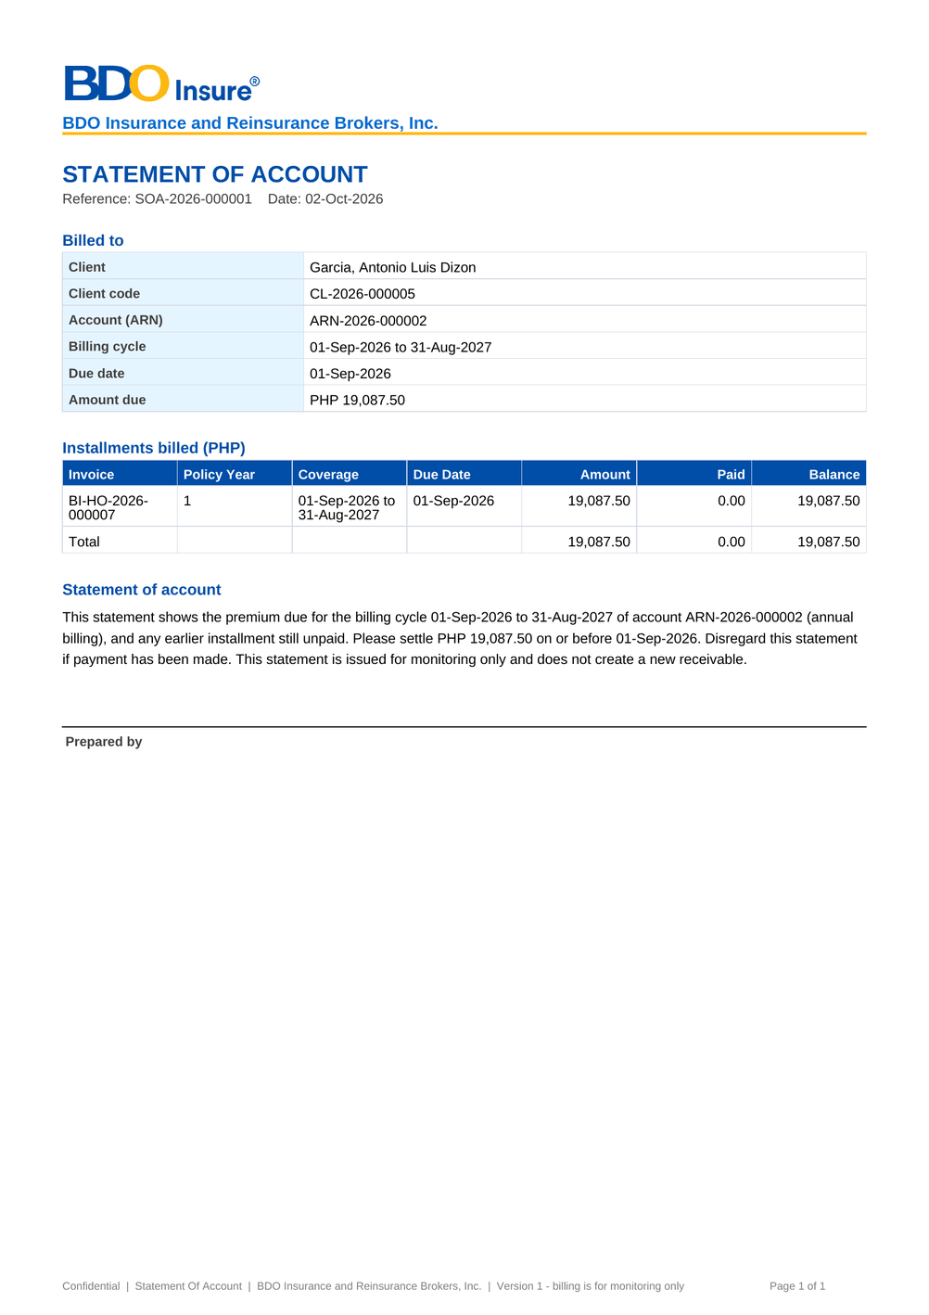
Figure 73: DO-01 Statement of account (SOA): first page as generated

17.2 DO-02 Outstanding PR List
Template | (report layout of the Collections reports)
Format | Excel; daily at the end of the day, and on request (Export to Files)
Produced by | Collections Files (daily file); PR Worklist › Export to Files
Password protected | No
FRs | FR-CL-083, FR-CL-084

Fields and their source
• Client and account: Client Code, Name of Assured, Invoice No., Policy No., Account (ARN), Booking Date, Aging Bracket, Invoicing Branch, Insurer, Product Line, Inception, Expiry – from the invoice ledger
• Amounts: Currency, Total Premium, Outstanding Premium, PR2307 Amount – from the invoice ledger
• Ownership: Market Segment, Sales Unit, Unit Head, Account Officer, Collection Handler – from the sales organisation and the assignments
• Collection work: Client Payment Status, Invoice Category, Disposition, Category (A/B/C), Tagging Owner, Last Collection Effort Date, Last Collection Effort Code, Remarks, Status – from the collection account

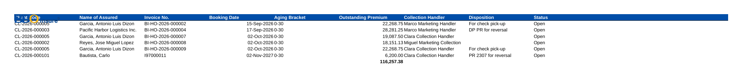
Figure 74: DO-02 Outstanding PR List: first page as generated

17.3 DO-03 Full Production Report
Template | (report layout of the Collections reports)
Format | Excel; daily after the end-of-day run (BRD p.61)
Produced by | Collections Files (daily file); Report Centre › Full Production Report
Password protected | No
FRs | FR-CL-083

Fields and their source
• Every collection account of the invoices booked in the period, any status, with the columns of the Outstanding PR List

Figure 75: DO-03 Full Production Report: first page as generated

17.4 DO-04 DP PR for Reversal and PR 2307 for Reversal files
Template | (report layout of the Collections reports)
Format | Excel; weekly per unit and branch (Saturday to Friday, available the Monday 08:00) and monthly for the previous month (first working day)
Produced by | Collections Files (weekly and monthly files)
Password protected | No
FRs | FR-CL-080, FR-CL-081, FR-CL-082

Fields and their source
• The accounts tagged DP PR for reversal or PR 2307 for reversal in the period, with the columns of the Outstanding PR List – from the collection accounts
• Tagging: Date Tagged, Tagged By, Tag Remarks – from the disposition
• Commission: Basic Commission, VAT on Commission, WTAX Rate and Diff (Premium Balance less PR2307) – from the invoice ledger

Figure 76: DO-04 DP PR for Reversal and PR 2307 for Reversal files: first page as generated

17.5 DO-05 For Application To Invoice file
Template | (fixed layout of the daily application file)
Format | Text file, daily before 06:00 for the requests of the previous day (BRCLXN.041-042); Report Centre for any period
Produced by | The daily application job; Requests to Cashiering shows the file of each request
Password protected | No
FRs | FR-CL-077

Fields and their source
• One line per application request: Requested On, Payment Date, Payment File Name, Transaction No., Paid Amount, Currency, Payment Type, Payor, Reference No., Name of Assured, Invoice No., User ID (who made the disposition), Unapplied Reference, Status, Cashiering Reference – from the requests and Cashiering

Figure 77: DO-05 For Application To Invoice file: first page as generated

18 Upload screens
Collections has one bulk upload, Collections Bulk Update, run on the Bulk Uploads screen of BRD-1 (SCR-NB-36): download the template, upload the filled file, review every row with its message, then process the valid rows. A file uploaded before is refused. The column checks (mandatory, number, date, Y/N) apply to every row, and the row checks listed below come on top. The values of the Escalation Level, Escalation Reason, Disposition and Effort Code columns are the codes of their lists, as the template states.

18.1 Collections Bulk Update (CLX_BULK_UPDATE)
Permission | BULK_PROCESS and CLX_BULK_UPDATE
Instructions | One row per invoice. Fill the promise columns to record a promise to pay, Escalate = Y with a reason to escalate the account, and the disposition, effort or remarks to update the worklist. Each row is checked and committed on its own.

Table 50: Template columns of Collections Bulk Update
No. | Column | Mand. | Type | Content | Example
1 | Invoice No | Y | Text | Invoice of the collection account | BI-MKT-2026-000001
2 | Promise Date | N | Date | Date the client promised to pay
3 | Promise Amount | N | Number | Amount promised; blank for the whole outstanding
4 | Promised On | N | Date | Day the promise was made; blank for today
5 | Escalate | N | Yes/No | Y to escalate the account | N
6 | Escalation Level | N | Text | Who the account is escalated to; blank for TL | TL
7 | Escalate To | N | Text | User ID of the user receiving the escalation
8 | Escalation Reason | N | Text | Why the account is escalated | NO_COMMITMENT
9 | Disposition | N | Text | Disposition of the premium receivable
10 | Effort Code | N | Text | Collection effort made
11 | Remarks | N | Text | Remarks

Row checks of this upload (besides the column checks)
• Fill a promise, Escalate = Y or a worklist field
• A promise amount needs the promise date
• Invoice <invoice> is not in the ledger
• Invoice <invoice> has nothing to collect
• You are not allowed to escalate accounts
• Escalation Level must be one of <>
• Name the user in Escalate To for a USER escalation
• <target> does not handle escalations
• Escalation Reason must be a code of the escalation reason list

19 Cross-BRD dependencies and interface contract
Collections reads every booked invoice from the Operations invoice ledger and New Business, and hands its work to Cashiering, Commission Receivables and Adjustment of Operations; it takes the sales organisation of Product Maintenance, the users of User Access Maintenance and the legacy follow-up of Data Migration. The contract below lists each exchange: the BRD or system, the direction, what is exchanged, when and how, and who owns the data. Section 7 describes the interfaces; the technical detail is in the Technical Specification, reviewed by BDOI IT.
Table 51: Interface contract of Collections
ID | BRD or system | Direction | What | When and how | Owner of the data | FR
IC-01 | BRD-2 Operations (invoice ledger) | In | Every booked invoice with its premium receivable by component, PR2307, payment and remittance status, direct payment and CWT flags, holds, pending negative adjustments and the team that locks it | Read every night by the worklist refresh and after each payment; the account and its tabs read the balances live; Collections keeps no second copy of the money | Operations (Cashiering, Remittance, Adjustment) | FR-CL-010, FR-CL-016, FR-CL-017
IC-02 | BRD-1 New Business | In | The account, client, policy, insurer shares, account officer, market segment and sales unit of each booked invoice | Read with the invoice by the worklist refresh; the Policy & Co-insurance tab reads the policy year | Processing (BRD-1) | FR-CL-010, FR-CL-043
IC-03 | BRD-2 Operations (Cashiering) | Out | A check pick-up request (pick-up date, address, contact, check amount, number and bank) from the disposition For check pick-up | Handed over inside BIBS when the disposition is recorded; it appears on Check Pick-up of Cashiering; the hand-off status shows on the account | Collections (request), Cashiering (pick-up) | FR-CL-032
IC-04 | BRD-2 Operations (Cashiering) | Out | A BIR 2307 tag (path, certificate number and period, 2% amount) from the disposition PR 2307 for reversal | Handed over inside BIBS when the tag is an Operations action; Cashiering validates it on BIR 2307 and posts the reversal | Collections (tag), Cashiering (validation and posting) | FR-CL-032, FR-CL-081
IC-05 | BRD-2 Operations (Commission Receivables) | Out | A direct payment account from the disposition DP PR for reversal, for the direct payment list of Commission Receivables | Placed on the direct payment list at once; the monthly and weekly DP PR for Reversal files list the same accounts for audit | Collections (tag), Commission Receivables (billing to the insurer and PR reversal) | FR-CL-032, FR-CL-080
IC-06 | BRD-2 Operations (Commission Receivables) | In | A direct payment account returned by the insurer | The account reopens in the worklist with the disposition DP returned by insurer and its handler is notified | Commission Receivables | FR-CL-032
IC-07 | BRD-2 Operations (Cashiering) | In | The unapplied payments of Cashiering with their payment, matched account, Cashiering tab and status | Read from Cashiering as of today, never copied | Cashiering | FR-CL-070, FR-CL-071
IC-08 | BRD-2 Operations (Cashiering) | Out | A request on an unapplied payment (apply to an invoice, refund, reclass, transfer to another unit) from a collector disposition, and the answer of Cashiering (accepted, rejected, applied) | Sent to the Incoming Requests of Cashiering when the disposition is recorded; Cashiering carries it out with its own approvals and its answer updates the request; the daily For Application To Invoice file lists the application requests | Collections (request), Cashiering (execution) | FR-CL-074, FR-CL-077
IC-09 | BRD-2 Operations (Adjustment) | Out | The cancellation of an account the client will not pay (disposition Cancel account) | No feed; the user raises the cancellation request in Adjustment; the account is excluded when the cancellation is posted | Adjustment | FR-CL-032, FR-CL-013
IC-10 | BRD-3 Product Maintenance (sales organisation) | In | Market segments, sales units and their Unit Heads | Read from the sales organisation; Collections Setup keeps the Unit Head of each unit for the worklist | Product Maintenance, Collections Setup users | FR-CL-015
IC-11 | BRD-11 User Access Maintenance | In | Users, roles and the Collections permissions; the handlers that may receive accounts and escalations | Read on every action; the sidebar and the buttons follow the role grants | System Administrator | FR-CL-001
IC-12 | BRD-13 Data Migration | In | Legacy invoices open at cut-over and the collection follow-up carried from legacy (disposition, promises, installments, collector) | Loaded once at cut-over; a migrated invoice carries the Legacy tag and its follow-up shows on the account | Data Migration | FR-CL-010
IC-13 | Client (e-mail) | Out | The statement of account of a billing cycle, password protected, and its password in a separate e-mail | Send via Email on the statement; the e-mail and its outcome are kept on the statement | Collections | FR-CL-061
IC-14 | BDOI file server (FS04) | Out | The daily For Application To Invoice file | Kept on Collections Files and downloaded by the user until the transfer to FS04 is specified (OQ17) | Collections, BDOI IT | FR-CL-077

Change against this signed set. A change to anything in this contract is raised in the Change Management Register and assessed with the owners of the other BRD: Collections reads the Operations invoice ledger and hands its work to Cashiering, Commission Receivables and Adjustment, so a change of a disposition with an Operations action, of a request type or of a balance component changes what Operations receives and is signed by both owners as a delta.

20 Sign-off and change control

20.1 What is signed
The business sign-off covers the release set BRD-04 Collections v2.0:
Table 52: Documents of the release set
Document | Content
00 Start Here | The map of the pack, the reading order per role, the steps up to closure and the dates
01 Sign-off Pack Guide (deck) | Purpose, approach and steps with who does what, the module at a glance, caveats and impacts on other modules, entry and exit criteria, handover and change control
02 This FRS v2.0 | Requirements (chapters 1-11), the business view of the system (chapters 12-19), sign-off (chapter 20), the proposed rules for confirmation (chapter 21) and the screen standards (appendix)
03 Sign-off workbook v2.0 | The screen standards, screens, fields, actions, rules, messages, notifications, menus, the upload template and the contract of this FRS, one row each, with the BU review columns; the comments log, meeting minutes, version history and sign-off certificate
04 and 05 Test plan v2.0 and its summary | The test cases traced to the FRs and to the screens of chapter 13

Table 53: The set in numbers
Content of the set | Count
Screens specified | 19
Fields and columns described | 152
Actions described | 66
Business rules on screens | 52
Messages (server, screen and upload row) | 148
Notifications and e-mails | 13
Upload types | 1
Generated documents | 5
Walkthroughs | 5
Interface contract lines | 14
Personas with their menus | 15

20.2 How the review is recorded
Each team records its review in the sign-off workbook: Accept, Change requested or Comment on each row of the screen standards, screen catalogue, field register, business rules and messages, with the comment, the reviewer and the date. Questions, corrections and change requests go to the comments log of the workbook, where the project team answers them. The project team answers every Change requested row in the comments log before sign-off: either the row is corrected in the next version of the set, or the change is raised as a change request (below) and the row is signed as specified.

20.3 What signing freezes
Signing this release set freezes, for Collections:
• the screens and their navigation (chapters 12 and 13), the fields with their order, labels, types, mandatory rules, lists and validations;
• the actions with their conditions and resulting statuses, and the business rules;
• the messages (chapter 15), the notifications (chapter 16) and the generated documents and files (chapter 17);
• the upload template (chapter 18) and the interface contract with the other BRDs (chapter 19).
Configuration values marked "default" (threshold, aging basis and brackets, edit-lock time, export cap, invoice number format, promise grace days, list entries, disposition attributes, escalation and assignment rules, the statement template, section 9) are not frozen; the Section Heads, the Business Administrator and the System Administrator change them in the system without a change request.

20.4 Change after sign-off
A change to anything frozen is raised in the Change Management Register. The request states the screen, field, rule or message concerned, the reason and the business priority. The project team assesses it, including its effect on the other BRDs through the interface contract of chapter 19 (for example a new disposition with an Operations action changes what Cashiering or Commission Receivables receives), and the owners of every BRD it touches approve it. An approved change is delivered as a new version of this release set (v2.1, v2.2 and so on) with its own Start Here guide, and only the changed pages and rows are reviewed and signed again (delta sign-off).

20.5 Proposed rules for confirmation
Chapter 21 lists the proposed business rules and screen behaviour that differ from the BRD or need a decision of BDOI. BDOI records its decision on each item with its review; a decision that changes a screen, field, rule or message is applied in the next version of this set.

20.6 Signatures
By signing, BDOI confirms that this FRS and the sign-off workbook describe the Collections functions, screens and messages it expects in BIBS, accepts the assumptions in section 10.1 and records its decisions on the items of chapter 21. Open questions in section 10.3 stay open; their answers are applied as configuration or through a change request. The signatories are those of the approval sheets of the Collections BRD.
Name | Role | Organisation | Signature | Date
Shellah Marie C. Miranda | AVP, Product Owner | BDOI
Jose Melvin Jarin | AVP, Product Owner | BDOI
Mark Joseph C. Makalintal | SAVP, Unit Head - Combank and Corbank | BDOI
Edmundante F. Ramirez | VP, Head - Retail Marketing | BDOI
Roderick Lim | FVP, Head - Retail Marketing | BDOI
Ronald Allan E. De Leon | VP, Head - Comptrollership | BDOI
John Benedict S. Santos | VP and Head, BDOI Operations (reviewer) | BDOI
Pia Grace M. Pinili | Collections and Marketing Support (input provider) | BDOI
Maria Victoria Evangelista | Collections and Marketing Support (input provider) | BDOI
Perjelyn Joy Gutierrez | Operations: Financial Transactions and Processing (input provider) | BDOI
 | Information Technology Group (reviewer) | BDOI
Dan Ace Cauton | Program Manager, ESG - Business Project Services | BDO Unibank ESG
Zean C. Ibay | Business Analyst, ESG - Business Project Services | BDO Unibank ESG
 | Project Manager | iorta TechNXT

21 Proposed business rules and clarifications for confirmation
The table lists each point where the proposed screen or rule differs from the BRD text, fills a gap the BRD leaves open, or needs a decision of BDOI. None of them removes a BRD requirement; most are settled by an answer of BDOI that is applied as configuration. BDOI records its decision with the review of this set (section 20.5); a decision that changes a screen, field, rule or message is applied in the next version of the set, and an answer that only sets a value (a list, a parameter, a template) is applied as configuration.
Table 54: Proposed business rules and clarifications for confirmation
Ref | Topic | Proposed rule or screen behaviour | Reason | Decision requested from BDOI
CLR-CL-01 | Daily refresh (BRCLXN.013-015; FR-CL-017) | EBIX is replaced by BIBS booking. The job CLX_DAILY_REFRESH reads the BIBS invoice ledger at 22:15; the balance of a listed account is also refreshed after each payment. Open EBIX items, their disposition history and unapplied items at go-live come in through a one-time migration. | The BRD extracts from EBIX after the 22:00 end-of-day; in BIBS the booking is internal. The migration scope and format are open (CQ07). | Confirm the refresh from the ledger; give the migration scope and cut-off (CQ07).
CLR-CL-02 | Negative balances (BRCLXN.010; FR-CL-013) | Negatives of cancellations and return invoices are never listed (EXCLUDED_CANCELLED); other negatives are kept as CREDIT on a Credit Balances tab. | The BRD excludes the negatives of transaction type C only (CQ04). | Confirm the treatment of negatives (CQ04).
CLR-CL-03 | Data scope per user (BRCLXN.012; FR-CL-015) | Every CLX_VIEW user sees every account and narrows it with the filters, which run on the whole list; there is no default scope per user. | The BRD shows only the accounts of the selected segment and UH (CQ06). | Confirm the filters, or give the default scope per role (CQ06).
CLR-CL-04 | Unit Head (BRCLXN.011; FR-CL-015) | The Unit Head is the head of the invoice's sales unit (else of its department or region), maintained on Collections Setup. | The BRD does not say where the Unit Head comes from (CQ05). | Confirm the source of the Unit Head (CQ05).
CLR-CL-05 | Monthly reversal files (BRCLXN.024, 026; FR-CL-032, 080, 081) | A DP PR disposition goes at once to the Commission DP list and a PR 2307 disposition to the Cashiering 2307 intake; the monthly file is the audit copy. | The BRD has the monthly batch generate the file for Operations (OQ16, OQ38). | Confirm the hand-off at the time of the disposition.
CLR-CL-06 | 2307 hand-off (BRCLXN.026; FR-CL-032) | Cashiering takes the PR 2307 hand-offs in its 2307 intake; a hand-off not taken within one day raises the alert CLX_OUTBOX_STALE. | The BRD says the 2307 accounts reach Operations for reversal without naming the step. | Confirm the Cashiering 2307 intake.
CLR-CL-07 | Request application of payment (BRCLXN.030, 032; FR-CL-074) | The request goes to Cashiering's Incoming Requests; a cashier accepts it and applies the payment through the Operations disposition workflow and its approvals. A request that Cashiering refuses shows "Rejected by Cashiering: <reason>". | The BRD does not name the Cashiering step (OQ15). | Confirm the Cashiering step (OQ15) and the texts of the refusals Cashiering gives at once (unknown payment, no balance, amount above the balance, no invoice).
CLR-CL-08 | Names on the unapplied list (BRCLXN.036; FR-CL-070) | User names are shown for UH and AO; booker and bank officer names, Business Origin and System Remarks are not shown; "Processing Stage" is the Cashiering tab. | BIBS does not hold the booker, bank officer, Business Origin or System Remarks of an unapplied item (CQ11). | Confirm the columns, or name the source of the other fields (CQ11).
CLR-CL-09 | Daily application file (BRCLXN.041-042; FR-CL-077) | The pipe-delimited file is written at 05:00 and kept in the list of extracts under FS04/CLX_APPLICATION_TO_INVOICE; the transfer to FS04 is added when BDOI names it. | The BRD loads the text file to FS04 before 06:00; the transfer is not specified (OQ17, CQ12). | Name the FS04 transfer and confirm the layout (OQ17, CQ12).
CLR-CL-10 | Invoice number (BRCLXN.047; FR-CL-075) | The pattern CLX_INVOICE_NO_PATTERN accepts the EBIX format and the BIBS format (BI-...), and the invoice must exist in the BIBS ledger. | The BRD gives the number as "I" and 8 digits; BIBS invoices have their own format (CQ13). | Confirm the two formats (CQ13).
CLR-CL-11 | Bulk update (BRCLXN.051; FR-CL-034) | The worklist updates several accounts with a disposition or an effort (with remarks) and reassigns them; promises and escalations are recorded in bulk on their screens. The upload Collections Bulk Update records promises, escalations, dispositions, efforts and remarks, each row on its own. | The BRD asks for bulk update of several invoices without naming the fields. | Confirm the fields of the grid actions and the upload.
CLR-CL-12 | Installment plans (BRCLXN.053; FR-CL-040) | Plans are made in Collections (policy years, generated or manual); installment terms do not come from the quotation or the account. | The BRD does not say where the installment terms come from (CQ15). | Confirm plans made in Collections (CQ15).
CLR-CL-13 | Broken promises (BRCLXN.055; FR-CL-042) | A promise is KEPT, PARTIALLY_KEPT or BROKEN by the payments applied between the day of the promise and the promised date plus CLX_PROMISE_GRACE_DAYS (0). | The BRD detects broken promises per installment without a grace period (CQ16). | Confirm the rule and the grace days (CQ16).
CLR-CL-14 | Delivery and receipt dates (BRCLXN.056; FR-CL-043) | The first AR date is shown as the receipt date; the delivery date is blank. | BIBS does not record the delivery of the policy (CQ17). | Confirm, or name the source of the delivery date (CQ17).
CLR-CL-15 | PR confirmation for CR billing (BRCLXN.059; FR-CL-090) | Commission bills a DP account only after the CRU reviewer confirms it "fully paid to the insurer" (CMRID.013); there is no separate automatic PR confirmation record. | The confirmation is a Commission step in BRD-2 (OQ38). | Confirm the CRU confirmation (OQ38).
CLR-CL-16 | Aging basis (BRCLXN.060; FR-CL-062) | The aging runs from the booking date or the inception date (CLX_AGING_BASIS); aging from the SOA due date is not proposed. | The BRD mentions billing statements, invoice dates and policy periods (CQ14). | Choose the aging basis (CQ14).
CLR-CL-17 | Draft commission and incentive rows (BRCLXN.061-064; FR-CL-091 to 094) | The four draft rows are proposed as described in section 4.10; their validations and messages are confirmed with the draft. | The rows are in the unsigned draft addendum only (CQ01). | Confirm or withdraw the draft rows (CQ01).
CLR-CL-18 | Several roles per user (NFR 3.04; FR-CL-001) | A user may hold several roles; segregation of duties is kept by the permission of each action. | Cross-BRD decision D5 of BRD-11. | Confirm decision D5 for Collections.
CLR-CL-19 | Lock-out (NFR 1.04, 2.02; FR-CL-001) | Every BIBS user is locked out after 3 invalid attempts (LOGIN_MAX_FAILED_ATTEMPTS = 3) and the correct password is then refused with the same message as a wrong password ("Invalid user name or password"); the lock shows to the System Administrator. | Cross-BRD decision D5 of BRD-11. | Confirm the lock-out rule.
CLR-CL-20 | Exports (p.93 caveat; FR-CL-084) | Exports run in the background, capped at CLX_EXPORT_MAX_ROWS, under their own permission CLX_EXPORT. | The BRD warns that exports may slow the system. | Confirm the cap and the permission.
CLR-CL-21 | Edit lock (NFR 9.03; FR-CL-005) | The lock is taken when the user opens the account and is released when the user leaves it or after CLX_EDIT_LOCK_MINUTES (15). Activity on the account does not renew the lock; when it expires, the next user takes it. | The BRD does not say whether work on the account renews the lock. | Confirm the expiry, or ask for renewal while the holder works.
CLR-CL-22 | Refresh after a payment (BRCLXN.013-015; FR-CL-017) | A payment applied in Cashiering updates the outstanding of the account within 5 minutes. | The BRD gives no target for the update after a payment. | Confirm the 5-minute target.
CLR-CL-23 | Report period check (FR-CL-004) | The report parameters check that the end date is on or after the start date; the message text is the one of the Report Centre, confirmed at the first test run. | The Report Centre checks the period for every report. | Confirm the check of the period.
CLR-CL-24 | Details of an Operations action (FR-CL-032) | A check pick-up needs the pick-up date and the check amount; a 2307 disposition needs the path, certificate received or paid in cash; a DP reversal needs no detail. A date detail is checked as yyyy-mm-dd and an amount as a number. | The BRD names the dispositions but not the details each needs. | Confirm the details per action.
CLR-CL-25 | Client on the worklist (screen standards; SCR-CL-02 to 04) | The client of an account is shown by its client code, a link to the client view, with the name of the assured under it; the client's own name is shown on the client view. | The client code is the reference the collectors quote to Cashiering and in the files. | Confirm the client code, or ask for the client's name with the code under it.
CLR-CL-26 | Filters and criteria typed (screen standards; SCR-CL-02, SCR-CL-17) | The filters of the PR Worklist and the criteria of the assignment rules and of Reassign by Criteria are text fields where the user types a segment, unit, Unit Head, handler or account officer; the handler of a reassignment is chosen by name. | The filters were kept as in the BRD's list of filter fields (BRCLXN.011-012). | Confirm, or ask for drop-downs of the segments, units and users by name.
CLR-CL-27 | Collections Setup values (screen standards; SCR-CL-19) | The parameters are listed by name with a business description, and the attributes of a disposition are shown by label and chosen from drop-downs (the reserved roles as check boxes). The Invoice Number Format parameter is kept as the pattern the invoice number is checked against. | The set-up is maintained by the Section Heads and the Business Administrator; the invoice number format follows the numbering of the legacy and the BIBS invoices. | Confirm the names and descriptions of the parameters, and whether the invoice number format stays a pattern kept by the System Administrator or becomes a choice of formats.
CLR-CL-28 | Designated user of an escalation (screen standards; SCR-CL-11, SCR-CL-13) | The designated user of a manual escalation and of an escalation rule is typed as the user ID; a user who does not handle escalations is refused. | The level (team lead, unit head, section head) is the usual target; a designated user is the exception. | Confirm, or ask for a drop-down of the users who handle escalations, by name.
CLR-CL-29 | Values of the upload template (FR-CL-034; chapter 18) | The Collections Bulk Update template takes the codes of its lists (escalation level TL, UH, SECTION_HEAD or USER; the codes of the escalation reasons, dispositions and efforts), as the template instructions state. | A template is filled in a spreadsheet and read back by the system without interpretation. | Confirm the codes in the template, or ask for the labels.
CLR-CL-30 | Disposition and effort values to confirm (FR-CL-030, 033, 072; CQ08) | The seeded dispositions, effort codes and escalation reasons are the values implied by the BRD; BDOI replaces them with its lists as configuration. | The lists are to be supplied by BDOI (CQ08). | Give the lists of dispositions, effort codes and escalation reasons (CQ08).
CLR-CL-31 | Authorization of escalation rules (BRCLXN.049; FR-CL-050) | A new or changed escalation rule is authorized by an authorizer of master data (the Authorizer role of the platform) other than its maker; no Collections role authorizes master data. | The BRD asks for maker-checker on the rules without naming the checker. | Name the role that authorizes the escalation rules (for example the Section Head), or confirm the authorizers of master data.

22 Appendix: Screen standards
The Collections screens follow the screen standards of BIBS. They are the same standards in every FRS and are listed here so that BDOI can agree the look of the screens once and check the screenshots against it; they are not repeated in each screen specification.
Table 55: Screen standards of BIBS
Area | Standard
Record pages | Back arrow and breadcrumb, title, then the record header: name, reference chips, status pill, flags (for example On Hold or Locked by Adjustment on a collection account) and the key facts. Page actions on the right in one order: secondary, primary, and the destructive action last and apart.
Workflow header (step bar) | Every record with a workflow shows a stepper under the record header: the stages of the main path in their order, passed stages ticked in blue, the current stage highlighted, the stages ahead in grey with their number. A returned stage shows in amber after the stage it came from; the last stage turns green when it is reached. Under the stepper one row gives Current Stage, Since, Due (with the Overdue pill) and Assigned To, with the actions of the stage on the right. The history is a table (Stage, From Stage, Action, By, Date and Time, Remarks, Duration in Stage), newest first.
Messages (notice standard) | One standard for errors, warnings, information and success: a white notice with a thin bar and an icon in the colour of its kind (red, amber, blue, green), a bold short title, then the business message with one bullet per missing item. No codes, internal references or technical terms in what the user reads. Field errors appear under the field; a long form lists its errors at the top with a link to the first field. Only an unexpected system error offers Retry and a reference for support behind Details. Special instructions are one short information notice.
Tables, not highlight boxes | Records and lists of records are rows of a titled table (for example the hand-offs of an account: Feed, Reference, Sent, Taken, Status); key data is a label and value grid. A coloured box carries a short message only, never a record.
Tables | Header row in BDO blue that stays in view; rows alternate white and Background Blue, with a light hover and a stronger blue for the selected row; a list scrolls inside its card, the card as high as its rows and never higher than the window; text left, amounts right, dates in one format; one value per cell with at most one muted line under it; a dash for an empty value; the kind of a mixed list of records in a Type column; a due date on one line, in red with the warning icon once past due; ages and durations in words (for example 3 days); "Showing x to y of n results" with page numbers. A table fits the page: related values share a column (one under the other) rather than scrolling sideways.
Row actions | The actions on a record of a list are in one row action menu at the end of the row (the three-dot button), never buttons or links in the row; a destructive action is listed last, in red, and asks for confirmation.
Status labels | Statuses are outlined pills (a border and text in the colour of the state group on a light tint) of one size and never wrap. The full label is shown (for example Pending Authorization, With Outstanding Balance); an agreed short form, with the full label in the tooltip, only for a label longer than 21 characters.
Labels and names | List values are shown by their label, never by their code; insurers by name; users by their names, never by their user ID.
Dates, amounts and rates | One date picker; dates entered and shown as dd-MMM-yyyy, times as dd-MMM-yyyy HH:mm (Philippine time). Amounts with two decimals and thousand separators, negatives in brackets, the currency in the column header or before the amount. Rates as percentages with two to four decimals, as keyed.
Period cell | A period (coverage, billing cycle, the period of a file) is shown in lists on two lines, the start date and "to" the end date, each date kept whole; an open end reads "to open". In a sentence or a label and value grid it is one line: "01-Sep-2026 to 30-Nov-2026".
Forms | Labels above the fields, fields of one height on one line, required fields marked, the error under the field, and the actions in one place (Cancel, then the main action). Format hints only; other guidance is in the tooltip of the label.
Uploads | Download Template next to the upload; a drop zone with the accepted types and maximum size; every row checked before anything is saved; Rows Read, Valid and Rejected with the rows; valid rows are processed and the rejected rows are returned in the error file (the template layout with an Error column and the wrong cells highlighted); Upload Corrected File keeps the link to the first upload; a file uploaded before is refused.
Confirmations and reasons | Every approve, authorize, post, release, cancel, void or deactivate asks for confirmation in a dialog that names the record and the effect. Every reject, return, cancel and void needs a reason (from its list where there is one) before it can be confirmed. Destructive actions are confirmed with the red button. The reason is kept in the history and sent with the notification.
Notifications | The bell shows the unread count and opens the panel grouped by day (Today, Yesterday, then the date), each notice with its title, one-line summary, record reference and time; Mark Read, Mark All Read and View All; the Notifications page lists every notice with filters.
Documents | Generated documents carry the BDO Insure letterhead, the document name and reference, and a business footer with "Confidential" and page x of y.

The project team checks each screen against these standards before UAT and records the result in the screen readiness checklist. A screen found not to follow a standard during the review is recorded as Change requested in the sign-off workbook and corrected before UAT without a change request. The presentation choices that BDOI is asked to confirm are items of the clarifications chapter.

