
PRJ0012475 - BDO Insure Brokering System (BIBS) - Operations Remittance: Screens and UX Design -
Release 1 / Drop 0
Prepared by: iorta TechNXT Project Team

Template Reference No. | D051
Document No. | PRJ0012475-RMT-UXD
Prepared by: | iorta TechNXT Project Team
Drafting support: | iorta TechNXT Project Team
Creation Date: | 10/17/2026
Revision No. | 1.1
Last Updated by: | iorta TechNXT Project Team
Last Updated Date: | 10/17/2026

Document Revision Log
Date | Revision | Description | Updated by
17 Oct 2026 | 1.0 | First issue, with the FRS Operations Remittance v1.0. | iorta TechNXT Project Team (drafting support); for review by the BDOI Product Owner
17 Oct 2026 | 1.1 | Second issue with the release of 17 Oct 2026: SCR-RMT-02, 04, 05 and 12 updated for the delivered extract files, settlement numbering, shared folder copy and Mall Assurance columns; SCR-RMT-13 Remittance Settings now available; screenshots captured from the running application on seed data. | iorta TechNXT Project Team (drafting support); for review by the BDOI Product Owner

Table of Contents
Document Revision Log 3
Table of Contents 4
Introduction 5
Menu by Persona 6
Screens 7
SCR-RMT-01 Remittance Workbench 7
SCR-RMT-02 Extraction 7
SCR-RMT-03 Remittance Batches 9
SCR-RMT-04 Remittance Batch 9
SCR-RMT-05 Insurer OR Upload 12
SCR-RMT-06 Remittance Holds 13
SCR-RMT-07 Remittance Hold 14
SCR-RMT-08 Special Remittance 15
SCR-RMT-09 Special Remittance Request 16
SCR-RMT-10 DTIP Status 17
SCR-RMT-11 Incentive Rules 18
SCR-RMT-12 Report Centre (Remittance) 19
SCR-RMT-13 Remittance Settings 20

Introduction
This document describes every Operations Remittance screen of BIBS: purpose, users, access, rules and states, fields with their type, whether they are required, default, rule and message, and the actions. The requirements and rules are in the FRS v1.0.
Most screens are offered by the BIBS platform today; the Availability row of each screen names the changes of this FRS still to deliver and marks the proposed new screen. Screenshots are added in the next version, after the walkthrough of the screens with the Business Unit on the test environment.
Codes used: Y required, N optional, Cond. required on a condition, - display only. Dates show as dd-MMM-yyyy, times in Manila time, amounts with two decimals.

Menu by Persona
The screens are under Operations › Remittance; the reports under Reports. A persona sees only its entries.
Table 1: Remittance menu by persona
Screen | Purpose | Personas
Remittance Workbench | Work waiting by stage, counts and amounts, links to each list | Processor, Team Leader, Mkt Collection, Mkt Team Leader
Extraction | Runs, manual extraction per insurer and type or per invoice, end-of-day queue | Processor, Team Leader
Remittance Batches | Batches by stage; review, exclusion, submission, approval, documents | Processor, Team Leader, Auditor
Insurer OR Upload | Upload of the insurer ORs and the exception report | Processor, Team Leader
Remittance Holds | Hold requests, approvals, extensions, cancellations, releases | Processor, Team Leader, Mkt Collection, Mkt Team Leader
Special Remittance | Special remittance requests and their approval | Processor, Team Leader, Mkt Collection
DTIP Status | Premium due to insurers per invoice and its remittance status | Processor, Team Leader, Comptrollership
Incentive Rules | Early remittance incentive rules | Team Leader
Remittance Settings | Extraction schedule, file names and output folders (proposed) | Team Leader
Report Centre | The remittance reports | Processor, Team Leader, Comptrollership, Auditor

Screens

SCR-RMT-01 Remittance Workbench
Item | Value
Purpose | The work waiting by stage: batches to review, to approve, holds and special requests for decision, the last extraction run.
Access | Remittance and Marketing personas (any remittance permission)
Requirements | FRID.RMT.013
Outcome | The user opens the list of the work he chose.
Availability | Available

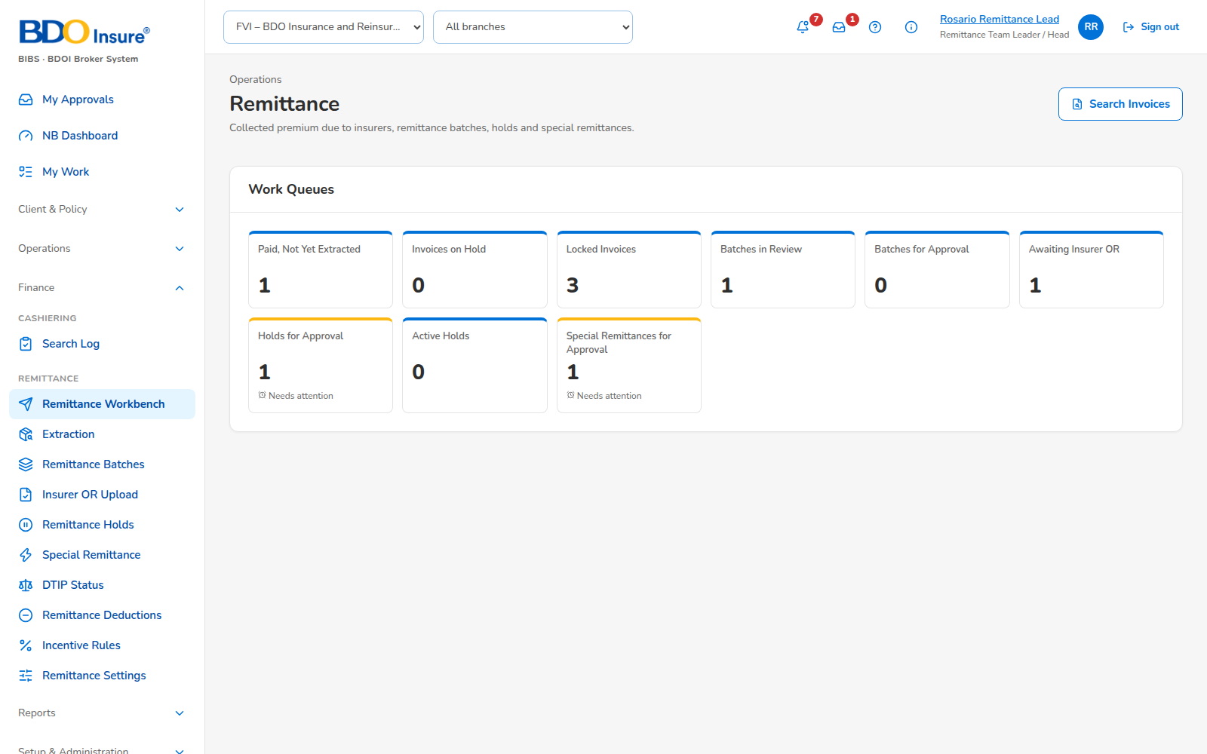
Figure 1: SCR-RMT-01 Remittance Workbench, captured from the running application on seed data
Rules and states:
• Counts and amounts follow the user's permissions and company.
• Each tile opens its list filtered on the tile.
Table 2: SCR-RMT-01 actions
Action | Who | Available when | What happens | Result
Open a tile | All | Always | Opens the filtered list | List

SCR-RMT-02 Extraction
Item | Value
Purpose | Extraction runs, manual extraction per insurer and type or per invoice, the end-of-day queue and the tags of each run.
Access | Remittance Processor, Remittance Team Leader
Requirements | FRID.RMT.001, 003, 004, 005
Outcome | Batches created; tags and reasons per account.
Availability | Available; delivered in the release of 17 Oct 2026 (FRID.RMT.001.03, 001.04, 001.08, 001.09)

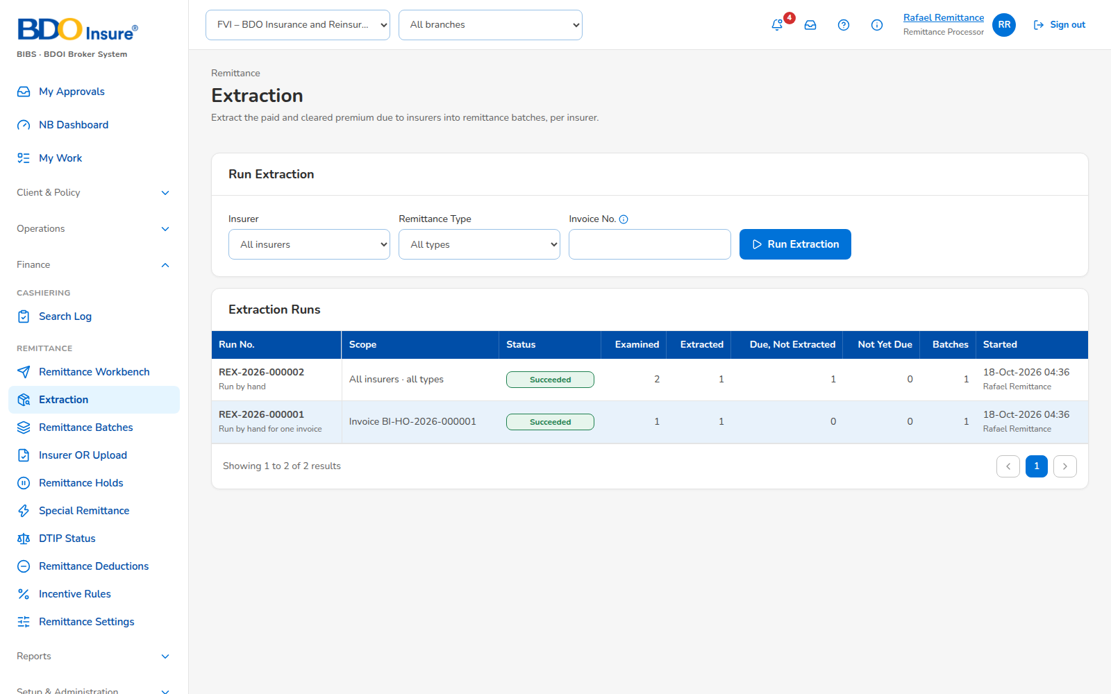
Figure 2: SCR-RMT-02 Extraction, captured from the running application on seed data
Rules and states:
• A manual extraction applies the rules of the scheduled run (BR-RMT-02).
• An invoice queued twice for the end of day is kept once.
• Each run lists its tags: Extracted, Unextracted - not yet due, Unextracted - due (reason), Returned.
Table 3: SCR-RMT-02 fields
Field | Type | Req. | Default | Rule | Message
Insurer | List | N | All | Active insurers | -
Remittance type | List | Y | - | With Incentives, Normal - Peso, Normal - Dollar | -
Invoice number | Text | Cond. | - | Manual extraction of one invoice | Invoice <invoice> cannot be extracted: <reason>

Table 4: SCR-RMT-02 actions
Action | Who | Available when | What happens | Result
Extract | Processor, Team Leader | Type chosen | Runs the extraction | Run with its batches
Queue for end of day | Processor | Invoice given | Queues the invoice | Queued
Open tags | Processor, Team Leader | A run selected | Lists the accounts checked | Tags

SCR-RMT-03 Remittance Batches
Item | Value
Purpose | Batches by stage with insurer, type, processor, accounts and amount due.
Access | Remittance personas, Auditor (read)
Requirements | FRID.RMT.006, 009
Outcome | A batch opened.
Availability | Available

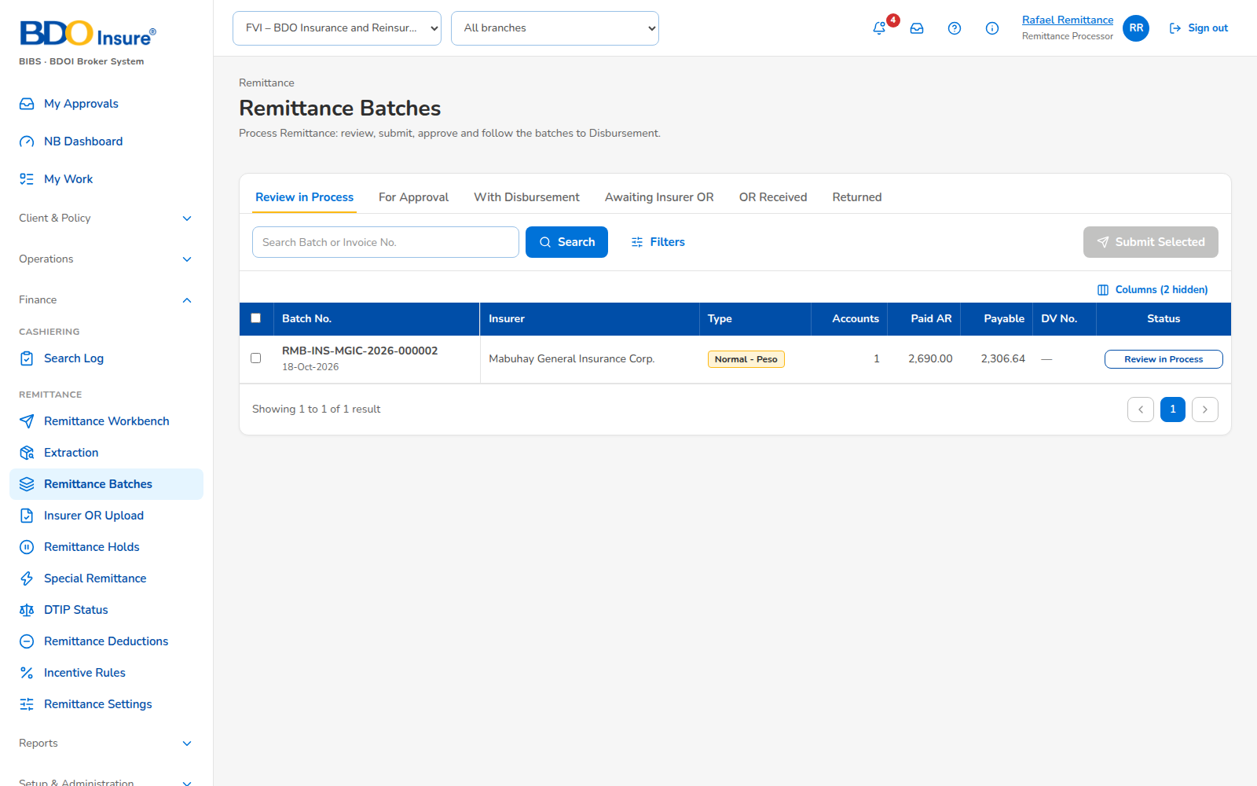
Figure 3: SCR-RMT-03 Remittance Batches, captured from the running application on seed data
Rules and states:
• Tabs by stage; filters by insurer, type, processor and batch number.
Table 5: SCR-RMT-03 fields
Field | Type | Req. | Default | Rule | Message
Search | Text | N | - | Batch number, insurer, invoice | -

Table 6: SCR-RMT-03 actions
Action | Who | Available when | What happens | Result
Reassign | Team Leader | Batch open | Gives the batch to another processor | Assigned

SCR-RMT-04 Remittance Batch
Item | Value
Purpose | One batch: its lines, exclusions, preview, documents, settlement and history.
Access | Remittance personas
Requirements | FRID.RMT.002, 006, 007, 015
Outcome | Batch submitted, approved, returned or sent.
Availability | Available; delivered in the release of 17 Oct 2026 (FRID.RMT.002.02, 007.01: extract files, settlement reference, shared folder copy and resend)

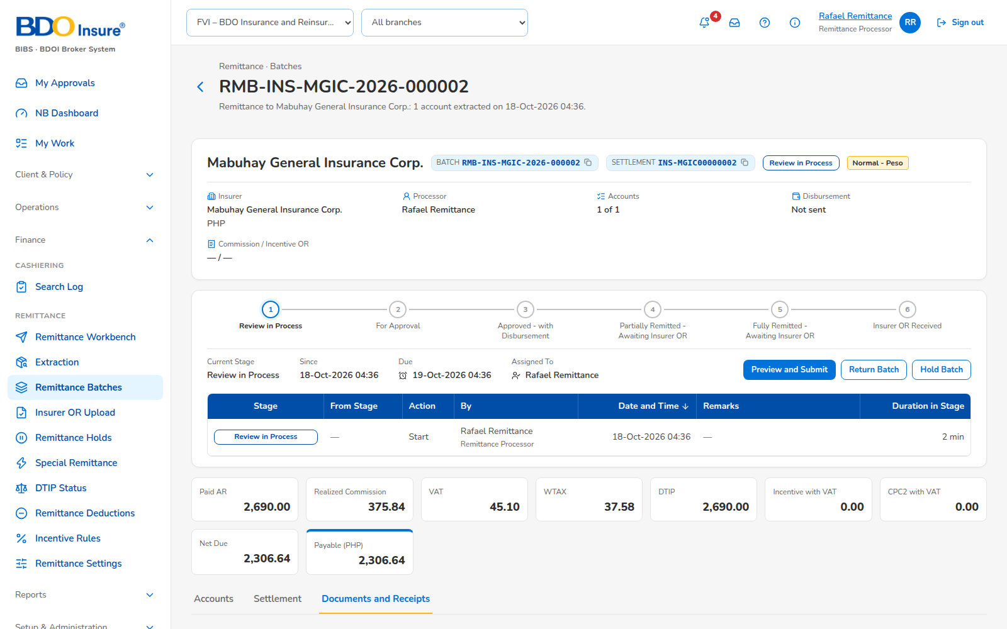
Figure 4: SCR-RMT-04 Remittance Batch (files), captured from the running application on seed data
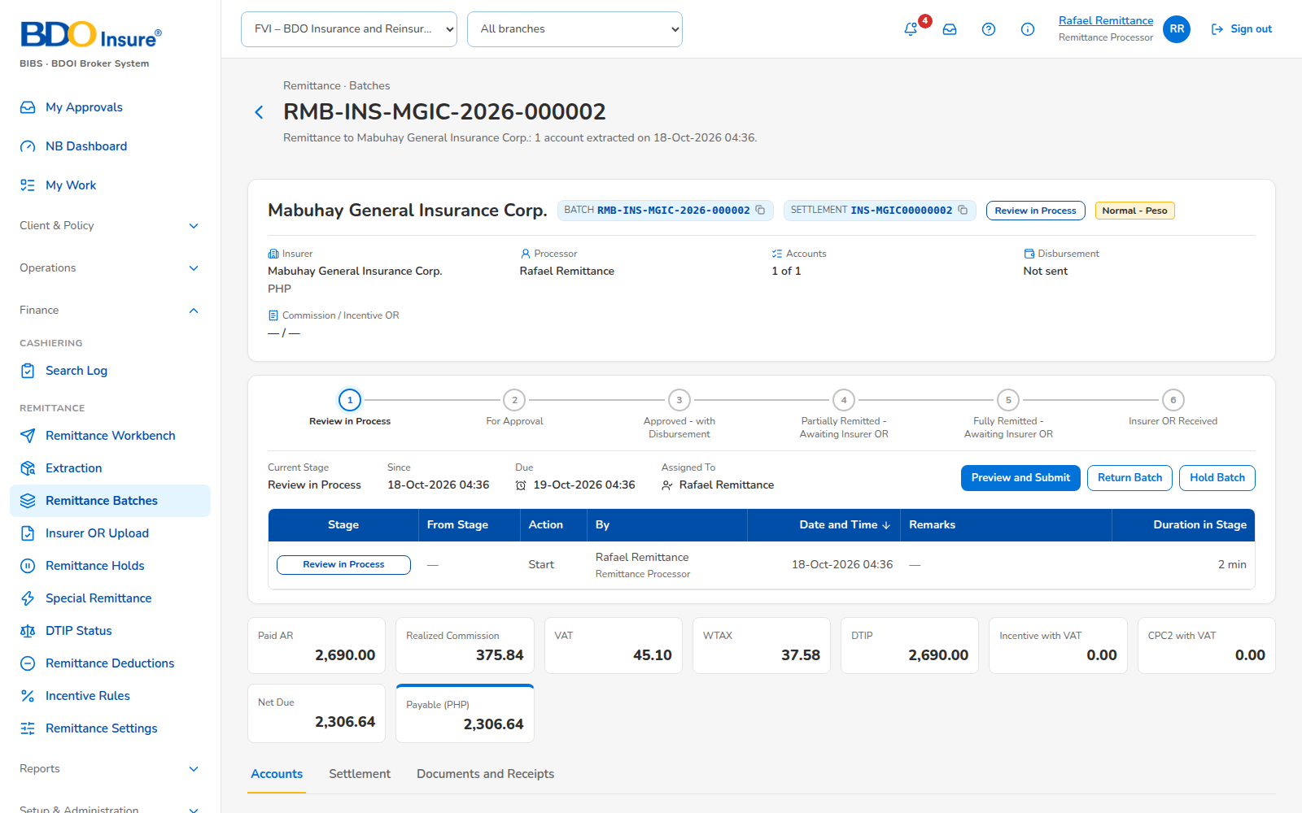
Figure 5: SCR-RMT-04 Remittance Batch, captured from the running application on seed data
Rules and states:
• Amounts are read-only; exclusion and restore while Review in Process (BR-RMT-06).
• The submitter cannot approve (BR-RMT-01).
• The schedule is sent after approval; a second sending asks for a confirmation.
Table 7: SCR-RMT-04 fields
Field | Type | Req. | Default | Rule | Message
Exclusion reason | List | Y | - | REMIT_EXCLUSION_REASON | Select a reason
Comment | Text 500 | Cond. | - | Required for Others | Enter a comment
Return reason | List | Y | - | REMIT_RETURN_REASON | Select a reason

Table 8: SCR-RMT-04 actions
Action | Who | Available when | What happens | Result
Exclude | Processor | Review in Process | Excludes the selected lines | Totals updated
Restore | Processor | Review in Process | Restores a line | Totals updated
Preview | Processor | Review in Process | Shows the batch after exclusions | Preview
Submit | Processor | Review in Process | Checks the account statuses | For Approval
Approve | Team Leader (not the submitter) | For Approval | Posts; payment request | Approved
Return | Processor, Team Leader | Open | Frees the lines | Returned
Send schedule | Processor | Approved | E-mails the schedule | Sent
Documents | Remittance personas | Always | Opens the Excel, text, schedule and payment request | File

SCR-RMT-05 Insurer OR Upload
Item | Value
Purpose | Upload of the insurer's returned schedule, results and exception report.
Access | Remittance Processor, Remittance Team Leader
Requirements | FRID.RMT.008
Outcome | Invoices updated with the insurer OR.
Availability | Available; delivered in the release of 17 Oct 2026 (FRID.RMT.008.01: Excel and text OR return with control totals)

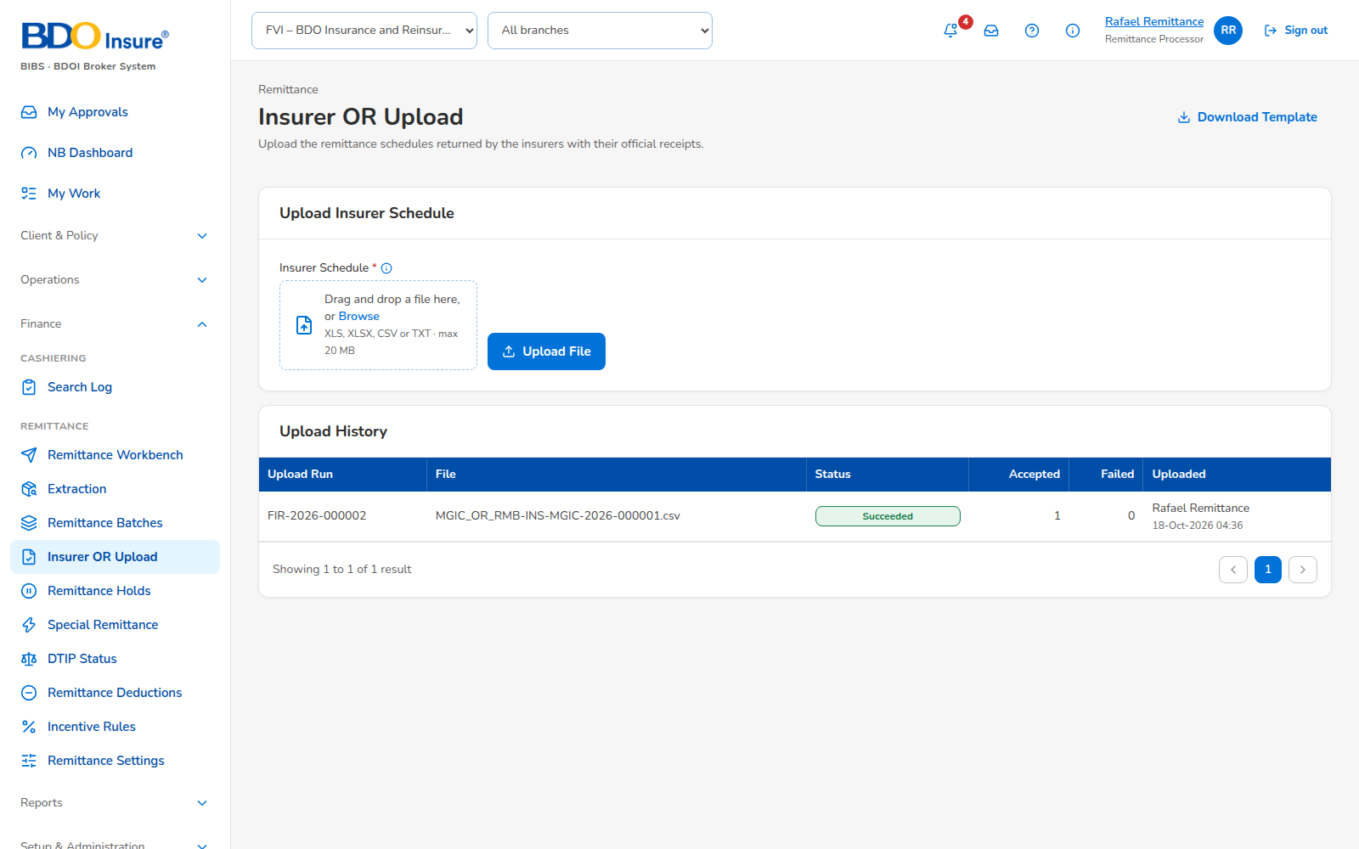
Figure 6: SCR-RMT-05 Insurer OR Upload, captured from the running application on seed data
Rules and states:
• Each account is processed on its own; refused accounts are listed with the reason.
• The same OR number is not recorded twice for a client.
Table 9: SCR-RMT-05 fields
Field | Type | Req. | Default | Rule | Message
File | File | Y | - | Excel or text of IF-RMT-03; at most 10 MB | The file must have the columns <columns>

Table 10: SCR-RMT-05 actions
Action | Who | Available when | What happens | Result
Upload | Processor | File chosen | Reads and checks the file | Run with results
Exception report | Processor | Run open | Downloads the report | Excel, PDF
Template | Processor | Always | Downloads the upload template | Excel

SCR-RMT-06 Remittance Holds
Item | Value
Purpose | Hold requests by stage; new request, bulk upload.
Access | Marketing Collection, Marketing Team Leader, Remittance personas (read)
Requirements | FRID.RMT.010
Outcome | Hold requested.
Availability | Available

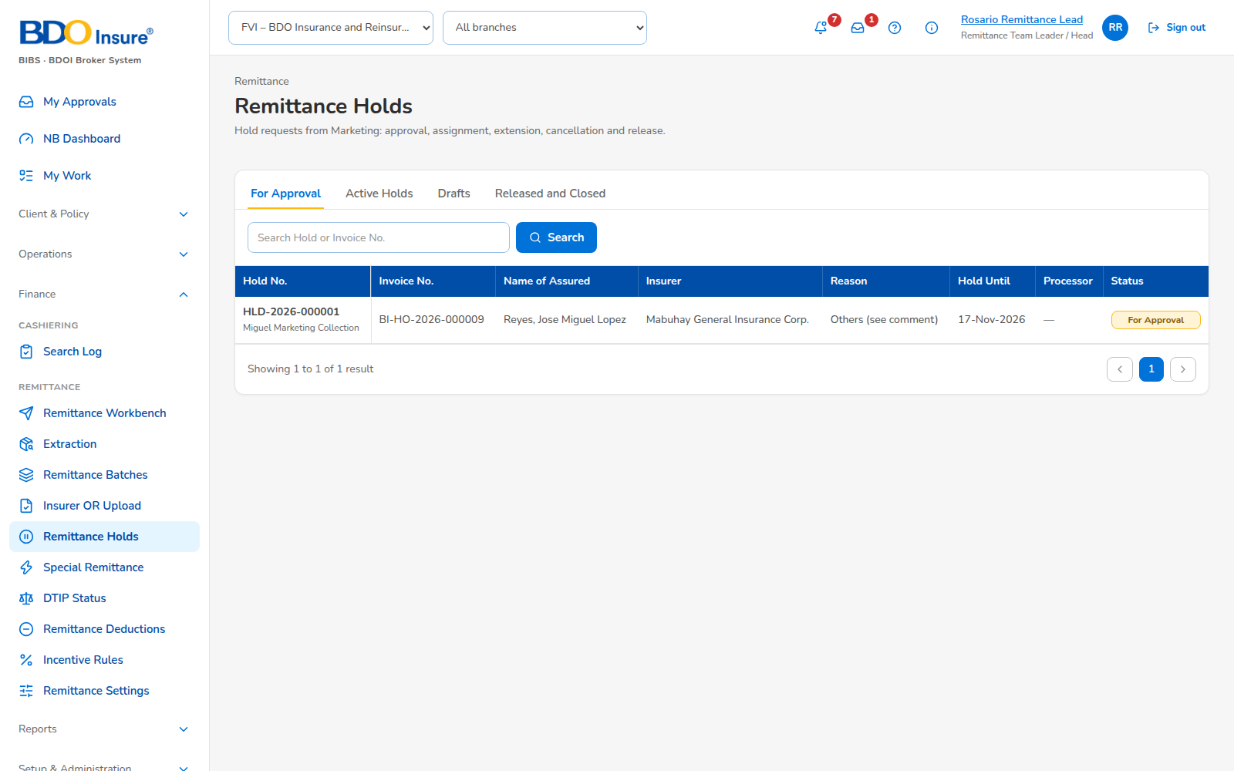
Figure 7: SCR-RMT-06 Remittance Holds, captured from the running application on seed data
Rules and states:
• One active hold per invoice.
Table 11: SCR-RMT-06 fields
Field | Type | Req. | Default | Rule | Message
Invoice number | Text | Y | - | Invoice with premium due | Invoice <invoice> already has an active hold
Reason | List | Y | - | HOLD_REASON | -
Hold until | Date | Y | - | Later than today | The hold-until date must be a later date

Table 12: SCR-RMT-06 actions
Action | Who | Available when | What happens | Result
New hold | Marketing Collection | Always | Saves the request | Draft
Upload | Marketing Collection | Always | Loads several requests | Drafts

SCR-RMT-07 Remittance Hold
Item | Value
Purpose | One hold request with its decisions, extension, cancellation and release.
Access | As Remittance Holds
Requirements | FRID.RMT.010
Outcome | Hold approved, extended, cancelled or released.
Availability | Available

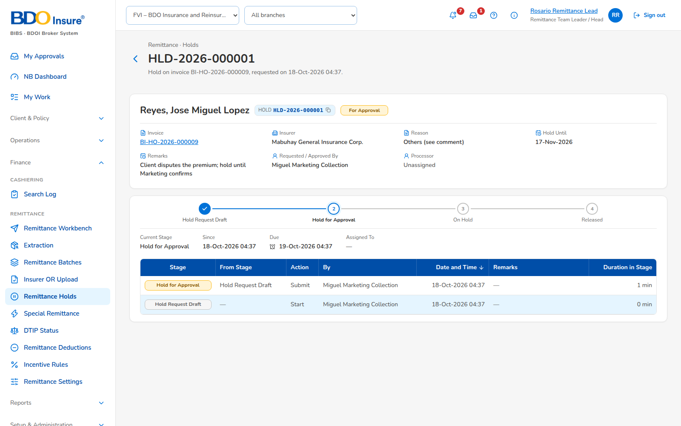
Figure 8: SCR-RMT-07 Remittance Hold, captured from the running application on seed data
Rules and states:
• The requester cannot approve (BR-RMT-01).
Table 13: SCR-RMT-07 actions
Action | Who | Available when | What happens | Result
Submit | Requester | Draft | Sends for approval | For Approval
Approve / Reject | Marketing Team Leader | For Approval | Decides | Active / Rejected
Extend | Requester | Active | New hold-until date | Extension For Approval
Cancel | Requester | Active | Asks to cancel | Cancel For Approval
Release | Requester | Active | Removes the hold | Released
Assign | Marketing Team Leader | Active | Gives the hold to a processor | Assigned

SCR-RMT-08 Special Remittance
Item | Value
Purpose | Special remittance requests; new request and upload.
Access | Marketing Collection, Remittance personas
Requirements | FRID.RMT.011, 009.06
Outcome | Request saved.
Availability | Available

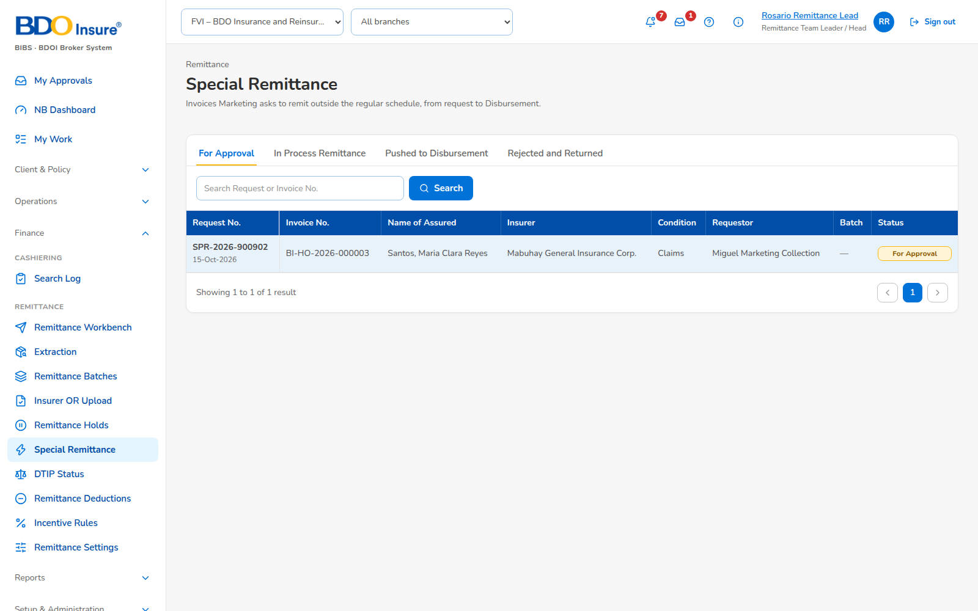
Figure 9: SCR-RMT-08 Special Remittance, captured from the running application on seed data
Rules and states:
• The condition is checked when the request is saved.
Table 14: SCR-RMT-08 fields
Field | Type | Req. | Default | Rule | Message
Invoice number | Text | Y | - | Invoice with premium due | -
Condition | List | Y | - | Claims, Renewal, Installment due, Immediate OR | Invoice <invoice> does not meet the condition <condition>

Table 15: SCR-RMT-08 actions
Action | Who | Available when | What happens | Result
New request | Marketing Collection | Always | Saves the request | Requested

SCR-RMT-09 Special Remittance Request
Item | Value
Purpose | One request with its decision and batch.
Access | As Special Remittance
Requirements | FRID.RMT.011
Outcome | Request approved or rejected.
Availability | Available

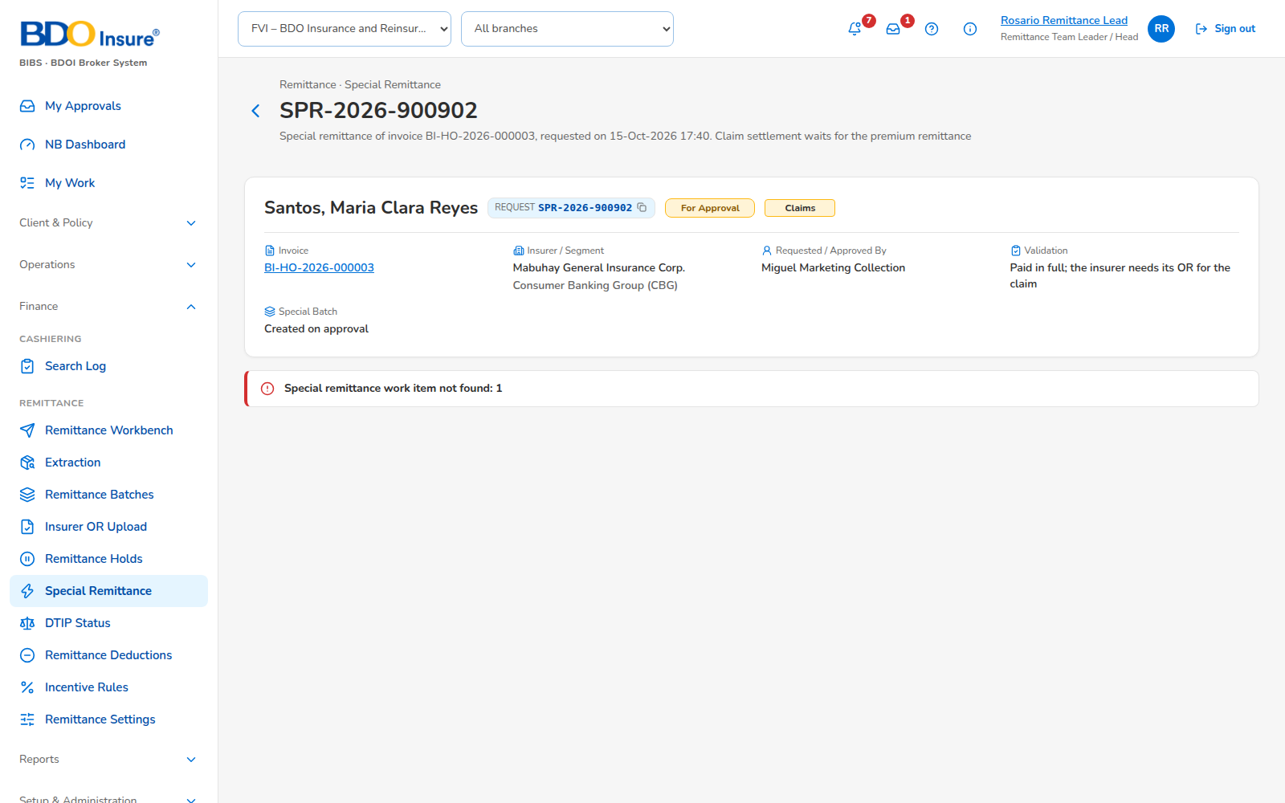
Figure 10: SCR-RMT-09 Special Remittance Request, captured from the running application on seed data
Rules and states:
• The approver is a Remittance Team Leader other than the requester.
Table 16: SCR-RMT-09 actions
Action | Who | Available when | What happens | Result
Approve | Remittance Team Leader | For Approval | Creates the Special batch | In Process Remittance
Reject | Remittance Team Leader | For Approval | With a reason | Rejected

SCR-RMT-10 DTIP Status
Item | Value
Purpose | Premium due to insurers per invoice with its remittance status; search.
Access | Remittance personas, Comptrollership
Requirements | FRID.RMT.009, 016
Outcome | Invoice found.
Availability | Available

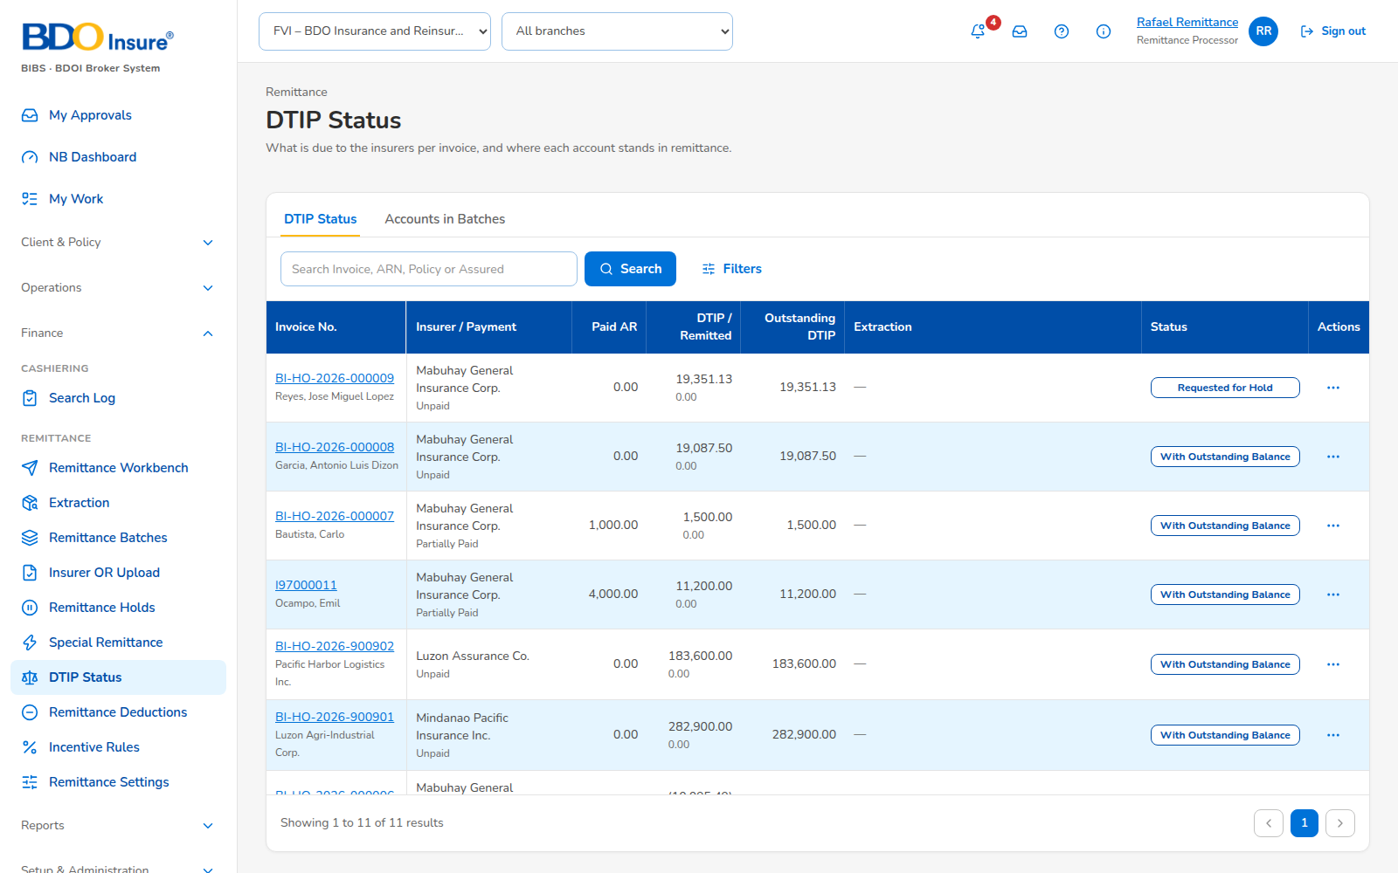
Figure 11: SCR-RMT-10 DTIP Status, captured from the running application on seed data
Rules and states:
• Search by invoice, batch, endorsement reference, policy or assured, partial, whatever the case.
Table 17: SCR-RMT-10 fields
Field | Type | Req. | Default | Rule | Message
Search | Text | N | - | At least 3 characters | -
Insurer | List | N | All | - | -
Remittance status | List | N | All | - | -

Table 18: SCR-RMT-10 actions
Action | Who | Available when | What happens | Result
Open invoice | All | Row chosen | Opens the invoice view | Invoice view

SCR-RMT-11 Incentive Rules
Item | Value
Purpose | Early remittance incentive rules.
Access | Remittance Team Leader
Requirements | FRID.RMT.012
Outcome | Rule saved.
Availability | Available

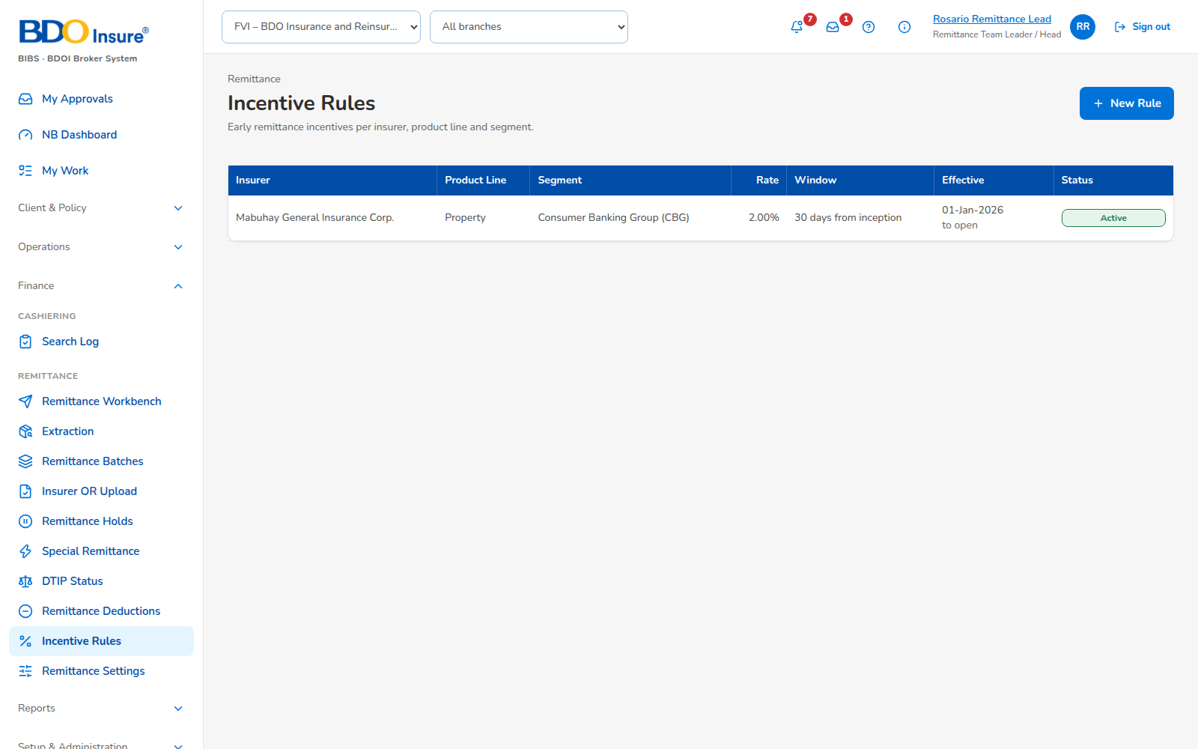
Figure 12: SCR-RMT-11 Incentive Rules, captured from the running application on seed data
Rules and states:
• Rules of the same insurer and line may not overlap.
Table 19: SCR-RMT-11 fields
Field | Type | Req. | Default | Rule | Message
Insurer | List | Y | - | - | -
Line | List | N | All | - | -
Rate | Percent | Y | - | 0 to 100 | -
Window (days) | Number | Y | 30 | 1 to 365 | -
Effective from / to | Date | Y | - | From before to | The rule overlaps another rule of the same insurer and line

Table 20: SCR-RMT-11 actions
Action | Who | Available when | What happens | Result
Save | Remittance Team Leader | Always | Saves the rule | Rule

SCR-RMT-12 Report Centre (Remittance)
Item | Value
Purpose | The remittance reports of Annex III and the control reports.
Access | Report permission
Requirements | FRID.RMT.014
Outcome | Report run and exported.
Availability | Available; delivered in the release of 17 Oct 2026 (FRID.RMT.014.01, 014.02: Mall Assurance columns, remitted batch by settlement reference)

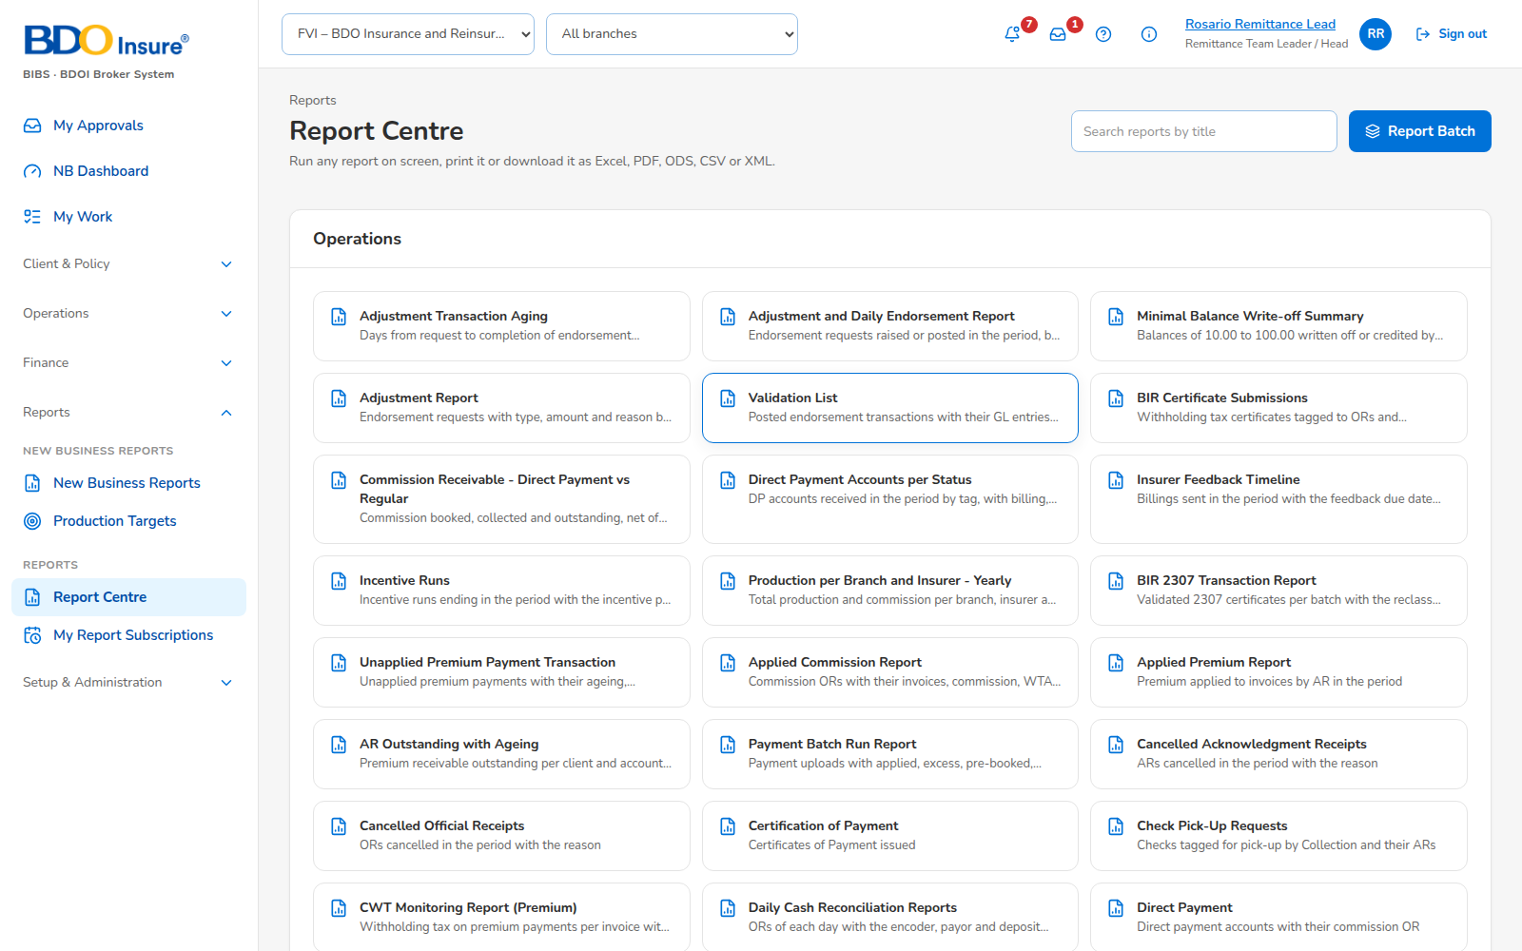
Figure 13: SCR-RMT-12 Report Centre (Remittance), captured from the running application on seed data
Rules and states:
• Each run is archived; names follow BR-RMT-05 and BR-RMT-15.
Table 21: SCR-RMT-12 fields
Field | Type | Req. | Default | Rule | Message
Report | List | Y | - | Remittance category | -
Period | Dates | Cond. | - | From not after to | -

Table 22: SCR-RMT-12 actions
Action | Who | Available when | What happens | Result
Run | Report users | Parameters given | Runs on screen | Report
Export | Report users | Report run | Excel or PDF | File

SCR-RMT-13 Remittance Settings
Item | Value
Purpose | Extraction schedule (days and time), output folders per type and file name pattern.
Access | Remittance Team Leader; approved by another user
Requirements | FRID.RMT.003.01, 001.04, 001.05
Outcome | Settings applied after approval.
Availability | Available; delivered in the release of 17 Oct 2026 (FRID.RMT.003.01)

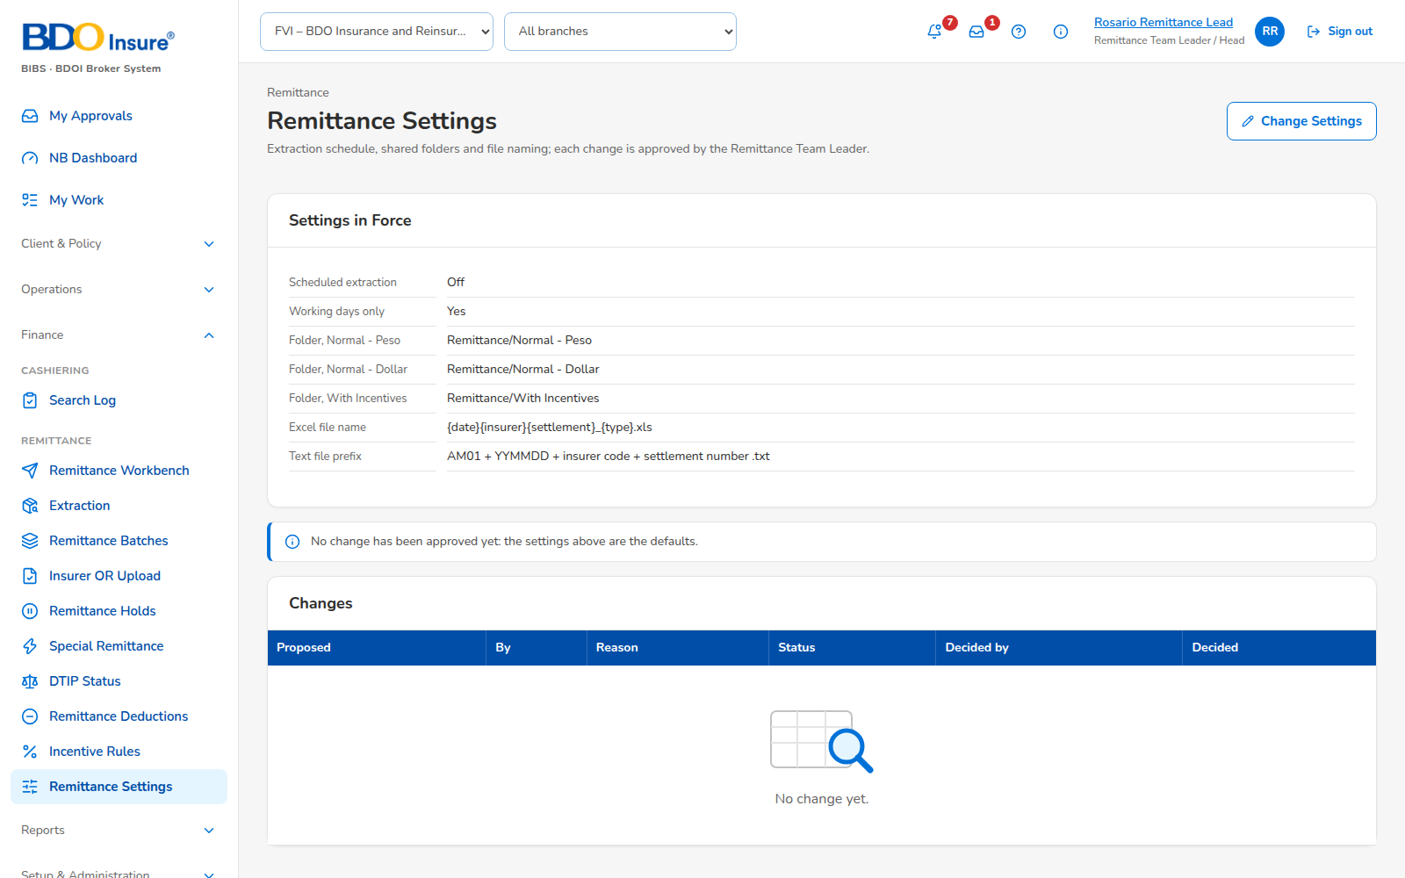
Figure 14: SCR-RMT-13 Remittance Settings, captured from the running application on seed data
Rules and states:
• A change applies after another user approves it.
• The schedule keeps the run off-peak.
Table 23: SCR-RMT-13 fields
Field | Type | Req. | Default | Rule | Message
Run days | Days | Y | Working days | - | -
Run time | Time | Y | 20:00 | 18:00 to 05:00 | -
Folder per type | Text | Y | - | Shared drive path | -
File name pattern | Text | Y | {date}{batchNo}_{type} | Tokens | -

Table 24: SCR-RMT-13 actions
Action | Who | Available when | What happens | Result
Save | Remittance Team Leader | Always | Saves for approval | For Approval
Approve | Another Team Leader | For Approval | Applies the settings | Applied

