
PRJ0012475 - BDO Insure Brokering System (BIBS) - Claims: Screens and UX Design -
Release 1 / Drop 0
Prepared by: iorta TechNXT Project Team

Template Reference No. | D051
Document No. | PRJ0012475-CLM-UXD
Prepared by: | iorta TechNXT Project Team
Drafting support: | iorta TechNXT Project Team
Creation Date: | 10/17/2026
Revision No. | 1.1
Last Updated by: | iorta TechNXT Project Team
Last Updated Date: | 10/17/2026

Document Revision Log
Date | Revision | Description | Updated by
17 Oct 2026 | 1.0 | First issue, with the FRS Claims v1.0. | iorta TechNXT Project Team (drafting support); for review by the BDOI Product Owner
17 Oct 2026 | 1.1 | Second issue with the release of 17 Oct 2026: SCR-CLM-01, 02, 04, 08 and 09 updated for the delivered follow-ups, document checklist, motor details, return to account officer, worklist sort and export, home trend, report heading and grouping, and team lead and team head on the handlers; screenshots captured from the running application on seed data. The screens of the change requests CR-CLM-101 to 112 stay proposed. | iorta TechNXT Project Team (drafting support); for review by the BDOI Product Owner

Table of Contents
Document Revision Log 3
Table of Contents 4
Introduction 5
Menu by Persona 6
Screens 7
SCR-CLM-01 Claims Home 7
SCR-CLM-02 Claims Worklist 7
SCR-CLM-03 Record Claim 9
SCR-CLM-04 Claim 10
SCR-CLM-05 Cover Lookup 13
SCR-CLM-06 My Diary 14
SCR-CLM-07 Insurer Location References 15
SCR-CLM-08 Claims Reports 16
SCR-CLM-09 Claims Setup 17
SCR-CLM-10 Claims Reporting Forms 20
SCR-CLM-11 Approvals 21
SCR-CLM-12 Claims Masters 21
SCR-CLM-13 Insurers' Scorecard 22

Introduction
This document describes every Claims screen of BIBS: purpose, users, access, rules and states, fields with their type, whether they are required, default, rule and message, and the actions. The requirements and rules are in the FRS v1.0.
The screens marked Available are offered by the BIBS platform today; the Availability row names the changes of this FRS still to deliver, and the proposed screens come with their change requests. Screenshots are added in the next version, after the walkthrough with the Business Unit on the test environment.
Codes used: Y required, N optional, Cond. required on a condition, - display only. Dates show as dd-MMM-yyyy, times in Manila time, amounts with two decimals.

Menu by Persona
The screens are under Claims & Insurance › Claims Handling. A persona sees only its entries.
Table 1: Claims menu by persona
Screen | Purpose | Personas
Claims Home | Dashboard of the user's role: open claims, follow-ups due, ageing, pending approvals | Handler, Team Leader, Team Head, Unit Head
Claims Worklist | Claims follow-up list with tabs, filters and quick view | Handler, Team Leader, Team Head, Unit Head, Risk
Claims Reporting Forms | Forms filled by Marketing for the handlers (proposed) | Handler, Team Leader, Mkt AO
Record Claim | Cover search and new claim | Handler, Team Leader, Team Head
Claim | One claim: details, locations, insurers, reserve, documents, diary, history | Handler, Team Leader, Team Head, Unit Head, Risk, Auditor
Approvals | Follow-ups and record changes waiting for approval (proposed) | Team Leader, Team Head
Cover Lookup | Read-only cover with premium and claims | Handler, Team Leader, Team Head, Unit Head, Risk
My Diary | The user's diary entries | Handler, Team Leader, Team Head
Insurer Location References | References of the insured locations per insurer | Handler, Team Leader, Team Head
Claims Reports | The claims reports | Handler, Team Leader, Team Head, Unit Head, Risk, Mkt AO, Mkt TL, Auditor
Claims Setup | Claims lists, status access matrix, handler groups, masters | Unit Head

Screens

SCR-CLM-01 Claims Home
Item | Value
Purpose | Dashboard of the user's role: my open claims, follow-ups due today and overdue, diary due, temporarily closed, unpaid premium, awaiting premium remittance, claims by status and ageing brackets.
Access | Claims personas
Requirements | FRCLM.001
Outcome | The user opens a list.
Availability | Available; delivered in the release of 17 Oct 2026 (FRCLM.001.01 trend; FRCLM.001.02 to .04 wait for CR-CLM-103)

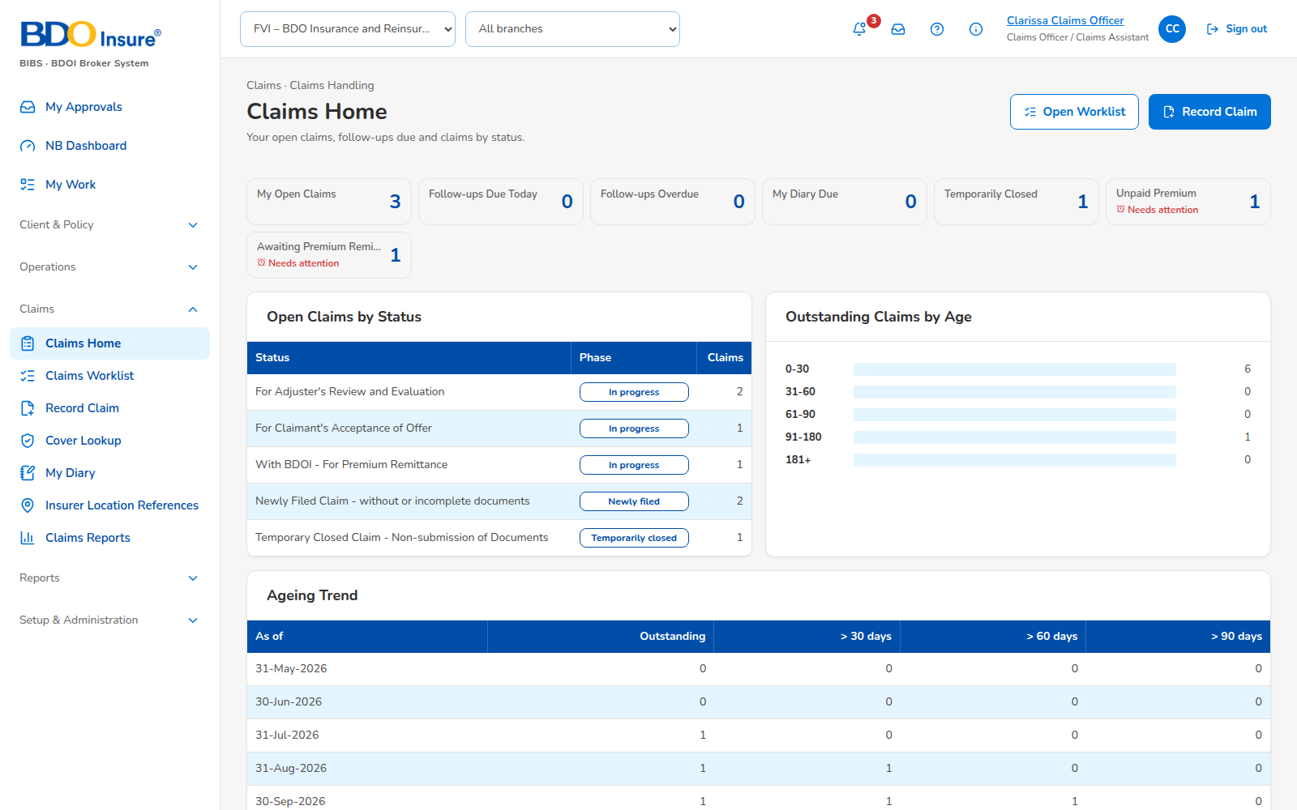
Figure 1: SCR-CLM-01 Claims Home, captured from the running application on seed data
Rules and states:
• Figures follow the user's claims (handler), team (Team Leader) or all (Team Head) with CR-CLM-104.
• Each tile opens the worklist filtered on it.
• Pending approvals show for the Team Leader and Team Head with CR-CLM-102.
Table 2: SCR-CLM-01 actions
Action | Who | Available when | What happens | Result
Open a tile | All | Always | Opens the filtered worklist | Worklist

SCR-CLM-02 Claims Worklist
Item | Value
Purpose | Follow-up list with tabs My Claims, Open, Temporarily Closed, Closed, Follow-ups Due, All; search; quick view.
Access | Claims personas
Requirements | FRCLM.009
Outcome | A claim opened or reassigned.
Availability | Available; delivered in the release of 17 Oct 2026 (FRCLM.009.01 columns, 009.08 sort and export)

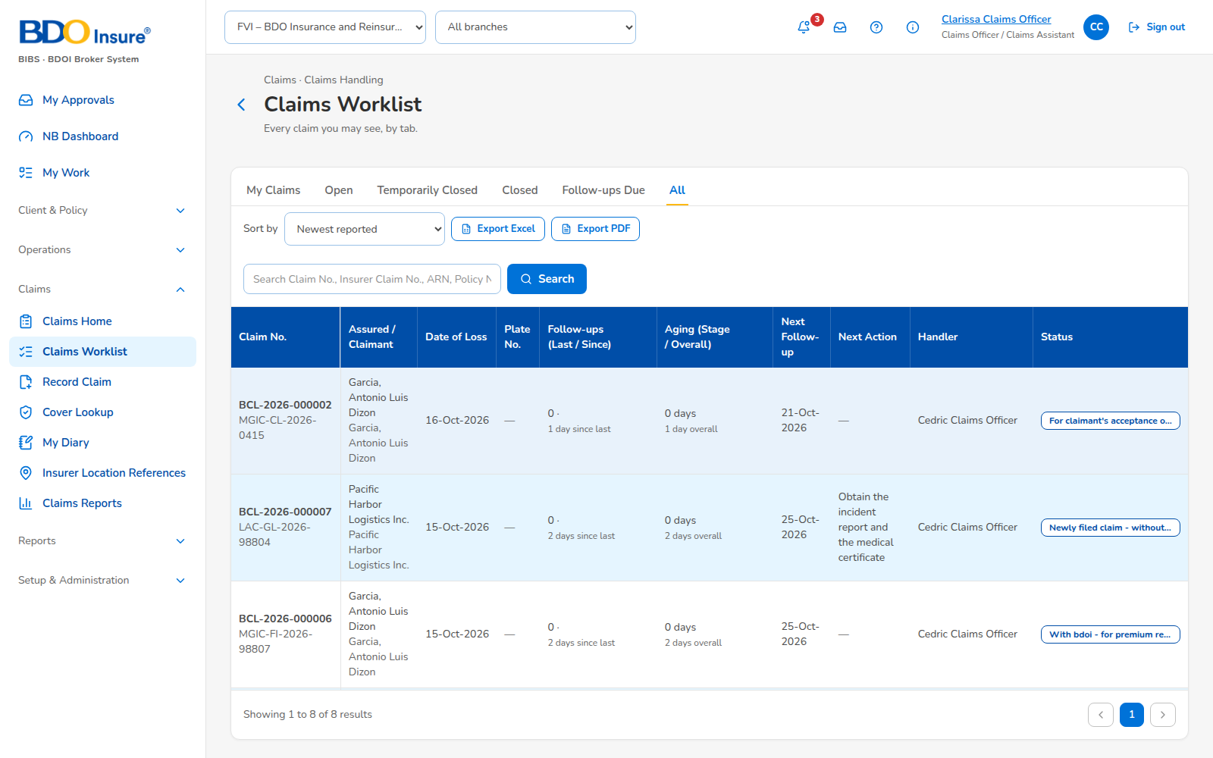
Figure 2: SCR-CLM-02 Claims Worklist, captured from the running application on seed data
Rules and states:
• Search by claim number, insurer claim number, ARN, policy number or assured, at least 3 characters.
• Columns: claim, claimant, follow-up count, last follow-up, aging since last follow-up, in status and overall, plate number, client, handler.
Table 3: SCR-CLM-02 fields
Field | Type | Req. | Default | Rule | Message
Search | Text | N | - | At least 3 characters | Enter at least 3 characters
Tab | Choice | Y | My Claims | - | -

Table 4: SCR-CLM-02 actions
Action | Who | Available when | What happens | Result
Reassign | Team Leader | Claims selected | Gives the claims to another handler | Reassigned
Export | Claims personas | List shown | Excel or PDF of the list (G-CLM-04) | File

SCR-CLM-03 Record Claim
Item | Value
Purpose | Cover search, cover card with the premium check, locations, loss, insurers, confirmation.
Access | Claims Handler, Team Leader, Team Head
Requirements | FRCLM.008, 021
Outcome | Claim recorded with its number.
Availability | Available; changes of the FRS v1.0 to deliver (FRCLM.008.02 fields, 008.10 with CR-CLM-108)

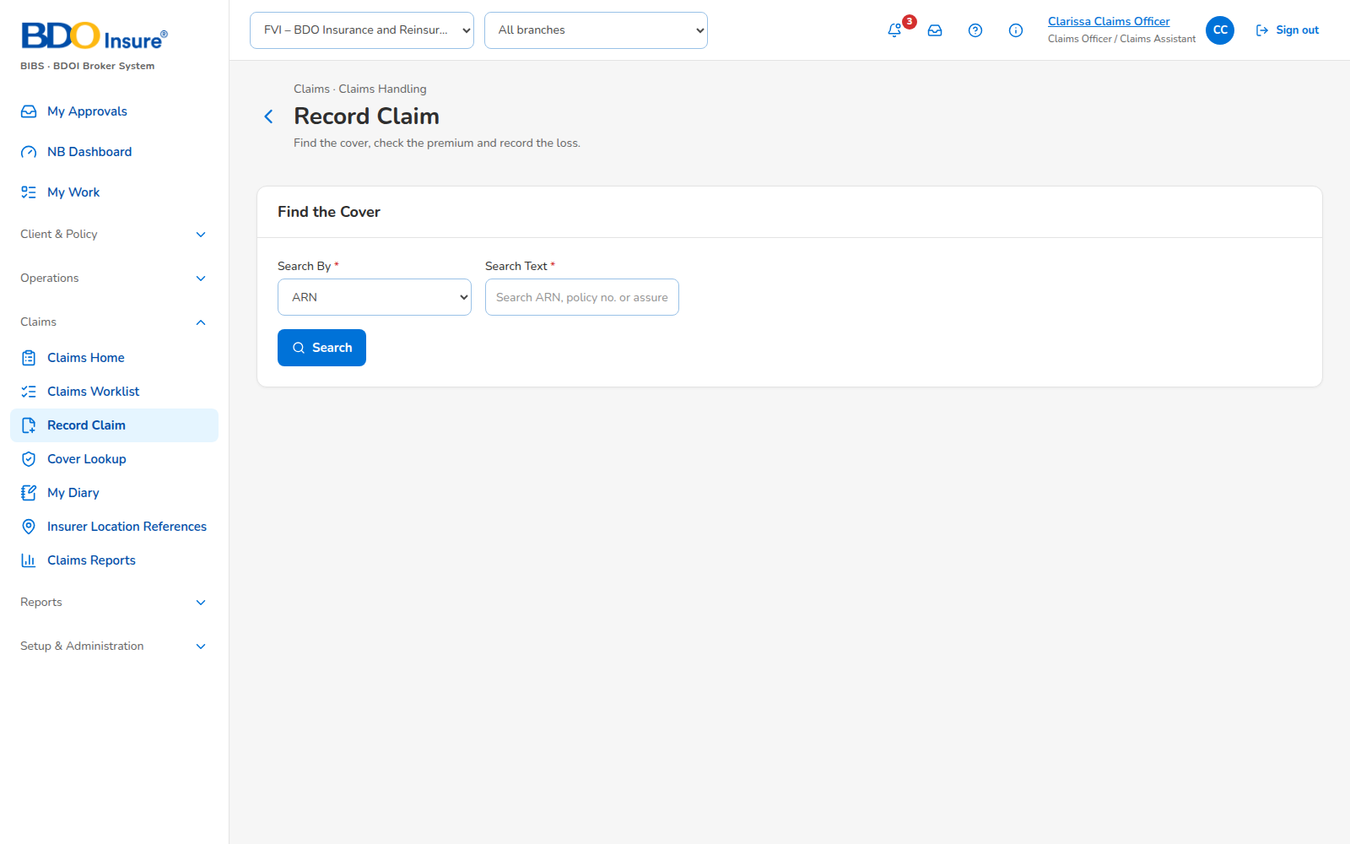
Figure 3: SCR-CLM-03 Record Claim, captured from the running application on seed data
Rules and states:
• Only the locations of the cover can be linked.
• A loss date outside the policy year needs a confirmation.
• The claim of an unpaid cover is saved, flagged and alerted.
Table 5: SCR-CLM-03 fields
Field | Type | Req. | Default | Rule | Message
Cover search | Text | Y | - | ARN, policy number or assured, at least 3 characters | Enter at least 3 characters
Date of loss | Date | Y | - | Not in the future | The date of loss cannot be in the future
Reported date | Date | Y | Today | Not before the date of loss | The reported date cannot be before the date of loss
Claimant | Text | Y | Assured | Override with the permission | -
Nature of claim | List | Y | - | Annex O | -
Claim type | List | Y | - | Annex M | -
Catastrophe | List | N | - | BRCLM.036 | -
Locations | Multiple | Y | Policy locations | Cover locations only | Location <item> is not on the cover
Insurers | Lines | Y | From the invoice shares | Shares total 100% | -

Table 6: SCR-CLM-03 actions
Action | Who | Available when | What happens | Result
Record | Handler | Fields valid | Creates the claim | Claim

SCR-CLM-04 Claim
Item | Value
Purpose | One claim: summary card and flags, status panel, tabs Details, Locations, Insurers and Updates, Reserve and Settlement, Documents, Diary, History.
Access | Claims personas; Marketing read (FRCLM.002.02)
Requirements | FRCLM.003, 006, 008, 009, 021 to 024
Outcome | Claim followed up, settled, closed or reopened.
Availability | Available; delivered in the release of 17 Oct 2026 (FRCLM.006 checklist, 007.02 and 007.03 follow-ups, 008.08 preview, 009.04 motor and return to account officer; 010 approval waits for CR-CLM-102)

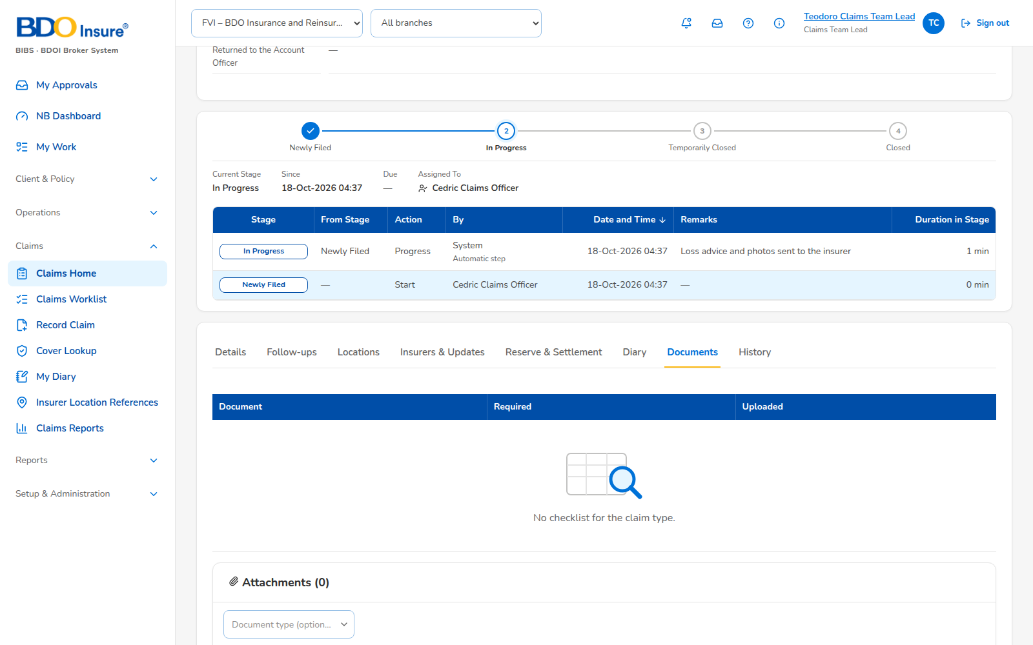
Figure 4: SCR-CLM-04 Claim (documents), captured from the running application on seed data
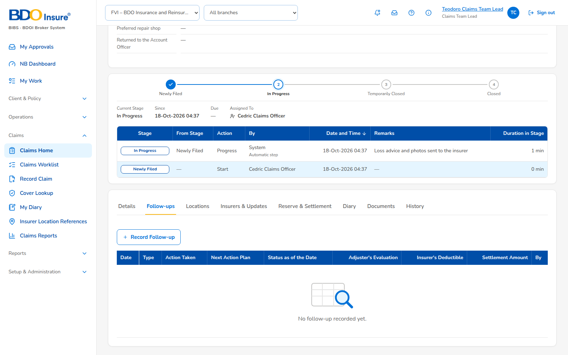
Figure 5: SCR-CLM-04 Claim (followups), captured from the running application on seed data
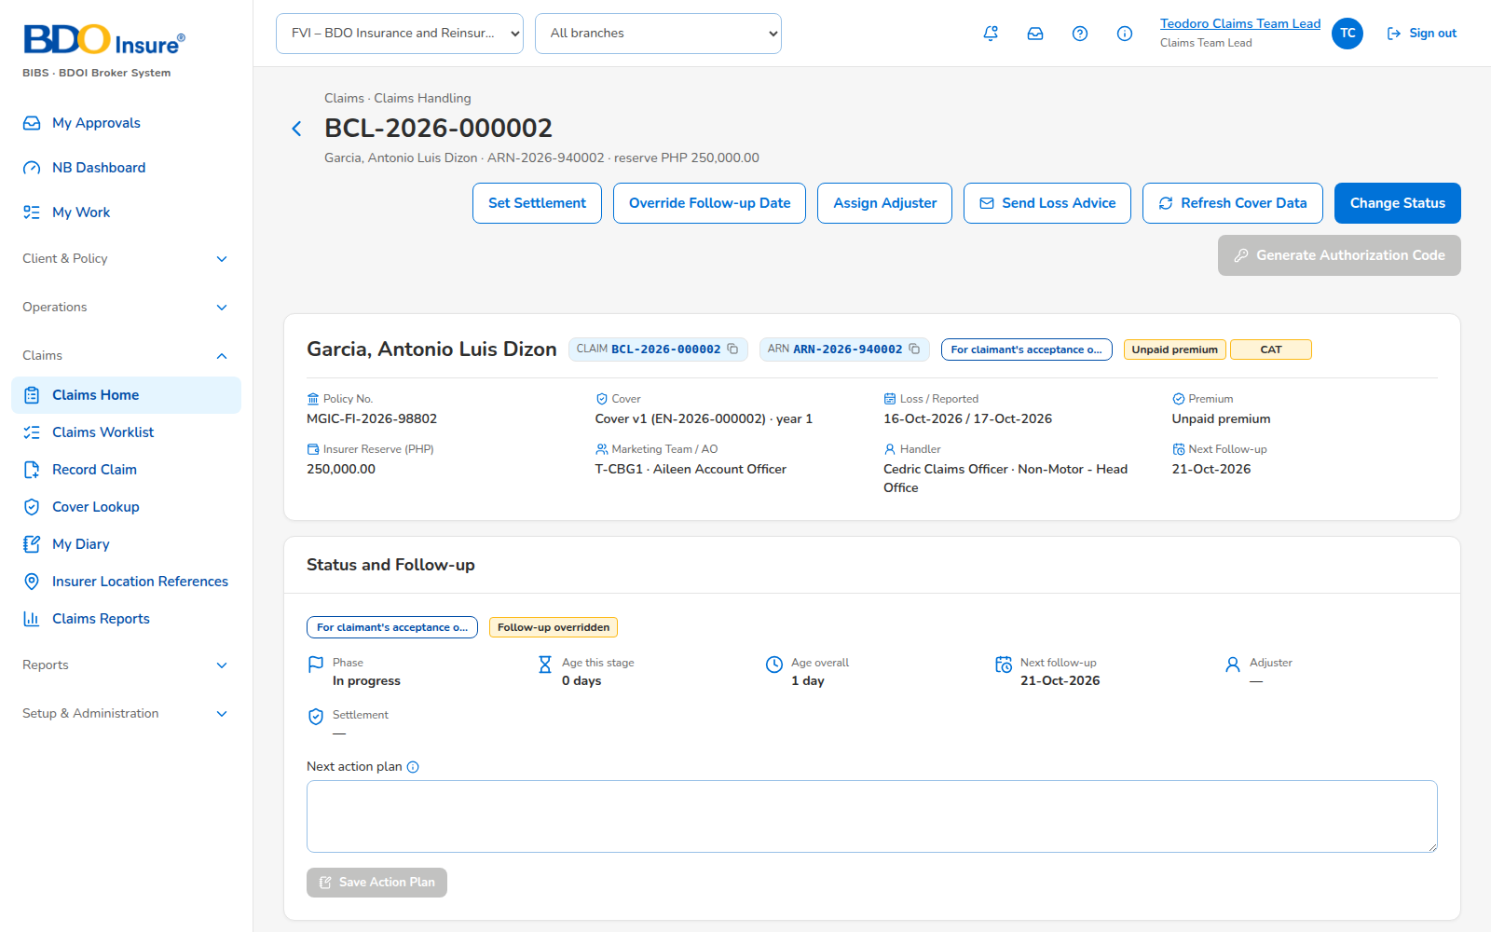
Figure 6: SCR-CLM-04 Claim, captured from the running application on seed data
Rules and states:
• Change Status lists only the statuses of the user's role and unit.
• A settlement type that closes needs the closing permission.
• Flags: Unpaid premium, Awaiting premium remittance, Newer cover version, Multi-location, Multi-insurer, CAT.
Table 7: SCR-CLM-04 fields
Field | Type | Req. | Default | Rule | Message
Status | List | Y | - | Status access matrix | Your role and unit may not set the status <status>
Next follow-up date | Date | Y | From the status | Today or later; override with reason | The next follow-up date must be today or later
Next action plan | Text 2,000 | N | - | Versions kept | The action plan can have at most 2,000 characters
Insurer claim number | Text | Cond. | - | Unique per insurer | Claim number <number> is already recorded for <insurer>
Reserve | Amount | N | - | Not negative; permission | The reserve cannot be negative
Settlement type | List | Cond. | - | Amount and date for a settled type | Enter the settlement amount and date

Table 8: SCR-CLM-04 actions
Action | Who | Available when | What happens | Result
Generate Authorization Code | Handler | Premium paid | Issues the code | Code
Send Loss Advice | Handler | Insurer line | E-mails the letter | Sent
Change Status | Handler, Team Leader, Team Head | Open claim | Sets the status | Status
Set Settlement | Team Leader, Team Head | Open claim | Records the outcome | Closed or open
Assign Adjuster | Team Leader, Team Head | Insurer line | Sets the adjuster | Adjuster
Override Follow-up Date | Team Leader, Team Head | Open claim | With reason | Date
Record Insurer Update | Handler | Always | Date, source, remarks | History line
Reopen | Team Head, Unit Head | Closed | With reason | In Progress
Request Special Remittance | Handler | Awaiting premium remittance | Opens the request | Request

SCR-CLM-05 Cover Lookup
Item | Value
Purpose | Read-only cover: account, policy years, items and locations, endorsements, invoices with payment and remittance status, claims of the cover, insurer location references.
Access | Claims personas
Requirements | FRCLM.002, 008.03
Outcome | Cover read.
Availability | Available

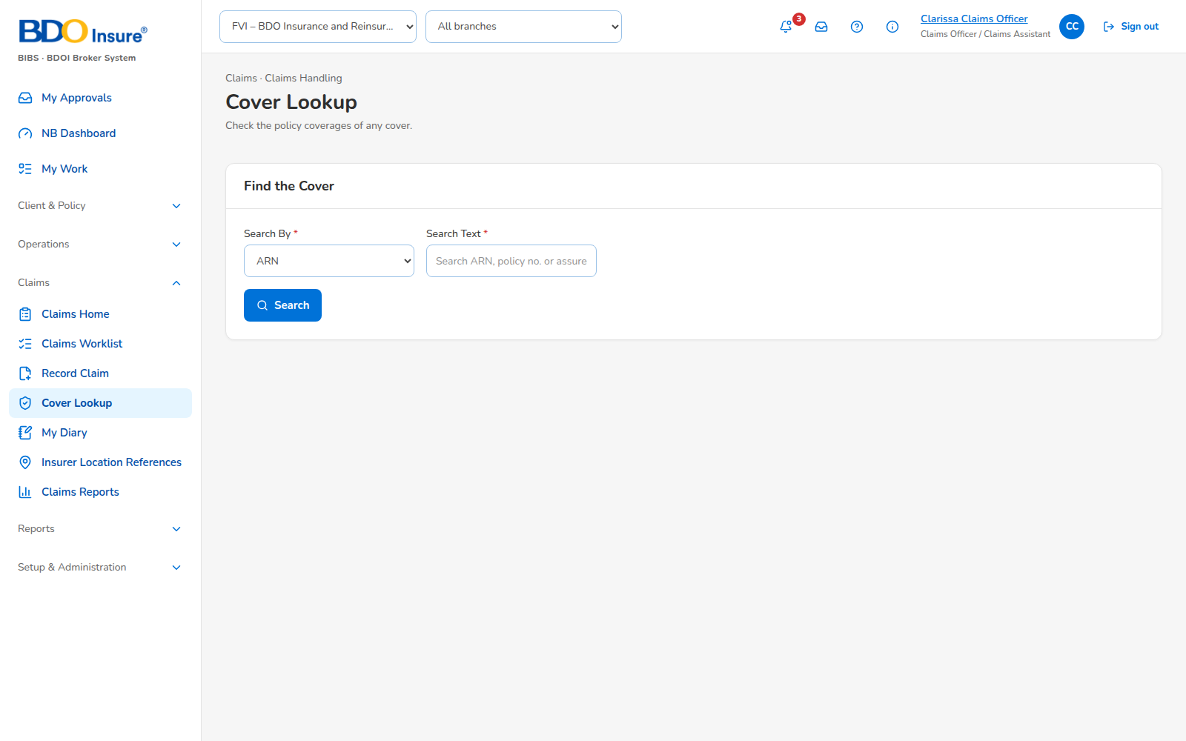
Figure 7: SCR-CLM-05 Cover Lookup, captured from the running application on seed data
Rules and states:
• Read-only; no account maintenance from Claims.
Table 9: SCR-CLM-05 actions
Action | Who | Available when | What happens | Result
Record claim | Handler | Cover chosen | Opens Record Claim on the cover | Record Claim

SCR-CLM-06 My Diary
Item | Value
Purpose | The user's diary entries across claims, due today and overdue.
Access | Claims personas
Requirements | FRCLM.009.06
Outcome | Entry done.
Availability | Available

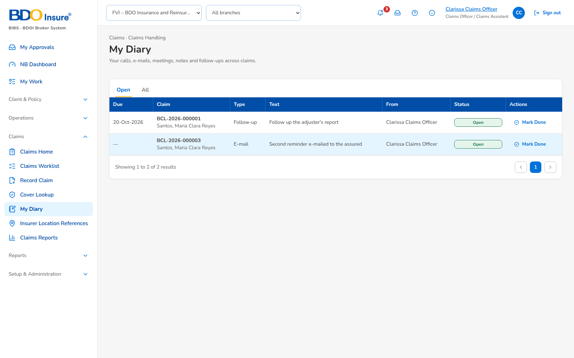
Figure 8: SCR-CLM-06 My Diary, captured from the running application on seed data
Rules and states:
• The assignee or the author marks an entry done.
Table 10: SCR-CLM-06 actions
Action | Who | Available when | What happens | Result
Done | Assignee, author | Open entry | Marks it done | Done

SCR-CLM-07 Insurer Location References
Item | Value
Purpose | References of the insured locations per insurer.
Access | Claims Handler, Team Leader, Team Head
Requirements | FRCLM.022.02
Outcome | Reference saved.
Availability | Available

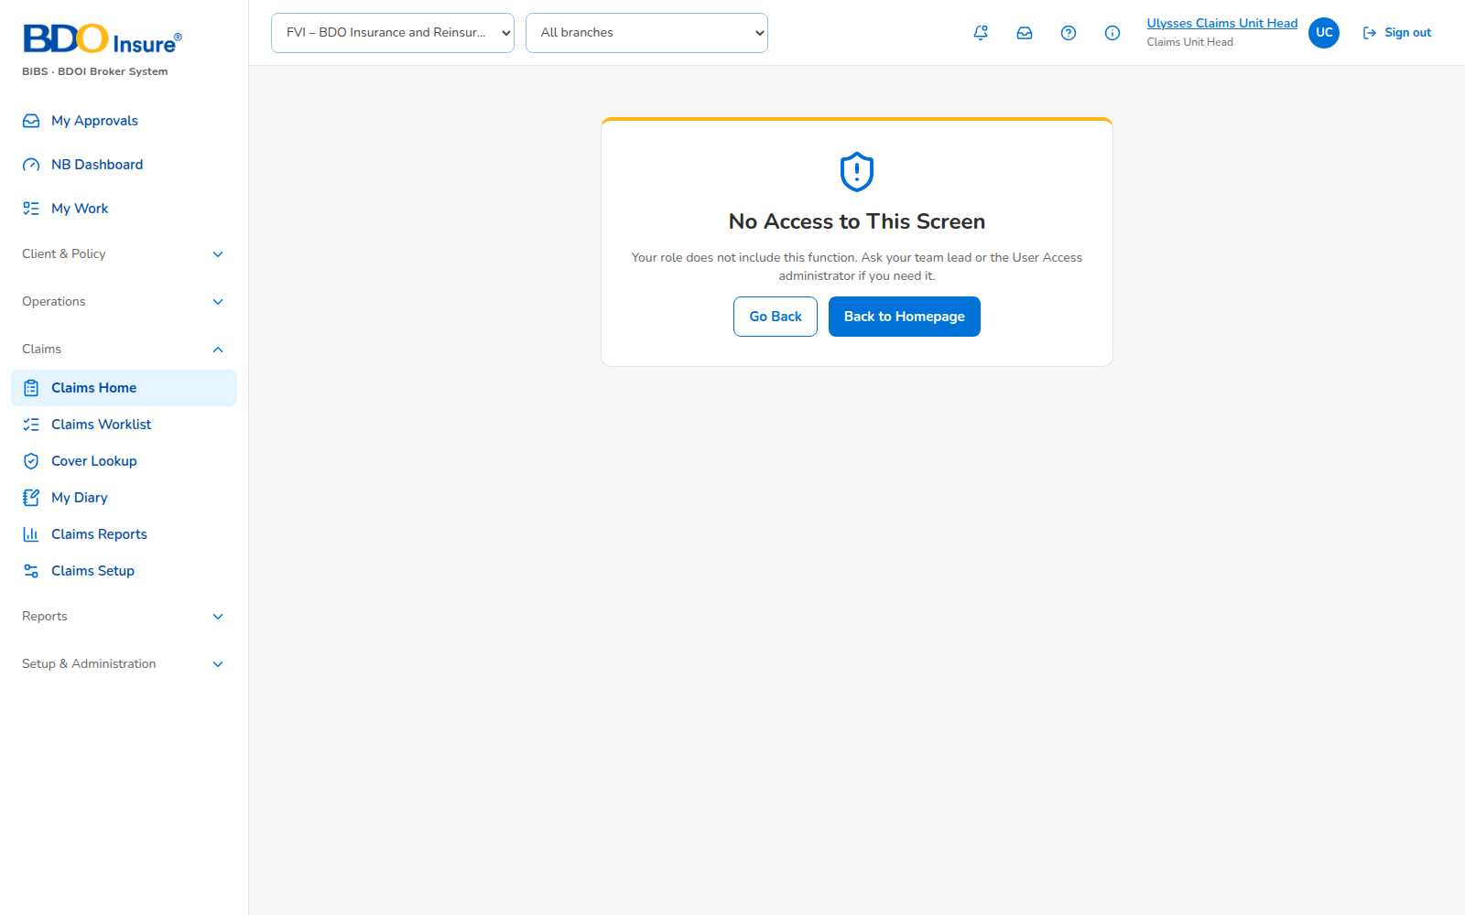
Figure 9: SCR-CLM-07 Insurer Location References, captured from the running application on seed data
Rules and states:
• A new reference end-dates the open one.
Table 11: SCR-CLM-07 fields
Field | Type | Req. | Default | Rule | Message
ARN | Text | Y | - | Cover | -
Item No. | Number | Y | - | Location of the cover | -
Insurer | List | Y | - | Insurer of the cover | -
Insurer Location Ref | Text | Y | - | - | -
Effective From | Date | Y | Today | - | -

Table 12: SCR-CLM-07 actions
Action | Who | Available when | What happens | Result
Add | Handler | Always | Saves the reference | Reference
Upload | Handler | Always | Loads references (IF-CLM-02) | Run

SCR-CLM-08 Claims Reports
Item | Value
Purpose | The claims reports.
Access | Report permission; Marketing on screen, Marketing Team Leader export
Requirements | FRCLM.011 to 019
Outcome | Report run.
Availability | Available; delivered in the release of 17 Oct 2026 (BDOI heading, filters, presentation and grouping; RPT-CLM-08 to 10 wait for their change requests)

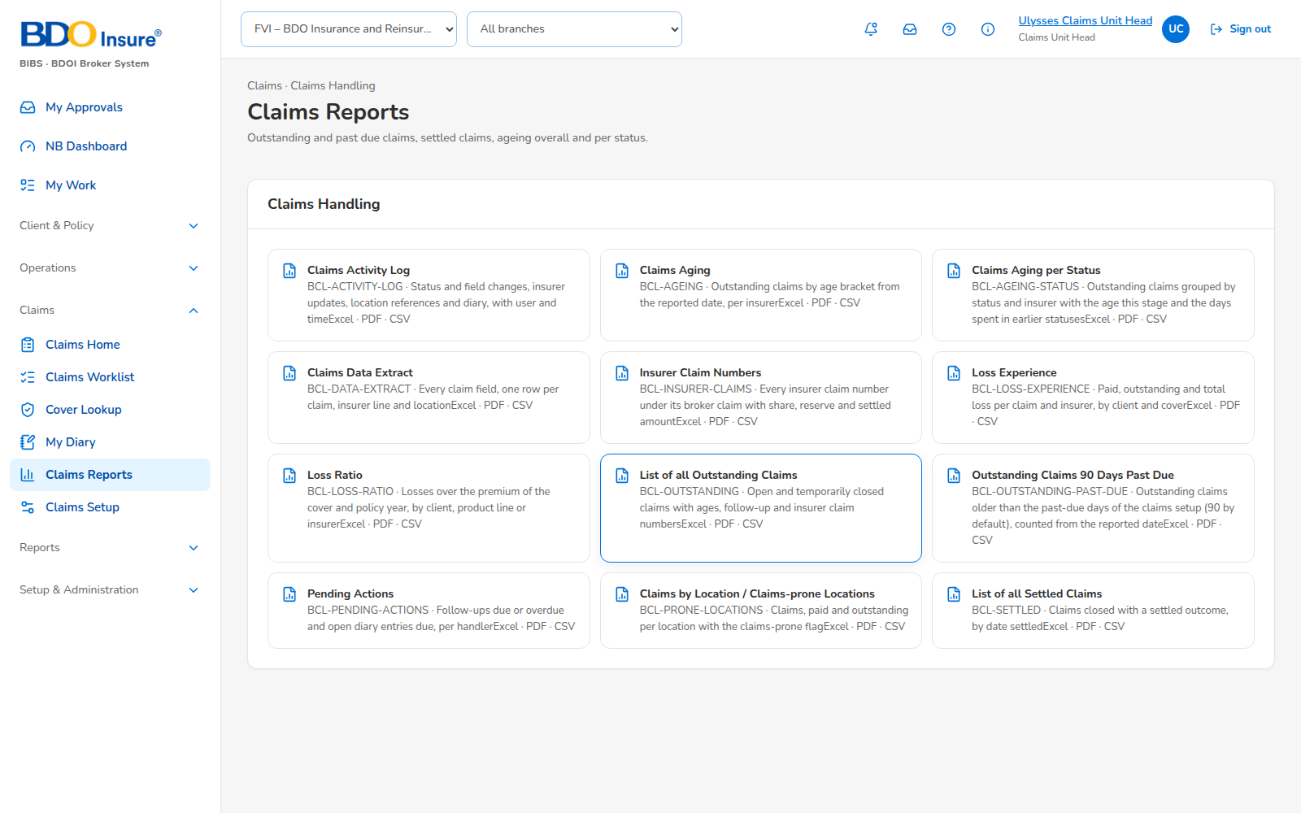
Figure 10: SCR-CLM-08 Claims Reports, captured from the running application on seed data
Rules and states:
• Heading of BR-CLM-10; each run archived.
Table 13: SCR-CLM-08 fields
Field | Type | Req. | Default | Rule | Message
Report | List | Y | - | Claims category | -
As of / period | Date | Y | Today | - | -
Presentation | Choice | Y | Detailed | Detailed or Summary | -
Grouping | Choice | Y | Insurer | Insurer, claim type or risk code | -

Table 14: SCR-CLM-08 actions
Action | Who | Available when | What happens | Result
Run | Report users | Parameters given | Runs on screen | Report
Export | Report export permission | Report run | Excel or PDF | File

SCR-CLM-09 Claims Setup
Item | Value
Purpose | Status attributes, settlement types, status access matrix, claims handler register, claims lists.
Access | Claims Unit Head
Requirements | FRCLM.002.06, 003, 004, 007
Outcome | Setup changed under maker-checker.
Availability | Available; delivered in the release of 17 Oct 2026 (FRCLM.002.06 team lead and team head; document checklist setup; FRCLM.004.02 waits for CR-CLM-106)

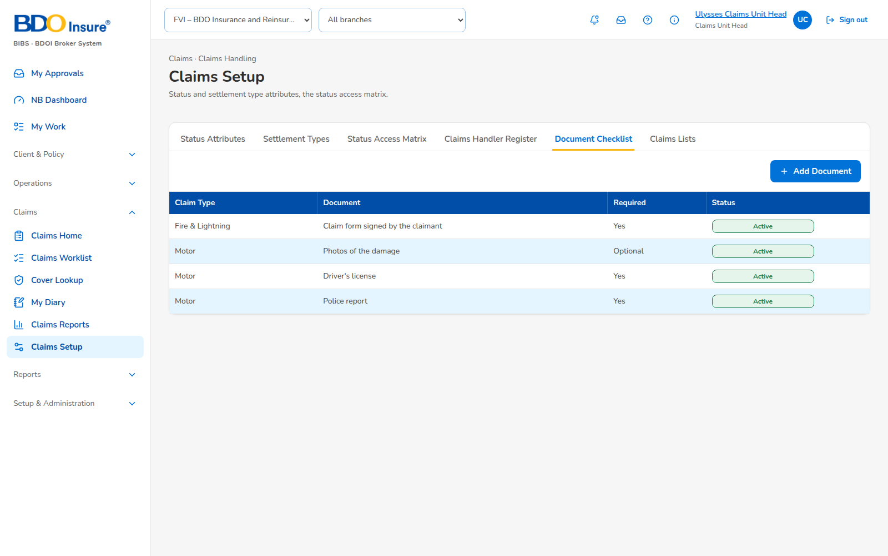
Figure 11: SCR-CLM-09 Claims Setup (checklist), captured from the running application on seed data
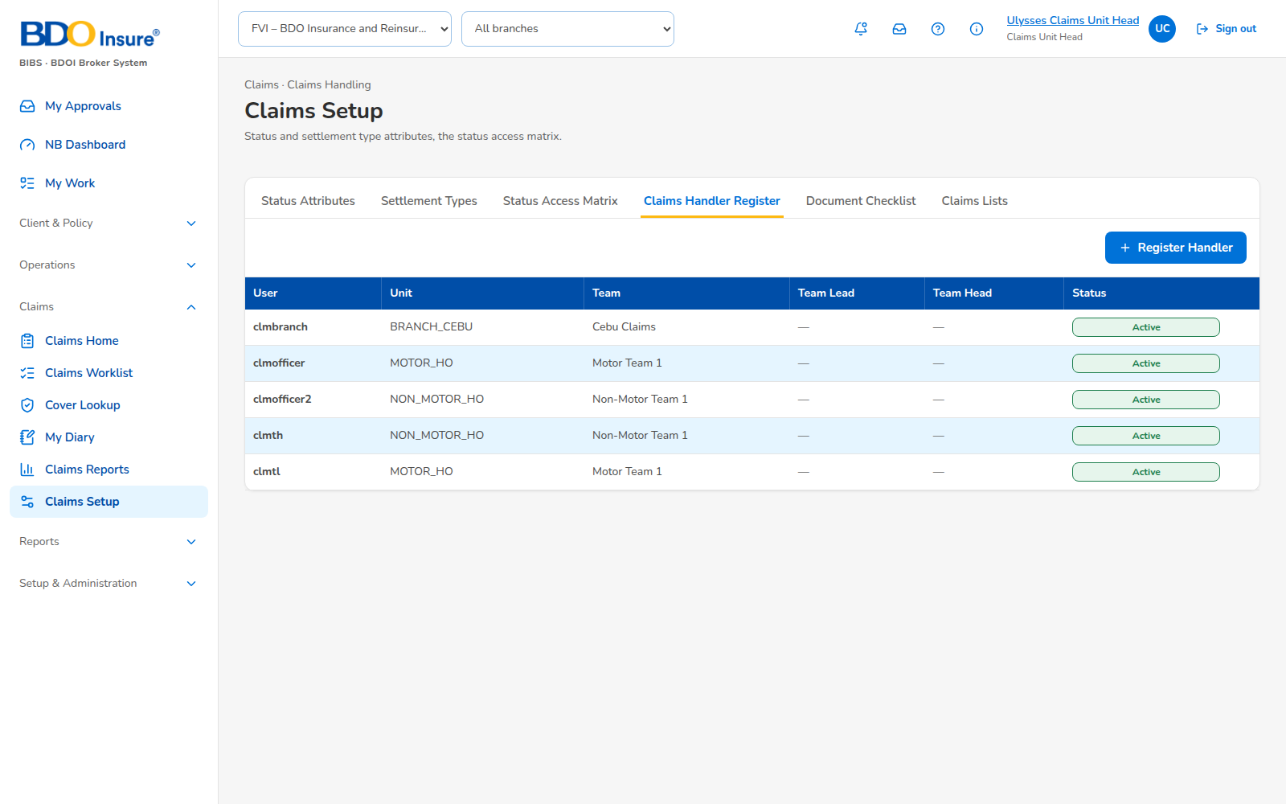
Figure 12: SCR-CLM-09 Claims Setup (handlers), captured from the running application on seed data
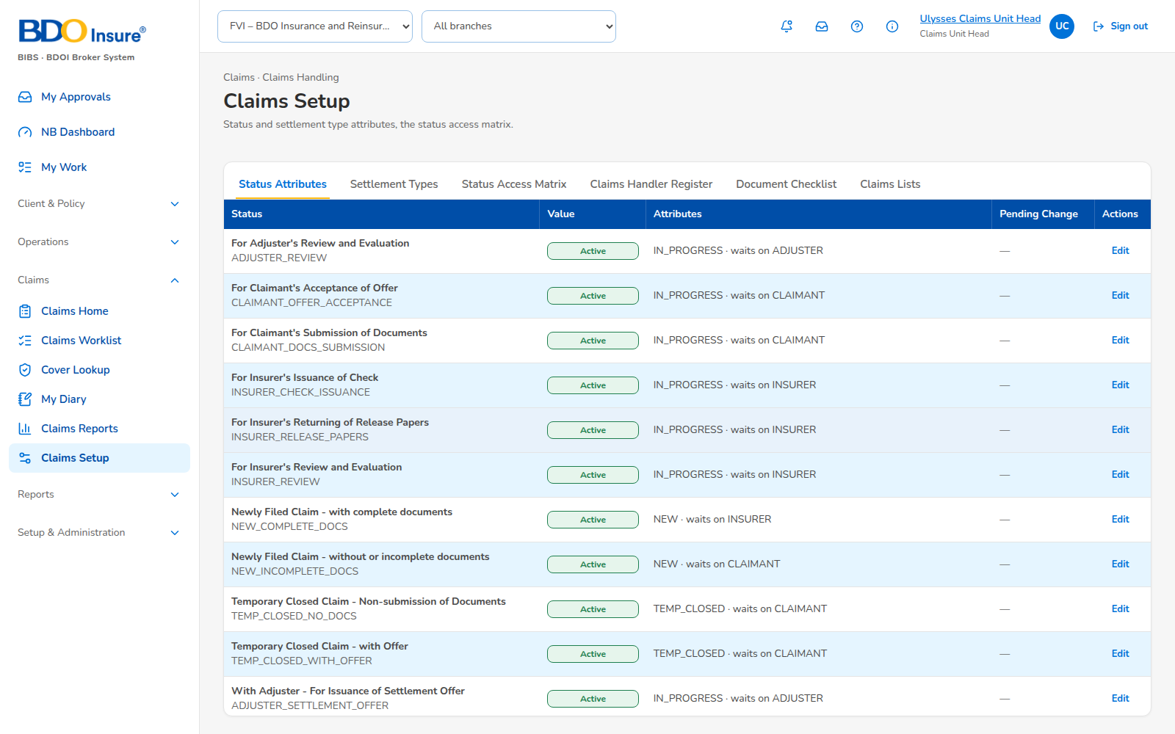
Figure 13: SCR-CLM-09 Claims Setup, captured from the running application on seed data
Rules and states:
• Every change applies after another user approves it.
Table 15: SCR-CLM-09 fields
Field | Type | Req. | Default | Rule | Message
Role | List | Y | - | Claims roles | -
Unit | List | N | Any | Claims units | -
Status | List | Y | - | - | The role and unit already have this status

Table 16: SCR-CLM-09 actions
Action | Who | Available when | What happens | Result
Save | Unit Head | Always | Saves for approval | For approval
Authorise | Another administrator | For approval | Applies the change | Applied

SCR-CLM-10 Claims Reporting Forms
Item | Value
Purpose | Claims reporting forms of Marketing: draft, submit, accept or return.
Access | Marketing Account Officer (own forms); Claims Handler, Team Leader
Requirements | FRCLM.008.01, 002.03
Outcome | Form accepted into a claim.
Availability | Proposed screen (CR-CLM-101)

Rules and states:
• The CRF reference differs from the claim number.
• A returned form goes back to the Account Officer with the reason.
Table 17: SCR-CLM-10 fields
Field | Type | Req. | Default | Rule | Message
Policy | Search | Y | - | Policy of the Account Officer's client | -
Fields of claim logging | Form | Cond. | - | As Record Claim | <Field> is required

Table 18: SCR-CLM-10 actions
Action | Who | Available when | What happens | Result
Save draft | Account Officer | Always | Saves | Draft
Submit | Account Officer | Draft | Sends to the handlers | Submitted
Accept | Handler | Submitted | Creates the claim | Accepted
Return | Handler | Submitted | With reason | Returned

SCR-CLM-11 Approvals
Item | Value
Purpose | Follow-ups and record changes waiting for the Team Leader or the Team Head.
Access | Claims Team Leader, Team Head
Requirements | FRCLM.010, 003.04
Outcome | Approved or returned.
Availability | Proposed screen (CR-CLM-102)

Rules and states:
• The approver is not the submitter.
• A denial needs a comment.
Table 19: SCR-CLM-11 fields
Field | Type | Req. | Default | Rule | Message
Comment | Text 1,000 | Cond. | - | Required to deny | Enter the comment for the handler

Table 20: SCR-CLM-11 actions
Action | Who | Available when | What happens | Result
Approve | Team Leader, Team Head | Pending | Approves or forwards | Approved or pending Team Head
Deny | Team Leader, Team Head | Pending | Returns with comment | Returned

SCR-CLM-12 Claims Masters
Item | Value
Purpose | Claim types by risk code, claim categories, severity, adjuster contacts, repair shops, document checklist per risk code category, loss advice templates with versions.
Access | Claims Unit Head
Requirements | FRCLM.004.02, 005, 006, 007
Outcome | Masters maintained under maker-checker.
Availability | Proposed screen (CR-CLM-105, 106, 107; G-CLM-01 to 03)

Rules and states:
• No duplicate codes; inactive values not offered on new claims; alphabetical order.
Table 21: SCR-CLM-12 fields
Field | Type | Req. | Default | Rule | Message
Code | Text | Y | - | Unique | -
Name | Text | Y | - | - | -
Risk code category | List | Cond. | - | Categories and documents | -
Effective from / to | Date | Cond. | - | Templates | -

Table 22: SCR-CLM-12 actions
Action | Who | Available when | What happens | Result
Save | Unit Head | Always | Saves for approval | For approval

SCR-CLM-13 Insurers' Scorecard
Item | Value
Purpose | Ratings A to F per insurer on the evaluation and check issuance TAT, acceptance rate and average TAT.
Access | Claims Team Head, Unit Head
Requirements | FRCLM.020
Outcome | Scorecard read.
Availability | Proposed screen (CR-CLM-109)

Rules and states:
• Working days on the holiday calendar; targets of Annex AB.
Table 23: SCR-CLM-13 fields
Field | Type | Req. | Default | Rule | Message
Period | Dates | Y | Last quarter | - | -
Insurer | List | N | All | - | -

Table 24: SCR-CLM-13 actions
Action | Who | Available when | What happens | Result
Run | Team Head, Unit Head | Period given | Computes the ratings | Scorecard

