
PRJ0012475 - BDO Insure Brokering System (BIBS) - Renewal: To-Be Process and Storyboards -
Release 1 / Drop 0
Prepared by: iorta TechNXT Project Team

Template Reference No. | D051
Document No. | PRJ0012475-RN-BPS
Prepared by: | iorta TechNXT Project Team
Drafting support: | iorta TechNXT Project Team
Creation Date: | 10/16/2026
Revision No. | 1.3
Last Updated by: | iorta TechNXT Project Team
Last Updated Date: | 10/16/2026

Document Revision Log
Date | Revision | Description | Updated by
16 Oct 2026 | 1.3 | First issue as a separate document of the Renewal set (taken out of the annexes of the FRS v1.2 and aligned with the system delivered). Numbered 1.3 to match the FRS. | iorta TechNXT Project Team (drafting support); for review by the BDOI Product Owner

Table of Contents
Document Revision Log 3
Table of Contents 4
Introduction 5
End-to-end Journey 6
To-be Processes 8
P-RN-01 Extraction, sanitation and classification 8
P-RN-02 Assignment, disposition and posting 8
P-RN-03 Processing and the insurer's answer 8
P-RN-04 Renewal Advice, follow-up and acceptance 8
P-RN-05 Placement, booking and e-policy 8
P-RN-06 Straight-through CBG renewals 9
P-RN-07 Set-up under maker-checker 9
Stages of a renewal account 9
Storyboards 10
SB-01 An expiring account from the Expiry List to the Team Leader's post 10
SB-02 Processing, the insurer's answer and the Renewal Advice 18
SB-03 The Contact Center follow-up and the client's acceptance 25
SB-04 Not for Renewal and the closing letter 29
SB-05 A transfer to another unit, and the controls the user sees 33

Introduction
This document shows how Renewal works end to end. The requirements are in the FRS v1.3; the screens in the UX Design v1.3; the reports, letters and notices in the Reports, Notifications and Outputs v1.3.
Each storyboard step is illustrated by a full-page screenshot taken on a test environment. The people, clients and insurers are fictitious.
Table 1: Personas
Persona | Does | Screens | Walkthrough account
Marketing Team Lead | Generates and initiates the expiry list, assigns and transfers renewals, reviews, returns, overrides and posts dispositions, decides transfers and TSU requests. | Renewal Home, Dashboard, Expiry List, TL Review, Transfers, Letters, KYC Monitoring | Marites Marketing Lead; Rosario Renewal Team Lead
Marketing Account Officer | Gives the disposition of assigned renewals, sends the Renewal Advice and letters, records the client's acceptance, raises transfers and TSU requests. | My Dispositions, Renewal, Letters, Transfer Requests, KYC Monitoring | Aileen Account Officer; Arnel Account Officer
Processing Team Lead | Assigns posted renewals to Processing Officers, uploads files, approves package choices, follows placement and billing. | Processing Dashboard, Processing Worklist, Renewal Setup (package choices), Submitted for Placement | Patricia Processing Lead
Processing Officer | Sends renewals to the insurers, records the insurer's answer, places, books, sends e-policies and billing files. | Processing Worklist, Insurer Batches, Submitted for Placement, E-Policies, CLPC Billing Files | Paolo Processor
Contact Center | Follows up clients who have not answered the Renewal Advice; sees no premium or commission. | Follow-ups, Renewal | Cecilia Contact Center
LAMD | Uploads the LAMD loan reports and reads the matching results. | LAMD Reports, RMU Account Maintenance | Leonardo Loan Monitoring
TSU Officer | Works the quotation requests raised from renewals. | TSU Requests | Teodoro TSU Analyst
Business Administrator | Keeps Renewal Setup, risk codes, lists of values, letter templates, RMU codes and the budget. | Renewal Setup, Risk Code Maintenance, Renewal Annual Budget, Channel Monitor, Audit Logs | Bea Business Admin
System Administrator | Keeps the group profiles and the channel connections. | Channel Monitor; User Access screens (BRD-11) | SIT System Administrator
Auditor | Reads renewals, their history, the reports and the audit logs. Changes nothing. | Renewal Dashboard, Renewal Accounts, Audit Logs, reports | Audrey Auditor

End-to-end Journey
13 steps from the expiring policy to the booked renewal.
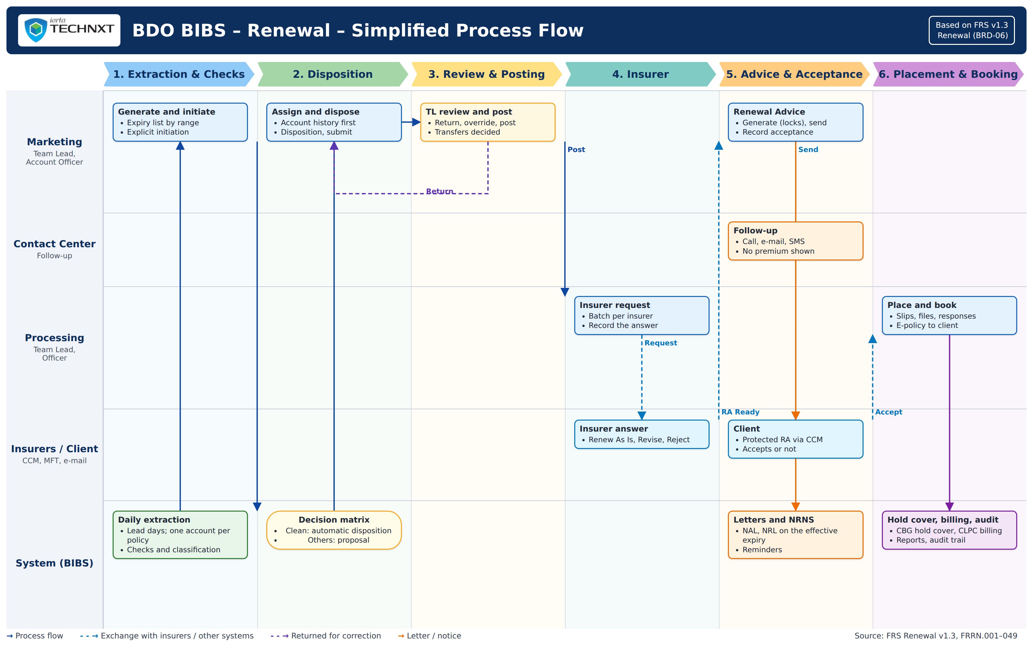
Figure 1: Renewal: simplified process flow (swimlanes by actor)
Table 2: The 13 steps
Step | Who | What happens
1 | BIBS | The daily run extracts the policies at the lead days before expiry; a Team Lead may generate any range. One renewal account per expiring policy.
2 | Marketing TL | Initiates the accounts; BIBS runs the checks, classifies them Clean, Review or Exception and the decision matrix proposes or gives the disposition.
3 | Marketing TL | Assigns the accounts to Account Officers (or BIBS assigns by round robin); transfers an account to another unit when needed.
4 | Account Officer | Reads the account history, gives the disposition and submits the account for posting.
5 | Marketing TL | Reviews, returns or overrides, and posts. For Renewal goes to Processing; For Quotation or For Proposal to New Business; Not for Renewal to the closing letter.
6 | Processing | Assigns the Processing Officer, sends the insurer request, records the insurer's answer.
7 | Insurers | Answer Renew As Is, Revise or Reject by file, MFT or e-mail.
8 | Marketing | Generates and sends the Renewal Advice (first, then last notice), protected through CCM.
9 | Contact Center | Follows up the client who has not answered.
10 | Marketing | Records the client's acceptance; BIBS requests the hold cover where needed.
11 | Processing | Places the renewal with the insurer (MFT or CCM), records the placement response.
12 | Processing | Books the renewal through New Business; the e-policy is received and sent to the client.
13 | BIBS | Closing letters, NRNS reminders, billing files and the closure of unrenewed accounts by the scheduled jobs.

To-be Processes

P-RN-01 Extraction, sanitation and classification
Item | Value
Journey steps | 1 to 2
Trigger | Daily run at the lead days, or Generate Expiry List.
Actors | BIBS, Marketing and Processing Team Leads
Outcome | Initiated renewal accounts with checks, classification and proposed disposition.
Controls | BR-RN-02, BR-RN-03, BR-RN-07; RNW_EXTRACTION_LEAD_DAYS.

P-RN-02 Assignment, disposition and posting
Item | Value
Journey steps | 3 to 5
Trigger | Initiated account.
Actors | Marketing Team Lead, Account Officer
Outcome | Posted renewal routed by its disposition.
Controls | BR-RN-04, BR-RN-06, BR-RN-15, BR-RN-16.

P-RN-03 Processing and the insurer's answer
Item | Value
Journey steps | 6 to 7
Trigger | Renewal posted For Renewal.
Actors | Processing Team Lead, Processing Officer, insurers
Outcome | Insurer disposition recorded; RA Ready, or returned to Marketing.
Controls | BR-RN-09, BR-RN-15; RNW_INSURER_REPLY_DAYS.

P-RN-04 Renewal Advice, follow-up and acceptance
Item | Value
Journey steps | 8 to 10
Trigger | RA Ready.
Actors | Account Officer, Contact Center, client
Outcome | Client acceptance recorded, or NRNS and closing letters.
Controls | BR-RN-05, BR-RN-08, BR-RN-09; RNW_RA_FIRST_NOTICE_DAYS, RNW_NRNS_REMINDER_DAYS.

P-RN-05 Placement, booking and e-policy
Item | Value
Journey steps | 11 to 12
Trigger | Accepted renewal; paid CBG account.
Actors | Processing Officer, insurers
Outcome | Renewal booked as business type Renewal; e-policy sent.
Controls | BR-RN-12, BR-RN-13.

P-RN-06 Straight-through CBG renewals
Item | Value
Journey steps | 1, 10 to 13
Trigger | Clean CBG account.
Actors | BIBS, LAMD, Processing
Outcome | Hold cover at 75 days, billing file to LMS, placement on payment.
Controls | BR-RN-07, BR-RN-12; RNW_HOLD_COVER_CBG_DAYS_BEFORE, RNW_CLPC_BILLING_DAYS_BEFORE.

P-RN-07 Set-up under maker-checker
Item | Value
Journey steps | -
Trigger | A change of risk codes, checks, rules, decision matrix, lists, templates or settings.
Actors | Business Administrator (maker), second user (checker)
Outcome | Approved set-up in force.
Controls | BR-RN-01, BR-RN-14.

Stages of a renewal account
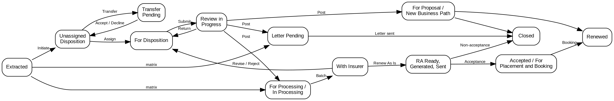
Figure 2: Stages of a renewal account

Storyboards

SB-01 An expiring account from the Expiry List to the Team Leader's post
The booked accounts expiring in the renewal horizon are extracted and initiated; the renewal of Pacific Harbor Logistics Inc. waits in the Unassigned Disposition tab of Corporate Marketing Team 1, classified Review: its expiring premium is outstanding, a claim is open and an endorsement is in progress. The Team Leader assigns it to the Account Officer, who reads the account history, gives the disposition For Renewal and pushes it. The Team Leader's post is refused while the blocking checks fail; she overrides them with a reason and posts the renewal to Processing.
Test data: Seed data: renewal of account ARN-2026-940004 (Pacific Harbor Logistics Inc., Luzon Assurance Co.), Corporate Marketing Team 1.
Table 3: SB-01 steps
Step | Who | Screen | Does | Sees
1 | Marketing Team Lead | Expiry List | Opens the Expiry List, tab Unassigned Disposition, ticks the renewal of Pacific Harbor Logistics Inc. and clicks Assign Disposition: Arnel Account Officer, then Assign and Push | Message: 1 assigned; the renewal leaves the tab
2 | Account Officer | My Dispositions | Opens My Dispositions | The renewal assigned to him with its expiry, the Review classification and the flags Outstanding and Claims
3 | Account Officer | Renewal | Opens the renewal, tab Account History, and clicks View Account History | The payments of the expiring invoice and the open claim; the viewing is recorded
4 | Account Officer | Set Disposition, Add Remark and Re-open | Clicks Set Disposition: For Renewal with the remarks of the client's call, then Save | Message: Saved; the disposition For Renewal on the renewal
5 | Account Officer | Set Disposition, Add Remark and Re-open | Clicks Push | Message: Pushed to the Team Leader; the status Review in Progress
6 | Marketing Team Lead | TL Review | Opens TL Review, tab For Review, ticks the renewal and clicks Post, then confirms | The outcome: 1 refused, the renewal cannot be posted while the claims, endorsement and outstanding premium checks fail
7 | Marketing Team Lead | TL Review | Clicks Override: Outstanding balance, reason Approved by the Team Leader, with remarks (the open claim and the endorsement are overridden the same way) | Message: 1 overridden; the override kept in the History tab of the renewal
8 | Marketing Team Lead | TL Review | Clicks Post again and confirms | Message: 1 posted; the renewal moves to Processing

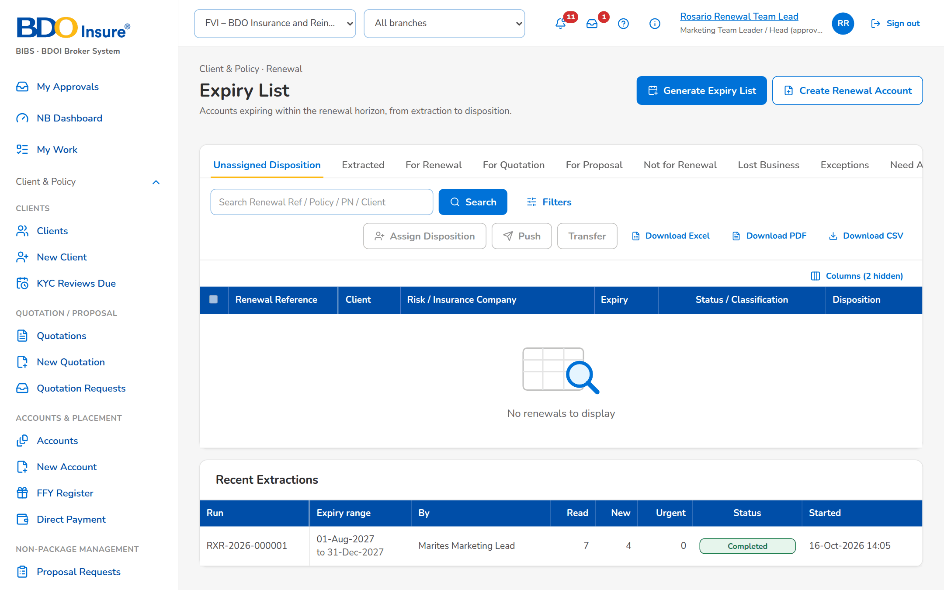
Figure 3: SB-01 step 1: Marketing Team Lead, Expiry List
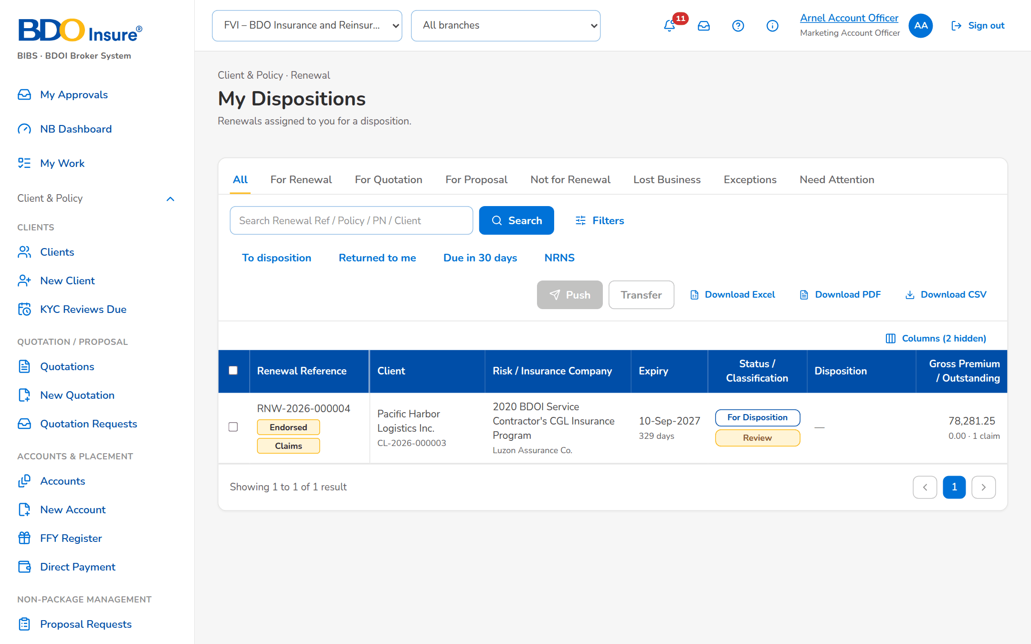
Figure 4: SB-01 step 2: Account Officer, My Dispositions
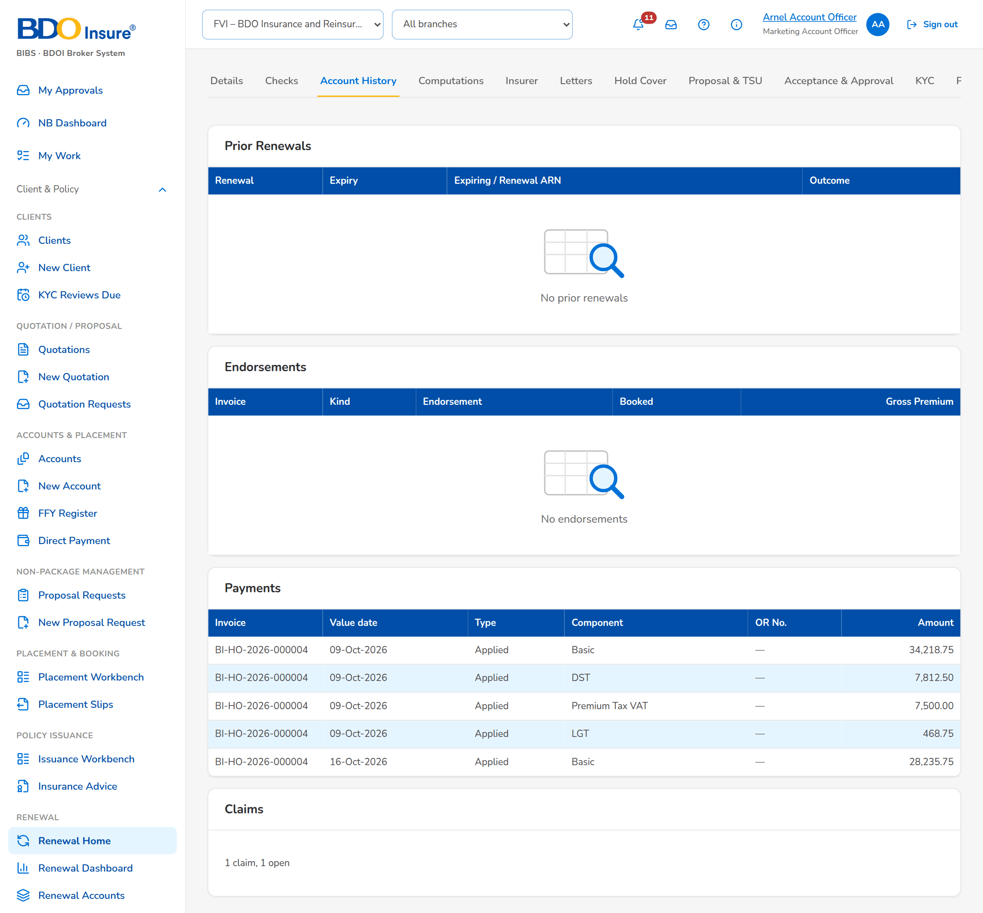
Figure 5: SB-01 step 3: Account Officer, Renewal
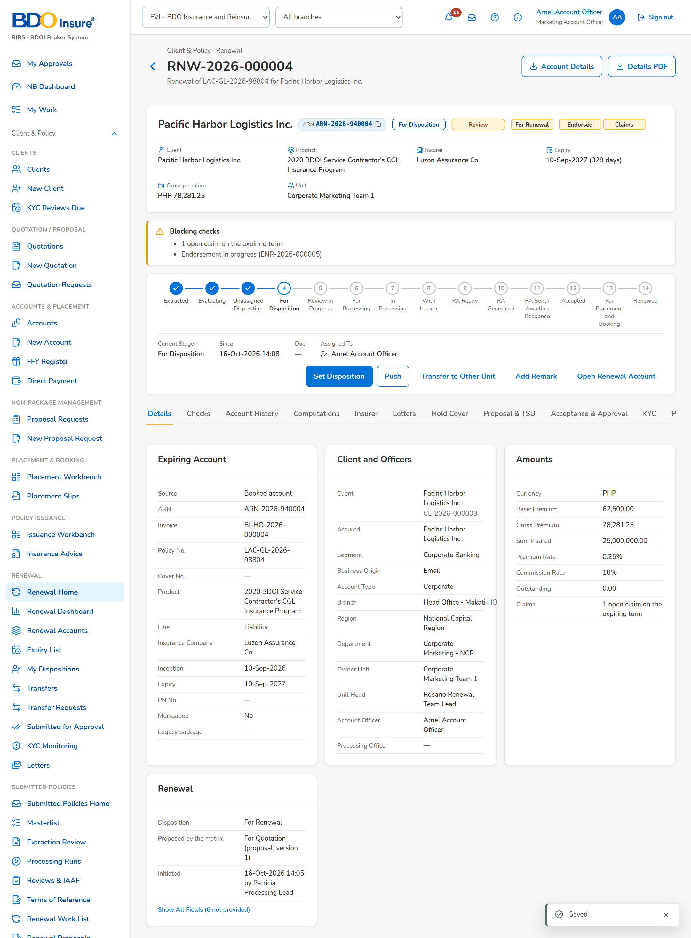
Figure 6: SB-01 step 4: Account Officer, Set Disposition, Add Remark and Re-open
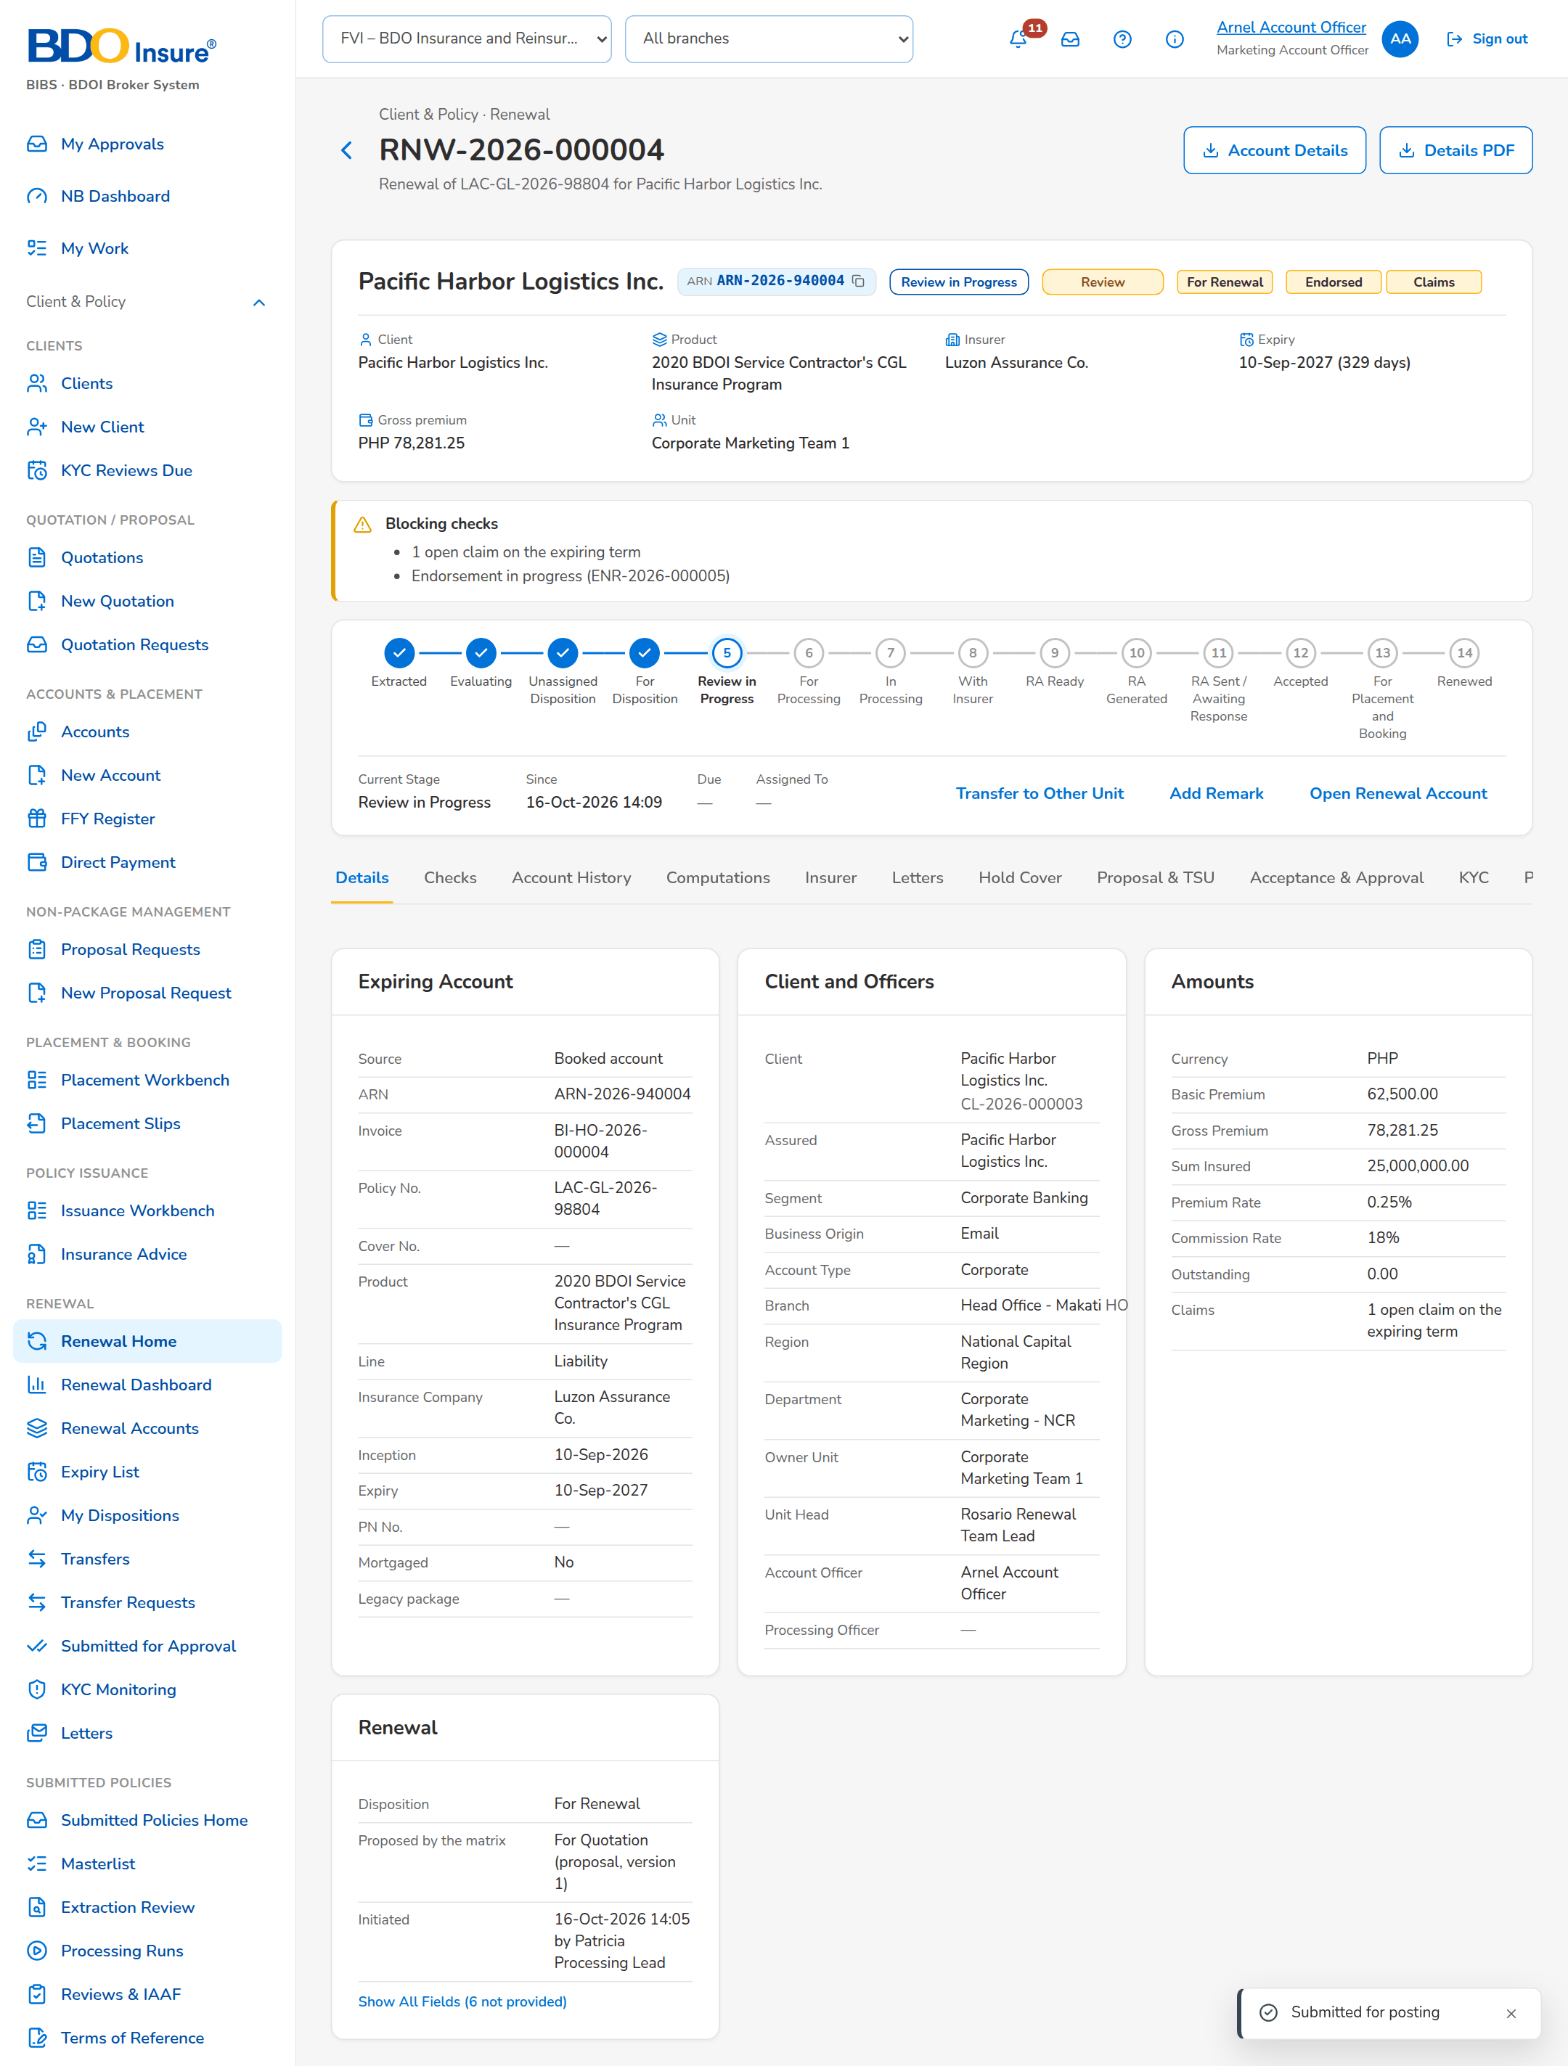
Figure 7: SB-01 step 5: Account Officer, Set Disposition, Add Remark and Re-open
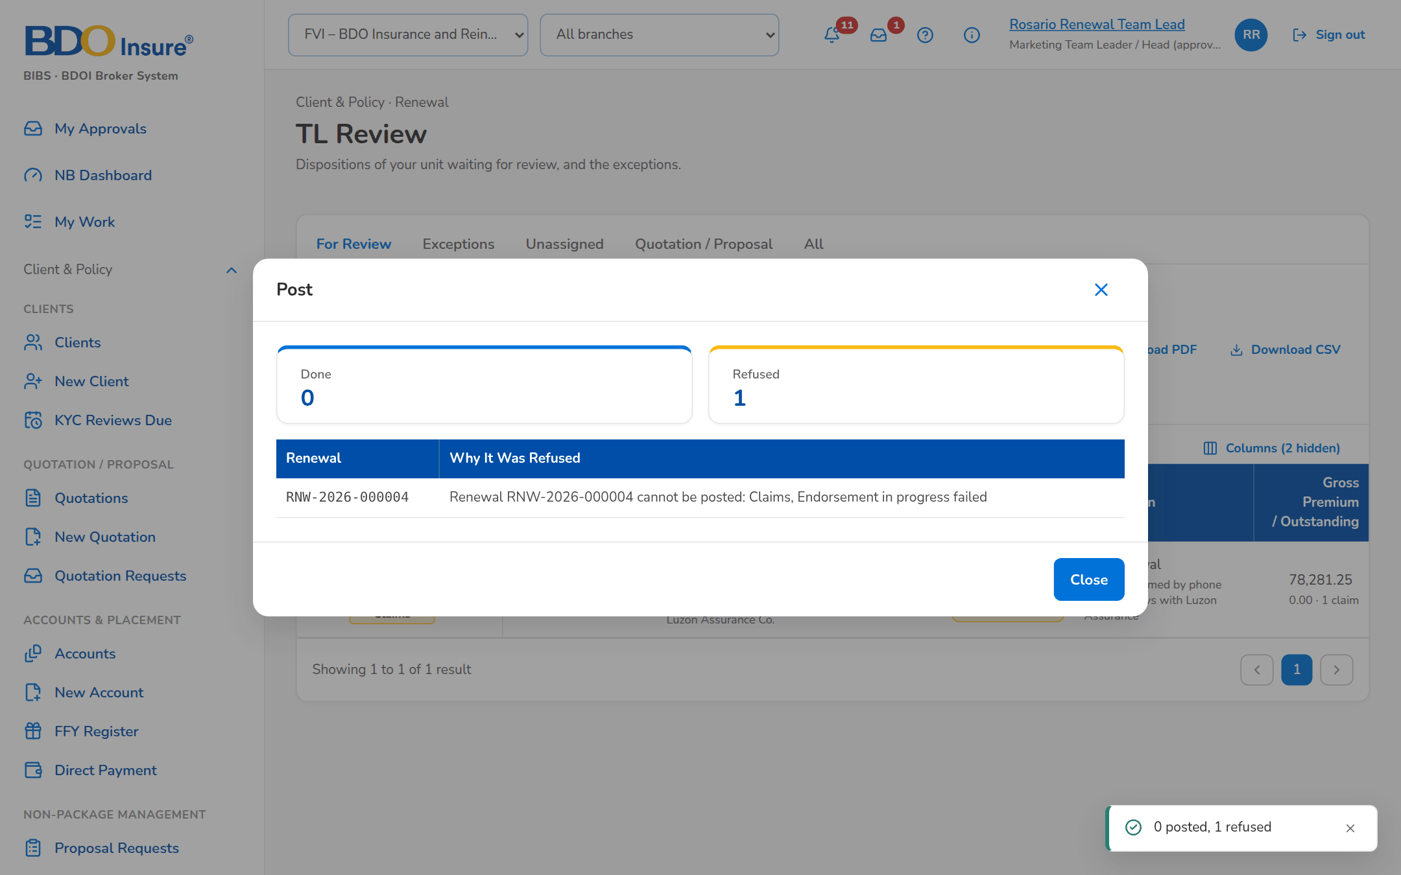
Figure 8: SB-01 step 6: Marketing Team Lead, TL Review
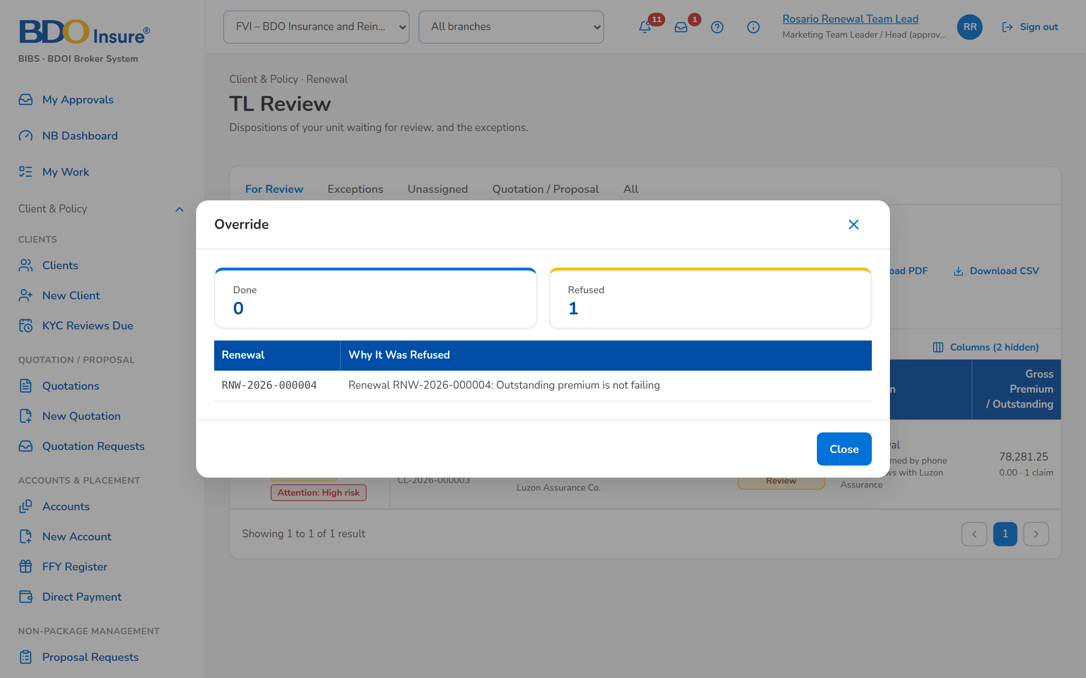
Figure 9: SB-01 step 7: Marketing Team Lead, TL Review
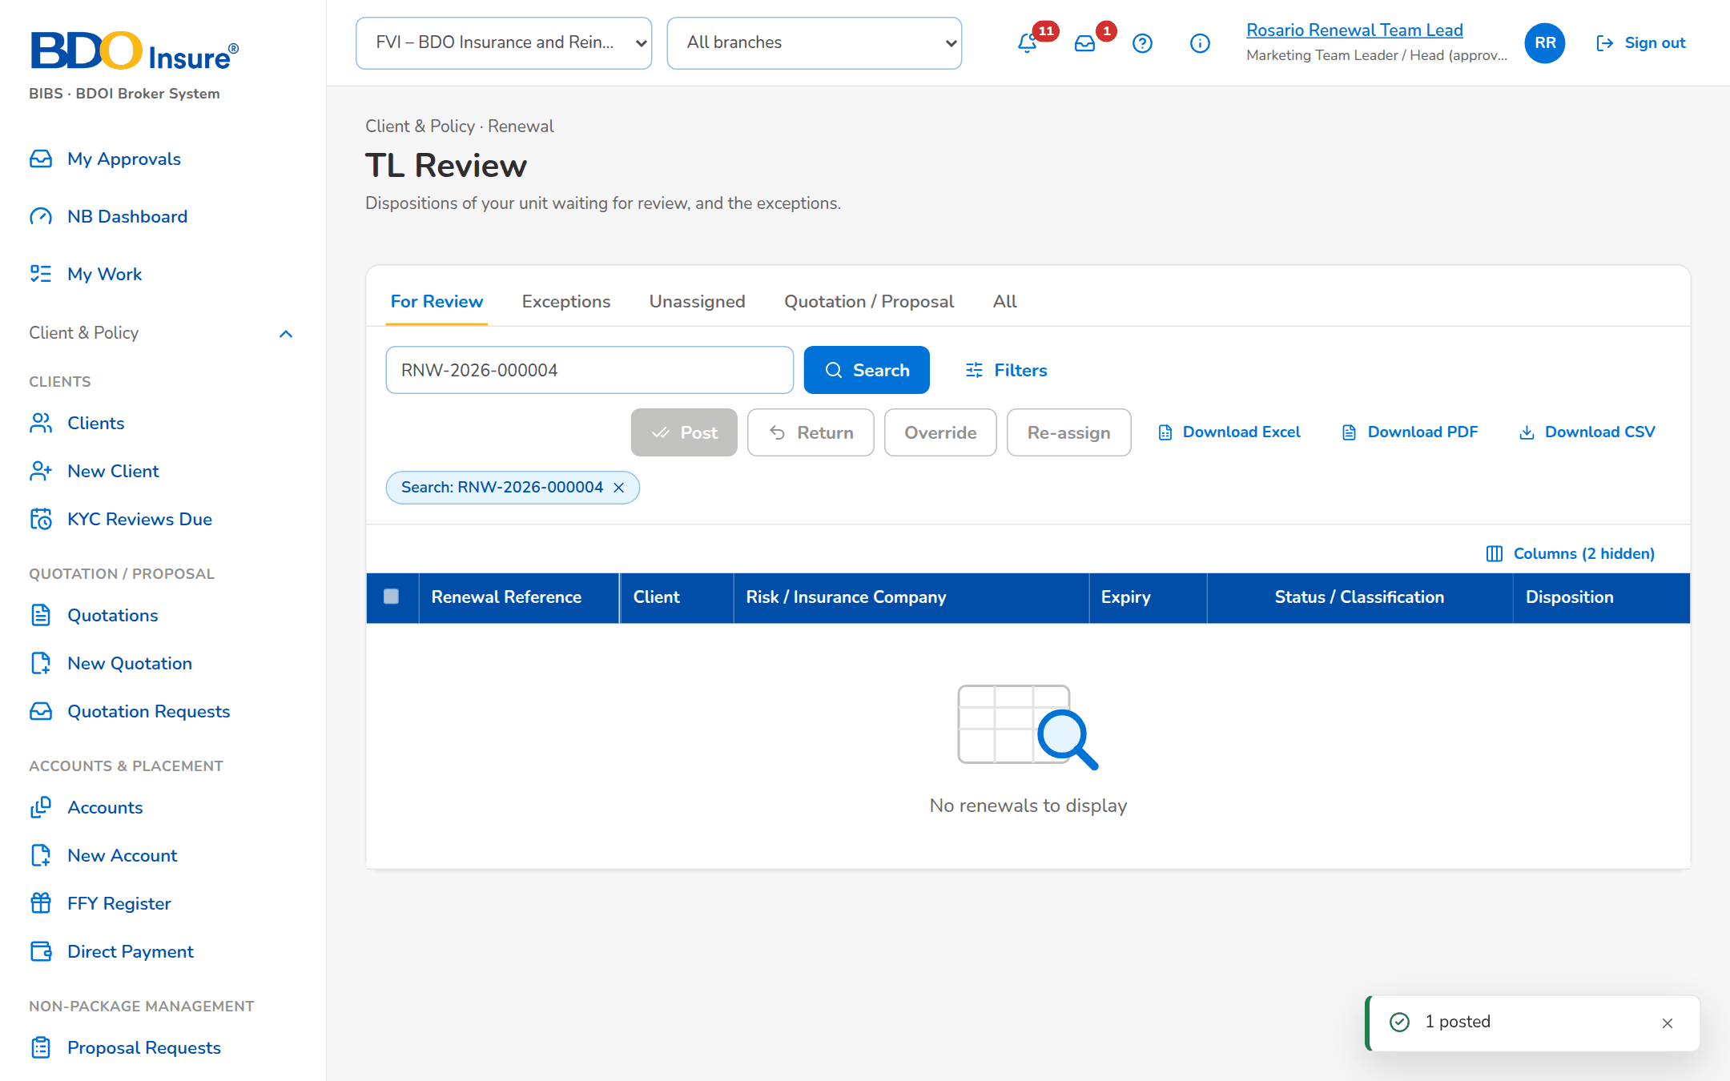
Figure 10: SB-01 step 8: Marketing Team Lead, TL Review

SB-02 Processing, the insurer's answer and the Renewal Advice
The Processing Team Leader assigns the renewal of walkthrough A to a Processing Officer, who sends it to the insurer in a batch and records the insurer's answer Renew as is. The renewal is then ready for its Renewal Advice: the Account Officer generates the first notice and sends it to the client, protected.
Test data: Seed data: the renewal posted in walkthrough A; Patricia Processing Lead and Paolo Processor.
Table 4: SB-02 steps
Step | Who | Screen | Does | Sees
1 | Processing Team Lead | Processing Worklist | Opens the Processing Worklist, tab For Processing, ticks the renewal and clicks Assign PO: Paolo Processor, then Assign | Message: 1 assigned; the renewal In Processing
2 | Processing Officer | Insurer Batches | Opens Insurer Batches, clicks New Batch with Luzon Assurance Co. and the expiry date of the renewal, then Create Batch, and opens the batch | The batch Draft with the renewal and the columns of the insurer extract
3 | Processing Officer | Insurer Batches | Clicks Send to Insurer and confirms | Message: Batch sent to the insurer; the batch Sent with its reply date
4 | Processing Officer | Record Insurer Response | Opens the renewal and clicks Record Insurer Response: Renew as is with the insurer reference, then Record | Message: Saved; the renewal RA Ready
5 | Account Officer | Letters | Opens Letters, tab RA Ready, ticks the renewal, clicks Generate RA: First notice, then Generate | Message: 1 generated; the renewal in RA Generated, locked on the Marketing side
6 | Account Officer | Letters | Opens the tab RA Generated, ticks the renewal, clicks Send and confirms | Message: 1 sent; the Renewal Advice e-mailed protected to the client

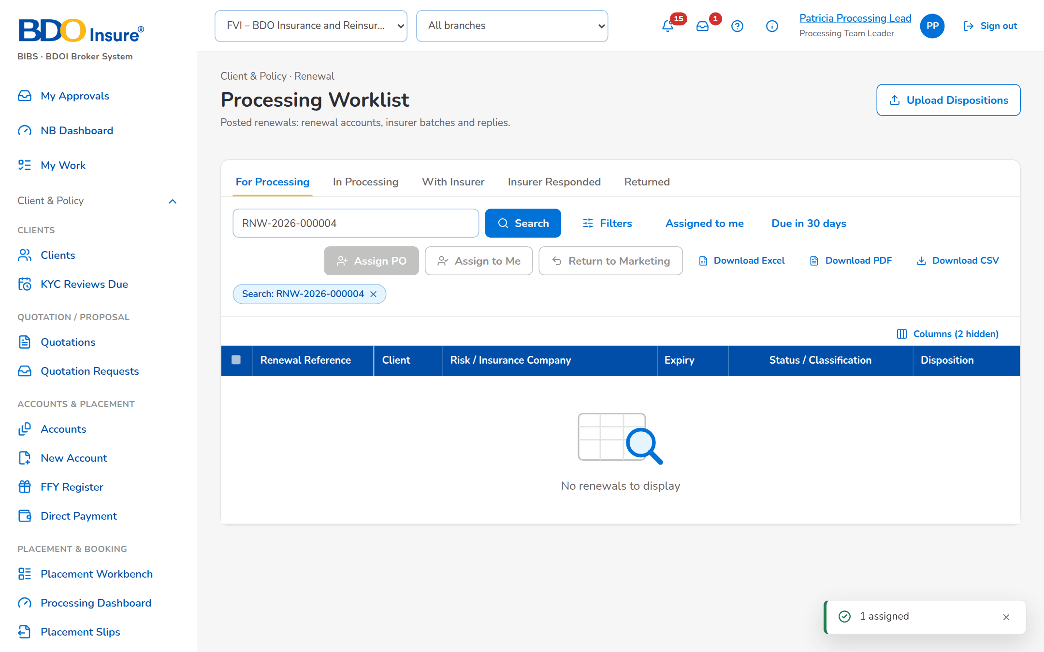
Figure 11: SB-02 step 1: Processing Team Lead, Processing Worklist
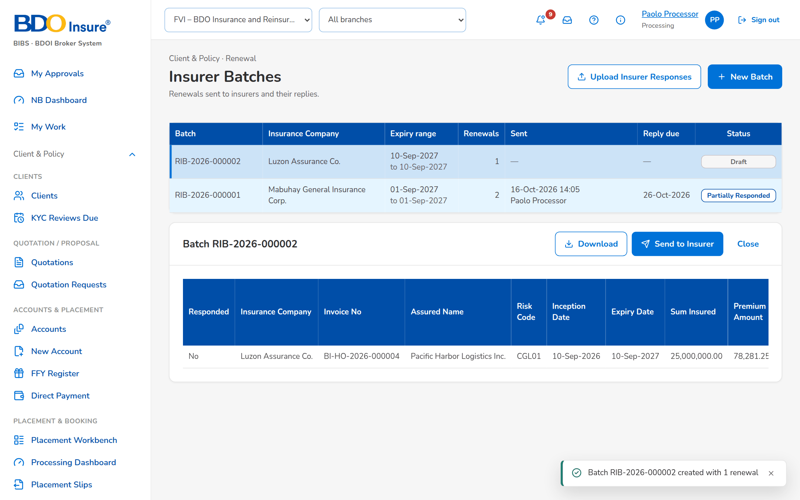
Figure 12: SB-02 step 2: Processing Officer, Insurer Batches
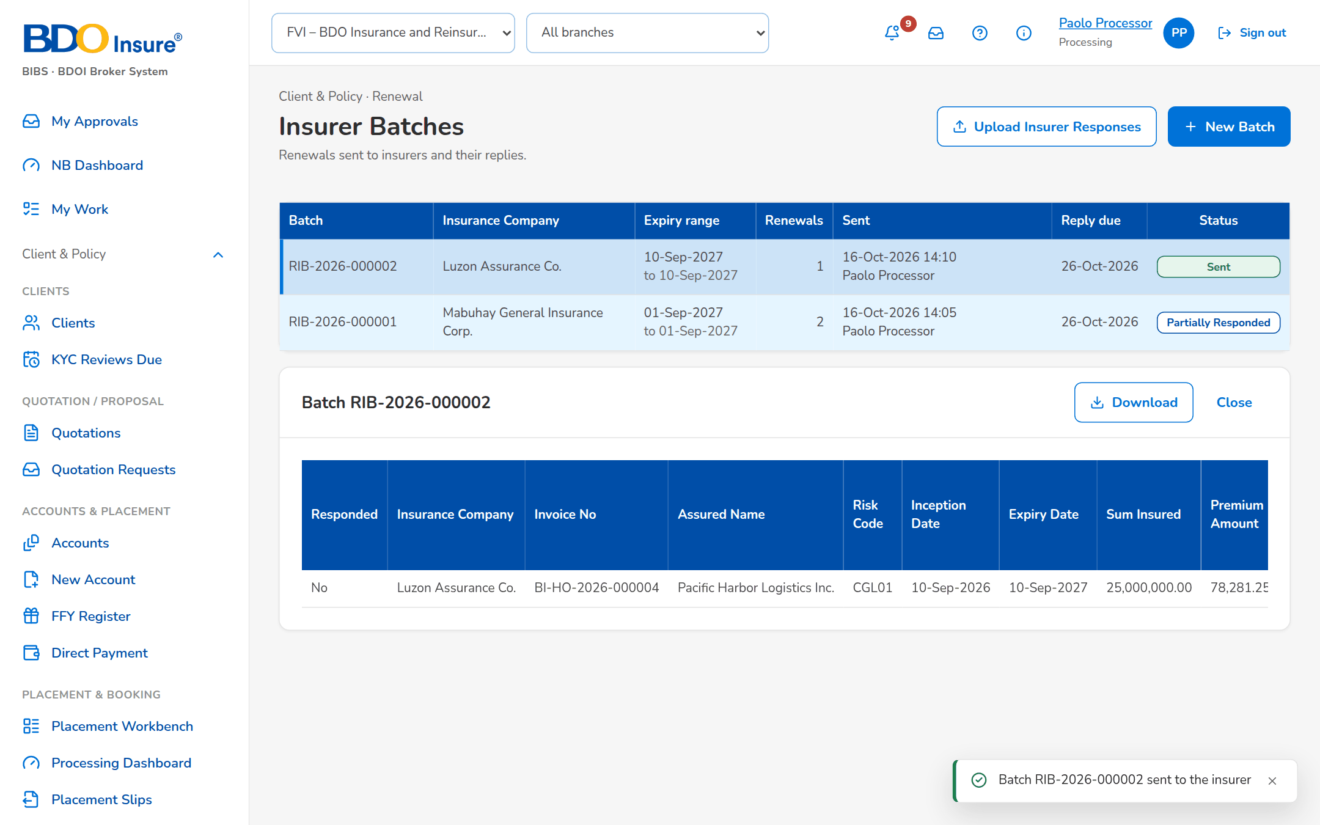
Figure 13: SB-02 step 3: Processing Officer, Insurer Batches
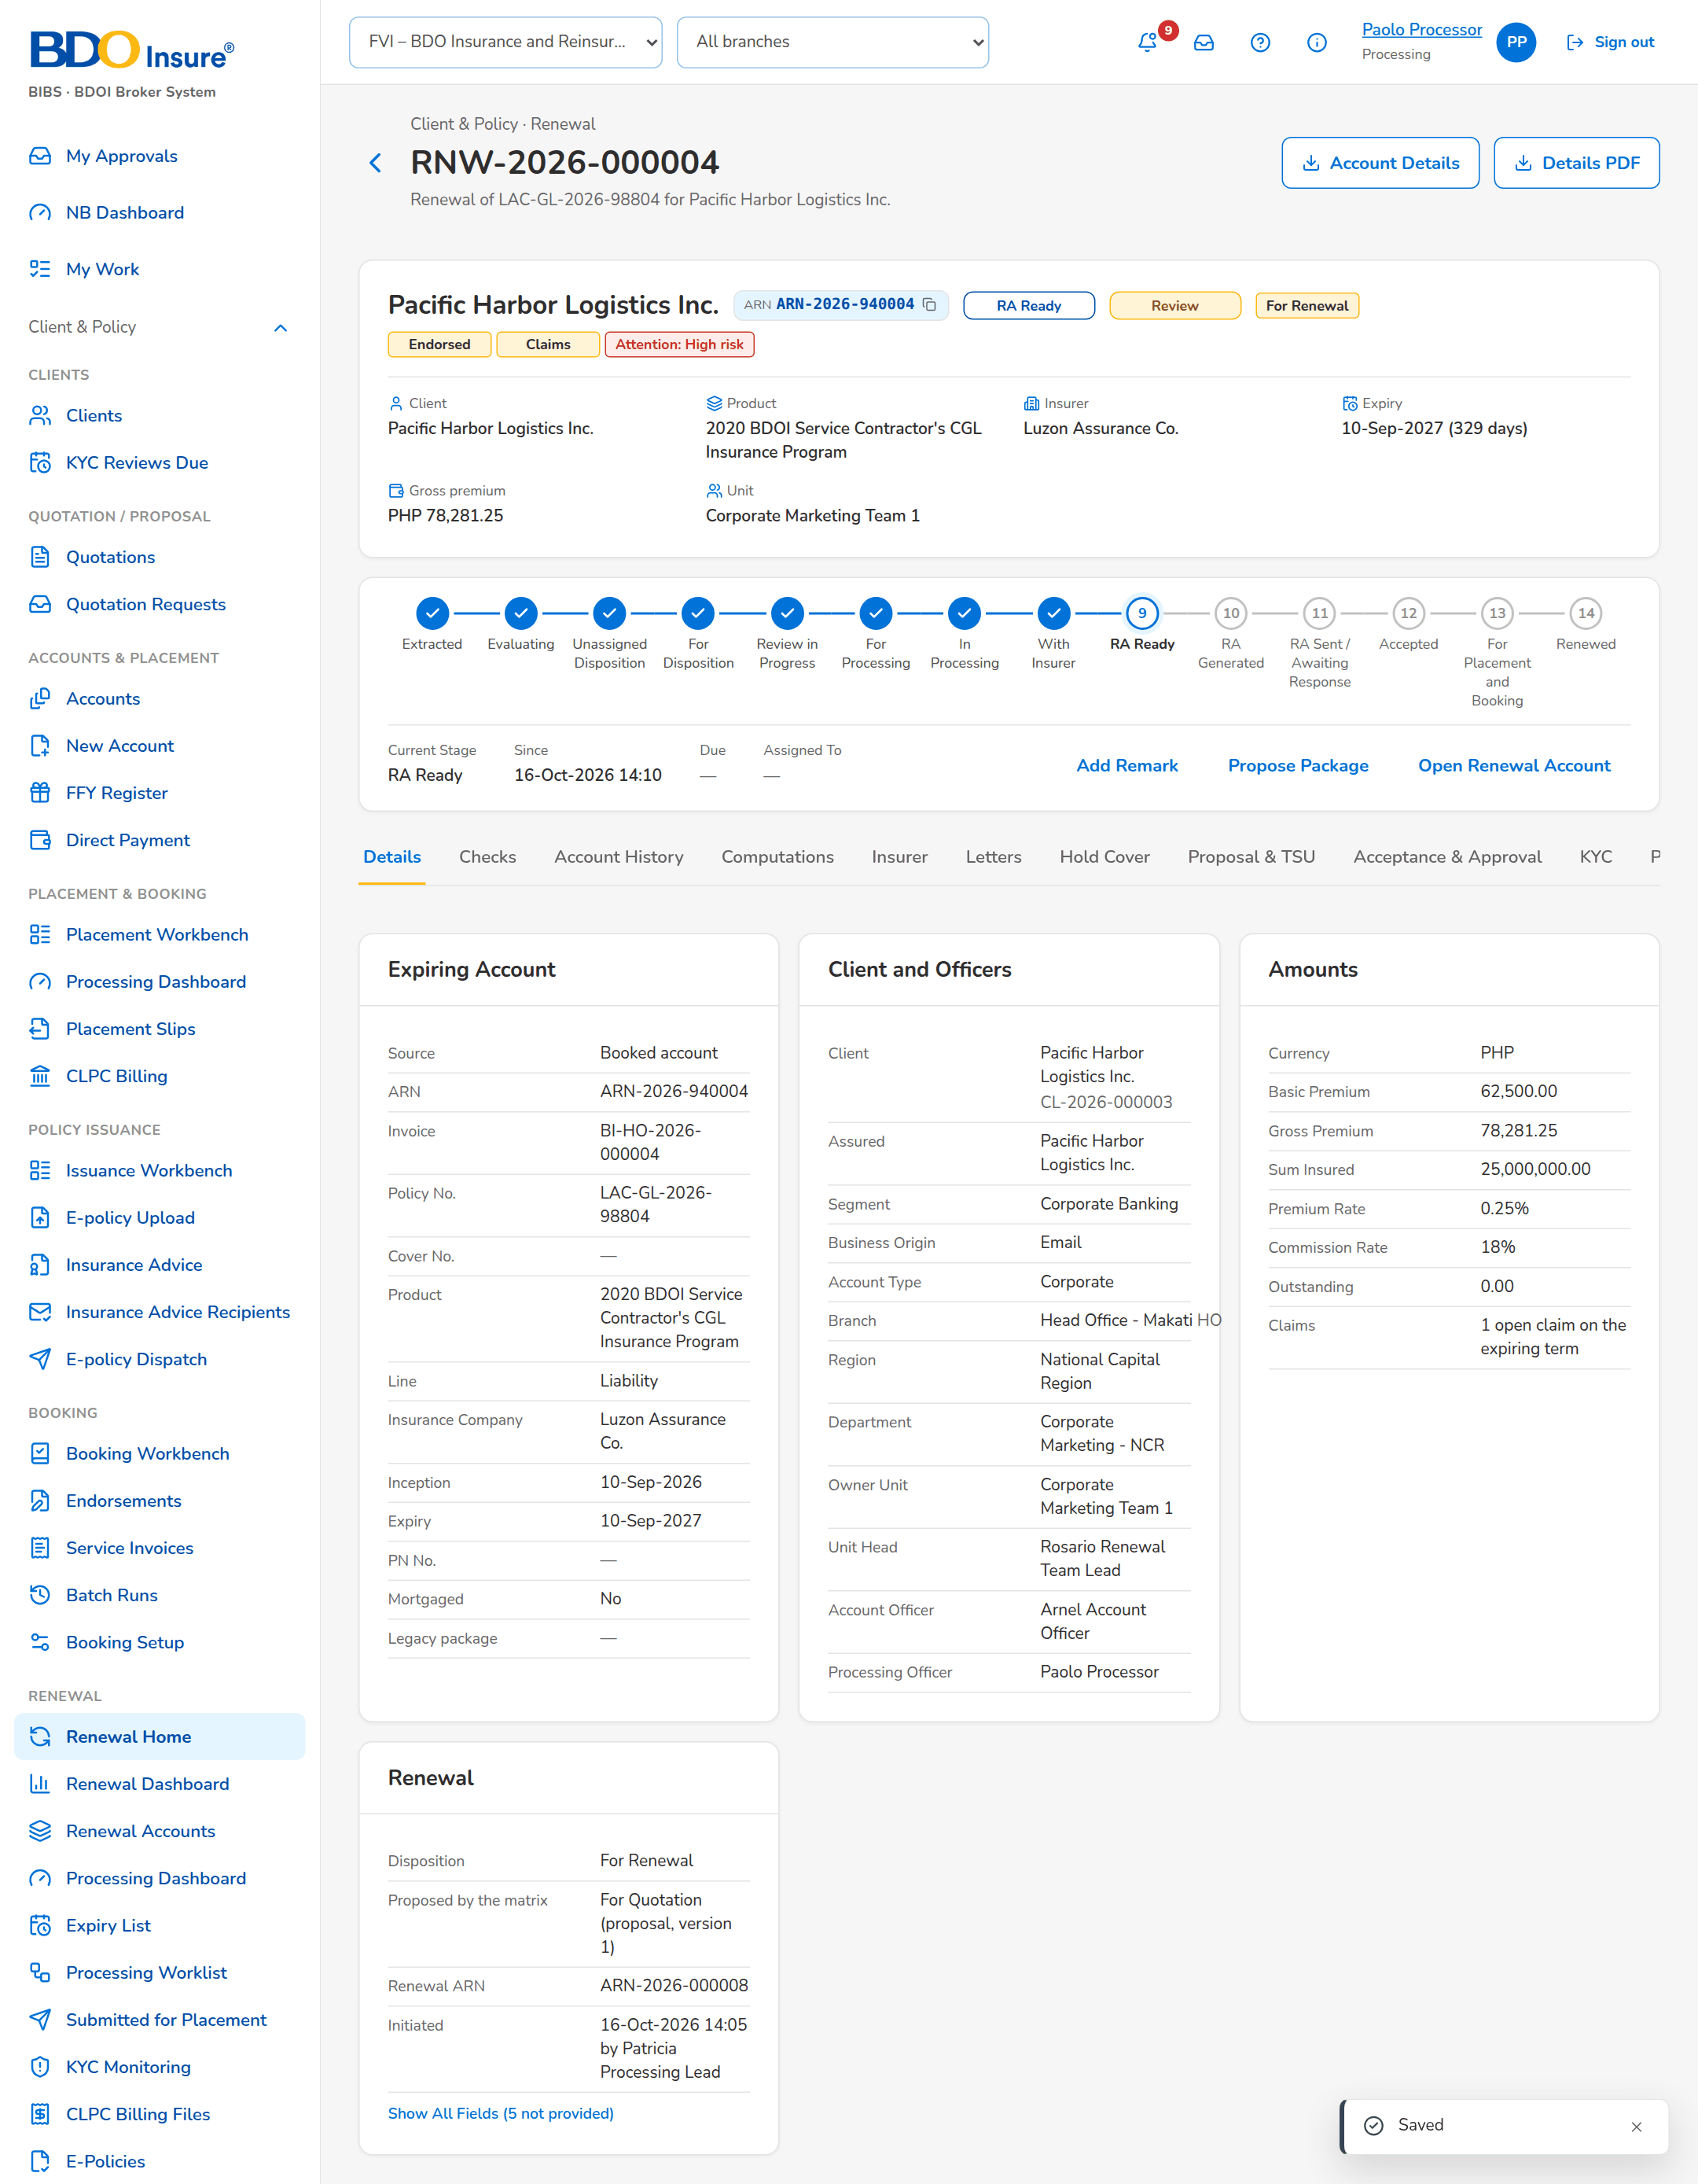
Figure 14: SB-02 step 4: Processing Officer, Record Insurer Response
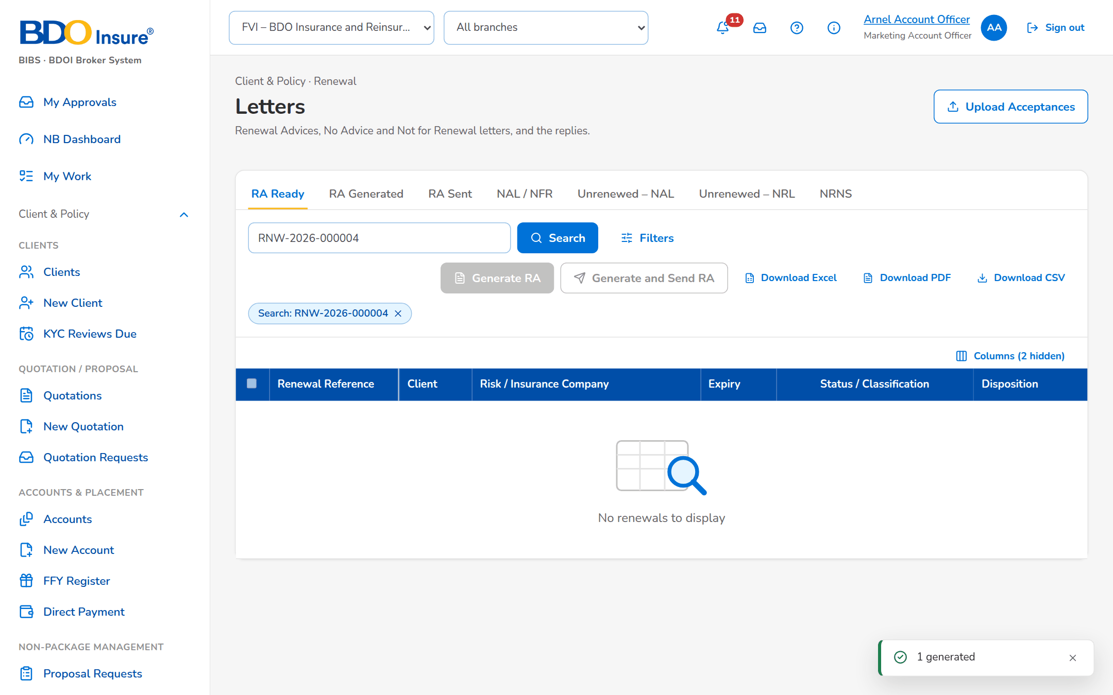
Figure 15: SB-02 step 5: Account Officer, Letters
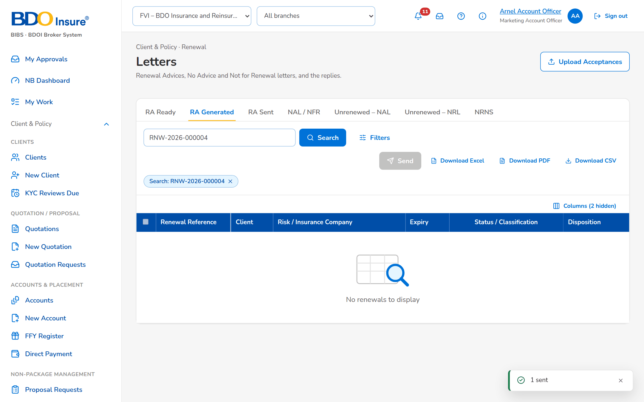
Figure 16: SB-02 step 6: Account Officer, Letters

SB-03 The Contact Center follow-up and the client's acceptance
The renewal of walkthrough B waits for the client's reply. The Contact Center calls the client and records the follow-up; the client pays the renewal premium, and the Account Officer records the acceptance by payment. The renewal account goes on to placement and booking without re-keying.
Test data: Seed data: the renewal sent in walkthrough B; Cecilia Contact Center.
Table 5: SB-03 steps
Step | Who | Screen | Does | Sees
1 | Contact Center | Follow-ups | Opens Follow-ups, tab RA Sent | The renewal waiting for the client's reply
2 | Contact Center | Follow-ups | Opens the renewal and clicks Add Follow-up: Call, Client will renew, the next action date and the remarks, then Save | Message: Saved; the follow-up on the Remarks & Follow-ups tab
3 | Account Officer | Record Acceptance | Opens the renewal and clicks Record Acceptance: Payment with the payment reference, then Record | Message: Saved; the renewal For Placement and Booking
4 | Account Officer | Renewal | Opens the tab Letters | The Renewal Advice in the e-mail queue to the client and the acceptance by payment

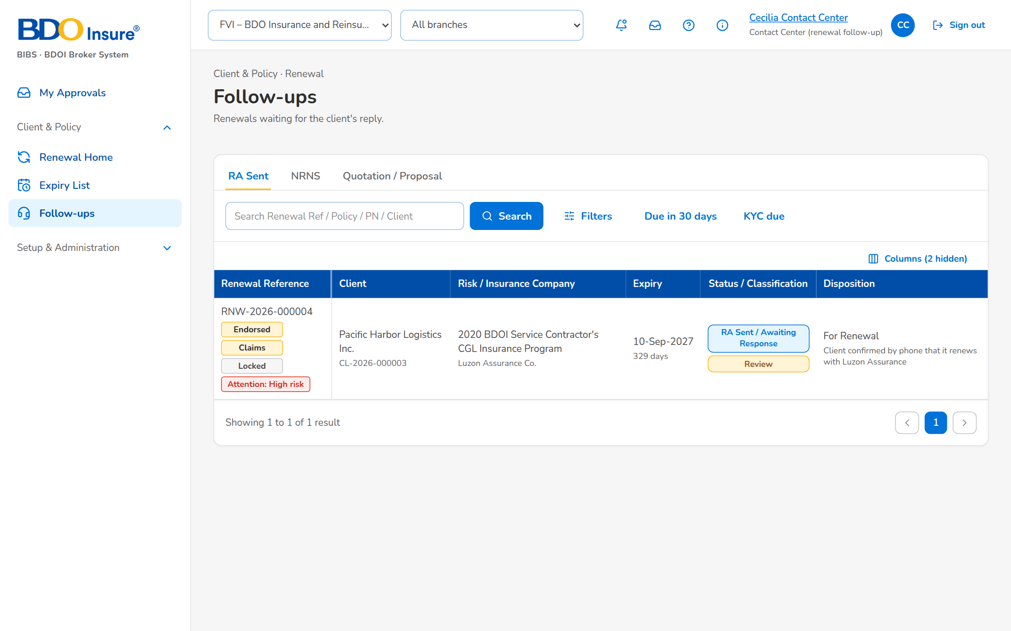
Figure 17: SB-03 step 1: Contact Center, Follow-ups
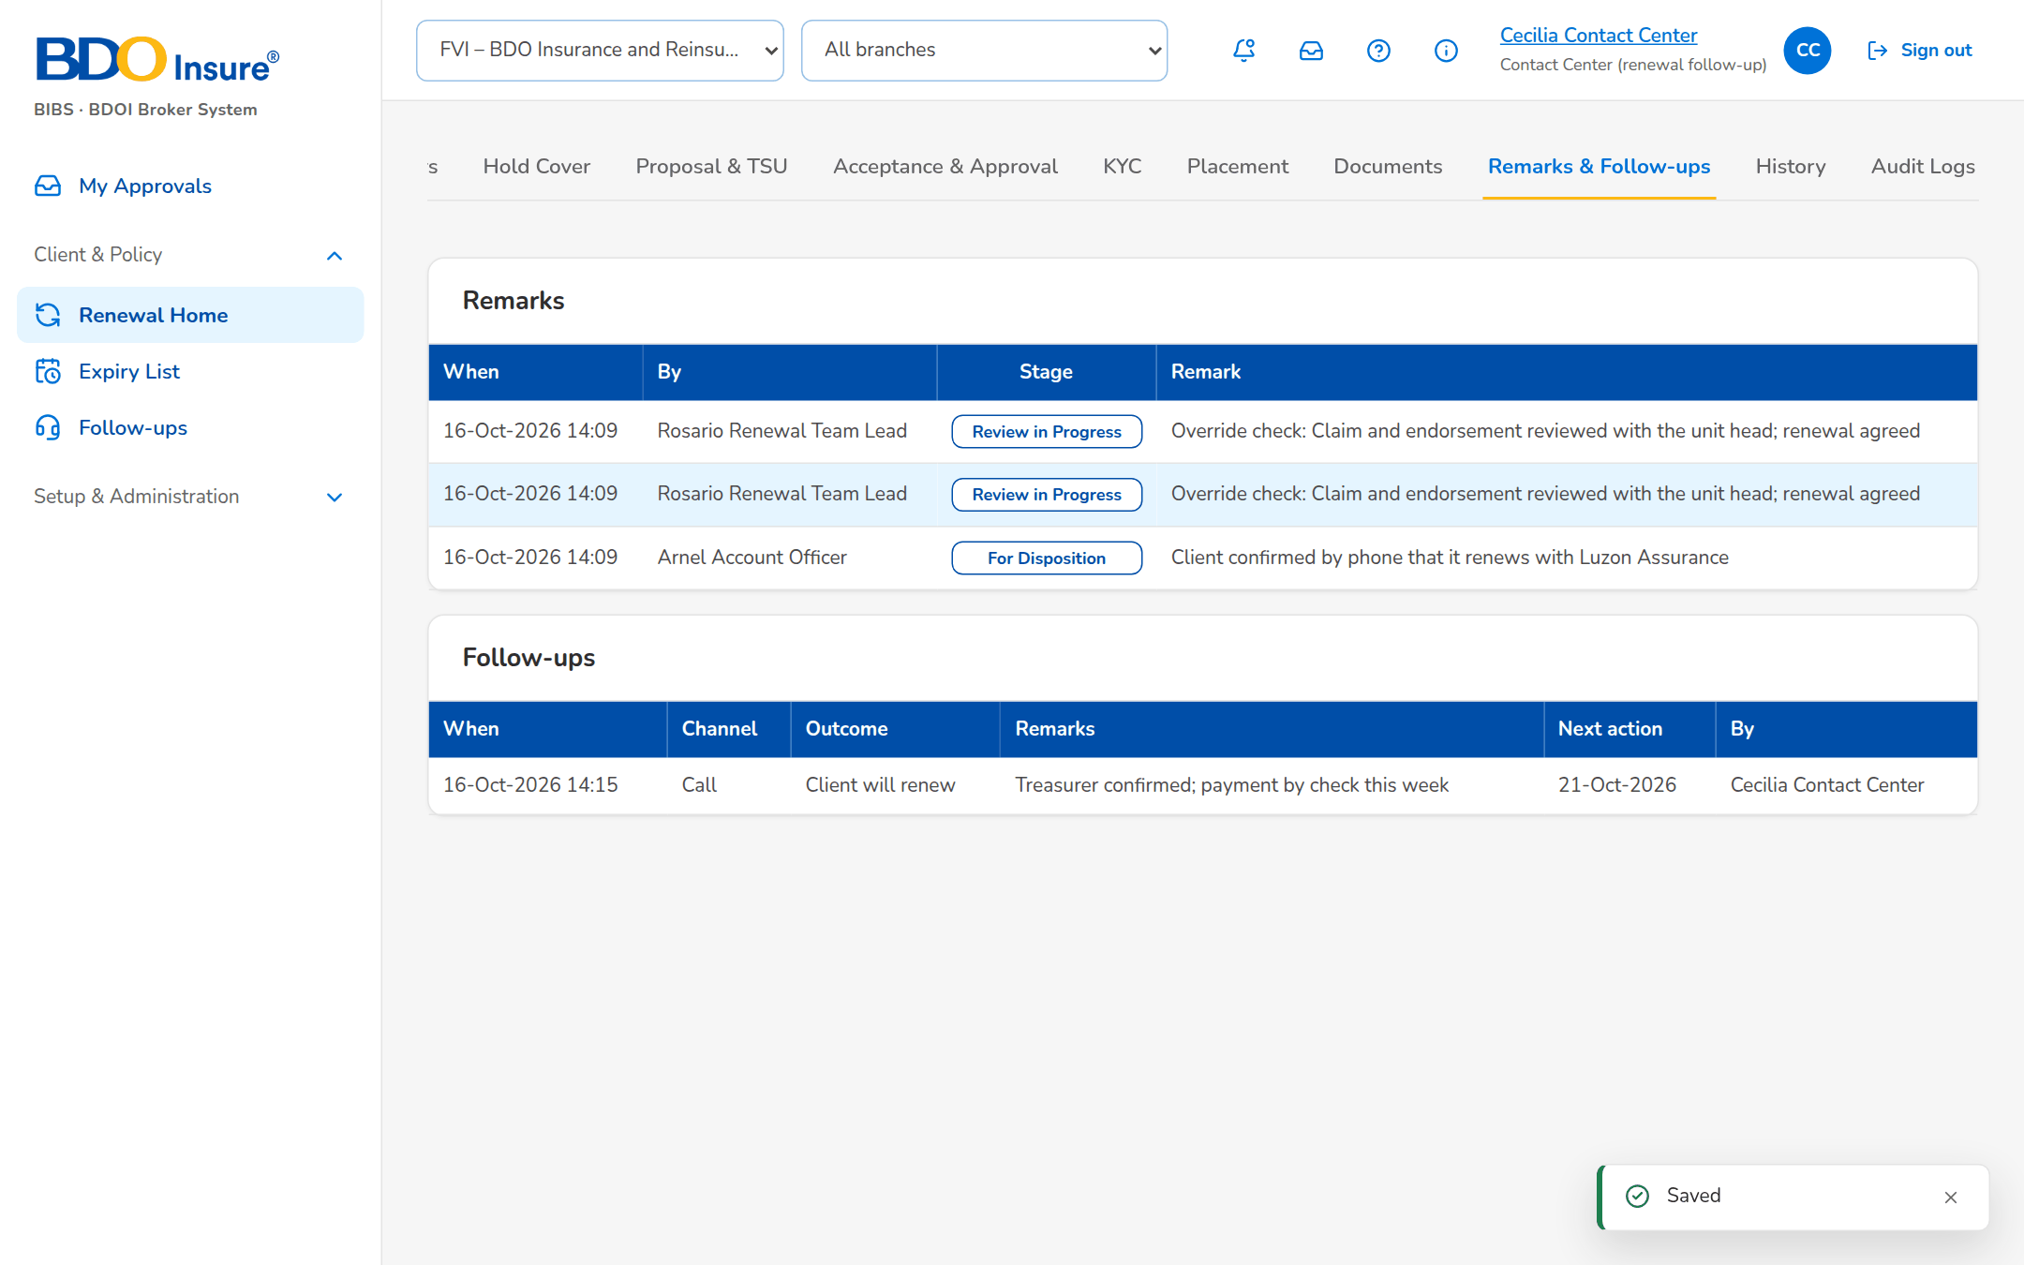
Figure 18: SB-03 step 2: Contact Center, Follow-ups
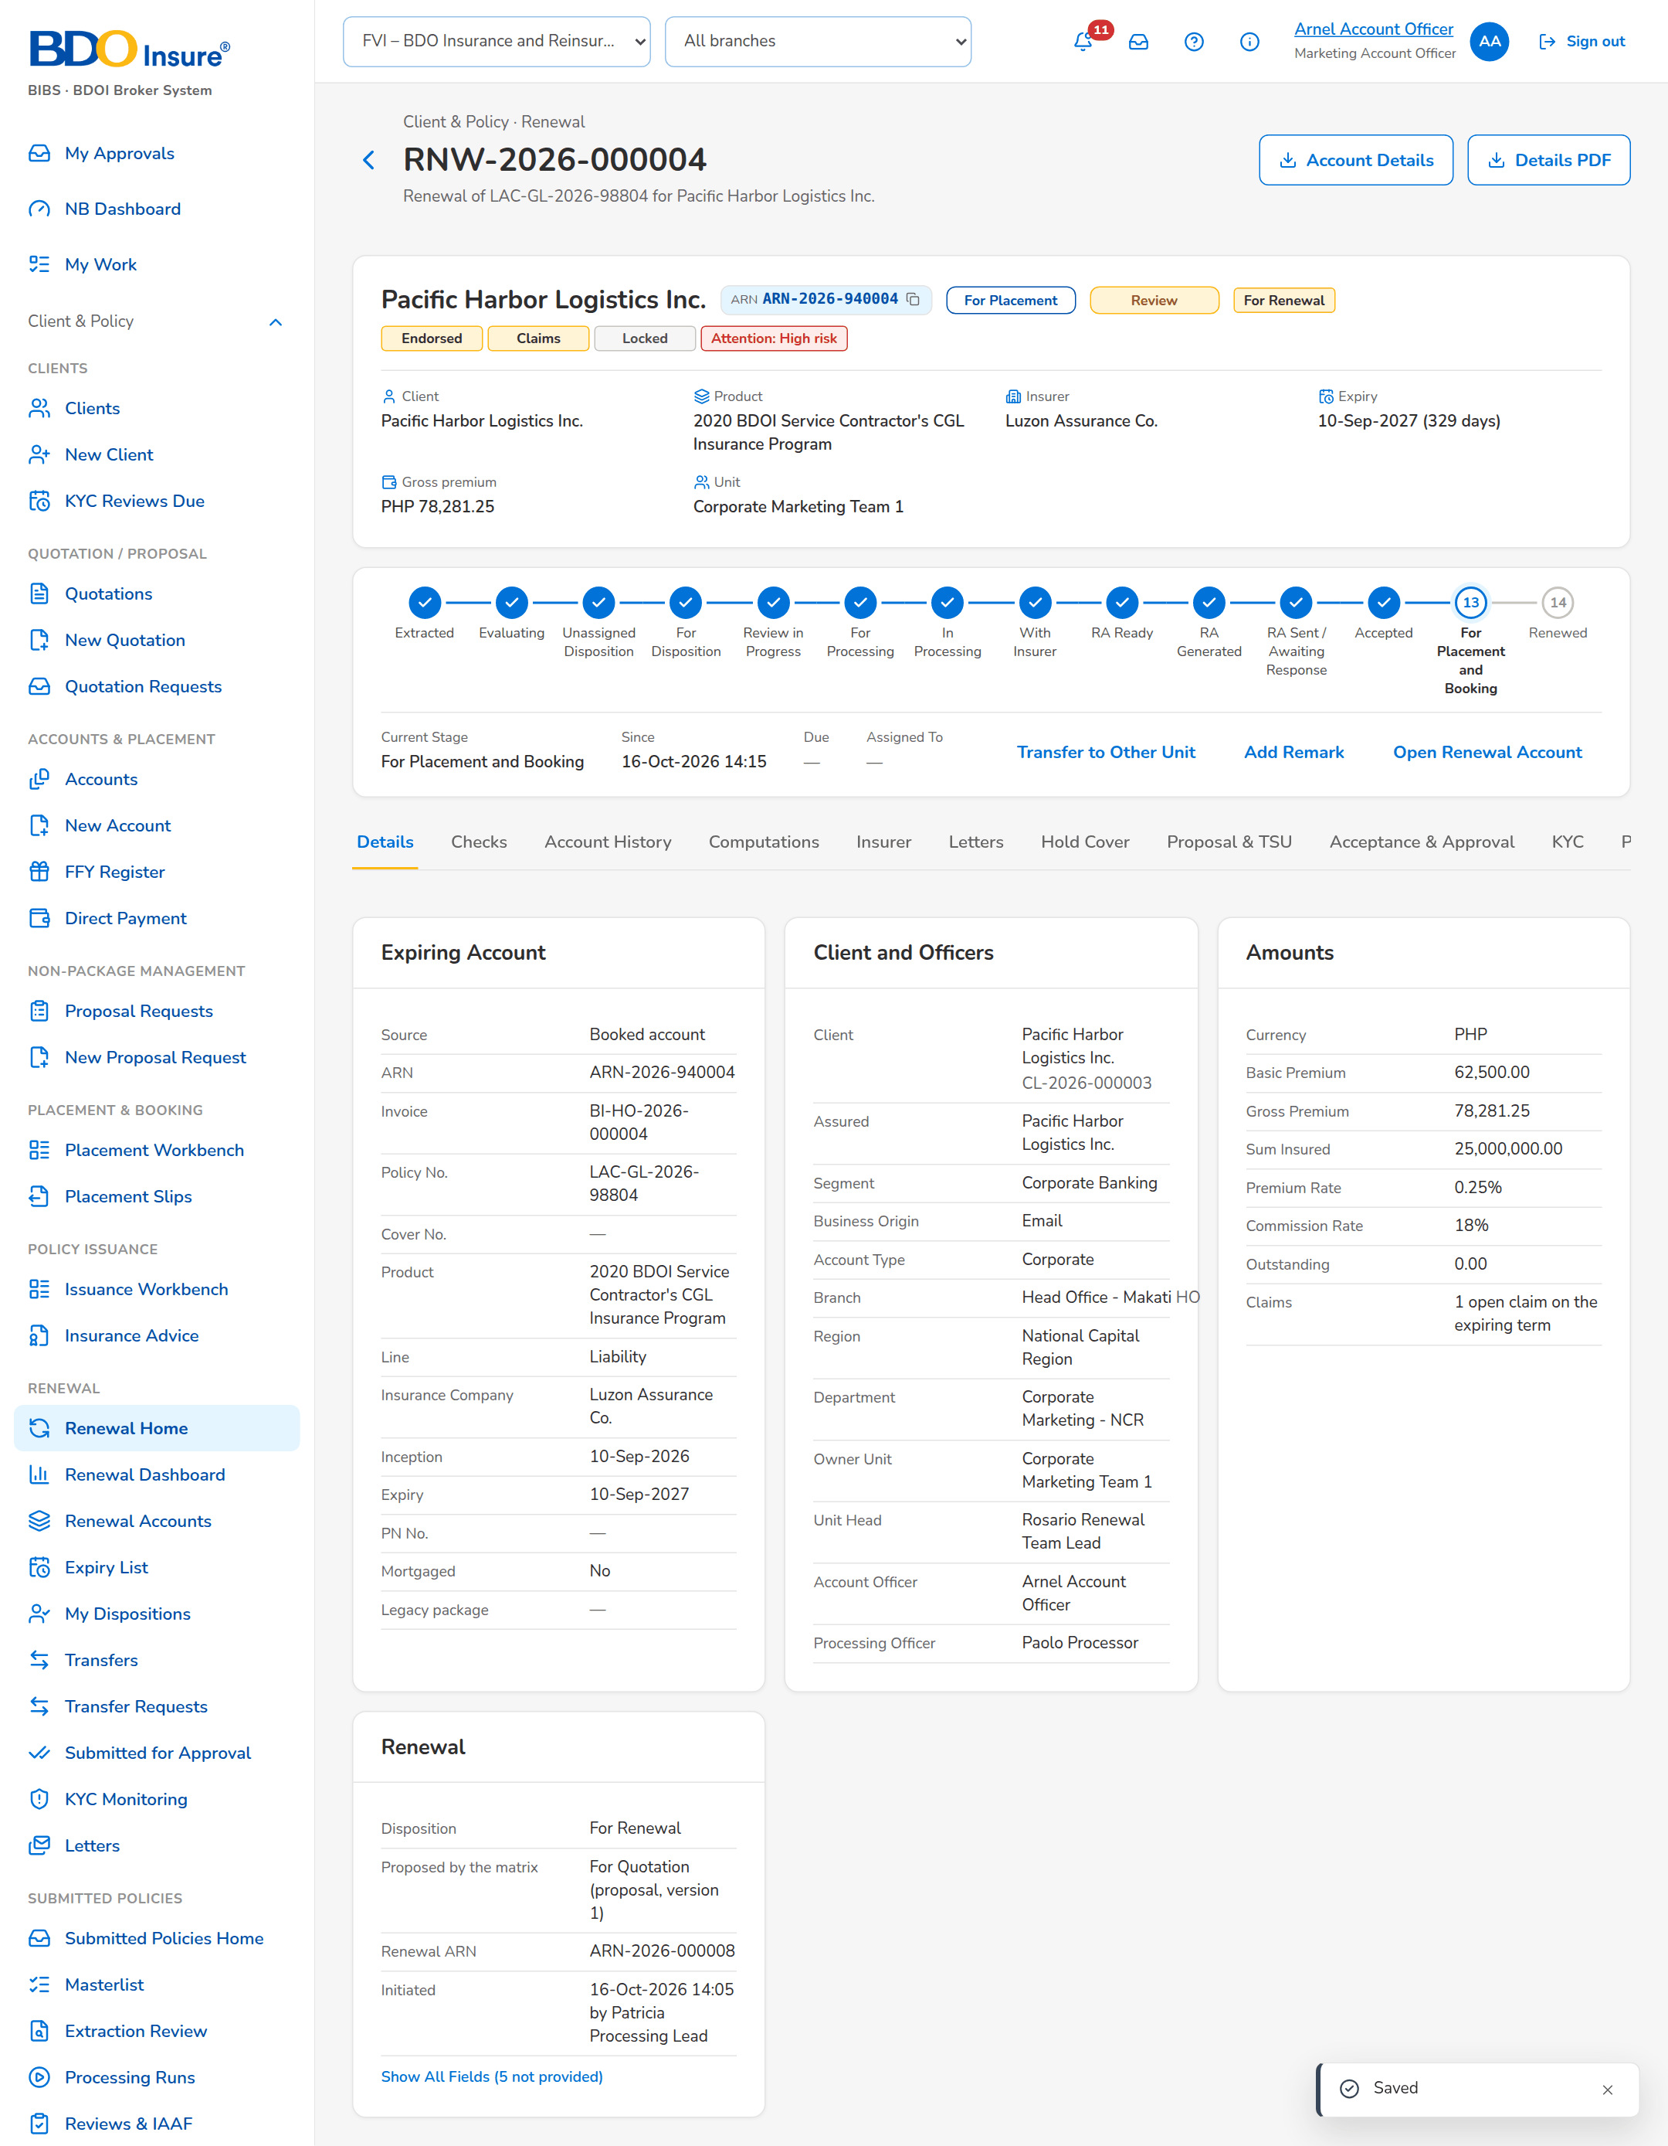
Figure 19: SB-03 step 3: Account Officer, Record Acceptance
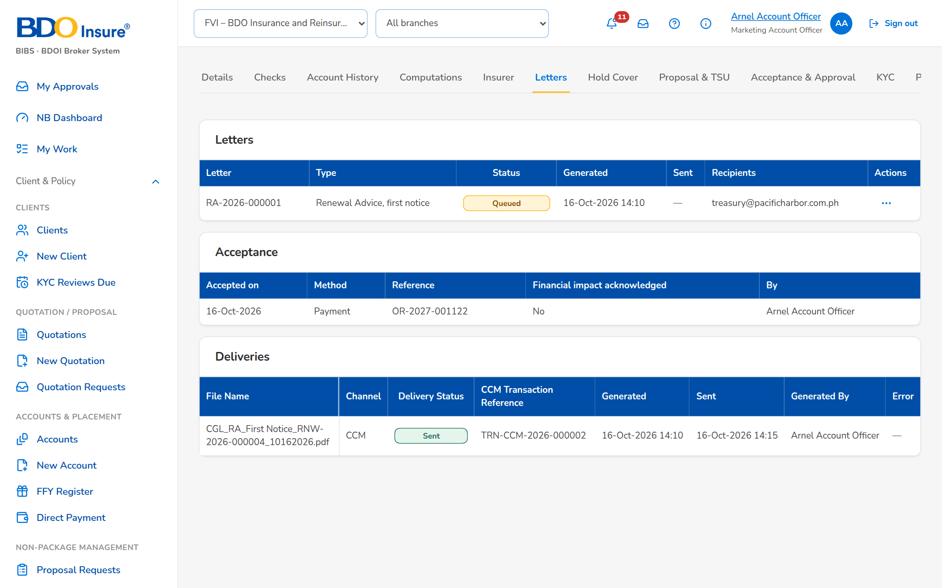
Figure 20: SB-03 step 4: Account Officer, Renewal

SB-04 Not for Renewal and the closing letter
Aileen Account Officer learns that the client's loan is fully paid: she gives the disposition Not for Renewal with that reason and pushes it; the Team Leader posts it to the letter step and the Not for Renewal Letter is sent, which closes the renewal.
Test data: Seed data: the renewal of the migrated motor policy QPS-FI-0100007 (Jose Miguel Reyes), CBG Metro Team 1, assigned to Aileen Account Officer by the Team Leader.
Table 6: SB-04 steps
Step | Who | Screen | Does | Sees
1 | Account Officer | Set Disposition, Add Remark and Re-open | Opens the renewal, views its account history, clicks Set Disposition: Not for Renewal, reason Loan fully paid, with remarks, then Save | Message: Saved; the disposition Not for Renewal with its reason
2 | Marketing Team Lead | TL Review | After the Account Officer's push, ticks the renewal on TL Review, clicks Post and confirms | Message: 1 posted; the renewal goes to the closing letters
3 | Account Officer | Letters | Opens Letters, tab NAL / NFR, ticks the renewal, clicks Send Letters and confirms | Message: 1 sent; the renewal is closed
4 | Account Officer | Renewal | Opens the renewal, tab Letters | The Not for Renewal Letter in the e-mail queue to the client

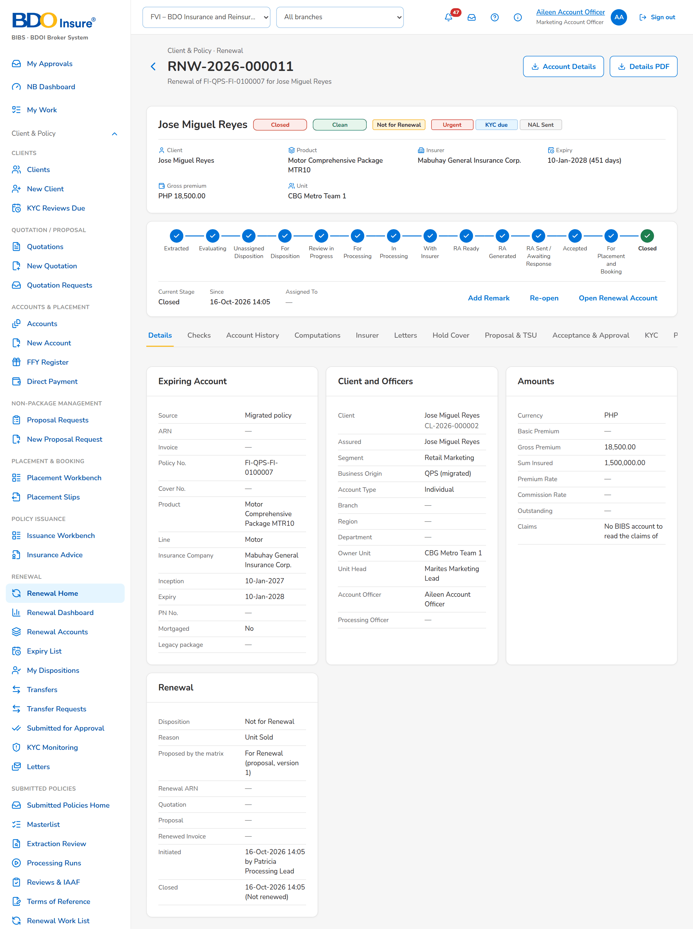
Figure 21: SB-04 step 1: Account Officer, Set Disposition, Add Remark and Re-open
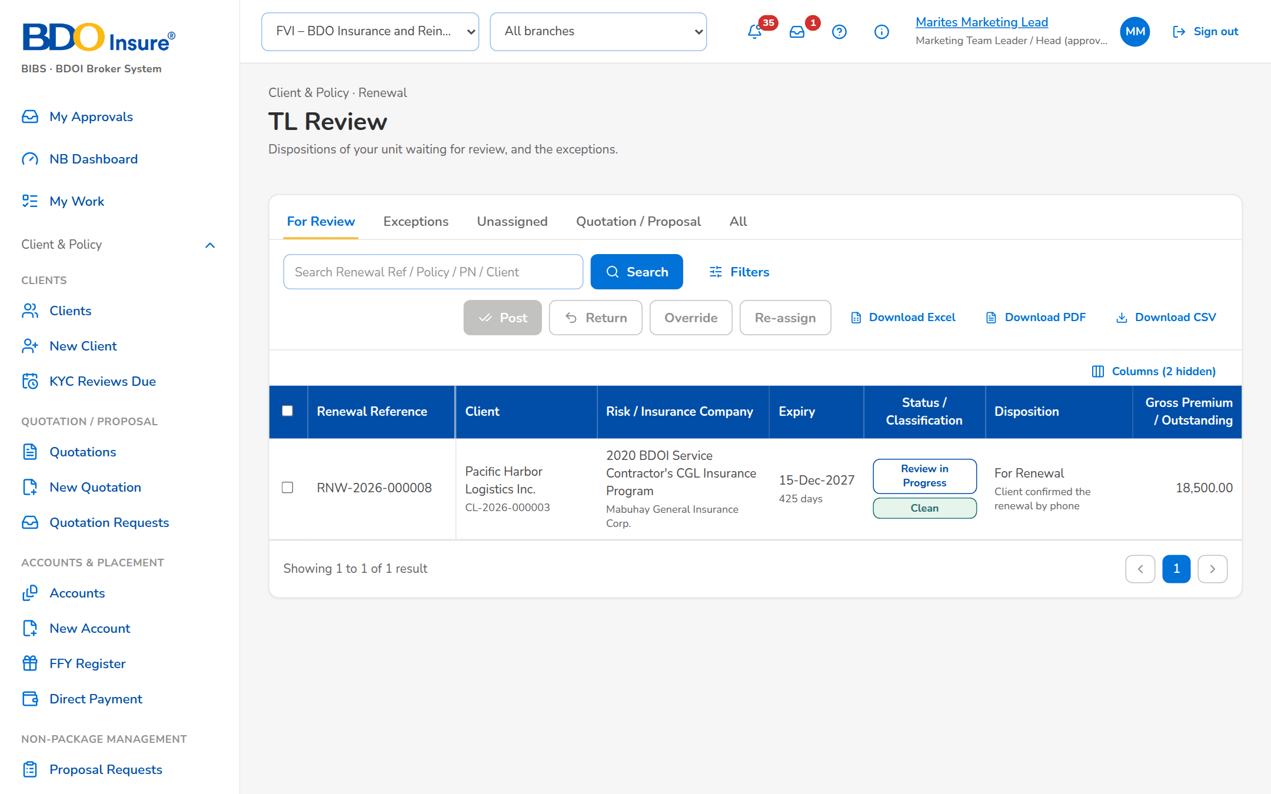
Figure 22: SB-04 step 2: Marketing Team Lead, TL Review
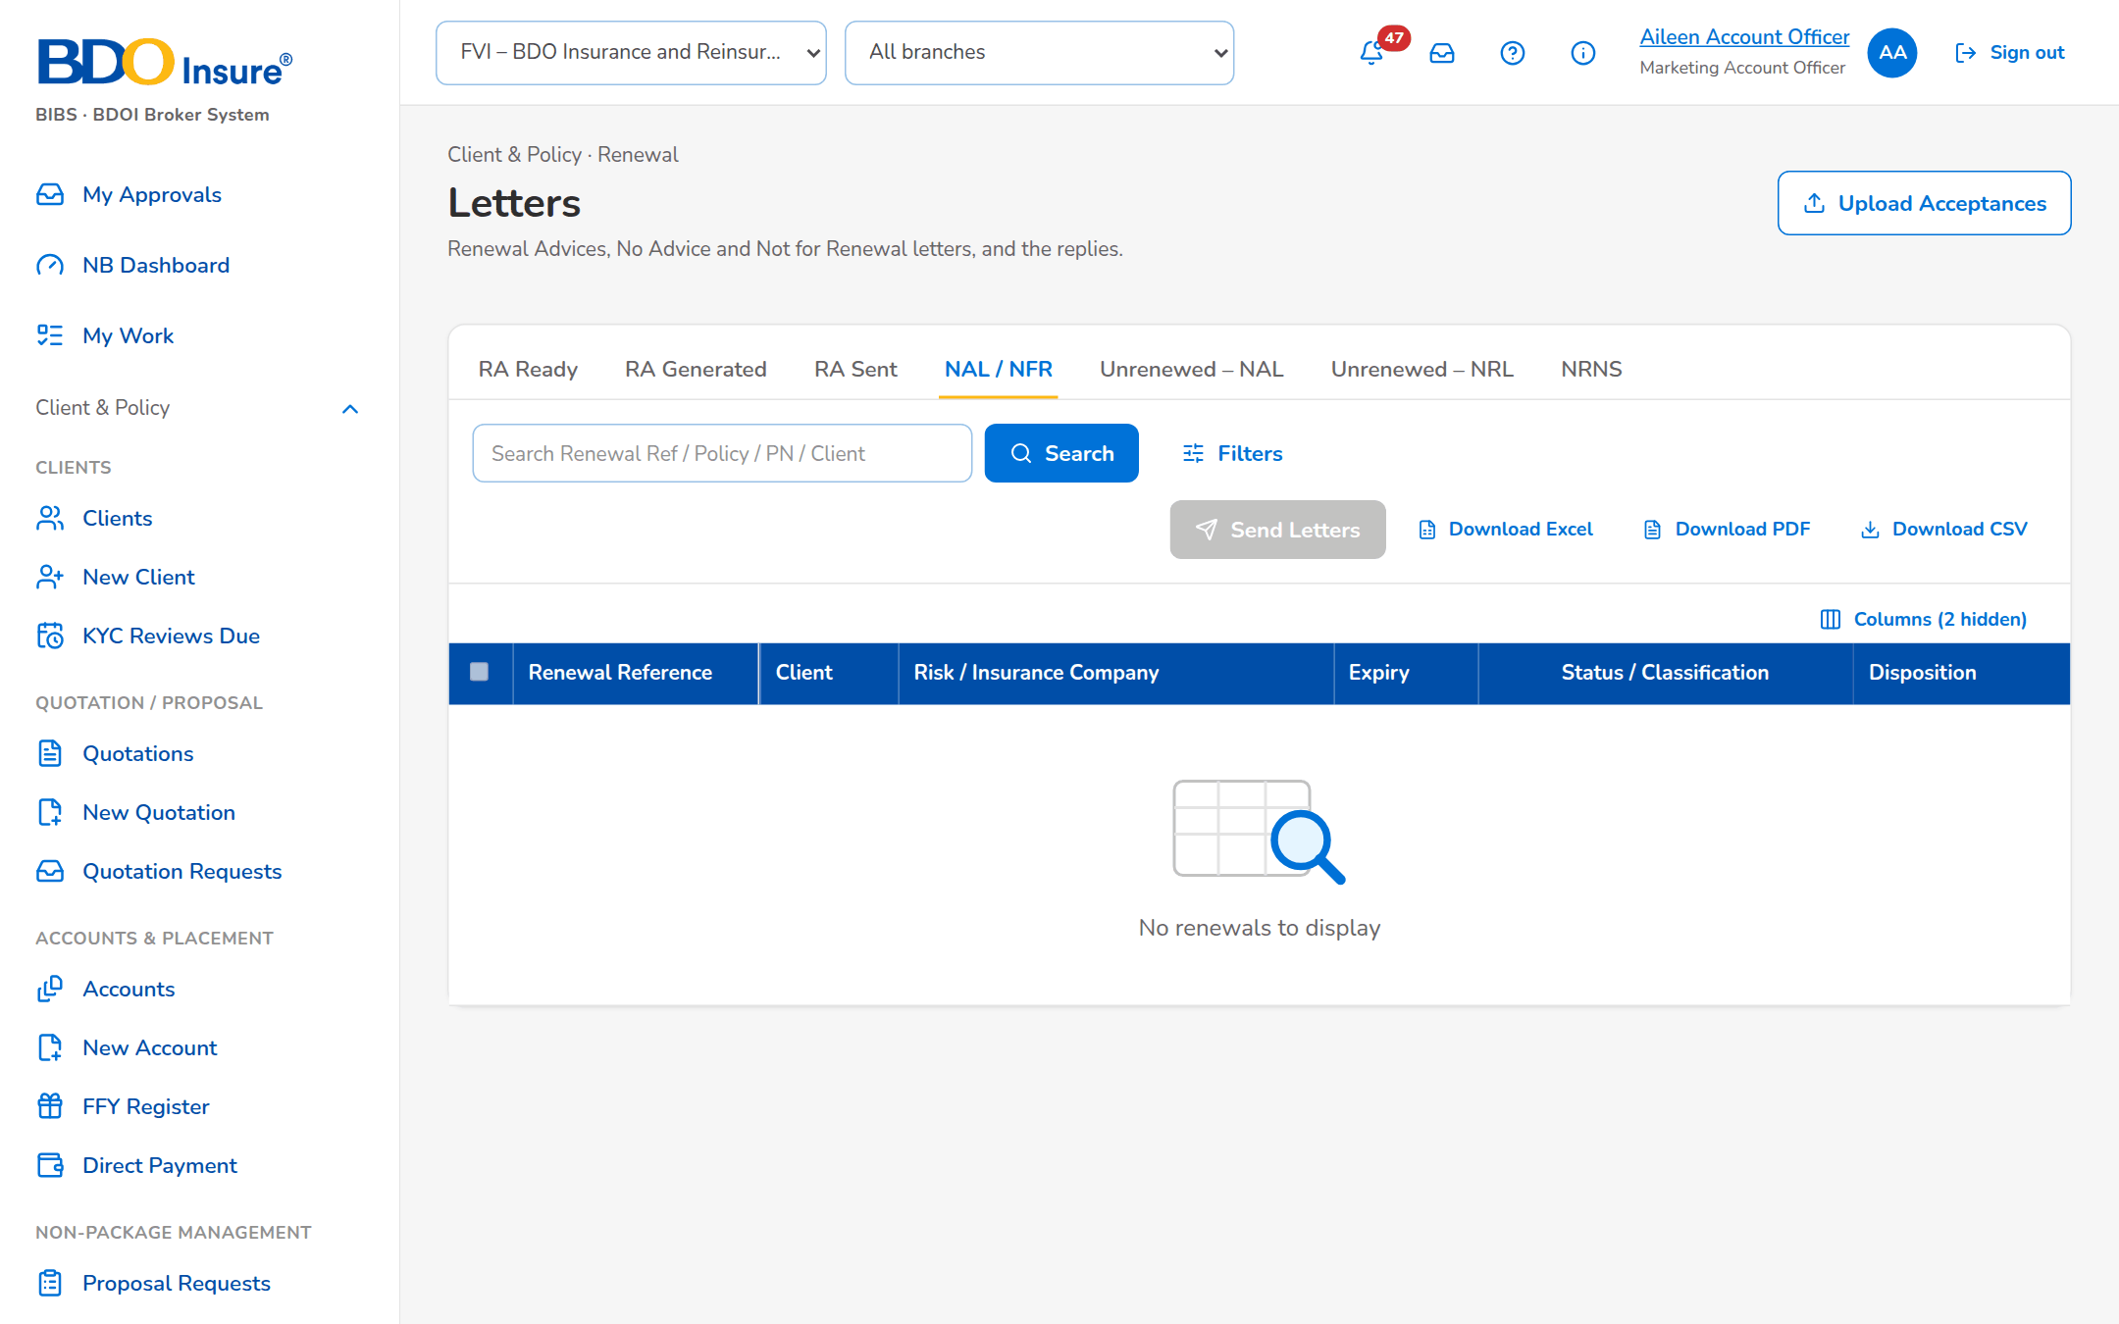
Figure 23: SB-04 step 3: Account Officer, Letters
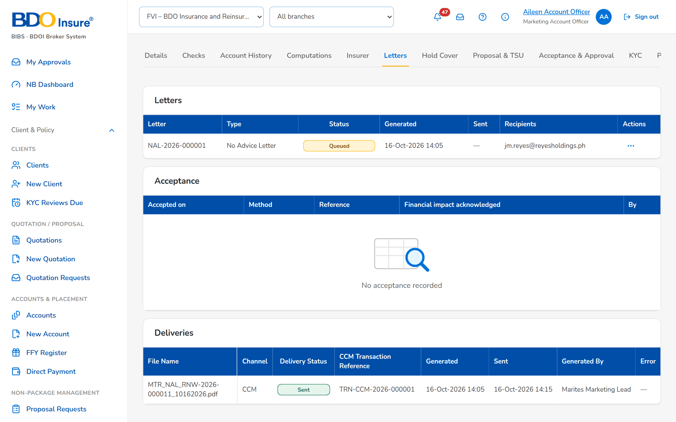
Figure 24: SB-04 step 4: Account Officer, Renewal

SB-05 A transfer to another unit, and the controls the user sees
CBG Metro Team 1 transferred the renewal of a corporate client to Corporate Marketing Team 1; its Team Leader accepts it. Then two controls of Renewal with the message the user sees: a disposition before the account history, and a transfer to the own unit.
Test data: Seed data: the transfer request of the migrated policy EBIX-CG-0100005 (Luzon Agri-Industrial Corp.) to Corporate Marketing Team 1; the renewal of the migrated policy QPS-FI-0100002 (Jose Miguel Reyes) of CBG Metro Team 1.
Table 7: SB-05 steps
Step | Who | Screen | Does | Sees
1 | Marketing Team Lead | Transfers | The Team Leader of Corporate Marketing Team 1 opens Transfers, tab Incoming, chooses Accept in the row action menu and confirms with remarks | Message: Transfer accepted; the renewal joins the Unassigned tab of the unit
2 | Account Officer | Set Disposition, Add Remark and Re-open | Aileen Account Officer gives a disposition on a renewal without opening its account history | Open the Account History before you give the disposition
3 | Marketing Team Lead | Expiry List | Marites Marketing Lead transfers a renewal of her unit to CBG Metro Team 1, her own unit | The receiving unit must be another unit

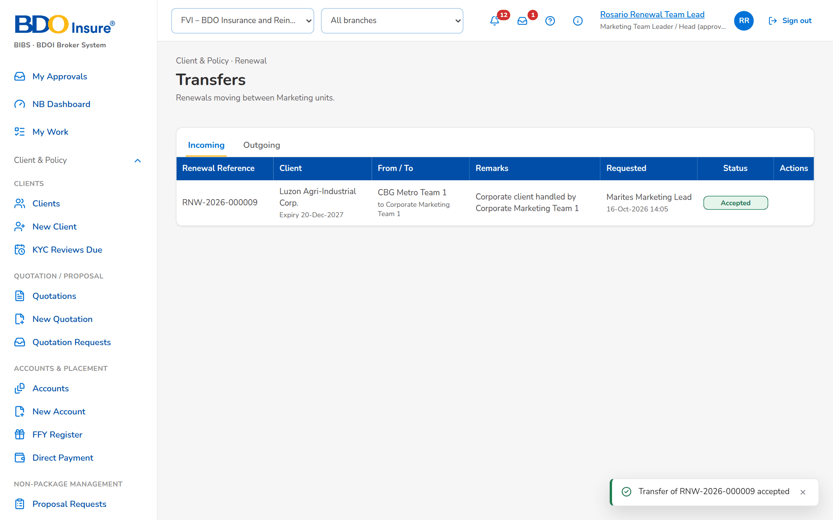
Figure 25: SB-05 step 1: Marketing Team Lead, Transfers
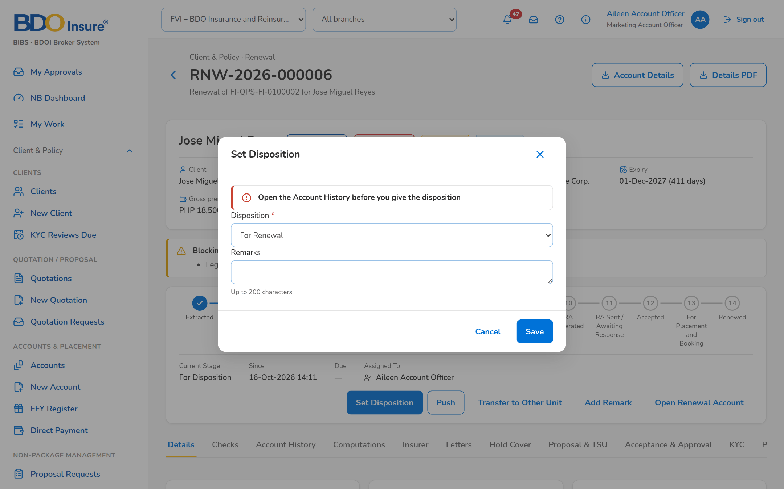
Figure 26: SB-05 step 2: Account Officer, Set Disposition, Add Remark and Re-open
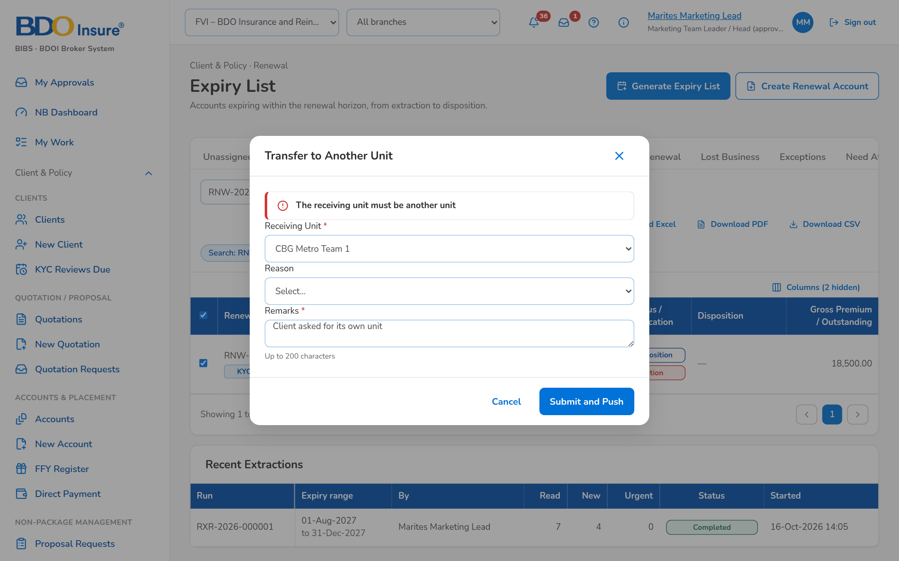
Figure 27: SB-05 step 3: Marketing Team Lead, Expiry List

