
PRJ0012475 - BDO Insure Brokering System (BIBS) - User Access Maintenance -
Release 1 / Drop 0
Prepared by: John Barbachano

Template Reference No. | D051
FR Document No. | PRJ0012475
Prepared by: | John Barbachano
Drafting support: | iorta TechNXT Project Team
Creation Date: | 09/21/2026
Revision No. | 1.3
Last Updated by: | John Barbachano
Last Updated Date: | 10/09/2026

Document Revision Log
Date | Revision | Description | Updated by
21 Sep 2026 - 09 Oct 2026 | 1.1 | As issued by BDO ITG (created 09/21/2026, last updated 10/09/2026) | John Barbachano
09 Oct 2026 | 1.2 | Draft for BDOI review: full coverage of the User Access Maintenance BRD (version of 8-Oct-2026); functional requirements elaborated with business rules, validations, fields, statuses, approvals, messages and numbered acceptance criteria; new sub-items and new items FRUM.009 to FRUM.013; Business Requirements Mapping extended to every BRD line; rows added to Annexes E, F and H; Annexes J to R added; observations and points for BDOI decision listed in Annex Q | iorta TechNXT Project Team (drafting support); for review by John Barbachano
09 Oct 2026 - 10 Oct 2026 | 1.3 | Business Unit review edition: summary for the Business Unit, end-to-end flows, workflow and approvals, e-mail texts, document formats, reports and schedules, integrations, non-functional requirements, open questions not answered in the BDOI FRS, change control, review checklist; aligned on 10 Oct 2026 with BIBS: new and changed screens with current screenshots (Identity Synchronisation, directory details, conflicting permission combinations, Session Timed Out, inactivity warning, Audit Trail), settings for the points BDOI decides (Annex M.10), notices and integrations | iorta TechNXT Project Team (drafting support)

Table of Contents
Document Revision Log 2
Table of Contents 3
1. Introduction 6
1.1. Document Purpose 6
1.2. Intended Audience 6
1.3. Project Background 6
1.4. Objectives to be achieved 6
1.5. Rationale 6
1.6. Document Preparation, Review and Approval 7
1.7. References 7
1.8. Summary for the Business Unit Review 8
2. Business Requirements Mapping 11
3. Functional Requirements 19
Annex A – To-Be Process Flows 55
Annex B – Report template 69
Annex C - User Access Matrix 69
Annex D – Audit Log Export 70
Annex E – User Access Report Fields 70
Annex F – Group Profile Membership List 70
Annex G – User Group Membership Report Fields 71
Annex H – Audit Log Fields 71
Annex I – Password Guidelines 72
Annex J – Screen Specifications 72
J.1 Login (SCR-UA-01) 72
J.2 Forgot Password and Set a New Password (SCR-UA-02) 74
J.3 Change Your Password (forced change) (SCR-UA-03) 75
J.4 Inactivity and Session-end Warnings (SCR-UA-04) 76
J.5 Session Timed Out (SCR-UA-21) 77
J.6 My Profile (SCR-UA-05) 78
J.7 Access Requests (SCR-UA-06) 80
J.8 New Request and Edit Request (user requests) (SCR-UA-07) 82
J.9 Access Request record (SCR-UA-08) 85
J.10 Bulk Request (SCR-UA-09) 87
J.11 Bulk Request Batch (SCR-UA-10) 89
J.12 Group Profile Requests (SCR-UA-11) 89
J.13 New Group Profile Request and Edit Request (SCR-UA-12) 90
J.14 User Access Matrix (SCR-UA-13) 93
J.15 User Access Reports (SCR-UA-14) 95
J.16 Users (SCR-UA-15) 96
J.17 Roles & Permissions (SCR-UA-16) 98
J.18 User access report (report runner) (SCR-UA-17) 100
J.19 System Parameters (sign-in, password and access settings) (SCR-UA-18) 102
J.20 Separation of Duties (SCR-UA-19) 105
J.21 Identity Synchronisation (SCR-UA-20) 106
J.22 Audit Trail (SCR-UA-22) 108
J.23 Menu by persona 110
Annex K – Messages and Validations 112
Annex L – Notifications and E-mails 117
Annex M – Business Rules and Parameters 119
M.1 Personas 119
M.2 Permissions of the access functions 119
M.3 Proposed role-to-action matrix 119
M.4 Password, lock-out and second factor 120
M.5 Session policy 120
M.6 Segregation and separation-of-duties rules 120
M.7 Configurable parameters 120
M.8 Lists of values 121
M.9 Request statuses and transitions 121
M.10 Settings for the points BDOI decides 122
Annex N – Sign-in and Identity Integration 123
N.1 Sign-in modes 123
N.2 Single sign-on with EIAM 123
N.3 Provisioning from UIDM-ISC 123
N.4 Break-glass administrators 124
N.5 What BDOI IT provides 124
Annex O – Process Walkthroughs 125
WT-A A new user from the enrolment request to the first sign-in with the menus of the persona 125
WT-B A change and a revocation under four eyes, and a group-profile change approved in order and implemented 126
WT-C Refused cases and the messages the user sees 126
WT-D The evidence of access, and the insurer roles hidden from BDOI 127
Annex P – Requirements Traceability 129
P.1 BRD requirement to FRUM and test conditions 129
P.2 FRUM item to BRD lines and test conditions 133
Annex Q – Observations and Points for BDOI Decision 136
Q.1 Points where the proposed behaviour differs from the original text of this FRS 136
Q.2 Slips noticed in BDOI's FRS (proposed corrections; BDOI's text is not changed) 140
Q.3 Changes to the Business Requirements Mapping 141
Q.4 Rows added to BDOI's annexes and other observations 144
Q.5 Observations of version 1.3 145
Annex R – Glossary 147
Annex S – Workflow and Approvals 148
Annex T – E-mail and Notification Texts 150
NT-01 Request to approve 150
NT-02 Request for second approval 151
NT-03 Request to implement 151
NT-04 Decision on the request 151
NT-05 Request returned 151
NT-06 Request cancelled 152
NT-07 Your access changed 152
NT-14 Your access changed (group profile deactivated or reactivated) 152
NT-15 Your account will be deactivated 153
NT-16 Dormant users deactivated 153
NT-08 Reset your password (break-glass accounts only) 153
NT-09 Your password expires soon (break-glass accounts) 153
NT-10 Batch job failed 154
NT-11 Alert: privileged access change 154
NT-12 Alert: scheduled access change failed 154
NT-13 Alert: role edited outside a request 155
NT-17 Separation-of-duties rule to authorise 155
NT-18 Security setting to approve 155
NT-19 Second-factor reset to approve 155
NT-20 Authenticator app reset 156
NT-21 Identity event to review 156
NT-22 Break-glass sign-in 156
Annex U – Document Prints and Output Formats 157
U.1 User Access Report (DO-01) 157
U.2 User Group Profile Report (DO-02) 157
U.3 Group Profile Membership (DO-03) 158
U.4 User Access Audit Log (DO-04) 159
U.5 Access Requests (DO-05) 160
U.6 User Access Matrix (Excel) (DO-06) 161
U.7 Bulk request template and error file (DO-07) 162
U.8 Temporary password of a new break-glass user (screen only) (DO-08) 162
Annex V – Reports and Schedules 163
Annex W – Integrations 165
Annex X – Non-functional Requirements 166
Annex Y – Data Set-up and Migration at Go-live 169
Annex Z – Assumptions, Dependencies and Open Questions 170
Z.1 Assumptions 170
Z.2 Dependencies 170
Z.3 Open questions not answered in BDOI's FRS 170
Annex AA – Change Control after Sign-off 172
Annex AB – Business Unit Review Checklist 173
Signoff Sheet 174

Introduction

Document Purpose
This Functional Requirements Specifications (FR) document outlines how business requirements which are baselined in the Business Requirements Document (BRD) for the BDO Insure Brokering System (BIBS) - User Access Maintenance Project Release 1/ Drop 0 are to be implemented in the IT systems. This FR document translates the business requirements into functional requirements in terms of system capability, behaviour/function with clearly outlined inputs and outputs.

Intended Audience
The primary audience of this document will be the BDO Insure Brokering System (BIBS) project team.

Project Background
BDO Insure Brokering System (BIBS) will modernize and streamline BDOI's insurance brokering operations. The project aims to replace the existing legacy platforms, including EBIX, QPS, ISYS, and Broker systems, with a unified and modern solution that supports end-to-end insurance brokering processes.

Objectives to be achieved
The implementation of the BDO Insure Brokering System (BIBS) aims to achieve the objectives below.
- Establish a single system of record that supports the entire insurance brokering lifecycle, from inquiry and quotation through policy issuance, renewal, collection, and claims processing.
- Enable straight-through processing (STP) across key business functions, including New Business, Policy Management, Renewals, and Collections, while enforcing maker-checker controls for financial transactions.
- Automated statutory and management reporting to improve reporting efficiency, enhance data accuracy, reduce manual reconciliation efforts, and minimize audit exposure.
- Provide configurable product and commission management capabilities that allow rapid introduction of new insurance products, covers, and commission structures, thereby reducing time-to-market.
- Implement a fully supported and hosted application platform with defined service levels, replacing end-of-life legacy systems and ensuring reliability, maintainability, and scalability.
- Improve operational efficiency and business visibility by consolidating processes and data into a unified platform that supports standardized workflows and decision-making.
- Strengthen governance, control, and compliance through integrated processing, automated controls, audit trails, and secure management of insurance brokering transactions.

Rationale
The implementation of the BDO Insure Brokering System B(IBS) will support the project's objectives by providing a single system for managing the end-to-end insurance broking lifecycle. The new system will streamline business processes, reduce manual work, and improve the accuracy and availability of information across the organization.
Through straight-through processing, automated reporting, and configurable products and commission structures, the system will improve operational efficiency, reduce reconciliation efforts, and enable faster response to business and market requirements.
The replacement of legacy applications with a fully supported and integrated platform will also enhance system reliability, strengthen controls and compliance, and provide a scalable solution that supports BDO Insure's future growth and business requirements.

Document Preparation, Review and Approval
The System Analyst, Business System Analyst or equivalent BDO ITG personnel is responsible for populating this Functional Requirements Specifications document by obtaining inputs from the business unit and if necessary from other IT units (ITEA, ITSec, ITSD, ITIO, ITEXD).
This version 1.2 was elaborated with the iorta TechNXT Project Team (drafting support), from the inputs of the business unit and BDO ITG, for review by the System Analyst. BDOI's text of version 1.1 is kept as issued; the additions elaborate it, and every point where the additions differ from it, or where BDOI's text needs a correction, is listed for BDOI's decision in Annex Q.
This document once approved will serve as the official baseline of functional requirements document for the BDO Insure Brokering System (BIBS) - User Access Maintenance Release 1 project.
Following the approval of this document, changes will be governed by the project’s change management process, including impact analysis, appropriate reviews and approvals.

References
The following documents are used as reference in preparing the functional requirements specifications:
References used for version 1.2: Business Requirements Document - QPS User Access Maintenance Module (version of 8-Oct-2026; v1 of 15-Apr-2025); BIBS Functional Requirements Specification BRD-11 User Access Maintenance v2.1 (8-Oct-2026) and its test plan v2.1; Authentication and Identity Integration Requirements v1.0 (03-Oct-2026); Drop 0 decisions of 26-Sep-2026 (EIAM single sign-on, UIDM-ISC provisioning).
References added in version 1.3: the review workbooks of BRD-11 issued with this edition (Business Unit Requirements Collection, BRD vs Out-of-the-Box vs Best Practice, Change Request Register, Test Cases and Traceability, Business Unit Walkthrough Users, all v1.0 of 9-Oct-2026); BIBS Non-Functional Requirements Register v1.0; BIBS Master Data and Configuration Upload Templates v1.2; BDOI Requirements and Inputs by BRD v1.2.

Summary for the Business Unit Review
This section is the short way into the document for the Business Unit. It shows on a few pages what User Access Maintenance covers, how the work flows from one persona to the next, the numbers behind the document, the decisions the Business Unit must take before signing, and which part each reviewer reads. The detail is in sections 2 and 3 and in the annexes; every statement traces to a BRD ID of the User Access Maintenance BRD of 8-Oct-2026.
Scope on a page
In scope of this FRS | Out of scope | Handled in another FRS or document
Sign-in through the BDO single sign-on (EIAM), inactivity warning, session end, log-out (FRUM.001) | Creation of EIAM accounts, their passwords, lock-out and second factor (BDO Enterprise SSO platform; FRUM.002, FRUM-004) | Permissions of each business module (the FRS of each BRD; the matrix of Annex C)
Users: creation, update, deactivation, reactivation, dormant users (FRUM.002, FRUM.003) | AD group creation and its request (FRUM.005, as BDOI states) | Loading the users at go-live: Data Set-up (Annex Y) with BRD-13 Data Migration
Passwords of the break-glass accounts only (FRUM-004, FRUM.001.06) | Authorisation through an external access-control list (BRD NFR 1.i, on hold) | Technical settings of single sign-on and provisioning: Technical Specification reviewed by BDOI IT
Roles (group profiles) and their permissions (FRUM.005, FRUM.006) | Portal (external) users: no portal in the BDOI drop plan | Screen standards: programme level (BIBS screen standards)
Access requests, approvals, bulk requests (FRUM.009 to FRUM.011), within the decision on C01 | Infrastructure set-up answered 'Follow existing QPS set up' (Annex X) | Hosting, back-up, disaster recovery: programme NFR register
Reports and audit logs (FRUM.007, FRUM.008); separation of duties and security settings (FRUM.012); notices and e-mails (FRUM.013) | The device policy itself (BDO network and EIAM conditional access) | Access certification campaigns in UIDM-ISC (BDOI IT)

The process from end to end
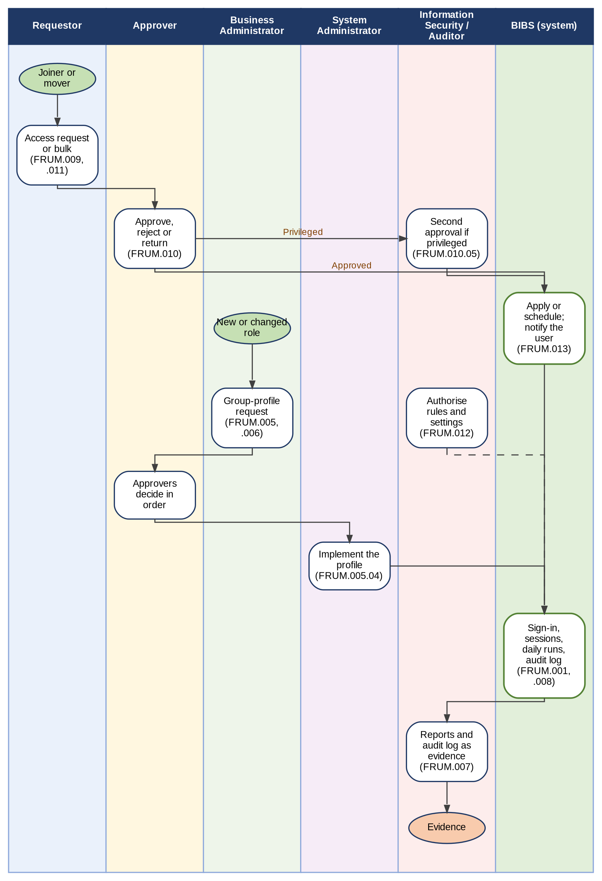
Figure 1 - User Access Maintenance from end to end: who does what, from the access request to the evidence of access
How to read it: Read from top to bottom. Each column is a persona; the green column is what the system does by itself. The numbers in brackets are the FR items of section 3. Traces to: BRD sections A to D; NFR 9 to 11.
Key numbers
The key numbers of this document (counted by the builder of the document; the workbooks give the same numbers):
Item | Number | Where
BRD requirement IDs mapped (each to at least one FR item) | 160 | Section 2; Annex P
Non-functional rows of the BRD | 41 | Annex X
FR entries (BDOI's 8 and FRUM.009 to FRUM.013) | 13 | Section 3
FR items and sub-items (BDOI's and added) | 57 | Section 3
Acceptance criteria | 117 | Section 3
Screens | 22 | Annex J
Messages shown to the user | 86 | Annex K
Notices and e-mails | 22 | Annex T
Documents and outputs | 8 | Annex U
Reports / scheduled runs | 8 / 6 | Annex V
Integrations | 11 | Annex W
Figures added in version 1.3 | 16 | 1.8; Annexes A, J, S
Test cases (Test Cases and Traceability workbook, with one per acceptance criterion) | 303 | Test Cases and Traceability workbook
Open questions not answered in BDOI's FRS / answered and not repeated | 25 / 44 | Annex Z
Observations and points for decision | 77 | Annex Q
Review checklist points | 27 | Annex AB

Decisions the Business Unit must take
The ten decisions below shape the rest of the document. Each points to the row of Annex Q (observations and points for decision) or Annex Z (open questions) where both readings, the BRD text and the proposal are given.
No. | Decision | Annex Q / Z | Decided by
1 | Where access requests are raised and approved: in UIDM-ISC (BDOI's FRS, "c/o UIDM") or in the system (BRD sections A and B) | Q-01 (C01) | BDOI IT; Process Owner (Business Administration); Information Security
2 | Roles assigned and changed only through approved requests and implemented by the System Administrator, or directly by authorised users | Q-02 (C02); Q-03 (C03); Q-22 (C22) | Process Owner (Business Administration); Information Security
3 | User ID and Windows ID, duplicate check and the user fields synchronised from the SSO platform | Q-04 (C04); Q-05 (C05); Q-06 (C06); Q-28 (C28) | Process Owner (Business Administration); BDOI IT
4 | Message at session time-out and the warning before the fixed end of a session | Q-07 (C07); Q-08 (C08) | Process Owner (Business Administration)
5 | Lock-out, password history of 10 and the reset of the break-glass accounts; number and holders of break-glass accounts | Q-09 (C09); Q-10 (C10); Q-11 (C11); Annex Z: CLR-UA-24 | Information Security; BDOI IT
6 | Revocation on an SSO status change, synchronisation status and on-demand synchronisation | Q-13 (C13); Q-14 (C14) | BDOI IT
7 | Which profiles are high privilege, the working hours and who gives the second approval | Q-17 (C17); Annex Z: UQ07 | Information Security
8 | Conflicting permissions inside a role and the separation-of-duties pairs of profiles | Q-16 (C16) | Information Security
9 | Dormant accounts: period and notice | Q-26 (C26); Annex Z: CLR-UA-08 | Information Security
10 | Export file names and the role and IP address in the audit log | Q-18 (C18); Q-19 (C19) | Process Owner (Business Administration); Information Security

How to review this document
How to review: each reviewer reads the parts of his or her role; the times are a guide for a first reading.
Reviewer (role) | Read first | Then | About
Product Owner, Marketing Business System | 1.8 Summary; Annex A figures; Annex AB checklist | Annex Q decisions; Annex Z open questions | 2 hours
Process Owner, User Access Maintenance (Business Administration) | Sections 2 and 3; Annex A; Annex S workflow | Annexes J, K, O (screens, messages, walkthroughs); T e-mails; U documents; V reports | 4 hours
BDOI Information Security | FRUM.001, FRUM-004, FRUM.008, FRUM.012; Annex M rules | Annex N sign-in; Annex X non-functional requirements; Annex Q decisions 5 to 9 | 3 hours
BDOI IT | Annex N sign-in and identity; Annex W integrations | Annex Y data set-up; Annex Z integration questions | 2 hours
Internal Audit and Compliance | FRUM.007, FRUM.008; Annex V reports | Annex U document formats; Annex X retention and audit | 1.5 hours
System Analyst (BDO ITG) | Section 2 mapping; Annex P traceability; Annex Q | Annex AA change control; the review workbooks | 4 hours

The review workbooks issued with this edition (same numbers as this document):
Workbook | What it holds
Business Unit Requirements Collection | What the Business Unit provides: document layouts, e-mail wordings, schedules, parameters, lists, master data, approvers, integration inputs, open decisions
BRD vs Out-of-the-Box vs Best Practice | For every BRD requirement: what the system offers as standard, broking best practice, fit and recommendation
Change Request Register | How a change after sign-off is raised and decided; candidate changes; the decision log of every Annex Q observation
Test Cases and Traceability | BRD ID to FR item, test cases, screens and walkthrough steps; the questions answered in BDOI's FRS; UAT entry and exit criteria
Business Unit Walkthrough Users | The sign-in ID of every persona for the walkthrough in the BIBS UAT environment and the walkthrough script

Before signing, the Business Unit confirms the 27 points of the review checklist in Annex AB.

Business Requirements Mapping
This section lists the business requirements baselined in the Business Requirements Document (BRD) and the corresponding Functional Requirements to satisfy each business requirement.

The details of each functional requirement are provided in the subsequent section.

BRD Req No. | Business Requirement | Functional Requirement Req IDs
BRD 1.001.1 | I. Log in as a Requestor  a. Access the application using any BDO issued device  1. Log in with a Requestor user profile  2. Receive the inactivity warning (15 minutes)  3. Receive warning prior to system triggered log out (30 minutes) | FRUM.001
BRD 1.001.1.1 | 1. Log in with a Requestor user profile | FRUM.001.01, FRUM.001.02
BRD 1.001.1.2 | 2. Receive the inactivity warning (15 minutes) | FRUM.001.01, FRUM.001.03, FRUM.001.04
BRD 1.001.1.3 | 3. Receive warning prior to system triggered log out (30 minutes) | FRUM.001.01, FRUM.001.03, FRUM.001.04
BRD 1.002.1 | II. Enroll New User  a. Submit a new User Access request  1. Create request  1.1 Input New User data  1.2 Select User Access Group profile  1.3 Select approver from the drop-down  1.4 Add remarks (i.e justification, etc.)  1.5 Save remarks  2. Edit drafted request  3. Cancel drafted request  4. Submit request | FRUM.002  Added in v1.2: FRUM.009.01, FRUM.009.02, FRUM.009.06
BRD 1.002.1.1 | 1. Create request | FRUM.002.01, FRUM.009.01, FRUM.009.02
BRD 1.002.1.1.1 | 1.1 Input New User data | FRUM.002.01, FRUM.009.02
BRD 1.002.1.1.2 | 1.2 Select User Access Group profile | FRUM.002.01, FRUM.009.02
BRD 1.002.1.1.3 | 1.3 Select approver from the drop-down | FRUM.009.06
BRD 1.002.1.1.4 | 1.4 Add remarks (i.e justification, etc.) | FRUM.009.01
BRD 1.002.1.1.5 | 1.5 Save remarks | FRUM.009.01
BRD 1.002.1.2 | 2. Edit drafted request | FRUM.009.01
BRD 1.002.1.3 | 3. Cancel drafted request | FRUM.009.01
BRD 1.002.1.4 | 4. Submit request | FRUM.009.01
BRD 1.003.1.1 | III. Modify Existing User  a. Submit modify User Access/permission request  1. Create request  1.1. Search existing User  1.2 Edit/Update selected user data  1.3 Select User Access Group profile  1.4 Select approver from the drop-down  1.5 Add remarks (i.e Justification, etc.)  1.6 Save remarks  2. Edit a drafted request  3. Cancel a drafted request  4. Submit a request | FRUM.003, FRUM.004  Added in v1.2: FRUM.003.01, FRUM.009.03
BRD 1.003.1 | III. Modify Existing User - a. Submit modify User Access/permission request | FRUM.003.01, FRUM.009.03
BRD 1.003.1.1.1 | 1.1 Search existing User | FRUM.003.01, FRUM.009.03
BRD 1.003.1.1.2 | 1.2 Edit/Update selected user data | FRUM.003.01, FRUM.009.03
BRD 1.003.1.1.3 | 1.3 Select User Access Group profile | FRUM.003.01, FRUM.009.03
BRD 1.003.1.1.4 | 1.4 Select approver from the drop-down | FRUM.009.06
BRD 1.003.1.1.5 | 1.5 Add remarks (i.e Justification, etc.) | FRUM.009.01
BRD 1.003.1.1.6 | 1.6 Save remarks | FRUM.009.01
BRD 1.003.1.2 | 2. Edit drafted request | FRUM.009.01
BRD 1.003.1.3 | 3. Cancel drafted request | FRUM.009.01
BRD 1.003.1.4 | 4. Submit request | FRUM.009.01
BRD 1.004.1 | IV. Deactivate User  a. Submit a User Access deactivation request  1. Create a request  1.1 Search an existing User  1.2 Add remarks (i.e reason for deactivation)  1.3 Save remarks  1.4 Select approver from the drop-down  2. Edit a drafted request  3. Cancel a drafted request  4. Submit a request | FRUM.003  Added in v1.2: FRUM.003.02.01, FRUM.009.04
BRD 1.004.1.1 | 1. Create a request | FRUM.003.02.01, FRUM.009.01, FRUM.009.04
BRD 1.004.1.1.1 | 1.1 Search an existing User | FRUM.003.02.01, FRUM.009.04
BRD 1.004.1.1.2 | 1.2 Add remarks (i.e reason for deactivation) | FRUM.003.02.01, FRUM.009.01, FRUM.009.04
BRD 1.004.1.1.3 | 1.3. Save remarks | FRUM.003.02.01, FRUM.009.01, FRUM.009.04
BRD 1.004.1.1.4 | 1.4 Select approver from the drop-down | FRUM.009.06
BRD 1.004.1.2 | 2. Edit drafted request | FRUM.009.01
BRD 1.004.1.3 | 3. Cancel drafted request | FRUM.009.01
BRD 1.004.1.4 | 4. Submit request | FRUM.009.01
BRD 1.005 | V. Reactivate User  a. Submit a User Access reactivation request  1. Create a request  1.1 Search an existing User  1.2 Add remarks (i.e reason for reactivation)  1.3 Save remarks  1.4 Select approver from the drop-down  2. Edit a drafted request  3. Cancel a drafted request  4. Submit a request | FRUM.003  Added in v1.2: FRUM.003.02.02, FRUM.009.05
BRD 1.005.1 | 1. Create a request | FRUM.003.02.02, FRUM.009.01, FRUM.009.05
BRD 1.005.1.1 | 1.1 Search an existing User | FRUM.003.02.02, FRUM.009.05
BRD 1.005.1.1.1 | 1.2 Add remarks (i.e reason for reactivation) | FRUM.003.02.02, FRUM.009.01, FRUM.009.05
BRD 1.005.1.1.2 | 1.3. Save remarks | FRUM.003.02.02, FRUM.009.01, FRUM.009.05
BRD 1.005.1.1.3 | 1.4 Select approver from the drop-down | FRUM.009.06
BRD 1.005.1.2 | 2. Edit a drafted request | FRUM.009.01
BRD 1.005.1.3 | 3. Cancel a drafted request | FRUM.009.01
BRD 1.005.1.4 | 4. Submit a request | FRUM.009.01
BRD 1.006.1 | VI. Apply Correction  a. Apply correction on returned requests  1. Receive notification on the returned request  2. Edit data on the returned request  3. Add remarks  4. Save remarks  5. Re-submit request | c/o UIDM  Added in v1.2: FRUM.009.07, FRUM.013.01
BRD 1.006.1.1 | 1. Receive notification on the returned request | FRUM.009.07, FRUM.013.01
BRD 1.006.1.2 | 2. Edit data on the returned request | FRUM.009.07
BRD 1.006.1.3 | 3. Add remarks | FRUM.009.07
BRD 1.006.1.4 | 4. Save remarks | FRUM.009.07
BRD 1.006.1.5 | 5. Re-submit request | FRUM.009.07
BRD 1.007.1 | VII. Cancel a request  a. Cancel a submitted request for approval  1. Search request  2. Add remarks(I,e reason for cancellation, etc.)  3. Save remarks  4. Re-submit request | c/o UIDM  Added in v1.2: FRUM.009.08
BRD 1.007.1.1 | 1. Search request | FRUM.009.08
BRD 1.007.1.2 | 2. Add remarks(I,e reason for cancellation, etc.) | FRUM.009.08
BRD 1.007.1.3 | 3. Save remarks | FRUM.009.08
BRD 1.007.1.4 | 4. Cancel submitted request | FRUM.009.08
BRD 1.008.1 | VIII. View request/s  a. View the submitted request/s  1. View the list of the submitted request/s  2. View the status of the submitted request/s  3. View the details of the submitted request/s  4. Receive notification on the approved/ rejected request | c/o UIDM  Added in v1.2: FRUM.009.09, FRUM.013.01
BRD 1.008.1.1 | 1. View the list of the submitted request/s | FRUM.007.03, FRUM.009.09
BRD 1.008.1.2 | 2. View the status of the submitted request/s | FRUM.007.03, FRUM.009.09
BRD 1.008.1.3 | 3. View the details of the submitted reques/s | FRUM.007.03, FRUM.009.09
BRD 1.008.1.4 | 4. Receive notification on the approved/rejected request | FRUM.007.03, FRUM.009.09, FRUM.013.01
BRD 1.009.1 | IX. Bulk Request  a. Submit request for bulk creation/modification/deactivation/reactivation  1. Attach a file for bulk processing  2. Add remarks  3. Save remarks  4. Edit a drafted request  5. Cancel a drafted request  6. Submit a request | c/o UIDM  Added in v1.2: FRUM.011.01
BRD 1.009.1.1 | 1. Attach a file for bulk processing | FRUM.011.01
BRD 1.009.1.2 | 2. Add remarks | FRUM.011.01
BRD 1.009.1.3 | 3. Save remarks | FRUM.011.01
BRD 1.009.1.4 | 4. Edit a drafted request | FRUM.011.01
BRD 1.009.1.5 | 5. Cancel a drafted request | FRUM.011.01
BRD 1.009.1.6 | 6. Submit a request | FRUM.011.01
BRD 2.001.1 | I. Log in as an Approver  a. Access the application using any BDO issued device  1. Log in with an Approver user profile  2. Receive the inactivity warning (15 minutes)  3. Receive warning prior to system triggered log out (30 minutes) | FRUM.001
BRD 2.001.1.1 | 1. Log in with an Approver user profile | FRUM.001.01, FRUM.001.02
BRD 2.001.1.2 | 2. Receive the inactivity warning (15 minutes) | FRUM.001.01, FRUM.001.03, FRUM.001.04
BRD 2.001.1.3 | 3. Receive warning prior to system triggered log out (30 minutes) | FRUM.001.01, FRUM.001.03, FRUM.001.04
BRD 2.002.1 | II. Review and approve request/s  a. Receive notification on the request for approval  b. View the list of requests for approval  1. Filter the list assigned to me  c. Select request  d. View request details  e. Approve request  f. Reject request  1. Add remarks (i.e rejection reason, etc.)  2. Save remarks  g. Return request to Requestor  1. Add remarks (i.e reason for return, etc.)  2. Save remarks | c/o UIDM  Added in v1.2: FRUM.010.01, FRUM.010.02, FRUM.010.03, FRUM.010.04, FRUM.010.05
BRD 2.002.2 | b. View the list of requests for approval | FRUM.010.01
BRD 2.002.2.1 | 1. Filter the list assigned to me | FRUM.010.01
BRD 2.002.3 | c. Select request | FRUM.010.01
BRD 2.002.4 | d. View request details | FRUM.010.01
BRD 2.002.5 | e. Approve request | FRUM.002.01, FRUM.010.02
BRD 2.002.6 | f. Reject request | FRUM.010.03
BRD 2.002.6.1 | 1. Add remarks (i.e rejection reason, etc.) | FRUM.010.03
BRD 2.002.6.2 | 2. Save remarks | FRUM.010.03
BRD 2.002.7 | g. Return request to Requestor | FRUM.010.04
BRD 2.002.7.1 | 1. Add remarks (i.e reason for return, etc.) | FRUM.010.04
BRD 2.002.7.1 (2nd) | 2. Save remarks | FRUM.010.04
BRD 3.001.1 | I. Log in as a Business Administrator  a. Access the application using any BDO issued device  1. Log in with a Business Administrator user profile  2. Receive the inactivity warning (15 minutes)  3. Receive warning prior to system triggered log out (30 minutes) | FRUM.001
BRD 3.001.1.1 | 1. Log in with an Business Adminitrator user profile | FRUM.001.01, FRUM.001.02
BRD 3.001.1.2 | 2. Receive the inactivity warning (15 minutes) | FRUM.001.01, FRUM.001.03, FRUM.001.04
BRD 3.001.1.3 | 3. Receive warning prior to system triggered log out (30 minutes) | FRUM.001.01, FRUM.001.03, FRUM.001.04
BRD 3.002.1 | II. Submit a User Access Group Profile Request  a. Submit a new User Access Group Profiles request  1. Create a request  2. Select approver/s from the drop-down  3. Edit a drafted request  4. Cancel a drafted request  5. Submit a request  6. Add remarks  7. Save remarks | FRUM.005  Added in v1.2: FRUM.005.02, FRUM.005.03, FRUM.005.04
BRD 3.002.1.1 | 1. Create a request | FRUM.005.01, FRUM.005.02
BRD 3.002.1.2 | 2. Select approver/s from the drop-down | FRUM.005.01, FRUM.005.03
BRD 3.002.1.3 | 3. Edit a drafted request | FRUM.005.01, FRUM.005.02
BRD 3.002.1.4 | 4. Cancel a drafted request | FRUM.005.01, FRUM.005.02
BRD 3.002.1.5 | 5. Submit a request | FRUM.005.01, FRUM.005.02
BRD 3.002.1.6 | 6. Add remarks | FRUM.005.01, FRUM.005.02
BRD 3.002.1.7 | 7. Save remarks | FRUM.005.01, FRUM.005.02
BRD 3.002.2 | b. Submit a new User Access Group Profiles request  1. Create a request  2. Search existing group profile from the drop-down  3. Select approver/s from the drop-down  4. Edit a drafted request  5. Cancel a drafted request  6. Submit a request  7. Add remarks  8. Save remarks | FRUM.005  Added in v1.2: FRUM.006.04, FRUM.005.03, FRUM.005.04
BRD 3.002.2.1 | 1. Create a request | FRUM.006.01, FRUM.006.03, FRUM.006.04
BRD 3.002.2.2 | 2. Search existing group profile from the drop-down | FRUM.006.01, FRUM.006.03, FRUM.006.04
BRD 3.002.2.3 | 3. Select approver/s from the drop-down | FRUM.005.01, FRUM.005.03
BRD 3.002.2.4 | 4. Edit a drafted request | FRUM.006.01, FRUM.006.03, FRUM.006.04
BRD 3.002.2.5 | 5. Cancel a drafted request | FRUM.006.01, FRUM.006.03, FRUM.006.04
BRD 3.002.2.6 | 6. Submit a request | FRUM.006.01, FRUM.006.03, FRUM.006.04
BRD 3.002.2.7 | 7. Add remarks | FRUM.006.01, FRUM.006.03, FRUM.006.04
BRD 3.002.2.8 | 8. Save remarks | FRUM.006.01, FRUM.006.03, FRUM.006.04
BRD 3.002.3 | c. Submit a User Access Group Profiles deactivation request  1. Create a request  2. Search existing group profile from the drop-down  3. Select approver/s from the drop-down  4. Edit a drafted request  5. Cancel a drafted request  6. Submit a request  7. Add remarks  8. Save remarks | FRUM.006  Added in v1.2: FRUM.006.04, FRUM.005.03, FRUM.005.04
BRD 3.002.3.1 | 1. Create a request | FRUM.006.02.01, FRUM.006.04
BRD 3.002.3.2 | 2. Search existing group profile from the drop-down | FRUM.006.02.01, FRUM.006.04
BRD 3.002.3.3 | 3. Select approver/s from the drop-down | FRUM.005.01, FRUM.005.03
BRD 3.002.3.4 | 4. Edit a drafted request | FRUM.006.02.01, FRUM.006.04
BRD 3.002.3.5 | 5. Cancel a drafted request | FRUM.006.02.01, FRUM.006.04
BRD 3.002.3.6 | 6. Submit a request | FRUM.006.02.01, FRUM.006.04
BRD 3.002.3.7 | 7. Add remarks | FRUM.006.02.01, FRUM.006.04
BRD 3.002.3.8 | 8. Save remarks | FRUM.006.02.01, FRUM.006.04
BRD 3.002.4 | d. Submit a User Access Group Profiles reactivation request  1. Create a request  2. Search existing group profile from the drop-down  3. Select approver/s from the drop-down  4. Edit a drafted request  5. Cancel a drafted request  6. Submit a request  7. Add remarks  8. Save remarks | FRUM.006  Added in v1.2: FRUM.006.04, FRUM.005.03, FRUM.005.04
BRD 3.002.4.1 | 1. Create a request | FRUM.006.02.02, FRUM.006.04
BRD 3.002.4.2 | 2. Search existing group profile from the drop-down | FRUM.006.02.02, FRUM.006.04
BRD 3.002.4.3 | 3. Select approver/s from the drop-down | FRUM.005.01, FRUM.005.03
BRD 3.002.4.4 | 4. Edit a drafted request | FRUM.006.02.02, FRUM.006.04
BRD 3.002.4.5 | 5. Cancel a drafted request | FRUM.006.02.02, FRUM.006.04
BRD 3.002.4.6 | 6. Submit a request | FRUM.006.02.02, FRUM.006.04
BRD 3.002.4.7 | 7. Add remarks | FRUM.006.02.02, FRUM.006.04
BRD 3.002.4.8 | 8. Save remarks | FRUM.006.02.02, FRUM.006.04
BRD 3.003.1 | III. Generate Reports  a. Generate Reports  1. User Access Report  1.1. User name  1.2. Group profile  1.3. Date created  1.4. Date modified  1.5. Created by  1.6. Added/ Modified/ deactivated/ reactivated by | FRUM.007
BRD 3.003.1.1 | 1. User Access Report | FRUM.007.01, FRUM.007.02
BRD 3.003.1.1 (2nd) | 1.1. User name | FRUM.007.01, FRUM.007.02
BRD 3.003.1.2 | 1.2. Group profile | FRUM.007.01, FRUM.007.02
BRD 3.003.1.3 | 1.3. Date created | FRUM.007.01, FRUM.007.02
BRD 3.003.1.4 | 1.4. Date modified | FRUM.007.01, FRUM.007.02
BRD 3.003.1.5 | 1.5. Created by | FRUM.007.01, FRUM.007.02
BRD 3.003.1.6 | 1.6. Added/Modified/deactivated/reactivated by | FRUM.007.01, FRUM.007.02
BRD 3.003.2 | 2. User Group Profile Report  2.1. Group profile name  2.2. Modules accessed under each Group profile  2.3. Date created  2.4. Date modified  2.5. Created by  2.6. Added/ Modified/ deactivated/ reactivated by | FRUM.007
BRD 3.003.2.1 | 2.1. Group profile name | FRUM.007.01, FRUM.007.02
BRD 3.003.2.2 | 2.2. Modules accessed under each Group profile | FRUM.007.01, FRUM.007.02
BRD 3.003.2.3 | 2.3. Date created | FRUM.007.01, FRUM.007.02
BRD 3.003.2.4 | 2.4. Date modified | FRUM.007.01, FRUM.007.02
BRD 3.003.2.5 | 2.5. Created by | FRUM.007.01, FRUM.007.02
BRD 3.003.2.6 | 2.6. Added/Modified/deactivated/reactivated by | FRUM.007.01, FRUM.007.02
BRD 3.003.3 | 3. Group Profile Membership list  3.1. list of members under each profile  3.1.1 Group profile  3.1.2 User Name | FRUM.007
BRD 3.003.3.1 | 1. list of members under each proflie | FRUM.007.01, FRUM.007.02
BRD 3.003.3.1.1 | 1.1 Group profile | FRUM.007.01, FRUM.007.02
BRD 3.003.3.1.2 | 1.2 User Name | FRUM.007.01, FRUM.007.02
BRD 4.001.1 | I. Log in as a Business Administrator  a. Access the application using any BDO issued device  1. Log in with a System Administrator user profile  2. Receive the inactivity warning (15 minutes)  3. Receive warning prior to system triggered log out (30 minutes) | FRID.001  Added in v1.2: FRUM.001
BRD 4.001.1.1 | 1. Log in with an System Adminitrator user profile | FRUM.001.01, FRUM.001.02
BRD 4.001.1.2 | 2. Receive the inactivity warning (15 minutes) | FRUM.001.01, FRUM.001.03, FRUM.001.04
BRD 4.001.1.3 | 3. Receive warning prior to system triggered log out (30 minutes) | FRUM.001.01, FRUM.001.03, FRUM.001.04
BRD 4.002.1 | II. Manage users of the system  a. Define User Profile/Role  1. Create user profile/role for Requestor  2. Create user profile/role for Approver  3. Create user profile/role for Business Administrator | FRID.005  Added in v1.2: FRUM.005.05
BRD 4.002.2 | II. Manage users of the system  b. Define specific functionality or capability to a specific user profile/role  1. Assign Enroll New User to a specific user profile/role  2. Assign Modify Existing User function to a specific user profile/role  3. Assign Deactivate User function to a specific user profile/role  4. Assign Reactivate User function to a specific user profile/role  5. Assign Apply Correction function to a specific user profile/role  6. Assign Cancel a request function to a specific user profile/role  7. Assign View request/s function to a specific user profile/role  8. Assign Review and approve request/s function to a specific user profile/role  9. Assign Submit a User Access Group Profiles Request function to a specific user profile/role  10. Generate Reports Request function to a specific user profile/role | FRID.006  Added in v1.2: FRUM.005.06
BRD 4.002.1.1 | 1. Create user profile/role for Requestor | FRUM.005.01, FRUM.005.05
BRD 4.002.1.2 | 2. Create user profile/role for Approver | FRUM.005.01, FRUM.005.05
BRD 4.002.1.3 | 3. Create user profile/role for Business Administrator | FRUM.005.01, FRUM.005.05
BRD 4.002.2.1 | 1. Assign Enroll New User to a specific user profile/role | FRUM.001.02, FRUM.005.01, FRUM.005.06, FRUM.007.03
BRD 4.002.2.2 | 2. Assign Modify Existing User function to a specific user profile/role | FRUM.001.02, FRUM.005.01, FRUM.005.06, FRUM.007.03
BRD 4.002.2.3 | 3. Assign Deactivate User function to a specific user profile/role | FRUM.001.02, FRUM.005.01, FRUM.005.06, FRUM.007.03
BRD 4.002.2.4 | 4. Assign Reactivate User function to a specific user profile/role | FRUM.001.02, FRUM.005.01, FRUM.005.06, FRUM.007.03
BRD 4.002.2.5 | 5. Assign Apply Correction function to a specific user profile/role | FRUM.001.02, FRUM.005.01, FRUM.005.06, FRUM.007.03
BRD 4.002.2.6 | 6. Assign Cancel a request function to a specific user profile/role | FRUM.001.02, FRUM.005.01, FRUM.005.06, FRUM.007.03
BRD 4.002.2.7 | 7. Assign View request/s function to a specific user profile/role | FRUM.001.02, FRUM.005.01, FRUM.005.06, FRUM.007.03
BRD 4.002.2.8 | 8. Assign Review and approve request/s function to a specific user profile/role | FRUM.001.02, FRUM.005.01, FRUM.005.06, FRUM.007.03
BRD 4.002.2.9 | 9. Assign Submit a User Access Group Profiles Request function to a specific user profile/role | FRUM.001.02, FRUM.005.01, FRUM.005.06, FRUM.007.03
BRD 4.002.2.10 | 10. Generate Reports Request function to a specific user profile/role | FRUM.001.02, FRUM.005.01, FRUM.005.06, FRUM.007.03
BRD 4.003.1 | III. Generate Logs  a. Generate Audit logs for compliance and audit purposes as needed | FRUM-008  Added in v1.2: FRUM.008.04

Functional Requirements
This section contains all the functional requirements for the User Access Maintenance that must be in place to address the business requirements. These include the capabilities that the system must possess and the operations and activities that it must be able to perform.

Functional Requirement ID | System Component / Module / Screen | Capability | Functional Requirements / Capability Descriptions | SAO Application Feature Model
FRUM.001 | Login | Login, Inactivity Warning, and Timeout | FRUM.001.01 The system shall allow the user to access BDOI-BROKERSYS application using any BDO-issued device and even on multiple tabs on supported web browser.  - The system shall keep one session for all the browser tabs of a user; activity in any tab keeps every tab signed in.  - The system shall rely on the BDO network and device policy, applied by EIAM at sign-in, to restrict access to BDO-issued devices (Annex N).  Acceptance criteria  - A user signed in on two tabs keeps working in the second tab after working only in the first for 20 minutes.  - A sign-in from a device that the BDO device policy does not allow is refused by EIAM before the system opens a session.  FRUM.001.02 Login and Role-Based Access  The system shall allow the user to log in using a valid profile.  - The BDOI-BROKERSYS application shall be onboarded as an authorized application in the Enterprise SSO platform to enable Single Sign-On (SSO) authentication.  - The system shall require users to sign in using their authorized Enterprise SSO account.  - Access to the application disables after three (3) invalid password tries.  - The system shall integrate with Enterprise SSO platform for user authentication.  - The system shall establish a session upon successful authentication and grant access based on the user's assigned roles and permissions.  - User shall only access (read, update, approve) modules based on the permission on the access matrix provided and approved by the Business. Refer to Annex C -User Access Matrix.  - User with Supervisory roles have the same view as their assigned personnels (e.g. UH can manage the records of all assigned personnels including access to uploaded documents).  - Access to unauthorized records and documents shall be denied in the BDOI-BROKERSYS application or any document repositories where the uploaded document is stored.  - The system shall deny access to users whose Enterprise SSO accounts are inactive, locked, disabled, or unauthorized to access the application.  - The system shall redirect unauthenticated users to page with appropriate error message.  - Users with unauthorized access to the page should be displayed an unauthorized error message.  - Users with expired sessions attempting to access pages should be redirected to the Login page and should go through re-authentication.  - The system shall record account login and logout activities in the audit trail.  - The system shall offer "Sign in with" the BDO identity provider (EIAM) on the Login page when single sign-on is switched on for the environment (Annex N).  - The system shall link the identity returned by EIAM to an existing and active user by the Windows ID, or by the user principal name where the Windows ID is not released; it shall never create a user from a sign-in.  - The system shall refuse an identity that is not linked to an active user with the message "Your sign-in was accepted by your organisation, but it is not linked to an active user of this system. Contact your administrator." and record the attempt in the audit trail.  - The system shall take the roles and permissions of the user only from the user's group profiles held in the system, whatever groups the identity provider holds.  - The system shall show in the menu only the screens of the user's active group profiles; a user with several group profiles sees the screens of all of them.  - The system shall refuse an action for which the user holds no permission with the message "You are not permitted to perform this action".  - The system shall allow local sign-in only to the named break-glass System Administrators (FRUM.001.06); it shall lock a local account after three (3) consecutive failed attempts and give one message for a wrong password, a locked and a deactivated account: "Invalid user name or password".  - The system shall record each sign-in with its method (single sign-on or local) and each failed attempt in the audit trail.  Acceptance criteria  - A user whose Windows ID matches an active user signs in at EIAM and sees only the screens of his or her group profiles; no password of the user is held in the system.  - An EIAM account that matches no active user is refused with the not-linked message, and the attempt is in the audit trail.  - A user without the permission of an action does not see its button, and the action is refused with "You are not permitted to perform this action".  - The third wrong password of a break-glass account locks it; the next attempt with the right password is refused with "Invalid user name or password", and the Users screen shows the account as locked.  FRUM.001.03 Inactivity Warning  - The system shall monitor user activity and display an inactivity warning after the inactivity timer has elapsed.  - Default inactivity timeout setting to 15 minutes.  - Inactivity timer shall be reset upon system detection of user activity.  - The warning shall prompt the user to either stay logged in or log out.  - Message – “You have been inactive for x minutes. For your security, your session is about to expire. Would you like to stay logged in or log out?”  - x minutes refers to the configured inactivity timer.  - The warning dialog shall display two buttons:  - “Stay Logged In” – keeps the current session active and resets the inactivity timer.  - “Log Out” – terminates the session and securely logs the user out of the system.  - The system shall record user inactivity in the audit trail.  - The system shall count the inactivity across all the tabs of the user and show the warning after the inactivity time set by the System Administrator (15 minutes as delivered).  - A change of the inactivity time shall apply only after the approval of Information Security (FRUM.012.02).  Acceptance criteria  - After 15 minutes without activity the warning appears with the buttons "Stay Logged In" and "Log Out".  - Stay Logged In closes the warning and restarts the timer; Log Out ends the session and opens the Login page.  FRUM.001.04 Session Timeout Warning  - The system shall notify the user x minutes after inactivity that the session automatically ended due to timeout.  - The warning message shall clearly state: “Your session timed out. Please log in again to continue”  - x minutes refer to the configurable timeout session.  - Default session timeout setting for 30 minutes.  - The notification shall display a “Log In” button that redirects the user to the Login page.  - The system shall record timeout in the audit trail.  - The system shall sign the user out after the session timeout without activity (30 minutes as delivered) and record the end of the session with the reason inactivity.  - The system shall also warn the user before the fixed end of a session, the configured number of minutes before it (30 minutes as delivered), so that the user can save the work (BRD x.001.1.3; Annex Q).  - After a sign-out of a single sign-on session, the next sign-in shall go through EIAM again.  Acceptance criteria  - After 30 minutes without activity the user is signed out, and the session log shows the reason inactivity.  - Opening a page of the ended session leads to the Login page and a new sign-in.  - 30 minutes before the fixed end of the session the user sees the session-end warning.  FRUM.001.05 Log Out and Session Log  - The system shall provide Log Out in the user menu; it shall end the session, record the log-out in the audit trail and show the Login page.  - With single sign-on, the system shall also send the user to the EIAM sign-out page so that the BDO session ends too (Annex Q).  - The system shall keep a session log of every session - user, sign-in method, second factor, start, last activity, end and end reason (log-out, inactivity, session expiry, ended by an administrator, account locked).  - The system shall show a user as Online on the Users screen while a session is open, and allow the System Administrator to end a session.  Acceptance criteria  - After Log Out the User Access Audit Log shows the log-out with the user and the time.  - The Users screen shows a signed-in user as Online.  - With single sign-on, after Log Out opening the system again asks for the BDO sign-in.  FRUM.001.06 Break-glass Administrators  - The system shall keep local sign-in, with a password and a second factor (code of an authenticator application) always asked, for two named System Administrator accounts, so that the system can be administered when EIAM is not available (Annex N).  - The system shall alert Information Security of every sign-in of a break-glass account and record it in the audit trail.  - The system shall refuse local sign-in to every other user while single sign-on is switched on.  - The password rules of the break-glass accounts are those of FRUM-004 and Annex M.  Acceptance criteria  - With single sign-on switched on, a break-glass System Administrator signs in with the password and the second factor, and Information Security receives the alert.  - Another user cannot sign in with a local password.  - A wrong second-factor code is refused and counts as a failed attempt.
FRUM.002 | User Management | User Creation | In-Scope: Creation of new user and sync of user details to BDOI-BROKERSYS application.  Out-of-Scope: New User request and Enterprise SSO account creation are done outside of the BDOI-BROKERSYS application.  FRUM.002.01 New User Creation  - New User requests and Enterprise SSO account creation shall be performed outside the BDOI-BROKERSYS application.  - The system shall allow authorized users to create a BDOI-BROKERSYS user using an existing and active Enterprise SSO account.  - The system shall validate that the Enterprise SSO account exists and is active before allowing user creation.  - The system shall retrieve available user information from the Enterprise SSO platform during automatic user creation via API.  - Windows ID  - AD Email  - AD Group  - AD Status  - AD Sync Date/Time  - Firstname  - Lastname  - Display Name  - Team Leader' Name  - Team Head' Name  - Section Head's Name  - Unit Head's Name  - Unit/Segment  - Department  - Location (i.e. CCO, Makati, etc.)  - UIDM Request No  - Created By  - Created Date  - Modified By  - Modified Date  - The system shall allow authorized users to assign the user's access role and applicable permissions.  - The system shall allow authorized users to assign the user's organizational hierarchy, region, branch, department, section, or other attributes as per defined in the access matrix.  - The system shall prevent the creation of duplicate users mapped to the same Enterprise SSO account.  - Duplication Criteria: Validate if there is existing AD email AND Windows ID combination.  - The system shall generate a unique user record within BDOI-BROKERSYS upon successful user creation.  - The system shall maintain the association between the BDOI-BROKERSYS user and Enterprise SSO account.  - The system shall record user creation activities in the audit trail.  - Only users with appropriate permissions shall be authorized to create users.  - The system shall display an appropriate error message when user creation cannot be completed due to invalid, inactive, or unavailable Enterprise SSO account information.  - Error messages should not give clues on exact error.  - Where the user is enrolled through a request in the system (FRUM.009.02), the system shall create the user only when the request is approved by another user, with the data and group profiles of the request.  - Where UIDM-ISC provisions the user account (Annex N), the system shall create the user from the provisioning event with the UIDM request number; the group profiles are assigned through a request (Annex Q).  - The system shall hold for each user the user ID (a letter followed by nine digits, for example a013000196), Windows ID, full name, e-mail, home branch, business unit group, user level, group profiles, authorisation limit and status.  - The system shall refuse a user ID that already exists ("User <user> already exists") or that does not follow the format ("The user ID must be a letter followed by nine digits, for example a013000196"), and a Windows ID held by another user ("Windows ID <windows id> belongs to another user").  - The system shall offer only active group profiles and refuse two group profiles that a separation-of-duties rule forbids one user to hold (FRUM.012.01).  - The system shall record every attribute of the new user, with the request number and the approver, in the access-change log (FRUM.008.01).  Acceptance criteria  - An enrolment of user a013000196 with the profile Marketing Account Officer, approved by another user, creates the user, who can then sign in.  - An enrolment with an existing user ID is refused with "User a013000196 already exists".  - An enrolment with a Windows ID held by another user is refused.  - An inactive group profile is not offered.  FRUM.002.02 New User details sync to BDOI-BROKERSYS application  - The system shall retrieve user details from the Enterprise SSO platform.  - The system shall synchronize user profile information maintained in the Enterprise SSO platform to the BDOI-BROKERSYS application.  - The system shall update user details in BDOI-BROKERSYS whenever changes are detected from the Enterprise SSO platform.  - The system shall synchronize user status information including Active, Inactive, Locked, Disabled, and other supported user status.  - The system shall synchronize user organizational attributes maintained in the Enterprise SSO platform.  - The system shall preserve application-specific roles and permissions maintained within BDOI-BROKERSYS application.  - The system shall prevent the creation of duplicate user records during synchronization.  - The system shall log all user synchronization activities and processing results in the audit trail.  - The system shall identify and record synchronization failures for administrative review.  - The system shall allow authorized users to initiate on-demand synchronization of user details.  - The system shall display the latest synchronization status and timestamp of the user.  - The system shall maintain data consistency between Enterprise SSO and BDOI-BROKERSYS user details based on the configured synchronization rules.  - Where UIDM-ISC provisioning is used (Annex N), the system shall receive the joiner, mover and leaver events of UIDM-ISC through the standard user-provisioning interface and apply them with the UIDM request number as reference.  - The system shall record each provisioning event, applied or refused, in the access-change log with the source UIDM-ISC, and alert the System Administrators of each refused event.  - The system shall show on the user the last provisioning event, with its date and time, source and UIDM request number (Annex Q).  - The system shall offer UIDM-ISC an extract of the accounts, group profiles and permissions for access certification.  Acceptance criteria  - A joiner event of UIDM-ISC creates the user, and the user shows the UIDM request number and the time of the event.  - A provisioning event for a Windows ID held by another user is refused, logged and alerted to the System Administrators.  FRUM.002.03 User Data and User ID Format  - The system shall list the users with user ID, Windows ID, full name, business unit group, user level, group profiles, authorisation limit, last sign-in and status (Active, Disabled, Locked, Online), with filters by status, business unit group and group profile.  - The system shall check new user IDs against the user ID format set by the System Administrator (a letter followed by nine digits as delivered) and show the format in words to the requester.  - The system shall take the business unit groups and the user levels from lists maintained by the Business Administrator.  - The system shall let one user hold several group profiles and one group profile be held by many users.  - The system shall change user data and group profiles only through approved requests; the System Administrator unlocks an account and resets the password of a local account directly, each recorded in the access-change log.  - The system shall refuse a change of one's own group profiles ("You cannot change your own roles").  Acceptance criteria  - The Users screen shows the Windows ID, business unit group, user level and status of each user.  - An unlock is listed in the User Access Audit Log with the System Administrator who did it.  - A System Administrator cannot change his or her own group profiles.
FRUM.003 | User Management | User Details Update | In-Scope: Sync of user details and status to BDOI-BROKERSYS application.  Out of Scope: User update request, User status update request and User details update done outside the BDOI-BROKERSYS application.  FRUM.003.01 User Details Update  - The system shall retrieve updated user details from the Enterprise SSO platform.  - The system shall synchronize user details maintained in the Enterprise SSO platform to BDOI-BROKERSYS.  - The system shall update the corresponding BDOI-BROKERSYS user when changes are detected in the Enterprise SSO platform.  - The system shall synchronize the account details and other user attributes maintained in the Enterprise SSO platform.  - The system shall maintain the user's existing application-specific roles and permissions unless modified by an authorized user.  - The system shall prevent the creation of duplicate user records during synchronization.  - The system shall record user detail update activities in the audit trail.  - The system shall identify and log synchronization failures for administrative review.  - The system shall display the latest synchronized user details within the BDOI-BROKERSYS application.  - The system shall update user details without requiring recreation of the user.  - Where the change is requested in the system (FRUM.009.03), the system shall apply the changed data and group profiles of an approved Modify user request and record each changed attribute with its from and to values and the request number.  - Where UIDM-ISC provisioning is used, the system shall apply the mover events of UIDM-ISC to the user details and keep the group profiles unchanged.  Acceptance criteria  - An approved request moving a user from Marketing Team Lead to Processing Team Lead is applied, and the User Access Audit Log shows "Marketing Team Lead" to "Processing Team Lead".  - A change of the e-mail only leaves the group profiles unchanged.  FRUM.003.02 User Status Update  FRUM.003.02.01 Deactivate User  - The system shall retrieve user status changes from the Enterprise SSO platform.  - The system shall synchronize user deactivation status to BDOI-BROKERSYS.  - The system shall automatically revoke access to BDOI-BROKERSYS when the synchronized user status is marked as Inactive, Disabled, Locked, or Deactivated.  - The system shall prevent deactivated users from logging in to the application.  - The system shall terminate active sessions upon detection of user deactivation.  - The system shall record user deactivation activities in the audit trail.  - Where the deactivation is requested in the system (FRUM.009.04), the system shall deactivate the user when the request is approved, or on its effective date, with its reason (Resigned, Transferred to another unit, Long leave, Security, Others).  - The system shall keep the group profiles of a deactivated user so that a reactivation restores them.  - The system shall refuse the sign-in of a deactivated user with the same message as a wrong password.  - The system shall end the open sessions of the user when a deactivation is applied, from a request, from UIDM-ISC or from the dormant-user run (Annex Q).  Acceptance criteria  - After the approved deactivation the user cannot sign in, and the User Access Report shows the deactivation with the approver.  - A deactivation with the effective date 30th is applied on the 30th.  - The open session of a deactivated user ends at the user's next action.  FRUM.003.02.02 Reactivate User  - The system shall retrieve user reactivation status changes from the Enterprise SSO platform.  - The system shall synchronize user reactivation status to BDOI-BROKERSYS.  - The system shall restore application access for users whose user status is changed to Active.  - The system shall maintain previously assigned application roles and permissions.  - The system shall allow reactivated users to access the application through Enterprise SSO authentication.  - The system shall record user reactivation activities in the audit trail.  - Where the reactivation is requested in the system (FRUM.009.05), the system shall reactivate the user when the request is approved, with the group profiles held before, and unlock the account when the request asks for it.  - The system shall refuse the reactivation of an active user ("User <user> is already active").  Acceptance criteria  - After the approved reactivation the user signs in with the group profiles held before the deactivation.  - A locked user reactivated with "Also unlock the account" can sign in again.  FRUM.003.03 User details sync to BDOI-BROKERSYS application  - The system shall integrate with the Enterprise SSO platform as the source of user details  - The system shall retrieve and synchronize user details and status from the Enterprise SSO platform and update BDOI-BROKERSYS whenever changes are detected.  - The system shall maintain data consistency between the Enterprise SSO platform and BDOI-BROKERSYS based on configured synchronization rules.  - The system shall synchronize user status including Active, Inactive, Locked, Disabled, Deactivated, and Reactivated statuses and reflect immediately to BIBS.  - The system shall preserve application-specific roles and permissions maintained within BDOI-BROKERSYS unless explicitly configured.  - The system shall prevent duplicate user records from being created during synchronization.  - The system shall maintain the association between the Enterprise SSO account and the corresponding BDOI-BROKERSYS user.  - The system shall deny access to users whose synchronized user status indicates Inactive, Locked, Disabled, Deactivated, or Unauthorized status.  - The system shall record all synchronization activities including successful and failed synchronization events in the audit trail.  - The system shall identify, record, and notify authorized users of synchronization failures.  - The system shall display the latest synchronization status and timestamp for each user.  - Where UIDM-ISC provisioning is used, the system shall apply its leaver and rehire events as the deactivation and the reactivation of the user (FRUM.003.02).  - A user whose EIAM account is disabled or locked shall not reach the system, because EIAM does not complete the sign-in.  - The system shall notify the System Administrators of every refused provisioning event (Annex L).  Acceptance criteria  - A leaver event of UIDM-ISC deactivates the user, and the user's next action is refused.  - A disabled EIAM account cannot sign in to the system.  FRUM.003.04 Dormant Users  - Every night the system shall deactivate the users who have not signed in for the dormancy period (90 days as delivered), counted from the last sign-in, or from the creation or the last reactivation when later.  - The system shall tell the user, in the system and by e-mail, the notice period before the deactivation (7 days as delivered).  - Each deactivation shall be a Deactivate user request with the reason "No sign-in for the dormancy period", approved and applied by the system, with its history and notices.  - The holders of the System Administrator profile shall never be deactivated this way.  - A dormancy period of 0 switches the deactivation off; a change of the values applies after the approval of Information Security (FRUM.012.02).  Acceptance criteria  - A user without a sign-in for 91 days is deactivated with the reason "No sign-in for the dormancy period".  - A user whose deactivation is 7 days away receives the notice and stays active.  - A System Administrator without a sign-in for 91 days stays active.
FRUM-004 | User Management | Password Maintenance | In-Scope: All password maintenance activities should reflect immediately to the BDOI-BROKERSYS application.  Out of Scope: All password maintenance requests and servicing are done outside the BDOI-BROKERSYS application.  FRUM-004.01 Password Expiry  - The system shall integrate with the Enterprise SSO platform for user authentication.  - The system shall rely on the Enterprise SSO platform for password expiry validation.  - Expires at least once every 90 days.  - The system shall prevent user access when the Enterprise SSO platform indicates that the user's password has expired.  - The system shall redirect users with expired passwords to the Login Page displaying applicable error message.  - Error messages should not give clues on exact error.  - The system shall not allow users to bypass password expiry requirements enforced by the Enterprise SSO platform.  - The system shall automatically recognize password expiry status changes upon the user's next authentication attempt.  - The system shall display an appropriate message when access is denied due to password expiry.  - The system shall record authentication failures related to password expiry in the audit trail.  - For the break-glass accounts (local password, FRUM.001.06), the system shall require a new password after 90 days, refuse a second change within 1 day, and ask for the new password at sign-in when the password has expired.  - The system shall notify the holder of a local account 7 days before the password expires.  Acceptance criteria  - A break-glass administrator whose password is 91 days old must set a new one before the home page opens.  - A single sign-on user is never asked for a password by the system.  FRUM-004.02 Reset Password  - The system shall not provide a password reset function within the BDOI-BROKERSYS application.  - Prevent reuse of at least the last ten (10) passwords.  - The system shall rely on the Enterprise SSO platform to validate user credentials during authentication.  - The system shall allow users to authenticate using their newly reset password.  - The system shall invalidate existing application sessions when required by the Enterprise SSO platform following a password reset.  - The system shall require re-authentication after a password reset has been completed.  - The system shall prevent access when authentication using the updated credentials fails.  - The system shall record authentication events following password reset activities in the audit trail.  - For the break-glass accounts only, a System Administrator other than the holder shall reset the password; the system shall show the temporary password once and require a change at the next sign-in (Annex Q).  - The system shall refuse the reuse of the last ten (10) passwords of a local account ("You used this password recently. Choose another one").  - A new local password shall have at least 10 characters with upper- and lower-case letters, a digit and a symbol; the screen shows what is still needed as the user types.  Acceptance criteria  - A reset password must be changed at the next sign-in.  - A new password equal to one of the last ten is refused.  - A password without a symbol is refused, and the screen lists "A symbol" as still needed.  FRUM-004.03 Forgot Password  - The system shall not provide a forgot password function within the BDOI-BROKERSYS application.  - Prevent reuse of at least the last ten (10) passwords.  - The system shall rely on the Enterprise SSO platform to perform identity verification and password recovery activities.  - The system shall not store, manage, retrieve, or disclose user passwords.  - The system shall allow users to authenticate after successful completion of the Enterprise SSO password recovery process.  - The system shall require successful authentication through the Enterprise SSO platform before granting access to the application.  - The system shall display an appropriate error message when authentication fails.  - Error messages should not give clues on exact error.  - The system shall maintain audit logs of login attempts and authentication outcomes.  - The system shall ensure that all password-related activities remain governed by the Enterprise SSO platform.  - The system shall offer no forgotten-password function to single sign-on users; for the break-glass accounts the self-service reset link (single use, valid 30 minutes) shall be switched off in production (Annex Q).  Acceptance criteria  - The Login page shows no forgotten-password function when single sign-on is switched on.
FRUM.005 | Roles Management | Role Creation | In-Scope: Role creation and permission configuration in BDOI-BROKERSYS application.  Out of Scope: AD Group creation request and AD Group creation are done outside the BDOI-BROKERSYS application.  FRUM.005.01 Role Creation and Permission configuration  - The system shall allow authorized users to create application roles within BDOI-BROKERSYS Application.  - The system shall allow authorized users to define a unique role name and role description.  - The system shall prevent the creation of duplicate role names.  - The system shall allow authorized users to configure permissions for each role.  - The system shall allow permissions to be assigned based on modules, functions, transactions, pages, and actions within the application.  - The system shall allow authorized users to configure record ownership access rules.  - The system shall allow authorized users to configure supervisory access rules for users managing subordinate personnel.  - The system shall enforce configured permissions during user access and transaction processing.  - The system shall prevent users from accessing functions and records not included in their assigned role.  - The system shall maintain role creation and permission configuration activities in the audit trail.  - The system shall allow authorized users to view all configured roles and associated permissions.  - The system shall create and change roles (group profiles) through approved group-profile requests (FRUM.005.02 to FRUM.005.04); the authorised user who configures the role in the system is the System Administrator who implements the approved request.  - The system shall hold for each role a code (capital letters, digits and underscore, up to 40 characters, unique), a name (up to 120 characters), a description (up to 500 characters), a privilege level (Low, Standard, High or Admin), a status and the permissions.  - The system shall give every function and action its own permission, with its module and action class (View, Create, Amend, Approve), so that each function can be granted to any role.  - The system shall refuse a direct change of a role outside an approved request ("Roles are changed through an approved group-profile request; implement the request instead") unless the emergency role edit is switched on with the approval of Information Security; each emergency change is recorded and alerted.  Acceptance criteria  - An approved request for a new role Processing Team Lead creates the role only when the System Administrator implements it.  - A role code that already exists is refused.  - A direct change of a role is refused while the emergency role edit is off.  FRUM.005.02 Group-Profile Request  - The system shall let the Business Administrator request a new group profile with its code, name, description, privilege level, the permissions picked by module and action, the approvers and the remarks.  - The request shall follow the request steps of FRUM.009.01 - draft, edit, cancel, submit - and keep every remark in its history.  - The system shall refuse a request without a permission ("Select at least one permission") or with a code that already exists.  Acceptance criteria  - A request for a new profile with its permissions reaches For Implementation after its approvers approve.  - A request without a permission cannot be submitted.  FRUM.005.03 Approvers in Order  - The system shall hold one or more approvers in order on a group-profile request; each approver decides in turn, the request moves to the next approver on approval, and all must approve.  - Any approver may reject or return the request; after a return and re-submission it starts again with the first approver.  - The system shall refuse an approver listed twice and the requester as an approver.  Acceptance criteria  - With two approvers, the second is notified only after the first approves.  - A rejection by the first approver ends the request; the second approver is not asked.  FRUM.005.04 Implementation by the System Administrator  - The system shall list the approved group-profile requests under For Implementation; Implement Request opens the role with the approved change, and saving it applies the change and sets the request to Implemented.  - The implementer shall not be the requester ("A request is implemented by someone other than its requester").  - The system shall notify the System Administrators of each request to implement and the requester when it is implemented.  Acceptance criteria  - An approved new profile exists only after the System Administrator implements it.  - The requester of a group-profile request cannot implement it.  FRUM.005.05 Group Profiles of the Access Personas (BRD 4.002.1)  - The system shall provide the group profiles Requestor, Approver, Second Approver, Business Administrator, System Administrator, Auditor and Information Security Officer with the access permissions of Annex M; later changes to them are group-profile requests.  Acceptance criteria  - The Requestor, Approver and Business Administrator profiles exist with the permissions of Annex M.  FRUM.005.06 Functions Assigned to Group Profiles (BRD 4.002.2)  - Each access function of BRD 4.002.2 shall have its own permission - enrol, modify, deactivate and reactivate a user, apply correction, cancel a request, view requests, review and approve, submit group-profile requests, generate reports (Annex M); granting a permission to a role grants the function to all its members.  - The User Access Matrix shall show the roles by permission and by module and action class, with an Excel export.  Acceptance criteria  - A role without the cancel permission does not show Cancel Request.  - The User Access Matrix shows the enrol permission under the module User Access, action Create.
FRUM.006 | Roles Management | Role  Details Update | In-Scope: Role update and permission update to BDOI-BROKERSYS application.  Out of Scope: Role update request, permission update request are done outside the BDOI-BROKERSYS application.  FRUM.006.01 Role Details Updates  - The system shall allow authorized users to search for existing roles.  - The system shall allow authorized users to modify role information, including role name and role description.  - The system shall prevent the use of duplicate role names.  - The system shall validate role update before saving changes.  - The system shall display the current users assigned to the selected role.  - The system shall maintain the association between users and their assigned roles after role updates.  - The system shall apply approved role updates to all users assigned to the role.  - The system shall record role update activities in the audit trail.  - The system shall apply role updates through a change request naming the role, the permissions to add and to remove, any change of the name, description and privilege level, the approvers and the justification (FRUM.006.04).  - The change applied shall be the difference between the role at implementation and the request, so that a change implemented in between is not lost.  - The system shall refuse a request for a role that has another request waiting for approval ("A request for role <code> is already waiting for approval").  Acceptance criteria  - A request that adds one permission and removes another is implemented with exactly that difference.  - A second request for a role with a pending request is refused.  FRUM.006.02 Role Status Updates  FRUM.006.02.01 Deactivate Role Status Updates  - The system shall allow authorized users to search for existing roles.  - The system shall allow authorized users to deactivate an active role.  - The system shall display the users currently assigned to the selected role prior to deactivation.  - The system shall prevent deactivated roles from being assigned to new users.  - The system shall retain role assignments for historical and audit purposes.  - The system shall enforce access restrictions based on the deactivated role status.  - The system shall record role deactivation activities in the audit trail.  - The system shall maintain historical records of role status changes.  - The system shall deactivate a role through an approved and implemented deactivation request that lists the members; the members lose its screens at their next action and are each notified in the system and by e-mail.  - The System Administrator profile shall never be deactivated.  - An inactive role shall keep its permissions for a reactivation.  Acceptance criteria  - After the implementation the members of the deactivated role lose its screens at their next action.  - The deactivated role is not offered on new requests.  FRUM.006.02.02 Reactivate Role Status Updates  - The system shall allow authorized users to search for inactive user roles.  - The system shall allow authorized users to reactivate an inactive role.  - The system shall restore the role to Active status upon successful update.  - The system shall allow the reactivated role to be assigned to users.  - The system shall enforce permissions associated with the reactivated role.  - The system shall record role reactivation activities in the audit trail.  - The system shall maintain historical records of role status changes.  - The system shall reactivate a role through an approved and implemented reactivation request, chosen from the list of inactive roles; the role is restored with its last permissions and its members regain them.  Acceptance criteria  - A reactivated role grants its permissions again to its members.  FRUM.006.03 Permission Updates  - The system shall allow authorized users to search for existing roles and permissions.  - The system shall allow authorized users to add, modify, or remove permissions assigned to a role.  - The system shall allow authorized users to update permissions based on the approved access matrix.  - The system shall validate permission configurations before saving changes.  - The system shall prevent the assignment of conflicting or invalid permission combinations.  - The system shall automatically enforce updated permissions after successful save.  - The system shall immediately restrict access to functions and records for permissions that have been removed.  - The system shall record all permission update activities in the audit trail.  - The system shall refuse a permission both added and removed in one request ("Permission(s) both added and removed: <permissions>") and a request that changes nothing.  - The system shall check every user request and bulk line against the separation-of-duties rules between roles (FRUM.012.01); a user may not hold both roles of an active rule.  - The system shall refuse a request listing too many permission changes at once ("Split the change into several requests").  Acceptance criteria  - A request that adds and removes the same permission is refused.  - A request giving one user both roles of an active separation-of-duties rule is refused with the names of the two roles.  FRUM.006.04 Group-Profile Change, Deactivation and Reactivation Requests  - The Business Administrator shall choose the role from the drop-down of active roles (change, deactivation) or of inactive roles (reactivation), enter the change, choose the approvers in order and write the remarks, and save a draft, edit it, cancel it or submit it as in FRUM.009.01.  - The system shall show the current members of the role on the request.  - The system shall refuse the deactivation of an inactive role and the reactivation of an active role.  Acceptance criteria  - A draft change request is seen and edited only by its creator and is submitted later with the same number.  - A deactivation request shows the members of the role.
FRUM.007 | Reports Managements | Reports Generation and Exports | FRUM.007.01 View and filter reports  - The system shall allow authorized users to access the Reports module and generate or export reports  - The system shall display only reports that the user is authorized to access.  - User Access Report  - User Group Profile Report  - Group Profile Membership List  - The system shall follow the report design from the Annex C - Report Templates.  - The system shall allow users to filter report data using search criteria.  - The system shall allow users to sort report results based on available report fields.  - The system shall display the total number of records returned from the selected criteria.  - The system shall maintain audit logs of report generation activities.  - The system shall offer the User Access Report by as-of date (the access held at the end of that date), business unit group, status and group profile; the User Group Profile Report by group profile, module and active flag; and the Group Profile Membership List by group profile and as-of date.  - The User Access Report shall show for each user the user ID, Windows ID, group profiles, business unit group, user level, status, created by and date, modified by and date, and the last action (added, modified, deactivated, reactivated) with who did it (Annex E).  - The User Group Profile Report shall show the module, task and access of each role, and the role's dates created and modified with who created and changed it (Annex F).  - Created by and Modified by shall show the approver of the request that made the change, with the request number.  - The system shall refuse an as-of date in the future ("The as-of date cannot be in the future").  Acceptance criteria  - The User Access Report shows user a024000000 with the profile Processing Officer, created by the approver of its enrolment and modified by the approver of the later change.  - For the Marketing Account Officer profile the User Group Profile Report lists the Client Management tasks with With Access or No Access.  - The membership list shows every member of Marketing Team Lead with who added the member and when.  FRUM.007.02 Export Reports  - The system shall allow authorized users to export reports below.  - User Access Report  - User Group Profile Report  - Group Profile Membership List  - The system shall support report export in CSV, XLSX and PDF format.  - File name:<Report_Name>_MMDDYYYY where  - Report_Name is the generated report  - MMDDYYYY is the extraction date  - The system shall export only the data returned by the user's selected filters and search criteria.  - The system shall preserve report headers and column formatting during export.  - The system shall prevent users from exporting data that they are not authorized to view.  - The system shall display a confirmation message upon successful report generation and export.  - The system shall record export activities in the audit trail.  - Every report shall print in its header the report name, the user who generated it, the date coverage and the date and time generated (BRD section 7).  Acceptance criteria  - The User Access Report exports to PDF, XLSX and CSV with the header of the report and only the filtered rows.  FRUM.007.03 Access Requests Report and User Access Matrix Export  - The system shall offer the Access Requests report by date range, status, type, requester and approver, with the age of each request.  - The system shall export the User Access Matrix (every role against every permission) to Excel.  Acceptance criteria  - The Access Requests report lists the requests of a date range with their status and approver.  - The User Access Matrix export lists every role against every permission.
FRUM-008 | Generate Logs | Audit Trail | FRUM.008.01 Generate audit logs for compliance, monitoring, security, and audit purposes.  - The system shall automatically record audit logs for all create, update, delete/deactivate, reactivate, submit, approve, reject, cancel, login, logout, export and other actions.  - The system shall capture user activities performed within the application.  - The system shall record the following audit information for each transaction:  - Timestamp  - Module  - User Id (Windows ID)  - Performed By (Username)  - Role  - Action (e.g. Create, Update, Delete, Submit, Approve, Reject, Cancel, Login, Logout, Inactivity, Timeout, Generate and Export)  - Activity (Short description of action)  - From (Old Value)  - To (New Value)  - IP Address  - The system shall generate audit logs automatically upon successful completion or upon failure of the action.  - The system shall maintain audit logs prevent unauthorized modification or deletion.  - The system shall generate separate audit log entries for each action performed on a record.  - The system shall retain audit logs in accordance with the organization's data retention policy.  - Each applied access change shall also write one line per changed attribute in the access-change log (time, user or role, activity, attribute, from value, to value, request number, done by, approved by), together with the change, so that no change is applied without its log lines.  - No user, the System Administrator included, shall change or delete an audit or access-change log entry; the entries are kept at least as long as the audit trail.  - The system shall record in each audit entry the role of the user at the time of the action and the source (IP) address of the session (Annex Q).  Acceptance criteria  - Each attribute of a modified user has one log line with its from and to values and the request number.  - An attempt to change or delete a log entry is refused.  FRUM.008.02 View audit trail records.  - The system shall have a dedicated Audit Trail page.  - The system shall display audit logs in chronological order sorted by the most recent record.  - The system shall display the following audit details for each transaction.  - Timestamp  - Module  - User Id (Windows ID)  - Performed By (Username)  - Role  - Action (e.g. Create, Update, Delete, Submit, Approve, Reject, Cancel, Login, Logout, Inactivity, Timeout, Generate and Export)  - Activity (Short description of action)  - From (Old Value)  - To (New Value)  - IP Address  - The system shall allow authorized users to filter audit logs based on selected criteria.  - The system shall allow authorized users to sort audit log records by available columns.  - Users without the required authorization shall be denied access to audit trail page.  - The User Access Audit Log shall list, for a date range, a user and an activity, each access activity with its date, activity, from, to, done by, approved by and request number; log-ins, failed log-ins and log-outs are included on request.  - The system shall refuse an end date before the start date ("The end date must be on or after the start date").  Acceptance criteria  - A change of the group profile of a user appears as "Modify User Group Profile" from "Marketing Team Lead" to "Processing Team Lead" with the user who did it.  - Log-outs appear when the option is selected.  FRUM.008.01 Export audit trail records.  - The system shall support export to CSV, PDF and XLSX.  - File name: Audit Logs_MMDDYYYY  - Audit Logs_ is constant  - MMDDYYYY is the extraction date  - The system shall include all audit trail records in the exported file based on the applied search and filter criteria.  - The exported audit trail report shall follow template as per Annex D – Audit Log Export  - The system shall allow export only to users with the appropriate access rights.  - The system shall maintain an audit record of all audit trail exports for compliance purposes.  - The export shall carry the header of the report (name, generated by, date coverage, date and time generated).  Acceptance criteria  - An export of the audit log for a date range holds only the records of that range and is itself recorded in the audit trail.  FRUM.008.04 Activities Recorded for User Access  - The system shall record the activities: request created, submitted, approved, second-approved, rejected, returned, re-submitted, cancelled, scheduled, applied and implemented; user created, modified, deactivated, reactivated and unlocked; password reset; group profile created, changed, deactivated and reactivated; separation-of-duties rule created, authorised and deactivated; security setting change requested, approved and rejected; log-in, failed log-in, log-out, inactivity sign-out and session expiry.  Acceptance criteria  - Each activity of the walkthroughs of Annex O appears in the User Access Audit Log with its actor and time.
FRUM.009 | User Access Requests | Access Request Lifecycle (Requestor) | In-Scope: access requests raised and decided in BDOI-BROKERSYS for the changes that are not requested in UIDM - the assignment and change of group profiles, and the enrolment, modification, deactivation and reactivation of users where BDOI decides so (Annex Q).  Out-of-Scope: the requests that BDOI keeps in UIDM, which reach the system through the provisioning of FRUM.002.02.  FRUM.009.01 Draft, Edit, Cancel and Submit a Request  - The system shall let a holder of the request permission create a request of type Enrol new user, Modify user, Deactivate user or Reactivate user from Access Requests, New Request, and save it as a draft.  - The system shall number each request AR-yyyy-nnnnnn; the type and the user of a saved request cannot change.  - Only the creator shall see and edit a draft; the creator cancels a draft with a reason (status Cancelled, kept and never deleted) or submits it.  - On Save Draft the system shall check the formats only; on Submit it shall run every check (the user exists or not, active group profiles, user ID format, eligible approver, one open request per user) and set the status Pending Approval.  - The remarks (justification, reason for the deactivation or the reactivation) shall be mandatory on submission, up to 1,000 characters, and every remark shall be kept in the history of the request.  - The system shall refuse a second open request for the same user ("A request for user <user> is already waiting for approval").  Acceptance criteria  - A draft enrolment saved today, edited the next day and submitted becomes Pending Approval with the same number.  - A cancelled draft stays in My Requests as Cancelled with its reason.  - Another Requestor cannot open the draft.  - A submission without justification is refused with "Enter the justification".  FRUM.009.02 Enrol a New User  - The request shall carry the user ID, Windows ID, full name, e-mail, home branch, business unit group, user level, authorisation limit, group profiles (at least one), effective date, approver and justification (Annex J).  - The group profiles shall be chosen in the profile picker - profiles grouped by business area, searchable by name, area or what the profile does, each with a short description and its details; the chosen profiles listed apart; high-privilege profiles marked Privileged; and a warning when two chosen profiles may not be held together (FRUM.012.01).  - On approval the system shall create the user and, for a local account, show the temporary password once to the approver (FRUM.010.02).  Acceptance criteria  - A request for a013000196 with the profile Marketing Account Officer, once approved, creates the user.  - Choosing two profiles of an active separation-of-duties rule shows the warning in the picker, and Submit is refused with "One user may not hold both <profile> and <profile>".  FRUM.009.03 Modify an Existing User  - The Requestor shall search the user by user ID, Windows ID or name; the form shows the current values next to the new ones, and the picker marks the group profiles held as Current, those added as Added and those removed as Removed.  - The request shall change the user data, the group profiles or both; only the changed attributes are applied.  - The system shall refuse a request that changes nothing ("The request does not change the user") and a request about the requester's own group profiles.  Acceptance criteria  - The form shows the group profiles the user holds marked Current.  - A request that changes nothing is refused.  FRUM.009.04 Deactivate a User  - The system shall offer only active users; the request carries a reason from the list (Resigned, Transferred to another unit, Long leave, Security, Others), the remarks and an optional effective date.  Acceptance criteria  - The deactivation of a user already deactivated is refused with "User <user> is already deactivated".  FRUM.009.05 Reactivate a User  - The system shall offer only deactivated or locked users; for a locked user the request may also unlock the account.  Acceptance criteria  - A reactivation request lists only deactivated or locked users.  FRUM.009.06 Choose the Approver  - The Requestor shall select the approver from a drop-down of the active holders of the approval permission, less the requester and the user concerned; only the chosen approver is notified and sees the request under Assigned to Me, unless BDOI decides that any approver may decide (Annex M).  Acceptance criteria  - The drop-down lists neither the requester nor the user the request is about.  - Only the chosen approver receives the notice.  FRUM.009.07 Apply Correction on a Returned Request  - The creator of a returned request shall receive a notice with the return remarks, edit the data, add the correction remarks (mandatory) and re-submit it to the same or another approver; the history keeps every round.  Acceptance criteria  - A returned request shows the approver's remarks; after correction and re-submission it is Pending Approval again.  - The history lists both rounds with their remarks.  FRUM.009.08 Cancel a Submitted Request  - The Requestor shall search a request by status, type, text (user, group profile or request number), requester, approver and date range, and cancel a Pending, Returned or Scheduled request with a mandatory reason; the request leaves the approver's list and the approver is notified.  - A decided request shall not be cancelled ("Request <request no> is already <status>").  Acceptance criteria  - A pending request cancelled by its creator disappears from the approver's list and shows Cancelled with the reason.  - An approved and applied request cannot be cancelled.  FRUM.009.09 View Submitted Requests  - Access Requests shall list the requests with number, type, change, requested by, requested on, approver, status and decided by, with filters; a Requestor sees his or her own requests on My Requests, and the holders of the approval, user management or audit permission see all.  - A request shall open on its detail with the tabs Details (current and requested values), Approvers and History (every event with its remarks).  - The requester shall be notified of each decision (FRUM.013.01).  Acceptance criteria  - A Requestor sees only his or her requests, with the current status.  - The History tab lists the submission, return, re-submission and approval with their remarks.  FRUM.009.10 Effective Date  - A request may carry an effective date of today or later; approved before that date, it shall wait as Scheduled and be applied by the daily run on the date after a new check; a blank date applies the change on approval.  - If the new check fails, the request shall stay Scheduled and the System Administrators shall be alerted.  Acceptance criteria  - A deactivation approved on the 10th with the effective date 15th is applied on the 15th.  - An effective date in the past is refused with "The effective date cannot be before today".
FRUM.010 | User Access Requests | Review and Approval (Approver) | FRUM.010.01 Receive, List and Open Requests for Approval  - The chosen approver shall receive a notice for each request assigned to him or her and find it in My Approvals and on Access Requests under Assigned to Me; the detail shows the current values next to the requested ones, the risk flags and the history.  Acceptance criteria  - The chosen approver receives a notice and finds the request under Assigned to Me.  - The detail of a role change shows Marketing Team Lead as current and Processing Team Lead as requested.  FRUM.010.02 Approve a Request  - Approve and Apply shall record the decision and apply the change, or set the request to Scheduled (effective date), Pending Second Approval (risk flag) or For Implementation (group profile); the change is checked again at approval.  - Neither the requester nor the user concerned shall decide ("A request cannot be decided by the user who submitted it"; "You cannot decide a request about your own access").  - An enrolment shall be approved on its own page so that the temporary password of a local account is shown once to the approver; other requests may be approved several at a time.  Acceptance criteria  - An approved enrolment creates the user and shows the temporary password once.  - The requester cannot approve his or her own request.  FRUM.010.03 Reject a Request  - Reject shall need a reason ("Enter the reason of the rejection"), set the request to Rejected, change nothing and notify the requester; a rejected request is final.  Acceptance criteria  - A rejection without a reason is refused.  - The requester sees the reason on the rejected request.  FRUM.010.04 Return a Request to the Requestor  - Return shall need remarks, set the request to Returned and notify the requester to correct it (FRUM.009.07).  Acceptance criteria  - A returned request appears in the requester's list for correction with the approver's remarks.  FRUM.010.05 Second Approval of Privileged and Out-of-Hours Changes  - The system shall flag a request that gives a user a High or Admin group profile, or that is submitted or approved outside working hours (08:00 to 18:00, Monday to Friday, as delivered); after the first approval a flagged request shall wait as Pending Second Approval for a holder of the second-approval permission other than the first approver, and raise an alert.  - The second approver approves, rejects or returns the request as in FRUM.010.02 to FRUM.010.04.  Acceptance criteria  - A request that adds the System Administrator profile to a user needs a second approval.  - A request submitted at 21:00 on a weekday is flagged out of hours.  - The first approver cannot give the second approval.
FRUM.011 | User Access Requests | Bulk Request | FRUM.011.01 Submit a Bulk Request  - The Requestor shall download the template, fill in one row per user (action enrol, modify, deactivate or reactivate; user ID, Windows ID, name, e-mail, branch, business unit group, user level, group profiles, effective date, remarks) and upload it as Excel, CSV or TXT.  - The system shall check every row as a single request and show a validation report with the rows in error and their messages, which can be downloaded as an error file; the valid rows become the lines of a draft batch.  - The Requestor shall add the batch remarks, edit the draft (replace the file or remove lines), cancel it or submit it to the chosen approver.  - On approval each line shall be applied on its own; a failed line is marked with its reason and the other lines stand.  - The maximum number of rows and line-by-line decisions are set by BDOI (Annex Q).  Acceptance criteria  - A file of three enrolments creates a draft batch of three lines; after approval the three users exist.  - A row with an existing user ID is reported before the batch is created.  - A file that is not Excel, CSV or TXT is refused.
FRUM.012 | Security Administration | Separation of Duties and Security Settings | FRUM.012.01 Separation-of-Duties Rules  - The Business Administrator shall record the pairs of group profiles that one user may not hold together, with the reason; each new rule and each deactivation shall wait for the authorisation of Information Security, and the maker never authorises.  - Every user request and every bulk line that would give a user both profiles of an active rule shall be refused, on submission and again at approval; users who already hold both are found with the User Access Report.  Acceptance criteria  - A rule on the Requestor and Approver profiles, once authorised, refuses a request that gives one user both.  - The Business Administrator who created a rule cannot authorise it.  FRUM.012.02 Second Approval of Security Settings  - A change of a security setting (sign-in, lock-out, password, session, dormancy, working hours, approver rules, emergency role edit) shall wait as pending and apply only when an Information Security Officer other than the requester approves it; one change per setting may be pending.  Acceptance criteria  - A change of the lock-out attempts by the System Administrator applies only after the Information Security Officer approves it.  - Switching on the emergency role edit needs the same approval.
FRUM.013 | Notifications | Notifications and E-mails | FRUM.013.01 Request and Access-Change Notices  - The system shall notify, in the system and by e-mail as each user prefers: the chosen approver of a submitted or re-submitted request; the requester of each decision, return and scheduled application; the approver of a cancellation; the second approvers and the System Administrators of the requests waiting for them; the affected user, always also by e-mail, when his or her access changes, and each member of a deactivated or reactivated role; the authorisers of separation-of-duties rules and the approvers of security settings (Annex L).  - The temporary password of a new user shall never be sent by e-mail.  Acceptance criteria  - A returned request notifies the requester with the remarks.  - An applied deactivation notifies the affected user by e-mail.  FRUM.013.02 Failed Batch Runs  - The system shall record each run of the daily runs (effective changes, dormant users, password expiry notice) with its success or failure, allow a run on demand and a re-run from the screen, and e-mail each failed run with the run, time and error to the recipients set by the System Administrator.  Acceptance criteria  - A failed run of the effective changes sends an e-mail to the recipients with the error.

Annex A – To-Be Process Flows
This section contains all the To-Be Process Flow for Login and Access Maintenance

Component | Process Flow
Login and Integration Process Flow

User Maintenance Process Flow
Roles Maintenance Process Flow
Report Generation Process Flow

Flows added in version 1.3
Added in version 1.3: one figure for every process of the BRD, drawn from end to end with one column per persona and one for the system, then the status life-cycle of each record and the integration context. BDOI's four process flows above are kept as issued; where the figures below follow the BRD and BDOI's FRS reads differently, the point is in Annex Q.
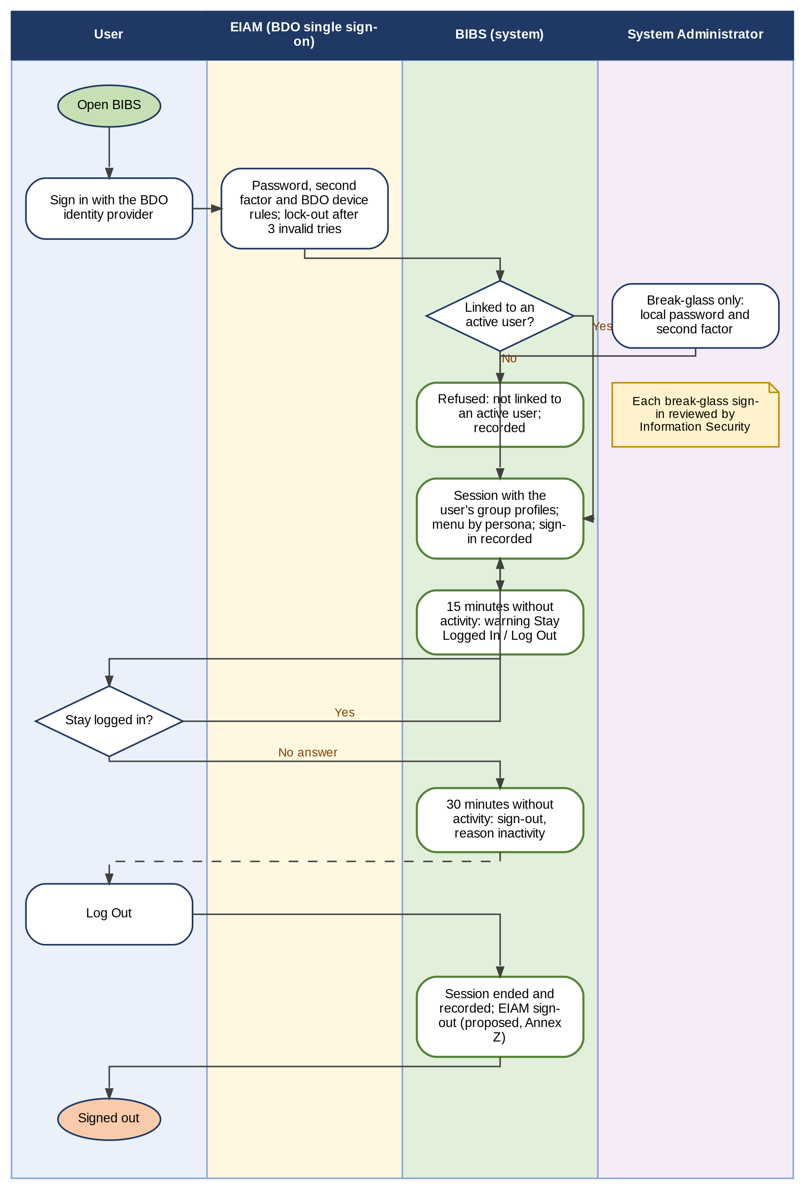
Figure 2 - Sign-in, inactivity warning, session end and log-out with single sign-on through EIAM
How to read it: Read from top to bottom. BDO users sign in at EIAM; only the named break-glass System Administrators keep a local password and the second factor (Annex N). Traces to: BRD 1.001, 2.001, 3.001, 4.001; NFR p.14, p.17; FRUM.001, FRUM-004.
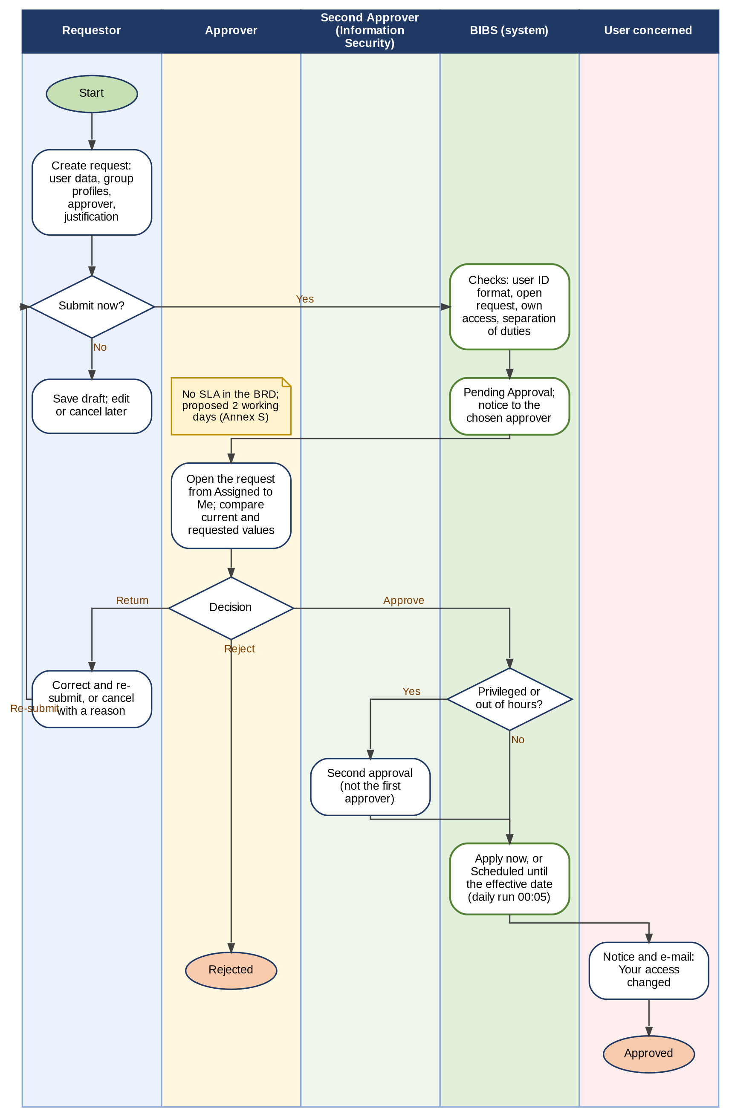
Figure 3 - User access request (enrol, modify, deactivate, reactivate): request, four-eyes decision, return, cancellation and effective date
How to read it: Read from top to bottom. Each column is a persona; the green column is what the system does by itself. Diamonds are decisions; the yellow note gives the time rule. Traces to: BRD 1.002 to 1.008, 2.002; FRUM.009, FRUM.010.
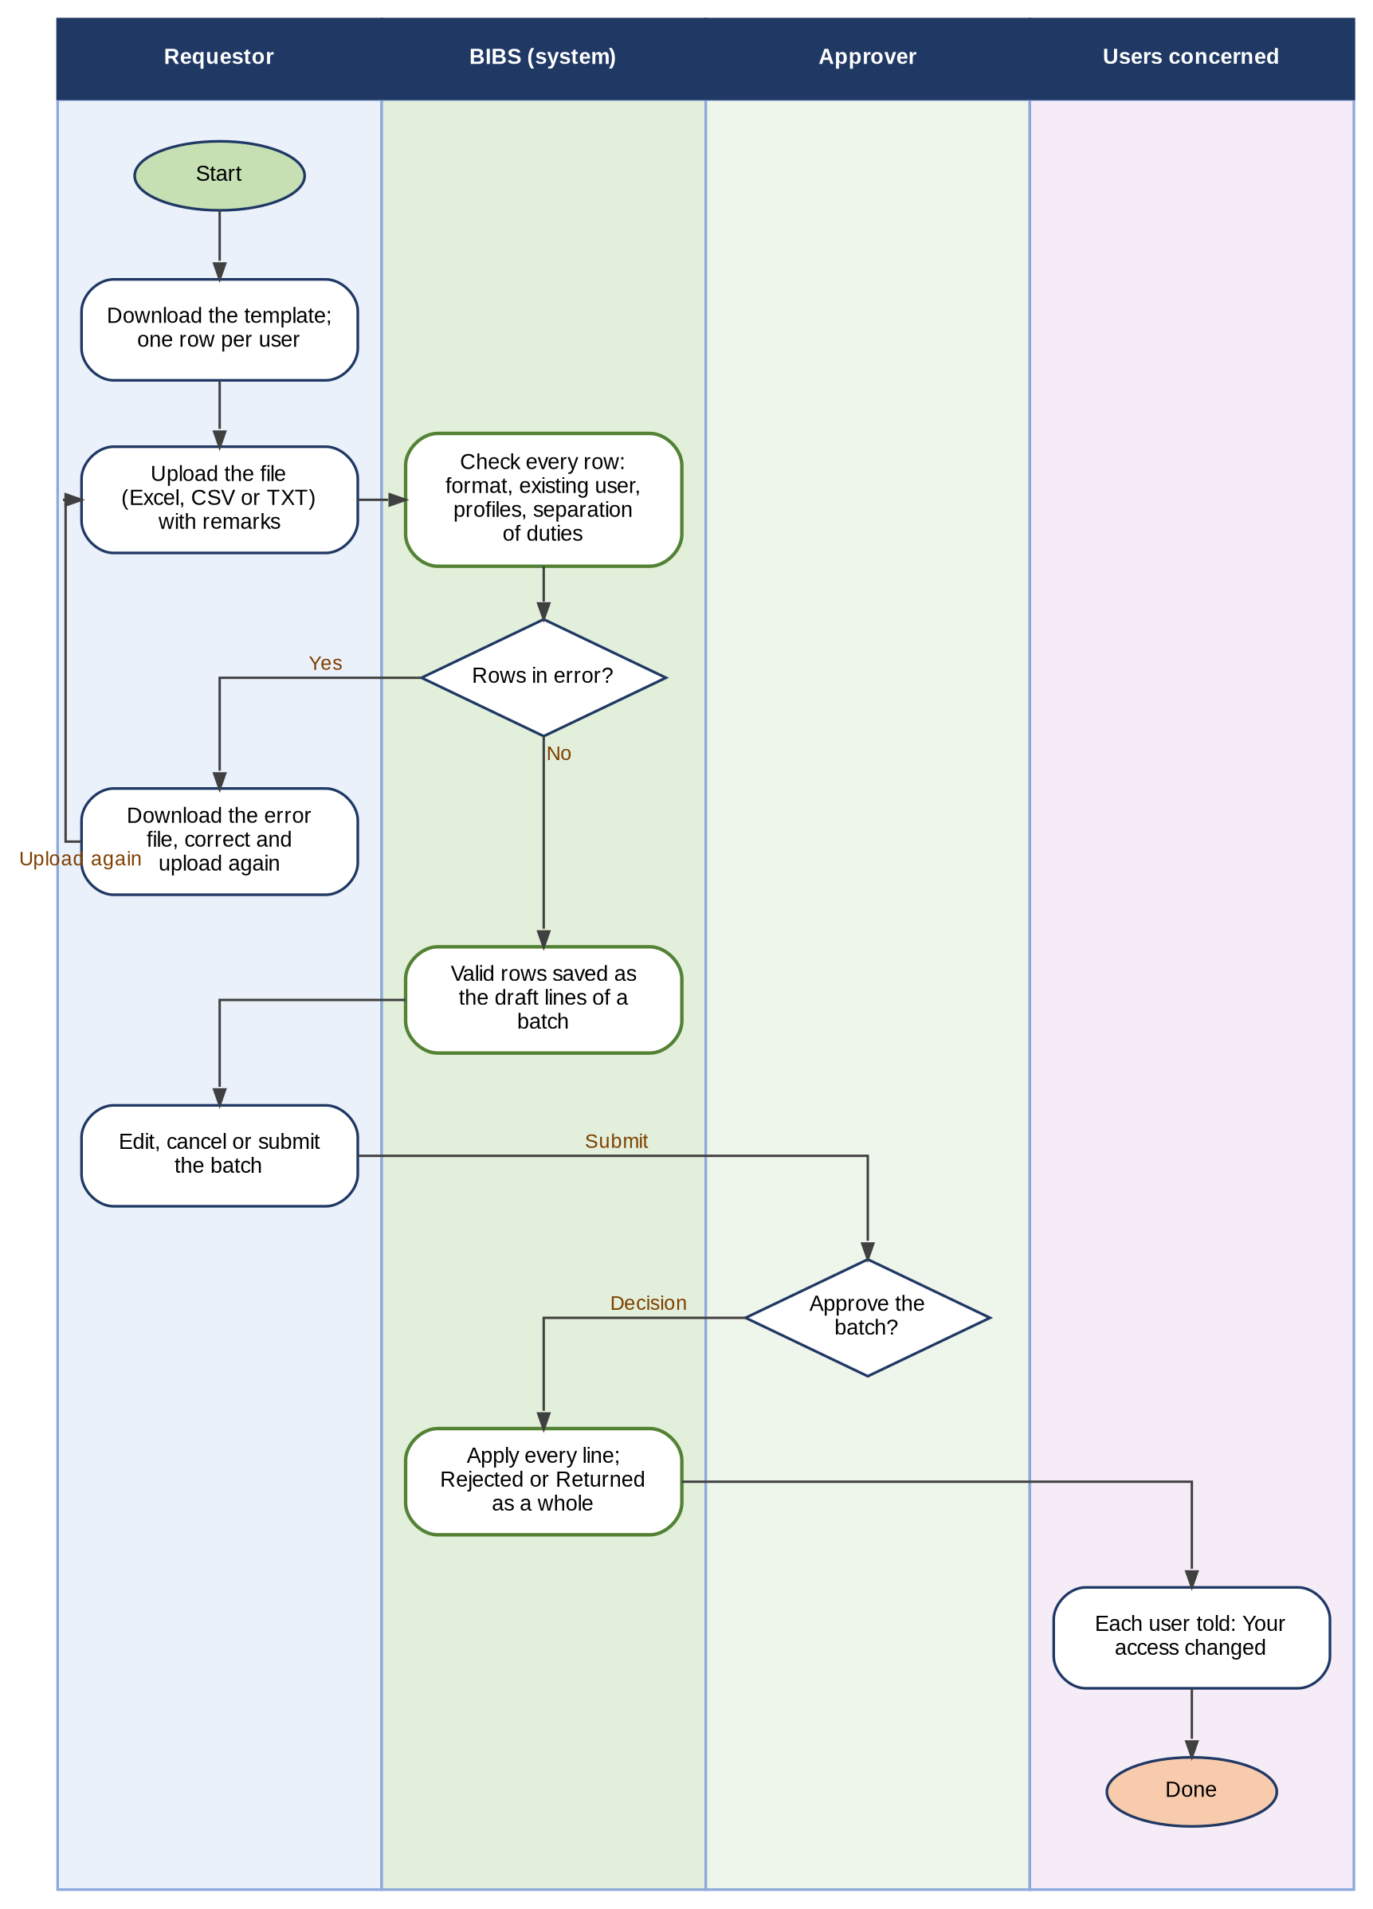
Figure 4 - Bulk request: template, row-by-row check, draft batch, decision of the approver on the batch
How to read it: Read from top to bottom. A file of user requests becomes one batch; the approver decides the batch as a whole (open point CLR-UA-16 answered by BDOI's mapping "c/o UIDM", see Annex Q C24). Traces to: BRD 1.009; NFR p.17 (9); FRUM.011.
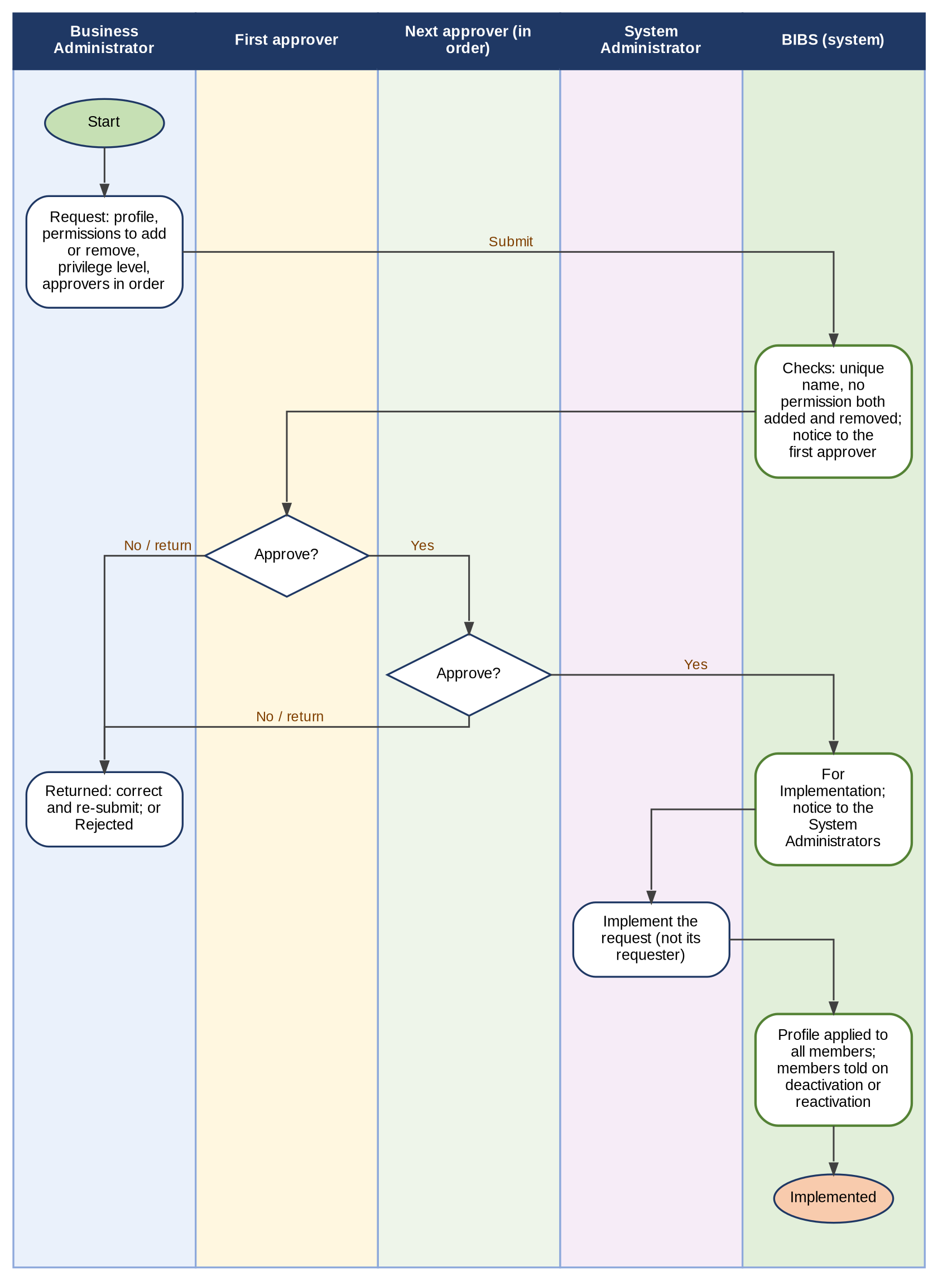
Figure 5 - Group-profile request (new, change, deactivation, reactivation): approvers in order and implementation by the System Administrator
How to read it: Read from top to bottom. The approvers decide one after the other; the System Administrator who implements cannot be the requester. BDOI's FRUM.005 and FRUM.006 let authorised users change roles directly (Annex Q, C03). Traces to: BRD 3.002, 4.002; p.6; FRUM.005, FRUM.006.
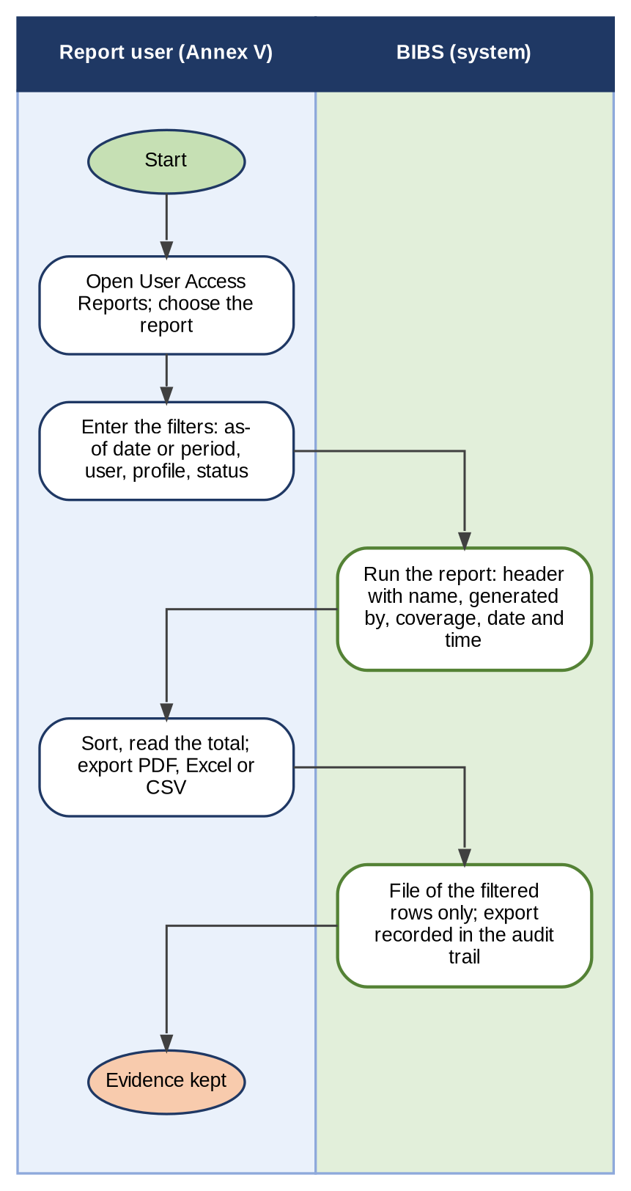
Figure 6 - Generating a user access report or the audit log, exporting it and the record of the export
How to read it: Read from top to bottom. Every report and export is limited to the holders of the report right and is itself recorded in the audit trail. Traces to: BRD 3.003, 4.003; p.18; FRUM.007, FRUM.008.
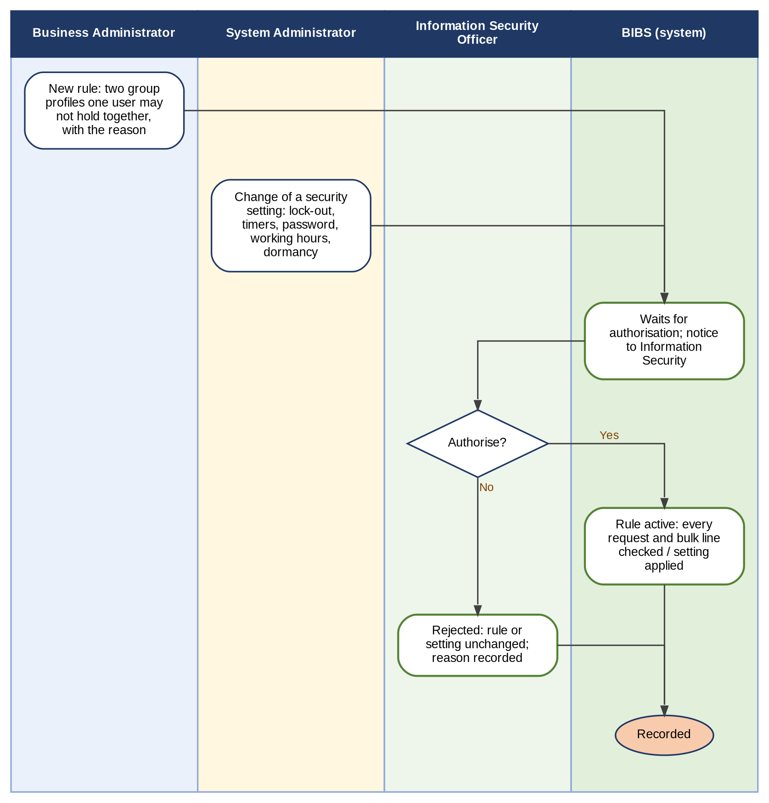
Figure 7 - Controls kept by Information Security: separation-of-duties rules and changes of security settings
How to read it: Read from top to bottom. Each rule or setting changes only after a second person of Information Security authorises it. Traces to: BRD NFR p.17 (11), p.14; FRUM.012.
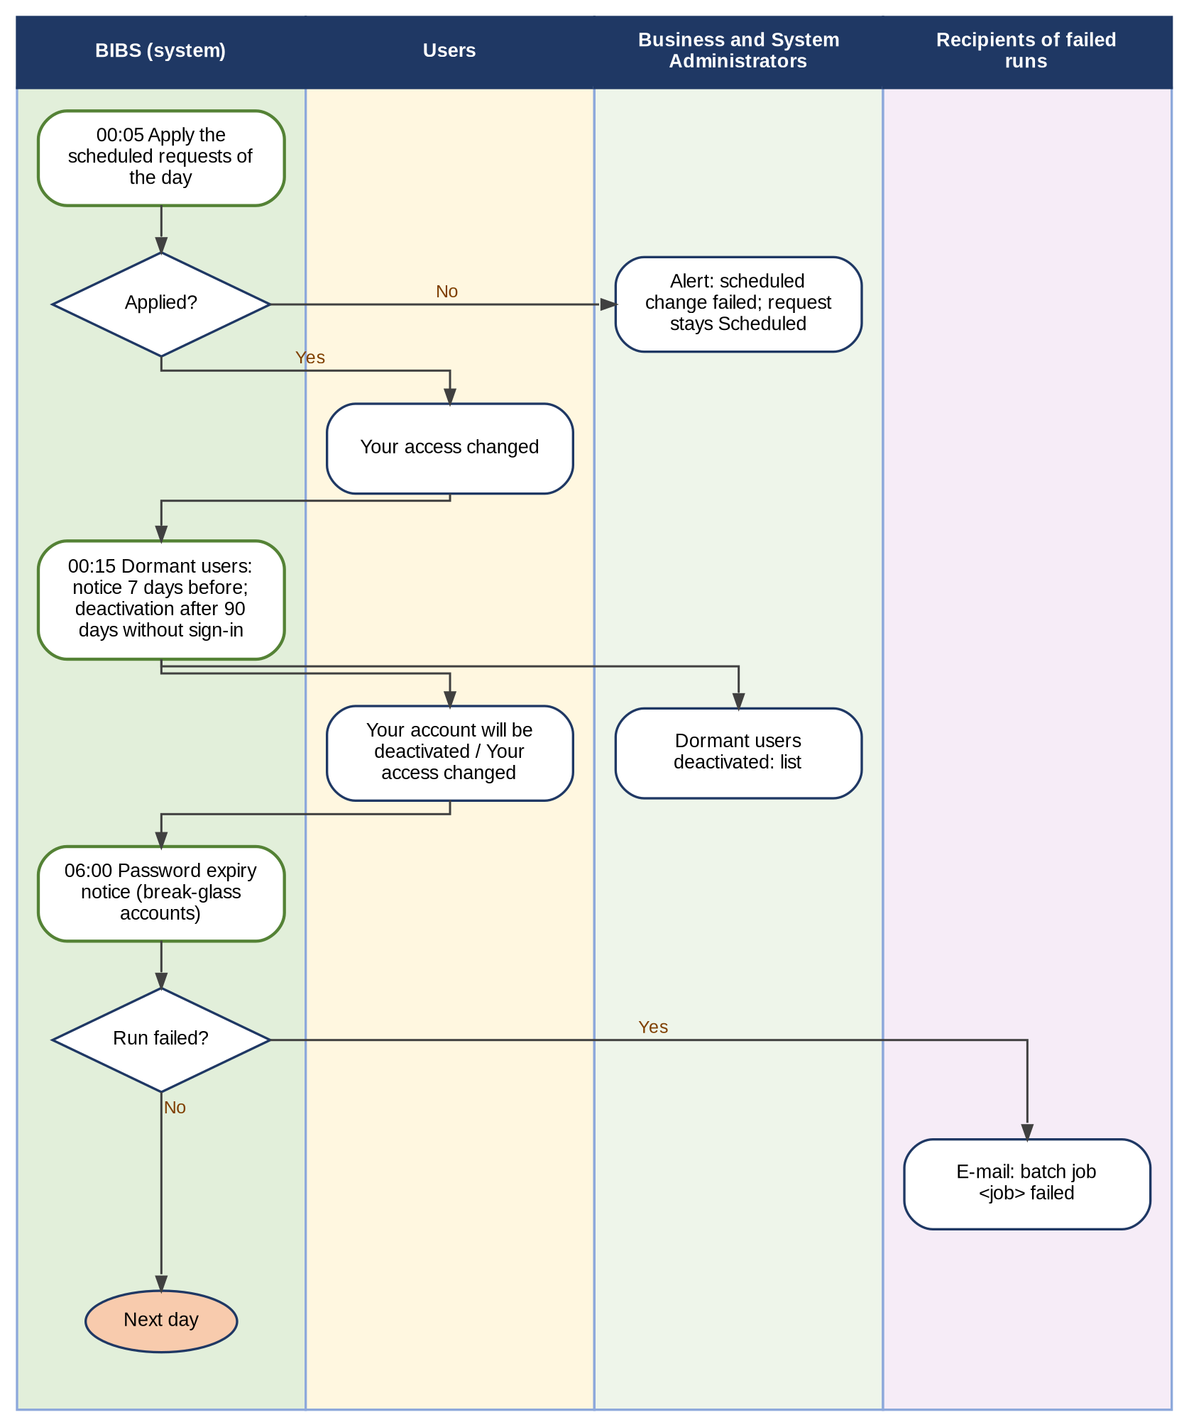
Figure 8 - Daily runs: effective-dated changes, dormant users and password expiry, with the notice of a failed run
How to read it: Read from top to bottom. The runs start by themselves at the times shown (Philippine time); a failed run is e-mailed to the named recipients. Traces to: BRD NFR p.13 (1.k), p.15; FRUM.003.04, FRUM.009.10, FRUM.013.02.
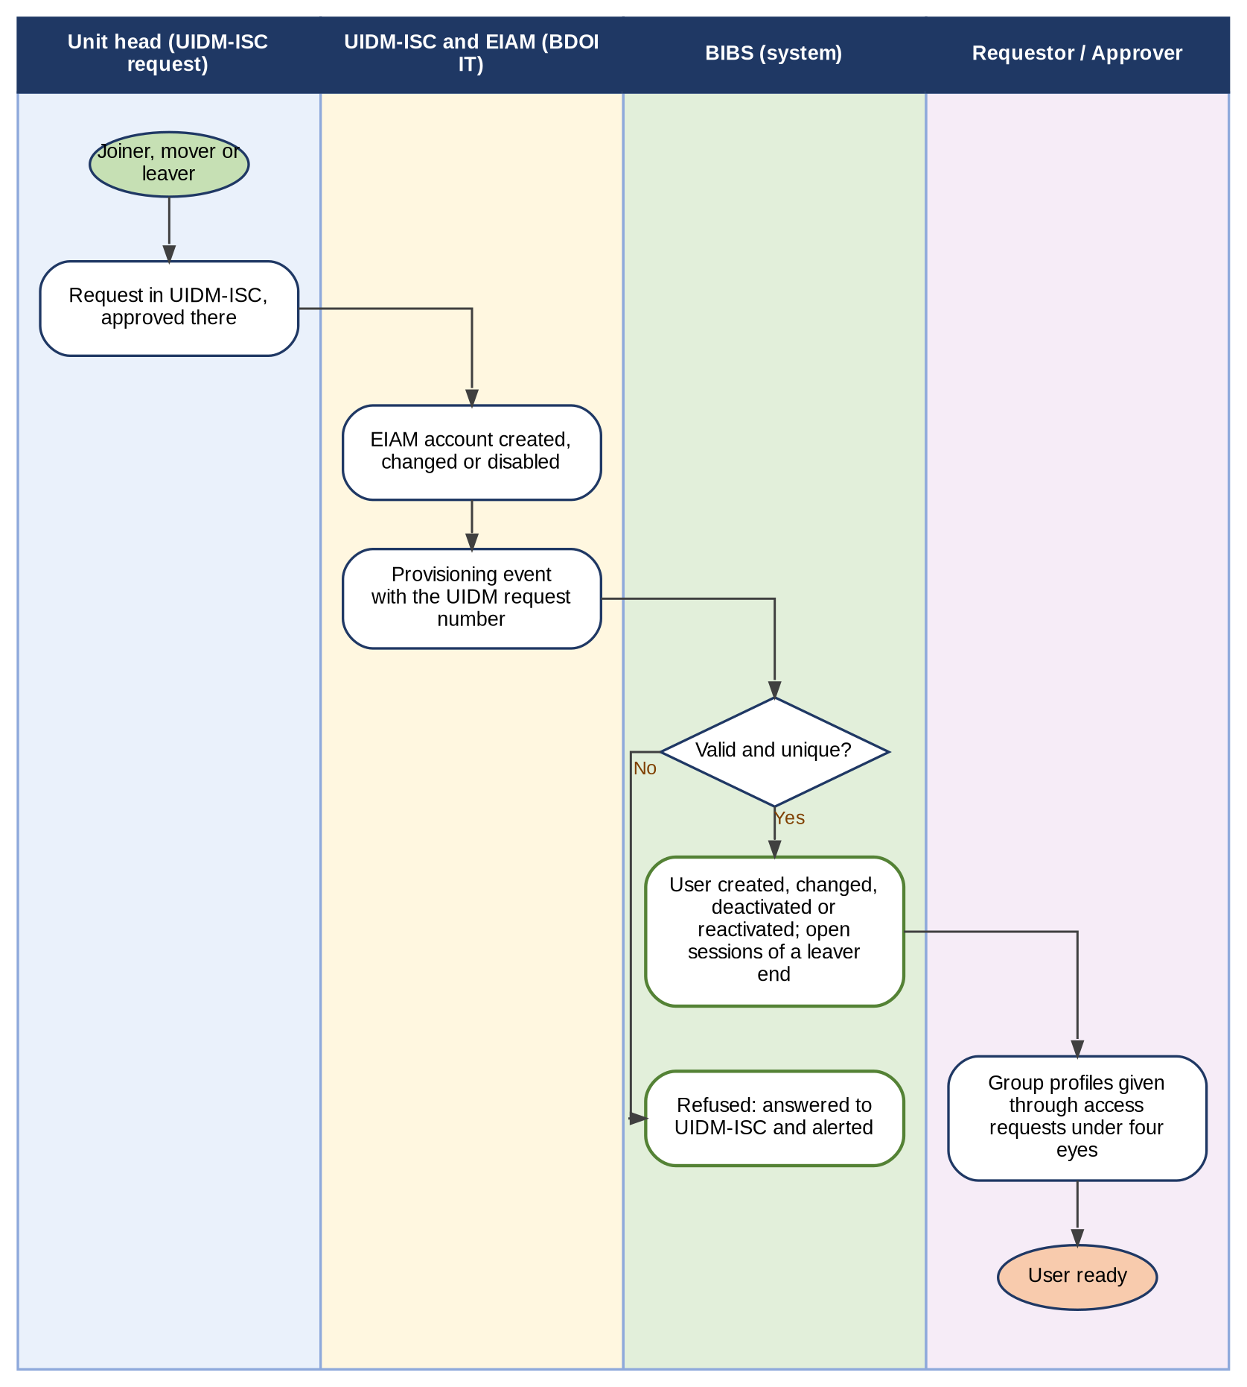
Figure 9 - Joiner, mover and leaver with UIDM-ISC and EIAM (BDOI's FRS: requests outside the system, details synchronised)
How to read it: Read from top to bottom. This is option (a) of Annex N; the choice of option is decision C01 of Annex Q. Group profiles stay in the system and change only through approved requests. Traces to: BRD p.5-6 (request rule); FRUM.002, FRUM.003; Annex N.
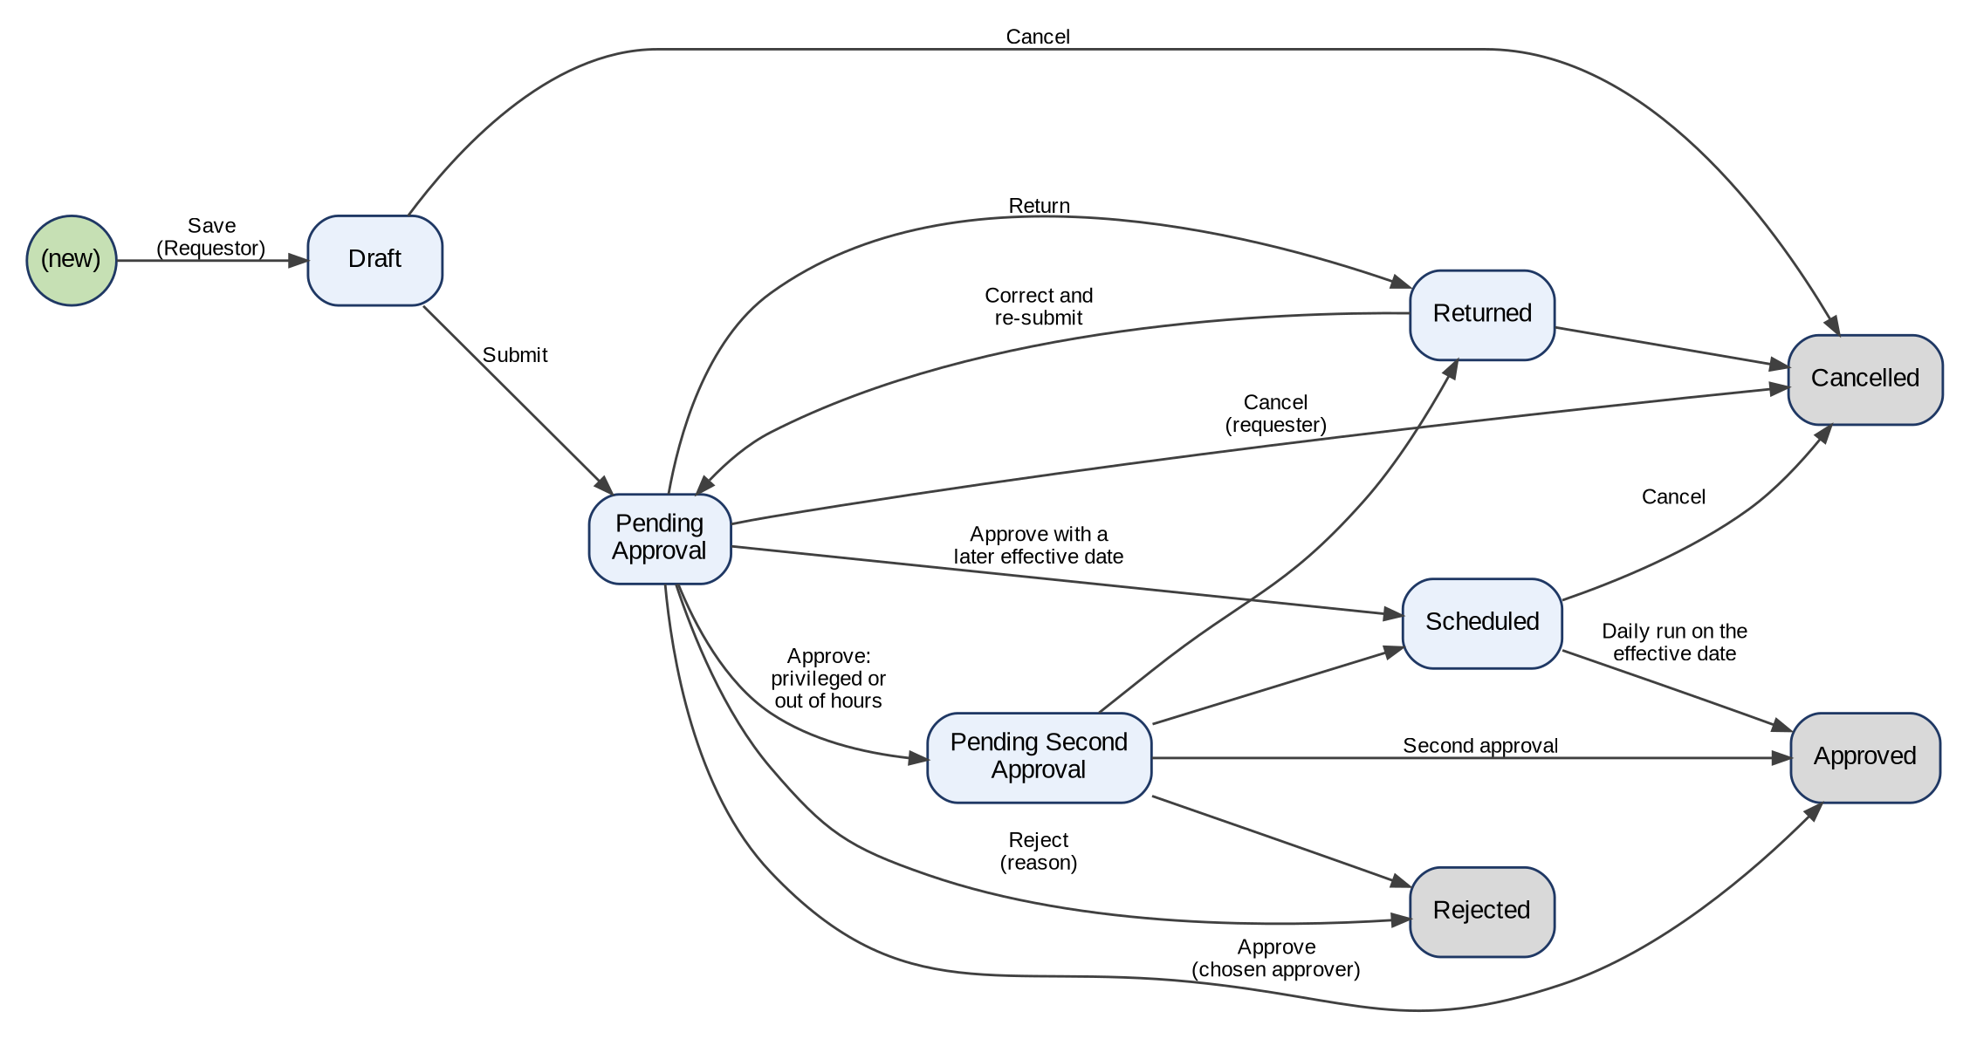
Figure 10 - Status life-cycle of a user access request
How to read it: Each box is a status shown on the screens; each arrow is an action with the persona who takes it. Grey boxes are final. Traces to: BRD 1.002 to 1.008, 2.002; FRUM.009, FRUM.010.
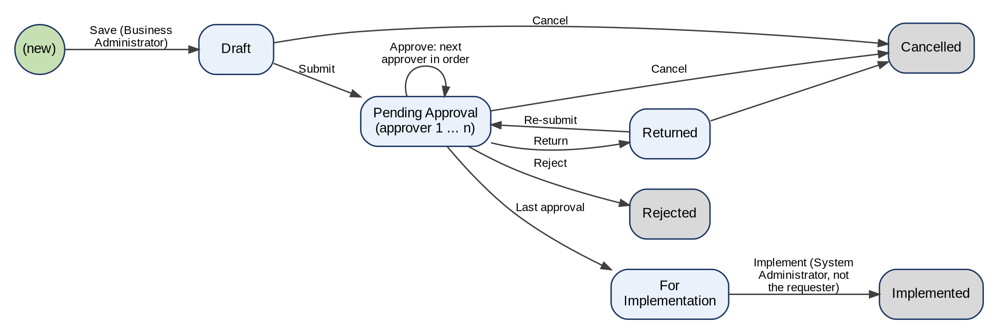
Figure 11 - Status life-cycle of a group-profile request
How to read it: As Figure of the access request, with approvers in order and the implementation step of the System Administrator. Traces to: BRD 3.002; p.6; FRUM.005, FRUM.006.
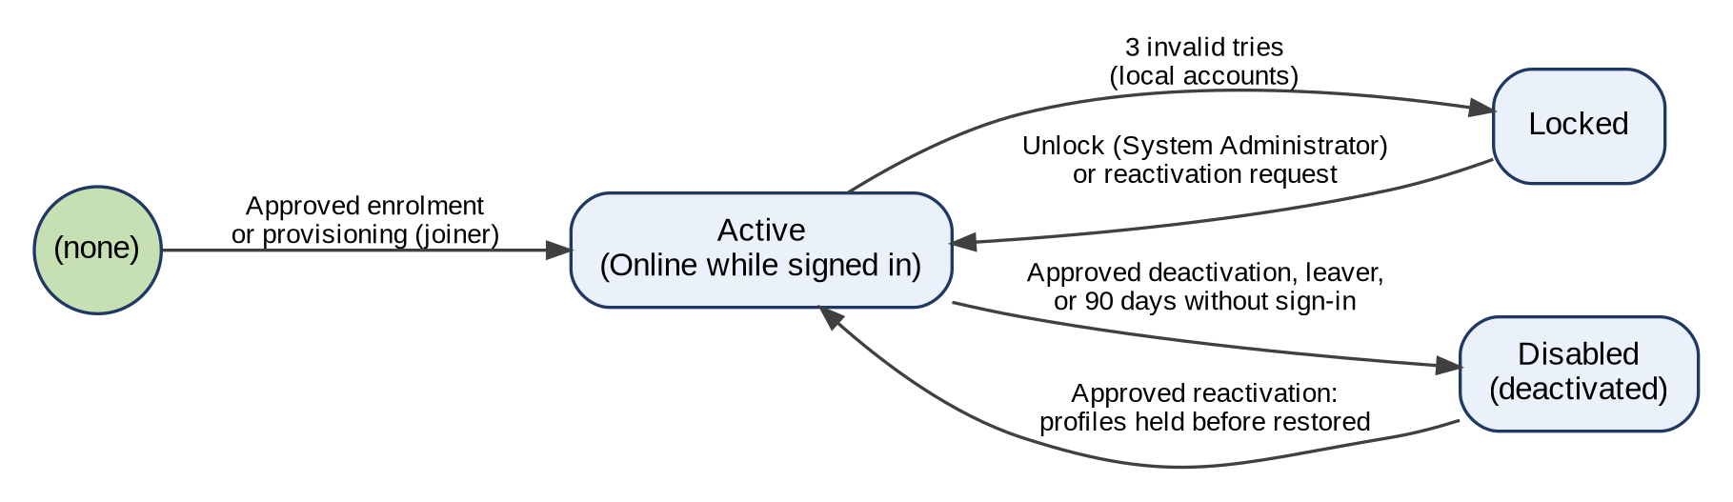
Figure 12 - Status life-cycle of a user account
How to read it: The statuses a user account takes in the system. With single sign-on, EIAM also refuses a disabled or locked BDO account at sign-in. Traces to: BRD 1.002, 1.004, 1.005; NFR p.13-14; FRUM.002, FRUM.003.
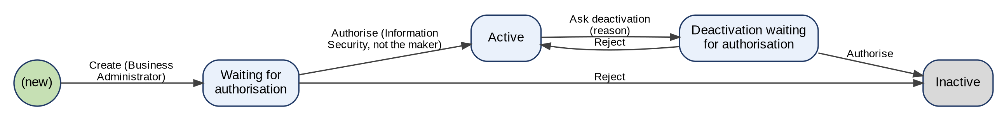
Figure 13 - Status life-cycle of a separation-of-duties rule
How to read it: A rule is made by the Business Administrator and authorised by Information Security; its deactivation is authorised the same way. Traces to: BRD NFR p.17 (11); FRUM.012.01.
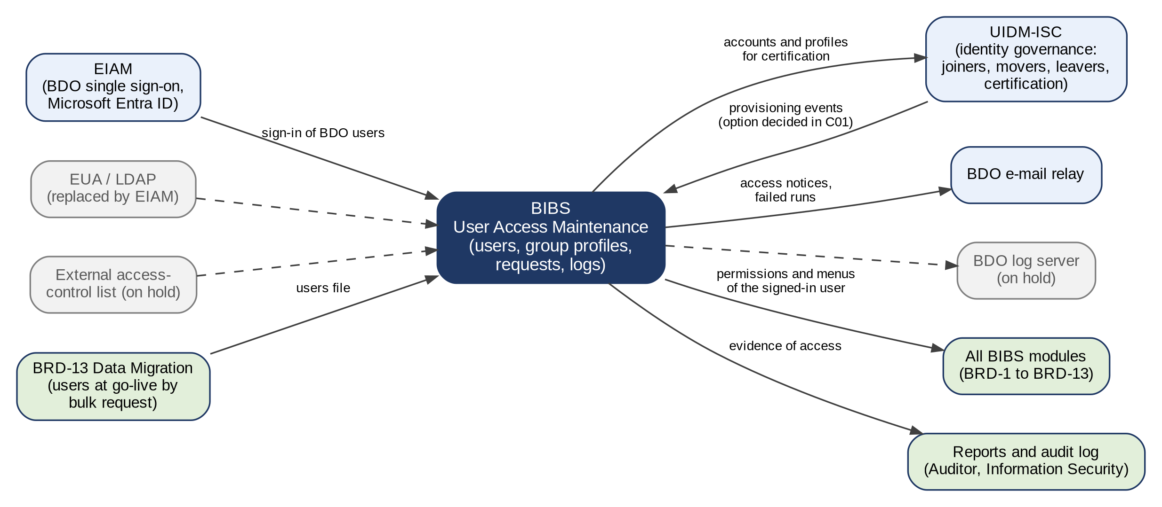
Figure 14 - Integration context of User Access Maintenance
How to read it: Solid lines are in scope; dashed lines are on hold or replaced; the details of each interface are in Annex W. Traces to: BRD NFR p.13-15, p.17; FRUM.001 to FRUM.003, FRUM.013.

Annex B – Report template
This section contains the sample reports.

Report name | Sample Report
User Access Report | 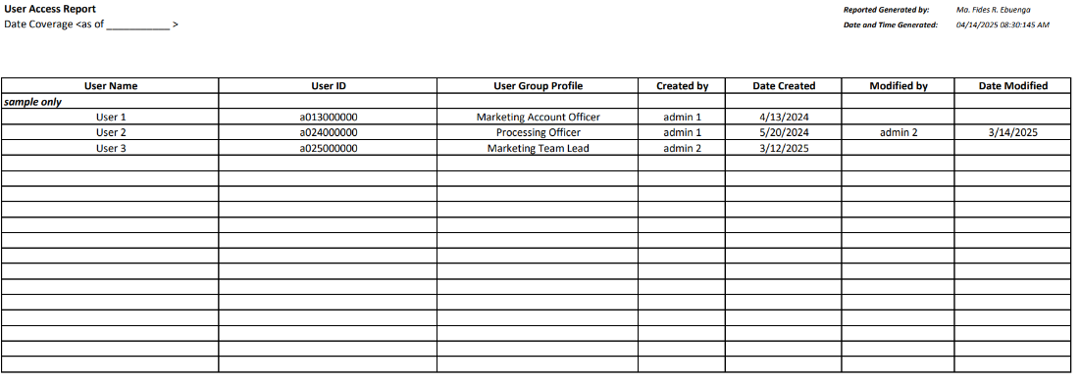
User Group Profile Report | 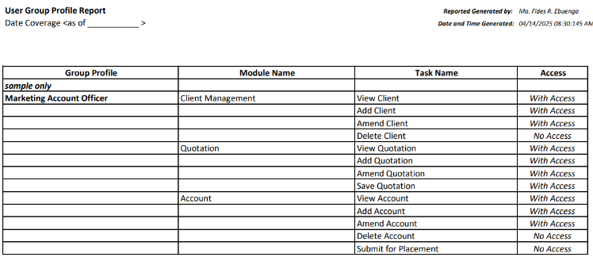
Group Profile Membership List | 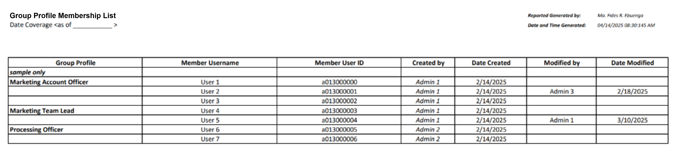

Annex C - User Access Matrix
This section defines the user and roles and permission mapping.

User Access Matrix - Target State082626.xlsx
List of BDOI Personnel _BDOI for Training.xlsx

Disclaimer: This document contains preliminary and partially completed set of capabilities, roles and permissions intended solely as a working baseline. As such, this document should not be interpreted as the final, complete, or officially approved version by the Business Unit (BU).

Annex D – Audit Log Export
Report Name | Sample Report
User Access Audit Log | 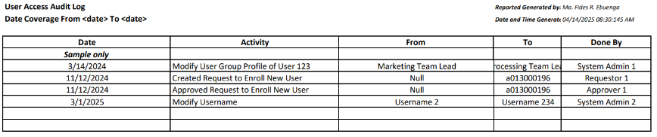

Annex E – User Access Report Fields
No | Field | Data Type | Description
1 | User Name | Text | The full name of the user
2 | User ID | Text | User's Windows ID
3 | User Group Profile | Text | The group profile assigned to the user, defining access permissions.
4 | Created by | Text | The user who originally created the record.
5 | Date Created | Date | The date when the record was initially created in the system.
6 | Modified by | Date | The user who last updated the record.
7 | Date Modified | Date | The date when the record was last updated.
8 | Date Coverage | Date | As of Date
9 | Reported Generated by | Text | The user who generated the report.
10 | Date and Time Generated | Date and Time | The exact date and time when the report was generated.
11 | Windows ID | Text | The user's Windows ID, held apart from the user ID (conflict C06).
12 | Business Unit Group | Text | The business unit group of the user (BRD NFR p.14).
13 | User Level | Text | The user level of the user (BRD NFR p.14).
14 | Status | Text | Active, Disabled or Locked on the as-of date.
15 | Last Action | Text | Added, modified, deactivated or reactivated (BRD 3.003.1.6).
16 | Last Action by | Text | The user who approved the last action, with the request number (BRD 3.003.1.6).

Annex F – Group Profile Membership List
No | Field | Data Type | Description
1 | Group Profile | Text | The name of the user group
2 | Module Name | Text | The system module or functional area to which the permission applies.
3 | Task Name | Text | The specific action or function within the module that the group profile is allowed or restricted to perform.
4 | Access | Text | Indicates whether the group profile is granted or denied permission to perform the specified task.
5 | Date Coverage | Date | As of Date
6 | Reported Generated by | Text | The user who generated the report.
7 | Date and Time Generated | Date and Time | The exact date and time when the report was generated.
8 | Date Created | Date | The date the group profile was created (BRD 3.003.2.3).
9 | Created by | Text | The user who created the group profile (BRD 3.003.2.5).
10 | Date Modified | Date | The date the group profile was last changed (BRD 3.003.2.4).
11 | Added / Modified / Deactivated / Reactivated by | Text | The user who made the last change to the group profile (BRD 3.003.2.6).

Annex G – User Group Membership Report Fields
No | Field | Data Type | Description
1 | Group Profile | Text | The name of the user group or role to which the user is assigned.
2 | Member Username | Text | The full name of the user
3 | Member User ID | Text | The unique windows ID of the group member.
4 | Created by | Text | The user who originally created the record.
5 | Date Created | Date | The date when the record was initially created in the system.
6 | Modified by | Text | The user who last updated the record.
7 | Date Modified | Date | The date when the record was last updated.
8 | Date Coverage | Date | As of Date
9 | Reported Generated by | Text | The user who generated the report.
10 | Date and Time Generated | Date and Time | The exact date and time when the report was generated.

Annex H – Audit Log Fields
No | Field | Data Type | Description
1 | Timestamp | Date and Time | The date and time when the system activity or transaction occurred.
2 | Module | Text | The module name where the activity was performed.
3 | User Id | Text | User's Windows ID
4 | Performed By | Text | The user who performed the recorded activity or action.
5 | User Group Profile | Text | The role of the user of performed the Action
6 | Action | Text | A description of the action performed in the system (e.g., view, create, update).
7 | Old Value | Text | The original value or state of the record before the change was made.  Pipe delimited if more than 1
8 | New Value | Text | The updated value or state of the record after the change was completed.  Pipe delimited if more than 1
9 | Date Coverage | Date | The start and end date range defining the period covered by the audit log entries in the report.
10 | Report Generated by | Text | The user who generated the report.
11 | Date & Time Generated | Date and Time | The exact date and time when the report was generated.
12 | Activity | Text | Short description of the action (FRUM.008.01).
13 | IP Address | Text | The source address of the session (FRUM.008.01; conflict C19).
14 | Approved By | Text | The approver of the request from which the activity came.
15 | Request No. | Text | The number of the access request (AR-yyyy-nnnnnn).

Annex I – Password Guidelines
Application Security Requirement (ASR).xlsx
Password Protection Guidelines v2_10Sep2026.pdf

Annex J – Screen Specifications
This annex specifies the User Access Maintenance screens: the purpose of each screen, how the user reaches it, the requirements it serves, one screenshot, its fields with type, mandatory marker, format, list or source and validation, its actions, and its rules. Mandatory: Y = mandatory, N = optional, Cond. = mandatory when the condition stated applies. The screenshots were taken on the BIBS test environment with SIT/UAT data on 10-Oct-2026.

J.1 Login (SCR-UA-01)
Purpose: The sign-in page of the system, on the BDO Insure portal layout. The user enters the user ID and password; the system checks the account and the password, counts failed attempts and locks the account at the third, and opens the home page with the menu of the user's group profiles. A user whose password was set by an administrator or has expired changes it first (SCR-UA-03).
Access: The the system address in the browser of a BDO-issued device; Every page when the session has ended (inactivity, end of the session, Log Out); Reset password › Back to Login
Requirements: FRUM.001.01, FRUM.001.02, FRUM.001.06, FRUM-004.01
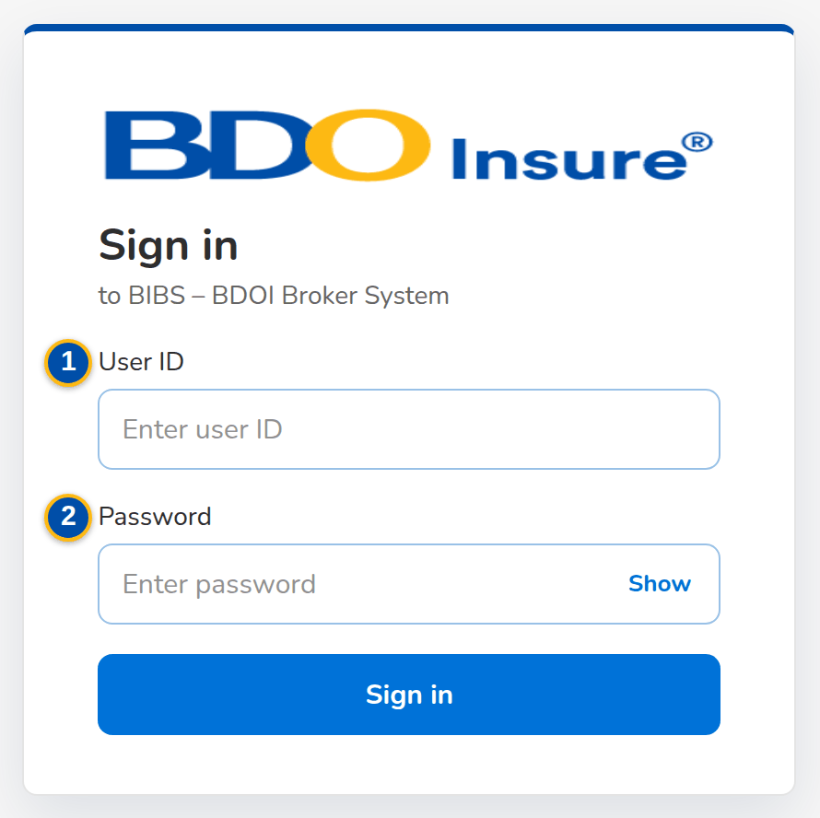
Figure J.1: Login page
Field | Type | Mandatory | Format / list / source | Validation and message
Sign-in: User ID | Text | Y | the system user ID (for example a013000196); with directory sign-in, the Windows ID; User master | Required by the browser; the account must exist, be active and not locked; Invalid user name or password
Sign-in: Password | Password | Y | Masked | Required by the browser; checked against the stored password (or by the directory); Invalid user name or password
Sign-in: Forgot password? | Link | - | Shown only when the password reset setting is off (self-service reset of local accounts); not shown as delivered, as BDOI's rules apply; Password reset setting | -

Action | Who | Available when | What happens | Resulting status
Login | Every user | User ID and password entered | Checks the account and the password. Success: opens the home page with the menu of the user's active group profiles and records the sign-in; a password set by an administrator or expired opens Change Your Password first. Failure: counts the failed attempt; the third consecutive failure locks the account and ends its open sessions | Signed in, or refused
Forgot password? | Every user | The password reset setting is off | Opens Forgot Password (SCR-UA-02) | -

Rules:
- The account locks after 3 consecutive failed sign-ins (parameter the lock-out attempts, all users); only the System Administrator unlocks it (Users › Unlock), or a reactivation request with Also unlock the account (FRUM.001.01, FRUM.001.02).
- The message never says whether the user ID or the password was wrong; a deactivated user is refused with the same message and the attempt counts (FRUM.001.01, FRUM.001.02).
- Every successful and failed sign-in is written to the audit trail with the user and the time (FRUM.001.01, FRUM.001.02, FRUM.008.01, FRUM.008.04).
- More than 20 sign-in attempts within a minute from one computer are refused until the minute ends: Too many sign-in attempts. Wait a minute and try again. (FRUM.001.01, FRUM.001.02).
- The menu shows only the screens of the user's active group profiles; a deactivated group profile grants nothing (FRUM.001.01, FRUM.001.02, FRUM.006.02.01, FRUM.006.04).
- As delivered, BDOI's password reset rules apply: the page has no Forgot password? link, and a forgotten password of a local account is reset by another System Administrator; with single sign-on the password is kept by the Enterprise SSO platform. The setting Password reset rules (Annex M) brings back the self-service link for local accounts (FRUM-004.01, FRUM-004.02).
- Outside production the page shows the name of the environment above the sign-in card (for example SIT ENVIRONMENT, UAT ENVIRONMENT), and under it the notice on authorised use (FRUM.001.01, FRUM.001.02).
- In directory mode the password is checked by the BDO directory and never stored in the system; until BDO supplies the directory interface that mode refuses every sign-in (FRUM.001.02, FRUM.001.06).

J.2 Forgot Password and Set a New Password (SCR-UA-02)
Purpose: Self-service reset of a forgotten password (local sign-in), offered only when the password reset setting is off; as delivered BDOI's rules apply and another System Administrator resets the password. On Forgot Password the user enters the user ID; the system e-mails a single-use link, valid for 30 minutes, to the address registered for the user. The link opens Set a New Password, where the user chooses the new password under the password rules.
Access: Login › Forgot password?; The link in the e-mail the system: reset your password
Requirements: FRUM-004.01, FRUM-004.02, FRUM-004.03
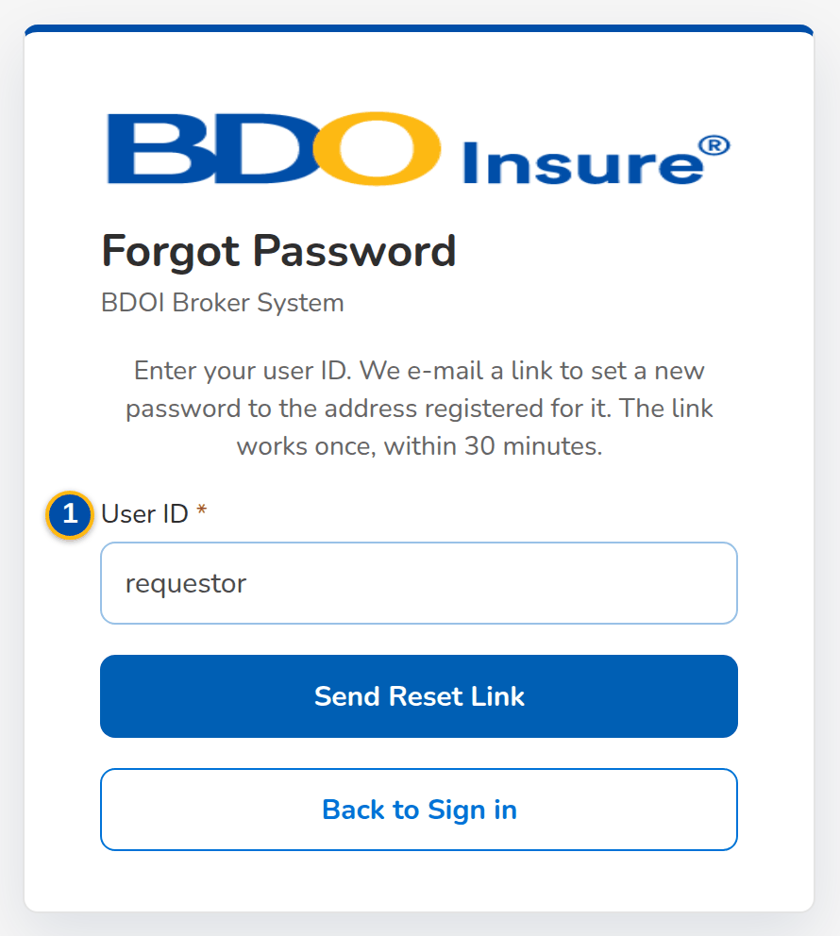
Figure J.2: Forgot Password with the user ID entered (password reset setting off)
Field | Type | Mandatory | Format / list / source | Validation and message
Forgot Password: User ID | Text | Y | the system user ID; User master | Required
Set a New Password: New password | Password | Y | At least 10 characters with an upper-case letter, a lower-case letter, a digit and a symbol | Checked as the user types; not one of the last 10 passwords; You used this password recently. Choose another one
Set a New Password: Confirm new password | Password | Y | Same as New password | Both new passwords must match; Both new passwords must match
Set a New Password: Still needed | Checklist | - | At least 10 characters; An upper-case letter; A lower-case letter; A digit; A symbol; Password rules | Shown until every rule is met

Action | Who | Available when | What happens | Resulting status
Send Reset Link | Every user | User ID entered | Withdraws the older links of the user and e-mails a new single-use link to the registered address; the same confirmation is shown for every user ID, so the page never reveals whether a user exists | -
Back to Login | Every user | Always | Returns to the Login page | -
Set Password | Holder of a valid link | New password meets the rules and is confirmed | Sets the password, marks the link used and confirms: Your password was changed. Sign in with the new password. | Password changed

Rules:
- A link works once and expires 30 minutes after it was sent; an older link of the same user stops working when a new one is requested (FRUM-004.01, FRUM-004.02).
- The link is sent only to an active user with an e-mail address, in local sign-in mode; a reset link does not unlock a locked account (FRUM-004.01, FRUM-004.02).
- The new password follows the password rules: at least 10 characters with upper and lower case, a digit and a symbol, and none of the last 10 passwords (parameter the password history) (FRUM-004.01, FRUM-004.02).

J.3 Change Your Password (forced change) (SCR-UA-03)
Purpose: Shown after sign-in, instead of the home page, while the password must be changed: after the account was created or the password reset by an administrator, and when the password is older than the maximum age. The user chooses a new password or signs out.
Access: Login, for a user whose password was set by an administrator or has expired
Requirements: FRUM-004.01, FRUM-004.02, FRUM-004.03
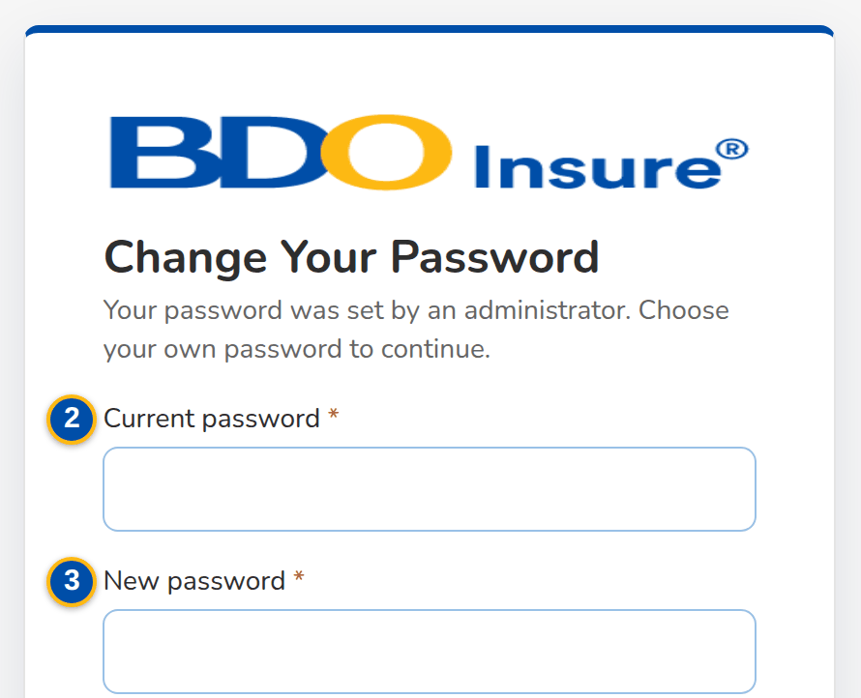
(continued below)
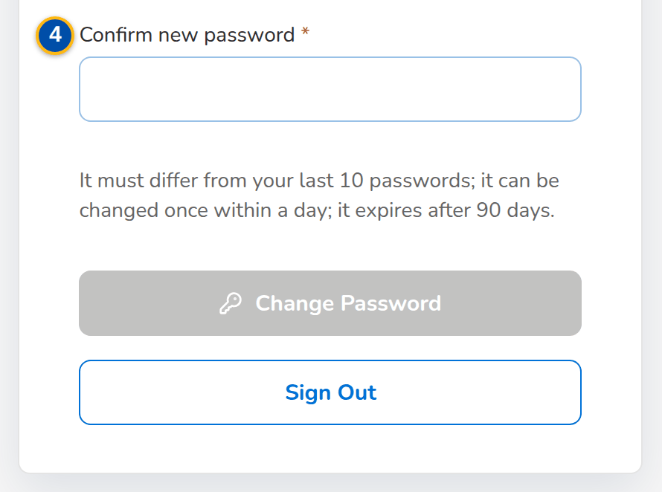
Figure J.3: Change Your Password after a password set by an administrator
Field | Type | Mandatory | Format / list / source | Validation and message
Change Your Password: [Reason] | Text | - | Your password was set by an administrator. Choose your own password to continue. / Your password is older than 90 days and has expired. Choose a new password to continue.; Password status | -
Change Your Password: Current password | Password | Y | Masked | Must be the current password; Current password is incorrect
Change Your Password: New password | Password | Y | At least 10 characters with an upper-case letter, a lower-case letter, a digit and a symbol | Rules checked as the user types; not one of the last 10 passwords; You used this password recently. Choose another one
Change Your Password: Confirm new password | Password | Y | Same as New password | Both new passwords must match; Both new passwords must match
Change Your Password: [Password rules] | Text | - | It must differ from your last 10 passwords; it can be changed once within a day; it expires after 90 days.; Parameters the password history, the minimum password age, the password expiry | -

Action | Who | Available when | What happens | Resulting status
Change Password | The signed-in user | Current password entered and the new password meets the rules | Saves the new password and opens the home page | Password changed
Sign Out | The signed-in user | Always | Ends the session and returns to the Login page | Signed out

Rules:
- A password set by someone else (enrolment, administrator reset) must be changed at the next sign-in (FRUM-004.01, FRUM-004.02).
- A password older than the password expiry (90 as delivered) must be changed before work continues; a password never changed since the release does not expire until changed once (FRUM-004.01, FRUM-004.02).
- The minimum age (the minimum password age, one day) does not apply to a forced change (FRUM-004.01, FRUM-004.02).

J.4 Inactivity and Session-end Warnings (SCR-UA-04)
Purpose: The two warnings of the session guard, shown over any screen: the inactivity warning, 15 minutes before the sign-out after 30 minutes without activity, in BDOI's wording with the buttons Stay Logged In and Log Out; and the warning before the fixed end of the session, 30 minutes before the system signs the user out whatever the activity. After the inactivity sign-out the user sees the page Session Timed Out (SCR-UA-21).
Access: Any screen after 15 minutes without activity; Any screen 30 minutes before the fixed end of the session
Requirements: FRUM.001.01, FRUM.001.03, FRUM.001.04, FRUM.001.05, FRUM.008.01
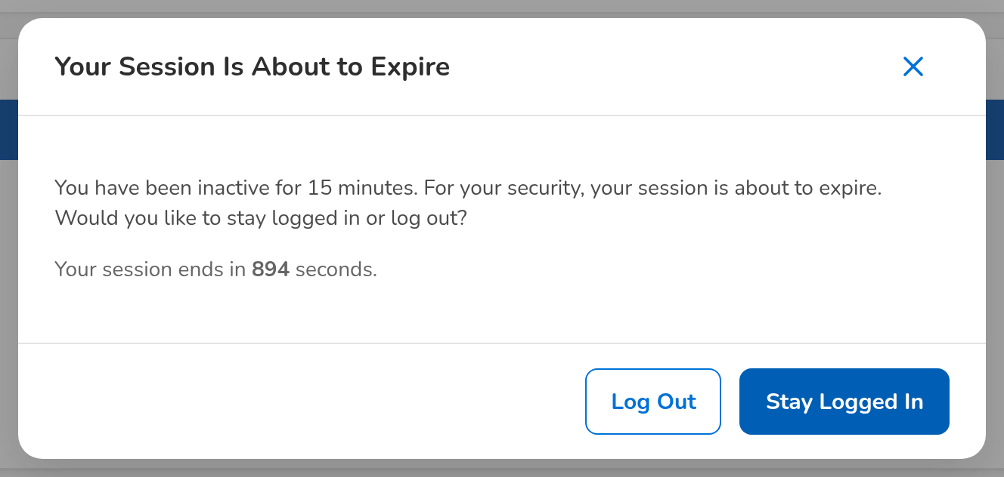
Figure J.4: Your session is about to expire: BDOI's inactivity warning with Stay Logged In and Log Out
Field | Type | Mandatory | Format / list / source | Validation and message
Your session is about to expire: [Warning text] | Text | - | You have been inactive for 15 minutes. For your security, your session is about to expire. Would you like to stay logged in or log out?; Parameters the inactivity warning time, the session timeout | -
Your session is about to expire: [Countdown] | Text | - | Your session ends in n seconds.; Parameter the session timeout | -
Your session will end soon: [Session end] | Text | - | For your security the system signs you out in n minute(s), at dd-MMM-yyyy HH:mm, whatever your activity.; Parameter the session-end warning time | -

Action | Who | Available when | What happens | Resulting status
Stay Logged In | The signed-in user | Inactivity warning shown | Closes the warning and restarts the inactivity timer in every tab | Signed in
Log Out | The signed-in user | Inactivity warning shown | Ends the session (with single sign-on, also at the Enterprise SSO platform) and returns to the Login page | Signed out
I Understand | The signed-in user | Session-end warning shown | Closes the warning; the session still ends at the time shown | Signed in

Rules:
- After 15 minutes without activity the inactivity warning is shown; after 30 minutes the user is signed out and the page Session Timed Out opens: Your session timed out. Please log in again to continue (parameters the inactivity warning time, the session timeout) (FRUM.001.01, FRUM.001.03).
- The wording and the buttons follow BDOI's FRS as delivered; the setting Inactivity warning wording (Annex M) brings back the earlier wording with Stay Signed In and Sign Out Now, and the setting Session timed-out page a message on the Login page instead of the page (FRUM.001.01, FRUM.001.03).
- The warning and the inactivity sign-out are written to the audit trail with the user and the time (FRUM.001.01, FRUM.001.03, FRUM.008.01, FRUM.008.04).
- Activity in any browser tab keeps every tab signed in (FRUM.001.01, FRUM.001.03).
- Every sign-out is kept in the session log with its reason: log-out, inactivity, end of the session, ended by an administrator or account locked (FRUM.001.04, FRUM.001.05).

J.5 Session Timed Out (SCR-UA-21)
Purpose: The page shown after the session ended for inactivity: BDOI's message "Your session timed out. Please log in again to continue" with the Log In button, which opens the Login page (with single sign-on, through the sign-out page of the Enterprise SSO platform, so that the sign-in is asked again).
Access: Any screen, 30 minutes without activity (the inactivity warning was not answered)
Requirements: FRUM.001.01, FRUM.001.03, FRUM.001.04, FRUM.001.05, FRUM.008.01
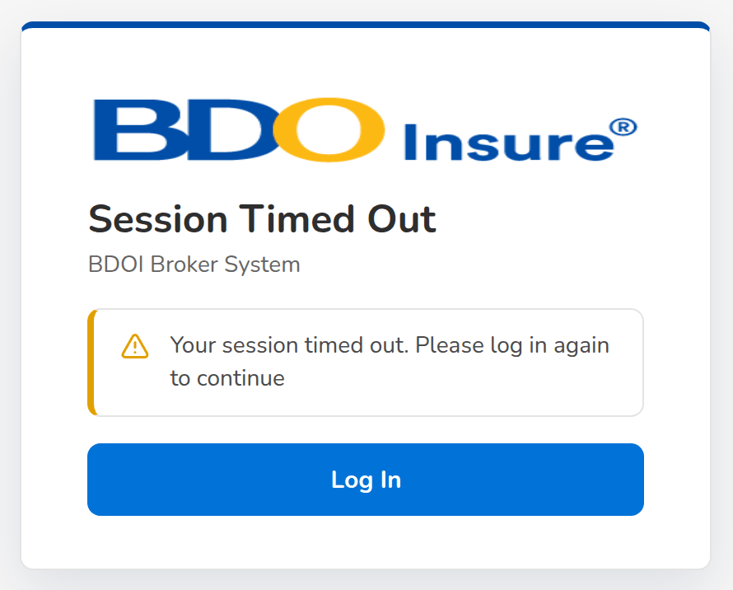
Figure J.5: Session Timed Out with the Log In button
Field | Type | Mandatory | Format / list / source | Validation and message
Session Timed Out: [Message] | Text | - | Your session timed out. Please log in again to continue | -

Action | Who | Available when | What happens | Resulting status
Log In | The user whose session timed out | Always | Opens the Login page; with single sign-on, signs the user out at the Enterprise SSO platform first | Signed out

Rules:
- Shown as delivered (setting Session timed-out page on, BDOI's FRS); with the setting off the Login page opens with the message You were signed out after 30 minutes of inactivity (FRUM.001.01, FRUM.001.03).
- The sign-out is kept in the session log with the reason Idle Timeout and written to the audit trail (FRUM.001.01, FRUM.001.03, FRUM.001.04, FRUM.001.05).

J.6 My Profile (SCR-UA-05)
Purpose: The signed-in user's own page: account details, contact details the user maintains, the group profiles and permissions held, the password with its rules and dates, and the recent sign-in sessions.
Access: User menu in the page header › My Profile; The notice Your password expires soon
Requirements: FRUM.001.04, FRUM.001.05, FRUM-004.01, FRUM-004.02, FRUM-004.03, FRUM.008.01
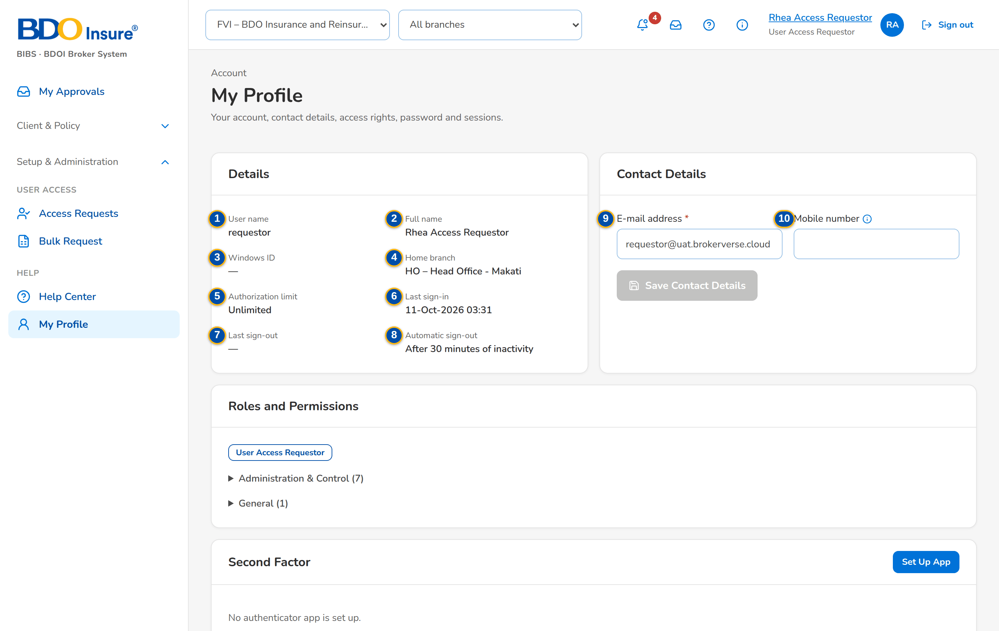
(continued below)
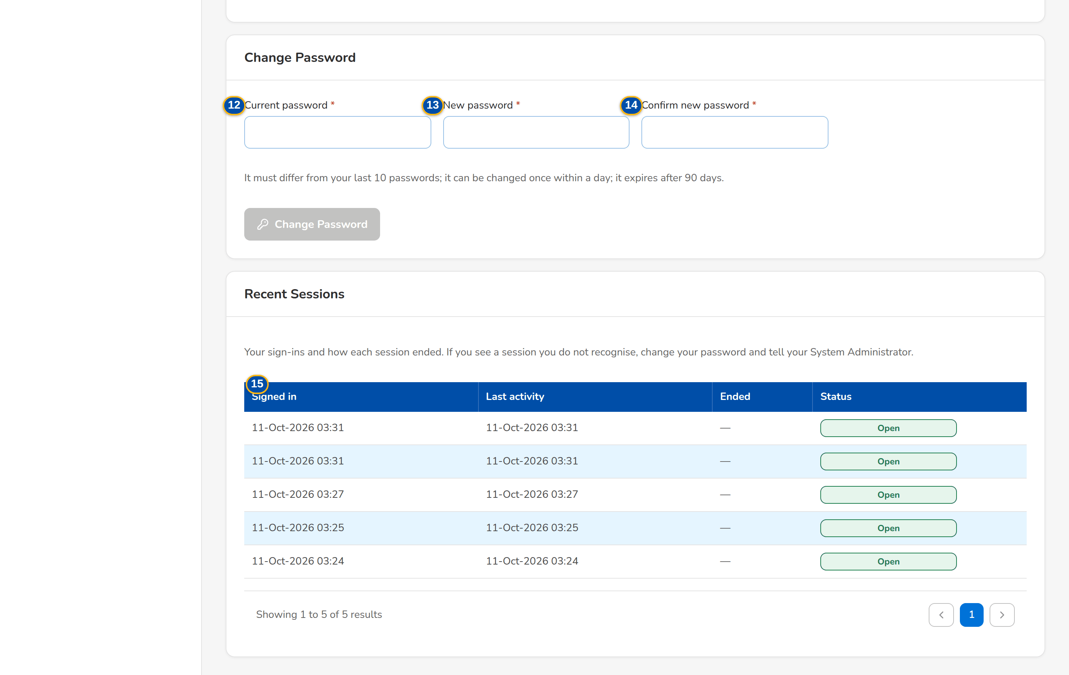
Figure J.6: My Profile of the Requestor
Field | Type | Mandatory | Format / list / source | Validation and message
Details: User name | Text | - | User ID; User master | -
Details: Full name | Text | - | User master | -
Details: Windows ID | Text | - | User master | -
Details: Home branch | Text | - | Code – name; Branches | -
Details: Authorization limit | Amount | - | PHP, two decimals; Unlimited when blank; User master | -
Details: Last sign-in | Date and time | - | dd-MMM-yyyy HH:mm; Session log | -
Details: Last sign-out | Date and time | - | dd-MMM-yyyy HH:mm; Session log | -
Details: Automatic sign-out | Text | - | After 30 minutes of inactivity; Parameter the session timeout | -
Contact details: E-mail address | E-mail | Y | Valid e-mail address; User master | A valid address; Enter your e-mail address
Contact details: Mobile number | Telephone | N | Digits with an optional +, spaces, brackets and dashes, 7 to 25 characters; User master | Digits only, for example +63 917 123 4567; Enter the mobile number with digits only, for example +63 917 123 4567
Roles and permissions: [Group profiles] / [Permissions by area] | Tags; collapsible tables | - | The names of the group profiles held; the permissions in words, one collapsible group per business area with its count, each a table of Permission and What it allows; Role grants | -
Change password: Current password | Password | Y | Masked | Must be the current password; Current password is incorrect
Change password: New password | Password | Y | At least 10 characters with upper and lower case, a digit and a symbol | Rules checked as the user types; history and minimum age checked on save; You changed your password less than a day ago
Change password: Confirm new password | Password | Y | Same as New password | Both new passwords must match; Both new passwords must match
Recent sessions: Signed in / Last activity / Ended / Status | Columns | - | Date and time; status Open, Logout, Idle Timeout, Expired, Admin Ended, Locked; Session log | -

Action | Who | Available when | What happens | Resulting status
Save Contact Details | The signed-in user | Address or number changed | Saves the e-mail address and mobile number; each changed value is written to the access change log without a request | -
Change Password | The signed-in user (local sign-in) | Current password entered and the new password meets the rules | Saves the new password; the dates under the card are updated | -

Rules:
- Users update their own e-mail address and mobile number without a request; every other attribute changes only through an approved access request (FRUM-004.01, FRUM-004.02, FRUM.003.01, FRUM.009.03).
- With directory sign-in the password card reads: You sign in with your organisation's network password. Change it through your organisation's directory, not here. (FRUM.001.02, FRUM.001.06, FRUM-004.01, FRUM-004.02).
- A password cannot be changed twice within the minimum password age (one day as delivered) and must differ from the last the password history passwords (8) (FRUM-004.01, FRUM-004.02).
- The recent sessions show how each session ended; a session the user does not recognise is reported to the System Administrator (FRUM.001.04, FRUM.001.05).

J.7 Access Requests (SCR-UA-06)
Purpose: The work list of access requests: the requests the user raised, the requests assigned to the user for approval or second approval, the approved group-profile requests waiting for implementation, and all requests the user may see. Approvers approve several selected requests at once; a new-user request is approved on its own.
Access: The notice Access request AR-yyyy-nnnnnn to approve (opens the request); Access Request record › back arrow; The old address Broking Setup › Access Requests opens this screen
Requirements: FRUM.002.01, FRUM.007.03, FRUM.009.09, FRUM.010.01, FRUM.010.02
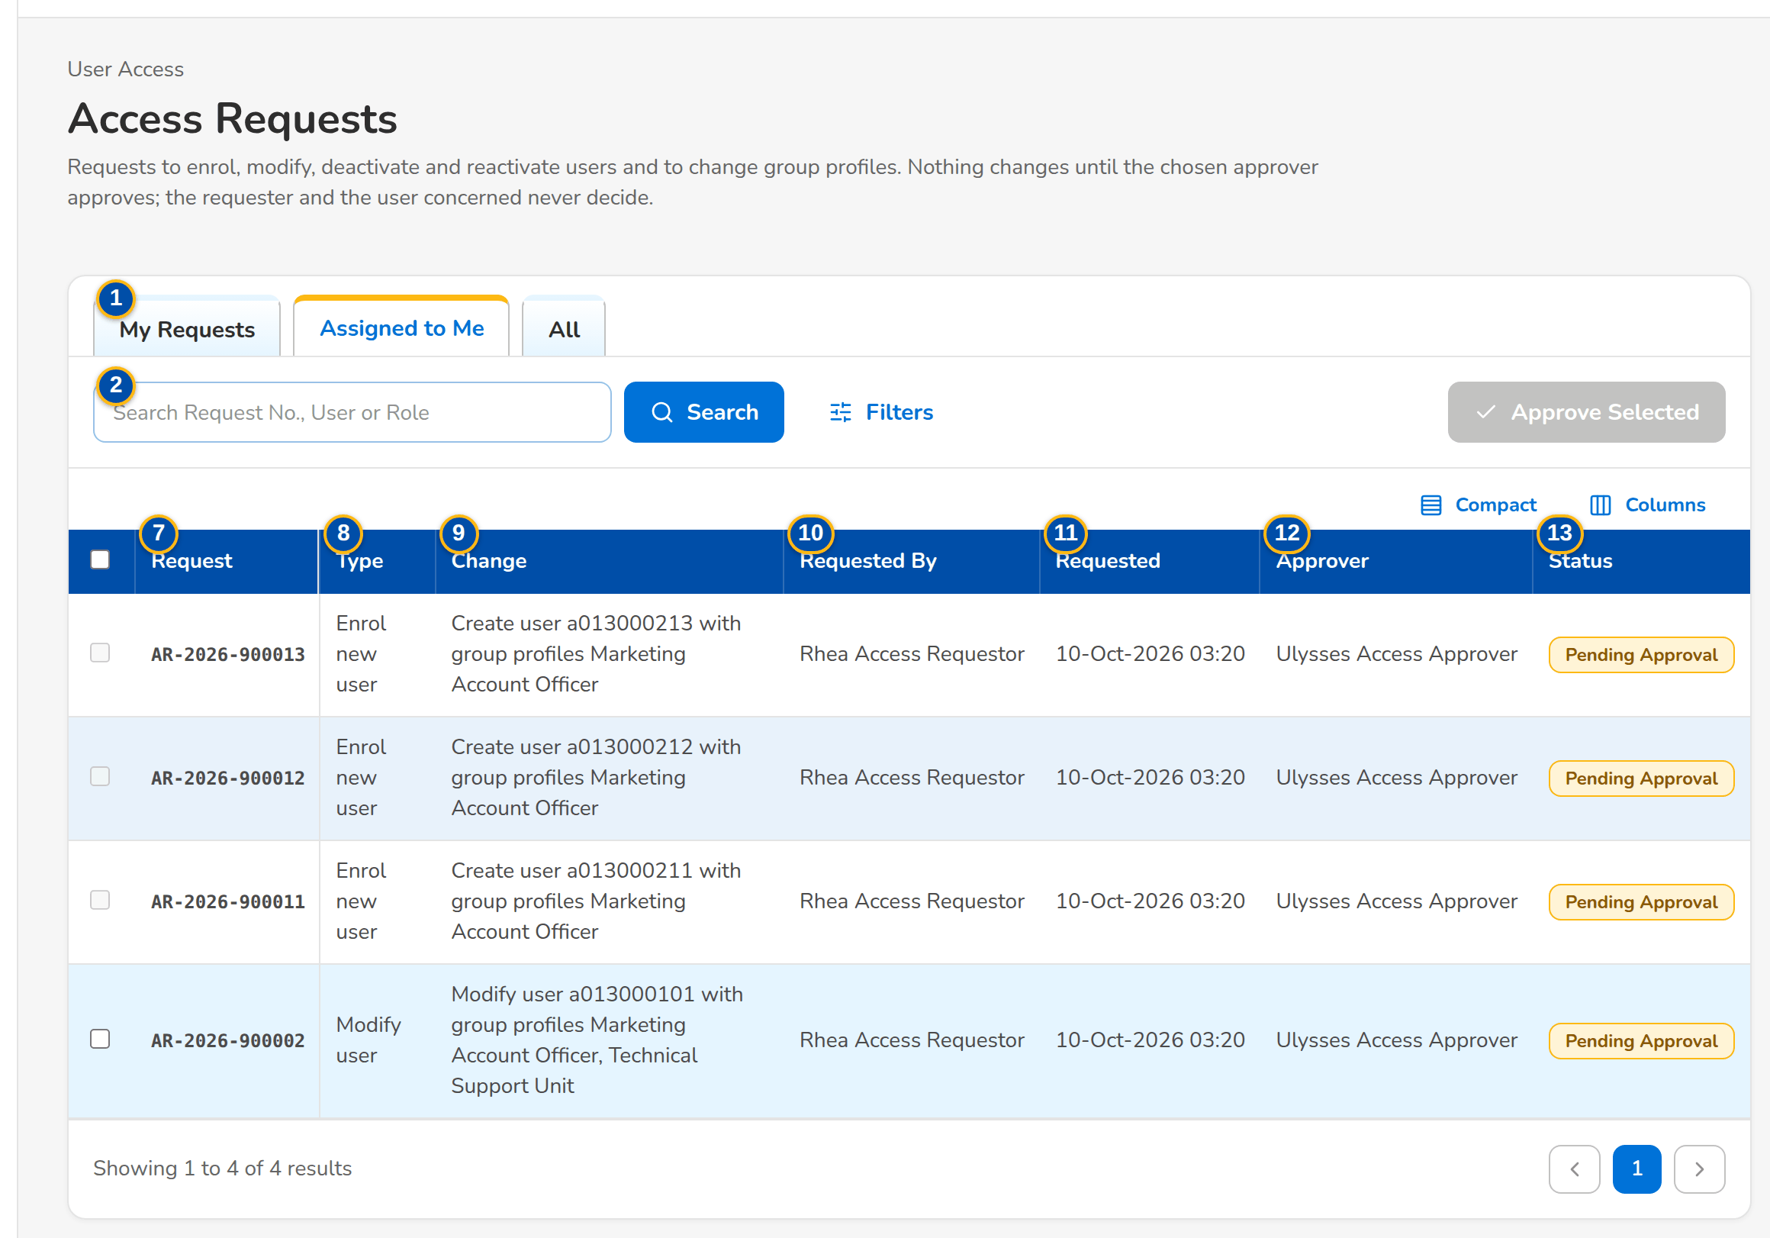
Figure J.7: Access Requests of the Approver, Assigned to Me tab
Field | Type | Mandatory | Format / list / source | Validation and message
Tabs: My Requests / Assigned to Me / Second Approval / For Implementation / All | Tab | - | Fixed; a tab is shown only to the users who work it | My Requests: raised by the user; Assigned to Me: waiting for the user (approval right); Second Approval: waiting for a second approval (second approval right); For Implementation: approved group-profile requests (role management right); All: every request the user may see
Search: Search Request No., User or Role | Text | N | Part of a request number, user ID or group profile | Contains search
Filters: Status | Drop-down | N | All, Draft, Pending Approval, Pending Second Approval, Returned, Scheduled, Approved, For Implementation, Implemented, Rejected, Cancelled; Fixed list | -
Filters: Request Type | Drop-down | N | All, Enrol new user, Modify user, Deactivate user, Reactivate user, Change roles, New group profile, Modify group profile, Deactivate group profile, Reactivate group profile; Fixed list | -
Filters: Requested By / Approver | Text | N | User ID | Exact user
Filters: Requested From / Requested To | Date | N | dd-MMM-yyyy | -
List: Request | Column | - | AR-yyyy-nnnnnn; Access request | -
List: Type | Column | - | Request type; Access request | -
List: Change | Column | - | One-line description with the names of the group profiles, for example Modify user a013000101 with group profiles Marketing Account Officer; Access request | -
List: Requested By | Column | - | Name of the requester; Access request | -
List: Requested | Column | - | dd-MMM-yyyy HH:mm; Access request | -
List: Approver | Column | - | Name of the chosen approver, or of the decider; Access request | -
List: Status | Column | - | Status pill; Access request | -
List: [Select] | Check box | N | One per row on Assigned to Me and Second Approval; disabled on a new-user request, with the tooltip Open the request to approve it: the temporary password of the new user is shown only once | -

Action | Who | Available when | What happens | Resulting status
New Request | Requestor, Business Administrator, System Administrator (enrol, modify, deactivate or reactivate right) | Always | Opens New Request (SCR-UA-07) | -
Approve Selected | Approver on Assigned to Me; Second Approver on Second Approval | Rows selected | Approves each selected request in turn, with the same rules as one approval; a new-user request cannot be selected. Toast: n request(s) approved | Approved, Scheduled, Pending Second Approval or For Implementation
Filters | Every user of the screen | Always | Shows or hides the filters | -
[Open a row] | Every user of the screen | Always | Opens the request (SCR-UA-08) | -

Rules:
- A draft is seen only by its creator. Holders of the approval, user management or audit right (Approver, New Business Approver, System Administrator, Business Administrator, Auditor, Information Security Officer) see every submitted request; the others see the requests they raised and those waiting for them (FRUM.007.03, FRUM.009.09).
- Assigned to Me lists the pending requests whose chosen approver is the user; when the any-approver setting is on, every approver sees every pending request (FRUM.010.01, FRUM.009.06).
- An enrolment is approved on its own, on the request, so that its temporary password is shown: its row cannot be selected here, and My Approvals refuses it among several: Approve <reference> on its own: the new user's temporary password is shown once (FRUM.002.01, FRUM.010.02).

J.8 New Request and Edit Request (user requests) (SCR-UA-07)
Purpose: One form for the four user requests: enrol a new user, modify a user (data and group profiles), deactivate and reactivate a user. The requester enters the user, the new values with the current ones shown beside them, the group profiles, the effective date, the approver and the justification; saves a draft to finish later or submits it. A returned request is corrected here and resubmitted with correction remarks.
Access: Access Requests › New Request; Access Request record › Edit Request (draft or returned request); Users › Raise Request, or a user row (opens a Modify user request for that user)
Requirements: FRUM.002.01, FRUM.003.01, FRUM.003.02.01, FRUM.003.02.02, FRUM.006.03, FRUM.009.01, FRUM.009.02, FRUM.009.03, FRUM.009.04, FRUM.009.05, FRUM.009.06, FRUM.009.07, FRUM.009.10, FRUM.012.01
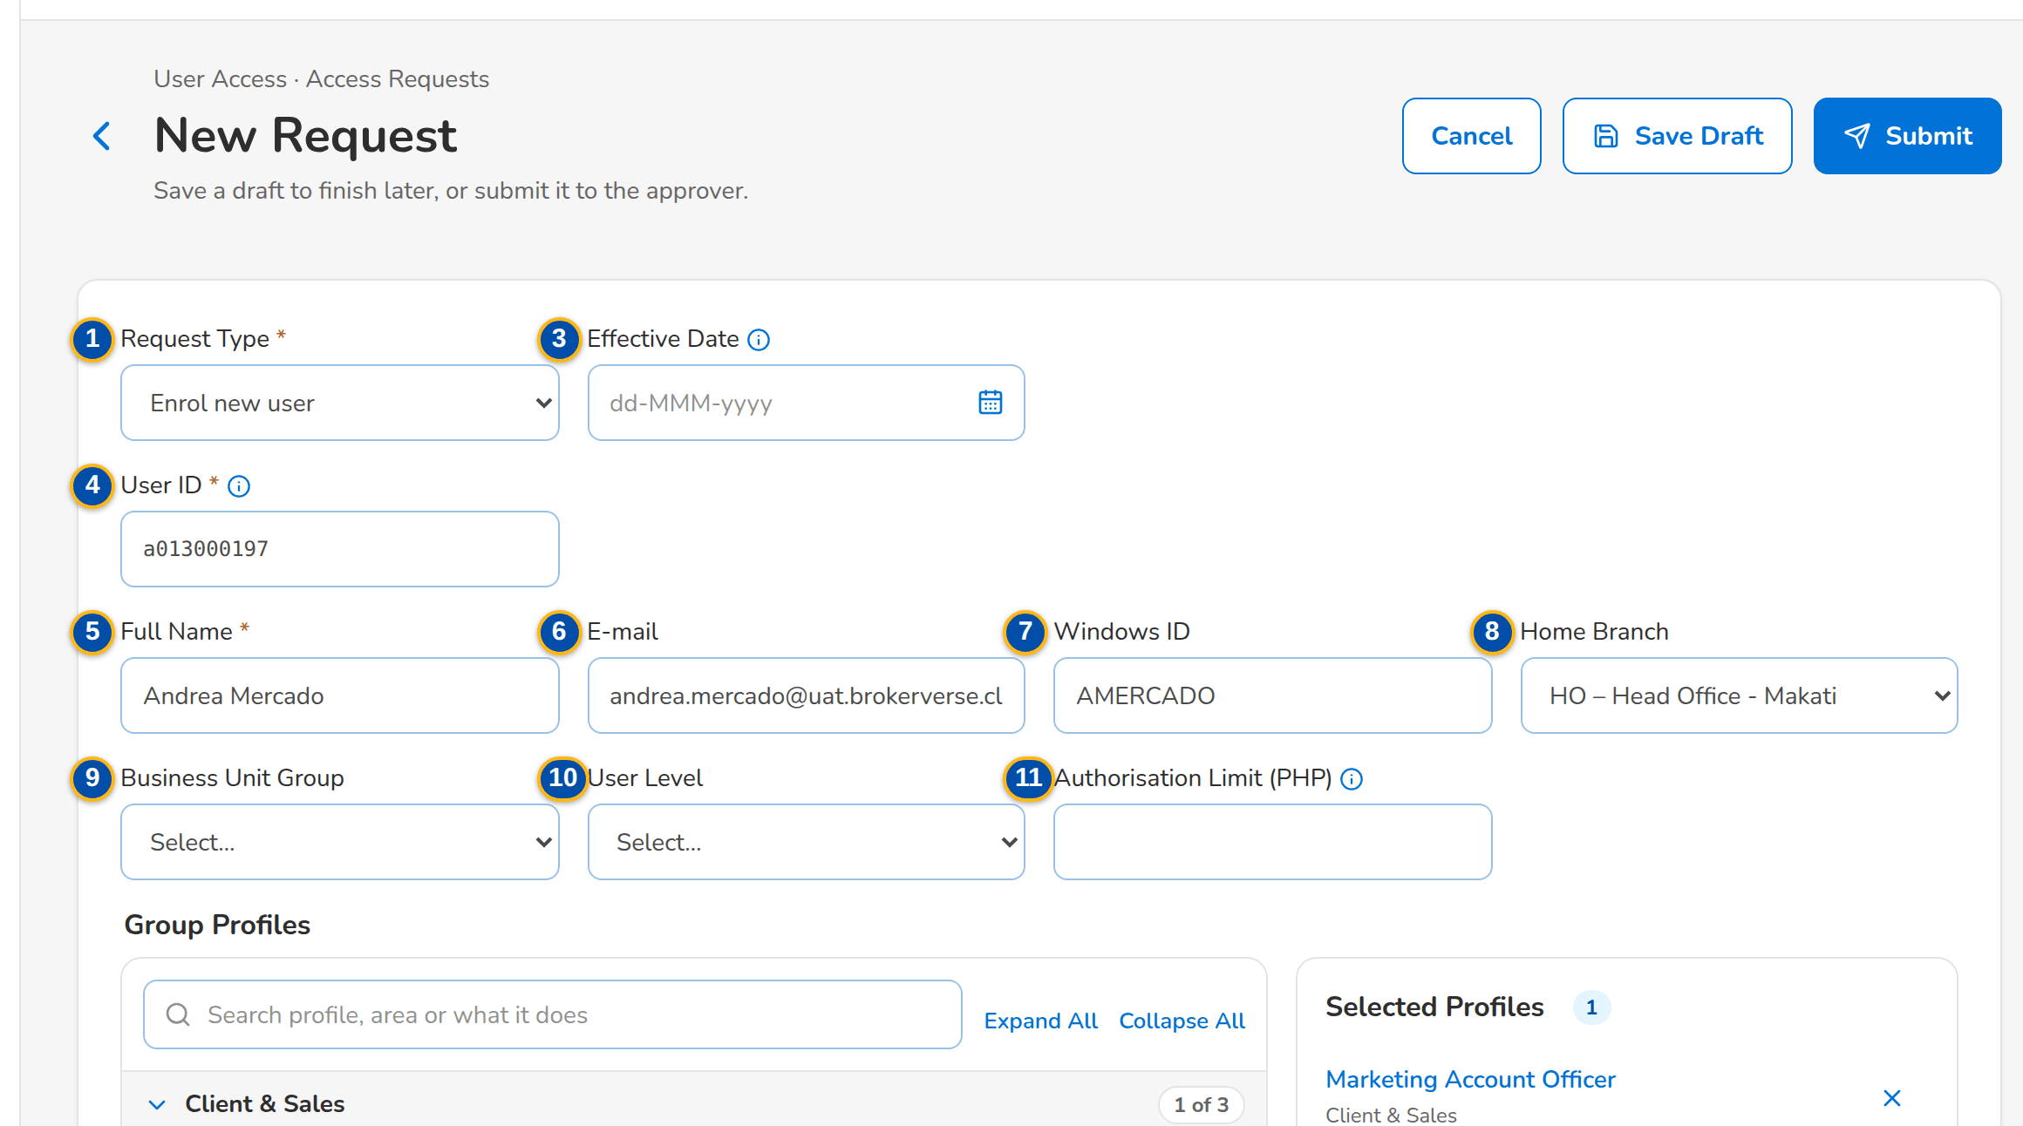
(continued below)
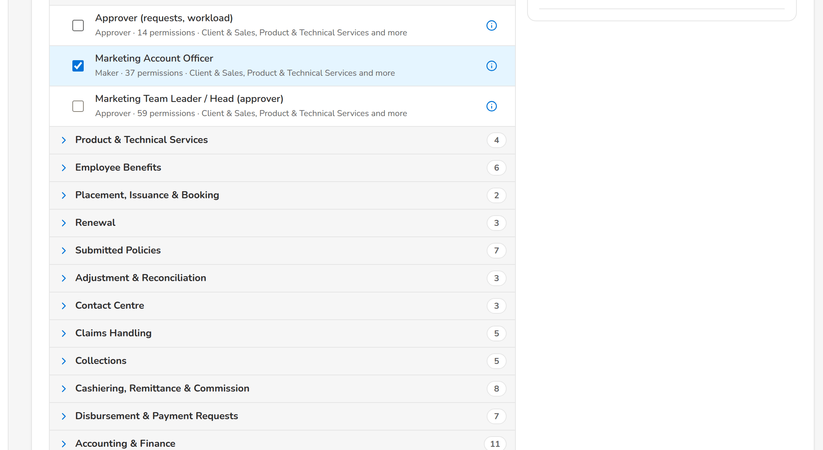
(continued below)
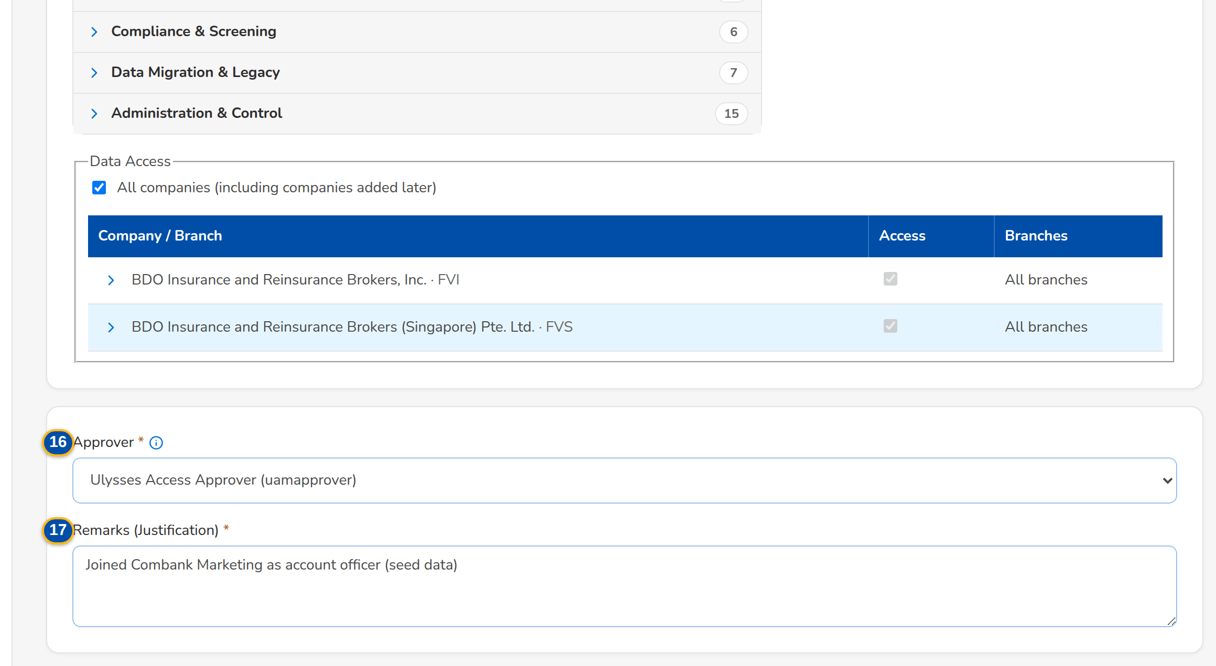
Figure J.8: New Request with the new user's data, group profile and approver
Field | Type | Mandatory | Format / list / source | Validation and message
Request: Request Type | Drop-down | Y | Enrol new user, Modify user, Deactivate user, Reactivate user; Fixed list | The type of a saved request cannot change; The type of request <request no> cannot change
Request: User Type | Drop-down | Y | Internal (the system user); External (portal user); Fixed list | Not shown while the external users setting is false (no portal installed, as delivered); every request is then for an internal user; Requests for external (portal) users are switched off: no portal is installed
Request: Effective Date | Date | N | dd-MMM-yyyy; blank = applies on approval | Today or later; The effective date cannot be before today
User: User ID | Text (new user); Drop-down (existing user) | Y | 3 to 50 letters, digits, dots, dashes or underscores; a new user ID in the BDOI format, shown in words under the field (BDOI format: a letter followed by nine digits, for example a013000196); User master (existing users: user ID – name (Windows ID)) | A new user ID must not exist and must follow the format; an existing user must be active to deactivate and deactivated or locked to reactivate; Use 3 to 50 letters, digits, dots, dashes or underscores; The user ID must be a letter followed by nine digits, for example a013000196
User data: Full Name | Text | Cond.: enrolment | Up to 120 characters; Current: value shown for a modification; User master | Not blank for a new user; Enter the full name of the new user
User data: E-mail | E-mail | N | Up to 120 characters; User master | -
User data: Windows ID | Text | N | Up to 120 characters; unique; User master | Not the Windows ID of another user; Windows ID <windows id> belongs to another user
User data: Home Branch | Drop-down | N | Code – name; Not specified (new) or Unchanged (modify); Branches | -
User data: Business Unit Group | Drop-down | N | Values of the list; List the business unit group list (values from BDOI) | -
User data: User Level | Drop-down | N | Values of the list; List the user level list (values from BDOI) | -
User data: Authorisation Limit (PHP) | Amount | N | Zero or more with up to 2 decimals; Blank: no limit (new) or Current: amount (modify); User master | Zero or more, 2 decimals; Enter an amount of zero or more, with up to 2 decimals
Group Profiles: Search group profiles | Text | N | Part of a profile name, code or module | The chosen profiles stay listed
Group Profiles: profile picker | Picker | Cond.: enrolment (at least one) | Active group profiles grouped by business area, in groups that open and close with their counts; search by profile, area or what the profile does; each profile with a one-line description, a details button (key permissions, kind, level) and the marker Privileged for High and Admin profiles; the chosen profiles listed apart, marked Current, Added or Removed for a modification and removable one by one | Active profiles only; a user cannot change his own profiles; two chosen profiles of an active separation-of-duties rule are flagged with a warning in the picker and refused on Submit; Select at least one role; One user may not hold both <profile> and <profile> (separation-of-duties rule <rule>)
Deactivation: Reason | Drop-down | N | Resigned, Transferred to another unit, Long leave, Security, Others, No sign-in for the dormancy period (values to confirm with BDOI); List the deactivation reason list | -
Reactivation: Also unlock the account | Check box | N | Shown when the user is locked | -
Approval: Approver | Drop-down | Y | Name (user ID) of each eligible approver; Holders of the approval right, less the requester and the user concerned | An eligible approver; one approver for a user request; Select the approver
Approval: Remarks (Justification) | Text area | Y | Up to 1,000 characters | Not blank on submission; Enter the justification
Approval: Correction Remarks | Text area | Cond.: resubmission | Up to 1,000 characters; shown for a returned request | Not blank on resubmission; Enter the correction remarks

Action | Who | Available when | What happens | Resulting status
Cancel | The requester | Always | Leaves the form without saving | Unchanged
Save Draft | Requestor, Business Administrator, System Administrator (type right) | User ID in a valid format; effective date not in the past | Saves the draft with format checks only; a new request is numbered AR-yyyy-nnnnnn. Toast: AR-yyyy-nnnnnn saved as a draft | Draft (new); unchanged (edit)
Submit | As Save Draft | Every field check passes | Runs the full checks (user state, format, active profiles, free Windows ID, one open request per user, eligible approver), evaluates the risk rules and sends the request to the approver. Toast: AR-yyyy-nnnnnn submitted | Pending Approval
Resubmit | The requester (correction right) | Returned request with correction remarks | Resubmits the corrected request to the approver | Pending Approval

Rules:
- The type and the user of a saved request cannot change; a different change is a new request (FRUM.009.01).
- Only one request per user can be open (draft excluded) at a time: A request for user <user> is already waiting for approval (FRUM.009.01).
- A new user ID must follow the user ID format (a letter followed by nine digits as delivered, shown in words from the user ID format in words) and must not exist (FRUM.002.01, FRUM.009.02, FRUM.002.01, FRUM.002.03).
- The group profiles of the user must not include both profiles of an active separation-of-duties rule; the check runs on submission and again at approval (FRUM.006.03, FRUM.012.01).
- The authorisation limit (used by the journal and payables approvals) is set on an enrolment and changed by a Modify user request; blank keeps the current limit (FRUM.002.01, FRUM.009.02, FRUM.003.01, FRUM.009.03).
- An enrolment needs the full name and at least one active group profile; a modification must change something: The request does not change the user (FRUM.002.01, FRUM.009.02, FRUM.003.01, FRUM.009.03).
- Only active users are deactivated and only deactivated or locked users are reactivated; a locked user can be unlocked with the reactivation (FRUM.003.02.01, FRUM.009.04, FRUM.003.02.02, FRUM.009.05).
- The approver is chosen among the holders of the approval right, never the requester nor the user the request is about; a user request has one approver (FRUM.009.06).
- A user cannot change his own group profiles through a request: You cannot change your own roles (FRUM.003.01, FRUM.009.03).
- An effective date in the future makes the approved change wait until that date; blank applies it on approval (FRUM.009.10).
- A returned request is corrected by its creator and resubmitted with correction remarks, kept in the history (FRUM.009.07).

J.9 Access Request record (SCR-UA-08)
Purpose: One access request: its number, type and subject, status and risk flags, who requested it and when, the approver, the effective date and the decision; the tabs Details (current and requested values), Approvers (in order, with each decision) and History (every event with its remarks); and the actions the viewer may take: edit, cancel, approve, give the second approval, return, reject or implement.
Access: Access Requests or Group Profile Requests › a row; My Approvals › an access request; The notices of the request (to approve, returned, decided, for second approval, to implement); Bulk Request Batch › a line
Requirements: FRUM.002.01, FRUM.005.01, FRUM.005.04, FRUM.006.01, FRUM.007.03, FRUM.008.01, FRUM.008.04, FRUM.009.08, FRUM.009.09, FRUM.010.01, FRUM.010.02, FRUM.010.03, FRUM.010.04, FRUM.010.05
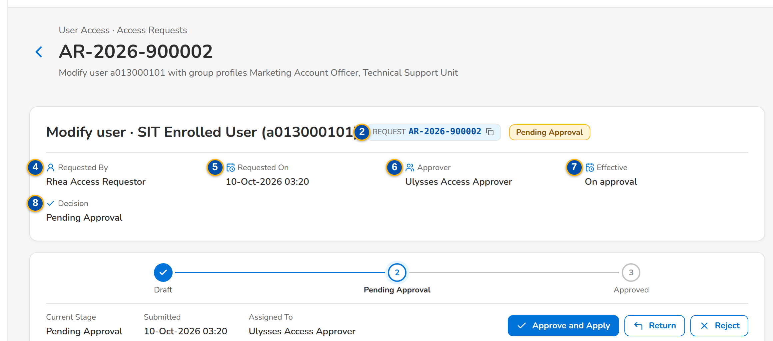
(continued below)
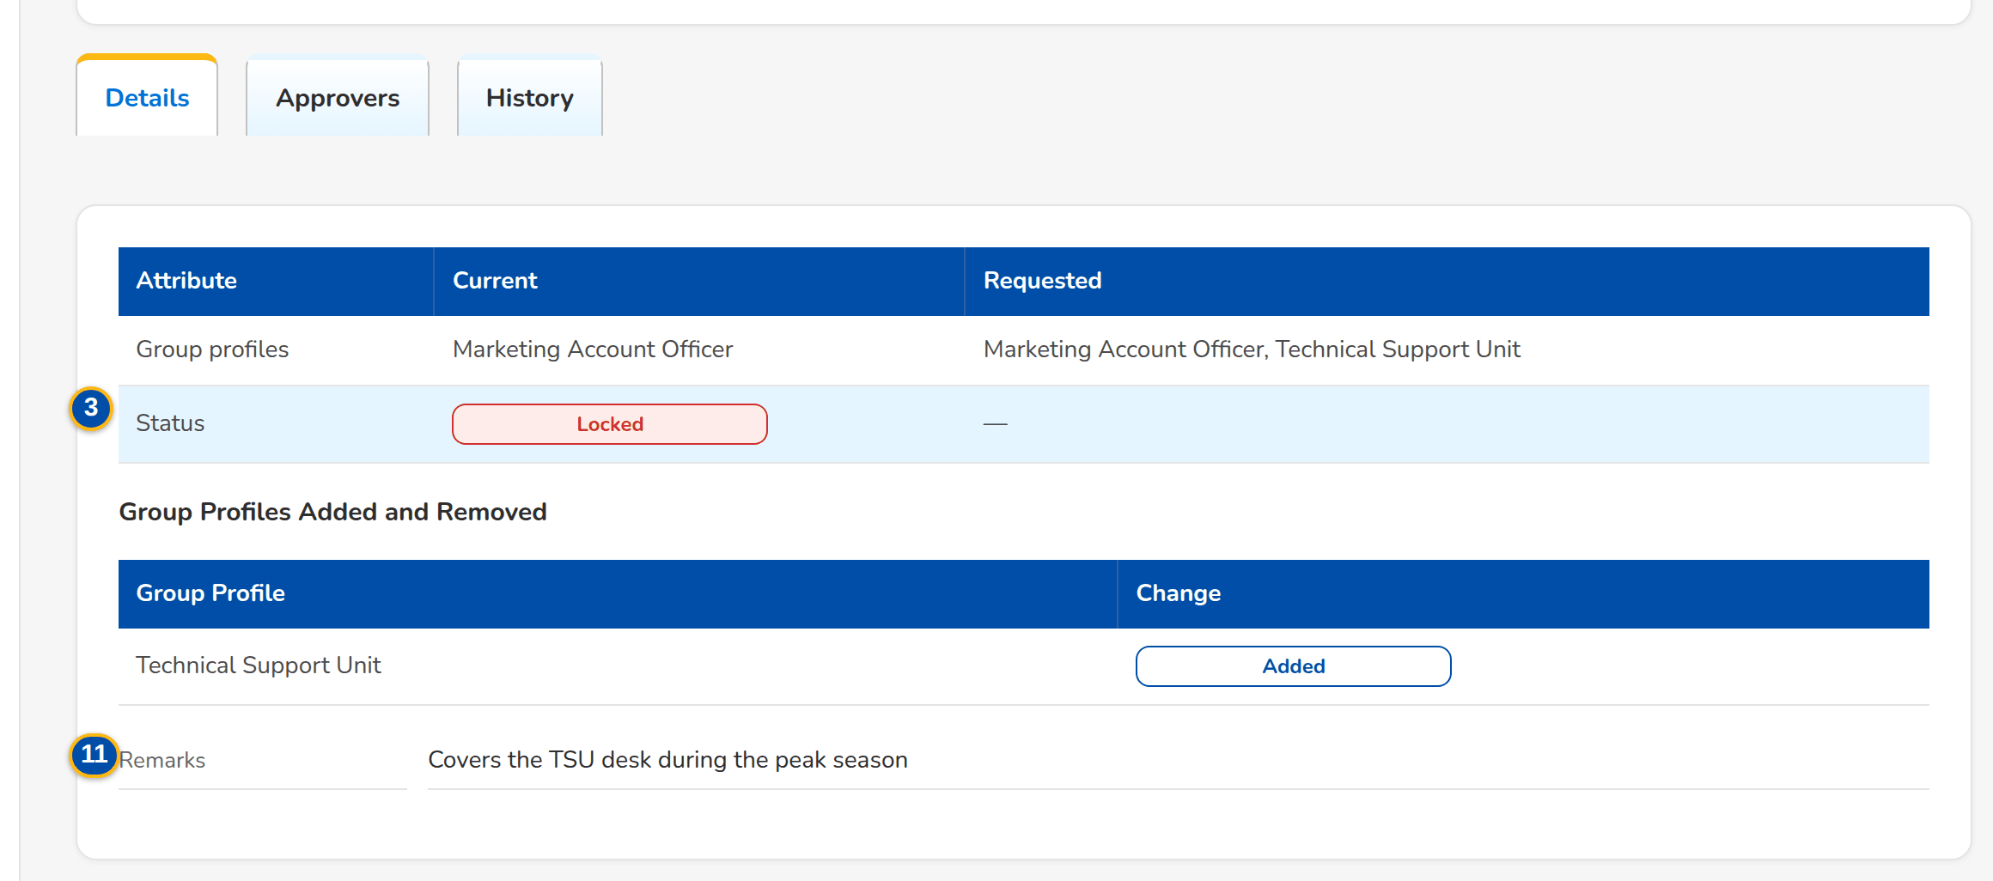
Figure J.9: A request waiting for the Approver, Details tab
Field | Type | Mandatory | Format / list / source | Validation and message
Summary: [Title] | Text | - | Request type · full name of the user with the user ID in brackets, or group profile name; Access request | -
Summary: Request | Reference chip | - | AR-yyyy-nnnnnn; Access request | -
Summary: [Status and risk flags] | Pill and tags | - | Status; Privilege increase, Outside working hours; Access request | -
Summary: Requested By | Text | - | Name of the requester; Access request | -
Summary: Requested On | Date and time | - | dd-MMM-yyyy HH:mm; Access request | -
Summary: Approver | Text | - | Name of the chosen approver or of the decider; Chosen on submission for a draft; Access request | -
Summary: Effective | Date | - | dd-MMM-yyyy, or On approval; Access request | -
Summary: Decision | Text | - | Pending Approval, or name · dd-MMM-yyyy HH:mm – comment; Access request | -
Details: Attribute / Current / Requested | Table | - | Full name, E-mail, Windows ID, Business unit, User level (list labels), Authorisation limit, Group profiles by name, Status; for a group profile: Group profile (name), Name, Description, Privilege level, Permissions added, Permissions removed (permission names); User or group profile; access request | -
Details: Group Profile / Change | Table | - | One row per group profile the request adds (Added) or removes (Removed), by name; User and access request | -
Details: Remarks / Effective date / Reason / Members / Could not be applied | Text | - | Justification; effective date (dd-MMM-yyyy); deactivation reason (list label); members of a profile to deactivate; the error of a scheduled change that failed; Access request | -
Approvers: Order / Approver / Decision / Remarks / Decided | Table | - | One row per approver in order; Approvers of the request | -
History: Date / Action / Status / By / Remarks | Table | - | Every event: saved, submitted, returned, resubmitted, cancelled, approved, second approval, rejected, scheduled, applied, failed to apply, for implementation, implemented; Request history (insert only) | -
Dialogs: Comment / Remarks / Reason | Text area | Cond.: Return, Reject, Cancel | Up to 1,000 characters | Not blank for a return, rejection or cancellation; Enter the remarks

Action | Who | Available when | What happens | Resulting status
Edit Request | The creator (correction right for a returned request) | Draft or Returned | Opens Edit Request (SCR-UA-07) | Unchanged
Cancel Request | The creator (cancel right); the approver of a scheduled request | Draft, Pending Approval, Pending Second Approval, Returned or Scheduled | Asks the reason and cancels the request; it is kept, never deleted | Cancelled
Approve and Apply | The chosen approver (approval right), not the requester nor the user concerned | Pending Approval | Applies the change now, schedules it for the effective date, passes it to the next approver in order, sends it for a second approval when a risk flag is found, or (group profile) sends it to the System Administrator. For an enrolment, shows the temporary password once | Approved, Scheduled, Pending Approval, Pending Second Approval or For Implementation
Second Approval | A second approver who did not give the first approval | Pending Second Approval | Applies, schedules or sends for implementation as above | Approved, Scheduled or For Implementation
Return | The deciding approver | Pending Approval or Pending Second Approval | Asks the remarks and returns the request to the requester for correction | Returned
Reject | The deciding approver | Pending Approval or Pending Second Approval | Asks the reason and closes the request; a rejection is final | Rejected
Implement Request | System Administrator (role management right), not the requester | For Implementation | Applies the approved group-profile change now | Implemented

Rules:
- The requester and the user the request is about never decide it: A request cannot be decided by the user who submitted it; You cannot decide a request about your own access (FRUM.002.01, FRUM.010.02).
- Only the approver chosen by the requester decides a pending request: Request <request no> is assigned to <approver> for approval (FRUM.009.06, FRUM.002.01, FRUM.010.02).
- A request that gives a High or Admin group profile, creates or raises a profile to High or Admin, reactivates a High or Admin profile, or is submitted or approved outside the working hours (the working hours, 08:00-18:00 Monday to Friday as delivered) needs a second approval by another approver and raises an alert (FRUM.010.05).
- Return and rejection need a text; the requester receives it with the notice (FRUM.010.03, FRUM.010.04).
- The temporary password of a new user is shown once to the approver, never stored in clear and never e-mailed; the user must change it at the first sign-in (FRUM.002.01, FRUM.009.02, FRUM.002.01, FRUM.010.02).
- A scheduled request is re-checked and applied by the daily job on its effective date; if it can no longer be applied it stays scheduled with the reason and an alert is raised (FRUM.009.10).
- Every applied change writes the access change log with the from and to values, the request number, the approver and the time; the history cannot be changed (FRUM.008.01, FRUM.008.04).

J.10 Bulk Request (SCR-UA-09)
Purpose: Many user requests in one file: the requester downloads the template, fills in one row per user (enrol, modify, deactivate or reactivate), uploads it and reviews the check of every row; the valid rows become the draft lines of a batch, which is submitted to one approver from the batch page. The list shows the batches.
Access: Setup & Administration › User Access › Bulk Request
Requirements: FRUM.011.01
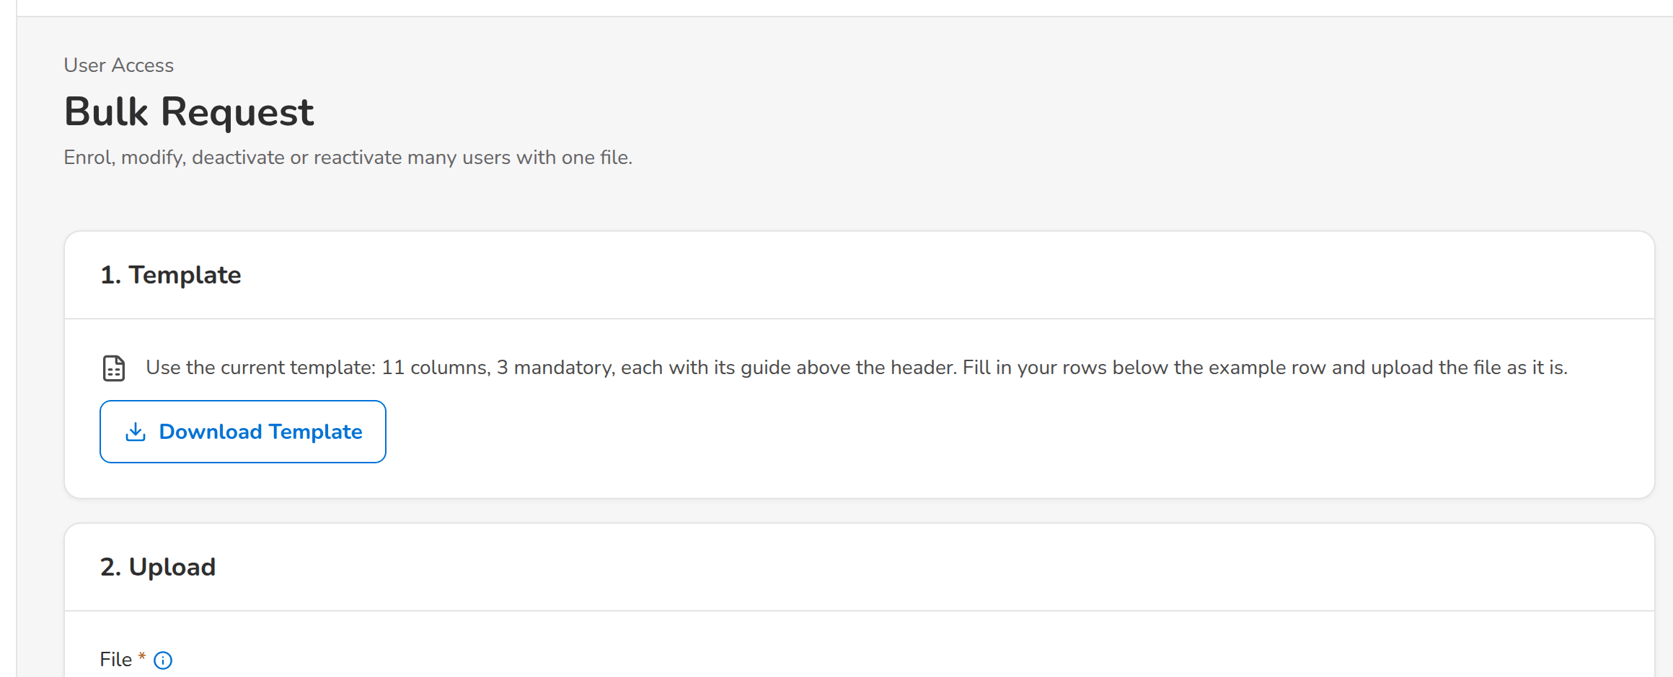
(continued below)
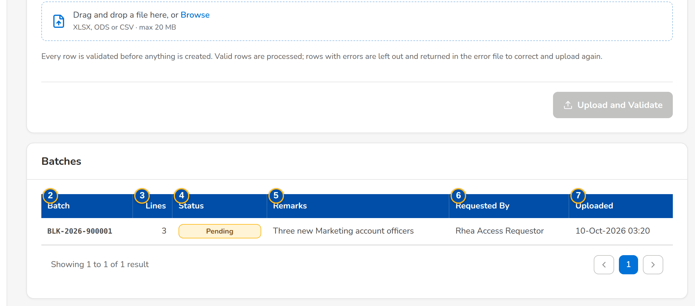
Figure J.10: Bulk Request with the upload wizard and the batches
Field | Type | Mandatory | Format / list / source | Validation and message
Upload: [Upload wizard] | Upload | Y | Template Bulk access requests (Excel); see Upload screens; Upload template | File checks; every row checked as a request
Batches: Batch | Column | - | BLK-yyyy-nnnnnn; Bulk batch | -
Batches: Lines | Column | - | Number of lines; Bulk batch | -
Batches: Status | Column | - | Draft, Pending Approval, Returned, Approved, Rejected, Cancelled; Bulk batch | -
Batches: Remarks | Column | - | Batch remarks; Bulk batch | -
Batches: Requested By | Column | - | Name; Bulk batch | -
Batches: Uploaded | Column | - | dd-MMM-yyyy HH:mm; Bulk batch | -

Action | Who | Available when | What happens | Resulting status
[Upload and commit the file] | Requestor, Business Administrator, System Administrator (enrol or modify right, and bulk upload right) | A file of the template is chosen | Checks every row; the valid rows are saved as the draft lines of a new batch. Toast: Batch BLK-yyyy-nnnnnn saved as a draft | Draft batch
[Open a batch] | Every user of the screen | Always | Opens Bulk Request Batch (SCR-UA-10) | -

Rules:
- Each row is checked with the rules of a single request of its action, the separation-of-duties rules included; a row in error is reported with its message and is not saved (FRUM.011.01, FRUM.006.03, FRUM.012.01).
- The actions of the file are ENROL, MODIFY, DEACTIVATE and REACTIVATE; group profiles are listed by their codes separated by a semicolon (FRUM.011.01).

J.11 Bulk Request Batch (SCR-UA-10)
Purpose: One bulk batch: its lines with their status and error; the requester submits it to one approver with the batch remarks, or cancels it; the approver approves (each line applied on its own), returns or rejects it.
Access: Bulk Request › a batch
Requirements: FRUM.011.01
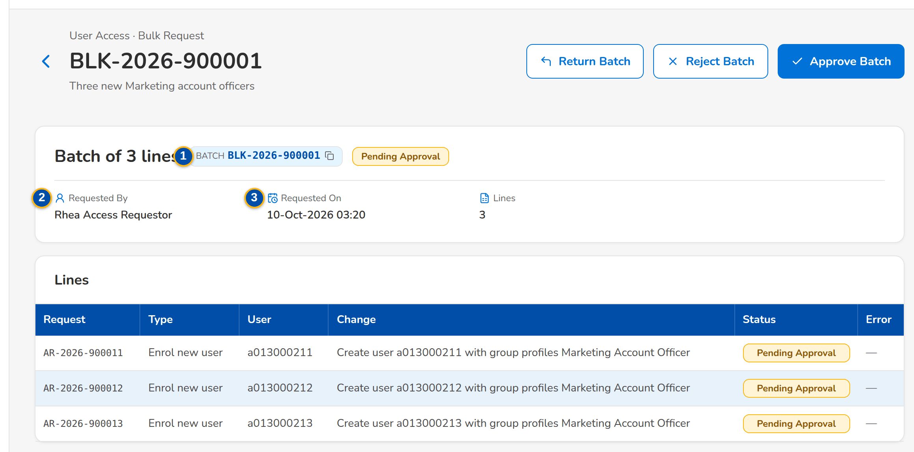
Figure J.11: The SIT/UAT batch of three lines waiting for the Approver
Field | Type | Mandatory | Format / list / source | Validation and message
Summary: Batch | Reference chip | - | BLK-yyyy-nnnnnn; Bulk batch | -
Summary: Requested By | Text | - | Name of the requester; Bulk batch | -
Summary: Requested On | Date and time | - | dd-MMM-yyyy HH:mm; Bulk batch | -
Lines: Request / Type / User / Change / Status / Error | Table | - | One access request per line; Line requests | -
Submit Batch: Approver | Drop-down | Y | Name (user ID) of each eligible approver; Holders of the approval right, less the requester | An eligible approver; Select the approver
Submit Batch: Remarks | Text area | Y | Up to 1,000 characters | Not blank; Enter the remarks

Action | Who | Available when | What happens | Resulting status
Submit Batch | The creator of the batch | Draft or Returned | Submits every draft line to the chosen approver with the batch remarks | Pending Approval
Approve Batch | The approver (approval right), not the creator | Pending Approval | Approves each line on its own; the outcome lists each line with its status or error and the temporary passwords of new users, shown once | Approved (lines applied, scheduled or for second approval)
Return Batch | The approver | Pending Approval | Returns the batch with the remarks | Returned
Reject Batch | The approver | Pending Approval | Rejects every line with the reason | Rejected
Cancel Batch | The creator of the batch | Draft, Returned or Pending Approval | Cancels every line with the reason | Cancelled
[Open a line] | Every user of the screen | Always | Opens the line's request (SCR-UA-08) | -

Rules:
- A batch is submitted only by its creator and decided by another user: Only the creator can submit batch <batch no> (FRUM.011.01).
- Each line is decided and applied on its own, with the checks and the risk rules of a single request; a line that needs a second approval waits for it (FRUM.011.01, FRUM.010.05).

J.12 Group Profile Requests (SCR-UA-11)
Purpose: The work list of the group-profile requests: new profiles, changes to the permissions, name, description or privilege level of a profile, and the deactivation and reactivation of a profile. The approvers decide in the order chosen by the requester; the System Administrator implements the approved request.
Access: The notice Access request AR-yyyy-nnnnnn to implement (System Administrator); Access Request record of a group-profile request › back arrow
Requirements: FRUM.005.01, FRUM.005.02, FRUM.005.03, FRUM.005.04, FRUM.006.01
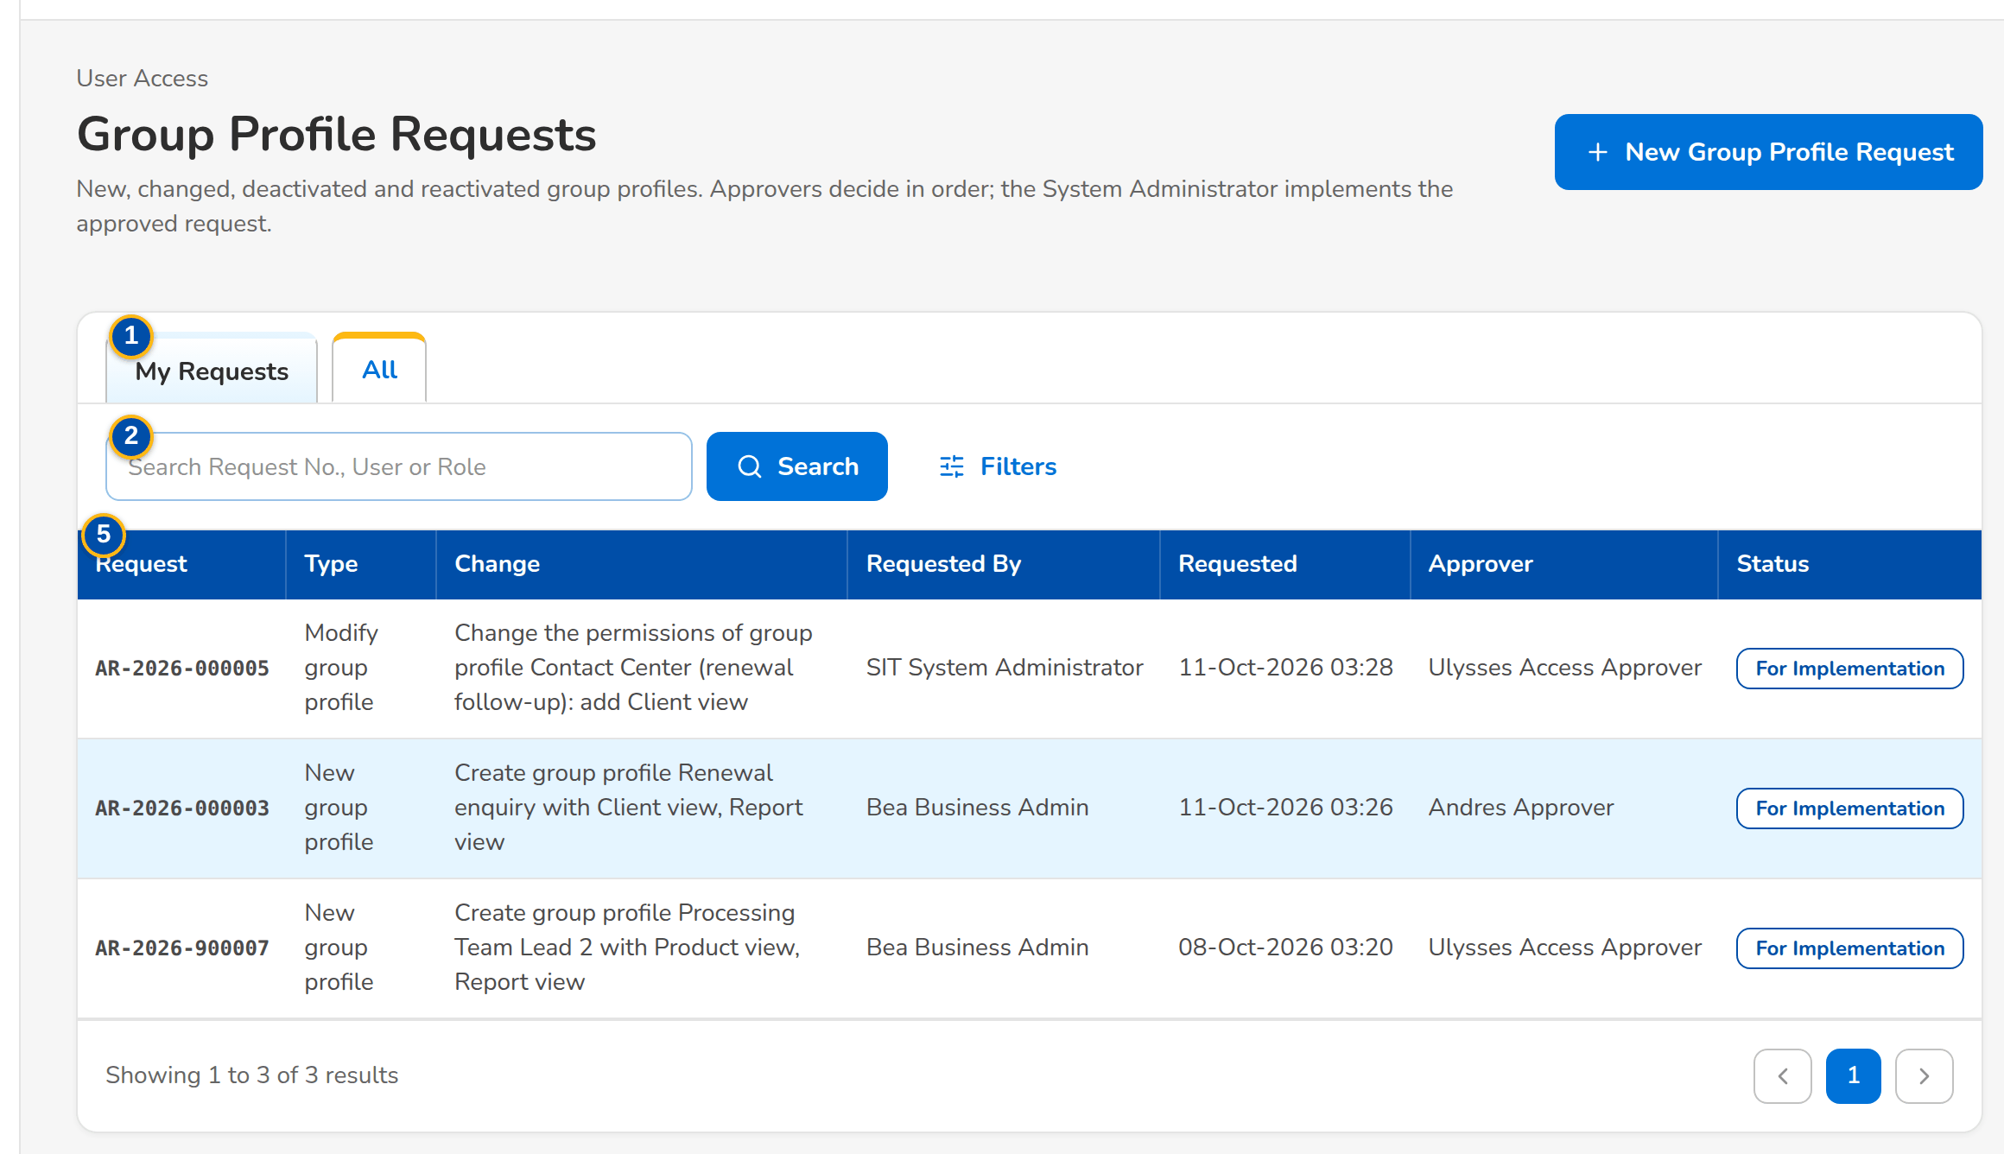
Figure J.12: Group Profile Requests of the Business Administrator, All tab
Field | Type | Mandatory | Format / list / source | Validation and message
Tabs: My Requests / Assigned to Me / Second Approval / For Implementation / All | Tab | - | Fixed; a tab is shown only to the users who work it | As Access Requests, limited to group-profile requests
Search: Search Request No., User or Role | Text | N | Part of a request number or group profile code | Contains search
Filters: Status | Drop-down | N | All and the request statuses; Fixed list | -
Filters: Request Type | Drop-down | N | All, New group profile, Modify group profile, Deactivate group profile, Reactivate group profile; Fixed list | -
List: Request / Type / Change / Requested By / Requested / Approver / Status | Columns | - | As Access Requests; Access request | -

Action | Who | Available when | What happens | Resulting status
New Group Profile Request | Business Administrator, System Administrator (group-profile request right) | Always | Opens New Request on the group-profile types (SCR-UA-12) | -
Approve Selected | Approver on Assigned to Me; Second Approver on Second Approval | Rows selected | Approves each selected request in turn | Pending Approval (next approver), Pending Second Approval or For Implementation
Filters | Every user of the screen | Always | Shows or hides the filters | -
[Open a row] | Every user of the screen | Always | Opens the request (SCR-UA-08) | -

Rules:
- Only one group-profile request per profile can be open at a time: A request for role <code> is already waiting for approval (FRUM.005.01, FRUM.005.02).
- Every approver in the list decides in turn; the request goes to the System Administrator only after the last approval (FRUM.005.01, FRUM.005.03).

J.13 New Group Profile Request and Edit Request (SCR-UA-12)
Purpose: The request form on the group-profile types. New group profile: code, name, description, privilege level and the permissions, chosen in the permission picker by business area. Modify group profile: the profile, the permissions it should hold after the change (added and removed shown against the current ones) and a new name, description or level. Deactivate and reactivate: the profile, with the members who lose its screens. Approvers are listed in order.
Access: Group Profile Requests › New Group Profile Request; Access Request record of a draft or returned group-profile request › Edit Request
Requirements: FRUM.001.02, FRUM.005.01, FRUM.005.02, FRUM.005.03, FRUM.005.06, FRUM.006.01, FRUM.006.02.01, FRUM.006.02.02, FRUM.006.03, FRUM.006.04, FRUM.007.03
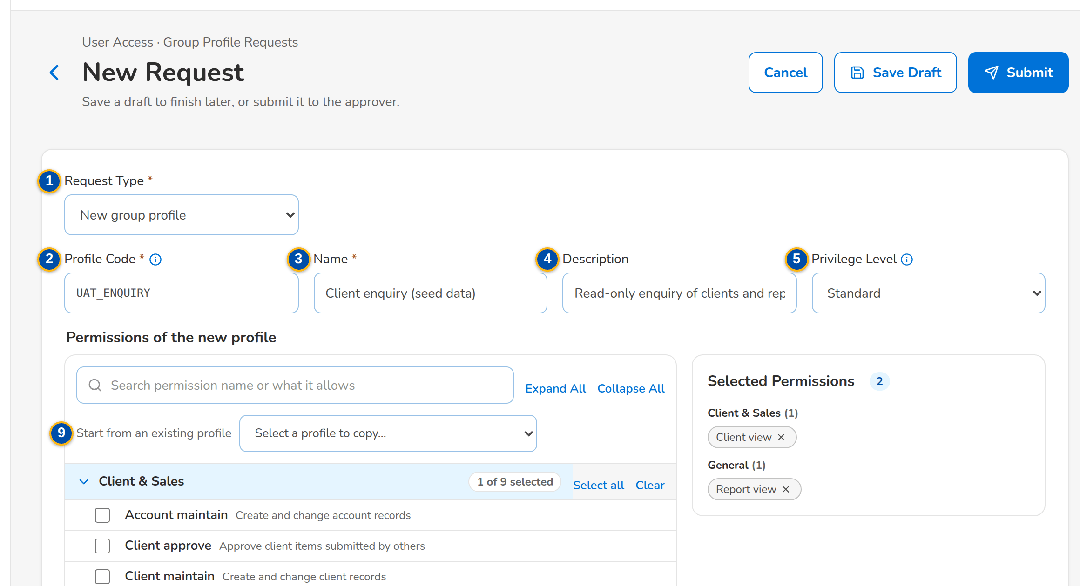
(continued below)
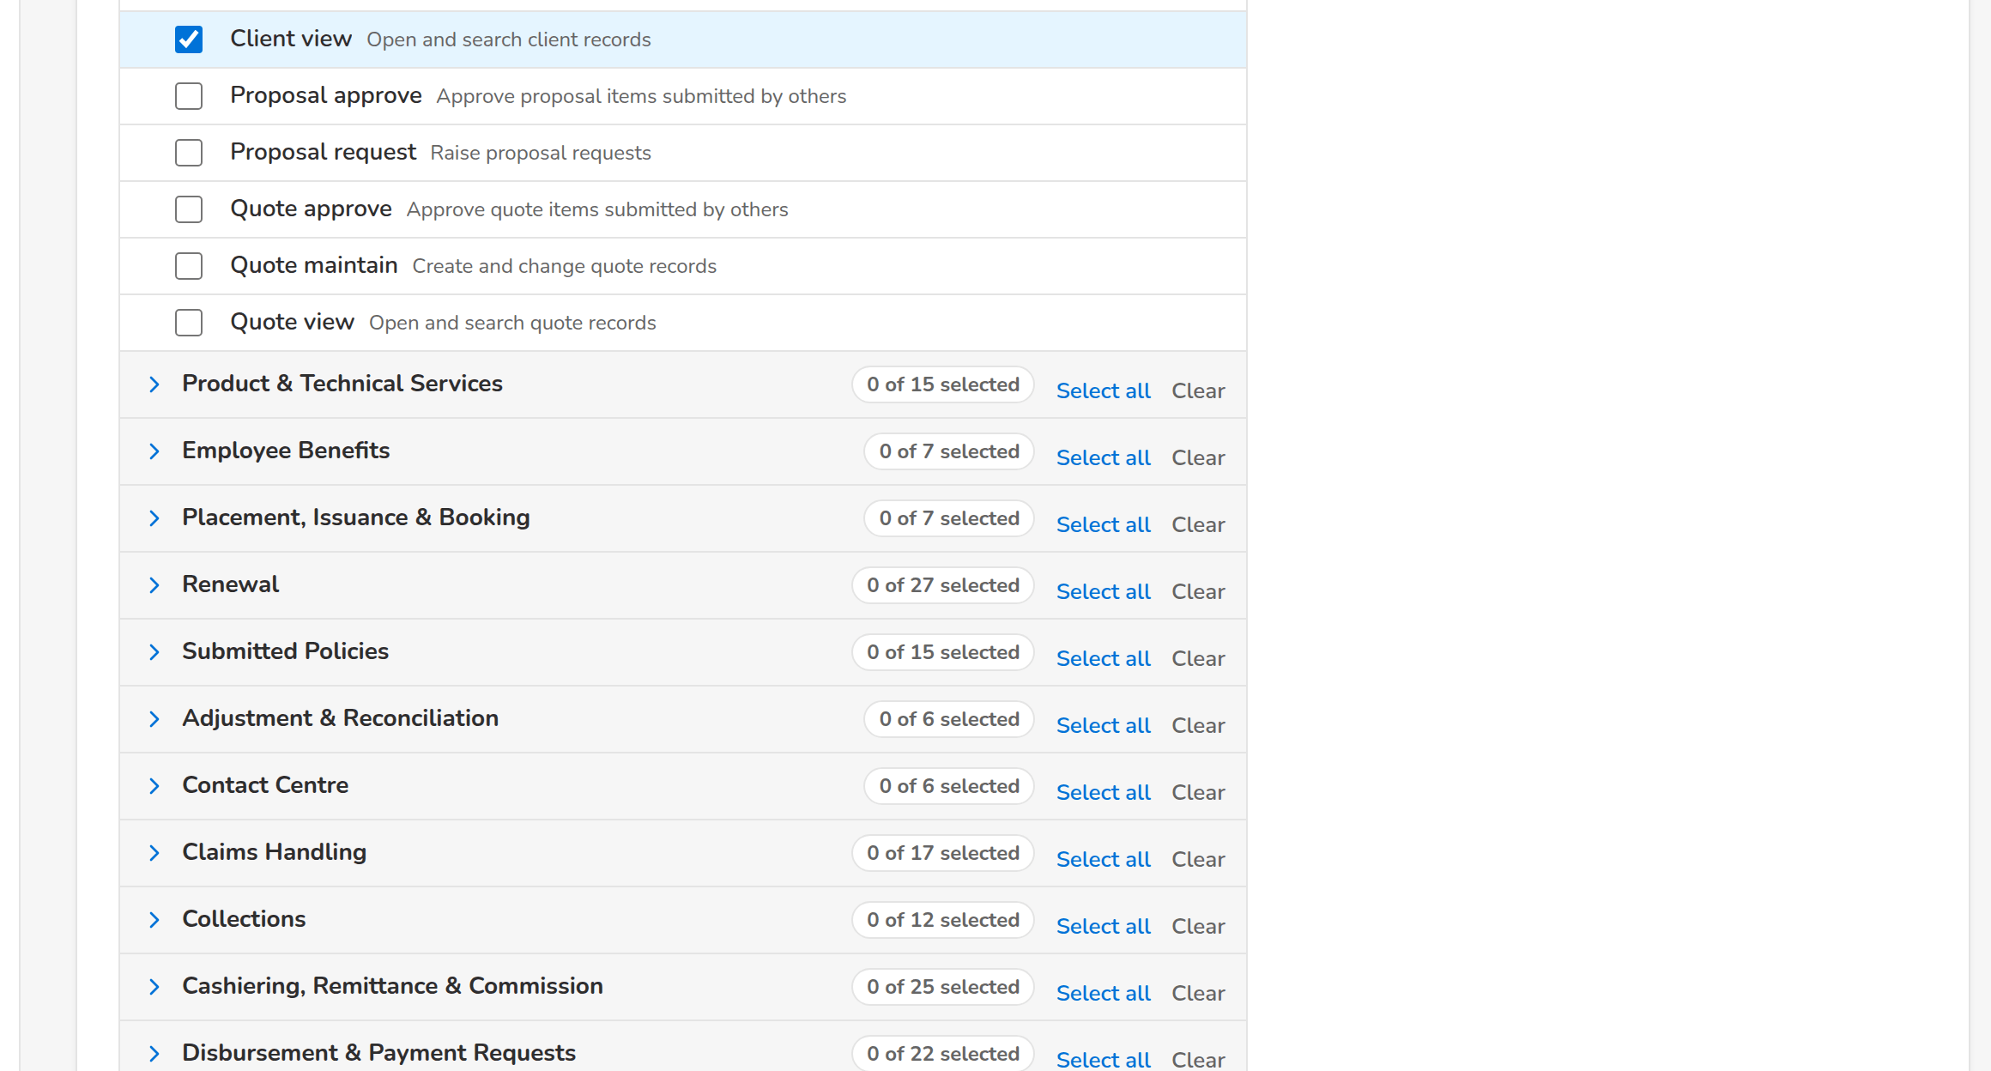
(continued below)
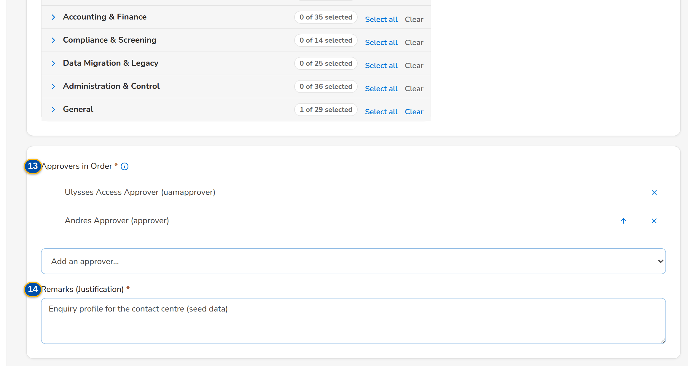
Figure J.13: New group profile with its permissions and two approvers in order
Field | Type | Mandatory | Format / list / source | Validation and message
Request: Request Type | Drop-down | Y | New group profile, Modify group profile, Deactivate group profile, Reactivate group profile; Fixed list | The type of a saved request cannot change; The type of request <request no> cannot change
New group profile: Profile Code | Text | Y | Up to 40 capital letters, digits or underscores (A-Z, 0-9 and _) | Format; not the system of an existing profile; Use up to 40 capital letters, digits or underscores
New group profile: Name | Text | Y | Up to 120 characters | Not blank; Enter the name of the group profile
Profile data: Description | Text | N | Up to 500 characters | -
Profile data: Privilege Level | Drop-down | N | Low, Standard, High, Admin; Standard (new) or Unchanged (modify) when blank; Fixed list | High and Admin profiles need a second approval
Modify / Deactivate / Reactivate: Group Profile | Drop-down | Y | Profile name; active profiles (modify, deactivate, the System Administrator profile excluded) or inactive profiles (reactivate); Group profiles | An existing profile in the right state; Select the role to change
Modify group profile: New Name | Text | N | Up to 120 characters | -
Permissions: [Permission picker by business area] | Check boxes in collapsible areas | Cond.: new profile (at least one); a change must add or remove one, or change the data | Left: the permissions by business area (User Access, Administration, Clients, Product Maintenance...), each area closed at first with n of m selected, Select all and Clear per area, Expand All and Collapse All, one search over the permission names and what each allows (the matching areas open); each permission by name with what it allows below. Right: Selected Permissions with the total, grouped by area, each removable; Permissions of the system, less the insurer-only permissions | Known permissions; not both added and removed; Select at least one permission
Permissions: Start from an existing profile | Drop-down | N | Active profile names; copies that profile's permissions into the selection (new group profile only); Group profiles | -
Permissions: Separation of duties / High privilege / Approval rights | Notice | - | Permissions of an active separation-of-duties rule chosen together, with the rule's reason; an administration permission (set the privilege level to Admin); an approving permission (consider the level High); Computed | -
Permissions: Added / Removed | Text | - | Under Selected Permissions: names of the permissions added and removed against the current ones, each with an undo; in the list the added and removed permissions are marked; Computed | A change must grant or withdraw at least one permission, or change the name, description or level; Grant or withdraw at least one permission
Deactivate group profile: [Members] | Warning | - | Members who lose the profile's screens, and are told when it is implemented: user IDs, or The profile has no members.; Users holding the profile | -
Approval: Approvers in Order | List and drop-down | Y | Name (user ID); arrows move an approver up; each approver decides in turn; Holders of the approval right, less the requester | At least one; eligible; no approver twice; Add at least one approver
Approval: Remarks (Justification) | Text area | Y | Up to 1,000 characters | Not blank on submission; Enter the justification

Action | Who | Available when | What happens | Resulting status
Save Draft | Business Administrator, System Administrator (group-profile request right) | Profile code or profile chosen | Saves the draft with format checks only | Draft
Submit | As Save Draft | Every field check passes | Runs the full checks, evaluates the risk rules and sends the request to the first approver in order | Pending Approval
Resubmit | The requester | Returned request with correction remarks | Resubmits the corrected request to the approvers | Pending Approval
Cancel | The requester | Always | Leaves the form without saving | Unchanged

Rules:
- A group-profile request has no effective date; it applies when the System Administrator implements it: An effective date applies to user requests; group profiles are implemented (FRUM.005.01, FRUM.005.02).
- The System Administrator profile cannot be deactivated: Group profile System Administrator cannot be deactivated (FRUM.006.02.01, FRUM.006.04).
- A deactivated profile grants nothing at once to its members and is no longer offered on requests; the members are listed on the request, a deactivation with members is allowed, and each member is told when the request is implemented, in the system and by e-mail (FRUM.006.02.01, FRUM.006.04, FRUM.006.02.02, FRUM.006.04).
- The insurer-only permissions and the insurer roles hidden from BDOI are neither listed nor accepted: Permission(s) not available in the system: <permissions> (FRUM.001.02, FRUM.005.01).
- Creating or raising a profile to High or Admin, and reactivating a High or Admin profile, need a second approval (FRUM.010.05).
- A change that lists too many permissions for one request is refused: Split the change into several requests (FRUM.006.01, FRUM.006.03).

J.14 User Access Matrix (SCR-UA-13)
Purpose: Every group profile against every permission as granted today, or against the functional areas and action classes (view only, create, amend, approve / validate) with the permissions behind each cell, with the number of active users of each profile, in one scroll area with the header row and the first column pinned. Read only; the Excel export holds both views.
Access: The old address Broking Setup › User Access Matrix opens this screen
Requirements: FRUM.001.02, FRUM.005.01, FRUM.005.06, FRUM.007.01, FRUM.007.02, FRUM.007.03
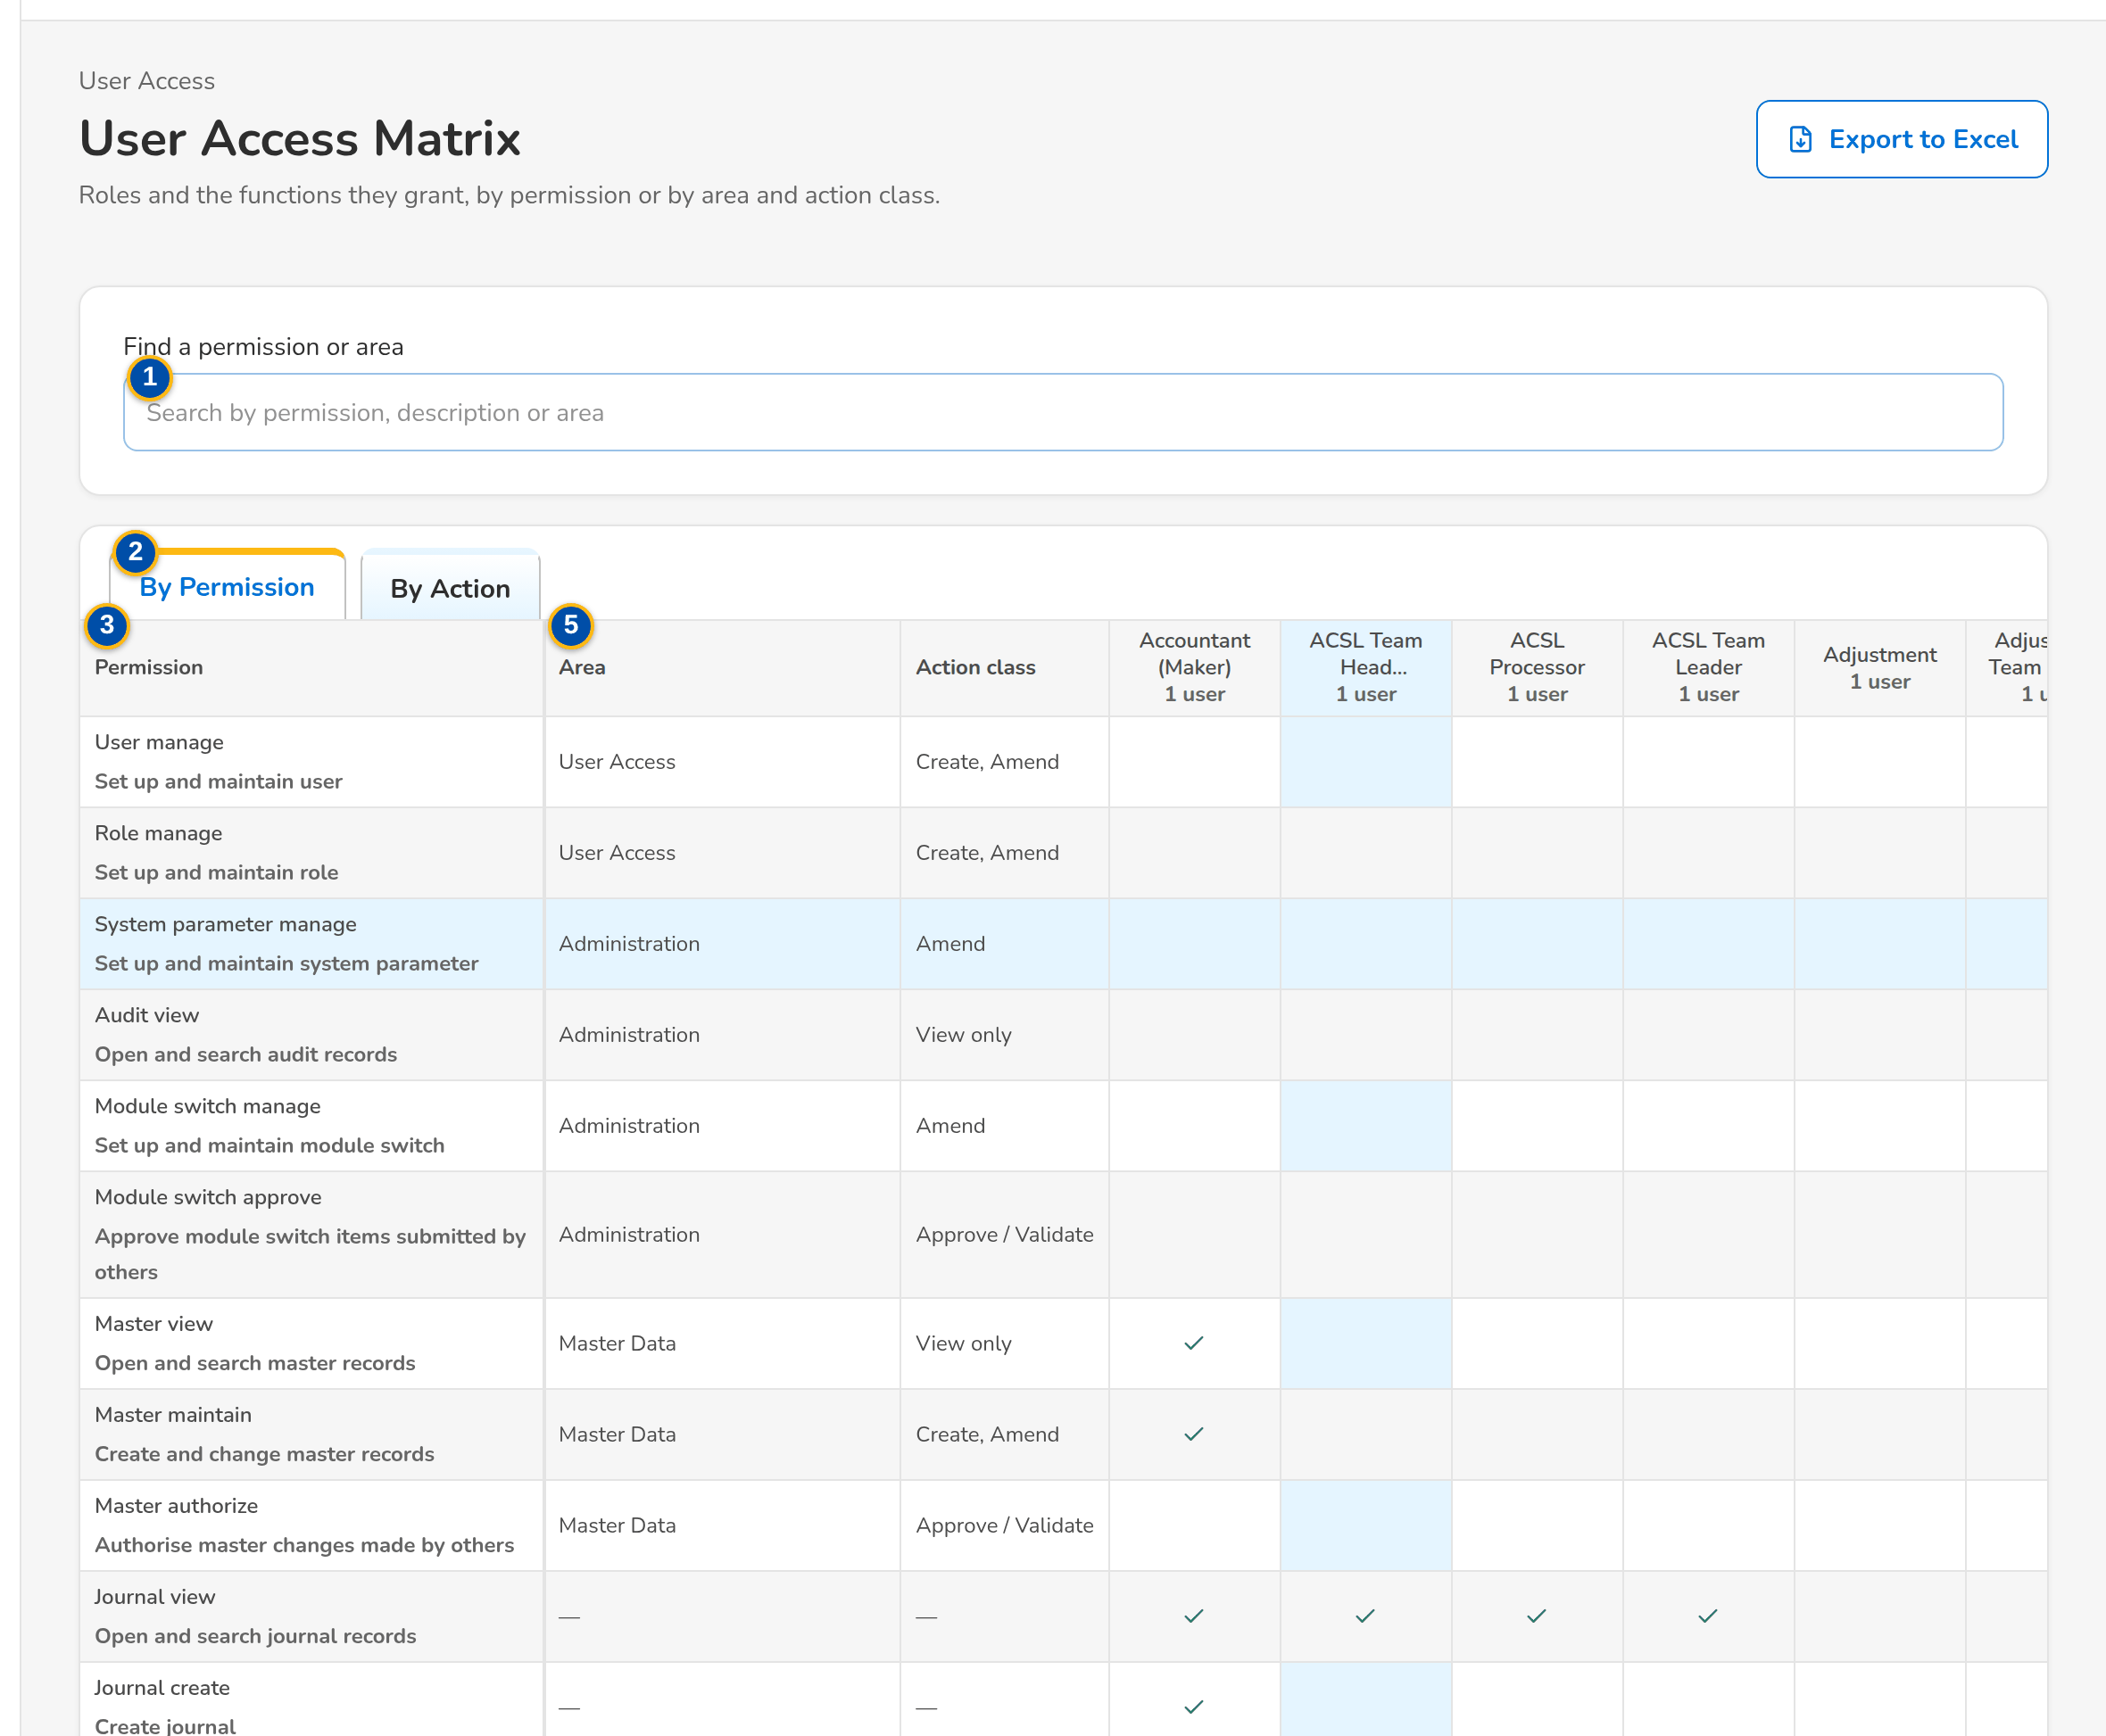
Figure J.14: User Access Matrix by permission
Field | Type | Mandatory | Format / list / source | Validation and message
Search: Find a permission or area | Text | N | Part of a permission name, what it allows or an area | -
Views: By Permission / By Action | Tab | - | Fixed | -
By Permission: Permission / Area / Action class | Columns | - | Permission name with what it allows below; functional area; View only, Create, Amend, Approve / Validate; Permission catalogue | -
Matrix: [Group profile columns] | Columns | - | Profile name with the number of active users; a tick where the profile holds the permission; Role grants | -
By Action: Area / Action class | Columns | - | One row per area and action class; each cell lists the names of the permissions the profile holds there; Role grants | -
Matrix: [Scroll area] | Table | - | One scroll area in both directions sized to the window; the header row with the profiles and the first column stay in view while scrolling | -

Action | Who | Available when | What happens | Resulting status
Export to Excel | Every user of the screen | Always | Downloads the matrix (both views) as an Excel file | -

Rules:
- The matrix is read from the grants in force; it changes only when a group-profile request is implemented (FRUM.001.02, FRUM.005.01).
- The matrix is open to the holders of the request, approval, role management and audit rights (the Information Security Officer among them); the Requestor and the Second Approver do not have it, as the permissions matrix of the FRS grants them no such right (FRUM.001.02, FRUM.005.01).
- The insurer-only permissions and the insurer roles hidden from BDOI are not listed (FRUM.001.02, FRUM.005.01).

J.15 User Access Reports (SCR-UA-14)
Purpose: The five user access reports, each opened in the report runner with its parameters and its PDF, Excel and CSV exports: User Access Report, User Group Profile Report, Group Profile Membership, User Access Audit Log and Access Requests.
Access: Reports › Report Centre, category Control & Audit
Requirements: FRUM.007.01, FRUM.007.02, FRUM.008.01, FRUM.008.01 (2nd), FRUM.008.02, FRUM.008.04
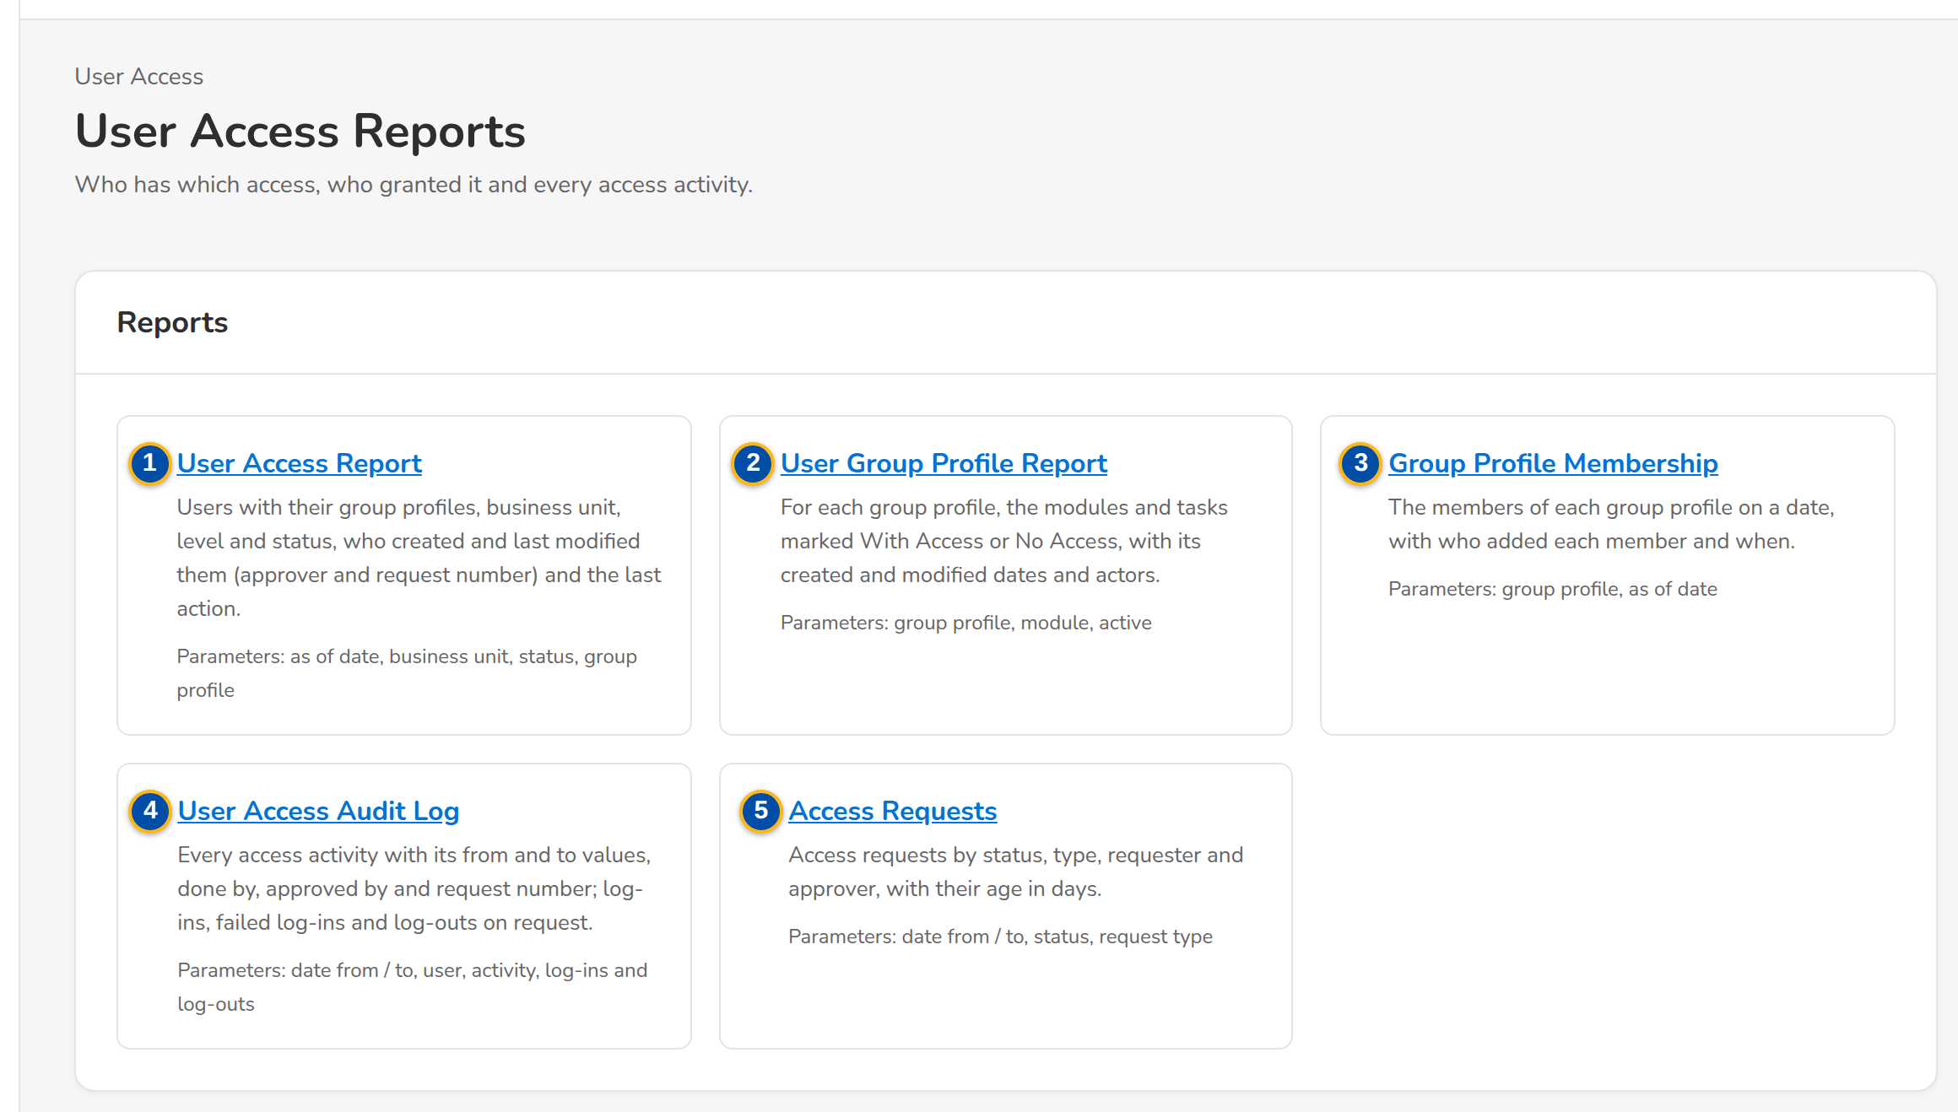
Figure J.15: User Access Reports
Field | Type | Mandatory | Format / list / source | Validation and message
Reports: User Access Report | Link | - | Users with their group profiles, business unit, level and status, who created and last modified them and the last action; Report catalogue | -
Reports: User Group Profile Report | Link | - | For each group profile, the modules and tasks With Access or No Access, with created and modified dates and actors; Report catalogue | -
Reports: Group Profile Membership | Link | - | The members of each group profile on a date, with who added each member and when; Report catalogue | -
Reports: User Access Audit Log | Link | - | Every access activity with from and to values, done by, approved by and request number; sign-ins and sign-outs on request; Report catalogue | -
Reports: Access Requests | Link | - | Requests by status, type, requester and approver, with their age in days; Report catalogue | -

Action | Who | Available when | What happens | Resulting status
[A report] | Holders of the user access report right | Always | Opens the report in the report runner (SCR-UA-17) | -

Rules:
- The reports are run by the Approver, the Business Administrator, the System Administrator, the Information Security Officer and the Auditor (user access report right) (FRUM.007.01, FRUM.007.02, FRUM.008.01, FRUM.008.01 (2nd)).

J.16 Users (SCR-UA-15)
Purpose: The System Administrator's list of users with their Windows ID, group profiles, business unit, user level, authorisation limit, last sign-in and status (Active, Online, Disabled, Locked); unlock of a locked account and the sessions of a user, with End Session, and the directory details of a user from the Enterprise SSO platform with Synchronise Now. Users are created and changed through access requests (Raise Request, or a row, opens a request) and, as delivered, from the Enterprise SSO platform and UIDM-ISC (Identity Synchronisation, SCR-UA-20).
Access: Setup & Administration › Administration › Users
Requirements: FRUM.001.04, FRUM.001.05, FRUM.002.01, FRUM.002.03, FRUM.008.01, FRUM.008.04
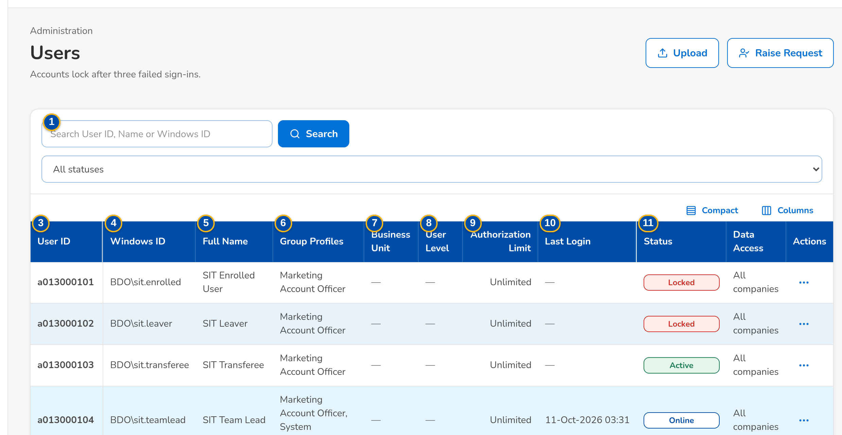
(continued below)
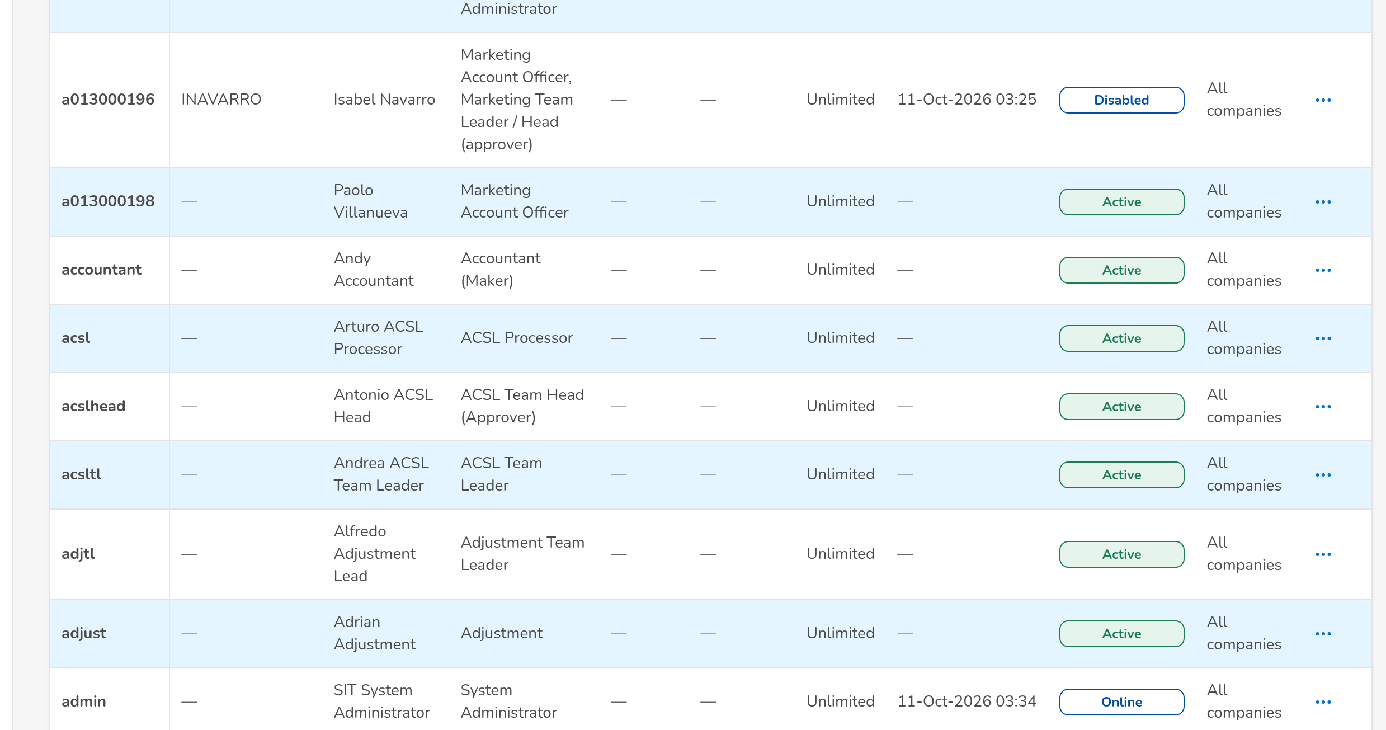
(continued below)
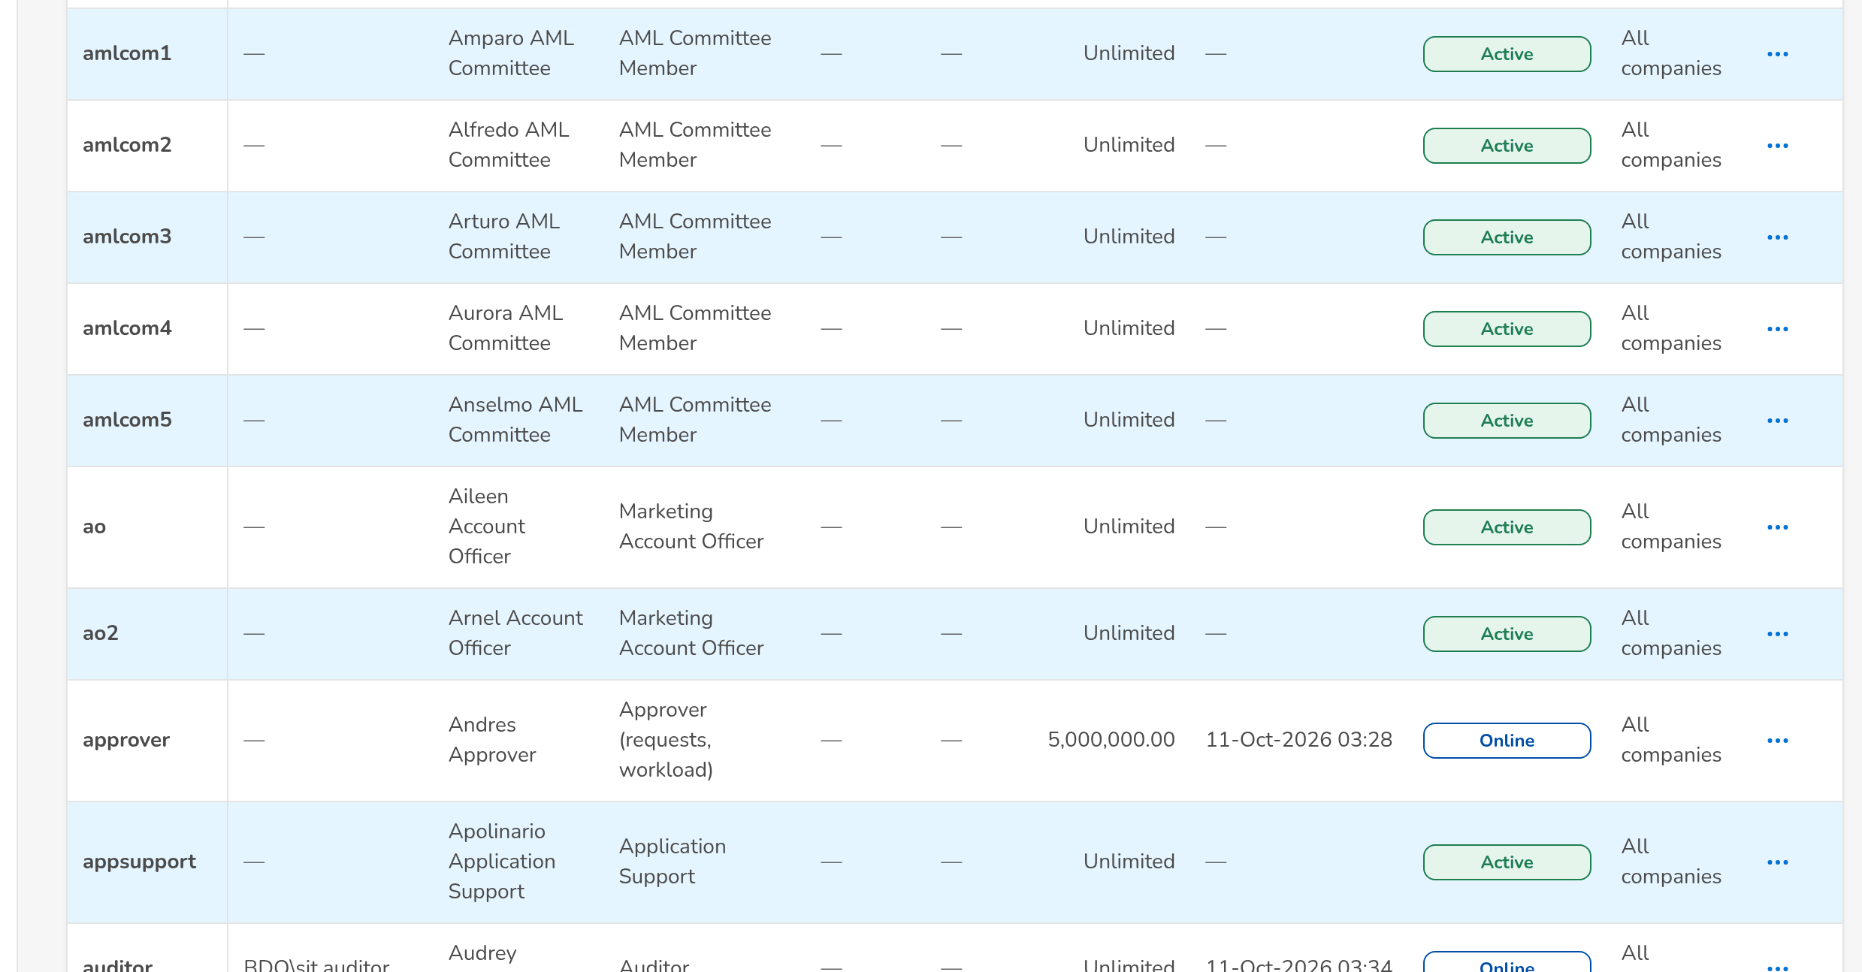
Figure J.16: Users with their status
Field | Type | Mandatory | Format / list / source | Validation and message
Search: Search User ID, Name or Windows ID | Text | N | Part of the user ID, name or Windows ID | Contains search
Search: Status | Drop-down | N | All statuses, Active, Online, Disabled, Locked; Fixed list | -
List: User ID | Column | - | User ID; User master | -
List: Windows ID | Column | - | Windows ID; User master | -
List: Full Name | Column | - | Name; User master | -
List: Group Profiles | Column | - | Names of the profiles held; User master | -
List: Business Unit | Column | - | Business unit group (list label); User master | -
List: User Level | Column | - | User level (list label); User master | -
List: Authorization Limit | Column | - | Amount in PHP, or Unlimited; User master | -
List: Last Login | Column | - | dd-MMM-yyyy HH:mm; Session log | -
List: Status | Column | - | Active, Online (open session), Disabled, Locked; User master and session log | -
Sessions of a user: Signed in / Last activity / Ended / Status | Columns | - | Date and time; Open, Logout, Idle Timeout, Expired, Admin Ended, Locked; Session log | -
Directory Details: Latest synchronisation | Status and date | - | Synchronised or Failed, dd-MMM-yyyy HH:mm; the reason of a failure below; Enterprise SSO platform | This user has not been synchronised from the Enterprise SSO platform yet
Directory Details: Windows ID / AD e-mail / AD group / AD status / AD sync date / time | Values | - | Domain\account; e-mail; directory group; Active, Inactive, Locked, Disabled, Deactivated; dd-MMM-yyyy HH:mm; Enterprise SSO platform | -
Directory Details: First name / Last name / Display name | Values | - | Names as kept by the directory; Enterprise SSO platform | -
Directory Details: Team leader's name / Team head's name / Section head's name / Unit head's name | Values | - | Names of the reporting line; Enterprise SSO platform | -
Directory Details: Unit / segment / Department / Location / UIDM request no. / Last event | Values | - | Organisation of the user; UIDM-yyyy-nnnnnn; the last event received with its date; Enterprise SSO platform and UIDM-ISC | -

Action | Who | Available when | What happens | Resulting status
Raise Request | System Administrator | Always | Opens New Request (SCR-UA-07) | -
[Open a row] | System Administrator | Always | Opens a Modify user request for the user (SCR-UA-07) | -
Unlock | System Administrator (user management right) | The user is locked | Unlocks the account and resets the failed attempts; written to the access change log | Active
Sessions | System Administrator | Always | Opens the sessions of the user | -
Directory details | System Administrator | Always | Opens the directory details of the user as last received from the Enterprise SSO platform | -
Synchronise Now | System Administrator | Directory details open; the user has a Windows ID | Reads the account from the Enterprise SSO platform now and applies the changes (as a status or mover event). Toast: Synchronisation: Applied / No change / Refused / Failed | -
End Session | System Administrator | The session is open | Ends the session at once on every server; the user is signed out at the next action. Toast: Session ended | Admin Ended
New User (Emergency) | System Administrator, only while the emergency role edit is on | Emergency path open | Creates or edits a user directly (audited, alert raised); not offered as delivered | -

Rules:
- Users, their data and their group profiles change only through an approved access request; the direct edit is an audited emergency path, closed as delivered (the emergency role edit = false) (FRUM.002.01, FRUM.002.03).
- A user is shown Online while a session is open; Locked after 3 failed sign-ins; Disabled after a deactivation, by a request or by the dormant-user job (FRUM.002.01, FRUM.002.03, FRUM.001.04, FRUM.001.05, FRUM.003.02.01, FRUM.003.04).
- A deactivated or locked user's open sessions end at once (FRUM.003.02.01, FRUM.009.04, FRUM.001.04, FRUM.001.05).
- Unlock, password reset and the end of a session are written to the access change log or the audit trail with the administrator's name (FRUM.008.01, FRUM.008.04).
- Synchronise Now needs the Windows ID of the user: User <user> has no Windows ID to synchronise; an account the directory does not hold is recorded as a failed synchronisation (FRUM.001.02, FRUM.001.06).
- As delivered BDOI's rules apply to a password reset: an administrator never resets his own password (Your own password is reset by another System Administrator; change it from My Profile), and with single sign-on only the break-glass accounts have a password in the system (FRUM-004.01, FRUM-004.02).

J.17 Roles & Permissions (SCR-UA-16)
Purpose: The group profiles (roles) against the permissions, with the privilege level and the active flag of each profile, read only as delivered; and the approved group-profile requests waiting for the System Administrator, each implemented with Implement Request.
Access: Setup & Administration › Administration › Roles & Permissions; The notice Access request AR-yyyy-nnnnnn to implement
Requirements: FRUM.001.02, FRUM.005.01, FRUM.005.04, FRUM.005.05, FRUM.005.06, FRUM.006.01, FRUM.007.03
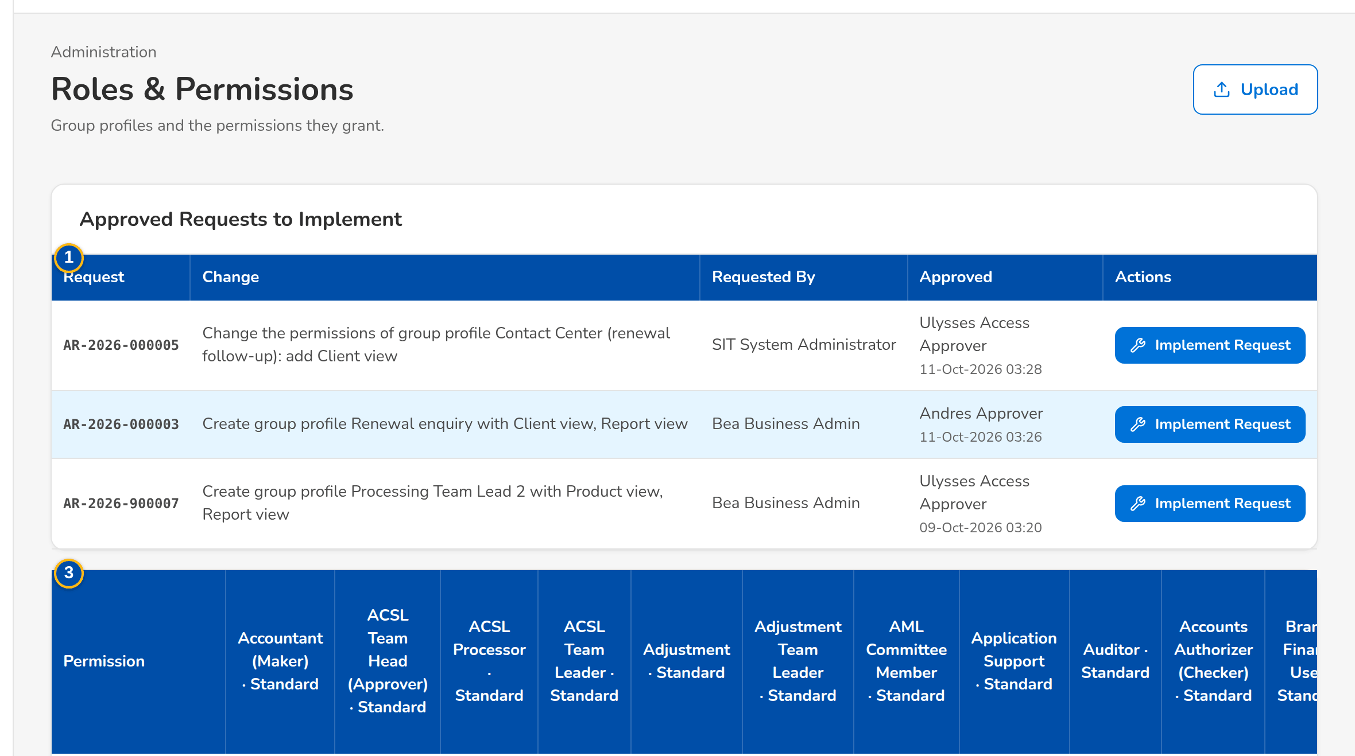
(continued below)
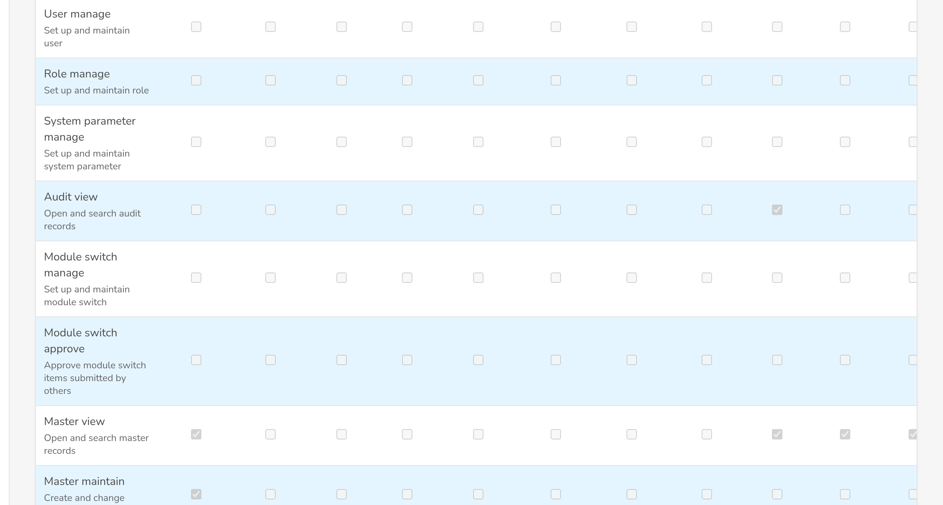
(continued below)
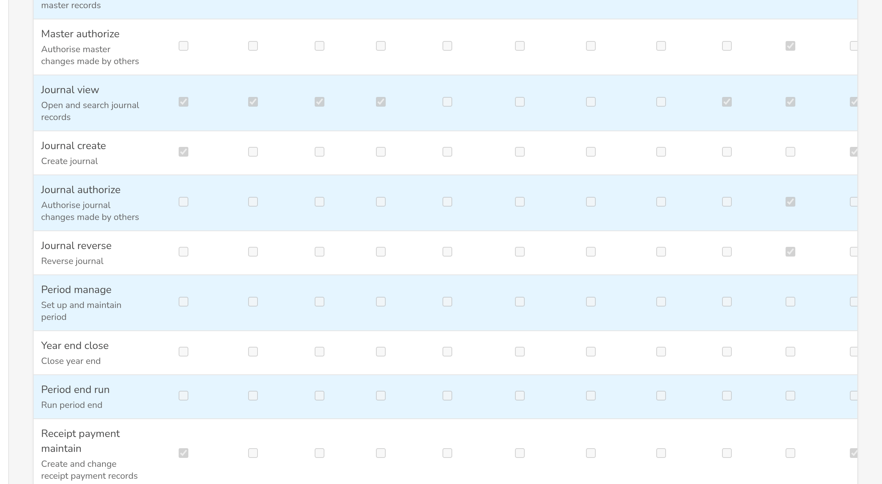
Figure J.17: Roles & Permissions with the approved requests to implement
Field | Type | Mandatory | Format / list / source | Validation and message
Approved Requests to Implement: Request / Change / Requested By / Approved | Columns | - | AR-yyyy-nnnnnn; description; name; approver · dd-MMM-yyyy HH:mm; Access requests For Implementation | -
Implement dialog: Permissions added / Permissions removed / Approved by | Text | - | Permission names; approver's name; Access request | -
Matrix: Permission | Column | - | Permission name with the system below in small print; Permission catalogue | -
Matrix: [Profile columns] | Check boxes | - | Profile name · privilege level, (inactive) and the Inactive pill for a deactivated profile; Role grants | -

Action | Who | Available when | What happens | Resulting status
Implement Request | System Administrator (role management right), not the requester | Request For Implementation | Applies the approved change to the group profile now; the request becomes Implemented. Toast: AR-yyyy-nnnnnn implemented | Implemented
Save | System Administrator, only while the emergency role edit is on | Emergency path open and a profile column changed | Saves the profile directly; audited and alerted | -

Rules:
- Group profiles change only by implementing an approved group-profile request: Roles are changed through an approved group-profile request; implement the request instead (FRUM.005.01, FRUM.005.04).
- The implementer is never the requester: A request is implemented by someone other than its requester (FRUM.005.01, FRUM.005.04).
- While the emergency path is open the page says so, and every direct edit is audited and raises an alert (FRUM.005.01, FRUM.005.04, FRUM.002.01, FRUM.002.03).

J.18 User access report (report runner) (SCR-UA-17)
Purpose: A user access report in the report runner: its parameters with their defaults, Run Report, Print, the PDF, Excel and CSV downloads, and the result with the parameters echoed and the notes of the report.
Access: User Access Reports › a report; Reports › Report Centre › a report of the category Control & Audit
Requirements: FRUM.007.01, FRUM.007.02, FRUM.008.01, FRUM.008.01 (2nd), FRUM.008.02, FRUM.008.04
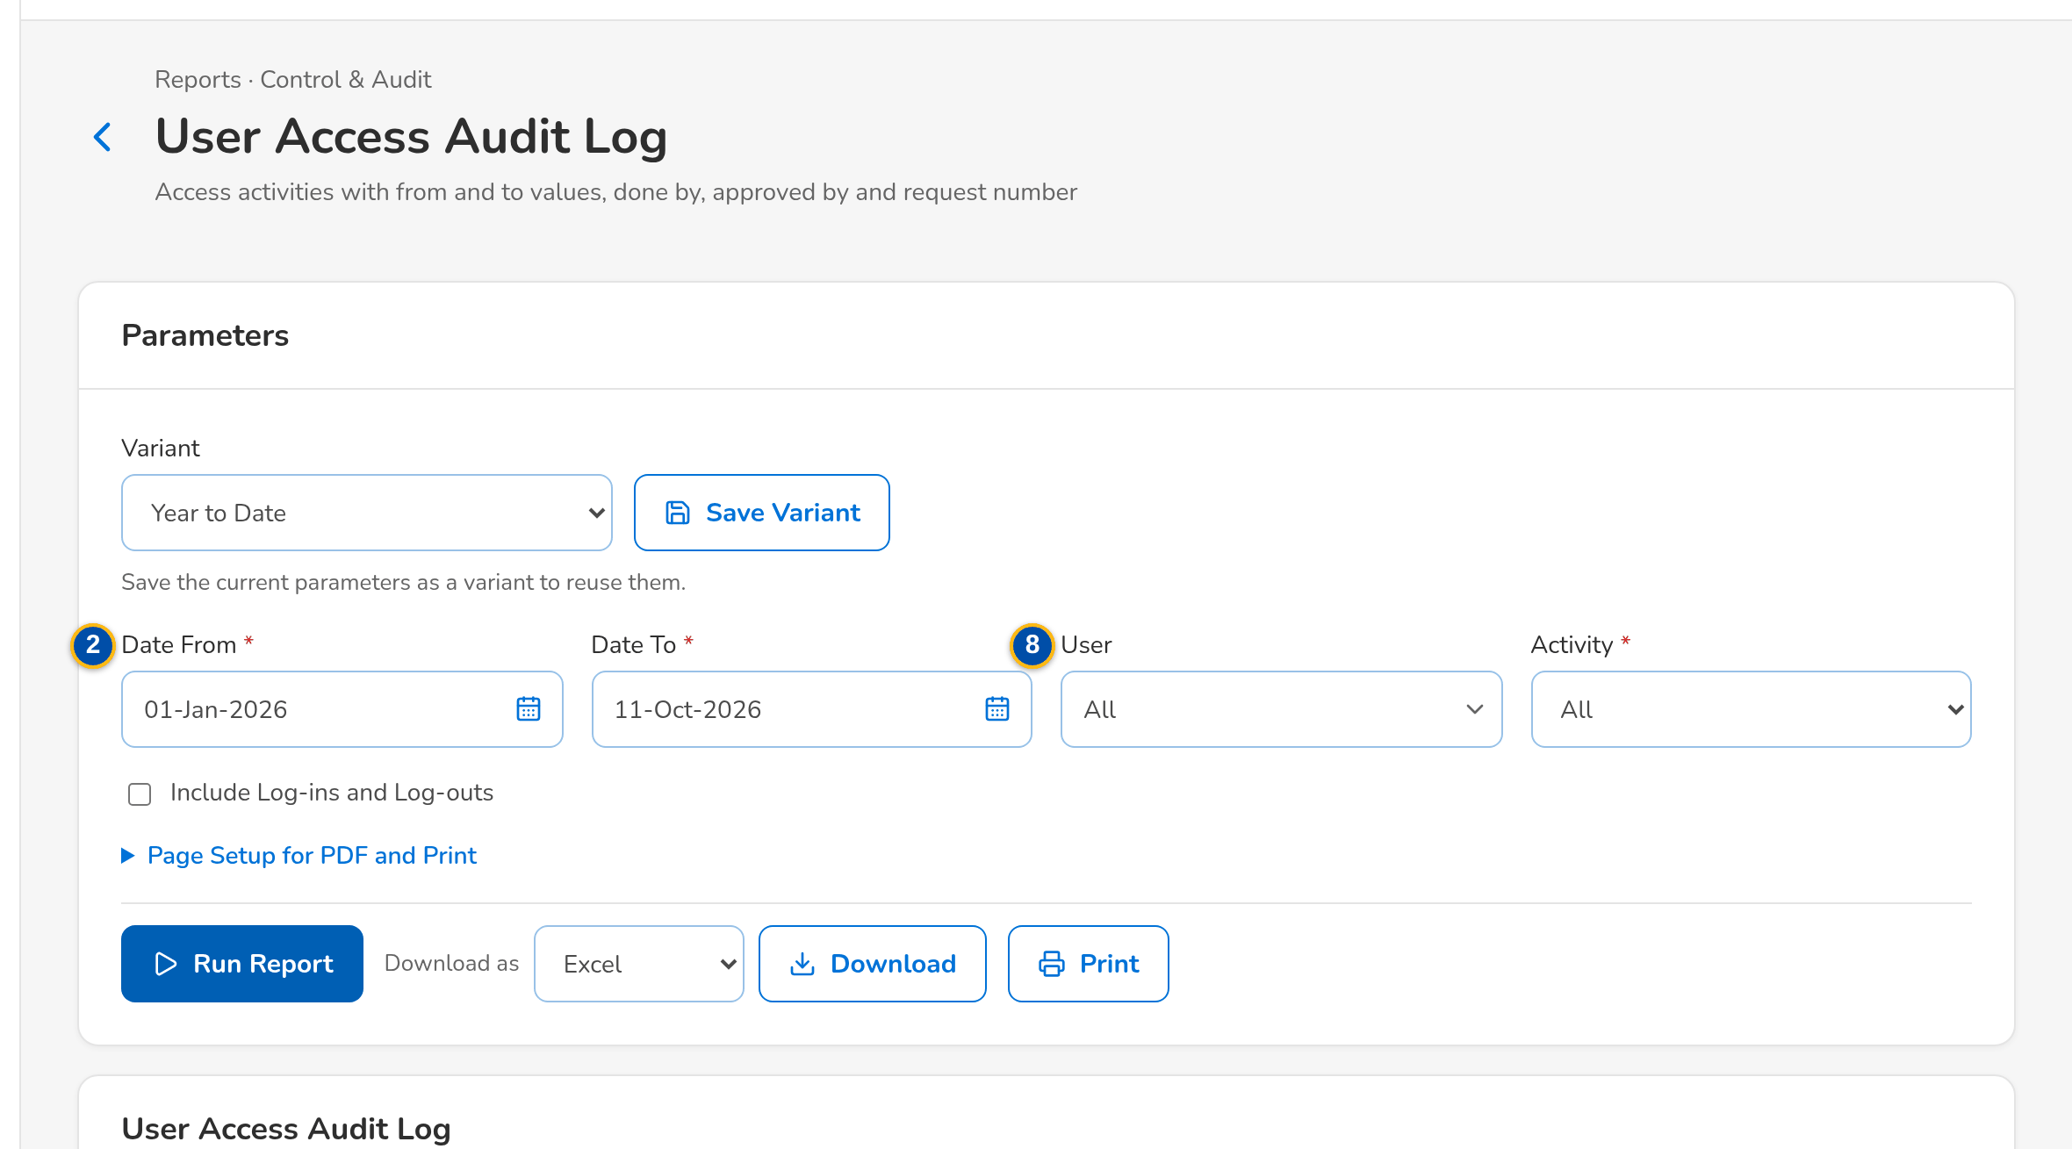
(continued below)
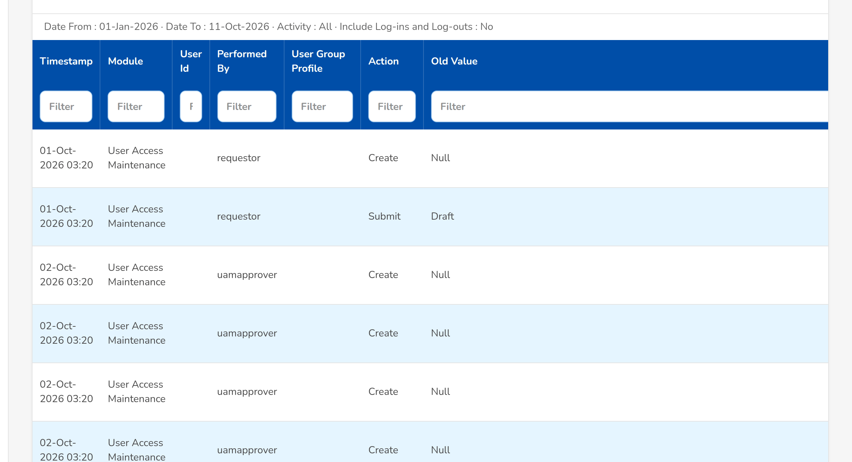
(continued below)
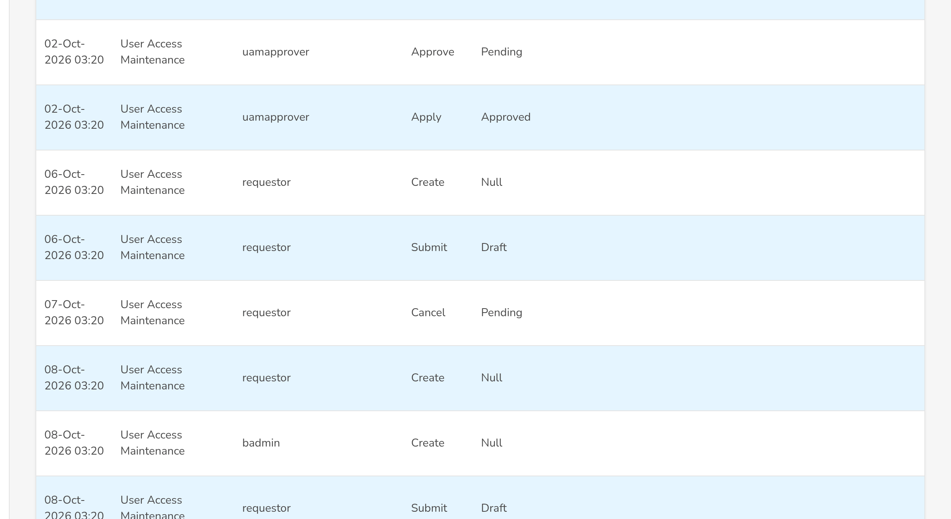
Figure J.18: User Access Audit Log with the from and to values
Field | Type | Mandatory | Format / list / source | Validation and message
Parameters: As of Date | Date | Y | dd-MMM-yyyy; not in the future | Not after today; The as-of date cannot be in the future
Parameters: Date From / Date To | Date | Y | dd-MMM-yyyy | The end on or after the start; The end date must be on or after the start date
Parameters: Business Unit Group | Text | N | Business unit code | -
Parameters: Status | Drop-down | N | All, Active, Disabled, Locked (users); the request statuses (Access Requests); Fixed list | -
Parameters: Group Profile (code) | Text | N | Profile code | -
Parameters: Module (area code) | Text | N | Area code | -
Parameters: Active | Drop-down | N | All, Yes, No; Fixed list | -
Parameters: User / Activity / Include Log-ins and Log-outs | Text / Drop-down / Check box | N | User ID; the access activities; sign-ins and sign-outs of the audit trail | -
Parameters: Request Type | Drop-down | N | All and the request types; Fixed list | -
Result: [Columns of the report] | Table | - | User Access Report: User Name, User ID / Windows ID, User Group Profile, Business Unit / User Level, Status, Created by, Date Created, Modified by, Date Modified, Last Action / by. User Group Profile Report: Module Name, Task Name, Access, Date Created, Created by, Date Modified, Modified by. Group Profile Membership: Member Username, Member User ID, Created by, Date Created, Modified by, Date Modified. User Access Audit Log: Date, Activity, From, To, Done By, Approved By, Request No. Access Requests: Request No., Request Type, User / Group Profile, Requester, Approver, Date Created, Date Decided, Effective Date, Age (days), Requests; Access change log, request history, audit trail | -

Action | Who | Available when | What happens | Resulting status
Run Report | Holders of the user access report right | Required parameters valid | Runs the report on screen | -
Print | As Run Report | Required parameters valid | Opens the printable report with the paper, orientation and width chosen | -
[PDF / Excel / CSV download] | As Run Report | Required parameters valid | Downloads the report; the header carries the report name, the user who generated it, the date coverage and the time generated | -

Rules:
- The as-of reports show the access held at the end of the as-of date (Philippine time), derived from the access change log (FRUM.007.01, FRUM.007.02, FRUM.007.01, FRUM.007.02).
- Created by and Modified by show the approver and the request number, or the user of a direct change (FRUM.007.01, FRUM.007.02).
- The audit log merges the access change log, the request history and, on request, the sign-ins, failed sign-ins and sign-outs (FRUM.008.01, FRUM.008.01 (2nd)).

J.19 System Parameters (sign-in, password and access settings) (SCR-UA-18)
Purpose: The list of the business parameters, with the security category holding the sign-in, password, session and access-request settings of this set. The System Administrator changes a value in a dialog, checked by type and range; a change of a security setting waits until the Information Security Officer approves it.
Access: Setup & Administration › Administration › System Parameters; The notice Security setting to approve, and My Approvals (Information Security Officer)
Requirements: FRUM.001.01, FRUM.001.02, FRUM.001.03, FRUM.001.04, FRUM.002.01, FRUM.002.03, FRUM.003.02.01, FRUM.003.04, FRUM-004.01, FRUM-004.02, FRUM-004.03, FRUM.012.02
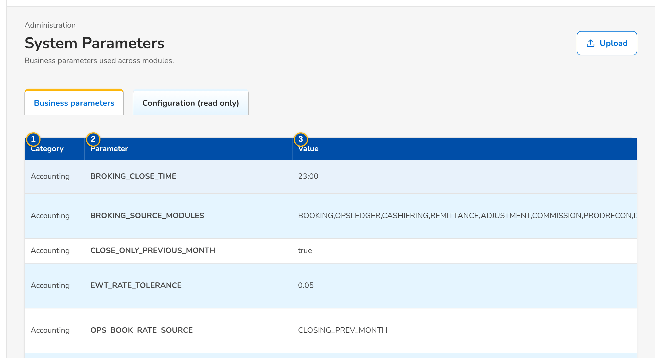
(continued below)
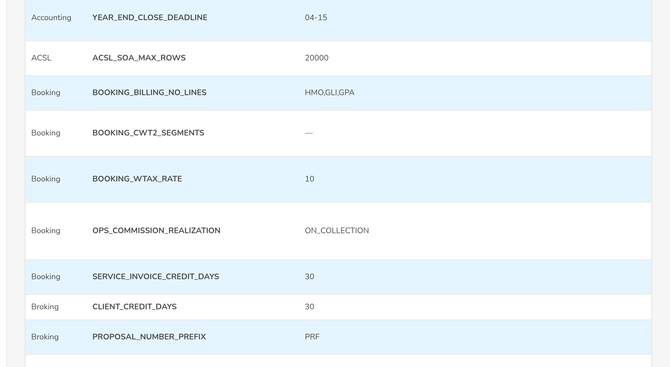
(continued below)
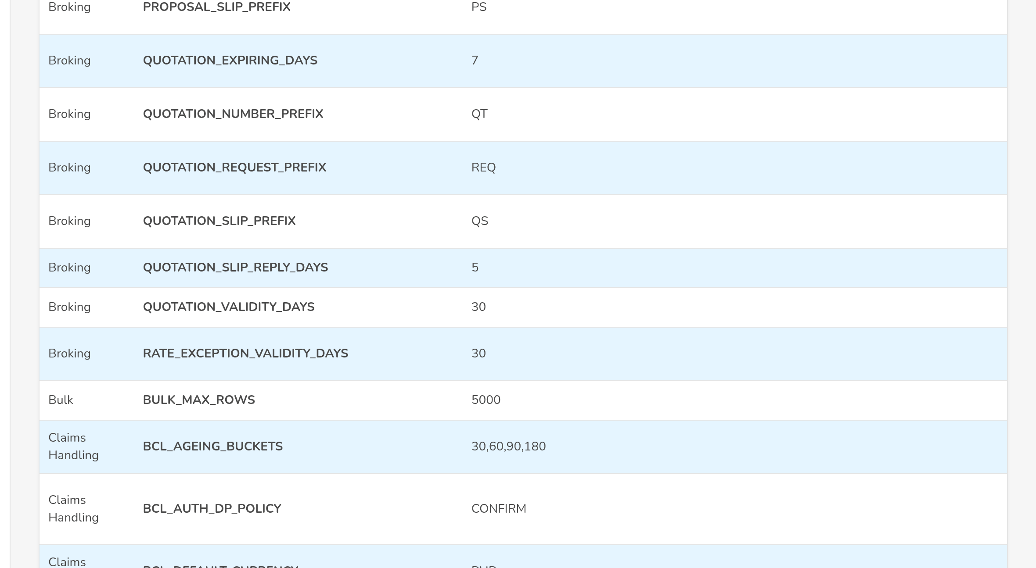
Figure J.19: System Parameters, security settings
Field | Type | Mandatory | Format / list / source | Validation and message
Parameters: Category | Column | - | Security for the settings of this set; Parameters | -
Parameters: Parameter | Column | - | the lock-out attempts, the inactivity warning time, the session timeout, the session-end warning time, the sign-in mode, the user ID format, the user ID format in words, the password history, the password expiry, the minimum password age, the working hours, the any-approver setting, the emergency role edit, the apply-on-approval setting, the external users setting, the dormancy period, the dormancy notice, the failed-run recipients; Parameters | -
Parameters: Value | Column | - | Value in force; under it, Waiting for approval: <new value>, asked by <name> while a change waits; Parameters | -
Parameters: Description | Column | - | What the parameter does; Parameters | -
Parameters: Last Changed | Column | - | Name, dd-MMM-yyyy HH:mm; Parameters | -
Edit dialog: Value | Text | Y | Up to 1,000 characters; the hint gives the type and range; a security setting says that the change applies once another user approves it | Type and range of the parameter; <parameter> <error of the type or range>
Approval dialog: Current value / New value / Requested by / Requested on | Text | - | The two values; the name of the requester and dd-MMM-yyyy HH:mm; Parameters | -

Action | Who | Available when | What happens | Resulting status
[Open a row] | System Administrator (parameter management right); Information Security Officer (security setting approval right) | Always | Opens the edit dialog; for a setting whose change waits, the approval dialog | -
Save | System Administrator (parameter management right) | Value valid | A security setting: keeps the change as waiting for approval and tells the approvers. Toast: <description>: change sent for approval. Another parameter: saves it at once. Toast: <description>: updated | Waiting for approval, or changed
Approve | Information Security Officer (security setting approval right), not the requester | A change waits | Applies the new value at once, audited with the requester and the approver. Toast: <description>: change approved | Changed
Reject | Information Security Officer; Withdraw for the requester | A change waits | Drops the change; the current value stays. Toast: Change rejected | Unchanged

Rules:
- Only the System Administrator asks for a change of a parameter; every change is written to the audit trail with the old and new value and the user (FRUM.002.01, FRUM.002.03).
- A change of a security setting, the emergency path the emergency role edit included, applies only when a holder of the approval right other than the requester approves it: A change cannot be approved by the user who asked for it (FRUM.012.02).
- One change per setting waits at a time: A change of <setting> already waits for approval; approve or reject it first (FRUM.012.02).
- The session, lock-out and password values are those of this FRS and of the configuration input template of the sign-in parameters (FRUM.001.01, FRUM.001.02, FRUM.001.01, FRUM.001.03, FRUM-004.01, FRUM-004.02).

J.20 Separation of Duties (SCR-UA-19)
Purpose: The separation-of-duties rules, each with its reason: two group profiles that one user may not hold together, and two permissions (the conflicting permission combinations) that neither one group profile nor one user may hold together. The Business Administrator adds a rule or asks for its deactivation; the Information Security Officer authorises or rejects each change. Every user request, bulk line and group-profile change is checked against the active rules.
Access: Setup & Administration › User Access › Separation of Duties; The notice Separation-of-duties rule <rule> to authorise, and My Approvals (Information Security Officer)
Requirements: FRUM.006.03, FRUM.012.01
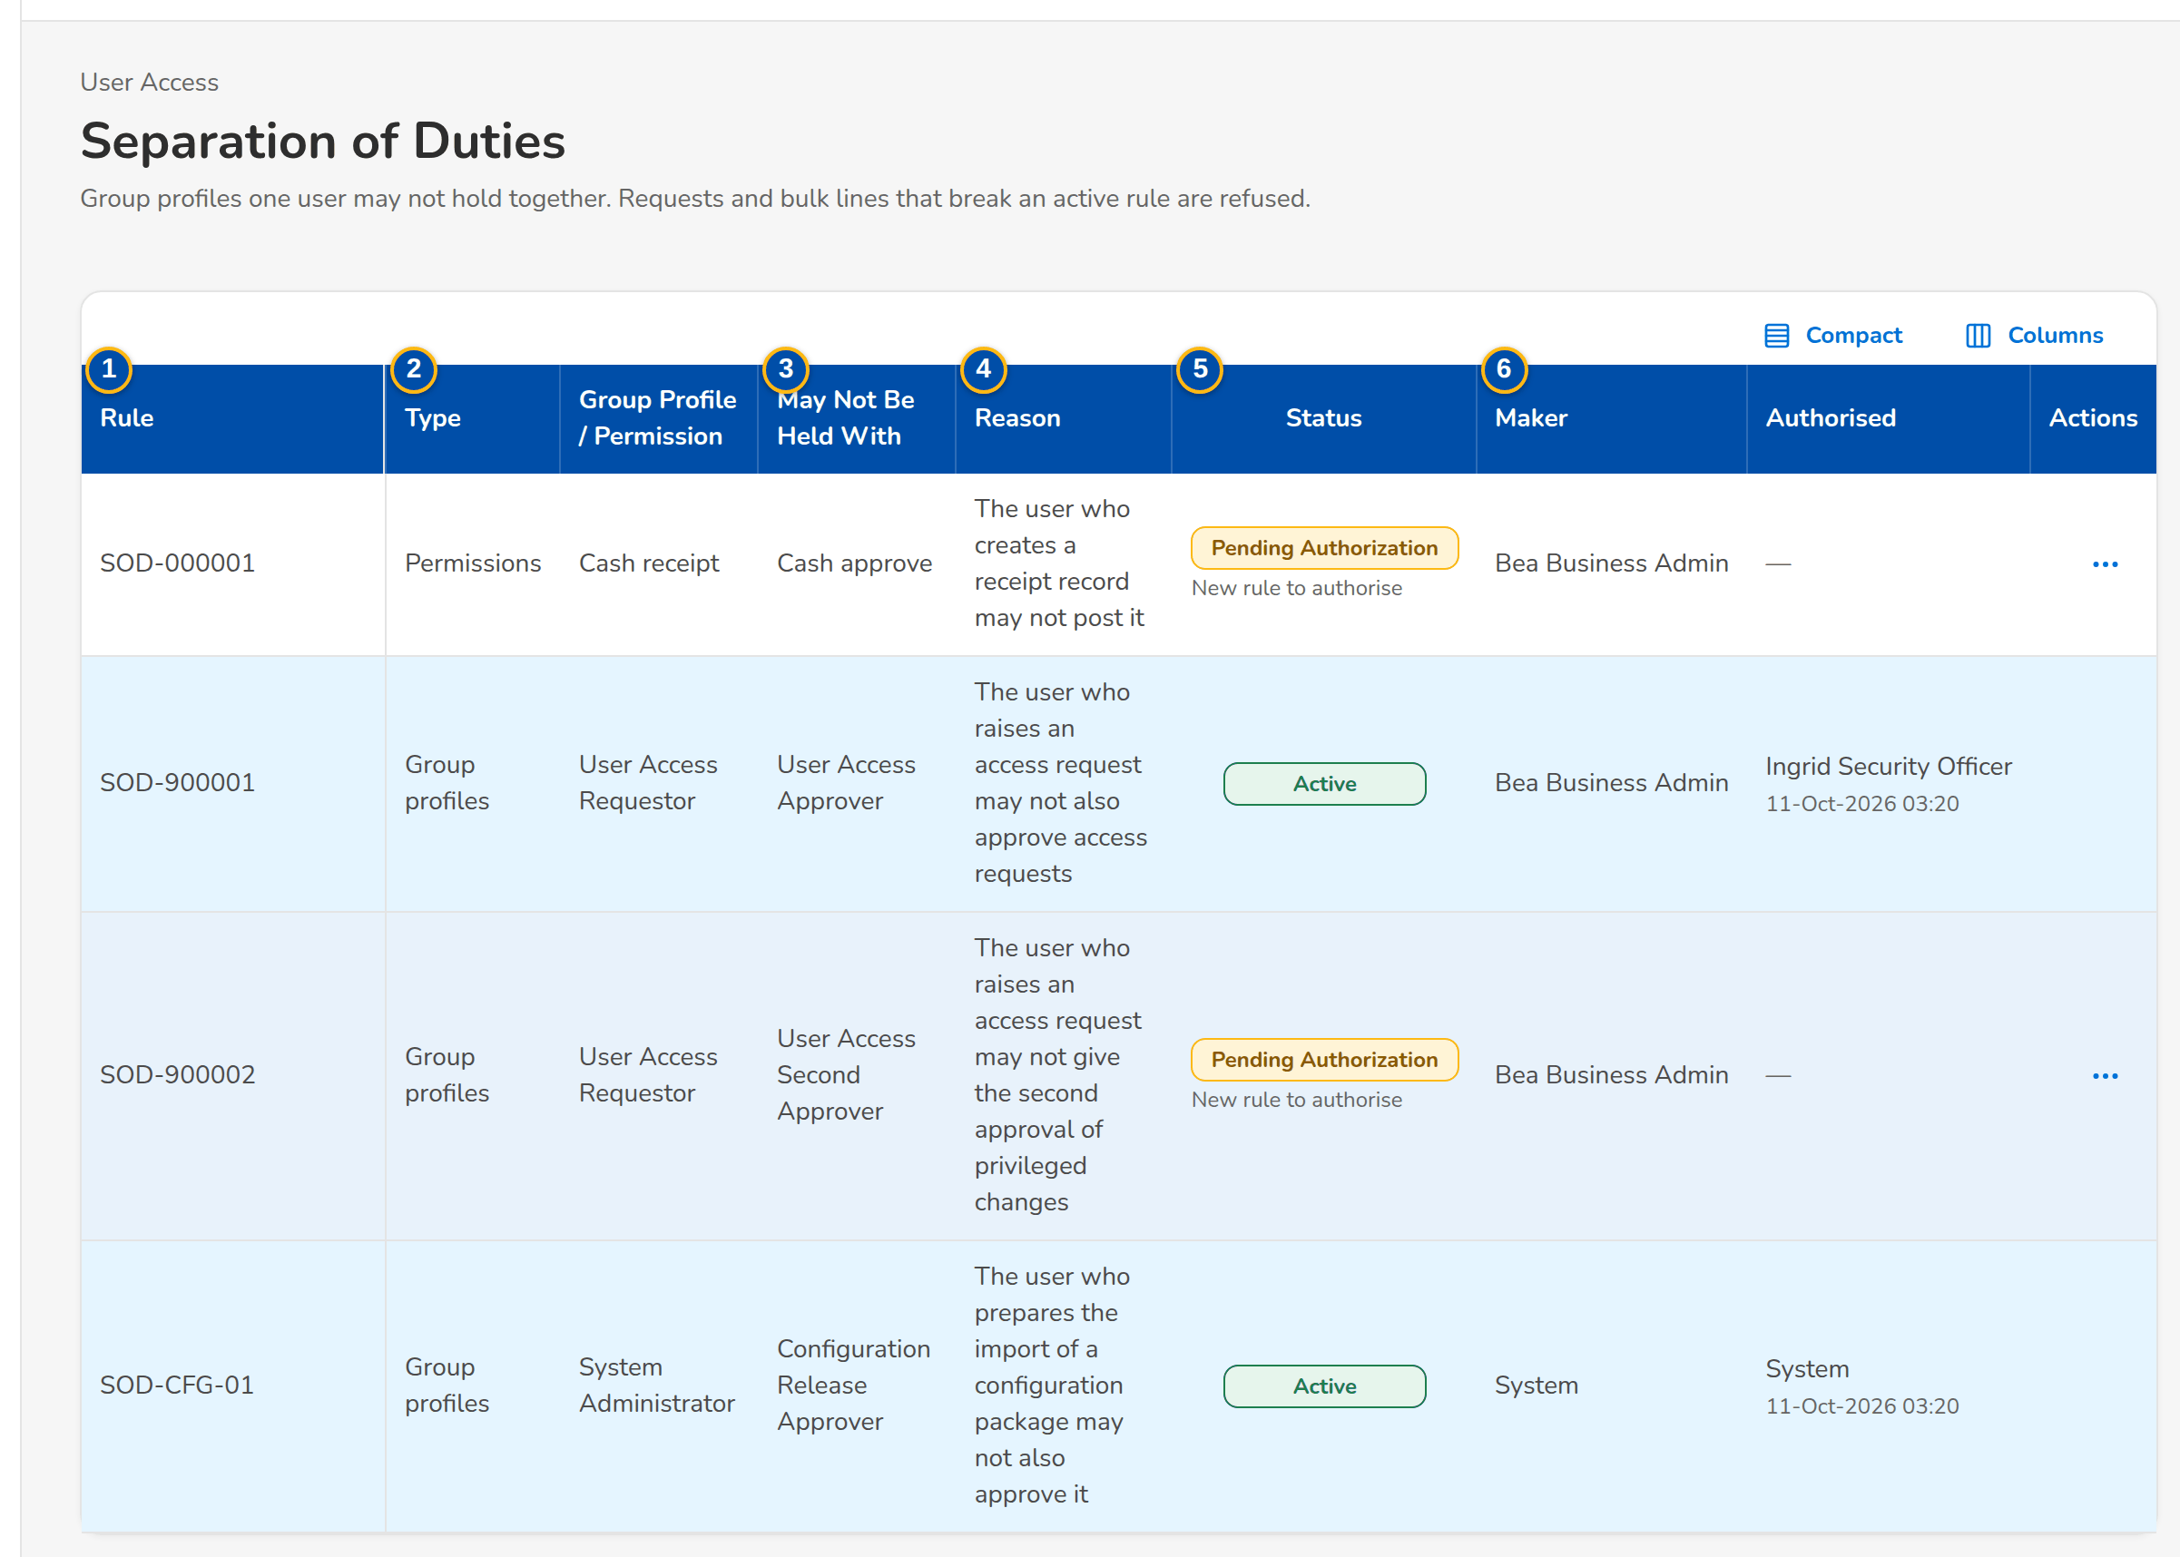
Figure J.20: Separation of Duties with the rules of group profiles and of permissions
Field | Type | Mandatory | Format / list / source | Validation and message
Rules: Rule | Column | - | SOD-nnnnnn; Rules | -
Rules: Type | Column | - | Group profiles, Permissions; Rules | -
Rules: Group Profile / Permission / May Not Be Held With | Columns | - | Profile names, or permission names; Rules | -
Rules: Reason | Column | - | Why one user may not hold both; Rules | -
Rules: Status | Column | - | Pending Authorization, Active, Inactive; under it New rule to authorise or Deactivation to authorise; Rules | -
Rules: Maker / Authorised | Columns | - | Name; name and dd-MMM-yyyy HH:mm; Rules | -
Rules: [Row action menu] | Row action menu | - | Authorise and Reject of a waiting change, Deactivate of an active rule, each confirmed in a dialog | -
New Rule: Rule Type | Drop-down | Y | Two group profiles one user may not hold; Two permissions not held together; Fixed list | -
New Rule: Group Profile | Drop-down | Cond.: rule of group profiles | Active group profiles by name (rule of group profiles); Group profiles | Select the first group profile
New Rule: Permission | Drop-down | Cond.: rule of permissions | Permissions by name (rule of permissions); Permission catalogue | Select the first permission
New Rule: May Not Be Held With | Drop-down | Y | Active group profiles, or permissions, by name; Group profiles or permission catalogue | Different from the first; Choose two different group profiles
New Rule: Reason | Text area | Y | Up to 500 characters | Not blank; Enter why the two profiles are not held together

Action | Who | Available when | What happens | Resulting status
New Rule | Business Administrator (rule maintenance right) | Always | Opens the New Rule dialog | -
Send for Authorisation | Business Administrator | Both profiles or permissions and the reason entered | Saves the rule as pending. Toast: Rule SOD-nnnnnn sent for authorisation | Pending Authorization
Deactivate | Business Administrator | Active rule, nothing waiting | Asks for the deactivation; the rule stays active until authorised | Active (deactivation to authorise)
Authorise | Information Security Officer (rule authorisation right), not the maker | A creation or deactivation waits | A new rule becomes active; a deactivated rule becomes inactive. Toast: Rule <rule> authorised | Active or Inactive
Reject | Information Security Officer, not the maker | A creation or deactivation waits | A new rule is closed; a rule whose deactivation is rejected stays active. Toast: Rule <rule> rejected | Inactive or Active

Rules:
- A rule applies only once authorised, and the maker never authorises it: A record cannot be authorized by the user who maintained it (FRUM.006.03, FRUM.012.01).
- One rule per pair of profiles or permissions, in either order: A rule for these two group profiles already exists (FRUM.006.03, FRUM.012.01).
- A request or bulk line that gives one user both profiles of an active rule is refused, on submission and at approval: One user may not hold both <profile> and <profile> (separation-of-duties rule <rule>) (FRUM.006.03, FRUM.012.01).
- Conflicting permission combinations: a group-profile change that gives one profile both permissions of an active rule is refused (Group profile <profile> may not hold both <permission> and <permission> (rule <rule>)), and so is a user request that gives one user both permissions through several profiles (One user may not hold both <permission> and <permission> through group profiles <profiles>) (FRUM.006.03, FRUM.012.01).
- A new rule does not change the users who already hold both profiles or permissions; they are found with the User Access Report and changed by requests (FRUM.006.03, FRUM.012.01, FRUM.007.01, FRUM.007.02).

J.21 Identity Synchronisation (SCR-UA-20)
Purpose: The users from the Enterprise SSO platform and UIDM-ISC: every provisioning event received (joiner, mover, leaver, rehire, status change) with its outcome, the user it changed, the UIDM request number and the reason of a refusal; Process again of a refused or failed event once the data is corrected; Create User from Enterprise SSO for an active directory account; and, in SIT and UAT only, the Enterprise SSO simulator with its accounts, from which the events are sent.
Access: Setup & Administration › Administration › Identity Synchronisation; The alert Identity event refused, to the System Administrator
Requirements: FRUM.001.02, FRUM.001.04, FRUM.001.05, FRUM.001.06, FRUM-004.01, FRUM.008.01, FRUM.008.04
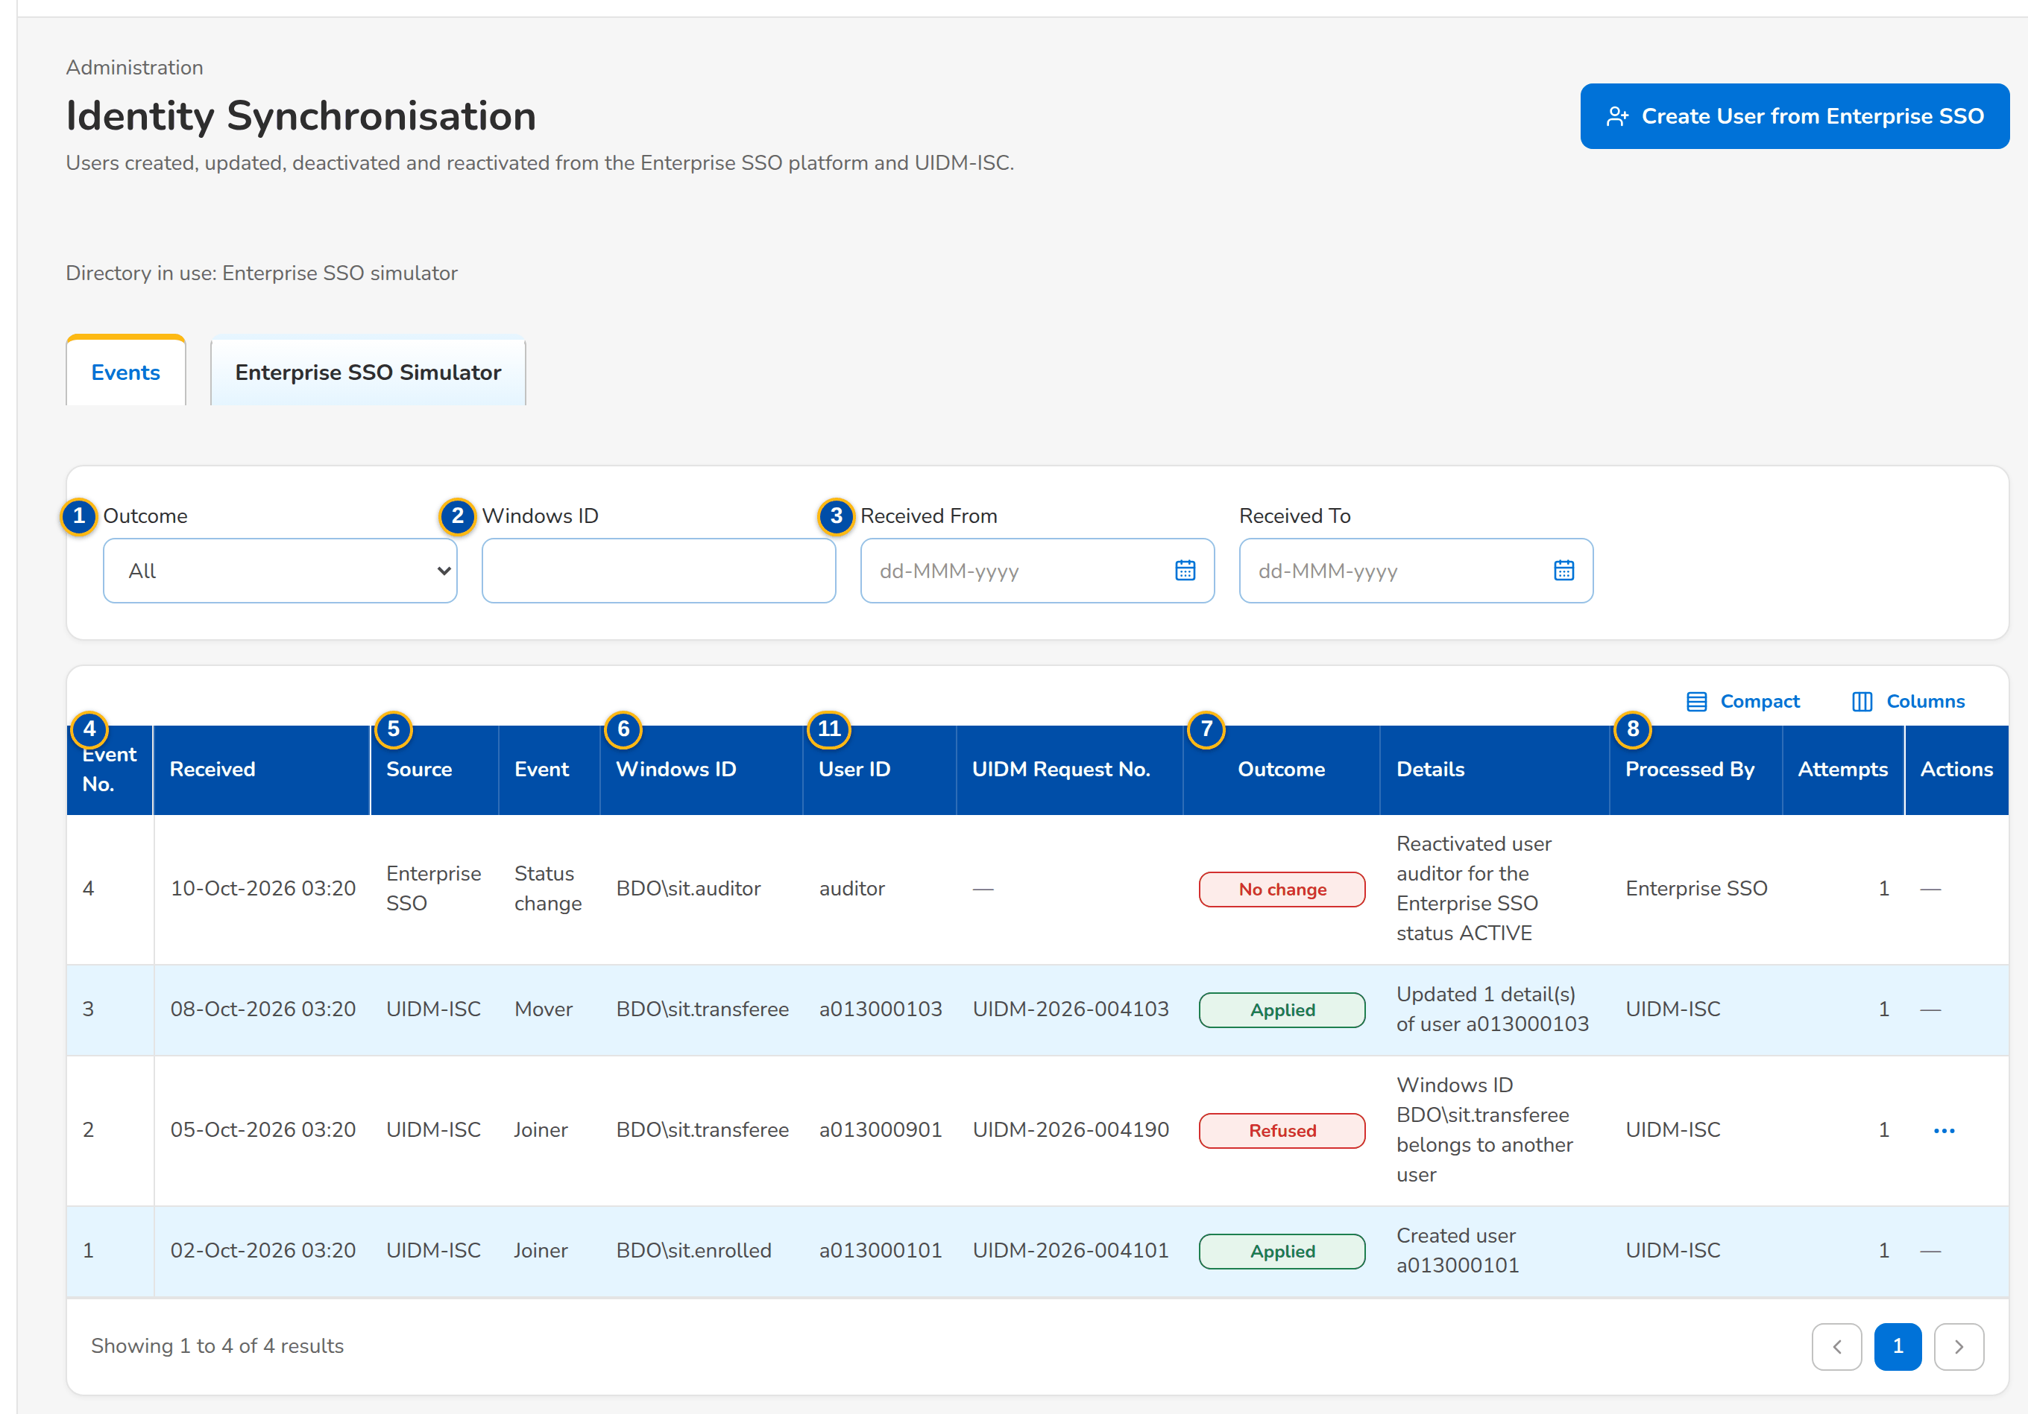
Figure J.21: Identity Synchronisation: events received from UIDM-ISC and the Enterprise SSO platform
Field | Type | Mandatory | Format / list / source | Validation and message
Events: Outcome | Drop-down | N | All, Applied, No change, Refused, Failed; Fixed list | -
Events: Windows ID | Text | N | Part of the Windows ID | -
Events: Received From / Received To | Date | N | dd-MMM-yyyy | -
Events: Event No. / Received | Columns | - | Number; dd-MMM-yyyy HH:mm; Identity events | -
Events: Source / Event | Columns | - | UIDM-ISC or Enterprise SSO; Joiner, Mover, Leaver, Rehire, Status change; Identity events | -
Events: Windows ID / User ID / UIDM Request No. | Columns | - | Domain\account; the system user ID; UIDM-yyyy-nnnnnn; Identity events | -
Events: Outcome / Details | Columns | - | Applied, No change, Refused, Failed; what was done or why it was refused; Identity events | -
Events: Processed By / Attempts | Columns | - | Name (or the source of an automatic run); number of times processed; Identity events | -
Create User from Enterprise SSO: Windows ID | Text | Y | Domain\account; Enterprise SSO platform | The account must exist and be active; The user cannot be created from this Enterprise SSO account
Create User from Enterprise SSO: User ID / Display name / AD e-mail / AD group / Unit / segment / Department / Location / Team leader / Unit head / UIDM request no. | Values | - | As kept by the directory, shown after Look Up Account; Enterprise SSO platform | User ID: a letter followed by nine digits; not an existing user; Windows ID not held by another user; The user ID must be a letter followed by nine digits, for example a013000196; User <user> already exists
Enterprise SSO Simulator: Windows ID / User ID / Display Name / AD E-mail / Unit / Segment / Location / AD Status | Columns | - | Accounts of the simulator; Simulator | -
Simulator account: Windows ID / User ID / AD status / First name / Last name / Display name / AD e-mail / AD group / Team leader's name / Team head's name / Section head's name / Unit head's name / Unit / segment / Department / Location / UIDM request no. | Form | Cond. | Windows ID, User ID, AD e-mail, first and last name required | Required fields entered; Still needed: <fields>

Action | Who | Available when | What happens | Resulting status
Process again | System Administrator (user management right) | A refused or failed event | Applies the event again after the data was corrected. Toast: Event <no> processed again: <outcome> | Applied, No change, Refused or Failed
Create User from Enterprise SSO | System Administrator | Always | Opens the dialog | -
Look Up Account | System Administrator | Windows ID entered | Reads the account from the Enterprise SSO platform and shows its details | -
Create User | System Administrator | An active account looked up | Creates the the system user with the directory details (without group profiles, which follow an access request) and records a joiner event. Toast: User <user> created from the Enterprise SSO account | Active user
New Account / Change | System Administrator, SIT and UAT only | Simulator shown | Adds or changes an account of the simulator. Toast: Enterprise SSO account <Windows ID> saved | -
Send joiner / Send mover (details changed) / Send leaver / Send rehire / Send status change | System Administrator, SIT and UAT only | Simulator shown | Sends the event of the account to the system as the Enterprise SSO platform would; the outcome is shown and listed under Events | Applied, No change, Refused or Failed

Rules:
- As delivered (setting Users from the Enterprise SSO platform on, BDOI's FRS) the joiner, mover, leaver, rehire and status events create, update, deactivate and reactivate the users; with the setting off the events are recorded but not applied and users change only through access requests: Users are maintained through access requests; the events of the Enterprise SSO platform are not applied (FRUM.001.02, FRUM.001.06).
- The group profiles named in a UIDM-ISC event are given to the user only when the setting Group profiles from UIDM-ISC is on (off as delivered: group profiles follow an approved access request) (FRUM.001.02, FRUM.001.06).
- A leaver or a status other than Active deactivates the user and ends the open sessions at once; a rehire or the status Active reactivates the user (FRUM.001.02, FRUM.001.06, FRUM.001.04, FRUM.001.05).
- Every event is kept with its outcome; a refused event raises the alert Identity event refused to the System Administrator and can be processed again once the data is corrected; every applied change is written to the access change log with the UIDM request number (FRUM.001.02, FRUM.001.06, FRUM.008.01, FRUM.008.04).
- The simulator stands for the Enterprise SSO platform in SIT and UAT only; it cannot be switched on in production. At SIT the connection to the Enterprise SSO platform is set with the details of BDOI IT (FRUM.001.02, FRUM.001.06).

J.22 Audit Trail (SCR-UA-22)
Purpose: Every financial and non-financial action, who performed it, when and from where, as BDOI's FRS shows the audit log: the module, the Windows ID, the name and the role of the user at the time, the action type, the activity, the from and to values, the source address and the reference number, with filters, sortable columns and the export in BDOI's audit log template, named Audit Logs_MMDDYYYY.
Access: Setup & Administration › Administration › Audit Trail
Requirements: FRUM.001.01, FRUM.001.02, FRUM.001.03, FRUM.001.04, FRUM.008.01, FRUM.008.04
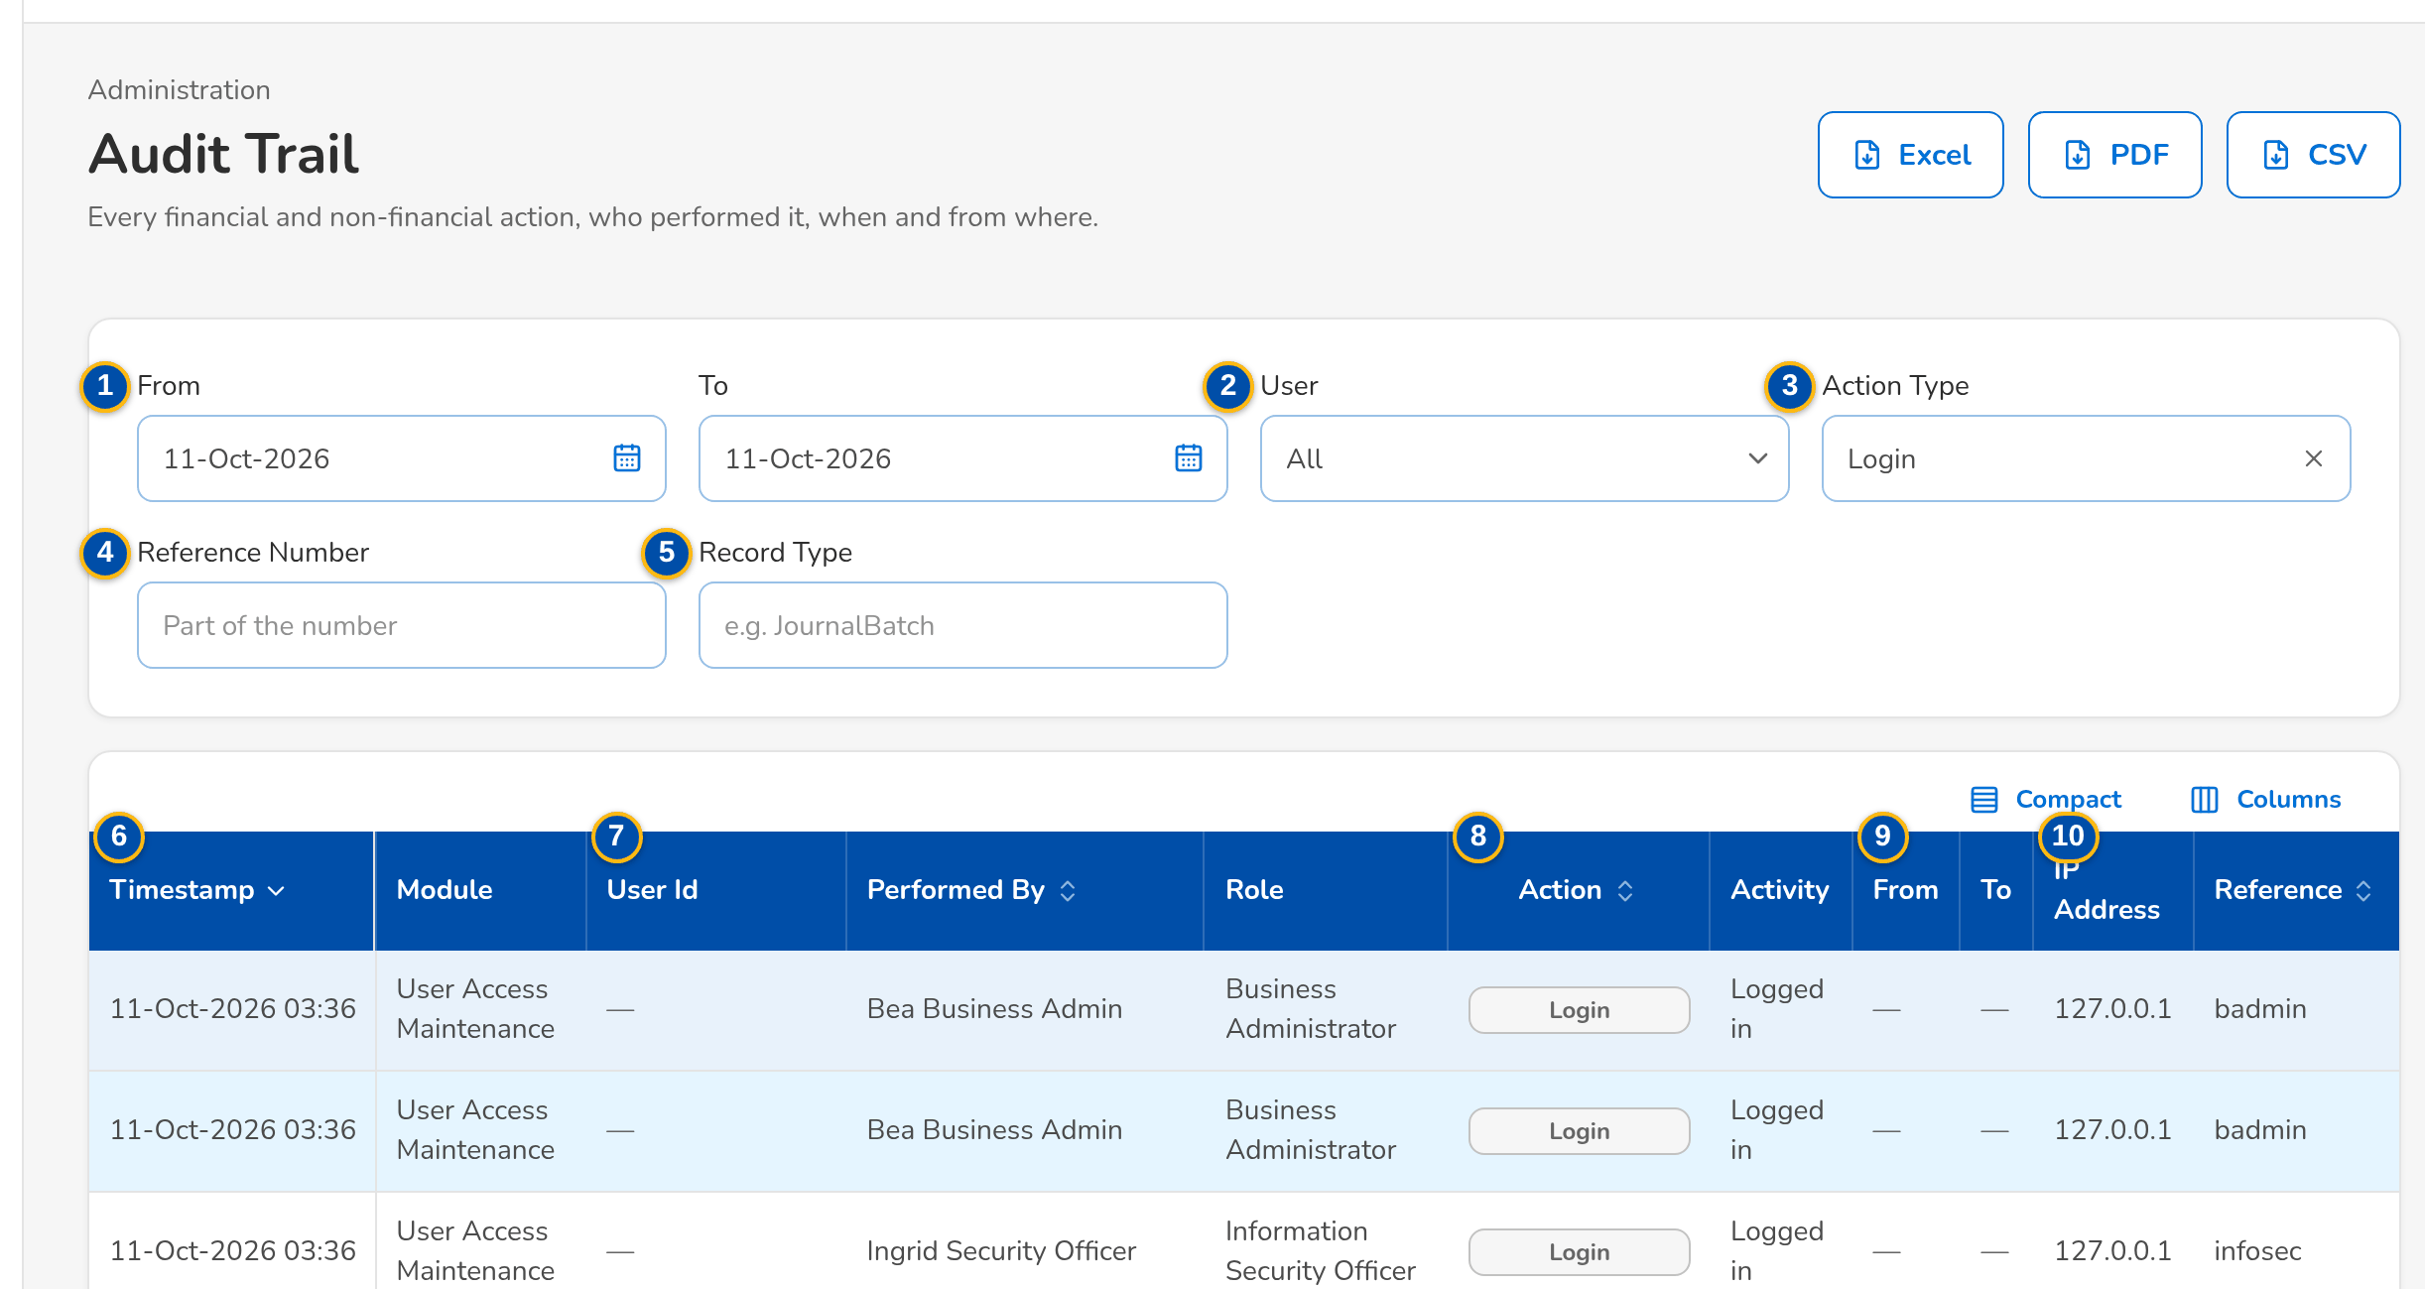
(continued below)
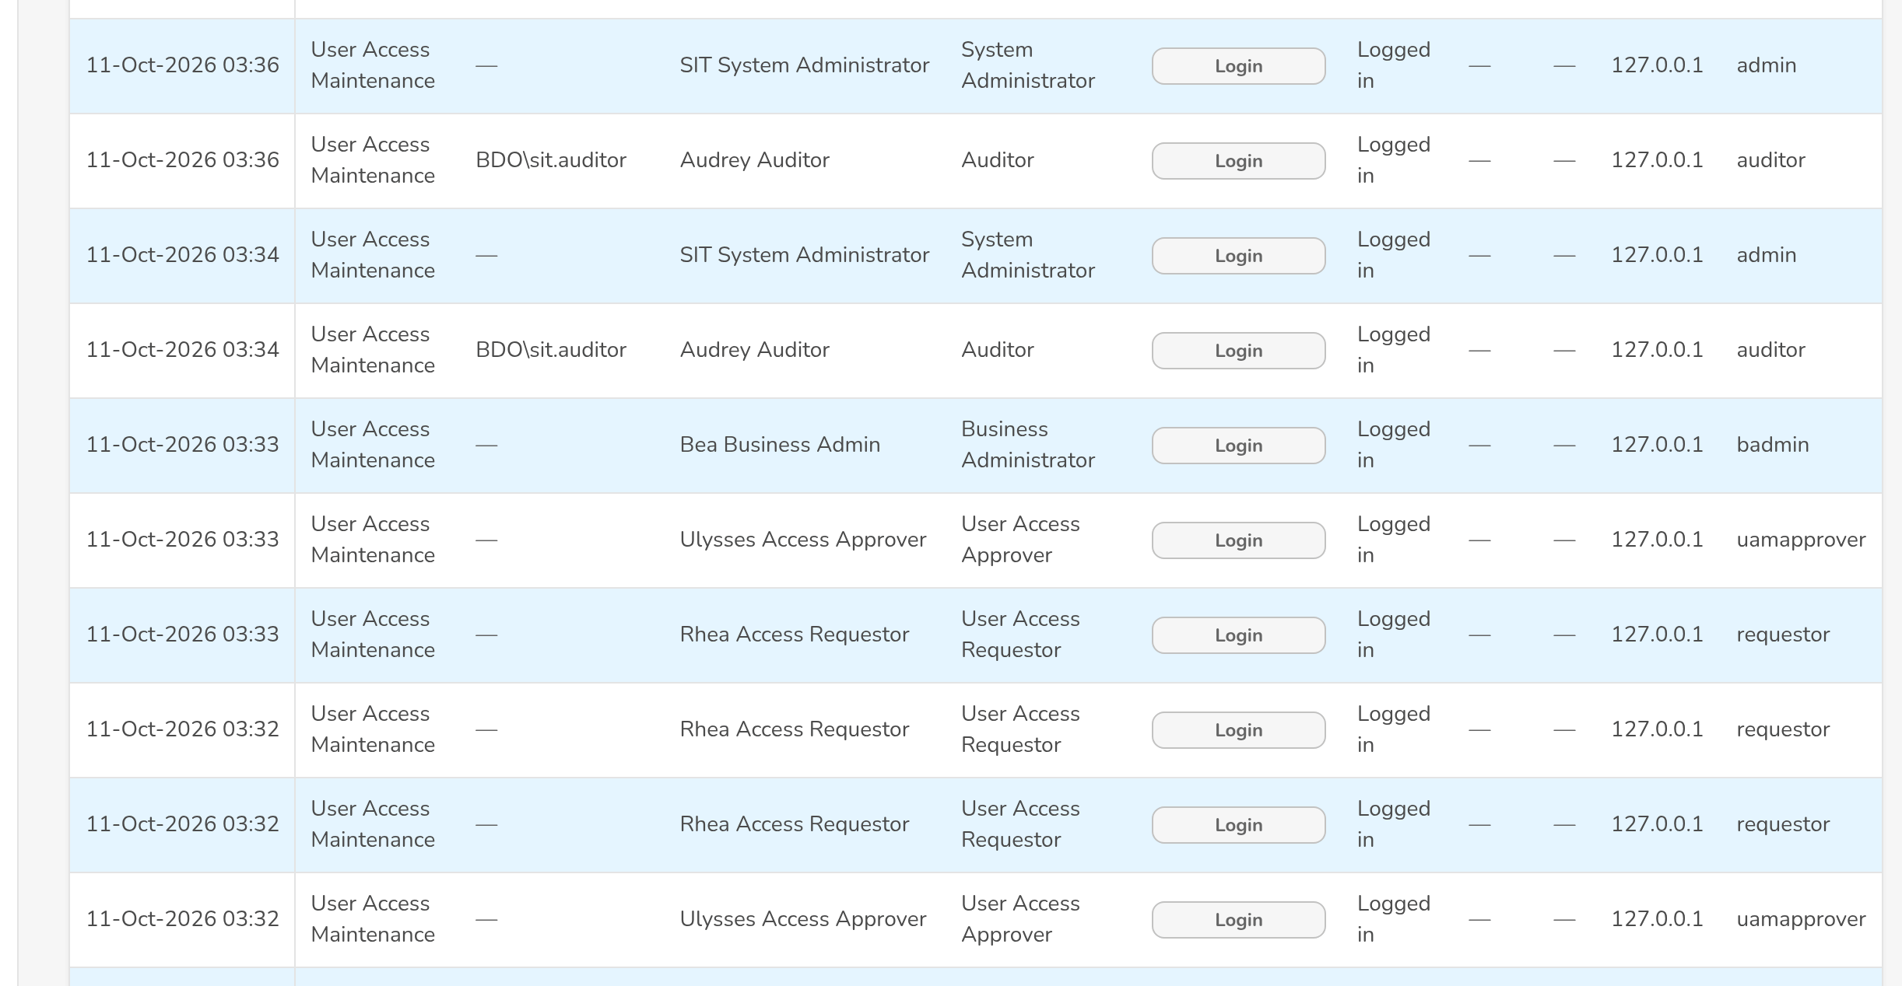
(continued below)
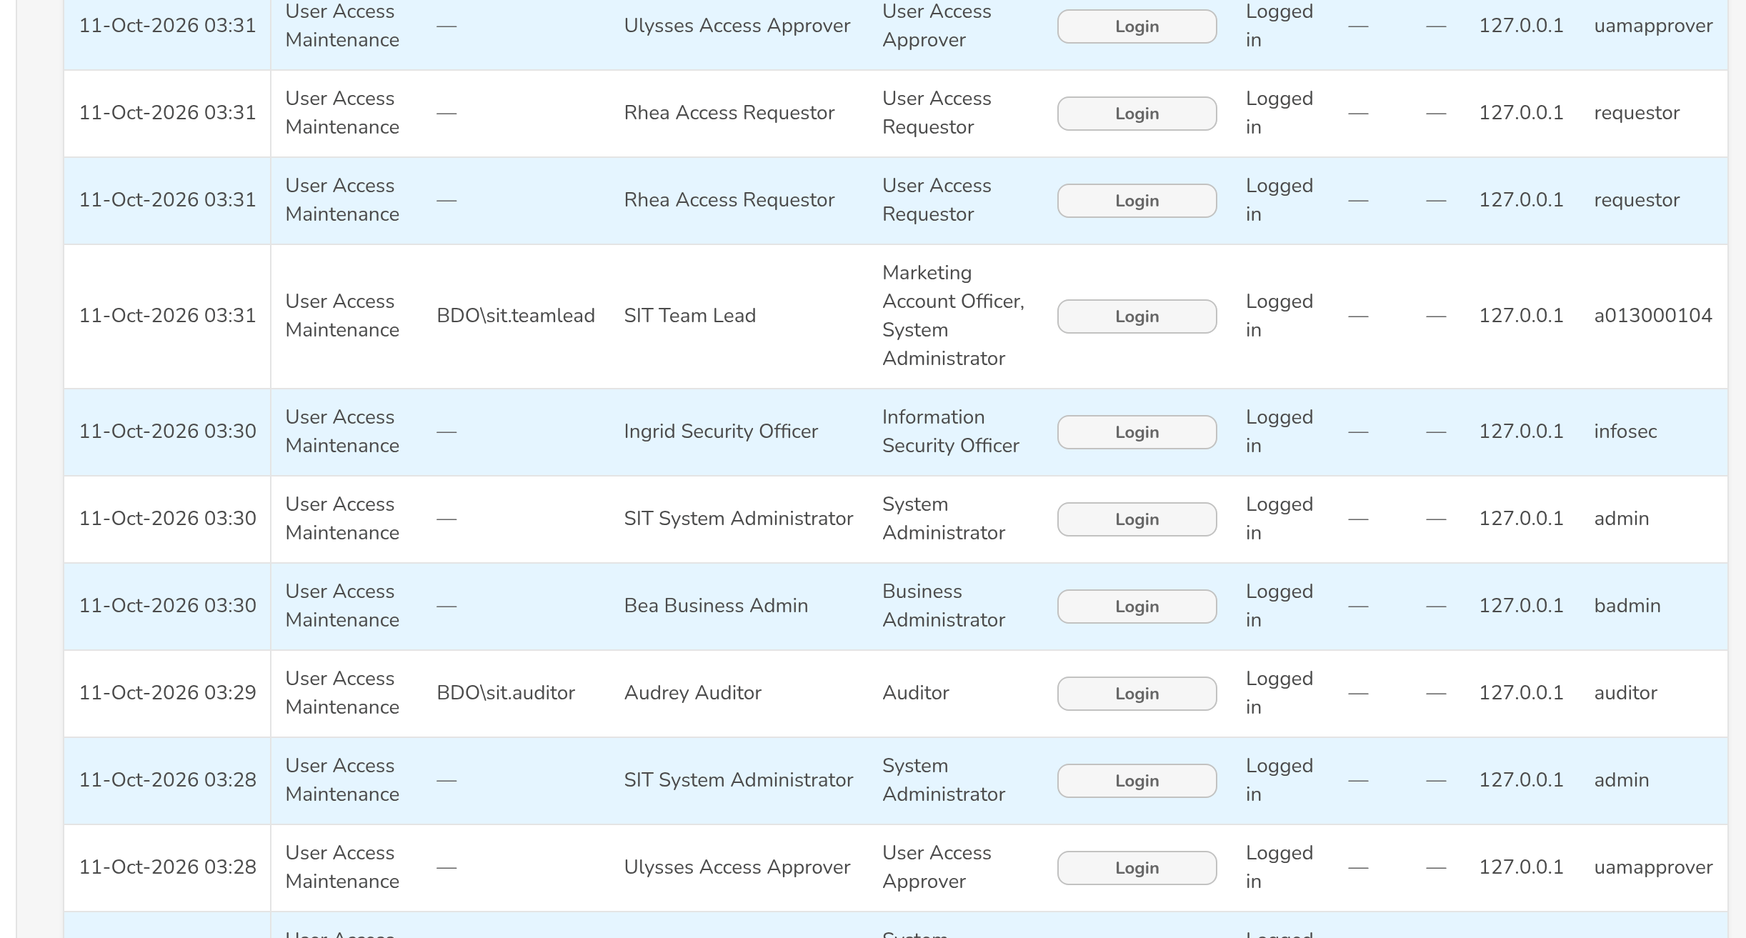
Figure J.22: Audit Trail filtered on the sign-in actions
Field | Type | Mandatory | Format / list / source | Validation and message
Filters: From / To | Date | N | dd-MMM-yyyy | To on or after From; The end date must be on or after the start date
Filters: User | Look-up | N | Name of the user; User master | -
Filters: Action Type | Drop-down | N | Create, Update, Delete/Deactivate, Submit, Approve, Reject, Login, Failed Login, Logout, Inactivity, Timeout, Generate, Export, Post, Reverse, Open, Close, Reopen; Fixed list | -
Filters: Reference Number | Text | N | Part of the number | -
Filters: Record Type | Text | N | Kind of record | -
List: Timestamp / Module | Columns | - | dd-MMM-yyyy HH:mm; module of the action; Audit trail | -
List: User Id / Performed By / Role | Columns | - | Windows ID; name; group profiles held at the time; Audit trail | -
List: Action / Activity | Columns | - | Action type; what was done; Audit trail | -
List: From / To | Columns | - | Value before and after the change; Audit trail | -
List: IP Address / Reference | Columns | - | Source address; reference number of the record; Audit trail | -

Action | Who | Available when | What happens | Resulting status
Excel / PDF / CSV | Auditor, Information Security Officer, System Administrator (audit right) | Always | Downloads the audit log of the filters on screen in BDOI's audit log template, named Audit Logs_MMDDYYYY. Toast: <file> downloaded | -

Rules:
- No user can change or delete an audit record (FRUM.008.01, FRUM.008.04).
- Sign-ins, failed sign-ins, log-outs, the inactivity warning and the inactivity time-out are recorded with the user, the time and the source address (FRUM.001.01, FRUM.001.02, FRUM.001.01, FRUM.001.03, FRUM.008.01, FRUM.008.04).
- The exports are named by BDOI's convention <name>_MMDDYYYY with the extraction date as delivered; the setting Export file names gives the report code instead (FRUM.008.01, FRUM.008.04).

J.23 Menu by persona
The User Access Maintenance entries of the menu of each persona (the sidebar shows an entry only when one of the user's active group profiles holds its permission). The figure is the one-page view for the review; the full sidebar of every persona of BIBS is in the BIBS sign-off workbook of BRD-11.
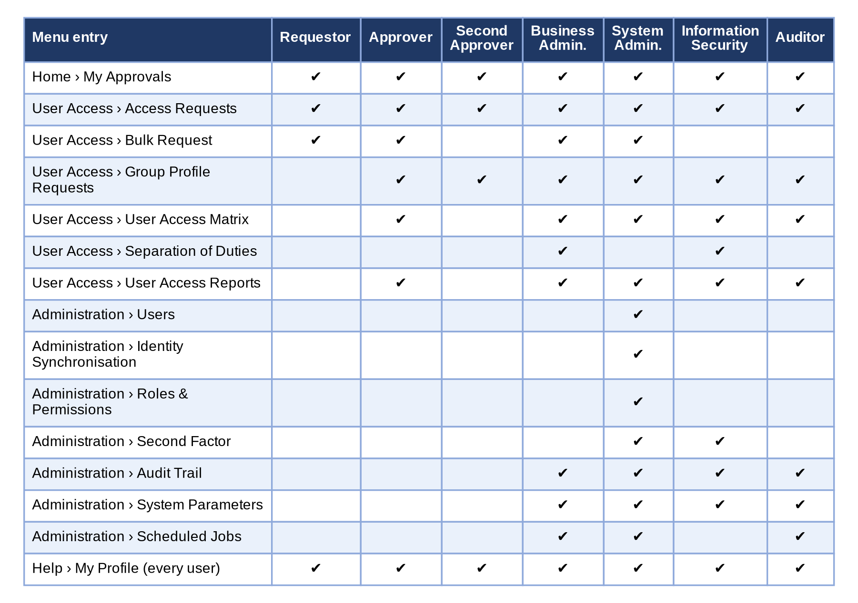
Figure 15 - Menu by persona: the User Access Maintenance screens each persona sees
How to read it: A tick means the screen is in the persona's menu; a screen without a tick is neither shown nor opened by its address. The full menus of every persona are in the BIBS sign-off workbook of BRD-11. Traces to: BRD 4.002.2; FRUM.001.02, FRUM.005.06.
Screen standards: the layout, formats of dates and amounts, tables with row action menus and the common screen elements follow the BIBS programme screen standards; they are not repeated here.

Annex K – Messages and Validations
The messages the user sees when a check fails or an action is not allowed, word for word as on the screens; <name> parts are filled in by the system. The messages of each screen are also in Annex J.
No. | Screen | When | Message shown | Requirement
1 | Login | User ID or password wrong | Invalid user name or password | FRUM.001.01, FRUM.001.02
2 | Login | The identity is not linked to an active user | Your sign-in was accepted by your organisation, but it is not linked to an active user of this system. Contact your administrator. | FRUM.001.02, FRUM.001.06, FRUM-004.01
3 | Login | The identity provider could not complete the sign-in | Your organisation’s sign-in service could not complete the sign-in. Try again in a moment. | FRUM.001.02, FRUM.001.06, FRUM-004.01
4 | Login | Single sign-on not set up in the environment | Single sign-on is not available. Contact your administrator. | FRUM.001.02, FRUM.001.06, FRUM-004.01
5 | Login | DIRECTORY mode - the directory refuses the log-on | The message returned by the directory | FRUM.001.02, FRUM.001.06, FRUM-004.01
6 | My Profile (Change password, Details) | Current password wrong | Current password is incorrect | FRUM-004.01, FRUM-004.02, FRUM-004.03
7 | My Profile (Change password, Details) | New password too weak | Still needed: At least 10 characters; An upper-case letter; A lower-case letter; A digit; A symbol (on the screen, as the user types) | FRUM-004.01, FRUM-004.02, FRUM-004.03
8 | My Profile (Change password, Details) | Password used before | You used this password recently. Choose another one | FRUM-004.01, FRUM-004.02, FRUM-004.03
9 | My Profile (Change password, Details) | Changed too soon | You changed your password less than a day ago | FRUM-004.01, FRUM-004.02, FRUM-004.03
10 | User Access > Access Requests | Justification blank | Enter the justification | FRUM.009.01
11 | User Access > Access Requests | Another request for the user is pending | A request for user <user> is already waiting for approval | FRUM.009.01
12 | User Access > Access Requests | Edit of a draft by another user | Only the creator can edit request <request no> | FRUM.009.01
13 | User Access > Access Requests | Cancel without reason | Enter the reason for the cancellation | FRUM.009.01
14 | New Request (type Enrol new user) | User ID with wrong characters or length | The user name has 3 to 50 letters, digits, dots, dashes or underscores | FRUM.002.01, FRUM.009.02
15 | New Request (type Enrol new user) | User ID not in the BDOI format | The user ID must be <user ID format in words> | FRUM.002.01, FRUM.009.02
16 | New Request (type Enrol new user) | User already exists | User <user> already exists | FRUM.002.01, FRUM.009.02
17 | New Request (type Enrol new user) | Full name blank | Enter the full name of the new user | FRUM.002.01, FRUM.009.02
18 | New Request (type Enrol new user) | No group profile | Select at least one role | FRUM.002.01, FRUM.009.02
19 | New Request (type Enrol new user) | Unknown group profile | Unknown role(s): <codes> | FRUM.002.01, FRUM.009.02
20 | New Request (type Enrol new user) | Inactive group profile | Group profile <name> is not active | FRUM.002.01, FRUM.009.02
21 | New Request (type Enrol new user) | Profiles one user may not hold together | One user may not hold both <profile> and <profile> (separation-of-duties rule <rule>) | FRUM.002.01, FRUM.009.02
22 | New Request (type Enrol new user) | Windows ID already used | Windows ID <id> belongs to another user | FRUM.002.01, FRUM.009.02
23 | New Request (type Modify user) | User not found | User <user> does not exist | FRUM.003.01, FRUM.009.03
24 | New Request (type Modify user) | Nothing changed | The request does not change the user | FRUM.003.01, FRUM.009.03
25 | New Request (type Modify user) | Own roles | You cannot change your own roles | FRUM.003.01, FRUM.009.03
26 | New Request (type Deactivate user) | User already disabled | User <user> is already deactivated | FRUM.003.02.01, FRUM.009.04
27 | New Request (type Reactivate user) | User already active | User <user> is already active | FRUM.003.02.02, FRUM.009.05
28 | New Request (Approver) | Approver not selected | Select the approver | FRUM.009.06
29 | New Request (Approver) | Approver not eligible | <user> cannot approve this request | FRUM.009.06
30 | Access Requests (My Requests) | Correction remark blank | Enter the correction remarks | FRUM.009.07
31 | Access Requests (My Requests) | Request already decided | Request <request no> is already <status> | FRUM.009.08
32 | User Access > Bulk Request | Row with an unknown action | Action <action> is not valid | FRUM.011.01
33 | User Access > Bulk Request | Row fails a request check | The message of the check of a single request (for example User <user> already exists) | FRUM.011.01
34 | User Access > Bulk Request | File type not allowed | The file type is not allowed | FRUM.011.01
35 | New Request (Effective date) | Effective date in the past | The effective date cannot be before today | FRUM.009.10
36 | Request detail (Approve and Apply) | Approver is the requester | A request cannot be decided by the user who submitted it | FRUM.002.01, FRUM.010.02
37 | Request detail (Approve and Apply) | Approver is the subject user | You cannot decide a request about your own access | FRUM.002.01, FRUM.010.02
38 | Request detail (Reject) | Reason blank | Enter the reason of the rejection | FRUM.010.03
39 | Request detail (Return) | Remarks blank | Enter the remarks for the requester | FRUM.010.04
40 | My Approvals | Second approver is the first approver | The second approval is given by another approver | FRUM.010.05
41 | User Access > Group Profile Requests (New) | Code already used | Role <code> already exists | FRUM.005.01, FRUM.005.02
42 | User Access > Group Profile Requests (New) | No permission | Select at least one permission | FRUM.005.01, FRUM.005.02
43 | User Access > Group Profile Requests (New) | Unknown permission | Unknown permission(s): <codes> | FRUM.005.01, FRUM.005.02
44 | User Access > Group Profile Requests (New) | Too many permissions in one request | Split the change into several requests | FRUM.005.01, FRUM.005.02
45 | Group Profile Requests (Modify) | No role selected | Select the role to change | FRUM.006.01, FRUM.006.03, FRUM.006.04
46 | Group Profile Requests (Modify) | Unknown role | Unknown role(s): <code> | FRUM.006.01, FRUM.006.03, FRUM.006.04
47 | Group Profile Requests (Modify) | Permission both added and removed | Permission(s) both added and removed: <codes> | FRUM.006.01, FRUM.006.03, FRUM.006.04
48 | Group Profile Requests (Modify) | No change | The request does not change the permissions of role <code> | FRUM.006.01, FRUM.006.03, FRUM.006.04
49 | Group Profile Requests (Modify) | Another request for the role pending | A request for role <code> is already waiting for approval | FRUM.006.01, FRUM.006.03, FRUM.006.04
50 | Group Profile Requests (Deactivate) | Profile already inactive | Group profile <code> is already inactive | FRUM.006.02.01, FRUM.006.04
51 | Group Profile Requests (Deactivate) | System Administrator profile | Group profile System Administrator cannot be deactivated | FRUM.006.02.01, FRUM.006.04
52 | Group Profile Requests (Reactivate) | Profile already active | Group profile <code> is already active | FRUM.006.02.02, FRUM.006.04
53 | Group Profile Requests (Approvers) | No approver | Add at least one approver | FRUM.005.01, FRUM.005.03
54 | Group Profile Requests (Approvers) | Same approver twice | <user> is already an approver of this request | FRUM.005.01, FRUM.005.03
55 | Access Requests (tab For Implementation) | Direct role edit without a request | Roles are changed through an approved group-profile request; implement the request instead | FRUM.005.01, FRUM.005.04, FRUM.006.01
56 | Access Requests (tab For Implementation) | Implementer is the requester | A request is implemented by someone other than its requester | FRUM.005.01, FRUM.005.04, FRUM.006.01
57 | Roles & Permissions | Action without permission | You are not permitted to perform this action | FRUM.001.02, FRUM.005.01, FRUM.005.06, FRUM.007.03
58 | Administration > Users | Unknown role | One or more roles do not exist: <codes> | FRUM.002.01, FRUM.002.03
59 | User Access > Separation of Duties | Same profile twice | Choose two different group profiles | FRUM.006.03, FRUM.012.01
60 | User Access > Separation of Duties | Rule exists | A rule for these two group profiles already exists | FRUM.006.03, FRUM.012.01
61 | User Access > Separation of Duties | Maker authorises | A record cannot be authorized by the user who maintained it | FRUM.006.03, FRUM.012.01
62 | Administration > System Parameters | Change already pending | A change of <setting> already waits for approval; approve or reject it first | FRUM.012.02
63 | Administration > System Parameters | Requester approves | A change cannot be approved by the user who asked for it | FRUM.012.02
64 | User Access > User Access Reports | As-of date in the future | The as-of date cannot be in the future | FRUM.007.01, FRUM.007.02
65 | User Access Reports | Date to before date from | The end date must be on or after the start date | FRUM.008.01, FRUM.008.01 (2nd), FRUM.008.02, FRUM.008.04
66 | Administration > Jobs (run history) | Invalid e-mail in the recipients | <address> is not a valid e-mail address | FRUM.013.02
67 | Forgot Password and Set a New Password | Confirm new password: Both new passwords must match | Both new passwords must match | FRUM-004.01, FRUM-004.02, FRUM-004.03
68 | My Profile | E-mail address: A valid address | Enter your e-mail address | FRUM.001.04, FRUM.001.05, FRUM-004.01, FRUM-004.02, FRUM-004.03, FRUM.008.01
69 | My Profile | Mobile number: Digits only, for example +63 917 123 4567 | Enter the mobile number with digits only, for example +63 917 123 4567 | FRUM.001.04, FRUM.001.05, FRUM-004.01, FRUM-004.02, FRUM-004.03, FRUM.008.01
70 | New Request and Edit Request (user requests) | Request Type: The type of a saved request cannot change | The type of request <request no> cannot change | FRUM.002.01, FRUM.003.01, FRUM.003.02.01, FRUM.003.02.02, FRUM.006.03, FRUM.009.01, FRUM.009.02, FRUM.009.03, FRUM.009.04, FRUM.009.05, FRUM.009.06, FRUM.009.07, FRUM.009.10, FRUM.012.01
71 | New Request and Edit Request (user requests) | User Type: Not shown while the external users setting is false (no portal installed, as delivered); every request is then for an internal user | Requests for external (portal) users are switched off: no portal is installed | FRUM.002.01, FRUM.003.01, FRUM.003.02.01, FRUM.003.02.02, FRUM.006.03, FRUM.009.01, FRUM.009.02, FRUM.009.03, FRUM.009.04, FRUM.009.05, FRUM.009.06, FRUM.009.07, FRUM.009.10, FRUM.012.01
72 | New Request and Edit Request (user requests) | User ID: A new user ID must not exist and must follow the format; an existing user must be active to deactivate and deactivated or locked to reactivate | Use 3 to 50 letters, digits, dots, dashes or underscores | FRUM.002.01, FRUM.003.01, FRUM.003.02.01, FRUM.003.02.02, FRUM.006.03, FRUM.009.01, FRUM.009.02, FRUM.009.03, FRUM.009.04, FRUM.009.05, FRUM.009.06, FRUM.009.07, FRUM.009.10, FRUM.012.01
73 | New Request and Edit Request (user requests) | User ID: A new user ID must not exist and must follow the format; an existing user must be active to deactivate and deactivated or locked to reactivate | The user ID must be a letter followed by nine digits, for example a013000196 | FRUM.002.01, FRUM.003.01, FRUM.003.02.01, FRUM.003.02.02, FRUM.006.03, FRUM.009.01, FRUM.009.02, FRUM.009.03, FRUM.009.04, FRUM.009.05, FRUM.009.06, FRUM.009.07, FRUM.009.10, FRUM.012.01
74 | New Request and Edit Request (user requests) | Windows ID: Not the Windows ID of another user | Windows ID <windows id> belongs to another user | FRUM.002.01, FRUM.003.01, FRUM.003.02.01, FRUM.003.02.02, FRUM.006.03, FRUM.009.01, FRUM.009.02, FRUM.009.03, FRUM.009.04, FRUM.009.05, FRUM.009.06, FRUM.009.07, FRUM.009.10, FRUM.012.01
75 | New Request and Edit Request (user requests) | Authorisation Limit (PHP): Zero or more, 2 decimals | Enter an amount of zero or more, with up to 2 decimals | FRUM.002.01, FRUM.003.01, FRUM.003.02.01, FRUM.003.02.02, FRUM.006.03, FRUM.009.01, FRUM.009.02, FRUM.009.03, FRUM.009.04, FRUM.009.05, FRUM.009.06, FRUM.009.07, FRUM.009.10, FRUM.012.01
76 | Access Request record | Comment / Remarks / Reason: Not blank for a return, rejection or cancellation | Enter the remarks | FRUM.002.01, FRUM.005.01, FRUM.005.04, FRUM.006.01, FRUM.007.03, FRUM.008.01, FRUM.008.04, FRUM.009.08, FRUM.009.09, FRUM.010.01, FRUM.010.02, FRUM.010.03, FRUM.010.04, FRUM.010.05
77 | New Group Profile Request and Edit Request | Profile Code: Format; not the system of an existing profile | Use up to 40 capital letters, digits or underscores | FRUM.001.02, FRUM.005.01, FRUM.005.02, FRUM.005.03, FRUM.005.06, FRUM.006.01, FRUM.006.02.01, FRUM.006.02.02, FRUM.006.03, FRUM.006.04, FRUM.007.03
78 | New Group Profile Request and Edit Request | Name: Not blank | Enter the name of the group profile | FRUM.001.02, FRUM.005.01, FRUM.005.02, FRUM.005.03, FRUM.005.06, FRUM.006.01, FRUM.006.02.01, FRUM.006.02.02, FRUM.006.03, FRUM.006.04, FRUM.007.03
79 | New Group Profile Request and Edit Request | Added / Removed: A change must grant or withdraw at least one permission, or change the name, description or level | Grant or withdraw at least one permission | FRUM.001.02, FRUM.005.01, FRUM.005.02, FRUM.005.03, FRUM.005.06, FRUM.006.01, FRUM.006.02.01, FRUM.006.02.02, FRUM.006.03, FRUM.006.04, FRUM.007.03
80 | Users | Latest synchronisation: - | This user has not been synchronised from the Enterprise SSO platform yet | FRUM.001.04, FRUM.001.05, FRUM.002.01, FRUM.002.03, FRUM.008.01, FRUM.008.04
81 | System Parameters (sign-in, password and access settings) | Value: Type and range of the parameter | <parameter> <error of the type or range> | FRUM.001.01, FRUM.001.02, FRUM.001.03, FRUM.001.04, FRUM.002.01, FRUM.002.03, FRUM.003.02.01, FRUM.003.04, FRUM-004.01, FRUM-004.02, FRUM-004.03, FRUM.012.02
82 | Separation of Duties | Group Profile: - | Select the first group profile | FRUM.006.03, FRUM.012.01
83 | Separation of Duties | Permission: - | Select the first permission | FRUM.006.03, FRUM.012.01
84 | Separation of Duties | Reason: Not blank | Enter why the two profiles are not held together | FRUM.006.03, FRUM.012.01
85 | Identity Synchronisation | Windows ID: The account must exist and be active | The user cannot be created from this Enterprise SSO account | FRUM.001.02, FRUM.001.04, FRUM.001.05, FRUM.001.06, FRUM-004.01, FRUM.008.01, FRUM.008.04
86 | Identity Synchronisation | Windows ID / User ID / AD status / First name / Last name / Display name / AD e-mail / AD group / Team leader's name / Team head's name / Section head's name / Unit head's name / Unit / segment / Department / Location / UIDM request no.: Required fields entered | Still needed: <fields> | FRUM.001.02, FRUM.001.04, FRUM.001.05, FRUM.001.06, FRUM-004.01, FRUM.008.01, FRUM.008.04

Annex L – Notifications and E-mails
The notifications the system sends: notices in the system (bell in the page header), e-mails and alerts. The temporary password of a new user is never e-mailed.
Corrected in version 1.3: the notices of access requests are given in the system; the e-mails are the access-change, dormant-account, password and failed-run messages (Annex Q.5). The full text of every notice and e-mail, with its subject, recipients and rules, is in Annex T, which prevails.
No. | Channel | Trigger | Recipient | Text | Requirement
NT-01 | Notice in the system | A request is submitted or resubmitted; a group-profile request is approved by one approver and waits for the next in order | The approver chosen by the requester (the next approver in order); for a request raised without a chosen approver, every holder of the approval right | Title: Access request <request no> to approve. Text: <description of the change> | FRUM.005.01, FRUM.005.03, FRUM.010.01, FRUM.013.01
NT-02 | Notice in the system | The first approval of a request with a risk flag (privilege increase, outside working hours) | Every holder of the second approval right (Second Approver) | Title: Access request <request no> for second approval. Text: <description of the change> <risk flags> | FRUM.010.05, FRUM.013.01
NT-03 | Notice in the system | The last approval of a group-profile request (the request waits for implementation) | Every holder of the role management right (System Administrator) | Title: Access request <request no> to implement. Text: <description of the change> | FRUM.005.01, FRUM.005.04, FRUM.006.01, FRUM.013.01
NT-04 | Notice in the system | A request is decided or completed: approved (applied), approved with a future effective date, approved for implementation, rejected, implemented, applied on its effective date by the daily job | The requester (the user who submitted the request) | Title: Access request <request no> approved | approved, applies on <dd-MMM-yyyy> | approved, for implementation | rejected | implemented | applied on its effective date. Text: <description of the change> (<comment of the decider>) | FRUM.002.01, FRUM.005.01, FRUM.005.04, FRUM.006.01, FRUM.009.10, FRUM.010.02, FRUM.010.03, FRUM.013.01
NT-05 | Notice in the system | The approver returns a request (Return) | The requester | Title: Access request <request no> returned. Text: <description of the change> - <remarks> | FRUM.009.07, FRUM.010.04, FRUM.013.01
NT-06 | in the system | The creator cancels a request that was assigned to an approver | The approver the request was assigned to | Title: Access request <request no> cancelled. Text: <description of the change> - <reason> | FRUM.009.08, FRUM.013.01
NT-07 | in the system and e-mail | An approved change to a user is applied (at approval, or on the effective date) | The user whose access changed (e-mail to the user's registered address) | in the system title: Your access changed. Text: Your access changed: <description of the change> (request <request no>). E-mail subject: the system: your access changed; body: the same text | FRUM.013.01
NT-14 | in the system and e-mail | A request that deactivates or reactivates a group profile is implemented (or applied on approval) | Each active member of the group profile (e-mail to the member's registered address) | in the system title: Your access changed. Text: Your access changed: <description of the change>, a group profile you hold (request <request no>). E-mail subject: the system: your access changed; body: the same text | FRUM.006.02.01, FRUM.006.02.02, FRUM.006.04, FRUM.013.01
NT-15 | in the system and e-mail | The daily job the dormant-user run (00:15) finds a user whose deactivation date is the dormancy notice days away (7) | The dormant user | Title: Your account will be deactivated. Text: You have not signed in to the system for a long time. Sign in before <dd-MMM-yyyy>, or your account is deactivated and a new access request is needed. E-mail subject: the system: sign in to keep your account | FRUM.003.02.01, FRUM.003.04
NT-16 | in the system | The daily job the dormant-user run deactivates one or more users (each also receives NT-07) | Every holder of the request right (Business Administrator, System Administrator) | Title: Dormant users deactivated. Text: <count> user(s) without a sign-in for <days> days were deactivated: <user IDs> | FRUM.003.02.01, FRUM.003.04
NT-08 | E-mail | A user asks for a reset link (Forgot password?, local sign-in) | The registered e-mail address of the user, when the user is active and has one | Subject: the system: reset your password. Body: Dear <full name>, A new the system password was requested for user <user ID>. Open this link to set it: <link>. The link works once and expires at <date and time> (Philippine time). If you did not ask for it, ignore this e-mail; your password stays as it is. | FRUM-004.01, FRUM-004.02, FRUM-004.03
NT-09 | in the system and e-mail (by preference) | The daily job the password expiry notice (06:00) finds a password that expires within 7 days (local sign-in) | The user whose password expires | Title: Your password expires soon. Text: Your the system password expires on <date and time> (Philippine time). Change it on My Profile before then. E-mail subject: the system: your password expires soon | FRUM-004.01, FRUM-004.02, FRUM-004.03
NT-10 | E-mail | A scheduled batch job fails (for example the daily application of dated access changes) | The addresses of the parameter the failed-run recipients | Subject: the system: batch job <job> failed. Body: The batch job <job> failed. Run: <run>. Started: <date and time> (Philippine time). Trigger: <trigger>. Error: <message>. Open Administration > Scheduled Jobs to see the run history and run the job again. | FRUM.013.02
NT-11 | Alert inbox | A request with a risk flag passes its first approval (alert Privileged access change, medium) | Holders of the alert right (System Administrator, Auditor) | Access request <request no> <risk flags>: <description of the change> | FRUM.010.05
NT-12 | Alert inbox | A scheduled request cannot be applied on its effective date (alert Scheduled access change failed, high) | Holders of the alert right (System Administrator, Auditor) | Access request <request no> could not be applied on <dd-MMM-yyyy>: <reason> | FRUM.009.10
NT-13 | Alert inbox | A group profile is created or changed directly while the emergency path the emergency role edit is open (alert Role edited outside a request, medium) | Holders of the alert right (System Administrator, Auditor) | Role <code> <change> directly by <user> (emergency path the emergency role edit) | FRUM.002.01, FRUM.002.03, FRUM.005.01, FRUM.005.04, FRUM.006.01
NT-17 | Notice in the system | A separation-of-duties rule is created, or its deactivation is asked | Every holder of the rule authorisation right (Information Security Officer) | Title: Separation-of-duties rule <rule> to authorise. Text: The new rule | deactivation of rule <rule>: <reason> | FRUM.006.03, FRUM.012.01
NT-18 | in the system and e-mail (by preference) | The System Administrator changes a security setting on System Parameters | Every holder of the security setting approval right (Information Security Officer) | Title: Security setting to approve: <description of the setting>. Text: <user name> requests a change from '<current value>' to '<new value>' | FRUM.012.02
NT-21 | Notice in the system (and e-mail by preference) | An event of UIDM-ISC or the Enterprise SSO platform is refused or fails | Every holder of the user management right (System Administrator) | Title: Identity event <event no> needs review. Text: <source> event <type> of Windows ID <Windows ID> was <refused | failed>: <reason> | FRUM.001.02, FRUM.001.06, FRUM-004.01
NT-22 | in the system and e-mail; alert | A break-glass System Administrator signs in with a local password while single sign-on is on | Information Security Officers and the addresses of the setting Break-glass alert recipients | Title: Break-glass sign-in. Text: Break-glass administrator <name> (<user ID>) signed in with a local password at <dd-MMM-yyyy HH:mm> from <address>. Review the use within one working day. | FRUM.001.02, FRUM.001.06, FRUM-004.01

Annex M – Business Rules and Parameters
The rules that apply across the User Access Maintenance requirements and the values the System Administrator maintains without a change to the system. A change of a security setting applies only after the approval of Information Security (FRUM.012.02).

M.1 Personas
Persona | Responsibilities | BRD
Requestor | Raises user access requests: enrol, modify, deactivate, reactivate, bulk; corrects and cancels them; views own requests | BRD section A
Approver | Reviews and approves, rejects or returns the requests assigned to him or her | BRD section B
Second Approver | Reviews privileged or out-of-hours changes after the first approval | BRD NFR 11
Business Administrator | Raises group-profile requests; generates the reports; maintains the separation-of-duties rules; uploads bulk requests; supports users | BRD section C
System Administrator | Implements approved group-profile requests; unlocks users; resets the passwords of local accounts; audit logs | BRD section D
Auditor | Views the requests and runs the reports and the audit log | BRD NFR 6
Information Security Officer | Authorises the separation-of-duties rules and the changes of security settings; views requests, matrix and audit trail | BRD NFR 11

M.2 Permissions of the access functions
Each access function has its own permission, so that it can be granted to any group profile (BRD 4.002.2; FRUM.005.06).
Function | Action class | BRD
Enrol a new user | Create | 4.002.2.1
Modify an existing user | Amend | 4.002.2.2
Deactivate a user | Amend | 4.002.2.3
Reactivate a user | Amend | 4.002.2.4
Apply correction to a returned request | Amend | 4.002.2.5
Cancel a request | Amend | 4.002.2.6
View requests | View | 4.002.2.7
Review and approve requests | Approve | 4.002.2.8
Submit group-profile requests | Create | 4.002.2.9
Generate the user access reports | View | 4.002.2.10
Second approval of privileged or out-of-hours changes | Approve | NFR 11
Maintain separation-of-duties rules | Amend | NFR 11
Authorise separation-of-duties rules | Approve | NFR 11
Approve a change of a security setting | Approve | NFR 11
Manage users and roles (implementation of group-profile requests) | Amend | 4.002.1
Bulk upload | Create | 1.009

M.3 Proposed role-to-action matrix
Y = the persona's group profile holds the permission. Proposal for BDOI to confirm with the User Access Matrix of Annex C; the segregation rules of M.6 apply whatever the roles grant.
Function | Requestor | Approver | Second Approver | Business Admin | System Admin | NB Approver | Auditor | InfoSec Officer
Enrol a new user | Y
Modify an existing user | Y
Deactivate a user | Y
Reactivate a user | Y
Apply correction | Y |  |  | Y
Cancel a request | Y |  |  | Y
View requests | Y | Y | Y | Y | Y |  | Y
Review and approve requests |  | Y |  |  |  | Y
Second approval |  |  | Y
Submit group-profile requests |  |  |  | Y
Generate the user access reports |  | Y |  | Y | Y |  | Y | Y
Manage users and roles |  |  |  |  | Y
Bulk upload | Y |  |  | Y | Y
Maintain separation-of-duties rules |  |  |  | Y
Authorise separation-of-duties rules |  |  |  |  |  |  |  | Y
Approve a change of a security setting |  |  |  |  |  |  |  | Y

M.4 Password, lock-out and second factor
Rule | Value | Applies to
Sign-in of BDO users | Single sign-on through EIAM; the password, its expiry and history, the lock-out and the second factor are EIAM's policies | All users except the break-glass accounts
Password length and composition | At least 10 characters with upper- and lower-case letters, a digit and a symbol | Break-glass accounts
Password history | Last 10 passwords refused (BDOI's FRUM-004) | Break-glass accounts
Password expiry | 90 days; a notice 7 days before | Break-glass accounts
Minimum password age | 1 day | Break-glass accounts
Lock-out | 3 consecutive failed attempts; unlocked by a System Administrator or a reactivation request | Break-glass accounts (EIAM's lock-out for the others)
Password reset | By another System Administrator, never one's own; temporary password shown once; change at the next sign-in; no forgotten-password link on the Login page (setting Password reset rules, M.10) | Break-glass accounts
Second factor | Code of an authenticator application at every sign-in; ten single-use recovery codes; a lost authenticator is reset by a System Administrator and approved by another | Break-glass accounts (EIAM's second factor for the others)

M.5 Session policy
Rule | Value | Note
Inactivity warning | 15 minutes without activity | Stay Logged In / Log Out
Inactivity sign-out | 30 minutes without activity | The session ends with the reason inactivity; the page Session Timed Out: Your session timed out. Please log in again to continue, with Log In
Session-end warning | 30 minutes before the fixed end of a session | BRD x.001.1.3
Several tabs | One session for all the tabs of a user | Activity in any tab counts
One session per device | Not enforced; every session is in the session log | Open point UQ09 of Annex Z

M.6 Segregation and separation-of-duties rules
- Four eyes: the requester and the user a request is about never decide it.
- The second approver differs from the first approver, the requester and the user concerned.
- The implementer of a group-profile request is not its requester.
- Separation-of-duties rules: pairs of group profiles one user may not hold together, and pairs of permissions (the conflicting permission combinations) that neither one group profile nor one user may hold together, kept by the Business Administrator and authorised by Information Security; checked on every request, bulk line and group-profile change, at submission and at approval.
- A user never changes his or her own group profiles.
- Privilege level of each group profile (Low, Standard, High, Admin): a request that gives a High or Admin profile, or that is submitted or approved outside working hours, needs a second approval and raises an alert.
- Security settings change only with the approval of Information Security.
- Group profiles change only through approved and implemented requests; the emergency role edit is off by default, needs the approval of Information Security and is alerted.
- Every change is recorded with its from and to values in a log that no user can change.

M.7 Configurable parameters
Parameter | Default | Meaning | Value decided by
Sign-in mode | Single sign-on through EIAM (OpenID Connect or SAML 2.0) in production; local sign-in in SIT until BIBS is registered in EIAM | Sign-in of the environment | BDOI IT
Lock-out attempts | 3 | Failed attempts before a local account locks | Information Security
Inactivity warning | 15 minutes | Inactivity time before the warning | Information Security
Session timeout | 30 minutes | Inactivity time before the sign-out | Information Security
Session-end warning | 30 minutes | Warning before the fixed end of a session | Information Security
User ID format | A letter followed by nine digits (a999999999) | Format of new user IDs | shown in words to the requester
Password history | 10 | Previous passwords refused (local accounts) | Information Security
Password expiry | 90 days | Password expiry (local accounts) | Information Security
Minimum password age | 1 day | Minimum days between changes (local accounts) | Information Security
Working hours | 08:00 to 18:00, Monday to Friday | Hours outside which a change needs a second approval | Information Security
Any approver may decide | No | Yes lets every approver decide every pending request, not only the chosen one | Business Administration
Emergency role edit | Off | Direct change of roles in an emergency (audited and alerted) | Information Security
Apply group profiles on approval | No | Yes applies an approved group-profile request without the implementation step | Business Administration
Failed-run recipients | (set by BDOI) | E-mail addresses of the failed-run notice | System Administrator
Dormancy period | 90 days | Days without a sign-in after which a user is deactivated; 0 switches it off | Information Security
Dormancy notice | 7 days | Days before the deactivation on which the user is told | Information Security
External (portal) users | Off | Requests for portal users; off while no portal is installed | Business Administration
Daily run of effective changes | 00:05 daily | Applies the scheduled requests | System Administrator
Daily run of dormant users | 00:15 daily | Deactivates the dormant users and sends the notices | System Administrator
Password expiry notice | 06:00 daily | Notifies local-account users whose password expires within 7 days | System Administrator

M.8 Lists of values
List | Values
Business unit group | Empty until BDOI supplies the values
User level | Empty until BDOI supplies the values
Deactivation reason | Resigned; Transferred to another unit; Long leave; Security; Others; No sign-in for the dormancy period (dormant-user run)
Privilege level | Low; Standard; High; Admin

M.9 Request statuses and transitions
Status | Meaning | Who acts
Draft | Saved, not submitted; seen by its creator only | Creator (edit, submit, cancel)
Pending Approval | Submitted; waiting for the chosen approver (group profiles: the current approver in order) | Approver; creator may cancel
Pending Second Approval | Approved once; waiting for a second approval because of a risk flag | Second Approver
Returned | Returned with remarks for correction | Creator (correct and re-submit, or cancel)
Scheduled | Approved; applied by the daily run on the effective date | System; creator or approver may cancel
Approved | Approved and applied | -
Rejected | Rejected with a reason | -
Cancelled | Cancelled by the creator with a reason | -
For Implementation | Group profile: approved; waiting for the System Administrator | System Administrator
Implemented | Group profile: implemented | -

From | Action | To | Who | Remarks
(new) | Save | Draft | Requestor (request permission) | Optional
Draft | Submit | Pending Approval | Creator | Mandatory
Draft | Cancel | Cancelled | Creator | Mandatory
Pending Approval | Approve | Approved, Scheduled, Pending Second Approval, For Implementation or the next approver | Chosen approver | Optional
Pending Second Approval | Second approval | Approved, Scheduled or For Implementation | Second Approver, not the first approver | Optional
Pending Approval, Pending Second Approval | Return | Returned | Approver | Mandatory
Pending Approval, Pending Second Approval | Reject | Rejected | Approver | Mandatory
Returned | Re-submit | Pending Approval | Creator (correction permission) | Mandatory
Pending Approval, Returned, Scheduled | Cancel | Cancelled | Creator (cancel permission); approver for Scheduled | Mandatory
Scheduled | Apply (daily run) | Approved | System | -
For Implementation | Implement | Implemented | System Administrator, not the requester | Optional

M.10 Settings for the points BDOI decides
The points where BDOI's FRS and the BRD or the earlier BIBS behaviour differ are offered both ways in BIBS, each chosen by a setting that the System Administrator changes with the approval of Information Security, without a release. The default is BDOI's FRS unless stated. BDOI's decision only confirms the value; the points stay in Annex Q as Configurable - BDOI to confirm the setting.
Setting | Values | Default | Settles (Annex Q) | Decided by
Users from the Enterprise SSO platform | On: users are created, updated, deactivated and reactivated from the Enterprise SSO and UIDM-ISC events, and from an active Enterprise SSO account; Off: only through approved access requests | On (BDOI's FRS) | C01, C04, C13, C14 | Information Security; BDOI IT
Group profiles from UIDM-ISC | On: the group profiles named in a UIDM-ISC event are given to the user (option b); Off: group profiles only through approved requests in the system (option a) | Off (option a) | C01 | Information Security; BDOI IT
Inactivity warning wording | On: You have been inactive for x minutes ... stay logged in or log out? with Stay Logged In and Log Out; Off: the earlier wording with Stay Signed In and Sign Out Now | On (BDOI's FRS) | C08 | Process Owner (Business Administration)
Session timed-out page | On: after the inactivity sign-out the page Your session timed out. Please log in again to continue, with Log In; Off: a message on the Login page | On (BDOI's FRS) | C07 | Process Owner (Business Administration)
Password reset rules | On: no forgotten-password link; a password is reset only by another System Administrator, and with single sign-on only for the break-glass accounts; Off: the self-service reset link for local accounts and the administrator reset of any local account | On (BDOI's FRS) | C11 | Information Security
Password history | 0 to 24 previous passwords that may not be reused | 10 (BDOI's FRS) | C10 | Information Security
Export file names | On: <name>_MMDDYYYY with the extraction date (for example Audit Logs_10092026.xlsx); Off: the report code | On (BDOI's FRS) | C18 | Process Owner (Business Administration)
Access request notices by e-mail | On: the notices of access requests are also e-mailed to each user who chose e-mail in the notification preferences; Off: in the system only | On (BDOI's FRS) | C25 | Process Owner (Business Administration)
Conflicting permission combinations | Rules of two permissions that neither one group profile nor one user may hold, kept on Separation of Duties | None delivered; BDOI lists the pairs | C16 | Information Security
Company-issued devices only | On: the system is used only from company networks or devices marked by the device-management gateway (with the company networks and the device marker of BDOI IT); Off: any device | Off as delivered; to be switched on with the values of BDOI IT | - | BDOI IT; Information Security
Break-glass alert recipients | E-mail addresses of Information Security alerted at every break-glass sign-in | Blank (to be given) | - | Information Security

Annex N – Sign-in and Identity Integration
The business view of the sign-in through the Enterprise SSO platform (EIAM), the provisioning of user accounts from UIDM-ISC and the break-glass access. The technical settings are in the Authentication and Identity Integration Requirements reviewed by BDOI IT.

N.1 Sign-in modes
Mode | How the user signs in | Who
Single sign-on (production) | The user signs in once with the BDO account at EIAM (BDO Enterprise Identity Access Management on Microsoft Entra ID), with EIAM's password, second factor and device rules; the system opens a session with the user's group profiles. OpenID Connect is proposed, SAML 2.0 is the fall-back if BDOI IT prefers it. | BDO users
Local sign-in (break-glass) | User ID, password and second factor held in the system | Two named System Administrators of BDOI IT
Local sign-in (SIT only) | User ID and password held in the system | SIT and UAT users until BIBS is registered in EIAM for the environment

N.2 Single sign-on with EIAM
- The user opens the system and clicks Sign in with the BDO identity provider on the Login page.
- EIAM signs the user in with the BDO account and its second factor, applying the BDO device and access policies, and returns the user to the system.
- The system checks EIAM's answer, finds the active user that matches the returned Windows ID (or user principal name) and opens the session with the user's group profiles; the sign-in is recorded with its method.
- An identity that matches no active user is refused with the not-linked message; EIAM unavailable shows "Your organisation's sign-in service could not complete the sign-in. Try again in a moment."
- Log Out ends the session in the system and at EIAM; an inactivity sign-out asks for the EIAM sign-in again at the next access.
Rules:
- The system never creates a user from a sign-in; users exist through an approved enrolment, the UIDM-ISC and Enterprise SSO events, or Create User from Enterprise SSO by the System Administrator for an active directory account (Identity Synchronisation, Annex J).
- Roles and permissions stay in the system and change only through requests; no EIAM group is mapped to a role. EIAM may restrict who reaches the system through a 'BIBS users' group kept by BDOI IT.
- The Windows ID held on each user identifies the EIAM account; the user ID keeps the BDOI format a999999999.
- Switching to single sign-on is a setting of the environment once BDOI IT has registered the system in EIAM, not a change request.

N.3 Provisioning from UIDM-ISC
BIBS offers the three options as settings (Annex M.10); as delivered option (a) applies. BDOI confirms the settings (Annex Q, conflict C01).
Option | Requests and approvals | Exchange with UIDM-ISC
(a) UIDM-ISC provisions the user accounts; role changes stay requests in the system (as delivered: Users from the Enterprise SSO platform on, Group profiles from UIDM-ISC off) | Joiners, movers and leavers come from UIDM-ISC: create, change, deactivate and reactivate users, each with its UIDM request number. The assignment and change of group profiles and the group-profile requests stay requests in the system under four eyes (FRUM.009 to FRUM.011 for them). | Standard user-provisioning interface from UIDM-ISC; extract of accounts, group profiles and permissions for certification
(b) UIDM-ISC provisions users and roles (Group profiles from UIDM-ISC on) | Every access change is requested and approved in UIDM-ISC and applied by the system; requests in the system only for the break-glass path. | The same interface with the group profiles as entitlements
(c) No provisioning from UIDM-ISC (Users from the Enterprise SSO platform off) | Every access change is a request in the system, as the BRD reads; UIDM-ISC only reads the accounts for certification. | Extract only

- Every change applied from UIDM-ISC is recorded in the access-change log with the source UIDM-ISC and the UIDM request number, so the reports of FRUM.007 and FRUM.008 stay complete.
- A refused provisioning event is answered to UIDM-ISC, kept with its reason on Identity Synchronisation and alerted to the System Administrators; it is processed again there once the data is corrected, or re-sent from UIDM-ISC.
- Each user shows the directory details last received (Windows ID, AD e-mail, group and status, names of the reporting line, unit, department, location, UIDM request number, date and time of the synchronisation); Synchronise Now on the Users screen reads the account from the Enterprise SSO platform again.
- In SIT and UAT a simulator stands for the Enterprise SSO platform: its accounts sign in on a sign-in page of the simulator and send the joiner, mover, leaver, rehire and status events, so that the flows run end to end; it cannot be switched on in production. The live connection is set at SIT with the details of BDOI IT.
- A leaver deactivates the user and ends the user's open sessions.

N.4 Break-glass administrators
Rule | Value
Who | Two named System Administrators of BDOI IT, listed in the configuration of the environment; no shared account
When | EIAM, or the network path to it, is not available, or the single sign-on settings must be repaired
How | Local password (Annex M) and the second factor, always
Control | Every sign-in recorded and alerted to Information Security (in the system and by e-mail to the addresses of the setting Break-glass alert recipients); credentials kept in the BDOI privileged access vault; each use reviewed within one working day; password changed after each use

N.5 What BDOI IT provides
- Registration of BIBS in EIAM for each environment: sign-in and sign-out addresses, the identifier of the user returned (Windows ID or user principal name) and test accounts for SIT and UAT.
- The confirmation of the provisioning settings (option a, b or c of N.3, Annex M.10) and the connection details of UIDM-ISC and of the Enterprise SSO directory at SIT.
- Confirmation that EIAM's policies meet the BRD rules: lock-out after 3 invalid attempts, password expiry, second factor and BDO-issued devices.
- The holders of the break-glass accounts and the privileged access vault.

Annex O – Process Walkthroughs
End-to-end walkthroughs of User Access Maintenance, step by step: who acts, on which screen, what the user does, what the user sees and the result. The screens are specified in Annex J.

WT-A A new user from the enrolment request to the first sign-in with the menus of the persona
Marketing hires an account officer. The Requestor raises an enrolment request with the user's data, the group profile Marketing Account Officer and the chosen approver, saves it as a draft and submits it. The Approver finds it in Assigned to Me and approves it; the system creates the user and shows the temporary password once. The new user signs in, must choose a personal password first, and then sees exactly the sidebar of the Marketing Account Officer given in this FRS and checked by the persona menu test. The Auditor finds the enrolment, the approval and the first sign-in in the User Access Audit Log.
SIT/UAT data: new user a013000196, Isabel Navarro (fictitious), e-mail a test e-mail address, Windows ID INAVARRO, home branch HO, group profile Marketing Account Officer; Requestor requestor, Approver uamapprover, Auditor auditor
Step | Persona | Screen | What the user does | What the user sees | Result
WT-A.1 | Requestor | New Request and Edit Request (user requests) (SCR-UA-07) | Opens User Access › Access Requests › New Request, keeps Enrol new user, enters the user ID a013000196, the full name, e-mail, Windows ID and home branch, ticks Marketing Account Officer, chooses the approver Ulysses Access Approver, writes the justification and clicks Save Draft | Toast: AR-yyyy-nnnnnn saved as a draft; the request opens as Draft with Approver Chosen on submission | Draft request
WT-A.2 | Requestor | Access Request record (SCR-UA-08) | Clicks Edit Request, checks the data and clicks Submit | Toast: AR-yyyy-nnnnnn submitted; the status is Pending Approval and the History tab lists Saved and Submitted | Pending Approval
WT-A.3 | Approver | Access Requests (SCR-UA-06) | Opens the notice Access request AR-yyyy-nnnnnn to approve, or User Access › Access Requests | The request is on the Assigned to Me tab with its change: Create user a013000196 with group profiles Marketing Account Officer | Request found
WT-A.4 | Approver | Access Request record (SCR-UA-08) | Opens the request, reads the Details tab (current and requested values), clicks Approve and Apply, adds a comment and confirms | User a013000196 was created, with the temporary password shown once to be given through a secure channel; the status is Approved | Approved and applied
WT-A.5 | Business user without access-maintenance rights (Marketing AO) | Login (SCR-UA-01) | The new user opens the system and signs in with a013000196 and the temporary password | Change Your Password: Your password was set by an administrator. Choose your own password to continue. | Forced change
WT-A.6 | Business user without access-maintenance rights (Marketing AO) | Change Your Password (forced change) (SCR-UA-03) | Enters the temporary password as the current password and a personal password twice, and clicks Change Password | Toast: Password changed; the home page opens | Signed in
WT-A.7 | Business user without access-maintenance rights (Marketing AO) | My Profile (SCR-UA-05) | Opens the sidebar and My Profile | The sidebar holds exactly the entries of the Marketing Account Officer (this FRS); My Profile lists the group profile Marketing Account Officer and its permissions, and the first session | Menus of the persona
WT-A.8 | Auditor | User access report (report runner) (SCR-UA-17) | Opens User Access Reports › User Access Audit Log for today, ticks Include Log-ins and Log-outs and clicks Run Report | Enroll New User a013000196 with the from and to values of the full name, e-mail and profiles, Done By and Approved By the Approver, the request number, and the Log-in of the new user | Evidence of the enrolment

Afterwards:
- Every the system module now opens its screens to the new user according to the Marketing Account Officer profile: Clients, Quotation / Proposal, Accounts & Placement, Renewal and the reports of that profile (menu of this FRS); nothing else is shown or accepted.
- The user appears in the User Access Report and in the Group Profile Membership of Marketing Account Officer, with the approver and the request number as Created by.
- The change is logged once: the access change log cannot be edited by any user.

WT-B A change and a revocation under four eyes, and a group-profile change approved in order and implemented
The new account officer also covers as team leader: the Requestor asks to add the profile, the Approver approves it and the user is told. A privileged change (a back-up System Administrator) is flagged and needs the Second Approver. The Business Administrator asks for a new group profile; two approvers approve it in order and the System Administrator implements it. When the officer resigns, the Requestor deactivates the user; the Approver approves and the user's sessions end at once.
SIT/UAT data: user a013000196 of walkthrough A; SIT/UAT request AR-2026-900008 (privileged change of a013000104 waiting for the second approval); new group profile Renewal Enquiry (fictitious) with two permissions; approvers uamapprover and approver
Step | Persona | Screen | What the user does | What the user sees | Result
WT-B.1 | Requestor | New Request and Edit Request (user requests) (SCR-UA-07) | Opens a New Request of type Modify user for a013000196, ticks Marketing Team Leader / Head (approver) besides the current profile, chooses the approver, writes the justification and clicks Submit | The Group Profiles show (current) after Marketing Account Officer; toast AR-yyyy-nnnnnn submitted | Pending Approval
WT-B.2 | Approver | Access Request record (SCR-UA-08) | Opens the request: the Details tab shows the group profiles added; clicks Approve and Apply | The status is Approved; the user receives Your access changed in the system and by e-mail | Change applied
WT-B.3 | Second approver | Access Request record (SCR-UA-08) | Opens AR-2026-900008 from the Second Approval tab: the tag Privilege increase, first approved by the Approver; clicks Second Approval and confirms | The status is Approved; the alert Privileged access change stays in the Alert inbox as evidence | Second approval given
WT-B.4 | Business Administrator | New Group Profile Request and Edit Request (SCR-UA-12) | Opens Group Profile Requests › New Group Profile Request, enters the system Renewal Enquiry, the name and description, keeps the level Standard, ticks two permissions, adds the approvers Ulysses Access Approver then the New Business Approver, writes the justification and clicks Submit | Toast: AR-yyyy-nnnnnn submitted; the Approvers tab lists the two approvers in order | Pending Approval (first approver)
WT-B.5 | Approver | Access Request record (SCR-UA-08) | Approves the group-profile request | The status stays Pending Approval; the request moves to the New Business Approver, who receives the notice | Next approver
WT-B.6 | New Business approver (keeps the approval permission) | Access Request record (SCR-UA-08) | Opens the request from My Approvals and approves it | The status is For Implementation; the System Administrators receive Access request AR-yyyy-nnnnnn to implement | For implementation
WT-B.7 | System Administrator | Roles & Permissions (SCR-UA-16) | Opens Roles & Permissions, finds the request under Approved Requests to Implement, clicks Implement Request and confirms | Toast: AR-yyyy-nnnnnn implemented; the profile appears in the matrix with its two permissions | Implemented
WT-B.8 | Requestor | New Request and Edit Request (user requests) (SCR-UA-07) | Opens a New Request of type Deactivate user for a013000196, chooses the reason Resigned, leaves the effective date blank, chooses the approver and clicks Submit | Toast: AR-yyyy-nnnnnn submitted | Pending Approval
WT-B.9 | Approver | Access Request record (SCR-UA-08) | Approves the deactivation | The status is Approved; the user is Disabled and every open session of the user has ended | User deactivated
WT-B.10 | System Administrator | Users (SCR-UA-15) | Opens Administration › Users with the status Disabled | a013000196 is listed Disabled with the profiles it held; Sessions shows the last session ended by the administrator | Evidence of the revocation

Afterwards:
- Each change is in the User Access Audit Log with its from and to values, the approver and the request number; the deactivated user keeps the history but can no longer sign in.
- The new group profile can be given to users by access requests at once; its content is in the User Group Profile Report and the User Access Matrix.

WT-C Refused cases and the messages the user sees
The same processes when something is wrong or not allowed: an incomplete or badly formatted enrolment, a second request for a user who already has one open, a change of one's own profiles, a decision by someone other than the chosen approver, an implementation by the requester, a locked account, a deactivated user signing in, and a password that breaks the rules, and two profiles that one user may not hold together. Each step shows the message and what the user does next.
SIT/UAT data: SIT/UAT requests AR-2026-900002 (pending for uamapprover); users a013000101 (active) and a013000196 (deactivated in walkthrough B); a group-profile request raised by the System Administrator and approved for implementation (prepared by the capture)
Step | Persona | Screen | What the user does | What the user sees | Result
WT-C.1 | Requestor | New Request and Edit Request (user requests) (SCR-UA-07) | Opens New Request, enters the user ID ab and clicks Submit without a full name, profile, approver or justification | Under the fields: Use 3 to 50 letters, digits, dots, dashes or underscores; Enter the full name of the new user; Select at least one role; Select the approver; Enter the justification. Nothing is saved | Form corrected
WT-C.2 | Requestor | New Request and Edit Request (user requests) (SCR-UA-07) | Enters the user ID a01300019X with the other fields complete and clicks Submit | Under the user ID: The user ID must be a letter followed by nine digits, for example a013000196 | User ID corrected
WT-C.3 | Requestor | New Request and Edit Request (user requests) (SCR-UA-07) | Raises a Modify user request for a013000101, which already has a pending request, and clicks Submit | A request for user a013000101 is already waiting for approval, with its reference | Wait for the open request
WT-C.4 | Requestor | New Request and Edit Request (user requests) (SCR-UA-07) | Raises a Modify user request for himself (requestor), ticks an additional profile and clicks Submit | You cannot change your own roles | Another requester raises it
WT-C.5 | Requestor | New Request and Edit Request (user requests) (SCR-UA-07) | Enrols a new user with both the User Access Requestor and the User Access Approver profiles and clicks Submit | One user may not hold both User Access Requestor and User Access Approver (separation-of-duties rule SOD-900001): the rule authorised by Information Security | One of the two profiles removed
WT-C.6 | New Business approver (keeps the approval permission) | Access Request record (SCR-UA-08) | Opens AR-2026-900002, assigned to Ulysses Access Approver | The request shows no decision button for this approver; a decision would be refused: Request AR-2026-900002 is assigned to uamapprover for approval | Left to the chosen approver
WT-C.7 | System Administrator | Roles & Permissions (SCR-UA-16) | Clicks Implement Request on a group-profile request he raised himself | A request is implemented by someone other than its requester | Another System Administrator implements it
WT-C.8 | Business user without access-maintenance rights (Marketing AO) | Login (SCR-UA-01) | User a013000101 enters a wrong password three times, then the right one | Invalid user name or password each time, also for the right password: a locked account is refused with the same message as a wrong password; Users shows the lock to the System Administrator | Account locked
WT-C.9 | System Administrator | Users (SCR-UA-15) | Opens Users with the status Locked and clicks Unlock on a013000101 | The user is Active again; the unlock is in the access change log | Account unlocked
WT-C.10 | Business user without access-maintenance rights (Marketing AO) | Login (SCR-UA-01) | The deactivated user a013000196 tries to sign in | Invalid user name or password, the same message as a wrong password; the attempt does not count towards the lock-out | Refused
WT-C.11 | Requestor | My Profile (SCR-UA-05) | On My Profile, types a new password that is too short and has no symbol | Still needed: At least 10 characters; A symbol; Change Password stays disabled | Password rules shown
WT-C.12 | Requestor | My Profile (SCR-UA-05) | Enters the current password as the new password and clicks Change Password | You used this password recently. Choose another one | Another password chosen

Afterwards:
- A refused action changes nothing; the message names what to correct, and a server refusal shows its reference for support.
- Every failed sign-in, lock and unlock is in the audit trail and the User Access Audit Log.
- A combination of profiles refused by a separation-of-duties rule is refused the same way on a bulk line and again at approval.

WT-D The evidence of access, and the insurer roles hidden from BDOI
The Auditor and Information Security review who can do what: the User Access Matrix, the User Group Profile Report and the Group Profile Membership of a profile, and the audit log of the changes. The insurer functions of the platform (underwriting, insurer claims, reinsurance, reserves) are not used by BDOI: their permissions are withdrawn from every BDOI profile, the three insurer roles are deactivated, and no User Access screen lists or accepts them.
SIT/UAT data: the delivered profiles and grants; the SIT/UAT users of the personas; the withdrawal of the insurer permissions and the deactivation of the insurer roles recorded at installation
Step | Persona | Screen | What the user does | What the user sees | Result
WT-D.1 | Auditor | User Access Matrix (SCR-UA-13) | Opens User Access › User Access Matrix, By Action, and searches USER ACCESS | The User Access area by action class, with the permissions each profile holds: the Requestor creates and amends, the Approver approves, the Second Approver gives the second approval | Matrix reviewed
WT-D.2 | Auditor | User access report (report runner) (SCR-UA-17) | Runs the User Group Profile Report for the profile Approver | The modules and tasks of the Approver with With Access, and the dates and actors of its creation and last change | Profile content reviewed
WT-D.3 | Auditor | User access report (report runner) (SCR-UA-17) | Runs Group Profile Membership for Marketing Account Officer as of today | The members of the Marketing Account Officer profile with who added each and when | Members reviewed
WT-D.4 | Auditor | User access report (report runner) (SCR-UA-17) | Runs the User Access Audit Log from the installation date with the activity Group Profile Changes | Deactivate Group Profile of the three insurer roles, Done By the system at installation, with their from and to values | Insurer roles deactivated
WT-D.5 | Business Administrator | New Group Profile Request and Edit Request (SCR-UA-12) | Opens New Group Profile Request of type New group profile and looks for the underwriting, insurer claims, reinsurance and reserve permissions | The permission picker lists no insurer permission; the Reactivate group profile list offers no insurer role | Nothing to request

Afterwards:
- Information Security signs the role matrix of this FRS and the separation-of-duties rules of this FRS on the basis of these reports; later changes to the matrix are group-profile requests and show in the same reports.

Annex P – Requirements Traceability
P.1 traces every requirement line of the User Access Maintenance BRD, and the non-functional rows that carry a function, to the functional requirements of this FRS (FRUM) and to the test conditions of the Test Cases and Traceability workbook issued with this FRS (TC-UA-nnn.n; the cases of each condition, with the screen and the walkthrough step where it is run, are in the workbook). The BRD gives no IDs to its non-functional rows; this FRS gives them the IDs UAM-NFR-nn of Annex X. P.2 lists every FRUM item with its BRD lines and test conditions.

P.1 BRD requirement to FRUM and test conditions
BRD ID | FRUM (this FRS) | Test conditions
BRD 1.001.1 | FRUM.001 | TC-UA-001.1 to 001.5 (7 cases)
BRD 1.001.1.1 | FRUM.001.01, FRUM.001.02 | TC-UA-001.1 to 001.5 (7 cases)
BRD 1.001.1.2 | FRUM.001.01, FRUM.001.03, FRUM.001.04 | TC-UA-002.1 to 002.5 (8 cases)
BRD 1.001.1.3 | FRUM.001.01, FRUM.001.03, FRUM.001.04 | TC-UA-002.1 to 002.5 (8 cases)
BRD 1.002.1 | FRUM.002, FRUM.009.01, FRUM.009.02, FRUM.009.06 | TC-UA-011.1 to 011.4 (9 cases)
BRD 1.002.1.1 | FRUM.002.01, FRUM.009.01, FRUM.009.02 | TC-UA-010.1 to 010.5 (8 cases); TC-UA-011.1 to 011.4 (9 cases)
BRD 1.002.1.1.1 | FRUM.002.01, FRUM.009.02 | TC-UA-011.1 to 011.4 (9 cases)
BRD 1.002.1.1.2 | FRUM.002.01, FRUM.009.02 | TC-UA-011.1 to 011.4 (9 cases)
BRD 1.002.1.1.3 | FRUM.009.06 | TC-UA-015.1 to 015.3 (4 cases)
BRD 1.002.1.1.4 | FRUM.009.01 | TC-UA-010.1 to 010.5 (8 cases)
BRD 1.002.1.1.5 | FRUM.009.01 | TC-UA-010.1 to 010.5 (8 cases)
BRD 1.002.1.2 | FRUM.009.01 | TC-UA-010.1 to 010.5 (8 cases)
BRD 1.002.1.3 | FRUM.009.01 | TC-UA-010.1 to 010.5 (8 cases)
BRD 1.002.1.4 | FRUM.009.01 | TC-UA-010.1 to 010.5 (8 cases)
BRD 1.003.1 | FRUM.003.01, FRUM.009.03 | TC-UA-012.1 to 012.3 (5 cases)
BRD 1.003.1.1 | FRUM.003, FRUM.004, FRUM.003.01, FRUM.009.03 | TC-UA-010.1 to 010.5 (8 cases); TC-UA-012.1 to 012.3 (5 cases)
BRD 1.003.1.1.1 | FRUM.003.01, FRUM.009.03 | TC-UA-012.1 to 012.3 (5 cases)
BRD 1.003.1.1.2 | FRUM.003.01, FRUM.009.03 | TC-UA-012.1 to 012.3 (5 cases)
BRD 1.003.1.1.3 | FRUM.003.01, FRUM.009.03 | TC-UA-012.1 to 012.3 (5 cases)
BRD 1.003.1.1.4 | FRUM.009.06 | TC-UA-015.1 to 015.3 (4 cases)
BRD 1.003.1.1.5 | FRUM.009.01 | TC-UA-010.1 to 010.5 (8 cases)
BRD 1.003.1.1.6 | FRUM.009.01 | TC-UA-010.1 to 010.5 (8 cases)
BRD 1.003.1.2 | FRUM.009.01 | TC-UA-010.1 to 010.5 (8 cases)
BRD 1.003.1.3 | FRUM.009.01 | TC-UA-010.1 to 010.5 (8 cases)
BRD 1.003.1.4 | FRUM.009.01 | TC-UA-010.1 to 010.5 (8 cases)
BRD 1.004.1 | FRUM.003, FRUM.003.02.01, FRUM.009.04 | TC-UA-013.1 to 013.3 (4 cases)
BRD 1.004.1.1 | FRUM.003.02.01, FRUM.009.01, FRUM.009.04 | TC-UA-010.1 to 010.5 (8 cases); TC-UA-013.1 to 013.3 (4 cases)
BRD 1.004.1.1.1 | FRUM.003.02.01, FRUM.009.04 | TC-UA-013.1 to 013.3 (4 cases)
BRD 1.004.1.1.2 | FRUM.003.02.01, FRUM.009.01, FRUM.009.04 | TC-UA-010.1 to 010.5 (8 cases); TC-UA-013.1 to 013.3 (4 cases)
BRD 1.004.1.1.3 | FRUM.003.02.01, FRUM.009.01, FRUM.009.04 | TC-UA-010.1 to 010.5 (8 cases); TC-UA-013.1 to 013.3 (4 cases)
BRD 1.004.1.1.4 | FRUM.009.06 | TC-UA-015.1 to 015.3 (4 cases)
BRD 1.004.1.2 | FRUM.009.01 | TC-UA-010.1 to 010.5 (8 cases)
BRD 1.004.1.3 | FRUM.009.01 | TC-UA-010.1 to 010.5 (8 cases)
BRD 1.004.1.4 | FRUM.009.01 | TC-UA-010.1 to 010.5 (8 cases)
BRD 1.005 | FRUM.003, FRUM.003.02.02, FRUM.009.05 | TC-UA-014.1 to 014.2 (3 cases)
BRD 1.005.1 | FRUM.003.02.02, FRUM.009.01, FRUM.009.05 | TC-UA-010.1 to 010.5 (8 cases); TC-UA-014.1 to 014.2 (3 cases)
BRD 1.005.1.1 | FRUM.003.02.02, FRUM.009.05 | TC-UA-014.1 to 014.2 (3 cases)
BRD 1.005.1.1.1 | FRUM.003.02.02, FRUM.009.01, FRUM.009.05 | TC-UA-010.1 to 010.5 (8 cases); TC-UA-014.1 to 014.2 (3 cases)
BRD 1.005.1.1.2 | FRUM.003.02.02, FRUM.009.01, FRUM.009.05 | TC-UA-010.1 to 010.5 (8 cases); TC-UA-014.1 to 014.2 (3 cases)
BRD 1.005.1.1.3 | FRUM.009.06 | TC-UA-015.1 to 015.3 (4 cases)
BRD 1.005.1.2 | FRUM.009.01 | TC-UA-010.1 to 010.5 (8 cases)
BRD 1.005.1.3 | FRUM.009.01 | TC-UA-010.1 to 010.5 (8 cases)
BRD 1.005.1.4 | FRUM.009.01 | TC-UA-010.1 to 010.5 (8 cases)
BRD 1.006.1 | FRUM.009.07, FRUM.013.01 | TC-UA-016.1 to 016.3 (4 cases)
BRD 1.006.1.1 | FRUM.009.07, FRUM.013.01 | TC-UA-016.1 to 016.3 (4 cases); TC-UA-070.1 to 070.3 (3 cases)
BRD 1.006.1.2 | FRUM.009.07 | TC-UA-016.1 to 016.3 (4 cases)
BRD 1.006.1.3 | FRUM.009.07 | TC-UA-016.1 to 016.3 (4 cases)
BRD 1.006.1.4 | FRUM.009.07 | TC-UA-016.1 to 016.3 (4 cases)
BRD 1.006.1.5 | FRUM.009.07 | TC-UA-016.1 to 016.3 (4 cases)
BRD 1.007.1 | FRUM.009.08 | TC-UA-017.1 to 017.4 (5 cases)
BRD 1.007.1.1 | FRUM.009.08 | TC-UA-017.1 to 017.4 (5 cases)
BRD 1.007.1.2 | FRUM.009.08 | TC-UA-017.1 to 017.4 (5 cases)
BRD 1.007.1.3 | FRUM.009.08 | TC-UA-017.1 to 017.4 (5 cases)
BRD 1.007.1.4 | FRUM.009.08 | TC-UA-017.1 to 017.4 (5 cases)
BRD 1.008.1 | FRUM.009.09, FRUM.013.01 | TC-UA-018.1 to 018.3 (5 cases)
BRD 1.008.1.1 | FRUM.007.03, FRUM.009.09 | TC-UA-018.1 to 018.3 (5 cases)
BRD 1.008.1.2 | FRUM.007.03, FRUM.009.09 | TC-UA-018.1 to 018.3 (5 cases)
BRD 1.008.1.3 | FRUM.007.03, FRUM.009.09 | TC-UA-018.1 to 018.3 (5 cases)
BRD 1.008.1.4 | FRUM.007.03, FRUM.009.09, FRUM.013.01 | TC-UA-018.1 to 018.3 (5 cases); TC-UA-070.1 to 070.3 (3 cases)
BRD 1.009.1 | FRUM.011.01 | TC-UA-019.1 to 019.4 (5 cases)
BRD 1.009.1.1 | FRUM.011.01 | TC-UA-019.1 to 019.4 (5 cases)
BRD 1.009.1.2 | FRUM.011.01 | TC-UA-019.1 to 019.4 (5 cases)
BRD 1.009.1.3 | FRUM.011.01 | TC-UA-019.1 to 019.4 (5 cases)
BRD 1.009.1.4 | FRUM.011.01 | TC-UA-019.1 to 019.4 (5 cases)
BRD 1.009.1.5 | FRUM.011.01 | TC-UA-019.1 to 019.4 (5 cases)
BRD 1.009.1.6 | FRUM.011.01 | TC-UA-019.1 to 019.4 (5 cases)
BRD 2.001.1 | FRUM.001 | TC-UA-001.1 to 001.5 (7 cases)
BRD 2.001.1.1 | FRUM.001.01, FRUM.001.02 | TC-UA-001.1 to 001.5 (7 cases)
BRD 2.001.1.2 | FRUM.001.01, FRUM.001.03, FRUM.001.04 | TC-UA-002.1 to 002.5 (8 cases)
BRD 2.001.1.3 | FRUM.001.01, FRUM.001.03, FRUM.001.04 | TC-UA-002.1 to 002.5 (8 cases)
BRD 2.002.1 | FRUM.010.01, FRUM.010.02, FRUM.010.03, FRUM.010.04, FRUM.010.05 | TC-UA-030.1 to 030.3 (3 cases); TC-UA-015.1 to 015.3 (4 cases); TC-UA-070.1 to 070.3 (3 cases)
BRD 2.002.2 | FRUM.010.01 | TC-UA-030.1 to 030.3 (3 cases)
BRD 2.002.2.1 | FRUM.010.01 | TC-UA-030.1 to 030.3 (3 cases)
BRD 2.002.3 | FRUM.010.01 | TC-UA-030.1 to 030.3 (3 cases)
BRD 2.002.4 | FRUM.010.01 | TC-UA-030.1 to 030.3 (3 cases)
BRD 2.002.5 | FRUM.002.01, FRUM.010.02 | TC-UA-031.1 to 031.3 (4 cases)
BRD 2.002.6 | FRUM.010.03 | TC-UA-032.1 to 032.2 (3 cases)
BRD 2.002.6.1 | FRUM.010.03 | TC-UA-032.1 to 032.2 (3 cases)
BRD 2.002.6.2 | FRUM.010.03 | TC-UA-032.1 to 032.2 (3 cases)
BRD 2.002.7 | FRUM.010.04 | TC-UA-033.1 to 033.2 (2 cases)
BRD 2.002.7.1 | FRUM.010.04 | TC-UA-033.1 to 033.2 (2 cases)
BRD 2.002.7.1 (2nd) | FRUM.010.04 | TC-UA-033.1 to 033.2 (2 cases)
BRD 3.001.1 | FRUM.001 | TC-UA-001.1 to 001.5 (7 cases)
BRD 3.001.1.1 | FRUM.001.01, FRUM.001.02 | TC-UA-001.1 to 001.5 (7 cases)
BRD 3.001.1.2 | FRUM.001.01, FRUM.001.03, FRUM.001.04 | TC-UA-002.1 to 002.5 (8 cases)
BRD 3.001.1.3 | FRUM.001.01, FRUM.001.03, FRUM.001.04 | TC-UA-002.1 to 002.5 (8 cases)
BRD 3.002.1 | FRUM.005, FRUM.005.02, FRUM.005.03, FRUM.005.04 | TC-UA-040.1 to 040.3 (6 cases)
BRD 3.002.1.1 | FRUM.005.01, FRUM.005.02 | TC-UA-040.1 to 040.3 (6 cases)
BRD 3.002.1.2 | FRUM.005.01, FRUM.005.03 | TC-UA-044.1 to 044.3 (5 cases)
BRD 3.002.1.3 | FRUM.005.01, FRUM.005.02 | TC-UA-040.1 to 040.3 (6 cases)
BRD 3.002.1.4 | FRUM.005.01, FRUM.005.02 | TC-UA-040.1 to 040.3 (6 cases)
BRD 3.002.1.5 | FRUM.005.01, FRUM.005.02 | TC-UA-040.1 to 040.3 (6 cases)
BRD 3.002.1.6 | FRUM.005.01, FRUM.005.02 | TC-UA-040.1 to 040.3 (6 cases)
BRD 3.002.1.7 | FRUM.005.01, FRUM.005.02 | TC-UA-040.1 to 040.3 (6 cases)
BRD 3.002.2 | FRUM.005, FRUM.006.04, FRUM.005.03, FRUM.005.04 | TC-UA-041.1 to 041.3 (6 cases)
BRD 3.002.2.1 | FRUM.006.01, FRUM.006.03, FRUM.006.04 | TC-UA-041.1 to 041.3 (6 cases)
BRD 3.002.2.2 | FRUM.006.01, FRUM.006.03, FRUM.006.04 | TC-UA-041.1 to 041.3 (6 cases)
BRD 3.002.2.3 | FRUM.005.01, FRUM.005.03 | TC-UA-044.1 to 044.3 (5 cases)
BRD 3.002.2.4 | FRUM.006.01, FRUM.006.03, FRUM.006.04 | TC-UA-041.1 to 041.3 (6 cases)
BRD 3.002.2.5 | FRUM.006.01, FRUM.006.03, FRUM.006.04 | TC-UA-041.1 to 041.3 (6 cases)
BRD 3.002.2.6 | FRUM.006.01, FRUM.006.03, FRUM.006.04 | TC-UA-041.1 to 041.3 (6 cases)
BRD 3.002.2.7 | FRUM.006.01, FRUM.006.03, FRUM.006.04 | TC-UA-041.1 to 041.3 (6 cases)
BRD 3.002.2.8 | FRUM.006.01, FRUM.006.03, FRUM.006.04 | TC-UA-041.1 to 041.3 (6 cases)
BRD 3.002.3 | FRUM.006, FRUM.006.04, FRUM.005.03, FRUM.005.04 | TC-UA-042.1 to 042.3 (4 cases)
BRD 3.002.3.1 | FRUM.006.02.01, FRUM.006.04 | TC-UA-042.1 to 042.3 (4 cases)
BRD 3.002.3.2 | FRUM.006.02.01, FRUM.006.04 | TC-UA-042.1 to 042.3 (4 cases)
BRD 3.002.3.3 | FRUM.005.01, FRUM.005.03 | TC-UA-044.1 to 044.3 (5 cases)
BRD 3.002.3.4 | FRUM.006.02.01, FRUM.006.04 | TC-UA-042.1 to 042.3 (4 cases)
BRD 3.002.3.5 | FRUM.006.02.01, FRUM.006.04 | TC-UA-042.1 to 042.3 (4 cases)
BRD 3.002.3.6 | FRUM.006.02.01, FRUM.006.04 | TC-UA-042.1 to 042.3 (4 cases)
BRD 3.002.3.7 | FRUM.006.02.01, FRUM.006.04 | TC-UA-042.1 to 042.3 (4 cases)
BRD 3.002.3.8 | FRUM.006.02.01, FRUM.006.04 | TC-UA-042.1 to 042.3 (4 cases)
BRD 3.002.4 | FRUM.006, FRUM.006.04, FRUM.005.03, FRUM.005.04 | TC-UA-043.1 to 043.2 (2 cases)
BRD 3.002.4.1 | FRUM.006.02.02, FRUM.006.04 | TC-UA-043.1 to 043.2 (2 cases)
BRD 3.002.4.2 | FRUM.006.02.02, FRUM.006.04 | TC-UA-043.1 to 043.2 (2 cases)
BRD 3.002.4.3 | FRUM.005.01, FRUM.005.03 | TC-UA-044.1 to 044.3 (5 cases)
BRD 3.002.4.4 | FRUM.006.02.02, FRUM.006.04 | TC-UA-043.1 to 043.2 (2 cases)
BRD 3.002.4.5 | FRUM.006.02.02, FRUM.006.04 | TC-UA-043.1 to 043.2 (2 cases)
BRD 3.002.4.6 | FRUM.006.02.02, FRUM.006.04 | TC-UA-043.1 to 043.2 (2 cases)
BRD 3.002.4.7 | FRUM.006.02.02, FRUM.006.04 | TC-UA-043.1 to 043.2 (2 cases)
BRD 3.002.4.8 | FRUM.006.02.02, FRUM.006.04 | TC-UA-043.1 to 043.2 (2 cases)
BRD 3.003.1 | FRUM.007 | TC-UA-060.1 to 060.3 (5 cases)
BRD 3.003.1.1 | FRUM.007.01, FRUM.007.02 | TC-UA-060.1 to 060.3 (5 cases)
BRD 3.003.1.1 (2nd) | FRUM.007.01, FRUM.007.02 | TC-UA-060.1 to 060.3 (5 cases)
BRD 3.003.1.2 | FRUM.007.01, FRUM.007.02 | TC-UA-060.1 to 060.3 (5 cases)
BRD 3.003.1.3 | FRUM.007.01, FRUM.007.02 | TC-UA-060.1 to 060.3 (5 cases)
BRD 3.003.1.4 | FRUM.007.01, FRUM.007.02 | TC-UA-060.1 to 060.3 (5 cases)
BRD 3.003.1.5 | FRUM.007.01, FRUM.007.02 | TC-UA-060.1 to 060.3 (5 cases)
BRD 3.003.1.6 | FRUM.007.01, FRUM.007.02 | TC-UA-060.1 to 060.3 (5 cases)
BRD 3.003.2 | FRUM.007 | TC-UA-061.1 to 061.2 (2 cases)
BRD 3.003.2.1 | FRUM.007.01, FRUM.007.02 | TC-UA-061.1 to 061.2 (2 cases)
BRD 3.003.2.2 | FRUM.007.01, FRUM.007.02 | TC-UA-061.1 to 061.2 (2 cases)
BRD 3.003.2.3 | FRUM.007.01, FRUM.007.02 | TC-UA-061.1 to 061.2 (2 cases)
BRD 3.003.2.4 | FRUM.007.01, FRUM.007.02 | TC-UA-061.1 to 061.2 (2 cases)
BRD 3.003.2.5 | FRUM.007.01, FRUM.007.02 | TC-UA-061.1 to 061.2 (2 cases)
BRD 3.003.2.6 | FRUM.007.01, FRUM.007.02 | TC-UA-061.1 to 061.2 (2 cases)
BRD 3.003.3 | FRUM.007 | TC-UA-062.1 to 062.2 (2 cases)
BRD 3.003.3.1 | FRUM.007.01, FRUM.007.02 | TC-UA-062.1 to 062.2 (2 cases)
BRD 3.003.3.1.1 | FRUM.007.01, FRUM.007.02 | TC-UA-062.1 to 062.2 (2 cases)
BRD 3.003.3.1.2 | FRUM.007.01, FRUM.007.02 | TC-UA-062.1 to 062.2 (2 cases)
BRD 4.001.1 | FRUM.001 | TC-UA-001.1 to 001.5 (7 cases)
BRD 4.001.1.1 | FRUM.001.01, FRUM.001.02 | TC-UA-001.1 to 001.5 (7 cases)
BRD 4.001.1.2 | FRUM.001.01, FRUM.001.03, FRUM.001.04 | TC-UA-002.1 to 002.5 (8 cases)
BRD 4.001.1.3 | FRUM.001.01, FRUM.001.03, FRUM.001.04 | TC-UA-002.1 to 002.5 (8 cases)
BRD 4.002.1 | FRUM.005.05 | TC-UA-050.1 to 050.3 (3 cases); TC-UA-045.1 to 045.3 (4 cases)
BRD 4.002.1.1 | FRUM.005.01, FRUM.005.05 | TC-UA-050.1 to 050.3 (3 cases)
BRD 4.002.1.2 | FRUM.005.01, FRUM.005.05 | TC-UA-050.1 to 050.3 (3 cases)
BRD 4.002.1.3 | FRUM.005.01, FRUM.005.05 | TC-UA-050.1 to 050.3 (3 cases)
BRD 4.002.2 | FRUM.005.06 | TC-UA-051.1 to 051.3 (3 cases)
BRD 4.002.2.1 | FRUM.001.02, FRUM.005.01, FRUM.005.06, FRUM.007.03 | TC-UA-051.1 to 051.3 (3 cases)
BRD 4.002.2.2 | FRUM.001.02, FRUM.005.01, FRUM.005.06, FRUM.007.03 | TC-UA-051.1 to 051.3 (3 cases)
BRD 4.002.2.3 | FRUM.001.02, FRUM.005.01, FRUM.005.06, FRUM.007.03 | TC-UA-051.1 to 051.3 (3 cases)
BRD 4.002.2.4 | FRUM.001.02, FRUM.005.01, FRUM.005.06, FRUM.007.03 | TC-UA-051.1 to 051.3 (3 cases)
BRD 4.002.2.5 | FRUM.001.02, FRUM.005.01, FRUM.005.06, FRUM.007.03 | TC-UA-051.1 to 051.3 (3 cases)
BRD 4.002.2.6 | FRUM.001.02, FRUM.005.01, FRUM.005.06, FRUM.007.03 | TC-UA-051.1 to 051.3 (3 cases)
BRD 4.002.2.7 | FRUM.001.02, FRUM.005.01, FRUM.005.06, FRUM.007.03 | TC-UA-051.1 to 051.3 (3 cases)
BRD 4.002.2.8 | FRUM.001.02, FRUM.005.01, FRUM.005.06, FRUM.007.03 | TC-UA-051.1 to 051.3 (3 cases)
BRD 4.002.2.9 | FRUM.001.02, FRUM.005.01, FRUM.005.06, FRUM.007.03 | TC-UA-051.1 to 051.3 (3 cases)
BRD 4.002.2.10 | FRUM.001.02, FRUM.005.01, FRUM.005.06, FRUM.007.03 | TC-UA-051.1 to 051.3 (3 cases)
BRD 4.003.1 | FRUM-008, FRUM.008.04 | TC-UA-063.1 to 063.3 (4 cases); TC-UA-064.1 to 064.3 (4 cases)
UAM-NFR-06 (Regulatory and compliance) | FRUM.003.02.01, FRUM.003.04, FRUM.006.03, FRUM.012.01 | TC-UA-006.1 to 006.3 (3 cases); TC-UA-053.1 to 053.4 (7 cases)
UAM-NFR-09 (User and role management 1.a-f) | FRUM.002.01, FRUM.002.03, FRUM.003.02.01, FRUM.003.04, FRUM.008.01, FRUM.008.04 | TC-UA-006.1 to 006.3 (3 cases); TC-UA-052.1 to 052.3 (4 cases); TC-UA-064.1 to 064.3 (4 cases)
UAM-NFR-10 (User and role management 1.g) | FRUM.007.01, FRUM.007.02 | TC-UA-060.1 to 060.3 (5 cases); TC-UA-062.1 to 062.2 (2 cases)
UAM-NFR-11 (User and role management 1.h) | FRUM.001.02, FRUM.001.06, FRUM-004.01 | TC-UA-003.1 to 003.6 (9 cases)
UAM-NFR-13 (User and role management 1.j) | FRUM.002.01, FRUM.002.03, FRUM.009.02 | TC-UA-011.1 to 011.4 (9 cases); TC-UA-052.1 to 052.3 (4 cases)
UAM-NFR-14 (User and role management 1.k) | FRUM.009.10 | TC-UA-020.1 to 020.4 (4 cases)
UAM-NFR-15 (User ID maintenance fields) | FRUM.001.04, FRUM.001.05, FRUM.002.01, FRUM.002.03, FRUM.008.01 | TC-UA-052.1 to 052.3 (4 cases); TC-UA-004.1 to 004.4 (4 cases)
UAM-NFR-16 (System Administrator capabilities) | FRUM.002.01, FRUM.002.03, FRUM.012.02 | TC-UA-052.1 to 052.3 (4 cases); TC-UA-054.1 to 054.3 (5 cases)
UAM-NFR-17 (Authentication through EUA) | FRUM.001.02, FRUM.001.06, FRUM-004.01 | TC-UA-003.1 to 003.6 (9 cases)
UAM-NFR-18 (Login logging) | FRUM.001.01, FRUM.001.02 | TC-UA-001.1 to 001.5 (7 cases)
UAM-NFR-19 (Lockout) | FRUM.001.01, FRUM.001.02 | TC-UA-001.1 to 001.5 (7 cases)
UAM-NFR-22 (Transaction logging and audit trail) | FRUM.008.01, FRUM.008.04 | TC-UA-064.1 to 064.3 (4 cases)
UAM-NFR-24 (Batch processing a-l) | FRUM.013.02 | TC-UA-071.1 to 071.2 (3 cases)
UAM-NFR-25 (Batch failure e-mail) | FRUM.013.02 | TC-UA-071.1 to 071.2 (3 cases)
UAM-NFR-31 (Other BU NFR 1) | FRUM-004.01, FRUM-004.02, FRUM-004.03 | TC-UA-005.1 to 005.5 (10 cases)
UAM-NFR-32 (Other BU NFR 2-3) | FRUM.001.02, FRUM.005.01, FRUM.005.06, FRUM.007.03 | TC-UA-051.1 to 051.3 (3 cases)
UAM-NFR-33 (Other BU NFR 4) | FRUM.001.02, FRUM.001.06, FRUM-004.01 | TC-UA-003.1 to 003.6 (9 cases)
UAM-NFR-34 (Other BU NFR 5) | FRUM.001.01, FRUM.001.03, FRUM.001.04 | TC-UA-002.1 to 002.5 (8 cases)
UAM-NFR-35 (Other BU NFR 6) | FRUM.001.04, FRUM.001.05, FRUM.008.01, FRUM.008.01 (2nd), FRUM.008.02, FRUM.008.04 | TC-UA-004.1 to 004.4 (4 cases); TC-UA-063.1 to 063.3 (4 cases)
UAM-NFR-36 (Other BU NFR 7) | FRUM-004.01, FRUM-004.02, FRUM-004.03 | TC-UA-005.1 to 005.5 (10 cases)
UAM-NFR-37 (Other BU NFR 8) | FRUM-004.01, FRUM-004.02, FRUM-004.03 | TC-UA-005.1 to 005.5 (10 cases)
UAM-NFR-38 (Other BU NFR 9) | FRUM.011.01 | TC-UA-019.1 to 019.4 (5 cases)
UAM-NFR-39 (Other BU NFR 10) | FRUM.013.01 | TC-UA-070.1 to 070.3 (3 cases)
UAM-NFR-40 (Other BU NFR 11) | FRUM.006.03, FRUM.010.05, FRUM.012.01, FRUM.012.02 | TC-UA-034.1 to 034.3 (5 cases); TC-UA-053.1 to 053.4 (7 cases); TC-UA-054.1 to 054.3 (5 cases)
UAM-NFR-41 (Report requirements (section 7)) | FRUM.007.01, FRUM.007.02, FRUM.008.01, FRUM.008.01 (2nd), FRUM.008.02, FRUM.008.04 | TC-UA-060.1 to 060.3 (5 cases); TC-UA-063.1 to 063.3 (4 cases)

P.2 FRUM item to BRD lines and test conditions
FRUM item (this FRS) | BRD lines | Test conditions
FRUM-004.01 | - | TC-UA-003.1 to 003.6 (9 cases); TC-UA-005.1 to 005.5 (10 cases)
FRUM-004.02 | - | TC-UA-005.1 to 005.5 (10 cases)
FRUM-004.03 | - | TC-UA-005.1 to 005.5 (10 cases)
FRUM-008 | BRD 4.003.1 | -
FRUM.001 | BRD 1.001.1, BRD 2.001.1, BRD 3.001.1, BRD 4.001.1 | -
FRUM.001.01 | BRD 1.001.1.1, BRD 1.001.1.2, BRD 1.001.1.3, BRD 2.001.1.1, BRD 2.001.1.2, BRD 2.001.1.3, BRD 3.001.1.1, BRD 3.001.1.2, BRD 3.001.1.3, BRD 4.001.1.1, BRD 4.001.1.2, BRD 4.001.1.3 | TC-UA-001.1 to 001.5 (7 cases); TC-UA-002.1 to 002.5 (8 cases)
FRUM.001.02 | BRD 1.001.1.1, BRD 2.001.1.1, BRD 3.001.1.1, BRD 4.001.1.1, BRD 4.002.2.1, BRD 4.002.2.10, BRD 4.002.2.2, BRD 4.002.2.3, BRD 4.002.2.4, BRD 4.002.2.5, BRD 4.002.2.6, BRD 4.002.2.7, BRD 4.002.2.8, BRD 4.002.2.9 | TC-UA-001.1 to 001.5 (7 cases); TC-UA-003.1 to 003.6 (9 cases); TC-UA-051.1 to 051.3 (3 cases)
FRUM.001.03 | BRD 1.001.1.2, BRD 1.001.1.3, BRD 2.001.1.2, BRD 2.001.1.3, BRD 3.001.1.2, BRD 3.001.1.3, BRD 4.001.1.2, BRD 4.001.1.3 | TC-UA-002.1 to 002.5 (8 cases)
FRUM.001.04 | BRD 1.001.1.2, BRD 1.001.1.3, BRD 2.001.1.2, BRD 2.001.1.3, BRD 3.001.1.2, BRD 3.001.1.3, BRD 4.001.1.2, BRD 4.001.1.3 | TC-UA-002.1 to 002.5 (8 cases); TC-UA-004.1 to 004.4 (4 cases)
FRUM.001.05 | - | TC-UA-004.1 to 004.4 (4 cases)
FRUM.001.06 | - | TC-UA-003.1 to 003.6 (9 cases)
FRUM.002 | BRD 1.002.1 | -
FRUM.002.01 | BRD 1.002.1.1, BRD 1.002.1.1.1, BRD 1.002.1.1.2, BRD 2.002.5 | TC-UA-011.1 to 011.4 (9 cases); TC-UA-031.1 to 031.3 (4 cases); TC-UA-052.1 to 052.3 (4 cases)
FRUM.002.03 | - | TC-UA-052.1 to 052.3 (4 cases)
FRUM.003 | BRD 1.003.1.1, BRD 1.004.1, BRD 1.005 | -
FRUM.003.01 | BRD 1.003.1, BRD 1.003.1.1, BRD 1.003.1.1.1, BRD 1.003.1.1.2, BRD 1.003.1.1.3 | TC-UA-012.1 to 012.3 (5 cases)
FRUM.003.02.01 | BRD 1.004.1, BRD 1.004.1.1, BRD 1.004.1.1.1, BRD 1.004.1.1.2, BRD 1.004.1.1.3 | TC-UA-006.1 to 006.3 (3 cases); TC-UA-013.1 to 013.3 (4 cases)
FRUM.003.02.02 | BRD 1.005, BRD 1.005.1, BRD 1.005.1.1, BRD 1.005.1.1.1, BRD 1.005.1.1.2 | TC-UA-014.1 to 014.2 (3 cases)
FRUM.003.04 | - | TC-UA-006.1 to 006.3 (3 cases)
FRUM.004 | BRD 1.003.1.1 | -
FRUM.005 | BRD 3.002.1, BRD 3.002.2 | -
FRUM.005.01 | BRD 3.002.1.1, BRD 3.002.1.2, BRD 3.002.1.3, BRD 3.002.1.4, BRD 3.002.1.5, BRD 3.002.1.6, BRD 3.002.1.7, BRD 3.002.2.3, BRD 3.002.3.3, BRD 3.002.4.3, BRD 4.002.1.1, BRD 4.002.1.2, BRD 4.002.1.3, BRD 4.002.2.1, BRD 4.002.2.10, BRD 4.002.2.2, BRD 4.002.2.3, BRD 4.002.2.4, BRD 4.002.2.5, BRD 4.002.2.6, BRD 4.002.2.7, BRD 4.002.2.8, BRD 4.002.2.9 | TC-UA-040.1 to 040.3 (6 cases); TC-UA-044.1 to 044.3 (5 cases); TC-UA-045.1 to 045.3 (4 cases); TC-UA-050.1 to 050.3 (3 cases); TC-UA-051.1 to 051.3 (3 cases)
FRUM.005.02 | BRD 3.002.1, BRD 3.002.1.1, BRD 3.002.1.3, BRD 3.002.1.4, BRD 3.002.1.5, BRD 3.002.1.6, BRD 3.002.1.7 | TC-UA-040.1 to 040.3 (6 cases)
FRUM.005.03 | BRD 3.002.1, BRD 3.002.1.2, BRD 3.002.2, BRD 3.002.2.3, BRD 3.002.3, BRD 3.002.3.3, BRD 3.002.4, BRD 3.002.4.3 | TC-UA-044.1 to 044.3 (5 cases)
FRUM.005.04 | BRD 3.002.1, BRD 3.002.2, BRD 3.002.3, BRD 3.002.4 | TC-UA-045.1 to 045.3 (4 cases)
FRUM.005.05 | BRD 4.002.1, BRD 4.002.1.1, BRD 4.002.1.2, BRD 4.002.1.3 | TC-UA-050.1 to 050.3 (3 cases)
FRUM.005.06 | BRD 4.002.2, BRD 4.002.2.1, BRD 4.002.2.10, BRD 4.002.2.2, BRD 4.002.2.3, BRD 4.002.2.4, BRD 4.002.2.5, BRD 4.002.2.6, BRD 4.002.2.7, BRD 4.002.2.8, BRD 4.002.2.9 | TC-UA-051.1 to 051.3 (3 cases)
FRUM.006 | BRD 3.002.3, BRD 3.002.4 | -
FRUM.006.01 | BRD 3.002.2.1, BRD 3.002.2.2, BRD 3.002.2.4, BRD 3.002.2.5, BRD 3.002.2.6, BRD 3.002.2.7, BRD 3.002.2.8 | TC-UA-041.1 to 041.3 (6 cases); TC-UA-045.1 to 045.3 (4 cases)
FRUM.006.02.01 | BRD 3.002.3.1, BRD 3.002.3.2, BRD 3.002.3.4, BRD 3.002.3.5, BRD 3.002.3.6, BRD 3.002.3.7, BRD 3.002.3.8 | TC-UA-042.1 to 042.3 (4 cases)
FRUM.006.02.02 | BRD 3.002.4.1, BRD 3.002.4.2, BRD 3.002.4.4, BRD 3.002.4.5, BRD 3.002.4.6, BRD 3.002.4.7, BRD 3.002.4.8 | TC-UA-043.1 to 043.2 (2 cases)
FRUM.006.03 | BRD 3.002.2.1, BRD 3.002.2.2, BRD 3.002.2.4, BRD 3.002.2.5, BRD 3.002.2.6, BRD 3.002.2.7, BRD 3.002.2.8 | TC-UA-041.1 to 041.3 (6 cases); TC-UA-053.1 to 053.4 (7 cases)
FRUM.006.04 | BRD 3.002.2, BRD 3.002.2.1, BRD 3.002.2.2, BRD 3.002.2.4, BRD 3.002.2.5, BRD 3.002.2.6, BRD 3.002.2.7, BRD 3.002.2.8, BRD 3.002.3, BRD 3.002.3.1, BRD 3.002.3.2, BRD 3.002.3.4, BRD 3.002.3.5, BRD 3.002.3.6, BRD 3.002.3.7, BRD 3.002.3.8, BRD 3.002.4, BRD 3.002.4.1, BRD 3.002.4.2, BRD 3.002.4.4, BRD 3.002.4.5, BRD 3.002.4.6, BRD 3.002.4.7, BRD 3.002.4.8 | TC-UA-041.1 to 041.3 (6 cases); TC-UA-042.1 to 042.3 (4 cases); TC-UA-043.1 to 043.2 (2 cases)
FRUM.007 | BRD 3.003.1, BRD 3.003.2, BRD 3.003.3 | -
FRUM.007.01 | BRD 3.003.1.1, BRD 3.003.1.1 (2nd), BRD 3.003.1.2, BRD 3.003.1.3, BRD 3.003.1.4, BRD 3.003.1.5, BRD 3.003.1.6, BRD 3.003.2.1, BRD 3.003.2.2, BRD 3.003.2.3, BRD 3.003.2.4, BRD 3.003.2.5, BRD 3.003.2.6, BRD 3.003.3.1, BRD 3.003.3.1.1, BRD 3.003.3.1.2 | TC-UA-060.1 to 060.3 (5 cases); TC-UA-061.1 to 061.2 (2 cases); TC-UA-062.1 to 062.2 (2 cases)
FRUM.007.02 | BRD 3.003.1.1, BRD 3.003.1.1 (2nd), BRD 3.003.1.2, BRD 3.003.1.3, BRD 3.003.1.4, BRD 3.003.1.5, BRD 3.003.1.6, BRD 3.003.2.1, BRD 3.003.2.2, BRD 3.003.2.3, BRD 3.003.2.4, BRD 3.003.2.5, BRD 3.003.2.6, BRD 3.003.3.1, BRD 3.003.3.1.1, BRD 3.003.3.1.2 | TC-UA-060.1 to 060.3 (5 cases); TC-UA-061.1 to 061.2 (2 cases); TC-UA-062.1 to 062.2 (2 cases)
FRUM.007.03 | BRD 1.008.1.1, BRD 1.008.1.2, BRD 1.008.1.3, BRD 1.008.1.4, BRD 4.002.2.1, BRD 4.002.2.10, BRD 4.002.2.2, BRD 4.002.2.3, BRD 4.002.2.4, BRD 4.002.2.5, BRD 4.002.2.6, BRD 4.002.2.7, BRD 4.002.2.8, BRD 4.002.2.9 | TC-UA-018.1 to 018.3 (5 cases); TC-UA-051.1 to 051.3 (3 cases)
FRUM.008.01 | - | TC-UA-004.1 to 004.4 (4 cases); TC-UA-063.1 to 063.3 (4 cases); TC-UA-064.1 to 064.3 (4 cases)
FRUM.008.02 | - | TC-UA-063.1 to 063.3 (4 cases)
FRUM.008.04 | BRD 4.003.1 | TC-UA-063.1 to 063.3 (4 cases); TC-UA-064.1 to 064.3 (4 cases)
FRUM.009.01 | BRD 1.002.1, BRD 1.002.1.1, BRD 1.002.1.1.4, BRD 1.002.1.1.5, BRD 1.002.1.2, BRD 1.002.1.3, BRD 1.002.1.4, BRD 1.003.1.1.5, BRD 1.003.1.1.6, BRD 1.003.1.2, BRD 1.003.1.3, BRD 1.003.1.4, BRD 1.004.1.1, BRD 1.004.1.1.2, BRD 1.004.1.1.3, BRD 1.004.1.2, BRD 1.004.1.3, BRD 1.004.1.4, BRD 1.005.1, BRD 1.005.1.1.1, BRD 1.005.1.1.2, BRD 1.005.1.2, BRD 1.005.1.3, BRD 1.005.1.4 | TC-UA-010.1 to 010.5 (8 cases)
FRUM.009.02 | BRD 1.002.1, BRD 1.002.1.1, BRD 1.002.1.1.1, BRD 1.002.1.1.2 | TC-UA-011.1 to 011.4 (9 cases)
FRUM.009.03 | BRD 1.003.1, BRD 1.003.1.1, BRD 1.003.1.1.1, BRD 1.003.1.1.2, BRD 1.003.1.1.3 | TC-UA-012.1 to 012.3 (5 cases)
FRUM.009.04 | BRD 1.004.1, BRD 1.004.1.1, BRD 1.004.1.1.1, BRD 1.004.1.1.2, BRD 1.004.1.1.3 | TC-UA-013.1 to 013.3 (4 cases)
FRUM.009.05 | BRD 1.005, BRD 1.005.1, BRD 1.005.1.1, BRD 1.005.1.1.1, BRD 1.005.1.1.2 | TC-UA-014.1 to 014.2 (3 cases)
FRUM.009.06 | BRD 1.002.1, BRD 1.002.1.1.3, BRD 1.003.1.1.4, BRD 1.004.1.1.4, BRD 1.005.1.1.3 | TC-UA-015.1 to 015.3 (4 cases)
FRUM.009.07 | BRD 1.006.1, BRD 1.006.1.1, BRD 1.006.1.2, BRD 1.006.1.3, BRD 1.006.1.4, BRD 1.006.1.5 | TC-UA-016.1 to 016.3 (4 cases)
FRUM.009.08 | BRD 1.007.1, BRD 1.007.1.1, BRD 1.007.1.2, BRD 1.007.1.3, BRD 1.007.1.4 | TC-UA-017.1 to 017.4 (5 cases)
FRUM.009.09 | BRD 1.008.1, BRD 1.008.1.1, BRD 1.008.1.2, BRD 1.008.1.3, BRD 1.008.1.4 | TC-UA-018.1 to 018.3 (5 cases)
FRUM.009.10 | - | TC-UA-020.1 to 020.4 (4 cases)
FRUM.010.01 | BRD 2.002.1, BRD 2.002.2, BRD 2.002.2.1, BRD 2.002.3, BRD 2.002.4 | TC-UA-030.1 to 030.3 (3 cases)
FRUM.010.02 | BRD 2.002.1, BRD 2.002.5 | TC-UA-031.1 to 031.3 (4 cases)
FRUM.010.03 | BRD 2.002.1, BRD 2.002.6, BRD 2.002.6.1, BRD 2.002.6.2 | TC-UA-032.1 to 032.2 (3 cases)
FRUM.010.04 | BRD 2.002.1, BRD 2.002.7, BRD 2.002.7.1, BRD 2.002.7.1 (2nd) | TC-UA-033.1 to 033.2 (2 cases)
FRUM.010.05 | BRD 2.002.1 | TC-UA-034.1 to 034.3 (5 cases)
FRUM.011.01 | BRD 1.009.1, BRD 1.009.1.1, BRD 1.009.1.2, BRD 1.009.1.3, BRD 1.009.1.4, BRD 1.009.1.5, BRD 1.009.1.6 | TC-UA-019.1 to 019.4 (5 cases)
FRUM.012.01 | - | TC-UA-053.1 to 053.4 (7 cases)
FRUM.012.02 | - | TC-UA-054.1 to 054.3 (5 cases)
FRUM.013.01 | BRD 1.006.1, BRD 1.006.1.1, BRD 1.008.1, BRD 1.008.1.4 | TC-UA-070.1 to 070.3 (3 cases)
FRUM.013.02 | - | TC-UA-071.1 to 071.2 (3 cases)

Annex Q – Observations and Points for BDOI Decision
Every point where the proposed behaviour differs from the original text of this FRS, the slips noticed in BDOI's text, the changes made to the Business Requirements Mapping, the rows added to BDOI's annexes and the other observations of this version. BDOI's text is kept in the body of the document; this annex gives the original text, the BRD text, what version 1.2 proposes, the impact and who decides. Every point starts as Open; a point that BIBS offers both ways, chosen by a system setting, reads Configurable - BDOI to confirm the setting.

Q.1 Points where the proposed behaviour differs from the original text of this FRS
No. | Topic | Original text of this FRS | BRD text | Proposed in v1.2 | Impact | Decision by | Status
Q-01 (C01) | Where access requests are raised and approved | Mapping rows BRD 1.006 to 1.009 and 2.002: "c/o UIDM". FRUM.002: "New User requests and Enterprise SSO account creation shall be performed outside the BDOI-BROKERSYS application." FRUM.003 and FRUM-004: update, status and password requests "done outside". | Sections A and B: the Requestor creates, edits, cancels, corrects and bulk-submits requests and the Approver approves, rejects or returns them; p.5: a module in which the business unit manages access itself, reducing the dependency on IT. | Option (a): UIDM-ISC provisions the user accounts (create, deactivate, reactivate) through the standard provisioning interface, each change logged with its UIDM request number; the assignment and change of group profiles and the group-profile requests stay as requests in the system under four eyes. FRUM.009 to FRUM.011 then apply to the changes not requested in UIDM; all of them apply if BDOI keeps every request in the system. Proposed behaviour: FRUM.009.01 to FRUM.009.10 and FRUM.010.01 to FRUM.010.05: every access change is a request in the system, decided by a chosen approver under four eyes; the UIDM-ISC option is open (CLR-UA-03). Available in BIBS: user accounts are created, updated, deactivated and reactivated from the Enterprise SSO and UIDM-ISC events (setting on by default, BDOI's text) or only through approved requests; the group profiles named in a UIDM-ISC event are applied only when a second setting is on (default off, option a). | Scope of FRUM.002, FRUM.003 and the new FRUM.009 to FRUM.011; provisioning interface to agree with BDOI IT; Annex A flows. | BDOI IT; Process Owner (Business Administration); Information Security | Configurable - BDOI to confirm the setting
Q-02 (C02) | Assignment of roles to a user | FRUM.002.01: "The system shall allow authorized users to assign the user's access role and applicable permissions." | BRD 1.002.1.1.2 and 1.003.1.1.3: select the User Access Group profile in the request; 2.002.5: approve the request. | Assign roles through the request with four eyes; read BDOI's "authorized users" as the requester and the approver together. Proposed behaviour: FRUM.002.01, FRUM.009.02, FRUM.003.01, FRUM.009.03, FRUM.002.01, FRUM.010.02: group profiles are assigned through an enrolment or modify request approved by another user; a direct change is an audited emergency of the System Administrator (FRUM.005.01, FRUM.005.04, FRUM.002.01, FRUM.002.03). | FRUM.002.01, FRUM.009.02 and.03. | Information Security; Process Owner (Business Administration) | Open
Q-03 (C03) | Creation and change of roles (group profiles) | FRUM.005.01 and FRUM.006: authorised users create, update, deactivate and reactivate roles and permissions in the application; "Role update request, permission update request are done outside the BDOI-BROKERSYS application." | BRD 3.002 and the process diagram of p.6: the Business Administrator submits the request, the approver approves, declines or returns it, the System Administrator creates or modifies the group profile. | Keep BDOI's capabilities as the System Administrator's implementation of an approved group-profile request (FRUM.005.02 to.04, FRUM.006.04). Proposed behaviour: FRUM.005.01, FRUM.005.02 to FRUM.005.01, FRUM.005.04: the Business Administrator requests, the approvers decide in order, the System Administrator implements; a direct role edit is refused unless the emergency setting is on. | FRUM.005, FRUM.006. | Process Owner (Business Administration); Information Security | Open
Q-04 (C04) | Creating the user from the SSO account | FRUM.002.01: create a user from an existing and active Enterprise SSO account; validate that it exists and is active; retrieve the user information from the Enterprise SSO platform during automatic user creation. | BRD 1.002.1.1.1: input new user data; NFR p.14: interface the user ID with EUA using the Windows ID. | Create the user from the UIDM-ISC provisioning (which carries the SSO account) or from an approved enrolment; the Windows ID is checked against EIAM at the first sign-in. A look-up of the SSO directory on the enrolment screen is a change to the system for BDOI to decide. Proposed behaviour: FRUM.001.02, FRUM.001.06, FRUM.002.01, FRUM.009.02: the system never creates a user from a sign-in; the EIAM identity is linked to an existing active user by the Windows ID or the UPN (CLR-UA-22); the user is created by an approved enrolment or, as proposed, by UIDM-ISC provisioning. Available in BIBS: the user is created from an active Enterprise SSO account when the provisioning setting is on (default). | FRUM.002.01, Annex N. | BDOI IT | Configurable - BDOI to confirm the setting
Q-05 (C05) | Duplicate user check | FRUM.002.01: "Duplication Criteria: Validate if there is existing AD email AND Windows ID combination." | Not stated in the BRD. | Keep the Windows ID unique on its own, which is stricter than the combination and also refuses BDOI's duplicates; warn when the e-mail address is already used by another user. Proposed behaviour: FRUM.002.01, FRUM.009.02: the user ID is unique and the Windows ID is unique on its own ("Windows ID <id> belongs to another user"). | FRUM.002.01; message in Annex K. | Information Security | Open
Q-06 (C06) | User ID and Windows ID | Annex E: "User ID - User's Windows ID"; FRUM.008.01: "User Id (Windows ID)". | NFR 1.j: user ID of at least ten alphanumeric characters in the a999999999 format; NFR p.14: Windows ID among the user fields; sample A shows user IDs a013000000. | Keep both values; the reports and the audit log show the user ID and the Windows ID. Proposed behaviour: FRUM.002.01, FRUM.009.02, FRUM.002.01, FRUM.002.03: a user ID in the BDOI format (a letter and nine digits) and the Windows ID held separately for the single sign-on match. | Annexes E, G and H (field descriptions). | Process Owner (Business Administration); BDOI IT | Open
Q-07 (C07) | Session timeout message or warning before the log-out | FRUM.001.04: "The system shall notify the user x minutes after inactivity that the session automatically ended due to timeout"; "Your session timed out. Please log in again to continue"; default 30 minutes. | BRD 1.001.1.3 (and 2.001, 3.001, 4.001): "Receive warning prior to system triggered log out (30 minutes)"; Other BU NFR 5. | Keep both - BDOI's message and Log In button after the inactivity sign-out (adopt the wording), and the warning before the fixed end of the session that the BRD asks. Proposed behaviour: FRUM.001.01, FRUM.001.03: sign-out after 30 minutes of inactivity with the warning at 15 minutes; a separate warning 30 minutes before the fixed end of the session. Available in BIBS: after the inactivity sign-out the page 'Your session timed out' with Log In is shown (setting on by default, BDOI's text) or a message on the Login page. | FRUM.001.04; Annexes J and K. | Process Owner (Business Administration) | Configurable - BDOI to confirm the setting
Q-08 (C08) | Wording of the inactivity warning | FRUM.001.03: "You have been inactive for x minutes. For your security, your session is about to expire. Would you like to stay logged in or log out?" with the buttons "Stay Logged In" and "Log Out". | BRD 1.001.1.2: "Receive the inactivity warning (15 minutes)". | Adopt BDOI's text and buttons (a screen text change, no rule change). Proposed behaviour: FRUM.001.01, FRUM.001.03 and the session dialog of the screens: "For your security the system signs you out in n minute(s)..." with the system's own buttons. Available in BIBS: the inactivity warning uses BDOI's wording and the buttons Stay Logged In and Log Out (setting on by default) or the earlier wording. | FRUM.001.03; Annex K. | Process Owner (Business Administration) | Configurable - BDOI to confirm the setting
Q-09 (C09) | Lock-out after three invalid tries | FRUM.001.02, under the Enterprise SSO sign-in: "Access to the application disables after three (3) invalid password tries." | NFR p.14: users are locked out after 3 invalid attempts. | EIAM's lock-out set to 3 invalid tries for BDO accounts (BDOI IT to confirm); 3 in the application for the break-glass accounts. Proposed behaviour: FRUM.001.01, FRUM.001.02, CLR-UA-25: with single sign-on the EIAM lock-out policy applies; the application locks the local (break-glass) accounts after 3 failed attempts. | FRUM.001.02; Annex M. | BDOI IT; Information Security | Open
Q-10 (C10) | Password history | FRUM-004.02 and.03: "Prevent reuse of at least the last ten (10) passwords." | Other BU NFR 7: enforce strong password policies (no value). | Adopt 10 for the local accounts (a setting value, no change). Proposed behaviour: FRUM-004.01, FRUM-004.02: history of 8 for local accounts (value to confirm, UQ08). Available in BIBS: the number of previous passwords that may not be reused is a security setting, delivered at 10 (BDOI's text). | Annex M. | Information Security | Configurable - BDOI to confirm the setting
Q-11 (C11) | Password reset and forgotten password | FRUM-004.02: "The system shall not provide a password reset function"; FRUM-004.03: "The system shall not provide a forgot password function". | Other BU NFR 1: password management (reset, change); NFR 8: self-service password reset. | SSO users: BDOI's rule (no reset in the application). Break-glass accounts: reset by a second administrator only; the self-service link switched off in production. Proposed behaviour: FRUM-004.01, FRUM-004.02: for local accounts, an administrator reset and a self-service reset link; none for SSO users. Available in BIBS: no forgotten-password link and reset by another System Administrator only (setting on by default, BDOI's text) or the self-service reset of local accounts. | FRUM-004; Annexes M and N. | Information Security; BDOI IT | Configurable - BDOI to confirm the setting
Q-12 (C12) | Detail of the sign-in error messages | FRUM.002.01, FRUM-004.01 and.03: "Error messages should not give clues on exact error." | NFR p.14: "If failed, corresponding error message will also be forwarded." | Keep the single message of the local sign-in; keep the not-linked message of single sign-on (the identity is already proven by EIAM, and the user needs to know to call the administrator), for Information Security to confirm. Proposed behaviour: FRUM.001.01, FRUM.001.02: one message for a wrong password, a locked and a deactivated account ("Invalid user name or password"); FRUM.001.02, FRUM.001.06: "Your sign-in was accepted by your organisation, but it is not linked to an active user of this system. Contact your administrator." | Annex K. | Information Security | Open
Q-13 (C13) | Revocation on an SSO status change and open sessions | FRUM.003.02.01: "automatically revoke access... when the synchronized user status is marked as Inactive, Disabled, Locked, or Deactivated"; "terminate active sessions upon detection of user deactivation". | BRD 1.004: a deactivation request. | With option (a), a leaver from UIDM-ISC deactivates the user and ends the open sessions at once (change to the system); a deactivation request does the same on approval. Proposed behaviour: FRUM.003.02.01, FRUM.009.04, FRUM.003.02.01, FRUM.003.04: deactivation by a request or the dormant-user job; EIAM refuses a disabled BDO account at the next sign-in; the open session ends at the inactivity sign-out or the session expiry. Available in BIBS: access is revoked and restored from the Enterprise SSO status when the provisioning setting is on (default). | FRUM.003.02.01; Annex N. | BDOI IT; Information Security | Configurable - BDOI to confirm the setting
Q-14 (C14) | Synchronisation status and on-demand synchronisation | FRUM.002.02 and FRUM.003.03: display the latest synchronisation status and timestamp of each user; authorised users start an on-demand synchronisation; failures are recorded and notified. | Not stated in the BRD. | Show on each user the last provisioning event (time, source, UIDM request number); refuse a failed provisioning call back to UIDM-ISC and alert the System Administrator; replace the on-demand synchronisation by a re-send from UIDM-ISC. Proposed behaviour: None; the UIDM-ISC option (a) pushes changes to the system; the Users screen shows the last sign-in. Available in BIBS: synchronisation from the Enterprise SSO runs on each event and on demand when the provisioning setting is on (default). | FRUM.002.02, FRUM.003.03; Annex N; change to the system. | BDOI IT | Configurable - BDOI to confirm the setting
Q-15 (C15) | Supervisory and record-ownership access | FRUM.001.02: "User with Supervisory roles have the same view as their assigned personnels (e.g. UH can manage the records of all assigned personnels including access to uploaded documents)"; FRUM.005.01: configurable record ownership and supervisory access rules. | Not stated in the BRD. | Hold the data scope on the user record (unit, team, supervisor) as part of FRUM.002.03, with the values per persona from the User Access Matrix. Proposed behaviour: Roles and permissions only in the BRD-11 FRS; the record scope of each user (own, team, unit) is set in the data scope of the user and specified by each module FRS. | FRUM.001.02, FRUM.002.03, FRUM.005.01. | Process Owner (Business Administration) | Open
Q-16 (C16) | Conflicting permission combinations | FRUM.006.03: "The system shall prevent the assignment of conflicting or invalid permission combinations." | Other BU NFR 11: changes to privileges monitored, evaluated and escalated. | Keep the rules at group-profile level (what one user may hold); BDOI lists the permission pairs it means and they become rules between profiles. Proposed behaviour: FRUM.006.03, FRUM.012.01: separation-of-duties rules name pairs of group profiles one user may not hold, maintained by the Business Administrator and authorised by Information Security; FRUM.006.01, FRUM.006.03 refuses a permission both added and removed. Available in BIBS: the conflicting permission combinations are rules maintained by Information Security under a second approval. | FRUM.006.03, FRUM.012.01. | Information Security | Configurable - BDOI to confirm the setting
Q-17 (C17) | Second approval of privileged and out-of-hours changes | No such rule (approvals are outside the system). | Other BU NFR 11: modifications outside working hours or from low to high privilege are escalated for additional review. | Add as FRUM.010.05; BDOI names the high-privilege profiles and the working hours. Proposed behaviour: FRUM.010.05: a change to a High or Admin profile, or one submitted or approved outside working hours, needs a second approver and raises an alert. | FRUM.010.05; Annex M. | Information Security | Open
Q-18 (C18) | File names of the exports | FRUM.007.02: "<Report_Name>_MMDDYYYY"; FRUM.008.01 (2nd): "Audit Logs_MMDDYYYY". | Not stated in the BRD. | Adopt BDOI's file names (a change of the download name). Proposed behaviour: FRUM.007.01, FRUM.007.02 to FRUM.008.01, FRUM.008.01 (2nd): report name, generated by, coverage and time generated in the header; the file name is not specified. Available in BIBS: the exports are named by BDOI's convention <name>_MMDDYYYY (setting on by default) or by the report code. | FRUM.007.02, FRUM.008.01 (2nd). | Process Owner (Business Administration) | Configurable - BDOI to confirm the setting
Q-19 (C19) | Role and IP address in the audit log | FRUM.008.01 and.02: Timestamp, Module, User Id, Performed By, Role, Action, Activity, From, To, IP Address. | Sample D: Date, Activity, From, To, Done By. | Add the role at the time and the source (IP) address to the audit entries (change to the system) and keep approved by and the request number; Annex H extended. Proposed behaviour: FRUM.008.01, FRUM.008.01 (2nd), FRUM.008.01, FRUM.008.04: date, activity, from, to, done by, approved by, request number; the session log keeps the sign-in method and second factor. | FRUM.008; Annex H. | Information Security; BDOI IT | Open
Q-20 (C20) | Inactivity and timeout in the audit trail | FRUM.001.03: "record user inactivity in the audit trail"; FRUM.001.04: "record timeout"; actions Inactivity and Timeout in FRUM.008.01. | Other BU NFR 6: log user log-in and log-out activities. | Show the inactivity sign-out as action Inactivity and the session expiry as action Timeout in the User Access Audit Log. Proposed behaviour: FRUM.001.04, FRUM.001.05: the session log records the end reason (log-out, inactivity, session expiry, ended by an administrator, account locked); the audit log report can include log-ins and log-outs. | FRUM.001.03,.04; FRUM.008. | Information Security | Open
Q-21 (C21) | Deactivating a role that has members | FRUM.006.02.01: display the users assigned; prevent new assignment; retain role assignments; enforce access restrictions. | Not stated in the BRD. | Allow it, as both say, with the members listed on the request and notified. Proposed behaviour: FRUM.006.02.01, FRUM.006.04: the members lose its screens on implementation and are listed and notified; whether members must be moved first is open (UQ16, CLR-UA-07). | FRUM.006.02.01. | Process Owner (Business Administration) | Open
Q-22 (C22) | Approvers of group-profile requests | No approver of role changes in the system. | BRD 3.002.1.2, 3.002.2.3, 3.002.3.3, 3.002.4.3: "Select approver/s from the drop-down". | Add as FRUM.005.03; BDOI names the approvers (UQ02). Proposed behaviour: FRUM.005.01, FRUM.005.03: one or more approvers in order; all must approve; any can reject or return. | FRUM.005.03. | Process Owner (Business Administration) | Open
Q-23 (C23) | Effective date of access changes | Not stated. | NFR 1.k: ability to specify an effective date for user and role changes. | Add as FRUM.009.10. Proposed behaviour: FRUM.009.10: a request may carry an effective date; approved before it, it waits as Scheduled and is applied on the date. | FRUM.009.10. | Process Owner (Business Administration) | Open
Q-24 (C24) | Bulk requests | Mapping row BRD 1.009.1: "c/o UIDM". | BRD 1.009 and Other BU NFR 9: bulk uploads or batch updates of user profiles. | Add as FRUM.011; with option (a) the bulk request serves the group-profile changes and the go-live load of users. Proposed behaviour: FRUM.011.01: a bulk request from a template, checked row by row, decided by one approver and applied line by line. | FRUM.011. | Process Owner (Business Administration); BDOI IT | Open
Q-25 (C25) | Notifications of access requests and changes | Only synchronisation failures are notified (FRUM.003.03); request notices are outside (UIDM). | BRD 1.006.1.1, 1.008.1.4, 2.002.1 and Other BU NFR 10: notification on returned, approved and rejected requests and on access changes. | Add as FRUM.013.01. Proposed behaviour: FRUM.013.01: notices to the approver, the requester and the affected user, in the system and by e-mail. Available in BIBS: the notices of access requests are also e-mailed by each user's notification preference (setting on by default) or shown in the system only. | FRUM.013.01; Annex L. | Process Owner (Business Administration) | Configurable - BDOI to confirm the setting
Q-26 (C26) | Dormant accounts | No rule; access follows the SSO status. | Not stated as such; NFR regulatory rows (MORB, Data Privacy Act). | Add as FRUM.003.04 with the values of Information Security. Proposed behaviour: FRUM.003.02.01, FRUM.003.04: users without a sign-in for 90 days are deactivated by a daily job, with a notice 7 days before; System Administrators exempt. | FRUM.003.04; Annex M. | Information Security | Open
Q-27 (C27) | AD group and roles | FRUM.002.01: the user information retrieved includes "AD Group". | Roles maintained in the module (BRD 4.002). | Hold the AD group for information and for the sign-in gate only; roles stay in the system. Proposed behaviour: CLR-UA-26: no Entra ID group is mapped to a role; roles change only through requests; a 'the system users' group may gate who reaches the system. | FRUM.002.01; Annex N. | BDOI IT | Open
Q-28 (C28) | Fields of the user record | FRUM.002.01: Windows ID, AD e-mail, AD group, AD status, AD sync date / time, first name, last name, display name, team leader, team head, section head and unit head names, unit / segment, department, location, UIDM request no., created and modified by and date. | NFR p.14: Windows ID, user name, user status, Business Unit Group, User Level. | Take the union - add BDOI's hierarchy names, unit / segment, department, location and UIDM request number (change to the system for the fields not held) and keep the BRD's business unit group and user level. Proposed behaviour: FRUM.002.01, FRUM.009.02, FRUM.002.01, FRUM.002.03: user ID, Windows ID, full name, e-mail, home branch, business unit group, user level, group profiles, authorisation limit, status, last sign-in. | FRUM.002.01, FRUM.002.03; Annex J. | Process Owner (Business Administration); BDOI IT | Open

Q.2 Slips noticed in BDOI's FRS (proposed corrections; BDOI's text is not changed)
No. | Topic | Original text of this FRS | BRD text | Proposed in v1.2 | Impact | Decision by | Status
Q-29 (S01) | Mapping row BRD 4.001.1 | Row BRD 4.001.1 reads "I. Log in as a Business Administrator" and maps to FRID.001. | BRD 4.001.1: "I. Log in as an System Administrator". | Read "System Administrator"; map to FRUM.001 (FRID.001 is not an item of this FRS). | Mapping table. | System Analyst (BDO ITG) | Open
Q-30 (S02) | Mapping rows BRD 4.002.1 and 4.002.2 | Rows BRD 4.002.1 and 4.002.2 map to FRID.005 and FRID.006. | BRD 4.002.1 define user profile / role; 4.002.2 assign each function to a profile. | Map to FRUM.005.05 and FRUM.005.06 of this FRS (FRID items belong to another document). | Mapping table. | System Analyst (BDO ITG) | Open
Q-31 (S03) | Mapping row BRD 3.002.2 | Row BRD 3.002.2 reads "b. Submit a new User Access Group Profiles request". | BRD 3.002.2: "b. Submit a modify User Access Group Profiles request". | Read "modify". | Mapping table. | System Analyst (BDO ITG) | Open
Q-32 (S04) | Mapping row BRD 1.007.1 | Row BRD 1.007.1 ends with "4. Re-submit request". | BRD 1.007.1.4: "4. Cancel submitted request". | Read "Cancel submitted request". | Mapping table. | System Analyst (BDO ITG) | Open
Q-33 (S05) | Mapping row BRD 1.003.1.1 | Row BRD 1.003.1.1 holds the whole function "III. Modify Existing User" and maps to FRUM.003, FRUM.004. | BRD 1.003.1 is the function; 1.003.1.1 is its step "1. Create request". | Read the row as BRD 1.003.1; FRUM-004 (password maintenance) does not cover a modification request - map to FRUM.003.01 and FRUM.009.03. | Mapping table. | System Analyst (BDO ITG) | Open
Q-34 (S06) | Reference to the report templates | FRUM.007.01: "The system shall follow the report design from the Annex C - Report Templates." | - | Read "Annex B - Report template" (Annex C is the User Access Matrix). | FRUM.007.01. | System Analyst (BDO ITG) | Open
Q-35 (S07) | Numbering of FRUM-004 and FRUM-008 | The export item of FRUM-008 is numbered FRUM.008.01 a second time; FRUM-004 and FRUM-008 are written with a hyphen, the others with a dot. | - | Read the export item as FRUM.008.03 and the entries as FRUM.004 and FRUM.008; v1.2 keeps BDOI's numbers and adds FRUM.008.04 onwards. | References in Annex P. | System Analyst (BDO ITG) | Open
Q-36 (S08) | Data type of Modified by (Annex E) | Annex E row 6: "Modified by | Date". | Sample A: Modified by admin 2. | Read "Text". | Annex E. | System Analyst (BDO ITG) | Open
Q-37 (S09) | Titles of Annexes F and G | Annex F "Group Profile Membership List" holds the fields of the User Group Profile Report (module, task, access); Annex G "User Group Membership Report Fields" holds the fields of the membership list. | BRD 3.003.2 User Group Profile Report; 3.003.3 Group Profile Membership list. | Read Annex F as "User Group Profile Report Fields" and Annex G as "Group Profile Membership List Fields". | Annexes F and G. | System Analyst (BDO ITG) | Open
Q-38 (S10) | Audit fields in FRUM.008.01 and Annex H | FRUM.008.01 and.02 list Activity and IP Address; Annex H (Audit Log Fields) does not. | Sample D: Activity column. | Add Activity and IP Address to Annex H (rows added in v1.2). | Annex H. | System Analyst (BDO ITG) | Open
Q-39 (S11) | Template instructions and placeholders | Instruction paragraphs under Rationale, Document Preparation and the Mapping; an empty 3 x 3 table; "(List the filenames of the Business Request...)" and "Describe major assumptions..." under References; "B(IBS)" in the Rationale. | - | BDO ITG removes the instructions and the empty table and fills in the references; v1.2 adds the references it used in a sentence and leaves BDOI's text as it is. | Introduction. | System Analyst (BDO ITG) | Open
Q-40 (S12) | No Document Revision Log | The document carries revision 1.1 on the cover but no Document Revision Log table. | - | v1.2 adds a Document Revision Log after the cover with the rows 1.1 (from the cover) and 1.2. | Front matter. | System Analyst (BDO ITG) | Open

Q.3 Changes to the Business Requirements Mapping
No. | Topic | Original text of this FRS | BRD text | Proposed in v1.2 | Impact | Decision by | Status
Q-41 (BRD 1.002.1) | Mapping extended | Mapped to: FRUM.002 | II. Enroll New User a. Submit a new User Access request 1. Create request 1.1 Input New User data 1.2 Select User Access Group profile 1.3 Select approver from the drop-down 1.4 Add remarks (i.e justification, etc.) 1.5 Save remarks 2. Edit drafted request 3. Cancel drafted request 4. Submit request | Mapped to: FRUM.002; added in v1.2: FRUM.009.01, FRUM.009.02, FRUM.009.06. The enrolment request, its draft and the chosen approver of BRD 1.002 are specified in the system as FRUM.009 (conflict C01). | Coverage of the BRD requirement. | System Analyst (BDO ITG); Process Owner (Business Administration) | Open
Q-42 (BRD 1.003.1.1) | Mapping extended | Mapped to: FRUM.003, FRUM.004 | III. Modify Existing User a. Submit modify User Access/permission request 1. Create request 1.1. Search existing User 1.2 Edit/Update selected user data 1.3 Select User Access Group profile 1.4 Select approver from the drop-down 1.5 Add remarks (i.e Justification, etc.) 1.6 Save remarks 2. Edit a dr | Mapped to: FRUM.003, FRUM.004; added in v1.2: FRUM.003.01, FRUM.009.03. FRUM-004 (password maintenance) does not cover a modification request (slip S05); the modification is FRUM.003.01 and the request FRUM.009.03. | Coverage of the BRD requirement. | System Analyst (BDO ITG); Process Owner (Business Administration) | Open
Q-43 (BRD 1.004.1) | Mapping extended | Mapped to: FRUM.003 | IV. Deactivate User a. Submit a User Access deactivation request 1. Create a request 1.1 Search an existing User 1.2 Add remarks (i.e reason for deactivation) 1.3 Save remarks 1.4 Select approver from the drop-down 2. Edit a drafted request 3. Cancel a drafted request 4. Submit a request | Mapped to: FRUM.003; added in v1.2: FRUM.003.02.01, FRUM.009.04. The deactivation request of BRD 1.004 is specified as FRUM.009.04 (conflict C01). | Coverage of the BRD requirement. | System Analyst (BDO ITG); Process Owner (Business Administration) | Open
Q-44 (BRD 1.005) | Mapping extended | Mapped to: FRUM.003 | V. Reactivate User a. Submit a User Access reactivation request 1. Create a request 1.1 Search an existing User 1.2 Add remarks (i.e reason for reactivation) 1.3 Save remarks 1.4 Select approver from the drop-down 2. Edit a drafted request 3. Cancel a drafted request 4. Submit a request | Mapped to: FRUM.003; added in v1.2: FRUM.003.02.02, FRUM.009.05. The reactivation request of BRD 1.005 is specified as FRUM.009.05 (conflict C01). | Coverage of the BRD requirement. | System Analyst (BDO ITG); Process Owner (Business Administration) | Open
Q-45 (BRD 1.006.1) | Mapping extended | Mapped to: c/o UIDM | VI. Apply Correction a. Apply correction on returned requests 1. Receive notification on the returned request 2. Edit data on the returned request 3. Add remarks 4. Save remarks 5. Re-submit request | Mapped to: c/o UIDM; added in v1.2: FRUM.009.07, FRUM.013.01. BDOI maps the row "c/o UIDM"; the correction of a returned request is specified in the system as FRUM.009.07, applicable if the request is raised in BDOI-BROKERSYS (conflict C01). | Coverage of the BRD requirement. | System Analyst (BDO ITG); Process Owner (Business Administration) | Open
Q-46 (BRD 1.007.1) | Mapping extended | Mapped to: c/o UIDM | VII. Cancel a request a. Cancel a submitted request for approval 1. Search request 2. Add remarks(I,e reason for cancellation, etc.) 3. Save remarks 4. Re-submit request | Mapped to: c/o UIDM; added in v1.2: FRUM.009.08. BDOI maps the row "c/o UIDM"; the cancellation is specified as FRUM.009.08 (conflict C01). | Coverage of the BRD requirement. | System Analyst (BDO ITG); Process Owner (Business Administration) | Open
Q-47 (BRD 1.008.1) | Mapping extended | Mapped to: c/o UIDM | VIII. View request/s a. View the submitted request/s 1. View the list of the submitted request/s 2. View the status of the submitted request/s 3. View the details of the submitted request/s 4. Receive notification on the approved/ rejected request | Mapped to: c/o UIDM; added in v1.2: FRUM.009.09, FRUM.013.01. BDOI maps the row "c/o UIDM"; the view of requests and the decision notice are specified as FRUM.009.09 and FRUM.013.01 (conflict C01). | Coverage of the BRD requirement. | System Analyst (BDO ITG); Process Owner (Business Administration) | Open
Q-48 (BRD 1.009.1) | Mapping extended | Mapped to: c/o UIDM | IX. Bulk Request a. Submit request for bulk creation/modification/deactivation/reactivation 1. Attach a file for bulk processing 2. Add remarks 3. Save remarks 4. Edit a drafted request 5. Cancel a drafted request 6. Submit a request | Mapped to: c/o UIDM; added in v1.2: FRUM.011.01. BDOI maps the row "c/o UIDM"; the bulk request is specified as FRUM.011.01 (conflicts C01, C24). | Coverage of the BRD requirement. | System Analyst (BDO ITG); Process Owner (Business Administration) | Open
Q-49 (BRD 2.002.1) | Mapping extended | Mapped to: c/o UIDM | II. Review and approve request/s a. Receive notification on the request for approval b. View the list of requests for approval 1. Filter the list assigned to me c. Select request d. View request details e. Approve request f. Reject request 1. Add remarks (i.e rejection reason, etc.) 2. Save remarks | Mapped to: c/o UIDM; added in v1.2: FRUM.010.01, FRUM.010.02, FRUM.010.03, FRUM.010.04, FRUM.010.05. BDOI maps the row "c/o UIDM"; review, approval, rejection, return and second approval are specified as FRUM.010 (conflicts C01, C17). | Coverage of the BRD requirement. | System Analyst (BDO ITG); Process Owner (Business Administration) | Open
Q-50 (BRD 3.002.1) | Mapping extended | Mapped to: FRUM.005 | II. Submit a User Access Group Profile Request a. Submit a new User Access Group Profiles request 1. Create a request 2. Select approver/s from the drop-down 3. Edit a drafted request 4. Cancel a drafted request 5. Submit a request 6. Add remarks 7. Save remarks | Mapped to: FRUM.005; added in v1.2: FRUM.005.02, FRUM.005.03, FRUM.005.04. The group-profile request, its approvers in order and the implementation of p.6 are specified as FRUM.005.02 to FRUM.005.04 (conflicts C03, C22). | Coverage of the BRD requirement. | System Analyst (BDO ITG); Process Owner (Business Administration) | Open
Q-51 (BRD 3.002.2) | Mapping extended | Mapped to: FRUM.005 | b. Submit a new User Access Group Profiles request 1. Create a request 2. Search existing group profile from the drop-down 3. Select approver/s from the drop-down 4. Edit a drafted request 5. Cancel a drafted request 6. Submit a request 7. Add remarks 8. Save remarks | Mapped to: FRUM.005; added in v1.2: FRUM.006.04, FRUM.005.03, FRUM.005.04. The change request of a group profile is specified as FRUM.006.04 (conflict C03). | Coverage of the BRD requirement. | System Analyst (BDO ITG); Process Owner (Business Administration) | Open
Q-52 (BRD 3.002.3) | Mapping extended | Mapped to: FRUM.006 | c. Submit a User Access Group Profiles deactivation request 1. Create a request 2. Search existing group profile from the drop-down 3. Select approver/s from the drop-down 4. Edit a drafted request 5. Cancel a drafted request 6. Submit a request 7. Add remarks 8. Save remarks | Mapped to: FRUM.006; added in v1.2: FRUM.006.04, FRUM.005.03, FRUM.005.04. The deactivation request of a group profile is specified as FRUM.006.04 (conflict C03). | Coverage of the BRD requirement. | System Analyst (BDO ITG); Process Owner (Business Administration) | Open
Q-53 (BRD 3.002.4) | Mapping extended | Mapped to: FRUM.006 | d. Submit a User Access Group Profiles reactivation request 1. Create a request 2. Search existing group profile from the drop-down 3. Select approver/s from the drop-down 4. Edit a drafted request 5. Cancel a drafted request 6. Submit a request 7. Add remarks 8. Save remarks | Mapped to: FRUM.006; added in v1.2: FRUM.006.04, FRUM.005.03, FRUM.005.04. The reactivation request of a group profile is specified as FRUM.006.04 (conflict C03). | Coverage of the BRD requirement. | System Analyst (BDO ITG); Process Owner (Business Administration) | Open
Q-54 (BRD 4.001.1) | Mapping extended | Mapped to: FRID.001 | I. Log in as a Business Administrator a. Access the application using any BDO issued device 1. Log in with a System Administrator user profile 2. Receive the inactivity warning (15 minutes) 3. Receive warning prior to system triggered log out (30 minutes) | Mapped to: FRID.001; added in v1.2: FRUM.001. FRID.001 is not an item of this FRS (slip S01); the log-in of the System Administrator is FRUM.001. | Coverage of the BRD requirement. | System Analyst (BDO ITG); Process Owner (Business Administration) | Open
Q-55 (BRD 4.002.1) | Mapping extended | Mapped to: FRID.005 | II. Manage users of the system a. Define User Profile/Role 1. Create user profile/role for Requestor 2. Create user profile/role for Approver 3. Create user profile/role for Business Administrator | Mapped to: FRID.005; added in v1.2: FRUM.005.05. FRID.005 is not an item of this FRS (slip S02); the profiles of the access personas are FRUM.005.05. | Coverage of the BRD requirement. | System Analyst (BDO ITG); Process Owner (Business Administration) | Open
Q-56 (BRD 4.002.2) | Mapping extended | Mapped to: FRID.006 | II. Manage users of the system b. Define specific functionality or capability to a specific user profile/role 1. Assign Enroll New User to a specific user profile/role 2. Assign Modify Existing User function to a specific user profile/role 3. Assign Deactivate User function to a specific user profil | Mapped to: FRID.006; added in v1.2: FRUM.005.06. FRID.006 is not an item of this FRS (slip S02); the functions assigned to profiles are FRUM.005.06. | Coverage of the BRD requirement. | System Analyst (BDO ITG); Process Owner (Business Administration) | Open
Q-57 (BRD 4.003.1) | Mapping extended | Mapped to: FRUM-008 | III. Generate Logs a. Generate Audit logs for compliance and audit purposes as needed | Mapped to: FRUM-008; added in v1.2: FRUM.008.04. The activities recorded for user access are listed in FRUM.008.04. | Coverage of the BRD requirement. | System Analyst (BDO ITG); Process Owner (Business Administration) | Open
Q-58 | BRD lines added | 23 rows, one per BRD function | 160 requirement lines | 137 BRD lines added under the row of their function, each with the BRD text and the FRUM items that cover it; BDOI's rows are kept as they are. | Coverage of every BRD ID. | System Analyst (BDO ITG) | Open

Q.4 Rows added to BDOI's annexes and other observations
No. | Topic | Original text of this FRS | BRD text | Proposed in v1.2 | Impact | Decision by | Status
Q-59 (Annex E) | Fields added to Annex E | Annex E as issued | - | Rows added: Windows ID, Business Unit Group, User Level, Status, Last Action, Last Action by. The BRD asks for the actor of each action (3.003.1.6) and the user fields of NFR p.14; the BIBS User Access Report shows them. | Annex E. | System Analyst (BDO ITG); Process Owner (Business Administration) | Open
Q-60 (Annex F) | Fields added to Annex F | Annex F as issued | - | Rows added: Date Created, Created by, Date Modified, Added / Modified / Deactivated / Reactivated by. BRD 3.003.2.3 to 3.003.2.6 ask for the dates and actors of each group profile; Annex F does not list them. | Annex F. | System Analyst (BDO ITG); Process Owner (Business Administration) | Open
Q-61 (Annex H) | Fields added to Annex H | Annex H as issued | - | Rows added: Activity, IP Address, Approved By, Request No.. FRUM.008.01 lists Activity and IP Address, which Annex H omits (slip S10); approved by and the request number come from sample D of the BRD and the BIBS audit log. | Annex H. | System Analyst (BDO ITG); Process Owner (Business Administration) | Open
Q-62 | Screenshots of New Request | - | BRD 1.002.1.1.2 and 1.003.1.1.3: Select User Access Group profile. | The screen offers the profile picker described in FRUM.009.02 and J.7 (profiles by business area, search, details, chosen profiles listed apart, Privileged marker, separation-of-duties warning). Resolved in version 1.3: every screenshot of Annex J was taken again on 10-Oct-2026 and shows the picker. | Annex J only; no change to the requirements. | Process Owner (Business Administration) - for information | Open
Q-63 | Scope of FRUM.009 to FRUM.013 | Requests, approvals and bulk "c/o UIDM"; no notification, separation-of-duties or security-setting item. | Sections A and B; NFR 9, 10 and 11. | New entries FRUM.009 to FRUM.013 specify what the BRD asks; their scope follows the decision on conflict C01 (requests in UIDM or in the system). | FRUM.009 to FRUM.013; Business Requirements Mapping. | BDOI IT; Process Owner (Business Administration) | Open
Q-64 | Duplicate BRD IDs | - | The BRD prints BRD 2.002.7.1 and BRD 3.003.1.1 twice; BRD 1.005 is numbered one level up. | The second occurrence is shown as "(2nd)" in the mapping and in Annex P; the printed IDs are kept. | Mapping and Annex P. | ES-BPDS (BRD owner) | Open
Q-65 | Non-functional rows of the BRD | - | Section 6 has no IDs; most rows read "Follow existing QPS set up". | Annex P lists the rows that carry a function with the IDs UAM-NFR-nn of Annex X; the infrastructure rows are answered in the Technical Specification reviewed by BDOI IT. | Annex P. | BDOI IT | Open
Q-66 | User Access Matrix (Annex C) | Annex C: "Disclaimer: This document contains preliminary and partially completed set of capabilities, roles and permissions ..." | 2.2: the assumption is there is a defined User Access Matrix in place. | BDOI issues the final matrix; the system holds it as group profiles created through group-profile requests (FRUM.005), and the configuration template of the matrix is provided with the BIBS sign-off set. | Annex C; FRUM.005. | Process Owner (Business Administration); Information Security | Open
Q-67 | Password guidelines (Annex I) | Annex I refers to the Application Security Requirement workbook and the Password Protection Guidelines v2 of 10-Sep-2026. | Other BU NFR 7: enforce strong password policies. | The values of Annex M for the break-glass accounts are reconciled with the guidelines once BDOI shares them; single sign-on users follow EIAM. | Annex M; FRUM-004. | Information Security | Open
Q-68 | Acceptance criteria of version 1.2 | No acceptance criteria. | Usage instruction 4: all requirements testable. | The numbered acceptance criteria added under each item are the basis of the test cases of the Test Cases and Traceability workbook (Annex P); BDOI accepts or amends them with the review. | All FRUM items. | Process Owner (Business Administration); Information Security | Open

Q.5 Observations of version 1.3
No. | Topic | Original text of this FRS | BRD text | Proposed in v1.2 | Impact | Decision by | Status
Q-69 | E-mail copy of the request notices | - | BRD 1.006.1.1, 1.008.1.4 and 2.002.1 a: receive notification on the returned, decided and to-approve request. | The notices of requests (NT-01 to NT-06) are given in the system (bell); Annex L of version 1.2 said they were also e-mailed by preference, which the system does not do today. Annex L is corrected and the e-mail copy is a point for decision (Annex Z). | Annexes L and T; FRUM.013.01. | Process Owner (Business Administration) | Open
Q-70 | Notices not listed in version 1.2 | - | BRD NFR p.17 (1, 11). | The two notices of the reset of a break-glass authenticator app (NT-19, NT-20) are added to Annex T. | Annex T. | Information Security - for information | Open
Q-71 | Wording of three system texts | - | - | Proposed wording for BDOI's approval: NT-17 "New rule <rule>: <reason>" instead of "The new rule of rule <rule>"; NT-13 "(emergency role edit)" instead of the setting code shown today; NT-18: the system says "<user> requests a change from ... to ..." while Annex L of version 1.2 showed "asks to change it from"; Annex L now quotes the system and BDOI chooses the wording. | Annexes L and T. | Process Owner (Business Administration) | Open
Q-72 | Approval times, reminders and escalation | - | No service level in the BRD. | Proposed: 2 working days per approval stage, 1 for the second approval and the implementation; a reminder on the next working day and escalation to the Business Administrator after 5 working days. Not available in the system today: the age of each request is shown on the Access Requests list and report. | Annex S; Change Request Register (candidate). | Process Owner (Business Administration) | Open
Q-73 | Scheduled access review report | - | BRD NFR p.11 (audit log report weekly, monthly, yearly) - UA-Q51. | Proposed as best practice: the User Access Report and the User Access Audit Log of the month sent to Information Security on the first working day of each month. Not available today (reports run on demand). | Annex V; Change Request Register (candidate). | Information Security | Open
Q-74 | Alert of a break-glass sign-in | FRUM.001.02: SSO for every user. | BRD NFR p.17 (11): changes systematically monitored. | FRUM.001.06 asks that Information Security is alerted at every break-glass sign-in. The system records the sign-in with its method in the audit trail today; the alert is planned for the release that switches single sign-on on. | FRUM.001.06; Annex N. | Information Security | Open
Q-75 | Non-functional rows without an FR item | - | BRD section 6 (41 rows, no IDs). | Annex X lists all 41 rows with how each is met; version 1.2 traced only the 25 rows that carry a function (Annex P). | Annex X. | BDOI IT - for information | Open
Q-76 | Open questions answered in BDOI's FRS | Sections 1 to 3 and Annexes E to I. | - | The earlier questions that BDOI's FRS answers are no longer asked; each is listed with the BDOI clause that answers it in the Test Cases and Traceability workbook (sheet Answered in the BDOI FRS). Where BDOI's answer differs from the BRD, the decision stays in Annex Q. | Annex Z. | System Analyst (BDO ITG) - for information | Open
Q-77 | E-mail sender and footer | - | BRD NFR p.17 (10). | The e-mails are plain text without a footer; BDOI gives the sender address of each environment and, if required, its standard footer or disclaimer (requirements collection workbook). | Annex T. | BDOI IT; Process Owner (Business Administration) | Open

Annex R – Glossary
Terms and abbreviations used in this document.
Term | Meaning
Access request | A request to create, change, deactivate or reactivate a user, or to change a group profile, decided under four eyes; numbered AR-yyyy-nnnnnn
Access-change log | The log of every applied access change, one line per attribute with from and to values, request number, done by and approved by; no user can change it
AD | Active Directory
Approver | The user who reviews and approves, rejects or returns access requests (BRD section B)
BDOI-BROKERSYS | BDO Insure Brokering System (BIBS), the system specified in this document
BRD | Business Requirements Document
Break-glass account | See Break-glass administrator
Break-glass administrator | A named System Administrator account that keeps a local password and the second factor, so that the system can be administered when EIAM is not available
Business Administrator | The BDOI user who defines and manages group profiles and raises group-profile requests (BRD section C)
Change request | A request to change something frozen by the signature of this FRS (Annex AA)
Checker | The user who checks and approves the work of the maker (four eyes)
Dormant user | A user who has not signed in for the dormancy period
Effective date | The date on which an approved access change applies
EIAM | BDO Enterprise Identity Access Management on Microsoft Entra ID, the Enterprise SSO platform of BDO users
Enterprise SSO | The BDO single sign-on platform (EIAM)
Four eyes | The rule that an access change is decided by a user other than the one who requested it
FR | Functional requirement
FRUM | Functional requirement of User Access Maintenance in this document
Group profile | A set of permissions assigned to a group of users (BRD 1.3); a role
Information Security Officer | The BDOI Information Security user who authorises separation-of-duties rules and changes of security settings
Maker | The user who prepares a request or record for another user to check
OOTB | Out of the box: what the system offers as standard or by configuration
OpenID Connect | A single sign-on standard; the proposed way for the system to sign users in through EIAM
Permission | One function or action of the system, with its module and action class (View, Create, Amend, Approve)
Privilege level | Low, Standard, High or Admin; given to each group profile; High and Admin changes need a second approval
Provisioning | The creation and change of user accounts in the system from the identity governance tool
Requestor | The user who submits user access requests (BRD section A)
SAML 2.0 | The other single sign-on standard the system supports
Second factor | A code of an authenticator application asked in addition to the password
Separation of duties | Pairs of group profiles one user may not hold together
Session log | The record of every session: user, sign-in method, start, last activity, end and end reason
SIT / UAT | System integration testing / user acceptance testing
SLA | Service level: the time within which a stage must be completed
SSO | Single sign-on
Swim lane | A column of a process figure holding the steps of one persona
System Administrator | The IT user who implements group profiles and maintains users and roles (BRD section D)
UAT | User acceptance testing by the Business Unit
UIDM / UIDM-ISC | BDO's identity governance tool for joiner, mover and leaver requests and access certification
UPN | User principal name, the sign-in name of a BDO account (for example name@bdo.com.ph)
User Access Matrix | The screen and export that show which roles hold which permissions
User ID | The identifier of a user in the system, in the BDOI format a999999999
Windows ID | The user's BDO network log-on name, held on every user and used to match the EIAM account

Annex S – Workflow and Approvals
How each change of access is made, checked and approved: the stages, who acts at each stage, the limits and controls, the time rules, escalation and the paths to return or void a request. The figure gives the routes at a glance; the table gives the detail. The BRD sets no service level for approvals; the times marked "proposed" are a proposal of iorta TechNXT for the Business Unit to confirm (Annex Q.5 and the requirements collection workbook, sheet Schedules and timings).
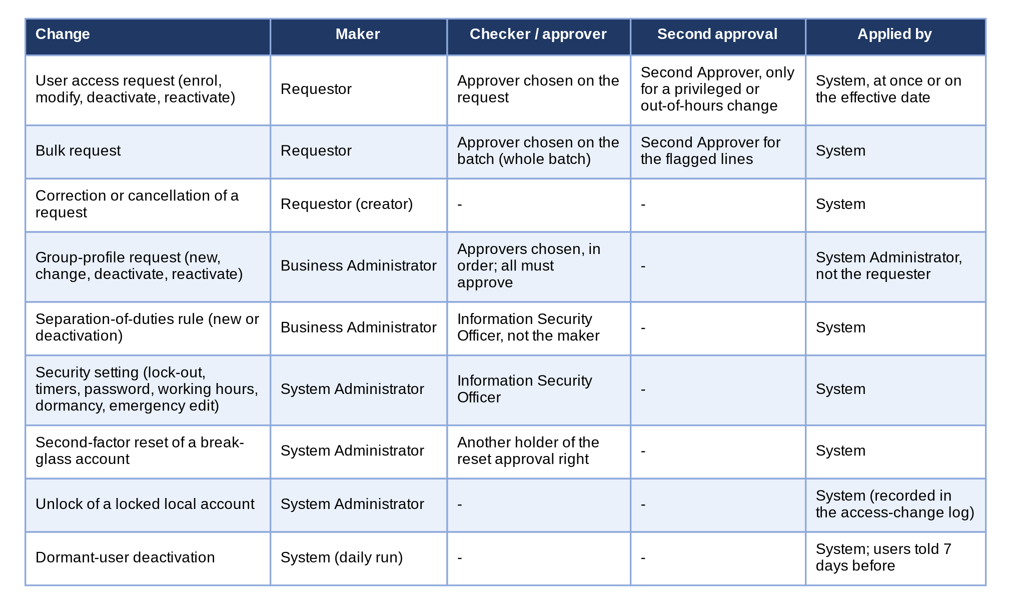
Figure 16 - Who makes, who checks and who approves each change of access
How to read it: Each row is a kind of change, read from left to right: the maker, the checker or approver, the second approval where it applies and who applies the change. No one decides his or her own change. Traces to: BRD sections A to D; NFR p.17 (11); FRUM.005, FRUM.009 to FRUM.012.
The process flows of Annex A draw each route step by step; the table below gives the stages, the controls and the time rules.
Process | Stage | Who acts (maker / checker / approver) | Limits and controls | Time rule, reminder, escalation | Return or void
User access request (BRD 1.002 to 1.008, 2.002) | 1 Draft | Requestor (maker) | Seen and edited by its creator only; justification mandatory; one open request per user | No time limit; draft kept until submitted or cancelled | Cancel with a reason (BRD 1.002.1.3)
 | 2 Pending Approval | Approver chosen on the request (checker) | Four eyes: not the requester, not the user concerned; checks repeated at approval | Proposed: decision within 2 working days; reminder on day 3; age shown in the Access Requests report | Return with remarks (BRD 2.002.7); reject with a reason (BRD 2.002.6); requester may cancel (BRD 1.007)
 | 3 Pending Second Approval | Second Approver (Information Security) | Only for a privileged profile (High, Admin) or an out-of-hours change; not the first approver | Proposed: within 1 working day; alert Privileged access change to System Administrators and Auditors | Return or reject as stage 2
 | 4 Scheduled / Approved | System | Applied at once, or on the effective date by the daily run at 00:05 | Failed application alerted (high) to System Administrators and Auditors | Creator or approver may cancel a Scheduled request
Bulk request (BRD 1.009) | 1 Upload and draft batch | Requestor (maker) | Every row checked before the batch is created; rows in error listed for correction | - | Cancel the draft batch
 | 2 Decision on the batch | Approver chosen on the batch | Decided as a whole (CLR-UA-16 answered by BDOI's mapping "c/o UIDM"; Annex Q, C24) | As stage 2 above | Return or reject the whole batch
Group-profile request (BRD 3.002) | 1 Draft | Business Administrator (maker) | Unique profile name; no permission both added and removed; privilege level given | - | Cancel
 | 2 Approvals in order | Approvers chosen on the request, in order; all must approve | The next approver is asked only after the previous one approves | Proposed: 2 working days per approver | Return or reject ends the round
 | 3 For Implementation | System Administrator (implementer) | Not the requester of the request (four eyes) | Proposed: implemented within 1 working day of the last approval | -
Separation-of-duties rule (BRD NFR 11) | Create or deactivate; authorise | Business Administrator (maker); Information Security Officer (checker) | The maker cannot authorise; rule applies to every later request and bulk line | Proposed: 2 working days | Reject: rule not created / deactivation refused
Security setting (BRD NFR 11; p.14) | Change; approve | System Administrator (maker); Information Security Officer (approver) | Old value stays in force until approved; change audited | Proposed: 2 working days | Reject: setting unchanged
Second-factor reset (break-glass) | Request; approve | System Administrator; another holder of the reset approval right | The requester cannot approve | Same working day | Reject
Dormant users (Information Security practice; CLR-UA-08) | Notice; deactivation | System (daily run 00:15) | Notice 7 days before; deactivation after 90 days without sign-in; System Administrator profile exempt | Business and System Administrators receive the list | Reactivation request

Role-to-stage matrix: M = makes, C = checks or approves, 2 = second approval, I = implements, V = views.
Stage | Requestor | Approver | Second Approver | Business Admin. | System Admin. | Information Security | Auditor
User access request: raise, correct, cancel | M |  |  | M |  |  | V
User access request: approve, reject, return |  | C |  |  |  |  | V
Privileged or out-of-hours change |  | C | 2 |  |  |  | V
Bulk request | M | C | 2 | M | M |  | V
Group-profile request |  | C |  | M | I | V | V
Separation-of-duties rule |  |  |  | M |  | C | V
Security setting |  |  |  |  | M | C | V
Second-factor reset |  |  |  |  | M | C
Reports and audit log |  | V |  | V | V | V | V

Escalation today: the request ages on the Access Requests list and report (Age in days); the Business Administrator may cancel it and raise it again to another approver, or the setting "Any approver may decide" lets every holder of the approval right decide it. An automatic reminder and escalation after a number of working days is a proposal (Annex Q.5) for the Business Unit to decide.

Annex T – E-mail and Notification Texts
Every notice and e-mail of User Access Maintenance, word for word as the system sends it today. The parts in angle brackets are filled in by the system. BDOI has not given wordings for these messages: the texts below are proposed by iorta TechNXT for BDOI's approval (requirements collection workbook, sheet E-mail wordings). The e-mails are plain text, sent from the system address of the environment, with no attachment; no password is ever sent by e-mail (the temporary password of a new user is shown once to the approver on the screen). A notice "in the system" appears under the bell in the page header and opens the record.
No. | Notice | Channel | Recipients
NT-01 | Request to approve | Notice in the system | The approver chosen on the request (group profiles: the next approver in order); for a request raised without a chosen approver, every holder of the approval right.
NT-02 | Request for second approval | Notice in the system | Every holder of the second-approval right (Second Approver), except the first approver.
NT-03 | Request to implement | Notice in the system | Every holder of the role management right (System Administrators).
NT-04 | Decision on the request | Notice in the system | The requester (the user who submitted the request).
NT-05 | Request returned | Notice in the system | The requester.
NT-06 | Request cancelled | Notice in the system | The approver the request was assigned to.
NT-07 | Your access changed | Notice in the system and e-mail | The user whose access changed (e-mail to the user's registered address).
NT-14 | Your access changed (group profile deactivated or reactivated) | Notice in the system and e-mail | Each active member of the group profile (e-mail to the member's registered address).
NT-15 | Your account will be deactivated | Notice in the system and e-mail | The dormant user.
NT-16 | Dormant users deactivated | Notice in the system | Every holder of the request right (Business Administrators, System Administrators).
NT-08 | Reset your password (break-glass accounts only) | E-mail | The registered e-mail address of the user, when the account is active and has one.
NT-09 | Your password expires soon (break-glass accounts) | Notice in the system; e-mail when the user's preference asks for it | The holder of the local account.
NT-10 | Batch job failed | E-mail | The addresses of the setting "failed-run recipients" (to be named by BDOI, UA-Q52).
NT-11 | Alert: privileged access change | Alerts inbox in the system (medium) | Holders of the alert right (System Administrators, Auditors).
NT-12 | Alert: scheduled access change failed | Alerts inbox in the system (high) | Holders of the alert right (System Administrators, Auditors).
NT-13 | Alert: role edited outside a request | Alerts inbox in the system (medium) | Holders of the alert right (System Administrators, Auditors).
NT-17 | Separation-of-duties rule to authorise | Notice in the system | Every holder of the rule authorisation right (Information Security Officers), except the maker.
NT-18 | Security setting to approve | Notice in the system | Every holder of the security setting approval right (Information Security Officers).
NT-19 | Second-factor reset to approve | Notice in the system | Every holder of the reset approval right, except the requester.
NT-20 | Authenticator app reset | Notice in the system | The holder of the break-glass account.
NT-21 | Identity event to review | Notice in the system (and e-mail by preference) | Every holder of the user management right (System Administrators); also raised as the alert Identity event refused.
NT-22 | Break-glass sign-in | Notice in the system and e-mail | Every holder of the security setting approval right (Information Security Officers), and the e-mail addresses of the setting Break-glass alert recipients; also raised as an alert.

NT-01 Request to approve
Item | Detail
Trigger | A user access request is submitted or re-submitted; a group-profile request approved by one approver waits for the next approver in order.
Recipients | The approver chosen on the request (group profiles: the next approver in order); for a request raised without a chosen approver, every holder of the approval right.
Channel | Notice in the system
Subject / title | Access request <request no> to approve
Text | <description of the change>, for example: Create user a013000196 with group profiles Marketing Account Officer
Attachments | None
Protection | No attachment and no password in the message; the link opens the record only for a signed-in user who holds the right.
Frequency | Once per submission or re-submission; once per approver in order.
Wording | Wording of the system today, proposed by iorta TechNXT for BDOI approval (requirements collection workbook, sheet E-mail wordings, item NT-01)
Traces to | BRD 2.002.1 (a); BRD 3.002.1.2; FRUM.010.01, FRUM.005.03, FRUM.013.01

NT-02 Request for second approval
Item | Detail
Trigger | The first approval of a request with a risk flag (privilege increase, outside working hours).
Recipients | Every holder of the second-approval right (Second Approver), except the first approver.
Channel | Notice in the system
Subject / title | Access request <request no> for second approval
Text | <description of the change> (<risk flags: privilege increase, outside working hours>)
Attachments | None
Protection | No attachment and no password in the message; the link opens the record only for a signed-in user who holds the right.
Frequency | Once per request.
Wording | Wording of the system today, proposed by iorta TechNXT for BDOI approval (requirements collection workbook, sheet E-mail wordings, item NT-02)
Traces to | BRD NFR p.17 (11); FRUM.010.05

NT-03 Request to implement
Item | Detail
Trigger | The last approval of a group-profile request (the request waits for implementation).
Recipients | Every holder of the role management right (System Administrators).
Channel | Notice in the system
Subject / title | Access request <request no> to implement
Text | <description of the change>
Attachments | None
Protection | No attachment and no password in the message; the link opens the record only for a signed-in user who holds the right.
Frequency | Once per request.
Wording | Wording of the system today, proposed by iorta TechNXT for BDOI approval (requirements collection workbook, sheet E-mail wordings, item NT-03)
Traces to | BRD 3.002; p.6; FRUM.005.04

NT-04 Decision on the request
Item | Detail
Trigger | A request is approved and applied, approved with a later effective date, approved for implementation, rejected, implemented, or applied on its effective date by the daily run.
Recipients | The requester (the user who submitted the request).
Channel | Notice in the system
Subject / title | Access request <request no> approved | approved, applies on <dd-MMM-yyyy> | approved, for implementation | rejected | implemented | applied on its effective date
Text | <description of the change> (<comment of the decider>)
Attachments | None
Protection | No attachment and no password in the message; the link opens the record only for a signed-in user who holds the right.
Frequency | Once per decision.
Wording | Wording of the system today, proposed by iorta TechNXT for BDOI approval (requirements collection workbook, sheet E-mail wordings, item NT-04)
Traces to | BRD 1.008.1.4; FRUM.009.09, FRUM.013.01

NT-05 Request returned
Item | Detail
Trigger | The approver returns a request for correction.
Recipients | The requester.
Channel | Notice in the system
Subject / title | Access request <request no> returned
Text | <description of the change> - <remarks of the approver>
Attachments | None
Protection | No attachment and no password in the message; the link opens the record only for a signed-in user who holds the right.
Frequency | Once per return.
Wording | Wording of the system today, proposed by iorta TechNXT for BDOI approval (requirements collection workbook, sheet E-mail wordings, item NT-05)
Traces to | BRD 1.006.1.1; 2.002.7; FRUM.009.07, FRUM.010.04

NT-06 Request cancelled
Item | Detail
Trigger | The creator cancels a request that was assigned to an approver.
Recipients | The approver the request was assigned to.
Channel | Notice in the system
Subject / title | Access request <request no> cancelled
Text | <description of the change> - <reason for the cancellation>
Attachments | None
Protection | No attachment and no password in the message; the link opens the record only for a signed-in user who holds the right.
Frequency | Once per cancellation.
Wording | Wording of the system today, proposed by iorta TechNXT for BDOI approval (requirements collection workbook, sheet E-mail wordings, item NT-06)
Traces to | BRD 1.007.1; FRUM.009.08

NT-07 Your access changed
Item | Detail
Trigger | An approved change to a user is applied (at approval, or on the effective date).
Recipients | The user whose access changed (e-mail to the user's registered address).
Channel | Notice in the system and e-mail
Subject / title | BIBS: your access changed (e-mail); Your access changed (notice)
Text | Your access changed: <description of the change> (request <request no>).
Attachments | None
Protection | No attachment and no password in the message; the link opens the record only for a signed-in user who holds the right.
Frequency | Once per applied change.
Wording | Wording of the system today, proposed by iorta TechNXT for BDOI approval (requirements collection workbook, sheet E-mail wordings, item NT-07)
Traces to | BRD NFR p.17 (10); FRUM.013.01

NT-14 Your access changed (group profile deactivated or reactivated)
Item | Detail
Trigger | A request that deactivates or reactivates a group profile is implemented.
Recipients | Each active member of the group profile (e-mail to the member's registered address).
Channel | Notice in the system and e-mail
Subject / title | BIBS: your access changed (e-mail); Your access changed (notice)
Text | Your access changed: <description of the change>, a group profile you hold (request <request no>).
Attachments | None
Protection | No attachment and no password in the message; the link opens the record only for a signed-in user who holds the right.
Frequency | Once per member and request.
Wording | Wording of the system today, proposed by iorta TechNXT for BDOI approval (requirements collection workbook, sheet E-mail wordings, item NT-14)
Traces to | BRD 3.002.3, 3.002.4; NFR p.17 (10); FRUM.006.04, FRUM.013.01

NT-15 Your account will be deactivated
Item | Detail
Trigger | The daily run of dormant users (00:15) finds a user whose deactivation is 7 days away.
Recipients | The dormant user.
Channel | Notice in the system and e-mail
Subject / title | BIBS: sign in to keep your account (e-mail); Your account will be deactivated (notice)
Text | You have not signed in to BIBS for a long time. Sign in before <dd-MMM-yyyy>, or your account is deactivated and a new access request is needed.
Attachments | None
Protection | No attachment and no password in the message; the link opens the record only for a signed-in user who holds the right.
Frequency | Once, 7 days before the deactivation.
Wording | Wording of the system today, proposed by iorta TechNXT for BDOI approval (requirements collection workbook, sheet E-mail wordings, item NT-15)
Traces to | BRD NFR p.13 (1.e); FRUM.003.04

NT-16 Dormant users deactivated
Item | Detail
Trigger | The daily run of dormant users deactivates one or more users (each user also receives NT-07).
Recipients | Every holder of the request right (Business Administrators, System Administrators).
Channel | Notice in the system
Subject / title | Dormant users deactivated
Text | <count> user(s) without a sign-in for <days> days were deactivated: <user IDs>
Attachments | None
Protection | No attachment and no password in the message; the link opens the record only for a signed-in user who holds the right.
Frequency | Once per run that deactivates users.
Wording | Wording of the system today, proposed by iorta TechNXT for BDOI approval (requirements collection workbook, sheet E-mail wordings, item NT-16)
Traces to | BRD NFR p.13 (1.e); FRUM.003.04

NT-08 Reset your password (break-glass accounts only)
Item | Detail
Trigger | A local account asks for a reset link (Forgot password?). Not offered to single sign-on users (BDOI's FRUM-004.03).
Recipients | The registered e-mail address of the user, when the account is active and has one.
Channel | E-mail
Subject / title | BIBS: reset your password
Text | Dear <full name>, A new BIBS password was requested for user <user ID>. Open this link to set it: <link>. The link works once and expires at <date and time> (Philippine time). If you did not ask for it, ignore this e-mail; your password stays as it is.
Attachments | None
Protection | No attachment and no password in the message; the link opens the record only for a signed-in user who holds the right.
Frequency | Once per request; the link works once and for 30 minutes.
Wording | Wording of the system today, proposed by iorta TechNXT for BDOI approval (requirements collection workbook, sheet E-mail wordings, item NT-08)
Traces to | BRD NFR p.17 (1, 8); FRUM-004.03, FRUM.001.06

NT-09 Your password expires soon (break-glass accounts)
Item | Detail
Trigger | The daily run (06:00) finds a local password that expires within 7 days.
Recipients | The holder of the local account.
Channel | Notice in the system; e-mail when the user's preference asks for it
Subject / title | BIBS: your password expires soon (e-mail); Your password expires soon (notice)
Text | Your BIBS password expires on <date and time> (Philippine time). Change it on My Profile before then.
Attachments | None
Protection | No attachment and no password in the message; the link opens the record only for a signed-in user who holds the right.
Frequency | Daily while the password expires within 7 days.
Wording | Wording of the system today, proposed by iorta TechNXT for BDOI approval (requirements collection workbook, sheet E-mail wordings, item NT-09)
Traces to | BRD NFR p.17 (7); FRUM-004.01

NT-10 Batch job failed
Item | Detail
Trigger | A scheduled run fails (for example the daily application of dated access changes).
Recipients | The addresses of the setting "failed-run recipients" (to be named by BDOI, UA-Q52).
Channel | E-mail
Subject / title | BIBS: batch job <job> failed
Text | The batch job <job> failed. Run: <run>. Started: <date and time> (Philippine time). Trigger: <trigger>. Error: <message>. Open Administration > Scheduled Jobs to see the run history and run the job again.
Attachments | None
Protection | No attachment and no password in the message; the link opens the record only for a signed-in user who holds the right.
Frequency | Once per failed run.
Wording | Wording of the system today, proposed by iorta TechNXT for BDOI approval (requirements collection workbook, sheet E-mail wordings, item NT-10)
Traces to | BRD NFR p.15 (batch failure e-mail); FRUM.013.02

NT-11 Alert: privileged access change
Item | Detail
Trigger | A request with a risk flag passes its first approval.
Recipients | Holders of the alert right (System Administrators, Auditors).
Channel | Alerts inbox in the system (medium)
Subject / title | Privileged access change
Text | Access request <request no> (<risk flags>): <description of the change>
Attachments | None
Protection | No attachment and no password in the message; the link opens the record only for a signed-in user who holds the right.
Frequency | Once per request.
Wording | Wording of the system today, proposed by iorta TechNXT for BDOI approval (requirements collection workbook, sheet E-mail wordings, item NT-11)
Traces to | BRD NFR p.17 (11); FRUM.010.05

NT-12 Alert: scheduled access change failed
Item | Detail
Trigger | A scheduled request cannot be applied on its effective date.
Recipients | Holders of the alert right (System Administrators, Auditors).
Channel | Alerts inbox in the system (high)
Subject / title | Scheduled access change failed
Text | Access request <request no> could not be applied on <dd-MMM-yyyy>: <reason>
Attachments | None
Protection | No attachment and no password in the message; the link opens the record only for a signed-in user who holds the right.
Frequency | Once per request and date.
Wording | Wording of the system today, proposed by iorta TechNXT for BDOI approval (requirements collection workbook, sheet E-mail wordings, item NT-12)
Traces to | BRD NFR p.13 (1.k); FRUM.009.10

NT-13 Alert: role edited outside a request
Item | Detail
Trigger | A group profile is created or changed directly while the emergency role edit is switched on.
Recipients | Holders of the alert right (System Administrators, Auditors).
Channel | Alerts inbox in the system (medium)
Subject / title | Role edited outside a request
Text | Role <profile code> <change> directly by <user> (emergency path <setting code>)
Attachments | None
Protection | No attachment and no password in the message; the link opens the record only for a signed-in user who holds the right.
Frequency | Once per direct change.
Wording | Wording of the system today, proposed by iorta TechNXT for BDOI approval (requirements collection workbook, sheet E-mail wordings, item NT-13)
Traces to | BRD NFR p.17 (11); FRUM.005.01, FRUM.012.02

NT-17 Separation-of-duties rule to authorise
Item | Detail
Trigger | A separation-of-duties rule is created, or its deactivation is asked.
Recipients | Every holder of the rule authorisation right (Information Security Officers), except the maker.
Channel | Notice in the system
Subject / title | Separation-of-duties rule <rule> to authorise
Text | The new rule of rule <rule>: <reason> | The deactivation of rule <rule>: <reason>
Attachments | None
Protection | No attachment and no password in the message; the link opens the record only for a signed-in user who holds the right.
Frequency | Once per rule change.
Wording | Wording of the system today, proposed by iorta TechNXT for BDOI approval (requirements collection workbook, sheet E-mail wordings, item NT-17)
Traces to | BRD NFR p.17 (11); FRUM.012.01

NT-18 Security setting to approve
Item | Detail
Trigger | The System Administrator changes a security setting on System Parameters.
Recipients | Every holder of the security setting approval right (Information Security Officers).
Channel | Notice in the system
Subject / title | Security setting to approve: <description of the setting>
Text | <user name> requests a change from '<current value>' to '<new value>'
Attachments | None
Protection | No attachment and no password in the message; the link opens the record only for a signed-in user who holds the right.
Frequency | Once per change.
Wording | Wording of the system today, proposed by iorta TechNXT for BDOI approval (requirements collection workbook, sheet E-mail wordings, item NT-18)
Traces to | BRD NFR p.17 (11); p.14; FRUM.012.02

NT-19 Second-factor reset to approve
Item | Detail
Trigger | A System Administrator asks for the reset of the authenticator app of a break-glass account.
Recipients | Every holder of the reset approval right, except the requester.
Channel | Notice in the system
Subject / title | Second factor reset to approve: <user name>
Text | <user name of the requester> asks for the reset. Reason: <reason>
Attachments | None
Protection | No attachment and no password in the message; the link opens the record only for a signed-in user who holds the right.
Frequency | Once per reset request.
Wording | Wording of the system today, proposed by iorta TechNXT for BDOI approval (requirements collection workbook, sheet E-mail wordings, item NT-19)
Traces to | BRD NFR p.17 (1); FRUM.001.06

NT-20 Authenticator app reset
Item | Detail
Trigger | The reset of the authenticator app is approved and applied.
Recipients | The holder of the break-glass account.
Channel | Notice in the system
Subject / title | Your authenticator app was reset
Text | Enrol your authenticator app again at your next sign-in.
Attachments | None
Protection | No attachment and no password in the message; the link opens the record only for a signed-in user who holds the right.
Frequency | Once per reset.
Wording | Wording of the system today, proposed by iorta TechNXT for BDOI approval (requirements collection workbook, sheet E-mail wordings, item NT-20)
Traces to | BRD NFR p.17 (1); FRUM.001.06

NT-21 Identity event to review
Item | Detail
Trigger | An event of UIDM-ISC or the Enterprise SSO platform (joiner, mover, leaver, rehire, status change) is refused or fails.
Recipients | Every holder of the user management right (System Administrators); also raised as the alert Identity event refused.
Channel | Notice in the system (and e-mail by preference)
Subject / title | Identity event <event no> needs review
Text | <UIDM-ISC | Enterprise SSO> event <Joiner | Mover | Leaver | Rehire | Status> of Windows ID <Windows ID> was <refused | failed>: <reason>
Attachments | None
Protection | No attachment and no password in the message; the link opens the record only for a signed-in user who holds the right.
Frequency | Once per refused or failed event (again after a failed Process again).
Wording | Wording of the system today, proposed by iorta TechNXT for BDOI approval (requirements collection workbook, sheet E-mail wordings, item NT-21)
Traces to | BRD 1.001 (user enrolment); BRD NFR p.13 (1); FRUM.002.02, FRUM.003.03

NT-22 Break-glass sign-in
Item | Detail
Trigger | A break-glass System Administrator signs in with a local password while single sign-on is on.
Recipients | Every holder of the security setting approval right (Information Security Officers), and the e-mail addresses of the setting Break-glass alert recipients; also raised as an alert.
Channel | Notice in the system and e-mail
Subject / title | Break-glass sign-in
Text | Break-glass administrator <name> (<user ID>) signed in with a local password at <dd-MMM-yyyy HH:mm> from <address>. Review the use within one working day.
Attachments | None
Protection | No attachment and no password in the message; the link opens the record only for a signed-in user who holds the right.
Frequency | Once per sign-in.
Wording | Wording of the system today, proposed by iorta TechNXT for BDOI approval (requirements collection workbook, sheet E-mail wordings, item NT-22)
Traces to | BRD NFR p.17 (1); FRUM.001.06

Annex U – Document Prints and Output Formats
Every document User Access Maintenance prints, e-mails or exports: purpose, recipients, format, protection, the fields in order and an image of the current layout in the system. BDOI's samples in Annexes B and D remain the reference; where the layout must still be given or confirmed by the Business Unit, the item of the requirements collection workbook is named. User Access Maintenance prints no letter, slip or certificate.
File names: BDOI's FRUM.007.02 and FRUM.008 (export) set <Report_Name>_MMDDYYYY and Audit Logs_MMDDYYYY; the system names the download after the report and the date in another order today (Annex Q, C18).

U.1 User Access Report (DO-01)
Item | Detail
Purpose | Users with their group profiles and who created and changed them (BRD 3.003.1; sample A; Annex E)
Recipients | Business Administrator, System Administrator, Approver, Information Security, Auditor
Format | PDF (landscape), Excel, CSV
Produced from | User Access Reports › User Access Report › PDF, Excel or CSV
Protection | No (kept by the user; the report is archived with its parameters)
Fields in order | 1. Header: report name, generated by (user), as-of date, date and time generated – from the run  2. User Name, User ID / Windows ID, Business Unit / User Level, Status – from the user master as at the end of the as-of date  3. User Group Profile – the profiles held on the as-of date, derived from the access change log  4. Created by / Date Created, Modified by / Date Modified – the approver and the request number of the enrolment and of the last change, or the user of a direct change  5. Last Action / by – added, modified, deactivated or reactivated, and by whom
BDOI reference | Annex B (User Access Report) and Annex E
Layout | Current layout of the system below; the Business Unit confirms it or gives its layout: requirements collection workbook, item RC-DOC-01

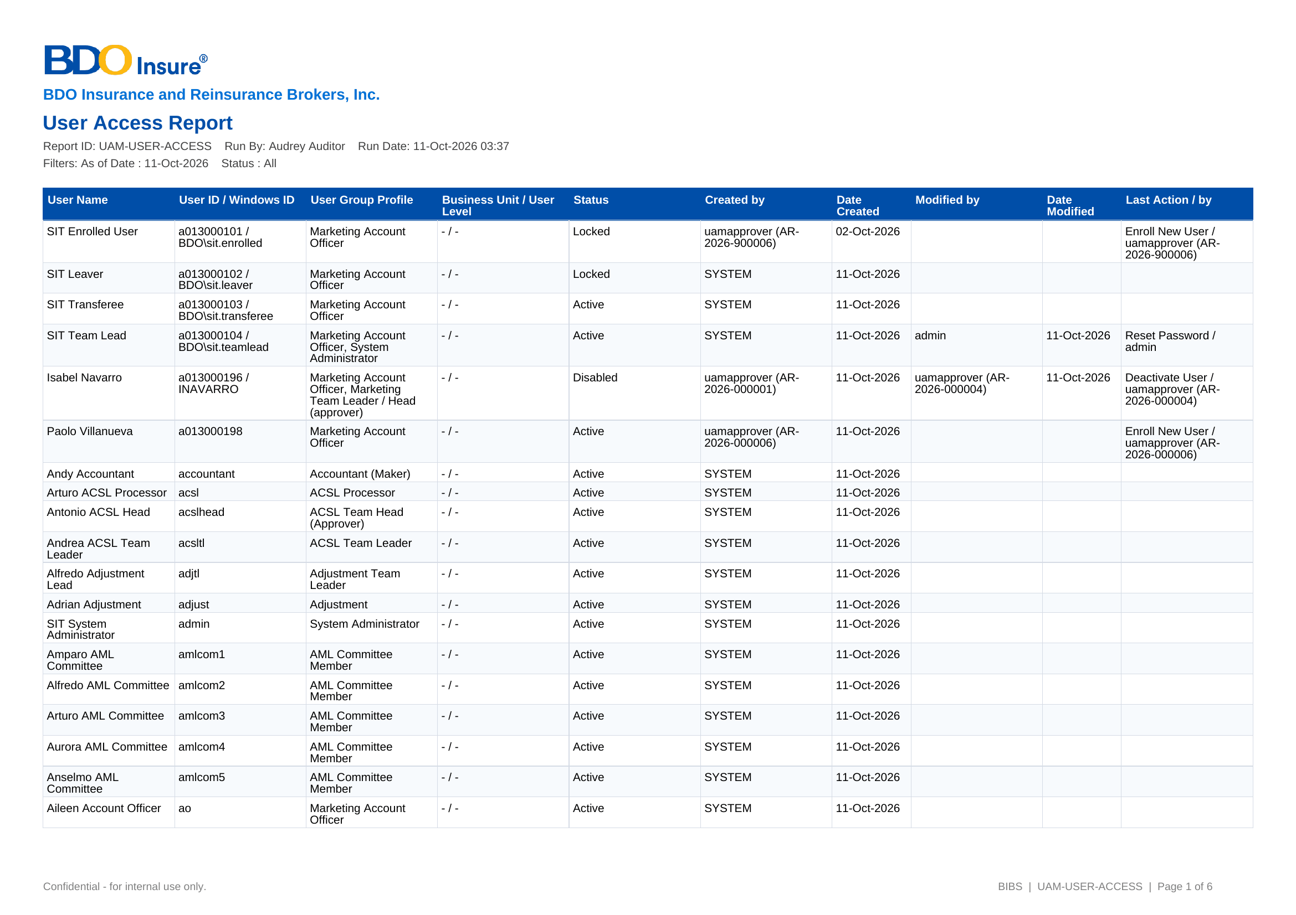
Figure U.1: current layout of the User Access Report

U.2 User Group Profile Report (DO-02)
Item | Detail
Purpose | Modules and tasks each group profile can access (BRD 3.003.2; sample B; Annex F)
Recipients | As DO-01
Format | PDF, Excel, CSV
Produced from | User Access Reports › User Group Profile Report
Protection | False
Fields in order | 1. Header as DO-01, with the profile, module and active filters  2. Group profile – code and name, as a group heading  3. Module Name, Task Name – the functional area and the permission  4. Access – With Access or No Access  5. Date Created, Created by, Date Modified, Modified by – from the access change log of the profile
BDOI reference | Annex B (User Group Profile Report) and Annex F
Layout | Current layout of the system below; the Business Unit confirms it or gives its layout: requirements collection workbook, item RC-DOC-02

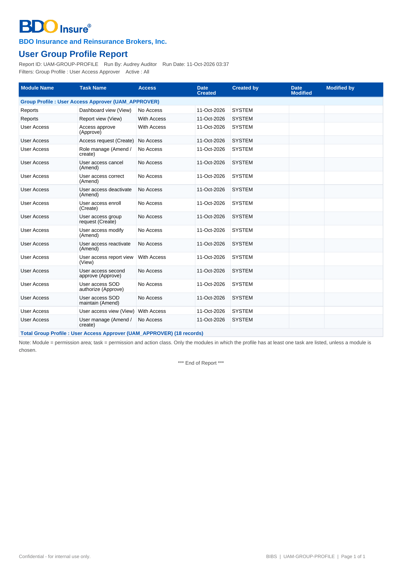
Figure U.2: current layout of the User Group Profile Report

U.3 Group Profile Membership (DO-03)
Item | Detail
Purpose | Members of each group profile (BRD 3.003.3; sample C; Annex G)
Recipients | As DO-01
Format | PDF, Excel, CSV
Produced from | User Access Reports › Group Profile Membership
Protection | False
Fields in order | 1. Header as DO-01, with the profile and the as-of date  2. Member Username, Member User ID – the members of each profile on the as-of date  3. Created by, Date Created, Modified by, Date Modified – who added the member and when, from the access change log
BDOI reference | Annex B (Group Profile Membership List) and Annex G
Layout | Current layout of the system below; the Business Unit confirms it or gives its layout: requirements collection workbook, item RC-DOC-03

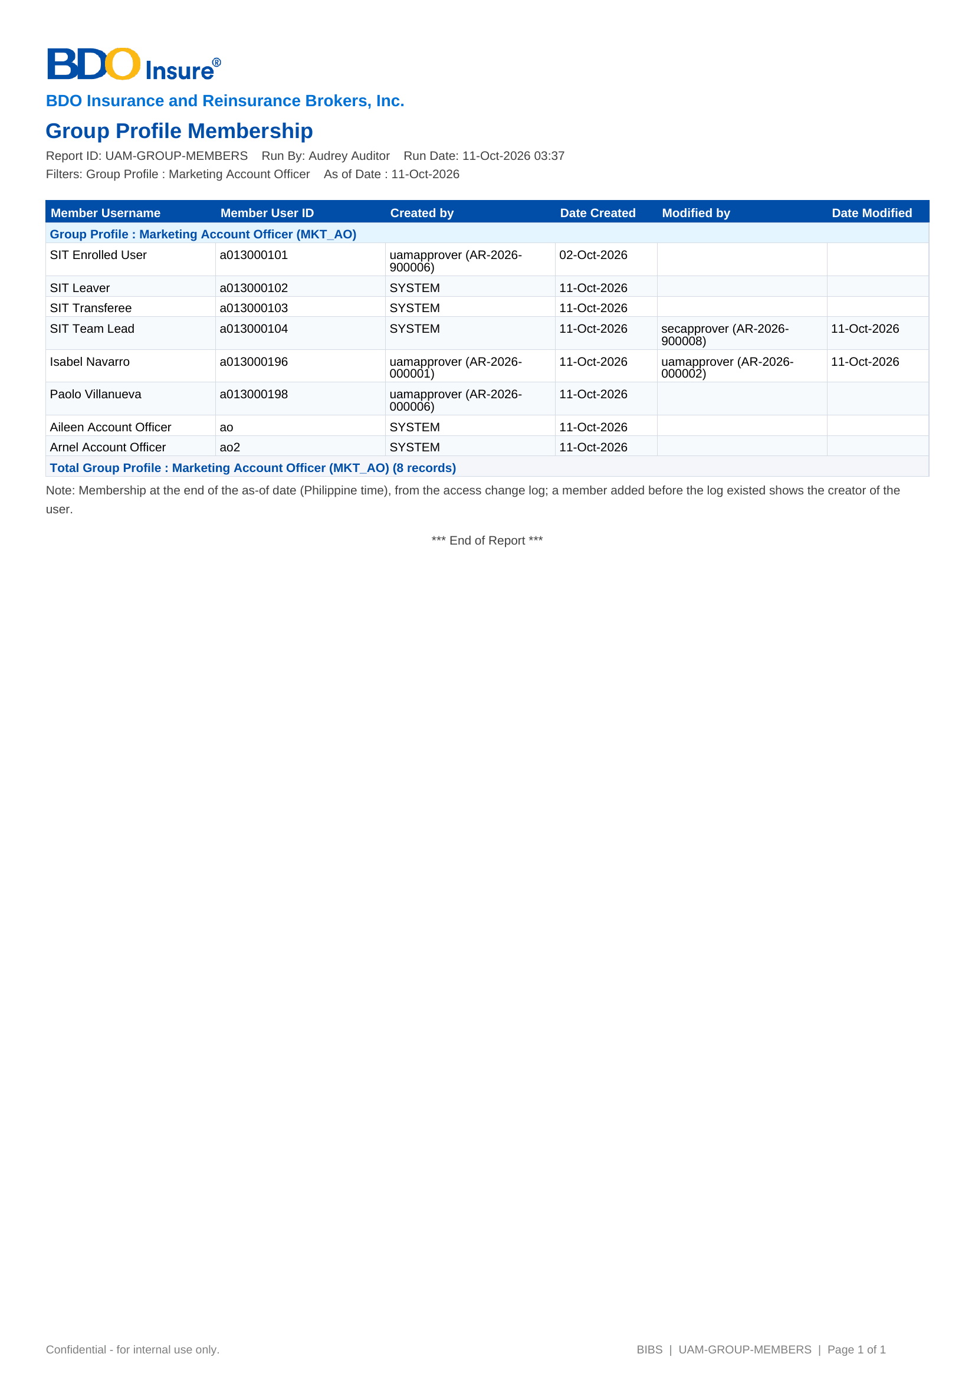
Figure U.3: current layout of the Group Profile Membership

U.4 User Access Audit Log (DO-04)
Item | Detail
Purpose | Access activities with from and to values (BRD 4.003.1; sample D; Annex H)
Recipients | System Administrator, Information Security, Auditor
Format | PDF, Excel, CSV
Produced from | User Access Reports › User Access Audit Log
Protection | False
Fields in order | 1. Header as DO-01, with the period, user and activity filters  2. Date, Activity – the time and the activity in the words of the BRD sample (Enroll New User, Modify User Group Profile of, Deactivate User, Reset Password of, Create Group Profile, Modify Group Profile Access of...)  3. From, To – the value before and after (Null when none; profile codes shown as profile names)  4. Done By, Approved By, Request No. – from the access change log and the request history  5. Log-in, Failed Log-in, Log-out – from the audit trail when Include Log-ins and Log-outs is ticked
BDOI reference | Annex D (Audit Log Export) and Annex H
Layout | Current layout of the system below; the Business Unit confirms it or gives its layout: requirements collection workbook, item RC-DOC-04

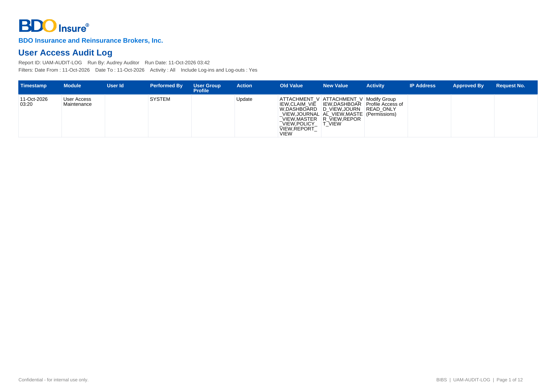
Figure U.4: current layout of the User Access Audit Log

U.5 Access Requests (DO-05)
Item | Detail
Purpose | Requests by status, type, requester, approver and age (BRD 1.008; 2.002.2)
Recipients | Business Administrator, System Administrator, Approver, Auditor
Format | PDF, Excel, CSV
Produced from | User Access Reports › Access Requests
Protection | False
Fields in order | 1. Header as DO-01, with the period, status and request type  2. Request No., Request Type, User / Group Profile, Requester, Approver – from the access request  3. Date Created, Date Decided, Effective Date, Age (days) – from the request and its history; open requests age to today
BDOI reference | Not in BDOI's annexes (layout to be confirmed)
Layout | Current layout of the system below; the Business Unit confirms it or gives its layout: requirements collection workbook, item RC-DOC-05

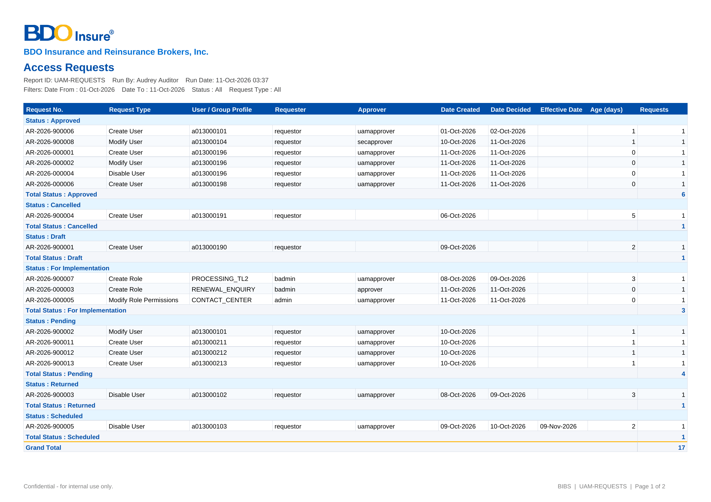
Figure U.5: current layout of the Access Requests

U.6 User Access Matrix (Excel) (DO-06)
Item | Detail
Purpose | Which group profiles hold which permissions (BRD 4.002.2; Annex C)
Recipients | Business Administrator, System Administrator, Approver, Information Security, Auditor
Format | Excel, two sheets (by permission; by area and action class)
Produced from | User Access Matrix › Export to Excel
Protection | False
Fields in order | 1. Header: the company, the title, run by and run date, and the number of permissions and group profiles – from the run  2. Sheet User Access Matrix: Permission, Area (area code), Action class and one column per group profile code (written upright), with Y where the profile holds the permission; the first row gives the enabled users of each profile – from the role grants in force. The headings and the first three columns stay in view when scrolling, and every column has a filter  3. Sheet By Action: Area, Action class, Permissions and, per profile, the permissions it holds there
BDOI reference | Annex C (User Access Matrix workbook of BDOI)
Layout | Current layout of the system below; the Business Unit confirms it or gives its layout: requirements collection workbook, item RC-DOC-06

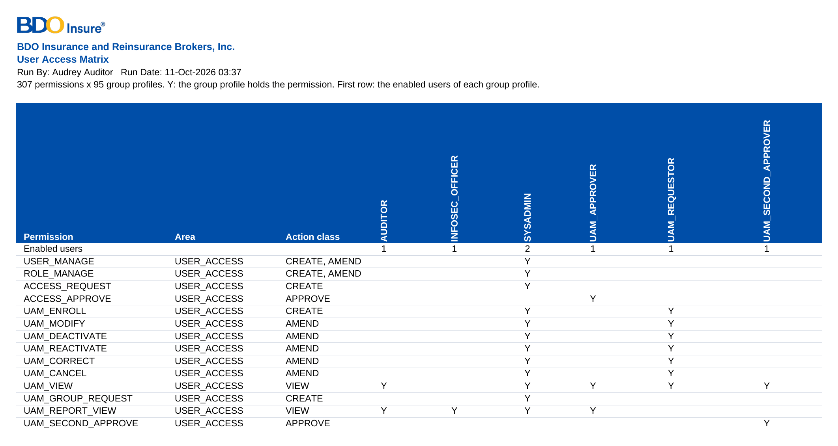
Figure U.6: current layout of the User Access Matrix (Excel) (extract – the header of the workbook and the permissions of the User Access area against the group profiles Requestor, Approver, Second Approver, Information Security Officer, System Administrator and Auditor (the full matrix: 293 permissions x 94 group profiles in the SIT/UAT data))

U.7 Bulk request template and error file (DO-07)
Item | Detail
Purpose | The file a Requestor fills in for a bulk request, and the file of the rows in error returned by the check (BRD 1.009)
Recipients | Requestor
Format | Excel template (also accepted as CSV or TXT); error file in Excel
Produced from | User Access › Bulk Request › Download template / Download errors
Protection | No
Fields in order | 1. One row per user: action (enrol, modify, deactivate, reactivate), user ID, full name, e-mail, Windows ID, home branch, business unit group, user level, group profiles, effective date, remarks  2. Error file: the rows in error with the message of each
BDOI reference | Not in BDOI's FRS (bulk is "c/o UIDM" in the mapping, Annex Q C24)
Layout | Layout to be provided or confirmed by the Business Unit: requirements collection workbook, item RC-DOC-07

U.8 Temporary password of a new break-glass user (screen only) (DO-08)
Item | Detail
Purpose | The password set by the system for a new local account (break-glass), shown once to the approver
Recipients | The approver of the enrolment, who gives it through a secure channel
Format | Shown once on the screen; never printed or e-mailed
Produced from | Access Request record › Approve and Apply
Protection | Shown once; changed at the first sign-in
Fields in order | 1. User ID, temporary password, the rule to change it at the first sign-in
BDOI reference | BDOI's FRUM-004 (no password function for SSO users)
Layout | Layout to be provided or confirmed by the Business Unit: requirements collection workbook, item RC-DOC-08

Annex V – Reports and Schedules
Every report of User Access Maintenance and every run the system starts by itself. The reports run on demand from User Access › User Access Reports for the holders of the report right and export to PDF, Excel and CSV with the header of the BRD (report name, generated by, date coverage, date and time generated; BRD p.18), each file named by BDOI's convention <report name>_MMDDYYYY (setting Export file names, Annex M.10). No report is sent by e-mail on a schedule today; a monthly access review report to Information Security is a proposal (Annex Q.5, UA-Q51).
Report | Frequency | Who runs it | Filters | Columns (in order) | Sort | Output | BRD / FR
User Access Report | On demand | Business Administrator, System Administrator, Approver, Information Security, Auditor | As-of date; business unit group; status; group profile | User Name; User ID / Windows ID; User Group Profile; Business Unit / User Level; Status; Created by / Date Created; Modified by / Date Modified; Last Action / by | User name | PDF (landscape), Excel, CSV | BRD 3.003.1; FRUM.007; Annex E
User Group Profile Report | On demand | As above | Group profile; module; active | Group Profile; Module Name; Task Name; Access (With Access / No Access); Date Created / Created by; Date Modified / Modified by | Profile, then module | PDF (portrait), Excel, CSV | BRD 3.003.2; FRUM.007; Annex F
Group Profile Membership | On demand | As above | Group profile; as-of date | Group Profile; Member Username; Member User ID; Created by / Date Created; Modified by / Date Modified | Profile, then member | PDF (portrait), Excel, CSV | BRD 3.003.3; FRUM.007; Annex G
User Access Audit Log | On demand | System Administrator, Information Security, Auditor | Date from / to; user; activity; include log-ins and log-outs | Date; Activity; From; To; Done By; Approved By / Request No. | Date and time | PDF (landscape), Excel, CSV | BRD 4.003.1; FRUM.008; Annex H
Access Requests | On demand | Business Administrator, System Administrator, Approver, Auditor | Period; status; request type | Request No.; Request Type; User / Group Profile; Requester; Approver; Date Created; Date Decided; Effective Date; Age (days) | Date created | PDF, Excel, CSV | BRD 1.008; FRUM.007.03
Audit Trail (screen) | On demand | Information Security, Auditor, System Administrator | From and to date; user; action type; reference number; record type | Timestamp; Module; User Id (Windows ID); Performed By; Role; Action; Activity; From; To; IP Address; Reference | Newest first; every column sortable | Screen; export Excel (BDOI's audit log template), PDF, CSV, named Audit Logs_MMDDYYYY | BRD 4.003.1; FRUM.008.02
Identity Synchronisation (screen) | On demand | System Administrator | Outcome; Windows ID; received from and to | Event No.; Received; Source; Event; Windows ID; User ID; UIDM Request No.; Outcome; Details; Processed By; Attempts | Newest first | Screen | BRD 1.001; FRUM.002.02, FRUM.003.03
User Access Matrix | On demand | Business Administrator, System Administrator, Approver, Information Security, Auditor | Area; action class | Permission; Area; Action class; one column per group profile | Area, permission | Excel (two sheets) | BRD 4.002.2; FRUM.007.03; Annex C

Runs the system starts by itself (Philippine time; each run is listed with its history on Administration › Scheduled Jobs and can be run again there):
Run | When | What it does | Who is told | Setting and owner | BRD / FR
Effective-dated access changes | Daily 00:05 | Applies the approved requests whose effective date is today | The requester (NT-04), the user (NT-07); a failure: alert NT-12 and e-mail NT-10 | Time: System Administrator | BRD NFR p.13 (1.k); FRUM.009.10
Dormant users | Daily 00:15 | Tells users 7 days before the deactivation; deactivates users without a sign-in for 90 days (System Administrator profile exempt) | The user (NT-15, NT-07); Business and System Administrators (NT-16) | Dormancy period and notice days: Information Security (CLR-UA-08) | BRD NFR p.13 (1.e); FRUM.003.04
Password expiry notice | Daily 06:00 | Tells the holders of local (break-glass) accounts whose password expires within 7 days | The holder (NT-09) | Information Security | BRD NFR p.17 (7); FRUM-004.01
Retention review | Monthly, 2nd day 11:00 | Counts the records that have reached their retention period under each rule; archives or deletes nothing | System Administrator (run history) | Retention periods: Compliance (UA-Q53) | BRD NFR p.11, p.14 (retention); Annex X
E-mail dispatch | Every 2 minutes | Sends the queued e-mails of the notices above | - | System Administrator; relay by BDOI IT (UA-Q56) | BRD NFR p.17 (10)
Failed-run notice | On every failed run | E-mails the failed run with its error | Failed-run recipients (to be named, UA-Q52) | System Administrator | BRD NFR p.15; FRUM.013.02

Annex W – Integrations
The interfaces of User Access Maintenance with BDOI's other systems and with the other BIBS modules, at business level. The technical detail (protocols, addresses, credentials) is in the Technical Specification reviewed by BDOI IT. The integration context is drawn in Annex A. (Figure 14).
Interface | Direction | What is exchanged | Trigger and frequency | Volumes | Owner | What BDOI IT provides | BDOI input
EIAM (BDO Enterprise SSO, Microsoft Entra ID) | In and out | The sign-in of every BDO user and the identity that links the account to the user (Windows ID); the directory details and status of each account, read for the synchronisation (Synchronise Now, Create User from Enterprise SSO); the sign-out at EIAM after Log Out and after the session timed out | Each sign-in and sign-out; each synchronisation | All users of BIBS (sizing 145 concurrent); BRD p.11: 14 requestors, 8 approvers, 4 business and 1 system administrator | BDOI IT | Registration of BIBS per environment, sign-in and sign-out addresses, the identifier returned, the address and access of the user directory, test accounts for SIT and UAT | Given: SSO is the sign-in (FRUM.001.02). Available in BIBS and run end to end in SIT and UAT against the Enterprise SSO simulator (accounts, sign-in page, events). Connection details from BDOI IT at SIT (CLR-UA-01)
UIDM-ISC (identity governance) | In and out | Joiner, mover, leaver, rehire and status changes of user accounts with the UIDM request number, through the standard user-provisioning interface; the answer to each event (applied or refused with the reason); accounts and group profiles for certification | Each approved UIDM request; certification extract on request | About 10 changes a month (BRD p.11) | BDOI IT; Information Security | The connection of UIDM-ISC, the access of UIDM-ISC to the interface, the aggregation frequency | Given: requests in UIDM, details synchronised (FRUM.002, FRUM.003). Available in BIBS: every event kept on Identity Synchronisation, refused events alerted and processed again; run end to end in SIT and UAT with the simulator. Settings to confirm: C01 (Annex M.10). Connection details from BDOI IT at SIT (UA-Q19, UA-Q21)
BDO e-mail relay | Out | The e-mails of Annex T | Each notice; dispatch every 2 minutes | Tens a month | BDOI IT | Relay and sender address per environment | To be provided (UA-Q56)
All BIBS modules (BRD-1 to BRD-13) | Out | The signed-in user, the active group profiles and the permissions: menus, buttons and actions | Every screen and action | All users | Business Administration (profile content) | - | Given: Annex C matrix (preliminary); final matrix to be provided (UA-Q29, UA-Q30)
BRD-1 New Business | Out and in | The approval right of access requests held by New Business approvers; the lists used on the request (branches) | Each request | - | Business Administration | - | Given
BRD-3 Product Maintenance | Out | Changes of Product Maintenance roles as group-profile requests | Each change | - | Business Administration; System Administrator | - | Given (Annex Q, C03)
BRD-13 Data Migration | In | The users and their group profiles at go-live (users are not migrated; they are loaded by bulk request) | Once before go-live, then dress rehearsal | All users | Business Administration; migration working group | - | To be provided (template UA-01)
Audit trail and reports | Out | Sign-ins, failed sign-ins, sign-outs, parameter changes and every access change | Continuous | - | System Administrator; Auditor | - | Given
BDO log server | Out | Application and error logs | Continuous | - | BDOI IT | Address and format | On hold (BRD NFR p.14)
External access-control list | In | Authorisation from an external list | - | - | BDOI IT | - | Answered by BDOI's FRS: authorisation stays in the system (FRUM.001.02)
BDO EUA / LDAP (Active Directory) | In | User ID and password check | - | - | BDOI IT | - | Answered by BDOI's FRS: replaced by the Enterprise SSO (FRUM.001.02)

Annex X – Non-functional Requirements
Every non-functional row of the BRD (section 6, pages 11 to 18). The BRD gives these rows no IDs; this FRS gives them the IDs UAM-NFR-01 to UAM-NFR-41. For each: the BRD requirement, how the system meets it, the FR item of this FRS or where it is specified, and the row of the BIBS Non-Functional Requirements Register. Rows answered "Follow existing QPS set up" in the BRD follow the BIBS standards agreed for all BRDs (Annex Z, UA-Q57).
ID | Topic | BRD requirement (page) | How the system meets it | Specified in | NFR register
UAM-NFR-01 | Capacity and performance | Requestor 14 users / 5 concurrent (enrol, modify, deactivate, reactivate, view: 10 tpm each; bulk 3 tpm); Approver 8 / 3 (10 tpm); BU Admin 4 / 2 (group profile 2 tpm); System Admin 1 / 1 (10 tpm, group profile 2 tpm); reports BU / System Admin 5 / 3 (10 tpm). Response 10 s, reports 20 s (p.11) | Within the the system sizing (145 concurrent users); online p95 under 3 seconds, reports under 20 seconds | Annex X; Technical Specification (BDOI IT) | NFR-PRF-01 Screen response time, NFR-PRF-03 Interactive reports, NFR-CAP-01 Users
UAM-NFR-02 | Projected volume | 10 transactions per month (average); login / logout, start-up and event reports 14 users / 5 concurrent, 10 per month, 5% growth, 10 s, 0% error; audit log report 5 / 3, 10 per month, 20% growth, 20 s, 0% error (p.11) | No specific sizing needed | Annex X; Technical Specification (BDOI IT) | NFR-CAP-02 Transaction volumes, NFR-PRF-03 Interactive reports
UAM-NFR-03 | Data retention (records, logs) | Follow QPS retention policy (p.11) | Retention rules per record type; access requests, change log and session log kept at least as long as the audit trail; QPS values UQ12 | Annex V (retention review); Annex Z (UA-Q53) | NFR-RET-01 Retention per record type, NFR-RET-03 Audit log retention
UAM-NFR-04 | Scalability, availability, reliability, DR, audit and data management, portability, interoperability, maintainability, environments, migration, support | "Follow existing QPS set up" for every item (scaling, operating hours, maintenance windows, high availability, uptime, recovery point and time, backup, disaster recovery, delivery models, integration with other systems, core banking, monitoring, environments from development to disaster recovery, data and user migration, QA, training, 24/7 support) (p.11-12) | The same the system standards for every BRD, specified in the Technical Specification, reviewed by BDOI IT; existing users loaded with the bulk request (FRUM.011.01) | Technical Specification (BDOI IT) | NFR-AVL-01 Availability in the service window, NFR-REC-01 Recovery point objective (RPO), NFR-REC-02 Recovery time objective (RTO), NFR-SCL-01 Horizontal scaling without downtime, NFR-OBS-01 Metrics and dashboards, NFR-SUP-01 Support levels
UAM-NFR-05 | Accessibility and channels | Accessibility options for impaired vision or colour blindness; website and mobile website: "Follow existing QPS set up" (p.12) | BDO UX contrast rules; responsive screens for desktop and mobile browsers | Annex J (screens); programme screen standards | NFR-ACC-01 WCAG 2.2 level AA, NFR-ACC-03 Contrast and colour, NFR-RSP-01 Responsive layout
UAM-NFR-06 | Regulatory and compliance | MORB (BSP), Circular 808 of 2013, AMLA 2001, Data Privacy Act 2012 (p.12) | Four eyes on every access change, least privilege, separation-of-duties rules, deactivation of dormant users, an audit trail no user can change, retention | FRUM.003.02.01, FRUM.003.04, FRUM.006.03, FRUM.012.01 | NFR-SEC-04 Role and data-scope access control, NFR-AUD-02 Audit records cannot be changed, NFR-PRV-03 Sensitive personal information
UAM-NFR-07 | Hardware, software, file locations, embedded IDs | Server / workstation specifications; binaries and logs in standard locations; embedded application user IDs named e_appshortname_description (e.g. p_appname_sftp) (p.12-13) | Service accounts named by the BDO convention; servers and software as specified in the Technical Specification, reviewed by BDOI IT | Technical Specification (BDOI IT) | NFR-MNT-04 Technology baseline and support horizon
UAM-NFR-08 | Network | No impact on branch / ATM operations, no change to network design; ports, devices, bandwidth, latency, interfaces (p.13) | Encrypted connections only; no change to the BDO network; hosts and ports as specified in the Technical Specification, reviewed by BDOI IT | Technical Specification (BDOI IT) | NFR-SEC-06 Encryption in transit and at rest, NFR-SEC-09 Integration security
UAM-NFR-09 | User and role management 1.a-f | Online modules to view, add, modify, delete master data incl. users and roles; access via roles; more than one user per role; **a user can have more than one role**; accounts can be disabled and re-enabled; maintenance recorded in the application log (p.13) | Users, roles and permissions; several roles per user and users per role; enable / disable, also of dormant users by a job; every change audited (CQ23 answered) | FRUM.002.01, FRUM.002.03, FRUM.003.02.01, FRUM.003.04, FRUM.008.01, FRUM.008.04 | NFR-SEC-03 User provisioning and leavers, NFR-SEC-04 Role and data-scope access control
UAM-NFR-10 | User and role management 1.g | Query or report showing the roles assigned to users; exportable (p.13) | Reports UAM-USER-ACCESS and UAM-GROUP-MEMBERS, exportable | FRUM.007.01, FRUM.007.02 | NFR-AUD-03 Audit enquiry and export
UAM-NFR-11 | User and role management 1.h | Supports LDAP or Active Directory authentication (p.13) | Directory sign-in through the Enterprise SSO platform (EIAM on Microsoft Entra ID), which holds the BDO directory accounts (BDOI FRUM.001.02); single sign-on with OpenID Connect or SAML 2.0, switched on by configuration. | FRUM.001.02, FRUM.001.06, FRUM-004.01 | NFR-SEC-01 Single sign-on with EIAM, NFR-INT-03 Identity standards
UAM-NFR-12 | User and role management 1.i | Can support authorisation of users by interfacing with an external ACL (p.13) | On hold until BDOI answers UQ14 | Technical Specification (BDOI IT) | NFR-SEC-04 Role and data-scope access control
UAM-NFR-13 | User and role management 1.j | User ID of at least ten (10) alphanumeric characters, supports the format a999999999 (p.13) | Parameter the user ID format checked on requests (default a999999999 format, UQ05) | FRUM.002.01, FRUM.002.03, FRUM.009.02 | NFR-CFG-01 No hard-coded business rules
UAM-NFR-14 | User and role management 1.k | Ability to specify an effective date for user and role changes (p.13) | Effective date on requests; daily job applies scheduled changes (UQ06) | FRUM.009.10 | NFR-CFG-02 Effective dates and approval of configuration
UAM-NFR-15 | User ID maintenance fields | Windows ID, user name, user status (active, disabled, locked out, online, etc.), Business Unit Group, User Level (p.14) | Windows ID, business unit group, user level; status Active, Disabled, Locked, Online (UQ05, UQ13) | FRUM.001.04, FRUM.001.05, FRUM.002.01, FRUM.002.03, FRUM.008.01 | NFR-SEC-04 Role and data-scope access control
UAM-NFR-16 | System Administrator capabilities | Access rights per group per role; user administrator maintenance; group administration; maintain reference tables; workflow set-up; screen update and maintenance (p.14) | Access rights per profile, user and group administration and reference tables exist; approver rules are parameters, and a change of a security setting needs a second approval; screens change by release | FRUM.002.01, FRUM.002.03, FRUM.012.02 | NFR-CFG-03 Configurable workflows, NFR-SUP-05 Administration without a command line
UAM-NFR-17 | Authentication through EUA | Interface the user ID with EUA using the Windows ID to authenticate access if the user exists in the BDO network, with password validation: the system passes the user ID and password; EUA returns whether the logon succeeded; on failure the error message is forwarded (p.14) | Replaced by the sign-in through the Enterprise SSO platform (BDOI FRUM.001.02); the Windows ID identifies the user (Annex E). | FRUM.001.02, FRUM.001.06, FRUM-004.01 | NFR-SEC-01 Single sign-on with EIAM
UAM-NFR-18 | Login logging | Log all valid and invalid attempts (p.14) | Every valid and invalid log-in is audited | FRUM.001.01, FRUM.001.02 | NFR-AUD-01 Complete audit trail
UAM-NFR-19 | Lockout | Users are locked out after 3 invalid attempts (p.14) | For single sign-on users the lock-out of the Enterprise SSO platform applies (BDOI FRUM.001.02, three invalid tries); local break-glass accounts lock after 3 failed attempts. | FRUM.001.01, FRUM.001.02 | NFR-SEC-05 Session and lock-out
UAM-NFR-20 | Reference / master data management | Online view / add / modify / delete; referential integrity and validation; logical deletion; changes logged; role-based access (p.14) | Lists of Values with maker-checker, effective dates and deactivation instead of delete; audited | Lists of values (Annex M.8) | NFR-AUD-04 Master-data change log, NFR-CFG-02 Effective dates and approval of configuration
UAM-NFR-21 | Error logging | Error log that records each failed action with its details: description, time, user ID and module ID; enable / disable; location; rotation; size; one line per entry; level and message-type selection; sent to a remote log server (p.14) | Every error is logged in one line with the user, the module and the failed action; the log details, levels and the transfer to the BDO log server are specified in the Technical Specification, reviewed by BDOI IT | Technical Specification (BDOI IT) | NFR-OBS-02 Logs, NFR-SUP-03 Error references and coded messages
UAM-NFR-22 | Transaction logging and audit trail | Transaction log with type, time, user ID, module ID; enable / disable; location; transmit; all user activities logged through the audit trail and retrievable by the administrator; allow automatic save option (p.14) | Audit trail that no user can change and the Audit Trail screen; meaning of 'automatic save option' is UQ15 | FRUM.008.01, FRUM.008.04 | NFR-AUD-01 Complete audit trail, NFR-AUD-02 Audit records cannot be changed
UAM-NFR-23 | Logs retention and archiving | Retention / archival / purging / backup for application, system, audit and infrastructure logs, historical data, snapshots, video, documents: "Follow existing QPS set up" (p.14) | As UAM-NFR-03 (UQ12) | Annex V (retention review); Annex Z (UA-Q53) | NFR-RET-02 Archive, purge and legal hold, NFR-RET-03 Audit log retention
UAM-NFR-24 | Batch processing a-l | Schedule, invoke manually, monitor, re-run, graceful terminate, UI without command line, publish status, single instance, restart at the interruption point, no privileged access, multi-core, parallel independent jobs (p.15) | Job scheduler with run history, run on demand, re-run, failure alert; restart without duplicates; status in monitoring | FRUM.013.02 | NFR-OBS-05 Job monitoring, NFR-SUP-05 Administration without a command line, NFR-PRF-07 Night batch window
UAM-NFR-25 | Batch failure e-mail | Monitor batch runs, log success and failure; forward an e-mail notification to designated users on failed batch runs (stated twice) (p.15) | Failed runs e-mailed to the failed-run recipients | FRUM.013.02 | NFR-OBS-03 Alerts, NFR-OBS-05 Job monitoring
UAM-NFR-26 | System monitoring; network configuration; DR | Monitor and start / stop application processes without command line; DNS aliases; configurable ports; no hosts file; standard ports; Netbackup / Bacula, clustering, offsite replication, active-active, disk estimates (p.15) | Monitoring, start and stop from the platform tools without a command line, as specified in the Technical Specification, reviewed by BDOI IT | Technical Specification (BDOI IT) | NFR-OBS-01 Metrics and dashboards, NFR-SUP-05 Administration without a command line, NFR-REC-03 Backup
UAM-NFR-27 | Data purging and archiving | Automated archiving and purging of transactional data, logs, reports, temporary files; schedule; restricted access; configurable rules (p.15-16) | Retention rules and the monthly retention review; physical archive and purge follow the the system retention decision (Q39, UQ12) | Annex V (retention review); Annex Z (UA-Q53) | NFR-RET-02 Archive, purge and legal hold
UAM-NFR-28 | Server and workstation software | Documented install / deploy / update; deploy from repository; runs as a service; multiple instances; dynamic configuration reload; least privilege; browser only on workstations; no proprietary office software; not tied to third-party versions (p.16) | Installation, deployment, instances and service accounts as specified in the Technical Specification, reviewed by BDOI IT; users need only a browser on their workstations | Technical Specification (BDOI IT) | NFR-RSP-03 Supported browsers, NFR-MNT-05 Releases and rollback
UAM-NFR-29 | System documentation | Functional design, technical design, user manual, installation guide, release notes, instruction guide on how to manage users and extract the users list and group profile list; troubleshooting guide; training; capacity planning; performance benchmarks (p.16-17) | User-administration guide in the in the system Help Center and the administration guide (UQ18) | User-administration guide of the Help Center | NFR-MNT-06 Documentation kept current
UAM-NFR-30 | System development, testing and production support | Access to resources outside the BDO network, off-site / on-site development, performance testing; maintenance access (p.17) | Engagement terms | Engagement terms | NFR-SUP-01 Support levels, NFR-PRV-02 Data residency and support access
UAM-NFR-31 | Other BU NFR 1 | Password management (reset, change) (p.17) | Password reset and change through the Enterprise SSO platform (BDOI FRUM-004.02); for the break-glass accounts, reset by a System Administrator with change at the next sign-in. | FRUM-004.01, FRUM-004.02, FRUM-004.03 | NFR-SEC-01 Single sign-on with EIAM
UAM-NFR-32 | Other BU NFR 2-3 | Role-based access control (define roles, assign permissions, map users to roles); permission management (p.17) | Roles, permissions, user-role mapping, Roles screen and User Access Matrix exist | FRUM.001.02, FRUM.005.01, FRUM.005.06, FRUM.007.03 | NFR-SEC-04 Role and data-scope access control
UAM-NFR-33 | Other BU NFR 4 | Integration with Single Sign-On (SSO) or LDAP (p.17) | Single sign-on through the Enterprise SSO platform (BDOI FRUM.001.02), OpenID Connect or SAML 2.0, switched on by configuration once the system is registered (Annex Z). | FRUM.001.02, FRUM.001.06, FRUM-004.01 | NFR-SEC-01 Single sign-on with EIAM, NFR-INT-03 Identity standards
UAM-NFR-34 | Other BU NFR 5 | Session management: inactivity warning after 15 minutes; warning prior to system-triggered log out after 30 minutes (p.17) | Session policy parameters and the web session guard | FRUM.001.01, FRUM.001.03, FRUM.001.04 | NFR-SEC-05 Session and lock-out
UAM-NFR-35 | Other BU NFR 6 | Audit logging: track changes in user roles and permissions; log user login / log out; audit log reports (p.17) | Role and permission changes in the structured change log; log-out and session log added; audit log report | FRUM.001.04, FRUM.001.05, FRUM.008.01, FRUM.008.01 (2nd), FRUM.008.02, FRUM.008.04 | NFR-AUD-01 Complete audit trail
UAM-NFR-36 | Other BU NFR 7 | Enforce strong password policies (p.17) | Password policy of the Enterprise SSO platform: expiry at least every 90 days, last 10 passwords refused (BDOI FRUM-004); the break-glass accounts follow the same values in the system. | FRUM-004.01, FRUM-004.02, FRUM-004.03 | NFR-SEC-01 Single sign-on with EIAM, NFR-SEC-05 Session and lock-out
UAM-NFR-37 | Other BU NFR 8 | Self-service and admin tools: self-service password reset; user-friendly screens to manage access; a defined user can update profile information (p.17) | Password recovery through the Enterprise SSO platform (BDOI FRUM-004.03); users manage access through the screens of Annex J; user details come from the Enterprise SSO platform (BDOI FRUM.002.02). | FRUM-004.01, FRUM-004.02, FRUM-004.03 | NFR-SEC-01 Single sign-on with EIAM
UAM-NFR-38 | Other BU NFR 9 | Bulk uploads or batch updates of user profiles (p.17) | Bulk request (UQ10) | FRUM.011.01 | NFR-PRF-05 Bulk uploads
UAM-NFR-39 | Other BU NFR 10 | Notification for access changes (p.17) | Affected user notified in the system and by e-mail when the change is applied | FRUM.013.01 | NFR-PRF-08 Notifications and e-mail
UAM-NFR-40 | Other BU NFR 11 | Configurable workflow for access requests and approvals; changes to user privileges systematically monitored, evaluated and, if necessary, escalated for additional review (e.g. modifications outside working hours, low to high privilege) (p.17) | Privilege level per profile; privilege increase or out-of-hours change needs a second approval and raises an alert (UQ07); separation-of-duties rules refuse combinations of profiles; security settings change under a second approval | FRUM.006.03, FRUM.010.05, FRUM.012.01, FRUM.012.02 | NFR-CFG-03 Configurable workflows, NFR-PRV-06 Security event alerts
UAM-NFR-41 | Report requirements (section 7) | Samples A User Access Report, B User Group Profile Report, C Group Profile membership (titled "User Group Profile Report"), D User Access Audit Log (date, activity, from, to, done by); generated by, date coverage, date and time generated (p.18) | Four reports with generated by, coverage and time generated in the header | FRUM.007.01, FRUM.007.02, FRUM.008.01, FRUM.008.01 (2nd), FRUM.008.02, FRUM.008.04 | NFR-AUD-03 Audit enquiry and export, NFR-PRF-03 Interactive reports

Annex Y – Data Set-up and Migration at Go-live
What User Access Maintenance needs loaded before go-live (and before each test cycle), where it comes from, the template, who provides it and who checks it. Users are not migrated from the legacy systems (data migration decision DMQ30): they are loaded with the bulk request and approved like single requests. The templates are the tabs UA-01 to UA-06 of the BIBS Master Data and Configuration Upload Templates v1.2.
What is loaded | Source | Template | Provided by | Checked by | How it is loaded | Needed by
Lists of values: business unit group, user level, deactivation reasons | BDOI Business Administration | UA-06 Lists of values (CI-06) | Business Administration | Process Owner | Lists of Values under maker-checker | 1-Nov-2027 (before the users)
Group profiles and their permissions (role-to-permission matrix) | BDOI's User Access Matrix (Annex C), completed | UA-02 Role matrix (CI-02) | Business Administration with the unit heads | Information Security (signs) | Group-profile requests, approved and implemented; checked with the User Group Profile Report | 9-Apr-2027 (trial migration 1)
Users with their group profiles | BDOI HR and unit heads; for SSO users the EIAM accounts | UA-01 Users and roles (CI-01) | Business Administration with the unit heads | Approver of the bulk request | Bulk request, checked row by row and approved | SIT/UAT reviewers 9-Apr-2027; production 1-Nov-2027
Approvers, approval rules and authorisation limits | BDOI Business Administration; Comptrollership for amounts | UA-03 Approval rules (CI-03) | Business Administration; Comptrollership | Information Security | Requests (users' profiles and limits); settings | 16-Jul-2027
Separation-of-duties rules | BDOI Information Security | UA-04 SoD rules (CI-04) | Information Security | Information Security (authoriser) | Separation of Duties screen, authorised | 16-Jul-2027
Password, session and sign-in settings | BDOI Information Security; BDOI IT for the sign-in mode | UA-05 Parameters (CI-05) | Information Security; BDOI IT | Information Security (approver) | System Parameters, approved | 16-Jul-2027
Break-glass administrators and their second factor | BDOI IT and Information Security | - | BDOI IT | Information Security | Enrolment of two named local accounts | Before single sign-on is switched on

Not loaded: the access requests, access history and audit logs of the legacy systems stay in the legacy systems for their retention period (retention values, UA-Q53).

Annex Z – Assumptions, Dependencies and Open Questions
Only the points that BDOI's FRS does not answer. Each reference of the earlier reviews (CLR-UA, UQ, IQ, UA-Q, A-UA, D-UA) is kept in a column so that the link to earlier decisions is not lost. The points that BDOI's FRS answers were checked one by one and are listed, with the clause of BDOI's FRS that answers them, in the Test Cases and Traceability workbook (sheet "Answered in the BDOI FRS"). The values and data the Business Unit provides are in the requirements collection workbook.

Z.1 Assumptions
No. | Reference | Assumption | Related
Z.1.1 | A-UA-02 | Group profiles are the roles of the system; a user may hold several (BRD NFR 1.c-d). | FRUM.001.02, FRUM.005
Z.1.2 | A-UA-03 | BDOI's User Access Matrix (Annex C, preliminary) is completed and approved by the Business Unit before UAT. | Annex C; UA-Q29
Z.1.3 | A-UA-05 | The approvers of a group-profile request decide in the order chosen and all must approve. | FRUM.005.03
Z.1.4 | A-UA-06 | Single sign-on through EIAM is switched on by configuration once BDOI IT registers BIBS for each environment; SIT uses local sign-in until then; the break-glass administrators keep local sign-in. | Annex N
Z.1.5 | A-UA-07 | The infrastructure rows answered "Follow existing QPS set up" are met by the BIBS standards agreed for all BRDs. | Annex X; UA-Q57
Z.1.6 | A-UA-08 | The duplicate BRD IDs 2.002.7.1 and 3.003.1.1 are kept as printed and marked "(2nd)". | Section 2; Annex P

Z.2 Dependencies
No. | Reference | Dependency | Needed for
Z.2.1 | D-UA-01 | BDOI IT registers BIBS in EIAM for each environment, with test accounts for SIT and UAT. | FRUM.001.02 (CLR-UA-01)
Z.2.2 | D-UA-02 | BDOI supplies the business unit groups and user levels. | FRUM.002.03 (CLR-UA-05)
Z.2.3 | D-UA-03 | BDOI names the Requestors, Approvers, Second Approvers and the high-privilege profiles. | Section 3; FRUM.010.05 (UQ01, UQ07)
Z.2.4 | D-UA-05 | The e-mail relay of each BIBS environment is available. | FRUM.013 (UA-Q56)
Z.2.5 | D-UA-07 | The decision on C01 (where requests are raised) is taken before the provisioning from UIDM-ISC is set up. | FRUM.002, FRUM.003, FRUM.009 to FRUM.011

Z.3 Open questions not answered in BDOI's FRS
No. | References | Question | Why it matters | Format of the answer needed | Owner | Needed by
Z.3.1 | CLR-UA-01; UA-Q06; IQ04 | Which single sign-on standard does EIAM use for BIBS (OpenID Connect proposed, SAML 2.0 fall-back), and when is BIBS registered for each environment? | BDOI's FRS onboards BIBS in the Enterprise SSO (FRUM.001.02) but does not name the standard or the registration. | Choice: OpenID Connect or SAML 2.0; per environment: registration date, sign-in and sign-out addresses, identifier returned, two test accounts | BDOI IT | 01-Dec-2026
Z.3.2 | CLR-UA-23; UA-Q12 | Should Log Out also end the user's EIAM session (single sign-out)? | Ending the EIAM session also signs the user out of the other BDO applications. | Yes / No | BDOI IT | 01-Dec-2026
Z.3.3 | UA-Q11 | What is the longest a session may last before the system asks to sign in again (the fixed end before which the session-end warning appears)? | BRD x.001.1.3 asks for a warning before the system-triggered log-out; BDOI's FRUM.001.04 gives the 30-minute inactivity time-out only. | Number of hours (proposed: 10) | Information Security | 01-Dec-2026
Z.3.4 | CLR-UA-24; UA-Q13 | Are local break-glass System Administrator accounts allowed when EIAM is the sign-in? If yes: how many, who holds them, where the credentials are kept and how each use is reviewed. | BDOI's FRS requires the Enterprise SSO for every sign-in; the system must stay manageable when EIAM is not available. | Yes / No; number; names of the holders; vault; review period | Information Security | 01-Dec-2026
Z.3.5 | CLR-UA-17; UA-Q10 | Which BDO network and device policy enforces access from BDO-issued devices only? | BRD 1.001.1 a; the system cannot see the device a browser runs on. | Name of the policy and confirmation that it applies to BIBS | BDOI IT | 01-Dec-2026
Z.3.6 | CLR-UA-09; UQ09; UA-Q44 | Must one session per user or per device be enforced? | BDOI's FRUM.001.01 allows several tabs; one session per device is not stated. | Yes (per user / per device) / No | Information Security | 01-Dec-2026
Z.3.7 | UQ13 | Must the user list show who is online in real time, and must an administrator be able to end a user's session? | BRD NFR p.14 lists the status Online. | Yes / No for each | Business Administration | 01-Dec-2026
Z.3.8 | UQ07 | Which group profiles are high privilege, what are the working hours, and who gives the additional review of privileged or out-of-hours changes? | BRD NFR 11 asks for the escalation of such changes; Annex Q, C17. | List of profiles with level High or Admin; hours (e.g. 08:00-18:00 Mon-Fri); role of the second approver | Information Security | 16-Jul-2027
Z.3.9 | CLR-UA-14; UA-Q37 | Do public holidays count as out of hours for the second approval? | The working hours have no holiday calendar. | Yes / No | Information Security | 16-Jul-2027
Z.3.10 | CLR-UA-08; UA-Q42 | Dormant accounts: after how many days without a sign-in is a user deactivated, and how many days before is the user told? | Information Security practice; BRD NFR 1.e allows accounts to be disabled. | Number of days (proposed 90) and notice days (proposed 7); 0 switches it off | Information Security | 16-Jul-2027
Z.3.11 | CLR-UA-15; UA-Q31 | When a new separation-of-duties rule is made, does Information Security review the users who already hold both profiles and raise the requests? | Existing access changes only through requests. | Yes / No and who raises the requests | Information Security | 16-Jul-2027
Z.3.12 | CLR-UA-04; UA-Q24 | Do external (portal) users stay switched off? | The BDOI drop plan has no portal. | Yes / No | BDOI IT | 01-Dec-2026
Z.3.13 | CLR-UA-06; UQ06; UA-Q39 | Effective dates: may a user access change start on a later date, and may access be given until an end date (temporary access)? | BRD NFR 1.k asks for an effective date; an end date is not stated. Applies to the changes raised in the system (decision C01). | Start date: Yes / No; End date: Yes / No | Business Administration | 01-Dec-2026
Z.3.14 | CLR-UA-13 | If temporary access is needed: who is told before the end date and how many days before? | Follows the answer above. | Role and number of days | Business Administration | 01-Dec-2026
Z.3.15 | CLR-UA-11; UA-Q32 | Should the Requestor read the User Access Matrix? | BRD 4.002.2.7 (view function) does not name the matrix. | Yes / No | Business Administration | 01-Dec-2026
Z.3.16 | CLR-UA-18; CLR-UA-19; CLR-UA-20; UA-Q36 | Confirm the stages and labels shown on a request (Draft, Pending Approval, Second approval, Approved / For implementation, Implemented, Scheduled, Returned, Rejected, Cancelled) and the full status labels. | The screens show these stages (Annex J). | Confirm / give the labels | Business Administration | 01-Dec-2026
Z.3.17 | CLR-UA-27; UA-Q04 | Accept the numbered acceptance criteria of section 3 and the IDs UAM-NFR-01 to 41 as the acceptance basis; BRD rows without a Mandatory flag treated as Must have. | The BRD has no acceptance criteria and no NFR IDs; they are the basis of the test cases. | Accept / amend per item | Business Administration; Information Security | 01-Dec-2026
Z.3.18 | UQ15; UQ18; UA-Q54 | What do the BRD lines "allow automatic save option" (audit trail, p.14) and the cut-off documentation line (p.17) mean? | Two BRD lines are incomplete. | Text of the complete requirement | ES-BPDS (BRD owner) | 01-Dec-2026
Z.3.19 | UA-Q21 | How will access certification work: frequency, who certifies, the content of the extract and how revocations come back? | Joiner, mover and leaver changes come from UIDM-ISC (BDOI's FRS); certification closes the loop. | Frequency; certifier role; extract fields; return path | Information Security | 16-Jul-2027
Z.3.20 | UA-Q45; UA-Q46; UA-Q47; UA-Q48 | Data access by company and branch: who may narrow a user's data access, must branch-limited users see only their branches in reports, must the home branch be included, and is widening flagged for second approval? | BDOI's FRUM.001.02 and FRUM.005.01 give supervisory and record-ownership access; the branch rules are not stated. | Yes / No and role for each of the four points | Information Security | 16-Jul-2027
Z.3.21 | UA-Q51 | Are the event / incident, device status and historical events reports of the BRD volume table (p.11) required, and must any report be produced on a schedule for named recipients? | They are not among the report samples (p.18). | List of reports with frequency and recipients, or None | Business Administration | 01-Dec-2026
Z.3.22 | UA-Q55 | Masking of user data: may the user-access screens and reports show the Windows ID, e-mail and mobile number in full to their authorised viewers? | Data Privacy Act 2012 (BRD NFR p.12). | Field by field: Show / Mask, per role | Information Security | 16-Jul-2027
Z.3.23 | UA-Q57 | Confirm that the infrastructure rows answered "Follow existing QPS set up" are replaced by the BIBS standards agreed for all BRDs. | Annex X; the QPS set-up does not apply to the new platform. | Confirm / list the exceptions | BDOI IT | 01-Dec-2026
Z.3.24 | Q.5 (approval times) | Approval times: how many working days may each approval stage take, when is a reminder sent and to whom is an overdue request escalated? | The BRD sets no service level; Annex S proposes 2 working days. | Days per stage; reminder day; escalation role | Business Administration | 01-Dec-2026
Z.3.25 | Q.5 (e-mail copy of notices) | Should the notices of requests (to approve, returned, decided) also be e-mailed? | BRD 1.006.1.1, 1.008.1.4 and 2.002.1 ask for a notification; the system gives it in the system. | Yes / No per notice of Annex T | Business Administration | 01-Dec-2026

44 earlier questions and assumptions are answered by BDOI's FRS and are not repeated here; 26 items are values or data the Business Unit provides (requirements collection workbook).

Annex AA – Change Control after Sign-off
Once this FRS is signed it is the baseline of User Access Maintenance (section 1.6). This annex says what the signature freezes, how a change is raised and decided, and where it is recorded: the Change Request Register workbook of BRD-11.
What signing freezes
- The functional requirements of section 3 with their acceptance criteria, and the Business Requirements Mapping of section 2.
- The screens, fields, actions, messages and walkthroughs (Annexes J, K and O), the e-mail texts (Annex T), the document formats (Annex U), the reports and schedules (Annex V).
- The workflow and approvals (Annex S), the business rules (Annex M) and the integrations at business level (Annexes N and W).
Not frozen: the content of the configuration - users, group profiles and their permissions, approvers, list values and the settings of Annex M (password, session, working hours, dormancy). They change in the system through approved requests and audited changes, without a change request.
How a change is raised and decided
Step | What happens | Who | Record
1 Raise | The change is written with the BRD ID, the FR item or annex concerned, the reason and the business priority | Any signatory or the Process Owner | Register: new row, status Raised
2 Assess | Impact on scope, schedule, cost (mandays), the other BRDs (interface lines of Annex W), the test cases and the training | iorta TechNXT Project Team with the System Analyst (BDO ITG) | Impact assessment form; status Assessed
3 Approve | Decision by the owners of every BRD touched; a change to a separation-of-duties rule, the sign-in or a security setting also by Information Security; a change to an integration also by BDOI IT | Business owner; Process Owner; Information Security; BDOI IT | Decision, approved by, date; status Approved or Rejected
4 Schedule | The change is given a drop and a version of this FRS (1.4, 1.5 and so on) | Project managers | Target drop; status Scheduled
5 Test | The test cases linked to the change are updated and run | Test lead; Business Unit testers | Linked test cases; result
6 Close | The new version of the FRS and of the workbooks is issued with the change marked | System Analyst (BDO ITG) | Status Closed

The Change Request Register is seeded with the candidate changes already known - the points where this FRS or BDOI's FRS goes beyond the BRD text - with the status "Candidate - for decision", and with one decision row per observation of Annex Q so that the Business Unit records its decision on each.

Annex AB – Business Unit Review Checklist
The points the Business Unit confirms before signing. Tick each point when it is confirmed; a point that cannot be confirmed is recorded as a comment in the requirements collection workbook (sheet Questions and comments) or, when it changes the document, in the Change Request Register.
No. | Point | Where | What to confirm | Role | Done
1 | Scope | 1.8, section 2 | In scope, out of scope and handled elsewhere are as the Business Unit expects | Product Owner | ☐
2 | Every BRD ID mapped | Section 2; Annex P | Each of the BRD IDs is mapped to at least one FR item | System Analyst (BDO ITG) | ☐
3 | Where requests are raised | Annex Q, C01 | The choice between UIDM-ISC and the system for user access requests | Process Owner; BDOI IT; Information Security | ☐
4 | Roles and group profiles | FRUM.005, FRUM.006; Annex Q C02, C03, C22 | How roles are created, changed and implemented | Process Owner; Information Security | ☐
5 | Process flows | Annex A | Each flow matches the way the Business Unit works | Process Owner | ☐
6 | Status life-cycles | Annex A | The statuses and who moves a record from one to the next | Process Owner | ☐
7 | Workflow and approvals | Annex S | Maker, checker and approver of each change; the approval times | Process Owner; Information Security | ☐
8 | Second approval | FRUM.010.05; Annex Z (UQ07) | The high-privilege profiles and the working hours | Information Security | ☐
9 | Separation of duties | FRUM.012; Annex M.6 | The pairs of profiles one user may not hold | Information Security | ☐
10 | Sign-in and sessions | FRUM.001; Annex N | Single sign-on, inactivity warning, time-out, session end, log-out | Information Security; BDOI IT | ☐
11 | Passwords and break-glass | FRUM-004, FRUM.001.06; Annex M.4 | Password rules of the break-glass accounts and who holds them | Information Security | ☐
12 | User data | FRUM.002; Annexes E and J | User ID, Windows ID and the user fields | Process Owner; BDOI IT | ☐
13 | Screens | Annex J | Fields, labels, mandatory rules and actions of each screen | Process Owner | ☐
14 | Menu by persona | Annex J (figure) | What each persona sees in the menu | Process Owner; Information Security | ☐
15 | Messages | Annex K | The wording of the messages | Process Owner | ☐
16 | E-mail and notice texts | Annex T | Trigger, recipients and wording of each notice and e-mail | Process Owner | ☐
17 | Document formats | Annexes B, D and U | The layout of each report and export, the file names | Process Owner; Auditor | ☐
18 | Reports and schedules | Annex V | Report filters and columns; the times of the daily runs | Process Owner; Information Security | ☐
19 | Audit log | FRUM.008; Annex H | The activities recorded and the fields shown | Information Security; Auditor | ☐
20 | Integrations | Annexes N and W | Each interface, its owner and what BDOI IT provides | BDOI IT | ☐
21 | Non-functional requirements | Annex X | How each BRD non-functional row is met | BDOI IT; Information Security | ☐
22 | Data set-up | Annex Y | What is loaded, from which template, by whom and when | Process Owner | ☐
23 | Open questions | Annex Z | An owner and a date for each open question | Product Owner | ☐
24 | Observations and decisions | Annex Q | A decision recorded on each observation (Change Request Register, Decisions log) | Product Owner; Process Owner | ☐
25 | Acceptance criteria | Section 3 | The acceptance criteria are the basis of UAT | Process Owner; Information Security | ☐
26 | Test cases and walkthrough users | Review workbooks | The test cases and the sign-in IDs for the walkthrough | Process Owner | ☐
27 | Change control | Annex AA | What signing freezes and how a change is raised | Product Owner | ☐

Signoff Sheet
I have read and understood the entire document.
Owner: I own this document. I have prepared the functional requirements based on inputs from the business unit and other requirement providers. I validate that this document is aligned with the business requirements and the approved solution architecture as applicable. | I have validated the completeness, accuracy, testability, and right level of granularity of functional requirements, their mapping to the business requirements, and alignment with all business stakeholders, subject to configuration or customization needs of the products.
Prepared by  ______________________________________  System Analyst / Business System Analyst  iorta TechNXT Project Team (drafting support) | Approved by  ______________________________________  BU Project Owner / Representative
I confirm that the functional requirements document was prepared according to applicable standards and procedures and that the necessary inputs from the business unit and all stakeholders were obtained. | I have validated the completeness of the functional requirements. I confirm that these requirements are aligned with all business stakeholders, their priorities, and the business case.
Reviewed by  _______________________________________  Delivery Manager | Approved by  _______________________________________  BU Product Owner Supervisor / BU Project Sponsor
I acknowledge receipt of the functional requirements and I confirm that I understand these requirements and their impact on my application. I confirm that the requirements are aligned with the capabilities and usage intended for my application subject to further design, build and test activities. | I acknowledge receipt of the functional requirements and I confirm that I understand these requirements and their impact on my platform. I confirm that the requirements are aligned with the capabilities and usage intended for my platform.
Reviewed by  _______________________________________  Application Owner  (or Unit / Dept. Head if no Application Owner is Identified) | Reviewed by  _______________________________________  Platform Owner  (or Unit / Dept. Head if no Platform Owner is Identified)

