
PRJ0012475 - BDO Insure Brokering System (BIBS) - User Access Maintenance: Screens and UX Design -
Release 1 / Drop 0
Prepared by: iorta TechNXT Project Team (drafting support); for review by the BDOI Product Owner

Template Reference No. | D051
FR Document No. | PRJ0012475-UXD
Prepared by: | iorta TechNXT Project Team (drafting support); for review by the BDOI Product Owner
Drafting support: | iorta TechNXT Project Team (drafting support); for review by the BDOI Product Owner
Creation Date: | 10/16/2026
Revision No. | 1.6
Last Updated by: | iorta TechNXT Project Team (drafting support); for review by the BDOI Product Owner
Last Updated Date: | 10/16/2026

Document Revision Log
Date | Revision | Description | Updated by
16 Oct 2026 | 1.5 | First issue as a separate document of the User Access Maintenance set (taken out of the FRS v1.4 annexes and rewritten for the agreed access model). Numbered 1.5 to match the FRS. | iorta TechNXT Project Team (drafting support); for review by the BDOI Product Owner
16 Oct 2026 | 1.6 | Names of persons removed. References to the new Developer Specification, Data Dictionary, User Stories and the programme documents (NFR, Glossary, Decision and Observation Log). | iorta TechNXT Project Team (drafting support); for review by the BDOI Product Owner

Table of Contents
Document Revision Log 3
Table of Contents 4
Introduction 5
Menu by Persona 6
Screens 7
SCR-UA-01 Sign in 7
SCR-UA-02 Users 8
SCR-UA-03 User › Profile 9
SCR-UA-04 User › Group Profiles 11
SCR-UA-05 User › Effective Permissions 12
SCR-UA-06 User › Data Access 13
SCR-UA-07 User › Sessions 15
SCR-UA-08 User › Access History 17
SCR-UA-09 Group Profiles 18
SCR-UA-10 Group Profile › Definition, Permissions, Members 19
SCR-UA-11 Propose a change 22
SCR-UA-12 Group Profile › Pending Change and History 24
SCR-UA-13 Identity Sync 26
SCR-UA-14 Separation of Duties 31
SCR-UA-15 Access Matrix 34
SCR-UA-16 Reports & Certification 36
SCR-UA-17 Audit Log 38
SCR-UA-18 UAM Settings 39

Introduction
This document describes every User Access screen of BIBS: purpose, who uses it, fields, input fields (type, mandatory, default, rule), validations, actions, states and empty or error states. Each screen state is shown by one full-page screenshot on its own page, taken on a test environment with fictitious data. The rules behind the screens are in the FRS v1.6.

Menu by Persona
All screens are under Setup & Administration › User Access. A persona sees only its entries.
Table 1: User Access menu by persona
Screen | Purpose | Personas
Users | Users received from UIDM-ISC; detail, data access, unlock, end sessions | Administrator, Auditor
Group Profiles | Definitions, permissions, members, pending change, history | Administrator, Maker, Checker, InfoSec, Auditor
Identity Sync | Connection status, events, refused events, reconciliation | Administrator
Separation of Duties | Rules and violations | Administrator, InfoSec, Auditor
Access Matrix | Group profiles against permissions; by action | Administrator, Maker, Checker, InfoSec, Auditor
Reports & Certification | Five reports and the certification extract | Administrator, Maker, Checker, InfoSec, Auditor
Audit Log | Audit trail of the user access records | Administrator, InfoSec, Auditor
UAM Settings | Session, dormancy, test-account and synchronisation settings | Administrator, InfoSec

Screens

SCR-UA-01 Sign in
Item | Value
Menu | Login page
Personas | All users
Purpose | Starts every session through Microsoft Entra ID.
Actions | Sign in with Microsoft Entra ID
States | Default; refused (message under the button).
Empty or error state | -

Table 2: SCR-UA-01 fields
Field | Description
Sign in with Microsoft Entra ID | Opens Entra ID; returns signed in.
Test account sign-in | DEV, SIT and UAT only: User ID and password of a test account.
Environment badge | Name of a non-production environment.

Table 3: SCR-UA-01 input fields (service messages: Developer Specification)
Input field | Type | Required | Default | Rule | Message on screen
User ID | Text, up to 50 | Yes | - | FRUM.001, FRUM-004 | -
Password | Text, up to 100 | Yes | - | FRUM.001, FRUM-004 | -

Table 4: SCR-UA-01 validations
Validation message
An identity not linked to an active user is refused.
Production offers no password form.

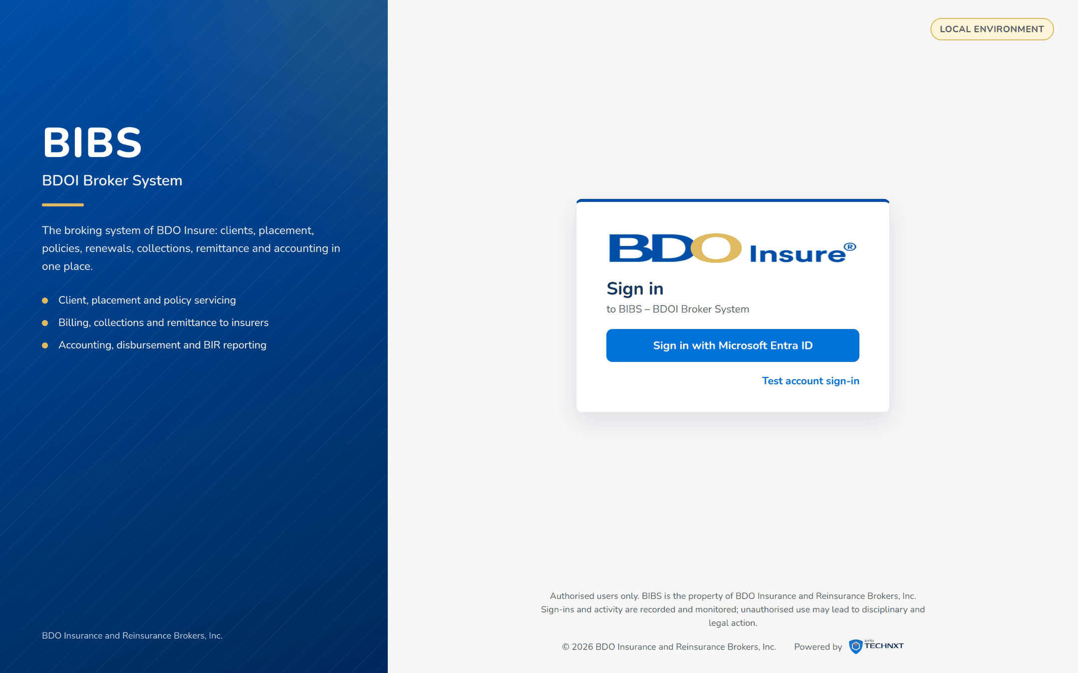
Figure 1: SCR-UA-01 Sign in with the Entra ID button

SCR-UA-02 Users
Item | Value
Menu | Setup & Administration › User Access › Users
Personas | User Access Administrator, Auditor
Purpose | The users received from UIDM-ISC. Read-only for the user record.
Actions | Search, Export (CSV), Open a user
States | List; filtered.
Empty or error state | No user matches the filters.

Table 5: SCR-UA-02 fields
Field | Description
Search | User ID, name or Windows ID.
Status | All, Active, Inactive, Locked.
Group profile | Filter by profile.
Business unit | Filter by unit.
Columns | User ID, Windows ID, Name, Business Unit, Status, Group Profiles, Last Login, Locked.

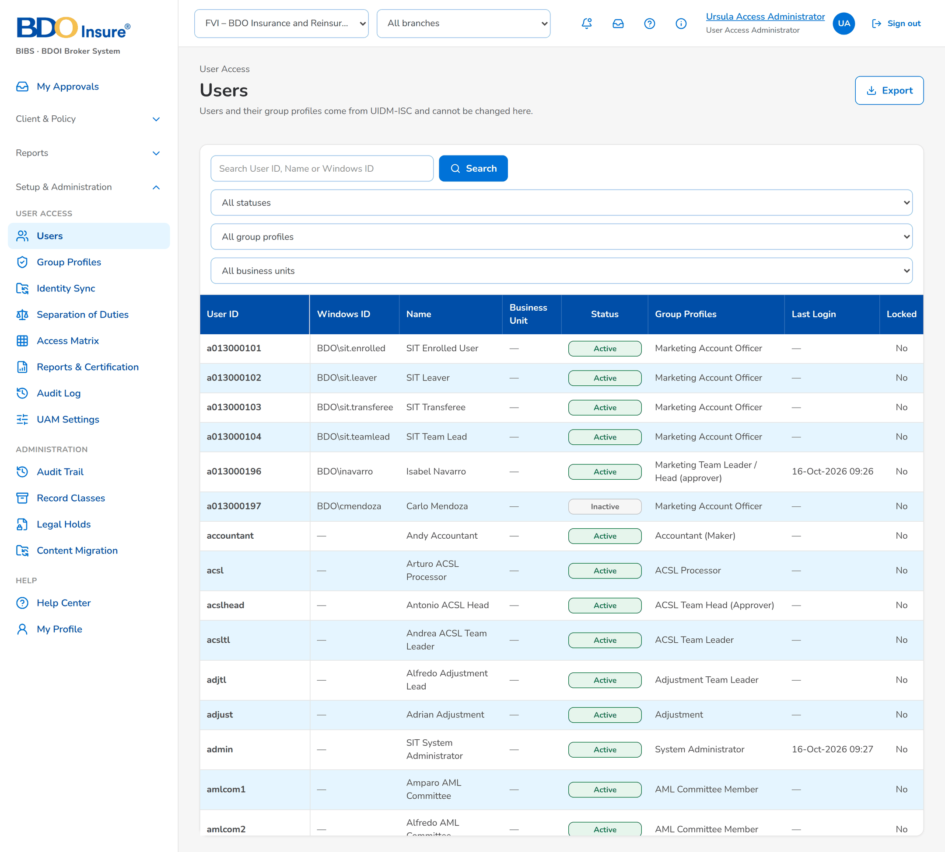
Figure 2: SCR-UA-02 Users of the User Access Administrator

SCR-UA-03 User › Profile
Item | Value
Menu | Users › a user
Personas | User Access Administrator, Auditor
Purpose | The account and the data sent by UIDM-ISC.
Actions | End Sessions, Unlock (locked test account)
States | Active, Inactive, Locked.
Empty or error state | Not connected: the directory data is not shown.

Table 6: SCR-UA-03 fields
Field | Description
Account | User ID, Windows ID, Name, E-mail, Business Unit, User Level, Status, Last Login.
From UIDM-ISC (SCIM) | Display name, directory status, department, unit, location, team leader, UIDM request no., last synchronised.

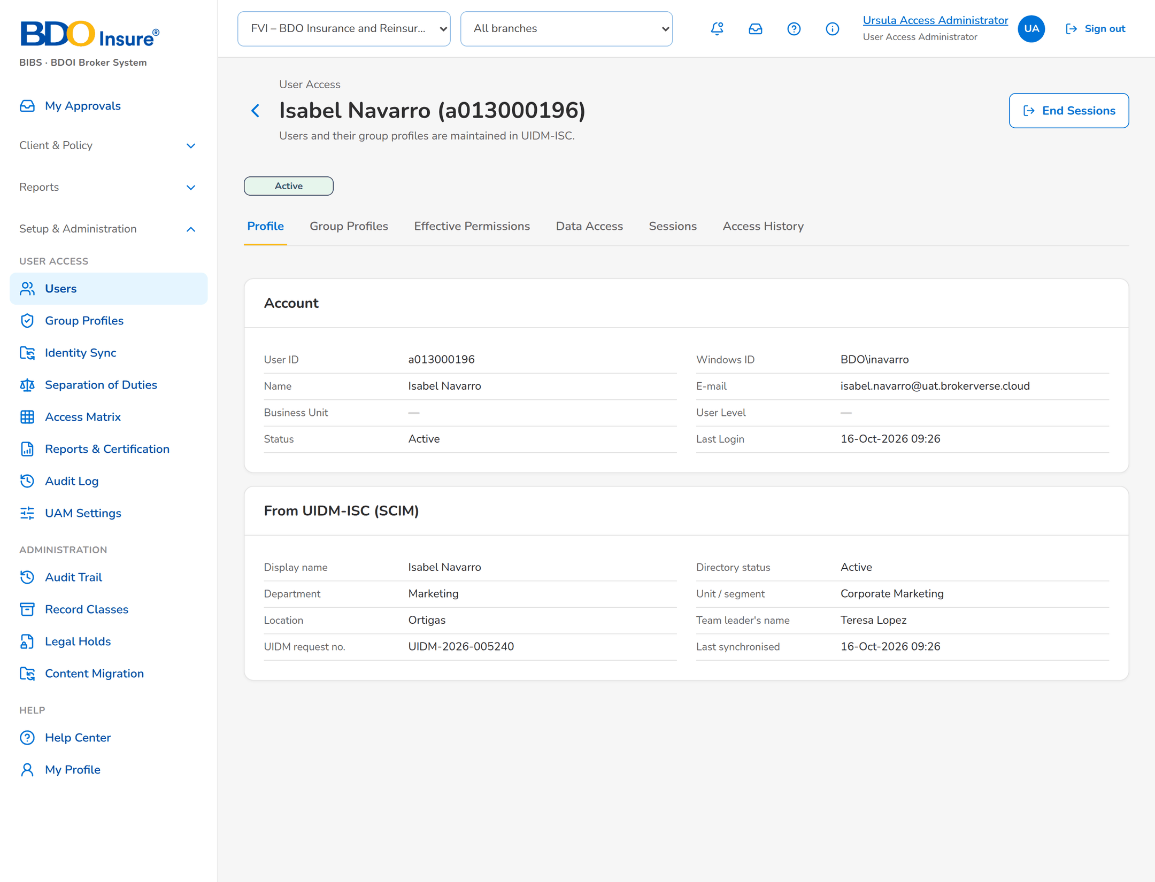
Figure 3: SCR-UA-03 User profile with the data from UIDM-ISC
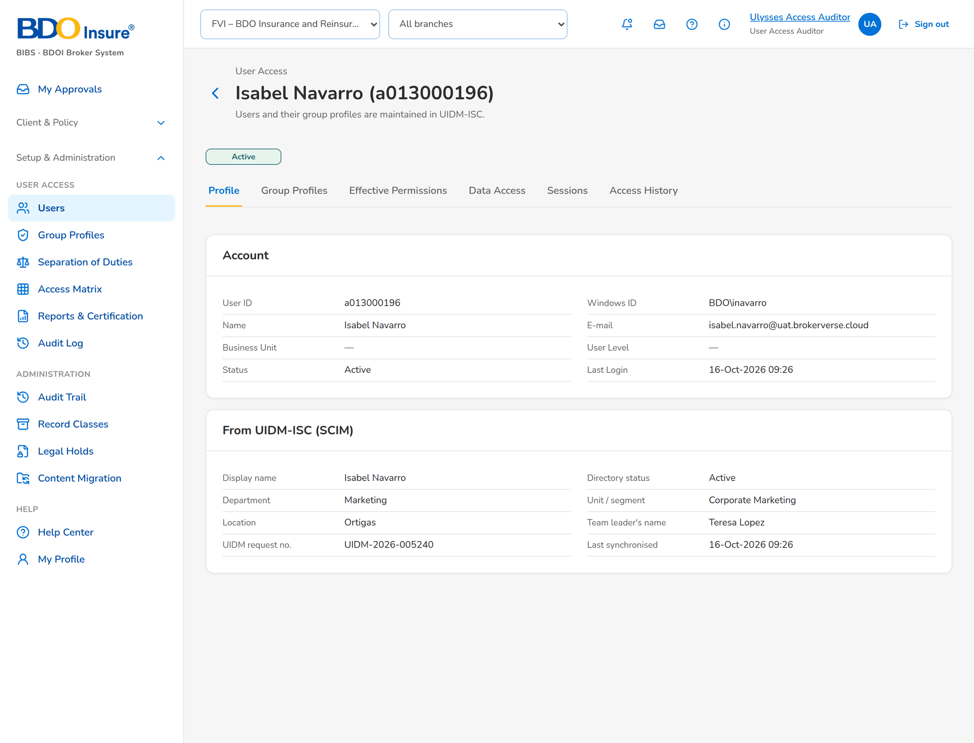
Figure 4: SCR-UA-03 The same user seen by the Auditor: no action buttons

SCR-UA-04 User › Group Profiles
Item | Value
Menu | Users › a user › Group Profiles
Personas | User Access Administrator, Auditor
Purpose | The group profiles held and where they came from.
Actions | -
States | List.
Empty or error state | No group profile.

Table 7: SCR-UA-04 fields
Field | Description
Columns | Code, Group Profile, Status, Source, Since, Request No.

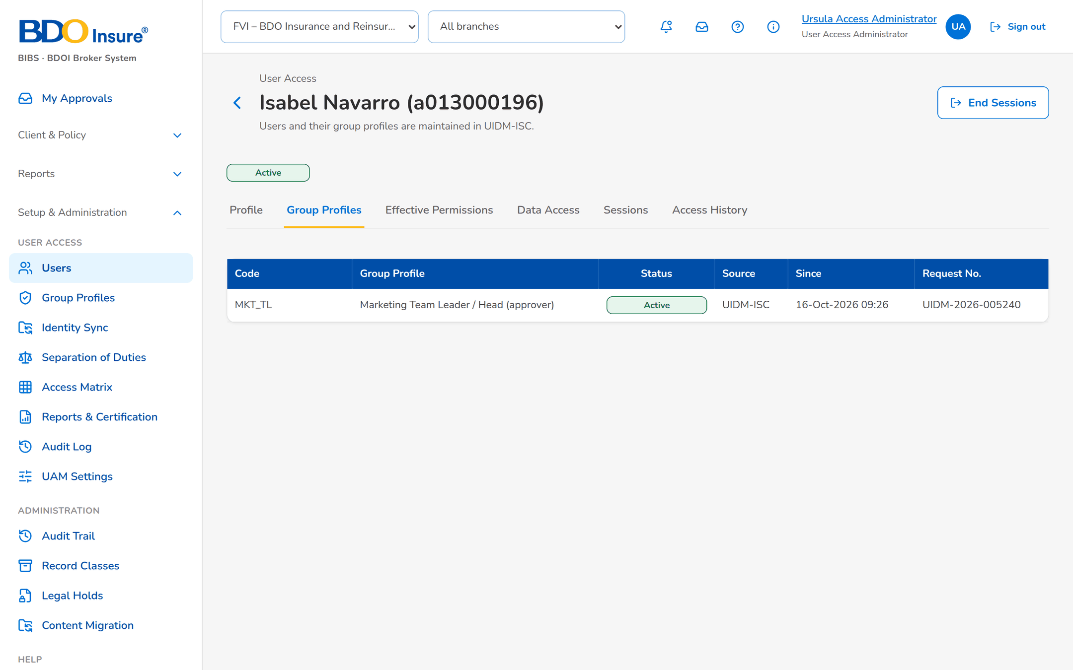
Figure 5: SCR-UA-04 Group profiles of a user with source and request number

SCR-UA-05 User › Effective Permissions
Item | Value
Menu | Users › a user › Effective Permissions
Personas | User Access Administrator, Auditor
Purpose | Every permission the user holds and through which profile.
Actions | -
States | List.
Empty or error state | No permission.

Table 8: SCR-UA-05 fields
Field | Description
Columns | Permission, area, granted by (group profiles).

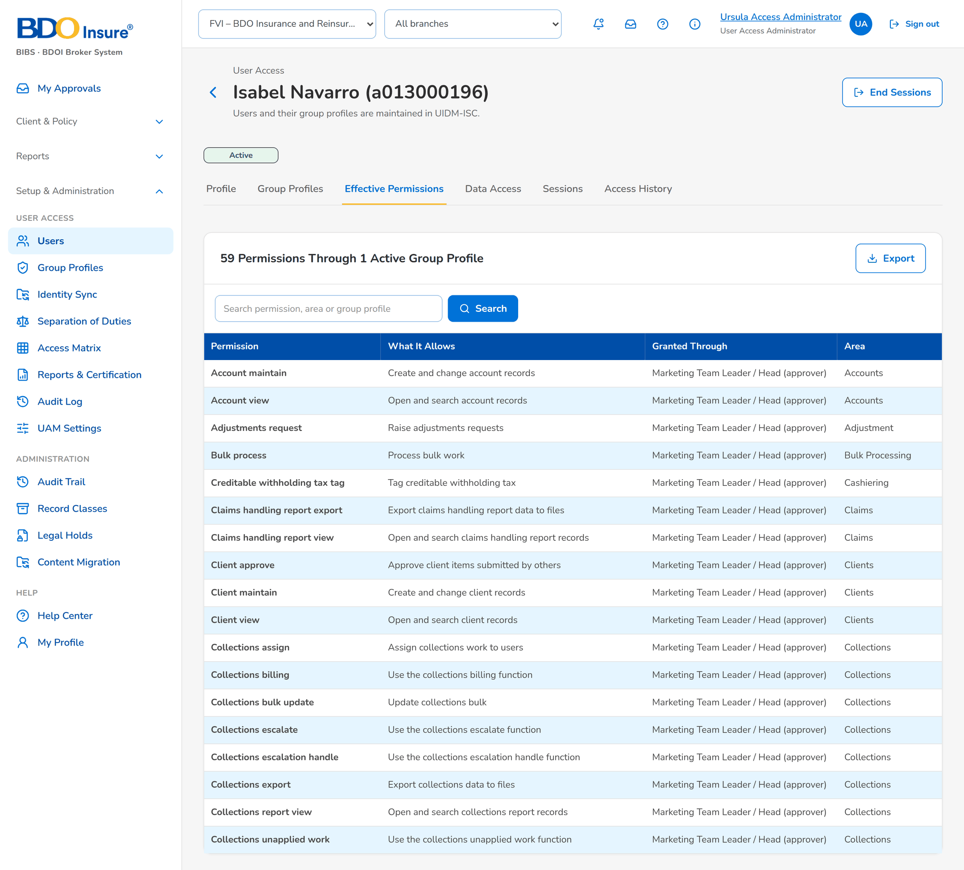
Figure 6: SCR-UA-05 Effective permissions through the active group profiles

SCR-UA-06 User › Data Access
Item | Value
Menu | Users › a user › Data Access
Personas | User Access Administrator (change), Auditor (read)
Purpose | The companies and branches the user may act for.
Actions | Save
States | Read; editing.
Empty or error state | No data access: the user sees no records.

Table 9: SCR-UA-06 fields
Field | Description
Companies | Ticked companies.
Branches | All branches, or the ticked ones.

Table 10: SCR-UA-06 input fields (service messages: Developer Specification)
Input field | Type | Required | Default | Rule | Message on screen
All companies | Yes/No | No | Yes | BR-UA-14 | -
Companies and branches | List of object | No | - | FRUM.003, FRUM.007 | -

Table 11: SCR-UA-06 validations
Validation message
At least one company.

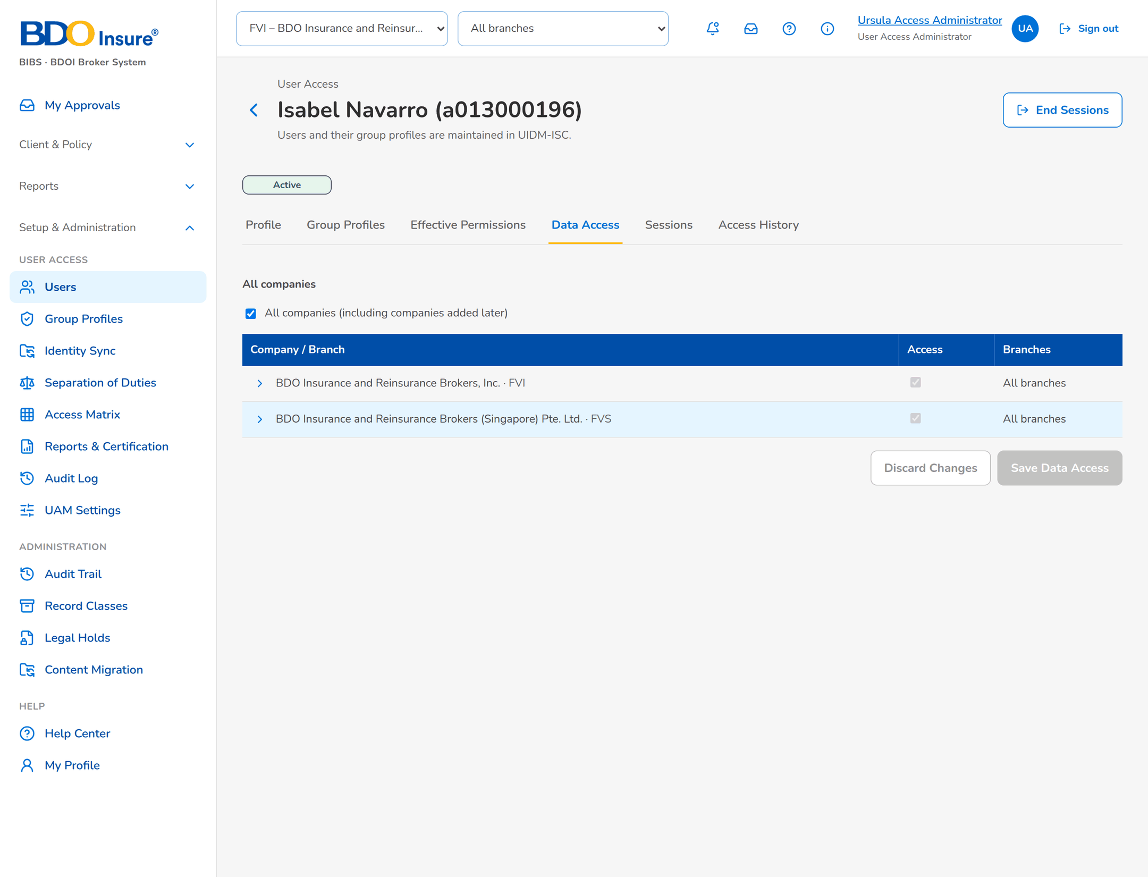
Figure 7: SCR-UA-06 Data access by company and branch

SCR-UA-07 User › Sessions
Item | Value
Menu | Users › a user › Sessions
Personas | User Access Administrator, Auditor
Purpose | Open and recent sessions.
Actions | End Sessions (header)
States | List.
Empty or error state | No session.

Table 12: SCR-UA-07 fields
Field | Description
Columns | Started, last activity, address, device, status, ended by.

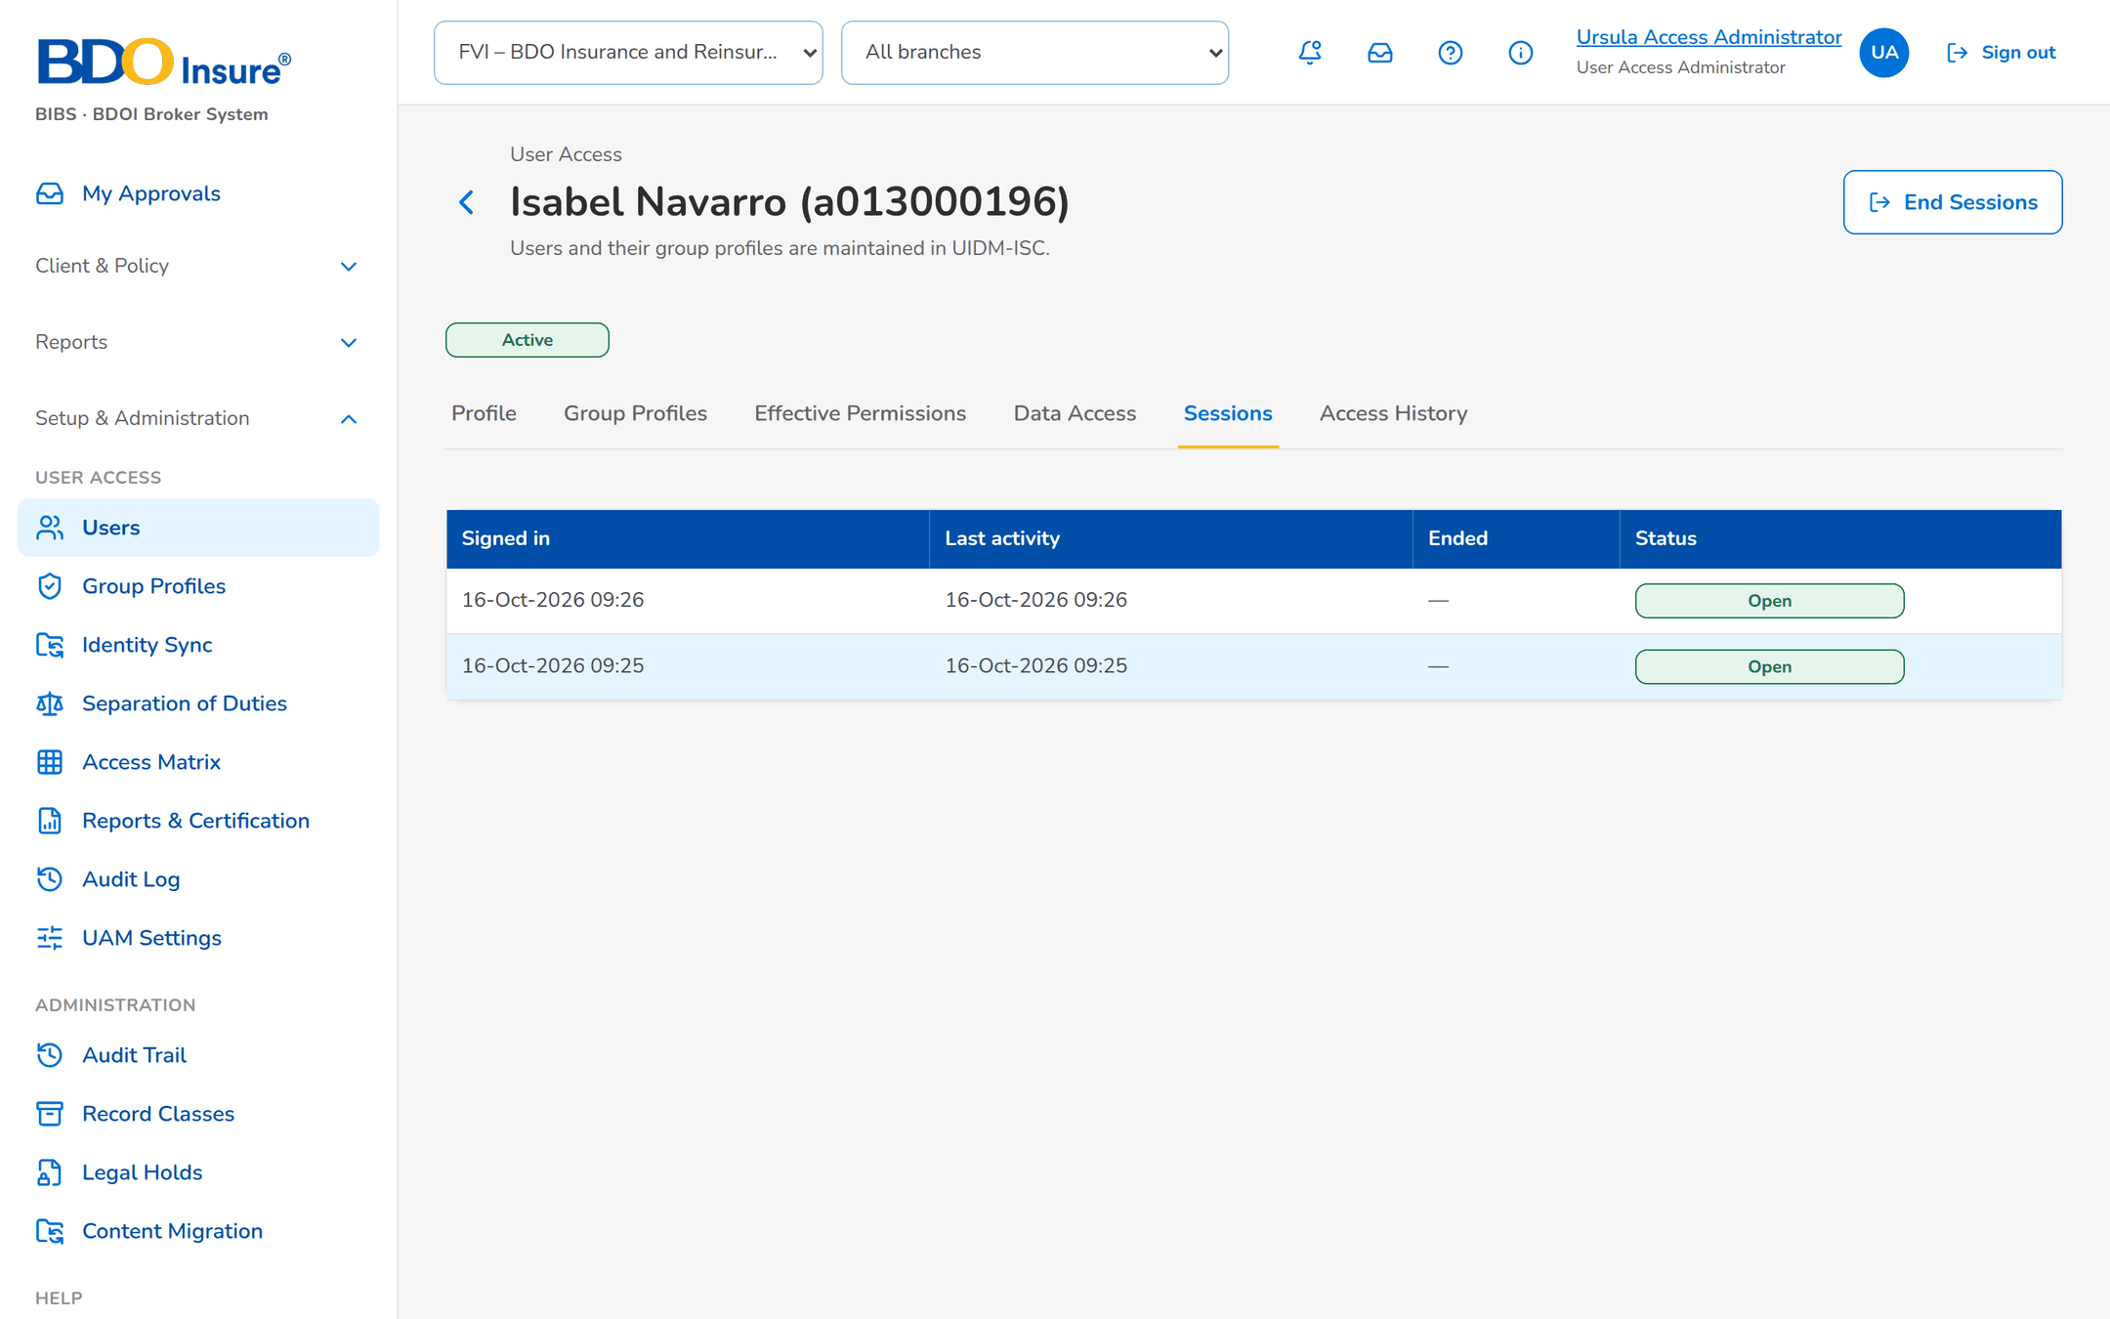
Figure 8: SCR-UA-07 Sessions of a user
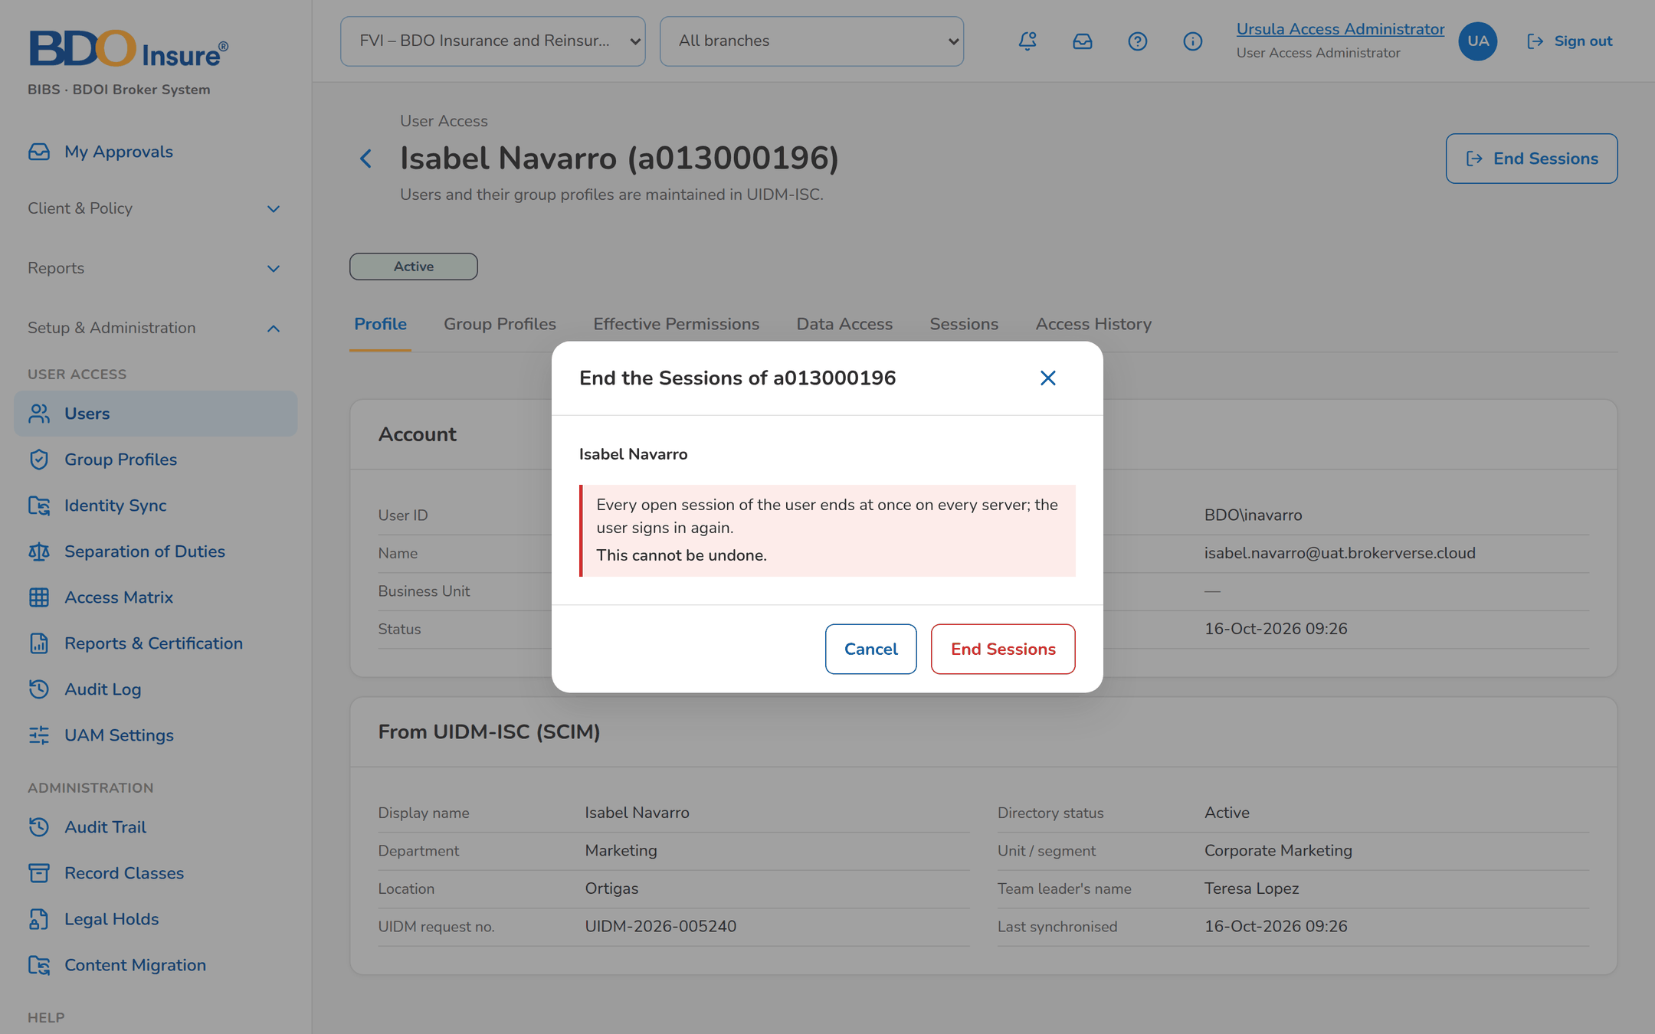
Figure 9: SCR-UA-07 End Sessions asks for confirmation

SCR-UA-08 User › Access History
Item | Value
Menu | Users › a user › Access History
Personas | User Access Administrator, Auditor
Purpose | Every change of the user, attribute by attribute.
Actions | -
States | List.
Empty or error state | No change recorded.

Table 13: SCR-UA-08 fields
Field | Description
Columns | Date / Time, Activity, Attribute, From, To, Request No., Done By, Approved By.

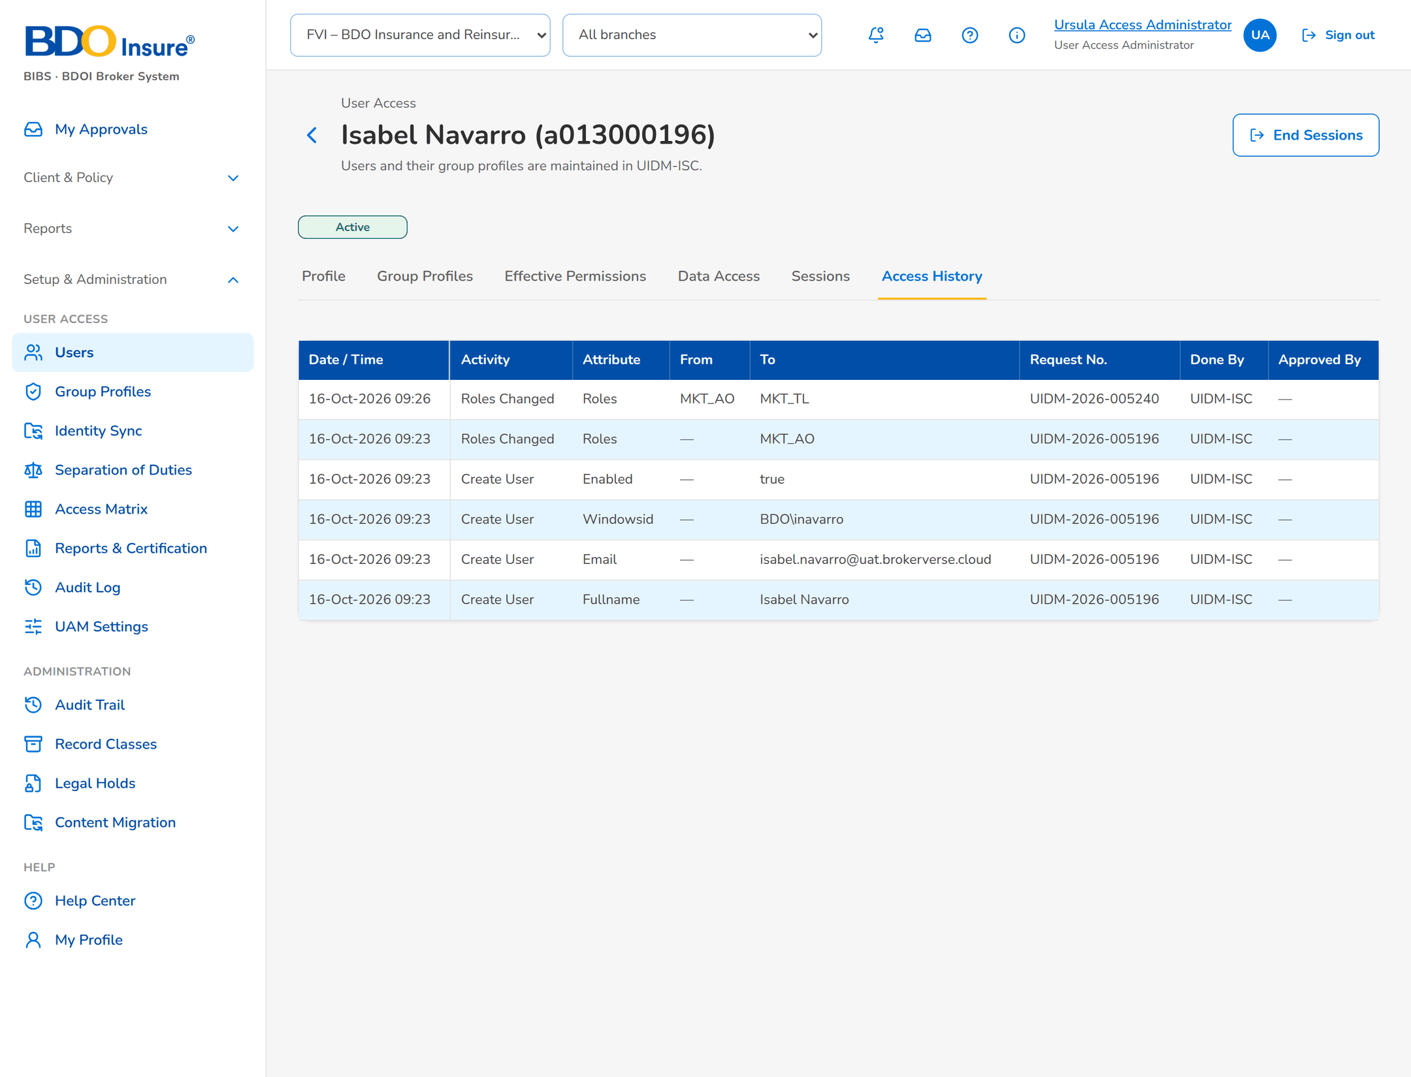
Figure 10: SCR-UA-08 Access history with the UIDM request numbers

SCR-UA-09 Group Profiles
Item | Value
Menu | Setup & Administration › User Access › Group Profiles
Personas | All User Access personas
Purpose | Every group profile and the change waiting for approval.
Actions | New Group Profile (maker), Open a profile
States | List.
Empty or error state | No group profile matches.

Table 14: SCR-UA-09 fields
Field | Description
Search | Code or name.
Columns | Code, Name, Privilege Level, Members, Status, Pending Change.
Proposed New Group Profiles | New profiles not yet approved.

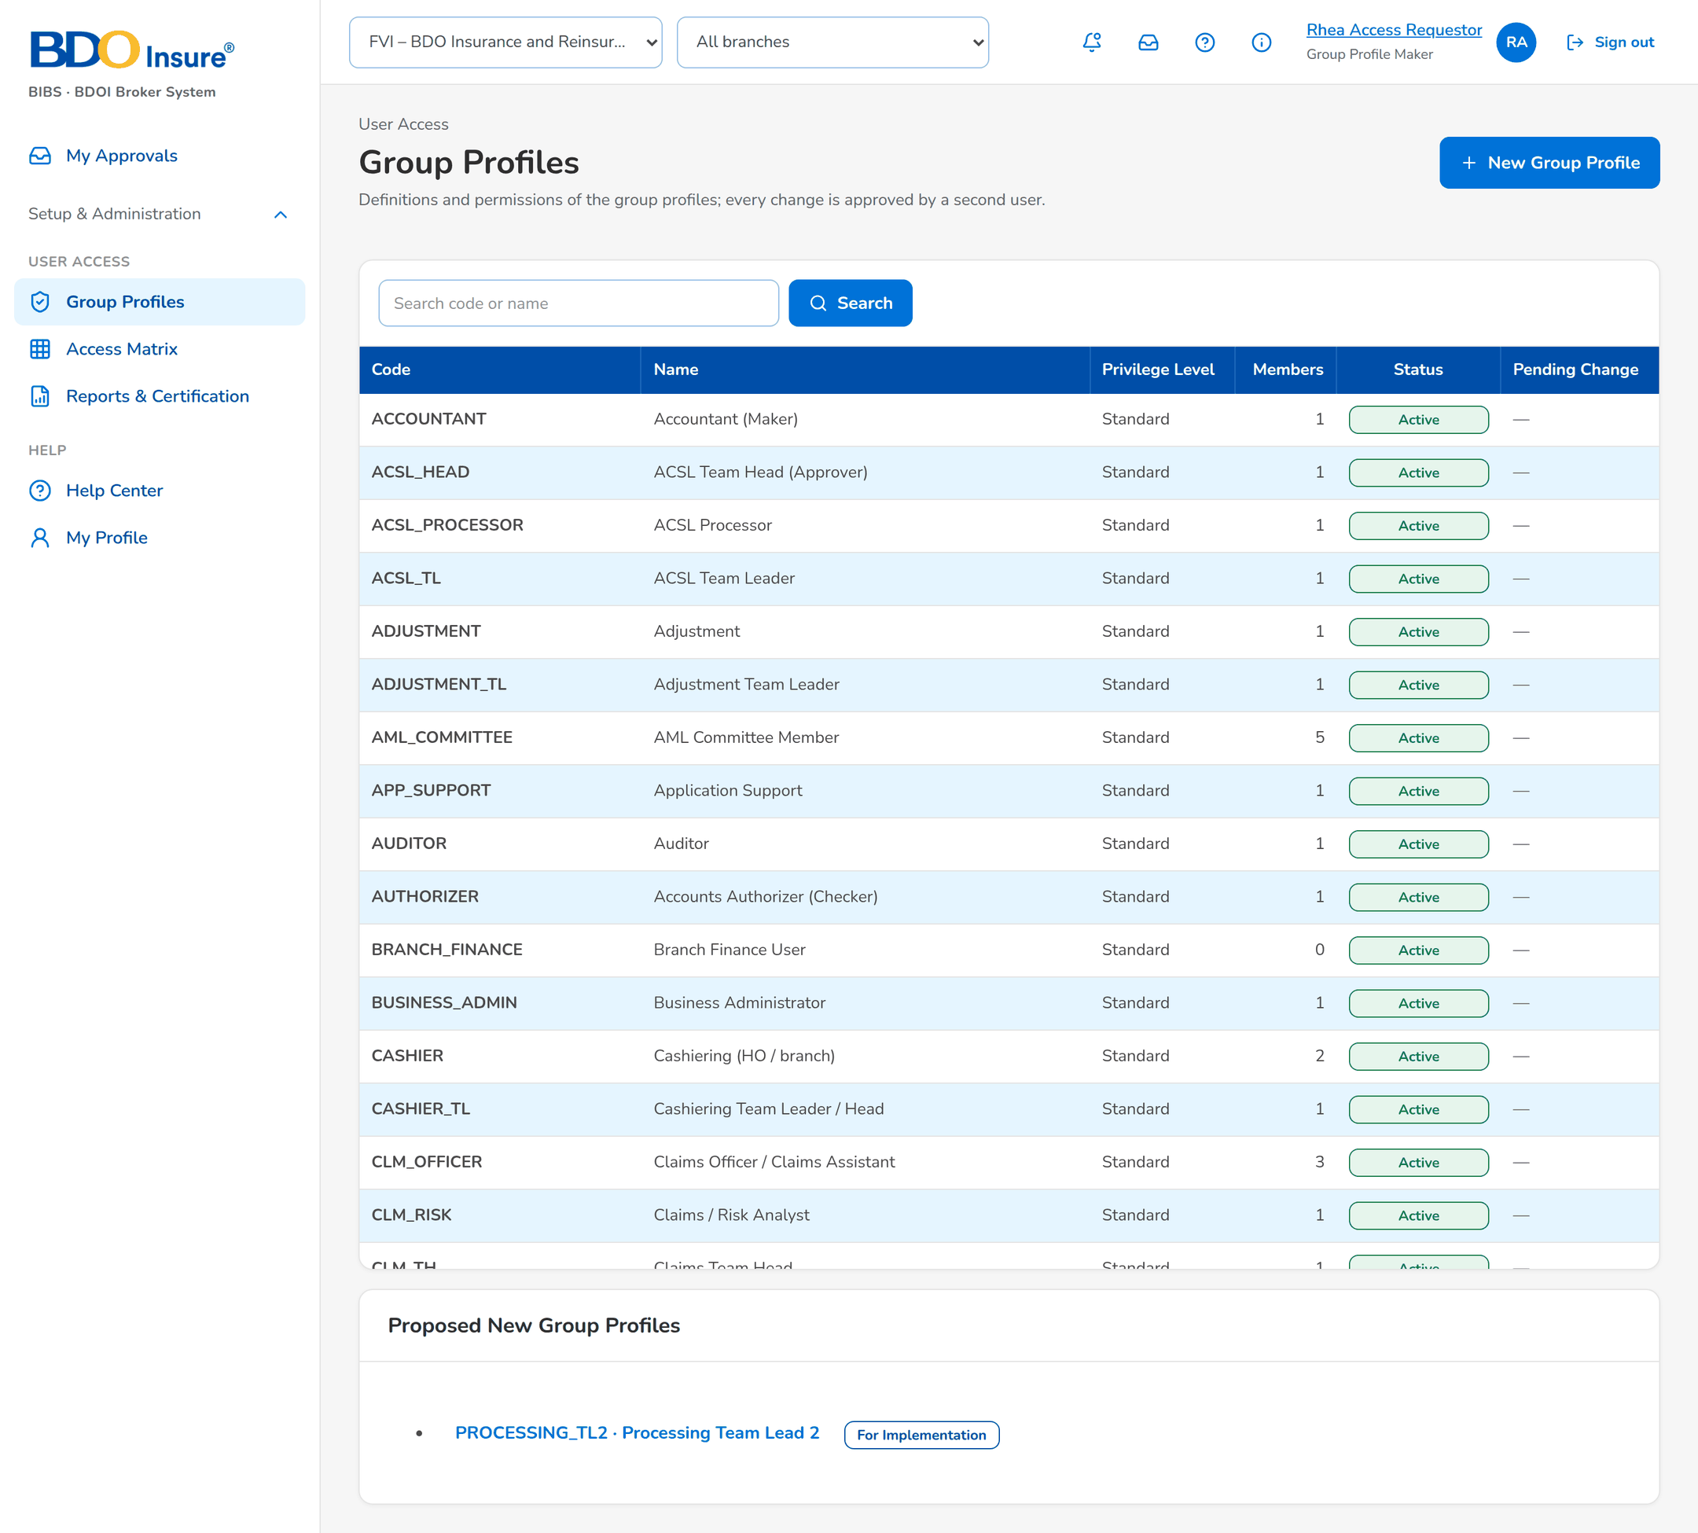
Figure 11: SCR-UA-09 Group Profiles of the maker

SCR-UA-10 Group Profile › Definition, Permissions, Members
Item | Value
Menu | Group Profiles › a profile
Personas | All User Access personas
Purpose | The definition, the permissions by area and the members (from UIDM-ISC, read-only).
Actions | Propose Change, Propose Deactivation / Reactivation (maker)
States | Active; Inactive; change pending (banner).
Empty or error state | No member.

Table 15: SCR-UA-10 fields
Field | Description
Definition | Code, Name, Description, Privilege Level, Status, Members, Permissions.
Permissions | By area, with what each permission allows.
Members | User ID, Windows ID, Name, Status.

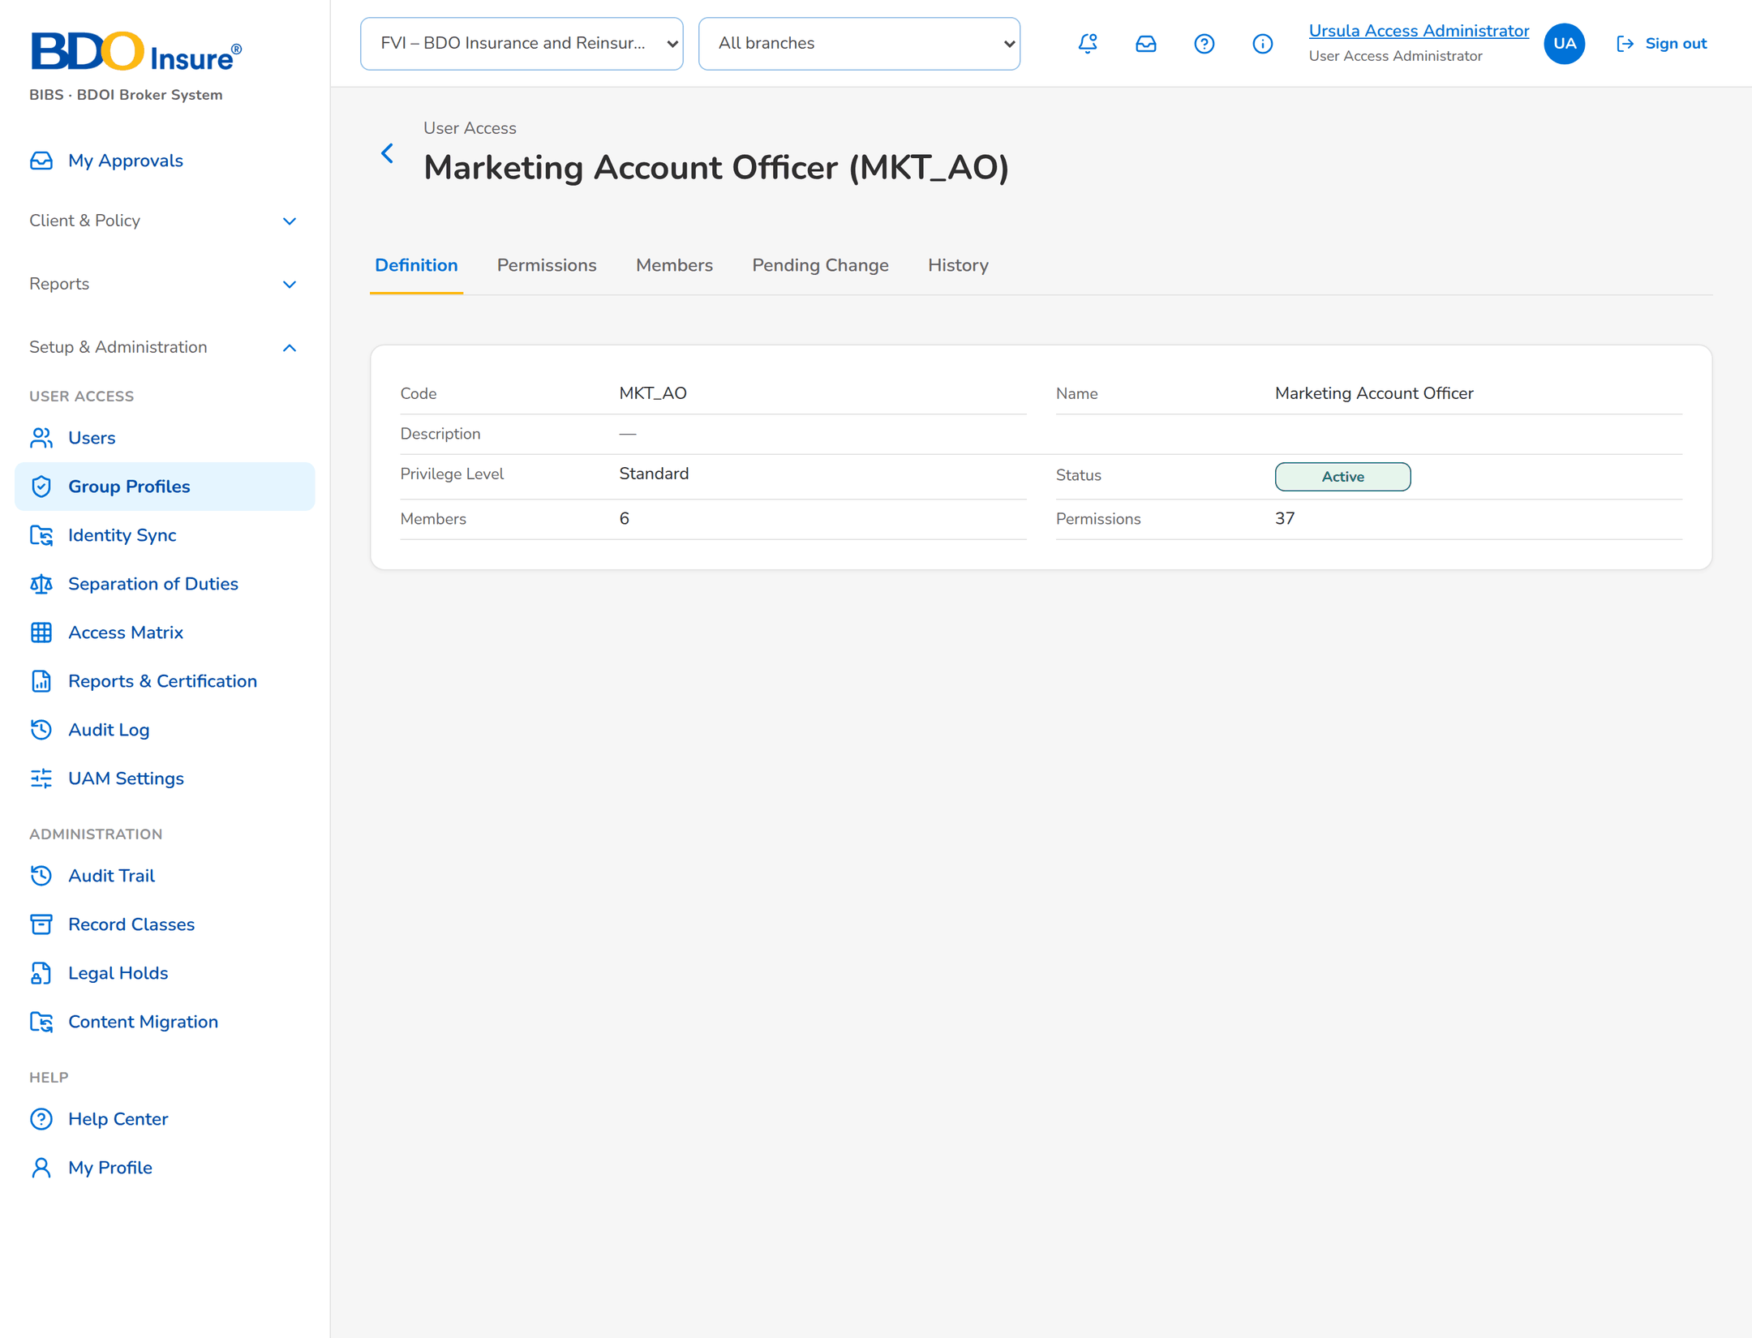
Figure 12: SCR-UA-10 Definition of a group profile
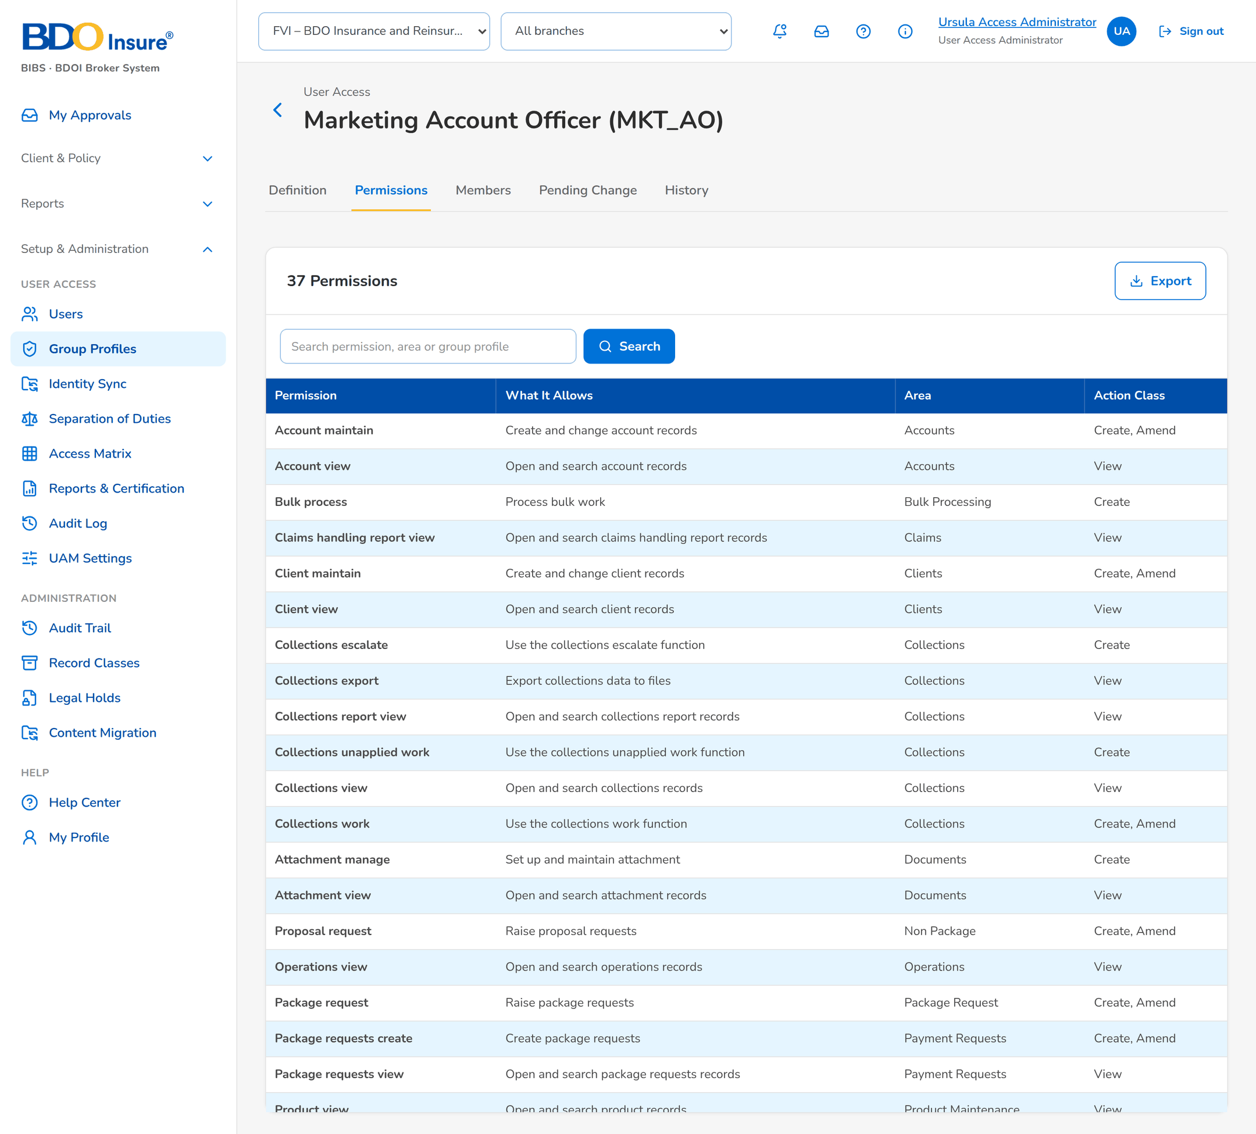
Figure 13: SCR-UA-10 Permissions of a group profile by area
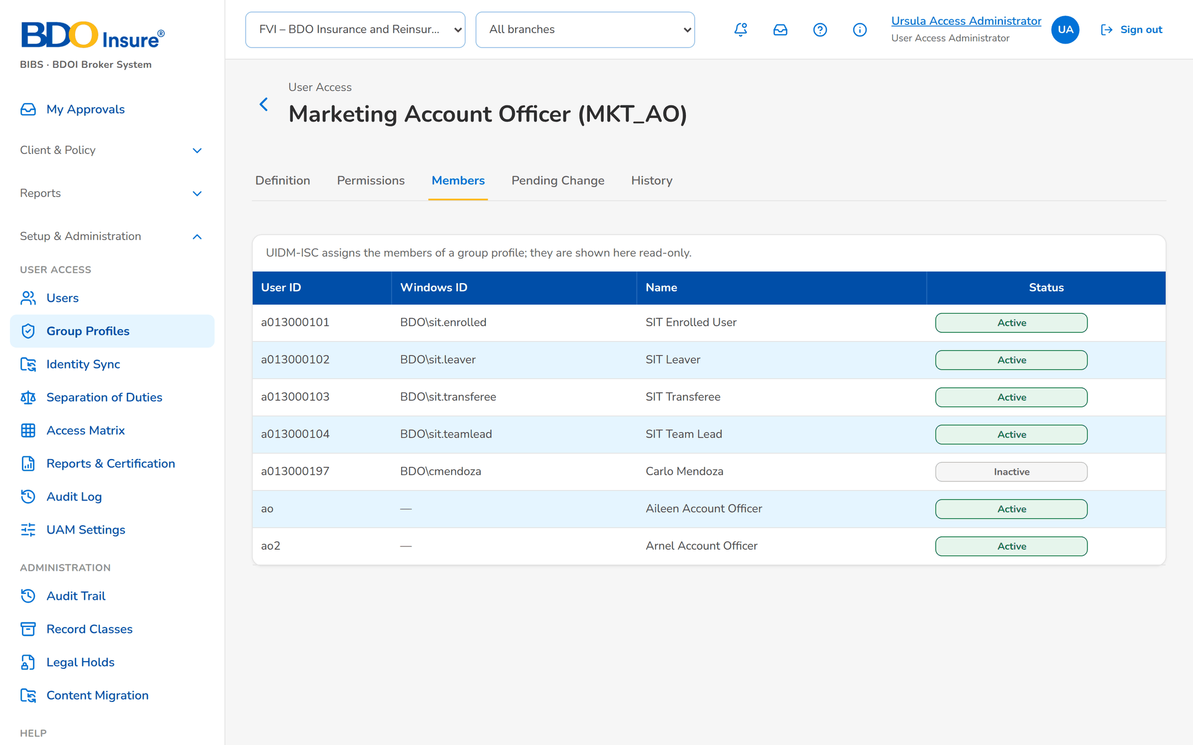
Figure 14: SCR-UA-10 Members of a group profile

SCR-UA-11 Propose a change
Item | Value
Menu | Group Profiles › New Group Profile / Propose Change
Personas | Group Profile Maker
Purpose | Proposes a new profile or a change, deactivation or reactivation.
Actions | Save Draft, Submit for Approval, Cancel
States | New; correcting a returned change.
Empty or error state | -

Table 16: SCR-UA-11 fields
Field | Description
Code | New profile: capital letters, digits and _ (up to 40). Mandatory.
Name / New Name | Mandatory for a new profile; blank keeps the current name.
Description | Optional; blank keeps the current one.
Privilege Level | Low, Standard, High, Admin; High and Admin need a second approval.
Permissions | Picker by area with search, Select all and Clear.
Reason | Mandatory on submission, up to 500 characters.

Table 17: SCR-UA-11 input fields (service messages: Developer Specification)
Input field | Type | Required | Default | Rule | Message on screen
Change type | Choice | Yes | - | FRUM.005, FRUM.006 | -
Code | Text, up to 40 | No | - | FRUM.005, FRUM.006 | Enter the code: capital letters, digits and _ (up to 40)
Name / New Name | Text, up to 120 | Yes | - | FRUM.005, FRUM.006 | Enter the name of the group profile
Description | Text, up to 500 | No | - | FRUM.005, FRUM.006 | -
Privilege Level | Choice | No | - | FRUM.005, FRUM.006 | -
Permissions | List of text | No | - | FRUM.005, FRUM.006 | Select at least one permission
Reason for the change | Text, up to 1000 | Yes | - | FRUM.005, FRUM.006 | Enter the reason for the change
What was corrected (returned change) | Text, up to 1000 | Yes | - | FRUM.005, FRUM.006 | Enter what was corrected

Table 18: SCR-UA-11 validations
Validation message
Enter the code: capital letters, digits and _ (up to 40).
Enter the name of the group profile.
Select at least one permission.
Change the permissions, the name, the description or the level.
Enter the reason for the change.

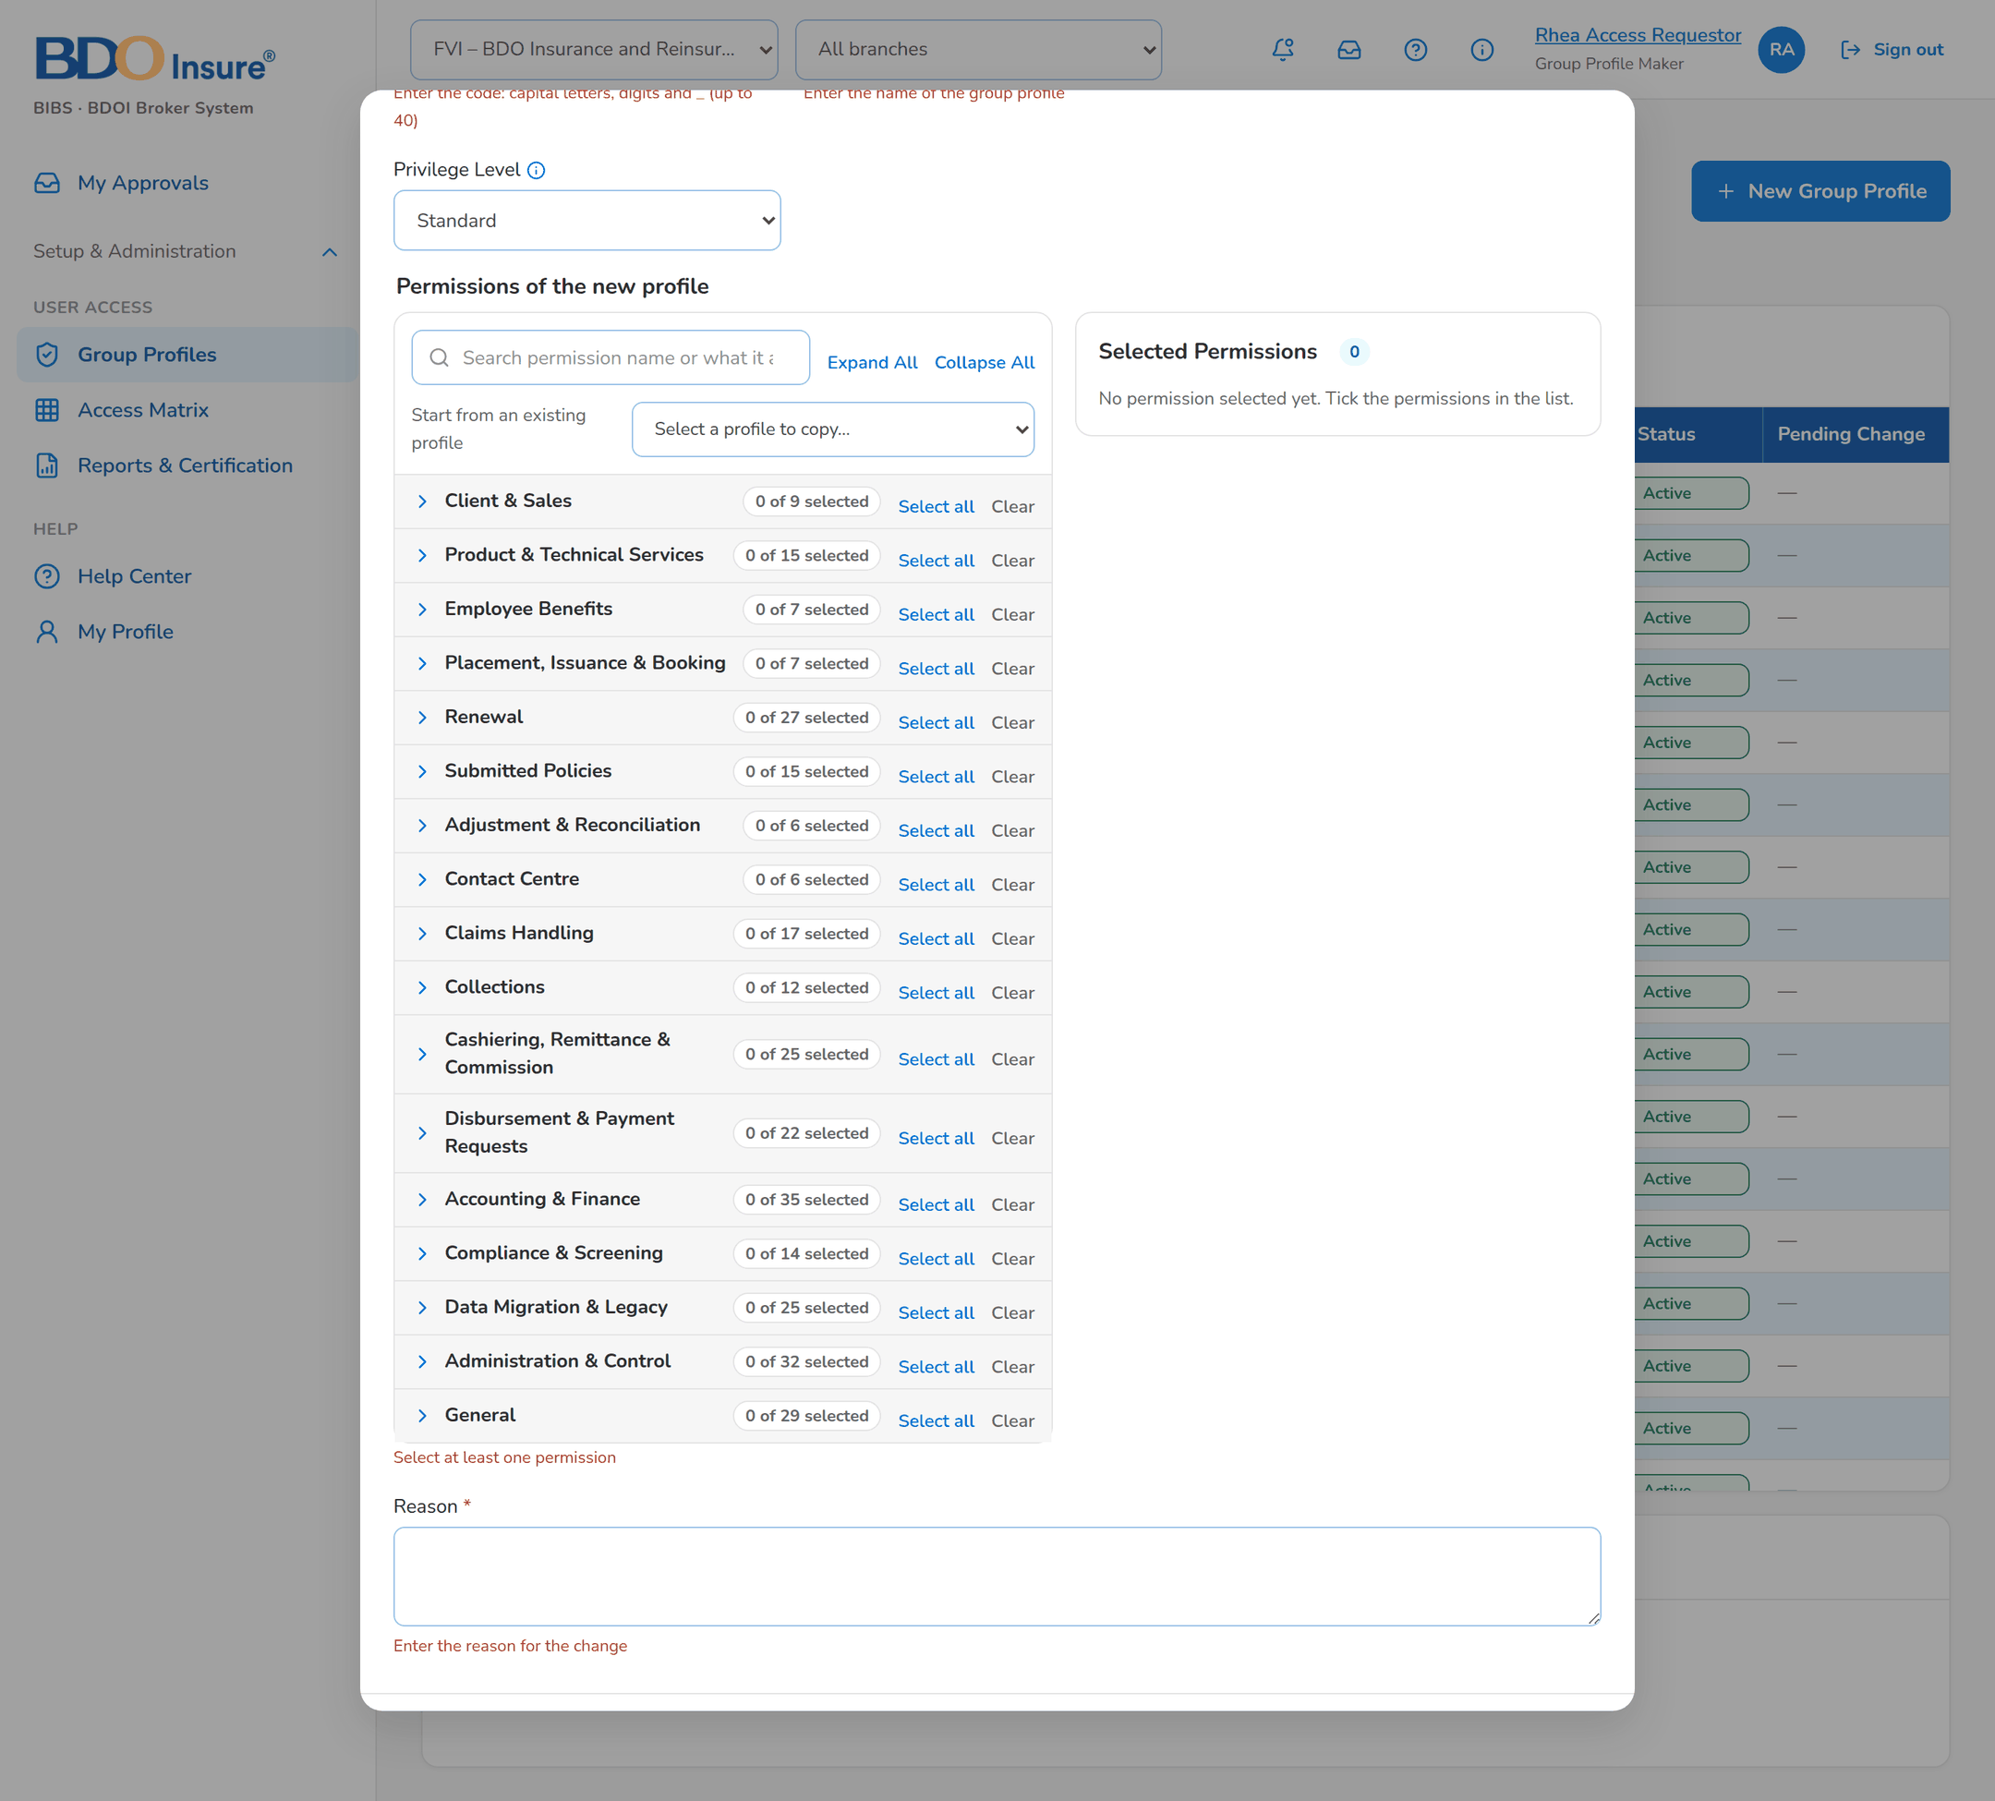
Figure 15: SCR-UA-11 New group profile with the messages of missing fields

SCR-UA-12 Group Profile › Pending Change and History
Item | Value
Menu | Group Profiles › a profile
Personas | Maker, Checker, System Administrator, Auditor
Purpose | The open change and its decisions.
Actions | Approve, Give Second Approval, Return for Correction, Reject, Cancel Change (maker), Implement (System Administrator)
States | Pending, Pending Second, Returned, For Implementation.
Empty or error state | No change of this group profile is waiting.

Table 19: SCR-UA-12 fields
Field | Description
Pending Change | Status, Maker, Proposed on, Change, Permissions added and removed, Reason, Checker remarks, Second approval.
History | Change No., Change, Details, Maker, Checker, Date, Status.

Table 20: SCR-UA-12 input fields (service messages: Developer Specification)
Input field | Type | Required | Default | Rule | Message on screen
Reason (Reject, Return for Correction, Cancel Change) | Text, up to 1000 | Yes | - | FRUM.006, FRUM.010 | Enter the reason.
Comment (Approve, Give Second Approval) | Text, up to 1000 | No | - | FRUM.006, FRUM.010 | -

Table 21: SCR-UA-12 validations
Validation message
Return and Reject need a remark.
The maker cannot decide.

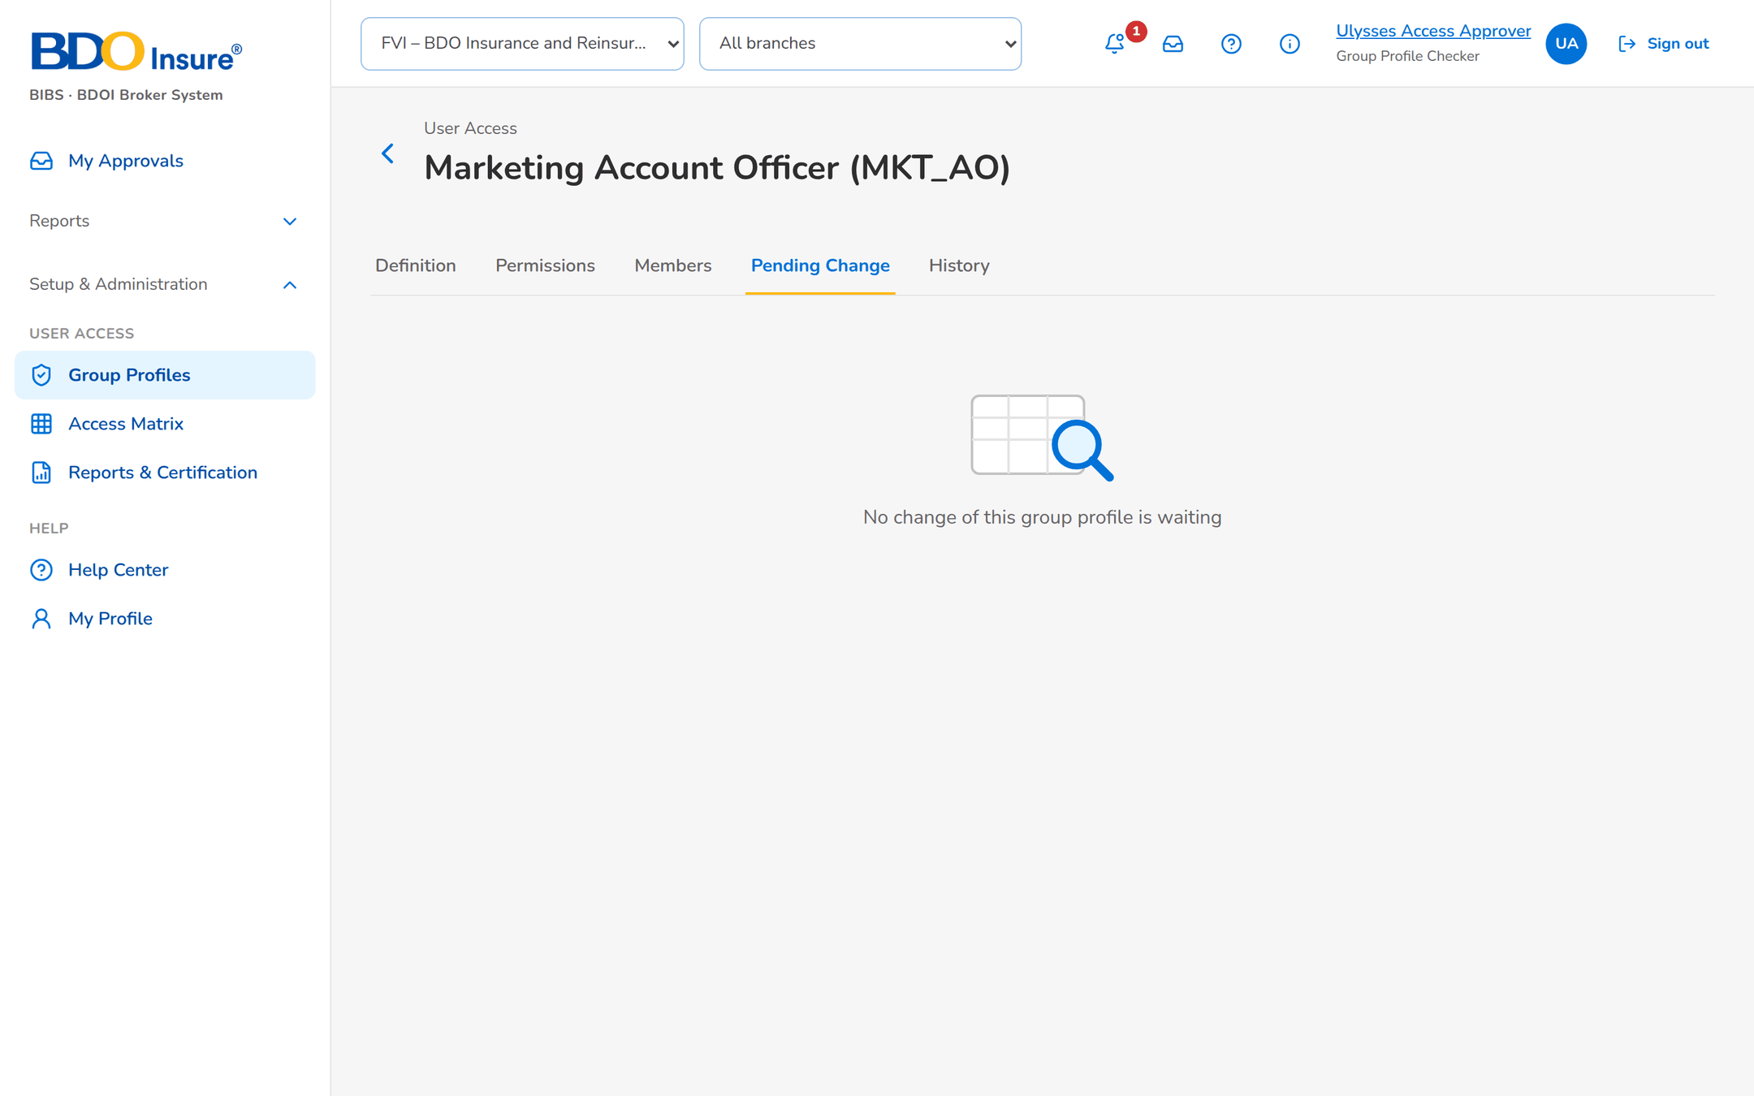
Figure 16: SCR-UA-12 Pending Change with nothing waiting

SCR-UA-13 Identity Sync
Item | Value
Menu | Setup & Administration › User Access › Identity Sync
Personas | User Access Administrator
Purpose | The link with UIDM-ISC: status, events, refused events, reconciliation.
Actions | Synchronise Now, Retry, Dismiss, Resolve, Run Now, Show resolved
States | Connected; errors.
Empty or error state | None yet / no refused event / no mismatch.

Table 22: SCR-UA-13 fields
Field | Description
Status | Directory, last call, last successful event, errors in 24 hours, refused events to review, mismatches to resolve, last synchronisation.
Events | Event No., Received, Source, Event, Windows ID, User ID, UIDM Request No., Outcome, Details, Processed By, Attempts.
Refused | Event No., Received, Event, Windows ID, User ID, UIDM Request No., Reason, Attempts.
Reconciliation | Run Date, User ID, Windows ID, Mismatch, Details, Resolved.

Table 23: SCR-UA-13 input fields (service messages: Developer Specification)
Input field | Type | Required | Default | Rule | Message on screen
Remark (Dismiss, Resolve) | Text, up to 500 | Yes | - | FRUM.014 | Enter the reason.

Table 24: SCR-UA-13 validations
Validation message
Dismiss and Resolve need a remark.

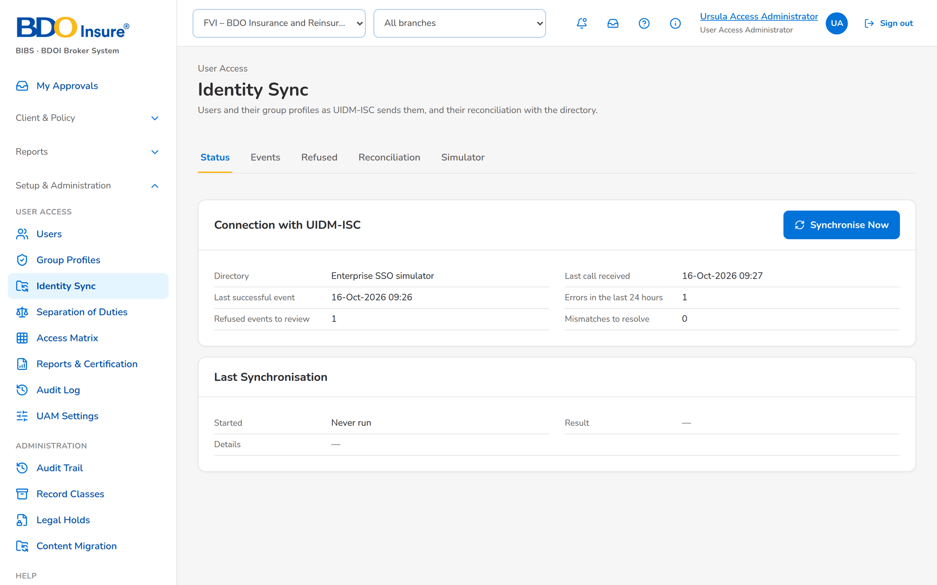
Figure 17: SCR-UA-13 Identity Sync status
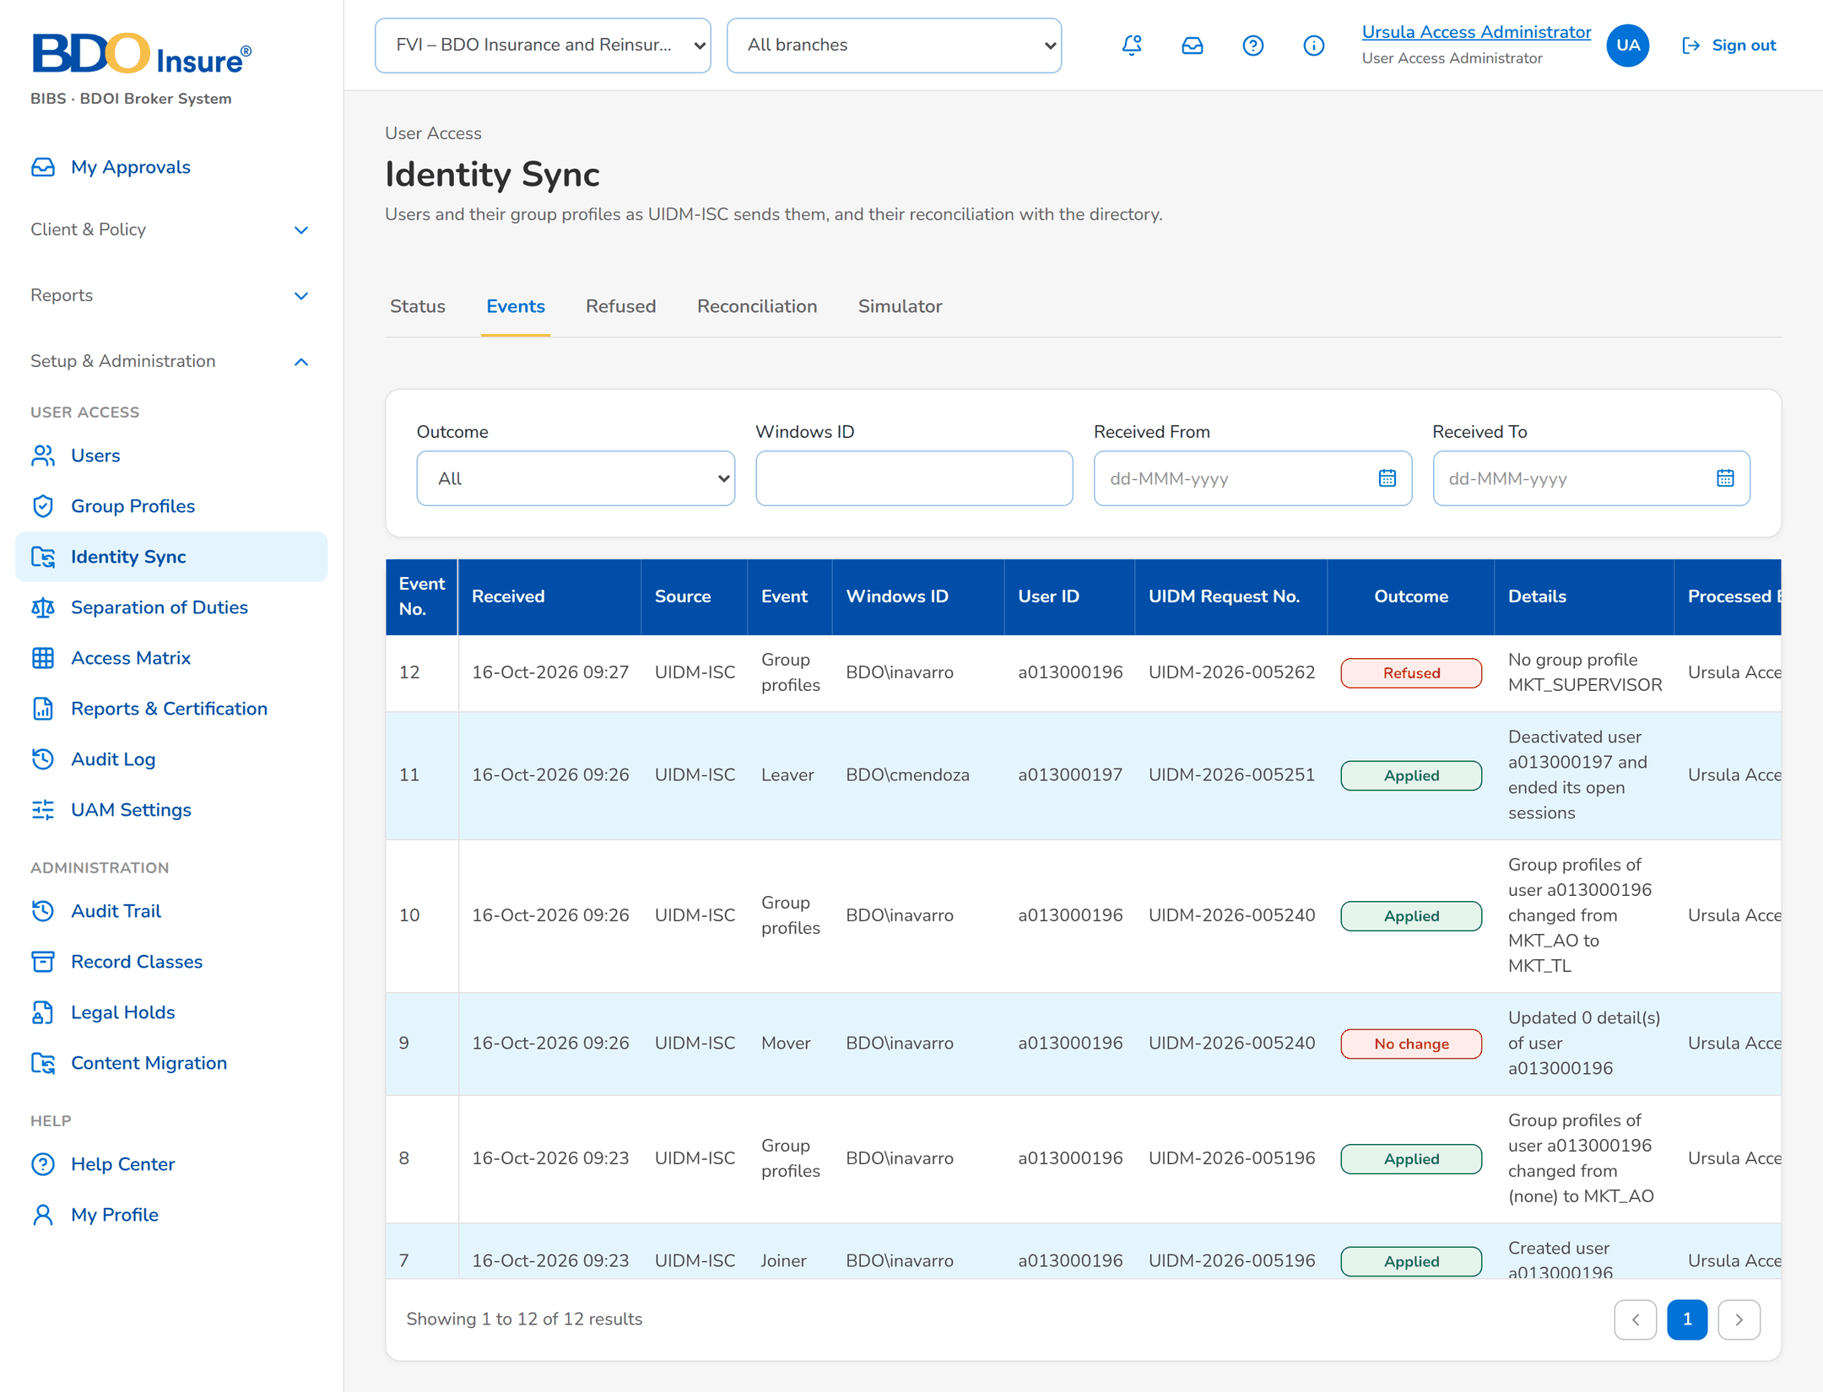
Figure 18: SCR-UA-13 Events received from UIDM-ISC
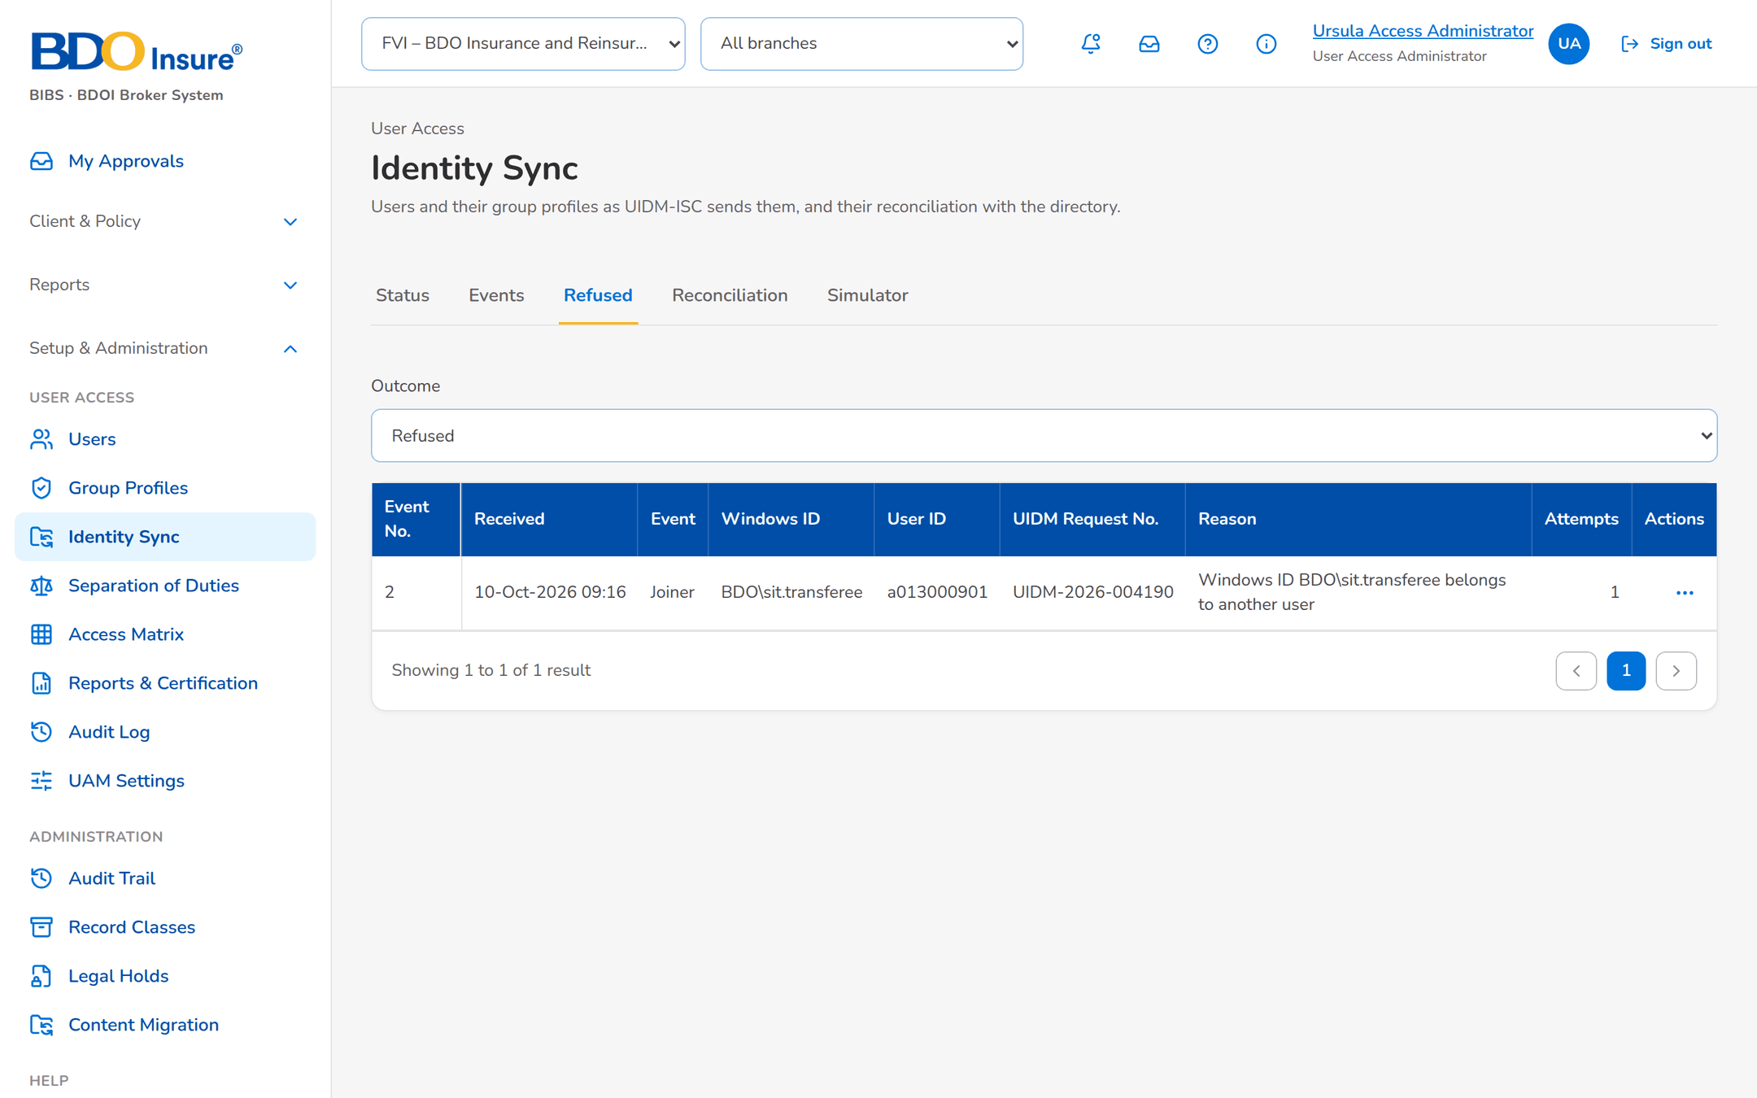
Figure 19: SCR-UA-13 Refused events
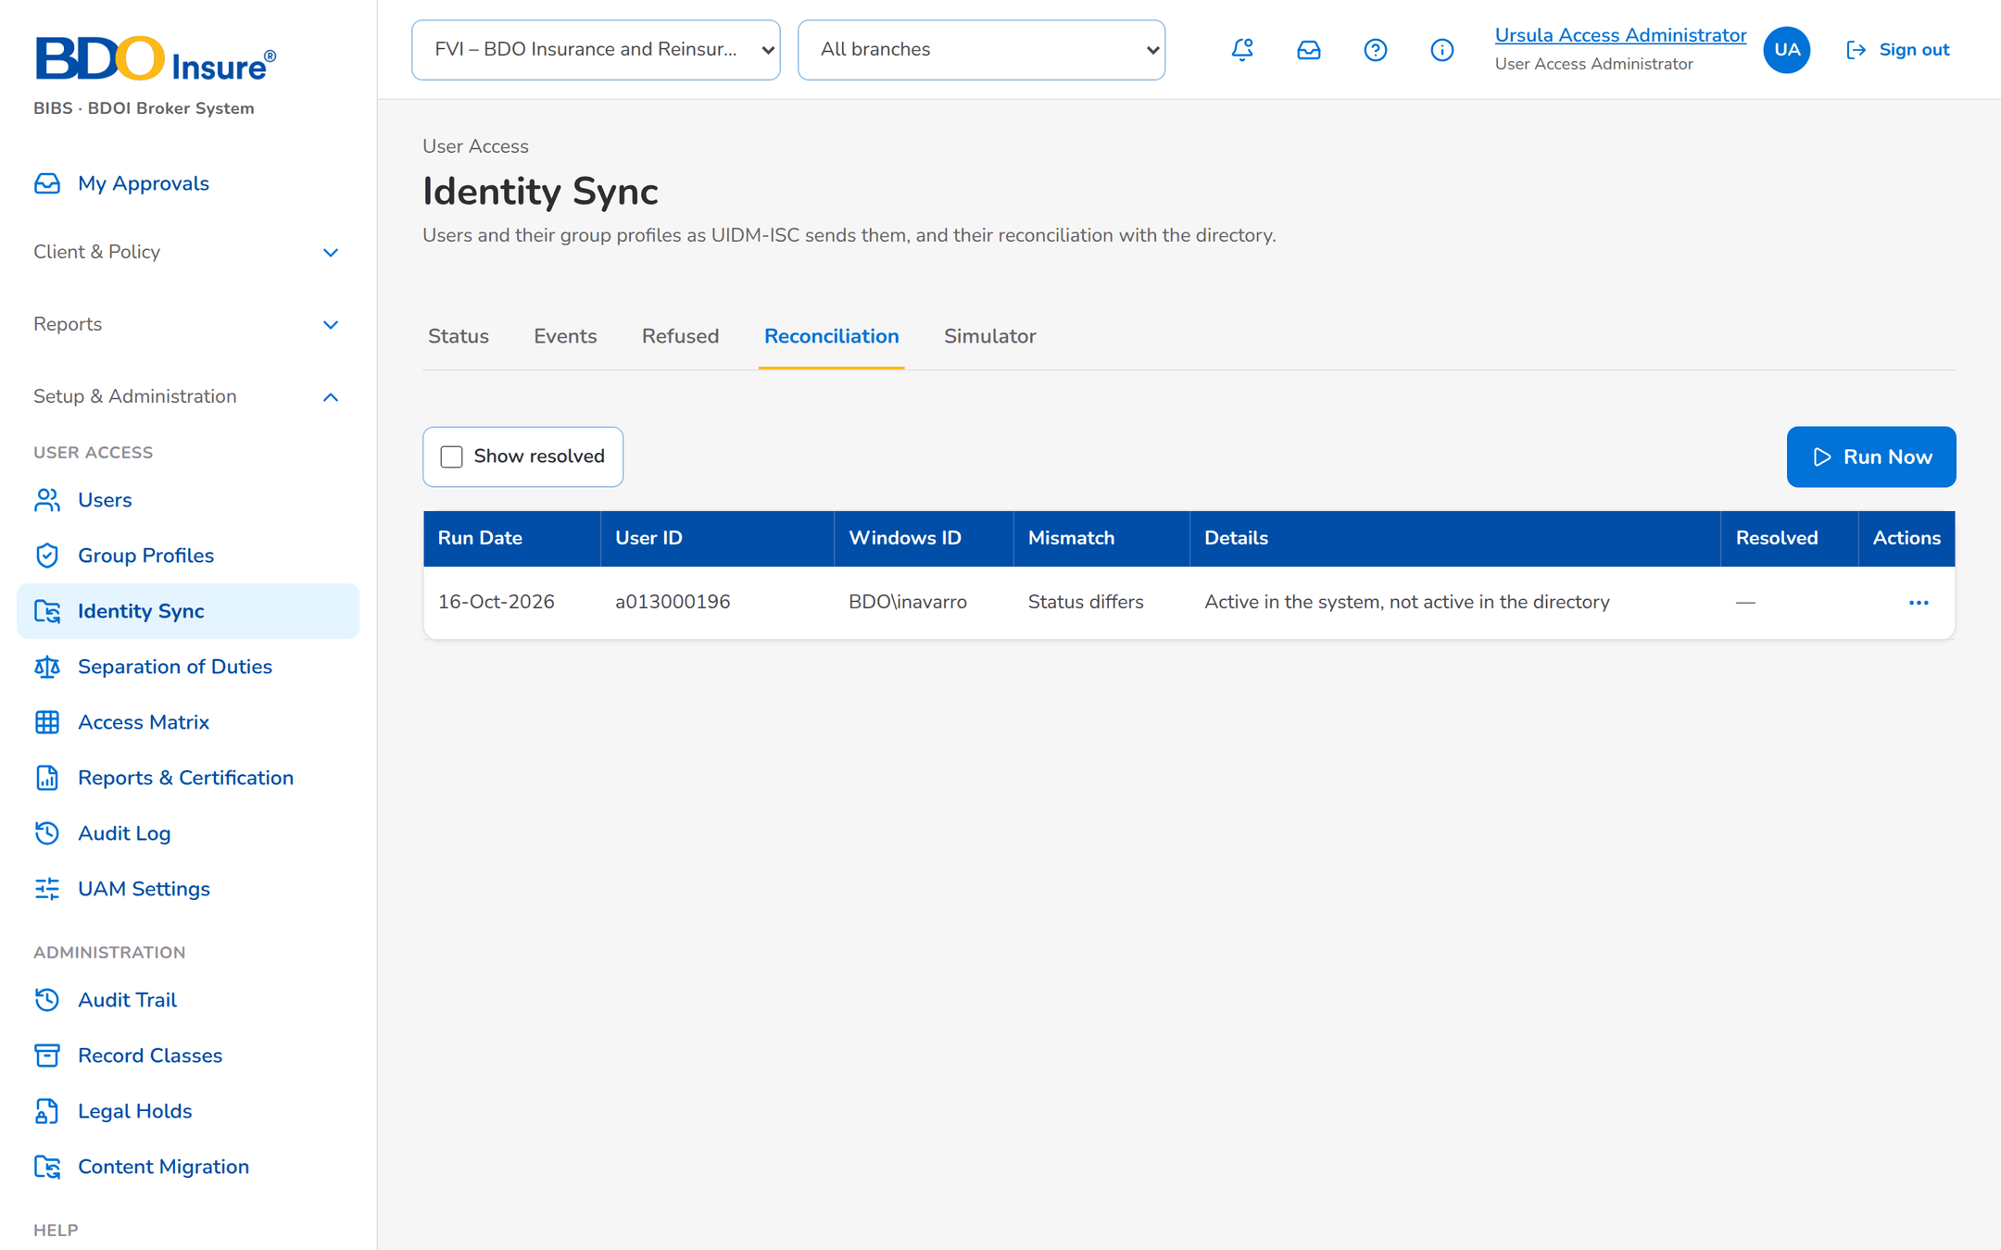
Figure 20: SCR-UA-13 Reconciliation mismatches

SCR-UA-14 Separation of Duties
Item | Value
Menu | Setup & Administration › User Access › Separation of Duties
Personas | Information Security; User Access Administrator and Auditor read
Purpose | Rules and the users who breach them.
Actions | New Rule (maintainer), Authorise, Reject, Deactivate, Export
States | Pending Authorization, Active, Inactive.
Empty or error state | No violation.

Table 25: SCR-UA-14 fields
Field | Description
Rules | Rule, Type, Group Profile / Permission, May Not Be Held With, Reason, Status, Maker, Authorised.
Violations | Rule, Kept Apart, User ID, Name, Group Profiles, First Found.

Table 26: SCR-UA-14 input fields (service messages: Developer Specification)
Input field | Type | Required | Default | Rule | Message on screen
Rule Type | Choice | Yes | Group profiles | FRUM.012 | -
Group Profile / Permission (first) | Text, up to 40 | Yes | - | FRUM.012 | -
Group Profile / Permission (second) | Text, up to 40 | Yes | - | FRUM.012 | Choose two different group profiles
Reason | Text, up to 500 | Yes | - | FRUM.012 | Enter why the two profiles are not held together
Reason of a rejection | Text | Yes | - | FRUM.012 | Enter the reason.

Table 27: SCR-UA-14 validations
Validation message
Choose two different group profiles.
Enter why the two profiles are not held together.

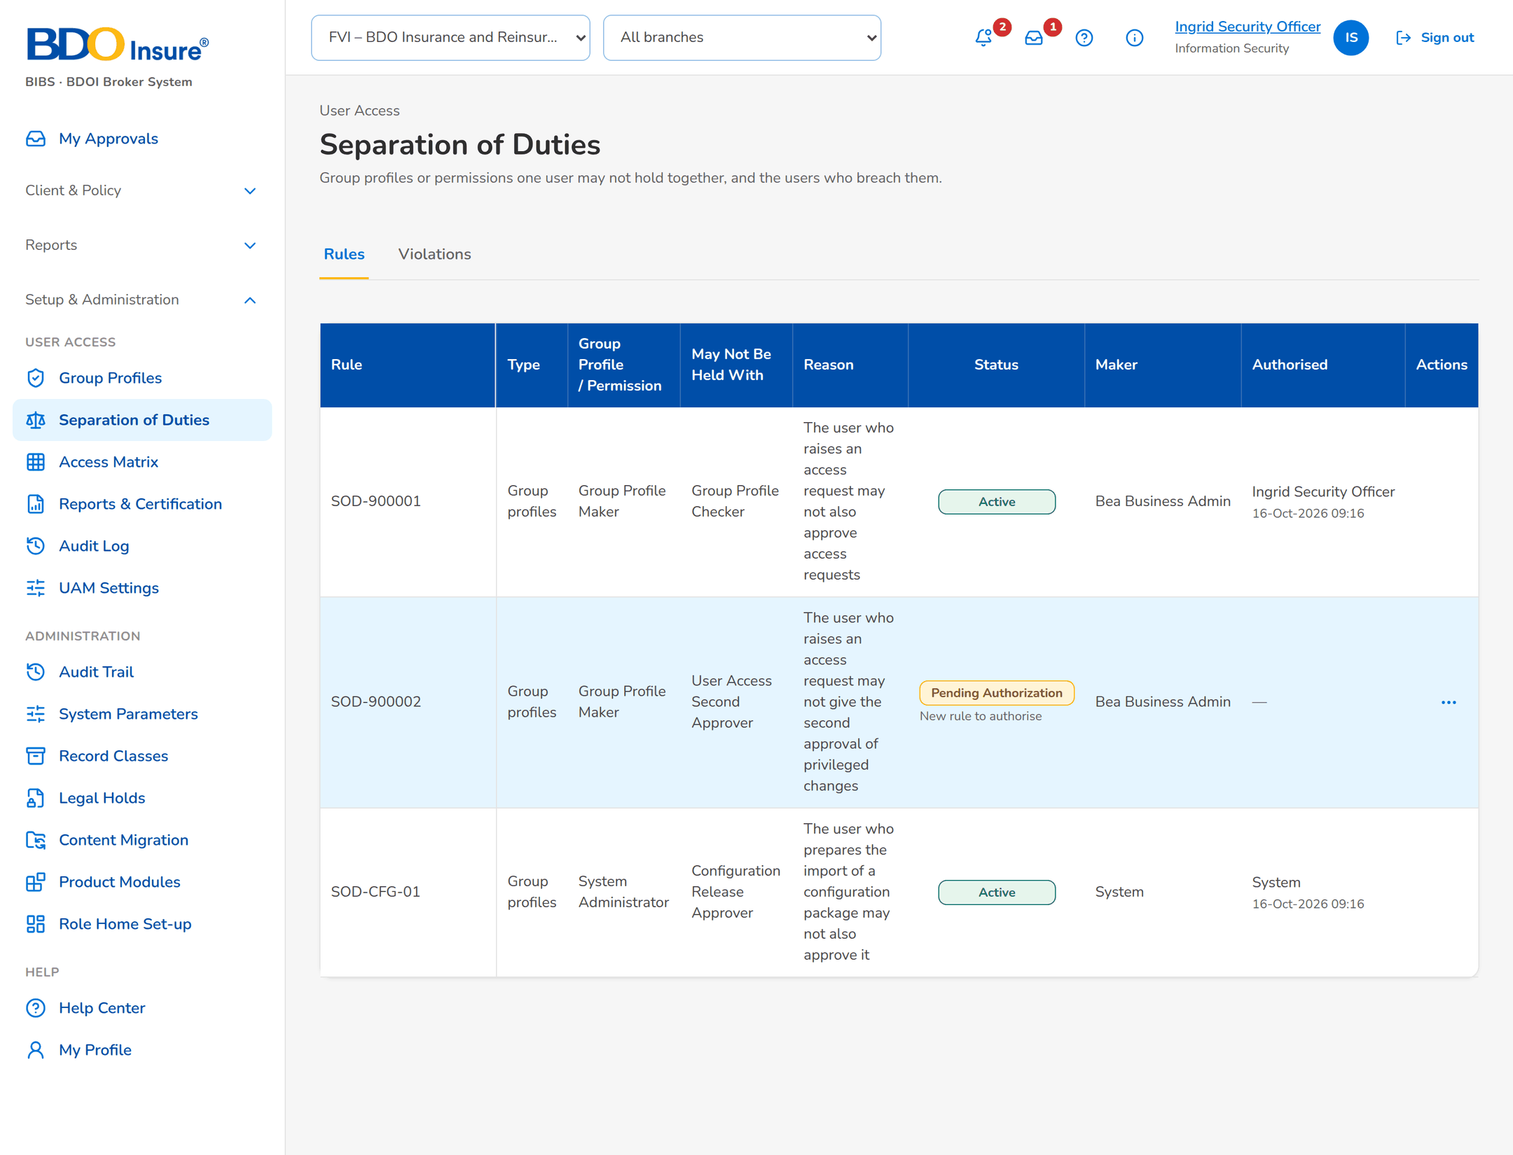
Figure 21: SCR-UA-14 Rules, one pending authorisation
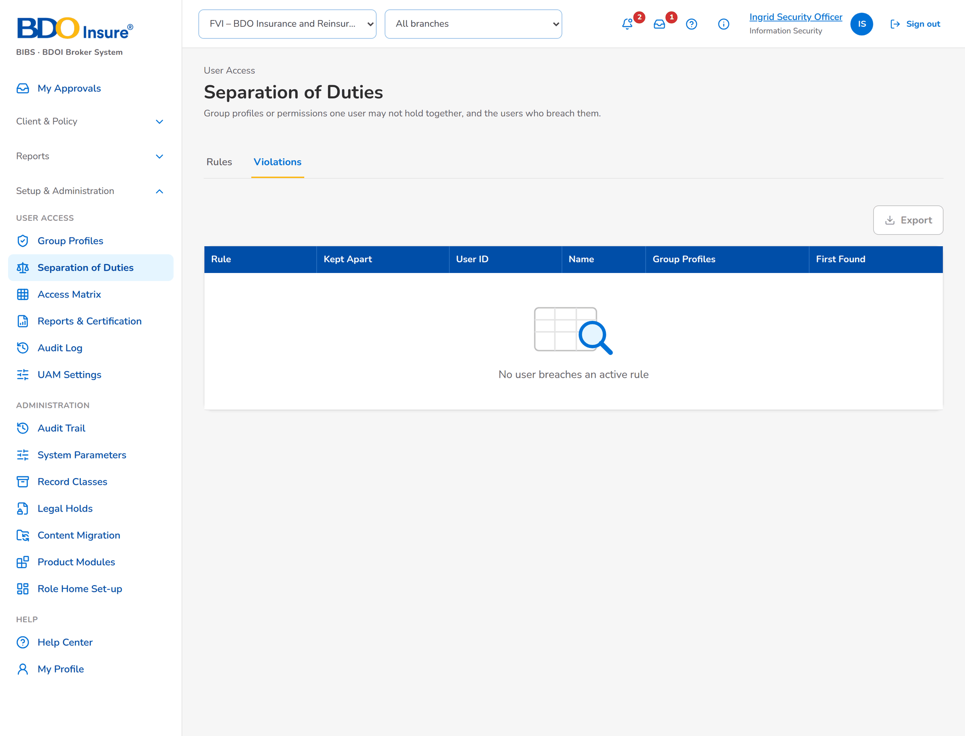
Figure 22: SCR-UA-14 Violations

SCR-UA-15 Access Matrix
Item | Value
Menu | Setup & Administration › User Access › Access Matrix
Personas | All User Access personas
Purpose | Group profiles against permissions.
Actions | Export to Excel
States | Two tabs.
Empty or error state | -

Table 28: SCR-UA-15 fields
Field | Description
By Permission | Profiles as columns, permissions as rows.
By Action | Area and action class.

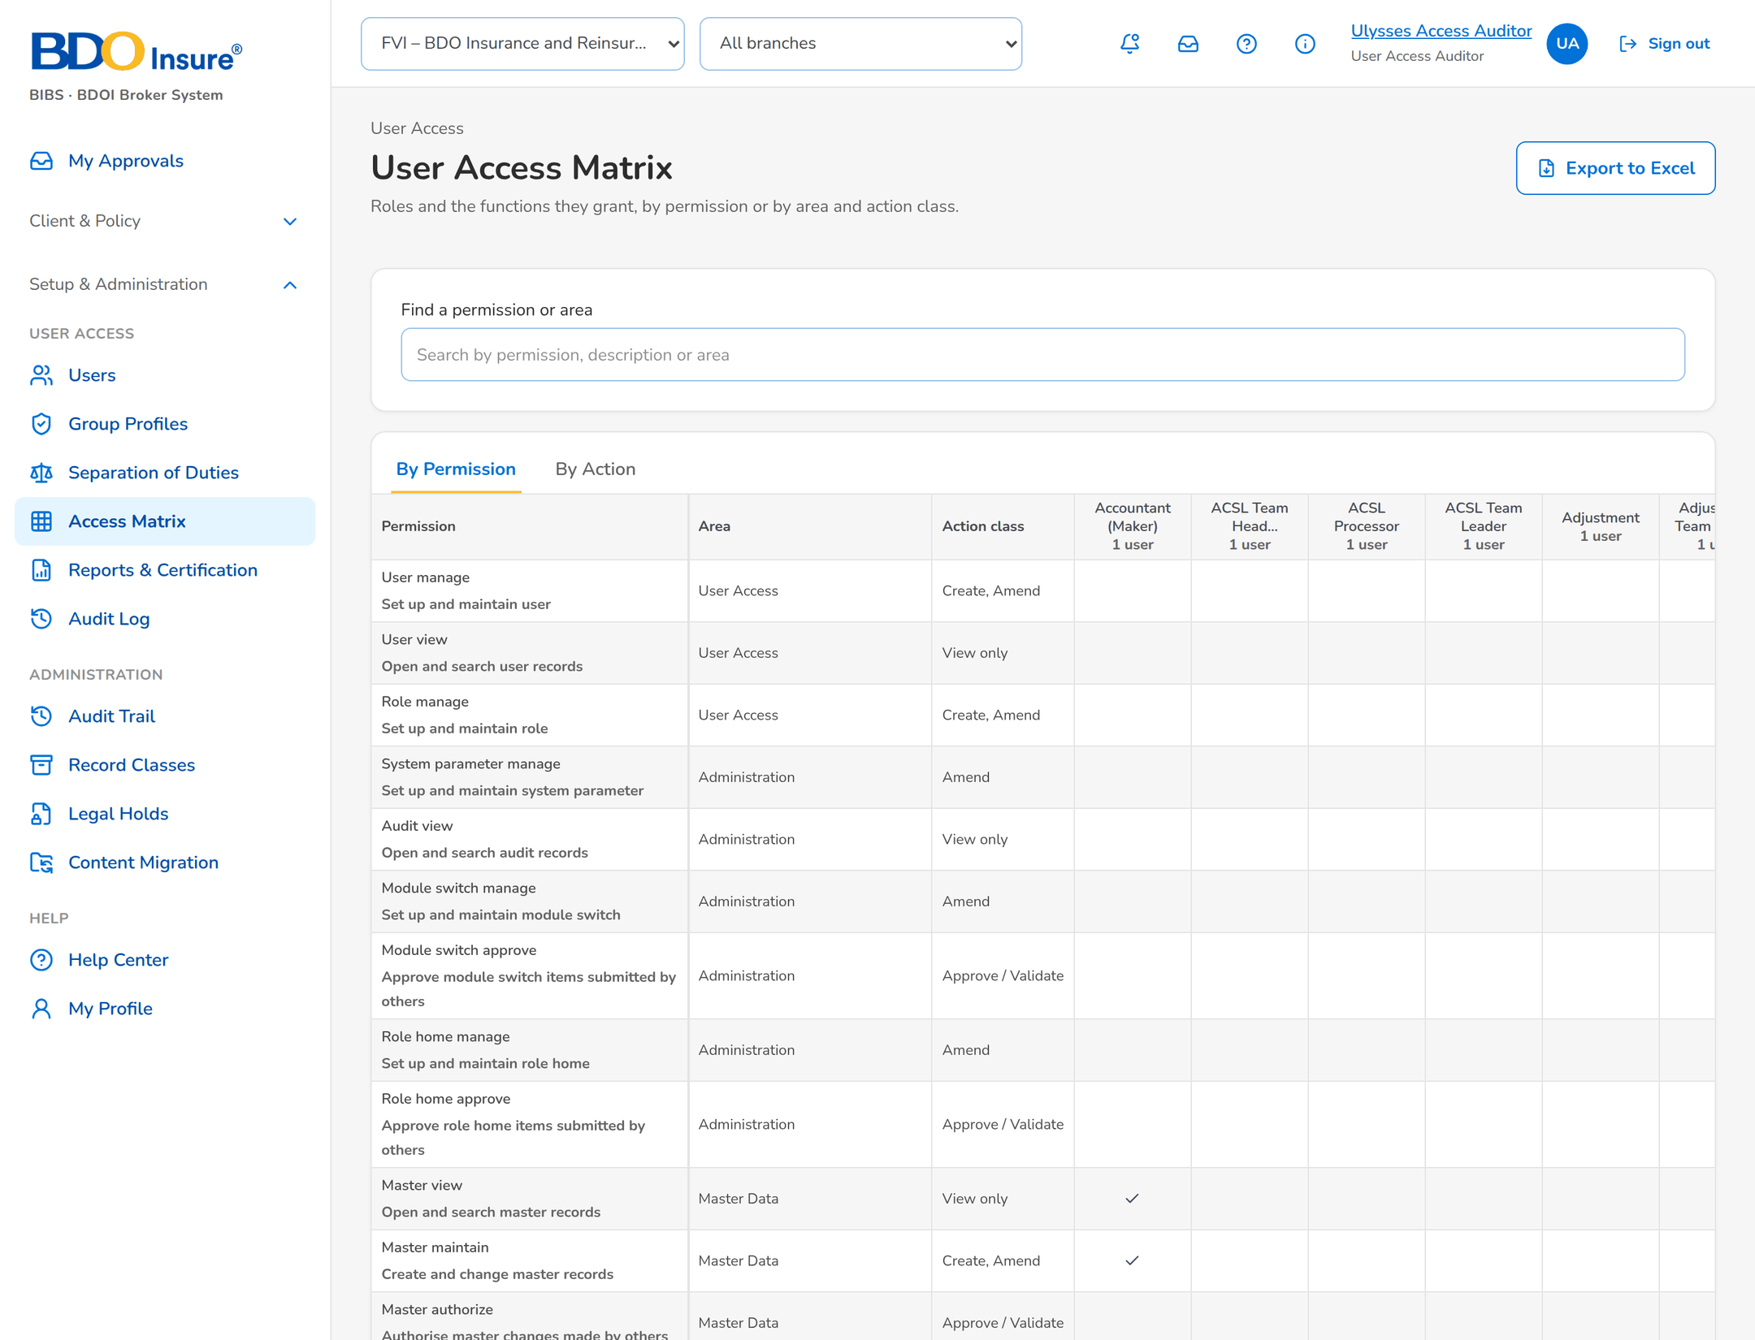
Figure 23: SCR-UA-15 Access matrix by permission
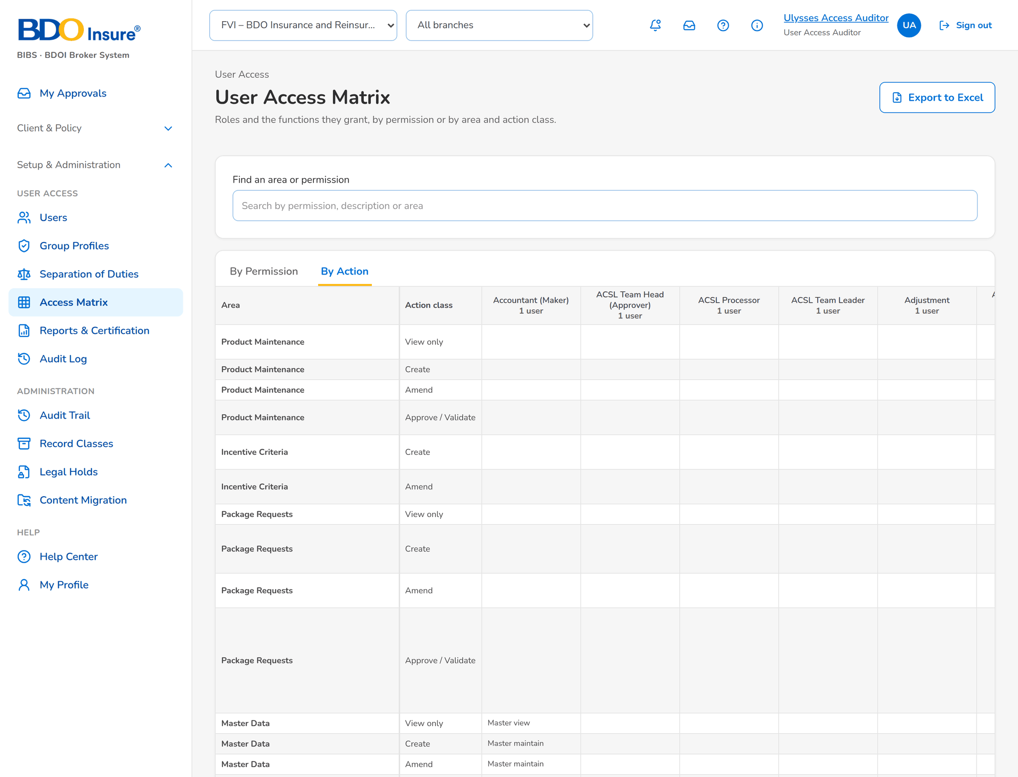
Figure 24: SCR-UA-15 Access matrix by action

SCR-UA-16 Reports & Certification
Item | Value
Menu | Setup & Administration › User Access › Reports & Certification
Personas | All User Access personas
Purpose | Reports and the certification extract.
Actions | Open a report, Take Extract (CSV / XLSX)
States | -
Empty or error state | No extract has been taken.

Table 29: SCR-UA-16 fields
Field | Description
Reports | Five reports with their parameters.
Extracts taken | Taken, Taken By, File, Rows, SHA-256.

Table 30: SCR-UA-16 input fields (service messages: Developer Specification)
Input field | Type | Required | Default | Rule | Message on screen
Format | Text | Yes | - | FRUM.007 | -
As-of date (reports) | Date | No | - | FRUM.007 | -

Table 31: SCR-UA-16 validations
Validation message
Choose CSV or XLSX.

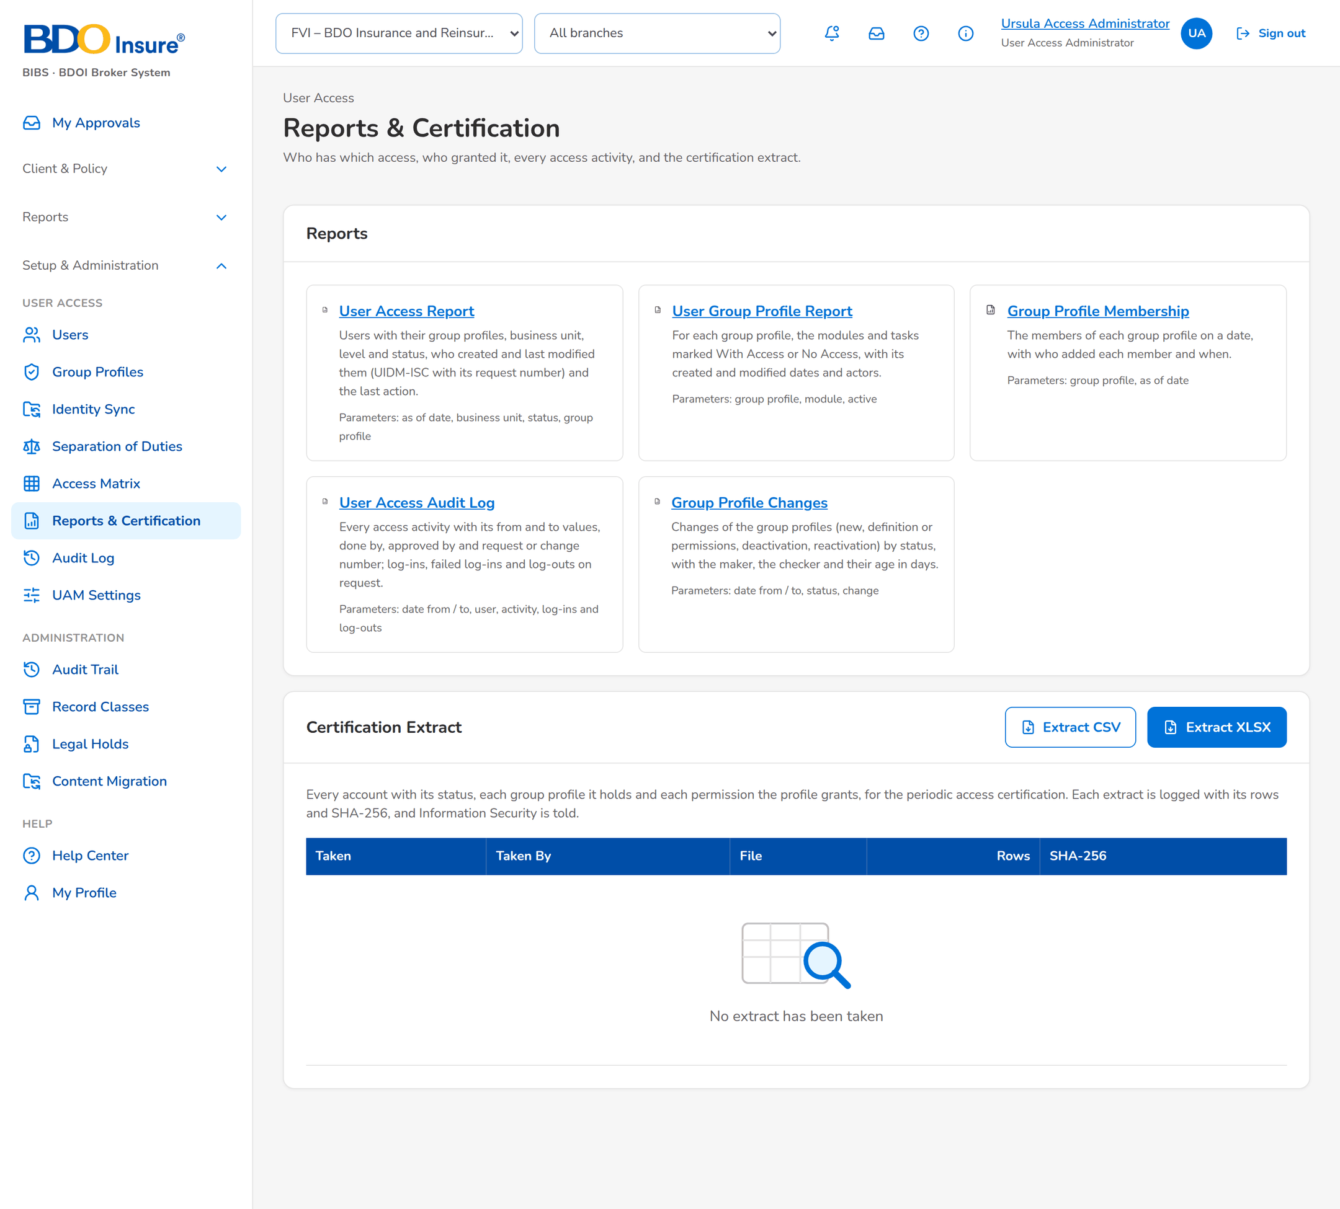
Figure 25: SCR-UA-16 Reports and certification extract log

SCR-UA-17 Audit Log
Item | Value
Menu | Setup & Administration › User Access › Audit Log
Personas | User Access Administrator, Information Security, Auditor
Purpose | The audit trail preset to the user access records.
Actions | Search, Export
States | -
Empty or error state | No event for the filters.

Table 32: SCR-UA-17 fields
Field | Description
Filters | Date from / to, record type, action, user.
Columns | Date / time, user, action, record, from and to values, address.

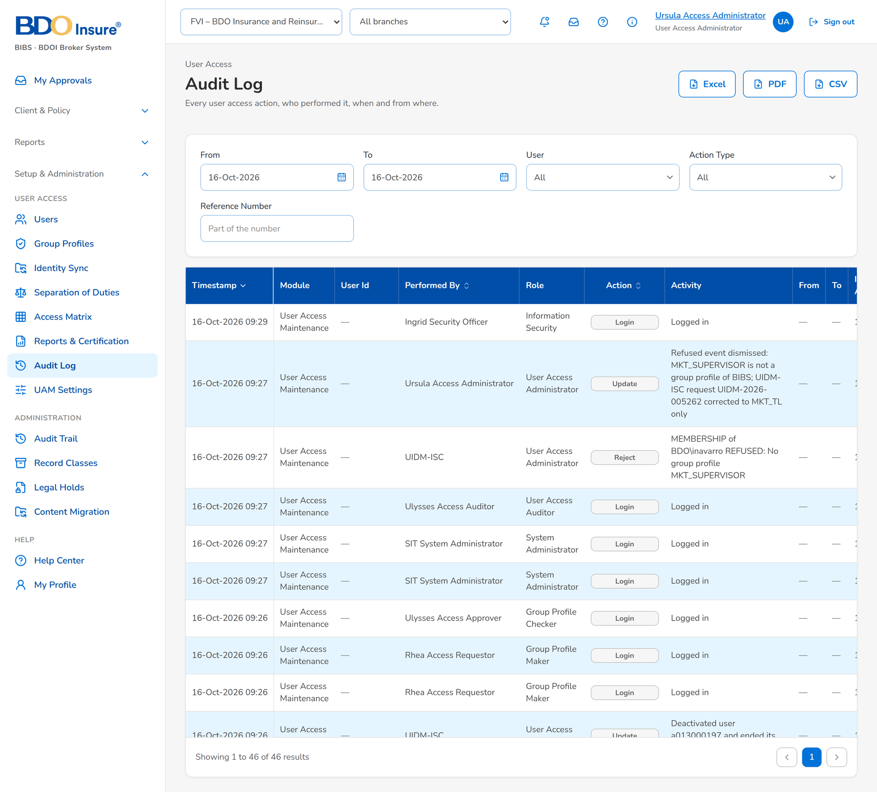
Figure 26: SCR-UA-17 Audit log of user access

SCR-UA-18 UAM Settings
Item | Value
Menu | Setup & Administration › User Access › UAM Settings
Personas | User Access Administrator (propose), Information Security (approve)
Purpose | Settings of sessions, dormancy, test accounts, synchronisation and group profiles.
Actions | Change, Approve, Reject, Withdraw
States | In Force; Pending Approval.
Empty or error state | -

Table 33: SCR-UA-18 fields
Field | Description
Columns | Area, Setting, Value, Status, Last Changed, Action.

Table 34: SCR-UA-18 input fields (service messages: Developer Specification)
Input field | Type | Required | Default | Rule | Message on screen
New value | Text, up to 1000 | Yes | - | FRUM.012 | Enter a value
Reason (reject) | Text | Yes | - | FRUM.012 | Enter the reason for the rejection

Table 35: SCR-UA-18 validations
Validation message
Whole number within the range; true or false; text.

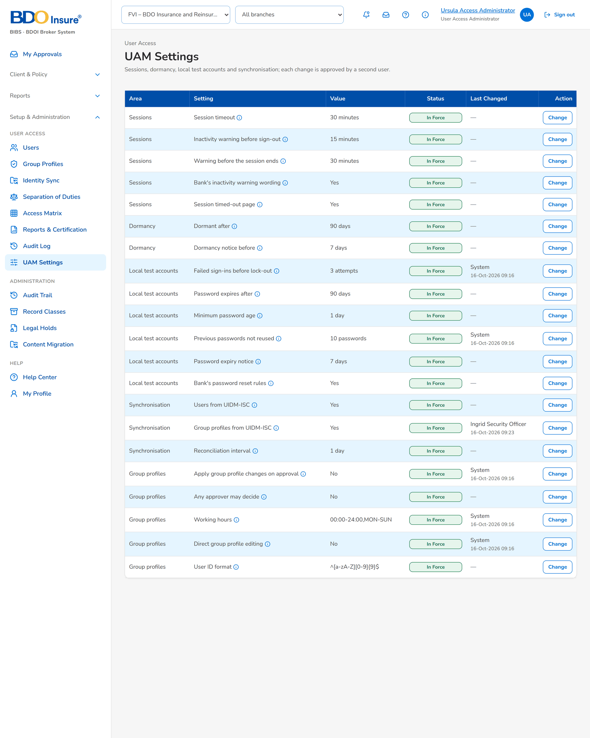
Figure 27: SCR-UA-18 UAM Settings
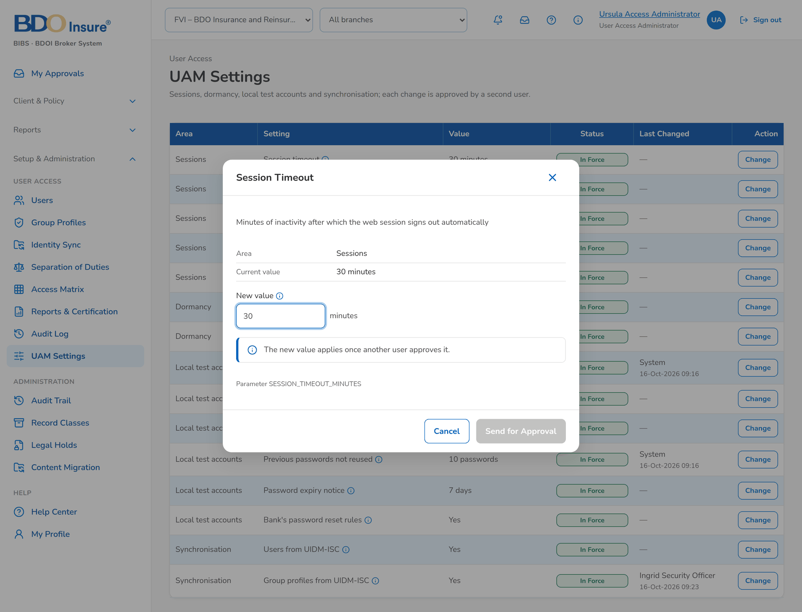
Figure 28: SCR-UA-18 Change of a setting
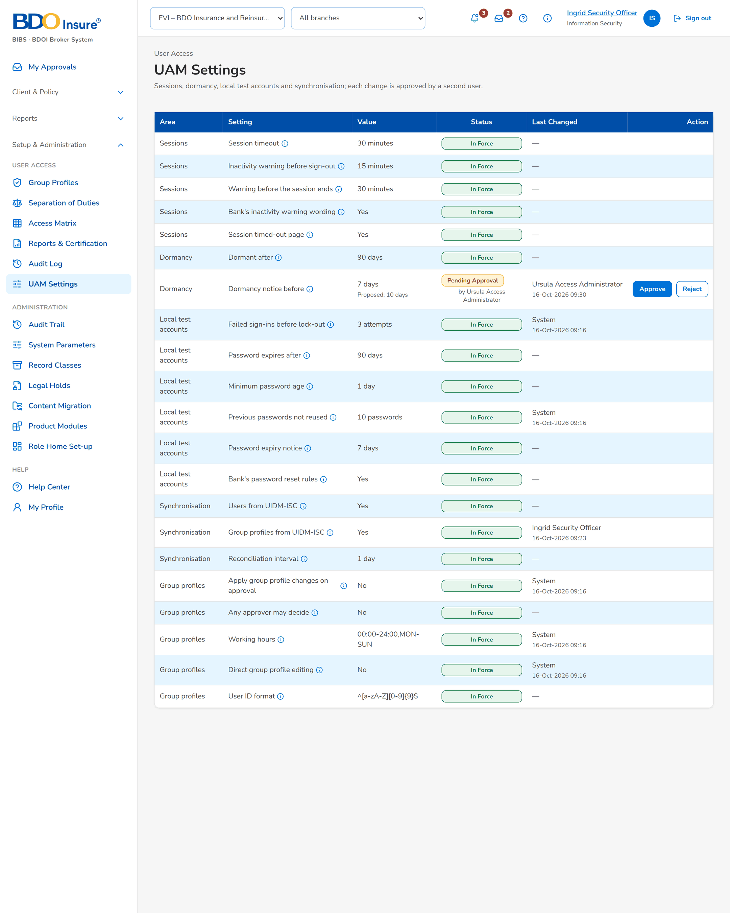
Figure 29: SCR-UA-18 Setting waiting for Information Security

