Version 1.3 – summary of changes
This review copy is the Product Maintenance FRS with the changes of version 1.3. The passages added in version 1.3 are shaded light yellow; BDOI's text and the content of versions 1.1 and 1.2 are not shaded. The clean copy has the same content without shading and without this page.
- Cover and Document Revision Log: version 1.3; the entries of versions 1.0 to 1.2 unchanged.
- Introduction: a note on what version 1.3 adds; section 1.4.2 shows the simplified swimlane process flow (Figure 1); new section 1.5 'How to Read this Document' with the colour legend.
- Process Flow: the end-to-end process flow by actor and system opens section 4 (Figure 2), with the change requests tagged; the figures after it are numbered from Figure 3.
- Colour of the points not in the BRD: 5 points in green (available OOTB in iNXT BrokerVerse) and the 1 change requests in orange where they are stated (FRPM items, Annexes M, P and T).
- Annex T: rows T-18 to T-21 for the BRD lines and programme NFRs not yet listed (4 gaps found in the BRD check). Annex X: one checklist point for the points beyond the BRD.
- New Annex Y: change requests with their effort (11.5 man-days), points beyond the BRD available OOTB in iNXT BrokerVerse, check of the BRD lines. New workbook BIBS_CR_BRD-03_Effort_Estimate_v1.0.xlsx; the change request register lists the change requests.
Shading used in this copy: text added in version 1.3


Project Functional Requirements Specifications

PRJ0012475 BDO Insurance Brokering System –Product Maintenance
v1.3

Prepared by: Angela V. Ramirez
Drafting support: iorta TechNXT Project Team

Table of Contents
Table of Contents 3
Document Revision Log 6
1. Introduction 7
1.1. Document Purpose 7
1.2. Project Overview 7
1.3. Document Preparation, Review and Approval 7
1.4. Summary for the Business Unit Review 8
1.4.1. Scope on a page 8
1.4.2. The process end to end 8
1.4.3. Key numbers 9
1.4.4. Decisions the Business Unit must take 10
1.4.5. How to review 10
1.5. How to Read this Document 11
2. Business Requirements Mapping 11
3. Functional Requirements 15
Process Flow 67
End-to-End Process Flow (all actors and systems) 67
Non-Package Request Process Flow 68
New Request Process Flow 69
Package Set-up, Validation and Release Process Flow 70
Package Expiry, Renewal and Deactivation Process Flow 71
Rate Exception Process Flow (New Business on a Package) 72
Package Request and Approval Process Flow (Marketing and TSU) 73
Negotiation, Comparative Table and Terms Review Process Flow 74
Product Master Maintenance Process Flow (Maker-Checker) 75
Status Life-cycles 76
Integration Context Diagram 78
Signoff Sheet 79
Annex A – Package Product Fields 80
Annex B – Non-Package Product Fields 82
Annex C – Non-Package Quotation Request Fields 86
Annex D – Non-Package Quotation Slip Templates 90
Annex E – Package Request Fields 90
Annex F– Package Quotation Slip Templates 92
Annex G – Screen Specifications 93
G.1 Product Maintenance Home (SCR-PM-01) 93
G.2 Package Requests (SCR-PM-02) 95
G.3 New Package Request and Edit Package Request (SCR-PM-03) 97
G.4 Package Request record (SCR-PM-04) 101
G.5 Package Request record: Negotiation tab (SCR-PM-05) 104
G.6 Package Request record: Comparative tab (SCR-PM-06) 108
G.7 Package Request record: Requirements & Sign-off tab (SCR-PM-07) 109
G.8 Package Request record: Set-up and Advisories tabs (SCR-PM-08) 112
G.9 TSU Workbench (SCR-PM-09) 114
G.10 Package Expiry (SCR-PM-10) 116
G.11 Products (SCR-PM-11) 117
G.12 Product record (SCR-PM-12) 120
G.13 Package Version (SCR-PM-13) 123
G.14 Validation Queue (SCR-PM-14) 126
G.15 Coverages & Clauses (SCR-PM-15) 126
G.16 Incentive Criteria (SCR-PM-16) 128
G.17 Insurers (SCR-PM-17) 130
G.18 Insurer record (SCR-PM-18) 131
G.19 Rates & Taxes (SCR-PM-19) 133
G.20 Sales Organisation (SCR-PM-20) 135
G.21 Premium Calculator (SCR-PM-21) 137
G.22 Quotation: package rate scheme and rate exception (SCR-PM-22) 140
G.23 Product Maintenance Dashboard (SCR-PM-23) 142
G.24 Deactivation Requests (SCR-PM-24) 145
G.25 Product Master Transfers (SCR-PM-25) 147
G.26 Placement Update Reports (SCR-PM-26) 148
G.27 Audit Logs (SCR-PM-27) 149
G.28 Proposal request: Comparative Table, proposal slips and client response (SCR-PM-28) 151
G.29 Package Request record: Routing & Approvals tab (SCR-PM-29) 152
G.30 Navigation: menu by persona 155
Annex H – Messages and Validations 156
Annex I – Notifications and E-mails 170
Annex J – Business Rules and Configurable Parameters 172
J.1 Business rules 172
J.2 Configurable parameters 172
J.3 Lists of values 173
J.4 Workflow stages and service levels 173
J.5 Proposed role-to-action matrix 173
J.6 Masters maintained by the business 174
J.7 Settings for the points BDOI decides 174
Annex K – Process Walkthroughs 176
WT-A A new package from the request to its first New Business quotation 176
WT-B Returns and refusals, and the messages the user sees 178
Annex L – Requirements Traceability 180
L.1 BRD requirement to FRPM and test conditions 180
L.2 FRPM item to BRD IDs and test conditions 181
Annex M – Observations and Points for BDOI Decision 184
M.1 Points where the proposed behaviour differs from the original text of this FRS 184
M.2 BDOI's open item and changes to the Business Requirements Mapping 188
M.3 Slips noticed in BDOI's FRS (proposed corrections; the text is not changed) 191
M.4 Scope, added requirements and added annex rows 192
M.5 Observations of version 1.2 194
Annex N – Glossary 196
N.2 Terms added in version 1.2 196
Annex O – Workflow and Approvals 198
O.1 Who makes, checks and approves (picture) 198
O.2 Stages, approvals and service levels per process 199
O.3 Role-to-stage matrix (table) 202
O.4 Status names: BDOI's FRS and the screens 203
Annex P – E-mail and Notification Texts 204
P.1 Overview 204
P.2 The texts 205
Annex Q – Document Prints and Output Formats 213
Q.1 Overview 213
Q.2 The documents 213
Annex R – Reports and Schedules 223
R.1 Reports 223
R.2 Scheduled runs 223
Annex S – Integrations [Integration scope] 225
Annex T – Non-functional Requirements 227
Annex U – Data Set-up and Migration at Go-live [Data Migration scope] 229
Annex V – Assumptions, Dependencies and Open Questions 230
V.1 Assumptions 230
V.2 Dependencies 230
V.3 Open questions 231
V.4 Proposed rules to confirm 232
Annex W – Change Control after Sign-off 233
W.1 What signing freezes 233
W.2 How a change is raised, assessed and approved 233
Annex X – Business Unit Review Checklist 234
Annex Y – Points beyond the BRD and Change Requests 236
Y.1 How the points were classified 236
Y.2 Change requests (orange) 236
Y.3 Points beyond the BRD available OOTB in iNXT BrokerVerse (green) 236
Y.4 Check of the BRD lines outside the requirement table 237
Y.5 Covered by the Integration scope and the Data Migration scope 238
Y.6 Best-practice recommendations (blue) 239

Document Revision Log
Date | Version | Description of Change | Created / Reviewed by
Aug 19, 2026 | 1.0 | Initial Document | Angela V. Ramirez
09 Oct 2026 | 1.1 | Draft for BDOI review: full coverage of the Product Maintenance BRD (version of 8-Oct-2026), functional requirements elaborated with acceptance criteria, annexes G onward added, observations and points for decision listed in Annex M | iorta TechNXT Project Team (drafting support); for review by Angela V. Ramirez
09 Oct 2026 - 10 Oct 2026 | 1.2 | Business Unit review edition: summary for the Business Unit, end-to-end flows, workflow and approvals, e-mail texts, document formats, reports and schedules, integrations, non-functional requirements, open questions not answered in the BDOI FRS, change control, review checklist; aligned on 10 Oct 2026 with BIBS: new and changed screens with current screenshots (workspace, dashboard, deactivation, routing and deployment, product master transfer, comparative table with Final Terms, proposal slips and client response, Consolidated Placement Update Report, audit logs), settings for the points BDOI decides (Annex J.7) | iorta TechNXT Project Team (drafting support)
11 Oct 2026 | 1.3 | Simplified and end-to-end swimlane process flows; colour coding of the points not in the BRD (green: available in the iNXT BrokerVerse OOTB edition; orange: change request); Annex Y with the change requests and their effort, the points beyond the BRD available OOTB in iNXT BrokerVerse and the check of every BRD line; BRD non-functional lines and programme NFRs 10.07 and 4.03 added to Annex T | iorta TechNXT Project Team (drafting support)

Introduction

Document Purpose
This Functional Requirements Specifications (FR) document outlines how business requirements which are baselined in the Business Requirements Document (BRD) for the BDO Insurance Brokering System (Product Maintenance module) project are to be implemented in the IT systems. This FR document translates the business requirements into functional requirements in terms of system capability, behaviour/function with clearly outlined inputs and outputs.

Project Overview
The Product Maintenance Module aims to streamline and centralize the management of insurance products and package configurations within the BDO Insurance Brokering System. Currently, product setup, insurer negotiations, approvals, comparative table preparation, and renewal monitoring are largely performed through manual processes, emails, and spreadsheets, resulting in inefficiencies, limited visibility, and increased operational risk.
The proposed solution will enable authorized users to maintain product configurations, insurer-specific coverages, rates, warranties, and incentives through a controlled and auditable workflow. It will automate validations, approvals, reporting, renewal tracking, and comparative table generation, improving operational efficiency, data accuracy, compliance, and reducing dependency on IT for product maintenance activities.
Version 1.1 also covers the points of the Product Maintenance BRD (version of 8-Oct-2026) that version 1.0 did not detail: the product hierarchy and clause library, insurer-specific package terms, package versions with the latest approved rate scheme for new business and the approval of rate exceptions, the review of negotiated terms and the product requirements submitted to ManCom, the post-setup validation checkpoint, package advisories, renewal requests, the password protection of documents shared outside the system, the enforcement of approvals and service levels, and the recording of product master changes for other BDOI systems. The requirements added in this version are listed under each functional requirement with their acceptance criteria; the points that need a BDOI decision are listed in Annex M.

Document Preparation, Review and Approval
The System Analyst or equivalent BDO ITG personnel is responsible for populating this Functional Requirements Specifications document by obtaining inputs from the business unit and when necessary, from other IT units.
Versions 1.1 and 1.2 were elaborated with the iorta TechNXT Project Team (drafting support), from the inputs of the business unit and BDO ITG, for review by the System Analyst.
Version 1.2 adds, for the review of the Business Unit, a summary of the module in pictures and tables (section 1.4), the end-to-end process flows and status life-cycles of every process of the BRD, and Annexes O to X: workflow and approvals, e-mail and notification texts, document prints, reports and schedules, integrations, non-functional requirements, data set-up at go-live, the open questions that BDOI's FRS does not answer, change control after sign-off and the review checklist. BDOI's text and the content of version 1.1 are unchanged.
Version 1.3 adds the simplified process flow (Figure 1) and the end-to-end process flow by actor and system (Figure 2, section 4) with the change requests marked; it colours the points of this FRS that are not requirements of the BRD (section 1.5); it adds Annex Y with the change requests and their effort, the points beyond the BRD that the iNXT BrokerVerse OOTB edition already provides, and the check of every line of the BRD against this FRS. BDOI's text and the content of versions 1.1 and 1.2 are otherwise unchanged.
This document once approved will serve as the official baseline of functional requirements document for the BDO Insurance Brokering System (Product Maintenance module) project.
Following the approval of this document, changes will be governed by the project’s change management process, including impact analysis, appropriate reviews and approvals.

Summary for the Business Unit Review
This section gives the Business Unit the whole module on a few pages: what is in scope, how the process runs end to end, the key numbers of this FRS, the decisions the Business Unit must take before signing, and which annexes each reviewer reads. The details are in the functional requirements (section 3), the process flows (section 4) and the annexes.

Scope on a page
In scope (BRD IDs) | Out of scope | Handled in another FRS
Product hierarchy, product matrix and clause library (packaged and non-packaged products) (PMADD01, PMADD02, BRPM.003, BRPM.004) | Computation and payout of incentives (the module keeps the rules and the indicator; PM-Q43) | Sign-in, access, roles and the role-to-action matrix: User Access Maintenance FRS (BRPM.001, BRPM.002, PMADD05)
Insurer-specific coverages, deductibles, warranties and clauses (PMADD02) | Renewal of client policies sold on a package (Renewal BRD-06) | Quotations, accounts and booking that use the packages: New Business FRS (BRD-01)
Package requests: creation, update, deactivation and renewal, with Marketing and TSU approvals (BRPM.008, BRPM.009, BRPM.011, BRPM.021) | Transfer of product master changes to other BDOI systems until BDOI names them (BRPM.022, PQ16) | Endorsement re-rating and commission on package accounts: Operations FRS (BRD-02)
Quotation Slips, negotiation rounds, insurer responses and Comparative Tables (master and client views) (PMADD03, PMADD04, BRPM.010, BRPM.012, BRPM.013, BRPM.014) | Insurer portals: insurers are reached by e-mail (BRPM.012) | Go-live load of products, insurers and the package map: Data Migration (BRD-13)
Review of negotiated terms, product requirements and ManCom approval (BRPM.013, BRPM.015)
MBS set-up, post-setup validation and release of package versions (PMADD06, BRPM.015)
Latest approved rate scheme for new business and rate exceptions (BRPM.007)
Advisories with supporting documents (BRPM.016)
Expiry and anniversary alerts, renewal requests, deactivation and archive (BRPM.006, BRPM.017)
Incentive eligibility rules (for example CPC2) on maintained products (PMADD07, PMADD08)
Dashboard, Placement Update and package reports, reports builder (BRPM.018, BRPM.019)
Document protection, workflow enforcement, notifications, audit trail (BRPM.020, BRPM.021, BRPM.022, BRPM.024)
Non-package quotation requests, as kept in BDOI's FRS (FRPM.005 to FRPM.010) (BRPM.010 to BRPM.014 (see C01))

The process end to end
The module on one page: each lane is an actor or system and the columns are the stages of a package, from the request to the release and monitoring. The end-to-end flow with every system and the change requests is Figure 2 (section 4); each process is drawn in detail in section 4.
Figure 1 – Product Maintenance – simplified process flow (swimlanes by actor, stages across)

Key numbers
Item | Number | Where in this document
BRD requirement IDs (PMADD01 to PMADD08, BRPM.001 to BRPM.024) | 31 | Section 2
Functional requirement items and sub-items | 30 items; 56 sub-items (35 of BDOI, 21 added) | Section 3
Acceptance criteria | 131 | Section 3
Process flows, life-cycles and other figures | 16 figures | Section 1.4, section 4
Screens | 29 (menu of 11 personas) | Annex G
Messages and validations | 232 | Annex H
E-mails and notices | 27 (24 as sent by BIBS, 3 proposed) | Annex P
Documents printed, e-mailed or exported | 12 | Annex Q
Reports and scheduled runs | 8 reports; 7 runs (weekly Thursday 08:00) | Annex R
Integrations | 11 | Annex S, Figure 16
Non-functional requirements | 21 | Annex T
Data set-up items at go-live | 12 | Annex U
Open items for BDOI (not answered in BDOI's FRS) | 38 (another 17 answered by BDOI's FRS) | Annex V
Observations and points for decision | 78 | Annex M
Test cases (traceability workbook) | 472 | BIBS_RTM_BRD-03 workbook
Review checklist points | 28 | Annex X

Decisions the Business Unit must take
The ten decisions with the largest effect on the module. Each points to the row of the annex where the options are given; every other point for decision is in Annex M and Annex V.
No. | Decision | Why it matters | Where | Who decides
1 | Who validates a package configuration after set-up (TSU Head, Business Administrator or either) and the checklist | No package reaches sales without an accountable check (PMADD06) | Annex V (PQ09); Annex M (C06) | Head, TSU; Head, MBS
2 | ManCom approval: approver list, the President's step and the service level | ManCom approval time and evidence (BRPM.015) | Annex M (C17); Annex V (PQ07) | ManCom; Product Owner
3 | BRPM.020 document protection: confirm it is not waived and give the password convention | Insurer and client documents leave BDOI by e-mail | Annex M (M.2); Annex V (PQ21) | Product Owner; BPS
4 | Service level of each workflow stage and who is alerted when it passes | Overdue marking, alerts and reports (BRPM.021) | Annex O; Annex V (PQ08, CLR-PM-16) | Head, TSU; Head, Retail Marketing
5 | Expiry and anniversary dates of a package, alert days and automatic drafting of renewal requests | Renewal of packages on time (BRPM.017) | Annex V (PQ11, CLR-PM-22) | Head, TSU
6 | Definition of CPC2 and the other incentive types | Incentive rules cannot be set up without it (PMADD08) | Annex V (PQ04) | Head, MBS; Product Owner
7 | The other BDOI systems that receive product master changes, the format and the timing | BRPM.022 integration | Annex S; Annex V (PQ16) | Product Owner; BDO ITG
8 | Layouts of the package documents not yet given (request form, Comparative Table, package slip, advisory, ManCom record) | Documents printed and e-mailed by the module (BRPM.005, BRPM.016) | Annex Q; Annex V (D-PM-02) | Head, TSU; Head, MBS
9 | Packages in force at go-live: set up through package requests, and how many | Effort of TSU and MBS before go-live (BRPM.007) | Annex U; Annex V (CLR-PM-21) | Head, TSU; Head, MBS
10 | Non-package quotation requests: stay in this FRS as BDOI wrote them, or in the New Business FRS | Scope of this sign-off and the menu (C01) | Annex M (C01) | Product Owner; BPS

How to review
Reviewer | What to read | About
Head, Technical Support Unit (and TSU Team Leads) | Section 1.4; process flows; FRPM.004 to FRPM.016, FRPM.024 to FRPM.026; Annexes O, P, Q, V, X | 3 hours
Head, Marketing Business Services and System Support (MBS) | Section 1.4; FRPM.002, FRPM.003, FRPM.016, FRPM.018, FRPM.022 to FRPM.024, FRPM.030; Annexes A, J, O, U, V | 3 hours
Head, Retail Marketing (and Marketing approvers) | Section 1.4; package request flow; FRPM.011, FRPM.013.02, FRPM.024.02; Annexes E, K, P | 1.5 hours
ManCom representative | Section 1.4; FRPM.014; Annex O (ManCom stage); Annex P (ManCom e-mails) | 30 minutes
Product Owner, Marketing Business System | Section 1.4; Annexes M, V, W, X; the decisions above | 2 hours
BDO ITG System Analyst and Tech Lead | Whole document; Annexes L, R, S, T, W | 4 hours
Program Manager, Business Project Services | Section 1.4; Annexes M, V, W, X | 1 hour

Before signing, the Business Unit confirms the 28 points of the Business Unit Review Checklist (Annex X).

How to Read this Document
Most of this FRS states requirements of the Product Maintenance BRD (BRPM.001 to BRPM.024, PMADD01 to PMADD08 and its non-functional table) or of the programme-wide non-functional requirements of the BDOI addenda. BDOI's own text (version 1.0) is kept word for word. Where version 1.1 to 1.3 states a point that is not a BRD requirement, the point is coloured where it is stated, so that the Business Unit sees at once what goes beyond the BRD and whether it costs anything. Out of the box (OOTB) means the iNXT BrokerVerse OOTB platform (brokerverse-platform), checked against the platform itself with the programme Feature List as a cross-check, not the work done for BDOI in this project:
Colour | Meaning | Cost
Black text | A BRD requirement, BDOI's own FRS text, or the detail needed to meet a BRD requirement. | In scope
Green text | Not in the BRD, and available out of the box in the iNXT BrokerVerse OOTB platform. No development needed; the Business Unit may keep or drop it. | No cost; listed in Annex Y.3
[Integration scope] / [Data Migration scope] | Grey label on an interface with another system or on a data load at go-live: covered by the Integration scope or the Data Migration scope (BRD-13), not a change request. | Listed in Annex Y.5
Blue table | Insurance-broking best practice for this area that is not in the BRD, this FRS or the OOTB platform: a recommendation with an indicative effort, not a commitment. | Annex Y.6; not in the change request total
Orange text | Not in the BRD and not available, or only partly available, in the iNXT BrokerVerse OOTB platform edition: a change request (CR-PM-1nn), even where it was already delivered for BIBS in this project. It is delivered only if the Business Unit approves it. | Effort in Annex Y.2 and the CR effort workbook

In the end-to-end process flow (Figure 2) the change requests are tagged: yellow for a change request not in any BRD, blue for a change request that extends a BRD requirement, green for a point that is already a BRD requirement (for example the programme NFRs 10.07 and 4.03). The walkthroughs of Annex K and the screenshots of Annex G use the BIBS DEV environment: https://dev.brokerverse.cloud.
In this version: 1 change requests (11.5 man-days in all) and 5 points beyond the BRD available OOTB in iNXT BrokerVerse; every line of the BRD is covered (Annex Y.4).

Business Requirements Mapping
This section lists the business requirements baselined in the Business Requirements Document (BRD) and the corresponding Functional Requirements to satisfy each business requirement.

The details of each functional requirement are provided in the subsequent section.

BRD Req No. | Business Requirement | Functional Requirement Req IDs
PMADD01 | I want a standard reusable product structure hierarchy so that product data is consistent and scalable across packaged and non-packaged products. | FRPM.003  FRPM.022.01
PMADD02 | I want insurer-specific coverage, deductibles, and warranty mappings maintained without IT intervention so that insurer variability is supported in a controlled manner. | FRPM.003  FRPM.022.02  FRPM.023.01
PMADD03 | I want configurable comparative tables so that client-specific outputs can be generated without manual Excel rework while retaining an auditable master version. | FRPM.006  FRPM.012.04
PMADD04 | I want to have explicit exception states and iterative negotiation loop support so that non-linear insurer negotiations, revisions, and declines are handled as formal workflow outcomes rather than informal handling. | FRPM.006  FRPM.012.03
PMADD05 | I want a role-to-action access matrix so that access is controlled appropriately and audit risk is reduced. | Refer to User Access Maintenance FRS
PMADD06 | I want an explicit post-setup validation checkpoint (e.g., by TSU Head / Business Administrator role) so that incorrect package/product configurations do not propagate downstream without accountability. | FRPM.003.03  FRPM.016.02
PMADD07 | I want to define and maintain Incentive criteria based on the Maintained Products Matrix, so that incentives are accurately configured and applied only to eligible product combinations. | FRPM.018  FRPM.003.02  FRPM.018.02
PMADD08 | I must have a maintenance facility to define and update Incentives (i.e. CPC2) criteria based on the maintained products. | FRPM.018  FRPM.003.02  FRPM.018.02
BRPM.001 | Access and log-in to the system. | Refer to User Access Maintenance FRS
BRPM.002 | Restrict access to authorized users. | Refer to User Access Maintenance FRS
BRPM.003 | There must be a capability to capture, store, and validate all mandatory, critical and product-specific fields. | FRPM.002  FRPM.003  FRPM.003.08
BRPM.004 | There must be a capability to apply validation rules based on product type. | FRPM.003  FRPM.003.08
BRPM.005 | There must be a capability to use shared templates with dynamic fields for product-specific data. | FRPM.020  FRPM.030.01
BRPM.006 | There must be a capability to store and archive details of expired insurance products (policies/packages) for future reference or potential reactivation. | FRPM.002.02  FRPM.003.05  FRPM.019.03
BRPM.007 | The system ensures that all new business (new insurance placements) must automatically use the latest approved rate scheme. Outdated rates cannot be selected for new business. | FRPM.003.03  FRPM.024.01  FRPM.024.02
BRPM.008 | Submit approved Package Request Form. | FRPM.011
BRPM.009 | Review package requests and recommends for approval. | FRPM.011.03
BRPM.010 | The system must support the process where the Technical Support Unit (TSU) or authorized users negotiate terms, rates, and conditions with insurers for insurance packages. | FRPM.006.02  FRPM.008  FRPM.009  FRPM.010  FRPM.013  FRPM.012.03  FRPM.013.02
BRPM.011 | Facility to allow User to receive and view requests for product creation, amend, updating, or deletion based on client or business needs. | FRPM.005  FRPM.017  FRPM.011.01  FRPM.011.02  FRPM.003.04
BRPM.012 | Prepare and send quotation slip to Insurers indicating applicable terms and conditions. | FRPM.006  FRPM.012  FRPM.013
BRPM.013 | Facility to allow user to key-in the terms and conditions / feedback from the Insurers, which may be edited by TSU later on. | FRPM.006.02  FRPM.008  FRPM.009  FRPM.012.02  FRPM.013.02
BRPM.014 | The system must automatically compile all insurers’ feedback and responses into a single, consolidated comparative table for each package. | FRPM.006.02  FRPM.008  FRPM.009  FRPM.012.04
BRPM.015 | Received product requirements from TSU. (i.e. computation and details that Marketing needed for their transactions).  Product requirements and details from TSU are submitted via the system, triggering a ManCom review and signoff workflow. Only after ManCom’s in-system approval are requirements automatically forwarded to MBS for processing. MBS receives only validated, signed-off requirements and returns incomplete submissions. Marketing is notified by the system when the package is ready. While some manual steps (like physical signatures) may still occur, most information should flow through the system. | FRPM.014  FRPM.015  FRPM.016  FRPM.014.02  FRPM.016.02
BRPM.016 | The system must allow Users to access supporting documents necessary for creating advisories. This means users should be able to retrieve, view, and utilize all relevant documentation directly within the system when preparing advisory communications (e.g., notifications, emails, or reports about product/package status).  Documents could be but not limited to the following: Advisory / email broadcast that Package is ready.  Package slip (signed) ManCom signed off | FRPM.011  FRPM.025.01
BRPM.017 | The system must enable the TSU Officer to monitor the expiry or anniversary date of each insurance package | FRPM.004  FRPM.019  FRPM.019.02  FRPM.025.01  FRPM.026.01
BRPM.018 | Facility to allow User to generate Placement Update Reports (both for individual accounts and collectively for all accounts).  This is to track and report the status of package creation, including key details such as but not limited to the following: account information, package status, expiry dates, terms, rates, and recent actions. Reports should support business monitoring, audit, and operational needs. | FRPM.007  FRPM.007.02
BRPM.019 | Dashboard for real-time tracking and reporting | FRPM.001
BRPM.020 | Capability to check for document security (password protection/ encryption). | FRPM.027.01
BRPM.021 | Validation and approval workflow enforcement. | FRPM.003.03  FRPM.003.07  FRPM.005.02  FRPM.011.03  FRPM.012.01  FRPM.014  FRPM.028.01
BRPM.022 | Notification and integration for seamless data flow. | FRPM.003  FRPM.004  FRPM.005  FRPM.006  FRPM.008  FRPM.009  FRPM.010  FRPM.011  FRPM.012  FRPM.013  FRPM.014  FRPM.015  FRPM.017  FRPM.029.01
BRPM.024 | Ensure audit trail for all actions and changes. | FRPM.021

Functional Requirements
This section contains all the functional requirements for the BDOI Brokering System that must be in place to address the business requirements. These include the capabilities that the system must possess and the operations and activities that it must be able to perform. All capabilities and corresponding descriptions needed to address the business requirements and develop the system must be listed.

Functional Requirement ID | System Component / Module / Screen | Capability | Functional Requirements / Capability Descriptions
FRPM.001 | Dashboard | Dashboard | FRPM.001.01 Dashboard Visibility  - The system shall provide a dashboard that delivers real-time visibility into Product Maintenance/ TSU operations based on the logged-in user's role and organizational hierarchy.  - The dashboard shall refresh dynamically based on the selected filters.  - Users shall be able to filter dashboard information using:  - Period From Date  - Period To Date  - TSU Officer  - Product Line  - Package Type  - The system shall display the following KPIs:  - Incoming Requests  - Count of package and quotation requests for Non-Package products received during the selected period.  - In-Progress Requests  - Count of requests currently being worked on by TSU users.  - For Approval  - Count of requests pending approval.  - Expiring Packages  - Count of package products approaching expiry based on configured expiry dates.  - Issued Proposals  - Count of proposals generated and released to Marketing during the selected period.  - Deactivation Requests  - Count of package or product deactivation requests awaiting approval.  - The dashboard shall support drill-down capabilities, enabling users to view detailed transaction information from any dashboard KPI.  - Information displayed:  - Request Number  - Request Type  - Product Line  - Requested By  - Assigned TSU Officer  - Current Status  - Submission Date  - Aging  - Users shall be able to click any record from the drilldown table and view the corresponding record details.  - The dashboard shall display aging information for all pending/in progress requests.  - The dashboard shall calculate and display aging based on the account's current workflow stage or status.  - The aging counter shall start when the request enters a workflow stage and shall stop when the request progresses to the next status.  - Users shall be able to export dashboard data.  - Supported Formats  - Excel (.xlsx)  - PDF (.pdf)  - CSV (.csv)  - The exported data shall be based on the applied filters and user access permissions.  - The dashboard counts shall follow the user's access: a user sees only the requests and packages of the company and areas the user's role allows.  - The system shall show, besides the KPIs above, the following tiles, each opening its filtered list:  - Package requests by stage (Drafts, For Approval, TSU Review, Negotiation, ManCom, With MBS, For Validation, Released)  - Packages ending within 30, 60 and 90 days  - Package configurations waiting for the post-setup validation  - Advisories drafted and not yet sent  - Comparative outputs generated in the last seven days  - The system shall mark each pending request against the service level of its workflow stage:  - Amber from 80% of the stage service level (due soon)  - Red once the stage service level has passed (overdue); the tile shows the number of overdue requests  - Each filtered list opened from a tile shall be exportable to Excel with the same rows as on the screen.  Acceptance criteria  - A request past the service level of its stage is counted in a red tile and shown as overdue.  - Clicking the tile of packages ending within 30 days opens the expiry list filtered to 30 days.  - A user sees only the counts of the requests and packages the user's role and company allow.
FRPM.002 | Product Maintenance Module | Product Maintenance Module | FRPM.002.01 Product Maintenance Module  - The system shall provide a dedicated Product Maintenance Module accessible through the main system menu.  - The Product Maintenance Module shall serve as the centralized repository for package-related configurations and quotation requests for non-package products.  - The module shall support product setup, risk code configuration, field management, quotation request requirements, and related maintenance activities used across upstream and downstream business processes.  - The menu shall show only the Product Maintenance screens the user's role allows; buttons for actions the user may not perform shall be hidden.  - Besides the landing page, the module shall give authorized users access to:  - Product Maintenance dashboard (FRPM.001)  - TSU Workbench (the TSU queues by stage)  - Package Expiry (FRPM.004)  - Validation Queue (FRPM.016.02)  - Coverages & Clauses, Incentive Criteria, Insurers, Rates & Taxes and Sales Organisation (product masters)  - Premium Calculator (FRPM.024.02)  - A user who opens a Product Maintenance screen through a direct link without the access shall see the message "You do not have access to this screen. Contact your administrator if you need it."; a direct request for an action without the access shall be refused with "You are not permitted to perform this action" and logged.  Acceptance criteria  - A Marketing Account Officer sees the dashboard, Package Requests and the product screens, and does not see the Validation Queue or the TSU Workbench.  - A direct approval request by a user without the approval access is refused and logged.  FRPM.002.02 Product Maintenance Landing Page  - Upon accessing the Product Maintenance Module, the system shall display a landing page containing the following tabs:  - Product Matrix  - Sub-divided into three tabs  - Quotation Request List  - Package Request List  - The three sub tabs of Product Matrix shall be the following:  - Active Products  - Contains all active packages  - Expiring Products  - Contains all active packages but expiring within 90 days  - Expired Products  - Contains all expired packages  - The Product Matrix tab shall allow authorized users to do the following:  - View Product Matrix records  - Add New Package  - Update Existing Package  - Deactivate Package  - Search, filter, and sort Packages  - The Quotation Request List tab shall display all quotation requests initiated by Marketing for packages, risks, coverages, or special requirements that are not currently available in the approved Product Matrix.  - Users shall be able to:  - View Quotation Request  - Update Quotation Request Details  - Search, filter, and sort records  - Information Displayed  - Quotation Request Number  - Related Reference Number  - Business Type (New Business / Renewal/ Endorsement)  - Assured's Name  - Product Line  - Account Officer  - Assigned TSU User  - Submission Date  - Current Status  - The Package Request List tab shall display all package creation and update requests.  - Users shall be able to:  - View Package Request  - Update Package Request Details  - Search, filter, and sort records  - Information Displayed  - Package Request Number  - Reference Number (for update requests)  - Request Type (New/ Update)  - Product Line  - Account Officer (if marketing initiated)  - Assigned TSU User  - Submission Date  - Current Status  - The Expired Products sub-tab shall be shown only to users authorized to view archived packages (TSU Head, MBS, Business Administrator and Auditor).  - The Package Request List tab shall also display:  - Scope (Generic programme or Client-specific package)  - Client or programme name  - Days in the current stage, marked overdue when the stage service level has passed  - Users shall also be able to:  - Search by part of the request number  - Show only the requests they created or that are assigned to them (Only My Requests)  - Filter by request type  Acceptance criteria  - A request submitted by Marketing appears in the Package Request List with its type, client or programme, line and stage.  - A Marketing Account Officer does not see the Expired Products sub-tab.
FRPM.003 | Product Matrix | Product Matrix Maintenance | FRPM.003.01 View Product Matrix  - The system shall allow the user to access the Product Matrix list displaying all maintained package products.  - Information displayed:  - Line of Insurance  - Sub-Line  - Package Name  - Package Description  - Insurer  - Status  - Effective Date  - Expiry Date  - Last Updated By  - Last Updated Date  - The screen shall support:  - Search  - Filter  - Sort  - Pagination  - Export  - The Product Matrix list shall also display, for package products:  - Risk code  - Cover type  - Version in force and its effective date  - The list shall be filterable by Line of Insurance and by status (Active, Expiring, Expired, Deactivated).  - Opening a package shall show its record with the versions of its terms in time order, each with its status and effective dates, and allow two versions to be compared (FRPM.024.01).  Acceptance criteria  - The versions of a package are listed with their status and effective dates.  - The Product Matrix export contains the same rows as the filtered list.  FRPM.003.02 Create/Update a Package/Non-Package Record  - The system shall allow authorized users to create and update a Product Matrix record.  - Product type: Package/ Non-Package  - The system shall support different field configurations depending on the selected Line of Insurance.  - Motor  - Property  - Engineering  - EEI  - Floater  - Marine Cargo  - Marine Hull  - Aviation  - Stock Throughput  - Liability  - Crime  - Bonds  - Personal Accident  - Miscellaneous  - The system shall enforce mandatory fields based on the selected Line of Insurance and Product Type.  - The system shall provide an Incentive Eligible indicator.  - Default value is No  - If Incentive Eligible is set to Yes, the system shall require the user to provide either:  - Incentive Amount; or  - Incentive Commission Rate  - The system shall allow the user to specify a fixed incentive amount applicable to the product.  - Must be greater than zero.  - The system shall allow the user to specify the commission percentage to be used for incentive computation.  - Must be greater than 0%.  - Must not exceed 100%.  - The system shall prevent saving when mandatory fields are incomplete.  - The system shall allow users to configure rules per field.  - The system shall allow the user to upload any other supporting documents.  - The system shall allow users to set the Product Matrix status to “Draft”.  - The system shall allow the user to select an approver and send the “Draft” matrix for approval.  - The system shall notify the approver regarding the request.  See Annex A for Package Product Fields  See Annex B for Non-Package Product Fields  - A package product shall not be saved without its Sub-Line / cover type, and a package configuration shall not be sent for approval without at least one basic coverage.  - The risk code of a new product shall follow the naming convention of its Line of Insurance, once BDOI has stated the convention of the line.  - The approver selected shall not be the user who created or last updated the record; the system shall not offer the maker in the approver list.  - Warranties and clauses shall be selected from the clause library (FRPM.022.02); deductibles, limits and clauses shall be held per insurer and per coverage where the insurers' terms differ (FRPM.023).  - The system shall show the following messages:  - "A package needs its cover type (PMADD01)" when a package product has no cover type  - "Risk code <code> does not follow the naming convention of <line>" when the risk code breaks the convention of the line  - "The rate, minimum premium, commission and TSI limit of package <code> change through a new version (Versions tab)" when a user edits these values directly on an active package  Acceptance criteria  - A package product without a cover type cannot be saved.  - A risk code that does not follow the naming convention of its line is refused with the message above.  - A changed rate of an active package takes effect only through a new version that is approved; the version in force keeps selling until then.  FRPM.003.03 Review Product Matrix Creation/ Update Request  - The system shall enable approvers to approve, return, or reject the matrix creation/update request assigned to them.  - Information Captured  - Approval Decision  - Approval Remarks  - Approver  - Approval Date and Time  - Remarks shall be mandatory for Rejected and Returned requests.  - The system shall notify the requestor when the request is approved, returned, or rejected.  - When a request is returned for revision, the system shall reassign it to the creator and allow updates based on the feedback provided by the approver.  - Upon approval of the request, the system shall automatically update the status to Active.  - The package shall become available for use by authorized Marketing users during Proposal Creation, New Business Account Creation, and Renewal Account Creation processes. The system shall automatically make the active package available for selection in applicable transactions.  - The approver shall not be the maker or the submitter of the configuration ("A package version is validated by someone other than its maker and submitter").  - Before approving a package configuration, the approver shall confirm the post-setup validation checklist (FRPM.016.02); the approval is not available until every checklist item is confirmed.  - The system shall record the approval with the checklist results, the approver and the date and time; the record shall stay visible on the package.  - When a new version of an active package is approved, the previous version shall end on the day before the new effective date, so that one version is in force at any date.  - Only approved and active configurations shall be used for new business; configurations in Draft or pending approval shall not be selectable.  Acceptance criteria  - The user who set up a package configuration cannot approve it.  - An approved version is used by new quotations from its effective date; before approval it is not.  - A returned configuration is editable again by its maker, with the approver's remarks shown.  FRPM.003.04 Deactivation Request for a Package/Non-Package Record  - The system shall provide a Deactivate Package button that allows authorized users to initiate a Package Deactivation Request.  - The Deactivate Package button shall be available in the following locations:  - Package Details Screen  - When a user opens an active package record, the system shall display the button  - Product Matrix List  - The system shall allow users to select a package record from the Product Matrix list and initiate deactivation  - The action shall be available for active packages only.  - Upon selecting Deactivate Package, the system shall require the user to provide:  - Deactivation Effective Date  - Allow current ad future dates only  - Reason for Deactivation  - Remarks (optional)  - Supporting Documents (optional)  - The system shall allow users to upload one or more supporting documents as part of the deactivation request.  - Upon submission, the system shall require the user to select an Approver.  - The system shall create the deactivation request only after successful validation.  - The system shall notify the selected approver regarding the deactivation request.  - A deactivated package and all its versions, documents and request history shall stay readable and searchable by authorized users; nothing shall be deleted.  - On deactivation, the system shall flag the active incentive criteria of the package for review and notify the users who maintain incentive criteria (FRPM.018.02).  - The system shall draft a deactivation advisory for the package (FRPM.025).  - A new-business quotation on a deactivated package shall be refused with the message "Product <code> is <status> and cannot be sold".  Acceptance criteria  - After deactivation, a new quotation on the package is refused.  - The deactivated package and its versions remain searchable for users authorized to view archived packages.  FRPM.003.05 Automatic Package Deactivation  - Once the package expiry date is reached, the system shall automatically update the package status to Inactive.  - The package shall no longer be available for:  - Update Package Requests  - Proposal Generation  - New Business Account Creation  - Renewal Account Creation  - Existing transactions processed before deactivation shall remain accessible for inquiry and audit purposes.  - The system shall check the package expiry dates every day and update the status of each package whose expiry date has passed without a newer approved version.  - Expired packages shall be retained with all their versions, terms, documents and communications, tagged "Expired", and shall be visible only to users authorized to view archived packages.  - The system shall notify the TSU and MBS users when a package expires.  Acceptance criteria  - A package past its expiry date without a renewal is tagged Expired and cannot be sold.  - Its versions, documents and request history remain retrievable by authorized users.  - A Marketing Account Officer does not see expired packages.  FRPM.003.06 View Deactivation Requests  - The system shall provide a Deactivation Request List containing:  - Request Number  - Package Name  - Deactivation Effective Date  - Approval Status  - Requested By  - Request Date  - Package Expiry Date  - Users shall be able to:  - Search  - Filter  - View Details  - Download Attachments  - Opening a deactivation request shall show its details, the approval decision and its history with the user and date and time of each action.  Acceptance criteria  - A submitted deactivation request appears in the list with its approval status and requester.  FRPM.003.07 Approve or Reject Deactivation Request  - The system shall enable approvers to approve or reject the deactivation request assigned to them.  - Information Captured  - Approval Decision  - Approval Remarks  - Approver  - Approval Date and Time  - Approval remarks shall be mandatory for Rejected requests.  - Upon approval of the Package Deactivation Request, the system shall automatically update the package expiry date.  - The package expiry date shall be set using the later of:  - Deactivation Effective Date or  - Approval Date  - The system shall notify the requestor when the deactivation request is approved or rejected.  - The approver shall not be the requester of the deactivation.  - The decision shall be recorded in the history of the package with the user, date and time and remarks.  Acceptance criteria  - The requester cannot approve his or her own deactivation request.  - A rejected deactivation request shows the approval remarks and the package stays active.  FRPM.003.08 Field Rules per Line of Insurance and Product  - The system shall allow MBS to maintain, per Line of Insurance or per product, which fields a quotation or account must capture and how their values are checked, without IT intervention.  - Check types:  - Presence (mandatory field)  - List (the value is one of a maintained list of values)  - Range (minimum and maximum)  - Pattern (the format of the value)  - A rule shall apply to all products, to one Line of Insurance or to one product; the most specific rules apply in addition to the wider ones.  - Each new or changed rule shall be authorized by a user other than its maker.  - When a quotation or account of the product is submitted, the system shall check all rules in scope and list every violation against its field.  - A pattern that cannot be evaluated safely shall be refused when the rule is saved.  - The system shall show the following messages:  - "<Field> is required for <product>"  - "<Field> must be between <min> and <max>"  - "<Field> is not a valid value"  Acceptance criteria  - A Motor product rule "plate number required" stops the submission of a Motor account without a plate number and names the field.  - A range rule refuses a value outside the range and accepts the limits.  - MBS adds a field rule for a line that has none, and the rule applies to the next account of that line.
FRPM.004 |  | Package Expiry Notification | FRPM.004.01 Package Expiry Notification  - The system shall maintain expiry and anniversary dates for all package and non-package products.  - The system shall automatically identify packages:  - Approaching expiry  - Approaching anniversary dates  - Already expired  - The system shall generate alerts beginning:  - 90 calendar days before the package expiry date  - 90 calendar days before the package anniversary date  - Notification Recipients  - TSU Officer  - TSU Team Lead  - The system shall raise each alert once per package, version and alert day, never twice for the same alert day.  - Further reminder days before the expiry date shall be configurable by the System Administrator.  - The system shall provide a Package Expiry screen listing the active packages by expiry date, with tabs:  - Expiring (with the days left and the anniversary date)  - Renewal in Progress (with the open renewal request and its stage)  - Expired  - Users shall be able to set "Packages ending within (days)" and export the expiry list for a date range (Generate Expiry List).  Acceptance criteria  - A package ending in 45 days appears in the Expiring tab with 45 days left.  - The alert of a package is raised once at each alert day and never twice for the same day.
FRPM.005 | Quotation Request | Quotation Request  Management | FRPM.005.01 Quotation Request List  - The system shall provide a Quotation Request List screen displaying all Quotation Requests created within the system.  - Information displayed  - Request Number  - Request Date  - Product Line  - Current Status  - Effective Date  - Expiry Date  - Assigned TSU User  - Marketing Account Officer  - Aging (Days)  - The system shall allow users to search, filter, and sort Quotation Requests.  - The system shall display the current processing status of each Quotation Request.  - Draft  - Pending Marketing Approval  - For TSU Review  - For Quotation Slip Creation  - Rejected  - Returned for Revision  - QS for Approval  - QS Returned  - QS Rejected  - Under Negotiation  - Terms Agreed  - Proposal Ready  - Proposal Rejected  - For Deployment  - Deployed  - Users shall be able to select a Quotation Request from the list and view its complete details.  - The system shall provide a Quotation Request Details screen containing the complete information, processing history, approvals, negotiations, insurer details, client approvals, deployment requests, and related package documents.  See Annex C for Non-Package Quotation Request Fields  - On first save the system shall assign the request number from a gap-free yearly sequence; the number shall be shown on the request and in every list and shall not be editable.  - Before submission the system shall check the header (client and product), the risk description (sections or risk items), the period and the mandatory documents of the product's document checklist; the checklist shall show each document as Attached or Missing.  - The product of a request shall not change after the first save.  - TSU shall be able to amend a received request, return it to Marketing with a reason from the return reason list, or void it while it is with TSU; the Account Officer shall see each return with its reason.  - The system shall show the following messages:  - "Complete the PRF header" when the client or the product is missing  - "Describe the risk (sections or risk items) before submitting"  - "Attach the mandatory documents: <types>"  - "The period end must be after the period start"  - "Product <code> is not offered to segment <segment>"  - "PRF <number> cannot be changed while <stage>" when a user edits the request in a stage that does not allow it  Acceptance criteria  - A new quotation request gets the next number of the year; no two requests share a number and the number cannot be edited.  - A request without its mandatory documents cannot be submitted.  - A request returned by TSU is back with the Account Officer with the reason shown.  FRPM.005.02 Review Quotation Request Details  - The system shall enable approvers to approve, return, or reject the quotation request with “For TSU Review” status assigned to them.  - Information Captured  - Approval Decision  - Approval Remarks  - Approver  - Approval Date and Time  - Remarks shall be mandatory for Rejected and Returned requests.  - The system shall notify the requestor when the request is approved, returned, or rejected.  - When a request is returned for revision, the system shall reassign it to the creator and allow updates based on the feedback provided by the approver.  - Status shall be updated to “Returned for Revision”  - Upon approval of the request, the system shall automatically update the status to “For Quotation Slip Creation”.  - The approver shall not be the maker or submitter of the request ("A PRF is approved by someone other than its maker").  - A return shall require a reason ("Select a reason for '<action>'"); the return reasons are: Incomplete or incorrect details; Missing supporting documents; Declined by insurer; Additional insurer requirements; Rate or terms to be reviewed; Insurer underwriting review; Others.  Acceptance criteria  - The Account Officer who submitted the request cannot approve it.  - An approved request appears in the TSU Workbench.
FRPM.006 | Quotation Slip | Quotation Slip (QS) Management | FRPM.006.01 Generate Quotation Slip  - The system shall provide a Generate QS button within the approved quotation request record.  - Upon selecting Generate QS, the system shall generate a Quotation Slip (QS) per insurer based on the approved quotation request.  - The system shall allow users to review and update the values that will be reflected in the Quotation Slip prior to generation.  - The system shall provide dedicated fields for capturing and maintaining the QS-specific values to be used during Quotation Slip generation.  - Upon successful generation, the system shall automatically attach the generated Quotation Slip to the corresponding quotation request record.  - Information Recorded  - File Name  - File Type: Quotation Slip  - Version Number  - Generated Date and Time  - Generated By  - The system shall maintain version history whenever a Quotation Slip is regenerated.  - The system shall generate the Quotation Slip file name using a configurable naming convention.  - Format: QS_<Reference Number>_<Insurer>_MMDDYYYY.pdf  - The system shall allow authorized users to preview the generated Quotation Slip before sending it to insurers.  - The system shall allow authorized users to download the generated Quotation Slip.  - Users shall be able to:  - Download the file to a local destination.  - Save the file using a custom filename without modifying the original attached document.  - The downloaded QS shall be the official insurer-facing document and may be used by users for manual email transmission.  - Before sending to insurers, the system shall require internal review and approval.  - Authorized users shall be able to:  - Approve  - Reject  - Return for Revision  - Remarks shall be mandatory for Rejected and Returned QS.  - The system shall notify the requestor when the QS is approved, returned, or rejected.  - Only approved Quotation Slips are allowed to be transmitted to insurers.  - Once approved, the system shall update the status to “For Negotiation”.  See Annex D for Non-Package Quotation Slip Templates  - The system shall number each Quotation Slip on submission for approval and set the date by which insurers are asked to reply (default: the send date plus 5 days, configurable).  - The approver of a Quotation Slip shall not be its preparer ("The quotation slip is approved by another TSU officer").  - In addition to the download, the system shall allow the approved Quotation Slip to be e-mailed from the system to each insurer's placement e-mail address as a password-protected document, with the password in a separate e-mail (FRPM.027), and shall show the send status of each e-mail; a failed e-mail can be resent.  - The system shall show the following messages:  - "Select at least one insurer of the panel for the quotation slip"  - "<insurer> has no placement e-mail address" when the slip is sent to an insurer without a placement e-mail  - "No quotation slip has been prepared yet" when approval is attempted before preparation  Acceptance criteria  - The preparer cannot approve his or her own Quotation Slip.  - An approved Quotation Slip sent from the system reaches each selected insurer as a protected document, and each send is listed with its status.  - A failed send can be resent.  FRPM.006.02 Insurer Feedback and Terms Capture  - The system shall display a Comparative Table that allows users to capture and maintain insurer responses directly within the table.  - The Comparative Table shall be displayed in a side-by-side comparison format where:  - The first column shall display the selected comparison fields.  - The second column shall display the corresponding QS value for each field.  - A separate column shall be displayed for each participating insurer.  - Users shall be able to input insurer responses directly into the corresponding insurer column.  - The number of insurer columns shall dynamically adjust based on the number of insurers included in the quotation request.  - The system shall allow users to choose which fields will be displayed in the Comparative Table before capturing insurer responses.  - The system shall allow users to capture multiple quotation options from the same insurer within the Comparative Table.  - An insurer may provide multiple combinations of:  - Coverage  - Premium  - Commission  - Deductibles  - Terms and Conditions  - Warranties  - Clauses  - Extensions of Cover  - Other quotation details  - The system shall support maintaining and displaying all quotation options received from the same insurer.  - The selected fields shall become the row labels of the Comparative Table.  - The system shall allow users to capture insurer responses directly in the Comparative Table.  - For each insurer column, the system shall provide an Insurer Response field.  - Supported Responses  - Approved - Indicates that the insurer has offered terms and is willing to provide coverage.  - Not Covered - Indicates that the insurer declines to provide coverage for the risk.  - Others - When Others is selected, the system shall require the user to specify the insurer's actual response.  - The insurer-specific response shall be displayed within the Comparative Table.  - Users shall be able to:  - Modify insurer responses.  - Update insurer-specific terms and conditions.  - The table shall always reflect the latest available insurer responses.  - The system shall allow the user to configure what details in the comparative table should be displayed and sent to the client.  - Users shall be able to export comparative tables in:  - Excel (.xlsx)  - PDF  - The exported output shall contain the latest insurer responses and approved terms.  - An insurer response with offered terms shall require the premium quoted ("Enter the premium quoted by <insurer>").  - Each change to a saved response shall keep the previous values in the response history with the user and date and time.  - The Comparative Table shall list the insurers with offered terms first, lowest premium first, then the insurers that declined, then those that have not responded; the lowest premium shall be flagged and the recommended insurer marked.  - The Comparative Table shall always be compiled from the current responses, so a changed response shows at once.  - Insurer responses shall be keyed in only after the Quotation Slip is sent ("Insurer terms are keyed in after the quotation slip is sent").  Acceptance criteria  - TSU records terms for two insurers and a decline for a third; the Comparative Table shows the two offers, the lowest premium first.  - A change of premium on a saved response keeps the earlier premium in the history.  - The Excel export contains the same rows as the screen.
FRPM.007 | Placement Update | Placement Update Report Generation | FRPM.007.01 Consolidated Placement Update Report  - The system shall automatically generate a Consolidated Placement Update Report every Thursday at 8am.  - The schedule shall be configurable by authorized users or system administrators.  - The report shall include all quotation requests that are active or processed within the reporting period and their corresponding placement status.  - The Consolidated Placement Update Report shall display the latest placement information.  - Item No.  - Insured's Name  - Marketing Segment  - Team  - Account Officer  - TSU Handler  - Line of Insurance  - Sub-Line  - PRF Received Date  - PRF Received Time  - Aging  - Status  - The system shall automatically determine the Placement Update Status using the following rules:  - Upon execution of the scheduled job, the system shall:  - Retrieve eligible quotation request transactions.  - Compile their latest placement statuses.  - Generate the Consolidated Placement Update Report.  - Store the generated report in the system repository.  - Make the report available for preview and download.  - The system shall generate the report in Excel format.  - File naming convention: PlacementUpdate_MMDDYYYY.xlsx  - The system shall maintain a repository of generated Placement Update Reports.  - Information Displayed  - File Name  - Report Date  - Generated Date and Time  - Generated By  - Number of Records Included  - Authorized users shall be able to preview the generated report directly from the system  - Authorized users shall be able to download the generated report.  - Users shall be able to:  - Download to a local destination.  - Save the file using a custom file name without modifying the original generated report.  - Besides the scheduled run, authorized users shall be able to generate the report on request for one quotation request (individual report) or for a period (collective report), optionally for one insurer or Account Officer.  - Every generation of the report, scheduled or on request, shall be recorded with the user (or the schedule), the parameters and the date and time.  Acceptance criteria  - The report generated on the scheduled day lists the quotation requests active or processed in the period with their latest status.  - The report for one request number shows only that request.  - The Excel file in the repository contains the same rows as the preview.  FRPM.007.02 Package Status Update Report (individual and all package requests)  - The system shall allow authorized users to generate a Package Status Update Report for one package request (individual report) or for all package requests.  - Report parameters:  - Request Number (individual report)  - Status (all or one stage)  - Request Type  - Line of Insurance  - Insurer  - Package ends within (days)  - Information displayed:  - Request Number  - Request Type  - Client or Programme  - Package Name  - Risk Code and Version  - Current Status  - Days in Status  - Package Expiry Date  - Rate % of the proposed terms  - Insurers (chosen or targeted)  - Last Action, with its date and user  - The report shall be printed in landscape, one row per request sorted by request number, with the parameters in the report header, and shall be exportable to PDF, Excel and CSV.  Acceptance criteria  - The report for one Request Number shows only that request.  - The report exports to PDF and Excel with the same rows.
  Current Workflow Status | Placement Update Status
  For TSU Review | Unprocessed
  For Quotation Slip Creation | On-Going Placement
  QS For Approval | On-Going Placement
  Under Negotiation | On-Going Placement
  Terms Agreed | Fully-Placed
  Proposal Ready | Proposal Released
FRPM.008 |  | Insurer Selection for Proposal Creation | FRPM.008.01 Insurer Selection for Proposal Creation  - Once the Comparative Table contains responses from at least one insurer, the system shall allow the requestor to select one or more insurers for inclusion in the Proposal.  - The system shall provide a selection control for each insurer displayed in the Comparative Table.  - Selection Rules  - Single insurer selection shall be supported.  - Multiple insurer selection shall be supported.  - Only insurers with completed responses may be selected.  - The system shall provide a Proceed to Proposal button within the Quotation request record.  - The button shall be enabled only when:  - At least one insurer has provided a response; and  - At least one insurer has been selected by the user.  - The system shall update the status to “Terms Agreed”.  - The system shall notify the assigned TSU officer regarding the proposal creation request.  - The requestor shall be able to mark one insurer as the recommended insurer; only an insurer with received terms can be recommended ("Only received terms can be recommended").  - Proceed to Proposal shall not be available while an insurer response is still pending unless the pending responses are closed ("<n> insurer(s) have not answered: close the request to proceed").  Acceptance criteria  - An insurer that declined cannot be selected for the Proposal.  - Proceed to Proposal is enabled only after at least one insurer with a response is selected.
FRPM.009 |  | Proposal Creation | FRPM.009.01 Comparative Table with Final Terms Column  - The system shall display an additional column labeled: Final Terms for Proposal within the Comparative Table.  - The column shall be displayed alongside the insurer response columns.  - The system shall allow users to review insurer responses and specify the final values to be reflected in the Proposal.  - The Final Terms for Proposal column shall serve as the official source of information for Proposal generation.  - The Final Terms for Proposal shall be taken by default from the selected insurer's response and may then be edited; the change shall be recorded in the history.  Acceptance criteria  - The Final Terms column shows the selected insurer's terms, and an edited value is kept in the history.  FRPM.009.02 Generate Proposal  - The system shall provide a Generate Proposal button within the quotation request screen.  - The system shall allow users to generate separate Proposal Slips for one or more selected insurers.  - Each Proposal Slip shall contain only the respective insurer's quotation and the corresponding Final Terms for Proposal.  - Upon clicking Generate Proposal, the system shall generate a Proposal document using:  - Selected Insurer Information  - Final Terms for Proposal  - Upon successful generation, the system shall automatically:  - Attach the Proposal to the Quotation Request.  - File naming convention: ProposalSlip_<Reference Number>_<Insurer Name>_<Version Number>_MMDDYYYY.pdf  Where:  - ProposalSlip = constant  - Reference Number = Renewal/ New Business/Endorsement Reference Number  - Insurer Name = Selected Insurer  - Version Number = Proposal Version  - MMDDYYYY = Proposal Generation Date  - Information Recorded  - Proposal File Name  - Proposal Version  - Generated Date and Time  - Generated By  - The system shall allow users to:  - Preview the generated Proposal.  - Download the Proposal.  - Regenerate Proposal Slips for an insurer.  - Maintain multiple Proposal Slip versions per insurer.  - The system shall require internal review and approval.  - Authorized users shall be able to:  - Approve  - Reject  - Return for Revision  - Remarks shall be mandatory for Rejected and Returned Proposal.  - The system shall notify the TSU officer when the proposal is approved, returned, or rejected.  - Once approved, the system shall update the status to “Proposal Ready” and attach the proposal slip/s in the corresponding New Business/ Renewal/ Endorsement record.  - The system shall notify the requestor once the proposal is ready for client sending.  - Each generation shall be a new version of the Proposal Slip; earlier versions shall stay searchable and downloadable.  - The approver of a Proposal shall not be its preparer ("The proposal slip is approved by another TSU officer"); the Proposal shall reach Marketing only after approval.  - The system shall show the following messages:  - "Choose the insurer (or flag the recommended one) for the proposal slip"  - "<insurer> has not quoted terms"  - "No proposal slip has been prepared yet"  Acceptance criteria  - A Proposal cannot reach Marketing before a second TSU officer approves it.  - After a return and a new generation, both versions are listed.
FRPM.010 |  | Client Response Capture | FRPM.010.01 Client Response Capture  - The system shall provide a Record Client Response button within:  - Proposal Details Screen  - Renewal Account Details  - Quotation Request Details Screen  - The button shall only be available for proposals with a status of: Proposal Released  - The system shall allow users to record the client's decision on the Proposal.  - Supported Responses  - Accepted  - Rejected  - Return for Revision  - Information Captured  - Client Response  - Response Date  - Client Remarks  - Recorded By  - Date Recorded  - When the client response is Accepted, the system shall:  - Update the Proposal Status to Accepted.  - Allow selection of the insurer(s) accepted by the client.  - Record the accepted proposal option(s).  - Allow progression to the next workflow stage.  - When the client response is Rejected, the system shall:  - Update the Proposal Status to Rejected.  - Capture the rejection reason.  - When the client response is Return for Revision, the system shall:  - Require revision remarks.  - Return the proposal to the responsible TSU user.  - Allow updates to the Comparative Table.  - Allow updates to insurer quotations and final proposal terms.  - Allow generation of a revised Proposal.  - Update the status to Returned for Revision.  - The system shall generate notifications when:  - Client Acceptance is recorded.  - Client Rejection is recorded.  - Proposal is returned for revision.  - The system shall send the released Proposal and the Comparative Table to the client as password-protected documents, with the password in a separate e-mail (FRPM.027).  - Recording an Accepted response shall require the client's acceptance e-mail as an attachment ("Attach the client's acceptance e-mail first").  - After acceptance, the system shall allow the Account Officer to create one draft account per accepted risk group, carrying the request's reference number, the accepted insurer and its quoted rate; account creation shall require a confirmed client ("Client <code> is not yet confirmed (onboarding and KYC incomplete)").  - Accepted proposals shall be listed on the client record under Confirmed Proposals.  Acceptance criteria  - An accepted request creates its account with the accepted insurer and the quoted rate.  - The client record lists the accepted request under Confirmed Proposals.  - Acceptance cannot be recorded without the client's acceptance e-mail.
FRPM.011 | Package Request | Package Request  Management | FRPM.011.01 Package Request List  - The system shall provide a Quotation Request List screen displaying all Quotation Requests created within the system.  - Information displayed  - Request Number  - Request Date  - Product Line  - Current Status  - Effective Date  - Expiry Date  - Assigned TSU User  - Requestor  - Aging (Days)  - The system shall allow users to search, filter, and sort Package Requests.  - The system shall display the current processing status of each Package Request.  - Draft  - Pending Marketing TL Approval  - Pending Marketing TH Approval  - Pending Marketing UH Approval  - For TSU Review  - For Quotation Slip Creation  - Rejected  - Returned for Revision  - QS for Approval  - QS Returned  - QS Rejected  - Under Negotiation  - Terms Agreed  - Proposal Ready  - Proposal Rejected  - Awaiting Mancom Approval  - For Deployment  - Package Deployment for Review  - Package Deployment Returned  - Deployed  - Users shall be able to select a Package Request from the list and view its complete details.  - The system shall provide a Package Request Details screen containing the complete information, processing history, approvals, negotiations, insurer details, client approvals, deployment requests, and related package documents.  - Package Request Numbers shall follow the format PKR-yyyy-nnnnnn, from a yearly sequence, and shall not be editable.  - The list shall also display:  - Request Type  - Scope (Generic programme or Client-specific package)  - Client or Programme  - Days in the current stage, marked overdue when the stage service level has passed  - Users shall be able to search by part of the request number, filter by request type and show only their own requests.  Acceptance criteria  - A request submitted by Marketing appears in the list for TSU review with its type, client, line and reason.  - A request assigned to a TSU officer shows the officer as Assigned TSU User.  FRPM.011.02 Create/Edit Package Request Details  - The system shall provide a Create Package Request button within the Product Maintenance Module.  - Upon selection, the system shall create a new Package Request record and assign a unique Package Request Number.  - The system shall allow users to save the Package Request as a draft.  - The system shall require the user to specify the Source of the package request.  - Marketing  - TSU  - Insurer  - When source is Marketing, the system shall route the Package Request through the Marketing approval hierarchy (until Unit Head) before submitting the request to TSU.  - Each approver shall approve or reject independently.  - Approval history shall be maintained.  - The request shall not proceed to TSU until the Marketing Unit Head has approved the request.  - The system shall provide a Submit Package Request button.  - Upon submission, the system shall:  - Validate all required fields.  - Route the Package Request to the TSU queue.  - Record the submission date and time.  - Update the request status to For TSU Review  - When source is TSU or Insurer, the system shall route the Package Request through the TSU approval hierarchy before proceeding to the next workflow stage.  - If Source is Insurer, proceed to proposal preparation  - Upon submission and each approval stage transition, the system shall automatically notify the next approver.  - The system shall allow users to attach supporting documents to the Package Request.  - The system shall allow the users to preview and download the attached documents.  - The system shall allow authorized users to modify Package Requests that are in Draft and Returned statuses.  See Annex E for Package Request Fields  - For a request on an existing package, the system shall pre-fill the requested terms from the package's version in force, so nothing is keyed in twice.  - A client-specific package request shall name the client (from the client master); a generic programme shall not need one.  - Before submission, the request shall have the requested terms, the package expiry date and, when insurers are to be approached, at least one target insurer; the system shall name every missing item.  - The type of a saved request shall not change.  - The requester shall be able to void a draft with a reason; the request then closes as Voided.  - No Marketing approver shall approve a request he or she created or submitted ("A package request is approved by someone other than its maker").  - The system shall show the following messages:  - "Enter the package or programme name"  - "Select the product line"  - "Select the reason"  - "Select the client of the client-specific package (PQ14)"  - "The package end date must be after its start date"  - "Rates and amounts cannot be negative"  - "Complete the request: <items>"  - "The type of a request cannot change"  Acceptance criteria  - A Marketing Account Officer submits a complete request; it receives a Package Request Number and moves to Marketing approval.  - Submission with missing mandatory fields is refused and each missing item is named.  - A request on an existing package opens with the current terms pre-filled.  - A client-specific request without a client cannot be saved.  - The requester cannot approve his or her own request.  FRPM.011.03 Review Package Request Details (Source: Marketing)  - The system shall enable approvers to approve, return, or reject the quotation request with “For TSU Review” status assigned to them.  - Information Captured  - Approval Decision  - Approval Remarks  - Approver  - Approval Date and Time  - Remarks shall be mandatory for Rejected and Returned requests.  - The system shall notify the requestor when the request is approved, returned, or rejected.  - When a request is returned for revision, the system shall reassign it to the creator and allow updates based on the feedback provided by the approver.  - Status shall be updated to “Returned for Revision”  - Upon approval of the request, the system shall automatically update the status to “For Quotation Slip Creation”.  - The reviewer shall be able to correct the request before the decision; the correction shall be recorded in the history.  - The reviewer's remarks shall be stored on the request and displayed to every later approver.  - A return shall require a reason ("Select a reason for '<action>'"); the returned request shall show the reason to the requester.  - The reviewer shall not be the creator of the request.  Acceptance criteria  - A returned request is back with the requester as Returned for Revision with the reason visible on the request.  - The reviewer's remarks are visible to the next approver of the request.
FRPM.012 | Package Request | Quotation Slip (QS) Management | FRPM.012.01 Generate Quotation Slip for Package Request (skip if Source: Insurer)  - The system shall provide a Generate QS button within the approved package request record.  - Upon selecting Generate QS, the system shall generate a Quotation Slip (QS) based on the request details.  - The system shall allow users to review and update the values that will be reflected in the Quotation Slip prior to generation.  - The system shall provide dedicated fields for capturing and maintaining the QS-specific values to be used during Quotation Slip generation.  - Upon successful generation, the system shall automatically attach the generated Quotation Slip to the corresponding package request record.  - Information Recorded  - File Name  - File Type: Quotation Slip  - Version Number  - Generated Date and Time  - Generated By  - The system shall maintain version history whenever a Quotation Slip is regenerated.  - The system shall generate the Quotation Slip file name using a configurable naming convention.  - Format: QS_<Reference Number>_<Insurer>_MMDDYYYY.pdf  - The system shall allow authorized users to preview the generated Quotation Slip before sending it to insurers.  - The system shall allow authorized users to download the generated Quotation Slip.  - Users shall be able to:  - Download the file to a local destination.  - Save the file using a custom filename without modifying the original attached document.  - The downloaded QS shall be the official insurer-facing document and may be used by users for manual email transmission.  - Before sending to insurers, the system shall require internal review and approval.  - Authorized users shall be able to:  - Approve  - Reject  - Return for Revision  - Remarks shall be mandatory for Rejected and Returned QS.  - The system shall notify the requestor when the QS is approved, returned, or rejected.  - Only approved Quotation Slips are allowed to be transmitted to insurers.  - Once approved, the system shall update the status to “For Negotiation”.  See Annex F for Package Quotation Slip Templates  - Each Quotation Slip shall be numbered PQS-yyyy-nnnnnn on submission for approval, with the date by which insurers are asked to reply (default: the send date plus 5 days, configurable).  - The approver of a Quotation Slip shall be a TSU Team Lead or a co-officer and shall not be its preparer ("The quotation slip is approved by a TL or a co-officer").  - In addition to the download, the system shall allow the approved Quotation Slip to be e-mailed from the system to each insurer as a password-protected document, with the password in a separate e-mail (FRPM.027), and shall show the send confirmation per insurer.  - The officer shall be able to view the sent history and resend the slip to one insurer (for example after a bounced e-mail); each resend shall be logged.  - The Quotation Slips shall remain editable by TSU until the ManCom approval and shall then be locked ("The slips are locked since the ManCom sign-off").  - The Quotation Slip shall be generated from the template of the Line of Insurance (Annex F), so that the Marketing details flow into it without re-keying (FRPM.030).  - The system shall show the following messages:  - "Select at least one insurer for the quotation slip"  - "Round <n> is already sent"  - "Only the slip of an open, sent round can be resent"  Acceptance criteria  - The preparer cannot approve his or her own Quotation Slip.  - An approved Quotation Slip sent from the system reaches each insurer as a protected document, and each send is listed.  - The officer can view the sent history and resend the slip to one insurer.  - After the ManCom approval the Quotation Slip cannot be edited or resent.  FRPM.012.02 Insurer Feedback and Terms Capture (skip if Source: Insurer)  - The system shall display a Comparative Table that allows users to capture and maintain insurer responses directly within the table.  - The Comparative Table shall be displayed in a side-by-side comparison format where:  - The first column shall display the selected comparison fields.  - The second column shall display the corresponding QS value for each field.  - A separate column shall be displayed for each participating insurer.  - Users shall be able to input insurer responses directly into the corresponding insurer column.  - The number of insurer columns shall dynamically adjust based on the number of insurers included in the quotation request.  - The system shall allow users to choose which fields will be displayed in the Comparative Table before capturing insurer responses.  - The system shall allow users to capture multiple quotation options from the same insurer within the Comparative Table.  - An insurer may provide multiple combinations of:  - Coverage  - Premium  - Commission  - Deductibles  - Terms and Conditions  - Warranties  - Clauses  - Extensions of Cover  - Other quotation details  - The system shall support maintaining and displaying all quotation options received from the same insurer.  - The selected fields shall become the row labels of the Comparative Table.  - The system shall allow users to capture insurer responses directly in the Comparative Table.  - For each insurer column, the system shall provide an Insurer Response field.  - Supported Responses  - Approved - Indicates that the insurer has offered terms and is willing to provide coverage.  - Not Covered - Indicates that the insurer declines to provide coverage for the risk.  - Others - When Others is selected, the system shall require the user to specify the insurer's actual response.  - The insurer-specific response shall be displayed within the Comparative Table.  - Users shall be able to:  - Modify insurer responses.  - Update insurer-specific terms and conditions.  - The table shall always reflect the latest available insurer responses.  - The system shall allow the user to configure what details in the comparative table should be displayed and sent to the client.  - Users shall be able to export comparative tables in:  - Excel (.xlsx)  - PDF  - The exported output shall contain the latest insurer responses and approved terms.  - For each insurer response the system shall capture the offered rate and minimum premium, the terms per coverage (included, limit, deductible, clauses), conditions and warranties, validity date, remarks and the insurer's reply document.  - A response with offered terms shall require a rate ("Enter the rate offered by <insurer> (<outcome>)"); rates and amounts shall not be negative.  - When an insurer does not respond by the reply date, the user shall be able to record that no response was received.  - Every change to a saved response shall be kept in the response history with the earlier values, the user and the date and time.  - Marketing users shall have view-only access to the Comparative Table.  Acceptance criteria  - An offer without a rate is refused.  - The response history shows every earlier value with the user and date and time.  - A Marketing user can open the Comparative Table but cannot change it.  FRPM.012.03 Negotiation Rounds and Exception Outcomes  - The system shall allow TSU to open a further negotiation round (Revise Quotation Slip) when terms need to be renegotiated, stating what changes in the round.  - The new round shall propose, by default, the insurers of the previous round that did not decline; TSU may adjust the insurers. The Quotation Slip of the new round follows the same approval and sending as the first (FRPM.012.01).  - All rounds, their Quotation Slips and the insurer responses of each round shall stay on the package request.  - There shall be no maximum number of rounds unless BDOI sets one.  - TSU or the TSU Head shall be able to close a request as Not Proceeded with a reason: Declined by the insurers; Negotiated terms not accepted; Client withdrew the request; Business decision; Others (with a comment). A request closed as Not Proceeded cannot be reopened.  - A further round shall not be opened before the Quotation Slip of the current round is sent ("Send the slip of round <n> first").  Acceptance criteria  - A request negotiated in two rounds shows both rounds, their Quotation Slip numbers and the responses of each.  - Round 2 opens by default without the insurers that declined in round 1.  - A request closed as Not Proceeded shows the reason and cannot be reopened.  FRPM.012.04 Comparative Table Master and Client Views  - The system shall keep one current master Comparative Table per package request, compiled from the responses of the latest round; a new compilation shall mark the previous master as superseded, and every superseded master shall remain downloadable (auditable master version).  - Each master and client view shall be stored as PDF and Excel on the package request with the date and time, the user and the template version, and shall show the same content whenever it is downloaded later.  - The system shall allow TSU to generate a client view from the current master by choosing a title, the fields and the insurers to show; a client view never changes values and keeps a link to its master.  - Fields selectable for a client view: Outcome, Rate %, Minimum Premium, Coverages, Deductibles, Conditions / Warranties, Valid Until and Remarks (list to be confirmed by BDOI).  - The system shall show the following messages:  - "Send the quotation slip of round <n> first" when a master is compiled before the slip of the round is sent  - "Compile the comparative master first"  - "Enter the title of the view"  - "Select at least one insurer of the master"  Acceptance criteria  - A request with three responses has one current master listing the three insurers with their terms.  - After a second compilation the first master is marked superseded and is still downloadable.  - A client view that excludes one insurer and the Remarks field shows neither, and its values equal the master's.
FRPM.013 | Package Request | Insurer Selection for Proposal Creation | FRPM.013.01 Generate Proposal  - The system shall provide a Generate Proposal button within the package request screen.  - The system shall allow users to generate separate Proposal Slips for one or more selected insurers.  - Each Proposal Slip shall contain only the respective insurer's quotation and the corresponding Final Terms for Proposal.  - Upon clicking Generate Proposal, the system shall generate a Proposal document using:  - Selected Insurer Information  - Final Terms for Proposal  - Upon successful generation, the system shall automatically:  - Attach the Proposal to the Package Request.  - File naming convention: ProposalSlip_<Reference Number>_<Insurer Name>_<Version Number>_MMDDYYYY.pdf  Where:  - ProposalSlip = constant  - Reference Number = Renewal/ New Business/Endorsement Reference Number  - Insurer Name = Selected Insurer  - Version Number = Proposal Version  - MMDDYYYY = Proposal Generation Date  - Information Recorded  - Proposal File Name  - Proposal Version  - Generated Date and Time  - Generated By  - The system shall allow users to:  - Preview the generated Proposal.  - Download the Proposal.  - Regenerate Proposal Slips for an insurer.  - Maintain multiple Proposal Slip versions per insurer.  - The system shall require internal review and approval.  - Authorized users shall be able to:  - Approve  - Reject  - Return for Revision  - Remarks shall be mandatory for Rejected and Returned Proposal.  - The system shall notify the TSU officer when the proposal is approved, returned, or rejected.  - Once approved, the system shall update the status to “Proposal Ready”.  - The system shall notify the requestor once the proposal is ready.  - Only insurers that offered terms shall be selectable for the Proposal ("<insurer> did not offer terms in this round").  - When several insurers share the package, the user shall give each insurer's role (Lead, Participant or Panel) and share; the shares shall total 100% ("The co-insurance shares must add up to 100%").  - The approver of a Proposal shall not be its preparer.  Acceptance criteria  - An insurer that did not offer terms cannot be selected.  - Shares that do not total 100% are refused.  FRPM.013.02 Review of Negotiated Terms (TSU Head and Marketing)  - The TSU Head shall review the proposed terms and the master Comparative Table before the product requirements are prepared.  - For a client-specific package, the TSU Head shall release the terms to the Marketing requestor, who reviews them before any client presentation and either accepts them or requests changes with a reason; a change request returns the package request to negotiation.  - A generic programme has no client presentation; the TSU Head sends it straight to the preparation of the product requirements.  - Marketing shall be able to close the request as Not Proceeded with a reason.  Acceptance criteria  - A client-specific package cannot skip the Marketing review.  - Marketing's change request returns the package request to negotiation with the reason shown.
FRPM.014 | Package Request | ManCom Approval | FRPM.014.01 ManCom Approver Selection and Approval Routing  - The system shall provide a Select ManCom Approvers button once proposal is ready.  - The system shall allow users to select one or more approvers from the maintained ManCom approver list.  - Upon submission, the system shall create approval tasks for all selected approvers and automatically generate email notifications to all selected approvers via Microsoft 365.  - The system shall:  - Route the request to all selected non-President approvers.  - Wait for all required non-President approvers to complete their approvals.  - Support parallel approval for all approvers except the President.  - Route the request to the President only after all preceding approvers have approved.  - Notify the President once the request becomes available for approval.  - Selected approvers shall be able to view pending approval requests from their approval work queue.  - The system shall allow approvers to:  - Approve  - Reject  - Return for Revision  - Remarks shall be mandatory for Rejected and Returned requests.  - The system shall display the approval progress for each selected approver.  - A ManCom approver shall not be the user who submitted the product requirements ("ManCom signs off requirements submitted by someone else").  - An approver may upload a physically signed sign-off sheet; without an upload, the system shall attach a generated sign-off record to the package request. The sign-off reference shall be MC-<package request number>.  - On completion of the ManCom approval the Quotation Slips of every round shall be locked.  - The product requirements shall not reach MBS before the ManCom approval.  Acceptance criteria  - The requirements reach MBS only after the ManCom approval.  - After the approval, the Quotation Slips can no longer be edited or resent.  - A request without an uploaded sheet carries a generated ManCom sign-off record.  FRPM.014.02 Product Requirements for ManCom Approval  - Before the ManCom approvers are selected, TSU shall complete the product requirements that Marketing needs for its transactions:  - Package rate (or a rate per insurer), minimum premium, commission and package TSI limit  - Computation basis  - Effective date, package start, expiry and anniversary dates  - Insurers with their role and share  - Signed package slip (the system generates the unsigned package slip for signature)  - The system shall refuse the submission while an item is missing and name every missing item ("Complete the requirements: <missing items>"); the package expiry date shall be after the effective date.  Acceptance criteria  - Submission without a signed package slip is refused and names the missing slip.  - A complete set of requirements can be submitted for ManCom approval, and the ManCom approvers are notified.
FRPM.015 |  | Request Package Deployment | FRPM.015.01 Request Package Deployment  - The system shall notify the requestor once all required approvals have been completed.  - The system shall provide a Request for Deployment button within the Package Request Details screen.  - The button shall only be available when all required approvals have been completed.  - Upon clicking Request for Deployment, the system shall:  - Generate a Package Deployment Request.  - Assign a unique Deployment Request Number.  - Record the request date and time.  - Associate the deployment request with the approved package.  - Upon successful creation of the Package Deployment Request, the system shall automatically update the Package Request status to: For Deployment.  - The status shall remain until deployment processing is completed.  - Upon creation of the Package Deployment Request, the system shall automatically notify the designated MBS user.  - A Package Deployment Request shall not be possible without the completed ManCom approval, whatever the access of the user.  Acceptance criteria  - A package request cannot be sent to MBS without the ManCom approval.
FRPM.016 |  | MBS Work Queue | FRPM.016.01 MBS Work Queue  - The system shall provide an MBS Deployment Queue displaying all deployment requests pending setup.  - Information Displayed  - Deployment Request Number  - Package Name  - Product Line  - Effective Date  - Request Date  - Requestor  - Assignee  - Deployment Status  - Supported Statuses  - For Deployment  - Draft Setup  - Pending Approval  - Approved  - Deployed  - Returned  - The MBS Deployment Queue shall also show the ManCom sign-off reference and the days in the current status.  - MBS shall be able to return an incomplete deployment request to TSU with a reason (Returned); the request returns to TSU with the reason shown.  Acceptance criteria  - Incomplete requirements returned by MBS reach TSU with the reason.  FRPM.016.02 Package Set-up and Post-Setup Validation  - MBS shall set up the package from the ManCom-approved terms; the system creates a draft package configuration (rate scheme, dates, coverages, insurers and insurer terms) with the package request number and the ManCom sign-off reference as its origin. For a new package, MBS gives the risk code and name of the new product.  - A product shall have only one configuration in set-up or in validation at a time ("Product <code> already has a version being set up").  - A new product created by the set-up stays pending until its first configuration is validated.  - The package configuration shall not be ready for use until it is validated by the TSU Head or the Business Administrator, who shall be neither its maker nor its submitter.  - Post-setup validation checklist (final list to be confirmed by BDOI):  - Hierarchy complete (cover type and at least one basic coverage)  - Every insurer of the package has terms for each included coverage  - Co-insurance shares total 100% where shares are used  - Rates and minimum premiums match the ManCom-approved terms  - Dates and package term are correct; the effective date is today or later and after the latest approved version  - Test premium computed on a sample item reviewed  - The validator shall either release the configuration (Validate and Release) or return it to MBS with a reason; the validation record shall show the result, the validator, the date and time, the test premium and each check with Passed, Failed or Not Applicable.  - On release, the package becomes available to Marketing, which is notified, and the advisory is drafted (FRPM.025).  - The system shall show the following messages:  - "Insurer <code> has no terms for coverage <coverage>"  - "Enter the package rate or a rate for every insurer"  - "Enter the effective date"  - "A package version is validated by someone other than its maker and submitter"  Acceptance criteria  - MBS cannot set up a package before the ManCom approval.  - Set-up creates a draft configuration whose terms equal the ManCom-approved terms.  - The MBS user who set up the configuration cannot validate it.  - A returned configuration is editable again and the request is back with MBS.
FRPM.017 |  | Update Reviewer / Approver Assignment | FRPM.017.01 Update Reviewer / Approver Assignment  - Authorized users shall be able to update the assigned reviewer or approver in case the initial assignee is not available.  - Upon reassignment, the system shall automatically notify the replacement reviewer or approver.  - The system shall notify the original reviewer or approver that the assignment has been reassigned.  - A TSU Team Lead or Head shall be able to assign several selected requests of one stage to a user of the team at once, or return them to the team queue.  - A TSU officer shall be able to claim an unassigned request of the team queue.  - The assignee shall be shown on the request and in the lists.  Acceptance criteria  - A request assigned to an officer shows the officer as assignee, and the officer is notified.
FRPM.018 |  | Incentive Eligibility Configuration Maintenance | FRPM.018.01 Maintain Incentive Eligibility Rules  - The system shall allow authorized users to create and maintain Incentive Eligibility rules.  - Users shall be able to search and filter incentive eligibility records.  - Available Actions  - Add Rule  - Edit Rule  - Activate Rule  - Deactivate Rule  - View Rule Details  - Information Captured  - Incentive Information  - Incentive Code  - Incentive Description  - Effective Date  - Expiry Date  - Status  - Eligibility Criteria  - Users shall be able to define one or more criteria.  - Information Captured shall also include:  - Incentive Type (list supplied by BDOI)  - Value Basis (fixed amount or rate) and Value  - Rule parameters (each with its value)  - Applicable products, picked from the active products of the Product Matrix, optionally narrowed by cover type, market segment, channel and insurer  - Only products and insurers active on the effective date shall be selectable ("Product <code> is not an active product of the matrix").  - Two rules with the same code shall not overlap in time ("Criterion <code> already covers part of this period").  - Every new or changed rule shall be authorized by a user other than its maker before it applies.  - An active rule shall not be edited; an amendment shall create a successor that takes effect when authorized, and the previous rule shall then end on the day before, with no gap. Deactivation shall end-date the rule. The history of every rule shall be kept.  - The system shall show the following messages:  - "Select at least one product of the products matrix"  - "Enter the value of the incentive criterion"  - "Enter a value for each parameter"  - "<parameter> cannot be negative"  - "An active criterion is changed by amending it (successor)"  Acceptance criteria  - A rule on an inactive product cannot be saved.  - An amended active rule stays active until its successor is authorized, with no gap.  - The history shows every earlier version of the rule.  FRPM.018.02 Application of Incentive Rules and Review when Products End  - At booking, the system shall match the active incentive rules against the transaction (product, cover type, market segment, channel, lead insurer and booking date) and store the matched incentive codes on the invoice; the incentive indicator of the transaction is set when at least one rule matches.  - Endorsements shall keep the incentive codes of the original invoice.  - When a product expires or is deactivated, its active incentive rules shall be flagged for review and the users who maintain them notified; the rules are never deleted.  - The computation and payout of incentives are outside Product Maintenance.  Acceptance criteria  - An invoice on a product covered by CPC2 carries CPC2 and the incentive indicator.  - Deactivating the product raises the review notice for CPC2.
FRPM.019 | Reports | Generate Renewal Request Report | FRPM.019.01 Generate Renewal Request Report  - The system shall allow authorized users to generate a Renewal Request Report.  - The report shall display all expiring package accounts within the selected reporting period, regardless of whether a renewal request has been created.  - The system shall allow users to preview and export the report.  - For each expiring package, the report shall show whether a renewal request is open and its current stage.  - The report shall be exportable to PDF, Excel and CSV, and every generation shall be logged.  Acceptance criteria  - A package expiring in the period is listed whether or not a renewal request exists, with the renewal request and its stage when one is open.  FRPM.019.02 Package Expiry Report  - The system shall allow authorized users to generate a Package Expiry Report of the active packages by expiry date, with the parameter Ending Within (days), default 90.  - Information displayed:  - Risk Code and Package Name  - Version in force  - Package Expiry Date and Days Left  - Anniversary Date  - Renewal Request (open request, or None) and its stage  - The report shall be exportable to PDF, Excel and CSV.  Acceptance criteria  - A package ending within the parameter days is listed with its days left and its renewal request.  FRPM.019.03 Package Version History Report  - The system shall allow authorized users to generate a Package Version History of every version of the package products, grouped by product with the versions in ascending order, optionally for one product.  - Information displayed:  - Risk Code and Version  - Status (Draft, For Validation, Released, Superseded, Expired)  - Effective From and Effective To  - Package Expiry Date  - Submitted By, Validated By and Validated On  - Validation Result (Passed or Returned, with the return reason)  - Source Package Request  - Change Summary  Acceptance criteria  - Every version of a package appears with its validator, dates and source request.
FRPM.020 | Reports | Reports Generation | FRPM.020.01 Report Generation  - The system shall provide authorized users with the ability to generate, preview, download, print, and export custom reports using the Reports Builder.  - The system shall allow users to select the fields to be displayed in the report.  - The available fields shall be based on the selected data source.  - The system shall allow users to save report definitions as reusable report templates.  - The saved report shall be available for future execution.  - All report generation, downloading, printing, and export activities shall be fully auditable and traceable.  - All reports shall support filtering and date range selection where applicable.  - The system shall allow authorized users to download generated reports in the following formats:  - Microsoft Excel (.xlsx)  - PDF (.pdf)  - CSV (.csv)  - Saved report definitions shall be shareable with other authorized users.  - Only users with report access shall be able to generate Product Maintenance reports.  Acceptance criteria  - A report saved by one user can be run by another authorized user with the same result.  - A user without report access cannot generate the reports.  - A report exported to PDF and to Excel contains the same rows.
FRPM.021 | Audit Trail | Audit Trail  Generation | FRPM.021.01 Audit Logs Module and List View  - The system shall include an "Audit Logs" section within the menu, for tracking all activities.  - The system shall display audit logs in a tabular format with sortable columns.  - The system shall allow users to filter audit logs by  - Date range  - Action Type  - Reference Number  - User  - The system shall display the following fields in the Audit logs table:  - Timestamp (Date & Time)  - Module  - Renewal  - Reference Number (ID)  - Client/Assured’s Name  - Action Type (e.g., View, Create, Update, Delete)  - Description  - Old Value  - New Value  - Performed By (User Name)  - Remarks  - The system shall enable users to export audit log details as a CSV or Excel file containing only the records that match the applied filters.  - File name: Audit Logs_MMDDYYYY where:  - Audit Logs_ is constant  - MMDDYYYY is the extraction date  - Audit log entries can only be added: no user, including the System Administrator, shall be able to change or delete them.  - The system shall write the audit entry together with the change it records, so that a change is never kept without its audit entry.  - Audit entries shall be retained 5 years online and 15 years in the archive, unless BDOI states another retention for Product Maintenance.  - Each e-mail sent from Product Maintenance shall be logged with the recipient, the date and time, the subject and the name and fingerprint of the attachment.  Acceptance criteria  - No screen or direct request allows an audit entry to be edited or deleted.  - The audit logs of a released package list every step from submission to release with the user and date and time.  FRPM.021.02 Audit Logs per record display  - Upon opening a specific record, the system shall display a new section for audit logs.  - Audit log fields  - Timestamp (Date & Time)  - Action Type (e.g., View, Create, Update Details, Update Status, Delete)  - Description  - Old Value  - New Value  - Performed By (Username)  - Remarks  - The system shall enable users to export audit log details as a CSV or Excel file.  - The record's audit section shall show the workflow history and the audit entries in time order.  Acceptance criteria  - A changed insurer response shows its earlier values in the record's audit section.
FRPM.022 | Product Matrix | Product Hierarchy, Coverages and Clause Library | FRPM.022.01 Product Hierarchy and Coverages  - The system shall hold one product hierarchy for all packaged and non-packaged products:  - Level 1: Line of Insurance (for example Motor, Fire)  - Level 2: Sub-Line / cover type, with an optional subtype under it (at most two levels)  - Level 3: Product (risk code)  - Level 4: Coverages and perils of the line, used in each package configuration  - Coverage kinds shall be Section, Coverage, Peril and Extension (configurable list).  - Each new or changed hierarchy record shall be authorized by a user other than its maker before it can be used; a rejected record stays unusable and the maker can correct it.  - A subtype shall not be created under a subtype.  Acceptance criteria  - A new coverage is usable in package configurations only after another user authorizes it.  - A subtype under a subtype is refused.  FRPM.022.02 Clause Library  - The system shall hold warranties, clauses, exclusions and deductible wordings once, in a clause library, with their kind, Line of Insurance (or all lines), title, wording and effective dates.  - Package configurations shall refer to the clauses of the library for each insurer and coverage (FRPM.023).  - Each new or changed clause shall be authorized by a user other than its maker.  - A clause shall never be deleted; it is end-dated or deactivated and stays readable on the configurations that used it.  - The system shall show the following messages:  - "Enter the wording"  - "The end date must be on or after the start date"  Acceptance criteria  - A clause is selectable in insurer terms only after authorization and within its effective dates.  - An end-dated clause stays readable on the versions that used it.
FRPM.023 | Product Matrix | Insurer-Specific Package Terms | FRPM.023.01 Insurer-Specific Coverages, Deductibles and Warranties  - Each package configuration shall list its insurers with their role (Lead, Participant or Panel), share (co-insurance), rate and minimum premium.  - For each insurer and coverage, the configuration shall hold whether the coverage is included, the limit and sub-limit, the deductible (amount, percentage or wording) and the clauses that apply, maintained by MBS without IT intervention.  - Insurer terms shall be maintained on a draft configuration only and reach new business after validation and release (FRPM.016.02), so that a change never alters a package already on sale.  - When shares are used they shall total 100%, and every insurer shall have terms for every included coverage before the configuration is submitted for validation.  - A new-business transaction with an insurer that is not on the package's panel shall be refused ("Insurer <code> is not on the panel of <package>").  - The system shall show the following messages:  - "The co-insurance shares must add up to 100%"  - "Insurer <code> has no terms for coverage <coverage>"  Acceptance criteria  - MBS maintains different deductibles for two insurers on the same coverage without IT.  - A configuration whose insurer has no terms for an included coverage cannot be submitted.  - A quotation on the package with an insurer outside the panel is refused.
FRPM.024 | Product Matrix / New Business | Package Versions and Latest Approved Rate Scheme | FRPM.024.01 Package Versions  - The commercial terms of a package (rate scheme, coverages, insurers, insurer terms and dates) shall be held in numbered versions with an effective date; a package shall never be edited in place.  - MBS shall create a new draft version (New Version) as a copy of the version in force, effective the next day; the version in force keeps selling while the new version is validated and released.  - Version statuses: Draft; For Validation; Released; Superseded (ended by a newer released version); Expired (expiry date passed with no newer version).  - One released version shall be in force per package at any date; the previous one ends on the day before the next takes effect.  - The packages in force at go-live shall be set up through package requests with their signed package slip and ManCom reference, and validated before go-live.  - Users shall be able to compare two versions of a package.  Acceptance criteria  - Changing the rate of a released package creates version n+1; version n stays in force until n+1 takes effect.  - The versions of a package are shown with their status and effective dates.  FRPM.024.02 New Business on the Latest Approved Rate Scheme  - A new-business quotation or account on a package shall be priced on the version in force on the transaction date, whatever the period start, so that an outdated rate cannot be selected.  - The version number shall be stored on the quotation, the account and the invoice, and shown to the user ("Priced on version n").  - An item rate different from the scheme rate, or the use of a version that is not current, shall require an approved rate-scheme exception; without it the submission is refused ("Package <code> is priced on the current rate scheme: rate <n>% needs an approved rate exception").  - The requester shall state the reason of the exception; the approver, who is not the requester, compares the requested rate with the scheme in force on the exception record and approves it (optional comment) or rejects it (reason required). The requester is notified of the decision.  - An approved exception shall be valid for 30 days.  - Renewals and endorsements shall use the version of the original account.  - Statutory charges (documentary stamp tax, VAT, premium tax and local government tax) keep their own effective dates.  - Whether a package version allows manual item rates shall be a setting of the version, off unless BDOI decides otherwise.  - A quotation priced on a version that changed while it was in draft shall be refused on submission until it is repriced on the current version.  Acceptance criteria  - A quotation with a period start before the new version's effective date is priced on the new version.  - Submission with a manual rate different from the scheme is refused without an approved exception and accepted with one.  - The approver approves or rejects the exception on its record; the requester cannot decide it and a rejection needs its reason.  - The quotation, account and invoice show the version number that priced them.
FRPM.025 | Package Request | Package Advisories | FRPM.025.01 Draft and Send Package Advisories  - On release, the system shall draft the advisory automatically:  - New package advisory, for a new or reactivated package  - Renewal advisory, for a renewed package (with the previous and new term dates)  - Package update advisory, for other changes  - Deactivation advisory, for a deactivated package  - The user shall check and edit the recipients, the subject and the text before sending.  - Recipient groups: Marketing, TSU, MBS, Processing and Operations; default Marketing, TSU, MBS and Operations (configurable).  - Sending shall be blocked until the supporting documents are on the request: the signed package slip and the ManCom sign-off (for a deactivation, the ManCom sign-off only) ("Attach the supporting documents before sending: <documents>").  - Recipients shall receive an in-system notification; e-mail addresses given on the advisory shall receive the advisory as a password-protected document.  - The sent advisory shall be stored on the package request with its supporting documents listed.  Acceptance criteria  - An advisory cannot be sent while the signed package slip is missing.  - A sent advisory reaches the users of each selected group in the system and lists the supporting documents.  - The advisory document is stored on the request.
FRPM.026 | Package Request | Package Renewal Requests | FRPM.026.01 Generate Renewal Requests from the Expiry List  - The TSU Officer shall be able to select expiring packages on the Package Expiry screen and generate one renewal request per package (Generate Renewal Request).  - Each renewal request shall be pre-filled from the version in force, with the next term's dates (start = previous expiry date + 1 day, same length); the officer edits dates, terms and rates as needed and submits it through the normal package request workflow, with or without negotiation.  - A package shall have at most one open renewal request ("Select the packages to renew" when none is selected).  - When automatic drafting is switched on by the System Administrator, the system shall draft the renewal request at the first expiry alert and the TSU Officer completes and submits it; no second request is drafted while one is open.  - MBS shall accept or return the renewal documentation at the set-up step; the renewal advisory follows FRPM.025.  Acceptance criteria  - A generated renewal request has the terms of the current version and the next term's dates.  - A package with an open renewal request cannot get a second one.  - With automatic drafting switched on, the first alert of a package also drafts its renewal request.
FRPM.027 | Documents | Document Protection | FRPM.027.01 Password Protection of Documents Shared Outside the System  - Quotation Slips, Comparative Tables and client views, Proposals, package slips and advisories e-mailed from the system shall be sent as password-protected PDF or password-protected Excel files, with the password in a separate e-mail.  - Protection shall apply to every document e-mailed outside the system and shall not be switched off per e-mail.  - The password convention shall be the one BDOI confirms; until then the system generates a password per e-mail.  - Inside the system, package documents shall open only for users with access to the package request.  - Each e-mail shall be logged on the request with its status; a failed e-mail can be resent.  Acceptance criteria  - A Quotation Slip e-mailed to an insurer arrives as a protected document, and the password arrives in a separate e-mail.  - A user without access to the package request cannot open its documents.
FRPM.028 | Workflow | Workflow Enforcement, Segregation of Duties and Service Levels | FRPM.028.01 Enforce Validations, Approvals and Service Levels  - Each workflow stage shall have an owner and a service level in hours; each action shall check the user's access, the segregation of duties and the data of the action before the request moves on.  - A request or document shall not move, be sent or be finalised until its checks and approvals are complete; only the transitions of the workflow are possible ("'<action>' is not allowed while <reference> is in stage <stage name>").  - Segregation of duties, which no role setting can switch off:  - A request is never approved by its maker  - A Quotation Slip or Proposal is never approved by its preparer  - ManCom never approves requirements submitted by the same user  - A package configuration is never validated by its maker or submitter  - A rate exception is never decided by its requester  - Pending actions shall appear in the owners' work queues; when the service level of a stage passes, the stage owners shall be alerted.  - Default service levels (hours, configurable): Marketing approval 24; TSU review 24; TSU Head approval 24; negotiation 120; negotiated terms review 24; Marketing review 48; requirements preparation 48; ManCom approval 72; MBS set-up 48; validation 24.  Acceptance criteria  - A request cannot be sent to MBS without the ManCom approval, even by a direct request.  - A request past its stage service level raises an alert to the stage owners.
FRPM.029 | Notifications | Notifications and Product Master Changes to BDOI Systems | FRPM.029.01 Notifications and Product Master Change Records  - The system shall notify the users concerned on every stage entry, return, service-level breach, release, expiry and advisory, in the system and, where set in the user's preferences, by e-mail (Annex I).  - Users shall set their notification preferences (in-system or e-mail) per event type.  - Released and expired package versions shall be recorded as product master changes with product, version and effective date, for the BDOI tracking and reporting systems that BDOI names; the transfer to those systems shall follow BDOI's choice of systems, format and timing.  Acceptance criteria  - The TSU Team Lead receives a notification when a request enters TSU review.  - A release records a product master change with the product, version and effective date.
FRPM.030 | Documents | Shared Document Templates | FRPM.030.01 Shared Templates with Product-Specific Sections  - Product Maintenance documents (package request form, Quotation Slip, Comparative Table, package slip and advisories) shall be generated from versioned templates with line-specific sections, so that one template serves Motor, Fire, Liability, Engineering, Marine and the other lines.  - BDOI's Quotation Slip templates (Annex D and F) shall be loaded as the templates of the lines they cover.  - Each generated document shall record the template version used, and a document regenerated later shall show the same content.  - A document shall not be generated when no active template of its type exists ("The template <code> is not available").  Acceptance criteria  - A Quotation Slip for a Motor package shows the Motor coverages and deductibles; one for a Fire package shows the Fire coverages.  - Each generated document shows the template version in its record.

Process Flow

End-to-End Process Flow (all actors and systems)
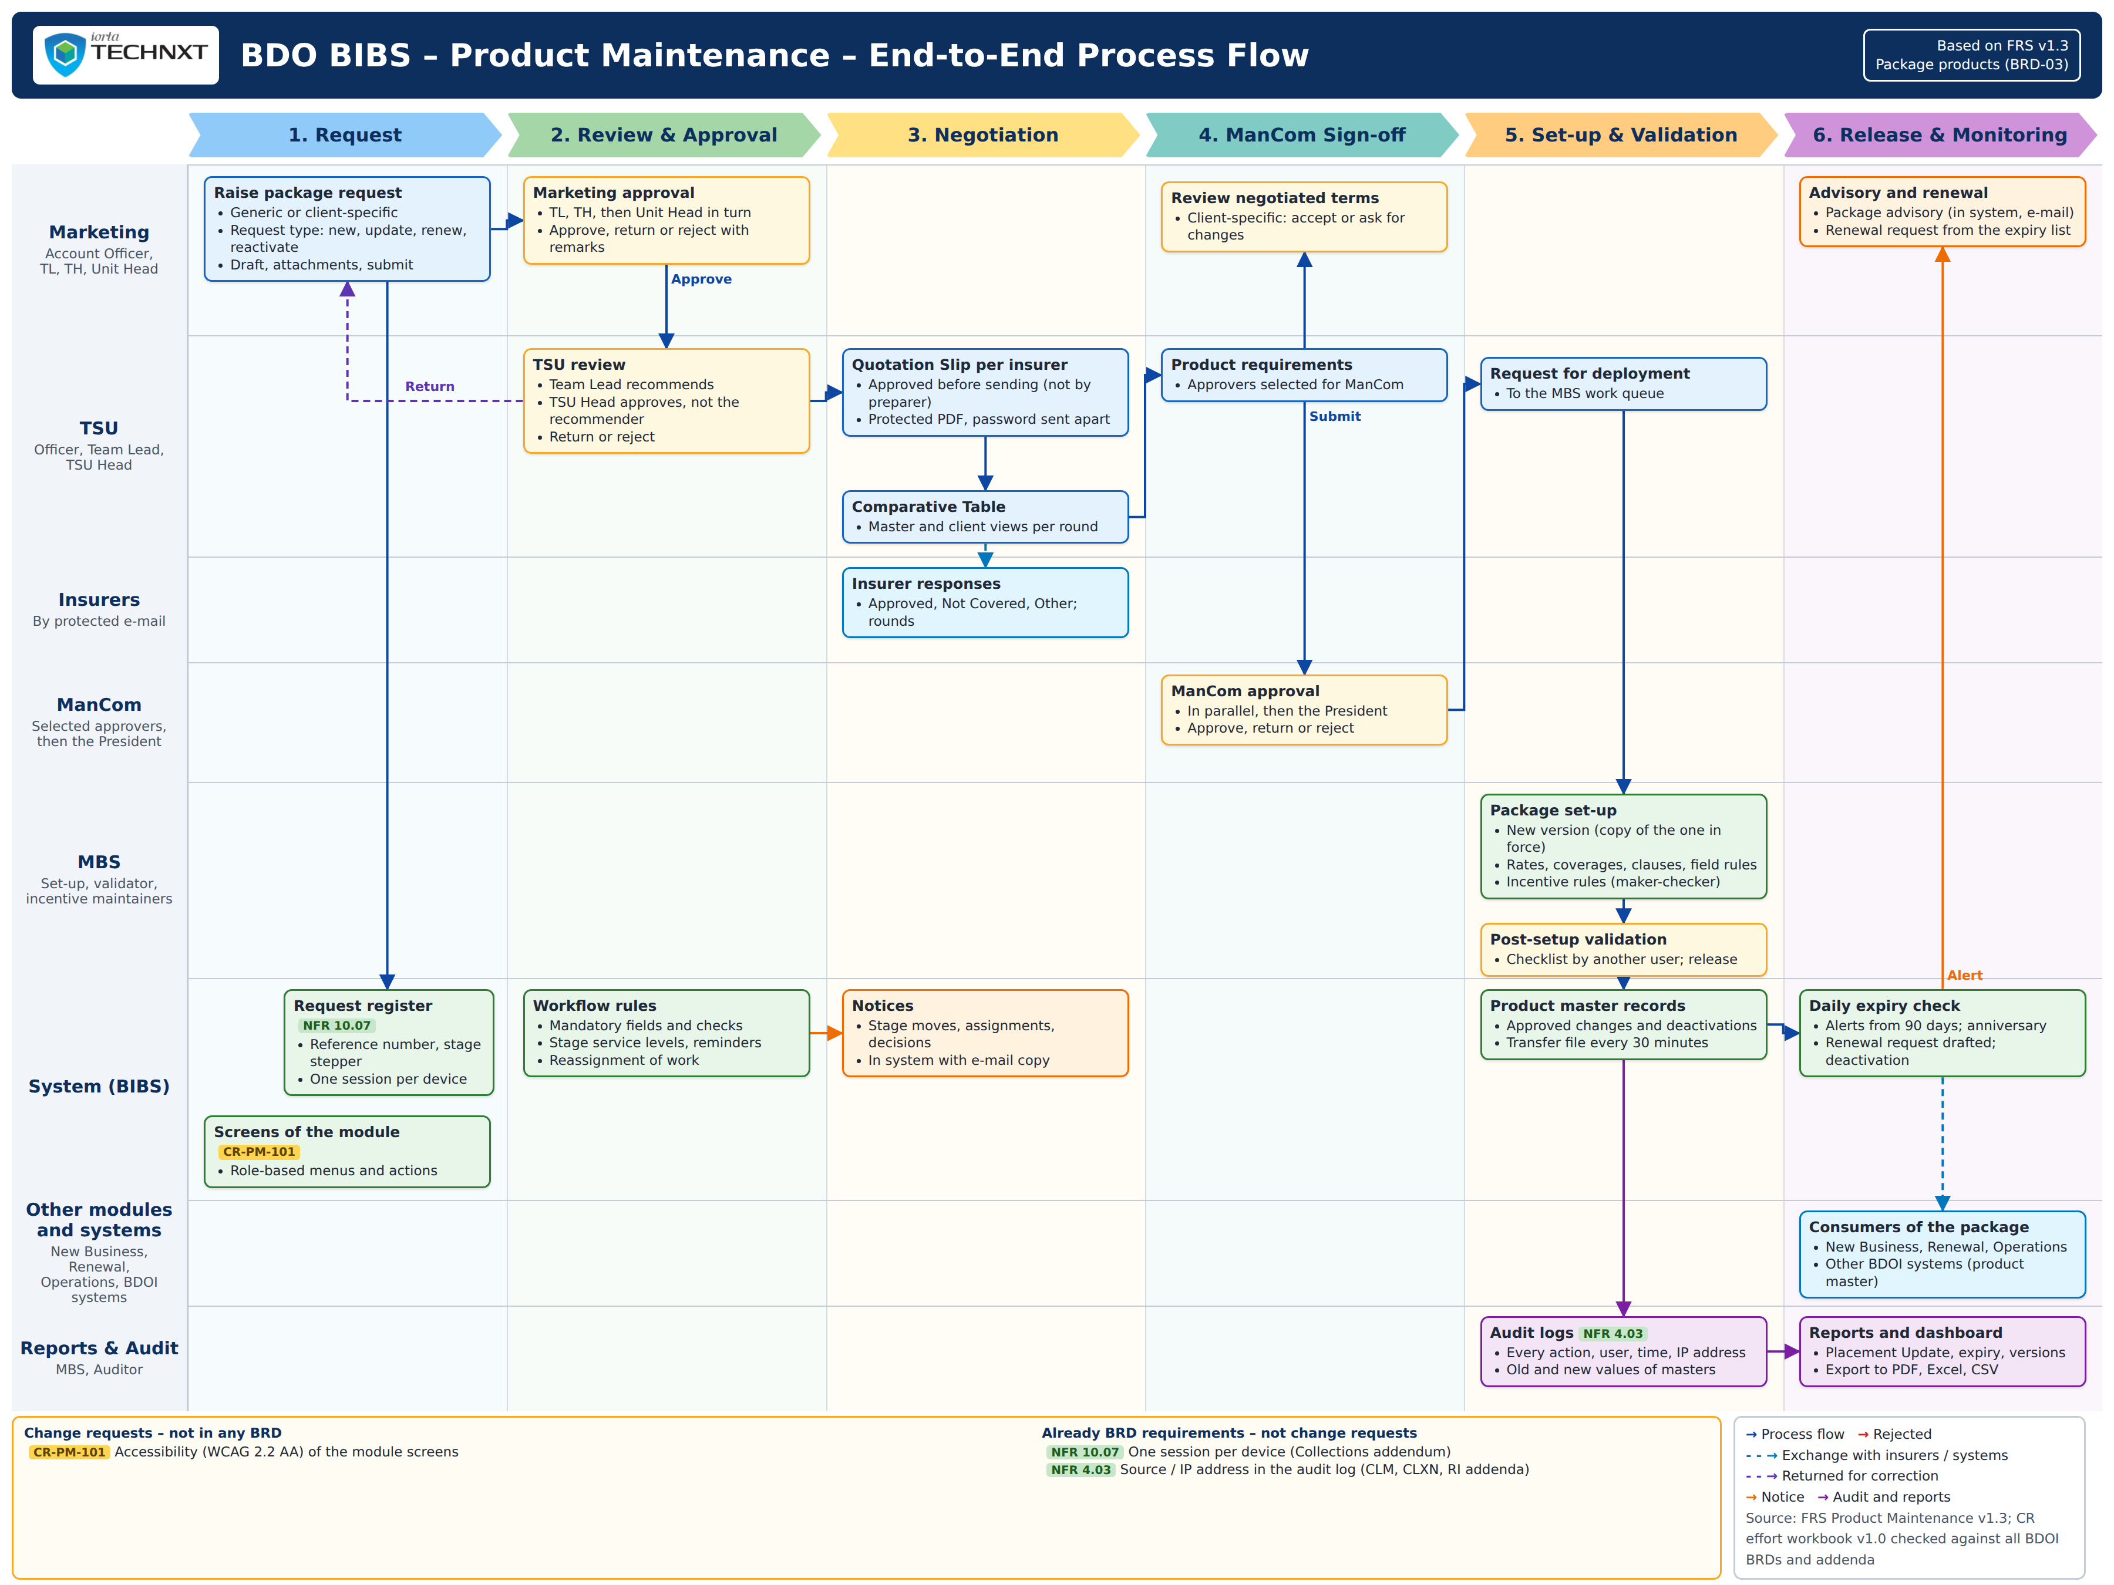
Figure 2 – End-to-End Process Flow (all actors and systems)
Figure 2 shows the whole module across the actors and systems: Marketing, TSU, the insurers, ManCom, MBS, BIBS, the modules and BDOI systems that use the package, and the reports and audit. The tags name the change requests of Annex Y.2 (blue: extends a BRD requirement; yellow: not in any BRD) and the programme NFRs that are BRD requirements (green). The figures that follow draw each process in detail.

Non-Package Request Process Flow
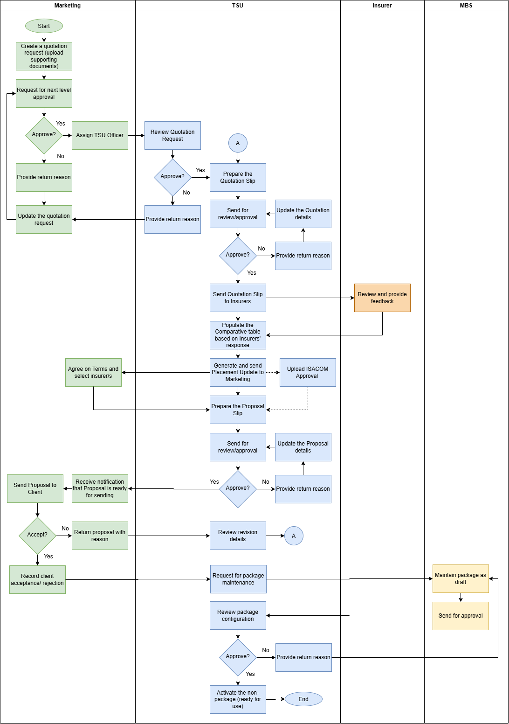
Figure 3 – Non-Package Request Process Flow

New Request Process Flow
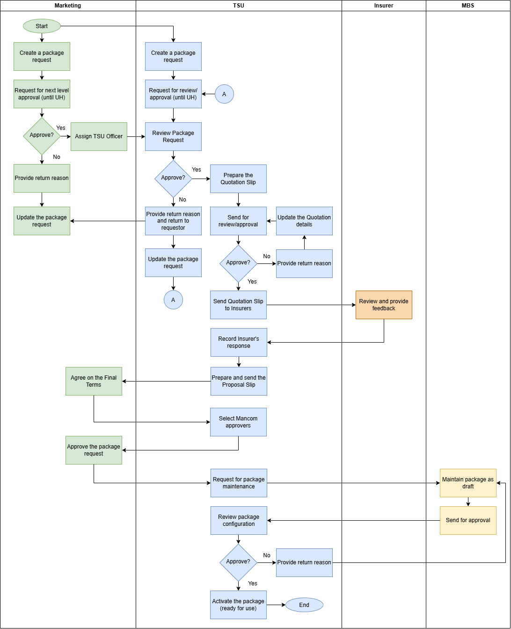
Figure 4 – New Request Process Flow

Package Set-up, Validation and Release Process Flow
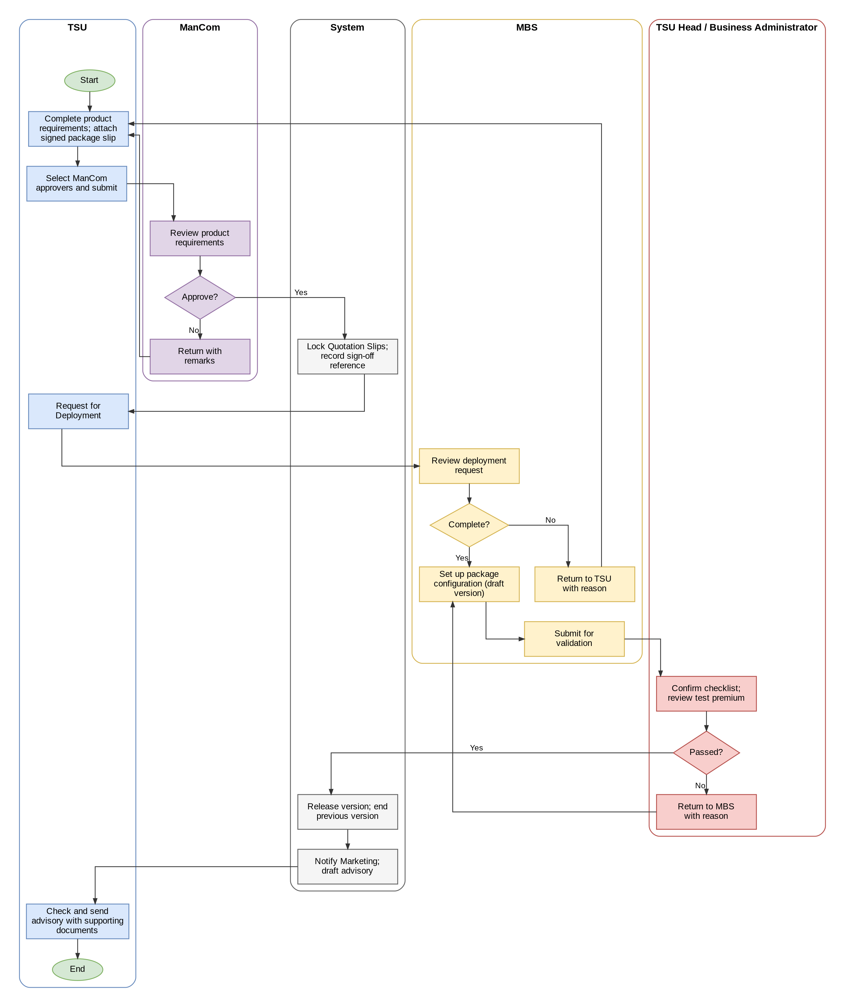
Figure 5 – Package Set-up, Validation and Release Process Flow

Package Expiry, Renewal and Deactivation Process Flow
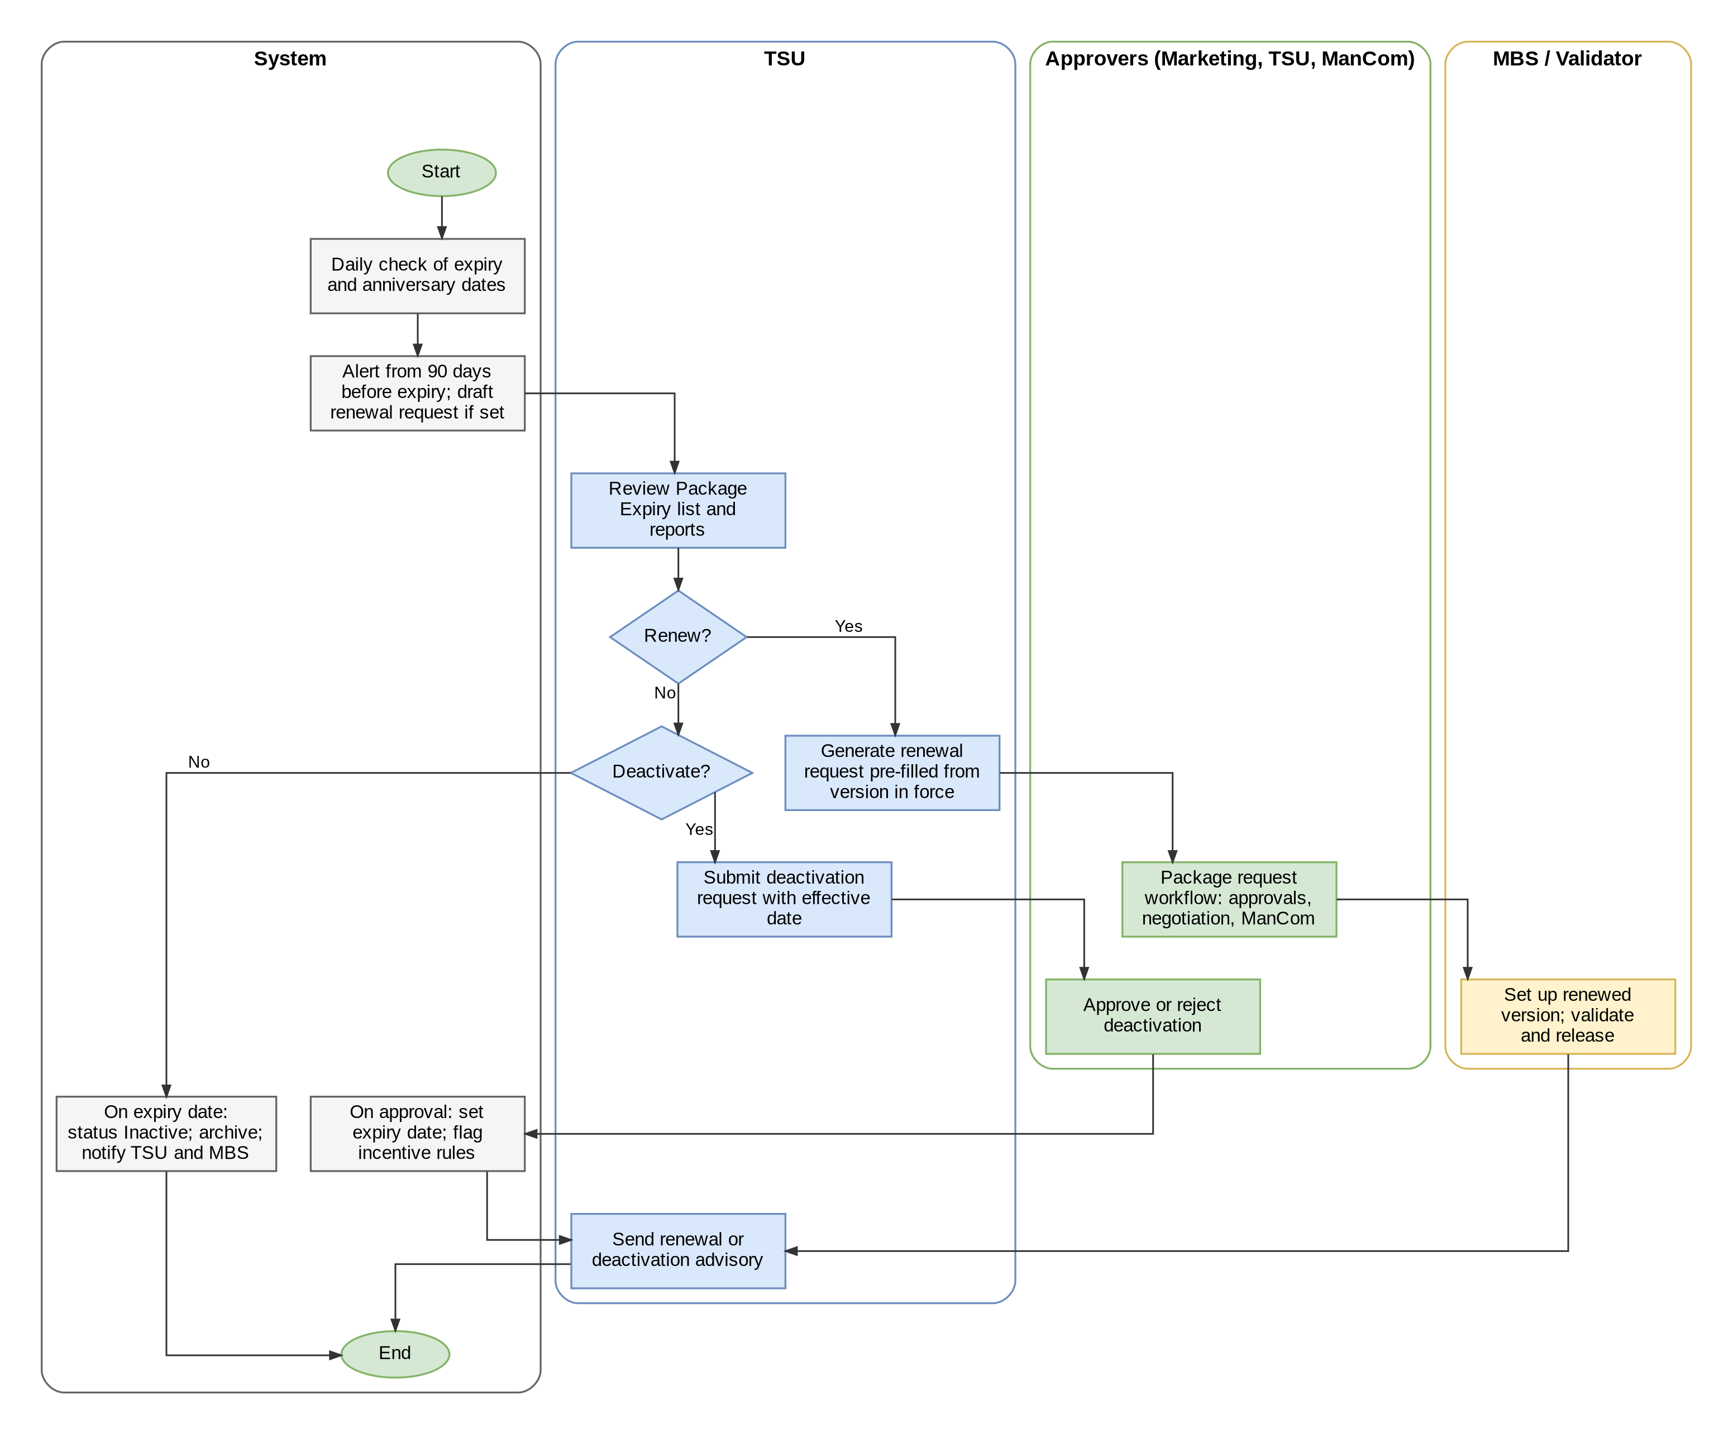
Figure 6 – Package Expiry, Renewal and Deactivation Process Flow

Rate Exception Process Flow (New Business on a Package)
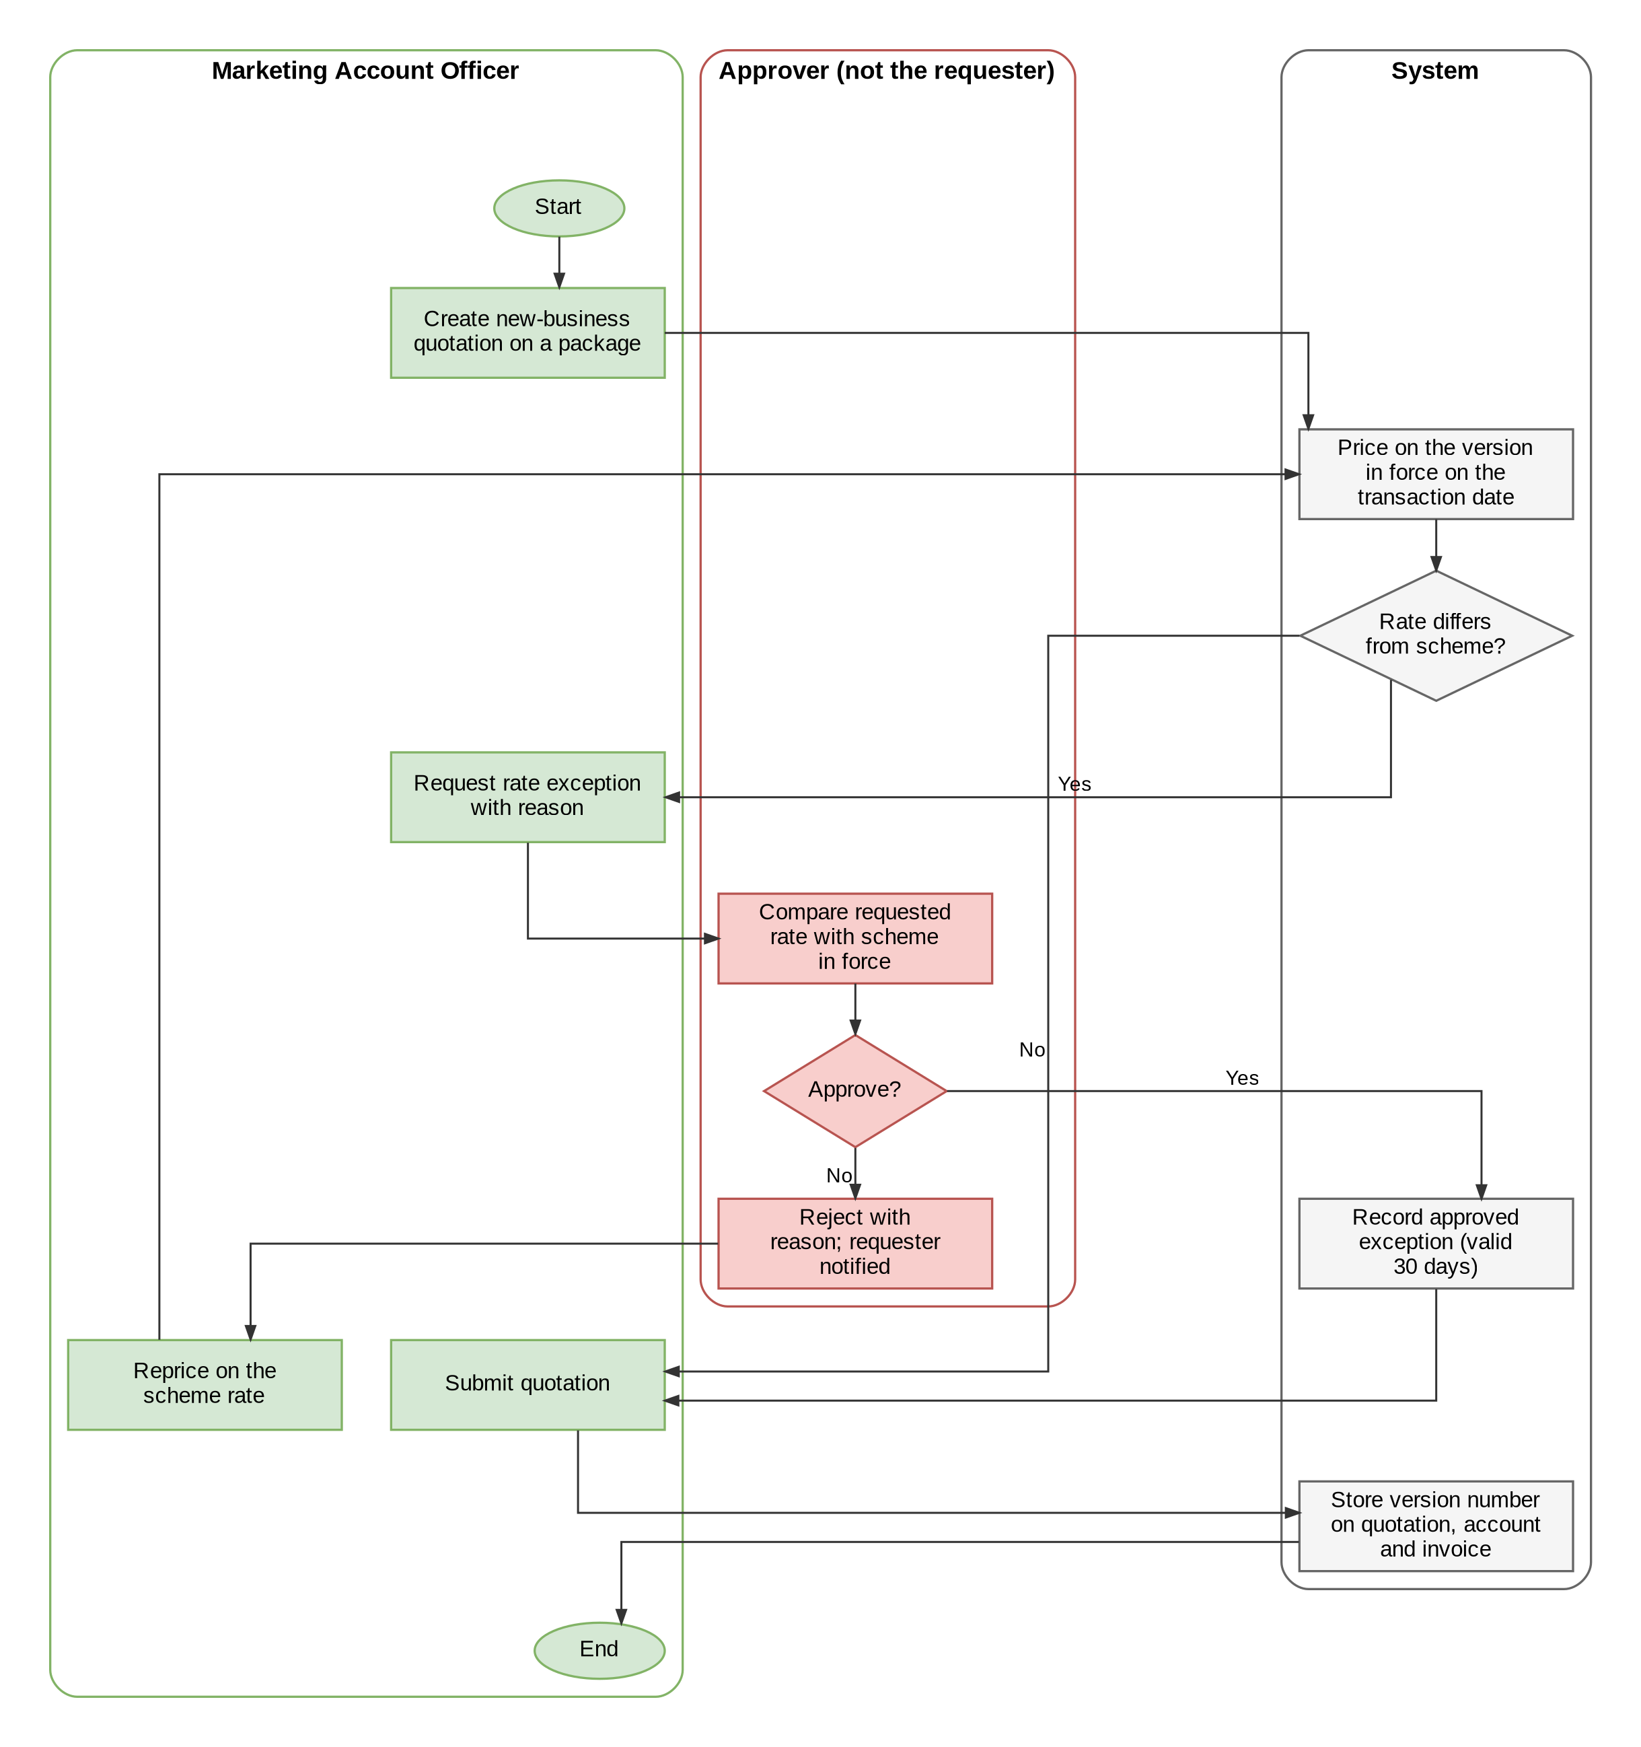
Figure 7 – Rate Exception Process Flow (New Business on a Package)

Package Request and Approval Process Flow (Marketing and TSU)
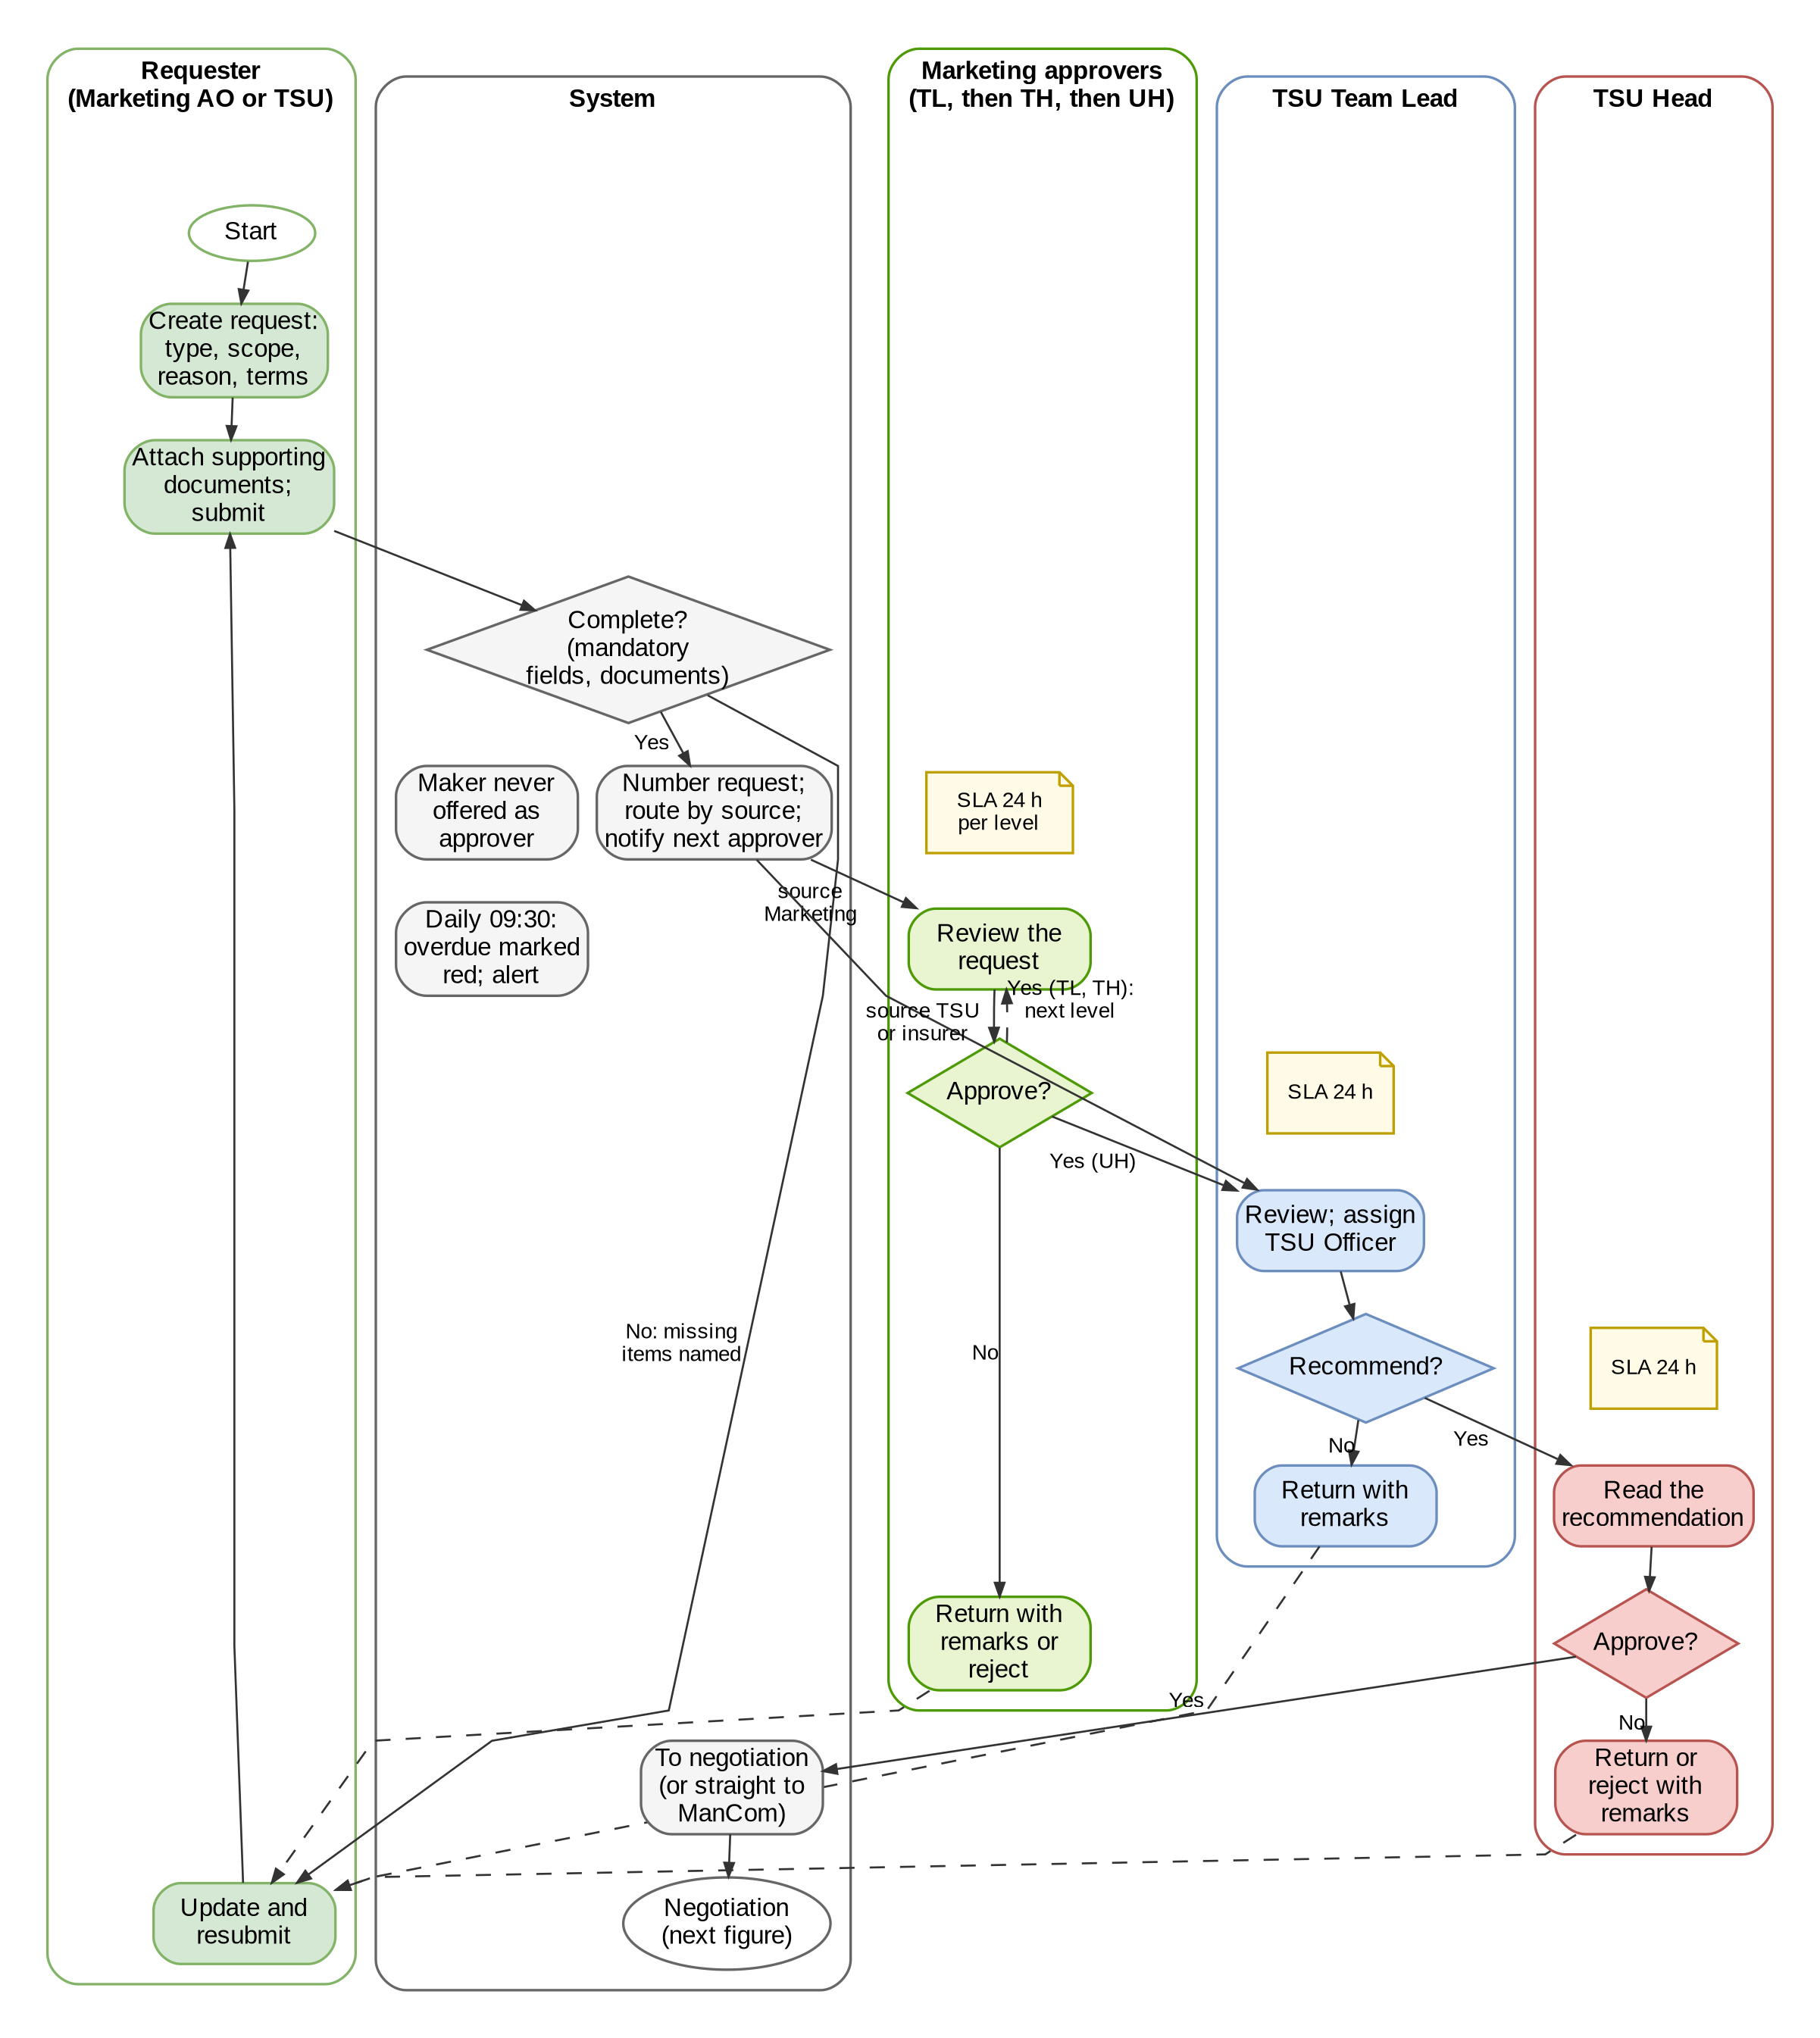
Figure 8 – Package request and approval, with the default service levels

Negotiation, Comparative Table and Terms Review Process Flow
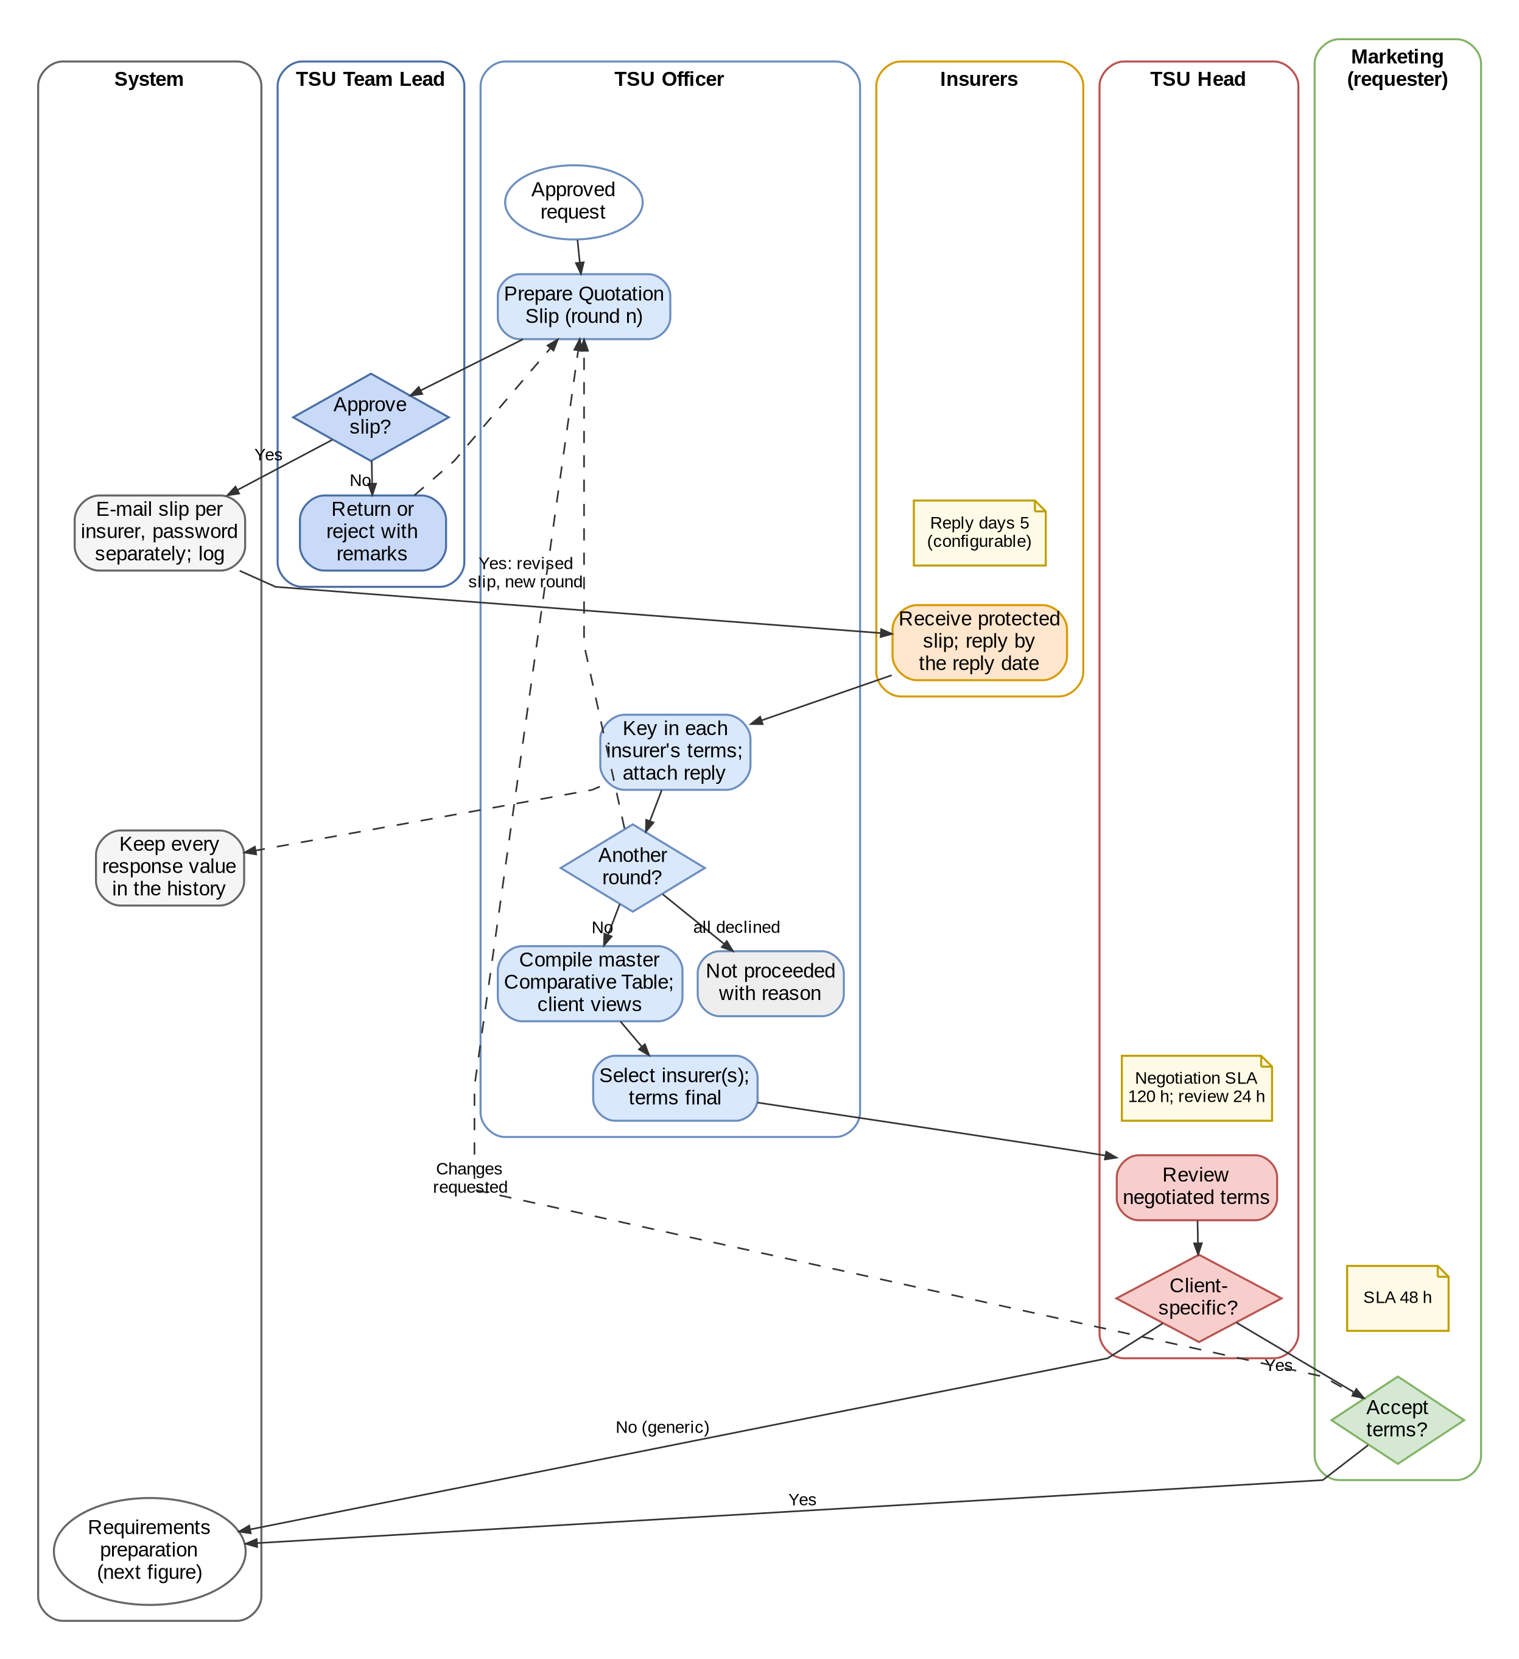
Figure 9 – Negotiation with insurers, Comparative Table and review of the negotiated terms

Product Master Maintenance Process Flow (Maker-Checker)
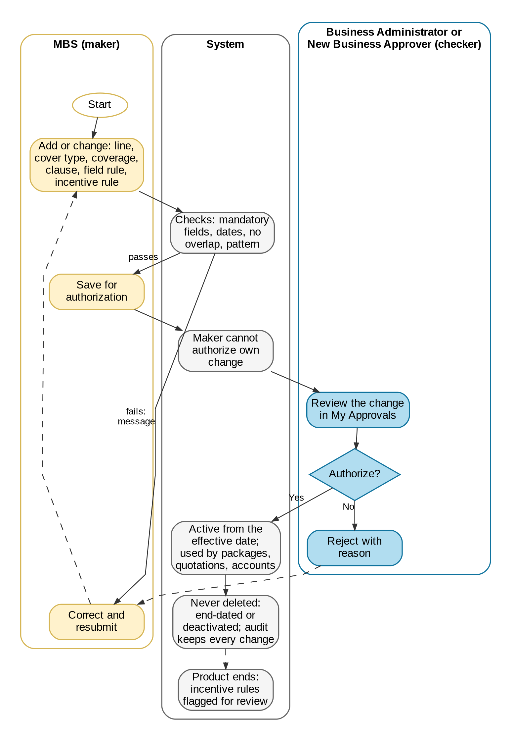
Figure 10 – Maintenance of the product hierarchy, clauses, field rules and incentive rules

Status Life-cycles
The statuses each record passes through. Solid arrows are the main path; dashed arrows are returns; dotted arrows close the record.
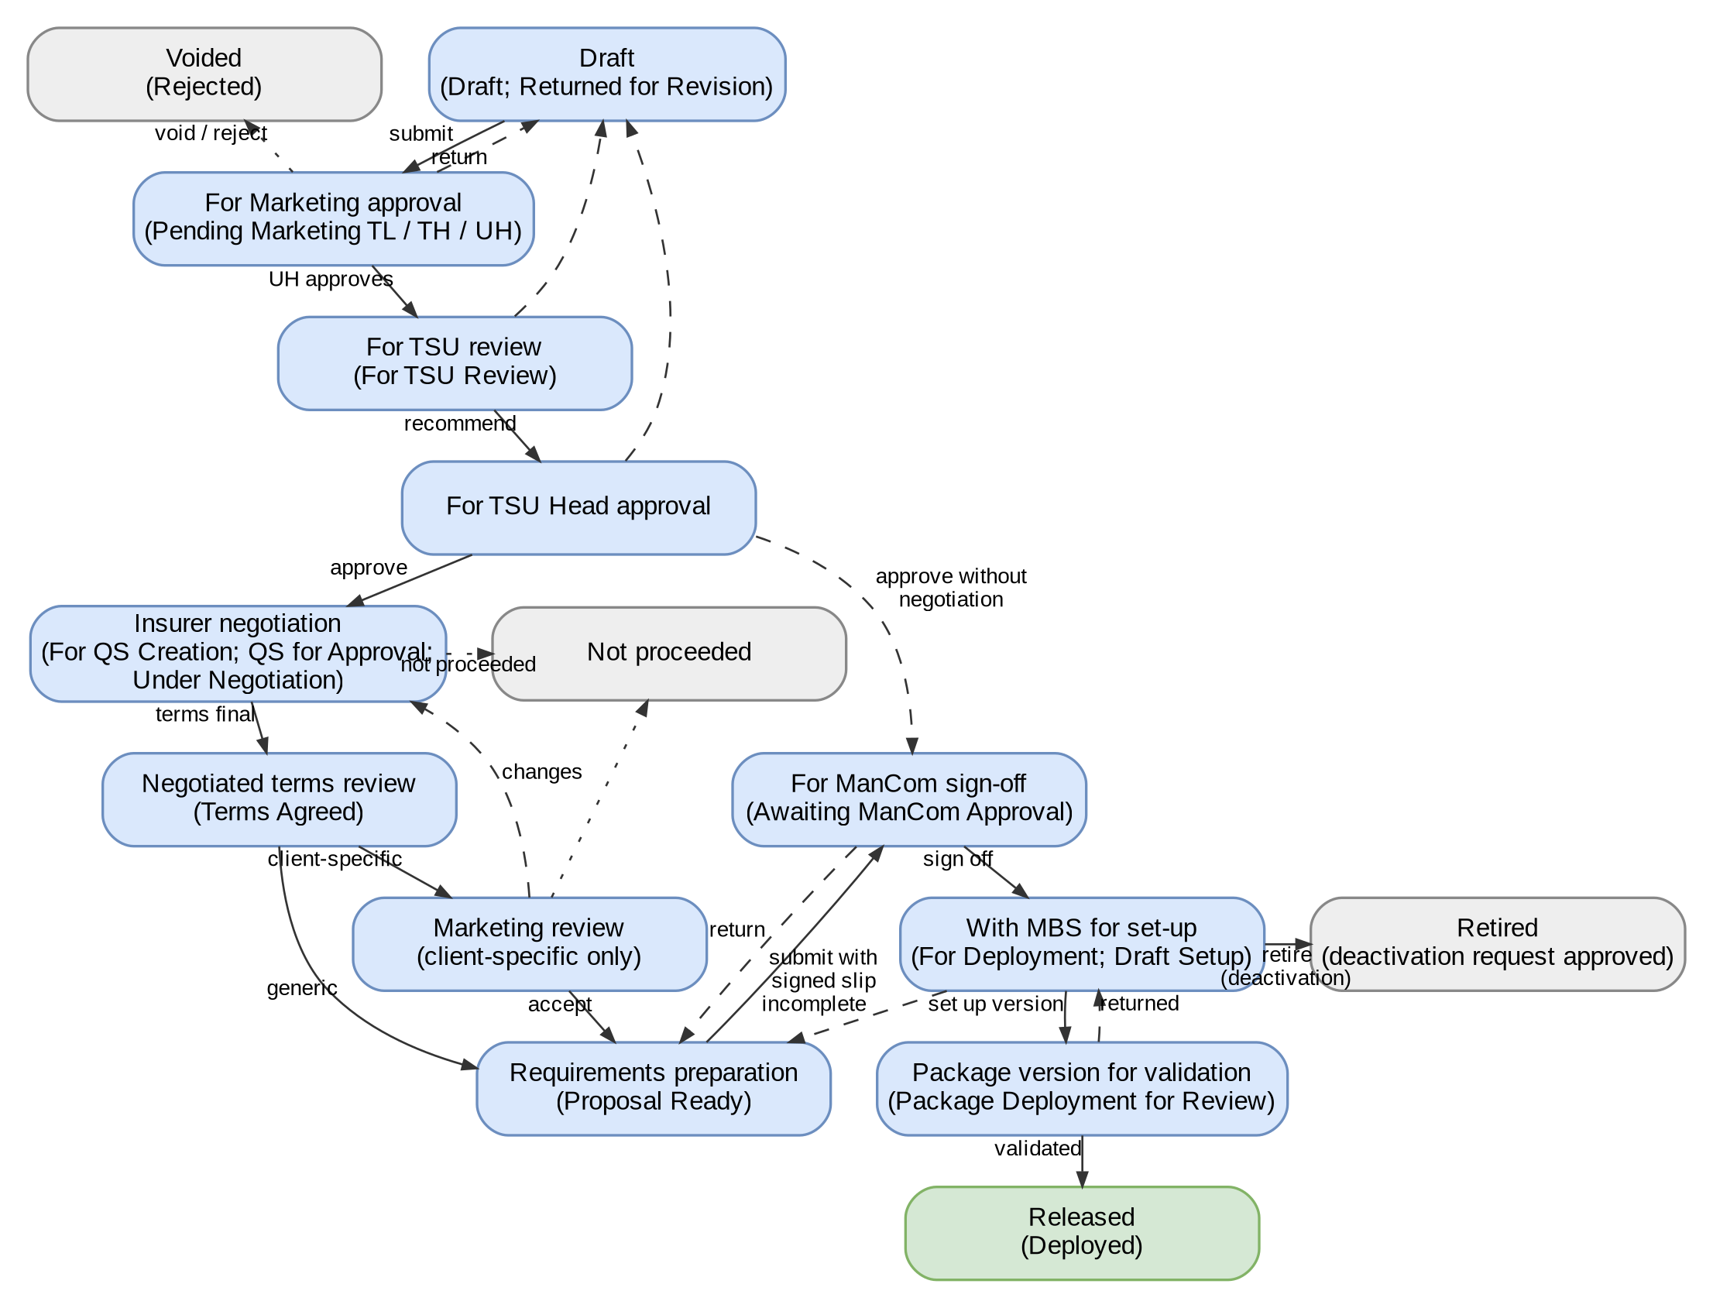
Figure 11 – Life-cycle of a package request (BDOI's status names in brackets)
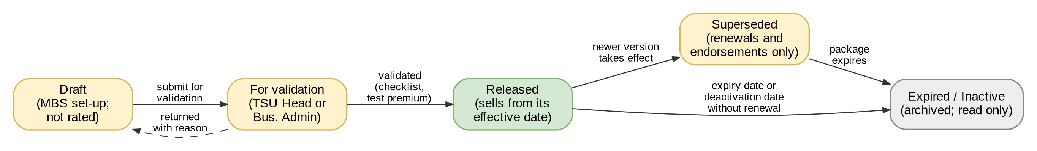
Figure 12 – Life-cycle of a package version
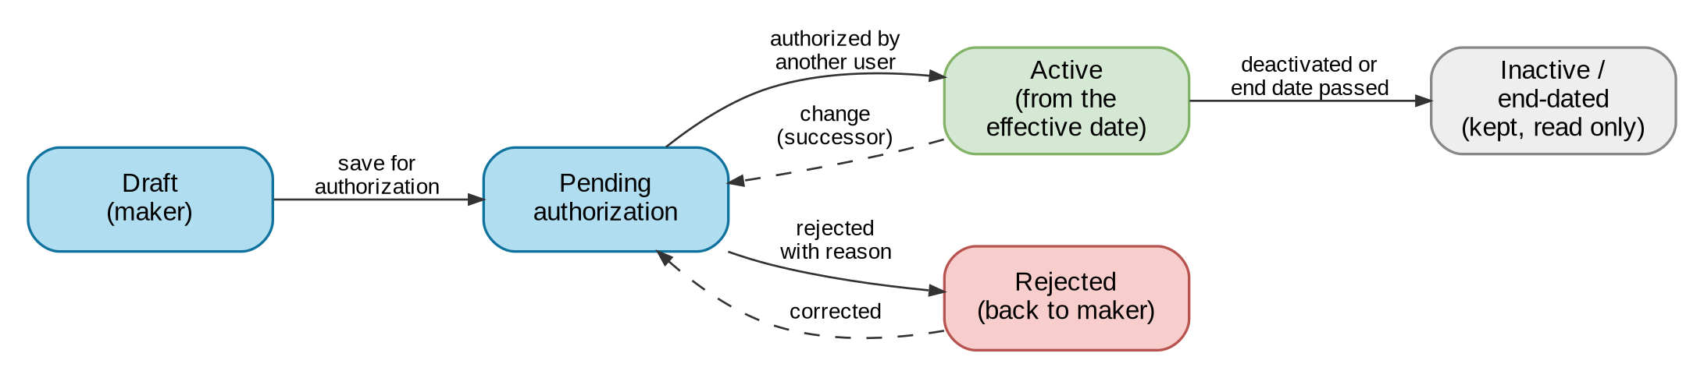
Figure 13 – Life-cycle of a product master record or incentive rule
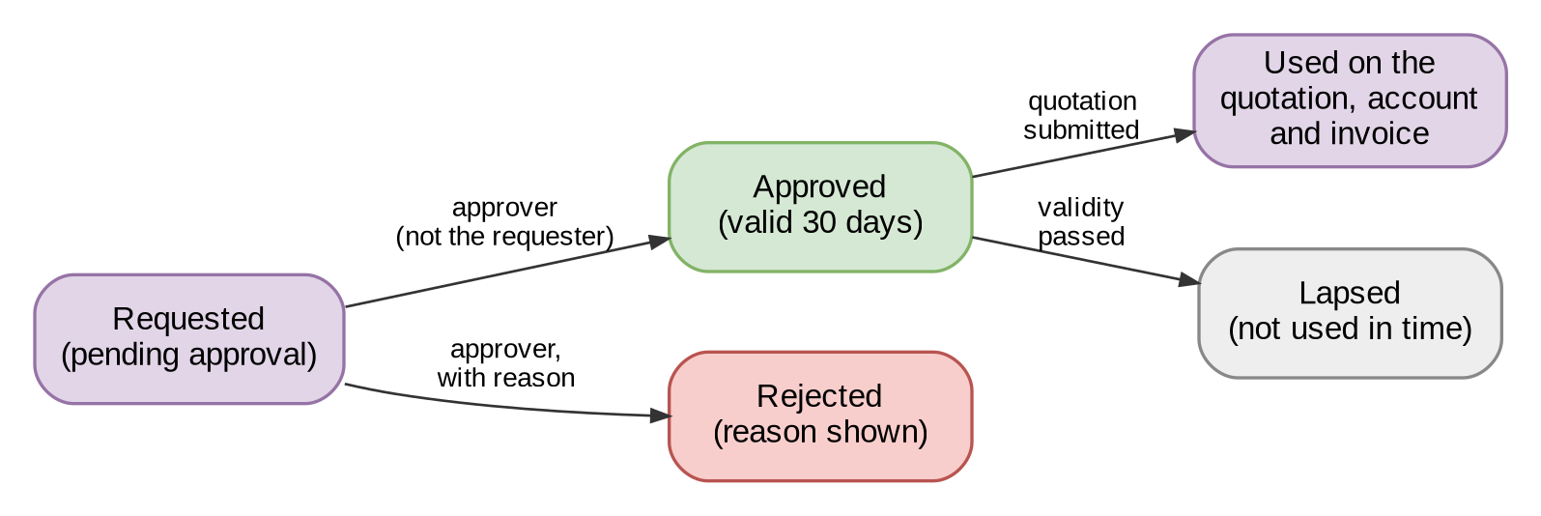
Figure 14 – Life-cycle of a rate exception
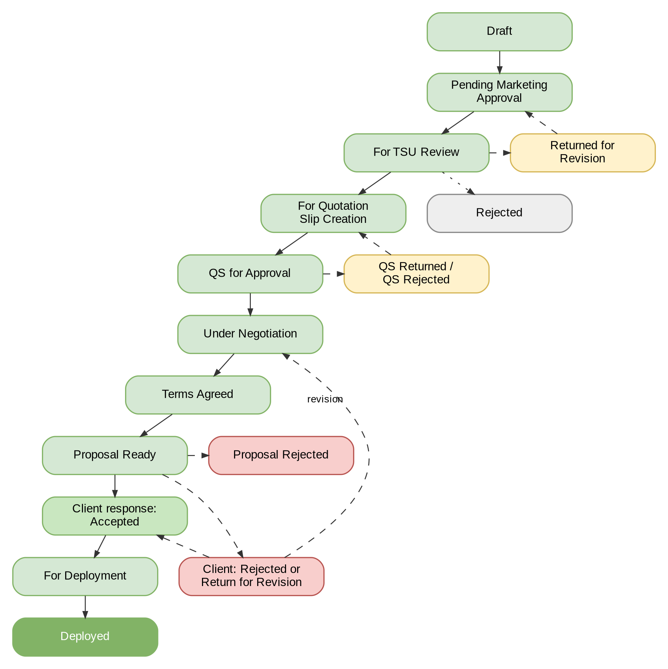
Figure 15 – Life-cycle of a non-package quotation request (BDOI's statuses)

Integration Context Diagram
The systems and modules Product Maintenance exchanges information with, in business terms; each interface is described in Annex S.
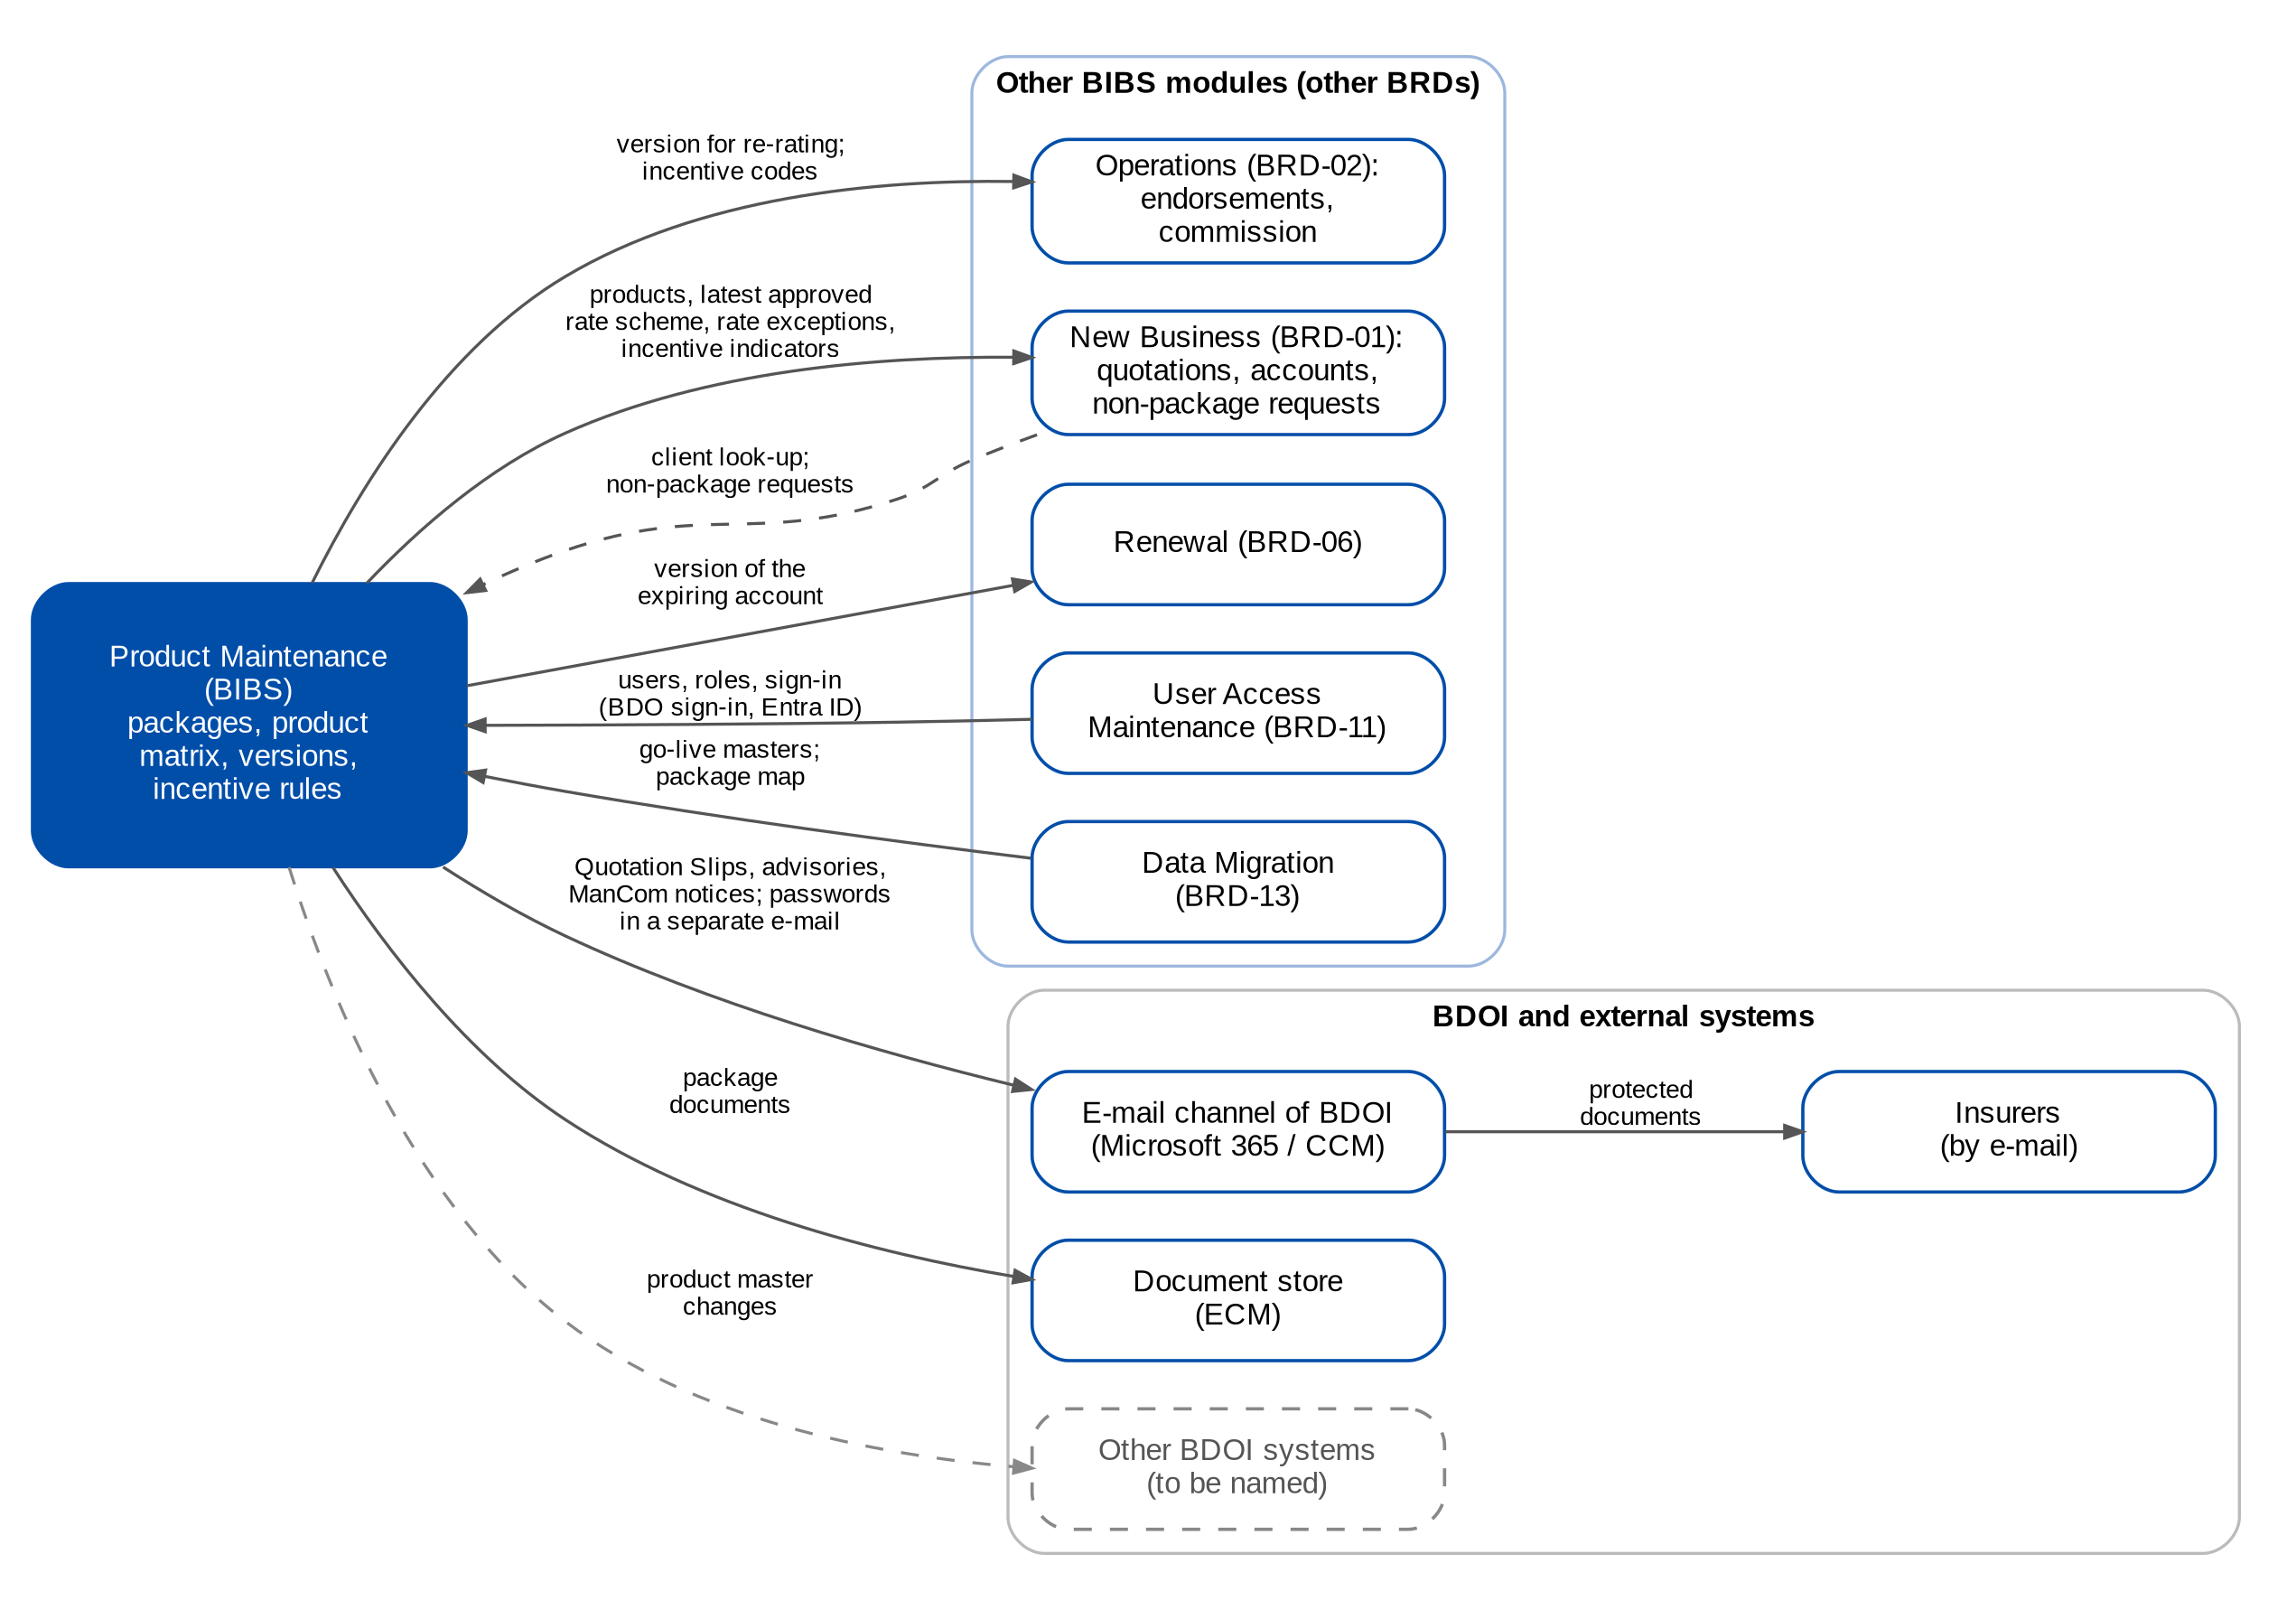
Figure 16 – Integration context of Product Maintenance (business level; dashed = waits for a BDOI input)

Signoff Sheet
Prepared by
______________________________________
System Analyst
iorta TechNXT Project Team (drafting support)

Reviewed by
______________________________________
Tech Lead

______________________________________
Application or Platform Owner
(or Unit / Dept. Head if no Application Owner is Identified)

I have validated the completeness of the functional requirements. I confirm that these requirements are aligned with all stakeholders, their priorities, and the business case.

Approved by
______________________________________
Project Owner / Project Sponsor
(add BU signatories, as applicable)

Annex A – Package Product Fields
Column | Data Type | Product Line(s) | Remarks
Policy Type | Dropdown | Motor, Property, EEI, Floater, Marine Cargo, Marine Hull, Aviation, Stock Throughput, Personal Accident, Miscellaneous | Values: Individual, Fleet, Group, Single Location, Various Locations
Sub-Line | Dropdown | Engineering, Liability, Crime, Bonds, Personal Accident, Miscellaneous
Package Name | Text | All
Package Description | Text | All
Insurer | Dropdown | All
Business Origin | Dropdown | All
Account Officer | Dropdown | All
Unit Head | Dropdown | All
Insured's Name | Text | All
Mailing Address | Text | All
Perils/Coverages | Text | Motor, Engineering, EEI, Floater, Marine Cargo, Marine Hull, Aviation
Benefits/Coverages | Text | Personal Accident
Type of Cover | Dropdown | Property | Values: All-Risk, F/L Only, Named Perils
Description of Cover | Text | All
Extensions of Cover | Text | Property, Engineering, EEI, Floater, Marine Cargo, Marine Hull, Aviation, Stock Throughput, Liability, Crime, Personal Accident, Miscellaneous
Warranties, Clauses | Dropdown | All
Other Conditions, Subjectivities, Exclusions | Text | All
Deductibles | Text | All
Maximum Limit/s | Text | All
Premium | Currency | All
Premium Rates | Percentage | All
Commission Rates | Percentage | All
Effectivity Date | Date | All
Expiry Date | Date | All
Incentive Eligible | Boolean | All
Incentive Amount | Float | All
Incentive Commission Rate | Percentage | All
Risk Code | Text | All | Code of the package product; follows the naming convention of its Line of Insurance once stated (FRPM.003.02)
Cover Type / Subtype | Dropdown | All | Level below the Line of Insurance; mandatory for a package (FRPM.022.01)
Version Number | Number | All | Version of the package terms; set by the system (FRPM.024.01)
Version Status | Dropdown | All | Values: Draft, For Validation, Released, Superseded, Expired
Insurer Role | Dropdown | All | Values: Lead, Participant, Panel (per insurer of the package)
Insurer Share | Percentage | All | Co-insurance share per insurer; shares total 100% when used
Minimum Premium | Currency | All | Per package and per insurer
Package TSI Limit | Currency | All | Maximum total sum insured of the package
Package Start Date | Date | All | Start of the package term
Anniversary Date | Date | All | Optional; used for the anniversary alert (FRPM.004.01)
Computation Basis | Text | All | How the premium is computed, as approved by ManCom (FRPM.014.02)
ManCom Sign-off Reference | Text | All | MC-<package request number>; set by the system
Change Summary | Text | All | What changed in this version
Market Segments | Dropdown | All | Multi-select; segments to which the package is offered

Sub Line Dropdown Values
Product Line | Values
Engineering | CARI, EAR
Liability | Comprehensive General Liability, Employers Liability, Directors and Officers Liability, Pollution Liability, Cyber Liability, Professional Liability, Medical Malpractice, Products Liability, Errors and Omissions, Marine Liability, Excess Auto Liability
Crime | Fidelity Guarantee, Money/Securities & Payroll, Kidnap and Ransom, Bankers Blanket Bond, Combined FG and MSP, Dishonesty/Disappearance/Destruction
Bonds | Heirs Bond, Performance Bond, Surety Bond, Bidder's Bond, Judicial Bond, Warranty Bond
Personal Accident | Personal Accident, Travel
Miscellaneous | Golfer's Insurance/Hole-In-One, Sabotage and Terrorism, Political Violence, Trade Credit, Parametric, Fine Arts

Annex B – Non-Package Product Fields
Field Name | Data Type | Applicable Product Lines | Remarks
Policy Type | Dropdown | Motor, Property, EEI, Floater, Marine Cargo, Marine Hull, Aviation, Stock Throughput, Personal Accident, Miscellaneous | Values: Individual, Fleet, Group, Single Location, Various Locations)
Sub-Line | Dropdown | Engineering, Liability, Crime, Bonds, Personal Accident, Miscellaneous
Business Origin | Dropdown | All Product Lines
Account Officer | Dropdown | All Product Lines
Unit Head | Dropdown | All Product Lines
Insured's Name | Text | All Product Lines
Mailing Address | Text | All Product Lines
Effectivity Date | Date | All Product Lines
Expiry Date | Date | All Product Lines
Premium | Currency | All Product Lines
Premium Rates | Percentage | All Product Lines
Commission Rates | Percentage | All Product Lines
Warranties, Clauses | Text | All Product Lines
Other Conditions, Subjectivities, Exclusions |  | All Product Lines
Deductibles | Text | All Product Lines
Extensions of Cover | Text | Property, Engineering, EEI, Floater, Marine Cargo, Marine Hull, Aviation, Stock Throughput, Liability, Crime, Personal Accident, Miscellaneous
Maximum Limit/s |  | Property
Type of Cover | Dropdown | Property | Values: All-Risk, F/L Only, Named Perils
Description of Cover | Text | Property, Personal Accident
Cover/ Undertaking |  | Engineering, EEI, Floater, Stock Throughput, Liability, Crime, Miscellaneous, Bonds
Perils/Coverages | Text | Motor, Marine Cargo, Marine Hull, Aviation
Benefits/Coverages | Dropdown | Personal Accident
Vehicle Type | Dropdown | Motor | Values:  1. PC Sedan  2. PC SUV/AUV  2. CV  3. Motorcycle  4. LTO  5. Various
Engine Type | Dropdown | Motor | Values:  1. Gas  2. Diesel  3. Hybrid  4. Fully-Electric  5. Various
Year Model | Text/Number | Motor
Manufacturer | Dropdown | Motor
Model / Variant | Dropdown | Motor
Sum Insured per Peril | Currency | Motor
Currency |  | Motor, Property, Engineering, EEI, Floater, Miscellaneous, Marine Cargo, Stock Throughput, Liability, Crime, Bonds
Location/s of Risk | Text | Property, EEI, Floater, Stock Throughput, Crime, Miscellaneous
Location/s of Risk City |  | Property, EEI, Floater, Stock Throughput, Crime, Miscellaneous
Location/s of Risk: Province |  | Property, EEI, Floater, Stock Throughput, Crime, Miscellaneous
Properties Insured | Dropdown | Property, Miscellaneous | Dropdown for Property:  1. Building / Building Improvements or  Leasehold Improvements / Land  Improvements  2. Contents  3. Machinery / Equipment  4. Stocks  Drop-Down (for Sabotage and Terrorism, Political Violence and Parametric only) :  1. Building / Building Improvements or  Leasehold Improvements / Land  Improvements  2. Contents  3. Machinery / Equipment  4. Stocks  Free text for Golfer’s Insurance, Fine Arts
Description of Properties Insured | Text | Property, EEI, Floater, Miscellaneous
Sum Insured per Property Insured | Currency | Property, EEI, Floater, Miscellaneous
Basis of Valuation |  | Property, EEI, Floater, Stock Throughput, Miscellaneous | Drop-Down :  1. Sound Value / Actual Cash  Value  2. Replacement Value  3. Cost Price  4. Selling Price  Note: Under Miscellaneous: for Sabotage and Terrorism, Political Violence and Parametric only
Total Sum Insured | Currency (Computed) | Property, EEI, Floater, Stock Throughput | Must automatically be computed by the system based on the Sum Insured per Property Insured specified
Building Description | Dropdown | Property, Stock Throughput | Values:  1. Class A  2. Class B  3. Light Material
Building Occupancy | Dropdown | Property | Values:  1. Residential  2. General  3. Warehouse  4. Industrial
Contractor's Name | Text | Engineering
Project Description / Scope of Work | Text | Engineering
Project Location | Text | Engineering
Total Contract Value | Currency | Engineering
Sum Insured per Cover | Currency | Engineering
Nature of Business | Text | Marine Cargo, Marine Hull, Liability, Crime, Bonds, Miscellaneous
Details of Cargo | Text | Marine Cargo
Details of Packaging | Text | Marine Cargo, Stock Throughput
Type of Conveyance | Dropdown | Marine Cargo
Limit per Conveyance/Shipment | Currency | Marine Cargo
Frequency of Delivery | Text | Marine Cargo
Actual Turn-Over for the Past 12 Months | Currency | Marine Cargo
Estimated Turn-Over for the Next 12 Months | Currency | Marine Cargo
Sum Insured | Currency | Marine Cargo, Stock Throughput
Vessel Name | Text | Marine Hull
Vessel Operator and Manager | Text | Marine Hull
Type of Vessel | Dropdown | Marine Hull
Aircraft Usage |  | Marine Hull
Year Built | Number | Marine Hull, Aviation
Gross Tonnage | Number | Marine Hull
Net Tonnage | Number | Marine Hull
Cargoes Carried | Text | Marine Hull
No. of Passenger and Crew Seats | Number | Marine Hull
Construction Material | Dropdown | Marine Hull
Agreed Value | Currency | Marine Hull, Aviation
Type of Aircraft | Dropdown | Aviation
Pilot Details | Text | Aviation
Aircraft Operator | Text | Aviation
Make/Model | Text | Aviation
Registration Mark No. | Text | Aviation
Serial No. | Text | Aviation
Hangar Location | Text | Aviation
Geographical Limits | Text | Aviation
Origin of Goods | Text | Stock Throughput
Destination of Goods | Text | Stock Throughput
Average and Maximum Monthly Inventory | Currency | Stock Throughput
Annual Sales Turn-Over | Currency | Stock Throughput
Description of Stocks | Text | Stock Throughput
Location of Premises | Text | Liability
Limit of Liability | Currency | Liability, Crime
Bond Amount | Currency | Bonds
Occupation / Nature of Business | Text | Personal Accident
No. of Persons to be Covered | Number | Personal Accident
Incentive Eligible | Boolean | All Product Lines
Incentive Amount | Currency | All Product Lines
Incentive Commission Rate | Percentage | All Product Lines
Market Segment | Dropdown | All Product Lines | Segment of the client; must be one allowed for the product

Annex C – Non-Package Quotation Request Fields
Field Name | Data Type | Applicable Product Line | Remarks (Validation / Values)
Line of Insurance | Dropdown | All
Transaction Type | Dropdown | All | Values: New Business, Renewal, Endorsement  Engineering & Bonds: New Business, Endorsement only
Expiring / Existing Policy No. | Text | All | Applicable for Renewal/Endorsement transactions only
Preferred / Expiring / Existing Insurer/s | Dropdown | All | Insurer selection
Expiring / Existing Share per Insurer | Percentage | All | Applicable for Renewal/Endorsement only; should be in %
Expiring / Existing Premium Rate per Insurer | Percentage | All | Applicable for Renewal/Endorsement only; should be in %
Expiring / Existing Commission Rate per Insurer | Percentage | All | Applicable for Renewal/Endorsement only; should be in %
Policy Type | Dropdown | Motor, Property, EEI, Floater, Marine Cargo, Marine Hull, Aviation, Stock Throughput, Personal Accident, Miscellaneous | Product line-specific dropdown values
Sub-Line | Dropdown | Engineering, Liability, Crime, Bonds, Personal Accident, Miscellaneous | Product line-specific dropdown values
Business Origin | Dropdown | All | Business source/origin
Account Officer | Dropdown | All | Account Officer selection
Unit Head | Dropdown | All | Unit Head selection
Insured's Name | Text | All | Free text
Mailing Address | Text | All | Free text
Effectivity Date | Date | All | Policy start date
Expiry Date | Date | All | Policy expiry date
Mortgagee | Text | All | Optional field
Loss Information | Text | All | Free text, optional
Premium | Currency | Engineering, Marine Cargo, Marine Hull, Aviation, Stock Throughput, Liability, Crime, Bonds, Personal Accident, Miscellaneous | Currency must be captured separately
Premium Rates | Percentage | All | Premium rate (%)
Commission Rates | Percentage | All | Commission rate (%)
Warranties, Clauses | Text | All | Free text
Other Instructions | Text | All | Free text
Deductibles | Text | All | Free text
Extensions of Cover | Text | Property, Engineering, EEI, Floater, Marine Cargo, Marine Hull, Aviation, Stock Throughput, Liability, Crime, Personal Accident, Miscellaneous | Free text
Vehicle Type | Dropdown | Motor | Values: PC Sedan, PC SUV/AUV, CV, Motorcycle, LTO, Various
Engine Type | Dropdown | Motor | Values: Gas, Diesel, Hybrid, Fully-Electric, Various
Year Model | Text/Number | Motor | Vehicle year model
Manufacturer | Dropdown | Motor | Manufacturer list
Model / Variant | Dropdown | Motor | Vehicle model/variant
Perils/Coverages | Text | Motor, Marine Cargo, Marine Hull, Aviation | Coverage details
Sum Insured per Peril | Currency | Motor | Currency should be separate field
Location/s of Risk | Text | Property, EEI, Floater, Stock Throughput, Crime | City and Province should be maintained separately as dropdowns
Properties Insured | Dropdown | Property, Miscellaneous | Product-specific property types
Description of Properties Insured | Text | Property, EEI, Floater, Miscellaneous | Free text per property insured
Sum Insured per Property Insured | Currency | Property, EEI, Floater, Miscellaneous | Currency should be maintained separately
Basis of Valuation per Property Insured | Dropdown | Property, EEI, Floater, Miscellaneous, Stock Throughput | Values: Sound Value/Actual Cash Value, Replacement Value, Cost Price, Selling Price
Total Sum Insured | Currency (Computed) | Property, EEI, Floater, Stock Throughput | System-computed based on insured values entered
Building Description | Dropdown | Property, Stock Throughput | Values: Class A, Class B, Light Material
Building Occupancy | Dropdown | Property | Values: Residential, General, Warehouse, Industrial
Type of Cover | Dropdown | Property | Values: All-Risk, F/L Only, Named Perils
Description of Cover | Text | Property, Personal Accident | Free text
Contractor's Name | Text | Engineering | Free text
Project Description / Scope of Work | Text | Engineering | Free text
Project Location | Text | Engineering | Free text
Total Contract Value | Currency | Engineering | Currency should be maintained separately
Cover / Undertaking | Text | Engineering, EEI, Floater, Stock Throughput, Liability, Crime, Miscellaneous, Bonds | Free text/dropdown depending on product line
Sum Insured per Cover | Currency | Engineering | Currency should be maintained separately
Nature of Business | Text | Marine Cargo, Marine Hull, Liability, Crime, Bonds, Miscellaneous, Personal Accident | Free text
Details of Cargo | Text | Marine Cargo | Free text
Details of Packaging | Text | Marine Cargo, Stock Throughput | Free text
Type of Conveyance | Dropdown | Marine Cargo | Conveyance types maintained by system
Limit per Conveyance/Shipment | Currency | Marine Cargo | Currency maintained separately
Frequency of Delivery | Text | Marine Cargo | Free text
Actual Turn-Over for Past 12 Months | Currency | Marine Cargo | Currency maintained separately
Estimated Turn-Over for Next 12 Months | Currency | Marine Cargo | Currency maintained separately
Sum Insured | Currency | Marine Cargo, Stock Throughput | Currency maintained separately
Vessel Name | Text | Marine Hull | Free text
Vessel Operator and Manager | Text | Marine Hull | Free text
Type of Vessel | Dropdown | Marine Hull | Vessel type list
Vessel Usage | Dropdown | Marine Hull | Usage classification
Year Built | Number | Marine Hull, Aviation | Year value
Gross Tonnage | Number | Marine Hull | Numeric value
Net Tonnage | Number | Marine Hull | Numeric value
Cargoes Carried | Text | Marine Hull | Free text
No. of Passenger and Crew Seats | Number | Marine Hull | Numeric value
Construction Material | Dropdown | Marine Hull | Material classification
Agreed Value | Currency | Marine Hull, Aviation | Currency maintained separately
Type of Aircraft | Dropdown | Aviation | Aircraft type selection
Pilot Details | Text | Aviation | Free text
Aircraft Operator | Text | Aviation | Free text
Make/Model | Text | Aviation | Aircraft make/model
Registration Mark No. | Text | Aviation | Registration number
Serial No. | Text | Aviation | Serial number
Hangar Location | Text | Aviation | Free text
Geographical Limits | Text | Aviation, Crime | Geographic coverage limits
Origin of Goods | Text | Stock Throughput | Free text
Destination of Goods | Text | Stock Throughput | Free text
Average and Maximum Monthly Inventory | Currency | Stock Throughput | Currency maintained separately
Annual Sales Turn-Over | Currency | Stock Throughput | Currency maintained separately
Description of Stocks | Text | Stock Throughput | Free text
Location of Premises | Text | Liability | Free text
Limit of Liability | Currency | Liability, Crime | Currency maintained separately
Bond Amount | Currency | Bonds | Currency maintained separately
Occupation / Nature of Business | Text | Personal Accident | Free text
No. of Persons to be Covered | Number | Personal Accident | Whole number only
Benefits/Coverages | Dropdown | Personal Accident | Coverage benefits
Location of Risk | Text | Miscellaneous | Free text
Incentive Eligible | Boolean | All Product Lines
Incentive Amount | Currency | All Product Lines
Incentive Commission Rate | Percentage | All Product Lines
Market Segment | Dropdown | All | Segment of the client; must be one allowed for the product
Risk Details | Text | All | Free sections (heading and details); risk details or risk items are required before submission
Risk Items | Table | All | Items with sum insured and risk group, per the item fields of the line
Mandatory Documents | Attachment | All | Document checklist of the product; each shown as Attached or Missing
Recommended Insurer | Dropdown | All | Insurer with received terms flagged by TSU (FRPM.008.01)

Annex D – Non-Package Quotation Slip Templates

Annex E – Package Request Fields
Column | Data Type | Product Lines | Remarks
Line of Insurance | Dropdown | All
Sub-Line | Dropdown | Engineering, Liability, Crime, Bonds, Personal Accident, Miscellaneous
Insurer/s | Dropdown | All
Business Origin | Dropdown | All
Account Officer | Dropdown | All
Unit Head | Dropdown | All
Estimated No. of Policies to be Issued | Numeric | All | Estimated number of policies; must be at least 20
Estimated Total Basic Premium to be Issued | Float | All | Estimated premium; must be at least PHP 5M
Insured's Name | Text | All
Perils/Coverages | Dropdown | Motor, Engineering, EEI, Floater, Marine Cargo, Marine Hull, Aviation
Type of Cover | Dropdown | Property | Values:  1. All-Risk  2. F/L only  3. Named Perils
Description of Cover | Text | Property, Personal Accident
Benefits/Coverages | Text | Personal Accident
Cover | Text | Motor, Engineering, EEI, Floater, Marine Cargo, Marine Hull, Aviation, Stock Throughput, Liability, Crime, Miscellaneous
Cover / Undertaking | Text | Bonds
Extensions of Cover | Text | Property, Engineering, EEI, Floater, Marine Cargo, Marine Hull, Aviation, Stock Throughput, Liability, Crime, Personal Accident, Miscellaneous
Warranties, Clauses | Dropdown | All
Other Instructions | Text | All
Deductibles | Text | Motor, Property, Engineering, EEI, Floater, Marine Cargo, Marine Hull, Aviation, Stock Throughput, Liability, Crime, Bonds, Miscellaneous
Maximum Limit/s | Text | All
Premium | Currency | Liability, Crime, Personal Accident, Miscellaneous
Premium Rates | Percentage | All
Commission Rates | Percentage | All
Incentive Eligible | Boolean | All
Incentive Amount | Float | All
Incentive Commission Rate | Percentage | All
Request Type | Dropdown | All | Values: New, Update (FRPM.002.02); Renew and Reactivate proposed (Annex M)
Scope | Option | All | Values: Generic programme, Client-specific package; a client-specific package needs the Insured's Name
Package / Programme Name | Text | All | Mandatory
Package Product | Dropdown | All | The existing package of an update, renewal or deactivation request
Reason for Request | Dropdown | All | Values: Client requirement; New programme for a market segment; Market competitiveness; Change in insurer terms or rates; Loss experience; Regulatory change; Package expiry or anniversary; Others
Comment on the Reason | Text | All | Mandatory when the reason is Others
Negotiation Required | Boolean | All | Whether insurers are approached; at least one Insurer when Yes
Market Segments | Dropdown | All | Multi-select
Effective From | Date | All | Date from which the package is offered
Package Start Date | Date | All
Package Expiry Date | Date | All | Mandatory on submission; after the start date
Anniversary Date | Date | All | Optional
Minimum Premium | Currency | All | Cannot be negative
Package TSI Limit | Currency | All | Cannot be negative
Supporting Documents | Attachment | All | Preview and download (FRPM.011.02)

Annex F– Package Quotation Slip Templates

Annex G – Screen Specifications
This annex specifies the Product Maintenance screens: the purpose of each screen, how the user reaches it, its fields with type, format, mandatory marker, list or source and validation, its actions with who may perform them and what happens, its rules, and one screenshot of the screen. Mandatory: Y = mandatory, N = optional, Cond. = mandatory when the condition stated applies. Dates are shown as dd-MMM-yyyy and amounts with thousands separators.

G.1 Product Maintenance Home (SCR-PM-01)
Purpose: The workspace of Product Maintenance: the Product Matrix of every package and non-package product (active, expiring within 90 days and expired) with its filters and exports, the Quotation Request List of the non-package products and the Package Request List, each with its row actions; the figures and stage tiles are on the Product Maintenance Dashboard (SCR-PM-23).
Access: Sign in, then the sidebar entry Product Maintenance Home
Requirements: FRPM.001.01, FRPM.002.01, FRPM.002.02, FRPM.003.01, FRPM.003.02, FRPM.003.06, FRPM.011.01, FRPM.011.03, FRPM.016.01, FRPM.017.01, FRPM.022.01
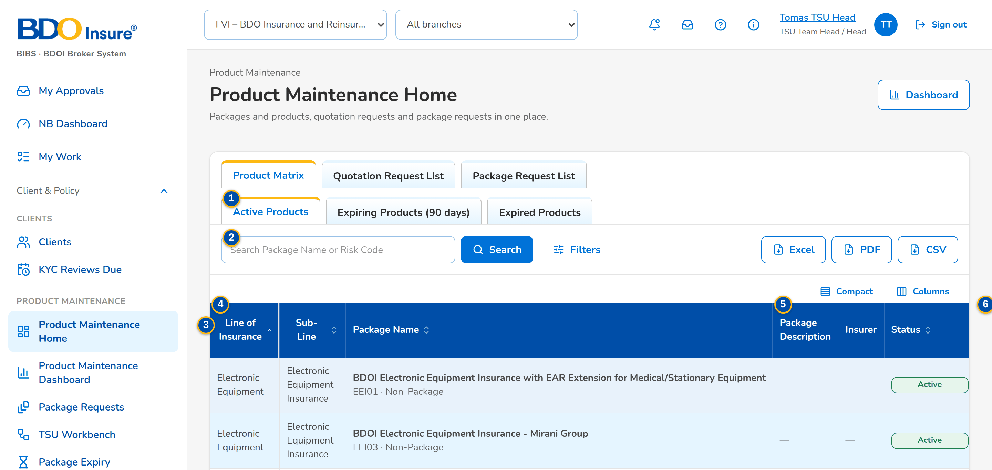
(continued below)
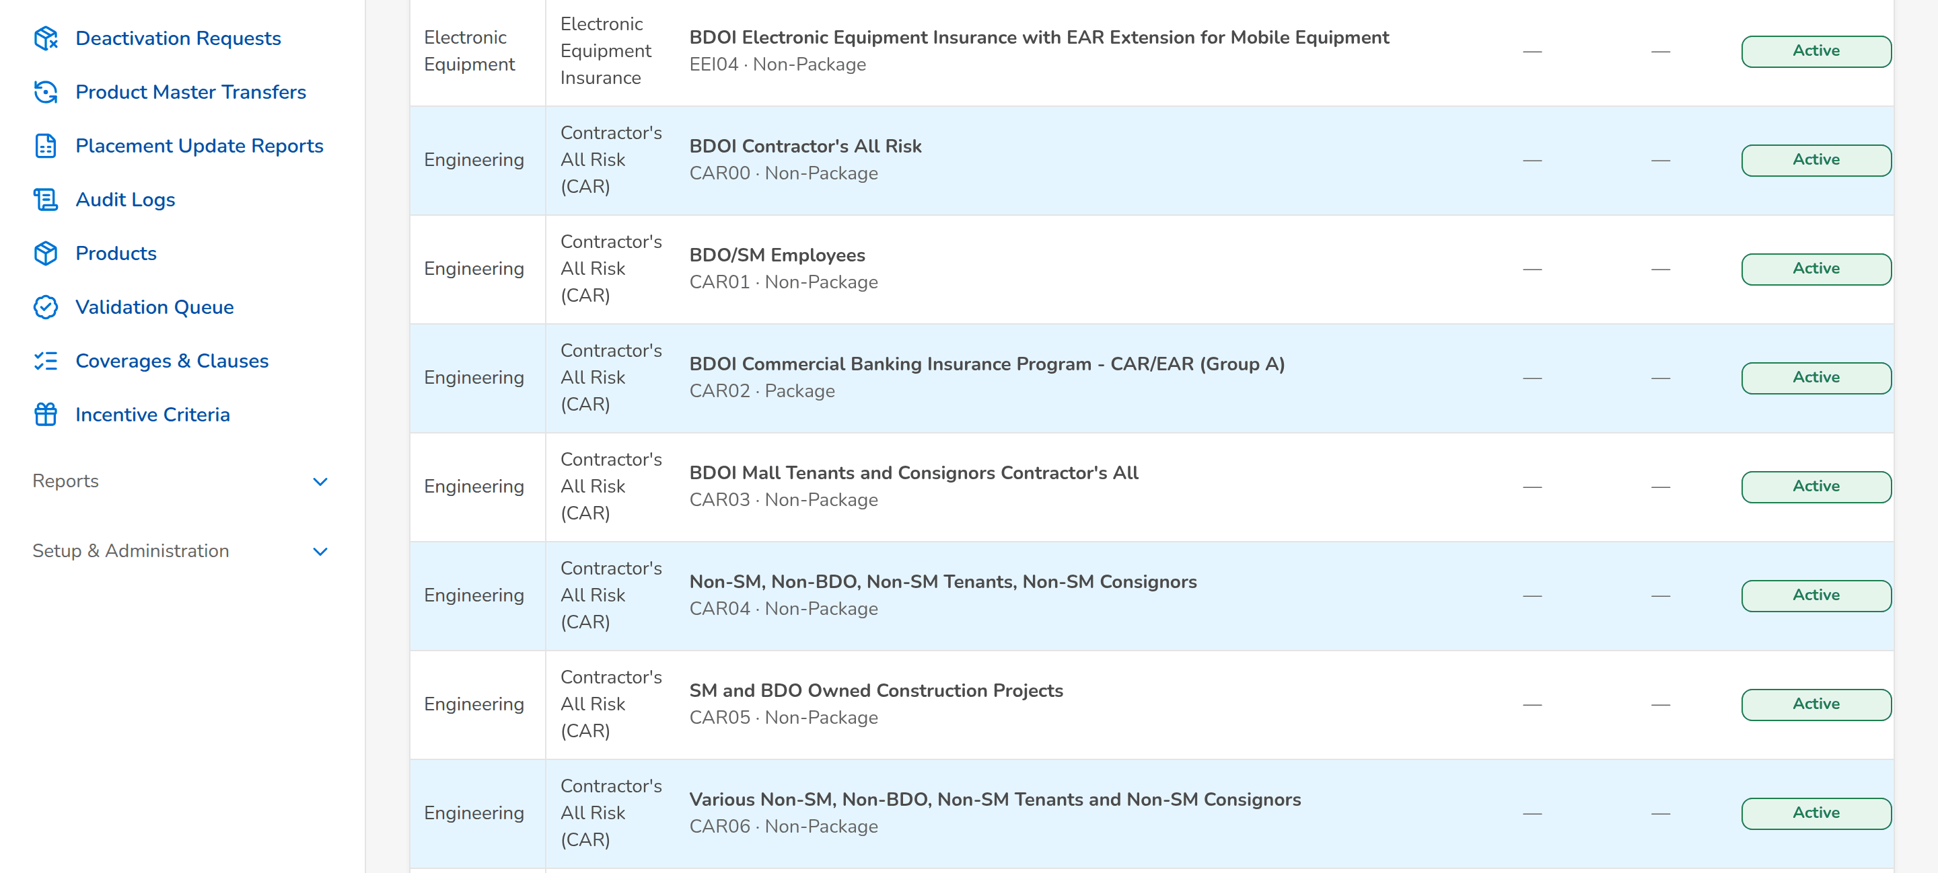
(continued below)
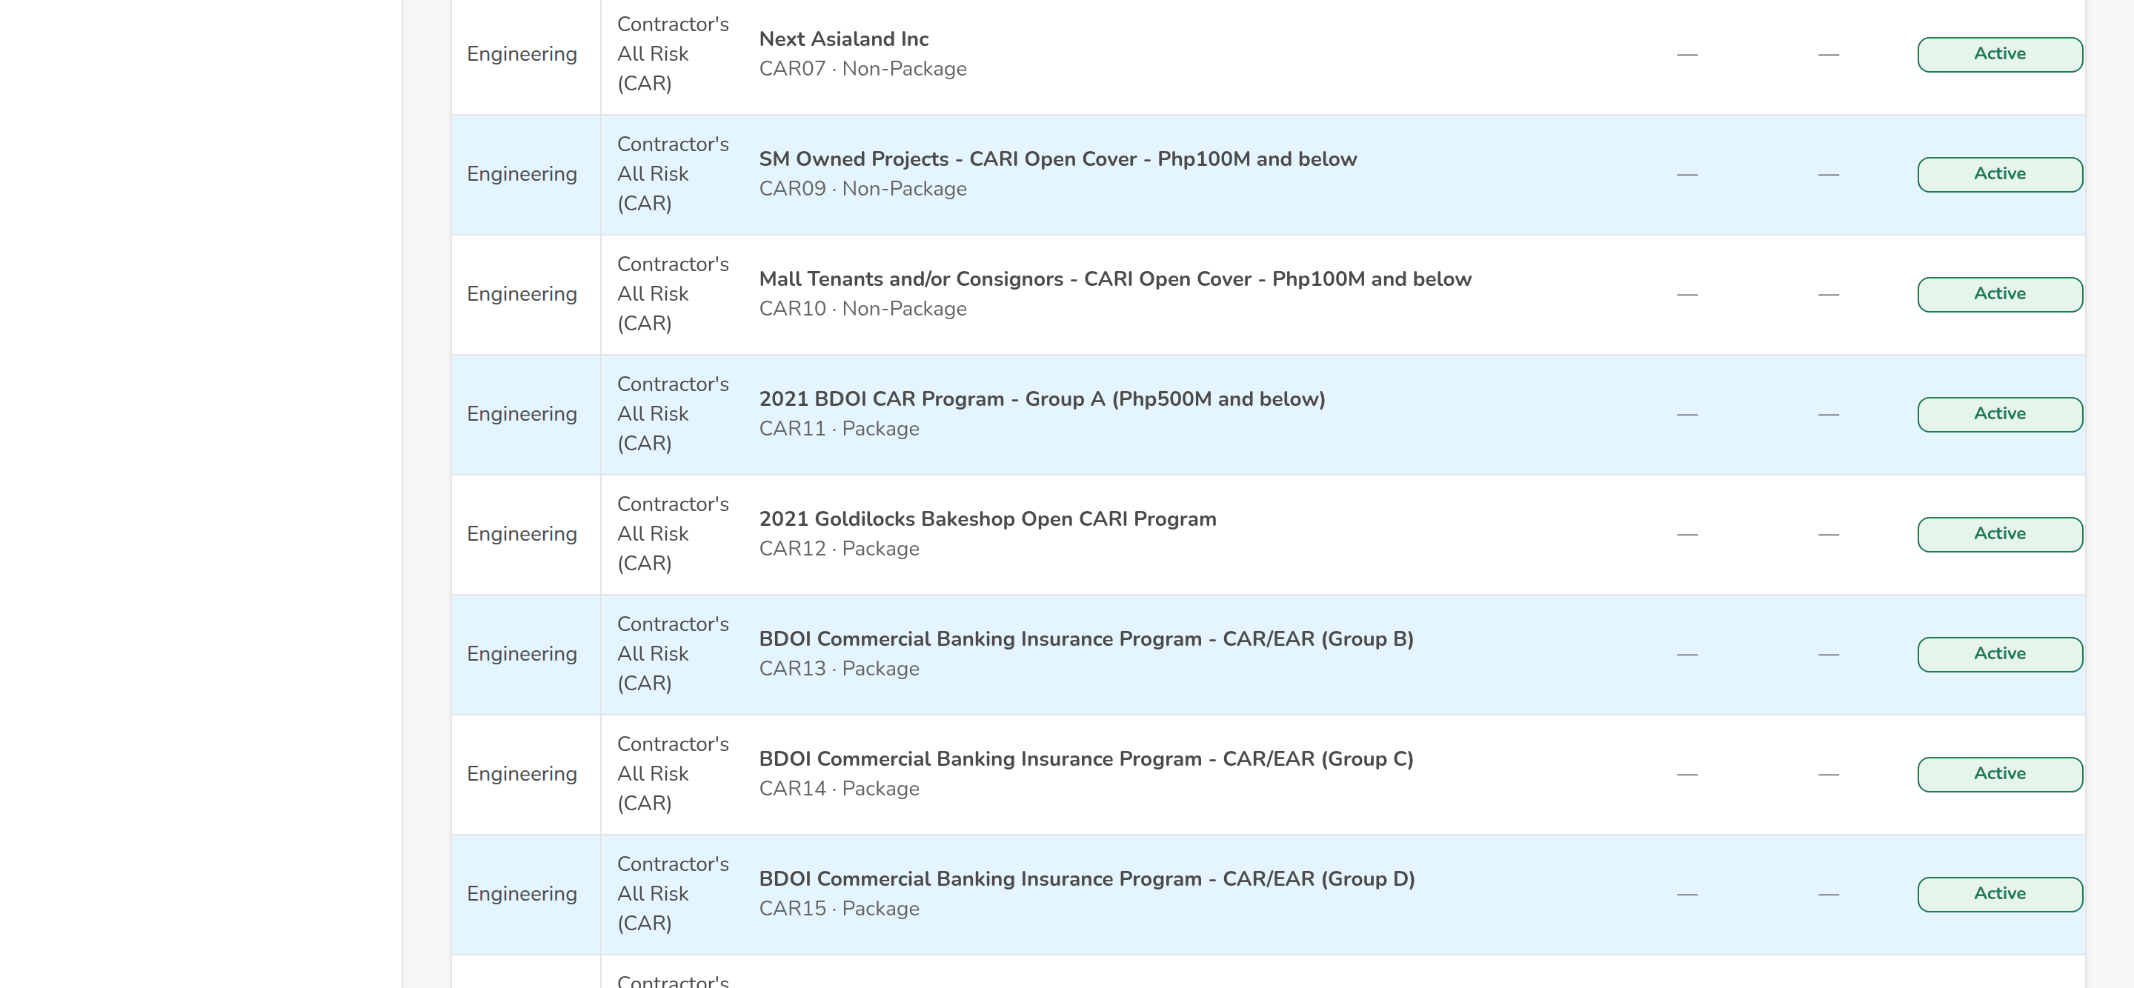
Figure G.1: Product Maintenance Home: the Product Matrix
Field | Type | Mandatory | Format / list / source | Validation and message
Product Matrix: Active Products / Expiring Products (90 days) / Expired Products | Tab | - | Products in force, ending within 90 days, ended; Products and package versions | -
Product Matrix: Search Package Name or Risk Code | Text | N | Part of the name or the risk code | -
Product Matrix: Line of Insurance / Product Type | Filters | N | Line names; Package, Non-Package; Product lines; fixed list | -
Product Matrix: Line of Insurance / Sub-Line / Package Name | Columns | - | Line; sub-line; name with the risk code and Package or Non-Package; Products | -
Product Matrix: Package Description / Insurer / Status | Columns | - | Description; insurer of the package; Active, Expiring, Expired, Deactivated; Products | -
Product Matrix: Effective Date / Expiry Date | Columns | - | dd-MMM-yyyy; Package versions | -
Product Matrix: Last Updated By / Last Updated Date | Columns | - | Name; dd-MMM-yyyy; Products | -
Quotation Request List: Search Request Number or Assured / Open Requests Only | Text; check box | N | Part of the number or the name | -
Quotation Request List: Quotation Request Number / Related Reference Number / Business Type / Assured's Name | Columns | - | PRF-yyyy-nnnnnn with its date; ARN; New Business or Renewal; name; Proposal requests | -
Quotation Request List: Product Line / Account Officer / Assigned TSU User / Submission Date | Columns | - | Line; names; dd-MMM-yyyy; Proposal requests | -
Quotation Request List: Effective / Expiry Date / Current Status / Aging (Days) | Columns | - | Period; status; working days since the submission; Proposal requests | -
Package Request List: Search Request Number or Package | Text | N | Part of the number or the name | -
Package Request List: Package Request Number / Reference Number / Request Type / Product Line | Columns | - | PKR-yyyy-nnnnnn; package code; type; line; Package requests | -
Package Request List: Account Officer / Assigned TSU User / Submission Date / Current Status | Columns | - | Names; dd-MMM-yyyy; status; Package requests | -

Action | Who | Available when | What happens | Resulting status
New Package Request | Marketing AO, Marketing TL, TSU Officer (package request right) | Always | Opens the New Package Request form | -
Excel / PDF / CSV | Every user of the screen | Always | Exports the Product Matrix of the filters on screen, named by the convention <name>_MMDDYYYY | -
View Package / Update Package | Every user; Update Package for MBS while direct maintenance is on | A row of the Product Matrix | Opens the product record, or its editor for the update with approval | -
View Quotation Request | Every user of the screen | A row of the Quotation Request List | Opens the proposal request (SCR-PM-28) | -
[A row of the Package Request List] | Every user of the screen | Always | Opens the package request (SCR-PM-04) | -

Rules:
- The lists are those of the company selected in the page header (FRPM.001.01).
- Expiring Products lists the packages that end within 90 days, the alert period of BDOI's FRPM.004.01 (FRPM.004.01, FRPM.001.01).
- The Product Matrix is maintained directly by MBS with approval while the setting Direct maintenance of the Product Matrix is on (as delivered); with the setting off new packages come only from package requests (FRPM.003.01, FRPM.001.01).

G.2 Package Requests (SCR-PM-02)
Purpose: The work list of package requests of the company, by stage, from the draft to the released or closed request. Team leaders assign the selected requests of one stage to a user of the team.
Access: Product Maintenance Home › a stage tile (opens the tab of the stage); Package Request record › back arrow
Requirements: FRPM.001.01, FRPM.002.02, FRPM.003.06, FRPM.003.07, FRPM.011.01, FRPM.011.03, FRPM.015.01, FRPM.016.01, FRPM.017.01, FRPM.028.01
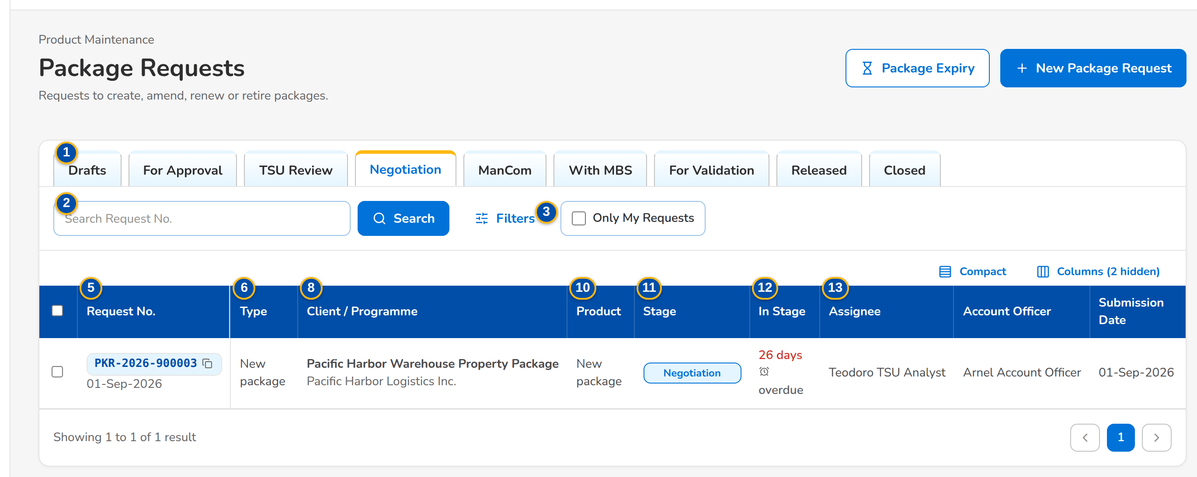
Figure G.2: Package Requests, Negotiation tab
Field | Type | Mandatory | Format / list / source | Validation and message
Tabs: Drafts / For Approval / TSU Review / Negotiation / ManCom / With MBS / For Validation / Released / Closed | Tab | - | Fixed | Each tab lists its stages: TSU Review = TSU review and TSU Head approval; Negotiation = negotiation, terms review, Marketing review and requirements; Closed = retired, not proceeded and voided
Search: Search Request No. | Text | N | PKR-yyyy-nnnnnn, part of a number allowed | Contains search on the request number
Search: Only My Requests | Check box | N | - | Requests created by the user or assigned to the user
Filters: Request type | Drop-down | N | All types, New package, Amend package terms, Update package details, Renew package, Retire package, Reactivate expired package; Fixed list | -
List: Request No. | Column | - | PKR-yyyy-nnnnnn with the creation date under it; Package request | -
List: Type | Column | - | Request type; Package request | -
List: Scope | Column | - | Generic or Client-specific tag; Package request | -
List: Client / Programme | Column | - | Package or programme name, with the client name or Programme under it; Package request | -
List: Line | Column | - | Product line; Package request | -
List: Product | Column | - | Risk code and resulting version (v2), or New package; Package request | -
List: Stage | Column | - | Status pill; Workflow | -
List: In Stage | Column | - | n days, with overdue or due soon; Workflow | Red when past the due time
List: Assignee | Column | - | User or a dash; Workflow | -

Action | Who | Available when | What happens | Resulting status
Package Expiry | Every user of the screen | Always | Opens Package Expiry | -
New Package Request | Marketing AO, Marketing TL, TSU Officer | Always | Opens the New Package Request form | -
Assign | Team leaders | Rows of one stage are selected | Opens Assign Package Requests: choose a user of the team of the stage, or Team queue (unassigned), and click Assign | Unchanged
Filters | Every user of the screen | Always | Shows or hides the request type filter | -
[Open a row] | Every user of the screen | Always | Opens the package request | -

Rules:
- The list shows the requests of the company selected in the page header (FRPM.002.02).
- Assign is offered only for requests of one stage; the assignee is chosen among the users who work that stage (FRPM.002.02).
- The time in stage turns red when the stage due time has passed (FRPM.001.01).

G.3 New Package Request and Edit Package Request (SCR-PM-03)
Purpose: The Package Request Form. Marketing or TSU describe the package: the request type and scope, the package or programme name, the client of a client-specific package, the product line, cover type and product, the reason, the requested terms by section and coverage, the requested rate scheme and package term, and the insurers to approach. The draft is saved at any time; submission checks that the request is complete. The TSU Team Lead can complete the form during the TSU review.
Access: Package Requests › New Package Request; Product Maintenance Home › New Package Request; Package Request record › Edit (draft, or TSU review for the TSU Team Lead); Package Expiry › Generate Renewal Request (opens the drafted renewal request)
Requirements: FRPM.003.01, FRPM.003.02, FRPM.003.04, FRPM.003.06, FRPM.003.07, FRPM.011.02, FRPM.022.01
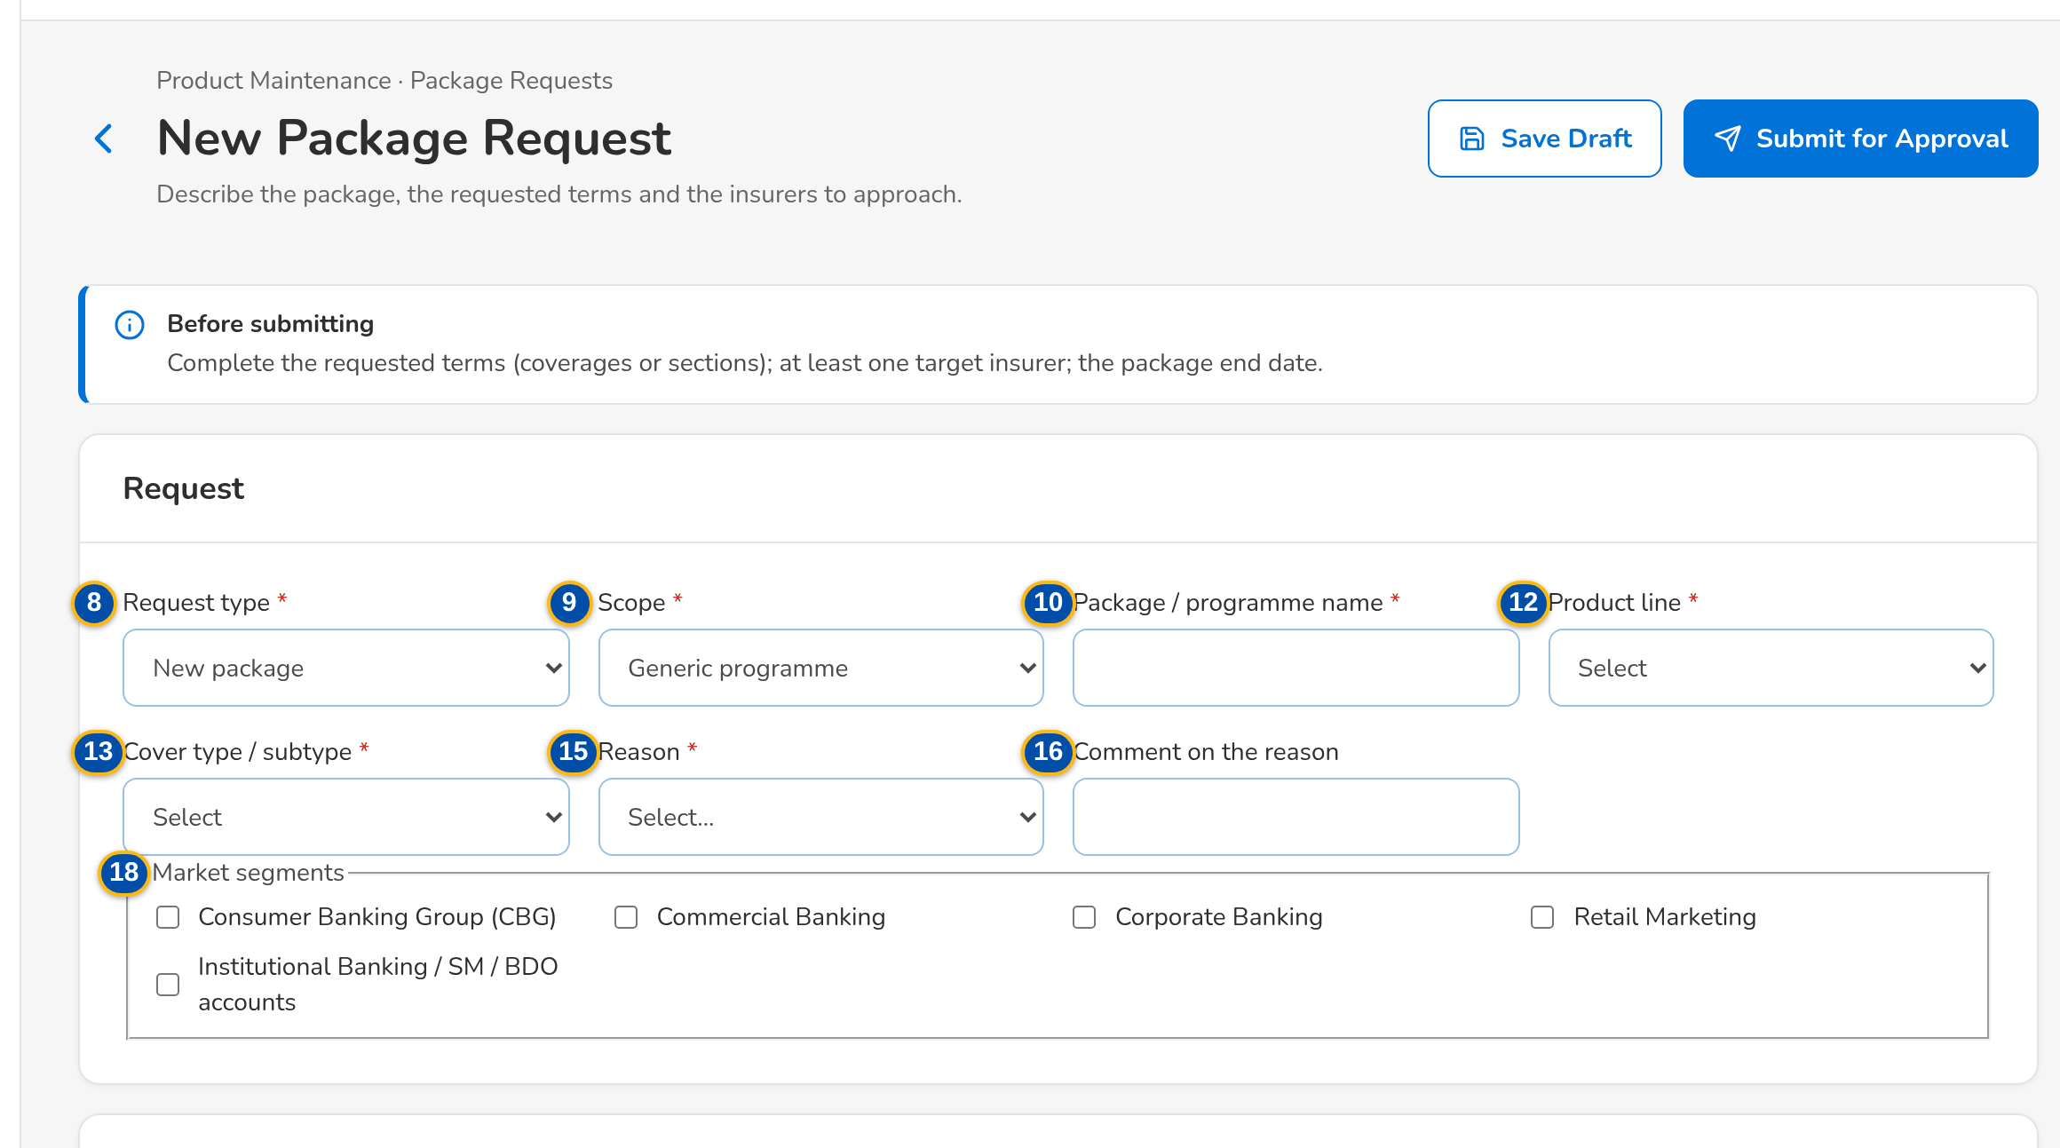
(continued below)
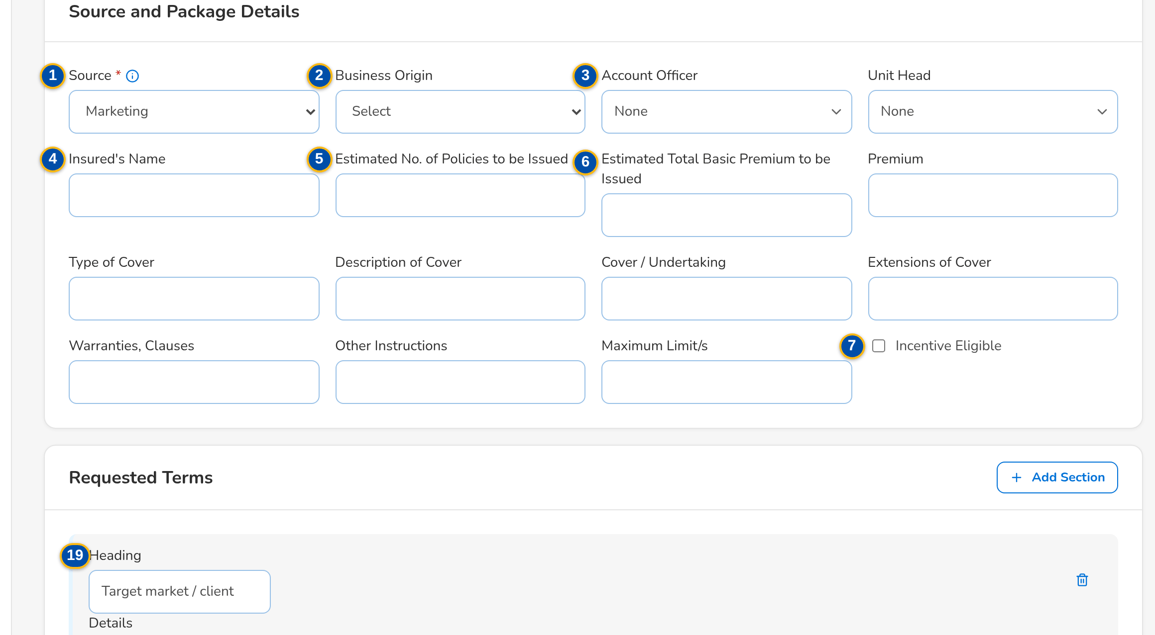
(continued below)
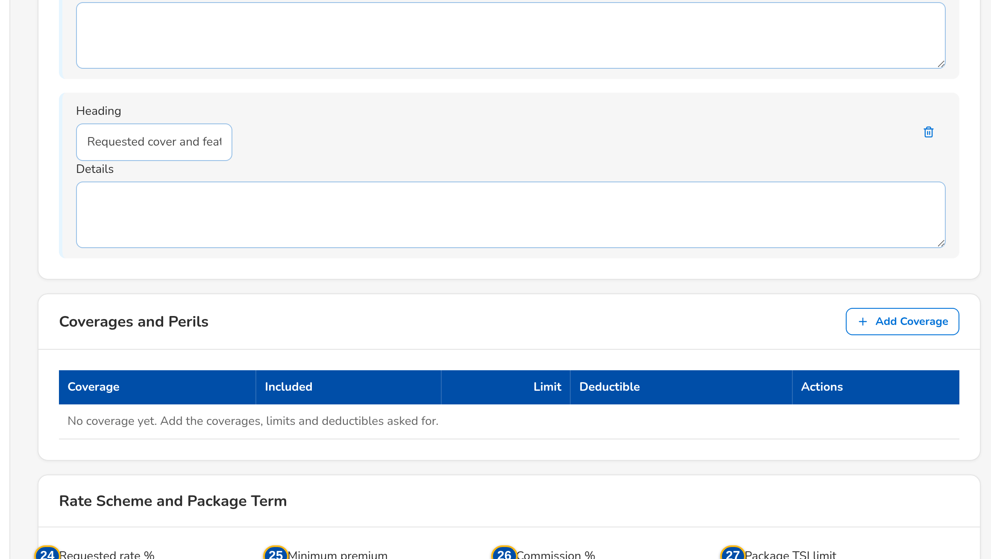
Figure G.3: New Package Request form
Field | Type | Mandatory | Format / list / source | Validation and message
Source and Package Details: Source | Radio buttons | Y | Marketing (Marketing approval first, then TSU review), TSU (goes to TSU review at once), Insurer; Fixed list | -
Source and Package Details: Business Origin | Drop-down | N | Bank referral, Direct client, Insurer offer, Affinity or programme; List of values | -
Source and Package Details: Account Officer / Unit Head | Look-up | N | Names of the Marketing users; Users | -
Source and Package Details: Insured's Name / Type of Cover / Description of Cover / Cover / Undertaking / Extensions of Cover / Warranties, Clauses / Other Instructions / Maximum Limit/s / Premium | Text | N | As BDOI's Annex E of the request form | -
Source and Package Details: Estimated No. of Policies to be Issued | Number | N | Whole number | At least the least number of policies (20 as delivered); Enter at least 20 policies
Source and Package Details: Estimated Total Basic Premium to be Issued | Number | N | Amount in PHP | At least the least premium (5,000,000.00 as delivered); Enter at least 5,000,000.00
Source and Package Details: Incentive Eligible / Incentive Amount / Incentive Commission Rate (%) | Check box; numbers | Cond.: amount or rate when eligible | Amount in PHP; percentage | Amount above zero; rate above 0% and at most 100%; Enter the incentive amount or the incentive commission rate
Request: Request type | Drop-down | Y | New package, Amend package terms, Update package details, Renew package, Retire package, Reactivate expired package; List request type list | The type of a saved request cannot change; The type of a request cannot change
Request: Scope | Drop-down | Y | Generic programme or Client-specific package; Fixed list | Select the request type and the package scope
Request: Package / programme name | Text | Y | Up to 200 characters | Not blank; Enter the package or programme name
Request: Client or prospect | Look-up | Cond.: client-specific package | Client code or name; Client master (BRD-1) | An active client; Select the client
Request: Product line | Drop-down | Y | Line name; Product lines | An existing line; Select the product line
Request: Cover type / subtype | Drop-down | Cond.: New package | Cover types of the line; Cover types | A cover type of the chosen line; Select the cover type
Request: Package product | Drop-down | Cond.: every type except New package | Code – name of the packaged products of the line; Products flagged Package | A packaged product of the chosen line; Select the package product
Request: Reason | Drop-down | Y | Client requirement, New programme for a market segment, Market competitiveness, Change in insurer terms or rates, Loss experience, Regulatory change, Package expiry or anniversary, Others; List request reason list | An active value of the list; Select the reason
Request: Comment on the reason | Text | N | Up to 500 characters | -
Request: Negotiate with the insurers | Check box | N | Shown for Renew, Update and Reactivate | New and Amend always negotiate; Retire never
Request: Market segments | Check boxes | N | One or more; List market segment list | Active values of the list
Requested terms: Heading / Details | Text | Cond.: sections or coverages before submission | Heading and up to 4,000 characters per section; suggested sections Target market / client and Requested cover and features | Empty sections are dropped; Complete the request: the requested terms (coverages or sections)
Coverages and perils: Coverage | Drop-down | Cond.: sections or coverages before submission | Name of each active coverage of the product line, (basic) after a basic coverage; Choose the line first until a product line is chosen; Coverages of the line | Every line has a coverage; Enter a code for every coverage or remove the line
Coverages and perils: Included | Check box | N | - | -
Coverages and perils: Limit | Number | N | Amount in PHP | Zero or more; Rates and amounts cannot be negative
Coverages and perils: Deductible | Text | N | Wording, for example 1% of loss, minimum PHP 20,000 | -
Rate scheme and package term: Requested rate % | Number | N | Up to four decimals | Zero or more; Rates and amounts cannot be negative
Rate scheme and package term: Minimum premium | Number | N | Amount in PHP | Zero or more; Rates and amounts cannot be negative
Rate scheme and package term: Commission % | Number | N | Percentage | Zero or more; Rates and amounts cannot be negative
Rate scheme and package term: Package TSI limit | Number | N | Amount in PHP | Zero or more; Rates and amounts cannot be negative
Rate scheme and package term: Effective from | Date | N | dd-MMM-yyyy | -
Rate scheme and package term: Package start | Date | N | dd-MMM-yyyy | -
Rate scheme and package term: Package end | Date | Cond.: before submission (not for Retire) | dd-MMM-yyyy; monitored for expiry and renewal | After the package start; The package end date must be after its start date
Rate scheme and package term: Anniversary | Date | N | dd-MMM-yyyy | -
Target insurers: [Insurer check boxes] | Check boxes | Cond.: at least one when the insurers are approached | Name of each insurer of the panel; Insurers (authorised, active) | Authorised and active insurers; Complete the request: at least one target insurer
Documents: [Documents panel] | Upload | N | See Common screen elements; Document types | File checks of every upload; Save the draft to attach the supporting documents.

Action | Who | Available when | What happens | Resulting status
Load Current Terms | Users of the form | Type other than New package and a package product chosen | Copies the terms of the version in force (coverages, rate scheme, dates, insurers) into the requested terms; the sections typed stay | Unchanged
Save Draft | Marketing AO, Marketing TL, TSU Officer; TSU Team Lead during the TSU review | No field message on the form | Checks the fields and saves the draft; a new request is numbered PKR-yyyy-nnnnnn | Draft request (new); unchanged (edit)
Submit for Approval | As Save Draft | No field message on the form | Saves the request, checks that it is complete (requested terms, target insurers when negotiated, package end date, cover type of a new package) and sends it to Marketing approval | For Marketing approval

Rules:
- The request number PKR-yyyy-nnnnnn is given at the first save (parameter request number prefix) (FRPM.011.02).
- A new package needs its cover type; every other type needs the packaged product it changes, of the chosen line (FRPM.003.01, FRPM.011.02).
- A client-specific package needs an active client of the client master (FRPM.011.02).
- New and Amend always go to the insurers; Retire never; Renew, Update and Reactivate go to the insurers only when Negotiate with the insurers is ticked (FRPM.011.02, FRPM.003.04).
- Before submission the request needs its requested terms (coverages or sections), at least one target insurer when negotiated, and the package end date; a retirement needs none of these (FRPM.011.02).
- What is still missing for the submission is shown in the information notice Before submitting above the form; the coverages are chosen by name from the coverages of the product line (FRPM.011.02).
- The type and the product of a saved request cannot change (FRPM.011.02).
- A request from Marketing goes to the Marketing approval first; a request from TSU or from an insurer goes to the TSU review at once (FRPM.011.02, FRPM.011.02).
- The least estimated number of policies and the least estimated total basic premium are settings (20 and 5,000,000.00 as delivered) (FRPM.011.02).
- A draft is edited by the Marketing or TSU users who create requests; during the TSU review, by the TSU Team Lead (FRPM.011.02, FRPM.011.03).

G.4 Package Request record (SCR-PM-04)
Purpose: One package request: its number, stage and flags, the key facts (type, client or programme, line and product, scheme rate, package term, insurers), the workflow header (stage stepper, then Current Stage, Since, Due and Assigned To) with the actions of the stage, and the tabs Details, Requested Terms, Negotiation, Comparative, Requirements & Sign-off, Set-up, Advisories, Documents, E-mails, History, Routing & Approvals and Audit Logs. This section specifies the header, the stage actions and the tabs Details, Requested Terms, Documents, E-mails, History and Audit Logs; the other tabs have their own sections (SCR-PM-05 to SCR-PM-08, Routing & Approvals SCR-PM-29).
Access: Package Requests › a row; TSU Workbench › a row; A workflow notice or an assignment notice (bell); Package Expiry › the renewal request number
Requirements: FRPM.001.01, FRPM.002.02, FRPM.003.06, FRPM.003.07, FRPM.011.01, FRPM.011.02, FRPM.011.03, FRPM.015.01, FRPM.016.01, FRPM.017.01, FRPM.021.01, FRPM.021.02, FRPM.028.01
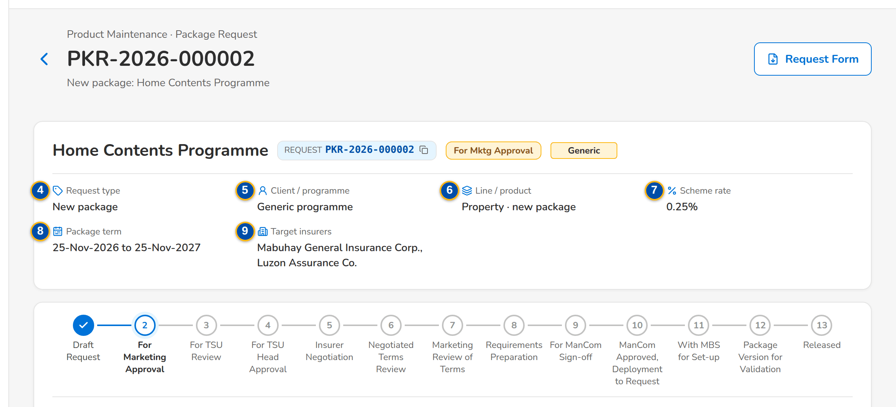
(continued below)
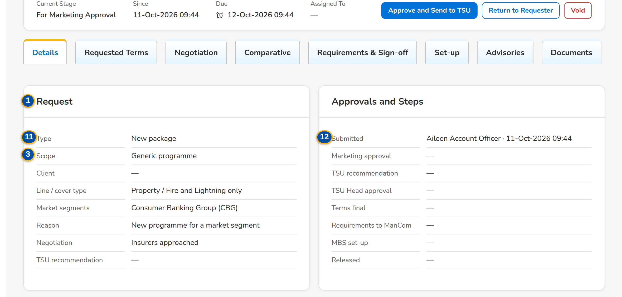
Figure G.4: Package request waiting for the Marketing approval, Details tab
Field | Type | Mandatory | Format / list / source | Validation and message
Header: Request | Reference chip | - | PKR-yyyy-nnnnnn; Package request | -
Header: [Stage pill] | Pill | - | Stage of the request; Workflow | -
Header: [Scope and negotiation tags] | Tag | - | Generic or Client-specific; No negotiation; Package request | -
Header: Request type | Fact | - | Request type; Package request | -
Header: Client / programme | Fact | - | Client name or Generic programme; Package request | -
Header: Line / product | Fact | - | Line · risk code and resulting version, or new package; Package request | -
Header: Scheme rate | Fact | - | Rate % of the proposed terms, else of the requested terms; Terms | -
Header: Package term | Fact | - | Package start – package end; Terms | -
Header: Target insurers / Chosen insurers | Fact | - | Insurer codes; the chosen insurers once the terms are final; Terms | -
Workflow: [Stage stepper and meta row] | Panel | - | The stages of the request in order, the current one highlighted; Current Stage, Since, Due, Assigned To; Workflow | Overdue pill after the due time
Details › Request: Type / Scope / Client / Line / cover type / Market segments / Reason / Negotiation / TSU recommendation | Detail | - | As entered on the form; Negotiation: Insurers approached or No negotiation; Package request | -
Details › Approvals and steps: Submitted / Marketing approval / TSU recommendation / TSU Head approval / Terms final / Requirements to ManCom / MBS set-up / Released | Detail | - | User · dd-MMM-yyyy HH:mm, or a dash; Request milestones | -
Requested Terms: [Sections, coverages, rate scheme, dates and insurers] | Read-only view | - | Sections; Coverage, Included, Limit, Deductible; Rate / minimum premium; Commission / TSI limit; Computation basis; Effective from; Package term; Insurer, Role, Share %, Rate %, Minimum; Requested terms | -
History › Status history: Stage / From Stage / Action / By / Date and Time / Remarks / Duration in Stage | Table | - | Newest first; Workflow history | -
History › Insurer response revisions: Changed / By / Rev. / Outcome / Rate % / Remarks | Table | - | Every saved revision of every insurer response; Response history | No insurer response keyed in yet
Documents: [Documents panel] | Table and upload | - | See Common screen elements; Attachments of the request | File checks
E-mails: [Sent e-mails] | Table | - | Recipient, subject, attachments, status; Outbound messages of the request | -
Audit Logs: Timestamp / Action Type / Description / Old Value / New Value / Performed By / Remarks | Table | - | Every change of the request, newest first; CSV and Excel exports; Audit trail | No activity recorded yet.

Action | Who | Available when | What happens | Resulting status
Request Form | Every user of the screen | Always | Downloads the Package Request Form (PDF) with the requested terms | Unchanged
Edit | requesters in Draft; TSU Team Lead in For TSU review | Draft or For TSU review | Opens Edit Package Request | Unchanged
Submit for approval | requesters | Draft; the request is complete | Checks completeness and submits | For Marketing approval
Approve and send to TSU | Marketing TL / TH / UH | For Marketing approval; the user is not the maker or the submitter | Records the Marketing approval | For TSU review
Return to requester | Marketing TL (For Marketing approval); TSU Team Lead (For TSU review); TSU Head (For TSU Head approval) | Those stages | Opens the reason dialog (Return reason, mandatory; Comment) and returns the request | Draft request
Void | The requester (Draft, For Marketing approval); the Marketing approver; the TSU Team Lead; the TSU Head | Draft to For TSU Head approval | Opens the reason dialog (Void reason, mandatory) and closes the request without a package | Voided
Recommend for approval | TSU Team Lead | For TSU review | Opens Recommend for Approval: the Recommendation (mandatory, up to 2,000 characters) is kept on the request and shown to the TSU Head | For TSU Head approval
Approve for negotiation | TSU Head | For TSU Head approval; the request is negotiated; the user is not the recommender | Approves the request and opens negotiation round 1 with the target insurers | Insurer negotiation
Approve without negotiation | TSU Head | For TSU Head approval; no negotiation (Retire, or Renew, Update, Reactivate without insurers) | The requested terms become the proposed terms; the request goes to ManCom | For ManCom sign-off
Not proceeded | TSU Officer or TSU Head (Insurer negotiation); Marketing (Marketing review of terms) | Those stages | Opens the reason dialog (Not proceeded reason, mandatory) and closes the request | Not proceeded
Release terms to Marketing | TSU Head | Negotiated terms review; client-specific package | Sends the negotiated terms to Marketing for the client | Marketing review of terms
Proceed to requirements (generic package) | TSU Head | Negotiated terms review; generic programme | Skips the Marketing review | Requirements preparation
Accept terms | Marketing | Marketing review of terms | Records the client's acceptance of the terms | Requirements preparation
Request changes | Marketing | Marketing review of terms | Opens the reason dialog; the latest round stays open so that TSU revises the slip or makes the terms final again | Insurer negotiation
Return to TSU | ManCom | For ManCom sign-off | Opens the reason dialog; the return is kept as a ManCom decision Returned | Requirements preparation
Retire package | MBS | With MBS for set-up; request type Retire | Retires the product: it is no longer sold; its versions stay readable; the retirement advisory is drafted and incentive criteria on the product are flagged | Package retired
Return incomplete requirements to TSU | MBS | With MBS for set-up | Opens Return Incomplete Requirements (Return reason, mandatory; Comment; Return to TSU) | Requirements preparation

Rules:
- A request is never approved by its maker or submitter, and the TSU Head approval is never given by the recommender (FRPM.011.02, FRPM.011.03).
- The TSU Team Lead's recommendation is mandatory and is shown to the TSU Head (FRPM.011.03).
- Return, void, not proceeded and request changes need a reason from their list of values; the comment is kept in the history (FRPM.011.02, FRPM.001.01).
- The actions of the stage stay on one row of the step bar; an action that closes the request off its path (Not Proceeded, Void) is shown in red (FRPM.001.01).
- Void is possible from the draft to the TSU Head approval; after that a request ends as not proceeded, released or retired (FRPM.001.01).
- Every stage has a due time from its service level hours (parameters the service level settings*): Marketing approval 24, TSU review 24, TSU Head approval 24, negotiation 120, ManCom 72, MBS set-up 48 hours by default (FRPM.001.01).
- Every action is written to the history and the audit trail; audit rows cannot be changed or deleted (FRPM.021.01).

G.5 Package Request record: Negotiation tab (SCR-PM-05)
Purpose: The negotiation with the insurers, one card per round, newest first. TSU prepares the quotation slip of the round (insurers and notes), a TSU Team Lead or a co-officer approves it and the system e-mails it to each insurer, password protected. TSU keys in each insurer's reply with its outcome, rate and terms; a further round revises the slip. When every insurer has answered, TSU makes the terms final with the insurers the package takes.
Access: Package Request record › Negotiation tab
Requirements: FRPM.012.01, FRPM.012.02, FRPM.012.03, FRPM.013.01, FRPM.027.01
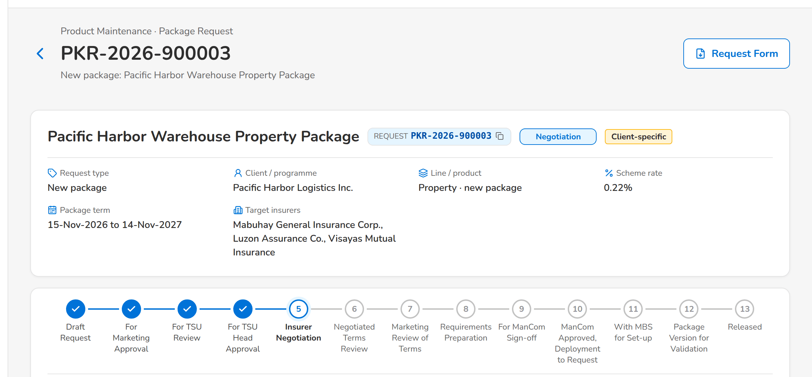
(continued below)
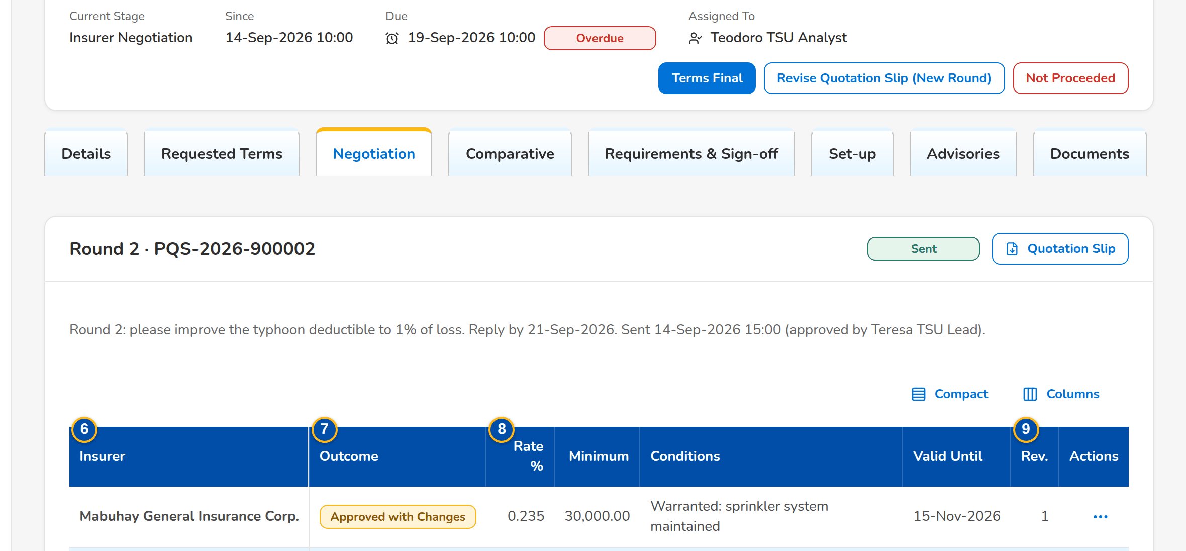
(continued below)
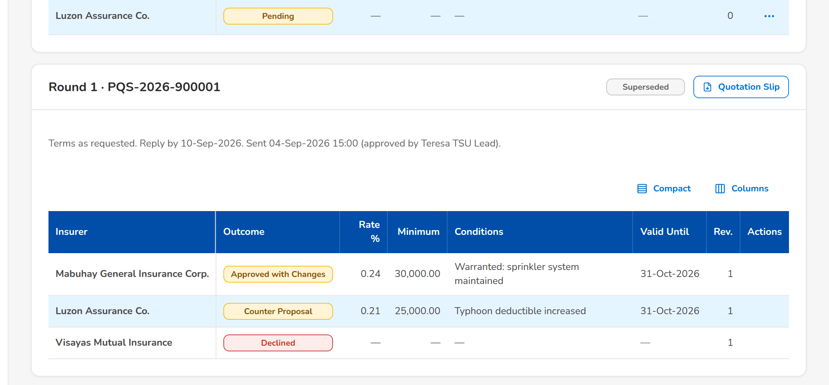
Figure G.5: Negotiation tab: round 2 sent, round 1 closed with three outcomes
Field | Type | Mandatory | Format / list / source | Validation and message
Round card: [Round n · slip number] | Card title | - | Round number and quotation slip number; Negotiation round | -
Round card: [Round status pill and Locked tag] | Pill | - | Preparation, For approval, Sent, Superseded; Locked after the ManCom sign-off; Negotiation round | -
Round card: [Round note] | Text | - | Notes of the round; Reply by dd-MMM-yyyy; Sent dd-MMM-yyyy HH:mm (approved by user); Negotiation round | -
Slip preparation: [Insurer check boxes] | Check boxes | Y (at least one) | Insurers of the round; Insurers (authorised, active) | At least one insurer; each insurer authorised and with a placement e-mail; Select at least one insurer for the quotation slip
Slip preparation: Notes to the insurers | Text | N | Up to 4,000 characters | -
Responses: Insurer | Column | - | Insurer name; Insurer response | -
Responses: Outcome | Column | - | Pending, Accepted as requested, Approved with changes, Counter-proposal, Declined, No response; Insurer response | -
Responses: Rate % / Minimum / Conditions / Valid Until | Column | - | As keyed in; Insurer response | -
Responses: Rev. | Column | - | Revision number of the response; Insurer response | -
Responses: [Row action menu] | Row action menu | - | Key In and Resend of the insurer's row | -
Terms of <insurer>: Outcome | Drop-down | Y | Accepted as requested, Approved with changes, Counter-proposal, Declined, No response; List response outcome list | An active value of the list
Terms of <insurer>: Rate % | Number | Cond.: an offer (accepted, approved with changes, counter-proposal) | Up to four decimals | Zero or more; Enter the rate offered
Terms of <insurer>: Minimum premium | Number | N | Amount in PHP | Zero or more; Rates and amounts cannot be negative
Terms of <insurer>: Valid until | Date | N | dd-MMM-yyyy | -
Terms of <insurer>: [Deductible per coverage] | Text | N | One field per requested coverage; Requested coverages | -
Terms of <insurer>: Conditions and warranties | Text | N | Up to 2,000 characters | -
Terms of <insurer>: Remarks | Text | N | Up to 1,000 characters | -
Terms of <insurer>: Response document | File | N | The insurer's reply (PDF, e-mail or image) | File checks of every upload; The file could not be read
Terms Final: [Offer check box] | Check box | Y (at least one) | Insurer name · rate %, one per insurer that offered terms in the latest round; Latest round | Only insurers that offered terms; Choose the insurer(s) whose terms the package takes
Terms Final: Role | Drop-down | Y | Panel, Lead, Participant; Fixed list | -
Terms Final: Share % | Number | Cond.: co-insurance (lead and participants) | Co-insurance share | Shares given for every co-insurer and totalling 100; Co-insurance shares must be given for every insurer and total 100
Terms Final: Comment | Text | N | Up to 1,000 characters | -
Revise Quotation Slip: [Insurer check boxes] | Check boxes | Y (at least one) | Insurers of the next round; Insurers | -
Revise Quotation Slip: What changes in this round | Text | N | Up to 4,000 characters | -

Action | Who | Available when | What happens | Resulting status
Save Slip | TSU Officer or Team Lead | Round in preparation | Saves the insurers and notes of the slip | Round in preparation
Submit for Approval | TSU Officer or Team Lead | Round in preparation; at least one insurer | Saves the slip, numbers it PQS-yyyy-nnnnnn and sets the reply date (today + insurer reply days, 5 days) | Round for approval
Approve and Send | TSU Team Lead or a co-officer, not the preparer | Round for approval | Approves the slip and e-mails it to each insurer, password protected; a pending response is opened per insurer | Round sent
Quotation Slip | Every user of the screen | The slip is numbered | Downloads the quotation slip PDF of the round | Unchanged
Key In | TSU | Round sent, open and not locked | Opens Terms of <insurer> from the row action menu | Unchanged
Save Terms | TSU | Outcome chosen; a rate for an offer | Saves the response as a new revision (the previous values stay in the history) and attaches the response document | Response outcome
Resend | TSU | Round sent, open and not locked | From the row action menu: e-mails the slip again to that insurer | Unchanged
Revise quotation slip (new round) | TSU | Insurer negotiation; the latest slip was sent | Opens Revise Quotation Slip; Open New Round closes the sent round and opens round n+1 with the chosen insurers | Insurer negotiation (round n+1)
Terms final | TSU | Insurer negotiation; every insurer of the latest round has an outcome | Opens Terms Final; Make Terms Final records the chosen insurers with role and share as the proposed terms and compiles the comparative master | Negotiated terms review

Rules:
- A quotation slip is approved by a TSU Team Lead or a co-officer, never by its preparer (FRPM.012.01).
- Each insurer receives its own protected e-mail; an insurer without a placement e-mail address stops the sending (FRPM.012.01, FRPM.027.01).
- An offer (accepted as requested, approved with changes, counter-proposal) needs the rate offered; every change of a response is kept as a revision (FRPM.012.02).
- Only the latest round is keyed in; a sent round is revised through a new round, never changed (FRPM.012.03).
- The terms are final only when every insurer of the latest round has an outcome and the chosen insurers offered terms; co-insurance shares total 100 (FRPM.013.01).
- The slips are locked at the ManCom sign-off (FRPM.014.01).

G.6 Package Request record: Comparative tab (SCR-PM-06)
Purpose: The comparison of the insurer terms of the latest round, the one current comparative master kept for audit, the client views derived from it for a client presentation, and the comparative table with the options of each insurer and the final terms, from which the proposal slips per insurer are generated (as for the quotation requests, SCR-PM-28). Every output is stored with its PDF and Excel file.
Access: Package Request record › Comparative tab
Requirements: FRPM.012.02, FRPM.012.04
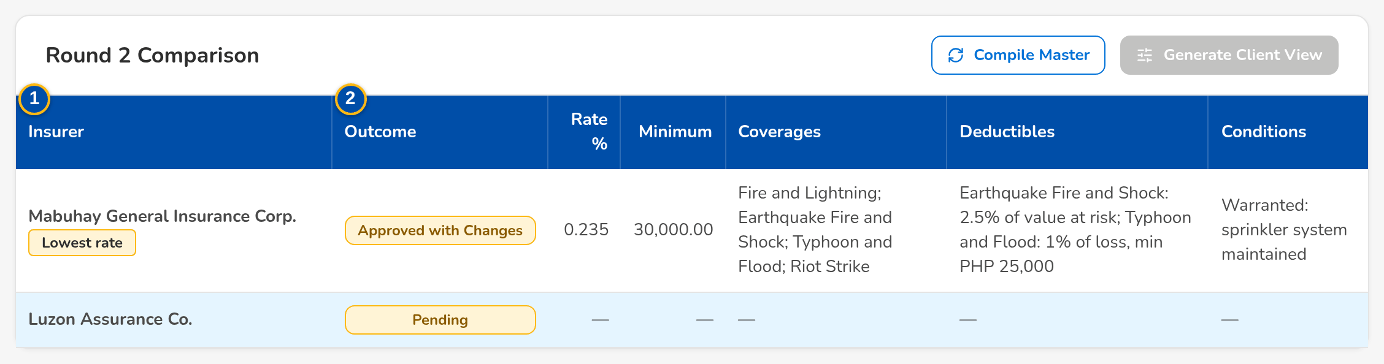
Figure G.6: Comparative tab with the round 2 comparison and the stored outputs
Field | Type | Mandatory | Format / list / source | Validation and message
Round n comparison: Insurer | Column | - | Insurer name, with the Lowest rate tag; Latest round | No insurer terms to compare yet
Round n comparison: Outcome / Rate % / Minimum / Coverages / Deductibles / Conditions | Column | - | As keyed in; Insurer responses | -
Stored outputs: Output | Column | - | Title, with Audit master or Client view and the round; Comparative outputs | No comparative output yet
Stored outputs: Status | Column | - | Current or Superseded (master); Comparative outputs | -
Stored outputs: Fields | Column | - | All, or the number of fields shown; Comparative outputs | -
Stored outputs: Generated | Column | - | User · dd-MMM-yyyy HH:mm; Comparative outputs | -
Stored outputs: Fingerprint | Column | - | First 12 characters of the file fingerprint; Comparative outputs | -
Generate Client View: Title | Text | Y | Up to 200 characters | Not blank; Enter the title of the view
Generate Client View: Fields shown | Check boxes | Y (at least one) | Outcome, Rate %, Minimum Premium, Coverages, Deductibles, Conditions / Warranties, Valid Until, Remarks; Fixed list | Known fields only
Generate Client View: Insurers shown | Check boxes | Y (at least one) | Insurers of the master; Current master | Insurers of the master; Select at least one insurer of the master
Comparative Table: Field / QS Value / Final Terms for Proposal | Grid | - | One row per comparison field (Coverage, Sum Insured, Period of Insurance, Premium, Premium Rate (%), Commission Rate (%), Deductibles, Terms and Conditions, Warranties, Clauses, Extensions of Cover, Other Quotation Details); the value of the quotation slip; one column per option of each insurer with its response; the final terms keyed by TSU; Insurer responses and options | -
Comparative Table: Insurer Response | Drop-down | Y | Approved, Not Covered, Others; Fixed list | Others needs the actual response; Specify the insurer's actual response for Others
Insurers for the Proposal: [Insurer check boxes] | Check boxes | Y (at least one) | Insurers that gave terms; Insurer responses | -
Proposal Slips: Insurer / Version / File Name / Generated By / Generated On | Table | - | One proposal slip per selected insurer, numbered by version; Proposal files | No proposal has been generated yet

Action | Who | Available when | What happens | Resulting status
Compile Master | TSU | The slip of the latest round was sent | Compiles a new comparative master from the latest round; the previous master becomes Superseded | -
Generate Client View | TSU | A current master exists | Opens Generate Client View; Generate stores a view with the chosen fields and insurers, taken from the master's values | -
PDF / Excel | Every user of the screen | Always | Downloads the stored output | -
Choose Fields | TSU (negotiation right) | Always | Chooses the comparison fields shown in the table and to the client | -
Edit / Add Option | TSU (negotiation right) | Insurer column | Keys the response of the insurer and its values, or a further option of the same insurer | -
Final Terms History | Every user of the screen | Always | Shows every change of the final terms with the previous and new value, by whom and when | -
Proceed to Proposal | TSU (negotiation right) | Terms agreed; at least one insurer selected | Generates one proposal slip per selected insurer and lists it under Proposal Slips | -

Rules:
- There is one current comparative master per request; a new master supersedes the previous one (FRPM.012.02).
- The comparative table shows the value of the quotation slip, every option of every insurer and the final terms for the proposal; every change of a final term is kept with its old and new value (FRPM.013.01, FRPM.012.02).
- A client view is taken from the current master and never changes a value; it shows only the fields and insurers chosen (FRPM.012.04).
- Every output is attached to the request with its Fingerprint and written to the audit trail (FRPM.012.02, FRPM.021.01).

G.7 Package Request record: Requirements & Sign-off tab (SCR-PM-07)
Purpose: The requirements pack that ManCom signs off: what the pack still lacks, the proposed rate scheme, computation basis and dates (editable while the requirements are prepared), the package slip to print and sign, and the ManCom decisions with their sign-off reference.
Access: Package Request record › Requirements & Sign-off tab
Requirements: FRPM.013.01, FRPM.013.02, FRPM.014.01, FRPM.014.02, FRPM.015.01
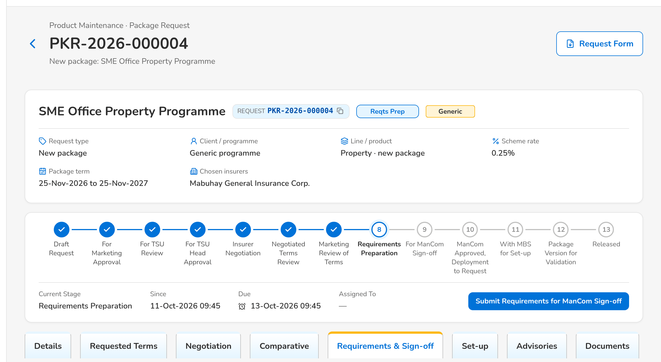
(continued below)
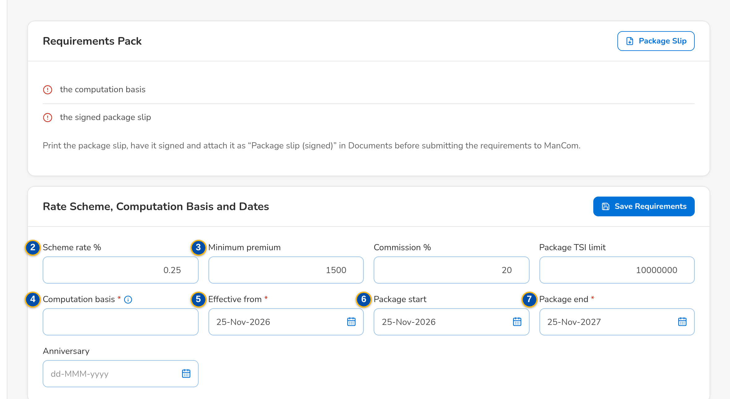
(continued below)
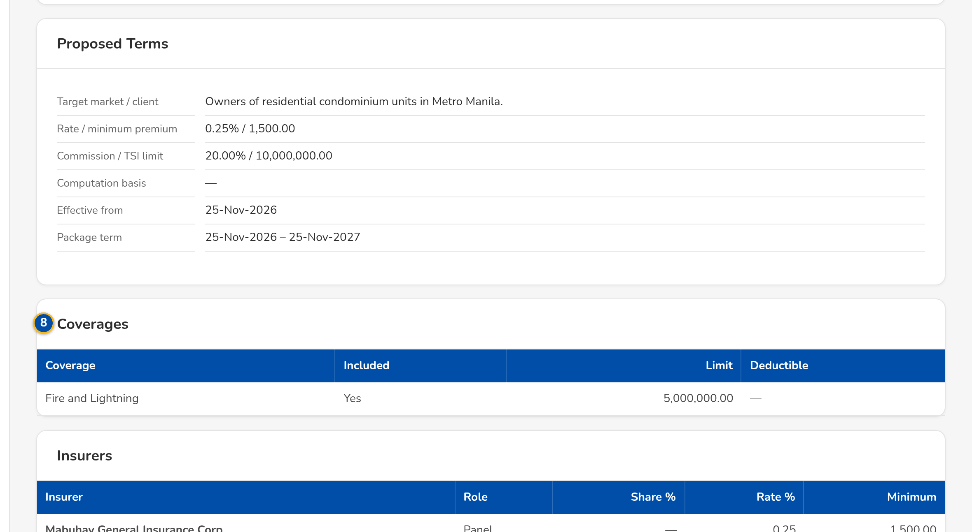
Figure G.7: Requirements & Sign-off tab during the requirements preparation
Field | Type | Mandatory | Format / list / source | Validation and message
Requirements pack: [Checklist] | Checklist | - | Missing items, or The requirements pack is complete.; Requirements check | The effective date and package end date, a scheme rate or a rate for every insurer, the computation basis, the chosen insurer(s) and the signed package slip; Complete the requirements: <missing>
Rate scheme, computation basis and dates: Scheme rate % | Number | Cond.: or a rate for every insurer | Up to four decimals; Proposed terms | Zero or more; Rates and amounts cannot be negative
Rate scheme, computation basis and dates: Minimum premium / Commission % / Package TSI limit | Number | N | Amount in PHP; percentage; Proposed terms | Zero or more; Rates and amounts cannot be negative
Rate scheme, computation basis and dates: Computation basis | Text | Y | How the premium is computed; Proposed terms | Not blank before submission; Complete the requirements: the computation basis
Rate scheme, computation basis and dates: Effective from | Date | Y | dd-MMM-yyyy; Proposed terms | Complete the requirements: the effective date and the package end date
Rate scheme, computation basis and dates: Package start / Anniversary | Date | N | dd-MMM-yyyy; Proposed terms | -
Rate scheme, computation basis and dates: Package end | Date | Y | dd-MMM-yyyy; Proposed terms | After the effective date; The package end date must be after the effective date
Proposed terms: [Sections, coverages, rate scheme, dates and insurers] | Read-only view | - | As on the Requested Terms tab; Proposed terms | -
ManCom decisions: Reference / Decision / By / On / Comment | Table | - | MC-PKR-yyyy-nnnnnn; Signed or Returned; ManCom sign-offs | No ManCom decision yet

Action | Who | Available when | What happens | Resulting status
Package Slip | Every user of the screen | Always | Downloads the package slip (PDF) with the proposed terms, to be printed and signed | Unchanged
Save Requirements | TSU | Requirements preparation | Saves the rate scheme, computation basis and dates of the proposed terms | Unchanged
Submit requirements for ManCom sign-off | TSU | Requirements preparation; the pack is complete | Sends the pack to ManCom | For ManCom sign-off
Sign off and send to MBS | ManCom, not the submitter of the requirements | For ManCom sign-off, with the ManCom routing set to one sign-off by any member (under the routing by selected approvers the request is signed off by their approvals on the Routing & Approvals tab, SCR-PM-29) | Records the sign-off MC-<request no.>, locks the quotation slips and attaches the sign-off record (or links the uploaded ManCom sign-off sheet) | With MBS for set-up

Rules:
- The requirements pack needs the effective date and package end date, a scheme rate or a rate for every insurer, the computation basis, at least one chosen insurer and the signed package slip attached as Package slip (signed) (FRPM.013.01).
- ManCom never signs off requirements it submitted; a single ManCom sign-off is recorded (FRPM.014.01).
- At the sign-off the quotation slips of every round are locked (FRPM.014.01).

G.8 Package Request record: Set-up and Advisories tabs (SCR-PM-08)
Purpose: MBS turns the signed-off terms into a draft catalog version (Set up package version), completes it in the version editor and submits it for validation; the request is released when the version is validated. On release (or retirement) the system drafts the advisory, which TSU edits and sends to the recipient groups once the signed package slip and the ManCom sign-off are attached.
Access: Package Request record › Set-up tab, Advisories tab
Requirements: FRPM.003.03, FRPM.003.04, FRPM.003.06, FRPM.003.07, FRPM.016.01, FRPM.016.02, FRPM.025.01
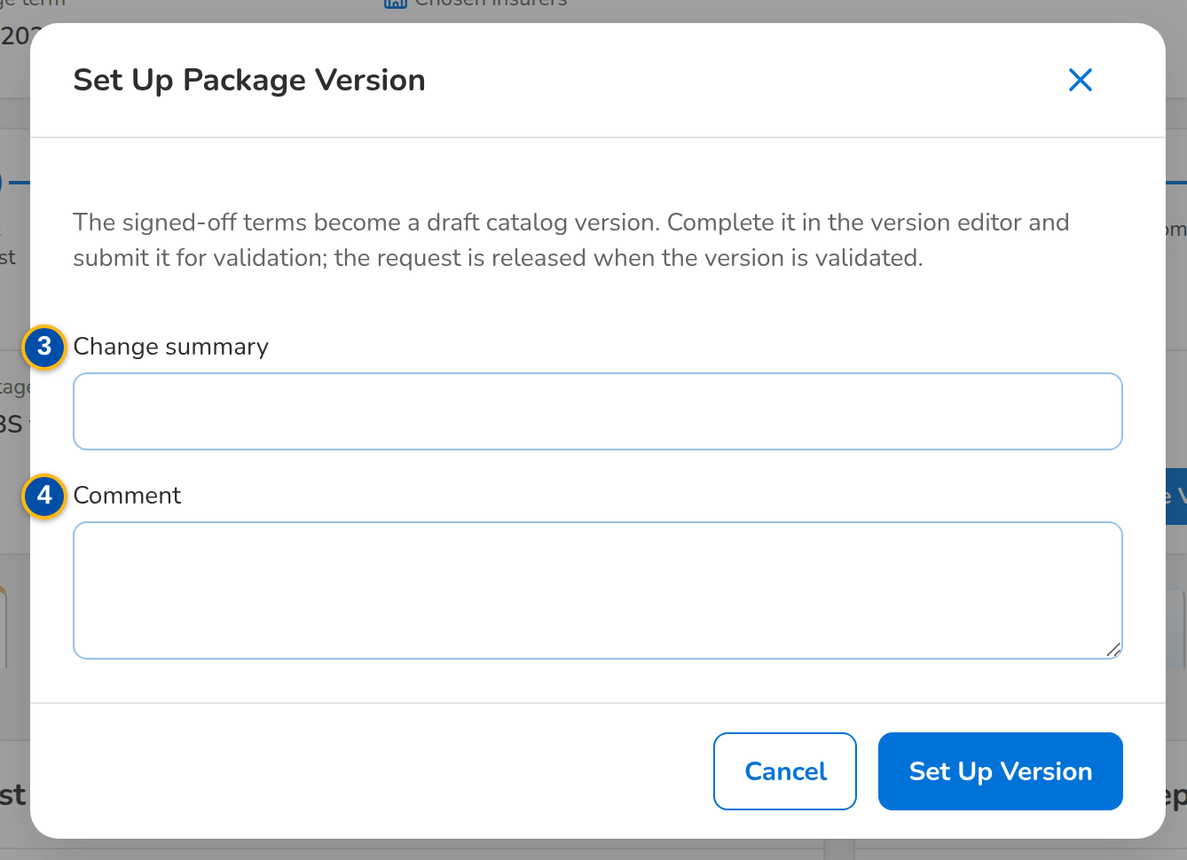
Figure G.8: Set Up Package Version dialog of MBS
Field | Type | Mandatory | Format / list / source | Validation and message
Set Up Package Version: Risk code of the new package | Text | Cond.: New package | Up to 20 capitals or digits; the naming convention of the line when set | Not blank; not an existing product; Enter the risk code of the new package
Set Up Package Version: Product name | Text | N | Up to 200 characters | -
Set Up Package Version: Change summary | Text | N | Up to 500 characters | -
Set Up Package Version: Comment | Text | N | Up to 1,000 characters | -
Set-up › Catalog version: Product / Version / Request stage | Detail | - | Risk code, version number, stage pill; Package version | MBS sets the package up after the ManCom sign-off
Advisories: [Advisory card] | Card | - | Subject, status pill, type · recipient groups, sent date and user, text; Advisory | An advisory is drafted when the package is released or retired
Advisories: [Supporting documents checklist] | Checklist | - | Package slip (signed) and ManCom sign-off (retirement: ManCom sign-off only), each Attached or Missing; Documents of the request | Both documents attached before sending; The advisory cannot be sent until the supporting documents are attached (Documents tab).
Edit Advisory: Recipient groups | Check boxes | Y (at least one) | Marketing, TSU, MBS, Processing, Operations; List advisory recipient group list | Active values of the list; Select at least one recipient group
Edit Advisory: E-mail to (optional) | Text | N | Comma-separated addresses | -
Edit Advisory: Subject | Text | Y | Up to 200 characters | Not blank; Enter the subject and the text
Edit Advisory: Text | Text | Y | Up to 8,000 characters | Not blank; Enter the subject and the text

Action | Who | Available when | What happens | Resulting status
Set up package version | MBS | With MBS for set-up; not a Retire request | Opens Set Up Package Version; Set Up Version creates the draft catalog version from the signed-off terms (a new package also creates its product, pending authorisation) | Package version for validation
Open Version Editor | Every user of the screen | A version was set up | Opens the Package Version (SCR-PM-13) | -
Edit | TSU | Draft advisory | Opens Edit Advisory; Save keeps the changes | Draft
Send Advisory | TSU | Draft advisory; the supporting documents are attached | Stores the advisory PDF on the request, notifies the users of each recipient group in the system and, when addresses are given, e-mails the protected PDF | Sent

Rules:
- The set-up creates a draft version; a product can have only one version being set up at a time (FRPM.016.01).
- A new package needs its risk code; the product is authorised when its first version is validated (FRPM.016.01, FRPM.003.03).
- The request is released automatically when its version is validated, and returns to MBS when the validator returns the version (FRPM.003.03).
- An advisory is sent only with the signed package slip and the ManCom sign-off attached; a retirement advisory needs the ManCom sign-off only (FRPM.025.01).
- Recipient groups are notified in the system: Marketing, TSU, MBS, Processing and Operations users by their permissions; e-mail addresses are optional (FRPM.025.01).

G.9 TSU Workbench (SCR-PM-09)
Purpose: The package request queues of the TSU Officer, Team Lead and Head: one tile per stage they work (review, approval, negotiation, terms review, requirements), with the open and overdue counts, and the queue of the chosen stage, oldest due first. A user claims a request to work it; team leads assign requests.
Access: Sidebar entry TSU Workbench
Requirements: FRPM.002.02, FRPM.003.06, FRPM.011.01, FRPM.011.03, FRPM.016.01, FRPM.017.01
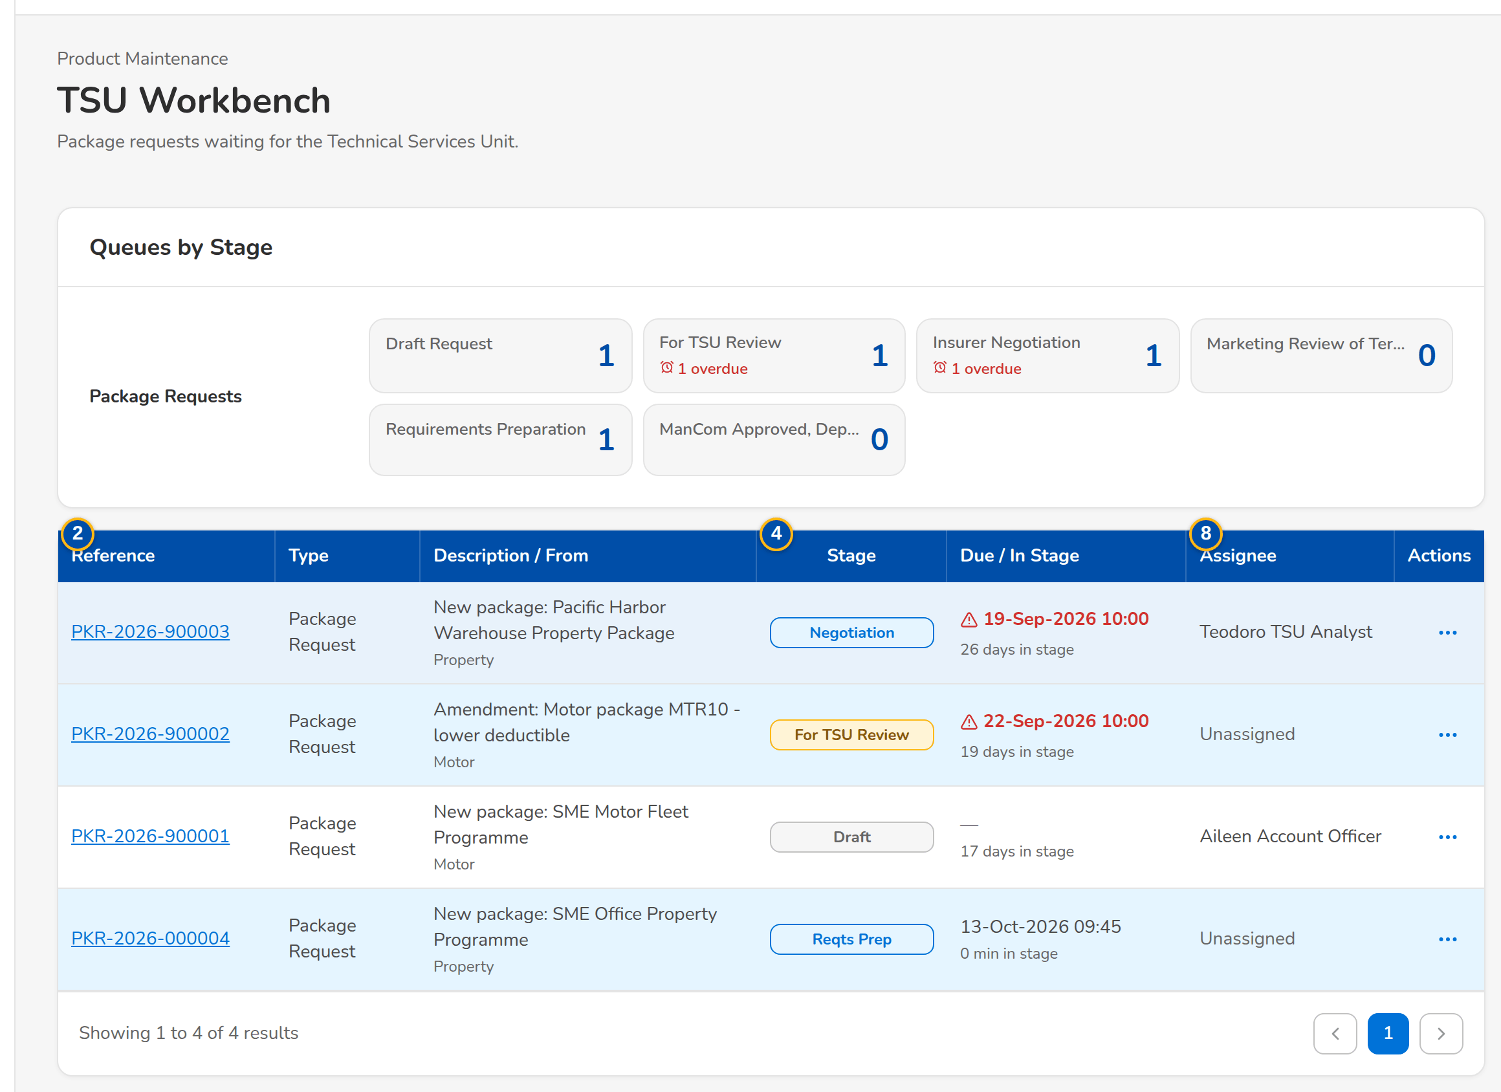
Figure G.9: TSU Workbench of the TSU Team Lead
Field | Type | Mandatory | Format / list / source | Validation and message
Package requests: [Stage tiles] | Tile | - | Stage name, open count, 'n overdue', 'n mine'; Workflow queues | -
Queue: Reference | Column | - | PKR-yyyy-nnnnnn; Work item | -
Queue: Description | Column | - | Request type, product and name; Work item | -
Queue: Stage | Column | - | Stage pill; Workflow | -
Queue: From | Column | - | Unit or user that raised the request; Work item | -
Queue: In Stage | Column | - | Time in the stage; Workflow | -
Queue: Due | Column | - | dd-MMM-yyyy HH:mm; Overdue in red; Workflow | -
Queue: Assignee | Column | - | User or unassigned; Workflow | -

Action | Who | Available when | What happens | Resulting status
[A stage tile] | Every user of the screen | Always | Shows the queue of that stage | -
Claim | A user of the stage | Unassigned item | Assigns the request to the user | Unchanged
Assign | Team leaders | Always | Opens the assignment dialog: a user of the stage or the team queue | Unchanged
[Open a row] | Every user of the screen | Always | Opens the package request | -

Rules:
- Only the stages the user's permissions work are shown (FRPM.002.02).
- A claimed request is worked by the user who claimed it; a team leader can re-assign it (FRPM.002.02).

G.10 Package Expiry (SCR-PM-10)
Purpose: The released packages by package end date, with their renewal status: packages ending without a renewal request, packages whose renewal is in progress, and the pointer to the expired packages kept in the catalog. TSU drafts renewal requests for the selected packages, pre-filled from the version in force.
Access: Product Maintenance Home › Packages ending soon tiles; Package Requests › Package Expiry; The expiry alert (Alert inbox) and the package expired notice
Requirements: FRPM.002.02, FRPM.003.01, FRPM.003.05, FRPM.004.01, FRPM.019.01, FRPM.019.02, FRPM.026.01
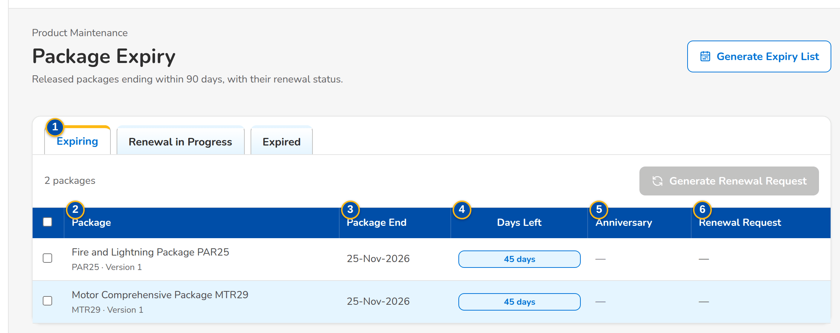
Figure G.10: Package Expiry, Expiring tab
Field | Type | Mandatory | Format / list / source | Validation and message
Tabs: Expiring / Renewal in Progress / Expired | Tab | - | Fixed | Expiring = no renewal request yet; Renewal in Progress = an open renewal or reactivation request
List: Package | Column | - | Risk code v<version>, with the product name; Version in force | -
List: Package End | Column | - | dd-MMM-yyyy; Version in force | -
List: Days Left | Column | - | Days until the package end, red up to 7, amber up to 30; Computed | -
List: Anniversary | Column | - | dd-MMM-yyyy; Version in force | -
List: Renewal Request | Column | - | Request number and its stage pill; Package requests | -
Generate Expiry List: Packages ending within (days) | Number | Y | Whole days from today | Zero or more

Action | Who | Available when | What happens | Resulting status
Generate Expiry List | Every user of the screen | Always | Opens the dialog; Generate lists the packages ending within the days entered | -
Generate Renewal Request | TSU | Expiring tab; at least one package selected | Drafts one Renew request per package, pre-filled from the version in force with the next term (start = old end + 1 day, same length); a package with an open renewal keeps it; one request opens directly | Draft request

Rules:
- A package is listed from its version in force; the expiry alerts start 90 days before the expiry date, with the configured reminder days (FRPM.004.01).
- A renewal request is never drafted twice for the same package; when the automatic drafting setting is on, the monitor drafts it itself (FRPM.026.01).
- Expired packages stay readable on Products with the Expired filter; an expired package is sold again only through a Reactivate request (FRPM.002.02).

G.11 Products (SCR-PM-11)
Purpose: The product catalogue: every product (risk code) with its line, package flag, current version, market segments, rate and minimum premium, and its lifecycle; and, on their own tabs, the field rules, document rules and TSU routing rules that decide what an account needs and when TSU reviews it. MBS creates products and rules; a second user authorises them. Expired and retired products are listed for the users who may see the archive.
Access: Sidebar entry Products; Package Expiry › Expired tab › Products; Product record › back arrow
Requirements: FRPM.002.02, FRPM.003.01, FRPM.003.02, FRPM.003.03, FRPM.003.05, FRPM.003.08, FRPM.012.01, FRPM.019.03, FRPM.022.01, FRPM.024.01, FRPM.030.01
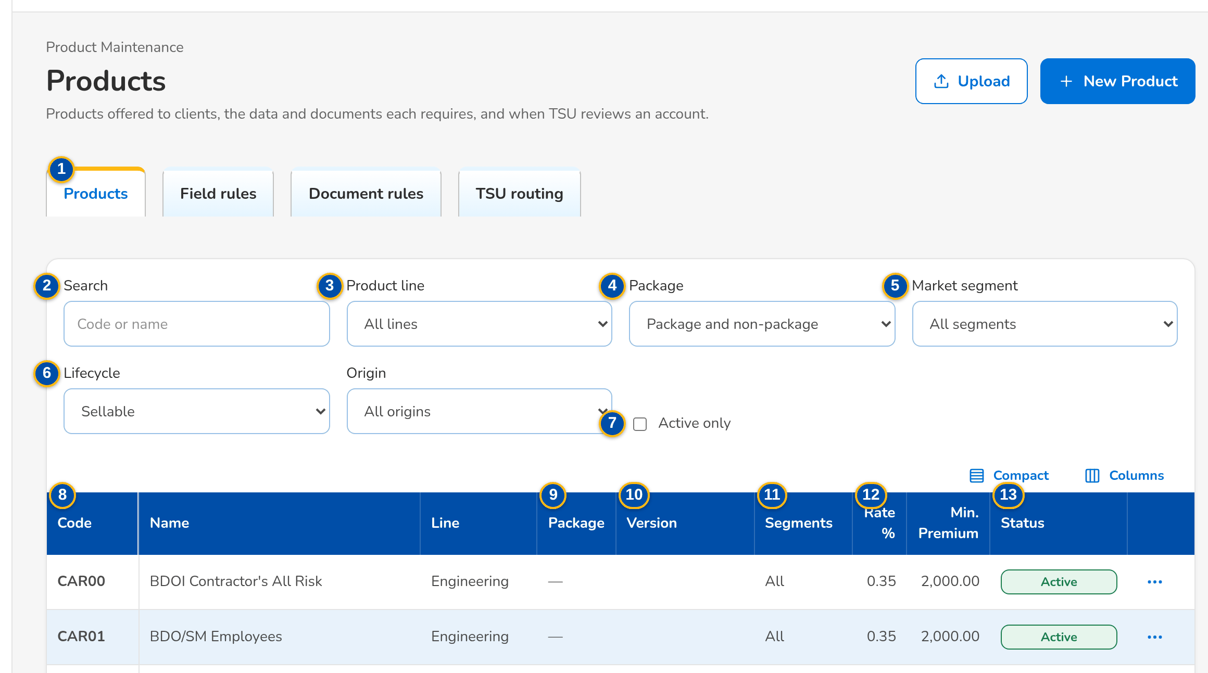
(continued below)
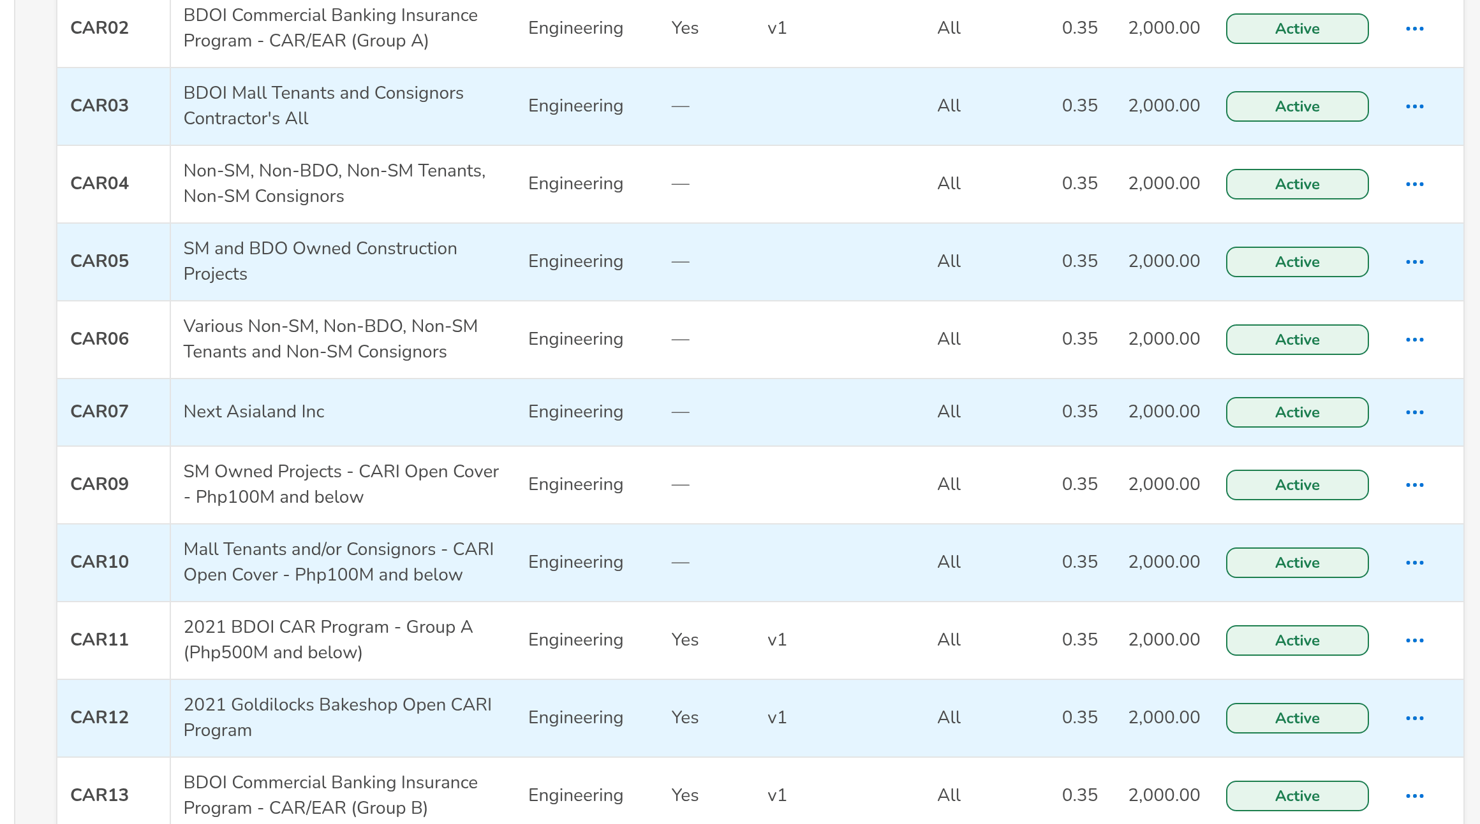
(continued below)
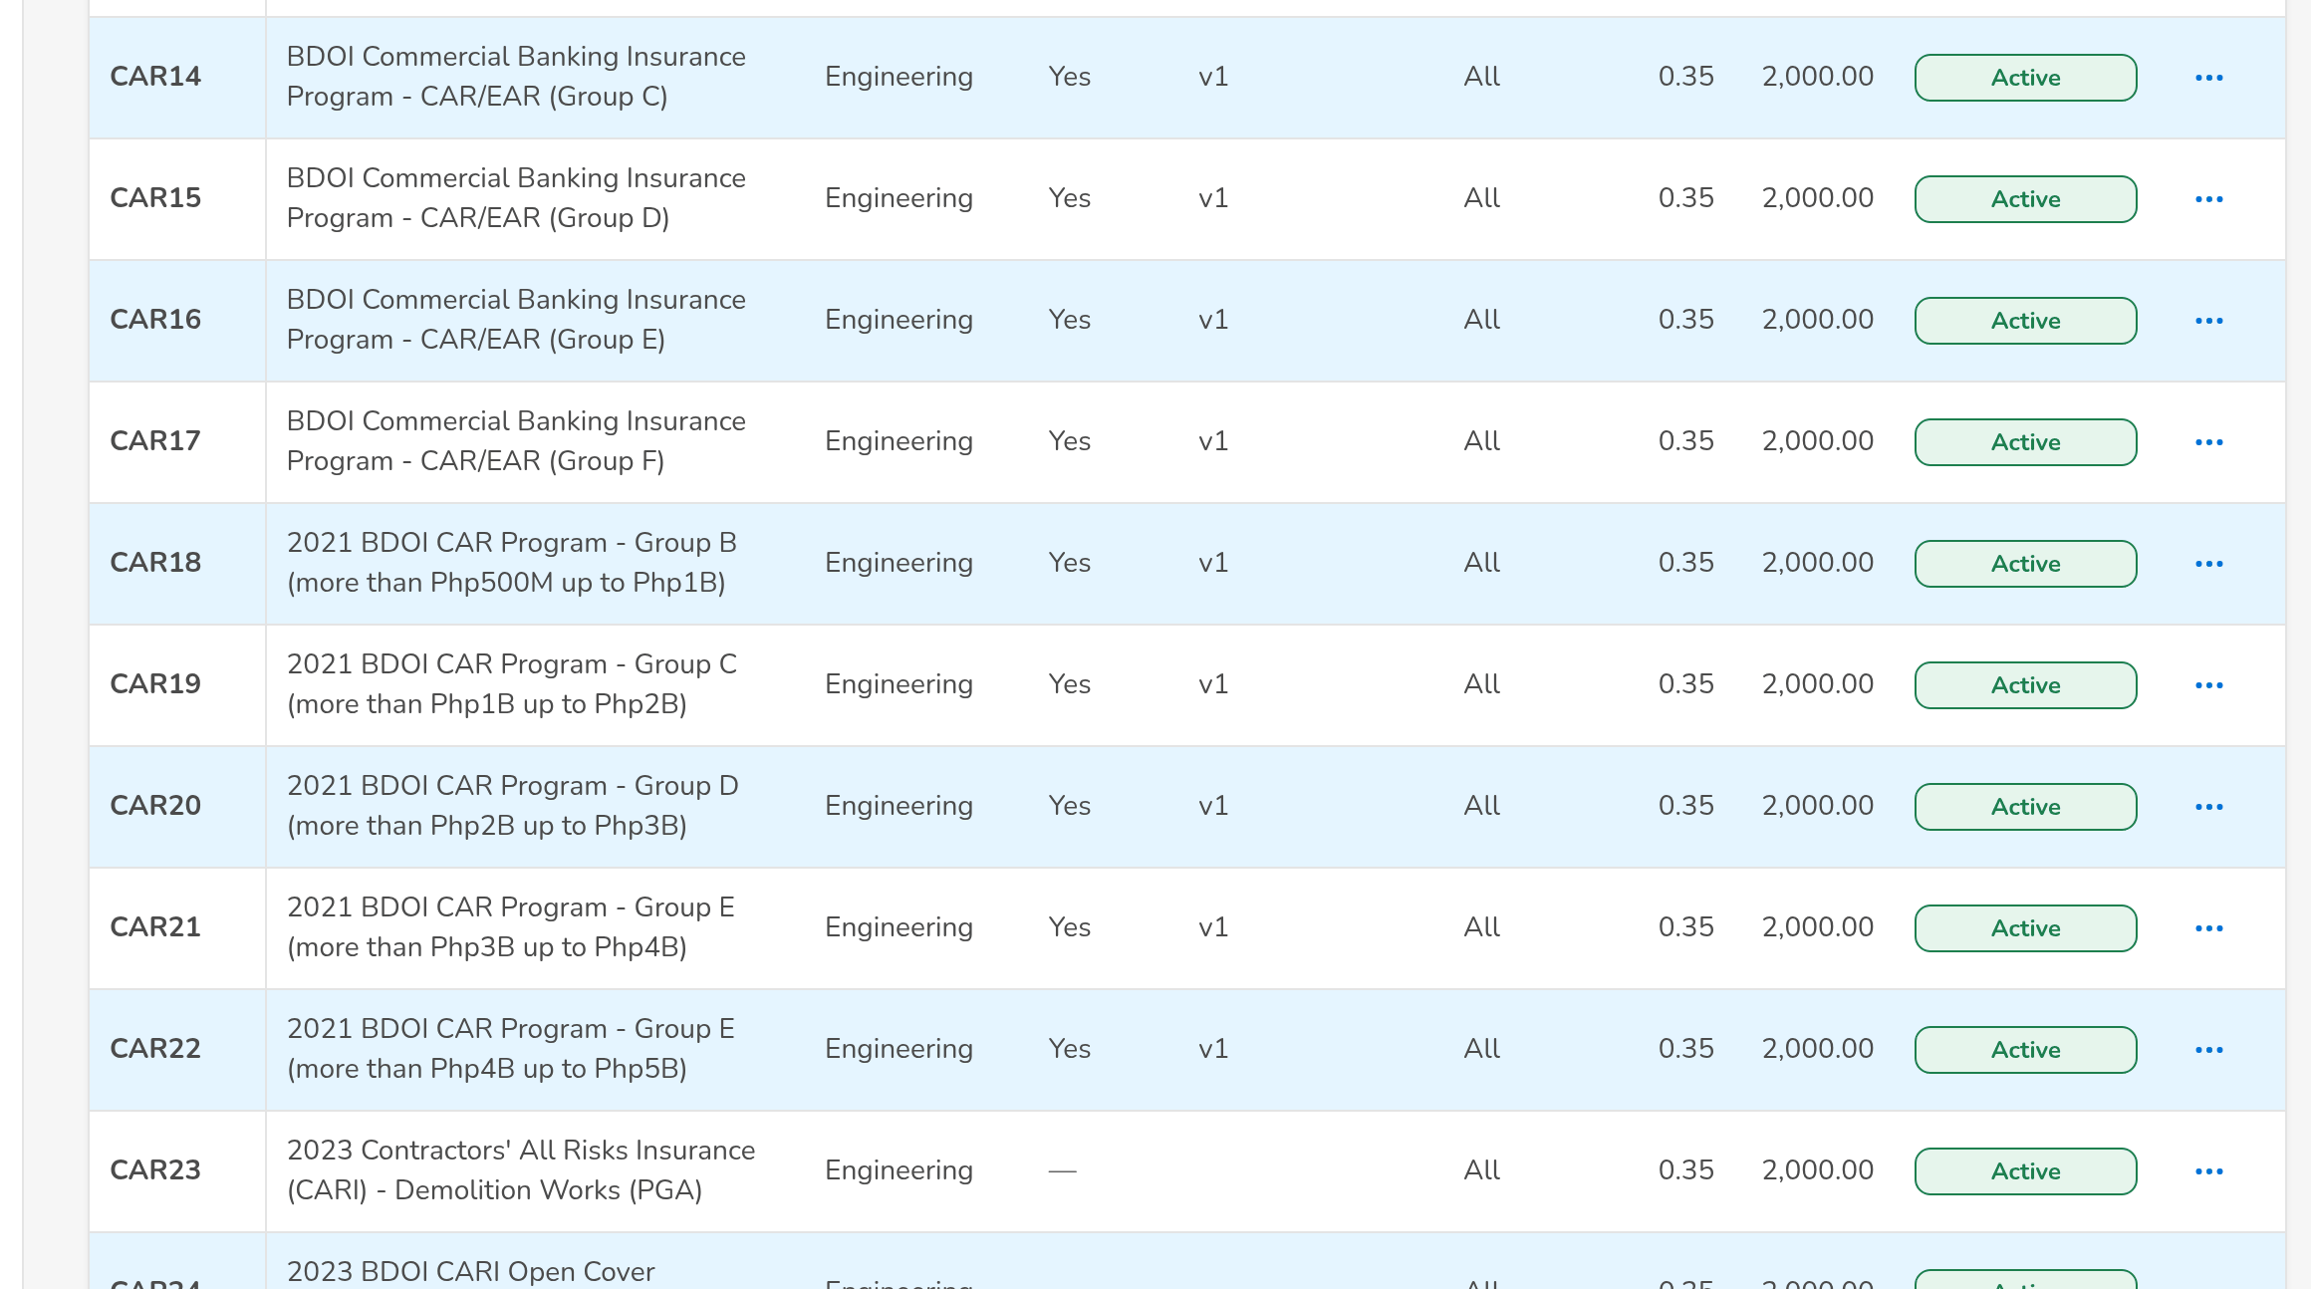
Figure G.11: Products with the package filter
Field | Type | Mandatory | Format / list / source | Validation and message
Tabs: Products / Field rules / Document rules / TSU routing | Tab | - | Fixed | -
Filters: Search | Text | N | Code or name | Contains search
Filters: Product line | Drop-down | N | All lines or one line; Product lines | -
Filters: Package | Drop-down | N | Package and non-package, Package only, Non-package only; Fixed list | -
Filters: Market segment | Drop-down | N | All segments or one; List market segment list | -
Filters: Lifecycle | Drop-down | N | Sellable, Expired, Retired; Fixed list | Shown only to users who may see the archive
Filters: Active only | Check box | N | - | Authorised and active records only
List: Code / Name / Line | Column | - | Risk code, product name, line code; Product master | No product matches the filters.
List: Package | Column | - | Yes for a package product; Product master | -
List: Version | Column | - | Current version (v2) and the pill of a version being set up (Draft, For validation); Package versions | -
List: Segments | Column | - | Market segments, or All; Product master | -
List: Rate % / Min. Premium | Column | - | Product rate and minimum premium (of the version in force for a package); Product master | -
List: Status | Column | - | Pending Authorization, Active, Inactive; Expired or Retired for a package no longer sold; Product master | -
New product: Code | Text | Y | 1 to 20 capitals or digits | Unique; the naming convention of the line when set; Code: 1 to 20 capital letters or digits.
New product: Name | Text | Y | Up to 200 characters | Not blank; Name is required.
New product: Product line | Drop-down | Y | Line name; Product lines | Choose the product line.
New product: Cover type | Drop-down | Cond.: package product | Cover types of the line; Cover types | A cover type of the line; a package needs one; A package needs its cover type
New product: Placement after | Drop-down | Y | Paid, Client confirmation; Fixed list | -
New product: TSU review | Drop-down | N | By rules, Always, Never; Fixed list | -
New product: Default rate % | Number | N | Up to four decimals | 0 to 100; The rate, minimum premium, commission and TSI limit of package <code> change through a new version (Versions tab)
New product: Default commission % | Number | Y | Percentage | 0 to 100; Default commission rate is required.
New product: Minimum premium | Number | Y | Amount in PHP | Zero or more; The minimum premium cannot be negative
New product: Package TSI limit | Number | N | Amount in PHP; above it the account goes to TSU | Zero or more
New product: Maximum term (years) | Number | Cond.: multi-year term allowed | 1 to 10 | At least 2 for a multi-year product; A multi-year product needs a maximum term of at least 2 years.
New product › Features: Package product (fixed cover) / Fleet (several vehicles) / Mortgage / loan related / Direct payment to insurer allowed / Multi-year term allowed / Free First Year eligible | Check box | N | - | -
New product: Market segments (none = all) | Check boxes | N | Segments the product is offered to; List market segment list | Active values
Field rules: Applies to / Level / Field / Key / Mandatory / Status | Column | - | All products, a line or a product; Account or Risk item; Field rules | -
Document rules: Applies to / Document / Before Submission / Status | Column | - | Document type; Required or Optional; Document rules | -
TSU routing: Priority / Code / Description / Criteria / TSI Above / Status | Column | - | Lower priority evaluated first; TSU routing rules | -

Action | Who | Available when | What happens | Resulting status
New Product | MBS (master data maintainers) | Products tab | Opens New product; Save for Authorization saves it pending authorisation | Pending Authorization
Add Rule | MBS, Business Administrator | Field rules, Document rules or TSU routing tab | Opens New Rule (see SCR-PM-12) | Pending Authorization
Authorize | authorizers or authorizers (Business Administrator, New Business Approver), not the maker | Row pending authorisation | From the row action menu, after the confirmation: authorises the record; it is used by quotations, accounts and rating from now | Active
Deactivate | MBS or master data maintainers | Active row | From the row action menu (last, in red); asks the reason, kept in the audit trail, and ends the use of the record; its history stays | Inactive
[Open a row] | Every user of the screen | Products tab | Opens the product record | -

Rules:
- Every product and rule is maker-checker: saved changes wait for a second user's authorisation and are not used until then (FRPM.003.01, FRPM.003.02).
- A package product needs its cover type; the risk code follows the naming convention of its line once BDOI has stated it (FRPM.003.01).
- The rate, minimum premium, commission and TSI limit of a package change only through a new version, so a released package stays sellable while it is changed (FRPM.003.01).
- Sellable lists show active products only; expired and retired products are shown to the archive users and are never deleted (FRPM.002.02).
- Field rules check presence, a list of values, a number range or a format; document rules name the documents an account needs before submission (FRPM.003.02, FRPM.012.01).

G.12 Product record (SCR-PM-12)
Purpose: One product: its risk code, lifecycle and authorisation status, package and version flags, line and cover type, current version, rate, package end and TSU review; the tabs Versions (every package version with its status, dates, source request and validator), Features (all product attributes) and Field Rules & Documents (the field matrix and the documents an account needs). MBS creates the next version of a package from here.
Access: Products › a row; Package Version › back arrow; Incentive Criteria (products matrix)
Requirements: FRPM.003.01, FRPM.003.02, FRPM.003.03, FRPM.003.08, FRPM.012.01, FRPM.016.01, FRPM.016.02, FRPM.019.03, FRPM.024.01, FRPM.030.01
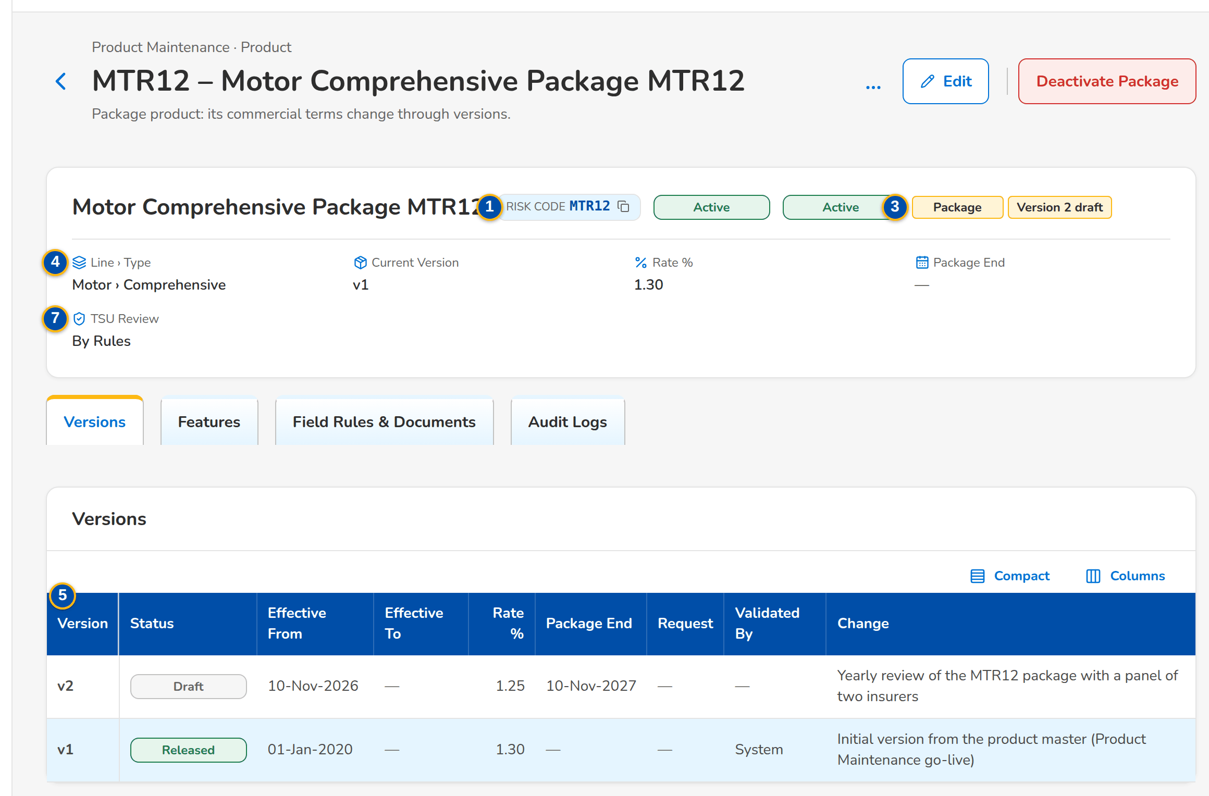
Figure G.12: Product record of a package, Versions tab
Field | Type | Mandatory | Format / list / source | Validation and message
Header: Risk code | Reference chip | - | Product code; Product master | -
Header: [Lifecycle and record status pills] | Pill | - | Active, Expired, Retired; Pending Authorization, Active, Inactive; Product master | -
Header: [Package and version tags] | Tag | - | Package; Version n Draft or For validation; Product master | -
Header: Line › Type / Current Version / Rate % / Package End / TSU Review | Fact | - | As in the catalogue; Product master, version in force | -
Versions: Version / Status / Effective From / Effective To / Rate % / Package End / Request / Validated By / Change | Column | - | Newest first; Draft, For validation, Released, Superseded, Expired; Package versions | No version yet.
New Version: What changes | Text | Y | Free text | Not blank; Describe the change
Features: Line / Cover type / Risk items / Rating / Package / Package TSI limit / Fleet / Market segments / Mortgage related / Direct payment allowed / Multi-year / Free First Year / Placement after / Default rate % / Default commission % / Minimum premium / TSU review | Detail | - | As on the product; Product master | -
Field Rules & Documents › Field matrix: Level / Field / Key / Mandatory / Check / From | Column | - | Rules of all products, the line and the product; Field rules | No field rules apply.
Field Rules & Documents: Documents required before submission | List | - | Document types; Document rules | No document is required.
New Rule (field): Applies to | Drop-down | Y | All, Line, Product; Fixed list | Rules for every product use the scope code *; Rules for every product use the scope code '*'
New Rule (field): Level | Drop-down | N | Account or Risk item; Fixed list | -
New Rule (field): Field key / Label | Text | Y | Field key (one of several keys with a vertical bar) and its label | Unique per scope; Minimum-field rule already exists: <key>
New Rule (field): Check | Drop-down | N | Presence only, List of values, Number range, Format (pattern); Fixed list | The parameters of the check are complete; Complete the parameters of the <type> rule
New Rule (field): List of values / Minimum / Maximum / Pattern | Text / Number | Cond.: by check | List code; range; pattern; Lists of values | Known list; valid pattern; Unknown list of values <lov type>
New Rule (document): Document type | Drop-down | Y | Document types; List document type list | Active value
New Rule: Mandatory | Check box | N | - | -
Product dialog: Policy Type / Insured's Name | Drop-down; text | N | Package or non-package policy type; name of the insured of a client-specific package; List of values | -
Product dialog: Incentive Amount / Incentive Commission Rate (%) / Approver | Numbers; look-up | Cond.: Approver for a direct change | Amount in PHP; percentage; name of the approver of the change; Users with the approval right | Amount above zero; rate above 0% and at most 100%
Audit Logs: Timestamp / Action Type / Description / Old Value / New Value / Performed By / Remarks | Table | - | Every change of the product, newest first; CSV and Excel exports; Audit trail | No activity recorded yet.

Action | Who | Available when | What happens | Resulting status
Edit | MBS or master data maintainers | Always | Opens the product dialog (as New product, code fixed); Save for Authorization | Pending Authorization
Authorize / Deactivate | As on Products | As on Products | As on Products | Active / Inactive
New Version | MBS | Package product with a version in force and no version being set up | Opens New Version; Create Draft copies the version in force into a new draft effective tomorrow and opens it | Draft version
Add Product Rule | MBS or master data maintainers | Field Rules & Documents tab | Opens New Rule with the scope set to this product; Save for Authorization | Pending Authorization
[Open a version row] | Every user of the screen | Versions tab | Opens the Package Version | -
Deactivate Package | MBS (product maintenance right) | Active package without a deactivation waiting | Opens Deactivate Package (SCR-PM-24): effective date, reason, approver and remarks; Submit for Approval | Pending Approval

Rules:
- A non-package product has no versions; it is rated on the product rate (FRPM.003.01).
- The product dialog carries the Product Matrix fields of BDOI's FRS: Policy Type, Insured's Name, Incentive Amount, Incentive Commission Rate (%) and the Approver of the change; a change made directly on the Product Matrix waits for that approval (setting Direct maintenance of the Product Matrix) (FRPM.003.01, FRPM.018.01).
- The Audit Logs of the product list every change with the old and new value, by whom and when (FRPM.021.01).
- A package has at most one version being set up (draft or for validation) at a time (FRPM.016.01, FRPM.003.01).
- Every version is kept: superseded and expired versions stay readable with their validator and source request (FRPM.003.01, FRPM.021.01).
- Field rules of all products, of the line and of the product apply together; the account checks refuse a missing or invalid value (FRPM.003.02).

G.13 Package Version (SCR-PM-13)
Purpose: One version of a package: the rate scheme, dates and origin, the coverages and perils, the insurers of the panel with their role, share, rate and minimum premium, and the insurer terms per coverage with their clauses. MBS edits a draft and submits it for validation; the validator (TSU Head or Business Administrator, never the maker or submitter) confirms the checklist and releases it, or returns it to MBS with a reason. Released versions are read only and show who validated them.
Access: Product record › Versions tab › a row; Product record › New Version; Package Request record › Set-up tab › Open Version Editor; Validation Queue › a row
Requirements: FRPM.003.01, FRPM.003.02, FRPM.003.03, FRPM.016.01, FRPM.016.02, FRPM.019.03, FRPM.022.02, FRPM.023.01, FRPM.024.01
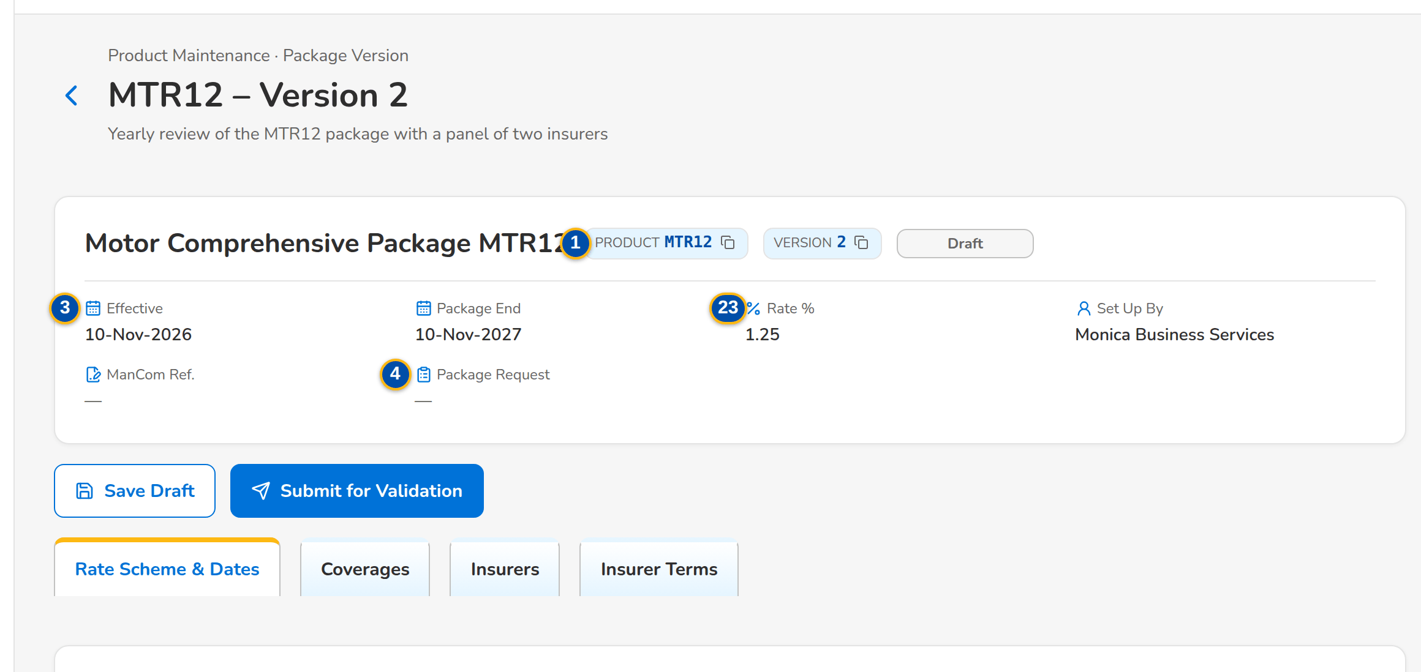
(continued below)
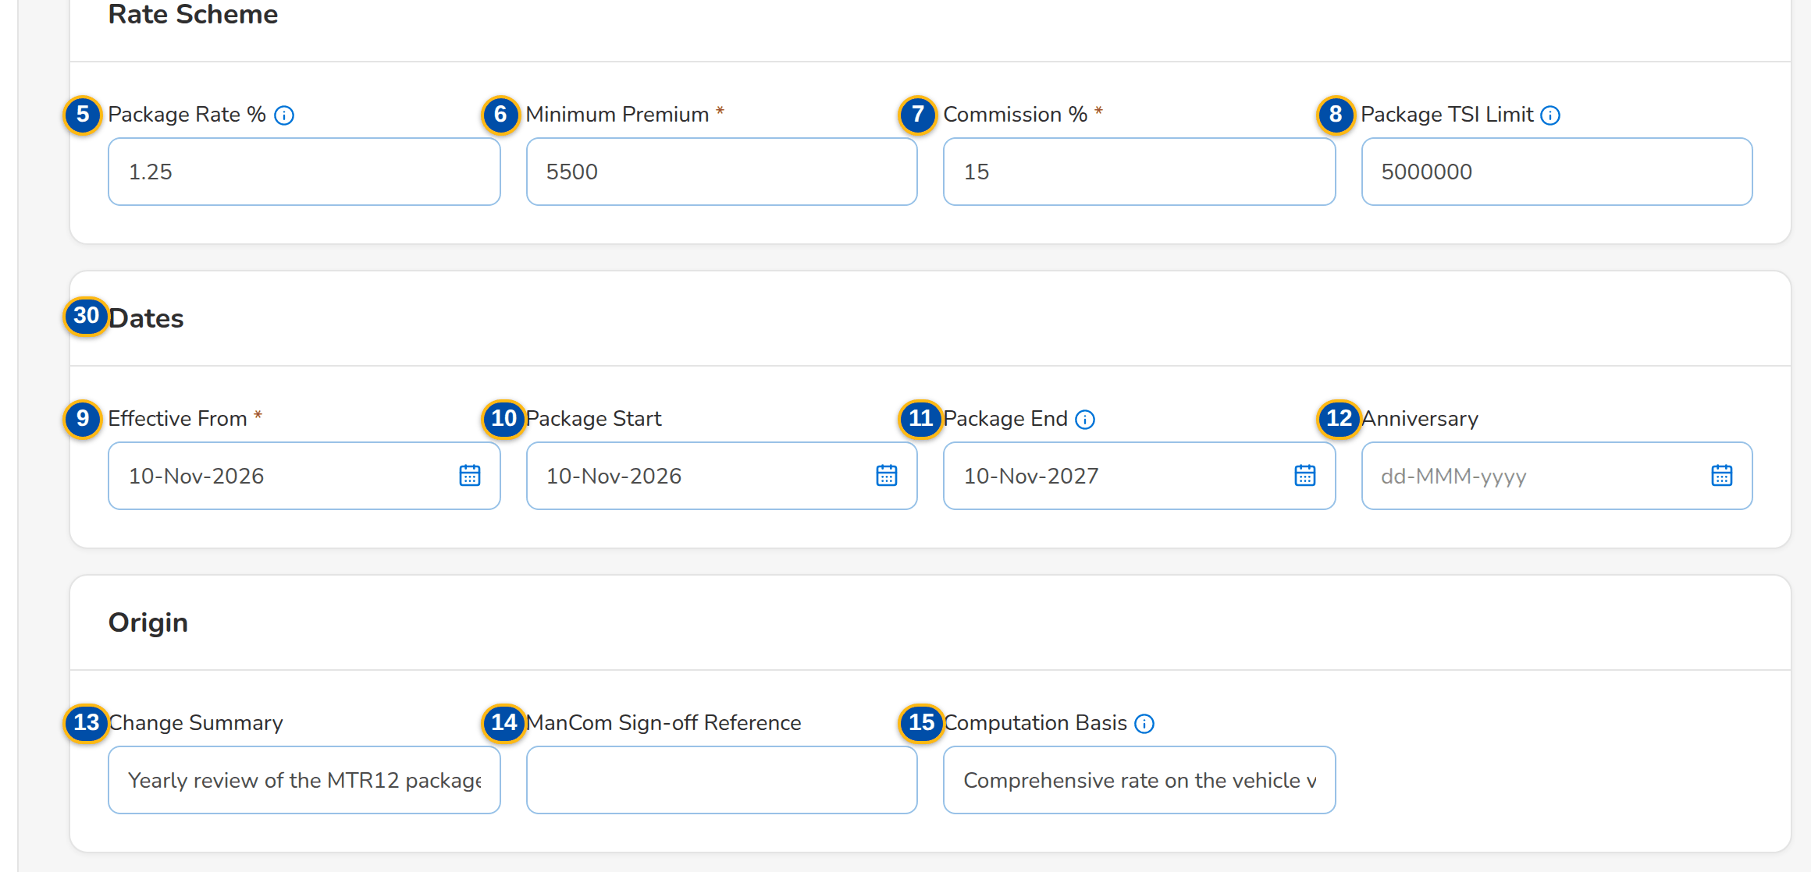
Figure G.13: Draft version of the MTR12 package, Rate Scheme & Dates tab
Field | Type | Mandatory | Format / list / source | Validation and message
Header: Product / Version | Reference chip | - | Risk code; version number; Package version | -
Header: [Version status pill] | Pill | - | Draft, For validation, Released, Superseded, Expired; Package version | -
Header: Effective / Package End / Rate % / Set Up By / ManCom Ref. | Fact | - | Rate % shows Per insurer when every insurer has its own rate; Package version | -
Header: Package Request | Fact | - | PKR-yyyy-nnnnnn of the request that produced the version, a link to the request; Package version | -
Rate Scheme: Package Rate % | Number | Cond.: or a rate for every insurer | Up to four decimals; empty when every insurer has its own rate | 0 to 100; the package rate or a rate for every insurer; Enter a rate between 0 and 100 / Enter the package rate or a rate for every insurer
Rate Scheme: Minimum Premium | Number | Y | Amount in PHP | Zero or more; Enter the minimum premium
Rate Scheme: Commission % | Number | Y | Percentage | 0 to 100; Enter a commission between 0 and 100
Rate Scheme: Package TSI Limit | Number | N | Amount in PHP; above it TSU prices the risk | Zero or more; Enter a positive amount
Dates: Effective From | Date | Y | dd-MMM-yyyy | Today or later; after the start of the version in force; Enter the effective date / The effective date cannot be before today / The effective date must be after the start of version <version no>
Dates: Package Start | Date | N | dd-MMM-yyyy | -
Dates: Package End | Date | N | dd-MMM-yyyy; expiry monitoring | After the effective date; The package end date must be after the effective date
Dates: Anniversary | Date | N | dd-MMM-yyyy | -
Origin: Change Summary | Text | N | Up to 500 characters | -
Origin: ManCom Sign-off Reference | Text | N | MC-PKR-yyyy-nnnnnn; ManCom sign-off | -
Origin: Computation Basis | Text | N | As agreed with the insurers; Proposed terms | -
Coverages: Coverage | Column | Y (at least one included) | Coverage name, with the Basic tag; Coverages of the line | At least one included coverage; a basic coverage; Include at least one coverage / The package needs its cover type and at least one included basic coverage
Coverages: Included / Optional | Check box | N | - | -
Coverages: Limit / Deductible | Number | N | Amounts in PHP | Zero or more
Coverages: Add coverage | Drop-down | N | Active coverages of the line not yet added, (basic) marked; Coverages & Clauses | -
Insurers: Insurer | Column | N | Insurer name; Insurers (authorised, active) | Every insurer with terms is on the package; Insurer <insurer code> has terms but is not on the package
Insurers: Role | Drop-down | Y | Panel, Lead, Participant; Fixed list | -
Insurers: Share % | Number | Cond.: lead and participants | Co-insurance share | 0 to 100; lead and participant shares total 100%; Enter a share between 0 and 100 / The co-insurance shares must add up to 100%
Insurers: Rate % | Number | Cond.: when there is no package rate | Insurer's own rate; wins over the package rate | 0 to 100; Enter a rate between 0 and 100
Insurers: Minimum Premium | Number | N | Insurer's own minimum premium | Zero or more
Insurers: Add insurer | Drop-down | N | Active insurers not yet on the panel; Insurers | -
Insurer Terms: Insurer / Coverage | Column | Y (every pair) | One row per panel insurer and included coverage; Panel and coverages | Every panel insurer has terms for each included coverage; Insurer <insurer code> has no terms for coverage <coverage>
Insurer Terms: Covered | Check box | N | - | -
Insurer Terms: Limit / Deductible / Deductible Wording | Number / Text | N | Amounts in PHP; wording | -
Insurer Terms: Clauses | Multi-select | N | Active clauses of the line or of every line; Clause library | Active clauses
Validation Checklist: Hierarchy complete: cover type and basic coverage / Every panel insurer has terms for each included coverage / Rates and minimum premiums match the signed-off terms / Dates and package term are correct / Test premium reviewed | Check box | Y (all five) | Every item; Fixed checklist | Every item confirmed
Validation: Result / Validated By / Validated On / Test Premium / Return Reason | Fact | - | Passed or Returned pill; validator's name; dd-MMM-yyyy HH:mm; PHP amount; the reason when returned (Returned By / Returned On); Validation checkpoint | -
Validation: # / Check / Result / Details | Table | - | One row per check: hierarchy, insurer terms, co-insurance shares, rates and minimum premiums, dates and package term, test premium; Passed, Failed or Not Applicable with the figures compared (for example 3 of 3 insurers have terms for 2 included coverages); Validation checkpoint | -
Return Version to MBS: Return reason / Comment | Drop-down / Text | Y (reason) | Return reason list; free text; List return reason list | Not blank; Enter the reason of the return

Action | Who | Available when | What happens | Resulting status
Save Draft | MBS | Draft | Checks the fields and saves the whole draft | Draft
Submit for Validation | MBS | Draft; no field message | Saves the draft and checks completeness (cover type and basic coverage, insurer terms for every included coverage, shares, rate, dates) | For validation
Validate and Release | TSU Head or Business Administrator, not the maker or the submitter | For validation; every checklist item ticked | Computes the test premium, releases the version and ends the previous version the day before; releases the source request, drafts its advisory and, for a new package, authorises the product | Released
Return to MBS | As Validate and Release | For validation | Opens Return Version n to MBS; Return sends the version back to draft with the reason, and the request back to MBS | Draft

Rules:
- A draft is invisible to rating; only a released version prices new business (FRPM.003.01, FRPM.024.02).
- Submission needs the cover type and at least one included basic coverage, terms for every panel insurer on every included coverage, the package rate or a rate for every insurer, co-insurance shares totalling 100%, an effective date today or later and after the start of the version in force, and a package end after the effective date (FRPM.003.03, FRPM.003.02).
- The validator is never the maker or the submitter of the version; the validator confirms the five checklist items and a test premium is computed (FRPM.003.03).
- At release and at return the system records each check with its result (Passed, Failed or Not Applicable) and the figures compared, with the validator, the time and, for a return, the reason; the Validation card shows them until the version is submitted again (FRPM.003.03).
- The Details of a check name the cover type, the coverages and the insurers by their names; a released version shows its rate scheme, dates and terms as values (amounts with separators, rates with their decimals, a dash when empty, long texts wrapped) (FRPM.003.03, FRPM.003.01).
- On release the previous version ends the day before the new one takes effect and becomes Superseded; a version whose package end has passed without a renewal becomes Expired and the product is no longer sold (FRPM.003.01, FRPM.002.02).
- An insurer's own rate and minimum premium win over the package's; a package with a panel is placed only with its panel insurers (FRPM.003.02, FRPM.024.02).

G.14 Validation Queue (SCR-PM-14)
Purpose: The package versions submitted by MBS that wait for the post-set-up validation, oldest first, with their age. A row opens the version with its checklist.
Access: Sidebar entry Validation Queue; Product Maintenance Home › Versions for validation
Requirements: FRPM.003.03, FRPM.016.02
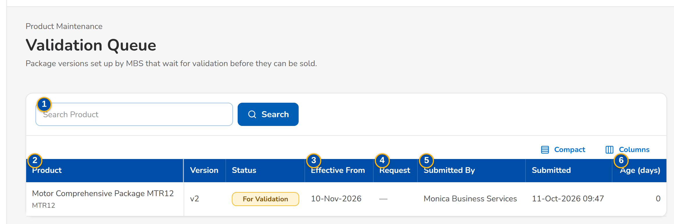
Figure G.14: Validation Queue of the TSU Head
Field | Type | Mandatory | Format / list / source | Validation and message
Search: Search Product | Text | N | Code or name | Contains search
List: Product / Name / Version / Status | Column | - | Risk code, product name, v<n>, For validation pill; Package versions | No package version waits for validation.
List: Effective From | Column | - | dd-MMM-yyyy; Package version | -
List: Request | Column | - | PKR-yyyy-nnnnnn; Package version | -
List: Submitted By / Submitted | Column | - | User; dd-MMM-yyyy HH:mm; Package version | -
List: Age (days) | Column | - | Whole days since the submission; Computed | -

Action | Who | Available when | What happens | Resulting status
[Open a row] | TSU Head, Business Administrator | Always | Opens the Package Version with the Validation Checklist | -

Rules:
- Only users who validate package versions see the queue; a version they set up or submitted is shown but cannot be validated by them (FRPM.003.03).

G.15 Coverages & Clauses (SCR-PM-15)
Purpose: The coverage and peril level of the product hierarchy, per line, and the clause library (warranties, clauses, exclusions and deductible wordings) that package versions use in their insurer terms. MBS maintains them; a second user authorises them.
Access: Sidebar entry Coverages & Clauses
Requirements: FRPM.003.01, FRPM.003.02, FRPM.022.01, FRPM.022.02
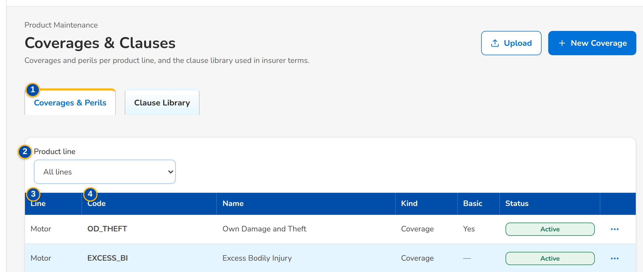
(continued below)
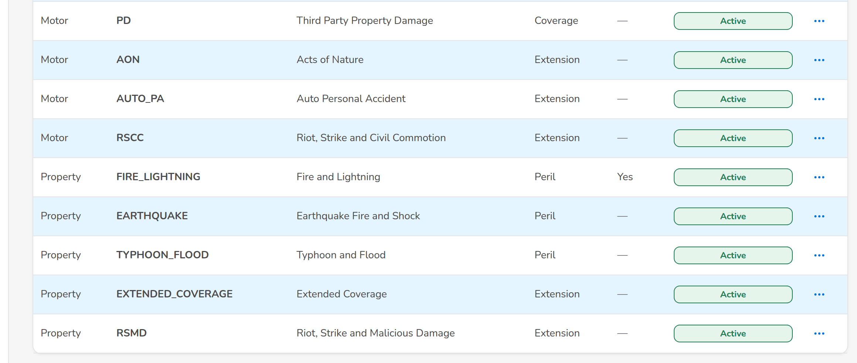
Figure G.15: Coverages & Perils tab
Field | Type | Mandatory | Format / list / source | Validation and message
Tabs: Coverages & Perils / Clause Library | Tab | - | Fixed | -
Coverages & Perils: Product line | Drop-down | N | All lines or one line; Product lines | -
Coverages & Perils: Line / Code / Name / Kind / Basic / Status | Column | - | Coverage of the line; Basic Yes; Coverages | No coverage is set up for this line.
Clause Library: Code / Kind / Title / Line / Effective / Until / Status | Column | - | Line or All lines; dd-MMM-yyyy; Clauses | The clause library is empty.
New Coverage: Product line | Drop-down | Y | Line name; Product lines | Select the product line
New Coverage: Code | Text | Y | A-Z, 0-9 and _ | Unique per line; Use A-Z, 0-9 and _
New Coverage: Name | Text | Y | Free text | Not blank; Enter the name
New Coverage: Kind | Drop-down | Y | Coverage kinds; List coverage kind list | Active value; Select the kind
New Coverage: Display order | Number | N | Whole number | -
New Coverage: Basic coverage | Check box | N | - | -
New Clause: Code | Text | Y | A-Z, 0-9 and _ | Unique; Use A-Z, 0-9 and _
New Clause: Kind | Drop-down | Y | Clause kinds; List clause kind list | Active value; Select the kind
New Clause: Product line | Drop-down | N | Every line or one line; Product lines | -
New Clause: Title | Text | Y | Free text | Not blank; Enter the title
New Clause: Effective from / Effective to | Date | Y (from) | dd-MMM-yyyy | To on or after from; Enter the effective date / The end is before the start
New Clause: Wording | Text | Y | Full wording | Not blank; Enter the wording

Action | Who | Available when | What happens | Resulting status
New Coverage / New Clause | MBS | Tab of the kind | Opens the dialog; Save for Authorization saves it pending authorisation | Pending Authorization
[Open a row] | MBS | Always | Opens the coverage or clause for change (code fixed) | Pending Authorization
Authorize | authorizers (Business Administrator, New Business Approver), not the maker | Pending row | From the row action menu, after the confirmation: authorises the coverage or clause | Active
Deactivate | MBS | Active row | From the row action menu (last, in red); asks the reason, kept in the audit trail, and ends its use; versions already released keep it | Inactive

Rules:
- The hierarchy is line, cover type with at most one subtype level, product, and coverage or peril of the line (FRPM.003.01).
- A package version offers only the active coverages of its line and the active clauses of its line or of every line (FRPM.003.01, FRPM.022.02).
- Coverages and clauses are maker-checker and never deleted (FRPM.022.02).

G.16 Incentive Criteria (SCR-PM-16)
Purpose: Incentive criteria, such as CPC2, on the products matrix: their value (rate, fixed amount or rule), the products and segments they apply to, and their effective dates. An active criterion is changed by an amendment that starts later and is deactivated, never deleted. Booking stamps on each invoice the criteria it matches.
Access: Sidebar entry Incentive Criteria; The incentive alert when a product of a criterion expires or is retired
Requirements: FRPM.018.01, FRPM.018.02
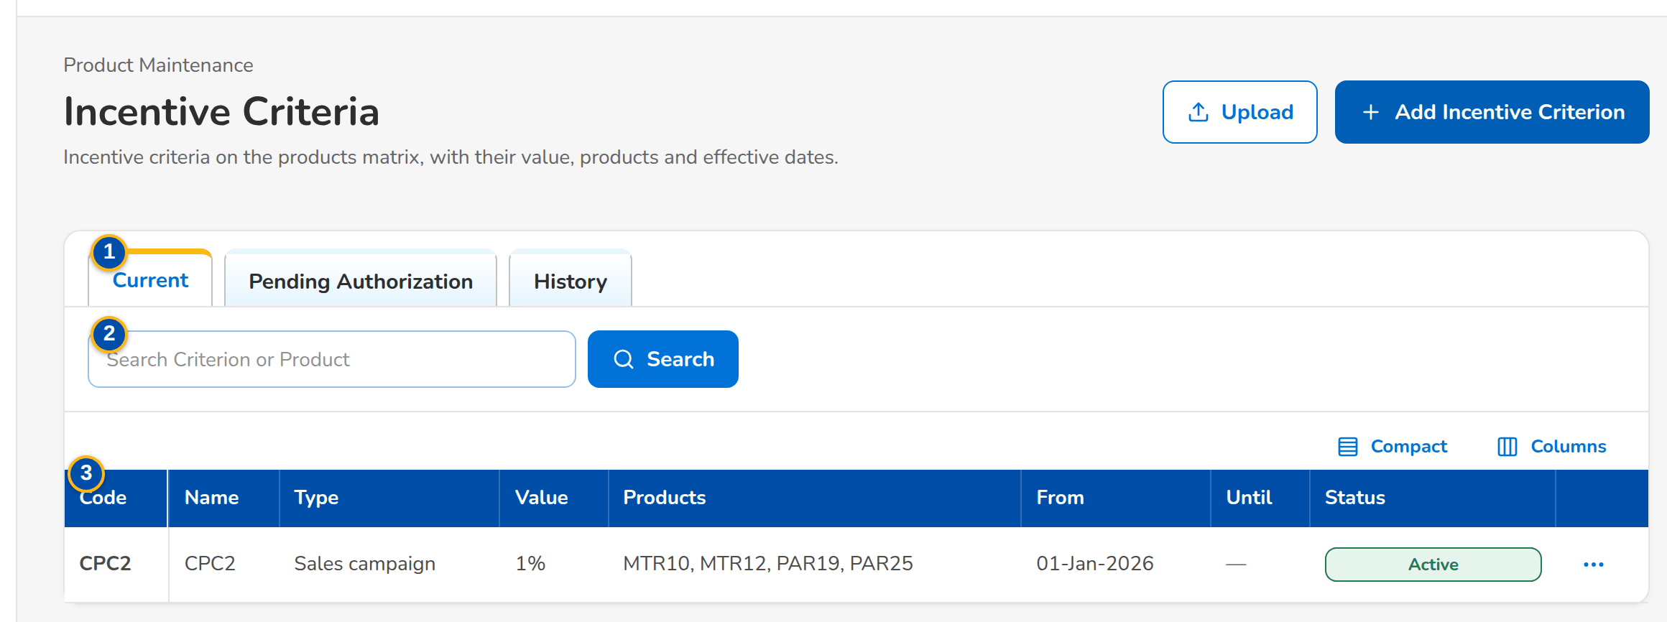
Figure G.16: Incentive Criteria, Current tab
Field | Type | Mandatory | Format / list / source | Validation and message
Tabs: Current / Pending Authorization / History | Tab | - | Fixed | Current = active and not ended; History = ended, replaced or inactive
Search: Search Criterion or Product | Text | N | Code of a criterion or a product | Contains search
List: Code / Name / Type / Value / Products / From / Until / Status | Column | - | Value as n%, an amount, or Rule; Incentive criteria | No incentive criterion in this list.
New Incentive Criterion: Code | Text | Y | A-Z, 0-9, _ and - | Unique; Use A-Z, 0-9, _ and -
New Incentive Criterion: Name | Text | Y | Up to 150 characters | Not blank; Enter the name
New Incentive Criterion: Incentive type | Drop-down | Y | Incentive types; List incentive type list | Active value; Select the type
New Incentive Criterion: Value basis | Drop-down | Y | Rate (%), Fixed amount, Rule (parameters); Fixed list | -
New Incentive Criterion: Value | Number | Cond.: rate or fixed amount | Rate 0 to 100 or an amount | Zero or more; a rate up to 100; Enter the value / A rate is between 0 and 100
New Incentive Criterion: Effective from | Date | Y | dd-MMM-yyyy | An amendment starts after the active row; no overlap with another row of the code; Enter the start date / The change must start after <active from> / Criterion <code> already covers part of this period
New Incentive Criterion: Effective to | Date | N | dd-MMM-yyyy | On or after the start; The end is before the start
New Incentive Criterion: Rule Parameters | Rows: parameter and value | N (a value per row) | Parameter from the parameters of the incentive type (Minimum Gross Premium); value as the parameter asks (an amount); Rule parameters of the incentive type | Each parameter once; a value for each parameter; a number, zero or more; Select the parameter / <parameter> is listed twice / Enter a value for each parameter / <parameter> must be a number / <parameter> cannot be negative
New Incentive Criterion: Description | Text | N | Free text | -
New Incentive Criterion: Products matrix | Drop-down and rows | Y (at least one) | Active product, with a segment per product (Any segment); Active products; list market segment list | Active products only; Select at least one product of the matrix

Action | Who | Available when | What happens | Resulting status
Add Incentive Criterion | MBS | Always | Opens New Incentive Criterion; Save for Authorization | Pending Authorization
[Open a row] | MBS | Row not inactive | Opens Change <code> (pending row) or Amend <code> (active row: a successor from a later date) | Pending Authorization
Authorize | authorizers (Business Administrator, New Business Approver), not the maker | Pending row | From the row action menu, after the confirmation: authorises the criterion; an authorised amendment ends the active row the day before it starts | Active
Deactivate | MBS | Active row | From the row action menu (last, in red); asks the reason, kept in the audit trail, and ends the criterion; its history stays | Inactive

Rules:
- A criterion names at least one active product of the matrix; a product that expires or is retired raises an alert to review or deactivate the criterion (FRPM.018.01, FRPM.018.02).
- An active criterion is changed only by an amendment starting after it; the active row ends when the amendment is authorised, so there is never a gap or an overlap (FRPM.018.01).
- At booking, the invoice stores the codes of the criteria that match its product, cover type, segment, channel, lead insurer and booking date (FRPM.018.02).

G.17 Insurers (SCR-PM-17)
Purpose: The insurer panel of the company: each accredited insurer with its accreditation date, placement channel and placement e-mails, and its credit days. Package versions, quotation slips and placement use this panel. A new insurer also creates its business partner for the ledger; both are authorised together.
Access: Sidebar entry Insurers
Requirements: FRPM.003.02, FRPM.023.01
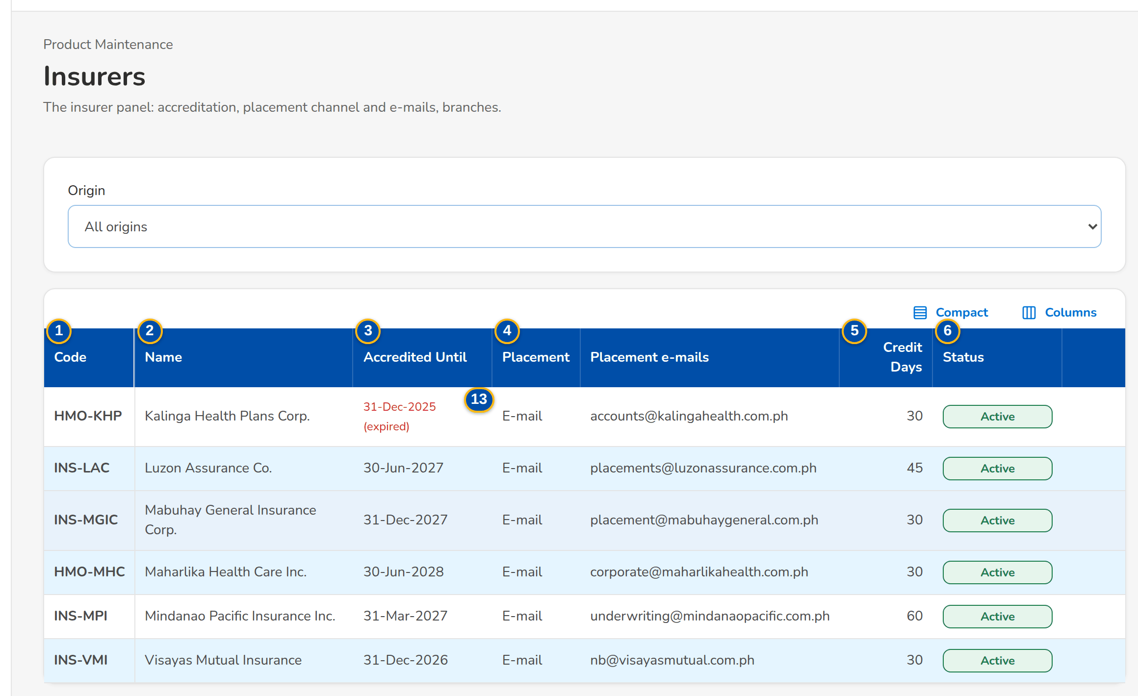
Figure G.17: Insurers list
Field | Type | Mandatory | Format / list / source | Validation and message
List: Code | Column | - | Partner code INS-...; Insurer master | No insurer on the panel yet.
List: Name | Column | - | Registered name; Insurer master | -
List: Accredited Until | Column | - | dd-MMM-yyyy; (expired) in red once past; Insurer master | -
List: Placement / Placement e-mails | Column | - | E-mail; addresses; Insurer master | -
List: Credit Days | Column | - | Days; Insurer master | -
List: Status | Column | - | Pending Authorization, Active, Inactive; Insurer master | -
New insurer: Partner code | Text | Y | INS- followed by capitals | Unique; an existing party must be an insurer; Party <party code> exists and is not an insurer
New insurer: Name / Short name | Text | Y (name) | Registered and short name | -
New insurer: IC accreditation no. / Accredited until | Text / Date | N | Insurance Commission accreditation; dd-MMM-yyyy | -
New insurer: Placement channel | Drop-down | Y | E-mail; Fixed list | Only e-mail placement is available; Only e-mail placement is available; choose the e-mail placement channel
New insurer: Placement e-mails | Text | N (needed to send quotation slips and placement slips) | Addresses separated by commas | <name> has no placement e-mail address
New insurer: Credit days | Number | N | 0 to 365 | 0 to 365; Default credit days must be between 0 and 365
New insurer: TIN / Address / E-mail / Phone | Text | N | Business partner details | -

Action | Who | Available when | What happens | Resulting status
New Insurer | master data maintainers (Business Administrator) | Always | Opens New insurer; Save for Authorization | Pending Authorization
Authorize | authorizers, not the maker | Pending row | From the row action menu, after the confirmation: authorises the insurer and its business partner | Active
Deactivate | master data maintainers | Active row | From the row action menu (last, in red); asks the reason, kept in the audit trail; the insurer is no longer offered | Inactive
[Open a row] | Every user of the screen | Always | Opens the insurer record | -

Rules:
- Only authorised, active insurers are offered in package requests, package versions and quotation slips (FRPM.003.02, FRPM.012.01).
- The insurer master is maintained under New Business rules (BRD-1, insurer panel); Product Maintenance uses it for the package panels (FRPM.003.02).

G.18 Insurer record (SCR-PM-18)
Purpose: One insurer: its profile (partner code, accreditation, placement channel and e-mails, credit days, maker and authoriser), its branches with the local government tax rate, and its commission rates by product.
Access: Insurers › a row
Requirements: FRPM.003.02, FRPM.023.01
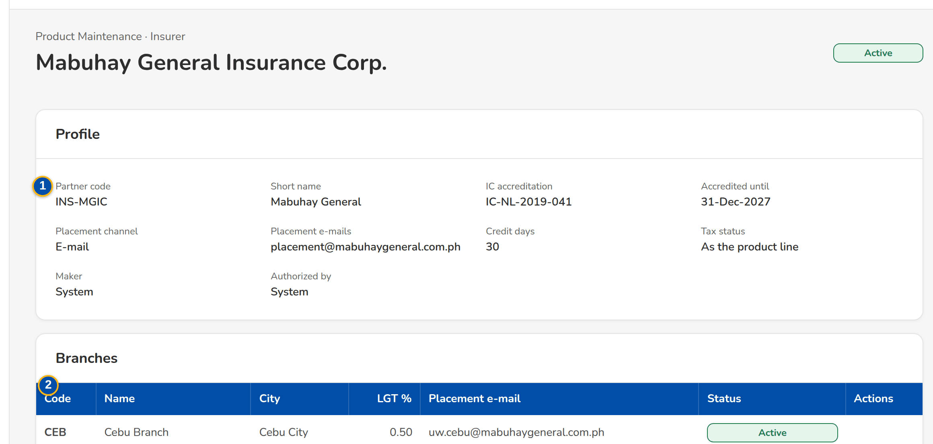
(continued below)
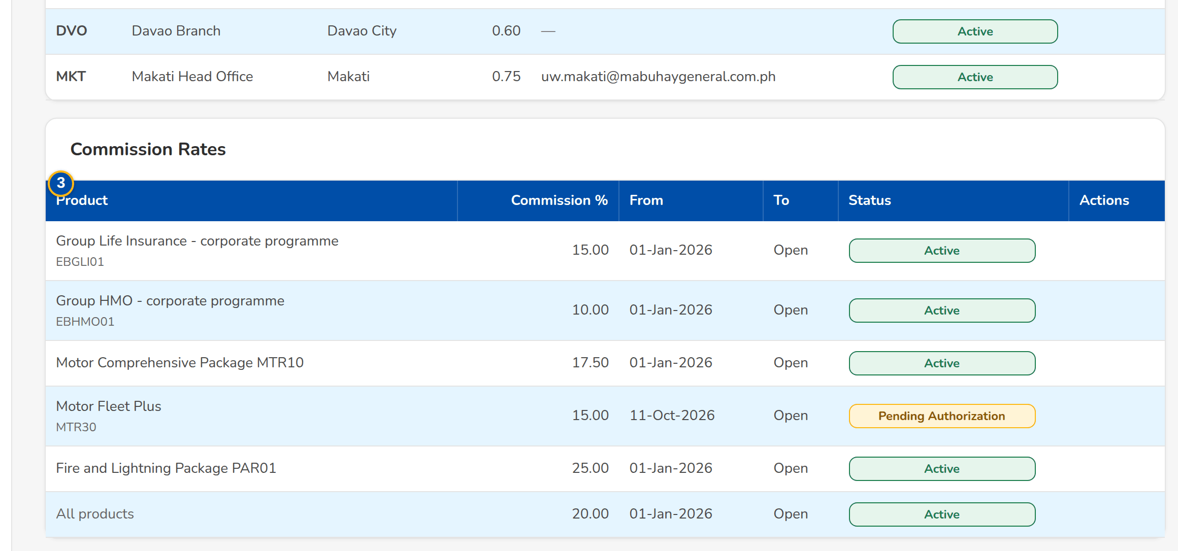
Figure G.18: Insurer record with branches and commission rates
Field | Type | Mandatory | Format / list / source | Validation and message
Profile: Partner code / Short name / IC accreditation / Accredited until / Placement channel / Placement e-mails / Credit days / Maker / Authorized by | Detail | - | As entered; Insurer master | -
Branches: Code / Name / City / LGT % / Placement e-mail / Status | Column | - | Branch of the insurer; Insurer branches | No branch recorded.
Commission rates: Product / Commission % / From / To / Status | Column | - | All products or one product; To shows Open; Commission rates | No commission rate: the product default applies.
New Branch: Code / Name | Text | Y | Branch code and name | Unique per insurer; Insurer branch already exists: <key>
New Branch: City | Text | N | Free text | -
New Branch: LGT % | Number | Y | Local government tax on premium, up to four decimals | 0 to 100; The LGT rate must be between 0 and 100 %
New Branch: Placement e-mail | Text | N | Address | -
New Commission Rate: Product | Drop-down | N | All products of the insurer or one active product; Active products | -
New Commission Rate: Commission % | Number | Y | Percentage | 0 to 100; The commission rate must be a percentage between 0 and 100
New Commission Rate: Effective from / Effective to | Date | Y (from) | dd-MMM-yyyy | To on or after from; Enter the effective-from date / The effective-to date is before the effective-from date

Action | Who | Available when | What happens | Resulting status
Edit | master data maintainers | Always | Opens the insurer dialog (partner code fixed); Save for Authorization | Pending Authorization
Add branch | master data maintainers | Always | Opens New Branch; Save for Authorization | Pending Authorization
Add rate | master data maintainers | Always | Opens New Commission Rate; Save for Authorization | Pending Authorization
Authorize / Deactivate | As on Insurers | As on Insurers | As on Insurers | Active / Inactive

Rules:
- The commission rate in force on the account's period start applies; without an insurer rate, the product default applies (FRPM.003.02).
- A package version's own insurer rate and minimum premium win over the insurer's general terms for that package (FRPM.003.02).

G.19 Rates & Taxes (SCR-PM-19)
Purpose: The statutory charges and rating tables applied by the premium calculation: documentary stamp tax, premium tax, VAT, fire service tax and the motor own-damage factors; the short-period table; and the bodily injury and property damage limit premiums. Every row is effective-dated and maker-checker.
Access: Sidebar entry Rates & Taxes
Requirements: FRPM.024.02
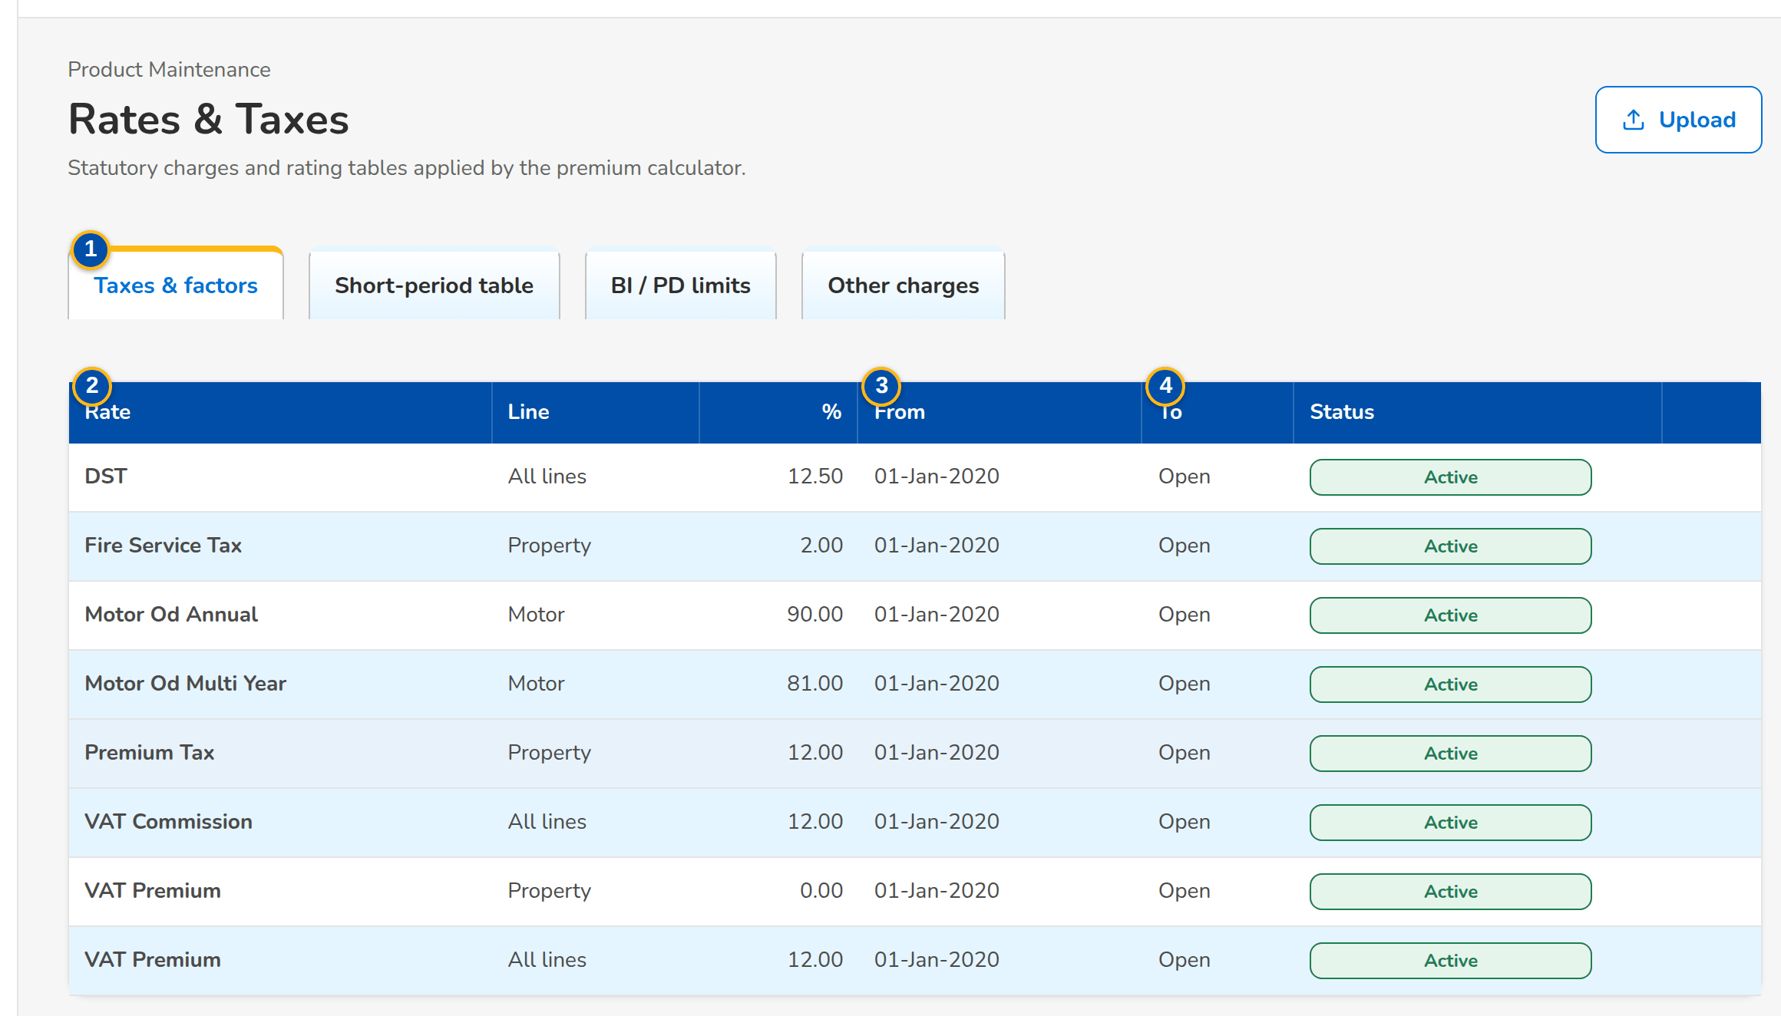
Figure G.19: Rates & Taxes, Taxes & factors tab
Field | Type | Mandatory | Format / list / source | Validation and message
Tabs: Taxes & factors / Short-period table / BI / PD limits | Tab | - | Fixed | -
Taxes & factors: Rate / Line / % / From / To / Status | Column | - | Rate name; All lines or a line; percentage; dd-MMM-yyyy; Open; Rate table | -
Short-period table: Months Covered (up To) / % of Annual Premium / From / To / Status | Column | - | Months 1 to 12; percentage; Short-period table | -
BI / PD limits: Coverage / Limit / Premium / From / To / Status | Column | - | Bodily injury or Property damage; amounts; Motor limit table | -
New rate: Rate | Drop-down | Y | DST, premium tax, VAT, fire service tax and the motor factors; Fixed list | -
New rate: Line code | Text | N | Blank = every line; Product lines | -
New rate: Rate % / % of annual premium | Number | Y | Percentage, up to four decimals | 0 to 100; The rate must be a percentage between 0 and 100 / The short-period percentage must be a percentage between 0 and 100
New rate: Months covered | Number | Y (short-period table) | 1 to 12 | 1 to 12; Months covered must be between 1 and 12
New rate: Coverage / Limit / Premium | Drop-down / Number | Y (limit table) | Bodily injury (BI) or Property damage (PD); amounts; Fixed list | Limit greater than zero; premium zero or more; The limit must be greater than zero / The premium cannot be negative
New rate: Effective from / Effective to | Date | Y (from) | dd-MMM-yyyy | To on or after from; Enter the effective-from date / The effective-to date is before the effective-from date

Action | Who | Available when | What happens | Resulting status
New Rate | master data maintainers (Business Administrator) | Always | Opens the dialog of the current tab; Save for Authorization | Pending Authorization
Authorize / Deactivate | authorizers / master data maintainers | As on Insurers | Authorises the row or ends its use | Active / Inactive

Rules:
- The row in force on the rating date applies; statutory rates keep their effective-date look-up and do not follow the package version (FRPM.024.02).
- A period without a short-period row, or a motor limit not in the table, is refused at rating (FRPM.024.02).

G.20 Sales Organisation (SCR-PM-20)
Purpose: The sales organisation of the company as one tree table: regions, departments and teams with their cost centres, and the account officers of each team by name, role and assignment date. Accounts are stamped with the creator's units and cost centre when they are created.
Access: Sidebar entry Sales Organisation
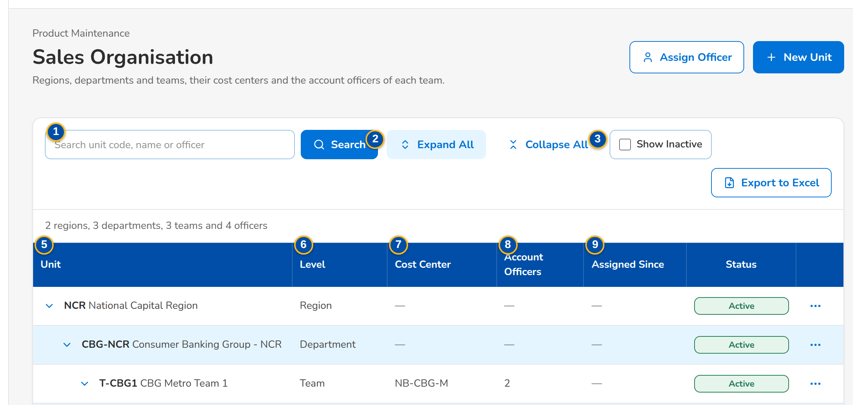
(continued below)
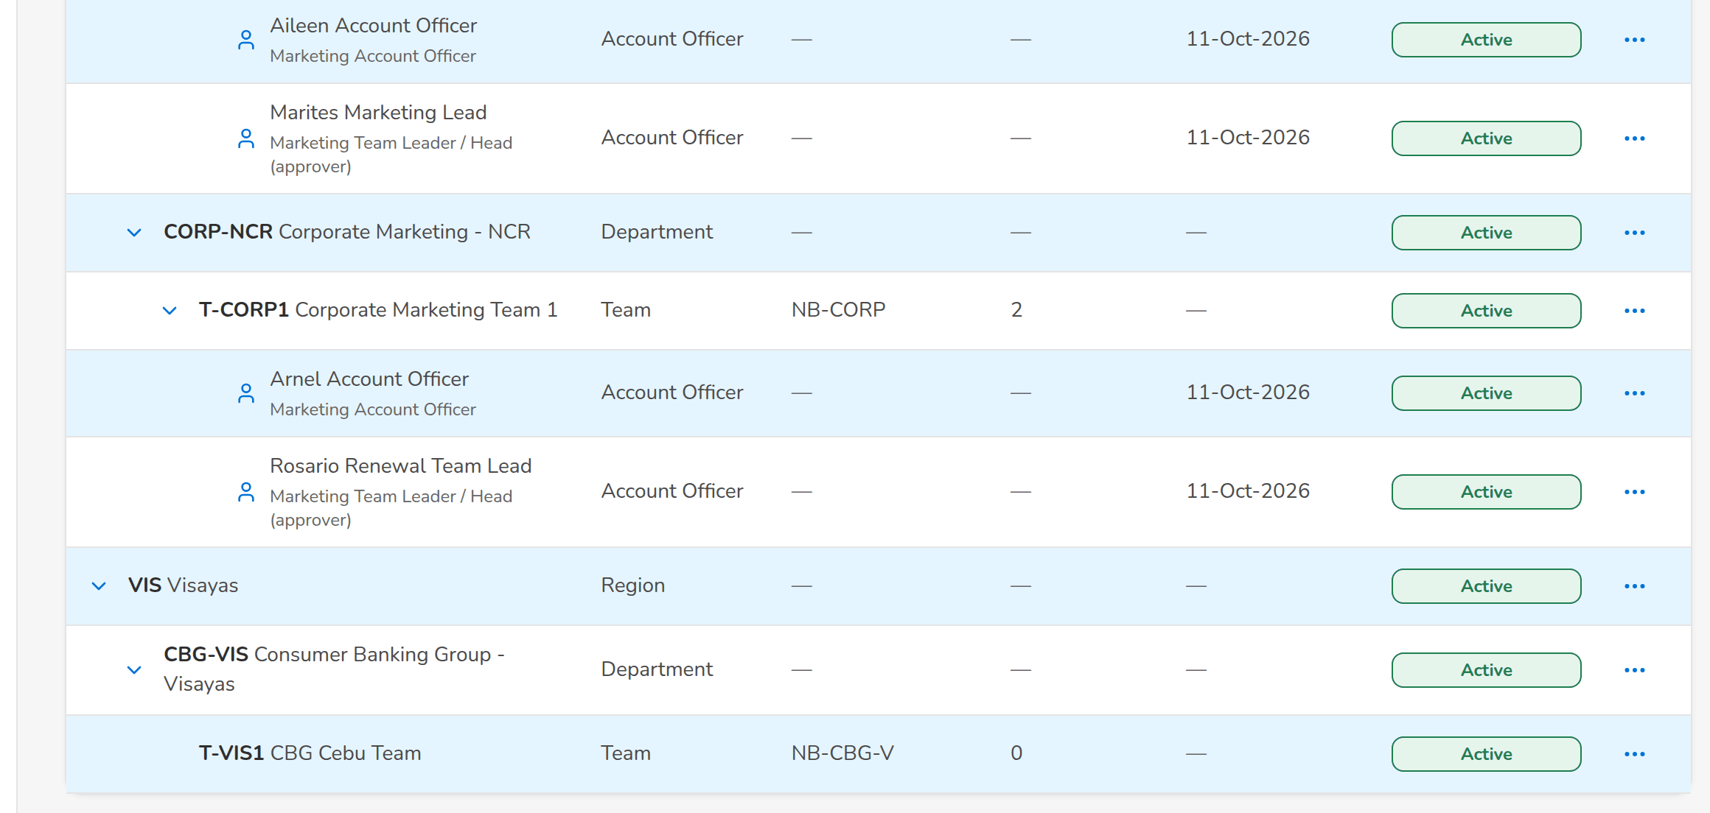
Figure G.20: Sales Organisation tree table, every branch expanded
Field | Type | Mandatory | Format / list / source | Validation and message
Toolbar: Search unit code, name or officer | Text | N | Unit code or name, or the officer's name | Contains search; the matching branches open; No unit or officer matches the search
Toolbar: Expand All / Collapse All | Button | - | Opens or closes every branch | -
Toolbar: Show Inactive | Check box | N | Lists deactivated units and removed officers in grey | -
Toolbar: [Summary] | Text | - | n regions · n departments · n teams · n officers of the rows shown; Sales units and officers | -
Tree table: Unit | Column | - | Chevron and indentation per level; code in bold and name; an officer by full name with the role below; Sales units; users | No sales unit defined yet
Tree table: Level | Column | - | Region, Department, Team or Account Officer; Sales units | -
Tree table: Cost Center | Column | - | The unit's own cost centre, or the cost centre in force with Inherited from <parent code> below it; Sales units | -
Tree table: Account Officers | Column | - | Number of active officers of a team; Sales officers | -
Tree table: Assigned Since | Column | - | dd-MMM-yyyy, date the officer joined the team; Sales officers | -
Tree table: Status | Pill | - | Active, Pending Authorization, Inactive; Sales units and officers | -
Tree table: [Actions] | Menu | - | The actions of the row (see Actions) | -
New unit / Add sub-unit: Level | Drop-down | Y | Region, Department, Team; fixed to the level below when opened from a unit; Fixed list | A department belongs to a region; a team to a department; A <level> must belong to an active <parent level>
New unit / Add sub-unit: Code / Name | Text | Y | Unit code and name | Unique; Sales unit already exists: <key>
New unit / Add sub-unit: Cost Center | Text | N | Blank = inherited from the parent; Cost centres | A cost centre of the company
New unit / Add sub-unit: Parent | Drop-down | Cond.: department and team | Active units of the level above; Sales units | -
Unit details: Code, Name, Level, Parent Unit, Cost Center, Unit Head, Sub-units, Account Officers, Status, Status Reason, Created, Last Changed, Authorized | Detail | - | Names of users, dd-MMM-yyyy HH:mm; Sales units | -
Assign Account Officer / Reassign: Team | Drop-down | Y | Active teams; Sales units | An existing, active team; Team <team code> is unknown or inactive
Assign Account Officer / Reassign: Account Officer | Drop-down | Y | the system users by name and role; Users | An existing user; Unknown user <user>
Deactivate / Reactivate / Remove from Team: Reason | Text | Y | Why the unit or officer changes | Not blank; Enter the reason.

Action | Who | Available when | What happens | Resulting status
New Unit | master data maintainers | Always | Opens New unit; Save for Authorization | Pending Authorization
Assign Officer | master data maintainers | Always | Opens Assign Account Officer; Save for Authorization | Pending Authorization
View / Edit | Every user of the screen; Edit with master data maintainers | Unit row | Opens the unit details; Edit changes name, parent and cost centre, Save for Authorization | Pending Authorization
Add Department / Add Team | master data maintainers | Active region / department | Opens New unit at the level below, the parent filled | Pending Authorization
Assign Officer (row) | master data maintainers | Active team | Opens Assign Account Officer with the team filled | Pending Authorization
Authorize | authorizers, not the maker | Pending unit or officer | From the row action menu, after the confirmation: authorises the record | Active
Deactivate | master data maintainers | Active or pending unit without active sub-units or officers | Asks the reason and deactivates the unit; refused with a notice while sub-units or officers remain | Inactive
Reactivate | master data maintainers | Inactive unit whose parent is not inactive | Asks the reason; the unit waits for authorisation again | Pending Authorization
Reassign / Assign to a Team | master data maintainers | Officer row | Moves the officer to another team (or places a removed officer again) from today | Pending Authorization
Remove from Team | master data maintainers | Active or pending officer | Asks the reason and ends the officer's assignment | Inactive
Export to Excel | Every user of the screen | Always | Downloads the tree in tree order with the effective cost centres and the officers by name and role | -

Rules:
- The sales organisation is a New Business master (BRD-1, sales hierarchy and production reporting) kept in the Product Maintenance section of the menu; it is loaded at go-live by the data migration.
- A unit is deactivated only when none of its sub-units and account officers is still active or pending; a unit is reactivated only under an active or pending parent, and waits for authorisation again.
- Deactivation, reactivation and removal from a team need a reason, kept on the record and in the audit trail with the user and time.
- A team without its own cost centre uses the cost centre of the nearest parent that has one.

G.21 Premium Calculator (SCR-PM-21)
Purpose: Rates a product with the charges in force, for an insurer and branch, annual, pro-rata or short period, for a new account or an endorsement over the remaining term, and shows every charge and the commission. For a package it shows the version that priced it; an earlier released version can be chosen for information.
Access: Sidebar entry Premium Calculator
Requirements: FRPM.002.02, FRPM.003.01, FRPM.003.05, FRPM.024.02
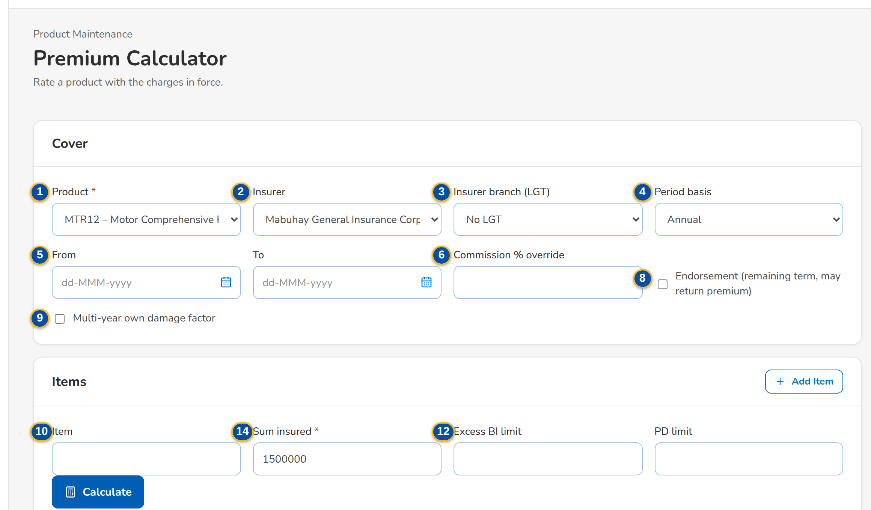
(continued below)
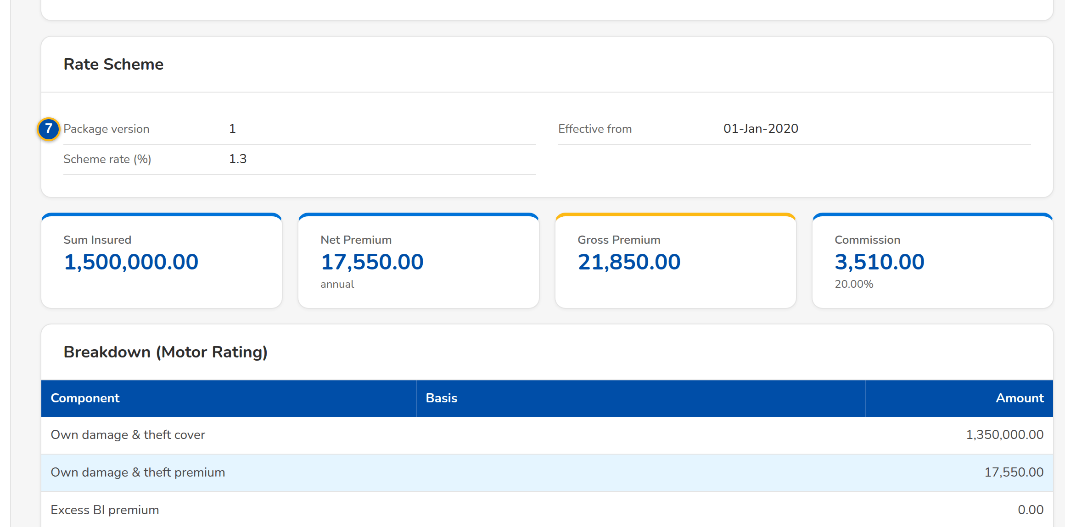
(continued below)
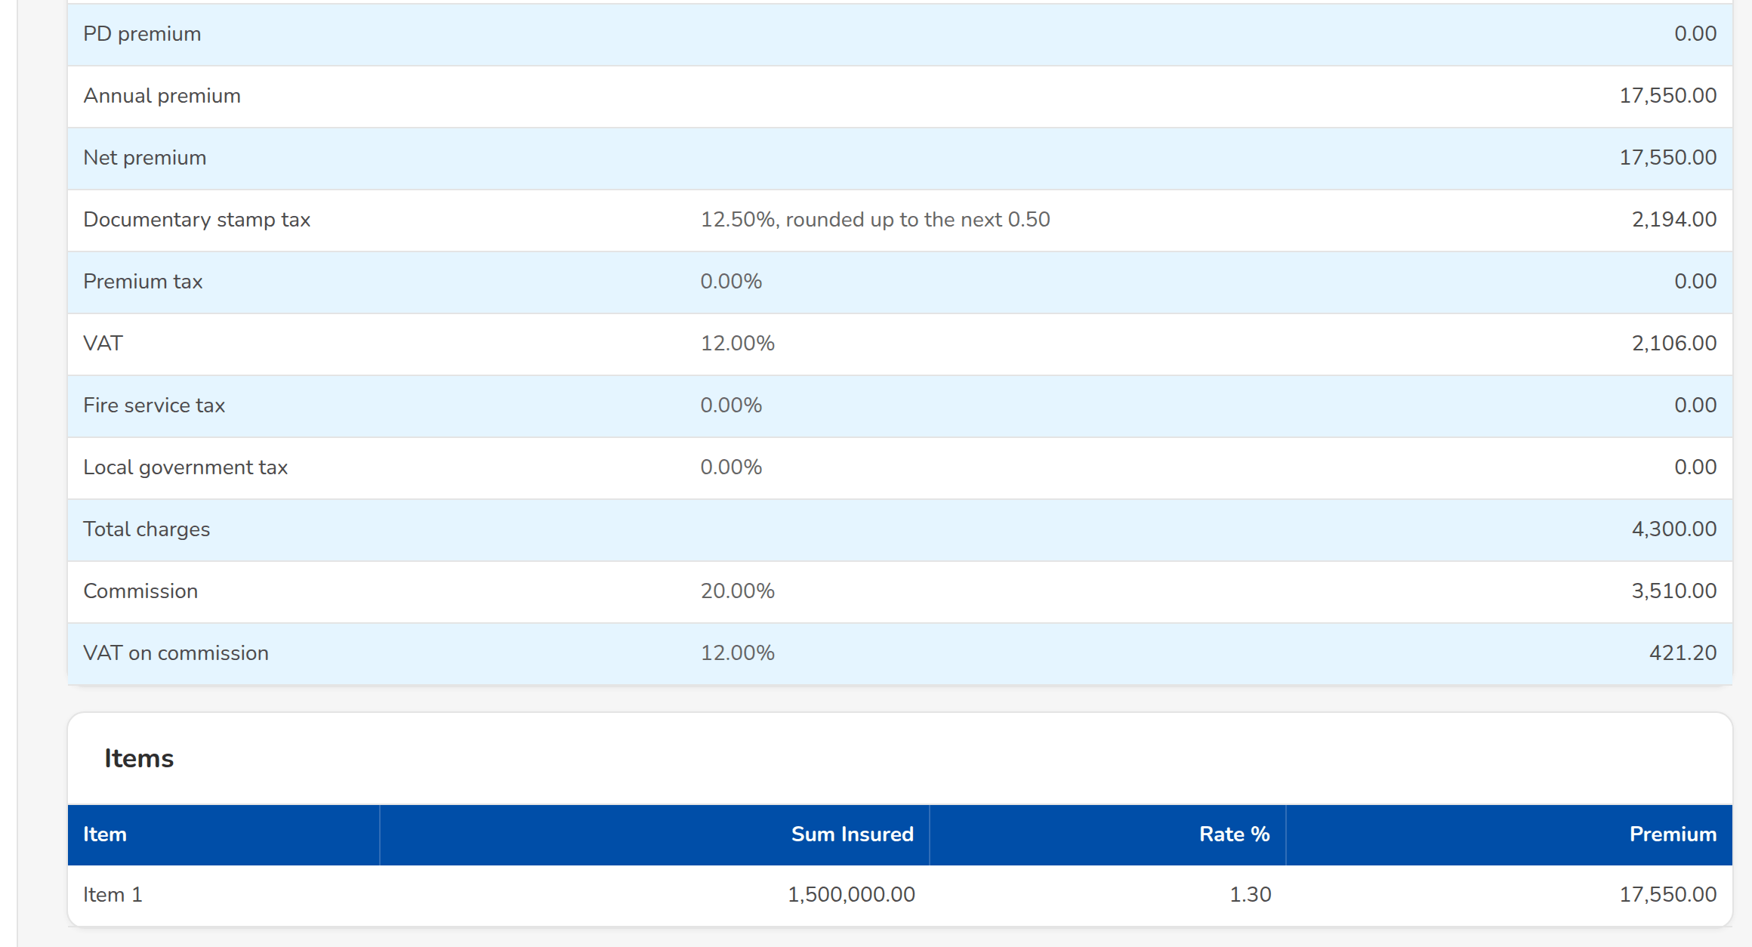
Figure G.21: Premium Calculator: a package priced on its version in force
Field | Type | Mandatory | Format / list / source | Validation and message
Cover: Product | Drop-down | Y | Code – name of the active products; Active products | Choose a product.
Cover: Insurer | Drop-down | N | Insurers of the panel; Insurers | A package with a panel accepts only its panel insurers; Insurer <insurer code> is not on the panel of <product code> version <version no>
Cover: Insurer branch (LGT) | Drop-down | N | Branch name (LGT %); Insurer branches | An authorised branch of the insurer; Branch <branch code> is not authorized or inactive
Cover: Period basis | Drop-down | N | Annual, Pro-rata (days), Short period (table); Fixed list | Pro-rata and short period need the period; Pro-rata and short-period rating need the period (for endorsements: the remaining term).
Cover: From / To | Date | Cond.: pro-rata or short period | dd-MMM-yyyy | To after From; The period end must be after the period start
Cover: Commission % override | Number | N | Percentage | -
Cover: Package version | Drop-down | N | Version in force, or an earlier released version; Released and superseded versions | Shown when the package has two or more sold versions
Cover: Endorsement (remaining term, may return premium) | Check box | N | - | Only an endorsement may reduce the sum insured; Only an endorsement may reduce the sum insured.
Cover: Multi-year own damage factor | Check box | N | Motor multi-year products | -
Items: Item / Sum insured | Text / Number | Y (a sum insured for at least one item) | Label; amount in PHP | Zero or more; Enter the sum insured of at least one item.
Items: Rate % | Number | N | Blank = product default (non-motor) | A rate other than the scheme rate is priced but flagged; Enter the premium rate of <item>
Items: Excess BI limit / PD limit | Number | N | Motor limits of the table; Motor limit table | A limit of the table; <coverage> limit <amount> is not in the limit table
Result: [Version line] | Banner | - | Priced on package version n (effective dd-MMM-yyyy, scheme rate r%); not the current version; an item rate differs from the scheme rate; Package version | -
Result: Sum insured / Net premium / Gross premium / Commission | Figure | - | Amounts in PHP; Premium computation | -
Result: Component / Basis / Amount | Table | - | Annual premium, net premium, documentary stamp tax, premium tax, VAT, fire service tax, local government tax, total charges, commission, VAT on commission; Premium computation | -

Action | Who | Available when | What happens | Resulting status
Add Item / Remove | Every user of the screen | Always | Adds or removes an item | -
Calculate | Every user of the screen | Product chosen and a sum insured entered | Rates the cover and shows the result | -

Rules:
- New business is priced on the package version in force on the transaction date, not on the period start (FRPM.024.02).
- A version other than the one in force is shown for information only; a quotation needs the current version or an approved rate exception (FRPM.024.02).
- An item rate different from the scheme rate (or the panel insurer's rate) is priced but flagged; a quotation with it needs an approved rate exception (FRPM.024.02).
- An expired or retired package, or a package with no version in force, cannot be priced for new business (FRPM.002.02).

G.22 Quotation: package rate scheme and rate exception (SCR-PM-22)
Purpose: Where New Business meets the package version: the quotation record of a package product shows the version that priced it and warns when an item rate differs from the scheme rate. The Account Officer then requests a rate exception. The approver opens the exception record from My Approvals, compares the requested rate with the scheme in force and approves it with a comment or rejects it with a reason; the requester is notified and the quotation is submitted with the approved exception. Only the Rate Exceptions card, the Request Rate Exception dialog and the exception record are specified here; the rest of the quotation record is specified in the New Business set (SCR-NB-07).
Access: Quotations › a row (New Business); New Quotation › Submit for Review refused with the rate scheme message; My Approvals › the rate exception row (the exception record); Notification of the decision › the exception record
Requirements: FRPM.024.02
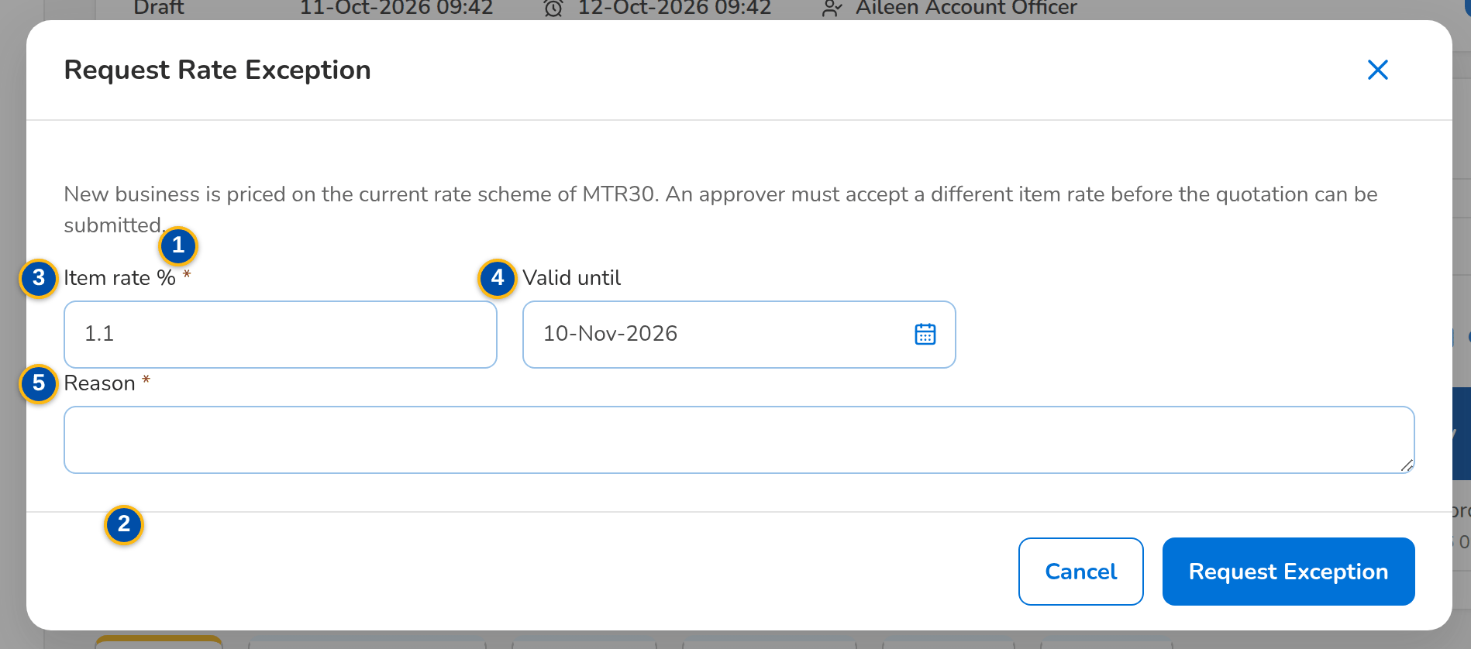
Figure G.22: Request Rate Exception dialog
Field | Type | Mandatory | Format / list / source | Validation and message
Rate Exceptions card: [Pricing notice] | Notice | - | Priced on package version n. An item rate differs from the scheme rate, so submission needs an approved rate exception; Quotation pricing | Shown while an item rate differs; Package <product code> is priced on the current rate scheme: <what> needs an approved rate exception
Rate Exceptions card: [Rate exceptions table] | Table | - | One row per exception: Exception No. (opens the exception record), Requested Rate (%), Scheme Rate (%), Difference (%) in percentage points with its sign, Valid Until, Requested By and on, Decided By and on, Status (Pending Authorization, Approved or Rejected); Rate exceptions of the quotation | -
Request Rate Exception: Item rate % | Number | Y | 0 to 100 | 0 to 100; Enter the item rate between 0 and 100
Request Rate Exception: Valid until | Date | N | dd-MMM-yyyy | Not in the past; The validity date cannot be in the past
Request Rate Exception: Reason | Text | Y | Free text | Not blank; Explain why the scheme rate cannot be used
Exception record: Package | Fact | - | Risk code – package name; Product master | -
Exception record: Requested rate | Fact | - | Rate n.nn% (or the version requested); Exception | -
Exception record: Scheme in force | Fact | - | Version n, rate n.nn% (or rate per insurer); Package version in force today | -
Exception record: Quotation | Fact | - | Quotation number (opens the quotation), client and gross premium; Quotation | -
Exception record: Requested by | Fact | - | Display name and date and time of the request; Exception | -
Exception record: Reason for the exception | Text | - | As requested; Exception | -
Exception record: Decision | Detail | - | Approved by or Rejected by (display name and role), On, Comment or Reason; Exception | -
Approve Rate Exception: Comment | Text | N | Free text, up to 1,000 characters | -
Reject Rate Exception: Reason for the rejection | Text | Y | Free text, up to 1,000 characters | Not blank; Enter the reason for the rejection

Action | Who | Available when | What happens | Resulting status
Request Rate Exception | Marketing | Draft quotation of a package with an item rate that differs | Opens the dialog; Request Exception records the exception for this quotation, pending approval | Pending Authorization
[Open from My Approvals] | Business Administrator, New Business Approver | Exception pending | The rate exception row of My Approvals opens the exception record | -
Approve | Business Administrator, New Business Approver, not the requester | Exception pending | Opens the confirmation with an optional comment; Approve approves the exception, which prices the quotation from then on | Approved
Reject | Business Administrator, New Business Approver, not the requester | Exception pending | Opens the confirmation; the reason is required; Reject rejects the exception, which can no longer be used | Rejected

Rules:
- Only package rate schemes need an exception; an exception names the rate or the version it approves and the transaction (quotation number or ARN) (FRPM.024.02).
- An exception is approved or rejected by a holder of the product approval permission other than its requester; the requester sees the record without the Approve and Reject buttons (FRPM.024.02).
- A rejection needs its reason; the decision, its maker, date and comment or reason stay on the record and in the audit trail (FRPM.024.02).
- Submission of the quotation (and of the account) is refused until an approved exception covers the differing rate or version (FRPM.024.02).
- The approved exception is stored on the quotation and passed to the accounts created from it (FRPM.024.02).

G.23 Product Maintenance Dashboard (SCR-PM-23)
Purpose: The figures of Product Maintenance for a period: incoming, in-progress, for-approval, expiring, issued and deactivation figures, each opening its list of requests with the request type, line, requester, assigned TSU officer, status, submission date and aging; the package requests by stage with the overdue ones; the packages ending within 30, 60 and 90 days; and the shortcuts to the versions for validation, the advisories not sent and the comparative outputs of the week. Exported to Excel, PDF and CSV.
Access: Product Maintenance › Product Maintenance Dashboard
Requirements: FRPM.001.01, FRPM.002.01, FRPM.002.02, FRPM.003.07, FRPM.007.02, FRPM.015.01, FRPM.019.01, FRPM.019.02, FRPM.019.03, FRPM.020.01, FRPM.028.01
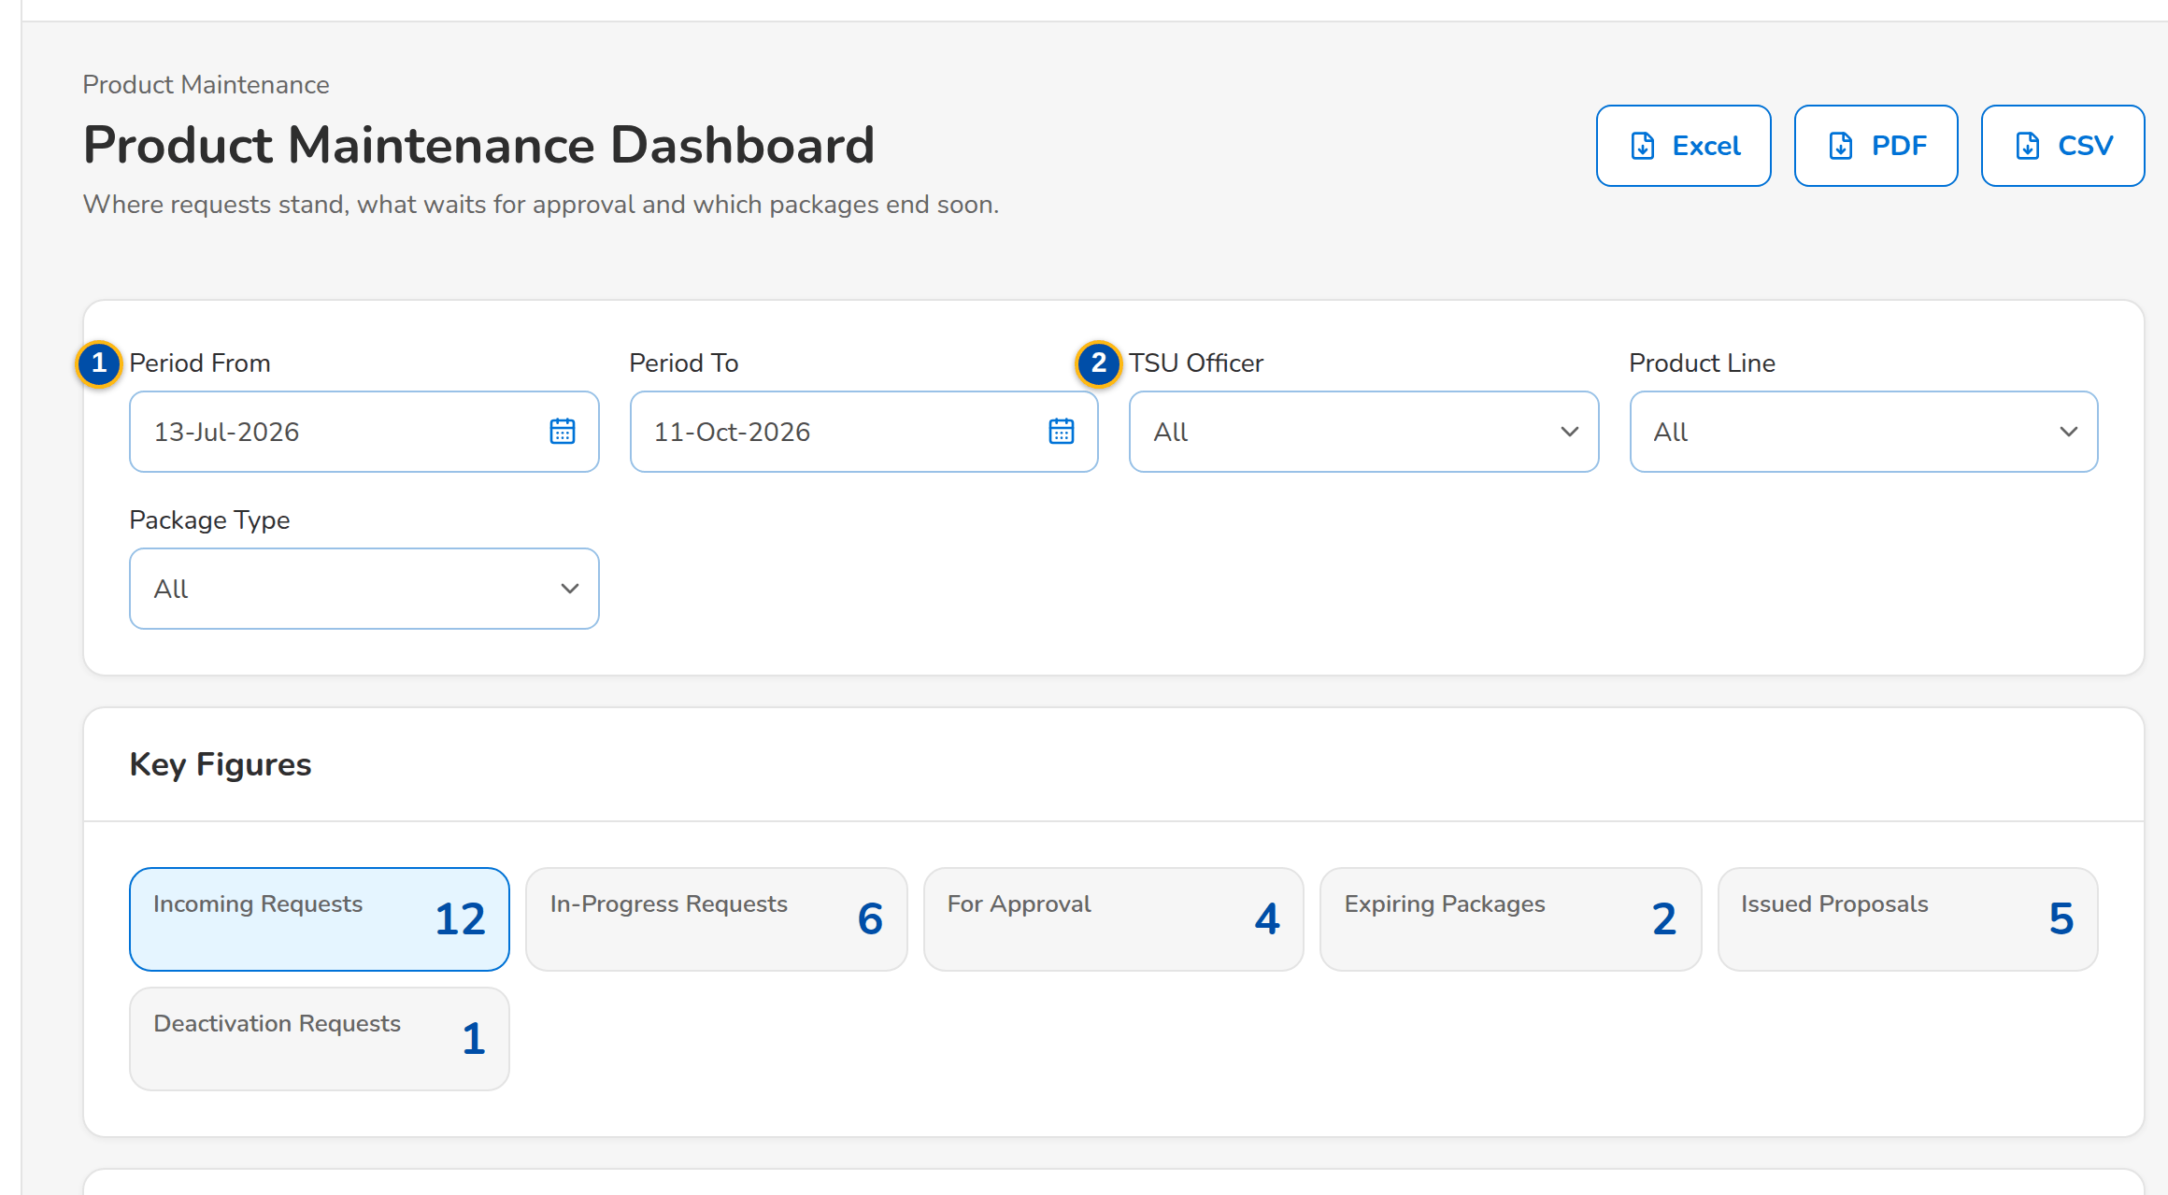
(continued below)
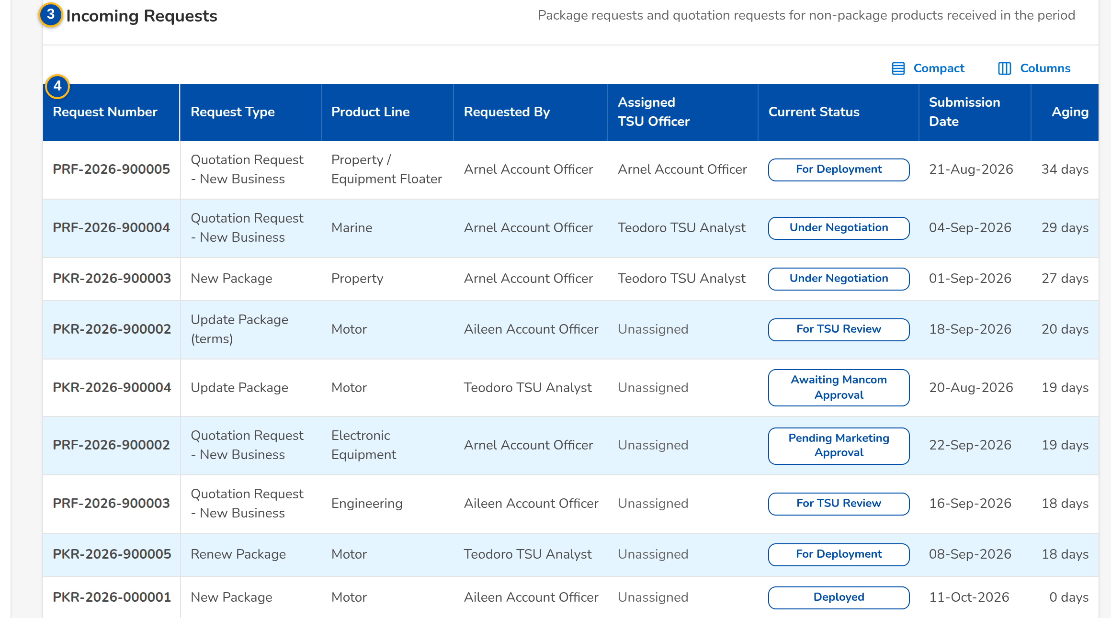
(continued below)
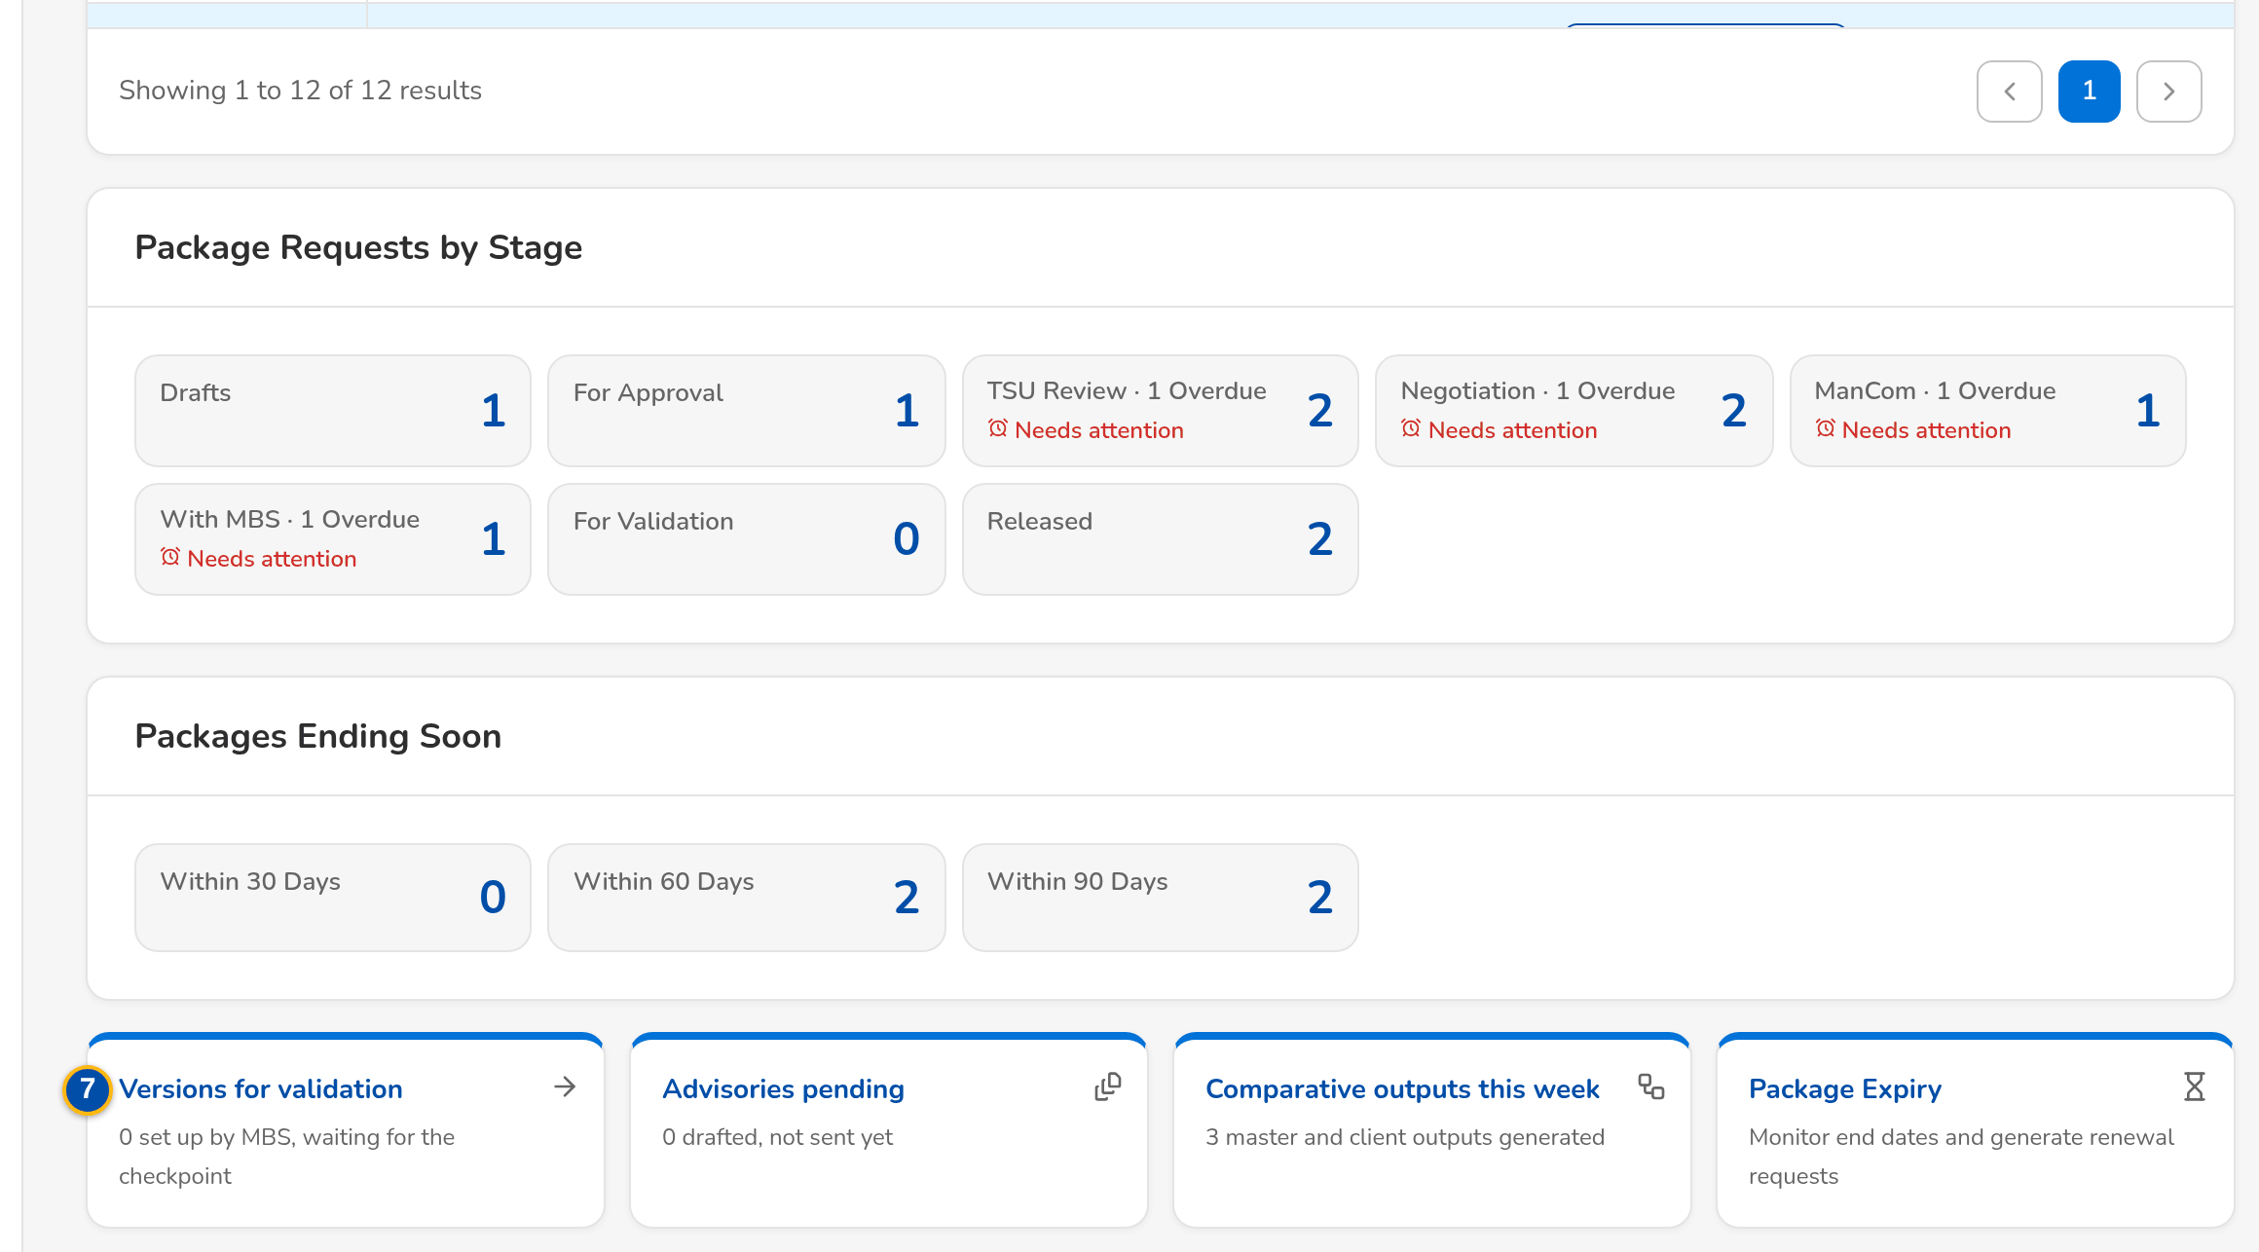
Figure G.23: Product Maintenance Dashboard with the key figures and the incoming requests
Field | Type | Mandatory | Format / list / source | Validation and message
Filters: Period From / Period To | Date | N | dd-MMM-yyyy | To on or after From; The end date must be on or after the start date
Filters: TSU Officer / Product Line / Package Type | Look-up; drop-downs | N | Names of the TSU officers; lines; Package, Non-Package; Users; product lines; fixed list | -
Key Figures: Incoming Requests / In-Progress Requests / For Approval / Expiring Packages / Issued Proposals / Deactivation Requests | Tile | - | Count of the period; the chosen tile opens its list below; Package and quotation requests, package versions, deactivation requests | -
[List of the chosen figure]: Request Number / Request Type / Product Line / Requested By / Assigned TSU Officer / Current Status / Submission Date / Aging | Columns | - | PKR or PRF number; type; line; names; status; dd-MMM-yyyy; working days; Requests | -
Package requests by stage: Drafts / For Approval / TSU Review / Negotiation / ManCom / With MBS / For Validation / Released | Tile | - | Count of requests; '· n Overdue' and Needs attention when a request of the tile is past its due time; Package requests | -
Packages ending soon: Within 30 Days / Within 60 Days / Within 90 Days | Tile | - | Count of released packages whose end date falls in the window; Package versions in force | -
Shortcuts: Versions for validation / Advisories pending / Comparative outputs this week / Package Expiry | Tile | - | 'n set up by MBS, waiting for the checkpoint'; 'n drafted, not sent yet'; 'n master and client outputs generated'; Requests, advisories, outputs | -

Action | Who | Available when | What happens | Resulting status
Excel / PDF / CSV | Every user of the screen | Always | Exports the figures and the list on screen, named by the convention <name>_MMDDYYYY | -
[A key figure] | Every user of the screen | Always | Shows the list of the figure under the tiles | -
[A stage or expiry tile] | Every user of the screen | Always | Opens Package Requests on the tab of the tile, or Package Expiry with the window | -

Rules:
- The figures are those of the company selected in the page header and of the filters (FRPM.001.01).
- A request is overdue when its stage due time has passed; the due time comes from the service level hours of the stage (FRPM.001.01).

G.24 Deactivation Requests (SCR-PM-24)
Purpose: The requests to deactivate a package with an effective date: the list with the approval status and the new expiry date, the request with its details, supporting documents and audit log, and the decision of the approver (approve or reject with remarks); the Deactivate Package dialog of the product record raises the request.
Access: Product Maintenance › Deactivation Requests; Products › a package › Deactivate Package; The notice <request no>: deactivation of <risk code> for your approval
Requirements: FRPM.003.04, FRPM.003.06, FRPM.003.07, FRPM.021.01, FRPM.021.02, FRPM.029.01
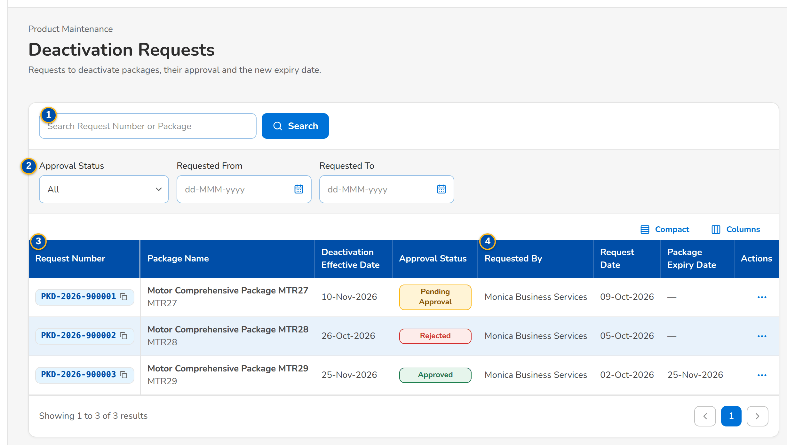
Figure G.24: Deactivation Requests with their approval status
Field | Type | Mandatory | Format / list / source | Validation and message
List: Search Request Number or Package | Text | N | Part of the number or the package name | -
List: Approval Status / Requested From / Requested To | Drop-down; dates | N | Pending Approval, Approved, Rejected, Cancelled; dd-MMM-yyyy; Fixed list | -
List: Request Number / Package Name / Deactivation Effective Date / Approval Status | Columns | - | PKD-yyyy-nnnnnn; name with the risk code; dd-MMM-yyyy; status; Deactivation requests | -
List: Requested By / Request Date / Package Expiry Date | Columns | - | Name; dd-MMM-yyyy; the new expiry date once approved; Deactivation requests | -
Deactivate Package: Package / Expiry Date | Values | - | Name and risk code; current expiry date or None; Product | -
Deactivate Package: Deactivation Effective Date | Date | Y | dd-MMM-yyyy | Today or later; Enter the deactivation effective date; The deactivation effective date must be today or later
Deactivate Package: Reason for Deactivation | Drop-down | Y | Insurer withdrew the terms, Replaced by another package, Loss experience, Low uptake, Regulatory change, Others (see remarks); List of values | Select the reason for deactivation
Deactivate Package: Approver | Look-up | Y | Users with the deactivation approval right; Users | Select the approver
Deactivate Package: Remarks / Supporting Documents | Text area; files | N | Up to 1,000 characters; documents named PKD-yyyy-nnnnnn_TYPE_n | File checks of every upload
Deactivation Request: Request Number / Package / Deactivation Effective Date / Approval Status / Reason / Remarks / Requested By / Request Date / Approver / Package Expiry Date / Approval Remarks / Approval Date and Time / New Expiry Date | Values | - | As recorded; Deactivation request | -
Deactivation Request: Approval Remarks | Text area | Cond.: rejection | Up to 1,000 characters | Mandatory to reject; Enter the approval remarks of the rejection
Deactivation Request: Reassign To | Look-up | Cond.: reassignment | Approvers other than the current one; Users | Select the new approver

Action | Who | Available when | What happens | Resulting status
Deactivate Package | MBS (product maintenance right) | Active package without a deactivation waiting | Opens the dialog | -
Submit for Approval | The requester | Fields complete | Records the request PKD-yyyy-nnnnnn and sends it to the approver | Pending Approval
View Details | Every user of the screen | Always | Opens the request | -
Approve | The approver named on the request | Pending Approval | Approves; the package expires on the effective date (daily run) and the change goes to the product master transfer | Approved
Reject | The approver named on the request | Pending Approval; approval remarks entered | Rejects; the package stays active | Rejected
Reassign | A team head (work assignment or TSU Head approval right) | Pending Approval | Gives the request to another approver | Pending Approval
Withdraw | The requester | Pending Approval | Withdraws the request | Cancelled

Rules:
- As delivered (setting Package deactivation route: effective-dated) a package is deactivated through this request; the earlier retirement through a package request stays available by the setting (FRPM.003.04).
- The approver never approves his own request; every decision and every change of the request is in its audit log (FRPM.003.04, FRPM.021.01).
- On the effective date the daily run sets the package to expired, it is no longer offered for new business and the change is sent to the receiving systems (FRPM.003.04, FRPM.029.01).

G.25 Product Master Transfers (SCR-PM-25)
Purpose: The product master changes (new, updated, deactivated or expired packages) sent to the other systems of the bank: every change with its package, version, effective date, request, status, file and time sent, the error of a failed transfer, Send Now and, in SIT and UAT, the inbox of the receiving system simulator.
Access: Product Maintenance › Product Master Transfers
Requirements: FRPM.029.01
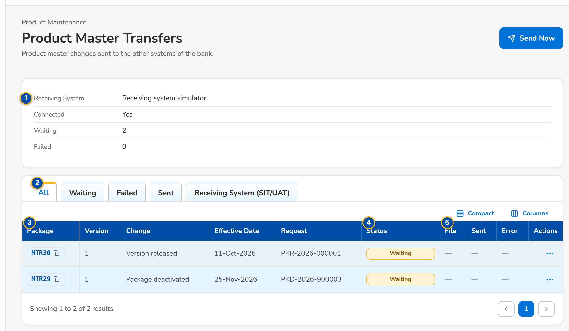
Figure G.25: Product Master Transfers with the change sent to the receiving system
Field | Type | Mandatory | Format / list / source | Validation and message
Receiving System: Receiving System / Connected / Waiting / Failed | Values | - | Name of the receiving system (the simulator in SIT and UAT); Yes or No; counts; Transfer settings | -
Changes: All / Waiting / Failed / Sent | Tab | N | Status filter; Fixed list | -
Changes: Package / Version / Change / Effective Date / Request | Columns | - | Risk code; version; Package added, updated, deactivated or expired; dd-MMM-yyyy; request number; Product master changes | -
Changes: Status / File / Sent / Error | Columns | - | Waiting, Sent, Failed; ProductMaster_yyyyMMddHHmmss.csv; dd-MMM-yyyy HH:mm; reason of a failure; Product master changes | -
Receiving System (SIT/UAT): File / Records / Received / Content | Columns | - | Files received by the simulator with their records; Simulator inbox | -

Action | Who | Available when | What happens | Resulting status
Send Now | MBS (product maintenance right) | Changes waiting or failed | Writes the waiting changes to the transfer file now instead of at the next scheduled run | Sent or Failed

Rules:
- Every approved change of the Product Matrix, every deactivation and every expiry is queued for the receiving systems and sent by the scheduled transfer or Send Now (FRPM.029.01).
- In SIT and UAT a simulator receives the files so that the flow runs end to end; the folder of the receiving systems is set at SIT with the details of BDOI IT; until then the transfer fails with an alert (FRPM.029.01).

G.26 Placement Update Reports (SCR-PM-26)
Purpose: The Consolidated Placement Update Report of the quotation requests: its schedule (every Thursday at 08:00 for the last 7 days as delivered), the scope, Generate Now, the Report Builder and the repository of every report generated, with preview and download.
Access: Product Maintenance › Placement Update Reports; The notice PlacementUpdate_<MMDDYYYY>.xlsx generated
Requirements: FRPM.007.02, FRPM.019.01, FRPM.019.02, FRPM.019.03, FRPM.020.01
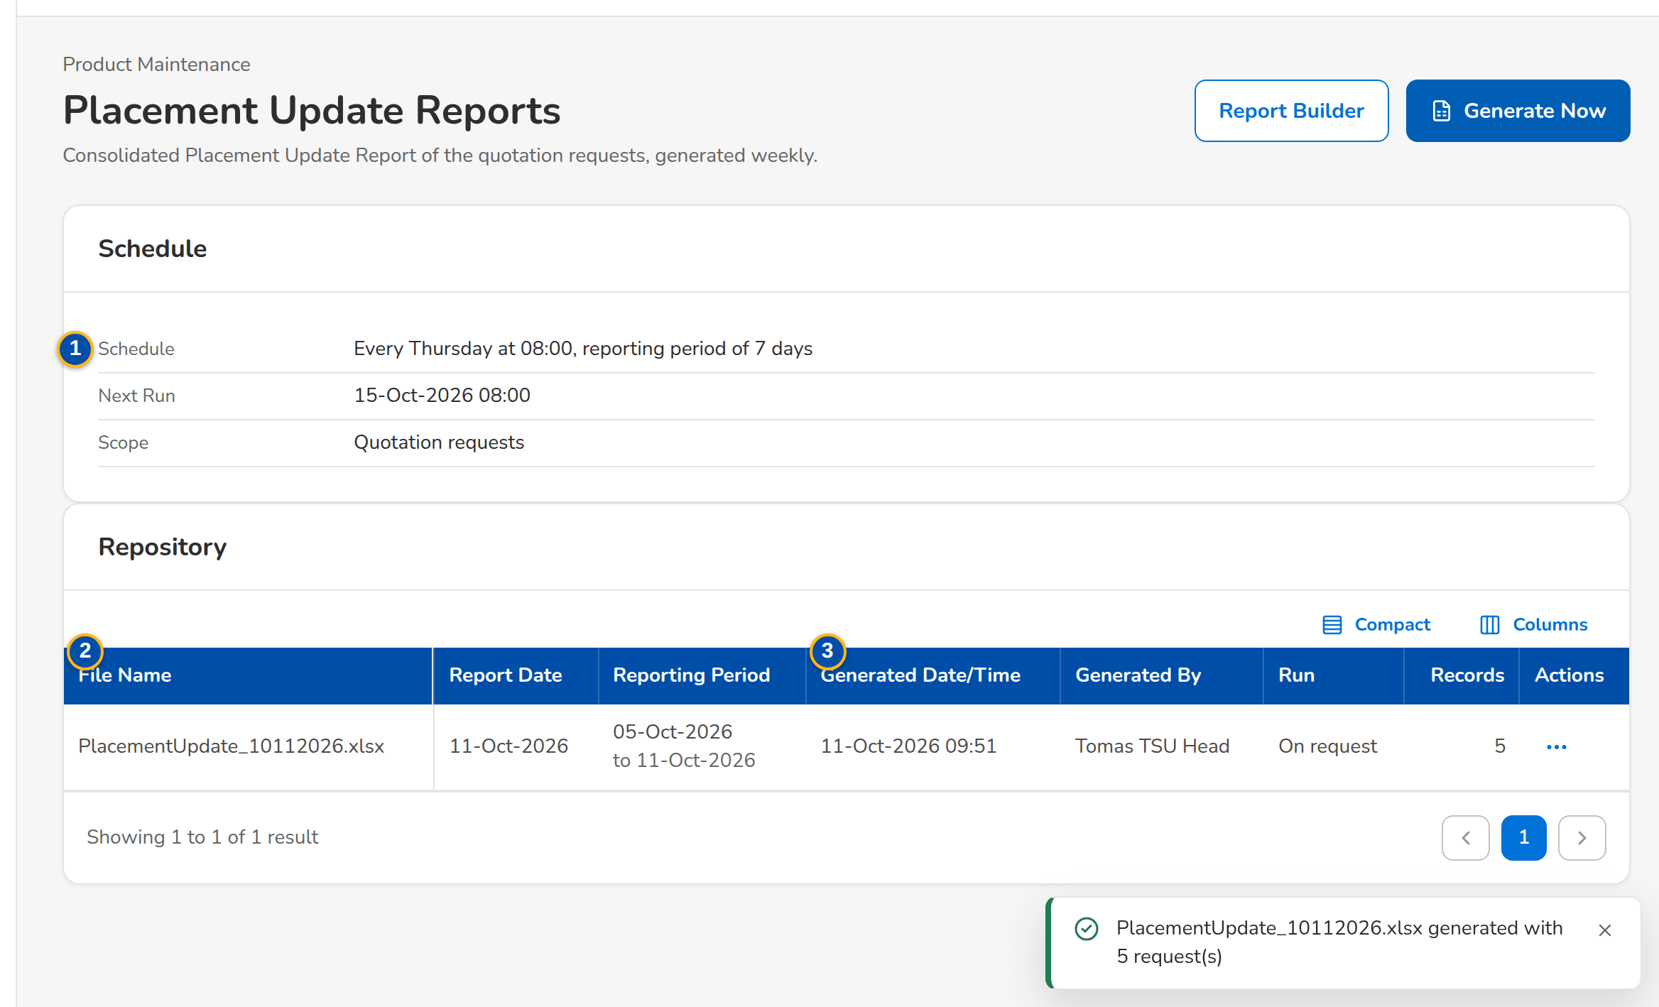
Figure G.26: Placement Update Reports with the schedule and a report generated
Field | Type | Mandatory | Format / list / source | Validation and message
Schedule: Schedule / Next Run / Scope | Values | - | Weekday, time and reporting period; dd-MMM-yyyy HH:mm; Quotation requests, or Quotation and package requests; Settings of the report | -
Repository: File Name / Report Date / Reporting Period | Columns | - | PlacementUpdate_MMDDYYYY.xlsx; dd-MMM-yyyy; from – to; Placement reports | No Placement Update Report has been generated yet
Repository: Generated Date/Time / Generated By / Run / Records | Columns | - | dd-MMM-yyyy HH:mm; name or System; Scheduled or On request; count; Placement reports | -

Action | Who | Available when | What happens | Resulting status
Generate Now | Users of the Product Maintenance reports | Always | Generates the report for the period ending today and stores it in the repository | -
Report Builder | Users of the Product Maintenance reports | Always | Opens the report builder of the Product Maintenance reports (columns, filters, sort) | -
Preview / Download | Users of the Product Maintenance reports | A report of the repository | Shows the report on screen, or downloads the Excel file | -

Rules:
- The day, time, period and scope of the scheduled report are settings (Thursday, 08:00, 7 days, quotation requests as delivered) (FRPM.019.01).
- Every report generated is kept in the repository with who generated it and when (FRPM.019.01, FRPM.021.01).

G.27 Audit Logs (SCR-PM-27)
Purpose: Who changed packages, products and requests, and when: every action of Product Maintenance with the module, reference number, client or assured, action type, description, old and new value, the user and the remarks, with filters and the CSV and Excel exports named Audit Logs_MMDDYYYY.
Access: Product Maintenance › Audit Logs
Requirements: FRPM.021.01, FRPM.021.02
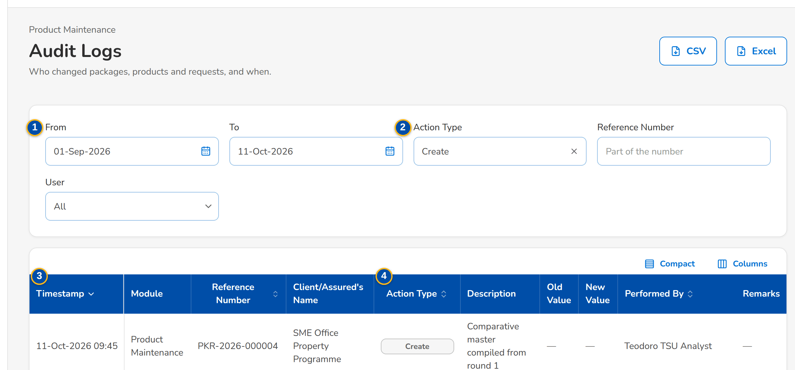
(continued below)
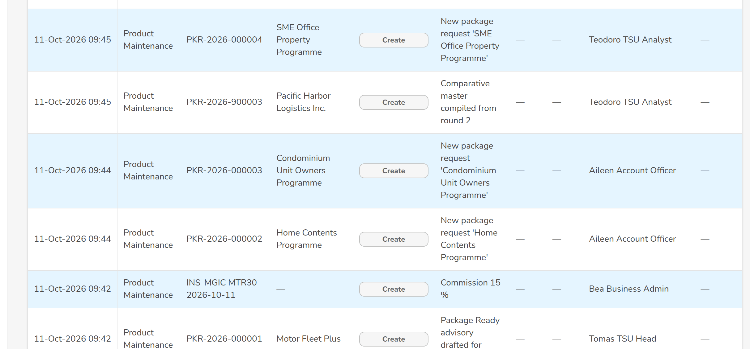
(continued below)
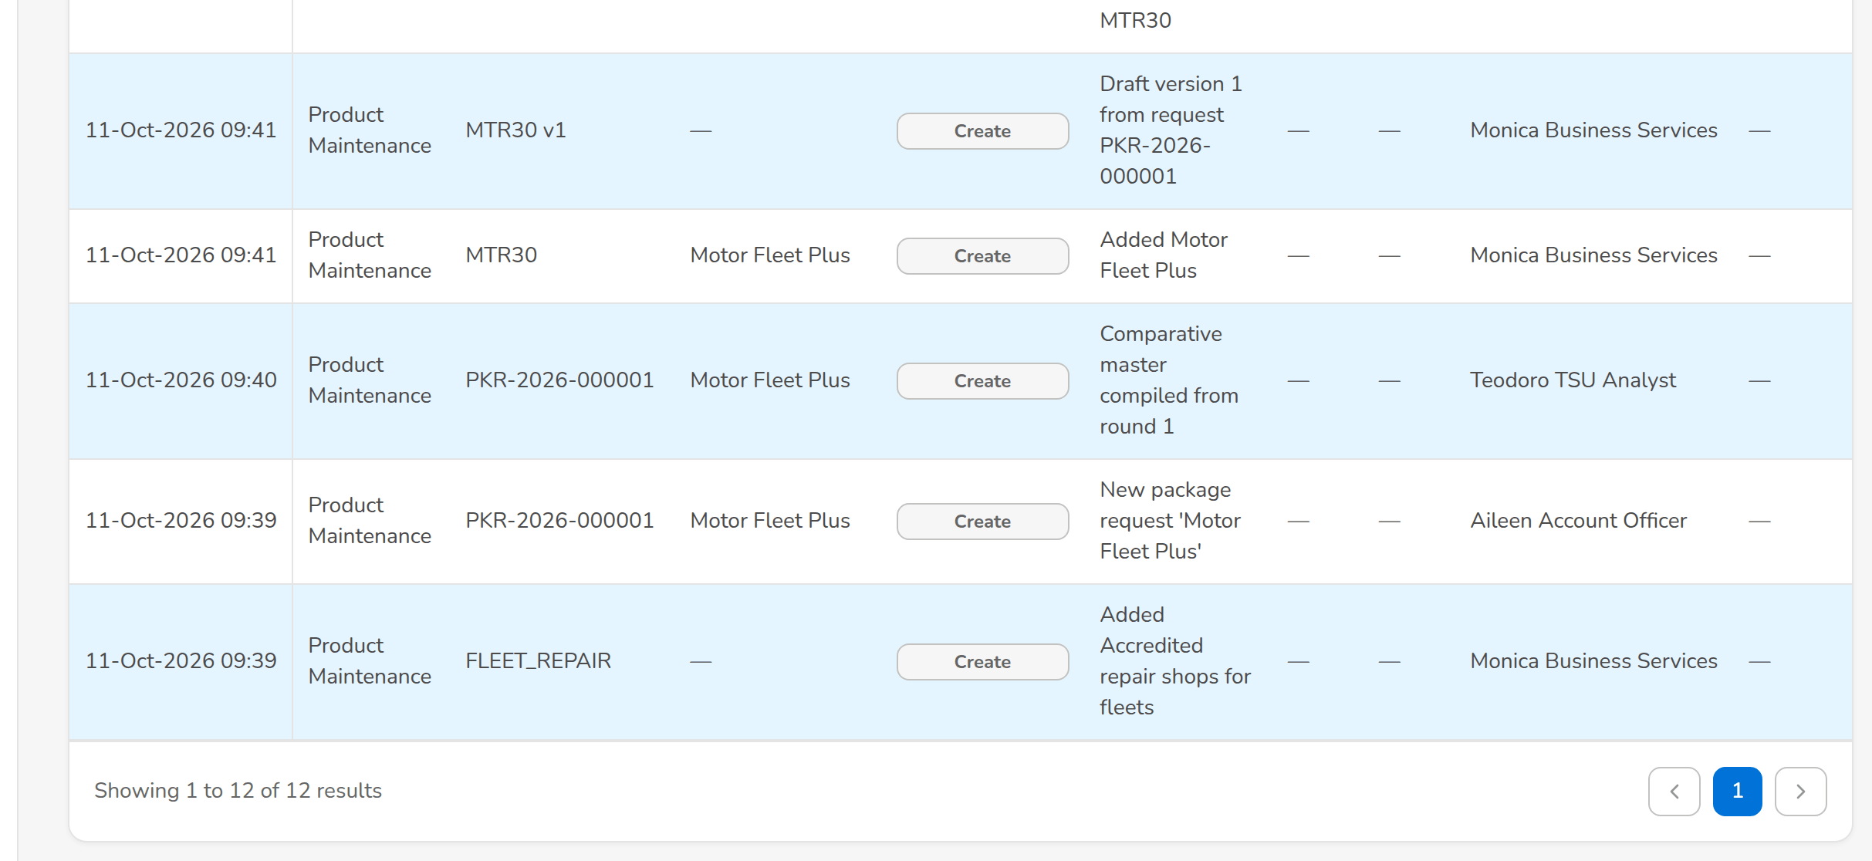
Figure G.27: Audit Logs of Product Maintenance for a period
Field | Type | Mandatory | Format / list / source | Validation and message
Filters: From / To | Date | N | dd-MMM-yyyy | To on or after From; The end date must be on or after the start date
Filters: Action Type / Reference Number / User | Drop-down; text; look-up | N | Action types; part of the number; name; Fixed list; users | -
List: Timestamp / Module / Reference Number / Client/Assured's Name | Columns | - | dd-MMM-yyyy HH:mm; Product Maintenance area; request, package or product number; name; Audit trail | No activity for these filters.
List: Action Type / Description / Old Value / New Value / Performed By / Remarks | Columns | - | Action; what changed; values before and after; name; remarks; Audit trail | -

Action | Who | Available when | What happens | Resulting status
CSV / Excel | Every user of the screen | Always | Downloads the audit log of the filters on screen, named Audit Logs_MMDDYYYY | -

Rules:
- No user can change or delete an audit record (FRPM.021.01).

G.28 Proposal request: Comparative Table, proposal slips and client response (SCR-PM-28)
Purpose: The quotation request of a non-package product (proposal request PRF-yyyy-nnnnnn), as TSU and Marketing see it on the Comparative Table and Proposal Slip tabs: the insurer responses, the comparative table with the value of the quotation slip, every option of each insurer and the Final Terms for Proposal, the insurers chosen for the proposal, the proposal slip generated per insurer, and the client response recorded by Marketing.
Access: Product Maintenance Home › Quotation Request List › View Quotation Request; Proposal request › Comparative Table, Proposal Slip
Requirements: FRPM.012.02, FRPM.012.04, FRPM.013.01, FRPM.013.02
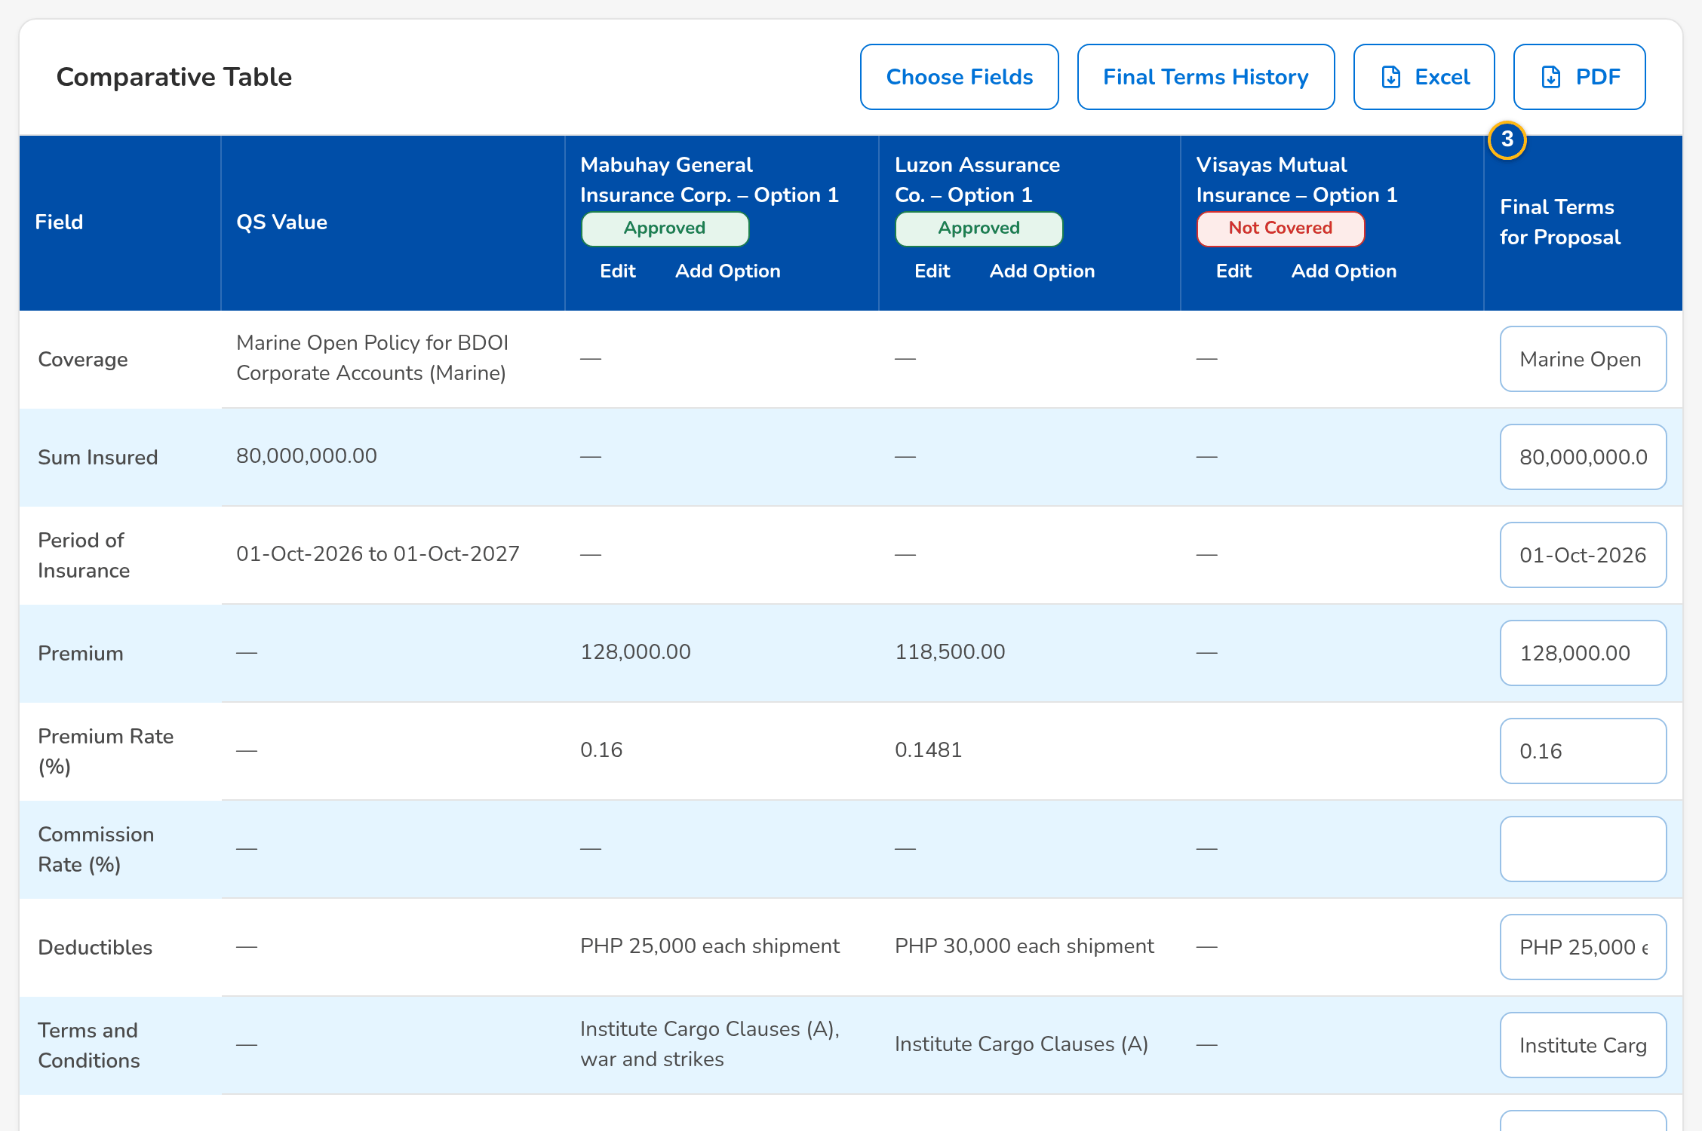
Figure G.28: Comparative Table with the options of each insurer and the Final Terms for Proposal
Field | Type | Mandatory | Format / list / source | Validation and message
Comparative Table: Field / QS Value | Rows | - | Coverage, Sum Insured, Period of Insurance, Premium, Premium Rate (%), Commission Rate (%), Deductibles, Terms and Conditions, Warranties, Clauses, Extensions of Cover, Other Quotation Details; the value of the quotation slip; Quotation slip | -
Comparative Table: [Insurer – Option n] | Column | - | Response (Approved, Not Covered, Others) and the values of the option; Insurer responses and options | -
Comparative Table: Final Terms for Proposal | Column | Cond.: before Proceed to Proposal | Value of each field for the proposal | -
Option: Insurer Response | Drop-down | Y | Approved, Not Covered, Others; Fixed list | -
Option: Insurer's Response | Text | Cond.: Others | The actual response of the insurer | Mandatory for Others; Specify the insurer's actual response for Others
Choose Comparison Fields: [Field check boxes] | Check boxes | Y (at least one) | Fields shown in the table and to the client; Comparison fields | -
Final Terms History: Field / Previous Value / New Value / Changed By / Changed On | Table | - | Every change of a final term; Final terms history | -
Insurers for the Proposal: [Insurer check boxes] | Check boxes | Y (at least one) | Insurers that gave terms; Insurer responses | An insurer of the request; <insurer> is not an insurer of this request
Proposal Slips: Insurer / Version / File Name / Generated By / Generated On | Table | - | One proposal slip per selected insurer, by version; Proposal files | No proposal has been generated yet
Client Response: Response / Response Date / Client Remarks / Recorded By / Recorded On | Table | - | Accepted, Rejected or Returned; dd-MMM-yyyy; remarks; name; date and time; Client responses | No client response recorded yet
Record Client Response: Client Response / Response Date / Client Remarks | Drop-down; date; text | Y (response) | Accepted, Rejected, Returned; Fixed list | -

Action | Who | Available when | What happens | Resulting status
Edit / Add Option | TSU (negotiation right) | Terms received | Keys the response and values of an insurer, or a further option of the same insurer | -
Choose Fields / Final Terms History / Excel / PDF | TSU and Marketing | Always | Chooses the fields shown; shows the changes of the final terms; exports the table | -
Proceed to Proposal | The requestor (Marketing) or TSU | Terms received; at least one insurer selected | Records the insurers chosen; the TSU officer who prepared the quotation slip is told to generate the proposal | Terms agreed
[Generate proposal] | TSU (negotiation right) | Terms agreed | Generates one proposal slip per selected insurer (PDF), listed under Proposal Slips | Proposal slip for approval
Record Client Response | Marketing | Sent to Client | Records Accepted, Rejected or Returned with the date and remarks; Returned sends the request back to TSU for revision | Accepted, Rejected or Terms received

Rules:
- The final terms are keyed by TSU in the table; every change is kept with the previous and new value (FRPM.013.01).
- A proposal slip is generated for each insurer selected by the requestor, numbered by version (FRPM.012.04, FRPM.025.01).
- The client response is recorded once the proposal is sent to the client; a returned proposal goes back to TSU for revision (FRPM.013.02).

G.29 Package Request record: Routing & Approvals tab (SCR-PM-29)
Purpose: The routing of a package request as BDOI's FRS sets it: the source and package details of the request form, the Marketing approvals by level, the ManCom approval with the selected approvers and the President last, and the package deployment request that forwards the approved package to MBS.
Access: Package Request record › Routing & Approvals
Requirements: FRPM.011.02, FRPM.014.01, FRPM.015.01, FRPM.016.01, FRPM.016.02
(continued below)
(continued below)
Figure G.29: Routing & Approvals tab with the ManCom approvers to select
Field | Type | Mandatory | Format / list / source | Validation and message
Source and Package Details: Source / Business Origin / Account Officer / Unit Head / Insured's Name / Estimated No. of Policies / Estimated Total Basic Premium / Type of Cover / Description of Cover / Cover / Undertaking / Extensions of Cover / Warranties, Clauses / Other Instructions / Maximum Limit/s / Premium / Incentive Eligible / Incentive Amount / Incentive Commission Rate | Values | - | As entered on the request form; Package request | -
Marketing Approvals: [Chain] | Text | - | One approval by the Team Leader, Team Head or Unit Head; or Team Leader, then Team Head, then Unit Head; Setting of the Marketing chain | -
Marketing Approvals: Level / Approver / Decision / Remarks / Approved | Columns | - | Marketing Team Leader, Team Head or Unit Head; name; decision; remarks; dd-MMM-yyyy HH:mm; Marketing approvals | No Marketing approval yet.
ManCom Approval: Select ManCom Approvers | Check boxes | Y (at least one) | ManCom members; the President marked (President, approves last); ManCom members | -
ManCom Approval: Round / Approver / Approval Progress / Remarks / Decided | Columns | - | Round; name; Pending Approval, Waiting for the others, Approved, Returned for Revision, Rejected; remarks; date and time; ManCom approvals | No ManCom approvers selected yet.
ManCom Approval: Remarks | Text area | Cond.: return or rejection | Up to 1,000 characters | Enter the remarks of the rejection or the return
Package Deployment Request: Forwarding to MBS / Deployment Request Number / Requested / Requested By | Values | - | Automatic or By the Request for Deployment button; PDR-yyyy-nnnnnn; date and time; name; Deployment request | -

Action | Who | Available when | What happens | Resulting status
Send for ManCom Approval | TSU (negotiation or TSU Head approval right) | For ManCom sign-off; at least one approver selected | Sends the request to the selected ManCom approvers at once, the President after the others | For ManCom sign-off
Approve / Return for Revision / Reject | The selected ManCom approver | His approval pending | Records the decision; a return or rejection needs remarks | Approved, returned or rejected
Request for Deployment | TSU | ManCom approved; forwarding by the button | Raises the deployment request PDR-yyyy-nnnnnn and forwards the package to MBS for set-up | With MBS for set-up

Rules:
- The Marketing chain is a setting: one approval by the Team Leader, Team Head or Unit Head (as delivered), or the three in order (BDOI's FRS) (FRPM.011.02).
- The ManCom routing is a setting: the selected approvers in parallel, then the President (as delivered, BDOI's FRS), or one sign-off by any member (FRPM.014.01).
- The forwarding to MBS is a setting: automatic at the ManCom approval (as delivered) or by the Request for Deployment button (FRPM.014.01, FRPM.016.01).

G.30 Navigation: menu by persona
The Product Maintenance entries of the menu (Client & Policy › Product Maintenance) that each persona sees, with the sign-in ID of the persona in the BIBS DEV environment. A green cell means the persona sees the entry; the actions inside each screen follow the role (Annex J.5). The screen standards (layout, tables with row action menus, dates dd-MMM-yyyy, formatted amounts, messages) are those of the programme screen standards and are not repeated here.
Figure G.30 – Product Maintenance menu by persona

Annex H – Messages and Validations
The messages the user sees when a check fails or an action is not allowed, word for word as on the screens; <name> parts are filled in by the system. The fields and messages of each screen are also in Annex G.
No. | Screen | When | Message shown | Requirement
1 | Login | User ID or password wrong | Invalid user name or password | User Access Maintenance FRS
2 | All Product Maintenance screens | Action without permission | You are not permitted to perform this action | FRPM.002.01, FRPM.028.01
3 | Access Requests | No permission added or removed | Select at least one permission to add or remove | User Access Maintenance FRS
4 | Access Requests | Approver is the requester | An access request is approved by someone other than the requester | User Access Maintenance FRS
5 | Products | Packaged product without cover type | A package needs its cover type (PMADD01) | FRPM.003.01, FRPM.003.02, FRPM.022.01
6 | Products | Risk code does not match the line pattern | Risk code <code> does not follow the naming convention of <line> | FRPM.003.01, FRPM.003.02, FRPM.022.01
7 | Coverages & Clauses | Wording blank | Enter the wording | FRPM.022.02
8 | Coverages & Clauses | Effective to before effective from | The end date must be on or after the start date | FRPM.022.02
9 | Product page (Field Rules & Documents tab) | Mandatory field blank on submission | <Field> is required for <product> | FRPM.003.02, FRPM.003.08
10 | Product page (Field Rules & Documents tab) | Value outside the range or list | <Field> must be between <min> and <max> / <Field> is not a valid value | FRPM.003.02, FRPM.003.08
11 | Product page (Field Rules & Documents tab) | Invalid pattern entered on a line rule | The risk-code pattern is not a valid pattern | FRPM.003.02, FRPM.003.08
12 | Package Request page (form.pdf, QS, comparative, package slip, advisory downloads) | No active template of the type | The template <code> is not available | FRPM.012.01, FRPM.030.01
13 | Package Version (Insurers, Insurer Terms sections) | Shares do not total 100 | The co-insurance shares must add up to 100% | FRPM.003.02, FRPM.023.01
14 | Package Version (Insurers, Insurer Terms sections) | Insurer lacks a term for an included coverage | Insurer <code> has no terms for coverage <coverage> | FRPM.003.02, FRPM.023.01
15 | Package Version (Insurers, Insurer Terms sections) | Non-panel insurer on a quotation | Insurer <code> is not on the panel of <package> | FRPM.003.02, FRPM.023.01
16 | Package Version (Insurers, Insurer Terms sections) | Direct edit of a versioned field on the product | The rate, minimum premium, commission and TSI limit of package <code> change through a new version (Versions tab) | FRPM.003.02, FRPM.023.01
17 | Package Requests | Package or programme name blank | Enter the package or programme name | FRPM.011.02
18 | Package Requests | Line not selected | Select the product line | FRPM.011.02
19 | Package Requests | Reason not selected | Select the reason | FRPM.011.02
20 | Package Requests | NEW request without cover type | Select the cover type | FRPM.011.02
21 | Package Requests | Other type without package | Select the package product of the <type> request | FRPM.011.02
22 | Package Requests | Client-specific without client | Select the client of the client-specific package (PQ14) | FRPM.011.02
23 | Package Requests | End date not after start date | The package end date must be after its start date | FRPM.011.02
24 | Package Requests | Negative rate or amount | Rates and amounts cannot be negative | FRPM.011.02
25 | Package Requests | Missing items on submit | Complete the request: <items> | FRPM.011.02
26 | Package Requests | Type changed on a saved request | The type of a request cannot change | FRPM.011.02
27 | Package Requests (tab For Approval) | Approver is the maker | A package request is approved by someone other than its maker | FRPM.011.02
28 | Package Requests (tab For Approval) | Return without reason | Select a reason for '<action>' | FRPM.011.02
29 | TSU Workbench | Recommendation blank | Write the recommendation for the TSU Head | FRPM.011.03
30 | TSU Workbench | Approver is the recommender | The TSU Head approval is given by someone other than the recommender | FRPM.011.03
31 | Package Request page (Negotiation tab) | No insurer selected | Select at least one insurer for the quotation slip | FRPM.012.01
32 | Package Request page (Negotiation tab) | Approver is the preparer | The quotation slip is approved by a TL or a co-officer | FRPM.012.01
33 | Package Request page (Negotiation tab) | Edit after sign-off | The slips are locked since the ManCom sign-off | FRPM.012.01
34 | Package Request page (Negotiation tab) | Round already sent | Round <n> is already sent | FRPM.012.01
35 | Package Request page (Negotiation tab) | Resend of a closed round | Only the slip of an open, sent round can be resent | FRPM.012.01
36 | Package Request page (Negotiation tab, response dialog) | Offer without rate | Enter the rate offered by <insurer> (<outcome>) | FRPM.012.02, FRPM.012.03
37 | Package Request page (Negotiation tab) | Revise before the current QS is sent | Send the slip of round <n> first | FRPM.012.03
38 | Package Request page (Negotiation tab, Terms Final dialog) | An insurer still pending | Every insurer of round <n> needs an outcome before the terms are final (<insurers>) | FRPM.013.01
39 | Package Request page (Negotiation tab, Terms Final dialog) | No insurer chosen | Choose the insurer(s) whose terms the package takes | FRPM.013.01
40 | Package Request page (Negotiation tab, Terms Final dialog) | Chosen insurer did not offer | <insurer> did not offer terms in this round | FRPM.013.01
41 | Package Request page (Comparative tab) | Compile before the quotation slip of the round is sent | Send the quotation slip of round <n> first | FRPM.012.02, FRPM.012.04
42 | Package Request page (Comparative tab, Generate Client View dialog) | No current master | Compile the comparative master first | FRPM.012.04
43 | Package Request page (Comparative tab, Generate Client View dialog) | Title blank | Enter the title of the view | FRPM.012.04
44 | Package Request page (Comparative tab, Generate Client View dialog) | No insurer selected | Select at least one insurer of the master | FRPM.012.04
45 | Package Request page | Skip review on a client-specific package | Marketing reviews the terms of a client-specific package | FRPM.013.02
46 | Package Request page | Release to Marketing of a generic programme | A generic programme goes straight to the requirements | FRPM.013.02
47 | Package Request page (Requirements & Sign-off tab) | Pack incomplete | Complete the requirements: <missing items> | FRPM.013.01, FRPM.014.02
48 | Package Request page (Requirements & Sign-off tab) | End date not after effective date | The package end date must be after the effective date | FRPM.013.01, FRPM.014.02
49 | Package Request page (Requirements & Sign-off tab) | Signer submitted the requirements | ManCom signs off requirements submitted by someone else | FRPM.014.01, FRPM.015.01
50 | Package Request page (Set-up tab) | A version is already being set up | Product <code> already has a version being set up | FRPM.016.01, FRPM.016.02
51 | Validation Queue | No rate | Enter the package rate or a rate for every insurer | FRPM.003.03, FRPM.016.02
52 | Validation Queue | No effective date | Enter the effective date | FRPM.003.03, FRPM.016.02
53 | Validation Queue | Validator is maker or submitter | A package version is validated by someone other than its maker and submitter | FRPM.003.03, FRPM.016.02
54 | Validation Queue | Checklist not complete | Validate and Release stays disabled until every item is ticked | FRPM.003.03, FRPM.016.02
55 | Package Request page (Advisories tab) | Documents missing | Attach the supporting documents before sending: <documents> | FRPM.025.01
56 | Package Request page (Advisories tab) | Subject or text blank | Enter the subject and the text | FRPM.025.01
57 | New Package Request (type RETIRE) | Retire on another request type | Only a request to retire the package can retire it | FRPM.003.04, FRPM.003.06, FRPM.003.07
58 | New Package Request (type RETIRE) | Set-up on a retirement request | A retirement request retires the package; it has no version to set up | FRPM.003.04, FRPM.003.06, FRPM.003.07
59 | New Package Request (type RETIRE) | Quotation on a retired product | Product <code> is RETIRED and cannot be sold | FRPM.003.04, FRPM.003.06, FRPM.003.07
60 | Quotation (rate scheme panel, Request Rate Exception) | Deviating rate without exception | Package <code> is priced on the current rate scheme: rate <n>% needs an approved rate exception | FRPM.024.02
61 | Quotation (rate scheme panel, Request Rate Exception) | Rejection without a reason | Enter the reason for the rejection | FRPM.024.02
62 | Quotation (rate scheme panel, Request Rate Exception) | Decision by the requester | A rate exception is decided by someone other than its requester | FRPM.024.02
63 | Quotation (rate scheme panel, Request Rate Exception) | Exception already decided | Rate exception <reference> is already decided | FRPM.024.02
64 | Quotation (rate scheme panel, Request Rate Exception) | Product expired or retired | Product <code> is <status> and cannot be sold | FRPM.024.02
65 | Quotation (rate scheme panel, Request Rate Exception) | No version in force | Package <code> has no released version in force on <date> | FRPM.024.02
66 | Package Expiry (bulk Generate Renewal Request) | No package selected | Select the packages to renew | FRPM.026.01
67 | Reports (category New Business) | Days not a whole number | <Parameter> must be a whole number | FRPM.019.01, FRPM.020.01, FRPM.007.02, FRPM.019.02, FRPM.019.03
68 | Package Request page (workflow panel) | Action not allowed in the stage | '<action>' is not allowed while <reference> is in stage <stage name> | FRPM.001.01, FRPM.002.02, FRPM.003.07, FRPM.015.01, FRPM.028.01
69 | Incentive Criteria | No product selected | Select at least one product of the products matrix | FRPM.018.01
70 | Incentive Criteria | Product not active | Product <code> is not an active product of the matrix | FRPM.018.01
71 | Incentive Criteria | Value missing | Enter the value of the incentive criterion | FRPM.018.01
72 | Incentive Criteria | Period overlaps | Criterion <code> already covers part of this period | FRPM.018.01
73 | Incentive Criteria | Rule parameter without a value | Enter a value for each parameter | FRPM.018.01
74 | Incentive Criteria | Rule parameter value not a number | <parameter> must be a number | FRPM.018.01
75 | Incentive Criteria | Rule parameter below zero | <parameter> cannot be negative | FRPM.018.01
76 | Incentive Criteria | Parameter not of the incentive type | <parameter> is not a parameter of this incentive type | FRPM.018.01
77 | Incentive Criteria | Direct edit of an active row | An active criterion is changed by amending it (successor) | FRPM.018.01
78 | Invoice (booking) | Change to a former booking incentive rule | The booking incentive rules are read-only; use Incentive Criteria | FRPM.018.02
79 | Proposal Requests | Client or product missing | Complete the PRF header | FRPM.005.01
80 | Proposal Requests | No risk description | Describe the risk (sections or risk items) before submitting | FRPM.005.01
81 | Proposal Requests | Documents missing | Attach the mandatory documents: <types> | FRPM.005.01
82 | Proposal Requests | TSU not needed | No TSU rule applies to this package risk: quote it directly as a package quotation | FRPM.005.01
83 | Proposal Requests | Segment not allowed | Product <code> is not offered to segment <segment> | FRPM.005.01
84 | Proposal Requests | Period end not after start | The period end must be after the period start | FRPM.005.01
85 | Proposal Requests | Product changed | The product of a PRF cannot change | FRPM.005.01
86 | Proposal Requests | Edit in a locked stage | PRF <number> cannot be changed while <stage> | FRPM.005.01
87 | Proposal Requests (For Approval tab) | Approver is the maker | A PRF is approved by someone other than its maker | FRPM.005.02
88 | Proposal Requests (For Approval tab) | Return without reason | Select a reason for 'Return to Account Officer' | FRPM.005.02
89 | TSU Workbench | Return without reason | Select a reason for 'Return to Marketing' | FRPM.005.01, FRPM.005.02
90 | Proposal Request page (Quotation Slip tab, Routing and insurers) | No insurer | Select at least one insurer of the panel for the quotation slip | FRPM.006.01
91 | Proposal Request page (Quotation Slip tab, Routing and insurers) | Insurer change after submission | Insurers are selected before the quotation slip is submitted | FRPM.006.01
92 | Proposal Request page (Quotation Slip tab, Routing and insurers) | Approver is the preparer | The quotation slip is approved by another TSU officer | FRPM.006.01
93 | Proposal Request page (Quotation Slip tab, Routing and insurers) | Insurer without e-mail | <insurer> has no placement e-mail address | FRPM.006.01
94 | Proposal Request page (Quotation Slip tab, Routing and insurers) | Approve before preparation | No quotation slip has been prepared yet | FRPM.006.01
95 | Proposal Request page (Insurer Responses tab) | Terms without premium | Enter the premium quoted by <insurer> | FRPM.006.02, FRPM.008.01, FRPM.009.01
96 | Proposal Request page (Insurer Responses tab) | Recommend a response without terms | Only received terms can be recommended | FRPM.006.02, FRPM.008.01, FRPM.009.01
97 | Proposal Request page (Insurer Responses tab) | Keying in before the slip is sent | Insurer terms are keyed in after the quotation slip is sent | FRPM.006.02, FRPM.008.01, FRPM.009.01
98 | Proposal Request page (Insurer Responses tab) | Complete with no terms | No insurer terms have been received | FRPM.006.02, FRPM.008.01, FRPM.009.01
99 | Proposal Request page (Insurer Responses tab) | Complete with pending responses | <n> insurer(s) have not answered: close the request to proceed | FRPM.006.02, FRPM.008.01, FRPM.009.01
100 | Proposal Request page (Proposal Slip tab, Archived versions) | No insurer chosen | Choose the insurer (or flag the recommended one) for the proposal slip | FRPM.009.01, FRPM.009.02
101 | Proposal Request page (Proposal Slip tab, Archived versions) | Chosen insurer has no terms | <insurer> has not quoted terms | FRPM.009.01, FRPM.009.02
102 | Proposal Request page (Proposal Slip tab, Archived versions) | Approver is the preparer | The proposal slip is approved by another TSU officer | FRPM.009.01, FRPM.009.02
103 | Proposal Request page (Proposal Slip tab, Archived versions) | Approve before preparation | No proposal slip has been prepared yet | FRPM.009.01, FRPM.009.02
104 | Proposal Request page | No acceptance e-mail | Attach the client's acceptance e-mail first | FRPM.010.01
105 | Proposal Request page | Unknown risk group | The proposal covers risk groups <groups> only | FRPM.010.01
106 | Proposal Request page | Create accounts before acceptance | Record the client's acceptance of the proposal first | FRPM.010.01
107 | Proposal Request page | Chosen terms missing | No terms of <insurer> are recorded | FRPM.010.01
108 | Proposal Request page | Client not confirmed | Client <code> is not yet confirmed (onboarding and KYC incomplete) | FRPM.010.01
109 | New Business Reports | Delete by a non-owner | Only the user who saved a report variant may delete it | FRPM.007.01
110 | New Business Reports | Report not permitted | Report <code> is not available to you | FRPM.007.01
111 | New Package Request and Edit Package Request | Estimated No. of Policies to be Issued: At least the least number of policies (20 as delivered) | Enter at least 20 policies | FRPM.003.01, FRPM.003.02, FRPM.003.04, FRPM.003.06, FRPM.003.07, FRPM.011.02, FRPM.022.01
112 | New Package Request and Edit Package Request | Estimated Total Basic Premium to be Issued: At least the least premium (5,000,000.00 as delivered) | Enter at least 5,000,000.00 | FRPM.003.01, FRPM.003.02, FRPM.003.04, FRPM.003.06, FRPM.003.07, FRPM.011.02, FRPM.022.01
113 | New Package Request and Edit Package Request | Incentive Eligible / Incentive Amount / Incentive Commission Rate (%): Amount above zero; rate above 0% and at most 100% | Enter the incentive amount or the incentive commission rate | FRPM.003.01, FRPM.003.02, FRPM.003.04, FRPM.003.06, FRPM.003.07, FRPM.011.02, FRPM.022.01
114 | New Package Request and Edit Package Request | Scope: - | Select the request type and the package scope | FRPM.003.01, FRPM.003.02, FRPM.003.04, FRPM.003.06, FRPM.003.07, FRPM.011.02, FRPM.022.01
115 | New Package Request and Edit Package Request | Client or prospect: An active client | Select the client | FRPM.003.01, FRPM.003.02, FRPM.003.04, FRPM.003.06, FRPM.003.07, FRPM.011.02, FRPM.022.01
116 | New Package Request and Edit Package Request | Package product: A packaged product of the chosen line | Select the package product | FRPM.003.01, FRPM.003.02, FRPM.003.04, FRPM.003.06, FRPM.003.07, FRPM.011.02, FRPM.022.01
117 | New Package Request and Edit Package Request | Heading / Details: Empty sections are dropped | Complete the request: the requested terms (coverages or sections) | FRPM.003.01, FRPM.003.02, FRPM.003.04, FRPM.003.06, FRPM.003.07, FRPM.011.02, FRPM.022.01
118 | New Package Request and Edit Package Request | Coverage: Every line has a coverage | Enter a code for every coverage or remove the line | FRPM.003.01, FRPM.003.02, FRPM.003.04, FRPM.003.06, FRPM.003.07, FRPM.011.02, FRPM.022.01
119 | New Package Request and Edit Package Request | [Insurer check boxes]: Authorised and active insurers | Complete the request: at least one target insurer | FRPM.003.01, FRPM.003.02, FRPM.003.04, FRPM.003.06, FRPM.003.07, FRPM.011.02, FRPM.022.01
120 | New Package Request and Edit Package Request | [Documents panel]: File checks of every upload | Save the draft to attach the supporting documents. | FRPM.003.01, FRPM.003.02, FRPM.003.04, FRPM.003.06, FRPM.003.07, FRPM.011.02, FRPM.022.01
121 | Package Request record | Changed / By / Rev. / Outcome / Rate % / Remarks: - | No insurer response keyed in yet | FRPM.001.01, FRPM.002.02, FRPM.003.06, FRPM.003.07, FRPM.011.01, FRPM.011.02, FRPM.011.03, FRPM.015.01, FRPM.016.01, FRPM.017.01, FRPM.021.01, FRPM.021.02, FRPM.028.01
122 | Package Request record | Timestamp / Action Type / Description / Old Value / New Value / Performed By / Remarks: - | No activity recorded yet. | FRPM.001.01, FRPM.002.02, FRPM.003.06, FRPM.003.07, FRPM.011.01, FRPM.011.02, FRPM.011.03, FRPM.015.01, FRPM.016.01, FRPM.017.01, FRPM.021.01, FRPM.021.02, FRPM.028.01
123 | Package Request record: Negotiation tab | Rate %: Zero or more | Enter the rate offered | FRPM.012.01, FRPM.012.02, FRPM.012.03, FRPM.013.01, FRPM.027.01
124 | Package Request record: Negotiation tab | Response document: File checks of every upload | The file could not be read | FRPM.012.01, FRPM.012.02, FRPM.012.03, FRPM.013.01, FRPM.027.01
125 | Package Request record: Negotiation tab | Share %: Shares given for every co-insurer and totalling 100 | Co-insurance shares must be given for every insurer and total 100 | FRPM.012.01, FRPM.012.02, FRPM.012.03, FRPM.013.01, FRPM.027.01
126 | Package Request record: Comparative tab | Insurer: - | No insurer terms to compare yet | FRPM.012.02, FRPM.012.04
127 | Package Request record: Comparative tab | Output: - | No comparative output yet | FRPM.012.02, FRPM.012.04
128 | Package Request record: Comparative tab | Insurer Response: Others needs the actual response | Specify the insurer's actual response for Others | FRPM.012.02, FRPM.012.04
129 | Package Request record: Comparative tab | Insurer / Version / File Name / Generated By / Generated On: - | No proposal has been generated yet | FRPM.012.02, FRPM.012.04
130 | Package Request record: Requirements & Sign-off tab | [Checklist]: The effective date and package end date, a scheme rate or a rate for every insurer, the computation basis, the chosen insurer(s) and the signed package slip | Complete the requirements: <missing> | FRPM.013.01, FRPM.013.02, FRPM.014.01, FRPM.014.02, FRPM.015.01
131 | Package Request record: Requirements & Sign-off tab | Computation basis: Not blank before submission | Complete the requirements: the computation basis | FRPM.013.01, FRPM.013.02, FRPM.014.01, FRPM.014.02, FRPM.015.01
132 | Package Request record: Requirements & Sign-off tab | Effective from: - | Complete the requirements: the effective date and the package end date | FRPM.013.01, FRPM.013.02, FRPM.014.01, FRPM.014.02, FRPM.015.01
133 | Package Request record: Requirements & Sign-off tab | Reference / Decision / By / On / Comment: - | No ManCom decision yet | FRPM.013.01, FRPM.013.02, FRPM.014.01, FRPM.014.02, FRPM.015.01
134 | Package Request record: Set-up and Advisories tabs | Risk code of the new package: Not blank; not an existing product | Enter the risk code of the new package | FRPM.003.03, FRPM.003.04, FRPM.003.06, FRPM.003.07, FRPM.016.01, FRPM.016.02, FRPM.025.01
135 | Package Request record: Set-up and Advisories tabs | Product / Version / Request stage: - | MBS sets the package up after the ManCom sign-off | FRPM.003.03, FRPM.003.04, FRPM.003.06, FRPM.003.07, FRPM.016.01, FRPM.016.02, FRPM.025.01
136 | Package Request record: Set-up and Advisories tabs | [Advisory card]: - | An advisory is drafted when the package is released or retired | FRPM.003.03, FRPM.003.04, FRPM.003.06, FRPM.003.07, FRPM.016.01, FRPM.016.02, FRPM.025.01
137 | Package Request record: Set-up and Advisories tabs | [Supporting documents checklist]: Both documents attached before sending | The advisory cannot be sent until the supporting documents are attached (Documents tab). | FRPM.003.03, FRPM.003.04, FRPM.003.06, FRPM.003.07, FRPM.016.01, FRPM.016.02, FRPM.025.01
138 | Package Request record: Set-up and Advisories tabs | Recipient groups: Active values of the list | Select at least one recipient group | FRPM.003.03, FRPM.003.04, FRPM.003.06, FRPM.003.07, FRPM.016.01, FRPM.016.02, FRPM.025.01
139 | Products | Code / Name / Line: - | No product matches the filters. | FRPM.002.02, FRPM.003.01, FRPM.003.02, FRPM.003.03, FRPM.003.05, FRPM.003.08, FRPM.012.01, FRPM.019.03, FRPM.022.01, FRPM.024.01, FRPM.030.01
140 | Products | Code: Unique; the naming convention of the line when set | Code: 1 to 20 capital letters or digits. | FRPM.002.02, FRPM.003.01, FRPM.003.02, FRPM.003.03, FRPM.003.05, FRPM.003.08, FRPM.012.01, FRPM.019.03, FRPM.022.01, FRPM.024.01, FRPM.030.01
141 | Products | Name: Not blank | Name is required. | FRPM.002.02, FRPM.003.01, FRPM.003.02, FRPM.003.03, FRPM.003.05, FRPM.003.08, FRPM.012.01, FRPM.019.03, FRPM.022.01, FRPM.024.01, FRPM.030.01
142 | Products | Product line: - | Choose the product line. | FRPM.002.02, FRPM.003.01, FRPM.003.02, FRPM.003.03, FRPM.003.05, FRPM.003.08, FRPM.012.01, FRPM.019.03, FRPM.022.01, FRPM.024.01, FRPM.030.01
143 | Products | Cover type: A cover type of the line; a package needs one | A package needs its cover type | FRPM.002.02, FRPM.003.01, FRPM.003.02, FRPM.003.03, FRPM.003.05, FRPM.003.08, FRPM.012.01, FRPM.019.03, FRPM.022.01, FRPM.024.01, FRPM.030.01
144 | Products | Default commission %: 0 to 100 | Default commission rate is required. | FRPM.002.02, FRPM.003.01, FRPM.003.02, FRPM.003.03, FRPM.003.05, FRPM.003.08, FRPM.012.01, FRPM.019.03, FRPM.022.01, FRPM.024.01, FRPM.030.01
145 | Products | Minimum premium: Zero or more | The minimum premium cannot be negative | FRPM.002.02, FRPM.003.01, FRPM.003.02, FRPM.003.03, FRPM.003.05, FRPM.003.08, FRPM.012.01, FRPM.019.03, FRPM.022.01, FRPM.024.01, FRPM.030.01
146 | Products | Maximum term (years): At least 2 for a multi-year product | A multi-year product needs a maximum term of at least 2 years. | FRPM.002.02, FRPM.003.01, FRPM.003.02, FRPM.003.03, FRPM.003.05, FRPM.003.08, FRPM.012.01, FRPM.019.03, FRPM.022.01, FRPM.024.01, FRPM.030.01
147 | Product record | Version / Status / Effective From / Effective To / Rate % / Package End / Request / Validated By / Change: - | No version yet. | FRPM.003.01, FRPM.003.02, FRPM.003.03, FRPM.003.08, FRPM.012.01, FRPM.016.01, FRPM.016.02, FRPM.019.03, FRPM.024.01, FRPM.030.01
148 | Product record | What changes: Not blank | Describe the change | FRPM.003.01, FRPM.003.02, FRPM.003.03, FRPM.003.08, FRPM.012.01, FRPM.016.01, FRPM.016.02, FRPM.019.03, FRPM.024.01, FRPM.030.01
149 | Product record | Level / Field / Key / Mandatory / Check / From: - | No field rules apply. | FRPM.003.01, FRPM.003.02, FRPM.003.03, FRPM.003.08, FRPM.012.01, FRPM.016.01, FRPM.016.02, FRPM.019.03, FRPM.024.01, FRPM.030.01
150 | Product record | Documents required before submission: - | No document is required. | FRPM.003.01, FRPM.003.02, FRPM.003.03, FRPM.003.08, FRPM.012.01, FRPM.016.01, FRPM.016.02, FRPM.019.03, FRPM.024.01, FRPM.030.01
151 | Product record | Applies to: Rules for every product use the scope code * | Rules for every product use the scope code '*' | FRPM.003.01, FRPM.003.02, FRPM.003.03, FRPM.003.08, FRPM.012.01, FRPM.016.01, FRPM.016.02, FRPM.019.03, FRPM.024.01, FRPM.030.01
152 | Product record | Field key / Label: Unique per scope | Minimum-field rule already exists: <key> | FRPM.003.01, FRPM.003.02, FRPM.003.03, FRPM.003.08, FRPM.012.01, FRPM.016.01, FRPM.016.02, FRPM.019.03, FRPM.024.01, FRPM.030.01
153 | Product record | Check: The parameters of the check are complete | Complete the parameters of the <type> rule | FRPM.003.01, FRPM.003.02, FRPM.003.03, FRPM.003.08, FRPM.012.01, FRPM.016.01, FRPM.016.02, FRPM.019.03, FRPM.024.01, FRPM.030.01
154 | Product record | List of values / Minimum / Maximum / Pattern: Known list; valid pattern | Unknown list of values <lov type> | FRPM.003.01, FRPM.003.02, FRPM.003.03, FRPM.003.08, FRPM.012.01, FRPM.016.01, FRPM.016.02, FRPM.019.03, FRPM.024.01, FRPM.030.01
155 | Package Version | Package Rate %: 0 to 100; the package rate or a rate for every insurer | Enter a rate between 0 and 100 | FRPM.003.01, FRPM.003.02, FRPM.003.03, FRPM.016.01, FRPM.016.02, FRPM.019.03, FRPM.022.02, FRPM.023.01, FRPM.024.01
156 | Package Version | Minimum Premium: Zero or more | Enter the minimum premium | FRPM.003.01, FRPM.003.02, FRPM.003.03, FRPM.016.01, FRPM.016.02, FRPM.019.03, FRPM.022.02, FRPM.023.01, FRPM.024.01
157 | Package Version | Commission %: 0 to 100 | Enter a commission between 0 and 100 | FRPM.003.01, FRPM.003.02, FRPM.003.03, FRPM.016.01, FRPM.016.02, FRPM.019.03, FRPM.022.02, FRPM.023.01, FRPM.024.01
158 | Package Version | Package TSI Limit: Zero or more | Enter a positive amount | FRPM.003.01, FRPM.003.02, FRPM.003.03, FRPM.016.01, FRPM.016.02, FRPM.019.03, FRPM.022.02, FRPM.023.01, FRPM.024.01
159 | Package Version | Effective From: Today or later; after the start of the version in force | The effective date cannot be before today | FRPM.003.01, FRPM.003.02, FRPM.003.03, FRPM.016.01, FRPM.016.02, FRPM.019.03, FRPM.022.02, FRPM.023.01, FRPM.024.01
160 | Package Version | Effective From: Today or later; after the start of the version in force | The effective date must be after the start of version <version no> | FRPM.003.01, FRPM.003.02, FRPM.003.03, FRPM.016.01, FRPM.016.02, FRPM.019.03, FRPM.022.02, FRPM.023.01, FRPM.024.01
161 | Package Version | Coverage: At least one included coverage; a basic coverage | Include at least one coverage | FRPM.003.01, FRPM.003.02, FRPM.003.03, FRPM.016.01, FRPM.016.02, FRPM.019.03, FRPM.022.02, FRPM.023.01, FRPM.024.01
162 | Package Version | Coverage: At least one included coverage; a basic coverage | The package needs its cover type and at least one included basic coverage | FRPM.003.01, FRPM.003.02, FRPM.003.03, FRPM.016.01, FRPM.016.02, FRPM.019.03, FRPM.022.02, FRPM.023.01, FRPM.024.01
163 | Package Version | Insurer: Every insurer with terms is on the package | Insurer <insurer code> has terms but is not on the package | FRPM.003.01, FRPM.003.02, FRPM.003.03, FRPM.016.01, FRPM.016.02, FRPM.019.03, FRPM.022.02, FRPM.023.01, FRPM.024.01
164 | Package Version | Share %: 0 to 100; lead and participant shares total 100% | Enter a share between 0 and 100 | FRPM.003.01, FRPM.003.02, FRPM.003.03, FRPM.016.01, FRPM.016.02, FRPM.019.03, FRPM.022.02, FRPM.023.01, FRPM.024.01
165 | Package Version | Insurer / Coverage: Every panel insurer has terms for each included coverage | Insurer <insurer code> has no terms for coverage <coverage> | FRPM.003.01, FRPM.003.02, FRPM.003.03, FRPM.016.01, FRPM.016.02, FRPM.019.03, FRPM.022.02, FRPM.023.01, FRPM.024.01
166 | Package Version | Return reason / Comment: Not blank | Enter the reason of the return | FRPM.003.01, FRPM.003.02, FRPM.003.03, FRPM.016.01, FRPM.016.02, FRPM.019.03, FRPM.022.02, FRPM.023.01, FRPM.024.01
167 | Validation Queue | Product / Name / Version / Status: - | No package version waits for validation. | FRPM.003.03, FRPM.016.02
168 | Coverages & Clauses | Line / Code / Name / Kind / Basic / Status: - | No coverage is set up for this line. | FRPM.003.01, FRPM.003.02, FRPM.022.01, FRPM.022.02
169 | Coverages & Clauses | Code / Kind / Title / Line / Effective / Until / Status: - | The clause library is empty. | FRPM.003.01, FRPM.003.02, FRPM.022.01, FRPM.022.02
170 | Coverages & Clauses | Code: Unique per line | Use A-Z, 0-9 and _ | FRPM.003.01, FRPM.003.02, FRPM.022.01, FRPM.022.02
171 | Coverages & Clauses | Name: Not blank | Enter the name | FRPM.003.01, FRPM.003.02, FRPM.022.01, FRPM.022.02
172 | Coverages & Clauses | Kind: Active value | Select the kind | FRPM.003.01, FRPM.003.02, FRPM.022.01, FRPM.022.02
173 | Coverages & Clauses | Title: Not blank | Enter the title | FRPM.003.01, FRPM.003.02, FRPM.022.01, FRPM.022.02
174 | Coverages & Clauses | Effective from / Effective to: To on or after from | The end is before the start | FRPM.003.01, FRPM.003.02, FRPM.022.01, FRPM.022.02
175 | Incentive Criteria | Code / Name / Type / Value / Products / From / Until / Status: - | No incentive criterion in this list. | FRPM.018.01, FRPM.018.02
176 | Incentive Criteria | Code: Unique | Use A-Z, 0-9, _ and - | FRPM.018.01, FRPM.018.02
177 | Incentive Criteria | Incentive type: Active value | Select the type | FRPM.018.01, FRPM.018.02
178 | Incentive Criteria | Value: Zero or more; a rate up to 100 | Enter the value | FRPM.018.01, FRPM.018.02
179 | Incentive Criteria | Value: Zero or more; a rate up to 100 | A rate is between 0 and 100 | FRPM.018.01, FRPM.018.02
180 | Incentive Criteria | Effective from: An amendment starts after the active row; no overlap with another row of the code | Enter the start date | FRPM.018.01, FRPM.018.02
181 | Incentive Criteria | Effective from: An amendment starts after the active row; no overlap with another row of the code | The change must start after <active from> | FRPM.018.01, FRPM.018.02
182 | Incentive Criteria | Rule Parameters: Each parameter once; a value for each parameter; a number, zero or more | Select the parameter | FRPM.018.01, FRPM.018.02
183 | Incentive Criteria | Rule Parameters: Each parameter once; a value for each parameter; a number, zero or more | <parameter> is listed twice | FRPM.018.01, FRPM.018.02
184 | Incentive Criteria | Products matrix: Active products only | Select at least one product of the matrix | FRPM.018.01, FRPM.018.02
185 | Insurers | Code: - | No insurer on the panel yet. | FRPM.003.02, FRPM.023.01
186 | Insurers | Partner code: Unique; an existing party must be an insurer | Party <party code> exists and is not an insurer | FRPM.003.02, FRPM.023.01
187 | Insurers | Placement channel: Only e-mail placement is available | Only e-mail placement is available; choose the e-mail placement channel | FRPM.003.02, FRPM.023.01
188 | Insurers | Placement e-mails: - | <name> has no placement e-mail address | FRPM.003.02, FRPM.023.01
189 | Insurers | Credit days: 0 to 365 | Default credit days must be between 0 and 365 | FRPM.003.02, FRPM.023.01
190 | Insurer record | Code / Name / City / LGT % / Placement e-mail / Status: - | No branch recorded. | FRPM.003.02, FRPM.023.01
191 | Insurer record | Product / Commission % / From / To / Status: - | No commission rate: the product default applies. | FRPM.003.02, FRPM.023.01
192 | Insurer record | Code / Name: Unique per insurer | Insurer branch already exists: <key> | FRPM.003.02, FRPM.023.01
193 | Insurer record | LGT %: 0 to 100 | The LGT rate must be between 0 and 100 % | FRPM.003.02, FRPM.023.01
194 | Insurer record | Commission %: 0 to 100 | The commission rate must be a percentage between 0 and 100 | FRPM.003.02, FRPM.023.01
195 | Insurer record | Effective from / Effective to: To on or after from | Enter the effective-from date | FRPM.003.02, FRPM.023.01
196 | Insurer record | Effective from / Effective to: To on or after from | The effective-to date is before the effective-from date | FRPM.003.02, FRPM.023.01
197 | Rates & Taxes | Rate % / % of annual premium: 0 to 100 | The rate must be a percentage between 0 and 100 | FRPM.024.02
198 | Rates & Taxes | Rate % / % of annual premium: 0 to 100 | The short-period percentage must be a percentage between 0 and 100 | FRPM.024.02
199 | Rates & Taxes | Months covered: 1 to 12 | Months covered must be between 1 and 12 | FRPM.024.02
200 | Rates & Taxes | Coverage / Limit / Premium: Limit greater than zero; premium zero or more | The limit must be greater than zero | FRPM.024.02
201 | Rates & Taxes | Coverage / Limit / Premium: Limit greater than zero; premium zero or more | The premium cannot be negative | FRPM.024.02
202 | Sales Organisation | Search unit code, name or officer: Contains search; the matching branches open | No unit or officer matches the search
203 | Sales Organisation | Unit: - | No sales unit defined yet
204 | Sales Organisation | Level: A department belongs to a region; a team to a department | A <level> must belong to an active <parent level>
205 | Sales Organisation | Code / Name: Unique | Sales unit already exists: <key>
206 | Sales Organisation | Team: An existing, active team | Team <team code> is unknown or inactive
207 | Sales Organisation | Account Officer: An existing user | Unknown user <user>
208 | Sales Organisation | Reason: Not blank | Enter the reason.
209 | Premium Calculator | Product: - | Choose a product. | FRPM.002.02, FRPM.003.01, FRPM.003.05, FRPM.024.02
210 | Premium Calculator | Insurer: A package with a panel accepts only its panel insurers | Insurer <insurer code> is not on the panel of <product code> version <version no> | FRPM.002.02, FRPM.003.01, FRPM.003.05, FRPM.024.02
211 | Premium Calculator | Insurer branch (LGT): An authorised branch of the insurer | Branch <branch code> is not authorized or inactive | FRPM.002.02, FRPM.003.01, FRPM.003.05, FRPM.024.02
212 | Premium Calculator | Period basis: Pro-rata and short period need the period | Pro-rata and short-period rating need the period (for endorsements: the remaining term). | FRPM.002.02, FRPM.003.01, FRPM.003.05, FRPM.024.02
213 | Premium Calculator | Endorsement (remaining term, may return premium): Only an endorsement may reduce the sum insured | Only an endorsement may reduce the sum insured. | FRPM.002.02, FRPM.003.01, FRPM.003.05, FRPM.024.02
214 | Premium Calculator | Item / Sum insured: Zero or more | Enter the sum insured of at least one item. | FRPM.002.02, FRPM.003.01, FRPM.003.05, FRPM.024.02
215 | Premium Calculator | Rate %: A rate other than the scheme rate is priced but flagged | Enter the premium rate of <item> | FRPM.002.02, FRPM.003.01, FRPM.003.05, FRPM.024.02
216 | Premium Calculator | Excess BI limit / PD limit: A limit of the table | <coverage> limit <amount> is not in the limit table | FRPM.002.02, FRPM.003.01, FRPM.003.05, FRPM.024.02
217 | Quotation: package rate scheme and rate exception | [Pricing notice]: Shown while an item rate differs | Package <product code> is priced on the current rate scheme: <what> needs an approved rate exception | FRPM.024.02
218 | Quotation: package rate scheme and rate exception | Item rate %: 0 to 100 | Enter the item rate between 0 and 100 | FRPM.024.02
219 | Quotation: package rate scheme and rate exception | Valid until: Not in the past | The validity date cannot be in the past | FRPM.024.02
220 | Quotation: package rate scheme and rate exception | Reason: Not blank | Explain why the scheme rate cannot be used | FRPM.024.02
221 | Deactivation Requests | Deactivation Effective Date: Today or later | Enter the deactivation effective date; The deactivation effective date must be today or later | FRPM.003.04, FRPM.003.06, FRPM.003.07, FRPM.021.01, FRPM.021.02, FRPM.029.01
222 | Deactivation Requests | Reason for Deactivation: - | Select the reason for deactivation | FRPM.003.04, FRPM.003.06, FRPM.003.07, FRPM.021.01, FRPM.021.02, FRPM.029.01
223 | Deactivation Requests | Approver: - | Select the approver | FRPM.003.04, FRPM.003.06, FRPM.003.07, FRPM.021.01, FRPM.021.02, FRPM.029.01
224 | Deactivation Requests | Approval Remarks: Mandatory to reject | Enter the approval remarks of the rejection | FRPM.003.04, FRPM.003.06, FRPM.003.07, FRPM.021.01, FRPM.021.02, FRPM.029.01
225 | Deactivation Requests | Reassign To: - | Select the new approver | FRPM.003.04, FRPM.003.06, FRPM.003.07, FRPM.021.01, FRPM.021.02, FRPM.029.01
226 | Placement Update Reports | File Name / Report Date / Reporting Period: - | No Placement Update Report has been generated yet | FRPM.007.02, FRPM.019.01, FRPM.019.02, FRPM.019.03, FRPM.020.01
227 | Audit Logs | Timestamp / Module / Reference Number / Client/Assured's Name: - | No activity for these filters. | FRPM.021.01, FRPM.021.02
228 | Proposal request: Comparative Table, proposal slips and client response | [Insurer check boxes]: An insurer of the request | <insurer> is not an insurer of this request | FRPM.012.02, FRPM.012.04, FRPM.013.01, FRPM.013.02
229 | Proposal request: Comparative Table, proposal slips and client response | Response / Response Date / Client Remarks / Recorded By / Recorded On: - | No client response recorded yet | FRPM.012.02, FRPM.012.04, FRPM.013.01, FRPM.013.02
230 | Package Request record: Routing & Approvals tab | Level / Approver / Decision / Remarks / Approved: - | No Marketing approval yet. | FRPM.011.02, FRPM.014.01, FRPM.015.01, FRPM.016.01, FRPM.016.02
231 | Package Request record: Routing & Approvals tab | Round / Approver / Approval Progress / Remarks / Decided: - | No ManCom approvers selected yet. | FRPM.011.02, FRPM.014.01, FRPM.015.01, FRPM.016.01, FRPM.016.02
232 | Package Request record: Routing & Approvals tab | Remarks: - | Enter the remarks of the rejection or the return | FRPM.011.02, FRPM.014.01, FRPM.015.01, FRPM.016.01, FRPM.016.02

Annex I – Notifications and E-mails
The notifications the system sends: in-system notices (bell in the page header), alerts and e-mails. E-mails with documents are password protected and the password follows in a separate e-mail (FRPM.027.01).
No. | Channel | Trigger | Recipient | Text | Requirement
NT-01 | in-system | A package request moves to another stage (any workflow action, including return, void, not proceeded and the automatic release or return of its version) | The creator of the request and its current assignee, unless they made the move themselves | Title: <request no.>: <new stage name>. Text: <request description> - <comment> | FRPM.001.01, FRPM.002.02, FRPM.003.06, FRPM.003.07, FRPM.011.01, FRPM.011.03, FRPM.015.01, FRPM.016.01, FRPM.017.01, FRPM.028.01, FRPM.029.01
NT-02 | in-system | A package version set up from a request is validated and released | Every user who creates quotations (Marketing) | Title: Package available: <risk code>. Text: <package name> (version <n>) sells from <effective date>. | FRPM.003.03, FRPM.016.02, FRPM.029.01
NT-03 | in-system | TSU sends an advisory (Send Advisory) | The users of each recipient group: Marketing, TSU, MBS, Processing, Operations | Title: <advisory subject>. Text: <advisory text> | FRPM.025.01
NT-04 | in-system | The daily package version step finds a package whose package end date has passed without a released renewal; the product becomes Expired | Every every TSU user and every MBS user | Title: Package expired: <risk code>. Text: Version <n> ended on <package end date> without a renewal; the package is no longer sold for new business. | FRPM.002.02, FRPM.003.01, FRPM.003.05, FRPM.004.01, FRPM.019.01, FRPM.019.02, FRPM.026.01
NT-05 | E-mail | A quotation slip is approved and sent (Approve and Send), or resent to one insurer (Resend) | The placement e-mail addresses of each insurer of the round | Subject: Package quotation slip <PQS no.> - <package name>. Body: Dear <insurer>, Please find attached our package quotation slip <PQS no.> (round <n>) for <package name>. Kindly send your best terms on or before <reply date>. The document is password protected; the password follows separately. BDO Insurance and Reinsurance Brokers, Inc. | FRPM.012.01, FRPM.027.01
NT-06 | E-mail | An advisory is sent with e-mail addresses in E-mail to (optional) | The addresses entered on the advisory | Subject: <advisory subject>. Body: <advisory text> The advisory is attached (password protected; the password follows separately). BDO Insurance and Reinsurance Brokers, Inc. | FRPM.025.01, FRPM.027.01
NT-07 | E-mail | Every e-mail sent with a password-protected attachment (NT-05, NT-06) | The same recipients as the document e-mail | Subject: Password for: <subject of the document e-mail>. Body: The documents sent to you in the e-mail "<subject>" are password protected. Password: <password>. This e-mail was sent separately for your security. Please do not forward it. | FRPM.027.01
NT-08 | Alert inbox | The daily expiry check finds an active package at the expiry alert days before its expiry date (90 days, FRPM.004.01) and at each reminder day; once per alert day | Users of the Alerts screen (System Administrator, Auditor); in the system, every TSU user and every MBS user | Alert 'Package expiring': Package <risk code> version <n> ends on <dd-MMM-yyyy> (<n> days); no renewal request yet (or: renewal <request no.>). in-system notice: Title: Package ending: <risk code>, with the same text | FRPM.004.01, FRPM.019.01, FRPM.019.02, FRPM.026.01
NT-09 | Alert inbox | A package that an active incentive criterion names expires or is retired | Users of the Alerts screen (System Administrator, Auditor); in the system, every TSU user and every MBS user | Alert 'Incentive criterion on an inactive product': Incentive criterion <code> applies to package <risk code>, which <expired or retired>: review or deactivate it. in-system notice: Title: Incentive criterion to review: <code>, with the same text | FRPM.018.02
NT-10 | in-system | A team leader assigns package requests (Package Requests › Assign, TSU Workbench › Assign) | The new assignee, unless the team leader assigns them to himself | Title: <request no.> assigned to you. Text: <request description> | FRPM.002.02, FRPM.003.06, FRPM.011.01, FRPM.011.03, FRPM.016.01, FRPM.017.01
NT-11 | Alert inbox | The daily check finds package requests past the service level of their stage (FRPM.028.01) | Users of the Alerts screen (System Administrator, Auditor); the Product Maintenance roles see the same requests as overdue on the home tiles, Package Requests and TSU Workbench | Alert: Work item overdue | FRPM.001.01, FRPM.002.02, FRPM.003.07, FRPM.015.01, FRPM.028.01

Annex J – Business Rules and Configurable Parameters
The business rules that apply across the Product Maintenance requirements, the values the System Administrator or the business maintains without a change to the system, and the proposed role-to-action matrix. Changes to parameters and lists are audited.

J.1 Business rules
No. | Rule | Requirement
1 | A request, Quotation Slip, Proposal, ManCom approval, package configuration or rate exception is never approved by the user who made or submitted it. | FRPM.028.01
2 | One released version of a package is in force at any date; the previous version ends on the day before the next takes effect. | FRPM.024.01
3 | New business is priced on the version in force on the transaction date; another rate needs an approved rate exception. | FRPM.024.02
4 | Renewals and endorsements use the version of the original account. | FRPM.024.02
5 | Package records, versions, clauses, audit entries and documents are never deleted; they are end-dated, deactivated or expired. | FRPM.003.04, FRPM.021.01
6 | Expired and deactivated packages are visible only to users authorized to view archived packages. | FRPM.003.05
7 | Quotation Slips lock at the ManCom approval. | FRPM.014.01
8 | MBS receives product requirements only after the ManCom approval. | FRPM.014.01, FRPM.015.01
9 | A package configuration is used only after the post-setup validation. | FRPM.016.02
10 | Every document e-mailed outside the system is password protected; the password is sent separately. | FRPM.027.01
11 | Advisories are sent only with their supporting documents attached. | FRPM.025.01
12 | A package has at most one open renewal request. | FRPM.026.01
13 | Incentive rules apply only to products active on their effective date and do not overlap in time for the same code. | FRPM.018.01

J.2 Configurable parameters
Parameter | Default | Meaning | Maintained by
Package request number prefix | PKR- | Prefix of package request numbers; the year and a sequence are added (PKR-yyyy-nnnnnn) | System Administrator
Quotation slip number prefix | PQS- | Prefix of package Quotation Slip numbers (PQS-yyyy-nnnnnn) | System Administrator
Insurer reply days | 5 | Days insurers have to reply to a Quotation Slip (1 to 60) | System Administrator
Expiry alert days | 90 | Days before the package expiry date of the first alert (FRPM.004.01) | System Administrator
Expiry reminder days | 30, 7 | Days of the further reminders before the expiry date | System Administrator
Automatic drafting of renewal requests | Off (proposed On) | The first expiry alert also drafts the renewal request (FRPM.026.01) | System Administrator
Default advisory recipients | Marketing, TSU, MBS, Operations | Recipient groups proposed on a new advisory (FRPM.025.01) | System Administrator
Service level per stage | See FRPM.028.01 | Hours of each workflow stage; amber from 80%, red past the service level | System Administrator
Rate exception validity | 30 days | Days an approved rate exception can be used (FRPM.024.02) | System Administrator
Daily package checks | 01:00 daily | Time of the expiry alerts and of the expiry of packages | System Administrator
Placement Update Report schedule | Thursday 08:00 | Schedule of the Consolidated Placement Update Report (FRPM.007.01) | System Administrator
Minimum policies of a package request | 20 | Estimated No. of Policies to be Issued (Annex E) | System Administrator
Minimum premium of a package request | PHP 5,000,000.00 | Estimated Total Basic Premium to be Issued (Annex E) | System Administrator

J.3 Lists of values
List | Values
Request reasons | Client requirement; New programme for a market segment; Market competitiveness; Change in insurer terms or rates; Loss experience; Regulatory change; Package expiry or anniversary; Others (see comment)
Return reasons | Incomplete or incorrect details; Missing supporting documents; Declined by insurer; Additional insurer requirements; Rate or terms to be reviewed; Insurer underwriting review; Others
Not proceeded reasons | Declined by the insurers; Negotiated terms not accepted; Client withdrew the request; Business decision; Others (see comment)
Insurer response values | Approved; Not Covered; Others (BDOI's list, FRPM.006.02); proposed additions: Approved with changes; Counter-proposal; Declined; No response (Annex M, C14)
Advisory recipient groups | Marketing; Technical Support Unit; Marketing Business Services; Processing; Operations
Coverage kinds | Section; Coverage; Peril; Extension
Clause kinds | Warranty; Clause; Exclusion; Deductible wording
Insurer roles | Lead; Participant; Panel
Incentive types | To be supplied by BDOI (for example CPC2)
Package documents | Package request form; Quotation Slip; Insurer response; Comparative Table; Package slip (signed); ManCom sign-off; Advisory

J.4 Workflow stages and service levels
Stage | Owner | Service level (hours, default)
Draft | Requester (Marketing Account Officer or TSU Officer) | -
Marketing approval | Marketing TL, TH, UH | 24
TSU review | TSU Team Lead | 24
TSU Head approval | TSU Team Head | 24
Negotiation | TSU Officer / Team Lead | 120
Negotiated terms review | TSU Team Head | 24
Marketing review (client-specific) | Marketing requestor | 48
Product requirements preparation | TSU Officer / Team Lead | 48
ManCom approval | ManCom approvers | 72
MBS set-up | MBS | 48
Post-setup validation | TSU Head or Business Administrator | 24

J.5 Proposed role-to-action matrix
Y = the role may perform the action. PMADD05 is specified in the User Access Maintenance FRS (sign-in, roles and their changes); the matrix below is the proposal for the Product Maintenance actions, for BDOI to confirm. The segregation of duties of FRPM.028.01 applies whatever the role grants.
Action | Mkt AO | Mkt TL/TH/UH | TSU Officer | TSU TL | TSU Head | MBS | ManCom | Bus. Admin | Auditor
View Product Maintenance screens | Y | Y | Y | Y | Y | Y | Y | Y | Y
View expired and deactivated packages |  |  |  |  | Y | Y |  | Y | Y
Generate Product Maintenance reports |  | Y |  | Y | Y | Y |  | Y | Y
Create and submit package requests | Y | Y | Y
Approve package requests (Marketing) |  | Y
Review package requests (TSU) |  |  |  | Y
Approve package requests (TSU Head) |  |  |  |  | Y
Prepare Quotation Slips and record insurer responses |  |  | Y | Y
Approve Quotation Slips |  |  |  | Y
Approve product requirements (ManCom) |  |  |  |  |  |  | Y
Send advisories |  |  | Y | Y
Set up package configurations and maintain coverages and clauses |  |  |  |  |  | Y
Validate and release package configurations |  |  |  |  | Y |  |  | Y
Authorize product masters, incentive rules and rate exceptions |  |  |  |  |  |  |  | Y
Maintain incentive rules |  |  |  |  |  | Y

J.6 Masters maintained by the business
Master | Maintained by | Authorized by | Requirement
Lines of insurance, sub-lines / cover types, coverages and perils | MBS | Business Administrator | FRPM.022.01
Clause library | MBS | Business Administrator | FRPM.022.02
Field rules | MBS | Business Administrator | FRPM.003.08
Document templates | System Administrator | - | FRPM.030.01
Package versions and insurer terms | MBS | TSU Head or Business Administrator (validation) | FRPM.016.02, FRPM.023.01
Incentive rules | MBS | Business Administrator | FRPM.018.01
Rate exceptions | Marketing Account Officer (request) | Business Administrator or New Business approver | FRPM.024.02

J.7 Settings for the points BDOI decides
The points where BDOI's FRS and the BRD or the earlier BIBS behaviour differ are offered both ways in BIBS, each chosen by a setting that the System Administrator changes with maker-checker, without a release. BDOI's decision only confirms the value; the points stay in Annex M as Configurable - BDOI to confirm the setting.
Setting | Values | Default | Settles (Annex M) | Decided by
Expiry and anniversary notices | Days before the expiry date and before the anniversary date at which TSU is told; MBS told as well or not | 90 days and 90 days; TSU Officers and TSU Team Leads only (BDOI's FRS) | C02 | Head TSU
Consolidated Placement Update Report | Weekday, time, length of the reporting period and scope (quotation requests, or quotation and package requests) | Thursday 08:00, 7 days, quotation requests (BDOI's FRS) | C03 | Head TSU; Head Retail Marketing
Marketing approval chain | One approval by the Marketing Team Leader, Team Head or Unit Head; or Team Leader, then Team Head, then Unit Head (BDOI's FRS) | One approval (the BRD) | C05 | Head Retail Marketing; Product Owner
Direct maintenance of the Product Matrix | On: authorised users add and update Product Matrix records directly, with the approval of the named approver; Off: new packages only from package requests | On (BDOI's FRS) | C09 | Head MBS; Head TSU
Package deactivation route | Deactivate Package with effective date, reason and approver (BDOI's FRS); or a retirement package request | Deactivate Package (BDOI's FRS) | C10 | Head TSU; ManCom
ManCom routing | The selected approvers approve in parallel, then the President (BDOI's FRS); or one sign-off by any member; the President is named in the setting | Selected approvers, then the President (BDOI's FRS); President to be named | C17 | ManCom; Product Owner
Forwarding to MBS after ManCom | Automatic at the ManCom approval (BRPM.015); or by the Request for Deployment button (BDOI's FRS) | Automatic (the BRD) | C20 | Head MBS; Head TSU
File names of the documents and exports | BDOI's names with MMDDYYYY (QS_, ProposalSlip_, PlacementUpdate_, Audit Logs_); or the reference numbers | BDOI's names (BDOI's FRS) | C23 | BDO ITG System Analyst
Least volume of a package request | Least estimated number of policies and least estimated total basic premium of a package request | 20 policies; PHP 5,000,000.00 | - | Head TSU
Deactivation and deployment request numbers | Prefixes of the deactivation and deployment requests; the year and a sequence are added | PKD-; PDR- | - | System Administrator

Annex K – Process Walkthroughs
End-to-end walkthroughs of the Product Maintenance process, step by step (storyboard): who acts, on which screen, what the user does, what the user sees and the result. The screens are specified in Annex G.

WT-A A new package from the request to its first New Business quotation
Marketing asks for a new generic motor package for SME fleets. MBS first adds a clause wording to the library, which the Business Administrator authorises. The request is approved by Marketing, recommended and approved by TSU, negotiated with two insurers and made final; the requirements pack with the signed package slip is signed off by ManCom. MBS sets up version 1 with its rate scheme, coverages, panel insurers and clauses; the TSU Head validates and releases it, the Business Administrator adds the insurer's commission rate for the new product and the New Business Approver authorises it. TSU sends the advisory. Marketing then prices the package and quotes it; a quotation with a different item rate needs a rate exception, which the New Business Approver opens from My Approvals and approves on its record, so the quotation can be submitted. The package documents use the templates of the Document Templates screen (New Business set, SCR-NB-44).
SIT/UAT data: new request Motor Fleet Plus (fictitious), line Motor, cover type Comprehensive, insurers Mabuhay General Insurance Corp. and Luzon Assurance Co., new risk code MTR30, client Garcia (SIT/UAT client)
Step | Persona | Screen | What the user does | What the user sees | Result
WT-A.1 | Marketing Business Services | Coverages & Clauses (SCR-PM-15) | Opens Coverages & Clauses › Clause Library, clicks New Clause, enters the code FLEET_REPAIR, kind, line Motor, title, effective date and wording, and clicks Save for Authorization | Toast: Clause FLEET_REPAIR saved – pending authorization; the row shows Pending Authorization | Clause pending authorisation
WT-A.2 | Business Administrator | Coverages & Clauses (SCR-PM-15) | Opens the Clause Library and clicks Authorize on FLEET_REPAIR | Toast: FLEET_REPAIR authorized; the status is Active | Clause active
WT-A.3 | Marketing AO | New Package Request and Edit Package Request (SCR-PM-03) | Opens Package Requests › New Package Request, chooses New package and Generic programme, enters Motor Fleet Plus, line Motor, cover type Comprehensive, reason New programme for a market segment, the segments, the requested coverages, rate 1.20%, minimum premium and package dates, ticks Mabuhay General Insurance Corp. and Luzon Assurance Co., and clicks Submit for Approval | Toast: PKR-yyyy-nnnnnn submitted for Marketing approval; the request opens in For Marketing approval | For Marketing approval
WT-A.4 | Marketing TL / TH / UH | Package Request record (SCR-PM-04) | Opens the request from the For Approval tab and clicks Approve and send to TSU | The stage becomes For TSU review; the history lists the approval | For TSU review
WT-A.5 | TSU Team Lead | Package Request record (SCR-PM-04) | Clicks Recommend for approval, writes the recommendation and clicks Recommend | The TSU recommendation shows on the Details tab; the stage becomes For TSU Head approval | For TSU Head approval
WT-A.6 | TSU Head | Package Request record (SCR-PM-04) | Reads the recommendation and clicks Approve for negotiation | The stage becomes Insurer negotiation; round 1 is opened with the two target insurers | Insurer negotiation
WT-A.7 | TSU Officer | Package Request record: Negotiation tab (SCR-PM-05) | Opens the Negotiation tab, adds a note to the insurers and clicks Submit for Approval | Toast: PQS-yyyy-nnnnnn submitted for approval; round 1 shows For approval | Slip for approval
WT-A.8 | TSU Team Lead | Package Request record: Negotiation tab (SCR-PM-05) | Clicks Approve and Send on round 1 | Toast: PQS-yyyy-nnnnnn sent to 2 insurer(s); both responses show Pending; the E-mails tab lists the slip and password e-mails | Slip sent
WT-A.9 | TSU Officer | Package Request record: Negotiation tab (SCR-PM-05) | Clicks Key In for each insurer, enters the outcome, rate, minimum premium and deductibles, attaches the insurer's reply and clicks Save Terms | Toast: Terms of <insurer> saved; the responses show Approved with changes and Counter-proposal with their rates | Responses recorded
WT-A.10 | TSU Officer | Package Request record: Negotiation tab (SCR-PM-05) | Clicks Terms final, ticks the offer of Mabuhay General Insurance Corp. and clicks Make Terms Final | The stage becomes Negotiated terms review; the chosen insurer shows in the header | Terms final
WT-A.11 | TSU Officer | Package Request record: Comparative tab (SCR-PM-06) | Opens the Comparative tab | The round 1 comparison with the Lowest rate tag and the current audit master in Stored outputs | Comparative master stored
WT-A.12 | TSU Head | Package Request record (SCR-PM-04) | Clicks Proceed to requirements (generic package) | The stage becomes Requirements preparation | Requirements preparation
WT-A.13 | TSU Officer | Package Request record: Requirements & Sign-off tab (SCR-PM-07) | Enters the computation basis, clicks Save Requirements, downloads the Package Slip, uploads the signed slip on the Documents tab as Package slip (signed), clicks Submit requirements for ManCom sign-off, then on the Routing & Approvals tab ticks the ManCom member and the President and clicks Send for ManCom Approval | The checklist reads The requirements pack is complete.; the stage becomes For ManCom sign-off; the ManCom Approval table lists the member Pending Approval and the President Waiting for the others | For ManCom sign-off
WT-A.14 | ManCom member | Package Request record: Routing & Approvals tab (SCR-PM-29) | The ManCom member reviews the proposed terms and clicks Approve on the Routing & Approvals tab; the President, asked once the member approved, clicks Approve | The ManCom Approval table shows both Approved; ManCom decisions lists MC-PKR-yyyy-nnnnnn Signed; the slips show Locked; the stage becomes With MBS for set-up (forwarding automatic) | Signed off
WT-A.15 | Marketing Business Services | Package Request record: Set-up and Advisories tabs (SCR-PM-08) | Clicks Set up package version, enters the risk code MTR30 and the product name, and clicks Set Up Version | Toast: Version 1 set up; the Set-up tab shows MTR30 version 1; the stage becomes Package version for validation | Draft version 1
WT-A.16 | Marketing Business Services | Package Version (SCR-PM-13) | Clicks Open Version Editor, adds the clause FLEET_REPAIR on the insurer terms, saves and clicks Submit for Validation | Toast: Version 1 submitted for validation; the version shows For validation | For validation
WT-A.17 | TSU Head | Package Version (SCR-PM-13) | Opens the version from the Validation Queue, ticks the five checklist items and clicks Validate and Release | Toast: Version 1 released; the Validation card shows the result Passed, the validator, the date, the test premium and the checks with their figures | Released
WT-A.18 | Business Administrator | Insurer record (SCR-PM-18) | Opens Insurers › Mabuhay General Insurance Corp., clicks Add rate, chooses MTR30, 15% from today and clicks Save for Authorization | Toast: Commission rate saved – pending authorization | Commission rate pending
WT-A.19 | New Business approver | Insurer record (SCR-PM-18) | Opens the insurer and clicks Authorize on the new commission rate | The rate for MTR30 shows Active | Commission rate active
WT-A.20 | TSU Officer | Package Request record: Set-up and Advisories tabs (SCR-PM-08) | Opens the Advisories tab of the released request, checks that both supporting documents are Attached and clicks Send Advisory | Toast: Advisory sent; the advisory shows Sent with the date; Marketing users receive the notice | Advisory sent
WT-A.21 | Marketing AO | Premium Calculator (SCR-PM-21) | Opens Premium Calculator, chooses MTR30 and Mabuhay General Insurance Corp., enters a vehicle value and clicks Calculate | Priced on package version 1 (effective <date>, scheme rate 1.2%) with every charge and the commission | Priced on version 1
WT-A.22 | Marketing AO | Quotation: package rate scheme and rate exception (SCR-PM-22) | Creates a New Business quotation of MTR30 for the SIT/UAT client with an item rate of 1.10%, opens it and clicks Request Rate Exception with the reason | The rate scheme panel shows the exception pending approval | Exception requested
WT-A.23 | New Business approver | Quotation: package rate scheme and rate exception (SCR-PM-22) | Opens My Approvals, clicks the rate exception of the quotation, compares the requested rate with the scheme in force on the exception record, clicks Approve, writes the comment and confirms | Toast: Rate exception RSE-yyyy-nnnnnn approved; the record shows Approved with the approver, the date and the comment; the Account Officer receives the notice | Exception approved
WT-A.24 | Marketing AO | Quotation: package rate scheme and rate exception (SCR-PM-22) | Opens the quotation again after the approval | The Rate Exceptions table lists the exception Approved; the quotation can be submitted for review | Quotation ready for review

Afterwards:
- New Business (BRD-1): New Quotation and New Account offer MTR30 to the segments of the package; the quotation, the account and the booked invoice keep version 1 and the approved exception.
- Booking and Operations: the booked invoice stores version 1 and the incentive criteria it matches; endorsements re-rate on version 1.
- Renewal (BRD-6): renewal candidates of MTR30 accounts are priced on version 1 while it is released or superseded; the package map of the data migration may name MTR30 version 1 as the target of a legacy package.
- Package Expiry: MTR30 appears on the Expiring tab 90 days before its package end date; the alerts follow FRPM.004.01 (from 90 days).

WT-B Returns and refusals, and the messages the user sees
The same process when something is missing or not allowed: an incomplete form, an approval by the maker, a return by TSU, a slip approved by its preparer, terms made final before every insurer answered, a ManCom return, a requirements pack without the signed slip, and a version returned by the validator. Each step shows the message on the screen and what the user does next.
SIT/UAT data: package requests PKR-2026-900002 (For TSU review), PKR-2026-900003 (round 2 with one insurer pending), PKR-2026-900004 (For ManCom sign-off), PKR-2026-900005 (With MBS) and the draft version 2 of MTR12
Step | Persona | Screen | What the user does | What the user sees | Result
WT-B.1 | Marketing AO | New Package Request and Edit Package Request (SCR-PM-03) | Opens New Package Request and clicks Save Draft without the name, line and reason | Under the fields: Enter the package or programme name; Select the product line; Select the reason. Nothing is saved | Form corrected
WT-B.2 | Marketing AO | New Package Request and Edit Package Request (SCR-PM-03) | Completes the header only and clicks Submit for Approval | The hint Before submitting, complete the requested terms (coverages or sections); at least one target insurer; the package end date, and the refusal Complete the request:... with its reference | Request stays a draft
WT-B.3 | Marketing TL / TH / UH | Package Request record (SCR-PM-04) | Creates and submits a request himself, then clicks Approve and send to TSU on it | A package request is approved by someone other than its maker | Another Marketing approver is needed
WT-B.4 | TSU Team Lead | Package Request record (SCR-PM-04) | Opens PKR-2026-900002 and clicks Return to requester, chooses the reason and writes what is missing | The stage becomes Draft request; the requester receives the workflow notice with the comment | Returned to the requester
WT-B.5 | TSU Team Lead | Package Request record: Negotiation tab (SCR-PM-05) | Prepares and submits a slip himself, then clicks Approve and Send on it | The quotation slip is approved by a TL or a co-officer | Another approver is needed
WT-B.6 | TSU Officer | Package Request record: Negotiation tab (SCR-PM-05) | Opens PKR-2026-900003 and clicks Terms final while Luzon Assurance is still pending in round 2 | Every insurer of round 2 needs an outcome before the terms are final (1 pending) | Outcome to be keyed in first
WT-B.7 | ManCom member | Package Request record (SCR-PM-04) | Opens PKR-2026-900004 and clicks Return to TSU with the reason | The stage becomes Requirements preparation; ManCom decisions lists the return | Returned to TSU
WT-B.8 | TSU Officer | Package Request record: Requirements & Sign-off tab (SCR-PM-07) | Clicks Submit requirements for ManCom sign-off before uploading the signed package slip | The checklist lists the missing signed package slip; the refusal Complete the requirements:... | Signed slip to be uploaded
WT-B.9 | Marketing Business Services | Package Request record: Set-up and Advisories tabs (SCR-PM-08) | Opens PKR-2026-900005 and clicks Return incomplete requirements to TSU with the reason | The stage becomes Requirements preparation | Returned to TSU
WT-B.10 | Marketing Business Services | Package Version (SCR-PM-13) | Opens MTR12 version 2, clears the minimum premium and sets an effective date before today, then clicks Submit for Validation | Toast Correct the highlighted fields; under the fields Enter the minimum premium and The effective date cannot be before today | Version stays a draft
WT-B.11 | TSU Head | Package Version (SCR-PM-13) | Opens the submitted MTR12 version 2 and clicks Return to MBS with the reason | Toast: Version 2 returned to MBS | Returned to MBS
WT-B.12 | Marketing Business Services | Package Version (SCR-PM-13) | Opens MTR12 version 2 | The banner Returned by the validator: <reason> above the tabs; the draft can be corrected and submitted again | Draft to correct

Afterwards:
- Every return keeps its reason and comment in the history of the request, and the notice reaches the user who must act.
- A refused action changes nothing; the message names what to correct, and a server refusal shows its reference for support.

Annex L – Requirements Traceability
L.1 traces every requirement of the Product Maintenance BRD to the functional requirements of this FRS (FRPM) and to the test conditions of the Test Cases and Traceability workbook issued with this FRS (TC-PM-nnn.n and TC-NB-nnn.n; the cases of each condition, with the screen and the walkthrough step where it is run, are in the workbook). L.2 lists every FRPM item with its BRD IDs and test conditions.

L.1 BRD requirement to FRPM and test conditions
BRD ID | FRPM (this FRS) | Test conditions
PMADD01 | FRPM.003, FRPM.022.01 | TC-PM-010.1 to 010.4 (7 cases)
PMADD02 | FRPM.003, FRPM.022.02, FRPM.023.01 | TC-PM-011.1 to 011.3 (5 cases); TC-PM-014.1 to 014.4 (5 cases)
PMADD03 | FRPM.006, FRPM.012.04 | TC-PM-035.1 to 035.3 (5 cases)
PMADD04 | FRPM.006, FRPM.012.03 | TC-PM-031.1 to 031.3 (6 cases); TC-PM-032.1 to 032.4 (5 cases)
PMADD05 | Refer to User Access Maintenance FRS | TC-PM-002.1 to 002.4 (6 cases); TC-PM-003.1 to 003.4 (6 cases)
PMADD06 | FRPM.003.03, FRPM.016.02 | TC-PM-043.1 to 043.4 (9 cases)
PMADD07 | FRPM.018, FRPM.003.02, FRPM.018.02 | TC-PM-080.1 to 080.4 (11 cases); TC-PM-081.1 to 081.3 (4 cases)
PMADD08 | FRPM.018, FRPM.003.02, FRPM.018.02 | TC-PM-080.1 to 080.4 (11 cases); TC-PM-081.1 to 081.3 (4 cases)
BRPM.001 | Refer to User Access Maintenance FRS | TC-PM-001.1 to 001.5 (7 cases)
BRPM.002 | Refer to User Access Maintenance FRS | TC-PM-002.1 to 002.4 (6 cases)
BRPM.003 | FRPM.002, FRPM.003, FRPM.003.08 | TC-PM-012.1 to 012.4 (6 cases)
BRPM.004 | FRPM.003, FRPM.003.08 | TC-PM-012.1 to 012.4 (6 cases)
BRPM.005 | FRPM.020, FRPM.030.01 | TC-PM-013.1 to 013.3 (3 cases)
BRPM.006 | FRPM.002.02, FRPM.003.05, FRPM.019.03 | TC-PM-045.1 to 045.4 (7 cases); TC-PM-052.1 to 052.3 (4 cases); TC-PM-071.1 to 071.3 (7 cases)
BRPM.007 | FRPM.003.03, FRPM.024.01, FRPM.024.02 | TC-PM-050.1 to 050.4 (7 cases); TC-PM-051.1 to 051.4 (10 cases)
BRPM.008 | FRPM.011 | TC-PM-020.1 to 020.5 (11 cases); TC-PM-021.1 to 021.3 (5 cases)
BRPM.009 | FRPM.011.03 | TC-PM-022.1 to 022.3 (5 cases); TC-PM-023.1 to 023.3 (4 cases)
BRPM.010 | FRPM.006.02, FRPM.008, FRPM.009, FRPM.010, FRPM.013, FRPM.012.03, FRPM.013.02 | TC-PM-032.1 to 032.4 (5 cases); TC-PM-033.1 to 033.4 (8 cases); TC-PM-036.1 to 036.3 (6 cases)
BRPM.011 | FRPM.005, FRPM.017, FRPM.011.01, FRPM.011.02, FRPM.003.04 | TC-PM-020.1 to 020.5 (11 cases); TC-PM-024.1 to 024.4 (6 cases); TC-PM-045.1 to 045.4 (7 cases)
BRPM.012 | FRPM.006, FRPM.012, FRPM.013 | TC-PM-030.1 to 030.5 (7 cases)
BRPM.013 | FRPM.006.02, FRPM.008, FRPM.009, FRPM.012.02, FRPM.013.02 | TC-PM-031.1 to 031.3 (6 cases); TC-PM-034.1 to 034.4 (5 cases); TC-PM-036.1 to 036.3 (6 cases)
BRPM.014 | FRPM.006.02, FRPM.008, FRPM.009, FRPM.012.04 | TC-PM-034.1 to 034.4 (5 cases)
BRPM.015 | FRPM.014, FRPM.015, FRPM.016, FRPM.014.02, FRPM.016.02 | TC-PM-040.1 to 040.3 (5 cases); TC-PM-041.1 to 041.5 (8 cases); TC-PM-042.1 to 042.4 (7 cases); TC-PM-043.1 to 043.4 (9 cases)
BRPM.016 | FRPM.011, FRPM.025.01 | TC-PM-044.1 to 044.4 (7 cases)
BRPM.017 | FRPM.004, FRPM.019, FRPM.019.02, FRPM.025.01, FRPM.026.01 | TC-PM-044.1 to 044.4 (7 cases); TC-PM-060.1 to 060.4 (7 cases); TC-PM-061.1 to 061.3 (4 cases); TC-PM-071.1 to 071.3 (7 cases)
BRPM.018 | FRPM.007, FRPM.007.02 | TC-PM-071.1 to 071.3 (7 cases)
BRPM.019 | FRPM.001 | TC-PM-070.1 to 070.4 (7 cases)
BRPM.020 | FRPM.027.01 | TC-PM-004.1 to 004.3 (4 cases)
BRPM.021 | FRPM.003.03, FRPM.003.07, FRPM.005.02, FRPM.011.03, FRPM.012.01, FRPM.014, FRPM.028.01 | TC-PM-021.1 to 021.3 (5 cases); TC-PM-073.1 to 073.3 (5 cases)
BRPM.022 | FRPM.003, FRPM.004, FRPM.005, FRPM.006, FRPM.008, FRPM.009, FRPM.010, FRPM.011, FRPM.012, FRPM.013, FRPM.014, FRPM.015, FRPM.017, FRPM.029.01 | TC-PM-072.1 to 072.2 (5 cases)
BRPM.024 | FRPM.021 | TC-PM-005.1 to 005.4 (4 cases)

L.2 FRPM item to BRD IDs and test conditions
FRPM item (this FRS) | BRD IDs | Test conditions
FRPM.001 | BRPM.019 | -
FRPM.001.01 | - | TC-PM-070.1 to 070.4 (7 cases); TC-PM-073.1 to 073.3 (5 cases)
FRPM.002 | BRPM.003 | -
FRPM.002.01 | - | TC-PM-002.1 to 002.4 (6 cases); TC-PM-070.1 to 070.4 (7 cases)
FRPM.002.02 | BRPM.006 | TC-PM-024.1 to 024.4 (6 cases); TC-PM-052.1 to 052.3 (4 cases); TC-PM-073.1 to 073.3 (5 cases)
FRPM.003 | BRPM.003, BRPM.004, BRPM.022, PMADD01, PMADD02 | -
FRPM.003.01 | - | TC-PM-010.1 to 010.4 (7 cases); TC-PM-050.1 to 050.4 (7 cases); TC-PM-052.1 to 052.3 (4 cases)
FRPM.003.02 | PMADD07, PMADD08 | TC-PM-010.1 to 010.4 (7 cases); TC-PM-012.1 to 012.4 (6 cases); TC-PM-014.1 to 014.4 (5 cases)
FRPM.003.03 | BRPM.007, BRPM.021, PMADD06 | TC-PM-043.1 to 043.4 (9 cases); TC-PM-050.1 to 050.4 (7 cases)
FRPM.003.04 | BRPM.011 | TC-PM-045.1 to 045.4 (7 cases)
FRPM.003.05 | BRPM.006 | TC-PM-052.1 to 052.3 (4 cases)
FRPM.003.06 | - | TC-PM-024.1 to 024.4 (6 cases); TC-PM-045.1 to 045.4 (7 cases)
FRPM.003.07 | BRPM.021 | TC-PM-045.1 to 045.4 (7 cases); TC-PM-073.1 to 073.3 (5 cases)
FRPM.003.08 | BRPM.003, BRPM.004 | TC-PM-012.1 to 012.4 (6 cases)
FRPM.004 | BRPM.017, BRPM.022 | -
FRPM.004.01 | - | TC-PM-060.1 to 060.4 (7 cases)
FRPM.005 | BRPM.011, BRPM.022 | -
FRPM.005.01 | - | TC-NB-050.1 to 050.3 (6 cases); TC-NB-052.1 to 052.3 (5 cases)
FRPM.005.02 | BRPM.021 | TC-NB-051.1 to 051.2 (3 cases); TC-NB-052.1 to 052.3 (5 cases)
FRPM.006 | BRPM.012, BRPM.022, PMADD03, PMADD04 | -
FRPM.006.01 | - | TC-NB-053.1 to 053.3 (5 cases)
FRPM.006.02 | BRPM.010, BRPM.013, BRPM.014 | TC-NB-054.1 to 054.3 (5 cases); TC-NB-055.1 to 055.2 (4 cases)
FRPM.007 | BRPM.018 | -
FRPM.007.01 | - | TC-NB-121.1 to 121.2 (3 cases); TC-NB-123.1 to 123.2 (3 cases)
FRPM.007.02 | BRPM.018 | TC-PM-071.1 to 071.3 (7 cases)
FRPM.008 | BRPM.010, BRPM.013, BRPM.014, BRPM.022 | -
FRPM.008.01 | - | TC-NB-054.1 to 054.3 (5 cases)
FRPM.009 | BRPM.010, BRPM.013, BRPM.014, BRPM.022 | -
FRPM.009.01 | - | TC-NB-054.1 to 054.3 (5 cases); TC-NB-056.1 to 056.3 (5 cases)
FRPM.009.02 | - | TC-NB-056.1 to 056.3 (5 cases)
FRPM.010 | BRPM.010, BRPM.022 | -
FRPM.010.01 | - | TC-NB-057.1 to 057.2 (4 cases)
FRPM.011 | BRPM.008, BRPM.016, BRPM.022 | -
FRPM.011.01 | BRPM.011 | TC-PM-024.1 to 024.4 (6 cases)
FRPM.011.02 | BRPM.011 | TC-PM-020.1 to 020.5 (11 cases); TC-PM-021.1 to 021.3 (5 cases)
FRPM.011.03 | BRPM.009, BRPM.021 | TC-PM-022.1 to 022.3 (5 cases); TC-PM-023.1 to 023.3 (4 cases); TC-PM-024.1 to 024.4 (6 cases)
FRPM.012 | BRPM.012, BRPM.022 | -
FRPM.012.01 | BRPM.021 | TC-PM-013.1 to 013.3 (3 cases); TC-PM-030.1 to 030.5 (7 cases)
FRPM.012.02 | BRPM.013 | TC-PM-031.1 to 031.3 (6 cases); TC-PM-034.1 to 034.4 (5 cases)
FRPM.012.03 | BRPM.010, PMADD04 | TC-PM-031.1 to 031.3 (6 cases); TC-PM-032.1 to 032.4 (5 cases)
FRPM.012.04 | BRPM.014, PMADD03 | TC-PM-034.1 to 034.4 (5 cases); TC-PM-035.1 to 035.3 (5 cases)
FRPM.013 | BRPM.010, BRPM.012, BRPM.022 | -
FRPM.013.01 | - | TC-PM-033.1 to 033.4 (8 cases); TC-PM-040.1 to 040.3 (5 cases)
FRPM.013.02 | BRPM.010, BRPM.013 | TC-PM-036.1 to 036.3 (6 cases)
FRPM.014 | BRPM.015, BRPM.021, BRPM.022 | -
FRPM.014.01 | - | TC-PM-041.1 to 041.5 (8 cases)
FRPM.014.02 | BRPM.015 | TC-PM-040.1 to 040.3 (5 cases)
FRPM.015 | BRPM.015, BRPM.022 | -
FRPM.015.01 | - | TC-PM-041.1 to 041.5 (8 cases); TC-PM-073.1 to 073.3 (5 cases)
FRPM.016 | BRPM.015 | -
FRPM.016.01 | - | TC-PM-024.1 to 024.4 (6 cases); TC-PM-042.1 to 042.4 (7 cases)
FRPM.016.02 | BRPM.015, PMADD06 | TC-PM-042.1 to 042.4 (7 cases); TC-PM-043.1 to 043.4 (9 cases)
FRPM.017 | BRPM.011, BRPM.022 | -
FRPM.017.01 | - | TC-PM-024.1 to 024.4 (6 cases)
FRPM.018 | PMADD07, PMADD08 | -
FRPM.018.01 | - | TC-PM-080.1 to 080.4 (11 cases)
FRPM.018.02 | PMADD07, PMADD08 | TC-PM-081.1 to 081.3 (4 cases)
FRPM.019 | BRPM.017 | -
FRPM.019.01 | - | TC-PM-060.1 to 060.4 (7 cases); TC-PM-071.1 to 071.3 (7 cases)
FRPM.019.02 | BRPM.017 | TC-PM-060.1 to 060.4 (7 cases); TC-PM-071.1 to 071.3 (7 cases)
FRPM.019.03 | BRPM.006 | TC-PM-050.1 to 050.4 (7 cases); TC-PM-071.1 to 071.3 (7 cases)
FRPM.020 | BRPM.005 | -
FRPM.020.01 | - | TC-PM-071.1 to 071.3 (7 cases)
FRPM.021 | BRPM.024 | -
FRPM.021.01 | - | TC-PM-005.1 to 005.4 (4 cases)
FRPM.021.02 | - | TC-PM-005.1 to 005.4 (4 cases)
FRPM.022.01 | PMADD01 | TC-PM-010.1 to 010.4 (7 cases)
FRPM.022.02 | PMADD02 | TC-PM-011.1 to 011.3 (5 cases)
FRPM.023.01 | PMADD02 | TC-PM-014.1 to 014.4 (5 cases)
FRPM.024.01 | BRPM.007 | TC-PM-050.1 to 050.4 (7 cases)
FRPM.024.02 | BRPM.007 | TC-PM-051.1 to 051.4 (10 cases)
FRPM.025.01 | BRPM.016, BRPM.017 | TC-PM-044.1 to 044.4 (7 cases)
FRPM.026.01 | BRPM.017 | TC-PM-060.1 to 060.4 (7 cases); TC-PM-061.1 to 061.3 (4 cases)
FRPM.027.01 | BRPM.020 | TC-PM-004.1 to 004.3 (4 cases)
FRPM.028.01 | BRPM.021 | TC-PM-002.1 to 002.4 (6 cases); TC-PM-073.1 to 073.3 (5 cases)
FRPM.029.01 | BRPM.022 | TC-PM-072.1 to 072.2 (5 cases)
FRPM.030.01 | BRPM.005 | TC-PM-013.1 to 013.3 (3 cases)

Annex M – Observations and Points for BDOI Decision
Every point where the proposed behaviour differs from the original text of this FRS, BDOI's open item, the changes made to the Business Requirements Mapping, the slips noticed in BDOI's text and the other observations of this version. BDOI's text is kept in the body of the document; this annex gives the original text, the BRD text, what version 1.1 proposes, the impact and who decides. Every point starts as Open; a point that BIBS offers both ways, chosen by a system setting, reads Configurable - BDOI to confirm the setting.

M.1 Points where the proposed behaviour differs from the original text of this FRS
No. | Ref. | Topic | Original text of this FRS | BRD text | Proposed in v1.1 | Impact | Decision by | Status
M-01 | C01 | Scope: non-package requests and products in Product Maintenance | 'centralized repository for package-related configurations and quotation requests for non-package products' (FRPM.002.01); Product type 'Package/ Non-Package' (FRPM.003.02); Annex B, C, D. | BRD revision log 27-Oct-2025: 'Exclude Non-Package and include this as part of an' addendum; the addendum's PMADD01 speaks of 'packaged and non-packaged products' for the product structure only. | BDOI's non-package items FRPM.005 to FRPM.010 and Annex B, C and D are kept and completed with the rules of the New Business FRS (proposal request, quotation slip, insurer terms, comparative table, proposal slip, client acceptance). The non-package process is specified in one place only; v1.1 proposes that it stays in this FRS as BDOI wrote it, and that the New Business FRS refers to it. | Scope of this FRS and of its sign-off; menu placement of non-package quotation requests. | Product Owner, Marketing Business System; Program Manager, Business Project Services | Open
M-02 | C02 | Expiry alerts: notice days, anniversary alerts, recipients | 'alerts beginning: 90 calendar days before the package expiry date; 90 calendar days before the package anniversary date'; recipients 'TSU Officer, TSU Team Lead' (FRPM.004.01); Expiring Products tab 'expiring within 90 days' (FRPM.002.02). | BRPM.017 asks to monitor 'the expiry or anniversary date' without days or recipients. | BDOI's 90-day alerts, anniversary alerts and recipients (TSU Officer and TSU Team Lead) are kept. v1.1 adds configurable reminder days and the rule that each alert is raised once per alert day (FRPM.004.01). MBS is proposed as an additional recipient, for the set-up of renewals. Available in the system: the expiry notice period (90 days), the anniversary notice period (90 days) and whether MBS is also told (default: TSU Officers and TSU Team Leads only, as BDOI's text). | Alert days are a configurable value; the anniversary alert and MBS as recipient need confirmation. | Head, Technical Support Unit (TSU) | Configurable - BDOI to confirm the setting
M-03 | C03 | Placement Update Report: schedule, scope and columns | 'automatically generate a Consolidated Placement Update Report every Thursday at 8am. The schedule shall be configurable'; 'all quotation requests that are active or processed within the reporting period'; 12 columns; 'PlacementUpdate_MMDDYYYY.xlsx'; repository (FRPM.007.01). | BRPM.018: 'generate Placement Update Reports (both for individual accounts and collectively for all accounts)... to track and report the status of package creation'; no schedule. | BDOI's weekly report of quotation requests is kept and v1.1 adds on-request individual and collective runs (FRPM.007.01). The package creation status asked by BRPM.018 is covered by the new Package Status Update Report (FRPM.007.02). Available in the system: the weekly Consolidated Placement Update Report runs on the day and at the time set (default Thursday 08:00) for a period of days set (default 7) and a scope set (default quotation requests, as BDOI's text); the on-request run is also available. | Two reports instead of one; BDOI to confirm the scope and columns of each, and the Placement Update Status rules (see D05). | Head, Technical Support Unit (TSU); Head, Retail Marketing | Configurable - BDOI to confirm the setting
M-04 | C04 | Decision outcomes: Reject as well as Return | 'approve, return, or reject' at the matrix, quotation request, package request, quotation slip, proposal and ManCom steps; 'Remarks shall be mandatory for Rejected and Returned'. | The BRD uses 'approved', 'returns incomplete submissions' and negative scenarios; it does not define a rejected state. | BDOI's Reject outcome is kept at every step. v1.1 proposes that a rejected request closes and cannot be resubmitted (the requester raises a new request), and that the reason is recorded. | Status lists and closing reasons. | Product Owner, Marketing Business System | Open
M-05 | C05 | Marketing approval chain | 'route the Package Request through the Marketing approval hierarchy (until Unit Head)... Each approver shall approve or reject independently... shall not proceed to TSU until the Marketing Unit Head has approved' (FRPM.011.02); statuses Pending Marketing TL, TH, UH Approval. | BRPM.008: 'reviewed and approved by the Marketing Team Lead (TL), Team Head (TH), or Marketing Unit Head (UH)'; BRPM.021: 'multi-level approvals'. | BDOI's sequential Marketing approval (TL, TH, then UH) is kept. v1.1 adds that no approver approves a request he or she created (FRPM.011.02). BDOI to confirm that every request passes all three levels, or state the levels by market segment or amount. Available in the system: the Marketing approval chain is a setting: one approval by the Team Leader, Team Head or Unit Head (default, as the BRD), or Team Leader, then Team Head, then Unit Head (BDOI's text). | Number of approval steps and service levels before TSU receives a request. | Head, Retail Marketing; Product Owner, Marketing Business System | Configurable - BDOI to confirm the setting
M-06 | C06 | TSU review: one step or recommendation then approval | 'enable approvers to approve, return, or reject the quotation request with For TSU Review status' (FRPM.011.03), then 'For Quotation Slip Creation'. | BRPM.009: 'TSU TL provides a recommendation for approval... TSU Team Head (TH) reviews the recommendation and provides formal approval'. | BDOI's single TSU review (FRPM.011.03) is kept. The BRD (BRPM.009) asks for a written recommendation by the TSU Team Lead followed by the formal approval of the TSU Team Head. v1.1 adds that the reviewer's remarks are kept and shown to the next approver; it recommends two sub-items under FRPM.011: TSU Team Lead review with mandatory recommendation, then TSU Team Head approval, never by the recommender. | Full coverage of BRPM.009 depends on this decision; one more approval step for TSU. | Head, Technical Support Unit (TSU); Program Manager, Business Project Services | Open
M-07 | C07 | Source of a package request and its routing | Source 'Marketing / TSU / Insurer'; 'When source is TSU or Insurer,... route... through the TSU approval hierarchy'; 'If Source is Insurer, proceed to proposal preparation' (no quotation slip). | BRPM.008 persona 'Marketing AO / TSU' with approval by Marketing TL, TH or UH; insurer-initiated packages are not mentioned. | BDOI's Source field (Marketing, TSU, Insurer) and its routing are kept. v1.1 proposes that, for the Insurer source, the insurer's offer is recorded as the first insurer response so that the Comparative Table and audit trail stay complete. | Routing of TSU- and insurer-initiated requests. | Head, Technical Support Unit (TSU); Head, Retail Marketing | Open
M-08 | C08 | Who approves: approver picked by name or role queue with four-eyes | 'select an approver and send the Draft matrix for approval' (FRPM.003.02); 'require the user to select an Approver' (FRPM.003.04); ManCom approvers selected (FRPM.014.01); reassignment (FRPM.017.01). | BRPM.021: 'Each approval step is completed by the designated authority (e.g., TSU TL, TSU TH, Marketing TL/TH/UH)'. | BDOI's selection of the approver by name is kept. v1.1 adds that the maker is never offered as approver and that the segregation of duties applies at every step (FRPM.028.01). Work queues by role, with reassignment (FRPM.017.01), are proposed so that requests do not wait when a named approver is absent. | How approvers receive work; segregation of duties. | Product Owner, Marketing Business System; Head, Technical Support Unit (TSU) | Open
M-09 | C09 | How a package is created and changed | Authorised users 'create and update a Product Matrix record' directly, Draft, then approval; MBS 'Maintain package as draft' after ManCom (process flow). | BRPM.015 (set-up by MBS after ManCom) and BRPM.007 (latest approved rate scheme; old packages locked) support versions set up from signed-off requirements. | BDOI's direct creation and update of Product Matrix records with Draft and approval is kept. v1.1 adds package versions (FRPM.024.01): the commercial terms of an active package change through a new version, validated before it takes effect, while descriptive details may be edited directly with approval. Available in the system: direct add and update of Product Matrix records with approval is a setting (default on, as BDOI's text); the request route stays available. | How rates and terms of an active package are changed; history for BRPM.007. | Head, Marketing Business Services and System Support (MBS); Head, Technical Support Unit (TSU) | Configurable - BDOI to confirm the setting
M-10 | C10 | Package deactivation route and dates | Deactivation request with 'Deactivation Effective Date... current and future dates only', one selected approver; on approval 'expiry date shall be set using the later of: Deactivation Effective Date or Approval Date' (FRPM.003.04 to 07). | BRPM.011 lists 'deletion' among requests; the route is not described. | BDOI's deactivation request with an effective date and one approver is kept (FRPM.003.04 to 07). v1.1 adds that nothing is deleted, that incentive rules are flagged for review and that a deactivation advisory is drafted. BDOI to confirm whether a ManCom sign-off is needed for a deactivation. Available in the system: the deactivation route is a setting: Deactivate Package with effective date, reason and approver (default, as BDOI's text) or the retirement package request. | Approval route of a deactivation. | Head, Technical Support Unit (TSU); Management Committee (ManCom) | Configurable - BDOI to confirm the setting
M-11 | C11 | Expired package: label and reactivation | 'automatically update the package status to Inactive. The package shall no longer be available for: Update Package Requests...' (FRPM.003.05). | BRPM.006: 'store and archive details of expired insurance products... for future reference or potential reactivation'. | BDOI's label Inactive and its rule that an expired package is no longer available are kept. The BRD (BRPM.006) mentions potential reactivation; v1.1 recommends that an expired package can return to sale only through an approved package request that creates a new version. | Whether expired packages can be reactivated; label shown to users. | Head, Technical Support Unit (TSU); Head, Marketing Business Services and System Support (MBS) | Open
M-12 | C12 | Quotation slip: sent by the system or by the user; one slip per insurer or per round | 'generate a Quotation Slip (QS) per insurer'; 'The downloaded QS shall be the official insurer-facing document and may be used by users for manual email transmission' (FRPM.006.01, 012.01). | BRPM.012: 'send... to insurers directly from the system (e.g., via email...)'; 'Users receive confirmation of successful transmission'; 'view sent history and resend'. | BDOI's Quotation Slip per insurer and its download for manual e-mail are kept. To cover BRPM.012 (send from the system, confirmation, sent history and resend), v1.1 adds sending from the system as a protected document, with send status and resend (FRPM.006.01, FRPM.012.01). | How slips reach insurers; evidence of transmission. | Head, Technical Support Unit (TSU) | Open
M-13 | C13 | Document security (BRPM.020) | 'Under negotiation if can be waived' (Business Requirements Mapping). | BRPM.020 'Must have': 'All shared documents are password protected or encrypted'. | See section M.2 (BDOI's open item BRPM.020): v1.1 maps BRPM.020 to the new item FRPM.027 (document protection) and recommends not to waive it. | BRD priority Must have. | Product Owner, Marketing Business System; Program Manager, Business Project Services | Open
M-14 | C14 | Insurer response values and options per insurer | 'Approved', 'Not Covered', 'Others' (specify); 'capture multiple quotation options from the same insurer' (FRPM.006.02, 012.02). | PMADD04 asks for 'explicit exception states'; options per insurer are not mentioned. | BDOI's response values (Approved, Not Covered, Others) and multiple options per insurer are kept. For PMADD04 (explicit exception states), v1.1 proposes to complete the list with Approved with changes, Counter-proposal, Declined and No response, as a configurable list, and adds negotiation rounds (FRPM.012.03). | Response values used in the Comparative Table and reports. | Head, Technical Support Unit (TSU) | Open
M-15 | C15 | Comparative table: capture in the table, QS value column, retained master | 'The second column shall display the corresponding QS value'; 'Users shall be able to input insurer responses directly into the corresponding insurer column'; 'The table shall always reflect the latest available insurer responses'. | PMADD03: 'retaining an auditable master version'; BRPM.014: one consolidated table per package. | BDOI's capture of responses in the Comparative Table, the QS value column and the latest responses are kept. For PMADD03 (auditable master version), v1.1 adds one current master with superseded masters retained and client views derived from it (FRPM.012.04). | Audit of what was presented to the client. | Head, Technical Support Unit (TSU) | Open
M-16 | C16 | Status names of package and quotation requests | 20 statuses for package requests (for example 'Pending Marketing TL Approval', 'QS for Approval', 'Under Negotiation', 'Terms Agreed', 'Proposal Ready', 'Awaiting Mancom Approval', 'For Deployment', 'Deployed'). | The BRD does not name statuses. | BDOI's status lists are kept. v1.1 adds the stages BDOI's lists do not have (TSU Head approval, negotiated terms review, Marketing review, requirements preparation, post-setup validation). One list of status names is to be agreed once C04 to C20 are decided; status names are configurable labels. | Status names on screens, reports and notifications. | Product Owner, Marketing Business System; BDO ITG System Analyst | Open
M-17 | C17 | ManCom approval routing | 'select one or more approvers from the maintained ManCom approver list'; 'parallel approval for all approvers except the President'; 'Route the request to the President only after all preceding approvers have approved'; e-mail 'via Microsoft 365'. | BRPM.015: 'ManCom reviews and signs off within the system; approval is mandatory and logged'. | BDOI's ManCom routing (selected approvers in parallel, then the President, with e-mail notice) is kept. v1.1 adds that the submitter cannot approve, the optional upload of the signed sheet, the sign-off reference and the locking of the Quotation Slips (FRPM.014.01). BDOI to give the ManCom approver list and confirm the quorum. Available in the system: the ManCom routing is a setting: the selected approvers approve in parallel, then the President (default, as BDOI's text), or one sign-off; the President is named in the settings. | ManCom approval time and evidence. | Management Committee (ManCom); Product Owner, Marketing Business System | Configurable - BDOI to confirm the setting
M-18 | C18 | Package path after negotiation: proposal slips or package slip; who selects insurers | Requestor selects insurers, 'Proceed to Proposal', status 'Terms Agreed' (FRPM.008); 'Final Terms for Proposal' column (FRPM.009.01); 'Generate Proposal... separate Proposal Slips' then ManCom (FRPM.013, 014). | BRPM.013: Marketing reviews client-specific terms before any client presentation; BRPM.015: 'Product requirements and details from TSU are submitted... triggering a ManCom review'; BRPM.016: 'Package slip (signed)'. | BDOI's Proposal path for packages (FRPM.013.01) is kept. v1.1 adds the review of negotiated terms by the TSU Head and, for client-specific packages, by Marketing (FRPM.013.02), and the product requirements with the signed package slip before ManCom (FRPM.014.02), as BRPM.013, 015 and 016 ask. BDOI to confirm whether proposal slips per insurer are produced for packages and who selects the insurers. | Steps between negotiation and ManCom for packages. | Head, Technical Support Unit (TSU); Head, Retail Marketing | Open
M-19 | C19 | Incentive eligibility on the product or in criteria | 'Incentive Eligible indicator. Default value is No... require... either: Incentive Amount; or Incentive Commission Rate' on the product (FRPM.003.02) and incentive rules (FRPM.018). | PMADD07: 'define and maintain Incentive criteria based on the Maintained Products Matrix'. | BDOI's Incentive Eligible indicator on the product and the incentive rules (FRPM.018.01) are kept. v1.1 adds the content of the rules and their application at booking (FRPM.018.02) and recommends one source of truth: the indicator on the product shown from the active rules, so that the two cannot disagree. | Where incentive eligibility is maintained. | Head, Marketing Business Services and System Support (MBS); Product Owner, Marketing Business System | Open
M-20 | C20 | Hand-over to MBS after ManCom | 'Request for Deployment button... available when all required approvals have been completed... Assign a unique Deployment Request Number' (FRPM.015.01). | BRPM.015: 'Only after ManCom’s in-system approval are requirements automatically forwarded to MBS'. | BDOI's Request for Deployment step is kept (FRPM.015.01). The BRD (BRPM.015) asks for automatic forwarding to MBS after ManCom approval; v1.1 adds that a deployment request is never possible without the completed ManCom approval and recommends that the deployment request be created automatically on ManCom approval. Available in the system: the forwarding to MBS is a setting: automatic on the ManCom approval (default, as BRPM.015) or by the Request for Deployment button (BDOI's text). | One manual step less for TSU if automatic. | Head, Marketing Business Services and System Support (MBS); Head, Technical Support Unit (TSU) | Configurable - BDOI to confirm the setting
M-21 | C21 | BRPM.005 shared templates: reports builder or document templates | BRPM.005 mapped to FRPM.020 'custom reports using the Reports Builder'. | BRPM.005: 'shared document templates that can dynamically adjust to include fields specific to each insurance product line (e.g., CGL, Equipment Floater, Marine Cargo, Fire, Motor, etc.)'. | BDOI's Reports Builder (FRPM.020.01) is kept. BRPM.005 asks for shared document templates with product-specific fields; v1.1 adds FRPM.030 (shared document templates, loaded from BDOI's Annex D and F) and maps BRPM.005 to FRPM.020 and FRPM.030. | Coverage of BRPM.005. | Product Owner, Marketing Business System; Program Manager, Business Project Services | Open
M-22 | C22 | Renewal Request Report: packages or client accounts | 'all expiring package accounts within the selected reporting period, regardless of whether a renewal request has been created' (FRPM.019.01). | BRPM.017 asks to monitor the expiry or anniversary of each package. | BDOI's Renewal Request Report of expiring package accounts is kept and v1.1 adds the renewal request and its stage (FRPM.019.01). A Package Expiry Report of the packages themselves is added (FRPM.019.02). BDOI to confirm whether FRPM.019.01 lists packages or client accounts sold on packages. | Report content for TSU monitoring. | Head, Technical Support Unit (TSU) | Open
M-23 | C23 | File names and document numbers | 'QS_<Reference Number>_<Insurer>_MMDDYYYY.pdf'; 'ProposalSlip_<Reference Number>_<Insurer Name>_<Version Number>_MMDDYYYY.pdf'; 'PlacementUpdate_MMDDYYYY.xlsx'; 'Audit Logs_MMDDYYYY'. | Not stated in the BRD. | BDOI's file names are kept. v1.1 adds the request and slip numbers printed in the documents (PKR-yyyy-nnnnnn, PQS-yyyy-nnnnnn). Available in the system: BDOI's file names (QS_, ProposalSlip_, PlacementUpdate_, Audit Logs_ with MMDDYYYY) are a setting, on by default. | Names of downloaded files and document references. | BDO ITG System Analyst | Configurable - BDOI to confirm the setting

M.2 BDOI's open item and changes to the Business Requirements Mapping
No. | Ref. | Topic | Original text of this FRS | BRD text | Proposed in v1.1 | Impact | Decision by | Status
M-24 | BRPM.020 | BDOI's open item: document security (BRPM.020) | Business Requirements Mapping: 'Under negotiation if can be waived'. | BRPM.020 (Must have): 'Capability to check for document security (password protection/ encryption).' All shared documents are password protected or encrypted. | Mapping changed from 'Under negotiation if can be waived' to FRPM.027 (new: password protection of documents shared outside the system, password in a separate e-mail). Recommendation: do not waive; BDOI to confirm the password convention. | Coverage of a Must-have requirement; protection of client and insurer documents. | Product Owner, Marketing Business System; Program Manager, Business Project Services | Open
M-25 | PMADD01 | Mapping extended | Mapped to: FRPM.003 | I want a standard reusable product structure hierarchy so that product data is consistent and scalable across packaged and non-packaged products. | Mapped to: FRPM.003 + FRPM.022.01. Product hierarchy with levels for line, sub-line / cover type, product and coverage / peril. | Coverage of the BRD requirement. | BDO ITG System Analyst; Product Owner, Marketing Business System | Open
M-26 | PMADD02 | Mapping extended | Mapped to: FRPM.003 | I want insurer-specific coverage, deductibles, and warranty mappings maintained without IT intervention so that insurer variability is supported in a controlled manner. | Mapped to: FRPM.003 + FRPM.022.02, FRPM.023.01. Clause library and terms per insurer and coverage. | Coverage of the BRD requirement. | BDO ITG System Analyst; Product Owner, Marketing Business System | Open
M-27 | PMADD03 | Mapping extended | Mapped to: FRPM.006 | I want configurable comparative tables so that client-specific outputs can be generated without manual Excel rework while retaining an auditable master version. | Mapped to: FRPM.006 + FRPM.012.04. Auditable master Comparative Table and client views. | Coverage of the BRD requirement. | BDO ITG System Analyst; Product Owner, Marketing Business System | Open
M-28 | PMADD04 | Mapping extended | Mapped to: FRPM.006 | I want to have explicit exception states and iterative negotiation loop support so that non-linear insurer negotiations, revisions, and declines are handled as formal workflow outcomes rather than informal handling. | Mapped to: FRPM.006 + FRPM.012.03. Negotiation rounds and exception outcomes. | Coverage of the BRD requirement. | BDO ITG System Analyst; Product Owner, Marketing Business System | Open
M-29 | PMADD06 | Mapping extended | Mapped to: FRPM.003.03 | I want an explicit post-setup validation checkpoint (e.g., by TSU Head / Business Administrator role) so that incorrect package/product configurations do not propagate downstream without accountability. | Mapped to: FRPM.003.03 + FRPM.016.02. Post-setup validation checklist and record. | Coverage of the BRD requirement. | BDO ITG System Analyst; Product Owner, Marketing Business System | Open
M-30 | PMADD07 | Mapping extended | Mapped to: FRPM.018 / FRPM.003.02 | I want to define and maintain Incentive criteria based on the Maintained Products Matrix, so that incentives are accurately configured and applied only to eligible product combinations. | Mapped to: FRPM.018, FRPM.003.02 + FRPM.018.02. Application of the incentive rules at booking and review when products end. | Coverage of the BRD requirement. | BDO ITG System Analyst; Product Owner, Marketing Business System | Open
M-31 | PMADD08 | Mapping extended | Mapped to: FRPM.018 / FRPM.003.02 | I must have a maintenance facility to define and update Incentives (i.e. CPC2) criteria based on the maintained products. | Mapped to: FRPM.018, FRPM.003.02 + FRPM.018.02. As PMADD07. | Coverage of the BRD requirement. | BDO ITG System Analyst; Product Owner, Marketing Business System | Open
M-32 | BRPM.003 | Mapping extended | Mapped to: FRPM.002 / FRPM.003 | There must be a capability to capture, store, and validate all mandatory, critical and product-specific fields. | Mapped to: FRPM.002, FRPM.003 + FRPM.003.08. Field rules per line of insurance and product. | Coverage of the BRD requirement. | BDO ITG System Analyst; Product Owner, Marketing Business System | Open
M-33 | BRPM.004 | Mapping extended | Mapped to: FRPM.003 | There must be a capability to apply validation rules based on product type. | Mapped to: FRPM.003 + FRPM.003.08. Validation rules by product type. | Coverage of the BRD requirement. | BDO ITG System Analyst; Product Owner, Marketing Business System | Open
M-34 | BRPM.005 | Mapping extended | Mapped to: FRPM.020 | There must be a capability to use shared templates with dynamic fields for product-specific data. | Mapped to: FRPM.020 + FRPM.030.01. Shared document templates with product-specific sections (see C21). | Coverage of the BRD requirement. | BDO ITG System Analyst; Product Owner, Marketing Business System | Open
M-35 | BRPM.006 | Mapping extended | Mapped to: FRPM.002.02 | There must be a capability to store and archive details of expired insurance products (policies/packages) for future reference or potential reactivation. | Mapped to: FRPM.002.02 + FRPM.003.05, FRPM.019.03. Archive of expired packages and the version history report. | Coverage of the BRD requirement. | BDO ITG System Analyst; Product Owner, Marketing Business System | Open
M-36 | BRPM.007 | Mapping extended | Mapped to: FRPM.003.03 | The system ensures that all new business (new insurance placements) must automatically use the latest approved rate scheme. Outdated rates cannot be selected for new business. | Mapped to: FRPM.003.03 + FRPM.024.01, FRPM.024.02. Package versions; new business on the latest approved rate scheme; approval of rate exceptions; version logged on each transaction. | Coverage of the BRD requirement. | BDO ITG System Analyst; Product Owner, Marketing Business System | Open
M-37 | BRPM.010 | Mapping extended | Mapped to: FRPM.006.02 / FRPM.008 / FRPM.009 / FRPM.010 / FRPM.013 | The system must support the process where the Technical Support Unit (TSU) or authorized users negotiate terms, rates, and conditions with insurers for insurance packages. | Mapped to: FRPM.006.02, FRPM.008, FRPM.009, FRPM.010, FRPM.013 + FRPM.012.03, FRPM.013.02. Negotiation rounds and the review of negotiated terms. | Coverage of the BRD requirement. | BDO ITG System Analyst; Product Owner, Marketing Business System | Open
M-38 | BRPM.011 | Mapping extended | Mapped to: FRPM.005 / FRPM.017 | Facility to allow User to receive and view requests for product creation, amend, updating, or deletion based on client or business needs. | Mapped to: FRPM.005, FRPM.017 + FRPM.011.01, FRPM.011.02, FRPM.003.04. BDOI's mapping points to the non-package quotation request; the package requests (creation, update, deactivation) are added. | Coverage of the BRD requirement. | BDO ITG System Analyst; Product Owner, Marketing Business System | Open
M-39 | BRPM.013 | Mapping extended | Mapped to: FRPM.006.02 / FRPM.008 / FRPM.009 | Facility to allow user to key-in the terms and conditions / feedback from the Insurers, which may be edited by TSU later on. | Mapped to: FRPM.006.02, FRPM.008, FRPM.009 + FRPM.012.02, FRPM.013.02. Insurer terms keyed in for packages; Marketing review of client-specific packages. | Coverage of the BRD requirement. | BDO ITG System Analyst; Product Owner, Marketing Business System | Open
M-40 | BRPM.014 | Mapping extended | Mapped to: FRPM.006.02 / FRPM.008 / FRPM.009 | The system must automatically compile all insurers’ feedback and responses into a single, consolidated comparative table for each package. | Mapped to: FRPM.006.02, FRPM.008, FRPM.009 + FRPM.012.04. One consolidated master Comparative Table per package request. | Coverage of the BRD requirement. | BDO ITG System Analyst; Product Owner, Marketing Business System | Open
M-41 | BRPM.015 | Mapping extended | Mapped to: FRPM.014 / FRPM.015 / FRPM.016 | Received product requirements from TSU. (i.e. computation and details that Marketing needed for their transactions). Product requirements and details from TSU are submitted via the system, triggering a ManCom review and signoff workflow. Only after ManCom’s in-system approval are requirements automatically forwarded to MBS for processing. MBS receives only validated, signed-off requirements and returns incomplete submissions. Marketing is notified by the system when the package is ready. While some manual steps (like physical signatures) may still occur, most information should flow through the system. | Mapped to: FRPM.014, FRPM.015, FRPM.016 + FRPM.014.02, FRPM.016.02. Product requirements before ManCom; MBS set-up and validation. | Coverage of the BRD requirement. | BDO ITG System Analyst; Product Owner, Marketing Business System | Open
M-42 | BRPM.016 | Mapping extended | Mapped to: FRPM.011 | The system must allow Users to access supporting documents necessary for creating advisories. This means users should be able to retrieve, view, and utilize all relevant documentation directly within the system when preparing advisory communications (e.g., notifications, emails, or reports about product/package status). Documents could be but not limited to the following: Advisory / email broadcast that Package is ready. Package slip (signed) ManCom signed off | Mapped to: FRPM.011 + FRPM.025.01. Advisories with their supporting documents. | Coverage of the BRD requirement. | BDO ITG System Analyst; Product Owner, Marketing Business System | Open
M-43 | BRPM.017 | Mapping extended | Mapped to: FRPM.004 / FRPM.019 | The system must enable the TSU Officer to monitor the expiry or anniversary date of each insurance package | Mapped to: FRPM.004, FRPM.019 + FRPM.019.02, FRPM.025.01, FRPM.026.01. Package Expiry Report, renewal advisory and renewal requests. | Coverage of the BRD requirement. | BDO ITG System Analyst; Product Owner, Marketing Business System | Open
M-44 | BRPM.018 | Mapping extended | Mapped to: FRPM.007 | Facility to allow User to generate Placement Update Reports (both for individual accounts and collectively for all accounts). This is to track and report the status of package creation, including key details such as but not limited to the following: account information, package status, expiry dates, terms, rates, and recent actions. Reports should support business monitoring, audit, and operational needs. | Mapped to: FRPM.007 + FRPM.007.02. Package creation status, individual and for all requests. | Coverage of the BRD requirement. | BDO ITG System Analyst; Product Owner, Marketing Business System | Open
M-45 | BRPM.021 | Mapping extended | Mapped to: FRPM.003.03 / FRPM.003.07 / FRPM.005.02 / FRPM.011.03 / FRPM.012.01 / FRPM.014 | Validation and approval workflow enforcement. | Mapped to: FRPM.003.03, FRPM.003.07, FRPM.005.02, FRPM.011.03, FRPM.012.01, FRPM.014 + FRPM.028.01. Workflow enforcement, segregation of duties and service levels. | Coverage of the BRD requirement. | BDO ITG System Analyst; Product Owner, Marketing Business System | Open
M-46 | BRPM.022 | Mapping extended | Mapped to: FRPM.003 / FRPM.004 / FRPM.005 / FRPM.006 / FRPM.008 / FRPM.009 / FRPM.010 / FRPM.011 / FRPM.012 / FRPM.013 / FRPM.014 / FRPM.015 / FRPM.017 | Notification and integration for seamless data flow. | Mapped to: FRPM.003, FRPM.004, FRPM.005, FRPM.006, FRPM.008, FRPM.009, FRPM.010, FRPM.011, FRPM.012, FRPM.013, FRPM.014, FRPM.015, FRPM.017 + FRPM.029.01. Notifications and product master change records for BDOI systems. | Coverage of the BRD requirement. | BDO ITG System Analyst; Product Owner, Marketing Business System | Open

M.3 Slips noticed in BDOI's FRS (proposed corrections; the text is not changed)
No. | Ref. | Topic | Original text of this FRS | BRD text | Proposed in v1.1 | Impact | Decision by | Status
M-47 | D01 | Package Request List heading | FRPM.011.01 'Package Request List': 'The system shall provide a Quotation Request List screen displaying all Quotation Requests'. | Not stated in the BRD. | Proposed correction (not applied in the text): 'The system shall provide a Package Request List screen displaying all Package Requests created within the system.' | Wording only. | BDO ITG System Analyst | Open
M-48 | D02 | Package request review refers to quotation requests | FRPM.011.03 (package): 'approve, return, or reject the quotation request with For TSU Review status'. | Not stated in the BRD. | Proposed correction (not applied in the text): 'approve, return, or reject the package request with "For TSU Review" status'. | Wording only. | BDO ITG System Analyst | Open
M-49 | D03 | 'For Negotiation' vs 'Under Negotiation' | FRPM.006.01 and 012.01: 'update the status to For Negotiation'; the status lists of FRPM.005.01 and 011.01 have 'Under Negotiation'. | Not stated in the BRD. | Proposed correction: use 'Under Negotiation' in FRPM.006.01 and FRPM.012.01, as in the status lists. | Status name. | BDO ITG System Analyst | Open
M-50 | D04 | 'Proposal Released' status | FRPM.010.01: 'available for proposals with a status of: Proposal Released'; the status lists have 'Proposal Ready', not 'Proposal Released'. | Not stated in the BRD. | Proposed correction: use 'Proposal Ready' in FRPM.010.01, as in the status lists, or add 'Proposal Released' to the lists. | Status name. | BDO ITG System Analyst | Open
M-51 | D05 | Placement Update Status rules missing | FRPM.007.01: 'determine the Placement Update Status using the following rules:' followed by no rules. | Not stated in the BRD. | The rules are to be supplied. Proposed starting point: Received (request submitted, not yet with TSU); For QS (with TSU, slip not sent); With Insurers (slip sent, responses pending); Terms Received (at least one response); Proposal Ready; Client Response Received; Closed (deployed, rejected or not proceeded). | Content of the Placement Update Report. | Head, Technical Support Unit (TSU); BDO ITG System Analyst | Open
M-52 | D06 | 'Renewal' among the audit log fields | FRPM.021.01 field list: 'Timestamp... Module, Renewal, Reference Number...'. | Not stated in the BRD. | Proposed correction: remove 'Renewal' under Module, or list the modules (Product Maintenance, Package Request, Quotation Request). | Wording only. | BDO ITG System Analyst | Open
M-53 | D07 | Package path lacks insurer selection and Final Terms column | FRPM.013 is titled 'Insurer Selection for Proposal Creation' but only generates proposals; the selection (FRPM.008) and Final Terms column (FRPM.009.01) are written for non-package requests. | Not stated in the BRD. | State in FRPM.013 that FRPM.008.01 and FRPM.009.01 also apply to package requests, if confirmed under C18. | Package path completeness. | BDO ITG System Analyst; Head, Technical Support Unit (TSU) | Open
M-54 | D08 | Two status sets for MBS deployment | FRPM.011.01 has 'Package Deployment for Review', 'Package Deployment Returned', 'Deployed'; FRPM.016.01 has 'For Deployment, Draft Setup, Pending Approval, Approved, Deployed, Returned'. | Not stated in the BRD. | Use one status set for the MBS deployment: For Deployment, Draft Setup, Pending Approval (post-setup validation), Approved, Deployed, Returned; map 'Package Deployment for Review' and 'Package Deployment Returned' to these. | Status names. | BDO ITG System Analyst; Head, Marketing Business Services and System Support (MBS) | Open
M-55 | D09 | Field types differ between annexes | 'Warranties, Clauses' is Dropdown in Annex A and E but Text in Annex B and C; 'Perils/Coverages' Text in Annex A, Dropdown in Annex E; 'Benefits/Coverages' Text in Annex A, Dropdown in Annex B and C; 'Incentive Amount' Float in Annex A and E, Currency in B and C; several types blank in Annex B. | Not stated in the BRD. | One type per field: Warranties, Clauses as Dropdown (from the clause library, FRPM.022.02); Perils/Coverages and Benefits/Coverages as Dropdown (from the coverage list, FRPM.022.01); Incentive Amount as Currency; blank types in Annex B to be completed. | Field types on screens. | BDO ITG System Analyst; Head, Marketing Business Services and System Support (MBS) | Open
M-56 | D10 | 'Aircraft Usage' under Marine Hull | Annex B: 'Aircraft Usage... Marine Hull'; Annex C: 'Vessel Usage... Marine Hull'. | Not stated in the BRD. | Proposed correction in Annex B: 'Vessel Usage' (Dropdown) under Marine Hull, as in Annex C. | Field name. | BDO ITG System Analyst | Open
M-57 | D11 | Incentive eligibility criteria not defined | FRPM.018.01: 'Users shall be able to define one or more criteria' without the criteria attributes; CPC2 not described. | Not stated in the BRD. | v1.1 adds the criteria attributes (FRPM.018.01): type, value basis and value, rule parameters, applicable products with cover type, segment, channel and insurer. BDOI to define CPC2 and the other incentive types. | Incentive set-up. | Head, Marketing Business Services and System Support (MBS); Product Owner, Marketing Business System | Open

M.4 Scope, added requirements and added annex rows
No. | Ref. | Topic | Original text of this FRS | BRD text | Proposed in v1.1 | Impact | Decision by | Status
M-58 | Scope | Non-package flows in this FRS | FRPM.002.01: 'centralized repository for package-related configurations and quotation requests for non-package products'; FRPM.005 to FRPM.010; Annex B, C and D. | BRD revision log of 27-Oct-2025: non-package excluded and to be part of an addendum; PMADD01 speaks of 'packaged and non-packaged products' for the product structure. | BDOI's non-package items are kept and completed from the New Business FRS (numbering, mandatory documents, return reasons, approval by someone other than the maker, sending from the system, insurer terms and history, proposal versions, client acceptance and account creation). See C01. | The non-package requirements are signed off with this FRS. | Product Owner, Marketing Business System; Program Manager, Business Project Services | Open
M-59 | Terms | Name of the non-package request | 'Quotation Request' (FRPM.005). | New Business BRD: 'Proposal Request Form (PRF)'. | The two names refer to the same request; v1.1 keeps BDOI's 'Quotation Request' and quotes the system messages, which say 'PRF'. BDOI to confirm one name for screens and messages. | Labels and messages. | Product Owner, Marketing Business System | Open
M-60 | Request types | Types of package request | FRPM.002.02: 'Request Type (New/ Update)'; FRPM.003.04 deactivation request. | BRPM.011: requests for product creation, amend, updating or deletion; BRPM.006: potential reactivation; BRPM.017: renewal of packages. | BDOI's New and Update are kept. v1.1 proposes that the Request Type list also distinguishes Renew (FRPM.026.01) and Reactivate (C11), and that Update covers both changes of terms (with negotiation) and of details (without), chosen on the form. | Request type list and routing; Annex E remarks. | Head, Technical Support Unit (TSU); Head, Marketing Business Services and System Support (MBS) | Open
M-61 | FRPM.013.02 | Review of negotiated terms added | FRPM.013.01: proposal ready, then FRPM.014.01 Select ManCom Approvers. | BRPM.013: Marketing reviews client-specific terms before any client presentation; BRPM.010: TSU negotiates and finalises terms. | New sub-item FRPM.013.02: the TSU Head reviews the proposed terms; for client-specific packages Marketing accepts them or requests changes before the ManCom step. | One review step before ManCom for client-specific packages. | Head, Technical Support Unit (TSU); Head, Retail Marketing | Open
M-62 | FRPM.014.02 | Product requirements before ManCom added | FRPM.014.01: 'Select ManCom Approvers button once proposal is ready'. | BRPM.015: product requirements (computation and details that Marketing needs) submitted via the system; BRPM.016: package slip (signed). | New sub-item FRPM.014.02: TSU completes the product requirements and attaches the signed package slip before the ManCom approvers are selected. | Completeness of what ManCom approves and MBS sets up. | Head, Technical Support Unit (TSU); Management Committee (ManCom) | Open
M-63 | FRPM.016.02 | Post-setup validation checklist added | PMADD06 mapped to FRPM.003.03 (approve, return or reject the matrix request); MBS statuses 'Pending Approval', 'Approved' (FRPM.016.01). | PMADD06: explicit post-setup validation checkpoint (e.g. by TSU Head / Business Administrator) so that incorrect configurations do not propagate downstream. | New sub-item FRPM.016.02 with the checklist, the test premium and the validation record; FRPM.003.03 refers to it. The final checklist is for BDOI to confirm. | Who validates (TSU Head, Business Administrator or either) and the checklist content. | Head, Technical Support Unit (TSU); Head, Marketing Business Services and System Support (MBS) | Open
M-64 | FRPM.022-030 | New requirement items FRPM.022 to FRPM.030 | BDOI's table ends at FRPM.021. | PMADD01, PMADD02, BRPM.005, 006, 007, 016, 017, 020, 021 and 022 (see the mapping). | Nine new items for capabilities BDOI's FRS does not have: FRPM.022 product hierarchy and clause library; FRPM.023 insurer-specific terms; FRPM.024 package versions and latest approved rate scheme; FRPM.025 advisories; FRPM.026 renewal requests; FRPM.027 document protection; FRPM.028 workflow enforcement and service levels; FRPM.029 notifications and product master changes; FRPM.030 shared document templates. | Numbering and review of the new items by BDO ITG. | BDO ITG System Analyst; BDO ITG Tech Lead | Open
M-65 | Service levels | Service levels per workflow stage | Aging shown on the dashboard (FRPM.001.01) and lists; no service levels stated. | BRPM.021: validation and approval workflow enforcement; BRPM.019: real-time tracking. | Default service levels per stage (FRPM.028.01) with amber and red marking (FRPM.001.01). The values are placeholders for BDOI to confirm. | Overdue marking and alerts. | Head, Technical Support Unit (TSU); Head, Retail Marketing | Open
M-66 | BRPM.022 | Receiving BDOI systems for product master changes | BRPM.022 mapped to notifications in FRPM.003 to FRPM.017. | BRPM.022: notification and integration for seamless data flow; data synchronized with BDOI systems. | FRPM.029.01 records every released and expired version as a product master change; BDOI to name the receiving systems, format and timing. | Coverage of the integration part of BRPM.022. | Product Owner, Marketing Business System; BDO ITG Tech Lead | Open
M-67 | Annex A | Rows added to Annex A – Package Product Fields | Annex A lists 27 package product fields. | PMADD01, PMADD02, BRPM.007, BRPM.015. | Rows added (shaded in the review copy): Risk Code; Cover Type / Subtype; Version Number; Insurer Role; Insurer Share; Minimum Premium; Package TSI Limit; Package Start Date; Anniversary Date; Computation Basis; ManCom Sign-off Reference; Change Summary; Market Segments; Version Status. | Fields of the package record. | Head, Marketing Business Services and System Support (MBS); BDO ITG System Analyst | Open
M-68 | Annex B / C | Rows added to Annex B and Annex C – Non-Package fields | Annex B (85 fields) and Annex C (91 fields). | New Business BRD (proposal request); BRPM.003. | Rows added (shaded in the review copy) to Annex C: Market Segment; Risk Details (sections); Risk Items; Mandatory Documents; Recommended Insurer. Annex B: Market Segment. The vessel and aircraft rows are unchanged (see D10). | Fields of the quotation request. | Head, Retail Marketing; BDO ITG System Analyst | Open
M-69 | Annex E | Rows added to Annex E – Package Request Fields | Annex E lists 26 package request fields. | BRPM.008, BRPM.011, BRPM.017. | Rows added (shaded in the review copy): Request Type; Scope; Package / Programme Name; Package Product (for changes); Reason for Request; Comment on the Reason; Negotiation Required; Market Segments; Effective From; Package Start Date; Package Expiry Date; Anniversary Date; Minimum Premium; Package TSI Limit; Supporting Documents. | Fields of the Package Request Form. | Head, Retail Marketing; Head, Technical Support Unit (TSU); BDO ITG System Analyst | Open
M-70 | Annex E rule | Minimum policies and premium of a package request | Annex E: 'Estimated No. of Policies to be Issued... must be at least 20'; 'Estimated Total Basic Premium... must be at least PHP 5M'. | Not stated in the BRD. | Kept as BDOI's validation of the Package Request Form. v1.1 proposes that both minimums are configurable values and that a request below them can be submitted with the approval of the Marketing Unit Head. | Which package requests TSU receives. | Head, Retail Marketing; Head, Technical Support Unit (TSU) | Open

M.5 Observations of version 1.2
No. | Ref. | Topic | Original text of this FRS | BRD text | Proposed in v1.1 | Impact | Decision by | Status
M-71 | FRPM.004.01 | Expiry alert days: 90 days in BDOI's FRS | FRPM.004.01: alerts beginning 90 calendar days before the package expiry date and the anniversary date. | BRPM.017: TSU monitors the expiry or anniversary date of each package. | The alert days are a configurable value; the go-live value is set to BDOI's 90 days (the the system delivered value is 60 with reminders at 30 and 7 days). The anniversary alert is added to the daily check. | Configuration value at go-live; anniversary alert to be made available. | Head, Technical Support Unit (TSU) | Open
M-72 | FRPM.014.01 | ManCom e-mail through Microsoft 365 | FRPM.014.01: e-mail notifications to all selected approvers via Microsoft 365; the President after the other approvers. | BRPM.015: ManCom review and in-system sign-off. | Annex P gives the proposed texts NT-13 and NT-14 for BDOI's approval; the e-mail channel of BDOI is an integration input (Annex S, IN-08). | Wording and channel of the ManCom e-mails. | Management Committee (ManCom); BDO ITG Tech Lead | Open
M-73 | FRPM.007.01 | Weekly run of the Consolidated Placement Update Report | FRPM.007.01: generated automatically every Thursday at 8am; stored in a repository. | BRPM.018: Placement Update Reports for individual accounts and collectively. | The report runs on request and its runs are kept; the scheduled weekly run with its repository and notice (NT-17, proposed) is planned with the report scheduling of the platform. | Until the scheduled run is available, TSU runs the report on Thursday morning. | Head, Technical Support Unit (TSU); BDO ITG Tech Lead | Open
M-74 | FRPM.017.01 | Notice to the original assignee on reassignment | FRPM.017.01: the system notifies the replacement and the original reviewer or approver. | BRPM.021: workflow enforcement. | The notice to the new assignee is sent (NT-10); the notice to the original assignee is proposed (NT-15). | One more notice. | BDO ITG System Analyst | Open
M-75 | FRPM.021.01 | Old and new values of changed master records in the audit logs | FRPM.021.01: audit logs with Old Value and New Value. | BRPM.024: audit trail for all actions and changes. | The audit trail records every action with the user and time; the field-by-field old and new values of changed product masters are planned with the programme master data change log. | Reviewers of master changes see old and new values. | BDO ITG System Analyst; BDO ITG Tech Lead | Open
M-76 | Open questions | Open questions answered by BDOI's FRS | BDOI's FRS states the Marketing approval chain (TL, TH, UH), the ManCom routing, the Placement Update Report columns, the client-view fields, the status names, the sign-in reference and the non-package scope. | - | The open questions of the earlier reviews that BDOI's FRS answers are no longer asked (Annex V); they are listed with BDOI's clause in the traceability workbook (sheet 'Answered in the BDOI FRS'). Where BDOI's answer differs from the earlier proposal, the point is in M.1 (C05, C17, C03, C16). | Fewer open questions for the Business Unit. | Product Owner, Marketing Business System; BDO ITG System Analyst | Open
M-77 | Annex P | Rate exception notice added to the notifications | Not stated. | BRPM.007: outdated rates cannot be selected for new business. | The notice sent by the system when a rate exception is approved or rejected (NT-12) is added to Annex P. | Completeness of the notification texts. | Head, Retail Marketing | Open
M-78 | Annex T | Non-functional values to confirm | Not stated in BDOI's FRS. | BRD non-functional table: users, response time under 5 seconds, availability 99.9%, recovery 4 hours. | Annex T aligns the BRD values with the programme register; volumes, retention and accessibility are proposed values for BDOI to confirm (PQ18). | Sizing and tests of the module. | Product Owner, Marketing Business System; BDO ITG Tech Lead | Open

Annex N – Glossary
Terms and abbreviations used in this document.
Term | Meaning
Advisory | Notice to the business units that a package is available, renewed, updated or deactivated, with its supporting documents
AO | Account Officer (Marketing)
BIBS | BDO Insure Brokering System, the system specified in this document
BRD | Business Requirements Document
BRPM | Requirement ID prefix of the Product Maintenance BRD (BRPM.001 to BRPM.024; there is no BRPM.023)
Client view | Comparative output for a client presentation, derived from the master Comparative Table with selected fields and insurers
Client-specific package | Package negotiated for one client
Comparative Table | Side-by-side comparison of the insurer responses of a request
CPC2 | An incentive type named in PMADD08 as an example; its definition is to be supplied by BDOI
FRPM | Functional requirement ID prefix of this FRS
Generic programme | Package offered to a market segment, not to one client
Line of Insurance | Level 1 of the product hierarchy (for example Motor, Property, Engineering)
ManCom | Management Committee
Master Comparative Table | The one current Comparative Table of a package request, compiled from the latest round; earlier masters are kept as superseded
MBS | Marketing Business Services and System Support
Negotiation round | One Quotation Slip sent to insurers and the responses received to it; a request may have several rounds
Package | Pre-arranged insurance programme whose terms, rates and conditions BDOI negotiates with insurers and offers repeatedly through Marketing
Package slip | Document of the agreed package terms, signed before the ManCom approval
Package version | One effective-dated set of package terms (rate scheme, coverages, insurers, dates)
PKR | Prefix of package request numbers (PKR-yyyy-nnnnnn)
PMADD | Requirement ID prefix of the Product Maintenance Addendum (PMADD01 to PMADD08)
Post-setup validation | Checkpoint by the TSU Head or the Business Administrator before a package configuration is used (PMADD06)
PQS | Prefix of package Quotation Slip numbers (PQS-yyyy-nnnnnn)
PRF | Proposal Request Form: the non-package request of the New Business BRD; called Quotation Request in this FRS
QS | Quotation Slip sent to insurers
Rate exception | Approved use of a rate different from the package rate scheme on one new-business transaction
Rate scheme | Package rate, minimum premium, commission and TSI limit of a package version
Risk code | Code of a product in the product hierarchy
Service level | Target hours of a workflow stage
TH | Team Head
TL | Team Lead
TSI | Total sum insured
TSU | Technical Support Unit
UH | Unit Head (Marketing)

N.2 Terms added in version 1.2
Term | Meaning
BIBS | BDO Insurance Brokering System, the system specified in this FRS
CCM | Centralized Communications Management, a BDO channel for sending e-mails
ECM | Enterprise content management: BDO's document store
KPI | Key performance indicator shown on the dashboard
Maker-checker | A record is made by one user and authorized by another (four eyes)
NFR | Non-functional requirement (Annex T)
Service level | Target hours of a workflow stage; amber from 80%, red once passed
Sign-in ID | The user ID of a reviewer in the BIBS DEV environment (walkthrough users workbook)

Annex O – Workflow and Approvals
Who makes, checks and approves at each stage of every Product Maintenance process, the service level of each stage, the reminders and the return, reject and void paths. A user never approves or validates what he or she made or submitted (four eyes, FRPM.028.01). Service levels are the defaults proposed in FRPM.028.01 and are configurable values for BDOI to confirm (Annex V, PQ08).

O.1 Who makes, checks and approves (picture)
Figure O.1 – Role-to-stage matrix of Product Maintenance
Role-to-stage matrix: M = makes or performs, A = approves, checks or validates, R = reviews or recommends, N = is notified, V = views. The role-to-action matrix of the access rights is in Annex J.5 and the User Access Maintenance FRS (PMADD05).

O.2 Stages, approvals and service levels per process
- The service level of a stage starts when the request enters the stage and stops when it leaves it (aging, FRPM.001.01).
- A request is marked amber from 80% of the stage service level and red once it has passed; the daily check at 09:30 raises the alert 'Work item overdue' (Annex P) and the dashboard counts the overdue requests.
- Escalation beyond the owners of the stage is not in the BRD; it is an open question (Annex V, CLR-PM-16). An absent approver is replaced through reassignment (FRPM.017.01).
- Reminders of package expiry follow FRPM.004.01: from 90 days before the expiry and anniversary dates, then at the configured reminder days.
O.2.1 Package request and approval (BRD: BRPM.008, BRPM.009, BRPM.011, BRPM.021)
Stage | Makes / performs | Checks / approves | Four-eyes rule and limit | Service level and reminder | Return, reject or void | FRPM
Create and submit | Marketing AO or TSU Officer (source Marketing, TSU or Insurer) | - | Mandatory fields and documents checked on submission | - | Requester may void a draft | FRPM.011.02
Marketing approval (source Marketing) | - | Marketing TL, then TH, then UH; each approves independently | Requester is never offered as approver; minimums of 20 policies and PHP 5,000,000.00 basic premium (Annex E) | 24 hours per level | Return with remarks (Returned for Revision) or reject with remarks | FRPM.011.02, FRPM.011.03
TSU review and recommendation | - | TSU Team Lead (assigns the TSU Officer) | Not the requester | 24 hours | Return with remarks | FRPM.011.03
TSU Head approval | - | TSU Head | Not the recommender (proposed, C06) | 24 hours | Return or reject with remarks; approve without negotiation | FRPM.011.03

O.2.2 Quotation Slip and negotiation (BRD: BRPM.010, BRPM.012, BRPM.013, BRPM.014, PMADD03, PMADD04)
Stage | Makes / performs | Checks / approves | Four-eyes rule and limit | Service level and reminder | Return, reject or void | FRPM
Prepare Quotation Slip (each round) | TSU Officer | - | - | Within the negotiation stage, 120 hours | - | FRPM.012.01
Approve Quotation Slip | - | TSU Team Lead (or the co-officer, PM-Q19) | The preparer cannot approve | Within the negotiation stage | Return or reject with remarks | FRPM.012.01
Send to insurers | System, from the approved slip | - | Protected document; password in a separate e-mail | Insurer reply days: 5 (configurable) | Resend to one insurer | FRPM.012.01, FRPM.027.01
Key in insurer terms; Comparative Table; further rounds | TSU Officer | - | Every earlier value kept in the history | - | Not proceeded with reason (TSU Officer or TSU Head) | FRPM.012.02 to FRPM.012.04
Select insurers; terms final | TSU Officer | - | Only insurers with terms can be selected; shares total 100% | - | - | FRPM.013.01

O.2.3 Terms review, requirements and ManCom approval (BRD: BRPM.013, BRPM.015, BRPM.016)
Stage | Makes / performs | Checks / approves | Four-eyes rule and limit | Service level and reminder | Return, reject or void | FRPM
Review of negotiated terms | - | TSU Head | - | 24 hours | Back to negotiation | FRPM.013.02
Marketing review (client-specific package) | - | Marketing requester | - | 48 hours | Changes requested (back to negotiation) or not proceeded | FRPM.013.02
Product requirements and signed package slip | TSU Officer or TSU Team Lead | - | Signed package slip required | 48 hours | - | FRPM.014.02
ManCom approval | - | Selected ManCom approvers in parallel, then the President | The submitter cannot approve; Quotation Slips lock on approval | 72 hours | Return for revision or reject with remarks | FRPM.014.01

O.2.4 Deployment, set-up and post-setup validation (BRD: BRPM.015, PMADD06, BRPM.007)
Stage | Makes / performs | Checks / approves | Four-eyes rule and limit | Service level and reminder | Return, reject or void | FRPM
Request for deployment | TSU (BDOI's FRPM.015.01); automatic on ManCom approval proposed (C20) | - | Only after every required approval | - | - | FRPM.015.01
Set up package version (draft) | MBS | - | Terms equal the ManCom-approved terms | 48 hours | Return incomplete requirements to TSU with reason | FRPM.016.01, FRPM.016.02
Post-setup validation | - | TSU Head or Business Administrator (PQ09) | The MBS user who set up cannot validate; checklist and test premium | 24 hours | Return to MBS with reason | FRPM.003.03, FRPM.016.02
Release | System on validation | - | Previous version ends the day before the new one takes effect | - | - | FRPM.024.01

O.2.5 Advisories (BRD: BRPM.016)
Stage | Makes / performs | Checks / approves | Four-eyes rule and limit | Service level and reminder | Return, reject or void | FRPM
Draft advisory | System on release, renewal or deactivation | - | - | - | - | FRPM.025.01
Check and send advisory | TSU Officer or TSU Team Lead | - | Signed package slip and ManCom sign-off attached | - | - | FRPM.025.01

O.2.6 Deactivation and expiry (BRD: BRPM.006, BRPM.011, BRPM.017)
Stage | Makes / performs | Checks / approves | Four-eyes rule and limit | Service level and reminder | Return, reject or void | FRPM
Deactivation request | Authorized users (TSU, MBS) | Selected approver | The requester cannot approve | - | Reject with remarks | FRPM.003.04, FRPM.003.07
Automatic expiry | System (daily check) | - | - | Alerts from 90 days before expiry | - | FRPM.003.05, FRPM.004.01

O.2.7 Renewal of a package (BRD: BRPM.017)
Stage | Makes / performs | Checks / approves | Four-eyes rule and limit | Service level and reminder | Return, reject or void | FRPM
Expiry and anniversary alerts | System (daily check) | - | Once per alert day | From 90 days; reminders at the configured days | - | FRPM.004.01
Renewal request | TSU Officer (generated from the expiry list, or drafted automatically if switched on) | As O.2.1 to O.2.4 | One open renewal request per package | As O.2.1 to O.2.4 | As O.2.1 to O.2.4 | FRPM.026.01

O.2.8 Product masters and clause library (BRD: PMADD01, PMADD02, BRPM.003, BRPM.004, BRPM.005)
Stage | Makes / performs | Checks / approves | Four-eyes rule and limit | Service level and reminder | Return, reject or void | FRPM
Add or change a line, cover type, coverage, clause, field rule or template | MBS (templates: System Administrator) | Business Administrator | The maker cannot authorize | - | Reject with reason | FRPM.003.08, FRPM.022.01, FRPM.022.02, FRPM.030.01
Product Matrix record (BDOI's FRPM.003.02) | Authorized users | Selected approver | The maker cannot approve | - | Return or reject with remarks | FRPM.003.02, FRPM.003.03
Insurer commission rate for a new product | Business Administrator | New Business Approver | The maker cannot authorize | - | Reject with reason | FRPM.023.01

O.2.9 Incentive rules (BRD: PMADD07, PMADD08)
Stage | Makes / performs | Checks / approves | Four-eyes rule and limit | Service level and reminder | Return, reject or void | FRPM
Add, change, activate or deactivate a rule | MBS (incentive maintainer) | Business Administrator | Only on active products; no overlap in time for the same code | - | Reject with reason | FRPM.018.01
Review when a product ends | System raises the notice; MBS reviews | - | - | - | - | FRPM.018.02

O.2.10 Rate exception on new business (BRD: BRPM.007)
Stage | Makes / performs | Checks / approves | Four-eyes rule and limit | Service level and reminder | Return, reject or void | FRPM
Request a rate exception | Marketing AO | - | Reason required | - | - | FRPM.024.02
Decide the rate exception | - | New Business approver or Business Administrator | The requester cannot decide; a rejection needs its reason | Validity 30 days | Reject with reason | FRPM.024.02

O.2.11 Non-package quotation request (BDOI's FRPM.005 to FRPM.010) (BRD: BRPM.010 to BRPM.014)
Stage | Makes / performs | Checks / approves | Four-eyes rule and limit | Service level and reminder | Return, reject or void | FRPM
Create and submit request | Marketing AO | Marketing approvers | The submitter cannot approve | As O.2.1 | Return with remarks | FRPM.005.01, FRPM.005.02
TSU review | - | TSU approver | - | 24 hours | Return or reject with remarks | FRPM.005.02
Quotation Slip per insurer | TSU Officer | TSU approver | The preparer cannot approve | - | Return or reject with remarks | FRPM.006.01
Insurer responses, Comparative Table, insurer selection | TSU Officer; requester selects insurers | - | Only insurers with responses | - | - | FRPM.006.02, FRPM.008.01
Proposal Slips and approval | TSU Officer | A second TSU officer | The preparer cannot approve | - | Return or reject with remarks | FRPM.009.01, FRPM.009.02
Client response | Marketing AO | - | Client acceptance e-mail attached | - | Rejected or returned for revision | FRPM.010.01

O.2.12 Reassignment (BRD: BRPM.021)
Stage | Makes / performs | Checks / approves | Four-eyes rule and limit | Service level and reminder | Return, reject or void | FRPM
Reassign a reviewer or approver | Team leaders and authorized users | - | - | - | - | FRPM.017.01

O.3 Role-to-stage matrix (table)
Process step | Mkt AO | Mkt TL/TH/UH | TSU Officer | TSU TL | TSU Head | ManCom | MBS | Bus. Admin | NB Appr. | System
Package request | M | A | M | R | A |  |  |  |  | N
Quotation Slip |  |  | M | A |  |  |  |  |  | N
Insurer terms and Comparative Table | V | V | M | M | V
Review of negotiated terms | A |  |  |  | A |  |  |  |  | N
Product requirements |  |  | M | M
ManCom approval |  |  |  |  |  | A |  |  |  | N
Set-up of the package version |  |  |  |  |  |  | M |  |  | N
Post-setup validation |  |  |  |  | A |  |  | A |  | N
Advisory | N | N | M | M |  |  | N |  |  | M
Deactivation request |  |  | M |  | A |  | M |  |  | N
Expiry alerts and renewal request |  |  | M | N |  |  | N |  |  | M
Product masters and clauses |  |  |  |  |  |  | M | A
Incentive rules |  |  |  |  |  |  | M | A |  | N
Rate exception | M |  |  |  |  |  |  | A | A | N

O.4 Status names: BDOI's FRS and the screens
BDOI's status names (FRPM.011.01, FRPM.016.01) and the stages of the package request shown on the screens, side by side. One list of names is to be agreed (Annex M, C16); the names are configurable labels.
BDOI's status (FRPM.011.01, FRPM.016.01) | Stage on the screens | FRPM
Draft; Returned for Revision | Draft | FRPM.011.02
Pending Marketing TL / TH / UH Approval | For Marketing approval | FRPM.011.02
For TSU Review | For TSU review; For TSU Head approval | FRPM.011.03
For Quotation Slip Creation; QS for Approval; QS Returned; QS Rejected; Under Negotiation | Insurer negotiation | FRPM.012.01, FRPM.012.02
Terms Agreed | Negotiated terms review; Marketing review | FRPM.013.02
Proposal Ready; Proposal Rejected | Requirements preparation | FRPM.013.01, FRPM.014.02
Awaiting ManCom Approval | For ManCom sign-off | FRPM.014.01
For Deployment; Draft Setup; Package Deployment Returned | With MBS for set-up | FRPM.015.01, FRPM.016.01
Pending Approval; Package Deployment for Review | Package version for validation | FRPM.016.01, FRPM.016.02
Approved; Deployed | Released | FRPM.016.01
Rejected | Voided; Not proceeded | FRPM.011.03

Annex P – E-mail and Notification Texts
Every e-mail and in-system notice of Product Maintenance: what triggers it, who receives it, the channel, the subject and the full text with the parts the system fills in shown in angle brackets, the attachments, the protection and how often it is sent. 'Sent by BIBS' texts are quoted word for word from the BIBS environment; 'Proposed' texts are the wording proposed by the iorta TechNXT Project Team where BDOI's FRS asks for a notice and has not given its text, for BDOI to approve (Annex X). Documents e-mailed outside the system are password protected and the password follows in a separate e-mail (FRPM.027.01).

P.1 Overview
No. | Notice | Channel | Recipients | Text | FRPM
NT-01 | Package request moved to another stage | In-system notice | The creator of the request and its current assignee (not the user who made the move) | Sent by BIBS | FRPM.003.03, FRPM.011.02, FRPM.011.03, FRPM.012.01, FRPM.014.01, FRPM.029.01
NT-02 | Package available | In-system notice | Marketing users who create quotations | Sent by BIBS | FRPM.003.03, FRPM.016.02, FRPM.029.01
NT-03 | Package advisory (in-system) | In-system notice | The users of each recipient group chosen: Marketing, Technical Support Unit, Marketing Business Services, Processing, Operations | Sent by BIBS | FRPM.025.01
NT-04 | Package expired | In-system notice | TSU users and MBS users | Sent by BIBS | FRPM.003.05, FRPM.029.01
NT-05 | Package Quotation Slip to insurers | E-mail | The placement e-mail addresses of each insurer of the round | Sent by BIBS | FRPM.012.01, FRPM.027.01
NT-06 | Package advisory (e-mail) | E-mail | The addresses entered on the advisory | Sent by BIBS | FRPM.025.01, FRPM.027.01
NT-07 | Password of protected documents | E-mail (separate) | The same recipients as the document e-mail | Sent by BIBS | FRPM.027.01
NT-08 | Package ending (expiry alert) | In-system notice and alert | TSU users and MBS users (in-system); the Alerts screen (System Administrator, Auditor) | Sent by BIBS | FRPM.004.01
NT-09 | Incentive rule to review | In-system notice and alert | TSU users and MBS users (in-system); the Alerts screen | Sent by BIBS | FRPM.018.02
NT-10 | Request assigned | In-system notice | The new assignee (not the team leader assigning to himself or herself) | Sent by BIBS | FRPM.017.01
NT-11 | Work item overdue | Alert | The Alerts screen (System Administrator, Auditor); the requests show as overdue on the dashboard and lists of the Product Maintenance roles | Sent by BIBS | FRPM.028.01
NT-12 | Rate exception decided | In-system notice | The Marketing AO who requested the exception | Sent by BIBS | FRPM.024.02
NT-13 | ManCom approval request | E-mail through Microsoft 365, and in-system notice | Each selected ManCom approver (not the President at this step) | Proposed | FRPM.014.01
NT-14 | ManCom approval request to the President | E-mail through Microsoft 365, and in-system notice | The President | Proposed | FRPM.014.01
NT-15 | Assignment moved to another user | In-system notice | The original reviewer or approver | Sent by BIBS | FRPM.017.01
NT-16 | Quotation Slip decision to the preparer | In-system notice | The TSU Officer who prepared the slip | Proposed | FRPM.006.01, FRPM.012.01
NT-17 | Weekly Placement Update Report available | In-system notice | The users who may view the Product Maintenance reports | Sent by BIBS | FRPM.007.01
NT-18 | Non-package Quotation Slip to insurers | E-mail | The placement e-mail address of each insurer approached | Sent by BIBS | FRPM.006.01
NT-19 | Proposal to the client (non-package) | E-mail | The client and any Cc | Sent by BIBS | FRPM.009.02, FRPM.010.01
NT-20 | Package anniversary | In-system notice | TSU Officers and TSU Team Leads; MBS as well when the setting is on | Sent by BIBS | FRPM.004.01
NT-21 | Product Matrix record for approval | E-mail and in-system notice | The approver named on the record | Sent by BIBS | FRPM.003.02
NT-22 | Package deactivation for approval | E-mail and in-system notice | The approver named on the request | Sent by BIBS | FRPM.003.04
NT-23 | Package deactivation decided | E-mail and in-system notice | The requester | Sent by BIBS | FRPM.003.07
NT-24 | Insurers selected for the proposal | In-system notice | The TSU Officer who prepared the Quotation Slip | Sent by BIBS | FRPM.008.01
NT-25 | Proposal approved or returned | In-system notice | The TSU Officer who generated it; the requestor when it is approved | Sent by BIBS | FRPM.009.02
NT-26 | Client response recorded | In-system notice | The TSU Officer who generated the proposal and the requestor | Sent by BIBS | FRPM.010.01
NT-27 | Package deployment request | In-system notice | MBS and the requester | Sent by BIBS | FRPM.015.01

P.2 The texts
NT-01 Package request moved to another stage
Item | Content
Trigger | Any workflow action on a package request: submit, approve, recommend, return, reject or void, terms final, ManCom approval, set-up, the release or return of its version
Recipients (role) | The creator of the request and its current assignee (not the user who made the move)
Channel | In-system notice
Subject / title | <request no.>: <new stage name>
Text | <request description> - <comment typed with the action>
Attachments | None; the notice opens the request
Protection | -
Frequency | Once per workflow action
Wording | Sent by BIBS
Requirement | FRPM.003.03, FRPM.011.02, FRPM.011.03, FRPM.012.01, FRPM.014.01, FRPM.029.01

NT-02 Package available
Item | Content
Trigger | A package version set up from a request is validated and released
Recipients (role) | Marketing users who create quotations
Channel | In-system notice
Subject / title | Package available: <risk code>
Text | <package name> (version <n>) sells from <effective date dd-MMM-yyyy>.
Attachments | None; the notice opens the package request
Protection | -
Frequency | Once per release
Wording | Sent by BIBS
Requirement | FRPM.003.03, FRPM.016.02, FRPM.029.01

NT-03 Package advisory (in-system)
Item | Content
Trigger | TSU sends an advisory (Send Advisory)
Recipients (role) | The users of each recipient group chosen: Marketing, Technical Support Unit, Marketing Business Services, Processing, Operations
Channel | In-system notice
Subject / title | <advisory subject>
Text | <advisory text as edited by TSU>
Attachments | The advisory PDF and the supporting documents are listed on the request
Protection | -
Frequency | Once per advisory sent
Wording | Sent by BIBS
Requirement | FRPM.025.01

NT-04 Package expired
Item | Content
Trigger | The daily check finds a package whose expiry date has passed without a released renewal; the package becomes Inactive
Recipients (role) | TSU users and MBS users
Channel | In-system notice
Subject / title | Package expired: <risk code>
Text | Version <n> ended on <expiry date dd-MMM-yyyy> without a renewal; the package is no longer sold for new business.
Attachments | None; the notice opens Package Expiry
Protection | -
Frequency | Once per package
Wording | Sent by BIBS
Requirement | FRPM.003.05, FRPM.029.01

NT-05 Package Quotation Slip to insurers
Item | Content
Trigger | A Quotation Slip is approved and sent (Approve and Send), or resent to one insurer (Resend)
Recipients (role) | The placement e-mail addresses of each insurer of the round
Channel | E-mail
Subject / title | Package quotation slip <PQS no.> - <package name>
Text | Dear <insurer>,  Please find attached our package quotation slip <PQS no.> (round <n>) for <package name>. Kindly send your best terms on or before <reply date>. The document is password protected; the password follows separately.  BDO Insurance and Reinsurance Brokers, Inc.
Attachments | The Quotation Slip (PDF)
Protection | Password protected; password in NT-07
Frequency | Once per insurer per send or resend; each send logged on the E-mails tab
Wording | Sent by BIBS
Requirement | FRPM.012.01, FRPM.027.01

NT-06 Package advisory (e-mail)
Item | Content
Trigger | An advisory is sent with e-mail addresses entered in E-mail to
Recipients (role) | The addresses entered on the advisory
Channel | E-mail
Subject / title | <advisory subject>
Text | <advisory text>  The advisory is attached (password protected; the password follows separately).  BDO Insurance and Reinsurance Brokers, Inc.
Attachments | The advisory (PDF) with the list of supporting documents kept in the system
Protection | Password protected; password in NT-07
Frequency | Once per advisory
Wording | Sent by BIBS
Requirement | FRPM.025.01, FRPM.027.01

NT-07 Password of protected documents
Item | Content
Trigger | Every e-mail sent with a password-protected attachment (NT-05, NT-06, NT-18, NT-19)
Recipients (role) | The same recipients as the document e-mail
Channel | E-mail (separate)
Subject / title | Password for: <subject of the document e-mail>
Text | The documents sent to you in the e-mail "<subject>" are password protected.  Password: <password>  This e-mail was sent separately for your security. Please do not forward it.
Attachments | None
Protection | Sent separately from the documents
Frequency | One per document e-mail
Wording | Sent by BIBS
Requirement | FRPM.027.01

NT-08 Package ending (expiry alert)
Item | Content
Trigger | The daily check (01:00) finds an active package at the expiry alert days before its expiry date (90 days, FRPM.004.01) and at each reminder day
Recipients (role) | TSU users and MBS users (in-system); the Alerts screen (System Administrator, Auditor)
Channel | In-system notice and alert
Subject / title | Package ending: <risk code>
Text | Package <risk code> version <n> ends on <expiry date dd-MMM-yyyy> (<n> days); no renewal request yet (or: ; renewal <request no.>)
Attachments | None; the notice opens Package Expiry
Protection | -
Frequency | Once per package per alert day; never twice for the same day
Wording | Sent by BIBS
Requirement | FRPM.004.01

NT-09 Incentive rule to review
Item | Content
Trigger | A package or product named by an active incentive rule expires or is deactivated
Recipients (role) | TSU users and MBS users (in-system); the Alerts screen
Channel | In-system notice and alert
Subject / title | Incentive criterion to review: <code>
Text | Incentive criterion <code> applies to package <risk code>, which <expired or retired>: review or deactivate it
Attachments | None; the notice opens Incentive Criteria
Protection | -
Frequency | Once per rule and product
Wording | Sent by BIBS
Requirement | FRPM.018.02

NT-10 Request assigned
Item | Content
Trigger | A team leader assigns or reassigns package requests
Recipients (role) | The new assignee (not the team leader assigning to himself or herself)
Channel | In-system notice
Subject / title | <request no.> assigned to you
Text | <request description>
Attachments | None; the notice opens the request
Protection | -
Frequency | Once per assignment
Wording | Sent by BIBS
Requirement | FRPM.017.01

NT-11 Work item overdue
Item | Content
Trigger | The daily check (09:30) finds package requests past the service level of their stage
Recipients (role) | The Alerts screen (System Administrator, Auditor); the requests show as overdue on the dashboard and lists of the Product Maintenance roles
Channel | Alert
Subject / title | Work item overdue
Text | A broking work item (quotation, proposal request or account) has stayed in its stage beyond the stage SLA
Attachments | None
Protection | -
Frequency | Daily while overdue
Wording | Sent by BIBS
Requirement | FRPM.028.01

NT-12 Rate exception decided
Item | Content
Trigger | The approver approves or rejects a rate exception requested on a new-business quotation
Recipients (role) | The Marketing AO who requested the exception
Channel | In-system notice
Subject / title | Rate exception <RSE no.> approved (or: rejected)
Text | <quotation no.>: <requested rate and validity> approved (or: rejected) by <approver name> – <comment>.
Attachments | None; the notice opens the rate exception
Protection | -
Frequency | Once per decision
Wording | Sent by BIBS
Requirement | FRPM.024.02

NT-13 ManCom approval request
Item | Content
Trigger | TSU submits the product requirements to the selected ManCom approvers (Select ManCom Approvers)
Recipients (role) | Each selected ManCom approver (not the President at this step)
Channel | E-mail through Microsoft 365, and in-system notice
Subject / title | For ManCom approval: <request no.> - <package name>
Text | Dear <approver>,  The product requirements of <package name> (<request no.>, <line of insurance>) are ready for your approval. Please open the request in BIBS, My Approvals, to approve, reject or return it for revision by <due date>.  Technical Support Unit, BDO Insurance and Reinsurance Brokers, Inc.
Attachments | None; the requirements and the signed package slip are on the request
Protection | No document attached
Frequency | Once per approver
Wording | Proposed (BDOI's FRPM.014.01 asks for the e-mail; BIBS sends the in-system notice NT-01)
Requirement | FRPM.014.01

NT-14 ManCom approval request to the President
Item | Content
Trigger | All selected ManCom approvers have approved
Recipients (role) | The President
Channel | E-mail through Microsoft 365, and in-system notice
Subject / title | For your approval: <request no.> - <package name>
Text | Dear <President>,  The ManCom approvers <names> have approved the product requirements of <package name> (<request no.>). Please open the request in BIBS, My Approvals, to approve, reject or return it for revision.  Technical Support Unit, BDO Insurance and Reinsurance Brokers, Inc.
Attachments | None
Protection | No document attached
Frequency | Once per request
Wording | Proposed (BDOI's FRPM.014.01)
Requirement | FRPM.014.01

NT-15 Assignment moved to another user
Item | Content
Trigger | A reviewer or approver is replaced (FRPM.017.01)
Recipients (role) | The original reviewer or approver
Channel | In-system notice
Subject / title | <request no.> reassigned
Text | <request no.> (<request description>) has been reassigned from you to <new assignee> by <user>.
Attachments | None
Protection | -
Frequency | Once per reassignment
Wording | Sent by BIBS (the new assignee receives NT-10)
Requirement | FRPM.017.01

NT-16 Quotation Slip decision to the preparer
Item | Content
Trigger | The approver approves, returns or rejects a Quotation Slip
Recipients (role) | The TSU Officer who prepared the slip
Channel | In-system notice
Subject / title | <PQS no.> <approved, returned or rejected>
Text | Quotation Slip <PQS no.> of <request no.> was <approved, returned or rejected> by <approver> - <remarks>.
Attachments | None
Protection | -
Frequency | Once per decision
Wording | Proposed (BDOI's FRPM.006.01 and FRPM.012.01)
Requirement | FRPM.006.01, FRPM.012.01

NT-17 Weekly Placement Update Report available
Item | Content
Trigger | The scheduled run of the Consolidated Placement Update Report (Thursday 08:00)
Recipients (role) | The users who may view the Product Maintenance reports
Channel | In-system notice
Subject / title | PlacementUpdate_<MMDDYYYY>.xlsx generated
Text | <n> request(s) of <period from> to <period to>
Attachments | None; the notice opens the report repository
Protection | -
Frequency | Weekly, and at each run on request
Wording | Sent by BIBS
Requirement | FRPM.007.01

NT-18 Non-package Quotation Slip to insurers
Item | Content
Trigger | A non-package Quotation Slip is approved and sent to the insurers approached
Recipients (role) | The placement e-mail address of each insurer approached
Channel | E-mail
Subject / title | Quotation slip <QS No.> - <client>
Text | Dear <insurer>,  Please find attached our quotation slip <QS No.> for <product>. Kindly send your best terms on or before <reply date>. The document is password protected; the password follows separately.  BDO Insurance and Reinsurance Brokers, Inc.
Attachments | The Quotation Slip (PDF), one per insurer
Protection | Password protected; password in NT-07
Frequency | Once per insurer per send
Wording | Sent by BIBS (New Business FRS, NT-11)
Requirement | FRPM.006.01

NT-19 Proposal to the client (non-package)
Item | Content
Trigger | Send via Email on a released Proposal Slip
Recipients (role) | The client and any Cc
Channel | E-mail
Subject / title | Insurance proposal <PS No.> – <product>
Text | Dear <client>,  Please find attached our proposal slip <PS No.> and the comparative table of the terms received from the insurers approached (ARN <ARN>). The documents are password protected; the password follows in a separate e-mail. To proceed, reply to this e-mail confirming your acceptance.  BDO Insurance and Reinsurance Brokers, Inc.
Attachments | Proposal Slip (PDF); Comparative Table (PDF)
Protection | Password protected; password in NT-07
Frequency | Once per send
Wording | Sent by BIBS (New Business FRS, NT-12)
Requirement | FRPM.009.02, FRPM.010.01

NT-20 Package anniversary
Item | Content
Trigger | The daily check finds a package version whose anniversary date is within the anniversary notice days (90 by default)
Recipients (role) | TSU Officers and TSU Team Leads; MBS as well when the setting is on
Channel | In-system notice
Subject / title | Package anniversary: <risk code>
Text | <package name> reaches its anniversary on <dd-MMM-yyyy>.
Attachments | None; the notice opens the record
Protection | -
Frequency | Once per anniversary
Wording | Sent by BIBS
Requirement | FRPM.004.01

NT-21 Product Matrix record for approval
Item | Content
Trigger | A Product Matrix record is added or updated directly and sent to the named approver
Recipients (role) | The approver named on the record
Channel | E-mail and in-system notice
Subject / title | Product Matrix record for approval: <risk code>
Text | <user> sent <package name> for your approval.
Attachments | None; the notice opens the record
Protection | -
Frequency | Once per record sent
Wording | Sent by BIBS
Requirement | FRPM.003.02

NT-22 Package deactivation for approval
Item | Content
Trigger | A Deactivate Package request is submitted
Recipients (role) | The approver named on the request
Channel | E-mail and in-system notice
Subject / title | <deactivation request no.>: deactivation of <risk code> for your approval
Text | <package name>, effective <dd-MMM-yyyy>: <reason>
Attachments | None; the notice opens the record
Protection | -
Frequency | Once per request
Wording | Sent by BIBS
Requirement | FRPM.003.04

NT-23 Package deactivation decided
Item | Content
Trigger | The approver approves or rejects a deactivation request
Recipients (role) | The requester
Channel | E-mail and in-system notice
Subject / title | <deactivation request no.>: <approved or rejected>
Text | <package name> - <approver's remarks>
Attachments | None; the notice opens the record
Protection | -
Frequency | Once per decision
Wording | Sent by BIBS
Requirement | FRPM.003.07

NT-24 Insurers selected for the proposal
Item | Content
Trigger | The requestor selects the insurers and proceeds to the proposal
Recipients (role) | The TSU Officer who prepared the Quotation Slip
Channel | In-system notice
Subject / title | <reference no.>: Terms Agreed
Text | The requestor selected <insurers> for the proposal of <client>. Generate the proposal.
Attachments | None; the notice opens the record
Protection | -
Frequency | Once per selection
Wording | Sent by BIBS
Requirement | FRPM.008.01

NT-25 Proposal approved or returned
Item | Content
Trigger | The second TSU officer approves or returns the proposal
Recipients (role) | The TSU Officer who generated it; the requestor when it is approved
Channel | In-system notice
Subject / title | <reference no.>: proposal <approved or returned> (to the requestor: <reference no.>: Proposal Ready)
Text | <comment> (to the requestor: The proposal for <client> is ready to be sent to the client.)
Attachments | None; the notice opens the record
Protection | -
Frequency | Once per decision
Wording | Sent by BIBS
Requirement | FRPM.009.02

NT-26 Client response recorded
Item | Content
Trigger | The Account Officer records the client response
Recipients (role) | The TSU Officer who generated the proposal and the requestor
Channel | In-system notice
Subject / title | <reference no.>: client response <Accepted, Rejected or Return for Revision>
Text | <client> - <client remarks>
Attachments | None; the notice opens the record
Protection | -
Frequency | Once per response
Wording | Sent by BIBS
Requirement | FRPM.010.01

NT-27 Package deployment request
Item | Content
Trigger | The deployment of a ManCom-approved package is requested (automatically or with Request for Deployment)
Recipients (role) | MBS and the requester
Channel | In-system notice
Subject / title | Package deployment request <deployment request no.>
Text | <package name>
Attachments | None; the notice opens the record
Protection | -
Frequency | Once per request
Wording | Sent by BIBS
Requirement | FRPM.015.01

Annex Q – Document Prints and Output Formats
Every document Product Maintenance prints, e-mails or exports: purpose, recipients, format, protection, the fields in order, and the current layout in the BIBS environment where one exists. Where BDOI has not given its layout, the layout is to be provided by the Business Unit; the item number of the Business Unit requirements-collection workbook (BIBS_Inputs_BRD-03) is given. BDOI's own templates (Annex D and Annex F) are loaded as the Quotation Slip layouts.

Q.1 Overview
No. | Document | Format | Protection | Layout | FRPM
DO-01 | Package Request Form | PDF | Not e-mailed; kept in the system | Draft layout in BIBS; BDOI layout to be provided (RC-DOC-01) | FRPM.011.02, FRPM.030.01
DO-02 | Package Quotation Slip | PDF, one per insurer per round; file name QS_<Reference Number>_<Insurer>_MMDDYYYY.pdf (BDOI's convention) | Password protected when e-mailed (NT-05, NT-07) | BDOI's Annex F templates (given) | FRPM.012.01, FRPM.027.01
DO-03 | Comparative Table (master and client view) | PDF and Excel (.xlsx) | Password protected when e-mailed | Draft layout in BIBS; client layout to be provided (RC-DOC-02) | FRPM.006.02, FRPM.012.02, FRPM.012.04
DO-04 | Package slip | PDF | Not e-mailed; kept in the system | Draft layout in BIBS; BDOI layout to be provided (RC-DOC-03) | FRPM.014.02
DO-05 | ManCom approval record | PDF | Not e-mailed | Standard layout of the system; BDOI to confirm (RC-DOC-04) | FRPM.014.01
DO-06 | Package advisory (new, updated, renewed, deactivated) | PDF, stored on the request and e-mailed when addresses are given | Password protected when e-mailed (NT-06, NT-07) | Draft layout in BIBS; BDOI layout and wording to be provided (RC-DOC-05) | FRPM.025.01
DO-07 | Non-package Quotation Slip | PDF, one per insurer; file name QS_<Reference Number>_<Insurer>_MMDDYYYY.pdf | Password protected (NT-18, NT-07) | BDOI's Annex D templates (given) | FRPM.006.01
DO-08 | Proposal Slip (non-package) | PDF, versioned; file name ProposalSlip_<Reference Number>_<Insurer Name>_<Version Number>_MMDDYYYY.pdf | Password protected when e-mailed (NT-19, NT-07) | Layout of the New Business FRS; BDOI to confirm (RC-DOC-06) | FRPM.009.02, FRPM.013.01
DO-09 | Consolidated Placement Update Report | Excel (.xlsx); file name PlacementUpdate_MMDDYYYY.xlsx | Internal | BDOI's FRPM.007.01 (given) | FRPM.007.01
DO-10 | Package reports (status, expiry, version history) | PDF, Excel, CSV | Internal | Draft columns in BIBS; BDOI to confirm (RC-RPT-01) | FRPM.007.02, FRPM.019.01 to FRPM.019.03
DO-11 | Dashboard and list exports | Excel (.xlsx), PDF, CSV (BDOI's FRPM.001.01) | Internal; the export holds only the rows the user may see | As the screen | FRPM.001.01, FRPM.003.01
DO-12 | Audit log export | CSV or Excel; file name Audit Logs_MMDDYYYY | Internal | BDOI's FRPM.021.01 (given) | FRPM.021.01, FRPM.021.02

Q.2 The documents
DO-01 Package Request Form
Item | Content
Purpose | Record of a package request with its requested terms and approvals
Recipients | Internal: Marketing, TSU, MBS (kept in the system)
Format | PDF
Protection | Not e-mailed; kept in the system
Fields in order | Request number, type, scope, date, requester; client or programme; line, cover type, product; reason; requested terms by section; coverages (included, limit, deductible); rate scheme and package dates; target insurers; approvals with names and dates; signature lines Prepared by and Approved by
Layout | Draft layout in BIBS; BDOI layout to be provided (RC-DOC-01)
Requirement | FRPM.011.02, FRPM.030.01
Figure Q.01 – Package Request Form: current layout in the BIBS DEV environment
DO-02 Package Quotation Slip
Item | Content
Purpose | Request for terms sent to each insurer of a negotiation round
Recipients | Insurers (placement e-mail)
Format | PDF, one per insurer per round; file name QS_<Reference Number>_<Insurer>_MMDDYYYY.pdf (BDOI's convention)
Protection | Password protected when e-mailed (NT-05, NT-07)
Fields in order | As BDOI's Annex F template of the line; slip number PQS-yyyy-nnnnnn, round, reply date; requested cover by section; coverages; rate and minimum premium; period; contact
Layout | BDOI's Annex F templates (given)
Requirement | FRPM.012.01, FRPM.027.01
Figure Q.02 – Package Quotation Slip: current layout in the BIBS DEV environment
DO-03 Comparative Table (master and client view)
Item | Content
Purpose | Side-by-side comparison of the insurer responses; the master is kept for audit, client views are derived from it
Recipients | Internal (master); client (client view, through Marketing)
Format | PDF and Excel (.xlsx)
Protection | Password protected when e-mailed
Fields in order | Title (Audit master or client view title), request, round; one column per insurer (and the QS value column); rows per selected field: outcome, rate, minimum premium, coverages, deductibles, conditions and warranties, valid until, remarks; lowest rate marked
Layout | Draft layout in BIBS; client layout to be provided (RC-DOC-02)
Requirement | FRPM.006.02, FRPM.012.02, FRPM.012.04
Figure Q.03 – Comparative Table (master and client view): current layout in the BIBS DEV environment
DO-04 Package slip
Item | Content
Purpose | Agreed package terms, printed, signed and uploaded before the ManCom approval
Recipients | Internal: TSU, ManCom, MBS
Format | PDF
Protection | Not e-mailed; kept in the system
Fields in order | Package name and code; insurers with role and share; rate scheme; coverages and insurer terms; clauses; package dates; signature blocks
Layout | Draft layout in BIBS; BDOI layout to be provided (RC-DOC-03)
Requirement | FRPM.014.02
Figure Q.04 – Package slip: current layout in the BIBS DEV environment
DO-05 ManCom approval record
Item | Content
Purpose | Evidence of the ManCom approval when no signed sheet is uploaded
Recipients | Internal (kept on the request)
Format | PDF
Protection | Not e-mailed
Fields in order | Request, package, line, client or programme; reference MC-<request no.>; decision; approved by; date and time; comment
Layout | Standard layout of the system; BDOI to confirm (RC-DOC-04)
Requirement | FRPM.014.01
Figure Q.05 – ManCom approval record: current layout in the BIBS DEV environment
DO-06 Package advisory (new, updated, renewed, deactivated)
Item | Content
Purpose | Notice to the business units that a package is ready, renewed, updated or deactivated
Recipients | Recipient groups chosen by TSU; e-mail addresses entered
Format | PDF, stored on the request and e-mailed when addresses are given
Protection | Password protected when e-mailed (NT-06, NT-07)
Fields in order | Subject; advisory type; package and version; effective date; what changed; supporting documents (signed package slip, ManCom approval) with file names; instructions to units
Layout | Draft layout in BIBS; BDOI layout and wording to be provided (RC-DOC-05)
Requirement | FRPM.025.01
Figure Q.06 – Package advisory (new, updated, renewed, deactivated): current layout in the BIBS DEV environment
DO-07 Non-package Quotation Slip
Item | Content
Purpose | Request for terms sent to each insurer approached for a non-package risk
Recipients | Insurers
Format | PDF, one per insurer; file name QS_<Reference Number>_<Insurer>_MMDDYYYY.pdf
Protection | Password protected (NT-18, NT-07)
Fields in order | As BDOI's Annex D template of the line
Layout | BDOI's Annex D templates (given)
Requirement | FRPM.006.01
Figure Q.07 – Non-package Quotation Slip: current layout in the BIBS DEV environment
DO-08 Proposal Slip (non-package)
Item | Content
Purpose | Proposal to the client with the final terms of one selected insurer
Recipients | Client (through Marketing)
Format | PDF, versioned; file name ProposalSlip_<Reference Number>_<Insurer Name>_<Version Number>_MMDDYYYY.pdf
Protection | Password protected when e-mailed (NT-19, NT-07)
Fields in order | Client, product and risk; selected insurer; Final Terms for Proposal; validity; signature
Layout | Layout of the New Business FRS; BDOI to confirm (RC-DOC-06)
Requirement | FRPM.009.02, FRPM.013.01
Figure Q.08 – Proposal Slip (non-package): current layout in the BIBS DEV environment
DO-09 Consolidated Placement Update Report
Item | Content
Purpose | Weekly status of the quotation requests active or processed in the period
Recipients | TSU and Marketing (repository)
Format | Excel (.xlsx); file name PlacementUpdate_MMDDYYYY.xlsx
Protection | Internal
Fields in order | Item No.; Insured's Name; Marketing Segment; Team; Account Officer; TSU Handler; Line of Insurance; Sub-Line; PRF Received Date; PRF Received Time; Aging; Status (Placement Update Status)
Layout | BDOI's FRPM.007.01 (given)
Requirement | FRPM.007.01

DO-10 Package reports (status, expiry, version history)
Item | Content
Purpose | Monitoring of package requests and packages (Annex R)
Recipients | Authorized users
Format | PDF, Excel, CSV
Protection | Internal
Fields in order | Columns as in Annex R
Layout | Draft columns in BIBS; BDOI to confirm (RC-RPT-01)
Requirement | FRPM.007.02, FRPM.019.01 to FRPM.019.03

DO-11 Dashboard and list exports
Item | Content
Purpose | Export of the dashboard drill-down and of the Product Matrix and request lists
Recipients | The user who exports
Format | Excel (.xlsx), PDF, CSV (BDOI's FRPM.001.01)
Protection | Internal; the export holds only the rows the user may see
Fields in order | The columns shown on the screen, in the same order
Layout | As the screen
Requirement | FRPM.001.01, FRPM.003.01

DO-12 Audit log export
Item | Content
Purpose | Extract of the audit logs for review
Recipients | Auditor, authorized users
Format | CSV or Excel; file name Audit Logs_MMDDYYYY
Protection | Internal
Fields in order | Timestamp; Module; Reference Number; Client / Assured's Name; Action Type; Description; Old Value; New Value; Performed By; Remarks
Layout | BDOI's FRPM.021.01 (given)
Requirement | FRPM.021.01, FRPM.021.02

Annex R – Reports and Schedules
Every report of Product Maintenance and every scheduled run (alerts, jobs, weekly reports), with frequency and time, recipients, filters, columns, sort and output format. Times are Philippine time.

R.1 Reports
Report | Frequency / time | Recipients | Filters | Columns | Sort | Output | FRPM
Dashboard (KPIs and drill-down) | On screen, refreshed with the filters | Product Maintenance users, by role | Period From and To, TSU Officer, Product Line, Package Type | Request Number; Request Type; Product Line; Requested By; Assigned TSU Officer; Current Status; Submission Date; Aging | Aging, oldest first | Screen; Excel, PDF, CSV | FRPM.001.01
Consolidated Placement Update Report | Weekly, Thursday 08:00 (configurable); also on request for one or all requests | TSU, Marketing (repository) | Reporting period | Item No.; Insured's Name; Marketing Segment; Team; Account Officer; TSU Handler; Line of Insurance; Sub-Line; PRF Received Date; PRF Received Time; Aging; Status | Item No. | Excel; PlacementUpdate_MMDDYYYY.xlsx | FRPM.007.01
Package Status Update Report | On request (one request or all) | TSU, Marketing approvers, MBS, Auditor | Request No.; Status; Request Type; Line; Insurer; Package Ends Within (days) | Request No.; Type; Client / Programme; Package; Product; Version; Stage; Days in Stage; Package End; Rate %; Insurers; Last Action; On / By | Request number | PDF, Excel, CSV | FRPM.007.02
Renewal Request Report | On request | TSU | Reporting period | Package; Version; Expiry Date; Days Left; Renewal Request; Renewal Stage | Expiry date | Preview; Excel, PDF | FRPM.019.01
Package Expiry Report | On request | TSU, MBS | Ending Within (days), default 90 | Product; Package; Version; Package End; Days Left; Anniversary; Renewal Request; Renewal Stage | Package end date | PDF, Excel, CSV | FRPM.019.02
Package Version History | On request | MBS, TSU Head, Auditor | Product Code (optional) | Product; Version; Status; Effective From / To; Package End; Submitted By; Validated By; Validated On; Validation Result; Source Request; Change Summary | Product, then version | PDF, Excel, CSV | FRPM.019.03
Reports Builder (custom reports) | On request; saved definitions | Authorized users | Fields of the chosen data source; date range | As chosen | As chosen | Excel, PDF, CSV | FRPM.020.01
Audit logs | On request | Auditor, authorized users | Date range; Action Type; Reference Number; User | As in Annex Q, DO-12 | Timestamp, newest first | CSV, Excel | FRPM.021.01, FRPM.021.02

R.2 Scheduled runs
Scheduled runs of Product Maintenance.
Run | When | What it does | Recipients | FRPM
Daily package check | Daily 01:00 | Expiry and anniversary alerts from 90 days (NT-08); expiry of packages past their expiry date (NT-04); automatic drafting of renewal requests when switched on; review notice of incentive rules (NT-09) | TSU, MBS, Alerts screen | FRPM.003.05, FRPM.004.01, FRPM.018.02, FRPM.026.01
Daily version check | Daily 01:00 | A released version takes effect on its effective date; the previous version is superseded | - | FRPM.024.01
Daily service-level check | Daily 09:30 | Requests past the service level of their stage are marked red and raise 'Work item overdue' (NT-11) | Alerts screen; dashboards | FRPM.028.01
Weekly Placement Update Report | Thursday 08:00 for the last 7 days (settings of Annex J.7) | Generates and stores the Consolidated Placement Update Report in the repository of Placement Update Reports; notice NT-17 | TSU, Marketing | FRPM.007.01
Package deactivation | Daily 01:05 | Deactivates the packages whose approved deactivation is effective today and queues the change for the product master transfer | The requester; MBS | FRPM.003.05, FRPM.003.07
Product master transfer | Every 30 minutes, and Send Now | Writes the waiting product master changes to the file ProductMaster_yyyyMMddHHmmss.csv for the receiving systems; a failure is alerted | MBS (Product Master Transfers screen) | FRPM.029.01
E-mail sending | Every 2 minutes | Sends the queued e-mails (Quotation Slips, advisories, passwords) and records their status | - | FRPM.012.01, FRPM.027.01

Annex S – Integrations [Integration scope]
The interfaces of Product Maintenance with the other BDOI systems and with the other BIBS modules, in business terms. The technical detail is in the Technical Specification reviewed by BDO ITG. Status of the BDOI input: Given (in the BRD or BDOI's FRS), To be provided (an item of the requirements-collection workbook), Not needed.
The context diagram is Figure 16 in section 4.
No. | Interface (party) | Direction | What is exchanged | Trigger and frequency | Volume | Owner of the data | What BDOI IT provides | BDOI input | FRPM / BRD
IN-01 | New Business (BRD-01) | To New Business | Products and their flags, the latest approved rate scheme of each package, rate exceptions, incentive indicators | When a quotation, account or proposal request is created or saved | Per quotation | MBS | - | Given | FRPM.003.03, FRPM.024.02; BRPM.007, PMADD07
IN-02 | New Business (BRD-01): client master | From New Business | Client look-up on client-specific package requests | When a request is created | Per request | Marketing | - | Given | FRPM.011.02; BRPM.008
IN-03 | New Business (BRD-01): non-package requests | Both | Quotation requests, Quotation Slips, proposals and client responses (BDOI's FRPM.005 to FRPM.010) | Per request | Per request | Marketing, TSU | - | Decision C01 | FRPM.005.01 to FRPM.010.01
IN-04 | Operations (BRD-02) | To Operations | Package version for endorsement re-rating; incentive codes for commission | On each endorsement | Per endorsement | MBS | - | Given | FRPM.024.02; PMADD07
IN-05 | Renewal (BRD-06) | To Renewal | Package version of the expiring account | On each renewal | Per renewal | MBS | - | Given | FRPM.024.02; BRPM.007
IN-06 | User Access Maintenance (BRD-11) | To Product Maintenance | Users, roles, sign-in through BDO sign-in (Entra ID) | On sign-in and role change | - | BDO ITG, System Administrator | Directory sign-in set-up | Given (UAM FRS) | BRPM.001, BRPM.002, PMADD05
IN-07 | Data Migration (BRD-13) | To Product Maintenance | Go-live product masters, insurers, commission rates; package map of legacy packages | Once at go-live (trial loads before) | See Annex U | MBS, TSU | Legacy extracts | To be provided (Annex U) | BRPM.007; Annex U
IN-08 | E-mail channel of BDOI (Microsoft 365 or CCM) | From Product Maintenance | Quotation Slips, advisories, ManCom notices, password e-mails | On each send | Tens a month | TSU | E-mail channel and sender address | To be provided (PM-Q46) | FRPM.012.01, FRPM.014.01, FRPM.027.01; BRPM.012, BRPM.020
IN-09 | Insurers | To insurers (by e-mail) | Protected Quotation Slips; replies received by e-mail and keyed in | Per round | Per round | TSU | - | Insurer placement e-mails (PM-Q52) | FRPM.012.01; BRPM.012, BRPM.013
IN-10 | Document store (ECM) | From Product Maintenance | Package documents and attachments | On upload or generation | Per document | TSU, MBS | Document store access | Given (programme) | BRPM.016, BRPM.024
IN-11 | Other BDOI systems (to be named) | From Product Maintenance | Product master changes (package added, updated, deactivated or expired: product, version, effective date, request, status) in the file ProductMaster_yyyyMMddHHmmss.csv | Every 30 minutes and on Send Now, for each approved change, deactivation and expiry | Low | MBS | Receiving systems, the folder they read and the timing | Available in BIBS and run end to end in SIT and UAT against the receiving system simulator (Product Master Transfers screen); folder and receiving systems from BDOI IT at SIT (PQ16) | FRPM.029.01; BRPM.022

Annex T – Non-functional Requirements
The non-functional requirements that apply to Product Maintenance, from the BRD (non-functional table of the Product Maintenance BRD) and the programme register of non-functional requirements (NFR IDs). Status: Agreed (programme decision), Proposed (for BDOI to confirm, Annex V).
No. | Topic | Requirement for Product Maintenance | Target | BRD trace | Programme NFR | Status
T-01 | Users | Marketing up to 485 users (145 concurrent), MBS 5 (5), TSU 13 (13) | Within the programme sizing of 150 concurrent users, growing 20% a year | BRD non-functional table | NFR-CAP-01 | Agreed
T-02 | Volumes | Package requests and packages | Tens of package requests a month (assumption A-PM-08); BDOI to give the volumes | BRD non-functional table | NFR-CAP-02 | Proposed
T-03 | Response time | Every screen of the module | Under 5 seconds for every role (BRD); 95% of screens within 2 seconds | BRD non-functional table; BRPM.019 | NFR-PRF-01 | Agreed
T-04 | Reports | Dashboard, Placement Update and package reports | Interactive reports within 20 seconds; scheduled reports ready at their time | BRPM.018, BRPM.019 | NFR-PRF-03, NFR-PRF-04 | Agreed
T-05 | Documents and e-mails | Quotation Slips, advisories and their e-mails | One document within 5 seconds; notices within 1 minute of the event | BRPM.012, BRPM.016, BRPM.022 | NFR-PRF-06, NFR-PRF-08 | Proposed
T-06 | Peak | 15th and 30th of the month, 08:00 to 17:30 | 1.5 times the average daily volume | BRD non-functional table | NFR-CAP-05 | Agreed
T-07 | Availability | Service window of the users | 99.9% of the service window; use from 07:00 to 18:30 (BRD) within the programme window | BRD non-functional table | NFR-AVL-01, NFR-AVL-02 | Agreed
T-08 | Recovery | Loss of service | Recovery within 4 hours; data loss of at most 15 minutes (BRD allows 24 hours) | BRD non-functional table | NFR-REC-01, NFR-REC-02 | Agreed
T-09 | Devices | Mobile and desktop | Same functions and performance on BDO-issued mobile devices and desktops | BRD non-functional table | NFR-RSP-01, NFR-RSP-02 | Agreed
T-10 | Access | Only authorized users; actions by role; four eyes | No unauthorized access in the security tests | BRPM.002, BRPM.021, PMADD05 | NFR-SEC-04 | Agreed
T-11 | Document security | Documents that leave BDOI | Every document e-mailed outside BDOI is password protected; password sent separately | BRPM.020 | NFR-SEC-10 | Agreed
T-12 | Uploads | Supporting documents and insurer replies | Every file checked for malware before use; size limit 10 MB a file | BRPM.016 | NFR-SEC-11, NFR-CAP-04 | Agreed
T-13 | Audit | Every action and change | Complete audit trail that no user can change; exportable | BRPM.024 | NFR-AUD-01 to NFR-AUD-04 | Agreed
T-14 | Retention | Packages, versions, requests, documents | 5 years online and 15 years archive; package versions never deleted | BRPM.006 | NFR-RET-01 | Proposed
T-15 | Accessibility | Every screen | WCAG 2.2 level AA; keyboard use | BRD (all users) | NFR-ACC-01, NFR-ACC-02 | Proposed
T-16 | Configurability | Service levels, alert days, lists, templates | Changed by authorized users without a release, with approval and effective date | BRPM.005, BRPM.021, PMADD02 | NFR-CFG-01 to NFR-CFG-04 | Agreed
T-17 | Dates and amounts | Every screen, document and report | Dates dd-MMM-yyyy, Philippine time; amounts with thousands separators | BRPM.003 | NFR-LOC-02, NFR-LOC-03 | Agreed
T-18 | Maintenance | Planned maintenance of the system | Within the maintenance windows of the bank standard; users told in advance | BRD non-functional table (maintenance: as per bank standard) | NFR-AVL-03 | Agreed
T-19 | Sessions | Every user of the module | One session per device; a second sign-in on another device ends the first (User Access Maintenance FRS) | Collections addendum NFR 10.07 (programme-wide) | NFR 10.07 | Agreed
T-20 | Audit source | Every audit log entry of the module | The audit log records the source (workstation / IP address) of every action | CLM, CLXN and RI addenda NFR 4.03 (programme-wide) | NFR 4.03 | Agreed
T-21 | Disaster recovery | Major disaster | Business continuity threshold: recovery within 4 hours, data loss of at most 24 hours (BRD); the programme target of T-08 is stricter | BRD non-functional table (major disaster) | NFR-REC-01, NFR-REC-02 | Agreed

Annex U – Data Set-up and Migration at Go-live [Data Migration scope]
What Product Maintenance needs loaded or set up before go-live, from which source, with which template, who provides it and who checks it. The templates are the tabs of the programme workbook 'Master Data and Configuration Upload Templates' v1.2 (BIBS_Templates_BRD-00); the item numbers are those of the requirements-collection workbook of this FRS.
No. | What is loaded or set up | Source | Template (tab) | Provided by | Checked by | Needed by | Item
U-01 | Lists of values and parameters of Product Maintenance (request reasons, response outcomes, alert days, service levels, numbering prefixes) | BDOI decisions (Annex V) | PM-09 Lists and parameters | Head, MBS | Head, TSU | 16-Jul-2027 | CFG-097
U-02 | Product lines, cover types / sub-lines and products (risk codes) | Legacy product matrix; BDOI's Annex A sub-line values | PM-01 Product catalogue; R05 Product lines | Head, MBS | Head, TSU | 09-Apr-2027 | CFG-090
U-03 | Coverages, perils and field rules per line | Insurer wordings; BDOI's Annex A to C | PM-02 Coverages and rules | Head, MBS | Head, TSU | 16-Jul-2027 | CFG-091
U-04 | Clause library (warranties, clauses, exclusions, deductible wordings) | Insurer wordings | PM-03 Clause library | Head, TSU | Head, MBS | 16-Jul-2027 | CFG-092
U-05 | Rate tables and statutory charges | Legacy rate tables; tax rules | PM-04 Rate tables; PM-04C Other charges | Head, MBS | Head, Comptrollership | 16-Jul-2027 | CFG-093
U-06 | Insurers, insurer branches and placement e-mails | Legacy insurer master | R04 Insurers; R04B Insurer branches | Head, TSU | Head, MBS | 09-Apr-2027 | PM-Q52
U-07 | Commission rates by insurer and product | Legacy commission tables | R07 Commission rates by insurer | Head, MBS | Head, Comptrollership | 09-Apr-2027 | PM-CON-01
U-08 | Packages in force at go-live (set up through package requests, not loaded) | Signed package slips and ManCom approvals | PM-06 Packages | Head, TSU | Head, MBS (set-up); TSU Head (validation) | 01-Nov-2027 | CFG-094, PM-Q56
U-09 | Package map (legacy package to BIBS package version) | Legacy package list | R06 Package code map | Head, MBS | Head, TSU | 18-Jun-2027 | CFG-095
U-10 | Document templates of the package documents | BDOI layouts (Annex Q) | PM-08 Document templates | Head, TSU | Head, MBS | 16-Jul-2027 | CFG-098, DOC-07
U-11 | Incentive rules (CPC2 and others) | BDOI incentive definitions | PM-10 Incentive criteria | Head, MBS | Product Owner | 16-Jul-2027 | CFG-096, PM-Q42
U-12 | Users and roles of the module; ManCom approver list | BDOI organisation | UA-01 Users and roles; UA-02 Role matrix (User Access Maintenance); ManCom list: RC-APR-02 | Product Owner | BDO ITG | 30-Nov-2026 | PM-Q10, RC-APR-02

Annex V – Assumptions, Dependencies and Open Questions
Only the items that BDOI's FRS does not answer are listed. Each assumption, dependency, open question and proposed rule of the earlier reviews was checked against BDOI's FRS: 17 are answered by BDOI's FRS (or were closed earlier) and are not repeated here; they are listed with BDOI's clause in the traceability workbook (BIBS_RTM_BRD-03, sheet 'Answered in the BDOI FRS'). 17 are answered in part: only the remaining part is asked below. The reference numbers of the earlier reviews (A-PM, D-PM, PQ, CLR-PM) are kept so that the earlier decisions can be traced; the last column gives the item of the requirements-collection workbook where the answer is recorded.

V.1 Assumptions
BDOI confirms each assumption with the sign-off of this FRS.
No. | Ref. | Item | Format of the answer | Owner | Needed by | Workbook item
V-01 | A-PM-01 | The final main BRD and the addendum are the baseline; the earlier version is used only to trace changes. | Confirmation (yes / no) | Product Owner | 30-Nov-2026 | PM-Q01
V-02 | A-PM-08 | Package request volume is low (tens a month). | Number of package requests a month and yearly growth | Head, TSU | 30-Nov-2026 | PM-Q48

V.2 Dependencies
Inputs other parties provide.
No. | Ref. | Item | Format of the answer | Owner | Needed by | Workbook item
V-03 | D-PM-01 | BDOI provides the coverages and perils per line and the naming convention of the risk codes. (Answered in BDOI's FRS, Annex A (Sub-Line dropdown values): The sub-line values of each line are given in Annex A.) | Filled templates PM-01 and PM-02; naming rule per line | Head, MBS | 09-Apr-2027 | CFG-091
V-04 | D-PM-02 | BDOI provides the layouts of the package request form, the Comparative Table client output, the package slip, the advisory and the ManCom record, and the password convention. (Answered in BDOI's FRS, Annex D, Annex F: The Quotation Slip templates of each line (non-package and package) are given.) | Word or PDF layouts with wording and logo placement; password rule | Head, TSU; Head, MBS | 16-Jul-2027 | DOC-07
V-05 | D-PM-03 | BDOI defines CPC2 and the other incentive types. (Answered in BDOI's FRS, FRPM.003.02, FRPM.018.01: The rule fields (code, description, effective and expiry dates, status, criteria) and the incentive amount or commission rate on the product are given.) | Filled template PM-10 with the definition of each type | Head, MBS | 16-Jul-2027 | PM-Q42
V-06 | D-PM-04 | BDOI names the systems that receive product master changes. | System name, data, format, timing and BDOI IT contact | Product Owner; BDO ITG | 30-Nov-2026 | CLR-PM-10
V-07 | D-PM-05 | Renewal (BRD-06) passes the expiring account's version on Renew As Is. | Confirmation in the Renewal FRS | Head, Renewal | 30-Nov-2026 | PM-Q41
V-08 | D-PM-06 | BDOI confirms the e-mail channel and sender mailbox for the insurer e-mails (Quotation Slips, advisories). (Answered in BDOI's FRS, FRPM.014.01: ManCom e-mails are sent through Microsoft 365.) | Channel (Microsoft 365 or CCM), sender mailbox, contact | BDO ITG | 04-Jan-2027 | PM-Q46

V.3 Open questions
Questions to answer before or at sign-off.
No. | Ref. | Item | Format of the answer | Owner | Needed by | Workbook item
V-09 | PQ02 | Coverage and peril list per line; naming convention of the risk codes. (Answered in BDOI's FRS, Annex A (Sub-Line dropdown values): Sub-line values per line are given.) | Filled template PM-02; naming rule per line with an example | Head, MBS | 09-Apr-2027 | CLR-PM-01
V-10 | PQ03 | Can a package have several panel insurers or co-insurance with shares, and with which roles. (Answered in BDOI's FRS, FRPM.006.02, FRPM.012.02: An insurer may offer several combinations of coverage, premium, commission, deductibles, terms and conditions, warranties, clauses and extensions.) | Yes / no per case, with the roles (lead, participant, panel) | Head, TSU | 30-Nov-2026 | PM-Q22
V-11 | PQ04 | Definition of CPC2 and the other incentive types; the maintainer and the approver of the rules. (Answered in BDOI's FRS, FRPM.003.02, FRPM.018.01: Rule fields and the incentive amount or commission rate are given.) | Definition per type (basis, value, products); roles | Head, MBS; Product Owner | 16-Jul-2027 | PM-Q42
V-12 | PQ05 | Maximum number of negotiation rounds, if any. (Answered in BDOI's FRS, FRPM.006.02, FRPM.012.02: Responses Approved, Not Covered and Others, the same for package and non-package requests.) | Number or 'no limit' | Head, TSU | 16-Jul-2027 | PM-Q21
V-13 | PQ06 | The layout of the client output. (Answered in BDOI's FRS, FRPM.006.02, FRPM.012.02: The user chooses which details of the Comparative Table are displayed and sent to the client.) | Layout (Word, PDF or Excel sample) | Head, TSU | 16-Jul-2027 | RC-DOC-02
V-14 | PQ07 | The ManCom approver list and the service level of the ManCom step. (Answered in BDOI's FRS, FRPM.014.01: Selected approvers from the ManCom approver list approve in the system in parallel, then the President.) | List of names and roles; hours | ManCom; Product Owner | 30-Nov-2026 | RC-APR-02
V-15 | PQ08 | Who the QS co-officer is; the service level of each stage. (Answered in BDOI's FRS, FRPM.011.02: Every Marketing request passes TL, TH and UH.) | Name or role of the co-officer; hours per stage (Annex O) | Head, TSU; Head, Retail Marketing | 16-Jul-2027 | PM-Q17
V-16 | PQ09 | Whether the Business Administrator may also validate; the checklist items. (Answered in BDOI's FRS, FRPM.003.03; New Request Process Flow (review of the package configuration by TSU): TSU reviews and approves the package configuration set up by MBS.) | Role(s); checklist items | Head, TSU; Head, MBS | 30-Nov-2026 | PM-Q28
V-17 | PQ10 | Scope of a rate scheme (statutory rates?); approver of non-current rates; manual item rates on packages. | Decision per point | Head, MBS; Head, Retail Marketing | 30-Nov-2026 | PM-Q31
V-18 | PQ11 | Meaning of the expiry and anniversary dates; reminder days; automatic drafting of renewal requests. (Answered in BDOI's FRS, FRPM.004.01: Alerts begin 90 calendar days before the expiry and the anniversary dates.) | Definition; days; yes / no | Head, TSU | 16-Jul-2027 | PM-Q38
V-19 | PQ12 | Content of the requirements pack; formulas beyond the three rating methods; advisory recipients and channel. | List of contents; formulas; recipient units | Head, TSU | 30-Nov-2026 | PM-Q27
V-20 | PQ14 | Which fields are mandatory; whether a generic programme needs a client. (Answered in BDOI's FRS, Annex E: The fields of the Package Request Form per line.) | Mandatory Y / N per field of Annex E | Head, Retail Marketing; Head, TSU | 30-Nov-2026 | PM-Q15
V-21 | PQ16 | Systems that receive product master changes; format and timing. | System name, data, format, timing, contact | Product Owner; BDO ITG | 30-Nov-2026 | CLR-PM-10
V-22 | PQ18 | Volumes, growth, availability window and retention. | Numbers and periods (Annex T) | Product Owner; BDO ITG | 30-Nov-2026 | PM-Q48
V-23 | PQ21 | Which documents leave BDOI and the password convention. | List of documents; password rule | Product Owner | 30-Nov-2026 | CLR-PM-09

V.4 Proposed rules to confirm
Rules proposed where the BRD needs a decision of BDOI.
No. | Ref. | Item | Format of the answer | Owner | Needed by | Workbook item
V-24 | CLR-PM-01 | Risk-code naming per line. | Naming rule per line with an example | Head, MBS | 09-Apr-2027 | CLR-PM-01
V-25 | CLR-PM-02 | Layouts of the other package documents; confirm that no brochure is generated. (Answered in BDOI's FRS, FRPM.006.01, FRPM.012.01, Annex D, Annex F: Quotation Slip per insurer with BDOI's templates and file naming.) | Layouts; yes / no | Head, TSU | 30-Nov-2026 | CLR-PM-02
V-26 | CLR-PM-06 | Advisory recipients and channel. | Recipient units; channel | Head, TSU | 16-Jul-2027 | CLR-PM-06
V-27 | CLR-PM-07 | Channel of the alerts; whether MBS also receives them; recipients of the incentive review notice. (Answered in BDOI's FRS, FRPM.004.01: Recipients of the expiry alerts: TSU Officer and TSU Team Lead.) | Channel; recipients | Head, TSU; Head, MBS | 30-Nov-2026 | CLR-PM-07
V-28 | CLR-PM-09 | Generated password of protected documents, or BDOI's convention. | Password rule | Product Owner | 30-Nov-2026 | CLR-PM-09
V-29 | CLR-PM-10 | Systems, format and timing of the product master changes. | System, format, timing | Product Owner; BDO ITG | 30-Nov-2026 | CLR-PM-10
V-30 | CLR-PM-12 | Client view without a field selected. | Yes / no | Head, TSU | 30-Nov-2026 | CLR-PM-12
V-31 | CLR-PM-13 | Master Comparative Table with Pending rows before responses. | Yes / no | Head, TSU | 30-Nov-2026 | CLR-PM-13
V-32 | CLR-PM-15 | No bulk upload of product masters after go-live. | Yes / no | Head, MBS | 30-Nov-2026 | CLR-PM-15
V-33 | CLR-PM-16 | No escalation beyond the stage owners. | Yes / no; escalation level and hours if yes | Head, TSU; Head, Retail Marketing | 30-Nov-2026 | CLR-PM-16
V-34 | CLR-PM-18 | Scheme rate compared in a rate exception. | Rate compared with | Head, MBS | 30-Nov-2026 | CLR-PM-18
V-35 | CLR-PM-19 | Difference column in percentage points with the sign. | Yes / no | Head, MBS | 30-Nov-2026 | CLR-PM-19
V-36 | CLR-PM-21 | Packages in force at go-live set up through package requests. | Yes / no; number of packages | Head, TSU; Head, MBS | 30-Nov-2026 | CLR-PM-21
V-37 | CLR-PM-22 | Whether renewal requests are drafted automatically at the first alert. (Answered in BDOI's FRS, FRPM.004.01: First alert 90 days before the expiry and anniversary dates.) | Yes / no | Head, TSU | 30-Nov-2026 | CLR-PM-22
V-38 | CLR-PM-24 | No endorsement attribute on the incentive criteria. | Yes / no | Head, MBS | 30-Nov-2026 | CLR-PM-24

Annex W – Change Control after Sign-off
How the content of this FRS is controlled once it is signed (BDOI's 'Document Preparation, Review and Approval': changes are governed by the project's change management process).

W.1 What signing freezes
- The functional requirements FRPM.001 to FRPM.030 with their acceptance criteria, and the Business Requirements Mapping.
- The process flows, the workflow and approvals (Annex O), the screens (Annex G), the messages (Annex H), the e-mail and notification texts (Annex P), the documents (Annex Q), the reports and schedules (Annex R) and the integrations (Annex S).
- Not frozen: the content of the configuration (products, versions, rates, clauses, lists, parameters such as service levels and alert days, templates), which authorized users maintain under maker-checker without a change request.

W.2 How a change is raised, assessed and approved
Figure W.1 – Change control after sign-off
Step | What happens | Who | When
1 Raise | The business owner raises the change in the change request register with the BRD ID, the FRPM item, the reason and the priority. | Business owner (Head of the unit) | Same day
2 Assess | The iorta TechNXT Project Team assesses the impact on scope, schedule, cost (mandays), the other BRDs (through the integrations of Annex S) and the tests. | iorta TechNXT Project Team; BDO ITG System Analyst | 5 working days
3 Approve | The owners of every BRD the change touches, the Product Owner and the Program Manager (BPS) approve or reject it. | Product Owner; Program Manager BPS; owners of the BRDs touched | At the weekly change board
4 Schedule | An approved change is assigned to a drop and to a version of this FRS. | Program Manager BPS; iorta TechNXT Project Manager | At approval
5 Test | The test cases of the traceability workbook are updated and run; the Business Unit retests the changed rows. | iorta TechNXT test lead; Business Unit testers | Within the drop
6 Close | This FRS is re-issued (1.3, 1.4 ...) with the changed passages marked, and the delta is signed. | System Analyst; signatories of this FRS | End of the drop

Each change is assessed for its impact on scope, schedule, cost, the other BRDs and the tests; the owners of every BRD it touches approve it. The register: BIBS_CR_BRD-03_Change_Request_Register_v1.0.xlsx (sheet Register; the candidate changes already known are listed with the status 'Candidate - for decision').

Annex X – Business Unit Review Checklist
The points the Business Unit confirms before signing this FRS. Each reviewer ticks the box of each point of his or her role and records any comment in the change request register or the requirements-collection workbook.
No. | Point | Where | What to confirm | Role | Done
1 | Scope: in scope, out of scope and handled in another FRS | Section 1.4 | The list is complete and correct | Product Owner | ☐
2 | Business Requirements Mapping: every BRD ID is mapped | Section 2 | Each BRD ID maps to the right FRPM items | Product Owner; System Analyst | ☐
3 | Package request: fields, approvals and minimums | FRPM.011; Annex E; Annex O.2.1 | Fields, approval levels, 20 policies and PHP 5,000,000.00 minimums | Head, Retail Marketing | ☐
4 | TSU review and approval steps | FRPM.011.03; Annex O.2.1; Annex M (C06) | One or two TSU steps; who recommends, who approves | Head, TSU | ☐
5 | Quotation Slip: one per insurer, approval and sending from the system | FRPM.012.01; Annex Q (DO-02); Annex P (NT-05) | Approver, layout (Annex F) and e-mail text | Head, TSU | ☐
6 | Insurer responses, rounds and Comparative Table | FRPM.012.02 to FRPM.012.04; Annex M (C14, C15) | Response values; master and client views | Head, TSU | ☐
7 | Review of negotiated terms and Marketing review | FRPM.013.02; Annex O.2.3 | Steps and service levels | Head, TSU; Head, Retail Marketing | ☐
8 | ManCom approval | FRPM.014; Annex O.2.3; Annex P (NT-13, NT-14) | Approver list, President's step, e-mail texts | ManCom; Product Owner | ☐
9 | MBS set-up and post-setup validation | FRPM.016; Annex O.2.4 | Validator and checklist | Head, MBS; Head, TSU | ☐
10 | Latest approved rate scheme and rate exceptions | FRPM.024; Annex O.2.10 | Approver and validity of exceptions | Head, Retail Marketing; Head, MBS | ☐
11 | Advisories | FRPM.025; Annex P (NT-03, NT-06); Annex Q (DO-06) | Recipient groups, wording and supporting documents | Head, TSU | ☐
12 | Expiry, anniversary, renewal and deactivation | FRPM.003.04 to FRPM.004.01, FRPM.026; Annex O.2.6, O.2.7 | Alert days, recipients, automatic drafting | Head, TSU | ☐
13 | Incentive rules (CPC2) | FRPM.018; Annex O.2.9 | Rule content and definition of CPC2 | Head, MBS; Product Owner | ☐
14 | Product hierarchy, clause library and field rules | FRPM.003.08, FRPM.022, FRPM.023; Annex A | Levels, coverages, clause kinds, field rules per line | Head, MBS | ☐
15 | Non-package quotation requests | FRPM.005 to FRPM.010; Annex M (C01) | Where the non-package process is specified | Product Owner; BPS | ☐
16 | Workflow, approvals and service levels | Annex O | Makers, checkers, service levels, reassignment | Head, TSU; Head, Retail Marketing; Head, MBS | ☐
17 | E-mail and notification texts | Annex P | Each text, recipient and channel; proposed texts approved | Head, TSU; Head, MBS | ☐
18 | Document prints and formats | Annex Q | Layouts given or to be provided; protection | Head, TSU; Head, MBS | ☐
19 | Reports and schedules | Annex R | Columns, filters, Thursday 08:00 run and recipients | Head, TSU; Head, Retail Marketing | ☐
20 | Integrations | Annex S | Interfaces and the BDOI inputs to provide | Product Owner; BDO ITG Tech Lead | ☐
21 | Non-functional requirements | Annex T | Targets and proposed values | Product Owner; BDO ITG Tech Lead | ☐
22 | Data set-up at go-live | Annex U | Owners and dates of each load | Head, MBS; Head, TSU | ☐
23 | Open questions answered or assigned | Annex V | Each open question has an owner and a date | Product Owner | ☐
24 | Observations and points for decision | Annex M | Decision recorded on each point | Product Owner; System Analyst | ☐
25 | Screens and messages | Annex G; Annex H | Screens, fields and messages as expected | Heads of TSU, MBS and Retail Marketing | ☐
26 | Change control after sign-off | Annex W | Process and approvers | Product Owner; Program Manager BPS | ☐
27 | Walkthrough users and sign-in | Walkthrough users workbook (BIBS_UAT_BRD-03) | Each reviewer has a sign-in ID for the walkthrough | Product Owner | ☐
28 | Points beyond the BRD and change requests | Section 1.5; Annex Y | Keep or drop each green point; approve, defer or reject each orange change request | Product Owner; Head, MBS; Head, TSU | ☐

Annex Y – Points beyond the BRD and Change Requests
This annex lists what this FRS states beyond the Product Maintenance BRD: the change requests (orange in the text) with their effort, and the points that the iNXT BrokerVerse OOTB platform edition already provides (green in the text). It ends with the check of every line of the BRD outside its requirement table. The legend is in section 1.5. The programme-wide non-functional requirements of the other BDOI addenda (Collections NFR 10.07; Claims, Collections and Reinsurance NFR 4.03) are BRD requirements, not change requests.

Y.1 How the points were classified
- Every point added in versions 1.1 to 1.3 was compared with the BRD (BRPM.001 to BRPM.024, PMADD01 to PMADD08, the summary, envisioned process, key capabilities and non-functional table) and with the programme NFRs of the BDOI addenda.
- A point not in the BRD was looked up in the programme Feature List (column 'OOTB platform': the iNXT BrokerVerse OOTB platform edition): Available or OOTB extra = green; Partial, Not available, BDOI-specific or not listed = orange (change request), with the effort of the missing part only for a Partial feature. A point already delivered for BIBS in this project is still classified by the OOTB platform; the effort workbook says so in a separate column.
- Effort is in man-days of 8 hours, estimated from the size of the platform components each change touches, with a range of plus or minus 20%; the detail, the assumptions and the cost (rate cell) are in the workbook BIBS_CR_BRD-03_Effort_Estimate_v1.0.xlsx. The change requests are also in the change request register (status 'Candidate - for decision').

Y.2 Change requests (orange)
CR No. | Change | FRS reference | BRD reference | OOTB status (Feature List) | Man-days | Complexity | Priority
CR-PM-101 | Accessibility of the Product Maintenance screens (WCAG 2.2 level AA) | Annex T, T-15 | Not in BRD | NFR-021 Partial (contrast checked to WCAG AA in the theme; no accessibility statement or full WCAG audit) | 11.5 | Medium | Low
Total | 1 change requests |  |  |  | 11.5

Points of BDOI's FRS checked and found to be covered, fully or partly, by a BRD line: they are BRD requirements (black, in scope), not change requests; their gap against the OOTB platform is delivery work, with a planning effort.
No. | Point | BRD line that covers it | FRS reference | Planning man-days
D-PM-01 | Quotation Slip decision notice to the preparer | BRPM.021 AC5: 'The system notifies users of pending validation or approval actions and tracks resolution within the SLA'; BRPM.012: 'Prepare and send quotation slip to Insurers' | FRPM.006.01, FRPM.012.01; Annex P NT-16 | 3.5
D-PM-02 | ManCom e-mails in BDOI's wording, with the President's text | BRPM.015: 'a ManCom review and signoff workflow with audit logging'; BRPM.022: 'Notification and integration for seamless data flow' | FRPM.014.01; Annex P NT-13, NT-14 | 2.5
D-PM-03 | 'Due soon' marker at 80% of the stage service level | BRPM.021 ER3: 'Each approval step is completed by the designated authority ... within the defined SLA'; AC5 'tracks resolution within the SLA' | FRPM.001.01 | 3.5

Y.3 Points beyond the BRD available OOTB in iNXT BrokerVerse (green)
No. | Point | FRS reference | Feature List ID / OOTB status | Status
G-01 | TSU Workbench with the TSU queues by stage (team worklist) | FRPM.002.01 | WFL-005 Available | Available; no cost
G-02 | Premium Calculator on the package rate scheme | FRPM.002.01 | PRD-005 Available | Available; no cost
G-03 | Report exported to PDF, Excel and CSV, every run logged | FRPM.019.01 | RPT-011 Available; RPT-003 Partial (PDF, Excel and CSV available; Word and text exports, not asked here, are the missing part) | Available; no cost
G-04 | E-mail log with recipient, time, subject and attachment | FRPM.021.01 | WFL-011 Available | Available; no cost
G-05 | Old and new field values of changed master records | FRPM.021.01; Annex M.5 | ADM-012 Available | Available; no cost

Y.4 Check of the BRD lines outside the requirement table
Every requirement ID of the BRD is mapped in section 2 (Business Requirements Mapping) and traced to its test cases in the traceability workbook. The lines below are the other statements of the BRD and the programme NFRs; the gaps found were fixed in this version.
BRD part | BRD line | Where in this FRS | Result
Executive summary | Direct management and update capability for Package Products | FRPM.003, FRPM.022 to FRPM.024 | Covered
Executive summary | Automatic audit tracking for compliance | FRPM.021.01, FRPM.021.02; Annex T T-13 | Covered
Executive summary | Synchronization of updates across all relevant systems | FRPM.029.01; Annex S IN-01 to IN-11 | Covered
Executive summary | Streamlined approval, validation, and reporting processes | FRPM.011, FRPM.014, FRPM.016.02, FRPM.019, FRPM.020, FRPM.028.01 | Covered
Benefits | Files can be password-protected or encrypted; only authorized users access sensitive documents | FRPM.027.01; Annex T T-10, T-11 | Covered
Envisioned process 1-2 | Requests logged in the system; reference numbers generated and tracked | FRPM.011.01, FRPM.011.02 | Covered
Envisioned process 3 | Proposal and quotation workflows systematized | FRPM.012.01 to FRPM.013.02 | Covered
Envisioned process 4 | Comparative tables and reports generated and shared via a secure dashboard | FRPM.012.04, FRPM.001.01, FRPM.020.01 | Covered
Envisioned process 5 | Dashboard with real-time tracking, reporting and user-specific access | FRPM.001.01 | Covered
Envisioned process 6 | Documents shared securely (password protection / encryption) | FRPM.027.01 | Covered
Envisioned process 7 | Validation and approval steps enforced within the system | FRPM.028.01, FRPM.016.02 | Covered
Envisioned process 8-9 | Monitoring of expiring packages; automated renewal workflow before expiry | FRPM.004.01, FRPM.026.01 | Covered
Envisioned process 10 | Renewal records and history archived for audit | FRPM.024.01, FRPM.019.03, FRPM.021.01 | Covered
Key capabilities 1-9 | Request handling, reference numbers, quotation and proposal management, comparison tables, dashboard and reports, checks and approvals, secure sharing, works with existing systems, tracks all changes | FRPM.001 to FRPM.030 (Business Requirements Mapping) | Covered
Key capabilities 10-13 | Expiring packages monitoring; renewal workflow automation, negotiation and documentation; renewal reporting | FRPM.004.01, FRPM.026.01, FRPM.012.03, FRPM.019.01, FRPM.019.02 | Covered
Non-functional: users | Marketing 485 (145 concurrent), MBS 5 (5), TSU 13 (13) | Annex T T-01 | Covered
Non-functional: response | Expected response time under 5 seconds | Annex T T-03 | Covered
Non-functional: peak | Highest demand on the 15th and 30th; peak 08:00 to 17:30 | Annex T T-06 | Covered
Non-functional: devices | Same speed on mobile and desktop | Annex T T-09 | Covered
Non-functional: availability | 99.9%; used 07:00 to 18:30 | Annex T T-07 | Covered
Non-functional: downtime | RTO 4 hours, RPO 24 hours | Annex T T-08 | Covered
Non-functional: maintenance | Maintenance times as per bank standard | Annex T T-18 (added in v1.3) | Gap fixed
Non-functional: disaster | Business continuity threshold RTO 4 hours, RPO 24 hours | Annex T T-21 (added in v1.3) | Gap fixed
Programme NFR 10.07 | One session per device (Collections addendum) | Annex T T-19 (added in v1.3); User Access Maintenance FRS | Gap fixed
Programme NFR 4.03 | Source / IP address in the audit log (CLM, CLXN, RI addenda) | Annex T T-20 (added in v1.3); FRPM.021.01 | Gap fixed

Y.5 Covered by the Integration scope and the Data Migration scope
The interfaces with other systems and the data loaded at go-live are delivered under the Integration scope and the Data Migration scope (BRD-13). They carry a grey label in this document and are not change requests.
Item | Scope | What
IN-01 New Business (BRD-01) | Integration scope | Products and their flags, the latest approved rate scheme of each package, rate exceptions, incentive indicators
IN-02 New Business (BRD-01): client master | Integration scope | Client look-up on client-specific package requests
IN-03 New Business (BRD-01): non-package requests | Integration scope | Quotation requests, Quotation Slips, proposals and client responses (BDOI's FRPM.005 to FRPM.010)
IN-04 Operations (BRD-02) | Integration scope | Package version for endorsement re-rating; incentive codes for commission
IN-05 Renewal (BRD-06) | Integration scope | Package version of the expiring account
IN-06 User Access Maintenance (BRD-11) | Integration scope | Users, roles, sign-in through BDO sign-in (Entra ID)
IN-07 Data Migration (BRD-13) | Integration scope | Go-live product masters, insurers, commission rates; package map of legacy packages
IN-08 E-mail channel of BDOI (Microsoft 365 or CCM) | Integration scope | Quotation Slips, advisories, ManCom notices, password e-mails
IN-09 Insurers | Integration scope | Protected Quotation Slips; replies received by e-mail and keyed in
IN-10 Document store (ECM) | Integration scope | Package documents and attachments
IN-11 Other BDOI systems (to be named) | Integration scope | Product master changes (package added, updated, deactivated or expired: product, version, effective date, request, status) in the file ProductMaster_yyyyMMddHHmmss.csv
U-01 | Data Migration scope | Lists of values and parameters of Product Maintenance (request reasons, response outcomes, alert days, service levels, numbering prefixes)
U-02 | Data Migration scope | Product lines, cover types / sub-lines and products (risk codes)
U-03 | Data Migration scope | Coverages, perils and field rules per line
U-04 | Data Migration scope | Clause library (warranties, clauses, exclusions, deductible wordings)
U-05 | Data Migration scope | Rate tables and statutory charges
U-06 | Data Migration scope | Insurers, insurer branches and placement e-mails
U-07 | Data Migration scope | Commission rates by insurer and product
U-08 | Data Migration scope | Packages in force at go-live (set up through package requests, not loaded)
U-09 | Data Migration scope | Package map (legacy package to BIBS package version)
U-10 | Data Migration scope | Document templates of the package documents
U-11 | Data Migration scope | Incentive rules (CPC2 and others)
U-12 | Data Migration scope | Users and roles of the module; ManCom approver list

Y.6 Best-practice recommendations (blue)
Insurance-broking practices for this area that are not in the BRD, in this FRS or in the iNXT BrokerVerse OOTB platform. They are recommendations for the Business Unit, with an indicative effort; they are not change requests and are not in the change request total.
ID | Practice | Why it matters for a broker | Priority | Indicative man-days
BP-PM-01 | Periodic package performance review: take-up, premium, claims experience and loss ratio per package, with a recorded decision to keep, redesign or retire it before renewal | Packages sold through the bank stay fair value for clients and viable for insurers; Insurance Commission conduct expectations for products sold through banks | Medium | 6
BP-PM-02 | Product disclosure sheet per package for the bank channel (key features, exclusions, insurer, BDOI's role as broker), produced from the released package version | Bancassurance sales need clear pre-sale disclosure; one source avoids outdated brochures (Insurance Commission and BSP bancassurance rules) | High | 5
BP-PM-03 | Data-sharing record on client-specific packages: the basis for sharing with each insurer of the package and the client data sent in Quotation Slips | Data Privacy Act: personal data shared with insurers needs a documented basis and only the minimum data | Medium | 3

