
PRJ0012475 - BDO Insure Brokering System (BIBS) - Claims: To-Be Process and Storyboards -
Release 1 / Drop 0
Prepared by: iorta TechNXT Project Team

Template Reference No. | D051
Document No. | PRJ0012475-CLM-BPS
Prepared by: | iorta TechNXT Project Team
Drafting support: | iorta TechNXT Project Team
Creation Date: | 10/17/2026
Revision No. | 1.0
Last Updated by: | iorta TechNXT Project Team
Last Updated Date: | 10/17/2026

Document Revision Log
Date | Revision | Description | Updated by
17 Oct 2026 | 1.0 | First issue, with the FRS Claims v1.0. | iorta TechNXT Project Team (drafting support); for review by the BDOI Product Owner

Table of Contents
Document Revision Log 3
Table of Contents 4
Introduction 5
End-to-end Journey 6
To-be Processes 7
P-CLM-01 Notice of loss and claim recording 7
P-CLM-02 Follow-up and approval 7
P-CLM-03 Settlement and closure 7
P-CLM-04 Monitoring and reporting 7
Statuses 8
Storyboards 9
SB-CLM-01 Claims reporting form to loss advice 9
SB-CLM-02 Follow-up with approval 9
SB-CLM-03 Claim waiting for premium remittance 9

Introduction
This document shows how Claims works end to end. The requirements are in the FRS v1.0; the screens in the UX Design v1.0; the reports, documents and notices in the Reports, Notifications and Outputs v1.0.
The storyboards use the walkthrough accounts and fictitious clients, insurers and amounts; the screens they name are described in the UX Design. Storyboard SB-CLM-01 and the approval steps of SB-CLM-02 depend on change requests CR-CLM-101 and CR-CLM-102.
Table 1: Personas
Persona | Does | Screens | Walkthrough account
Claims Handler (Claims Officer) | Reviews claims reporting forms, records and completes claims, sends the formal loss advice, records insurer claim numbers and updates, follows up, keeps the diary. | Claims Home, Claims Worklist, Record Claim, Claim, Cover Lookup, My Diary | Clara Claims Officer
Claims Team Leader | Approves or returns follow-ups and record changes of the team, sets statuses, settlement, adjuster, reserve and follow-up date, closes claims, reassigns. | Claims Home, Claims Worklist, Claim, Approvals (proposed) | Tomas Claims Lead
Claims Team Head | Gives the final approval, follows every team, reopens claims. | Claims Home, Claims Worklist, Claim, Approvals (proposed) | Teodora Claims Head
Claims Unit Head | Keeps the claims lists, status access matrix and the claims handler groups; runs the data extract. | Claims Setup, Claims Reports | Ulysses Claims Unit Head
Claims / Risk user | Reads claims, claims-prone locations and loss reports. | Claims Reports, Cover Lookup | Rina Risk Analyst
Marketing Account Officer | Fills the claims reporting form of a client (proposed) and reads the loss reports of the accounts. | Claims Reporting Form (proposed), Claims Reports | Andres Account Officer
Marketing Team Leader | As the Account Officer, and exports the reports. | Claims Reports | Marta Marketing Lead
MBS Administrative Unit | Keeps the permissions of the claims group profiles in BIBS under maker-checker; users and memberships come from UIDM-ISC. | User Access screens (BRD-11) | SIT User Access Administrator
Auditor | Reads claims, their history and the reports. Changes nothing. | Claim, Claims Reports | Audrey Auditor

End-to-end Journey
10 steps from the notice of loss to the closure of the claim.
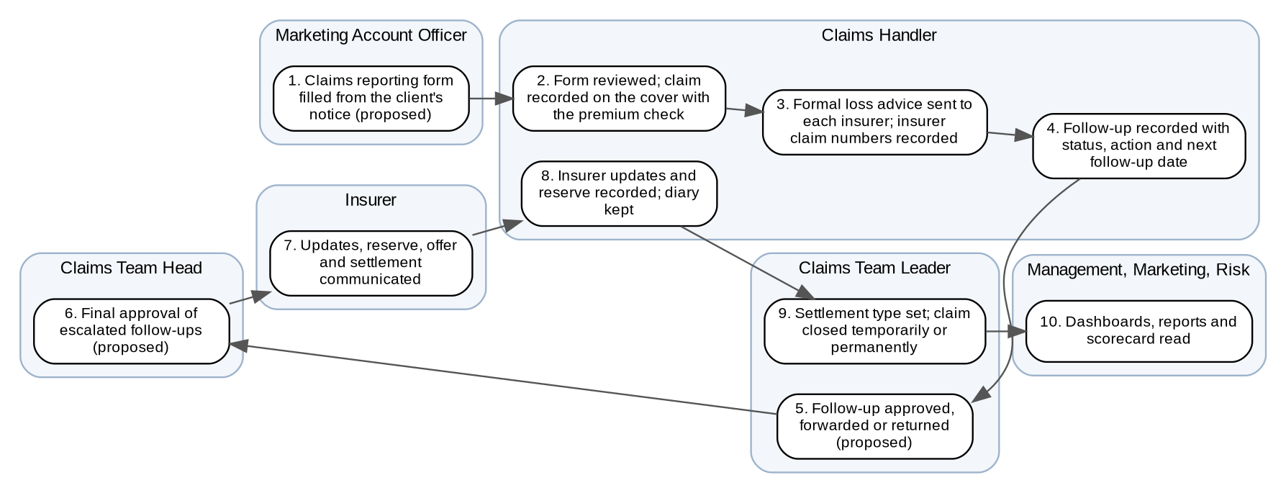
Figure 1: Claims: process flow (swimlanes by actor)
Table 2: The 10 steps
Step | Who | What happens
1 | Marketing Account Officer | Claims reporting form filled from the client's notice (proposed)
2 | Claims Handler | Form reviewed; claim recorded on the cover with the premium check
3 | Claims Handler | Formal loss advice sent to each insurer; insurer claim numbers recorded
4 | Claims Handler | Follow-up recorded with status, action and next follow-up date
5 | Claims Team Leader | Follow-up approved, forwarded or returned (proposed)
6 | Claims Team Head | Final approval of escalated follow-ups (proposed)
7 | Insurer | Updates, reserve, offer and settlement communicated
8 | Claims Handler | Insurer updates and reserve recorded; diary kept
9 | Claims Team Leader | Settlement type set; claim closed temporarily or permanently
10 | Management, Marketing, Risk | Dashboards, reports and scorecard read

To-be Processes

P-CLM-01 Notice of loss and claim recording
Item | Value
Journey steps | 1 to 3
Trigger | Client notice through Marketing or the insurer
Actors | Marketing Account Officer, Claims Handler
Outcome | Claim with its number, insurers and loss advice sent
Controls | BR-CLM-02, BR-CLM-03, BR-CLM-06
Requirements | FRCLM.008, 021, 022

P-CLM-02 Follow-up and approval
Item | Value
Journey steps | 4 to 8
Trigger | Next follow-up date; insurer update
Actors | Claims Handler, Team Leader, Team Head, Insurer
Outcome | Claim status current and approved
Controls | BR-CLM-05, BR-CLM-07, BR-CLM-12
Requirements | FRCLM.003, 009, 010

P-CLM-03 Settlement and closure
Item | Value
Journey steps | 9
Trigger | Insurer settlement or denial
Actors | Claims Team Leader, Team Head
Outcome | Claim closed or reopened
Controls | BR-CLM-05
Requirements | FRCLM.023, 024

P-CLM-04 Monitoring and reporting
Item | Value
Journey steps | 10
Trigger | On demand; daily jobs
Actors | Claims, Marketing, Risk
Outcome | Reports, dashboards, scorecard
Controls | BR-CLM-08, BR-CLM-10
Requirements | FRCLM.001, 011 to 020

Statuses
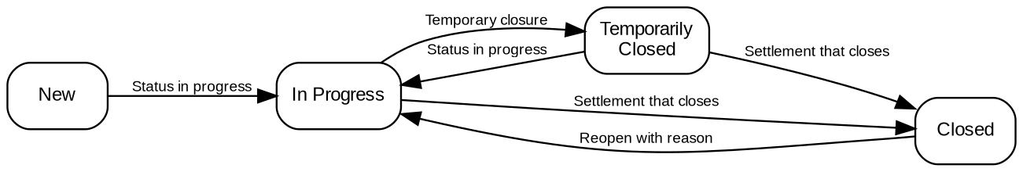
Figure 2: Phases of a claim
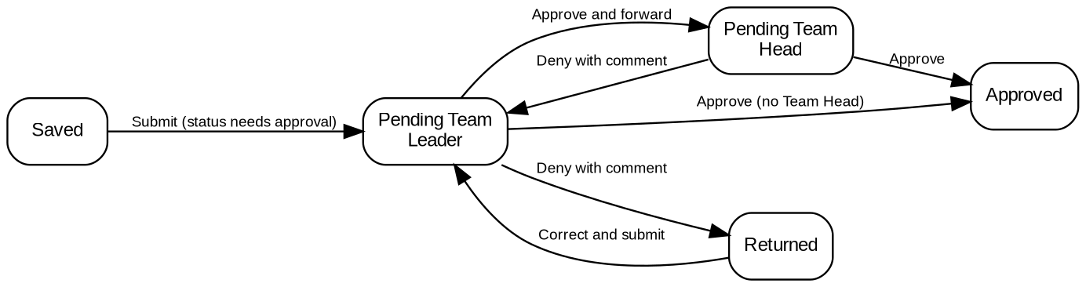
Figure 3: Approval of a follow-up (proposed, CR-CLM-102)

Storyboards
Each storyboard is a walkthrough of the to-be process with the walkthrough accounts of the Walkthrough Users workbook and fictitious clients and insurers. The screens are described in the UX Design.

SB-CLM-01 Claims reporting form to loss advice
Marketing fills the form, the handler accepts it, records the claim and sends the loss advice.
Test data: client Alpha Trading Corporation, Motor policy, own damage on 10-Oct-2026, insurer Alpha Insurance.
Table 3: SB-CLM-01 steps
Step | Who | Screen | Does | Sees
1 | Marketing Account Officer | Claims Reporting Form | Fills the form and submits it | CRF reference given; the handlers are told
2 | Claims Handler | Claims Reporting Form | Reviews and accepts the form | Claim created with its claim number
3 | Claims Handler | Claim | Completes the Motor fields and the insurer line | Premium paid; authorization code generated
4 | Claims Handler | Claim | Previews and sends the formal loss advice | Letter sent and kept under Documents

SB-CLM-02 Follow-up with approval
The handler records a follow-up whose status needs approval; the Team Leader approves and the Team Head gives the final approval.
Test data: the claim of SB-CLM-01.
Table 4: SB-CLM-02 steps
Step | Who | Screen | Does | Sees
1 | Claims Handler | Claims Worklist | Opens the claims due today | The claim with its ages
2 | Claims Handler | Claim | Records the follow-up with status Closed - within Deductible | Pending Team Leader
3 | Claims Team Leader | Approvals | Approves and forwards | Pending Team Head
4 | Claims Team Head | Approvals | Approves | Approved; claim closed

SB-CLM-03 Claim waiting for premium remittance
The insurer waits for the premium; the handler asks for the special remittance and is told when it is remitted.
Test data: a Fire claim whose premium is paid but not yet remitted.
Table 5: SB-CLM-03 steps
Step | Who | Screen | Does | Sees
1 | Claims Handler | Claim | Sets With BDOI - For Premium Remittance | Unremitted invoices shown with the link
2 | Marketing Collection | Special Remittance | Requests a special remittance with condition Claims | Confirmed by the Claims module
3 | Remittance Team Leader | Special Remittance Request | Approves | Batch created
4 | Claims Handler | Claims Home | Opens the notice | Premium remitted; flag cleared

