
Project Functional Requirements Specifications

PRJ0012475 BDO Insurance Brokering System – Renewal v1.2

Prepared by: Angela V. Ramirez
Drafting support: iorta TechNXT Project Team

Table of Contents
Table of Contents 1
Document Revision Log 2
1. Introduction 3
1.1. Document Purpose 4
1.2. Project Overview 4
1.3. Document Preparation, Review and Approval 4
2. Business Requirements Mapping 4
3. Functional Requirements 8
Signoff Sheet 74
Appendix A – 75
Appendix B - Sanitation Rules per Market Segment 76
I. Non-CBG 76
II. CBG Motor 76
III. CBG Home 79
Appendix C - CBG Motor Automatic Field Update Details 79
Appendix D – CBG Motor Automatic Field Update Details (Auto Promo to Regular) 81
Appendix E – Auto Assignment Logic Per Market Segment 83
I. Corporate 83
II. Retail 83
III. CBG Motor 84
IV. CBG Home 84
Appendix F - LAMD Upload File Details 85
I. CBG Loans excluding Personal 85
II. List of Paid Off Accounts 86
Appendix G – Insurer Disposition Upload Details (CBG) 87
Appendix H - 88
Appendix I - 88
Appendix J - 88
Appendix K - 88
Appendix L - Letter Eligibility Matrix 88
Appendix M - 89
Appendix N - 89
Appendix O - 89
Appendix P - 89
Appendix Q - 89
Appendix R - Billing File Template 90
Appendix S - 90
Appendix T - 90
Appendix U - 90
Appendix V - 90

Document Revision Log
Date | Version | Description of Change | Created / Reviewed by
June 11, 2026 | 1.0 | Initial Document | Angela Ramirez
09 Oct 2026 | 1.1 | Draft for BDOI review: full coverage of the Renewal BRD (version of 8-Oct-2026 with the Walkthrough addendum; the 42 BRRN requirements and the 1,033 requirement lines of the main BRD), functional requirements elaborated with acceptance criteria, new sub-items and entries FRRN.045 to FRRN.049, annexes AA onwards added, observations and points for decision listed in Annex AO. Business Unit review edition: summary for the Business Unit, end-to-end flows, workflow and approvals, e-mail texts, document formats, reports and schedules, integrations, non-functional requirements, open questions not answered in the BDOI FRS, change control, review checklist; aligned on 10 Oct 2026 with BIBS: the Renewal dashboards and bucket panels, sanitation, assignment and transfers, LAMD and insurer uploads, the CCM, MFT and LMS channels, BDOI's letters, placement and e-policies, hold cover, approvals and billing, proposals and the TSU Requests menu, with current screenshots and the settings for the points BDOI decides | iorta TechNXT Project Team (drafting support); for review by Angela V. Ramirez
11 Oct 2026 | 1.2 | Review of the Product Owner on version 1.1: colour code of the points beyond the BRD (green out of the box, orange change request) with its legend; Annex AP.1 lists them with the effort of each change request (CR effort workbook); the requirement lines of the BRD and the signed Concept Paper validated end to end (Annex AM.4); the programme non-functional requirements of the other BRDs that also apply to Renewal (Annex AJ); the environment of the screenshots and walkthroughs; figure captions kept with their figures | iorta TechNXT Project Team (drafting support); for review by Angela V. Ramirez

Introduction

Document Purpose
This Functional Requirements Specifications (FR) document outlines how business requirements which are baselined in the Business Requirements Document (BRD) for the BDO Insurance Brokering System – Renewal project are to be implemented in the IT systems. This FR document translates the business requirements into functional requirements in terms of system capability, behaviour/function with clearly outlined inputs and outputs.

Project Overview
The BDOI Brokering System Renewal Module is a comprehensive digital solution that modernizes the entire renewal lifecycle of insurance accounts—from identification of expiring policies to final processing and client communication. It eliminates reliance on manual tracking, email coordination, and Excel-based encoding by consolidating all renewal activities into a single, integrated platform.
By centralizing data and workflows, the system enables business units to efficiently manage, assign, and monitor renewal accounts in real time. It introduces structured processes for reviewing account details, validating computations, capturing dispositions, and handling exceptions—ensuring consistency and reducing errors. Automated rules and validations further enhance accuracy, while built-in controls support compliance and auditability.
In addition, the platform improves operational visibility and decision-making through dashboards, reporting, and status tracking, allowing stakeholders to easily monitor volumes, turnaround times, and performance metrics. Overall, the module drives greater efficiency, faster processing, improved collaboration, and stronger governance, empowering teams to deliver a more seamless and controlled renewal experience.
The Renewal BRD issued on 8-Oct-2026 adds, in front of the earlier content, the Renewal Addendum (Walkthrough) approved on 14 and 15 May 2026: rule-based sanitation with the TSI threshold to TSU, KYC for visibility, the routing of exceptions, the NRNS reminders and the No Advice and Non-Renewal Letters on the effective expiry date (the end of a confirmed hold cover), the client confirmation recorded by Marketing with placement and booking kept under manual control, the hold cover request from the renewal (BRRN.042) and the incentive eligibility after booking and full payment (BRRN.041). This version covers that BRD in full: the 42 BRRN requirements of the addenda and the 1,033 requirement lines of the main BRD (RMEL Phase 2 - Online Dispositioning).

Document Preparation, Review and Approval
The System Analyst or equivalent BDO ITG personnel is responsible for populating this Functional Requirements Specifications document by obtaining inputs from the business unit and when necessary, from other IT units.
This version 1.1 was elaborated with the iorta TechNXT Project Team (drafting support), from the inputs of the business unit and BDO ITG and the Renewal BRD of 8-Oct-2026, for review by the System Analyst. BDOI's text of version 1.0 is kept word for word; every addition traces to a BRD requirement, and every point where the additions differ from BDOI's text is listed for decision in Annex AO.
This document once approved will serve as the official baseline of functional requirements document for the BDO Insurance Brokering System – Renewal project.
Following the approval of this document, changes will be governed by the project’s change management process, including impact analysis, appropriate reviews and approvals.
How to read this document
The colour of a point tells where it comes from and whether it costs a change:
- Black: in the Renewal BRD (or the signed Concept Paper, or a programme-wide requirement of another BRD), also where BDOI's FRS elaborates a BRD line; in scope. A gap against the platform is a BRD item to deliver (Annex AP.1), not a change request.
- Green: not in the BRD, from BDOI's FRS; offered by the iNXT BrokerVerse platform out of the box, at no cost (Annex AP.1).
- Orange: in no BRD line at all and not (or only partly) in the iNXT BrokerVerse platform; a change request with its effort for that part only (Annex AP.1; CR Effort Estimate workbook).
- [Integration scope] / [Data Migration scope]: an interface with an external system or a migration item, delivered in that scope; not a change request (Annex AP.1).
- Blue: insurance-broking best practice not in the BRD, this FRS or the platform; a recommendation with indicative effort, not a commitment (Annex AP.2).
Out of the box means the iNXT BrokerVerse platform edition (its code and manual), cross-checked with the Feature List vs OOTB workbook; the work prepared for BIBS in this project is not out of the box.

References
The following documents are used as reference in version 1.1:
Document | Owner | Use in this FRS
Renewal (RN) BRD, issued 8-Oct-2026 (Walkthrough addendum v01.01, Workshop addendum, Addendum 1, RMEL Phase 2 - Online Dispositioning; 215 pages) | BDO Unibank ESG - Business Project Services | The baseline of this FRS: every BRD ID is mapped in section Business Requirements Mapping
Concept Paper - Advance Implementation of Renewal Processing v1.0 (signed) | BDOI | Superseded by BDOI's decision of 26-Sep-2026 (single go-live; FRRN.045)
User Access Maintenance FRS (BDOI format) | BDO ITG | Profiles, functions and access requests (FRRN.001.05)
Review workbooks of BRD-06 v1.0 (9-Oct-2026): Business Unit Requirements Collection; BRD vs Out-of-the-Box vs Best Practice; Change Request Register; Test Cases and Traceability; Business Unit Walkthrough Users | iorta TechNXT | Issued with this edition for the review of the Business Unit
BIBS Master Data and Configuration Upload Templates v1.2; BDOI Requirements and Inputs by BRD v1.2; BIBS Non-Functional Requirements Register v1.0 | iorta TechNXT | Data set-up, inputs and non-functional requirements (Annexes AJ, AK)

Summary for the Business Unit Review
This section is for the business owners of Renewal who sign this FRS. It shows on a few pages what the Renewal Module does, from the RMEL to the booking of the renewal, who does what, the key numbers of the document, the decisions the Business Unit must take before signing, and which annex each role reads. BDOI's text of version 1.0 is unchanged; the additions of version 1.1 trace to the Renewal BRD of 8-Oct-2026.
Scope on a page
In scope of this FRS | Out of scope | Specified in another FRS
RMEL: daily extraction at the lead days and generation by date range; filters, list, export and print (FRRN.002-004) | EBIX and BDOIsys references and QPS / EBIX searches (BRD Addendum 1, p.60) | Profiles, functions and access requests: User Access Maintenance FRS
Sanitation, classification, decision matrix, LAMD and insurer dispositions (FRRN.006-013, 038-041) | Renewal of Employee Benefits lines (HMO, group life, group personal accident): Employee Benefits | Placement, issuance, booking, service invoice, CLPC billing of the shared New Business flow: New Business FRS
Assignment, transfer, disposition, review and posting by Marketing (FRRN.010-016, 020) | Gating of the renewal by KYC (KYC is for visibility only, BRRN.028) | Payments, bounced checks, unapplied payments and refunds: Operations Cashiering FRS
Processing, request to the insurers and their dispositions (FRRN.003, 015, 021) | Automatic escalation of accounts to the Unit Head (BRRN.036) | Claims summary and total-loss indicator: Claims FRS
Renewal Advice, letters, NRNS, client acceptance, hold cover, incentive (FRRN.022-028, 034, 036-037) | Renewals in progress in the legacy systems at go-live (none is carried over; FRRN.045) | Hand-off of submitted policies: Submitted Policies FRS (FRRN.048 is the Renewal side)
Dashboards, reports, audit, maintenance; go-live take-over (FRRN.002.02, 042-049) | - | Migrated policies and their packages: Data Migration FRS

The process from end to end
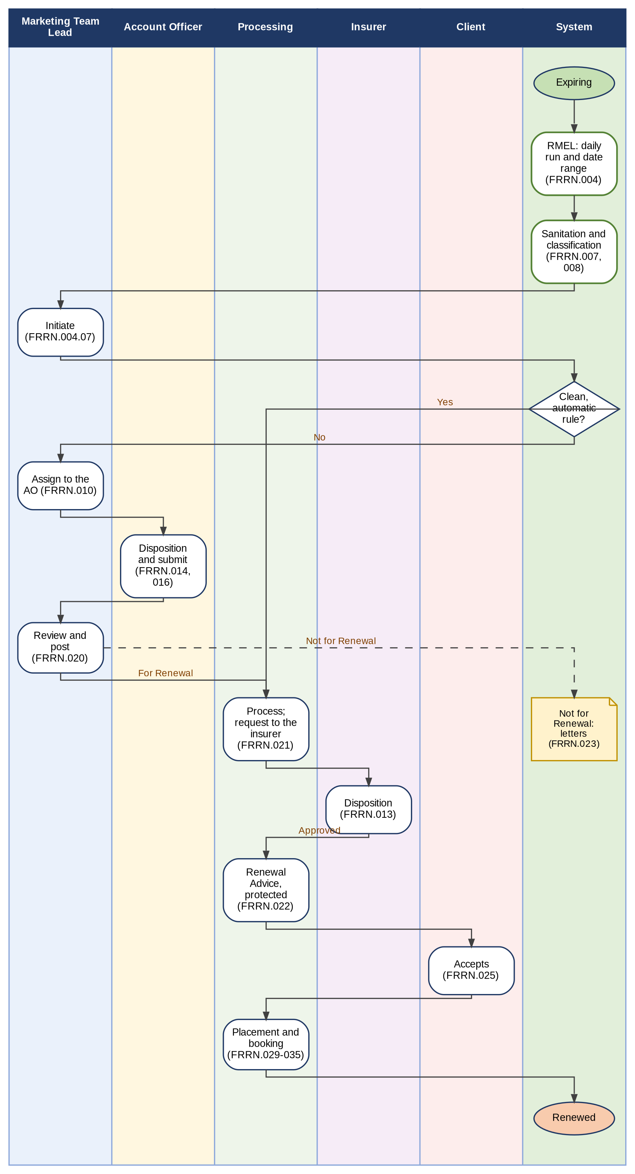
Figure 1 - Renewal from end to end: who does what, from the expiring account to the booked renewal
How to read it: Read from top to bottom. Each column is a persona; the green column is what the system does by itself. The FR items of section Functional Requirements are in brackets. Traces to: BRRN.001-042; BRD 1.003-4.09.
Key numbers
The key numbers of this version, by where they are in the document:
Item | Number | Where
BRD requirement IDs mapped (42 BRRN and the lines of the main BRD), each to at least one FR item | 1075 | Business Requirements Mapping; Annex AM
FR entries (BDOI's 44 and FRRN.045 to FRRN.049) | 49 | Functional Requirements
FR items and sub-items (BDOI's 143 and the added ones) | 167 | Functional Requirements
Acceptance criteria | 312 | Functional Requirements
Figures added | 13 | This summary; Process Flow; Annexes AA, AD, AH
Screens | 36 | Annex AA
Messages shown to the user | 163 | Annex AB
Notices, alerts and e-mails | 44 | Annex AE
Documents and outputs | 16 | Annex AF
Reports / scheduled runs | 18 / 11 | Annex AG
Integrations | 14 | Annex AH
Open questions not answered in BDOI's FRS / answered and not repeated | 26 / 60 | Annex AN
Observations and points for decision | 91 | Annex AO
Review checklist points | 27 | Annex AQ

Decisions the Business Unit must take
The ten decisions with the widest effect, of the points listed in Annex AO (conflicts between BDOI's FRS and the BRD or the system) and Annex AN (open questions not answered in BDOI's FRS). Each must be decided before the sign-off, or signed as proposed in this version.
No. | Decision | Annex AO / AM | Decided by
1 | Third classification: Non-Renewable (BDOI) or Exception (BRD BRRN.023); missing data Review or Exception | AO-01 (C01) | Product Owner, Renewal
2 | Paid-off and RMU loans: Not for Renewal (process flow) or renewed as is (Annex C) | AO-04 (C04); AO-05 (C05) | Product Owner, Renewal; CBG
3 | Assignment: automatic round robin (BDOI) or by the Team Lead (BRD 1.005, 3.005) | AO-06 (C06) | Marketing and Processing Heads
4 | Transfer: referral that keeps the account (BDOI) or transfer of the account (BRD 1.006) | AO-07 (C07) | Marketing Heads
5 | Extraction and initiation: by date range only, accounts created at generation (BDOI), or daily at the lead days with an explicit initiation (BRRN.021, 030) | AO-08 (C08); AO-09 (C09) | Product Owner, Renewal
6 | Meaning of For Quotation and For Proposal, and their routing to TSU | AO-03 (C03); AO-02 (C02) | Marketing; TSU
7 | Second approval after the client's acceptance and the automatic Submitted for Placement | AO-23 (C23); AO-28 (C28) | Product Owner, Renewal; Processing
8 | Delivery through CCM and MFT at go-live, with e-mail as the fall-back | AO-17 (C17) | BDO ITG
9 | Letters: lock at the Renewal Advice (BRD 2.004.9) or after posting and placement; NAL and NRL rules | AO-11 (C11); AO-15 (C15) | Product Owner, Renewal
10 | KYC blocking or visibility only; the incentive criteria | Annex AN.3 | Compliance; Product Owner, Renewal

How to review this document
Which part each role reads, in this order:
Role | Read first | Then | About
Product Owner, Renewal | This summary; Annex AO; Annex AN | Annex AD; Annex AQ | 2 hours
Marketing Team Leads and Account Officers | Process Flow; FRRN.002-020 | Annexes AA, AE, AL | 3 hours
Processing Team Leads and Officers | Process Flow; FRRN.003, 013, 015, 021-037 | Annexes AA, AF, AL | 3 hours
LAMD, Contact Center | FRRN.012, FRRN.047 | Annex AA (their screens) | 1 hour
Business Administrator (MBS) | Annex AC; FRRN.038-042, 049 | Annexes AE, AF, AK | 2 hours
BDO ITG (System Analyst, Tech Lead) | Business Requirements Mapping; Annex AO | Annexes AH, AJ, AM, AP | 4 hours

The workbooks issued with this edition:
Workbook | What it holds
Business Unit Requirements Collection | What the Business Unit provides: templates and print formats, e-mail wordings to confirm, schedules, parameters, lists, master data, approvers and users, inputs of BDOI IT, open decisions
BRD vs Out-of-the-Box vs Best Practice | Every BRD requirement against what the system offers and insurance-broking practice, with the fit
Change Request Register | How a change is raised after sign-off, the candidate changes and the decision log of Annex AO
CR Effort Estimate | The effort of each change request (orange points) by activity, the totals and the green points at no cost (Annex AP.1)
Test Cases and Traceability | BRD ID to FR item to test cases, screens and walkthrough steps; the test cases; the questions answered in BDOI's FRS
Business Unit Walkthrough Users | The users of the walkthrough with their sign-in IDs, menus and the walkthrough script

Before signing, the Business Unit confirms the 27 points of the review checklist in Annex AQ.

Business Requirements Mapping
This section lists the business requirements baselined in the Business Requirements Document (BRD) and the corresponding Functional Requirements to satisfy each business requirement.

The details of each functional requirement are provided in the subsequent section.

BRD Req No. | Business Requirement | Functional Requirement Req IDs
BRRN.001 | System must allow the user to generate and send a No Advice Letter (NAL) to clients whose expiring policies do not require either a Renewal Advice (RA) or a Not for Renewal Letter (NFR) or Non-Renewal Letter (NRL), typically when no action or advice is needed regarding the expiring policy. | FRRN.022  FRRN.023
BRRN.002 | The system must allow users to select and change the date range (month, day, year) for generating the list of expiring accounts. | FRRN.004
BRRN.003 | System provides filter criteria for generating the list, including all specified options, and allows filter management (apply, cancel, clear) | FRRN.004
BRRN.004 | System displays the generated list in a scrollable view with all required columns. | FRRN.004
BRRN.005 | System captures expired/expiring and unbooked accounts. | FRRN.004  Added in v1.1: FRRN.004.04, FRRN.045.01
BRRN.006 | System allows column filtering and search. | FRRN.002
BRRN.007 | System allows download, save, and print in .xlsx format. | FRRN.004.06
BRRN.008 | System provides print preview and settings. | FRRN.004.06
BRRN.009 | System tags non-renewable risk codes, excludes them, maintains codes, and sends NFR letters. | FRRN.007  FRRN.038  FRRN.023
BRRN.010 | - Generate Renewal Advice (RA)  - Ability to select accounts for RA generation (single, multiple, all, all except)  - Generate RA for selected accounts  - Prevent RA generation for locked accounts  - Identify if RA is for first or second notice  - View, preview, and close RA details  - Download and save RA (single or batch)  - Extract details for RA sending  - Send RA in batch, with encryption and password protection | FRRN.022  Added in v1.1: FRRN.024.01
BRRN.011 | System allows users to view all accounts assigned to them in a single, scrollable view. Any updates or endorsements made to an account are automatically reflected on the mother policy. | FRRN.014  FRRN.004.06  FRRN.010  Added in v1.1: FRRN.002.08
BRRN.012 | System allows users to select any account from the displayed list for further action or review. | FRRN.014  Added in v1.1: FRRN.002.08
BRRN.013 | System displays all renewal fields for the selected account, sourced from the generated expiring account list. | FRRN.014
BRRN.014 | System provides filtering options for each column in the account list, allowing users to narrow down results. | FRRN.002  Added in v1.1: FRRN.002.08
BRRN.015 | System provides sorting options for the account list, allowing users to order accounts by any column. | FRRN.002  Added in v1.1: FRRN.002.08
BRRN.016 | System provides a search function that allows users to find specific information within the account list, similar to a Ctrl+F feature. | FRRN.002  Added in v1.1: FRRN.002.08
BRRN.017 | System allows users to search for a particular account using name or unique reference number. | FRRN.002  Added in v1.1: FRRN.002.08
BRRN.018 | Upload file(s)  Select the source path Select the file(s) for upload  System allows users to select a source path and upload one or more dispositioned files to update account details in the system. | FRRN.015  Added in v1.1: FRRN.015.07
BRRN.019 | The system must allow users to generate comprehensive reports on accounts and transactions relevant to their role.  - Users should be able to define the report scope using flexible filters (such as invoice number, date range, unit, region, product, account type, status, and other relevant fields).  - Reports must be viewable in a single, scrollable interface and include all necessary columns for business review (e.g., invoice number, account details, transaction status, renewal information, remarks).  Users must have the ability to download, save, and print reports in standard formats (e.g., .xlsx, .pdf), with print preview and customizable print settings. Each report should also provide a summary section showing aggregate figures and key performance indicators. | FRRN.044  Added in v1.1: FRRN.044.02
BRRN.020 | As a renewal processor, I want data sanitation to occur within the system after extraction or upload, so that renewal eligibility is determined consistently and not dependent on manual pre-cleaning. | FRRN.007  RRN.040  Added in v1.1: FRRN.040.01, FRRN.046.01
BRRN.021 | As an authorized user, I want expiring accounts to be extracted (e.g. within the system and displayed on the screen/dashboard), with renewal processing starting only upon explicit user initiation, so that accounts do not renew prematurely and proper governance is maintained. | FRRN.004  FRRN.003  Added in v1.1: FRRN.004.07
BRRN.022 | As a renewal user, I want to have a unique reference number to be mandatory and used as the primary matching key, so that renewal records reliably link to the correct existing policies. | FRRN.004
BRRN.023 | I want the system to automatically classify renewal records into rule-based buckets (i.e. Clean, Review, Exception), so that renewal work is prioritized, straight through cases are processed efficiently, and exceptions are controlled and isolated. | FRRN.007  FRRN.008  Added in v1.1: FRRN.020.03
BRRN.024 | As an authorized user, I want the LAMD role limited to early validation only, so that booking, placement, and customer communications remain role-appropriate and controlled. | FRRN.012  Refer to User access matrix for access restriction  Added in v1.1: FRRN.001.02
BRRN.025 | I want expiry-driven reminder letters generated for expiring policies that are not yet submitted at the defined follow-up checkpoint (e.g., +90 days), so that follow-ups are standardized and time-bound. | FRRN.023  Added in v1.1: FRRN.023.03
BRRN.026 | As a Contact Center user, I want system access to renewal lists and the ability to update renewal statuses, so that follow-ups are done via system. | Refer to User access matrix for access restriction  Added in v1.1: FRRN.047.01
BRRN.027 | As a Renewal User, I want to view the full historical account record (i.e. policies, renewals, endorsements, payment history, and claims) during renewal review so that I can make an informed and auditable renewal decision. | FRRN.014
BRRN.028 | I want the system to identify and view accounts that are due or upcoming for KYC review, so that compliance monitoring and follow up can be performed without blocking or interrupting the renewal process. | FRRN.039
BRRN.029 | The system shall ingest LAMD-provided reports and match paid-off loan records against RMEL policies to determine renewal eligibility and proper routing. | FRRN.012  Added in v1.1: FRRN.041.01
BRRN.030 | The system shall automatically extract renewal candidates based on policy expiry date using configurable lead days (e.g., -140 days). | User will select date range to generate RMEL  FRRN.004  Added in v1.1: FRRN.004.04, FRRN.040.03
BRRN.031 | I want the system to apply rule-based disposition automatically and isolate exceptions, so that straight-through renewals proceed without manual effort and manual handling is focused only on high-impact or non-standard cases. | FRRN.007  FRRN.08  Added in v1.1: FRRN.008.01, FRRN.040.02, FRRN.020.03
BRRN.032 | Endorsements occurring before or during renewal must be reflected on the mother (expiring) policy prior to renewal approval. | FRRN.004.06
BRRN.033 | The system shall allow renewal-identified accounts to follow the New Business flow when financial or structural changes require repricing or restructuring. | FRRN.017  FRRN.018  FRRN.019  FRRN.020  Added in v1.1: FRRN.018.02
BRRN.034 | The system shall provide a configurable decision matrix defining which renewal scenarios are automated versus manual. | FRRN.040  Added in v1.1: FRRN.040.02
BRRN.035 | As a renewal user, I want the system to capture insurer responses (e.g., Approve/ Renew As-ls, Reject, Revise) and automatically apply them to the renewal workflow, so that renewal status progression is accurate, controlled, and does not rely on manual re-encoding or interpretation. | FRRN.013  Added in v1.1: FRRN.013.05
BRRN.036 | I want the system to generate customizable, centralized renewal listings (e.g., by unit, segment, UH, IBG, Leasing), expiry window, and current status, so that renewal exposure is clearly visible, proactively monitored, and escalated appropriately without relying on manual tracking. | FRRN.002.05  Added in v1.1: FRRN.044.03
BRRN.037 | I want the system to identify NRNS (No Renew/ No Submit) accounts and trigger reminder or non-acceptance letters to manage lapse risk. | FRRN.023  Added in v1.1: FRRN.023.03, FRRN.037.02
BRRN.038 | The system shall enforce routing of renewal changes based on financial impact, ensuring proper approval and proposal handling. | FRRN.017  Added in v1.1: FRRN.009.01, FRRN.018.02
BRRN.039 | The system shall support LAMD-driven matching and categorization for CBG Motor and Fire renewals, including straight-through processing and letter generation. | FRRN.012
BRRN.040 | I want the system to automatically proceed to placement and booking once the client has accepted the Renewal Advice (RA) and applicable payment rules are satisfied, so that the renewal process is completed without delay, duplicate handling, or manual re initiation, and the policy can be issued on time. | FRRN.029  Added in v1.1: FRRN.025.01, FRRN.26.01, FRRN.028.02
BRRN.041 | The system shall evaluate renewal transactions for incentive eligibility after successful placement, booking, and full payment confirmation, and assign an incentive eligibility indicator based on predefined, rule-based criteria, including applicable endorsements, so that incentive processing and reporting are accurate, consistent, and auditable. | FRRN.034
BRRN.042 | As a renewal user, I want to be able to send request for Hold Cover to insurer/s and to record the Hold Cover confirmation details received from the insurer. | FRRN.036  Added in v1.1: FRRN.037.02
BRD 1.001 | Log in (Marketing Team Leader) | Lines below
BRD 1.001.1 | a. Access the module/application using any BDO issued device | FRRN.001.01, FRRN.001.02, FRRN.001.03, FRRN.001.04
BRD 1.001.1.1 | 1. Log in with a Marketing Team Leader user profile | FRRN.001.01, FRRN.001.02, FRRN.001.03, FRRN.001.04
BRD 1.001.2.1 | 2. Receive the inactivity warning (15 minutes) | FRRN.001.01, FRRN.001.02, FRRN.001.03, FRRN.001.04
BRD 1.001.3.1 | 3. Receive warning prior to system triggered log out (30 minutes) | FRRN.001.01, FRRN.001.02, FRRN.001.03, FRRN.001.04
BRD 1.002 | Open in several tabs (Marketing Team Leader) | Lines below
BRD 1.002.1 | a. Open the module/application in multiple tabs | FRRN.001.01, FRRN.001.02, FRRN.001.03, FRRN.001.04
BRD 1.003 | Generate the list of expiring accounts (Marketing Team Leader) | Lines below
BRD 1.003.1 | a. Select the date range of the List of Expiring Accounts | FRRN.004.01, FRRN.004.02
BRD 1.003.1.1 | 1. Select the month, day and year | FRRN.004.01, FRRN.004.02
BRD 1.003.2 | b. Change the selected date range | FRRN.004.01, FRRN.004.02
BRD 1.003.3 | c. Filter Criteria | FRRN.004.03
BRD 1.003.3.1 | 1. Select single, multiple, select all except and all Unit Head from the drop-down | FRRN.004.03
BRD 1.003.3.1.2 | 2. Select single, multiple, select all except and all business Origin from the drop-down | FRRN.004.03
BRD 1.003.3.1.3 | 3. Select single, multiple, select all except and all account type from the drop-down | FRRN.004.03
BRD 1.003.3.1.4 | 4. Select single, multiple, select all except and all Region from the drop-down | FRRN.004.03
BRD 1.003.3.1.5 | 5. Select single, multiple, select all except and all Area from the drop-down | FRRN.004.03
BRD 1.003.3.1.6 | 6. Select single, multiple, select all except and all Invoicing Branch from the drop-down | FRRN.004.03
BRD 1.003.3.1.7 | 7. Select single, multiple, select all except and all Risk Code from the drop-down | FRRN.004.03
BRD 1.003.3.1.8 | 8. Select single, multiple, select all except and all Market Segment from the drop-down | FRRN.004.03
BRD 1.003.3.1.9 | 9. Select single, multiple, select all except and all Department Name from the drop-down | FRRN.004.03
BRD 1.003.3.1.10 | 10. Select single, multiple, select all except and all account Officer from the drop-down | FRRN.004.03
BRD 1.003.3.1.11 | 11. Cancel the selected filter | FRRN.004.03
BRD 1.003.3.1.12 | 12. Clear the selected filter | FRRN.004.03
BRD 1.003.3.1.13 | 13. Apply filter criteria | FRRN.004.03
BRD 1.003.4.1 | d. View the generated List of Expiring Accounts (display all accounts in 1 view using a scroll bar) | FRRN.002.05, FRRN.002.06
BRD 1.003.4.1.1 | 1. View the generated List of Expiring accounts with below columns: | FRRN.002.05, FRRN.002.06
BRD 1.003.4.1.1.1 | 1.1 Expiring EBIX Invoice No. | Out of scope (BRD Addendum 1, p.60); replaced by FRRN.002.05
BRD 1.003.4.1.1.2 | 1.2 Renewal Reference No. | FRRN.002.05, FRRN.002.06
BRD 1.003.4.1.1.3 | 1.3 BDOIsys Reference No. | Out of scope (BRD Addendum 1, p.60); replaced by FRRN.002.05
BRD 1.003.4.1.1.4 | 1.4 Cover No. | FRRN.002.05, FRRN.002.06
BRD 1.003.4.1.1.5 | 1.5 Version No. | FRRN.002.05, FRRN.002.06
BRD 1.003.4.1.1.6 | 1.6 Invoicing Branch | FRRN.002.05, FRRN.002.06
BRD 1.003.4.1.1.7 | 1.7 Department Code | FRRN.002.05, FRRN.002.06
BRD 1.003.4.1.1.8 | 1.8 Department Name | FRRN.002.05, FRRN.002.06
BRD 1.003.4.1.1.9 | 1.9 Unit Head | FRRN.002.05, FRRN.002.06
BRD 1.003.4.1.1.10 | 1.10 Client Name | FRRN.002.05, FRRN.002.06
BRD 1.003.4.1.1.11 | 1.11 Assured’s Name | FRRN.002.05, FRRN.002.06
BRD 1.003.4.1.1.12 | 1.12 Business Origin | FRRN.002.05, FRRN.002.06
BRD 1.003.4.1.1.13 | 1.13 Account Officer | FRRN.002.05, FRRN.002.06
BRD 1.003.4.1.1.14 | 1.14 Expiring Policy No. | FRRN.002.05, FRRN.002.06
BRD 1.003.4.1.1.15 | 1.15 Insurance Company | FRRN.002.05, FRRN.002.06
BRD 1.003.4.1.1.16 | 1.16 Risk Code | FRRN.002.05, FRRN.002.06
BRD 1.003.4.1.1.17 | 1.17 Risk Name | FRRN.002.05, FRRN.002.06
BRD 1.003.4.1.1.18 | 1.18 Risk Description | FRRN.002.05, FRRN.002.06
BRD 1.003.4.1.1.19 | 1.19 Renewal Stage/Status | FRRN.002.05, FRRN.002.06
BRD 1.003.4.1.1.20 | 1.20 Renewal Disposition | FRRN.002.05, FRRN.002.06
BRD 1.003.4.1.1.21 | 1.21 Disposition Remarks | FRRN.002.05, FRRN.002.06
BRD 1.003.4.1.1.22 | 1.21 Number of Claims | FRRN.002.05, FRRN.002.06
BRD 1.003.4.1.1.23 | 1.21 Status of Each claim | FRRN.002.05, FRRN.002.06
BRD 1.003.4.1.1.24 | 1.21 Amount of Outstanding Premium | FRRN.002.05, FRRN.002.06
BRD 1.003.4.1.2 | 2. Capture expired/expiring (within the identified date range) and unbooked account | FRRN.004.04
BRD 1.003.4.1.3 | 3. Filter each column | FRRN.002.05, FRRN.002.06
BRD 1.003.4.1.4 | 4. Search specific information from the list (i.e. similar to control F function) | FRRN.002.05, FRRN.002.06
BRD 1.003.5 | e. Download the generated list in a .xlsx format when needed | FRRN.002.07, FRRN.004.06 (2nd)
BRD 1.003.6 | f. Save the generated list in a .xlsx format when needed | FRRN.002.07, FRRN.004.06 (2nd)
BRD 1.003.7 | g. Print the generated list in a .xlsx format when needed | FRRN.002.07, FRRN.004.06 (2nd)
BRD 1.003.7.1 | 1. Print preview option | FRRN.002.07, FRRN.004.06 (2nd)
BRD 1.003.7.2 | 2. Print setting options | FRRN.002.07, FRRN.004.06 (2nd)
BRD 1.003.7.3 | 3. Automatically tag non- renewable risk codes as "Not for renewal" and should not be part of the list for assignment. There should be a maintenance for these risk codes. | FRRN.038.01, FRRN.038.03
BRD 1.003.7.3.1 | 3.1. System should automatically send Not for Renewal Letter (NFR) | FRRN.038.01, FRRN.038.03
BRD 1.004 | View account (Marketing Team Leader) | Lines below
BRD 1.004.1 | a. View the complete renewal fields of the expiring account | FRRN.014.01, FRRN.014.06
BRD 1.004.1.1 | 1. Select an account | FRRN.014.01, FRRN.014.06
BRD 1.004.1.2 | 2. View the complete renewal fields of the selected account from the generated expiring account list. | FRRN.014.01, FRRN.014.06
BRD 1.004.1.3 | 3. Download the account details as needed in a .pdf or .xlsx format | FRRN.014.01, FRRN.014.06
BRD 1.004.1.4 | 4. Save the account details as needed | FRRN.014.01, FRRN.014.06
BRD 1.004.1.5 | 5. Print the account details as needed | FRRN.014.01, FRRN.014.06
BRD 1.004.1.5.1 | 5.1. Print preview option | FRRN.014.01, FRRN.014.06
BRD 1.004.1.5.2 | 5.2. Print setting options | FRRN.014.01, FRRN.014.06
BRD 1.005 | Assign accounts (Marketing Team Leader) | Lines below
BRD 1.005.1 | a. Assign account to Marketing Account Officers (AO) | FRRN.010.01, FRRN.010.02
BRD 1.005.1.1 | 1. Select account/s | FRRN.010.01, FRRN.010.02
BRD 1.005.1.1.1 | 1.1 Select single, multiple, select all except and all account/s | FRRN.010.01, FRRN.010.02
BRD 1.005.1.1.2 | 1.2 Unselect account/s | FRRN.010.01, FRRN.010.02
BRD 1.005.1.2 | 2. Select the name of the Marketing AO | FRRN.010.01, FRRN.010.02
BRD 1.005.1.2.1 | 2.1 Search the name or ID of the Marketing AO | FRRN.010.01, FRRN.010.02
BRD 1.005.1.2.2 | 2.2 Select the name of the Marketing AO from the drop- down List | FRRN.010.01, FRRN.010.02
BRD 1.005.1.2.3 | 3. Tag the account to the assigned Marketing AO | FRRN.010.01, FRRN.010.02
BRD 1.005.1.2.4 | 4. Push the account to the next workflow | FRRN.010.01, FRRN.010.02
BRD 1.005.2 | b. Re-assign account to another Marketing Account Officers (AO) | FRRN.010.01, FRRN.010.02
BRD 1.006 | Transfer account to other units (Marketing Team Leader) | Lines below
BRD 1.006.1 | a. Select an account | FRRN.011.06
BRD 1.006.2 | b. View details of the selected account | FRRN.011.06
BRD 1.006.3 | c. Select from the drop-down the Marketing unit where the account will be transferred to | FRRN.011.06
BRD 1.006.4 | d. Submit transfer request | FRRN.011.06
BRD 1.006.5 | e. Push the account to the next workflow | FRRN.011.06
BRD 1.007 | Receive account transfer (Marketing Team Leader) | Lines below
BRD 1.007.1 | a. Receive notification on the transferred account/s from other unit | FRRN.011.06
BRD 1.007.2 | b. View flag on the transferred account/s | FRRN.011.06
BRD 1.007.3 | c. Accept transferred account/s | FRRN.011.06
BRD 1.007.3.1 | 1. Add accepted accounts to the list of accounts for assignment to Marketing AO | FRRN.011.06
BRD 1.007.4 | d. Decline transferred account/s | FRRN.011.06
BRD 1.007.4.1 | 1. Add remarks | FRRN.011.06
BRD 1.007.4.2 | 2. save remarks | FRRN.011.06
BRD 1.007.5 | e. Push the account to the next workflow | FRRN.011.06
BRD 1.008 | Review and post (Marketing Team Leader) | Lines below
BRD 1.008.1 | a. Review Accounts | FRRN.020.01, FRRN.020.02
BRD 1.008.1.1 | 1. View the list of all dispositioned accounts (display all accounts in 1 view using a scroll bar). Any updates/endorsement should reflect on the mother policy | FRRN.020.01, FRRN.020.02
BRD 1.008.1.2 | 2. Select an account | FRRN.014.01, FRRN.014.06, FRRN.020.01, FRRN.020.02
BRD 1.008.1.3 | 3. View the complete renewal fields of the selected account | FRRN.014.01, FRRN.014.06, FRRN.020.01, FRRN.020.02
BRD 1.008.1.4 | 4. Automatically tag the status as "review in progress" when Accounts are not yet posted | FRRN.004.06, FRRN.020.01, FRRN.020.02
BRD 1.008.2 | b. Return account/s | FRRN.020.01, FRRN.020.02
BRD 1.008.2.1 | 1. Select single, multiple, all except and all account/s | FRRN.020.01, FRRN.020.02
BRD 1.008.2.2 | 2. Tag the status as returned | FRRN.020.01, FRRN.020.02
BRD 1.008.2.3 | 3. Add remarks | FRRN.020.01, FRRN.020.02
BRD 1.008.2.4 | 4. Save remarks | FRRN.020.01, FRRN.020.02
BRD 1.008.2.5 | 5. Return to the assigned Marketing AO | FRRN.020.01, FRRN.020.02
BRD 1.008.2.6 | 6. Automatically flag the returned account | FRRN.020.01, FRRN.020.02
BRD 1.008.2.7 | 7. Push the account/s to the next workflow | FRRN.020.01, FRRN.020.02
BRD 1.008.3 | c. Post account/s | FRRN.020.01, FRRN.020.02
BRD 1.008.3.1 | 1. Select single, multiple, all except and all account/s | FRRN.020.01, FRRN.020.02
BRD 1.008.3.2 | 2. Review the account details | FRRN.020.01, FRRN.020.02
BRD 1.008.3.3 | 3. Post the account/s | FRRN.020.01, FRRN.020.02
BRD 1.008.3.4 | 4. Push the account/s to the next workflow | FRRN.020.01, FRRN.020.02
BRD 1.009 | Generate report (Marketing Team Leader) | Lines below
BRD 1.009.1 | a. Select expiry date range for each report | FRRN.044.01, FRRN.044.02
BRD 1.009.1.1 | 1. Select month, day and year | FRRN.044.01, FRRN.044.02
BRD 1.009.1.2 | 2. Change the selected date range | FRRN.044.01, FRRN.044.02
BRD 1.009.2 | b. Select single, multiple, all and all except criteria for each report | FRRN.044.01, FRRN.044.02
BRD 1.009.2.1 | 1. Select single, multiple, all except and all Unit Head from the drop-down list | FRRN.044.01, FRRN.044.02
BRD 1.009.2.2 | 2. Search specific Unit Head from the drop-down list | FRRN.044.01, FRRN.044.02
BRD 1.009.2.3 | 3. Select single, multiple, all except and all Risk Code from the drop-down list | FRRN.044.01, FRRN.044.02
BRD 1.009.2.4 | 4. Search specific Risk Code from the drop-down list | FRRN.044.01, FRRN.044.02
BRD 1.009.2.5 | 5. Select single, multiple, all except and all Insurance Company from the drop-down list | FRRN.044.01, FRRN.044.02
BRD 1.009.2.6 | 6. Search specific Insurance Company from the drop-down list | FRRN.044.01, FRRN.044.02
BRD 1.009.2.7 | 7. Select single, multiple, all except and all Insurance Group from the drop-down list | FRRN.044.01, FRRN.044.02
BRD 1.009.2.8 | 8. Search specific Insurance Group from the drop-down list | FRRN.044.01, FRRN.044.02
BRD 1.009.2.9 | 9. Select single, multiple, all except and all Business Origin from the drop-down list | FRRN.044.01, FRRN.044.02
BRD 1.009.2.10 | 10. Search specific Business Origin from the drop-down list | FRRN.044.01, FRRN.044.02
BRD 1.009.2.11 | 11. Select single, multiple, all except and all Market Category from the drop-down list | FRRN.044.01, FRRN.044.02
BRD 1.009.2.12 | 12. Search specific Market Category from the drop-down list | FRRN.044.01, FRRN.044.02
BRD 1.009.2.13 | 13. Select single, multiple, all except and all BDO Branch from the drop-down list | FRRN.044.01, FRRN.044.02
BRD 1.009.2.14 | 14. Search specific BDO Branch from the drop-down list | FRRN.044.01, FRRN.044.02
BRD 1.009.2.15 | 15. Select single, multiple, all except and all BDO Area from the drop-down list | FRRN.044.01, FRRN.044.02
BRD 1.009.2.16 | 16. Search specific BDO Area from the drop-down list | FRRN.044.01, FRRN.044.02
BRD 1.009.2.17 | 17. Select single, multiple, all except and all Region from the drop-down list | FRRN.044.01, FRRN.044.02
BRD 1.009.2.18 | 18. Search specific Region from the drop-down list | FRRN.044.01, FRRN.044.02
BRD 1.009.2.19 | 19. Select single, multiple, all except and all Bank Officer from the drop-down list | FRRN.044.01, FRRN.044.02
BRD 1.009.2.20 | 20. Search specific Bank Officer from the drop-down list | FRRN.044.01, FRRN.044.02
BRD 1.009.2.21 | 21. Select single, multiple, all except and all Bank Unit from the drop-down list | FRRN.044.01, FRRN.044.02
BRD 1.009.2.22 | 22. Search specific Bank Unit from the drop-down list | FRRN.044.01, FRRN.044.02
BRD 1.009.2.23 | 23. Select single, multiple, all except and all Product Code from the drop-down list | FRRN.044.01, FRRN.044.02
BRD 1.009.2.24 | 24. Search specific Product Code from the drop-down list | FRRN.044.01, FRRN.044.02
BRD 1.009.2.25 | 25. Select single, multiple, all except and all Account Type from the drop-down list | FRRN.044.01, FRRN.044.02
BRD 1.009.2.26 | 26. Search specific Account Type drop-down list | FRRN.044.01, FRRN.044.02
BRD 1.009.2.27 | 27. Select single, multiple, all except and all BDOI Branch from the drop-down list | FRRN.044.01, FRRN.044.02
BRD 1.009.2.28 | 28. Search specific BDOI Branch from the drop-down list | FRRN.044.01, FRRN.044.02
BRD 1.009.2.29 | 29. Select single, multiple, all except and all Location from the drop-down list | FRRN.044.01, FRRN.044.02
BRD 1.009.2.30 | 30. Search specific Location from the drop-down list | FRRN.044.01, FRRN.044.02
BRD 1.009.2.31 | 31. Select single, multiple, all except and all Account Broker from the drop-down list | FRRN.044.01, FRRN.044.02
BRD 1.009.2.32 | 32. Search specific Account Broker from the drop-down list | FRRN.044.01, FRRN.044.02
BRD 1.009.2.33 | 33. Select single, multiple, all except and all Business Type from the drop-down list | FRRN.044.01, FRRN.044.02
BRD 1.009.2.34 | 34. Search specific Business Type from the drop-down list | FRRN.044.01, FRRN.044.02
BRD 1.009.2.35 | 35. Select single, multiple, all except and all Customer Segment from the drop-down list | FRRN.044.01, FRRN.044.02
BRD 1.009.2.36 | 36. Search specific Customer Segment from the drop-down list | FRRN.044.01, FRRN.044.02
BRD 1.009.2.37 | 37. Select single, multiple, all except and all Specific Client from the drop-down list | FRRN.044.01, FRRN.044.02
BRD 1.009.2.38 | 38. Search specific Client from the drop-down list | FRRN.044.01, FRRN.044.02
BRD 1.009.2.39 | 39. Select single, multiple, all except and all Renewal Status from the drop-down list | FRRN.044.01, FRRN.044.02
BRD 1.009.2.40 | 40. Search specific Renewal Status from the drop-down list | FRRN.044.01, FRRN.044.02
BRD 1.009.3 | c. Generate a report showing the overall status of the renewal accounts with the following information per invoice | FRRN.044.01, FRRN.044.02
BRD 1.009.3.1 | 1. Display the following information per invoice (display all accounts in 1 view using a scroll bar) | FRRN.044.01, FRRN.044.02
BRD 1.009.3.1.1 | 5.1. Unit Head | FRRN.044.01, FRRN.044.02
BRD 1.009.3.1.2 | 5.2. Account Broker | FRRN.044.01, FRRN.044.02
BRD 1.009.3.1.3 | 5.3. Business Origin | FRRN.044.01, FRRN.044.02
BRD 1.009.3.1.4 | 5.4. Bank Officer | FRRN.044.01, FRRN.044.02
BRD 1.009.3.1.5 | 5.5. Renewal Reference | FRRN.044.01, FRRN.044.02
BRD 1.009.3.1.6 | 5.6. Expiring Ebix Invoice No | FRRN.044.01, FRRN.044.02
BRD 1.009.3.1.7 | 5.7. Assured | FRRN.044.01, FRRN.044.02
BRD 1.009.3.1.8 | 5.8. Type of Risk | FRRN.044.01, FRRN.044.02
BRD 1.009.3.1.9 | 5.9. Expiring Invoice Inception Date | FRRN.044.01, FRRN.044.02
BRD 1.009.3.1.10 | 5.10. Expiring Invoice Expiry Date | FRRN.044.01, FRRN.044.02
BRD 1.009.3.1.11 | 5.11. Renewal Reference Inception Date | FRRN.044.01, FRRN.044.02
BRD 1.009.3.1.12 | 5.12. Renewal Reference Expiry Date | FRRN.044.01, FRRN.044.02
BRD 1.009.3.1.13 | 5.13. Expiring Invoice Policy Number | FRRN.044.01, FRRN.044.02
BRD 1.009.3.1.14 | 5.14. Account Type | FRRN.044.01, FRRN.044.02
BRD 1.009.3.1.15 | 5.15. Basic Premium | FRRN.044.01, FRRN.044.02
BRD 1.009.3.1.16 | 5.16. Gross Premium | FRRN.044.01, FRRN.044.02
BRD 1.009.3.1.17 | 5.17. Premium Rate | FRRN.044.01, FRRN.044.02
BRD 1.009.3.1.18 | 5.18. Commission Rate | FRRN.044.01, FRRN.044.02
BRD 1.009.3.1.19 | 5.19. Total Sum Insured | FRRN.044.01, FRRN.044.02
BRD 1.009.3.1.20 | 5.20. Risk Description | FRRN.044.01, FRRN.044.02
BRD 1.009.3.1.21 | 5.21. Location of Risk | FRRN.044.01, FRRN.044.02
BRD 1.009.3.1.22 | 5.22. Address | FRRN.044.01, FRRN.044.02
BRD 1.009.3.1.23 | 5.23. Contact No(S). | FRRN.044.01, FRRN.044.02
BRD 1.009.3.1.24 | 5.24. Email Address | FRRN.044.01, FRRN.044.02
BRD 1.009.3.1.25 | 5.25. Region | FRRN.044.01, FRRN.044.02
BRD 1.009.3.1.26 | 5.26. Area | FRRN.044.01, FRRN.044.02
BRD 1.009.3.1.27 | 5.27. Branch | FRRN.044.01, FRRN.044.02
BRD 1.009.3.1.28 | 5.28. Insurer | FRRN.044.01, FRRN.044.02
BRD 1.009.3.1.29 | 5.29. Location | FRRN.044.01, FRRN.044.02
BRD 1.009.3.1.30 | 5.30. Mortgaged To BDO | FRRN.044.01, FRRN.044.02
BRD 1.009.3.1.31 | 5.31. Mortgagee Bank | FRRN.044.01, FRRN.044.02
BRD 1.009.3.1.32 | 5.32. PN Number | FRRN.044.01, FRRN.044.02
BRD 1.009.3.1.33 | 5.33. Hold Cover (HC) | FRRN.044.01, FRRN.044.02
BRD 1.009.3.1.34 | 5.34. HC End Date | FRRN.044.01, FRRN.044.02
BRD 1.009.3.1.35 | 5.35. Renewal Status | FRRN.044.01, FRRN.044.02
BRD 1.009.3.1.36 | 5.36. Reason for "Not For Renewal" | FRRN.044.01, FRRN.044.02
BRD 1.009.3.1.37 | 5.37. Remarks Of Acct Officer | FRRN.044.01, FRRN.044.02
BRD 1.009.3.2 | 2. Display a summary | FRRN.044.01, FRRN.044.02
BRD 1.009.3.2.1 | 2.1. Total No. of Booked | FRRN.044.01, FRRN.044.02
BRD 1.009.3.2.2 | 2.2. Total No. of Canceled | FRRN.044.01, FRRN.044.02
BRD 1.009.3.2.3 | 2.3. Total No. of Renewal - For Placement | FRRN.044.01, FRRN.044.02
BRD 1.009.3.2.4 | 2.4. Total No. of Renewal - For Proposal | FRRN.044.01, FRRN.044.02
BRD 1.009.3.2.5 | 2.5. Total No. of Renewal - For ARF | FRRN.044.01, FRRN.044.02
BRD 1.009.3.2.6 | 2.6. Total No. of RA Processed | FRRN.044.01, FRRN.044.02
BRD 1.009.3.2.7 | 2.7. Total No. of Renewal - For RA Processing | FRRN.044.01, FRRN.044.02
BRD 1.009.3.2.8 | 2.8. Total No. of Renew to TSU | FRRN.044.01, FRRN.044.02
BRD 1.009.3.2.9 | 2.9. Total No. of Returned to Marketing | FRRN.044.01, FRRN.044.02
BRD 1.009.3.2.10 | 2.10. Total No. of Awaiting Marketing TL Approval (For Renewal) | FRRN.044.01, FRRN.044.02
BRD 1.009.3.2.11 | 2.11. Total No. of Awaiting Marketing TL Approval (For Quotation) | FRRN.044.01, FRRN.044.02
BRD 1.009.3.2.12 | 2.12. Total No. of Awaiting Marketing TL Approval (Not For Renewal) | FRRN.044.01, FRRN.044.02
BRD 1.009.3.2.13 | 2.13. Total No. of Awaiting Marketing TL Approval (Lost Business) | FRRN.044.01, FRRN.044.02
BRD 1.009.3.2.14 | 2.14. Total No. of Disapproved Accounts | FRRN.044.01, FRRN.044.02
BRD 1.009.3.2.15 | 2.15. Total No. of Not For Renewal Accounts | FRRN.044.01, FRRN.044.02
BRD 1.009.3.2.16 | 2.16. Total No. of Mortgaged for Lost Business | FRRN.044.01, FRRN.044.02
BRD 1.009.3.2.17 | 2.17. Total No. of Unrenewed Mortgaged For Proposal | FRRN.044.01, FRRN.044.02
BRD 1.009.3.2.18 | 2.18. Total No. of Unrenewed Mortgaged Transferred to Other Unit | FRRN.044.01, FRRN.044.02
BRD 1.009.3.2.19 | 2.19. Total No. of Mortgaged Loan Fully Paid | FRRN.044.01, FRRN.044.02
BRD 1.009.3.2.20 | 2.20. Unrenewed Mortgaged Awaiting Confirmation | FRRN.044.01, FRRN.044.02
BRD 1.009.3.2.21 | 2.21. Total No. of Mortgaged Booked under New Invoice No. | FRRN.044.01, FRRN.044.02
BRD 1.009.3.2.22 | 2.22. Total No. of Unrenewed Mortgaged with No Disposition | FRRN.044.01, FRRN.044.02
BRD 1.009.3.2.23 | 2.23. Total No. of Unrenewed Mortgaged to Other Bank | FRRN.044.01, FRRN.044.02
BRD 1.009.3.2.24 | 2.24. Total No. of Non- Mortgaged Lost Business | FRRN.044.01, FRRN.044.02
BRD 1.009.3.2.25 | 2.25. Total No. of Unrenewed Non- Mortgaged for Proposal | FRRN.044.01, FRRN.044.02
BRD 1.009.3.2.26 | 2.26. Total No. of Unrenewed Non- Mortgaged Transferred to Other Unit | FRRN.044.01, FRRN.044.02
BRD 1.009.3.2.27 | 2.27. Total No. of Non- Mortgaged Loan Fully Paid | FRRN.044.01, FRRN.044.02
BRD 1.009.3.2.28 | 2.28. Total No. of Unrenewed Non- Mortgaged Awaiting Confirmation from Client | FRRN.044.01, FRRN.044.02
BRD 1.009.3.2.29 | 2.29. Total No. of Non- Mortgaged Booked under Invoice No. | FRRN.044.01, FRRN.044.02
BRD 1.009.3.2.30 | 2.30. Total No. of Unrenewed Non- Mortgaged with No Disposition | FRRN.044.01, FRRN.044.02
BRD 1.009.3.2.31 | 2.31. Total No. of Unrenewed Non- Mortgaged to Other Bank | FRRN.044.01, FRRN.044.02
BRD 1.009.3.2.32 | 2.32. Total No. of Non- Renewable Accounts | FRRN.044.01, FRRN.044.02
BRD 1.009.3.2.33 | 2.33. Total No. of No Disposition | FRRN.044.01, FRRN.044.02
BRD 1.009.3.2.34 | 2.34. Total No. of Accounts | FRRN.044.01, FRRN.044.02
BRD 1.009.4 | d. Download report | FRRN.044.01, FRRN.044.02
BRD 1.009.4.1 | 1. Download in a .xlsx format | FRRN.044.01, FRRN.044.02
BRD 1.009.4.2 | 2. Download in a .pdf format | FRRN.044.01, FRRN.044.02
BRD 1.009.5 | e. Save the report in the desired location | FRRN.044.01, FRRN.044.02
BRD 1.009.5.1 | 1. Save in a .xlsx format | FRRN.044.01, FRRN.044.02
BRD 1.009.5.2 | 2. Save in a .pdf format | FRRN.044.01, FRRN.044.02
BRD 1.009.6 | f. Print report | FRRN.044.01, FRRN.044.02
BRD 1.009.7 | g. View the assigned accounts per Marketing AO in a dashboard | FRRN.002.02, FRRN.003.01
BRD 1.010 | Generate Renewal Advice (Marketing Team Leader) | Lines below
BRD 1.010.1 | a. Select single, multiple, all except and all accounts | FRRN.022.01
BRD 1.010.2 | b. Generate RA for the selected account/s | FRRN.022.01
BRD 1.010.2.1 | 1. Disable RA generation on locked accounts (account should be locked on the marketing side when the RA is generated) | FRRN.022.01
BRD 1.010.2.2 | 2. With visible identifier if the generated RA is for first notice or second notice | FRRN.022.01
BRD 1.010.3 | c. View the generated RA | FRRN.022.01
BRD 1.010.3.1 | 1. Select RA | FRRN.022.01
BRD 1.010.3.2 | 2. Preview the details of the RA | FRRN.022.01
BRD 1.010.3.3 | 3. Close the preview | FRRN.022.01
BRD 1.010.4 | d. Download the generated RA | FRRN.022.01
BRD 1.010.4.1 | 1. Select single or multiple RA/s | FRRN.022.01
BRD 1.010.4.2 | 2. Download single or multiple RA/s | FRRN.022.01
BRD 1.010.5 | e. Save the generated RA/s | FRRN.022.01
BRD 1.010.5.1 | 1. Select single or multiple RA/s | FRRN.022.01
BRD 1.010.5.2 | 2. Select the desired location | FRRN.022.01
BRD 1.010.6 | f. Extract the details required for RA sending | FRRN.022.02, FRRN.024.01
BRD 1.010.7 | g. Send RA in batch | FRRN.022.02, FRRN.024.01
BRD 1.010.7.1 | 1. Encrypt and add password prior to sending | FRRN.022.02, FRRN.024.01
BRD 1.011 | Override accounts (Marketing Team Leader) | Lines below
BRD 1.011.1 | a. Override Accounts with Outstanding balance | FRRN.014.04, FRRN.020.03
BRD 1.011.1.1 | 1. See flag on accounts with outstanding balance | FRRN.014.04, FRRN.020.03
BRD 1.011.1.2 | 2. Select single or multiple accounts with outstanding balance | FRRN.014.04, FRRN.020.03
BRD 1.011.1.3 | 3. Override single or multiple accounts with outstanding balance | FRRN.014.04, FRRN.020.03
BRD 2.001 | Log in (Marketing AO / Admin (Account Broker)) | Lines below
BRD 2.001.1 | a. Access the module/application using any BDO issued device | FRRN.001.01, FRRN.001.02, FRRN.001.03, FRRN.001.04
BRD 2.001.1.1 | 1. Log in with a Marketing Account Officer user profile | FRRN.001.01, FRRN.001.02, FRRN.001.03, FRRN.001.04
BRD 2.001.1.2 | 2. Receive the inactivity warning (15 minutes) | FRRN.001.01, FRRN.001.02, FRRN.001.03, FRRN.001.04
BRD 2.001.1.3 | 3. Receive warning prior to system triggered log out (30 minutes) | FRRN.001.01, FRRN.001.02, FRRN.001.03, FRRN.001.04
BRD 2.002 | Open in several tabs (Marketing AO / Admin (Account Broker)) | Lines below
BRD 2.002.1 | a. Open the application in multiple tabs | FRRN.001.01, FRRN.001.02, FRRN.001.03, FRRN.001.04
BRD 2.003 | View accounts for disposition (Marketing AO / Admin (Account Broker)) | Lines below
BRD 2.003.1 | a. View all accounts assigned to me (display all accounts in 1 view using a scroll bar). Any updates/endorsement should reflect on the mother policy | FRRN.002.08
BRD 2.003.1.1 | 1. Select an account | FRRN.002.08
BRD 2.003.1.2 | 2. View the complete renewal fields of the selected account from the generated expiring account list | FRRN.002.08, FRRN.014.01, FRRN.014.06
BRD 2.003.1.3 | 3. Option to filter each column of the list | FRRN.002.08
BRD 2.003.1.4 | 4. Option to sort the list | FRRN.002.08
BRD 2.003.1.5 | 5. Search specific information from the list (i.e. similar to control F function) | FRRN.002.08
BRD 2.003.1.6 | 6. Search a particular account via name, QPS reference number, Ebix reference number | Out of scope (BRD Addendum 1, p.60); replaced by FRRN.002.06, FRRN.002.08
BRD 2.003.2 | b. Save the account details as needed | FRRN.014.01, FRRN.014.06
BRD 2.003.3 | C. Print the account details as needed | FRRN.014.01, FRRN.014.06
BRD 2.003.3.1 | 1. Print preview option | FRRN.014.01, FRRN.014.06
BRD 2.003.3.2 | 2. Print setting options | FRRN.014.01, FRRN.014.06
BRD 2.004 | Provide disposition (Marketing AO / Admin (Account Broker)) | Lines below
BRD 2.004.1 | a. Select a particular account from my list | FRRN.014.02, FRRN.016.01
BRD 2.004.2 | b. View the complete renewal details of the account. Any updates/endorsement should reflect on the mother policy | FRRN.014.02, FRRN.016.01
BRD 2.004.3 | c. Provide disposition by selecting any of the following from the drop- down: | FRRN.014.02, FRRN.016.01
BRD 2.004.3.1 | 1. For Renewal | FRRN.014.02, FRRN.016.01
BRD 2.004.3.2 | 2. Not for Renewal | FRRN.014.02, FRRN.016.01
BRD 2.004.3.3 | 3. For Quotation | FRRN.014.02, FRRN.016.01
BRD 2.004.3.4 | 4. For Proposal | FRRN.014.02, FRRN.016.01
BRD 2.004.3.5 | 5. Lost Business | FRRN.014.02, FRRN.016.01
BRD 2.004.4 | d. Select reason for non-renewal from the drop-down list | FRRN.014.02, FRRN.016.01
BRD 2.004.4.1 | 1. Remedial Management Unit (RMU) | FRRN.014.02, FRRN.016.01
BRD 2.004.4.2 | 2. With submitted policy | FRRN.014.02, FRRN.016.01
BRD 2.004.4.3 | 3. Loan fully paid | FRRN.014.02, FRRN.016.01
BRD 2.004.4.4 | 4. Direct to Insurer | FRRN.014.02, FRRN.016.01
BRD 2.004.4.5 | 5. Total Loss Claim | FRRN.014.02, FRRN.016.01
BRD 2.004.4.6 | 6. Unit Sold | FRRN.014.02, FRRN.016.01
BRD 2.004.4.7 | 7. Canceled Policy | FRRN.014.02, FRRN.016.01
BRD 2.004.4.8 | 8. Transfer to Another Marketing Unit | FRRN.011.06, FRRN.014.02, FRRN.016.01
BRD 2.004.4.9 | 9. Non-renewable Accounts | FRRN.014.02, FRRN.016.01
BRD 2.004.4.10 | 10. Booked to New Invoice | FRRN.014.02, FRRN.016.01
BRD 2.004.5 | e. Update necessary details | FRRN.014.02, FRRN.016.01
BRD 2.004.5.1 | 1. Easily view mandatory details | FRRN.014.02, FRRN.016.01
BRD 2.004.5.2 | 2. Receive prompts to supply missing mandatory details. The system should not allow me to push the account to the next workflow if there are missing mandatory fields | FRRN.014.02, FRRN.016.01
BRD 2.004.5.3 | 3. Save updated details | FRRN.014.02, FRRN.016.01
BRD 2.004.6 | f. Add remarks (max number of characters = 200) | FRRN.014.02
BRD 2.004.7 | g. Save remarks | FRRN.014.02
BRD 2.004.8 | h. Push the account to the next workflow | FRRN.014.02
BRD 2.004.9 | i. Disable disposition and editing on locked accounts (account should be locked on the marketing side once RA is generated) | FRRN.022.01
BRD 2.004.10 | j. Edit disposition on accounts tagged as “Not for Renewal” (i.e. account was initially tagged as “Not for Renewal” then client later on decided to renew, etc.) | FRRN.014.07
BRD 2.005 | Transfer account to other units (Marketing AO / Admin (Account Broker)) | Lines below
BRD 2.005.1 | a. Select an account | FRRN.011.06
BRD 2.005.2 | b. View details of the selected account | FRRN.011.06
BRD 2.005.3 | c. Select from the drop-down the Marketing unit where the account will be transferred to | FRRN.011.06
BRD 2.005.3.1 | 1. Add remarks | FRRN.011.06
BRD 2.005.3.2 | 2. Save remarks | FRRN.011.06
BRD 2.005.4 | d. Submit transfer request | FRRN.011.06
BRD 2.005.5 | e. Push the account to the next workflow | FRRN.011.06
BRD 2.006 | View the list of dispositioned accounts (Marketing AO / Admin (Account Broker)) | Lines below
BRD 2.006.1 | a. View the list of my dispositioned accounts with renewal status (display all accounts in 1 view using a scroll bar). | FRRN.002.08
BRD 2.006.1.1 | 1. View complete list including the renewal status of each accounts | FRRN.002.08
BRD 2.006.1.1.1 | 1.1. Easily identify accounts with endorsements and claims (i.e. flag, etc.) | FRRN.002.08
BRD 2.006.1.1.2 | 1.2. Take effect the latest endorsement details to the mother policy | FRRN.002.08
BRD 2.006.1.2 | 2. Search a particular account via name, QPS reference number, Ebix reference number | Out of scope (BRD Addendum 1, p.60); replaced by FRRN.002.06, FRRN.002.08
BRD 2.006.1.3 | 3. Select Specific account | FRRN.002.08
BRD 2.006.1.4 | 4. View the complete renewal details of the selected account including the renewal status | FRRN.002.08
BRD 2.006.1.5 | 5. Add remarks on specific account (max number of characters = 200) | FRRN.014.02
BRD 2.006.1.5.1 | 5.1. Capture Date and Time stamp | FRRN.014.02
BRD 2.006.1.5.2 | 5.2. Capture user id of the processor who added remarks | FRRN.014.02
BRD 2.006.1.5.3 | 5.3. Add remarks on accounts that are not yet closed (there should be an indicator whether an account is still open or close i.e. padlock, etc.) | FRRN.014.02
BRD 2.006.1.6 | 6. Save remarks | FRRN.014.02
BRD 2.007 | Update the returned accounts (Marketing AO / Admin (Account Broker)) | Lines below
BRD 2.007.1 | a. Receive notification on returned account/s | FRRN.002.08
BRD 2.007.2 | b. Easily identify returned accounts from the list (i.e red flag, etc.) | FRRN.002.08
BRD 2.007.3 | c. Review remarks on returned account/s | FRRN.002.08
BRD 2.007.4 | d. Update returned accounts | FRRN.002.08
BRD 2.007.4.1 | 1. Search a particular account via name, QPS reference number, Ebix reference number | Out of scope (BRD Addendum 1, p.60); replaced by FRRN.002.06, FRRN.002.08
BRD 2.007.4.2 | 2. Select specific account | FRRN.002.08
BRD 2.007.4.3 | 3. Edit details on specific account | FRRN.002.08
BRD 2.007.4.4 | 4. Add remarks | FRRN.002.08
BRD 2.007.4.5 | 5. Save remarks | FRRN.002.08
BRD 2.007.4.6 | 6. Cancel editing | FRRN.002.08
BRD 2.007.4.7 | 7. Save the Updated details | FRRN.002.08
BRD 2.007.5 | e. Push the account to the next workflow | FRRN.002.08
BRD 2.008 | Generate report (Marketing AO / Admin (Account Broker)) | Lines below
BRD 2.008.1 | a. Select expiry date range for each report | FRRN.044.01, FRRN.044.02
BRD 2.008.1.1 | 1. Select month, day and year | FRRN.044.01, FRRN.044.02
BRD 2.008.1.2 | 2. Change the selected date range | FRRN.044.01, FRRN.044.02
BRD 2.008.2 | b. Select single, multiple, all and all except criteria for each report | FRRN.044.01, FRRN.044.02
BRD 2.008.2.1 | 1. Select single, multiple, all except and all Unit Head from the drop-down list | FRRN.044.01, FRRN.044.02
BRD 2.008.2.2 | 2. Search specific Unit Head from the drop-down list | FRRN.044.01, FRRN.044.02
BRD 2.008.2.3 | 3. Select single, multiple, all except and all Risk Code from the drop-down list | FRRN.044.01, FRRN.044.02
BRD 2.008.2.4 | 4. Search specific Risk Code from the drop-down list | FRRN.044.01, FRRN.044.02
BRD 2.008.2.5 | 5. Select single, multiple, all except and all Insurance Company from the drop-down list | FRRN.044.01, FRRN.044.02
BRD 2.008.2.6 | 6. Search specific Insurance Company from the drop-down list | FRRN.044.01, FRRN.044.02
BRD 2.008.2.7 | 7. Select single, multiple, all except and all Insurance Group from the drop-down list | FRRN.044.01, FRRN.044.02
BRD 2.008.2.8 | 8. Search specific Insurance Group from the drop-down list | FRRN.044.01, FRRN.044.02
BRD 2.008.2.9 | 9. Select single, multiple, all except and all Business Origin from the drop-down list | FRRN.044.01, FRRN.044.02
BRD 2.008.2.10 | 10. Search specific Business Origin from the drop-down list | FRRN.044.01, FRRN.044.02
BRD 2.008.2.11 | 11. Select single, multiple, all except and all Market Category from the drop-down list | FRRN.044.01, FRRN.044.02
BRD 2.008.2.12 | 12. Search specific Market Category from the drop-down list | FRRN.044.01, FRRN.044.02
BRD 2.008.2.13 | 13. Select single, multiple, all except and all BDO Branch from the drop-down list | FRRN.044.01, FRRN.044.02
BRD 2.008.2.14 | 14. Search specific BDO Branch from the drop-down list | FRRN.044.01, FRRN.044.02
BRD 2.008.2.15 | 15. Select single, multiple, all except and all BDO Area from the drop-down list | FRRN.044.01, FRRN.044.02
BRD 2.008.2.16 | 16. Search specific BDO Area from the drop-down list | FRRN.044.01, FRRN.044.02
BRD 2.008.2.17 | 17. Select single, multiple, all except and all Region from the drop-down list | FRRN.044.01, FRRN.044.02
BRD 2.008.2.18 | 18. Search specific Region from the drop-down list | FRRN.044.01, FRRN.044.02
BRD 2.008.2.19 | 19. Select single, multiple, all except and all Bank Officer from the drop-down list | FRRN.044.01, FRRN.044.02
BRD 2.008.2.20 | 20. Search specific Bank Officer from the drop-down list | FRRN.044.01, FRRN.044.02
BRD 2.008.2.21 | 21. Select single, multiple, all except and all Bank Unit from the drop-down list | FRRN.044.01, FRRN.044.02
BRD 2.008.2.22 | 22. Search specific Bank Unit from the drop-down list | FRRN.044.01, FRRN.044.02
BRD 2.008.2.23 | 23. Select single, multiple, all except and all Product Code from the drop-down list | FRRN.044.01, FRRN.044.02
BRD 2.008.2.24 | 24. Search specific Product Code from the drop-down list | FRRN.044.01, FRRN.044.02
BRD 2.008.2.25 | 25. Select single, multiple, all except and all Account Type from the drop-down list | FRRN.044.01, FRRN.044.02
BRD 2.008.2.26 | 26. Search specific Account Type drop-down list | FRRN.044.01, FRRN.044.02
BRD 2.008.2.27 | 27. Select single, multiple, all except and all BDOI Branch from the drop-down list | FRRN.044.01, FRRN.044.02
BRD 2.008.2.28 | 28. Search specific BDOI Branch from the drop-down list | FRRN.044.01, FRRN.044.02
BRD 2.008.2.29 | 29. Select single, multiple, all except and all Location from the drop-down list | FRRN.044.01, FRRN.044.02
BRD 2.008.2.30 | 30. Search specific Location from the drop-down list | FRRN.044.01, FRRN.044.02
BRD 2.008.2.31 | 31. Select single, multiple, all except and all Account Broker from the drop-down list | FRRN.044.01, FRRN.044.02
BRD 2.008.2.32 | 32. Search specific Account Broker from the drop-down list | FRRN.044.01, FRRN.044.02
BRD 2.008.2.33 | 33. Select single, multiple, all except and all Business Type from the drop-down list | FRRN.044.01, FRRN.044.02
BRD 2.008.2.34 | 34. Search specific Business Type from the drop-down list | FRRN.044.01, FRRN.044.02
BRD 2.008.2.35 | 35. Select single, multiple, all except and all Customer Segment from the drop-down list | FRRN.044.01, FRRN.044.02
BRD 2.008.2.36 | 36. Search specific Customer Segment from the drop-down list | FRRN.044.01, FRRN.044.02
BRD 2.008.2.37 | 37. Select single, multiple, all except and all Specific Client from the drop-down list | FRRN.044.01, FRRN.044.02
BRD 2.008.2.38 | 38. Search specific Client from the drop-down list | FRRN.044.01, FRRN.044.02
BRD 2.008.2.39 | 39. Select single, multiple, all except and all Renewal Status from the drop-down list | FRRN.044.01, FRRN.044.02
BRD 2.008.2.40 | 40. Search specific Renewal Status from the drop-down list | FRRN.044.01, FRRN.044.02
BRD 2.008.3 | c. Generate a report showing the overall status of the renewal accounts with the following information per invoice | FRRN.044.01, FRRN.044.02
BRD 2.008.3.1 | 1. Display the following information per invoice (display all accounts in 1 view using a scroll bar) | FRRN.044.01, FRRN.044.02
BRD 2.008.3.1.1 | 1.1. Unit Head | FRRN.044.01, FRRN.044.02
BRD 2.008.3.1.2 | 1.2. Account Broker | FRRN.044.01, FRRN.044.02
BRD 2.008.3.1.3 | 1.3. Business Origin | FRRN.044.01, FRRN.044.02
BRD 2.008.3.1.4 | 1.4. Bank Officer | FRRN.044.01, FRRN.044.02
BRD 2.008.3.1.5 | 1.5. Renewal Reference | FRRN.044.01, FRRN.044.02
BRD 2.008.3.1.6 | 1.6. Expiring Ebix Invoice No | FRRN.044.01, FRRN.044.02
BRD 2.008.3.1.7 | 1.7. Assured | FRRN.044.01, FRRN.044.02
BRD 2.008.3.1.8 | 1.8. Type of Risk | FRRN.044.01, FRRN.044.02
BRD 2.008.3.1.9 | 1.9. Expiring Invoice Inception Date | FRRN.044.01, FRRN.044.02
BRD 2.008.3.1.10 | 1.10. Expiring Invoice Expiry Date | FRRN.044.01, FRRN.044.02
BRD 2.008.3.1.11 | 1.11. Renewal Reference Inception Date | FRRN.044.01, FRRN.044.02
BRD 2.008.3.1.12 | 1.12. Renewal Reference Expiry Date | FRRN.044.01, FRRN.044.02
BRD 2.008.3.1.13 | 1.13. Expiring Invoice Policy Number | FRRN.044.01, FRRN.044.02
BRD 2.008.3.1.14 | 1.14. Account Type | FRRN.044.01, FRRN.044.02
BRD 2.008.3.1.15 | 1.15. Basic Premium | FRRN.044.01, FRRN.044.02
BRD 2.008.3.1.16 | 1.16. Gross Premium | FRRN.044.01, FRRN.044.02
BRD 2.008.3.1.17 | 1.17. Premium Rate | FRRN.044.01, FRRN.044.02
BRD 2.008.3.1.18 | 1.18. Commission Rate | FRRN.044.01, FRRN.044.02
BRD 2.008.3.1.19 | 1.19. Total Sum Insured | FRRN.044.01, FRRN.044.02
BRD 2.008.3.1.20 | 1.20. Risk Description | FRRN.044.01, FRRN.044.02
BRD 2.008.3.1.21 | 1.21. Location Of Risk | FRRN.044.01, FRRN.044.02
BRD 2.008.3.1.22 | 1.22. Address | FRRN.044.01, FRRN.044.02
BRD 2.008.3.1.23 | 1.23. Contact No(S). | FRRN.044.01, FRRN.044.02
BRD 2.008.3.1.24 | 1.24. Email Address | FRRN.044.01, FRRN.044.02
BRD 2.008.3.1.25 | 1.25. Region | FRRN.044.01, FRRN.044.02
BRD 2.008.3.1.26 | 1.26. Area | FRRN.044.01, FRRN.044.02
BRD 2.008.3.1.27 | 1.27. Branch | FRRN.044.01, FRRN.044.02
BRD 2.008.3.1.28 | 1.28. Insurer | FRRN.044.01, FRRN.044.02
BRD 2.008.3.1.29 | 1.29. Location | FRRN.044.01, FRRN.044.02
BRD 2.008.3.1.30 | 1.30. Mortgaged To BDO | FRRN.044.01, FRRN.044.02
BRD 2.008.3.1.31 | 1.31. Mortgagee Bank | FRRN.044.01, FRRN.044.02
BRD 2.008.3.1.32 | 1.32. PN Number | FRRN.044.01, FRRN.044.02
BRD 2.008.3.1.33 | 1.33. Hold Cover (HC) | FRRN.044.01, FRRN.044.02
BRD 2.008.3.1.34 | 1.34. HC End Date | FRRN.044.01, FRRN.044.02
BRD 2.008.3.1.35 | 1.35. Renewal Status | FRRN.044.01, FRRN.044.02
BRD 2.008.3.1.36 | 1.36. Reason for "Not For Renewal" | FRRN.044.01, FRRN.044.02
BRD 2.008.3.1.37 | 1.37. Remarks Of Acct Officer | FRRN.044.01, FRRN.044.02
BRD 2.008.3.2 | 2. Display a summary | FRRN.044.01, FRRN.044.02
BRD 2.008.3.2.1 | 2.1. Total No. of Booked | FRRN.044.01, FRRN.044.02
BRD 2.008.3.2.2 | 2.2. Total No. of Can celled | FRRN.044.01, FRRN.044.02
BRD 2.008.3.2.3 | 2.3. Total No. of Renewal - For Placement | FRRN.044.01, FRRN.044.02
BRD 2.008.3.2.4 | 2.4. Total No. of Renewal - For Proposal | FRRN.044.01, FRRN.044.02
BRD 2.008.3.2.5 | 2.5. Total No. of Renewal - For ARF | FRRN.044.01, FRRN.044.02
BRD 2.008.3.2.6 | 2.6. Total No. of RA Processed | FRRN.044.01, FRRN.044.02
BRD 2.008.3.2.7 | 2.7. Total No. of Renewal - For RA Processing | FRRN.044.01, FRRN.044.02
BRD 2.008.3.2.8 | 2.8. Total No. of Renew to TSU | FRRN.044.01, FRRN.044.02
BRD 2.008.3.2.9 | 2.9. Total No. of Returned to Marketing | FRRN.044.01, FRRN.044.02
BRD 2.008.3.2.10 | 2.10. Total No. of Awaiting Marketing TL Approval (For Renewal) | FRRN.044.01, FRRN.044.02
BRD 2.008.3.2.11 | 2.11. Total No. of Awaiting Marketing TL Approval (For Quotation) | FRRN.044.01, FRRN.044.02
BRD 2.008.3.2.12 | 2.12. Total No. of Awaiting Marketing TL Approval (Not For Renewal) | FRRN.044.01, FRRN.044.02
BRD 2.008.3.2.13 | 2.13.Total No. of Awaiting Marketing TL Approval (Lost Business) | FRRN.044.01, FRRN.044.02
BRD 2.008.3.2.14 | 2.14. Total No. of Disapproved Accounts | FRRN.044.01, FRRN.044.02
BRD 2.008.3.2.15 | 2.15. Total No. of Not For Renewal Accounts | FRRN.044.01, FRRN.044.02
BRD 2.008.3.2.16 | 2.16. Total No. of Mortgaged Lost Business | FRRN.044.01, FRRN.044.02
BRD 2.008.3.2.17 | 2.17. Total No. of Unrenewed Mortgaged For Proposal | FRRN.044.01, FRRN.044.02
BRD 2.008.3.2.18 | 2.18. Total No. of Unrenewed Mortgaged Transferred to Other Unit | FRRN.044.01, FRRN.044.02
BRD 2.008.3.2.19 | 2.19. Total No. of Mortgaged Loan Fully Paid | FRRN.044.01, FRRN.044.02
BRD 2.008.3.2.20 | 2.20. Unrenewed Mortgaged Awaiting Confirmation | FRRN.044.01, FRRN.044.02
BRD 2.008.3.2.21 | 2.21. Total No. of Mortgaged Booked under New Invoice No. | FRRN.044.01, FRRN.044.02
BRD 2.008.3.2.22 | 2.22. Total No. of Unrenewed Mortgaged with No Disposition | FRRN.044.01, FRRN.044.02
BRD 2.008.3.2.23 | 2.23. Total No. of Unrenewed Mortgaged to Other Bank | FRRN.044.01, FRRN.044.02
BRD 2.008.3.2.24 | 2.24. Total No. of Non- Mortgaged Lost Business | FRRN.044.01, FRRN.044.02
BRD 2.008.3.2.25 | 2.25. Total No. of Unrenewed Non- Mortgaged For Proposal | FRRN.044.01, FRRN.044.02
BRD 2.008.3.2.26 | 2.26. Total No. of Unrenewed Non- Mortgaged Transferred To Other Unit | FRRN.044.01, FRRN.044.02
BRD 2.008.3.2.27 | 2.27. Total No. of Non- Mortgaged Loan Fully Paid | FRRN.044.01, FRRN.044.02
BRD 2.008.3.2.28 | 2.28. Total No. of Unrenewed Non- Mortgaged Awaiting Confirmation from Client | FRRN.044.01, FRRN.044.02
BRD 2.008.3.2.29 | 2.29. Total No. of Non- Mortgaged Booked under Invoice No. | FRRN.044.01, FRRN.044.02
BRD 2.008.3.2.30 | 2.30. Total No. of Unrenewed Non- Mortgaged with No Disposition | FRRN.044.01, FRRN.044.02
BRD 2.008.3.2.31 | 2.31. Total No. of Unrenewed Non- Mortgaged to Other Bank | FRRN.044.01, FRRN.044.02
BRD 2.008.3.2.32 | 2.32. Total No. of Non- renewable Accounts | FRRN.044.01, FRRN.044.02
BRD 2.008.3.2.33 | 2.33. Total No. of No Disposition | FRRN.044.01, FRRN.044.02
BRD 2.008.3.2.34 | 2.34. Total No. of Accounts | FRRN.044.01, FRRN.044.02
BRD 2.008.4 | d. Download report | FRRN.044.01, FRRN.044.02
BRD 2.008.4.1 | 1. Download in a .xlsx format | FRRN.044.01, FRRN.044.02
BRD 2.008.4.2 | 2. Download in a .pdf format | FRRN.044.01, FRRN.044.02
BRD 2.008.5 | e. Save report in the desired location | FRRN.044.01, FRRN.044.02
BRD 2.008.5.1 | 1. Save in a .xlsx format | FRRN.044.01, FRRN.044.02
BRD 2.008.5.2 | 2. Save in a .pdf format | FRRN.044.01, FRRN.044.02
BRD 2.008.6 | f. Print report | FRRN.044.01, FRRN.044.02
BRD 2.009 | Generate Renewal Advice (Marketing AO / Admin (Account Broker)) | Lines below
BRD 2.009.1 | a. Select single, multiple, all except and all accounts | FRRN.022.01
BRD 2.009.2 | b. Generate RA for the selected account/s | FRRN.022.01
BRD 2.009.2.1 | 1. Disable RA generation on locked accounts (account should be locked on the marketing side when the RA is generated) | FRRN.022.01
BRD 2.009.2.2 | 2. With visible identifier if the generated RA is for first notice or second notice | FRRN.022.01
BRD 2.009.3 | c. View the generated RA | FRRN.022.01
BRD 2.009.3.1 | 1. Select RA | FRRN.022.01
BRD 2.009.3.2 | 2. Preview the details of the RA | FRRN.022.01
BRD 2.009.3.3 | 3. Close the preview | FRRN.022.01
BRD 2.009.4 | d. Download the generated RA | FRRN.022.01
BRD 2.009.4.1 | 1. Select single or multiple RA/s | FRRN.022.01
BRD 2.009.4.2 | 2. Download single or multiple RA/s | FRRN.022.01
BRD 2.009.5 | e. Save the generated RA/s | FRRN.022.01
BRD 2.009.5.1 | 1. Select single or multiple RA/s | FRRN.022.01
BRD 2.009.5.2 | 2. Select the desired location | FRRN.022.01
BRD 2.009.6 | f. Extract the details required for RA sending | FRRN.022.02, FRRN.024.01
BRD 2.009.7 | g. Send RA in batch | FRRN.022.02, FRRN.024.01
BRD 2.009.7.1 | 1. Encrypt and add password prior to sending | FRRN.022.02, FRRN.024.01
BRD 3.001 | Log in (Processing Team Leader) | Lines below
BRD 3.001.1 | a. Access the module/application using any BDO issued device | FRRN.001.01, FRRN.001.02, FRRN.001.03, FRRN.001.04
BRD 3.001.1.1 | 1. Log in with a Processing Team Leader user profile | FRRN.001.01, FRRN.001.02, FRRN.001.03, FRRN.001.04
BRD 3.001.1.2 | 2. Receive the inactivity warning (15 minutes) | FRRN.001.01, FRRN.001.02, FRRN.001.03, FRRN.001.04
BRD 3.001.1.3 | 3. Receive warning prior to system triggered log out (30 minutes) | FRRN.001.01, FRRN.001.02, FRRN.001.03, FRRN.001.04
BRD 3.002 | Open in several tabs (Processing Team Leader) | Lines below
BRD 3.002.1 | a. Open the application in multiple tabs | FRRN.001.01, FRRN.001.02, FRRN.001.03, FRRN.001.04
BRD 3.003 | Generate list of accounts for processing (Processing Team Leader) | Lines below
BRD 3.003.1 | a. Select the date range of the List of Expiring Accounts | FRRN.004.01, FRRN.004.02
BRD 3.003.1.1 | 1. Select the month, day and year | FRRN.004.01, FRRN.004.02
BRD 3.003.2 | b. Change the selected date range | FRRN.004.01, FRRN.004.02
BRD 3.003.3 | c. Filter Criteria | FRRN.004.03
BRD 3.003.3.1 | 1. Select single, multiple, select all except and all Unit Head from the drop-down | FRRN.004.03
BRD 3.003.3.2 | 2. Select single, multiple, select all except and all business Origin from the drop-down | FRRN.004.03
BRD 3.003.3.3 | 3. Select single, multiple, select all except and all account type from the drop-down | FRRN.004.03
BRD 3.003.3.4 | 4. Select single, multiple, select all except and all Region from the drop-down | FRRN.004.03
BRD 3.003.3.5 | 5. Select single, multiple, select all except and all Area from the drop-down | FRRN.004.03
BRD 3.003.3.6 | 6. Select single, multiple, select all except and all Invoicing Branch from the drop-down | FRRN.004.03
BRD 3.003.3.7 | 7. Select single, multiple, select all except and all Risk Code from the drop-down | FRRN.004.03
BRD 3.003.3.8 | 8. Select single, multiple, select all except and all Market Segment from the drop-down | FRRN.004.03
BRD 3.003.3.9 | 9. Select single, multiple, select all except and all Department Name from the drop-down | FRRN.004.03
BRD 3.003.3.10 | 10. Select single, multiple, select all except and all account Officer from the drop-down | FRRN.004.03
BRD 3.003.3.11 | 11. Cancel the selected filter | FRRN.004.03
BRD 3.003.3.12 | 12. Clear the selected filter | FRRN.004.03
BRD 3.003.3.13 | 13. Apply filter criteria | FRRN.004.03
BRD 3.003.4 | d. View the generated List of Expiring Accounts for Processing (display all accounts using scroll bars). Any updates/endorsement should reflect on the mother policy | FRRN.002.05, FRRN.002.06
BRD 3.003.4.1 | 1. View the generated List of Expiring accounts with below column per invoice: | FRRN.002.05, FRRN.002.06
BRD 3.003.4.1.1 | 1.1 Expiring EBIX Invoice No. | Out of scope (BRD Addendum 1, p.60); replaced by FRRN.002.05
BRD 3.003.4.1.2 | 1.2 Renewal Reference No. | FRRN.002.05, FRRN.002.06
BRD 3.003.4.1.3 | 1.3 BDOIsys Reference No. | Out of scope (BRD Addendum 1, p.60); replaced by FRRN.002.05
BRD 3.003.4.1.4 | 1.4 Cover No. | FRRN.002.05, FRRN.002.06
BRD 3.003.4.1.5 | 1.5 Version No. | FRRN.002.05, FRRN.002.06
BRD 3.003.4.1.6 | 1.6 Invoicing Branch | FRRN.002.05, FRRN.002.06
BRD 3.003.4.1.7 | 1.7 Department Code | FRRN.002.05, FRRN.002.06
BRD 3.003.4.1.8 | 1.2 Department Name | FRRN.002.05, FRRN.002.06
BRD 3.003.4.1.9 | 1.3 Unit Head | FRRN.002.05, FRRN.002.06
BRD 3.003.4.1.10 | 1.4 Client Name | FRRN.002.05, FRRN.002.06
BRD 3.003.4.1.11 | 1.5 Assured’s Name | FRRN.002.05, FRRN.002.06
BRD 3.003.4.1.12 | 1.6 Business Origin | FRRN.002.05, FRRN.002.06
BRD 3.003.4.1.13 | 1.7 Account Officer | FRRN.002.05, FRRN.002.06
BRD 3.003.4.1.14 | 1.8 Expiring Policy No. | FRRN.002.05, FRRN.002.06
BRD 3.003.4.1.15 | 1.9 Insurance Company | FRRN.002.05, FRRN.002.06
BRD 3.003.4.1.16 | 1.10 Risk Code | FRRN.002.05, FRRN.002.06
BRD 3.003.4.1.17 | 1.11 Risk Name | FRRN.002.05, FRRN.002.06
BRD 3.003.4.1.18 | 1.12 Risk Description | FRRN.002.05, FRRN.002.06
BRD 3.003.4.1.19 | 1.13 Renewal Stage/Status | FRRN.002.05, FRRN.002.06
BRD 3.003.4.1.20 | 1.14 Renewal Disposition | FRRN.002.05, FRRN.002.06
BRD 3.003.4.1.21 | 1.15 Disposition Remarks | FRRN.002.05, FRRN.002.06
BRD 3.003.4.2 | 2. Should capture expired/expiring (within the identified date range) and unrenewed account | FRRN.004.04
BRD 3.003.4.3 | 3. Filter each column | FRRN.002.05, FRRN.002.06
BRD 3.003.4.4 | 4. Search specific information from the list (i.e. similar to control F function) | FRRN.002.05, FRRN.002.06
BRD 3.003.4.5 | 5. Search a particular account via name, QPS reference number, Ebix reference number | Out of scope (BRD Addendum 1, p.60); replaced by FRRN.002.06
BRD 3.003.5 | e. Download the generated list in a .xlsx format when needed | FRRN.002.07, FRRN.004.06 (2nd)
BRD 3.003.6 | f. Save the generated list in a .xlsx format when needed | FRRN.002.07, FRRN.004.06 (2nd)
BRD 3.003.7 | g. Print the generated list in a .xlsx format when needed | FRRN.002.07, FRRN.004.06 (2nd)
BRD 3.003.7.1 | 1. Print preview option | FRRN.002.07, FRRN.004.06 (2nd)
BRD 3.003.7.2 | 2. Print setting options | FRRN.002.07, FRRN.004.06 (2nd)
BRD 3.004 | Upload dispositioned file (Processing Team Leader) | Lines below
BRD 3.004.1 | a. Upload file/s | FRRN.015.03, FRRN.015.07
BRD 3.004.1.1 | 1. Select the source path | FRRN.015.03, FRRN.015.07
BRD 3.004.1.2 | 2. Select the file/s for upload | FRRN.015.03, FRRN.015.07
BRD 3.004.2 | b. Upload single or multiple files | FRRN.015.03, FRRN.015.07
BRD 3.004.3 | c. Push the uploaded account to the list of accounts for Processing | FRRN.015.03, FRRN.015.07
BRD 3.004.3.1 | 1. Capture the account/s on the uploaded file as part of the generated list of accounts for processing | FRRN.015.03, FRRN.015.07
BRD 3.004.4 | d. Automatically tag accounts as “Not for renewal” with reason “Non- renewable Accounts” if it is not part of the uploaded dispositioned file and should not be part of the list for processing. | FRRN.015.03, FRRN.015.07
BRD 3.004.5 | e. Edit disposition on accounts tagged as “Not for Renewal” (i.e. account was initially tagged as “Not for Renewal” then client later on decided to renew, etc.) | FRRN.014.07
BRD 3.005 | Assign accounts (Processing Team Leader) | Lines below
BRD 3.005.1 | a. Assign account to Processing Office (PO) | FRRN.010.01
BRD 3.005.1.1 | 1. Select account/s | FRRN.010.01
BRD 3.005.1.1.1 | 1.1 Select single, multiple, select all except and all account/s | FRRN.010.01
BRD 3.005.1.1.2 | 1.2 Unselect account/s | FRRN.010.01
BRD 3.005.1.2 | 2. Select the name of the Processing Officer (PO) | FRRN.010.01
BRD 3.005.1.2.1 | 2.1 Search the name of the Processing Officer (PO) | FRRN.010.01
BRD 3.005.1.2.2 | 2.2 Select the ID of the Processing Officer (PO) from the drop-down List | FRRN.010.01
BRD 3.005.1.3 | 3. Tag the account to the assigned Processing Officer (PO) | FRRN.010.01
BRD 3.005.1.4 | 4. Tag the account to myself | FRRN.010.01
BRD 3.005.1.5 | 5. Push the account to the next workflow | FRRN.010.01
BRD 3.005.1.6 | b. Re-assign account to another Processing Officer (PO) | FRRN.010.01
BRD 3.006 | View accounts for processing (Processing Team Leader) | Lines below
BRD 3.006.1 | a. View all accounts assigned to me (display all accounts in 1 view using a scroll bar) | FRRN.003.05
BRD 3.006.1.1 | 1. Select an account | FRRN.003.05, FRRN.014.01, FRRN.014.06
BRD 3.006.1.2 | 2. View the complete renewal fields of the selected account from the generated expiring account list. Any updates/endorsement should reflect on the mother policy | FRRN.003.05, FRRN.014.01, FRRN.014.06
BRD 3.006.1.3 | 3. Option to filter each column of the list | FRRN.003.05
BRD 3.006.1.4 | 4. Option to sort the list | FRRN.003.05
BRD 3.006.1.5 | 5. Search specific information from the list (i.e. similar to control F function) | FRRN.002.05, FRRN.002.06
BRD 3.006.1.6 | 6. Search a particular account via name, QPS reference number, Ebix reference number | FRRN.003.05
BRD 3.006.2 | b. Save the account details as needed | FRRN.014.01, FRRN.014.06
BRD 3.006.3 | C. Print the account details as needed | FRRN.014.01, FRRN.014.06
BRD 3.006.3.1 | 1. Print preview option | FRRN.014.01, FRRN.014.06
BRD 3.006.3.2 | 2. Print setting options | FRRN.014.01, FRRN.014.06
BRD 3.007 | Update data on an account (Processing Team Leader) | Lines below
BRD 3.007.1 | a. Select an account | FRRN.005.01, FRRN.009.01
BRD 3.007.2 | b. View specific details of the selected account. Any updates/endorsement should reflect on the mother policy | FRRN.005.01, FRRN.009.01
BRD 3.007.3 | c. Update necessary details | FRRN.005.01, FRRN.009.01
BRD 3.007.3.1 | 1. Easily view mandatory details | FRRN.005.01, FRRN.009.01
BRD 3.007.3.2 | 2. Receive prompts to supply missing mandatory details. The system should not allow me to push the account to the next workflow if there are missing mandatory fields | FRRN.005.01, FRRN.009.01
BRD 3.007.3.3 | 3. Save updated details | FRRN.005.01, FRRN.009.01
BRD 3.007.3.4 | 4. Disable editing on locked accounts (account should be locked when placement is completed) | FRRN.005.01, FRRN.009.01
BRD 3.008 | Review computations; return (Processing Team Leader) | Lines below
BRD 3.008.1 | a. Review computations per account | FRRN.009.01
BRD 3.008.1.1 | 1.View all calculated fields | FRRN.009.01
BRD 3.008.2 | b. Return account/s | FRRN.031.01
BRD 3.008.2.1 | 1. Select single, multiple, all except and all account/s | FRRN.031.01
BRD 3.008.2.2 | 2. Tag the status as returned | FRRN.031.01
BRD 3.008.2.3 | 3. Add remarks | FRRN.031.01
BRD 3.008.2.4 | 4. Save remarks | FRRN.031.01
BRD 3.008.2.5 | 5. Return to the assigned Marketing TL | FRRN.031.01
BRD 3.008.2.6 | 6. Flag the returned account | FRRN.031.01
BRD 3.008.2.7 | 7. Push the account/s to the next workflow | FRRN.031.01
BRD 3.009 | Extract accounts per insurer (Processing Team Leader) | Lines below
BRD 3.009.1 | a. View the list of "For renewal" accounts per Insurer (display all accounts in 1 view using a scroll bar) | FRRN.021, FRRN.29.05
BRD 3.009.1.1 | 1. Select date range | FRRN.021, FRRN.29.05
BRD 3.009.1.2 | 2. Select the name of the Insurer from the drop-down | FRRN.021, FRRN.29.05
BRD 3.009.1.3 | 3. Search the name of specific Insurer | FRRN.021, FRRN.29.05
BRD 3.009.1.4 | 4. View the following columns: | FRRN.021, FRRN.29.05
BRD 3.009.1.4.1 | 4.1. Insurance Company | FRRN.021, FRRN.29.05
BRD 3.009.1.4.2 | 4.2. Invoice No | FRRN.021, FRRN.29.05
BRD 3.009.1.4.3 | 4.3. Assured Name | FRRN.021, FRRN.29.05
BRD 3.009.1.4.4 | 4.4. Risk Code | FRRN.021, FRRN.29.05
BRD 3.009.1.4.5 | 4.5. Inception Date | FRRN.021, FRRN.29.05
BRD 3.009.1.4.6 | 4.6. Expiry Date | FRRN.021, FRRN.29.05
BRD 3.009.1.4.7 | 4.7. Sum Insured | FRRN.021, FRRN.29.05
BRD 3.009.1.4.8 | 4.8. Premium Amount | FRRN.021, FRRN.29.05
BRD 3.009.1.4.9 | 4.9. Commission Rate | FRRN.021, FRRN.29.05
BRD 3.009.1.4.10 | 4.10. AR Client (Unpaid Balance) | FRRN.021, FRRN.29.05
BRD 3.009.1.4.11 | 4.11. Is Mortgaged (Yes or No) | FRRN.021, FRRN.29.05
BRD 3.009.1.4.12 | 4.12. Premium Rate (breakdown per cover) | FRRN.021, FRRN.29.05
BRD 3.009.1.4.13 | 4.13. Policy No | FRRN.021, FRRN.29.05
BRD 3.009.1.4.14 | 4.14. Risk Description | FRRN.021, FRRN.29.05
BRD 3.009.1.4.15 | 4.15. Encoder Name (User Who Booked The Account) | FRRN.021, FRRN.29.05
BRD 3.009.1.4.16 | 4.16. Unit Head | FRRN.021, FRRN.29.05
BRD 3.009.1.4.17 | 4.17. Business Origin | FRRN.021, FRRN.29.05
BRD 3.009.1.4.18 | 4.18. Account Type | FRRN.021, FRRN.29.05
BRD 3.009.1.4.19 | 4.19. Region | FRRN.021, FRRN.29.05
BRD 3.009.1.4.20 | 4.20. Area | FRRN.021, FRRN.29.05
BRD 3.009.1.4.21 | 4.21. Branch | FRRN.021, FRRN.29.05
BRD 3.009.1.4.22 | 4.22. Account Officer Name | FRRN.021, FRRN.29.05
BRD 3.009.1.4.23 | 4.23. Remarks | FRRN.021, FRRN.29.05
BRD 3.009.1.4.24 | 4.24. Bodily Injury and Property Damage for Motor Accounts (BIPD) | FRRN.021, FRRN.29.05
BRD 3.009.1.4.25 | 4.25. Seating capacity for Motor | FRRN.021, FRRN.29.05
BRD 3.009.1.4.26 | 4.26. Auto Personal Accident for Motor | FRRN.021, FRRN.29.05
BRD 3.009.1.4.27 | 4.27. Sum Insured (breakdown per cover) | FRRN.021, FRRN.29.05
BRD 3.009.1.4.28 | 4.28. Packaged/Non- Packaged description | FRRN.021, FRRN.29.05
BRD 3.009.2 | b. Download the generated list in a .xlsx format when needed | FRRN.021, FRRN.29.05, FRRN.044.04
BRD 3.009.3 | c. Save the generated list in a .xlsx format when needed | FRRN.021, FRRN.29.05, FRRN.044.04
BRD 3.009.4 | d. Print the generated list in a .xlsx format when needed | FRRN.021, FRRN.29.05, FRRN.044.04
BRD 3.009.4.1 | 1. Print preview option | FRRN.021, FRRN.29.05, FRRN.044.04
BRD 3.009.4.2 | 2. Print setting options | FRRN.021, FRRN.29.05, FRRN.044.04
BRD 3.009.5 | e. Send the file to Insurer/s | FRRN.021, FRRN.29.05
BRD 3.009.5.1 | 1. Encrypt and add password on the file | FRRN.021, FRRN.29.05
BRD 3.009.6 | f. Received dispositioned file from Insurer | FRRN.013.01, FRRN.013.02, FRRN.013.05
BRD 3.009.6.1 | 1. Download and view the file | FRRN.013.01, FRRN.013.02, FRRN.013.05
BRD 3.009.6.2 | 2. Update account | FRRN.013.01, FRRN.013.02, FRRN.013.05
BRD 3.010 | Generate report (Processing Team Leader) | Lines below
BRD 3.010.1 | a. Select expiry date range for each report | FRRN.044.01, FRRN.044.02
BRD 3.010.1.1 | 1. Select month, day and year | FRRN.044.01, FRRN.044.02
BRD 3.010.1.2 | 2. Change the selected date range | FRRN.044.01, FRRN.044.02
BRD 3.010.2 | b. Select single, multiple, all and all except criteria for each report | FRRN.044.01, FRRN.044.02
BRD 3.010.2.1 | 1. Select single, multiple, all except and all Unit Head from the drop-down list | FRRN.044.01, FRRN.044.02
BRD 3.010.2.2 | 2. Search specific Unit Head from the drop-down list | FRRN.044.01, FRRN.044.02
BRD 3.010.2.3 | 3. Select single, multiple, all except and all Risk Code from the drop-down list | FRRN.044.01, FRRN.044.02
BRD 3.010.2.4 | 4. Search specific Risk Code from the drop-down list | FRRN.044.01, FRRN.044.02
BRD 3.010.2.5 | 5. Select single, multiple, all except and all Insurance Company from the drop-down list | FRRN.044.01, FRRN.044.02
BRD 3.010.2.6 | 6. Search specific Insurance Company from the drop-down list | FRRN.044.01, FRRN.044.02
BRD 3.010.2.7 | 7. Select single, multiple, all except and all Insurance Group from the drop-down list | FRRN.044.01, FRRN.044.02
BRD 3.010.2.8 | 8. Search specific Insurance Group from the drop-down list | FRRN.044.01, FRRN.044.02
BRD 3.010.2.9 | 9. Select single, multiple, all except and all Business Origin from the drop-down list | FRRN.044.01, FRRN.044.02
BRD 3.010.2.10 | 10. Search specific Business Origin from the drop-down list | FRRN.044.01, FRRN.044.02
BRD 3.010.2.11 | 11. Select single, multiple, all except and all Market Category from the drop-down list | FRRN.044.01, FRRN.044.02
BRD 3.010.2.12 | 12. Search specific Market Category from the drop-down list | FRRN.044.01, FRRN.044.02
BRD 3.010.2.13 | 13. Select single, multiple, all except and all BDO Branch from the drop-down list | FRRN.044.01, FRRN.044.02
BRD 3.010.2.14 | 14. Search specific BDO Branch from the drop-down list | FRRN.044.01, FRRN.044.02
BRD 3.010.2.15 | 15. Select single, multiple, all except and all BDO Area from the drop-down list | FRRN.044.01, FRRN.044.02
BRD 3.010.2.16 | 16. Search specific BDO Area from the drop-down list | FRRN.044.01, FRRN.044.02
BRD 3.010.2.17 | 17. Select single, multiple, all except and all Region from the drop-down list | FRRN.044.01, FRRN.044.02
BRD 3.010.2.18 | 18. Search specific Region from the drop-down list | FRRN.044.01, FRRN.044.02
BRD 3.010.2.19 | 19. Select single, multiple, all except and all Bank Officer from the drop-down list | FRRN.044.01, FRRN.044.02
BRD 3.010.2.20 | 20. Search specific Bank Officer from the drop-down list | FRRN.044.01, FRRN.044.02
BRD 3.010.2.21 | 21. Select single, multiple, all except and all Bank Unit from the drop-down list | FRRN.044.01, FRRN.044.02
BRD 3.010.2.22 | 22. Search specific Bank Unit from the drop-down list | FRRN.044.01, FRRN.044.02
BRD 3.010.2.23 | 23. Select single, multiple, all except and all Product Code from the drop-down list | FRRN.044.01, FRRN.044.02
BRD 3.010.2.24 | 24. Search specific Product Code from the drop-down list | FRRN.044.01, FRRN.044.02
BRD 3.010.2.25 | 25. Select single, multiple, all except and all Account Type from the drop-down list | FRRN.044.01, FRRN.044.02
BRD 3.010.2.26 | 26. Search specific Account Type drop-down list | FRRN.044.01, FRRN.044.02
BRD 3.010.2.27 | 27. Select single, multiple, all except and all BDOI Branch from the drop-down list | FRRN.044.01, FRRN.044.02
BRD 3.010.2.28 | 28. Search specific BDOI Branch from the drop-down list | FRRN.044.01, FRRN.044.02
BRD 3.010.2.29 | 29. Select single, multiple, all except and all Location from the drop-down list | FRRN.044.01, FRRN.044.02
BRD 3.010.2.30 | 30. Search specific Location from the drop-down list | FRRN.044.01, FRRN.044.02
BRD 3.010.2.31 | 31. Select single, multiple, all except and all Account Broker from the drop-down list | FRRN.044.01, FRRN.044.02
BRD 3.010.2.32 | 32. Search specific Account Broker from the drop-down list | FRRN.044.01, FRRN.044.02
BRD 3.010.2.33 | 33. Select single, multiple, all except and all Business Type from the drop-down list | FRRN.044.01, FRRN.044.02
BRD 3.010.2.34 | 34. Search specific Business Type from the drop-down list | FRRN.044.01, FRRN.044.02
BRD 3.010.2.35 | 35. Select single, multiple, all except and all Customer Segment from the drop-down list | FRRN.044.01, FRRN.044.02
BRD 3.010.2.36 | 36. Search specific Customer Segment from the drop-down list | FRRN.044.01, FRRN.044.02
BRD 3.010.2.37 | 37. Select single, multiple, all except and all Specific Client from the drop-down list | FRRN.044.01, FRRN.044.02
BRD 3.010.2.38 | 38. Search specific Client from the drop-down list | FRRN.044.01, FRRN.044.02
BRD 3.010.2.39 | 39. Select single, multiple, all except and all Renewal Status from the drop-down list | FRRN.044.01, FRRN.044.02
BRD 3.010.2.40 | 40. Search specific Renewal Status from the drop-down list | FRRN.044.01, FRRN.044.02
BRD 3.010.3 | c. Generate a report showing the overall status of the renewal accounts with the following information per invoice | FRRN.044.01, FRRN.044.02
BRD 3.010.3.1 | 1. Display the following information per invoice (display all accounts in 1 view using a scroll bar) | FRRN.044.01, FRRN.044.02
BRD 3.010.3.1.1 | 1.1. Unit Head | FRRN.044.01, FRRN.044.02
BRD 3.010.3.1.2 | 1.2. Account Broker | FRRN.044.01, FRRN.044.02
BRD 3.010.3.1.3 | 1.3. Business Origin | FRRN.044.01, FRRN.044.02
BRD 3.010.3.1.4 | 1.4. Bank Officer | FRRN.044.01, FRRN.044.02
BRD 3.010.3.1.5 | 1.1. Renewal Reference | FRRN.044.01, FRRN.044.02
BRD 3.010.3.1.6 | 1.6. Expiring Ebix Invoice No | FRRN.044.01, FRRN.044.02
BRD 3.010.3.1.7 | 1.7. Assured | FRRN.044.01, FRRN.044.02
BRD 3.010.3.1.8 | 1.8. Type of Risk | FRRN.044.01, FRRN.044.02
BRD 3.010.3.1.9 | 1.9. Expiring Invoice Inception Date | FRRN.044.01, FRRN.044.02
BRD 3.010.3.1.10 | 1.10. Expiring Invoice Expiry Date | FRRN.044.01, FRRN.044.02
BRD 3.010.3.1.11 | 1.11. Renewal Reference Inception Date | FRRN.044.01, FRRN.044.02
BRD 3.010.3.1.12 | 1.12. Renewal Reference Expiry Date | FRRN.044.01, FRRN.044.02
BRD 3.010.3.1.13 | 1.13. Expiring Invoice Policy Number | FRRN.044.01, FRRN.044.02
BRD 3.010.3.1.14 | 1.14. Account Type | FRRN.044.01, FRRN.044.02
BRD 3.010.3.1.15 | 1.11. Basic Premium | FRRN.044.01, FRRN.044.02
BRD 3.010.3.1.16 | 1.16. Gross Premium | FRRN.044.01, FRRN.044.02
BRD 3.010.3.1.17 | 1.17. Premium Rate | FRRN.044.01, FRRN.044.02
BRD 3.010.3.1.18 | 1.18. Commission Rate | FRRN.044.01, FRRN.044.02
BRD 3.010.3.1.19 | 1.19. Total Sum Insured | FRRN.044.01, FRRN.044.02
BRD 3.010.3.1.20 | 1.20. Risk Description | FRRN.044.01, FRRN.044.02
BRD 3.010.3.1.21 | 1.21. Location Of Risk | FRRN.044.01, FRRN.044.02
BRD 3.010.3.1.22 | 1.22. Address | FRRN.044.01, FRRN.044.02
BRD 3.010.3.1.23 | 1.23. Contact No(S). | FRRN.044.01, FRRN.044.02
BRD 3.010.3.1.24 | 1.24. Email Address | FRRN.044.01, FRRN.044.02
BRD 3.010.3.1.25 | 1.21. Region | FRRN.044.01, FRRN.044.02
BRD 3.010.3.1.26 | 1.26. Area | FRRN.044.01, FRRN.044.02
BRD 3.010.3.1.27 | 1.27. Branch | FRRN.044.01, FRRN.044.02
BRD 3.010.3.1.28 | 1.28. Insurer | FRRN.044.01, FRRN.044.02
BRD 3.010.3.1.29 | 1.29. Location | FRRN.044.01, FRRN.044.02
BRD 3.010.3.1.30 | 1.30. Mortgaged To BDO | FRRN.044.01, FRRN.044.02
BRD 3.010.3.1.31 | 1.31. Mortgagee Bank | FRRN.044.01, FRRN.044.02
BRD 3.010.3.1.32 | 1.32. PN Number | FRRN.044.01, FRRN.044.02
BRD 3.010.3.1.33 | 1.33. Hold Cover (HC) | FRRN.044.01, FRRN.044.02
BRD 3.010.3.1.34 | 1.34. HC End Date | FRRN.044.01, FRRN.044.02
BRD 3.010.3.1.35 | 1.31. Renewal Status | FRRN.044.01, FRRN.044.02
BRD 3.010.3.1.36 | 1.36. Reason for "Not for Renewal" | FRRN.044.01, FRRN.044.02
BRD 3.010.3.1.37 | 1.37. Remarks Of Acct Officer | FRRN.044.01, FRRN.044.02
BRD 3.010.3.1.38 | 1.38. Name of Renewal Processor | FRRN.044.01, FRRN.044.02
BRD 3.010.3.1.39 | 1.39. Name of Assigned Marketing Account Officer | FRRN.044.01, FRRN.044.02
BRD 3.010.3.1.40 | 1.40. Sum Insured per Cover | FRRN.044.01, FRRN.044.02
BRD 3.010.3.2 | 2. Display a summary | FRRN.044.01, FRRN.044.02
BRD 3.010.3.2.1 | 2.1. Total No. of Booked | FRRN.044.01, FRRN.044.02
BRD 3.010.3.2.2 | 2.2. Total No. of Cancelled | FRRN.044.01, FRRN.044.02
BRD 3.010.3.2.3 | 2.3. Total No. of Renewal - For Placement | FRRN.044.01, FRRN.044.02
BRD 3.010.3.2.4 | 2.4. Total No. of Renewal - For Proposal | FRRN.044.01, FRRN.044.02
BRD 3.010.3.2.5 | 2.5. Total No. of Renewal - For ARF | FRRN.044.01, FRRN.044.02
BRD 3.010.3.2.6 | 2.6. Total No. of RA Processed | FRRN.044.01, FRRN.044.02
BRD 3.010.3.2.7 | 2.7. Total No. of Renewal - For RA Processing | FRRN.044.01, FRRN.044.02
BRD 3.010.3.2.8 | 2.8. Total No. of Renew to TSU | FRRN.044.01, FRRN.044.02
BRD 3.010.3.2.9 | 2.9. Total No. of Returned to Marketing | FRRN.044.01, FRRN.044.02
BRD 3.010.3.2.10 | 2.10. Total No. of Awaiting Marketing TL Approval (For Renewal) | FRRN.044.01, FRRN.044.02
BRD 3.010.3.2.11 | 2.11. Total No. of Awaiting Marketing TL Approval (For Quotation) | FRRN.044.01, FRRN.044.02
BRD 3.010.3.2.12 | 2.12. Total No. of Awaiting Marketing TL Approval (Not For Renewal) | FRRN.044.01, FRRN.044.02
BRD 3.010.3.2.13 | 2.13. Total No. of Awaiting Marketing TL Approval (Lost Business) | FRRN.044.01, FRRN.044.02
BRD 3.010.3.2.14 | 2.14. Total No. of Disapproved Accounts | FRRN.044.01, FRRN.044.02
BRD 3.010.3.2.15 | 2.15. Total No. of Not for Renewal Accounts | FRRN.044.01, FRRN.044.02
BRD 3.010.3.2.16 | 2.16. Total No. of Mortgaged Lost Business | FRRN.044.01, FRRN.044.02
BRD 3.010.3.2.17 | 2.17. Total No. of Unrenewed Mortgaged for Proposal | FRRN.044.01, FRRN.044.02
BRD 3.010.3.2.18 | 2.18. Total No. of Unrenewed Mortgaged Transferred to Other Unit | FRRN.044.01, FRRN.044.02
BRD 3.010.3.2.19 | 2.19. Total No. of Mortgaged Loan Fully Paid | FRRN.044.01, FRRN.044.02
BRD 3.010.3.2.20 | 2.20. Total number of Unrenewed Mortgaged Awaiting Confirmation | FRRN.044.01, FRRN.044.02
BRD 3.010.3.2.21 | 2.21. Total No. of Mortgaged Booked under New Invoice No. | FRRN.044.01, FRRN.044.02
BRD 3.010.3.2.22 | 2.22. Total No. of Unrenewed Mortgaged No Disposition | FRRN.044.01, FRRN.044.02
BRD 3.010.3.2.23 | 2.23. Total No. of Unrenewed Mortgaged to Other Bank | FRRN.044.01, FRRN.044.02
BRD 3.010.3.2.24 | 2.24. Total No. of Non- Mortgaged Lost Business | FRRN.044.01, FRRN.044.02
BRD 3.010.3.2.25 | 2.25. Total No. of Unrenewed Non- Mortgaged For Proposal | FRRN.044.01, FRRN.044.02
BRD 3.010.3.2.26 | 2.26. Total No. of Unrenewed Non- Mortgaged Transferred to Other Unit | FRRN.044.01, FRRN.044.02
BRD 3.010.3.2.27 | 2.27. Total No. of Non- Mortgaged Loan Fully Paid | FRRN.044.01, FRRN.044.02
BRD 3.010.3.2.28 | 2.28. Total No. of Unrenewed Non- Mortgaged Awaiting Confirmation from Client | FRRN.044.01, FRRN.044.02
BRD 3.010.3.2.29 | 2.29. Total No. of Non- Mortgaged Booked under Invoice No. | FRRN.044.01, FRRN.044.02
BRD 3.010.3.2.30 | 2.30. Total No. of Unrenewed Non- Mortgaged with No Disposition | FRRN.044.01, FRRN.044.02
BRD 3.010.3.2.31 | 2.31. Total No. of Unrenewed Non- Mortgaged to Other Bank | FRRN.044.01, FRRN.044.02
BRD 3.010.3.2.32 | 2.32. Total No. of Non- renewable Accounts | FRRN.044.01, FRRN.044.02
BRD 3.010.3.2.33 | 2.33. Total No. of No Disposition | FRRN.044.01, FRRN.044.02
BRD 3.010.3.2.34 | 2.34. Total No. of Accounts | FRRN.044.01, FRRN.044.02
BRD 3.010.4 | d. Download report | FRRN.044.01, FRRN.044.02
BRD 3.010.4.1 | 1. Download in a .xlsx format | FRRN.044.01, FRRN.044.02
BRD 3.010.4.2 | 2. Download in a .pdf format | FRRN.044.01, FRRN.044.02
BRD 3.010.5 | e. Save report in the desired location | FRRN.044.01, FRRN.044.02
BRD 3.010.5.1 | 1. Save in a .xlsx format | FRRN.044.01, FRRN.044.02
BRD 3.010.5.2 | 2. Save in a .pdf format | FRRN.044.01, FRRN.044.02
BRD 3.010.6 | f. Print report | FRRN.044.01, FRRN.044.02
BRD 3.010.7 | g. View the assigned accounts per Processing Officer in a dashboard | FRRN.002.02, FRRN.003.01
BRD 3.011 | Generate Renewal Advice (Processing Team Leader) | Lines below
BRD 3.011.1 | a. Select single, multiple, all except and all accounts | FRRN.022.01
BRD 3.011.2 | b. Generate RA for the selected account/s | FRRN.022.01
BRD 3.011.2.1 | 1. Disable RA generation on locked accounts (account should be locked on the marketing side when the RA is generated) | FRRN.022.01
BRD 3.011.2.2 | 2. With visible identifier if the generated RA is for first notice or second notice | FRRN.022.01
BRD 3.011.3 | c. View the generated RA | FRRN.022.01
BRD 3.011.3.1 | 1. Select RA | FRRN.022.01
BRD 3.011.3.2 | 2. Preview the details of the RA | FRRN.022.01
BRD 3.011.3.3 | 3. Close the preview | FRRN.022.01
BRD 3.011.4 | d. Download the generated RA | FRRN.022.01
BRD 3.011.4.1 | 1. Select single or multiple RA/s | FRRN.022.01
BRD 3.011.4.2 | 2. Download single or multiple RA/s | FRRN.022.01
BRD 3.011.5 | e. Save the generated RA/s | FRRN.022.01
BRD 3.011.5.1 | 1. Select single or multiple RA/s | FRRN.022.01
BRD 3.011.5.2 | 2. Select the desired location | FRRN.022.01
BRD 3.011.6 | f. Extract the details required for RA sending | FRRN.022.02, FRRN.024.01
BRD 3.011.7 | g. Send RA in batch | FRRN.022.02, FRRN.024.01
BRD 3.011.7.1 | 1. Encrypt and add password prior to sendin | FRRN.022.02, FRRN.024.01
BRD 4.001 | Log in (Processing Officer / Broker) | Lines below
BRD 4.001.1 | a. Access the module/application using any BDO issued device | FRRN.001.01, FRRN.001.02, FRRN.001.03, FRRN.001.04
BRD 4.001.1.1 | 1. Log in with a Operations Team Leader user profile | FRRN.001.01, FRRN.001.02, FRRN.001.03, FRRN.001.04
BRD 4.001.1.2 | 2. Receive the inactivity warning (15 minutes) | FRRN.001.01, FRRN.001.02, FRRN.001.03, FRRN.001.04
BRD 4.001.1.3 | 3. Receive warning prior to system triggered log out (30 minutes) | FRRN.001.01, FRRN.001.02, FRRN.001.03, FRRN.001.04
BRD 4.002 | Open in several tabs (Processing Officer / Broker) | Lines below
BRD 4.002.1 | a. Open the application in multiple tabs | FRRN.001.01, FRRN.001.02, FRRN.001.03, FRRN.001.04
BRD 4.003 | View accounts for processing (Processing Officer / Broker) | Lines below
BRD 4.003.1 | a. View all accounts assigned to me (display all accounts in 1 view using a scroll bar). Any updates/endorsement should reflect on the mother policy | FRRN.003.05
BRD 4.003.1.1 | 1. Select an account | FRRN.003.05, FRRN.014.01, FRRN.014.06
BRD 4.003.1.2 | 2. View the complete renewal fields of the selected account from the generated expiring account list | FRRN.003.05, FRRN.014.01, FRRN.014.06
BRD 4.003.1.3 | 3. Option to filter each column of the list | FRRN.003.05
BRD 4.003.1.4 | 4. Option to sort the list | FRRN.003.05
BRD 4.003.1.5 | 5. Search specific information from the list (i.e. similar to control F function) | FRRN.002.05, FRRN.002.06
BRD 4.003.1.6 | 6. Search a particular account via name, QPS reference number, Ebix reference number | Out of scope (BRD Addendum 1, p.60); replaced by FRRN.002.06
BRD 4.003.2 | b. Save the account details as needed | FRRN.014.01, FRRN.014.06
BRD 4.003.3 | C. Print the account details as needed | FRRN.014.01, FRRN.014.06
BRD 4.003.3.1 | 1. Print preview option | FRRN.014.01, FRRN.014.06
BRD 4.003.3.2 | 2. Print setting options | FRRN.014.01, FRRN.014.06
BRD 4.004 | Upload dispositioned file (Processing Officer / Broker) | Lines below
BRD 4.004.1 | a. Upload file/s | FRRN.015.03, FRRN.015.07
BRD 4.004.1.1 | 1. Select the source path | FRRN.015.03, FRRN.015.07
BRD 4.004.1.2 | 2. Select the file/s for upload | FRRN.015.03, FRRN.015.07
BRD 4.004.2 | b. Upload single or multiple files | FRRN.015.03, FRRN.015.07
BRD 4.004.3 | c. Push the uploaded account to the list of accounts for Processing | FRRN.015.03, FRRN.015.07
BRD 4.004.3.1 | 1. Capture the account/s on the uploaded file as part of the generated list of accounts for processing | FRRN.015.03, FRRN.015.07
BRD 4.005 | Update data on an account (Processing Officer / Broker) | Lines below
BRD 4.005.1 | a. Select an account | FRRN.005.01, FRRN.009.01
BRD 4.005.2 | b. View specific details of the selected account | FRRN.005.01, FRRN.009.01
BRD 4.005.3 | c. Update necessary details | FRRN.005.01, FRRN.009.01
BRD 4.005.3.1 | 1. Easily view mandatory details | FRRN.005.01, FRRN.009.01
BRD 4.005.3.2 | 2. Receive prompts to supply missing mandatory details. The system should not allow me to push the account to the next workflow if there are missing mandatory fields | FRRN.005.01, FRRN.009.01
BRD 4.005.3.3 | 3. Save updated details | FRRN.005.01, FRRN.009.01
BRD 4.005.3.4 | 4. Disable editing on locked accounts (account should be locked after placement) | FRRN.005.01, FRRN.009.01
BRD 4.006 | Review computations; return (Processing Officer / Broker) | Lines below
BRD 4.006.1 | a. Review computations per account | FRRN.009.01
BRD 4.006.1.1 | 1.View all calculated fields | FRRN.009.01
BRD 4.006.2 | b. Return account/s | FRRN.031.01
BRD 4.006.2.1 | 1. Select single, multiple, all except and all account/s | FRRN.031.01
BRD 4.006.2.2 | 2. Tag the status as returned | FRRN.031.01
BRD 4.006.2.3 | 3. Add remarks | FRRN.031.01
BRD 4.006.2.4 | 4. Save remarks | FRRN.031.01
BRD 4.006.2.5 | 5. Return to the assigned Marketing AO | FRRN.031.01
BRD 4.006.2.6 | 6. Flag the returned account | FRRN.031.01
BRD 4.006.2.7 | 7. Push the account/s to the next workflow | FRRN.031.01
BRD 4.007 | Extract accounts per insurer (Processing Officer / Broker) | Lines below
BRD 4.007.1 | a. View the list of "For renewal" accounts per Insurer (display all accounts in 1 view using a scroll bar) | FRRN.021, FRRN.29.05
BRD 4.007.1.1 | 1. Select date range | FRRN.021, FRRN.29.05
BRD 4.007.1.2 | 2. Select the name of the Insurer from the drop-down | FRRN.021, FRRN.29.05
BRD 4.007.1.3 | 3. Search the name of specific Insurer | FRRN.021, FRRN.29.05
BRD 4.007.1.4 | 4. View the following columns: | FRRN.021, FRRN.29.05
BRD 4.007.1.4.1 | 4.1. Insurance Company | FRRN.021, FRRN.29.05
BRD 4.007.1.4.2 | 4.2. Invoice No | FRRN.021, FRRN.29.05
BRD 4.007.1.4.3 | 4.3. Assured Name | FRRN.021, FRRN.29.05
BRD 4.007.1.4.4 | 4.4. Risk Code | FRRN.021, FRRN.29.05
BRD 4.007.1.4.5 | 4.5. Inception Date | FRRN.021, FRRN.29.05
BRD 4.007.1.4.6 | 4.6. Expiry Date | FRRN.021, FRRN.29.05
BRD 4.007.1.4.7 | 4.7. Sum Insured | FRRN.021, FRRN.29.05
BRD 4.007.1.4.8 | 4.8. Premium Amount | FRRN.021, FRRN.29.05
BRD 4.007.1.4.9 | 4.9. Commission Rate | FRRN.021, FRRN.29.05
BRD 4.007.1.4.10 | 4.10. AR Client (Unpaid Balance) | FRRN.021, FRRN.29.05
BRD 4.007.1.4.11 | 4.11. Is Mortgaged (Yes Or No) | FRRN.021, FRRN.29.05
BRD 4.007.1.4.12 | 4.12. Premium Rate (breakdown per cover) | FRRN.021, FRRN.29.05
BRD 4.007.1.4.13 | 4.13. Policy No | FRRN.021, FRRN.29.05
BRD 4.007.1.4.14 | 4.14. Risk Description | FRRN.021, FRRN.29.05
BRD 4.007.1.4.15 | 4.15. Encoder Name (User Who Booked the Account) | FRRN.021, FRRN.29.05
BRD 4.007.1.4.16 | 4.16. Unit Head | FRRN.021, FRRN.29.05
BRD 4.007.1.4.17 | 4.17. Business Origin | FRRN.021, FRRN.29.05
BRD 4.007.1.4.18 | 4.18. Account Type | FRRN.021, FRRN.29.05
BRD 4.007.1.4.19 | 4.19. Region | FRRN.021, FRRN.29.05
BRD 4.007.1.4.20 | 4.20. Area | FRRN.021, FRRN.29.05
BRD 4.007.1.4.21 | 4.21. Branch | FRRN.021, FRRN.29.05
BRD 4.007.1.4.22 | 4.22. Account Officer Name | FRRN.021, FRRN.29.05
BRD 4.007.1.4.23 | 4.23. Remarks | FRRN.021, FRRN.29.05
BRD 4.007.1.4.24 | 4.24. Bodily Injury and Property Damage for Motor Accounts (BIPD) | FRRN.021, FRRN.29.05
BRD 4.007.1.4.25 | 4.25. Seating capacity for Motor | FRRN.021, FRRN.29.05
BRD 4.007.1.4.26 | 4.26. Auto Personal Accident for Motor | FRRN.021, FRRN.29.05
BRD 4.007.1.4.27 | 4.27. Sum Insured (breakdown per cover) | FRRN.021, FRRN.29.05
BRD 4.007.1.4.28 | 4.28. Packaged/Non- Packaged description | FRRN.021, FRRN.29.05
BRD 4.007.2 | b. Download the generated list in a .xlsx format when needed | FRRN.021, FRRN.29.05, FRRN.044.04
BRD 4.007.3 | c. Save the generated list in a .xlsx format when needed | FRRN.021, FRRN.29.05, FRRN.044.04
BRD 4.007.4 | d. Print the generated list in a .xlsx format when needed | FRRN.021, FRRN.29.05, FRRN.044.04
BRD 4.007.4.1 | 1. Print preview option | FRRN.021, FRRN.29.05, FRRN.044.04
BRD 4.007.4.2 | 2. Print setting options | FRRN.021, FRRN.29.05, FRRN.044.04
BRD 4.007.5 | e. Send the file to Insurer/s | FRRN.021, FRRN.29.05
BRD 4.007.5.1 | 1. Encrypt and add password on the file | FRRN.021, FRRN.29.05
BRD 4.007.6 | f. Received dispositioned file from Insurer | FRRN.013.01, FRRN.013.02, FRRN.013.05
BRD 4.007.6.1 | 1. Download and view the file | FRRN.013.01, FRRN.013.02, FRRN.013.05
BRD 4.007.6.2 | 2. Update account | FRRN.013.01, FRRN.013.02, FRRN.013.05
BRD 4.008 | Generate report (Processing Officer / Broker) | Lines below
BRD 4.008.1 | a. Select expiry date range for each report | FRRN.044.01, FRRN.044.02
BRD 4.008.1.1 | 1. Select month, day and year | FRRN.044.01, FRRN.044.02
BRD 4.008.1.2 | 2. Change the selected date range | FRRN.044.01, FRRN.044.02
BRD 4.008.2 | b. Select single, multiple, all and all except criteria for each report | FRRN.044.01, FRRN.044.02
BRD 4.008.2.1 | 1. Select single, multiple, all except and all Unit Head from the drop-down list | FRRN.044.01, FRRN.044.02
BRD 4.008.2.2 | 2. Search specific Unit Head from the drop-down list | FRRN.044.01, FRRN.044.02
BRD 4.008.2.3 | 3. Select single, multiple, all except and all Risk Code from the drop-down list | FRRN.044.01, FRRN.044.02
BRD 4.008.2.4 | 4. Search specific Risk Code from the drop-down list | FRRN.044.01, FRRN.044.02
BRD 4.008.2.5 | 5. Select single, multiple, all except and all Insurance Company from the drop-down list | FRRN.044.01, FRRN.044.02
BRD 4.008.2.6 | 6. Search specific Insurance Company from the drop-down list | FRRN.044.01, FRRN.044.02
BRD 4.008.2.7 | 7. Select single, multiple, all except and all Insurance Group from the drop-down list | FRRN.044.01, FRRN.044.02
BRD 4.008.2.8 | 8. Search specific Insurance Group from the drop-down list | FRRN.044.01, FRRN.044.02
BRD 4.008.2.9 | 9. Select single, multiple, all except and all Business Origin from the drop-down list | FRRN.044.01, FRRN.044.02
BRD 4.008.2.10 | 10. Search specific Business Origin from the drop-down list | FRRN.044.01, FRRN.044.02
BRD 4.008.2.11 | 11. Select single, multiple, all except and all Market Category from the drop-down list | FRRN.044.01, FRRN.044.02
BRD 4.008.2.12 | 12. Search specific Market Category from the drop-down list | FRRN.044.01, FRRN.044.02
BRD 4.008.2.13 | 13. Select single, multiple, all except and all BDO Branch from the drop-down list | FRRN.044.01, FRRN.044.02
BRD 4.008.2.14 | 14. Search specific BDO Branch from the drop-down list | FRRN.044.01, FRRN.044.02
BRD 4.008.2.15 | 15. Select single, multiple, all except and all BDO Area from the drop-down list | FRRN.044.01, FRRN.044.02
BRD 4.008.2.16 | 16. Search specific BDO Area from the drop-down list | FRRN.044.01, FRRN.044.02
BRD 4.008.2.17 | 17. Select single, multiple, all except and all Region from the drop-down list | FRRN.044.01, FRRN.044.02
BRD 4.008.2.18 | 18. Search specific Region from the drop-down list | FRRN.044.01, FRRN.044.02
BRD 4.008.2.19 | 19. Select single, multiple, all except and all Bank Officer from the drop-down list | FRRN.044.01, FRRN.044.02
BRD 4.008.2.20 | 20. Search specific Bank Officer from the drop-down list | FRRN.044.01, FRRN.044.02
BRD 4.008.2.21 | 21. Select single, multiple, all except and all Bank Unit from the drop-down list | FRRN.044.01, FRRN.044.02
BRD 4.008.2.22 | 22. Search specific Bank Unit from the drop-down list | FRRN.044.01, FRRN.044.02
BRD 4.008.2.23 | 23. Select single, multiple, all except and all Product Code from the drop-down list | FRRN.044.01, FRRN.044.02
BRD 4.008.2.24 | 24. Search specific Product Code from the drop-down list | FRRN.044.01, FRRN.044.02
BRD 4.008.2.25 | 25. Select single, multiple, all except and all Account Type from the drop-down list | FRRN.044.01, FRRN.044.02
BRD 4.008.2.26 | 26. Search specific Account Type drop-down list | FRRN.044.01, FRRN.044.02
BRD 4.008.2.27 | 27. Select single, multiple, all except and all BDOI Branch from the drop-down list | FRRN.044.01, FRRN.044.02
BRD 4.008.2.28 | 28. Search specific BDOI Branch from the drop-down list | FRRN.044.01, FRRN.044.02
BRD 4.008.2.29 | 29. Select single, multiple, all except and all Location from the drop-down list | FRRN.044.01, FRRN.044.02
BRD 4.008.2.30 | 30. Search specific Location from the drop-down list | FRRN.044.01, FRRN.044.02
BRD 4.008.2.31 | 31. Select single, multiple, all except and all Account Broker from the drop-down list | FRRN.044.01, FRRN.044.02
BRD 4.008.2.32 | 32. Search specific Account Broker from the drop-down list | FRRN.044.01, FRRN.044.02
BRD 4.008.2.33 | 33. Select single, multiple, all except and all Business Type from the drop-down list | FRRN.044.01, FRRN.044.02
BRD 4.008.2.34 | 34. Search specific Business Type from the drop-down list | FRRN.044.01, FRRN.044.02
BRD 4.008.2.35 | 35. Select single, multiple, all except and all Customer Segment from the drop-down list | FRRN.044.01, FRRN.044.02
BRD 4.008.2.36 | 36. Search specific Customer Segment from the drop-down list | FRRN.044.01, FRRN.044.02
BRD 4.008.2.37 | 37. Select single, multiple, all except and all Specific Client from the drop-down list | FRRN.044.01, FRRN.044.02
BRD 4.008.2.38 | 38. Search specific Client from the drop-down list | FRRN.044.01, FRRN.044.02
BRD 4.008.2.39 | 39. Select single, multiple, all except and all Renewal Status from the drop-down list | FRRN.044.01, FRRN.044.02
BRD 4.008.2.40 | 40. Search specific Renewal Status from the drop-down list | FRRN.044.01, FRRN.044.02
BRD 4.008.3 | c. Generate a report showing the overall status of the renewal accounts with the following information per invoice | FRRN.044.01, FRRN.044.02
BRD 4.008.3.1 | 1. Display the following information per invoice (display all accounts in 1 view using a scroll bar). Any updates/endorsement should reflect on the mother policy | FRRN.044.01, FRRN.044.02
BRD 4.008.3.1.1 | 1.1. Unit Head | FRRN.044.01, FRRN.044.02
BRD 4.008.3.1.2 | 1.2. Account Broker | FRRN.044.01, FRRN.044.02
BRD 4.008.3.1.3 | 1.3. Business Origin | FRRN.044.01, FRRN.044.02
BRD 4.008.3.1.4 | 1.4. Bank Officer | FRRN.044.01, FRRN.044.02
BRD 4.008.3.1.5 | 1.1. Renewal Reference | FRRN.044.01, FRRN.044.02
BRD 4.008.3.1.6 | 1.6. Expiring Ebix Invoice No | FRRN.044.01, FRRN.044.02
BRD 4.008.3.1.7 | 1.7. Assured | FRRN.044.01, FRRN.044.02
BRD 4.008.3.1.8 | 1.8. Type of Risk | FRRN.044.01, FRRN.044.02
BRD 4.008.3.1.9 | 1.9. Expiring Invoice Inception Date | FRRN.044.01, FRRN.044.02
BRD 4.008.3.1.10 | 1.10. Expiring Invoice Expiry Date | FRRN.044.01, FRRN.044.02
BRD 4.008.3.1.11 | 1.11. Renewal Reference Inception Date | FRRN.044.01, FRRN.044.02
BRD 4.008.3.1.12 | 1.12. Renewal Reference Expiry Date | FRRN.044.01, FRRN.044.02
BRD 4.008.3.1.13 | 1.13. Expiring Invoice Policy Number | FRRN.044.01, FRRN.044.02
BRD 4.008.3.1.14 | 1.14. Account Type | FRRN.044.01, FRRN.044.02
BRD 4.008.3.1.15 | 1.11. Basic Premium | FRRN.044.01, FRRN.044.02
BRD 4.008.3.1.16 | 1.16. Gross Premium | FRRN.044.01, FRRN.044.02
BRD 4.008.3.1.17 | 1.17. Premium Rate | FRRN.044.01, FRRN.044.02
BRD 4.008.3.1.18 | 1.18. Commission Rate | FRRN.044.01, FRRN.044.02
BRD 4.008.3.1.19 | 1.19. Total Sum Insured | FRRN.044.01, FRRN.044.02
BRD 4.008.3.1.20 | 1.20. Risk Description | FRRN.044.01, FRRN.044.02
BRD 4.008.3.1.21 | 1.21. Location Of Risk | FRRN.044.01, FRRN.044.02
BRD 4.008.3.1.22 | 1.22. Address | FRRN.044.01, FRRN.044.02
BRD 4.008.3.1.23 | 1.23. Contact No(S). | FRRN.044.01, FRRN.044.02
BRD 4.008.3.1.24 | 1.24. Email Address | FRRN.044.01, FRRN.044.02
BRD 4.008.3.1.25 | 1.21. Region | FRRN.044.01, FRRN.044.02
BRD 4.008.3.1.26 | 1.26. Area | FRRN.044.01, FRRN.044.02
BRD 4.008.3.1.27 | 1.27. Branch | FRRN.044.01, FRRN.044.02
BRD 4.008.3.1.28 | 1.28. Insurer | FRRN.044.01, FRRN.044.02
BRD 4.008.3.1.29 | 1.29. Location | FRRN.044.01, FRRN.044.02
BRD 4.008.3.1.30 | 1.30. Mortgaged To BDO | FRRN.044.01, FRRN.044.02
BRD 4.008.3.1.31 | 1.31. Mortgagee Bank | FRRN.044.01, FRRN.044.02
BRD 4.008.3.1.32 | 1.32. PN Number | FRRN.044.01, FRRN.044.02
BRD 4.008.3.1.33 | 1.33. Hold Cover (HC) | FRRN.044.01, FRRN.044.02
BRD 4.008.3.1.34 | 1.34. HC End Date | FRRN.044.01, FRRN.044.02
BRD 4.008.3.1.35 | 1.31. Renewal Status | FRRN.044.01, FRRN.044.02
BRD 4.008.3.1.36 | 1.36. Reason for "Not For Renewal" | FRRN.044.01, FRRN.044.02
BRD 4.008.3.1.37 | 1.37. Remarks of Acct Officer | FRRN.044.01, FRRN.044.02
BRD 4.008.3.1.38 | 1.38. Name of Renewal Processor | FRRN.044.01, FRRN.044.02
BRD 4.008.3.1.39 | 1.39. Name of Assigned Marketing Account Officer | FRRN.044.01, FRRN.044.02
BRD 4.008.3.1.40 | 1.40. Sum Insured per Cover | FRRN.044.01, FRRN.044.02
BRD 4.008.3.2 | 2. Display a summary | FRRN.044.01, FRRN.044.02
BRD 4.008.3.2.1 | 2.1. Total No. of Booked | FRRN.044.01, FRRN.044.02
BRD 4.008.3.2.2 | 2.2. Total No. of Cancelled | FRRN.044.01, FRRN.044.02
BRD 4.008.3.2.3 | 2.3. Total No. of Renewal - For Placement | FRRN.044.01, FRRN.044.02
BRD 4.008.3.2.4 | 2.4. Total No. of Renewal - For Proposal | FRRN.044.01, FRRN.044.02
BRD 4.008.3.2.5 | 2.5. Total No. of Renewal - For ARF | FRRN.044.01, FRRN.044.02
BRD 4.008.3.2.6 | 2.6. Total No. of RA Processed | FRRN.044.01, FRRN.044.02
BRD 4.008.3.2.7 | 2.7. Total No. of Renewal - For RA Processing | FRRN.044.01, FRRN.044.02
BRD 4.008.3.2.8 | 2.8. Total No. of Renew to TSU | FRRN.044.01, FRRN.044.02
BRD 4.008.3.2.9 | 2.9. Total No. of Returned to Marketing | FRRN.044.01, FRRN.044.02
BRD 4.008.3.2.10 | 2.10. Total No. of Awaiting Marketing TL Approval (For Renewal) | FRRN.044.01, FRRN.044.02
BRD 4.008.3.2.11 | 2.11. Total No. of Awaiting Marketing TL Approval (For Quotation) | FRRN.044.01, FRRN.044.02
BRD 4.008.3.2.12 | 2.12. Total No. of Awaiting Marketing TL Approval (Not For Renewal) | FRRN.044.01, FRRN.044.02
BRD 4.008.3.2.13 | 2.13. Total No. of Awaiting Marketing TL Approval (Lost Business) | FRRN.044.01, FRRN.044.02
BRD 4.008.3.2.14 | 2.14. Total No. of Disapproved Accounts | FRRN.044.01, FRRN.044.02
BRD 4.008.3.2.15 | 2.15. Total No. of Not For Renewal Accounts | FRRN.044.01, FRRN.044.02
BRD 4.008.3.2.16 | 2.16. Total No. of Mortgaged Lost Business | FRRN.044.01, FRRN.044.02
BRD 4.008.3.2.17 | 2.17. Total No. of Unrenewed Mortgaged for Proposal | FRRN.044.01, FRRN.044.02
BRD 4.008.3.2.18 | 2.18. Total No. of Unrenewed Mortgaged Transferred to Other Unit | FRRN.044.01, FRRN.044.02
BRD 4.008.3.2.19 | 2.19. Total No. of Mortgaged Loan Fully Paid | FRRN.044.01, FRRN.044.02
BRD 4.008.3.2.20 | 2.20. Unrenewed Mortgaged Awaiting Confirmation | FRRN.044.01, FRRN.044.02
BRD 4.008.3.2.21 | 2.21. Total No. of Mortgaged Booked under New Invoice No. | FRRN.044.01, FRRN.044.02
BRD 4.008.3.2.22 | 2.22. Total No. of Unrenewed Mortgaged No Disposition | FRRN.044.01, FRRN.044.02
BRD 4.008.3.2.23 | 2.23. Total No. of Unrenewed Mortgaged to Other Bank | FRRN.044.01, FRRN.044.02
BRD 4.008.3.2.24 | 2.24. Total No. of Non- Mortgaged Lost Business | FRRN.044.01, FRRN.044.02
BRD 4.008.3.2.25 | 2.25. Total No. of Unrenewed Non- Mortgaged for Proposal | FRRN.044.01, FRRN.044.02
BRD 4.008.3.2.26 | 2.26. Total No. of Unrenewed Non- Mortgaged Transferred To Other Unit | FRRN.044.01, FRRN.044.02
BRD 4.008.3.2.27 | 2.27. Total No. of Non- Mortgaged Loan Fully Paid | FRRN.044.01, FRRN.044.02
BRD 4.008.3.2.28 | 2.28. Total No. of Unrenewed Non- Mortgaged Awaiting Confirmation from Client | FRRN.044.01, FRRN.044.02
BRD 4.008.3.2.29 | 2.29. Total No. of Non- Mortgaged Booked under Invoice No. | FRRN.044.01, FRRN.044.02
BRD 4.008.3.2.30 | 2.30. Total No. of Unrenewed Non- Mortgaged No Disposition | FRRN.044.01, FRRN.044.02
BRD 4.008.3.2.31 | 2.31. Total No. of Unrenewed Non- Mortgaged to Other Bank | FRRN.044.01, FRRN.044.02
BRD 4.008.3.2.32 | 2.32. Total No. of Non- renewable Accounts | FRRN.044.01, FRRN.044.02
BRD 4.008.3.2.33 | 2.33. Total No. of No Disposition | FRRN.044.01, FRRN.044.02
BRD 4.008.3.2.34 | 2.34. Total No. of Accounts | FRRN.044.01, FRRN.044.02
BRD 4.008.4 | d. Download report | FRRN.044.01, FRRN.044.02
BRD 4.008.4.1 | 1. Download in a .xlsx format | FRRN.044.01, FRRN.044.02
BRD 4.008.4.2 | 2. Download in a .pdf format | FRRN.044.01, FRRN.044.02
BRD 4.008.5 | e. Save report in the desired location | FRRN.044.01, FRRN.044.02
BRD 4.008.5.1 | 1. Save in a .xlsx format | FRRN.044.01, FRRN.044.02
BRD 4.008.5.2 | 2. Save in a .pdf format | FRRN.044.01, FRRN.044.02
BRD 4.008.6 | f. Print report | FRRN.044.01, FRRN.044.02
BRD 4.09 | Generate Renewal Advice (Processing Officer / Broker) | Lines below
BRD 4.09.1 | a. Select single, multiple, all except and all accounts | FRRN.022.01
BRD 4.09.2 | b. Generate RA for the selected account/s | FRRN.022.01
BRD 4.09.2.1 | 1. Disable RA generation on locked accounts (account should be locked on the marketing side when the RA is generated) | FRRN.022.01
BRD 4.09.2.2 | 2. With visible identifier if the generated RA is for first notice or second notice | FRRN.022.01
BRD 4.09.2.3 | c. View the generated RA | FRRN.022.01
BRD 4.09.3 | 1. Select RA | FRRN.022.01
BRD 4.09.3.1 | 2. Preview the details of the RA | FRRN.022.01
BRD 4.09.3.2 | 3. Close the preview | FRRN.022.01
BRD 4.09.4 | d. Download the generated RA | FRRN.022.01
BRD 4.09.4.1 | 1. Select single or multiple RA/s | FRRN.022.01
BRD 4.09.4.2 | 2. Download single or multiple RA/s | FRRN.022.01
BRD 4.09.5 | e. Save the generated RA/s | FRRN.022.01
BRD 4.09.5.1 | 1. Select single or multiple RA/s | FRRN.022.01
BRD 4.09.5.2 | 2. Select the desired location | FRRN.022.01
BRD 4.09.6 | f. Extract the details required for RA sending | FRRN.022.02, FRRN.024.01
BRD 4.09.7 | g. Send RA in batch | FRRN.022.02, FRRN.024.01
BRD 5.001 | Log in (Business Administrator) | Lines below
BRD 5.001.1 | a. Access the module/application using any BDO issued device | FRRN.001.01, FRRN.001.02, FRRN.001.03, FRRN.001.04
BRD 5.001.1.1 | 1. Log in with a Business Administrator user profile | FRRN.001.01, FRRN.001.02, FRRN.001.03, FRRN.001.04
BRD 5.001.1.2 | 2. Receive the inactivity warning (15 minutes) | FRRN.001.01, FRRN.001.02, FRRN.001.03, FRRN.001.04
BRD 5.001.1.3 | 3. Receive warning prior to system triggered log out (30 minutes) | FRRN.001.01, FRRN.001.02, FRRN.001.03, FRRN.001.04
BRD 5.002 | Open in several tabs (Business Administrator) | Lines below
BRD 5.002.1 | a. Open the application in multiple tabs | FRRN.001.01, FRRN.001.02, FRRN.001.03, FRRN.001.04
BRD 5.003 | Maintain lists of values (Business Administrator) | Lines below
BRD 5.003.1 | a. View defined LOVs | FRRN.049.01
BRD 5.003.2 | b. Add new LOVs | FRRN.049.01
BRD 5.003.3 | c. Edit defined LOVs | FRRN.049.01
BRD 5.003.4 | d. Delete defined LOVs | FRRN.049.01
BRD 5.003.5 | e. Select an effectivity date on the changes in LOVs | FRRN.049.01
BRD 5.004 | Maintain users (Business Administrator) | Lines below
BRD 5.004.1 | a. Assign user profile/role to a specific user/s (based on agreed User Access Matrix) | FRRN.001.05
BRD 5.005 | Update the RA template (Business Administrator) | Lines below
BRD 5.005.1 | a. Update the Renewal Advice template when necessary | FRRN.049.02
BRD 6.001 | Access the application (System Administrator) | Lines below
BRD 6.001.1 | a. Access the application using any BDO Work station | FRRN.001.01, FRRN.001.02, FRRN.001.03, FRRN.001.04
BRD 6.001.1.1 | 1. Log in with a System Administrator User profile | FRRN.001.01, FRRN.001.02, FRRN.001.03, FRRN.001.04
BRD 6.002 | Manage users, profiles and functions (System Administrator) | Lines below
BRD 6.002.1 | a. Define User profile/role | FRRN.001.05
BRD 6.002.1.2 | 1. Create profile for Marketing Team Leader | FRRN.001.05
BRD 6.002.1.3 | 2. Create profile for Marketing Account Officer/Admin | FRRN.001.05
BRD 6.002.1.4 | 3. Create profile for Processing Team Leader | FRRN.001.05
BRD 6.002.1.5 | 4. Create profile for Processing Officer | FRRN.001.05
BRD 6.002.1.6 | 5. Create profile for Business Administrator | FRRN.001.05
BRD 6.002.2 | b. Assign specific functionality/capability to a user profile/role | FRRN.001.05
BRD 6.002.2.1 | 1. Assign Acquire Document/s function to a specific user profile/role | FRRN.001.05
BRD 6.002.2.2 | 2. Assign open the application in multiple tabs function to a specific user profile/role | FRRN.001.05
BRD 6.002.2.3 | 3. Assign generate the list of expiring accounts function to a specific user profile/role | FRRN.001.05
BRD 6.002.2.4 | 4. Assign view account function to a specific user profile/role | FRRN.001.05
BRD 6.002.2.5 | 5. Assign accounts function to a specific user profile/role | FRRN.001.05
BRD 6.002.2.6 | 6. Assign transfer to account to other units’ function to a specific user profile/role | FRRN.001.05
BRD 6.002.2.7 | 7. Assign receive account transfer requests from other units’ function to a specific user profile/role | FRRN.001.05
BRD 6.002.2.8 | 8. Assign review and post disposition accounts function to a specific user profile/role | FRRN.001.05
BRD 6.002.2.9 | 9. Assign generate report function to a specific user profile/role | FRRN.001.05
BRD 6.002.2.10 | 10. Assign generate renewal advice (RA) function to a specific user profile/role | FRRN.001.05
BRD 6.002.2.11 | 11. Assign view accounts for disposition function to a specific user profile/role | FRRN.001.05
BRD 6.002.2.12 | 12. Assign provide disposition function to a specific user profile/role | FRRN.001.05
BRD 6.002.2.13 | 13. Assign view the list of dispositioned accounts function to a specific user profile/role | FRRN.001.05
BRD 6.002.2.14 | 14. Assign update the returned accounts function to a specific user profile/role | FRRN.001.05
BRD 6.002.2.15 | 15. Assign generate list of accounts for processing function to a specific user profile/role | FRRN.001.05
BRD 6.002.2.16 | 16. Assign upload dispositioned file function to a specific user profile/role | FRRN.001.05
BRD 6.002.2.17 | 17. Assign view accounts for processing function to a specific user profile/role | FRRN.001.05
BRD 6.002.2.18 | 18. Assign update data on an account function to a specific user profile/role | FRRN.001.05
BRD 6.002.2.19 | 19. Assign review computations function to a specific user profile/role | FRRN.001.05
BRD 6.002.2.20 | 20. Assign extract accounts for renewal per insurer function to a specific user profile/role | FRRN.001.05
BRD 6.002.2.21 | 21. Assign view generate renewal advice (RA) function to a specific user profile/role | FRRN.001.05
BRD 6.002.2.22 | 22. Assign return account/s function to a specific user profile/role | FRRN.001.05
BRD 6.002.2.23 | 23. Assign maintain LOVs function to a specific user profile/role | FRRN.001.05, FRRN.049.01
BRD 6.002.2.24 | 24. Assign maintain users function to a specific user profile/role | FRRN.001.05
BRD 6.002.2.25 | 25. Update the Renewal Advice Template | FRRN.001.05, FRRN.049.02

Functional Requirements
This section contains all the functional requirements for the BDOI Brokering System that must be in place to address the business requirements. These include the capabilities that the system must possess and the operations and activities that it must be able to perform. All capabilities and corresponding descriptions needed to address the business requirements and develop the system must be listed.

Functional Requirement ID | System Component / Module / Screen | Capability | Functional Requirements / Capability Descriptions
FRRN.001 | Login | Login, Inactivity Warning, and Timeout | FRRN.001.01 The system shall allow the user to access BDOI-BROKERSYS application using any BDO-issued device and even on multiple tabs.  - The system shall keep one session for all the browser tabs of a user; each tab works on its own record, and activity in any tab keeps every tab signed in.  Acceptance criteria  - A user works on the RMEL in one tab and on a renewal account in a second tab without losing the work of either tab.  - A user signed in on two tabs is still signed in on the second tab after working only in the first tab for 20 minutes.  FRRN.001.02 Login and Role-Based Access  The system shall allow the user to log in using a valid profile.  - The system shall enforce role-based access control, ensuring that each user only sees and interacts with features assigned to their role by the System Administrator.  - User - Can manage only records assigned to them.  - Team Lead/ Team Head/ Unit Head - Can manage records assigned to them and to users within their reporting hierarchy.  - The system shall show in the menu only the Renewal screens that the user's profiles allow, and hide the buttons of the actions the user may not perform.  - The system shall refuse a direct link to a screen the user may not open with the message "You do not have access to this screen. Contact your administrator if you need it.", and an action without the function with the message "You are not permitted to perform this action"; each refusal is recorded with the user and the time.  - The system shall apply the user's data scope to every list, record, dashboard, report and export, not only to the screen.  - The system shall limit the LAMD profile to the LAMD uploads and the validation results; it shall never hold a booking, placement, issuance, letter or client-communication function (BRRN.024).  - The system shall show the renewal lists to the LAMD and Contact Center users without the premium and commission columns.  - The system shall lock an account after three (3) consecutive failed sign-in attempts and give one message for a wrong password, a locked and a deactivated account: "Invalid user name or password".  Acceptance criteria  - A Marketing Account Officer sees My Dispositions and the renewal accounts assigned to him, and does not see the Processing Worklist or Renewal Setup.  - A Marketing Team Lead does not see the renewal accounts of another Marketing Unit, in the lists, the dashboard or an export.  - A Unit Head sees the renewal accounts of the users of his reporting hierarchy and can open them.  - A LAMD user can upload a LAMD report and view the matching results, and cannot generate or send a Renewal Advice.  FRRN.001.03 Inactivity Warning  - The system shall monitor user activity and display an inactivity warning after 15 minutes of no interaction.  - The warning shall prompt the user to either stay logged in or log out.  - Message – “You have been inactive for 15 minutes. For your security, your session is about to expire. Would you like to stay logged in or log out?”  - The warning dialog shall display two buttons:  - “Stay Logged In” – keeps the current session active and resets the inactivity timer.  - “Log Out” – terminates the session and securely logs the user out of the system.  - The system shall count the inactivity across all the tabs of the user.  - The inactivity time (15 minutes as delivered) shall be a parameter maintained by the System Administrator.  Acceptance criteria  - After 15 minutes without activity the warning appears with the message of this item and the buttons "Stay Logged In" and "Log Out".  - Stay Logged In closes the warning and restarts the inactivity timer; Log Out ends the session and opens the Login page.  FRRN.001.04 Session Timeout Warning  - The system shall notify the user 30 minutes after inactivity that the session automatically ended due to timeout.  - The warning message shall clearly state: “Your session timed out. Please log in again to continue”  - The notification shall display a “Log In” button that redirects the user to the system login page.  - The system shall record the end of each session with the reason (inactivity or log-out).  - The system shall also warn the user 30 minutes before the system-triggered end of a session, so that the work can be saved (BRD 1.001.3.1, 2.001.1.3, 3.001.1.3, 4.001.1.3, 5.001.1.3; Annex AO).  Acceptance criteria  - After 30 minutes without activity the session ends and the message "Your session timed out. Please log in again to continue" is shown with the button Log In, which opens the Login page.  - 30 minutes before the system-triggered end of the session the user sees the session-end warning.  - The session log shows the end of the session with the reason inactivity.  FRRN.001.05 Profiles and Renewal Functions  - Each of the 25 Renewal functions of the BRD (BRD 6.002.2.1 to 6.002.2.25) shall be a function that can be granted to any profile; the profiles of Renewal are Marketing Team Lead, Marketing Account Officer / Admin, Processing Team Lead, Processing Officer, Business Administrator, System Administrator, LAMD user and Contact Center user.  - The System Administrator shall assign functions to a profile, and the Business Administrator profiles to a user (BRD 5.004.1, 6.002), through a request approved by another user, as the User Access Maintenance FRS states.  - A user may hold several profiles; the menu and the functions are those of all his profiles.  Acceptance criteria  - The function "Extract accounts for renewal per insurer" is granted to the Processing Officer profile only after another user approves the request.  - A user given the Marketing Account Officer profile sees the Renewal screens of that profile at his next sign-in.
FRRN.002 | Renewal Landing Page | Marketing Dashboard and Renewal Account Listing | FRRN.002.01 Renewal Module  The system shall provide a dedicated Renewal Module that manages the end-to-end renewal process, including identification, classification, assignment, tracking, and processing of renewal accounts accessible via the main system menu.  - The module shall display:  - Renewal account listings (per bucket)  - Filters and search tools  - Report extraction  - Document upload facility  - LAMD Reports  - Insurer Disposition  - Account Update  - Insurer Placement Report  - Hold Cover Response  - The Renewal Module shall hold, by persona, the screens Renewal Home, RMEL (Expiry List), My Dispositions, TL Review, Transfers, Processing Worklist, Insurer Batches, Letters, Follow-ups, LAMD Reports, Renewal Reports and Renewal Setup; each screen is shown only to the profiles that hold its function (Annex AA, menu by persona).  - Each upload of the module shall offer the download of its template, a check of every row with its message, and the processing of the valid rows; a file that was already uploaded shall be refused.  - Each upload shall be recorded with the file, the user, the time and the counts of rows read, applied and refused.  Acceptance criteria  - A Processing Team Lead sees the Processing Worklist, the Insurer Batches and the uploads of Processing; a Marketing Account Officer does not see Renewal Setup.  - A file uploaded a second time is refused and nothing is updated.  - The upload result lists every refused row with its message and can be downloaded.  FRRN.002.02 Dashboard Visibility  - The system shall provide a Dashboard that delivers real-time visibility into renewal operations based on role.  - The dashboard shall provide summary KPIs, operational statistics, trend indicators, and monitoring information through dashboard cards, tables, and grids.  - The dashboard shall support drill-down capabilities enabling users to view detailed transaction information from any dashboard metric, count, amount, chart, card, or table.  - The system shall provide dashboard filters including:  - Period From Date  - Period To Date  - Market Segment  - Account Officer  - The dashboard shall refresh dynamically based on the selected filters.  - The marketing drill-down screen shall display the following information at a minimum:  - Reference Number  - Invoice Number  - Expiring Invoice Number  - Assured's Name  - Product Line  - Risk Code  - Premium  - Commission  - Renewal Status  - Assigned User  - Insurer Disposition  - Insurer Remarks  - The dashboard shall count only the renewal accounts of the user's data scope.  - The dashboard shall show the renewal accounts expiring within 30, 60, 90 and 140 days, the work that needs attention (at risk, urgent, returned, NRNS, insurer reply overdue, letters not delivered), the renewal accounts by status and by classification, and the workload per officer: per Account Officer for the Marketing Team Lead and per Processing Officer for the Processing Team Lead, with the ageing to expiry (BRD 1.009.7, 3.010.7).  - Every figure of the dashboard shall open the list of the renewal accounts it counts, and that list can be exported.  Acceptance criteria  - A Marketing Team Lead sees, for each Account Officer of his unit, the number of open renewal accounts assigned to him.  - Clicking "Expiring within 30 days" opens the list of exactly the renewal accounts counted.  - Changing the Market Segment filter changes every figure and the drill-down lists accordingly.  FRRN.002.02.01 Basic Premium and Gross Commission  - The dashboard shall display production metrics.  - Information Displayed  - Basic Premium  - Actual  - Budget  - % vs Budget (Current Actual YoY/ Current Budget YoY) x 100  - Variance: Difference of Actual - Budget  - Growth: (Previous Actual YoY/ Current Budget YoY) x 100  - Adjustments: Sum of Adjusted amount  - Gross Commission  - Actual  - Budget  - % vs Budget  - Variance: Difference of Actual - Budget  - Growth: (Previous Actual YoY/ Current Budget YoY) x 100  - Adjustments: Sum of Adjusted amount  - Users shall be able to click Show Details to view the underlying transactions.  - The actual figures shall be the basic premium and gross commission of the booked renewal accounts of the period; the budget figures shall be those of the Annual Renewal Budget of FRRN.042 for the same period, segment and hierarchy.  Acceptance criteria  - With a budget of PHP 10,000,000.00 and an actual of PHP 8,500,000.00 for the period, the dashboard shows % vs Budget 85.00 and a variance of PHP -1,500,000.00.  - Show Details lists the transactions whose total equals the actual shown.  FRRN.002.02.02 Pipeline Summary  - The dashboard shall display a Pipeline Summary section showing workload and account movement across processing stages.  - Pipeline Categories  - New  - Organic  - Submitted  - Renewal  - Deferred  - Workflow Stages  - For Survey  - For Proposal  - For Confirm  - For Booking  - For Delivery  - Metrics Displayed  - Count:  - Count of Accounts per Status  - Premium:  - Sum (Premium Amount) for all accounts in the selected pipeline stage  - Commission:  - Sum (Commission Amount) for all accounts in the selected pipeline stage  - The system shall calculate totals for all pipeline stages.  - Users shall be able to click on any count or total to view the associated accounts.  - The system shall count each renewal account in one pipeline stage at a time, from its current status (the stage-to-status mapping is in Annex AC; Annex AO).  Acceptance criteria  - The total of the Pipeline Summary equals the sum of its stages for count, premium and commission.  - Clicking a count lists exactly the renewal accounts counted.  FRRN.002.02.03 Outstanding Renewal Accounts  - The dashboard shall display outstanding renewal accounts during the aging period.  - Aging Buckets  - Prior Month  - Current Month  - +1 Month  - +2 Months  - Total  - Metrics  - Count:  - Number of renewal accounts not yet renewed/booked  - Premium:  - Sum of Premium Amount for outstanding renewal accounts  - Commission:  - Sum of Commission Amount for outstanding renewal accounts  - Users shall be able to drill down into each aging category.  Acceptance criteria  - A renewal account expiring next month and not yet booked is counted under +1 Month; once booked it is no longer counted.  - The Total column equals the sum of the ageing buckets for count, premium and commission.  FRRN.002.02.04 Closing Ratio  - The dashboard shall display renewal conversion metrics.  - Categories  - New  - Organic  - Submitted  - Renewal  - Deferred  - Metrics  - In-Process Pipeline  - Accounts that are in Tier 3  - Posted Pipeline  - Accounts that are in Tier 2  - Booked  - Accounts successfully booked/ Tier 1  - Closing Ratio (%)  - (Booked Accounts / Total Accounts) X 100  - Users shall be able to view the accounts contributing to each ratio.  Acceptance criteria  - With 40 booked renewal accounts out of 50 renewal accounts of the period, the closing ratio of Renewal shows 80.00%.  - The accounts contributing to each ratio can be listed from the figure.  FRRN.002.02.05 Biggest Open Deals  - The dashboard shall display the largest open opportunities.  - Information Displayed  - Ranking  - Account Number  - Assured Name  - Risk Code  - Business Type  - Team  - Premium Amount  - Commission Amount  - Viewing Options  - Top 50  - Top 75  - Top 100  - Users shall be able to navigate directly to the account details.  Acceptance criteria  - The Top 50 view lists the 50 open renewal accounts with the highest premium, highest first, with the columns of this item.  - Selecting a row opens the renewal account.  FRRN.002.02.06 Renewal Persistency Ratio  - The dashboard shall display renewal persistency performance.  - Periods  - Current  - -1 Month  - -2 Month  - -3 Month  - -4 Month  - -5 Month  - -6 Month  - YTD  - Metrics  - Count  - (Renewed Accounts / Total Renewable Accounts) x 100  - Premium  - (Renewed Premium / Total Renewable Premium) x 100  - Commission  - (Renewed Commission / Total Renewable Commission) x 100  Acceptance criteria  - With 90 renewed out of 100 renewable accounts in the current month, the count persistency of the current month shows 90.00%.  - The YTD figure covers the renewable accounts from January of the year to the selected month.  FRRN.002.02.07 Product Mix  - The dashboard shall display production distribution by product line.  - Information Displayed  - Product Line  - Count  - Premium  - Commission  Acceptance criteria  - The product mix lists each product line with the count, premium and commission of the period, and the totals equal the dashboard totals.  FRRN.002.02.08 Insurer Renewal Remarks  - The system shall display an Insurer Renewal Approval Monitoring table for the selected reporting period.  - The organization's hierarchy displayed shall depend on the Market Segment selected.  - Information Displayed  - Market Segment  - Total Renew As Is  - Represents all renewal accounts identified as renewal opportunities within the selected reporting period.  - Count of Accounts where Renewal Disposition = “For Renewal”  - Insurer Approved  - Count of Accounts where Insurer Disposition = “Approved”  - Pending for Insurer Approval  - Count of Accounts with no Insurer Disposition yet  - Return to Marketing  - Count of Accounts where Insurer Disposition is not “Approved” (either rejected or with revisions)  - % of Approval  - % Approval = Insurer Approved / Total Renew As Is × 100  - The dashboard shall display a separate table showing Pending for Insurer Approval accounts grouped by insurer.  - Information Displayed  - Insurer Name  - Number of Pending Accounts  - Count of Accounts with no Insurer Disposition yet  Acceptance criteria  - A renewal account For Renewal with the insurer disposition Approved is counted under Insurer Approved; one without insurer disposition is counted under Pending for Insurer Approval and in the row of its insurer in the table of pending accounts.  - % of Approval equals Insurer Approved divided by Total Renew As Is, times 100.  FRRN.002.02.09 KPI Summary Cards  - The system shall display KPI summary cards to provide users with visibility of key renewal, operational, payment, and exception metrics.  - Users shall be able to click on any KPI card and view the corresponding accounts.  - The system shall display the following Marketing Renewal KPI Cards:  - Total Expiring  - Displays the total number of expiring accounts within the selected reporting period.  - For Disposition:  - Displays the total number of Accounts without Disposition yet  - For Renewal:  - Displays the total number of Accounts with “For Renewal” Disposition  - For Quotation/ Proposal:  - Displays the total number of Accounts with “For Quotation/ Proposal” Disposition  - Not for Renewal:  - Displays the total number of Accounts with “Not for Renewal” Disposition  - Renewed:  - Displays the total number of Accounts already renewed/booked  - Unrenewed:  - Displays the total number of Accounts not yet renewed/booked  - Returned Accounts  - Count of Accounts with Status = “Returned”.  - Display the returned date and return reason in the drilldown  - Cancelled  - Count of Accounts with Status = Cancelled  - Display the cancellation date and reason in the drilldown  - Adjustments  - Count of Accounts with adjustments  - Display adjustment type (financial/ non-financial) in the drilldown  - Bounced Check  - Count of Bounced Checks received from Cashiering  - Display check number, bank name, and bounced date in the drilldown  - Unapplied Payment  - Count of Unapplied Payment Transactions  - Refund  - Count of Refund Transactions  - Display amount, refund date, and category (Excess Payment Refund/ Cancellation Refund) in the drilldown  - Expiring Hold Cover  - Count of accounts with hold cover expiring within the next 7 days.  - Users shall be able to:  - Search  - Filter  - Sort  - Export  - Open Account Details  - The card Expiring Hold Cover shall count the confirmed hold covers whose end date falls within the next 7 days (FRRN.036, FRRN.037).  - The cards that come from Cashiering (Bounced Check, Unapplied Payment, Refund) shall count the transactions of the renewal accounts of the user's scope (Operations Cashiering FRS).  Acceptance criteria  - Clicking the For Disposition card lists every renewal account of the user's scope without a disposition.  - A renewal account with a confirmed hold cover ending in 5 days is counted in Expiring Hold Cover; one ending in 10 days is not.  FRRN.002.05 Renewal Account Bucket List  - The system shall display renewal records in four distinct panels, each representing a classification bucket:  - Clean Panel  - Review Panel  - Non-Renewable Panel  - All  - Shall display the Renewal accounts from previous years, including both booked and unbooked accounts.  - Shall display the Renewal accounts for the current year.  - Each panel shall display only the records assigned to its respective classification.  - Each classification panel shall:  - Display records in a table/grid format  - Include consistent columns across all panels, such as:  - Expiring Invoice Number  - Renewal Reference Number  - With Claim  - Invoice Number  - Assured's Name  - Client  - Expiry Date  - Sum Insured  - Premium Rate  - Premium  - Commission Rate  - Commission Amount  - Mailing Address  - Mortgaged (Y/N)  - Renewal Status  - Renewal Disposition  - Assigned User  - Upon selection of a specific record, the system shall display the renewal account details.  - The system shall show the records of each panel in one scrollable view without pages, with the number of rows (BRRN.004).  - The system shall show next to the renewal reference of each record its classification and the flags Returned, Transferred, Endorsed, Claims, Outstanding, KYC due, NRNS and Hold Cover confirmed; a padlock shall mark the locked accounts (BRD 2.006).  - Besides the columns above, the system shall offer the columns of the BRD (BRD 1.003.4.1.1, 3.003.4.1): Cover No., Version No., Invoicing Branch, Department Code, Department Name, Unit Head, Business Origin, Account Officer, Expiring Policy No., Insurance Company, Risk Code, Risk Name, Risk Description, Disposition Remarks and, for Marketing, Number of Claims, Status of Each Claim and Amount of Outstanding Premium.  - The expiring EBIX invoice number and the BDOIsys reference number are out of scope (BRD Addendum 1, p.60); the expiring invoice number of the system and the renewal reference take their place.  Acceptance criteria  - A panel of 20,000 records scrolls from the first to the last record without a pager, and the number of rows shows 20,000.  - A record with an open claim shows the Claims flag and never appears in the Clean panel.  - A record locked after posting and placement shows the padlock.  FRRN.002.06 Column Filtering and Search  - The system shall provide:  - A global search box  - Support keywords and phrases  - Search across all columns  - Column-level filters (dropdowns or text inputs)  - Each column shall support individual filtering.  - Sorting  - Default is ascending  - The system shall allow users to enter partial or complete values.  - The system shall return matching accounts based on the search criteria.  - The global search shall filter the list and highlight the matching text in each row, like Ctrl+F (BRRN.016).  - The system shall find an account by name or by reference: renewal reference, account reference number (ARN), expiring invoice number, expiring policy number, PN and client code (BRRN.017).  - Each column shall be filtered by its type (text, list, date or amount); columns can be resized and moved, and the layout is kept for the user.  Acceptance criteria  - Typing a client's name in the search box lists only that client's renewal accounts and highlights the name.  - A search by PN finds the renewal account of the loan.  - A column moved to the first position stays first after the user logs out and in.  FRRN.002.07 Export, Save, and Print  - The system shall allow users to export and print every drilldown list using an Export button.  - Once clicked, the system shall display a preview of the generated list and provide options to:  - Download as .xlsx and save file to a preferred local destination  - Print the list  - The system shall display a print preview screen before printing.  - The system shall allow configuration of:  - Page size  - Orientation (portrait/landscape)  - Margins  - The exported file shall:  - Match the displayed list  - Include all visible columns  - Reflect applied filters  - Each export shall be recorded with the user, the filters and the time.  Acceptance criteria  - The Excel file of a filtered drill-down list holds exactly the rows and columns shown on the screen.  - The print preview shows the same rows as the printed pages.  FRRN.002.08 My Dispositions (Account Officer List)  - The system shall list for the Account Officer, in one scrollable view, every renewal account ever assigned to him, whatever its status and year (active, expiring, expired, previous years); the filters are optional and the default is all statuses and years (BRRN.011, BRD 2.003).  - The policy fields shall be read from the current account, so that endorsements and updates of the mother policy show at once.  - The list shall offer the quick filters Returned to me, Due in 30 days and NRNS, and a dispositioned view with the status, the flags Endorsed and Claims with the effective date of the latest endorsement, and a padlock on closed or locked accounts (BRD 2.006).  - The Account Officer shall be notified when an account is returned to him; a returned account carries a red Returned flag and shows the reason and the remarks of the return until it is submitted again (BRD 2.007).  Acceptance criteria  - An Account Officer sees his renewal accounts of the current and previous years without choosing a filter, and sorts them by expiry date both ways.  - An endorsement posted on the mother policy shows in the list without a new generation, with the Endorsed flag and its effective date.  - A returned account shows the red Returned flag and the Team Lead's remarks; once submitted again it leaves the Returned to me filter.
  Tier 1 | All placed and booked accounts
  Tier 2 | Accounts for which the RA has been issued
  Tier 3 | All Renewal accounts under Clean and Review Buckets
FRRN.003 | Dashboard | Processing Dashboard and Account Listing | FRRN.003.01 Processing Dashboard Visibility  - The system shall provide a Processing Dashboard that displays operational workload, processing progress, policy issuance status, booking status, and placement performance for both:  - New Business Accounts  - Renewal Accounts  - The dashboard shall provide a consolidated view of accounts currently being processed and completed within the production workflow.  - The dashboard shall support the following using dashboard filters.  - Combined View (New Business + Renewal)  - New Business View  - Renewal View  - The system shall provide filtering options including:  - Business Type  - New Business  - Renewal  - All  - Period From Date  - Period To Date  - Unit/Market Segment  - Account Officer  - In the Renewal view the system shall show, per Processing Officer, the renewal accounts open, overdue against their expiry date and returned, with the ageing to expiry (BRD 3.010.7).  Acceptance criteria  - The Combined View count equals the New Business View count plus the Renewal View count.  - A Processing Team Lead sees, for each Processing Officer, the number of open renewal accounts assigned to him.  FRRN.003.02 Processing KPI Cards  - The system shall display the following KPI Cards:  - For Placement  - Count of Accounts where Current Status = "Submitted for Placement"  - For Booking  - Count of Accounts already submitted for placement but not yet booked.  - With Policy  - Displays count of accounts with policy numbers already received and recorded.  - Without Policy  - Displays count of accounts with no policy received yet from insurers  - For Releasing  - Count of Accounts where Current Status = "For E-Policy Sending"  - Released Policy  - Count of Policies successfully sent  - Unreleased Policy  - Count of Policies unsuccessfully sent  - Directly Booked  - Count of Accounts with tagging “Direct Booking”  - Returned Accounts  - Count of Accounts with Status = “Returned”.  - Display the returned date and return reason in the drilldown  - All Processing Dashboard KPI Cards shall support drill-down functionality.  - Users shall be able to click any KPI card and view the corresponding accounts.  - Users shall be able to:  - Search  - Filter  - Sort  - Export  - Open Account Details  Acceptance criteria  - A renewal account with status "Submitted for Placement" is counted in For Placement; once the placement is sent to the insurer and until it is booked, it is counted in For Booking.  - Clicking a card lists exactly the accounts counted, and the list can be searched, filtered, sorted and exported.  FRRN.003.02.01 For Placement Details  - When the user clicks the For Placement KPI card, the system shall display two tabs:  - Assigned  - Display accounts assigned to a Placement Processor.  - Unassigned  - Accounts that are not yet assigned to any Processor.  - Both tabs will display the following information:  - Account Reference Number  - BDOI Branch  - Unit Head  - Account Officer  - Assured's Name  - Insurer  - Inception Date  - Expiry Date  - Date Posted  - Date when the account is approved and submitted for placement  - Processor  - Blank if Unassigned  - Name of the Processor if Assigned  - Insurance Line  - Aging (Days)  - No. of business day from “Submitted for Placement” date  - When an account is selected, the system shall display the renewal account details.  - Ageing in business days shall exclude Saturdays, Sundays and the holidays of the BDOI holiday calendar.  Acceptance criteria  - An account submitted for placement on a Friday shows an ageing of 1 on the following Monday.  - The Unassigned tab lists the accounts without a Placement Processor; assigning one moves the account to the Assigned tab with the Processor's name.  FRRN.003.02.02 For Booking Details  - When the user clicks the For Booking KPI card, the system shall display the following information:  - Account Reference Number  - BDOI Branch  - Unit Head  - Account Officer  - Assured’s Name  - Insurer  - Inception Date  - Expiry Date  - Placement Date  - Date when the placement is sent to the insurer  - Processor  - Insurance Line  - Aging (Days)  - No. of business day from submission of placement to insurer  - When an account is selected, the system shall display the renewal account details.  Acceptance criteria  - The ageing counts the business days from the date the placement was sent to the insurer.  FRRN.003.02.03 With/ Without Policy Details  - When the user clicks the With Policy or Without Policy KPI card, the system shall display the following information:  - Department  - Assured's Name  - Reference No.  - Insurer  - Risk Code  - Inception Date  - Expiry Date  - Processed Date  - Date when the placement is submitted to the insurer  - Booking Date  - Date when the placement is approved by the insurer  - Unit Head  - Account Officer  - Processor  - Sum Insured  - Basic Premium  - Commission  - Policy Number  - Market Segment  - Month  - Policy Status  - Pending  - Received  - Spoiled  - Canceled  - With Issue  - Placement Aging  - No. of business day from submission of placement to insurer  - Policy Delivery Date  - Policy Delivery Aging (No. of Days)  - TAT Status  - Within TAT  - Beyond TAT  - Placement Issue  - Placement Issue Resolution Date  - When an account is selected, the system shall display the renewal account details.  Acceptance criteria  - An account whose policy number is recorded is listed under With Policy; one without is listed under Without Policy.  - TAT Status shows Beyond TAT when the placement ageing exceeds the turnaround time of FRRN.29.05.  FRRN.003.02.04 For Releasing/ Released/ Unreleased Details  - When the user clicks the For Releasing or Released or Unreleased KPI card, the system shall display the following information:  - Department  - Assured's Name  - Reference No.  - Insurer  - Risk Code  - Inception Date  - Expiry Date  - Processed Date  - Date when the placement is submitted to the insurer  - Booking Date  - Date when the placement is approved by the insurer  - Unit Head  - Account Officer  - Processor  - Sum Insured  - Basic Premium  - Commission  - Policy Number  - Market Segment  - Month  - Policy Transmittal Status  - Sent  - Pending  - Unsuccessful  - Policy Received Date  - Policy Transmittal Date  - Policy Delivery Aging (No. of Days)  - TAT Status  - Reason for Reject  - When an account is selected, the system shall display the renewal account details.  Acceptance criteria  - A policy sent successfully is listed under Released; one that could not be sent is listed under Unreleased with the reason for reject.  FRRN.003.02.05 Direct Booking Details  - When the user clicks the Direct Booking KPI card, the system shall display the following information:  - Account Reference Number  - BDOI Branch  - Unit Head  - Account Officer  - Assured's Name  - Insurer  - Inception Date  - Expiry Date  - Date Posted  - Date when the account is approved and submitted for placement  - Processor  - Insurance Line  - When an account is selected, the system shall display the renewal account details.  Acceptance criteria  - An account tagged For Booking Only (direct booking) is counted under Directly Booked and listed with its booking details.  FRRN.003.02.06 Returned Account Details  - When the user clicks the Returned Account KPI card, the system shall display the following information:  - Account Reference Number  - BDOI Branch  - Unit Head  - Account Officer  - Assured's Name  - Insurer  - Inception Date  - Expiry Date  - Date Posted  - Date when the account is approved and submitted for placement  - Processor  - Insurance Line  - Reason for Return  - When an account is selected, the system shall display the renewal account details.  Acceptance criteria  - An account returned to Marketing is counted under Returned Accounts and listed with the return date and the return reason.  FRRN.003.03 Column Filtering and Search  - The system shall provide:  - A global search box  - Support keywords and phrases  - Search across all columns  - Column-level filters (dropdowns or text inputs)  - Each column shall support individual filtering.  - Sorting  - Default is descending  - The system shall allow users to enter partial or complete values.  - The system shall return matching accounts based on the search/filter criteria.  Acceptance criteria  - A partial value typed in a column filter lists every account whose value contains it.  - Sorting works on every column.  FRRN.003.04 Export, Save, and Print  - The system shall allow users to export and print every drilldown list using an Export button.  - Once clicked, the system shall display a preview of the generated list and provide options to:  - Download as .xlsx and save file to a preferred local destination  - Print the list  - The system shall display a print preview screen before printing.  - The system shall allow configuration of:  - Page size  - Orientation (portrait/landscape)  - Margins  - The exported file shall:  - Match the displayed list  - Include all visible columns  - Reflect applied filters  Acceptance criteria  - The exported file of a drill-down list matches the list shown, with its filters.  FRRN.003.05 Processing Worklist  - The system shall show the renewal accounts of Processing in one scrollable view with the tabs For Processing, In Processing, With Insurer, Insurer Responded and Returned, with the filter, sort and search of FRRN.003.03 (BRD 3.006, 4.003).  - A Processing Officer shall see the accounts assigned to him; the Processing Team Lead sees those of his unit.  Acceptance criteria  - A Processing Officer sees in In Processing only the accounts assigned to him.  - Sorting and the column filters work on every column of every tab.
FRRN.004 | Renewal List | Generate List of Expiring Accounts | FRRN.004.01 Generate RMEL Modal  The system shall provide a Generate RMEL Modal that allows users to generate an RMEL (Renewal Master Expiry List) by entering the required information and submitting the request.  - When the user clicks Generate RMEL on the Renewal Dashboard, the system shall display the Generate RMEL modal.  - The modal shall allow the following:  - Date Range selection  - Filter Management  - Sorting functionality  - The modal shall display the following buttons:  - Generate  - Cancel – close the modal without saving any data.  - The system shall record each generation of the RMEL as an extraction run with the user, the date range, the filters and the counts of accounts read, new, already listed and skipped.  Acceptance criteria  - A Marketing Team Lead generates the RMEL for 01-Mar-2027 to 31-Mar-2027 and sees every account of his units expiring in March 2027, and only those.  - The run is listed with the user, the range and its counts.  FRRN.004.02 Date Range Selection  The system shall allow users to select and modify a date range (month, day, year) to generate the list of expiring accounts.  - The system shall provide date picker fields for Start Date and End Date.  - The system shall allow selection of month, day, and year.  - The system shall allow users to modify the selected date range at any time before or after list generation.  - The system shall validate date inputs to ensure:  - Start Date is not later than End Date.  - The system shall refuse a missing or invalid date with the message "Enter a valid start and end date", and an end date before the start date with the message "The end date must be on or after the start date".  Acceptance criteria  - An end date before the start date cannot be submitted, and the message is shown.  - Changing the range after generation refreshes the list at once.  FRRN.004.03 Filter Management  The system shall provide filtering capabilities to refine the list of expiring accounts.  - The system shall provide filter functionality.  - All available fields  - Each filter shall support:  - Single selection  - Multiple selection  - “Select All”  - “All Except” selection  - The system shall provide filter management actions:  - Apply - Applying filters shall update the list immediately.  - Cancel - Canceling filters shall revert to the previous filter state.  - Clear - Clearing filters shall reset all filters and display the full list.  - The system shall offer at least the filters of the BRD: Unit Head, Business Origin, Account Type, Region, Area, Invoicing Branch, Risk Code, Market Segment, Department Name and Account Officer (BRD 1.003.3.1, 3.003.3.1), and the classification, the disposition and the status; each with a search in the drop-down.  - The system shall refuse an "only" and an "all except" selection on the same filter with the message "Choose either 'only' or 'all except' for <filter>".  - The applied filters shall stay visible above the list.  Acceptance criteria  - Risk Code "All Except" MC01 lists every expiring account except those with risk code MC01.  - Two Unit Heads selected together list the accounts of both.  - Clear returns the full list.  FRRN.004.04 Generate Action  - Upon clicking the Generate button,  - The system shall identify and include relevant accounts in the generated list based on the selected date range and applied filter criteria.  - The system shall include:  - Expired accounts with no linked new renewal account  - Booked accounts expiring within the selected date range  - Free-First Year accounts with In Process status  - The system shall display an informative message when no accounts match the selected date range.  - Message: “No records found.”  - The system shall automatically create a renewal account for each account included in the generated expiry list.  - Upon successful creation of accounts, the system shall:  - Display a success message: “Generation of RMEL successful!”  - Close the modal.  - Display the newly created records in the Renewal Account Bucket List – All panel.  - If generation fails due to a system error, the system shall display an appropriate error message and prevent record creation.  - The system shall ensure that:  - Each renewal account is linked to its original account (latest cover version).  - Relevant data from the original account is carried over.  - The system shall assign a sequential unique identifier to each renewal account.  - Each created renewal account shall have a default renewal disposition: “For Disposition” and renewal status: “In Process Renewal”.  - The system shall allow users to:  - View newly created renewal accounts  - Access and edit renewal account details.  - The system shall not use pagination.  - The system shall ensure that all columns are populated where data is available.  - The system shall ensure no data truncation or missing rows.  - Besides the generation by the user, the system shall extract every day the accounts whose policy expiry date is the business date plus the lead days (140 days as delivered; a value per market segment may replace it), so that no expiring account is missed (BRRN.030; Annex AO).  - The lead days shall be parameters; a change applies from the next run.  - The unique identifier of a renewal account shall be its renewal reference; it shall be the matching key of every upload of Renewal (BRRN.022).  - The system shall keep one open renewal account per expiring policy; a second generation or run over the same dates shall not create a second one.  - For a multi-year policy, only the last policy year of the term shall produce a renewal account.  - Employee Benefits lines (HMO, group life and group personal accident) shall not be listed; they are renewed in the Employee Benefits module (cross-BRD decision D3).  - When the daily run fails, the system shall alert the administrators and the next run shall take the missed dates.  Acceptance criteria  - A booked account expiring 140 days after the business date is listed that day with a renewal reference, and is not listed twice after a second run.  - A change of the lead days from 140 to 150 applies from the next run without a release.  - An HMO account is not listed.  - A date range without expiring account shows "No records found."; a successful generation shows "Generation of RMEL successful!".  FRRN.004.06 Endorsement Synchronization Prior to Renewal Booking  - The system shall identify endorsements associated with the expiring (mother) policy.  - The system shall consider endorsements that are:  - Issued before renewal generation.  - Issued after renewal generation but prior to renewal placement/booking.  - Approved or processed while the renewal account is still in progress.  - The system shall provide a Refresh Endorsements action allowing authorized users to retrieve the latest endorsement information from the mother policy.  - The system shall compare the following to determine whether endorsement updates are pending synchronization.  - Current mother policy information  - Renewal account information  - Upon refresh, the system shall:  - Re-evaluate endorsement changes.  - Update renewal information.  - Recalculate premiums when applicable.  - The renewal account shall be created from the expiring (mother) policy as of its last posted endorsement.  - While an endorsement request on the expiring policy is neither posted nor cancelled, the system shall refuse the posting, the Renewal Advice and the client acceptance of the renewal account with the message "Renewal <reference> has an endorsement in progress (<endorsement no.>)" (BRRN.032).  - The system shall record on the renewal account the endorsements linked to it and show the Endorsed flag.  Acceptance criteria  - A renewal account cannot be posted while an endorsement request on its expiring policy is open, and the message names the endorsement.  - After the endorsement is posted, the renewal account shows the endorsed sum insured, and the endorsement number is listed on it.  FRRN.004.06 Export, Save, and Print  The system shall allow users to export and print the generated list using an Export button.  - Once clicked, the system shall display a preview of the generated list and provide options to:  - Download as .xlsx and save file to a preferred local destination  - Print the list  - The system shall display a print preview screen before printing.  - The system shall allow configuration of:  - Page size  - Orientation (portrait/landscape)  - Margins  - The exported file shall:  - Match the displayed list  - Include all visible columns  - Reflect applied filters  - File Name Convention  RMEL_<MMM>_<YYYY>_<MMDDYYYY>.xlsx  Where:  - RMEL is constant  - <MMM> = expiry month  - <YYYY> = expiry year  - <MMDDYYYY> = date of extraction  - The export shall hold the same rows and columns as the list displayed; nothing is truncated (BRRN.007).  Acceptance criteria  - The RMEL of March 2027 extracted on 10-Oct-2026 downloads as RMEL_MAR_2027_10102026.xlsx with exactly the rows and columns of the screen.  - The print preview has the page size and orientation chosen by the user.  FRRN.004.07 Initiation of Renewal Processing  - The system shall start the renewal processing of a listed account (classification, rule-based disposition, assignment, letters) only when an authorised user initiates it; the generation alone never starts it (BRRN.021; Annex AO).  - The market segments initiated in bulk (CLG as delivered) shall be a parameter; the other segments (for example Non-Mortgage) are initiated one account at a time.  - The system shall refuse a second initiation ("Renewal <reference> is already initiated") and the bulk initiation of a segment initiated one by one ("Segment <segment> is initiated one account at a time").  - The initiation shall be recorded with the user and the time, as an entry separate from the generation.  Acceptance criteria  - A generated account stays unassigned and in no work list until it is initiated.  - Bulk initiation of 200 CLG accounts records the user and the time on each.  - A Non-Mortgage account in a bulk initiation is refused with the segment message while the others are initiated.
FRRN.005 | Account Creation | Manual Account Creation | FRRN.005.01 Manual Account Creation  - The system shall provide a Create Renewal Account function accessible to authorized users.  - The system shall allow users to search and select an expiring account and link it to the renewal account.  - Client linked to the expiring account shall be linked to the new renewal account.  - Upon selecting an expiring account, the system shall automatically populate the Renewal Account with information from the expiring account.  - Inception Date  - One day after the expiry date of the expiring account  - Expiry Date  - One year after the new inception date  - The system shall allow users to update renewal-specific details.  - The system shall validate all required information before allowing the Renewal Account to be saved.  - Upon successful validation, the system shall:  - Create the Renewal Account.  - Generate a Renewal Account Number.  - Establish a link to the Client Record.  - Establish a link to the Expiring Account.  - Record the creator and creation date.  - All the manually created renewal account will be included in the Renewal list for auto sanitation, assignment, and bucket classification.  See Annex A for Renewal Fields  - The duplicate checking of FRRN.006 shall run before the renewal account is saved.  - The system shall list every missing mandatory field of the product with the message "Complete the mandatory fields of <product>: <fields>", and refuse a product that is not sellable with the message "Product <code> is <status> and cannot be sold".  - The renewal account shall carry the business type Renewal and the link to the account reference number (ARN) of the expiring account (cross-BRD decision D1).  - The creation shall be recorded in the audit log with the user and the time.  Acceptance criteria  - A renewal account created from an expiring Motor account carries the same client, vehicle, insurer and PN, the business type Renewal and the link to the expiring ARN.  - A save with a mandatory field missing names every missing field.  - The new renewal account appears in the renewal list and goes through sanitation, assignment and classification.
FRRN.006 | Account Creation | Duplicate Checking | FRRN.006.01 Duplicate Account Checking  - The system shall automatically perform duplicate validation whenever an account is being created or generated or updated.  - The system shall identify potential duplicate accounts using the following criteria.  - Client Number  - Risk Code  - PN (CBG Home)  - Expiring Policy Number  - The applicable duplicate criteria shall be configurable by product line of insurance.  - The system shall identify an exact duplicate when all configured duplicate criteria match an existing account.  - The system shall identify a Potential Duplicate when one or more duplicate criteria match an existing account.  - For manually created accounts and account updates, the system shall display a warning message when a potential duplicate record is identified.  - Message: “Potential Duplicate Account Detected  A similar account was found based on the configured duplicate validation criteria.  Click here to review the possible duplicate account:  [Duplicate Account Link]  Please review before proceeding.”  - Available Actions  - Open Duplicate Account  - Update Details  - Cancel Transaction  - If Update Details is clicked, the system shall allow the user to update the renewal account details to resolve duplicate issue.  - If Cancel Transaction is clicked, the account will not be saved after the user confirms to discard all inputs.  - For automatically generated accounts with a potential duplicate, the system shall assign the Bucket Classification "For Review" and set the Reason field to "Potential Duplicate Account - [Duplicate Account Link]".  - The account link shall provide direct navigation to the matching account.  - The system shall allow creation of accounts that match an existing account when the matching account has a status of “Cancelled”.  - Duplicate validation shall still be performed and displayed to the user; however, the system shall not prevent creation solely because the matching account is cancelled.  - Warning Message: "A matching account was found with a status of Cancelled. Account creation may proceed."  See Annex B for Additional Duplicate Checking Criteria  - Whatever the configured criteria, the system shall never keep two open renewal accounts for the same expiring policy (BRRN.005).  - The result of the duplicate check shall be shown on the sanitation results of the renewal account.  - The duplicate criteria per line of insurance shall be maintained by the Business Administrator with an effective date (Annex B).  Acceptance criteria  - A manual creation with the same plate, serial and motor numbers and an overlapping policy period as an existing Motor account shows the potential-duplicate warning with the link to that account.  - A match with a cancelled account shows the cancelled-match warning and the account can be saved.  - A generated renewal account with a potential duplicate is classified For Review with the reason "Potential Duplicate Account" and the link.
FRRN.007 | Account Sanitation | Account Sanitation and Validation | FRRN.007.01 Sanitation Execution  - The system shall automatically perform sanitation checks upon:  - Renewal account creation  - Renewal account updates (individual/upload)  - The system shall enforce sanitation as a mandatory preprocessing step, ensuring that no record proceeds to classification, routing, or renewal workflows unless it has undergone sanitation.  - The system shall maintain a Sanitation Rule Engine configurable via UI.  - The system shall also run the sanitation after every upload (LAMD, insurer disposition, renewal update), on the booking, endorsement and payment of the expiring account, and every night.  - Each sanitation rule shall record its result (passed, warning, failed, for information or not applicable) with its detail; the results are shown on the renewal account and in the Sanitation report for any date range.  - A change of the sanitation rules shall apply to the renewal accounts not yet in process; accounts in process keep their results until their next event (BRRN.020).  - The sanitation rules shall be changed only by the authorised users, with an effective date (FRRN.040).  Acceptance criteria  - A renewal account with an open endorsement request shows the endorsement rule as failed in its sanitation results.  - When the endorsement is posted, the rule shows passed at the next event without a user action.  - The Sanitation report lists the failed rules of a date range with the renewal account and the detail.  FRRN.007.02 Sanitation Rules (For All Market Segment)  - Data Completeness Check  - The system validates the presence of mandatory fields.  - If complete, the system shall proceed to the next validation. If not, flag as Review Record.  - Risk Code Filtering  - The system shall check if the risk code is tagged as renewable or non-renewable.  - If renewable, then proceed to the next validation.  - If non-renewable, the system shall automatically tag the Renewal Disposition as “Not for Renewal”.  - Disposition Reason: Non-Renewable Account  - The system shall exclude accounts associated with non-renewable risk codes from the assignment list and include them in the Non-Renewable bucket.  - If risk code is not found in configuration, then flag as Review Record with Reason “Risk Code is not maintained as Renewable/Not Renewable”.  - Product Line Filtering  - The system shall check if the product line is either a Personal Accident or Group Personal Accident.  - Classify as Clean  - Disposition: “For Proposal”  - Endorsement  - The system shall validate endorsements associated with the expiring policy.  - The system shall verify that all approved endorsements are reflected in the renewal account and mother policy.  - Records with endorsements shall be routed to the Review bucket.  - Claims  - The system shall validate claims associated with the expiring policy.  - The system shall determine whether the policy has:  - Open claims  - Pending claims  - Closed claims  - Total loss claims  - Policies with active or unresolved claims shall be routed to the Review bucket.  - Policies with “Total Loss” claims Settlement tagging shall be classified as “Not for Renewal” with Disposition reason: Total Loss Claim and included in the Non-Renewable Bucket.  - TSI Threshold  - The system shall evaluate the Total Sum Insured (TSI) of each policy against predefined financial thresholds.  - Automatically classify policies with TSI values less than or equal to the configured threshold (e.g., 250 million) as Clean Record.  - Identify policies with TSI values exceeding the defined threshold and classify them as Clean Record with “For Quotation” disposition.  - Automatically route such policies to TSU Queue for proposal processing.  - Once quotation is available, update the classification to Review.  See Annex C for Sanitation Rules per Market Segment  - For CBG Motor and CBG Home (mortgaged accounts) the system shall check that the PN is present; a renewal account without PN shall not proceed without review (BRRN.039).  - The system shall check that the risk is in the renewable list given by the insurer, where the insurer gives one (Walkthrough addendum SC-10).  - The system shall check that the insurer is active and usable, and that the renewal premium has no financial impact beyond the tolerance (FRRN.009, BRRN.038).  - When the claims of an account cannot be read (a migrated policy whose claims are not in the system), the claims rule shall show not applicable and shall not block the renewal.  - The KYC due rule shall be for information only and shall never block the renewal (BRRN.028; FRRN.039).  - The TSI threshold (PHP 250,000,000.00 as delivered) shall be a parameter.  Acceptance criteria  - A renewal account with a TSI of PHP 300,000,000.00 is classified and dispositioned as Annex C states for its market segment; one with PHP 200,000,000.00 passes the TSI rule.  - A renewal account whose risk code is not maintained is flagged Review with the reason "Risk Code is not maintained as Renewable/Not Renewable".  - A renewal account on a non-renewable risk code is tagged Not for Renewal and is not in the assignment list.  - A CBG Motor renewal account without PN does not move on as Clean.
FRRN.008 | Account Classification | Bucket Classification | FRRN.008.01 Bucket Classification  The system shall automatically classify the generated renewal records into predefined rule-based buckets (Clean, Review, Non-Renewable) to enable prioritization, streamline straight-through processing, and isolate non-compliant records.  - The system shall automatically classify renewal records into the following buckets:  - Clean  - No data issues  - No endorsements  - No claims requiring review  - No rates/terms and conditions changes  - Paid premium  - Single Insurer  - Meets all eligibility requirements  - Personal Accident or Group Personal Accident (For Proposal)  - TSI > 250M (For Quotation (initial))  - Review  - Missing or inconsistent information  - With Endorsements  - With Claims  - With “For Revision” Insurer Disposition  - TSI > 250M (For Proposal (once quotation is available))  - Non-packages with risk code mapping  - Non-Renewable  - Non-packages with no risk code mapping  - Total Loss Claims (Not for Renewal)  - Non-renewable Risk Codes (Not for Renewal)  - For renewal accounts in the Clean bucket, the system shall update the following details.  - Renewal Disposition: For Renewal  - Except for: TSI > 250M (For Quotation (initial))  - Renewal Status  - CBG: For RA Generation  - Non- CBG: Posted  - Classification shall occur immediately after data sanitation and validation.  - The system shall assign bucket classification strictly based on defined rules, including:  - Sanitation results  - Matching outcomes  - Eligibility criteria  - Dynamic Reclassification  - The system shall automatically move records between buckets when underlying conditions change, such as:  - Updates to validation results  - Resolution of exceptions  - Changes in eligibility status  - Manual Reclassification  - The system shall allow authorized users to update the renewal account classification and require a mandatory justification for any reclassification.  - The system shall record with each classification the version of the rules and the rule that set it, and keep the history of the classifications of the renewal account (from, to, rule, cause, user and remarks).  - A renewal account with a failed sanitation rule shall never be classified Clean, by rule or by a manual reclassification; the attempt is refused with the message "Renewal <reference> has failed checks and cannot be Clean" (BRRN.023).  - A manual reclassification shall need a justification of up to 200 characters ("Enter the remarks of the override") and shall be recorded with the user and the time.  - A renewal account that stays in exception beyond the ageing days (5 working days as delivered) shall raise one alert to the owner of its stage; the account is not moved by the alert (Walkthrough addendum R29-05).  - The users shall filter and export the renewal accounts by classification.  Acceptance criteria  - A renewal account with an open claim is classified Review, never Clean.  - When the claim is closed, the renewal account becomes Clean at the next re-evaluation and the history shows both classifications.  - A manual reclassification to Clean of a renewal account with a failed rule is refused with the message.  - The renewal account shows, for each classification, the version of the rules and the rule that set it.
FRRN.009 | Account Details | Automatic Renewal Information Update | FRRN.009.01 Automatic Renewal Information Update  - The system shall automatically retrieve, calculate, and update CBG Motor renewal account information after the Renewal Account has been created using the information provided in the Annex.  - Risk Code / Premium Rate  - Account Type  - BDOI Reference Number  - New Insurer  - New Inception Date  - New Expiry Date  - New OD/Theft Coverage  - New BI Coverage  - New PD Coverage  - New OD/Theft Premium  - New BI Premium  - New PD Premium  - Auto PA Premium  - Basic Premium  - DST (Documentary Stamp Tax)  - VAT  - LGT  - Other Charges  - Total Premium  - For CBG Home and Non-CBG accounts, the system shall automatically update the following fields.  See Annex D for CBG Motor Automatic Field Update Details  See Annex E for Automatic Field Update Details (Auto Promo to Regular)  - The system shall show on a Computations tab every calculated field of the renewal account (premium by component, taxes, commission and total) next to the expiring account, with the difference.  - The system shall compare the renewal premium, sum insured, rate, commission and charges with the expiring account; a difference beyond the tolerance (0.00 as delivered, a parameter) shall flag a financial impact, route the renewal account to Review and propose the New Business path (FRRN.018.02, BRRN.038).  - The documentary stamp tax shall be rounded up to the next PHP 0.50 (Annex D).  Acceptance criteria  - The Computations tab shows the same premium components as the renewal account, with the expiring values and the differences.  - For a CBG Motor Regular renewal, the own damage and theft sum insured is depreciated by 10% and the other fields are updated as Annex D states.  - A renewal premium different from the expiring premium flags the financial impact and shows the difference.
  Field | Policy Period | Value
  New Inception | All | Policy Expiry + 1 Day
  New Expiry | 1 Year | = New Inception + 365 Days (+366 Days If Leap Year)
  New Expiry | 2 Year | = New Inception + 730 Days (+731 Days If Leap Year)
  New Expiry | 3 Year | = New Inception + 365 Days (+366 Days If Leap Year)
  New Expiry | 4 Year | = New Inception + 365 Days (+366 Days If Leap Year)
  New Expiry | 5 Year | = New Inception + 365 Days (+366 Days If Leap Year)
FRRN.010 | Assignment | Auto Assignment and Reassignment of Accounts | FRRN.010.01 Auto Assignment Capability  - For Marketing, the system shall support automatic assignment of accounts to users based on teams and sub teams.  - If there are multiple AOs assigned to a specific sub team/ location, the system shall distribute the accounts evenly (round robin/ workload balancing)  - For Processing, the system shall support round robin/ workload balancing automatic assignment.  - Auto assignment shall take place after sanitation and account classification.  - Users have visibility into records that are assigned to them, based on their role and hierarchical access level.  - User - Can manage only records assigned to them.  - Team Lead/ Team Head/ Unit Head - Can manage records assigned to them, including records assigned to users within their respective team or reporting hierarchy.  See Annex F for Auto Assignment Logic Per Market Segment  - The system shall also allow the Marketing Team Lead to assign accounts of his unit to an Account Officer of the unit, and the Processing Team Lead to assign accounts to a Processing Officer or to himself, by single, multiple, all and all-except selection (BRD 1.005, 3.005; Annex AO).  - The list of officers offered shall be limited to the active officers of the user's unit; an officer of another unit is refused with the message "<officer> is not an officer of your unit", and an empty selection with "Select at least one account".  - The assigned officer shall receive a notice in the system for each account assigned to him (Annex AE).  - Each assignment shall be recorded with the previous and new officer, the user and the time.  Acceptance criteria  - Accounts assigned to an Account Officer appear in his My Dispositions and leave the unassigned list.  - A Team Lead cannot assign an account to an officer of another unit.  - The assigned officer receives the notice "<renewal reference> assigned to you".  FRRN.010.02 Manual Renewal Account Reassignment Capability  - The system shall allow users to select accounts for reassignment within the same Department.  - The system shall support:  - Single selection  - Multiple selection  - Select all  - Select all except specific accounts  - Deselect previously selected accounts  - The system shall allow users to select a user for assignment.  - The system shall provide:  - Search functionality by name  - A dropdown list displaying the users available based on their assigned access rights and organizational hierarchy.  - The system shall allow users to reassign selected accounts to the chosen user using the Assign button.  - Upon assignment, the system shall update the account ownership details.  - Re-assignment shall be refused once the account is locked (FRRN.014.02), with the message "Renewal <reference> is locked since the Renewal Advice was generated" for an account locked by its Renewal Advice (Annex AO).  - The user may give a reason for the re-assignment from a list maintained by the Business Administrator.  Acceptance criteria  - A Team Lead re-assigns three accounts to another officer of his unit; the accounts move to that officer's list and the history shows both officers.  - A locked account cannot be re-assigned.
FRRN.011 | Renewal Account Transfer | Account Transfer Request for New Business Opportunity Creation | FRRN.011 Account Transfer Request for New Business Opportunity Creation  The system shall allow authorized users to create a transfer request to another Market Segment when an account is identified as a potential New Business opportunity for another segment.  Unlike a standard account transfer, the original renewal account shall remain under the ownership of the current Marketing Unit and Account Officer. The receiving Marketing Unit shall review, approve, and accept the transfer request and, upon acceptance, create a new New Business account using information copied from the renewal account.  The transfer request shall serve as an opportunity for endorsement and referral mechanisms between Marketing Units.  - The transfer of the renewal account itself to another Marketing Unit (BRD 1.006, 1.007, 2.005) is specified in FRRN.011.06; whether the referral of this entry, the transfer or both are used is a decision of BDOI (Annex AO).  Acceptance criteria  - A transfer request never changes the owner of the original renewal account (referral of this entry).  FRRN.011.01 Initiate Transfer Request  - The system shall allow authorized users to initiate a transfer request from a renewal account.  - Button: Transfer to Other Unit  - The system shall allow the user to review the complete renewal account information before submission.  - The system shall allow the user to select the target Marketing Unit from a dropdown list.  - The system shall not allow selection of the same Marketing Unit as the originating unit.  - The system shall require the requesting user to provide business justification for the transfer request.  - The system shall allow authorized users to submit the transfer request.  - Upon submission, the system shall:  - Generate a Transfer Request Number.  - Store the request information.  - Route the request to the receiving Marketing Unit.  - Update the request status to Pending Acceptance  - The transfer request shall create a referral opportunity and shall not update ownership of the original renewal account.  - The system shall refuse a request without target unit ("Select the receiving unit"), without justification ("Enter the remarks"), to the same unit ("The receiving unit must be another unit") or for an account with an open request ("Renewal <reference> already has a transfer request").  Acceptance criteria  - A submitted request gets a Transfer Request Number and the status Pending Acceptance, and the Team Leads of the receiving unit are notified.  - A request to the originating unit is refused with the message.  FRRN.011.02 Receiving Unit Review/ Approval  - The receiving Marketing Unit shall be able to review the transfer request.  - The receiving unit shall be able to:  - Accept  - Record the accepting user.  - Record acceptance date and time.  - Update the transfer status to Accepted  - Reject  - Require justification/remarks  - Update the transfer status to Rejected  - Return for Clarification  - Require remarks  - Update the transfer status to Returned  - Only a Team Lead of the receiving unit shall decide the request; remarks are mandatory to reject or return it ("Enter the remarks of the decline").  - A request already decided shall not be decided again ("The transfer of <reference> is already decided").  Acceptance criteria  - The receiving Team Lead accepts the request; the acceptance date and time are recorded and the status becomes Accepted.  - A rejection without remarks is refused.  FRRN.011.03 Creation of New Business Account  - Upon acceptance of the transfer request, the system shall create a New Business account using information copied from the renewal account.  - The receiving unit shall be allowed to modify the copied information before saving the New Business account.  - Route to New Business workflow  Acceptance criteria  - On acceptance, a New Business account is created with the data copied from the renewal account, linked to the Transfer Request Number; the receiving user can change the copied data before saving.  FRRN.011.04 Transfer Request Monitoring  - The system shall provide a Transfer Request Monitoring screen.  - Information Displayed  - Transfer Request Number  - Renewal Account Number  - Assured's Name  - Source Marketing Unit  - Receiving Marketing Unit  - Request Date  - Transfer Status  - Draft  - Pending Acceptance  - Accepted  - Rejected  - Returned for Clarification  - Accepted By  - New Business Account Number  - All transfer requests, acceptance, and New Business account creation activities shall be fully auditable and traceable.  Acceptance criteria  - The Transfer Request Monitoring screen lists every request with its number, units, status and the New Business account number once created.  - Each request, decision and New Business account creation is in the audit log with the user and the time.  FRRN.011.05 Notifications  - The system shall generate notifications when:  - A transfer request is submitted.  - Transfer requests are accepted.  - The transfer request has been rejected.  - The transfer request is returned for clarification.  - The notifications shall use the texts of Annex AE.  Acceptance criteria  - The requesting user is notified when the request is rejected or returned for clarification, with the remarks.  FRRN.011.06 Transfer of the Account to Another Marketing Unit  - The Marketing Team Lead or the Account Officer shall be able to transfer an unlocked renewal account to another active Marketing Unit with the remarks; the account leaves the sender's list and waits for the decision of the receiving unit (BRD 1.006, 2.005).  - A Team Lead of the receiving unit shall accept the account, which joins his unit's unassigned list with the Transferred flag, or decline it with remarks, which returns it to the sending unit at its previous status (BRD 1.007).  - The sender may cancel an open transfer before it is decided; the account returns to its status.  - The non-renewal reason Transfer to Another Marketing Unit shall open this transfer (BRD 2.004.4.8).  Acceptance criteria  - A submitted transfer removes the account from the sender's list and shows it in the receiving Team Lead's Transfers inbox.  - An accepted account appears in the receiving unit's unassigned list with the Transferred flag.  - A declined account returns to the sender with the decline remarks.
FRRN.012 | Renewal Home | LAMD, BDOFC, and BDOSOLD Report Upload | FRRN.012.01 LAMD Reports Upload  - The system shall display a “LAMD Report Upload” button on the Renewal landing page.  - Upon clicking the button, the system shall display a pop-up where the user will select which LAMD type to be uploaded.  - CBG Loans excluding Personal  - List of Paid Off Accounts  - After selecting the LAMD Type, the user shall select the file to be uploaded.  - The system shall support predefined file formats (Example: Excel/ CSV).  - The system shall validate the uploaded file for:  - Correct format and structure  - Required fields (For All)  - PN Number  - Officer (AO Code) PN  - Additional Required Field (For Motor)  - Serial Number  - Motor Number  - The system shall process and save the following details from the uploaded CBG Loans excluding Personal report immediately upon successful upload.  - PN Number  - Book Date  - Maturity Date  - Logical Branch Description PN  - Product Type Description  - Officer (AO Code) PN  - Email Address  - Mailing Address  - Serial Number  - Motor Number  - The system shall process and save the following details from the uploaded List of Paid Off Accounts report immediately upon successful upload.  - PN Number  - IBG/ CBG Tag  - Product Type Description  - Email Address  - Mailing Address  - Serial Number  - Motor Number  - The system shall provide real-time feedback:  - Upload in progress  - Upload completed  - Upload failed  - The system shall display success/error messages:  - Upload and Processing Complete: “LAMD report is successfully processed. Records have been matched and updated accordingly.”  - Invalid File Format: “Upload failed. Invalid file format. Please upload a supported file type (.xlsx or .csv).”  - Missing Required Data: “Upload failed. The file is missing required fields (e.g., PN, account status). Please verify and try again.”  - Corrupted or Unreadable File: “Upload failed. The file is corrupted or cannot be read.”  - Processing Error: “Upload successful, but an error occurred during processing. Please review logs or contact support.”  See Annex G for LAMD Upload File Details  - Only the users of the LAMD profile (and the users BDOI names) shall upload LAMD reports.  - The user shall give the period (month) of the report; each upload is recorded with the report type, the period, the file, the user and the time.  Acceptance criteria  - A LAMD user uploads the List of Paid Off Accounts of September 2026 and sees "LAMD report is successfully processed. Records have been matched and updated accordingly."  - A file in another format is refused with "Upload failed. Invalid file format. Please upload a supported file type (.xlsx or .csv)."  - A file without the PN column is refused with the missing-required-data message.  FRRN.012.02 LAMD Record Matching  - The system shall match loan records from LAMD reports with RMEL accounts using:  - CBG Home:  - Promissory Note (PN) Number  - CBG Motor  - Promissory Note (PN) Number  - Serial Number  - Motor Number  - The system shall evaluate matched records to determine renewal eligibility based on the sanitation rules.  - The PN shall be the primary matching key (BRRN.029).  - A PN that matches several renewal accounts shall not update any of them and shall be listed with the message "Row <n>: PN <pn> matches several renewals"; an unmatched PN shall be kept as unmatched.  - Each match and its effect on the renewal account shall be recorded with the time and the data source (BRRN.029).  Acceptance criteria  - A paid-off PN matching an expiring CBG Motor account updates that renewal account as the sanitation rules of Annex C state.  - A PN found on two renewal accounts updates neither and is listed with the message.  FRRN.012.03 LAMD Report Upload Outcome Summary  The system shall display a file-level upload summary in tabular format showing each uploaded report and its processing outcome.  - The table shall be:  - Scrollable  - Filterable  - Paginated  - The system shall include the following columns:  - Upload ID (unique identifier per upload)  - File Name  - Upload Date and Time  - Upload Status:  - Successful  - Failed  - Partially Successful  - Reason/Remarks:  - Description of failure or partial processing  - Action  - Download Processing Result  - Each uploaded file shall be recorded as a separate row.  - The system shall display the latest uploads at the top (default sorting).  - Clicking a row shall allow users to view detailed record-level results.  - The system shall provide search functionality for:  - File name (file-level)  - The system shall allow filtering by:  - Processing Status (Success / Failed)  - The system shall allow the user to download the Processing Result in excel format.  - Filename: LAMD Processing Result_ MMDDYYYY.xlsx where MMDDYYYY is the upload date.  Acceptance criteria  - Each upload is one row of the summary, latest first, with its status and counts; the processing result downloads as "LAMD Processing Result_ MMDDYYYY.xlsx" with the upload date.  FRRN.012.04 Record-Level Summary View  - The system shall provide a detailed view of each upload showing individual record processing results.  - The system shall display records in a:  - Scrollable grid  - Paginated table  - Each record shall include:  - PN Number  - IBG/ CBG Tag  - Book Date  - Maturity Date  - Logical Branch Description PN  - Product Type Description  - Officer (AO Code) PN  - Email Address  - Mailing Address  - Serial Number  - Motor Number  - Matching Status:  - Matched  - Unmatched  - Processing Status:  - Success  - Failed  - Reason (if failed or unmatched)  - The system shall allow filtering by:  - Matching Status (Matched / Unmatched)  - The system shall provide search functionality for:  - PN  - Account Name  Acceptance criteria  - Opening an upload lists every record with its matching and processing status and the reason of a failure, and the list can be filtered by Matched and Unmatched.  FRRN.012.05 Paid-Off Accounts Repository  - The system shall maintain a dedicated backend repository/table for Paid-Off Accounts.  - The repository shall store all accounts identified as paid off from uploaded LAMD reports.  - Compare records against the Paid-Off Accounts Repository.  - Add qualified records that do not already exist.  - If a matching record already exists:  - No new record shall be created.  - The existing record shall remain unchanged.  Acceptance criteria  - A paid-off account uploaded twice in two months is kept once in the list of paid-off accounts, unchanged by the second upload.  [Integration scope]  FRRN.012.06 BDOFC Reports Upload  - The system shall display a “BDOFC/SOLD Report Upload” button on the Renewal landing page.  - Upon clicking the button, the system shall display a pop-up where the user will select which type to be uploaded.  - BDOFC  - BDOSOLD  - Once the type is selected, the user shall be required to select the file to be uploaded.  - The system shall support excel and csv formats.  - The system shall validate the uploaded file for:  - Correct format and structure  - Required fields  - PN  - Assured's Name  - Remarks  - The system shall process and save the following details upon successful upload.  - BDOI Location  - PN  - Assured's Name  - Inception Date  - Expiry Date  - Remarks  - The system shall display success/error messages:  - Upload and Processing Complete: “BDOFC/SOLD report is successfully processed. Records have been matched and updated accordingly.”  - Invalid File Format: “Upload failed. Invalid file format. Please upload a supported file type (.xlsx or .csv).”  - Missing Required Data: “Upload failed. The file is missing required fields (e.g., PN, Remarks). Please verify and try again.”  - Corrupted or Unreadable File: “Upload failed. The file is corrupted or cannot be read.”  - Processing Error: “Upload successful, but an error occurred during processing. Please review logs or contact support.”  Acceptance criteria  - A BDOFC report with the PN, the assured's name and the remarks is processed and the success message of this item is shown.  - A file without the PN or the remarks is refused with the missing-required-data message.  FRRN.012.07 BDOFC/SOLD Record Matching  - The system shall match records from BDOFC/SOLD reports with RMEL accounts using the Promissory Note (PN) Number.  - The system shall evaluate matched records to determine renewal eligibility based on the sanitation rules.  Acceptance criteria  - A BDOFC or SOLD line whose PN matches a renewal account is linked to it and the account is re-evaluated by the sanitation rules (the effect of a match is to be confirmed by BDOI, Annex AN).  FRRN.012.08 BDOFC/SOLD Report Upload Outcome Summary  The system shall display a file-level upload summary in tabular format showing each uploaded report and its processing outcome.  - The table shall be:  - Scrollable  - Filterable  - Paginated  - The system shall include the following columns:  - Upload ID (unique identifier per upload)  - File Name  - Upload Date and Time  - Upload Status:  - Successful  - Failed  - Partially Successful  - Reason/Remarks:  - Description of failure or partial processing  - Action  - Download Processing Result  - Each uploaded file shall be recorded as a separate row.  - The system shall display the latest uploads at the top (default sorting).  - Clicking a row shall allow users to view detailed record-level results.  - The system shall provide search functionality for:  - File name (file-level)  - The system shall allow filtering by:  - Processing Status (Success / Failed)  - The system shall allow the user to download the Processing Result in excel format.  - Filename: BDOFC/SOLD Processing Result_ MMDDYYYY.xlsx where MMDDYYYY is the upload date.  Acceptance criteria  - Each BDOFC or SOLD upload is one row of the summary with its status; the processing result downloads as "BDOFC/SOLD Processing Result_ MMDDYYYY.xlsx".  FRRN.012.09 Record-Level Summary View  - The system shall provide a detailed view of each upload showing individual record processing results.  - The system shall display records in a:  - Scrollable grid  - Paginated table  - Each record shall include:  - BDOI Location  - PN  - Assured's Name  - Inception Date  - Expiry Date  - Remarks  - Matching Status:  - Matched  - Unmatched  - Processing Status:  - Success  - Failed  - Reason (if failed or unmatched)  - The system shall allow filtering by:  - Matching Status (Matched / Unmatched)  - The system shall provide search functionality.  Acceptance criteria  - Opening a BDOFC or SOLD upload lists every record with its matching and processing status.
FRRN.013 | Renewal Home | Insurer Disposition Upload | FRRN.013.01 Insurer Disposition Upload  - The system shall display an “Insurer Disposition Upload” button on the Renewal landing page.  - Upon clicking the button, the system shall display a pop-up where the user will select the file to be uploaded.  - The system shall support predefined file formats (sample: Excel/ CSV).  - The system shall validate the uploaded file for:  - Correct format and structure  - Required fields  - The system shall process the uploaded report immediately upon successful upload.  - CBG  - Assured's Name  - Renewal Reference Number  - Expiring Reference Number  - Expiring Policy No.  - Inception Date  - Expiry Date  - Location of Risk (Property)  - Unit Description  - Serial No. (For Motor)  - Motor No. (For Motor)  - Plate No.  - Color  - TSI  - Premium Rate  - Insurer's Approval  - Insurer Remarks  - Insurer  - Insurer's Branch  - Non-CBG  - Fields in the insurer disposition request file  - Insurer's Approval  - Insurer  - Insurer's Branch  - Insurer Remarks  - The system shall provide real-time feedback:  - Upload in progress  - Upload completed  - Upload failed  - The system shall display success/error messages:  - Upload Successful: “Insurer Disposition file is uploaded successfully. Processing is in progress.”  - Upload and Processing Complete: “Insurer Disposition file is successfully processed. Records have been matched and updated accordingly.”  - Invalid File Format: “Upload failed. Invalid file format. Please upload a supported file type (.xlsx or .csv).”  - Missing Required Data: “Upload failed. The file is missing required fields (e.g., PN, account status). Please verify and try again.”  - Corrupted or Unreadable File: “Upload failed. The file is corrupted or cannot be read.”  - Processing Error: “Upload successful, but an error occurred during processing. Please review logs or contact support.”  See Annex H for Insurer Disposition Upload File Details (CBG)  - Each upload shall be recorded with the file, the insurer, the user, the time and the counts of records matched, applied and refused.  - The insurer's response shall be captured once and be the single source of the progress of the renewal account (BRRN.035).  Acceptance criteria  - A CBG insurer disposition file in the layout of Annex H is processed and the success messages of this item are shown.  - A file without a required field is refused with the missing-required-data message, and nothing is updated.  FRRN.013.02 Record Matching  - The system shall match renewal records from the uploaded Insurer Disposition file using Expiring Policy Number or  Expiring Reference Number or Renewal Reference Number  - Update the Insurer Disposition field, Bucket classification, and Renewal Disposition based on the corresponding Disposition value provided in the uploaded file.  - Insurer Disposition: Renew As is/ Approved  - Bucket: Clean  - Renewal Disposition: For Renewal  - Insurer Disposition: Rejected  - Bucket: Review  - Renewal Disposition: For Disposition  - Insurer Disposition: Total Loss  - Bucket: Non-Renewable  - Renewal Disposition: Not for Renewal  - Insurer Disposition: Renew with surcharge  - Bucket: Review  - Renewal Disposition: For Disposition  - Insurer Disposition: Renew under another package  - Bucket: Review  - Renewal Disposition: For Disposition  - Insurer Disposition: Non-Renewal due to frequent loss/ high-loss ratio  - Bucket: Review  - Renewal Disposition: For Disposition  - Insurer Disposition: Non-Renewal due to old unit  - Bucket: Review  - Renewal Disposition: For Disposition  - Insurer Disposition: Non-Renewal due to Non-Payment of Premium  - Bucket: Review  - Renewal Disposition: For Disposition  - Insurer Disposition: Apply minimum premium  - Bucket: Review  - Renewal Disposition: For Disposition  - Each insurer disposition value shall also count as one of the three outcomes of the BRD (BRRN.035): Renew As Is / Approved as Approve; Renew with surcharge, Renew under another package and Apply minimum premium as Revise; Rejected, Total Loss and the three non-renewal values as Reject (Annex AO).  - The responses shall only be added, never changed; the latest valid response drives the renewal account.  - A response that does not match (reference, policy number or several rows for one account), arrives after the reply date or conflicts with another response in the same file shall not move the renewal account; it is flagged for review, and only a manual update with remarks moves it.  - A Renew As Is that matches shall move the renewal account on without re-keying and without changing the terms, the price or the structure (BRRN.035).  Acceptance criteria  - An insurer disposition Renew As Is that matches sets the bucket Clean and the renewal disposition For Renewal, with the premium and terms unchanged.  - A row whose expiring policy number differs from the renewal account's is not applied and the account is flagged for review.  - An insurer disposition Renew with surcharge sets the bucket Review and the renewal disposition For Disposition, and the financial impact is flagged.  FRRN.012.03 Insurer Disposition File Upload Outcome Summary  The system shall display a file-level upload summary in tabular format showing each uploaded report and its processing outcome.  - The table shall be:  - Scrollable  - Filterable  - Paginated  - The system shall include the following columns:  - Upload ID (unique identifier per upload)  - File Name  - Upload Date and Time  - Upload Status:  - Successful  - Failed  - Partially Successful  - Reason/Remarks:  - Description of failure or partial processing  - Each uploaded file shall be recorded as a separate row.  - The system shall display the latest uploads at the top (default sorting).  - Clicking a row shall allow users to view detailed record-level results.  - The system shall provide search functionality for:  - File name (file-level)  - The system shall allow filtering by:  - Processing Status (Success / Failed)  Acceptance criteria  - Each insurer disposition upload is one row of the summary with its status and counts, latest first.  FRRN.012.04 Record-Level Summary View  - The system shall provide a detailed view of each upload showing individual record processing results.  - The system shall display records in a:  - Scrollable grid  - Paginated table  - Each record shall include:  - Fields in the upload file  - Processing Status:  - Success  - Failed  - Reason (if failed or unmatched)  - Record not found  - The system shall allow filtering by:  - Insurer Disposition  - Processing Status  - The system shall provide search functionality using the fields in the uploaded file.  Acceptance criteria  - A record whose reference is not found is listed with "Record not found" and updates nothing.  FRRN.013.05 Insurer Disposition Recorded on the Account  - For a single account, the authorised user shall record the insurer's disposition on the renewal account: the disposition, the insurer's reference, the received date (not in the future), the remarks and, for a revision, the revised premium, sum insured, rate or terms ("Row <n>: enter the revised premium, sum insured or rate" in an upload).  - The recorded disposition shall drive the renewal account as an uploaded one (FRRN.013.02), and the assigned Processing Officer shall be notified (Annex AE).  Acceptance criteria  - A disposition Renew As Is recorded by hand moves the renewal account as the same disposition uploaded would.  - A revision without revised values is refused.
FRRN.014 | Renewal List | View and Update Account Details (Individual) | FRRN.014.01 View Renewal Account Details  - The system shall allow users to view the complete renewal information of an expiring account, including the ability to download, save, and print the account details.  - Display link to related records  - Expiring account  - Endorsement (if applicable)  - Claims (if applicable)  - Payment  - Refund  - The system shall allow users to select an account from the bucket list.  - Upon account selection, the system shall display the complete renewal details of the selected account.  - The account details page shall display all renewal-related fields.  - The system shall ensure all displayed information reflects the latest updates saved.  - The account details shall be read from the expiring account and the renewal account at the time of viewing, so that every update and endorsement shows at once (BRRN.011, BRRN.013).  - The system shall show on an Account History tab, read only, the previous policies and renewals of the account, its endorsements, its payment history and its claims, sourced from the mother policy (BRRN.027).  - The system shall refuse the disposition until the user has opened the Account History, with the message "Open the Account History before you give the disposition"; the viewing is recorded with the user and the time (BRRN.027).  Acceptance criteria  - The account details show every renewal field of the account as listed in the RMEL.  - The Account History of a renewed account lists the previous year's ARN, its endorsements, payments and claims.  - A disposition given without opening the Account History is refused with the message; once opened, it is accepted.  FRRN.014.02 Update Account Details/ Disposition (Individual)  - The system shall allow authorized users to update the details of a renewal account prior to its submission for placement.  - Edit information  - Upload additional supporting documents  - Delete existing document  - The system shall allow the user to cancel any updates made to an existing account record before the changes are saved.  - The system shall clearly identify mandatory fields through a visual indicator: red asterisk.  - The system shall allow users to modify editable fields.  - The system shall allow users to assign a disposition to the renewal account by selecting a value in the dropdown list.  - For Renewal  - Not for Renewal  - For Quotation  - For Proposal  - If Disposition is Not for Renewal, the system shall require the user to select a disposition reason from a dropdown.  - Remedial Management Unit (RMU)  - With submitted policy  - Loan fully paid  - Direct to Insurer  - Total Loss Claim  - Unit Sold  - Canceled Policy  - Transfer to Another Marketing Unit  - Non-renewable Accounts  - Booked to New Invoice  - One time policy/event  - Project completed  - Invoice for cancellation  - Egress  - Expat returning to home country  - Business/ Store closed  - Endorsement Only  - Time on risk / Short period only  - Properties returned to the originating Unit  - No renewal instruction from RMU UH and Team  - The system shall allow users to upload supporting documents in the following file formats:  - Microsoft Word documents (.doc, .docx)  - PDF (.pdf)  - Microsoft Excel files (.xls, .xlsx)  - JPEG and PNG images (.jpg, .jpeg, .png)  - OpenDocument Spreadsheet (.ods)  - Comma-Separated Values (.csv)  - Upon saving, the system shall validate the renewal fields to ensure required fields are populated.  - Users shall see a prompt confirmation message upon successful updating of details.  - “Renewal account details have been updated successfully.  - Invalid/ Incomplete input: “Invalid or Incomplete Input.  One or more required fields are missing or contain invalid data. Please review your input and ensure all mandatory fields are correctly filled out.”  - The system shall automatically lock the account when already posted and placement has been completed.  - The system shall disable all editing functions for locked accounts.  - The system shall refuse a Not for Renewal without reason ("Select the reason for Not for Renewal"); the reason Booked to New Invoice shall require the new invoice number ("Enter the new invoice number"), which must exist; the reason Transfer to Another Marketing Unit shall open the transfer of FRRN.011.06.  - The system shall keep every disposition as a new entry with its source (user, rule, upload, insurer, LAMD or sanitation), reason, remarks, user and time; the earlier entries stay visible.  - The user may add remarks of up to 200 characters ("Remarks may have at most 200 characters"); each remark is stamped with the user ID, the date, the time and the stage, and saved remarks are not edited (BRD 2.004.6-8).  - The account shall also be locked on the Marketing side once its Renewal Advice is generated (BRD 2.004.9; Annex AO); an authorised user unlocks it only by cancelling the Renewal Advice through a controlled override (FRRN.020.03).  Acceptance criteria  - An Account Officer gives the disposition For Renewal, saves and submits the account; it appears in the Team Lead's review list.  - A Not for Renewal without reason cannot be saved; Booked to New Invoice without an existing invoice number is refused.  - A saved remark shows the user ID, the date and the time; a remark of 201 characters cannot be saved.  - After the Renewal Advice is generated, the disposition of the account cannot be changed.  FRRN.014.03 Multiple Insurer Allocation for Renewal Accounts  - The system shall allow authorized users to assign multiple insurers to a renewal account when the risk is to be placed with more than one insurer.  - Users shall be able to:  - Add Insurer  - Edit Insurer Allocation  - Remove Insurer  - View Allocation Summary  - The system shall support allocation of coverage using either:  - Percentage Allocation; or  - Coverage Amount Allocation  - Only one allocation method shall be used per renewal account.  - When Percentage Allocation is selected, the system shall allow users to specify the percentage assigned to each insurer.  - The system shall validate that Total Percentage Allocation = 100%  - The system shall prevent saving when the total is less than or greater than 100%.  - When Coverage Amount Allocation is selected, the system shall allow users to specify the coverage amount assigned to each insurer.  - The system shall validate that Total Coverage Allocation = Total Sum Insured (TSI)  - The system shall prevent submission when the allocated amount does not equal the TSI.  - The system shall display and maintain coverage and premium information at the insurer level.  - The system shall automatically calculate the allocated coverage and premium amount per insurer based on the selected allocation method.  Acceptance criteria  - Two insurers at 60% and 40% are saved; 60% and 30% are refused because the total is not 100%.  - With coverage amounts of PHP 6,000,000.00 and 4,000,000.00 on a TSI of PHP 10,000,000.00 the allocation is saved, and the premium per insurer is computed from the allocation.  FRRN.014.04 Direct Booking Tagging  - The system shall provide a For Booking Only toggle on the renewal account record.  - The system shall allow authorized users to tag an account as For Booking Only during:  - Renewal Account Creation  - Individual/ Bulk Account Update  - For accounts tagged as For Booking Only, the system shall perform the following validations before allowing submission to proceed:  - Policy Number is available.  - OR (Official Receipt) Number is available.  - At least one insurer-issued policy document has been uploaded.  - Payment Status is Paid.  - If the account is not fully paid or policy details are not available yet, the system shall prevent account submission and require the user to submit the account for override approval.  - Error message upon submission for placement: "The account is not fully paid. Override approval is required before you can proceed."  - The approver shall be required to provide an override justification when approving an account for submission.  - The system shall allow authorized users to tag multiple accounts as For Booking Only.  - The system shall support:  - Single Selection  - Multiple Selection  - Select/ Deselect All  - Bulk Upload Tagging  - Each account shall be processed independently.  Acceptance criteria  - An account tagged For Booking Only without full payment cannot be submitted for placement and shows "The account is not fully paid. Override approval is required before you can proceed."  - After the override approval with a justification, the account can be submitted; the approval and the justification are in the audit log.  FRRN.014.05 Direct-to-Insurer Payment Tagging and Approval  - The system shall allow authorized users to tag an account as “Direct-to-Insurer Payment”.  - The system shall allow authorized users to tag an account as Direct-to-Insurer Payment during:  - Renewal Account Creation  - Individual/Bulk Account Update  - When an account is tagged as Direct-to-Insurer Payment, the system shall display the following options:  - With Blanket Approval  - Route for UH Approval  - The user shall be required to select one option before proceeding.  - If the user selects “With Blanket Approval”, the system shall:  - Bypass the Unit Head approval workflow.  - Allow the account to proceed to the next workflow stage.  - If the user selects “Route for UH Approval”, the system shall route the account to the Unit Head of the assigned user.  - The system shall allow the Unit Head to review the Direct-to-Insurer Payment account.  - The Unit Head shall be able to:  - Approve  - Reject  - Rejection reason shall be required for rejected account.  - If the request is rejected, the user shall only be allowed to proceed after removing the "Direct to Insurer Payment" tag.  - When the Unit Head approves the request, the system shall proceed to the next workflow.  Acceptance criteria  - An account tagged Direct-to-Insurer Payment with "Route for UH Approval" goes to the Unit Head of the assigned user and proceeds only after the Unit Head approves it.  - A rejection without reason is refused; after a rejection the account proceeds only once the tag is removed.  FRRN.014.06 Download and Print Account Details  - The system shall allow users to export and print the account details.  - The system shall provide options to:  - Download as .xlsx  - Save file locally  - Print the list  - The system shall display a print preview screen before printing.  - The system shall allow configuration of:  - Page size  - Orientation (portrait/landscape)  - Margins  - The file shall contain all available account details displayed on the screen.  - The system shall preserve data completeness and formatting during export.  - File Name Convention: Renewal Account Details.xlsx  - Each download shall be recorded with the user and the time.  Acceptance criteria  - The downloaded file "Renewal Account Details.xlsx" holds the same values as the account details on the screen.  FRRN.014.07 Re-open an Account Tagged Not for Renewal  - When the client decides to renew after the account was tagged Not for Renewal (by the user, by the sanitation or by an upload), the Account Officer or the Processing Team Lead shall re-open it with a reason and give a new disposition (BRD 2.004.10, 3.004.5).  - Re-opening shall be allowed until the expiry date plus 30 days (a parameter); later it is refused ("Renewal <reference> can no longer be re-opened (expired on <date>)").  - The earlier disposition and a letter already sent stay in the history; the account shows the flag Non-Renewal Letter sent.  Acceptance criteria  - A Not for Renewal account re-opened ten days before expiry returns to For Disposition, and the assigned Account Officer and Team Lead are notified.  - A re-open after the limit is refused.
FRRN.015 |  | Update Account Details (Bulk) | FRRN.015.03 Bulk Upload of Dispositioned Account Files  - The system shall provide a Download Template link on the Renewal landing page.  - Upon clicking Download Template, the system shall download the template in XLSX format.  - The system shall display an “Renewal Update Upload” button on the Renewal landing page.  - Upon clicking the button, the system shall display a pop-up where the user will select the file to be uploaded.  - The system shall support excel file formats  - The system shall validate the uploaded file for:  - Correct format and structure  - Required fields  - The system shall process the uploaded report immediately upon successful upload.  - The system shall provide real-time feedback:  - Upload in progress  - Upload completed  - Upload failed  - The system shall display success/error messages:  - Upload Successful: “Renewal Update file is uploaded successfully. Processing is in progress.”  - Upload and Processing Complete: “Renewal Update file is successfully processed. Records have been matched and updated accordingly.”  - Invalid File Format: “Upload failed. Invalid file format. Please upload a supported file type (.xlsx or .csv).”  - Missing Required Data: “Upload failed. The file is missing required fields. Please verify and try again.”  - Corrupted or Unreadable File: “Upload failed. The file is corrupted or cannot be read.”  - Processing Error: “Upload successful, but an error occurred during processing. Please review logs or contact support.”  - The renewal reference shall be mandatory on every row; a row without a valid reference is refused with the message "Row <n> has no valid renewal reference" (BRRN.022).  - A row with a disposition that is not in the list ("Row <n>: disposition <value> is not valid") or for an account that cannot be changed in its status ("Row <n>: renewal <reference> cannot be updated in stage <status>") shall be refused; the valid rows are applied.  - The user may upload several files at once; each file is processed and reported on its own.  - The dispositions given by upload and online shall be kept in the same history with their source (BRRN.018).  Acceptance criteria  - A file of 500 rows with 3 unknown references updates 497 renewal accounts and lists the 3 refused rows with their message.  - Two files uploaded together give two results.  FRRN.015.04 Record Matching and Updating  - The system shall match renewal records from the uploaded Renewal Update file using the Reference Number.  - Update the renewal account fields based on the corresponding value provided in the uploaded file.  Acceptance criteria  - A row matched on its renewal reference updates only the fields given in the file; a row whose reference is unknown updates nothing.  FRRN.015.05 Bulk Update Upload Outcome Summary  - The system shall display a file-level upload summary in tabular format showing each uploaded report and its processing outcome.  - The table shall be:  - Scrollable  - Filterable  - Paginated  - The system shall include the following columns:  - Upload ID (unique identifier per upload)  - File Name  - Upload Date and Time  - Upload Status:  - Successful  - Failed  - Partially Successful  - Reason/Remarks:  - Description of failure or partial processing  - Each uploaded file shall be recorded as a separate row.  - The system shall display the latest uploads at the top (default sorting).  - Clicking a row shall allow users to view detailed record-level results.  - The system shall provide search functionality for:  - File name (file-level)  - The system shall allow filtering by:  - Processing Status (Success / Failed)  Acceptance criteria  - Each renewal update upload is one row of the summary with its status and counts, latest first.  FRRN.015.06 Record-Level Summary View  - The system shall provide a detailed view of each upload showing individual record processing results.  - The system shall display records in a:  - Scrollable grid  - Paginated table  - The system shall allow filtering, sort, and search functionality  Acceptance criteria  - The record-level view lists each row of the file with its processing status and message, and can be filtered, sorted and searched.  FRRN.015.07 Complete Dispositioned File  - When the user declares a file complete for an expiry range and a unit, the system shall tag Not for Renewal, with the reason Non-renewable Accounts, the accounts of that range and unit that are not in the file, and keep them out of the processing list (BRD 3.004.4).  - Without that declaration no account shall be tagged; a tagged account can be re-opened (FRRN.014.07).  Acceptance criteria  - With "Complete file for March 2027, unit X" ticked, a March account of unit X absent from the file is tagged Not for Renewal with the reason Non-renewable Accounts.  - Without the tick, no account is tagged.
FRRN.016 | Renewal Account Screen | Submit for Approval | FRRN.016.01 Submit Account for Posting  - After finalizing the renewal account details, the system shall allow the user to submit the “In Process Renewal" for TL review and approval.  - Button: Submit for Posting  - When clicked, the system shall check the completeness of the required fields and the correctness of the input format.  - Display an informative error message if any of the required details is missing.  - If passed, then the system shall require the user to select an approver.  - The system shall update the account status to “Submitted for Posting”  - The completeness check shall name every missing required field in the message ("Complete the mandatory fields: <fields>").  - The account shall not be submitted while a blocking sanitation rule fails (endorsement in progress, outstanding premium, financial impact), unless an authorised user has overridden it (FRRN.020.03).  - The selected approver, or the Team Leads of the unit, shall receive a notice of the submitted account.  Acceptance criteria  - An account submitted for posting has the status "Submitted for Posting" and is listed for the approver chosen.  - A submission with a required field missing names every missing field and the status is unchanged.
FRRN.017 | Proposal | Generate Quick and Full Proposal | FRRN.017.01 Generate Quick and Full Proposal  - The system shall allow proposal generation only for renewal accounts For Proposal disposition.  - The system shall prevent generation of proposals for accounts with other dispositions.  - Disable Generate Proposal Slip button  - The system shall provide users with the option to generate:  - Quick Proposal  - Full Proposal  - Users shall select the proposal type prior to generation.  - Quick Proposal File name: Renewal_QuickProposal_XXXXXXXXXX_MMDDYYYY.pdf  - where:  - Renewal_QuickProposal_ is constant  - XXXXXXXXXX_ is the Reference Number  - MMDDYYYY is the generation date  - Full Proposal File name: Renewal_FullProposal_XXXXXXXXXX_MMDDYYYY.pdf  - where:  - Renewal_FullProposal_ is constant  - XXXXXXXXXX_ is BDOI QPS Reference Number  - MMDDYYYY is the generation date  - For Full Proposal printing, the system shall prompt the user to select signatories depending on the TSI of the record.  - For Full Quotation (Package):  - Need provision for 2 signatories.  - For Full Quotation (Non-Package):  - Need provision for 2 signatories for TSI below 500M.  - Need provision for 3 signatories for TSI above 500M.  - The system shall validate that all required signatories have been selected before generating the quotation.  - Error Message: "Required signatories must be selected before the Full Quote can be generated."  - After generation, the system shall provide a preview of the generated proposal slip.  - The system shall attach the generated file to the renewal account.  - Users shall be able to download the generated quotation to their preferred local destination, with the ability to specify a custom file name.  - Users should be able to print the generated proposal slip.  - The system shall display a print preview screen before printing.  - The system shall allow configuration of:  - Page size  - Orientation  - Margins  See Annex I for Quick Proposal Template  See Annex J for Full Proposal Template  - A proposal generated from a renewal account shall carry its renewal reference, and the accounts booked from it shall carry the business type Renewal and the link to the expiring ARN (cross-BRD decision D1).  - Each generation shall be recorded with the proposal type, the signatories, the user and the time.  Acceptance criteria  - Generate Proposal Slip is disabled for a renewal account whose disposition is not For Proposal.  - A Full Proposal of a non-package account with a TSI above PHP 500,000,000.00 cannot be generated until three signatories are selected; the message "Required signatories must be selected before the Full Quote can be generated." is shown.  - The Quick Proposal of reference 1234567890 generated on 30-Jun-2026 is named Renewal_QuickProposal_1234567890_06302026.pdf and is attached to the renewal account.  FRRN.017.02 Send Proposal via CCM API  - The system shall transmit the generated proposal to the nominated client email recipient(s) by invoking the Customer Communication Management (CCM) API.  - The system shall provide a Send Proposal button for authorized users.  - Upon user initiation, the system shall:  - Generate the CCM handoff payload containing the quotation and recipient details.  - Invoke the CCM API to transmit the quotation to the nominated recipient.  - The system shall receive and process the response returned by the CCM API.  - The system shall store the CCM transaction reference number returned by the API for tracking and audit purposes.  - The system shall update the quotation delivery status based on the API response.  - The system shall support the following statuses:  - Pending Transmission  - Submitted to CCM  - Sent  - Delivered  - Failed  - Cancelled  - Success Message:  - "Proposal has been successfully submitted to CCM for delivery to the client."  - Error Messages:  - "Unable to send the proposal. CCM service is currently unavailable."  - "Unable to send the proposal. One or more recipient email addresses are invalid."  - "Quotation transmission failed. Please review the error details and try again."  Acceptance criteria  - A proposal sent successfully shows "Proposal has been successfully submitted to CCM for delivery to the client.", and the CCM transaction reference number and the delivery status are kept on the renewal account.  - An invalid recipient address is refused with the invalid-address message, and nothing is sent.
FRRN.018 | Quotation Request | Quotation Request | FRRN.018.01 Quotation Request to TSU Creation  - The system shall allow the user to create a TSU request for renewal accounts with a "For Quotation" disposition that requires TSU processing.  - The TSU request shall inherit the relevant renewal account information including:  - Reference Number  - Client Information  - Risk Code  - Insurer Information  - Risk Information Details  - Assigned Account Officer  - The system shall allow the user to upload supporting documents.  - Before routing the request to TSU, the system shall require approval from the appropriate Marketing Team Lead.  - The system shall allow users to submit the request for approval.  - Change the request status to: Pending Team Lead Approval  - Notify the Team Lead of the pending action.  - The system shall allow the Team Lead to review the quotation request details.  - The Team Lead shall be able to:  - Approve  - Reject  - Return for Revision  - Upon Team Lead approval, the system shall allow the user to assign a TSU Officer.  - The system shall then route the request to the designated TSU work queue.  - Update status to: For TSU Processing  - The system shall notify the responsible TSU officer of the new request.  - The system shall prevent duplicate TSU requests for the same renewal account.  - The system shall allow users to view the status of TSU requests.  - The system shall notify the user every time there is an update in their TSU request.  - The system shall allow the Marketing user to select insurer/s from the updated Comparative Table after the TSU Officer has incorporated all insurer responses, quotations, terms, and conditions.  - Once the proposal has been completed by TSU, authorized users shall be able to:  - View the proposal from the renewal account record.  - Download the proposal in PDF format.  - Save the proposal using a custom file name.  - Print the proposal.  - Access print preview and print settings.  - Send the proposal to the client through CCM.  See Annex K for Non –Package Quotation Request Details  - The TSU request shall carry the renewal reference and the expiring account's data (Annex K), and the accounts booked from it shall carry the business type Renewal.  Acceptance criteria  - A TSU request submitted for approval has the status Pending Team Lead Approval and the Team Lead is notified; after approval and the choice of the TSU Officer it has the status For TSU Processing and the officer is notified.  - A second TSU request for the same renewal account is refused.  FRRN.018.02 Renewals with Financial or Structural Changes  - A renewal shall take the New Business path when its disposition is For Quotation or For Proposal, or when the financial impact of FRRN.009.01 is flagged; the account is tagged "For Proposal / New Business Path" and the reason is recorded (BRRN.033, BRRN.038).  - The quotation or proposal request started from the renewal shall be pre-filled from the expiring account, carry the renewal reference, and its booked accounts carry the business type Renewal; one New Business path is allowed per renewal ("Renewal <reference> already has quotation <no.>").  - When the financial impact is flagged, the client's acceptance shall be recorded with its method (e-mail, signed Renewal Advice or payment), whichever path the renewal takes (BRRN.038).  - What makes a structural change, and whether the routing is automatic, is to be confirmed by BDOI (Annex AN).  Acceptance criteria  - A renewal with a 10% premium increase from the insurer is tagged For Proposal / New Business Path with the reason.  - The quotation created from the renewal carries the renewal reference, and its booked invoice has the business type Renewal.  - The renewal is closed as renewed when the quotation's account is booked, or as lost when the quotation is declined.
FRRN.019 | Renewal Account Screen | Update Proposal Status | FRRN.019.01 Update Client Acceptance Status  - The system shall allow authorized users to update the client's acceptance status after receiving the client's decision.  - The system shall provide the following status options:  - Pending Client Response  - Accepted  - Rejected  - Request for Revision  - Remarks shall be mandatory for:  - Rejected  - Request for Revision  - The system shall allow users to upload supporting documents related to the client response, including:  - Signed proposal  - Client confirmation email  - Workflow Progression Based on Client Response  - Accepted  - The system will allow the user to finalize the renewal account details prior to sending for review and approval.  - Submit for Approval button should be available. Once clicked, the system shall display a success message: “Renewal account submitted for review and approval.”  - Rejected  - The system will update the renewal disposition to “Not for Renewal” and the disposition reason to “Lost Business”  - Submit for Approval button should be available. Once clicked, the system shall display a success message: “Renewal account submitted for review and approval.”  - Request for Revision  - The system shall allow the user to update the renewal quotation/proposal, generate a revised copy and send it to the client again.  - Once revised quotation/ proposal is sent, the client acceptance status will revert to “Pending Client Response”.  - Remarks shall be mandatory for the statuses Rejected and Request for Revision; the client's response document is attached to the renewal account.  Acceptance criteria  - A proposal Rejected by the client sets the disposition Not for Renewal with the reason Lost Business.  - After a revised proposal is sent, the client acceptance status returns to Pending Client Response.
FRRN.020 | Renewal Account Screen | Manage “Submitted for Posting” Renewal Accounts | FRRN.020.01 Review and Posting of Account  - The system shall allow the authorized users to view the list of renewal accounts with status “Submitted for Posting”.  - The user shall review the correctness and completeness of the renewal account details then do the necessary updates (minimal and optional) before proceeding with posting/approval.  - Button: Approve  - When clicked, the system shall  - Automatically update the status of the renewal account to “Posted”  - Display a success message: “Renewal account successfully posted.”  - Workflow progression after renewal account posting according to renewal disposition.  - For Proposal/ Quotation  - The system will route the renewal account for placement processing and update the renewal account status to “Submitted for Placement”  - Not For Renewal  - The system shall proceed with the generation and processing of the Not for Renewal (NFR) letter.  - For Renewal  - The system shall check if the Insurer Disposition field has value.  - If available and insurer approves the renewal account, the system shall proceed with the generation and processing of Renewal Advice letter.  - If none, the system shall proceed with the generation and processing of insurer disposition file.  - The system shall refuse to post an account while a blocking sanitation rule fails, with the message "Renewal <reference> cannot be posted: <rule> failed", unless an authorised user has overridden it with remarks (FRRN.020.03; BRD 1.008, 1.011).  - A posted account with the disposition Lost Business shall be closed.  - The Processing Team Leads shall receive a notice of each account posted For Renewal (Annex AE).  - The approver shall be able to approve several accounts at once (single, multiple, all, all except); each account is checked and posted on its own (BRD 1.008.3).  Acceptance criteria  - A posted For Renewal account appears in the Processing Worklist with the status Posted.  - An account with an outstanding premium cannot be posted until the Team Lead overrides the flag.  - Approving ten accounts at once posts the valid ones and lists each refused account with its reason.  FRRN.020.02 Return the Renewal Account  If there are further updates needed, the approver may opt to return the renewal account to the assigned officer.  - Button: Return  - A prompt will be displayed by the system requiring the user to provide a reason or remarks for the return.  - When clicked, the system shall  - Automatically update the status of the renewal account to “In Process Renewal”.  - Display a success message: “Renewal account successfully returned.”  - Assigned user needs to make the necessary updates then resend for review and approval.  - The reason of the return shall be chosen from the list of return reasons ("Select a reason for 'Return'") and the remarks are mandatory; the reason Disapproved counts in the summary of the Renewal Status Report (BRD 1.009.3.2).  - A returned account shall carry the red Returned flag until it is submitted again, and the assigned officer shall be notified with the reason and the remarks (Annex AE).  Acceptance criteria  - A returned account is back in the officer's list with the Returned flag and the approver's remarks.  - A return without a reason is refused.  FRRN.020.03 Controlled Overrides  - The system shall flag the accounts whose expiring policy has an outstanding premium above the threshold (0.00 as delivered) and route them to Review (BRD 1.011).  - The Marketing Team Lead shall override, for one or several selected accounts, the outstanding-balance flag, a classification, a rule-based disposition or an insurer-response mismatch, and cancel a Renewal Advice to unlock an account; each override needs a reason from a list and remarks ("Select the reason of the override", "Enter the remarks of the override").  - An override shall never make a renewal account with a failed rule Clean (FRRN.008.01).  - Every override shall be recorded with its kind, the previous and new value, the reason, the remarks, the user and the time, and listed in the decision log report.  Acceptance criteria  - An account with an unpaid premium shows the Outstanding flag; after the Team Lead's override it can be posted.  - An override without remarks is refused.  - The decision log report lists the override with the Team Lead and the remarks.
FRRN.021 | Renewal List | Insurer Disposition File Generation and Processing | FRRN.021 Send RMEL Insurer Disposition Request  - The system shall allow insurer disposition requests to be generated from the Renewal list.  - The system shall allow users to select:  - Entire RMEL  - Selected accounts from the RMEL  - Filtered RMEL records based on business criteria  - The system shall allow users to select the data fields to be included in the generated export file.  - The system shall provide an Export button for authorized users.  - Upon user initiation, the system shall transmit the file to the nominated recipient.  - The system shall update the delivery status.  - Delivered  - Failed  - Display error reason  - Success Message:  - "Insurer Disposition Request file has been successfully sent to the insurer/s."  - By default the export shall hold the 28 fields of BRD 3.009.1.4 (Annex AF), one file per insurer and expiry range; a renewal account is in one open insurer request at a time.  - The file shall leave the system password protected, and the password shall be sent in a separate e-mail (FRRN.024).  - The system shall set a reply date (send date plus the reply days of the insurer) and raise an alert when the insurer has not answered by that date (Annex AE).  - The renewal accounts of a sent request shall show that they wait for the insurer's disposition.  Acceptance criteria  - A request for insurer X and March 2027 holds every For Renewal account of insurer X expiring in March 2027 with the 28 fields.  - The insurer receives a password-protected Excel file and, in a separate e-mail, its password.  - An insurer that has not answered by the reply date raises the overdue alert.
FRRN.022 | Renewal List | Renewal Advice Letter Generation and Sending | FRRN.022.01 Renewal Advice (RA) Letter Generation  The system shall generate and send a Renewal Advice (RA) Letter via CCM to the client after receipt of insurer approval and successful completion of all required renewal validations.  - The system shall allow users to select renewal accounts for RA generation.  - The system shall support:  - Single account selection  - Multiple account selection  - Select/Deselect All  - The system shall provide a Generate and Send RA button for authorized users.  - The system shall generate a Renewal Advice document for each selected account.  - The system shall utilize the latest BDOI-approved Renewal Advice template.  - The system shall generate RA in PDF format.  - The system shall automatically determine whether the Renewal Advice is:  - First Notice  - Second Notice  - The Generate RA action shall be disabled for locked accounts.  - The system shall display an appropriate error or warning message.  - Message: “Renewal Advice cannot be generated because the account is locked.”  - The system shall allow users to:  - Preview the generated RA Letter.  - The preview shall display the exact version sent to the client.  - Download the attached RA Letter.  - Users shall be able to download the attachment to a preferred local destination.  - Users shall be able to specify a custom file name when downloading without changing the original attached document.  - Print the attached RA Letter.  - The system shall provide print preview and allow users to configure the print settings.  - Resend the attached RA Letter to the client when:  - Delivery fails  - The client requests another copy  - Attach a copy of the generated RA Letter to the renewal account record.  - The attached RA Letter shall serve as the system copy of the communication sent to the client.  - The attachment record shall include:  - File Name  - Document Type = RA Letter  - Generation Date and Time  - Sent Date and Time  - CCM Transaction Reference Number  - Delivery Status  - Generated By  - File naming convention: <Product>_RA_<Notice#>_XXXXXXXXXX_MMDDYYYY.pdf  Where:  - <Product> = Product Code  - RA = Constant Value  - _<Notice#>_ = First/Last Notice  - XXXXXXXXXX = Reference Number  - MMDDYYYY = Generation Date  - Sample: MTR_RA_First Notice_1234567890_06302026.pdf  See Annex L for Renewal Advice Template  - The system shall refuse the Renewal Advice of an account with a blocking sanitation rule, with the message "Renewal <reference> cannot get a Renewal Advice: <rule> failed", and of an account that already has one for the same notice.  - The system shall warn when the Renewal Advice is generated less than 30 days (a parameter) before the expiry date; the user confirms to continue and the confirmation is recorded.  - The system shall number each Renewal Advice and store it with the renewal account, the client and the template version used.  - The generation shall lock the account on the Marketing side (BRD 2.004.9; FRRN.014.02).  - Only the profiles that hold the Renewal Advice function shall generate it; a generation of a large selection runs in the background and shows its progress.  Acceptance criteria  - A Renewal Advice generated for reference 1234567890 on 30-Jun-2026 for a Motor account is named MTR_RA_First Notice_1234567890_06302026.pdf and attached to the renewal account.  - A Renewal Advice generated 20 days before expiry needs the user's confirmation.  - After generation, the disposition of the account cannot be changed.  - A user without the Renewal Advice function cannot generate it.  [Integration scope]  FRRN.022.02 Renewal Advice (RA) Letter Sending  - After letter generation and encryption, the system shall:  - Generate the CCM handoff payload containing the renewal and recipient details.  - Invoke the CCM API to transmit the file to the nominated recipient.  - The system shall receive and process the response returned by the CCM API.  - The system shall store the CCM transaction reference number returned by the API for tracking and audit purposes.  - The system shall update the delivery status based on the API response.  - The system shall support the following statuses:  - Pending Transmission  - Submitted to CCM  - Sent  - Delivered  - Failed  - Cancelled  - Success Message:  - "Renewal Advice file has been successfully submitted to CCM for delivery to the client/s."  - Error Messages:  - "Unable to send the file. CCM service is currently unavailable."  - "Unable to send the file. One or more recipient email addresses are invalid."  - "File transmission failed. Please review the error details and try again."  - The Renewal Advice shall always leave the system encrypted and password protected; the protection cannot be switched off (BRRN.010).  - The password shall be sent to the client in a separate e-mail (Annex AE).  - A Renewal Advice that could not be delivered shall raise an alert to the administrators and can be resent.  - Every sending, including a failure, shall be recorded with the user, the time, the recipient and the status.  Acceptance criteria  - Sending 50 Renewal Advices produces 50 protected e-mails and 50 password e-mails, and the 50 accounts show the Renewal Advice as sent.  - A failed sending is listed with its error and can be resent.
FRRN.023 | Renewal Letters | Automated Client Letter Determination, Generation, and Sending | FRRN.023.01 Automated Client Letter Determination  - The system shall automatically evaluate renewal accounts and determine the appropriate client communication to generate.  - The system shall support the following letter types:  - NRNS Reminder Letter  - FFY Reminder Letter  - No Advice Letter (NAL)  - Non-Renewal Letter  - SFU Letter  See Annex M for Letter Eligibility Matrix  - The letters shall be determined on the effective expiry date: the end of a confirmed hold cover (FRRN.037), otherwise the policy expiry date (Walkthrough addendum R37-HC-01 to 04).  - No closing letter shall be sent before the effective expiry date (R37-HC-05).  - An account shall never receive both a No Advice Letter and a Non-Renewal Letter (R37-HC-09, 10; Annex AO).  Acceptance criteria  - An account with a confirmed 30-day hold cover gets no closing letter until the hold cover ends.  - An account that has received a No Advice Letter cannot receive a Non-Renewal Letter, and the reverse.  FRRN.023.02 Letter Generation and Sending  - The system shall:  - Generate the applicable client letter using the approved template on the appropriate  - Populate the template with relevant renewal, client, and policy information.  - Generate the document in PDF format.  - File naming convention  <Product>_<Letter Type>_XXXXXXXXXX_MMDDYYYY.pdf  Where:  - <Product> = Product Code  - <Letter Type> = Reminder/ NFR/ NAL/ NRL/ SFU  - XXXXXXXXXX = Reference Number  - MMDDYYYY = Generation Date  Sample: MTR_NFR_1234567890_06302026.pdf  - After the letter generation, the system shall:  - Create the CCM communication payload.  - Invoke the CCM API to send the Letter to the nominated client recipient(s).  - Record the CCM transaction reference number returned by CCM.  - Update the communication status of the letter.  - Attach a copy of the generated letter to the renewal account record.  - The attached letter shall serve as the system copy of the communication sent to the client.  - The attachment record shall include:  - File Name  - Document Type = Letter Type  - Generation Date and Time  - Sent Date and Time  - CCM Transaction Reference Number  - Delivery Status  - Generated By  - Success Message  - "<Letter Type> Letter generated and successfully submitted to CCM for delivery."  - Error Message  - "<Letter Type> Letter generated but transmission to CCM failed. Please review the communication details and retry."  - The attachment shall remain accessible regardless of the delivery status.  - The system shall allow authorized users to:  - Preview the generated letter.  - The preview shall display the exact version sent to the client.  - Download the attached letter.  - Users shall be able to download the attachment to a preferred local destination.  - Users shall be able to specify a custom file name when downloading without changing the original attached document.  - Print the attached letter.  - The system shall provide print preview and allow users to configure the print settings.  - Resend the attached letter to the client when:  - Delivery fails  - The client requests another copy  - Upon resend, the system shall:  - Generate a new CCM transmission request  - Maintain the original attached document  - Record the resend transaction in the audit logs.  See Annex N for NRNS Reminder Letter Template  See Annex O for No Advice Letter Template  See Annex P for Non-Renewal Letter Template  See Annex Q for SFU Letter Template  See Annex R for FFY Reminder Letter Template  - Each letter shall record the template and its version; a letter generated after a new template version is activated uses that version.  - A letter that could not be generated or sent shall stay listed with the failure, and the user shall be notified.  Acceptance criteria  - The Non-Renewal letter of reference 1234567890 for a Motor account generated on 30-Jun-2026 is named MTR_NRL_1234567890_06302026.pdf and attached to the renewal account.  - A resend keeps the original attached letter and records the resend in the audit log.  FRRN.023.03 NRNS Classification, Reminders and Non-acceptance  - The system shall tag NRNS (no renew, no submit) the renewal accounts not yet submitted at the checkpoint, and send each one reminder letter at that checkpoint; accounts already submitted or in process are excluded (BRRN.025).  - The NRNS tag and the closing letters shall use the effective expiry date (FRRN.023.01); an account that reaches it without renewal becomes an unrenewed NRNS account and, after the waiting days of its segment (0 as delivered), is routed to its closing letter for the Account Officer's follow-up and final disposition (BRRN.037).  - At the non-acceptance point (the effective expiry date as delivered) the system shall send the non-acceptance letter, close the renewal account as expired without renewal and notify the assigned users (Annex AE).  - The checkpoint, the waiting days and the non-acceptance days shall be parameters (Annex AC).  Acceptance criteria  - An account without disposition at the checkpoint gets one reminder letter and the NRNS flag; an account already accepted gets none.  - At the effective expiry date without acceptance, the account is closed as expired without renewal with a non-acceptance letter, and its officers are notified.  - An account with a confirmed hold cover is not tagged NRNS until the hold cover ends.
FRRN.024 | File Encryption | File Encryption | FRRN.024.01 Generated File Encryption  - The system shall automatically generate a unique encryption key (password) for each outbound file prior to transmission.  - The encryption key shall be based on the client type (Individual or Corporate).  - For Individual Renewal Accounts:  - The encryption key shall be derived from the client's first name and last name.  - Password Generation Rules:  - Remove spaces from the client's first name and last name.  - Remove special characters from the client's first name and last name.  - Convert all resulting characters to uppercase.  - Extract the first three (3) characters of the cleaned first name.  - Extract the first three (3) characters of the cleaned last name.  - Concatenate both extracted values to create the encryption key.  - If the client's first name or last name contains fewer than three characters, the system shall use all available characters from the name.  - The system shall not pad missing characters with blanks or special characters.  - For Corporate Clients, the system shall generate a random password consisting of:  - One (1) lowercase alphabetic character  - One (1) uppercase alphabetic character  - One (1) special character  - Five (5) numeric digits  - The system shall encrypt the PDF document using the generated encryption key.  - The system shall ensure the encrypted document cannot be opened without the corresponding password.  - The system shall validate successful encryption before transmission.  - The password shall never be written in the e-mail that carries the file, in the system screens or in the audit log.  - The same rule shall apply to every file the Renewal Module sends (Renewal Advice, letters, insurer requests, placement files, Insurance Advice, e-policies).  Acceptance criteria  - For the individual client Juan Dela Cruz the password is JUADEL; for the individual client Li Ong it is LIONG.  - For a corporate client the password has eight characters - one lower-case letter, one upper-case letter, one special character and five digits - and differs from one sending to the next.  - The PDF cannot be opened without the password.
FRRN.025 | Renewal Account Screen | Client RA Acceptance Update | FRRN.025.01 Update Client Acceptance Status  - The system shall allow authorized users to update the client's acceptance status and other account details (as needed) after receiving the client's decision.  - Not required for CBG Home and FFY accounts  - Automatically update status to “For Billing Generation” after RA/ FFY Reminder Letter sending.  - The system shall provide the following RA status options:  - Pending Client Response  - Accepted  - Rejected  - Request for Revision  - Not Applicable  - Remarks shall be mandatory for:  - Rejected  - Request for Revision  - The system shall allow users to upload supporting documents related to the client response. (i.e. client confirmation email)  - Workflow Progression Based on Client Response  - Accepted  - The system will allow the user to finalize the renewal account details prior to sending for approval.  - Submit for Approval button should be available. Once clicked, the system shall display a success message: “Renewal account submitted for review and approval.”  - Update status to “Submitted for Approval”.  - Rejected  - The system shall issue a Non-Renewal Letter to the client according to the configured letter-sending schedule.  - Request for Revision  - The system shall allow the user to update the renewal details, generate a revised renewal advice copy and send it to the client again.  - Once revised RA is sent, the client acceptance status will revert to “Pending Client Response”.  - The user shall record the method of the client's acceptance (e-mail, signed Renewal Advice or payment) and attach the evidence; the date of acceptance cannot be in the future ("Select the acceptance method", "Attach the acceptance evidence").  - The evidence shall be mandatory when the renewal has a financial impact (FRRN.009.01, BRRN.038).  - The acceptance shall be refused while a blocking sanitation rule fails ("Renewal <reference> cannot be accepted: <rule> failed").  Acceptance criteria  - An acceptance by e-mail with the client's e-mail attached sets the status Accepted and the account moves on as this item states.  - An acceptance of a renewal with a financial impact cannot be saved without evidence.  FRRN.025.02 Acceptance Upload  - The authorised user shall upload a list of client acceptances (renewal reference, method, date and the evidence reference) to record several acceptances at once; each row is checked as an acceptance recorded on the account.  - A payment received before the confirmation shall be shown to the Account Officer as evidence, who records the acceptance with the method Payment.  Acceptance criteria  - An acceptance list of 20 rows with one unknown reference records 19 acceptances and lists the refused row.
FRRN.026 | Renewal Account Screen | Review and Submission of Account | FRRN.26.01 Review and Submission of Account  The system shall allow the authorized users to view the list of accounts with status “Submitted for Approval”.  - The user shall review the correctness and completeness of the account details.  - The system shall provide an Approve button for authorized users.  - When the authorized user clicks Approve, the system shall:  - Validate that all required fields are complete.  - Determine the account's assigned Department.  - If the account is classified under CBG Motor, the system shall monitor payment application and automatically proceed with submission for placement upon successful payment posting.  - Update the account status to "Submitted for Placement" then route the renewal account to the Placement process.  - For Non-CBG accounts, the system shall require the user to indicate the client's payment confirmation status before proceeding.  - Client Payment Confirmation shall be mandatory.  - Error message: "Please select the client's payment confirmation status."  - If the user selects a payment confirmation, the system shall update the account status to "Submitted for Placement" then route the renewal account to the Placement process.  - Success Message: "Account successfully approved and submitted for Placement."  - Button: Reject  - A prompt will be displayed by the system requiring the user to provide a reason or remarks for the rejection.  - When clicked, the system shall automatically update the status of the account to “Returned Account”.  - Success message: "Account successfully returned for correction."  - The system shall return the account to the originating work queue of the authorized user responsible for the renewal account.  - After making the necessary corrections, the authorized user shall be able to resubmit the account for review and approval.  - Upon resubmission, the system shall:  - Update the account status to "Submitted for Approval"  - Record the resubmission date and time.  - Route the account to the appropriate approval queue.  - The approval shall not create a second proposal or a new renewal account; the renewal account is the one already processed (BRRN.040).  Acceptance criteria  - An approved Non-CBG account without the payment confirmation status shows "Please select the client's payment confirmation status."; with it, the status becomes Submitted for Placement.  - A rejected account has the status "Returned Account" and is back in the queue of its officer; its resubmission is recorded with the date and time.
FRRN.027 | Billing File | Billing File Generation and Sending | [Integration scope]  FRRN.27.01 Automatic (Scheduled) Billing File Generation  - The system shall provide an automated scheduler service that executes billing file generation based on configured schedules without user intervention.  - The scheduler shall run automatically according to the configured processing calendar and generate billing files for eligible accounts.  - CBG Home Billing Generation Job  - The system shall execute the CBG Home Billing Generation Job daily.  - During execution, the system shall identify accounts where:  - 10 calendar days prior to expiry date  - Renewal Account Status = For Billing Generation  - FFY Billing Generation Job  - The system shall execute the FFY Motor Billing Generation Job on:  - 10th day of the month  - 25th day of the month  - During execution, the system shall identify accounts where:  - Renewal Account Status = For Billing Generation  - The system shall automatically classify eligible accounts into the appropriate billing file.  - File types:  - Built-in: contains amortized accounts  - File Name: <Product Line>_CLPC Billing Built in_MMDDYYYY.csv  where:  - <Product Line> is Product Line  - _CLPC Billing Built in_ is constant  - MMDDYYYY is the generation date  - Non-Built-in: contains non-amortized accounts  - File Name: <Product Line>_CLPC Billing NonBuilt in_MMDDYYYY.csv  where:  - <Product Line> is Product Line  - _CLPC Billing NonBuilt in_ is constant  - MMDDYYYY is the generation date  - The generated billing files shall contain billing information required by CLPC.  - The system shall populate all fields using the most current renewal data.  - The system shall attach the generated file to each account included in the file and record the corresponding file generation details.  - The system shall allow authorized users to:  - Preview the generated Billing file.  - Download the generated Billing file.  - Users shall be able to download the file to a preferred local destination.  - Users shall be able to specify a custom file name when downloading without changing the original attached document.  - If LMS integration is available, the system shall automatically upload the billing files into the designated shared LMS directory.  Acceptance criteria  - On a day the CBG Home job runs, every CBG Home account with the status For Billing Generation expiring 10 calendar days later is in the billing file of its type (built-in or non-built-in), named as this item states with the date of the run.  - The generated file is attached to each account it holds.  FRRN.27.02 Manual Billing File Generation  - The system shall provide a Generate Billing File function for authorized users.  - Upon clicking the Generate Billing File button, the system shall display a modal window that allows the user to specify the From Date and To Date filters to determine which eligible accounts will be included in the billing file.  - Filter Fields  - From Date  - User-editable field.  - The selected date shall not exceed 31 calendar days prior to the selected To Date.  - From Date must not be later than To Date.  - From Date cannot be more than 31 calendar days before the selected To Date.  - To Date  - Default value shall be the current system date.  - User may modify the value subject to system date validation.  - The system shall generate billing files containing accounts with the status "For Billing Generation".  - The system shall automatically classify eligible accounts into the appropriate billing file.  - File types:  - Built-in: contains amortized accounts  - File Name: <Product Line>_CLPC Billing Built in_MMDDYYYY.csv  where:  - <Product Line> is Product Line  - _CLPC Billing Built in_ is constant  - MMDDYYYY is the generation date  - Non-Built-in: contains non-amortized accounts  - File Name: <Product Line>_CLPC Billing NonBuilt in_MMDDYYYY.csv  where:  - <Product Line> is Product Line  - _CLPC Billing NonBuilt in_ is constant  - MMDDYYYY is the generation date  - The generated billing files shall contain billing information required by CLPC.  - The system shall populate all fields using the most current renewal data.  - The system shall attach the generated file to each account included in the file and record the corresponding file generation details.  - The system shall allow authorized users to:  - Preview the generated Billing file.  - Download the generated Billing file.  - Users shall be able to download the file to a preferred local destination.  - Users shall be able to specify a custom file name when downloading without changing the original attached document.  - If LMS integration is available, the system shall automatically upload the billing files into the designated shared LMS directory.  See Annex S for Billing File Template  Acceptance criteria  - A From Date more than 31 calendar days before the To Date is refused; a From Date after the To Date is refused.  FRRN.27.03 Billing File Sending  - After file generation, the system shall transmit the file to the nominated recipient..  - The system shall update the delivery status  - Delivered  - Failed  - Display error reason  Acceptance criteria  - After sending, the delivery status of the billing file is shown on the billing record (e-mail of Annex S).
FRRN.028 | Payment | Automatic Payment Status Update from Cashiering | FRRN.028.01 Automatic Payment Status Update from Cashiering  - The system shall automatically synchronize payment information once a payment has been applied in the Cashiering module.  - The synchronization shall occur automatically without user intervention.  - Upon receiving the payment application update, the system shall:  - Match the payment to the corresponding Renewal Account.  - Recalculate payment balances.  - Update Renewal Account payment status  - Outstanding Balance is Zero = Paid  - Outstanding Balance is greater than Zero but lesser than the Total Premium = Partially Paid  - Outstanding Balance is equal to Total Premium = Unpaid  Acceptance criteria  - A payment applied in Cashiering that leaves an outstanding balance of zero sets the payment status Paid; one that leaves a balance below the total premium sets Partially Paid.  FRRN.028.02 Automatic Update of Renewal Account Status (CBG)  - Once a CBG renewal account's payment status is updated to "Paid," the system shall automatically change the renewal status to "Submitted for Placement."  - The placement itself shall remain a user action (Walkthrough addendum p.4; FRRN.029).  Acceptance criteria  - A CBG renewal account whose payment status becomes Paid has the status Submitted for Placement without a user action.
FRRN.029 | Placement and Booking | Placement Processing | FRRN.029.01 View Submitted for Placement Accounts  - The system shall provide a Submitted for Placement listing that displays all accounts that has been posted and submitted for placement and booking based on the logged-in user's profile, role, and organizational hierarchy.  - The system shall allow users to search, filter, and sort Submitted for Placement accounts.  - The system shall allow users to select an account and view placement details.  - The system shall allow authorized users to export Submitted for Placement accounts.  - Supported formats:  - Excel (.xlsx)  - PDF (.pdf)  - CSV (.csv)  Acceptance criteria  - The Submitted for Placement list shows only the accounts of the user's profile and hierarchy, and can be searched, filtered, sorted and exported.  FRRN.029.02 Placement Files Generation  - The system shall provide a Generate Placement button.  - The system shall support:  - Single account processing  - Multiple account processing  - The system shall generate placement documents for renewal accounts submitted for placement. The system shall support:  - Placement Slip Generation  - The system shall generate one PDF Placement Slip per insurer per renewal account.  - For renewal accounts with multiple insurers,  separate Placement Slips shall be generated for each co-insurer.  - Placement File Generation  - One consolidated placement file per insurer in excel format (for packaged accounts)  - Where co-insurers exist, the file shall reflect the corresponding premium share and coverage allocation for each insurer. (for packaged accounts)  - When the user clicks on Generate Placement, the system shall generate placement files using the approved insurer placement template.  - Exclude accounts tagged as “For Booking only”  - The system shall allow authorized users to:  - Preview the generated placement documents.  - Download the generated placement documents.  - Users shall be able to download the file to a preferred local destination.  - Users shall be able to specify a custom file name when downloading without changing the original attached document.  Acceptance criteria  - A renewal account with two co-insurers produces two placement slips; an account tagged For Booking Only produces none.  - Packaged accounts of the same insurer are combined in one placement file per insurer showing each co-insurer's share.  FRRN.029.02.01 Placement Slip  - Placement slip naming convention:  <InsurerCode>_<Product Line>_PlacementSlip_XXXXXXXXXX_MMDDYYYY.pdf  Where:  - <InsurerCode> = Insurer Code  - <Product Line> = Product Line  - PlacementSlip = Constant Value  - XXXXXXXXXX = Reference Number  - MMDDYYYY = Generation Date  Sample: PGAI_MTR_FIP_PlacementSlip_1234567890_07172026.pdf  - Upon successful generation, the system shall:  - Automatically attach the placement slip to the corresponding renewal account.  - Update the following fields:  - Is Generated Placement: Yes  - Generation Date: Current Date  - Generated By: Logged-in User  - The system shall store:  - File Name  - Document Type = Placement Slip  - Generation Date and Time  - Generated By  - Insurer Name  - Placement Status  See Annex T for Placement Slip Template  Acceptance criteria  - After generation the placement slip is attached to the renewal account and the account shows Is Generated Placement Yes, the generation date and the user.  FRRN.029.02.02 Consolidated Placement File per Insurer  - The system shall generate a consolidated placement file per insurer.  - The file shall combine all eligible renewal accounts for the same insurer.  Sample: If 150 renewal accounts belong to Insurer ABC:  - 150 individual Placement Slips shall be generated.  - One consolidated Placement File shall be generated for Insurer ABC.  - Placement file naming convention:  <InsurerCode>_<Product Line>_PlacementFile_MMDDYYYY.xlsx  Where:  - <InsurerCode> = Insurer Code  - <Product Line> = Product Line  - Placement File = Constant Value  - MMDDYYYY = Generation Date  Sample: MTR_FIP_PlacementFile_1234567890_07172026.pdf  See Annex U for Placement File Template  Acceptance criteria  - For 150 renewal accounts of insurer ABC, 150 placement slips and one placement file are generated.  [Integration scope]  FRRN.29.03 Automatic Placement File Upload via MFT  - MFT Eligibility Validation  - The system shall validate the following before initiating the upload:  - Insurer is tagged as MFT Enrolled in Insurer Maintenance.  - MFT integration is active and available.  - Shared directory configuration exists for the insurer.  - Placement file generation completed successfully.  - Automatic Upload Process  - The system shall:  - Identify the target insurer's configured MFT directory.  - Establish connection to the MFT service.  - Upload the file(s) to the designated shared directory.  - Record upload results.  - Update the transmission status.  - The system shall support the following statuses:  - Pending Upload  - Uploaded to MFT  - Upload Failed  - If the MFT upload fails, the system shall:  - Record the error.  - Update the upload status to: Upload Failed  - Notify the appropriate users.  - Upon successful placement sending, the system shall update the status of the renewal account to “For Booking”.  Acceptance criteria  - For an insurer not tagged MFT Enrolled, no file is uploaded to MFT and the file waits for sending by e-mail; a failed upload shows Upload Failed.  FRRN.29.04 Placement Files Sending via CCM  - The system shall allow authorized users to select one or more accounts from the generated Placement Slip or Placement File for transmission to insurers.  - The selected accounts may include:  - Single Insurer Accounts  - Multiple Insurer Accounts  - The system shall automatically retrieve the recipient email address(es) from the Insurer Maintenance configuration based on the insurer associated with each selected account.  - Primary Recipient Email Address  - Secondary Recipient Email Address (if configured)  - The system shall display the recipient information before sending.  - Users shall be able to:  - View default recipients  - Modify recipient email addresses  - Add additional recipients  - Remove recipients  - The system shall allow users to specify Carbon Copy (CC) recipients.  - The system shall validate email address formats before transmission.  - After recipient validation, the system shall, the system shall:  - Generate the CCM handoff payload containing the renewal and recipient details.  - Invoke the CCM API to transmit the file to the nominated recipient.  - The system shall receive and process the response returned by the CCM API.  - The system shall store the CCM transaction reference number returned by the API for tracking and audit purposes.  - The system shall update the delivery status based on the API response.  - The system shall support the following statuses:  - Pending Transmission  - Submitted to CCM  - Sent  - Delivered  - Failed  - Cancelled  - Upon successful placement sending, the system shall update the status of the renewal account to “For Booking”.  Acceptance criteria  - The recipients are taken from Insurer Maintenance and can be changed before sending; an invalid address is refused before sending.  - After a successful sending the renewal account has the status For Booking.  FRRN.29.05 Placement Response Turnaround Time (TAT) Monitoring  - The system shall automatically calculate and monitor the insurer response Turnaround Time (TAT) from the date the placement submission was sent to the insurer.  - For Packaged Accounts, the system shall apply a target SLA of 3 business days starting from the Placement Submission Date.  - For Non-Package Accounts, the system shall apply a target SLA of 10 business days starting from the Placement Submission Date.  - Cut-Off Rule  - Placement submissions sent after 3PM shall be considered as received on the next business day for TAT computation purposes.  - The system shall calculate TAT using business days only.  - The calculation shall:  - Exclude Saturdays.  - Exclude Sundays.  - Exclude Holidays.  - The system shall allow users to record and track issues encountered during insurer placement processing.  - The system should display a checkbox to tag if placement is “With Issue”.  - If checked, the system shall provide a Resolution Date field for placement response issue tracking.  - The Resolution Date shall:  - Be editable by authorized users.  - Allow entry of a historical date.  - Not allow a date earlier than the Placement Submission Date.  - When a placement is tagged with an issue, the system shall continue counting TAT until the issue is resolved.  - Upon recording the Resolution Date, the system shall use the Resolution Date as the end date for SLA measurement.  - The system shall display SLA compliance indicators.  - SLA Status Values  - Within SLA  - Beyond SLA  Acceptance criteria  - A packaged placement sent at 4:00 PM on a Monday counts from Tuesday and is Beyond TAT from the fourth business day.  - A placement tagged With Issue with a resolution date measures the TAT up to the resolution date; a resolution date before the placement submission date is refused.
FRRN.030 | Placement Response | Insurer Placement Response Processing | FRRN.030.01 Insurer Placement Response Processing  - The system shall support the following placement response channels:  - Non-MFT Insurers  - The system shall allow authorized users to upload insurer placement response files manually.  - MFT-Enrolled Insurers  - The system shall automatically retrieve and process insurer placement response files from the configured shared directory.  - The system shall monitor the designated MFT directory and identify newly received placement response files.  - Upon receipt of the insurer placement response file, the system shall:  - Validate the file structure.  - Validate mandatory fields.  - Validate record completeness.  - Validate insurer information.  - Validate response values.  - The system shall match insurer responses to the corresponding renewal account.  - Matching criteria: Renewal Reference Number  - The system shall support the following insurer responses:  - Approved  - Rejected  Acceptance criteria  - An uploaded response file is matched on the renewal reference; a response without a matching reference is listed as unmatched and updates nothing.  FRRN.030.01.01 “Approved” Response  - When the insurer response is Approve, the system shall:  - Update the insurer placement response status to Approved.  - Record the insurer response date.  - Store insurer remarks, if provided.  - Update the status to “Booked”  - Lock the renewal account  Acceptance criteria  - An Approved response records the response date and the insurer's remarks and sets the status as this item states.  FRRN.030.01.02 “Rejected” Response  - When the insurer response is Reject, the system shall:  - Update the insurer response status to Rejected.  - Record the insurer response date.  - Store insurer remarks and rejection reasons.  - Claims/Losses  - Duplicate request for policy issuance  - Outstanding Premium  - With Existing Cover under Another Intermediary  - Client Initiated, will not push through / Spoilage request  - Insurer's non-acceptance of the risk  - Update the status to “Rejected Placement”  - Allow the user to return the account to Marketing team to address rejection reason or cancel the placement of the renewal account.  Acceptance criteria  - A Rejected response records the reason, sets the status Rejected Placement, and the user can return the account to Marketing or cancel the placement.  FRRN.030.03 Placement Response Receipt Processing Summary  The system shall display a file-level upload summary in tabular format showing each uploaded report and its processing outcome.  - The table shall be:  - Scrollable  - Filterable  - Paginated  - The system shall include the following columns:  - ID (unique identifier per file)  - File Name  - Upload Date and Time  - Upload Status:  - Successful  - Failed  - Reason/Remarks:  - Description of failure  - Each uploaded file shall be recorded as a separate row.  - The system shall display the latest uploads at the top (default sorting).  - Clicking a row shall allow users to view detailed record-level results.  - The system shall provide search functionality for:  - File name (file-level)  - The system shall allow filtering by:  - Processing Status (Success / Failed)  Acceptance criteria  - Each placement response file is one row of the summary with its status, latest first.  FRRN.030.04 Record-Level Summary View  - The system shall provide a detailed view of each upload showing individual record processing results.  - The system shall display records in a:  - Scrollable grid  - Paginated table  - Each record shall include:  - Renewal Reference Number  - Assured’s Name  - Matching Status:  - Matched  - Unmatched  - Placement Status:  - Approved  - Rejected  - Remarks (if rejected or unmatched)  - The system shall allow filtering by:  - Matching Status (Matched / Unmatched)  - Placement Status (Approved/ Rejected)  - The system shall provide search functionality for:  - Renewal Reference Number  - Assured’s Name  Acceptance criteria  - The record-level view can be filtered by Matched and Unmatched and by Approved and Rejected.
FRRN.031 | Return Account | Return Renewal Account to Marketing | FRRN.031.01 Return the Renewal Account to Marketing  - If there are further updates needed or the placement was rejected by the insurer, the Processor may opt to return the account to Marketing.  - The system shall display a Return button for renewal accounts with “Submitted for Placement” and “Rejected Placement” statuses.  - The system shall require the user to select a reason and add remarks for returning the account.  - When the return button is clicked, the system shall automatically update the status of the account to “Returned - Renewal”.  - The user should make the necessary updates, then resend renewal account for review and approval.  See Annex V for Return Reasons  - The return shall be possible for one or several accounts at once (single, multiple, all, all except), to the assigned Account Officer or to the Marketing Team Lead (BRD 3.008.2, 4.006.2).  - A return without reason is refused ("Select a reason for 'Return to Marketing'") and without remarks ("Enter the remarks").  - The receiving user shall be notified with the reason and the remarks (Annex AE).  Acceptance criteria  - An account returned to the Account Officer appears in his list with the Returned flag and the reason.  - A return without reason is refused.
FRRN.032 | Insurance Advice | Insurance Advice  Generation and Sending | FRRN.032.01 Insurance Advice Generation  - The system shall automatically generate an Insurance Advice document when:  - Placement Slip has been successfully generated and sent to the insurer; or  - Placement File has been successfully generated and sent to the insurer.  - The system shall generate Insurance Advice only for renewal accounts associated with a mortgage account under BDO  - The system shall generate the Insurance Advice in PDF format.  - File Naming Convention: IA_<Reference Number>_MMDDYYYY.pdf  Where:  - IA = Insurance Advice  - Reference Number = Renewal Account Reference Number  - MMDDYYYY = Generation Date  - Upon successful generation, the system shall automatically attach the Insurance Advice document to the corresponding Renewal Account.  - Information Recorded  - File Name  - File Type  - Generation Date and Time  - Generated By  - Version Number  - Authorized users shall be able to access the generated Insurance Advice from the Renewal Account.  - Available Actions  - View Insurance Advice  - Download Insurance Advice  - Print Insurance Advice  - View Generation Details  - When placement information changes after initial generation, the system shall automatically generate a new version of the Insurance Advice.  - The previous version shall remain available for audit purposes.  - For renewal accounts tagged as "For Booking Only," the system shall automatically generate an Insurance Advice upon submission of the account for placement.  See Annex W for Insurance Advice Template  Acceptance criteria  - The Insurance Advice of a mortgaged renewal account is generated when the placement slip is sent, named IA_<reference>_MMDDYYYY.pdf and attached; a change of the placement creates a new version and the previous one stays available.  - No Insurance Advice is generated for a renewal account without mortgage.  FRRN.032.02 Send Insurance Advice via CCM  - The system shall provide a Send Insurance Advice button.  - The functionality shall allow users to select a single or multiple accounts for Insurance Advice transmission.  - The button shall only be enabled when generated Insurance Advice documents are available for all selected accounts.  - Upon clicking Send via CCM, the system shall display all selected accounts and nominate recipient/s for all of them.  - The system shall allow users to add one or more CC (carbon copy) recipients  - Upon confirmation, the system shall:  - Generate the CCM handoff payload for each selected account.  - Attach the corresponding Insurance Advice document.  - Include the designated recipient(s).  - Include the specified CC recipient(s).  - Submit the communication request to CCM.  - Process the CCM response.  - The system shall receive and process the response returned by the CCM API.  - The system shall store the CCM transaction reference number returned by the API for tracking and audit purposes.  - The system shall update the delivery status based on the API response.  - The system shall support the following statuses:  - Pending Transmission  - Submitted to CCM  - Sent  - Delivered  - Failed  - Cancelled  Acceptance criteria  - Send Insurance Advice is disabled when one of the selected accounts has no generated Insurance Advice.
FRRN.033 | E-Policy | E-policy Processing and Sending | FRRN.033 E- Policy File Processing  The system shall be capable of receiving, validating, processing, and updating renewal account records using E-Policy files provided by insurers. The system shall extract policy information from the insurer's E-Policy file and update the corresponding renewal records.  Acceptance criteria  - The policy number from the insurer's e-policy file updates the renewal account it matches.  FRRN.033.01 Receipt of E-Policy Artifacts  - The system shall support the receipt, validation, processing, and storage of insurer-issued E-Policy artifacts through both manual upload and Managed File Transfer (MFT) integration.  - Non-MFT Insurers  - The system shall allow authorized users to upload:  - One E-Policy Summary File (.txt)  - One ZIP File containing E-Policy documents  - MFT-Enrolled Insurers  - The system shall automatically retrieve the following from the insurer's designated shared directory.  - E-Policy Summary File (.txt)  - E-Policy Document ZIP File  - No manual upload shall be required for MFT-enrolled insurers.  - For insurers enrolled in MFT, the system shall automatically:  - Monitor the designated shared directory.  - Identify newly received E-Policy files.  - Retrieve the E-Policy Summary File.  - Retrieve the ZIP file containing E-Policy documents.  - Validate the file structure and contents.  - Process the E-Policy records.  - Update the corresponding renewal accounts.  - Store processing results.  - The system shall not process E-Policy files unless the required files are available.  - E-Policy Summary File  - E-Policy ZIP File  - The summary file shall contain:  - Sequence Number  - Reference Number  - Policy Number  - PDF File Name  - Document Tag  - The system shall extract all files contained in the uploaded ZIP file.  - The system shall verify that every uploaded document corresponds to a record contained in the uploaded summary file.  - The system shall automatically match extracted documents using the Reference Number.  - For successfully matched records, the system shall:  - Update the Policy Number using the value from the summary file.  - Attach the corresponding E-Policy document(s) to the renewal account.  - The documents shall be available for:  - Viewing  - Downloading  - Printing  - Sending  Acceptance criteria  - A ZIP file with a document that is not in the summary file is refused for that document; a matched document is attached to its renewal account and the policy number is updated.  FRRN.033.02 E-Policy Receipt Processing Summary  - The system shall display a file-level upload/MFT-processed summary in tabular format showing each uploaded report and its processing outcome.  - The table shall be:  - Scrollable  - Filterable  - Paginated  - The system shall include the following columns:  - ID (unique identifier per upload)  - File Name  - Receipt Date and Time  - Receipt Type:  - MFT  - Upload  - Processing Status:  - Successful  - Failed  - Reason/Remarks:  - Description of failure  - Each file shall be recorded as a separate row.  - The system shall display the latest file at the top (default sorting).  - Clicking a row shall allow users to view detailed record-level results.  - The system shall provide search functionality for:  - File name (file-level)  - The system shall allow filtering by:  - Processing Status (Success / Failed)  Acceptance criteria  - Each received e-policy file is one row of the summary with its receipt type and status.  FRRN.033.03 Record-Level Summary View  - The system shall provide a detailed view of each received file showing individual record processing results.  - The system shall display records in a:  - Scrollable grid  - Paginated table  - Each record shall include:  - Renewal Reference Number  - Policy Number  - Matching Status:  - Matched  - Unmatched  - Remarks (if unmatched)  - The system shall allow filtering by:  - Matching Status (Matched / Unmatched)  - The system shall provide search functionality for:  - Renewal Reference Number  - Policy Number  Acceptance criteria  - The record-level view lists each document with its matching status.  FRRN.033.04 E-Policy Sending via CCM  - The system shall allow authorized users to select multiple renewal accounts for E-Policy delivery.  - The system shall support the following selection options:  - Single account selection  - Multiple account selection  - Select All/ Deselect All  - The system shall only allow selection of renewal accounts that:  - Have an attached E-Policy document.  - Have a valid Policy Number.  - Have at least one valid client email address.  - Status is “For E-Policy Sending”  - The system shall automatically exclude accounts that do not meet the eligibility criteria.  - The system shall allow users to specify Carbon Copy (CC) recipients.  - The system shall validate email address formats before transmission.  - When users select multiple accounts and click Send E-Policy, the system shall:  - Validate each selected account independently.  - Generate the CCM handoff payload containing the E-Policy artifacts and recipient details.  - Invoke the CCM API to transmit the file to the nominated recipients.  - The system shall receive and process the response returned by the CCM API.  - The system shall store the CCM transaction reference number returned by the API for tracking and audit purposes.  - The system shall update the delivery status based on the API response.  - The system shall maintain transmission status for each selected renewal account independently.  - Pending Transmission  - Submitted to CCM  - Sent  - Delivered  - Failed  - Cancelled  - Upon completion of bulk sending, the system shall display a summary containing:  - Total Accounts Selected  - Successfully Submitted  - Failed Submission  - Pending Submission  See Annex X for E-Policy Email Template  Acceptance criteria  - An account without a valid client e-mail address or not in the status For E-Policy Sending is excluded from the sending, and the summary shows it.  FRRN.033.05 Batch Upload of E-Policy Numbers  - The system shall provide an Upload E-Policy Numbers function accessible to authorized users.  - The system shall allow users to upload a file containing e-policy numbers for multiple renewal accounts.  - Format: Excel/ CSV/ ODS  - The system shall provide a downloadable upload template.  - The upload template shall contain the following fields:  - Reference Number  - Policy Number  - The system shall validate the uploaded data before processing.  - Reference Number is required.  - E-Policy Number is required.  - Reference Number must exist in the system.  - Upon upload, the system shall match each uploaded record to an existing renewal account using the Reference Number.  - The system shall verify that:  - The Reference Number exists.  - The Reference Number belongs to an active renewal account.  - The renewal account is eligible for e-policy updating.  - The system shall validate whether the uploaded E-Policy Number already exists in another active account prior to updating the renewal account.  - If the uploaded E-Policy Number already exists in another active account, the system shall:  - Reject the update.  - Exclude the record from processing.  - Record the validation error in the upload exception report.  - For successfully matched records, the system shall:  - Update the E-Policy Number in the corresponding renewal account.  - Record the upload batch number.  - Record the update date and time.  - Record the user who performed the upload.  - Upon completion of processing, the system shall display a processing summary.  - Information Displayed  - Total Records Uploaded  - Successfully Updated Records  - Failed Records  - Duplicate Policy Number  - Processing Date and Time  - The system shall generate an exception report for records that fail processing.  - Reference Number  - E-Policy Number  - Error Description  - Users shall be able to download the exception report.  Acceptance criteria  - An e-policy number already held by another active account is excluded and listed in the exception report.
FRRN.034 | Booked Accounts | Incentive Code Determination | FRRN.034.01 Incentive Code Determination  - Upon booking, the system shall evaluate whether the renewal account is eligible for an incentive.  - The system shall:  - Determine incentive eligibility based on configured business rules.  - Retrieve the corresponding incentive code.  - Display the incentive code in the booking screen when applicable.  - The eligibility shall also be evaluated when the payment becomes Fully Paid and the client's acceptance is confirmed (BRRN.041; Annex AO), with the matched criteria and the time recorded.  - The incentive code shall never be set or changed by hand; an endorsement of the term re-evaluates it and a cancellation after booking invalidates it.  Acceptance criteria  - A renewal account that matches the configured incentive criteria shows the incentive code on the booking screen.  - No user can set the incentive code by hand.  - A renewal cancelled after booking shows the incentive invalidated, with the reason in the history.
FRRN.035 | Booked Accounts | Automatic Invoice Number Assignment, GL Entry Generation, and Service Invoice Creation | FRRN.035.01 Automatic Invoice Number Assignment, GL Entry Generation, and Service Invoice Creation  - Upon successful booking, the system shall:  - Automatically generate a unique Invoice Number to the booked account.  - Automatically generate the required GL entries.  - The booked transaction is automatically reflected in the accounting records.  - The system shall automatically post the generated GL Entry on the booking date.  - Automatically generate a Service Invoice document  - Attach the generated file to the renewal account  See Annex Y for Service Invoice Document Template  Acceptance criteria  - The booked renewal account has a unique invoice number, the business type Renewal, the accounting entries of the booking date and the service invoice attached.
FRRN.036 | Hold Cover | Hold Cover Processing | FRRN.036.01 Hold Cover Request Duration  - The system shall automatically assign the default Hold Cover duration based on account type.  - Non CBG (Retail/ Corporate): 30 days  - CBG (Motor/Home): 90 days  - For transferred accounts, the default Hold Cover duration shall be:  - CBG Home: 30 days  - CBG Motor: 60 days  - Transferred accounts refer to accounts where:  - The originally selected insurer rejected the Hold Cover request; or  - The account was transferred to another insurer.  - The default durations shall be parameters maintained by the Business Administrator.  Acceptance criteria  - A hold cover of a Non-CBG account defaults to 30 days and one of a CBG account to 90 days.  - A hold cover of a CBG Motor account whose first insurer rejected the request defaults to 60 days.  FRRN.036.02 Hold Cover Request Generation for Non-CBG Accounts  - For Non-CBG accounts, the system shall automatically generate a Hold Cover request after client confirmation/ RA acceptance.  - The system shall generate separate request for accounts with co-insurer.  - The generated Hold Cover request shall:  - Be created in PDF format.  - Use the approved Hold Cover template.  - Include the required policy and coverage information.  - Be attached to the account.  - A second hold cover request for the same renewal account shall be refused while one is requested or confirmed ("Account <ARN> already has a hold cover requested or confirmed"); it is allowed once the previous one has expired or was cancelled.  - A requested or confirmed hold cover can be cancelled with a reason.  - Each request, confirmation, rejection and cancellation shall be recorded with the user, the time, the dates and the insurer's reference.  Acceptance criteria  - After a Non-CBG client confirms the renewal, a hold cover request is generated from the approved template, one per co-insurer.  - A second request while the first is confirmed is refused; after the first is cancelled a new request is accepted.  FRRN.036.03 Hold Cover Extension Generation for Non-CBG  - The system shall allow users to generate a Hold Cover Extension request.  - The extension request may be generated 7 calendar days prior to Hold Cover expiry.  - The generated request shall contain:  - Original Hold Cover Agreement  - Extension Duration  - Current Coverage Information  - The system shall allow 15- or 30-days extension duration.  Acceptance criteria  - An extension of 15 or 30 days can be generated from 7 calendar days before the hold cover ends, and not earlier.  FRRN.036.04 Hold Cover Request Generation for CBG Accounts  - The system shall automatically generate Hold Cover requests for all eligible CBG accounts classified under the Clean Bucket  - CBG Motor Trigger: 75 Days prior to account expiry  - CBG Home Trigger: 75 Days prior to account expiry  - The system shall generate one batch file per insurer in excel format.  - Generate separate file for accounts with co-insurer  Acceptance criteria  - 75 days before expiry, the eligible Clean CBG accounts produce one Excel file per insurer, with a separate file for the accounts with co-insurers.  FRRN.036.05 Hold Cover Extension Processing for CBG Home  - The system shall automatically generate a 30-Day Hold Cover extension every 15th day of the month for the following:  - Expired Accounts  - Unbooked Accounts  Acceptance criteria  - On the 15th of the month every eligible CBG Home account receives a 30-day hold cover extension.  FRRN.036.06 Hold Cover Request Transmission  - Immediately after successful Hold Cover generation, the system shall automatically transmit the file/s to the insurer.  - Before transmitting a Hold Cover request, the system shall verify the insurer's configured transmission method from Insurer Maintenance.  - MFT Enrolled  - CCM Transmission  - For MFT-Enrolled Insurers, the system shall automatically:  - Upload the Hold Cover request to the configured MFT location.  - Record the upload result.  - Update the transmission status.  - For Non-MFT Insurers, the system shall:  - allow the user to send the Hold cover request via email  - Attach the Hold Cover document(s).  - Determine recipient email addresses.  See Annex Z for Hold Cover Template  Acceptance criteria  - The request of an MFT-enrolled insurer is uploaded to its MFT location; that of another insurer is sent by e-mail with the hold cover document attached.
FRRN.037 | Hold Cover | Upload and Process Hold Cover Response from Insurer | FRRN.037.01 Receive Hold Cover Responses  - The system shall support the following response channels:  - Non-MFT Enrolled Insurers  - The system shall provide an Upload Hold Cover Response function that allows authorized users to upload the Hold Cover response file  - MFT-Enrolled Insurers- the system shall automatically:  - Monitor the designated MFT shared directory.  - Detect newly received Hold Cover response files.  - Retrieve the response file and supporting documents.  - Validate and process the received files.  - No manual upload shall be required for MFT-enrolled insurers.  - The system shall automatically match uploaded or MFT-retrieved Hold Cover responses to the corresponding Renewal Account and Hold Cover Request using the “Reference Number”.  Acceptance criteria  - An uploaded hold cover response is matched to its renewal account and request by the reference number.  FRRN.037.02 Auto Update Renewal Account Based on Insurer Response  - When the insurer response is Approved, the system shall:  - Update the Hold Cover Status to Approved.  - Record the insurer response date  - Record the hold cover coverage date  - Record insurer remarks.  - When the insurer response is Rejected, the system shall:  - Update the Hold Cover Status to Rejected.  - Record the insurer response date.  - Record insurer remarks and rejection reason.  - Route the account back to the responsible user for amendment and resubmission.  - The end date of an approved hold cover shall become the effective expiry date of the renewal account for the reminders and the closing letters (FRRN.023.01; Walkthrough addendum R37-HC-01 to 04).  - The renewal lists and the account shall show the flag Hold Cover confirmed.  Acceptance criteria  - After an approved response, the renewal account shows Hold Cover confirmed and its effective expiry date is the end of the hold cover.  - A rejected response returns the account to the responsible user with the insurer's remarks.  FRRN.037.03 Hold Cover Upload Outcome Summary  The system shall display a file-level upload summary in tabular format showing each uploaded report and its processing outcome.  - The table shall be:  - Scrollable  - Filterable  - Paginated  - The system shall include the following columns:  - Upload ID (unique identifier per upload)  - File Name  - Upload Date and Time  - Upload Status:  - Successful  - Failed  - Reason/Remarks:  - Description of failure  - Each uploaded file shall be recorded as a separate row.  - The system shall display the latest uploads at the top (default sorting).  - Clicking a row shall allow users to view detailed record-level results.  - The system shall provide search functionality for:  - File name (file-level)  - The system shall allow filtering by:  - Processing Status (Success / Failed)  Acceptance criteria  - Each hold cover response file is one row of the summary with its status and counts, latest first.  FRRN.037.04 Record-Level Summary View  - The system shall provide a detailed view of each upload showing individual record processing results.  - The system shall display records in a:  - Scrollable grid  - Paginated table  - Each record shall include:  - Reference Number  - Account Name  - Matching Status:  - Matched  - Unmatched  - Hold Cover Status:  - Approved  - Rejected  - Remarks (if rejected or unmatched)  - The system shall allow filtering by:  - Matching Status (Matched / Unmatched)  - Hold Cover Status (Approved/ Rejected)  - The system shall provide search functionality for:  - Reference Number  - Account Name  Acceptance criteria  - The record-level view can be filtered by Matched and Unmatched and by Approved and Rejected.  FRRN.037.05 Manual Hold Cover Response Update  - The system shall allow authorized users to manually update Hold Cover response information on an individual account basis.  - The user shall be able to:  - Select the Renewal Account  - Select the Hold Cover Request  - Update Hold Cover Status  - Enter Response Date  - Enter Coverage End Date  - Enter Insurer Remarks  - Enter Rejection Reason  - Attach Supporting Documents  - The system shall require mandatory remarks when the response is Rejected.  - The user shall enter the insurer's reference and the validity period of an approved hold cover ("Enter the insurer reference and the validity period").  Acceptance criteria  - A manual update to Rejected without remarks is refused.
FRRN.038 | Maintenance | Maintenance of Risk Codes | FRRN.038.01 Risk Code Maintenance Module  The system shall provide a Risk Code Maintenance facility that allows authorized users to create, update, activate, deactivate, and classify risk codes as Renewable or Non-Renewable. The renewable classification shall be used by the renewal process to determine account eligibility for renewal processing.  - The system shall provide a dedicated sub-module for the maintenance of risk codes.  - Module Name: Risk Code Maintenance  - The system shall allow authorized users to configure risk codes by:  - Adding risk code to the list  - Updating risk code details  - The system shall enforce role-based access control to:  - Restrict maintenance functions to authorized users only.  - Provide read-only access to non-authorized users.  - A risk code shall never be deleted; it is deactivated or its indicator changed with an effective date, so that the accounts that used it stay readable.  - A change of a risk code shall take effect only after another authorised user approves it (Annex AO).  Acceptance criteria  - A user without the maintenance function sees the risk codes read only.  - A change takes effect only after a second authorised user approves it.  FRRN.038.02 View Risk Codes  - The system shall allow authorized users to view all maintained risk codes.  - The system shall display the following information:  - Risk Code  - Risk Description  - Product Line  - Renewable Indicator  - Status (Active/Inactive)  - Created By  - Created Date  - Last Updated By  - Last Updated Date  - The system shall support:  - Search  - Filter  - Sort  Acceptance criteria  - The list shows each risk code with its description, line, Renewable or Non-Renewable indicator, status and the created and updated by and on.  FRRN.038.03 Add Risk Code to the List  - The system shall allow authorized users to create new entries in the Risk Code Maintenance Module.  - The system shall maintain the following attributes for each risk code:  - ID (unique identifier)  - Risk Code  - Dropdown list containing active risk codes  - Risk Code Description  - Renewable Indicator  - Renewable  - Non-Renewable  - Effective Date – default to current date  - Remarks (optional)  - The system shall prevent duplicate risk codes.  - Error message: “Duplicate entry detected. The risk code already exists in the list.”  - The system shall validate mandatory fields before saving.  - Invalid/ Incomplete input error message: “Invalid or Incomplete input. One or more required fields are missing or contain invalid data. Please review your input and ensure all mandatory fields are correctly filled out.”  - The system shall save and display the following creation details:  - Created by (Username)  - Created on (Date & Time)  - Users shall see a prompt confirmation message upon successful creation of entries.  - “Record successfully saved.”  - Effective dates for entries must be current or future-dated; retroactive dates are not allowed.  - The system shall allow users to:  - Search risk codes by ID, risk code  - Filter risk codes (Effective date, Renewable Indicator)  - When tagged as Renewable:  - Accounts using the risk code shall be eligible for renewal processing.  - The risk code shall be included during renewal account generation.  - When tagged as Non-Renewable:  - Accounts using the risk code shall not be eligible for renewal processing.  - The system shall automatically classify the account as Not for Renewal during renewal account generation.  - The corresponding non-renewal reason shall be recorded.  - Reason: “Non-Renewable Risk Code”  - A renewal account on a risk code tagged Non-Renewable shall be excluded from the assignment list and the Non-Renewal Letter shall be prepared for it (BRRN.009; FRRN.023).  Acceptance criteria  - A risk code already in the list is refused with "Duplicate entry detected. The risk code already exists in the list."  - A retroactive effective date is refused.  - An expiring account on a risk code tagged Non-Renewable is classified Not for Renewal at the next generation, with the reason recorded.  FRRN.038.03 Update of Existing Risk Code Entries  - The system shall allow authorized users to update existing entries.  - Success message: “Record successfully updated.”  - When the effective date is updated, the system shall validate that the new date is either current or future dated. Retroactive effective dates are not allowed.  - When Renewable indicator has been updated, the system shall:  - When tagged as Renewable:  - Accounts using the risk code shall be eligible for renewal processing.  - The risk code shall be included during renewal account generation.  - When tagged as Non-Renewable:  - Accounts using the risk code shall not be eligible for renewal processing.  - The system shall automatically classify the account as Not for Renewal during renewal account generation.  - The corresponding non-renewal reason shall be recorded.  - Reason: “Non-Renewable Risk Code”.  - Saving Validation  - The system shall validate updated fields to prevent incomplete/invalid or duplicate values (Risk Code)  - Duplicate record error message: “Duplicate entry detected. The risk code already exists in the list.”  - Invalid/ Incomplete input: “Invalid or Incomplete Input. One or more required fields are missing or contain invalid data. Please review your input and ensure all mandatory fields are correctly filled out.”  - All updates shall be logged with:  - Updated on (Date & Time)  - Updated by (Username)  Acceptance criteria  - An update saved shows "Record successfully updated." and the log shows the old and new values, the user and the time.  - A change of the indicator to Non-Renewable applies to the accounts generated after its effective date.
FRRN.039 | KYC | KYC Monitoring | FRRN.039.01 KYC Identification  - The system shall identify renewal accounts that are due or approaching KYC review based on configurable KYC reference data and review timelines.  - The identification criteria shall be configurable and may include:  - Periodic KYC review schedules  - KYC expiration dates  - Customer classification (e.g., Bank or Non-Bank)  - Product-specific KYC requirements  - Regulatory review periods  - When a renewal account meets KYC monitoring criteria, the system shall automatically tag the account for KYC monitoring.  - The KYC tag shall be shown as a flag in the renewal lists and as a column in the reports, with the date it was first identified, and shall never block, stop or reroute the renewal (BRRN.028; Annex AO).  Acceptance criteria  - A renewal account whose client is due for KYC review in 20 days shows the KYC due flag, and its classification is unchanged.  FRRN.039.02 KYC Status Tracking  - The system shall maintain KYC monitoring statuses for reporting and tracking purposes.  - KYC Due  - KYC Upcoming  - KYC Not Required  - Pending Follow-Up  - KYC Completed  - The system shall record status history.  - Authorized users shall be able to:  - Record KYC review activities.  - Add monitoring remarks.  - Update follow-up notes.  - Record completion of KYC review activities.  Acceptance criteria  - Recording a completed KYC review sets the status Completed and the history keeps the earlier statuses with the user and the time.  FRRN.039.03 KYC Monitoring Dashboard  - The system shall provide a KYC Monitoring Dashboard displaying:  - Total Accounts Due for KYC Review  - Total Accounts with Upcoming KYC Reviews  - Total Accounts Completed KYC  - Total Accounts Pending Follow-up  - The dashboard shall support drill-down to account-level details.  Acceptance criteria  - Clicking Total Accounts Due for KYC Review lists those accounts.
FRRN.040 | Maintenance | Sanitation Rules Configuration | FRRN.040.01 Sanitation Rules Configuration  - The system shall provide a Sanitation Rules Configuration menu accessible only to authorized users.  - The system shall support role-based access to:  - View Rules  - Create Rules  - Edit Rules  - Activate Rules  - Deactivate Rules  - View Audit Logs  - The system shall provide a Rule Maintenance screen where users can:  - Create Rules  - Edit Rules  - Clone Existing Rules  - Activate Rules  - Deactivate Rules  - View Rule Details  - The screen shall support:  - Search  - Filter  - Sort  - Pagination  - The system shall allow users to create a new rule by copying an existing rule.  - Upon cloning, the system shall:  - Create a new Rule ID.  - Copy all rule conditions.  - Set the new rule status to Draft.  - The system shall support rule effectiveness periods.  - Effective Date  - Expiry Date  - The system shall evaluate only rules that are:  - Active; and  - Within their effective period.  - Upon saving, the system shall validate the renewal list against the configured criteria based on the selected effective date.  - A rule set shall become active only after another authorised user approves it (maker-checker); the active version and the earlier versions stay visible with their makers, checkers and dates (Annex AO).  - A rule that would make a renewal account with a failed rule Clean shall not be saved ("A failed check cannot give the Clean bucket").  - The lead days, the thresholds and the notice days shall be maintained in the same menu with their effective dates (FRRN.040.03).  Acceptance criteria  - A cloned rule has the status Draft and does not apply until it is approved and its effective date is reached.  - A rule that maps a failed rule to Clean cannot be saved.  - A rule approved by its own maker is refused.  FRRN.040.02 Decision Matrix for the Rule-based Disposition  - The system shall hold a versioned decision matrix; each rule has a priority and conditions on market segment, line, product, mortgaged, classification, claims, endorsements, payment status and days to expiry, and gives a disposition and the automation Automatic or Manual (BRRN.031, BRRN.034).  - The first rule by priority shall propose the disposition of a renewal account after its initiation; for a Clean account whose rule is Automatic the disposition is given by the system and the account moves on without a user action; otherwise the proposal is the default the Account Officer sees.  - Renewal accounts with claims, endorsements, a missing or invalid PN or an unresolved payment shall always be handled by a user (BRRN.031).  - Each version shall be activated by an authorised user other than its maker; each disposition given by the system records the version and the rule (Annex AO).  - The first content of the matrix shall be BDOI's rules of FRRN.008 and Annex C (Clean accounts For Renewal).  Acceptance criteria  - A Clean CBG Motor account matching an Automatic rule receives the disposition For Renewal from the system and moves on without a user action.  - An account with an open claim is not disposed by the system; the Account Officer sees the proposal.  - The decision log report shows, for each disposition given by the system, the matrix version and the rule.  FRRN.040.03 Renewal Parameters  - The Business Administrator shall maintain, without a change to the system, the parameters of Annex AC (lead days, TSI threshold, outstanding and financial-impact tolerances, Renewal Advice notice and second-notice days, NRNS checkpoint and waiting days, re-open days, ageing days, hold cover durations, segments initiated in bulk); every change is recorded with the old and new value, the user and the time.  - The lead days shall never be fixed in the system (BRRN.030).  - A user without the maintenance function shall see the parameters read only (Walkthrough addendum SC-07).  Acceptance criteria  - Changing the lead days from 140 to 120 applies from the next daily run.  - A user without the maintenance function cannot change a parameter.
FRRN.041 | Maintenance | RMU Account Maintenance | FRRN.041.01 RMU Account Maintenance  - The system shall provide an RMU Account Maintenance screen displaying all maintained RMU Account records.  - Account Officer Code  - Remarks  - Status  - Active  - Inactive  - Created By  - Created Date  - Last Updated By  - Last Updated Date  - All users should be able to view the RMU Account List.  - The system shall allow authorized users to create a new RMU Account record.  - Required Fields  - Account Officer Code  - Optional  - Remarks  - Validations:  - Account Officer Code must be unique.  - Duplicate active Account Officer Codes shall not be allowed.  - The system shall allow authorized users to update an existing RMU Account record.  - The system shall record the update history.  - The system shall allow authorized users to deactivate an active RMU Account record.  - Upon deactivation, the system shall:  - Update the Status to Inactive.  - Record the deactivation date.  - Record the user who performed the action.  - The system shall allow authorized users to reactivate an inactive RMU Account record.  - Upon reactivation, the system shall:  - Update the Status to Active.  - Record the reactivation date.  - Record the user who performed the action.  - The system shall allow users to search, sort, and filter RMU Account records.  Acceptance criteria  - A second active record with the same Account Officer code is refused.  - A loan of the LAMD report whose Account Officer code is in the RMU list is identified as RMU.
FRRN.042 | Maintenance | Annual Renewal Budget Maintenance | FRRN.042.01 Access Renewal Annual Budget Maintenance Module  - The system shall provide a Renewal Annual Budget Maintenance menu accessible to authorized users.  - Authorized users shall be able to:  - Create Annual Budgets  - Update Annual Budgets  - View Annual Budgets  - View Budget History  Acceptance criteria  - A user without the budget function does not see the Renewal Annual Budget Maintenance menu.  FRRN.042.02 Create/ Update Annual Budget  - The system shall allow authorized users to create and update existing annual budget records.  - Information Captured  - Budget Information  - Fiscal Year  - Organizational Information  - Unit Head  - Market Segment  - Region (Not Applicable to Corporate)  - Team (Corporate Only)  - Sub-Team (Corporate Only)  - Section Head  - Team Head  - Team Lead  - Account Officer (Not Applicable to CBG)  - Budget Targets  - Monthly New Budget  - Monthly Renewal Budget  - Monthly Organic Budget  - Totals  - Annual New Budget  - Annual Renewal Budget  - Annual Organic Budget  - Grand Total  - The system shall automatically compute annual totals.  Acceptance criteria  - The annual total of a budget record equals the sum of its twelve monthly amounts.  FRRN.042.03 Budget Upload  - The system shall allow authorized users to upload annual budget to create or update records.  - Supported File Formats  - Excel (.xlsx)  - CSV (.csv)  - The system shall provide a downloadable upload template.  Acceptance criteria  - An uploaded budget in the template creates or updates the records of the file.  FRRN.042.04 Budget Validation  - The system shall validate budget entries before saving.  - Fiscal Year is required.  - Market Segment is required.  - Monthly budget amounts must be numeric.  - Budget values cannot be negative.  - Region is mandatory for Non-Corporate segments.  - Team and Sub-Team are mandatory for Corporate segments.  - AO budget assignment shall not be required for CBG.  Acceptance criteria  - A negative amount is refused; a Corporate budget without team and sub-team is refused.  FRRN.042.05 View Annual Budgets  - The system shall provide a Budget Inquiry screen where users can view the maintained renewal annual budget.  - Information Displayed  - Fiscal Year  - Market Segment  - Region  - Team  - Sub-Team  - Section Head  - Team Head  - Team Lead  - Account Officer  - Monthly New Budget  - Monthly Renewal Budget  - Monthly Organic Budget  - Annual New Budget  - Annual Renewal Budget  - Annual Organic Budget  - The screen shall support:  - Search  - Filter  - Sort  - Pagination  Acceptance criteria  - The Budget Inquiry screen lists the budgets of the fiscal year chosen, by segment and hierarchy.  FRRN.042.06 Budget History  - The system shall maintain historical versions/ audit trail of budget records.  - Information Captured  - Fiscal Year  - Market Segment  - Region  - Team  - Sub-Team  - Section Head  - Team Head  - Team Lead  - Account Officer  - Previous Budget  - Updated Budget  - Created By  - Created Date  - Modified By  - Modification Date  Acceptance criteria  - A change of a monthly amount keeps the previous and the new value with the user and the time.
FRRN.043 | Audit Logs | Audit Logs | FRRN.043.01 Audit Logs Module and List View  - The system shall include an "Audit Logs" section within the menu, for tracking all renewal activities.  - The system shall display audit logs in a tabular format with sortable columns.  - The system shall allow users to filter audit logs by  - Date range  - Action Type  - Reference Number  - User  - The system shall display the following fields in the Audit logs table:  - Timestamp (Date & Time)  - Module  - Renewal  - Reference Number (ID)  - Client/Assured’s Name  - Action Type (e.g., View, Create, Update, Delete)  - Description  - Old Value  - New Value  - Performed By (User Name)  - Remarks  - The system shall enable users to export audit log details as a CSV or Excel file containing only the records that match the applied filters.  - File name: Audit Logs_MMDDYYYY where:  - Audit Logs_ is constant  - MMDDYYYY is the extraction date  - The audit log shall only be added to; no user can change or delete an entry (BRRN.021 to BRRN.040).  - The actions of the system (generation, sanitation, classification, rule-based disposition, uploads, letters) shall be logged with the rule or the run that made them; extraction and initiation are separate entries.  Acceptance criteria  - For a renewed account, the log lists the extraction, the sanitation, the classification, the disposition, the posting, the insurer's disposition, the Renewal Advice, the acceptance and the booking with the user or the source and the time.  - No screen allows an audit entry to be changed or deleted.  FRRN.043.02 Audit Logs per record display  - Upon opening a specific record, the system shall display a new section for audit logs.  - Audit log fields  - Timestamp (Date & Time)  - Action Type (e.g., View, Create, Update Details, Update Status, Delete)  - Description  - Old Value  - New Value  - Performed By (Username)  - Remarks  - The system shall enable users to export audit log details as a CSV or Excel file.  Acceptance criteria  - The audit section of a renewal account lists its actions with the old and new values, and can be exported.
FRRN.044 | Reports | Report Generation | FRRN.044.01 Report Generation  - The system shall provide authorized users with the ability to generate, preview, download, print, and export the following reports.  - Pipeline Report  - Full Production Report  - Audit Log Report  - CLPC Billing Report (Non-Built-In FIP)  - CLPC Billing Report (Built-In HLS Amortized and Non-Built-In)  - CLPC Billing Report (HLS Amortized Loan Release)  - Successful and Fall-Out Accounts Report per Stage  - Placement Summary Report  - Successfully and Unsuccessfully Sent ePolicy Report  - List of Expiring Accounts Report  - Renewal Status Report  - Generated Renewal Advice Report  - Penetration Report  - Hold Cover Report  - Booked Non-Bank Client Report  - Booked PEP Client Report  - Accounts without Policy Number Report  - Insurer Scorecard Report  - Unapplied Payment Report with Disposition  - Accounts Tagged as RMU from LAMD Report  - Accounts Tagged as RMU but No Booking in System Report  - Accounts Not Tagged as RMU but with Booking in System Report  - Accounts from LAMD Report Tagged as Submitted in System Report  - Accounts from LAMD Report Not Tagged as RMU and with No Submitted Records in System Report  - The detailed specifications for each report shall be documented in the Annex.  - All report generation, downloading, printing, and export activities shall be fully auditable and traceable.  - All reports shall support filtering and date range selection where applicable.  - The system shall allow authorized users to download generated reports in the following formats:  - Microsoft Excel (.xlsx)  - PDF (.pdf)  - CSV (.csv)  - The reports shall also include the Renewal Status Report (FRRN.044.02), the renewal listing with attention flags (FRRN.044.03) and the operational reports of FRRN.044.04; the columns, filters and schedules of every report are in Annex AG.  - Every report shall apply the user's data scope and be produced within 20 seconds for up to 30,000 rows (BRD, usage requirements).  Acceptance criteria  - Each report of this item can be previewed, downloaded as Excel and PDF, and printed with print preview.  - A user sees in a report only the accounts of his data scope.  FRRN.044.02 Renewal Status Report  - The user shall select and change the expiry date range and the criteria of the BRD (Unit Head, Risk Code, Insurance Company, Insurance Group, Business Origin, Market Category, BDO Branch, BDO Area, Region, Bank Officer, Bank Unit, Product Code, Account Type, BDOI Branch, Location, Account Broker, Business Type, Customer Segment, Specific Client, Renewal Status), each with single, multiple, all-except and all selection and a search in the drop-down (BRD 1.009.2, 2.008.2, 3.010.2, 4.008.2).  - The report shall show the status of every renewal per invoice in one scrollable view with the 37 columns of the BRD for Marketing and 40 for Processing, and the summary of 34 counters (BRD 1.009.3; Annex AG).  - The report shall export to Excel and PDF, be saved, printed with preview and print settings, and saved as a variant of the user (BRRN.019).  Acceptance criteria  - The Renewal Status Report of March 2027 with Risk Code "All Except" MC01 lists the March invoices except MC01 and shows the 34 counters.  - The Excel and PDF files have the same rows as the screen.  - The Processing variant shows the renewal processor, the assigned Account Officer and the sum insured per cover.  FRRN.044.03 Renewal Listing with Attention Flags  - The user shall generate one renewal listing filtered by unit and segment (for example UH, IBG, Leasing), by expiry window (current, prior, future or chosen months) and by status (Renewed, Unrenewed, Expired), with the ageing to expiry, and act on the listed accounts from it (BRRN.036).  - The listing shall flag the accounts that need attention, each with the rule that flagged it: ageing (not progressing within the escalation days before expiry: 60 for IBG and Leasing, 30 for the others as delivered), overdue and high risk.  - The system shall never escalate an account by itself; no alert goes to the Unit Head without a user action (BRRN.036).  Acceptance criteria  - A listing of IBG for the next month shows each account with its status and days to expiry.  - An IBG account not disposed 59 days before expiry shows the ageing flag with its rule, and no alert is sent to the Unit Head.  FRRN.044.04 Operational Renewal Reports  - The Renewal reports shall also hold the sanitation results and classification changes, the decision log (dispositions with the matrix rule and version, overrides with their reasons), the LAMD matching, the request per insurer (28 fields), the letter log with the delivery status, the workload per officer by status, the go-live take-over and the package choices of migrated policies (Annex AG).  - Every report shall export to PDF, Excel, ODS and CSV, offer saved variants and apply the user's data scope.  Acceptance criteria  - The decision log lists each disposition given by the system with the matrix version and the rule, and each override with the user and the remarks.  - The letter log lists every Renewal Advice of a date range with its recipient and delivery status.
FRRN.045 | Renewal Setup | Go-live Take-over of Expiring Renewals | FRRN.045.01 Go-live Extraction  - Once, after the sign-off of the migration load, the system shall create a renewal account for every migrated policy in force that expires from the go-live date to 31-May-2028, with the legacy policy reference, and run the sanitation on it (BRRN.005; BDOI decision of 26-Sep-2026).  - The renewal accounts expiring up to 31-Jan-2028 shall carry the flag Urgent and come first in every list; both dates are parameters.  - A policy already renewed in the legacy system shall be skipped; a second run shall create nothing new and is recorded with zero new accounts; the daily run (FRRN.004.04) shall not list a policy already taken over.  - The Processing Team Lead and the Marketing Team Leads shall be notified of the counts per expiry month and the number of urgent accounts (Annex AE).  Acceptance criteria  - After the go-live run every migrated policy expiring from go-live to 31-May-2028 is listed exactly once, and the January 2028 expiries show Urgent and come first.  - The first daily run after go-live creates no second renewal account for a policy expiring on 31-May-2028.  FRRN.045.02 Renewal Advices Already Sent before Go-live  - The Renewal processing team shall upload the Renewal Advices sent by hand before go-live (legacy policy reference, date, reference and recipient) from the trackers of the business units; each matched row is recorded as a Renewal Advice sent with its date, and the account is not offered for a Renewal Advice again.  - A row without a matching renewal account ("Row <n>: no renewal candidate for legacy policy <reference>"), a second row for the same policy or a date missing or after go-live is refused; the corrected row is applied only after a second member of the team approves it (maker-checker).  - The second notice and the NRNS checkpoint shall count from the legacy date of the Renewal Advice.  Acceptance criteria  - An account whose Renewal Advice is recorded from a tracker shows it as sent with the legacy date and cannot be sent again.  - A refused tracker row is applied only after a second team member approves the correction.
FRRN.046 | Renewal Account Screen | Package of a Migrated Policy | FRRN.046.01 Package Remapping at Sanitation  - For a migrated policy, the sanitation shall look its legacy package up in the package code map; when the map gives one active package version for renewal, the renewal account takes it; otherwise the account is set apart as an exception (BRRN.020; BDOI decision of 26-Sep-2026).  - A member of the Renewal processing team shall choose the package version with a reason, and a second member shall approve the choice (maker-checker); the choice is logged and listed so that the map can be completed.  - Only active package versions sellable for renewal can be chosen.  Acceptance criteria  - A migrated policy whose legacy package maps to one package version passes the rule and shows that version.  - A migrated policy with an unmapped package stays an exception until a choice is approved by a second team member; the same user cannot choose and approve.
FRRN.047 | Follow-ups | Contact Center Follow-up | FRRN.047.01 Follow-up of the Client by the Contact Center  - The Contact Center users shall view the renewal lists without the premium and commission columns and record follow-ups on an account - channel (call, e-mail, SMS), outcome, remarks and next action date - and upload the documents received from the client (BRRN.026).  - The Contact Center users shall not give a disposition or send letters; every follow-up and upload is recorded with the user and the time.  - The system shall refuse a follow-up without outcome ("Select the outcome") and a next action date in the past.  Acceptance criteria  - A Contact Center user records a call outcome and uploads a signed Renewal Advice; the Account Officer sees both on the account.  - A Contact Center user does not see the premium columns.
FRRN.048 | Renewal List | Renewal of Submitted Policies | FRRN.048.01 Renewal of Submitted Policies Handed over by Submitted Policies  - When the Submitted Policies module hands over an expiring submitted policy, the Renewal Module shall create one renewal account per SBM number, initiate it, run the sanitation and the decision matrix, request the hold cover and prepare the letters of submitted policies (FFY Renewal Advice, reminder, SFU letter for mortgaged accounts, NRNS and No Advice Letter) (cross-BRD decision D2).  - The Renewal Module shall answer the status queries of Submitted Policies (open, renewed, not renewed, lost or expired without renewal, with the reason).  - A Non-CBG Retail hand-off shall start unassigned for a disposition by the user; a second hand-off of the same SBM number creates nothing new.  Acceptance criteria  - A submitted CBG Motor policy handed over creates one renewal account, one hold cover request and one Renewal Advice.  - When the renewal account is booked, the masterlist record of Submitted Policies shows it as booked.
FRRN.049 | Maintenance | Lists of Values and Letter Templates | FRRN.049.01 Lists of Values of Renewal  - The Business Administrator shall view, add, edit and end the values of the Renewal lists (dispositions labels, non-renewal reasons, return reasons, transfer reasons, follow-up outcomes, override reasons, insurer dispositions) with an effective date; a change takes effect on its date and is approved by a second user (BRD 5.003).  - A value is never deleted; it is ended so that the records that used it stay readable. An end date before the start date is refused ("The effective-to date is before the effective-from date").  Acceptance criteria  - A new non-renewal reason effective next month can be chosen from that date only.  - An ended reason stays visible on the accounts that used it.  FRRN.049.02 Renewal Advice and Letter Templates  - The Business Administrator shall update the Renewal Advice template and the other Renewal letter templates; a new version applies to every document generated after its activation, and documents already generated keep their version (BRD 5.005).  - A template that uses an unknown field shall not be saved ("The template uses an unknown field <name>").  Acceptance criteria  - A Renewal Advice generated after a new version is activated shows the new layout and its version.

Process Flow
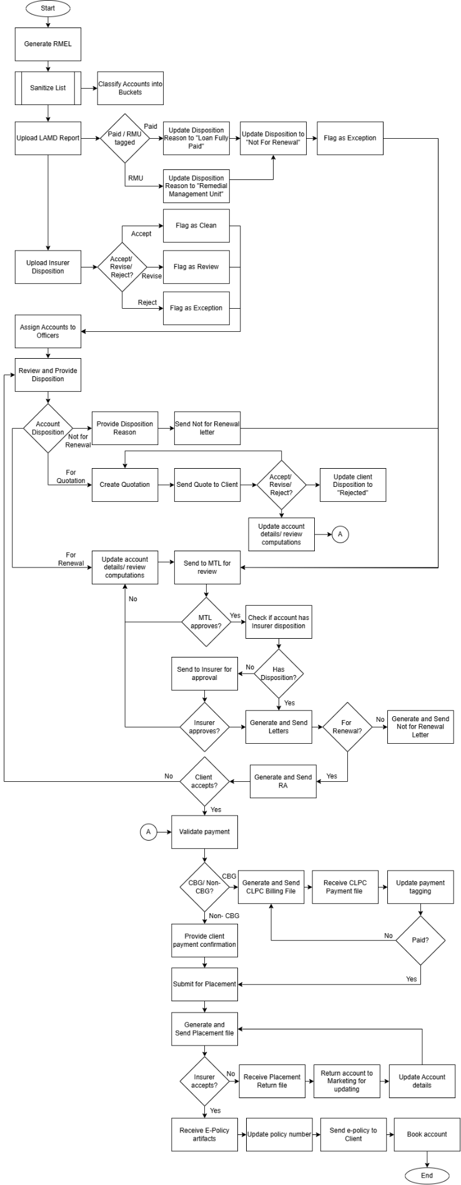

Flows added in version 1.1
BDOI's flowchart above is kept. The figures below draw every process of the BRD from end to end, one column per persona and a column for what the system does by itself, followed by the status life-cycles of the renewal account, the letters, the hold cover and the uploads. Where the flow differs from BDOI's flowchart (paid-off and RMU loans), the decision is in Annex AO.
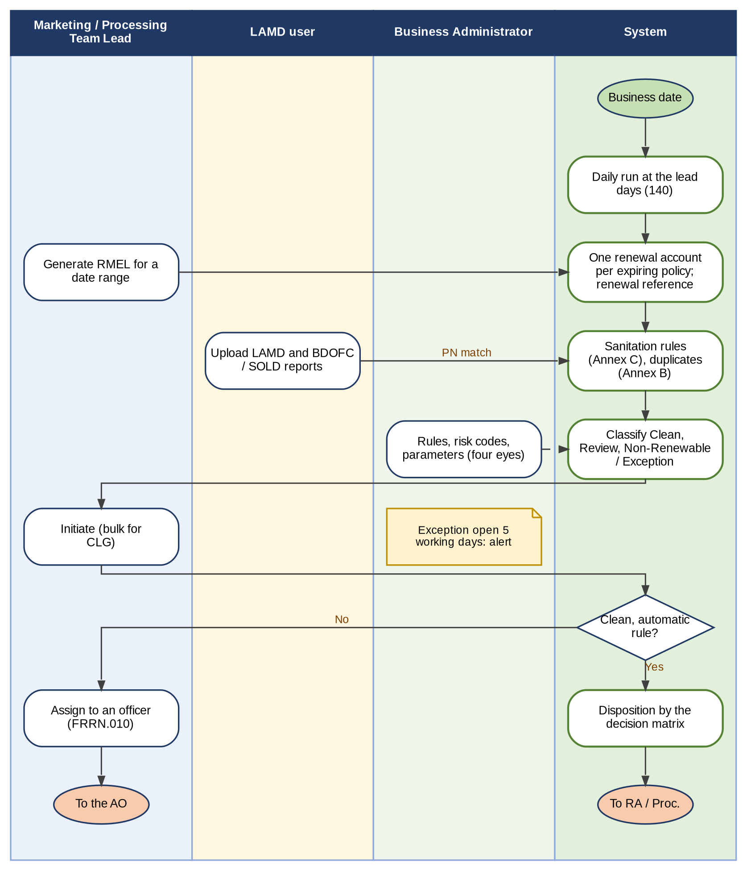
Figure 2 - RMEL, sanitation, classification and initiation
How to read it: Read from top to bottom. The daily run and the generation by date range create one renewal account per expiring policy; the sanitation rules of Annex C classify it; the user initiates it; the decision matrix proposes or gives the disposition. Traces to: BRRN.002-009, 020-024, 029-031, 034, 039; BRD 1.003, 3.003; FRRN.004-009, 012, 038-041.
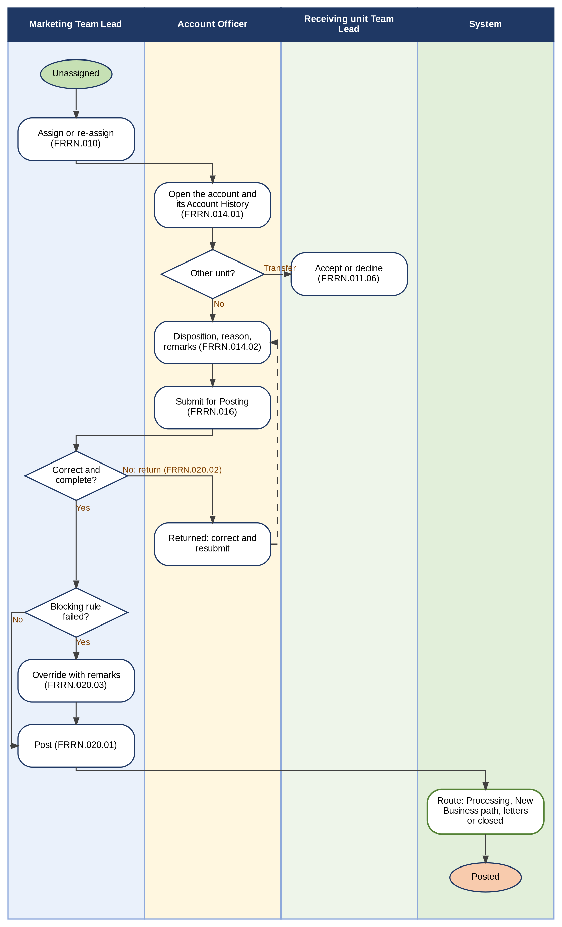
Figure 3 - Assignment, transfer, disposition, review and posting by Marketing
How to read it: Read from top to bottom. The Account Officer reads the Account History before the disposition; the Team Lead returns or posts; a blocking rule is cleared only by an override with remarks. Traces to: BRRN.011-017, 027; BRD 1.004-1.008, 1.011, 2.003-2.007; FRRN.002.08, 010, 011, 014, 016, 020.
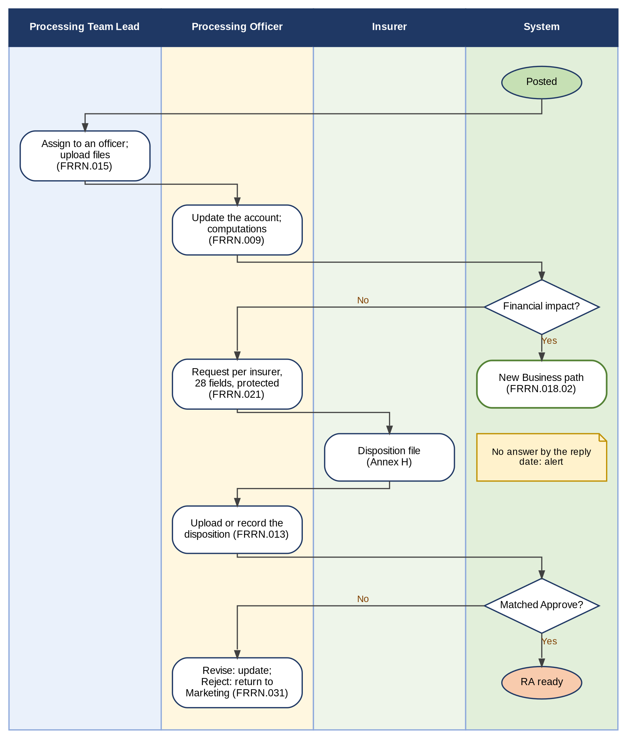
Figure 4 - Processing and the insurer's disposition
How to read it: Read from top to bottom. A financial impact routes the renewal to the New Business path; a matched Approve moves the account to the Renewal Advice; a Revise or a Reject returns it. Traces to: BRRN.018, 033, 035, 038; BRD 3.004-3.009, 4.003-4.007; FRRN.003, 009, 013, 015, 018.02, 021, 031.
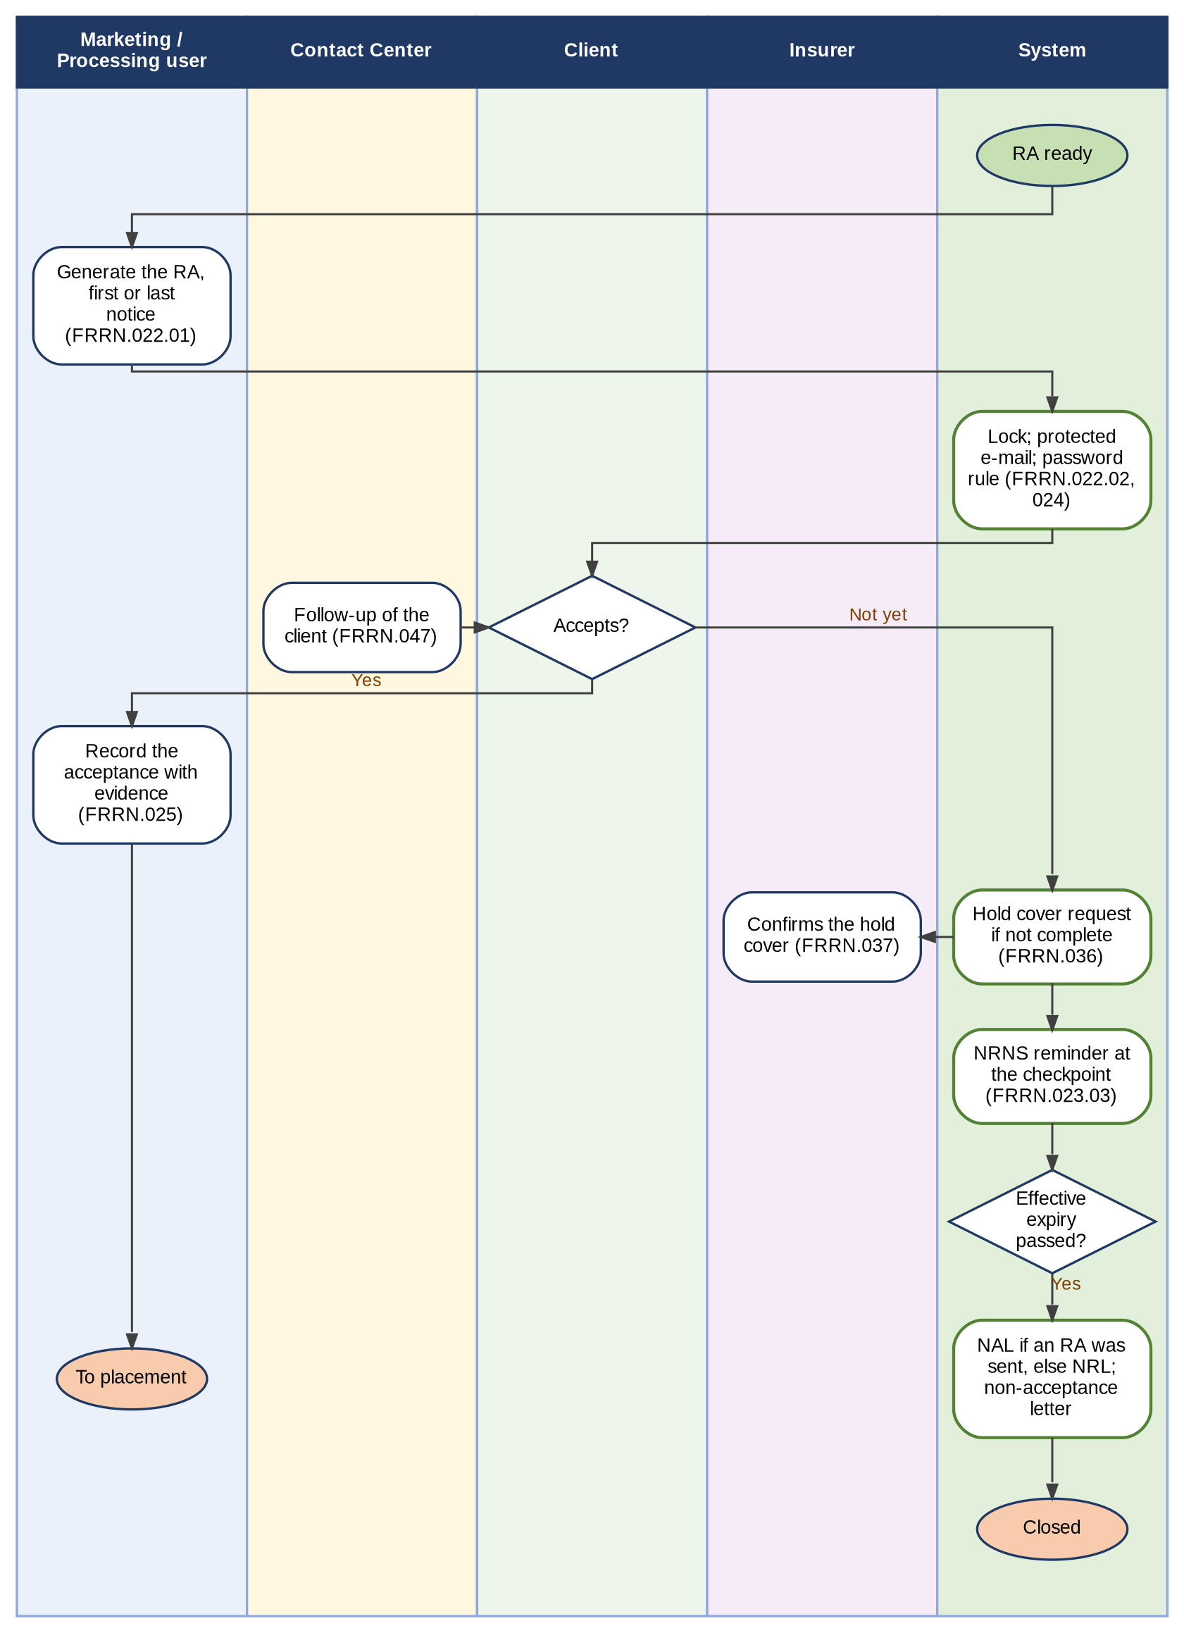
Figure 5 - Renewal Advice, client acceptance, hold cover and the letters
How to read it: Read from top to bottom. The letters use the effective expiry date: the end of a confirmed hold cover, otherwise the policy expiry date. An account never receives both a No Advice Letter and a Non-Renewal Letter. Traces to: BRRN.001, 010, 025, 026, 037, 040, 042; BRD 1.010, 2.009, 3.011, 4.09; FRRN.022-025, 036-037, 047.
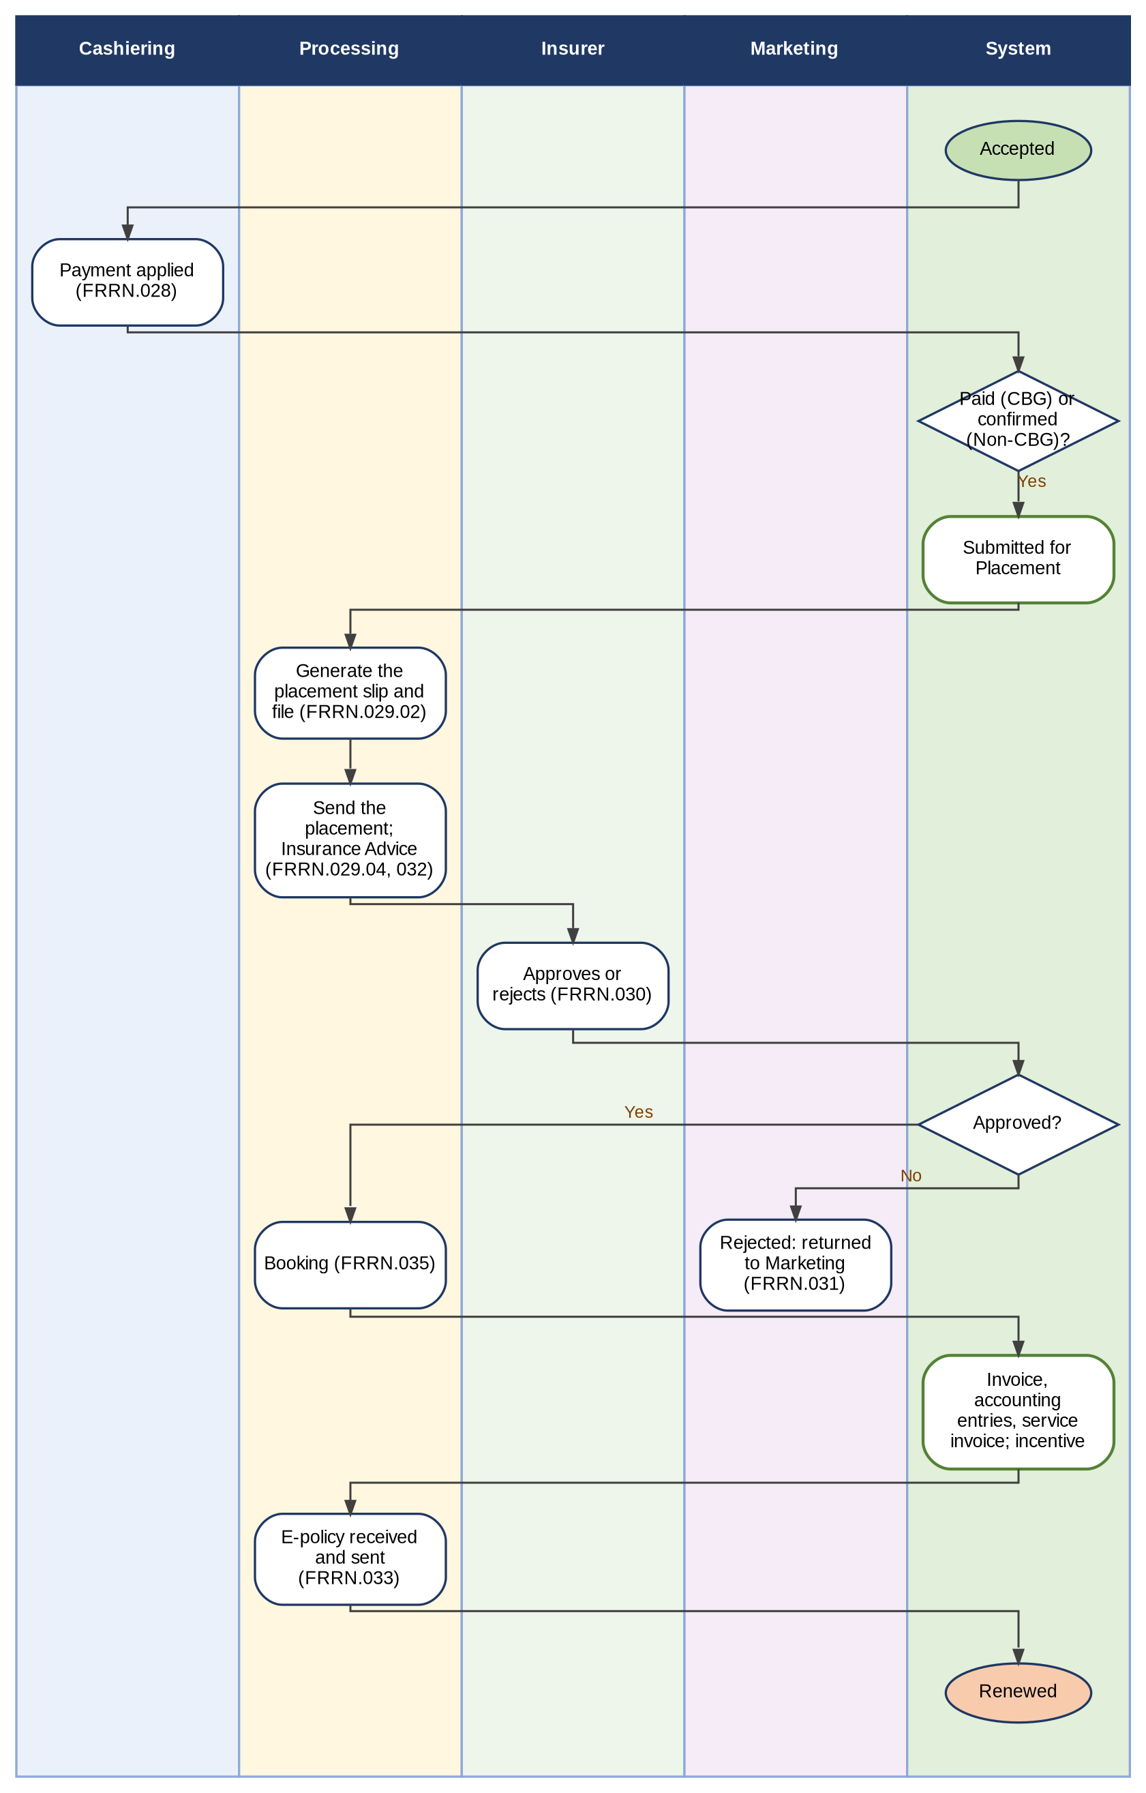
Figure 6 - Payment, placement, booking and the e-policy
How to read it: Read from top to bottom. Placement and booking stay actions of the user (Walkthrough addendum p.4); the incentive is evaluated after booking, confirmed acceptance and full payment (BRRN.041). Traces to: BRRN.040, 041; FRRN.026-035.
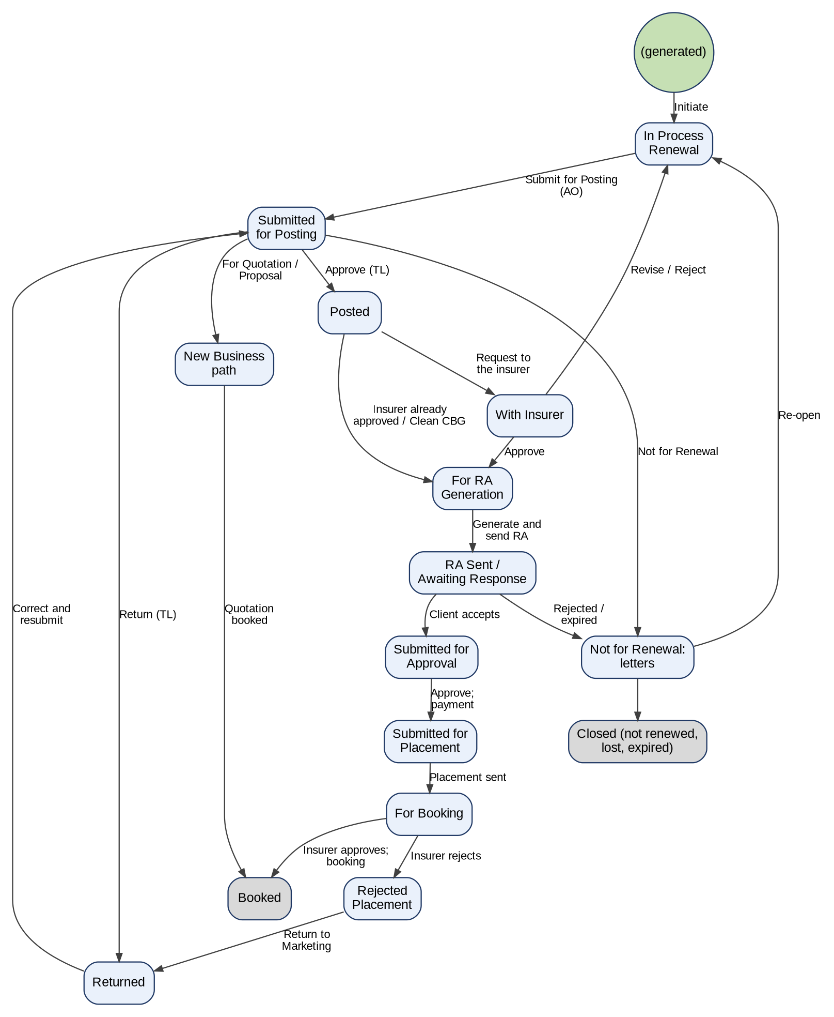
Figure 7 - Status life-cycle of a renewal account
How to read it: Each box is a status of BDOI's FRS (with the BRD stage where it differs); each arrow is the action that moves it. Grey boxes are final. The mapping of BDOI's statuses to the stages of the system is in Annex AC. Traces to: BRRN.021, 023, 040; BRD 1.008, 2.004, 3.008; FRRN.004.04, 016, 020, 025, 026, 029, 030, 035.
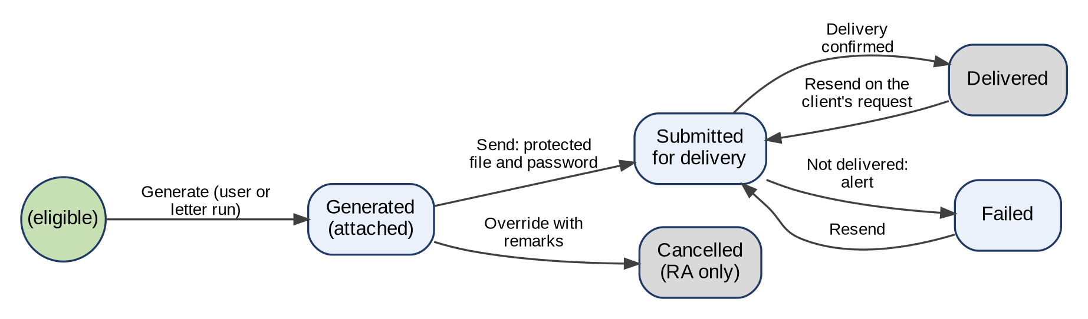
Figure 8 - Status life-cycle of a Renewal Advice or letter
How to read it: A letter is generated, then sent through CCM or the e-mail of the system; a failed sending raises an alert and can be resent. A Renewal Advice is cancelled only by a controlled override, which unlocks the account. Traces to: BRRN.001, 010, 025, 037; FRRN.022, 023, 024.
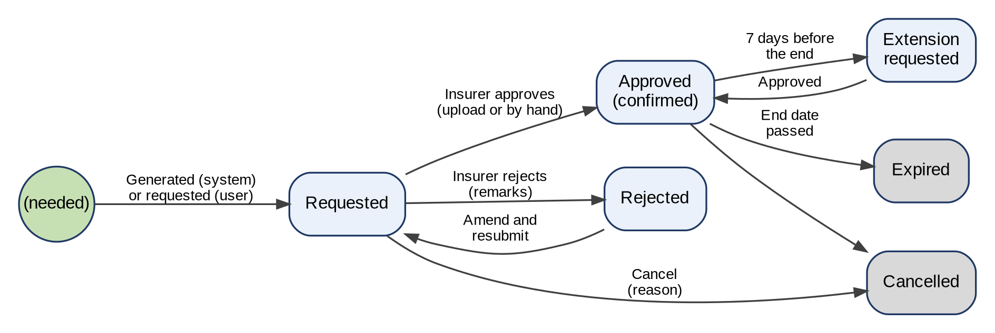
Figure 9 - Status life-cycle of a hold cover
How to read it: The end date of an approved hold cover becomes the effective expiry date of the renewal account; a new request is accepted only when no hold cover is requested or confirmed. Traces to: BRRN.037, 042; FRRN.036, 037.
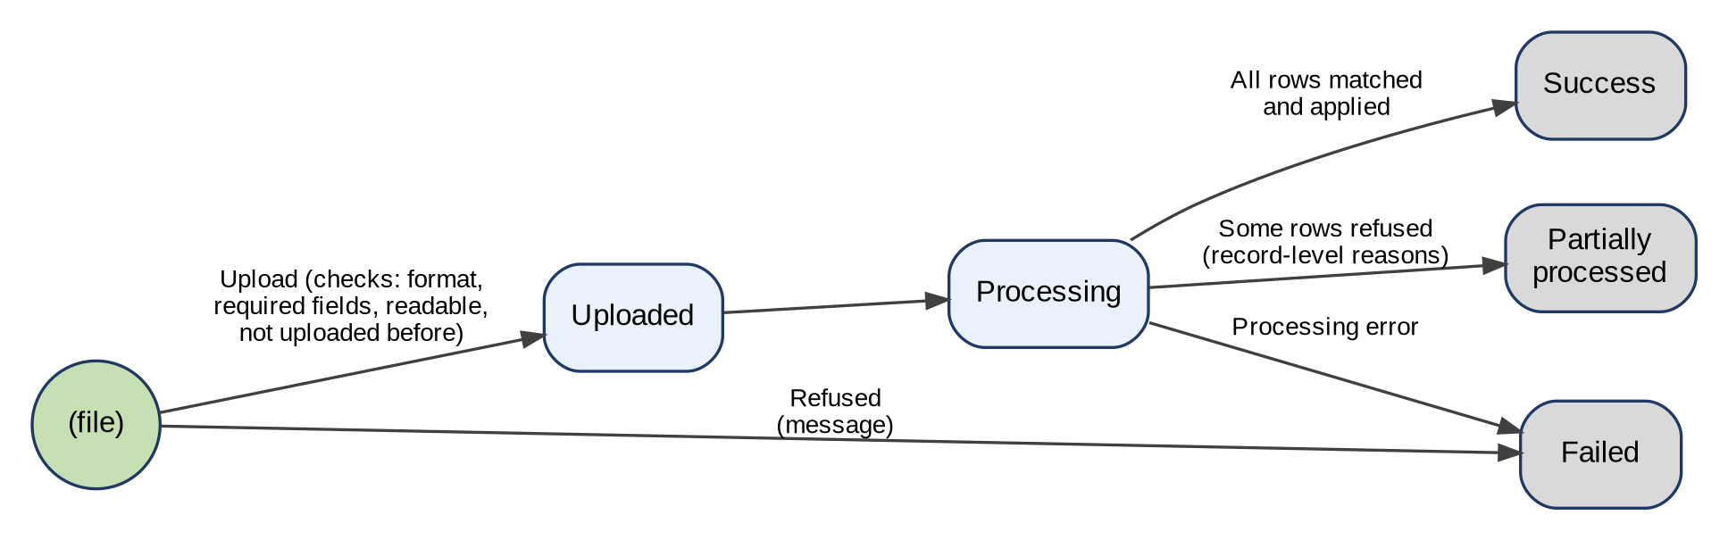
Figure 10 - Status life-cycle of an upload (LAMD, BDOFC / SOLD, insurer disposition, renewal update, placement response, hold cover response, e-policy)
How to read it: Every upload of Renewal follows the same life-cycle; the summary and record-level views of BDOI's items show the statuses. Traces to: BRRN.018, 029, 035; FRRN.012, 013, 015, 030, 033, 037.

Signoff Sheet
Prepared by
_______________Angela V. Ramirez_______________
System Analyst
iorta TechNXT Project Team (drafting support)

Reviewed by
______________________________________
Tech Lead

______________________________________
Application or Platform Owner
(or Unit / Dept. Head if no Application Owner is Identified)

I have validated the completeness of the functional requirements. I confirm that these requirements are aligned with all stakeholders, their priorities, and the business case.

Approved by
______________________________________
Project Owner / Project Sponsor
(add BU signatories, as applicable)

Annex A – Renewal Fields

Annex B – Duplicate Checking Criteria
LINE | Non-CBG Corporate | Non-CBG Retail | CBG Fire | CBG Motor
Property | Location of risk, TSI, Items insured, Policy Period (if inception date is within the existing policy or quotation in force) | Location of risk, TSI, Items insured, Policy Period (if inception date is within the existing policy or quotation in force) | Location of risk, TSI, Items insured, Assured's Name, Policy Period, PN Number and/or Application Number
Motor | Plate Number, Serial Number, Motor Number, Policy Period (if inception date is within the existing policy or quotation in force) | Plate Number, Serial Number, Motor Number, Policy Period (if inception date is within the existing policy or quotation in force) |  | Serial Number, Motor Number, Plate number, Policy Period,
Engineering | Project Location, Project Description, Contract Value, Policy Period (if inception date is within the existing policy or quotation in force) | Project Location, Project Description, Contract Value, Policy Period (if inception date is within the existing policy or quotation in force)
Liability | Items insured, Policy Period (if inception date is within the existing policy or quotation in force) | Items insured, Type of Cover, Policy Period (if inception date is within the existing policy or quotation in force)
Crime | Items insured, Policy Period (if inception date is within the existing policy or quotation in force) | Items insured, Type of Cover, Policy Period (if inception date is within the existing policy or quotation in force)
Floater | Serial Number, Motor Number, Policy Period (if inception date is within the existing policy or quotation in force) | Serial Number, Motor Number, Policy Period (if inception date is within the existing policy or quotation in force)
Marine | BL number, Policy period (if inception date is within the existing policy or quotation in force, TSI | BL number, Policy period (if inception date is within the existing policy or quotation in force), TSI
Electronic Equipment | Serial Number, Motor Number, Policy Period (if inception date is within the existing policy or quotation in force) | Serial Number, Motor Number, Policy Period (if inception date is within the existing policy or quotation in force)
Bonds | Bond Type, Project Location, Project Description, Contract Value, Policy Period (if inception date is within the existing policy or quotation in force) | Bond Type, Project Location, Project description/Items insured, Contract Value, Policy Period (if inception date is within the existing policy or quotation in force)
Miscellaneous | Type of Cover, Project description/Items insured, Policy Period (if inception date is within the existing policy or quotation in force) | Type of Cover, Project description/Items insured, Policy Period (if inception date is within the existing policy or quotation in force)
Aviation | Registration Number, Serial Number, Policy Period (if inception date is within the existing policy or quotation in force) | Registration Number, Serial Number, Motor Number, Policy Period (if inception date is within the existing policy or quotation in force)
Personal Accident | Type of Cover, Items insured, Policy Period (if inception date is within the existing policy or quotation in force) | Type of Cover, Items insured, Policy Period (if inception date is within the existing policy or quotation in force)
FTR | FTR Number, Policy Period (if inception date is within the existing policy or quotation in force), TSI
Marine Cargo (for LC) | LC Number, Items insured, Policy Period (if inception date is within the existing policy or quotation in force) | LC Number, Items insured, Policy Period (if inception date is within the existing policy or quotation in force)
Marine Hull | Vessel Name, Policy Period (if inception date is within the existing policy or quotation in force), TSI | Vessel Name, Policy Period (if inception date is within the existing policy or quotation in force)
All lines (generated renewal accounts) | Expiring policy and renewal reference: one open renewal account per expiring policy (BRRN.005) | Expiring policy and renewal reference: one open renewal account per expiring policy (BRRN.005) | Expiring policy and renewal reference: one open renewal account per expiring policy (BRRN.005) | Expiring policy and renewal reference: one open renewal account per expiring policy (BRRN.005)

Annex C - Sanitation Rules per Market Segment

Non-CBG
# | Criteria | Renewal Disposition | Bucket Classification | Reason
1 | TSI is greater than PHP 250M | For Quotation | Clean
2 | Dollar-denominated policy with TSI converted to PHP and value is greater than PHP 250M | For Quotation | Clean
3 | Dollar-denominated policy with TSI converted to PHP and value is greater than PHP 250M | For Proposal | Clean
4 | Account has outstanding premium balance | For Disposition | Review | Requires further review due to unpaid premium obligations.
5 | Account has multiple insurers or co-insurers | For Proposal | Clean
6 | Account is mortgaged | For Disposition | Review | Requires review because of mortgage-related considerations.
7 | Risk Code is Bonds, Group Personal Accident, or Motor (Fleet) | For Proposal | Clean
8 | Risk Code is Aviation, Liability, Crime, Trade Credit, Marine Cargo, Marine Hull, S&T, PV, Floater, EEI, or STP | For Quotation | Clean

CBG Motor
Branch | Policy Type | Loan Status | Employee  (Cons 3) | MYP | Premium  Package | BI/PD Premium  (Correct?) | Insurer's Dispo | Double Booking | Bucket &  Dispo
HO | Regular  (Not Auto Promo) | Active | No | Yes/  No | Packaged | Yes | Renew As Is | No | Clean/  For renewal
HO | Regular  (Not Auto Promo) | Loan Fully Paid
HO | Regular  (Not Auto Promo) | RMU
HO | Auto Promo/ FFYMI | Active | - | No | Packaged | Yes | Not Total Loss | No | Clean/  For renewal
HO | Auto Promo/ FFYMI | Loan Fully Paid | No | No | Packaged | Yes | Not Total Loss | No | Clean/  For renewal
HO | Regular  (Not Auto Promo) | Unmatched | Yes | Pro-Rata | Non-Packaged | No | Neither Renew as is Nor Total Loss | Yes | Review/ For Disposition
 |  |  |  |  |  |  | Blank (No Dispo) | Yes | Review/ For Disposition
 |  |  |  |  |  |  | Not In File | Yes | Review/ For Disposition
HO | Auto Promo/FFYMI | Loan Fully Paid | Yes | Yes/  Pro-Rata | Non-Packaged | No | Not In File | Yes | Review/ For Disposition
HO | Auto Promo/FFYMI | RMU | -
HO | Auto Promo/FFYMI | Unmatched | -
HO | Regular  (Not Auto Promo) | - | - | - | - | - | Total Loss | - | Non-Renewable/ Not for Renewal
HO | Auto Promo/FFYMI | - | - | - | - | - | Total Loss | - | Non-Renewable/ Not for Renewal
Provincial Branch | Regular  (Not Auto Promo) | Active | No | Yes/No | Packaged | Yes | Renew As Is | No | Clean/  For renewal
Provincial Branch | Regular  (Not Auto Promo) | Loan Fully Paid
Provincial Branch | Regular  (Not Auto Promo) | RMU
Provincial Branch | Auto Promo/FFYMI | Active | - | No | Packaged | Yes | Not Total Loss | No | Clean/  For renewal
Provincial Branch | Auto Promo/FFYMI | Loan Fully Paid | No | No | Packaged | Yes | Not Total Loss | No | Clean/  For renewal
Provincial Branch | Regular  (Not Auto Promo) | Unmatched | Yes | Pro-Rata | Non-Packaged | No | Neither Renew as is Nor Total Loss | Yes | Review/ For Disposition
 |  |  |  |  |  |  | Blank (No Dispo) | Yes | Review/ For Disposition
 |  |  |  |  |  |  | Not In File | Yes | Review/ For Disposition
Provincial Branch | Auto Promo/FFYMI | Loan Fully Paid | Yes | Yes/  Pro-Rata | Non-Packaged | No | Not In File | Yes | Review/ For Disposition
Provincial Branch | Auto Promo/FFYMI | RMU | -
Provincial Branch | Auto Promo/FFYMI | Unmatched | -
Provincial Branch | Regular  (Not Auto Promo) | - | - | - | - | - | Total Loss | - | Non-Renewable/ Not for Renewal
Provincial Branch | Auto Promo/FFYMI | - | - | - | - | - | Total Loss | - | Non-Renewable/ Not for Renewal

Item | Risk Code | Is Policy Coverage 1yr? | Bucket Classification | Disposition
1 | CTP01 | YES | CLEAN | For Renewal
2 | CTP01 | NO | REVIEW | For Disposition

Criteria | Value | Description
LOAN STATUS | ACTIVE | PN no. exists in LAMD Report (CBG Loans excluding Personal) and Outstanding balance is NOT equal to zero (0)
LOAN STATUS | ACTIVE | PN no. exists in LAMD Report (CBG Loans excluding Personal) and AO Code is NOT included in the RMU list
LOAN STATUS | LOAN FULLY PAID (OPEN MARKET) | PN no. does not exists in LAMD Report (CBG Loans excluding Personal) but exists in the “List of Paid-Off Accounts”
LOAN STATUS | LOAN FULLY PAID (OPEN MARKET) | PN no. exists in LAMD Report (CBG Loans excluding Personal) and Outstanding balance is equal to zero (0)
LOAN STATUS | RMU | PN no. exists in LAMD Report (CBG Loans excluding Personal) and AO Code is included in the RMU list
LOAN STATUS | UNMATCHED | PN no. DOES NOT exist in both “CBG Loans excluding Personal” and “List of Paid-Off Accounts”
LOAN STATUS | UNMATCHED | PN no. is blank and Account Type is NOT equal to “CLG Auto Open Market” or “NEW - NON BDO MORTGAGED”
PREMIUM PACKAGE | PACKAGED | Premium rate is within BDOI Premium Table in relation to the policy period (MYP or 1 YEAR) and Vehicle Type/ Risk Code
PREMIUM PACKAGE | NON-PACKAGE | Premium rate is NOT within BDOI Premium Table in relation to the policy period (MYP or 1 YEAR) and Vehicle Type/ Risk Code
BI/PD PREMIUM |  | BI/PD Premium should match the corresponding BI/PD coverage
MYP (NO) | 1 YEAR (NON-MYP) | POLICY PERIOD IS 365/366 DAYS **Example: 7/1/26 – 7/1/27
MYP (YES) | 2 YEAR | POLICY PERIOD IS 730/731 DAYS **Example: 7/1/26 – 7/1/28
MYP (YES) | 3 YEAR | POLICY PERIOD IS 1,096 DAYS **Example: 7/1/26 – 7/1/29
MYP (YES) | 4 YEAR | POLICY PERIOD IS 1,461 DAYS **Example: 7/1/26 – 7/1/30
MYP (YES) | 5 YEAR | POLICY PERIOD IS 1,826 DAYS **Example: 7/1/26 – 7/1/31
MYP | PRO-RATA | 1. POLICY PERIOD IS <>365/366 DAYS BUT <730/731 DAYS  2. POLICY PERIOD DOES NOT MATCH WITH ANY OF THE ABOVE-MENTIONED POLICY PERIOD
BRANCH DESCRIPTION | HO | 80500 |CLG - AUTO LOANS
BRANCH DESCRIPTION | HO | 80820 |PBC - LUCENA - AUTO
BRANCH DESCRIPTION | HO | 80807 |PBC-BATANGAS-AUTO
BRANCH DESCRIPTION | HO | 80817 |PBC-CAVITE-AUTO
BRANCH DESCRIPTION | HO | 80808 |PBC-LAGUNA-AUTO
BRANCH DESCRIPTION | HO | 80822 |PBC - CALAMBA - AUTO
BRANCH DESCRIPTION | HO | 80800 |PBC-NAGA-AUTO
BRANCH DESCRIPTION | PROVINCIAL BRANCH (CDO) | 80809 | PBC-CAGAYAN DE ORO-AUTO
BRANCH DESCRIPTION | PROVINCIAL BRANCH (CDO) | 80816 | PBC-BUTUAN-AUTO
BRANCH DESCRIPTION | PROVINCIAL BRANCH (DAVAO) | 80810 | PBC-DAVAO-AUTO (SHARED BY DAVAO & GENSAN)
BRANCH DESCRIPTION | PROVINCIAL BRANCH (DAVAO) | 80947 | PBC – TAGUM – AUTO
BRANCH DESCRIPTION | PROVINCIAL BRANCH (VISAYAS) | 80813 | PBC-BACOLOD-AUTO
BRANCH DESCRIPTION | PROVINCIAL BRANCH (VISAYAS) | 80811 | PBC-CEBU-AUTO
BRANCH DESCRIPTION | PROVINCIAL BRANCH (VISAYAS) | 80812 | PBC-ILOILO-AUTO
BRANCH DESCRIPTION | PROVINCIAL BRANCH (VISAYAS) | 80826 | PBC - TAGBILARAN - AUTO
BRANCH DESCRIPTION | PROVINCIAL BRANCH (VISAYAS) | 80823 | PBC - DUMAGUETE - AUTO
BRANCH DESCRIPTION | PROVINCIAL BRANCH (VISAYAS) | 80825 | PBC - TACLOBAN - AUTO
BRANCH DESCRIPTION | PROVINCIAL BRANCH (VISAYAS) | 80824 | PBC - PUERTO PRINCESA - AUTO
BRANCH DESCRIPTION | PROVINCIAL BRANCH (ANGELES) | 80806 | PBC-BAGUIO-AUTO
BRANCH DESCRIPTION | PROVINCIAL BRANCH (ANGELES) | 80803 | PBC-BULACAN-AUTO
BRANCH DESCRIPTION | PROVINCIAL BRANCH (ANGELES) | 80802 | PBC-CABANATUAN-AUTO
BRANCH DESCRIPTION | PROVINCIAL BRANCH (ANGELES) | 80805 | PBC-DAGUPAN-AUTO
BRANCH DESCRIPTION | PROVINCIAL BRANCH (ANGELES) | 80804 | PBC-LAOAG-AUTO
BRANCH DESCRIPTION | PROVINCIAL BRANCH (ANGELES) | 80801 | PBC-PAMPANGA-AUTO
BRANCH DESCRIPTION | PROVINCIAL BRANCH (ANGELES) | 80814 | PBC-SANTIAGO,ISABELA-AUTO
BRANCH DESCRIPTION | PROVINCIAL BRANCH (ANGELES) | 80815 | PBC-TARLAC-AUTO
BRANCH DESCRIPTION | PROVINCIAL BRANCH (ANGELES) | 80821 | PBC - ANGELES - AUTO
BRANCH DESCRIPTION | PROVINCIAL BRANCH (GENSAN) | 80819 | PBC-ZAMBOANGA-AUTO
BRANCH DESCRIPTION | PROVINCIAL BRANCH (GENSAN) | 80818 | PBC-GENERAL SANTOS-AUTO
BRANCH DESCRIPTION | PROVINCIAL BRANCH (GENSAN) | 80810 | PBC-DAVAO-AUTO (SHARED BY DAVAO & GENSAN)
EMPLOYEE (CONS 3) | Product Type | 502
EMPLOYEE (CONS 3) | Product Type | 505
EMPLOYEE (CONS 3) | Product Type | 506
FFYMI | RISK CODE | MTR70
FFYMI | RISK CODE | MTR71
FFYMI | RISK CODE | MTR72
FFYMI | RISK CODE | MTR73 (LTO)
DOUBLE BOOKING | NO | No existing duplicate policy within the same year and the succeeding years  ** should be checked using motor and serial no.  ** no other active policy except the one being renewed
DOUBLE BOOKING | YES | Has duplicate policy within the same year and the succeeding years  ** should be checked using motor and serial no.  ** no other active policy except the one being renewed

CBG Home
￼

Annex D - CBG Motor Automatic Field Update Details
FIELD | ADDITIONAL DETAILS/ CRITERIA | REGULAR (NEW VALUE) | AUTO PROMO (NEW VALUE) | CTPL (NEW VALUE)
RISK CODE |  | RETAIN | RETAIN | RETAIN
ACCOUNT TYPE | BDO MORTGAGED (NOT LTO)  LAMD Loan Status: ACTIVE/RMU | CLG AUTO | Retain existing Account Type and increment by 1year  **Example: From CLG AUTO FFYMI YEAR 1 to CLG AUTO FFYMI YEAR 2 | RETAIN
ACCOUNT TYPE | LOAN FULLY PAID (NOT LTO) | CLG AUTO OPEN MARKET |  | RETAIN
ACCOUNT TYPE | BDO MORTGAGED (LTO)  Account Type is CLG Auto for Hire  LAMD Loan Status: ACTIVE/RMU | CLG AUTO FOR HIRE |  | RETAIN
ACCOUNT TYPE | LOAN FULLY PAID (LTO)  Account Type is CLG Auto for Hire | CLG AUTO OPM LTO |  | RETAIN
NEW INSURER |  | = PREVIOUS INSURER | = PREVIOUS INSURER | = PREVIOUS INSURER
NEW INCEPTION |  | = POLICY EXPIRY | = POLICY EXPIRY | = POLICY EXPIRY
NEW EXPIRY | 1 YEAR (NON-MYP) | = NEW INCEPTION + 365 DAYS (+366 days if leap year) | = NEW INCEPTION + 365 DAYS (+366 days if leap year) | = NEW INCEPTION + 365 DAYS (+366 days if leap year)
NEW EXPIRY | 2 YEARS | = NEW INCEPTION + 730 DAYS (+731 days if leap year) | N/A | = NEW INCEPTION + 365 DAYS (+366 days if leap year)
NEW EXPIRY | 3 YEARS | = NEW INCEPTION + 365 DAYS (+366 days if leap year) | N/A | = NEW INCEPTION + 365 DAYS (+366 days if leap year)
NEW EXPIRY | 4 YEARS | = NEW INCEPTION + 365 DAYS (+366 days if leap year) | N/A | = NEW INCEPTION + 365 DAYS (+366 days if leap year)
NEW EXPIRY | 5 YEARS | = NEW INCEPTION + 365 DAYS (+366 days if leap year) | N/A | = NEW INCEPTION + 365 DAYS (+366 days if leap year)
NEW OD/THEFT COVERAGE | 1 YEAR (NON-MYP) | = PREVIOUS TSI x 90% (DEPRECIATE PREVIOUS TSI BY 10%) | = PREVIOUS TSI x 90% (DEPRECIATE PREVIOUS TSI BY 10%) | =EXPIRING TSI
NEW OD/THEFT COVERAGE | 2 YEARS (1st YEAR) | = PREVIOUS TSI /1.9 x .81 | N/A | =EXPIRING TSI
NEW OD/THEFT COVERAGE | 2 YEARS (2nd YEAR) | = 2 YEAR (1st YEAR) x .9 | N/A | =EXPIRING TSI
NEW OD/THEFT COVERAGE | 3 YEARS | = PREVIOUS TSI /2.71 x .729 | N/A | =EXPIRING TSI
NEW OD/THEFT COVERAGE | 4 YEARS | = PREVIOUS TSI /3.439 x .6561 | N/A | =EXPIRING TSI
NEW OD/THEFT COVERAGE | 5 YEARS | = PREVIOUS TSI /4.0951 x .59049 | N/A | =EXPIRING TSI
NEW OD/ THEFT PREMIUM |  | = NEW OD/THEFT COVERAGE x EXPIRING PREMIUM RATE | = NEW OD/THEFT COVERAGE x EXPIRING PREMIUM RATE | N/A
NEW BI COVERAGE |  | IF EXPIRING BI COVERAGE < NEW OD/THEFT COVERAGE, THEN, EXPIRING BI COVERAGE | = EXPIRING BI COVERAGE | N/A
NEW BI COVERAGE |  | IF EXPIRING BI COVERAGE > NEW OD/THEFT COVERAGE, THEN, LOWER BI COVERAGE BY GETTING THE NEXT TIER DOWN UNTIL BI COVERAGE IS < NEW OD/THEFT COVERAGE | = EXPIRING BI COVERAGE | N/A
NEW PD COVERAGE |  | IF EXPIRING PD COVERAGE < NEW OD/THEFT COVERAGE, THEN, EXPIRING PD COVERAGE | = EXPIRING PD COVERAGE | N/A
NEW PD COVERAGE |  | IF EXPIRING PD COVERAGE > NEW OD/THEFT COVERAGE, THEN, LOWER PD COVERAGE BY GETTING THE NEXT TIER DOWN UNTIL PD COVERAGE IS < NEW OD/THEFT COVERAGE | = EXPIRING PD COVERAGE | N/A
NEW BI PREMIUM | 1 YEAR (NON-MYP) | IF NEW BI COVERAGE = EXPIRING BI COVERAGE, THEN EXPIRING BI PREMIUM, ELSE, GET NEW BI PREMIUM | = EXPIRING BI PREMIUM | NA
NEW BI PREMIUM | MYP | GET THE CORRESPONDING BI PREMIUM BASED ON NEW BI COVERAGE | = EXPIRING BI PREMIUM | NA
NEW PD PREMIUM | 1 YEAR (NON-MYP) | IF NEW PD COVERAGE = EXPIRING PD COVERAGE, THEN EXPIRING PD PREMIUM, ELSE, GET NEW PD PREMIUM | = EXPIRING PD PREMIUM | NA
NEW PD PREMIUM | MYP | GET THE CORRESPONDING PD PREMIUM BASED ON NEW PD COVERAGE | = EXPIRING PD PREMIUM | NA
AUTO PA PREMIUM |  | =EXPIRING AUTO PA PREMIUM | =EXPIRING AUTO PA PREMIUM | N/A
BASIC PREMIUM |  | = NEW OD/ THEFT PREMIUM + NEW BI PREMIUM + NEW PD PREMIUM + AUTO PA PREMIUM | = NEW OD/ THEFT PREMIUM + NEW BI PREMIUM + NEW PD PREMIUM + AUTO PA PREMIUM | =EXPIRING BASIC PREMIUM
DST (DOCSTAMPS) |  | '=BASIC PREMIUM x 12.5% ROUNDED UP TO P0.50 **EXAMPLE: P1,537.12 THEN P1,537.50  P1,537.60 THEN P1,538.00 | '=BASIC PREMIUM x 12.5% ROUNDED UP TO P0.50 **EXAMPLE: P1,537.12 THEN P1,537.50  P1,537.60 THEN P1,538.00 | =EXPIRING DST (DOCSTAMPS)
VAT |  | =BASIC PREMIUM x 12% | =BASIC PREM x 12% | =EXPIRING VAT
LGT |  | =BASIC PREMIUM x (EXPIRING LGT AMOUNT/ EXPIRING BASIC PREMIUM) | =BASIC PREMIUM x (EXPIRING LGT AMOUNT/ EXPIRING BASIC PREMIUM) | =EXPIRING LGT
OTHER CHARGES |  | N/A | N/A | =EXPIRING OTHER CHARGES
TOTAL PREMIUM |  | =BASIC PREMIUM + DST (DOCSTAMPS) + VAT + LGT | =BASIC PREM + DST (DOCSTAMPS) + VAT + LGT | =EXPIRING TOTAL PREMIUM

Annex E – CBG Motor Automatic Field Update Details (Auto Promo to Regular)
FIELD | ADDITIONAL DETAILS/ CRITERIA | NEW VALUE
RISK CODE | MTR70 | MTR22
RISK CODE | MTR71 | MTR23
RISK CODE | MTR72 | MTR25
RISK CODE | MTR73 | MTR73
PREMIUM | 2.4230% | 2.3760%
PREMIUM | 1.9450% | 1.6060%
PREMIUM | 2.0400% | 1.9630%
PREMIUM | 3.0000% | 3.0000%
AUTO PA COVERAGE |  | 100000
ACCOUNT TYPE | BDO MORTGAGED (NOT LTO)  LAMD Loan Status: ACTIVE/RMU | CLG AUTO
ACCOUNT TYPE | LOAN FULLY PAID (NOT LTO) | CLG AUTO OPEN MARKET
ACCOUNT TYPE | BDO MORTGAGED (LTO)  Account Type is CLG Auto for Hire  LAMD Loan Status: ACTIVE/RMU | CLG AUTO FOR HIRE
ACCOUNT TYPE | LOAN FULLY PAID (LTO)  Account Type is CLG Auto for Hire | CLG AUTO OPM LTO
NEW INSURER |  | = PREVIOUS INSURER
NEW INCEPTION |  | = POLICY EXPIRY
NEW EXPIRY |  | = NEW INCEPTION + 365 DAYS (+366 days if leap year)
NEW OD/THEFT COVERAGE |  | = PREVIOUS TSI x 90% (DEPRECIATE PREVIOUS TSI BY 10%)
NEW OD/ THEFT PREMIUM |  | = NEW OD/THEFT COVERAGE x EXPIRING PREMIUM RATE
NEW BI COVERAGE |  | IF EXPIRING BI COVERAGE < NEW OD/THEFT COVERAGE, THEN, EXPIRING BI COVERAGE
NEW BI COVERAGE |  | IF EXPIRING BI COVERAGE > NEW OD/THEFT COVERAGE, THEN, LOWER BI COVERAGE BY GETTING THE NEXT TIER DOWN UNTIL BI COVERAGE IS < NEW OD/THEFT COVERAGE
NEW PD COVERAGE |  | IF EXPIRING PD COVERAGE < NEW OD/THEFT COVERAGE, THEN, EXPIRING PD COVERAGE
NEW PD COVERAGE |  | IF EXPIRING PD COVERAGE > NEW OD/THEFT COVERAGE, THEN, LOWER PD COVERAGE BY GETTING THE NEXT TIER DOWN UNTIL PD COVERAGE IS < NEW OD/THEFT COVERAGE
NEW BI PREMIUM |  | IF NEW BI COVERAGE = EXPIRING BI COVERAGE, THEN EXPIRING BI PREMIUM, ELSE, GET NEW BI PREMIUM
NEW PD PREMIUM |  | IF NEW PD COVERAGE = EXPIRING PD COVERAGE, THEN EXPIRING PD PREMIUM, ELSE, GET NEW PD PREMIUM
AUTO PA PREMIUM |  | =EXPIRING AUTO PA PREMIUM
BASIC PREMIUM |  | = NEW OD/ THEFT PREMIUM + NEW BI PREMIUM + NEW PD PREMIUM + AUTO PA PREMIUM
DST (DOCSTAMPS) |  | '=BASIC PREMIUM x 12.5% ROUNDED UP TO P0.50 **EXAMPLE: P1,537.12 THEN P1,537.50  P1,537.60 THEN P1,538.00
VAT |  | =BASIC PREMIUM x 12%
LGT |  | =BASIC PREMIUM x (EXPIRING LGT AMOUNT/ EXPIRING BASIC PREMIUM)
TOTAL PREMIUM |  | =BASIC PREMIUM + DST (DOCSTAMPS) + VAT + LGT

Annex F – Auto Assignment Logic Per Market Segment

Corporate

Retail
TEAM | ACCOUNT OFFICER | TEAM LEADER | TEAM HEAD | SECTION HEAD | UNIT HEAD
REGION 2 | Emerson Malabanan | Regina Matutina | Kim Ysaac A. Flores | Vacant | Edmundante F. Ramirez
REGION 2 | Hazyl Manseguiao
REGION 2 | Jonald Cajilig
REGION 2 | Lyka Krizzia Palomeno
REGION 2 | Mary Grace Manaluz
REGION 2 | Lilibeth Arlan
EMPLOYEES RETAIL | Jonilyn Dee | Gladys Dormido | Kim Ysaac A. Flores | Vacant | Edmundante F. Ramirez
EMPLOYEES RETAIL | Renz Mar Concepcion
EMPLOYEES RETAIL | Ja Andrei Hewitt Ong
EMPLOYEES RETAIL | Lyka Krizzia Palomeno
REGION 4 | Jayson Novela | Jeramie Ramos | Lorna Ildefonso | Vacant | Edmundante F. Ramirez
REGION 4 | Yolanda Parola
REGION 4 | Ysmael Valenzuela
REGION 4 | Myken Apolinario
REGION 4 | Angelica Amurao
REGION 4 | Rhea Mae Villaflor
REGION 4 | Francisco Azul Iv
REGION 5 | Adrian Salapare | Genilyn De Castro | Lorna Ildefonso | Vacant | Edmundante F. Ramirez
REGION 5 | Edwin Brucal Reyes
REGION 5 | Marilyn Jinayon
REGION 5 | Jerome Paolo Zapata
REGION 5 | Rowell Vincent Esguerra
REGION 5 | Peter John Vergara
REGION 3 | Aireen Joyce Garcia | Nina Grace Linganay | Robbie Alvarez | Vacant | Edmundante F. Ramirez
REGION 3 | Cezssane Canarias
REGION 3 | Jan Aldrin Velasquez
REGION 3 | Ma. Arfel Navarro
REGION 3 | Marcelo Buenavista Jr
REGION 3 | Mary Ann Estrella
REGION 3 | Aivel Lumogdang
REGION 3 | Russel David
REGION 6 | Arnelyn Cruz | Dexter Enraca | Robbie Alvarez | Vacant | Edmundante F. Ramirez
REGION 6 | Jacil Crisostomo
REGION 6 | Jerson Oliveria
REGION 6 | Kristine Ann Santiago
REGION 6 | Marchelle Irish Parale
REGION 6 | Maricel Liwag
REGION 6 | Timothy Rodger Uson
REGION 6 | Racel Narvasa
REGION 6 | Angelo Aratia

CBG Motor
ACCOUNT OFFICER | TEAM LEADER | TEAM HEAD | SECTION HEAD | UNIT HEAD
Patrick Pimentel | Criffson Rendon | Charlie Catacutan | Vacant | Edmundante F. Ramirez
Jessica Bonifacio
Jayson Flores
Julius Laganzon
Gabrielle Castro
Ronie Lampa
Juny Guardiano
Queenie Beronque
Maricel Salas
Noreen Villaroel
Paul Ong
Robert Poldo
Mathew Blanco
Ana Rocafor
Chris Breis
Vacant
Vacant

CBG Home
ACCOUNT OFFICER | TEAM LEADER | TEAM HEAD | SECTION HEAD | UNIT HEAD
Angelo Alibuyog | Lailani Aguila | Maria Celeste Acuña | Vacant | Edmundante F. Ramirez
Randolf Balane
Ma. Christena Cezar
Kiriath Jearim Cruz
Desiree Escobido
Mary Camille Guevarra
Jhennifer Magnaye
Kevin Christopher Marquez

Annex G - LAMD Upload File Details

CBG Loans excluding Personal
FIELDS | Description | Data Type | Sample Value
Original Source | Motor Sample Value = ICBS/ Zero OB with AIR Covid  Fire Sample Value = ICBS/ Zero OB with AIR Covid/ LMS/ CLG Loans ITL/ COHP  Values are as of May 2026 / Source system, application, or database where the loan/account record originated. | Text | LMS
PN Number | Promissory Note (PN) number assigned to the loan account. | Number | 515023030xxx
Short name | Customer's short name or abbreviated borrower name maintained in the core banking system. | Text | 1 OMEGA PRIME PROP
Logical Branch PN | Branch code associated with the Promissory Note account. | Number | 80600
Logical Branch Description PN | Full branch name or description corresponding to the Logical Branch PN code. | Text | CLG - HOME RETAIL
Product Type | Loan product classification or product category. | Number | 515
Product Description | Detailed description of the loan product. | Number | BDO CONSUMER HOUSING LOAN
Book Date | Date when the loan was granted, booked, or released in the system. | Date | 3/16/2023
Maturity Date | Date when the loan is scheduled to mature or become fully due. | Date | 3/16/2038
Amount Financed (Orig) | Original loan amount approved and financed at loan booking. | Number | 11,514,000.00
O/S Bal. (LCYE) | Outstanding loan balance as of the Last Calendar Year-End (LCYE). | Number | 9,999,202.99
Customer No. | Unique customer identification number assigned by the bank. | Number | 0024326535
Park Branch | Branch where the account is currently parked, maintained, or serviced. | Number | 300
Officer (AO Code) PN | Account Officer code assigned to manage the loan account. | Text | RMF
AO Name PN | Full name of the Account Officer assigned to the loan account. | Text | REGINA KARLA M. FUNTANILLA-RMF
IBG/CBG Tag | Indicator identifying whether the account belongs to Institutional Banking Group (IBG) or Consumer Banking Group (CBG). | Text | CBG HOME
Home Contact No. | Customer's residential telephone number. | Number | 63476031229
Business Contact No. | Customer's business or office contact number. | Number | 63476031229
Mobile No. | Customer's registered mobile phone number. | Number | 639952267755
Email Address | Customer's registered email address used for notifications and correspondence. | Text | adaabadsantos@gmail.xxx
Mailing Address | (Address Line 1 - Unit/House No., Street, Subd/Brgy.) + (Address Line 2 - District, Town) + (Address Line 3 - City) + (Address Line 4 – Province, Country) | Text | 11 G 2ND ST. NEW KABABAE 11 G 2ND ST. NEW KABABAE Zambales 2200
Risk & Compliance Tagging (PEP, AMLA High Risk, RPT) | Risk classification tags indicating whether the customer is a Politically Exposed Person (PEP), AMLA High-Risk client, or Related Party Transaction (RPT) account. | Text | Politician
Source of Funds | Declared source from which the customer obtains funds or income. | Text | Salary
Serial No. | Serial number of the collateral asset, typically applicable to motor vehicles or equipment. | Text | MHKAA1BA6RJ1342xx
Motor No. | Vehicle engine number or motor number associated with the collateral. | Text | 1KRA9131xx
Collateral Desc | Description of the collateral securing the loan account. The LAMD discussion specifically identified this field for inclusion in Motor and Fire Loan reports. | Text | TCT# 146-2025013138

List of Paid Off Accounts
FIELDS | Description | Data Type | Sample Value
PN Number | Motor Sample Value = ICBS/ Zero OB with AIR Covid  Fire Sample Value = ICBS/ Zero OB with AIR Covid/ LMS/ CLG Loans ITL/ COHP  Values are as of May 2026 / Source system, application, or database where the loan/account record originated. | Text | 515023030xxx
IBG/CBG Tag | Indicator identifying whether the account belongs to Institutional Banking Group (IBG) or Consumer Banking Group (CBG). | Number | CBG HOME
Product Type | Loan product classification or product category. | Number | 515
Product Type Desc | Detailed description of the loan product. | Text | BDO CONSUMER HOUSING LOAN
Posting Date |  | Date | 07/28/26
Next Rate Review Date |  | Date | 07/28/26
Home Contact No. | Customer's residential telephone number. | Number | 63476031229
Business Contact No. | Customer's business or office contact number. | Number | 63476031229
Mobile No. | Customer's registered mobile phone number. | Number | 639952267755
Email Address | Customer's registered email address used for notifications and correspondence. | Text | adaabadsantos@gmail.xxx
Mailing Address | (Address Line 1 - Unit/House No., Street, Subd/Brgy.) + (Address Line 2 - District, Town) + (Address Line 3 - City) + (Address Line 4 – Province, Country) | Text | 11 G 2ND ST. NEW KABABAE 11 G 2ND ST. NEW KABABAE Zambales 2200
Risk & Compliance Tagging (PEP, AMLA High Risk, RPT) | Risk classification tags indicating whether the customer is a Politically Exposed Person (PEP), AMLA High-Risk client, or Related Party Transaction (RPT) account. | Text | Politician
Source of Funds | Declared source from which the customer obtains funds or income. | Text | Salary
Serial No. | Serial number of the collateral asset, typically applicable to motor vehicles or equipment. | Text | MHKAA1BA6RJ1342xx
Motor No. | Vehicle engine number or motor number associated with the collateral. | Text | 1KRA9131xx
Collateral Desc | Description of the collateral securing the loan account. The LAMD discussion specifically identified this field for inclusion in Motor and Fire Loan reports. | Text | TCT# 146-2025013138

Annex H – Insurer Disposition Upload Details (CBG)
Field Name | Description | Data Type | Sample Value
Item No. | Sequential number assigned to each record | Number | 1
Assured's Name | Name Of the Insured Party Covered by the Policy. | Text | Angeles, Jimmy Navarro
Expiring Reference Number | Previous reference number of the expiring account | Number | 2501984214
Expiring Policy No. | Official Insurance Policy Number of the expiring account. | Text | Fl-flr-bdo-0613192
Inception Date | Effective Start Date of Insurance Coverage. | Date | 11/27/2025
Expiry Date | Coverage Expiration Date. | Date | 11/27/2026
Location Of Risk | Location Address of the Insured Risk. | Text | Unit 8f 8th Floor, Stamford Executive Residences Tower 3, Florence Way Mckinley Hill, Taguig
Unit Description | Vehicle Detail | Text | 2020 Toyota Wigo 1.0 TRD S A/T Hatchback
Serial No. | Vehicle Detail | Text | MHKA4DF5FLJ043869
Motor No. | Vehicle Detail | Text | 1KRA551929
Plate No. | Vehicle Detail | Text | NGN1269
Color | Vehicle Detail | Text | Gray Metallic
TSI | Total sum insured of the account | Number | 5,433,750.00
Premium Rate | Applied insurance rate used to compute premium. | Number | 0.28
Insurer | Insurer Name | Text | Standard
Insurer's Branch | Insurer's Branch | Text | Manila
Insurer's Approval | Appears to be A field used to record the insurer's approval or acceptance of A renewal account | Text | Ok To Renew

Annex I – Quick Proposal Template

Annex J – Full Proposal Template

Annex K - Non –Package Quotation Request Details

Annex L – Renewal Advice Template

Annex M - Letter Eligibility Matrix
Letter Name | Market Segment | Eligibility | Schedule for Sending
Renewal Advice (RA) First Notice | All | 1. Account disposition is For Renewal.  2. Exclude CBG Home amortized accounts. | 75 days prior to the policy expiry date
Renewal Advice (RA) Last Notice | All | 1. Account disposition is For Renewal.  2. Exclude CBG Home amortized accounts. | 45 days prior to the policy expiry date
FFY Reminder Letter | CBG | 1. Account is tagged as FFY (Free First Year). | 75 days prior to the policy expiry date
NRNS Reminder Letter | CBG Motor | 1. Account has an active loan based on the latest LAMD Report.  2. No corresponding insurance policy (inforce/ submitted) record exists in BDOI. | 75 days prior to the policy expiry date
No Advice Letter (NAL) | CBG Motor/ Non- CBG | 1. A Renewal Advice (RA) has been issued.  2. The client has not responded to the Renewal Advice.  3. The policy has expired.  4. Exclude paid accounts.  5. Include mortgaged accounts and/or fully paid loan accounts. | 1 day after the policy expiry date
Service Fulfillment Unit (SFU) Letter | CBG Motor | 1. The property is mortgaged to BDO.  2. A Renewal Advice (RA) has been issued.  3. The client has not responded to the Renewal Advice.  4. Exclude paid accounts. | 1 day after the policy expiry date
Non-Renewal Letter (NRL) | CBG Motor | 1. The client has confirmed the non-renewal of the policy; or  2. The account is tagged as Not for Renewal. | 1 day after the policy expiry date
Non-Renewal Letter (NRL) | Non- CBG | 1. The client has confirmed the non-renewal of the policy; or  2. The account is tagged as Not for Renewal.  3. The system sent an NAL letter to the client | 3 days after the policy expiry date
Non-Acceptance Letter | All | 1. A Renewal Advice was sent and the client has not accepted it by the effective expiry date (BRRN.025, BRRN.037). | On the effective expiry date (end of a confirmed hold cover, otherwise the policy expiry date); days after it are a parameter (0 as delivered)

Annex N – NRNS Reminder Letter Template

Annex O – No Advice Letter Template

Annex P – Non-Renewal Letter Template

Annex Q – SFU Letter Template

Annex R – FFY Reminder Letter Template

Annex S - Billing File Email and Attachment Template

Attachment Details
Field Name | Description | Data Type | Motor/ Home/ Both | Mapping
No. | Sequential number assigned to each record or item in the report for reference | Number | Both | Not Applicable
PN # | Promissory Note Number associated with the loan account. This serves as the unique loan reference number used in the bank's loan system. | Number | Both | PN Number
Account No. | Unique account number assigned to the borrower's loan account. Used for identification and tracking of the loan facility. | Number | Both | Renewal Reference Number
Assured's Name | Full name of the insured borrower, property owner, or client covered by the insurance policy. | Text | Both | Assured's Name
Loan Booking Date | Date when the loan was approved, released, and officially booked in the bank's records. | Date | Home | Loan Booking Date (LAMD)
Loan Maturity Date | Date when the loan obligation is scheduled to mature or become fully due and payable. | Date | Home | Loan Maturity Date (LAMD)
Inception Date | Start date of the insurance policy coverage. This is the effective date when insurance protection begins. | Date | Home | Inception Date
Expiry Date | End date of the insurance policy coverage. Insurance protection remains valid until this date unless renewed earlier. | Date | Home | Expiry Date
Loan Type | Classification or type of loan granted to the borrower (e.g., Home or MPL.). | Text | Home | IBG/CBG Tag (LAMD)
Total Premium (1 Year) | Total annual insurance premium amount payable for one (1) year of coverage based on the insured property or risk. | Number | Both | Total Premium
Logical Branch Description PN | Name or description of the branch that originated, booked, or currently manages the loan account associated with the Promissory Note (PN). | Text | Home | Logical Branch Description PN (LAMD)
BDO Insure Branch | BDO Insure branch responsible for servicing, processing, or managing the account. | Text | Both | BDO Insure Branch
BDO Enrolled Account Number | Client's Account Number | Text | Motor | BDO Enrolled Account Number

Email Template

Annex T - Placement Slip Template

Annex U – Placement File Field Details
Field Name | Data Type | Description | Remarks / Notes
BDOI Branch | Text | Branch of BDOI handling the account.
Assured Name | Text | Full name of the insured client or entity.
Address | Text | Registered or mailing address of the insured.
BDOI Reference No | Text | Unique reference number assigned by BDOI to the account.
Unit Head | Text | Name of the responsible Business Unit Head.
BDOI Account Officer | Text | Assigned BDOI Account Officer managing the account.
Bank Branch | Text | BDO branch associated with the client account.
BDOI Department | Text | Department responsible for servicing the account.
BDOI Market Segment | Text | Market segment classification of the account.
Business Type | Text | Type of insurance business transaction. | New / Renewal / Organic / Submitted / New Organic
Account Type | Text | Classification of account based on business rules.
Insurer | Text | Name of the insurance company providing coverage.
Insurer Branch Location | Text | Branch location of the insurer handling the policy.
Type of Policy | Text | Insurance line or policy type.
Previous Policy Number | Text | Prior policy number for renewal accounts.
Insurer Package Name | Text | Name of the insurer's package or insurance product.
Package / Cover Option | Text | Selected package, plan, or coverage option.
Risk Code | Text | Code identifying the insured risk category.
Risk Information Details | Text | Detailed description of the insured risk. | See Risk Description Details
Items Insured | Text | List of assets, properties, or interests covered by the policy. | Breakdown of items insured (e.g., Building, Contents, Furniture & Fixtures)
Location of Risk (LOR) | Text | Physical location of the insured risk. | Property, Floater, and other insurance lines requiring LOR
Construction | Text | Construction type or material of the insured property. | Fire
Occupancy | Text | Use or occupancy classification of the insured property. | Fire
Boundaries | Text | Boundary description of the insured property. | Fire
Basis of Valuation | Text | Valuation method used to determine the insured value. | Fire
Mortgagee | Text | Name of the mortgagee or lending institution with insurable interest.
Sum Insured | Decimal (18,2) | Total amount of insurance coverage provided under the policy.
Inception | Date | Effective start date of the policy coverage.
Expiry | Date
Basic Premium | Decimal (18,2) | Premium amount before taxes and charges.
Documentary Stamps | Decimal (18,2) | Documentary Stamp Tax (DST) amount.
VAT / Premium Tax | Decimal (18,2) | Applicable Value Added Tax (VAT) or Premium Tax.
FST | Decimal (18,2) | Fire Service Tax amount. Applicable to Fire policies and other insurance lines requiring Fire Service Tax.
LGT | Decimal (18,2) | Local Government Tax amount, where applicable.
Other Charges | Decimal (18,2) | Other applicable policy charges and fees.
Validation Fee / CTPL Fee | Decimal (18,2) | Validation Fee or CTPL Fee. Applicable to CTPL policies only.
Total Premium | Decimal (18,2) | Total amount payable, inclusive of premium, taxes, and charges.
Commission Rate | Decimal (5,2) | Commission percentage rate.
Commission Amount | Decimal (18,2) | Computed commission amount.
Loan PL No | Text | Loan Promissory Note (PL) Number.
EOPT TIN & Branch Code | Text | Tax Identification Number (TIN) and Branch Code for EOPT/Service Invoice purposes.
Name of Taxpayer | Text | Registered taxpayer name for EOPT/Service Invoice purposes.

Package Risk Description
Package | Sequence
Motor | Year  Make  Model  Variant  Serial No./Chassis No.  Engine No./Motor No.  Plate No./Conduction Sticker  MV File No.  Color
Property | Location of Risk: [House No. / Apt. No. / Unit No. / Floor] [space] [Street Name / Sitio / Purok] [space] [Province][space] [City / Municipality] [space] Occupancy: [Building Occupancy]  Mortgagee: [Mortgagee]
Contractors All Risk | Location of Risk: [House/Unit/Floor No. / Building Name / Street] [space] [Subdivision/Village/Barangay] [space] [Province/State] [space] [City/Town] [/] [Project Name] Contract/PO No. [Contract/PO No] / Scope of Work [Scope of Work]
Marine Cargo | Items Insured: [Item/s Insured] [Sum Insured] [/] [Letter of Credit No.]
Fire Trust Receipt | [House/Unit/Floor No. / Building Name / Street] [space] [Subdivision/Village/Barangay] [space] [Province/State] [City/Town] [/] [TR Reference Number] [/] [LC No] [/] [Sum Insured]
Equipment Floater | [Unit Description] [/] [Serial No.] [/] [Sum Insured] [/] Location of Risk: [Location of Risk]
Electronic Equipment | [Item Insured] [Item Description] [Item Value] [Total Sum Insured] [/] Location of Risk: [Location of Risk]
CGL / Public Liability | [Item insured / Project Description/ Undertaking] [/] [TSI] [/] [Location of Risk]
Inland Marine | [Insured Items] [Type] [Make and Model] [Plate No.] [Engine No] [Chassis No.]
Personal Accident (PA) | Personal Accident for [Assured Name]

Non-Package Risk Description
Insurance Line | Specific Syntax / Format | For Single Risk (Sample) | For Multiple Risks (Sample)
Aviation | Risk Description:  Type of Vessel: <Vessel Description>  Year: <Year Manufactured>  Serial / RPC No.: <Serial / RPC No.>  Sum Insured: <Value>  Mortgagee: <Name of Mortgagee> | Type of Vessel: Cessna Seaplane A185F  Year: 2017  Serial / RPC No.: RPC1208  Sum Insured: P2,000,000.00  Mortgagee: BDO Unibank, Inc. | Type of Vessel: Various  Year: Various  Serial / RPC No.: Various  Total Sum Insured: P20,000,000.00  Mortgagee: BDO Unibank, Inc.
Bonds (Construction) | Risk Description:  Type of Works: <NTP/Contract No, Generic Scope of Works>  Project Name: <Project Name>  Contract Amount: <Value>  Obligee: <Name of Project Owner / Bond Obligee> | Type of Works: NTP-01, Excavation and Foundation Works  Project Name: Makati Skyrise Condominium  Contract Amount: P500,000,000.00  Obligee: Anchor Properties, Inc. | N/A
Liability  CGL – Completed Operations | Risk Description:  LOR: <Location of Risk>  Property Use: <Occupancy / Property Use>  Establishment Name: <Name of Property (as applicable)>  Annual Turn-over: <Value>  Floor Area: <Value (in sqm)> | LOR: U5715, GF, The Office Bldg., N. Garcia Ave., Brgy. San Miguel, Makati City  Property Use: Commercial / Office  Establishment Name: N/A  Annual Turn-over: P50,000,000.00  Floor Area: 1,000 sqm | LOR: Various  Property Use: Commercial / Office  Establishment Name: N/A  Annual Turn-over: P50,000,000.00  Floor Area: Various
Liability  CGL – Premises Operations | Risk Description:  LOR: <Location of Risk>  Property Use: <Occupancy / Property Use>  Establishment Name: <Name of Property (as applicable)> | LOR: Unit 56-J, Ground Floor, SM North EDSA Annex Building 1, Quezon City  Property Use: Restaurant  Establishment Name: Vikings Buffet | LOR: Various  Property Use: Various  Establishment Name: Vikings Buffet
Liability  Employer’s Liability | Risk Description:  Business Operations: <Employer’s Nature of Business>  Employee Count: <Value> | Business Operations: Security Agency  Employee Count: 2,000 | N/A
Liability  Products Liability | Risk Description:  Covered Products: <Products Covered>  Annual Turn-over: <Value> | Covered Products: On the packaging materials, pallets and cartons  Annual Turn-over: P100,000,000.00 | N/A
Contractors All Risk / Erection All Risk | Risk Description, Location of Risk:  Type of Works: <Generic Scope of Works>  Project Description: <Description of the Structure under Construction>  Project Name: <Project Name>  LOR: <Location of Risk>  Mortgagee: <Name of Mortgagee> | Type of Works: Ground-Up Construction  Project Description: 42 Storey Class A Mixed Residential/Commercial Building  Project Name: Makati Skyrise Condominium  LOR: 6151 Valero Street., Brgy. Bel-Air, Makati City  Mortgagee: BDO Unibank, Inc. | N/A
Equipment Floater / Electronic Equipment | Risk Description, Location of Risk:  Brand: <Brand Name of Equipment>  Year: <Year Manufactured>  Model: <Risk Model / Description>  Serial / Ref No.: <Serial / Ref No. >  LOR: <Location of Risk>  Mortgagee: <Name of Mortgagee> | Brand: Hyundai  Year: 2023  Model: 30D-7SA Diesel Forklift  Serial / Ref No.: SSA123457XYZ001  LOR: 1234 Goldenville Industrial Subd., Brgy. Patok, Meycauayan, Bulacan  Mortgagee: BDO Unibank, Inc. | Brand: Various  Year: Various  Model: Various  Serial / Ref No.: Various  LOR: Various  Total Sum Insured: P100,000,000.00  Mortgagee: BDO Unibank, Inc.
Fire Trust Receipt | Risk Description:  Stocks Description: <Stocks Description>  LOR: <Location of Risk.>  LC/TR Reference No.: <Reference No.>  Mortgagee: <Name of Mortgagee> | Stocks Description: On Stocks of Feeds and other items usual to the Assured’s business  LC/TR Reference No.: TR123456789FLC  LOR: 1234 Goldenville Industrial Subd., Brgy. Patok, Meycauayan, Bulacan  Mortgagee: BDO Unibank, Inc. | Stocks Description: On Stocks of Feeds and other items usual to the Assured’s business  LC/TR Reference No.: TR123456789FLC  LOR:  Location 1: 1234 Warehouse, Valenzuela City, NCR  Location 2: 5678 Warehouse, Meycauayan, Bulacan  Location 3: 9101 Warehouse, Sucat, Paranaque, NCR  Loc 1: P500,000,000.00  Loc 2: P250,000,000.00  Loc 3: P750,000,000.00  Total Sum Insured: P1,500,000,000.00  Mortgagee: BDO Unibank, Inc.
Marine | Risk Description:  Cargo Description: <Qty., Cargo description>  Invoice No.: <Invoice No.>  Bill of Lading No.: <BL No.>  LC/TR Reference No.: <Reference No.>  Mortgagee: <Name of Mortgagee> | Cargo Description: 1.3MT of Linear Alkyl Benzene  Invoice No.: 2023-ISU-LAB-004 (Bulk)  Bill of Lading No.: JBR00456789A01  LC/TR Reference No.: ILC00234567FLS  Mortgagee: BDO Unibank, Inc. | N/A
Marine Hull | Risk Description:  Vessel Name: <Name of Vessel>  Type of Vessel: <Vessel Description>  Year: <Year Manufactured>  Sum Insured: <Value>  Mortgagee: <Name of Mortgagee> | Vessel Name: M/Tkr Maginoo  Type of Vessel: Motorized tanker with double skinned/hull construction  Year: 2023  Sum Insured: P250,000,000.00  Mortgagee: BDO Unibank, Inc. | Vessel Name: Various  Type of Vessel: Various  Year: Various  Total Sum Insured: P2,500,000,000.00  Mortgagee: BDO Unibank, Inc.
Motor (non-package) | Risk Description:  Year: <Year Manufactured>  Make: <Vehicle make>  Model: <Risk Model / Description>  Plate No. / Conduction Sticker: <Plate No. / CS No. >  User Assigned: <Name of Assigned User of the Vehicle, as applicable>  Mortgagee: <Name of Mortgagee> | Year: 2023  Make: Toyota  Model: Fortuner 2.8 4x$ LTD AT  Plate No. / Conduction Sticker: Cs No. BIU732  User Assigned: Juan Dela Cruz  Mortgagee:  Mortgagee: BDO Unibank, Inc. | Year: Various  Make: Various  Model: Various  Plate No. / Conduction Sticker: Various  User Assigned: Various  Total Sum Insured: P38,325,000.00  Mortgagee:  Mortgagee: BDO Unibank, Inc.
Property | Risk Description, Location of Risk  Building Description: <Construction Class>, <# of Storey / Bldg. Description>  Occupancy: <Property Use>  LOR: <Location of Risk>  Breakdown of Items & Sums Insured (BI/Loss of Profit/Loss of Rent) to be encoded as part of Items Insured):  Item 1 - <Item Description>: <Value>  Item 2 - <Item Description>: <Value>  Item N - <Item Description>: <Value>  Total Sum Insured: <Value>  Mortgagee: <Name of Mortgagee> | Building Description: Class A, Lofty with Mezzanine  Occupancy: Mixed Warehouse & Industrial  LOR: 1234 Goldenville Industrial Subd., Brgy. Patok, Meycauayan, Bulacan  Item 1 – On the Warehouse bldg. 1: P5,500,000.00  Item 2 – On Machinery & Equipment: P1,000,000.00  Item 3 – On Stocks Usual to the Assured’s Business: P5,000,000.00  Item 4 – Business Interruption: P5,000,000.00  Total Sum Insured: P16,500,000.00  Mortgagee: BDO Unibank, Inc. | Building Description: Various  Occupancy: Various  LOR: Various  Item 1 – On the bldg and impv’ts: P55,000,000.00  Item 2 – On the Machinery & Equipment: P10,000,000.00  Item 3 – On Stocks Usual to the Assured’s Business: P50,000,000.00  Item 4 – Business Interruption: P50,000,000.00  Total Sum Insured: P165,000,000.00  Mortgagee: BDO Unibank, Inc.
Stock Throughput | Risk Description, Location of Risk  Cargo/Stock Description: <Goods description>  LOR: <Location of Risk>  Breakdown of Sums Insured:  Loc 1: <Value>  Loc 2 <Value>  Loc N: <Value>  Total Sum Insured: <Value>  Mortgagee:  Mortgagee: <Name of Mortgagee> | Cargo/Stock Description: Cargo/Stocks of apparel and shoes and other items usual to the Assured’s business  LOR:  Location 1: 1234 Warehouse, Valenzuela City, NCR  Location 2: 5678 Warehouse, Meycauayan, Bulacan  Location 3: 9101 Warehouse, Sucat, Paranaque, NCR  Loc 1: P500,000,000.00  Loc 2: P250,000,000.00  Loc 3: P750,000,000.00  Total Sum Insured: P1,500,000,000.00  Mortgagee: BDO Unibank, Inc. | Same format as single risk

Annex V – Return Reasons
Return Reason | Detailed Description | Insurance Line
Account Type / Business Type | To correct account type or business type | All Lines
AO Request – For Updating | AO requested updates to the account details | All Lines
Canceled Request | Request has been canceled and will not proceed | All Lines
CIF / KYC | To include or update CIF/KYC-related information | All Lines
Client / Assured's Name | To correct the client or assured name | All Lines
Commission Rate | To correct the commission rate | All Lines
Construction / Occupancy | To add or correct construction and occupancy details | Property
Coverage | To correct policy coverage details | All Lines
CRM | To update CRM information | All Lines
Double Request | Duplicate request already submitted | All Lines
DST | To correct Documentary Stamp Tax (DST), Local Government Tax (LGT), VAT, or other charges | All Lines
Email Address | To provide or update the client's email address | All Lines
EOPT Details | To include EOPT-related information | All Lines
Extension / Deductible | To correct extension or deductible details | All Lines
FST | To correct DST, LGT, VAT, Fire Service Tax (FST), or other charges | All Lines
Hold Cover Details | To include hold cover details | All Lines
Insurer / Insurer Code / Insurer Branch | To correct insurer, insurer code, or insurer branch information | All Lines
Insurer Declined the Risk | Insurer declined the risk for placement | All Lines
Insurer's Approval | To provide insurer approval | All Lines
Items Insured | To correct items insured information | All Lines
LGT | To correct Local Government Tax (LGT) | All Lines
Location of Risk | To correct the location of risk details | Property
Mandatory Field | To update mandatory field information | All Lines
Marketing Diary Details | To update marketing diary details | All Lines
MIS Related | To correct or update MIS-related information | All Lines
Mortgagee | To correct or add mortgagee information | Motor / Property
Motor Type | To correct or update motor type details | Motor / CTPL
Non-Bank Client Approval | To provide non-bank client approval | All Lines
Package | To change the selected package | All Lines
Payment Undertaking / Payment Related | To include payment undertaking or payment-related updates | All Lines
Period of Insurance | To correct the policy period of insurance | All Lines
Policy Delivery Instruction / Others | To include or update policy delivery instructions | All Lines
Premium Rate / Premium Variance | To correct premium rate or premium amount | All Lines
Product Code | To correct the product code | All Lines
Requiring Approval | To provide approval required for processing | All Lines
Risk Details | To correct risk details and descriptions | All Lines
TSI / Sum Insured | To correct the Total Sum Insured (TSI) or Sum Insured | All Lines
Unit Details | To correct unit details | Motor / CTPL
VAT | To correct DST, LGT, VAT, FST, or other charges | All Lines
Disapproved | Returned by the Marketing Team Lead at review because the disposition is disapproved (BRD 1.008.2; counted in the summary counter Disapproved Accounts, BRD 1.009.3.2) | All Lines

Annex W – Insurance Advice Template

Annex X – E-Policy Email Template

Annex Y – Service Invoice Template
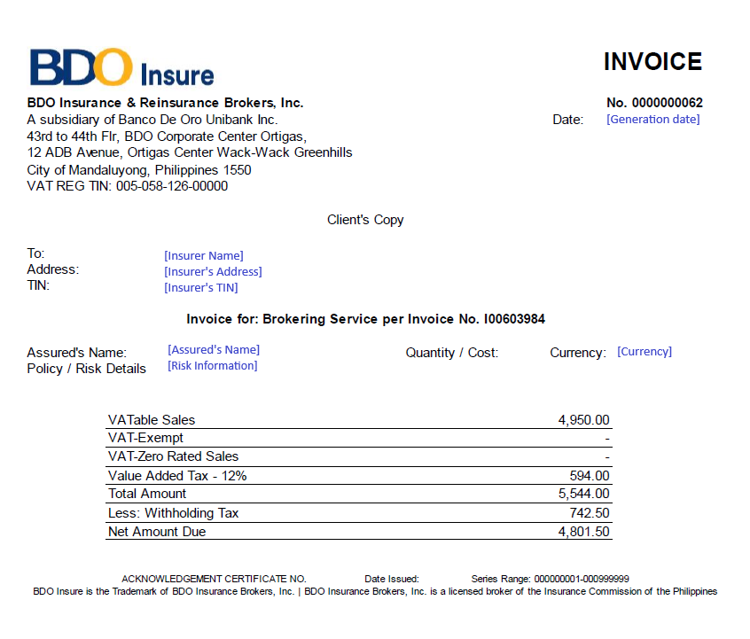

Annex Z – Hold Cover Template

Annex AA – Screen Specifications
This annex specifies the Renewal screens of the system: the purpose of each screen, how the user reaches it, the FR items it serves, one screenshot, its fields with type, mandatory marker, format, list or source and validation, and its actions. Mandatory: Y = mandatory, N = optional, Cond. = mandatory when the condition stated applies. The screenshots were taken on the BIBS DEV environment: https://dev.brokerverse.cloud with SIT/UAT data; the labels of the screens follow the BRD (for example Expiry List for the RMEL) and adopt BDOI's names once decided (Annex AO). The screen standards (layout, dates dd-Mmm-yyyy, amounts with two decimals, tables with row action menus) are those of the programme and are not repeated here.
AA.1 Renewal Home (SCR-RN-01)
Purpose: The renewals of the user's scope at a glance: the renewals due in 30, 60, 90 and 140 days, the work queues that need attention (at risk, urgent, returned, NRNS, insurer reply overdue, letters failed), the renewals by status and by classification and the workload of the officers. Each tile and status opens the list behind it.
Access: Client & Policy › Renewal › Renewal Home
FR items: FRRN.002.02, FRRN.003.01, FRRN.044.03
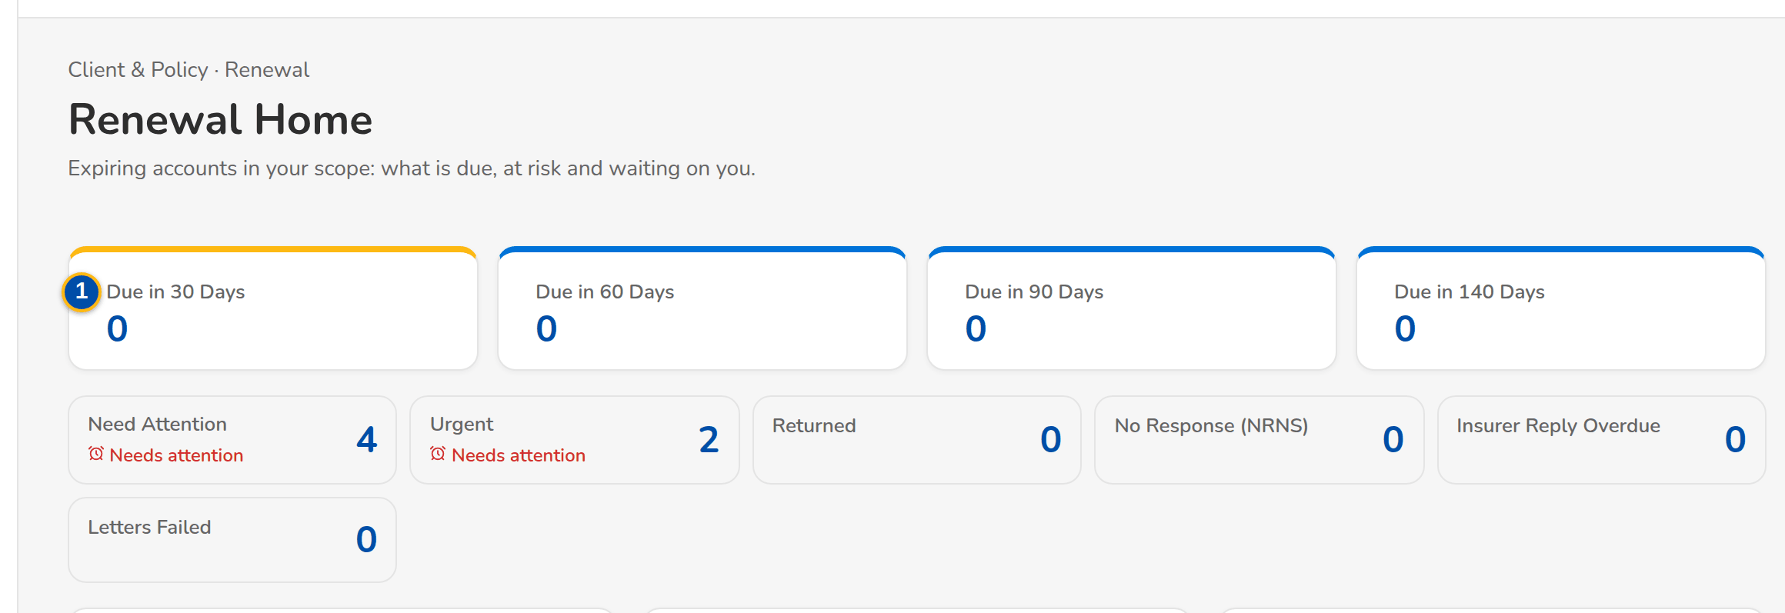
(continued below)
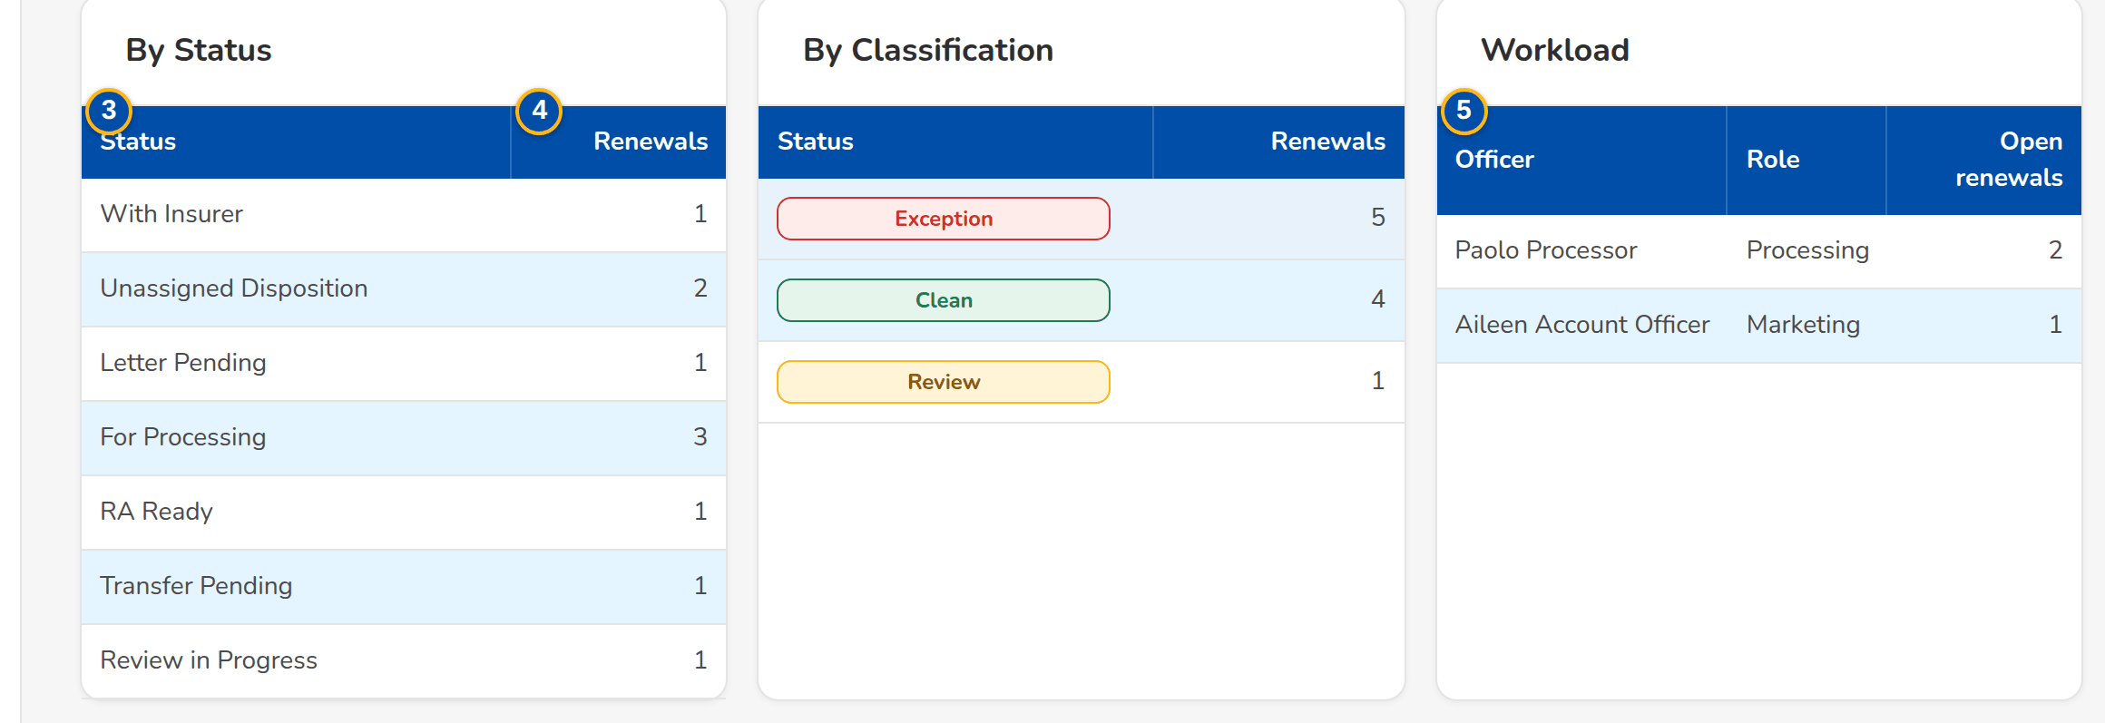
Figure AA.1 - Renewal Home of the Marketing Team Leader: due dates, work queues, renewals by status and classification, workload
Field | Type | Mandatory | Format / list / source | Validation and message
Figures: Due in 30 days / Due in 60 days / Due in 90 days / Due in 140 days | Figure | - | Number of renewals expiring within the days; Renewals of the user's scope | -
Work tiles: At risk / Urgent / Returned / NRNS / Insurer reply overdue / Letters failed | Tile | - | Title and live count; Needs attention when the queue needs action; Renewals of the user's scope | -
By status: Status / Renewals | Column | - | Stage of the renewal and the number of renewals; Renewals | No renewals
By classification: [Classification pill] / Renewals | Column | - | Clean, Review or Exception and the number of renewals; Renewals | No renewals
Workload: Officer / Role / Open renewals | Column | - | Name of the officer; Marketing or Processing; number of open renewals; Assignments | No renewals assigned

Action | Who | When | What happens | Status after | Notice
[Tile or status row] | Every Renewal user | Always | Opens the list and tab of those renewals (Expiry List, My Dispositions, Processing Worklist, Letters) | - | -

AA.2 Expiry List (SCR-RN-02)
Purpose: The expiring accounts from extraction to disposition, by tab: extracted, unassigned, by disposition, exceptions, transfers pending and all. Generate Expiry List reads the accounts expiring in a range; Initiate starts the checks of the extracted renewals; Assign Disposition gives renewals to an Account Officer; Push sends the dispositioned ones to the Team Leader; Transfer moves one renewal to another unit.
Access: Client & Policy › Renewal › Expiry List; Renewal Home › At risk, Urgent or a status
FR items: FRRN.002.05, FRRN.002.06, FRRN.002.07, FRRN.004.01, FRRN.004.02, FRRN.004.03, FRRN.004.04, FRRN.004.06 (2nd), FRRN.004.07, FRRN.010.01, FRRN.010.02, FRRN.011.06
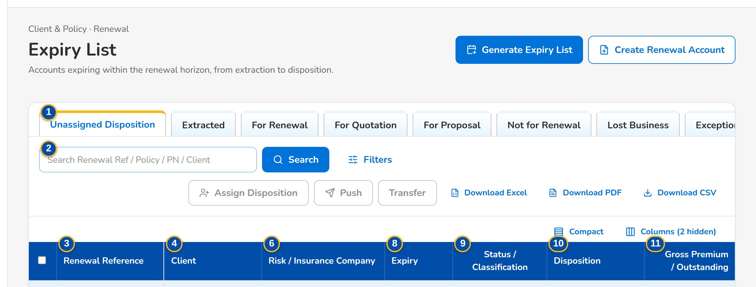
(continued below)
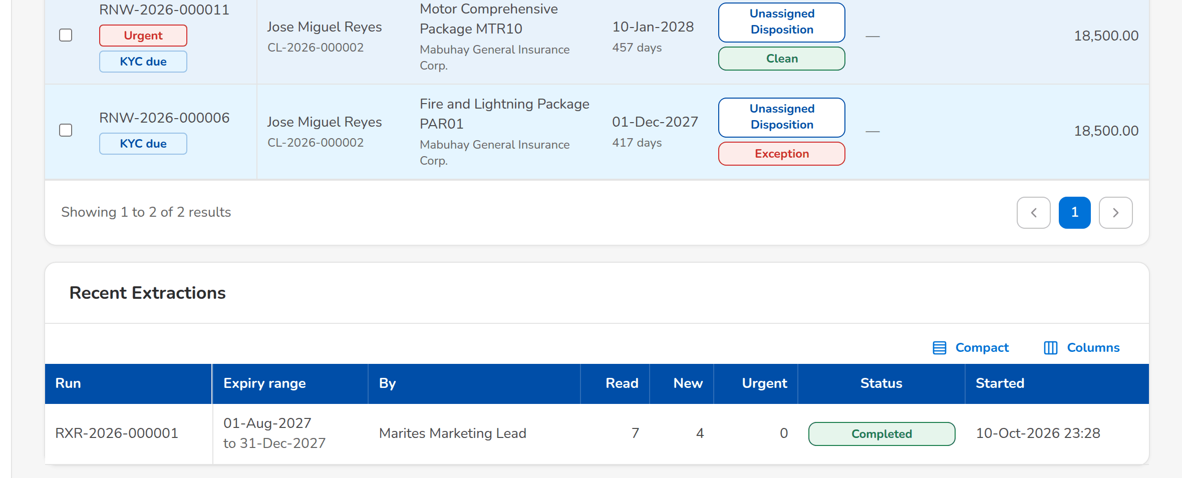
Figure AA.2 - Expiry List of the Marketing Team Leader, tab Unassigned Disposition: classification, flags and the actions of the tab
Field | Type | Mandatory | Format / list / source | Validation and message
Tabs: Unassigned Disposition / Extracted / For Renewal / For Quotation / For Proposal / Not for Renewal / Lost Business / Exceptions / Transfer Pending / All | Tab | - | Stage and disposition of the renewal | -
Toolbar: Search Renewal Ref / Policy / PN / Client | Text | N | Renewals | Contains
List: Renewal Reference | Column | - | RNW-yyyy-nnnnnn with the flag tags next to it; Renewals | No renewals to display
List: Client | Column | - | Name of the client with the client code under it; Renewal | -
List: Expiring Policy / Invoice | Column | - | Policy number with the invoice under it; Renewal | -
List: Risk / Insurance Company | Column | - | Product name with the insurer name under it; Product catalogue, insurers | -
List: Unit / Officer | Column | - | Name of the owner unit with the officer's name under it; Sales organisation, assignments | -
List: Expiry | Column | - | dd-MMM-yyyy with the days left under it; Renewal | -
List: Status / Classification | Column | - | Stage pill with the Clean, Review or Exception pill under it; Renewal | -
List: Disposition | Column | - | Disposition with the remarks under it; Renewal | -
List: Gross Premium / Outstanding | Column | - | Two decimals; the outstanding of the expiring invoice family and the claims count under it (hidden for LAMD and Contact Center); Expiring invoice, checks | -
Filters panel: Expiry From / Expiry To | Date | N | dd-MMM-yyyy | -
Filters panel: Unit Head, Business Origin, Account Type, Region, Department, Invoicing Branch, Risk Code, Segment, Account Officer, Insurance Company, Classification, Disposition, Status | Multi-select | N | Several values, or all except the values chosen; Values of the renewals | -
Generate Expiry List dialog: Expiry From / Expiry To | Date | Y | dd-MMM-yyyy; the end on or after the start | Valid range; The end date must be on or after the start date
Assign Disposition dialog: Account Officer | Drop-down | Y | Name of the officer; Officers of the Marketing units | Active officer of the unit of the renewal; Select the account officer
Assign Disposition dialog: Reason (re-assignment) | Drop-down | N | Renewal transfer reason list; Renewal transfer reason | -
Transfer dialog: Receiving Unit / Reason / Remarks | Drop-down, drop-down, text area | Y / N / Y | Name of the unit; renewal transfer reason; up to 200 characters; Marketing units, Renewal transfer reason | Another active unit; The receiving unit must be another unit
Recent extractions: Run / Expiry range / By / Read / New / Urgent / Status / Started | Column | - | The last five runs: the range or Daily run, the user's name, the counts, the status and the start time; Extraction runs | No extraction yet

Action | Who | When | What happens | Status after | Notice
Generate Expiry List | Marketing and Processing Team Leaders | Always | Opens the dialog; Generate reads the accounts expiring in the range and creates their renewals once | Extracted | -
Initiate | Team Leaders (extract or assign permission) | Tab Extracted, renewals ticked | Starts the checks: each renewal gets its classification and the decision matrix proposes its disposition | Unassigned Disposition, For Processing or Letter Pending by the rules | -
Assign Disposition | Marketing Team Leader | Renewals ticked | Opens the dialog; Assign and Push gives the renewals to the officer | For Disposition | Renewal assigned
Push | Account Officers and Team Leaders (dispose permission) | Renewals ticked | Sends the dispositioned renewals to the Team Leader | Review in Progress | -
Transfer | Marketing Team Leader | One renewal ticked | Opens the dialog; Submit and Push requests the transfer to the receiving unit | Transfer Pending | Renewal transfer requested
Download | Users with the export permission | Always | Downloads the list as shown, with its filters, as a spreadsheet | - | -
[Row] | Every Renewal user | Always | Opens the renewal | - | -

AA.3 Renewal (SCR-RN-03)
Purpose: One renewal: the client, the ARN chip, the status, classification and disposition, the flags and key facts, the blocking checks, the workflow header with the actions the user may take now, and the Details tab with the expiring account, the client and officers, the amounts and the renewal itself.
Access: Expiry List, My Dispositions, Team Lead Review, Processing Worklist, Letters or Follow-ups › open a row; A Renewal notification
FR items: FRRN.001.02, FRRN.004.04, FRRN.014.01, FRRN.014.06, FRRN.015.04, FRRN.039.01
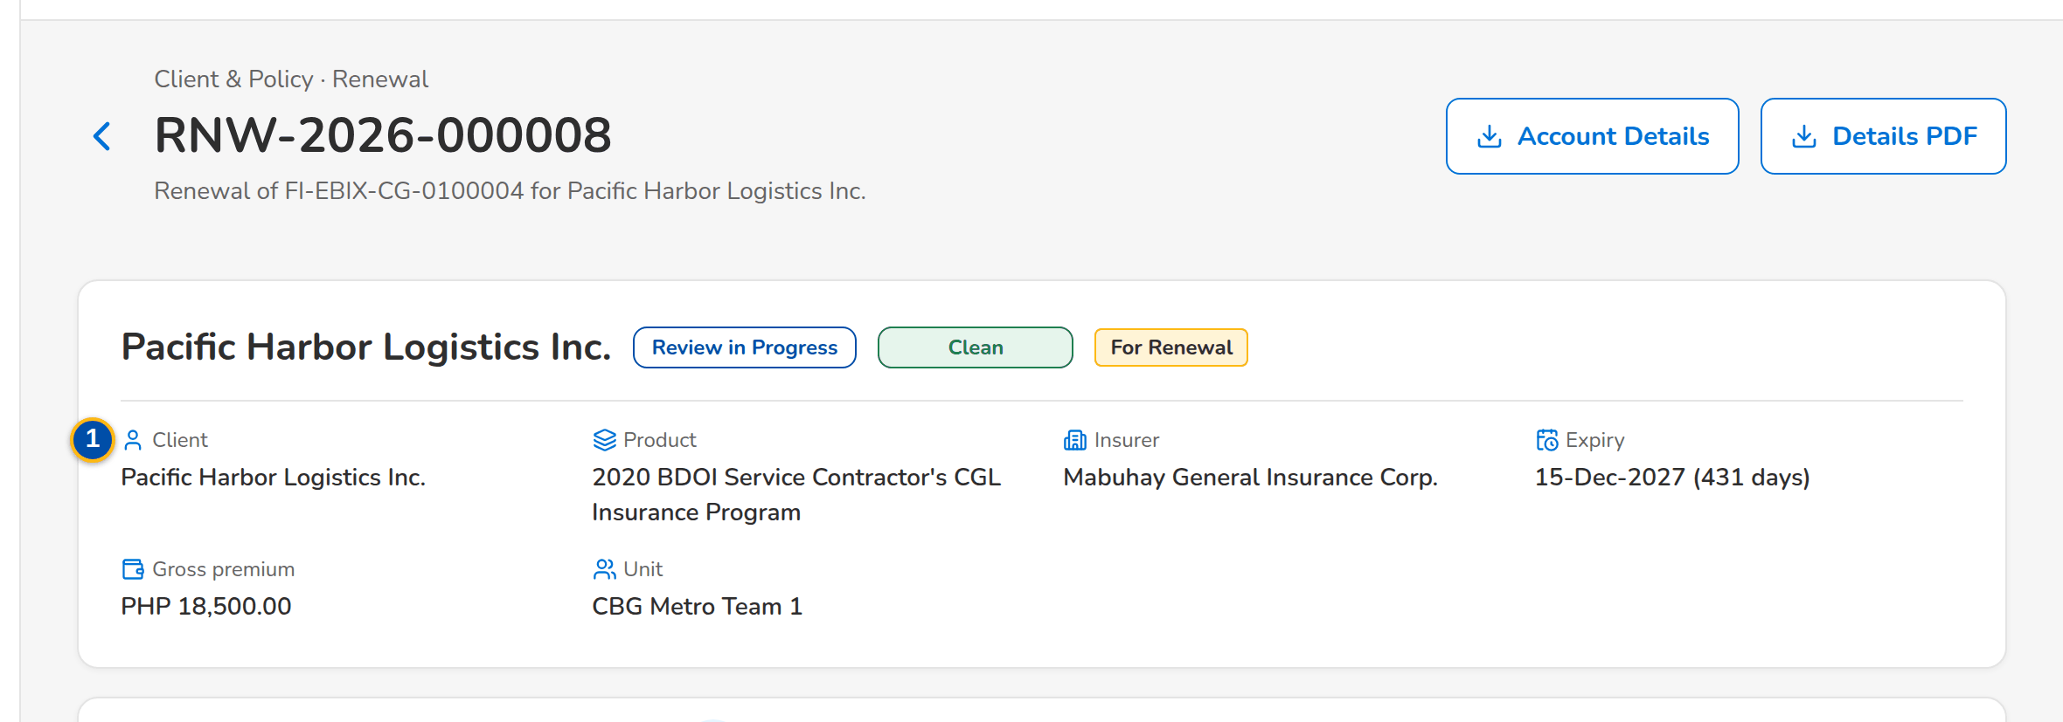
(continued below)
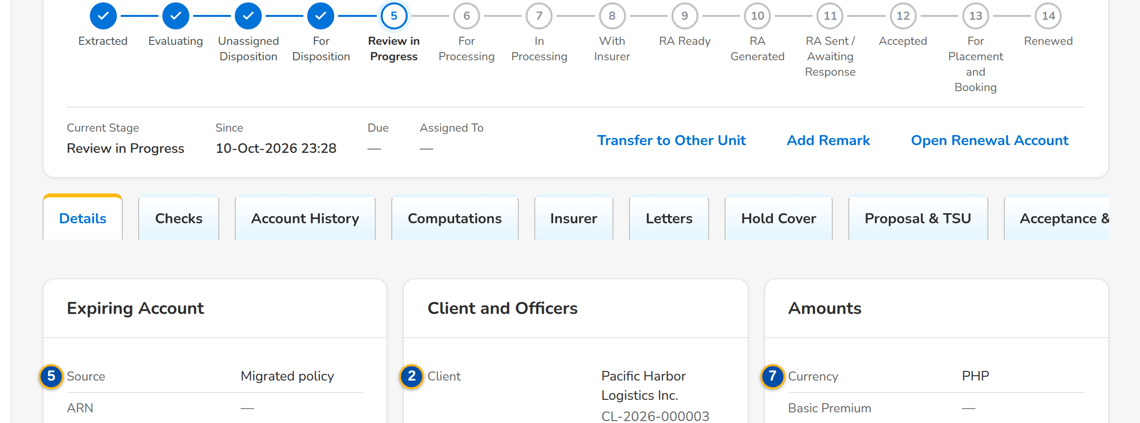
(continued below)
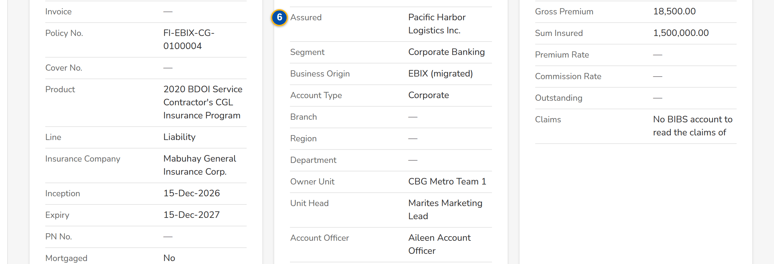
(continued below)
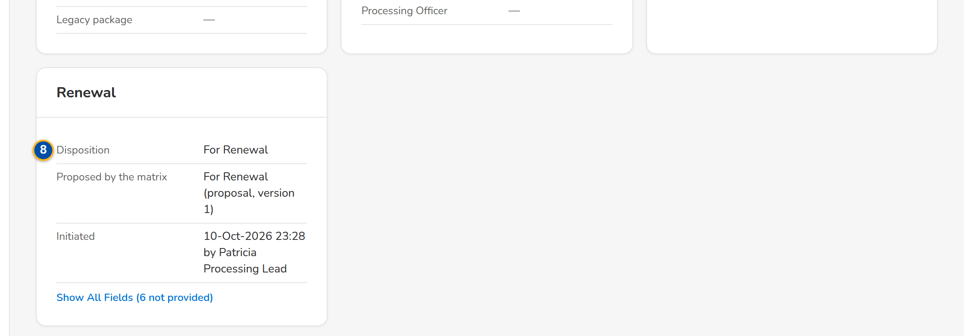
Figure AA.3 - A renewal in review: header, flags, workflow header and the Details tab
Field | Type | Mandatory | Format / list / source | Validation and message
Header: [Client, ARN chip, status pill, classification pill, disposition tag, flags] | Reference chip, pills, tags | - | Renewal | -
Facts: Client / Product / Insurer / Expiry / Gross premium / Unit | Display | - | Names; expiry dd-MMM-yyyy with the days left; amount with the currency; Renewal | -
Blocking checks: [Amber notice with the failed checks] | Notice | - | One bullet per failed blocking check; Latest checks | -
Workflow: [Renewal workflow header] | Stepper | - | The stages of the renewal with Current Stage, Since, Due and Assigned To and the history table; Renewal workflow | -
Details tab: Expiring account: Source / ARN / Invoice / Policy No. / Cover No. / Product / Line / Insurance Company / Inception / Expiry / PN No. / Mortgaged / Legacy package | Display | - | Names of the product, line and insurer; dates dd-MMM-yyyy; Expiring account or migrated policy | -
Details tab: Client and officers: Client / Assured / Segment / Business Origin / Account Type / Branch / Region / Department / Owner Unit / Unit Head / Account Officer / Processing Officer | Display | - | Names of the units and users; Client, sales organisation, assignments | -
Details tab: Amounts: Currency / Basic Premium / Gross Premium / Sum Insured / Premium Rate / Commission Rate / Outstanding / Claims | Display | - | Two decimals; rates as keyed; Expiring invoice, checks | -
Details tab: Renewal: Disposition / Reason / Proposed by the matrix / Renewal ARN / Quotation / Proposal / Renewed Invoice / Initiated / Closed | Display | - | Labels; the officer's name; dd-MMM-yyyy HH:mm; Renewal | -

Action | Who | When | What happens | Status after | Notice
Details PDF | Users with the export permission | Always | Downloads the account details of the renewal as a PDF | - | -
[Actions of the status] | By status and permission | The renewal is in the status | Set Disposition, Push, Start Quotation / Proposal, Create Renewal Account, Record Insurer Response, Record Acceptance, Add Follow-up, Add Remark, Propose Package, Re-open (SCR-RN-07, SCR-RN-12, SCR-RN-14, SCR-RN-15, SCR-RN-19) | - | -
Open Renewal Account | Every Renewal user | The renewal account exists | Opens the renewal account in New Business | - | -

AA.4 Renewal: Checks, Account History and Computations (SCR-RN-04)
Purpose: The tabs the officers read before the disposition and the processing: the results of the sanitation checks with the classification history and the endorsements linked; the account history (prior renewals, endorsements, payments and claims), whose viewing is recorded and required before the disposition; the expiring and renewal terms side by side.
Access: Renewal › Checks, Account History or Computations tab
FR items: FRRN.004.06, FRRN.007.01, FRRN.007.02, FRRN.008.01, FRRN.009.01, FRRN.014.01
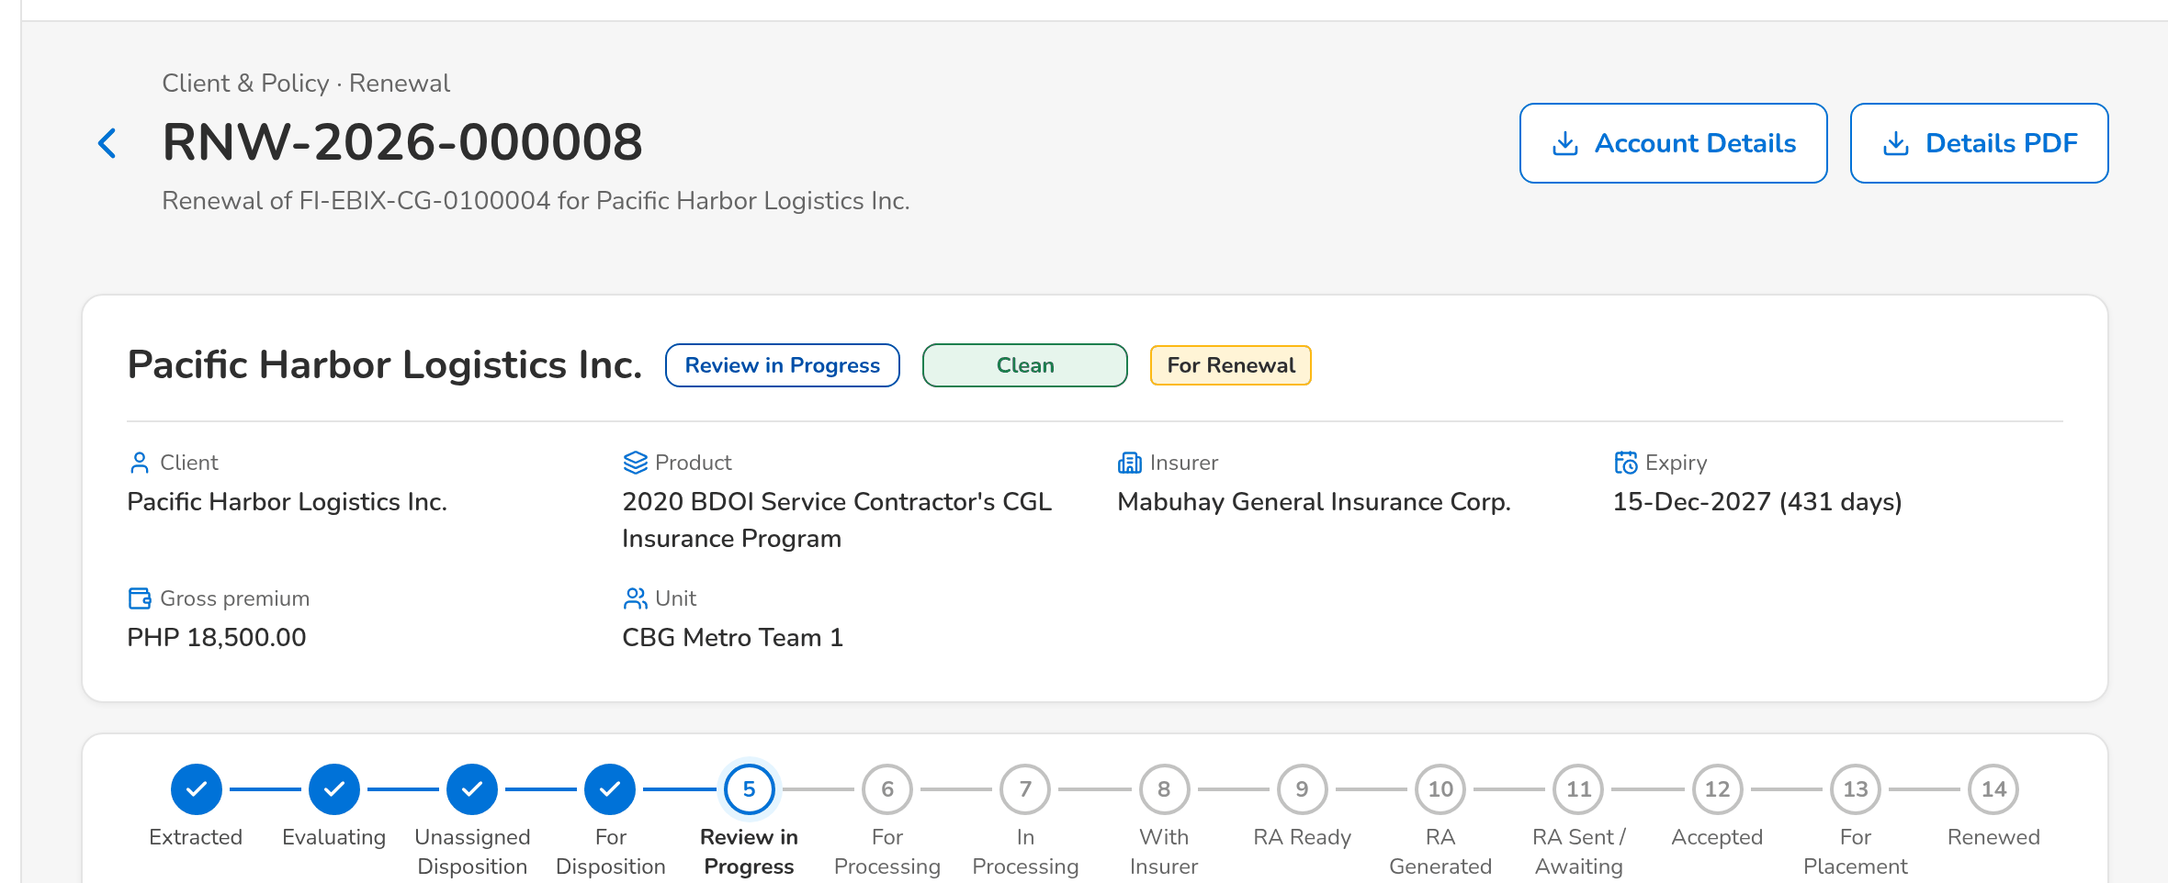
(continued below)
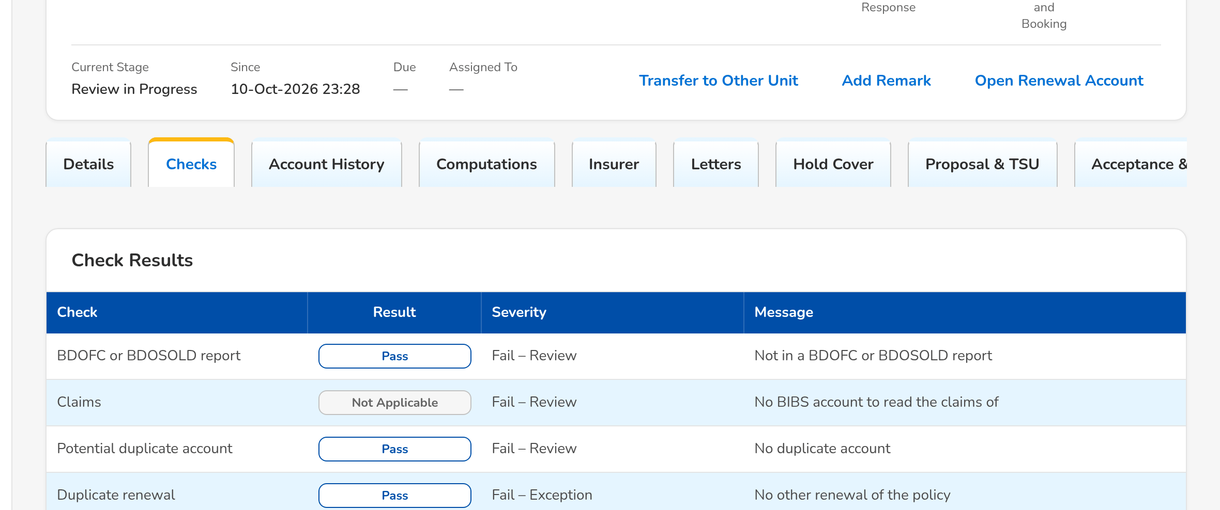
(continued below)
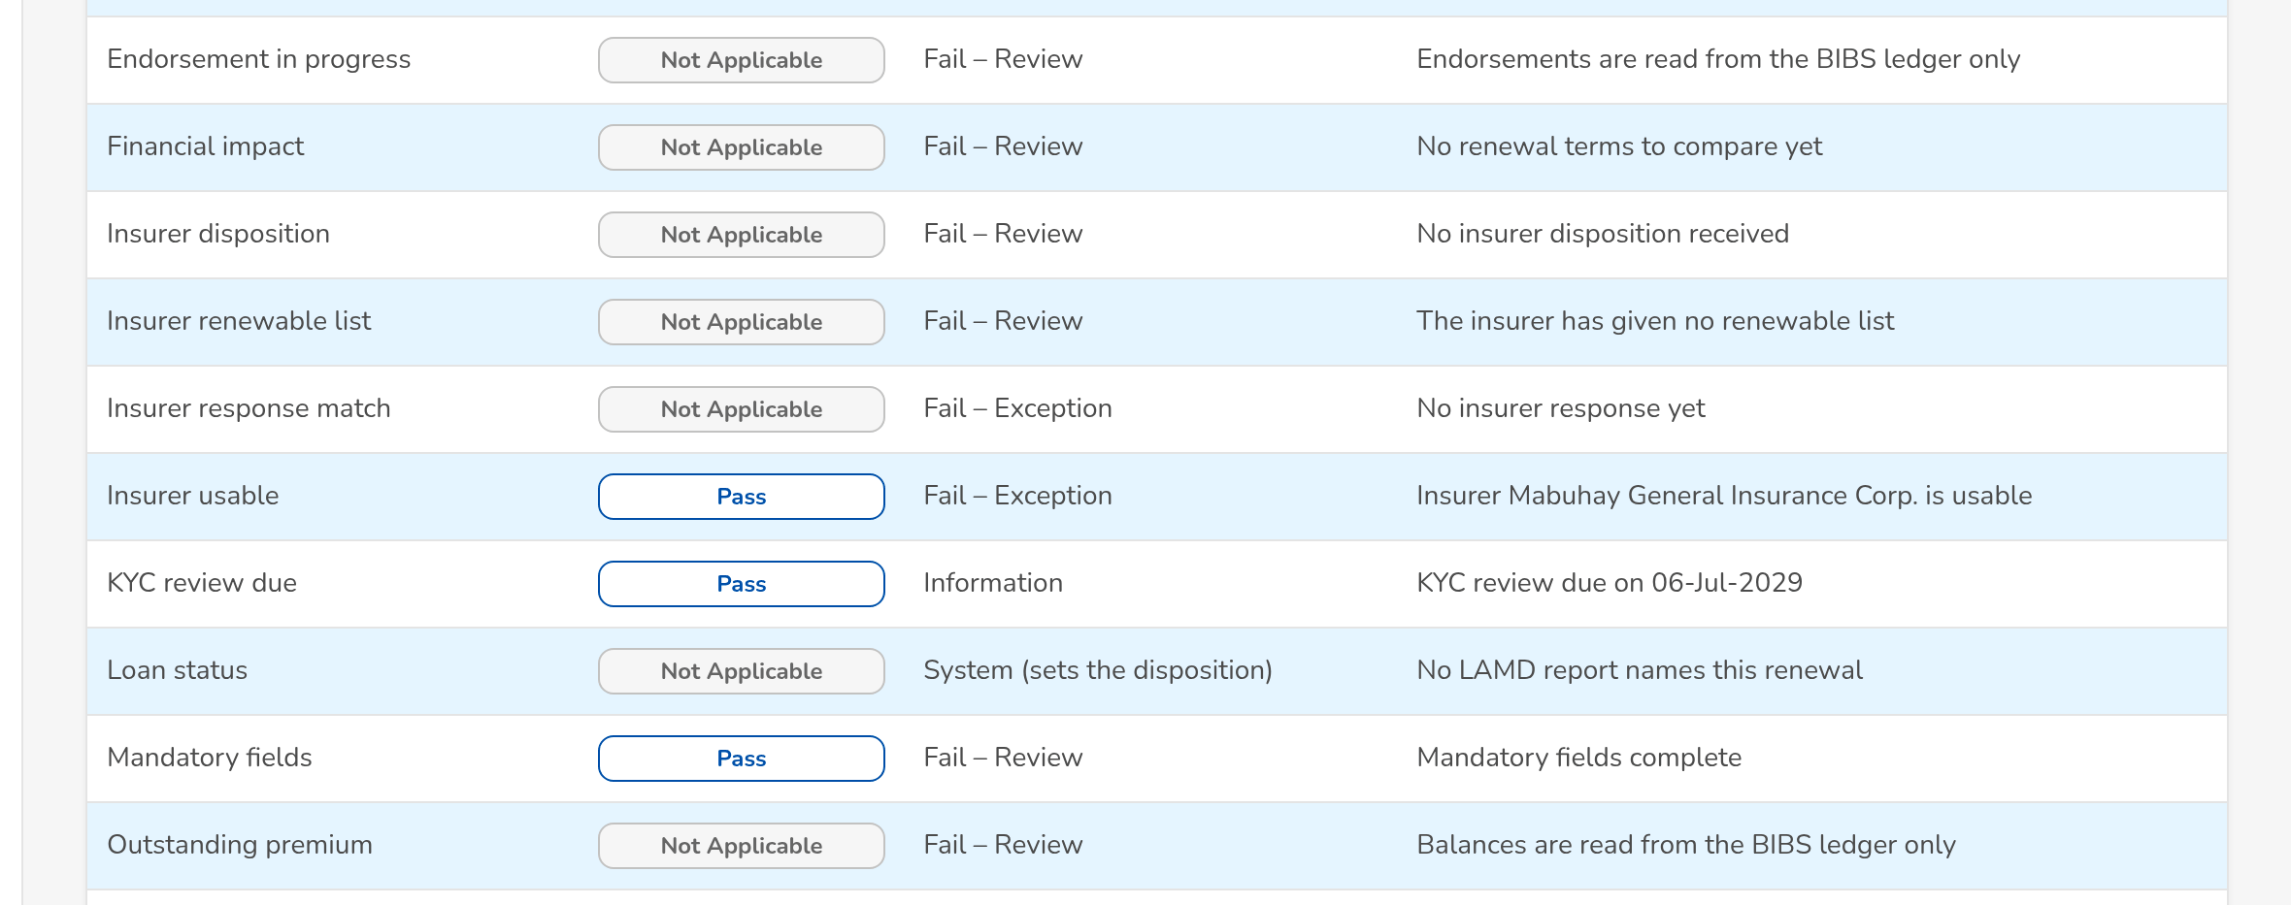
(continued below)
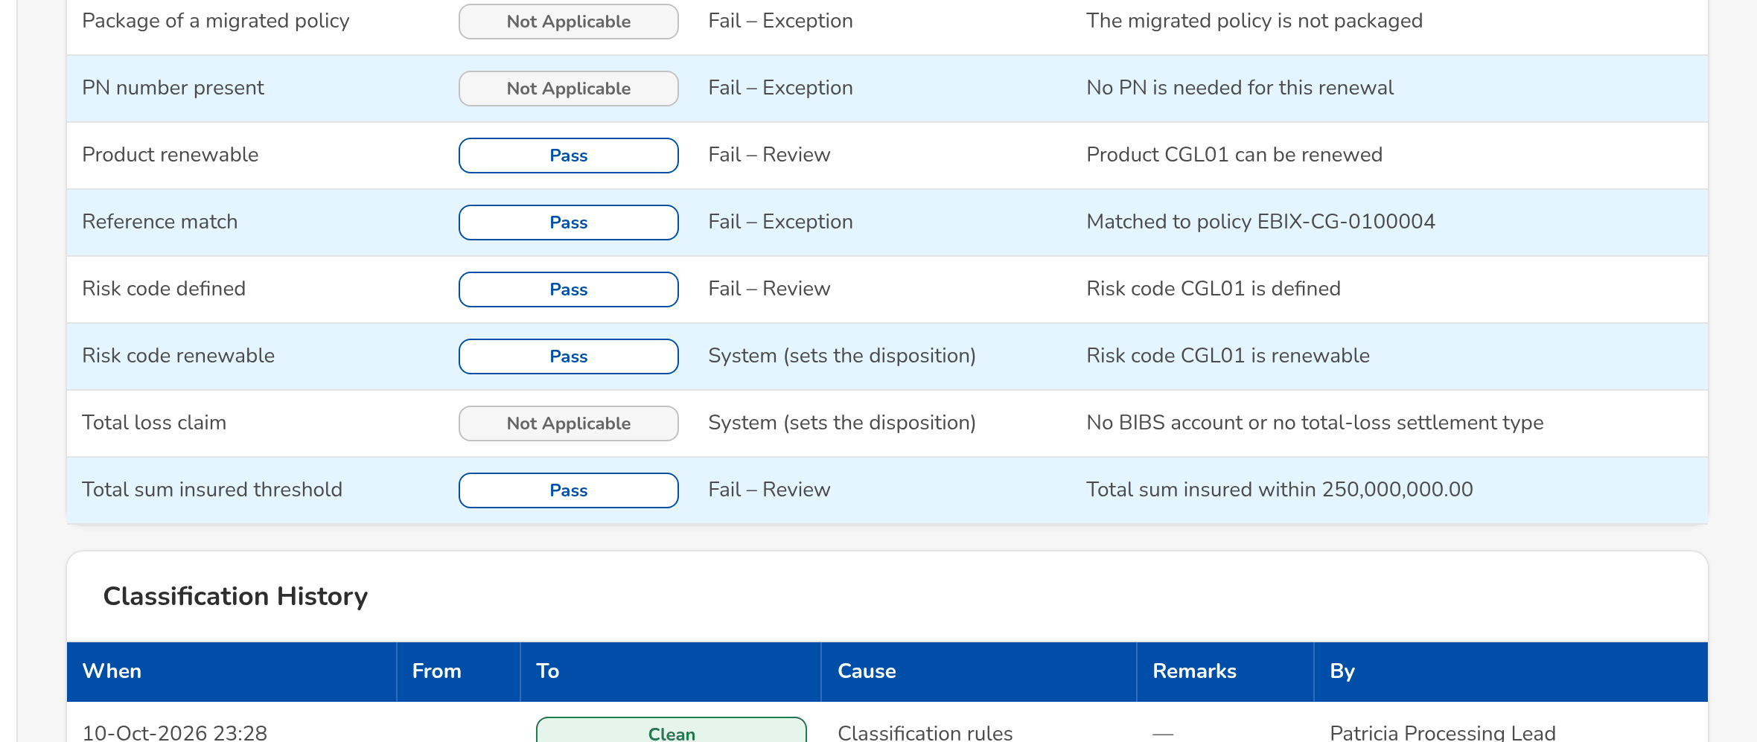
Figure AA.4 - Checks tab: the result of each check, the classification history and the endorsements
Field | Type | Mandatory | Format / list / source | Validation and message
Check results: Check / Result / Severity / Message | Column | - | Name of the check; Pass, Warning, Fail, Information or Not applicable; severity as on Renewal Setup; the finding; Latest check run | The checks have not run yet
Classification history: When / From / To / Cause / Remarks / By | Column | - | dd-MMM-yyyy HH:mm; classification pills; Classification rules or Override; the user's name; Classification changes | No classification yet
Endorsements linked: Reference / Source / Status / Linked | Column | - | The endorsements of the term of the expiring policy; Booking and Adjustment | No endorsements in the term
Account History: View Account History | Button | - | Records that the officer read the history | -
Account History: Prior renewals / Endorsements / Payments / Claims | Table | - | Renewal, Expiry, Expiring / Renewal ARN, Outcome; Invoice, Kind, Endorsement, Booked, Gross Premium; Invoice, Value date, Type, Component, OR No., Amount; the claims count; Booking, Operations ledger, Claims | No prior renewals
Computations: Expiring / Renewal | Display | - | Currency, Net Premium, Charges, Gross Premium, Sum Insured, Commission Rate, Commission; Expiring invoice, renewal account | -

Action | Who | When | What happens | Status after | Notice
View Account History | Every Renewal user | Always | Shows the history and records that it was viewed | - | -

AA.5 Renewal: Insurer, Letters, Documents, Remarks and History (SCR-RN-05)
Purpose: The tabs that keep the record of the renewal: the insurer responses (append-only, the latest valid one drives the renewal), the letters with their delivery and the acceptance, the documents of the renewal, the remarks and the Contact Center follow-ups, and the history of dispositions, assignments and overrides.
Access: Renewal › Insurer, Letters, Documents, Remarks & Follow-ups or History tab
FR items: FRRN.013.01, FRRN.013.02, FRRN.013.05, FRRN.014.02, FRRN.022.01, FRRN.025.01, FRRN.028.02, FRRN.043.01, FRRN.043.02
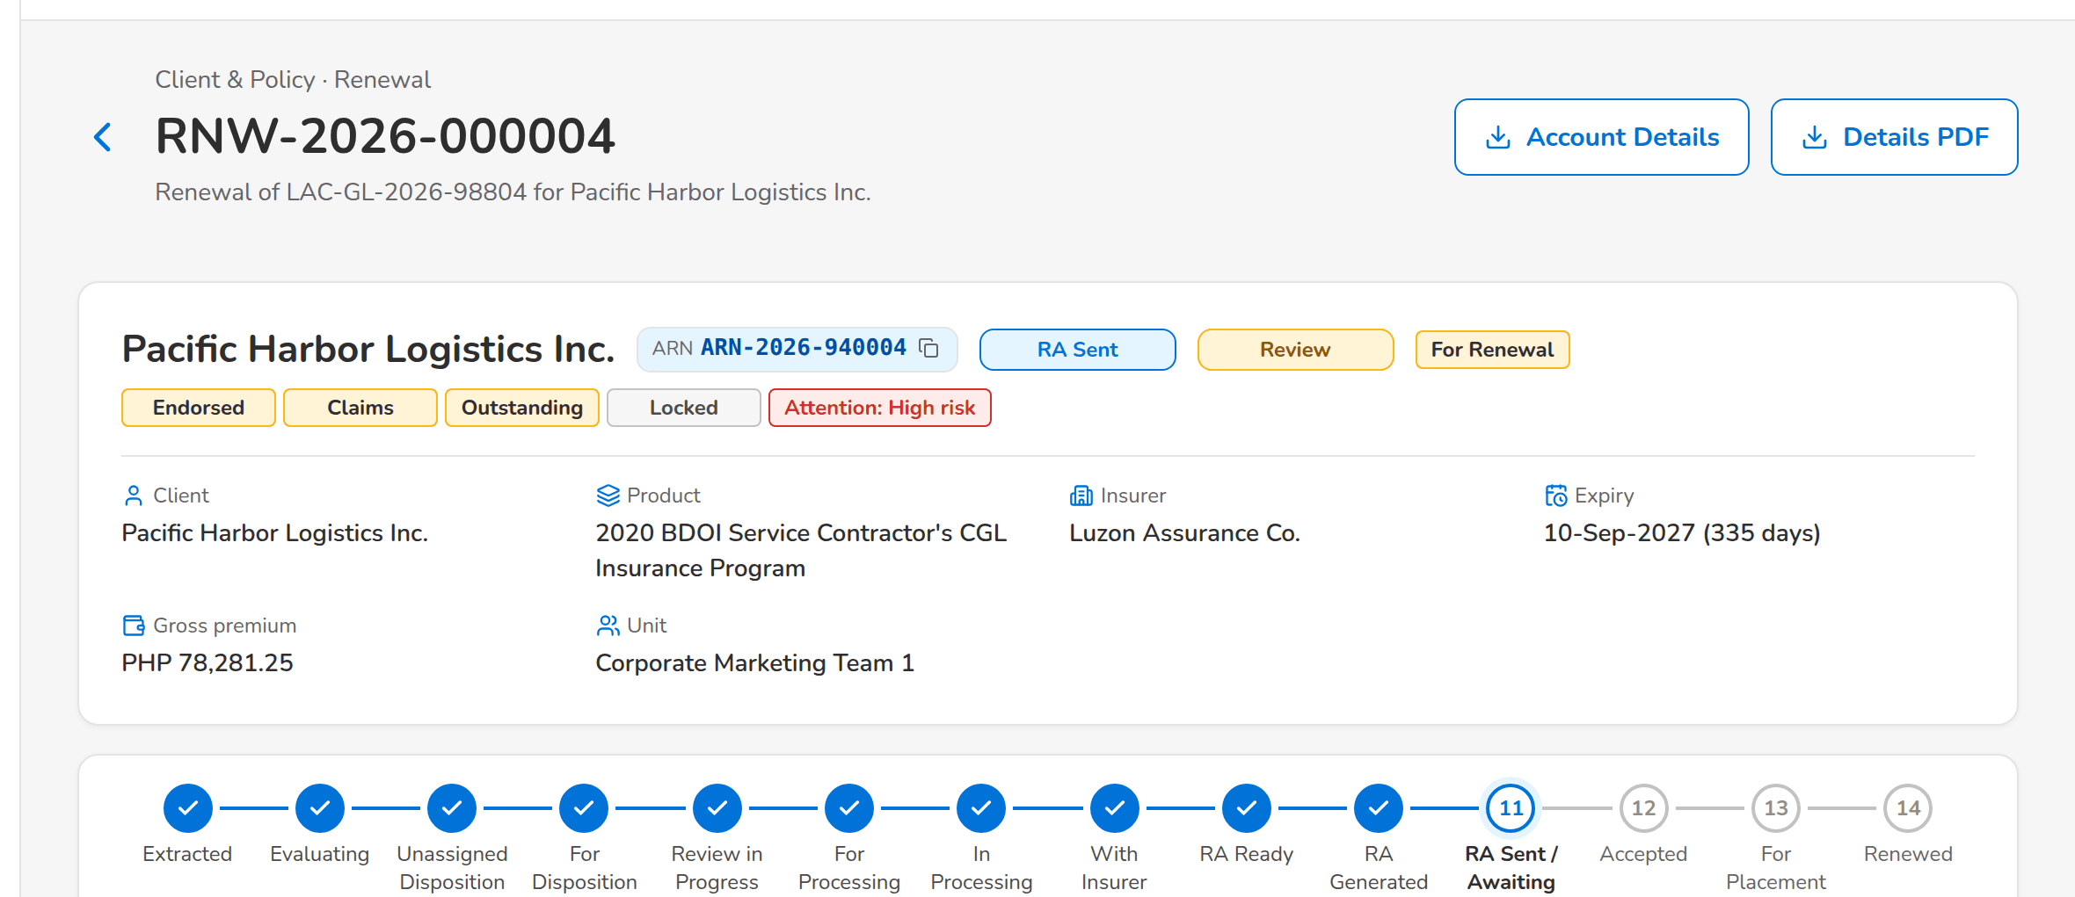
(continued below)
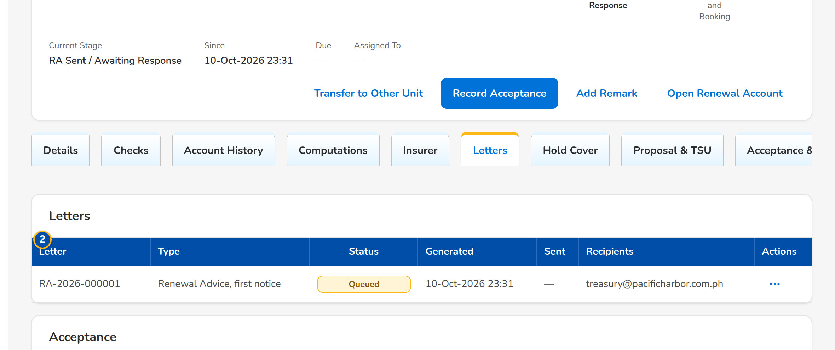
(continued below)
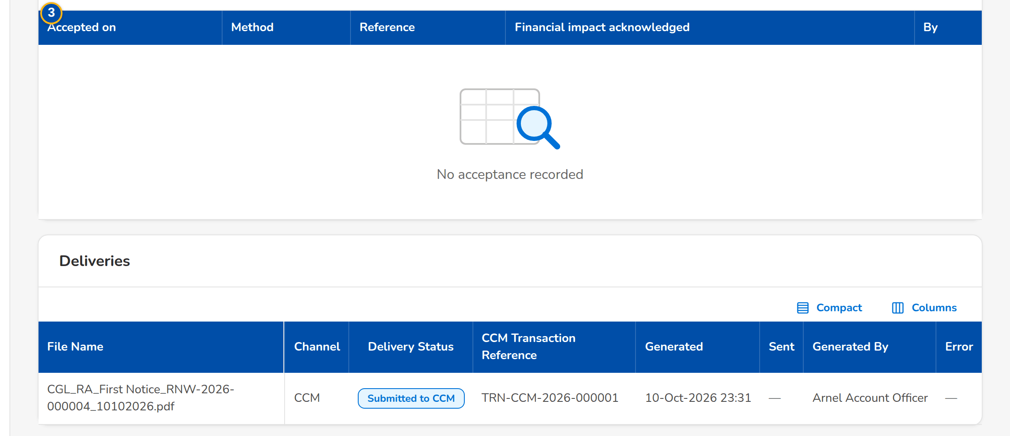
Figure AA.5 - Letters tab: the Renewal Advice sent to the client
Field | Type | Mandatory | Format / list / source | Validation and message
Insurer responses: Received / Response / Insurer Ref / Revised Premium / Revised Sum Insured / Match / Used / Source / By | Column | - | dd-MMM-yyyy; Renew as is, Renew with revised terms or Declined; two decimals; Matched or the mismatch; Latest valid or Late; Manual or the upload; the user's name; Insurer responses | No response from the insurer
Letters: Letter / Type / Status / Generated / Sent / Recipients | Column | - | Letter number; Renewal Advice with its notice, No Advice Letter, Not for Renewal Letter; status pill; dd-MMM-yyyy HH:mm; e-mail addresses or the failure; Letters | No letters
Acceptance: Accepted on / Method / Reference / Financial impact acknowledged / By | Column | - | dd-MMM-yyyy; E-mail from the client, Signed Renewal Advice or Payment; Yes or No; the user's name; Acceptances | No acceptance recorded
Documents: [Documents of the renewal] | Table | - | Type, file, uploaded by and when; Upload; Documents | -
Remarks: When / By / Stage / Remark | Column | - | dd-MMM-yyyy HH:mm; the user's name; status pill; Remarks | No remarks
Follow-ups: When / Channel / Outcome / Remarks / Next action / By | Column | - | Labels of the follow-up channel and outcome; dd-MMM-yyyy; Follow-ups | No follow-ups
History: Dispositions: When / Disposition / Reason / Source / Remarks / Current / By | Column | - | Labels; User, System check, Decision matrix, Upload, Insurer response or LAMD report; Dispositions | No dispositions
History: Assignments: When / Role / Assigned to / Previous / By | Column | - | Account Officer or Processing Officer; users' names; Assignments | No assignments
History: Overrides: When / Override / Change / Reason / Remarks / By | Column | - | What was overridden; the change in words (Review to Clean); the override reason; Overrides | No overrides

Action | Who | When | What happens | Status after | Notice
Download PDF (row menu) | Every Renewal user | The letter has its PDF | Downloads the letter | - | -

AA.6 My Dispositions (SCR-RN-06)
Purpose: The renewals assigned to the Account Officer, by disposition, with quick filters for the renewals to disposition, returned to the officer, due in 30 days and with no response (NRNS). The officer opens a renewal to read its history and give the disposition, pushes the dispositioned renewals to the Team Leader and transfers one to another unit.
Access: Client & Policy › Renewal › My Dispositions; Renewal Home › Returned; Notification Renewal assigned
FR items: FRRN.002.08
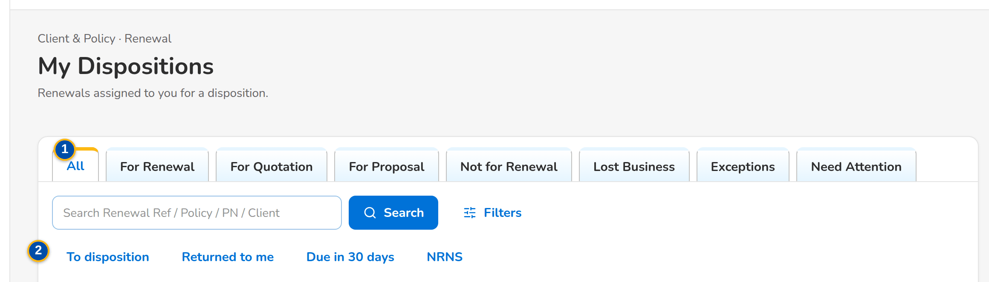
(continued below)
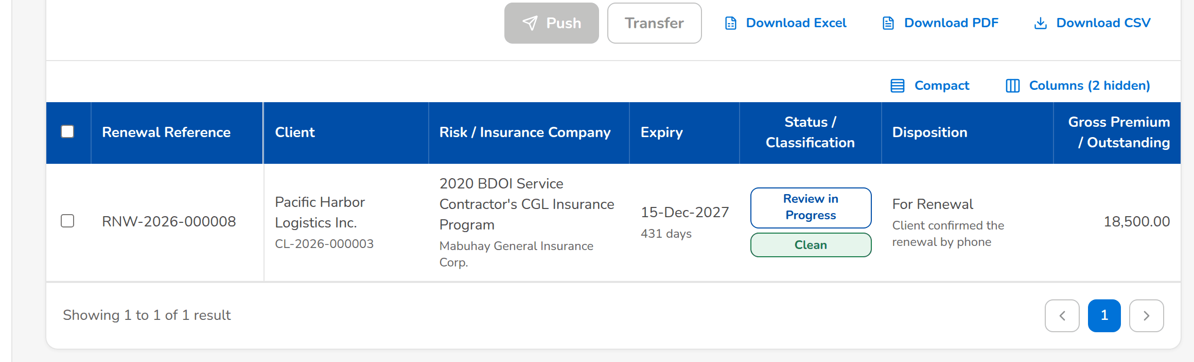
Figure AA.6 - My Dispositions of the Account Officer with the quick filters
Field | Type | Mandatory | Format / list / source | Validation and message
Tabs: All / For Renewal / For Quotation / For Proposal / Not for Renewal / Lost Business / Exceptions | Tab | - | Disposition and classification | -
Quick filters: To disposition / Returned to me / Due in 30 days / NRNS | Toggle button | - | One at a time | -
List: [Columns of the renewal lists] | Column | - | As on the Expiry List (SCR-RN-02), the renewals assigned to the officer; Renewals | No renewals assigned to you

Action | Who | When | What happens | Status after | Notice
Push | The Account Officer | Renewals ticked | Sends the dispositioned renewals to the Team Leader; each renewal without a complete disposition is refused with the reason | Review in Progress | -
Transfer | Users with the assign permission | One renewal ticked | Opens the Transfer dialog (SCR-RN-02) | Transfer Pending | Renewal transfer requested
Download | Users with the export permission | Always | Downloads the list as shown | - | -

AA.7 Set Disposition, Add Remark and Re-open (SCR-RN-07)
Purpose: The disposition of the renewal by the Account Officer (or the Team Leader): For Renewal, For Quotation, For Proposal, Not for Renewal with its reason, or Lost Business, with remarks; Push sends it to the Team Leader. Add Remark keeps a remark on the renewal. A renewal tagged Not for Renewal can be re-opened with a reason until the re-open days after expiry. A renewal posted For Quotation or For Proposal starts its quotation or proposal request here.
Access: Renewal › Set Disposition, Add Remark, Re-open or Start Quotation / Proposal
FR items: FRRN.014.01, FRRN.014.02, FRRN.014.07, FRRN.016.01, FRRN.017.01, FRRN.018.02
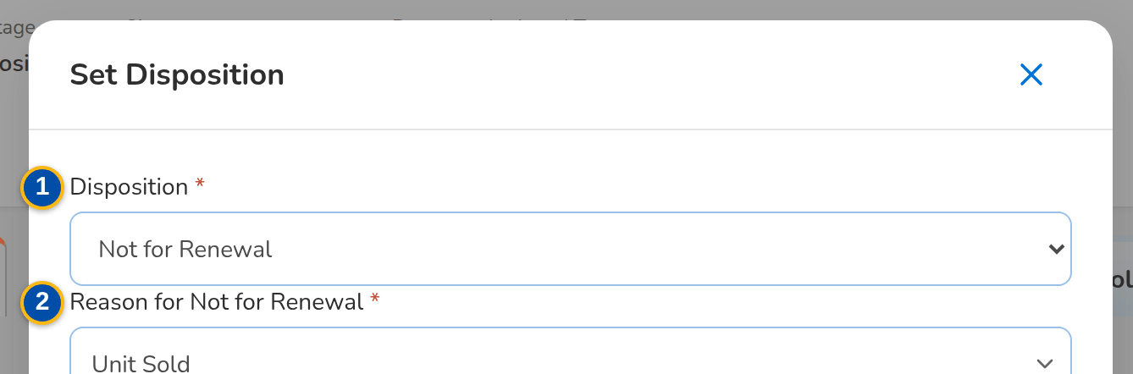
(continued below)
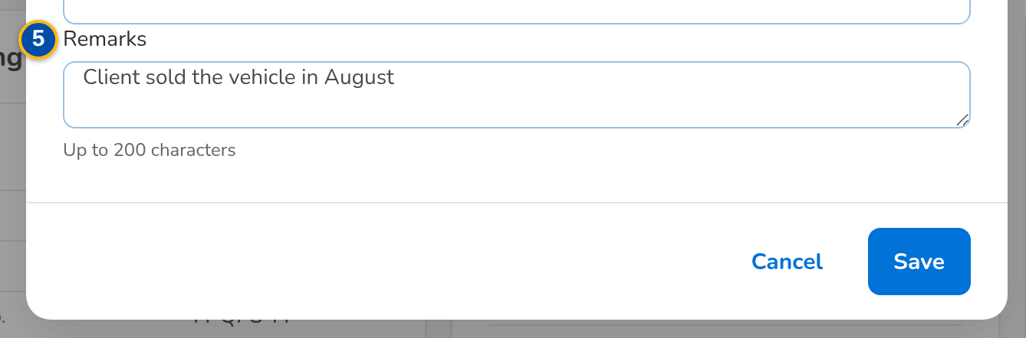
Figure AA.7 - Set Disposition dialog: Not for Renewal with its reason and remarks
Field | Type | Mandatory | Format / list / source | Validation and message
Set Disposition dialog: Disposition | Drop-down | Y | For Renewal, Not for Renewal, For Quotation, For Proposal, Lost Business; Renewal disposition list | Account history viewed; Select the disposition
Set Disposition dialog: Reason for Not for Renewal | Drop-down | Cond.: Not for Renewal | Reason for Not for Renewal list; Reason for Not for Renewal | Select the reason for Not for Renewal
Set Disposition dialog: New Invoice No. | Text | Cond.: reason Booked to New Invoice | The invoice the policy was booked under; Booking | Invoice of the ledger; Enter the new invoice number
Set Disposition dialog: Receiving Unit | Drop-down | Cond.: reason Transfer to Another Marketing Unit | Name of the unit; Marketing units | Another active unit; Select the receiving unit
Set Disposition dialog: Remarks | Text area | N | Up to 200 characters | At most 200 characters; Remarks may have at most 200 characters
Add Remark dialog: Remark | Text area | Y | Up to 200 characters | Not blank; Enter the remarks
Re-open dialog: Reason | Text area | Y | Up to 200 characters | Within the re-open days after expiry; Only a renewal tagged Not for Renewal can be re-opened

Action | Who | When | What happens | Status after | Notice
Set Disposition | The assigned officer or a Team Leader | For Disposition | Opens the dialog; Save keeps the disposition, which supersedes the previous one | For Disposition | -
Push | The assigned officer or a Team Leader | For Disposition with a disposition | Sends the renewal to the Team Leader | Review in Progress | -
Start Quotation / Proposal | Account Officers and Team Leaders | Posted For Quotation or For Proposal, none started | Creates the quotation or the proposal request from the expiring account | For Proposal / New Business Path | -
Add Remark | Marketing, Processing and Contact Center users | Any open status | Keeps the remark on the Remarks & Follow-ups tab | - | -
Re-open | Account Officers and the Processing Team Leader | Letter Pending or closed as not renewed | Asks for the reason and returns the renewal for a new disposition | For Disposition | Renewal returned

AA.8 Team Lead Review (SCR-RN-08)
Purpose: The dispositions of the unit waiting for the Team Leader, the exceptions, the unassigned renewals and the renewals on the quotation or proposal path. The Team Leader posts the reviewed renewals (each moves on by its disposition), returns them to the officer with a reason, overrides a failed check, the classification, the disposition or the outstanding balance with a reason, and re-assigns them.
Access: Client & Policy › Renewal › Team Lead Review; Notification of a pushed renewal
FR items: FRRN.014.04, FRRN.020.01, FRRN.020.02, FRRN.020.03, FRRN.040.02
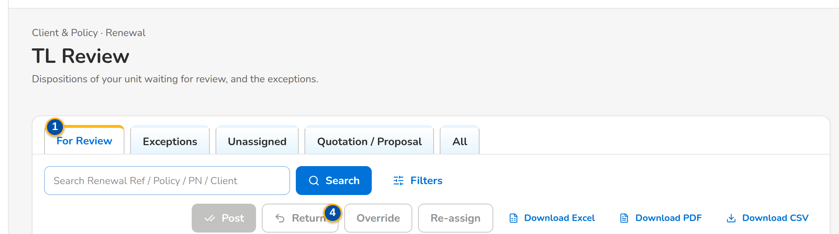
(continued below)
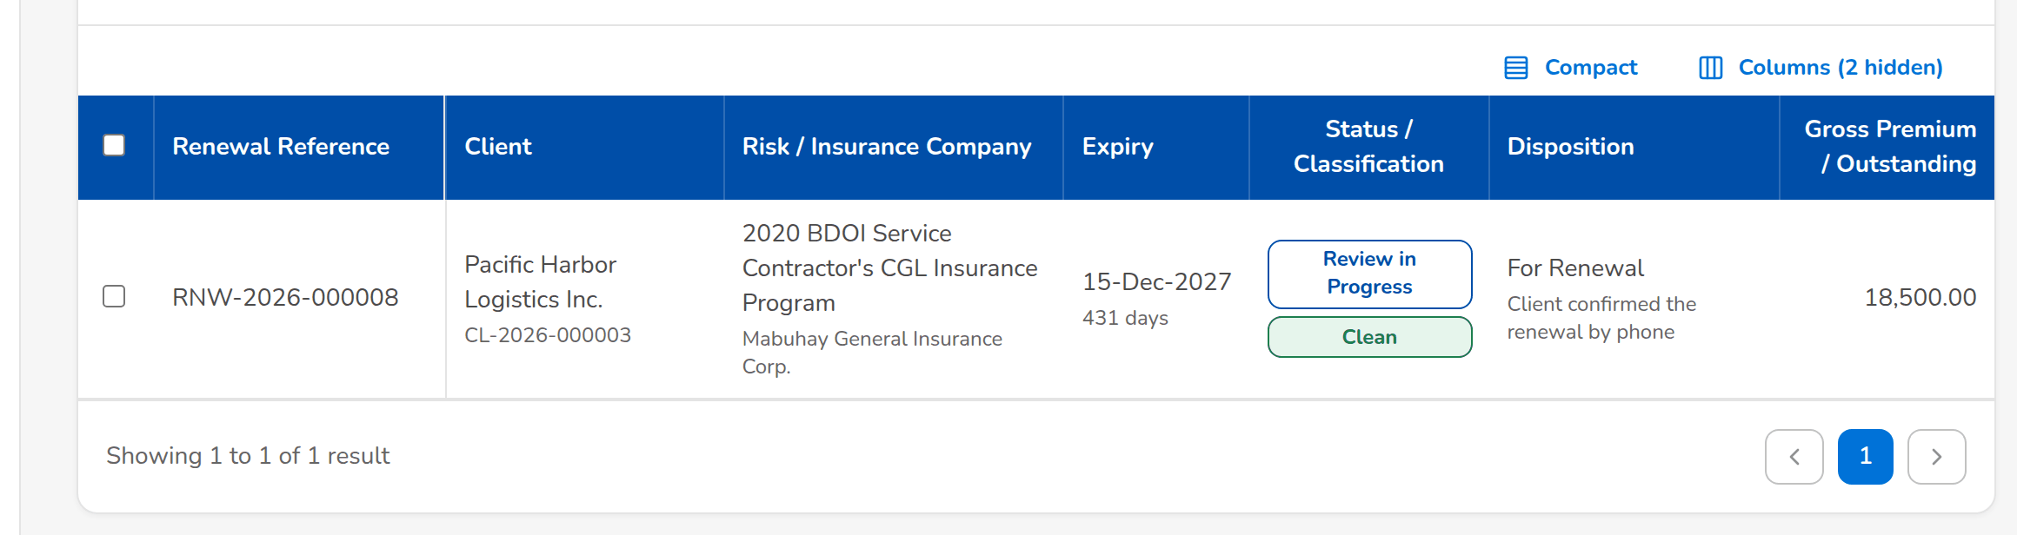
Figure AA.8 - Team Lead Review: the dispositions of the unit waiting for review with the actions of the Team Leader
Field | Type | Mandatory | Format / list / source | Validation and message
Tabs: For Review / Exceptions / Unassigned / Quotation / Proposal / All | Tab | - | Stage and classification | -
List: [Columns of the renewal lists] | Column | - | As on the Expiry List (SCR-RN-02), the renewals of the unit; Renewals | No renewals to display
Return dialog: Reason / Remarks | Drop-down, text area | Y / Y | Renewal return reason list; up to 200 characters; Renewal return reason | Select a reason for 'Return'
Override dialog: Override | Drop-down | Y | Outstanding balance, Failed check, Classification, Disposition, Insurer response mismatch, Unlock the Renewal Advice; Fixed list | Select the kind of override
Override dialog: Check / New value | Drop-down | Cond.: failed check, classification or disposition | The failing check; the new classification or disposition; Checks, classifications, dispositions | A failed check never turns Clean; An override never turns a failed check into Clean
Override dialog: Reason / Remarks | Drop-down, text area | Y / Y | Renewal override reason list; up to 200 characters; Renewal override reason | Select the reason of the override

Action | Who | When | What happens | Status after | Notice
Post | Marketing Team Leader | Renewals ticked | Asks for confirmation; For Renewal goes to Processing, For Quotation and For Proposal to the New Business path, Not for Renewal to the letter step, Lost Business is closed | For Processing, For Proposal / New Business Path, Letter Pending or Closed | Renewal posted
Return | Marketing Team Leader | Renewals ticked | Opens the dialog; the renewal goes back to its officer with the Returned tag | For Disposition | Renewal returned
Override | Marketing Team Leader (override permission) | Renewals ticked | Opens the dialog; the override is kept with its reason in the history | The status the override allows | -
Re-assign | Marketing Team Leader | Renewals ticked | Opens the Assign Disposition dialog (SCR-RN-02) | For Disposition | Renewal assigned

AA.9 Transfers (SCR-RN-09)
Purpose: The requests to move a renewal to another Marketing unit: Incoming for the receiving Team Leader, who accepts or declines them with remarks; Outgoing for the requesting unit, which may cancel an open request.
Access: Client & Policy › Renewal › Transfers; Notification Renewal transfer requested
FR items: FRRN.011.06
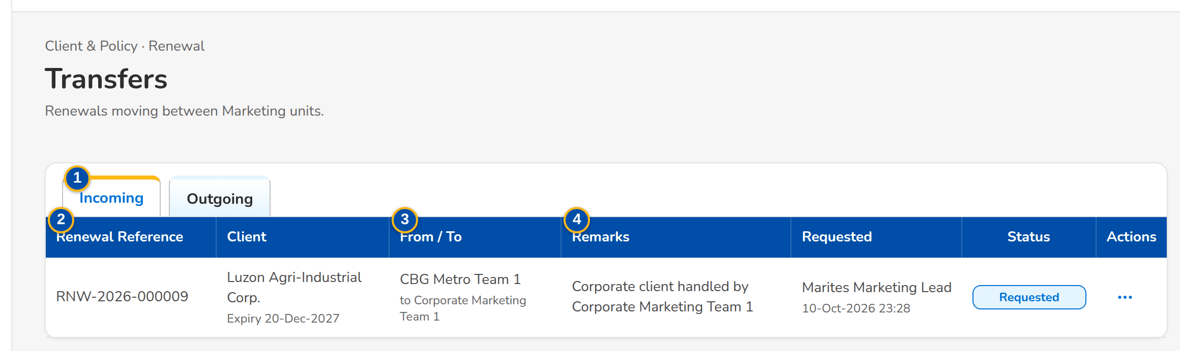
Figure AA.9 - Transfers, Incoming: the request from another unit with its row action menu
Field | Type | Mandatory | Format / list / source | Validation and message
Tabs: Incoming / Outgoing | Tab | - | Transfer requests | -
List: Renewal Reference / Client | Column | - | Reference; client with the expiry under it; Transfers | No transfers
List: From / To | Column | - | Name of the sending unit with the receiving unit under it; Sales organisation | -
List: Remarks / Requested / Status | Column | - | Remarks of the request; the requester's name with the time; Requested, Accepted, Declined or Cancelled; Transfers | -
Accept or Decline dialog: Remarks | Text area | Cond.: decline | Up to 200 characters | Not blank to decline; Enter the remarks

Action | Who | When | What happens | Status after | Notice
Accept (row menu) | A Team Leader of the receiving unit | Requested | Asks for remarks; the renewal joins the unit, unassigned | Unassigned Disposition | Renewal transfer decided
Decline (row menu) | A Team Leader of the receiving unit | Requested | Asks for the remarks; the renewal returns to the sending unit | The status before the request | Renewal transfer decided
Cancel Request (row menu) | The requester | Requested | Asks for confirmation; the renewal stays with the unit | The status before the request | -

AA.10 Processing Worklist (SCR-RN-10)
Purpose: The renewals posted For Renewal, by tab: for processing, in processing, with the insurer, insurer responded and returned. The Processing Team Leader assigns a Processing Officer (or takes them); the officer creates the renewal account and works the renewal; a renewal that cannot proceed is returned to Marketing with a reason. The dispositioned file of Marketing is uploaded here.
Access: Client & Policy › Renewal › Processing Worklist; Renewal Home › Insurer reply overdue; Notification Renewal posted
FR items: FRRN.003.05, FRRN.005.01, FRRN.009.01, FRRN.010.01, FRRN.015.03, FRRN.015.07, FRRN.031.01
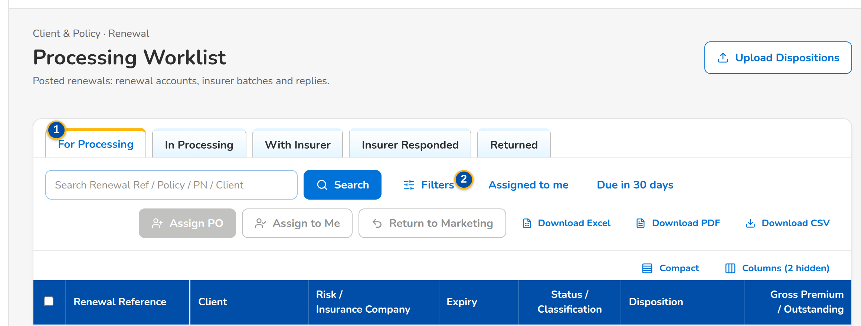
(continued below)
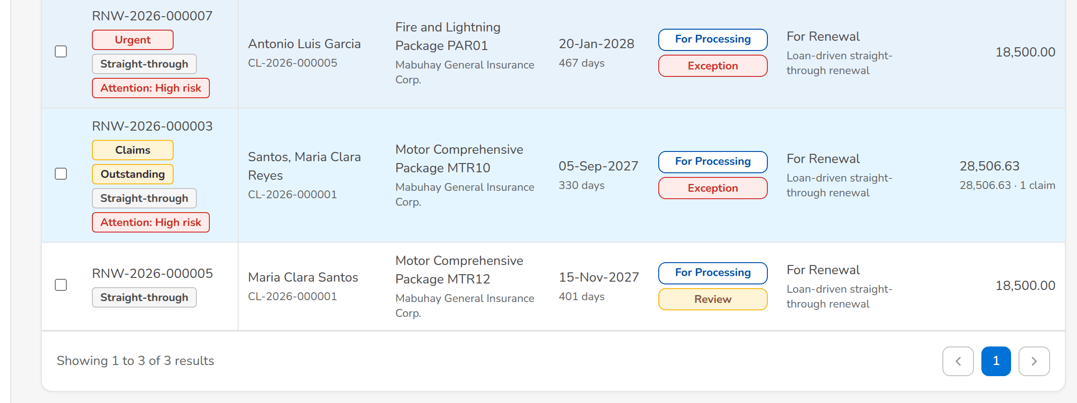
Figure AA.10 - Processing Worklist of the Processing Team Leader with the actions of the tab
Field | Type | Mandatory | Format / list / source | Validation and message
Tabs: For Processing / In Processing / With Insurer / Insurer Responded / Returned | Tab | - | Processing status | -
Quick filters: Assigned to me / Due in 30 days | Toggle button | - | One at a time | -
List: [Columns of the renewal lists] | Column | - | As on the Expiry List (SCR-RN-02); Renewals | No renewals to display
Assign Processing Officer dialog: Processing Officer | Drop-down | Y | Name of the officer; Processing Officers | Active Processing Officer; <officer> is not a Processing Officer
Return to Marketing dialog: Return to | Drop-down | Y | Account Officer or Team Leader; Fixed list | -
Return to Marketing dialog: Reason / Remarks | Drop-down, text area | Y / Y | Renewal return reason list; up to 200 characters; Renewal return reason | Select a reason for 'Return to Marketing'
Upload Dispositions: [Upload wizard: Renewal Reference, Disposition, Reason, New Invoice No, Remarks] | Upload | - | Template of the dispositioned file; Renewals | Every row checked before anything is saved; Disposition <disposition> is not valid
Complete file: Expiry From / Expiry To / Unit | Date, date, text | Y | The expiry range and the unit the file covers | Enter the expiry range and the unit of the complete file

Action | Who | When | What happens | Status after | Notice
Assign PO | Processing Team Leader | Renewals ticked | Opens the dialog; Assign gives the renewals to the officer | In Processing | Renewal assigned
Assign to Me | Processing Team Leader | Renewals ticked | Assigns the renewals to the user | In Processing | -
Return to Marketing | Processing Team Leader and Officers | Renewals ticked | Opens the dialog; the renewal goes back to the officer or the Team Leader | For Disposition or Review in Progress | Renewal returned
Upload Dispositions | Processing Team Leader and Officers (upload permission) | Always | Opens the upload of the dispositioned file; Declare Complete File tags the renewals of the range and unit missing from it | For Disposition with the dispositions of the file | -
Create Renewal Account (renewal) | Processing Officers | For Processing or In Processing without a renewal account | Creates the renewal account (business type Renewal) from the expiring account | - | -

AA.11 Insurer Batches (SCR-RN-11)
Purpose: The renewals sent to each insurer for its renewal terms: New Batch takes the renewals of an insurer in processing for an expiry range with the 28 columns of the insurer extract; the batch is downloaded or sent to the insurer, protected; Upload Insurer Responses records the replies of the insurer's file.
Access: Client & Policy › Renewal › Insurer Batches
FR items: FRRN.013.01, FRRN.013.02, FRRN.013.05, FRRN.021, FRRN.29.05
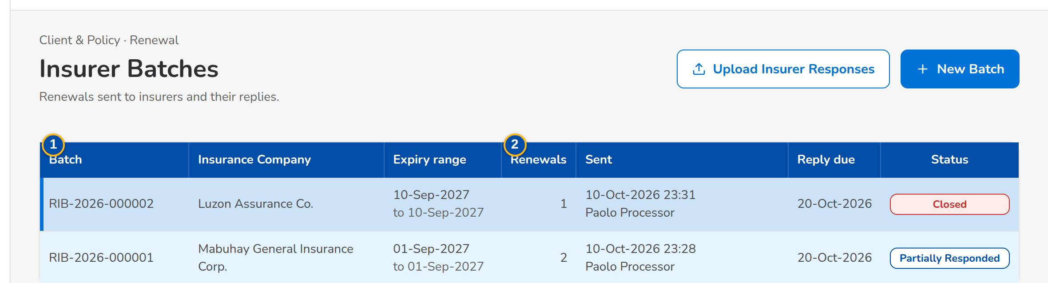
(continued below)
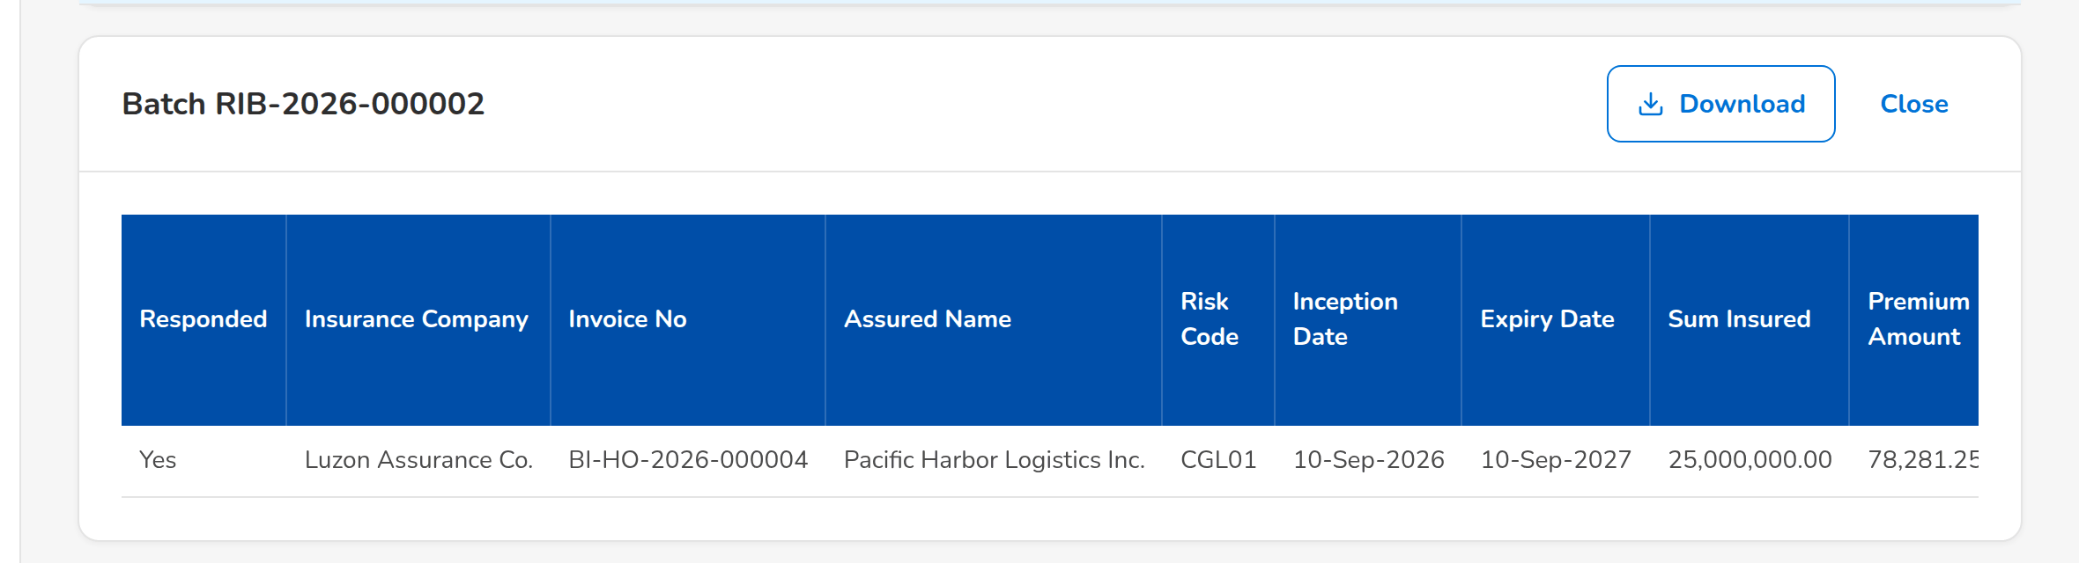
Figure AA.11 - Insurer Batches with the batch opened: the renewals and the columns of the extract
Field | Type | Mandatory | Format / list / source | Validation and message
List: Batch / Insurance Company / Expiry range | Column | - | Batch number; name of the insurer; the range as a period; Insurer batches | No insurer batches
List: Renewals / Sent / Reply due / Status | Column | - | Number of renewals; time and the sender's name; dd-MMM-yyyy; Draft, Sent, Partially Responded or Closed; Insurer batches | -
Batch: Responded / [the 28 columns of the insurer extract] | Table | - | Yes or No for each renewal; Insurance Company, Invoice No, Assured Name, Risk Code, Inception Date, Expiry Date, Sum Insured, Premium Amount and the other columns of FRS this FRS; Renewals of the batch | -
New insurer batch dialog: Insurance Company | Drop-down | Y | Name of the insurer; Insurers of the renewals | Select the insurer
New insurer batch dialog: Expiry From / Expiry To | Date | Y | dd-MMM-yyyy; the end on or after the start | Valid range; Enter a valid start and end date
Upload Insurer Responses: [Upload wizard: Renewal Reference, Policy No, Response, Insurer Reference, Revised Premium, Revised Sum Insured, Revised Rate, Terms, Received On, Reject Action, Remarks] | Upload | - | Template of the insurer responses; Renewals with the insurer | Every row checked before anything is saved; Response <response> is not valid

Action | Who | When | What happens | Status after | Notice
New Batch | Processing (insurer permission) | Always | Opens the dialog; Create Batch takes the renewals of the insurer in the range | Draft | -
Download | Every user of the screen | A batch is open | Downloads the insurer extract | - | -
Send to Insurer | Processing (insurer permission) | Draft | Asks for confirmation; the extract is e-mailed protected to the insurer's renewal contacts | Sent; the renewals With Insurer | Insurer extract e-mail
Upload Insurer Responses | Processing (insurer permission) | Always | Opens the upload of the insurer's file; each response is matched to its renewal | Insurer Responded | Insurer renewal response
Close | Every user of the screen | A batch is open | Closes the batch | - | -

AA.12 Record Insurer Response (SCR-RN-12)
Purpose: The insurer's answer for one renewal, recorded by hand when it does not come in the insurer's file: renew as is, renew with revised terms (the revised premium and sum insured) or declined, with the insurer reference and the date received; a declined renewal is re-marketed to another insurer or goes to the No Advice Letter.
Access: Renewal (With Insurer) › Record Insurer Response
FR items: FRRN.013.01, FRRN.013.02, FRRN.013.05
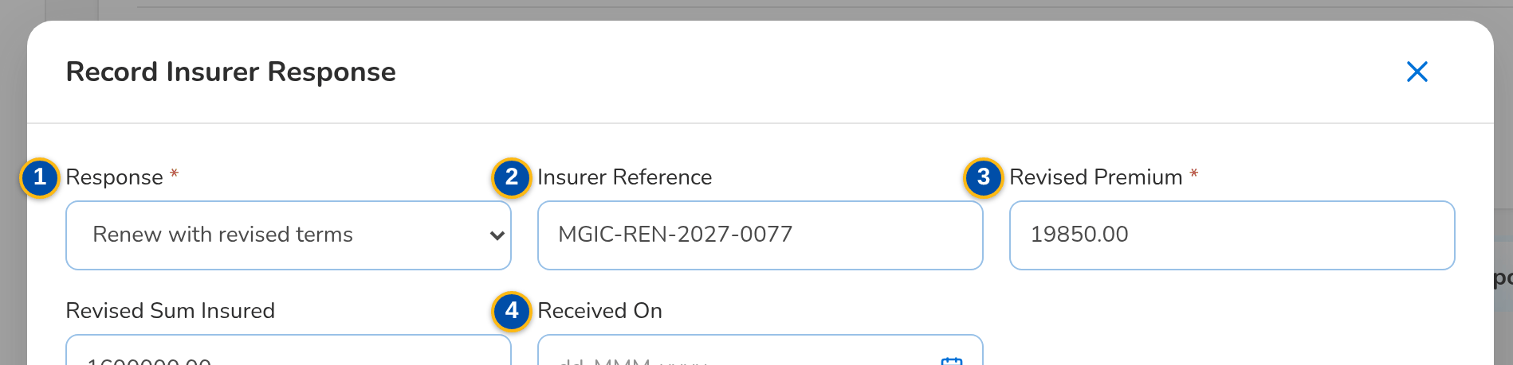
(continued below)
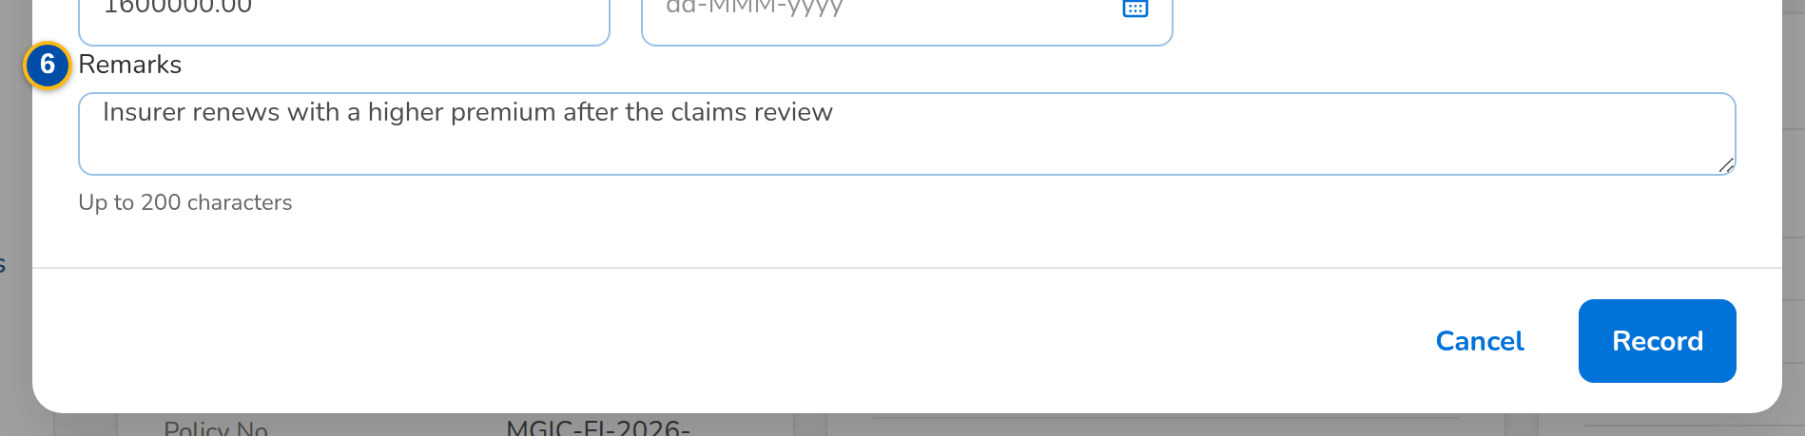
Figure AA.12 - Record Insurer Response dialog: renew with revised terms
Field | Type | Mandatory | Format / list / source | Validation and message
Record Insurer Response dialog: Response | Drop-down | Y | Renew as is, Renew with revised terms, Declined; Insurer renewal response | -
Record Insurer Response dialog: Insurer Reference | Text | N | Reference of the insurer | -
Record Insurer Response dialog: Revised Premium / Revised Sum Insured | Amount | Cond.: revised terms (premium) / N | Two decimals | Above zero; Enter the revised premium
Record Insurer Response dialog: Received On | Date | N | dd-MMM-yyyy | -
Record Insurer Response dialog: Re-market to another insurer | Check box | N | Declined only | -
Record Insurer Response dialog: Remarks | Text area | N | Up to 200 characters | At most 200 characters; Remarks may have at most 200 characters

Action | Who | When | What happens | Status after | Notice
Record Insurer Response | Processing (insurer permission) | With Insurer | Opens the dialog; Record keeps the response, which drives the renewal when it is the latest valid one | RA Ready, In Processing (revised terms), For Disposition (re-market) or Letter Pending (declined) | Insurer renewal response

AA.13 Letters (SCR-RN-13)
Purpose: The letters of the renewals by tab: RA Ready (generate the Renewal Advice, first or second notice), RA Generated (send it, protected, to the client), RA Sent, NAL / NFR (send the No Advice or Not for Renewal letter that closes the renewal) and NRNS (renewals with no response). Client acceptances are recorded on the renewal or uploaded here.
Access: Client & Policy › Renewal › Letters; Renewal Home › NRNS or Letters failed
FR items: FRRN.022.01, FRRN.022.02, FRRN.023.01, FRRN.023.02, FRRN.023.03, FRRN.024.01, FRRN.038.01, FRRN.038.03
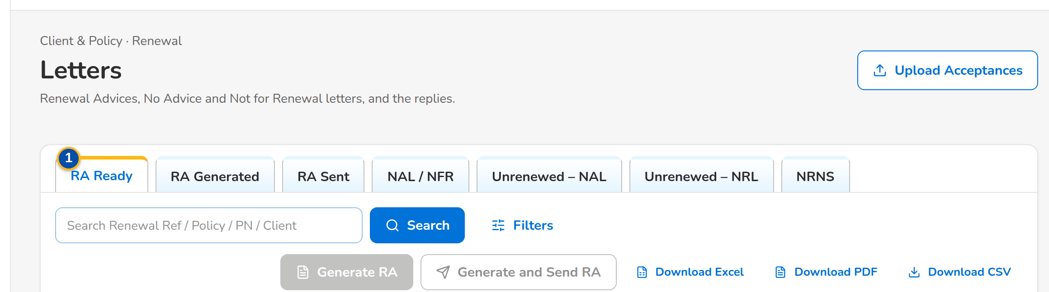
(continued below)
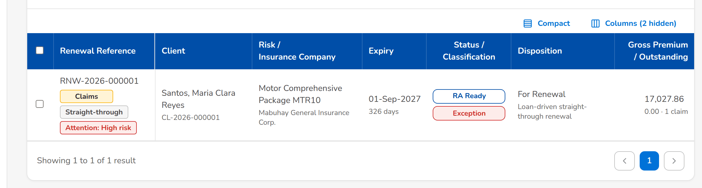
Figure AA.13 - Letters, tab RA Ready: the renewals whose Renewal Advice can be generated
Field | Type | Mandatory | Format / list / source | Validation and message
Tabs: RA Ready / RA Generated / RA Sent / NAL / NFR / NRNS | Tab | - | Letter status of the renewal | -
List: [Columns of the renewal lists] | Column | - | As on the Expiry List (SCR-RN-02); Renewals | No renewals to display
Generate Renewal Advice dialog: Notice | Drop-down | Y | First notice or Second notice; Fixed list | The second notice after the days from the first; The second notice of <renewal ref> is due <ra second notice days> days after the first
Generate Renewal Advice dialog: Generate also when the minimum notice before expiry has passed (the confirmation is recorded) | Check box | Cond.: fewer than 30 days to expiry | - | Renewal <renewal ref> expires in <days> day(s): confirm the late Renewal Advice
Upload Acceptances: [Upload wizard: Renewal Reference, Method, Evidence Reference, Accepted On, Remarks] | Upload | - | Template of the client acceptances; Renewals | Every row checked before anything is saved; Method <method> is not valid (E-mail or Payment)

Action | Who | When | What happens | Status after | Notice
Generate RA | Marketing and Processing (generate permission) | Tab RA Ready, RA Sent or NRNS, renewals ticked | Opens the dialog; Generate creates the Renewal Advice from the latest template and locks the renewal on the Marketing side | RA Generated | -
Send | Marketing and Processing (send permission) | Tab RA Generated, renewals ticked | Asks for confirmation; the Renewal Advice is e-mailed protected to the client | RA Sent / Awaiting Response | Renewal Advice e-mail and password (NT-16, NT-17)
Send Letters | Users with the generate and send permissions | Tab NAL / NFR, renewals ticked | Asks for confirmation; the No Advice or Not for Renewal letter is generated and e-mailed and the renewal is closed | Closed | Closing letter e-mail
Upload Acceptances | Users with the acceptance permission | Always | Opens the upload of the client acceptances | Accepted | Renewal accepted

AA.14 Record Acceptance (SCR-RN-14)
Purpose: The client's acceptance of the Renewal Advice: by e-mail or signed Renewal Advice (the file uploaded in the Documents tab first) or by payment (with its reference), with the date and remarks. When the renewal terms differ from the expiring terms, the user confirms that the client acknowledged the change. Once accepted, the renewal account goes to placement and booking without re-keying.
Access: Renewal (RA Sent / Awaiting Response) › Record Acceptance
FR items: FRRN.025.01, FRRN.028.02
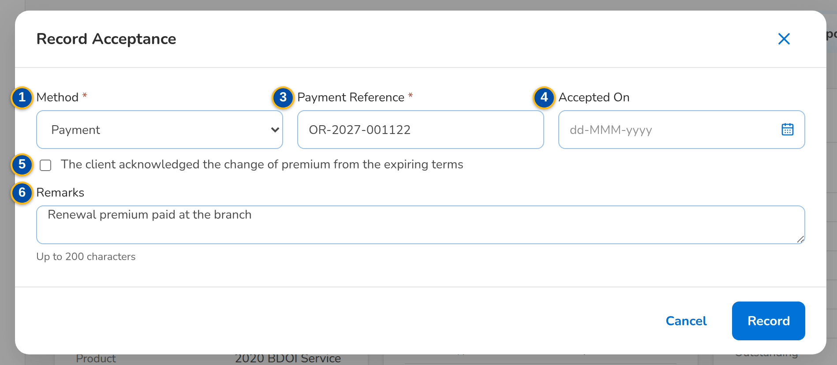
Figure AA.14 - Record Acceptance dialog: acceptance by payment with its reference
Field | Type | Mandatory | Format / list / source | Validation and message
Record Acceptance dialog: Method | Drop-down | Y | E-mail from the client, Signed Renewal Advice, Payment; Fixed list | Select the acceptance method
Record Acceptance dialog: Evidence | Drop-down | Cond.: e-mail or signed Renewal Advice | A document of the renewal (Documents tab); Documents of the renewal | A document of this renewal; The evidence is not a document of this renewal
Record Acceptance dialog: Payment Reference / Reference | Text | Cond.: payment | The payment or e-mail reference | -
Record Acceptance dialog: Accepted On | Date | N | dd-MMM-yyyy | Not in the future; The acceptance date cannot be in the future
Record Acceptance dialog: The client acknowledged the change of premium from the expiring terms | Check box | Cond.: financial impact | - | The renewal terms differ from the expiring terms: confirm that the client accepted them
Record Acceptance dialog: Remarks | Text area | N | Up to 200 characters | -

Action | Who | When | What happens | Status after | Notice
Record Acceptance | Marketing and Processing (acceptance permission) | RA Sent / Awaiting Response | Opens the dialog; Record keeps the acceptance and moves the renewal account on to placement and booking | Accepted, then For Placement and Booking | Renewal accepted

AA.15 Follow-ups (SCR-RN-15)
Purpose: The renewals waiting for the client's reply after the Renewal Advice, for the Contact Center, with the renewals with no response and those on the quotation or proposal path. The Contact Center user opens a renewal to record a call, e-mail or SMS with its outcome and next action date, and uploads the client's documents.
Access: Client & Policy › Renewal › Follow-ups
FR items: FRRN.023.03, FRRN.047.01
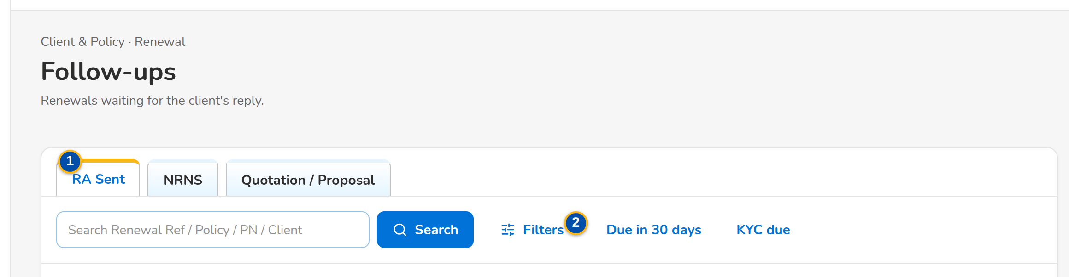
(continued below)
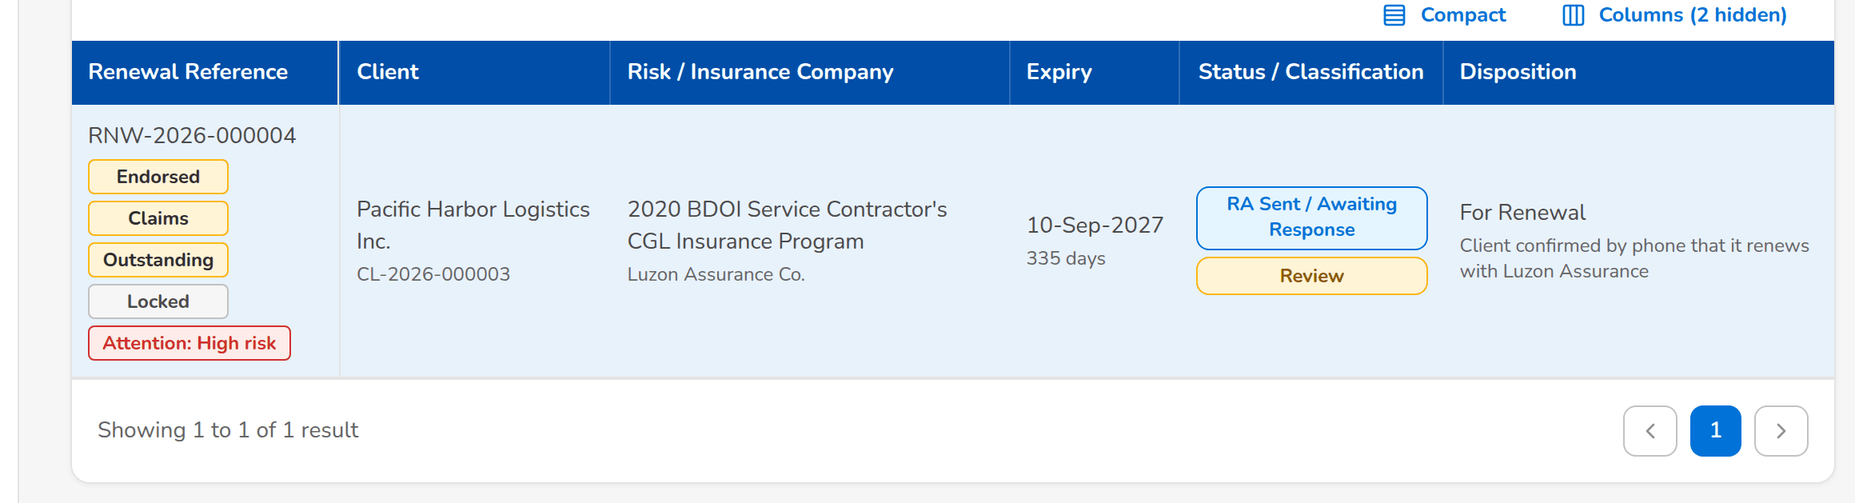
Figure AA.15 - Follow-ups of the Contact Center, tab RA Sent
Field | Type | Mandatory | Format / list / source | Validation and message
Tabs: RA Sent / NRNS / Quotation / Proposal | Tab | - | Stage of the renewal | -
Quick filters: Due in 30 days / KYC due | Toggle button | - | One at a time | -
List: [Columns of the renewal lists] | Column | - | As on the Expiry List (SCR-RN-02), without the premium amounts; Renewals | No renewals to follow up
Add Follow-up dialog: Channel / Outcome | Drop-down | Y / Y | Renewal follow-up channel; renewal follow-up outcome; Lists of values | Select the channel and the outcome
Add Follow-up dialog: Next Action Date | Date | N | dd-MMM-yyyy, from today on | Not in the past; The next action date cannot be in the past
Add Follow-up dialog: Remarks | Text area | Y | Up to 200 characters | Not blank; Enter the remarks

Action | Who | When | What happens | Status after | Notice
Add Follow-up (renewal) | Contact Center | Any open status | Opens the dialog; Save keeps the follow-up on the Remarks & Follow-ups tab | - | -
[Row] | Contact Center | Always | Opens the renewal | - | -

AA.16 LAMD Reports (SCR-RN-16)
Purpose: The monthly paid-off and past-due (RMU) loan reports of the Loan and Mortgage department. Each line is matched to the renewals by PN number: a paid-off loan proposes Not for Renewal, a past-due loan routes the renewal to the Team Leader of its unit.
Access: Client & Policy › Renewal › LAMD Reports
FR items: FRRN.012.01, FRRN.012.02, FRRN.041.01
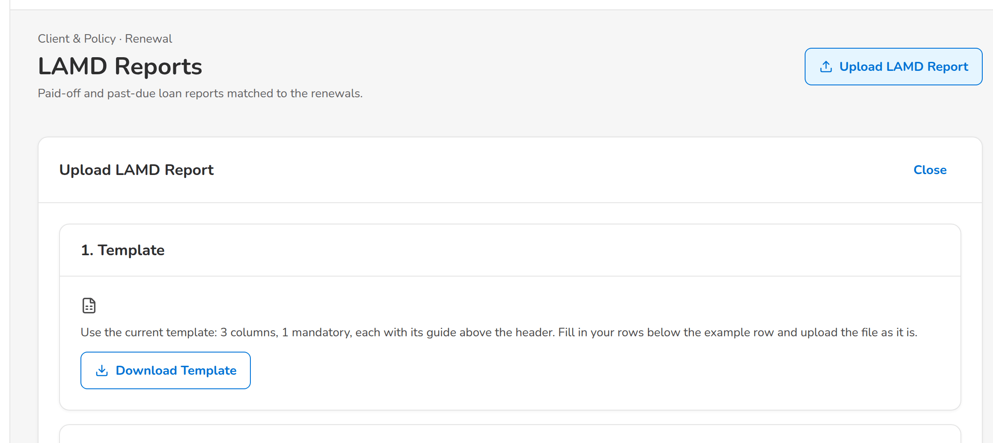
(continued below)
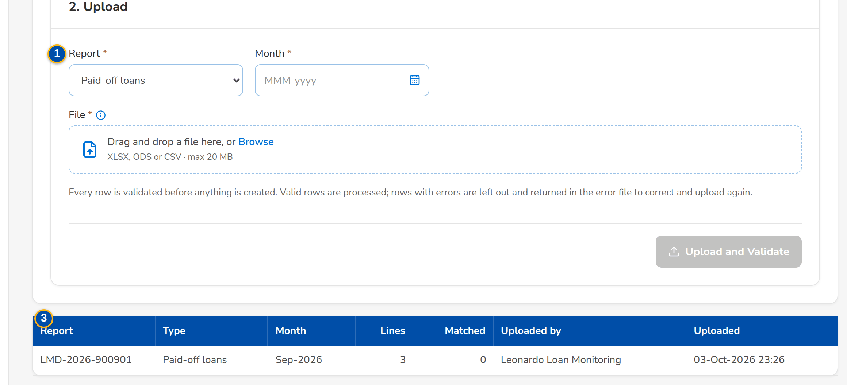
Figure AA.16 - LAMD Reports with the upload of a paid-off or past-due loan report
Field | Type | Mandatory | Format / list / source | Validation and message
Upload LAMD Report: Report / Month | Drop-down, month | Y / Y | Paid-off loans or RMU (past due); the month of the report; Fixed list | Choose the period of the report
Upload LAMD Report: [Upload wizard: PN Number, Status Date, Borrower] | Upload | - | Template of the LAMD loan report | Every row checked before anything is saved; The row has no PN number
List: Report / Type / Month / Lines / Matched / Uploaded by / Uploaded | Column | - | Report number; Paid-off loans or RMU (past due); the month; counts; the user's name and the time; LAMD reports | No LAMD reports uploaded
Lines: Row / PN / Borrower / Loan Status / Status date / Match / Renewal / Outcome | Column | - | The line of the report, the renewal matched and what followed; LAMD lines | No lines

Action | Who | When | What happens | Status after | Notice
Upload LAMD Report | LAMD | Always | Opens the upload; each line is matched to the renewals by PN | - | Renewal assigned to the Team Leaders of the unit
[Row] | LAMD | Always | Opens the lines of the report | - | -

AA.17 Renewal Setup: Non-renewable Risk Codes and Checks (SCR-RN-17)
Purpose: The risk codes that are never renewed (the renewal gets Not for Renewal and the Not for Renewal Letter) and the sanitation checks with their severity and parameters. A new or changed risk code or check applies once another user authorizes it; a risk code is end-dated or deactivated, never deleted.
Access: Client & Policy › Renewal › Renewal Setup › Non-renewable Risk Codes or Checks
FR items: FRRN.007.01, FRRN.007.02, FRRN.038.01, FRRN.038.03, FRRN.040.01, FRRN.040.03
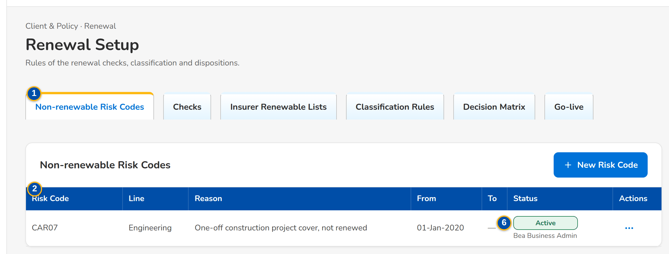
Figure AA.17 - Non-renewable Risk Codes with their row action menu
Field | Type | Mandatory | Format / list / source | Validation and message
Tabs: Non-renewable Risk Codes / Checks / Classification Rules / Decision Matrix / Package Map / Package Choices / Go-live | Tab | - | By permission | -
Risk codes: Risk Code / Line / Reason / From / To / Status | Column | - | Code; name of the line or All; dates dd-MMM-yyyy; Active, Pending Authorization or Inactive with the maker's name; Non-renewable risk codes | No non-renewable risk codes
Risk code dialog: Risk Code / Line of Business | Text | Y / N | The risk code; the line, blank for every line; Product catalogue | Not blank; Enter the risk code
Risk code dialog: Effective From / Effective To | Date | Y / N | dd-MMM-yyyy; the end after the start | The end after the start; The effective-to date is before the effective-from date
Risk code dialog: Reason | Text | Y | Up to 200 characters | Not blank; Enter the reason and the effective date
Checks: Check / Active / Severity / Parameters / Status | Column | - | Name of the check; Yes or No; Fail – Exception, Fail – Review, Warning, Information or System (sets the disposition); the settings of the check; Check settings | No checks
Check dialog: Active / Severity / Parameters | Check box, drop-down, text | N / Y / N | Optional settings of the check, e.g. days=30; Severities | Choose the severity of the check

Action | Who | When | What happens | Status after | Notice
New Risk Code | Business Administrator | Always | Opens the dialog; Save for Authorization keeps the code waiting for a second user | Pending Authorization | -
Authorize (row menu) | Another Business Administrator than the maker | Pending Authorization | Asks for confirmation; the change takes effect | Active | -
Edit (row menu) | Business Administrator | Always | Opens the dialog; the change waits for authorization | Pending Authorization | -
Deactivate (row menu) | Business Administrator | Active | Asks for confirmation; the code is no longer used for new renewals | Inactive | -

AA.18 Renewal Setup: Classification Rules and Decision Matrix (SCR-RN-18)
Purpose: The versioned rules: the classification rules turn the check results into Clean, Review or Exception; the decision matrix proposes the disposition by segment, line, product, mortgage, classification, claims, endorsement, payment and days to expiry, automatic or as a proposal to the officer, with the letter. A new version is a draft from the active one, submitted, then activated or rejected by another user; activation retires the active version.
Access: Client & Policy › Renewal › Renewal Setup › Classification Rules or Decision Matrix
FR items: FRRN.008.01, FRRN.040.01, FRRN.040.02, FRRN.040.03
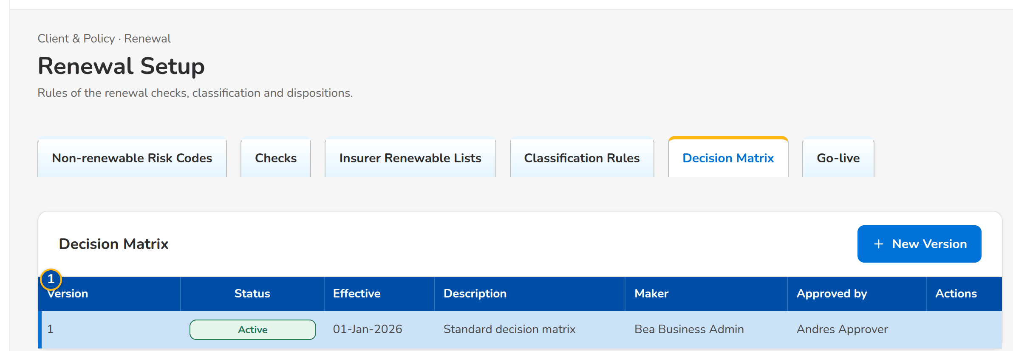
(continued below)
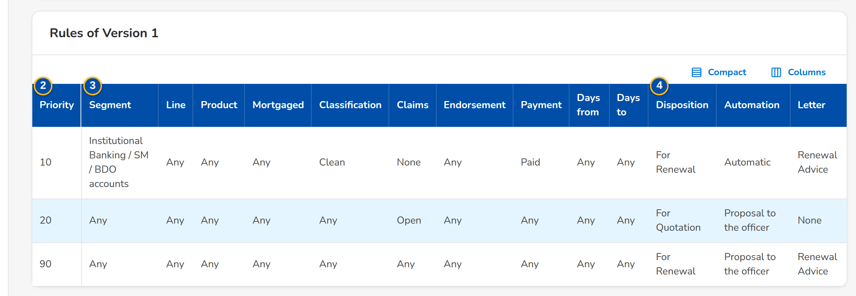
Figure AA.18 - Decision Matrix: the versions with their row action menu and the rules of the active version
Field | Type | Mandatory | Format / list / source | Validation and message
Versions: Version / Status / Effective / Description / Maker / Approved by | Column | - | Number; Draft, Submitted, Active, Retired or Rejected; dd-MMM-yyyy; users' names; Rule versions | No versions
Classification rules: Priority / Check / Severity / Outcome / Classification | Column | - | Order of the rule; the check or Any; the severity or Any; Failed or Warning; Clean, Review or Exception; Classification rules | No rules
Decision matrix: Priority / Segment / Line / Product / Mortgaged / Classification / Claims / Endorsement / Payment / Days from / Days to | Column | - | The conditions of the rule; Any when blank; Decision matrix | No rules
Decision matrix: Disposition / Automation / Letter | Column | - | The disposition proposed; Automatic or Proposal to the officer; Renewal Advice, Not for Renewal, No Advice Letter or None; Decision matrix | -
New version dialog: Effective From / Description | Date, text | N / N | dd-MMM-yyyy; up to 200 characters | -
New version dialog: [The rules of the version, one row each, with Add Rule and Remove rule] | Table | Y | The columns of the rules | Each rule its own priority; a failed check never gives Clean; Two rules have the priority <p>

Action | Who | When | What happens | Status after | Notice
New Version | Business Administrator | Always | Opens the dialog with the rules of the active version; Save Draft keeps the draft | Draft | -
Submit (row menu) | Business Administrator | Draft | Submits the version for a second user | Submitted | -
Activate (row menu) | Another Business Administrator than the maker | Submitted | Asks for confirmation; the version replaces the active one from its effective date | Active | -
Reject (row menu) | Another Business Administrator than the maker | Submitted | Asks for the reason; the version returns to its maker | Rejected | -

AA.19 Renewal Setup: Package Map, Package Choices and Propose Package (SCR-RN-19)
Purpose: The package of a migrated policy: the package map gives the the system product and version a legacy package renews on (or rejects it), by risk code, insurer and sum insured band; when the map gives no answer, a Processing Officer proposes the package on the renewal and another member of the team approves or rejects the choice.
Access: Client & Policy › Renewal › Renewal Setup › Package Map or Package Choices; Renewal (migrated packaged policy) › Propose Package
FR items: FRRN.046.01
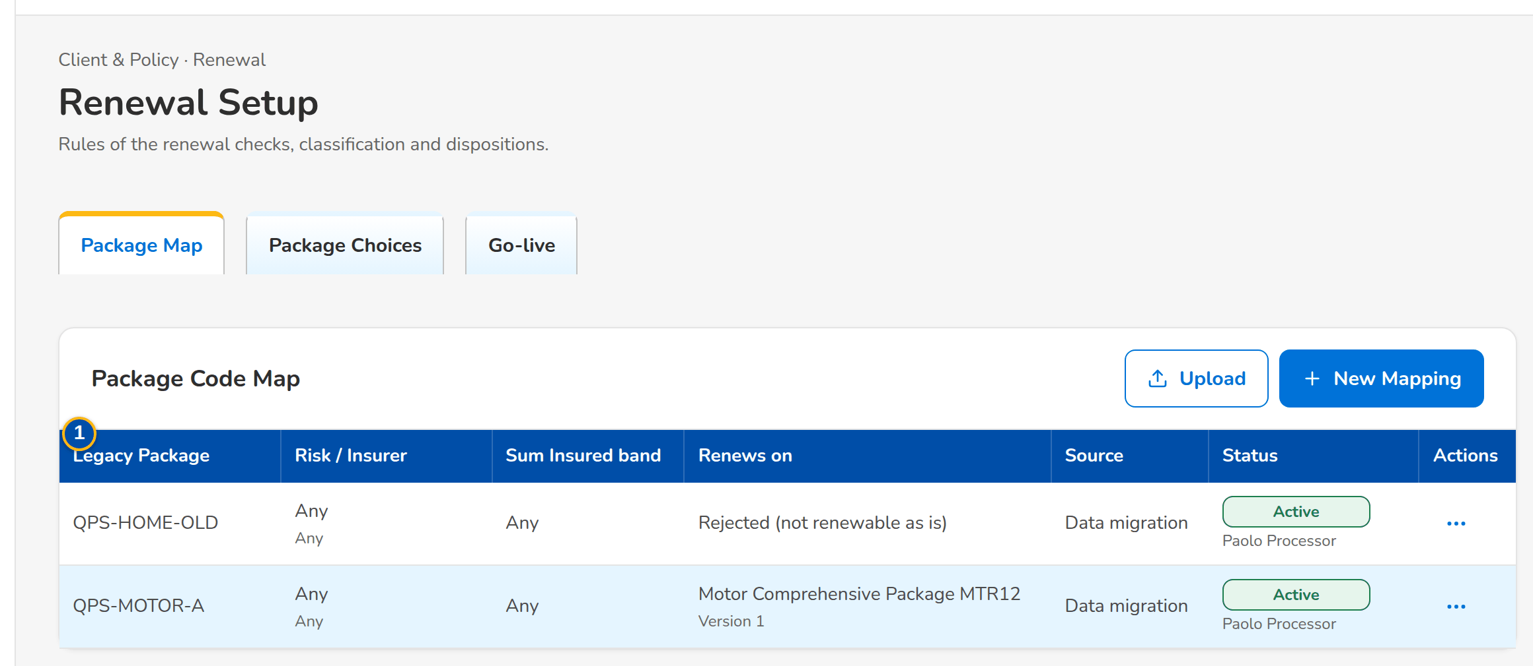
Figure AA.19 - Package Map of the migrated policies with the row action menu
Field | Type | Mandatory | Format / list / source | Validation and message
Package map: Legacy Package / Risk / Insurer / Sum Insured band / Renews on / Source / Status | Column | - | Legacy code with its version; risk code and insurer name or Any; the band or Any; product name with its version, or Rejected (not renewable as is); Data migration, Entered on screen or Upload; the approval status; Package map | No package mappings
Mapping dialog: Legacy Package Code / Legacy Package Version / Risk Code / Insurance Company / Sum Insured From / Sum Insured To | Text, amount | Y / N | The legacy package and its qualifiers, blank for any | -
Mapping dialog: Product Code (blank to reject) / Product Version / Remarks | Text, number | N | The the system product and version; Product catalogue | -
Package choices: Renewal / Client / Legacy Package / Proposed / Reason / Proposed by | Column | - | Renewal reference; client; legacy package; product name with its version; the reason; the maker's name with the time; Package choices | No package choices waiting
Propose Package dialog: Product Code / Product Version / Reason | Text, number, text area | Y / Y / Y | A product that can be sold for renewal; version 1 or more; up to 200 characters; Product catalogue | Enter the reason of the choice

Action | Who | When | What happens | Status after | Notice
New Mapping | Processing (package permission) | Always | Opens the dialog; Save for Authorization keeps the mapping waiting for a second user | Pending Authorization | -
Upload | Processing (package permission) | Always | Opens the upload of the package map | Pending Authorization | -
Authorize, Edit, Deactivate (row menu) | Processing (package permission); Authorize by another user than the maker | By status | As for the risk codes (SCR-RN-17) | Active, Pending Authorization or Inactive | -
Approve, Reject (row menu) | Another member of the Renewal processing team than the maker | Choice waiting | Asks for remarks (mandatory to reject); an approved choice applies to the renewal | Approved or Rejected | Package choice decided
Propose Package (renewal) | Processing Officers | Open renewal of a migrated packaged policy | Opens the dialog; Submit for Approval keeps the choice waiting | Pending | -

AA.20 Renewal Setup: Go-live (SCR-RN-20)
Purpose: The take-over of the renewals of the migrated policies expiring from the go-live date within the renewal horizon, the upload of the migrated policies when the migration source is not connected, and the Renewal Advices sent by hand before go-live, recorded so they are never sent again, with the corrections approved by a second team member.
Access: Client & Policy › Renewal › Renewal Setup › Go-live
FR items: FRRN.045.01, FRRN.045.02
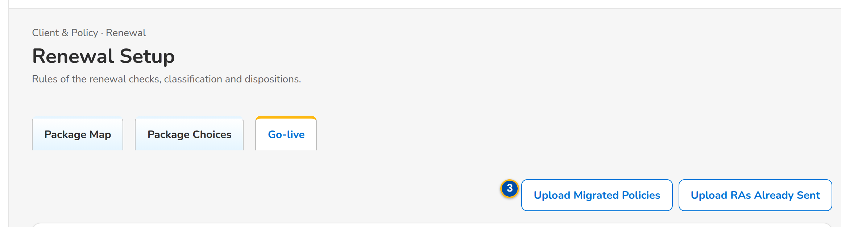
(continued below)
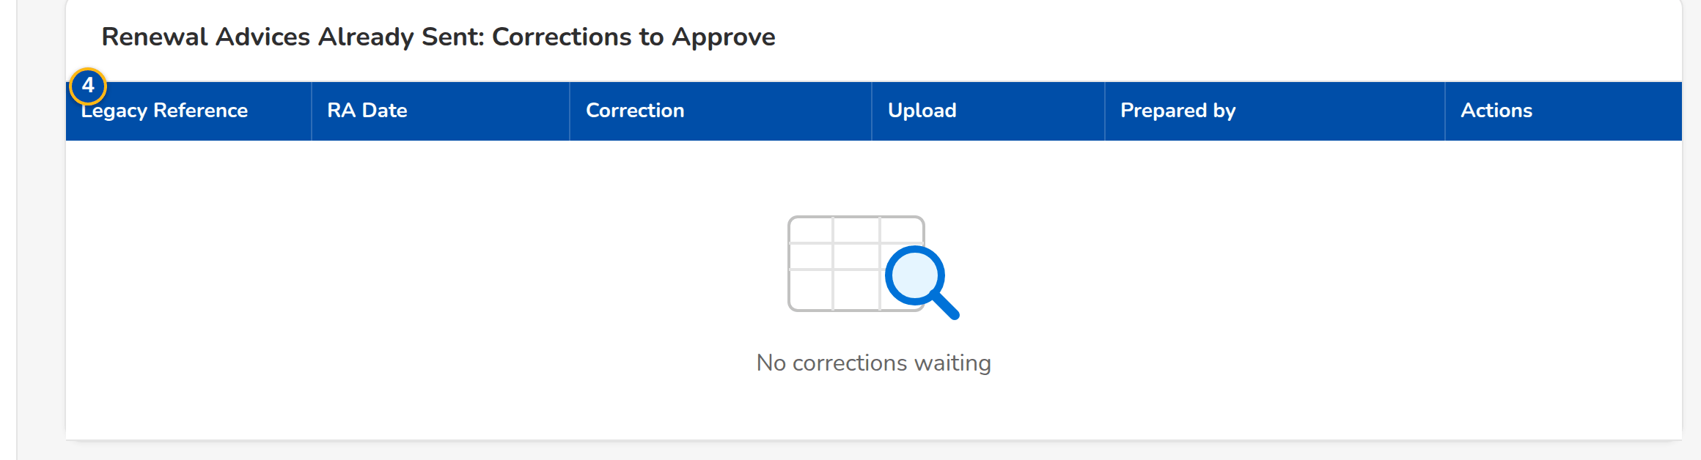
Figure AA.20 - Go-live tab of the Processing Team Leader: the uploads of the go-live and the corrections to approve
Field | Type | Mandatory | Format / list / source | Validation and message
Go-live take-over: Go-live Date | Date | Y | dd-MMM-yyyy | -
Go-live take-over: [Migrated policies source: connected or loaded by upload] | Text | - | Data migration | -
Uploads: Upload Migrated Policies / Upload RAs Already Sent | Upload | - | Templates of the expiring policies of the legacy systems and of the Renewal Advices sent before go-live | Every row checked before anything is saved; Legacy policy <legacy ref> is already a renewal
Corrections: Legacy Reference / RA Date / Correction / Upload / Prepared by | Column | - | The Renewal Advice recorded and the correction proposed; the upload and row; the maker's name; Renewal Advices already sent | No corrections waiting

Action | Who | When | What happens | Status after | Notice
Run Take-over | Business Administrator | Go-live date entered | Takes over the renewals of the migrated policies expiring from the date within the horizon; expiries up to the urgent date are flagged Urgent | Extracted | Go-live renewal extraction completed
Upload Migrated Policies | Users with the extract permission | Always | Opens the upload of the migrated policies | - | -
Upload RAs Already Sent | Users with the send permission | Always | Opens the upload of the Renewal Advices sent by hand | - | -
Approve, Reject (row menu) | Another member of the Renewal processing team than the maker | Correction waiting | Asks for remarks (mandatory to reject) | Approved or Rejected | -

AA.21 Renewal Dashboard (SCR-RN-21)
Purpose: The Marketing view of the renewals for a period: the KPI cards (basic premium and gross commission against the budget, pipeline, closing ratio, persistency), the outstanding renewal accounts by product, the biggest open deals, the insurer approval monitoring and the open renewal accounts per officer. Each figure opens the accounts behind it.
Access: Client & Policy › Renewal › Renewal Dashboard; Home after sign-in of the Marketing users
FR items: FRRN.002, FRRN.042, FRRN.044
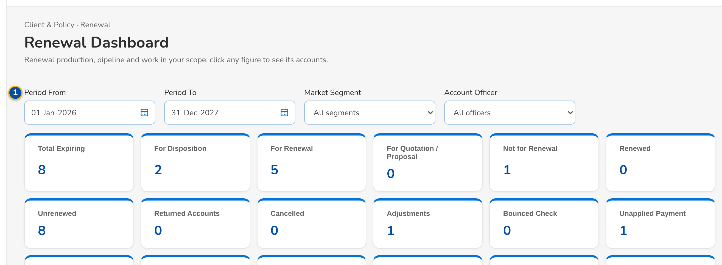
(continued below)
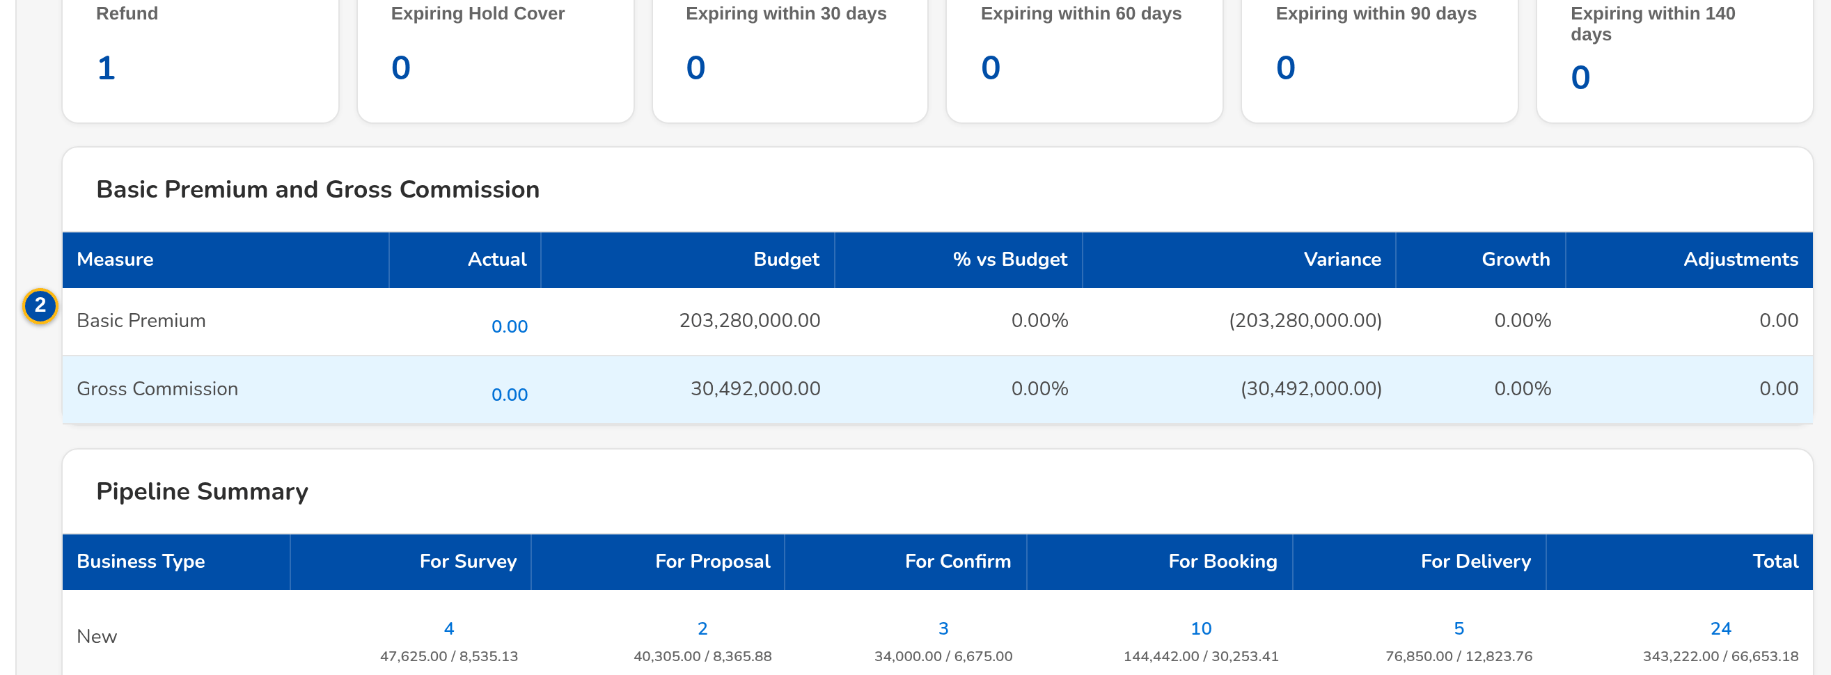
(continued below)
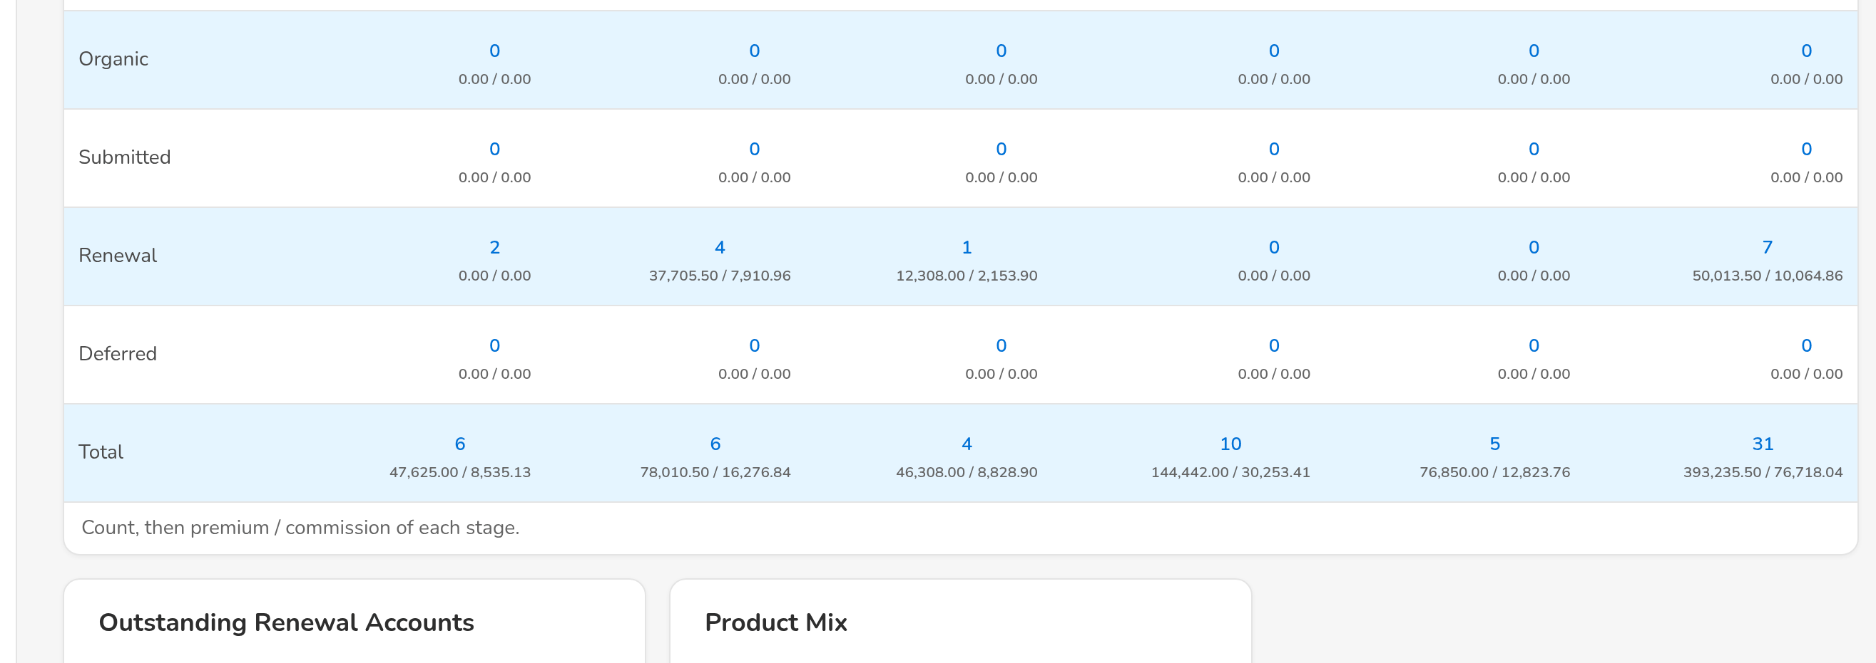
(continued below)
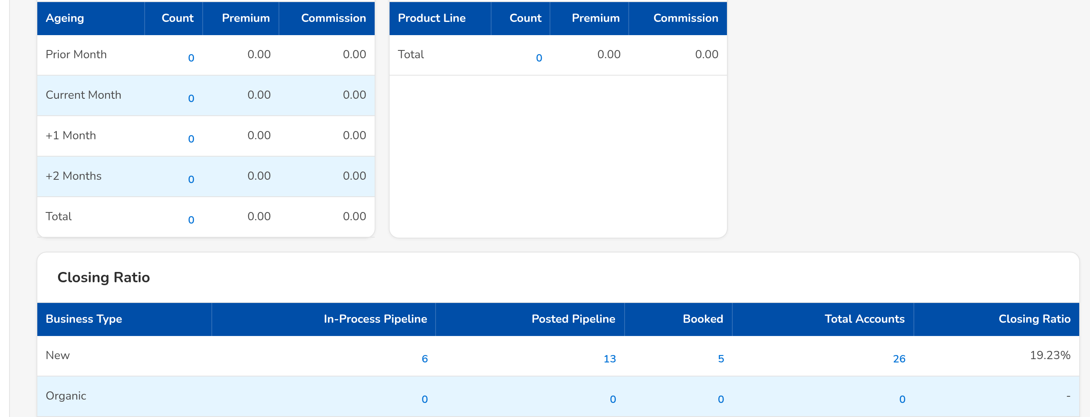
Figure AA.21 - Renewal Dashboard of the Marketing Team Leader: KPI cards, pipeline and the open accounts per officer
Field | Type | Mandatory | Format / list / source | Validation and message
Filters: Period From / Period To / Market Segment / Account Officer | Date, date, drop-down, drop-down | N | dd-MMM-yyyy; names; Market segments; users of the unit | Period To not before Period From
KPI summary cards: Basic Premium and Gross Commission / Pipeline Summary / Closing Ratio / Renewal Persistency Ratio | Card | - | Actual, Budget, % vs Budget, Variance, Growth; counts and amounts; Renewals, budget | -
Biggest Open Deals: Ranking / Account Number / Assured Name / Risk Code / Team / Premium Amount / Commission Amount | Table | - | Two decimals; Open renewals | No open deals
Insurer Renewal Approval Monitoring: Insurer Name / Number of Pending Accounts / % of Approval | Table | - | Counts and percentages; Renewals with the insurer | No pending accounts
Open Renewal Accounts per Officer: Officer / Open Renewal Accounts | Table | - | Counts; Assignments | No renewal accounts assigned
Drill-down: Reference Number / Premium / Commission / Assigned User / Expiry Date | Table in a dialog | - | Two decimals; dd-MMM-yyyy; The accounts behind a figure | No records found.

Action | Who | When | What happens | Status after | Notice
[Figure or row] | Marketing users | Always | Opens the accounts behind the figure; a row opens the renewal | - | -

AA.22 Renewal Accounts (SCR-RN-22)
Purpose: The renewal accounts of the user's unit in BDOI's bucket panels: Clean, Review, the third panel of the setting (Non-Renewable by default) and All, with the expiring invoice, the renewal reference, the claim flag, the amounts and the disposition. The account tags of a file are uploaded here.
Access: Client & Policy › Renewal › Renewal Accounts; Renewal Dashboard › a figure
FR items: FRRN.002, FRRN.008, FRRN.009, FRRN.015
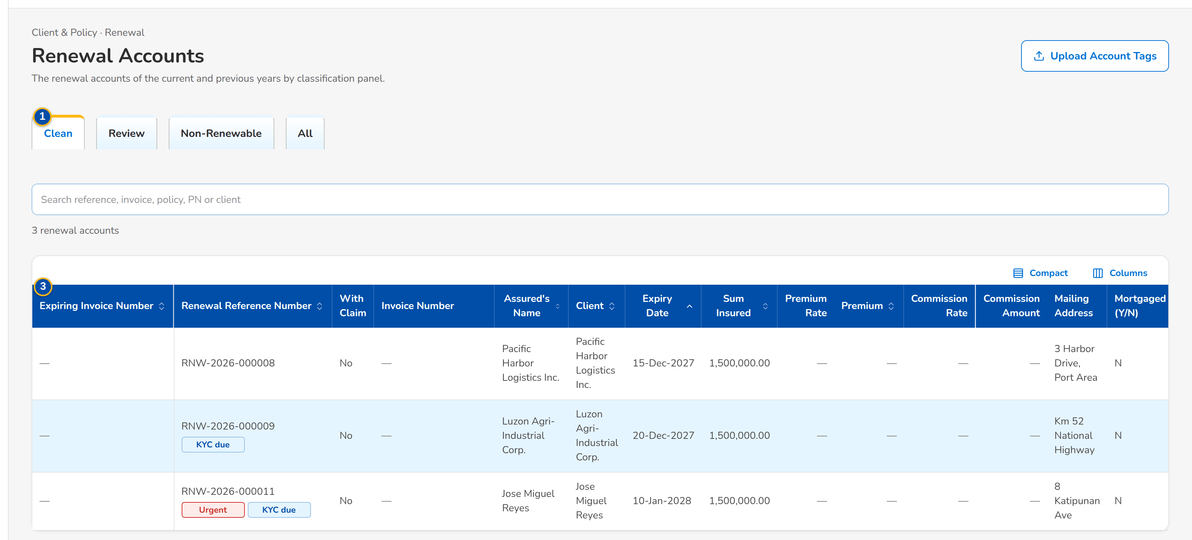
Figure AA.22 - Renewal Accounts, Clean panel: the accounts with their amounts, status and assigned user
Field | Type | Mandatory | Format / list / source | Validation and message
Panels: Clean / Review / Non-Renewable / All | Tab | - | Count on each tab; Bucket classification of the account (Annex AC.9, C01) | -
Search: Search the renewal accounts | Text | N | Reference, invoice, client or assured | -
List: Expiring Invoice Number / Renewal Reference Number / With Claim / Invoice Number / Assured / Client / Expiry Date / Sum Insured / Premium Rate / Premium / Commission Rate / Commission Amount / Mailing Address / Mortgaged (Y/N) / Renewal Status / Renewal Disposition / Assigned User | Column | - | Two decimals; dd-MMM-yyyy; labels; Renewal accounts | No renewal accounts in this panel
Upload Account Tags: [Upload of the file of account tags] | Upload | - | Template of the account tags; Renewal accounts | Every row checked before anything is saved

Action | Who | When | What happens | Status after | Notice
Upload Account Tags | Marketing users (update permission) | Always | Uploads the tags of the accounts of the file (bulk update) | - | -
[Row] | Marketing users | Always | Opens the renewal | - | -

AA.23 Processing Dashboard (SCR-RN-23)
Purpose: The Processing view of the month: KPI cards of the accounts to process, a combined, New Business or Renewal view, and the accounts by Placement Processor, assigned or unassigned.
Access: Client & Policy › Renewal › Processing Dashboard; Home after sign-in of the Processing users
FR items: FRRN.003, FRRN.010
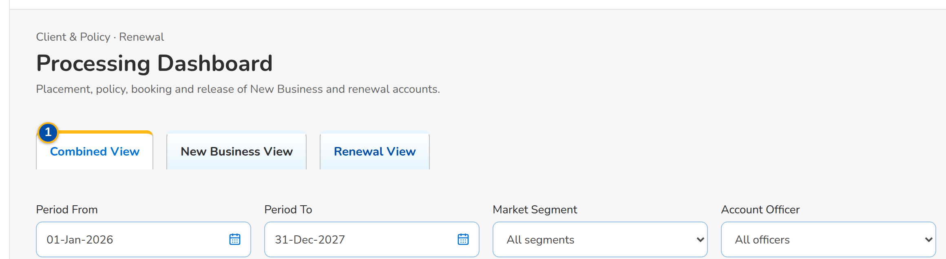
(continued below)
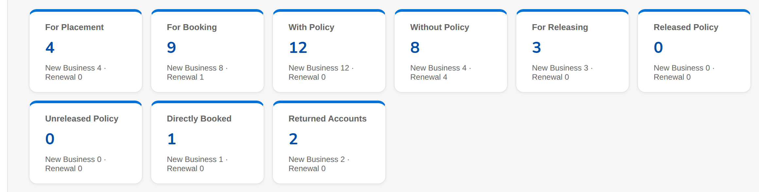
Figure AA.23 - Processing Dashboard of the Processing Team Leader: KPI cards and the accounts of the month
Field | Type | Mandatory | Format / list / source | Validation and message
View: Combined View / New Business View / Renewal View | Toggle | - | One at a time | -
Processing KPI cards: Accounts by status of processing | Card | - | Counts; Renewals and New Business accounts | -
Filter: Placement Processor / Unassigned / Assigned | Toggle | - | One at a time; Processing Officers | -
List: Account Reference Number / Month and the counts of the stages | Table | - | Counts; Accounts of the month | No records found.

Action | Who | When | What happens | Status after | Notice
[Figure or row] | Processing users | Always | Opens the accounts behind the figure | - | -

AA.24 Transfer Requests (SCR-RN-24)
Purpose: The requests to transfer a renewal account to another Marketing unit as a New Business opportunity: the source unit raises the request with a justification, the receiving unit accepts, rejects or returns it for clarification and creates the New Business account; the requester may cancel it while it is open.
Access: Client & Policy › Renewal › Transfer Requests; Renewal › Transfer to Another Unit
FR items: FRRN.011
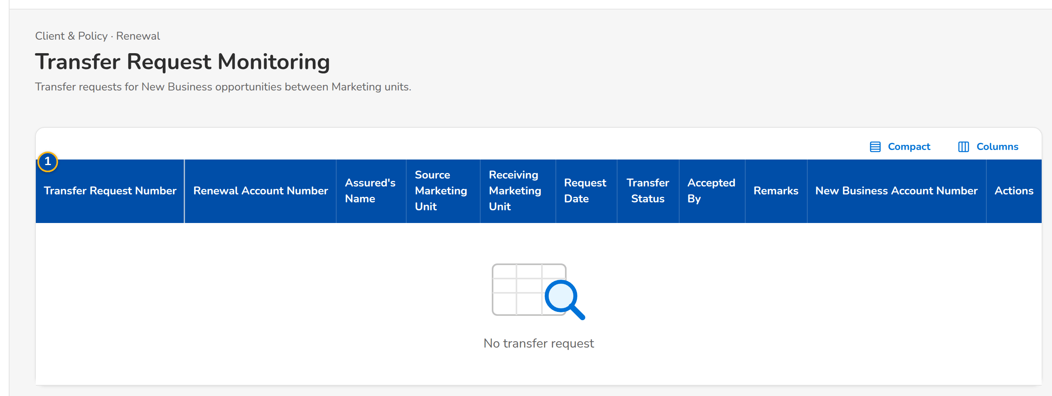
Figure AA.24 - Transfer Request Monitoring with the requests and their status
Field | Type | Mandatory | Format / list / source | Validation and message
List: Transfer Request Number / Renewal Account Number / Assured / Source Marketing Unit / Receiving Marketing Unit / Request Date / Transfer Status / Accepted By / Remarks / New Business Account Number | Column | - | dd-MMM-yyyy; names of the units; Transfer requests | No transfer request
Transfer request dialog: Receiving Marketing Unit / Business Justification | Drop-down, text area | Y / Y | Marketing units; up to 500 characters; Marketing units | Another unit than the source; Enter the business justification
Decision dialog: Remarks | Text area | Cond.: reject or return | Up to 500 characters | Enter the remarks
Create New Business Account dialog: Risk Code / Market Segment / Period From / Period To | Drop-down, drop-down, date, date | Y | Names; dd-MMM-yyyy; Risk codes, market segments | Period To after Period From

Action | Who | When | What happens | Status after | Notice
Accept | Receiving unit (Team Leader) | Request open | Accepts the transfer | Accepted | Transfer accepted
Reject / Return for Clarification | Receiving unit (Team Leader) | Request open | Records the decision with the remarks | Rejected / Returned | Transfer decided
Create New Business Account | Receiving unit | Request accepted | Creates the New Business account of the opportunity; its number is shown on the request | Completed | -
Cancel Request | Source unit | Request open | Cancels the request | Cancelled | -

AA.25 Submitted for Approval (SCR-RN-25)
Purpose: The renewal accounts accepted by the client that wait for the second approval of the setting (Annex AC.9, C23), with the client payment confirmation. The approver approves or rejects each account with the reason.
Access: Client & Policy › Renewal › Submitted for Approval; Notification Renewal submitted for approval
FR items: FRRN.016, FRRN.026
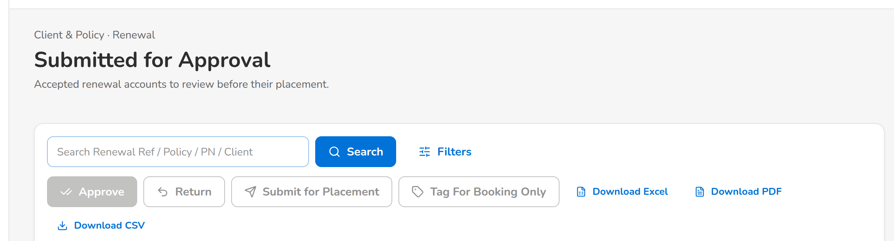
(continued below)
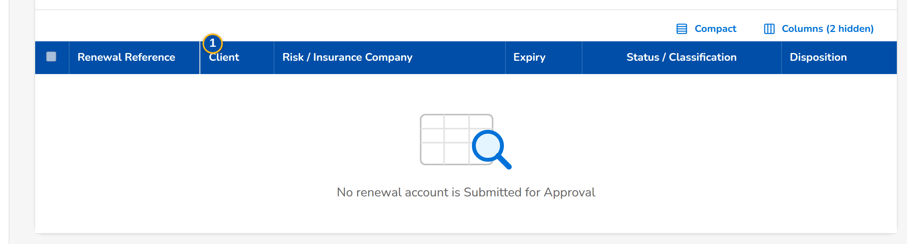
Figure AA.25 - Submitted for Approval with the accounts waiting for the approver
Field | Type | Mandatory | Format / list / source | Validation and message
List: Reference / Client / Disposition / Premium / Submitted by / Submitted on | Column | - | Two decimals; dd-MMM-yyyy; Renewals Submitted for Approval | No renewal account is Submitted for Approval
Approve dialog: Client payment confirmation | Tick box | Cond.: payment before placement | Confirmed by the client | -
Reject dialog: Reason or remarks | Text area | Y | Up to 500 characters | Enter the reason

Action | Who | When | What happens | Status after | Notice
Approve | Approver (not the submitter) | Submitted for Approval | Approves the account; it goes to the payment check and placement | For Placement | Renewal approved
Reject | Approver (not the submitter) | Submitted for Approval | Returns the account to the Account Officer with the reason | Returned | Renewal returned

AA.26 Submitted for Placement (SCR-RN-26)
Purpose: The renewal accounts submitted for placement with the insurers: the Processing Officer sends the placement slip to each insurer through CCM or by protected e-mail (setting, Annex AC.9, C17), records the insurer's response and returns an account that cannot be placed.
Access: Client & Policy › Renewal › Submitted for Placement
FR items: FRRN.029, FRRN.030, FRRN.031, FRRN.032
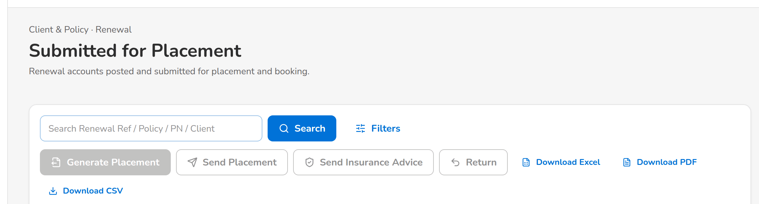
(continued below)
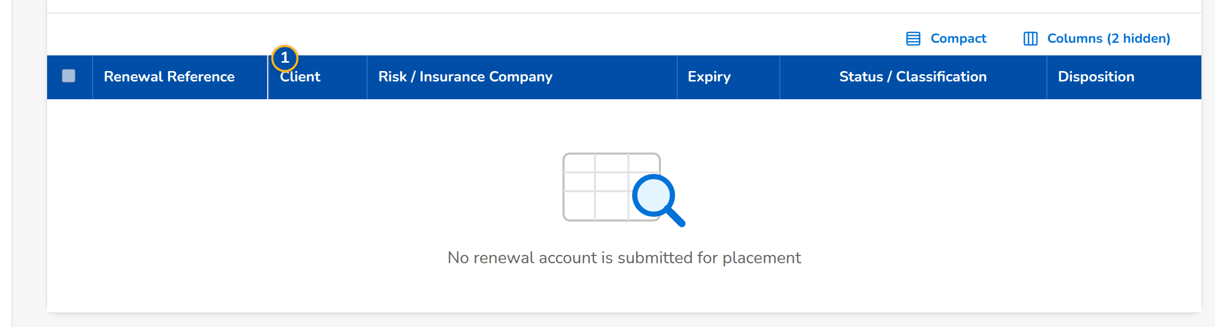
Figure AA.26 - Submitted for Placement with the accounts waiting for the insurers
Field | Type | Mandatory | Format / list / source | Validation and message
List: Reference / Client / Insurer / Premium / Submitted / TAT (business days) / SLA | Column | - | Two decimals; dd-MMM-yyyy; Renewals submitted for placement | No renewal account is submitted for placement
Send dialog: Recipients / CC recipients | E-mail addresses | Y / N | Separated by commas; Insurer contacts | Valid e-mail addresses
Return dialog: Return reason / Remarks | Drop-down, text area | Y / Y | Return reasons; up to 500 characters; Renewal return reason | Select a return reason

Action | Who | When | What happens | Status after | Notice
Send / Send via CCM | Processing Officers | For Placement | Sends the placement slip to the insurer by the channel of the setting | With Insurer | -
Record Insurer Response | Processing Officers | With Insurer | Opens the response of the insurer (SCR-RN-36, Placement tab) | Placed or Rejected | -
Return | Processing Officers | For Placement | Returns the account to Marketing with the reason | Returned | Renewal returned

AA.27 TSU Requests (SCR-RN-27)
Purpose: The requests of the Account Officers to the Technical Support Unit for a quotation or a proposal of a renewal, by status: pending the Team Lead's approval, approved, for TSU processing and completed.
Access: Client & Policy › Renewal › TSU Requests; Renewal › Proposal & TSU tab
FR items: FRRN.017, FRRN.018, FRRN.019
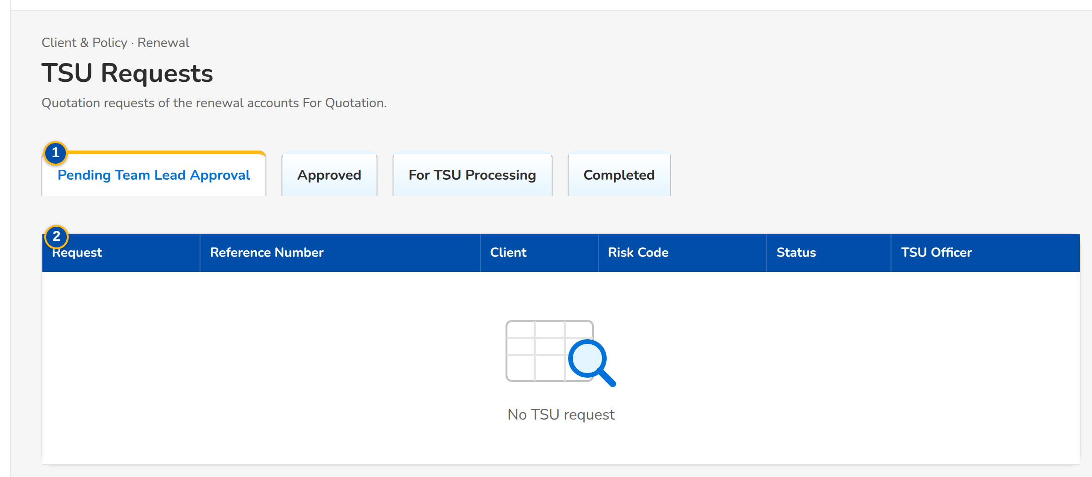
Figure AA.27 - TSU Requests with the requests of the unit by status
Field | Type | Mandatory | Format / list / source | Validation and message
Status tabs: Pending Team Lead Approval / Approved / For TSU Processing / Completed | Tab | - | Count on each tab; TSU requests | -
List: Request / Reference Number / Client / Risk Code / Status / TSU Officer | Column | - | Names of the users; TSU requests | No TSU request

Action | Who | When | What happens | Status after | Notice
[Row] | Marketing and TSU users | Always | Opens the renewal on its Proposal & TSU tab | - | -

AA.28 KYC Monitoring (SCR-RN-28)
Purpose: The renewal accounts whose client is due for the KYC review: due, upcoming, completed and pending follow-up. KYC is for information and never blocks the renewal.
Access: Client & Policy › Renewal › KYC Monitoring
FR items: FRRN.039
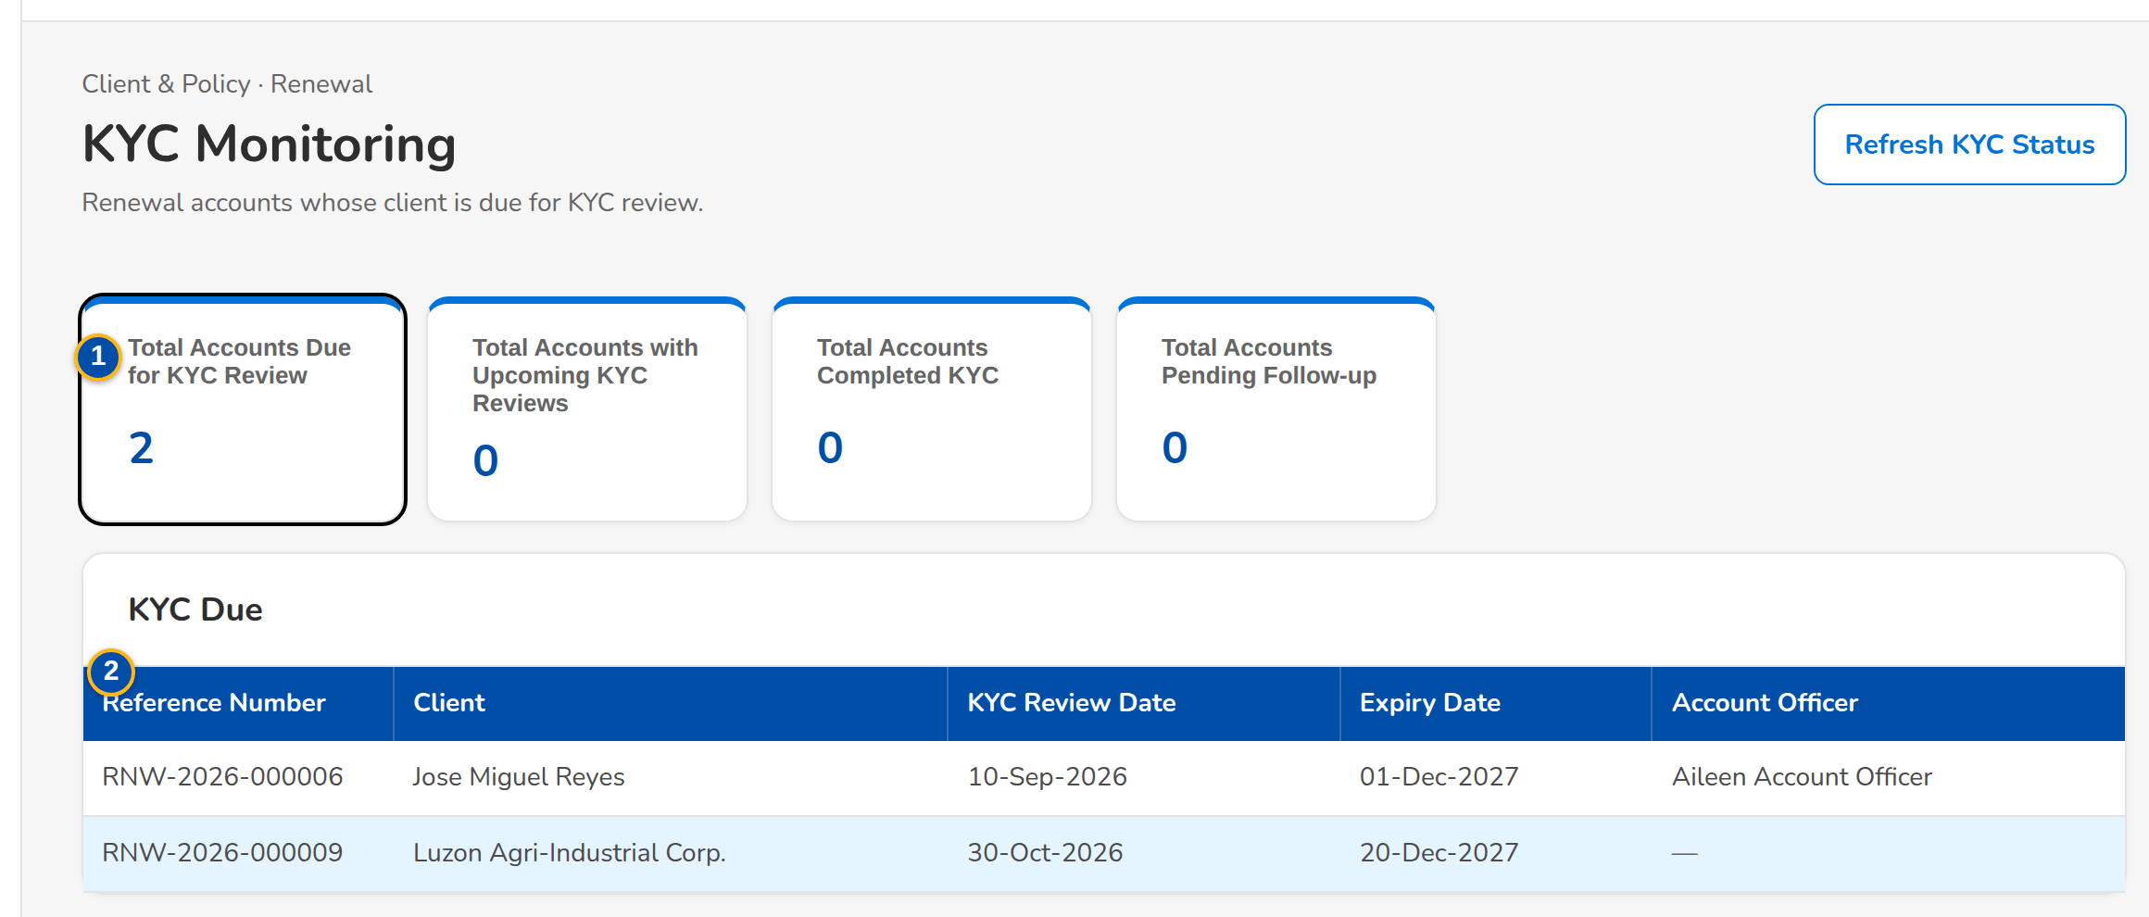
Figure AA.28 - KYC Monitoring with the counts and the accounts due for the KYC review
Field | Type | Mandatory | Format / list / source | Validation and message
Counts: Total Accounts Due for KYC Review / Total Accounts with Upcoming KYC Reviews / Total Accounts Completed KYC / Total Accounts Pending Follow-up | Card | - | Counts; each opens its accounts; KYC of the clients | -
List: Reference Number / Client / KYC Review Date / Expiry Date / Account Officer | Column | - | dd-MMM-yyyy; Accounts of the card chosen | No account

Action | Who | When | What happens | Status after | Notice
[Card or row] | Marketing users | Always | Lists the accounts of the card; a row opens the renewal on its KYC tab | - | -

AA.29 Risk Code Maintenance (SCR-RN-29)
Purpose: The risk codes of Renewal with their renewable indicator: a non-renewable risk code keeps its accounts out of renewal. A change takes effect from its effective date once a second authorised user authorises it.
Access: Client & Policy › Renewal › Risk Code Maintenance
FR items: FRRN.038
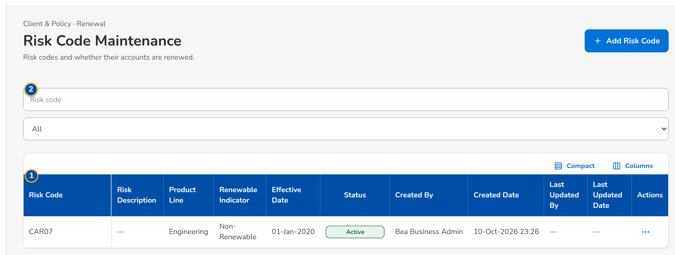
Figure AA.29 - Risk Code Maintenance with the risk codes and their renewable indicator
Field | Type | Mandatory | Format / list / source | Validation and message
List: Risk Code / Risk Description / Product Line / Renewable Indicator / Effective Date / Status / Created By / Created Date / Last Updated By / Last Updated Date | Column | - | dd-MMM-yyyy; names; Risk codes | No risk code
Risk code dialog: Risk Code / Risk Code Description / Product Line / Renewable Indicator / Effective Date / Remarks | Text, text, drop-down, Yes/No, date, text area | Y / Y / Y / Y / Y / N | dd-MMM-yyyy; up to 500 characters; Product lines | Effective date today or later

Action | Who | When | What happens | Status after | Notice
Add / Update | Business Administrator | Always | Saves the risk code for authorisation | For Authorization | -
Authorize | Another Business Administrator | For Authorization | Authorises the change; it applies from the effective date | Active | -
Deactivate | Business Administrator | Active | Deactivates the risk code for authorisation | For Authorization | -

AA.30 CLPC Billing Files (SCR-RN-30)
Purpose: The billing files of the CLPC renewals: the file of the renewals billed through the loan of the client is generated for a period, sent to LMS and kept with its delivery status.
Access: Client & Policy › Renewal › CLPC Billing Files
FR items: FRRN.027, FRRN.028
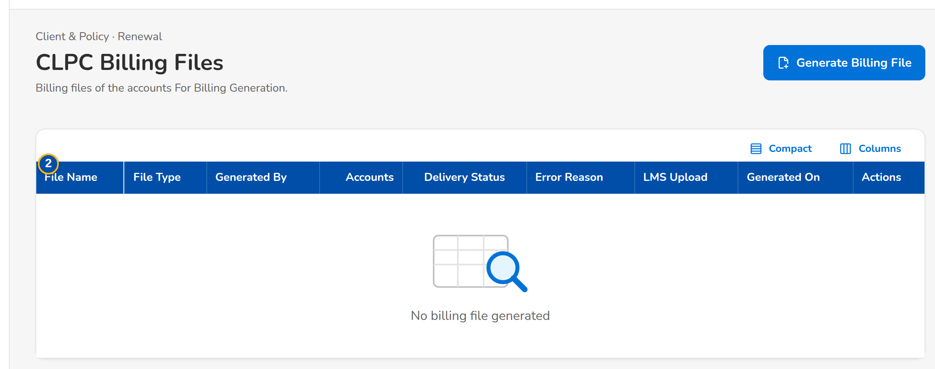
Figure AA.30 - CLPC Billing Files with the files generated and their delivery status
Field | Type | Mandatory | Format / list / source | Validation and message
Generate Billing File dialog: From Date / To Date | Date | Y | dd-MMM-yyyy | To Date not before From Date
List: File Name / File Type / Generated By / Accounts / Delivery Status / Error Reason / LMS Upload / Generated On | Column | - | Names; dd-MMM-yyyy HH:mm; Billing files | No billing file generated

Action | Who | When | What happens | Status after | Notice
Generate Billing File | Processing users | Always | Generates the file of the period and sends it to LMS | Generated | -
Download / Download As | Processing users | Always | Downloads the file under its name or another name | - | -

AA.31 E-Policies (SCR-RN-31)
Purpose: The e-policies of the insurers: the files received (summary file and ZIP of the policies) matched to the renewal accounts, the accounts For E-Policy Sending with the policy to send to the client, and the upload of the e-policy numbers.
Access: Client & Policy › Renewal › E-Policies
FR items: FRRN.033
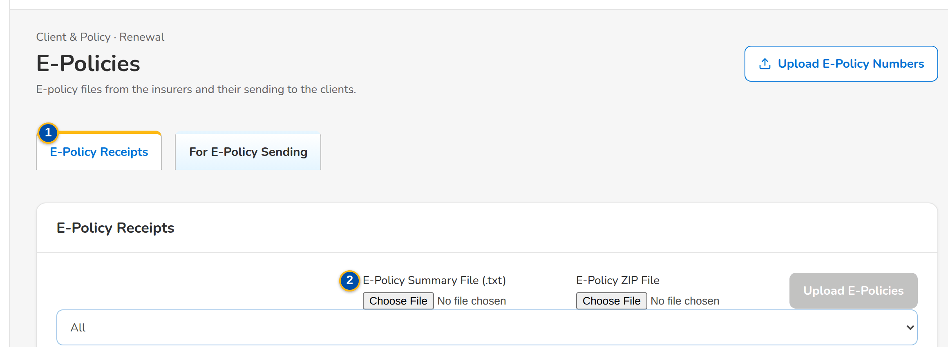
(continued below)
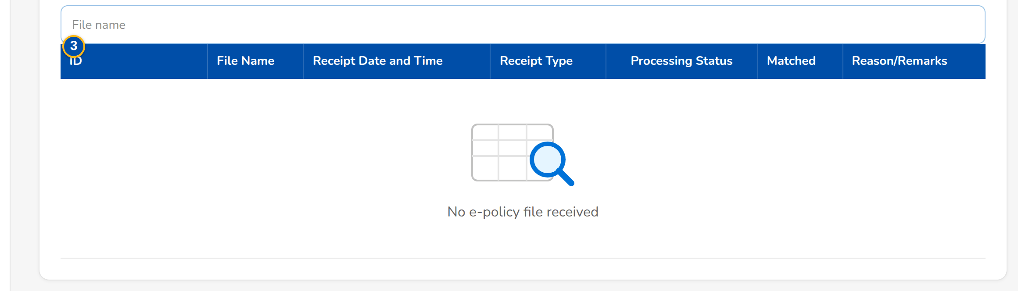
Figure AA.31 - E-Policies, E-Policy Receipts: the files received and the matching of each policy
Field | Type | Mandatory | Format / list / source | Validation and message
Tabs: E-Policy Receipts / For E-Policy Sending / Upload E-Policy Numbers | Tab | - | - | -
E-Policy Receipts: E-Policy Summary File (.txt) / E-Policy ZIP File | Upload | Y | The summary file and the ZIP of the policies of an insurer | The ZIP holds the documents of the summary
Files received: ID / File Name / Receipt Date and Time / Receipt Type / Processing Status / Matched / Reason/Remarks | Column | - | dd-MMM-yyyy HH:mm; E-policy files | No e-policy file received
Policies of a file: Sequence / Renewal Reference Number / Policy Number / Document / Matching Status / Remarks | Column | - | Matched, Not matched; Lines of the file | No record
For E-Policy Sending: Select / Renewal Reference Number / Client / Policy Number / Client Email / E-Policy / Not Eligible / CC recipients | Column, tick box, e-mail | - | Accounts with an e-policy | No account is For E-Policy Sending

Action | Who | When | What happens | Status after | Notice
Upload | Processing users | Always | Receives the e-policy files and matches each policy to its renewal | Matched or Not matched | -
Send | Processing users | Accounts ticked | Sends the e-policy to the client by the channel of the setting | Sent | -

AA.32 RMU Account Maintenance (SCR-RN-32)
Purpose: The Account Officers of the RMU (past-due loans) whose renewal accounts are handled apart, maintained by the Business Administrator.
Access: Client & Policy › Renewal › RMU Account Maintenance
FR items: FRRN.041
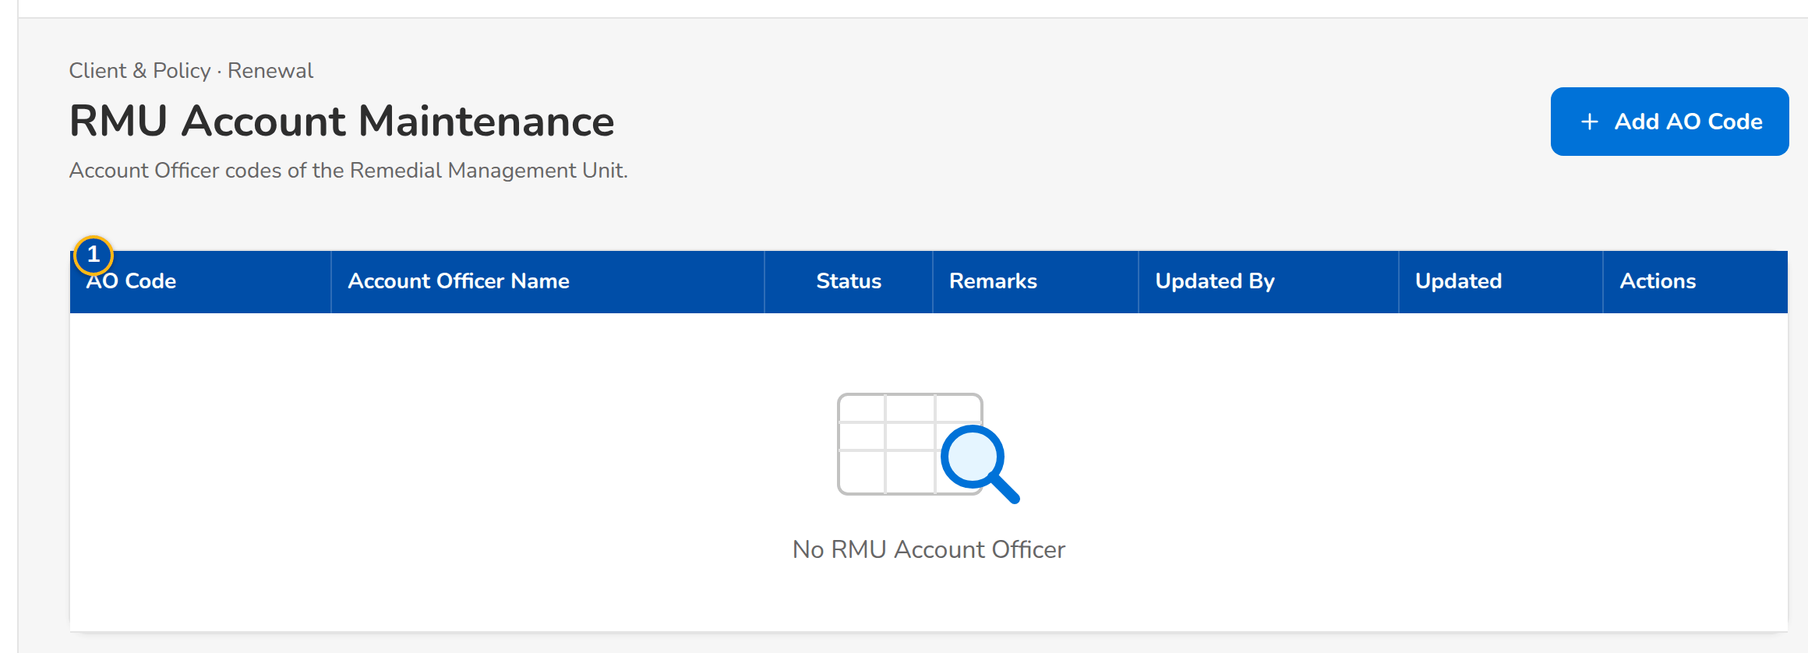
Figure AA.32 - RMU Account Maintenance with the RMU Account Officers
Field | Type | Mandatory | Format / list / source | Validation and message
List: AO Code / Account Officer Name / Status / Remarks / Updated By / Updated | Column | - | Names; dd-MMM-yyyy; RMU Account Officers | No RMU Account Officer
RMU officer dialog: AO Code / Account Officer Name / Remarks | Text | Y / Y / N | Up to 500 characters | AO code not yet listed

Action | Who | When | What happens | Status after | Notice
Add / Update | Business Administrator | Always | Saves the RMU Account Officer | Active | -

AA.33 Channel Monitor (SCR-RN-33)
Purpose: The documents of Renewal sent through the channels (CCM to the clients, MFT to the insurers, LMS for billing): each message with its status, reference, recipients and error, its delivery history and the connection of each channel. A failed message may be sent again.
Access: Client & Policy › Renewal › Channel Monitor
FR items: FRRN.022, FRRN.024, FRRN.027
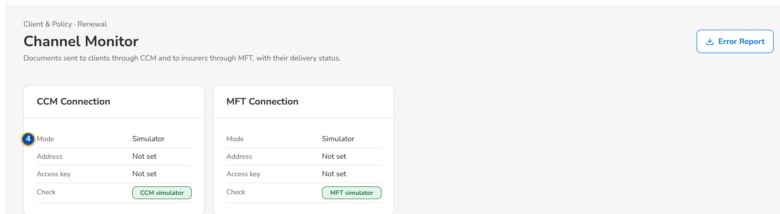
(continued below)
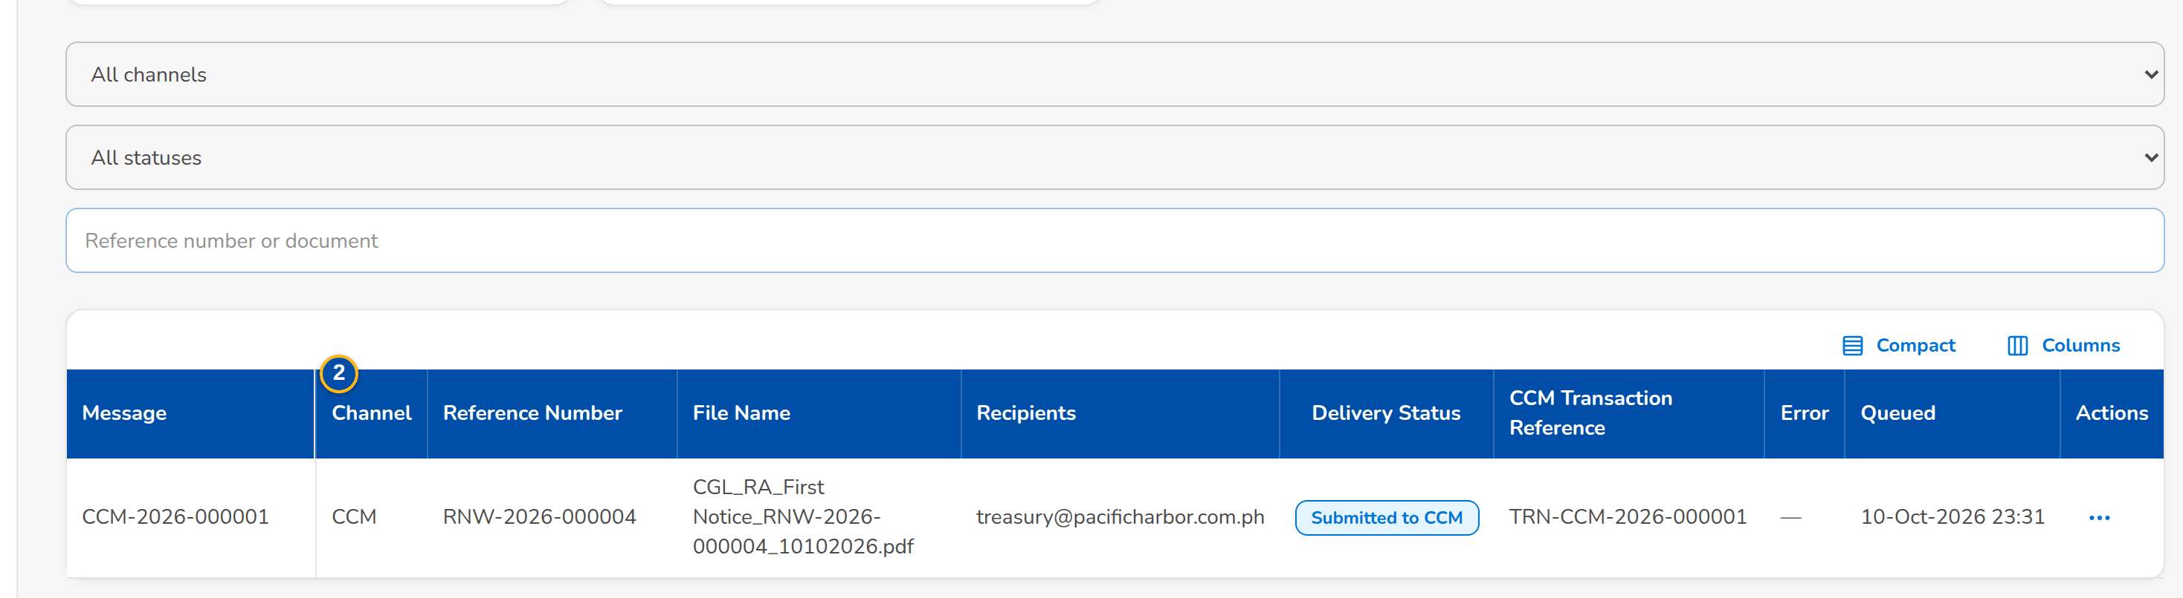
Figure AA.33 - Channel Monitor with the messages sent through CCM, MFT and LMS
Field | Type | Mandatory | Format / list / source | Validation and message
Filters: Channel / Delivery status / Search reference | Drop-down, drop-down, text | N | CCM, MFT, LMS; statuses | -
List: Channel / Reference Number / File Name / Recipients / Delivery Status / CCM Transaction Reference / Error / Queued | Column | - | dd-MMM-yyyy HH:mm; Messages of the channels | No message
Delivery History: When / Status / Detail / By | Table in a dialog | - | dd-MMM-yyyy HH:mm; Events of the message | No status yet
Connection: Mode / Address / Access key | Display | - | The mode of the channel (live or simulator in SIT and UAT); Settings of the channel | -

Action | Who | When | What happens | Status after | Notice
Resend | System Administrator | Message failed | Sends the message again | Queued | -
Cancel | System Administrator | Message queued | Cancels the message | Cancelled | -
Check | System Administrator | Always | Checks the connection of the channel | - | -

AA.34 Audit Logs (SCR-RN-34)
Purpose: Every action on the renewal accounts with its old and new value, who did it and when, filtered by date, action type, reference and user. Nobody can change or delete an entry.
Access: Client & Policy › Renewal › Audit Logs; Renewal › Audit Logs tab
FR items: FRRN.043
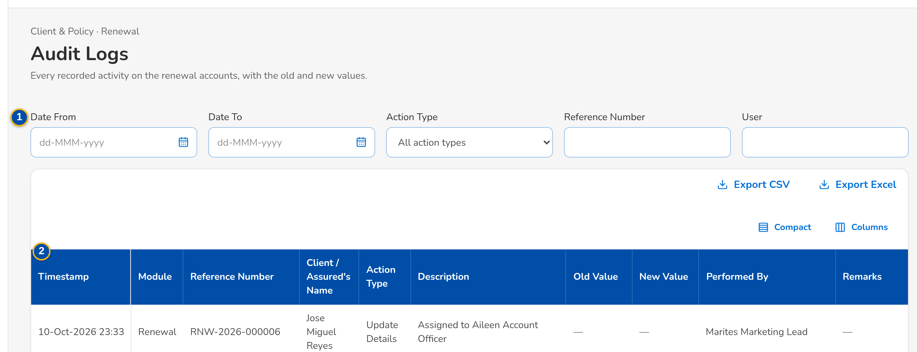
(continued below)
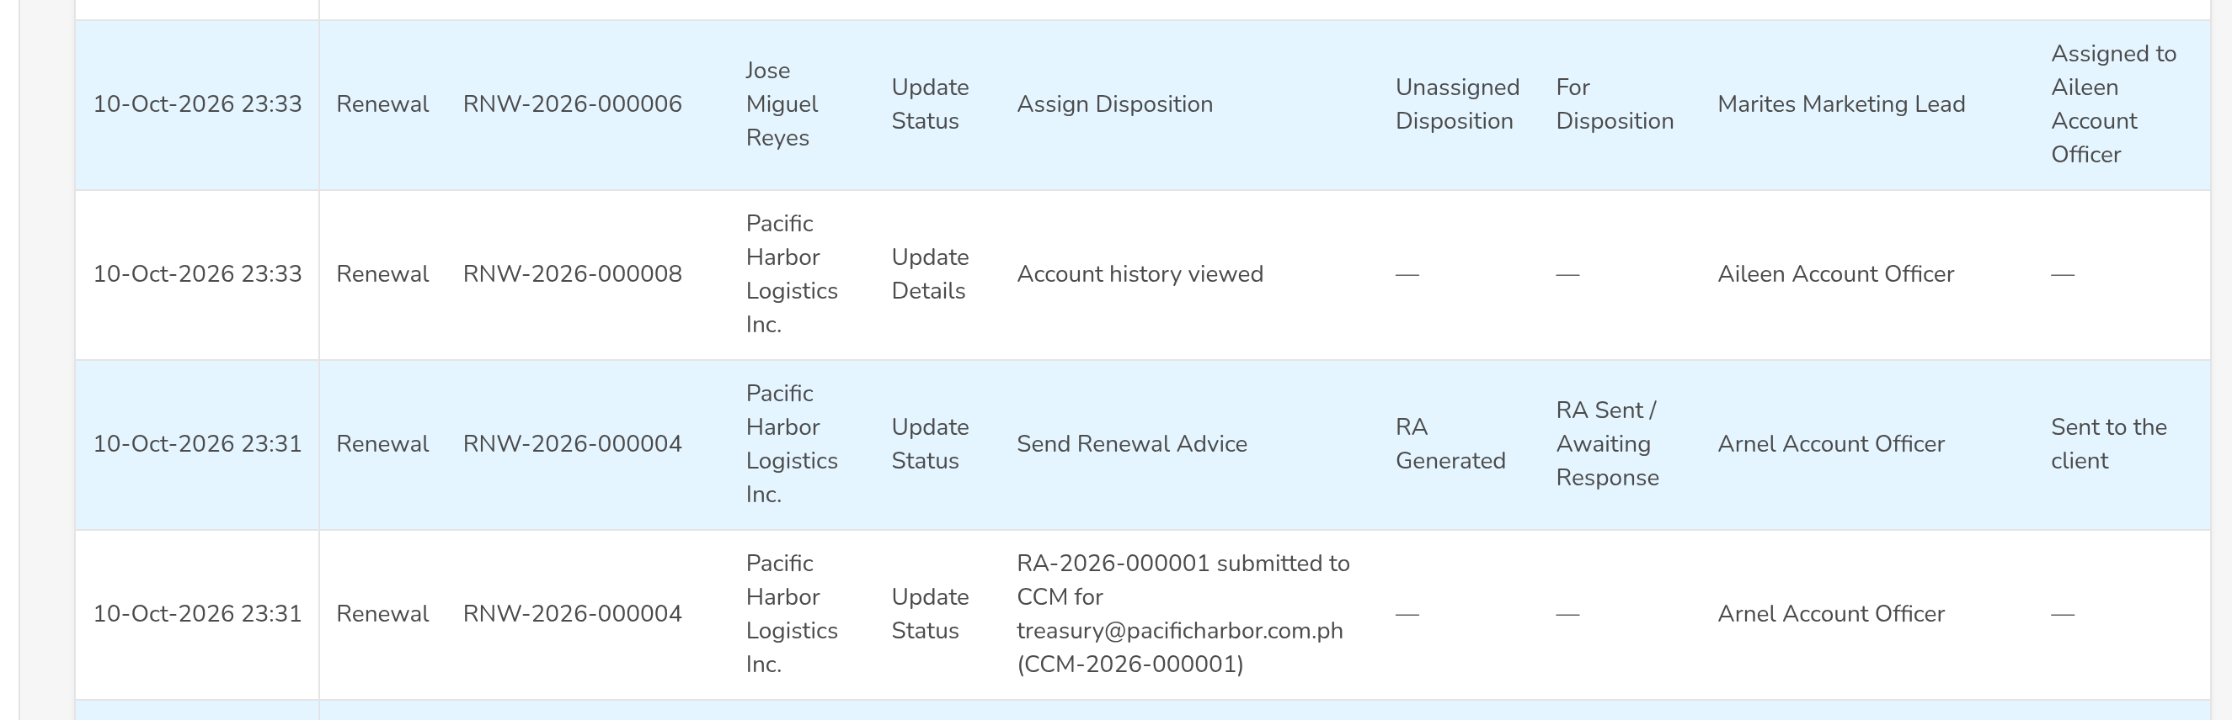
(continued below)
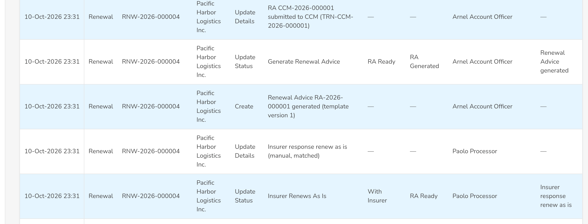
(continued below)
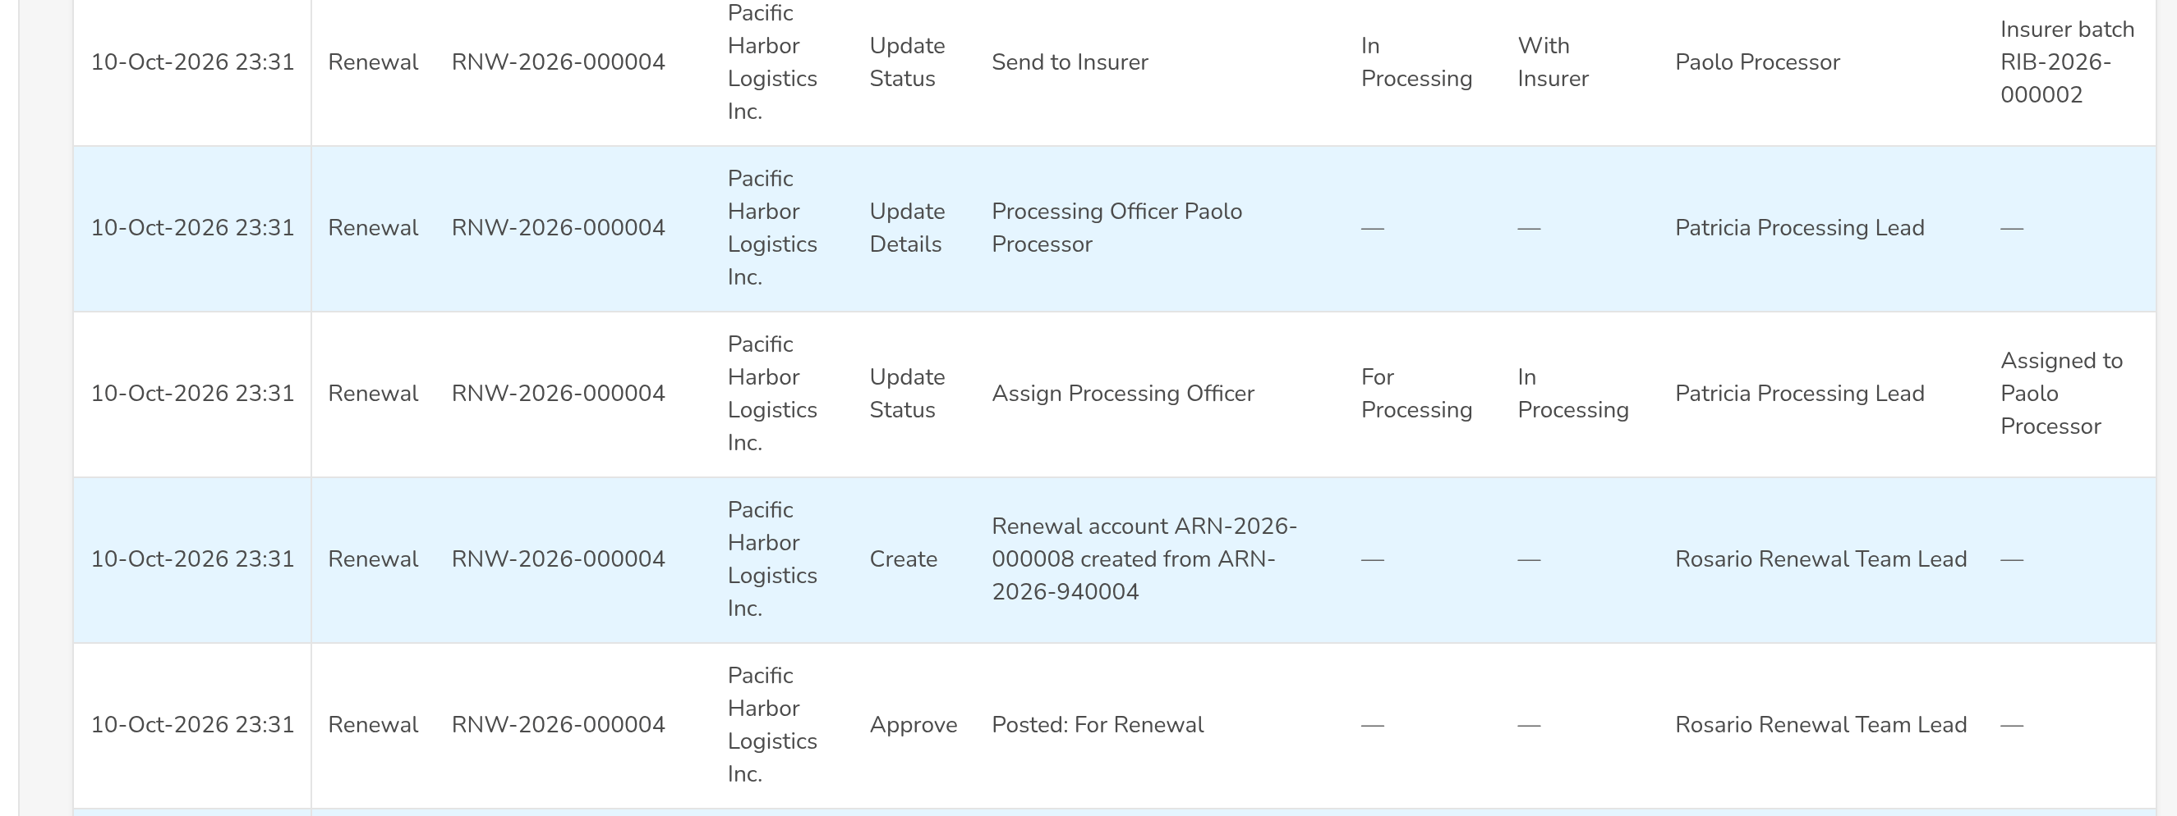
Figure AA.34 - Audit Logs of Renewal with the actions of the period
Field | Type | Mandatory | Format / list / source | Validation and message
Filters: Date From / Date To / Action Type / Reference Number / User | Date, date, drop-down, text, drop-down | N | dd-MMM-yyyy; action types in words; names; Action types; users | Date To not before Date From
List: Timestamp / Module / Reference Number / Client / Assured / Action Type / Description / Old Value / New Value / Performed By / Remarks | Column | - | dd-MMM-yyyy HH:mm; values in words; Audit trail | No audit log entries

Action | Who | When | What happens | Status after | Notice
Export | Auditor, Business Administrator | Always | Downloads the entries of the filters | - | -

AA.35 Renewal Annual Budget (SCR-RN-35)
Purpose: The annual budget of the renewals per fiscal year, measure, market segment and team, uploaded and updated by month, with the history of every change. The Renewal Dashboard compares the actuals with it.
Access: Client & Policy › Renewal › Renewal Annual Budget
FR items: FRRN.042
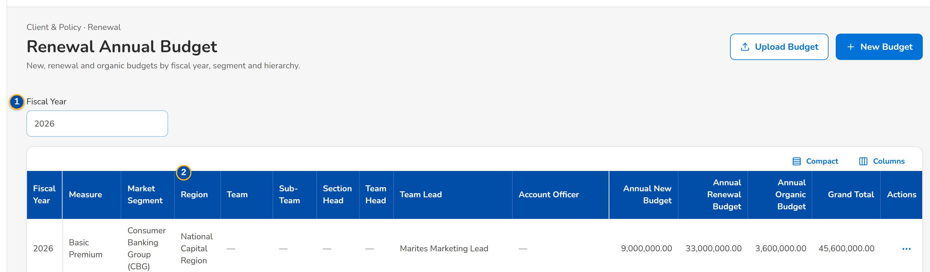
(continued below)
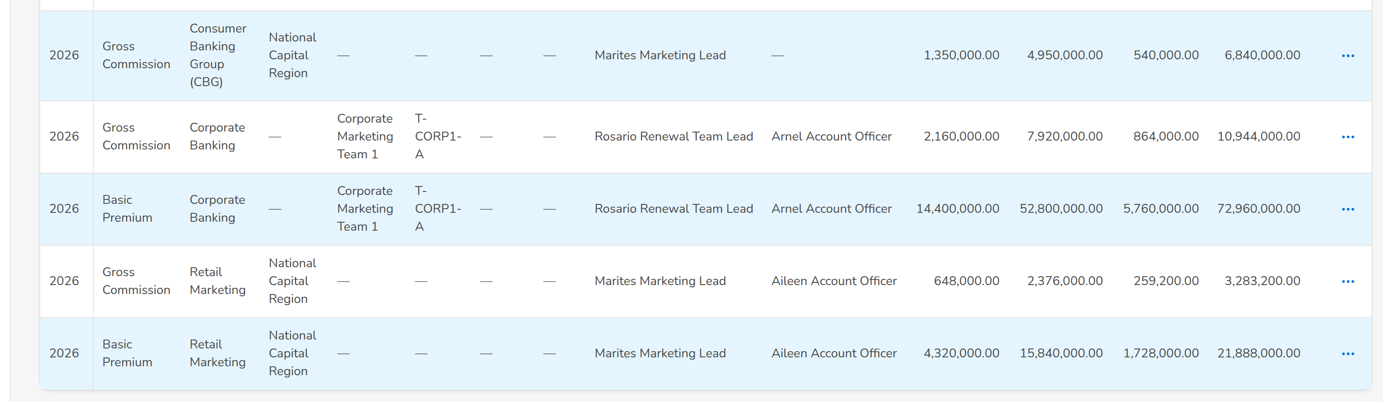
Figure AA.35 - Renewal Annual Budget of the fiscal year by team and month
Field | Type | Mandatory | Format / list / source | Validation and message
Filters: Fiscal Year / Measure / Market Segment / Team Lead | Drop-down | Y / N / N / N | Years; measures; segments; users | -
Budget: Region / Team / Sub-Team / Section Head / Team Head / Team Lead / Account Officer / Annual New Budget / Annual Renewal Budget / Annual Organic Budget / Grand Total | Column | - | Two decimals; Budget of the year | No budget for this fiscal year
Update Budget dialog: Month / Budget | Table | Y | Two decimals | Not negative
Budget History: Month / Previous Budget / Updated Budget / Modified By / Modification Date | Table in a dialog | - | dd-MMM-yyyy; Changes of the budget | No changes since the budget was created

Action | Who | When | What happens | Status after | Notice
Upload Budget | Business Administrator | Always | Uploads the budget file of the fiscal year | - | -
Update Budget | Business Administrator | Budget loaded | Changes the budget of a month | - | -
View Budget History | Business Administrator | Always | Opens the history of the changes | - | -

AA.36 Renewal: Hold Cover, Proposal & TSU, Acceptance & Approval, KYC, Placement and Audit Logs (SCR-RN-36)
Purpose: The tabs of the renewal record added with the full coverage: the hold cover requests of the account with the insurers' shares, the proposals and the TSU request, the client's acceptance with the approval and the payment, the KYC status, the Insurance Advice and the placement with each insurer's response, and the audit trail of the renewal.
Access: Renewal › Hold Cover, Proposal & TSU, Acceptance & Approval, KYC, Placement or Audit Logs tab
FR items: FRRN.016, FRRN.017, FRRN.025, FRRN.029, FRRN.030, FRRN.032, FRRN.036, FRRN.037, FRRN.039, FRRN.043
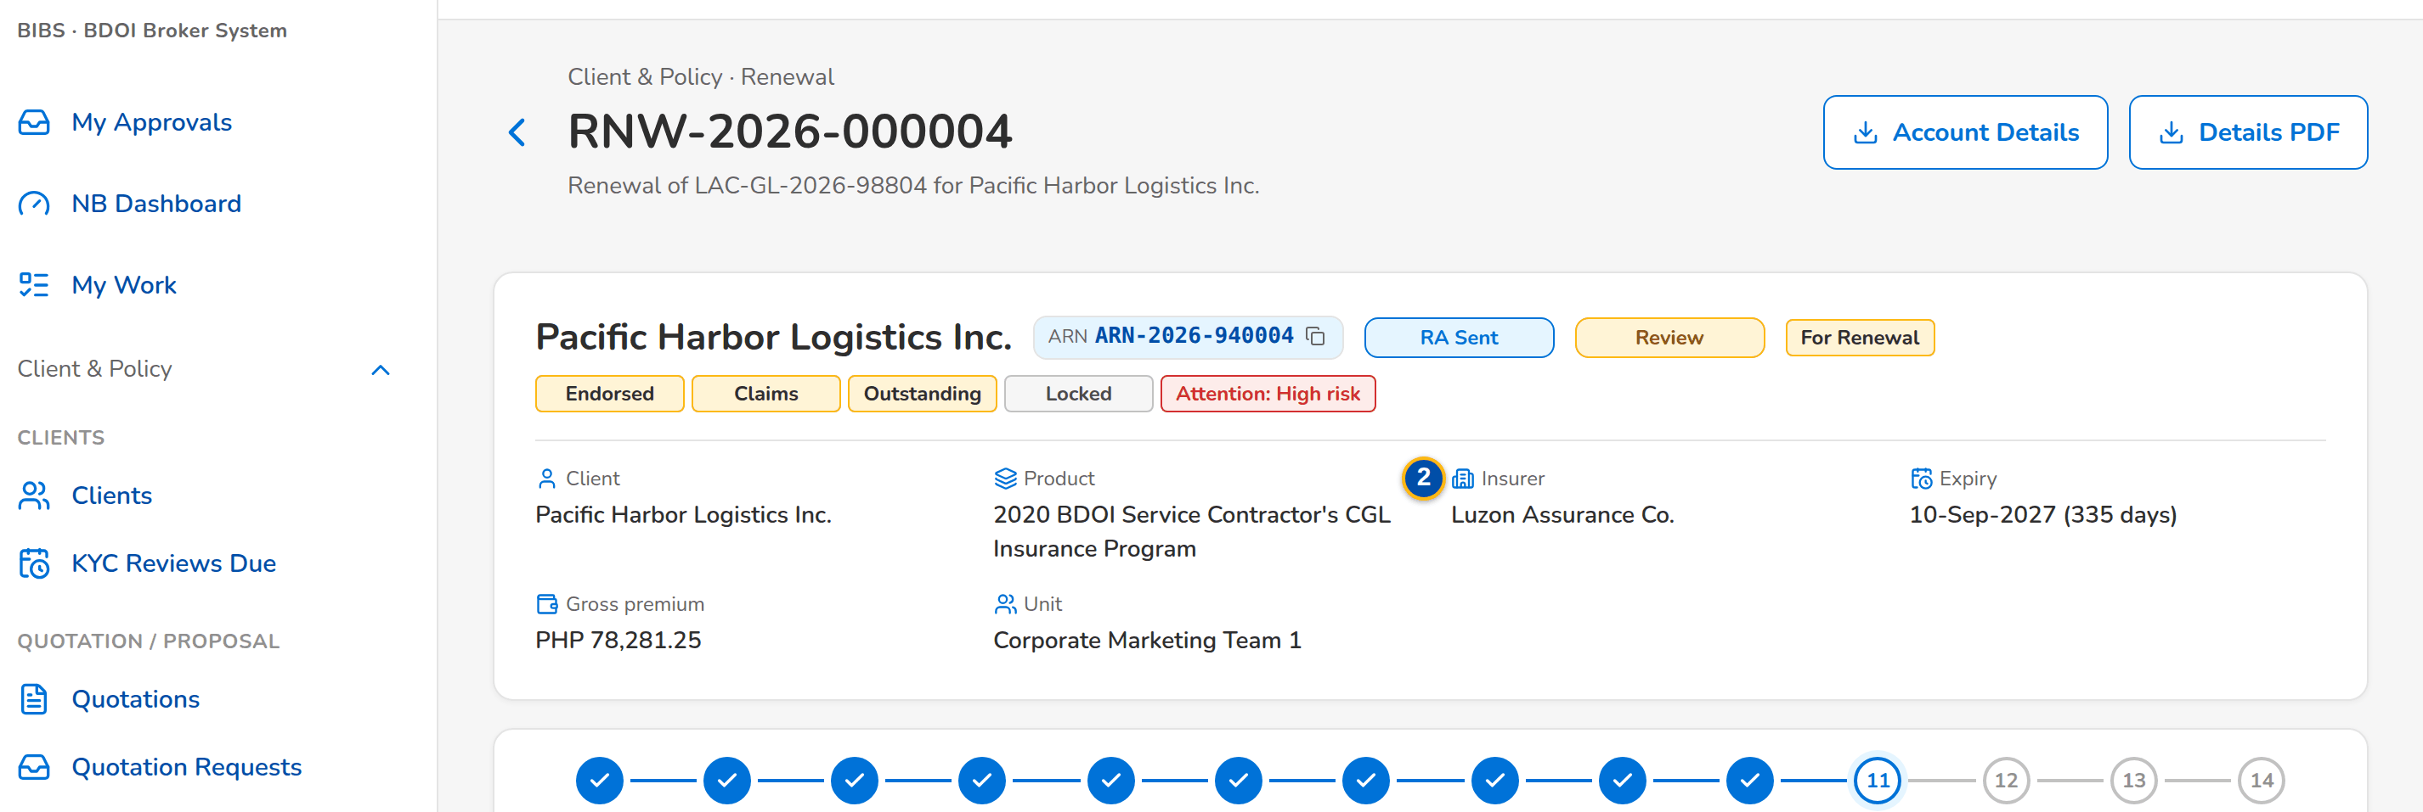
(continued below)
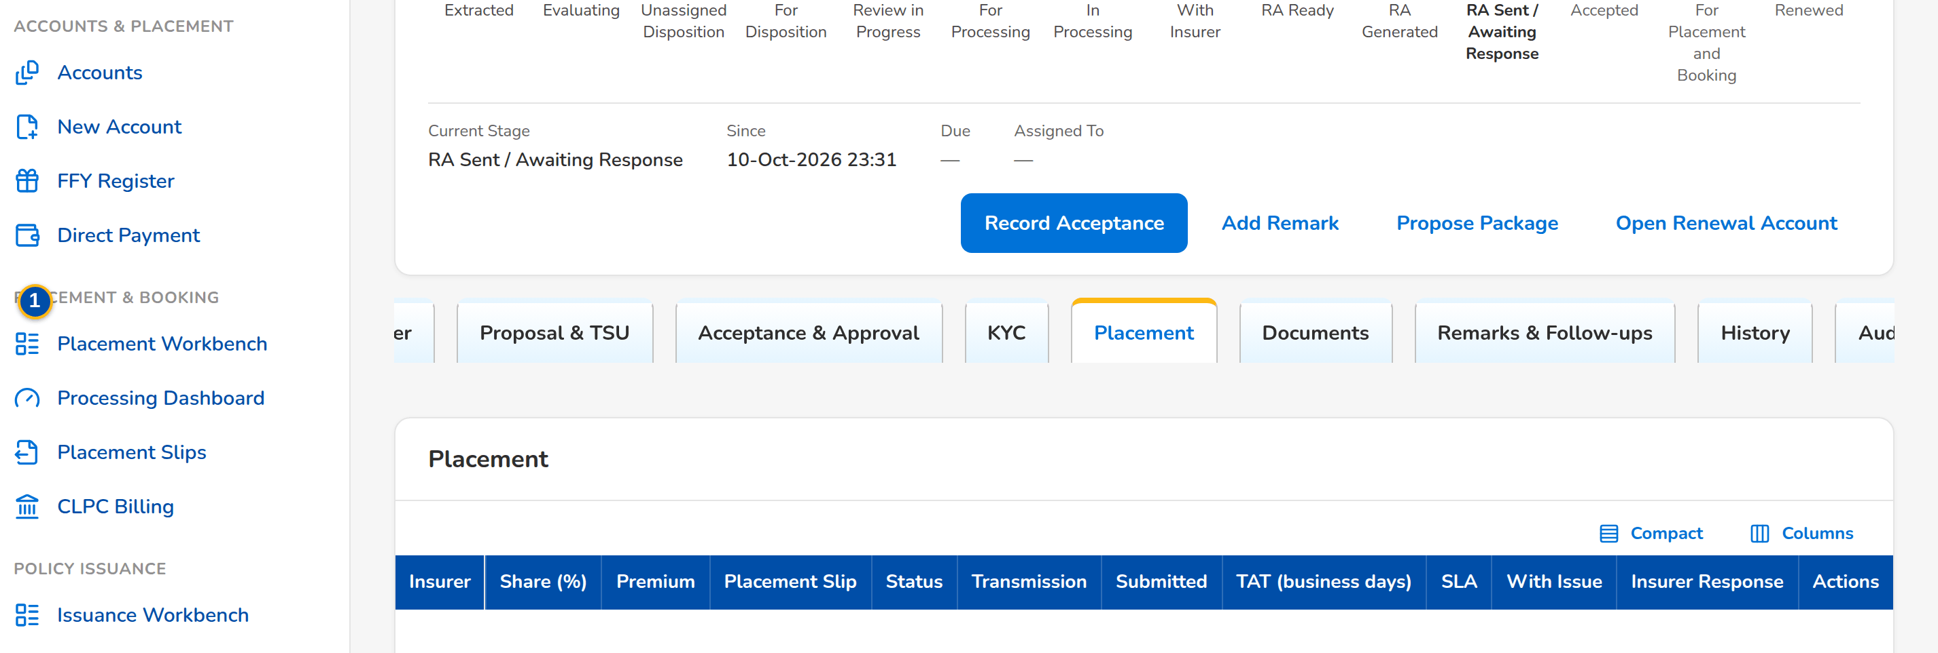
(continued below)
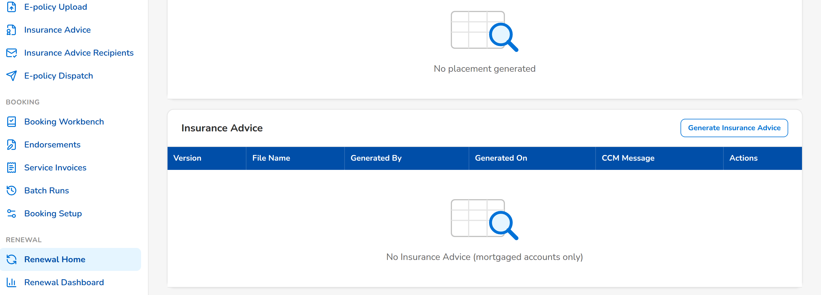
Figure AA.36 - Placement tab: the Insurance Advice and the placement slip of each insurer with its response
Field | Type | Mandatory | Format / list / source | Validation and message
Hold Cover tab: Insurers: Insurer / Share (%) / Coverage / Premium | Table | - | Two decimals; Insurers of the account | No insurer
Hold Cover tab: Hold Cover Requests: Reference Number / Request / Insurer / Share (%) / Start / End / Sent By / Status / Insurer Remarks | Table | - | dd-MMM-yyyy; Hold cover requests | No hold cover request
Hold Cover tab: extension: Extension days | Number | Y | 15 or 30 days (setting, Annex AC.9, C12) | Within the extension window
Proposal & TSU tab: Proposals: File Name / Proposal / Status / CCM Message / Generated On | Table | - | dd-MMM-yyyy HH:mm; Proposals of the renewal | No proposal generated
Proposal & TSU tab: TSU Request: TSU Officer / Remarks / Insurer / Premium / Terms and conditions / Proposal | Drop-down, text, drop-down, amount, text area, file | Y | Names; two decimals; TSU officers, insurers | -
Acceptance & Approval tab: Client Acceptance Status / For Booking Only / Direct-to-Insurer Payment / Approval and Payment: Status / Remarks / Policy Number / OR Number / Override reason or justification / Option / Rejection reason | Drop-down, text | Cond. | Labels; Acceptance statuses | An override needs a justification
KYC tab: Status / Activity / Remarks or follow-up note | Drop-down, drop-down, text area | N | Labels; KYC statuses and activities | -
Placement tab: Insurance Advice: Version / File Name / Generated By / Generated On / CCM Message | Table | - | dd-MMM-yyyy HH:mm; Insurance Advices (mortgaged accounts) | No Insurance Advice (mortgaged accounts only)
Placement tab: Placement: Insurer / Share (%) / Premium / Placement Slip / Status / Transmission / Submitted / TAT (business days) / SLA / With Issue / Insurer Response | Table | - | Two decimals; dd-MMM-yyyy; Placement of each insurer | No placement generated
Record Insurer Response dialog: Insurer Response / Rejection Reason / Insurer Remarks | Drop-down, drop-down, text area | Y / Cond. / N | Approved, Rejected; rejection reasons; Insurer responses | A rejection needs its reason
Audit Logs tab: Timestamp / Action Type / Description / Old Value / New Value / Performed By / Remarks | Table | - | dd-MMM-yyyy HH:mm; Audit trail of the renewal | No audit log entries

Action | Who | When | What happens | Status after | Notice
Request Hold Cover / Record Approval | Account Officer; Processing Officer | Before expiry, payment pending | Sends the hold cover request to the insurers; records the insurer's approval with the extension | Hold cover requested / approved | -
Generate Proposal / Send via CCM / Download As | Account Officer | For Proposal | Generates the quick or full proposal and sends it to the client | Proposal sent | -
Submit to TSU | Account Officer | For Quotation or For Proposal | Sends the request to the TSU after the Team Lead's approval | Pending Team Lead Approval | -
Record Acceptance / Approve / Reject | Account Officer; approver | After the Renewal Advice | Records the client's acceptance and the second approval of the setting | Accepted / Submitted for Approval | -
Download Slip / Download Placement File / Record Insurer Response | Processing Officer | For Placement, With Insurer | Downloads the slip and records the insurer's response | Placed or Rejected | -

AA.37 Menu by persona
The Renewal entries of the menu of each persona: the menu shows an entry only when one of the user's profiles holds its function (FRRN.001.02).
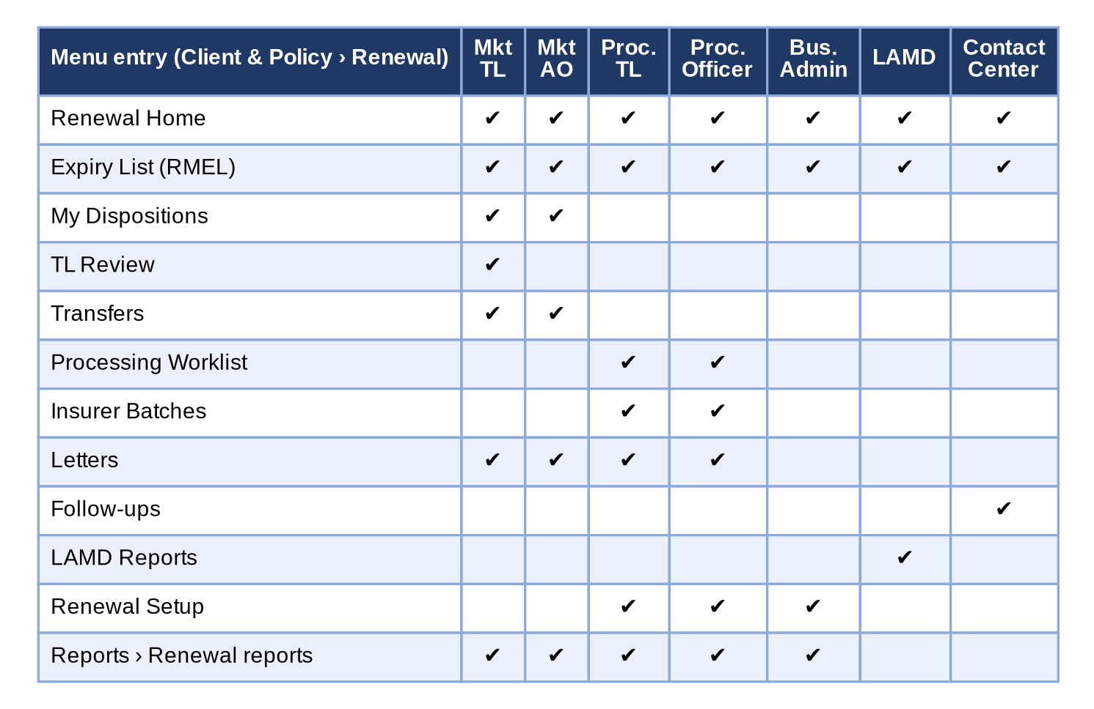
Figure 11 - Menu by persona: the Renewal screens each persona sees
How to read it: A tick means the screen is in the persona's menu; a screen without a tick is neither shown nor opened by its address. The renewal account opens from any list. Traces to: BRD 6.002.2; FRRN.001.02, FRRN.001.05, FRRN.002.01.

Annex AB – Messages and Validations
The messages the user sees when a check fails or an action is not allowed, word for word as on the screens; <name> parts are filled in by the system. BDOI's own messages of section Functional Requirements prevail where they cover the same case; the messages below complete them.
No. | Screen | When | Message shown | FR item
1 | Login | User ID or password wrong | Invalid user name or password | FRRN.001.01, FRRN.001.02, FRRN.001.03, FRRN.001.04
2 | All Renewal screens | Action without permission | You are not permitted to perform this action | FRRN.001.02
3 | Access Requests | No role or permission selected | Select at least one role or permission | FRRN.001.05
4 | Expiry List (Generate Expiry List dialog) | Start or end date missing or not a date | Enter a valid start and end date | FRRN.004.01, FRRN.004.02
5 | Expiry List (Generate Expiry List dialog) | End date before start date | The end date must be on or after the start date | FRRN.004.01, FRRN.004.02
6 | Expiry List (Filters panel) | Conflicting selection on one criterion | Choose either 'only' or 'all except' for <criterion> | FRRN.004.03
7 | Expiry List (Initiate) | Candidate not Extracted | Renewal <ref> is already initiated | FRRN.004.07
8 | Expiry List (Initiate) | Bulk initiation of a single-initiation segment | Segment <segment> is initiated one account at a time | FRRN.004.07
9 | Renewal Home (extraction runs) | Tracker row whose legacy policy reference has no renewal account | Row <n>: no renewal renewal account for legacy policy <reference> | FRRN.045.01, FRRN.045.02
10 | Renewal Home (extraction runs) | Second tracker row for the same policy | Row <n>: the Renewal Advice of legacy policy <reference> is already recorded | FRRN.045.01, FRRN.045.02
11 | Renewal Home (extraction runs) | RA date missing or after the go-live date | Row <n>: enter the date the Renewal Advice was sent (before go-live) | FRRN.045.01, FRRN.045.02
12 | Expiry List | Upload row without reference | Row <n> has no renewal reference | FRRN.004.04, FRRN.015.04
13 | Expiry List | Reference not found | Row <n>: renewal reference <ref> does not exist | FRRN.004.04, FRRN.015.04
14 | Expiry List (Classification pill, Exceptions tab, Bucket filter) | Override to Clean with a failed check | Renewal <ref> has failed checks and cannot be Clean | FRRN.008.01
15 | Expiry List (Classification pill, Exceptions tab, Bucket filter) | Override without remarks | Enter the remarks of the override | FRRN.008.01
16 | Renewal Setup (Decision Matrix) | Activation by the maker | A matrix version is activated by someone other than its maker | FRRN.040.02
17 | Renewal Setup (Decision Matrix) | Rule without outcome | Select the disposition of the rule | FRRN.040.02
18 | Renewal Setup (Non-renewable Risk Codes) | Effective to before effective from | The effective-to date is before the effective-from date | FRRN.038.01, FRRN.038.03
19 | Renewal Setup (Non-renewable Risk Codes) | Risk code not in the catalogue | Risk code <code> does not exist | FRRN.038.01, FRRN.038.03
20 | LAMD Reports (upload, match results, routing) | File type not allowed | The file type is not allowed | FRRN.012.01, FRRN.012.02, FRRN.041.01
21 | LAMD Reports (upload, match results, routing) | Row without PN | Row <n> has no PN number | FRRN.012.01, FRRN.012.02, FRRN.041.01
22 | LAMD Reports (upload, match results, routing) | PN matches several renewal accounts | Row <n>: PN <pn> matches several renewals | FRRN.012.01, FRRN.012.02, FRRN.041.01
23 | Record page (Checks & Bucket, Account History) | Post or RA with an open endorsement | Renewal <ref> has an endorsement in progress (<endorsement no.>) | FRRN.004.06
24 | Record page (Checks & Bucket, Package panel) | No package version chosen, or no reason | Choose the package version and give the reason | FRRN.046.01
25 | Record page (Checks & Bucket, Package panel) | Checker is the maker | The package choice must be approved by another user | FRRN.046.01
26 | Expiry List (tab Unassigned Disposition | No account selected | Select at least one account | FRRN.010.01, FRRN.010.02
27 | Expiry List (tab Unassigned Disposition | AO outside the unit | <AO> is not an officer of your unit | FRRN.010.01, FRRN.010.02
28 | Expiry List (tab Unassigned Disposition | Account locked by the RA | Renewal <ref> is locked since the Renewal Advice was generated | FRRN.010.01, FRRN.010.02
29 | Expiry List and My Dispositions (Transfer) | Unit not selected | Select the receiving unit | FRRN.011.06
30 | Expiry List and My Dispositions (Transfer) | Remarks blank | Enter the remarks | FRRN.011.06
31 | Expiry List and My Dispositions (Transfer) | Same unit | The receiving unit must be another unit | FRRN.011.06
32 | Expiry List and My Dispositions (Transfer) | Transfer already open | Renewal <ref> already has a transfer request | FRRN.011.06
33 | Transfers (Incoming) | Decline without remarks | Enter the remarks of the decline | FRRN.011.06
34 | Transfers (Incoming) | Request already decided | The transfer of <ref> is already decided | FRRN.011.06
35 | Record page (Account History tab) | Disposition before the history was opened | Open the Account History before you give the disposition | FRRN.014.01
36 | Record page (Disposition panel) | Disposition not selected | Select the disposition | FRRN.014.02, FRRN.016.01
37 | Record page (Disposition panel) | Not for Renewal without reason | Select the reason for Not for Renewal | FRRN.014.02, FRRN.016.01
38 | Record page (Disposition panel) | Booked to New Invoice without invoice no. | Enter the new invoice number | FRRN.014.02, FRRN.016.01
39 | Record page (Disposition panel) | New invoice no. not found | Invoice <no.> does not exist | FRRN.014.02, FRRN.016.01
40 | Record page (Disposition panel) | Mandatory fields missing on push | Complete the mandatory fields: <fields> | FRRN.014.02, FRRN.016.01
41 | Record page (Remarks & Follow-ups tab) | Remarks longer than 200 characters | Remarks may have at most 200 characters | FRRN.014.02
42 | Record page (Re-open Disposition) | Re-open after the limit | Renewal <ref> can no longer be re-opened (expired on <date>) | FRRN.014.07
43 | Record page (Re-open Disposition) | Reason blank | Enter the reason for re-opening | FRRN.014.07
44 | Record page (Start NB Path) | NB path already started | Renewal <ref> already has quotation <no.> | FRRN.017.01, FRRN.018.02
45 | Team Lead Review (Review in progress list | Return without reason | Select a reason for 'Return' | FRRN.020.01, FRRN.020.02
46 | Team Lead Review (Review in progress list | Post with a failing check | Renewal <ref> cannot be posted: <check> failed | FRRN.020.01, FRRN.020.02
47 | Team Lead Review (Override Outstanding Balance) | Override reason missing | Select the reason of the override | FRRN.014.04, FRRN.020.03
48 | Processing Worklist (Upload Dispositioned File) | File without header row | The file has no header row | FRRN.015.03, FRRN.015.07
49 | Processing Worklist (Upload Dispositioned File) | Row without valid reference | Row <n> has no valid renewal reference | FRRN.015.03, FRRN.015.07
50 | Processing Worklist (Upload Dispositioned File) | Disposition not in the list | Row <n>: disposition <value> is not valid | FRRN.015.03, FRRN.015.07
51 | Processing Worklist (Upload Dispositioned File) | Account locked or closed | Row <n>: renewal <ref> cannot be updated in status <status> | FRRN.015.03, FRRN.015.07
52 | Processing Worklist (Assign PO, Assign to Me) | Officer not selected | Select the Processing Officer | FRRN.010.01
53 | Record page (Renewal Account) | Mandatory fields missing | Complete the mandatory fields of <product>: <fields> | FRRN.005.01, FRRN.009.01
54 | Record page (Renewal Account) | Product not sellable for renewal | Product <code> is <status> and cannot be sold | FRRN.005.01, FRRN.009.01
55 | Processing Worklist | Return without reason | Select a reason for 'Return to Marketing' | FRRN.031.01
56 | Insurer Batches (create, preview, download, send) | Insurer not selected | Select the insurer | FRRN.021, FRRN.29.05
57 | Insurer Batches (create, preview, download, send) | No account in the batch | No For Renewal account of <insurer> expires in the range | FRRN.021, FRRN.29.05
58 | Insurer Batches (create, preview, download, send) | Insurer without renewal or placement e-mail | <insurer> has no e-mail address for renewals | FRRN.021, FRRN.29.05
59 | Insurer Batches (Upload Response, Match Review) | Reference or policy number do not match | Row <n>: <ref> does not match policy <no.> | FRRN.013.01, FRRN.013.02, FRRN.013.05
60 | Insurer Batches (Upload Response, Match Review) | Response code unknown | Row <n>: response <value> is not valid | FRRN.013.01, FRRN.013.02, FRRN.013.05
61 | Insurer Batches (Upload Response, Match Review) | Revise without revised values | Row <n>: enter the revised premium, sum insured or rate | FRRN.013.01, FRRN.013.02, FRRN.013.05
62 | Insurer Batches (Upload Response, Match Review) | Conflicting responses in one file | Row <n>: <ref> has conflicting responses | FRRN.013.01, FRRN.013.02, FRRN.013.05
63 | Letters (tabs RA Ready, RA Generated, RA Sent | Account locked or already with an RA of that notice | Renewal <ref> already has a <notice> Renewal Advice | FRRN.022.01
64 | Letters (tabs RA Ready, RA Generated, RA Sent | Blocking check open | Renewal <ref> cannot get a Renewal Advice: <check> failed | FRRN.022.01
65 | Letters (tabs RA Ready, RA Generated, RA Sent | Late RA not confirmed | The Renewal Advice is less than <n> days before expiry; confirm to continue | FRRN.022.01
66 | Letters (tab RA Generated | Client without e-mail | Client <name> has no registered e-mail address | FRRN.022.02, FRRN.024.01
67 | Letters (tab RA Generated | Recipient refused | <address> is not an approved recipient domain | FRRN.022.02, FRRN.024.01
68 | Letters (NAL / NFR tab, with the period, segment, unit head and status filters) | Ineligible account selected | Renewal <ref> already has a <letter> and cannot receive a NAL | FRRN.023.01, FRRN.023.02
69 | Record page (Record Acceptance) | Method not selected | Select the acceptance method | FRRN.025.01, FRRN.028.02
70 | Record page (Record Acceptance) | Evidence missing | Attach the acceptance evidence | FRRN.025.01, FRRN.028.02
71 | Record page (Record Acceptance) | Blocking check open | Renewal <ref> cannot be accepted: <check> failed | FRRN.025.01, FRRN.028.02
72 | Follow-ups (list) | Outcome not selected | Select the outcome | FRRN.047.01
73 | Record page (Hold Cover panel of the renewal account, Request Hold Cover, Record Confirmation, Cancel Hold Cover) | Hold cover already open | Account <arn> already has a hold cover requested or confirmed | FRRN.036.02, FRRN.037.02
74 | Record page (Hold Cover panel of the renewal account, Request Hold Cover, Record Confirmation, Cancel Hold Cover) | Duration not chosen | Select the duration of the hold cover | FRRN.036.02, FRRN.037.02
75 | Record page (Hold Cover panel of the renewal account, Request Hold Cover, Record Confirmation, Cancel Hold Cover) | Confirmation without reference or validity | Enter the insurer reference and the validity period | FRRN.036.02, FRRN.037.02
76 | Booked Invoice (incentive indicator) | Manual change of the indicator | The incentive indicator is set by the incentive rules and cannot be changed by hand | FRRN.034.01
77 | Lists of Values (Broking Setup) | List maintained by the system | The list <type> is maintained by the system | FRRN.049.01
78 | Document Templates | Unknown placeholder | The template uses an unknown field <name> | FRRN.049.02
79 | Renewal Setup (Check Settings, Bucket Rules, Decision Matrix, Non-renewable Risk Codes, Parameters) | Rule maps a failure to Clean | A failed check cannot give the Clean bucket | FRRN.040.01, FRRN.040.03
80 | Renewal Setup (Check Settings, Bucket Rules, Decision Matrix, Non-renewable Risk Codes, Parameters) | Activation by the maker | A version is activated by someone other than its maker | FRRN.040.01, FRRN.040.03
81 | Renewal Home | Status / Renewals: - | No renewals | FRRN.002.02, FRRN.003.01, FRRN.044.03
82 | Renewal Home | Officer / Role / Open renewals: - | No renewals assigned | FRRN.002.02, FRRN.003.01, FRRN.044.03
83 | Expiry List | Renewal Reference: - | No renewals to display | FRRN.002.05, FRRN.002.06, FRRN.002.07, FRRN.004.01, FRRN.004.02, FRRN.004.03, FRRN.004.04, FRRN.004.06 (2nd), FRRN.004.07, FRRN.010.01, FRRN.010.02, FRRN.011.06
84 | Expiry List | Account Officer: Active officer of the unit of the renewal | Select the account officer | FRRN.002.05, FRRN.002.06, FRRN.002.07, FRRN.004.01, FRRN.004.02, FRRN.004.03, FRRN.004.04, FRRN.004.06 (2nd), FRRN.004.07, FRRN.010.01, FRRN.010.02, FRRN.011.06
85 | Expiry List | Run / Expiry range / By / Read / New / Urgent / Status / Started: - | No extraction yet | FRRN.002.05, FRRN.002.06, FRRN.002.07, FRRN.004.01, FRRN.004.02, FRRN.004.03, FRRN.004.04, FRRN.004.06 (2nd), FRRN.004.07, FRRN.010.01, FRRN.010.02, FRRN.011.06
86 | Renewal: Checks, Account History and Computations | Check / Result / Severity / Message: - | The checks have not run yet | FRRN.004.06, FRRN.007.01, FRRN.007.02, FRRN.008.01, FRRN.009.01, FRRN.014.01
87 | Renewal: Checks, Account History and Computations | When / From / To / Cause / Remarks / By: - | No classification yet | FRRN.004.06, FRRN.007.01, FRRN.007.02, FRRN.008.01, FRRN.009.01, FRRN.014.01
88 | Renewal: Checks, Account History and Computations | Reference / Source / Status / Linked: - | No endorsements in the term | FRRN.004.06, FRRN.007.01, FRRN.007.02, FRRN.008.01, FRRN.009.01, FRRN.014.01
89 | Renewal: Checks, Account History and Computations | Prior renewals / Endorsements / Payments / Claims: - | No prior renewals | FRRN.004.06, FRRN.007.01, FRRN.007.02, FRRN.008.01, FRRN.009.01, FRRN.014.01
90 | Renewal: Insurer, Letters, Documents, Remarks and History | Received / Response / Insurer Ref / Revised Premium / Revised Sum Insured / Match / Used / Source / By: - | No response from the insurer | FRRN.013.01, FRRN.013.02, FRRN.013.05, FRRN.014.02, FRRN.022.01, FRRN.025.01, FRRN.028.02, FRRN.043.01, FRRN.043.02
91 | Renewal: Insurer, Letters, Documents, Remarks and History | Letter / Type / Status / Generated / Sent / Recipients: - | No letters | FRRN.013.01, FRRN.013.02, FRRN.013.05, FRRN.014.02, FRRN.022.01, FRRN.025.01, FRRN.028.02, FRRN.043.01, FRRN.043.02
92 | Renewal: Insurer, Letters, Documents, Remarks and History | Accepted on / Method / Reference / Financial impact acknowledged / By: - | No acceptance recorded | FRRN.013.01, FRRN.013.02, FRRN.013.05, FRRN.014.02, FRRN.022.01, FRRN.025.01, FRRN.028.02, FRRN.043.01, FRRN.043.02
93 | Renewal: Insurer, Letters, Documents, Remarks and History | When / By / Stage / Remark: - | No remarks | FRRN.013.01, FRRN.013.02, FRRN.013.05, FRRN.014.02, FRRN.022.01, FRRN.025.01, FRRN.028.02, FRRN.043.01, FRRN.043.02
94 | Renewal: Insurer, Letters, Documents, Remarks and History | When / Channel / Outcome / Remarks / Next action / By: - | No follow-ups | FRRN.013.01, FRRN.013.02, FRRN.013.05, FRRN.014.02, FRRN.022.01, FRRN.025.01, FRRN.028.02, FRRN.043.01, FRRN.043.02
95 | Renewal: Insurer, Letters, Documents, Remarks and History | When / Disposition / Reason / Source / Remarks / Current / By: - | No dispositions | FRRN.013.01, FRRN.013.02, FRRN.013.05, FRRN.014.02, FRRN.022.01, FRRN.025.01, FRRN.028.02, FRRN.043.01, FRRN.043.02
96 | Renewal: Insurer, Letters, Documents, Remarks and History | When / Role / Assigned to / Previous / By: - | No assignments | FRRN.013.01, FRRN.013.02, FRRN.013.05, FRRN.014.02, FRRN.022.01, FRRN.025.01, FRRN.028.02, FRRN.043.01, FRRN.043.02
97 | Renewal: Insurer, Letters, Documents, Remarks and History | When / Override / Change / Reason / Remarks / By: - | No overrides | FRRN.013.01, FRRN.013.02, FRRN.013.05, FRRN.014.02, FRRN.022.01, FRRN.025.01, FRRN.028.02, FRRN.043.01, FRRN.043.02
98 | My Dispositions | [Columns of the renewal lists]: - | No renewals assigned to you | FRRN.002.08
99 | Set Disposition, Add Remark and Re-open | Reason: Within the re-open days after expiry | Only a renewal tagged Not for Renewal can be re-opened | FRRN.014.01, FRRN.014.02, FRRN.014.07, FRRN.016.01, FRRN.017.01, FRRN.018.02
100 | Team Lead Review | Override: - | Select the kind of override | FRRN.014.04, FRRN.020.01, FRRN.020.02, FRRN.020.03, FRRN.040.02
101 | Team Lead Review | Check / New value: A failed check never turns Clean | An override never turns a failed check into Clean | FRRN.014.04, FRRN.020.01, FRRN.020.02, FRRN.020.03, FRRN.040.02
102 | Transfers | Renewal Reference / Client: - | No transfers | FRRN.011.06
103 | Processing Worklist | Processing Officer: Active Processing Officer | <officer> is not a Processing Officer | FRRN.003.05, FRRN.005.01, FRRN.009.01, FRRN.010.01, FRRN.015.03, FRRN.015.07, FRRN.031.01
104 | Processing Worklist | [Upload wizard: Renewal Reference, Disposition, Reason, New Invoice No, Remarks]: Every row checked before anything is saved | Disposition <disposition> is not valid | FRRN.003.05, FRRN.005.01, FRRN.009.01, FRRN.010.01, FRRN.015.03, FRRN.015.07, FRRN.031.01
105 | Processing Worklist | Expiry From / Expiry To / Unit: - | Enter the expiry range and the unit of the complete file | FRRN.003.05, FRRN.005.01, FRRN.009.01, FRRN.010.01, FRRN.015.03, FRRN.015.07, FRRN.031.01
106 | Insurer Batches | Batch / Insurance Company / Expiry range: - | No insurer batches | FRRN.013.01, FRRN.013.02, FRRN.013.05, FRRN.021, FRRN.29.05
107 | Insurer Batches | [Upload wizard: Renewal Reference, Policy No, Response, Insurer Reference, Revised Premium, Revised Sum Insured, Revised Rate, Terms, Received On, Reject Action, Remarks]: Every row checked before anything is saved | Response <response> is not valid | FRRN.013.01, FRRN.013.02, FRRN.013.05, FRRN.021, FRRN.29.05
108 | Record Insurer Response | Revised Premium / Revised Sum Insured: Above zero | Enter the revised premium | FRRN.013.01, FRRN.013.02, FRRN.013.05
109 | Letters | Notice: The second notice after the days from the first | The second notice of <renewal ref> is due <ra second notice days> days after the first | FRRN.022.01, FRRN.022.02, FRRN.023.01, FRRN.023.02, FRRN.023.03, FRRN.024.01, FRRN.038.01, FRRN.038.03
110 | Letters | Generate also when the minimum notice before expiry has passed (the confirmation is recorded): - | Renewal <renewal ref> expires in <days> day(s): confirm the late Renewal Advice | FRRN.022.01, FRRN.022.02, FRRN.023.01, FRRN.023.02, FRRN.023.03, FRRN.024.01, FRRN.038.01, FRRN.038.03
111 | Letters | [Upload wizard: Renewal Reference, Method, Evidence Reference, Accepted On, Remarks]: Every row checked before anything is saved | Method <method> is not valid (E-mail or Payment) | FRRN.022.01, FRRN.022.02, FRRN.023.01, FRRN.023.02, FRRN.023.03, FRRN.024.01, FRRN.038.01, FRRN.038.03
112 | Record Acceptance | Evidence: A document of this renewal | The evidence is not a document of this renewal | FRRN.025.01, FRRN.028.02
113 | Record Acceptance | Accepted On: Not in the future | The acceptance date cannot be in the future | FRRN.025.01, FRRN.028.02
114 | Record Acceptance | The client acknowledged the change of premium from the expiring terms: - | The renewal terms differ from the expiring terms: confirm that the client accepted them | FRRN.025.01, FRRN.028.02
115 | Follow-ups | [Columns of the renewal lists]: - | No renewals to follow up | FRRN.023.03, FRRN.047.01
116 | Follow-ups | Channel / Outcome: - | Select the channel and the outcome | FRRN.023.03, FRRN.047.01
117 | Follow-ups | Next Action Date: Not in the past | The next action date cannot be in the past | FRRN.023.03, FRRN.047.01
118 | LAMD Reports | Report / Month: - | Choose the period of the report | FRRN.012.01, FRRN.012.02, FRRN.041.01
119 | LAMD Reports | [Upload wizard: PN Number, Status Date, Borrower]: Every row checked before anything is saved | The row has no PN number | FRRN.012.01, FRRN.012.02, FRRN.041.01
120 | LAMD Reports | Report / Type / Month / Lines / Matched / Uploaded by / Uploaded: - | No LAMD reports uploaded | FRRN.012.01, FRRN.012.02, FRRN.041.01
121 | LAMD Reports | Row / PN / Borrower / Loan Status / Status date / Match / Renewal / Outcome: - | No lines | FRRN.012.01, FRRN.012.02, FRRN.041.01
122 | Renewal Setup: Non-renewable Risk Codes and Checks | Risk Code / Line / Reason / From / To / Status: - | No non-renewable risk codes | FRRN.007.01, FRRN.007.02, FRRN.038.01, FRRN.038.03, FRRN.040.01, FRRN.040.03
123 | Renewal Setup: Non-renewable Risk Codes and Checks | Risk Code / Line of Business: Not blank | Enter the risk code | FRRN.007.01, FRRN.007.02, FRRN.038.01, FRRN.038.03, FRRN.040.01, FRRN.040.03
124 | Renewal Setup: Non-renewable Risk Codes and Checks | Reason: Not blank | Enter the reason and the effective date | FRRN.007.01, FRRN.007.02, FRRN.038.01, FRRN.038.03, FRRN.040.01, FRRN.040.03
125 | Renewal Setup: Non-renewable Risk Codes and Checks | Check / Active / Severity / Parameters / Status: - | No checks | FRRN.007.01, FRRN.007.02, FRRN.038.01, FRRN.038.03, FRRN.040.01, FRRN.040.03
126 | Renewal Setup: Non-renewable Risk Codes and Checks | Active / Severity / Parameters: - | Choose the severity of the check | FRRN.007.01, FRRN.007.02, FRRN.038.01, FRRN.038.03, FRRN.040.01, FRRN.040.03
127 | Renewal Setup: Classification Rules and Decision Matrix | Version / Status / Effective / Description / Maker / Approved by: - | No versions | FRRN.008.01, FRRN.040.01, FRRN.040.02, FRRN.040.03
128 | Renewal Setup: Classification Rules and Decision Matrix | Priority / Check / Severity / Outcome / Classification: - | No rules | FRRN.008.01, FRRN.040.01, FRRN.040.02, FRRN.040.03
129 | Renewal Setup: Classification Rules and Decision Matrix | [The rules of the version, one row each, with Add Rule and Remove rule]: Each rule its own priority; a failed check never gives Clean | Two rules have the priority <p> | FRRN.008.01, FRRN.040.01, FRRN.040.02, FRRN.040.03
130 | Renewal Setup: Package Map, Package Choices and Propose Package | Legacy Package / Risk / Insurer / Sum Insured band / Renews on / Source / Status: - | No package mappings | FRRN.046.01
131 | Renewal Setup: Package Map, Package Choices and Propose Package | Renewal / Client / Legacy Package / Proposed / Reason / Proposed by: - | No package choices waiting | FRRN.046.01
132 | Renewal Setup: Package Map, Package Choices and Propose Package | Product Code / Product Version / Reason: - | Enter the reason of the choice | FRRN.046.01
133 | Renewal Setup: Go-live | Upload Migrated Policies / Upload RAs Already Sent: Every row checked before anything is saved | Legacy policy <legacy ref> is already a renewal | FRRN.045.01, FRRN.045.02
134 | Renewal Setup: Go-live | Legacy Reference / RA Date / Correction / Upload / Prepared by: - | No corrections waiting | FRRN.045.01, FRRN.045.02
135 | Renewal Dashboard | Ranking / Account Number / Assured Name / Risk Code / Team / Premium Amount / Commission Amount: - | No open deals | FRRN.002, FRRN.042, FRRN.044
136 | Renewal Dashboard | Insurer Name / Number of Pending Accounts / % of Approval: - | No pending accounts | FRRN.002, FRRN.042, FRRN.044
137 | Renewal Dashboard | Officer / Open Renewal Accounts: - | No renewal accounts assigned | FRRN.002, FRRN.042, FRRN.044
138 | Renewal Dashboard | Reference Number / Premium / Commission / Assigned User / Expiry Date: - | No records found. | FRRN.002, FRRN.042, FRRN.044
139 | Renewal Accounts | Expiring Invoice Number / Renewal Reference Number / With Claim / Invoice Number / Assured / Client / Expiry Date / Sum Insured / Premium Rate / Premium / Commission Rate / Commission Amount / Mailing Address / Mortgaged (Y/N) / Renewal Status / Renewal Disposition / Assigned User: - | No renewal accounts in this panel | FRRN.002, FRRN.008, FRRN.009, FRRN.015
140 | Transfer Requests | Transfer Request Number / Renewal Account Number / Assured / Source Marketing Unit / Receiving Marketing Unit / Request Date / Transfer Status / Accepted By / Remarks / New Business Account Number: - | No transfer request | FRRN.011
141 | Transfer Requests | Receiving Marketing Unit / Business Justification: Another unit than the source | Enter the business justification | FRRN.011
142 | Submitted for Approval | Reference / Client / Disposition / Premium / Submitted by / Submitted on: - | No renewal account is Submitted for Approval | FRRN.016, FRRN.026
143 | Submitted for Approval | Reason or remarks: - | Enter the reason | FRRN.016, FRRN.026
144 | Submitted for Placement | Reference / Client / Insurer / Premium / Submitted / TAT (business days) / SLA: - | No renewal account is submitted for placement | FRRN.029, FRRN.030, FRRN.031, FRRN.032
145 | Submitted for Placement | Return reason / Remarks: - | Select a return reason | FRRN.029, FRRN.030, FRRN.031, FRRN.032
146 | TSU Requests | Request / Reference Number / Client / Risk Code / Status / TSU Officer: - | No TSU request | FRRN.017, FRRN.018, FRRN.019
147 | KYC Monitoring | Reference Number / Client / KYC Review Date / Expiry Date / Account Officer: - | No account | FRRN.039
148 | Risk Code Maintenance | Risk Code / Risk Description / Product Line / Renewable Indicator / Effective Date / Status / Created By / Created Date / Last Updated By / Last Updated Date: - | No risk code | FRRN.038
149 | CLPC Billing Files | File Name / File Type / Generated By / Accounts / Delivery Status / Error Reason / LMS Upload / Generated On: - | No billing file generated | FRRN.027, FRRN.028
150 | E-Policies | ID / File Name / Receipt Date and Time / Receipt Type / Processing Status / Matched / Reason/Remarks: - | No e-policy file received | FRRN.033
151 | E-Policies | Sequence / Renewal Reference Number / Policy Number / Document / Matching Status / Remarks: - | No record | FRRN.033
152 | E-Policies | Select / Renewal Reference Number / Client / Policy Number / Client Email / E-Policy / Not Eligible / CC recipients: - | No account is For E-Policy Sending | FRRN.033
153 | RMU Account Maintenance | AO Code / Account Officer Name / Status / Remarks / Updated By / Updated: - | No RMU Account Officer | FRRN.041
154 | Channel Monitor | Channel / Reference Number / File Name / Recipients / Delivery Status / CCM Transaction Reference / Error / Queued: - | No message | FRRN.022, FRRN.024, FRRN.027
155 | Channel Monitor | When / Status / Detail / By: - | No status yet | FRRN.022, FRRN.024, FRRN.027
156 | Audit Logs | Timestamp / Module / Reference Number / Client / Assured / Action Type / Description / Old Value / New Value / Performed By / Remarks: - | No audit log entries | FRRN.043
157 | Renewal Annual Budget | Region / Team / Sub-Team / Section Head / Team Head / Team Lead / Account Officer / Annual New Budget / Annual Renewal Budget / Annual Organic Budget / Grand Total: - | No budget for this fiscal year | FRRN.042
158 | Renewal Annual Budget | Month / Previous Budget / Updated Budget / Modified By / Modification Date: - | No changes since the budget was created | FRRN.042
159 | Renewal: Hold Cover, Proposal & TSU, Acceptance & Approval, KYC, Placement and Audit Logs | Insurer / Share (%) / Coverage / Premium: - | No insurer | FRRN.016, FRRN.017, FRRN.025, FRRN.029, FRRN.030, FRRN.032, FRRN.036, FRRN.037, FRRN.039, FRRN.043
160 | Renewal: Hold Cover, Proposal & TSU, Acceptance & Approval, KYC, Placement and Audit Logs | Reference Number / Request / Insurer / Share (%) / Start / End / Sent By / Status / Insurer Remarks: - | No hold cover request | FRRN.016, FRRN.017, FRRN.025, FRRN.029, FRRN.030, FRRN.032, FRRN.036, FRRN.037, FRRN.039, FRRN.043
161 | Renewal: Hold Cover, Proposal & TSU, Acceptance & Approval, KYC, Placement and Audit Logs | File Name / Proposal / Status / CCM Message / Generated On: - | No proposal generated | FRRN.016, FRRN.017, FRRN.025, FRRN.029, FRRN.030, FRRN.032, FRRN.036, FRRN.037, FRRN.039, FRRN.043
162 | Renewal: Hold Cover, Proposal & TSU, Acceptance & Approval, KYC, Placement and Audit Logs | Version / File Name / Generated By / Generated On / CCM Message: - | No Insurance Advice (mortgaged accounts only) | FRRN.016, FRRN.017, FRRN.025, FRRN.029, FRRN.030, FRRN.032, FRRN.036, FRRN.037, FRRN.039, FRRN.043
163 | Renewal: Hold Cover, Proposal & TSU, Acceptance & Approval, KYC, Placement and Audit Logs | Insurer / Share (%) / Premium / Placement Slip / Status / Transmission / Submitted / TAT (business days) / SLA / With Issue / Insurer Response: - | No placement generated | FRRN.016, FRRN.017, FRRN.025, FRRN.029, FRRN.030, FRRN.032, FRRN.036, FRRN.037, FRRN.039, FRRN.043

Annex AC – Business Rules and Configurable Parameters
The rules that apply across the Renewal requirements, the mapping of BDOI's statuses to the stages of the system, and the values the Business Administrator maintains without a change to the system. A change of a rule set, parameter, list or risk code takes effect from its effective date, after a second authorised user approves it (FRRN.040).
AC.1 Personas
Persona | Responsibilities | BRD
Marketing Team Lead | Generates the RMEL; initiates; assigns and re-assigns Account Officers; transfers and receives accounts; reviews, returns and posts; overrides the outstanding-balance flag; Renewal Advices; reports | BRD 1.001-1.011
Marketing Account Officer / Admin (Account Broker) | Views the assigned accounts; gives the disposition; remarks; requests transfers; updates returned accounts; Renewal Advices; client acceptance; reports | BRD 2.001-2.009
Processing Team Lead | Generates the RMEL for processing; uploads dispositioned files; assigns Processing Officers; updates data; computations; request to the insurers and their dispositions; Renewal Advices; reports | BRD 3.001-3.011
Processing Officer / Broker | Processes the assigned accounts; uploads; updates data; computations; request to the insurers and their dispositions; Renewal Advices; reports | BRD 4.001-4.09
Business Administrator | Maintains the lists of values, the renewal rules and parameters and the letter templates; assigns profiles to users | BRD 5.001-5.005
System Administrator | Defines the profiles and assigns the functions to them | BRD 6.001-6.002
LAMD user | Uploads the LAMD reports; validation results only | BRRN.024, 029
Contact Center user | Views the renewal lists; records follow-ups; uploads client documents | BRRN.026
Client | Receives the Renewal Advice and the letters; accepts by e-mail, signed Renewal Advice or payment | BRRN.010, 040
Insurer | Receives the request for renewal disposition; returns its disposition file | BRD 3.009; BRRN.035

AC.2 Proposed role-to-function matrix
Y = the persona's profile holds the function; T = transfer request only. Proposal for BDOI to confirm with the User Access Matrix (FRRN.001.02, FRRN.001.05). A rule set, a decision matrix or a risk code change is activated by a user other than its maker; the LAMD profile never holds a placement, booking, issuance, letter, disposition or messaging function (BRRN.024).
Function | Mkt TL | Mkt AO | Proc. TL | Proc. Off. | Bus. Admin | Sys. Admin | LAMD | Contact Ctr
View the renewal home, lists, accounts and history | Y | Y | Y | Y | Y |  | Y | Y
Generate the RMEL and initiate | Y |  | Y
Assign and re-assign; transfer; receive transfers | Y | T
Give the disposition; remarks; New Business path | Y | Y
Review, return and post | Y
Controlled overrides | Y
Assign Processing Officers |  |  | Y
Update data, computations, return to Marketing |  |  | Y | Y
Upload dispositioned files |  |  | Y | Y
Request to the insurers and their dispositions |  |  | Y | Y
Generate and send Renewal Advices and letters | Y | Y | Y | Y
Record the client acceptance | Y | Y | Y | Y
Follow-ups of the Contact Center |  |  |  |  |  |  |  | Y
LAMD uploads and validation results |  |  |  |  |  |  | Y
Reports and exports | Y | Y | Y | Y | Y
Renewal rules, parameters, risk codes |  |  |  |  | Y
Letter templates and lists of values |  |  |  |  | Y
Package of migrated policies |  |  | Y | Y
Profiles and functions (request) |  |  |  |  |  | Y

AC.3 Dispositions and their paths
Disposition | Path after posting | BRD
For Renewal | Processing, the request to the insurer, the Renewal Advice, the client acceptance, placement and booking | BRD 2.004.3
Not for Renewal | The letter step (Non-Renewal Letter or No Advice Letter), then closed as not renewed; can be re-opened until the expiry date plus the re-open days (FRRN.014.07) | BRD 2.004.3, 2.004.10
For Quotation | New Business path (FRRN.017, FRRN.018; the meaning of For Quotation and For Proposal is a point of Annex AO) | BRD 2.004.3
For Proposal | New Business path (FRRN.017, FRRN.018.02) | BRD 2.004.3
Lost Business | Closed as lost (BDOI's FRS records Lost Business as a reason of Not for Renewal; Annex AO) | BRD 2.004.3

Non-renewal reasons of the BRD (BRD 2.004.4.1-10): RMU; With submitted policy; Loan fully paid; Direct to Insurer; Total Loss Claim; Unit Sold; Canceled Policy; Transfer to Another Marketing Unit; Non-renewable Accounts; Booked to New Invoice. BDOI's FRS adds eleven reasons (FRRN.014.02), kept as values of the same list.
AC.4 Sanitation rules of the system and their default effect
The rules of the system that run with BDOI's sanitation rules of Annex C; the severity decides the classification. KYC is for information only.
Rule | BRD | Default effect when it fails
Renewal reference matches the expiring policy | BRRN.022 | Exception
PN present (mortgaged and CBG lines) | BRRN.029, 031, 039 | Exception
Risk code renewable | BRRN.009; SC-08, SC-09 | Not for Renewal (system)
Risk code maintained in the rules | BRRN.020; SC-11 | Review (manual review)
Risk in the insurer's renewable list | BRRN.020; SC-10 | Review
TSI against the threshold (PHP 250M) | BRRN.020, 023; SC-12, SC-13 | Review; disposition as Annex C
LAMD loan status (paid off, RMU) | BRRN.029, 039 | As Annex C (Annex AO)
Claims of the expiring term | BRRN.031, 034; R23-05, R28-05 | Review when claims are open; not applicable when they cannot be read
Endorsement in progress | BRRN.032 | Review; blocks posting, Renewal Advice and acceptance
Outstanding premium above the threshold | BRD 1.011; BRRN.031 | Review; override by the Team Lead
Financial impact beyond the tolerance | BRRN.038 | Review; New Business path
Insurer disposition matched, not late, not conflicting | BRRN.035 | Exception
Mandatory fields complete | BRD 2.004.5, 3.007.3 | Review
Product sellable for renewal | BRRN.040 | Review
Insurer active and usable | BRRN.035 | Exception
No other open renewal on the same expiring policy | BRRN.005 | Exception
KYC due | BRRN.028 | For information only; never blocks
Package of a migrated policy mapped | BRRN.020 | Exception until a choice is approved (FRRN.046)

AC.5 BDOI's statuses and the stages of the system
BDOI status (this FRS) | Stage of the system | Meaning
In Process Renewal | Extracted; Unassigned; For Disposition | Generated, initiated, assigned to the Account Officer
Submitted for Posting | Review in Progress | Submitted to the Team Lead (FRRN.016)
Posted | For Processing; In Processing | Posted For Renewal (FRRN.020.01)
(insurer disposition requested) | With Insurer | Request to the insurer sent (FRRN.021)
For RA Generation | RA Ready | Insurer approved, or Clean CBG (FRRN.008.01)
(RA sent) | RA Generated; RA Sent / Awaiting Response | Renewal Advice generated and sent (FRRN.022)
Submitted for Approval | Accepted | Client acceptance recorded (FRRN.025; second approval: Annex AO)
For Billing Generation | - | CBG Home and FFY billing (FRRN.027; New Business CLPC billing)
Submitted for Placement; For Booking | For Placement and Booking | Placement and booking by the user (FRRN.029)
Booked | Renewed | Renewal account booked (FRRN.035)
Returned - Renewal; Returned Account | For Disposition or Review in Progress with the Returned flag | Return to Marketing (FRRN.020.02, FRRN.031)
Rejected Placement | - | Placement rejected by the insurer (FRRN.030.01.02)
For E-Policy Sending | - | E-policy received (FRRN.033)
(Not for Renewal) | Letter Pending; Closed - not renewed | Letter step, then closure (FRRN.023)
- | Transfer Pending | Transfer to another unit waiting for the decision (FRRN.011.06)
- | For Proposal / New Business Path | Quotation or proposal request (FRRN.018.02)
- | Closed - lost; Closed - expired without renewal; Closed - booked under another invoice | Closures (FRRN.023.03, FRRN.014.02)

AC.6 Status transitions
From | Action | To | Who | Condition
Extracted | Initiate | Evaluation, then Unassigned, Review in Progress, For Processing or Letter Pending | Marketing / Processing Team Lead | By classification and decision matrix
Unassigned | Assign | For Disposition | Marketing Team Lead | -
Unassigned, For Disposition | Transfer | Transfer Pending | Team Lead or Account Officer | Remarks
Transfer Pending | Accept / Decline | Unassigned of the receiving unit / previous status | Receiving Team Lead | Decline remarks
For Disposition | Submit for Posting | Review in Progress | Account Officer | Account History viewed; mandatory fields
Review in Progress | Return | For Disposition (Returned) | Marketing Team Lead | Return reason and remarks
Review in Progress | Post | For Processing, New Business path, Letter Pending or Closed | Marketing Team Lead | No blocking rule failed
For Processing | Assign | In Processing | Processing Team Lead | -
For Processing, In Processing | Return to Marketing | For Disposition or Review in Progress | Processing | Return reason and remarks
In Processing | Send to insurer | With Insurer | Processing | Request sent
With Insurer | Insurer disposition | RA Ready / In Processing / For Disposition / Letter Pending | Processing or the upload | Renew As Is / Revise / Reject
RA Ready | Generate Renewal Advice | RA Generated | Authorised user | No blocking rule failed
RA Generated | Send | RA Sent / Awaiting Response | Authorised user | -
RA Sent | Record acceptance | Accepted, then For Placement and Booking | Account Officer or payment | Evidence
For Placement and Booking | Booking of the renewal account | Renewed | New Business booking | -
Letter Pending | Send letter | Closed - not renewed | Authorised user | -
Closed - not renewed | Re-open | For Disposition | Account Officer, Processing Team Lead | Until expiry plus the re-open days
RA Sent, For Disposition, Unassigned | Effective expiry reached | Closed - expired without renewal | System | Non-acceptance letter

AC.7 Configurable parameters
Parameter | Value as delivered | BRD | Value decided by
Lead days of the daily extraction | 140 days; per market segment if given | BRRN.030 | Product Owner, Renewal
Go-live take-over window | From go-live to 31-May-2028; urgent up to 31-Jan-2028 | BRRN.005 | Product Owner, Renewal
Segments initiated in bulk | CLG | BRRN.021 | Product Owner, Renewal
TSI threshold | PHP 250,000,000.00 | BRRN.020; SC-12 | Product Owner, Renewal
Outstanding premium threshold | PHP 0.00 (any balance) | BRD 1.011 | Product Owner, Renewal
Financial-impact tolerance | PHP 0.00 (any change) | BRRN.038 | Product Owner, Renewal
Renewal Advice first and last notice | 75 and 45 days before expiry (Annex M) | BRRN.010 | BDOI (given)
Late Renewal Advice warning | Less than 30 days before expiry | BRRN.010 | Product Owner, Renewal
NRNS reminder checkpoint | 75 days before expiry (Annex M) | BRRN.025 | BDOI (given)
NRNS waiting days after the effective expiry date | 0 days, per segment | BRRN.037 | Product Owner, Renewal
Non-acceptance letter | On the effective expiry date (0 days) | BRRN.025 | Product Owner, Renewal
No Advice Letter / Non-Renewal Letter | 1 day after expiry; Non-CBG Non-Renewal Letter 3 days (Annex M) | BRRN.001, 037 | BDOI (given)
Re-open of Not for Renewal | Until the expiry date plus 30 days | BRD 2.004.10 | Product Owner, Renewal
Exception ageing alert | 5 working days | BRRN.029 (R29-05) | Product Owner, Renewal
Attention flag (ageing) of the listing | IBG 60, Leasing 60, others 30 days before expiry | BRRN.036 | Product Owner, Renewal
Insurer reply days | 10 days after sending | BRD 3.009 | Product Owner, Renewal
Hold cover durations | Non-CBG 30, CBG 90; transferred CBG Home 30, CBG Motor 60 days (FRRN.036.01) | BRRN.042 | BDOI (given)
Placement turnaround time | 3 business days packaged, 10 non-package; cut-off 3 PM (FRRN.29.05) | BRRN.040 | BDOI (given)
Inactivity warning and session end | 15 and 30 minutes | BRD x.001 | System Administrator
Lines excluded from Renewal | HMO, group life, group personal accident (Employee Benefits) | Decision D3 | Product Owner, Renewal

AC.8 Lists of values
List | Values
Renewal dispositions | For Renewal; Not for Renewal; For Quotation; For Proposal; Lost Business (labels maintained; the values drive the workflow)
Non-renewal reasons | The ten reasons of the BRD and the eleven of FRRN.014.02
Return reasons | The 39 reasons of Annex V and Disapproved
Transfer reasons | To be given by BDOI (requirements collection workbook)
Follow-up channels and outcomes | Call, E-mail, SMS; outcomes to be given by BDOI
Override reasons | To be given by BDOI
Insurer dispositions | The nine values of FRRN.013.02, each counted as Approve, Revise or Reject
Client acceptance statuses | Pending Client Response; Accepted; Rejected; Request for Revision; Not Applicable (FRRN.025.01)
Placement rejection reasons | The reasons of FRRN.030.01.02
KYC statuses | Due; Upcoming; Not Required; Pending Follow-Up; Completed (FRRN.039.02)
Document types of Renewal | RA acceptance; signed Renewal Advice; LAMD report; insurer disposition file; renewal letter; Renewal Advice

AC.9 Settings for the points BDOI decides
The points where BDOI's FRS and the BRD differ are offered both ways in BIBS, each chosen by a setting that the Business Administrator changes with maker-checker, without a release. BDOI's decision only confirms the value; the points stay in Annex AO as Configurable - BDOI to confirm the setting. The settings without a point number are inputs BDOI gives.
Setting | Values | Default | Settles (Annex AO) | Decided by
Third bucket and missing data | the third panel of the renewal accounts is Non-Renewable (default, BDOI's panels Clean, Review, Non-Renewable and All, the Exception accounts shown under Review) or Exception (the BRD's Clean, Review and Exception). | BDOI's panels Clean, Review, Non-Renewable and All, the Exception accounts shown under Review | C01 | Product Owner, Renewal
TSI above PHP 250M | an account above the sum insured threshold is Clean For Quotation and goes to the TSU (default, BDOI's rule) or Review with a proposal for the TSU. | BDOI's rule | C02 | Product Owner, Renewal
Assignment of accounts | the renewal accounts of the market segments chosen are assigned automatically to an Account Officer of the team, fewest open accounts first and then in turn, and the accounts routed to Processing to a Processing Officer when a second setting is on; with no segment chosen (default, the BRD) the Team Leader assigns. | the BRD | C06 | Marketing and Processing Heads
Transfer to another unit | a transfer to another Marketing unit is a referral (the receiving unit opens a New Business account and the renewal keeps its owner, BDOI's text), a move of the account (the BRD), or both offered to the user (default). | As delivered | C07 | Marketing Heads
Lock of the account | Marketing can no longer change the account once the Renewal Advice is generated (default, BDOI's text) or once it is posted and the placement is sent. | BDOI's text | C11 | Product Owner, Renewal
Hold cover duration and trigger | hold cover durations of 30 days (Non-CBG), 90 days (CBG), 60 days (CBG Motor after an insurer's rejection) and 30 days (CBG Home), extensions of 15 or 30 days from 7 days before the end, automatic requests for Non-CBG accounts after the client's confirmation and for Clean CBG accounts 75 days before expiry, and the monthly CBG Home extension on the 15th; each value is a setting. | - | C12 | Product Owner, Renewal
Renewal Advice notices | the Renewal Advice notice follows the expiry, First Notice from 75 days and Last Notice from 45 days before expiry (default, BDOI's text), or is chosen by the user. | BDOI's text | C13 | Product Owner, Renewal
NAL and Non-Renewal Letter | the No Advice Letter 1 day and the Non-Renewal Letter 1 day (CBG Motor) or 3 days (Non-CBG) after the effective expiry date, each a setting; the two letters exclude each other. | - | C15 | Product Owner, Renewal
Password of protected files | protected files use BDOI's password convention (default: the first three letters of the first and last names in capitals for an individual client, eight random characters for a corporate client) or a random password per file. | the first three letters of the first and last names in capitals for an individual client, eight random characters for a corporate client | C16 | Product Owner, Renewal; Information Security
Delivery channel to clients and insurers | client documents are sent through CCM (default) or by protected e-mail with the password in a separate e-mail; insurers receive their files through MFT when enrolled, otherwise by e-mail. | As delivered | C17 | BDO ITG
Booking on the insurer's approval | the insurer's approval of the placement leaves the account For Booking for the Processing Officer (default, the BRD) or books and locks it (BDOI's text). | the BRD | C20 | Product Owner, Renewal
Endorsements at sanitation | every endorsement of the expiring term routes the account to Review (default, BDOI's text) or only an endorsement in progress. | BDOI's text | C21 | Product Owner, Renewal
Dispositions and non-renewal reasons | the dispositions offered to Marketing are For Renewal, Not for Renewal, For Quotation, For Proposal and Lost Business (default, the BRD) or the first four with Lost Business as a reason of Not for Renewal (BDOI's text); BDOI's non-renewal reasons are in the list of values. | the BRD | C22 | Product Owner, Renewal
Second approval after acceptance | an accepted account goes to the payment check and placement at once (default, the BRD) or is Submitted for Approval and goes to placement once an approver approves it (BDOI's text). | the BRD | C23 | Product Owner, Renewal; Processing Head
Clean accounts and posting | Clean accounts are disposed For Renewal automatically (default, BDOI's rule) or wait for the disposition of Marketing. | BDOI's rule | C24 | Product Owner, Renewal
Status names | the statuses read with BDOI's names (default: In Process Renewal, Submitted for Posting, Posted and the others) or with the workflow status names. | In Process Renewal, Submitted for Posting, Posted and the others | C25 | System Analyst (BDO ITG)
Name of the expiring list and letters | generated files are named with BDOI's convention <Product>_<Letter>_<Reference>_MMDDYYYY.pdf (default) or with the letter number. | As delivered | C26 | Product Owner, Renewal
Reason of a non-renewable risk code | the reason recorded for a non-renewable risk code is Non-renewable Accounts (default, the BRD) or Non-Renewable Risk Code (BDOI's text). | the BRD | C27 | Product Owner, Renewal
Company that receives the MFT files | The company whose renewal files of the MFT folders (placement and hold cover responses of the insurers, e-policies) are; blank = the first company | Blank (the first company) | - | System Administrator; BDOI IT

Annex AD – Workflow and Approvals
The stages of the renewal, who makes, checks and approves at each stage, the time rules and the return paths. The figure shows the approvals and controls; the process flows in section Process Flow draw each route step by step. Four-eyes controls apply to every change of a rule, parameter set, risk code, list of values and package choice: the change takes effect only after a second authorised user approves it.
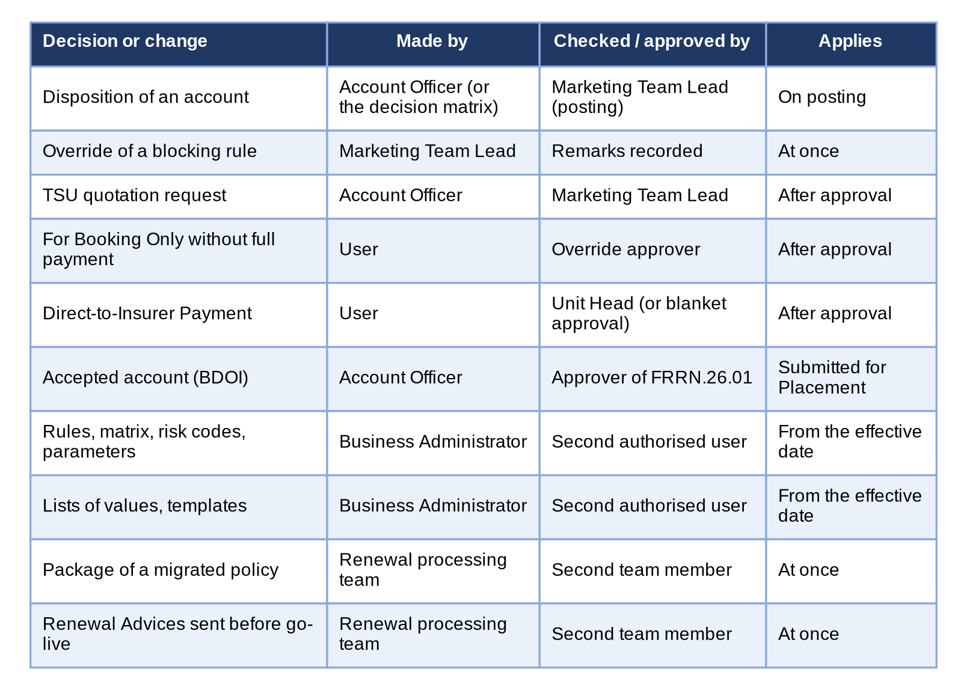
Figure 12 - Who makes, who checks and who approves each decision of Renewal
How to read it: Each row is a decision or a change, read from left to right. No one approves his or her own change. Traces to: BRD 1.008, 1.011; BRRN.020, 023, 031, 034, 040; FRRN.014.04-05, 016, 018, 020, 026, 038, 040, 045-046.
Process | Stage | Maker | Checker / approver | Time rule (SLA, reminder, escalation) | Return / void
RMEL | Generation and initiation | Marketing or Processing Team Lead; the daily run | - | Daily run at 01:00; lead days 140 (parameter) | -
Sanitation | Classification and rule-based disposition | System | Team Lead reclassifies or overrides with remarks | Exception ageing alert after 5 working days | Reclassification with justification
Assignment | Assign / re-assign | Marketing Team Lead; Processing Team Lead | - | Until the account is locked | Re-assign
Transfer | Request and decision | Team Lead or Account Officer | Team Lead of the receiving unit | - | Decline with remarks; cancel by the sender
Disposition | Disposition and submission for posting | Account Officer | Marketing Team Lead (approver chosen, FRRN.016.01) | Ageing flag 30 days before expiry (IBG, Leasing 60); no automatic escalation | Return with reason and remarks
Posting | Review and post | Marketing Team Lead | - | - | Return to the Account Officer
Overrides | Outstanding balance, classification, disposition, insurer mismatch, RA cancellation | Marketing Team Lead | Remarks recorded (no second approver in the BRD; Annex AO) | - | -
Processing | Update, computations, request to the insurer | Processing Officer | Processing Team Lead (assignment) | Insurer reply 10 days; overdue alert | Return to Marketing
Insurer | Insurer disposition | Insurer (file) or Processing | - | Late answer blocks straight-through progress | Revise or Reject reroutes
Renewal Advice | Generate and send | Authorised Marketing or Processing user | - | First notice 75 days, last notice 45 days before expiry; warning below 30 days | RA cancellation by override
Acceptance | Client acceptance | Account Officer | Approver of FRRN.26.01 (BDOI); none in the BRD (Annex AO) | NRNS reminder 75 days before expiry; non-acceptance at the effective expiry date | Request for Revision returns to the revision
Placement and booking | Placement, booking | Processing; booking user | Override approval for For Booking Only; Unit Head for Direct-to-Insurer Payment | Placement TAT 3 / 10 business days, cut-off 3 PM | Rejected Placement returns to Marketing
Hold cover | Request, extension, confirmation | System or user | Insurer | CBG 75 days before expiry; extension from 7 days before the end | Rejected returns to the user
Letters | NRNS, No Advice, Non-Renewal, non-acceptance | System; Operations; Account Officer | - | On the effective expiry date (+1 / +3 days, Annex M) | Re-open until expiry plus 30 days
Maintenance | Rules, parameters, risk codes, lists, templates, budget | Business Administrator | Second authorised user (four eyes) | Effective date | Rejected change stays draft
Go-live | Package choices; Renewal Advices already sent | Renewal processing team (maker) | Second member of the team (checker) | Once at go-live | Rejected row corrected

Who acts at each stage (M = makes, A = approves or decides, V = views):
Stage | Mkt TL | Mkt AO | Proc. TL | Proc. Off. | Bus. Admin | LAMD | Contact Ctr
RMEL generation and initiation | M | V | M | V |  |  | V
Assignment | M | V | M | V
Transfer | M / A | M
Disposition | V | M |  |  |  |  | V
Review and posting; overrides | A
Processing and insurer | V |  | M / A | M
Renewal Advice and letters | M | M | M | M |  |  | V
Client acceptance | M | M | M | M |  |  | V
LAMD uploads | V | V | V | V |  | M
Follow-ups | V | V |  |  |  |  | M
Rules, parameters, lists, templates |  |  |  |  | M / A

Escalation is by visibility: the attention flags of the renewal listing (ageing, overdue, high risk) and the tiles of the dashboard show the accounts that need action, and the Account Officer escalates outside the system; the system never escalates an account by itself (BRRN.036). The alerts of Annex AE go to the administrators and Team Leads for the runs that failed, the insurer answers that are overdue, the letters not delivered and the exceptions that stay open beyond the ageing days.

Annex AE – E-mail and Notification Texts
Every notice in the system, alert and e-mail of Renewal, with its trigger, recipients, channel, subject or title, full text, attachments, protection and frequency. The texts are the wording of the system today (quoted word for word; <name> parts are filled in by the system), proposed by iorta TechNXT for BDOI's approval where BDOI has not given its own. Where BDOI's FRS gives the wording (Annexes L, S, W, X), BDOI's wording prevails and the difference is listed in Annex AP.5; the Business Unit approves each text in the requirements collection workbook (sheet E-mail wordings).
A notice appears under the bell in the page header and opens the renewal account; the user chooses on Notification Settings whether the events of Renewal also come by e-mail.
No. | Notice, alert or e-mail | Channel | Recipients
AE.01 | Account assigned to the Account Officer | Notice in the system | The Account Officer assigned
AE.02 | Account assigned for processing | Notice in the system | The Processing Officer assigned
AE.03 | Account classified Exception | Notice in the system | The Account Officer and the Processing Officer of the account
AE.04 | LAMD line applied to an account | Notice in the system | The Team Leads of the unit of the account
AE.05 | Transfer to another unit requested | Notice in the system; e-mail by the user's choice | The Team Leads of the receiving unit
AE.06 | Transfer accepted or declined | Notice in the system | The user who requested the transfer
AE.07 | Account returned to the Account Officer | Notice in the system; e-mail by the user's choice | The Account Officer of the account
AE.08 | Account returned by Processing | Notice in the system; e-mail by the user's choice | The Account Officer, or the Team Leads of the unit for a return to the Team Lead
AE.09 | Account re-opened | Notice in the system | The Account Officer of the account and the Team Leads of its unit
AE.10 | Account posted for processing | Notice in the system | The Processing Team Leads
AE.11 | Insurer disposition recorded | Notice in the system | The Processing Officer of the account
AE.12 | Client accepted the renewal | Notice in the system | The Account Officer and the Processing Officer of the account
AE.13 | Renewal account ready for placement | Notice in the system | The Processing Officer of the account
AE.14 | Renewal booked | Notice in the system | The Account Officer and the Processing Officer of the account
AE.15 | Renewal closed, expired without renewal | Notice in the system | The Account Officer and the Processing Officer of the account
AE.16 | Go-live take-over completed | Notice in the system; e-mail by the user's choice | The users who generate the RMEL (Marketing and Processing Team Leads)
AE.17 | Package choice approved or rejected | Notice in the system | The user who chose the package
AE.18 | Alert - extraction run failed | Alert (alert inbox) | The administrators who receive the alerts of Renewal
AE.19 | Alert - insurer answer overdue | Alert (alert inbox) | The administrators and the Processing Team Leads who receive the alerts of Renewal
AE.20 | Alert - letter not delivered | Alert (alert inbox) | The administrators who receive the alerts of Renewal
AE.21 | Alert - exception ageing | Alert (alert inbox) | The administrators and Team Leads who receive the alerts of Renewal
AE.22 | Renewal Advice e-mail (first notice) | E-mail | The client's registered e-mail address
AE.23 | Renewal Advice e-mail (second / last notice) | E-mail | The client's registered e-mail address
AE.24 | Password e-mail | E-mail | The same recipients as the protected e-mail
AE.25 | No Advice Letter e-mail | E-mail | The client's registered e-mail address
AE.26 | Non-Renewal Letter e-mail | E-mail | The client's registered e-mail address
AE.27 | NRNS reminder letter e-mail | E-mail | The client's registered e-mail address
AE.28 | Non-acceptance letter e-mail | E-mail | The client's registered e-mail address
AE.29 | Renewal Advice of a free-first-year account (FFY) | E-mail or print | The client's registered e-mail address (or print through the mail house)
AE.30 | SFU letter (mortgaged accounts) | E-mail or print | The client's registered e-mail address (or print)
AE.31 | Request for renewal disposition to the insurer | E-mail | The renewal e-mail addresses of the insurer (Insurer Maintenance)
AE.32 | Hold cover request e-mail | E-mail | The insurer's e-mail addresses (Insurer Maintenance), or the addresses the user enters
AE.33 | Step of the progression not completed | Notice in the system | The Processing Officer of the account
AE.34 | Hold cover rejected by the insurer | Notice in the system | The responsible user of the account
AE.35 | Hold cover and placement files to the insurer | E-mail with the file attached (MFT upload for the enrolled insurers) | The placement e-mail addresses of the insurer in Insurer Maintenance
AE.36 | Placement not sent | Notice in the system | The Processing Officer of the account
AE.37 | Placement response received | Notice in the system | The Processing Officer of the account
AE.38 | Account submitted for posting | Notice in the system | The approver chosen
AE.39 | Transfer request received | Notice in the system | The Team Leads of the receiving unit
AE.40 | Transfer request decided | Notice in the system | The requesting user
AE.41 | Direct-to-Insurer Payment to approve | Notice in the system | The Unit Head of the assigned user
AE.42 | Direct-to-Insurer Payment decided | Notice in the system | The Account Officer of the account
AE.43 | Account returned for correction | Notice in the system | The Account Officer of the account
AE.44 | TSU request to approve, assigned and updated | Notice in the system | The Team Lead (approval), the TSU officer (assignment), the requester and the Account Officer (decisions and updates)

AE.01 Account assigned to the Account Officer
Item | Detail
Trigger | The Marketing Team Lead assigns or re-assigns renewal accounts (FRRN.010).
Recipients | The Account Officer assigned
Channel | Notice in the system
Subject / title | <renewal reference> assigned to you
Text | Give the disposition of the renewal of <client>, expiring <expiry date>
Attachments | None
Protection | No attachment; the notice opens the record only for a signed-in user who holds the right.
Frequency | Once per account assigned
Wording | Wording of the system today, proposed by iorta TechNXT for BDOI approval (requirements collection workbook, sheet E-mail wordings, item AE.01)
Traces to | BRD 1.005.1.2; 1.005.2; FRRN.010.01

AE.02 Account assigned for processing
Item | Detail
Trigger | The Processing Team Lead assigns renewal accounts to a Processing Officer (FRRN.010.01, FRRN.003.05).
Recipients | The Processing Officer assigned
Channel | Notice in the system
Subject / title | <renewal reference> assigned to you for processing
Text | <client>
Attachments | None
Protection | No attachment; the notice opens the record only for a signed-in user who holds the right.
Frequency | Once per account assigned
Wording | Wording of the system today, proposed by iorta TechNXT for BDOI approval (requirements collection workbook, sheet E-mail wordings, item AE.02)
Traces to | BRD 3.005.1; FRRN.010.01

AE.03 Account classified Exception
Item | Detail
Trigger | A sanitation rule fails with the severity Exception on a re-evaluation (FRRN.007.01, FRRN.008.01).
Recipients | The Account Officer and the Processing Officer of the account
Channel | Notice in the system
Subject / title | <renewal reference>: Exception
Text | A check failed on the renewal of <client>
Attachments | None
Protection | No attachment; the notice opens the record only for a signed-in user who holds the right.
Frequency | Once per change to Exception
Wording | Wording of the system today, proposed by iorta TechNXT for BDOI approval (requirements collection workbook, sheet E-mail wordings, item AE.03)
Traces to | BRRN.023; FRRN.008.01

AE.04 LAMD line applied to an account
Item | Detail
Trigger | A line of a LAMD report matches a renewal account and is applied (FRRN.012.02).
Recipients | The Team Leads of the unit of the account
Channel | Notice in the system
Subject / title | <renewal reference>: LAMD loan fully paid, or <renewal reference>: LAMD loan under RMU
Text | Moved from <status> to <status>, or Checks run again; stage <status>
Attachments | None
Protection | No attachment; the notice opens the record only for a signed-in user who holds the right.
Frequency | Once per line applied
Wording | Wording of the system today, proposed by iorta TechNXT for BDOI approval (requirements collection workbook, sheet E-mail wordings, item AE.04)
Traces to | BRRN.029, 039; FRRN.012.02

AE.05 Transfer to another unit requested
Item | Detail
Trigger | An account is transferred to another Marketing Unit (FRRN.011.06, FRRN.011.05).
Recipients | The Team Leads of the receiving unit
Channel | Notice in the system; e-mail by the user's choice
Subject / title | <renewal reference> transferred to your unit
Text | Accept or decline the renewal of <client>: <remarks>
Attachments | None
Protection | No attachment; the notice opens the record only for a signed-in user who holds the right.
Frequency | Once per request
Wording | Wording of the system today, proposed by iorta TechNXT for BDOI approval (requirements collection workbook, sheet E-mail wordings, item AE.05)
Traces to | BRD 1.006.5; 1.007.1; FRRN.011.05, FRRN.011.06

AE.06 Transfer accepted or declined
Item | Detail
Trigger | The receiving Team Lead accepts or declines the transfer (FRRN.011.02).
Recipients | The user who requested the transfer
Channel | Notice in the system
Subject / title | <renewal reference>: transfer accepted, or <renewal reference>: transfer declined
Text | The transfer to <unit> was accepted, or The transfer to <unit> was declined: <remarks>
Attachments | None
Protection | No attachment; the notice opens the record only for a signed-in user who holds the right.
Frequency | Once per decision
Wording | Wording of the system today, proposed by iorta TechNXT for BDOI approval (requirements collection workbook, sheet E-mail wordings, item AE.06)
Traces to | BRD 1.007.4, 1.007.5; FRRN.011.05

AE.07 Account returned to the Account Officer
Item | Detail
Trigger | The Marketing Team Lead returns an account (FRRN.020.02).
Recipients | The Account Officer of the account
Channel | Notice in the system; e-mail by the user's choice
Subject / title | <renewal reference> returned to you
Text | <return reason>: <remarks>
Attachments | None
Protection | No attachment; the notice opens the record only for a signed-in user who holds the right.
Frequency | Once per return
Wording | Wording of the system today, proposed by iorta TechNXT for BDOI approval (requirements collection workbook, sheet E-mail wordings, item AE.07)
Traces to | BRD 1.008.2; 2.007.1; FRRN.020.02, FRRN.002.08

AE.08 Account returned by Processing
Item | Detail
Trigger | Processing returns an account to Marketing (FRRN.031.01).
Recipients | The Account Officer, or the Team Leads of the unit for a return to the Team Lead
Channel | Notice in the system; e-mail by the user's choice
Subject / title | <renewal reference> returned by Processing
Text | <return reason>: <remarks>
Attachments | None
Protection | No attachment; the notice opens the record only for a signed-in user who holds the right.
Frequency | Once per return
Wording | Wording of the system today, proposed by iorta TechNXT for BDOI approval (requirements collection workbook, sheet E-mail wordings, item AE.08)
Traces to | BRD 3.008.2; 4.006.2; FRRN.031.01

AE.09 Account re-opened
Item | Detail
Trigger | An account tagged Not for Renewal is re-opened (FRRN.014.07).
Recipients | The Account Officer of the account and the Team Leads of its unit
Channel | Notice in the system
Subject / title | <renewal reference> re-opened
Text | To the Account Officer - Give a new disposition: <reason>; to the Team Leads - <reason>
Attachments | None
Protection | No attachment; the notice opens the record only for a signed-in user who holds the right.
Frequency | Once per re-open
Wording | Wording of the system today, proposed by iorta TechNXT for BDOI approval (requirements collection workbook, sheet E-mail wordings, item AE.09)
Traces to | BRD 2.004.10; 3.004.5; FRRN.014.07

AE.10 Account posted for processing
Item | Detail
Trigger | The Marketing Team Lead posts an account For Renewal (FRRN.020.01).
Recipients | The Processing Team Leads
Channel | Notice in the system
Subject / title | <renewal reference> posted for processing
Text | <client>
Attachments | None
Protection | No attachment; the notice opens the record only for a signed-in user who holds the right.
Frequency | Once per account posted
Wording | Wording of the system today, proposed by iorta TechNXT for BDOI approval (requirements collection workbook, sheet E-mail wordings, item AE.10)
Traces to | BRD 1.008.3; FRRN.020.01

AE.11 Insurer disposition recorded
Item | Detail
Trigger | An insurer disposition is uploaded or recorded on the account (FRRN.013.02, FRRN.013.05).
Recipients | The Processing Officer of the account
Channel | Notice in the system
Subject / title | <renewal reference>: insurer response <disposition>
Text | Applied to the renewal, or Not applied: check the Insurer tab
Attachments | None
Protection | No attachment; the notice opens the record only for a signed-in user who holds the right.
Frequency | Once per disposition recorded
Wording | Wording of the system today, proposed by iorta TechNXT for BDOI approval (requirements collection workbook, sheet E-mail wordings, item AE.11)
Traces to | BRD 3.009.6; BRRN.035; FRRN.013.02, FRRN.013.05

AE.12 Client accepted the renewal
Item | Detail
Trigger | The client's acceptance is recorded (FRRN.025.01).
Recipients | The Account Officer and the Processing Officer of the account
Channel | Notice in the system
Subject / title | <renewal reference> accepted by the client
Text | <client> accepted the renewal by <method>
Attachments | None
Protection | No attachment; the notice opens the record only for a signed-in user who holds the right.
Frequency | Once per acceptance
Wording | Wording of the system today, proposed by iorta TechNXT for BDOI approval (requirements collection workbook, sheet E-mail wordings, item AE.12)
Traces to | BRRN.040; FRRN.025.01

AE.13 Renewal account ready for placement
Item | Detail
Trigger | The accepted renewal account reaches placement and its placement slips are generated (FRRN.028.02, FRRN.029).
Recipients | The Processing Officer of the account
Channel | Notice in the system
Subject / title | <renewal reference>: ready for placement
Text | <n> placement slip(s) of <ARN> generated; send them from Placement
Attachments | None
Protection | No attachment; the notice opens the record only for a signed-in user who holds the right.
Frequency | Once per renewal account
Wording | Wording of the system today, proposed by iorta TechNXT for BDOI approval (requirements collection workbook, sheet E-mail wordings, item AE.13)
Traces to | BRRN.040; FRRN.028.02, FRRN.029.02

AE.14 Renewal booked
Item | Detail
Trigger | The renewal account is booked (FRRN.035.01).
Recipients | The Account Officer and the Processing Officer of the account
Channel | Notice in the system
Subject / title | <renewal reference> renewed
Text | Booked with invoice <invoice no.>
Attachments | None
Protection | No attachment; the notice opens the record only for a signed-in user who holds the right.
Frequency | Once per renewal
Wording | Wording of the system today, proposed by iorta TechNXT for BDOI approval (requirements collection workbook, sheet E-mail wordings, item AE.14)
Traces to | BRRN.040; FRRN.035.01

AE.15 Renewal closed, expired without renewal
Item | Detail
Trigger | The effective expiry date passes without acceptance (FRRN.023.03).
Recipients | The Account Officer and the Processing Officer of the account
Channel | Notice in the system
Subject / title | <renewal reference> closed: expired without renewal
Text | The policy of <client> expired on <date>; Operations sends the No Advice Letter, or The policy of <client> expired on <date>; the Account Officer sends the Non-Renewal Letter
Attachments | None
Protection | No attachment; the notice opens the record only for a signed-in user who holds the right.
Frequency | Once per account
Wording | Wording of the system today, proposed by iorta TechNXT for BDOI approval (requirements collection workbook, sheet E-mail wordings, item AE.15)
Traces to | BRRN.025, 037; FRRN.023.03

AE.16 Go-live take-over completed
Item | Detail
Trigger | The go-live extraction of the migrated policies completes (FRRN.045.01).
Recipients | The users who generate the RMEL (Marketing and Processing Team Leads)
Channel | Notice in the system; e-mail by the user's choice
Subject / title | Go-live renewals taken over (<n>)
Text | <n> renewals, <n> urgent; by expiry month <month>: <count>, ...
Attachments | None
Protection | No attachment; the notice opens the record only for a signed-in user who holds the right.
Frequency | Once at go-live
Wording | Wording of the system today, proposed by iorta TechNXT for BDOI approval (requirements collection workbook, sheet E-mail wordings, item AE.16)
Traces to | BRRN.005; FRRN.045.01

AE.17 Package choice approved or rejected
Item | Detail
Trigger | The checker decides the package chosen for a migrated policy (FRRN.046.01).
Recipients | The user who chose the package
Channel | Notice in the system
Subject / title | <renewal reference>: package choice approved, or <renewal reference>: package choice rejected
Text | <package version> applies to the renewal, or <package version> was rejected: <remarks>
Attachments | None
Protection | No attachment; the notice opens the record only for a signed-in user who holds the right.
Frequency | Once per decision
Wording | Wording of the system today, proposed by iorta TechNXT for BDOI approval (requirements collection workbook, sheet E-mail wordings, item AE.17)
Traces to | BRRN.020; FRRN.046.01

AE.18 Alert - extraction run failed
Item | Detail
Trigger | The daily extraction fails (FRRN.004.04).
Recipients | The administrators who receive the alerts of Renewal
Channel | Alert (alert inbox)
Subject / title | Renewal extraction failed
Text | The renewal extraction of <date> failed: <reason>
Attachments | None
Protection | No attachment; the notice opens the record only for a signed-in user who holds the right.
Frequency | Once per failed run; the next run takes the missed dates
Wording | Wording of the system today, proposed by iorta TechNXT for BDOI approval (requirements collection workbook, sheet E-mail wordings, item AE.18)
Traces to | BRRN.030; FRRN.004.04

AE.19 Alert - insurer answer overdue
Item | Detail
Trigger | An insurer has not answered a request by its reply date (FRRN.021).
Recipients | The administrators and the Processing Team Leads who receive the alerts of Renewal
Channel | Alert (alert inbox)
Subject / title | Insurer renewal batch overdue
Text | Insurer <insurer> has not answered batch <batch no.> due <date>
Attachments | None
Protection | No attachment; the notice opens the record only for a signed-in user who holds the right.
Frequency | Once per request and day overdue, until answered
Wording | Wording of the system today, proposed by iorta TechNXT for BDOI approval (requirements collection workbook, sheet E-mail wordings, item AE.19)
Traces to | BRD 3.009.6; FRRN.021

AE.20 Alert - letter not delivered
Item | Detail
Trigger | A Renewal Advice or letter could not be delivered (FRRN.022.02, FRRN.023.02).
Recipients | The administrators who receive the alerts of Renewal
Channel | Alert (alert inbox)
Subject / title | Renewal letter not delivered
Text | Letter <letter no.> was not delivered: <error>
Attachments | None
Protection | No attachment; the notice opens the record only for a signed-in user who holds the right.
Frequency | Once per letter
Wording | Wording of the system today, proposed by iorta TechNXT for BDOI approval (requirements collection workbook, sheet E-mail wordings, item AE.20)
Traces to | BRRN.010; FRRN.022.02, FRRN.023.02

AE.21 Alert - exception ageing
Item | Detail
Trigger | An account stays Exception beyond the ageing days, 5 working days as delivered (FRRN.008.01).
Recipients | The administrators and Team Leads who receive the alerts of Renewal
Channel | Alert (alert inbox)
Subject / title | Renewal exception ageing
Text | Renewal <renewal reference> is an Exception since <date>
Attachments | None
Protection | No attachment; the notice opens the record only for a signed-in user who holds the right.
Frequency | Once per account and day while it stays Exception
Wording | Wording of the system today, proposed by iorta TechNXT for BDOI approval (requirements collection workbook, sheet E-mail wordings, item AE.21)
Traces to | BRRN.029 (R29-05); FRRN.008.01

AE.22 Renewal Advice e-mail (first notice)
Item | Detail
Trigger | Send on the Letters screen (FRRN.022.02).
Recipients | The client's registered e-mail address
Channel | E-mail
Subject / title | Renewal Advice - <assured name> - policy <policy no.>
Text | Dear <client name>,  Your policy <policy no.> with <insurer name> expires on <expiry date>. We are pleased to offer its renewal for the period <renewal from> to <renewal to> on the following terms:  Product: <product name>  Sum insured: <currency> <sum insured>  Renewal premium: <currency> <gross premium>  To renew, please reply to this e-mail, sign and return this Renewal Advice, or pay the renewal premium on or before <expiry date>.  Renewal reference: <renewal reference>  Account officer: <account officer name>  Thank you for your continued trust,  BDO Insurance and Reinsurance Brokers, Inc.
Attachments | <letter no.>.pdf (the Renewal Advice), password protected
Protection | The attachment is a password-protected PDF or Excel file; the password is sent in a separate e-mail (AE.24) and is never written in the e-mail that carries the file, on the screens or in the audit log (FRRN.024.01).
Frequency | Once per Renewal Advice sent; resent on request
Wording | BDOI's approved Renewal Advice templates BDOI-005 to BDOI-008 (one per line) and e-mails BDOI-009 to BDOI-011 (Annex L) prevail; the system's text is replaced by them (Annex AP.5).
Traces to | BRRN.010; BRD 1.010.7; FRRN.022.01, FRRN.022.02

AE.23 Renewal Advice e-mail (second / last notice)
Item | Detail
Trigger | Send of a second notice on the Letters screen (FRRN.022.01).
Recipients | The client's registered e-mail address
Channel | E-mail
Subject / title | Second notice: Renewal Advice - <assured name> - policy <policy no.>
Text | Dear <client name>,  This is our second notice on the renewal of your policy <policy no.> with <insurer name>, which expires on <expiry date>. The renewal terms remain:  Sum insured: <currency> <sum insured>  Renewal premium: <currency> <gross premium>  Please reply to this e-mail, sign and return this Renewal Advice, or pay the renewal premium on or before <expiry date> to keep your cover.  Renewal reference: <renewal reference>  Account officer: <account officer name>  BDO Insurance and Reinsurance Brokers, Inc.
Attachments | <letter no.>.pdf, password protected
Protection | The attachment is a password-protected PDF or Excel file; the password is sent in a separate e-mail (AE.24) and is never written in the e-mail that carries the file, on the screens or in the audit log (FRRN.024.01).
Frequency | Once per notice
Wording | BDOI's templates mark the last notice FINAL NOTICE (Annex L); BDOI's wording prevails (Annex AP.5).
Traces to | BRRN.010; FRRN.022.01

AE.24 Password e-mail
Item | Detail
Trigger | Follows every protected e-mail of Renewal (Renewal Advice, letters, request to the insurer).
Recipients | The same recipients as the protected e-mail
Channel | E-mail
Subject / title | Password for: <subject of the protected e-mail>
Text | The documents sent to you in the e-mail "<subject>" are password protected.  Password: <password>  This e-mail was sent separately for your security. Please do not forward it.
Attachments | None
Protection | No attachment; the notice opens the record only for a signed-in user who holds the right.
Frequency | Once per protected e-mail
Wording | BDOI's convention (FRRN.024.01) lets the client derive the password, which BDOI's e-mails BDOI-009 to BDOI-011 explain; whether the separate password e-mail is still sent is a decision (Annex AP.5).
Traces to | BRRN.010; BRD 1.010.7.1; FRRN.024.01, FRRN.022.02

AE.25 No Advice Letter e-mail
Item | Detail
Trigger | Send Letters on the No Advice tab (FRRN.023.02).
Recipients | The client's registered e-mail address
Channel | E-mail
Subject / title | Notice on your policy <policy no.>
Text | Dear <client name>,  This is to inform you that your policy <policy no.> with <insurer name>, expiring on <expiry date>, will not be renewed through BDO Insurance and Reinsurance Brokers, Inc. No further action is needed from you.  Reference: <renewal reference>  Account officer: <account officer name>
Attachments | <letter no.>.pdf, password protected
Protection | The attachment is a password-protected PDF or Excel file; the password is sent in a separate e-mail (AE.24) and is never written in the e-mail that carries the file, on the screens or in the audit log (FRRN.024.01).
Frequency | Once per account
Wording | Annex O (No Advice Letter Template) is a heading only: the Business Unit confirms this text or gives its template.
Traces to | BRRN.001; FRRN.023.01, FRRN.023.02

AE.26 Non-Renewal Letter e-mail
Item | Detail
Trigger | Send Letters on the Non-Renewal tab (FRRN.023.02; FRRN.038.03).
Recipients | The client's registered e-mail address
Channel | E-mail
Subject / title | Your policy <policy no.> will not be renewed
Text | Dear <client name>,  We regret to inform you that your policy <policy no.> with <insurer name>, expiring on <expiry date>, is not for renewal: <reason>.  For questions, please contact your account officer <account officer name>.  Reference: <renewal reference>  BDO Insurance and Reinsurance Brokers, Inc.
Attachments | <letter no.>.pdf, password protected
Protection | The attachment is a password-protected PDF or Excel file; the password is sent in a separate e-mail (AE.24) and is never written in the e-mail that carries the file, on the screens or in the audit log (FRRN.024.01).
Frequency | Once per account
Wording | Annex P (Non-Renewal Letter Template) is a heading only: the Business Unit confirms this text or gives its template.
Traces to | BRRN.009, 037; FRRN.023.02, FRRN.038.03

AE.27 NRNS reminder letter e-mail
Item | Detail
Trigger | The nightly letter run at the NRNS checkpoint (FRRN.023.03).
Recipients | The client's registered e-mail address
Channel | E-mail
Subject / title | Reminder: renewal of your policy <policy no.>
Text | Dear <client name>,  Your policy <policy no.> with <insurer name> expires on <expiry date> and its renewal has not been confirmed yet. Please contact your account officer <account officer name> to renew your cover.  Reference: <renewal reference>
Attachments | <letter no.>.pdf, password protected
Protection | The attachment is a password-protected PDF or Excel file; the password is sent in a separate e-mail (AE.24) and is never written in the e-mail that carries the file, on the screens or in the audit log (FRRN.024.01).
Frequency | Once per account and checkpoint
Wording | Annex N (NRNS Reminder Letter Template) is a heading only: the Business Unit confirms this text or gives its template.
Traces to | BRRN.025; FRRN.023.03

AE.28 Non-acceptance letter e-mail
Item | Detail
Trigger | The effective expiry date passes without acceptance (FRRN.023.03).
Recipients | The client's registered e-mail address
Channel | E-mail
Subject / title | Your policy <policy no.> has expired
Text | Dear <client name>,  Your policy <policy no.> with <insurer name> expired on <expiry date> without renewal, as we did not receive your acceptance of the Renewal Advice. Your property or risk is no longer covered by this policy.  Please contact your account officer <account officer name> if you wish to be covered again.  Reference: <renewal reference>
Attachments | <letter no.>.pdf, password protected
Protection | The attachment is a password-protected PDF or Excel file; the password is sent in a separate e-mail (AE.24) and is never written in the e-mail that carries the file, on the screens or in the audit log (FRRN.024.01).
Frequency | Once per account
Wording | Not in BDOI's matrix; added as a row of Annex M (Annex AP.4).
Traces to | BRRN.025, 037; FRRN.023.03

AE.29 Renewal Advice of a free-first-year account (FFY)
Item | Detail
Trigger | The Renewal Advice of a submitted FFY policy (FRRN.048.01).
Recipients | The client's registered e-mail address (or print through the mail house)
Channel | E-mail or print
Subject / title | Renewal Advice (first year free) - <assured name> - policy <policy no.>
Text | Dear <client name>,  The first year of your policy <policy no.> with <insurer name> was free of charge and ends on <expiry date>. To keep your cover, we offer its renewal for the period <renewal from> to <renewal to>:  Sum insured: <currency> <sum insured>  Renewal premium: <currency> <gross premium>  To renew, please sign and return this Renewal Advice, or pay the renewal premium on or before <expiry date>.  Renewal reference: <renewal reference>  Account officer: <account officer name>  Thank you for your trust,  BDO Insurance and Reinsurance Brokers, Inc.
Attachments | <letter no.>.pdf, password protected
Protection | The attachment is a password-protected PDF or Excel file; the password is sent in a separate e-mail (AE.24) and is never written in the e-mail that carries the file, on the screens or in the audit log (FRRN.024.01).
Frequency | Once per account
Wording | Annex R (FFY Reminder Letter Template) is a heading only: the Business Unit confirms this text or gives its template.
Traces to | BRRN.010 (submitted policies); FRRN.048.01

AE.30 SFU letter (mortgaged accounts)
Item | Detail
Trigger | Follow-up of a mortgaged submitted policy without answer to the Renewal Advice (FRRN.048.01).
Recipients | The client's registered e-mail address (or print)
Channel | E-mail or print
Subject / title | Follow-up on the renewal of your mortgaged property - policy <policy no.>
Text | Dear <client name>,  Your property is mortgaged to the bank and must stay insured. Your policy <policy no.> expires on <expiry date> and we have not received your answer to our Renewal Advice.  Please sign and return the Renewal Advice, or pay the renewal premium, on or before <expiry date>.  Renewal reference: <renewal reference>  Account officer: <account officer name>  Thank you,  BDO Insurance and Reinsurance Brokers, Inc.
Attachments | <letter no.>.pdf, password protected
Protection | The attachment is a password-protected PDF or Excel file; the password is sent in a separate e-mail (AE.24) and is never written in the e-mail that carries the file, on the screens or in the audit log (FRRN.024.01).
Frequency | Once per account
Wording | Annex Q (SFU Letter Template) is a heading only: the Business Unit confirms this text or gives its template.
Traces to | BRRN.010 (submitted policies); FRRN.048.01

AE.31 Request for renewal disposition to the insurer
Item | Detail
Trigger | Send on a request to the insurer (FRRN.021).
Recipients | The renewal e-mail addresses of the insurer (Insurer Maintenance)
Channel | E-mail
Subject / title | Renewals for your decision - batch <batch no.>
Text | Dear <insurer name>,  Please find attached the policies expiring from <expiry from> to <expiry to> that we propose for renewal (<count> accounts). Please return the file with your decision on each account (Renew As Is, Revise or Reject) by <reply date>.  BDO Insurance and Reinsurance Brokers, Inc. - Processing
Attachments | The request file (Excel, 28 fields), password protected
Protection | The attachment is a password-protected PDF or Excel file; the password is sent in a separate e-mail (AE.24) and is never written in the e-mail that carries the file, on the screens or in the audit log (FRRN.024.01).
Frequency | Once per request; resent on failure
Wording | BDOI's FRS gives the success message of FRRN.021 but no e-mail text: the Business Unit confirms this text.
Traces to | BRD 3.009.5; 4.007.5; FRRN.021

AE.32 Hold cover request e-mail
Item | Detail
Trigger | A hold cover is requested from the renewal account (FRRN.036.02, FRRN.036.06).
Recipients | The insurer's e-mail addresses (Insurer Maintenance), or the addresses the user enters
Channel | E-mail
Subject / title | Hold cover request - <ARN> - <client name>
Text | Please hold cover the risk below for thirty (30) days from <start date> under reference <reference> while the placement is being completed. Kindly confirm the hold cover and your reference number.
Attachments | HOLD_COVER_<ARN>.pdf (the hold cover request)
Protection | The attachment is a password-protected PDF or Excel file; the password is sent in a separate e-mail (AE.24) and is never written in the e-mail that carries the file, on the screens or in the audit log (FRRN.024.01).
Frequency | Once per request or extension
Wording | Annex Z (Hold Cover Template) is a heading only. The text names thirty days whatever the duration (30, 60 or 90 days, FRRN.036.01): Annex AP.5.
Traces to | BRRN.042; FRRN.036.02, FRRN.036.06

AE.33 Step of the progression not completed
Item | Detail
Trigger | A step after the acceptance (completion of the renewal account, placement) cannot be completed (FRRN.028.02).
Recipients | The Processing Officer of the account
Channel | Notice in the system
Subject / title | <renewal reference>
Text | <what could not be completed, as recorded in the remarks of the account>
Attachments | None
Protection | No attachment; the notice opens the record only for a signed-in user who holds the right.
Frequency | Once per step not completed
Wording | Wording of the system today, proposed by iorta TechNXT for BDOI approval (requirements collection workbook, sheet E-mail wordings, item AE.33)
Traces to | BRRN.040; FRRN.028.02

AE.34 Hold cover rejected by the insurer
Item | Detail
Trigger | The insurer rejects a hold cover request in the Hold Cover Response upload (FRRN.037.02).
Recipients | The responsible user of the account
Channel | Notice in the system
Subject / title | <renewal reference>: hold cover rejected by <insurer>
Text | <insurer's remarks>, or Rejected by the insurer
Attachments | None
Protection | No attachment; the notice opens the record only for a signed-in user who holds the right.
Frequency | Once per rejected request
Wording | Wording of the system today, proposed by iorta TechNXT for BDOI approval (requirements collection workbook, sheet E-mail wordings, item AE.34)
Traces to | BRRN.042; FRRN.037.02

AE.35 Hold cover and placement files to the insurer
Item | Detail
Trigger | A hold cover request or a placement file is sent to an insurer not enrolled in MFT (FRRN.036.06, FRRN.29.04).
Recipients | The placement e-mail addresses of the insurer in Insurer Maintenance
Channel | E-mail with the file attached (MFT upload for the enrolled insurers)
Subject / title | <document type> - <file name>
Text | Please find attached <file name>.
Attachments | The file
Protection | The attachment is a password-protected PDF or Excel file; the password is sent in a separate e-mail (AE.24) and is never written in the e-mail that carries the file, on the screens or in the audit log (FRRN.024.01).
Frequency | Once per file and insurer
Wording | Wording of the system today, proposed by iorta TechNXT for BDOI approval (requirements collection workbook, sheet E-mail wordings, item AE.35)
Traces to | BRRN.042; BRRN.040; FRRN.036.06; FRRN.29.04

AE.36 Placement not sent
Item | Detail
Trigger | A placement of the account could not be sent to an insurer (FRRN.29.04).
Recipients | The Processing Officer of the account
Channel | Notice in the system
Subject / title | <renewal reference> placement not sent
Text | Check the Channel Monitor
Attachments | None
Protection | No attachment; the notice opens the record only for a signed-in user who holds the right.
Frequency | Once per sending that failed
Wording | Wording of the system today, proposed by iorta TechNXT for BDOI approval (requirements collection workbook, sheet E-mail wordings, item AE.36)
Traces to | BRRN.040; FRRN.29.04

AE.37 Placement response received
Item | Detail
Trigger | The insurer's placement response is uploaded or received through MFT (FRRN.030.01).
Recipients | The Processing Officer of the account
Channel | Notice in the system
Subject / title | <renewal reference> placement approved, or placement rejected
Text | <reason of the rejection>
Attachments | None
Protection | No attachment; the notice opens the record only for a signed-in user who holds the right.
Frequency | Once per response
Wording | Wording of the system today, proposed by iorta TechNXT for BDOI approval (requirements collection workbook, sheet E-mail wordings, item AE.37)
Traces to | BRRN.040; FRRN.030.01

AE.38 Account submitted for posting
Item | Detail
Trigger | An Account Officer submits an account for posting with an approver chosen (FRRN.016.01).
Recipients | The approver chosen
Channel | Notice in the system
Subject / title | <renewal reference> submitted for posting
Text | Approve the posting of the renewal of <client>
Attachments | None
Protection | No attachment; the notice opens the record only for a signed-in user who holds the right.
Frequency | Once per submission
Wording | Wording of the system today, proposed by iorta TechNXT for BDOI approval (requirements collection workbook, sheet E-mail wordings, item AE.38)
Traces to | BRD 1.008.3; FRRN.016.01

AE.39 Transfer request received
Item | Detail
Trigger | A transfer request for a New Business opportunity is submitted to another Marketing unit (FRRN.011.01).
Recipients | The Team Leads of the receiving unit
Channel | Notice in the system
Subject / title | <transfer request number>: transfer request for a New Business opportunity
Text | Review the transfer request of <client> from <unit>: <justification>
Attachments | None
Protection | No attachment; the notice opens the record only for a signed-in user who holds the right.
Frequency | Once per request
Wording | Wording of the system today, proposed by iorta TechNXT for BDOI approval (requirements collection workbook, sheet E-mail wordings, item AE.39)
Traces to | BRD 1.006.5; 1.007.1; FRRN.011.01; FRRN.011.05

AE.40 Transfer request decided
Item | Detail
Trigger | The receiving Team Lead accepts, rejects or returns a transfer request (FRRN.011.02, FRRN.011.05).
Recipients | The requesting user
Channel | Notice in the system
Subject / title | <transfer request number>: <Accepted, Rejected or Returned for Clarification>
Text | Transfer request of <renewal reference> to <unit>: <outcome> - <remarks>
Attachments | None
Protection | No attachment; the notice opens the record only for a signed-in user who holds the right.
Frequency | Once per decision
Wording | Wording of the system today, proposed by iorta TechNXT for BDOI approval (requirements collection workbook, sheet E-mail wordings, item AE.40)
Traces to | BRD 1.007.4, 1.007.5; FRRN.011.05

AE.41 Direct-to-Insurer Payment to approve
Item | Detail
Trigger | An account is tagged Direct-to-Insurer Payment with Route for UH Approval (FRRN.014.05).
Recipients | The Unit Head of the assigned user
Channel | Notice in the system
Subject / title | <renewal reference>: Direct-to-Insurer Payment to approve
Text | <client>
Attachments | None
Protection | No attachment; the notice opens the record only for a signed-in user who holds the right.
Frequency | Once per tag
Wording | Wording of the system today, proposed by iorta TechNXT for BDOI approval (requirements collection workbook, sheet E-mail wordings, item AE.41)
Traces to | BRRN.040; FRRN.014.05

AE.42 Direct-to-Insurer Payment decided
Item | Detail
Trigger | The Unit Head approves or rejects a Direct-to-Insurer Payment (FRRN.014.05).
Recipients | The Account Officer of the account
Channel | Notice in the system
Subject / title | <renewal reference>: Direct-to-Insurer Payment approved, or rejected
Text | <rejection reason>
Attachments | None
Protection | No attachment; the notice opens the record only for a signed-in user who holds the right.
Frequency | Once per decision
Wording | Wording of the system today, proposed by iorta TechNXT for BDOI approval (requirements collection workbook, sheet E-mail wordings, item AE.42)
Traces to | BRRN.040; FRRN.014.05

AE.43 Account returned for correction
Item | Detail
Trigger | The approver rejects an account submitted for approval (FRRN.26.01).
Recipients | The Account Officer of the account
Channel | Notice in the system
Subject / title | <renewal reference> returned for correction
Text | <reason of the return>
Attachments | None
Protection | No attachment; the notice opens the record only for a signed-in user who holds the right.
Frequency | Once per return
Wording | Wording of the system today, proposed by iorta TechNXT for BDOI approval (requirements collection workbook, sheet E-mail wordings, item AE.43)
Traces to | BRRN.038; FRRN.26.01

AE.44 TSU request to approve, assigned and updated
Item | Detail
Trigger | A TSU request is submitted for the Team Lead's approval, assigned to a TSU officer, decided, given a comparative table or completed (FRRN.018.01).
Recipients | The Team Lead (approval), the TSU officer (assignment), the requester and the Account Officer (decisions and updates)
Channel | Notice in the system
Subject / title | <request number> pending your approval; <request number> assigned to you; <request number>: <Approved, Rejected or Returned>, For TSU Processing, comparative table updated, proposal completed by TSU
Text | <client>
Attachments | None
Protection | No attachment; the notice opens the record only for a signed-in user who holds the right.
Frequency | Once per step of the request
Wording | Wording of the system today, proposed by iorta TechNXT for BDOI approval (requirements collection workbook, sheet E-mail wordings, item AE.44)
Traces to | BRRN.033; FRRN.018.01

Not sent as a message:
Item | How it is handled
Renewal at risk | The accounts not disposed or not accepted within the escalation days show the ageing flag in the renewal listing and the At risk figure of the dashboard; no message is sent to anyone (BRRN.036).
Proposal, Insurance Advice, e-policy, billing and placement e-mails | Sent with the wording of BDOI's Annexes S, W and X and of the New Business FRS (FRRN.017.02, 027, 029.04, 032.02, 033.04); the e-mail texts of New Business are in the New Business FRS.

Annex AF – Document Prints and Output Formats
Every document the Renewal Module prints, e-mails or exports: purpose, recipients, format, protection, the fields in order and, where the system has one, an image of its current layout. Where BDOI's FRS gives the template, BDOI's template prevails; where it does not, the layout is to be provided or confirmed by the Business Unit (item of the requirements collection workbook, sheet Documents and print formats). Every PDF letter carries the BDO Insure letterhead, the page number and the template version.
File names follow BDOI's conventions where BDOI's FRS gives them (RMEL_<MMM>_<YYYY>_<MMDDYYYY>.xlsx, <Product>_RA_<Notice>_<Reference>_<MMDDYYYY>.pdf, <Product>_<Letter Type>_<Reference>_<MMDDYYYY>.pdf, IA_<Reference>_ <MMDDYYYY>.pdf, Renewal Account Details.xlsx, LAMD Processing Result_ MMDDYYYY.xlsx, Audit Logs_MMDDYYYY); the others use the document number of the system (for example RA-2027-000123.pdf).
AF.1 Renewal Advice (first and second notice) (DO-01)
Item | Detail
Purpose | Offer the renewal to the client: first and last notice (BRRN.010)
Recipients | Client (e-mail, protected)
Format | PDF, one per renewal; e-mailed to the client
Produced from | Letters › Generate RA, then Send; Renewal › Letters tab › Download PDF
Protection | Yes when e-mailed (password in a separate e-mail)
Fields in order | 1. Title: Renewal Advice - the assured - policy number (second notice: Second notice) – from the renewal  2. Client and policy: client name, policy number, insurer name and expiry date – from the expiring account  3. Renewal terms: renewal period, product, sum insured and renewal premium with the currency – from the renewal account, else the expiring terms  4. How to accept: reply to the e-mail, sign and return the Renewal Advice, or pay the renewal premium on or before the expiry date  5. Renewal reference and the name of the Account Officer – from the renewal
BDOI reference | Annex L: approved templates BDOI-005 to BDOI-008, one per line (Motor, PAR CLG, PAR Non-CLG, Other Lines) - they prevail
Layout | Current layout of the system below; where BDOI's FRS gives the template, BDOI's template prevails; otherwise the Business Unit confirms it or gives its layout (requirements collection workbook, item RC-DOC-01)

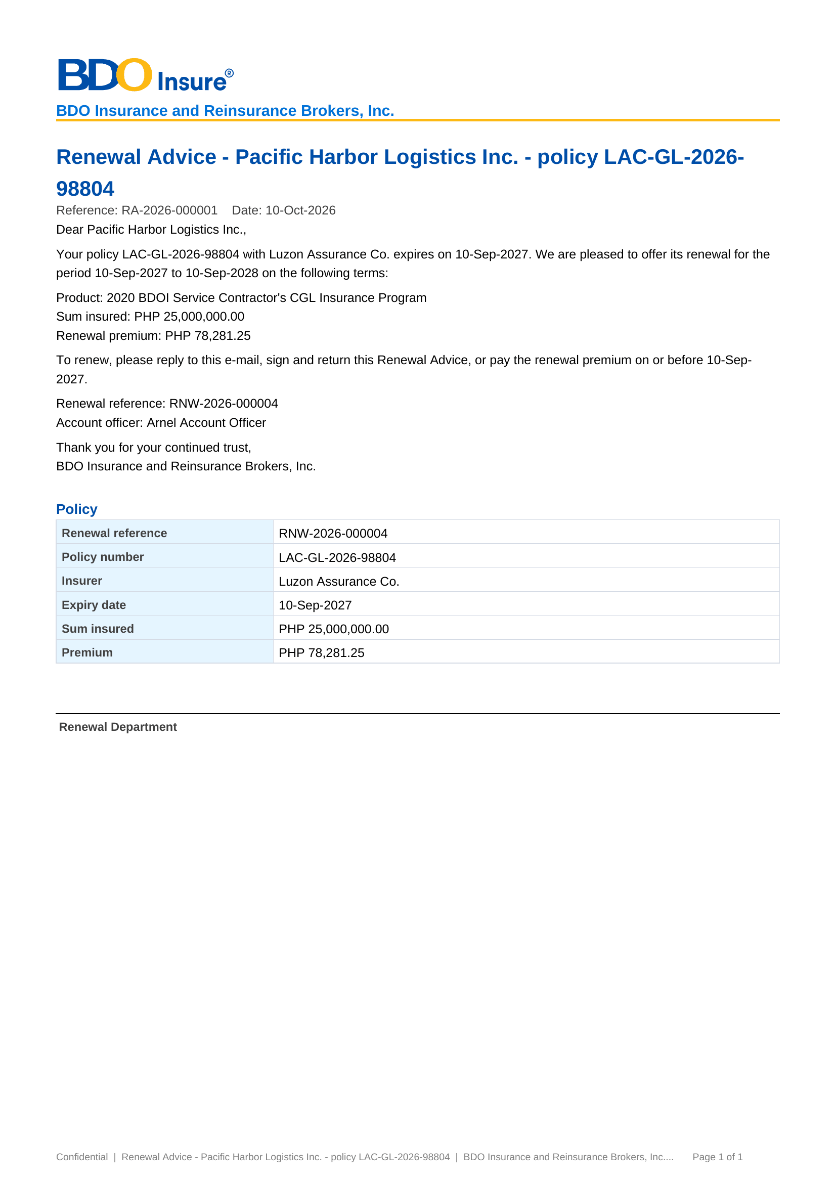
Figure AF.1: current layout of the Renewal Advice (first and second notice)
AF.2 Not for Renewal Letter and No Advice Letter (DO-02)
Item | Detail
Purpose | Tell the client that the policy is not renewed: No Advice Letter and Non-Renewal Letter (BRRN.001, 009, 037)
Recipients | Client (e-mail, protected)
Format | PDF, one per renewal; e-mailed to the client
Produced from | Letters, tab NAL / NFR › Send Letters
Protection | Yes when e-mailed (password in a separate e-mail)
Fields in order | 1. Client and policy: client name, policy number, insurer name and expiry date – from the expiring account  2. Not for Renewal Letter: the reason for Not for Renewal and the name of the Account Officer; No Advice Letter: that the policy is not renewed through BDOI and no action is needed  3. Reference: the renewal reference
BDOI reference | Annexes O and P: heading only - layout to be provided
Layout | Current layout of the system below; where BDOI's FRS gives the template, BDOI's template prevails; otherwise the Business Unit confirms it or gives its layout (requirements collection workbook, item RC-DOC-02)

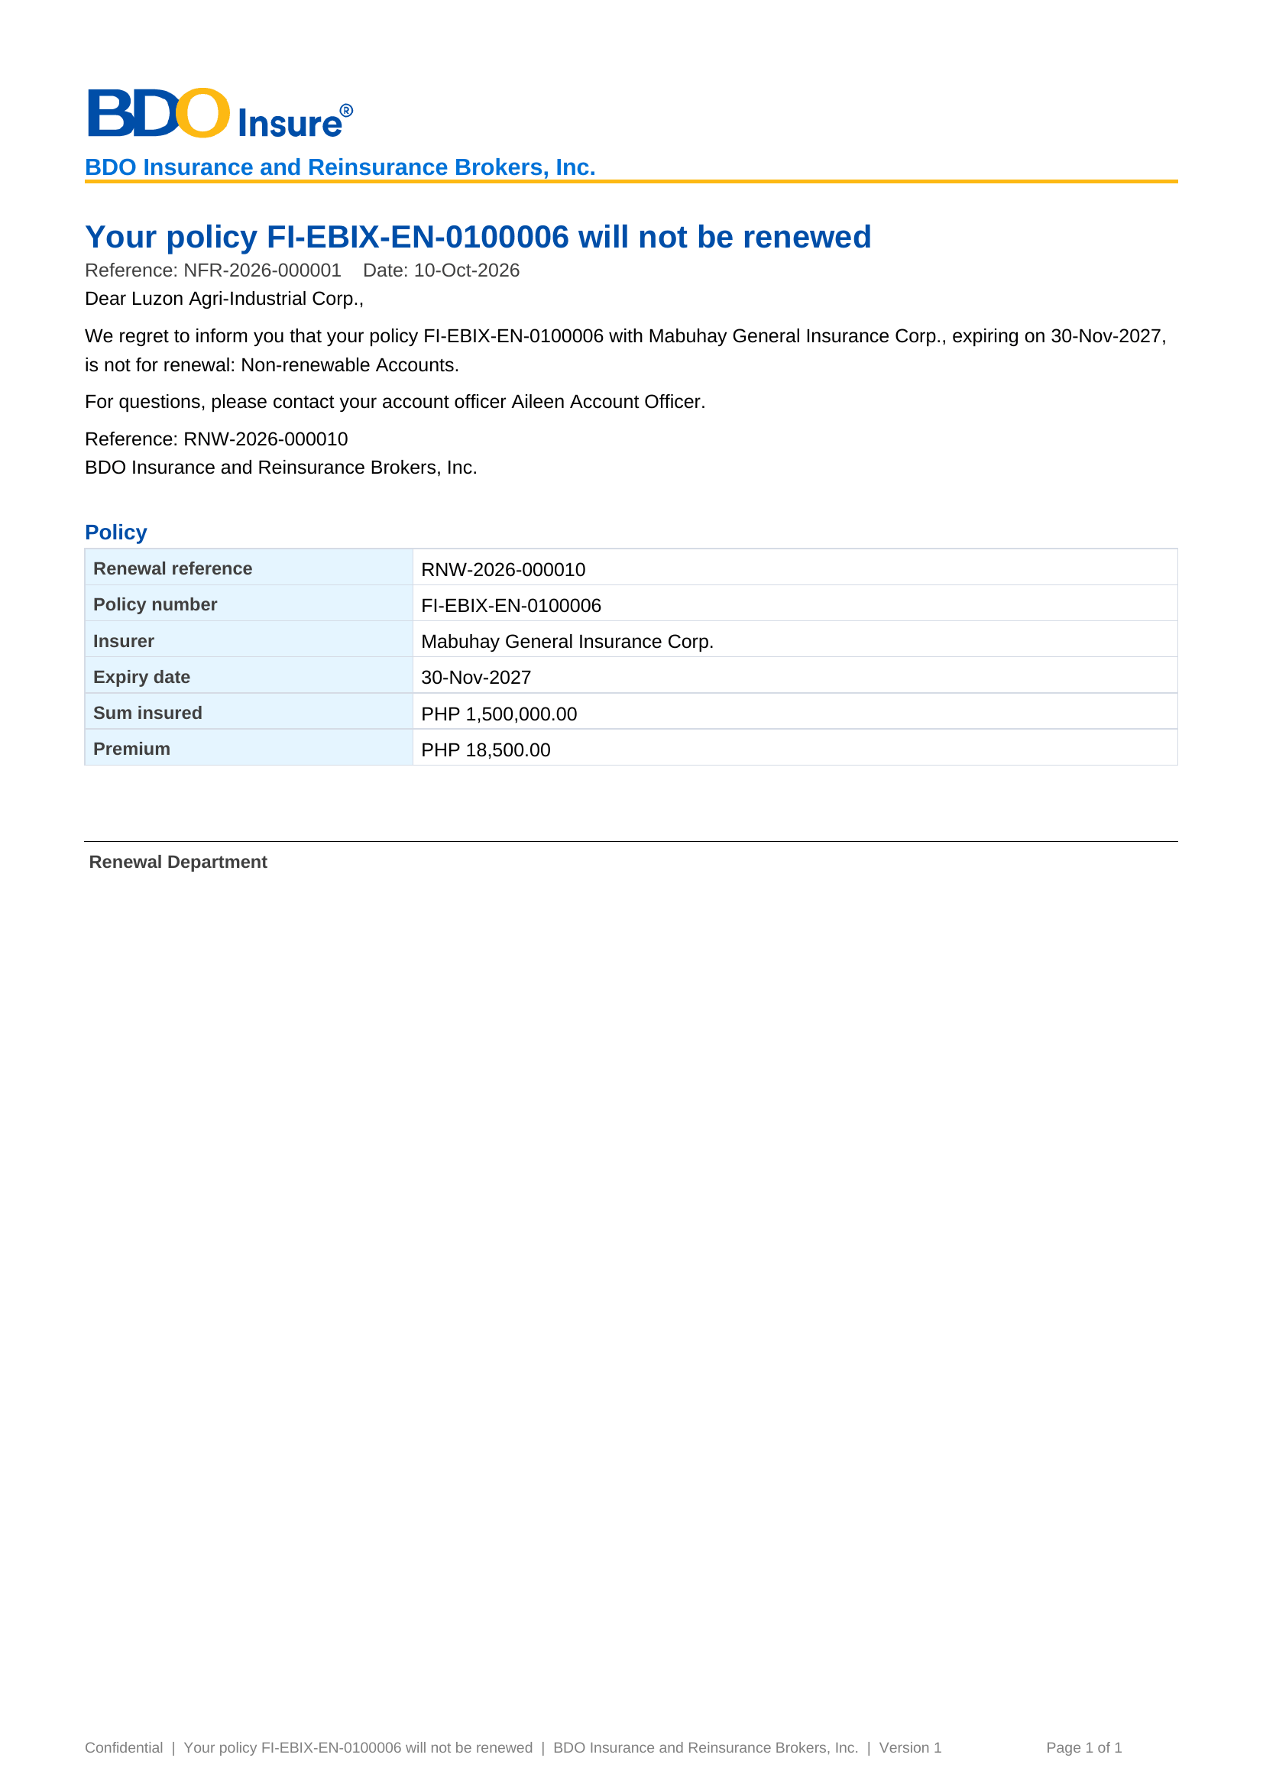
Figure AF.2: current layout of the Not for Renewal Letter and No Advice Letter
AF.3 Insurer extract (DO-03)
Item | Detail
Purpose | Request the insurer's renewal disposition: the 28 fields of BRD 3.009.1.4
Recipients | Insurer (e-mail, protected)
Format | Excel workbook, one per insurer batch; e-mailed to the insurer
Produced from | Insurer Batches › New Batch, then Download or Send to Insurer
Protection | Yes when e-mailed (password in a separate e-mail)
Fields in order | 1. Insurance Company, Invoice No, Assured Name, Risk Code, Inception Date, Expiry Date, Sum Insured, Premium Amount, Commission Rate, AR Client (Unpaid Balance), Is Mortgaged – from the expiring account and the ledger  2. Premium Rate (per cover), Policy No, Risk Description, Encoder Name, Unit Head, Business Origin, Account Type, Region, Area, Branch, Account Officer Name, Remarks – from the account and the sales organisation  3. BIPD for Motor, Seating Capacity for Motor, Auto Personal Accident for Motor, Sum Insured (per cover), Packaged / Non-Packaged – from the policy
BDOI reference | FRRN.021 lets the user choose the fields; Annex H gives the CBG return layout
Layout | Current layout of the system below; where BDOI's FRS gives the template, BDOI's template prevails; otherwise the Business Unit confirms it or gives its layout (requirements collection workbook, item RC-DOC-03)

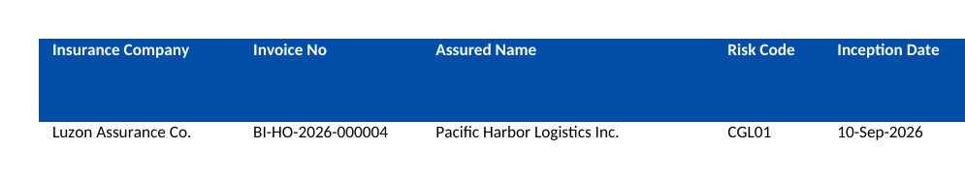
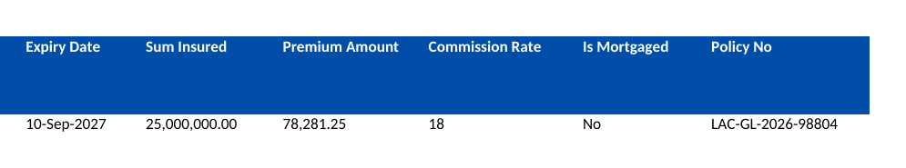
Figure AF.3: current layout of the Insurer extract
AF.4 Expiry list download (DO-04)
Item | Detail
Purpose | The RMEL and every renewal list as displayed (BRRN.007)
Recipients | The user (download)
Format | Excel workbook of the list as shown, with its filters
Produced from | Expiry List, My Dispositions, Team Lead Review, Processing Worklist, Letters › Download
Protection | No
Fields in order | 1. Renewal Reference, Status, Classification, Disposition, Expiring Invoice, Expiring ARN, Policy No., Client – from the renewal  2. Product, Line, Insurer, Segment, Branch, Unit, Account Officer, Assigned AO, Assigned PO, Expiry – from the expiring account and the assignments  3. Currency, Gross Premium, Sum Insured – from the expiring account (empty for LAMD and Contact Center)
BDOI reference | FRRN.004.06: file name RMEL_<MMM>_<YYYY>_<MMDDYYYY>.xlsx
Layout | Current layout of the system below; where BDOI's FRS gives the template, BDOI's template prevails; otherwise the Business Unit confirms it or gives its layout (requirements collection workbook, item RC-DOC-04)

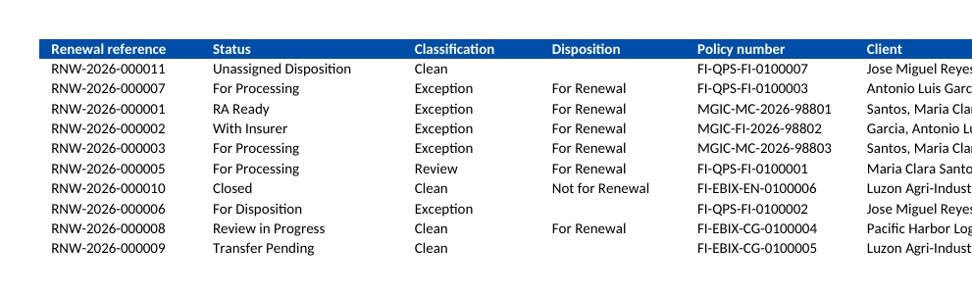
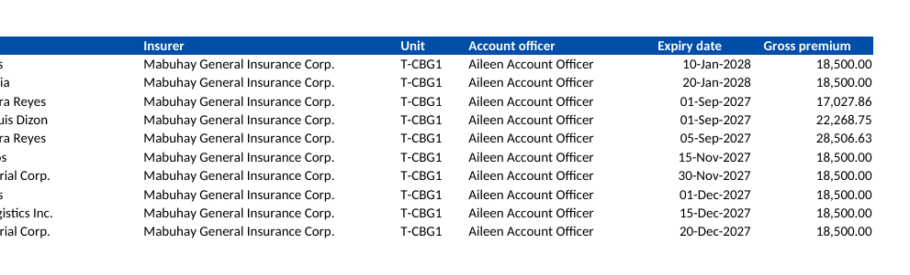
Figure AF.4: current layout of the Expiry list download
AF.5 Renewal account details (DO-05)
Item | Detail
Purpose | The details of one renewal account (BRD 1.004.1.3)
Recipients | The user (download)
Format | PDF, one per renewal
Produced from | Renewal › Details PDF
Protection | No
Fields in order | 1. Renewal: renewal reference, status, classification, client, expiring invoice and ARN, policy number, insurer, expiry date, Account Officer and Processing Officer, gross premium and sum insured – from the renewal  2. Checks: the check, its outcome, severity and message – from the latest check run  3. Dispositions: disposition, reason, remarks, source, by and on – from the dispositions of the renewal
BDOI reference | FRRN.014.06: Renewal Account Details.xlsx
Layout | Current layout of the system below; where BDOI's FRS gives the template, BDOI's template prevails; otherwise the Business Unit confirms it or gives its layout (requirements collection workbook, item RC-DOC-05)

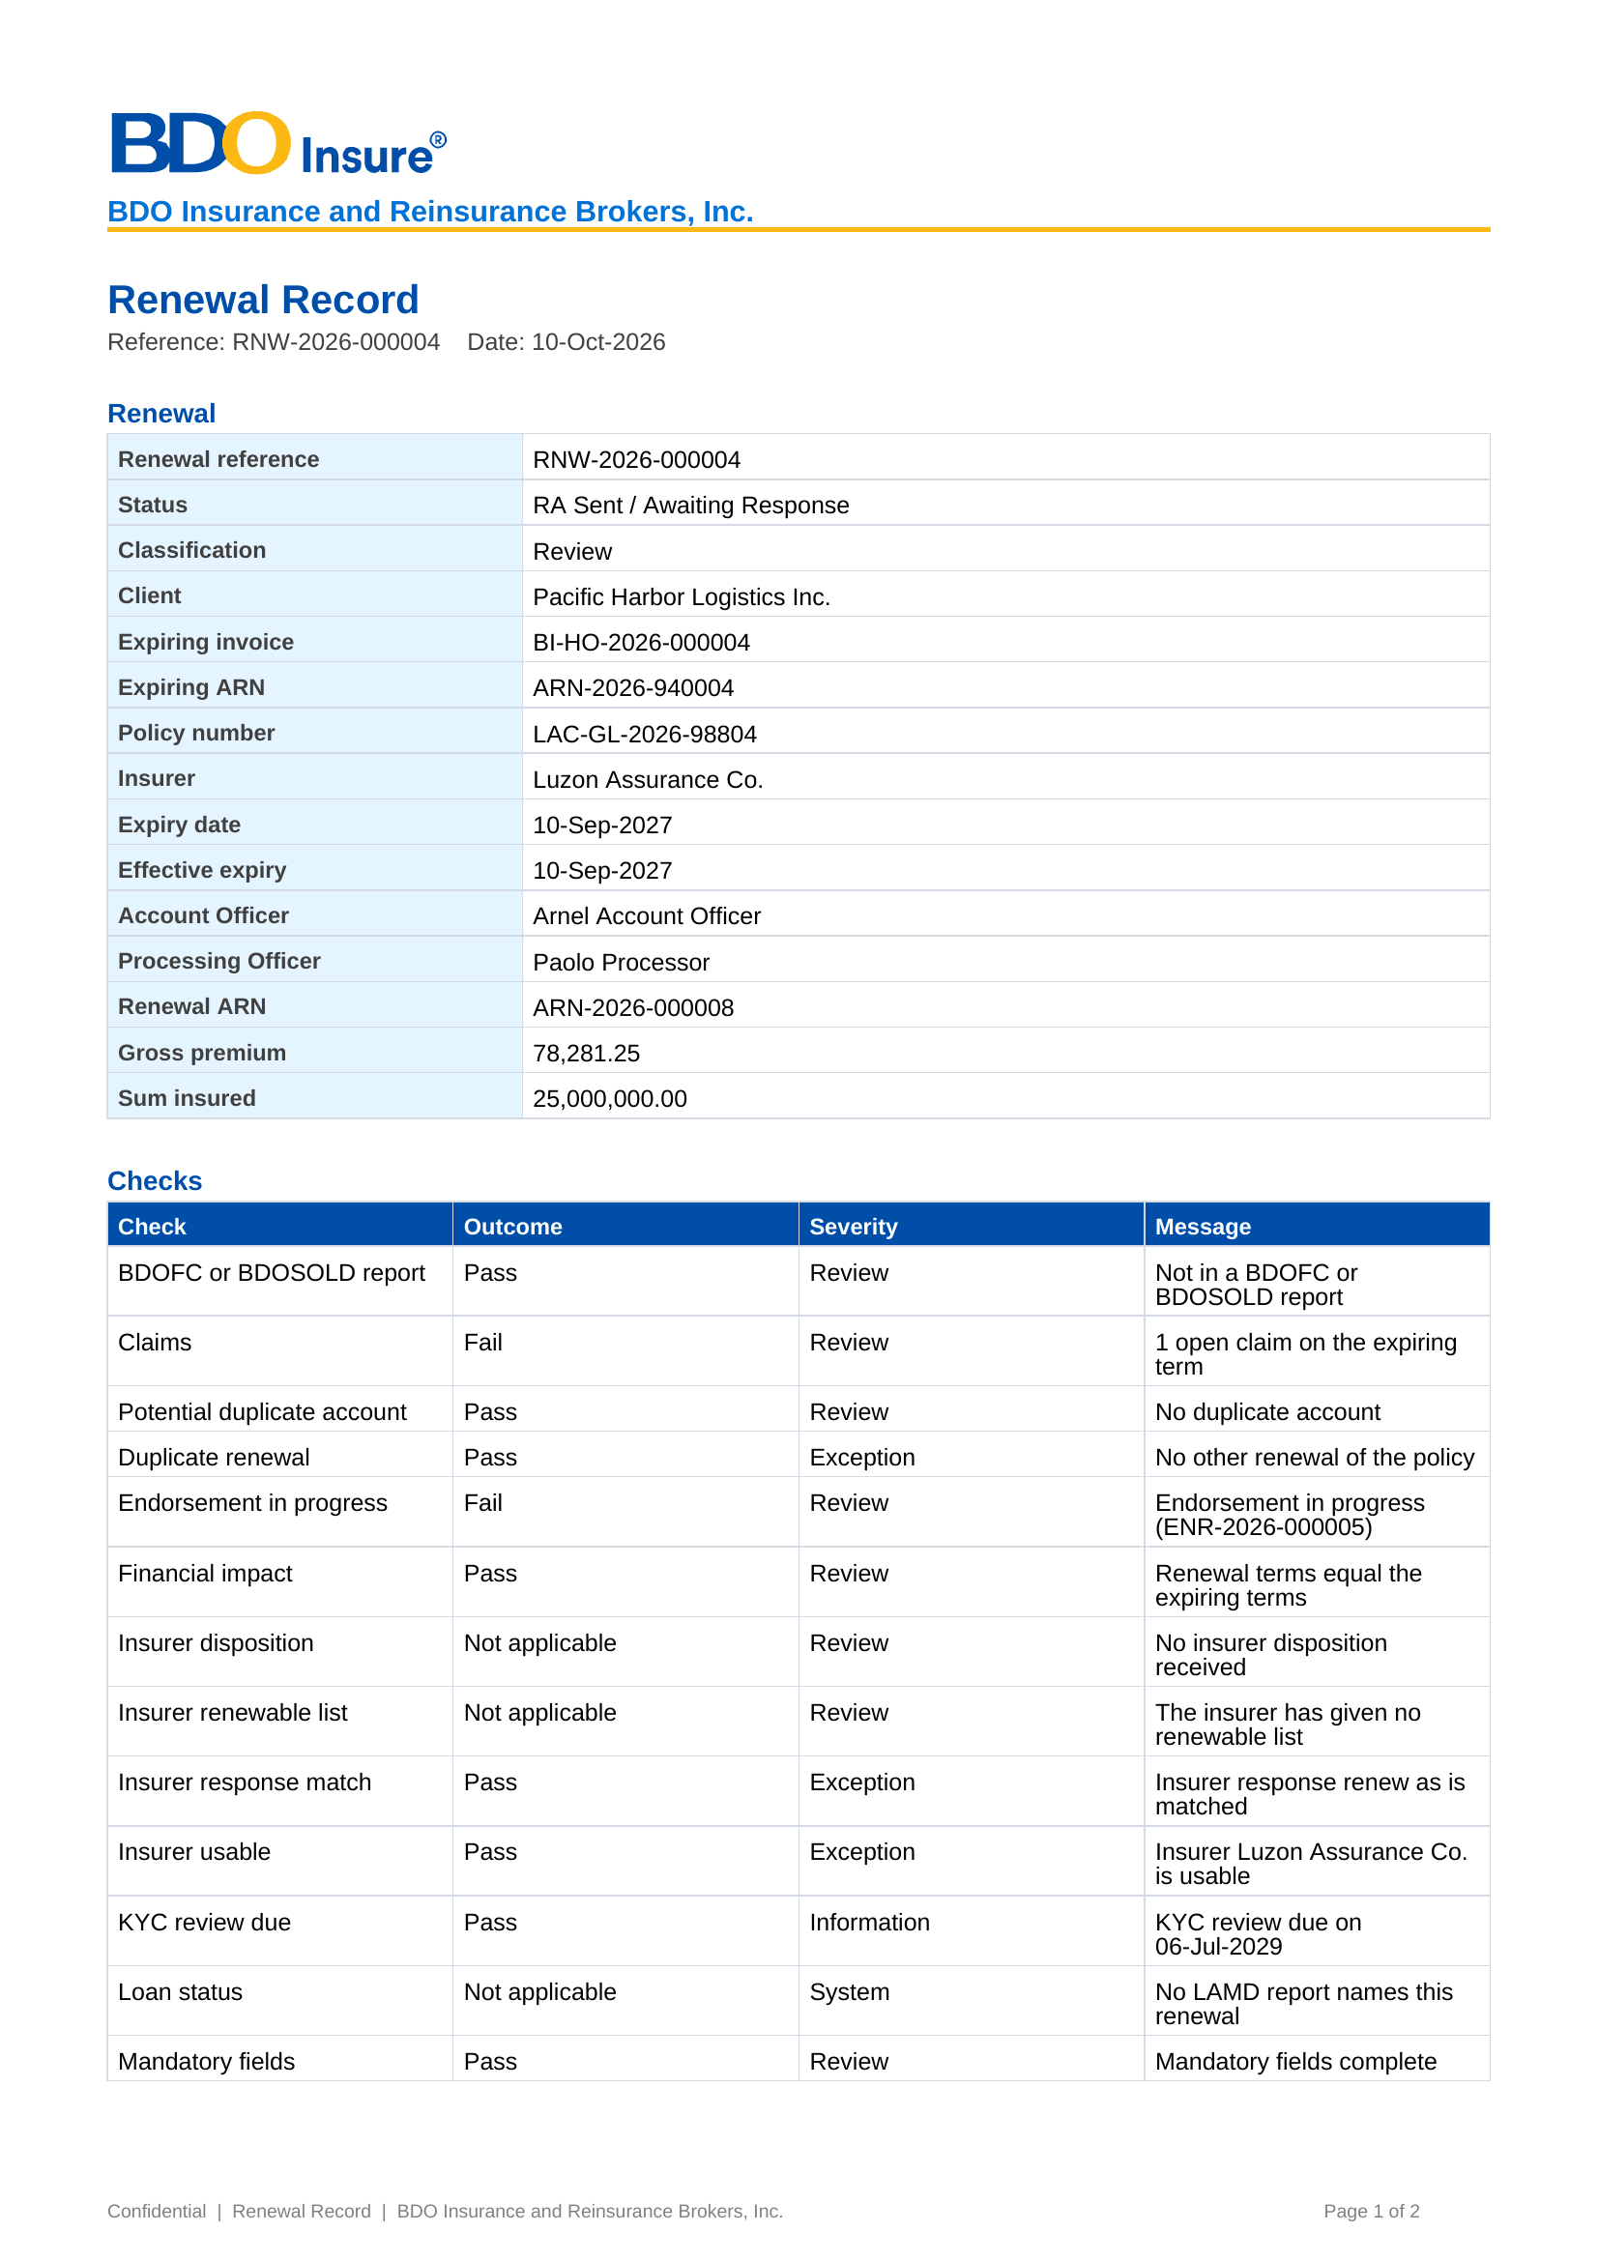
Figure AF.5: current layout of the Renewal account details
AF.6 Quick Proposal and Full Proposal (DO-06)
Item | Detail
Purpose | Proposal of a For Proposal renewal (FRRN.017.01)
Recipients | Client
Format | PDF
Produced from | Renewal account, Generate Proposal Slip
Protection | Yes when sent
Fields in order | 1. Client and risk  2. Insurers and terms of the comparative table  3. Premium  4. Signatories (two; three for a non-package TSI above PHP 500M)
BDOI reference | Annexes I and J: heading only
Layout | Layout to be provided by the Business Unit (requirements collection workbook, item RC-DOC-06)

AF.7 TSU quotation request (DO-07)
Item | Detail
Purpose | Request of a For Quotation renewal to TSU (FRRN.018.01)
Recipients | TSU
Format | Request in the system
Produced from | Renewal account, TSU request
Protection | No (in the system)
Fields in order | 1. The fields per line of Annex K
BDOI reference | Annex K: given (14 lines)
Layout | BDOI's template of this FRS; the Business Unit confirms it (requirements collection workbook, item RC-DOC-07)

AF.8 NRNS reminder, SFU and FFY reminder letters (DO-08)
Item | Detail
Purpose | Reminders before expiry (FRRN.023.03, FRRN.048.01)
Recipients | Client (e-mail, protected, or print)
Format | PDF
Produced from | Nightly letter run; Letters
Protection | Yes when e-mailed
Fields in order | 1. Client and policy  2. Expiry date  3. What to do and by when  4. Renewal reference and Account Officer
BDOI reference | Annexes N, Q and R: heading only
Layout | Layout to be provided by the Business Unit (requirements collection workbook, item RC-DOC-08)

AF.9 Non-acceptance letter (DO-09)
Item | Detail
Purpose | Tell the client that the policy expired without renewal (FRRN.023.03)
Recipients | Client (e-mail, protected)
Format | PDF
Produced from | Nightly letter run
Protection | Yes
Fields in order | 1. Client and policy  2. Expiry date  3. No cover  4. Account Officer
BDOI reference | Not in BDOI's FRS (row added to Annex M)
Layout | Layout to be provided by the Business Unit (requirements collection workbook, item RC-DOC-09)

AF.10 CLPC billing file and e-mail (DO-10)
Item | Detail
Purpose | Billing of CBG Home and FFY Motor renewals (FRRN.027)
Recipients | BDO CBG Loan Services
Format | CSV (Built-in, Non-Built-in) with e-mail
Produced from | Scheduled and manual billing
Protection | As BDO ITG decides (Annex AH)
Fields in order | 1. The 13 fields of Annex S
BDOI reference | Annex S: given (form BFP-001-2026-0)
Layout | BDOI's template of this FRS; the Business Unit confirms it (requirements collection workbook, item RC-DOC-10)

AF.11 Placement slip and placement file (DO-11)
Item | Detail
Purpose | Placement with the insurer (FRRN.029.02)
Recipients | Insurer
Format | PDF slip per insurer and account; Excel file per insurer
Produced from | Generate Placement
Protection | Yes when e-mailed
Fields in order | 1. The 42 fields of Annex U  2. Risk description per package and line (Annex U)
BDOI reference | Annex T: heading only (slip); Annex U: given (file)
Layout | BDOI's template of this FRS; the Business Unit confirms it (requirements collection workbook, item RC-DOC-11)

AF.12 Insurance Advice (DO-12)
Item | Detail
Purpose | Advice to the mortgagee bank (FRRN.032)
Recipients | Client and the BDO unit of the mortgage
Format | PDF
Produced from | On sending of the placement
Protection | Yes when e-mailed
Fields in order | 1. As templates IA-001 to IA-004 (Annex W)
BDOI reference | Annex W: given
Layout | BDOI's template of this FRS; the Business Unit confirms it (requirements collection workbook, item RC-DOC-12)

AF.13 E-policy e-mail (DO-13)
Item | Detail
Purpose | Sending of the e-policy to the client (FRRN.033.04)
Recipients | Client
Format | E-mail with the e-policy PDF
Produced from | E-policy sending
Protection | Yes (FRRN.024.01)
Fields in order | 1. As templates BDOI-012 to BDOI-014 (Annex X)
BDOI reference | Annex X: given
Layout | BDOI's template of this FRS; the Business Unit confirms it (requirements collection workbook, item RC-DOC-13)

AF.14 Service invoice (DO-14)
Item | Detail
Purpose | Invoice of the brokerage service on booking (FRRN.035)
Recipients | Insurer
Format | PDF
Produced from | Booking
Protection | No
Fields in order | 1. As the image of Annex Y
BDOI reference | Annex Y: given (image)
Layout | BDOI's template of this FRS; the Business Unit confirms it (requirements collection workbook, item RC-DOC-14)

AF.15 Hold cover request (DO-15)
Item | Detail
Purpose | Request of a hold cover or extension (FRRN.036)
Recipients | Insurer
Format | PDF with e-mail, or Excel batch per insurer (CBG)
Produced from | Hold cover request; scheduled CBG requests
Protection | No as delivered (Annex AP.5)
Fields in order | 1. Insurer and ARN  2. Client and risk  3. Start date and duration  4. Reference
BDOI reference | Annex Z: heading only
Layout | Layout to be provided by the Business Unit (requirements collection workbook, item RC-DOC-15)

AF.16 Upload results and exports of lists (DO-16)
Item | Detail
Purpose | Processing results of the LAMD, BDOFC/SOLD, insurer disposition, renewal update, hold cover and e-policy uploads; audit log export
Recipients | The user (download)
Format | Excel or CSV
Produced from | Each upload summary; Audit Logs
Protection | No
Fields in order | 1. The columns of the record-level views (FRRN.012.04, 015.06, 030.04, 033.03, 037.04)
BDOI reference | File names given (FRRN.012.03, 012.08, 043.01)
Layout | BDOI's template of this FRS; the Business Unit confirms it (requirements collection workbook, item RC-DOC-16)

Annex AG – Reports and Schedules
The reports of Renewal: who uses each, its filters, columns, sort and output. Every report applies the user's data scope, exports to Excel and PDF (the operational reports also to ODS and CSV), has a print preview and saved variants, and is produced within 20 seconds for up to 30,000 rows. BDOI's reports of FRRN.044.01 that the BRD does not specify are listed with the layout to be provided by the Business Unit.
Report | Users | Filters | Columns | Summary | Sort | Output | BRD / FR item
Renewal Status Report | All report users | Expiry date range; the 20 criteria of BRD 1.009.2 | 37 (Marketing) or 40 (Processing) columns of BRD 1.009.3.1 | 34 counters of BRD 1.009.3.2 | Expiry date | Excel, PDF | BRRN.019; BRD 1.009, 2.008, 3.010, 4.008; FRRN.044.02
RMEL (List of Expiring Accounts) | Marketing and Processing | Expiry date range; the filters of FRRN.004.03 | The columns of FRRN.002.05 | Row count | Expiry date | Excel; print | BRRN.004, 007; FRRN.004.06
Renewal listing with attention flags | Marketing Team Leads, Unit Heads, Account Officers | Unit, segment, expiry window, status | Account, status, days to expiry, flag and its rule | Counts by status | Days to expiry | Excel, PDF | BRRN.036; FRRN.044.03
Request per insurer | Processing | Insurer, expiry range | The 28 fields of BRD 3.009.1.4 | Number of accounts | Expiry date | Excel | BRD 3.009, 4.007; FRRN.021
Letter log | Marketing, Processing | Letter type, period, status | Letter, account, recipient, sent on, delivery status | Counts by status | Sent on | Excel, PDF | BRRN.001, 010, 025, 037; FRRN.044.04
Sanitation results | Processing, Business Administrator | Date range, rule, result | Account, rule, result, detail, classification and changes | Counts by rule | Date | Excel, PDF | BRRN.020, 023; FRRN.044.04
Decision log | Team Leads, Business Administrator, audit | Date range, source, user | Disposition, source, matrix version and rule, overrides with reason and remarks | - | Date | Excel, PDF | BRRN.031, 034; BRD 1.011; FRRN.044.04
LAMD matching | LAMD, Processing | Report, period, result | PN, account, matching and processing status, effect | Matched / unmatched | Row | Excel | BRRN.029; FRRN.012.04
Workload | Team Leads | Unit, officer | Officer, status, open, overdue, returned | Totals | Officer | Excel, PDF | BRD 1.009.7, 3.010.7; FRRN.002.02
Go-live take-over | Processing Team Lead | Expiry month | Migrated policies, renewal accounts, urgent, skipped, RA already sent | Totals | Expiry month | Excel | BRRN.005; FRRN.045
Package choices | Processing, Business Administrator | Status | Legacy package, chosen version, maker, checker | - | Date | Excel | BRRN.020; FRRN.046
Audit Logs | Audit, Team Leads | Date, user, action, record | The fields of FRRN.043.01 | - | Date and time | Excel, CSV | BRRN.021-040; FRRN.043
CLPC Billing Reports (Non-Built-In FIP; Built-In HLS Amortized and Non-Built-In; HLS Amortized Loan Release) | Processing | To be provided | Layout to be provided by the Business Unit | - | - | Excel, PDF | FRRN.044.01 (RC-RPT-01)
Successful and Fall-Out Accounts per Stage | Team Leads | To be provided | Layout to be provided by the Business Unit | - | - | Excel, PDF | FRRN.044.01 (RC-RPT-02)
Successfully and Unsuccessfully Sent ePolicy | Processing | To be provided | Layout to be provided by the Business Unit | - | - | Excel, PDF | FRRN.044.01 (RC-RPT-03)
Accounts without Policy Number | Processing | To be provided | Layout to be provided by the Business Unit | - | - | Excel, PDF | FRRN.044.01 (RC-RPT-04)
Unapplied Payment Report with Disposition | Marketing, Cashiering | To be provided | Layout to be provided by the Business Unit | - | - | Excel, PDF | FRRN.044.01 (RC-RPT-05)
LAMD reconciliation reports (Tagged as RMU; RMU without booking; not RMU with booking; tagged as submitted; not RMU and no submitted record) | LAMD, Processing | To be provided | Layout to be provided by the Business Unit | - | - | Excel, PDF | FRRN.044.01 (RC-RPT-06)

The scheduled runs of Renewal; each run is listed on the scheduled jobs screen with its last result, and a failed run raises an alert:
Run | When | What it does | Who is told | Changed by | BRD / FR item
Daily extraction | Every day 01:00 | Lists the accounts expiring at the lead days and runs the sanitation | Alert to the administrators if it fails | System Administrator (time); Business Administrator (lead days) | BRRN.030; FRRN.004.04
Re-evaluation | Every day 01:30 | Runs the sanitation again on the open renewal accounts and recomputes the classification | Notice when an account turns Exception | System Administrator | BRRN.020; FRRN.007.01
Letter run | Every day 06:00 | NRNS tag and reminder letters; letters due on the effective expiry date | - | System Administrator | BRRN.025, 037; FRRN.023.03
Expiry sweep | Every day 00:15 | Closes the accounts past the effective expiry date without acceptance; non-acceptance letters | Notice to the officers of the account | System Administrator | BRRN.025; FRRN.023.03
Renewal alerts | Every day | Insurer answers overdue; exceptions beyond the ageing days; letters not delivered | Administrators and Team Leads (alerts) | System Administrator | BRRN.029; FRRN.008.01, 021
Attention flags | Every day | Sets the ageing, overdue and high-risk flags of the listing | No message (BRRN.036) | Business Administrator (days) | BRRN.036; FRRN.044.03
CBG Home billing | Every day | Billing file of CBG Home accounts 10 days before expiry | - | System Administrator | FRRN.27.01
FFY Motor billing | 10th and 25th of the month | Billing file of FFY Motor accounts | - | System Administrator | FRRN.27.01
CBG hold cover requests | Every day (75 days before expiry) | Hold cover requests of the Clean CBG accounts, one file per insurer | - | System Administrator | FRRN.036.04
CBG Home hold cover extension | 15th of the month | 30-day extension of the expired, unbooked CBG Home accounts | - | System Administrator | FRRN.036.05
Go-live extraction | Once, after the sign-off of the migration load | Takes over the expiries up to 31-May-2028 | Notice with the counts | Processing Team Lead (runs it) | BRRN.005; FRRN.045.01

Annex AH – Integrations
The systems and modules Renewal exchanges information with, in business terms; the technical detail is in the Technical Specification reviewed by BDOI IT. The figure shows the context. (Figure 13).
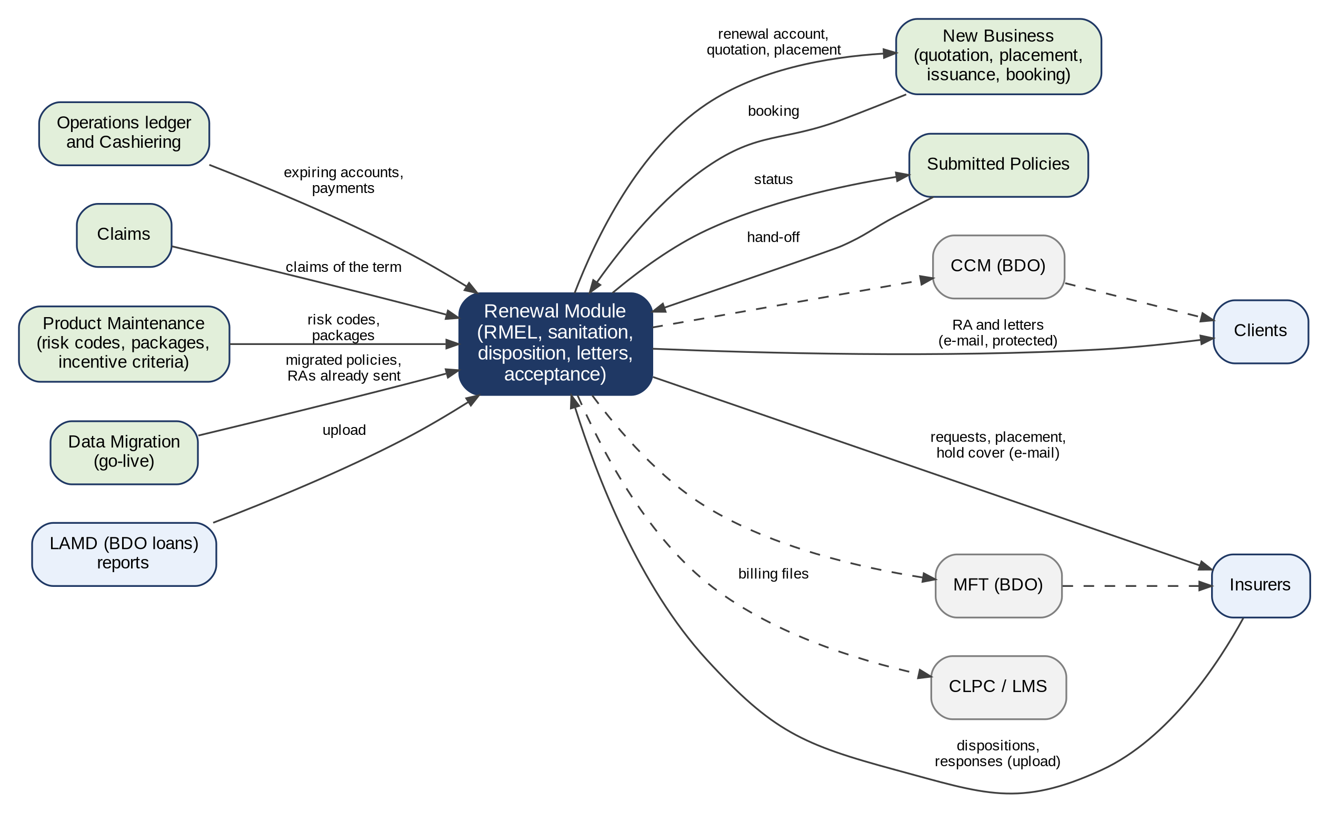
Figure 13 - Integration context of Renewal
How to read it: Solid lines are exchanges in scope; dashed lines depend on a decision of BDO ITG (CCM, MFT, LMS). The details of each interface are in the table of this annex. Traces to: BRRN.010, 029, 035, 040; BRD 3.009; FRRN.012, 013, 021, 022, 027-033.
Interface | Direction | What is exchanged | Trigger and frequency | Volumes | Owner | What BDOI IT provides | BDOI input
Booked accounts and the operations ledger (New Business, Operations) | In | Expiring accounts, balances, booking and endorsement events | Daily run; on each event | About 25,800 renewals a month (BRD) | New Business / Operations | - | Given (BRD)
New Business: quotation, proposal, TSU, placement, issuance, booking | Out / in | Renewal account (business type Renewal), quotation or proposal request, placement slip, booking | On posting, acceptance, placement | As renewals | New Business | - | Given (New Business FRS)
Cashiering | In | Payment applications, bounced checks, unapplied payments, refunds | On each payment | As payments | Operations Cashiering | - | Given (Cashiering FRS)
Claims | In | Claims of the expiring term; total-loss settlement tag | On sanitation | - | Claims | - | To be provided: total-loss indicator (Annex AN)
LAMD (BDO loans) | In | CBG loans excluding personal; paid-off accounts; RMU Account Officer codes | Upload, frequency to be confirmed | To be confirmed | LAMD | Report extraction from the loan systems | Layout given (Annex G); frequency to be provided
BDOFC and BDOSOLD reports | In | PN, assured, remarks | Upload | To be confirmed | BDOI | - | To be provided: effect of a match (Annex AN)
Insurers | Out / in | Request for renewal disposition (28 fields); disposition file; placement files and responses; hold cover requests and responses; e-policies | E-mail and upload; MFT where enrolled | Per insurer and month | Processing | MFT set-up and directories per insurer (if in scope) | To be provided: MFT scope (Annex AO C17)
CCM (client communications) | Out | Proposals, Renewal Advices, letters, Insurance Advices, e-policies | On sending | About 25,800 RAs a month | BDO ITG | CCM interface and delivery statuses (if in scope) | To be provided: CCM scope for go-live
E-mail of the system | Out | Protected e-mails and the password e-mails (fall-back of CCM) | On sending | As letters | iorta TechNXT / BDO ITG | Sender address and relay per environment | To be provided
CLPC / LMS | Out | CLPC billing files | Scheduled (FRRN.027) | Daily and twice a month | BDO CBG Loan Services | LMS shared directory (if available) | To be provided
Submitted Policies | In / out | Hand-off of expiring submitted policies; status queries | Daily scan; on hand-off | - | Submitted Policies | - | Given (Submitted Policies FRS)
Data migration | In | Migrated policies in force, package code map, Renewal Advices already sent | Once at go-live | Expiries up to 31-May-2028 | Data Migration | Legacy extracts | Given (decisions of 26-Sep-2026)
Sign-in (EIAM) | In | Single sign-on and user identity | On sign-in | Renewal users | BDO ITG | As the User Access Maintenance FRS | Given (User Access Maintenance FRS)
Product Maintenance | In | Risk codes, packages, rates, incentive criteria | On rating and evaluation | - | MBS | - | Given (Product Maintenance FRS)

Annex AJ – Non-functional Requirements
The non-functional requirements of Renewal: the usage requirements of the BRD (pages 212-214), BDOI's own rules of this FRS, and the programme register of non-functional requirements they trace to. The BRD gives no IDs to its usage requirements; they are numbered RN-NFR-nn here.
No. | Topic | Requirement (BRD / BDOI FRS) | How the system meets it | FR item | NFR register
RN-NFR-01 | Users | Marketing Team Leads 75 (23 concurrent); Account Officers / Brokers 319 (50); Processing Team Leads 50 (15) for lists, 9 (3) for assignment and upload; Processing Officers 73 (22); reports and Renewal Advices 485 (145) (BRD p.212) | Within the sizing of 145 concurrent users of the broking modules; Renewal adds load, not users | FRRN.001.02 | NFR-CAP-01
RN-NFR-02 | Volumes | 25,800 transactions a month per process, growth 20% a year (BRD p.212) | About 26,000 renewal accounts a month, without decline for five years | FRRN.004.04 | NFR-CAP-02, NFR-CAP-03
RN-NFR-03 | Response time | 10 seconds online; 20 seconds for reports and Renewal Advice generation (BRD p.213) | Lists served in parts; Renewal Advice generation and batch sending in the background with progress; reports within 20 seconds at 30,000 rows | FRRN.002.05, 022.01, 044.01 | NFR-PRF-01, NFR-PRF-03, NFR-PRF-06
RN-NFR-04 | Peak | Month-end; 08:00-10:00 and 15:00-17:00 daily (BRD p.213) | Extraction, re-evaluation and letter runs at night | FRRN.004.04 | NFR-CAP-05, NFR-PRF-07
RN-NFR-05 | One view without pages | "The system shall not use pagination" (FRRN.004.04); one scrollable view (BRRN.004) | Lists of up to 30,000 rows in one scrollable view with the row count | FRRN.002.05 | NFR-USE-02
RN-NFR-06 | Devices | Same performance on mobile and desktop; any BDO-issued device (BRD p.213; FRRN.001.01) | Responsive screens | FRRN.001.01 | NFR-RSP-01, NFR-RSP-02
RN-NFR-07 | Availability | Use 07:00-22:00 Monday to Saturday; availability, downtime and maintenance "follow existing QPS set up" (BRD p.213) | Service window of the programme; BDOI gives the values (Annex AN) | - | NFR-AVL-01, NFR-AVL-02, NFR-AVL-03
RN-NFR-08 | Recovery | "Follow existing QPS set up" (BRD p.214) | Recovery point and time of the programme register | - | NFR-REC-01, NFR-REC-02
RN-NFR-09 | Retention | "Follow existing QPS set up" (BRD p.214) | Retention per record type of the programme; renewal records and letters kept as policy records (values Annex AN) | FRRN.043 | NFR-RET-01, NFR-RET-03
RN-NFR-10 | Security of files sent | Encrypted, password-protected Renewal Advice and insurer files; approved domains (BRD 1.010.7.1; FRRN.024.01) | Every file that leaves BDOI is protected; BDOI's password convention | FRRN.022.02, 024.01 | NFR-SEC-10
RN-NFR-11 | Access | Role-based access and data scope (FRRN.001.02) | Each function and record checked against the user's profiles and scope | FRRN.001.02, 001.05 | NFR-SEC-04
RN-NFR-12 | Session | Inactivity warning 15 minutes; session end 30 minutes (FRRN.001.03-04) | Parameters of the programme | FRRN.001.03, 001.04 | NFR-SEC-05
RN-NFR-13 | Audit | Every action logged with the user, the time and the source (BRRN.021-040; FRRN.043) | Audit entries that no user can change | FRRN.043.01 | NFR-AUD-01, NFR-AUD-02, NFR-AUD-03
RN-NFR-14 | Configurability | Lead days, rules and thresholds configurable, never hard-coded (BRRN.030, 034) | Parameters and rule sets with effective dates and four eyes | FRRN.040 | NFR-CFG-01, NFR-CFG-02, NFR-CFG-04
[Integration scope] RN-NFR-15 | E-mail channel | Proposals, Renewal Advices, letters through CCM (BDOI FRS) | Through CCM when in scope; e-mail of the system as the fall-back | FRRN.022.02, 023.02 | NFR-INT-05
RN-NFR-16 | Accessibility | - | Screens meet WCAG 2.2 level AA | - | NFR-ACC-01
RN-NFR-17 | One session per device | "Limit the number of concurrent sessions to a single device; an opened session on a different device prompts a log-off of the previous device session" (Collections addendum NFR 10.07; the same programme rule for every module) | Every sign-in is recorded in the session log; the single-device rule is a programme setting that BDOI confirms for all modules (programme change CR-0025; discrepancy DCR-044: NFR 9.02 allows concurrent sessions) | FRRN.001.01 | NFR-SEC-05
RN-NFR-18 | Audit source | Each audit entry records the source of the event (workstation, device or IP address; behind a load balancer the original address) (Claims, Collections and Reinsurance addenda NFR 4.03) | Audit entries with the user, time, action and source address; read-only for every user | FRRN.043.01 | NFR-AUD-01, NFR-AUD-02

Annex AK – Data Set-up and Migration at Go-live
What is loaded for Renewal before go-live, from which source and template, who provides it and who checks it. The templates are the tabs of the BIBS Master Data and Configuration Upload Templates v1.2; this FRS does not copy them.
Data | Source | Template (tab) | Provided by | Checked by | Needed for | Status
Renewal parameters (lead days, thresholds, notice and waiting days, durations) | Annex AC; BDOI's values of this FRS | System parameters; SLA and turnaround | Product Owner, Renewal | Business Administrator (second user) | FRRN.040.03 | Defaults given; values to confirm
Lists of values of Renewal (reasons, outcomes, insurer dispositions) | Annex AC; Annex V | R01 Lists of values and MIS values | Business Administrator | Product Owner, Renewal | FRRN.049.01 | Partly given
Risk codes with the Renewable indicator | Product catalogue; BDOI risk code list | R05 Product lines, cover types (risk codes) | MBS | Product Owner, Renewal | FRRN.038 | To be provided
Sanitation rules and decision matrix | Annex C; FRRN.008 | Configured on screens (Renewal Setup) | Product Owner, Renewal | Second Business Administrator | FRRN.040 | Given in part (CBG Home empty)
Duplicate criteria per line | Annex B | Configured on screens | Business Administrator | Product Owner, Renewal | FRRN.006.01 | Given
Sales organisation and assignment hierarchy | Annex F | R03 Sales organisation (units and officers) | Marketing Heads | Business Administrator | FRRN.010 | Given (Annex F); Corporate as embedded document
RMU Account Officer codes | LAMD | Configured on screens (RMU Account Maintenance) | LAMD | Product Owner, Renewal | FRRN.041.01 | To be provided
Annual renewal budgets | Marketing | Budget upload template (FRRN.042.03) | Marketing Heads | Business Administrator | FRRN.042 | To be provided
Insurers: renewal and placement e-mail addresses, MFT enrolment, renewable lists | Insurers | R04 Insurers; R04B Insurer branches | Processing Head | Business Administrator | FRRN.021, 029.04, 036.06 | To be provided
Letter and document templates | Annexes L, W, X; templates still to come (N to R, T, Z) | PM-08 Document templates; Document templates | Product Owner, Renewal | Compliance | FRRN.049.02 | Partly given
Holiday calendar (business days of TAT and ageing) | BDOI | D0-03 Holiday calendar | Administration | Business Administrator | FRRN.003.02.01, 29.05 | To be provided
Incentive criteria | Product Maintenance | PM-10 Incentive criteria | MBS | Product Owner | FRRN.034.01 | To be provided
Package code map of legacy packages | Data migration | R06 Package code map (legacy packages) | MBS | Renewal processing team | FRRN.046.01 | To be provided
Migrated policies in force and Renewal Advices already sent | Legacy systems; unit trackers | Data migration templates (Data Migration FRS) | Data owners; Renewal processing team | Renewal processing team (second member) | FRRN.045 | Decided 26-Sep-2026
Users and profiles of Renewal | BDOI | UA-01 Users and roles; UA-02 Role matrix | User Access Administrator | Information Security | FRRN.001.05 | To be provided

Not loaded: renewals in progress in the legacy systems (none is carried over, BDOI decision of 26-Sep-2026), and the history of renewals before the system (the Account History shows the history from the system on).

Annex AL – Process Walkthroughs
End-to-end walkthroughs of Renewal, step by step: who acts, on which screen, what the user does, what the user sees and the result. The screens are specified in Annex AA; the users who run the walkthrough with the Business Unit are in the Business Unit Walkthrough Users workbook.
The walkthroughs are run on the BIBS DEV environment: https://dev.brokerverse.cloud.
WT-A An expiring account from the Expiry List to the Team Leader's post
The booked accounts expiring in the renewal horizon are extracted and initiated; the renewal of Pacific Harbor Logistics Inc. waits in the Unassigned Disposition tab of Corporate Marketing Team 1, classified Review: its expiring premium is outstanding, a claim is open and an endorsement is in progress. The Team Leader assigns it to the Account Officer, who reads the account history, gives the disposition For Renewal and pushes it. The Team Leader's post is refused while the blocking checks fail; she overrides them with a reason and posts the renewal to Processing.
SIT/UAT data: renewal of account ARN-2026-940004 (Pacific Harbor Logistics Inc., Luzon Assurance Co.), Corporate Marketing Team 1
Step | Persona | Screen | What the user does | What the user sees | Result
WT-A.1 | Marketing Team Leader | Expiry List (SCR-RN-02) | Opens the Expiry List, tab Unassigned Disposition, ticks the renewal of Pacific Harbor Logistics Inc. and clicks Assign Disposition: Arnel Account Officer, then Assign and Push | Message: 1 assigned; the renewal leaves the tab | Assigned
WT-A.2 | Marketing AO / Admin (Account Broker) | My Dispositions (SCR-RN-06) | Opens My Dispositions | The renewal assigned to him with its expiry, the Review classification and the flags Outstanding and Claims | For disposition
WT-A.3 | Marketing AO / Admin (Account Broker) | Renewal: Checks, Account History and Computations (SCR-RN-04) | Opens the renewal, tab Account History, and clicks View Account History | The payments of the expiring invoice and the open claim; the viewing is recorded | History viewed
WT-A.4 | Marketing AO / Admin (Account Broker) | Set Disposition, Add Remark and Re-open (SCR-RN-07) | Clicks Set Disposition: For Renewal with the remarks of the client's call, then Save | Message: Saved; the disposition For Renewal on the renewal | Dispositioned
WT-A.5 | Marketing AO / Admin (Account Broker) | Set Disposition, Add Remark and Re-open (SCR-RN-07) | Clicks Push | Message: Pushed to the Team Leader; the status Review in Progress | Pushed
WT-A.6 | Marketing Team Leader | Team Lead Review (SCR-RN-08) | Opens Team Lead Review, tab For Review, ticks the renewal and clicks Post, then confirms | The outcome: 1 refused, the renewal cannot be posted while the claims, endorsement and outstanding premium checks fail | Refused
WT-A.7 | Marketing Team Leader | Team Lead Review (SCR-RN-08) | Clicks Override: Outstanding balance, reason Approved by the Team Leader, with remarks (the open claim and the endorsement are overridden the same way) | Message: 1 overridden; the override kept in the History tab of the renewal | Overridden
WT-A.8 | Marketing Team Leader | Team Lead Review (SCR-RN-08) | Clicks Post again and confirms | Message: 1 posted; the renewal moves to Processing | Posted

Afterwards:
- The Processing Team Leaders are notified of the renewal posted for processing (walkthrough B); the renewal account is created from the expiring account.
- A renewal posted For Quotation or For Proposal continues as a New Business quotation or proposal request.
WT-B Processing, the insurer's answer and the Renewal Advice
The Processing Team Leader assigns the renewal of walkthrough A to a Processing Officer, who sends it to the insurer in a batch and records the insurer's answer Renew as is. The renewal is then ready for its Renewal Advice: the Account Officer generates the first notice and sends it to the client, protected.
SIT/UAT data: the renewal posted in walkthrough A; Patricia Processing Lead and Paolo Processor
Step | Persona | Screen | What the user does | What the user sees | Result
WT-B.1 | Processing Team Leader | Processing Worklist (SCR-RN-10) | Opens the Processing Worklist, tab For Processing, ticks the renewal and clicks Assign PO: Paolo Processor, then Assign | Message: 1 assigned; the renewal In Processing | In processing
WT-B.2 | Processing Officer / Broker | Insurer Batches (SCR-RN-11) | Opens Insurer Batches, clicks New Batch with Luzon Assurance Co. and the expiry date of the renewal, then Create Batch, and opens the batch | The batch Draft with the renewal and the columns of the insurer extract | Batch ready
WT-B.3 | Processing Officer / Broker | Insurer Batches (SCR-RN-11) | Clicks Send to Insurer and confirms | Message: Batch sent to the insurer; the batch Sent with its reply date | With the insurer
WT-B.4 | Processing Officer / Broker | Record Insurer Response (SCR-RN-12) | Opens the renewal and clicks Record Insurer Response: Renew as is with the insurer reference, then Record | Message: Saved; the renewal RA Ready | RA ready
WT-B.5 | Marketing AO / Admin (Account Broker) | Letters (SCR-RN-13) | Opens Letters, tab RA Ready, ticks the renewal, clicks Generate RA: First notice, then Generate | Message: 1 generated; the renewal in RA Generated, locked on the Marketing side | RA generated
WT-B.6 | Marketing AO / Admin (Account Broker) | Letters (SCR-RN-13) | Opens the tab RA Generated, ticks the renewal, clicks Send and confirms | Message: 1 sent; the Renewal Advice e-mailed protected to the client | RA sent

Afterwards:
- The client receives the Renewal Advice as a protected PDF and its password in a separate e-mail.
- Without acceptance after the second-notice days, the second notice is generated from the RA Sent tab.
WT-C The Contact Center follow-up and the client's acceptance
The renewal of walkthrough B waits for the client's reply. The Contact Center calls the client and records the follow-up; the client pays the renewal premium, and the Account Officer records the acceptance by payment. The renewal account goes on to placement and booking without re-keying.
SIT/UAT data: the renewal sent in walkthrough B; Cecilia Contact Center
Step | Persona | Screen | What the user does | What the user sees | Result
WT-C.1 | Contact Center user | Follow-ups (SCR-RN-15) | Opens Follow-ups, tab RA Sent | The renewal waiting for the client's reply | Awaiting response
WT-C.2 | Contact Center user | Follow-ups (SCR-RN-15) | Opens the renewal and clicks Add Follow-up: Call, Client will renew, the next action date and the remarks, then Save | Message: Saved; the follow-up on the Remarks & Follow-ups tab | Followed up
WT-C.3 | Marketing AO / Admin (Account Broker) | Record Acceptance (SCR-RN-14) | Opens the renewal and clicks Record Acceptance: Payment with the payment reference, then Record | Message: Saved; the renewal For Placement and Booking | Accepted
WT-C.4 | Marketing AO / Admin (Account Broker) | Renewal: Insurer, Letters, Documents, Remarks and History (SCR-RN-05) | Opens the tab Letters | The Renewal Advice in the e-mail queue to the client and the acceptance by payment | Kept

Afterwards:
- The renewal account is fast-tracked to the payment gate, placed and booked through New Business as business type Renewal; the booking closes the renewal as renewed.
WT-D Not for Renewal and the closing letter
Aileen Account Officer learns that the client's loan is fully paid: she gives the disposition Not for Renewal with that reason and pushes it; the Team Leader posts it to the letter step and the Not for Renewal Letter is sent, which closes the renewal.
SIT/UAT data: the renewal of the migrated motor policy QPS-FI-0100007 (Jose Miguel Reyes), CBG Metro Team 1, assigned to Aileen Account Officer by the Team Leader
Step | Persona | Screen | What the user does | What the user sees | Result
WT-D.1 | Marketing AO / Admin (Account Broker) | Set Disposition, Add Remark and Re-open (SCR-RN-07) | Opens the renewal, views its account history, clicks Set Disposition: Not for Renewal, reason Loan fully paid, with remarks, then Save | Message: Saved; the disposition Not for Renewal with its reason | Dispositioned
WT-D.2 | Marketing Team Leader | Team Lead Review (SCR-RN-08) | After the Account Officer's push, ticks the renewal on Team Lead Review, clicks Post and confirms | Message: 1 posted; the renewal goes to the closing letters | Letter pending
WT-D.3 | Marketing AO / Admin (Account Broker) | Letters (SCR-RN-13) | Opens Letters, tab NAL / NFR, ticks the renewal, clicks Send Letters and confirms | Message: 1 sent; the renewal is closed | Closed
WT-D.4 | Marketing AO / Admin (Account Broker) | Renewal: Insurer, Letters, Documents, Remarks and History (SCR-RN-05) | Opens the renewal, tab Letters | The Not for Renewal Letter in the e-mail queue to the client | Letter kept

Afterwards:
- Until the re-open days after expiry, the Account Officer may re-open the renewal for a new disposition.
WT-E A transfer to another unit, and the controls the user sees
CBG Metro Team 1 transferred the renewal of a corporate client to Corporate Marketing Team 1; its Team Leader accepts it. Then two controls of Renewal with the message the user sees: a disposition before the account history, and a transfer to the own unit.
SIT/UAT data: the transfer request of the migrated policy EBIX-CG-0100005 (Luzon Agri-Industrial Corp.) to Corporate Marketing Team 1; the renewal of the migrated policy QPS-FI-0100002 (Jose Miguel Reyes) of CBG Metro Team 1
Step | Persona | Screen | What the user does | What the user sees | Result
WT-E.1 | Marketing Team Leader | Transfers (SCR-RN-09) | The Team Leader of Corporate Marketing Team 1 opens Transfers, tab Incoming, chooses Accept in the row action menu and confirms with remarks | Message: Transfer accepted; the renewal joins the Unassigned tab of the unit | Transferred
WT-E.2 | Marketing AO / Admin (Account Broker) | Set Disposition, Add Remark and Re-open (SCR-RN-07) | Aileen Account Officer gives a disposition on a renewal without opening its account history | Open the Account History before you give the disposition | Refused
WT-E.3 | Marketing Team Leader | Expiry List (SCR-RN-02) | Marites Marketing Lead transfers a renewal of her unit to CBG Metro Team 1, her own unit | The receiving unit must be another unit | Refused

Annex AM – Requirements Traceability
AM.1 traces the 42 BRRN requirements of the addenda, and AM.2 the 1,033 requirement lines of the main BRD (grouped by BRD function), to the FR items of this FRS (FRRN) and to the test conditions of the Test Cases and Traceability workbook issued with this FRS (TC-RN-nnn.n; the cases of each condition, with the screen and the walkthrough step where it is run, are in the workbook). AM.3 lists every FR item of this FRS with its BRD IDs and test conditions.
AM.1 BRRN requirements
BRD ID | FR items (this FRS) | Test conditions
BRRN.001 (p.48; updated p.15-16) | FRRN.022, FRRN.023 | TC-RN-082.1 to 082.4 (5 cases)
BRRN.002 (p.48-49) | FRRN.004 | TC-RN-011.1 to 011.4 (7 cases)
BRRN.003 (p.49) | FRRN.004 | TC-RN-012.1 to 012.3 (6 cases)
BRRN.004 (p.49-50) | FRRN.004 | TC-RN-013.1 to 013.5 (9 cases)
BRRN.005 (p.50-51) | FRRN.004, FRRN.004.04, FRRN.045.01 | TC-RN-010.1 to 010.7 (8 cases); TC-RN-016.1 to 016.5 (8 cases)
BRRN.006 (p.51) | FRRN.002 | TC-RN-013.1 to 013.5 (9 cases)
BRRN.007 (p.51-52) | FRRN.004.06 | TC-RN-014.1 to 014.4 (6 cases)
BRRN.008 (p.52) | FRRN.004.06 | TC-RN-014.1 to 014.4 (6 cases)
BRRN.009 (p.52-53) | FRRN.007, FRRN.038, FRRN.023 | TC-RN-024.1 to 024.4 (6 cases)
BRRN.010 (p.53-54) | FRRN.022, FRRN.024.01 | TC-RN-080.1 to 080.5 (12 cases); TC-RN-081.1 to 081.4 (8 cases)
BRRN.011 (p.54-55) | FRRN.014, FRRN.004.06, FRRN.010, FRRN.002.08 | TC-RN-040.1 to 040.5 (7 cases)
BRRN.012 (p.55) | FRRN.014, FRRN.002.08 | TC-RN-040.1 to 040.5 (7 cases)
BRRN.013 (p.55-56) | FRRN.014 | TC-RN-041.1 to 041.4 (8 cases)
BRRN.014 (p.56) | FRRN.002, FRRN.002.08 | TC-RN-040.1 to 040.5 (7 cases)
BRRN.015 (p.56) | FRRN.002, FRRN.002.08 | TC-RN-040.1 to 040.5 (7 cases)
BRRN.016 (p.56-57) | FRRN.002, FRRN.002.08 | TC-RN-040.1 to 040.5 (7 cases)
BRRN.017 (p.57) | FRRN.002, FRRN.002.08 | TC-RN-040.1 to 040.5 (7 cases)
BRRN.018 (p.57) | FRRN.015, FRRN.015.07 | TC-RN-060.1 to 060.4 (8 cases)
BRRN.019 (p.58-59) | FRRN.044, FRRN.044.02 | TC-RN-101.1 to 101.5 (8 cases); TC-RN-103.1 to 103.3 (8 cases)
BRRN.020 (p.30; p.5, 20-21) | FRRN.007, FRRN.040.01, FRRN.046.01 | TC-RN-020.1 to 020.6 (8 cases); TC-RN-028.1 to 028.4 (6 cases); TC-RN-112.1 to 112.4 (6 cases)
BRRN.021 (p.30) | FRRN.004, FRRN.003, FRRN.004.07 | TC-RN-015.1 to 015.4 (5 cases); TC-RN-004.1 to 004.4 (5 cases)
BRRN.022 (p.30) | FRRN.004 | TC-RN-021.1 to 021.3 (4 cases); TC-RN-020.1 to 020.6 (8 cases)
BRRN.023 (p.30-32; p.5-6, 21) | FRRN.007, FRRN.008, FRRN.020.03 | TC-RN-022.1 to 022.7 (9 cases); TC-RN-051.1 to 051.5 (8 cases); TC-RN-112.1 to 112.4 (6 cases)
BRRN.024 (p.32; p.6, 21) | FRRN.012, FRRN.001.02 | TC-RN-002.1 to 002.5 (8 cases); TC-RN-025.1 to 025.5 (9 cases)
BRRN.025 (p.32) | FRRN.023, FRRN.023.03 | TC-RN-083.1 to 083.4 (5 cases)
BRRN.026 (p.32-33) | FRRN.047.01 | TC-RN-085.1 to 085.3 (4 cases)
BRRN.027 (p.33) | FRRN.014 | TC-RN-042.1 to 042.3 (4 cases)
BRRN.028 (p.33-34; p.6-7, 21-23) | FRRN.039 | TC-RN-026.1 to 026.4 (4 cases)
BRRN.029 (p.34; p.7-8, 23) | FRRN.012, FRRN.041.01 | TC-RN-025.1 to 025.5 (9 cases); TC-RN-022.1 to 022.7 (9 cases)
BRRN.030 (p.34-35; p.8) | FRRN.004, FRRN.004.04, FRRN.040.03 | TC-RN-010.1 to 010.7 (8 cases); TC-RN-016.1 to 016.5 (8 cases); TC-RN-112.1 to 112.4 (6 cases)
BRRN.031 (p.35-36) | FRRN.007, FRRN.08, FRRN.008.01, FRRN.040.02, FRRN.020.03 | TC-RN-023.1 to 023.7 (9 cases); TC-RN-051.1 to 051.5 (8 cases)
BRRN.032 (p.36) | FRRN.004.06 | TC-RN-027.1 to 027.3 (4 cases)
BRRN.033 (p.36; p.8-9) | FRRN.017, FRRN.018, FRRN.019, FRRN.020, FRRN.018.02 | TC-RN-048.1 to 048.4 (6 cases)
BRRN.034 (p.37; p.9, 23) | FRRN.040, FRRN.040.02 | TC-RN-023.1 to 023.7 (9 cases); TC-RN-112.1 to 112.4 (6 cases)
BRRN.035 (p.37-38; p.9-11, 23-24) | FRRN.013, FRRN.013.05 | TC-RN-071.1 to 071.4 (9 cases); TC-RN-051.1 to 051.5 (8 cases); TC-RN-084.1 to 084.5 (7 cases)
BRRN.036 (p.38-39; p.11-12, 24) | FRRN.002.05, FRRN.044.03 | TC-RN-102.1 to 102.3 (3 cases)
BRRN.037 (p.39; p.12, 24-26) | FRRN.023, FRRN.023.03, FRRN.037.02 | TC-RN-083.1 to 083.4 (5 cases); TC-RN-082.1 to 082.4 (5 cases); TC-RN-086.1 to 086.3 (4 cases)
BRRN.038 (p.40) | FRRN.017, FRRN.009.01, FRRN.018.02 | TC-RN-048.1 to 048.4 (6 cases); TC-RN-064.1 to 064.3 (3 cases); TC-RN-084.1 to 084.5 (7 cases)
BRRN.039 (p.40) | FRRN.012 | TC-RN-025.1 to 025.5 (9 cases); TC-RN-023.1 to 023.7 (9 cases)
BRRN.040 (p.40-41) | FRRN.029, FRRN.025.01, FRRN.26.01, FRRN.028.02 | TC-RN-084.1 to 084.5 (7 cases)
BRRN.041 (p.12-14) | FRRN.034 | TC-RN-087.1 to 087.3 (4 cases)
BRRN.042 (p.14-15) | FRRN.036, FRRN.037.02 | TC-RN-086.1 to 086.3 (4 cases)

AM.2 Requirement lines of the main BRD
BRD function | Line IDs | Pages | FR items (this FRS) | Test conditions
1.001 Log in | 1.001.1 to 1.001.3.1 (4 lines) | p.70 | FRRN.001.01, FRRN.001.02, FRRN.001.03, FRRN.001.04 | TC-RN-001.1 to 001.6 (13 cases)
1.002 Open in several tabs | 1.002.1 | p.70 | FRRN.001.01, FRRN.001.02, FRRN.001.03, FRRN.001.04 | TC-RN-001.1 to 001.6 (13 cases)
1.003 Generate the list of expiring accounts | 1.003.1 to 1.003.2 (3 lines) | p.70-71 | FRRN.004.01, FRRN.004.02 | TC-RN-011.1 to 011.4 (7 cases)
1.003 Generate the list of expiring accounts | 1.003.3 to 1.003.3.1.13 (14 lines) | p.71-73 | FRRN.004.03 | TC-RN-012.1 to 012.3 (6 cases)
1.003 Generate the list of expiring accounts | 1.003.4.1 to 1.003.4.1.1 (2 lines) | p.73 | FRRN.002.05, FRRN.002.06 | TC-RN-013.1 to 013.5 (9 cases)
1.003 Generate the list of expiring accounts | 1.003.4.1.1.1 | p.73 | Out of scope (p.60); FRRN.002.05 | -
1.003 Generate the list of expiring accounts | 1.003.4.1.1.2 | p.73 | FRRN.002.05, FRRN.002.06 | TC-RN-013.1 to 013.5 (9 cases)
1.003 Generate the list of expiring accounts | 1.003.4.1.1.3 | p.73 | Out of scope (p.60); FRRN.002.05 | -
1.003 Generate the list of expiring accounts | 1.003.4.1.1.4 to 1.003.4.1.1.24 (21 lines) | p.74-76 | FRRN.002.05, FRRN.002.06 | TC-RN-013.1 to 013.5 (9 cases)
1.003 Generate the list of expiring accounts | 1.003.4.1.2 | p.76 | FRRN.004.04 | TC-RN-010.1 to 010.7 (8 cases)
1.003 Generate the list of expiring accounts | 1.003.4.1.3 to 1.003.4.1.4 (2 lines) | p.76 | FRRN.002.05, FRRN.002.06 | TC-RN-013.1 to 013.5 (9 cases)
1.003 Generate the list of expiring accounts | 1.003.5 to 1.003.7.2 (5 lines) | p.76-77 | FRRN.002.07, FRRN.004.06 (2nd) | TC-RN-014.1 to 014.4 (6 cases)
1.003 Generate the list of expiring accounts | 1.003.7.3 to 1.003.7.3.1 (2 lines) | p.77 | FRRN.038.01, FRRN.038.03 | TC-RN-024.1 to 024.4 (6 cases)
1.004 View account | 1.004.1 to 1.004.1.5.2 (8 lines) | p.77-78 | FRRN.014.01, FRRN.014.06 | TC-RN-041.1 to 041.4 (8 cases)
1.005 Assign accounts | 1.005.1 to 1.005.2 (10 lines) | p.79-80 | FRRN.010.01, FRRN.010.02 | TC-RN-030.1 to 030.5 (7 cases)
1.006 Transfer account to other units | 1.006.1 to 1.006.5 (5 lines) | p.80-81 | FRRN.011.06 | TC-RN-031.1 to 031.4 (7 cases)
1.007 Receive account transfer | 1.007.1 to 1.007.5 (8 lines) | p.81-82 | FRRN.011.06 | TC-RN-032.1 to 032.4 (6 cases)
1.008 Review and post | 1.008.1 to 1.008.1.1 (2 lines) | p.82 | FRRN.020.01, FRRN.020.02 | TC-RN-050.1 to 050.4 (6 cases)
1.008 Review and post | 1.008.1.2 to 1.008.1.3 (2 lines) | p.82 | FRRN.014.01, FRRN.014.06, FRRN.020.01, FRRN.020.02 | TC-RN-050.1 to 050.4 (6 cases); TC-RN-041.1 to 041.4 (8 cases)
1.008 Review and post | 1.008.1.4 | p.82 | FRRN.004.06, FRRN.020.01, FRRN.020.02 | TC-RN-050.1 to 050.4 (6 cases); TC-RN-027.1 to 027.3 (4 cases)
1.008 Review and post | 1.008.2 to 1.008.3.4 (13 lines) | p.82-84 | FRRN.020.01, FRRN.020.02 | TC-RN-050.1 to 050.4 (6 cases)
1.009 Generate report | 1.009.1 to 1.009.6 (125 lines) | p.84-101 | FRRN.044.01, FRRN.044.02 | TC-RN-101.1 to 101.5 (8 cases)
1.009 Generate report | 1.009.7 | p.101 | FRRN.002.02, FRRN.003.01 | TC-RN-100.1 to 100.3 (4 cases)
1.010 Generate Renewal Advice | 1.010.1 to 1.010.5.2 (14 lines) | p.102-103 | FRRN.022.01 | TC-RN-080.1 to 080.5 (12 cases)
1.010 Generate Renewal Advice | 1.010.6 to 1.010.7.1 (3 lines) | p.103-104 | FRRN.022.02, FRRN.024.01 | TC-RN-081.1 to 081.4 (8 cases)
1.011 Override accounts | 1.011.1 to 1.011.1.3 (4 lines) | p.104 | FRRN.014.04, FRRN.020.03 | TC-RN-051.1 to 051.5 (8 cases)
2.001 Log in | 2.001.1 to 2.001.1.3 (4 lines) | p.104-105 | FRRN.001.01, FRRN.001.02, FRRN.001.03, FRRN.001.04 | TC-RN-001.1 to 001.6 (13 cases)
2.002 Open in several tabs | 2.002.1 | p.105 | FRRN.001.01, FRRN.001.02, FRRN.001.03, FRRN.001.04 | TC-RN-001.1 to 001.6 (13 cases)
2.003 View accounts for disposition | 2.003.1 to 2.003.1.1 (2 lines) | p.105 | FRRN.002.08 | TC-RN-040.1 to 040.5 (7 cases)
2.003 View accounts for disposition | 2.003.1.2 | p.105 | FRRN.002.08, FRRN.014.01, FRRN.014.06 | TC-RN-040.1 to 040.5 (7 cases); TC-RN-041.1 to 041.4 (8 cases)
2.003 View accounts for disposition | 2.003.1.3 to 2.003.1.5 (3 lines) | p.105-106 | FRRN.002.08 | TC-RN-040.1 to 040.5 (7 cases)
2.003 View accounts for disposition | 2.003.1.6 | p.106 | Out of scope (p.60); FRRN.002.06, FRRN.002.08 | -
2.003 View accounts for disposition | 2.003.2 to 2.003.3.2 (4 lines) | p.106 | FRRN.014.01, FRRN.014.06 | TC-RN-041.1 to 041.4 (8 cases)
2.004 Provide disposition | 2.004.1 to 2.004.4.7 (16 lines) | p.106-109 | FRRN.014.02, FRRN.016.01 | TC-RN-043.1 to 043.5 (10 cases)
2.004 Provide disposition | 2.004.4.8 | p.109 | FRRN.011.06, FRRN.014.02, FRRN.016.01 | TC-RN-043.1 to 043.5 (10 cases); TC-RN-031.1 to 031.4 (7 cases)
2.004 Provide disposition | 2.004.4.9 to 2.004.5.3 (6 lines) | p.109-110 | FRRN.014.02, FRRN.016.01 | TC-RN-043.1 to 043.5 (10 cases)
2.004 Provide disposition | 2.004.6 to 2.004.8 (3 lines) | p.110 | FRRN.014.02 | TC-RN-044.1 to 044.2 (5 cases)
2.004 Provide disposition | 2.004.9 | p.110 | FRRN.022.01 | TC-RN-080.1 to 080.5 (12 cases)
2.004 Provide disposition | 2.004.10 | p.110 | FRRN.014.07 | TC-RN-047.1 to 047.3 (6 cases)
2.005 Transfer account to other units | 2.005.1 to 2.005.5 (7 lines) | p.110-111 | FRRN.011.06 | TC-RN-031.1 to 031.4 (7 cases)
2.006 View the list of dispositioned accounts | 2.006.1 to 2.006.1.1.2 (4 lines) | p.111-112 | FRRN.002.08 | TC-RN-045.1 to 045.3 (3 cases)
2.006 View the list of dispositioned accounts | 2.006.1.2 | p.112 | Out of scope (p.60); FRRN.002.06, FRRN.002.08 | -
2.006 View the list of dispositioned accounts | 2.006.1.3 to 2.006.1.4 (2 lines) | p.112 | FRRN.002.08 | TC-RN-045.1 to 045.3 (3 cases)
2.006 View the list of dispositioned accounts | 2.006.1.5 to 2.006.1.6 (5 lines) | p.112-113 | FRRN.014.02 | TC-RN-044.1 to 044.2 (5 cases)
2.007 Update the returned accounts | 2.007.1 to 2.007.4 (4 lines) | p.113 | FRRN.002.08 | TC-RN-046.1 to 046.3 (4 cases)
2.007 Update the returned accounts | 2.007.4.1 | p.114 | Out of scope (p.60); FRRN.002.06, FRRN.002.08 | -
2.007 Update the returned accounts | 2.007.4.2 to 2.007.5 (7 lines) | p.114 | FRRN.002.08 | TC-RN-046.1 to 046.3 (4 cases)
2.008 Generate report | 2.008.1 to 2.008.6 (125 lines) | p.115-132 | FRRN.044.01, FRRN.044.02 | TC-RN-101.1 to 101.5 (8 cases)
2.009 Generate Renewal Advice | 2.009.1 to 2.009.5.2 (14 lines) | p.132-133 | FRRN.022.01 | TC-RN-080.1 to 080.5 (12 cases)
2.009 Generate Renewal Advice | 2.009.6 to 2.009.7.1 (3 lines) | p.134 | FRRN.022.02, FRRN.024.01 | TC-RN-081.1 to 081.4 (8 cases)
3.001 Log in | 3.001.1 to 3.001.1.3 (4 lines) | p.134 | FRRN.001.01, FRRN.001.02, FRRN.001.03, FRRN.001.04 | TC-RN-001.1 to 001.6 (13 cases)
3.002 Open in several tabs | 3.002.1 | p.134 | FRRN.001.01, FRRN.001.02, FRRN.001.03, FRRN.001.04 | TC-RN-001.1 to 001.6 (13 cases)
3.003 Generate list of accounts for processing | 3.003.1 to 3.003.2 (3 lines) | p.135 | FRRN.004.01, FRRN.004.02 | TC-RN-011.1 to 011.4 (7 cases)
3.003 Generate list of accounts for processing | 3.003.3 to 3.003.3.13 (14 lines) | p.135-137 | FRRN.004.03 | TC-RN-012.1 to 012.3 (6 cases)
3.003 Generate list of accounts for processing | 3.003.4 to 3.003.4.1 (2 lines) | p.137 | FRRN.002.05, FRRN.002.06 | TC-RN-013.1 to 013.5 (9 cases)
3.003 Generate list of accounts for processing | 3.003.4.1.1 | p.137 | Out of scope (p.60); FRRN.002.05 | -
3.003 Generate list of accounts for processing | 3.003.4.1.2 | p.138 | FRRN.002.05, FRRN.002.06 | TC-RN-013.1 to 013.5 (9 cases)
3.003 Generate list of accounts for processing | 3.003.4.1.3 | p.138 | Out of scope (p.60); FRRN.002.05 | -
3.003 Generate list of accounts for processing | 3.003.4.1.4 to 3.003.4.1.21 (18 lines) | p.138-140 | FRRN.002.05, FRRN.002.06 | TC-RN-013.1 to 013.5 (9 cases)
3.003 Generate list of accounts for processing | 3.003.4.2 | p.140 | FRRN.004.04 | TC-RN-010.1 to 010.7 (8 cases)
3.003 Generate list of accounts for processing | 3.003.4.3 to 3.003.4.4 (2 lines) | p.140 | FRRN.002.05, FRRN.002.06 | TC-RN-013.1 to 013.5 (9 cases)
3.003 Generate list of accounts for processing | 3.003.4.5 | p.141 | Out of scope (p.60); FRRN.002.06 | -
3.003 Generate list of accounts for processing | 3.003.5 to 3.003.7.2 (5 lines) | p.141 | FRRN.002.07, FRRN.004.06 (2nd) | TC-RN-014.1 to 014.4 (6 cases)
3.004 Upload dispositioned file | 3.004.1 to 3.004.4 (7 lines) | p.141-142 | FRRN.015.03, FRRN.015.07 | TC-RN-060.1 to 060.4 (8 cases)
3.004 Upload dispositioned file | 3.004.5 | p.143 | FRRN.014.07 | TC-RN-047.1 to 047.3 (6 cases)
3.005 Assign accounts | 3.005.1 to 3.005.1.6 (11 lines) | p.143-144 | FRRN.010.01 | TC-RN-061.1 to 061.3 (5 cases)
3.006 View accounts for processing | 3.006.1 | p.144 | FRRN.003.05 | TC-RN-062.1 to 062.2 (3 cases)
3.006 View accounts for processing | 3.006.1.1 to 3.006.1.2 (2 lines) | p.144 | FRRN.003.05, FRRN.014.01, FRRN.014.06 | TC-RN-062.1 to 062.2 (3 cases); TC-RN-041.1 to 041.4 (8 cases)
3.006 View accounts for processing | 3.006.1.3 to 3.006.1.4 (2 lines) | p.145 | FRRN.003.05 | TC-RN-062.1 to 062.2 (3 cases)
3.006 View accounts for processing | 3.006.1.5 | p.145 | FRRN.002.05, FRRN.002.06 | TC-RN-013.1 to 013.5 (9 cases)
3.006 View accounts for processing | 3.006.1.6 | p.145 | FRRN.003.05 | TC-RN-062.1 to 062.2 (3 cases)
3.006 View accounts for processing | 3.006.2 to 3.006.3.2 (4 lines) | p.145 | FRRN.014.01, FRRN.014.06 | TC-RN-041.1 to 041.4 (8 cases)
3.007 Update data on an account | 3.007.1 to 3.007.3.4 (7 lines) | p.146 | FRRN.005.01, FRRN.009.01 | TC-RN-063.1 to 063.4 (5 cases)
3.008 Review computations; return | 3.008.1 to 3.008.1.1 (2 lines) | p.147 | FRRN.009.01 | TC-RN-064.1 to 064.3 (3 cases)
3.008 Review computations; return | 3.008.2 to 3.008.2.7 (8 lines) | p.147-148 | FRRN.031.01 | TC-RN-065.1 to 065.2 (4 cases)
3.009 Extract accounts per insurer | 3.009.1 to 3.009.1.4.28 (33 lines) | p.148-152 | FRRN.021, FRRN.29.05 | TC-RN-070.1 to 070.5 (9 cases)
3.009 Extract accounts per insurer | 3.009.2 to 3.009.4.2 (5 lines) | p.152-153 | FRRN.021, FRRN.29.05, FRRN.044.04 | TC-RN-070.1 to 070.5 (9 cases); TC-RN-103.1 to 103.3 (8 cases)
3.009 Extract accounts per insurer | 3.009.5 to 3.009.5.1 (2 lines) | p.153 | FRRN.021, FRRN.29.05 | TC-RN-070.1 to 070.5 (9 cases)
3.009 Extract accounts per insurer | 3.009.6 to 3.009.6.2 (3 lines) | p.153 | FRRN.013.01, FRRN.013.02, FRRN.013.05 | TC-RN-071.1 to 071.4 (9 cases)
3.010 Generate report | 3.010.1 to 3.010.6 (128 lines) | p.153-171 | FRRN.044.01, FRRN.044.02 | TC-RN-101.1 to 101.5 (8 cases)
3.010 Generate report | 3.010.7 | p.171 | FRRN.002.02, FRRN.003.01 | TC-RN-100.1 to 100.3 (4 cases)
3.011 Generate Renewal Advice | 3.011.1 to 3.011.5.2 (14 lines) | p.171-173 | FRRN.022.01 | TC-RN-080.1 to 080.5 (12 cases)
3.011 Generate Renewal Advice | 3.011.6 to 3.011.7.1 (3 lines) | p.173 | FRRN.022.02, FRRN.024.01 | TC-RN-081.1 to 081.4 (8 cases)
4.001 Log in | 4.001.1 to 4.001.1.3 (4 lines) | p.174 | FRRN.001.01, FRRN.001.02, FRRN.001.03, FRRN.001.04 | TC-RN-001.1 to 001.6 (13 cases)
4.002 Open in several tabs | 4.002.1 | p.174 | FRRN.001.01, FRRN.001.02, FRRN.001.03, FRRN.001.04 | TC-RN-001.1 to 001.6 (13 cases)
4.003 View accounts for processing | 4.003.1 | p.174 | FRRN.003.05 | TC-RN-062.1 to 062.2 (3 cases)
4.003 View accounts for processing | 4.003.1.1 to 4.003.1.2 (2 lines) | p.175 | FRRN.003.05, FRRN.014.01, FRRN.014.06 | TC-RN-062.1 to 062.2 (3 cases); TC-RN-041.1 to 041.4 (8 cases)
4.003 View accounts for processing | 4.003.1.3 to 4.003.1.4 (2 lines) | p.175 | FRRN.003.05 | TC-RN-062.1 to 062.2 (3 cases)
4.003 View accounts for processing | 4.003.1.5 | p.175 | FRRN.002.05, FRRN.002.06 | TC-RN-013.1 to 013.5 (9 cases)
4.003 View accounts for processing | 4.003.1.6 | p.175 | Out of scope (p.60); FRRN.002.06 | -
4.003 View accounts for processing | 4.003.2 to 4.003.3.2 (4 lines) | p.176 | FRRN.014.01, FRRN.014.06 | TC-RN-041.1 to 041.4 (8 cases)
4.004 Upload dispositioned file | 4.004.1 to 4.004.3.1 (6 lines) | p.176-177 | FRRN.015.03, FRRN.015.07 | TC-RN-060.1 to 060.4 (8 cases)
4.005 Update data on an account | 4.005.1 to 4.005.3.4 (7 lines) | p.177-178 | FRRN.005.01, FRRN.009.01 | TC-RN-063.1 to 063.4 (5 cases)
4.006 Review computations; return | 4.006.1 to 4.006.1.1 (2 lines) | p.178 | FRRN.009.01 | TC-RN-064.1 to 064.3 (3 cases)
4.006 Review computations; return | 4.006.2 to 4.006.2.7 (8 lines) | p.178-179 | FRRN.031.01 | TC-RN-065.1 to 065.2 (4 cases)
4.007 Extract accounts per insurer | 4.007.1 to 4.007.1.4.28 (33 lines) | p.179-183 | FRRN.021, FRRN.29.05 | TC-RN-070.1 to 070.5 (9 cases)
4.007 Extract accounts per insurer | 4.007.2 to 4.007.4.2 (5 lines) | p.184 | FRRN.021, FRRN.29.05, FRRN.044.04 | TC-RN-070.1 to 070.5 (9 cases); TC-RN-103.1 to 103.3 (8 cases)
4.007 Extract accounts per insurer | 4.007.5 to 4.007.5.1 (2 lines) | p.184 | FRRN.021, FRRN.29.05 | TC-RN-070.1 to 070.5 (9 cases)
4.007 Extract accounts per insurer | 4.007.6 to 4.007.6.2 (3 lines) | p.185 | FRRN.013.01, FRRN.013.02, FRRN.013.05 | TC-RN-071.1 to 071.4 (9 cases)
4.008 Generate report | 4.008.1 to 4.008.6 (128 lines) | p.185-203 | FRRN.044.01, FRRN.044.02 | TC-RN-101.1 to 101.5 (8 cases)
4.09 Generate Renewal Advice | 4.09.1 to 4.09.5.2 (14 lines) | p.203-204 | FRRN.022.01 | TC-RN-080.1 to 080.5 (12 cases)
4.09 Generate Renewal Advice | 4.09.6 to 4.09.7 (2 lines) | p.204-205 | FRRN.022.02, FRRN.024.01 | TC-RN-081.1 to 081.4 (8 cases)
5.001 Log in | 5.001.1 to 5.001.1.3 (4 lines) | p.205 | FRRN.001.01, FRRN.001.02, FRRN.001.03, FRRN.001.04 | TC-RN-001.1 to 001.6 (13 cases)
5.002 Open in several tabs | 5.002.1 | p.205 | FRRN.001.01, FRRN.001.02, FRRN.001.03, FRRN.001.04 | TC-RN-001.1 to 001.6 (13 cases)
5.003 Maintain lists of values | 5.003.1 to 5.003.5 (5 lines) | p.205-206 | FRRN.049.01 | TC-RN-110.1 to 110.4 (4 cases)
5.004 Maintain users | 5.004.1 | p.206 | FRRN.001.05 | TC-RN-003.1 to 003.4 (6 cases)
5.005 Update the RA template | 5.005.1 | p.206 | FRRN.049.02 | TC-RN-111.1 to 111.2 (2 cases)
6.001 Access the application | 6.001.1 to 6.001.1.1 (2 lines) | p.206 | FRRN.001.01, FRRN.001.02, FRRN.001.03, FRRN.001.04 | TC-RN-001.1 to 001.6 (13 cases)
6.002 Manage users, profiles and functions | 6.002.1 to 6.002.2.22 (29 lines) | p.206-211 | FRRN.001.05 | TC-RN-003.1 to 003.4 (6 cases)
6.002 Manage users, profiles and functions | 6.002.2.23 | p.211 | FRRN.001.05, FRRN.049.01 | TC-RN-003.1 to 003.4 (6 cases); TC-RN-110.1 to 110.4 (4 cases)
6.002 Manage users, profiles and functions | 6.002.2.24 | p.211 | FRRN.001.05 | TC-RN-003.1 to 003.4 (6 cases)
6.002 Manage users, profiles and functions | 6.002.2.25 | p.211 | FRRN.001.05, FRRN.049.02 | TC-RN-003.1 to 003.4 (6 cases); TC-RN-111.1 to 111.2 (2 cases)

AM.3 FR item to BRD IDs and test conditions
FR item (this FRS) | BRD IDs | Test conditions
FRRN.001.01 | 1.001.1 to 1.001.3.1 (4 lines), 1.002.1, 2.001.1 to 2.001.1.3 (4 lines), 2.002.1, 3.001.1 to 3.001.1.3 (4 lines), 3.002.1, 4.001.1 to 4.001.1.3 (4 lines), 4.002.1, 5.001.1 to 5.001.1.3 (4 lines), 5.002.1, 6.001.1 to 6.001.1.1 (2 lines) | TC-RN-001.1 to 001.6 (13 cases)
FRRN.001.02 | BRRN.024, 1.001.1 to 1.001.3.1 (4 lines), 1.002.1, 2.001.1 to 2.001.1.3 (4 lines), 2.002.1, 3.001.1 to 3.001.1.3 (4 lines), 3.002.1, 4.001.1 to 4.001.1.3 (4 lines), 4.002.1, 5.001.1 to 5.001.1.3 (4 lines), 5.002.1, 6.001.1 to 6.001.1.1 (2 lines) | TC-RN-001.1 to 001.6 (13 cases); TC-RN-002.1 to 002.5 (8 cases)
FRRN.001.03 | 1.001.1 to 1.001.3.1 (4 lines), 1.002.1, 2.001.1 to 2.001.1.3 (4 lines), 2.002.1, 3.001.1 to 3.001.1.3 (4 lines), 3.002.1, 4.001.1 to 4.001.1.3 (4 lines), 4.002.1, 5.001.1 to 5.001.1.3 (4 lines), 5.002.1, 6.001.1 to 6.001.1.1 (2 lines) | TC-RN-001.1 to 001.6 (13 cases)
FRRN.001.04 | 1.001.1 to 1.001.3.1 (4 lines), 1.002.1, 2.001.1 to 2.001.1.3 (4 lines), 2.002.1, 3.001.1 to 3.001.1.3 (4 lines), 3.002.1, 4.001.1 to 4.001.1.3 (4 lines), 4.002.1, 5.001.1 to 5.001.1.3 (4 lines), 5.002.1, 6.001.1 to 6.001.1.1 (2 lines) | TC-RN-001.1 to 001.6 (13 cases)
FRRN.001.05 | 5.004.1, 6.002.1 to 6.002.2.22 (29 lines), 6.002.2.23, 6.002.2.24, 6.002.2.25 | TC-RN-003.1 to 003.4 (6 cases)
FRRN.002 | BRRN.006, BRRN.014, BRRN.015, BRRN.016, BRRN.017 | -
FRRN.002.01 | - | TC-RN-100.1 to 100.3 (4 cases); TC-RN-013.1 to 013.5 (9 cases)
FRRN.002.02 | 1.009.7, 3.010.7 | TC-RN-100.1 to 100.3 (4 cases)
FRRN.002.02.03 | - | TC-RN-100.1 to 100.3 (4 cases)
FRRN.002.02.08 | - | TC-RN-071.1 to 071.4 (9 cases); TC-RN-103.1 to 103.3 (8 cases)
FRRN.002.02.09 | - | TC-RN-100.1 to 100.3 (4 cases); TC-RN-086.1 to 086.3 (4 cases)
FRRN.002.05 | BRRN.036, 1.003.4.1 to 1.003.4.1.1 (2 lines), 1.003.4.1.1.1, 1.003.4.1.1.2, 1.003.4.1.1.3, 1.003.4.1.1.4 to 1.003.4.1.1.24 (21 lines), 1.003.4.1.3 to 1.003.4.1.4 (2 lines), 3.003.4 to 3.003.4.1 (2 lines), 3.003.4.1.1, 3.003.4.1.2, 3.003.4.1.3, 3.003.4.1.4 to 3.003.4.1.21 (18 lines), 3.003.4.3 to 3.003.4.4 (2 lines), 3.006.1.5, 4.003.1.5 | TC-RN-013.1 to 013.5 (9 cases); TC-RN-022.1 to 022.7 (9 cases); TC-RN-045.1 to 045.3 (3 cases)
FRRN.002.06 | 1.003.4.1 to 1.003.4.1.1 (2 lines), 1.003.4.1.1.2, 1.003.4.1.1.4 to 1.003.4.1.1.24 (21 lines), 1.003.4.1.3 to 1.003.4.1.4 (2 lines), 2.003.1.6, 2.006.1.2, 2.007.4.1, 3.003.4 to 3.003.4.1 (2 lines), 3.003.4.1.2, 3.003.4.1.4 to 3.003.4.1.21 (18 lines), 3.003.4.3 to 3.003.4.4 (2 lines), 3.003.4.5, 3.006.1.5, 4.003.1.5, 4.003.1.6 | TC-RN-013.1 to 013.5 (9 cases); TC-RN-040.1 to 040.5 (7 cases)
FRRN.002.07 | 1.003.5 to 1.003.7.2 (5 lines), 3.003.5 to 3.003.7.2 (5 lines) | TC-RN-014.1 to 014.4 (6 cases)
FRRN.002.08 | BRRN.011, BRRN.012, BRRN.014, BRRN.015, BRRN.016, BRRN.017, 2.003.1 to 2.003.1.1 (2 lines), 2.003.1.2, 2.003.1.3 to 2.003.1.5 (3 lines), 2.003.1.6, 2.006.1 to 2.006.1.1.2 (4 lines), 2.006.1.2, 2.006.1.3 to 2.006.1.4 (2 lines), 2.007.1 to 2.007.4 (4 lines), 2.007.4.1, 2.007.4.2 to 2.007.5 (7 lines) | TC-RN-045.1 to 045.3 (3 cases); TC-RN-040.1 to 040.5 (7 cases); TC-RN-046.1 to 046.3 (4 cases)
FRRN.003 | BRRN.021 | -
FRRN.003.01 | 1.009.7, 3.010.7 | TC-RN-100.1 to 100.3 (4 cases); TC-RN-062.1 to 062.2 (3 cases)
FRRN.003.02.06 | - | TC-RN-065.1 to 065.2 (4 cases)
FRRN.003.03 | - | TC-RN-013.1 to 013.5 (9 cases); TC-RN-062.1 to 062.2 (3 cases)
FRRN.003.04 | - | TC-RN-014.1 to 014.4 (6 cases)
FRRN.003.05 | 3.006.1, 3.006.1.1 to 3.006.1.2 (2 lines), 3.006.1.3 to 3.006.1.4 (2 lines), 3.006.1.6, 4.003.1, 4.003.1.1 to 4.003.1.2 (2 lines), 4.003.1.3 to 4.003.1.4 (2 lines) | TC-RN-062.1 to 062.2 (3 cases); TC-RN-061.1 to 061.3 (5 cases)
FRRN.004 | BRRN.002, BRRN.003, BRRN.004, BRRN.005, BRRN.021, BRRN.022, BRRN.030 | -
FRRN.004.01 | 1.003.1 to 1.003.2 (3 lines), 3.003.1 to 3.003.2 (3 lines) | TC-RN-011.1 to 011.4 (7 cases)
FRRN.004.02 | 1.003.1 to 1.003.2 (3 lines), 3.003.1 to 3.003.2 (3 lines) | TC-RN-011.1 to 011.4 (7 cases)
FRRN.004.03 | 1.003.3 to 1.003.3.1.13 (14 lines), 3.003.3 to 3.003.3.13 (14 lines) | TC-RN-012.1 to 012.3 (6 cases)
FRRN.004.04 | BRRN.005, BRRN.030, 1.003.4.1.2, 3.003.4.2 | TC-RN-010.1 to 010.7 (8 cases); TC-RN-021.1 to 021.3 (4 cases); TC-RN-015.1 to 015.4 (5 cases)
FRRN.004.06 | BRRN.007, BRRN.008, BRRN.011, BRRN.032, 1.008.1.4 | TC-RN-027.1 to 027.3 (4 cases)
FRRN.004.06 (2nd) | 1.003.5 to 1.003.7.2 (5 lines), 3.003.5 to 3.003.7.2 (5 lines) | TC-RN-014.1 to 014.4 (6 cases)
FRRN.004.07 | BRRN.021 | TC-RN-015.1 to 015.4 (5 cases)
FRRN.005.01 | 3.007.1 to 3.007.3.4 (7 lines), 4.005.1 to 4.005.3.4 (7 lines) | TC-RN-063.1 to 063.4 (5 cases)
FRRN.006.01 | - | TC-RN-020.1 to 020.6 (8 cases)
FRRN.007 | BRRN.009, BRRN.020, BRRN.023, BRRN.031 | -
FRRN.007.01 | - | TC-RN-020.1 to 020.6 (8 cases); TC-RN-112.1 to 112.4 (6 cases)
FRRN.007.02 | - | TC-RN-022.1 to 022.7 (9 cases); TC-RN-020.1 to 020.6 (8 cases); TC-RN-024.1 to 024.4 (6 cases); TC-RN-026.1 to 026.4 (4 cases)
FRRN.08 | BRRN.031 | -
FRRN.008 | BRRN.023 | -
FRRN.008.01 | BRRN.031 | TC-RN-022.1 to 022.7 (9 cases); TC-RN-023.1 to 023.7 (9 cases); TC-RN-051.1 to 051.5 (8 cases)
FRRN.009.01 | BRRN.038, 3.007.1 to 3.007.3.4 (7 lines), 3.008.1 to 3.008.1.1 (2 lines), 4.005.1 to 4.005.3.4 (7 lines), 4.006.1 to 4.006.1.1 (2 lines) | TC-RN-063.1 to 063.4 (5 cases); TC-RN-064.1 to 064.3 (3 cases)
FRRN.010 | BRRN.011 | -
FRRN.010.01 | 1.005.1 to 1.005.2 (10 lines), 3.005.1 to 3.005.1.6 (11 lines) | TC-RN-030.1 to 030.5 (7 cases); TC-RN-061.1 to 061.3 (5 cases)
FRRN.010.02 | 1.005.1 to 1.005.2 (10 lines) | TC-RN-030.1 to 030.5 (7 cases)
FRRN.011 | - | TC-RN-031.1 to 031.4 (7 cases); TC-RN-032.1 to 032.4 (6 cases)
FRRN.011.01 | - | TC-RN-031.1 to 031.4 (7 cases)
FRRN.011.02 | - | TC-RN-032.1 to 032.4 (6 cases)
FRRN.011.04 | - | TC-RN-031.1 to 031.4 (7 cases); TC-RN-032.1 to 032.4 (6 cases)
FRRN.011.05 | - | TC-RN-031.1 to 031.4 (7 cases); TC-RN-032.1 to 032.4 (6 cases)
FRRN.011.06 | 1.006.1 to 1.006.5 (5 lines), 1.007.1 to 1.007.5 (8 lines), 2.004.4.8, 2.005.1 to 2.005.5 (7 lines) | TC-RN-031.1 to 031.4 (7 cases); TC-RN-032.1 to 032.4 (6 cases)
FRRN.012 | BRRN.024, BRRN.029, BRRN.039 | -
FRRN.012.01 | - | TC-RN-025.1 to 025.5 (9 cases)
FRRN.012.02 | - | TC-RN-025.1 to 025.5 (9 cases)
FRRN.012.03 | - | TC-RN-025.1 to 025.5 (9 cases)
FRRN.012.03 (2nd) | - | TC-RN-071.1 to 071.4 (9 cases)
FRRN.012.04 | - | TC-RN-025.1 to 025.5 (9 cases)
FRRN.012.04 (2nd) | - | TC-RN-071.1 to 071.4 (9 cases)
FRRN.012.05 | - | TC-RN-025.1 to 025.5 (9 cases)
FRRN.013 | BRRN.035 | -
FRRN.013.01 | 3.009.6 to 3.009.6.2 (3 lines), 4.007.6 to 4.007.6.2 (3 lines) | TC-RN-071.1 to 071.4 (9 cases)
FRRN.013.02 | 3.009.6 to 3.009.6.2 (3 lines), 4.007.6 to 4.007.6.2 (3 lines) | TC-RN-071.1 to 071.4 (9 cases)
FRRN.013.05 | BRRN.035, 3.009.6 to 3.009.6.2 (3 lines), 4.007.6 to 4.007.6.2 (3 lines) | TC-RN-071.1 to 071.4 (9 cases)
FRRN.014 | BRRN.011, BRRN.012, BRRN.013, BRRN.027 | -
FRRN.014.01 | 1.004.1 to 1.004.1.5.2 (8 lines), 1.008.1.2 to 1.008.1.3 (2 lines), 2.003.1.2, 2.003.2 to 2.003.3.2 (4 lines), 3.006.1.1 to 3.006.1.2 (2 lines), 3.006.2 to 3.006.3.2 (4 lines), 4.003.1.1 to 4.003.1.2 (2 lines), 4.003.2 to 4.003.3.2 (4 lines) | TC-RN-041.1 to 041.4 (8 cases); TC-RN-042.1 to 042.3 (4 cases)
FRRN.014.02 | 2.004.1 to 2.004.4.7 (16 lines), 2.004.4.8, 2.004.4.9 to 2.004.5.3 (6 lines), 2.004.6 to 2.004.8 (3 lines), 2.006.1.5 to 2.006.1.6 (5 lines) | TC-RN-043.1 to 043.5 (10 cases); TC-RN-044.1 to 044.2 (5 cases); TC-RN-080.1 to 080.5 (12 cases)
FRRN.014.04 | 1.011.1 to 1.011.1.3 (4 lines) | TC-RN-051.1 to 051.5 (8 cases)
FRRN.014.06 | 1.004.1 to 1.004.1.5.2 (8 lines), 1.008.1.2 to 1.008.1.3 (2 lines), 2.003.1.2, 2.003.2 to 2.003.3.2 (4 lines), 3.006.1.1 to 3.006.1.2 (2 lines), 3.006.2 to 3.006.3.2 (4 lines), 4.003.1.1 to 4.003.1.2 (2 lines), 4.003.2 to 4.003.3.2 (4 lines) | TC-RN-041.1 to 041.4 (8 cases)
FRRN.014.07 | 2.004.10, 3.004.5 | TC-RN-047.1 to 047.3 (6 cases)
FRRN.015 | BRRN.018 | -
FRRN.015.03 | 3.004.1 to 3.004.4 (7 lines), 4.004.1 to 4.004.3.1 (6 lines) | TC-RN-060.1 to 060.4 (8 cases)
FRRN.015.04 | - | TC-RN-021.1 to 021.3 (4 cases); TC-RN-060.1 to 060.4 (8 cases)
FRRN.015.05 | - | TC-RN-060.1 to 060.4 (8 cases)
FRRN.015.06 | - | TC-RN-060.1 to 060.4 (8 cases)
FRRN.015.07 | BRRN.018, 3.004.1 to 3.004.4 (7 lines), 4.004.1 to 4.004.3.1 (6 lines) | TC-RN-060.1 to 060.4 (8 cases)
FRRN.016.01 | 2.004.1 to 2.004.4.7 (16 lines), 2.004.4.8, 2.004.4.9 to 2.004.5.3 (6 lines) | TC-RN-043.1 to 043.5 (10 cases); TC-RN-050.1 to 050.4 (6 cases)
FRRN.017 | BRRN.033, BRRN.038 | -
FRRN.017.01 | - | TC-RN-048.1 to 048.4 (6 cases)
FRRN.018 | BRRN.033 | -
FRRN.018.01 | - | TC-RN-048.1 to 048.4 (6 cases)
FRRN.018.02 | BRRN.033, BRRN.038 | TC-RN-064.1 to 064.3 (3 cases); TC-RN-048.1 to 048.4 (6 cases)
FRRN.019 | BRRN.033 | -
FRRN.019.01 | - | TC-RN-048.1 to 048.4 (6 cases); TC-RN-084.1 to 084.5 (7 cases)
FRRN.020 | BRRN.033 | -
FRRN.020.01 | 1.008.1 to 1.008.1.1 (2 lines), 1.008.1.2 to 1.008.1.3 (2 lines), 1.008.1.4, 1.008.2 to 1.008.3.4 (13 lines) | TC-RN-050.1 to 050.4 (6 cases)
FRRN.020.02 | 1.008.1 to 1.008.1.1 (2 lines), 1.008.1.2 to 1.008.1.3 (2 lines), 1.008.1.4, 1.008.2 to 1.008.3.4 (13 lines) | TC-RN-065.1 to 065.2 (4 cases); TC-RN-050.1 to 050.4 (6 cases)
FRRN.020.03 | BRRN.023, BRRN.031, 1.011.1 to 1.011.1.3 (4 lines) | TC-RN-051.1 to 051.5 (8 cases)
FRRN.021 | 3.009.1 to 3.009.1.4.28 (33 lines), 3.009.2 to 3.009.4.2 (5 lines), 3.009.5 to 3.009.5.1 (2 lines), 4.007.1 to 4.007.1.4.28 (33 lines), 4.007.2 to 4.007.4.2 (5 lines), 4.007.5 to 4.007.5.1 (2 lines) | TC-RN-070.1 to 070.5 (9 cases)
FRRN.022 | BRRN.001, BRRN.010 | -
FRRN.022.01 | 1.010.1 to 1.010.5.2 (14 lines), 2.004.9, 2.009.1 to 2.009.5.2 (14 lines), 3.011.1 to 3.011.5.2 (14 lines), 4.09.1 to 4.09.5.2 (14 lines) | TC-RN-080.1 to 080.5 (12 cases)
FRRN.022.02 | 1.010.6 to 1.010.7.1 (3 lines), 2.009.6 to 2.009.7.1 (3 lines), 3.011.6 to 3.011.7.1 (3 lines), 4.09.6 to 4.09.7 (2 lines) | TC-RN-081.1 to 081.4 (8 cases)
FRRN.023 | BRRN.001, BRRN.009, BRRN.025, BRRN.037 | -
FRRN.023.01 | - | TC-RN-082.1 to 082.4 (5 cases); TC-RN-083.1 to 083.4 (5 cases)
FRRN.023.02 | - | TC-RN-082.1 to 082.4 (5 cases); TC-RN-111.1 to 111.2 (2 cases)
FRRN.023.03 | BRRN.025, BRRN.037 | TC-RN-083.1 to 083.4 (5 cases)
FRRN.024.01 | BRRN.010, 1.010.6 to 1.010.7.1 (3 lines), 2.009.6 to 2.009.7.1 (3 lines), 3.011.6 to 3.011.7.1 (3 lines), 4.09.6 to 4.09.7 (2 lines) | TC-RN-081.1 to 081.4 (8 cases)
FRRN.025.01 | BRRN.040 | TC-RN-084.1 to 084.5 (7 cases)
FRRN.025.02 | - | TC-RN-084.1 to 084.5 (7 cases)
FRRN.26.01 | BRRN.040 | TC-RN-084.1 to 084.5 (7 cases)
FRRN.028.01 | - | TC-RN-084.1 to 084.5 (7 cases); TC-RN-087.1 to 087.3 (4 cases)
FRRN.028.02 | BRRN.040 | TC-RN-084.1 to 084.5 (7 cases)
FRRN.029 | BRRN.040 | -
FRRN.29.05 | 3.009.1 to 3.009.1.4.28 (33 lines), 3.009.2 to 3.009.4.2 (5 lines), 3.009.5 to 3.009.5.1 (2 lines), 4.007.1 to 4.007.1.4.28 (33 lines), 4.007.2 to 4.007.4.2 (5 lines), 4.007.5 to 4.007.5.1 (2 lines) | TC-RN-070.1 to 070.5 (9 cases)
FRRN.031.01 | 3.008.2 to 3.008.2.7 (8 lines), 4.006.2 to 4.006.2.7 (8 lines) | TC-RN-065.1 to 065.2 (4 cases)
FRRN.034 | BRRN.041 | -
FRRN.034.01 | - | TC-RN-087.1 to 087.3 (4 cases)
FRRN.035.01 | - | TC-RN-084.1 to 084.5 (7 cases)
FRRN.036 | BRRN.042 | -
FRRN.036.01 | - | TC-RN-086.1 to 086.3 (4 cases)
FRRN.036.02 | - | TC-RN-086.1 to 086.3 (4 cases)
FRRN.036.06 | - | TC-RN-086.1 to 086.3 (4 cases)
FRRN.037.01 | - | TC-RN-086.1 to 086.3 (4 cases)
FRRN.037.02 | BRRN.037, BRRN.042 | TC-RN-086.1 to 086.3 (4 cases)
FRRN.037.05 | - | TC-RN-086.1 to 086.3 (4 cases)
FRRN.038 | BRRN.009 | -
FRRN.038.01 | 1.003.7.3 to 1.003.7.3.1 (2 lines) | TC-RN-112.1 to 112.4 (6 cases); TC-RN-024.1 to 024.4 (6 cases)
FRRN.038.02 | - | TC-RN-024.1 to 024.4 (6 cases)
FRRN.038.03 | 1.003.7.3 to 1.003.7.3.1 (2 lines) | TC-RN-024.1 to 024.4 (6 cases)
FRRN.038.03 (2nd) | - | TC-RN-112.1 to 112.4 (6 cases); TC-RN-024.1 to 024.4 (6 cases)
FRRN.039 | BRRN.028 | -
FRRN.039.01 | - | TC-RN-026.1 to 026.4 (4 cases)
FRRN.039.02 | - | TC-RN-026.1 to 026.4 (4 cases)
FRRN.039.03 | - | TC-RN-026.1 to 026.4 (4 cases)
FRRN.040 | BRRN.034 | -
FRRN.040.01 | BRRN.020 | TC-RN-022.1 to 022.7 (9 cases); TC-RN-112.1 to 112.4 (6 cases); TC-RN-023.1 to 023.7 (9 cases)
FRRN.040.02 | BRRN.031, BRRN.034 | TC-RN-023.1 to 023.7 (9 cases)
FRRN.040.03 | BRRN.030 | TC-RN-112.1 to 112.4 (6 cases)
FRRN.041.01 | BRRN.029 | TC-RN-025.1 to 025.5 (9 cases)
FRRN.043.01 | - | TC-RN-004.1 to 004.4 (5 cases)
FRRN.043.02 | - | TC-RN-004.1 to 004.4 (5 cases)
FRRN.044 | BRRN.019 | -
FRRN.044.01 | 1.009.1 to 1.009.6 (125 lines), 2.008.1 to 2.008.6 (125 lines), 3.010.1 to 3.010.6 (128 lines), 4.008.1 to 4.008.6 (128 lines) | TC-RN-103.1 to 103.3 (8 cases); TC-RN-101.1 to 101.5 (8 cases); TC-RN-102.1 to 102.3 (3 cases)
FRRN.044.02 | BRRN.019, 1.009.1 to 1.009.6 (125 lines), 2.008.1 to 2.008.6 (125 lines), 3.010.1 to 3.010.6 (128 lines), 4.008.1 to 4.008.6 (128 lines) | TC-RN-101.1 to 101.5 (8 cases)
FRRN.044.03 | BRRN.036 | TC-RN-102.1 to 102.3 (3 cases)
FRRN.044.04 | 3.009.2 to 3.009.4.2 (5 lines), 4.007.2 to 4.007.4.2 (5 lines) | TC-RN-103.1 to 103.3 (8 cases)
FRRN.045.01 | BRRN.005 | TC-RN-016.1 to 016.5 (8 cases)
FRRN.045.02 | - | TC-RN-016.1 to 016.5 (8 cases)
FRRN.046.01 | BRRN.020 | TC-RN-028.1 to 028.4 (6 cases)
FRRN.047.01 | BRRN.026 | TC-RN-085.1 to 085.3 (4 cases)
FRRN.048.01 | - | TC-RN-090.1 to 090.5 (6 cases)
FRRN.049.01 | 5.003.1 to 5.003.5 (5 lines), 6.002.2.23 | TC-RN-110.1 to 110.4 (4 cases)
FRRN.049.02 | 5.005.1, 6.002.2.25 | TC-RN-111.1 to 111.2 (2 cases)

AM.4 Signed Concept Paper (Advance Implementation of Renewal Processing v1.0)
The signed Concept Paper proposed an early release of Renewal before the core cut-over. BDOI decided on 26-Sep-2026 that every module goes live together in January 2028; the points of the Concept Paper are traced below with that decision.
Concept Paper point | Where in this FRS | Status
Renewal intake and pipeline tracking; RMEL extract ingestion and validation | FRRN.002, FRRN.004, FRRN.045 | Covered
Data sanitation and enrichment; RMEL data quality with exception handling (Annex C risk) | FRRN.006 to FRRN.009, FRRN.040.02; Annex AC.4 | Covered
Disposition management | FRRN.014 to FRRN.016, FRRN.020 | Covered
Proposal / quotation generation; TSU quotation capability | FRRN.017 to FRRN.019 (Product Maintenance and New Business FRS for the quotation) | Covered; TSU functions in their own FRS
Insurer engagement and approval tracking | FRRN.013, FRRN.021, FRRN.029 | Covered
Renewal Advice generation; NAL and NRL processing | FRRN.022 to FRRN.024; Annex AE | Covered
Pre-placement adjustments | FRRN.018.02, FRRN.025 | Covered
Submitted Policy and Free First Year renewal processing | FRRN.048.01; FRRN.27.01 | Covered
Package remapping: design decision on upload or sanitation | FRRN.046.01 (at sanitation); Annex AO | Covered; BDOI confirms (Concept Paper decision owner)
Early migration of the Client Master and reference data (LOV, MIS, insurer, branch, product) | Annex AK | Covered
User readiness: role-based training and a pilot or batch dry run | Annex AQ; walkthrough users workbook (Annex AL) | Covered by the programme's training and UAT plan
Early release by 15-Aug-2027 for January to May 2028 expiries; no placement or booking before the January 2028 cut-over | FRRN.045 (go-live take-over of expiries to 31-May-2028) | Superseded by BDOI's decision of 26-Sep-2026: single go-live in January 2028, so no pre-cut-over placement rule is needed

Annex AN – Assumptions, Dependencies and Open Questions
Only the points that BDOI's FRS does not answer. Every open question, assumption and clarification of the earlier reviews of Renewal (references RQ, CLR-RN, A-RN, D-RN, DMQ) and every Renewal row of the BDOI Requirements and Inputs by BRD v1.2 was checked against BDOI's FRS: a point BDOI's FRS answers is not repeated here and is listed, with BDOI's clause, in the sheet "Answered in the BDOI FRS" of the Test Cases and Traceability workbook; where BDOI's answer differs from the BRD, the decision is in Annex AO. Values and data the Business Unit provides are in the requirements collection workbook. The reference numbers keep the link to the earlier decisions.
AN.1 Assumptions
No. | Our reference | Assumption | Related
AN.1.1 | A-RN-01 | The Walkthrough addendum is the latest layer and governs the BRRN it restates; the Workshop addendum governs the other BRRN.020-040; a BRRN of Addendum 1 governs the main-BRD IDs it restates; the main BRD governs the rest. | BRD of 8-Oct-2026
AN.1.2 | A-RN-08 | The renewal is a new account of business type Renewal; the expiring account is never endorsed to renew it. | Decision D1; FRRN.005.01
AN.1.3 | A-RN-09 | The payment rules of BRRN.040 and BRRN.041 are those of the payment gate of New Business and Cashiering. | FRRN.028; FRRN.034
AN.1.4 | A-RN-11 | Renewal volume is 25,800 transactions a month per process, growing 20% a year. | BRD p.212; Annex AJ
AN.1.5 | A-RN-13 | The hold cover of a renewal uses the hold cover request and confirmation of New Business on the renewal account. | BRRN.042; FRRN.036

AN.2 Dependencies
No. | Our reference | Dependency | Needed for
AN.2.1 | D-RN-01 | The business type Renewal of the account is shared with the New Business booking. | FRRN.005.01, 018.02, 035.01
AN.2.2 | D-RN-02 | The Claims module gives the claims of the expiring term and the total-loss settlement tag. | FRRN.007.02, 014.01
AN.2.3 | D-RN-03 | Submitted Policies hands its expiring records over to Renewal. | FRRN.048
AN.2.4 | D-RN-06 | The e-mail relay (or CCM) of the BDOI environment is available for client and insurer e-mails. | FRRN.021, 022.02
AN.2.5 | D-RN-08 | The incentive criteria of Product Maintenance are given. | FRRN.034.01

AN.3 Open questions not answered in BDOI's FRS
No. | Our reference | Question | Why (BDOI's FRS) | Format of the answer | Owner | Needed by
AN.3.1 | RQ04 | Lead days of the daily extraction per segment or line (140 proposed), in addition to the generation by date range of FRRN.004. | BDOI's FRS has the generation by date range only; BRRN.030 asks for configurable lead days (Annex AO C08). | Days per market segment (Non-CBG, CBG Motor, CBG Home) | Product Owner, Renewal | 30-Nov-2026
AN.3.2 | RQ09 | Outstanding balance: which balances count (the expiring invoice only, the client, all years), the threshold, and who may override. | Annex C routes an outstanding balance to Review without threshold or override (BRD 1.011). | Scope; amount; role | Product Owner, Renewal | 30-Nov-2026
AN.3.3 | RQ10 | Definition of the 34 summary counters of the Renewal Status Report, including For ARF, Renew to TSU, Disapproved and to Other Bank. | BDOI's FRS does not specify the Renewal Status Report. | Rule per counter (status, disposition, reason) | Product Owner, Renewal | 30-Nov-2026
AN.3.4 | RQ11; CLR-RN-35 | Ageing, overdue and high-risk criteria of the renewal listing, and whether the Account Officer may be notified. | BDOI's FRS has no listing with attention flags (BRRN.036). | Days per segment; criteria; Yes / No | Product Owner, Renewal | 30-Nov-2026
AN.3.5 | RQ16; CLR-RN-12 | Approved recipient domains for the Renewal Advice e-mails, if any. | BDOI's FRS gives the password rule (FRRN.024.01) but not the approved domains of the BRD. | List of domains, or None | BDOI IT | 31-Jan-2027
AN.3.6 | RQ21 | Contact Center follow-up outcomes and the lists the Contact Center sees. | BDOI's FRS refers to the User Access Matrix only (BRRN.026). | List of outcomes; lists | Contact Center Head | 30-Nov-2026
AN.3.7 | RQ22 | Source of the KYC data of bank clients and the KYC review dates. | FRRN.039.01 makes the criteria configurable without naming the source. | Source system; field | Compliance | 31-Jan-2027
AN.3.8 | RQ25 | Financial-impact tolerance (any change, or an amount or %) for the routing to the New Business path. | BDOI's FRS has no financial-impact rule (BRRN.038). | Amount or % | Product Owner, Renewal | 30-Nov-2026
AN.3.9 | RQ28 | Availability, maintenance window, recovery and retention values (the BRD says "follow existing QPS set up"). | BDOI's FRS has no non-functional section. | Values per item of Annex AJ | BDOI IT | 31-Jan-2027
AN.3.10 | RQ29 | Late Renewal Requests Report: needed as a variant of the renewal listing? | Not among the reports of FRRN.044.01. | Yes / No; columns | Product Owner, Renewal | 30-Nov-2026
AN.3.11 | RQ30 | Renewal of an account whose package version has expired with no current version. | BDOI's FRS does not treat it. | Rule | MBS | 30-Nov-2026
AN.3.12 | RQ33; CLR-RN-37 | The incentive criteria and whether the evaluation is shared with New Business. | FRRN.034.01 refers to configured rules without giving them. | Criteria (line, product, segment, conditions) | Product Owner, Renewal; MBS | 30-Nov-2026
AN.3.13 | CLR-RN-31 | What is a structural change that routes a renewal to the New Business path, and is the routing automatic? | BRRN.033 names structural changes without defining them; BDOI's FRS routes by disposition only. | Definition; Automatic / Manual | Product Owner, Renewal | 30-Nov-2026
AN.3.14 | CLR-RN-38 | How the insurers give their renewable lists and who maintains them. | BDOI's FRS does not have the insurer's renewable list (Walkthrough SC-10). | Channel; owner | BDOI IT; Processing Head | 31-Jan-2027
AN.3.15 | CLR-RN-28; RQ13 | How the claims of migrated policies are found at sanitation (migrated claims or a manual flag). | FRRN.007.02 reads the claims of the expiring policy; migrated policies have no claims in the system. | Choice | Product Owner, Renewal; Claims | 30-Nov-2026
AN.3.16 | CLR-RN-17 | Place of the upload of dispositioned files (Processing Worklist proposed). | BDOI places the Renewal Update upload on the landing page. | Confirm / other place | Processing Head | 30-Nov-2026
AN.3.17 | CLR-RN-19 | What the Contact Center and LAMD users see on the renewal account. | BDOI's FRS does not say. | Confirm the proposal of FRRN.001.02 | Product Owner, Renewal | 30-Nov-2026
AN.3.18 | CLR-RN-21 | Codes typed in Renewal Setup, or drop-downs by name. | Screen behaviour not in BDOI's FRS. | Confirm / drop-downs | Business Administrator | 30-Nov-2026
AN.3.19 | CLR-RN-22; CLR-RN-24 | Side stages on the step bar and the short status labels in the lists. | Screen behaviour not in BDOI's FRS. | Confirm | Product Owner, Renewal | 30-Nov-2026
AN.3.20 | CLR-RN-23 | Processing completes the missing mandatory fields of a migrated policy before the Renewal Advice. | Not in BDOI's FRS. | Confirm | Processing Head | 30-Nov-2026
AN.3.21 | CLR-RN-26 | Landing page of the Renewal users after sign-in (Renewal Home or the common dashboard). | BDOI's FRS has a Renewal landing page (FRRN.002.01) without saying it is the first page. | Choice | Product Owner, Renewal | 30-Nov-2026
AN.3.22 | CLR-RN-39 | The classification filter and the export by classification stay on the RMEL. | The Walkthrough addendum no longer lists them; BDOI's panels show the buckets. | Confirm | Product Owner, Renewal | 30-Nov-2026
AN.3.23 | New in v1.1 | What a BDOFC or SOLD match changes on the renewal account (FRRN.012.07). | FRRN.012.07 evaluates matched records without stating the outcome. | Rule per report type | Product Owner, Renewal | 30-Nov-2026
AN.3.24 | New in v1.1 | The sanitation rules of CBG Home (Annex C) and the fields updated automatically for CBG Home and Non-CBG (FRRN.009.01). | Both are empty in BDOI's FRS. | Rules as Annex C; field list | Product Owner, Renewal; CBG | 30-Nov-2026
AN.3.25 | DCR-065; DCR-076; DCR-077 | Slips of the BRD text: labels of 1.003.4.1.1.21-24 all read 1.21; RA IDs 4.09.x; the workshop table titled for New Business; the source IDs of BRRN.020-040. | Corrections of the BRD, not of the FRS. | Corrected BRD pages or confirmation | BRD owner (ESG - Business Project Services) | 30-Nov-2026
AN.3.26 | DCR-061; DCR-066; DCR-068; DCR-069 | Confirm the signed BRD text is final; the Processing Officer profile (BRD 4.001.1.1 reads Operations Team Leader); the recipient of an account returned by Processing (3.008.2.5); the approval e-mail of the addenda. | Points on the BRD document. | Confirmation | Product Owner, Renewal | 30-Nov-2026

60 earlier questions, clarifications and assumptions are answered by BDOI's FRS and are not repeated here (sheet Answered in the BDOI FRS of the Test Cases and Traceability workbook); 10 items are values, templates, data or signatures the Business Unit provides (requirements collection workbook).

Annex AO – Observations and Points for BDOI Decision
Every point where the proposed behaviour differs from the original text of this FRS or from the BRD of 8-Oct-2026, the slips noticed in BDOI's text, the changes made to the Business Requirements Mapping, the rows added to BDOI's annexes and the other observations of this version. BDOI's text is kept in the body of the document; this annex gives both readings, the BRD text, what version 1.1 proposes, the impact and who decides. Every point starts as Open; a point that BIBS offers both ways, chosen by a system setting, reads Configurable - BDOI to confirm the setting. The Business Unit records its decision in the Change Request Register workbook (sheet Decisions log).
AO.1 Points where the proposed behaviour differs from the original text of this FRS
No. | Topic | Original text of this FRS | BRD text | Proposed in v1.1 | Impact | Decision by | Status
AO-01 (C01) | Third bucket and missing data (Rule) | FRRN.008.01: "Clean... Review... Non-Renewable"; FRRN.007.02: missing mandatory fields "flag as Review Record". | BRRN.023: "Clean, Review, Exception"; the Walkthrough annex rules R23 (p.21) make missing mandatory data a sanitation failure. | Keep Clean / Review / Exception as the BRD says; show the Not for Renewal accounts as BDOI's "Non-Renewable" panel (a filter on the disposition). (The system today: Clean, Review, Exception.) Available in BIBS: the third panel of the renewal accounts is Non-Renewable (default, BDOI's panels Clean, Review, Non-Renewable and All, the Exception accounts shown under Review) or Exception (the BRD's Clean, Review and Exception). | Matches: Ours (BRD and platform) | Product Owner, Renewal | Configurable - BDOI to confirm the setting
AO-02 (C02) | TSI above PHP 250M (Rule) | FRRN.007.02: above the threshold "Clean Record with 'For Quotation' disposition", routed to the TSU queue, "Review" once the quotation is available. | Walkthrough SC-12, SC-13: above the threshold the renewal goes to TSU or proposal handling. | Keep the Review bucket (the TSU route is manual work) and use BDOI's disposition word once the For Quotation / For Proposal meaning is settled. (The system today: Review with a proposed disposition.) Available in BIBS: an account above the sum insured threshold is Clean For Quotation and goes to the TSU (default, BDOI's rule) or Review with a proposal for the TSU. | Matches: Both partly | Product Owner, Renewal | Configurable - BDOI to confirm the setting
AO-03 (C03) | Meaning of For Quotation and For Proposal (Naming and routing) | FRRN.017: Quick and Full Proposal only for "For Proposal"; FRRN.018: "For Quotation" goes to a TSU request (non-package quotation, Annex K). | BRD 2.004.3 lists both dispositions without defining the route. | Adopt BDOI's meaning (BDOI's process vocabulary) after Marketing confirms it; the change to the system is the routing of the two values. (The system today: For Quotation to the package quotation, For Proposal to the proposal request.) | Matches: Not stated | Marketing; TSU | Open
AO-04 (C04) | Paid-off loans (Loan Fully Paid) (Rule) | Annex C CBG Motor: "Loan Fully Paid... Renew As Is... Clean / For renewal" (account type becomes CLG Auto Open Market, Annex D); Process Flow: Paid goes to "Not For Renewal" and "Flag as Exception". | BRRN.029: match paid-off loans "to determine renewal eligibility and proper routing". | Ask BDOI which of its two rules applies; we recommend Annex C (renew in the open market) as the detailed rule, with the change of account type. (The system today: Not for Renewal, reason Loan fully paid.) | Matches: Ours and BDOI's flow; not BDOI's Annex C | Product Owner, Renewal; CBG | Open
AO-05 (C05) | RMU loans (Rule) | Annex C: RMU with Renew As Is is "Clean / For renewal"; Process Flow: RMU goes to "Not For Renewal"; RMU is derived from the AO code in the RMU list (FRRN.041). | BRRN.029, BRD 2.004.4.1 (reason RMU). | Ask BDOI; take RMU from the AO code list if LAMD sends the full loan list (FRRN.012). (The system today: Not for Renewal or transfer; RMU from the report.) | Matches: Ours and BDOI's flow; not BDOI's Annex C | Product Owner, Renewal; CBG | Open
AO-06 (C06) | Assignment of accounts (Rule) | FRRN.010.01: "automatic assignment... based on teams and sub teams", round robin, for Marketing and Processing. | BRD 1.005, 3.005: the Team Lead assigns accounts to the AO or Processing Officer. | Keep the Team Lead assignment of the BRD and add automatic assignment as an option per segment (change to the system), if BDOI confirms. (The system today: Manual assignment.) Available in BIBS: the renewal accounts of the market segments chosen are assigned automatically to an Account Officer of the team, fewest open accounts first and then in turn, and the accounts routed to Processing to a Processing Officer when a second setting is on; with no segment chosen (default, the BRD) the Team Leader assigns. | Matches: Ours (BRD and platform) | Marketing and Processing Heads | Configurable - BDOI to confirm the setting
AO-07 (C07) | Transfer to another unit (Rule) | FRRN.011: "the original renewal account shall remain under the ownership of the current Marketing Unit"; the receiving unit creates a New Business account. | BRD 1.006, 1.007, 2.005: transfer the account to another unit; the receiving unit accepts or declines. | Keep the BRD transfer; add BDOI's referral as a second action (New Business opportunity) if BDOI wants both. (The system today: Ownership transfer.) Available in BIBS: a transfer to another Marketing unit is a referral (the receiving unit opens a New Business account and the renewal keeps its owner, BDOI's text), a move of the account (the BRD), or both offered to the user (default). | Matches: Ours (BRD and platform) | Marketing Heads | Configurable - BDOI to confirm the setting
AO-08 (C08) | Extraction trigger (Schedule) | Mapping of BRRN.030: "User will select date range to generate RMEL". | BRRN.030: "automatically extract renewal renewal accounts... using configurable lead days (e.g., -140 days)". | Keep both triggers; BDOI confirms the lead days per segment. (The system today: Daily run and on-demand range.) | Matches: Ours (BRD and platform) | Product Owner, Renewal | Open
AO-09 (C09) | When the renewal account is created (Status) | FRRN.004.04: generation creates a renewal account per listed account with "For Disposition" and "In Process Renewal". | BRRN.021: renewal processing starts "only upon explicit user initiation". | Keep ours; use BDOI's status names on the renewal record (In Process Renewal for an initiated renewal). (The system today: Renewal record first, account at processing.) | Matches: Ours (BRD and platform) | Product Owner, Renewal | Open
AO-10 (C10) | Insurer disposition values (Rule) | FRRN.013.02: nine values (Renew As Is / Approved, Rejected, Total Loss, Renew with surcharge, Renew under another package, three non-renewal causes, Apply minimum premium); Rejected goes to Review / For Disposition. | BRRN.035: insurer responses Approve / Renew As-Is, Reject and Revise. | Adopt BDOI's nine values as a list mapped to the three BRD outcomes, with BDOI's bucket and disposition per value (change to the system). (The system today: Three responses.) | Matches: Ours (BRD wording); BDOI more detailed | Product Owner, Renewal | Open
AO-11 (C11) | Lock of the account (Status) | FRRN.014.02: lock "when already posted and placement has been completed"; FRRN.022.01: RA generation disabled for locked accounts. | BRD 2.004.9: the account is locked once the RA is generated. | Keep the RA lock of the BRD and add BDOI's lock after placement (edits after placement are already refused by the account). (The system today: Lock at RA generation.) Available in BIBS: Marketing can no longer change the account once the Renewal Advice is generated (default, BDOI's text) or once it is posted and the placement is sent. | Matches: Ours (BRD and platform) | Product Owner, Renewal | Configurable - BDOI to confirm the setting
AO-12 (C12) | Hold cover duration and trigger (Rule) | FRRN.036: default 30 days Non-CBG, 90 days CBG; transferred 30 (CBG Home) or 60 (CBG Motor); automatic request after RA acceptance (Non-CBG) and at 75 days before expiry (CBG Clean); extensions. | BRRN.042: "send request for Hold Cover to insurer/s and... record the Hold Cover confirmation". | Adopt BDOI's durations as parameters now; automatic requests and extensions are a change to the system for BDOI to prioritise. (The system today: User request, 30 or 60 days.) Available in BIBS: hold cover durations of 30 days (Non-CBG), 90 days (CBG), 60 days (CBG Motor after an insurer's rejection) and 30 days (CBG Home), extensions of 15 or 30 days from 7 days before the end, automatic requests for Non-CBG accounts after the client's confirmation and for Clean CBG accounts 75 days before expiry, and the monthly CBG Home extension on the 15th; each value is a setting. | Matches: Both meet the BRD; BDOI more specific | Product Owner, Renewal | Configurable - BDOI to confirm the setting
AO-13 (C13) | Renewal Advice notices (Schedule) | Annex M: first notice 75 days and last notice 45 days before expiry, automatic; FRRN.022.01: the system determines First or Second Notice; templates print "FINAL NOTICE". | BRRN.010: "Identify if RA is for first or second notice". | Adopt BDOI's 75 / 45 days and the automatic determination; name the notices First and Final as in the approved templates. (The system today: User choice; second-notice days parameter.) Available in BIBS: the Renewal Advice notice follows the expiry, First Notice from 75 days and Last Notice from 45 days before expiry (default, BDOI's text), or is chosen by the user. | Matches: Both meet the BRD | Product Owner, Renewal | Configurable - BDOI to confirm the setting
AO-14 (C14) | NRNS reminder (Schedule) | Annex M: NRNS Reminder for CBG Motor with an active loan and no policy in BDOI, 75 days before expiry. | BRRN.025: "at the defined follow-up checkpoint (e.g., +90 days)"; BRRN.037. | Adopt BDOI's definition and 75 days (parameter value). (The system today: 90-day parameter.) | Matches: Both (example value) | Product Owner, Renewal | Open
AO-15 (C15) | NAL and Non-Renewal Letter (Rule and schedule) | Annex M: NAL 1 day after expiry when an RA was issued and not answered; NRL 1 day (CBG Motor) or 3 days (Non-CBG) after expiry, the Non-CBG NRL after an NAL was sent. | Walkthrough R37-HC-05 to 10: no letter before the effective expiry date; NAL and NRL are mutually exclusive. | Keep the mutual exclusion and the effective expiry date of the BRD; adopt BDOI's day offsets (1 and 3 days) as parameters. (The system today: Mutually exclusive, effective expiry date.) Available in BIBS: the No Advice Letter 1 day and the Non-Renewal Letter 1 day (CBG Motor) or 3 days (Non-CBG) after the effective expiry date, each a setting; the two letters exclude each other. | Matches: Ours (BRD) | Product Owner, Renewal | Configurable - BDOI to confirm the setting
AO-16 (C16) | Password of protected files (Rule) | FRRN.024.01: individuals - first three letters of first and last name in capitals; corporate - one lower case, one upper case, one special character and five digits; approved e-mail templates BDOI-009 to 011 explain it to clients. | BRRN.010: send RA "with encryption and password protection". | Adopt BDOI's convention (answers Q07); change to the system of the password rule. (The system today: Random 12-character password in a separate e-mail.) Available in BIBS: protected files use BDOI's password convention (default: the first three letters of the first and last names in capitals for an individual client, eight random characters for a corporate client) or a random password per file. | Matches: Both meet the BRD; BDOI's is the approved convention | Product Owner, Renewal; Information Security | Configurable - BDOI to confirm the setting
AO-17 (C17) | Delivery channel to clients and insurers (Integration) | CCM for proposals, RA, letters, Insurance Advice, e-policies and placement files; MFT for placement, hold cover and e-policy files. | The BRD asks for sending; it does not name CCM or MFT. | BDO ITG decides whether CCM and MFT are in scope for go-live; the system keeps e-mail as the fallback channel. (The system today: Outgoing e-mail; CCM listed as an option in the integration inventory (IQ11).) Available in BIBS: client documents are sent through CCM (default) or by protected e-mail with the password in a separate e-mail; insurers receive their files through MFT when enrolled, otherwise by e-mail. | Matches: Neither stated in the BRD | BDO ITG | Configurable - BDOI to confirm the setting
AO-18 (C18) | Incentive timing (Rule) | FRRN.034.01: "Upon booking, the system shall evaluate whether the renewal account is eligible". | BRRN.041: "after successful placement, booking, and full payment confirmation". | Keep ours; align BDOI's wording with BRRN.041. (The system today: After booking and full payment.) | Matches: Ours (BRD and platform) | Product Owner, Renewal | Open
AO-19 (C19) | Session timeout (Rule) | FRRN.001.04: notify "30 minutes after inactivity that the session automatically ended". | BRD x.001: warning after 15 minutes of inactivity and 30 minutes before the system-triggered log-out. | Ask BDOI which timing it means; both are parameter values. (The system today: Idle warning and log-out timings by parameter.) | Matches: Ours (BRD wording) | Information Security; BDO ITG | Open
AO-20 (C20) | Booking on the insurer's approval (Status) | FRRN.030.01.01: on "Approved" the system shall "Update the status to 'Booked'" and lock the account. | Walkthrough addendum p.4: client confirmation, placement and booking stay under manual control. | Keep the booking a user action as the Walkthrough addendum says, unless BDOI changes it. (The system today: Booking is a user action (automatic booking rules exist in New Business).) Available in BIBS: the insurer's approval of the placement leaves the account For Booking for the Processing Officer (default, the BRD) or books and locks it (BDOI's text). | Matches: Ours (BRD) | Product Owner, Renewal | Configurable - BDOI to confirm the setting
AO-21 (C21) | Endorsements at sanitation (Rule) | FRRN.007.02: "Records with endorsements shall be routed to the Review bucket". | BRRN.032: endorsements must be reflected on the mother policy before renewal approval. | Keep ours and add BDOI's Review routing for endorsements of the term if Marketing wants to see them. (The system today: Pending endorsement blocks.) Available in BIBS: every endorsement of the expiring term routes the account to Review (default, BDOI's text) or only an endorsement in progress. | Matches: Both meet the BRD | Product Owner, Renewal | Configurable - BDOI to confirm the setting
AO-22 (C22) | Dispositions and non-renewal reasons (Naming) | FRRN.014.02: four dispositions and 21 non-renewal reasons; FRRN.019.01: "Lost Business" is a reason. | BRD 2.004.3 (dispositions) and 2.004.4.1-10 (ten reasons). | Keep the five dispositions of the BRD and add BDOI's eleven extra reasons as list values. (The system today: Five dispositions; eleven reasons (list values).) Available in BIBS: the dispositions offered to Marketing are For Renewal, Not for Renewal, For Quotation, For Proposal and Lost Business (default, the BRD) or the first four with Lost Business as a reason of Not for Renewal (BDOI's text); BDOI's non-renewal reasons are in the list of values. | Matches: Ours (BRD); BDOI's reasons extend the list | Product Owner, Renewal | Configurable - BDOI to confirm the setting
AO-23 (C23) | Second approval after acceptance (Approval) | FRRN.025, 026: accepted accounts go to "Submitted for Approval" and are approved again before placement. | BRRN.040: proceed to placement and booking "without delay, duplicate handling, or manual re initiation". | Ask BDOI; a second approval is a change to the system and slows BRRN.040. (The system today: No second approval.) Available in BIBS: an accepted account goes to the payment check and placement at once (default, the BRD) or is Submitted for Approval and goes to placement once an approver approves it (BDOI's text). | Matches: Ours (BRD) | Product Owner, Renewal; Processing Head | Configurable - BDOI to confirm the setting
AO-24 (C24) | Clean accounts and posting (Status) | FRRN.008.01: Clean accounts get "For Renewal" and status "For RA Generation" (CBG) or "Posted" (Non-CBG). | BRRN.031, 034: rule-based disposition and a matrix of automated versus manual scenarios. | Keep the matrix and load BDOI's rule (Clean is automatic For Renewal) as its first content. (The system today: Matrix proposal or automatic disposition.) Available in BIBS: Clean accounts are disposed For Renewal automatically (default, BDOI's rule) or wait for the disposition of Marketing. | Matches: Both meet the BRD | Product Owner, Renewal | Configurable - BDOI to confirm the setting
AO-25 (C25) | Status names (Naming) | In Process Renewal, Submitted for Posting, Posted, Submitted for Approval, Submitted for Placement, For Booking, Booked, Returned - Renewal, Rejected Placement, For Billing Generation, For E-Policy Sending. | The main BRD uses Review in progress, Returned and the RA statuses. | Map the two lists one to one in the status model annex and use BDOI's names where the BRD is silent. (The system today: The the system stages.) Available in BIBS: the statuses read with BDOI's names (default: In Process Renewal, Submitted for Posting, Posted and the others) or with the workflow status names. | Matches: Ours (main BRD terms) | System Analyst (BDO ITG) | Configurable - BDOI to confirm the setting
AO-26 (C26) | Name of the expiring list and letters (Naming) | RMEL (Renewal Master Expiry List); NRL (Non-Renewal Letter). | RMEL in the BRD title; NFR in BRRN.009, NRL in the Walkthrough addendum. | Use BDOI's names RMEL and NRL in the merged FRS and on the screens. (The system today: Expiry List; NAL / NFR.) Available in BIBS: generated files are named with BDOI's convention <Product>_<Letter>_<Reference>_MMDDYYYY.pdf (default) or with the letter number. | Matches: Both used in the BRD | Product Owner, Renewal | Configurable - BDOI to confirm the setting
AO-27 (C27) | Reason of a non-renewable risk code (Naming) | FRRN.007.02: "Non-Renewable Account"; FRRN.038.03: "Non-Renewable Risk Code". | BRD 2.004.4.9: Non-renewable Accounts. | Keep the BRD label and correct BDOI's two variants. (The system today: Non-renewable Accounts.) Available in BIBS: the reason recorded for a non-renewable risk code is Non-renewable Accounts (default, the BRD) or Non-Renewable Risk Code (BDOI's text). | Matches: Ours (BRD) | Product Owner, Renewal | Configurable - BDOI to confirm the setting
AO-28 (C28) | Automatic placement status for paid CBG renewals (Status) | FRRN.028.02: a paid CBG renewal automatically becomes "Submitted for Placement"; FRRN.026.01 for CBG Motor. | BRRN.040 (automatic progression) and the Walkthrough addendum p.4 (manual placement). | Adopt BDOI's automatic status change; the placement itself stays a user action. (The system today: Fast track to placement; placement by the user.) | Matches: Both | Product Owner, Renewal | Open

AO.2 Slips noticed in BDOI's FRS (proposed corrections; BDOI's text is not changed)
No. | Topic | Original text of this FRS | BRD text | Proposed in v1.1 | Impact | Decision by | Status
AO-29 (S01) | Item number used twice | FRRN.004.06 is used for Endorsement Synchronization and for Export, Save, and Print. | - | Renumber the second item FRRN.004.07 in BDOI's next revision; this version refers to it as FRRN.004.06 (2nd). | References to FRRN.004.06 are ambiguous (BRRN.007, 008, 011, 032). | System Analyst (BDO ITG) | Open
AO-30 (S02) | Item number used twice | FRRN.038.03 is used for Add Risk Code and for Update of Existing Risk Code Entries. | - | Renumber the second item FRRN.038.04. | References are ambiguous. | System Analyst (BDO ITG) | Open
AO-31 (S03) | Items of another entry | Under FRRN.013 the upload summary and the record-level view are numbered FRRN.012.03 and FRRN.012.04. | - | Renumber them FRRN.013.03 and FRRN.013.04. | They repeat the numbers of the LAMD items. | System Analyst (BDO ITG) | Open
AO-32 (S04) | Numbering starts at .03 | FRRN.015 starts at FRRN.015.03; FRRN.002 goes from FRRN.002.02.09 to FRRN.002.05. | - | Keep the numbers (they may be referred to); state in the entry that .01, .02, .03 and .04 are not used. | Readers look for the missing items. | System Analyst (BDO ITG) | Open
AO-33 (S05) | Numbers without the leading zero | FRRN.26.01, FRRN.27.01 to FRRN.27.03 and FRRN.29.03 to FRRN.29.05. | - | Write FRRN.026.01, FRRN.027.01-03 and FRRN.029.03-05. | Searches for FRRN.026, 027 and 029 miss them. | System Analyst (BDO ITG) | Open
AO-34 (S06) | Mapping reference mistyped | BRRN.020 maps to "RRN.040"; BRRN.031 maps to "FRRN.08". | - | Read FRRN.040 and FRRN.008; this version adds the items (Annex AP.3). | Two BRRN rows point to no item. | System Analyst (BDO ITG) | Open
AO-35 (S07) | Example file names | FRRN.029.02.01: "PGAI_MTR_FIP_PlacementSlip_..." carries two product codes; FRRN.029.02.02: the example of the .xlsx placement file is "MTR_FIP_PlacementFile_1234567890_07172026.pdf". | - | Use one product code in the slip example; the placement file example ends in .xlsx without a reference number. | The examples contradict the naming conventions they illustrate. | System Analyst (BDO ITG) | Open
AO-36 (S08) | Annex C rows 2 and 3 | The same criterion (dollar-denominated TSI above PHP 250M) gives For Quotation in row 2 and For Proposal in row 3. | - | BDOI states the distinguishing condition (for example package and non-package). | The rule cannot be applied as written. | System Analyst (BDO ITG) | Open
AO-37 (S09) | Annex D multi-year expiry | Annex D gives the expiry of the 2-year policy as +730 days and of the 3, 4 and 5-year policies as +365 days. | - | Confirm +1,095, +1,460 and +1,825 days, or the one-year renewal of a multi-year policy. | The renewal period of multi-year policies. | System Analyst (BDO ITG) | Open
AO-38 (S10) | Empty list | FRRN.009.01: "For CBG Home and Non-CBG accounts, the system shall automatically update the following fields." is followed by no field. | - | BDOI gives the fields (requirements collection workbook), or the sentence is removed. | No automatic update can be specified for CBG Home and Non-CBG. | System Analyst (BDO ITG) | Open
AO-39 (S11) | Report specifications | FRRN.044.01: "The detailed specifications for each report shall be documented in the Annex." No annex holds them. | - | The reports of Annex AG carry the specifications of the BIBS reports; BDOI gives the layouts of its other reports (requirements collection workbook). | 13 named reports have no columns or filters. | System Analyst (BDO ITG) | Open
AO-40 (S12) | Annexes with a heading only | Annexes I, J, N, O, P, Q, R, T and Z (proposal templates, NRNS, No Advice, Non-Renewal, SFU and FFY letters, placement slip, hold cover) and the CBG Home rules of Annex C hold a heading only. | - | BDOI provides the templates (requirements collection workbook); until then the system's current layouts of Annex AF apply. | The wording of nine documents is not agreed. | System Analyst (BDO ITG) | Open
AO-41 (S13) | QPS reference in a file name | FRRN.017.01: the Full Proposal file name uses the "BDOI QPS Reference Number". | - | Use the renewal reference (QPS references are out of scope, BRD Addendum 1 p.60). | The file name cannot be formed. | System Analyst (BDO ITG) | Open
AO-42 (S14) | Quotation words in the proposal item | FRRN.017.01 speaks of "Full Quotation (Package)" and "Full Quote" in the proposal item. | - | Write Full Proposal throughout, once the meaning of For Quotation and For Proposal is decided (Annex AP.1). | Wording only. | System Analyst (BDO ITG) | Open
AO-43 (S15) | Two wordings of one reason | FRRN.007.02: "Non-Renewable Account"; FRRN.038.03: "Non-Renewable Risk Code"; the BRD: "Non-renewable Accounts" (BRD 2.004.4.9). | - | Use the BRD label in both items. | Reports count two reasons for one cause. | System Analyst (BDO ITG) | Open
AO-44 (S16) | Title of FRRN.011 | The entry FRRN.011 is titled Account Transfer Request although the request is a referral that keeps the account in its unit. | - | Title it Referral to Another Marketing Unit, if BDOI keeps the referral (Annex AP.1). | Readers expect the transfer of BRD 1.006. | System Analyst (BDO ITG) | Open
AO-45 (S17) | Mapping of BRRN.011 | BRRN.011 maps to FRRN.004.06, which is the endorsement or the export item. | - | Keep FRRN.004.06 (endorsements reflected on the mother policy); this version adds FRRN.002.08. | Ambiguous reference (S01). | System Analyst (BDO ITG) | Open
AO-46 (S18) | Process flow and Annex C | The process flow sends paid-off and RMU loans to Not for Renewal; Annex C makes them Clean / For Renewal when the insurer renews as is. | - | See conflicts C04 and C05 of Annex AP.1. | Two rules for one case. | System Analyst (BDO ITG) | Open

AO.3 Changes to the Business Requirements Mapping
No. | Topic | Original text of this FRS | BRD text | Proposed in v1.1 | Impact | Decision by | Status
AO-47 (BRRN.005) | Mapping extended | Mapped to: FRRN.004 | System captures expired/expiring and unbooked accounts. | Mapped to: FRRN.004; added in v1.1: FRRN.004.04, FRRN.045.01. The daily extraction at the lead days and the go-live take-over list every expired, expiring and unbooked account. | Coverage of the BRD requirement. | System Analyst (BDO ITG); Product Owner, Renewal | Open
AO-48 (BRRN.010) | Mapping extended | Mapped to: FRRN.022 | - Generate Renewal Advice (RA) - Ability to select accounts for RA generation (single, multiple, all, all except) - Generate RA for selected accounts - Prevent RA generation for locked accounts - Identify if RA is for first or second notice - View, preview, and close RA details - Download and save R | Mapped to: FRRN.022; added in v1.1: FRRN.024.01. BRRN.010 asks to send the RA encrypted and password protected; FRRN.024.01 holds the password rule. | Coverage of the BRD requirement. | System Analyst (BDO ITG); Product Owner, Renewal | Open
AO-49 (BRRN.011) | Mapping extended | Mapped to: FRRN.014 / FRRN.004.06 / FRRN.010 | System allows users to view all accounts assigned to them in a single, scrollable view. Any updates or endorsements made to an account are automatically reflected on the mother policy. | Mapped to: FRRN.014 / FRRN.004.06 / FRRN.010; added in v1.1: FRRN.002.08. The list of the Account Officer (BRD 2.003.1) is specified in the new sub-item. | Coverage of the BRD requirement. | System Analyst (BDO ITG); Product Owner, Renewal | Open
AO-50 (BRRN.012) | Mapping extended | Mapped to: FRRN.014 | System allows users to select any account from the displayed list for further action or review. | Mapped to: FRRN.014; added in v1.1: FRRN.002.08. Selecting an account from the Account Officer's list. | Coverage of the BRD requirement. | System Analyst (BDO ITG); Product Owner, Renewal | Open
AO-51 (BRRN.014) | Mapping extended | Mapped to: FRRN.002 | System provides filtering options for each column in the account list, allowing users to narrow down results. | Mapped to: FRRN.002; added in v1.1: FRRN.002.08. Column filters of the Account Officer's list. | Coverage of the BRD requirement. | System Analyst (BDO ITG); Product Owner, Renewal | Open
AO-52 (BRRN.015) | Mapping extended | Mapped to: FRRN.002 | System provides sorting options for the account list, allowing users to order accounts by any column. | Mapped to: FRRN.002; added in v1.1: FRRN.002.08. Sorting of the Account Officer's list. | Coverage of the BRD requirement. | System Analyst (BDO ITG); Product Owner, Renewal | Open
AO-53 (BRRN.016) | Mapping extended | Mapped to: FRRN.002 | System provides a search function that allows users to find specific information within the account list, similar to a Ctrl+F feature. | Mapped to: FRRN.002; added in v1.1: FRRN.002.08. Search of the Account Officer's list. | Coverage of the BRD requirement. | System Analyst (BDO ITG); Product Owner, Renewal | Open
AO-54 (BRRN.017) | Mapping extended | Mapped to: FRRN.002 | System allows users to search for a particular account using name or unique reference number. | Mapped to: FRRN.002; added in v1.1: FRRN.002.08. Search by name or reference in the Account Officer's list. | Coverage of the BRD requirement. | System Analyst (BDO ITG); Product Owner, Renewal | Open
AO-55 (BRRN.018) | Mapping extended | Mapped to: FRRN.015 | Upload file(s) Select the source path Select the file(s) for upload System allows users to select a source path and upload one or more dispositioned files to update account details in the system. | Mapped to: FRRN.015; added in v1.1: FRRN.015.07. The complete dispositioned file of BRD 3.004.4. | Coverage of the BRD requirement. | System Analyst (BDO ITG); Product Owner, Renewal | Open
AO-56 (BRRN.019) | Mapping extended | Mapped to: FRRN.044 | The system must allow users to generate comprehensive reports on accounts and transactions relevant to their role. - Users should be able to define the report scope using flexible filters (such as invoice number, date range, unit, region, product, account type, status, and other relevant fields). - | Mapped to: FRRN.044; added in v1.1: FRRN.044.02. The Renewal Status Report with its columns and summary counters. | Coverage of the BRD requirement. | System Analyst (BDO ITG); Product Owner, Renewal | Open
AO-57 (BRRN.020) | Mapping extended | Mapped to: FRRN.007 / RRN.040 | As a renewal processor, I want data sanitation to occur within the system after extraction or upload, so that renewal eligibility is determined consistently and not dependent on manual pre-cleaning. | Mapped to: FRRN.007 / RRN.040; added in v1.1: FRRN.040.01, FRRN.046.01. BDOI's cell reads "RRN.040" (slip, Annex AP.2); the package remapping of migrated policies at sanitation. | Coverage of the BRD requirement. | System Analyst (BDO ITG); Product Owner, Renewal | Open
AO-58 (BRRN.021) | Mapping extended | Mapped to: FRRN.004 / FRRN.003 | As an authorized user, I want expiring accounts to be extracted (e.g. within the system and displayed on the screen/dashboard), with renewal processing starting only upon explicit user initiation, so that accounts do not renew prematurely and proper governance is maintained. | Mapped to: FRRN.004 / FRRN.003; added in v1.1: FRRN.004.07. The explicit initiation of renewal processing. | Coverage of the BRD requirement. | System Analyst (BDO ITG); Product Owner, Renewal | Open
AO-59 (BRRN.023) | Mapping extended | Mapped to: FRRN.007 / FRRN.008 | I want the system to automatically classify renewal records into rule-based buckets (i.e. Clean, Review, Exception), so that renewal work is prioritized, straight through cases are processed efficiently, and exceptions are controlled and isolated. | Mapped to: FRRN.007 / FRRN.008; added in v1.1: FRRN.020.03. The controlled override of BRRN.023 (acceptance criterion 5). | Coverage of the BRD requirement. | System Analyst (BDO ITG); Product Owner, Renewal | Open
AO-60 (BRRN.024) | Mapping extended | Mapped to: FRRN.012 / Refer to User access matrix for access restriction | As an authorized user, I want the LAMD role limited to early validation only, so that booking, placement, and customer communications remain role-appropriate and controlled. | Mapped to: FRRN.012 / Refer to User access matrix for access restriction; added in v1.1: FRRN.001.02. The limits of the LAMD profile are stated in FRRN.001.02; BDOI's reference to the User Access Matrix is kept. | Coverage of the BRD requirement. | System Analyst (BDO ITG); Product Owner, Renewal | Open
AO-61 (BRRN.025) | Mapping extended | Mapped to: FRRN.023 | I want expiry-driven reminder letters generated for expiring policies that are not yet submitted at the defined follow-up checkpoint (e.g., +90 days), so that follow-ups are standardized and time-bound. | Mapped to: FRRN.023; added in v1.1: FRRN.023.03. The NRNS reminders and the non-acceptance letters. | Coverage of the BRD requirement. | System Analyst (BDO ITG); Product Owner, Renewal | Open
AO-62 (BRRN.026) | Mapping extended | Mapped to: Refer to User access matrix for access restriction | As a Contact Center user, I want system access to renewal lists and the ability to update renewal statuses, so that follow-ups are done via system. | Mapped to: Refer to User access matrix for access restriction; added in v1.1: FRRN.047.01. BDOI's cell refers to the User Access Matrix only; the Contact Center follow-up is specified in FRRN.047. | Coverage of the BRD requirement. | System Analyst (BDO ITG); Product Owner, Renewal | Open
AO-63 (BRRN.029) | Mapping extended | Mapped to: FRRN.012 | The system shall ingest LAMD-provided reports and match paid-off loan records against RMEL policies to determine renewal eligibility and proper routing. | Mapped to: FRRN.012; added in v1.1: FRRN.041.01. The RMU accounts are identified from the RMU Account Officer codes. | Coverage of the BRD requirement. | System Analyst (BDO ITG); Product Owner, Renewal | Open
AO-64 (BRRN.030) | Mapping extended | Mapped to: User will select date range to generate RMEL / FRRN.004 | The system shall automatically extract renewal candidates based on policy expiry date using configurable lead days (e.g., -140 days). | Mapped to: User will select date range to generate RMEL / FRRN.004; added in v1.1: FRRN.004.04, FRRN.040.03. BRRN.030 asks for an automatic extraction at configurable lead days (Annex AO, conflict on the extraction trigger). | Coverage of the BRD requirement. | System Analyst (BDO ITG); Product Owner, Renewal | Open
AO-65 (BRRN.031) | Mapping extended | Mapped to: FRRN.007 / FRRN.08 | I want the system to apply rule-based disposition automatically and isolate exceptions, so that straight-through renewals proceed without manual effort and manual handling is focused only on high-impact or non-standard cases. | Mapped to: FRRN.007 / FRRN.08; added in v1.1: FRRN.008.01, FRRN.040.02, FRRN.020.03. BDOI's cell reads "FRRN.08" (slip, Annex AP.2); the decision matrix and the controlled overrides. | Coverage of the BRD requirement. | System Analyst (BDO ITG); Product Owner, Renewal | Open
AO-66 (BRRN.033) | Mapping extended | Mapped to: FRRN.017 / FRRN.018 / FRRN.019 / FRRN.020 | The system shall allow renewal-identified accounts to follow the New Business flow when financial or structural changes require repricing or restructuring. | Mapped to: FRRN.017 / FRRN.018 / FRRN.019 / FRRN.020; added in v1.1: FRRN.018.02. The routing of renewals with financial or structural changes to the New Business path. | Coverage of the BRD requirement. | System Analyst (BDO ITG); Product Owner, Renewal | Open
AO-67 (BRRN.034) | Mapping extended | Mapped to: FRRN.040 | The system shall provide a configurable decision matrix defining which renewal scenarios are automated versus manual. | Mapped to: FRRN.040; added in v1.1: FRRN.040.02. The decision matrix of automated and manual scenarios. | Coverage of the BRD requirement. | System Analyst (BDO ITG); Product Owner, Renewal | Open
AO-68 (BRRN.035) | Mapping extended | Mapped to: FRRN.013 | As a renewal user, I want the system to capture insurer responses (e.g., Approve/ Renew As-ls, Reject, Revise) and automatically apply them to the renewal workflow, so that renewal status progression is accurate, controlled, and does not rely on manual re-encoding or interpretation. | Mapped to: FRRN.013; added in v1.1: FRRN.013.05. The insurer's disposition recorded on a single account. | Coverage of the BRD requirement. | System Analyst (BDO ITG); Product Owner, Renewal | Open
AO-69 (BRRN.036) | Mapping extended | Mapped to: FRRN.002.05 | I want the system to generate customizable, centralized renewal listings (e.g., by unit, segment, UH, IBG, Leasing), expiry window, and current status, so that renewal exposure is clearly visible, proactively monitored, and escalated appropriately without relying on manual tracking. | Mapped to: FRRN.002.05; added in v1.1: FRRN.044.03. The renewal listing with the attention flags, without automatic escalation. | Coverage of the BRD requirement. | System Analyst (BDO ITG); Product Owner, Renewal | Open
AO-70 (BRRN.037) | Mapping extended | Mapped to: FRRN.023 | I want the system to identify NRNS (No Renew/ No Submit) accounts and trigger reminder or non-acceptance letters to manage lapse risk. | Mapped to: FRRN.023; added in v1.1: FRRN.023.03, FRRN.037.02. NRNS on the effective expiry date, which a confirmed hold cover sets. | Coverage of the BRD requirement. | System Analyst (BDO ITG); Product Owner, Renewal | Open
AO-71 (BRRN.038) | Mapping extended | Mapped to: FRRN.017 | The system shall enforce routing of renewal changes based on financial impact, ensuring proper approval and proposal handling. | Mapped to: FRRN.017; added in v1.1: FRRN.009.01, FRRN.018.02. The financial-impact check and the New Business path. | Coverage of the BRD requirement. | System Analyst (BDO ITG); Product Owner, Renewal | Open
AO-72 (BRRN.040) | Mapping extended | Mapped to: FRRN.029 | I want the system to automatically proceed to placement and booking once the client has accepted the Renewal Advice (RA) and applicable payment rules are satisfied, so that the renewal process is completed without delay, duplicate handling, or manual re initiation, and the policy can be issued on ti | Mapped to: FRRN.029; added in v1.1: FRRN.025.01, FRRN.26.01, FRRN.028.02. The client acceptance, its approval and the progression to placement (Annex AO, conflicts on the second approval and on placement). | Coverage of the BRD requirement. | System Analyst (BDO ITG); Product Owner, Renewal | Open
AO-73 (BRRN.042) | Mapping extended | Mapped to: FRRN.036 | As a renewal user, I want to be able to send request for Hold Cover to insurer/s and to record the Hold Cover confirmation details received from the insurer. | Mapped to: FRRN.036; added in v1.1: FRRN.037.02. The hold cover confirmation and the effective expiry date. | Coverage of the BRD requirement. | System Analyst (BDO ITG); Product Owner, Renewal | Open
AO-74 | BRD lines added | 42 rows, one per BRRN requirement | 1033 requirement lines of the main BRD | The 1033 lines are added under the heading of their BRD function (47 functions), each with its BRD text and the FRRN items that cover it; 9 are out of scope by Addendum 1 (p.60). BDOI's rows are kept as they are. | Coverage of every BRD ID. | System Analyst (BDO ITG) | Open

AO.4 Rows added to BDOI's annexes and other observations
No. | Topic | Original text of this FRS | BRD text | Proposed in v1.1 | Impact | Decision by | Status
AO-75 (Annex B) | Row added to Annex B | Annex B as issued | - | Row added: All lines (generated renewal accounts). BRRN.005 asks that the list has no duplicates; the rule applies to every line on top of the criteria per line. | Annex B. | System Analyst (BDO ITG); Product Owner, Renewal | Open
AO-76 (Annex M) | Row added to Annex M | Annex M as issued | - | Row added: Non-Acceptance Letter. BRRN.025 asks for non-acceptance letters, which the matrix does not list. | Annex M. | System Analyst (BDO ITG); Product Owner, Renewal | Open
AO-77 (Annex V) | Row added to Annex V | Annex V as issued | - | Row added: Disapproved. The Renewal Status Report counts the disapproved accounts (BRD 1.009.3.2), which needs this return reason. | Annex V. | System Analyst (BDO ITG); Product Owner, Renewal | Open
AO-78 | Fields not in Annex A | Annex A (embedded catalogue of 224 renewal fields) is kept as issued. | BRRN.004, 022, 023; BRD 2.006 | The fields the BRD adds (renewal reference, classification, flags Returned, Transferred, Endorsed, Claims, Outstanding, KYC due, NRNS, Hold Cover confirmed, effective expiry date) are specified with the screens in Annex AA; BDOI adds them to Annex A in its next revision. | Annex A as issued cannot be extended in this document (embedded object). | System Analyst (BDO ITG) | Open
AO-79 | Signatories of the Business Unit | Signoff Sheet: "Project Owner / Project Sponsor (add BU signatories, as applicable)". | Approval sheets of the Renewal BRD and its addenda | Add the approvers of the BRD: Shellah Marie C. Miranda (AVP, Product Owner), Jose Melvin Jarin (AVP, Product Owner), Mark Joseph C. Makalintal (SAVP, Unit Head - Combank and Corbank), Edmundante F. Ramirez (VP, Head - Retail Marketing), Roderick Lim (FVP, Head - Corporate and Retail Marketing). | Business sign-off of the FRS. | Project Owner; PMO | Open
AO-80 | Delivery channel CCM and MFT | FRRN.017.02, 022.02, 023.02, 029.03-04, 032.02, 033.01, 033.04, 036.06, 037.01 send through CCM and receive through MFT. | The BRD asks for sending; it does not name CCM or MFT. | BDO ITG decides whether CCM and MFT are in scope for go-live; the system's e-mail, with the protection of FRRN.024, and manual uploads are the fall-back (Annex AH). | Two integrations for BDOI IT; the delivery statuses of BDOI's items depend on them. | BDO ITG; Product Owner, Renewal | Open
AO-81 | Scope beyond the BRD in BDOI's FRS | Dashboards of FRRN.002.02.01-07 (budget, pipeline, closing ratio, top deals, persistency, product mix), FRRN.042 budget maintenance, FRRN.033 e-policy, FRRN.027 billing, FRRN.029-030 placement. | BRD 1.009.7 and 3.010.7 ask for dashboards of the accounts per officer; placement, billing and issuance are New Business (BRD-01) and Cashiering (BRD-02). | Kept as BDOI's requirements. The dashboard metrics elaborate BRD 1.009.7 and 3.010.7 and the e-policy batch elaborates BR-040 to BR-042 of the programme BRD: BRD items to deliver (Annex AP.1). The budget maintenance (FRRN.042) is in no BRD and stays a change request; the New Business FRS specifies the shared placement, issuance and billing. | Scope and schedule of Drop 1. | Product Owner, Renewal; PMO | Open
AO-82 | Main BRD line IDs in the mapping | The mapping lists the 42 BRRN requirements of the addenda. | The main BRD holds 1,033 requirement lines (BRD 1.001.1 to 6.002.2.25). | The 1,033 lines are added to the mapping under the heading of their BRD function, each with its BRD text and its FRRN items; 9 lines are out of scope by Addendum 1 (p.60). | Full coverage of the BRD. | System Analyst (BDO ITG) | Open
AO-83 | Acceptance criteria | BDOI's items have no acceptance criteria. | Each BRD line gives a result and a negative scenario. | Each item carries numbered acceptance criteria, the basis of the test cases (Test Cases and Traceability workbook). | UAT is run against the signed criteria. | System Analyst (BDO ITG); Business Unit | Open

AO.5 Observations of the Business Unit review
No. | Topic | Original text of this FRS | BRD text | Proposed in v1.1 | Impact | Decision by | Status
AO-84 | Renewal Advice wording | Annex L: approved templates BDOI-005 to BDOI-008 per line, with the bills payment slip, the FINAL NOTICE marker, the conforme and the data privacy consent; e-mails BDOI-009 to BDOI-011. | BRRN.010: "using the latest BDOI-approved RA template" | The system's two draft templates (first and second notice, Annex AE.22-23) are replaced by BDOI's four templates and three e-mails; the notice is First or Final as BDOI writes. | Template set-up before UAT (Annex AK). | Product Owner, Renewal; Compliance | Open
AO-85 | Separate password e-mail | FRRN.024.01 derives the password of individuals from their names and BDOI's e-mails explain it to the client. | BRD 1.010.7.1: "Encrypt and add password prior to sending" | Keep BDOI's convention; the separate password e-mail (Annex AE.24) is sent only for corporate clients, whose password is random, unless BDOI decides otherwise. | One e-mail less per individual client. | Product Owner, Renewal; Information Security | Open
AO-86 | Hold cover request text | FRRN.036.01: durations of 30, 60 and 90 days; Annex Z: heading only. | BRRN.042 | The request text of the system names thirty days whatever the duration (Annex AE.32); the text takes the duration of the request, and BDOI gives its template. | Wording of a document sent to insurers. | Processing Head | Open
AO-87 | Insurance Advice and e-policy wording | Annexes W and X: approved templates IA-001 to IA-004 and BDOI-012 to BDOI-014. | - | The system's Insurance Advice and e-policy texts of New Business are replaced by BDOI's templates for renewals. | Template set-up. | Product Owner, Renewal | Open
AO-88 | Renewal at risk | - | BRRN.036: no automatic escalation | The at-risk accounts are shown by the ageing flag and the dashboard; no message is sent (Annex AE). | None; to be confirmed with RQ11. | Product Owner, Renewal | Open
AO-89 | E-mail channel in the programme | CCM for every client communication. | - | The programme register of non-functional requirements also sends all outbound e-mail through CCM (NFR-INT-05); BDO ITG confirms the go-live date of CCM for Renewal, and the system's e-mail stays the fall-back. | Integration plan. | BDO ITG | Open
AO-90 | Reports without layout | FRRN.044.01 names 13 reports without columns. | BRRN.019 | The layouts are requested in the requirements collection workbook (RC-RPT-01 to 06); until given they are produced as listings with the columns of the Renewal Status Report. | Report set-up and test. | Marketing and Processing Heads | Open
AO-91 | Sender and footer of e-mails | - | - | BDO ITG gives the sender address per environment and the standard footer or disclaimer of BDOI's e-mails. | Every e-mail of Annex AE. | BDO ITG | Open

Annex AP – Change Control after Sign-off
Once BDOI signs this FRS, it is the baseline of the Renewal Module. A change is raised, assessed, approved, scheduled, tested and closed through the Change Request Register workbook, under the project's change management process stated in the Introduction.
What signing freezes
- The FR items, their statements and acceptance criteria, and the Business Requirements Mapping.
- The screens, fields, messages, e-mail and letter texts, documents, reports and uploads of Annexes AA to AG.
- The workflow and approvals of Annex AD and the interfaces of Annex AH.
Not frozen: the values the Business Administrator maintains in the system (parameters, lists of values, rules and the decision matrix, risk codes, templates) - they are changed in the system with four eyes, without a change request - and the answers to the open questions of Annex AN, which are applied as configuration or, where they change a frozen item, through a change request.
How a change is raised and decided
Step | What happens | Who | Record
Raise | The requester describes the change, the reason, the BRD ID and the FR item. | Any Business Unit or BDO ITG member | Register, status Raised
Assess | The project assesses the impact on scope, schedule, cost, other BRDs and the tests. | iorta TechNXT Project Team with the System Analyst | Impact assessment form
Approve | The owners of every BRD the change touches approve or reject it. | Product Owner, Renewal; Project Owner; BDO ITG | Register, decision and date
Schedule | The approved change gets its drop. | PMO | Register, target drop
Test | The test cases are added or changed and run. | Test lead; Business Unit | Linked test cases
Close | The FRS is revised (next version) and the change is closed. | System Analyst | Register, status Closed

AP.1 Points beyond the BRD: out of the box and change requests
The points of this FRS that are not in the Renewal BRD or the signed Concept Paper are coloured where they are stated (see How to read this document). Out of the box means the iNXT BrokerVerse platform edition: its code and manual, cross-checked with the Feature List vs OOTB and Best Practice workbook (column OOTB platform); the work prepared for BIBS in this project is not out of the box. Green points are offered by the platform and cost nothing. Orange points are in no BRD (only the part no BRD line covers) and not in the platform, or only in part: each is a change request whose effort (for the missing part) is in the CR Effort Estimate workbook (one man-day = 8 hours, estimate within plus or minus 20 percent), also where the point is already prepared for BIBS. Interfaces with external systems are delivered in the Integration scope and are not change requests. All of them stay in the Change Request Register for BDOI's decision.
Green - beyond the BRD, out of the box
No. | FR item | Point | Feature List / OOTB | BRD (what it asks) | Offered by iNXT BrokerVerse (screen) | Register
G-09 | FRRN.014.03 | Allocation to several insurers by percentage or amount | QPL-016: Available | BRRN.040 | Placement participants with insurer shares (Placement) | CR-RN-009

Orange - change requests
CR No. | FRS reference | Change | Feature List / OOTB | What is missing in the platform edition | Prepared for BIBS | Man-days | Priority
CR-RN-005 | FRRN.042.01 | Annual renewal budget maintenance, upload, inquiry and history | ACC-023: Not available | Not available: No budget maintenance, upload, inquiry or history. | Yes | 11.0 | Medium
CR-RN-008 | FRRN.009.01 | CBG Motor rules of Annexes D and E only: depreciation schedule of the sum insured, BI / PD tier table and the Auto Promo to Regular conversion | Not in the feature list: BDOI-specific | BDOI-specific: no depreciation schedule, BI / PD tier table or Auto Promo to Regular rule (Annexes D, E); the field update itself is a BRD item to deliver. | Yes | 6.5 | High
CR-RN-015 | FRRN.29.05 | Placement turnaround time (business days, With Issue, resolution date) | QPL-032 (no TAT feature): Not available | Not available: No placement turnaround time in business days with With Issue and resolution date. | Yes | 8.0 | Medium
CR-RN-024 | Annex AJ RN-NFR-16 | Accessibility conformance (WCAG 2.2 level AA) of the Renewal screens | NFR-021: Partial | Partly: the screens have labelled fields, keyboard navigation and the programme colours; no conformance check of the Renewal screens against WCAG 2.2 AA and no conformance statement. | No | 20.0 | Medium

Total of the change requests: 45.5 man-days (4 change requests). The requirements of other BRDs of the programme that also apply to Renewal (Annex AJ, RN-NFR-17 and RN-NFR-18) are BRD requirements and are not change requests of Renewal.
Black - BRD requirements to deliver (first listed as change requests; not change requests)
These points are in the BRD: fully, or as a BRD line that BDOI's FRS elaborates (the FRS defines the metrics of a dashboard the BRD asks for, automates a step the BRD names, or adds the rule of a value the BRD lists). They are black, in scope, and their gap against the iNXT BrokerVerse platform edition is delivery work, planned in the sheet BRD items to deliver of the CR Effort Estimate workbook. Where only a part of a point is beyond the BRD, that part alone stays orange above.
Former CR No. | FRS reference | Point | BRD line (quoted) | Gap against the platform edition | Man-days
CR-RN-008 (BRD part) | FRRN.009.01 | Automatic update of the CBG Motor renewal account fields (straight-through renewal) | BRRN.039 "support LAMD-driven matching and categorization for CBG Motor and Fire renewals, including straight-through processing"; BRD 3.009.1.4.24 "Bodily Injury and Property Damage for Motor Accounts value" | Not available: the renewal account fields of FRRN.009.01 (risk code and rate, insurer, dates, OD / theft, BI and PD coverages and premiums, taxes, total premium) are not set by the system for a straight-through CBG Motor renewal. | 5.0
CR-RN-001 | FRRN.010.01 | Automatic assignment by team and sub-team (Annex F) | BRD 1.005.1 "a. Assign account to Marketing Account Officers (AO)"; BRD 3.005 (assignment to the Processing Officer); BRRN.031 "apply rule-based disposition automatically ... so that straight-through renewals proceed without manual effort" | Partial: Assignment and reassignment exist; automatic round-robin assignment of renewals by team and sub-team (Annex F) is the missing part. | 6.0
CR-RN-002 | FRRN.011.03 | New Business account from an accepted referral | BRD 1.006 "Transfer account to other units" (1.006.3 "Select from the drop-down the Marketing unit where the account will be transferred to", 1.006.4 "Submit transfer request"); BRD 1.007.3 "Accept transferred account/s"; BRRN.033 "allow renewal-identified accounts to follow the New Business flow" | Not available: No transfer or referral of renewal accounts between units with acceptance. | 10.0
CR-RN-003 | FRRN.002.02.01 | Marketing dashboard metrics (budget, pipeline, closing ratio, top deals, persistency, product mix) | BRD 1.009.7 "g. View the assigned accounts per Marketing AO in a dashboard"; BRRN.021 "displayed on the screen/dashboard"; BRD-00 BR-203 "Dashboards and reports for real-time tracking and reporting" | Partial: Renewal dashboards are standard; the budget, closing ratio, top deals, persistency and product mix metrics of BDOI are not. | 9.5
CR-RN-004 | FRRN.003.02 | Processing dashboard cards and drill-downs | BRD 3.010.7 "g. View the assigned accounts per Processing Officer in a dashboard"; BRD-00 BR-203 "Dashboards and reports for real-time tracking and reporting" | Partial: Placement reports exist; the processing cards and drill-downs of BDOI are not. | 9.5
CR-RN-006 | FRRN.039.02 | KYC monitoring statuses, history and dashboard | BRRN.028 "I want the system to identify and view accounts that are due or upcoming for KYC review, so that compliance monitoring and follow up can be performed without blocking or interrupting the renewal process" | Partial: A periodic KYC review list is standard; the KYC monitoring statuses, history and dashboard of Renewal are not. | 8.5
CR-RN-010 | FRRN.014.05 | Direct-to-Insurer Payment approval (blanket or Unit Head) | BRD 2.004.4.4 "4. Direct to Insurer" (reason for non-renewal); BRD-00 BR-035 "allow user to tag of Direct Payment (DP)" | Partial: Direct-payment accounts are standard; the blanket or Unit Head approval of the renewal is not. | 6.0
CR-RN-011 | FRRN.036.03 | Hold cover automation (CBG at 75 days, extensions, CBG Home on the 15th) | BRRN.042 "I want to be able to send request for Hold Cover to insurer/s and to record the Hold Cover confirmation details received from the insurer"; BRD-00 BR-034 "the system sends a 30 days Hold Cover (HC) request to Insurer/s" | Partial: Cover notes of 30 days are standard; automatic CBG requests at 75 days, extensions and insurer batches are not. | 15.0
CR-RN-014 | FRRN.033.01 | E-policy batch processing (summary file and ZIP) | BRD-00 BR-040 "allow users to receive e-policy. (Individual or Batch)", BR-041 "send e-policy to client. (Individual or Batch)", BR-042 "updates client record to add e-policy and policy number. (Individual or Batch)"; BRRN.040 "the policy can be issued on time" | Partial: Protected e-policy dispatch is partly standard; the summary file and ZIP receipt, matching and batch sending are not. | 10.5
CR-RN-016 | FRRN.26.01 | Second approval after acceptance | BRD 1.008.1 "Review and Post Disposition Accounts - a. Review Accounts"; BRD 1.009.3.2.10 "Total No. of Awaiting Marketing TL Approval (For Renewal)"; BRRN.038 "routing of renewal changes based on financial impact, ensuring proper approval" | Partial: Maker-checker on renewal terms is standard; Submitted for Approval after acceptance is not. | 6.5
CR-RN-017 | FRRN.013.02 | Nine insurer disposition values | BRRN.035 "capture insurer responses (e.g., Approve/ Renew As-Is, Reject, Revise) and automatically apply them to the renewal workflow" | BDOI-specific: BDOI's nine insurer values and their mapping to the BRD outcomes. | 6.0
CR-RN-018 | FRRN.006.01 | Duplicate criteria per line and segment (Annex B) | BRRN.005 negative scenario "List contains duplicate or irrelevant accounts"; BRD-00 BR-026 "sanitize ... based on configurable business rules ... such as duplicate detection" | Partial: Duplicate account prevention is partly standard; criteria per line and segment (Annex B) are not. | 5.5
CR-RN-020 | FRRN.024.01 | Password convention of protected files | BRRN.010 "Send RA in batch, with encryption and password protection"; BRD 1.010.7.1 "1. Encrypt and add password prior to sending" | Not available: Documents are sent as plain PDF; no password convention. | 4.5
CR-RN-022 | FRRN.041.01 | RMU Account Officer maintenance | BRD 2.004.4.1 "1. Remedial Management Unit (RMU)"; BRRN.029 "ingest LAMD-provided reports and match paid-off loan records ... to determine renewal eligibility and proper routing" | BDOI-specific: Bank-specific RMU Account Officer codes. | 5.0

Total planning effort of these BRD items: 107.5 man-days (14 items); not in the change request total.
Black - BRD requirements offered out of the box (in scope; no effort)
Points first listed as green that a BRD line asks for, read with BRD-00 and the programme-wide NFRs (product owner decision of 11-Oct-2026). They are black and in scope; the iNXT BrokerVerse platform offers them, so they need no change request and no delivery effort.
No. | FR item | Point | BRD line (quoted) | Feature List / OOTB | Man-days
G-19 | FRRN.022.01 | Renewal Advice per line; first and last notice set by the system | BRRN.010 "Generate Renewal Advice (RA) ... Identify if RA is for first or second notice"; acceptance: "The system generates Renewal Advice (RA) for each selected account, using the latest BDOI-approved RA template" and "Each RA clearly displays whether it is a First Notice or Second Notice" | RNW-022: Available | 0.0
G-23 | FRRN.043.01 | Audit Logs menu with filters and export | BRD-00 User & Data Management, User access and record: "audit logs are viewable/exportable"; programme NFR 4.05 (Collections, Claims, ReInsurance addenda) "Audit logs should be exportable"; Renewal BRD BRRN.010 "All actions ... are logged with user ID, timestamp, and affected account(s)" | RNW-037: Available | 0.0

Grey - covered by the Integration and Data Migration scopes (not change requests)
Register | FR item | Point | Interface | Covered by
CR-RN-007 | FRRN.012.06 | BDOFC and SOLD uploads and matching | BDOFC and BDOSOLD reports of BDO systems | Integration scope
CR-RN-012 | FRRN.022.02 | Delivery through CCM | CCM of BDO (client communications) | Integration scope
CR-RN-013 | FRRN.29.03 | MFT exchange with insurers | MFT with the insurers | Integration scope
CR-RN-021 | FRRN.27.01 | Scheduled CLPC billing (CBG Home, FFY Motor) and the e-mail of Annex S | CLPC billing files to BDO CBG Loan Services (LMS) | Integration scope

AP.2 Best-practice recommendations (not in the BRD, this FRS or the platform)
Insurance-broking practices for renewals that neither the BRD, this FRS nor the iNXT BrokerVerse platform covers. They are recommendations for BDOI's consideration, with an indicative effort; they are not commitments and are not in the change request totals.
ID | Practice | Why it matters for a broker | Suggested priority | Indicative man-days
BP-RN-01 | Suitability review at renewal: the officer confirms the client's needs and covers are still adequate and records the advice given | Fair treatment of clients and market-conduct expectations of the Insurance Commission for intermediaries; protects the broker against claims of poor advice | High | 6.0
BP-RN-02 | Remarketing check: renewals above a premium threshold or with a large premium increase are quoted with at least one other insurer before the renewal is accepted | The broker acts for the client (Insurance Code); shows best terms were sought, especially on hardening rates | Medium | 5.0
BP-RN-03 | Sum-insured adequacy prompt: property and motor renewals flag values not reviewed for two years or below an indexed value | Avoids underinsurance and average at claim time, a common cause of client disputes | Medium | 4.0
BP-RN-04 | Key-account renewal plan: accounts above a premium threshold get a stewardship review 120 days before expiry with claims, service and market summary | Retention of the largest corporate accounts; market practice of corporate brokers | Low | 5.0
BP-RN-05 | Remuneration disclosure on request: the Renewal Advice states that the commission or fee earned on the policy is disclosed on request | Transparency expected of intermediaries by the Insurance Commission and good conduct practice | Low | 2.0

Annex AQ – Business Unit Review Checklist
The points the Business Unit confirms before signing this FRS. Each points to the part of the document to read and the role that confirms it.
No. | Point | Where | What to confirm | Role | Done
1 | Scope | Summary for the Business Unit Review | In scope, out of scope and the other FRS | Product Owner, Renewal | ☐
2 | BRD coverage | Business Requirements Mapping; Annex AM | Every BRD ID maps to an FR item | System Analyst (BDO ITG) | ☐
3 | Decisions | Annex AO | A decision on each conflict, or sign as proposed | Product Owner, Renewal | ☐
4 | Open questions | Annex AN | An answer or an owner and date for each | Product Owner, Renewal | ☐
5 | RMEL and extraction | FRRN.004; FRRN.045 | Generation, lead days, go-live take-over | Marketing and Processing Heads | ☐
6 | Sanitation and classification | FRRN.006-009; Annex C; Annex AC | Rules per segment, classification, decision matrix | Product Owner, Renewal; CBG | ☐
7 | Assignment and transfer | FRRN.010-011 | Automatic or manual assignment; referral or transfer | Marketing Heads | ☐
8 | LAMD and RMU | FRRN.012, 041; Annex G | Layouts, matching, effect of paid-off and RMU | LAMD; CBG | ☐
9 | Insurer dispositions | FRRN.013, 021; Annex H | Layouts, values and their effect | Processing Head | ☐
10 | Disposition and posting | FRRN.014-016, 020 | Dispositions, reasons, lock, overrides | Marketing Heads | ☐
11 | Proposals and TSU | FRRN.017-019 | Meaning of For Quotation and For Proposal | Marketing; TSU | ☐
12 | Renewal Advice and letters | FRRN.022-024; Annexes L, M; Annex AE | Timing, templates, password rule, NAL and NRL | Product Owner, Renewal; Compliance | ☐
13 | Acceptance, payment, placement | FRRN.025-031 | Statuses, second approval, automatic placement status | Processing Head | ☐
14 | Insurance Advice and e-policy | FRRN.032-033 | Templates and sending | Processing Head | ☐
15 | Incentive and booking | FRRN.034-035 | Timing of the incentive evaluation | Product Owner, Renewal | ☐
16 | Hold cover | FRRN.036-037 | Durations, automatic requests, extensions | Processing Head; CBG | ☐
17 | Maintenance and budget | FRRN.038-042, 049 | Who maintains what, four eyes | Business Administrator | ☐
18 | Workflow and approvals | Annex AD | Stages, approvers, time rules | Product Owner, Renewal | ☐
19 | E-mail and letter texts | Annex AE | Each text approved, or BDOI's wording given | Product Owner, Renewal; Compliance | ☐
20 | Documents and formats | Annex AF | Layouts and file names; templates still to give | Product Owner, Renewal | ☐
21 | Reports and schedules | Annex AG | Columns, filters, run times; layouts of BDOI's reports | Marketing and Processing Heads | ☐
22 | Integrations | Annex AH | CCM, MFT, LAMD, LMS inputs of BDOI IT | BDO ITG | ☐
23 | Non-functional | Annex AJ | Volumes, times, availability values | BDO ITG | ☐
24 | Data set-up | Annex AK | Who provides each data set and when | Product Owner, Renewal | ☐
25 | Walkthrough | Annex AL; Walkthrough Users workbook | The walkthrough was run with the named users | Business Unit testers | ☐
26 | Change control | Annex AP | What signing freezes | Project Owner | ☐
27 | Signatories | Signoff Sheet; Annex AP.4 | The Business Unit signatories to add | Project Owner; PMO | ☐

Annex AR – Glossary
Terms and abbreviations used in this document.
Term | Meaning
Account Officer (AO) | Marketing officer who gives the disposition of a renewal account
Alert | Message to the administrators and Team Leads in the alert inbox, for runs, overdue answers and failures
ARN | Account reference number of an account of the system
BDOFC / BDOSOLD (SOLD) | Reports of BDO's finance company and of sold accounts, uploaded and matched on the PN (FRRN.012.06)
BIBS | BDO Insure Brokering System, the system specified in this document
BRD | Business Requirements Document; here the Renewal BRD of 8-Oct-2026
BRRN | Requirement of the Renewal addenda (BRRN.001 to BRRN.042)
CBG / Non-CBG | Consumer Banking Group market segment (CBG Motor, CBG Home) and the other segments (Retail, Corporate)
CCM | Customer Communication Management, BDO's channel for client communications
Classification (bucket) | Clean, Review or Exception (BRRN.023); BDOI's FRS uses Clean, Review and Non-Renewable (Annex AO)
CLG | Consumer lending group accounts initiated in bulk (FRRN.004.07)
CLPC | The unit that receives the billing files of CBG loans (FRRN.027)
Decision matrix | Versioned rules that give a disposition to a renewal account, automatically or as a proposal (FRRN.040.02)
DST, VAT, LGT | Documentary stamp tax, value added tax, local government tax
Effective expiry date | End of a confirmed hold cover, otherwise the policy expiry date; it drives the NRNS tag and the closing letters
FFY / FFYMI | Free first year (motor insurance) accounts of CBG Motor
Four eyes | A change made by one user takes effect only after a second user approves it (maker-checker)
FRRN | Functional requirement of this FRS
Hold cover | Temporary cover the insurer grants while the renewal is completed (FRRN.036)
IBG | Institutional Banking Group segment
Initiation | The explicit start of renewal processing of a generated account (BRRN.021)
KYC | Know your customer review
LAMD | Loans administration unit of BDO that provides the loan reports (FRRN.012)
Maker-checker | A change made by one user takes effect only after a second user approves it
MFT | Managed file transfer with the insurers
MYP | Multi-year policy
NAL | No Advice Letter
NFR / NRL | Not for Renewal Letter / Non-Renewal Letter (the same letter)
Notice in the system | Message under the bell of the page header that opens the record
NRNS | No renew, no submit: an account not submitted at the checkpoint (BRRN.025, 037)
PN | Promissory note number of a BDO loan
RA | Renewal Advice
Renewal reference | Unique reference of a renewal account; the matching key of every upload (BRRN.022)
Requirements collection workbook | The workbook in which the Business Unit gives the templates, values and decisions this FRS needs
RMEL | Renewal Master Expiry List
RMU | Remedial management unit of BDO loans
Sanitation | The checks run on a renewal account before classification (BRRN.020)
SFU | Special follow-up letter for mortgaged accounts
SIT / UAT | System integration test and user acceptance test; the environments and their users
STP | Straight-through processing: a Clean account moves on without user action (BRRN.031, 039)
TAT | Turnaround time
TL / UH | Team Lead / Unit Head
TSI | Total sum insured
TSU | Technical support unit that prepares the non-package proposals
Walkthrough, Workshop addendum, Addendum 1 | The three addenda of the Renewal BRD (May 2026, the workshop addendum and Addendum 1)

