
PRJ0012475 - BDO Insure Brokering System (BIBS) - Operations Cashiering: To-Be Process and Storyboards -
Release 1 / Drop 0
Prepared by: iorta TechNXT Project Team

Template Reference No. | D051
Document No. | PRJ0012475-CSH-BPS
Prepared by: | iorta TechNXT Project Team
Drafting support: | iorta TechNXT Project Team
Creation Date: | 10/16/2026
Revision No. | 3.4
Last Updated by: | iorta TechNXT Project Team
Last Updated Date: | 10/16/2026

Document Revision Log
Date | Revision | Description | Updated by
16 Oct 2026 | 3.4 | First issue as a separate document of the Operations Cashiering set (taken out of the appendices of the FRS v3.3 and aligned with the system delivered). Numbered 3.4 to match the FRS. | iorta TechNXT Project Team (drafting support); for review by the BDOI Product Owner

Table of Contents
Document Revision Log 3
Table of Contents 4
Introduction 5
End-to-end Journey 6
To-be Processes 7
P-CSH-01 Collection receipt (AR) 7
P-CSH-02 OR issuance 7
P-CSH-03 Payment files and automatic matching 7
P-CSH-04 Unapplied payments and dispositions 7
P-CSH-05 Cancellation and reinstatement 7
P-CSH-06 Deposit and bank reconciliation 8
P-CSH-07 Remittance hand-off 8
P-CSH-08 Set-up under maker-checker 8
Statuses of a record 8
Storyboards 9
SB-01 A premium payment from the counter to the issued AR 9
SB-02 A service fee OR at Head Office 16
SB-03 A Bills Payment file from upload to matching 20
SB-04 An excess payment refunded through Disbursement 24
SB-05 Cancellation of an issued AR 28

Introduction
This document shows how Operations Cashiering works end to end. The requirements are in the FRS v3.4; the screens in the UX Design v3.4; the reports, receipts and notices in the Reports, Notifications and Outputs v3.4.
Each storyboard step is illustrated by a full-page screenshot taken on a test environment. The people, clients and insurers are fictitious.
Table 1: Personas
Persona | Does | Screens | Walkthrough account
Cashier | Receives payments at Head Office or a branch, creates AR and OR records and submits them, raises cancellations and reinstatements, uploads payment files, warehouses post-dated checks, gives dispositions, prints receipts. | Cashiering Dashboard, Create AR/OR, Receipts, Unapplied Payments, Payment Uploads, Batch Print, Day-End List | Carmela Cashier (Head Office); Benjie Branch Cashier (Cebu)
Cashiering Team Leader | Posts or returns AR, OR, cancellation and reinstatement records, approves dispositions and requests, maintains receipt series and the Cashiering settings, follows payment files. | Posting, Unapplied Payments, Incoming Requests, Receipt Series, AR and OR Forms, Cashiering Setup, Search Log | Cecilia Cashiering Lead
Marketing Collection | Tags BIR 2307 certificates of 2% CWT clients, follows the unapplied payments of the marketing unit and raises collector requests. | BIR 2307, Unapplied Payment List | Miguel Marketing Collection
Disbursement | Receives the refund requests of approved dispositions and approves insurer settlements that trigger the automatic OR. | Disbursement Queue (BRD-05) | Dante Disbursement
Top Management Approver | Gives the final approval of unapplied payments reclassified to income. | Unapplied to Income, My Approvals | Teresa Top Management
Comptrollership | Reads the Cashiering reports and journals. | Report Centre | Consuelo Comptroller
Auditor | Reads receipts, their history, the search log and the reports. Changes nothing. | Receipts, Search Log, Report Centre | Audrey Auditor
System Administrator | Keeps the group profiles and the lists of values. | User Access screens (BRD-11) | SIT System Administrator

End-to-end Journey
10 steps from the payment to the deposit and the reports.
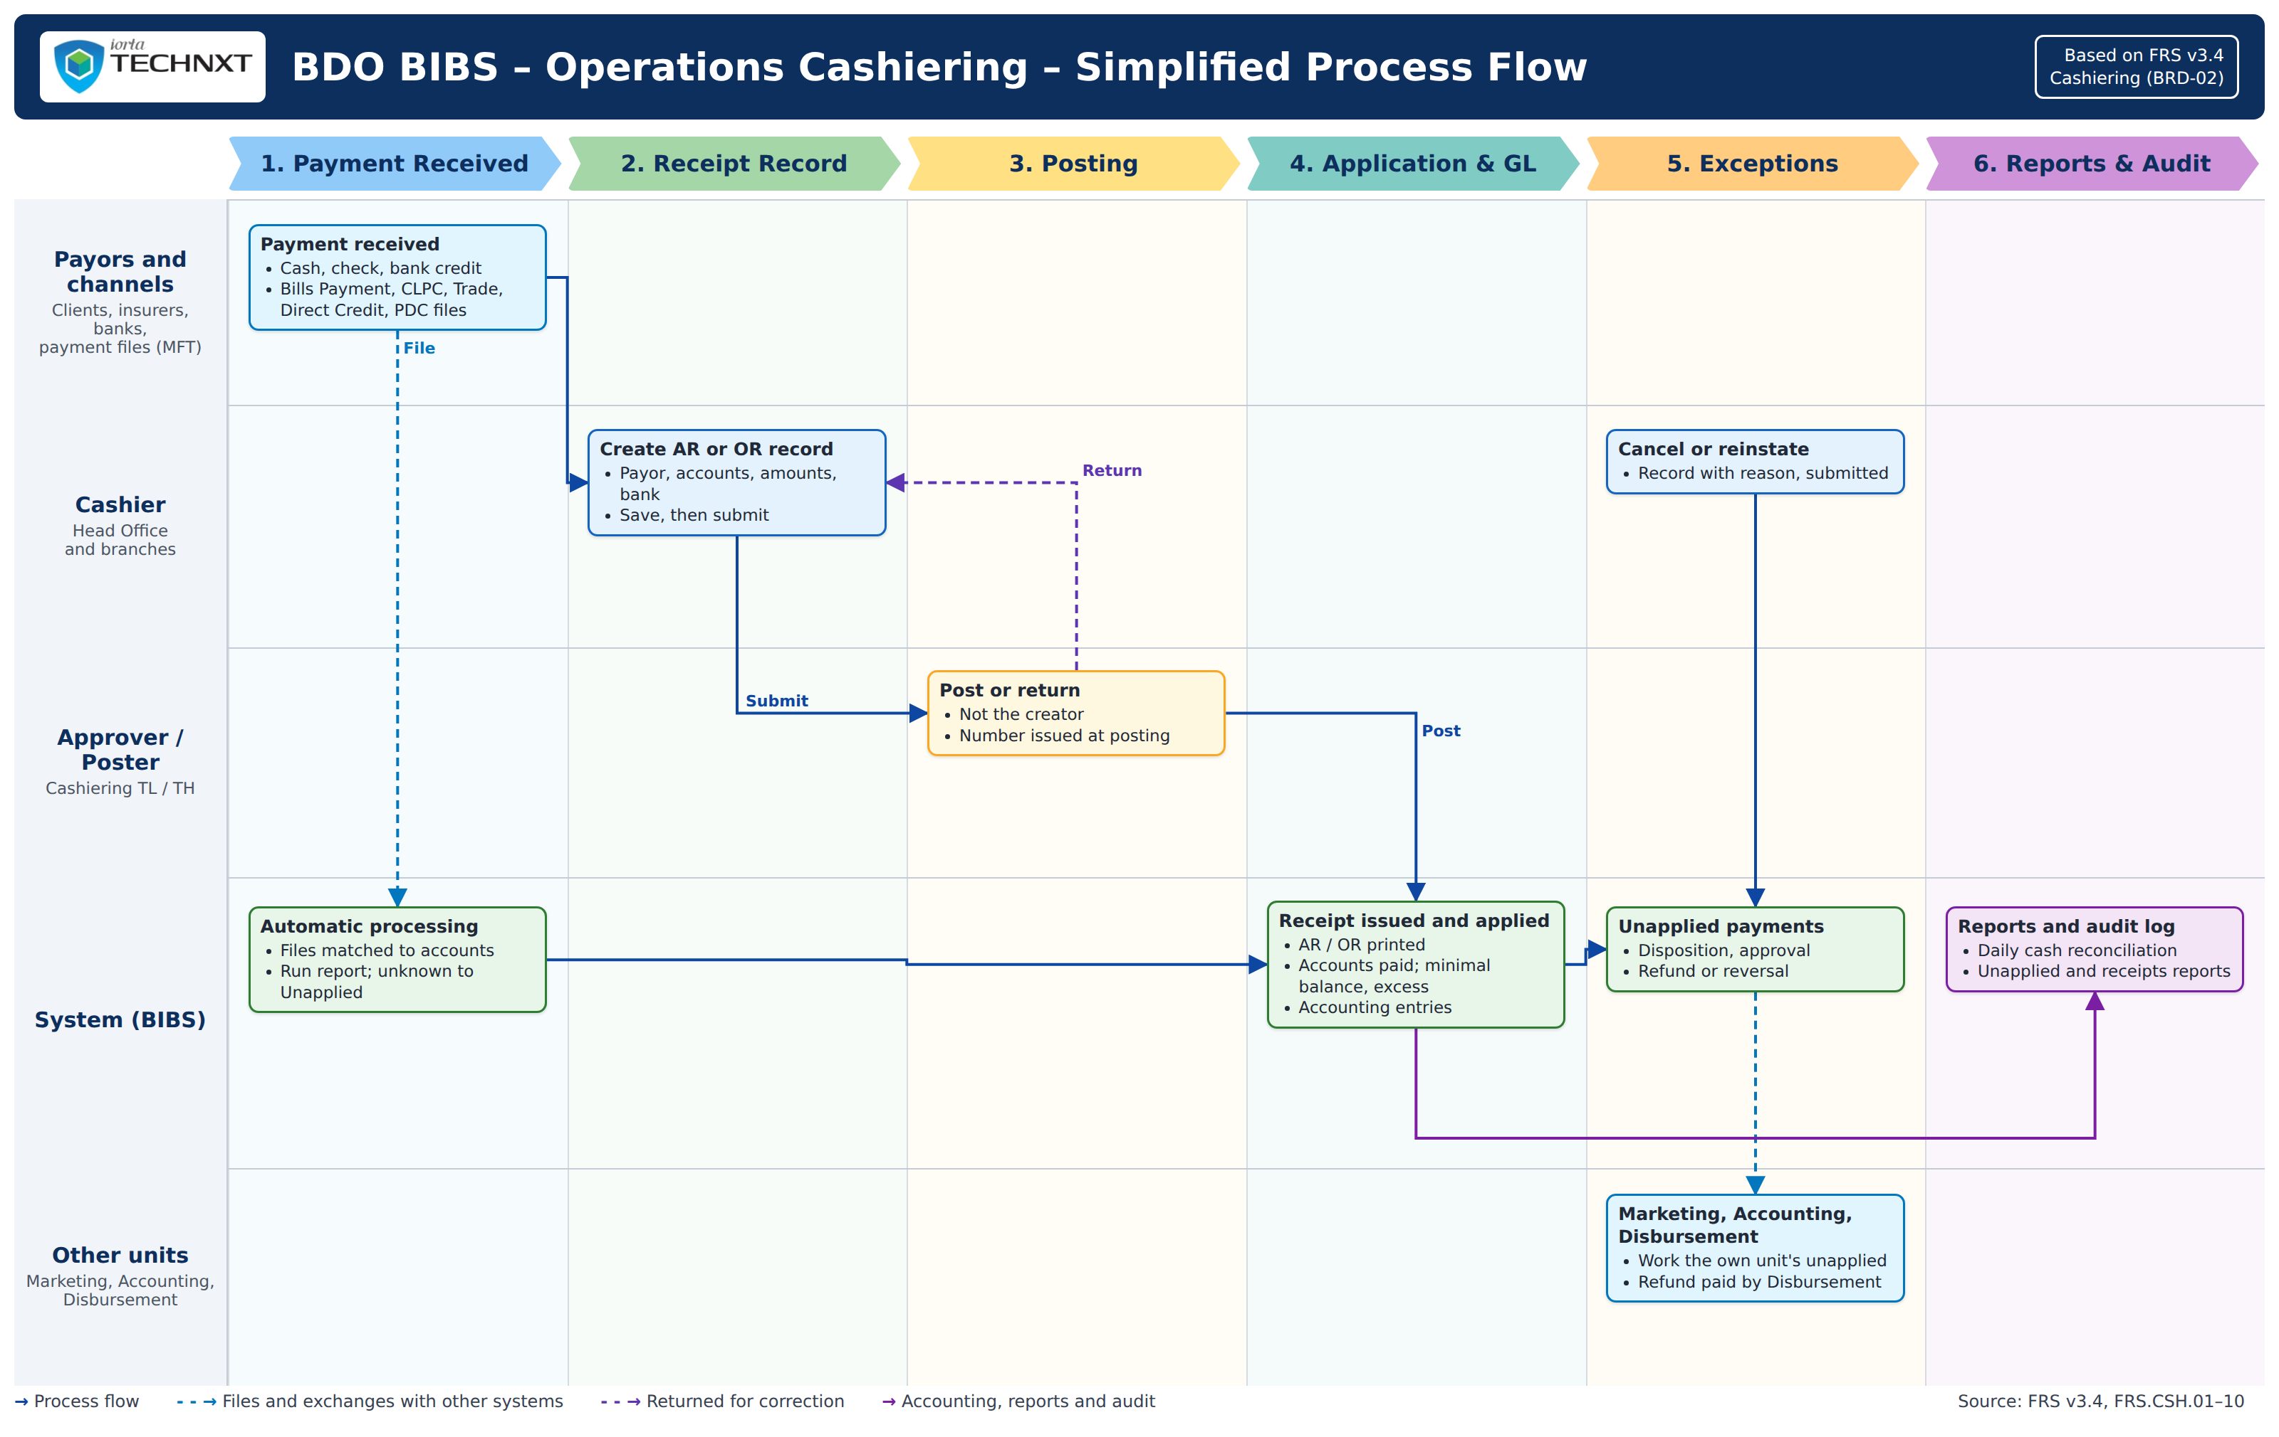
Figure 1: Operations Cashiering: simplified process flow (swimlanes by actor)
Table 2: The 10 steps
Step | Who | What happens
1 | Client or insurer | Pays at a Head Office or branch counter, by a bank channel (Bills Payment, CLPC, Trade, Direct Credit), by post-dated check or through an insurer settlement.
2 | Cashier | Creates the AR or OR record with the accounts paid and the bank account to post to, and submits it for posting.
3 | Cashiering Team Leader | Posts the record: BIBS issues the AR or OR number, applies the payment by component and posts the journal; or returns the record with a reason.
4 | BIBS | Matches and applies the payment files and matured checks row by row; each payment gets its AR and a result (Applied, Excess, Pre-booked, Unbooked/Unmatched).
5 | Cashier | Prints the ARs and ORs in batches; the BDOI Copy is kept with the receipt.
6 | Cashier and Team Leader | Work the unapplied payments: apply to another invoice, refund, reclass or transfer; the Team Leader approves refunds, reclasses and transfers.
7 | Cashier and Team Leader | Cancel or reinstate a receipt through a record posted by a second user; BIBS reverses or re-posts the payment and the journal.
8 | BIBS | The paid premium is read by the Remittance extraction; refunds go to Disbursement; journals to the general ledger.
9 | Accounting (BRD-05) | Deposits the day's collections and reconciles the bank accounts on Finance › Receivables against the bank statements.
10 | Cashiering Team Leader | Reviews the Day-End List and the Daily Cash Reconciliation report.

To-be Processes

P-CSH-01 Collection receipt (AR)
Item | Value
Journey steps | 1 to 3
Trigger | Payment of a client at the counter.
Actors | Cashier, Cashiering Team Leader
Outcome | AR issued from the branch series; payment applied by component; excess in the Unapplied list; journal posted.
Controls | BR-CSH-01, BR-CSH-02, BR-CSH-04 to BR-CSH-11, BR-CSH-15.

P-CSH-02 OR issuance
Item | Value
Journey steps | 1 to 3
Trigger | Service fee, profit share, commission, incentive or other income received at Head Office; insurer settlement approved by Disbursement; Commission Schedule processed.
Actors | Head Office Cashier, Cashiering Team Leader, BIBS
Outcome | OR issued from the Head Office series with its VAT and withholding tax; queued for printing.
Controls | BR-CSH-01 to BR-CSH-04, BR-CSH-15.

P-CSH-03 Payment files and automatic matching
Item | Value
Journey steps | 4
Trigger | File uploaded on Payment Uploads or received through MFT; post-dated check at maturity.
Actors | Cashier, BIBS
Outcome | One AR per payment; each row Applied, Excess, Pre-booked or Unbooked/Unmatched; run report.
Controls | BR-CSH-05, BR-CSH-06, BR-CSH-08, BR-CSH-17.

P-CSH-04 Unapplied payments and dispositions
Item | Value
Journey steps | 6
Trigger | Excess, unmatched, returned or migrated money; collector request.
Actors | Cashier, Cashiering Team Leader, Marketing Collection, Disbursement
Outcome | Balance applied, refunded, reclassified, transferred or taken to income.
Controls | BR-CSH-01, BR-CSH-16, BR-CSH-20.

P-CSH-05 Cancellation and reinstatement
Item | Value
Journey steps | 7
Trigger | Error, double issuance, returned check, mis-application.
Actors | Cashier, Cashiering Team Leader
Outcome | Receipt cancelled or reinstated; payments and journal reversed or re-posted; AR Insurer Refund for a remitted AR.
Controls | BR-CSH-01, BR-CSH-12 to BR-CSH-15.

P-CSH-06 Deposit and bank reconciliation
Item | Value
Journey steps | 9
Trigger | End of the business day; bank statement received.
Actors | Accounting (BRD-05), Cashiering Team Leader
Outcome | The postings of Cashiering on each bank account (Post to Bank Account) are deposited and reconciled on Finance › Receivables (Cheques & Deposits, Bank Statements, Bank Reconciliation).
Controls | Day-End List and Daily Cash Reconciliation report; BR-CSH-15.

P-CSH-07 Remittance hand-off
Item | Value
Journey steps | 8
Trigger | Premium applied to a booked invoice.
Actors | BIBS, Remittance
Outcome | The paid premium is extracted by Remittance per insurer; a cancellation after remittance becomes an AR Insurer Refund; a remittance return comes back as an unapplied payment.
Controls | BR-CSH-13, BR-CSH-14.

P-CSH-08 Set-up under maker-checker
Item | Value
Journey steps | -
Trigger | A new receipt series, form change or Cashiering setting.
Actors | Cashiering Team Leader (maker), second authorised user (checker)
Outcome | Approved series, form or setting in force.
Controls | BR-CSH-01, BR-CSH-18.

Statuses of a record
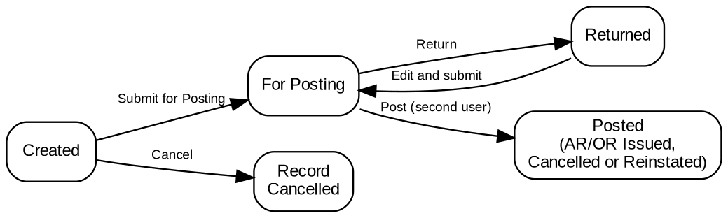
Figure 2: Statuses of an AR / OR creation, cancellation or reinstatement record

Storyboards

SB-01 A premium payment from the counter to the issued AR
A Head Office cashier receives a client's premium in cash, saves the AR record and submits it; the Cashiering Team Leader posts it; the AR is issued, the payment applied by component and the AR queued for printing.
Test data: Seed account of the ARN series 2026-94 with an outstanding balance; fictitious payor.
Table 3: SB-01 steps
Step | Who | Screen | Does | Sees
1 | Cashier | Create AR/OR | Opens Create AR/OR, finds the account, enters the payor, Cash, the bank account, the amount and the remarks | The account with its outstanding balance and the preview of the application
2 | Cashier | Cashiering Record | Saves the record and clicks Submit for Posting | Record CR-AR-<n> For Posting; the receipt number is given at posting
3 | Cashiering Team Leader | Posting | Opens Posting | The record among the AR/OR records for posting
4 | Cashiering Team Leader | Cashiering Record | Opens the record and clicks Post | The confirmation: the AR will be issued, payments applied, any excess in the Unapplied list
5 | Cashiering Team Leader | Cashiering Record | Confirms | AR/OR Issued with the AR number
6 | Cashier | Receipt | Opens the AR | The AR Issued with its application by component
7 | Cashier | Batch Print | Opens Batch Print | The AR in the print queue

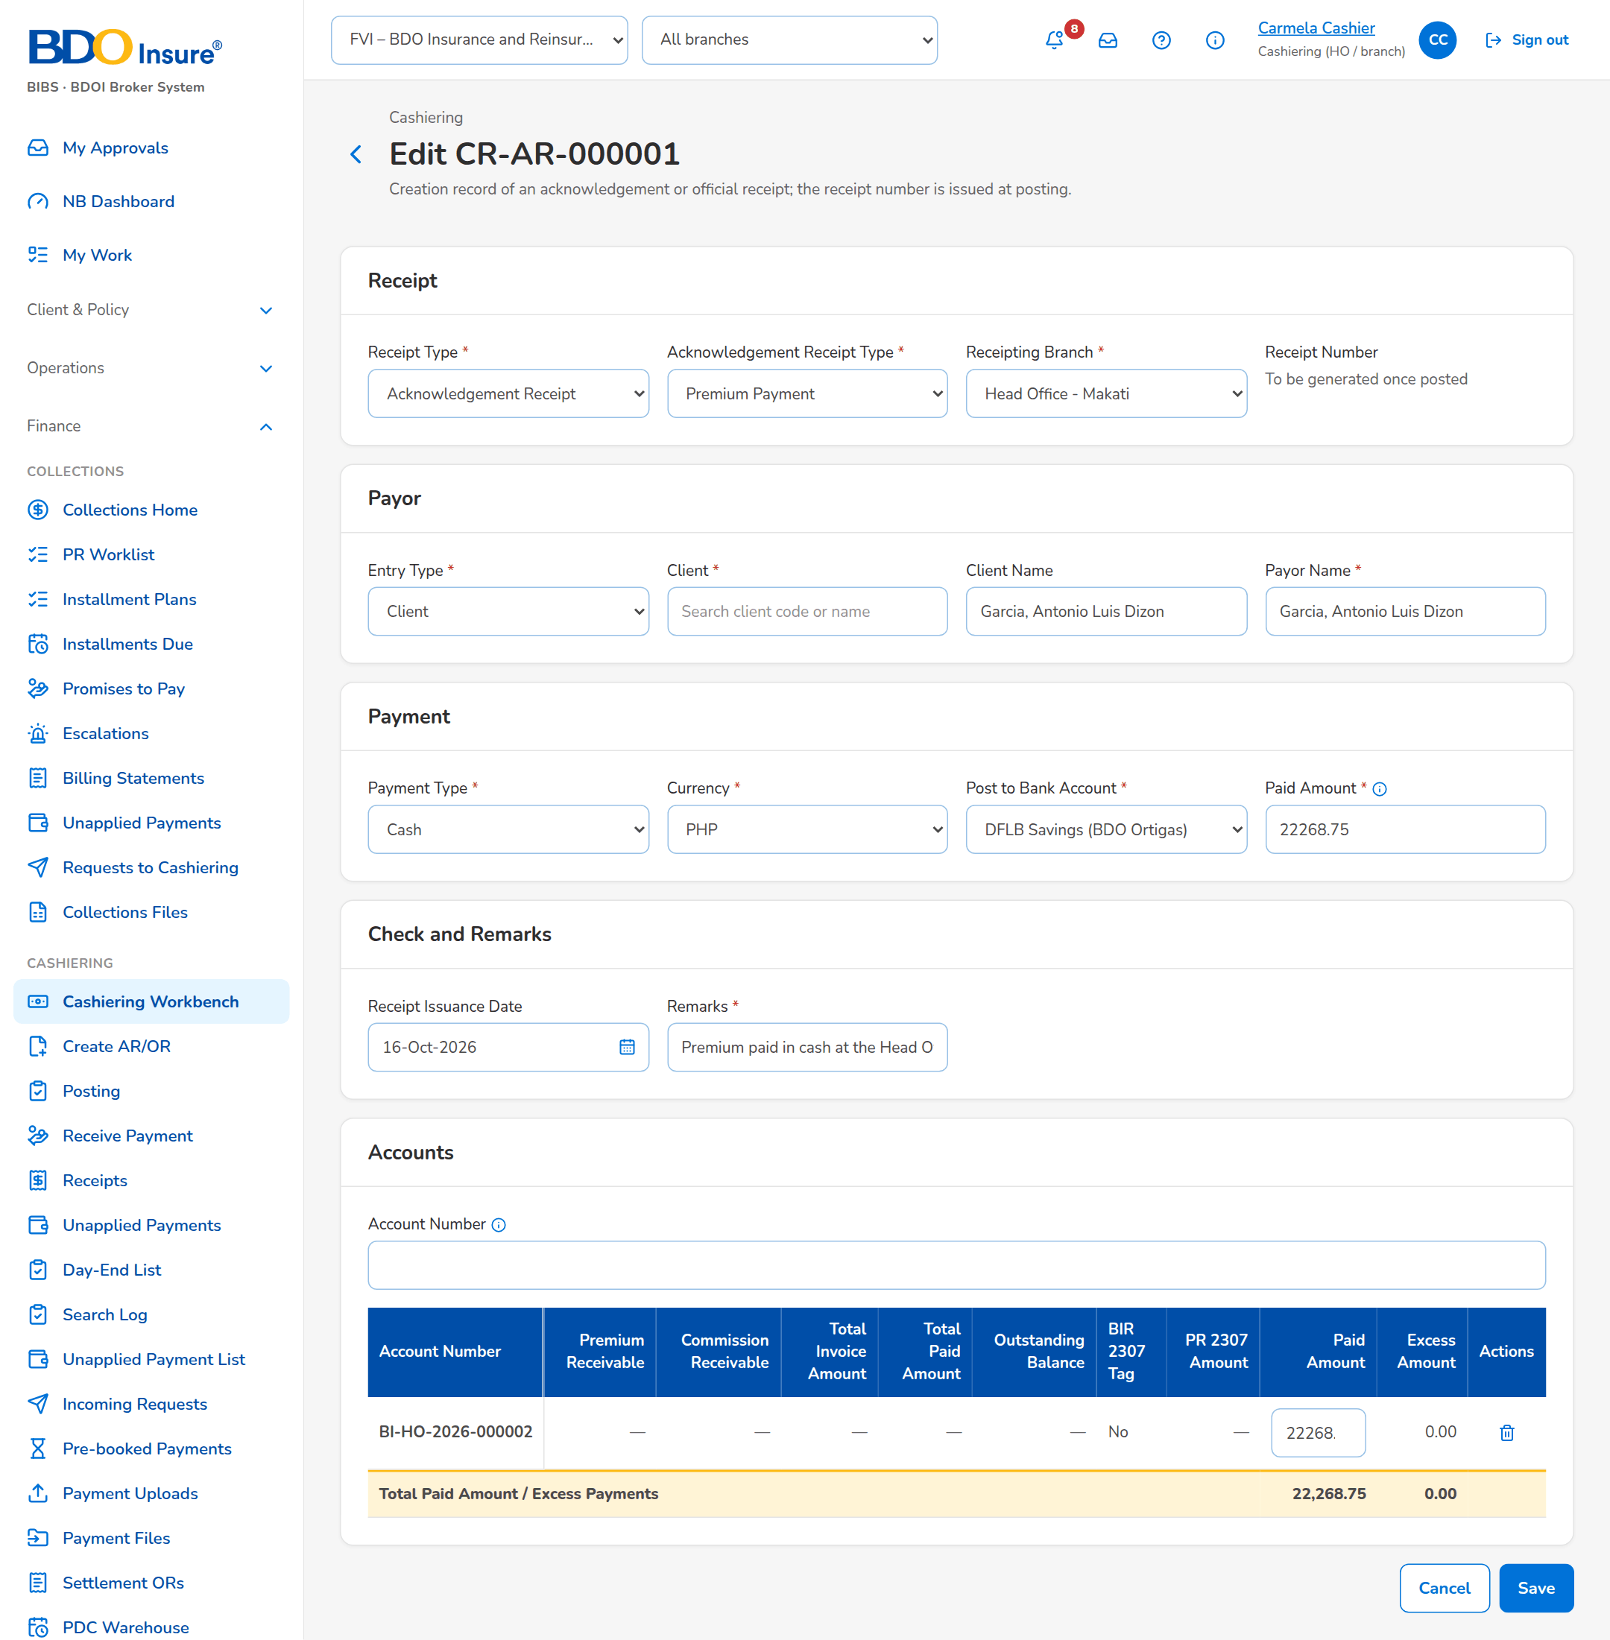
Figure 3: SB-01 step 1: Cashier, Create AR/OR
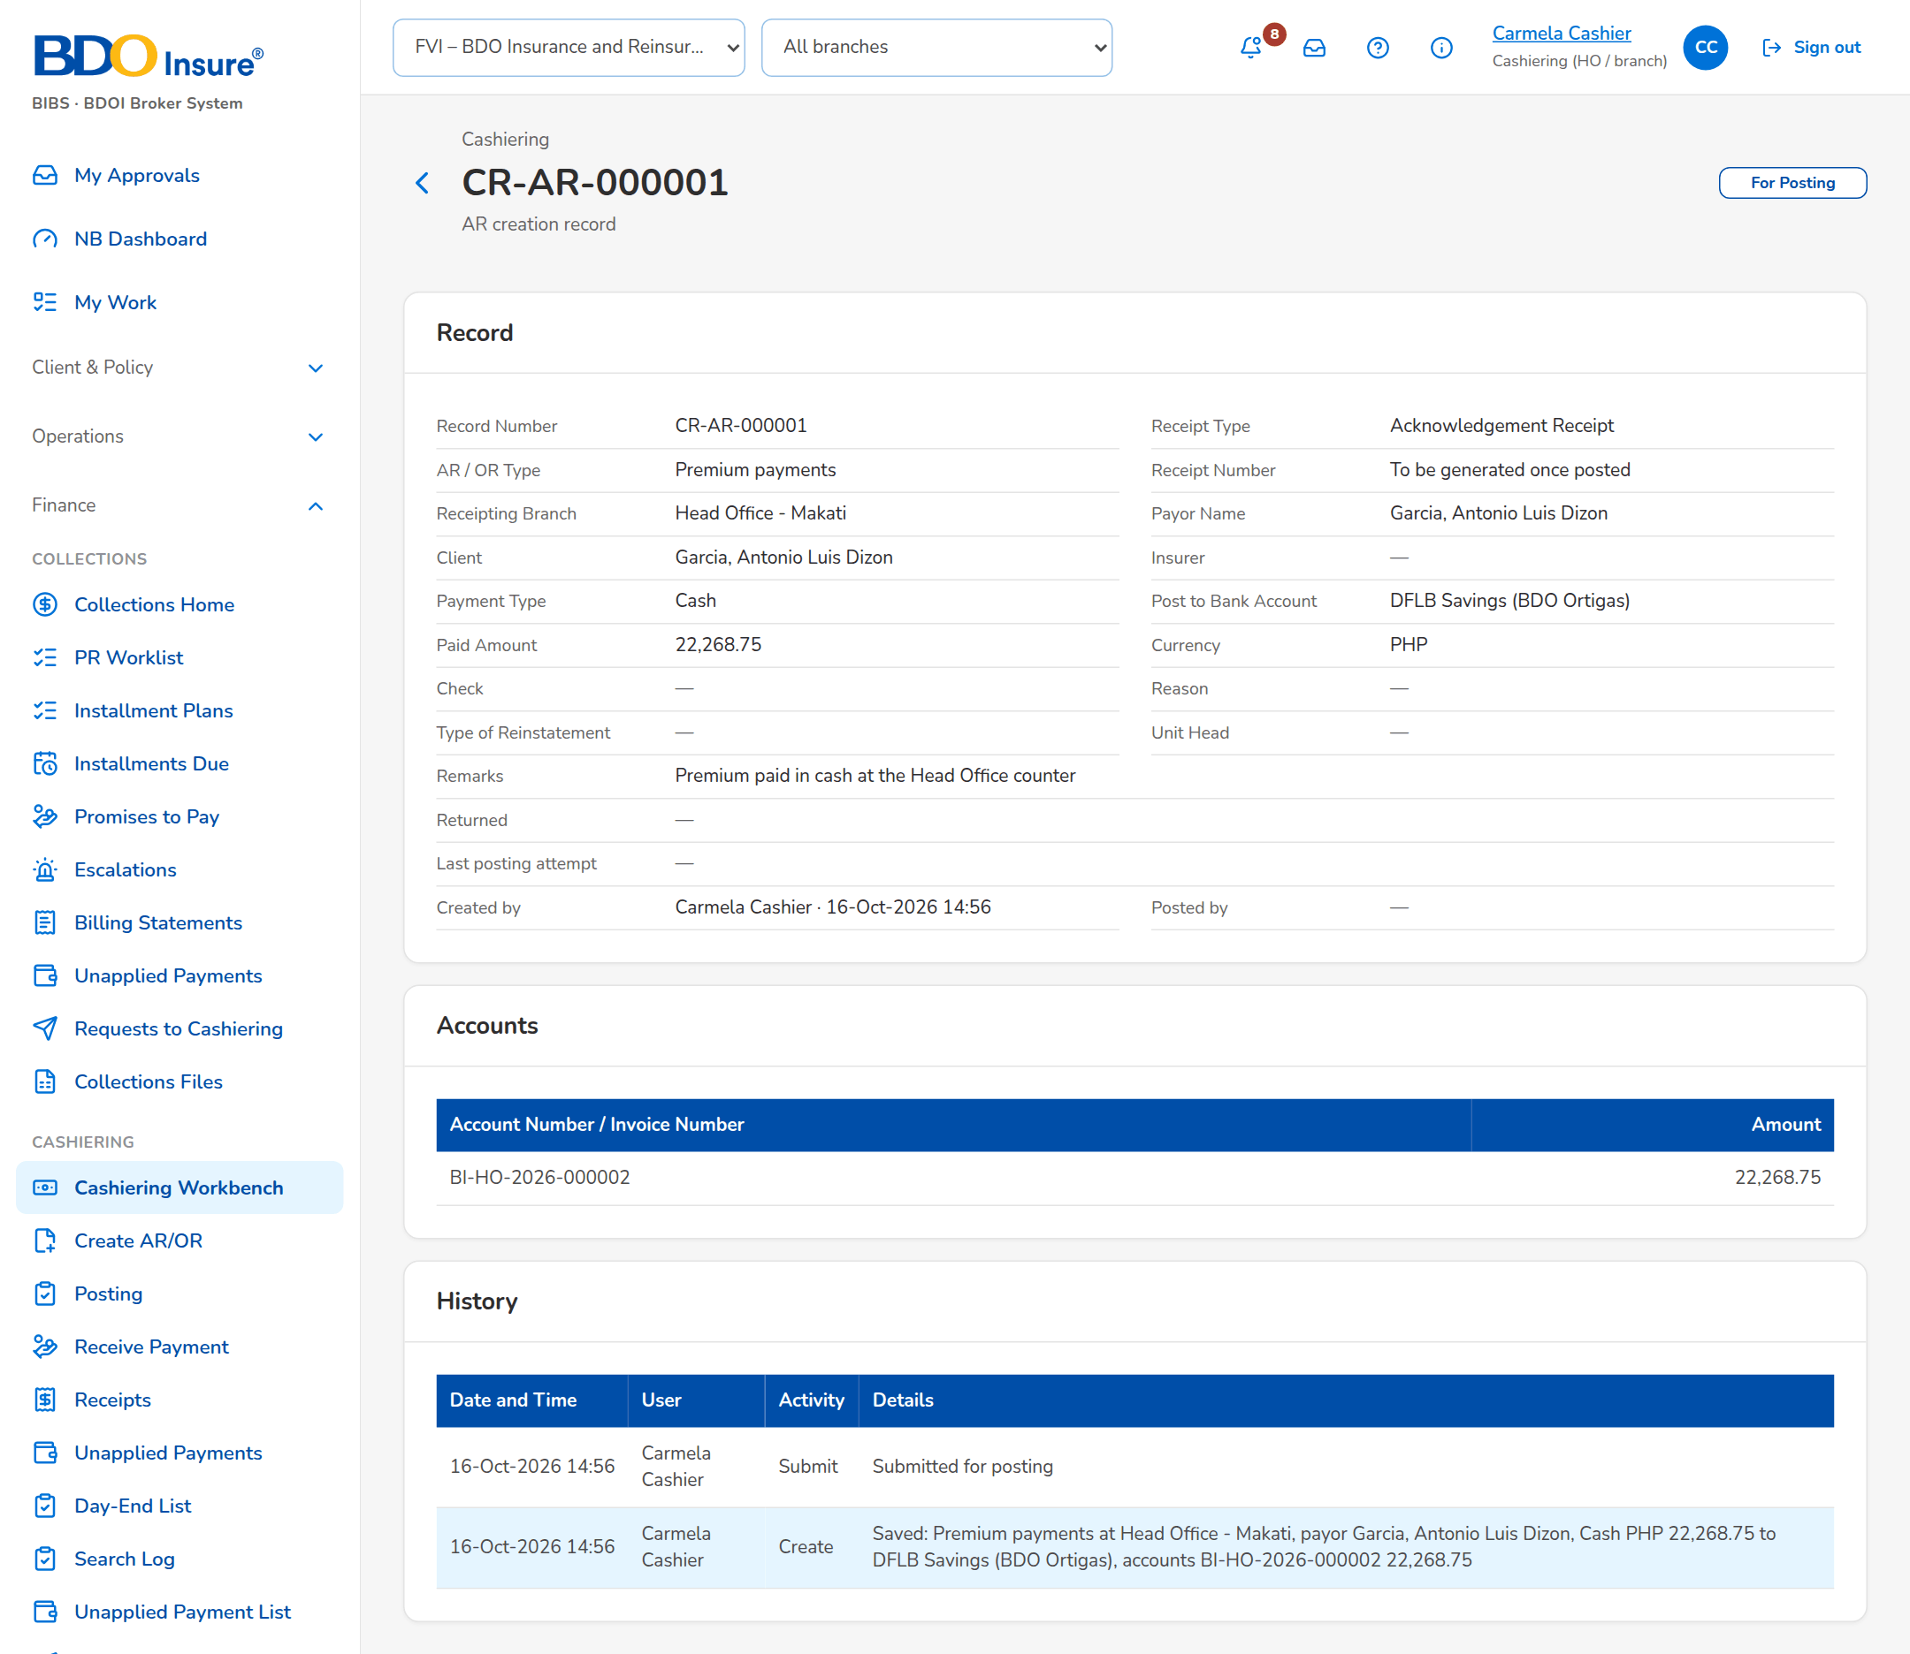
Figure 4: SB-01 step 2: Cashier, Cashiering Record
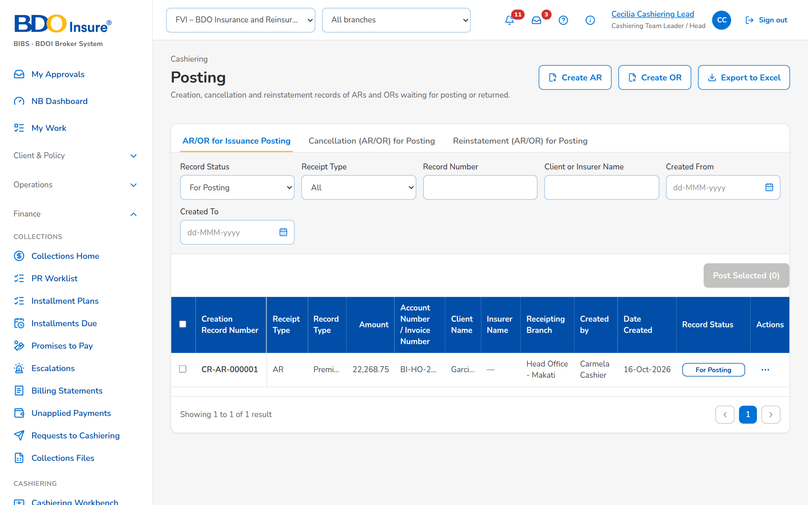
Figure 5: SB-01 step 3: Cashiering Team Leader, Posting
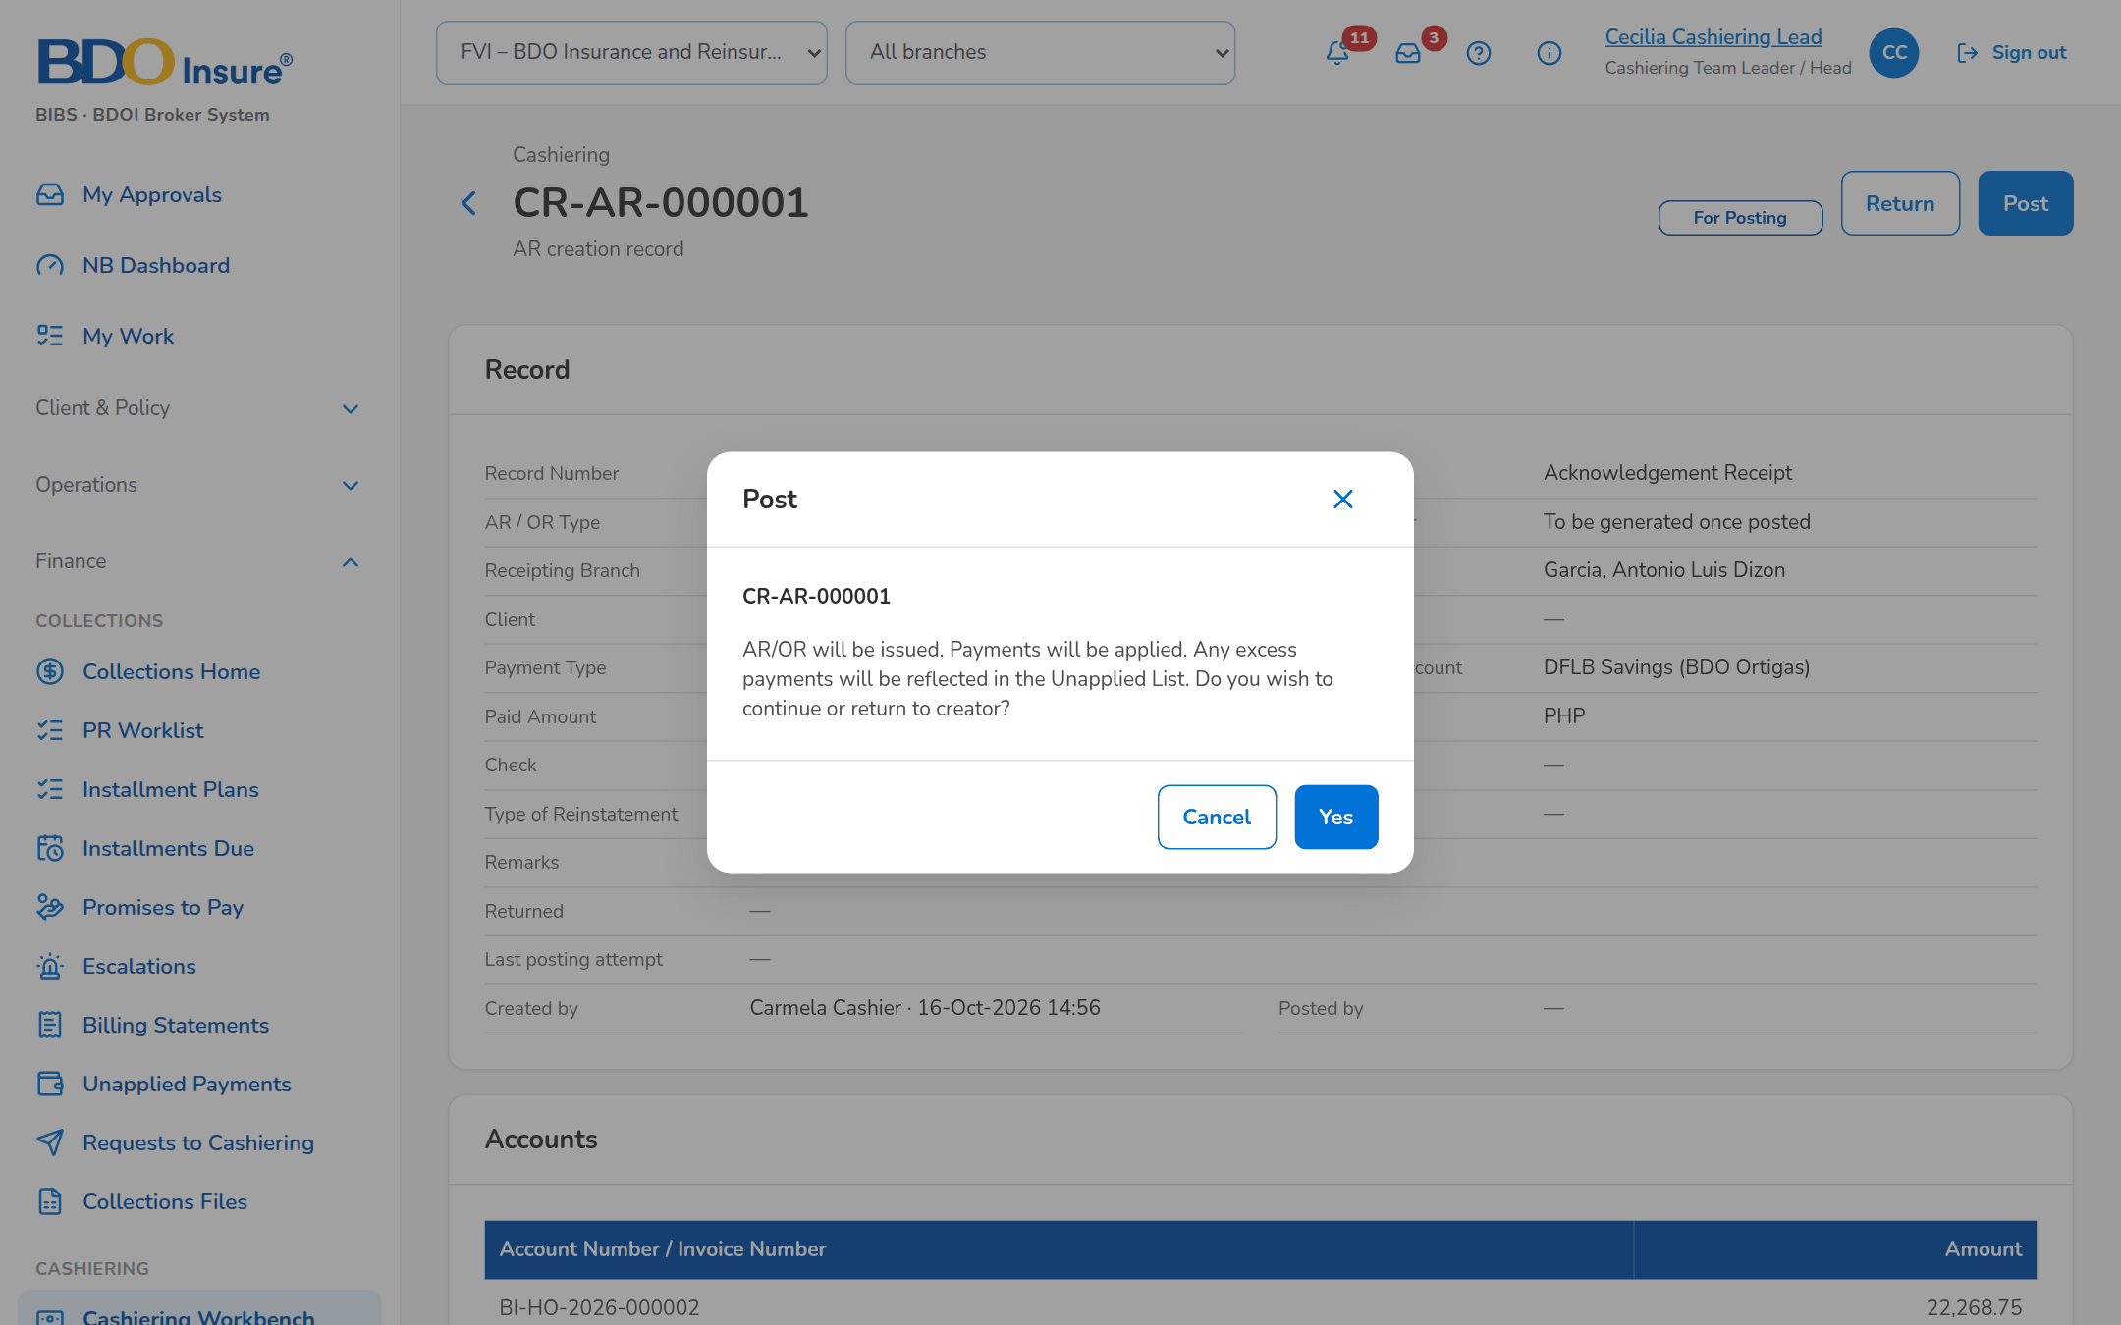
Figure 6: SB-01 step 4: Cashiering Team Leader, Cashiering Record
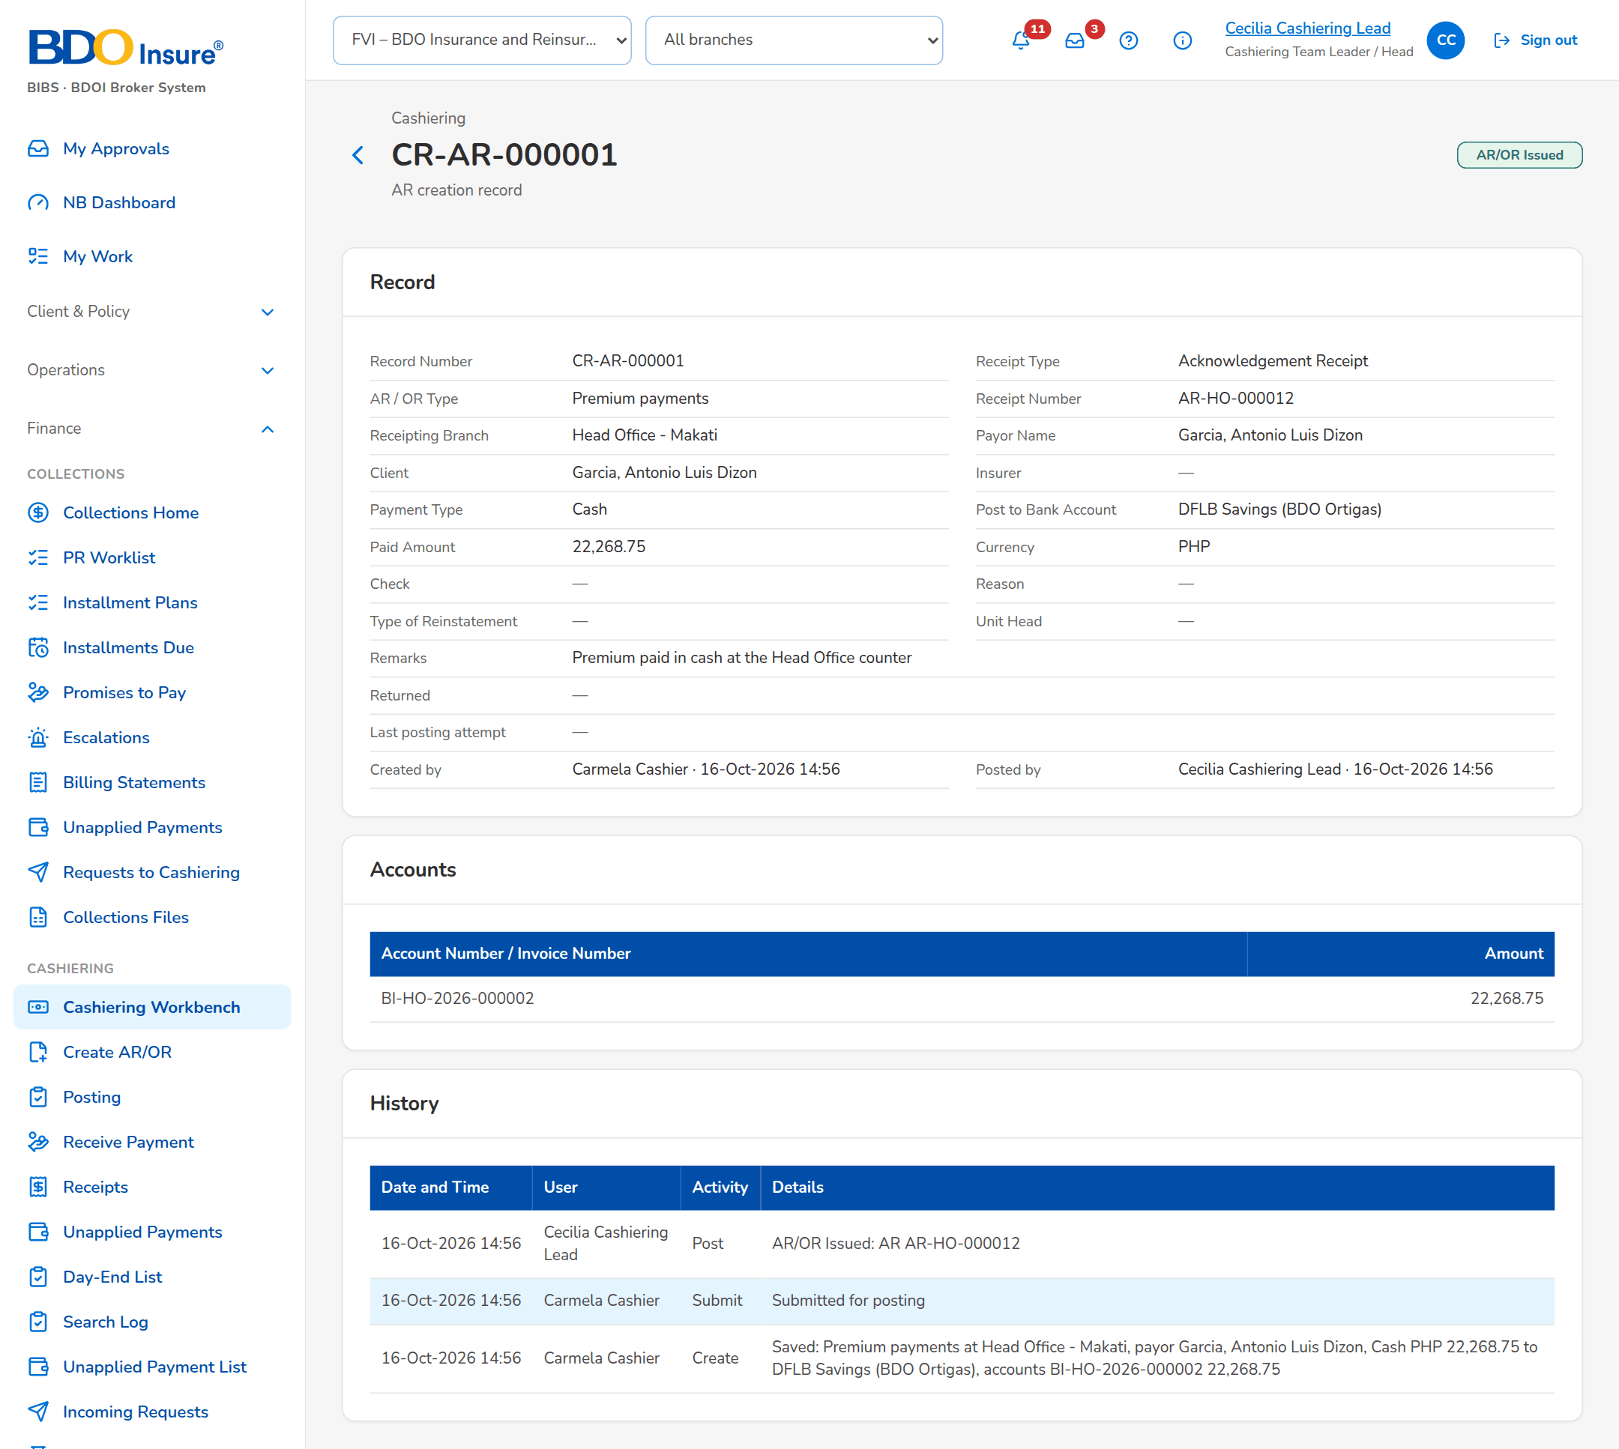
Figure 7: SB-01 step 5: Cashiering Team Leader, Cashiering Record
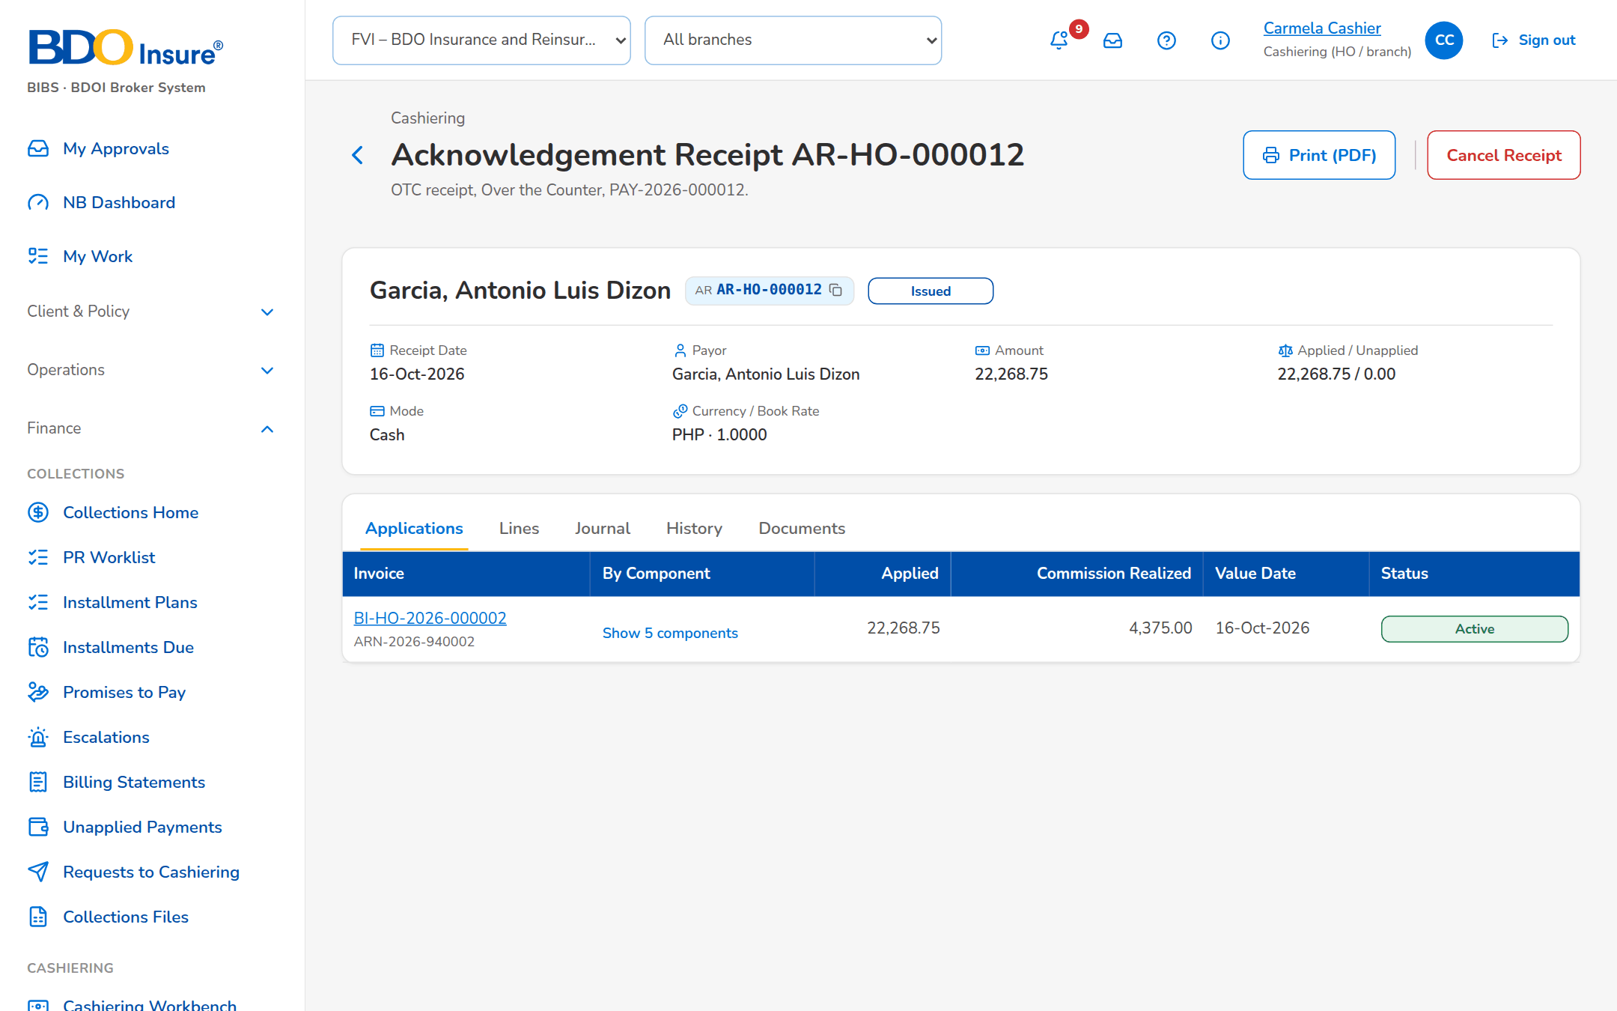
Figure 8: SB-01 step 6: Cashier, Receipt
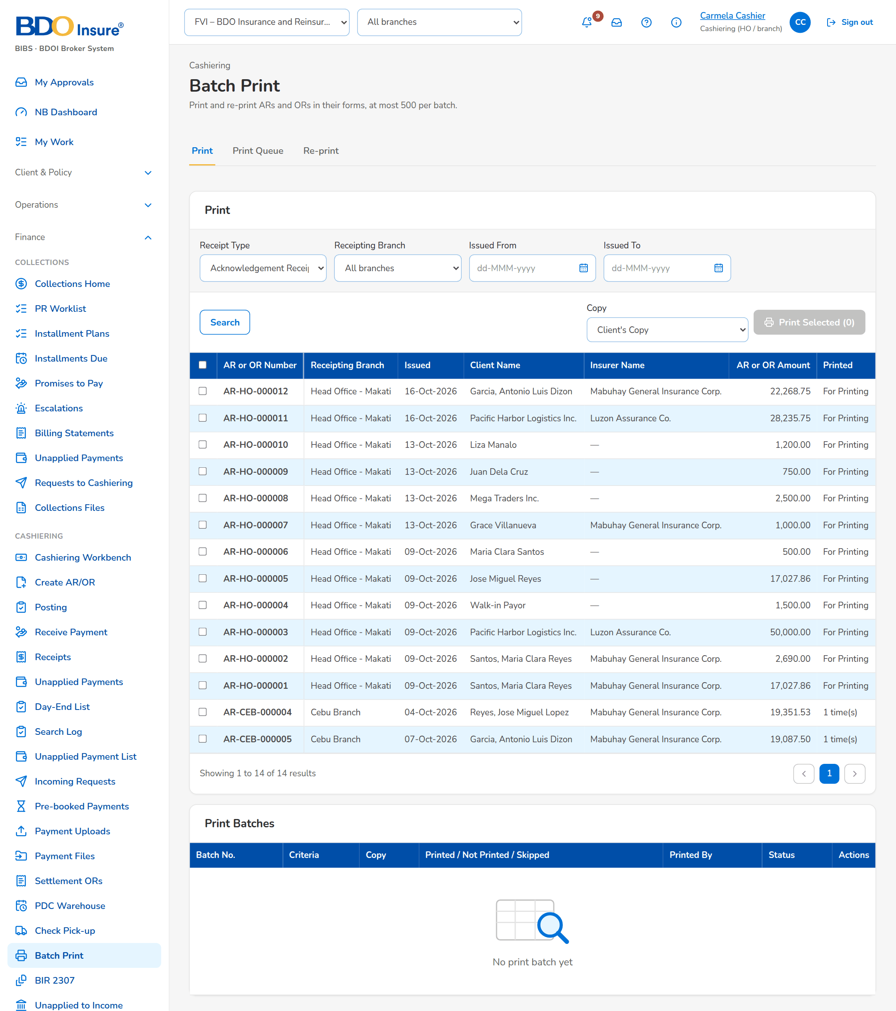
Figure 9: SB-01 step 7: Cashier, Batch Print

SB-02 A service fee OR at Head Office
The Head Office cashier records a service fee paid by an insurer by check, with VAT; the Team Leader posts it and the OR is issued from the Head Office series.
Test data: Seed insurer Mabuhay General Insurance Corp.; check past its holding period.
Table 4: SB-02 steps
Step | Who | Screen | Does | Sees
1 | Cashier | Create AR/OR | Opens Create OR, chooses Service Fee, the insurer, Check with its date, the amount and the VAT | The OR record with the payment type Check and the VAT
2 | Cashiering Team Leader | Cashiering Record | Opens the submitted record and posts it | AR/OR Issued with the OR number of the Head Office series
3 | Cashier | Receipt | Opens the OR | The OR Issued with its gross amount, VAT and lines

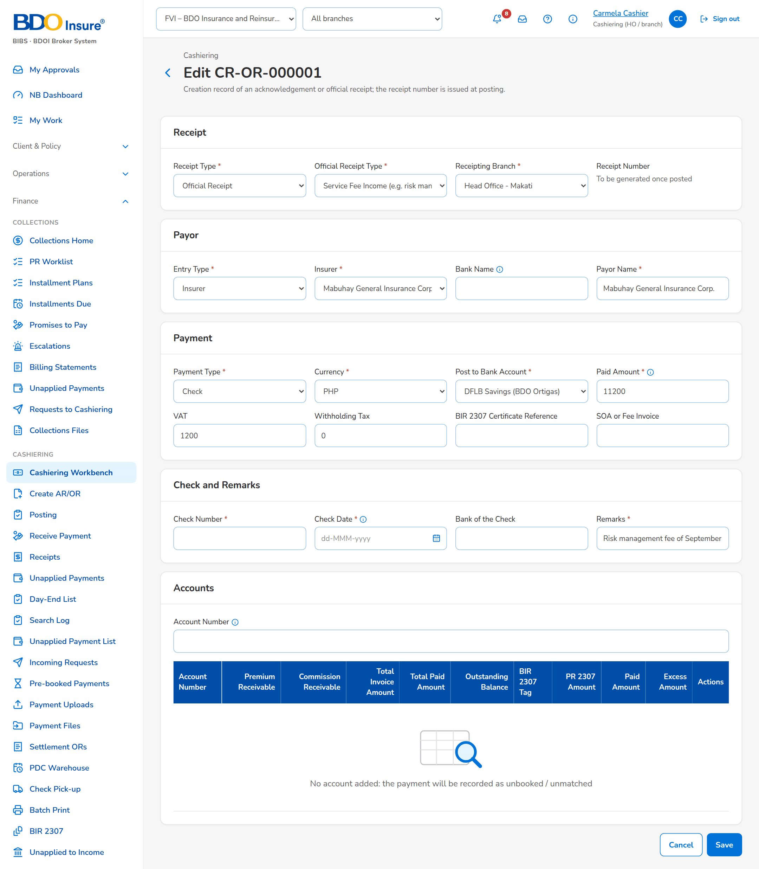
Figure 10: SB-02 step 1: Cashier, Create AR/OR
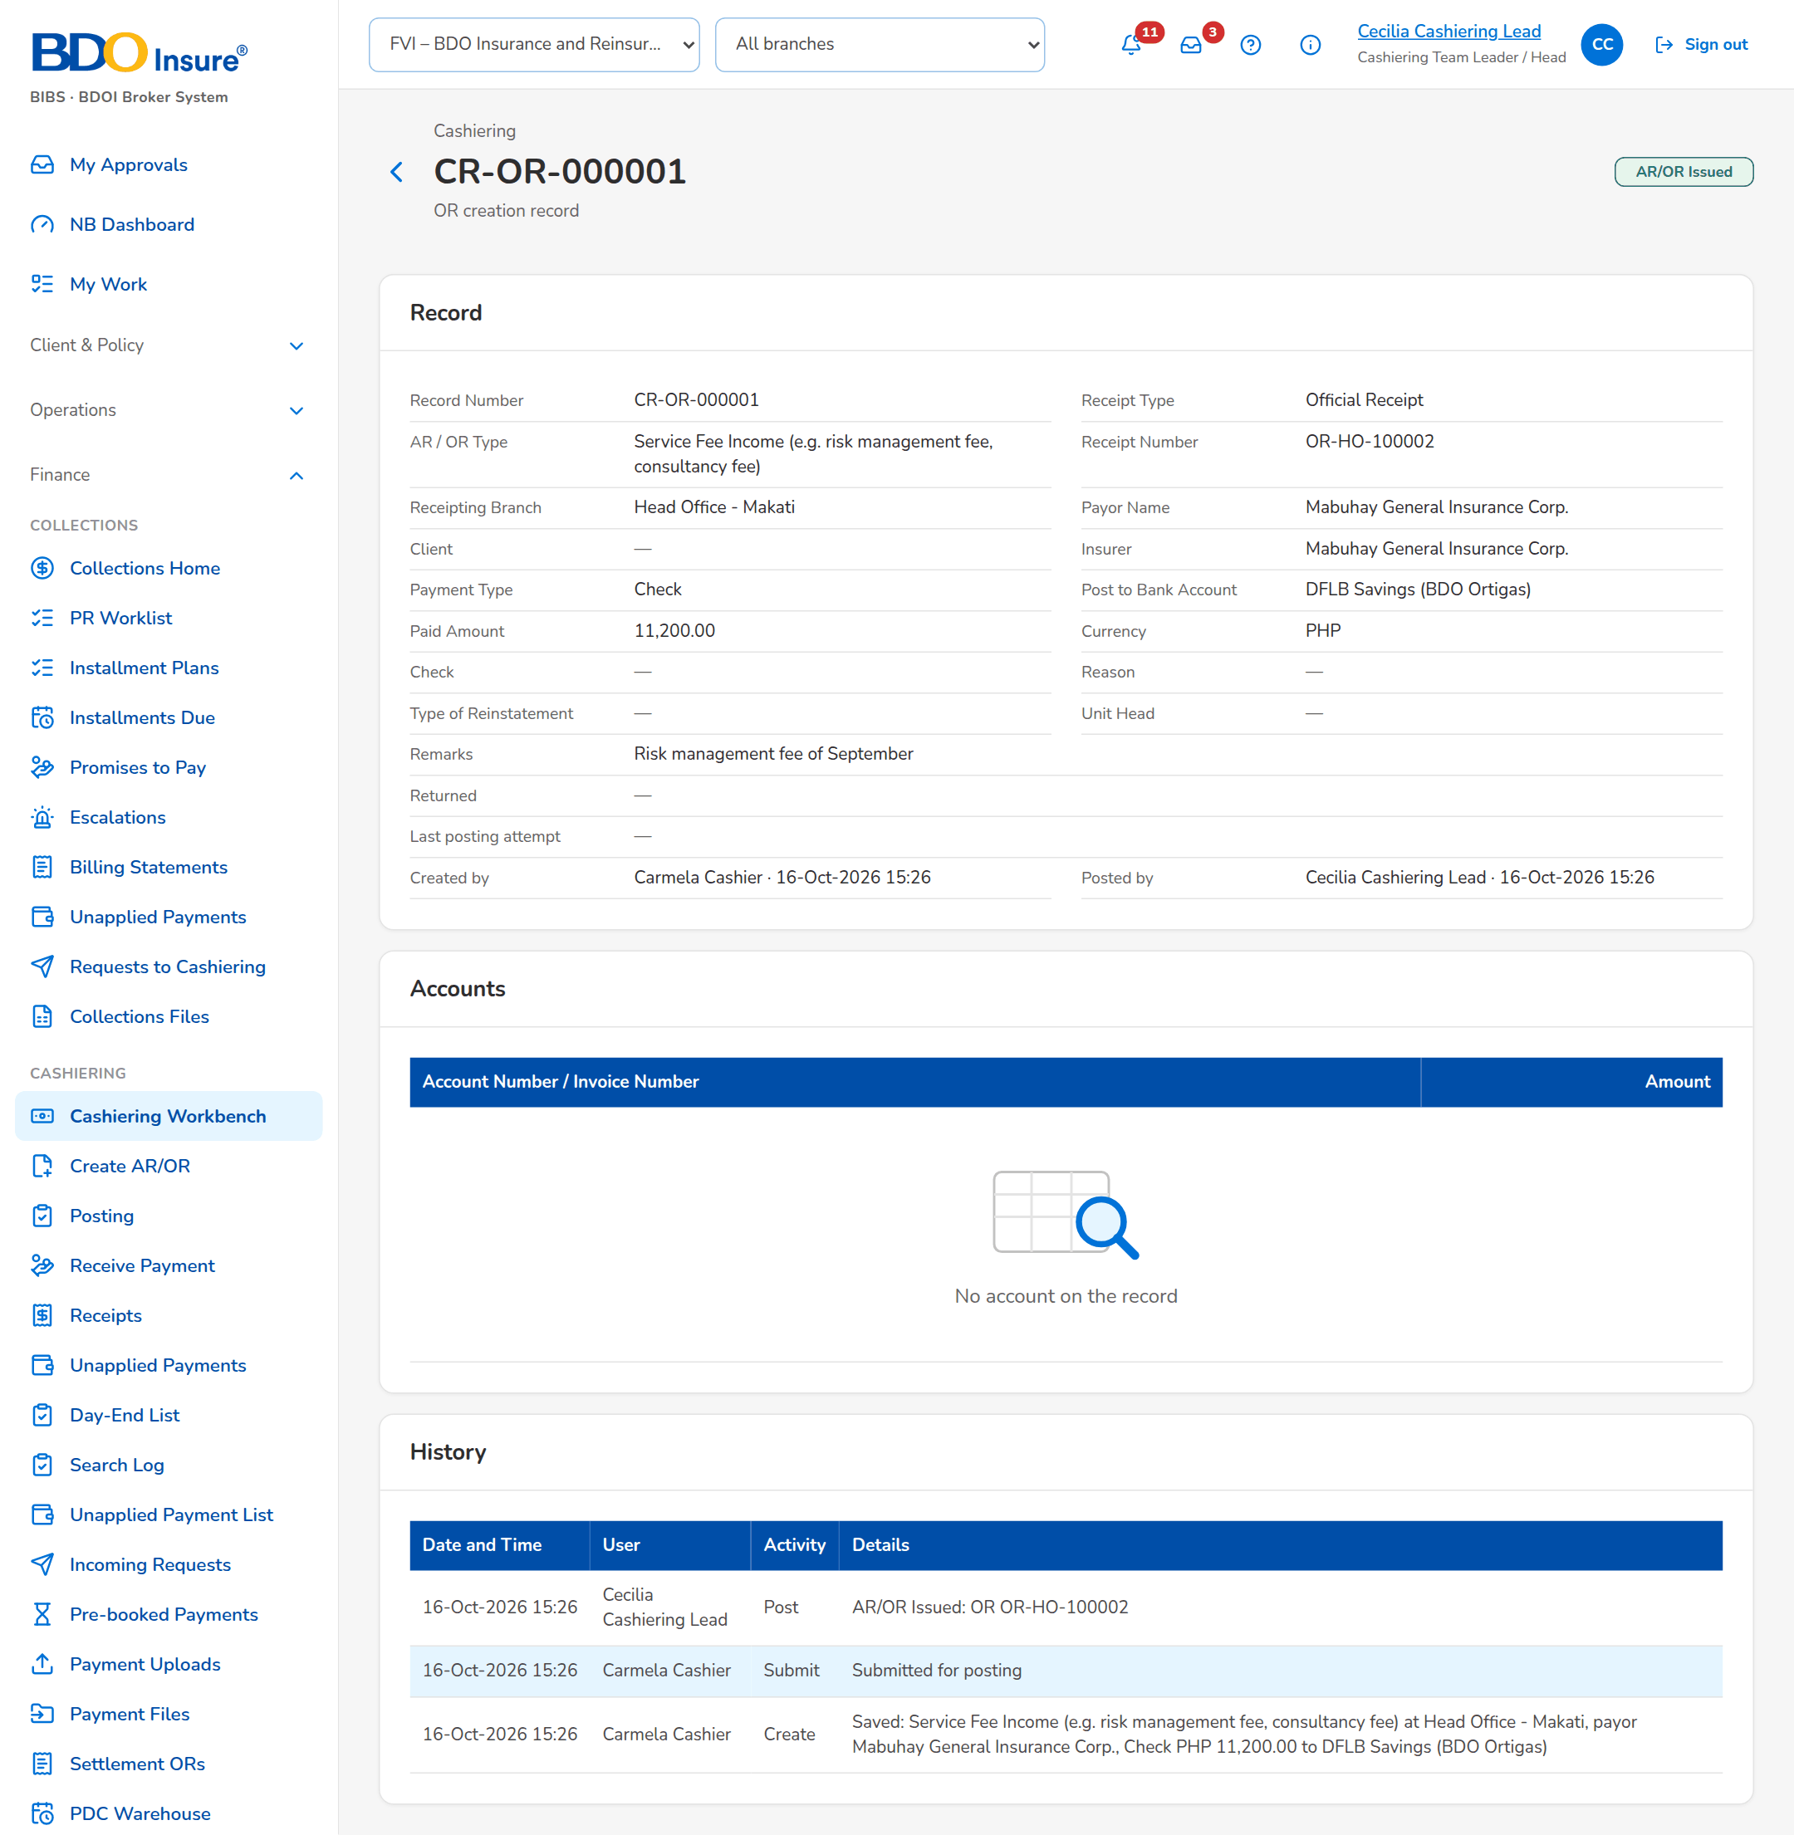
Figure 11: SB-02 step 2: Cashiering Team Leader, Cashiering Record
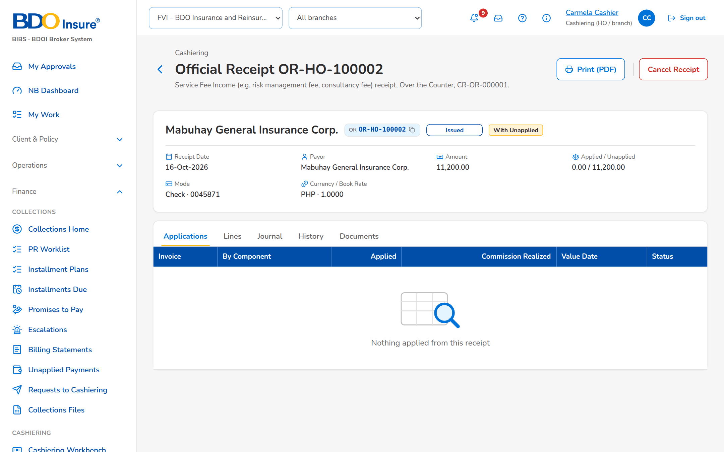
Figure 12: SB-02 step 3: Cashier, Receipt

SB-03 A Bills Payment file from upload to matching
The cashier uploads a Bills Payment file of the bank channel. BIBS checks the file, matches each row and issues one AR per payment; the run report gives the result per row; the unmatched payment waits in the Unapplied list.
Test data: Bills Payment file of six rows in BDOI's layout made by the channel simulator of the test environment.
Table 5: SB-03 steps
Step | Who | Screen | Does | Sees
1 | Cashier | Payment Uploads | Chooses Bills Payment and the file | The file chosen with its type, ready to upload
2 | Cashier | Payment Files | Opens Payment Files | The file Processed with its counts per result
3 | Cashier | Payment Files | Opens the run report of the file | Each payment with its AR and result
4 | Cashier | Unapplied Payments | Opens Unapplied Payments | The unmatched payment as Unbooked/Unmatched

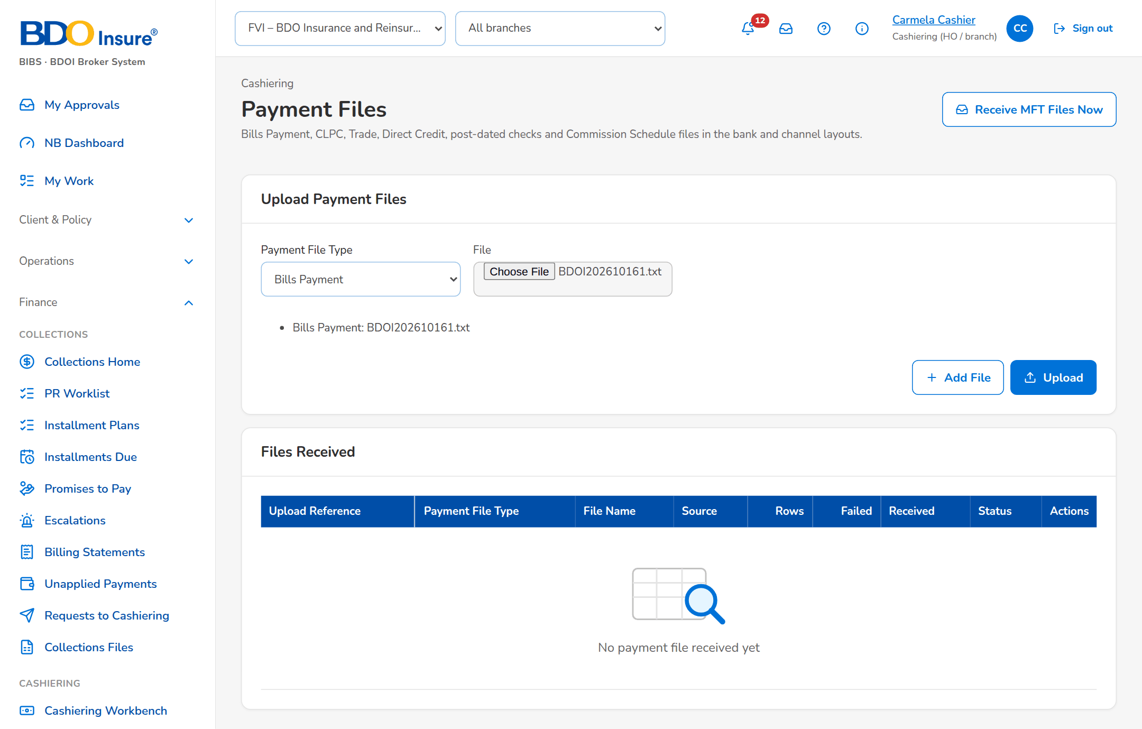
Figure 13: SB-03 step 1: Cashier, Payment Uploads
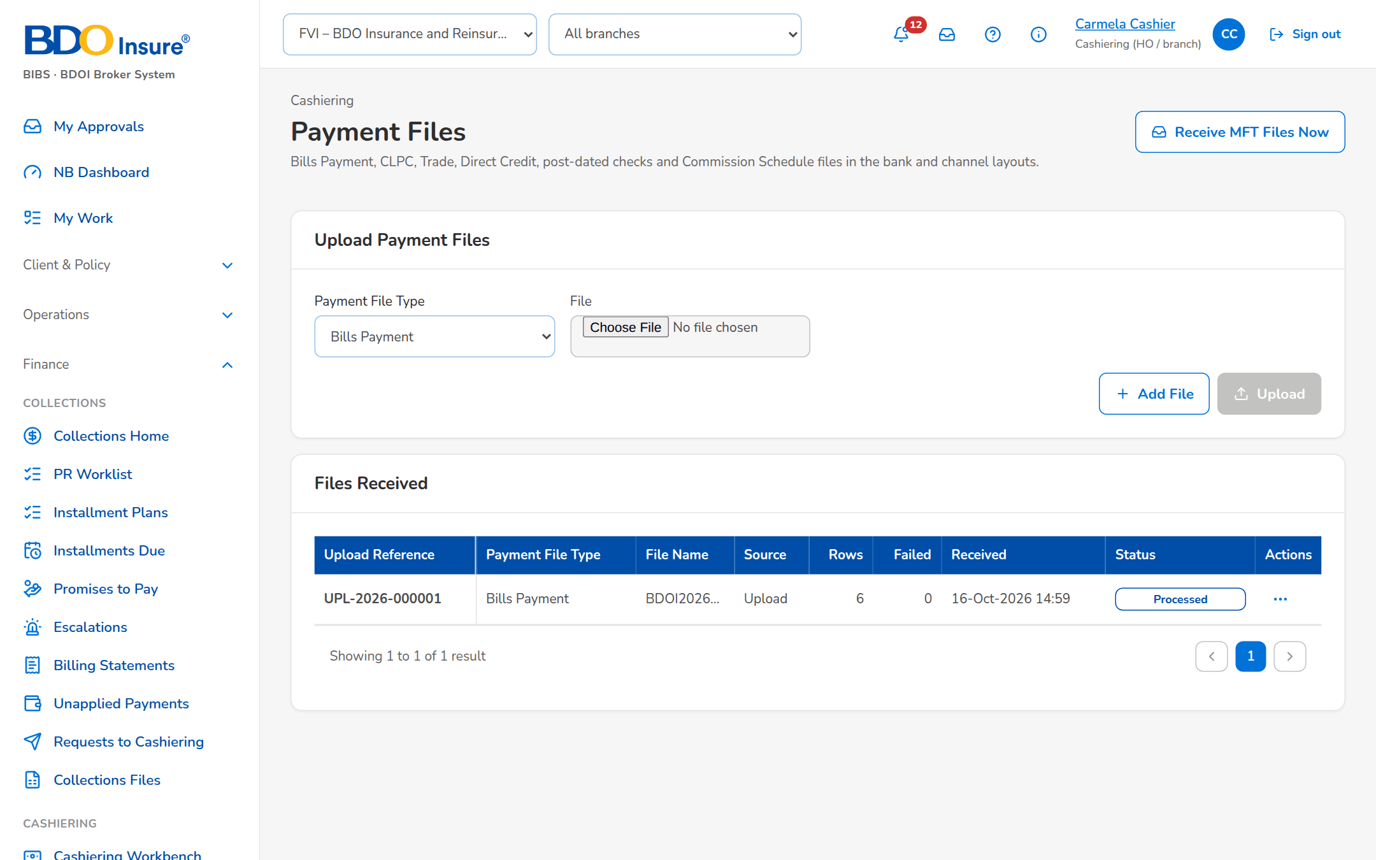
Figure 14: SB-03 step 2: Cashier, Payment Files
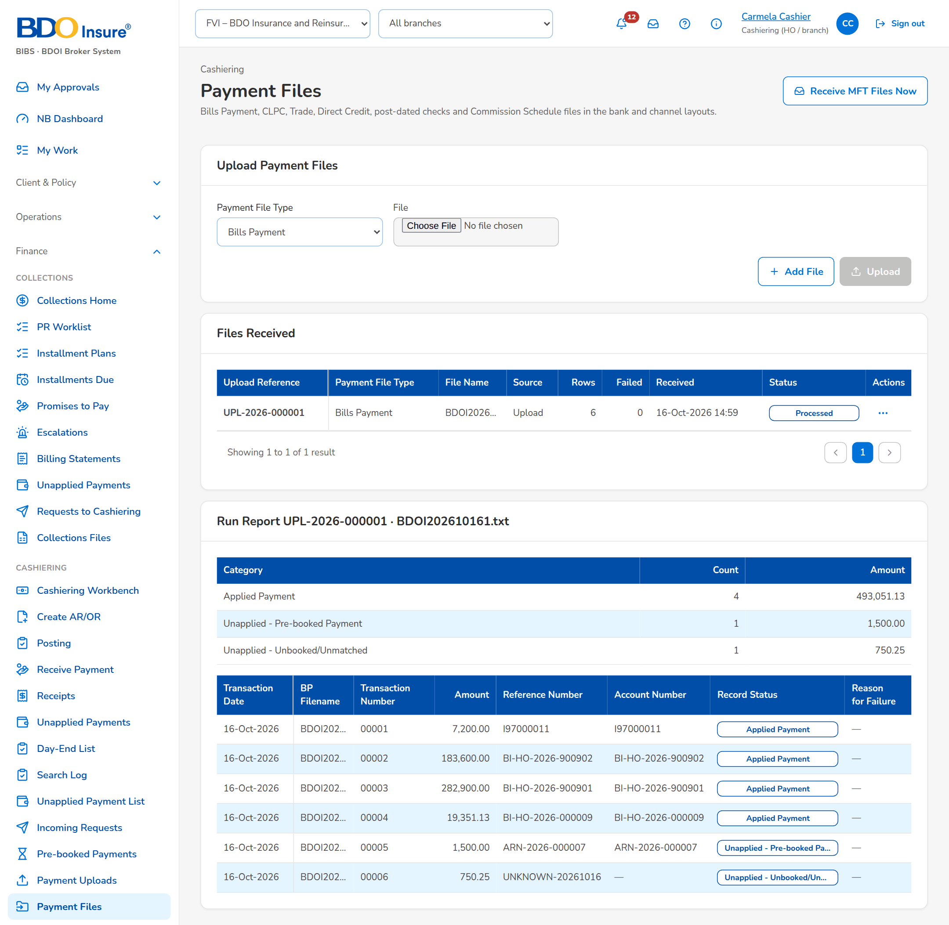
Figure 15: SB-03 step 3: Cashier, Payment Files
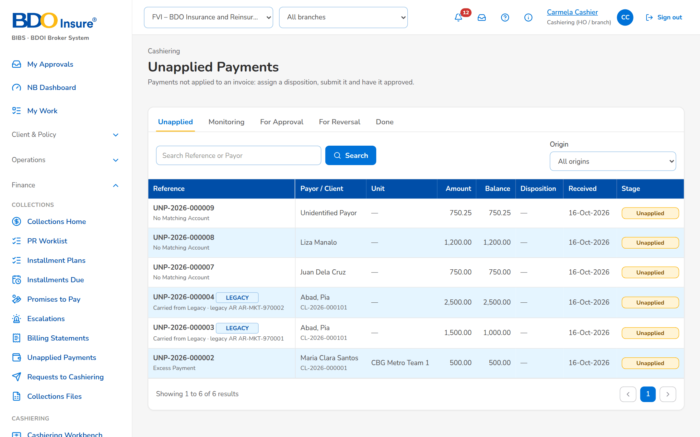
Figure 16: SB-03 step 4: Cashier, Unapplied Payments

SB-04 An excess payment refunded through Disbursement
An unapplied payment is refunded: the cashier gives the Refund disposition and submits it, the Team Leader approves it and the refund request reaches the Disbursement queue.
Test data: Seed unapplied payment without a match; fictitious payee.
Table 6: SB-04 steps
Step | Who | Screen | Does | Sees
1 | Cashier | Unapplied Payment | Opens the unapplied payment and fills the Refund disposition | The disposition form with the payee and remarks
2 | Cashier | Unapplied Payment | Submits the disposition | For Approval in the workflow header
3 | Cashiering Team Leader | Unapplied Payment | Opens it from For Approval and approves | The disposition approved; the refund request sent to Disbursement
4 | Disbursement | Disbursement Queue | Opens the Disbursement Queue | The refund request to acknowledge

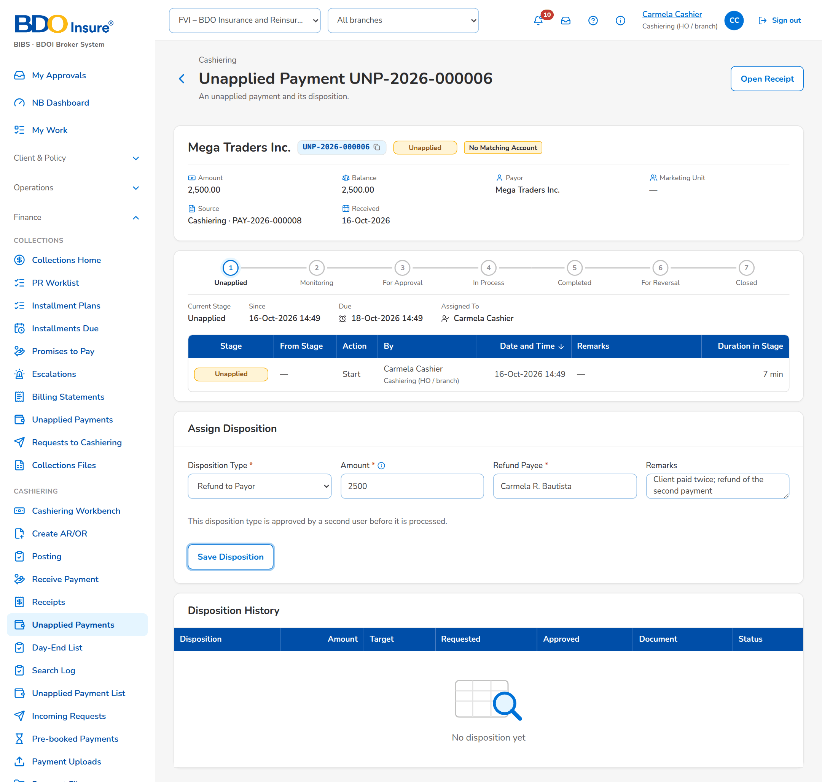
Figure 17: SB-04 step 1: Cashier, Unapplied Payment
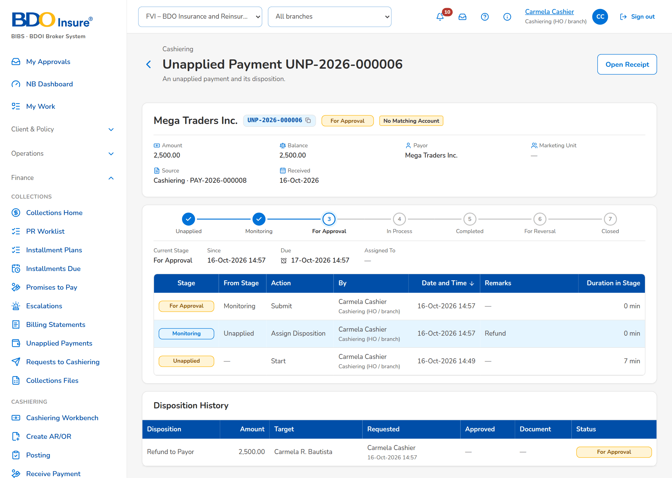
Figure 18: SB-04 step 2: Cashier, Unapplied Payment
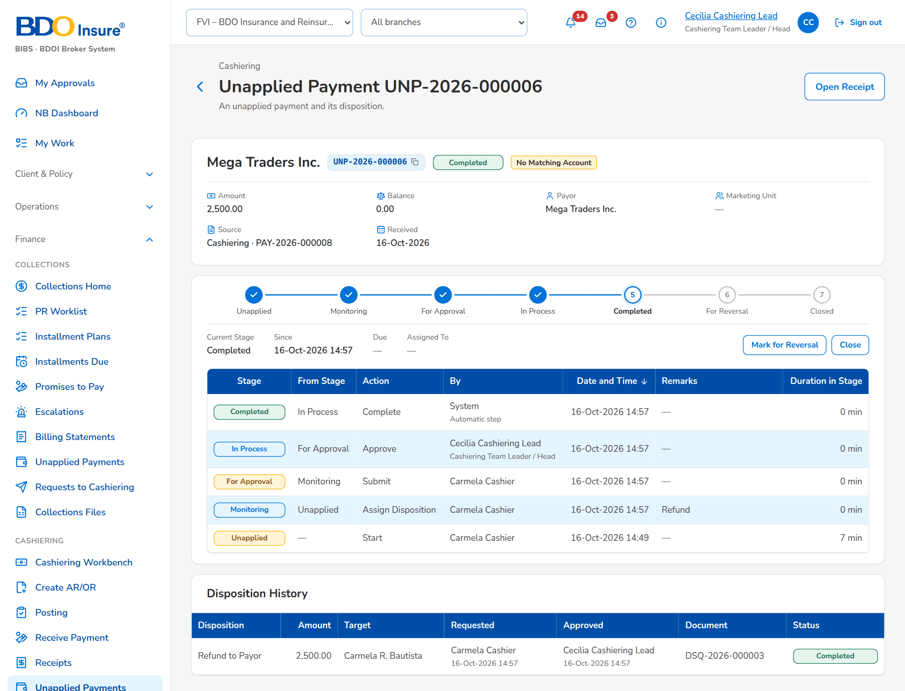
Figure 19: SB-04 step 3: Cashiering Team Leader, Unapplied Payment
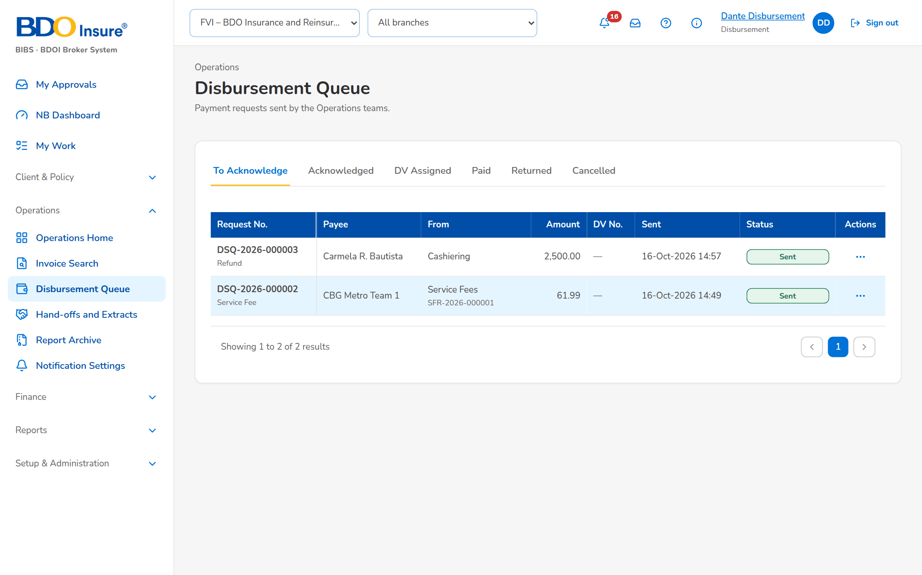
Figure 20: SB-04 step 4: Disbursement, Disbursement Queue

SB-05 Cancellation of an issued AR
An AR issued twice is cancelled: the cashier raises the cancellation record with its reason, the Team Leader posts it and the AR becomes Cancelled with its payments reversed.
Test data: Seed AR issued at Head Office; reason Double issuance.
Table 7: SB-05 steps
Step | Who | Screen | Does | Sees
1 | Cashier | Receipt | Opens the AR, clicks Cancel Receipt and chooses the reason | The cancellation dialog with the reason
2 | Cashiering Team Leader | Posting | Opens the cancellation records for posting | The cancellation record CN-AR-<n> For Posting
3 | Cashiering Team Leader | Cashiering Record | Opens the record and posts it | AR/OR Cancelled
4 | Cashier | Receipt | Opens the AR | The AR Cancelled with its cancellation record in the history

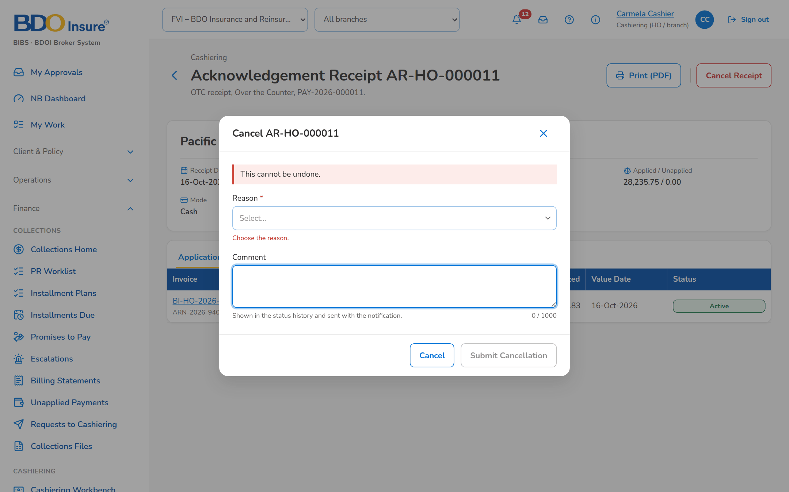
Figure 21: SB-05 step 1: Cashier, Receipt
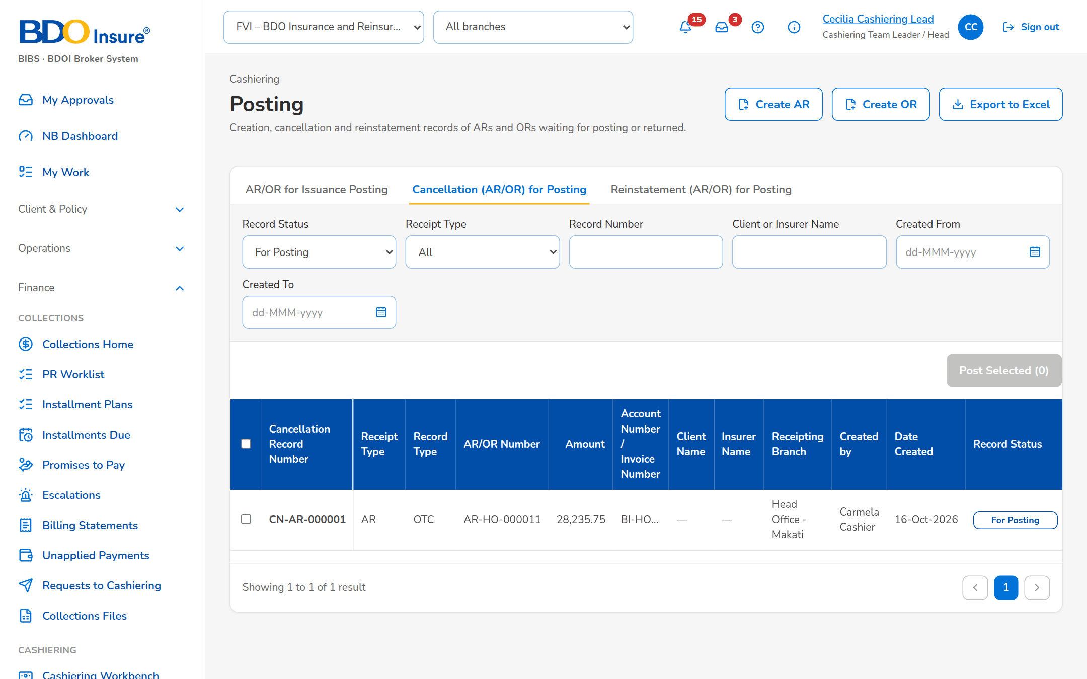
Figure 22: SB-05 step 2: Cashiering Team Leader, Posting
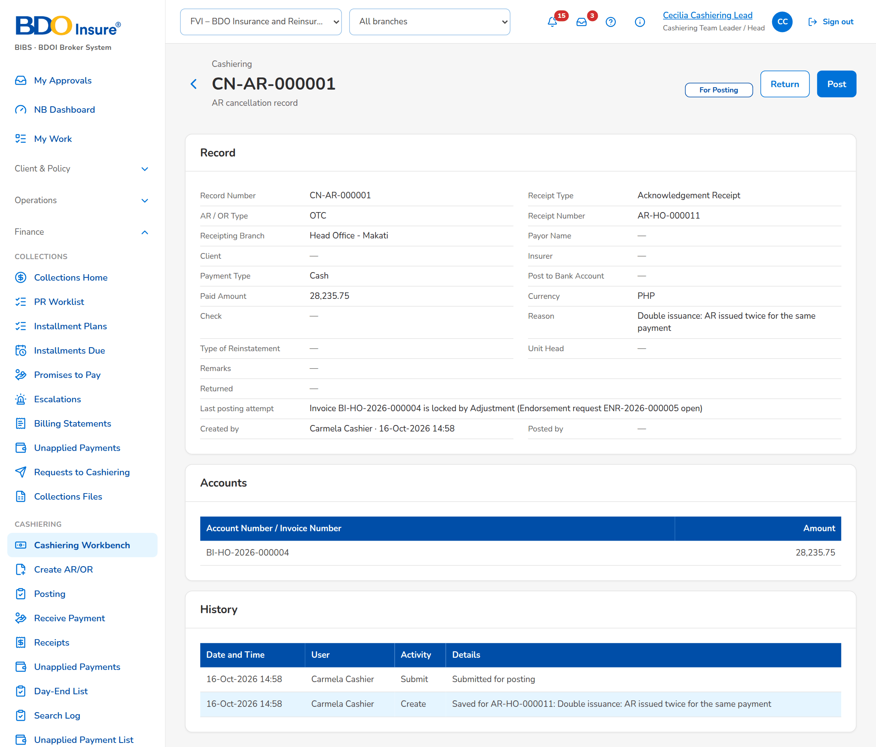
Figure 23: SB-05 step 3: Cashiering Team Leader, Cashiering Record
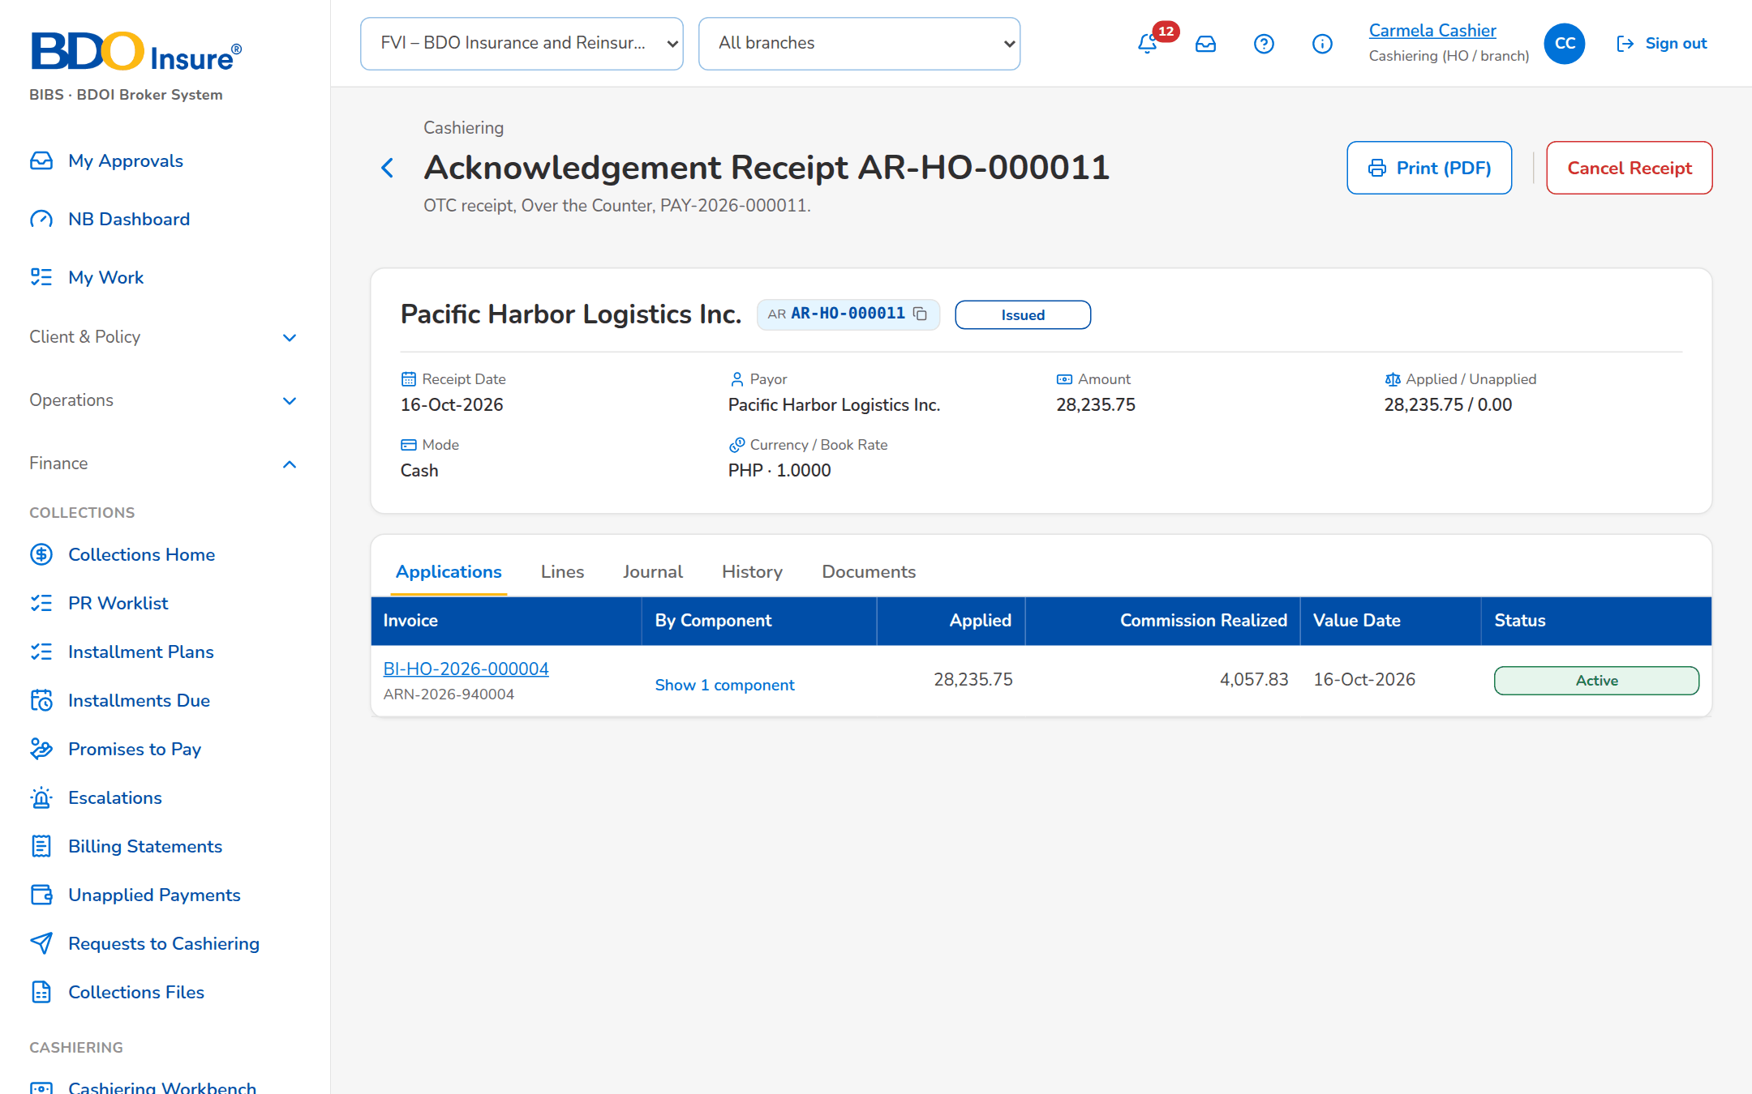
Figure 24: SB-05 step 4: Cashier, Receipt

