
PRJ0012475 - BDO Insure Brokering System (BIBS) - Operations Cashiering: Reports, Notifications and Outputs -
Release 1 / Drop 0
Prepared by: iorta TechNXT Project Team

Template Reference No. | D051
Document No. | PRJ0012475-CSH-RNO
Prepared by: | iorta TechNXT Project Team
Drafting support: | iorta TechNXT Project Team
Creation Date: | 10/16/2026
Revision No. | 3.4
Last Updated by: | iorta TechNXT Project Team
Last Updated Date: | 10/16/2026

Document Revision Log
Date | Revision | Description | Updated by
16 Oct 2026 | 3.4 | First issue as a separate document of the Operations Cashiering set (taken out of the appendices of the FRS v3.3 and aligned with the system delivered). Numbered 3.4 to match the FRS. | iorta TechNXT Project Team (drafting support); for review by the BDOI Product Owner

Table of Contents
Document Revision Log 3
Table of Contents 4
Introduction 5
Reports 6
Official Receipts and Other Documents 10
Exports 12
Notices, E-mails and Alerts 13
Scheduled Jobs 14

Introduction
This document lists the reports, the receipts and other documents, the exports, the notices and alerts and the scheduled jobs of Operations Cashiering. Times are Manila time.

Reports
Table 1: Cashiering reports
ID | Report | FRS | Parameters | Content | Output
RPT-CSH-01 | Applied Premium Report | FRS.CSH.09.02.01 | Period | Premium applied to invoices by AR: AR no., date, amount, invoice, payor, bank, branch, check, risk code | Excel
RPT-CSH-02 | Applied Commission Report | FRS.CSH.09.02.02 | Period | Commission ORs with invoices, insurer, basic commission, WTAX, EVAT, net | Excel
RPT-CSH-03 | Minimal Balance of Unapplied Payments (Excess Payments) | FRS.CSH.09.02.03 | Period | Excess payments moved to AP overages | Excel
RPT-CSH-04 | Cancelled Official Receipts | FRS.CSH.09.02.04 | Period | Date issued, OR, assured, gross, VAT, WTAX, amount, reason | Excel, PDF
RPT-CSH-05 | Cancelled Acknowledgment Receipts | FRS.CSH.09.02.05 | Period | Date issued, reason, AR, assured, amounts | Excel, PDF
RPT-CSH-06 | Unapplied Commission Receivable Extract for Mancom Reports | FRS.CSH.09.02.06 | End date | Commission ORs with an OR balance, age, encoder | Excel
RPT-CSH-07 | Unapplied Commission Receivable Payments YTD balance per Criteria | FRS.CSH.09.02.07 | Year, criteria | Year-to-date unapplied commission | Excel
RPT-CSH-08 | Unapplied Premium Minimal Balance | FRS.CSH.09.02.08 | Period | ARs with minimal premium balances reversed | Excel, PDF
RPT-CSH-09 | Unapplied Commission Minimal Balance | FRS.CSH.09.02.09 | Period | ORs with minimal commission balances | Excel, PDF
RPT-CSH-10 | Daily Cash Reconciliation Reports | FRS.CSH.09.02.10 | Period | ORs of each day with encoder, payor and deposit bank; grand total | Excel, PDF
RPT-CSH-11 | Unapplied Premium Payment Transaction | FRS.CSH.09.02.11 | Period | Advance and unapplied premium payments with ageing, application and disposition | Excel, PDF
RPT-CSH-12 | Direct Payment | FRS.CSH.09.02.12 | Period | Direct payment accounts with their commission OR, reversal and OR balance | Excel
RPT-CSH-13 | Reinstatement Monitoring Report | FRS.CSH.09.02.13 | Period | Reinstatements with status, reason and approvers | Excel, PDF
RPT-CSH-14 | Re-Application Report | FRS.CSH.09.02.14 | Period | Payments re-applied after a reinstatement or correction | Excel, PDF
RPT-CSH-15 | Certification of Payment | FRS.CSH.09.02.15 | Period | Certificates of Payment issued | Excel, PDF
RPT-CSH-16 | Reinstatement | FRS.CSH.09.02.16 | Period | Reinstatements posted per account and receipt with turnaround | Excel, PDF
RPT-CSH-17 | CWT Monitoring Report (Premium) | FRS.CSH.09.02.17 | Period | Withholding tax per invoice with its BIR 2307 tag | Excel, PDF
RPT-CSH-18 | Summary Per Disposition - Remittance | FRS.CSH.09.02.18 | Period | Unapplied payments by disposition type | Excel, PDF
RPT-CSH-19 | Post-dated Checks Warehousing | FRS.CSH.09.02.19 | End date | Warehoused checks by maturity date | Excel, PDF
RPT-CSH-20 | Priority Posted Accounts | FRS.CSH.09.02.20 | Period | Payments posted with encoder and branch | Excel, PDF
RPT-CSH-21 | Payment Reversals | FRS.CSH.09.02.21 | Period | Cancellation and reinstatement records posted | Excel, PDF
RPT-CSH-22 | AR Outstanding with Ageing | FRS.CSH.09.02.22 | End date | Premium receivable outstanding per client and account, aged from booking | Excel, PDF
RPT-CSH-23 | Payment Batch Run Report | FRS.CSH.09.02.23 | Period | Payment uploads with applied, excess, pre-booked, unapplied and failed records | Excel
RPT-CSH-24 | Legacy Unapplied Payments | FRS.CSH.06.01.02 | End date | Unapplied payments carried over from the legacy systems with legacy receipt and age [Data Migration scope] | Excel
RPT-CSH-25 | Unapplied Payments Reclassified to Income | FRS.CSH.06.01.02 | Period | Unapplied payments taken to other income after the two approvals [Data Migration scope] | Excel
RPT-CSH-26 | Check Pick-Up Requests | - | Period | Checks tagged for pick-up and their ARs (CSHID.009 removed; Q-CSH-07) | Excel

The reports are under Report Centre › Operations › Cashiering. File name <Report Name>_<date of extraction MMDDYYYY> (BR-CSH-21). Every report applies the user's data access, is logged with the user, parameters and time, and can be scheduled with its format and recipients.
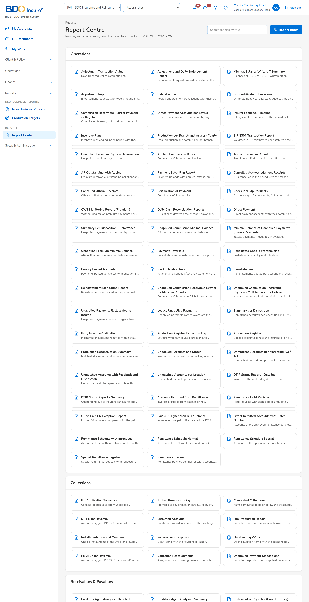
Figure 1: Report Centre with the Cashiering reports (FRS.CSH.09.01)
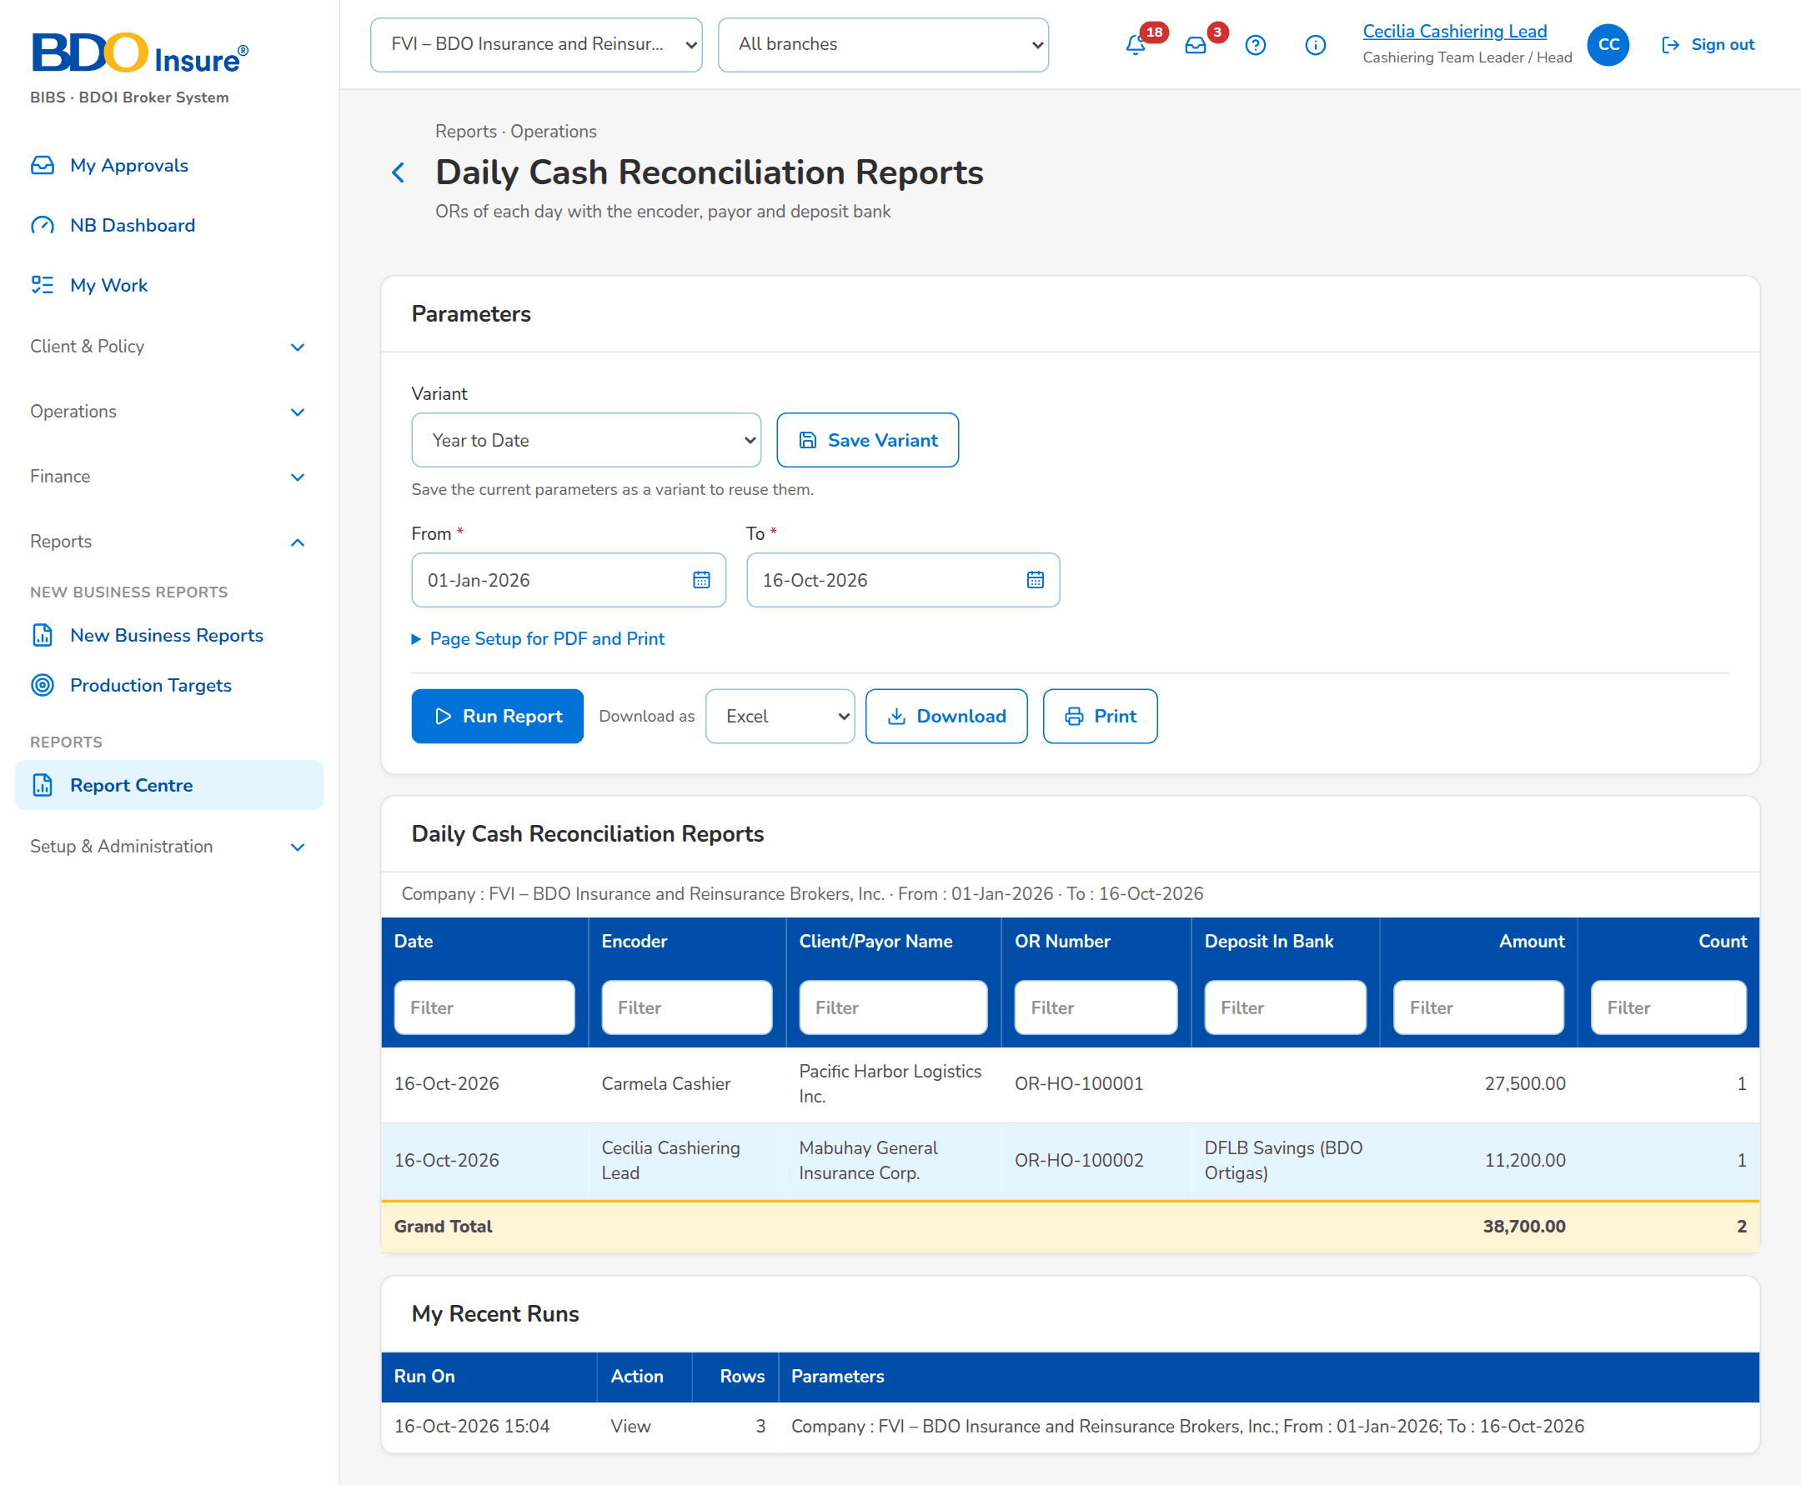
Figure 2: Daily Cash Reconciliation Reports run on screen (FRS.CSH.09.02.10)

Official Receipts and Other Documents
Table 2: Receipts and documents produced
ID | Document | Format and file name | Kept | FRS
DO-01 | Acknowledgement Receipt (AR) | PDF AR_<AR number>.pdf; Client's Copy and BDOI Copy; REPRINT on a later print | BDOI Copy kept with the receipt | FRS.CSH.02.04, FRS.CSH.02.06.03
DO-02 | Official Receipt (OR) | PDF OR_<OR number>.pdf; Client's Copy and BDOI Copy | BDOI Copy kept with the receipt | FRS.CSH.02.04, FRS.CSH.02.06.02
DO-03 | Print batch | One PDF of the batch for the printer; ZIP of the receipts for download | Kept with the batch | FRS.CSH.02.04.09, FRS.CSH.02.04.10
DO-04 | Certification of Payment | PDF with its series number | - | FRS.CSH.02.06.04
DO-05 | Validation report of an upload | Excel: accepted and refused rows with the reason | - | FRS.CSH.02.02.04
DO-06 | Run report of a payment file | On screen; Excel report, failed rows and matching list | - | FRS.CSH.05.01.12
DO-07 | Matched and unmatched list of a Commission Schedule | Excel | - | FRS.CSH.02.02.09

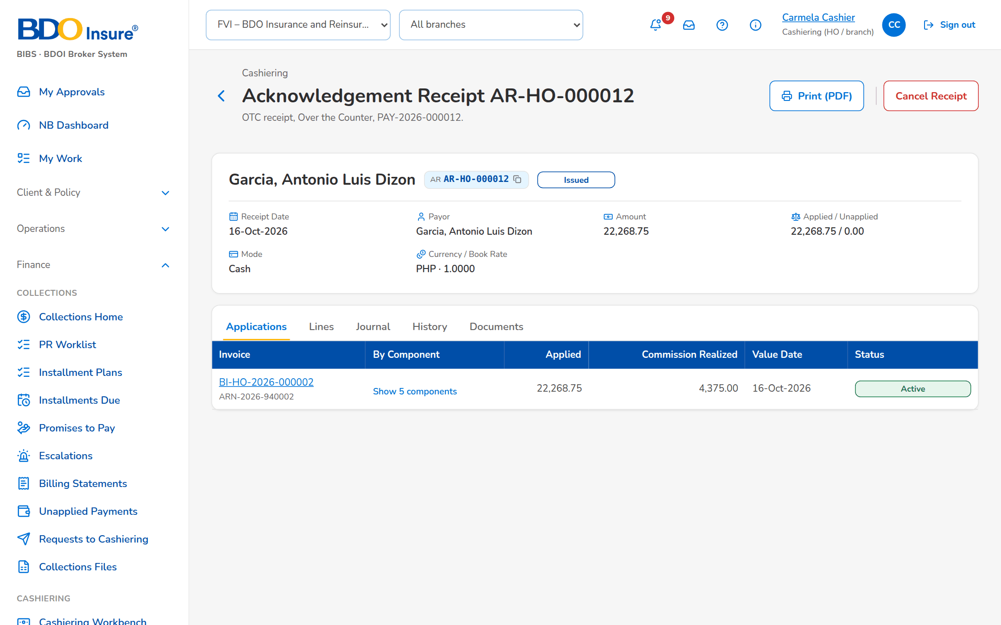
Figure 3: An issued AR on screen, with its application by component

Exports
Table 3: Exports
Output | Format | Where | Content
Posting lists, Receipts, Unapplied Payment List | Excel | Export of the list | Columns of the screen
Day-End List | Screen | Day-End List | Records of the day and totals per payment type and bank account
Search Log | Screen | Search Log | User, time, criteria, results
Raw payment file | Original file | Payment Files › Download | The file as received, unchanged

Notices, E-mails and Alerts
Notices appear under the bell; each user may add the e-mail channel on Notification Settings (FRS.CSH.10.04.03). Alerts appear on the Alerts screen. Text in angle brackets is filled in.
Table 4: Notices and alerts
ID | Event | To | Text | Channel
NT-01 | AR / OR, cancellation or reinstatement record submitted | Users with the posting permission | <record> for posting: <kind> of <amount> waits for posting | Bell (e-mail by choice)
NT-02 | Record posted | Creator | <record> posted: <status>: <AR or OR> <number> | Bell (e-mail by choice)
NT-03 | Record returned | Creator | <record> returned: Reason: <reason> | Bell (e-mail by choice)
NT-04 | Disposition for approval | Team Leaders | <reference> disposition for approval: <type> <currency> <amount> | Bell (e-mail by choice)
NT-05 | Receipt cancellation or reinstatement for approval (posting step off) | Team Leaders | <transaction> for approval: <action> of receipt, reason: <reason> | Bell (e-mail by choice)
NT-06 | Collector request | Cashiers | <request>: <action> requested by a collector: <reference> to invoice <invoice> | Bell
NT-07 | Refund validation requested | Cashiers | <task>: refund validation requested: Confirm that the premium of <invoice> is back in the unapplied list | Bell
NT-08 | Payment reversal for approval | Team Leaders | <request>: payment reversal for approval: Receipt <receipt> on invoice <invoice> | Bell
NT-09 | AR or OR form change | Form approvers | <kind> form version <n> for approval: Effective <date>, changed by <user> | Bell (e-mail by choice)
AL-01 | Receipt series low | Team Leader (alert) | <kind> series <prefix> has <n> numbers left | Alerts
AL-02 | Pre-booked payment ageing | Team Leader (alert) | Payment for <ARN> waits for the booking since <date> | Alerts
AL-03 | Payment file received via MFT refused | Team Leader (alert) | Payment file <name> received via MFT was refused: <reason> | Alerts

Scheduled Jobs
Table 5: Jobs
Job | When | What it does | Alerts
PREBOOKED_REMATCH | Every 2 hours | Applies the pre-booked payments whose account is now booked. | AL-02
PAYMENT_AUTOMATCH | Hourly at :30 | Matches the unapplied payments again against booked invoices. | -
PDC_MATURITY | Daily 08:30 | Creates the payment and AR of each post-dated check at maturity. | -
MINIMAL_BALANCE_SWEEP | Daily 04:00 | Reverses minimal premium balances and moves minimal excess to AP overages left by earlier postings. | -
CASH_MFT_INTAKE | On demand (schedule set at go-live) | Takes the payment files received through MFT and processes them. | AL-03

Every run is recorded with its start, end, outcome and counts, and can be started at once from Operations › Jobs by a user with the job permission.

