Summary of changes in version 3.3
This review copy shows in light yellow the passages added in version 3.3. BDOI's text of version 3.1 and the content of version 3.2 are not shaded. The clean copy has the same content without shading and without this page.
- Document Revision Log: row 3.3; Introduction: a note on what version 3.3 adds.
- Section 1.4: the simplified swimlane process flow (Figure 1); new section 1.5 'How to Read this Document' with the colour legend.
- Appendix C: the end-to-end process flow by actor and system (Figure 2) with the change requests tagged; the figures after it are numbered from Figure 3.
- Colour of the points not in the BRD: 2 points in green (available OOTB in iNXT BrokerVerse) and the 4 change requests in orange where they are stated (Appendices G, J, M and N).
- Appendix O: peak hours aligned with the BRD (08:00-17:30); rows CSH-NFR-15 to CSH-NFR-18 for the BRD lines and programme NFRs not yet listed (5 gaps found). Appendix U: one checklist point.
- New Appendix W: change requests with their effort (15.5 man-days), points beyond the BRD available OOTB in iNXT BrokerVerse, check of the BRD non-functional lines. New workbook BIBS_CR_BRD-02_Effort_Estimate_v1.0.xlsx; the change request register and the traceability workbook list the change requests.
Shading used in this copy: text added in version 3.3


Project Functional Requirements Specifications
PRJ0012475 – New BDO Insure Brokering System | Operations - Cashiering

Prepared by: Abegail Panghulan
Drafting support: iorta TechNXT Project Team

Table of Contents
Table of Contents 3
Document Revision Log 6
1. Introduction 7
1.1. Document Purpose 7
1.2. Project Overview 7
1.3. Document Preparation, Review and Approval 7
1.4. Summary for the Business Unit Review 9
1.5. How to Read this Document 12
2. Business Requirements Mapping 12
3. Functional Requirements 18
Signoff Sheet 143
Template Revision Log 144
Appendix A – Templates 145
Sample AR 145
Sample Billspayment file 145
Sample CLPC file 145
Sample Trade file 146
Appendix B – References 146
Appendix C – To-Be Process Flows 147
C.1 Process flows 147
C.2 Status life-cycles 158
Appendix D – Payment and Upload File Layouts 160
D.1 Bills Payment file (OBPCS, via MFT) 160
D.2 Post-dated checks file (PMS, via MFT; or Excel upload) 160
D.3 CLPC file 161
D.4 Trade file (TFS, from CIB) 161
D.5 Direct Credit file 161
D.6 Commission Schedule (FRS.CSH.02.02.03) 162
Appendix E – Screen Specifications 163
E.1 Cashiering Dashboard 163
E.2 Create AR/OR and Edit Record 165
E.3 Cashiering Record 168
E.4 Posting 170
E.5 Receive Payment 172
E.6 Receipts 174
E.7 Receipt 176
E.8 Unapplied Payments 178
E.9 Unapplied Payment 180
E.10 Unapplied Payment List 182
E.11 Incoming Requests 183
E.12 Pre-booked Payments 185
E.13 Payment Uploads 186
E.14 Payment Files 187
E.15 PDC Warehouse 189
E.16 Batch Print 190
E.17 AR and OR Forms 193
E.18 Commission ORs 194
E.19 Settlement ORs 195
E.20 Receipt Series 196
E.21 Cashiering Setup 198
E.22 Day-End List 199
E.23 Search Log 200
E.24 Invoice Search 201
E.25 Invoice 360 203
E.26 Report Archive 206
E.27 Report Centre (Operations reports) 208
E.28 Report 209
E.29 Interfaces 211
E.30 Menu by persona 213
Appendix F – Messages and Validations 215
F.1 Messages of BDOI's FRS 215
F.2 Messages of the system 215
Appendix G – Notifications and E-mail Texts 221
G-01 Cancellation or reinstatement record for approval 221
G-02 Disposition for approval 222
G-03 Payment reversal for approval 222
G-04 Request of a collector 222
G-05 Refund validation requested 223
G-06 Record moved to another stage 223
G-07 Work assigned 223
G-08 Work handed over 224
G-09 Refund request to Disbursement 224
G-10 Status of a refund request 224
G-11 Receipt series low 225
G-12 Pre-booked payment waiting 225
G-13 Interface run failed 225
G-14 Batch run failed 226
G-15 AR / OR record for posting 226
G-16 AR / OR record posted or returned 226
G-17 File received via MFT refused 227
G-18 AR or OR form change for approval 227
Appendix H – Business Rules, Roles and Configurable Parameters 228
H.1 Personas 228
H.2 Proposed role-to-action matrix 228
H.3 Controls 229
H.4 Configurable parameters 229
H.5 Lists of values 229
H.6 Scheduled runs 230
H.7 Statuses 230
H.8 Settings for the points BDOI decides 230
Appendix I – Accounting Entries 232
Appendix J – Workflow and Approvals 233
Appendix K – Process Walkthroughs 235
WT-A A booked invoice from the client's payment to the insurer's official receipt 235
WT-B Cancellation of a paid and remitted policy, from the request to the refund 235
WT-D Controls and the messages the user sees 235
WT-E A Cashiering day for the Business Unit walkthrough 236
Appendix L – Document Prints and Output Formats 237
L.1 Acknowledgement Receipt (AR) 237
L.2 Official Receipt (OR) 238
L.3 Certification of Payment 240
L.4 Validation report of an upload 240
L.5 Run report of automatic payment processing 240
L.6 Matched and unmatched list of a Commission Schedule 240
L.7 Print batch download 241
L.8 Report outputs 241
Appendix M – Reports and Schedules 242
Appendix N – Integrations [Integration scope] 245
Appendix O – Non-functional Requirements 248
Appendix P – Data Set-up and Migration at Go-live [Data Migration scope] 249
Appendix Q – Requirements Traceability 250
Q.1 BRD requirement to FR items and test conditions 250
Q.2 FR item to BRD IDs and test conditions 251
Appendix R – Observations and Points for BDOI Decision 255
R.1 Points where the proposed behaviour differs from the original text of this FRS 255
R.2 Slips noticed in BDOI's FRS (proposed corrections; BDOI's text is not changed) 258
R.3 Changes to the Business Requirements Mapping 260
R.4 Other observations and proposals of version 3.2 264
Appendix S – Assumptions, Dependencies and Open Questions 266
S.1 Assumptions 266
S.2 Dependencies 266
S.3 Open questions not answered in BDOI's FRS 266
Appendix T – Change Control after Sign-off 268
Appendix U – Business Unit Review Checklist 269
Appendix V – Glossary 271
Appendix W – Points beyond the BRD and Change Requests 273
W.1 How the points were classified 273
W.2 Change requests (orange) 273
W.3 Points beyond the BRD available OOTB in iNXT BrokerVerse (green) 273
W.4 Check of the non-functional lines of the BRD 274
W.5 Covered by the Integration scope and the Data Migration scope 274
W.6 Best-practice recommendations (blue) 275

Document Revision Log
Date | Version | Description of Change | Created / Reviewed by
Aug 26, 2026 | 1.0 | Initial Document | Abegail Panghulan
October 9, 2026 | 1.1 | Updated Automatic Generation of OR – coming from Disbursement | Abegail Panghulan
09 Oct 2026 - 10 Oct 2026 | 3.2 | Draft for BDOI review:full coverage of the Cashiering scope of the Operations BRD (v1.01 with the Cashiering annex of May 2026; version of 8-Oct-2026), functional requirements elaborated with numbered acceptance criteria, new items FRS.CSH.05.02 to FRS.CSH.10.04, Appendices C to V added, observations and points for decision in Appendix R; Business Unit review edition: summary for the Business Unit, end-to-end flows, workflow and approvals, e-mail texts, document prints and formats, reports and schedules, integrations, non-functional requirements, data set-up, open questions not answered in the BDOI FRS, change control, review checklist; aligned on 10 Oct 2026 with BIBS: the screens of the posting step, payment files and their monitor, AR and OR forms, day-end list, search log, unapplied payment list and settlement ORs with current screenshots, the settings for the points BDOI decides (Appendix H.8), messages, integrations and schedules | iorta TechNXT Project Team (drafting support); for review by Abegail Panghulan
11 Oct 2026 | 3.3 | Simplified and end-to-end swimlane process flows; colour coding of the points not in the BRD (green: available in the iNXT BrokerVerse OOTB edition; orange: change request); Appendix W with the change requests and their effort, the points beyond the BRD available OOTB in iNXT BrokerVerse and the check of the BRD non-functional lines; Appendix O: BRD maintenance and disaster lines and programme NFRs 10.07 and 4.03 added, peak hours aligned with the BRD | iorta TechNXT Project Team (drafting support)

Introduction

Document Purpose
This Functional Requirements Specifications (FR) document outlines how business requirements which are baselined in the Business Requirements Document (BRD) for the New BDO Insure Brokering System project - Drop 1 project are to be implemented in the IT systems. This FR document translates the business requirements into functional requirements in terms of system capability, behaviour/function with clearly outlined inputs and outputs.

Project Overview
The Cashiering Module provides a centralized and automated solution for payment acceptance, receipt issuance, and payment application. It streamlines the recording, validation, matching, and tracking of payments while ensuring accuracy, transparency, and auditability across financial transactions. The module supports multiple payment types and currencies, automated AR/OR management, manual and auto-application of payments, reconciliation, and accounting integration. By reducing manual processing and providing real-time transaction visibility, the module improves operational efficiency, strengthens financial controls, and supports compliance requirements.
Key Objectives
- Automate payment acceptance and application processes to reduce manual effort and processing time.
- Improve the accuracy and integrity of financial transactions through system validations and automated controls.
- Ensure complete traceability and auditability of payment-related activities.
- Enhance user productivity through streamlined workflows and real-time transaction visibility.
- Support financial reporting, reconciliation, and accounting requirements through automated processing and reporting capabilities.
- Strengthen compliance and governance by enforcing standardized payment processing and documentation controls
The Operations BRD of 8-Oct-2026 (BRD v1.01 of 15-Apr-2026 with the Cashiering annex of May 2026) removes check pick-up from Collection (CSHID.009) and the Cashiering processing and reversal of BIR 2307 (CSHID.026, CSHID.027), and clears minimal balances when the payment is processed (CSHID.016). This FRS covers the Cashiering requirements (BRQID.001 to BRQID.007, CSHID.001 to CSHID.025) and states where MKTID.013 and DBMID.001 are specified; the rest of Operations (Remittance, Adjustment / Cancellation, Production Reconciliation, Commission Receivables and the Marketing activities) is specified in separate FRS documents of the Operations BRD.

Document Preparation, Review and Approval
The System Analyst or equivalent BDO ITG personnel is responsible for populating this Functional Requirements Specifications document by obtaining inputs from the business unit and when necessary, from other IT units.
Version 3.2 of this document was elaborated with the iorta TechNXT Project Team (drafting support), from the inputs of the business unit and BDO ITG, for review by the System Analyst. BDOI's text of version 3.1 is kept as issued; the additions are written in the same style and listed in the change summary of the review copy; the points where a decision is needed are in Appendix R.
Version 3.3 adds the simplified process flow (Figure 1, section 1.4) and the end-to-end process flow by actor and system (Figure 2, Appendix C) with the change requests marked; it colours the points of this FRS that are not requirements of the BRD (section 1.5); it adds Appendix W with the change requests and their effort, the points beyond the BRD that the iNXT BrokerVerse OOTB edition already provides, and the check of the non-functional lines of the BRD. BDOI's text and the content of version 3.2 are otherwise unchanged.
This document once approved will serve as the official baseline of functional requirements document for the New BDO Insure Brokering System project - Drop 1 project.
Following the approval of this document, changes will be governed by the project’s change management process, including impact analysis, appropriate reviews and approvals.

Summary for the Business Unit Review
This section is the short way into the document for the Business Unit. It shows on a few pages what Operations Cashiering covers, how the work flows from one persona to the next, the numbers behind the document, the decisions the Business Unit must take before signing, and which part each reviewer reads. The detail is in sections 2 and 3 and in the appendices; every statement traces to a BRD ID of the Operations BRD of 8-Oct-2026.
Scope on a page
In scope of this FRS | Out of scope | Handled in another FRS or document
Log-in, access by role and the Cashiering dashboard (FRS.CSH.01) | Check pick-up from Collection (CSHID.009, removed from the BRD) | Remittance, Adjustment / Cancellation, Production Reconciliation, Commission Receivables and the Marketing activities: separate FRS documents of the Operations BRD
AR and OR creation, posting, number series, batch printing, templates (FRS.CSH.02) | Cashiering processing and reversal of BIR 2307 (CSHID.026, CSHID.027, deleted in BRD v1.01) | PR 2307 reversal and the release of the certificates (MKTID.013, DBMID.001): "Com rec" in BDOI's mapping (Appendix R)
Cancellation and reinstatement of ARs and ORs with their accounting (FRS.CSH.03, 04) | The bank deposit slip of the day's collections (Accounting module; Appendix R) | User access, roles and sign-in: User Access Maintenance FRS ("Based on UAM")
Automatic payment processing of the Bills Payment, CLPC, Trade, Direct Credit and post-dated check files; post-dated check warehouse; pre-booked payments (FRS.CSH.05) | Transport of the channel files other than MFT (to be agreed with BDOI IT) | GL accounts and the accounting rules: Accounting FRS (BRD-5); the default entries are in Appendix I
Unapplied payments and their dispositions; requests of other modules (FRS.CSH.06) | Payment of refunds (Disbursement module) | Refund payment and the insurer settlement: Disbursement (BRD-5)
Automatic OR, inquiry, payment history, audit trail, reports, interfaces, batch runs and notices (FRS.CSH.07 to FRS.CSH.10) | Screen standards (programme level) | Data migration of the open accounts and unapplied payments: BRD-13 Data Migration (Appendix P)

The process from end to end
Figure 1 – Operations Cashiering – simplified process flow (swimlanes by actor, stages across)
How to read it: Each lane is an actor or system and the columns are the stages of a payment, from its receipt to the reports. The end-to-end flow with every unit and the change requests is Figure 2 (Appendix C); each process is drawn in detail in Appendix C. Traces to: BRQID and CSHID IDs of the Cashiering scope.
Key numbers
The key numbers of this document (counted by the builder of the document; the workbooks give the same numbers):
Item | Number | Where
BRD IDs of the Cashiering scope in the mapping (removed and by reference included) | 36 | Section 2; Appendix Q
FR entries (BDOI's 18 and the new FRS.CSH.05.02 to FRS.CSH.10.04) | 28 | Section 3
FR items and sub-items (BDOI's and added) | 275 | Section 3
BDOI items elaborated / new sub-items and items | 66 / 37 | Section 3
Acceptance criteria | 167 | Section 3
Figures added (flows, life-cycles, menus, approvals, context) | 18 | 1.4; Appendices C, E, J, N
Screens | 29 | Appendix E
Messages (BDOI's FRS / system) | 24 / 131 | Appendix F
Notices, alerts and e-mails | 18 | Appendix G
Documents and outputs | 8 | Appendix L
Reports / scheduled runs | 23 / 8 | Appendix M
Integrations | 14 | Appendix N
Test cases (Test Cases and Traceability workbook, with one per acceptance criterion) | 295 | Test Cases and Traceability workbook
Open questions not answered in BDOI's FRS / answered and not repeated | 13 / 27 | Appendix S
Observations and points for decision | 83 | Appendix R
Review checklist points | 27 | Appendix U

Decisions the Business Unit must take
The ten decisions below shape the rest of the document. Each points to the row of Appendix R (observations and points for decision) or Appendix S (open questions) where both readings, the BRD text and the proposal are given.
No. | Decision | Appendix R | Decided by
1 | Must every AR and OR be posted by a second user before its number is issued (BDOI's posting step), or is the AR issued when the cashier saves? | R-01 (C1) | Cashiering Process Owner; Comptrollership
2 | What reinstatement means: restoring a cancelled receipt (BRD reason "Due to Cancellation"), reversing the application of an issued receipt (BDOI's FRS), or both | R-02 (C2) | Cashiering Process Owner
3 | Direct Credit file: identification of payments already received (BDOI's FRS) or new payments | R-07 (C8) | Cashiering Process Owner; BDOI IT
4 | Cancellation of an AR already remitted: AR Insurer Refund per account and insurer | R-08 (C9) | Comptrollership; Cashiering Process Owner
5 | When the commission OR is generated: at the approval of the insurer settlement by Disbursement (BDOI's FRS) or at the remittance approval | R-11 (C12) | Comptrollership
6 | Minimal balance threshold: -1.00 to 1.00 (BDOI's FRS) or Php 10.00 (BRD) | R-04 (C5) | Comptrollership; Cashiering Process Owner
7 | Application hierarchy: place of the Fire Service Tax and the meaning of check before cash | R-05 (C6) | Comptrollership; insurers
8 | BIR 2307: tag per account or per client, and the base of the 2% (basic or gross premium) | R-23 (C26) | Comptrollership (Tax)
9 | Check holding period at the counter (4 working days) or only before remittance (3 banking days) | R-06 (C7) | Cashiering Process Owner
10 | Formats of the AR and OR numbers, of the acknowledgement certificate number and of the record numbers | R-26 (C4); R-03 (C3) | Comptrollership (BIR registration); System Analyst (BDO ITG)

How to review this document
How to review: each reviewer reads the parts of his or her role; the times are a guide for a first reading.
Reviewer (role) | Read first | Then | About
Product Owner | 1.4 Summary; Appendix C figures; Appendix U checklist | Appendix R decisions; Appendix S open questions | 2 hours
Cashiering Process Owner (Head Office and branches) | Section 3 FRS.CSH.01 to FRS.CSH.06; Appendix C; Appendix J workflow | Appendices D, E, F, K (files, screens, messages, walkthroughs); G e-mails; L documents; M reports | 5 hours
Comptrollership (accounting and tax) | FRS.CSH.02.05, 03.01.08-.09, 04.01.09-.10; Appendix I entries | Appendix R decisions 4 to 8 and 10; Appendix H parameters | 3 hours
Marketing and Commission Receivable | FRS.CSH.06; FRS.CSH.07 | Appendix R C13, C14; Appendix M reports | 1.5 hours
BDOI IT | Appendix N integrations; FRS.CSH.05.01.04 (MFT) | Appendix O non-functional requirements; Appendix P data set-up; Appendix S integration questions | 2 hours
System Analyst (BDO ITG) | Section 2 mapping; Appendix Q traceability; Appendix R | Appendix T change control; the review workbooks | 4 hours

The review workbooks issued with this version (same numbers as this document):
Workbook | What it holds
Business Unit Requirements Collection | What the Business Unit provides: document layouts, e-mail and message wordings, schedules, parameters, lists, master data, approvers, integration inputs, open decisions
BRD vs Out-of-the-Box vs Best Practice | For every BRD requirement: what the system offers as standard, broking best practice, fit and recommendation
Change Request Register | How a change after sign-off is raised and decided; candidate changes; the decision log of every Appendix R observation
Test Cases and Traceability | BRD ID to FR item, test cases, screens and walkthrough steps; the questions answered in BDOI's FRS; UAT entry and exit criteria
Business Unit Walkthrough Users | The sign-in ID of every persona for the walkthrough in the BIBS DEV environment and the walkthrough script

Before signing, the Business Unit confirms the 27 points of the review checklist in Appendix U.

How to Read this Document
Most of this FRS states requirements of the Operations BRD for Cashiering (BRQID and CSHID IDs, and its non-functional table) or of the programme-wide non-functional requirements of the BDOI addenda. BDOI's own text (version 3.1) is kept word for word. Where version 3.2 or 3.3 states a point that is not a BRD requirement, the point is coloured where it is stated, so that the Business Unit sees at once what goes beyond the BRD and whether it costs anything. Out of the box (OOTB) means the iNXT BrokerVerse OOTB platform (brokerverse-platform), checked against the platform itself with the programme Feature List as a cross-check, not the work done for BDOI in this project:
Colour | Meaning | Cost
Black text | A BRD requirement, BDOI's own FRS text, or the detail needed to meet a BRD requirement. | In scope
Green text | Not in the BRD, and available out of the box in the iNXT BrokerVerse OOTB platform. No development needed; the Business Unit may keep or drop it. | No cost; listed in Appendix W.3
[Integration scope] / [Data Migration scope] | Grey label on an interface with another system or on a data load at go-live: covered by the Integration scope or the Data Migration scope (BRD-13), not a change request. | Listed in Appendix W.5
Blue table | Insurance-broking best practice for this area that is not in the BRD, this FRS or the OOTB platform: a recommendation with an indicative effort, not a commitment. | Appendix W.6; not in the change request total
Orange text | Not in the BRD and not available, or only partly available, in the iNXT BrokerVerse OOTB platform edition: a change request (CR-CSH-1nn), even where it was already delivered for BIBS in this project. It is delivered only if the Business Unit approves it. | Effort in Appendix W.2 and the CR effort workbook

In the end-to-end process flow (Figure 2, Appendix C) the change requests are tagged: yellow for a change request not in any BRD, blue for a change request that extends a BRD requirement, green for a point that is already a BRD requirement (the programme NFRs 10.07 and 4.03). The walkthroughs and screenshots use the BIBS DEV environment: https://dev.brokerverse.cloud.
In this version: 4 change requests (15.5 man-days in all) and 2 points beyond the BRD available OOTB in iNXT BrokerVerse (Appendix W).

Business Requirements Mapping
This section lists the business requirements baselined in the Business Requirements Document (BRD) and the corresponding Functional Requirements to satisfy each business requirement.

The details of each functional requirement are provided in the subsequent section.

BRD Req No. | Business Requirement | Functional Requirement Req IDs
BRQID.001 | Access and log-in to the system. | Added in v3.2: FRS.CSH.01.01, FRS.CSH.01.02
BRQID.002 | Restrict access to authorized users so that only authorized personnel can access the system. | Added in v3.2: FRS.CSH.01.02, FRS.OPS.002.04, FRS.OPS.002.05
BRQID.003 | Upon successful login, the system must immediately present the User with access to the Operations functionality, displayed prominently on the dashboard. The User must be able to select and view specific operational sections based on their role, preference, or task at hand.  The system must ensure intuitive navigation, allowing users to switch between sections efficiently, with each section offering its full suite of functionalities, validations, reporting tools, ability to open a link to applications it integrates with. | Added in v3.2: FRS.CSH.01.03, FRS.CSH.01.03.05, FRS.CSH.10.01.02
BRQID.004 | Integrate with other systems / applications / modules to fetch or flow-in data. (i.e. Collection, Accounting, Disbursement, Marketing, Claims). | Added in v3.2: FRS.CSH.10.01, FRS.CSH.06.03
BRQID.005 | Facility to fetch from other systems / applications / modules the necessary data that are required to flow-in to support Operations processes. | Added in v3.2: FRS.CSH.05.01, FRS.CSH.10.02
BRQID.006 | Implement a batch job processing system that continues execution even if one or more records encounter errors during processing. The system must log failed records for future evaluation and potential reprocessing. Additionally, generate a comprehensive report summarizing the outcome of the batch run. | Added in v3.2: FRS.CSH.05.01, FRS.CSH.05.01.13, FRS.CSH.10.03, FRS.CSH.09.02.23
BRQID.007 | Capabilities to include, record, update remittance details at  the invoice level and ensure visible payment histories  including dates, amounts, and AR numbers. | Added in v3.2: FRS.CSH.08.01, FRS.CSH.08.02, FRS.CSH.02.05.10
CSHID.001 | Create, cancel, and reinstate Acknowledgement Receipt (AR).  1. Premium Payments - Bills Payments, OTC, Trade, CLPC, PDC.  2. Non-Premium Payments - Insurance Payments (Refund, Other expenses, AR Insurance) | FRS.CSH.02.01  FRS.CSH.02.05  FRS.CSH.03.01  FRS.CSH.04.01  Added in v3.2: FRS.CSH.02.01.15, FRS.CSH.02.01.16, FRS.CSH.03.01.11, FRS.CSH.04.01.12
CSHID.002 | Create, cancel, and reinstate Official Receipt (OR).  1. Service Fee Income (e.g. risk management fee, consultancy fee)  2. Insurance Profit Share  3. Commissions (e.g. e.g. VAT or W/Tax)  4. Incentives  5. Others (discount) | FRS.CSH.02.02  FRS.CSH.02.05  FRS.CSH.03.01  FRS.CSH.04.01  Added in v3.2: FRS.CSH.02.02.10, FRS.CSH.02.06
CSHID.003 | Facility to allow User to choose the reason for AR or OR cancellation. | FRS.CSH.03.01  Added in v3.2: FRS.CSH.03.01.06
CSHID.004 | Facility to allow User to choose the reason for Reinstatement. | FRS.CSH.04.01
CSHID.005 | Facility to allow User to encode the required information for Reinstatement.  1. Premium Payment  - Invoice number  - Acknowledgment Receipt number  - Assured/Payor name  - Amount reinstated  - Account officer  - Unit Head  - Team Leader  2. Direct Payment  - Invoice number  - OR number  - Assured/Payor name  - Amount reinstated | FRS.CSH.04.01  Added in v3.2: FRS.CSH.04.01.06
CSHID.006 | Auto-assign AR/OR numbers per transaction based on branch.  Note: OR issuance is exclusively done by HO. | FRS.CSH.02.05  FRS.CSH.02.03  Added in v3.2: FRS.CSH.02.03.06, FRS.CSH.02.05.08
CSHID.007 | Issue an individual OR per commission check or credited amount or multiple payments in one OR as long as one Insurer / Payee (one certificate).  Source of data:  1. Uploaded commission payment details from collection.  2. Remittance Schedule. | FRS.CSH.02.02  FRS.CSH.07.01  Added in v3.2: FRS.CSH.02.05.14, FRS.CSH.07.01.05
CSHID.008 | For AR, allow uploads for Bills, Trade, CLPC payments, matured PDC, Direct Credit for batch processing.  Sources of files and file type:  a. Bills Payment: TXT (FS01) from IT-DCO  b. Trade Payment: TXT from CIB  c. CLPC Payment: EXCEL  d. PDC Payment file in excel for upload  e. Direct Credit: TXT  FS01/04: All via batch process.  Trade, Direct Credit, CLPC – manually prepared by BU, send to IT, IT to run batch process – FS04. | FRS.CSH.05.01  Added in v3.2: FRS.CSH.05.02, FRS.CSH.05.01.13
CSHID.009 | Facility to accept check with “for check pick up” from Collection. | Removed from the BRD by the Cashiering annex of May 2026 (annex p.4-6): check pick-up is no longer part of BDOI's target process; no FR item.
CSHID.010 | Access and perform search using the following parameter:  - AR Number  - OR Number  - Client Number  - Invoice Number  - Payor Name  - Assured Name  - Amount  - Date of Issuance  - Policy Number  - Insurer Name | FRS.CSH.08.01  Added in v3.2: FRS.CSH.08.01.04
CSHID.011 | Facility to log in the Audit Trail the AR number and Username. | Added in v3.2: FRS.CSH.08.03, FRS.CSH.02.01.14
CSHID.012 | Post Accounting entries once cancellation is posted. | FRS.CSH.03.01  Added in v3.2: FRS.CSH.03.01.09
CSHID.013 | Post Accounting entries once reinstatement is posted. | FRS.CSH.04.01  Added in v3.2: FRS.CSH.04.01.10
CSHID.014 | Post Accounting entries for AR/OR. | FRS.CSH.02.05  Added in v3.2: FRS.CSH.02.05.15
CSHID.015 | Validate AR/OR series is not depleted before transaction processing. | FRS.CSH.02.05  Added in v3.2: FRS.CSH.02.05.09
CSHID.016 | Automatically reverse Premium Receivables with minimal balances and below (Php 10.00 and below) if not equal to the following:  a. Two percent (2%) creditable withholding tax  b. Amount of DST charged into the account  c. Amount of the entire premium | FRS.CSH.02.05  Added in v3.2: FRS.CSH.02.05.12, FRS.CSH.06.01.08
CSHID.017 | Facility to allow authorized Users to generate, download, or print reports. | FRS.CSH.09.01  Added in v3.2: FRS.CSH.09.01.05
CSHID.018 | Facility to allow selected Users to view generated report. | FRS.CSH.09.01
CSHID.019 | Facility to perform batch printing of AR / OR. | FRS.CSH.02.04  Added in v3.2: FRS.CSH.02.04.17
CSHID.020 | Perform matching at the point of payment acceptance except for issued PDC. | FRS.CSH.05.01  Added in v3.2: FRS.CSH.05.03, FRS.CSH.05.04, FRS.CSH.02.01.02
CSHID.021 | Facility to flow-in payment made from Insurer to AR Insurance. These are payment from Insurer that needs to be segregated from premium payments and expected to flow-in to AR Insurance. | FRS.CSH.06.01  Added in v3.2: FRS.CSH.02.01.15
CSHID.022 | Apply payments based on defined hierarchy of payment application.  Per Transaction Level hierarchy:  1. Premium Receivable - DST  2. Premium Receivable - Premium Tax (VAT)  3. Premium Receivable - LGT  4. Premium Receivable - Other Charges  5. Premium Receivable - Basic Premium  Mode of Payment hierarchy:  1. Check  Cash | FRS.CSH.02.05  Added in v3.2: FRS.CSH.02.05.11
CSHID.023 | Capability to generate reports.  2. See Cashiering Reports list under Annex. | FRS.CSH.09.01  Added in v3.2: FRS.CSH.09.02, FRS.CSH.02.06.04
CSHID.024 | Facility where users can view and manage dispositions for unapplied payments, ensuring proper tracking, approval, and processing of various disposition types.  Example of Disposition Types:  - Apply to other invoice  - DST payment application  - Refund  - Reclass  - Transfer to other marketing unit  - Others (customizable) | FRS.CSH.06.01  Added in v3.2: FRS.CSH.06.02, FRS.CSH.06.03
CSHID.025 | Facility to display information as per Disposition Tabs  1. Unapplied - Displays payments with no disposition assigned.  2. Monitoring - Displays payments with disposition already assigned.  3. For Approval - Displays payments requiring Team  approval. | FRS.CSH.06.02
CSHID.026 | Facility to receive tagged BIR 2307 data from Marketing Collection, process payments (cash or certificate), and remit accordingly. Issue ARs, reverse premiums, and forward transactions to Disbursement. | Deleted in BRD v1.01 (e-mail record p.67-69, p.186-188): the BIR 2307 processing is done by Marketing Collection (MKTID.013); no FR item.
CSHID.027 | Facility to provide capability to Operations to process BIR 2307 reversals using reference numbers generated by Marketing. This is to validate the data, generate the transaction report, and route it directly to Disbursement without going through the Remittance function. | Deleted in BRD v1.01 (e-mail record p.67-69, p.186-188); no FR item.
MKTID.013 | Facility to tag Reversal Transactions for BIR 2307, submit certificates received from clients, and enforce system validations on reversal amounts.  The system must validate certificate amounts against the computed PR 2307 amount, and the outstanding PR balance, to ensure accuracy, compliance, and prevention of over-reversal. | Com rec  Added in v3.2: FRS.CSH.02.05.13
DBMID.001 | Receive and process BIR 2307 Report.  Receive sorted BIR 2307 certificates and supporting documents from Marketing Collection. | Com rec  Added in v3.2: FRS.CSH.10.01

List of Integrations:

- OBPCS to BIBS via MFT for Bills Payment processing
- PMS to BIBS for PDC
Added in version 3.2 (Appendix N gives each interface with its direction, trigger, owner and what BDOI IT provides):
- Trade (TFS) and Direct Credit files to BIBS by upload; CLPC file by upload
- BIBS Collections module to Cashiering: disposition requests on unapplied payments, commission payment details
- Cashiering to BIBS Disbursement module: refund requests; Disbursement to Cashiering: payment request status and the approved insurer settlements that trigger the automatic OR
- BIBS New Business to Cashiering: booked accounts; Cashiering to New Business: payment confirmation of each account
- Cashiering to BIBS Remittance: paid and applied premium of each account; Remittance to Cashiering: remittance status
- Cashiering to the BIBS accounting engine: the journal of every posting (Appendix I)

Functional Requirements
This section contains all the functional requirements for the BIBS that must be in place to address the business requirements. These include the capabilities that the system must possess and the operations and activities that it must be able to perform. All capabilities and corresponding descriptions needed to address the business requirements and develop the system must be listed. These include but may not be limited to:

- Capabilities on data inputs into the system and how they are entered
- Capabilities on data outputs from the system and how they are delivered to the user
- Capabilities on calculations, manipulation, formatting and other operations performed on each screen
- Capabilities on workflows performed by the system
- Capabilities related to regulatory compliance
- Interfaces with other systems
- User administration including user authentication and authorization for the different system modules
- Data retention

Populate the succeeding table as follows:
- Functional Requirement ID – unique identifier for each functional requirement
- System Component / Module / Screen – if applicable, this indicates where the capability must be implemented
- Capability – the features, operations or activities that the system must perform or possess
- Functional Requirements / Capability Descriptions – describe how capability should be implemented to address the business requirements in the BRD
- Application Feature Model – the corresponding feature group and feature in the Solution Architecture where the functional requirement will be implemented

Functional Requirement ID | System Component / Module / Screen | Capability | Functional Requirements / Capability Descriptions | Application Feature Model
1. Log in and Dashboard
FRS.CSH.01.01 | Operations | Access / Log in | FRS.OPS.001. System shall be accessible using BDO issued device  - The system shall be used through the web browser of the device; access only from BDO-issued devices shall be enforced by the BDO network and device policy at sign-in, without a change to the Cashiering screens (Appendix R).  - The system shall present the same Cashiering screens, fields and actions on the desktop and on the tablet browser of a BDO-issued device (BRD non-functional requirement "same performance on mobile and desktop").  Acceptance criteria  - A cashier opens the system from the browser of a BDO-issued laptop and reaches the Login page.  - The Receive Payment and Receipts screens keep their fields and actions on a BDO-issued tablet. | Feature: Platform › Sign-in (User Access Maintenance FRS)  Test conditions: TC-OP-001.1 to 001.2 (3 cases)
FRS.CSH.01.02 | User Log-in screen | Role/Profile Log In | FRS.OPS.002.01. User should be able to log in using username and password  FRS.OPS.002.02. System shall authenticate user and load modules, fields, and data access based on profile.  - The system shall show in the menu only the Cashiering screens that the user's roles allow (Finance › Cashiering), and hide the buttons of the actions the user may not perform.  - The system shall refuse an action for which the user holds no permission with the message "You are not permitted to perform this action" and record the refusal in the audit trail with the failure indicator.  - The data access of a user (company and branch) shall be applied to every Cashiering list, search and report.  Acceptance criteria  - A Cashier sees Finance › Cashiering with Receive Payment, Receipts, Unapplied Payments, Payment Uploads and Batch Print, and does not see the authorisation of receipt series.  - A user without the posting permission does not see the Post action, and a direct posting attempt is refused with "You are not permitted to perform this action".  FRS.OPS.002.03. If user is unauthenticated, system shall block access and display applicable error message.  The following may trigger block access:  1. User is not defined  2. User access is already expired  - The system shall give the same message, "Invalid user name or password", for a user that is not defined, an expired or locked access and a wrong password, so that the reason is not disclosed; the System Administrator sees the reason on the user record (User Access Maintenance FRS).  - The system shall record every refused sign-in in the audit trail with the user ID entered, the date and time and the origin of the attempt.  Acceptance criteria  - A sign-in with a user ID that is not defined is refused with "Invalid user name or password", and the attempt is in the audit trail.  - A user whose access has expired cannot sign in and receives the same message.  FRS.OPS.002.04 Permissions per Cashiering action  - The system shall require a permission for each Cashiering action: create AR / OR; post AR / OR; create cancellation and reinstatement records; post them; upload payment files; maintain the post-dated check warehouse; assign and submit dispositions; approve dispositions; maintain and authorise receipt series; print and re-print receipts; maintain templates; view reports; download and print reports.  - The permissions shall be granted to the roles of Appendix H.2 until BDOI confirms the access matrix in the User Access Maintenance FRS ("Based on UAM").  Acceptance criteria  - A Branch Cashier holds create AR and print but not post AR / OR; the Post action is not shown to him or her.  - A Cashiering Team Leader holds post AR / OR and approve dispositions.  FRS.OPS.002.05 Segregation of duties  - The system shall not allow the user who created a record to post, approve or authorise it: AR and OR creation records, cancellation and reinstatement records, dispositions, receipt series and template changes. The message is "The requester cannot approve <record number>". This rule cannot be switched off.  Acceptance criteria  - A Cashiering Team Leader who created an AR creation record cannot post it; another Approver/Poster can. | Feature: Platform › Roles, permissions and segregation of duties  Test conditions: TC-OP-001.1 to 001.2 (3 cases); TC-OP-002.1 to 002.3 (3 cases)
FRS.CSH.01.03 | Operations > Cashiering | Dashboard | FRS.CSH.01.03 .01. The system shall display Cashiering dashboard catered to involved group.  User group: Cashiering  FRS.CSH.01.03 .02. The system shall include the following to be displayed in user’s dashboard. The system shall display both count and amount per item:  - AR/OR for Posting  AR  - Premium  - Non-Premium  - Refund  - Other Expenses  - AR Insurance  OR  - Service Fee  - Insurance Profit Share  - Commissions  - Incentives  - Others  - Cancellation (AR/OR) for Posting  AR  - Premium  - Non-Premium  - Refund  - Other Expenses  - AR Insurance  OR  - Service Fee  - Insurance Profit Share  - Commissions  - Incentives  - Others  - Reinstatement (AR/OR) for Posting  AR  - Premium  - Non-Premium  - Refund  - Other Expenses  - AR Insurance  OR  - Service Fee  - Insurance Profit Share  - Commissions  - Incentives  - Others  - Returned List  - AR  - Issuance  - Cancellation  - Reinstatement  - OR  - Issuance  - Cancellation  - Reinstatement  - Unapplied Payments for Disposition  - Pre-Booked  - Excess  - Refund to Client (?)  - Refund to Insurer (?)  - Unbooked/Unmatched  - Unapplied  - Unapplied Commission  - For Auto Payment Processing  - PDC  - Bills Payment  - CLPC  - Trade  - Direct Credit  Main Navigation:  - Create AR/OR  - Post- Issuance  - Edit  - Cancel AR/OR  - Post – Cancellation  - Edit  - Reinstate AR/OR  - Post – Reinstatement  - Edit  - Batch Print AR/OR Facility  - Unapplied Payments Facility  - Automatic Payment Processing Uploading Facility  - Reports Generation  - The system shall count the items and total their amounts when the dashboard opens and when the user refreshes it, with the amounts per currency (PHP and USD) and two decimals.  - Each item shall open the list of FRS.CSH.01.03.04 already filtered on that item (receipt type, AR or OR type and status).  - The dashboard shall show only the items of the user's role; an item the user cannot act on is not shown.  Acceptance criteria  - After sign-in a Cashier sees the count and the amount of every item of the dashboard; the amount of "AR for Posting – Premium" equals the total of the premium AR creation records in status For Posting.  - Clicking "Cancellation (AR/OR) for Posting – OR – Commissions" opens the list of OR cancellation records For Posting of the type Commissions.  - The dashboard opens within 5 seconds (BRD non-functional requirement).  FRS.CSH.01.03 .03. The system shall direct the system to each facility listed in the Main Navigation section.  FRS.CSH.01.03 .04. The system should be able to display the list per summary group in a tabular form. Allow user to filter status.  AR/OR for Issuance Posting  - Creation Record Status = For Posting (default)  - Creation Record Number  - Receipt Type (AR/OR)  - Record Number  - Amount  - Account number/Invoice Number  - Client Name  - Insurer Name  Cancellation (AR/OR) for Posting  - Cancellation Record Status = For Posting (default)  - Cancellation Record Number  - Receipt Type (AR/OR)  - Record Number  - AR/OR number  - Amount  - Account number/Invoice Number  - Client Name  - Insurer Name  Reinstatement (AR/OR) for Posting  - Reinstatement Record Status = For Posting (default)  - Reinstatement Record Number  - Receipt Type (AR/OR)  - Record Number  - AR/OR number  - Amount  - Account number/Invoice Number  - Client Name  - Insurer Name  Returned - Issuance  - Record Status = Returned (default)  - Creation Record Number  - Receipt Type (AR/OR)  - Record Number  - Amount  - Account number/Invoice Number  - Client Name  - Insurer Name  Returned - Cancellation  - Record Status = Returned (default)  - Cancellation Record Number  - Receipt Type (AR/OR)  - Record Number  - AR/OR number  - Amount  - Account number/Invoice Number  - Client Name  - Insurer Name  Returned - Reinstatement  - Record Status = Returned (default)  - Cancellation Record Number  - Receipt Type (AR/OR)  - Record Number  - AR/OR number  - Amount  - Account number/Invoice Number  - Client Name  - Insurer Name  Unapplied Payments  - Unapplied Payment Type  - Pre-Booked  - Excess  - Refund to Client  - Refund to Insurer  - Unbooked/Unmatched  - Payment Source  - Autopay  - Billspayment  - Trade  - CLPC  - Direct Payment  - Endorsement  - Issuance of AR  - Cancellation  - Reinstatement  - Source Transaction Number  - Endorsement Request Number  - Creation Record Number  - Cancellation Record Number  - Reinstatement Record Number  - BP Filename (for Automatic payment)  - Transaction Number (for Automatic payment)  - Account number/Invoice Number  - Assured  - Unapplied Amount  - Payment Date  - Unapplied Payment Status  - The system shall show each list as a table with paging, sorting by any column and a row action menu (Open, Post, Return, Edit, according to the status and the user's role); amounts with thousands separators and two decimals, dates as dd-MMM-yyyy.  - The system shall let the user filter each list by status, receipt type, branch and date range and export the list to Excel.  Acceptance criteria  - The AR/OR for Issuance Posting list shows the records For Posting by default; changing the status filter to Returned lists the returned records.  - Exporting a list gives an Excel file with the columns shown on the screen.  FRS.CSH.01.03.05 Invoice search and links to the applications Cashiering works with  - The dashboard shall have a search box for an account, invoice, ARN, AR or OR number and a list of links to the applications Cashiering works with (name and address of each link maintained by the System Administrator).  Acceptance criteria  - Typing an AR number in the dashboard search opens the receipt.  - A link added by the System Administrator appears on the dashboard and opens the application in a new tab. | Feature: Finance › Cashiering › Cashiering Workbench (Appendix E.1)  Test conditions: TC-OP-003.1 to 003.4 (4 cases); TC-OP-022.1 to 022.4 (7 cases)
2. Creation of AR/OR
FRS.CSH.02.01 | Cashiering – Create AR | Create AR | FRS.CSH.02.01.01. The system shall have a facility that will allow authorized user to create an AR  User Group: Cashiering  User Role:  - User Role (proposed, Appendix H): Cashier (Head Office and branches) creates, edits, saves, submits and cancels the AR creation record; the Approver/Poster is the Cashiering Team Leader or Team Head.  Acceptance criteria  - A user with the Cashier role opens Create AR; a Remittance Processor does not see it.  FRS.CSH.02.01.02. The system shall allow authorized user to input the following:  For AR Creation:  - Receipt Type (drop down, single select)  - Receipt type can be either “Acknowledgement Receipt” or “Official Receipt”  - Receipt Number (auto-generated)  - If Receipt type = Acknowledgement Receipt, display the generated AR number  - To be generated after posting  - Acknowledgement Receipt Type (drop down, single select, should be displayed if Receipt type = Acknowledgement Receipt)  - Premium Payment  - Non-Premium Payment (include in maintenance table)  If Non-Premium Payment, the system shall allow user to select Non-Premium Payment type (drop down):  - Refund from Insurer  - Other Expenses  - AR Insurance  Note: For Non-Premium Payments, the system shall reflect account number applicable per type.  - Entry Type  - Client (default)  - Insurer  - Other  - Details per Entry Type  - Client  - Client Code (search field)  - Client Name (default display based on client code)  - Account Number (search field)  - Insurer  - Insurer Code (search field)  - Insurer Name (default display based on Insurer code)  - Account Number (search field)  - Bank Name (based on Insurer Banking list)  - Payor Name (default to Client Name or Insurer Name, modifiable)  - Payment Type (drop down)  - Cash  - Check  - Currency (drop down)  - PHP  - USD  - Post to Bank Account  - DFLB Savings (BDO Ortigas) (default if PHP, modifiable)  - DFLB Savings Mall (Peso)  - DFLB savings Trade (Peso)  - DFLB Savings FX (BDO Ortigas) (default if USD)  - Paid Amount (amount, max of 1B)  - Check Number (text field, displayed if Payment Type = Check)  - Check Date (Date field, displayed if Payment Type = Check)  - Receipt Issuance Date (default to current date)  - Remarks (text field, max 200 characters)  - Receipting Branch (drop down, single select)  - Head office  - Cebu  - Angeles  - Davao  - General Santos  - CDO  - The system shall default the Receipting Branch to the branch of the user and offer only the branches that have a usable AR series for the year (FRS.CSH.02.03).  - The lists Post to Bank Account, Receipting Branch, Acknowledgement Receipt Type and Non-Premium Payment type shall be maintained lists (add, edit, deactivate) kept by the System Administrator (Appendix H).  - The system shall find the account by its account number, invoice number, ARN, policy number or promissory note (PN) number, partially and without regard to case, and allow several accounts of the payor in one receipt (FRS.CSH.02.01.04).  - When the account found is not yet booked (pre-booked), the system shall accept the payment and record it as a Pre-booked payment in the Unapplied list, to be applied when the account is booked (FRS.CSH.05.03; CSHID.020).  - The system shall show the rate of the day of the Comptrollership exchange rate table with two decimals when the currency is USD (CSHID.012).  - Payor Name shall take up to 250 characters and Check Number up to 40 characters; the bank of the check shall be chosen from the list of banks.  Acceptance criteria  - A cashier of the Cebu branch opens Create AR; Receipting Branch shows Cebu and only branches with a usable AR series are offered.  - Selecting Currency USD shows the rate of the day and defaults Post to Bank Account to DFLB Savings FX (BDO Ortigas).  - Searching "940001" in Account Number lists the accounts whose numbers contain it.  - A payment for an account that is not yet booked is saved and, once posted, is shown in the Unapplied list as a Pre-booked payment.  FRS.CSH.02.01.03. The system should be able to display an Account table with the following fields based on the created receipt record:  AR Issuance Account table  - Account Number (receipt record)  - List of account number/s selected  - Premium Receivable Amount (mapped)  - Commission Receivable Amount (mapped)  - Total Invoice Amount (mapped)  - Total Paid Amount (mapped)  - Total payments received  - Outstanding Balance (mapped/computed)  - Total Invoice Amount – Total Paid Amount  - PR 2307 Amount  - Computed BIR 2307 amount per account tag with BIR 2307. If account does not have BIR 2307 tag, display as null.  - Paid Amount (receipt record)  - Paid amount encoded per account  - Excess Amount (computed)  - If Paid Amount> (Outstanding Balance – PR 2307),  - Excess Amount = Paid Amount – Outstanding Balance – PR 2307  - Else, no excess amount to be computed.  - The system shall show, for each selected account, the outstanding balance by component in the order of application of FRS.CSH.02.05.11 (DST, Premium Tax (VAT), LGT, Other Charges, Basic Premium) as a preview of how the paid amount will be applied.  - The system shall show the amount that will be kept as Excess payment (FRS.CSH.02.05.10) and the amount that will be reversed as minimal balance (FRS.CSH.02.05.12) before the record is saved.  - The PR 2307 Amount shall be shown only for accounts with the BIR 2307 tag; the amount waiting for the BIR 2307 certificate is never applied (FRS.CSH.02.05.13).  Acceptance criteria  - For an account with DST 1,000.00, Premium Tax (VAT) 1,200.00 and Basic Premium 10,000.00, a paid amount of 1,500.00 shows 1,000.00 against DST and 500.00 against Premium Tax (VAT) in the preview.  - An account without the BIR 2307 tag shows the PR 2307 Amount as blank.  FRS.CSH.02.01.04. The system shall allow selection of multiple accounts. An “Add” button shall be displayed to add accounts per receipt record.  FRS.CSH.02.01.05. The system shall be able to display totals per receipt record:  - Total Paid Amount  - Excess Payments  FRS.CSH.02.01.06. The system shall display all required fields with “*”. The required fields are:  - Receipt Type  - AR Type  - Entry Type  - Details  - Payor Name  - Payment Type  - Post to Bank Account  - Paid Amount  - Check Number (if check payment)  - Check Date (if check payment)  - Currency  - Remarks  FRS.CSH.02.01.07. The system shall allow the user to trigger save or cancel record.  If Save action is triggered, the system shall trigger validation.  FRS.CSH.02.01.08. Validation  The system should be able to perform the following validation:  - All required fields are filled out  - Account’s booked currency should be the same as the receipt record currency  - For check payments, validate if all of the conditions below are true  - Check date should be less than Current Date – 4 working days (holding period)  FRS.CSH.02.01.08.01. If any of the validation above fails, the system shall display an error message and prevent saving.  FRS.CSH.02.01.08.02. Once all validations have been passed, allow saving of AR/OR creation record. Set AR Creation Record Status = Created. Generate Request Number.  - Display message : Record will be Saved. Do you wish to continue?  Action: Yes or No  - If Action = Yes,  - Save the record  - Generate Creation Record Number  - Set Creation Record status = Created  - If Action = No,  - Redirect to Creation screen  - Allow user to re-trigger cancel or save actions.  FRS.CSH.02.01.08.03. Once record is saved, allow the user to trigger submit for posting.  Generate Request Number  - The system shall show the message of each failed validation next to its field: "<Field> is required"; "Paid Amount must be above zero and not more than 1,000,000,000.00"; "The currency of account <account> is <currency>; the receipt is in <currency>"; "The check date must be at least 4 working days before today (holding period)" (messages proposed for BDOI's confirmation, Appendix F).  - The working days of the holding period shall be counted on the holiday calendar maintained by Comptrollership.  Acceptance criteria  - Saving without Post to Bank Account is refused with "Post to Bank Account is required" and nothing is saved.  - Saving a Paid Amount of 0.00 or of 1,500,000,000.00 is refused.  - Saving a USD receipt for a peso account is refused with the currency message.  - Saving a check payment whose check date is within the holding period is refused with the holding-period message.  FRS.CSH.02.01.09. Request number shall following the following convention: <Prefix>-<Receipt Type>-<Sequence Number>  Prefix:  - Creation of AR or OR: CR  - Cancellation of AR or OR: CN  - Reinstatement of AR or OR: RE  Receipt type:  - AR  - OR  - The sequence number of the request number shall be unique per prefix and receipt type, generated by the system and never reused, even when a record is cancelled (Appendix R).  - The prefixes shall be maintained values (CR-AR, CR-OR, CN-AR, CN-OR, RE-AR, RE-OR) kept by the System Administrator.  Acceptance criteria  - Two AR creation records saved one after the other receive consecutive numbers CR-AR-<sequence> and CR-AR-<sequence + 1>.  - A cancelled creation record keeps its number; the number is not given to another record.  FRS.CSH.02.01.10. Once Submit for Posting is triggered, system will do the following:  - Display a confirmation message: “Record is now submitted for Posting”  - Record status will change to For Posting  - Record will be assigned to Approver/Poster  - Based on UAM  - The system shall notify the Approver/Poster in the system (bell in the page header) when a record is submitted for posting (Appendix G).  - The system shall not offer the Post action to the user who created the record (FRS.OPS.002.05).  Acceptance criteria  - After Submit for Posting the record shows For Posting, it is on the Approver/Poster's list and the Approver/Poster has a notice that opens it.  - The creator of the record does not see the Post action on it.  FRS.CSH.02.01.11. The system shall allow user to cancel created record. If cancel action is triggered, the system shall prompt a confirmation window. If user accepted the cancellation, the system will cancel the created record.  Confirmation message: “Record will be cancelled. Do you wish to continue?”  Action: Yes or No  If Action=Yes,  Do not save the creation record. Do not generate a creation record number.  If Action=No,  Return to creation window. Allow user to re-trigger cancel or save actions.  FRS.CSH.02.01.12. The system shall allow the user to cancel an already saved record if and only if the status = Created.  - Display message: Record will be Cancelled. Do you wish to continue?  Action: Yes or No  - If Action = Yes,  - System to update the status to Record Cancelled  - If Action = No,  - Redirect to AR Creation screen  - Do not update the record details and status.  FRS.CSH.02.01.13. Edit  FRS.CSH.02.01.13.01. The system shall allow authorized user to edit created AR Creation Record if status is not equal to the following and no AR has been assigned:  - For Posting  - Issued  FRS.CSH.02.01.13.02. Allow user to save or cancel modifications done. Log all modifications in the audit logs.  FRS.CSH.02.01.13.03. Allow user to re-submit for posting.  FRS.CSH.02.01.14. Audit Trail  All activities done (e.g., create, edit, save) shall be logged with: Module, Transaction type, Username, Date and Timestamp, Transaction Number,, and AR Number (if any), modifications done, if available.  - Each audit record shall hold the seven items of the BDO IT audit trail standard: the user who started the activity, the event type, the module, the values before and after, the origin of the event (IP address, terminal ID or equivalent), the date and time, and the success or failure indicator; a refused action is recorded with the failure indicator (Appendix R).  - Audit records shall not be changed or deleted by any user; they are shown on the History tab of the record.  Acceptance criteria  - The History tab of an AR creation record shows its creation, edit, save and submission with the user, date and time and the changed values.  - A save refused for a missing field is recorded with the failure indicator.  FRS.CSH.02.01.15 Non-premium payments of insurers (AR Insurance)  - For a Non-Premium Payment (Refund from Insurer, Other Expenses, AR Insurance) the Entry Type shall be Insurer and the insurer shall be mandatory; the system shall show the AR Insurer Refund accounts of the insurer for a Refund from Insurer.  - The system shall post the non-premium payment to AR Insurer of the insurer the same business day it is posted (CSHID.021), and shall never match it to a client account or extract it for remittance.  - The system shall refuse a Non-Premium AR without an insurer with the message "A non-premium AR needs the paying insurer's code".  Acceptance criteria  - An insurer refund of 25,000.00 received as Non-Premium – Refund from Insurer and posted the same day credits AR Insurer of the insurer and changes no client account.  - A Non-Premium AR without an insurer is refused.  FRS.CSH.02.01.16 Cashier's day-end list  - The system shall give each cashier the list of the AR creation records of the day with their status (Created, For Posting, Returned, AR/OR Issued, Record Cancelled) and the total paid amount per payment type and bank account, as input to the Daily Cash Reconciliation Report (FRS.CSH.09.02.10).  Acceptance criteria  - At the end of the day a cashier sees the records of the day with the totals of cash and of checks per bank account. | Feature: Finance › Cashiering › Receive Payment; Receipts (Appendix E.5, Appendix E.7)  Test conditions: TC-OP-002.1 to 002.3 (3 cases); TC-OP-011.1 to 011.4 (9 cases); TC-OP-013.1 to 013.3 (4 cases); TC-OP-018.1 to 018.3 (5 cases); TC-OP-019.1 to 019.2 (3 cases); TC-OP-020.1 to 020.2 (2 cases); TC-OP-024.1 to 024.4 (6 cases); TC-OP-028.1 to 028.3 (4 cases)
  Non-Premium Payment Type | Applicability
  Refund from Insurer | All policy accounts with AR Insurer Refund
  Other Expenses | All GL accounts record with Other Expenses
  Validation | Message | Remarks
  No value for required field | “All required fields must be filled out.” | The system should highlight the required field without value.  Allow user to edit receipt record.
  Booked currency is not aligned with receipt currency | “Currency is not aligned with booked currency.” | Allow user to edit receipt record.
  Check date equal or greater than Current Date – 4 days | “Check not yet cleared.” | Prompt user but allow creation/saving record.
FRS.CSH.02.02 | Cashiering – Create OR | Create OR | FRS.CSH.02.02.01. The system shall have a facility that will allow authorized user to create an OR.  User Group: Cashiering  User Role:  - User Role (proposed, Appendix H): Head Office Cashier creates the OR creation record; the Approver/Poster is the Cashiering Team Leader or Team Head of Head Office.  - The system shall refuse an OR creation record from a branch other than Head Office with the message "Official receipts are issued by Head Office only" (CSHID.006).  Acceptance criteria  - A branch cashier cannot create an OR creation record.  FRS.CSH.02.02.02. The system shall allow authorized user to input the following:  For OR Creation:  - Receipt Type (drop down)  - Receipt type can be either “Acknowledgement Receipt” or “Official Receipt”  - Receipt Number (auto-generated)  - If Receipt type = Official Receipt, display the generated OR number  - To be generated once posted  - Official Receipt Type (drop down, should be displayed if Receipt type = Official Receipt)  - Fee Invoice (include in maintenance table)  - List of Service Fee  - Contingent Profit Commission (CPC)  - Commissions (include in maintenance table)  - Commission Income – Direct Payment  - Incentives (include in maintenance table)  - List of Incentives  - Others  - Receipting Branch (default to HO)  - Entry Type  - Client  - Insurer (default)  - Details per Entry Type  - Client  - Client Code (search field)  - Client Name (default display based on client code)  - Account Number (search field)  - Insurer  - Insurer Code (search field)  - Insurer Name (default display based on Insurer code)  - Bank Name (based on Insurer Banking list)  - Payor Name (default to Insurer but can be modified)  - Payment Type (drop down)  - Cash  - Check  - Direct Credit  - Currency (drop down)  - PHP  - USD  - Post to Bank Account  - DFLB - Current (BDO Ortigas)  - DFLB Savings (BDO Ortigas) (default if PHP, modifiable)  - DFLB Savings Mall (Peso)  - DFLB savings Trade (Peso)  - DFLB Savings FX (BDO Ortigas)(default if USD)  - Paid Amount (amount, max of 1B)  - Check Number (text field, displayed if Payment Type = Check)  - Check Date (Date field)  - Receipt Issuance Date  - should be posting date  - Remarks (text field, max 200 characters)  - The Official Receipt Types and their lists (service fees, incentives) shall be maintained lists kept by the System Administrator; each type names the income account of its accounting entry (Appendix I).  - For an OR on which tax is withheld or VAT is due, the system shall capture per line the gross amount, the VAT and the withholding tax, and the BIR 2307 certificate reference when tax is withheld (CSHID.002 "Commissions (e.g. VAT or W/Tax)").  - Receipt Issuance Date shall be the posting date (FRS.CSH.02.05.08).  Acceptance criteria  - An OR of type Fee Invoice of 11,200.00 with VAT 1,200.00 is saved with status Created and number CR-OR-<sequence>.  - An OR of type Commissions with withholding tax requires the BIR 2307 certificate reference.  FRS.CSH.02.02.03. File Intake  The system shall allow manual uploading of payment file for commission and other income processing.  FRS.CSH.02.02.03.01. Manual Uploading:  - The system shall allow the user to select which payment file will be uploaded.  - Payment file type (drop down, single select)  - Commission Schedule  - The system shall allow the user to do the following:  - Select multiple payment files per Payment file type  - Add another/multiple Payment file types per uploading activity  - Sample: Upload the following in a single uploading event:  - Commission Schedule  - File1  - File2  - The system shall display list of selected files per payment file type for uploading.  - The system shall allow the user to trigger uploading via Upload action button.  FRS.CSH.02.02.04. Validation  Once Upload action is triggered, the system shall be able to perform the following template validations upon uploading:  - Required fields are complete  - Uploaded files are in .csv format, pipe delimiter  - File size is within limit (max of 50MB)  - Duplicate check  - A previously uploaded file should not be processed.  FRS.CSH.02.02.04.01. The system shall produce a validation report (list of uploaded, rejected and errors). The file should contain summary count of uploaded and rejected records.  FRS.CSH.02.02.04.02. For Failed Uploads, the system shall provide the list of failed items with reason for failures per uploaded file  - Upload file fields  - Status (Failed)  - Reason for Failure  FRS.CSH.02.02.04.03. For Successful Upload, the system shall provide the list of successful items per uploaded file  - Upload file fields  - Status (Successful)  FRS.CSH.02.02.04.04. The system shall allow the user to download list of successful upload and failed upload in xlsx format.  FRS.CSH.02.02.04.05. Once uploaded, the raw Commission Schedule file shall be stored as a protected, non-editable record and assigned a unique upload or batch reference. The system shall tag each record with UploadID, SourceFileID, UploadedbyID and ProcessingTimestamp.  - The system shall refuse a file already uploaded (same content) with the message "This file was already uploaded" and a file larger than 50 MB with the message "The file is larger than 50 MB".  - The validation report shall be shown on the screen right after the upload and kept with the upload reference for later download.  Acceptance criteria  - A Commission Schedule file in pipe-delimited .csv format with all mandatory fields is accepted and listed with its upload reference.  - The same file uploaded again is refused with "This file was already uploaded".  - A file with a row without the payment reference is not processed and the validation report lists the row with the reason.  FRS.CSH.02.02.06. The system shall not process the file if there are failed validations.  FRS.CSH.02.02.07 File Template  The system shall check if all fields are included in the file per payment file type:  - Commission Schedule list of fields  - Until BDOI gives the Commission Schedule list of fields, the system shall read the fields proposed in Appendix D.6: insurer code, payee name, certificate reference, payment reference, invoice number, basic commission, VAT, withholding tax, payment date.  Acceptance criteria  - A Commission Schedule file with the nine fields of Appendix D.6 passes the template check; a file without the payment date column fails it.  FRS.CSH.02.02.08 For Other Income Payment  For payments not requiring an upload file, the system shall allow user to select the following:  - For incentive payments, allow selection of Valid for Collection SOA  - For Fee Policy payment, allow selection of Fee Policy invoice  - For an incentive payment the system shall list the Valid for Collection SOAs of the insurer with their outstanding amounts; for a Fee Policy payment the open Fee Policy invoices of the client; the OR settles the items selected.  Acceptance criteria  - An incentive OR for an insurer lists that insurer's Valid for Collection SOAs; selecting one fills the paid amount with its outstanding amount.  FRS.CSH.02.02.09 Matching  The system should be able to match data from the following:  - Uploaded payment files with booked system data.  Matching Rules  - Match Reference Number  - Account Number (new core)  - Match Paid amount with outstanding balance  - Paid amount = outstanding balance  FRS.CSH.02.02.09.01 If unmatched, the system shall not process the file. The system shall display list of unmatched items.  FRS.CSH.02.02.09.02 For Matched Reference Number, the system shall,  - Check if matched,  - If yes, display the matched reference number  - If not, display “unmatched”  FRS.CSH.02.02.09.03 For Matched Outstanding Amount, the system shall,  - Check if Paid amount = reference outstanding balance,  - If yes, display the matched reference number’s outstanding balance  - if not, display “unmatched”  FRS.CSH.02.02.09.04 The system shall allow the user to download the matched and/or unmatched list in excel format.  FRS.CSH.02.02.09.05 If all records matched, the system shall process the payment.  FRS.CSH.02.02.09.10 The system shall be able to display totals per receipt record:  - Total Paid Amount  - Excess Payments  FRS.CSH.02.02.09.11 The system shall display all required fields with “*”. The required fields are:  - Receipt Type  - OR Type  - Entry Type  - Details  - Payor Name  - Payment Type  - Post to Bank Account  - Paid Amount  - Check Number (if check payment)  - Check Date (if check payment)  - Currency  - Remarks  FRS.CSH.02.02.09.12The system shall allow the user to trigger save or cancel record.  FRS.CSH.02.02.09.12.1 If Save action is triggered, the system shall trigger validation.  FRS.CSH.02.02.09.13 Validation  The system should be able to perform the following validation:  - All required fields are filled out  - Account’s booked currency should be the same as the receipt record currency  - For check payments, validate if all of the conditions below are true  - Check date should be less than Current Date – 4 working days (holding period)  FRS.CSH.02.02.09.13.01 If any of the validation above fails, the system shall display an error message and prevent saving.  FRS.CSH.02.02.09.13.02 Once all validations have been passed, allow saving of AR/OR creation record. Set OR Creation Record Status = Created. Generate Request Number.  - Display message : Record will be Saved. Do you wish to continue?  Action: Yes or No  - If Action = Yes,  - Save the record  - Generate Creation Record Number  - Set Creation Record status = Created  - If Action = No,  - Redirect to Creation screen  - Allow user to re-trigger cancel or save actions.  FRS.CSH.02.02.09.13.03 Once record is saved, allow the user to trigger submit for posting.  FRS.CSH.02.02.09.14 Generate Request Number  Request number shall following the following convention: <Prefix>-<Receipt Type>-<Sequence Number>  Prefix:  - Creation of AR or OR: CR  - Cancellation of AR or OR: CN  - Reinstatement of AR or OR: RE  Receipt type:  - AR  - OR  FRS.CSH.02.02.09.15 Once Submit for Posting is triggered, system will do the following:  - Display a confirmation message: “Record is now submitted for Posting”  - Record status will change to For Posting  - Record will be assigned to Approver/Poster  - Based on UAM  FRS.CSH.02.02.09.15.01 The system shall allow user to cancel created record. If cancel action is triggered, the system shall prompt a confirmation window. If user accepted the cancellation, the system will cancel the created record.  Confirmation message: “Record will be cancelled. Do you wish to continue?”  Action: Yes or No  If Action=Yes,  Do not save the creation record. Do not generate a creation record number.  If Action=No,  Return to creation window. Allow user to re-trigger cancel or save actions.  FRS.CSH.02.02.09.16 The system shall allow the user to cancel an already saved record if and only if the status = Created.  - Display message: Record will be Cancelled. Do you wish to continue?  Action: Yes or No  - If Action = Yes,  - System to update the status to Record Cancelled  - If Action = No,  - Redirect to OR Creation screen  - Do not update the record details and status.  FRS.CSH.02.02.09.17 Edit  The system shall allow authorized user to edit created OR Creation Record if status is not equal to the following and no OR has been assigned:  - For Posting  - Issued  FRS.CSH.02.02.09.17.01 Allow user to save or cancel modifications done. Log all modifications in the audit logs.  FRS.CSH.02.02.09.18 Allow user to re-submit for posting.  FRS.CSH.02.02.09.19 Audit Trail  All activities done (e.g., create, edit, save) shall be logged with: Module, Transaction type, Username, Date and Timestamp, Transaction Number,and AR/OR Number (if any), modifications done, if available.  - When a commission schedule holds payments of more than one insurer or payee, the system shall issue one OR per insurer or payee (FRS.CSH.07.01.02; CSHID.007).  - The matched and unmatched list shall show for each line the reference number, the paid amount, the outstanding balance and the result (matched reference number or "unmatched").  Acceptance criteria  - A schedule of three lines of one insurer, all matched with paid amount equal to outstanding, is processed and issues one OR for the total.  - A schedule with one line whose paid amount differs from the outstanding balance shows that line as "unmatched" and is not processed.  FRS.CSH.02.02.10 Taxes on official receipts  - The system shall post for each OR the income of its Official Receipt Type, the output VAT and the creditable withholding tax withheld by the payor, with the accounts of Appendix I.  - The VAT rate shall be taken from the tax code of the Official Receipt Type maintained by Comptrollership.  Acceptance criteria  - An OR of type Fee Invoice for 11,200.00 with VAT 1,200.00 posts the service fee income of 10,000.00 and output VAT of 1,200.00.  - An OR of type Commissions with withholding tax of 200.00 posts the creditable withholding tax of 200.00. | Feature: Finance › Cashiering › Receipts › Issue Official Receipt; Commission ORs (Appendix E.6, Appendix E.18)  Test conditions: TC-OP-002.1 to 002.3 (3 cases); TC-OP-008.1 to 008.3 (4 cases); TC-OP-012.1 to 012.2 (3 cases); TC-OP-021.1 to 021.3 (5 cases); TC-OP-027.1 to 027.2 (3 cases); TC-OP-094.1 to 094.2 (4 cases)
   | Count | Amount
  Successful Upload
  Failed Upload
  Total
  Reference Number | Matched Reference Number | Paid Amount | Matched Outstanding Amount
  Validation | Message | Remarks
  No value for required field | “All required fields must be filled out.” | The system should highlight the required field without value.  Allow user to edit receipt record.
  Booked currency is not aligned with receipt currency | “Currency is not aligned with booked currency.” | Allow user to edit receipt record.
  Check date equal or greater than Current Date – 4 days | “Check not yet cleared.” | Prompt user but allow creation/saving record.
FRS.CSH.02.03 | Maintenance - Cashiering | AR/OR Number Series Management | FRS.CSH.02.03.01 The system shall allow maintenance of AR and OR numbers series.  FRS.CSH.02.03.02 The system shall allow configuration of AR and OR numbers based on standard format.  AR number digits: 10  Convention: <Prefix>-<Year>-<Branch Indicator>-<Sequence>  FRS.CSH.02.03.03 For AR number series, the system shall allow authorized user to maintain the following:  - Receipting Branch  - Start Series to Use per Branch for the year  - End Series to User per Branch for the year  - Year (period)  - The system shall also keep for each series the receipt kind (AR or OR), the prefix, the BIR Authority to Print (ATP) number and the warning level of numbers left; OR series are kept for Head Office only.  - A new or changed series shall be usable only after another authorised user authorises it; the user who maintained it cannot authorise it (maker-checker).  - The end series cannot be set below the last number already issued.  - When the numbers left in a series reach its warning level, the system shall alert the Cashiering Team Leader: "<kind> series <prefix> has <n> numbers left" (Appendix G).  - Deactivating a series shall move the numbering of the branch to its next authorised series for the year.  Acceptance criteria  - A series for Head Office for 2027 maintained by one user becomes usable only when another authorised user authorises it.  - The user who maintained a series cannot authorise it.  - Setting the end series below the last AR number issued is refused.  - When the numbers left reach the warning level, the Cashiering Team Leader receives the alert.  - An OR series for the Cebu branch is refused.  FRS.CSH.02.03.04 Branch Location List for AR Number  - Head office  - Cebu  - Angeles  - Davao  - General Santos  - CDO  - The Branch Location List shall be a maintained list (add, edit, deactivate) with the branch indicator used in the AR number (FRS.CSH.02.03.02).  Acceptance criteria  - A deactivated branch is no longer offered as Receipting Branch; its issued ARs keep their branch.  FRS.CSH.02.03.05 Audit Trail  All changes in the configuration shall be logged with: Transaction/Record ID, Username, Date and Timestamp, Activity, and Modifications made (Previous value, New value, status, remarks, AR/OR number) source module, etc..  FRS.CSH.02.03.06 Receipt series in use at go-live  - The series in use at go-live (receipting branch, kind, prefix, start and end series, BIR ATP number and the next number) shall be loaded before go-live from the template "Receipt series in use" (Appendix P), so that the numbering continues without a gap.  Acceptance criteria  - After the go-live load, the first AR of each branch takes the next number given in the template. | Feature: Finance › Cashiering › Receipt Series (Appendix E.20)  Test conditions: TC-OP-010.1 to 010.3 (5 cases)
  Prefix | Year | Receipting Branch Indicator – last 3 digit Branch TIN | Sequence
  AR | 2026 | 000 (HO)  010 (Cebu)  030 (Angeles)  040 (Davao)  050 General Santos)  060 (CDO) | 000001
  OR | 2026 | 0000 (HO) | 000001
FRS.CSH.02.04 | Cashiering – Batch Printing of AR/OR | Batch Printing  Add re-print | FRS.CSH.02.04.01 The system shall provide a facility that will allow authorized user to print and/or re-print AR/OR.  User Group: Cashiering  User Role:  FRS.CSH.02.04.02 The system shall allow user to search and filter AR/OR for printing. The system shall have the following filter criteria:  For manual AR Printing:  - Receipting Branch (drop down, single select)  - Issued Date (period)  For manual OR Printing:  - Insurer Name (search box, type ahead)  - Issued Date (period)  For Re-printing  - AR Number  - OR Number  - The system shall list in a print queue the ARs and ORs generated by the system (uploaded payments, matured post-dated checks, automatic ORs) with the status For Printing, so that they are printed in one action (FRS.CSH.05.01.10).  - The re-printing search shall find a receipt by its full or partial AR or OR number.  Acceptance criteria  - After a Bills Payment upload, its ARs are in the print queue with the status For Printing and are printed with one Print action.  FRS.CSH.02.04.03 The system shall allow user to use multiple filter criteria per receipt type.  FRS.CSH.02.04.04 The system shall display list of AR or OR based on filter criteria.  The following fields should be displayed in a tabular form:  - AR or OR number  - Receipting Branch  - Client Name  - Insurer Name  - AR or OR Amount  FRS.CSH.02.04.05 The system shall allow user to select AR or OR number/s for printing. Allow bulk/batch printing.  - The system shall allow at most 500 receipts per print batch and refuse a larger selection with the message "Select between 1 and 500 receipts to print".  Acceptance criteria  - Selecting 501 receipts is refused; selecting 500 starts the print batch.  FRS.CSH.02.04.06 The system shall generate a print ready and user readable AR and OR format based on AR and OR templates.  FRS.CSH.02.04.07 The system shall assign a certificate number per printed receipt.  Convention:  - Until BDOI gives the convention, the certificate number shall follow the sample AR of Appendix A: AC_<branch indicator>_<MMYYYY of the print date>_<5-digit sequence>, for example AC_125_022025_00482, unique and never reused (Appendix R).  Acceptance criteria  - The first printed AR of the Head Office branch in October 2026 carries a certificate number AC_<branch>_102026_<sequence>, and the next printed receipt the next sequence.  FRS.CSH.02.04.08 The system shall allow user to either download or print the generated AR/OR documents.  FRS.CSH.02.04.09 Allow the user to either download then print or vice versa.  FRS.CSH.02.04.09.01 If the user selects “Download”, the system shall allow downloading of the AR/OR document in pdf format. Allow user to select a local drive for saving.  FRS.CSH.02.04.09.02 The system shall support download of multiple selected AR/OR in pdf format as single ZIP archive.  FRS.CSH.02.04.09.03 The system shall automatically assign file using the convention: <Receipt Type>_<Receipt Number>.pdf  FRS.CSH.02.04.10 If the user selects “Print”, the system shall allow printing of the AR/OR documents based on user’s print/printer set up. The system shall support batch printing by merging selected AR/OR documents into a print queue.  FRS.CSH.02.04.11 The system shall allow user to select “Print Preview” before printing starts.  FRS.CSH.02.04.11.01 If user selects “Print Preview”, the system shall display preview of each AR or OR documents in the print queue.  FRS.CSH.02.04.12 The system shall allow re-printing of AR or OR documents. Re-printed AR/OR should have re-print watermark. See template:  - The first print of a receipt shall carry no re-print mark; every later print shall carry the watermark and the <Reprint tag> REPRINT of the AR template, and increase the print count of the receipt.  Acceptance criteria  - The second print of an AR shows REPRINT; the first does not; the History tab shows the print count 2.  FRS.CSH.02.04.13 If an error is encountered during printing, the system shall display an error in printing message for the specific AR/OR number document. The system shall allow the user to retry printing or skip to the next AR/OR document in queue.  Error Message: printer error / network error / etc  Action: Retry or Skip  FRS.CSH.02.04.14 If user selects “Retry”, the system will retry printing the AR/OR document before proceeding with printing the next one.  FRS.CSH.02.04.15 If the user selects “Skip”, the system will skip printing to the next one on queue.  FRS.CSH.02.04.16 Audit Trail  All activities and transactions done shall be logged with: Username, Date and Timestamp, Transaction Number, Module, and AR/OR Number, re-print count, if any.  - The print log shall also keep the print batch number, the number of receipts printed, the failures with their reason and whether the user retried or skipped them.  Acceptance criteria  - A print batch of 50 ARs of one branch is ready to print within 10 seconds (BRD non-functional requirement) and the print log shows 50 receipts printed.  - A receipt skipped after a printer error is listed in the print log as skipped.  FRS.CSH.02.04.17 Copy label  - The system shall print the copy label of the template (Client's Copy or BDOI Copy) according to the copy chosen at printing; the BDOI Copy is kept as a PDF with the receipt.  Acceptance criteria  - Printing the Client's Copy and the BDOI Copy of an OR gives two documents with their labels, and the BDOI Copy is on the Documents tab of the receipt. | Feature: Finance › Cashiering › Batch Print; Document templates (Appendix E.16; Appendix L)  Test conditions: TC-OP-015.1 to 015.4 (6 cases); TC-OP-024.1 to 024.4 (6 cases); TC-OP-025.1 to 025.3 (5 cases)
FRS.CSH.02.05 | Cashiering – AR/OR Manual Posting | AR/OR Manual Posting | FRS.CSH.02.05.01 AR/OR Issuance  The system shall allow authorized user to search and filter AR/OR records for manual posting assigned to him/her.  AR/OR Creation Record status: For Posting  FRS.CSH.02.05.01.01 For AR Posting:  - Created by (search field, name)  - Receipting Branch (drop down, single select)  - Created Date (period)  - Request Number  FRS.CSH.02.05.01.02 For OR Posting:  - Created by (search field, name)  - Insurer Name (search box, type ahead)  - Created Date (period)  - Request Number  FRS.CSH.02.05.02 The system shall allow user to use multiple filter criteria per receipt type.  FRS.CSH.02.05.03 The system shall display list of manually created AR or OR based on filter criteria. The following fields should be displayed in a tabular form:  - Per Creator  - Receipting Branch  - Client Name  - Insurer Name  - AR or OR Amount  - Date Printed  - Date Created  - AR/OR Status  - AR/OR Creation Record Number  - AR/OR Creation Record Status  FRS.CSH.02.05.04 The system shall allow user to select all or single or multiple AR or OR number/s for posting. Allow bulk/batch posting.  FRS.CSH.02.05.05 The system shall allow user to trigger Posting of AR/OR issuance.  FRS.CSH.02.05.06 If the user trigger the Post action, the system shall display a message confirmation for posting.  Confirmation Message: “AR/OR will be issued. Payments will be applied. Any excess payments will be reflected in the Unapplied List. You you wish to continue or return to creator?”  Action: Yes or Return  If the user selects Action = Yes, the system shall perform the following:  - Generate AR/OR number  - Set OR/AR Number status to Issued  - Set AR/OR Creation Req Status to AR/OR Issued  - Check if with Minimal Balance  - Check if with BIR 2307  - Apply payment to outstanding balance  - Check if with excess payment  - Create excess, if needed  - Post GL entries  - The system shall refuse the posting by the user who created the record with the message "The requester cannot approve <record number>" (FRS.OPS.002.05).  - When several records are posted together and one fails a check, the system shall post the others and keep the failed record in its status with the reason shown in the posting result.  Acceptance criteria  - The Approver/Poster posts an AR creation record For Posting; the AR number is the next of the branch series, the AR number status is Issued and the record status is AR/OR Issued.  - The creator of the record cannot post it.  - Posting ten records of which one is in a depleted series posts nine and lists the tenth with the depleted-series message.  FRS.CSH.02.05.07 If the user selects Action = Return, the system shall perform the following:  - Return the record to the creator  - Set status to Returned  - Remove from for posting list  - The Approver/Poster shall enter a reason when returning a record; the creator is notified in the system and sees the reason on the record (Appendix G).  Acceptance criteria  - A record returned with the reason "Wrong account" shows Returned with the reason, and the creator has a notice that opens it.  FRS.CSH.02.05.08 AR Number / OR Number  Once record is posted, the system shall generate and assign a unique AR Number / OR Number using the configured series rule for AR and OR Receipt Numbers. This shall be displayed in Receipt Number field.  FRS.CSH.02.05.08 .01 AR Number series issuance shall be based on issuing branch.  FRS.CSH.02.05.08 .02 OR Number can only be generated by Head Office (HO).  FRS.CSH.02.05.08.03 The system shall assign AR Number sequentially (incremental). The system should not allow duplicate AR numbers to be assigned nor skipped AR numbers.  - The system shall take the next AR or OR number under a lock, so that two postings at the same time never receive the same number; a number is used only when the posting completes.  Acceptance criteria  - Two Approvers/Posters posting at the same time receive two consecutive AR numbers.  FRS.CSH.02.05.09 Validation if Series is Depleted  The system shall check if AR Number or OR Number series is already depleted (used up).  Sample:  Configuration:  Branch HO  Start Series: AR20260000000001  End Series: AR20260000999999  Latest AR Number: AR20260000999999  FRS.CSH.02.05.09.01 This means that AR series for Branch HO is already depleted. Same scenario with OR Number.  FRS.CSH.02.05.09 .02 If AR or OR number series is depleted, the system shall display a message prompt “Receipt Number series for this Branch is depleted. Contact your Administrator.” AR or OR number will not be issued. Status will remain unchanged (AR/OR Creation Record = Created).  FRS.CSH.02.05.09 .03 If AR or OR number series is not yet depleted, the system shall proceed with the assignment of AR/OR number. The system will update the AR/OR Creation Record status to AR/OR Issued.  FRS.CSH.02.05.09 .04 The system shall define status for AR and OR number after assignment. Set AR or OR number status to Issued.  FRS.CSH.02.05.10 Apply Payment and Excess Payment  Once AR/OR Creation Record Status = AR/OR Issued and AR or OR Number Status = Issued, the system will apply payments to outstanding balance, less PR 2307 if there is any, of selected accounts. See hierarchy of payment application.  FRS.CSH.02.05.10.01 If there are excess payments greater than the minimal balance threshold, specific to AR, the system shall automatically create an Excess payment record amounting to the excess amount and associate it to the particular account number.  FRS.CSH.02.05.10.02The created Excess payment record should be reflected in the Unapplied Payment list.  - The Excess payment record shall carry its source (AR number, account and the module source, for example Manual AR or Auto Payment Processing) and the marketing unit of the account.  - An excess within the minimal balance threshold shall not create an Excess payment record; it is cleared as a minimal balance (FRS.CSH.02.05.12).  - After posting, the system shall update the payment status of each account (Unpaid, Partially Paid, Paid) and its payment history with the payment date, the amount applied and the AR number (BRQID.007).  Acceptance criteria  - A payment of 10,050.00 on an account with outstanding 10,000.00 applies 10,000.00 and creates an Excess payment record of 50.00 in the Unapplied list (with the default threshold of FRS.CSH.02.05.12.01).  - The account then shows Paid and its payment history lists the AR number, the payment date and 10,000.00.  FRS.CSH.02.05.11 Application of Payment Hierarchy  The system shall apply payment based on defined hierarchy for Payment Types:  - Check  - Cash  FRS.CSH.02.05.11.01If there are multiple payment records for application, the system shall apply check payment first before cash payment.  The system shall apply the payments per account by item hierarchy:  - Premium Receivable – DST  - Premium Receivable - Premium Tax (VAT)  - Premium Receivable – LGT  - Premium Receivable - Other Charges  - Premium Receivable - Basic Premium  Sample:  Application of 5000 will be broken down as follows:  - The system shall never apply a payment to the premium due to the insurer or to the commission of the account.  - Worked example (completing BDOI's sample): an application of 5,000.00 on an account with DST 1,000.00, Premium Tax (VAT) 1,200.00, LGT 200.00, Other Charges 100.00 and Basic Premium 10,000.00 is broken down as DST 1,000.00, Premium Tax (VAT) 1,200.00, LGT 200.00, Other Charges 100.00 and Basic Premium 2,500.00.  Acceptance criteria  - The application of 5,000.00 of the worked example gives the five amounts stated, and the account keeps Basic Premium 7,500.00 outstanding.  - When a check payment and a cash payment are posted for the same account on the same day, the check payment is applied first.  FRS.CSH.02.05.12 Minimal Balance  The system shall check if there is a minimal balance for reversal. If there is, the system shall automatically reverse the minimal balance. Reversal will be included in the posted GL entries.  FRS.CSH.02.05.12.01 To check for the minimal balance, the system shall check if outstanding Premium Receivable (PR) balance or excess payment is within the minimal balance threshold.  Configuration: Minimal Balance (default PHP -1.00<= x <=1.00)  FRS.CSH.02.05.12.02 If outstanding PR balance or excess payment is within the threshold, check if the amount is not equal to any of the following:  - Two percent (2%) creditable withholding tax  - Amount of DST charged into the account  - Amount of the entire premium  FRS.CSH.02.05.12.03 If the minimal balance amount is not equal to any of the above condition, the system shall automatically reverse the minimal balance. Outstanding PR balance shall be zero (fully paid) or available excess payment amount shall be zero (applied).  FRS.CSH.02.05.12.04 All minimal balance reversal shall be included in the audit logs.  - The system shall clear the minimal balance in the same posting as the payment, with no user action, approval or tagging; minimal balances never appear in the Unapplied, Monitoring or For Approval tabs (Cashiering annex of May 2026, CSHID.016).  - The threshold shall be a parameter maintained by the Cashiering Team Leader (Appendix H), with separate values for the outstanding premium receivable and for the excess payment; its default value is decided in Appendix R.  - Each component of an account shall be cleared once; an account already written off by the minimal balance file of Adjustment is skipped, so that no balance is reversed twice.  - A daily run (04:00) shall clear only a balance that a later event (for example a decrease posted by Adjustment) left within the threshold; after a normal payment it finds nothing to clear.  Acceptance criteria  - A payment of 9,999.40 on an account with outstanding 10,000.00 reverses the remaining 0.60 in the same posting; no Unapplied record is created.  - A remaining balance within the threshold that equals the DST charged on the account is not reversed.  - The receipt shows the minimal balance line in its applications and journal, and the Minimal Balance reports list it.  - Running the daily run after these payments changes nothing.  FRS.CSH.02.05.13 BIR 2307  The system shall check if account has BIR 2307 tag,  - If account have BIR 2307 tag, apply payment to outstanding less PR 2307 amount  - PR2307 = 2% of Premium Amount  - Create excess payment for the excess amount, if there is any  - Excess amount = Paid Amount – Outstanding balance - PR 2307 amount  - If account does not have BIR 2307 tag, apply payment to outstanding.  - The BIR 2307 tag of the account shall be shown on the account table and on the account record inquiry (FRS.CSH.08.01); the PR 2307 amount waits for the client's BIR 2307 certificate, which Marketing Collection tags and reverses (MKTID.013, outside this FRS).  - The share of the premium applied for an account with the BIR 2307 tag (98% as delivered) and the base of the 2% shall be parameters confirmed by Comptrollership (Appendix R).  Acceptance criteria  - For an account with the BIR 2307 tag and a premium of 10,000.00 (PR 2307 = 200.00), a payment of 9,800.00 clears the premium receivable except the PR 2307 of 200.00, and no Excess payment record is created.  FRS.CSH.02.05.14 Application of OR Payment  - For payment coming from upload file, apply payment equal to outstanding to each account reference number  - Generate/Issue one OR for the total commission schedule/commission check  - The system should be able to associate the generated OR number (single OR) to each account in the commission schedule.  - Automatically queue OR receipt for printing  - The generated OR shall be numbered from the Head Office OR series and placed in the print queue with the status For Printing (FRS.CSH.02.04.02).  Acceptance criteria  - After a Commission Schedule of five accounts is processed, one OR is in the print queue, and each of the five accounts shows the OR number in its payment history.  FRS.CSH.02.05.15 GL Posting  The system should be able to post GL entries once AR/OR Creation Record Status = AR/OR Issued and AR or OR Number Status = Issued. Posting of entry should be able to account reversal of minimal balance, if there is any.  FRS.CSH.02.05.15.01 For USD payment records (AR or OR), the system shall convert the USD amount to PHP amount using theeffective revaluation rate (Revaluation - Transaction Rate).  GL Reference: AR or OR Number  Description: AR or OR; Account Numbers <xxx>,<xxx>  Excess AR  Debit:  Credit:  Applied to invoice AR (payments)  Debit:  Credit  OR Issuance  Debit:  Credit  Minimal Balance (Outstanding PR or Excess)  Debit:  Credit:  - The default entries of each event (AR issued, payment applied, Excess, minimal balance reversal, OR issuance, cancellation, reinstatement, AR Insurance) are listed in Appendix I; Comptrollership maintains the accounts of each entry with maker-checker, and no account is fixed in the system.  - Every journal shall be balanced and linked to the AR or OR number (GL Reference), and shown on the Journal tab of the receipt.  Acceptance criteria  - Posting an AR applied to one account produces balanced journals for the receipt and the application, with the AR number as GL Reference.  - A USD AR posts pesos at the rate of FRS.CSH.02.05.15.01 with two decimals.  FRS.CSH.02.05.16 Accounts locked by another team  - A payment shall still be applied to an account locked by Remittance or Adjustment; any other Cashiering action on the account (cancellation, reinstatement, disposition) shall be refused with the name of the team holding the lock.  Acceptance criteria  - A payment for an account in a remittance batch is applied; a disposition to that account is refused with the message that the account is locked by Remittance. | Feature: Finance › Cashiering › Receipts (posting, application, journal) (Appendix E.7)  Test conditions: TC-OP-002.1 to 002.3 (3 cases); TC-OP-006.1 to 006.3 (3 cases); TC-OP-010.1 to 010.3 (5 cases); TC-OP-011.1 to 011.4 (9 cases); TC-OP-013.1 to 013.3 (4 cases); TC-OP-018.1 to 018.3 (5 cases); TC-OP-019.1 to 019.2 (3 cases); TC-OP-021.1 to 021.3 (5 cases); TC-OP-022.1 to 022.4 (7 cases); TC-OP-023.1 to 023.3 (5 cases); TC-OP-025.1 to 025.3 (5 cases); TC-OP-027.1 to 027.2 (3 cases); TC-OP-113.1 to 113.4 (8 cases)
  Policy Item | Amount
  Premium Receivable – DST | 100
  Premium Receivable - Premium Tax (VAT) | 1,200
  Premium Receivable – LGT | 500
  Premium Receivable - Other Charges | 200
  Premium Receivable - Basic Premium | 10,000
  Total | 12,000
  Policy Item | Amount | Applied Payment
  Premium Receivable – DST | 100 | 100
  Premium Receivable - Premium Tax (VAT) | 1,200 | 1,200
  Premium Receivable – LGT | 500 | 500
  Premium Receivable - Other Charges | 200 | 200
  Premium Receivable - Basic Premium | 10,000 | 3,000
  Total | 12,000 | 5,000
FRS.CSH.02.06 | Maintenance - Cashiering | AR / OR Template | FRS.CSH.02.06.01. The system shall provide a facility that will allow authorized user to configure an AR or OR template online.  User Group: MBS  AR Template set up  The system shall allow set up of the following fields:  - A template change made by MBS shall take effect only after another authorised user approves it; the earlier versions of the template are kept with their effective dates.  Acceptance criteria  - A change of the footer line 1 of the OR template approved on a date is printed on the ORs printed from that date.  FRS.CSH.02.06.02 OR Template set up  The system shall allow set up of the following fields:  - Header  - BDOI Logo  - Company Name: BDO Insurance and Reinsurance Brokers, Inc.  - Company Description: A subsidiary of BDO Unibank Inc.  - Company Address:  - Company VAT:  - Footer  - Line 1: BDO Insure is the Trademark of BDO Insurance and Reinsurance Brokers, Inc. | BDO Insurance and Reinsurance Brokers, Inc. is a licensed broker of the Insurance Commission of the Philippines.  - Line 2: ACKNOWLEDGEMENT CERTIFICATE NO. <certificate number> Date issued <Print date> Series Range: 0000000001 – 0009999999  - Line 3: THIS DOCUMENT IS NOT VALID FOR CLAIM OF INPUT TAX.  - Line 4: Client’s Copy or BDOI Copy  - Body  - Received From: <Insurer Name>  - Address: <Insurer Address>  - TIN: <Insurer TIN>  - Form of Payment: <Payment Type>  - Paid Amount (words): <Paid amount in words>  - Paid Amount: <Paid amount>  - In payment of: <Official Receipt Type>  - Bank/Branch: <Insurer Bank>  - Check No: <Check Number>  - Check Date: <Check Date>  - AC No: <certificate number>  - Date Issued: <Print Date>  - Company Address and Company VAT shall be taken from the company record, as on the sample AR of Appendix A (43F to 44F BDO Corporate Center Ortigas, 12 ADB Avenue, Ortigas Center, Wack-Wack Greenhills, City of Mandaluyong, Philippines 1550; VAT TIN 005-058-126-00000).  - The Paid Amount in words shall be written in English with the pesos and the centavos, as on the sample AR ("Five Million Five Hundred Forty One Thousand One Pesos and Twenty Six Centavos").  Acceptance criteria  - A printed OR shows the company address and VAT TIN of the company record and the paid amount in words and in figures.  FRS.CSH.02.06.03 AR Template set up  The system shall allow set up of the following fields:  - Header  - BDOI Logo  - Company Name: BDO Insurance and Reinsurance Brokers, Inc.  - Company Description: A subsidiary of BDO Unibank Inc.  - Company Address:  - Company VAT:  - Footer  - Line 1:  - Note: Official receipt to be issued by the insurance company.  - “THIS IS A SYSTEM GENERATED RECEIPT. NO SIGNATURE IS REQUIRED.”  - Line 2: BDO Insure is the Trademark of BDO Insurance and Reinsurance Brokers, Inc. | BDO Insurance and Reinsurance Brokers, Inc. is a licensed broker of the Insurance Commission of the Philippines.  - Line 3: ACKNOWLEDGEMENT CERTIFICATE NO. <certificate number> Date issued <Date Issued> Series Range: <Series per Branch>  - Line 4: THIS DOCUMENT IS NOT VALID FOR CLAIM OF INPUT TAX.  - Body  - <Reprint tag>  - RECEIVED FROM:  - DATE:  - TIN:  - THE SUM OF: <Amount in words>  - PAYMENT RECEIVED ON BEHALF OF INSURANCE COMPANY:  - INSURER:  - REMARKS:  - REFERENCE NO.:  - POLICY NO.:  - PAYMENT IN FORM OF:  - CHECK DETAILS:  - Check Total  - Check No.  - Check Date  - Bank/Branch  - Cash Total:  - The AR shall be printed with the AR number and the copy label (Client's Copy or BDOI Copy) at the top right, as on the sample AR of Appendix A; the date as Month DD, YYYY.  - The Note line printed on the AR shall be the one BDOI confirms (Appendix R).  Acceptance criteria  - A printed AR shows the AR number, the copy label, RECEIVED FROM, TIN, THE SUM OF in words and in figures, the insurer, the remarks, the reference and policy numbers, the form of payment, the check details and the footer lines of FRS.CSH.02.06.03.  FRS.CSH.02.06.04 Certification of Payment  - The system shall issue on request a Certification of Payment of an AR as a PDF with its series number, AR number, policy number, payor, amount, date paid, requesting market unit and date issued, and record it for the Certification of Payment report (FRS.CSH.09.02.15).  Acceptance criteria  - A Certification of Payment issued for an AR has the next series number and appears in the Certification of Payment report. | Feature: Setup › Document Templates (AR and OR forms, Appendix L)  Test conditions: TC-OP-011.1 to 011.4 (9 cases); TC-OP-012.1 to 012.2 (3 cases); TC-OP-025.1 to 025.3 (5 cases); TC-OP-028.1 to 028.3 (4 cases)
  BDOI Branch Code | Line 1 | Line 2 | Line 3
  HO | 43rd to 44th Flr, BDO Corporate Center Ortigas, | 12 ADB Avenue, Ortigas Center Wack-Wack Greenhills | City of Mandaluyong, Philippines 1550
  CEB | Portion of 3F, BDO Cebu-Cebu Gorordo Branch Bldg., | Gorordo Avenue, Lahug, Cebu City | Philippines
  BIN | 9F BDO Dasmarinas-Binondo Bldg., | Dasmarinas cor. Maquina St., | Binondo, Manila
  NLU | 3F BDO Angeles-Balibago Branch Bldg., | BDO Bldg along Ramon Tang Avenue, Diamond Subdivision, | Balibago, Angeles City
  DVO | 4F BDO Davao-Claveria | 30 C.M. Recto Avenue, | Poblacion, Davao City
  GES | Portion of 2F ONB Santiago Branch, | Santiago Boulevard, General Santos City | Philippines
  CDO | Portion of 5F BDO CDO Limketkai Bldg., | Lot 6 Blk 2 Limketkai Ave. & Road 7, Limketkai Commercial Complex, | Brgy. 31 Poblacion. Cagayan De Oro City, Misamis Oriental
  ILO | 2F BDO Iloilo Valeria Branch Bldg., | Valeria corner Solis St., Iloilo City | Philippines
  BCD | 2F BDO Bacolod Capitol Shopping Branch Bldg., | Benigno S. Aquino Drive, Capitol Shopping Complex, | 6100 Bacolod City
  BDOI Branch Code | TIN
  HO | 005-058-126-00000
  CEB | 005-058-126-00001
  BIN | 005-058-126-00002
  NLU | 005-058-126-00003
  DVO | 005-058-126-00004
  GES | 005-058-126-00005
  CDO | 005-058-126-00006
  ILO | 005-058-126-00007
  BCD | 005-058-126-00010
  BDOI Branch Code | Line 1 | Line 2 | Line 3
  HO | 43rd to 44th Flr, BDO Corporate Center Ortigas, | 12 ADB Avenue, Ortigas Center Wack-Wack Greenhills | City of Mandaluyong, Philippines 1550
  CEB | Portion of 3F, BDO Cebu-Cebu Gorordo Branch Bldg., | Gorordo Avenue, Lahug, Cebu City | Philippines
  BIN | 9F BDO Dasmarinas-Binondo Bldg., | Dasmarinas cor. Maquina St., | Binondo, Manila
  NLU | 3F BDO Angeles-Balibago Branch Bldg., | BDO Bldg along Ramon Tang Avenue, Diamond Subdivision, | Balibago, Angeles City
  DVO | 4F BDO Davao-Claveria | 30 C.M. Recto Avenue, | Poblacion, Davao City
  GES | Portion of 2F ONB Santiago Branch, | Santiago Boulevard, General Santos City | Philippines
  CDO | Portion of 5F BDO CDO Limketkai Bldg., | Lot 6 Blk 2 Limketkai Ave. & Road 7, Limketkai Commercial Complex, | Brgy. 31 Poblacion. Cagayan De Oro City, Misamis Oriental
  ILO | 2F BDO Iloilo Valeria Branch Bldg., | Valeria corner Solis St., Iloilo City | Philippines
  BCD | 2F BDO Bacolod Capitol Shopping Branch Bldg., | Benigno S. Aquino Drive, Capitol Shopping Complex, | 6100 Bacolod City
  BDOI Branch Code | TIN
  HO | 005-058-126-00000
  CEB | 005-058-126-00001
  BIN | 005-058-126-00002
  NLU | 005-058-126-00003
  DVO | 005-058-126-00004
  GES | 005-058-126-00005
  CDO | 005-058-126-00006
  ILO | 005-058-126-00007
  BCD | 005-058-126-00010
3. Cancellation of AR/OR
FRS.CSH.03.01 | Cashiering – Cancel AR/OR | Cancel AR/OR | FRS.CSH.03.01.01. The system shall have a facility that will allow authorized user to cancel an AR or OR.  User Group: Cashiering  User Role:  - User Role (proposed, Appendix H): Cashier creates and submits the cancellation record; the Approver/Poster (Cashiering Team Leader or Team Head) posts or returns it.  Acceptance criteria  - A Cashier creates a cancellation record; only a user with the posting role posts it.  FRS.CSH.03.01.02 The system shall allow user to search and filter AR or OR Receipt for cancellation using any of the following:  - Receipt Number  - AR  - OR  FRS.CSH.03.01.03 The system shall display filter results based on partial matches.  FRS.CSH.03.01.04 The system shall display issued AR/OR (AR or OR Number Status = Issued) based on filter criteria results in a tabular format:  FRS.CSH.03.01.04.01 If Receipt Type = Official Receipt  - OR Number  - OR Creation Record Number  - Issued Date  - Payment Type  - Insurer Name  - Insurer Code  - In payment of  - Total OR Amount  FRS.CSH.03.01.04.02 If Receipt Type = Acknowledgement Receipt  - AR Number  - AR Creation Record Number  - Issued Date  - Payment Type  - Account Number  - Client Name  - Client Code  - Insurer Name  - Insurer Code  - Assured Name  - Total Invoice Amount  - Total Payments  - Outstanding Balance  FRS.CSH.03.01.05 The system shall allow user to select all AR numbers only or all OR numbers only. Allow single or multiple selection.  FRS.CSH.03.01.05 Reason for Cancellation  Once AR/OR numbers for cancellation are selected, the system shall require the user to input the following:  - Reason for Cancellation (drop down, single select)  Applicable for all  - Error in Issuance Details  - Double issuance  - Others  - Allow user to input reason in a text field  - Discrepancy in check amount  - No signature  - Incorrect payee  - Incorrect check details provided by the client or Insurer  - Incorrect payment details  FRS.CSH.03.01.05.01 The system shall allow user to save or cancel the cancellation record.  - The reasons for cancellation shall be a maintained list kept by the System Administrator (add, deactivate), so that the reasons of the BRD (CSHID.003) can be added after BDOI's decision (Appendix R); "Others" requires the free text.  Acceptance criteria  - A reason added to the list by the System Administrator is offered on the next cancellation record.  FRS.CSH.03.01.06 Validation  If save action is selected, the system shall perform the following validation:  - Value for Reason for Cancellation is selected  - Payment = Check type, only allow the following:  - Discrepancy in check amount  - No signature  - Incorrect payee  - Incorrect check details provided by the client or Insurer  FRS.CSH.03.01.06.01 The system shall be able to display the error messages per validation  FRS.CSH.03.01.06.02 The system shall allow the user to edit cancellation record and re-trigger saving.  FRS.CSH.03.01.06.03 Once validated, the system shall do the following:  - Display message : Record will be Saved. Do you wish to continue?  Action: Yes or No  - If Action = Yes,  - Save the record  - Generate Cancellation Record Number  - Set Cancellation Record status = Created  - If Action = No,  - Redirect to Cancellation screen  - Allow user to re-trigger cancel or save actions.  FRS.CSH.03.01.06.04 If cancel action is selected, the system shall do the following:  - Display message: Record will be Cancelled. Do you wish to continue?  Action: Yes or No  - If Action = Yes,  - Do not save the record  - No Cancellation Record Number will be generated  - If Action = No,  - Redirect to Cancellation screen  - Allow user to re-trigger cancel or save actions.  FRS.CSH.03.01.06.05 The system shall allow the user to cancel an already saved record if and only if the status = Created.  - Display message: Record will be Cancelled. Do you wish to continue?  Action: Yes or No  - If Action = Yes,  - System to update the status to Record Cancelled  - If Action = No,  - Redirect to Cancellation screen  - Do not update the record details and status.  FRS.CSH.03.01.06.06 Once record is saved, allow the user to trigger submit for posting.  FRS.CSH.03.01.06.07 Once Submit for Posting is triggered, system will do the following:  - Display a confirmation message: “Record is now submitted for Posting”  - Record status will change to For Posting  - Record will be assigned to Approver/Poster  - Based on UAM  - The system shall show the messages: "Select a reason"; "Specify the reason when 'Others' is selected"; "The reason <reason> is not allowed for a check payment"; "Receipt <number> is already cancelled"; "Receipt <number> already has a cancellation or reinstatement record waiting".  - The system shall refuse the cancellation of a receipt whose Unapplied payment record has a disposition in process until the disposition is withdrawn, with the message "Unapplied payment <number> of the receipt is <status>".  Acceptance criteria  - A cancellation record without a reason is refused with "Select a reason".  - The reason "Double issuance" on a check payment is refused with the check-payment message.  - A receipt that already has a cancellation record For Posting cannot get a second one.  FRS.CSH.03.01.07 Edit  The system shall allow authorized user to edit created Cancellation Record if status is equal to either Created or Returned.  FRS.CSH.03.01.07.01 Allow user to save or cancel modifications done. Log all modifications in the audit logs.  FRS.CSH.03.01.07.02 Allow user to re-submit for posting.  FRS.CSH.03.01.08 Posting of Cancellation  The system shall allow user to trigger posting of AR or OR cancellation.  FRS.CSH.03.01.08.01 The system shall allow authorized user to search and filter AR/OR records for cancellation posting assigned to him/her.  Cancellation Record status: For Posting  FRS.CSH.03.01.08.02 For AR Cancellation:  • Created by (search box, name)  • Client Name (search box, name)  • Cancellation Record Number  • Cancellation Created Date (period)  FRS.CSH.03.01.08.03 For OR Cancellation:  • Created by (search box, name)  • Insurer Name (search box, type ahead)  • Cancellation Record Number  • Cancellation Created Date (period)  FRS.CSH.03.01.08.04 The system shall allow user to use multiple filter criteria per receipt type.  FRS.CSH.03.01.08.05 The system shall display list of AR or OR for cancellation based on filter criteria. The following fields should be displayed in a tabular form:  - Creator  - AR or OR number  - Receipting Branch  - Client Name  - Insurer Name  - AR or OR Amount  - Date Created  - AR/OR Status (Issued)  - Cancellation Record Number  - Cancellation Record Status = For Posting  FRS.CSH.03.01.08.06 If the user trigger the Cancellation Posting action, the system shall display a message confirmation for posting.  Confirmation Message: “AR/OR will be cancelled. Payments will be cancelled once cancellation is posted. You you wish to continue or return to creator?”  Action: Yes or Return  FRS.CSH.03.01.08.07 If the user selects Action = Return, the system shall perform the following:  - Return the record to creator  FRS.CSH.03.01.08 .08 If the user selects Action = Yes, the system shall perform the following:  - Set OR/AR Number status from Issued to Cancelled  - Set Cancellation Record status to AR/OR Cancelled  - Reverse payment  - Amount to be reversed should be equal to the AR/OR amount per account  - For AR Cancellation, check if payment is already remitted to Insurer,  - If already remitted,  - Create/re-class reversed payment to AR Insurer Refund associated to each account and insurer  - Copy from reinstatement  - no UPP  - If not remitted,  - Reverse entry PR, DTIP  ▪ Copy from reinstatement  - The system should be able to track creation of excess payment from source cancellation AR/OR.  - Outstanding should include the reversed amount  - For OR Cancellation,  - Create/re-class reversed payment to Commission Receivable payment associated to each account and insurer.  - Reverse CRU, PR, DTIP based on original booking  - Post GL entries  - The system shall refuse the posting by the user who created the cancellation record (FRS.OPS.002.05) and require a reason for a return.  - For an AR not yet remitted, the account shall show the reversed amount as outstanding again and its payment status shall be updated (Unpaid or Partially Paid).  - The Excess payment or AR Insurer Refund record created by the cancellation shall carry the cancellation record number as its source.  Acceptance criteria  - Posting the cancellation of an AR of 10,000.00 applied to one account not yet remitted sets the AR number status to Cancelled and the record to AR/OR Cancelled, and the account shows 10,000.00 outstanding again.  - The cancellation of an AR whose payment was already remitted creates an AR Insurer Refund record for each account and insurer.  - The cancellation of an OR re-classes the reversed payment to the Commission Receivable payment of each account and insurer.  - The creator of the cancellation record cannot post it; a returned record shows Returned with the reason and can be edited.  FRS.CSH.03.01.09 GL Posting  The system should be able to automatically post GL entries (reversal) once the Cancellation Record Status = AR/OR Cancelled and AR or OR Number Status = Cancelled. Minimal balances, if there are any, shall be included in the reversal.  FRS.CSH.03.01.09.01 For cancellation USD payment records (AR or OR), the system shall convert the USD amount to PHP amount using the effective revaluation rate (Revaluation - Transaction Rate).  GL Reference: <Cancellation Record Number>  Description: Cancellation of AR or OR due to” <cancellation reason> + <AR or OR Number>  Cancellation of Applied to invoice AR (remitted)  Debit:  Credit  Cancellation of Applied to invoice AR (not yet remitted)  Debit:  Credit  Cancellation of OR Issuance  Debit:  Credit  Cancellation of Minimal Balance (Outstanding PR or Excess)  Debit:  Credit:  - The default reversal entries are listed in Appendix I; the journal of the cancellation is linked to the cancellation record number and shown on the receipt.  Acceptance criteria  - The journal of a posted cancellation has the GL Reference <Cancellation Record Number> and the description "Cancellation of AR due to <reason> <AR number>".  FRS.CSH.03.01.10 Audit Trail  All activities and transactions done shall be logged with: Username, Date and Timestamp, Transaction Number, Module, and AR/OR Number, if available.  FRS.CSH.03.01.11 Notices of cancellation records  - The system shall notify the Approver/Poster in the system when a cancellation record is submitted for posting, and the creator when it is returned or posted (Appendix G).  Acceptance criteria  - After Submit for Posting the Approver/Poster has a notice "<Cancellation Record Number> for approval" that opens the record. | Feature: Finance › Cashiering › Receipt › Cancel (Appendix E.7)  Test conditions: TC-OP-002.1 to 002.3 (3 cases); TC-OP-013.1 to 013.3 (4 cases); TC-OP-027.1 to 027.2 (3 cases)
  Validation | Message
  No Reason for Cancellation value is selected | Reason for Cancellation is required.
4. Reinstatement of AR/OR
FRS.CSH.04.01 | Cashiering – Reinstate AR/OR | Reinstate AR/OR | FRS.CSH.04.01.01. The system shall have a facility that will allow authorized user to reinstate an AR or OR.  User Group: Cashiering  User Role:  - User Role (proposed, Appendix H): Cashier creates and submits the reinstatement record; the Approver/Poster (Cashiering Team Leader or Team Head) posts or returns it.  Acceptance criteria  - A Cashier creates a reinstatement record; only a user with the posting role posts it.  FRS.CSH.04.01.02 The system shall allow user to search and filter AR or OR Receipt for reinstatement using :  - Receipt Number  - AR prefix  - OR prefix  FRS.CSH.04.01.03 The system shall display filter results of matched receipt number.  FRS.CSH.04.01.03 The system shall display issued AR/OR (AR or OR Number Status = Issued) based on filter criteria results in a tabular format:  FRS.CSH.04.01.04.01 If Receipt Type = Official Receipt  - OR Number  - OR Creation Record Number  - Issued Date  - Payment Type  - Insurer Name  - Insurer Code  - In payment of field (OR)  - Total OR Amount  FRS.CSH.04.01.04.02 If Receipt Type = Acknowledgement Receipt  - AR Number  - AR Creation Record Number  - Issued Date  - Payment Type  - Account Number  - Client Name  - Client Code  - Insurer Name  - Insurer Code  - Assured Name  - Total Invoice Amount  - Total Payments  - Outstanding Balance  FRS.CSH.04.01.05 The system shall allow user to select all AR numbers only or all OR numbers only for reinstatement. Allow single or multiple selection.  FRS.CSH.04.01.06 Reason for Reinstatement  Once AR/OR numbers for reinstatement are selected, the system shall require the user to input the following:  - Type of Reinstatement (drop down, single select)  - Partial Reinstatement (not applicable for OR)  - Full Reinstatement (For AR and OR)  - Account number  Shall be displayed if Type of Reinstatement = Partial Reinstatement  - Remarks (text field, max 100 characters))  - Reason for Reinstatement (drop down, single select)  - If Receipt type = Acknowledgement Receipt  - Mis-application of payment  - Withholding Tax Adjustment  - Others  - Display free text field (text field, 100 characters)  - If Receipt type = Official Receipt (Direct Payment Reinstatement)  - Withholding Tax Adjustment  - Others  - Display free text field (text field, 100 characters)  FRS.CSH.04.01.06.01 If Type of Reinstatement = Partial Reinstatement, the system shall allow the user to select single or multiple account numbers within the selected AR number for reinstatement. Allow the user to add account numbers via “Add” button.  Sample: The user shall be able to select account numbers ACCT002 and ACCT003 for reinstatement  FRS.CSH.04.01.06.02 The system shall allow user to save or cancel the reinstatement record.  - For a premium reinstatement (AR) the system shall also capture the information of CSHID.005, defaulted from the AR and its accounts: invoice number, AR number, assured / payor name, amount reinstated, Account Officer, Unit Head and Team Leader; for a direct payment reinstatement (OR): invoice number, OR number, assured / payor name and amount reinstated.  - The reasons for reinstatement shall be maintained lists kept by the System Administrator, one per receipt type (Appendix R).  Acceptance criteria  - A premium reinstatement record shows the invoice number, AR number, assured, amount, Account Officer, Unit Head and Team Leader of the selected accounts; saving it without the Unit Head is refused with "Enter the Unit Head".  - Partial Reinstatement is not offered for an OR.  FRS.CSH.04.01.07 Validation  If save action is selected, the system shall perform the following validation:  - Value for Reason for Reinstatement is selected  - Reinstatement type is selected  - There is a single or multiple account numbers selected for Partial Reinstatement  FRS.CSH.04.01.07.01 The system shall be able to display the error messages per validation  FRS.CSH.04.01.07.02 The system shall allow the user to edit reinstatement record and re-trigger saving.  FRS.CSH.04.01.07.03 Once validated, the system shall do the following:  - Display message: Record will be Saved. Do you wish to continue?  Action: Yes or No  - If Action = Yes,  - Save the record  - Generate Reinstatement Record Number  - Set Reinstatement Record status = Created  - If Action = No,  - Redirect to reinstatement screen  - Do not save the record  - Do not generate Reinstatement Record Number  FRS.CSH.04.01.07.04 If Cancel action is selected, the system shall do the following:  - Display message: Record will be Cancelled. Do you wish to continue?  Action: Yes or No  - If Action = Yes,  - Do not save the record  - No Reinstatement Record Number will be generated  - If Action = No,  - Redirect to reinstatement screen  - Allow user to re-trigger cancel or save actions.  FRS.CSH.04.01.07.05 The system shall allow the user to cancel an already saved record if and only if the status = Created.  - Display message: Record will be Cancelled. Do you wish to continue?  Action: Yes or No  - If Action = Yes,  - System to update the status to Record Cancelled  - If Action = No,  - Redirect to Reinstatement screen  - Do not update the record details and status.  FRS.CSH.04.01.07.06 Once Submit for Posting is triggered, system will do the following:  - Display a confirmation message: “Record is now submitted for Posting”  - Record status will change to For Posting  - Record will be assigned to Approver/Poster  - Based on UAM  - The system shall show the messages: "Select a reason"; "Select the type of reinstatement"; "Select at least one account for a partial reinstatement"; "Receipt <number> already has a cancellation or reinstatement record waiting".  Acceptance criteria  - A partial reinstatement without an account is refused with "Select at least one account for a partial reinstatement".  FRS.CSH.04.01.08 Edit  The system shall allow authorized user to edit created Reinstatement Record if status is equal to either Created or Returned.  FRS.CSH.04.01.08.01 Allow user to save or cancel modifications done. Log all modifications in the audit logs.  FRS.CSH.04.01.08.02 Allow user to re-submit for posting.  FRS.CSH.04.01.09 Posting of Reinstatement  The system shall allow user to trigger posting of AR or OR reinstatement.  FRS.CSH.04.01.09.01 The system shall allow authorized user to search and filter AR/OR records for reinstatement posting assigned to him/her.  Reinstatement Record status: For Posting  FRS.CSH.04.01.09.02 For AR Reinstatement:  • Created by (search box, name)  • Client Name (search box, name)  • Reinstatement Record Number  • Reinstatement Created Date (period)  FRS.CSH.04.01.09.03 For OR Reinstatement:  • Created by (search box, name)  • Insurer Name (search box, type ahead)  • Reinstatement Record Number  • Reinstatement Created Date (period)  FRS.CSH.04.01.09.04 The system shall allow user to use multiple filter criteria per receipt type.  FRS.CSH.04.01.09.05 The system shall display list of manually created AR or OR based on filter criteria. The following fields should be displayed in a tabular form:  - Creator  - AR or OR number  - Receipting Branch  - Client Name  - Insurer Name  - AR or OR Amount  - Date Printed  - Date Created  - AR/OR Status (should be For Posting)  - Reinstatement Record Number  - Reinstatement Record Status  FRS.CSH.04.01.09 .06 If the user trigger the Reinstatement Posting action, the system shall display a message confirmation for Reinstatement posting.  Confirmation Message: “AR/OR will be reinstated. Payments will be reinstated once posted. You you wish to continue?”  Action: Yes or No  If the user selects Action = Yes, the system shall perform the following:  - Retain OR/AR Number status to Issued  - Set Reinstatement Record status to AR/OR Reinstated  - Reverse payment  - For Partial Reinstatement  - Amount to be reversed should be equal to the AR/OR amount per selected account.  - Sample:  ACCT002: 3,000  ACCT003: 2,000  - For Full Reinstatement  - Amount to be reversed should be equal to the AR/OR amount per all accounts in the AR/OR  - Sample:  ACCT001: 10,000  ACCT002: 3,000  ACCT003: 2,000  - For AR Reinstatement, check if payment is already remitted to Insurer,  - If already remitted,  - Create/re-class reversed payment to AR Insurer Refund associated to each account and insurer  - Outstanding will include reversed payment  - Reverse Remittance status  - Reverse PR, DTIP, and CRU, AR CWT-Remittance  - The system should be able to track creation of unapplied payment from source reinstated AR/OR  - If not remitted,  - Create/re-class reversed payment to unapplied payment associated to each account  - Outstanding will include reversed payment  - Reverse PR, DTIP, and CRU,  - The system should be able to track creation of unapplied payment from source reinstated AR/OR.  - For OR Reinstatement, create/re-class reversed payment to AP Unapplied Commission payment associated to each account and insurer.  - The system should be able to track creation of AP Unapplied Commission payment from source reinstated AR/OR.  - Post GL entries  - The system shall refuse the posting by the user who created the reinstatement record (FRS.OPS.002.05) and require a reason for a return.  - Each Unapplied, AR Insurer Refund or AP Unapplied Commission record created by the reinstatement shall carry the reinstatement record number and the AR or OR number as its source.  Acceptance criteria  - Posting a partial reinstatement of ACCT002 (3,000.00) and ACCT003 (2,000.00) of an AR not yet remitted keeps the AR Issued, creates Unapplied payment records of 3,000.00 and 2,000.00 for the two accounts and shows 3,000.00 and 2,000.00 outstanding again on them.  - Posting a full reinstatement of an AR already remitted creates an AR Insurer Refund record per account and insurer and reverses the remittance status of the accounts.  - Posting the reinstatement of an OR creates an AP Unapplied Commission record per account and insurer.  - The creator of the reinstatement record cannot post it.  FRS.CSH.04.01.10 GL Posting  The system should be able to automatically post GL entries once the Reinstatement Record Status = AR/OR Reinstated. Minimal balances, if there are any, shall be included in the reinstatement.  FRS.CSH.04.01.10.01 For reinstated USD payment records (AR or OR), the system shall convert the USD amount to PHP amount using the effective revaluation rate (Conversion rate at time of issuance). Same with remittance.  FRS.CSH.04.01.10 .02 GL Reference: <Reinstatement Record Number>  Description: Reinstatement of AR or OR due to” <reinstatement reason> + <AR or OR Number>  Reinstatement AR (not yet remitted)  Debit:  Credit:  Reinstatement AR (remitted)  Debit:  Credit  Reinstatement OR  Debit:  Credit  Reinstatement of Minimal Balance (compound entry)  Debit:  Credit:  - The default entries of the reinstatement are listed in Appendix I; the journal is linked to the reinstatement record number and shown on the receipt.  Acceptance criteria  - The journal of a posted reinstatement has the GL Reference <Reinstatement Record Number> and the description "Reinstatement of AR due to <reason> <AR number>".  FRS.CSH.04.01.11 Audit Trail  All activities and transactions done shall be logged with: Username, Date and Timestamp, Transaction Number, Module, and AR/OR Number, if available.  FRS.CSH.04.01.12 Notices of reinstatement records  - The system shall notify the Approver/Poster in the system when a reinstatement record is submitted for posting, and the creator when it is returned or posted (Appendix G).  Acceptance criteria  - After Submit for Posting the Approver/Poster has a notice "<Reinstatement Record Number> for approval" that opens the record. | Feature: Finance › Cashiering › Receipt › Reinstate (Appendix E.7)  Test conditions: TC-OP-002.1 to 002.3 (3 cases); TC-OP-014.1 to 014.3 (4 cases); TC-OP-027.1 to 027.2 (3 cases); TC-OP-057.1 to 057.2 (3 cases)
  AR Number: AR0000000001
  Status: Issued
  AR Amount: 15,000
  Account Number | Amount
  ACCT001 | 10,000
  ACCT002 | 3,000
  ACCT003 | 2,000
  Validation | Message
  No Reason for Reinstatement value is selected | Reason for Reinstatement is required.
  No Reinstatement type selected | Reinstatement type is required.
  No account number selected for Partial Reinstatement | Specify account number for partial reinstatement.
5. Automatic Payment Processing
FRS.CSH.05.01 | Cashiering – Auto Payment Processing | Upload payment file | FRS.CSH.05.01.01. The system shall provide a facility that will allow authorized user to upload or select payment files for automatic payment processing.  User Group: Cashiering  User Role:  - User Role (proposed, Appendix H): Cashier (Head Office) uploads the payment files; the Cashiering Team Leader follows the runs and the files received via MFT.  Acceptance criteria  - A Cashier of Head Office uploads a payment file; a Remittance Processor cannot.  FRS.CSH.05.01.02. File Intake  The system shall allow the following:  - Manual uploading of payment files  - Receiving (via MFT) of payment files.  FRS.CSH.05.01.03. For Manual Uploading:  - The system shall allow the user to select which payment file will be uploaded.  - Payment file type (drop down, single select)  - Bills Payment  - CLPC  - Trade  - Direct Credit  - The system shall allow the user to do the following:  - Select multiple payment files per Payment file type  - Add another/multiple Payment file types per uploading activity  - Sample: Upload the following in a single uploading event:  - Bills Payment  - BPayFile001  - BpayFile003  - CLPC  - CLPCFile001  - CLPCFile002  - The system shall display list of selected files per payment file type for uploading.  - The system shall allow the user to trigger uploading via Upload action button.  FRS.CSH.05.01.04. For Received files via MFT:  - Billspayment files (OBPCS)  The system shall be able to receive files from OBPCS via MFT.  The system shall subject the received files to validation upon uploading.  - Post Dated Checks (PDC)  The system shall process list of matured post dated checks.  List of matured check payments shall be integrated from PMS to new Core via MFT.  The system shall display in the dashboard if there are PMS files received for auto payment processing.  - The system shall check each file received via MFT at the times agreed with BDOI IT (Appendix N) and process it as an uploaded file; a file that fails the file checks is kept with its error and the Cashiering Team Leader is alerted.  - The dashboard item For Auto Payment Processing shall count the files received and not yet processed per payment file type.  Acceptance criteria  - A Bills Payment file placed by OBPCS in the agreed MFT folder is received, processed and its run is shown with the source MFT.  - A received file with a wrong file name is not processed and the Cashiering Team Leader is alerted.  FRS.CSH.05.01.05. Validation  The system shall allow uploading of files received via MFT and from manual uploading.  Once uploading is triggered, the system shall perform the following validation upon uploading:  - Required fields are complete  - Based on template  - Uploaded files are in .csv format with pipe delimiter  - File size is within limit (max of 50MB)  - Duplicate check  - A previously accepted file or source transaction should not be processed unless it goes through re-processing  - The system shall check the file name against the convention of its payment file type (FRS.CSH.05.01.06) and refuse a file that does not follow it with the message "The file name <name> does not follow the convention of <type>".  - The system shall refuse a file whose content was already accepted ("This file was already uploaded"), and process no row whose source transaction (file name and transaction number, or reference, amount and date of payment for the files without a transaction number) was already accepted.  Acceptance criteria  - A Bills Payment file named "payments.txt" is refused with the file-name message.  - The same Bills Payment file uploaded twice is refused the second time.  - A row already accepted in an earlier file is reported as Duplicate and not processed again.  FRS.CSH.05.01.06. File Templates  The system shall check if all fields are included in the file per payment file type:  Payment file type = Bills Payment  File Format: pipe delimited values (|)  file type: .txt  Filename convention (BDOIYYYYMMDD.txt): BDOI201506181.TXT  Payment file type = PDC  File Format: pipe delimited values (|)  file type: .txt  Filename convention (BDOIYYYYMMDDPMS.txt): BDOI201506181PMS.TXT  Header:  Details  Payment file type = CLPC  File Format: pipe delimited values (|)  file type: excel  Filename convention (CLPC-MonDDYYYY.xlsx): CLPC-Jun032025.xlsx  Payment file type = Trade  File Format: pipe delimited values (|)  file type: .txt  Filename convention (UploadTrade_MM.DD.YYYY.txt): UploadTrade_01.01.2025.TXT  Payment file type = Direct Credit  File Format: pipe delimited values (|)  file type: .txt / excel  Filename convention (OTCYYYYMMDD-<branch>.txt): OTC202506101- AUTOCREDIT.TXT  The system shall produce a validation report (list of uploaded, rejected and errors). The file should contain summary count of uploaded and rejected records.  For Failed Uploads, the system shall provide the list of failed items with reason for failures per uploaded file  - Upload file fields  - Status (Failed)  - Reason for Failure  For Successful Upload, the system shall provide the list of successful items per uploaded file  - Upload file fields  - Status (Successful)  The system shall allow the user to download list of successful upload and failed upload in xlsx format.  Once processed, the raw payment file shall be stored as a protected, non-editable record and assigned a unique upload or batch reference. The system shall tag each record with UploadID, SourceFileID, UploadedbyID and ProcessingTimestamp.  Partial failures (e.g., failed rows) shall still produce an output file while isolating invalid/failed records.  - The layout of each payment file type (fields, order, separator, date format, header and control records) shall be maintained without a change to the system (Cashiering Setup); the layouts are listed in Appendix D.  - The system shall read the header record of the Bills Payment file (record count, total amount and date) and check the detail records against it; a file whose count or total differs is not processed (Appendix D.1).  - A row labelled TOTAL at the end of the CLPC file shall be read as the control total and not as a payment (Appendix D.3).  Acceptance criteria  - A Bills Payment file whose header count is 48 and that holds 47 detail records is not processed, and the validation report says so.  - The CLPC file of Appendix A is read with 10 payments and its TOTAL row is checked against them.  FRS.CSH.05.01.07. Staging  The system shall store uploaded items in a staging table. The system shall map each file’s valid record to a specific table field.  Bills Payment  Trade  CLPC  Direct Credit  FRS.CSH.05.01.08. Matching  The system should be able to match data from uploaded payment files with booked system data.  Matching Rules for Billspayment, CLPC, PDC, and Trade  - Priority 1 (stop at first match)  - Match Reference Number with  - QPS Number  - ISYS Number  - Ebix Number  - PN Number  - Loan Application Number  - Account Number (new core)  - Priority 2 (stop at first match)  - Match Reference Number with Pre-booked  - QPS Number  - ISYS Number  - Ebix Number  - Account Number (new core)  If unmatched,  - The system shall tag the payment record as “Unbooked/Unmatched”.  - No payment will be applied.  - The system shall create an Unbooked/ Unmatched payment record amounting to the paid amount.  - Include the Unbooked/Unmatched payment in the Unapplied List.  If tagged as Matched on Pre-booked,  - The system shall create a Pre-booked payment record amounting to the paid amount.  - Include the Pre-booked payment in the Unapplied List.  - Include the Matched on Pre-booked record in the re-processing.  - Once the account is booked, the system shall apply the Pre-booked payment in the booked amount.  - Remove the Pre-booked payment in the Unapplied Payment list (pending).  - The legacy numbers (QPS, ISYS, Ebix, PN and Loan Application Number) of the accounts migrated at go-live shall be loaded with the accounts (Appendix P), so that payments that quote them are matched.  - The system shall match again the Unbooked/Unmatched and Pre-booked payment records every hour (configurable) and apply those whose account is now booked; each run is listed in the run reports.  Acceptance criteria  - A Bills Payment row quoting the QPS number of a migrated account is matched on Priority 1 and applied.  - A Pre-booked payment record is applied by the hourly run after its account is booked, and leaves the Unapplied list.  FRS.CSH.05.01.09. Matching Rules for Direct Credit  - Priority 1 (File vs Payment table)  - BP Filename and Transaction Number  - Paid Amount = Amount Paid  Check if,  - Record Status = Unbooked/Unmatched  If matched, proceed with priority 2 validation.  If unmatched, check which validation failed:  - If BP filename is unmatched, tag as Invalid BP filename  - If Transaction number is unmatched, tag as Invalid Transaction Number  - If record status is not Unbooked/Unmatched, tag as Duplicate  - Priority 2 (File vs Booked) (stop at first match)  - Match Reference Number  - QPS Number  - ISYS Number  - Ebix Number  - PN Number  - Loan Application Number  - Account Number (new core)  If matched, proceed with application of payment on matched account.  If unmatched, proceed with priority 3 validation.  - Priority 3 (stop at first match)  - Match Reference Number with Pre-booked  - QPS Number  - ISYS Number  - Ebix Number  - PN Number  - Loan Application Number  - Account Number (new core)  If matched, tag record as “Matched on Pre-booked”.  Re-process until account is booked.  If unmatched, retain Unbooked/Unmatched status.  FRS.CSH.05.01.10. AR Receipts  The system shall generate an Acknowledgement Receipt Number for all payments uploaded. Record Status:  - Applied Payment  - Excess Payment  - Unbooked/Unmatched  - Pre-booked Payment  The generated AR Number shall be tagged withAR Number status = For Printing.  Allow the user to print the AR (see FRS.CSH.02.03).  If a Pre-booked payment becomes Applied payment, no AR should be generated. The system shall be able to associate the Pre-booked payment and AR details to the newly booked account.  - The AR numbers of uploaded payments shall be taken from the AR series of Head Office, or of the receipting branch named for the file, and listed in the print queue (FRS.CSH.02.04.02).  Acceptance criteria  - A Bills Payment file of 20 rows, of which 18 match booked accounts, 1 matches a pre-booked account and 1 matches nothing, gives 20 ARs with status For Printing: 18 Applied (or Excess), 1 Pre-booked and 1 Unbooked/Unmatched.  FRS.CSH.05.01.11. Application of Payment  For matched with booked records, the system shall check if the matched account has outstanding balance.  - If no outstanding balance (Fully Paid),  - The system shall create Excess Payment record equal to the paid amount  - The system shall tag the source of the excess payment including the following:  - Module source: Auto Payment Processing  - If with outstanding balance,  - The system shall check if paid amount is greater than outstanding balance  - If paid amount is greater than outstanding balance, the system shall check if account has BIR 2307 tag before application of payment  - If with BIR 2307 tag,  - Apply payment equal to outstanding less PR 2307 amount  - PR2307 = 2% of Premium Amount  - Create excess payment for the excess amount  - Excess amount = Paid Amount – Outstanding balance - PR 2307 amount  - If without BIR 2307 tag,  - Apply payment equal to outstanding  - Create excess payment for the excess amount  - Excess amount = Paid Amount – Outstanding balance.  - If paid amount is less than outstanding balance, the system shall check if account has BIR 2307 tag before application of payment  - If with BIR 2307 tag,  - Apply payment equal to outstanding less PR 2307 amount  - PR2307 = 2% of Premium Amount  - If without BIR 2307 tag,  - Apply payment equal to outstanding  FRS.CSH.05.01.12. Payment Hierarchy  The system shall apply payment based on defined hierarchy for Payment Types:  - Check  - Cash  If there are multiple payment records for application, the system shall apply check payment first before cash payment.  The system shall apply the payments per account by item hierarchy:  - Premium Receivable – DST  - Premium Receivable - Premium Tax (VAT)  - Premium Receivable – LGT  - Premium Receivable - Other Charges  - Premium Receivable - Basic Premium  Sample:  Application of 5000 will be broken down as follows:  The system shall generate a report after each automatic payment processing run containing the following:  - Summary (count and amount)  - Matched  - Applied Payment  - Excess Payment  - Matched on Pre-booked  - Unbooked/Unmatched  - List of payment records per category above. The report shall display:  - Transaction Date  - BP filename  - Transaction Number  - Amount  - Reference Number  - Account Number  - Record Status  - Applied Payment  - Unapplied - Pre-booked Payment  - Unapplied - Excess Payment  - Unapplied - Unbooked/Unmatched  - The run report shall be shown on the screen at the end of the run, downloadable in Excel, and kept with the run (uploader or MFT, date and time, file names, counts and amounts per category).  - Failed rows shall be listed with their reason and can be corrected and processed again without processing again the rows already accepted (BRQID.006).  Acceptance criteria  - The run report of a file of 10 rows with one row without amount shows 9 rows processed by category and 1 failed row with its reason.  - Processing again the corrected failed row applies it and does not change the other nine.  FRS.CSH.05.01.13 Processing of each row on its own  - Each row of a file shall be processed on its own; a failed row never stops the others and is kept with its reason for correction and reprocessing (FRS.CSH.10.03).  Acceptance criteria  - A file of 10 rows with one unknown reference processes 10 rows; the unknown one becomes Unbooked/Unmatched and none is lost. | Feature: Finance › Cashiering › Payment Uploads; Cashiering Setup (Appendix E.13, Appendix E.21)  Test conditions: TC-OP-002.1 to 002.3 (3 cases); TC-OP-008.1 to 008.3 (4 cases); TC-OP-015.1 to 015.4 (6 cases); TC-OP-016.1 to 016.3 (4 cases); TC-OP-018.1 to 018.3 (5 cases); TC-OP-019.1 to 019.2 (3 cases); TC-OP-025.1 to 025.3 (5 cases); TC-OP-131.1 to 131.2 (3 cases)
  Field List | Sample
  Record Indicator  - This is a fixed value | 1
  Record Count | 00002
  Total Amount  Paid | 000016614.88
  Transaction Date | 06/18/2015
  Field List | Remarks | Sample
  Record Indicator | Fixed value = 2 | 2
  Sequence  No. | Value padded with leading 0 | 00001
  BDO BILL  No. | Value padded with leading 0 | 0000645494  2404576687
  Payor Name |  | JUAN DELA  CRUZ
  Amount  Paid | Value padded with leading 0 | 000004434.50
  Late check  indicator | Expected Values:  Y – PDC  N – Dated  Check | N
  Transaction  Source | Expected Values:  1 - Cash  2 - Check | 2
  Bank Code |  | UCP
  Check No. | Value padded with leading 0 | 07246741
  Risk Code | Value padded with leading 0
  Policy No. |  | ABC-123-11-  22-333
  Invoice No. |  | 150534452
  Phone No. |  | 77214414
  Branch Code | Value padded with leading 0 | 00397
  Transaction  Date | Format: MM/DD/YYYY | 06/18/2015
  Transaction  Time | Format: hh:mm:ss | 12:31:50
  Field List | Remarks | Sample
  Count | Format: MM/DD/YYYY | 1
  Date Credit | Format: MM/DD/YYYY | 01/01/2025
  Amount | 2 decimal places | 5000.00
  AR Number
  Invoice |  | 2404746876
  Assured |  | JOHN LIM
  PN Number |  | 540223030085
  Corp. Dept |  | SMALLBUSINESSLOAN
  Risk Code |  | FIP
  Remarks |  | (part of 900,000 /LIM/FIRE)
  Field List | Remarks | Sample
  Transaction Date | Format: MM/DD/YYYY | 05/30/2012
  Branch Name |  | TPC-ORTIGAS
  Transaction Description |  | MIP/COC/123456/ILC7041000123
  Debit | Can be null
  Credit |  | 25,123.00
  Running Balance |  | 25,123.00
  Check No. | Can be null | ABCD1234
  Field List | Remarks | Sample
  Transaction Date | Format: MM/DD/YYYY
  BP Filename
  Transaction No
  Paid Amount
  Payment Type
  Payor
  Account Ref No
  Assured
  Logged By
  Requestor
   | Count | Amount
  Successful Upload
  Failed Upload
  Total
  Bills Payment Field List | Staging table
  BP Filename | Upload payment filename
  Sequence No. | Transaction Number
  BDO BILL No. | Reference Number  This should be QPS number or ISYS Number or Ebix Invoice Number
  Payor Name | Payor Name
  Amount Paid | Amount Paid
  Late check indicator | Late check indicator,  map “Y” as “PDC”  map “N” as “Dated Check”
  Transaction Source | Payment Type  map “1” as “Cash”  map “2” as “Check”
  Bank Code | Bank Code
  Check No. | Check No.
  Risk Code | Risk Code
  Policy No.
  Invoice No. | Account Reference Number  If blank, match the corresponding account number from the Reference number.  Check if QPS Number or ISYS Number or Ebix Invoice number and match it with BDOI core account number.  Display BDOI core account number.
  Phone No.
  Branch Code | Branch Code
  Transaction Date | Transaction Date
  Transaction Time | Transaction Time
  Trade Field List | Staging table
  BP Filename | Upload payment filename
  Row number | Transaction Number  Map Transaction Number per row count
  Transaction Date | Transaction Date
  Branch Name | Branch Name
  Transaction Description | Map the following:  Risk code: First 3 digits (FIP or MIP)  Reference Number: Next 10 digits after first “/”
  Debit
  Credit | Amount Paid
  Running Balance
  Check No. | Check No.
  CLPC Field List | Staging table
  BP Filename | Upload payment filename
  Count | Transaction Number
  Date Credit | Transaction Date
  Amount | Amount Paid
  AR Number
  Invoice | Reference Number
  Assured | Assured
  PN Number | PN Number
  Corp. Dept | Corp. Dept
  Risk Code | Risk Code
  Remarks | Remarks
  Direct Credit Field List | Staging table
  Transaction Date | Transaction Date
  BP Filename | BP Filename
  Transaction No | Transaction No
  Paid Amount | Amount Paid
  Payment Type | Payment Type
  Payor | Payor
  Account Ref No | Account Ref No
  Assured | Assured
  EBIX_RefNo | EBIX_RefNo
  Logged By | Logged By
  Requestor | Requestor
  Payment Reference Number |  | System / Booked | Action
  Payment File Type | Field
  Bills Payment | BDO BILL  No.  or  Invoice Number | QPS Number  ISYS Number  Ebix Number  Account Number | Tag as “Matched”. Apply Payment to the corresponding Account Number
  Trade | Reference Number in Transaction Description | QPS Number  ISYS Number  Ebix Number  Account Number | Tag as “Matched”. Apply Payment to the corresponding Account Number
  CLPC | Invoice Number | QPS Number  ISYS Number  Ebix Number  Account Number | Tag as “Matched”. Apply Payment to the corresponding Account Number
  CLPC | PN Number | PN Number  Loan Application Number
  Direct Credit | Account Ref No | QPS Number  ISYS Number  Ebix Number  Account Number | Tag as “Matched”. Apply Payment to the corresponding Account Number
  Payment Reference Number |  | System / Pre-Booked | Action
  Payment File Type | Field
  Bills Payment | BDO BILL  No./  Invoice Number | QPS Number  ISYS Number  Ebix Number  Account Number | Tag as “Matched on Pre-booked”.  Re-process until account is booked.
  Trade | Reference Number in Transaction Description | QPS Number  ISYS Number  Ebix Number  Account Number | Tag as “Matched on Pre-booked”.  Re-process until account is booked.
  CLPC | Invoice Number | QPS Number  ISYS Number  Ebix Number  Account Number | Tag as “Matched on Pre-booked”.  Re-process until account is booked.
  CLPC | PN Number | PN Number  Loan Application Number
  Policy Item | Amount
  Premium Receivable – DST | 100
  Premium Receivable - Premium Tax (VAT) | 1,200
  Premium Receivable – LGT | 500
  Premium Receivable - Other Charges | 200
  Premium Receivable - Basic Premium | 10,000
  Total | 12,000
  Policy Item | Amount | Applied Payment
  Premium Receivable – DST | 100 | 100
  Premium Receivable - Premium Tax (VAT) | 1,200 | 1,200
  Premium Receivable – LGT | 500 | 500
  Premium Receivable - Other Charges | 200 | 200
  Premium Receivable - Basic Premium | 10,000 | 3,000
  Total | 12,000 | 5,000
FRS.CSH.05.02 | Cashiering – PDC Warehouse | Post-dated check warehouse | FRS.CSH.05.02.01 Warehousing of post-dated checks  - The system shall keep every post-dated check received in a warehouse with a system number (PDC warehouse number), the client, the account number (invoice, ARN, policy or PN number), the check number, the bank and branch, the maturity date, the amount and the market segment (CSHID.008: "system-generated number", "repository", "list").  - The checks shall be added one by one on the screen or from the list of received post-dated checks (the matured list of PMS received via MFT, FRS.CSH.05.01.04, or the PDC Excel file of Appendix D.2).  - The system shall refuse a check already in the warehouse (same bank and check number) with the message "Check <bank> <number> is already in the warehouse".  Acceptance criteria  - A check added on the screen receives its PDC warehouse number and shows Warehoused.  - The same check added twice is refused.  FRS.CSH.05.02.02 Maturity of post-dated checks  - On the maturity date the daily run (08:30) shall turn each matured check into a payment with its AR, matched and applied like any payment (FRS.CSH.05.01.08 to FRS.CSH.05.01.12); the check becomes Applied. Matching is not done before maturity (CSHID.020: "except for issued PDC").  - The Cashier may mature the checks due on demand (Mature Now).  Acceptance criteria  - A check with maturity today is applied by the daily run with its AR and shows Applied.  FRS.CSH.05.02.03 Release of a check before maturity  - Before maturity a check shall leave the warehouse only as Returned, Replaced or Pulled Out, with a reason; the message for another outcome is "A check leaves the warehouse as returned, replaced or pulled out".  Acceptance criteria  - A check released as Replaced is no longer matured by the daily run and keeps its history. | Feature: Finance › Cashiering › PDC Warehouse (Appendix E.15)  Test conditions: TC-OP-016.1 to 016.3 (4 cases); TC-OP-018.1 to 018.3 (5 cases)
FRS.CSH.05.03 | Cashiering – Pre-booked Payments | Pre-booked payments | FRS.CSH.05.03.01 Pre-booked payment list  - The system shall list the Pre-booked payment records with the reference quoted, the payor, the amount, the date received and the days waiting; the Cashier may match one again at once (Re-match Now) or release it to the Unapplied list as Unbooked/Unmatched (Release).  - When a Pre-booked payment waits for the booking of its account beyond the ageing threshold (5 days as delivered), the system shall alert the Cashiering Team Leader: "Payment for <ARN> waits for the booking since <date>" (Appendix G).  Acceptance criteria  - A Pre-booked payment is applied when its account is booked and leaves the list; no new AR is generated (FRS.CSH.05.01.10).  - A Pre-booked payment waiting 6 days raises the ageing alert. | Feature: Finance › Cashiering › Pre-booked Payments (Appendix E.12)  Test conditions: TC-OP-018.1 to 018.3 (5 cases)
FRS.CSH.05.04 | Cashiering – New Business payment gate | Payment confirmation to New Business | FRS.CSH.05.04.01 Payment confirmation for placement  - The system shall make every payment applied or recorded as Pre-booked on an account available to New Business as the confirmation of payment of the account, so that placement does not wait for the booking (New Business FRS).  Acceptance criteria  - A payment by ARN before booking shows on the New Business account as payment confirmed, with the AR number as evidence. | Feature: New Business › Placement payment gate  Test conditions: TC-OP-132.1 to 132.2 (2 cases)
6. Unapplied Payment Disposition Facility
FRS.CSH.06.01 | Cashiering – Unapplied Payment | Unapplied Payment Facility | FRS.CSH.06.01.01. The system shall have a facility for authorized user to monitor Unapplied Payment and manage its disposition.  User Group: Marketing, Cashiering, Commission Receivable  User Role:  - User Role (proposed, Appendix H): Cashier assigns dispositions and submits them; Cashiering Team Leader approves; Marketing users see and work the Unapplied payment records of their marketing unit; Commission Receivable users work the AP Unapplied Commission records.  Acceptance criteria  - A Marketing user sees the Unapplied payment records of his or her marketing unit only.  FRS.CSH.06.01.02 The system shall create unapplied payment record as a result of but not limited to the following:  - Adjustment/Endorsement (Negative and Cancellation) resulting to excess payment  - Adjustment/Endorsement (Negative and Cancellation) resulting to AR Insurer Refund  - Received excess payment  - Received payments to unbooked/unmatched account  - Received payments to Pre-booked account  - Reinstatement of AR (already remitted) resulting to AR Insurer Refund  - Reinstatement of AR (not remitted) resulting to unapplied payment  - Reinstatement of OR (for Com Rec and Cashiering) resulting to AP Unapplied Commission  - Reinstatement of AR resulting to unapplied payment  FRS.CSH.06.01.03 The system shall allow user to view the list of unapplied payments. Allow the user to filter and search using the following criteria:  - Unapplied Payment Type  - Excess payments  - Unapplied payment  - AR Insurer Refund  - Unbooked/ Unmatched payment  - Pre-booked payment  - Unapplied Payment  - AP Unapplied Commission  - This is for Commission Receivable users  - Payment Date  - Insurer Code (drop down, type ahead)  - Client Code (search box)  - Assured’s Name (search box)  - Account Reference Number  - The search shall also accept the Unapplied Payment No., the reference number and the payor name, partially and without regard to case.  Acceptance criteria  - Searching part of the assured's name in any case lists the matching Unapplied payment records.  FRS.CSH.06.01.04 The system shall display results based on filter criteria. The system shall display the following fields in tabular form:  - Source  - Unapplied Payment Type  - Unapplied Payment No.  - Payment/Creation Date  - Account No.  - PN No and/or Loan Application Number  - Client Name  - Insurer Name  - Unapplied Payment Amount  - Unapplied Payment Outstanding  - Unapplied Payment Status  FRS.CSH.06.01.05 If fully applied (outstanding =0), remove from list of unapplied.  FRS.CSH.06.01.06 Allow transfer of outstanding balance.  FRS.CSH.06.01.07 Unapplied Payment Record (data elements)  The system should be able to associate the following in an unapplied payment record (not limited to):  - The system shall associate in each Unapplied payment record: Unapplied Payment No. (generated by the system), source (module and record number: AR, cancellation, reinstatement, upload run, endorsement request), Unapplied Payment Type, payment or creation date, account number, PN number and/or Loan Application Number, client code and name, assured, insurer, marketing unit, currency, amount, outstanding, status, the disposition (type, amount, target account, client or unit, remarks) and the history of every action (user, date and time, action, reason).  Acceptance criteria  - The Unapplied payment record created by an excess shows the AR number and the account as its source and the amount and outstanding of the excess.  FRS.CSH.06.01.08 Minimal balances outside the Unapplied list  - Excess payments and outstanding balances within the minimal balance threshold shall never be created as Unapplied payment records; they are cleared when the payment is processed (FRS.CSH.02.05.12).  Acceptance criteria  - A payment exceeding the outstanding by an amount within the threshold creates no Unapplied payment record. | Feature: Finance › Cashiering › Unapplied Payments (Appendix E.8, Appendix E.9)  Test conditions: TC-OP-002.1 to 002.3 (3 cases); TC-OP-022.1 to 022.4 (7 cases); TC-OP-023.1 to 023.3 (5 cases)
  Field | List | Description
  Source | - Endorsement/Cancellation  - Automatic Payment Processing  - Payment Application  - Reinstatement  - Cancellation | Module or transaction where the unapplied payment record was created.
  Unapplied Payment Type | - Excess Payment  - AR  - OR  - AR Insurer Refund  - Unbooked/ Unmatched payment  - Pre-booked payment  - Unapplied  - Unapplied Commission | Unapplied payment type assigned based on scenario
  Unapplied Payment Number |  | Unique reference number generated during creation of unapplied payment record  Prefix per source  - EN = Endorsement  - Automatic Payment Processing  - RE = Reinstatement  - CN = Cancelattion
  Created Date |  | Date when unapplied payment record was created
  Unapplied Payment Amount |  | Amount if the created unapplied payment record.  Can be excess payment amount, reinstatement amount, pre-booked paid amount or unmatched paid amount.
  Disposition Type | - Apply to Other Invoice  - Refund  - Reclass  - Transfer to other marketing unit  - Others | Type of disposition the user can do for processing unapplied payment record.  Each disposition may have its own module.
  Account details |  | All pertinent details of the associate account number
FRS.CSH.06.02 | Cashiering – Unapplied Payment | Disposition tabs | FRS.CSH.06.02.01 The system shall allow Marketing Support and Cashiering users to put disposition types:  The following are the disposition types:  - Apply to Other Invoice  - Reclass  - Cashiering user will be allowed to do Reclass disposition.  - Refund  - Processing should be under Disbursement module  - Transfer to other marketing unit  - System shall check if Unapplied payment record to be transferred has partial application.  - If yes,  - The system shall ALLOW transfer of remaining UPP from partial application to another unit.  - The system shall allow user to apply another invoice within the originally tagged unit.  - If none,  - The system shall allow user to transfer UPP record to another responsible unit.  - If responsible unit is unknown, Marketing can transfer the responsibility to Cashiering.  - Apply to Other Invoice applies the amount through the hierarchy of FRS.CSH.02.05.11 to another booked invoice; DST payment application applies it to the DST of another invoice only; Refund sends a payment request to Disbursement (Refund to client) once approved, and the record is Done when Disbursement pays it; Reclass and Transfer move the outstanding balance to another client or unit; Others closes the balance settled outside the system with remarks.  - Whether a disposition type needs Team approval shall be a setting of the type kept by the System Administrator (Appendix S).  - The system shall show the messages: "The amount must be above zero and at most the outstanding <amount>"; "Enter the target invoice"; "Unknown invoice <number>"; "Invoice <number> has nothing outstanding to apply to"; "The requester cannot approve the disposition".  Acceptance criteria  - An Excess of 500.00 applied to another booked invoice of the client clears 500.00 of that invoice in the order of FRS.CSH.02.05.11.  - A Refund needs Team approval and, once approved, creates a payment request in the Disbursement queue; the record moves to Done when Disbursement pays it.  - The user who submitted a Refund cannot approve it.  - A transfer of an Unapplied payment record with a partial application moves only its remaining balance to the other marketing unit.  FRS.CSH.06.02.02 The system shall display list of unapplied payments per disposition tab:  - Unapplied  - List of unapplied payment records with no assigned disposition yet  - Monitoring  - List of unapplied payment records with disposition  - For Approval  - List of unapplied payment records for approval (if disposition needs approval)  - For Reversal  - List of unapplied payment records for reversal (if disposition need reversal)  - The system shall also show a Done tab with the dispositions completed, and allow the submission and the approval of several records selected together.  - A completed disposition shall be marked for reversal only with a reason; a Refund is reversed only after Disbursement returned the payment request.  Acceptance criteria  - Each Unapplied payment record is shown in the tab of its status only.  - Marking a completed disposition for reversal without a reason is refused with "Enter the reason for the reversal".  FRS.CSH.06.02.03 Pre-booked unapplied payment records will be automatically applied once account is booked. | Feature: Finance › Cashiering › Unapplied Payments (tabs) (Appendix E.8, Appendix E.9)  Test conditions: TC-OP-022.1 to 022.4 (7 cases); TC-OP-120.1 to 120.2 (3 cases)
FRS.CSH.06.03 | Cashiering – Incoming Requests | Requests of other modules on payments | FRS.CSH.06.03.01 Disposition requests of Collections  - The system shall receive the requests of collectors (Collections) to apply, refund or transfer an Unapplied payment record, list them for the Cashier with the record and the invoice, and let the Cashier accept them (the disposition is created) or reject them with a reason; the collector sees the result.  Acceptance criteria  - A collector's request to apply an Unapplied payment to an invoice, accepted by the Cashier, creates the disposition Apply to Other Invoice for that invoice.  FRS.CSH.06.03.02 Refund validation and payment reversal requests  - The system shall receive the refund validation requests of Payment Requests ("Confirm that the premium of <invoice> is back in the unapplied list") and the payment reversal requests of Accounting Controls, list them for the Cashier and the Cashiering Team Leader, and record the confirmation or the approval with the user and the date and time.  - A payment reversal request shall be approved by the Cashiering Team Leader; its requester cannot approve it.  Acceptance criteria  - A payment reversal requested by Accounting Controls is applied only after the Cashiering Team Leader approves it. | Feature: Finance › Cashiering › Incoming Requests (Appendix E.11)  Test conditions: TC-OP-022.1 to 022.4 (7 cases); TC-OP-130.1 to 130.2 (3 cases)
7. Automatic Generation of OR
FRS.CSH.07.01 | Cashiering – OR Issuance | Automatic generation of OR | FRS.CSH.07.01.01 The system shall trigger automatic generation of OR for the following:  - Insurer Settlement coming from Disbursement  - OR to be generated once disbursement is approved  - The automatic OR shall be numbered from the Head Office OR series, posted with its journal and placed in the print queue with the status For Printing (FRS.CSH.02.04.02).  Acceptance criteria  - When Disbursement approves an insurer settlement, one OR is generated for the insurer with the next Head Office OR number and is in the print queue.  FRS.CSH.07.01.02 The system shall issue a single OR per Insurer or Payee, per batch process, for the following:  - Commission check  - Credited amount  - Payments received  FRS.CSH.07.01.03 The system generated OR shall follow the OR template.  FRS.CSH.07.01.04 The system shall be able to map the following  For Remittance triggered OR, map the following:  - For a Remittance triggered OR the system shall map: OR date = date of the approval; Received From = the insurer (name, address and TIN of the insurer record); In payment of = Commissions; one line per account of the settlement with invoice number, basic commission, VAT on commission, withholding tax and net commission; total = commission retained in the settlement; GL Reference = OR number.  Acceptance criteria  - The OR of a settlement of five accounts shows five lines and a total equal to the commission retained in the settlement.  FRS.CSH.07.01.05 Commission ORs from the Commission Schedule  - The ORs of a processed Commission Schedule (FRS.CSH.02.05.14) and the automatic ORs shall be listed together on the Commission ORs list with their insurer, schedule or settlement, amount, status and print status.  Acceptance criteria  - The OR of a processed Commission Schedule is on the Commission ORs list with its schedule reference. | Feature: Finance › Cashiering › Commission ORs; Disbursement (Appendix E.18)  Test conditions: TC-OP-021.1 to 021.3 (5 cases); TC-OP-035.1 to 035.3 (3 cases)
  Fields | Remittance | Commission Payments
  Received From | Insurer Name | Payee Name
  Address | Insurer Address | Payee Address
  TIN | Insurer TIN | Payee TIN
  Form of Payment
  Paid Amount (words) | Total Commission Amount | Total Paid Amount
  Paid Amount | Total Commission Amount | Total Paid Amount
  In payment of | OR Type | OR Type
  Bank/Branch | Insurer Bank | Payee Bank
  Check No | Check Number | Check Number
  Check Date | Check Date | Check Date
  AC No:
  Date Issued | Generation Date | Generation Date
8. Record Inquiry
FRS.CSH.08.01 | Cashiering - Inquiry | Search | FRS.CSH.08.01.01. The system shall allow user to search and filter record using any of the following filters per Inquiry type:  Payment Record Inquiry  - Receipt Number  - AR  - OR  - Payor Name  - Date of Issuance (period)  Account Record Inquiry  - Client Number  - Account Number  - Assured Name  - Amount  - Policy Number  - Insurer Name  - Names (payor, assured, insurer) shall be found by part of the name and without regard to case; results are paged.  - Each search shall be recorded in the search log with the user, the criteria and the date and time (CSHID.010).  Acceptance criteria  - A search by part of the assured's name and a date range lists the matching ARs.  - The search log shows the search with the user and the criteria.  FRS.CSH.08.01.02 The system shall allow user to use one or more filter criteria.  FRS.CSH.08.01.03 The system shall display result based on filter criteria. The system shall display the following fields:  Payment Record Inquiry  - Payment details  - Receipt Number (AR or OR)  - Paid Amount  - Transaction type (Premium, Non-Premium, Commission, etc)  - Payment Date  - Account number/s  - Policy/Invoice Amount  - Excess Payments  Account Record Inquiry  - Latest Policy details (allow link to full information)  - Account Number  - Policy Number  - Direct Payment tag  - Risk Code  - Assured’s Name  - Client Name  - Insurer/s  - Insurer Proportion  - Policy Amount  - Commission Amount  - Commission rate  - Commission Income  - Vat on Commission  - Account Officer  - Branch  - Department  - Endorsements details (allow link to endorsement requests)  - Endorsement Request Number  - Endorsement Type  - Account Number  - Policy Number  - Assured’s Name  - Client Name  - Insurer/s  - Insurer Proportion  - Policy Amount  - Commission Amount  - Commission rate  - Commission Income  - Vat on Commission  - Account Officer  - Branch  - Department  - Outstanding Balance  - Payment details  - Receipt Number (AR or OR)  - Paid Amount  - Transaction type (Premium, Non-Premium, Commission, etc)  - Payment Date  - Total Paid Amount  - Remittance Details  - Remittance Batch Number  - Remittance Amount  - Premium Amount  - Commission Amount  - CWT Amount  - Net Due  - Remittance Date  - Total Remitted Amount  - Manual Adjustments (from ACSL)  - This are manual adjustments done affecting Commission Receivable  - The Account Record Inquiry shall open the account view with its components, payment history, remittances and adjustments, and its BIR 2307 tag; the Payment Record Inquiry opens the receipt with its applications, journal and history.  Acceptance criteria  - Opening an account from the inquiry shows its receipts with AR numbers, its remittance batch and its outstanding balance.  FRS.CSH.08.01.04 Search log  - The search log shall be viewed by the Auditor and the Cashiering Team Leader and kept for the retention period BDOI confirms (Appendix S).  Acceptance criteria  - The Auditor lists the searches of a user for a date range. | Feature: Finance › Cashiering › Receipts (search); Operations › Invoice Search, Invoice 360 (Appendix E.6, Appendix E.24, Appendix E.25)  Test conditions: TC-OP-004.1 to 004.4 (6 cases); TC-OP-005.1 to 005.3 (4 cases); TC-OP-024.1 to 024.4 (6 cases)
FRS.CSH.08.02 | Cashiering – Account payment history | Payment history at invoice level | FRS.CSH.08.02.01 Payment history of each account  - The system shall keep for every booked account (invoice) the history of its payments and remittances, with the payment date, the amount applied per component, the AR number, the remittance batch and the date (BRQID.007).  - The history shall be updated as soon as a payment is applied and shall be view-only outside Cashiering; payments are applied and corrected in Cashiering only.  Acceptance criteria  - A payment applied to an invoice shows at once in its payment history with the AR number, the date and the amount.  - A Remittance Processor sees the payment history of the invoice and has no action to change it. | Feature: Operations › Invoice Search, Invoice 360 (Appendix E.24, Appendix E.25)  Test conditions: TC-OP-004.1 to 004.4 (6 cases); TC-OP-005.1 to 005.3 (4 cases)
FRS.CSH.08.03 | Cashiering – Receipt audit trail | AR and OR audit trail | FRS.CSH.08.03.01 Audit trail of receipts  - The system shall log in the audit trail every action on an AR or OR (create, edit, submit, post, return, print, re-print, cancel, reinstate, apply) with the AR or OR number and the user name (CSHID.011), and the seven items of FRS.CSH.02.01.14.  - The History tab of each receipt shall show its audit trail; the Auditor sees every receipt's history.  Acceptance criteria  - The History tab of a cancelled AR shows its creation, posting, cancellation record and its posting, each with the user, the date and time and the AR number. | Feature: Finance › Cashiering › Receipt › History (Appendix E.7)  Test conditions: TC-OP-024.1 to 024.4 (6 cases)
9. Generate Reports
FRS.CSH.09.01 | Cashiering – Generate Reports | Generate Reports | FRS.CSH.09.01.01. The system shall have a facility to generate reports.  The system shall allow authorized user to access the reports generation facility.  User Group:  User Role:  - User Group and User Role (proposed, Appendix H): view on the screen: Cashier, Cashiering Team Leader, Comptrollership, Auditor; download and print: Cashier, Cashiering Team Leader, Comptrollership.  Acceptance criteria  - An Auditor opens the reports facility and sees the Cashiering reports.  FRS.CSH.09.01.02 The system shall allow the user to do the following:  - Generate reports on demand, based on UAM:  - Applied Premium Reports  - Applied Commission Reports  - Minimal Balance of Unapplied Payments  - Cancelled Official Receipts  - Cancelled Acknowledgment Receipts  - Unapplied Commission Receivable Extract for Mancom Reports  - Unapplied Commission Receivable Payments YTD balance per Criteria  - Unpplied Premium Minimal Balance  - Unapplied Commission Minimal Balance  - Daily Cash Reconciliation Reports  - Unapplied Premium Payment Transaction  - Direct Payment  - Reinstatement Monitoring Report  - Re-Application Report  - Certification of Payment  - Reinstatement  - CWT Monitoring Report (Premium)  - Summary Per Disposition  - Display report preview showing required fields  - Save reports based on template locally  - Based on UAM  - User Role:  - User Group:  - Print report  - Based on UAM  - Allow retry action if action is not completed/encountered an error.  - View and export (download, print) shall be separate permissions per report (CSHID.018); a user with the view permission only sees the report on the screen without download or print.  - Every run shall be kept in the Report Archive with the report name, the parameters, the user, the date and time and the file.  - The file name of each report shall follow FRS.CSH.09.02: <Report Name>_<date of extraction MMDDYYYY>, in the formats listed for the report.  Acceptance criteria  - An Auditor views the Applied Premium Report on the screen but has no download or print.  - A Cashier downloads the same report as Excel named "Manually Applied Payments_10092026.xlsx".  - The Report Archive lists the run with its parameters and the user.  FRS.CSH.09.01.03. The system shall be able to capture the following every report generation run:  - Report generated by name  - Report name  - Generation date and timestamp  FRS.CSH.09.01.04. The systems shall allow user to input the following for report generation:  • Select report name  • Input covered period  FRS.CSH.09.01.05 Reports on a schedule  - The system shall produce the reports marked as scheduled in Appendix M at their time and keep them in the Report Archive for the users with the view permission.  Acceptance criteria  - The Daily Cash Reconciliation Report of the business day is in the Report Archive after its scheduled time. | Feature: Reports › Report Centre; Operations › Report Archive (Appendix E.26, Appendix E.27, Appendix E.28)  Test conditions: TC-OP-009.1 to 009.2 (2 cases); TC-OP-028.1 to 028.3 (4 cases)
FRS.CSH.09.02 | Cashiering – Generate Reports | Report Requirements | FRS.CSH.09.02 Report Requirements  - For each report the columns shall be in the order listed, amounts with thousands separators and two decimals, dates as dd-MMM-yyyy in the report, with a total line and a footer with the user, the date and time of generation and the page number; the filters, sort and schedule of each report are in Appendix M.  Acceptance criteria  - Each report of FRS.CSH.09.02 opens with its columns in the listed order and its total line.  FRS.CSH.09.02.01  Report Name: Applied Premium Reports  Description:  Lists all premium payments applied to invoices, including AR No., Date, Amount Paid, Invoice No., Payor, Bank, Branch, Check No., Risk Code  Filename Convention:  Manually Applied Payments_<date of extraction>  Where date of extraction: MMDDYYYY  File format: Excel  Rules: Extract all applied payments within the covered period  - Payment to Premium (manual?)  Fields:  - Acknowledgement Receipt No.  - Date Paid  - Amount Paid  - Invoice No.  - Payor/Client Name  - Bank  - Branch  - Check No.  - Risk Code  FRS.CSH.09.02.02  Report Name: Applied Commission Reports  Description:  Details commission payments applied, with OR No., Invoice No., Insurance Company, Basic Commission, W/TAX, EVAT, Net Commission  Filename Convention:  Applied Commission Reports_<date of extraction>  Where date of extraction: MMDDYYYY  File format: Excel  Rules: Extract all payments applied to commission within the covered period  Fields:  - Official Receipt No.  - Number of Accounts  - Invoice Number  - Insurance Company  - Basic Commission  - Withholding Tax  - EVAT  - Net Commission  - Total Amount Applied  FRS.CSH.09.02.03  Report Name: Minimal Balance of Unapplied Payments  Description:  Lists receipts with minimal balances (excess/unapplied), including AR No., Date, Market Unit, Section Unit, Minimal Amount.  Filename Convention:  Minimal Balance of Unapplied Payments_<date of extraction>  Where date of extraction: MMDDYYYY  File format: Excel, PDF  Rules: Extract all AR and OR with reversed minimal balances  Fields:  - Acknowledgment Receipt No.  - Acknowledgment Receipt Date  - Market Unit  - Section Unit  - Minimal Amount  FRS.CSH.09.02.04  Report Name: Cancelled Official Receipts  Description:  Records cancelled ORs, with Date Issued, OR No., Assured, Gross Amount, VAT, WTAX, Amount, Reason for Cancellation.  Filename Convention:  Cancelled Official Receipts_<date of extraction>  Where date of extraction: MMDDYYYY  File format: Excel, PDF  Rules: Extract all cancelled OR within the covered period  - OR status = Cancelled  Fields:  - Date Issued  - Official Receipt Number  - Assured  - Gross Amount  - VAT  - WTAX  - Amount  - Reason for Cancellation  FRS.CSH.09.02.05  Report Name: Cancelled Acknowledgement Receipts  Description:  Records cancelled ARs, with Date Issued, Reason, AR No., Assured, Gross Amount, VAT, WTAX, Amount.  Filename Convention:  Cancelled Acknowledgment Receipts_<date of extraction>  Where date of extraction: MMDDYYYY  File format: Excel, PDF  Rules: Extract all cancelled OR within the covered period  - AR status = Cancelled  Fields:  - Date Issued  - Reason for Cancellation  - Acknowledgment Receipt Number  - Assured  - Gross Amount  - VAT  - WTAX  - Amount  FRS.CSH.09.02.06  Report Name: Unapplied Commission Receivable Extract for Mancom Reports  Description:  Extracts unapplied commission receivables for management, with Insurance Company, Assured, OR No., Invoice No., Payment Type, Booked Commission, Applied Amount, OR Balance, Policy No., Encoder, Age.  Filename Convention:  Unapplied Commission Receivable Extract for Mancom Reports_<date of extraction>  Where date of extraction: MMDDYYYY  File format: Excel, PDF  Rules: Extract OR for commission payment with OR Balance  Fields:  - Insurance Company Name  - Assured Name  - OR Number  - Invoice Number  - Number of Invoices  - Payment Type  - Booked Commission  - Commission Set-Up  - Check Amount  - Applied Amount  - OR Balance  - OR Date  - Policy Number  - Marketing Unit Head  - Corporate Department  - Corporate Name  - Encoder  - Age  FRS.CSH.09.02.07  Report Name: Unapplied Commission Receivable Payments YTD balance per Criteria  Description:  Year-to-date summary of unapplied commission receivable payments by criteria.  Filename Convention:  Unapplied Commission Receivable Payments YTD balance per Criteria_<date of extraction>  Where date of extraction: MMDDYYYY  File format: Excel, PDF  Rules:  Fields:  - Criteria No.  - Description  - Count  - Amount Balance  FRS.CSH.09.02.08  Report Name: Unpplied Premium Minimal Balance  Description:  Lists ARs with minimal premium balances, with AR No., Date, Market Unit, Section Unit, Minimal Amount.  Filename Convention:  Unpplied Premium Minimal Balance_<extraction date>  Where date of extraction: MMDDYYYY  File format: Excel, PDF  Rules: Extract all AR with minimal balance  Outstanding Amount <1  Excess Amount < 1  Fields:  - AR Number  - AR Date  - Market Unit  - Section Unit  - Minimal Amount  FRS.CSH.09.02.09  Report Name: Unapplied Commission Minimal Balance  Description:  Lists ORs with minimal commission balances, with OR No., Invoice No., Date, Market Unit, Section Unit, Minimal Amount.  Filename Convention:  Unapplied Commission Minimal Balance_<date of extraction>  Where date of extraction: MMDDYYYY  File format: Excel, PDF  Rules:  Fields:  - OR Number  - Invoice Number  - OR Date  - Market Unit  - Section Unit  - Minimal Amount  FRS.CSH.09.02.10  Report Name: Daily Cash Reconciliation Reports  Description:  Summarizes daily cash receipts and deposits, with Encoder, Client/Payor, OR No., Deposit Bank.  Filename Convention:  Daily Cash Reconciliation Reports_<date of extraction>  Where date of extraction: MMDDYYYY  File format: Excel, PDF  Rules:  Fields:  - Encoder  - Client/Payor Name  - OR Number  - Deposit In Bank  FRS.CSH.09.02.11  Report Name: Unapplied Premium Payment Transaction  Description:  Details advance payments , with AR No., Date Paid, Amount Paid, Amount Applied, Promissory Note, Payor, Risk Code.  Filename Convention:  Unapplied Premium Payment Transaction_<date of extraction>  Where date of extraction: MMDDYYYY  File format: Excel, PDF  Rules:  Fields:  - Aging (Per Date Booked)"S  - Aging Bracket (0-30, 31-60, 61-90, 91-120, 121-180, 181-365, above 365)  - DATE BOOKED (Date of AR Issuance)  - PAYMENT TYPE (CLPC/BP/TRADE, ETC)  - DATE PAID  - Filename  - Transaction No  - Receipt No. / AR #  - Payor Name  - Declared Ref. No.  - Dollar Rate Used  - Amount Paid  - Amount Applied  - Amount Balance (COL.K - COL.L)  - PAYMENT STATUS (APPLIED, EXCESS, ZERO PR, UNAPPLIED, REFUNDED, REINSTATEMENT, PRE-BOOKED)  - INVOICE (IF APPLIED)  - DATE APPLIED/REVERSED  - DEPARTMENT  - MARKET SEGMENT  - Business Origin  - UNIT HEAD  - Account Officer  - MARKETING DISPOSITION (Category, Sub-category)  - REMARKS  - Invoice No. (If for application)  - Processor Name  - DISPOSITION DATE  - Insurer  FRS.CSH.09.02.12  Report Name: Direct Payment  Description:  Details direct payments, with Invoice No., Assured, Policy No., AR Balance, Payment Type, OR No., Date, OR Amount, Reversal Amount, OR Balance, Remarks, Processor.  Filename Convention:  Direct Payment_<date of extraction>  Where date of extraction: MMDDYYYY  File format: Excel, PDF  Rules:  Fields:  - Invoice Number  - Assured's Name  - Policy Number  - AR Balance  - Payment Type  - OR Number  - OR Date  - OR Amount  - Reversal Amount  - OR Balance  - Requestor  - Processor  - Remarks  FRS.CSH.09.02.13  Report Name: Reinstatement Monitoring Report  Description:  A monitoring report that tracks all payment reinstatement activities, including:  Premium payment reinstatements  Direct payment reinstatements  Reason for reinstatement (e.g., misapplication, returned check, WTax adjustment)  Status (pending approval, approved, returned)  Related invoice/AR/OR numbers  Amount reinstated and responsible approvers  It provides visibility on the movement and corrections of previously posted payments.  Filename Convention:  Reinstatement Monitoring Report_<date of extraction>  Where date of extraction: MMDDYYYY  File format: Excel, PDF  Rules:  Fields:  - Date Requested  - Invoice Number  - AR Number  - Amount Reinstated  - Assured Name  - Date Processed  - Requestor  - Processor  FRS.CSH.09.02.14  Report Name: Re-Application Report  Description:  A report that lists all payments re-applied after correction.  This is produced whenever payments are corrected and re-allocated.  Filename Convention:  Re-Application Report_<date of extraction>  Where date of extraction: MMDDYYYY  File format: Excel, PDF  Rules:  Fields:  - Date Posted by GL  - Date Applied  - Invoice Number  - Assured Name  - Amount for Reapplication  - Reinstatement Transaction No.  - Requested by  - Reason for Reinstatement  - TAT Reapplication  - TAT Reinstatement process  FRS.CSH.09.02.15  Report Name: Certification of Payment  Description:  A report that generates a formal certification that payment has been:  Received  Processed  Applied to a specific invoice or policy  Filename Convention:  Certification of Payment_<date of extraction>  Where date of extraction: MMDDYYYY  File format: Excel, PDF  Rules:  Fields:  - AR Number  - Policy Number  - Requesting Market Unit  - Date (COP) Issued  - Series Number  FRS.CSH.09.02.16  Report Name: Reinstatement  Description:  A detailed report of completed reinstatement transactions, showing:  Payment reinstated  Adjustment entries generated  Updated PR Balance/DTIP balances  User and approval workflow trail  Filename Convention:  Reinstatement_<date of extraction>  Where date of extraction: MMDDYYYY  File format: Excel, PDF  Rules:  Fields:  - Invoice Number  - Assured  - AR Number  - Months  - No. of Request  - Date Processed (TAT)  - Date Re-applied (TAT)  - Instance of Mis-application  FRS.CSH.09.02.17  Report Name: CWT Monitoring Report (Premium)  Description:  This report concerns withholding tax applied to premium payments, and includes:  Invoice number  Payee  WTax base amount  Withholding tax amount (usually 2%)  BIR 2307 tagging per invoice  WTax effect on remittance and AR balances  Used for reconciliation and BIR 2307 submission.  Filename Convention:  CWT Monitoring Report (Premium)_<date of extraction>  Where date of extraction: MMDDYYYY  File format: Excel, PDF  Rules:  Fields:  - Item No.  - Invoice No.  - Assured Name  - Inception Date  - Expiry Date  - Policy No.  - Insurance Company  - Basic Premium  - W/held  - Prepared by  - Reviewed by  - Received by  FRS.CSH.09.02.18  Report Name: Summary Per Disposition – Remittance  Description:  This report groups unapplied payments by disposition type:  For Booking  For Reinstatement  For Refund  For Re-application  For Advanced OR / Pre-signed OR  For Client Identification  For AO/Unit Head review  Filename Convention:  Summary Per Disposition - Remittance_<date of extraction>  Where date of extraction: MMDDYYYY  File format: Excel, PDF  Rules:  Fields:  - Disposition Type (Hold, Returned, Approved, For Refund, For Reclassification)  - Reference Number  - Policy Number  - Client Name  - Insurer Name  - Amount  - Reason for Disposition  - Requested By  - Approval Status  - Date of Action  - Remarks  FRS.CSH.09.02.19 Report Name: Post-dated Checks Warehousing  - Description: lists the post-dated checks in the warehouse (FRS.CSH.05.02) by maturity date. Filename Convention: Post-dated Checks Warehousing_<date of extraction MMDDYYYY>. File format: Excel, PDF. Rules: checks with status Warehoused at the end of the covered period.  - Fields: AR Date; AR Number; Maturity Date; Client; Amount; Bank Code; Branch; Check No.; Market Segment.  Acceptance criteria  - The report lists every check of the warehouse with its maturity date within the covered period.  FRS.CSH.09.02.20 Report Name: Priority Posted Accounts  - Description: lists the payments posted for accounts marked as priority (BRD annex report 8). Filename Convention: Priority Posted Accounts_<date of extraction MMDDYYYY>. File format: Excel, PDF. Rules: payments posted within the covered period for accounts with the priority tag.  - Fields: OR / AR Number; Payor; Amount Paid; Date Paid; Encoder; Branch; Status; Invoice Number; Policy Number; Risk Code; Corporate Department.  Acceptance criteria  - The report lists the payments of the priority accounts posted within the covered period.  FRS.CSH.09.02.21 Report Name: Payment Reversals  - Description: lists the payment reversals (cancellations and reinstatements posted) within the covered period (BRD annex report 15). Filename Convention: Payment Reversals_<date of extraction MMDDYYYY>. File format: Excel, PDF. Rules: cancellation and reinstatement records posted within the covered period.  - Fields: Record Number; Type (Cancellation / Reinstatement); AR / OR Number; Account Number; Assured; Amount Reversed; Reason; Created by; Posted by; Date Posted.  Acceptance criteria  - A cancellation posted within the period appears with its reason, creator and poster.  FRS.CSH.09.02.22 Report Name: AR Outstanding with Ageing  - Description: outstanding premium receivable per client and account with ageing (BRD section 4.c). Filename Convention: AR Outstanding with Ageing_<date of extraction MMDDYYYY>. File format: Excel, PDF. Rules: accounts with an outstanding premium receivable at the end of the covered period; ageing from the booking date in the brackets of FRS.CSH.09.02.11 (0-30, 31-60, 61-90, 91-120, 121-180, 181-365, above 365).  - Fields: Client; Account Number; Invoice Number; Policy Number; Insurer; Booking Date; Outstanding Amount; Ageing Bracket; Marketing Unit; Account Officer.  Acceptance criteria  - An account booked 45 days before the end of the period is in the bracket 31-60.  FRS.CSH.09.02.23 Report Name: Payment Batch Run Report  - Description: the outcome of each automatic payment processing run (FRS.CSH.05.01.12). Filename Convention: Payment Batch Run Report_<run date MMDDYYYY>. File format: Excel. Rules: the runs of the covered period.  - Fields: Run Number; Source (Upload / MFT); Payment File Type; File Name; Uploaded by; Date and Time; Rows Read; Applied; Excess; Matched on Pre-booked; Unbooked/Unmatched; Failed; Amount per category.  Acceptance criteria  - The report of a run gives the counts and amounts per category equal to the run report on the screen. | Feature: Reports › Report Centre (Cashiering reports, Appendix M)  Test conditions: TC-OP-008.1 to 008.3 (4 cases); TC-OP-016.1 to 016.3 (4 cases); TC-OP-028.1 to 028.3 (4 cases)
10. Interfaces, Batch Processing and Notices
FRS.CSH.10.01 | Cashiering – Interfaces | Integration with other systems and modules | FRS.CSH.10.01.01 Interfaces of Cashiering  - The system shall exchange with the systems and modules of Appendix N: payment files of OBPCS and the matured post-dated checks of PMS via MFT; Trade (TFS) and Direct Credit files by upload; Collections (disposition requests, commission payment details); Disbursement (refund requests and their status, insurer settlement approvals for the automatic OR); New Business (booked accounts, payment confirmation); Remittance (remittance status of the accounts); Accounting (journals of every posting).  - Work that a module cannot complete because the other module is not in use shall be handed over to the responsible team as an open item, which the team closes with what was done.  Acceptance criteria  - A refund approved in Cashiering appears in the Disbursement queue with its amount and payee.  FRS.CSH.10.01.02 Links to the applications Cashiering works with  - The links of the dashboard (FRS.CSH.01.03.05) shall open the applications Cashiering works with (BRQID.003).  Acceptance criteria  - Each link of the dashboard opens its application. | Feature: Operations › Hand-offs and Extracts; Disbursement Queue (Appendix N)  Test conditions: TC-OP-003.1 to 003.4 (4 cases); TC-OP-120.1 to 120.2 (3 cases); TC-OP-121.1 to 121.2 (3 cases); TC-OP-130.1 to 130.2 (3 cases)
FRS.CSH.10.02 | Cashiering – Flow-in of data | Fetch the data that flows in to Cashiering | FRS.CSH.10.02.01 Flow-in runs  - Each flow-in of data (booked accounts, payment files via MFT, commission payment details) shall be recorded as a run with its trigger, start and end, records read, accepted and failed, status and errors; each record is accepted only once, so a file received twice creates no duplicate.  - A failed run or failed records shall alert the System Administrator: "Interface run <status>" (Appendix G).  Acceptance criteria  - A flow-in file with one invalid record records a run with one failed record and raises the alert.  - The same file received again accepts no new record. | Feature: Operations › Interfaces (Appendix E.29)  Test conditions: TC-OP-131.1 to 131.2 (3 cases)
FRS.CSH.10.03 | Cashiering – Batch processing | Batch job processing that continues past failed records | FRS.CSH.10.03.01 Batch runs and their report  - Every batch run of Cashiering (payment file processing, re-matching, post-dated check maturity, minimal balance run, automatic OR generation) shall process each record on its own, log the failed records with their reason for evaluation and reprocessing, and give a report of the run (count per outcome).  - A run that fails as a whole shall be reported by e-mail to the addresses of the failed-run recipients setting: subject "BIBS: batch job <job name> failed" (Appendix G).  Acceptance criteria  - A run with one failed record completes for the others and its report lists the failed record with its reason.  - A failed run sends the failed-run e-mail to the configured recipients. | Feature: Operations › Interfaces; Administration › Scheduled Jobs  Test conditions: TC-OP-008.1 to 008.3 (4 cases)
FRS.CSH.10.04 | Cashiering – Notices | Notices and alerts of Cashiering | FRS.CSH.10.04.01 Notices in the system  - The system shall give the notices of Appendix G in the system (bell in the page header), each opening its record: records for posting or approval, records returned or posted, dispositions for approval, requests of other modules, payment requests to Disbursement and their status.  - Each user may switch off the in-system notices of an event on the Notification Settings screen, except the approval requests.  Acceptance criteria  - A disposition submitted for approval gives the Cashiering Team Leaders the notice "<Unapplied Payment No.> disposition for approval" with the type and the amount.  FRS.CSH.10.04.02 Alerts  - The system shall raise the alerts of Appendix G to the Cashiering Team Leader: receipt series reaching its warning level; Pre-booked payment waiting beyond the ageing threshold; payment file received via MFT and refused.  Acceptance criteria  - The alerts are listed in the alert inbox of the Cashiering Team Leader with the record they concern. | Feature: Notifications (bell), Alerts, Notification Settings (Appendix G)  Test conditions: TC-OP-010.1 to 010.3 (5 cases); TC-OP-013.1 to 013.3 (4 cases); TC-OP-018.1 to 018.3 (5 cases); TC-OP-022.1 to 022.4 (7 cases); TC-OP-120.1 to 120.2 (3 cases)

Signoff Sheet
Prepared by
Abegail Panghulan
______________________________________
System Analyst
iorta TechNXT Project Team (drafting support)

Reviewed by
______________________________________
Tech Lead

______________________________________
Application or Platform Owner
(or Unit / Dept. Head if no Application Owner is Identified)

I have validated the completeness of the functional requirements. I confirm that these requirements are aligned with all stakeholders, their priorities, and the business case.

Approved by
______________________________________
Project Owner / Project Sponsor
(add BU signatories, as applicable)

Template Revision Log
Date | Version | Description of Change | Created / Reviewed by
11-May-21 | 1.0 | Initial Document | Carlo Jerome Ng
29-Nov-21 | 1.1 | Added Release/Drop on Cover Sheet | Camille Jacinto
20-Jan-23 | 1.2 | Added sign off statements on the Signoff Sheet | Camille Jacinto
5-Sep-23 | 1.3 | Revised sign-off statements on the Signoff Sheet | Carlo Jerome Ng
10-Mar-25 | 2.0 | Updated for Enhanced SDLC Launch | Project Office Team

Appendix A – Templates

Sample AR
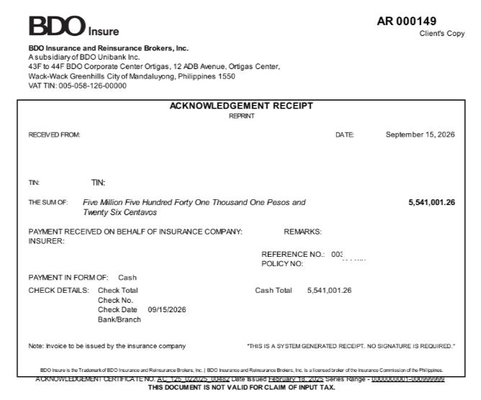

Sample Billspayment file
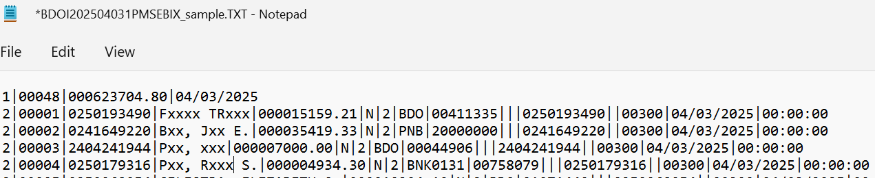

Sample CLPC file

Sample Trade file

Appendix B – References
The following documents are used as reference in preparing the functional requirements specifications:
- Operations_WS Addendum
References added in version 3.2:
- Operations BRD v1.01 (15-Apr-2026, signed 23 to 28-Apr-2026): pages 71-185 of the file Operations_WS Addendum; the Cashiering annex of May 2026 (Operations Central - Addendum 1, pages 1-8); the e-mail record of the BIR 2307 changes (pages 67-70 and 186-189).
- Review workbooks of BRD-02 Operations Cashiering, v1.0 (9-Oct-2026): Business Unit Requirements Collection; BRD vs Out-of-the-Box vs Best Practice; Change Request Register; Test Cases and Traceability (the test conditions TC-OP-nnn.n and the test cases quoted in Appendix Q); Business Unit Walkthrough Users.
- BIBS Non-Functional Requirements Register v1.0; BIBS Master Data and Configuration Upload Templates v1.2; BDOI Requirements and Inputs by BRD v1.2.
- The review workbooks of BRD-02 Operations Cashiering issued with this version (Business Unit Requirements Collection, BRD vs Out-of-the-Box vs Best Practice, Change Request Register, Test Cases and Traceability, Business Unit Walkthrough Users, all v1.0 of 9-Oct-2026) carry the same numbers as this document.

Appendix C – To-Be Process Flows
One figure for every process of the Cashiering scope of the BRD, drawn from end to end with one column per persona and one for the system, then the status life-cycles of the records. The figures follow BDOI's text of section 3; where the BRD reads differently or another behaviour is proposed, the point is in Appendix R.

C.1 Process flows
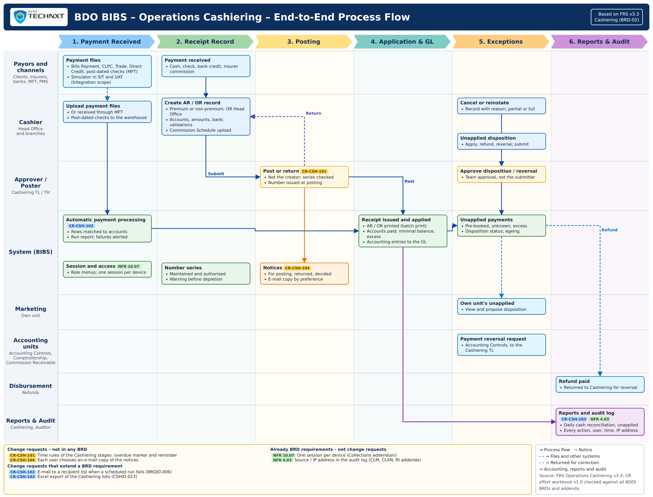
Figure 2 – End-to-end process flow of Operations Cashiering (all actors and systems)
How to read it: The lanes are the payors and channels, the Cashier, the Approver / Poster, BIBS, Marketing, the accounting units, Disbursement and the reports and audit; the tags name the change requests of Appendix W.2 (blue: extends a BRD requirement; yellow: not in any BRD) and the programme NFRs that are BRD requirements (green). The figures that follow draw each process in detail. Traces to: BRQID and CSHID IDs of the Cashiering scope; programme NFRs 10.07 and 4.03.
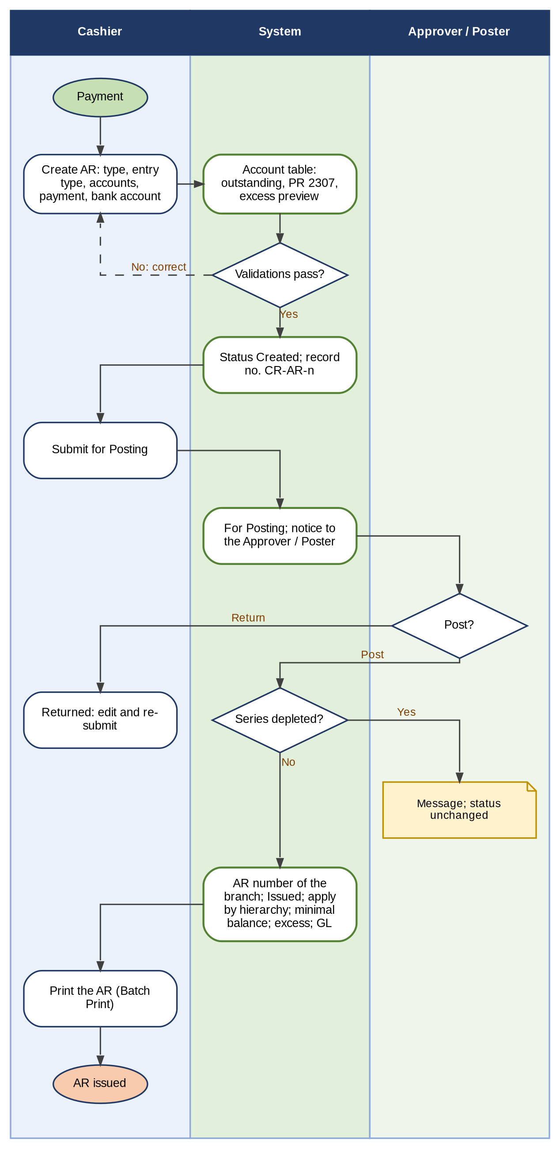
Figure 3 – Creation and posting of an Acknowledgement Receipt (premium and non-premium payments)
How to read it: Read from top to bottom. The AR number is generated only when the Approver/Poster posts the record (BDOI FRS.CSH.02.05.08); the creator never posts his or her own record. Traces to: CSHID.001, 006, 014, 015, 016, 020, 021, 022; FRS.CSH.02.01, FRS.CSH.02.05.
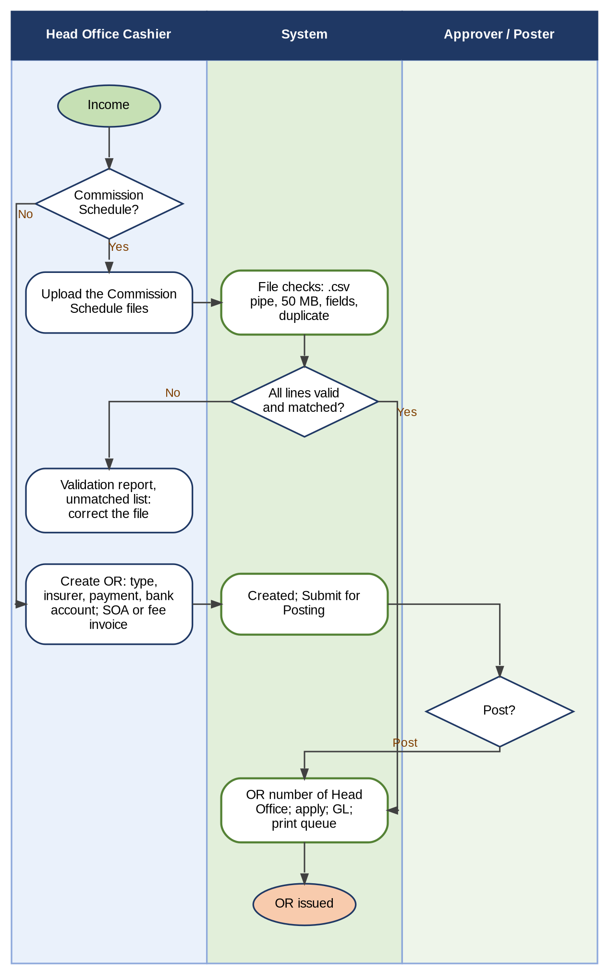
Figure 4 – Creation and posting of an Official Receipt, with the Commission Schedule upload and other income
How to read it: Read from top to bottom. ORs are issued by Head Office only. A Commission Schedule with a failed or unmatched line is not processed (BDOI FRS.CSH.02.02.06, 02.02.09.01; Appendix R, C10). Traces to: CSHID.002, 006, 007, 014; FRS.CSH.02.02, FRS.CSH.02.05.14.
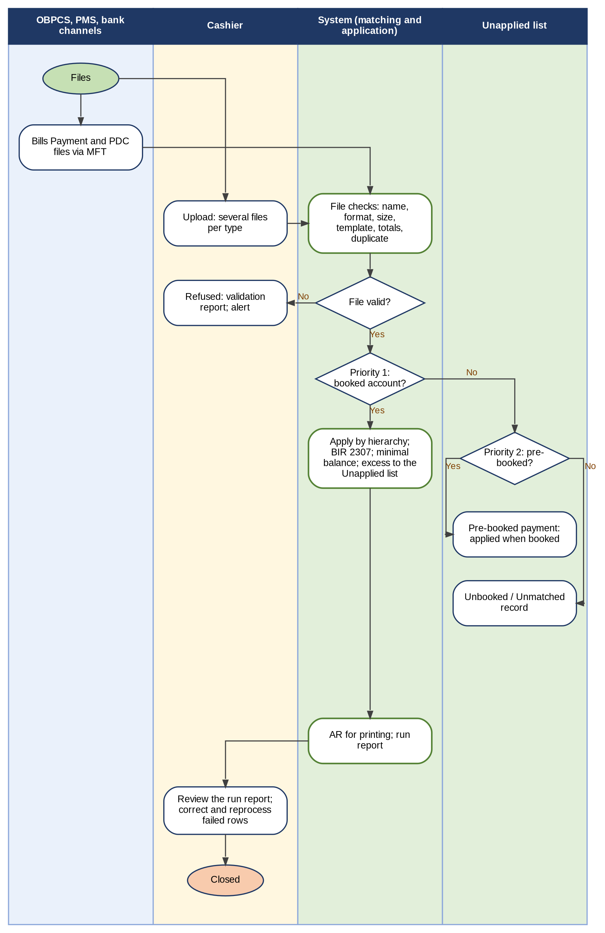
Figure 5 – Automatic payment processing of the Bills Payment, CLPC, Trade, Direct Credit and post-dated check files
How to read it: Read from top to bottom. Every row is processed on its own; a failed row never stops the others (BRQID.006). The right-hand column is the Unapplied list. Traces to: BRQID.005, 006; CSHID.008, 020, 022; FRS.CSH.05.01.
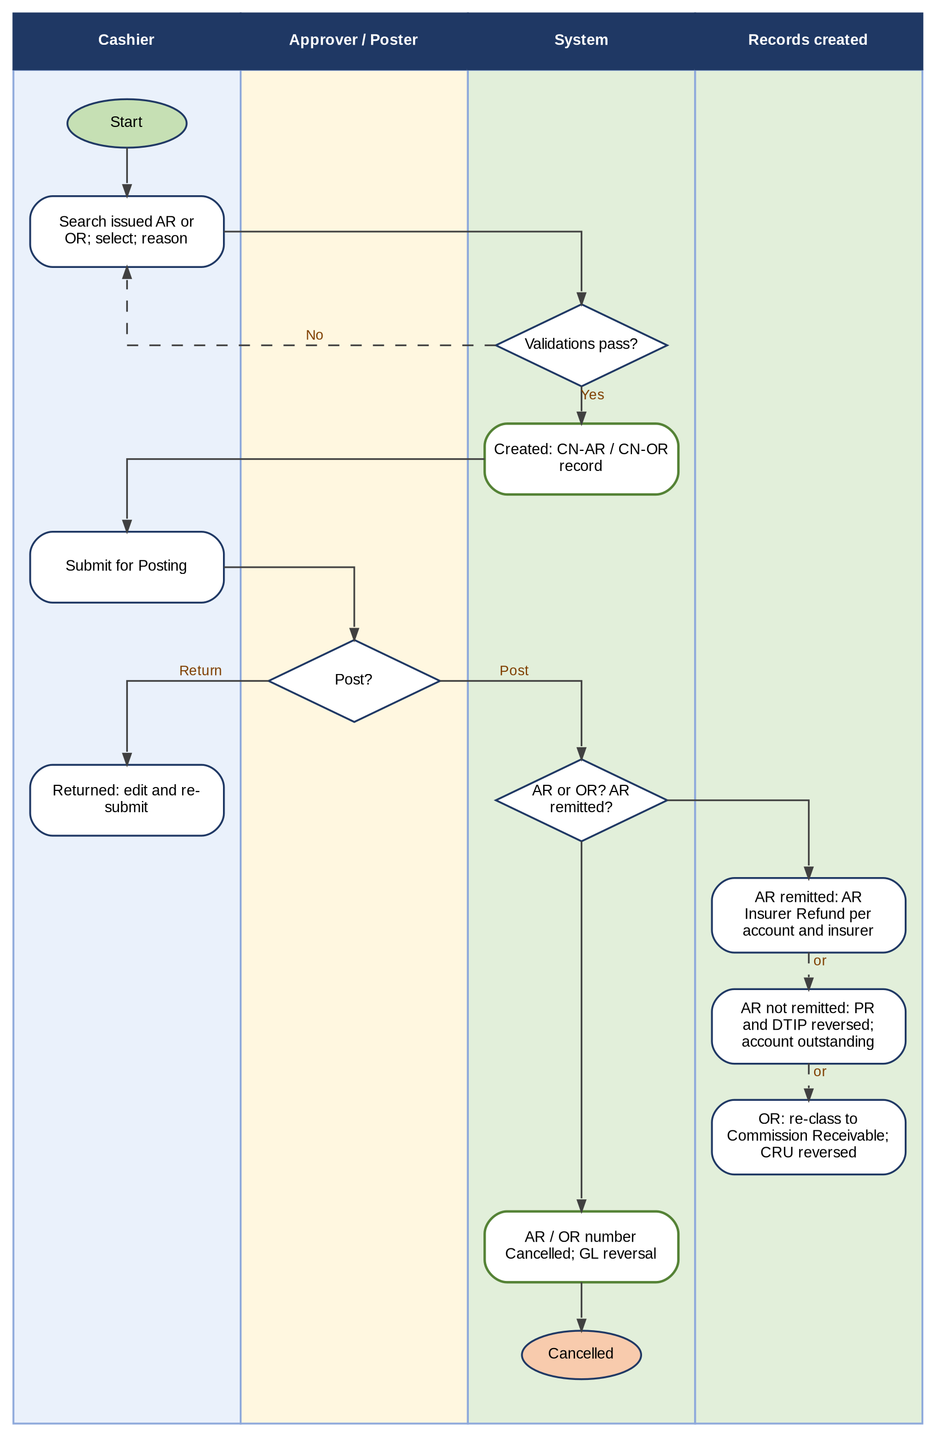
Figure 6 – Cancellation of an AR or OR: record, posting and reversal
How to read it: Read from top to bottom. The right-hand column shows what the posting creates in each case (remitted AR, AR not remitted, OR); the GL reversal entries are in Appendix I. Traces to: CSHID.001, 002, 003, 012; FRS.CSH.03.01.
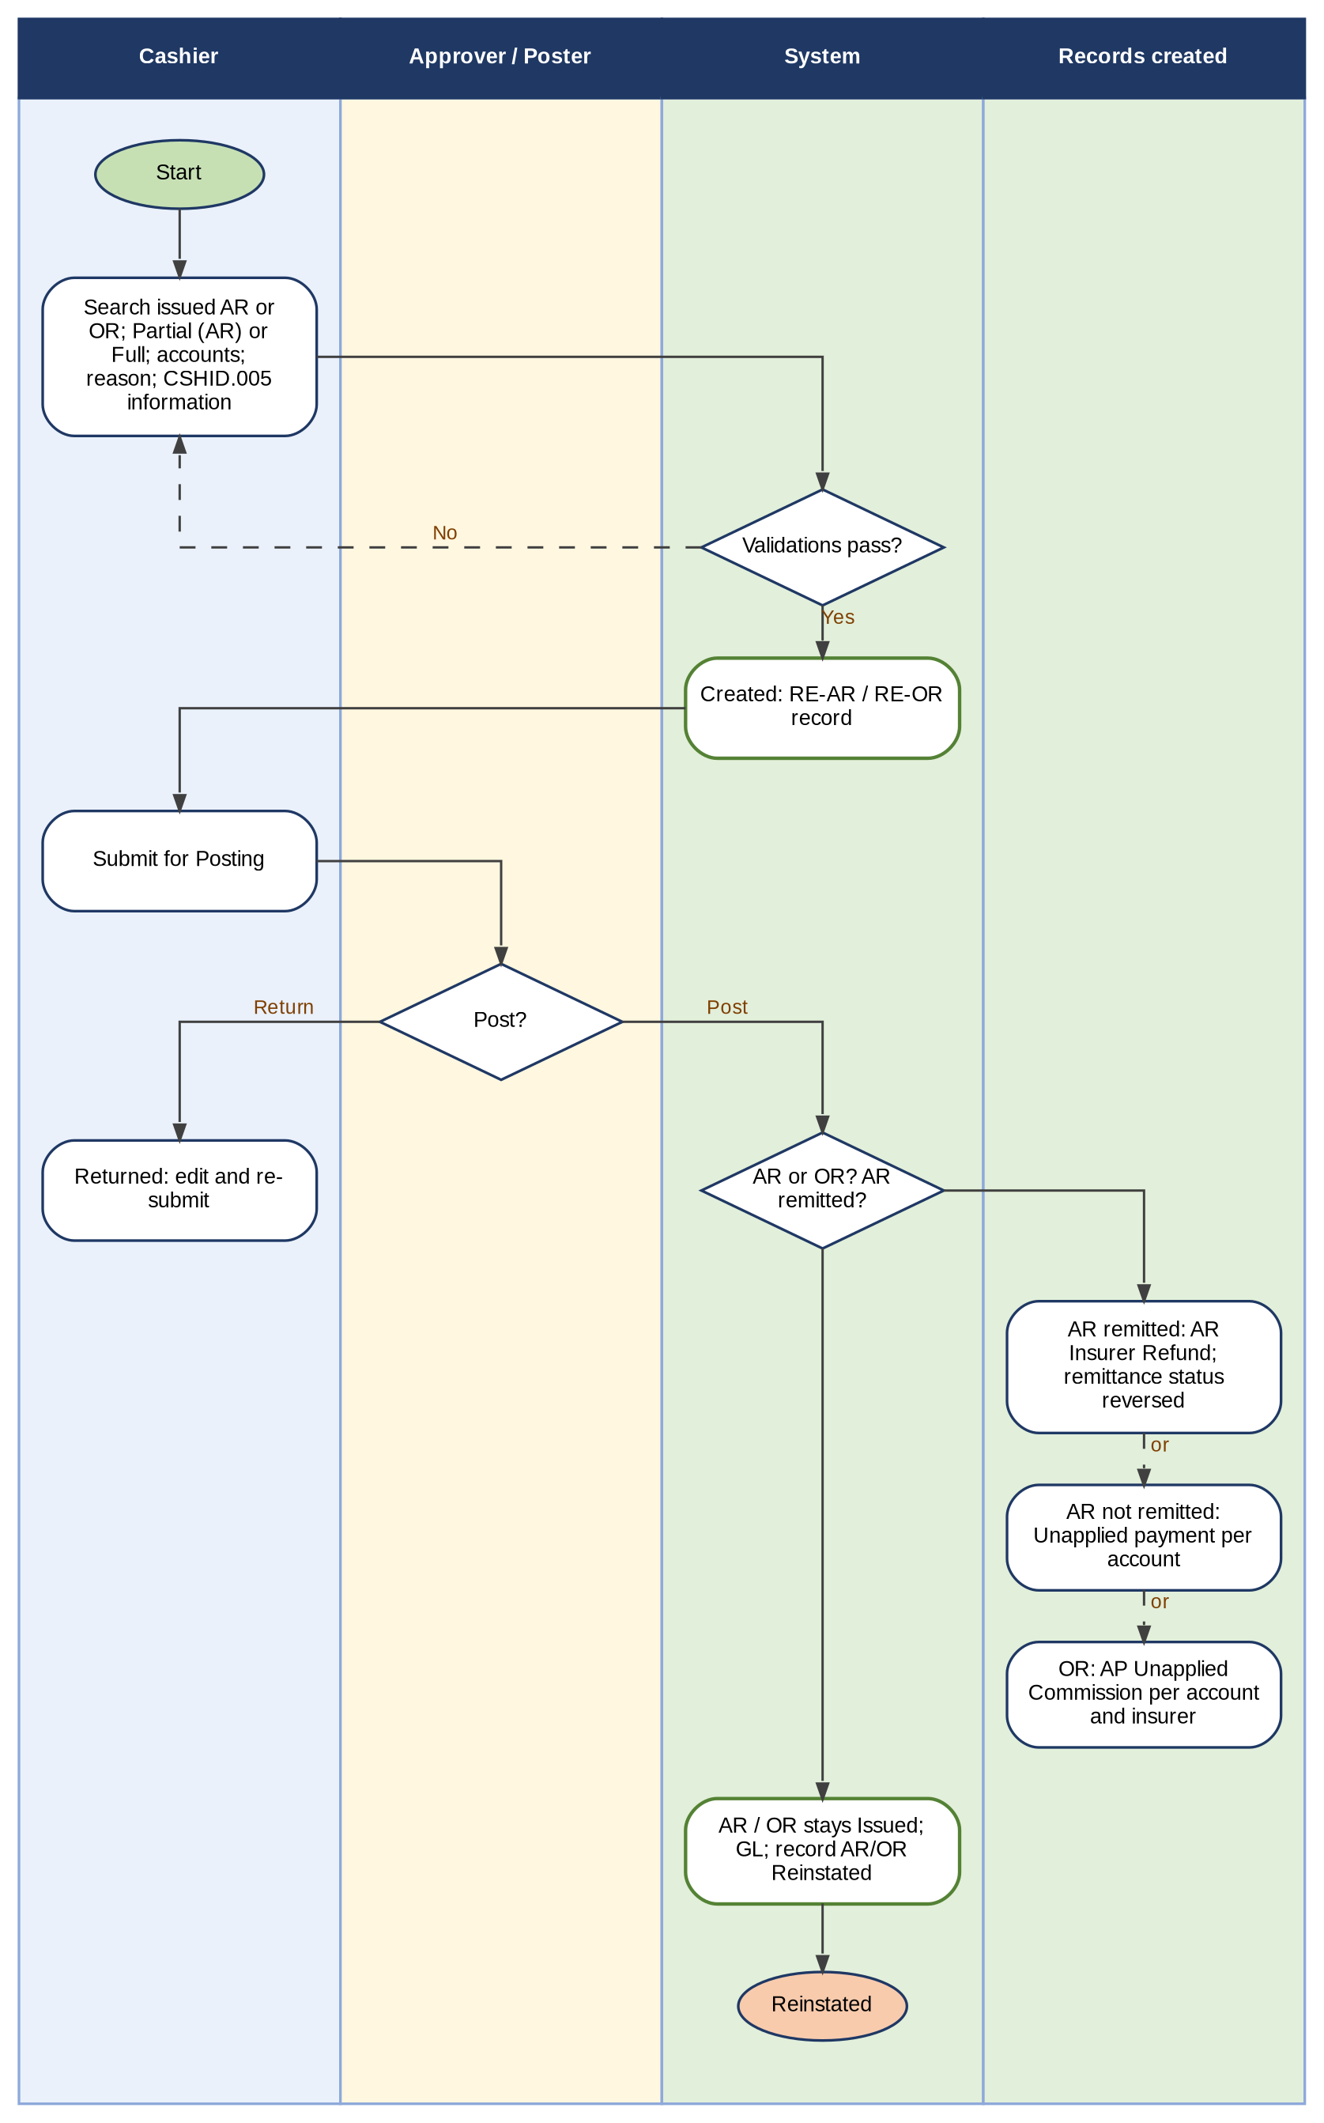
Figure 7 – Reinstatement of an AR or OR: partial or full, remitted or not remitted
How to read it: Read from top to bottom. The receipt stays Issued; the reversed payment becomes an Unapplied, AR Insurer Refund or AP Unapplied Commission record (BDOI FRS.CSH.04.01.09). Traces to: CSHID.001, 002, 004, 005, 013; FRS.CSH.04.01.
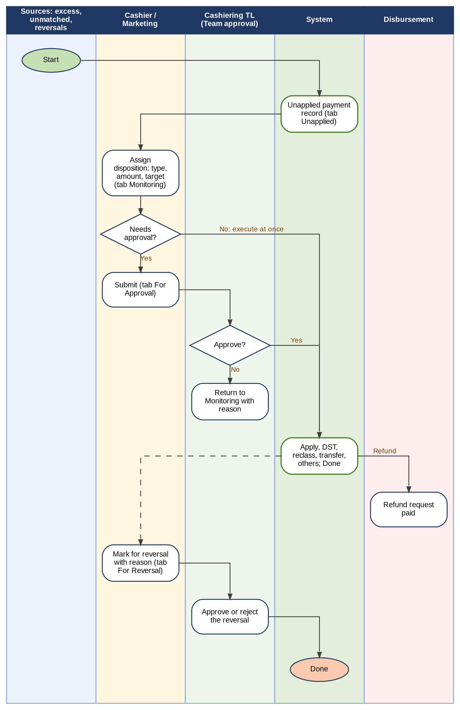
Figure 8 – Unapplied payments: disposition, approval, refund and reversal
How to read it: Read from top to bottom. The tabs of the Unapplied list follow the record: Unapplied, Monitoring, For Approval, For Reversal and Done. Traces to: CSHID.016, 024, 025; FRS.CSH.06.01, FRS.CSH.06.02.
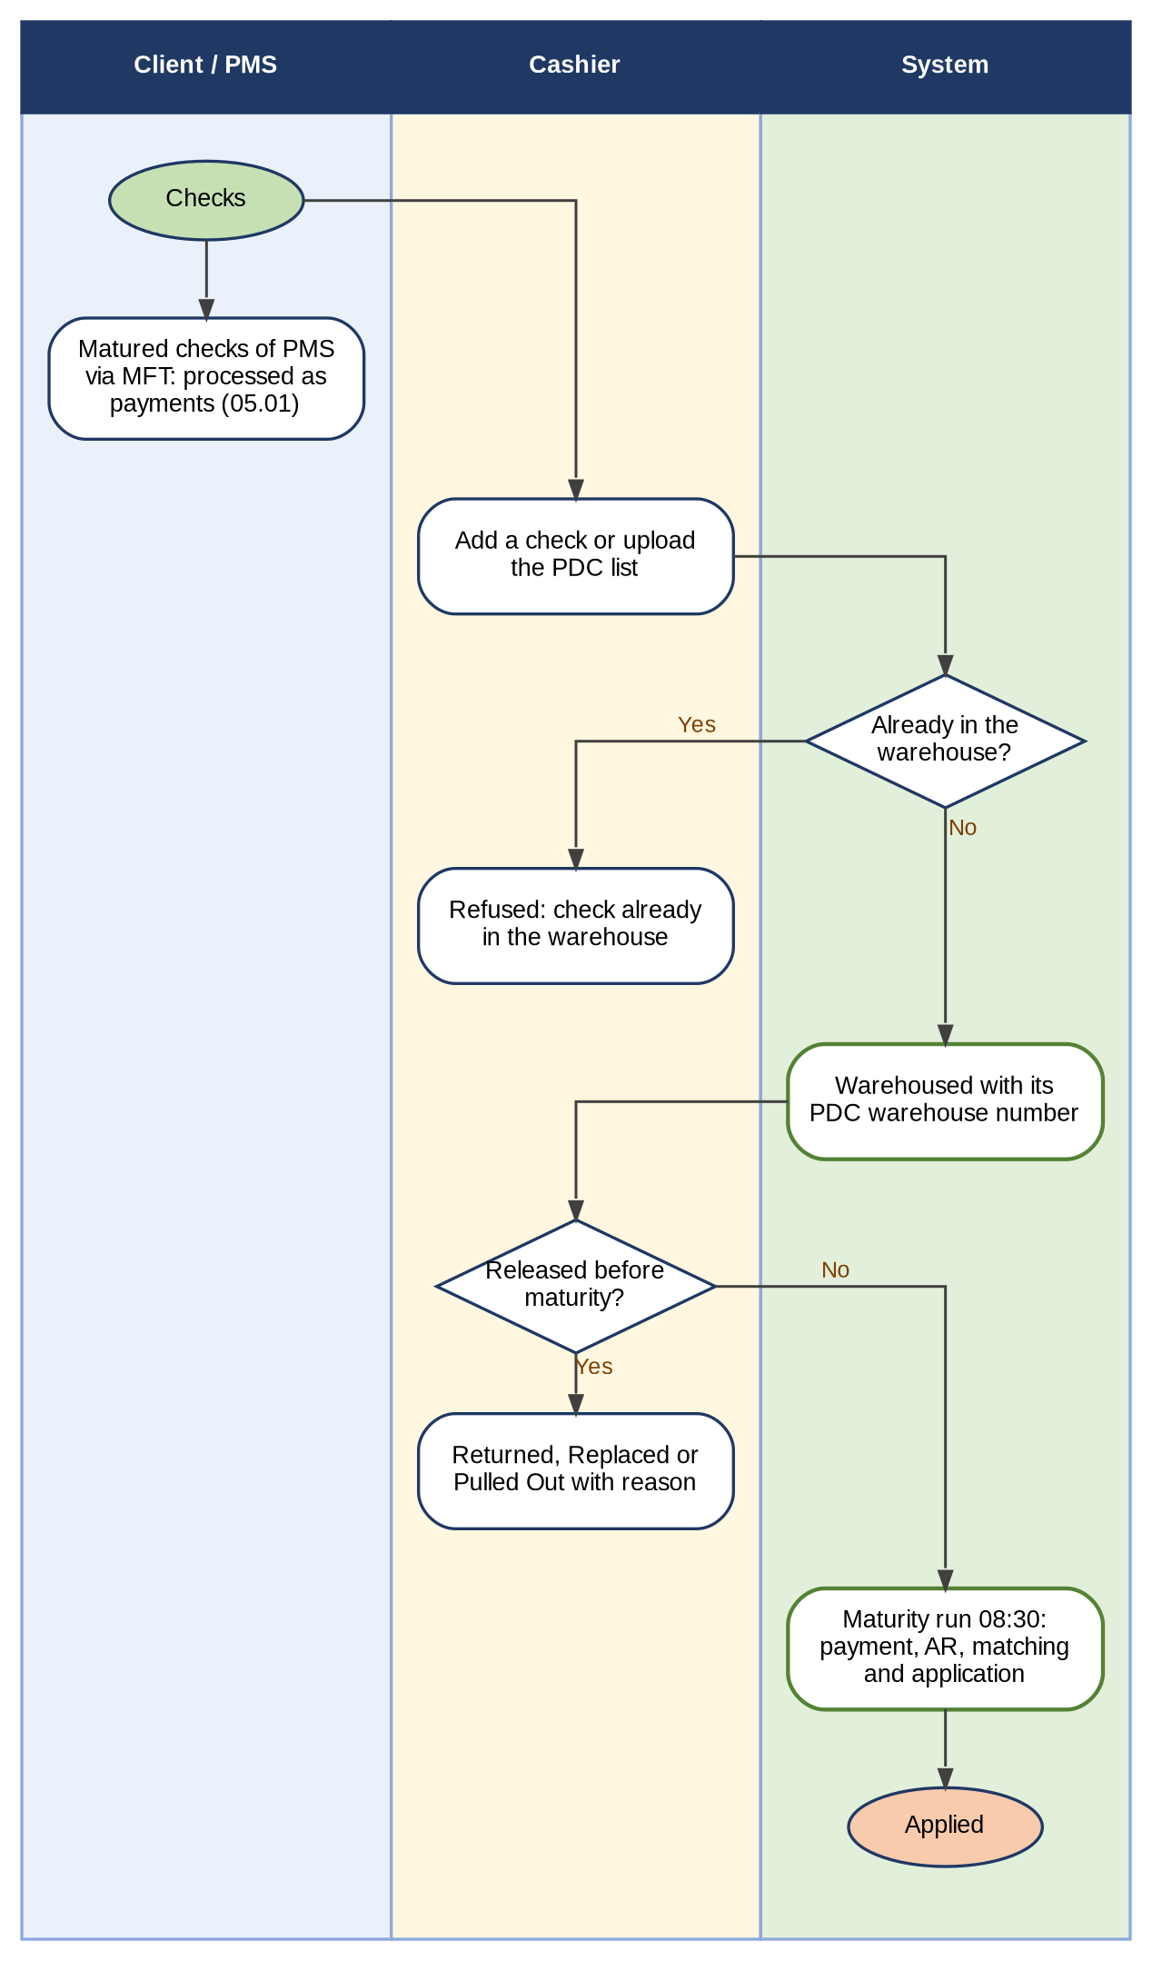
Figure 9 – Post-dated checks: warehouse, release before maturity and maturity
How to read it: Read from top to bottom. A post-dated check is not matched before its maturity (CSHID.020). Traces to: CSHID.008, 020; FRS.CSH.05.01.04, FRS.CSH.05.02.
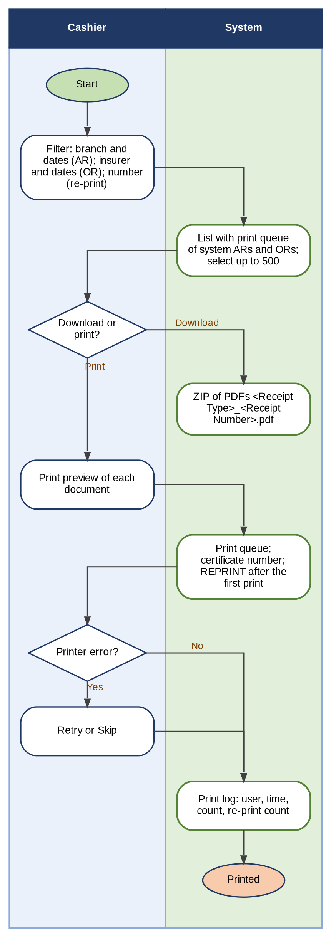
Figure 10 – Batch printing and re-printing of ARs and ORs
How to read it: Read from top to bottom. The certificate number is assigned per printed receipt; every print after the first carries REPRINT. Traces to: CSHID.019; FRS.CSH.02.04.
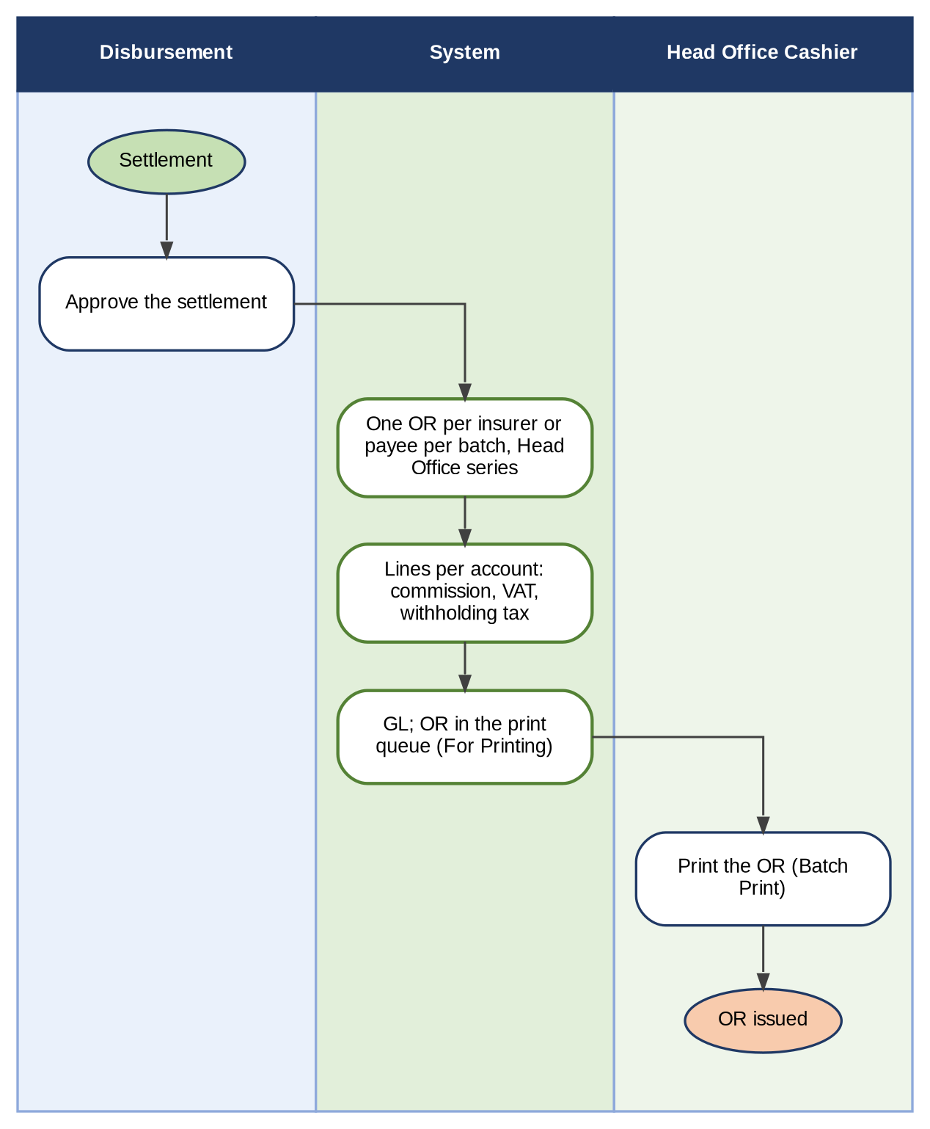
Figure 11 – Automatic generation of the OR of an insurer settlement
How to read it: Read from top to bottom. The OR is generated once Disbursement approves the settlement (BDOI FRS.CSH.07.01.01; Appendix R, C12). Traces to: CSHID.007; FRS.CSH.07.01.
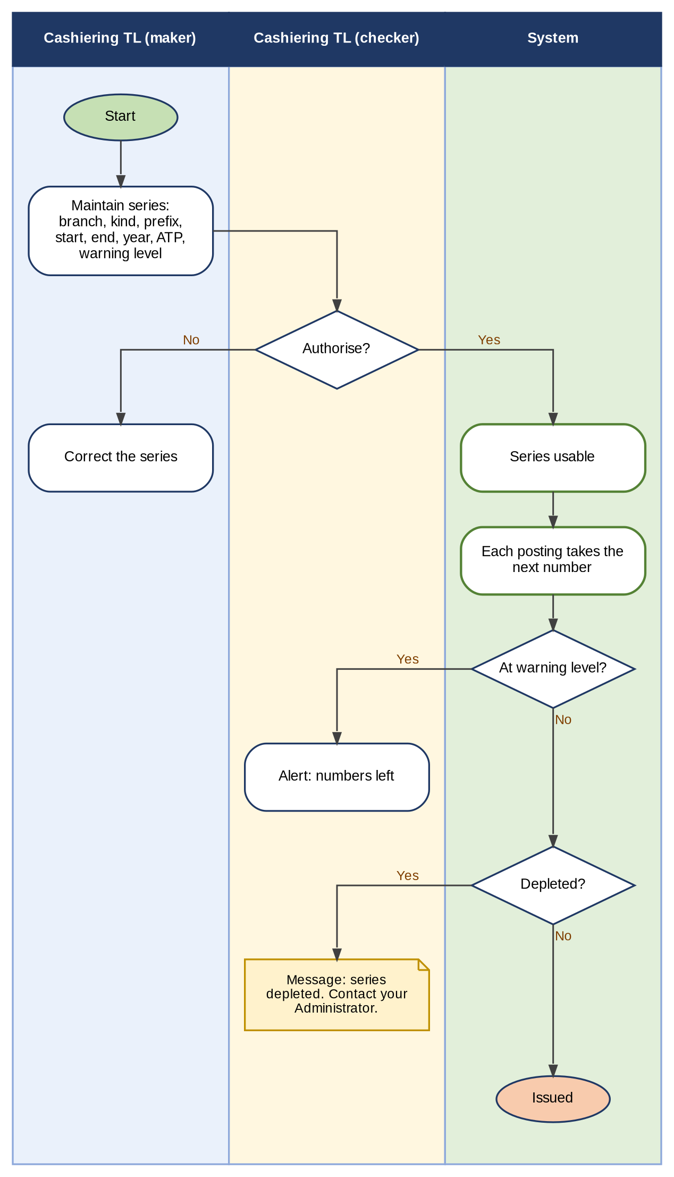
Figure 12 – AR and OR number series: maintenance, authorisation, numbering and depletion
How to read it: Read from top to bottom. A series is usable only when another authorised user authorises it. Traces to: CSHID.006, 015; FRS.CSH.02.03, FRS.CSH.02.05.08, FRS.CSH.02.05.09.

C.2 Status life-cycles
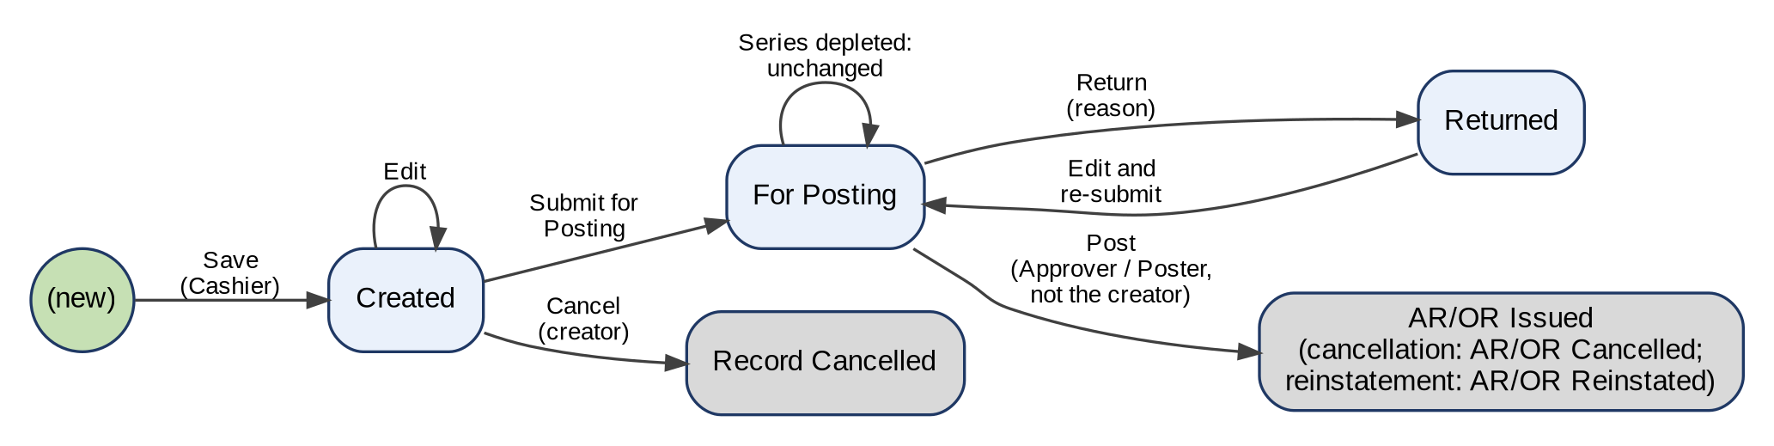
Figure 13 – Status life-cycle of the AR / OR creation, cancellation and reinstatement records
How to read it: Each box is a status of BDOI's FRS; each arrow is an action with the persona who takes it. Grey boxes are final. The cancellation and reinstatement records follow the same statuses and end in AR/OR Cancelled or AR/OR Reinstated. Traces to: CSHID.001 to CSHID.005; FRS.CSH.02.01, 02.05, 03.01, 04.01.
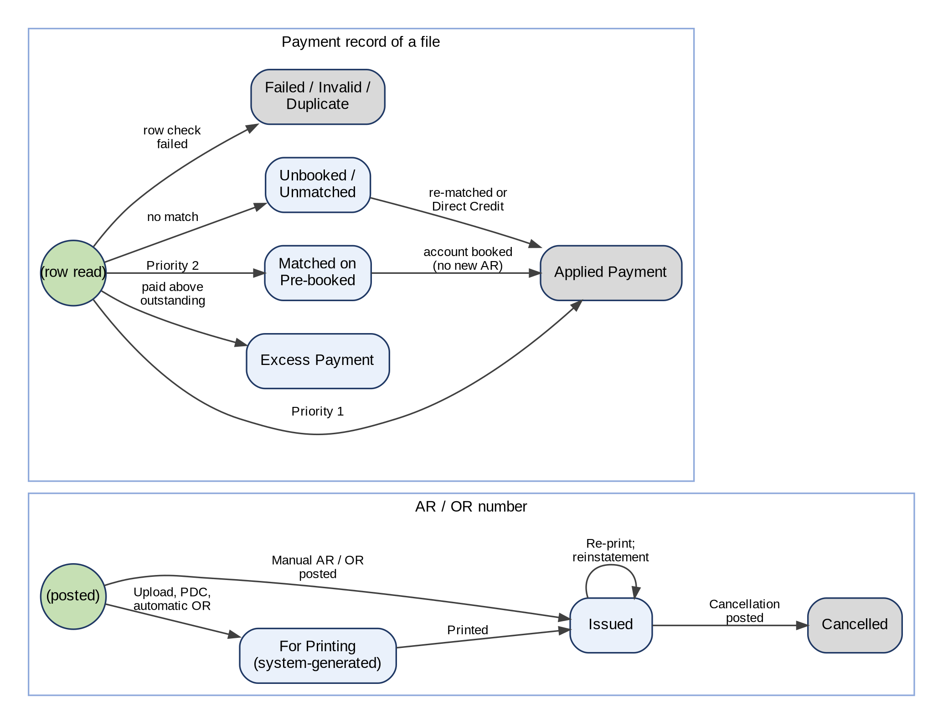
Figure 14 – Status life-cycle of the AR / OR number and of a payment record of a file
How to read it: Top: the status of an AR or OR number. Bottom: the record status of a payment of a file after matching (BDOI FRS.CSH.05.01.08 to .10). Traces to: CSHID.006, 008, 019, 020; FRS.CSH.02.05, 03.01, 05.01.
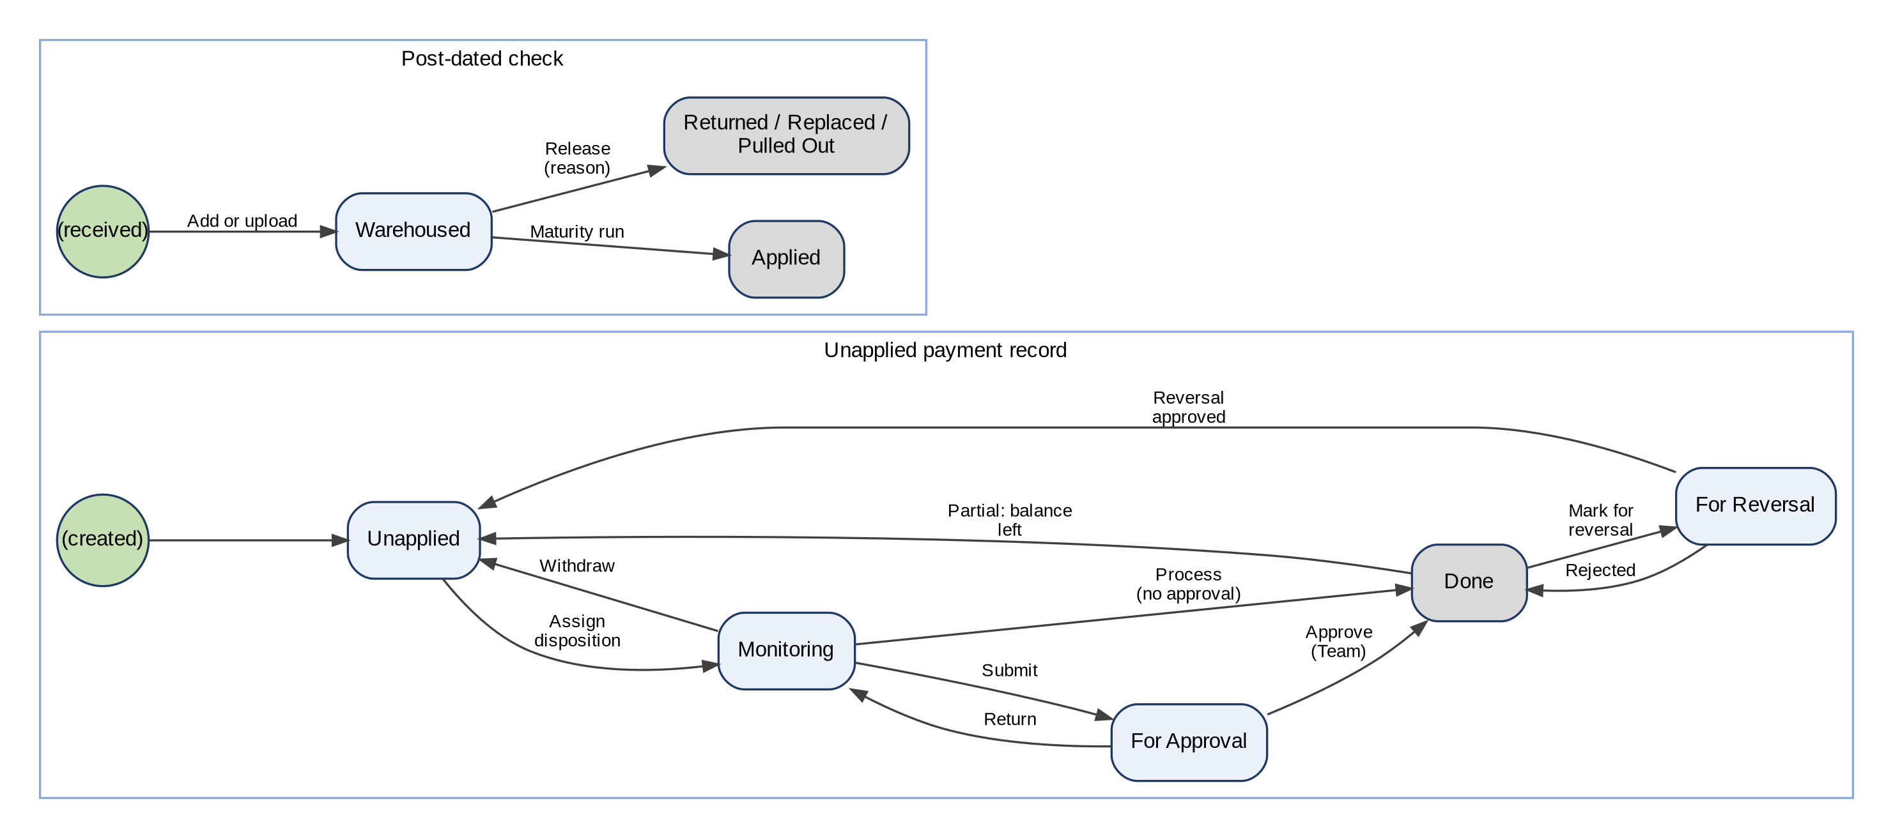
Figure 15 – Status life-cycle of an Unapplied payment record and of a post-dated check
How to read it: Top: the tabs of the Unapplied list (BDOI FRS.CSH.06.02.02, with Done added). Bottom: the statuses of a check in the warehouse. Traces to: CSHID.008, 024, 025; FRS.CSH.05.02, FRS.CSH.06.02.

Appendix D – Payment and Upload File Layouts
The layouts of the payment files of FRS.CSH.05.01 and of the Commission Schedule of FRS.CSH.02.02, field by field, with BDOI's samples of Appendix A where BDOI gave them. Each layout is kept in Cashiering Setup and can be changed without a change to the system (FRS.CSH.05.01.06). "To be confirmed" marks a point BDOI confirms with the channel owner (requirements collection workbook, sheet Integration inputs).

D.1 Bills Payment file (OBPCS, via MFT)
File name and format: BDOIYYYYMMDD.txt (example BDOI201506181.TXT); text file, values separated by a pipe (|); a header record (type 1) then detail records (type 2), without a line of column names (sample of Appendix A).
Pos. | Field | Format (sample) | Mandatory | Use in the system
H1 | Record type | 1 | Yes | Identifies the header record
H2 | Record count | 5 digits, zero-filled (00048) | Yes | Checked against the number of detail records (FRS.CSH.05.01.06)
H3 | Total amount | 12 characters, 2 decimals (000623704.80) | Yes | Checked against the total of the detail records
H4 | File date | MM/DD/YYYY (04/03/2025) | Yes | Shown on the run
1 | Record type | 2 | Yes | Identifies a detail record
2 | Incremental # | 5 digits (00001) | Yes | Row number in the run report
3 | Reference (invoice #) | 10 digits (0250193490) | Yes | Match key: account number or a legacy number (QPS, ISYS, Ebix, PN, Loan Application Number), FRS.CSH.05.01.08
4 | Assured / payor name | Text | Yes | Payor of the AR
5 | Amount | 12 characters, 2 decimals (000015159.21) | Yes | Paid amount
6 | Late deposit | Y / N | No | Kept with the payment
7 | (not named) | 2 on every row | To be confirmed | To be confirmed by BDOI
8 | Paying bank | BDO, PNB, BNK0131 | To be confirmed | Bank of the payment (to be confirmed)
9 | (not named) | 8 digits (00411335) | To be confirmed | Phone number, check or account number (to be confirmed)
10-11 | (empty) | - | - | Not read
12 | Reference (repeated) | Same value as position 3 | To be confirmed | Second reference (to be confirmed)
13 | (empty) | - | - | Not read
14 | Branch code | 5 digits (00300) | No | Paying branch
15 | Date of payment | MM/DD/YYYY (04/03/2025) | Yes | Payment date of the AR
16 | Time of payment | HH:MM:SS (00:00:00) | No | Kept with the payment

D.2 Post-dated checks file (PMS, via MFT; or Excel upload)
File name and format: BDOIYYYYMMDDPMS.txt (example BDOI201506181PMS.TXT), values separated by a pipe (|); header and details of BDOI's FRS to be given (FRS.CSH.05.01.06). The BRD names an Excel file; the Excel template of the system is used until BDOI gives the PMS layout.
No. | Field | Format (example) | Mandatory | Use in the system
1 | Client code | Text (CL-2026-000001) | No | Client of the check
2 | Payor | Text | Yes | Payor of the AR
3 | Reference | Account, invoice, ARN, policy or PN number | Yes | Match key at maturity
4 | Check number | Text (0012345) | Yes | With the bank, unique in the warehouse
5 | Bank code | Text (PNB) | Yes | Drawee bank
6 | Check branch | Text (Makati) | No | Branch of the drawee bank
7 | Maturity date | Date | Yes | Date of the daily maturity run
8 | Amount | Number, 2 decimals | Yes | Check amount
9 | Market segment | Text (CBG) | No | Segment for the reports

D.3 CLPC file
File name and format: CLPC-MonDDYYYY.xlsx (example CLPC-Jun032025.xlsx); Excel sheet with a line of column names and a TOTAL row at the end (sample of Appendix A).
Col. | Field | Format (sample) | Mandatory | Use in the system
1 | COUNT | 1 to n | Yes | Row number
2 | DATE CREDIT | MM/DD/YYYY (04/04/2025) | Yes | Payment date
3 | AMOUNT | Number without thousands separator (28695.75) | Yes | Paid amount
4 | AR NUMBER | Empty on upload | No | Filled by the system
5 | INVOICE | Text | No | Match key (account or invoice)
6 | ASSURED | Text | Yes | Payor of the AR
7 | PN NUMBER | Text | No | Match key when the invoice is blank
8 | CORP.DEPT | Text (SMALLBUSINESSLOAN) | No | Kept with the payment
9 | RISK CODE | Text (FIP) | No | Kept with the payment
10 | REMARKS | Text | No | Kept with the payment
- | TOTAL row | Label TOTAL with the total amount | Yes | Control total, not a payment (FRS.CSH.05.01.06)

D.4 Trade file (TFS, from CIB)
File name and format: UploadTrade_MM.DD.YYYY.txt (example UploadTrade_01.01.2025.TXT); text file with a line of column names; the sample of Appendix A is aligned with spaces or tabs although the FRS says pipe (|): separator to be confirmed.
Col. | Field | Format (sample) | Mandatory | Use in the system
1 | Transaction Date | MM/DD/YYYY (04/03/2025) | Yes | Payment date
2 | Branch Name | Text (RECON) | No | Kept with the payment
3 | Transaction Description | Risk code / 10-digit reference / code (FIP/0250088368/FSA7041259859IVF) | Yes | Each part is tried as a match key
4 | Debit | Number (0) | No | Kept with the payment
5 | Credit | Number (31080.04) | Yes | Paid amount; a row without credit is failed
6 | Running Balance | Number | No | Kept with the payment
7 | Check No. | Text (0) | No | Kept with the payment

D.5 Direct Credit file
File name and format: OTCYYYYMMDD-<branch>.txt (example OTC202506101- AUTOCREDIT.TXT); text (pipe) or Excel. BDOI's FRS uses the file to identify payments already received (FRS.CSH.05.01.09): the columns below are those of the BRD.
Col. | Field | Format | Mandatory | Use in the system
1 | Transaction date | Date | Yes | Payment date
2 | BP filename | Text | Yes | Priority 1 match with the payment record (FRS.CSH.05.01.09)
3 | Transaction no | Text | Yes | Priority 1 match with the payment record
4 | Paid amount | Number, 2 decimals | Yes | Must equal the amount of the payment record
5 | Payment type | Text | No | Kept with the payment
6 | Payor | Text | Yes | Payor
7 | Account ref no | Text | No | Priority 2 and 3 match keys
8 | Assured | Text | No | Kept with the payment
9 | Ebix reference no. | Text | No | Match key
10 | Logged by | Text | No | Kept with the payment
11 | Requestor | Text | No | Kept with the payment

D.6 Commission Schedule (FRS.CSH.02.02.03)
File name and format: Pipe-delimited .csv (FRS.CSH.02.02.04); BDOI's list of fields is blank (FRS.CSH.02.02.07): the fields below are proposed (the Commission Payment Details template of the system).
Col. | Field | Format (example) | Mandatory | Use in the system
1 | Insurer code | Text (INS-MGIC) | Yes | Insurer paying the commission
2 | Payee name | Text | Yes | Received From of the OR
3 | Certificate ref | Text (2307-0001) | No | BIR 2307 certificate of the insurer
4 | Payment ref | Text (check or credit reference) | Yes | Check number or credit reference
5 | Invoice no | Text | No | Match key (reference number)
6 | Basic commission | Number, 2 decimals | Yes | Commission paid
7 | VAT | Number, 2 decimals | Yes | VAT on the commission
8 | Withholding tax | Number, 2 decimals | Yes | Tax withheld by the insurer
9 | Payment date | Date | Yes | Date of the payment

Appendix E – Screen Specifications
This appendix specifies the screens of Operations Cashiering as the system shows them: the purpose of each screen, how the user reaches it, the FR items it serves, one screenshot, its fields with type, mandatory marker, format, list or source and validation, its actions and its rules. Mandatory: Y = mandatory, N = optional, Cond. = mandatory when the condition stated applies. The screenshots were taken on the BIBS test environment with SIT/UAT data; the screens of BDOI's posting step, payment files, receipt forms and lists were taken on 10-Oct-2026. Where a point is offered both ways by a setting, the screens show the value delivered (Appendix H.8) and the point is in Appendix R.

E.1 Cashiering Dashboard
Purpose: The landing page of Cashiering as BDOI's FRS sets it: for each item of the user's role the count and the amount per currency - the AR/OR, cancellation and reinstatement records for posting per receipt type, the returned records, the unapplied payments for disposition per type and the payment files waiting for automatic processing - each opening its list already filtered; the search of an account, invoice, ARN, AR or OR number; and the main navigation of Cashiering.
Access: Cashiering › Cashiering Workbench
FR items: FRS.CSH.01.03.02, FRS.CSH.01.03.04, FRS.CSH.01.03.05, FRS.CSH.10.01.02
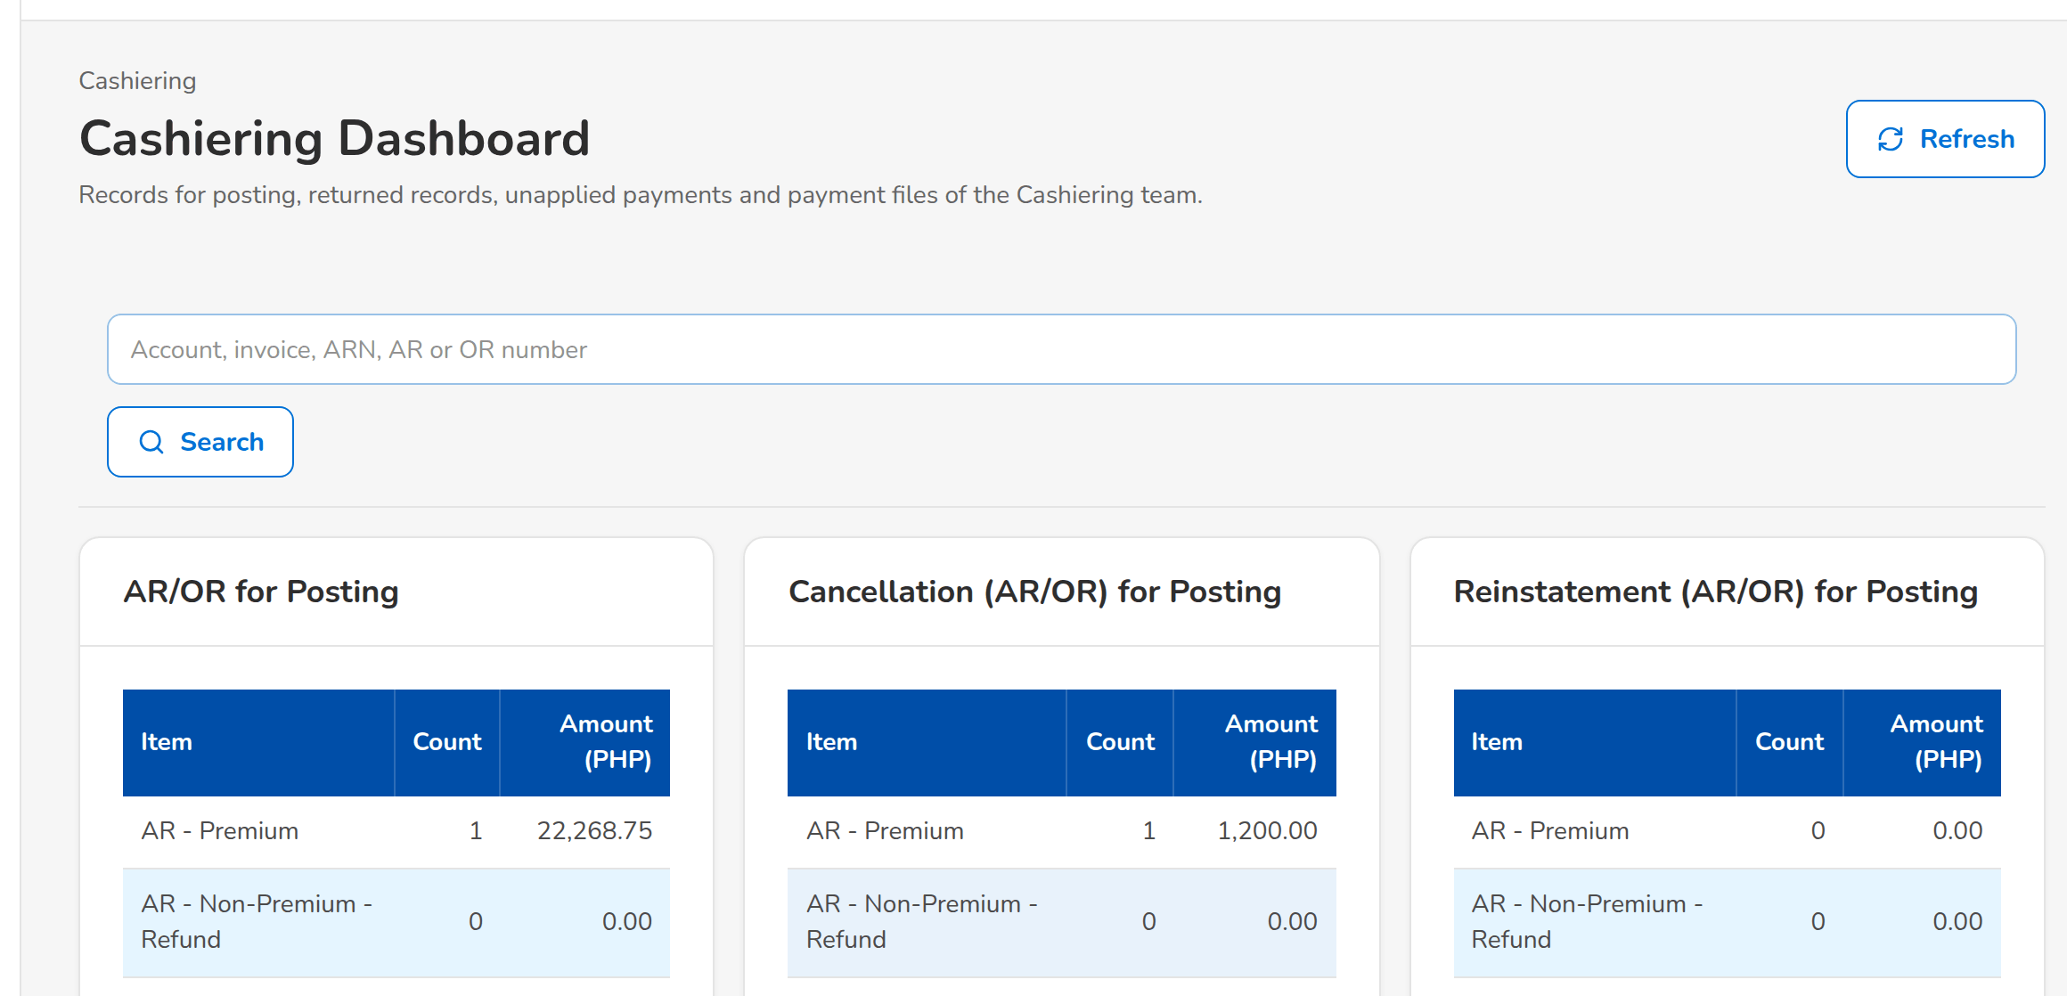
(continued below)
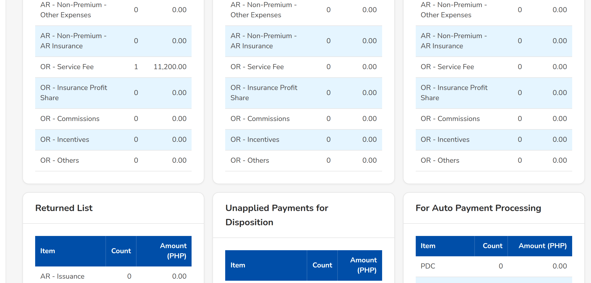
(continued below)
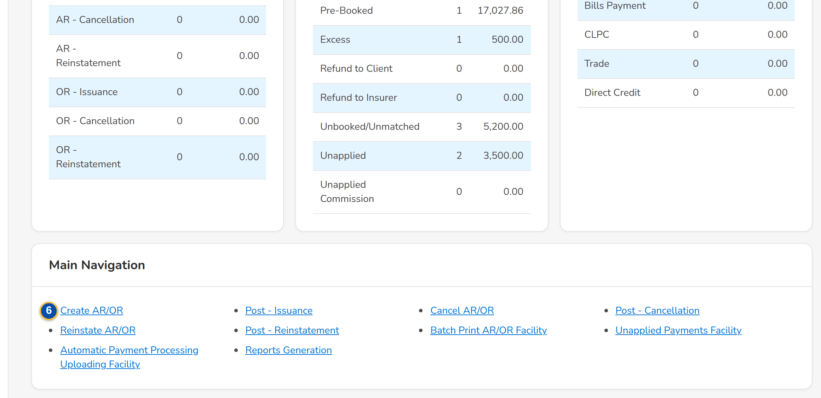
Screenshot E.1: Cashiering Dashboard of the Cashiering Team Leader
Field | Type | Mandatory | Format / list / source | Validation and message
Search: Search account, invoice, ARN, AR or OR number | Text | N | Account, invoice, ARN, AR or OR number; Receipts and the invoice ledger | -
AR/OR for Posting / Cancellation (AR/OR) for Posting / Reinstatement (AR/OR) for Posting: Item / Count / Amount (PHP) | Table | - | One row per receipt type: AR - Premium, AR - Non-Premium (Refund, Other Expenses, AR Insurance), OR - Service Fee, Insurance Profit Share, Commissions, Incentives, Others; count and amount per currency; Creation, cancellation and reinstatement records | Nothing to show
Returned List: Item / Count / Amount (PHP) | Table | - | AR and OR issuance, cancellation and reinstatement records returned to their creator; Records | -
Unapplied Payments for Disposition: Item / Count / Amount (PHP) | Table | - | Pre-Booked, Excess, Refund to Client, Refund to Insurer, Unbooked/Unmatched, Unapplied, Unapplied Commission; Unapplied payments | -
For Auto Payment Processing: Item / Count / Amount (PHP) | Table | - | PDC, Bills Payment, CLPC, Trade, Direct Credit files waiting; Payment files | -
Main Navigation: Create AR/OR / Post - Issuance / Cancel AR/OR / Post - Cancellation / Reinstate AR/OR / Post - Reinstatement / Batch Print AR/OR Facility / Unapplied Payments Facility / Automatic Payment Processing Uploading Facility / Reports Generation | Links | - | Shown by the user's role | -

Action | Who | Available when | What happens | Resulting status
Refresh | Every Cashiering user | Always | Counts the items again | -
Search | Every Cashiering user | A number entered | Opens the receipt found, or Invoice Search with the number | -
[An item row] | Every Cashiering user | Always | Opens its list already filtered (Posting, Unapplied Payments, Payment Files) | -

Rules:
- Each user sees only the groups of the role: the posting groups for the Approver/Poster, the returned list for the creators, the unapplied payments for the disposition and application rights, the payment files for the upload right.
- The counts and amounts are taken when the screen opens or is refreshed, per currency.

E.2 Create AR/OR and Edit Record
Purpose: The creation record of an acknowledgement receipt or an official receipt, as BDOI's FRS sets it: the receipt type and the AR or OR type, the receipting branch, the payor (client, insurer or other), the payment (type, currency, bank account, paid amount, with VAT, withholding tax and the BIR 2307 reference of an OR), the check details and remarks, and the accounts paid with the amount of each. The receipt number is issued when the record is posted by the Approver/Poster.
Access: Cashiering Dashboard › Create AR/OR; Posting › Create AR, Create OR; Receive Payment and Receipts › Create OR (posting step on)
FR items: FRS.CSH.02.01.01, FRS.CSH.02.01.02, FRS.CSH.02.01.03, FRS.CSH.02.01.08, FRS.CSH.02.01.10, FRS.CSH.02.01.16, FRS.CSH.02.02.01, FRS.CSH.02.02.02, FRS.CSH.02.02.08, FRS.CSH.02.02.10, FRS.CSH.02.05.06, FRS.CSH.02.05.10, FRS.CSH.02.05.11.01, FRS.CSH.02.05.13, FRS.CSH.02.06.02, FRS.CSH.02.06.03, FRS.CSH.05.01.08, FRS.CSH.05.01.12, FRS.CSH.05.02.02, FRS.CSH.05.03.01, FRS.CSH.10.04.02
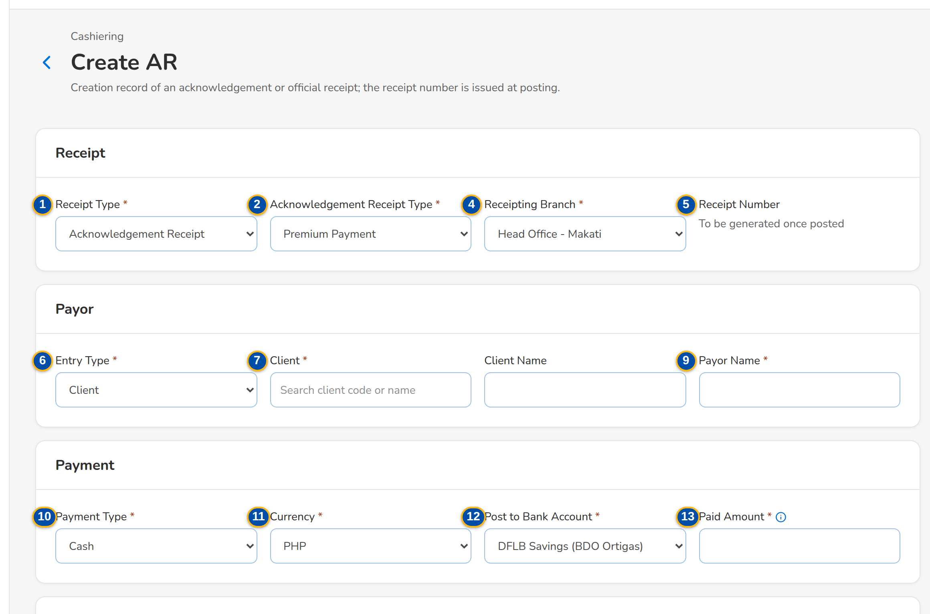
(continued below)
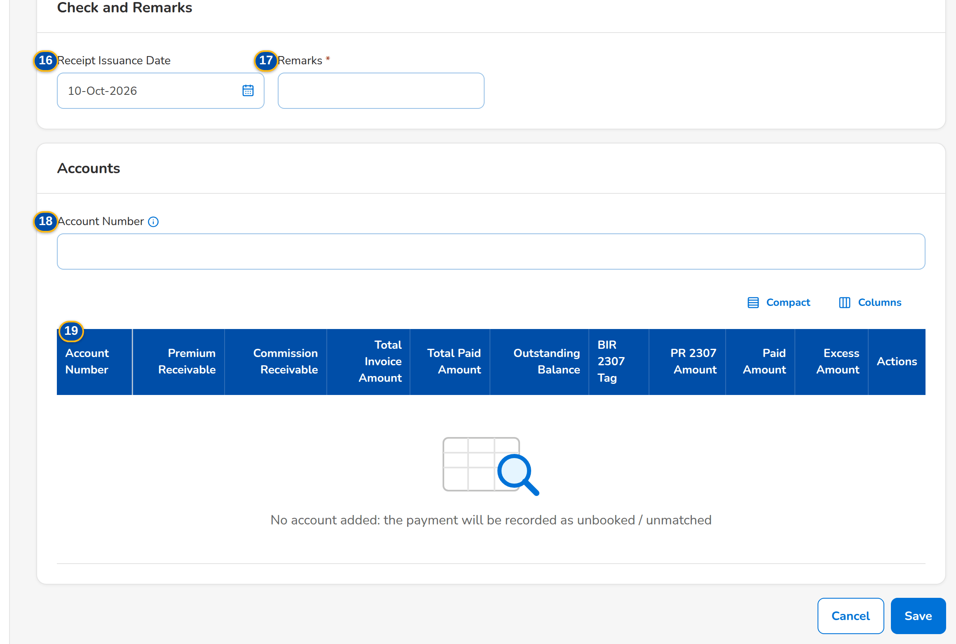
Screenshot E.2: Create AR: the creation record of an acknowledgement receipt
Field | Type | Mandatory | Format / list / source | Validation and message
Receipt: Receipt Type | Drop-down | Y | Acknowledgement Receipt or Official Receipt (from the entry); Fixed list | -
Receipt: Acknowledgement Receipt Type | Drop-down | Y (AR) | Premium Payment; Non-Premium Payment: Refund from Insurer, Other Expenses, AR Insurance; Fixed list | AR Type is required
Receipt: Official Receipt Type | Drop-down | Y (OR) | Service Fee Income, Insurance Profit Share, Commissions (with VAT / withholding tax), Incentives, Handling Fee, Others (discount); List of values OR type | OR Type is required
Receipt: Receipting Branch | Drop-down | Y | Branches of the user; Head Office only for an OR; Branches | Receipting Branch is required
Receipt: Receipt Number | Text | - | To be generated once posted; Receipt series | -
Payor: Entry Type | Drop-down | Y | Client, Insurer, Other; Insurer for a non-premium AR; Fixed list | -
Payor: Client / Client Name | Look-up | Cond.: entry type Client | Client code and name; Clients | An active client; Client is required
Payor: Insurer / Bank Name | Drop-down, text | Cond.: entry type Insurer or a non-premium AR | Insurers by name; bank from the insurer banking list; Insurers | Insurer is required
Payor: Payor Name | Text | Y | Up to 250 characters; proposed from the client or insurer | Payor Name is required
Payment: Payment Type | Drop-down | Y | Cash, Check; Direct Credit for an OR; Fixed list | -
Payment: Currency / Rate of the Day | Drop-down, value | Y | PHP, USD; the rate of the day for a foreign currency; Currencies of the bank accounts | Currency is required
Payment: Post to Bank Account | Drop-down | Y | DFLB - Current (BDO Ortigas), DFLB Savings (BDO Ortigas), DFLB Savings Mall (Peso), DFLB Savings Trade (Peso), DFLB Savings FX (BDO Ortigas); Bank accounts | Post to Bank Account is required
Payment: Paid Amount | Number | Y | Two decimals; at most 1,000,000,000.00 | Above zero and at most the maximum; equal to the sum of the accounts; Paid Amount must be above zero and not more than 1,000,000,000.00
Payment (OR): VAT / Withholding Tax / BIR 2307 Certificate Reference / SOA or Fee Invoice | Numbers, text, look-up | N | Two decimals; the statement or fee invoice paid; Statements of account and fee invoices | -
Check and Remarks: Check Number / Check Date / Bank of the Check | Text, date | Cond.: check payment | Up to 40 characters; dd-MMM-yyyy, with the holding period shown | Date not within the holding period (setting); Check Number is required; Check Date is required
Check and Remarks: Receipt Issuance Date | Date | N (AR) | dd-MMM-yyyy | -
Check and Remarks: Remarks | Text | Y as delivered (setting) | Up to 200 characters | Remarks is required
Accounts: Account Number | Look-up | N | Account, invoice or ARN number; Invoice ledger | -
Accounts: Account Number / Premium Receivable / Commission Receivable / Total Invoice Amount / Total Paid Amount / Outstanding Balance / BIR 2307 Tag / PR 2307 Amount / Paid Amount / Excess Amount | Columns | Cond.: paid amount per account | Amounts with two decimals; the paid amount keyed per account; the excess computed; Invoice ledger | The paid amounts add up to the Paid Amount; The amounts of the accounts must add up to the Paid Amount

Action | Who | Available when | What happens | Resulting status
Save | The creator (receipt right) | Required fields entered | Saves the record numbered CR-AR-nnnnnn or CR-OR-nnnnnn and opens it | Created
Cancel | The creator | Always | Leaves the form without saving | -

Rules:
- As delivered the ARs and ORs are issued through the posting step (setting Posting step of ARs and ORs, Appendix H.8): the record is created, submitted for posting and posted by an Approver/Poster other than its creator, who issues the receipt number.
- No account added: the payment will be recorded as unbooked / unmatched.
- A check dated within the holding period (4 working days as delivered) is refused at receipting while the check date rule is on (setting).
- An OR is created only for the Head Office.

E.3 Cashiering Record
Purpose: One creation, cancellation or reinstatement record of an AR or OR: its details, the accounts paid, its history, and the actions of the user - Edit, Submit for Posting and Cancel Record for the creator; Post and Return for the Approver/Poster, who is never the creator.
Access: Posting › a row; Cashiering Dashboard › an item of the posting groups or the returned list
FR items: FRS.CSH.02.01.01, FRS.CSH.02.01.02, FRS.CSH.02.01.08, FRS.CSH.02.01.09, FRS.CSH.02.01.10, FRS.CSH.02.01.16, FRS.CSH.02.02.01, FRS.CSH.02.02.02, FRS.CSH.02.02.08, FRS.CSH.02.02.10, FRS.CSH.02.05.06, FRS.CSH.02.05.07, FRS.CSH.02.05.15, FRS.CSH.02.06.02, FRS.CSH.02.06.03, FRS.CSH.03.01.01, FRS.CSH.03.01.05 (2nd), FRS.CSH.03.01.06, FRS.CSH.03.01.08, FRS.CSH.03.01.09, FRS.CSH.03.01.11, FRS.CSH.04.01.01, FRS.CSH.04.01.06, FRS.CSH.04.01.07, FRS.CSH.04.01.09, FRS.CSH.04.01.10, FRS.CSH.04.01.12, FRS.CSH.10.04.01
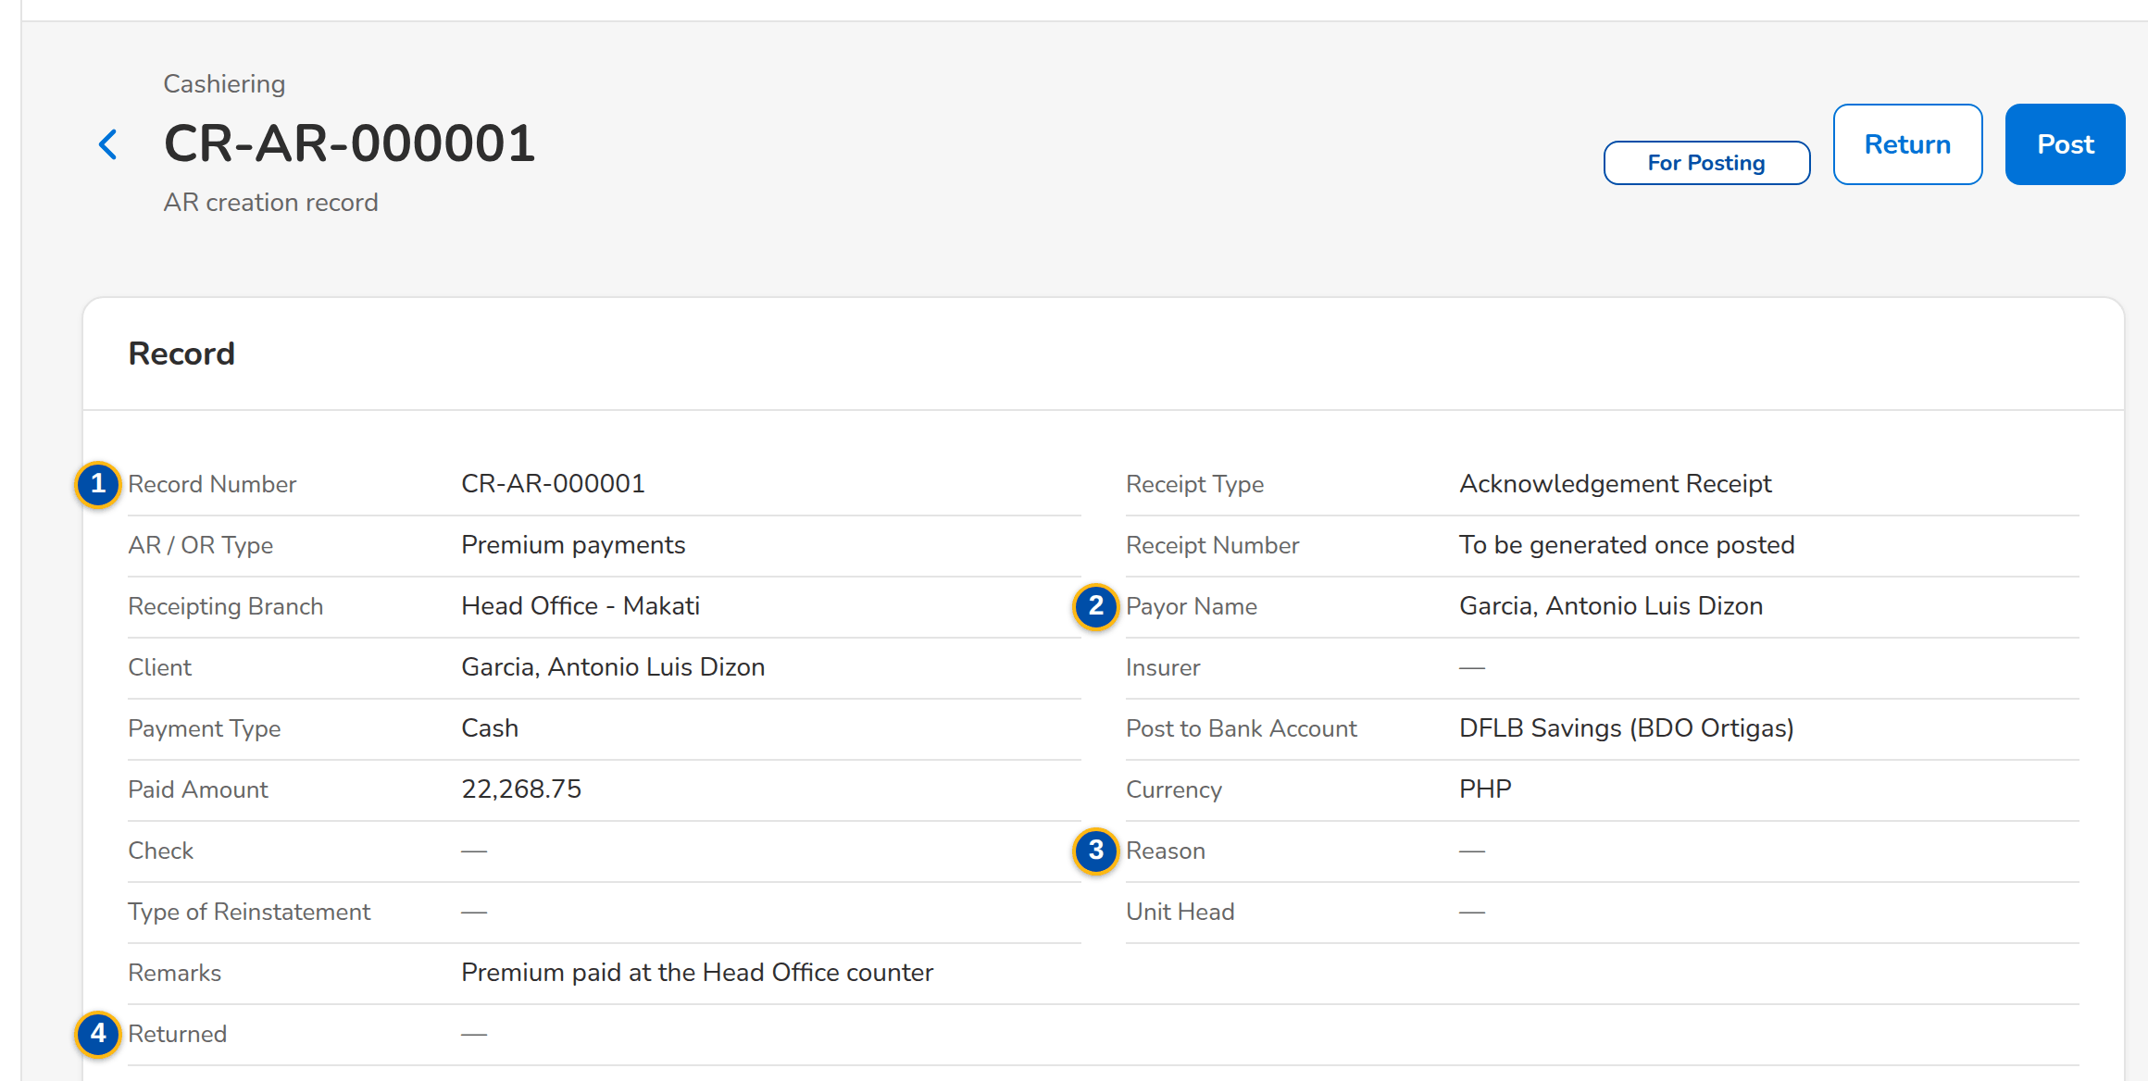
(continued below)
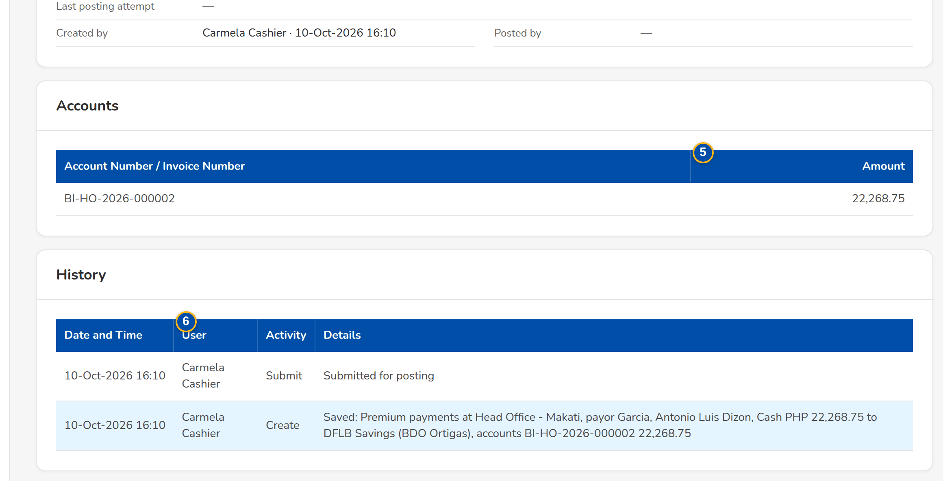
Screenshot E.3: AR creation record for posting, as the Approver/Poster sees it
Field | Type | Mandatory | Format / list / source | Validation and message
Record: Record Number / Receipt Type / AR / OR Type / Receipt Number / Receipting Branch | Values | - | CR-, CN- or RE- with AR or OR and a sequence; the receipt number once posted; Record | -
Record: Payor Name / Client / Insurer / Payment Type / Post to Bank Account / Paid Amount / Currency / Check | Values | - | As entered; the check as bank, number and date; Record | -
Record (cancellation, reinstatement): Reason / Type of Reinstatement / Unit Head / Remarks | Values | - | The reason of the list; Full or Partial Reinstatement; Record | -
Record: Returned / Last posting attempt / Created by / Posted by | Values | - | Reason and user of a return; result of the last posting; names with date and time; Record | -
Accounts: Account Number / Invoice Number / Amount | Columns | - | Accounts of the record; Record accounts | No account on the record
History: Date and Time / User / Activity / Details | Columns | - | Every action on the record; Record history | No activity yet
Return to Creator: Reason | Text area | Y | Why the record goes back | -

Action | Who | Available when | What happens | Resulting status
Edit | The creator | Created or Returned | Opens Edit Record | -
Submit for Posting | The creator | Created or Returned | Asks for confirmation (The record goes to the Approver/Poster for posting); toast Record is now submitted for Posting | For Posting
Cancel Record | The creator | Created or Returned | Record will be Cancelled. Do you wish to continue? | Record Cancelled
Post | Approver/Poster (posting right), not the creator | For Posting | Creation: AR/OR will be issued. Payments will be applied. Any excess payments will be reflected in the Unapplied List. Cancellation: AR/OR will be cancelled. Payments will be cancelled once cancellation is posted. Reinstatement: AR/OR will be reinstated. Payments will be reinstated once posted | AR/OR Issued, Cancelled or Reinstated
Return | Approver/Poster | For Posting | Returns the record to its creator with the reason | Returned

Rules:
- The creator never posts the own record.
- Posting issues the receipt number from the series of the branch in its number format and posts the accounting entries; a record that cannot be posted keeps its status with the reason in Last posting attempt.
- Checks are posted and applied before cash in one posting run as delivered (setting).
- The cancellation of an AR already remitted turns the payment into an AR Insurer Refund as delivered (setting).

E.4 Posting
Purpose: The lists of the records waiting for posting or returned, in three tabs - AR/OR for Issuance Posting, Cancellation (AR/OR) for Posting and Reinstatement (AR/OR) for Posting - with their filters, the posting of several records at once, the export to Excel and the creation of a new AR or OR.
Access: Cashiering Dashboard › Post - Issuance, Post - Cancellation, Post - Reinstatement
FR items: FRS.CSH.02.01.01, FRS.CSH.02.01.02, FRS.CSH.02.01.08, FRS.CSH.02.01.09, FRS.CSH.02.01.10, FRS.CSH.02.01.16, FRS.CSH.02.02.01, FRS.CSH.02.02.02, FRS.CSH.02.02.08, FRS.CSH.02.02.10, FRS.CSH.02.05.06, FRS.CSH.02.05.07, FRS.CSH.02.06.02, FRS.CSH.02.06.03, FRS.CSH.03.01.01, FRS.CSH.03.01.05 (2nd), FRS.CSH.03.01.06, FRS.CSH.03.01.08, FRS.CSH.03.01.11, FRS.CSH.04.01.01, FRS.CSH.04.01.06, FRS.CSH.04.01.07, FRS.CSH.04.01.09, FRS.CSH.04.01.12, FRS.CSH.10.04.01
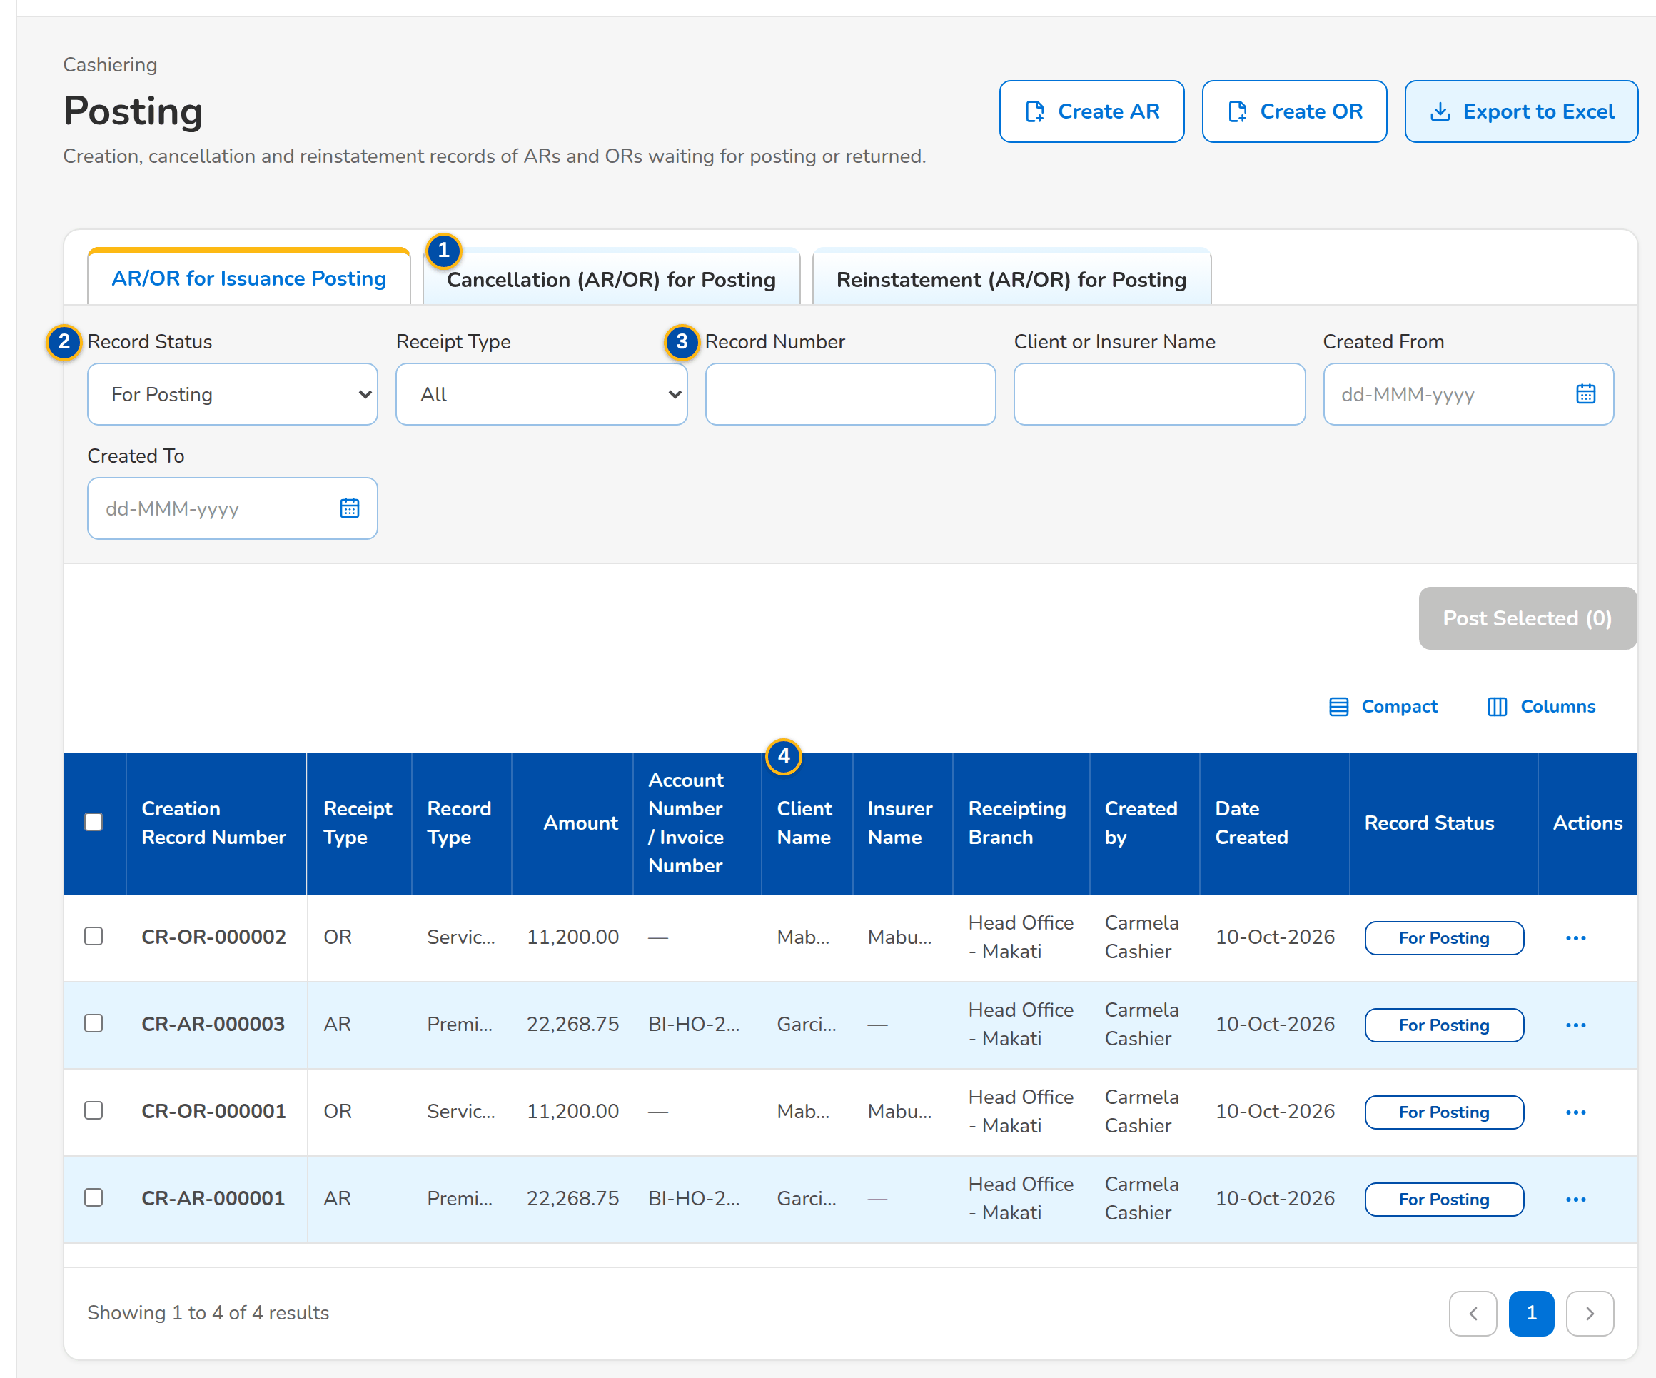
Screenshot E.4: Posting: AR/OR records for issuance posting
Field | Type | Mandatory | Format / list / source | Validation and message
Tabs: [Tabs: AR/OR for Issuance Posting, Cancellation (AR/OR) for Posting, Reinstatement (AR/OR) for Posting] | Tab | - | Fixed | -
Filters: Record Status / Receipt Type / Record Number / Client or Insurer Name / Created From / Created To | Drop-downs, text, dates | N | For Posting, Returned, Created, Posted, Record Cancelled; All, Acknowledgement Receipt, Official Receipt; Fixed lists | -
Records: Record Number / Receipt Type / Record Type / AR/OR Number / Amount | Columns | - | Creation, Cancellation or Reinstatement Record Number; AR or OR; the type; the receipt number; Records | No records match the filters
Records: Account Number / Invoice Number / Client Name / Insurer Name / Receipting Branch / Created by / Date Created / Record Status | Columns | - | As recorded; Records | -
Records not posted: [Outcome of a posting run] | Table | - | The records the run could not post, with the reason; Posting run | -

Action | Who | Available when | What happens | Resulting status
Post Selected (n) | Approver/Poster | Records For Posting selected | Posts the selected records, checks before cash; lists those not posted with the reason | AR/OR Issued, Cancelled or Reinstated
Open, Post, Return, Edit | As on the record | A row | From the row menu | -
Create AR / Create OR | Cashier | Always | Opens Create AR/OR | -
Export to Excel | Every user of the screen | Always | Downloads the list of the filters | -

Rules:
- A user posts only the records he did not create.

E.5 Receive Payment
Purpose: The over-the-counter payment of a walk-in payor: the references typed are matched on ARN, invoice, policy or PN number, the live preview shows how the money is applied component by component, and Issue AR and Apply issues the acknowledgement receipt, applies the payment and leaves any excess in unapplied collections. Shown when the posting step of ARs is off (setting of Appendix H.8); as delivered BDOI's posting step applies and the entry opens Create AR.
Access: Cashiering Workbench
FR items: FRS.CSH.02.01.01, FRS.CSH.02.01.02, FRS.CSH.02.01.03, FRS.CSH.02.01.08, FRS.CSH.02.01.10, FRS.CSH.02.01.15, FRS.CSH.02.01.16, FRS.CSH.02.05.06, FRS.CSH.02.05.10, FRS.CSH.02.05.11.01, FRS.CSH.02.05.13, FRS.CSH.02.06.03, FRS.CSH.05.01.08, FRS.CSH.05.01.12, FRS.CSH.05.02.02, FRS.CSH.05.03.01, FRS.CSH.10.04.02
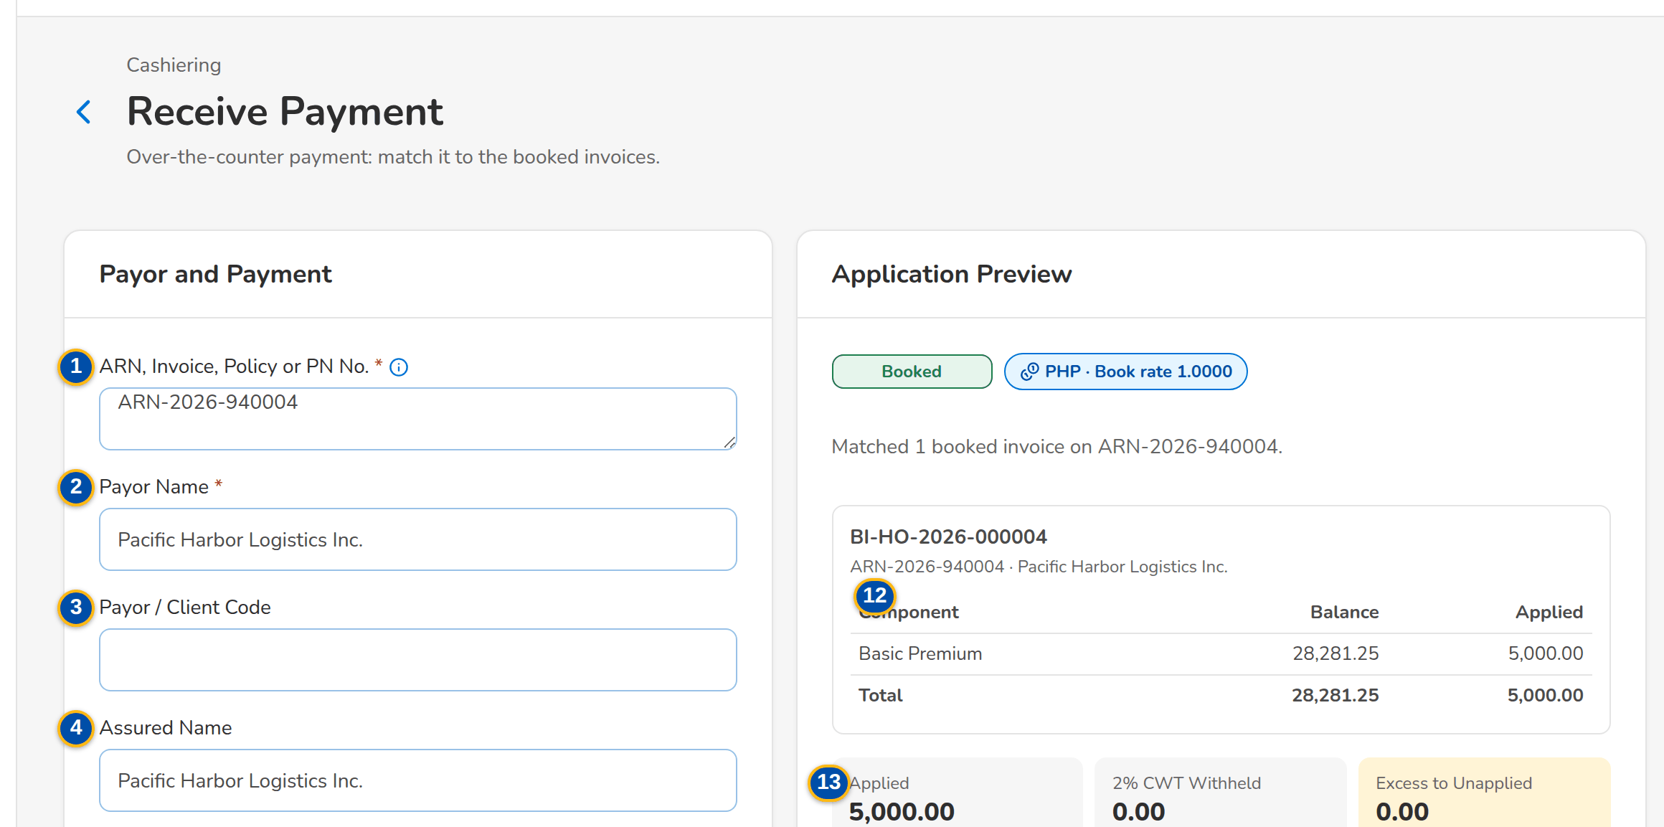
(continued below)
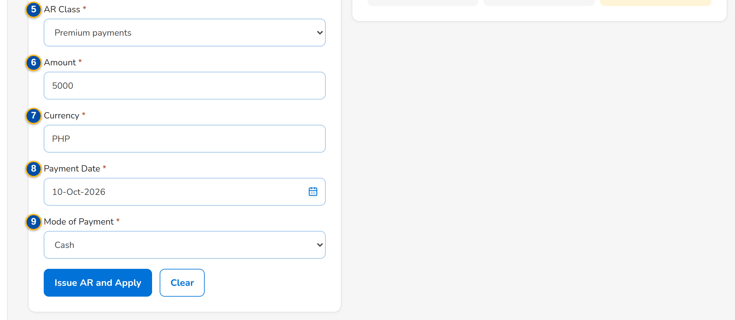
Screenshot E.5: Receive Payment with the application preview of an unpaid invoice
Field | Type | Mandatory | Format / list / source | Validation and message
Payor and Payment: ARN, Invoice, Policy or PN No. | Text area | Y | One or more references separated by commas or lines; applied oldest first; Invoice ledger, pre-booked accounts | At least one reference; Enter at least one reference, or the payor code for an unmatched payment
Payor and Payment: Payor Name | Text | Y | Up to 250 characters | Not blank; Payor name is required
Payor and Payment: Payor / Client Code | Text | N | Up to 30 characters; Clients (BRD-1) | -
Payor and Payment: Assured Name | Text | N | Up to 250 characters | -
Payor and Payment: AR Class | Drop-down | Y | Premium payments: Bills Payment, OTC, Trade, CLPC, PDC, Direct Credit; Non-premium payments (insurance payments): Refund, Other expenses, AR Insurance; List of values AR class | -
Payor and Payment: Amount | Number | Y | Two decimals | Above zero; Enter an amount above zero
Payor and Payment: Currency | Text | Y | 3 letters; Currencies | Converted at the BOOK rate of the day
Payor and Payment: Payment Date | Date | Y | dd-MMM-yyyy | -
Payor and Payment: Mode of Payment | Drop-down | Y | Cash, Check, Direct Credit, ADA, Credit to Account; Fixed list | -
Payor and Payment: Check No. / Bank | Text | Cond.: check number for a check | Up to 40 / 60 characters; shown for a check | Check number for a check payment; Check number is required for a check payment
Application Preview: [Match outcome and BOOK rate] | Status pill and chip | - | Booked, Pre-booked, Cancelled or No match; <currency> · BOOK <rate>; Payment matching | Enter an ARN, invoice, policy or PN number to preview the application.
Application Preview: Component / Balance / Applied | Column | - | One table per invoice: DST, VAT / Premium Tax, LGT, FST, Other Charges, Basic Premium with the total; Invoice ledger | Applied in this order
Application Preview: Applied / 2% CWT Withheld / Excess to Unapplied | Display | - | Amount; Computed | A 2% CWT client is applied up to 98% of the premium

Action | Who | Available when | What happens | Resulting status
Issue AR and Apply | Cashier | The form is complete | Issues the AR from the branch series, applies the payment by component and opens the receipt; an account not yet booked waits in the pre-booked queue, anything else goes to unapplied collections | AR issued
Clear | Cashier | Always | Empties the form | -

Rules:
- A payment is matched at acceptance on the ARN, invoice, policy or PN number: a booked invoice is applied at once, an account not yet booked waits in the pre-booked queue, a cancelled or unknown reference becomes an unapplied payment.
- Payments are applied in the order DST, VAT / premium tax, LGT, fire service tax, other charges, basic premium; the premium due to the insurer is never applied.
- The payment of a 2% CWT client is applied up to 98% of the premium; the 2% waits for the BIR 2307 and anything above it stays unapplied.
- The amount is converted at the BOOK rate of the currency and the AR takes the next number of the branch series.
- A non-premium payment of an insurer (refund, other expenses) is received as AR Insurance, apart from premium.

E.6 Receipts
Purpose: The search over acknowledgement receipts and Head Office official receipts with ten criteria, the open cancellation and reinstatement requests for approval, and the issue of an official receipt for BDOI income (service fee, profit share, commission, incentive, others).
Access: Cashiering Workbench › Cancellations and Reinstatements for Approval tile
FR items: FRS.CSH.02.01.09, FRS.CSH.02.01.14, FRS.CSH.02.02.01, FRS.CSH.02.02.02, FRS.CSH.02.02.08, FRS.CSH.02.02.10, FRS.CSH.02.04.16, FRS.CSH.02.05.07, FRS.CSH.02.06.02, FRS.CSH.03.01.01, FRS.CSH.03.01.05 (2nd), FRS.CSH.03.01.06, FRS.CSH.03.01.08, FRS.CSH.03.01.11, FRS.CSH.04.01.01, FRS.CSH.04.01.06, FRS.CSH.04.01.07, FRS.CSH.04.01.09, FRS.CSH.04.01.12, FRS.CSH.08.01.01, FRS.CSH.08.01.04, FRS.CSH.08.03.01, FRS.CSH.10.04.01
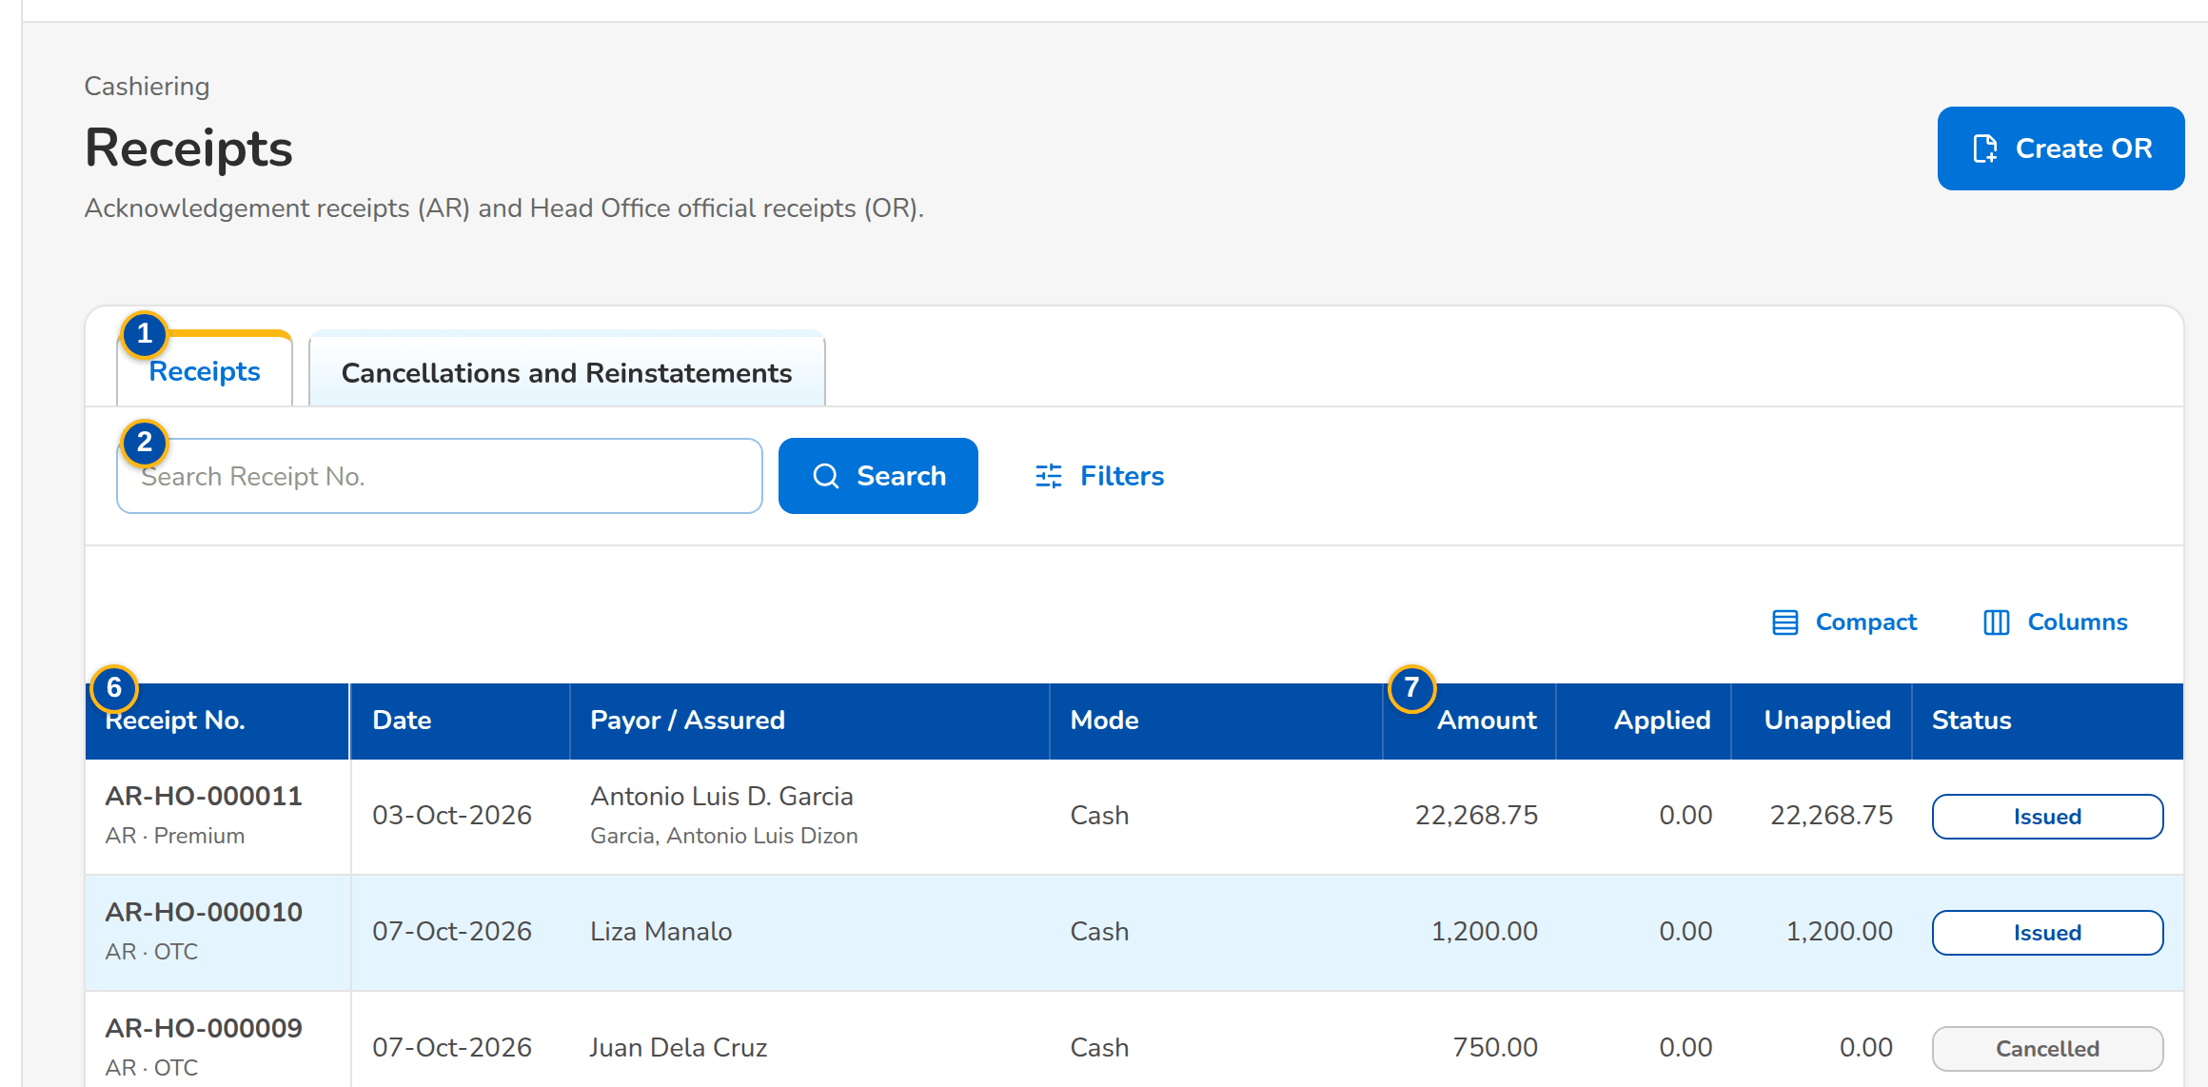
(continued below)
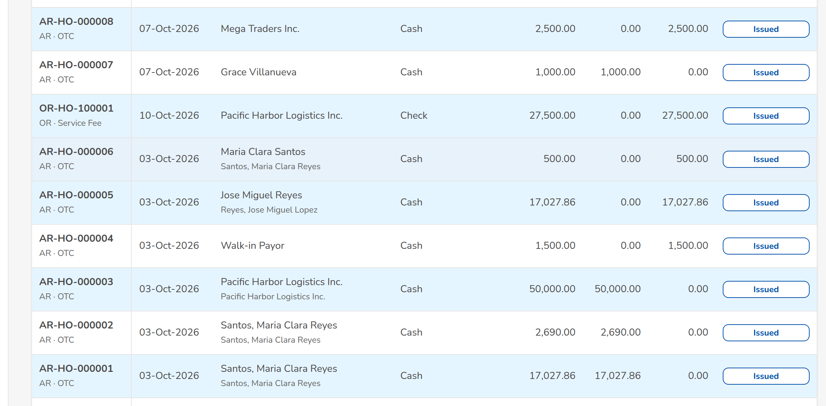
(continued below)
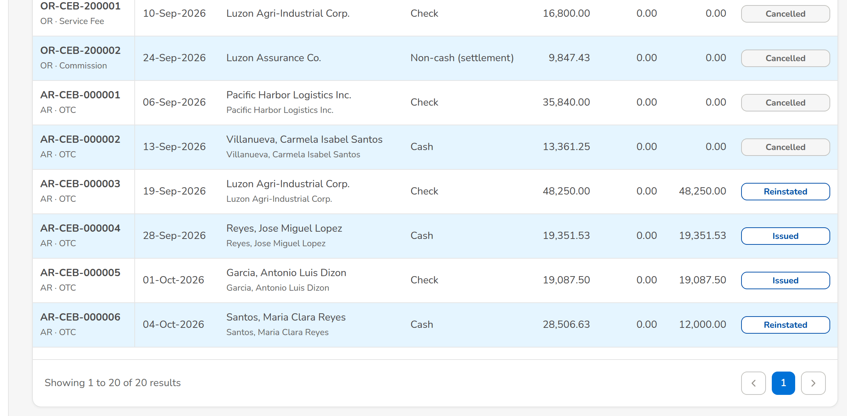
Screenshot E.6: Receipts: acknowledgement and official receipts
Field | Type | Mandatory | Format / list / source | Validation and message
Tabs: Receipts / Cancellations and Reinstatements | Tab | - | Fixed | -
Toolbar: Search Receipt No. | Text | N | Receipt number; Receipts | -
Filters: Client Code / Invoice No. / Policy No. / Payor Name / Assured Name / Insurer | Text, drop-down | N | Insurers by name | Contains
Filters: Amount / Date From / Date To | Number, Date | N | dd-MMM-yyyy | -
Filters: Kind / Status | Drop-down | N | All, AR, OR / All, Issued, Cancelled, Reinstated; Fixed list | -
List: Receipt No. / Date / Payor / Assured / Mode / Amount / Applied / Unapplied / Status | Column | - | Receipt number with its kind and class; payor with the assured or payor code; Receipts | No receipts match the search
Cancellations and Reinstatements: Transaction No. / Reason / Amount / Requested / Status | Column | - | CAN-yyyy-n or RIN-yyyy-n with the action; requester name and time; Receipt actions | -
Issue Official Receipt dialog: OR Type | Drop-down | Y | Service fee, profit share, commission, incentive, others; List of values OR type | Select the OR type
Issue Official Receipt dialog: Payor Name / Payor Code | Text | Y / N | Up to 250 / 30 characters | Payor name not blank; Payor name is required
Issue Official Receipt dialog: Currency / Mode of Payment / Check No. | Text, Drop-down | Y / N / N | Cash, Check, Direct Credit, Credit to Account, Non Cash | -
Issue Official Receipt dialog: Gross Amount / VAT / Withholding Tax | Number | Y / N / N | Two decimals | Gross above zero; VAT and withholding tax not negative; Enter the gross amount / VAT and withholding tax cannot be negative
Issue Official Receipt dialog: 2307 Certificate Ref. / Description | Text | N | Up to 60 / 250 characters | -

Action | Who | Available when | What happens | Resulting status
Create OR | Cashier (Head Office) | The posting step of ORs is on (as delivered) | Opens Create OR; the OR number is issued when the record is posted | Created
Issue Official Receipt / Issue OR | Cashier (Head Office) | The posting step of ORs is off | Issues the OR from the Head Office series with its VAT and withholding tax lines and opens it | OR issued
Search / Filters | Every Cashiering user | Always | Filters the receipts | -
Open Receipt | Every Cashiering user | Always | Opens the receipt of the request | -
Approve | Cashiering Team Leader | Request for approval | Asks for confirmation and applies the cancellation or reinstatement to the receipt with its postings | Posted
Resubmit | Cashier who requested it | Request returned to Requested | Sends the request for approval again | For approval

Rules:
- An OR is issued only from a Head Office series; an AR from the series of the receiving branch.
- The receipt search has ten criteria and every search is logged.
- A cancellation or reinstatement is approved by a Cashiering Team Leader other than its requester.

E.7 Receipt
Purpose: One AR or OR: payor, number, status and flags, the amounts applied and unapplied with the BOOK rate, the workflow of an open cancellation or reinstatement, and the tabs Applications, Lines, Journal and History. Print produces the receipt PDF; Cancel Receipt and Reinstate go to the Cashiering Team Leader.
Access: Receipts › open a row; Receive Payment (after Issue AR and Apply); Unapplied Payment › Open Receipt
FR items: FRS.CSH.02.01.01, FRS.CSH.02.01.02, FRS.CSH.02.01.08, FRS.CSH.02.01.09, FRS.CSH.02.01.10, FRS.CSH.02.01.14, FRS.CSH.02.01.16, FRS.CSH.02.02.01, FRS.CSH.02.02.02, FRS.CSH.02.02.08, FRS.CSH.02.02.10, FRS.CSH.02.04.02, FRS.CSH.02.04.05, FRS.CSH.02.04.07, FRS.CSH.02.04.12, FRS.CSH.02.04.16, FRS.CSH.02.04.17, FRS.CSH.02.05.06, FRS.CSH.02.05.07, FRS.CSH.02.05.14, FRS.CSH.02.05.15, FRS.CSH.02.06.01, FRS.CSH.02.06.02, FRS.CSH.02.06.03, FRS.CSH.03.01.01, FRS.CSH.03.01.05 (2nd), FRS.CSH.03.01.06, FRS.CSH.03.01.08, FRS.CSH.03.01.09, FRS.CSH.03.01.11, FRS.CSH.04.01.01, FRS.CSH.04.01.06, FRS.CSH.04.01.07, FRS.CSH.04.01.09, FRS.CSH.04.01.10, FRS.CSH.04.01.12, FRS.CSH.05.01.10, FRS.CSH.08.01.01, FRS.CSH.08.01.04, FRS.CSH.08.03.01, FRS.CSH.10.04.01
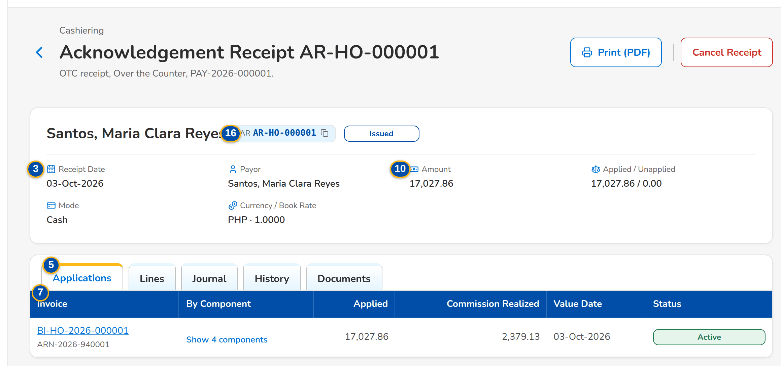
Screenshot E.7: Receipt with its applications by component
Field | Type | Mandatory | Format / list / source | Validation and message
Header: [Receipt No. chip and status pill] | Reference chip, status pill | - | AR or OR number; Issued, Cancelled, Reinstated; Receipts | -
Header: [Flags] | Tag | - | With Unapplied, Printed <n>x, Reinstated; Receipts | -
Header: Receipt Date / Payor / Amount / Applied / Unapplied / Mode / Currency / BOOK Rate | Display | - | Amounts with two decimals; mode with the check number; Receipts | -
Workflow: [Receipt action workflow header] | Stepper | - | Requested, For approval, Posted with the history table; Receipt action | -
Tabs: Applications / Lines / Journal / History / Documents | Tab | - | Fixed | -
Documents: Document / Printed By / Printed | Column | - | Every print of the receipt (client's and company copy, re-prints) with its PDF; Print lines | -
Applications: Invoice / Reference / By Component / Applied / Commission Realized / Value Date / Status | Column | - | Invoice with its ARN; the amount by component; Applications | Nothing applied from this receipt
Lines: Invoice / Item / Insurer / Gross / VAT / WTAX / Net | Column | - | OR lines; Receipt lines | -
Journal: Journal Batch / Posting | Column | - | Receipt, each application and each action; Journals (BRD-5) | No journal posted yet
History: Transaction No. / Action / Reason / Amount / Requested / Approved / Status | Column | - | Names and times; Receipt actions | No cancellation or reinstatement
Cancel Receipt dialog: Reason | Drop-down | Y | List of values receipt cancellation reason | Select a reason
Cancel Receipt dialog: Comment | Text area | Cond. | Mandatory for the reason Others | -
Reinstate dialog: Full / Partial | Radio | Y | Full = the receipt amount | -
Reinstate dialog: Reason Group / Reason | Drop-down | Y | Premium or Direct Payment; the reasons of the group; List of values reinstatement reason | Select a reason
Reinstate dialog: Amount to Reinstate | Number | Cond.: partial | Above zero, at most the receipt amount | Within the receipt amount; Enter an amount above zero and at most <amount>
Reinstate dialog: Invoice No. / AR / OR No. / Assured / Payor / Account Officer / Unit Head / Team Leader / Remarks | Text | Y (Remarks N) | Up to 250 characters; the Account Officer, Unit Head and Team Leader for the premium group | Not blank; <field> is required

Action | Who | Available when | What happens | Resulting status
Print (PDF) | Every Cashiering user | Always | Downloads the receipt PDF; the print count is kept | -
Cancel Receipt | Cashier | Issued and no request open | Asks for the reason and submits the cancellation for approval | Cancellation for approval
Reinstate | Cashier | Cancelled and no request open | Opens the reinstatement dialog and submits it for approval | Reinstatement for approval
Approve and Post | Cashiering Team Leader other than the requester | Request for approval | Posts the cancellation (reverses every application and the receipt) or the reinstatement (restores the receipt and applies the amount) | Posted
Return to Requester | Cashiering Team Leader | Request for approval | Asks for the reason and returns the request | Requested

Rules:
- A cancellation reverses every active application, reverses the receipt entry and closes the unapplied balance of the receipt.
- A reinstatement restores the receipt for the full or partial amount, applies it to the invoice encoded and leaves the rest unapplied; a bounced check needs no encoded fields.
- The requester never approves the own request.
- As delivered (posting step on, Appendix H.8) Cancel Receipt and Reinstate create a cancellation or reinstatement record, CN- or RE- numbered, that the Approver/Poster posts or returns on Posting.
- Every action on a receipt records the receipt number, the user and the time in the audit trail.

E.8 Unapplied Payments
Purpose: Payments not applied to an invoice (no match, excess, cancelled reference, adjustment, cancellation, remittance return, re-application, pre-booked and others) by stage: the cashier assigns a disposition, submits it and a second user approves it; selected items are submitted or approved in one action.
Access: Cashiering Workbench › Unapplied Payments and Dispositions for Approval tiles
FR items: FRS.CSH.01.03.04, FRS.CSH.02.05.10, FRS.CSH.06.01.01, FRS.CSH.06.01.03, FRS.CSH.06.01.07, FRS.CSH.06.02.01, FRS.CSH.06.02.02, FRS.CSH.06.03.01, FRS.CSH.06.03.02, FRS.CSH.10.04.01
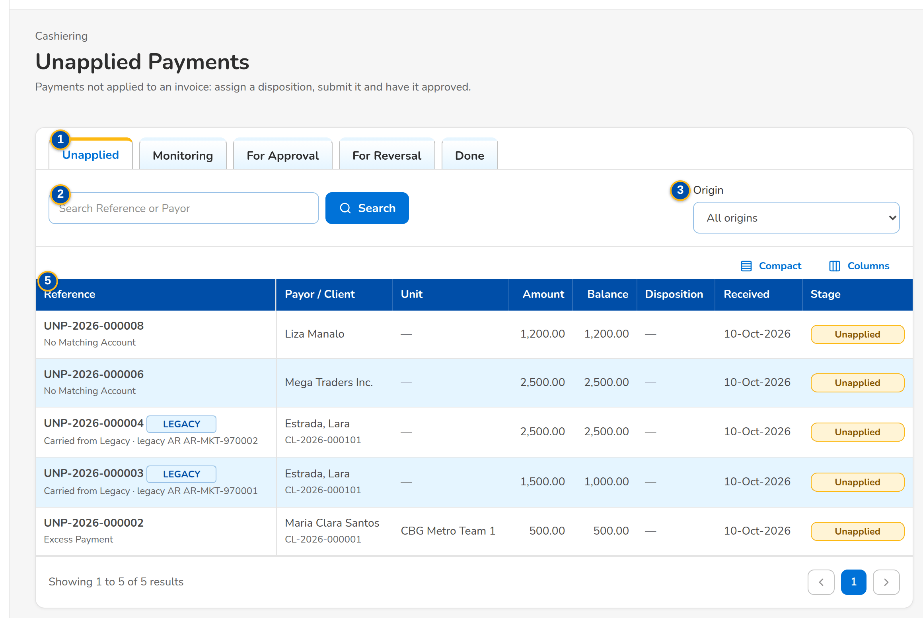
Screenshot E.8: Unapplied Payments, Unapplied tab
Field | Type | Mandatory | Format / list / source | Validation and message
Tabs: Unapplied / Monitoring / For Approval / For Reversal / Done | Tab | - | Fixed | -
Toolbar: Search Reference or Payor | Text | N | - | Contains
Toolbar: Origin | Drop-down | N | All origins, the system, Migrated; Fixed list | -
List: Select | Check box | N | On Monitoring and For Approval | -
List: Reference / Payor / Client / Unit / Amount / Balance / Disposition / Received / Stage | Column | - | UNP-yyyy-n with why it is unapplied; the unit by name; the disposition in words with its amount; Unapplied payments | No items to display
Bulk Action Results dialog: [Outcome per item] | Table | - | Done, or the message of the item | -

Action | Who | Available when | What happens | Resulting status
Submit Selected | Cashier | Monitoring, rows selected | Submits the disposition of each selected item on its own and lists the outcome of each | For approval
Approve Selected | Cashiering Team Leader | For Approval, rows selected | Approves each selected disposition on its own (never one's own) and lists the outcome of each | In process or Completed
Open a row | Every Cashiering user | Always | Opens the unapplied payment | -

Rules:
- Every unapplied balance keeps its origin until it is disposed of.
- Bulk submit and approve process each item on its own, so one failure does not stop the others.
- The approver is never the requester of the disposition.

E.9 Unapplied Payment
Purpose: One unapplied payment with its amount and balance, payor, client and unit and its source, the disposition workflow, the disposition form (apply to an invoice, apply to its DST, refund, reclass to another client, transfer to another unit, others) and the disposition history.
Access: Unapplied Payments › open a row
FR items: FRS.CSH.01.03.04, FRS.CSH.02.05.10, FRS.CSH.02.05.12, FRS.CSH.06.01.01, FRS.CSH.06.01.03, FRS.CSH.06.01.07, FRS.CSH.06.01.08, FRS.CSH.06.02.01, FRS.CSH.06.02.02, FRS.CSH.06.03.01, FRS.CSH.06.03.02, FRS.CSH.10.01.01, FRS.CSH.10.04.01
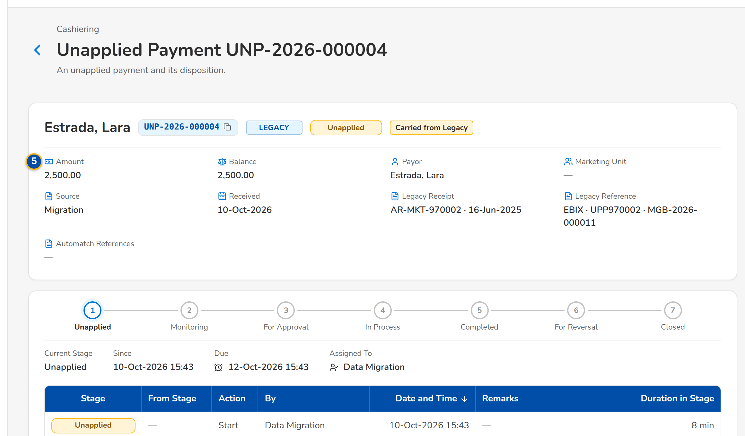
(continued below)
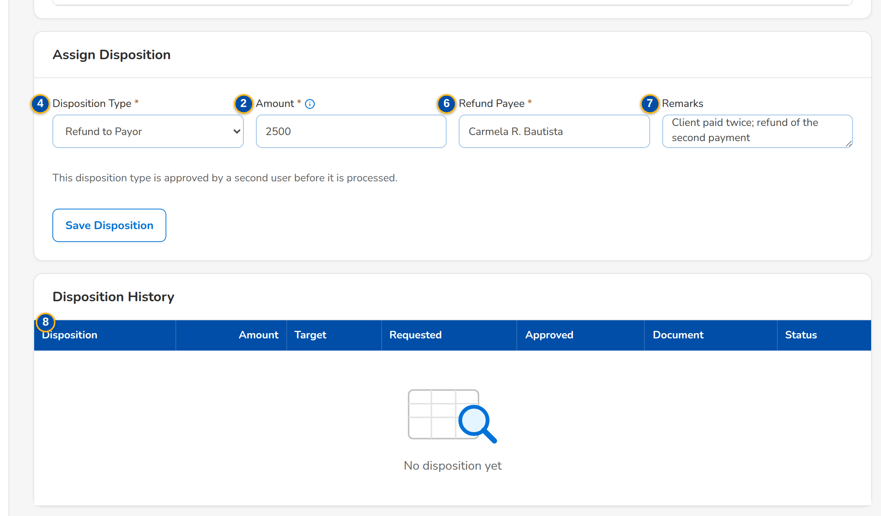
Screenshot E.9: Unapplied payment with the disposition form filled for a refund
Field | Type | Mandatory | Format / list / source | Validation and message
Header: [Reference chip, origin tag and stage pill] | Reference chip, tag, status pill | - | UNP-yyyy-n; No Match, Excess, Cancelled Reference and the other origins; Unapplied payments | -
Header: Amount / Balance / Payor / Marketing Unit / Source / Received | Display | - | Amounts with two decimals; the unit by name; the source by its module and document number; Unapplied payments | -
Workflow: [Disposition workflow header] | Stepper | - | Unapplied, Monitoring, For approval, In process, Completed; For reversal and Closed when reached; Disposition | -
Assign Disposition: Disposition Type | Drop-down | Y | The disposition types with their description; Disposition types | Select the disposition type
Assign Disposition: Amount | Number | Y | Above zero, at most the balance; a reclass or transfer moves the whole balance | Within the balance; Enter an amount above zero and at most <balance> / A reclass or transfer moves the whole balance
Assign Disposition: Apply to Invoice No. / Reclass to Client Code / Transfer to Marketing Unit / Refund Payee | Text | Cond. | Shown for the type: apply, reclass, transfer, refund; Invoice ledger, clients, sales organisation | Required for this disposition type; Required for this disposition type
Assign Disposition: Remarks | Text area | N | Up to 250 characters | -
Disposition History: Disposition / Amount / Target / Requested / Approved / Document / Status | Column | - | Payment request or journal in Document; Dispositions | No disposition yet
Mark for Reversal dialog: Reason / Comment | Drop-down, text area | Y / N | List of values return reason | -

Action | Who | Available when | What happens | Resulting status
Save Disposition | Cashier | Unapplied or Monitoring | Assigns or updates the disposition | Monitoring
Submit for Approval | Cashier | Monitoring, the type needs approval | Sends the disposition to a second user | For approval
Process Disposition | Cashier | Monitoring, the type needs no approval | Processes the disposition at once | In process or Completed
Approve | Cashiering Team Leader other than the requester | For approval | Approves and processes it: an application posts at once, a refund is sent to the Disbursement queue, a reclass or transfer moves the balance | In process or Completed
Return to Cashier | Cashiering Team Leader | For approval | Returns the disposition with a reason | Monitoring
Withdraw Disposition | Cashier | For approval | Takes the disposition back | Monitoring
Mark for Reversal / Approve Reversal | Cashier / Cashiering Team Leader | Completed / For reversal | Reverses a completed disposition on approval; a refund only after Disbursement returned it | For reversal / Unapplied
Open Receipt | Every Cashiering user | The item came from a receipt | Opens the receipt | -

Rules:
- The disposition type decides the fields to fill and whether a second user approves it.
- A refund goes to the Disbursement queue and is completed when Disbursement pays it.
- A balance left after a partial disposition returns to the Unapplied tab.
- Minimal excess amounts within the threshold (default PHP 10.00) never reach this list: they are moved to AP overages when the payment is processed.

E.10 Unapplied Payment List
Purpose: The unapplied payments with an outstanding amount, by type, payment date, insurer, client and account, as BDOI's FRS lists them for inquiry.
Access: Cashiering › Unapplied Payment List
FR items: FRS.CSH.01.03.04, FRS.CSH.02.05.10, FRS.CSH.06.01.01, FRS.CSH.06.01.03, FRS.CSH.06.01.07, FRS.CSH.06.02.01, FRS.CSH.06.02.02, FRS.CSH.06.03.01, FRS.CSH.06.03.02, FRS.CSH.10.04.01
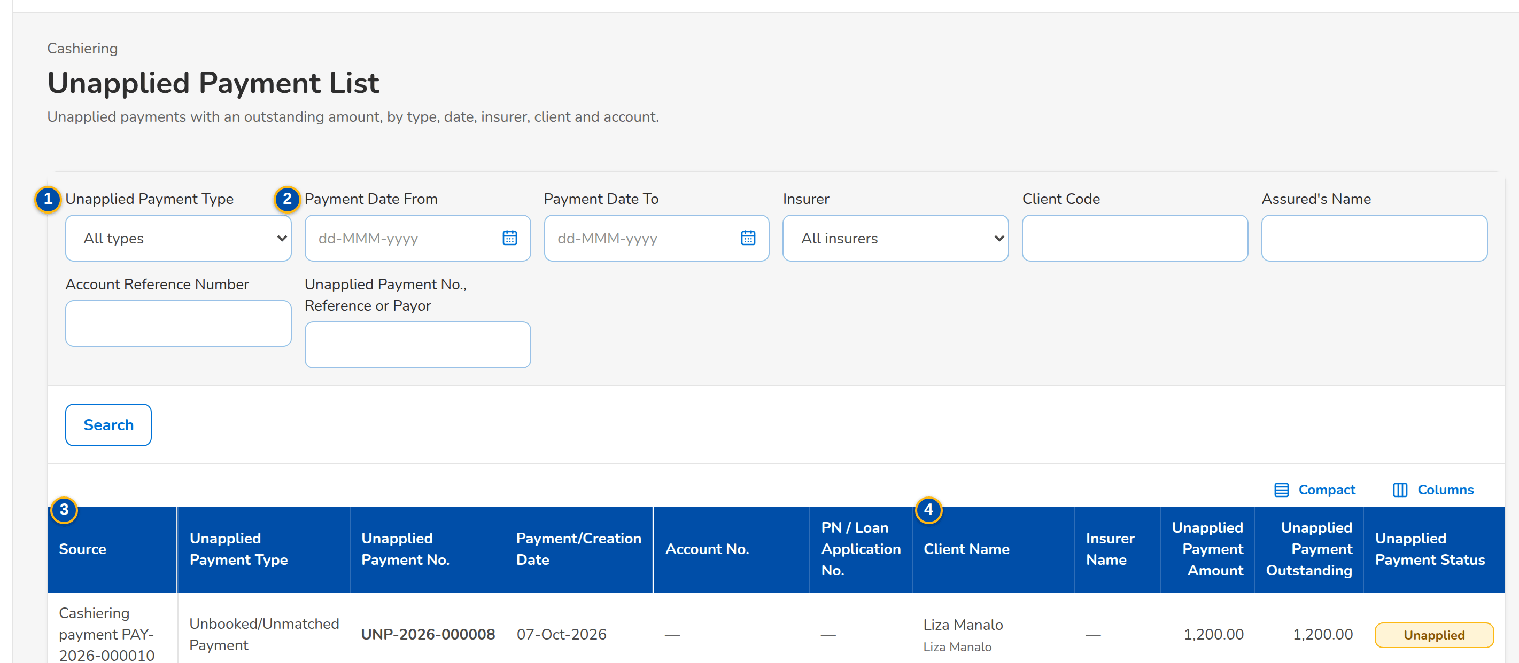
(continued below)
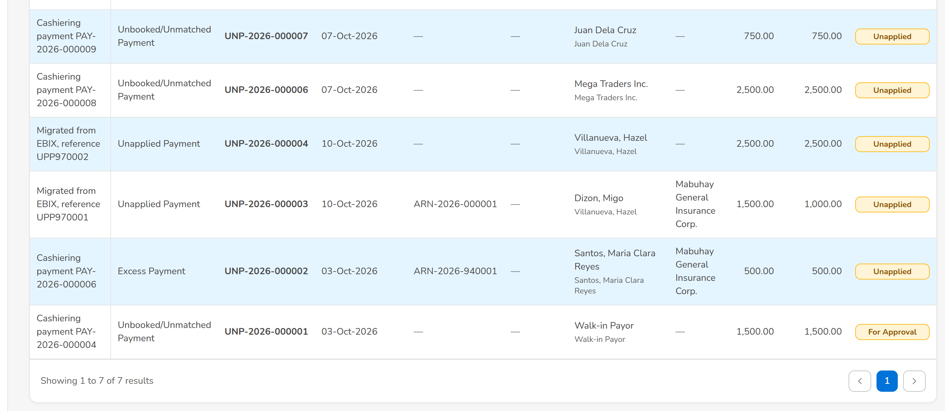
Screenshot E.10: Unapplied Payment List
Field | Type | Mandatory | Format / list / source | Validation and message
Filters: Unapplied Payment Type | Drop-down | N | Excess Payment, Unapplied Payment, AR Insurer Refund, Unbooked/Unmatched Payment, Pre-booked Payment, AP Unapplied Commission; Fixed list | -
Filters: Payment Date From / Payment Date To / Insurer / Client Code / Assured's Name / Account Reference Number / Unapplied Payment No., Reference or Payor | Dates, drop-down, text | N | dd-MMM-yyyy; insurers by name | -
List: Source / Unapplied Payment Type / Unapplied Payment No. / Payment/Creation Date / Account No. / PN / Loan Application No. | Columns | - | Origin of the payment; UNP-yyyy-nnnnnn; dd-MMM-yyyy; Unapplied payments | -
List: Client Name / Insurer Name / Unapplied Payment Amount / Unapplied Payment Outstanding / Unapplied Payment Status | Columns | - | Names; amounts; Unapplied, Monitoring, For Approval, For Reversal, Done; Unapplied payments | -

Action | Who | Available when | What happens | Resulting status
Search | Every Cashiering user | Always | Lists the unapplied payments of the filters | -

Rules:
- A Marketing user sees the unapplied payments of his or her marketing unit as delivered (setting Unapplied payments seen by Marketing, Appendix H.8).

E.11 Incoming Requests
Purpose: What the other modules ask of Cashiering: collector requests on unapplied payments from Collections (apply, refund, reclass, transfer), refund validations from Payment Requests and payment reversals from ACSL, each queue with its open and decided items.
Access: Cashiering Workbench
FR items: FRS.CSH.01.03.04, FRS.CSH.02.05.10, FRS.CSH.06.01.01, FRS.CSH.06.01.03, FRS.CSH.06.01.07, FRS.CSH.06.02.01, FRS.CSH.06.02.02, FRS.CSH.06.03.01, FRS.CSH.06.03.02, FRS.CSH.10.01.01, FRS.CSH.10.04.01
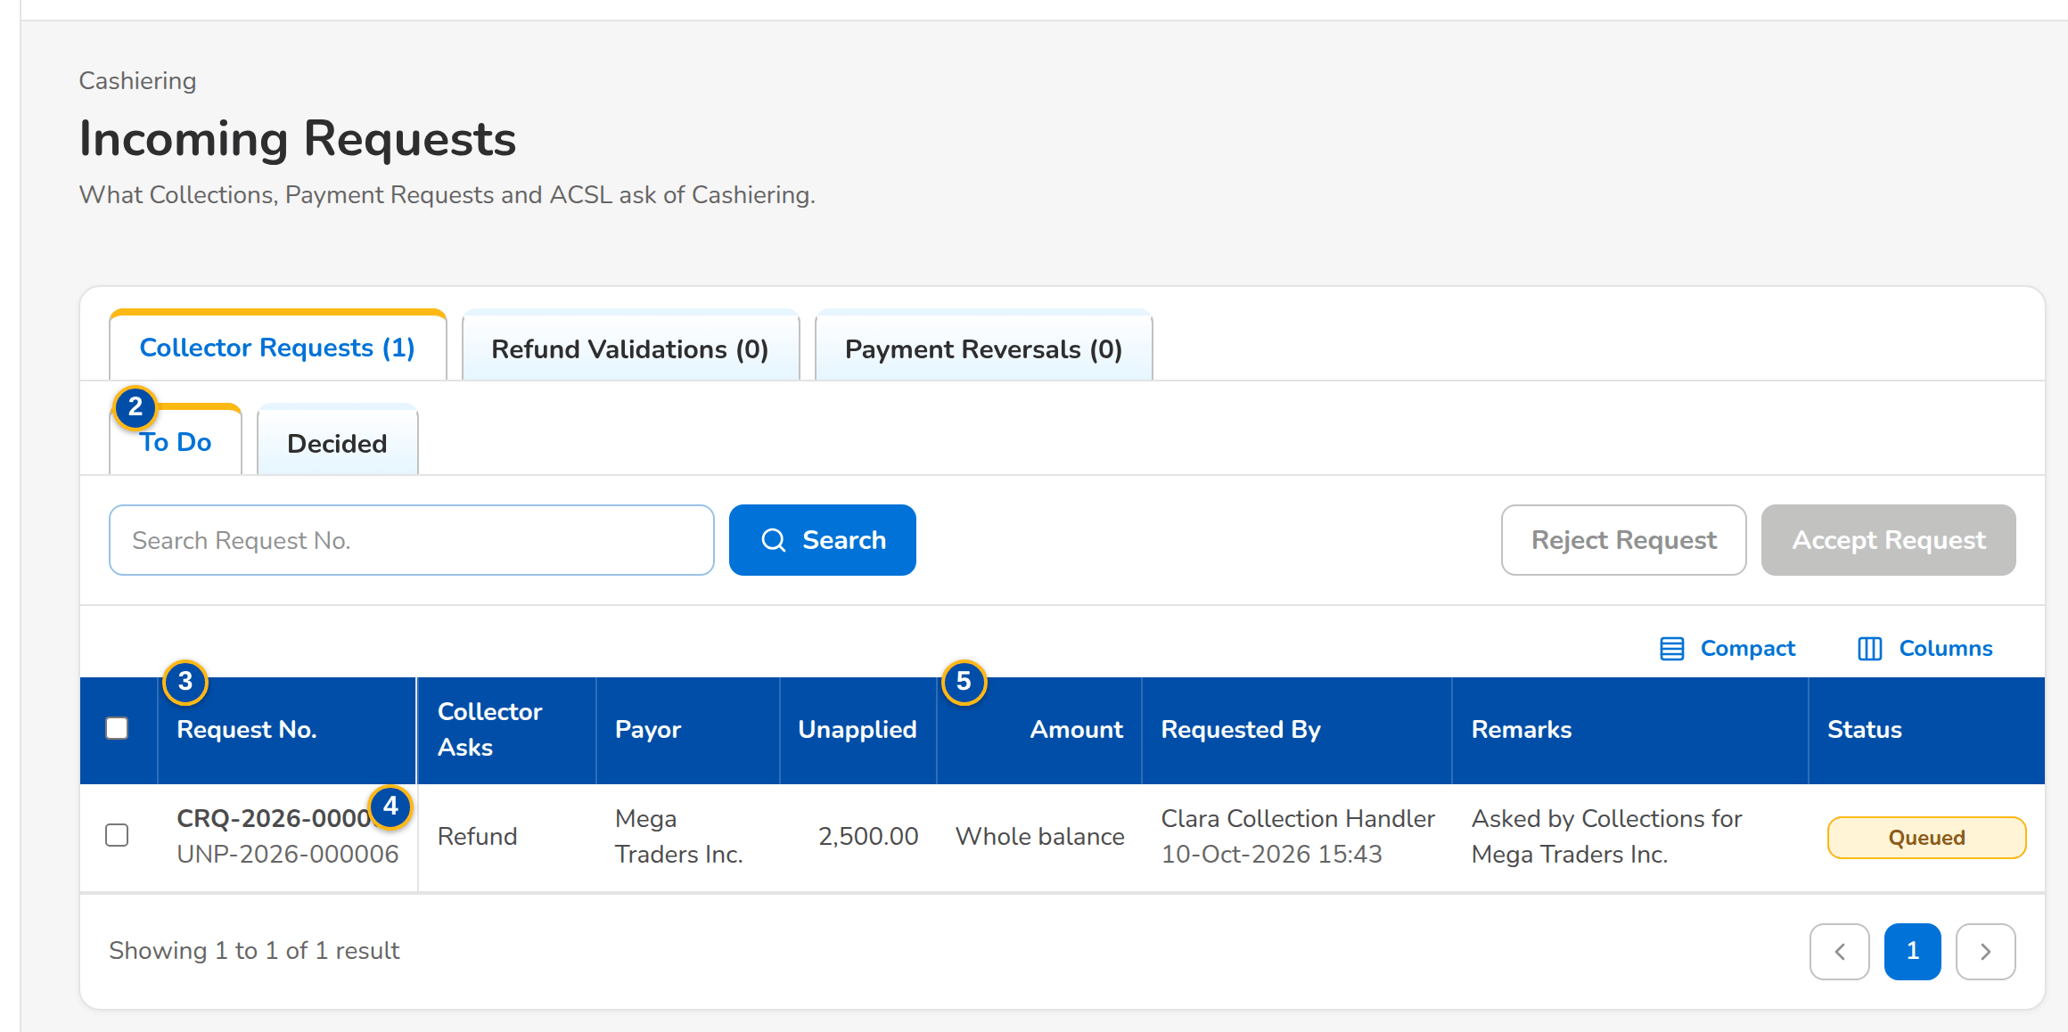
Screenshot E.11: Incoming Requests: Collector Requests, To Do
Field | Type | Mandatory | Format / list / source | Validation and message
Tabs: Collector Requests / Refund Validations / Payment Reversals | Tab | - | With the number of open items; Fixed | -
Tabs: To Do / Decided | Tab | - | Fixed | -
Collector Requests: Request No. / Collector Asks / Payor / Unapplied / Amount / Requested By / Remarks / Status | Column | - | CRQ-yyyy-n with the unapplied reference; Whole balance when no amount; Collections (BRD-4) | -
Refund Validations: Validation No. / Cancelled Invoice / AR of the Payment / Refund / Requested By / New AR / Remarks / Status | Column | - | Payment Requests (BRD-5) | -
Payment Reversals: Reversal No. / Invoice No. / Receipt / Amount / Value Date / Reason / Requested By / Status | Column | - | Whole application when no amount; ACSL (BRD-5) | -
Accept Request dialog: Disposition Type / Amount / Client to Reclass To / Marketing Unit / Refund Payee / Remarks | Drop-down, number, text | Cond. | Amount above zero and at most the unapplied balance; Disposition types | Enter the client to reclass to / Enter the marketing unit to transfer to / Enter an amount above zero and at most the unapplied balance
Accept Request dialog: Submit the disposition now (an application is processed at once) | Check box | N | - | -
Confirm Validation dialog: Unapplied Item / New AR No. / Remarks | Drop-down, text | Y / N / N | The unapplied item holding the returned premium; Unapplied payments | Choose the unapplied item that holds the returned premium
Reject dialog: Reason | Text | Y | - | Not blank; Enter the reason

Action | Who | Available when | What happens | Resulting status
Accept Request | Cashier | Collector request queued, row selected | Creates the disposition of the unapplied item and, when ticked, submits it | Accepted
Reject Request | Cashier | Collector request queued | Rejects the request with a reason | Rejected
Confirm Validation / Reject Validation | Cashier | Refund validation open | Confirms that the premium is back in the unapplied list (with its new AR) or rejects it | Confirmed / Rejected
Approve Reversal / Reject Reversal | Cashiering Team Leader | Payment reversal open | Asks for confirmation and reverses the application as requested, or rejects it with a reason | Approved / Rejected

Rules:
- Collections asks Cashiering to dispose of an unapplied payment; Cashiering decides and the collector sees the outcome.
- A refund validation confirms that the premium of a cancelled invoice is back in the unapplied list before Payment Requests refunds it.

E.12 Pre-booked Payments
Purpose: Payments received for accounts not yet booked: they wait with their age and re-match attempts and are applied automatically once the account is booked; an ageing item can be re-matched now or released to the unapplied payments.
Access: Cashiering Workbench › Pre-booked Payments tile
FR items: FRS.CSH.02.01.02, FRS.CSH.02.01.03, FRS.CSH.02.05.10, FRS.CSH.02.05.13, FRS.CSH.05.01.08, FRS.CSH.05.02.02, FRS.CSH.05.03.01, FRS.CSH.05.04.01, FRS.CSH.10.04.02
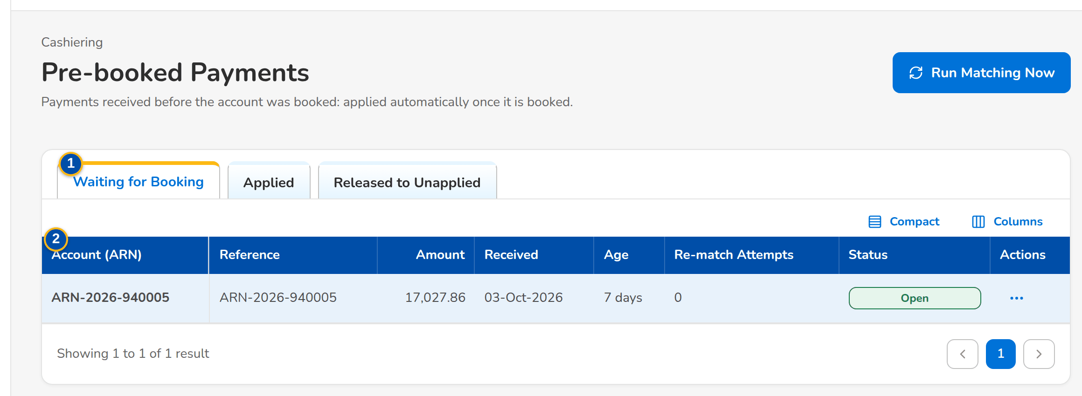
Screenshot E.12: Pre-booked Payments waiting for booking
Field | Type | Mandatory | Format / list / source | Validation and message
Tabs: Waiting for Booking / Applied / Released to Unapplied | Tab | - | Fixed | -
List: Account (ARN) / Reference / Amount / Received / Age / Re-match Attempts / Receipt / Status | Column | - | Age in days, amber after 7 and red after 30 days; Open AR opens the receipt; Pre-booked payments | No items to display
Release dialog: Comment | Text area | N | - | -

Action | Who | Available when | What happens | Resulting status
Run Matching Now | Cashier with the application permission | Always | Matches every waiting payment and unapplied item again and applies those whose invoice is now booked | Applied
Open Receipt | Every Cashiering user | Always | Opens the AR of the payment | -
Re-match Now | Cashier with the application permission | Waiting for booking | Matches the payment again | Applied or unchanged
Release to Unapplied | Cashier with the application permission | Waiting for booking | Moves the payment to the unapplied payments | Released

Rules:
- A payment for an account not yet booked waits in the queue and opens the New Business payment gate.
- It is applied when the invoice is booked, or by the scheduled re-match every two hours; an ageing item raises an alert.

E.13 Payment Uploads
Purpose: The payment files of the banks and channels (Bills Payment, Trade, CLPC, Direct Credit) and the file of post-dated checks, each in its template: every row is validated first, the valid rows become payments with their AR and are matched at once, and the run summary counts applied, unapplied, pre-booked, excess and failed rows.
Access: Cashiering Workbench
FR items: FRS.CSH.02.02.04, FRS.CSH.02.04.02, FRS.CSH.05.01.01, FRS.CSH.05.01.04, FRS.CSH.05.01.05, FRS.CSH.05.01.06, FRS.CSH.05.01.10, FRS.CSH.05.01.12, FRS.CSH.05.01.13, FRS.CSH.05.02.01, FRS.CSH.05.02.02, FRS.CSH.05.02.03, FRS.CSH.09.02.19, FRS.CSH.09.02.23, FRS.CSH.10.03.01
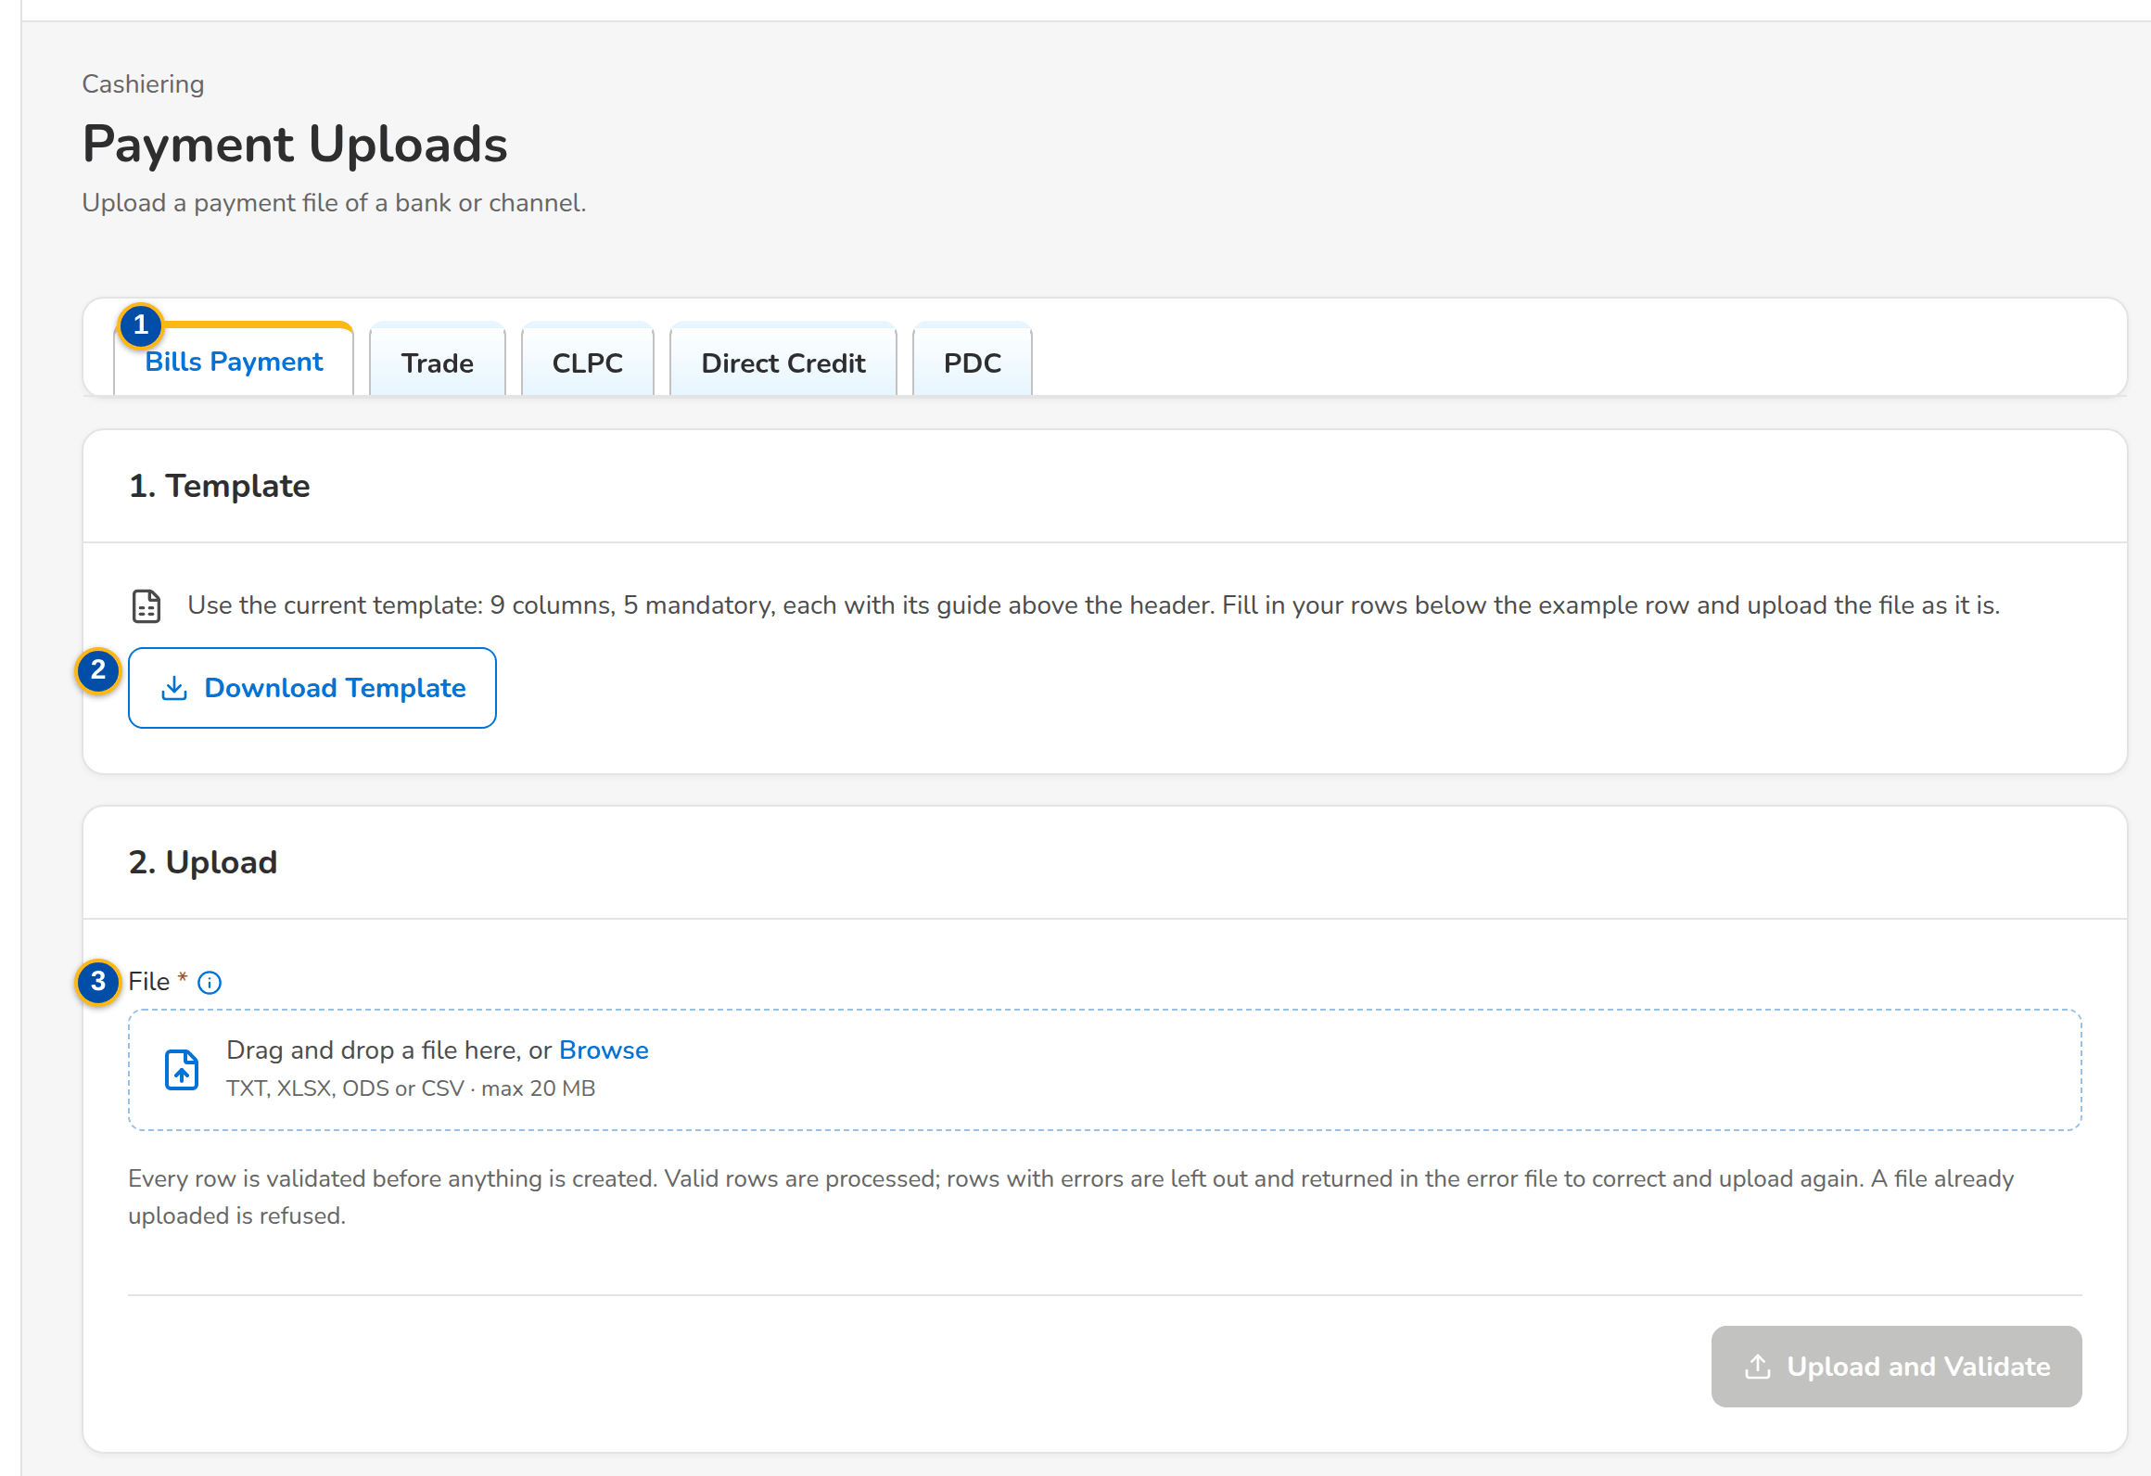
Screenshot E.13: Payment Uploads, Bills Payment: template and upload steps
Field | Type | Mandatory | Format / list / source | Validation and message
Tabs: Bills Payment / Trade / CLPC / Direct Credit / PDC | Tab | - | One file type per tab; Fixed | -
1. Template: Download Template | Button | - | The columns of the file type (this FRS); Upload template | Headers unchanged
2. Upload: File | File | Y | Drag and drop or Browse; the accepted types and the maximum size are shown | A file already uploaded is refused; This file was already uploaded
Run Summary: Applied / Unapplied / Pre-booked / With Excess / Failed Rows | Tile | - | Counts of the run; Upload run | -
Run Summary: Row / Reference / Payor / Amount / Applied / Unapplied / Outcome / Message | Column | - | One row per payment of the run; Payments | No payment accepted in this run

Action | Who | Available when | What happens | Resulting status
Download Template | Cashier | Always | Downloads the template of the file type | -
Upload and Validate | Cashier | File chosen | Validates every row and shows Rows Read, Valid and Rejected with the rows | -
[Process the valid rows] | Cashier | Rows validated | Creates the payments with their ARs and matches them | AR issued per payment
Download Report | Cashier | Run done | Downloads the run report with the failed rows and their messages | -

Rules:
- Every row is a payment: an AR is issued and the payment is matched at once; the same file cannot be uploaded twice.
- A failed row never stops the run; the failed rows are corrected in the report and uploaded again as a new file.
- The layout of each bank file is set on Cashiering Setup until BDOI confirms the bank layouts.

E.14 Payment Files
Purpose: The payment files of the banks and channels in BDOI's layouts - Bills Payment, CLPC, Trade, Direct Credit, post-dated checks (PMS) and Commission Schedule - uploaded several at a time or received via MFT, with the checks each file passed or the reason it was refused, and for each file the run report per category, the validation report, the failed rows to correct, the raw file and processing again.
Access: Cashiering Dashboard › Automatic Payment Processing Uploading Facility, For Auto Payment Processing
FR items: FRS.CSH.02.02.04, FRS.CSH.02.02.07, FRS.CSH.02.02.09, FRS.CSH.02.04.02, FRS.CSH.02.05.14, FRS.CSH.05.01.01, FRS.CSH.05.01.04, FRS.CSH.05.01.05, FRS.CSH.05.01.06, FRS.CSH.05.01.10, FRS.CSH.07.01.01, FRS.CSH.07.01.04, FRS.CSH.07.01.05
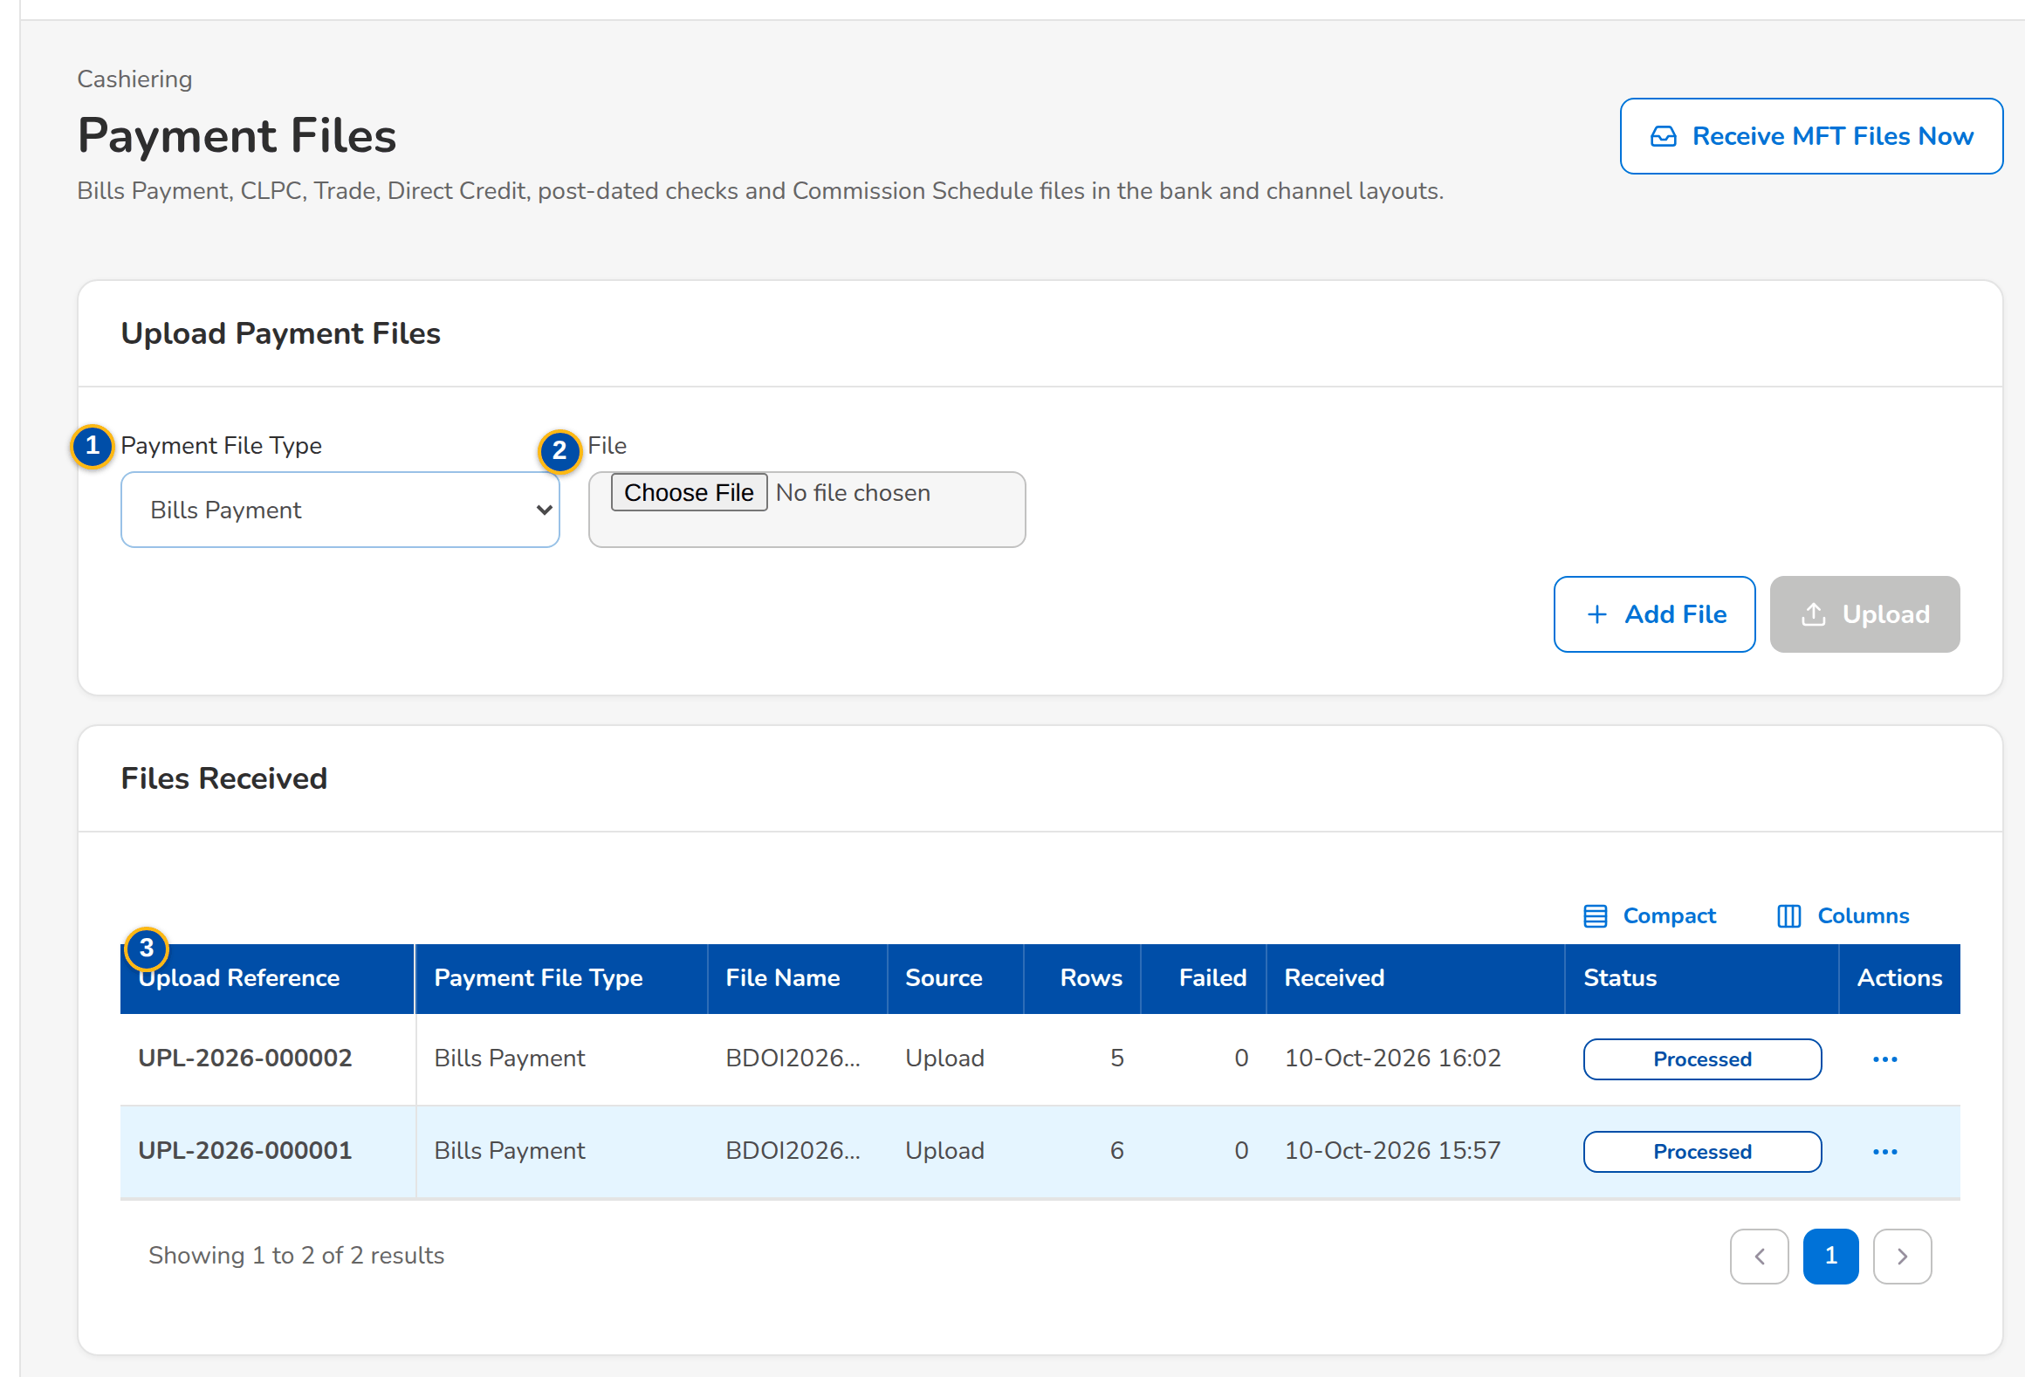
Screenshot E.14: Payment Files with a Bills Payment file received via MFT
Field | Type | Mandatory | Format / list / source | Validation and message
Upload Payment Files: Payment File Type | Drop-down | Y | Bills Payment, CLPC, Trade, Direct Credit, Post-dated checks (PMS), Commission Schedule; Payment file types | -
Upload Payment Files: File | File | Y | One file per line; several lines and types in one upload | File name, size, duplicate, header and TOTAL checks of the type
Files Received: Upload Reference / Payment File Type / File Name / Source / Rows / Failed / Received / Status | Columns | - | Upload or MFT; counts; dd-MMM-yyyy HH:mm; Received, Refused, Processed, Partly processed; Payment files | No payment file received yet
Run Report: Category / Count / Amount | Columns | - | Applied Payment, Excess Payment, Matched on Pre-booked, Unbooked/Unmatched, Invalid BP filename, Invalid Transaction Number, Duplicate, Failed; Run of the file | No payment record
Run Report: Transaction Date / BP Filename / Transaction Number / Amount / Reference Number / Account Number / Record Status / Reason for Failure | Columns | - | One row per payment record; Run of the file | -

Action | Who | Available when | What happens | Resulting status
Add File / Upload | Cashier (upload right) | Files chosen | Checks and processes each file; refused files are listed with the reason | Processed, Partly processed or Refused
Receive MFT Files Now | Cashier (upload right) | Always | Takes the files placed in the MFT folders now instead of at the next scheduled run | -
Run Report / Download Run Report / Validation Report / Failed Rows / Raw File | Cashier | A file | Shows or downloads the report or file | -
Process Again | Cashier | Partly processed file | Processes the corrected failed rows again | Processed

Rules:
- The file names follow BDOI's conventions (for example BDOIyyyymmddn.TXT for Bills Payment, CLPC-MmmDDYYYY.xlsx, UploadTrade_dd.mm.yyyy.TXT); a file with a wrong name, a size above the limit, a duplicate or a header or TOTAL that does not agree is refused with the reason.
- The Direct Credit file identifies payments already received (BP filename and transaction number) as delivered (setting); the Commission Schedule processes its valid lines as delivered (setting).
- The files of the MFT folders are taken at the times agreed with BDOI IT for the company of the setting MFT receiving company; in SIT and UAT a channel simulator writes the files in BDOI's layouts.

E.15 PDC Warehouse
Purpose: Post-dated checks kept in the warehouse with a PDCW- number, grouped by maturity month; the maturity job turns a matured check into a payment with its AR, and before maturity a check can be returned, replaced or pulled out.
Access: Cashiering Workbench › Post-dated Checks in the Warehouse tile
FR items: FRS.CSH.05.01.04, FRS.CSH.05.02.01, FRS.CSH.05.02.02, FRS.CSH.05.02.03, FRS.CSH.09.02.19
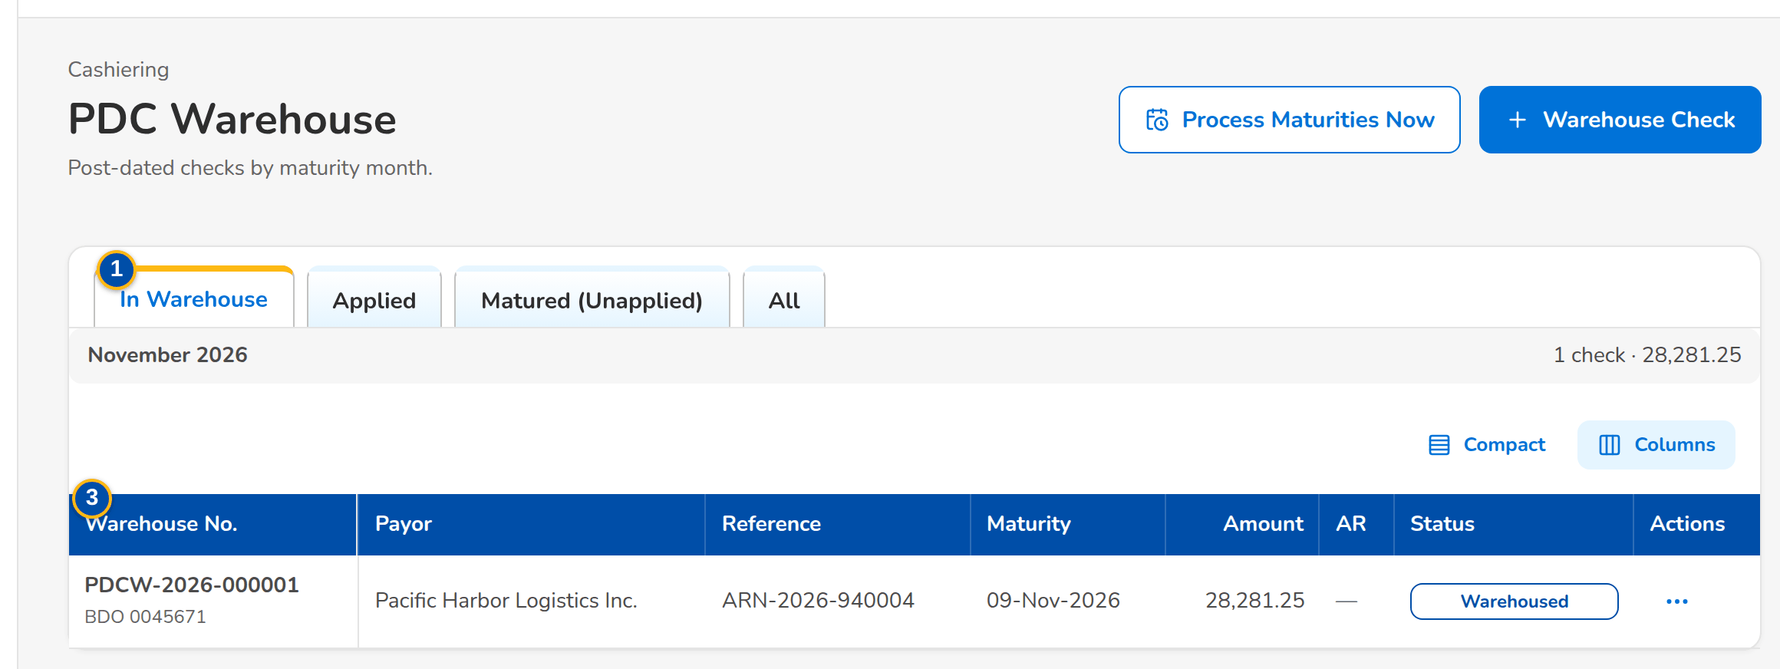
Screenshot E.15: PDC Warehouse by maturity month
Field | Type | Mandatory | Format / list / source | Validation and message
Tabs: In Warehouse / Applied / Matured (Unapplied) / All | Tab | - | Fixed | -
List: [Maturity month and total] | Heading | - | Month, number of checks and total; PDC warehouse | -
List: Warehouse No. / Payor / Reference / Maturity / Amount / AR / Status | Column | - | PDCW-yyyy-n with the bank and check number; PDC warehouse | -
Warehouse Post-dated Check dialog: Payor Name / Client Code / ARN, Invoice, Policy or PN No. / Check No. / Bank / Bank Branch / Maturity Date / Amount / Market Segment | Text, date, number | Payor, reference, check, bank, maturity date and amount Y | Maturity date dd-MMM-yyyy | Not blank; amount above zero; <field> is required / Enter an amount above zero
Release dialog: Outcome / Reason | Drop-down, text | Y | Returned, Replaced, Pulled out; Fixed list | Reason not blank; Reason is required

Action | Who | Available when | What happens | Resulting status
Warehouse Check | Cashier | Always | Stores the check in the warehouse | Warehoused
Process Maturities Now | Cashier | Always | Turns every matured check into a payment with its AR, matched at once | Applied or Matured (unapplied)
Release / Release Check | Cashier | Warehoused | Takes the check out before maturity with the outcome and reason | Returned, Replaced or Pulled out

Rules:
- A post-dated check waits in the warehouse until its maturity date; the daily maturity job receipts it then.

E.16 Batch Print
Purpose: Print and re-print ARs and ORs in their forms, at most 500 per batch: choose the receipts by type, branch and issue date, choose the copy (Client's Copy, Company Copy or both), print the selected receipts and follow the print batches with their log, preview, PDF or ZIP of single PDFs, and the retry or skip of the failures.
Access: Cashiering Dashboard › Batch Print AR/OR Facility
FR items: FRS.CSH.02.04.02, FRS.CSH.02.04.05, FRS.CSH.02.04.07, FRS.CSH.02.04.12, FRS.CSH.02.04.16, FRS.CSH.02.04.17, FRS.CSH.02.05.14, FRS.CSH.02.06.01, FRS.CSH.02.06.02, FRS.CSH.02.06.03, FRS.CSH.05.01.10
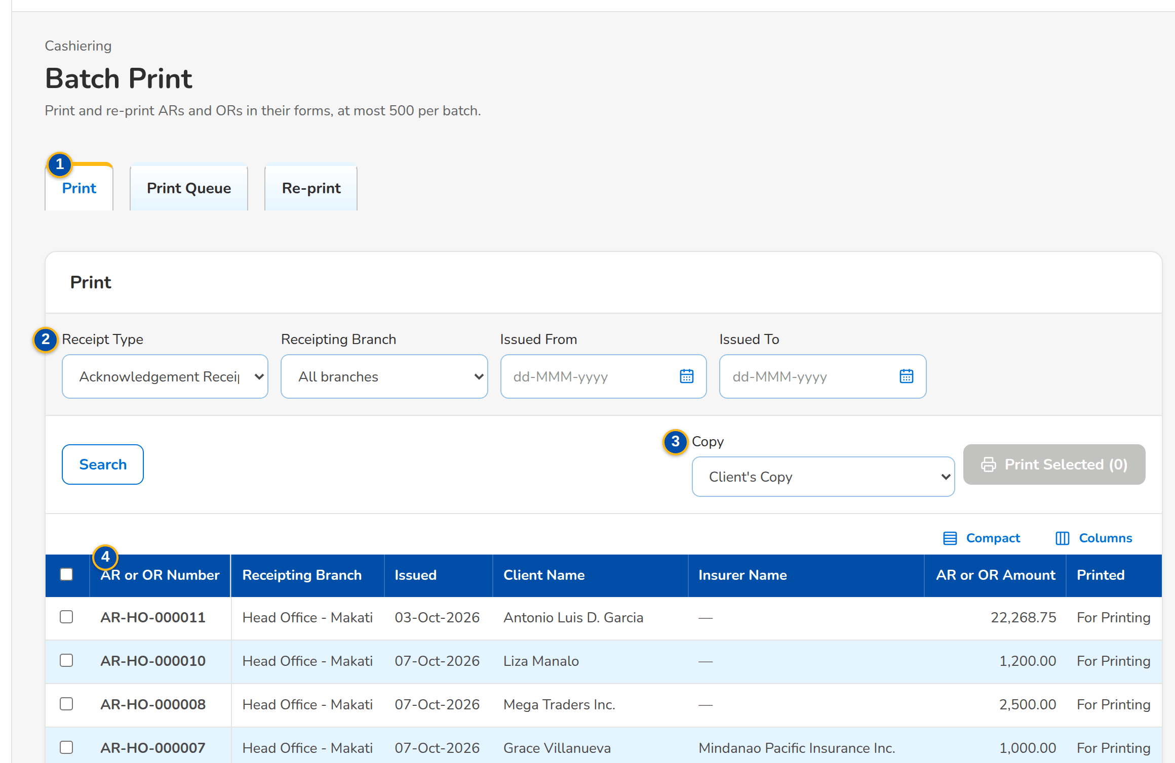
(continued below)
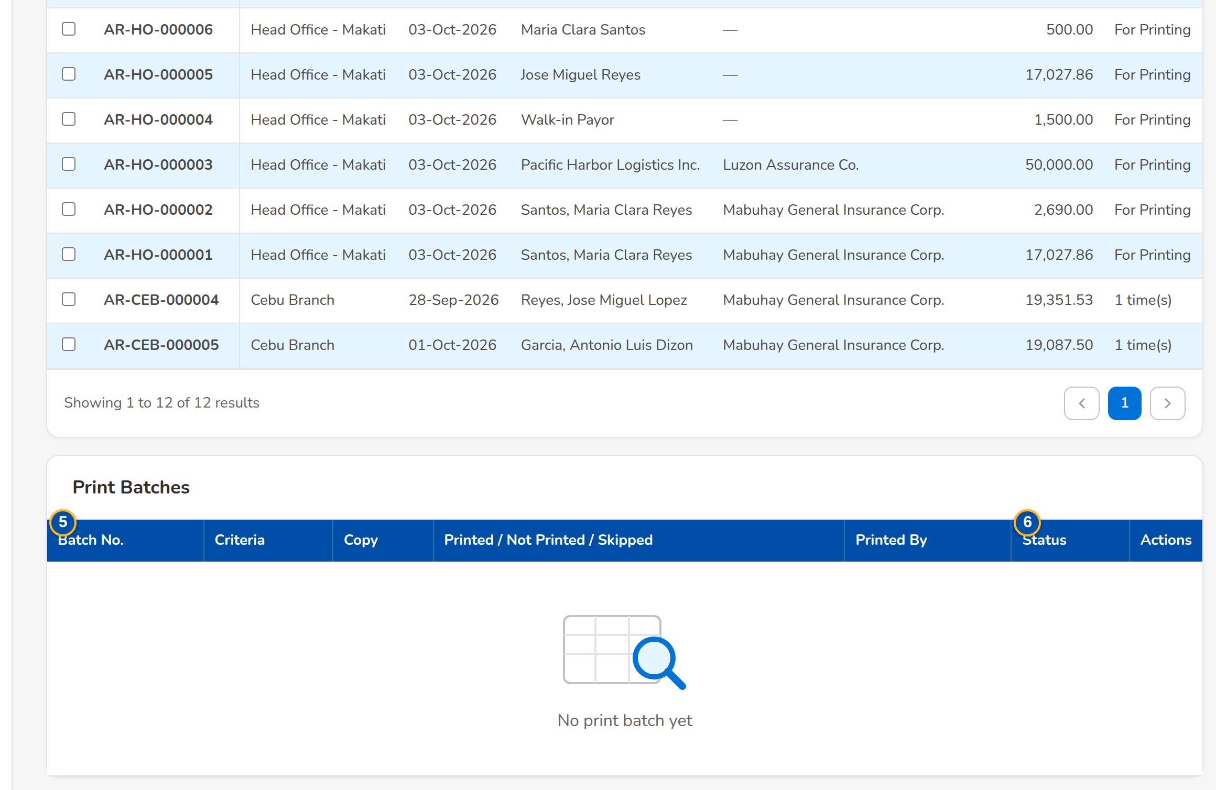
Screenshot E.16: Batch Print: receipts for printing with the copy to print
Field | Type | Mandatory | Format / list / source | Validation and message
Tabs: Print / Print Queue / Re-print | Tab | - | Receipts not printed yet; the print batches; receipts already printed; Fixed | -
Print: Receipt Type / Receipting Branch / Issued From / Issued To | Drop-down, date | N | Acknowledgement Receipt, Official Receipt; branches; dd-MMM-yyyy | -
Print: Copy | Drop-down | Y | Client's Copy, Company Copy, Client's Copy and Company Copy; Fixed list | -
Print: AR or OR Number / Receipting Branch / Issued / Client Name / Insurer Name / AR or OR Amount / Printed | Columns | - | For Printing, or the number of prints; Receipts | No receipts match the criteria
Print Queue: Batch No. / Criteria / Copy / Printed / Not Printed / Skipped / Printed By / Status | Columns | - | Counts of the batch; Print batches | -
Print Log: Receipt Number / Certificate No. / Reprint / Status / Reason | Columns | - | The acknowledgement certificate number of each print (AC_<branch>_<MMYYYY>_<sequence> as delivered); REPRINT on a re-print; Print lines | -

Action | Who | Available when | What happens | Resulting status
Search | Cashier | Always | Lists the receipts of the criteria | -
Print Selected (n) | Cashier (print right) | Receipts selected, at most 500 | Prints the selected receipts in their form with the copy chosen and records each | Printed
Print Log / Print Preview / Download PDF / Download ZIP | Cashier | A print batch | Shows the log; previews; downloads one PDF or a ZIP of one PDF per receipt | -
Retry Failures / Skip Failures | Cashier | Batch with failures | Prints the failed receipts again, or closes them as skipped | -

Rules:
- A batch records each receipt printed with its certificate number, so a failure is retried without printing the others again.
- A re-printed receipt is marked REPRINT.
- The receipt is printed in the AR or OR form in force (AR and OR Forms), with the amount in words of its currency (setting of Appendix H.8).

E.17 AR and OR Forms
Purpose: The header, note and footer lines of the printed AR and OR, with their versions: a change takes effect on its effective date once approved by a second user.
Access: Cashiering › AR and OR Forms
FR items: FRS.CSH.02.03.03, FRS.CSH.02.03.04, FRS.CSH.02.03.06, FRS.CSH.02.04.02, FRS.CSH.02.04.05, FRS.CSH.02.04.07, FRS.CSH.02.04.12, FRS.CSH.02.04.16, FRS.CSH.02.04.17, FRS.CSH.02.05.08.03, FRS.CSH.02.05.14, FRS.CSH.02.06.01, FRS.CSH.02.06.02, FRS.CSH.02.06.03, FRS.CSH.05.01.10, FRS.CSH.10.04.02
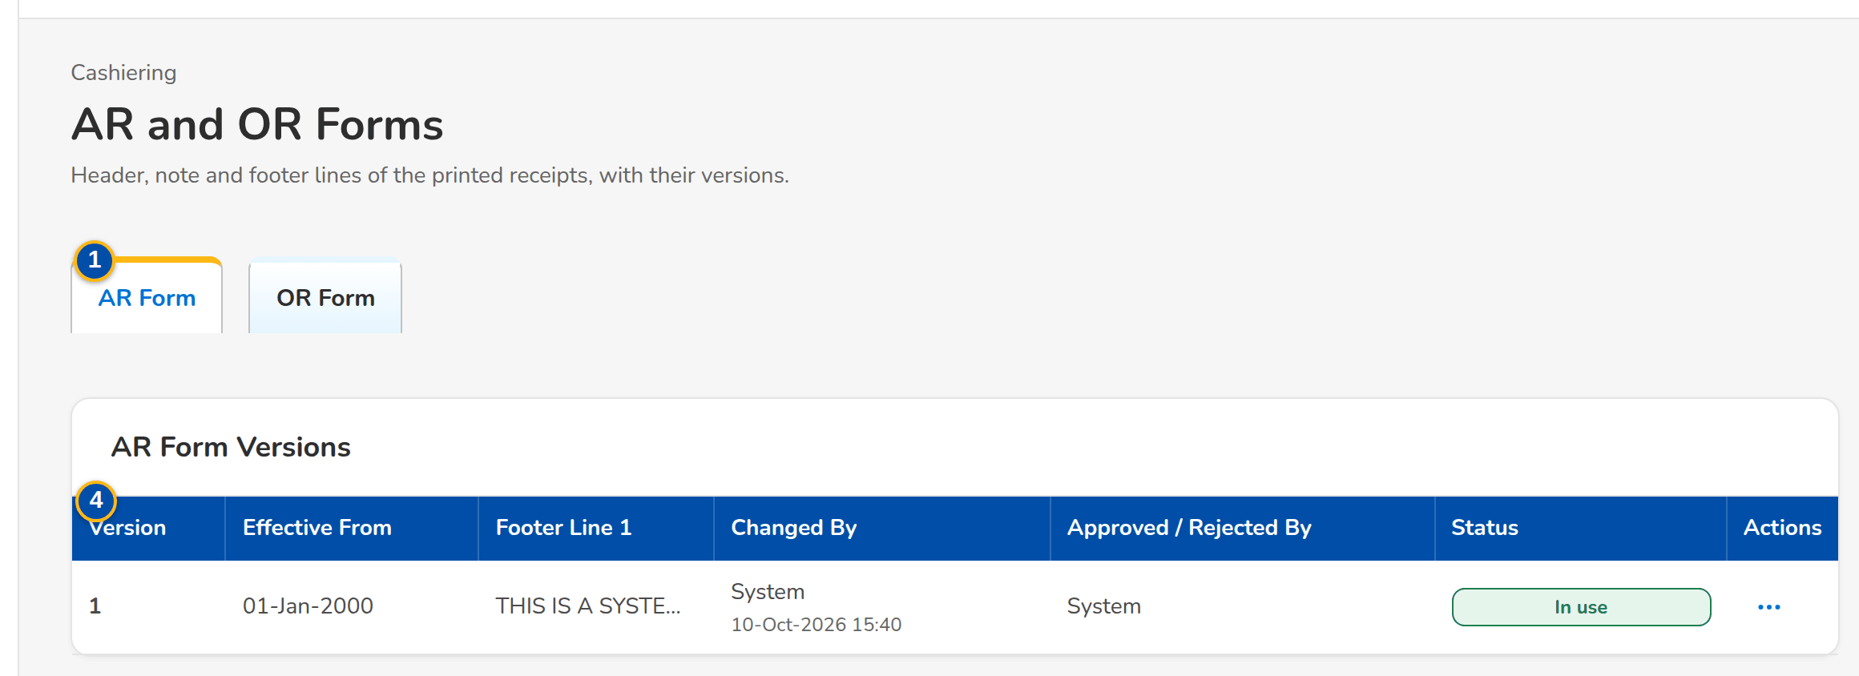
Screenshot E.17: AR and OR Forms with the versions of the AR form
Field | Type | Mandatory | Format / list / source | Validation and message
Tabs: AR Form / OR Form | Tab | - | Fixed | -
Form: Company Name / Company Description / Company Address / Company VAT TIN / Note Line (AR) / Footer Line 1 / Footer Line 2 / Footer Line 3 / Footer Line 4 | Text | Y (name, address) | As printed on the receipt | -
Form: Effective From | Date | Y | dd-MMM-yyyy | -
Versions: Version / Effective From / Footer Line 1 / Changed By / Approved / Rejected By / Status | Columns | - | Pending approval, In use, earlier versions, Rejected; Receipt forms | -

Action | Who | Available when | What happens | Resulting status
[Change AR Form, Change OR Form] | Users with the series right | Always | Opens the form lines of the version in use for a change | -
Submit for Approval | Users with the series right | Lines entered | Saves a new version for approval | Pending approval
Approve / Reject | A second user with the series or authorisation right, not the maker | Pending approval | Puts the version in use from its effective date, or rejects it | In use or Rejected

Rules:
- The receipt prints the form in use on its print date, with the amount in words in the words of its currency (setting Amount in words per currency, Appendix H.8).

E.18 Commission ORs
Purpose: The commission payments of the insurers uploaded from the payment details, staged until Issue ORs issues one official receipt per payment with its VAT and withholding tax.
Access: Cashiering Workbench
FR items: FRS.CSH.02.02.04, FRS.CSH.02.02.07, FRS.CSH.02.02.09, FRS.CSH.02.05.14, FRS.CSH.07.01.01, FRS.CSH.07.01.04, FRS.CSH.07.01.05
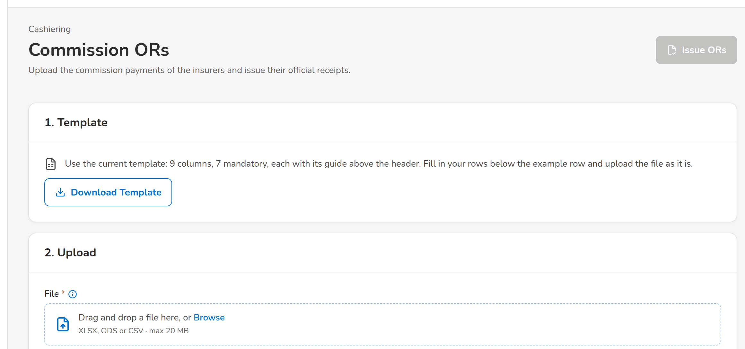
(continued below)
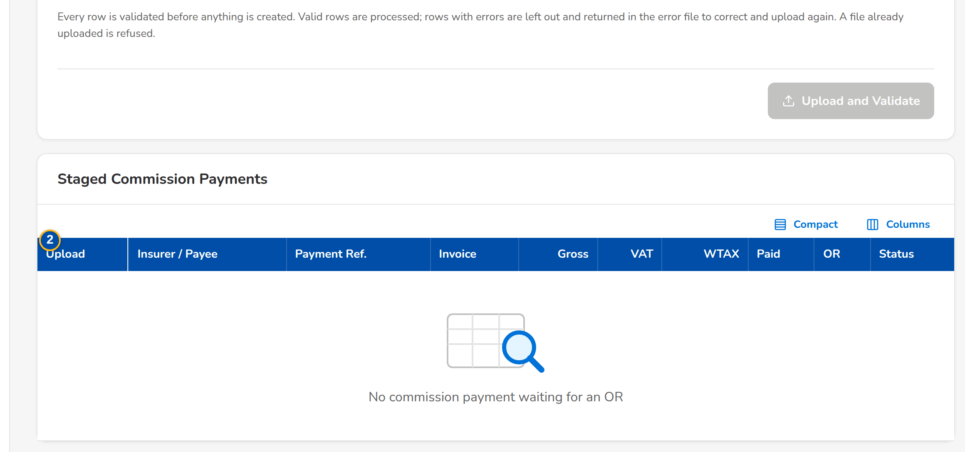
Screenshot E.18: Commission ORs: upload steps and the staged commission payments
Field | Type | Mandatory | Format / list / source | Validation and message
1. Template / 2. Upload: [Commission Payment Details upload] | Upload | Y | Template columns of this FRS; Upload template | Every row checked first; The basic commission must be above zero
Staged Commission Payments: Upload / Insurer / Payee / Payment Ref. / Invoice / Gross / VAT / WTAX / Paid / OR / Status | Column | - | Staged commission payments | No commission payment waiting for an OR

Action | Who | Available when | What happens | Resulting status
Upload and Validate | Cashier | File chosen | Validates and stages the commission payments | Staged
Issue ORs | Cashier | Staged payments | Issues one OR per staged payment | OR issued

Rules:
- One OR is issued per staged commission payment.

E.19 Settlement ORs
Purpose: The commission and incentive ORs of the insurer settlements, issued once Disbursement approves the payment request (as delivered), with the ones waiting and the ones that could not be issued.
Access: Cashiering › Settlement ORs
FR items: FRS.CSH.02.02.04, FRS.CSH.02.02.07, FRS.CSH.02.02.09, FRS.CSH.02.05.14, FRS.CSH.07.01.01, FRS.CSH.07.01.04, FRS.CSH.07.01.05
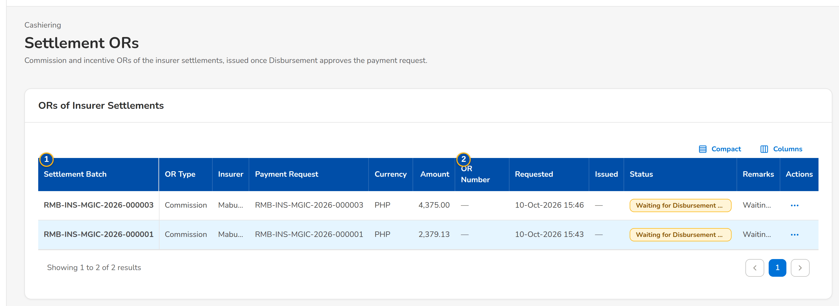
Screenshot E.19: Settlement ORs waiting for the Disbursement approval
Field | Type | Mandatory | Format / list / source | Validation and message
List: Settlement Batch / OR Type / Insurer / Payment Request / Currency / Amount | Columns | - | Remittance batch; Commission or Incentive; insurer; payment request; amount; Settlement ORs | -
List: OR Number / Requested / Issued / Status / Remarks | Columns | - | OR number once issued; dates; Waiting for Disbursement approval, Issued, Cancelled, Failed; Settlement ORs | -

Action | Who | Available when | What happens | Resulting status
Issue Again | Cashier | An OR that could not be issued | Issues the OR again | Issued

Rules:
- The ORs of a settlement are issued when Disbursement approves the payment request as delivered, or at the approval of the remittance (setting When the settlement ORs are issued, Appendix H.8).

E.20 Receipt Series
Purpose: The AR and OR number ranges per branch with their BIR Authority to Print, the next number and the numbers left before the series runs out; a new series is authorised by a second user before it is used.
Access: Cashiering Workbench
FR items: FRS.CSH.02.03.03, FRS.CSH.02.03.04, FRS.CSH.02.03.06, FRS.CSH.02.05.08.03, FRS.CSH.10.04.02
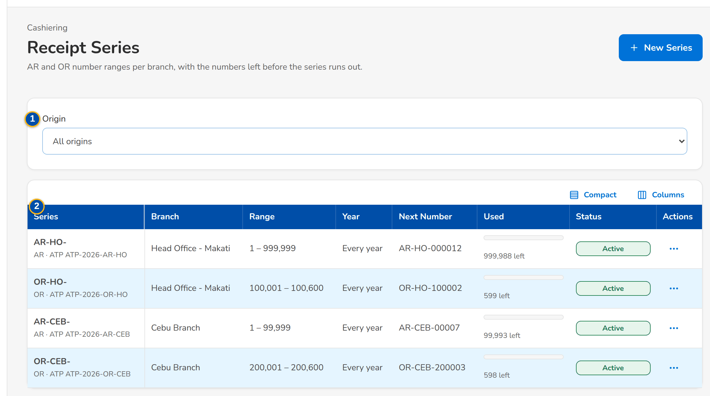
Screenshot E.20: Receipt Series with the numbers left
Field | Type | Mandatory | Format / list / source | Validation and message
Toolbar: Origin | Drop-down | N | All origins, the system, Migrated; Fixed list | -
List: Series / Branch / Range / Year / Next Number / Used / Status | Column | - | Prefix with the kind and ATP; year or Every year; next number in its format; gauge with the numbers left; Receipt series | No receipt series yet
New Receipt Series dialog: Kind / Branch | Drop-down | Y | AR or OR; an OR series only for the Head Office; Branches | -
New Receipt Series dialog: Prefix | Text | Y | For example AR-HO- | Not blank; Prefix is required
New Receipt Series dialog: From No. / To No. | Number | Y | The range ends at or after its start | Valid range; The range must end at or after its start
New Receipt Series dialog: BIR ATP No. / Warn When Remaining At | Text, number | N | - | -
New Receipt Series dialog: Year | Number | N | Year of the series; blank for every year | -
New Receipt Series dialog: Number Format | Text | N | Parts {PREFIX}, {YEAR}, {BRANCH}, {SEQ}; the first number is shown below the form; blank = prefix and sequence; Number format setting (Appendix H.8) | Only the parts listed

Action | Who | Available when | What happens | Resulting status
New Series / Save Series | Cashiering Team Leader | Always | Saves the series for authorisation | Pending authorization
Authorize | A second user with the authorisation permission | Series pending | Asks for confirmation and activates the series | Active
Deactivate | Cashiering Team Leader | Series active | Asks for confirmation; no more receipts are issued from it | Inactive

Rules:
- Each receipt takes the next number of its series; a depleted series refuses the receipt.
- When the numbers left reach the warning level, the Cashiering team is alerted.
- ORs are issued only from Head Office series.

E.21 Cashiering Setup
Purpose: The layouts of the bank and channel payment files and the minimal balance rules (thresholds and exceptions), with the manual run of the safety-net sweep.
Access: Cashiering Workbench
FR items: FRS.CSH.02.04.02, FRS.CSH.02.05.12, FRS.CSH.05.01.01, FRS.CSH.05.01.04, FRS.CSH.05.01.05, FRS.CSH.05.01.06, FRS.CSH.05.01.10, FRS.CSH.06.01.08
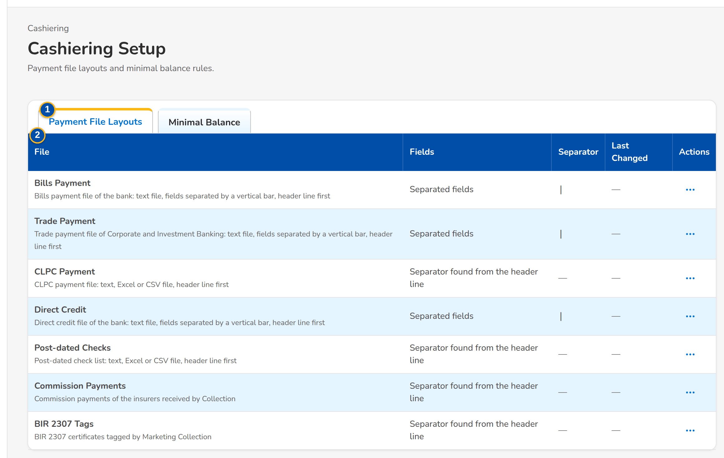
Screenshot E.21: Cashiering Setup, Payment File Layouts tab
Field | Type | Mandatory | Format / list / source | Validation and message
Tabs: Payment File Layouts / Minimal Balance | Tab | - | Fixed | -
Payment File Layouts: File / Kind / Separator / Last Changed | Column | - | Automatic, delimited or fixed width; Payment file layouts | -
Edit layout dialog: Fields / Separator / Fields (Header:start:length separated by; start is 1-based) | Drop-down, text | Y | Fields for a fixed-width file | -
Minimal Balance: Balance / Up To / Excludes / Action / Status | Column | - | For example premium balances up to 10.00, excluding the 2% CWT, the DST and the whole premium; Minimal balance rules | -

Action | Who | Available when | What happens | Resulting status
Edit Layout / Save Layout | Cashiering Team Leader | Always | Changes the layout of a payment file | -
Run Sweep Now | Cashiering Team Leader | Always | Runs the safety-net sweep now and reports the balances cleared that later events left within the threshold | -

Rules:
- Premium balances and excess amounts within the threshold (default PHP 10.00) are cleared when the payment is processed, never routed to Unapplied Payments; a balance equal to the 2% CWT, the DST or the whole premium, and an invoice already written off, are skipped.
- The thresholds are configurable; the daily sweep is only a safety net for balances that later events leave within the threshold.

E.22 Day-End List
Purpose: The records of a day with the totals per payment type and bank account, for the day-end balancing of the cashier.
Access: Cashiering › Day-End List
FR items: FRS.CSH.02.01.16, FRS.CSH.02.06.04, FRS.CSH.09.01.01, FRS.CSH.09.02, FRS.CSH.09.02.19, FRS.CSH.09.02.20, FRS.CSH.09.02.21, FRS.CSH.09.02.22
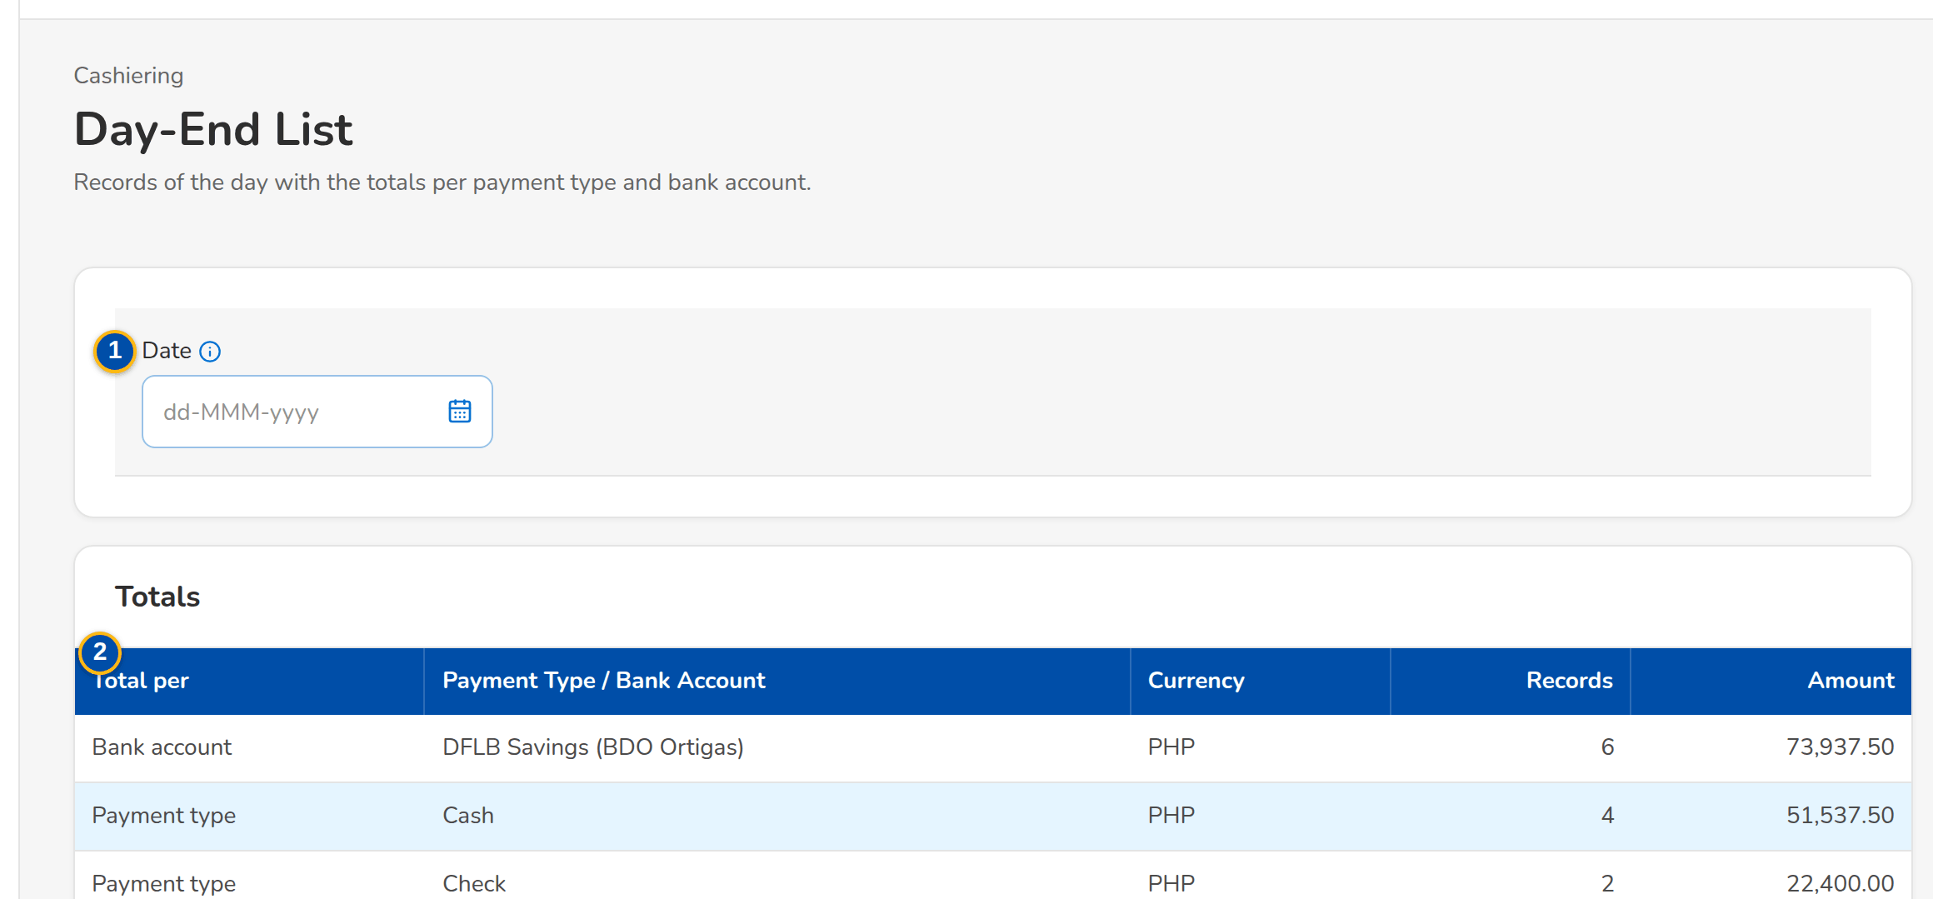
(continued below)
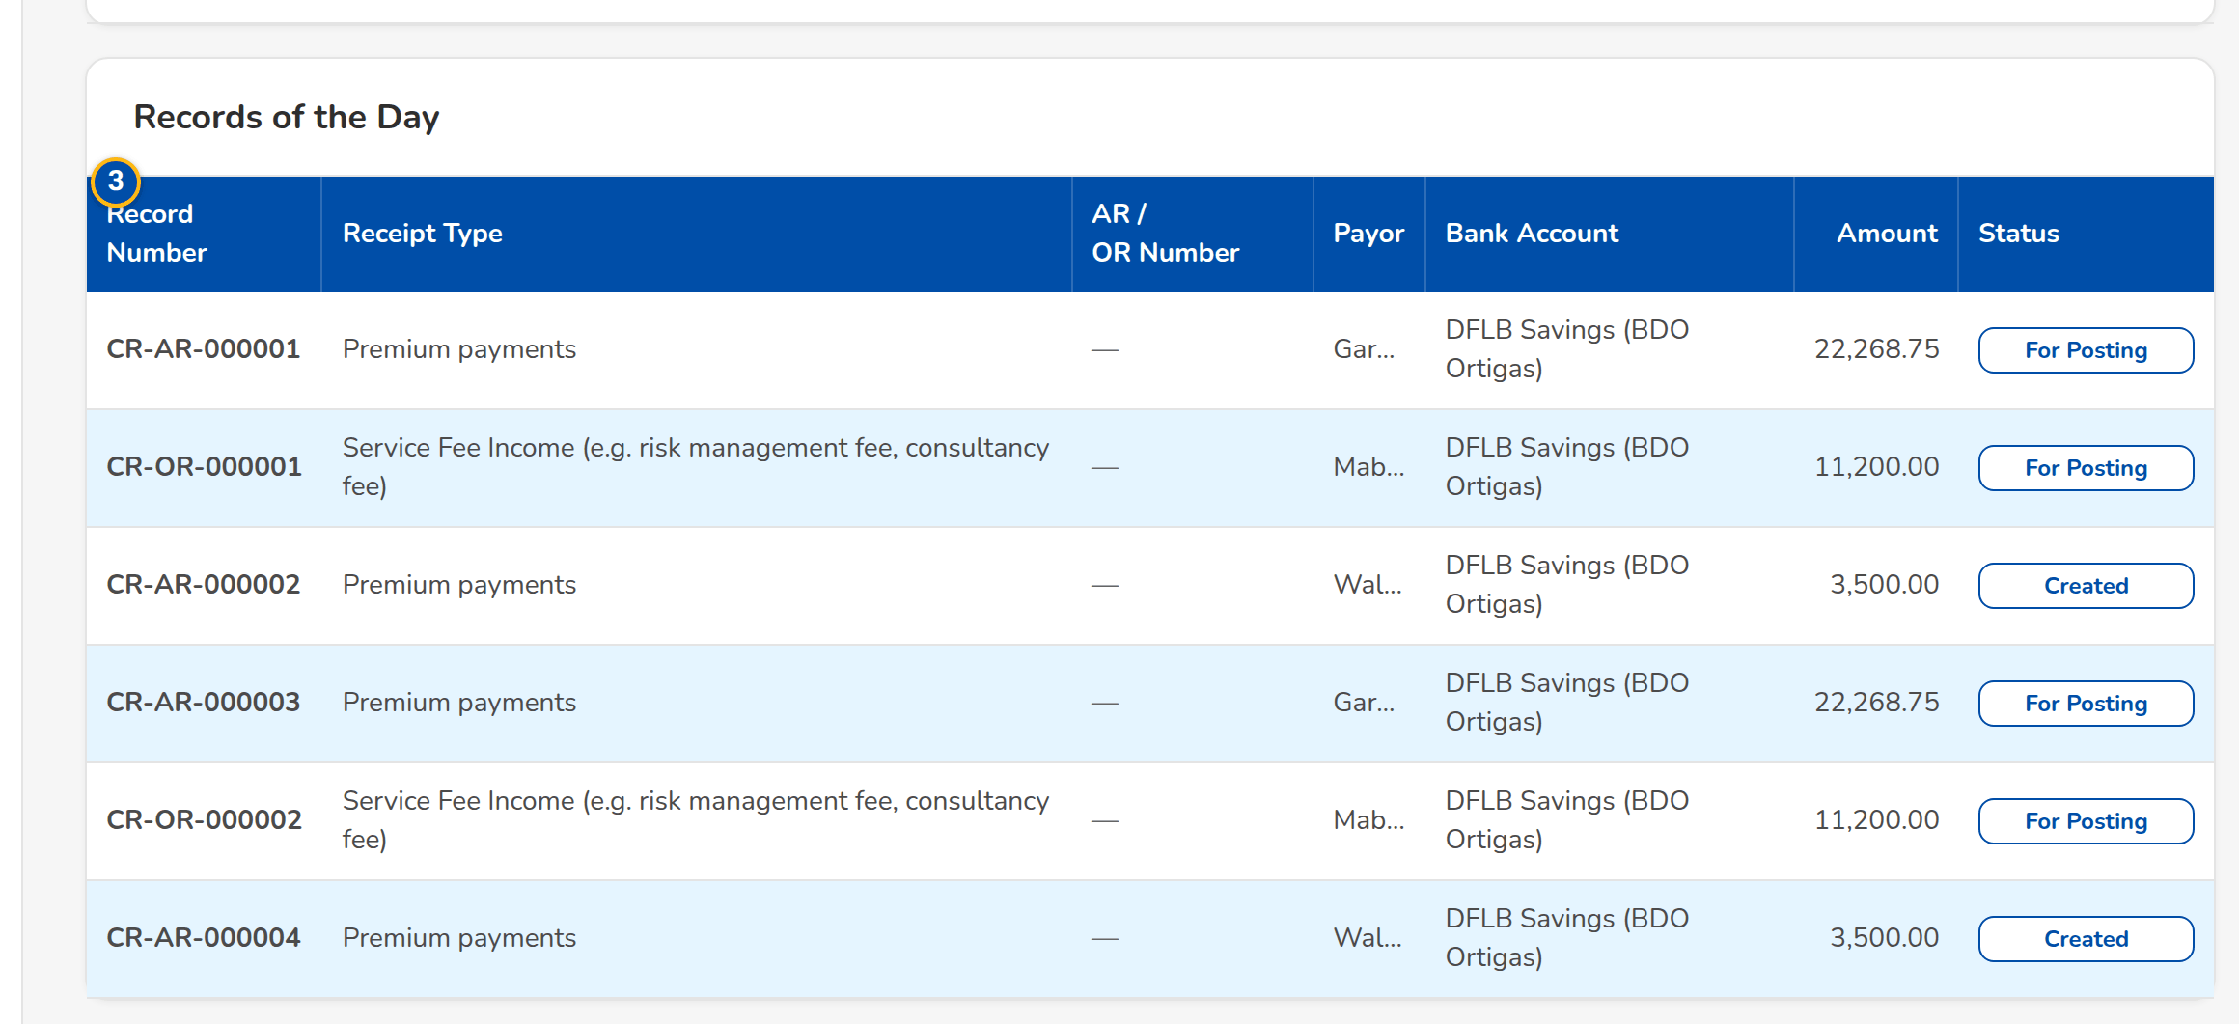
Screenshot E.22: Day-End List with the totals of the day
Field | Type | Mandatory | Format / list / source | Validation and message
Filter: Date | Date | Y | dd-MMM-yyyy | -
Totals: Total per / Payment Type / Bank Account / Currency / Records / Amount | Columns | - | Payment type or bank account; count; amount; Records of the day | No record on this day
Records of the Day: Record Number / Receipt Type / AR / OR Number / Payor / Bank Account / Amount / Status | Columns | - | As recorded; Records of the day | No record on this day

Rules:
- The list holds the AR and OR records of the company of the chosen day with their status.

E.23 Search Log
Purpose: The receipt searches with their user, criteria and number of results, kept as evidence of the inquiries.
Access: Cashiering › Search Log
FR items: FRS.CSH.02.01.14, FRS.CSH.02.04.16, FRS.CSH.08.01.01, FRS.CSH.08.01.04, FRS.CSH.08.03.01
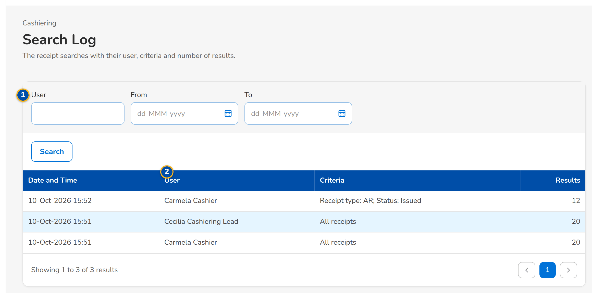
Screenshot E.23: Search Log of the receipt searches
Field | Type | Mandatory | Format / list / source | Validation and message
Filters: User / From / To | Look-up, dates | N | Name; dd-MMM-yyyy; Users | -
List: Date and Time / User / Criteria / Results | Columns | - | dd-MMM-yyyy HH:mm; name; the criteria entered; number of receipts found; Search log | -

Action | Who | Available when | What happens | Resulting status
Search | Cashiering Team Leader (posting right) | Always | Lists the searches of the filters | -

Rules:
- Every receipt search is logged; no user can change the log.

E.24 Invoice Search
Purpose: Every booked invoice, endorsement and return invoice of the Operations ledger with its gross and outstanding premium, payment and remittance status and flags; status tabs, a search box and filters find an invoice and a row opens its Invoice 360.
Access: Operations Home › Find an Invoice; Section workbenches › Search Invoices
FR items: FRS.CSH.08.01.01, FRS.CSH.08.01.03, FRS.CSH.08.02.01
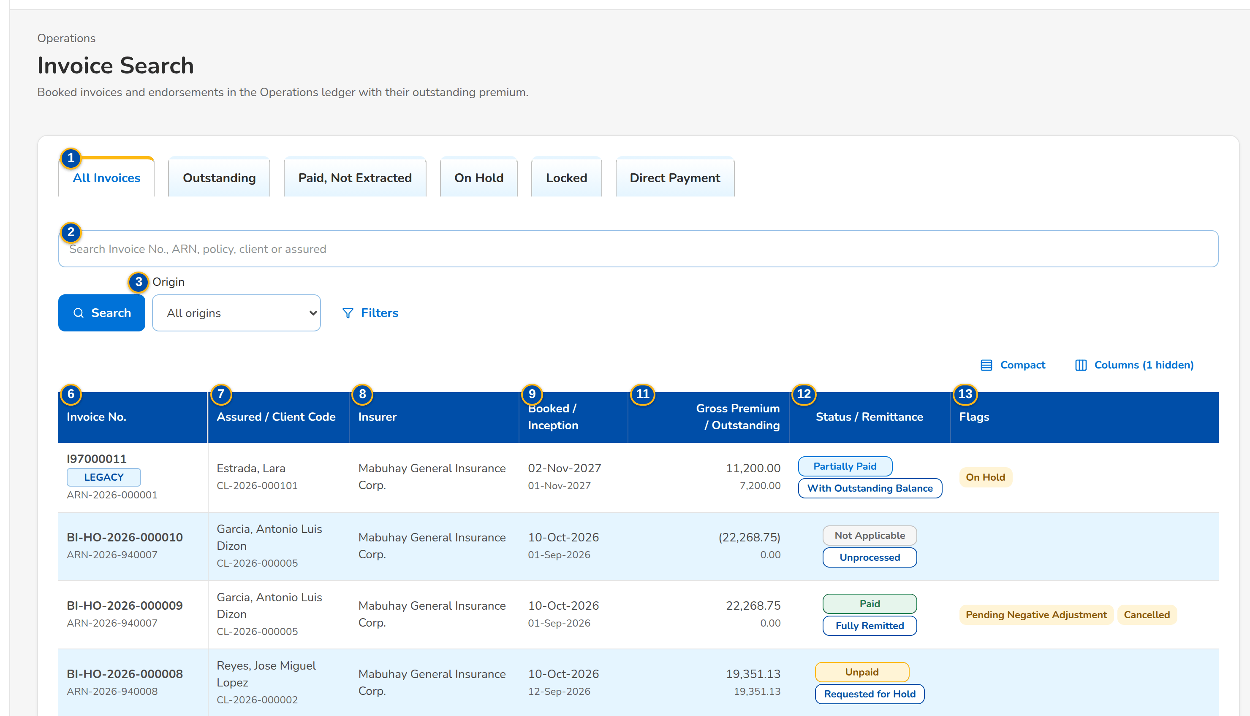
(continued below)
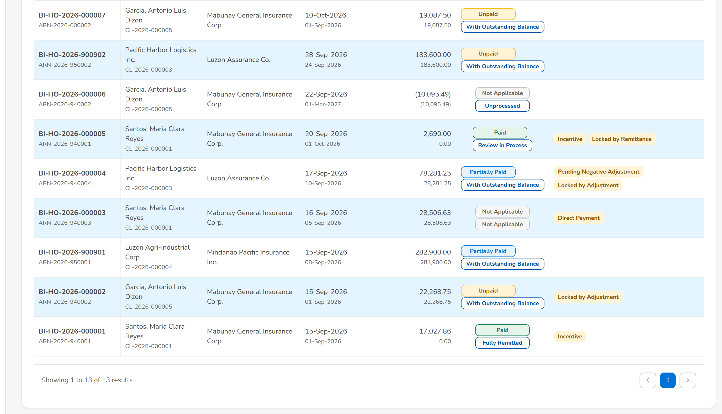
Screenshot E.24: Invoice Search, All Invoices tab
Field | Type | Mandatory | Format / list / source | Validation and message
Tabs: All Invoices / Outstanding / Paid, Not Extracted / On Hold / Locked / Direct Payment | Tab | - | Fixed | A tab keeps the text and panel filters
Toolbar: Search Invoice No., ARN, policy, client or assured | Text | N | Partial, not case-sensitive; Invoice ledger | -
Toolbar: Origin | Drop-down | N | All origins, the system, Migrated; Fixed list | -
Filters: Insurer / Name of Assured / Account Officer | Drop-down, text | N | Insurers by name; Insurers | Contains
Filters: Booked From / Booked To / Inception From / Inception To | Date | N | dd-MMM-yyyy | -
List: Invoice No. | Column | - | Invoice number with the ARN as the second line; migrated invoices carry the LEGACY tag; Invoice ledger | -
List: Assured / Client Code | Column | - | Assured name with the client code; Invoice ledger | -
List: Insurer | Column | - | Insurer name; Insurers (BRD-3) | -
List: Booked / Inception | Column | - | dd-MMM-yyyy, two lines; Invoice ledger | -
List: Account Officer | Column | - | User name; Invoice ledger | -
List: Gross Premium / Outstanding | Column | - | Amount, two decimals; a return invoice in brackets; Invoice ledger | -
List: Status / Remittance | Column | - | Payment status and remittance status pills; Invoice ledger | -
List: Flags | Column | - | Direct Payment, 2% CWT, Incentive, On Hold, Pending Negative Adjustment, Written Off, Cancelled, Estimated, Locked by <team>; Invoice ledger | -

Action | Who | Available when | What happens | Resulting status
Search | Every Operations user | Always | Filters the list on the text | -
Filters / Apply Filters | Every Operations user | Always | Opens the filter panel / applies the filters; the button shows the number of filters set | -
Open a row | Every Operations user | Always | Opens Invoice 360 of the invoice | -

Rules:
- The search is partial and not case-sensitive on the invoice number, ARN, policy number, client and assured.
- Payment status is derived from the premium receivable balances: Unpaid, Partially Paid, Paid; Not Applicable for direct payment and return invoices.
- Every invoice booked in New Business, every endorsement and every return invoice is in the ledger with its components as booked.

E.25 Invoice 360
Purpose: One invoice as Operations sees it: the reference chips (invoice, ARN, policy, endorsement, root invoice), the payment and remittance status and the flags, the account workflow, the premium receivable by component with its balance, every movement, the invoice family, the Policy Transactions with their accounting entries, one tab per Operations team with its records, the history and the documents.
Access: Invoice Search › open a row; Receipt, Remittance Batch, Endorsement Request, DTIP Status › invoice number; Policy Transactions of any screen › invoice number
FR items: FRS.CSH.02.05.16, FRS.CSH.08.01.01, FRS.CSH.08.01.03, FRS.CSH.08.02.01
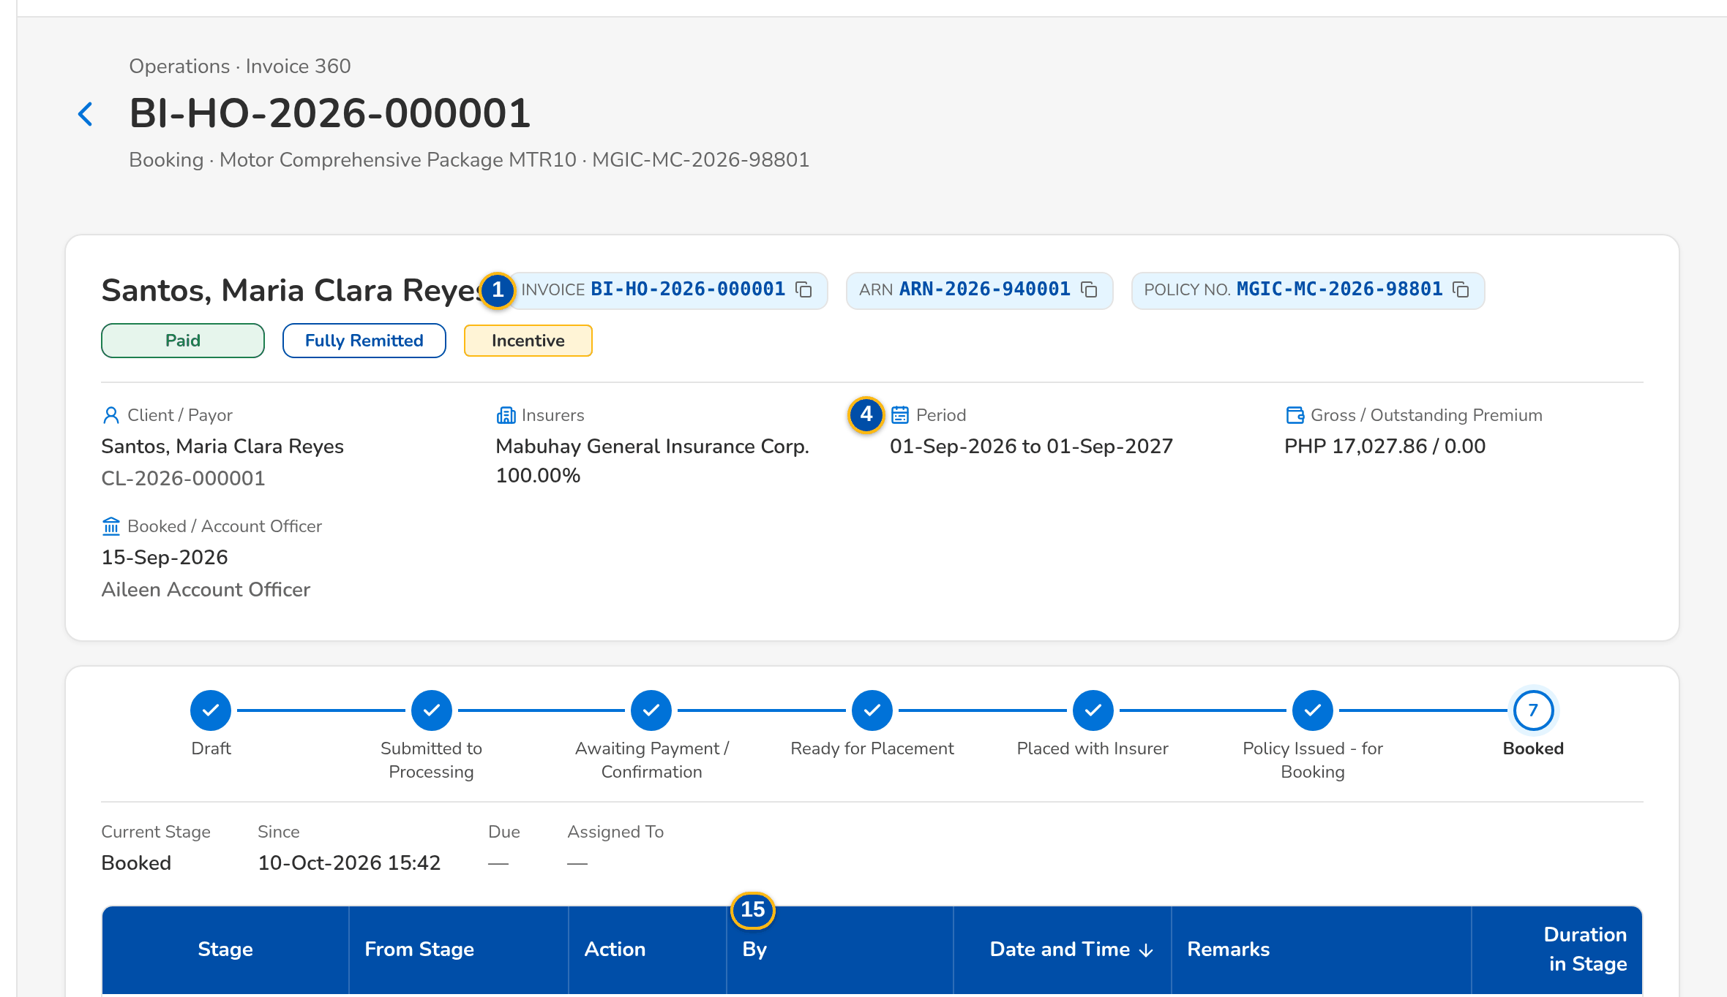
(continued below)
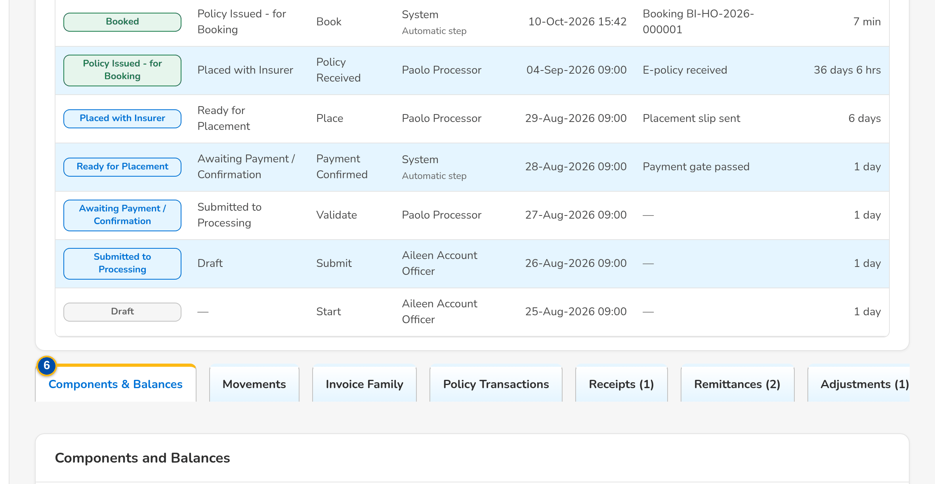
(continued below)
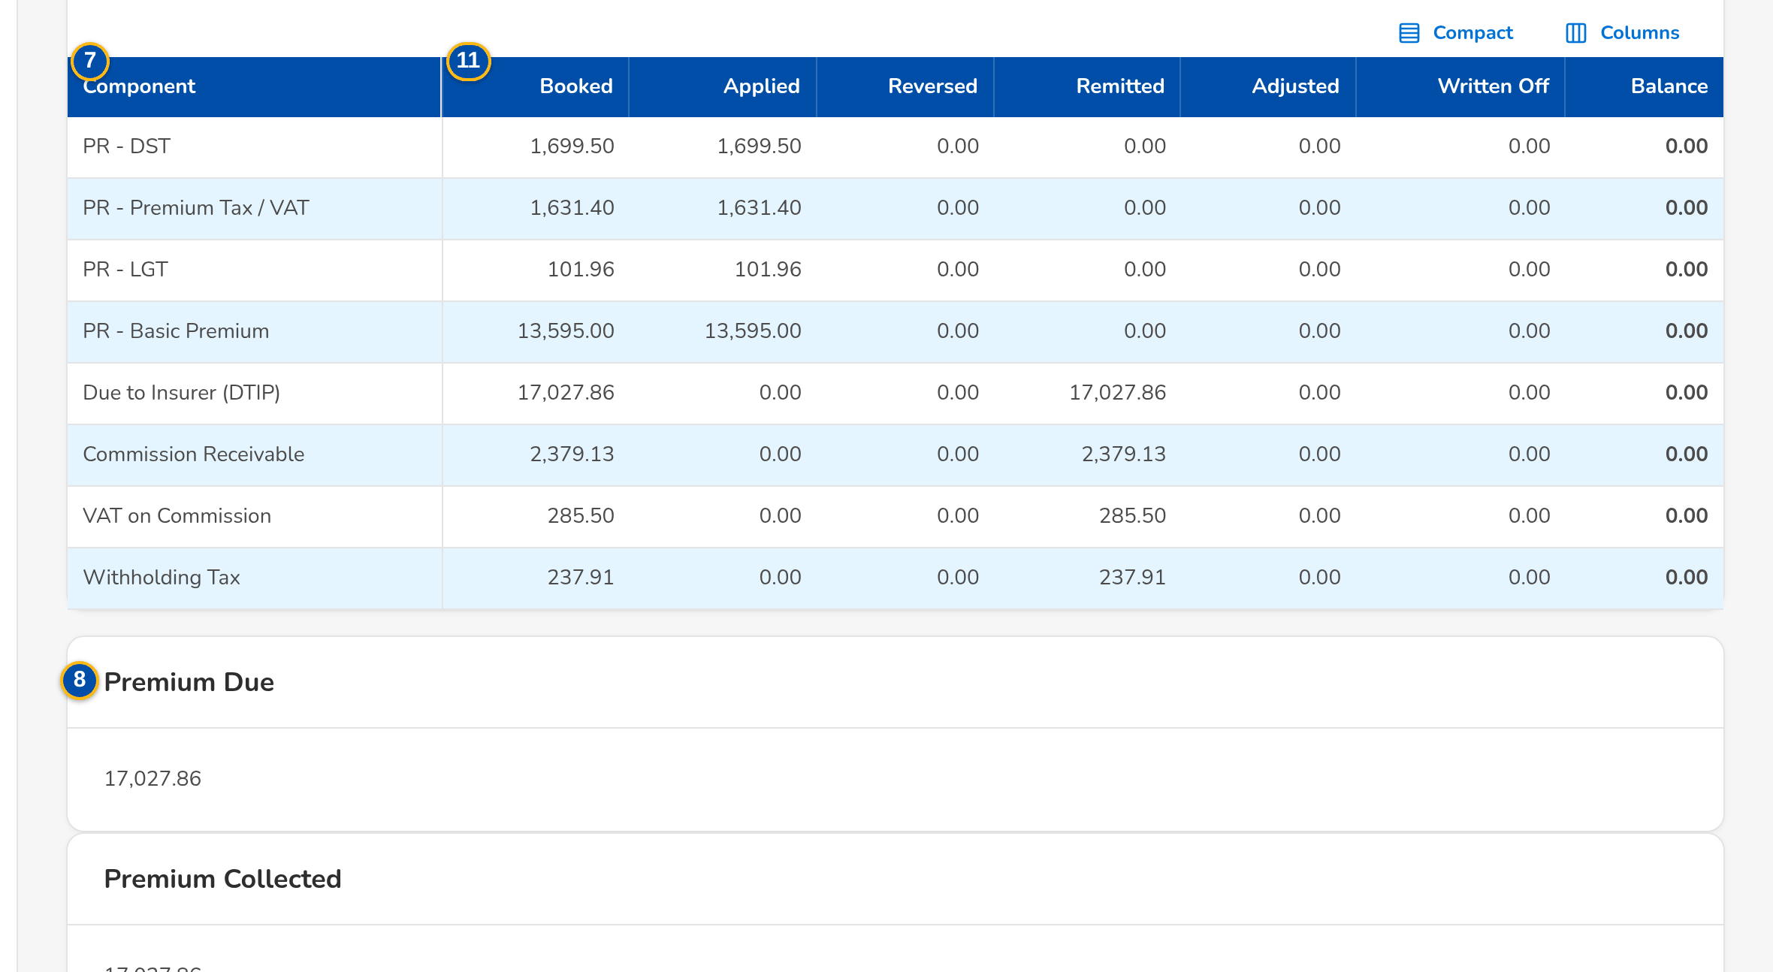
Screenshot E.25: Invoice 360 of a paid and fully remitted invoice, Components & Balances tab
Field | Type | Mandatory | Format / list / source | Validation and message
Header: Invoice / ARN / Policy No. / Endorsement / Root Invoice | Reference chip | - | Endorsement and root invoice only for an endorsement or return invoice; Invoice ledger | -
Header: [Payment status and remittance status pills] | Status pill | - | For example Paid and Fully Remitted; Invoice ledger | -
Header: [Flags] | Tag | - | Direct Payment, 2% CWT, Incentive, On Hold, Pending Negative Adjustment, Written Off, Cancelled, Estimated, Locked by <team>; Invoice ledger | -
Header: Client / Insurer(s) / Period / Gross / Outstanding Premium / Booked | Display | - | Insurer shares in %; period dd-MMM-yyyy to dd-MMM-yyyy; booked date, cost center and Account Officer; Invoice ledger | -
Workflow: [Account workflow header] | Stepper | - | The stages of the account from Draft to Booked with the history table; Account (BRD-1) | -
Tabs: Components & Balances / Movements / Invoice Family / Policy Transactions / Receipts / Remittances / Adjustments / Reconciliation / Commission / History / Documents | Tab | - | A team tab shows its number of records; Fixed | -
Components & Balances: Component / Booked / Applied / Reversed / Remitted / Adjusted / Written Off / Balance | Column | - | PR - DST, PR - Premium Tax / VAT, PR - LGT, PR - Fire Service Tax, PR - Other Charges, PR - Basic Premium, PR - CWT 2307, Due to Insurer (DTIP), Commission Receivable, VAT on Commission, Withholding Tax; Invoice ledger | Balance = booked + adjusted - applied + reversed - remitted - written off
Components & Balances: Premium Due / Premium Collected / Premium Outstanding | Display | - | Amount; Invoice ledger | -
Components & Balances: Insurer Shares | Table | - | Insurer, Share %, Lead; Booking | -
Movements: Value Date / Movement / Component / Amount / Source / Documents / Posted | Column | - | AR, OR, batch and journal numbers in Documents; Invoice ledger | -
Invoice Family: Invoice No. / Transaction / Booked / Gross Premium / Outstanding / Payment / Remittance | Column | - | The original booking first, then every endorsement and cancellation; family totals under the table; Invoice ledger | -
Policy Transactions: Date / Transaction / Reference / Premium Change / Taxes / Commission / Gross Premium After / Status / Accounting | Column | - | Amounts in the invoice currency; the reference under the transaction, the commission change under the taxes, the accounting under the status; Not posted for an open request; a row opens its GL journals; Invoice ledger, booked invoices, endorsement requests, journals | -
Policy Transactions: GL Account / Party / Narration / Debit / Credit | Column | - | The lines of each journal with the totals; Journals (BRD-5) | Debits equal credits
Team tabs: Record / Reference / Date / Amount / Status / Description | Column | - | The receipts and applications, remittance batches and holds, endorsement requests, reconciliation items or direct payment accounts of the invoice; Operations records | No <records> for this invoice yet
History: When / What / Change / Module / Reason / By | Column | - | Status, flag and lock changes, newest first; Invoice ledger | No status changes yet
Documents: [Documents panel] | Panel | - | Documents of the invoice (Common screen elements); Documents | File type, size and content checks

Action | Who | Available when | What happens | Resulting status
Open Booked Invoice | Processing and Adjustment users | The invoice was booked in the system | Opens the booked invoice of New Business | -
[A reference in a tab] | Every Operations user | Always | Opens the receipt, batch, request, cycle or billing | -
[Journals button of a Policy Transactions row] | Every Operations user | The transaction posted journals | Shows the journal lines under the row; the journal number opens the journal for users who may view journals | -

Rules:
- Each team tab lists only the records of that team with their count; an empty tab says so.
- The hold and remittance statuses are shown with their history and time stamps.
- Policy Transactions show the original booking, then every endorsement, adjustment, cancellation and refund in date order, with the position after each posted row and its journals; the history reads the invoice ledger and the journals, no second ledger is kept.
- A co-insured invoice stays one invoice with its insurer shares.
- While an invoice is locked by a team, the other teams may only apply payments to it.

E.26 Report Archive
Purpose: Every Operations report generated on screen or exported, and every file produced by a scheduled report job, with its parameters, the user and time, the number of rows and the file to download again.
Access: Reports › Report Centre › an Operations report (each run is archived)
FR items: FRS.CSH.09.01.01, FRS.CSH.09.01.02, FRS.CSH.09.01.05
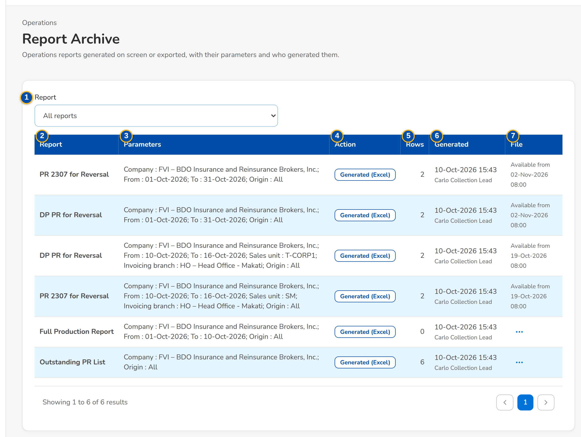
Screenshot E.26: Report Archive with the runs and their parameters
Field | Type | Mandatory | Format / list / source | Validation and message
Toolbar: Report | Drop-down | N | Report titles of the catalogue; Report catalogue | -
List: Report | Column | - | Report title with its code; Report catalogue | -
List: Parameters | Column | - | The parameters of the run; Report run | -
List: Action | Column | - | Generated or exported, with the format; Report run | -
List: Rows | Column | - | Number; Report run | -
List: Generated | Column | - | dd-MMM-yyyy HH:mm and the user's name; Report run | -
List: File | Column | - | Download, or Available from <date and time> for a file of a scheduled job; Report run | -

Action | Who | Available when | What happens | Resulting status
Search | Every Operations user | Always | Lists the runs of the report code | -
Download | Users who may export Operations reports | The file is available | Downloads the archived file | -

Rules:
- Viewing a report and exporting it are separate permissions; a view-only user sees the list without Download.
- Every generation and download is archived with its parameters, user and time.

E.27 Report Centre (Operations reports)
Purpose: The Operations reports of the Report Centre, by team: Cashiering, Remittance, Adjustment, Production Reconciliation and Commission Receivables, each card with its title, code and a one-line description; a card opens the report.
Access: Reports › Report Centre
FR items: FRS.CSH.02.01.16, FRS.CSH.02.06.04, FRS.CSH.09.01.01, FRS.CSH.09.01.02, FRS.CSH.09.01.05, FRS.CSH.09.02, FRS.CSH.09.02.19, FRS.CSH.09.02.20, FRS.CSH.09.02.21, FRS.CSH.09.02.22
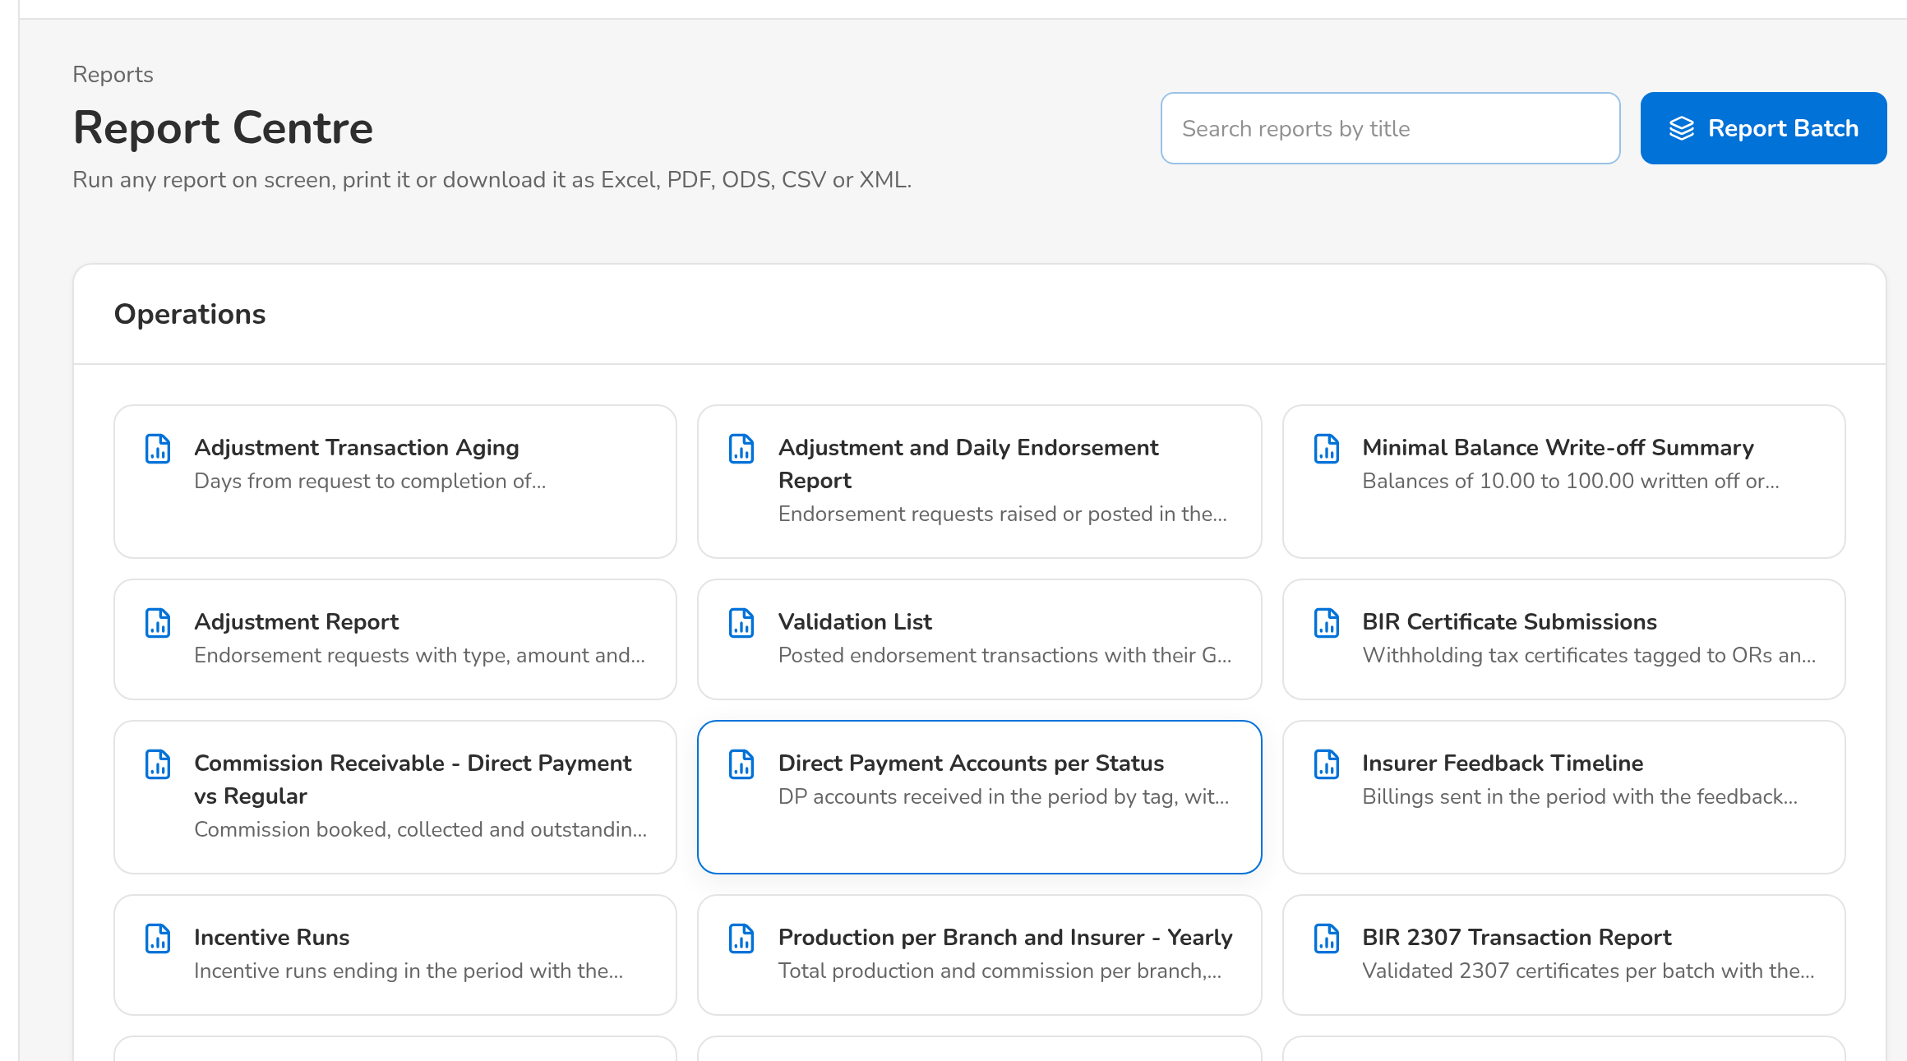
(continued below)
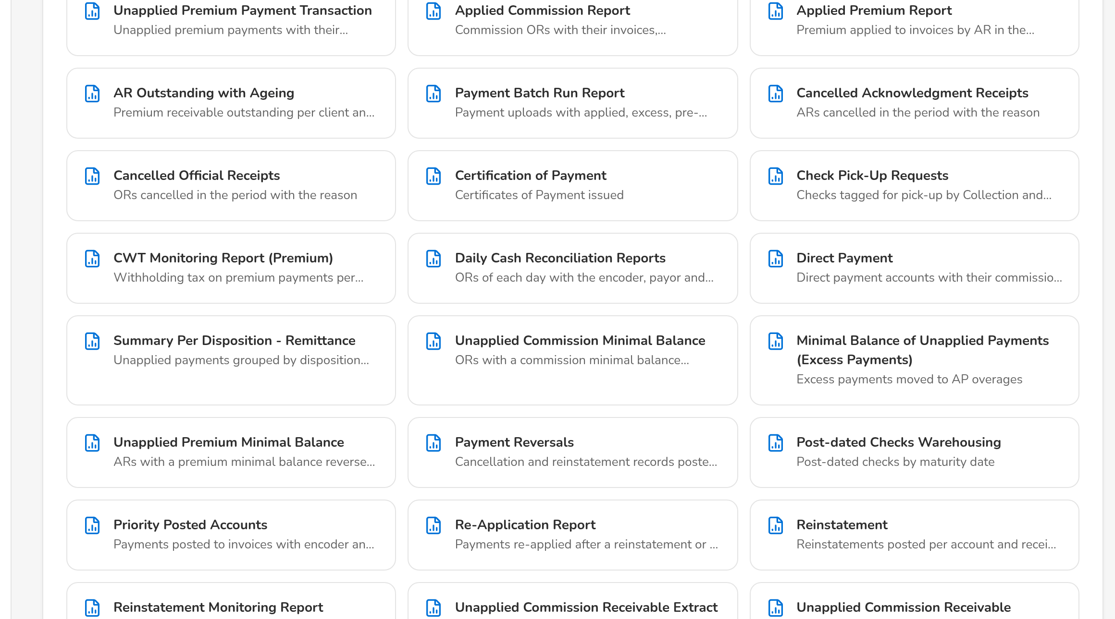
(continued below)
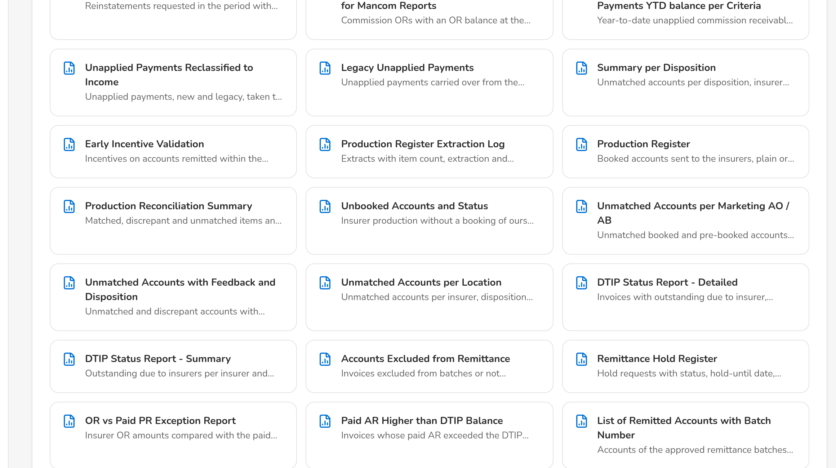
Screenshot E.27: Report Centre, the Operations reports
Field | Type | Mandatory | Format / list / source | Validation and message
Toolbar: Search reports | Text | N | Search by title or code; Report catalogue | -
Report cards: [Operations report cards] | Card | - | Title, code and description; the Operations group lists the Cashiering (CSH), Remittance (REM), Adjustment (ADJ), Production Reconciliation (PRC) and Commission Receivables (CMR) reports; Report catalogue | -
My report batches: Batch No. / Run At / Output / Status | Column | - | Reports run in a batch; Report batches | -

Action | Who | Available when | What happens | Resulting status
[Open a report card] | Users who may view Operations reports | Always | Opens the report with its parameters | -
Report Batch | Users who may view Operations reports | Always | Runs several reports in one batch | -

Rules:
- The Operations reports are in the category Operations; viewing and exporting are separate permissions.
- The layouts the BRD does not detail are proposed layouts for BDOI to confirm.

E.28 Report
Purpose: One Operations report: its parameters (with saved variants), run on screen, printed or exported to Excel, PDF, ODS, CSV or XML; each run is archived with its parameters.
Access: Report Centre › a report card; Report Archive › a run
FR items: FRS.CSH.09.01.01, FRS.CSH.09.01.02, FRS.CSH.09.01.05
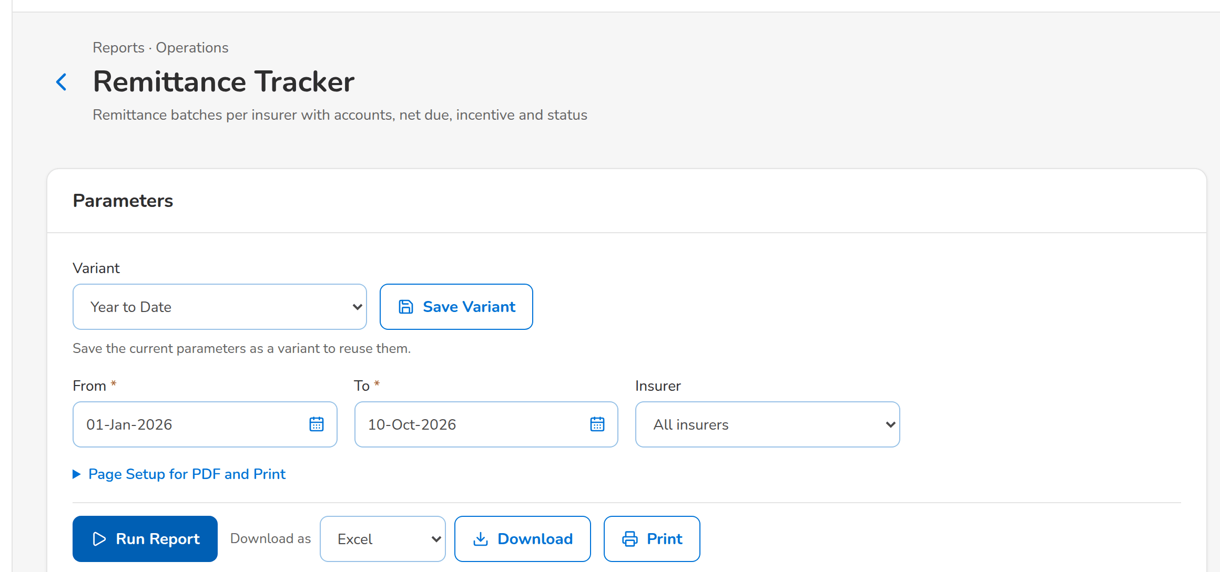
(continued below)
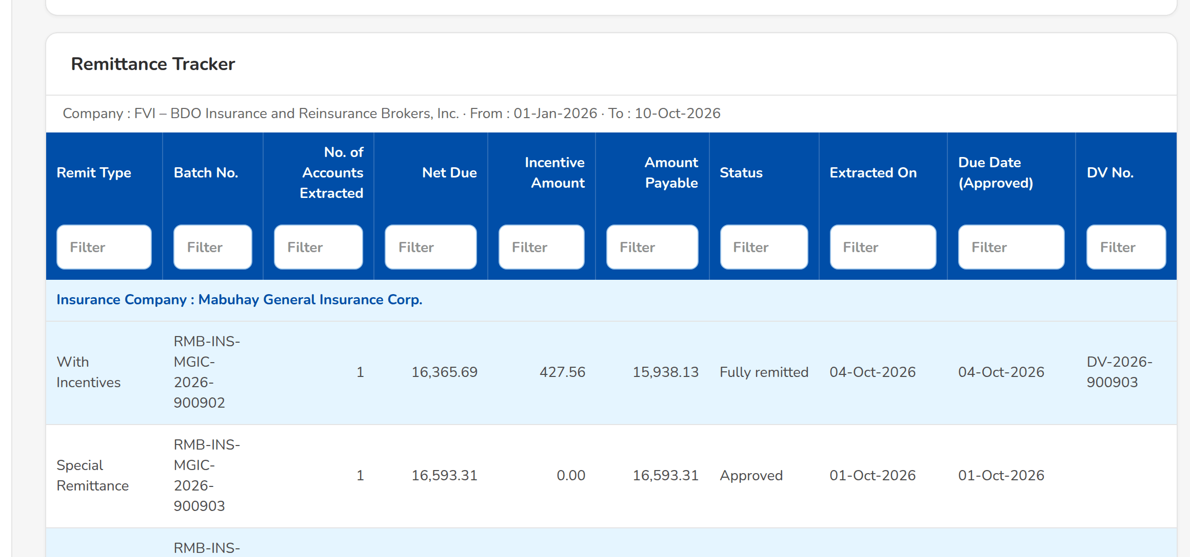
(continued below)
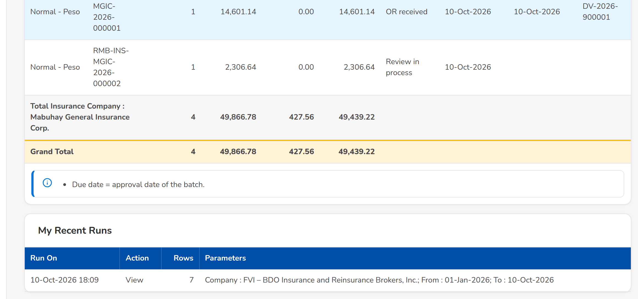
Screenshot E.28: Remittance Tracker run on screen
Field | Type | Mandatory | Format / list / source | Validation and message
Parameters: [Report parameters] | Date, drop-down, text | Per report | For example Company, From, To, Insurer, Origin; Report parameters | Mandatory parameters given
Parameters: Saved Variant / Variant Name | Drop-down, text | N | The user's and the shared variants; Report variants | -
Print options: Paper / Orientation / Width | Drop-down | N | Orientation Automatic (by width), Portrait, Landscape; Fixed list | -
Result: [Report table] | Table | - | The columns of the report with its totals; Report | -

Action | Who | Available when | What happens | Resulting status
Run Report | Users who may view the report | Parameters given | Runs the report on screen and archives the run | -
Print | Users who may export the report | Parameters given | Produces the printable PDF | -
[Export buttons] | Users who may export the report | Report run | Downloads the report as Excel, PDF, ODS, CSV or XML | -
Save Variant / Delete Variant | Every user of the screen | Always | Saves the parameters as a named variant, or deletes one's own | -

Rules:
- A view-only user runs the report on screen; the export and print buttons are not offered.
- Every run and export is archived with its parameters, user and time.

E.29 Interfaces
Purpose: The feeds Operations exchanges with booking, Collection, Disbursement and the insurers, with their direction, transport, owner team, schedule and status; the run log lists every run with its records read, taken in, duplicate and failed; files of a feed without an automatic transport are uploaded here, and the booked invoices can be replayed into the ledger.
Access: Operations Home › Interfaces › Open
FR items: FRS.CSH.02.02.04, FRS.CSH.05.01.04, FRS.CSH.05.01.05, FRS.CSH.05.01.12, FRS.CSH.05.01.13, FRS.CSH.06.03.01, FRS.CSH.06.03.02, FRS.CSH.08.01.03, FRS.CSH.08.02.01, FRS.CSH.09.02.23, FRS.CSH.10.01.01, FRS.CSH.10.02.01, FRS.CSH.10.03.01
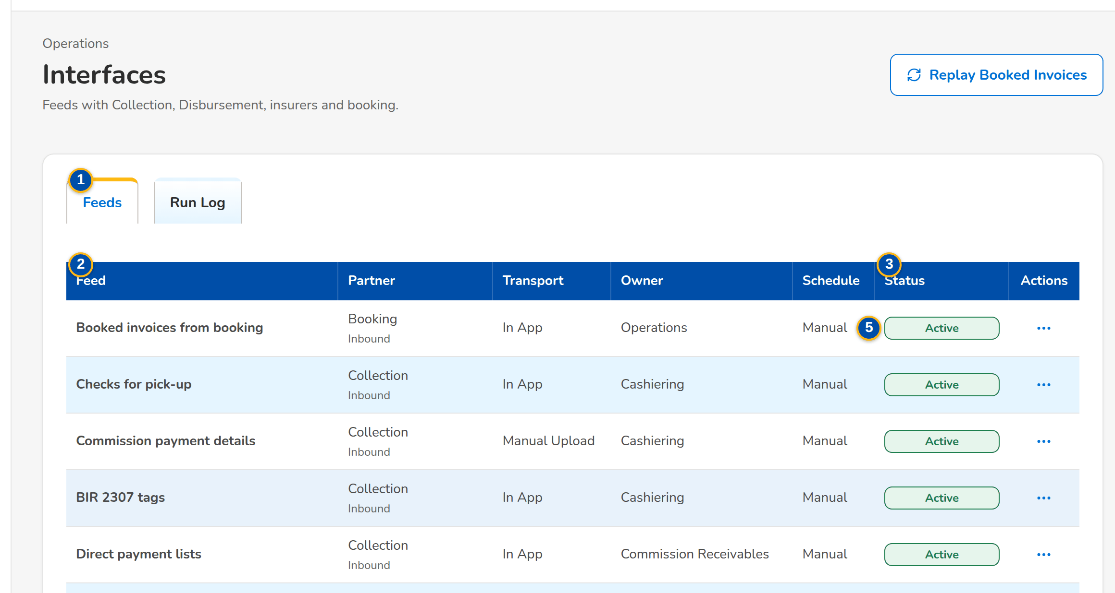
(continued below)
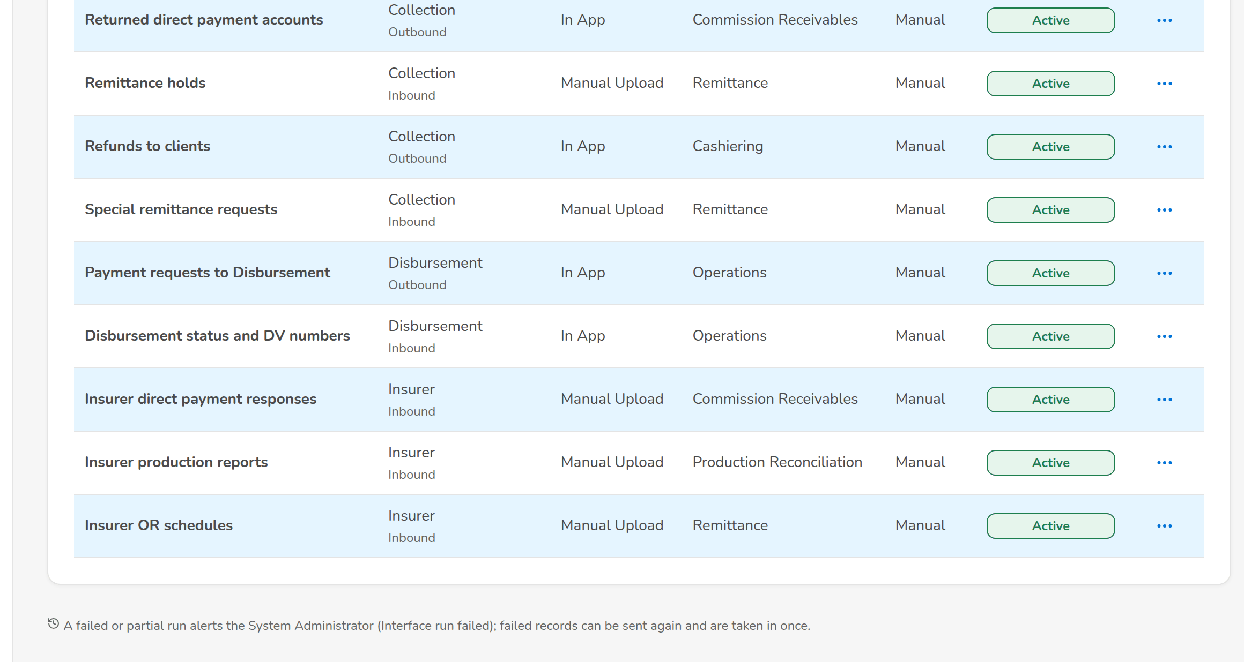
Screenshot E.29: Interfaces, Feeds tab
Field | Type | Mandatory | Format / list / source | Validation and message
Tabs: Feeds / Run Log | Tab | - | Fixed | -
Feeds: Feed / Partner / Transport / Owner / Schedule / Status | Column | - | Partner and direction (inbound, outbound); transport In App or Manual Upload; schedule Manual or the schedule of the feed; Interface feeds | -
Run Log: Run No. / Feed / Trigger / Started / Read / OK / Duplicate / Failed / File / Status | Column | - | Counts per outcome; Interface runs | No runs yet
Run dialog: Record / Status / Created / Message / Received | Column | - | Each record with its outcome and message; Interface run records | No records in this run
Configure dialog: Runs / Time / Active | Drop-down, time, check box | N | Manual runs only, Every hour, Every day, Monday to Friday; the time in Philippine time | -
Upload dialog: File | File | Y | The file of the feed | Choose a file
Replay Booked Invoices dialog: [Invoice number or ARN] | Text | N | One invoice, one account, or the whole company when blank; Booking | Give an invoice number, an ARN or a company to replay

Action | Who | Available when | What happens | Resulting status
Configure / Save Feed | System Administrator | Always | Changes the schedule and activation of the feed | Active or Inactive
Upload File | System Administrator | Active feed that accepts files | Takes in the records of the file, each once | Run done
Replay Booked Invoices / Replay Invoices | System Administrator | Always | Copies into the ledger every booked invoice of the scope missing from it; an invoice already there is not changed | Run done
[Open a run] | System Administrator | Always | Shows the records of the run | -

Rules:
- Each record of a feed is processed on its own and once; a failed record does not stop the run and can be sent again.
- A failed or partial run raises the interface alert.
- Until the systems of the other BRDs and the insurer channels are connected, their data arrives by upload here.

E.30 Menu by persona
The Cashiering entries of the menu of each persona (the menu shows an entry only when one of the user's roles holds its permission).
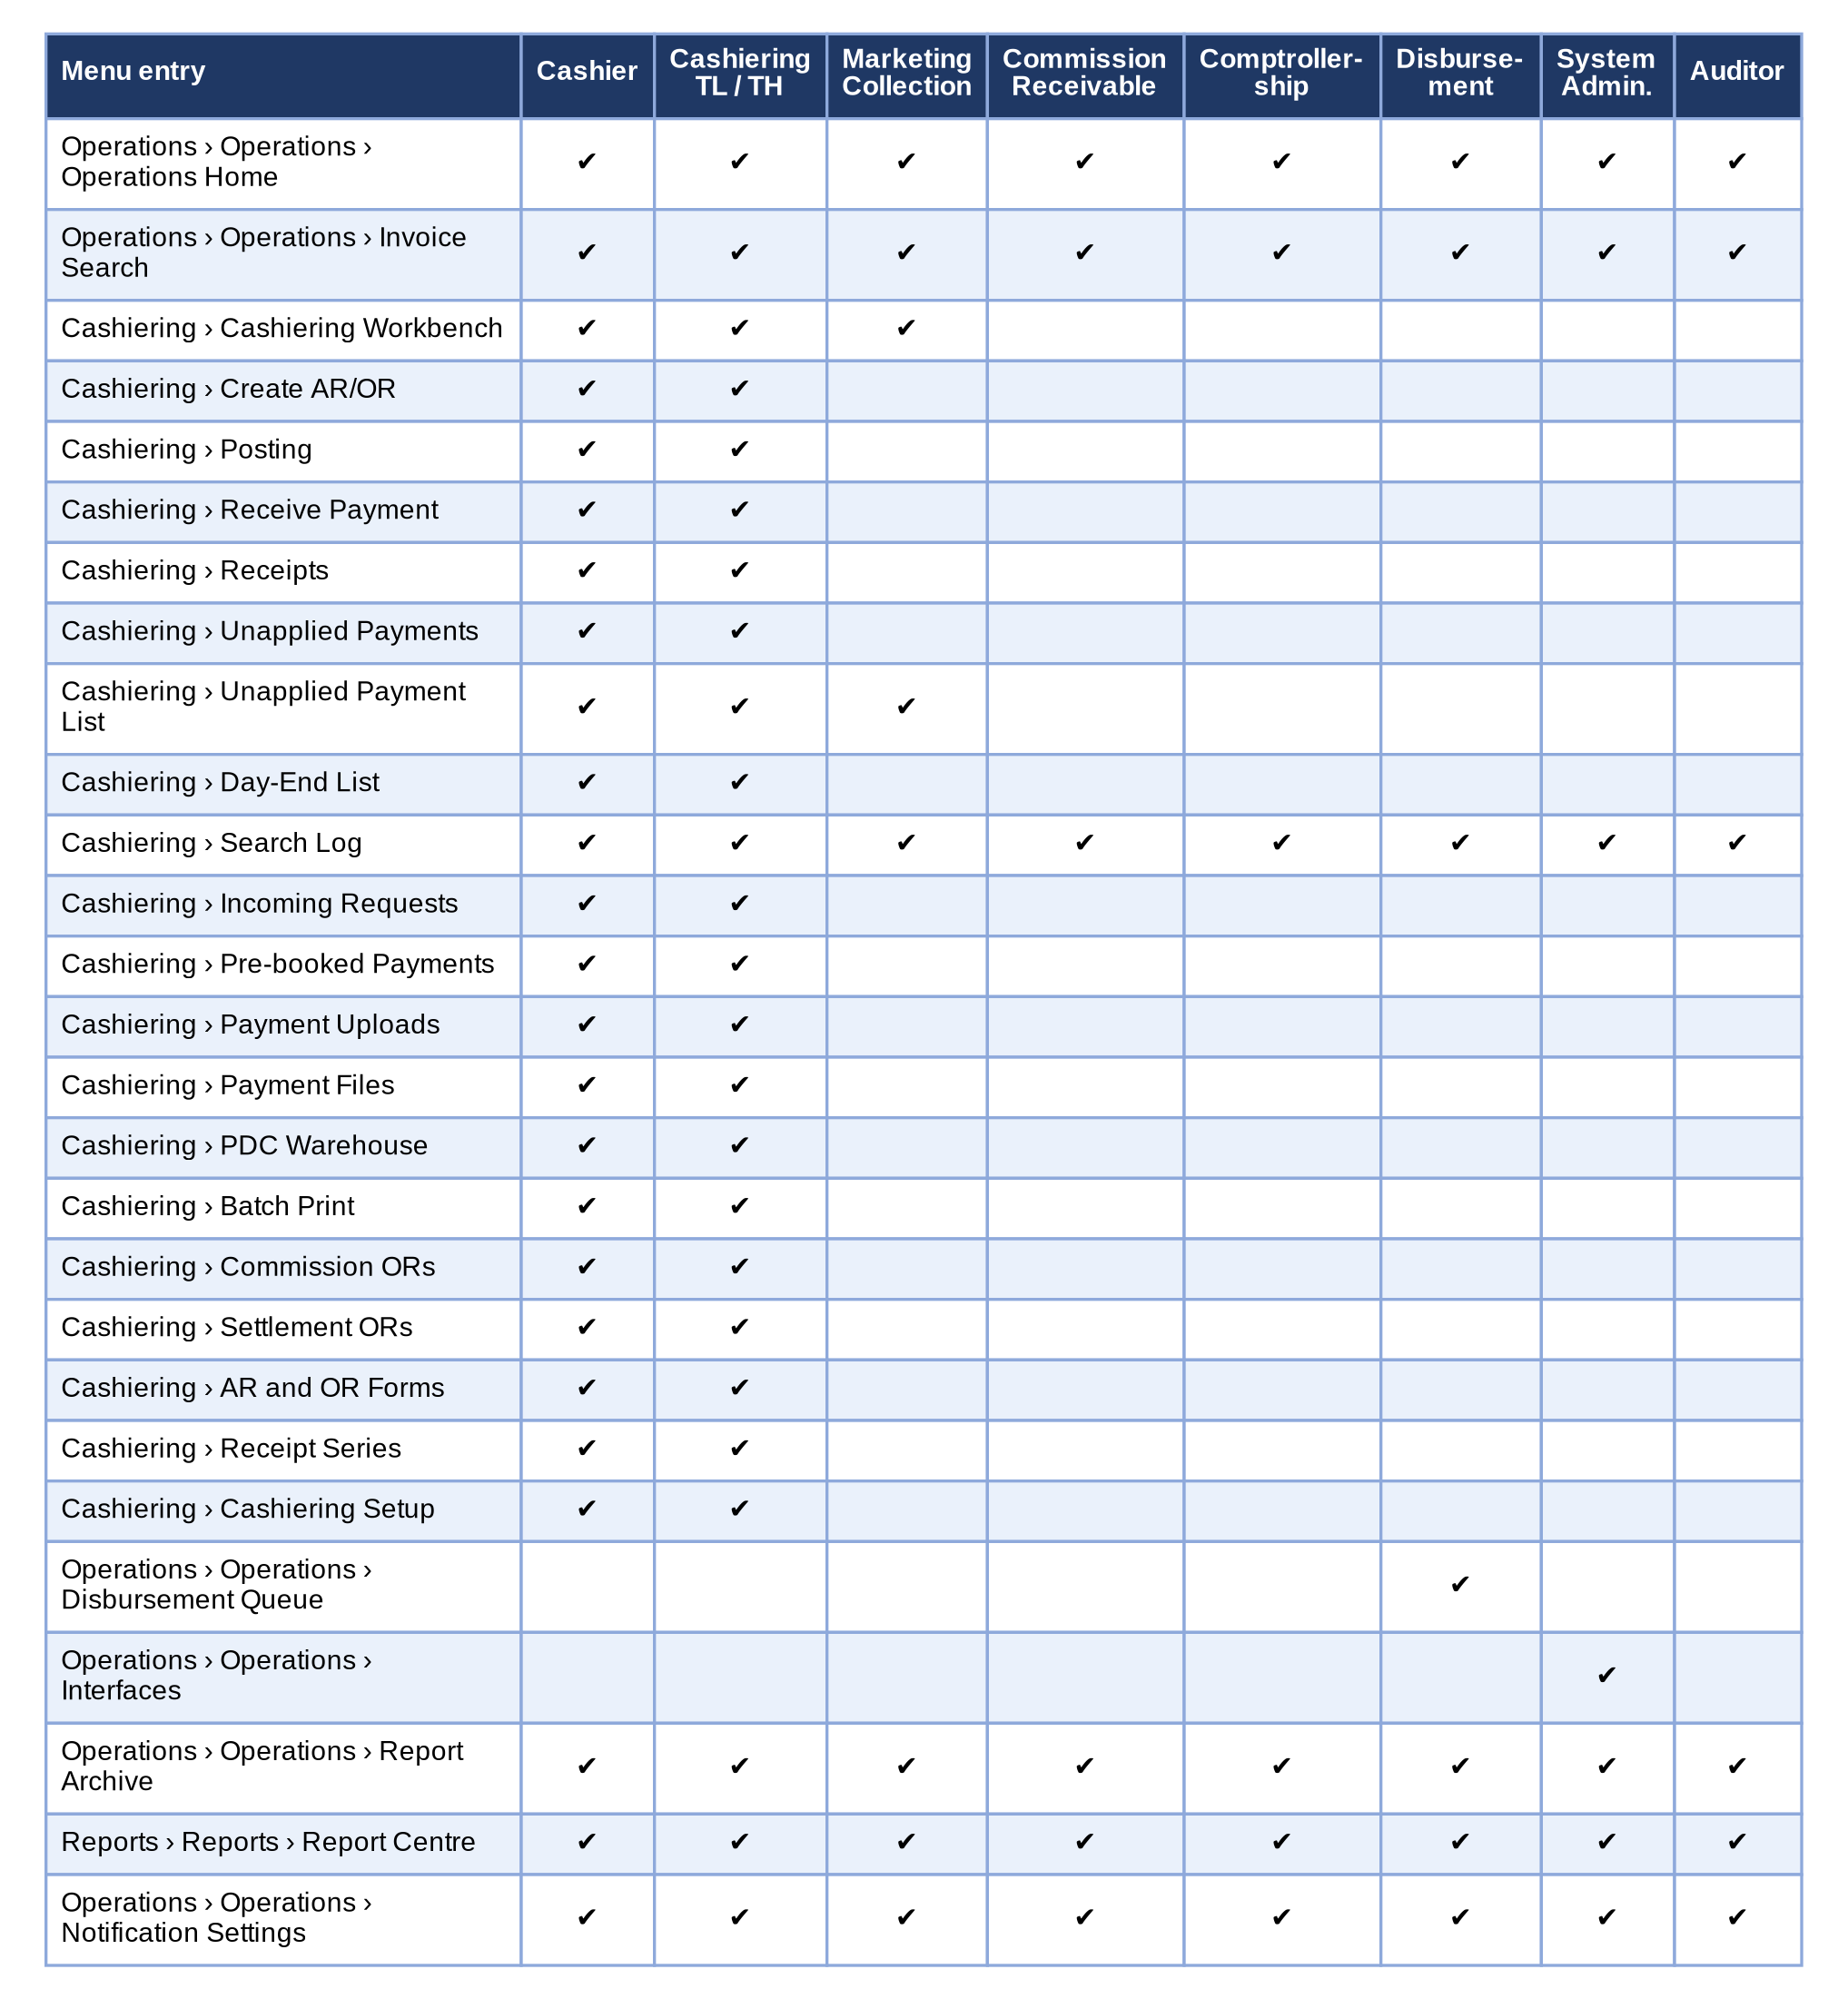
Figure 16 – Menu by persona: the Cashiering screens each persona sees
How to read it: A tick means the screen is in the persona's menu; a screen without a tick is neither shown nor opened by its address. The full menus of every persona are in the BIBS sign-off workbook of BRD-02. Traces to: BRQID.002, BRQID.003; FRS.CSH.01.02, FRS.CSH.01.03.
Screen standards: the layout, the formats of dates and amounts, the tables with row action menus and the common screen elements follow the BIBS programme screen standards; they are not repeated here.

Appendix F – Messages and Validations
F.1 lists the messages and confirmations of BDOI's FRS with the FR item that states them; F.2 lists the messages the system shows today on the Cashiering screens, word for word (the parts in angle brackets are filled in by the system). The wording of each message is confirmed by the Business Unit (requirements collection workbook, sheet Messages to confirm); where a message of the system differs from BDOI's, BDOI's wording prevails once confirmed.

F.1 Messages of BDOI's FRS
No. | FR item | Message
1 | FRS.OPS.002.02 | You are not permitted to perform this action
2 | FRS.CSH.02.01.08.01 | and prevent saving.
3 | FRS.CSH.02.01.08.02 | Record will be Saved. Do you wish to continue?
4 | FRS.CSH.02.01.08.03 | s proposed for BDOI's confirmation, Appendix F).
5 | FRS.CSH.02.01.10 | Record is now submitted for Posting
6 | FRS.CSH.02.01.11 | Record will be cancelled. Do you wish to continue?
7 | FRS.CSH.02.01.15 | A non-premium AR needs the paying insurer's code
8 | FRS.CSH.02.02.01 | Official receipts are issued by Head Office only
9 | FRS.CSH.02.02.04.05 | This file was already uploaded
10 | FRS.CSH.02.04.05 | Select between 1 and 500 receipts to print
11 | FRS.CSH.02.04.13 | for the specific AR/OR number document. The system shall allow the user to retry printing or skip to the next AR/OR document in queue.
12 | FRS.CSH.02.04.13 | printer error / network error / etc
13 | FRS.CSH.02.05.06 | confirmation for posting.
14 | FRS.CSH.02.05.06 | AR/OR will be issued. Payments will be applied. Any excess payments will be reflected in the Unapplied List. You you wish to continue or return to creator?
15 | FRS.CSH.02.05.06 | The requester cannot approve <record number>
16 | FRS.CSH.02.05.09.02 | Receipt Number series for this Branch is depleted. Contact your Administrator.
17 | FRS.CSH.02.05.16 | that the account is locked by Remittance.
18 | FRS.CSH.03.01.06.01 | s per validation
19 | FRS.CSH.03.01.06.07 | Unapplied payment <number> of the receipt is <status>
20 | FRS.CSH.03.01.08.06 | AR/OR will be cancelled. Payments will be cancelled once cancellation is posted. You you wish to continue or return to creator?
21 | FRS.CSH.04.01.09.06 | confirmation for Reinstatement posting.
22 | FRS.CSH.04.01.09.06 | AR/OR will be reinstated. Payments will be reinstated once posted. You you wish to continue?
23 | FRS.CSH.05.01.05 | The file name <name> does not follow the convention of <type>
24 | FRS.CSH.05.02.01 | Check <bank> <number> is already in the warehouse

F.2 Messages of the system
No. | Where it appears | Message | Type | What the user does
M-001 | Invoice Search (SCR-OP-02) | No items to display | Information | No action.
M-002 | Invoice Search (SCR-OP-02) | Give an invoice number, an ARN or a company to replay | Error | Give an invoice number or an ARN, or leave both blank to replay the whole company.
M-003 | Invoice 360 and Policy Transactions (SCR-OP-03) | No items to display | Information | No action.
M-004 | Invoice 360 and Policy Transactions (SCR-OP-03) | No lines | Information | No action.
M-005 | Invoice 360 and Policy Transactions (SCR-OP-03) | No related invoice | Information | No action.
M-006 | Invoice 360 and Policy Transactions (SCR-OP-03) | No status changes yet | Information | No action.
M-007 | Invoice 360 and Policy Transactions (SCR-OP-03) | No transaction recorded | Information | No action.
M-018 | Report Archive (SCR-OP-05) | No items to display | Information | No action.
M-020 | Receive Payment (SCR-OP-08) and the application of payments | A reclass or transfer moves the whole balance | Validation | Enter the whole balance as the amount.
M-021 | Receive Payment (SCR-OP-08) and the application of payments | Check number is required for a check payment | Validation | Enter the check number.
M-022 | Receive Payment (SCR-OP-08) and the application of payments | Enter an ARN, invoice, policy or PN number to preview the application. | Validation | Enter an ARN, invoice, policy or PN number to preview the application.
M-023 | Receive Payment (SCR-OP-08) and the application of payments | Enter an amount above zero | Validation | Enter an amount above zero.
M-024 | Receive Payment (SCR-OP-08) and the application of payments | Enter an amount above zero and at most <balance> | Validation | Enter an amount above zero and at most <balance>.
M-025 | Receive Payment (SCR-OP-08) and the application of payments | Enter an amount above zero and at most <receipt amount> | Validation | Enter an amount above zero and at most <receipt amount>.
M-026 | Receive Payment (SCR-OP-08) and the application of payments | Enter at least one reference, or the payor code for an unmatched payment | Validation | Enter at least one reference, or the payor code for an unmatched payment.
M-027 | Receive Payment (SCR-OP-08) and the application of payments | Payor name is required | Validation | Enter the payor name.
M-028 | Receive Payment (SCR-OP-08) and the application of payments | Select a reason | Validation | Select a reason.
M-029 | Receive Payment (SCR-OP-08) and the application of payments | The reference belongs to a cancelled invoice: the payment goes to unapplied collections. | Validation | No action; the payment will be kept unapplied for a disposition.
M-030 | Receive Payment (SCR-OP-08) and the application of payments | Application <id> is already reversed | Error | No action; the application was already reversed.
M-031 | Receive Payment (SCR-OP-08) and the application of payments | A non-premium AR needs the paying insurer's code | Error | Enter the system of the paying insurer in Payor / Client Code.
M-032 | Receive Payment (SCR-OP-08) and the application of payments | Official receipts are issued by Head Office only | Error | Issue the official receipt from Head Office, or create the series under Head Office.
M-033 | Receive Payment (SCR-OP-08) and the application of payments | An official receipt needs a line | Error | Enter the gross amount of the official receipt.
M-034 | Receive Payment (SCR-OP-08) and the application of payments | A receipt needs an amount above zero | Error | Enter an amount above zero.
M-035 | Receipts, Issue Official Receipt and the receipt series (SCR-OP-09, SCR-OP-21) | <receipt no> issued | Confirmation | No action.
M-036 | Receipts, Issue Official Receipt and the receipt series (SCR-OP-09, SCR-OP-21) | Enter the gross amount | Validation | Enter the gross amount.
M-037 | Receipts, Issue Official Receipt and the receipt series (SCR-OP-09, SCR-OP-21) | Payor name is required | Validation | Enter the payor name.
M-038 | Receipts, Issue Official Receipt and the receipt series (SCR-OP-09, SCR-OP-21) | Select the OR type | Validation | Select the OR type.
M-039 | Receipts, Issue Official Receipt and the receipt series (SCR-OP-09, SCR-OP-21) | VAT and withholding tax cannot be negative | Validation | Enter VAT and withholding tax of zero or more.
M-040 | Receipts, Issue Official Receipt and the receipt series (SCR-OP-09, SCR-OP-21) | Branch <code> is not of this company | Error | Choose a branch of the company in the header.
M-041 | Receipts, Issue Official Receipt and the receipt series (SCR-OP-09, SCR-OP-21) | The company has no Head Office branch for official receipts | Error | Ask the System Administrator to set up the Head Office branch of the company.
M-042 | Receipts, Issue Official Receipt and the receipt series (SCR-OP-09, SCR-OP-21) | Official receipt series belong to Head Office only | Error | Issue the official receipt from Head Office, or create the series under Head Office.
M-043 | Receipts, Issue Official Receipt and the receipt series (SCR-OP-09, SCR-OP-21) | No authorized <kind> series with numbers left for this branch | Error | Ask the Cashiering Team Leader to create and authorise a new series for the branch.
M-044 | Receipts, Issue Official Receipt and the receipt series (SCR-OP-09, SCR-OP-21) | Receipt series <prefix> is depleted | Error | Ask the Cashiering Team Leader to create and authorise a new series for the branch.
M-045 | Receipts, Issue Official Receipt and the receipt series (SCR-OP-09, SCR-OP-21) | Next number <legacy next no> is outside <from no>-<to no> | Error | Enter a next number within the range of the series.
M-046 | Receipts, Issue Official Receipt and the receipt series (SCR-OP-09, SCR-OP-21) | The last number cannot be below the numbers already issued | Error | Correct the range so that the last number is not below the first or the numbers already issued.
M-047 | Receipts, Issue Official Receipt and the receipt series (SCR-OP-09, SCR-OP-21) | The last number must not be below the first number | Error | Correct the range so that the last number is not below the first or the numbers already issued.
M-048 | Receipt: cancellation and reinstatement (SCR-OP-10) | No cancellation or reinstatement | Information | No action.
M-049 | Receipt: cancellation and reinstatement (SCR-OP-10) | No items to display | Information | No action.
M-050 | Receipt: cancellation and reinstatement (SCR-OP-10) | No journal posted yet | Information | No action.
M-051 | Receipt: cancellation and reinstatement (SCR-OP-10) | Nothing applied from this receipt | Information | No action.
M-052 | Receipt: cancellation and reinstatement (SCR-OP-10) | The requested action is applied to the receipt. | Validation | Confirm to approve, or close the dialog.
M-053 | Receipt: cancellation and reinstatement (SCR-OP-10) | The requester cannot approve <transaction no> | Error | Ask another Cashiering Team Leader to approve it.
M-054 | Receipt: cancellation and reinstatement (SCR-OP-10) | <transaction no> is <stage> | Error | No action; the request is not waiting for approval.
M-055 | Receipt: cancellation and reinstatement (SCR-OP-10) | Receipt <receipt no> already has a request waiting for approval | Error | Wait for the decision on the open request of the receipt.
M-056 | Receipt: cancellation and reinstatement (SCR-OP-10) | Receipt <receipt no> is already cancelled | Error | No action; the receipt is already cancelled.
M-057 | Receipt: cancellation and reinstatement (SCR-OP-10) | Unapplied item <reference> of the receipt is <stage> | Error | Withdraw or complete the disposition of the unapplied item first.
M-058 | Receipt: cancellation and reinstatement (SCR-OP-10) | Only a cancelled receipt can be reinstated | Error | Cancel the receipt first; only a cancelled receipt is reinstated.
M-059 | Receipt: cancellation and reinstatement (SCR-OP-10) | Select a reason | Error | Select a reason.
M-060 | Receipt: cancellation and reinstatement (SCR-OP-10) | Specify the reason when 'Others' is selected | Error | Type the reason in the comment when Others is selected.
M-061 | Receipt: cancellation and reinstatement (SCR-OP-10) | The reinstated amount must be above zero and at most <amount> | Error | Enter an amount above zero and at most the receipt amount.
M-062 | Receipt: cancellation and reinstatement (SCR-OP-10) | Enter the <missing> | Error | Enter the <missing>.
M-063 | Receipt: cancellation and reinstatement (SCR-OP-10) | Premium reinstatement reasons apply to ARs | Error | Choose a direct payment reason for an official receipt, or a premium reason for an AR.
M-064 | Unapplied Payments and dispositions (SCR-OP-11, SCR-OP-12) | Disposition updated | Confirmation | No action.
M-065 | Unapplied Payments and dispositions (SCR-OP-11, SCR-OP-12) | No disposition yet | Information | No action.
M-066 | Unapplied Payments and dispositions (SCR-OP-11, SCR-OP-12) | The amount must be above zero and at most the balance <balance> | Error | Enter an amount above zero and at most the balance.
M-067 | Unapplied Payments and dispositions (SCR-OP-11, SCR-OP-12) | Invoice <invoice no> takes no client payment | Error | Choose an invoice that takes client payments (not direct payment or a return invoice).
M-068 | Unapplied Payments and dispositions (SCR-OP-11, SCR-OP-12) | Unknown invoice <invoice no> | Error | Check the invoice number.
M-069 | Unapplied Payments and dispositions (SCR-OP-11, SCR-OP-12) | <description> needs the team leader's approval and is not processed at once | Error | Submit the disposition for approval.
M-070 | Unapplied Payments and dispositions (SCR-OP-11, SCR-OP-12) | Invoice <target invoice no> has nothing outstanding to apply to | Error | Choose another invoice that has premium outstanding.
M-071 | Unapplied Payments and dispositions (SCR-OP-11, SCR-OP-12) | No application | Error | No action; the disposition applied nothing to reverse.
M-072 | Unapplied Payments and dispositions (SCR-OP-11, SCR-OP-12) | Enter <what> | Error | Enter <what>.
M-073 | Unapplied Payments and dispositions (SCR-OP-11, SCR-OP-12) | Disposition type <type code> has no processing rule | Error | Choose another disposition type, or ask the Cashiering Team Leader to set up its processing rule.
M-074 | Unapplied Payments and dispositions (SCR-OP-11, SCR-OP-12) | A reclass or transfer moves the whole balance <balance> | Error | Enter the whole balance as the amount of a reclass or transfer.
M-075 | Unapplied Payments and dispositions (SCR-OP-11, SCR-OP-12) | The requester cannot approve the disposition | Error | Ask another Cashiering Team Leader to approve it.
M-076 | Unapplied Payments and dispositions (SCR-OP-11, SCR-OP-12) | A refund is reversed only after Disbursement returned the request | Error | Ask Disbursement to return the refund request first.
M-077 | Unapplied Payments and dispositions (SCR-OP-11, SCR-OP-12) | Enter the reason for the reversal | Error | Enter the reason for the reversal.
M-078 | Unapplied Payments and dispositions (SCR-OP-11, SCR-OP-12) | An unapplied item needs an amount above zero | Error | Enter an amount above zero.
M-079 | Unapplied Payments and dispositions (SCR-OP-11, SCR-OP-12) | Amount <value> is above the unapplied balance <balance> of <reference> | Error | Enter an amount within the unapplied balance.
M-080 | Unapplied Payments and dispositions (SCR-OP-11, SCR-OP-12) | <reference> is <stage>, not <stage> | Error | No action; the item has already moved on.
M-081 | Incoming Requests (SCR-OP-13) | Enter an amount above zero and at most the unapplied balance | Validation | Enter an amount above zero and at most the unapplied balance.
M-082 | Incoming Requests (SCR-OP-13) | Enter the client to reclass to | Validation | Enter the client to reclass to.
M-083 | Incoming Requests (SCR-OP-13) | Enter the marketing unit to transfer to | Validation | Enter the marketing unit to transfer to.
M-084 | Incoming Requests (SCR-OP-13) | No collector requests to display | Information | No action.
M-085 | Incoming Requests (SCR-OP-13) | No payment reversals to display | Information | No action.
M-086 | Incoming Requests (SCR-OP-13) | No refund validations to display | Information | No action.
M-087 | Incoming Requests (SCR-OP-13) | The selected receipt is reversed as requested. | Validation | Confirm to reverse, or close the dialog.
M-088 | Incoming Requests (SCR-OP-13) | <request no> is already <status> | Error | No action; the request was already decided.
M-089 | Incoming Requests (SCR-OP-13) | Disposition type <type> does not carry out a <action> request | Error | Choose a disposition type that carries out what the collector asked.
M-090 | Incoming Requests (SCR-OP-13) | Unknown disposition type <type> | Error | Choose another disposition type, or ask the Cashiering Team Leader to set up its processing rule.
M-091 | Incoming Requests (SCR-OP-13) | The requester cannot approve the payment reversal | Error | Ask another Cashiering Team Leader to approve it.
M-092 | Incoming Requests (SCR-OP-13) | <request no> is already <status> | Error | No action; the request was already decided.
M-093 | Incoming Requests (SCR-OP-13) | Receipt <receipt no> has <available> applied to <invoice no>, less than <target> | Error | Reject the reversal with the reason, or ask ACSL for the right amount.
M-094 | Incoming Requests (SCR-OP-13) | Unknown receipt <receipt no> | Error | Check the receipt number with ACSL.
M-095 | Incoming Requests (SCR-OP-13) | <task no> is already <status> | Error | No action; the validation was already decided.
M-096 | Incoming Requests (SCR-OP-13) | Choose the unapplied item that holds the returned premium | Error | Choose the unapplied item that holds the returned premium.
M-097 | Incoming Requests (SCR-OP-13) | Enter the reason for rejecting | Error | Enter the reason for rejecting.
M-098 | Pre-booked Payments (SCR-OP-14) | No items to display | Information | No action.
M-099 | Pre-booked Payments (SCR-OP-14) | Pre-booked payment of <arn> is <status> | Error | No action; the payment was already applied or released.
M-100 | Payment Uploads and Cashiering Setup (SCR-OP-15, SCR-OP-22) | Layout of <handler code> saved | Confirmation | No action.
M-101 | Payment Uploads and Cashiering Setup (SCR-OP-15, SCR-OP-22) | No payment accepted in this run | Information | No action.
M-102 | Payment Uploads and Cashiering Setup (SCR-OP-15, SCR-OP-22) | Sweep done: <premium> premium balance(s) reversed, <excess> excess moved to overages | Confirmation | No action.
M-103 | Payment Uploads and Cashiering Setup (SCR-OP-15, SCR-OP-22) | A delimited layout needs a one-character separator | Error | Enter a separator of one character.
M-104 | Payment Uploads and Cashiering Setup (SCR-OP-15, SCR-OP-22) | A fixed-width layout needs its fields | Error | Write each field as Header:start:length separated by semicolons.
M-105 | Payment Uploads and Cashiering Setup (SCR-OP-15, SCR-OP-22) | Start and length of '<part>' must be numbers | Error | Write each field as Header:start:length separated by semicolons.
M-106 | Payment Uploads and Cashiering Setup (SCR-OP-15, SCR-OP-22) | Write each field as Header:start:length, not '<part>' | Error | Write each field as Header:start:length separated by semicolons.
M-107 | Payment Uploads and Cashiering Setup (SCR-OP-15, SCR-OP-22) | Unknown layout kind <new kind> | Error | Choose Automatic, Delimited or Fixed width.
M-108 | PDC Warehouse (SCR-OP-16) | Enter an amount above zero | Validation | Enter an amount above zero.
M-109 | PDC Warehouse (SCR-OP-16) | PDC warehouse updated | Confirmation | No action.
M-110 | PDC Warehouse (SCR-OP-16) | A post-dated check needs an amount above zero | Error | Enter an amount above zero.
M-111 | PDC Warehouse (SCR-OP-16) | Check <bank code> <check no> is already warehoused | Error | No action; the check is already in the warehouse.
M-112 | PDC Warehouse (SCR-OP-16) | Check <warehouse no> is <status>, not in the warehouse | Error | No action; the check has already left the warehouse.
M-113 | PDC Warehouse (SCR-OP-16) | A check leaves the warehouse as returned, replaced or pulled out | Error | Choose Returned, Replaced or Pulled out.
M-114 | Batch Print (SCR-OP-18) | <batch no>: <printed count> printed, <failed count> failed | Confirmation | No action.
M-115 | Batch Print (SCR-OP-18) | No print batch yet | Information | No action.
M-116 | Batch Print (SCR-OP-18) | No receipts match the criteria | Information | No action.
M-117 | Batch Print (SCR-OP-18) | Receipt <receipt no> is cancelled | Error | Choose a receipt that is not cancelled.
M-118 | Batch Print (SCR-OP-18) | <batch no> has no failures | Error | No action; every receipt of the batch was printed.
M-119 | Batch Print (SCR-OP-18) | Select between 1 and 500 receipts to print | Error | Select between 1 and 500 receipts.
M-140 | Commission ORs (SCR-OP-20) | No commission payment waiting for an OR | Information | No action.
M-141 | Commission ORs (SCR-OP-20) | Unknown company <company> | Error | Correct the company of the row and upload it again.
M-351 | Interfaces (SCR-OP-61) | <name> saved | Confirmation | No action.
M-352 | Interfaces (SCR-OP-61) | No records in this run | Information | No action.
M-353 | Interfaces (SCR-OP-61) | No runs yet | Information | No action.
M-354 | Interfaces (SCR-OP-61) | Feed <code> is inactive | Error | Ask the System Administrator to activate the feed, then upload again.
M-355 | Interfaces (SCR-OP-61) | No module processes uploads of feed <feed code> yet | Error | Use the screen of the team that takes this feed in, or report it to the System Administrator.
M-356 | Several screens | No receipt series yet | Information | No action.
M-357 | Several screens | Prefix is required | Validation | Enter the prefix of the series.
M-358 | Several screens | Series <prefix> saved | Confirmation | No action.
M-359 | Several screens | The range must end at or after its start | Validation | Correct the range.
M-360 | Several screens | The series becomes active for issuing receipts. | Validation | Confirm to authorise the series, or close the dialog.
M-361 | Upload screens (Payment Uploads, BIR 2307, Commission ORs, Batch Request Upload, Minimal Balance File): every upload type | <Column> '<value>' is not a valid <number, date (yyyy-mm-dd), Y/N value> | Validation | Correct the value in the file in the format of the column and upload the file again.
M-362 | Upload screens (Payment Uploads, BIR 2307, Commission ORs, Batch Request Upload, Minimal Balance File): every upload type | <Column> is mandatory | Validation | Fill in the column in the file and upload the file again.
M-366 | Upload screens (Payment Uploads, BIR 2307, Commission ORs, Batch Request Upload, Minimal Balance File): Post-dated Checks | The amount must be above zero | Validation | Correct the amount of the row.
M-367 | Upload screens (Payment Uploads, BIR 2307, Commission ORs, Batch Request Upload, Minimal Balance File): Commission Payment Details | The basic commission must be above zero | Validation | Correct the basic commission of the row.
M-368 | Every screen (Common screen elements) | You are not permitted to perform this action | Error | Ask for the permission; the menu shows only the screens of your role.
M-369 | Every screen (Common screen elements) | The record was changed by another user. Please reload and try again. | Error | Reload the record; another user changed it. Enter the change again.
M-370 | Every screen (Common screen elements) | The system could not complete the request. Try again; if it continues, contact support with the reference. | Error | Report the message with its reference to the System Administrator.
M-371 | Every screen (Common screen elements) | Parameter '<name>' has an invalid value | Error | Reload the screen and try again; if it persists, report it with the time to the System Administrator.
M-372 | Every screen (Common screen elements) | Required parameter '<parameter name>' is missing | Error | Reload the screen and try again; if it persists, report it with the time to the System Administrator.
M-373 | Every screen (Common screen elements) | The uploaded file is too large | Error | Reduce the file (split it) and upload it again.
M-374 | Every screen (Common screen elements) | Invalid request | Error | Correct the fields listed under the message.

Appendix G – Notifications and E-mail Texts
Every notice, alert and e-mail of Operations Cashiering, word for word as the system gives it today; the parts in angle brackets are filled in by the system. A notice "in the system" appears under the bell in the page header and opens the record; an alert appears in the alert inbox of the role. The system sends one e-mail for Cashiering: the failed batch run. BDOI has not given wordings for these messages: the texts below are proposed by iorta TechNXT for BDOI's approval (requirements collection workbook, sheet E-mail wordings). The notices of the posting step, of the payment files received via MFT and of the AR and OR forms are G-15 to G-18.
No. | Notice | Channel | Recipients
G-01 | Cancellation or reinstatement record for approval | Notice in the system (the user may also choose an e-mail copy on Notification Settings: proposed, Appendix R) | Every holder of the posting right (Cashiering Team Leaders and Team Heads), except the submitter.
G-02 | Disposition for approval | Notice in the system | Every holder of the disposition approval right (Cashiering Team Leaders), except the submitter.
G-03 | Payment reversal for approval | Notice in the system | Every holder of the posting right (Cashiering Team Leaders).
G-04 | Request of a collector | Notice in the system | Every holder of the disposition right (Cashiers).
G-05 | Refund validation requested | Notice in the system | Every holder of the disposition right (Cashiers).
G-06 | Record moved to another stage | Notice in the system | The creator of the record and its current assignee, unless they made the move themselves.
G-07 | Work assigned | Notice in the system | The user assigned.
G-08 | Work handed over | Notice in the system | The users of the team named in the hand-over.
G-09 | Refund request to Disbursement | Notice in the system | Disbursement (holders of the Disbursement queue right).
G-10 | Status of a refund request | Notice in the system | The user who sent the request.
G-11 | Receipt series low | Alert | Cashiering Team Leader (alert inbox).
G-12 | Pre-booked payment waiting | Alert | Cashiering Team Leader (alert inbox).
G-13 | Interface run failed | Alert and notice in the system | System Administrator (alert inbox and notice).
G-14 | Batch run failed | E-mail (plain text, from the system address of the environment) | The e-mail addresses of the failed-run recipients setting (System Administrator; proposed: the Cashiering Team Head).
G-15 | AR / OR record for posting | Notice in the system | Every holder of the posting right (Cashiering Team Leaders and Team Heads).
G-16 | AR / OR record posted or returned | Notice in the system | The creator of the record.
G-17 | File received via MFT refused | Alert | Cashiering Team Leader (alert inbox).
G-18 | AR or OR form change for approval | Notice in the system | Every holder of the master data approval right, except the user who changed the form.

G-01 Cancellation or reinstatement record for approval
Item | Detail
Trigger | A cancellation or reinstatement record is submitted for posting.
Recipients | Every holder of the posting right (Cashiering Team Leaders and Team Heads), except the submitter.
Channel | Notice in the system (the user may also choose an e-mail copy on Notification Settings: proposed, Appendix R)
Subject / title | <record number> for approval
Text | <Cancellation / Reinstatement> of receipt, reason: <reason>
Attachments | None
Protection | No attachment, amount above the record's own or personal data beyond the names; the link opens the record only for a signed-in user who holds the right.
Frequency | Once per submission or re-submission.
Wording | Wording of the system today, proposed by iorta TechNXT for BDOI approval (requirements collection workbook, sheet E-mail wordings, item G-01)
Traces to | CSHID.001, CSHID.002; FRS.CSH.03.01.11, FRS.CSH.04.01.12

G-02 Disposition for approval
Item | Detail
Trigger | A disposition of a type that needs Team approval is submitted.
Recipients | Every holder of the disposition approval right (Cashiering Team Leaders), except the submitter.
Channel | Notice in the system
Subject / title | <Unapplied Payment No.> disposition for approval
Text | <disposition type> <currency> <amount>
Attachments | None
Protection | No attachment, amount above the record's own or personal data beyond the names; the link opens the record only for a signed-in user who holds the right.
Frequency | Once per submission.
Wording | Wording of the system today, proposed by iorta TechNXT for BDOI approval (requirements collection workbook, sheet E-mail wordings, item G-02)
Traces to | CSHID.024, CSHID.025; FRS.CSH.06.02.01, FRS.CSH.10.04.01

G-03 Payment reversal for approval
Item | Detail
Trigger | Accounting Controls requests the reversal of a payment application.
Recipients | Every holder of the posting right (Cashiering Team Leaders).
Channel | Notice in the system
Subject / title | <request number>: payment reversal for approval
Text | Receipt <AR number> on invoice <invoice number>
Attachments | None
Protection | No attachment, amount above the record's own or personal data beyond the names; the link opens the record only for a signed-in user who holds the right.
Frequency | Once per request.
Wording | Wording of the system today, proposed by iorta TechNXT for BDOI approval (requirements collection workbook, sheet E-mail wordings, item G-03)
Traces to | CSHID.024; BRQID.004; FRS.CSH.06.03.02

G-04 Request of a collector
Item | Detail
Trigger | A collector asks Cashiering to apply, refund or transfer an Unapplied payment record.
Recipients | Every holder of the disposition right (Cashiers).
Channel | Notice in the system
Subject / title | <request number>: <action> requested by a collector
Text | <Unapplied Payment No.> to invoice <invoice number>
Attachments | None
Protection | No attachment, amount above the record's own or personal data beyond the names; the link opens the record only for a signed-in user who holds the right.
Frequency | Once per request.
Wording | Wording of the system today, proposed by iorta TechNXT for BDOI approval (requirements collection workbook, sheet E-mail wordings, item G-04)
Traces to | CSHID.024; BRQID.004; FRS.CSH.06.03.01

G-05 Refund validation requested
Item | Detail
Trigger | Payment Requests asks Cashiering to confirm that a cancelled premium is back in the Unapplied list before a refund.
Recipients | Every holder of the disposition right (Cashiers).
Channel | Notice in the system
Subject / title | <task number>: refund validation requested
Text | Confirm that the premium of <invoice number> is back in the unapplied list
Attachments | None
Protection | No attachment, amount above the record's own or personal data beyond the names; the link opens the record only for a signed-in user who holds the right.
Frequency | Once per request.
Wording | Wording of the system today, proposed by iorta TechNXT for BDOI approval (requirements collection workbook, sheet E-mail wordings, item G-05)
Traces to | CSHID.024; BRQID.004; FRS.CSH.06.03.02

G-06 Record moved to another stage
Item | Detail
Trigger | A cancellation or reinstatement record or an Unapplied payment record is returned, posted, approved or moved by a workflow action.
Recipients | The creator of the record and its current assignee, unless they made the move themselves.
Channel | Notice in the system
Subject / title | <record number>: <new stage>
Text | <record description> - <comment typed with the action>
Attachments | None
Protection | No attachment, amount above the record's own or personal data beyond the names; the link opens the record only for a signed-in user who holds the right.
Frequency | Once per move.
Wording | Wording of the system today, proposed by iorta TechNXT for BDOI approval (requirements collection workbook, sheet E-mail wordings, item G-06)
Traces to | CSHID.001, CSHID.002, CSHID.024; FRS.CSH.02.05.07, FRS.CSH.03.01.11, FRS.CSH.04.01.12, FRS.CSH.10.04.01

G-07 Work assigned
Item | Detail
Trigger | A Team Leader assigns a record to a user.
Recipients | The user assigned.
Channel | Notice in the system
Subject / title | <record number> assigned to you
Text | <record title>
Attachments | None
Protection | No attachment, amount above the record's own or personal data beyond the names; the link opens the record only for a signed-in user who holds the right.
Frequency | Once per assignment.
Wording | Wording of the system today, proposed by iorta TechNXT for BDOI approval (requirements collection workbook, sheet E-mail wordings, item G-07)
Traces to | CSHID.024; FRS.CSH.10.04.01

G-08 Work handed over
Item | Detail
Trigger | A module hands Cashiering work it cannot complete because the other module is not in use (an OR or an unapplied item to set up).
Recipients | The users of the team named in the hand-over.
Channel | Notice in the system
Subject / title | Work handed over: <work>
Text | <what to do>
Attachments | None
Protection | No attachment, amount above the record's own or personal data beyond the names; the link opens the record only for a signed-in user who holds the right.
Frequency | Once per hand-over.
Wording | Wording of the system today, proposed by iorta TechNXT for BDOI approval (requirements collection workbook, sheet E-mail wordings, item G-08)
Traces to | BRQID.004; FRS.CSH.10.01.01

G-09 Refund request to Disbursement
Item | Detail
Trigger | A Refund disposition is approved: Cashiering sends a payment request to Disbursement.
Recipients | Disbursement (holders of the Disbursement queue right).
Channel | Notice in the system
Subject / title | Payment request <request number>
Text | <type>, <payee>, <amount>
Attachments | None
Protection | No attachment, amount above the record's own or personal data beyond the names; the link opens the record only for a signed-in user who holds the right.
Frequency | Once per request.
Wording | Wording of the system today, proposed by iorta TechNXT for BDOI approval (requirements collection workbook, sheet E-mail wordings, item G-09)
Traces to | CSHID.024; FRS.CSH.06.02.01, FRS.CSH.10.01.01

G-10 Status of a refund request
Item | Detail
Trigger | Disbursement acknowledges, pays or returns a refund request.
Recipients | The user who sent the request.
Channel | Notice in the system
Subject / title | Payment request <request number> is now <status>
Text | <DV number, status and return reason>
Attachments | None
Protection | No attachment, amount above the record's own or personal data beyond the names; the link opens the record only for a signed-in user who holds the right.
Frequency | Once per change of status.
Wording | Wording of the system today, proposed by iorta TechNXT for BDOI approval (requirements collection workbook, sheet E-mail wordings, item G-10)
Traces to | CSHID.024; FRS.CSH.06.02.01

G-11 Receipt series low
Item | Detail
Trigger | The numbers left in an AR or OR series reach its warning level.
Recipients | Cashiering Team Leader (alert inbox).
Channel | Alert
Subject / title | <AR / OR> series <prefix> has <n> numbers left
Text | The series; the alert opens Receipt Series.
Attachments | None
Protection | No attachment, amount above the record's own or personal data beyond the names; the link opens the record only for a signed-in user who holds the right.
Frequency | When each number at or below the warning level is issued; once per series and number left.
Wording | Wording of the system today, proposed by iorta TechNXT for BDOI approval (requirements collection workbook, sheet E-mail wordings, item G-11)
Traces to | CSHID.015; FRS.CSH.02.03.03, FRS.CSH.10.04.02

G-12 Pre-booked payment waiting
Item | Detail
Trigger | A Pre-booked payment waits for the booking of its account beyond the ageing threshold (5 days as delivered).
Recipients | Cashiering Team Leader (alert inbox).
Channel | Alert
Subject / title | Payment for <ARN> waits for the booking since <date>
Text | The pre-booked payment and its amount.
Attachments | None
Protection | No attachment, amount above the record's own or personal data beyond the names; the link opens the record only for a signed-in user who holds the right.
Frequency | Once a day per payment while it waits (re-matching run).
Wording | Wording of the system today, proposed by iorta TechNXT for BDOI approval (requirements collection workbook, sheet E-mail wordings, item G-12)
Traces to | CSHID.020; FRS.CSH.05.03.01, FRS.CSH.10.04.02

G-13 Interface run failed
Item | Detail
Trigger | A flow-in run (booked accounts, files received, commission payment details) fails or has failed records.
Recipients | System Administrator (alert inbox and notice).
Channel | Alert and notice in the system
Subject / title | Interface run <status>
Text | <feed> run <run number> <status>: <message>
Attachments | None
Protection | No attachment, amount above the record's own or personal data beyond the names; the link opens the record only for a signed-in user who holds the right.
Frequency | Once per run.
Wording | Wording of the system today, proposed by iorta TechNXT for BDOI approval (requirements collection workbook, sheet E-mail wordings, item G-13)
Traces to | BRQID.005, BRQID.006; FRS.CSH.10.02.01

G-14 Batch run failed
Item | Detail
Trigger | A scheduled run of Cashiering (re-matching, post-dated check maturity, minimal balance run) fails as a whole.
Recipients | The e-mail addresses of the failed-run recipients setting (System Administrator; proposed: the Cashiering Team Head).
Channel | E-mail (plain text, from the system address of the environment)
Subject / title | BIBS: batch job <job name> failed
Text | The batch job <job name> failed. Run: <run number>. Started: <date and time> (Philippine time). Trigger: <trigger>. Error: <message>. Open Administration > Scheduled Jobs to see the run history and run the job again.
Attachments | None
Protection | No attachment, amount above the record's own or personal data beyond the names; the link opens the record only for a signed-in user who holds the right.
Frequency | Once per failed run.
Wording | Wording of the system today, proposed by iorta TechNXT for BDOI approval (requirements collection workbook, sheet E-mail wordings, item G-14)
Traces to | BRQID.006; FRS.CSH.10.03.01

G-15 AR / OR record for posting
Item | Detail
Trigger | An AR or OR creation, cancellation or reinstatement record is submitted for posting (BDOI FRS.CSH.02.01.10).
Recipients | Every holder of the posting right (Cashiering Team Leaders and Team Heads).
Channel | Notice in the system
Subject / title | <record number> for posting
Text | <record type> of <amount> waits for posting
Attachments | None
Protection | No attachment, amount above the record's own or personal data beyond the names; the link opens the record only for a signed-in user who holds the right.
Frequency | Once per submission or re-submission.
Wording | Wording of the system today, proposed by iorta TechNXT for BDOI approval (requirements collection workbook, sheet E-mail wordings, item G-15)
Traces to | CSHID.001, CSHID.002; FRS.CSH.02.01.10

G-16 AR / OR record posted or returned
Item | Detail
Trigger | The Approver / Poster posts or returns an AR or OR record.
Recipients | The creator of the record.
Channel | Notice in the system
Subject / title | <record number> posted / <record number> returned
Text | Posted: <record type>: <AR / OR> <number>. Returned: Reason: <reason>.
Attachments | None
Protection | No attachment, amount above the record's own or personal data beyond the names; the link opens the record only for a signed-in user who holds the right.
Frequency | Once per posting or return.
Wording | Wording of the system today, proposed by iorta TechNXT for BDOI approval (requirements collection workbook, sheet E-mail wordings, item G-16)
Traces to | CSHID.001, CSHID.002; FRS.CSH.02.05.07

G-17 File received via MFT refused
Item | Detail
Trigger | A payment file received via MFT fails the file checks (FRS.CSH.05.01.04).
Recipients | Cashiering Team Leader (alert inbox).
Channel | Alert
Subject / title | Payment file <file name> received via MFT was refused: <reason>
Text | The file with its reason; the file is kept in the refused folder.
Attachments | None
Protection | No attachment, amount above the record's own or personal data beyond the names; the link opens the record only for a signed-in user who holds the right.
Frequency | Once per file.
Wording | Wording of the system today, proposed by iorta TechNXT for BDOI approval (requirements collection workbook, sheet E-mail wordings, item G-17)
Traces to | CSHID.008; BRQID.005; FRS.CSH.05.01.04, FRS.CSH.10.04.02

G-18 AR or OR form change for approval
Item | Detail
Trigger | A new version of the AR or OR form is saved (FRS.CSH.02.06.01).
Recipients | Every holder of the master data approval right, except the user who changed the form.
Channel | Notice in the system
Subject / title | <AR / OR> form version <number> for approval
Text | Effective <date>, changed by <user>
Attachments | None
Protection | No attachment, amount above the record's own or personal data beyond the names; the link opens the record only for a signed-in user who holds the right.
Frequency | Once per version.
Wording | Wording of the system today, proposed by iorta TechNXT for BDOI approval (requirements collection workbook, sheet E-mail wordings, item G-18)
Traces to | CSHID.019; FRS.CSH.02.06.01

Appendix H – Business Rules, Roles and Configurable Parameters
The roles of Cashiering, the permissions of each action, the configurable parameters and lists, the scheduled runs and the statuses of the records. The roles and permissions are proposed until BDOI confirms the access matrix in the User Access Maintenance FRS ("Based on UAM"); the values are changed in the system by the owner named, with an audit record, without a change to the system.

H.1 Personas
Persona | Responsibilities | BRD
Cashier, Head Office (11 users in the BRD) | Creates ARs and ORs, uploads payment files, keeps the post-dated check warehouse, creates cancellation and reinstatement records, assigns dispositions, prints | CSHID.001-008, 010-025
Cashier, branches (5 users) | Creates ARs of the branch, prints, creates cancellation and reinstatement records | CSHID.001, 006, 019
Cashiering Team Leader / Team Head (5 + 5 users) | Approver/Poster of AR and OR creation, cancellation and reinstatement records; approves dispositions; maintains the receipt series and the minimal balance threshold; receives the alerts | CSHID.001-006, 015, 016, 024, 025
Marketing (Marketing Support, Account Officers, Unit Heads) | Sees and works the Unapplied payment records of its unit; transfers to Cashiering when the unit is unknown (BDOI FRS.CSH.06.02.01) | CSHID.024, 025
Commission Receivable | Works the AP Unapplied Commission records; Commission Schedule (with Cashiering) | CSHID.007, 024
MBS | Maintains the AR and OR templates (BDOI FRS.CSH.02.06) | CSHID.019
Comptrollership | Maintains the accounts of the entries and the exchange rates; views the journals and reports | CSHID.012-014
Disbursement | Pays the refunds; approves the insurer settlements that trigger the automatic OR | CSHID.024; FRS.CSH.07.01
System Administrator | Maintains the lists, the parameters and the interfaces | BRQID.004, 005
Auditor | Views the receipts, their history, the search log and the reports | CSHID.010, 011, 018

H.2 Proposed role-to-action matrix
Y = the role holds the permission of the action. Proposal for BDOI to confirm with the access matrix of the User Access Maintenance FRS; the controls of H.3 apply whatever the roles grant.
Action | Cashier HO | Cashier branch | Cashiering TL / TH | Marketing | Comm. Receivable | Comptroller-ship | Auditor
Create AR; print | Y | Y | Y
Create OR | Y |  | Y
Post or return AR / OR creation records |  |  | Y
Create cancellation and reinstatement records | Y | Y | Y
Post or return cancellation and reinstatement records |  |  | Y
Upload payment files; post-dated check warehouse | Y |  | Y
Assign and submit dispositions | Y |  | Y | Y (own unit) | Y (AP Unapplied Commission)
Approve dispositions and payment reversals |  |  | Y
Maintain receipt series |  |  | Y (maker)
Authorise receipt series |  |  | Y (checker)
View receipts, accounts and history | Y | Y | Y | Y (own unit) | Y | Y | Y
View reports | Y | Y | Y |  | Y | Y | Y
Download and print reports | Y | Y | Y |  |  | Y

H.3 Controls
- The user who creates a record never posts, approves or authorises it (FRS.OPS.002.05); this cannot be switched off.
- OR series and ORs belong to Head Office only (CSHID.006).
- A receipt has at most one cancellation or reinstatement record waiting at a time.
- Audit records cannot be changed or deleted by any user (FRS.CSH.02.01.14).

H.4 Configurable parameters
Parameter | Value | Meaning | Maintained by
Minimal balance threshold – premium receivable | BDOI FRS: -1.00 to 1.00; BRD: 10.00 (Appendix R, C5) | Outstanding premium receivable cleared when the payment is processed | Cashiering Team Leader (Comptrollership confirms)
Minimal balance threshold – excess payment | As above | Excess cleared instead of an Excess payment record | Cashiering Team Leader
Share of premium applied for a BIR 2307 account | 98% | The 2% waits for the BIR 2307 certificate (FRS.CSH.02.05.13) | Comptrollership
Check holding period | 4 working days (BDOI FRS.CSH.02.01.08) | Check date validation (Appendix R, C7) | Cashiering Team Leader
Maximum paid amount per receipt | 1,000,000,000.00 | Paid Amount validation | Cashiering Team Leader
Maximum file size | 50 MB | Upload validation | System Administrator
Pre-booked ageing alert | 5 days | Alert to the Cashiering Team Leader | Cashiering Team Leader
Re-matching frequency | Every hour | Unbooked/Unmatched and Pre-booked payment records matched again | System Administrator
Maximum receipts per print batch | 500 | Batch printing | System Administrator
Failed-run recipients | (addresses to give) | E-mail of a failed batch run | System Administrator
Exchange rate | Comptrollership table, 2 decimals | Conversion of USD receipts (FRS.CSH.02.05.15.01) | Comptrollership

H.5 Lists of values
List | Values (BDOI's FRS)
Receipt Type | Acknowledgement Receipt; Official Receipt
Acknowledgement Receipt Type | Premium Payment; Non-Premium Payment (Refund from Insurer, Other Expenses, AR Insurance)
Official Receipt Type | Fee Invoice (list of service fees); Contingent Profit Commission (CPC); Commissions (Commission Income – Direct Payment); Incentives (list of incentives); Others
Entry Type | Client; Insurer; Other
Payment Type | Cash; Check; Direct Credit (OR)
Currency | PHP; USD
Post to Bank Account | DFLB - Current (BDO Ortigas) (OR); DFLB Savings (BDO Ortigas); DFLB Savings Mall (Peso); DFLB savings Trade (Peso); DFLB Savings FX (BDO Ortigas)
Receipting Branch | Head office; Cebu; Angeles; Davao; General Santos; CDO
Reason for Cancellation | Error in Issuance Details; Double issuance; Others; Discrepancy in check amount; No signature; Incorrect payee; Incorrect check details provided by the client or Insurer; Incorrect payment details (BRD list: Appendix R, C21)
Reason for Reinstatement (AR) | Mis-application of payment; Withholding Tax Adjustment; Others (BRD list: Appendix R, C2)
Reason for Reinstatement (OR) | Withholding Tax Adjustment; Others
Type of Reinstatement | Partial Reinstatement (AR only); Full Reinstatement
Payment file type | Bills Payment; CLPC; Trade; Direct Credit; PDC; Commission Schedule
Unapplied Payment Type | Excess payments; Unapplied payment; AR Insurer Refund; Unbooked/Unmatched payment; Pre-booked payment; AP Unapplied Commission
Disposition type | Apply to Other Invoice; DST payment application; Refund; Reclass; Transfer to other marketing unit; Others (customizable)
Links to applications | Name and address of each application the dashboard links to

H.6 Scheduled runs
Run | When | What it does
Re-matching of unapplied payments | Every hour | Unbooked/Unmatched and Pre-booked payment records matched again (FRS.CSH.05.01.08)
Pre-booked re-matching | Every 2 hours | Pre-booked payments of accounts now booked applied (FRS.CSH.05.03)
Post-dated check maturity | 08:30 daily | Matured checks turned into payments with their AR (FRS.CSH.05.02.02)
Minimal balance run | 04:00 daily | Balances left within the threshold by a later event cleared (FRS.CSH.02.05.12)
Files received via MFT | At the times agreed with BDOI IT | OBPCS and PMS files checked and processed (FRS.CSH.05.01.04)

H.7 Statuses
Record | Statuses | Source
AR / OR creation record | Created; For Posting; Returned; Record Cancelled; AR/OR Issued | BDOI FRS.CSH.02.01, 02.05
AR / OR number | For Printing (system-generated); Issued; Cancelled | BDOI FRS.CSH.02.05, 03.01, 05.01.10
Cancellation record | Created; For Posting; Returned; Record Cancelled; AR/OR Cancelled | BDOI FRS.CSH.03.01
Reinstatement record | Created; For Posting; Returned; Record Cancelled; AR/OR Reinstated | BDOI FRS.CSH.04.01
Payment record of a file | Applied Payment; Excess Payment; Matched on Pre-booked (Pre-booked Payment); Unbooked/Unmatched; Invalid BP filename; Invalid Transaction Number; Duplicate; Failed | BDOI FRS.CSH.05.01
Unapplied payment record | Unapplied; Monitoring; For Approval; For Reversal; Done | BDOI FRS.CSH.06.02.02; Done added
Post-dated check | Warehoused; Applied; Returned; Replaced; Pulled Out | FRS.CSH.05.02
Account (payment status) | Unpaid; Partially Paid; Paid | FRS.CSH.02.05.10

H.8 Settings for the points BDOI decides
The points where BDOI's FRS and the BRD or the earlier BIBS behaviour differ are offered both ways in BIBS, each chosen by a setting that the System Administrator changes with maker-checker, without a release. BDOI's decision only confirms the value; the points stay in Appendix R as Configurable - BDOI to confirm the setting. The values without a conflict number are inputs BDOI gives.
Setting | Values | Default | Settles (Appendix R) | Decided by
Posting step of ARs and ORs | The receipt kinds whose number is issued only when a second user posts the creation record: AR and OR; AR only; OR only; none (number issued at save) | AR and OR (BDOI's FRS) | C1 | Cashiering Team Leader; Comptrollership
What Reinstate does | Reverse the payment of an issued receipt; restore a cancelled receipt; both | Both | C2 | Cashiering Team Leader
Record number format | Parts of the creation, cancellation and reinstatement record numbers: prefix (CR, CN, RE), receipt type (AR, OR), year, sequence | CR-AR-nnnnnn (prefix, type, sequence) | C3 | Cashiering Team Leader
AR and OR number format | Parts of the number of a new series: prefix, year, branch indicator, sequence | <prefix>-<year>-<branch>-<sequence> | C4 | Comptrollership (Tax)
Acknowledgement certificate number | Number given to each printed receipt: AC, branch, month and year of the print, sequence of 5 digits | AC_<branch>_<MMYYYY>_<sequence> | C4 | Comptrollership (Tax)
Minimal balance threshold | Amount up to which a premium balance or an excess is cleared when the payment is processed | 10.00 (the BRD) | C5 | Comptrollership
Order of the payments of a posting run | Checks before cash; or in the order selected | Checks before cash | C6 | Cashiering Team Leader
Check date rule and holding period | On: a check dated within the holding period is refused at receipting; Off: accepted when presented; the holding period in working days | On; 4 working days (BDOI's FRS) | C7 | Cashiering Team Leader
Reading of the Direct Credit file | Identifies payments already received (BP filename and transaction number); or every row is a new payment with its own AR | Identifies payments already received (BDOI's FRS) | C8 | Cashiering Team Leader; BDOI IT
Cancellation of a remitted AR | The payment becomes an AR Insurer Refund; or every application is reversed | AR Insurer Refund (BDOI's FRS) | C9 | Comptrollership
Commission Schedule with failed or unmatched lines | The valid lines are processed; or a file with a failed or unmatched line, or a paid amount different from the outstanding, is not processed | Valid lines processed (the BRD) | C10 | Commission Receivables
When the settlement ORs are issued | When Disbursement approves the payment request; or at the approval of the remittance | At the Disbursement approval (BDOI's FRS) | C12 | Comptrollership
Unapplied payments seen by Marketing | The records of the user's marketing unit; or every record | The marketing unit (BDOI's FRS) | C13 | Head of Marketing
Size limit per payment file type | Highest size of one payment file, per type | 50 MB | C18 | System Administrator
Cancellation reasons of a check payment | The reasons allowed when the payment is a check; blank = every reason | Discrepancy in check amount; No signature; Incorrect payee; Incorrect check details | C21 | Cashiering Team Leader
Company-issued devices only | On: the system is used only from company networks or devices marked by the device-management gateway (with the networks and the device marker of BDOI IT); Off: any device | Off for SIT; on with the values of BDOI IT | C24 | BDOI IT; Information Security
Remarks of an AR or OR record | Mandatory; or optional | Mandatory | C25 | Cashiering Team Leader
Base of the PR 2307 | The premium amount; or the basic premium | The premium amount | C26 | Comptrollership (Tax)
Amount in words per currency | The words of the units and hundredths printed on a receipt for each currency, for example PHP Pesos / Centavos, USD US Dollars / Cents | PHP Pesos / Centavos; USD US Dollars / Cents | - | Comptrollership
Company that receives the MFT files | The company whose payments the files of the MFT folders are; blank = the first company | Blank (the first company) | - | System Administrator; BDOI IT
Highest paid amount of one record | Amount above which an AR or OR creation record is refused | 1,000,000,000.00 | - | Cashiering Team Leader

Appendix I – Accounting Entries
The default entry of each event of Cashiering, filling the "Debit: Credit:" lines of BDOI's FRS.CSH.02.05.15, FRS.CSH.03.01.09 and FRS.CSH.04.01.10. The accounts are named by their purpose; Comptrollership gives the account of each line in the accounting rules of the system (maker-checker), and no account is fixed in the system (open question S.3, OQ07). Amounts in USD are converted to pesos at the rate of BDOI's FRS with two decimals.
Event (BDOI's line) | GL Reference / Description | Debit | Credit | BDOI FR item
AR issued (premium payment received) | AR Number / AR; Account Numbers <xxx> | Cash in bank (the Post to Bank Account of the receipt) | Unapplied collections – client | FRS.CSH.02.05.15
Applied to invoice AR (payments) | AR Number / AR; Account Numbers <xxx> | Unapplied collections – client | Premium receivable by component (DST, Premium Tax (VAT), LGT, Other Charges, Basic Premium); with the commission realised on collection: Commission income and Output VAT against Unrealised commission and Deferred output VAT | FRS.CSH.02.05.15
Excess AR | AR Number / AR; Account Numbers <xxx> | - | The excess stays in Unapplied collections – client as an Excess payment record (no further entry) | FRS.CSH.02.05.15
Minimal Balance (Outstanding PR) | AR Number / Minimal balance reversal | Minimal balance write-off | Premium receivable of the component | FRS.CSH.02.05.15
Minimal Balance (Excess) | AR Number / Minimal balance reversal | Unapplied collections – client | Overages (minimal excess) | FRS.CSH.02.05.15
OR Issuance | OR Number / OR; Account Numbers <xxx> | Cash in bank; Creditable withholding tax receivable (tax withheld by the payor) | Income of the Official Receipt Type (service fee, profit share, commission, incentive, others); Output VAT. Commission ORs: Commission receivable; Deferred output VAT to Output VAT | FRS.CSH.02.05.15
AR Insurance (non-premium payment of an insurer) | AR Number / AR Insurance | Cash in bank | AR Insurer – insurer | FRS.CSH.02.01.15
Cancellation of Applied to invoice AR (not yet remitted) | <Cancellation Record Number> / Cancellation of AR due to <reason> <AR Number> | Premium receivable by component (application reversed); Unapplied collections – client | Unapplied collections – client; Cash in bank (receipt reversed) | FRS.CSH.03.01.09
Cancellation of Applied to invoice AR (remitted) | <Cancellation Record Number> / Cancellation of AR due to <reason> <AR Number> | AR Insurer Refund – insurer | Cash in bank (receipt reversed) | FRS.CSH.03.01.09
Cancellation of OR Issuance | <Cancellation Record Number> / Cancellation of OR due to <reason> <OR Number> | Income of the Official Receipt Type; Output VAT (commission ORs: Commission receivable restored) | Cash in bank; Creditable withholding tax receivable | FRS.CSH.03.01.09
Cancellation of Minimal Balance | <Cancellation Record Number> | Premium receivable of the component (or Overages) | Minimal balance write-off (or Unapplied collections) | FRS.CSH.03.01.09
Reinstatement AR (not yet remitted) | <Reinstatement Record Number> / Reinstatement of AR due to <reason> <AR Number> | Premium receivable by component | Unapplied collections – client (Unapplied payment record) | FRS.CSH.04.01.10
Reinstatement AR (remitted) | <Reinstatement Record Number> / Reinstatement of AR due to <reason> <AR Number> | Premium receivable by component; AR Insurer Refund – insurer | Unapplied collections – client; Due to insurer (remittance reversed, with the commission receivable and the withholding tax of the remittance) | FRS.CSH.04.01.10
Reinstatement OR | <Reinstatement Record Number> / Reinstatement of OR due to <reason> <OR Number> | Commission receivable (application reversed) | AP Unapplied Commission – insurer | FRS.CSH.04.01.10
Reinstatement of Minimal Balance (compound entry) | <Reinstatement Record Number> | Premium receivable of the component | Minimal balance write-off | FRS.CSH.04.01.10
Refund of an Unapplied payment record | Unapplied Payment No. | Unapplied collections – client | Refund payable – client (paid by Disbursement) | FRS.CSH.06.02.01
Reclass / transfer of an Unapplied payment record | Unapplied Payment No. | Unapplied collections – old client or unit | Unapplied collections – new client or unit | FRS.CSH.06.02.01

Appendix J – Workflow and Approvals
How each Cashiering record is made, checked and posted or approved: the stages, who acts at each stage, the controls, the time rules, escalation and the paths to return or cancel a record. The figure gives the routes at a glance; the table gives the detail. The BRD and BDOI's FRS set no time for posting or approval; the times marked "proposed" are a proposal of iorta TechNXT for the Business Unit to confirm (Appendix R and the requirements collection workbook, sheet Schedules and timings).
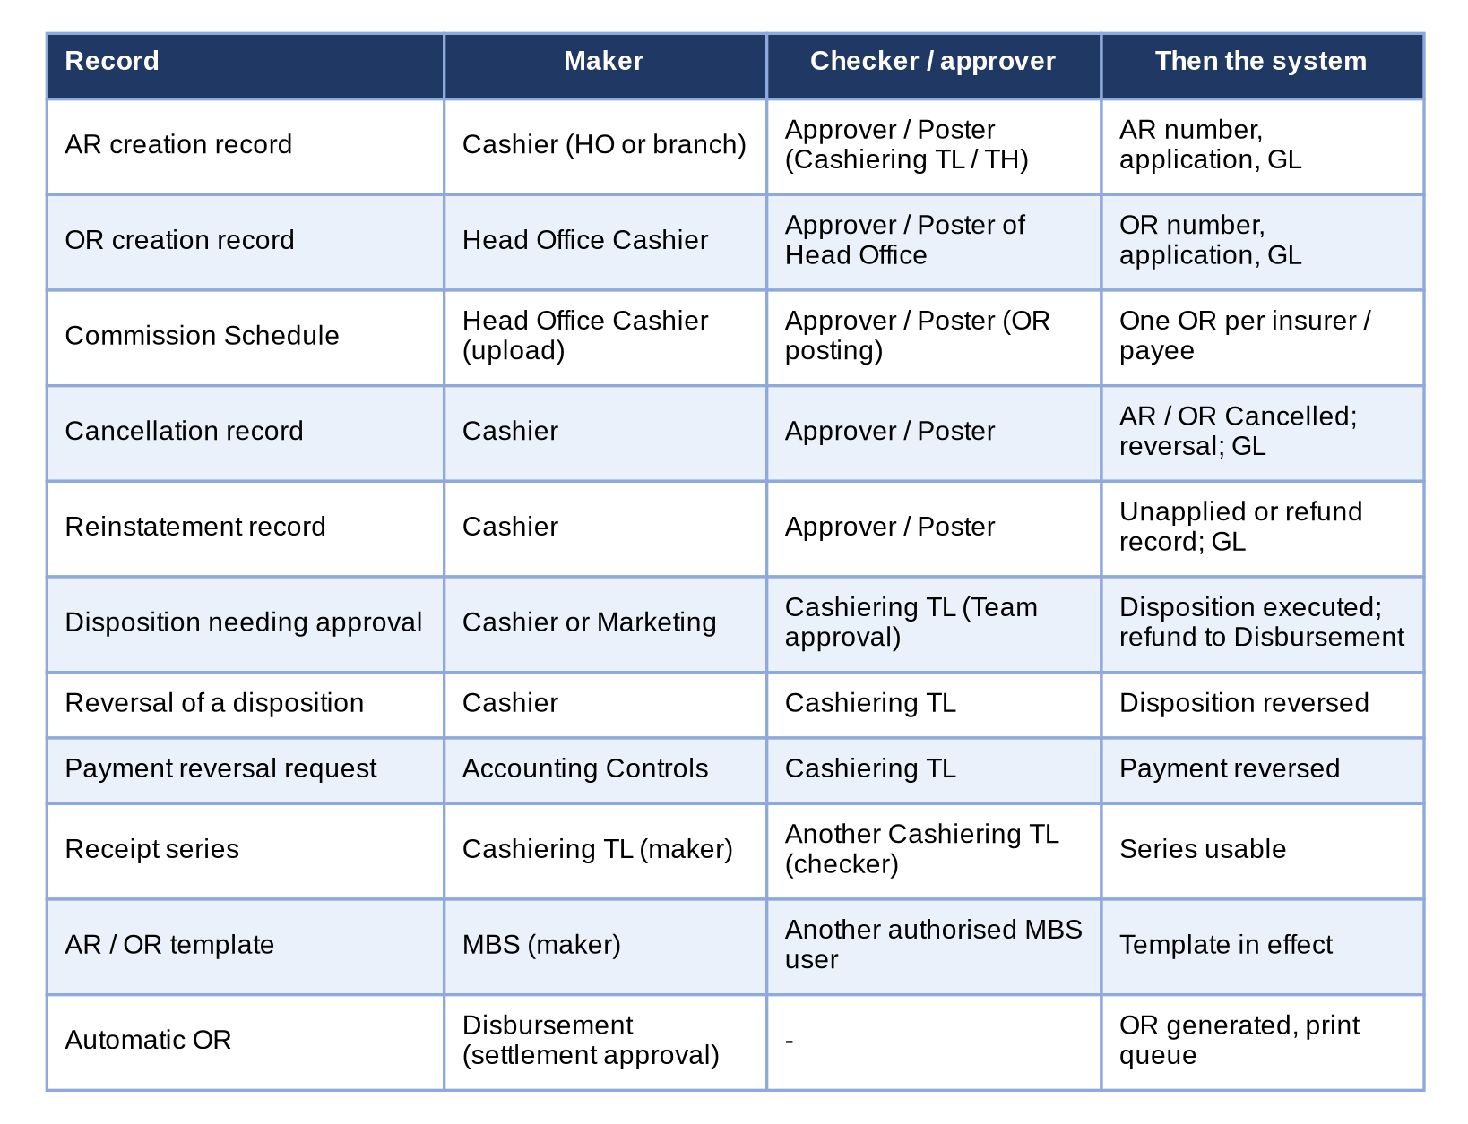
Figure 17 – Who makes, who checks and who approves each Cashiering record
How to read it: Each row is a kind of record, read from left to right: the maker, the checker or approver and what the system then does. No one posts or approves his or her own record. Traces to: CSHID.001 to 006, 015, 024, 025; FRS.OPS.002.05.
Process | Stage | Who acts (maker / checker) | Controls | Time rule, reminder, escalation | Return or cancel
AR / OR creation (FRS.CSH.02.01, 02.02, 02.05) | 1 Created | Cashier (maker); ORs Head Office only | Validations of FRS.CSH.02.01.08; editable; creation record number | No limit | Cancel the record (Record Cancelled)
 | 2 For Posting | Approver / Poster (Cashiering TL / TH), not the creator | Series checked; number generated at posting; four eyes | Proposed: posted the same business day; records For Posting shown on the dashboard with their age | Return with reason (Returned; edit and re-submit)
 | 3 AR/OR Issued | System | Application, minimal balance, excess, GL | - | Cancellation or reinstatement record
Cancellation (FRS.CSH.03.01) | 1 Created / 2 For Posting | Cashier; Approver / Poster | Reason; check reasons for check payments; no disposition in process | Proposed: posted within 1 working day | Return; cancel while Created
Reinstatement (FRS.CSH.04.01) | 1 Created / 2 For Posting | Cashier; Approver / Poster | Type, accounts, reason, CSHID.005 information | Proposed: posted within 1 working day | Return; cancel while Created
Unapplied disposition (FRS.CSH.06.02) | Unapplied, Monitoring | Cashier or Marketing (own unit) | Amount within the outstanding; target required | Proposed: disposition assigned within 2 working days | Withdraw to Unapplied
 | For Approval | Cashiering TL (Team approval), not the submitter | Types needing approval: setting of the type (Appendix S) | Proposed: decided within 1 working day | Return to Monitoring with reason
 | For Reversal | Cashier (mark); Cashiering TL (approve) | Reason required; a refund only after Disbursement returned it | Proposed: 1 working day | Reject the reversal
Payment reversal request of Accounting Controls (FRS.CSH.06.03.02) | Request; approval | Accounting Controls; Cashiering TL | Requester never approves | Proposed: 1 working day | Reject
Receipt series (FRS.CSH.02.03) | Maintain; authorise | Cashiering TL (maker); another Cashiering TL (checker) | End not below issued numbers; OR series Head Office only | Before the series is needed; warning level alert | Not authorised
AR / OR template (FRS.CSH.02.06) | Change; approve | MBS (maker); another authorised user | Earlier versions kept | - | Not approved

Role-to-stage matrix: M = makes, P = posts or approves, V = views, U = uploads.
Stage | Cashier HO | Cashier branch | Cashiering TL / TH | Marketing | Comm. Receivable | Comptroller-ship | Auditor
AR creation record | M | M | M |  |  |  | V
OR creation record; Commission Schedule | M, U |  | M |  |  |  | V
Posting of creation records |  |  | P |  |  |  | V
Cancellation / reinstatement record | M | M | M |  |  |  | V
Posting of cancellation / reinstatement |  |  | P |  |  |  | V
Payment files; PDC warehouse | U |  | U |  |  |  | V
Disposition | M |  | M | M (own unit) | M (AP Unapplied Commission) |  | V
Approval of dispositions and reversals |  |  | P |  |  |  | V
Receipt series |  |  | M / P (another TL) |  |  |  | V
Journals and reports | V | V | V |  | V | V | V

Escalation today: the records For Posting and For Approval are counted on the dashboard with their amounts, and each list shows the age of the record; the Cashiering Team Head works the records of the team. An automatic reminder and escalation after a number of working days is a proposal (Appendix R) for the Business Unit to decide.

Appendix K – Process Walkthroughs
The Cashiering steps of the end-to-end walkthroughs of the Operations BRD, step by step: who acts, on which screen, what the user does, what the user sees and the result (the step numbers are those of the walkthroughs), then the walkthrough of this FRS for the Business Unit (WT-E). The screens are specified in Appendix E; the sign-in IDs are in the Business Unit Walkthrough Users workbook.

WT-A A booked invoice from the client's payment to the insurer's official receipt
Processing books a Fire account; the invoice reaches the Operations ledger. The cashier receives the client's payment over the counter and applies it by component; Remittance extracts the paid premium into a batch per insurer, submits it and the Remittance Team Leader approves it; Disbursement assigns the DV number; Remittance uploads the insurer's official receipt and the invoice reads Paid and Fully Remitted.
Step | Persona | Screen | What the user does | What the user sees | Result
WT-A.1 | Processing (New Business) | New Business screen | Opens the account from Ready to Book, checks the invoice and the journal preview and clicks Book Account | The Booked Invoice with its invoice number; the invoice is copied into the Operations ledger | Booked
WT-A.2 | Cashier (Head Office) | Invoice Search (E.24) | Searches the ARN on Invoice Search | The new invoice with its gross premium, outstanding premium, Unpaid and With Outstanding Balance | In the ledger
WT-A.3 | Cashier (Head Office) | Receive Payment (E.5) | Opens Receive Payment, enters the ARN, the payor, the amount paid and the payment date, and checks the preview | Application Preview: Booked, the invoice with each component and the amount applied to it, Excess to Unapplied 0.00 | Preview
WT-A.4 | Cashier (Head Office) | Receipt (E.7) | Clicks Issue AR and Apply | Message: <AR> issued and applied to 1 invoice(s); the receipt opens with its application by component | AR issued and applied
WT-A.7 | Remittance Team Leader | Remittance Batch | Opens the batch from For Approval and clicks Approve and Push | The batch is Approved - with Disbursement with its payment request and the commission OR | Approved

WT-B Cancellation of a paid and remitted policy, from the request to the refund
Marketing Collection asks to cancel the policy of walkthrough A from inception. The request is raised on the policy, recomputed per insurer, validated by Adjustment and approved by the Adjustment Team Leader; posting books the return invoice, sets up the AR Insurer for the premium already remitted and has Cashiering re-apply the payment, whose excess becomes an unapplied payment; the cashier refunds it with the Team Leader's approval and the refund reaches the Disbursement queue.
Step | Persona | Screen | What the user does | What the user sees | Result
WT-B.8 | Cashier (Head Office) | Unapplied Payment (E.9) | Opens the unapplied payment left by the re-application, assigns a refund to the client and submits it | The disposition is For Approval | Refund for approval
WT-B.9 | Cashiering Team Leader / Head | Unapplied Payment (E.9) | Opens the unapplied payment and clicks Approve | The disposition is Completed and the balance 0.00; the refund is sent to Disbursement | Refund approved
WT-B.10 | Disbursement | Disbursement Queue | Opens the Disbursement Queue | The refund request to the client in To Acknowledge | Refund with Disbursement

WT-D Controls and the messages the user sees
The controls of Operations on screen: a remittance hold raised by Marketing Collection and decided by the Marketing Team Leader, an endorsement refused on an invoice locked by Remittance, a receipt cancellation approved by a second user, and a remittance batch that its submitter cannot approve.
Step | Persona | Screen | What the user does | What the user sees | Result
WT-D.3 | Cashier (Head Office) | Receipt (E.7) | Opens a receipt, clicks Cancel Receipt, chooses the reason and submits the cancellation | The receipt shows the cancellation For Approval in its workflow header | Cancellation requested
WT-D.4 | Cashiering Team Leader / Head | Receipt (E.7) | Opens the receipt and clicks Approve and Post | The receipt is Cancelled; its unapplied balance is closed | Cancelled

WT-E A Cashiering day for the Business Unit walkthrough
The walkthrough of this FRS for the Business Unit in the BIBS DEV environment: the receipt series, a payment file of the day, the pre-booked and unapplied payments, a post-dated check, an OR of Head Office, an AR of a branch, the printing of the day's receipts and the reports. The steps follow the screens of Appendix E as they are today; the posting step of BDOI's FRS (Appendix R, C1) is walked through once it is decided.
SIT/UAT data: receipt series of Head Office and Cebu; a Bills Payment file of the UAT data; booked and pre-booked accounts of the UAT data.
Step | Persona | Screen | What the user does | What the user sees | Result
WT-E.1 | Cashiering Team Leader / Head | Receipt Series (E.20) | Opens Receipt Series and reads the AR series of Head Office and Cebu and the OR series of Head Office | Each series with its prefix, range, numbers left, ATP number and warning level; OR series for Head Office only | Series checked
WT-E.2 | Cashier (Head Office) | Payment Uploads (E.13) | Opens Payment Uploads, chooses Bills Payment and uploads the file of the UAT data | The run summary with the applied, unapplied, pre-booked, excess and failed rows; the run report to download | File processed
WT-E.3 | Cashier (Head Office) | Pre-booked Payments (E.12) | Opens Pre-booked Payments and clicks Re-match Now on the payment of the run | The payment waits for the booking of its account, or is applied if the account is now booked | Pre-booked followed
WT-E.4 | Cashier (Head Office) | PDC Warehouse (E.15) | Opens PDC Warehouse and adds a post-dated check with its maturity date | The check in the warehouse with its number and maturity date | Check warehoused
WT-E.5 | Cashier (Head Office) | Unapplied Payments (E.8) | Opens Unapplied Payments, the excess of the run, assigns a Refund and submits it | The disposition is For Approval | Disposition submitted
WT-E.6 | Cashiering Team Leader / Head | Unapplied Payment (E.9) | Opens the Unapplied payment and clicks Approve | The disposition is approved and the refund request is in the Disbursement queue | Refund requested
WT-E.7 | Cashier (Head Office) | Receipts (E.6) | Opens Receipts and issues an Official Receipt for a service fee | The OR with the next Head Office OR number | OR issued
WT-E.8 | Cashier (Cebu branch) | Receive Payment (E.5) | Signs in as the Cebu cashier, opens Receive Payment, enters the account and the amount and checks the preview | The preview of the application by component; the AR takes the next Cebu number | AR issued
WT-E.9 | Cashier (Head Office) | Batch Print (E.16) | Opens Batch Print, selects the receipts of the day and prints them | One print batch with the receipts selected | Receipts printed
WT-E.10 | Cashier (Head Office) | Report Centre (Operations reports) (E.27) | Opens the Report Centre and runs the Applied Premium Report for the day in Excel | The report with the payments of the day | Report run
WT-E.11 | Auditor | Report (E.28) | Signs in as the Auditor and opens the same report | The report on the screen without download | View only

Appendix L – Document Prints and Output Formats
Every document Cashiering prints, downloads or exports: purpose, recipients, format, protection and the fields in order. Where the system has a layout today, it is shown; BDOI's own forms are the sample AR and the OR body of FRS.CSH.02.06 (Appendix A), which the system follows once BDOI confirms them (Appendix R, C16). The bank deposit slip of the day's collections is kept in the Accounting (Receivables) module and is not a Cashiering document (Appendix R).
File names: a printed receipt downloaded is named <Receipt Type>_<Receipt Number>.pdf (FRS.CSH.02.04.09.03); several receipts are one ZIP of these files; reports are named <Report Name>_<date of extraction MMDDYYYY> (FRS.CSH.09.02).

L.1 Acknowledgement Receipt (AR)
Item | Detail
Purpose | Proof given to the payor that the premium or non-premium payment was received on behalf of the insurer (CSHID.001, 019).
Recipients | Client's Copy: the payor; BDOI Copy: kept with the receipt.
Format | PDF, one per receipt; printed singly or in a print batch.
Protection | Not protected; certificate number and REPRINT mark on re-prints.
Fields in order | 1. Header: BDO Insure logo, company name, description, address, VAT TIN (company record)  2. AR number and copy label  3. Title ACKNOWLEDGEMENT RECEIPT; REPRINT tag on re-prints  4. Received from; date; TIN  5. The sum of: amount in words and in figures  6. Payment received on behalf of insurance company: insurer  7. Remarks; reference no.; policy no.  8. Payment in form of; check details (check total, check no., check date, bank / branch); cash total  9. Note line; THIS IS A SYSTEM GENERATED RECEIPT. NO SIGNATURE IS REQUIRED.  10. Footer: trademark and licence line; acknowledgement certificate no., date issued, series range; THIS DOCUMENT IS NOT VALID FOR CLAIM OF INPUT TAX.
BDOI reference | FRS.CSH.02.06.03; Sample AR of Appendix A
Layout | Current layout of the system below; the Business Unit confirms BDOI's form or gives its layout: requirements collection workbook, item RC-DOC-01

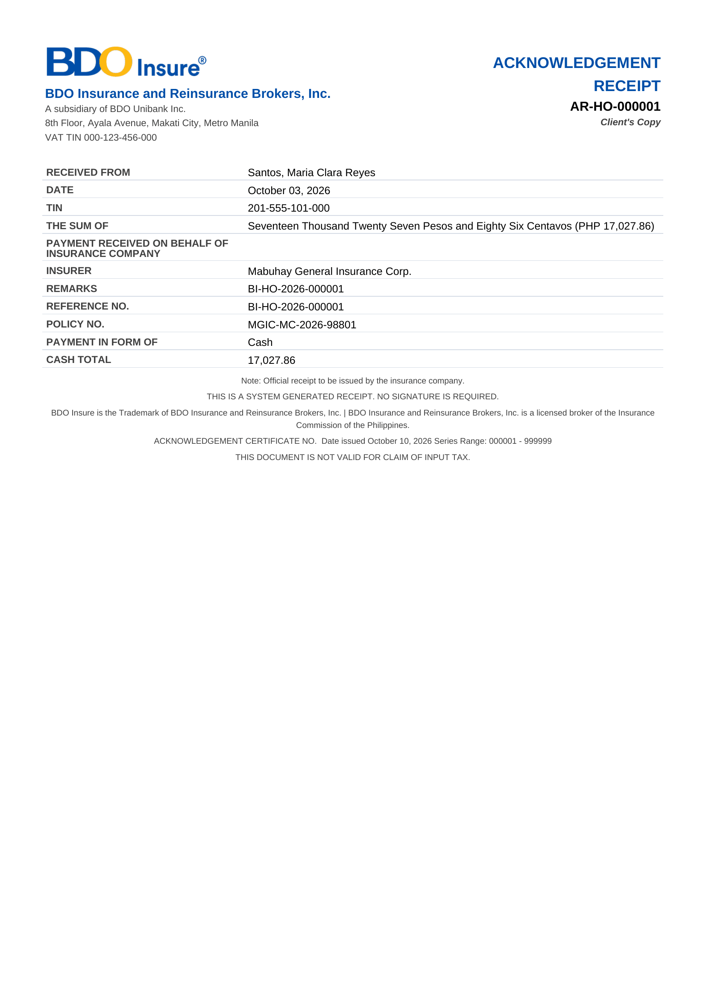
Image L.1: the system's AR today; the form becomes BDOI's sample AR once confirmed

L.2 Official Receipt (OR)
Item | Detail
Purpose | Receipt of BDOI income: service fee, profit share, commissions, incentives, others (CSHID.002).
Recipients | Client's Copy: the payor (insurer or client); BDOI Copy: kept with the receipt.
Format | PDF, one per receipt; printed singly or in a print batch.
Protection | Not protected; certificate number and REPRINT mark on re-prints.
Fields in order | 1. Header: BDO Insure logo, company name, description, address, VAT TIN  2. OR number and copy label  3. Received From <Insurer Name>; Address; TIN  4. Form of Payment; Paid Amount in words and in figures  5. In payment of <Official Receipt Type>; lines with gross amount, VAT and withholding tax (Appendix R)  6. Bank / Branch; Check No; Check Date  7. AC No; Date Issued  8. Footer: trademark line; acknowledgement certificate no. with series range; NOT VALID FOR CLAIM OF INPUT TAX; Client's Copy or BDOI Copy
BDOI reference | FRS.CSH.02.06.02
Layout | Current layout of the system below; the Business Unit confirms BDOI's form or gives its layout: requirements collection workbook, item RC-DOC-02

Image L.2: the system's OR today; the form becomes BDOI's OR template once confirmed

L.3 Certification of Payment
Item | Detail
Purpose | Formal certification that a payment was received, processed and applied to a policy (CSHID.023, FRS.CSH.02.06.04).
Recipients | The requesting market unit and the client.
Format | PDF, one per request.
Protection | Not protected.
Fields in order | 1. Title CERTIFICATION OF PAYMENT and series number  2. Text: This certifies that payment was received  3. From (payor); AR number; date paid; amount; policy number  4. Requested by (market unit); date issued  5. Signature: Cashiering
BDOI reference | FRS.CSH.09.02.15 (report)
Layout | Layout to be provided or confirmed by the Business Unit: requirements collection workbook, item RC-DOC-03

L.4 Validation report of an upload
Item | Detail
Purpose | List of the rows uploaded, rejected and in error with the reason, and the summary counts (FRS.CSH.02.02.04.01, FRS.CSH.05.01.06).
Recipients | The uploader; the Cashiering Team Leader.
Format | Excel (xlsx), downloaded from the upload.
Protection | Not protected.
Fields in order | 1. Upload reference, payment file type, file name, uploaded by, date and time  2. Summary: rows read, successful, failed  3. Per row: the fields of the file, Status (Successful / Failed), Reason for Failure
BDOI reference | FRS.CSH.02.02.04.01 to .04; FRS.CSH.05.01.06
Layout | Layout to be provided or confirmed by the Business Unit: requirements collection workbook, item RC-DOC-04

L.5 Run report of automatic payment processing
Item | Detail
Purpose | Outcome of each run: counts and amounts per category and the payment records (FRS.CSH.05.01.12).
Recipients | The uploader; the Cashiering Team Leader; Comptrollership (on request).
Format | On the screen; Excel (xlsx).
Protection | Not protected.
Fields in order | 1. Summary (count and amount): Matched, Applied Payment, Excess Payment, Matched on Pre-booked, Unbooked/Unmatched, Failed  2. Per payment record: Transaction Date, BP filename, Transaction Number, Amount, Reference Number, Account Number, Record Status, AR number
BDOI reference | FRS.CSH.05.01.12
Layout | Layout to be provided or confirmed by the Business Unit: requirements collection workbook, item RC-DOC-05

L.6 Matched and unmatched list of a Commission Schedule
Item | Detail
Purpose | Lines of a Commission Schedule with the matched reference number and outstanding balance, or unmatched (FRS.CSH.02.02.09.04).
Recipients | The Head Office Cashier; Commission Receivable.
Format | Excel (xlsx).
Protection | Not protected.
Fields in order | 1. Line fields of Appendix D.6  2. Matched reference number or "unmatched"  3. Outstanding balance or "unmatched"
BDOI reference | FRS.CSH.02.02.09.02 to .04
Layout | Layout to be provided or confirmed by the Business Unit: requirements collection workbook, item RC-DOC-06

L.7 Print batch download
Item | Detail
Purpose | Several receipts downloaded at once (FRS.CSH.02.04.09.02).
Recipients | The cashier.
Format | ZIP of PDFs named <Receipt Type>_<Receipt Number>.pdf.
Protection | Not protected.
Fields in order | 1. One PDF per receipt (L.1, L.2)
BDOI reference | FRS.CSH.02.04.09
Layout | Layout to be provided or confirmed by the Business Unit: requirements collection workbook, item RC-DOC-07

L.8 Report outputs
Item | Detail
Purpose | The Cashiering reports of Appendix M.
Recipients | As Appendix M.
Format | Excel and PDF as listed per report.
Protection | Not protected; download only with the export permission (FRS.CSH.09.01.02).
Fields in order | 1. The fields of each report in the order of FRS.CSH.09.02  2. Footer: generated by, date and time, page
BDOI reference | FRS.CSH.09.02
Layout | Layout to be provided or confirmed by the Business Unit: requirements collection workbook, item RC-DOC-08

Appendix M – Reports and Schedules
Every Cashiering report with how it is produced, who sees it, its filters, its columns, its sort and its format. The columns and file names are BDOI's (FRS.CSH.09.02); the filters, sort and timing are proposed where BDOI's FRS gives only the covered period, for the Business Unit to confirm (requirements collection workbook, sheet Documents and print formats). View on the screen and download are separate rights (FRS.CSH.09.01.02).
FR item | Report | When | Who views / exports | Filters | Columns (in order) | Sort | Format
FRS.CSH.09.02.01 | Applied Premium Reports | On demand | Cashiering, Comptrollership, Auditor (view) | Covered period; branch; source (manual, file, PDC) | AR No., Date Paid, Amount Paid, Invoice No., Payor / Client Name, Bank, Branch, Check No., Risk Code | Date paid, AR no. | Excel
FRS.CSH.09.02.02 | Applied Commission Reports | On demand | Cashiering, Commission Receivable, Comptrollership | Covered period; insurer | OR No., Number of Accounts, Invoice Number, Insurance Company, Basic Commission, Withholding Tax, EVAT, Net Commission, Total Amount Applied | OR no. | Excel
FRS.CSH.09.02.03 | Minimal Balance of Unapplied Payments | On demand; monthly | Cashiering, Comptrollership | Covered period; market unit | AR No., AR Date, Market Unit, Section Unit, Minimal Amount | AR date | Excel, PDF
FRS.CSH.09.02.04 | Cancelled Official Receipts | On demand; monthly | Cashiering, Comptrollership, Auditor | Covered period | Date Issued, OR Number, Assured, Gross Amount, VAT, WTAX, Amount, Reason for Cancellation | Date issued | Excel, PDF
FRS.CSH.09.02.05 | Cancelled Acknowledgement Receipts | On demand; monthly | Cashiering, Comptrollership, Auditor | Covered period; branch | Date Issued, Reason for Cancellation, AR Number, Assured, Gross Amount, VAT, WTAX, Amount | Date issued | Excel, PDF
FRS.CSH.09.02.06 | Unapplied Commission Receivable Extract for Mancom Reports | On demand; monthly for ManCom | Commission Receivable, Comptrollership | As of date; insurer; corporate department | Insurance Company Name, Assured Name, OR Number, Invoice Number, Number of Invoices, Payment Type, Booked Commission, Commission Set-Up, Check Amount, Applied Amount, OR Balance, OR Date, Policy Number, Marketing Unit Head, Corporate Department, Corporate Name, Encoder, Age | Insurer, age | Excel, PDF
FRS.CSH.09.02.07 | Unapplied Commission Receivable Payments YTD balance per Criteria | On demand | Commission Receivable, Comptrollership | Year to date; criteria (to be given, Appendix S) | Criteria No., Description, Count, Amount Balance | Criteria no. | Excel, PDF
FRS.CSH.09.02.08 | Unapplied Premium Minimal Balance | On demand; monthly | Cashiering, Comptrollership | Covered period; market unit | AR Number, AR Date, Market Unit, Section Unit, Minimal Amount | AR date | Excel, PDF
FRS.CSH.09.02.09 | Unapplied Commission Minimal Balance | On demand; monthly | Commission Receivable, Comptrollership | Covered period | OR Number, Invoice Number, OR Date, Market Unit, Section Unit, Minimal Amount | OR date | Excel, PDF
FRS.CSH.09.02.10 | Daily Cash Reconciliation Reports | Daily, after the close of the business day (proposed 18:30); on demand | Cashiering, Comptrollership | Business date; branch; encoder; bank account | Encoder, Client / Payor Name, OR Number (and AR number, Appendix S), Deposit In Bank | Encoder, receipt no. | Excel, PDF
FRS.CSH.09.02.11 | Unapplied Premium Payment Transaction | On demand; weekly (proposed Monday 08:00) | Cashiering, Marketing (own unit), Comptrollership | As of date; payment status; payment type; market segment; unit head | The 28 fields of FRS.CSH.09.02.11 with the ageing brackets 0-30 to above 365 | Ageing, date booked | Excel, PDF
FRS.CSH.09.02.12 | Direct Payment | On demand | Cashiering, Commission Receivable | Covered period; insurer | Invoice Number, Assured's Name, Policy Number, AR Balance, Payment Type, OR Number, OR Date, OR Amount, Reversal Amount, OR Balance, Requestor, Processor, Remarks | OR date | Excel, PDF
FRS.CSH.09.02.13 | Reinstatement Monitoring Report | On demand | Cashiering, Comptrollership | Covered period; status | Date Requested, Invoice Number, AR Number, Amount Reinstated, Assured Name, Date Processed, Requestor, Processor | Date requested | Excel, PDF
FRS.CSH.09.02.14 | Re-Application Report | On demand | Cashiering, Comptrollership | Covered period | Date Posted by GL, Date Applied, Invoice Number, Assured Name, Amount for Reapplication, Reinstatement Transaction No., Requested by, Reason for Reinstatement, TAT Reapplication, TAT Reinstatement process | Date applied | Excel, PDF
FRS.CSH.09.02.15 | Certification of Payment | On demand | Cashiering | Covered period; requesting market unit | AR Number, Policy Number, Requesting Market Unit, Date (COP) Issued, Series Number | Series number | Excel, PDF
FRS.CSH.09.02.16 | Reinstatement | On demand; monthly | Cashiering, Comptrollership | Covered period | Invoice Number, Assured, AR Number, Months, No. of Request, Date Processed (TAT), Date Re-applied (TAT), Instance of Mis-application | Invoice number | Excel, PDF
FRS.CSH.09.02.17 | CWT Monitoring Report (Premium) | On demand; monthly | Cashiering, Comptrollership (Tax) | Covered period; insurer | Item No., Invoice No., Assured Name, Inception Date, Expiry Date, Policy No., Insurance Company, Basic Premium, W/held, Prepared by, Reviewed by, Received by | Insurer, invoice | Excel, PDF
FRS.CSH.09.02.18 | Summary Per Disposition – Remittance | On demand | Owner to confirm (Appendix S) | Covered period; disposition type | Disposition Type, Reference Number, Policy Number, Client Name, Insurer Name, Amount, Reason for Disposition, Requested By, Approval Status, Date of Action, Remarks | Disposition type | Excel, PDF
FRS.CSH.09.02.19 | Post-dated Checks Warehousing | On demand; daily before the maturity run | Cashiering | Maturity period; client; bank | AR Date, AR Number, Maturity Date, Client, Amount, Bank Code, Branch, Check No., Market Segment | Maturity date | Excel, PDF
FRS.CSH.09.02.20 | Priority Posted Accounts | On demand | Cashiering | Covered period; branch | OR / AR Number, Payor, Amount Paid, Date Paid, Encoder, Branch, Status, Invoice Number, Policy Number, Risk Code, Corporate Department | Date paid | Excel, PDF
FRS.CSH.09.02.21 | Payment Reversals | On demand | Cashiering, Comptrollership, Auditor | Covered period; type | Record Number, Type, AR / OR Number, Account Number, Assured, Amount Reversed, Reason, Created by, Posted by, Date Posted | Date posted | Excel, PDF
FRS.CSH.09.02.22 | AR Outstanding with Ageing | On demand; monthly | Cashiering, Marketing (own unit), Comptrollership | As of date; client; insurer; marketing unit | Client, Account Number, Invoice Number, Policy Number, Insurer, Booking Date, Outstanding Amount, Ageing Bracket, Marketing Unit, Account Officer | Ageing, client | Excel, PDF
FRS.CSH.09.02.23 | Payment Batch Run Report | After each run; on demand | Cashiering | Run date; payment file type; source | Run Number, Source, Payment File Type, File Name, Uploaded by, Date and Time, Rows Read, Applied, Excess, Matched on Pre-booked, Unbooked/Unmatched, Failed, amounts | Run date | Excel

Scheduled runs and timings (Philippine time; times proposed where BDOI's FRS gives none):
Run | When | What it does | Who is told | Owner of the setting | Traces to
Files received via MFT (OBPCS Bills Payment, PMS post-dated checks) | At the times agreed with BDOI IT (proposed: every hour from 07:00 to 18:00), and on Receive MFT Files Now | Files checked and processed as uploads for the company of the setting MFT receiving company (FRS.CSH.05.01.04) | Cashiering Team Leader: alert when a file is refused | BDOI IT; System Administrator | CSHID.008; BRQID.005
Re-matching of unapplied payments | Every hour | Unbooked/Unmatched and Pre-booked payment records matched again | Run report | System Administrator | CSHID.020
Pre-booked re-matching and ageing | Every 2 hours | Pre-booked payments of booked accounts applied; ageing alert | Cashiering Team Leader: alert after 5 days | Cashiering Team Leader | CSHID.020
Post-dated check maturity | 08:30 daily | Matured checks turned into payments with their AR | Run report | System Administrator | CSHID.008
Minimal balance run | 04:00 daily | Balances left within the threshold by later events cleared | Run report | Cashiering Team Leader | CSHID.016
Daily Cash Reconciliation Report | Proposed 18:30 each business day | Report kept in the Report Archive | Cashiering Team Leader; Comptrollership | Cashiering Process Owner | CSHID.023
Unapplied Premium Payment Transaction | Proposed every Monday 08:00 | Report kept in the Report Archive for Marketing and Cashiering | Unit Heads; Cashiering Team Leader | Cashiering Process Owner | CSHID.023, CSHID.024
Failed run e-mail | When a run fails | E-mail G-14 | Failed-run recipients | System Administrator | BRQID.006

Appendix N – Integrations [Integration scope]
Each interface of Operations Cashiering at business level: direction, what is exchanged, trigger and frequency, owner, what BDOI IT provides and the status of BDOI's input. The technical detail is in the Technical Specification reviewed by BDOI IT (Figure 18).
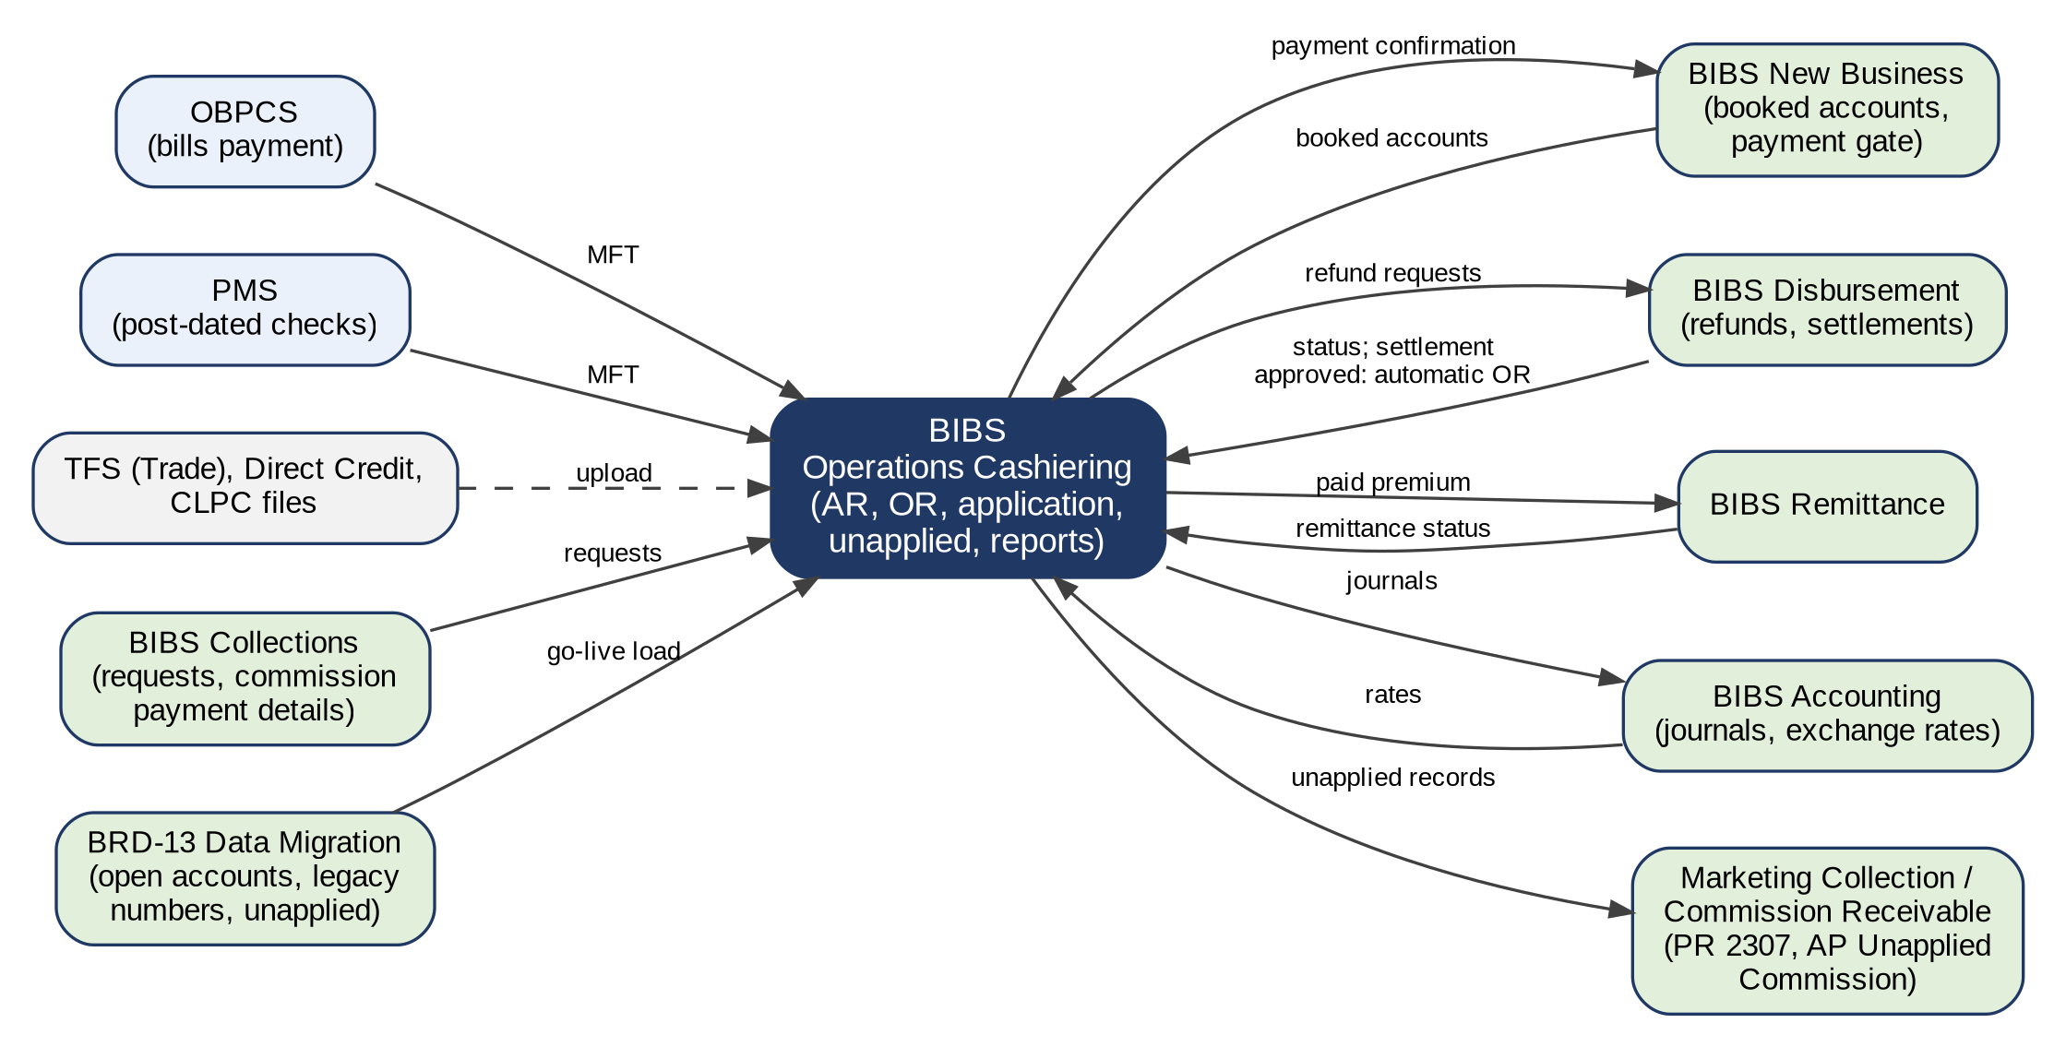
Figure 18 – Integration context of Operations Cashiering
How to read it: Solid lines are in scope; dashed lines are by upload until a transfer is agreed; the detail of each interface is in the table below. Traces to: BRQID.004, BRQID.005; FRS.CSH.10.01, FRS.CSH.10.02.
Interface | Direction | What is exchanged | Trigger / frequency | Volumes | Owner | What BDOI IT provides | BDOI input
OBPCS (Online Bills Payment Consolidation System) | In | Bills Payment file BDOIYYYYMMDD.txt with its header record (Appendix D.1) | Daily, via MFT, taken at the times set and on Receive MFT Files Now | To be given (about 48 payments in the sample) | BDOI IT; Cashiering | MFT folder, arrival time, positions 7 to 13 of the layout | Given in part (sample, file name). Available in BIBS: intake with the name, size, duplicate and header checks, run report, refusal alert and processing again; run end to end in SIT and UAT against the channel simulator. Connection details from BDOI IT at SIT
PMS (PDC Management System) | In | Matured post-dated checks BDOIYYYYMMDDPMS.txt (Appendix D.2) | Daily, via MFT | To be given | BDOI IT; Cashiering | MFT folder, time, the header and detail layout | To be provided. Available in BIBS in the proposed layout and run end to end against the channel simulator; layout and folder from BDOI IT at SIT
TFS / CIB (Trade) | In | Trade file UploadTrade_MM.DD.YYYY.txt (Appendix D.4) | Daily, upload by the Cashier (several files in one upload) | To be given | Cashiering | Separator of the file | Given in part (sample). Available in BIBS; the channel simulator writes the file for SIT and UAT
Direct Credit (bank credit of payments) | In | Direct Credit file OTCYYYYMMDD-<branch>.txt (Appendix D.5) identifying the payments of a Bills Payment file (setting, Appendix H.8) | Daily, upload | To be given | Cashiering | Layout of the file | To be provided. Available in BIBS in the proposed layout; the channel simulator writes the file for SIT and UAT
CLPC (Consumer Lending Processing Center) | In | CLPC file CLPC-MonDDYYYY.xlsx with its TOTAL row (Appendix D.3) | Daily, upload | To be given | Cashiering | - | Given (sample). Available in BIBS; the channel simulator writes the file for SIT and UAT
Insurers (Commission Schedule) | In | Commission Schedule of the commission paid by an insurer, matched to the commission receivable of each account | At each insurer payment, upload | To be given | Commission Receivables; Cashiering | - | Layout proposed in BIBS (Appendix D); valid lines processed as delivered (setting, Appendix H.8)
Channel simulator (SIT and UAT only) [Integration scope] | In | Payment files of every type in BDOI's layouts for booked accounts, one account not yet booked and one unknown reference, dropped in the MFT folders or handed for upload | On request of the test lead | - | iorta TechNXT Project Team | - | Not used in production; it cannot run outside SIT and UAT
BIBS New Business | In / Out | Booked accounts with their components (in); payment confirmation of each account (out) | At booking; at each payment | All booked accounts | New Business; Cashiering | - | Not needed
BIBS Collections | In / Out | Collector requests on unapplied payments; commission payment details; their result | At each request | - | Collections; Cashiering | - | Not needed
BIBS Disbursement | Out / In | Refund requests (out); their status and the approved insurer settlements that trigger the automatic OR (in) | At approval; at each status | - | Disbursement; Cashiering | - | Not needed
BIBS Remittance | Out / In | Paid and applied premium of each account (out); remittance status (in) | At each application; at each remittance | - | Remittance; Cashiering | - | Not needed
BIBS Accounting | Out / In | The journal of every posting (out); the exchange rates and the accounts of the entries (in) | At each posting; daily rates | - | Comptrollership | - | Accounts to be given (Appendix S)
Marketing Collection / Commission Receivable | Out | Unapplied records of their units; AP Unapplied Commission; PR 2307 kept outstanding | At each record | - | Marketing; Commission Receivable | - | Owner of MKTID.013 to confirm (Appendix R)
BRD-13 Data Migration | In | Open accounts with legacy numbers, unapplied payments, post-dated checks, receipt series in use (Appendix P) | Trial migrations and go-live | - | Data Migration lead | Extracts of the legacy systems | Per the drop plan

Appendix O – Non-functional Requirements
The non-functional requirements of the Operations BRD (v1.01, p.178-183) as they apply to Cashiering, how each is met, and the rows of the programme non-functional requirements register that govern it. Values marked "to confirm" are confirmed by BDOI IT (Appendix S).
ID | Topic | BRD value | How it is met | FR item | Programme NFR register
CSH-NFR-01 | Users | Cashiering HO 11, branches 5; TL / TH 5 + 5 | Within the BIBS sizing for all BRDs | FRS.CSH.01.02 | NFR-CAP-01
CSH-NFR-02 | Volumes | Not stated | Assumed within the BIBS sizing; to confirm | FRS.CSH.05.01 | NFR-CAP-02, NFR-CAP-03
CSH-NFR-03 | Response time | Under 5 seconds for every function; section navigation under 5 seconds | Screens within 3 seconds for 95% of requests; file processing and printing run in the background with progress | FRS.CSH.01.03.02 | NFR-PRF-01, NFR-PRF-02, NFR-PRF-03
CSH-NFR-04 | Batch printing | 50 documents under 10 seconds | Print batches of up to 500 receipts | FRS.CSH.02.04.16 | NFR-PRF-06
CSH-NFR-05 | File size | Not stated (BDOI FRS: 50 MB) | Files up to 50 MB; each row processed on its own | FRS.CSH.05.01.05 | NFR-CAP-04, NFR-PRF-05
CSH-NFR-06 | Peak | 15th and 30th of the month; peak hours 08:00-17:30 | Runs scheduled outside the peak hours (Appendix M) | FRS.CSH.10.03 | NFR-CAP-05, NFR-PRF-07
CSH-NFR-07 | Availability | 99.9%; use 07:00-18:30 | Same service window as BIBS | - | NFR-AVL-01, NFR-AVL-02
CSH-NFR-08 | Recovery | RTO 4 hours, RPO 24 hours | Programme backup and recovery | - | NFR-REC-01, NFR-REC-02, NFR-REC-03
CSH-NFR-09 | Retention | Logs and history 5 years online, 15 years archive; backup every 4 hours kept 7 years | Retention per record type | FRS.CSH.08.03 | NFR-RET-01, NFR-RET-03
CSH-NFR-10 | Devices | Same performance on mobile and desktop | Responsive screens; BDO-issued devices (FRS.OPS.001) | FRS.CSH.01.01 | NFR-RSP-01, NFR-RSP-02
CSH-NFR-11 | Security | Authorised users only; protected files | Role-based access, segregation of duties, files stored read-only | FRS.CSH.01.02; FRS.OPS.002.05 | NFR-SEC-04, NFR-SEC-11
CSH-NFR-12 | Audit | All actions logged; the seven items of the BDO IT audit trail standard (sign-off condition of BRD v1.01, p.67) | Audit trail that no user can change, refused actions recorded | FRS.CSH.02.01.14; FRS.CSH.08.03 | NFR-AUD-01, NFR-AUD-02, NFR-AUD-03
CSH-NFR-13 | Amounts and dates | Philippine peso and US dollar; two decimals | Amounts with thousands separators and two decimals; dates dd-MMM-yyyy; Philippine time | FRS.CSH.01.03.04 | NFR-LOC-02, NFR-LOC-03
CSH-NFR-14 | Configuration | Lists and thresholds maintained by the business | Parameters and lists of Appendix H changed without a change to the system | FRS.CSH.02.05.12 | NFR-CFG-01, NFR-CFG-02
CSH-NFR-15 | Maintenance | As per bank standard | Planned maintenance within the maintenance windows of the bank standard; users told in advance | - | NFR-AVL-03
CSH-NFR-16 | Disaster | Business continuity threshold: RTO 4 hours, RPO 24 hours | Programme disaster recovery; the targets of CSH-NFR-08 apply | - | NFR-REC-01, NFR-REC-02
CSH-NFR-17 | Sessions | Programme NFR 10.07 (Collections addendum): one session per device | A second sign-in on another device ends the first (User Access Maintenance FRS) | FRS.CSH.01.02 | NFR 10.07
CSH-NFR-18 | Audit source | Programme NFR 4.03 (CLM, CLXN, RI addenda): source / IP address in the audit log | The audit log records the workstation / IP address of every action | FRS.CSH.08.03 | NFR 4.03

Appendix P – Data Set-up and Migration at Go-live [Data Migration scope]
What is loaded into the system for Operations Cashiering before go-live, from which source and template, who provides it and who checks it. The templates are those of the BIBS Master Data and Configuration Upload Templates v1.2 (tab named) and of BRD-13 Data Migration; they are not copied here.
Data | Source | Template | Provided by | Checked by | When | Note
Receipt series in use (branch, kind, prefix, range, ATP, next number) | Current receipts of each branch | R11 Receipt series in use | Cashiering data steward | Cashiering Team Head | Map freeze | FRS.CSH.02.03.06; input CFG-050
Company bank accounts (Post to Bank Account list) | Treasury | D0-11 Company bank accounts | Comptrollership; Treasury | Cashiering Process Owner | Trial migration 1 | FRS.CSH.02.01.02
Branches and branch indicators | Organisation | D0-02 Branches; R02 Branches | Comptrollership | Cashiering Process Owner | Trial migration 1 | Receipting Branch list
Exchange rates and their source | Comptrollership rate table | MD-03 Exchange rates | Comptrollership (Treasury) | Comptrollership | Trial migration 1 | FRS.CSH.02.05.15.01
Holiday calendar | Organisation | D0-03 Holiday calendar | Comptrollership; Human Resources | Cashiering Process Owner | Trial migration 1 | Working days of the holding period
Accounting rules of the Cashiering events | Comptrollership | D0-08 Accounting rules | Comptrollership | Comptrollership (second person) | Before SIT | Appendix I
Insurers with their banking list and TIN | Legacy insurer master | R04 Insurers | Operations data steward | Head, Operations | Trial migration 1 | OR Received From, Bank Name
Clients with the BIR 2307 tag | Legacy client master | C01 Client master; TX-01 Party tax profiles | Marketing data steward; Comptrollership (Tax) | Comptrollership | Trial migration 1 | FRS.CSH.02.05.13
Users and roles of Cashiering | Business units | UA-01 Users and roles; UA-02 Role matrix | Business Administration with the unit heads | Information Security | Before SIT | Appendix H.2
Lists of values (reasons, OR types, disposition types, payment file types) | This FRS (Appendix H) | UA-06 / PM-09 Lists of values | Cashiering Process Owner | System Analyst (BDO ITG) | Before SIT | Appendix H
Open accounts with outstanding premium and the legacy numbers (QPS, ISYS, Ebix, PN, Loan Application Number) | Legacy systems | BRD-13 invoice ledger extract | Data Migration lead | Cashiering Process Owner | Trial migrations; go-live | FRS.CSH.05.01.08
Open unapplied payments (excess, unbooked, pre-booked) with their source | Legacy systems | BRD-13 unapplied payments extract | Data Migration lead | Cashiering Team Head | Trial migrations; go-live | FRS.CSH.06.01
Post-dated checks in the warehouse at cut-over | PMS and the vault | PDC Excel template (Appendix D.2) | Cashiering | Cashiering Team Head | Go-live | FRS.CSH.05.02
Payment file layouts of the channels | OBPCS, PMS, TFS, banks | Cashiering Setup (Appendix D) | BDOI IT; Cashiering | Cashiering Process Owner | Values for UAT | Input CFG-044
AR and OR templates | BDOI forms (Appendix A) | PM-08 Document templates | MBS | Comptrollership (Tax) | Values for UAT | FRS.CSH.02.06

Not loaded: closed receipts of the legacy systems (they stay in the legacy archive for inquiry) and the reports of past periods.

Appendix Q – Requirements Traceability
Q.1 traces every BRD ID of the Cashiering scope of the Operations BRD (v1.01 with the Cashiering annex of May 2026) to the FR items of this FRS and to the test conditions of the Test Cases and Traceability workbook issued with this FRS (TC-OP-nnn.n; the cases of each condition, with the screen and the walkthrough step where it is run, are in the workbook). Q.2 lists every FR item of this FRS with its BRD IDs and test conditions.

Q.1 BRD requirement to FR items and test conditions
BRD ID | BRD page | FR items (this FRS) | Test conditions
BRQID.001 | p.79 | FRS.CSH.01.01, FRS.CSH.01.02 | TC-OP-001.1 to 001.2 (3 cases)
BRQID.002 | p.79 | FRS.OPS.002.04, FRS.OPS.002.05, FRS.CSH.01.02 | TC-OP-002.1 to 002.3 (3 cases)
BRQID.003 | p.80 | FRS.CSH.01.03, FRS.CSH.01.03.05, FRS.CSH.10.01.02 | TC-OP-003.1 to 003.4 (4 cases)
BRQID.004 | p.81 | FRS.CSH.06.03, FRS.CSH.10.01 | TC-OP-130.1 to 130.2 (3 cases)
BRQID.005 | p.81 | FRS.CSH.05.01, FRS.CSH.10.02 | TC-OP-131.1 to 131.2 (3 cases)
BRQID.006 | p.82-83 | FRS.CSH.05.01, FRS.CSH.05.01.13, FRS.CSH.09.02.23, FRS.CSH.10.03 | TC-OP-008.1 to 008.3 (4 cases)
BRQID.007 | annex p.3 | FRS.CSH.02.05.10, FRS.CSH.08.01, FRS.CSH.08.02 | TC-OP-004.1 to 004.4 (6 cases)
CSHID.001 | p.86-87 | FRS.CSH.02.01, FRS.CSH.02.01.15, FRS.CSH.02.01.16, FRS.CSH.02.05, FRS.CSH.03.01, FRS.CSH.03.01.11, FRS.CSH.04.01, FRS.CSH.04.01.12 | TC-OP-011.1 to 011.4 (9 cases); TC-OP-013.1 to 013.3 (4 cases); TC-OP-014.1 to 014.3 (4 cases)
CSHID.002 | p.87-88 | FRS.CSH.02.02, FRS.CSH.02.02.10, FRS.CSH.02.05, FRS.CSH.02.06, FRS.CSH.03.01, FRS.CSH.04.01 | TC-OP-012.1 to 012.2 (3 cases); TC-OP-013.1 to 013.3 (4 cases)
CSHID.003 | p.88-89 | FRS.CSH.03.01, FRS.CSH.03.01.06 | TC-OP-013.1 to 013.3 (4 cases)
CSHID.004 | p.89-90 | FRS.CSH.04.01 | TC-OP-014.1 to 014.3 (4 cases)
CSHID.005 | p.90-91 | FRS.CSH.04.01, FRS.CSH.04.01.06 | TC-OP-014.1 to 014.3 (4 cases)
CSHID.006 | p.91-92 | FRS.CSH.02.03, FRS.CSH.02.03.06, FRS.CSH.02.05, FRS.CSH.02.05.08 | TC-OP-010.1 to 010.3 (5 cases)
CSHID.007 | p.92 | FRS.CSH.02.02, FRS.CSH.02.05.14, FRS.CSH.07.01, FRS.CSH.07.01.05 | TC-OP-021.1 to 021.3 (5 cases)
CSHID.008 | p.92-95 | FRS.CSH.05.01, FRS.CSH.05.01.13, FRS.CSH.05.02 | TC-OP-015.1 to 015.4 (6 cases); TC-OP-016.1 to 016.3 (4 cases)
CSHID.009 | annex p.4-6 | Removed from the BRD | -
CSHID.010 | p.96-97 | FRS.CSH.08.01, FRS.CSH.08.01.04 | TC-OP-024.1 to 024.4 (6 cases)
CSHID.011 | p.97-98 | FRS.CSH.02.01.14, FRS.CSH.08.03 | TC-OP-024.1 to 024.4 (6 cases)
CSHID.012 | p.98 | FRS.CSH.03.01, FRS.CSH.03.01.09 | TC-OP-013.1 to 013.3 (4 cases); TC-OP-027.1 to 027.2 (3 cases)
CSHID.013 | p.98-99 | FRS.CSH.04.01, FRS.CSH.04.01.10 | TC-OP-014.1 to 014.3 (4 cases); TC-OP-027.1 to 027.2 (3 cases)
CSHID.014 | p.99 | FRS.CSH.02.05, FRS.CSH.02.05.15 | TC-OP-027.1 to 027.2 (3 cases)
CSHID.015 | p.100 | FRS.CSH.02.05, FRS.CSH.02.05.09 | TC-OP-010.1 to 010.3 (5 cases)
CSHID.016 | p.100-101; annex p.4 and 6-7 | FRS.CSH.02.05, FRS.CSH.02.05.12, FRS.CSH.06.01.08 | TC-OP-023.1 to 023.3 (5 cases)
CSHID.017 | p.101 | FRS.CSH.09.01, FRS.CSH.09.01.05 | TC-OP-009.1 to 009.2 (2 cases)
CSHID.018 | p.101 | FRS.CSH.09.01 | TC-OP-009.1 to 009.2 (2 cases)
CSHID.019 | p.102-103 | FRS.CSH.02.04, FRS.CSH.02.04.17 | TC-OP-025.1 to 025.3 (5 cases)
CSHID.020 | p.103-104 | FRS.CSH.02.01.02, FRS.CSH.05.01, FRS.CSH.05.03, FRS.CSH.05.04 | TC-OP-018.1 to 018.3 (5 cases); TC-OP-132.1 to 132.2 (2 cases)
CSHID.021 | p.104 | FRS.CSH.02.01.15, FRS.CSH.06.01 | TC-OP-020.1 to 020.2 (2 cases)
CSHID.022 | p.105 | FRS.CSH.02.05, FRS.CSH.02.05.11 | TC-OP-019.1 to 019.2 (3 cases)
CSHID.023 | p.105; p.314-316 | FRS.CSH.02.06.04, FRS.CSH.09.01, FRS.CSH.09.02 | TC-OP-028.1 to 028.3 (4 cases)
CSHID.024 | p.105-106 | FRS.CSH.06.01, FRS.CSH.06.02, FRS.CSH.06.03 | TC-OP-022.1 to 022.4 (7 cases)
CSHID.025 | p.106-107 | FRS.CSH.06.02 | TC-OP-022.1 to 022.4 (7 cases)
CSHID.026 | p.67-69, 186-188 (deleted) | Removed from the BRD | -
CSHID.027 | p.67-69, 186-188 (deleted) | Removed from the BRD | -
DBMID.001 | p.109 | FRS.CSH.10.01 | TC-OP-120.1 to 120.2 (3 cases); TC-OP-121.1 to 121.2 (3 cases)
MKTID.013 | p.107-108 | FRS.CSH.02.05.13 | TC-OP-113.1 to 113.4 (8 cases)

Q.2 FR item to BRD IDs and test conditions
FR item (this FRS) | BRD IDs | Test conditions
FRS.OPS.001 | - | TC-OP-001.1 to 001.2 (3 cases)
FRS.OPS.002.02 | - | TC-OP-001.1 to 001.2 (3 cases); TC-OP-002.1 to 002.3 (3 cases)
FRS.OPS.002.03 | - | TC-OP-001.1 to 001.2 (3 cases)
FRS.OPS.002.04 | BRQID.002 | TC-OP-002.1 to 002.3 (3 cases)
FRS.OPS.002.05 | BRQID.002 | TC-OP-002.1 to 002.3 (3 cases)
FRS.CSH.01.01 | BRQID.001 | -
FRS.CSH.01.02 | BRQID.001, BRQID.002 | -
FRS.CSH.01.03 | BRQID.003 | -
FRS.CSH.01.03.02 | - | TC-OP-003.1 to 003.4 (4 cases)
FRS.CSH.01.03.04 | - | TC-OP-003.1 to 003.4 (4 cases); TC-OP-022.1 to 022.4 (7 cases)
FRS.CSH.01.03.05 | BRQID.003 | TC-OP-003.1 to 003.4 (4 cases)
FRS.CSH.02.01 | CSHID.001 | -
FRS.CSH.02.01.01 | - | TC-OP-002.1 to 002.3 (3 cases); TC-OP-011.1 to 011.4 (9 cases)
FRS.CSH.02.01.02 | CSHID.020 | TC-OP-011.1 to 011.4 (9 cases); TC-OP-018.1 to 018.3 (5 cases)
FRS.CSH.02.01.03 | - | TC-OP-018.1 to 018.3 (5 cases); TC-OP-019.1 to 019.2 (3 cases)
FRS.CSH.02.01.08 | - | TC-OP-011.1 to 011.4 (9 cases)
FRS.CSH.02.01.09 | - | TC-OP-013.1 to 013.3 (4 cases)
FRS.CSH.02.01.10 | - | TC-OP-002.1 to 002.3 (3 cases); TC-OP-011.1 to 011.4 (9 cases)
FRS.CSH.02.01.14 | CSHID.011 | TC-OP-024.1 to 024.4 (6 cases)
FRS.CSH.02.01.15 | CSHID.001, CSHID.021 | TC-OP-020.1 to 020.2 (2 cases)
FRS.CSH.02.01.16 | CSHID.001 | TC-OP-011.1 to 011.4 (9 cases); TC-OP-028.1 to 028.3 (4 cases)
FRS.CSH.02.02 | CSHID.002, CSHID.007 | -
FRS.CSH.02.02.01 | - | TC-OP-002.1 to 002.3 (3 cases); TC-OP-012.1 to 012.2 (3 cases)
FRS.CSH.02.02.02 | - | TC-OP-012.1 to 012.2 (3 cases)
FRS.CSH.02.02.04 | - | TC-OP-008.1 to 008.3 (4 cases); TC-OP-021.1 to 021.3 (5 cases)
FRS.CSH.02.02.07 | - | TC-OP-021.1 to 021.3 (5 cases)
FRS.CSH.02.02.08 | - | TC-OP-012.1 to 012.2 (3 cases); TC-OP-094.1 to 094.2 (4 cases)
FRS.CSH.02.02.09 | - | TC-OP-021.1 to 021.3 (5 cases)
FRS.CSH.02.02.10 | CSHID.002 | TC-OP-012.1 to 012.2 (3 cases); TC-OP-027.1 to 027.2 (3 cases)
FRS.CSH.02.03 | CSHID.006 | -
FRS.CSH.02.03.03 | - | TC-OP-010.1 to 010.3 (5 cases)
FRS.CSH.02.03.04 | - | TC-OP-010.1 to 010.3 (5 cases)
FRS.CSH.02.03.06 | CSHID.006 | TC-OP-010.1 to 010.3 (5 cases)
FRS.CSH.02.04 | CSHID.019 | -
FRS.CSH.02.04.02 | - | TC-OP-015.1 to 015.4 (6 cases); TC-OP-025.1 to 025.3 (5 cases)
FRS.CSH.02.04.05 | - | TC-OP-025.1 to 025.3 (5 cases)
FRS.CSH.02.04.07 | - | TC-OP-025.1 to 025.3 (5 cases)
FRS.CSH.02.04.12 | - | TC-OP-025.1 to 025.3 (5 cases)
FRS.CSH.02.04.16 | - | TC-OP-024.1 to 024.4 (6 cases); TC-OP-025.1 to 025.3 (5 cases)
FRS.CSH.02.04.17 | CSHID.019 | TC-OP-025.1 to 025.3 (5 cases)
FRS.CSH.02.05 | CSHID.001, CSHID.002, CSHID.006, CSHID.014, CSHID.015, CSHID.016, CSHID.022 | -
FRS.CSH.02.05.06 | - | TC-OP-002.1 to 002.3 (3 cases); TC-OP-011.1 to 011.4 (9 cases)
FRS.CSH.02.05.07 | - | TC-OP-013.1 to 013.3 (4 cases)
FRS.CSH.02.05.08 | CSHID.006 | -
FRS.CSH.02.05.08.03 | - | TC-OP-010.1 to 010.3 (5 cases)
FRS.CSH.02.05.09 | CSHID.015 | -
FRS.CSH.02.05.10 | BRQID.007 | TC-OP-018.1 to 018.3 (5 cases); TC-OP-019.1 to 019.2 (3 cases); TC-OP-022.1 to 022.4 (7 cases)
FRS.CSH.02.05.11 | CSHID.022 | -
FRS.CSH.02.05.11.01 | - | TC-OP-019.1 to 019.2 (3 cases)
FRS.CSH.02.05.12 | CSHID.016 | TC-OP-023.1 to 023.3 (5 cases)
FRS.CSH.02.05.13 | MKTID.013 | TC-OP-018.1 to 018.3 (5 cases); TC-OP-113.1 to 113.4 (8 cases)
FRS.CSH.02.05.14 | CSHID.007 | TC-OP-021.1 to 021.3 (5 cases); TC-OP-025.1 to 025.3 (5 cases)
FRS.CSH.02.05.15 | CSHID.014 | TC-OP-027.1 to 027.2 (3 cases)
FRS.CSH.02.05.16 | - | TC-OP-006.1 to 006.3 (3 cases)
FRS.CSH.02.06 | CSHID.002 | -
FRS.CSH.02.06.01 | - | TC-OP-025.1 to 025.3 (5 cases)
FRS.CSH.02.06.02 | - | TC-OP-012.1 to 012.2 (3 cases); TC-OP-025.1 to 025.3 (5 cases)
FRS.CSH.02.06.03 | - | TC-OP-011.1 to 011.4 (9 cases); TC-OP-025.1 to 025.3 (5 cases)
FRS.CSH.02.06.04 | CSHID.023 | TC-OP-028.1 to 028.3 (4 cases)
FRS.CSH.03.01 | CSHID.001, CSHID.002, CSHID.003, CSHID.012 | -
FRS.CSH.03.01.01 | - | TC-OP-002.1 to 002.3 (3 cases); TC-OP-013.1 to 013.3 (4 cases)
FRS.CSH.03.01.05 (2nd) | - | TC-OP-013.1 to 013.3 (4 cases)
FRS.CSH.03.01.06 | CSHID.003 | TC-OP-013.1 to 013.3 (4 cases)
FRS.CSH.03.01.08 | - | TC-OP-002.1 to 002.3 (3 cases); TC-OP-013.1 to 013.3 (4 cases)
FRS.CSH.03.01.09 | CSHID.012 | TC-OP-027.1 to 027.2 (3 cases)
FRS.CSH.03.01.11 | CSHID.001 | TC-OP-013.1 to 013.3 (4 cases)
FRS.CSH.04.01 | CSHID.001, CSHID.002, CSHID.004, CSHID.005, CSHID.013 | -
FRS.CSH.04.01.01 | - | TC-OP-002.1 to 002.3 (3 cases); TC-OP-014.1 to 014.3 (4 cases)
FRS.CSH.04.01.06 | CSHID.005 | TC-OP-014.1 to 014.3 (4 cases)
FRS.CSH.04.01.07 | - | TC-OP-014.1 to 014.3 (4 cases)
FRS.CSH.04.01.09 | - | TC-OP-002.1 to 002.3 (3 cases); TC-OP-014.1 to 014.3 (4 cases); TC-OP-057.1 to 057.2 (3 cases)
FRS.CSH.04.01.10 | CSHID.013 | TC-OP-027.1 to 027.2 (3 cases)
FRS.CSH.04.01.12 | CSHID.001 | TC-OP-014.1 to 014.3 (4 cases)
FRS.CSH.05.01 | BRQID.005, BRQID.006, CSHID.008, CSHID.020 | -
FRS.CSH.05.01.01 | - | TC-OP-002.1 to 002.3 (3 cases); TC-OP-015.1 to 015.4 (6 cases)
FRS.CSH.05.01.04 | - | TC-OP-015.1 to 015.4 (6 cases); TC-OP-016.1 to 016.3 (4 cases); TC-OP-131.1 to 131.2 (3 cases)
FRS.CSH.05.01.05 | - | TC-OP-008.1 to 008.3 (4 cases); TC-OP-015.1 to 015.4 (6 cases)
FRS.CSH.05.01.06 | - | TC-OP-015.1 to 015.4 (6 cases)
FRS.CSH.05.01.08 | - | TC-OP-018.1 to 018.3 (5 cases)
FRS.CSH.05.01.10 | - | TC-OP-015.1 to 015.4 (6 cases); TC-OP-025.1 to 025.3 (5 cases)
FRS.CSH.05.01.12 | - | TC-OP-008.1 to 008.3 (4 cases); TC-OP-019.1 to 019.2 (3 cases)
FRS.CSH.05.01.13 | BRQID.006, CSHID.008 | TC-OP-008.1 to 008.3 (4 cases)
FRS.CSH.05.02 | CSHID.008 | -
FRS.CSH.05.02.01 | - | TC-OP-016.1 to 016.3 (4 cases)
FRS.CSH.05.02.02 | - | TC-OP-016.1 to 016.3 (4 cases); TC-OP-018.1 to 018.3 (5 cases)
FRS.CSH.05.02.03 | - | TC-OP-016.1 to 016.3 (4 cases)
FRS.CSH.05.03 | CSHID.020 | -
FRS.CSH.05.03.01 | - | TC-OP-018.1 to 018.3 (5 cases)
FRS.CSH.05.04 | CSHID.020 | -
FRS.CSH.05.04.01 | - | TC-OP-132.1 to 132.2 (2 cases)
FRS.CSH.06.01 | CSHID.021, CSHID.024 | -
FRS.CSH.06.01.01 | - | TC-OP-002.1 to 002.3 (3 cases); TC-OP-022.1 to 022.4 (7 cases)
FRS.CSH.06.01.03 | - | TC-OP-022.1 to 022.4 (7 cases)
FRS.CSH.06.01.07 | - | TC-OP-022.1 to 022.4 (7 cases)
FRS.CSH.06.01.08 | CSHID.016 | TC-OP-023.1 to 023.3 (5 cases)
FRS.CSH.06.02 | CSHID.024, CSHID.025 | -
FRS.CSH.06.02.01 | - | TC-OP-022.1 to 022.4 (7 cases); TC-OP-120.1 to 120.2 (3 cases)
FRS.CSH.06.02.02 | - | TC-OP-022.1 to 022.4 (7 cases)
FRS.CSH.06.03 | BRQID.004, CSHID.024 | -
FRS.CSH.06.03.01 | - | TC-OP-022.1 to 022.4 (7 cases); TC-OP-130.1 to 130.2 (3 cases)
FRS.CSH.06.03.02 | - | TC-OP-022.1 to 022.4 (7 cases); TC-OP-130.1 to 130.2 (3 cases)
FRS.CSH.07.01 | CSHID.007 | -
FRS.CSH.07.01.01 | - | TC-OP-021.1 to 021.3 (5 cases); TC-OP-035.1 to 035.3 (3 cases)
FRS.CSH.07.01.04 | - | TC-OP-021.1 to 021.3 (5 cases); TC-OP-035.1 to 035.3 (3 cases)
FRS.CSH.07.01.05 | CSHID.007 | TC-OP-021.1 to 021.3 (5 cases)
FRS.CSH.08.01 | BRQID.007, CSHID.010 | -
FRS.CSH.08.01.01 | - | TC-OP-005.1 to 005.3 (4 cases); TC-OP-024.1 to 024.4 (6 cases)
FRS.CSH.08.01.03 | - | TC-OP-004.1 to 004.4 (6 cases); TC-OP-005.1 to 005.3 (4 cases)
FRS.CSH.08.01.04 | CSHID.010 | TC-OP-024.1 to 024.4 (6 cases)
FRS.CSH.08.02 | BRQID.007 | -
FRS.CSH.08.02.01 | - | TC-OP-004.1 to 004.4 (6 cases); TC-OP-005.1 to 005.3 (4 cases)
FRS.CSH.08.03 | CSHID.011 | -
FRS.CSH.08.03.01 | - | TC-OP-024.1 to 024.4 (6 cases)
FRS.CSH.09.01 | CSHID.017, CSHID.018, CSHID.023 | -
FRS.CSH.09.01.01 | - | TC-OP-009.1 to 009.2 (2 cases); TC-OP-028.1 to 028.3 (4 cases)
FRS.CSH.09.01.02 | - | TC-OP-009.1 to 009.2 (2 cases)
FRS.CSH.09.01.05 | CSHID.017 | TC-OP-009.1 to 009.2 (2 cases)
FRS.CSH.09.02 | CSHID.023 | TC-OP-028.1 to 028.3 (4 cases)
FRS.CSH.09.02.19 | - | TC-OP-016.1 to 016.3 (4 cases); TC-OP-028.1 to 028.3 (4 cases)
FRS.CSH.09.02.20 | - | TC-OP-028.1 to 028.3 (4 cases)
FRS.CSH.09.02.21 | - | TC-OP-028.1 to 028.3 (4 cases)
FRS.CSH.09.02.22 | - | TC-OP-028.1 to 028.3 (4 cases)
FRS.CSH.09.02.23 | BRQID.006 | TC-OP-008.1 to 008.3 (4 cases)
FRS.CSH.10.01 | BRQID.004, DBMID.001 | -
FRS.CSH.10.01.01 | - | TC-OP-120.1 to 120.2 (3 cases); TC-OP-121.1 to 121.2 (3 cases); TC-OP-130.1 to 130.2 (3 cases)
FRS.CSH.10.01.02 | BRQID.003 | TC-OP-003.1 to 003.4 (4 cases)
FRS.CSH.10.02 | BRQID.005 | -
FRS.CSH.10.02.01 | - | TC-OP-131.1 to 131.2 (3 cases)
FRS.CSH.10.03 | BRQID.006 | -
FRS.CSH.10.03.01 | - | TC-OP-008.1 to 008.3 (4 cases)
FRS.CSH.10.04.01 | - | TC-OP-013.1 to 013.3 (4 cases); TC-OP-022.1 to 022.4 (7 cases); TC-OP-120.1 to 120.2 (3 cases)
FRS.CSH.10.04.02 | - | TC-OP-010.1 to 010.3 (5 cases); TC-OP-018.1 to 018.3 (5 cases)

Appendix R – Observations and Points for BDOI Decision
Every point where the proposed behaviour differs from the original text of this FRS, the slips noticed in BDOI's text, the changes made to the Business Requirements Mapping and the other observations of this version. BDOI's text is kept in the body of the document; this appendix gives the original text, the BRD text, what version 3.2 proposes, the impact and who decides. Every point starts as Open; a point available as a setting of the system is marked Configurable – BDOI to confirm the setting.

R.1 Points where the proposed behaviour differs from the original text of this FRS
No. | Topic | Original text of this FRS | BRD text | Proposed in v3.2 | Impact | Decision by | Status
R-01 (C1) | Posting step for AR / OR issuance (maker-checker) | The creator saves (status Created), submits for posting; the poster posts and only then the AR / OR number is generated (FRS.CSH.02.01.08-.10, 02.05). | CSHID.006 AC4: numbering “will be generated upon posting”; no BRD ID asks for a second person to post an issuance. (the BRD supports both readings) | Issue at save for counter, file and PDC payments, so the client gets the AR at once and the series is used in order; give the TL a daily review list. If BDOI keeps the posting step, make it a configurable approval per receipt type (for example manual ORs only). Proposed behaviour: “Issue AR and Apply” issues the AR from the branch series, applies the payment and opens the receipt; ORs likewise. Available as a setting: Setting of the receipts that need the posting step: AR and OR (BDOI's reading) by default; blank issues the number at save. | Must every AR and OR be posted by a second user before its number is issued? | Cashiering Process Owner; System Analyst (BDO ITG) | Configurable – BDOI to confirm the setting
R-02 (C2) | Meaning of reinstatement | Reinstate an issued AR / OR: the receipt stays Issued and the payment is reversed to unapplied, AR Insurer Refund or AP Unapplied Commission (FRS.CSH.04.01). | CSHID.004 lists “Due to Cancellation” and “Mis-application of payment”; the BRD summary speaks of “payment application reinstatement” (p.84). (the BRD supports both readings) | Both, under one Reinstate action with the BRD's reasons: “Due to Cancellation” and bounced check restore a cancelled receipt; mis-application and withholding tax adjustment reverse the application of an issued receipt for re-application. Proposed behaviour: Reinstate a cancelled receipt in full or in part; the reinstated amount is applied to the encoded invoice. Reversal of an issued receipt's application is the payment reversal of Incoming Requests. Available as a setting: Setting of what Reinstate does: issued receipts (BDOI's reading), cancelled receipts, or both (by default). | Does reinstatement mean restoring a cancelled receipt, reversing a payment application, or both? | Cashiering Process Owner; System Analyst (BDO ITG) | Configurable – BDOI to confirm the setting
R-03 (C3) | Numbers of creation, cancellation and reinstatement records | “<Prefix>-<Receipt Type>-<Sequence Number>” with CR, CN, RE and AR / OR (FRS.CSH.02.01.09). | CSHID.001: “auto-generates a transaction number for reinstatement”. | Adopt BDOI's prefixes with the year (for example CN-AR-2026-000001); the numbering is configuration. Proposed behaviour: Cancellation CAN-yyyy-n and reinstatement RIN-yyyy-n (014). Available as a setting: Setting of the record number format: prefix, type and sequence by default. | Which numbering applies? | Cashiering Process Owner; System Analyst (BDO ITG) | Configurable – BDOI to confirm the setting
R-04 (C5) | Minimal balance threshold | “Minimal Balance (default PHP -1.00<= x <=1.00)” (FRS.CSH.02.05.12.01); report rule “Outstanding Amount <1”; its own mapping row quotes “Php 10.00 and below”. | CSHID.016: “Php 10.00 and below”; the Cashiering annex: “the defined minimal balance threshold”, configurable. (the BRD reads as the proposed behaviour) | Keep 10.00 as in the BRD unless BDOI decides otherwise; it is a parameter. Proposed behaviour: Default 10.00 for premium and excess, configurable. Available as a setting: Setting of the minimal balance threshold: 10.00 by default (BRD). | The threshold value for premium and for excess. | Cashiering Process Owner; System Analyst (BDO ITG) | Configurable – BDOI to confirm the setting
R-05 (C6) | Application hierarchy | Check before cash; DST, Premium Tax (VAT), LGT, Other Charges, Basic Premium (FRS.CSH.02.05.11); review comment “Confirm first with Insurers for payment hierarchy”. | CSHID.022 lists the five components without FST and “Mode of Payment hierarchy: Check, Cash”. (the BRD reads as BDOI's FRS) | Keep FST as its own component after LGT (it is booked on fire policies); apply check payments before cash payments on the same invoice on the same day. Proposed behaviour: DST, VAT, LGT, FST, other charges, basic premium; check before cash open. Available as a setting: Setting of the order of the payments of one posting run: checks before cash by default. | Where Fire Service Tax sits, and what “check before cash” means when one receipt has both. | Cashiering Process Owner; System Analyst (BDO ITG) | Configurable – BDOI to confirm the setting
R-06 (C7) | Check holding period | AR validation: “Check date should be less than Current Date – 4 working days (holding period)” (FRS.CSH.02.01.08). | No receipting rule in CSHID; RMTID.017: checks held 3 banking days before remittance. (the BRD reads as the proposed behaviour) | Accept the check when it is presented (a post-dated check goes to the PDC warehouse); keep the holding period for remittance only. Proposed behaviour: No check-date validation at receipt; 3 banking days before the payment is remitted (RMTID.017). Available as a setting: Settings of the check date rule (on) and of the holding period (4 working days). | Is a check refused at the counter within 4 working days of its date, and is it 4 working or 3 banking days? | Cashiering Process Owner; System Analyst (BDO ITG) | Configurable – BDOI to confirm the setting
R-07 (C8) | Direct Credit file | Priority 1 matches the file against the payment records on BP filename and transaction number; the record must be Unbooked / Unmatched; else Invalid BP filename, Invalid Transaction Number or Duplicate (FRS.CSH.05.01.09). | CSHID.008 Direct Credit fields include BP Filename and Transaction No, which point to an earlier bills payment. (the BRD reads as BDOI's FRS) | Adopt BDOI's reading: the file identifies unmatched payments already receipted, so no second AR; new money arrives through the other channels. Proposed behaviour: Every Direct Credit row is a new payment with its own AR. Available as a setting: Setting of the reading of the Direct Credit file: identification of payments already received (BDOI's reading) by default. | Is the Direct Credit file an identification of payments already received, or new money? | Cashiering Process Owner; System Analyst (BDO ITG) | Configurable – BDOI to confirm the setting
R-08 (C9) | Cancellation of a remitted AR | “If already remitted, Create/re-class reversed payment to AR Insurer Refund... If not remitted, Reverse entry PR, DTIP” (FRS.CSH.03.01.08). | CSHID.012: “Post Accounting entries once cancellation is posted”. | Adopt BDOI's rule; it matches how our Adjustment FRs handle remitted premium (AR Insurer). Proposed behaviour: Every application is reversed and the invoices are outstanding again. Available as a setting: Setting of the cancellation of a remitted AR: AR insurer refund (BDOI's reading) by default. | How a cancelled AR whose premium was already remitted is accounted for. | Cashiering Process Owner; System Analyst (BDO ITG) | Configurable – BDOI to confirm the setting
R-09 (C10) | Commission Schedule with failed or unmatched lines | “The system shall not process the file if there are failed validations”; “If unmatched, the system shall not process the file”; paid amount must equal the outstanding balance. | BRQID.006: batch processing continues when records fail and logs them. (the BRD reads as the proposed behaviour) | Line-level processing as BRQID.006 asks, with the exceptions listed; partial payments allowed and shown as such. Proposed behaviour: Valid lines are staged and issued; failed lines stay staged with their reason. Available as a setting: Setting of the commission schedule with failed or unmatched lines: valid lines processed (BRD) by default; whole file refused available. | Whole-file rejection or line-level processing; exact amount match or partial commission payments. | Cashiering Process Owner; System Analyst (BDO ITG) | Configurable – BDOI to confirm the setting
R-10 (C11) | One OR per commission schedule or per insurer and certificate | “Generate/Issue one OR for the total commission schedule/commission check” (FRS.CSH.02.05.14); “single OR per Insurer or Payee, per batch” (FRS.CSH.07.01.02). | CSHID.007: individual OR per check, or consolidated when the same insurer / payee and the same certificate; “One OR per Remittance Batch number”. (the BRD supports both readings) | One OR per insurer / payee and certificate per schedule or batch, as CSHID.007 states. Proposed behaviour: One OR per insurer, certificate and payment for Collection details; one OR per remittance batch. | The consolidation rule of commission ORs. | Cashiering Process Owner; System Analyst (BDO ITG) | Open
R-11 (C12) | When the remittance OR is generated | “Insurer Settlement coming from Disbursement... OR to be generated once disbursement is approved” (FRS.CSH.07.01.01, added 09-Oct-2026). | BRD p.84: “OR issuance for commission deducted from for remittance. There should be one OR per settlement batch per Insurer.” (the BRD supports both readings) | Comptrollership decides the point at which the commission OR is issued; moving it to the Disbursement approval is a change to the system. Proposed behaviour: The commission OR is issued when the Remittance TL approves the batch. Available as a setting: Setting of the point the settlement OR is issued: at the approval of Disbursement (BDOI's reading) by default; at the remittance approval available. | The trigger of the commission OR (remittance approval or Disbursement approval). | Cashiering Process Owner; System Analyst (BDO ITG) | Configurable – BDOI to confirm the setting
R-12 (C13) | Who works the unapplied payments | Marketing, Cashiering and Commission Receivable users; Marketing Support and Cashiering assign dispositions; reclass by Cashiering only; Marketing may transfer to Cashiering (FRS.CSH.06.01-06.02). | CSHID.024: “Users can assign a disposition” (no persona). | Keep Cashiering ownership with requests from Collections, as the BRD-4 Collections FRS specifies; give Marketing read access to the items of its unit. Proposed behaviour: The Cashier assigns and the Cashiering TL approves; Collections asks through Incoming Requests (BRD-4). Available as a setting: Setting of what Marketing users see in the unapplied payment list: their marketing unit (BDOI's reading) by default. | Do Marketing and Commission Receivable users work the unapplied list directly? | Cashiering Process Owner; System Analyst (BDO ITG) | Configurable – BDOI to confirm the setting
R-13 (C14) | AP Unapplied Commission and AR Insurer Refund as unapplied types | Unapplied types include “AR Insurer Refund” and “AP Unapplied Commission... for Commission Receivable users” (FRS.CSH.06.01.03). | No BRD ID names these types. | Add AP Unapplied Commission for reversed ORs; keep AR Insurer as a receivable, shown on the list for information. Proposed behaviour: AR Insurer is a receivable from the insurer set up by Adjustment; no AP Unapplied Commission. | Are these two types items of the unapplied list? | Cashiering Process Owner; System Analyst (BDO ITG) | Open
R-14 (C15) | Post-dated checks | “The system shall process list of matured post dated checks... integrated from PMS to new Core via MFT” (FRS.CSH.05.01.04). | CSHID.008: upload of the list of received PDCs for the day, a system-generated number, a repository, a list; matured checks transacted automatically. (the BRD reads as the proposed behaviour) | Keep the the system warehouse (BRD); load it from the PMS list, so PMS stays the source of the checks. Proposed behaviour: Checks are warehoused in the system with a PDCW number and matured by the daily run. | Is PMS or the system the warehouse of post-dated checks? | Cashiering Process Owner; System Analyst (BDO ITG) | Open
R-15 (C16) | AR form and signature | “THIS IS A SYSTEM GENERATED RECEIPT. NO SIGNATURE IS REQUIRED.”; header, footer and certificate lines (FRS.CSH.02.06.03, Sample AR). | CSHID.019: “formatted according to standards”. | Adopt BDOI's forms. Proposed behaviour: The AR / OR PDF has a Cashier signature line; layout draft (this FRS). | Confirm BDOI's AR and OR forms as the standard. | Cashiering Process Owner; System Analyst (BDO ITG) | Open
R-16 (C18) | File size limit | “File size is within limit (max of 50MB)”. | - | Set 50 MB. Proposed behaviour: Not stated; the system accepts files up to 25 MB. Available as a setting: Size limit per payment file type: 50 MB by default. | Confirm 50 MB. | Cashiering Process Owner; System Analyst (BDO ITG) | Configurable – BDOI to confirm the setting
R-17 (C20) | Exchange rate for USD receipts | “effective revaluation rate (Revaluation - Transaction Rate)” for issuance and cancellation; “Conversion rate at time of issuance” for reinstatement. | CSHID.012-014: “Comptrollership exchange rate table”, 2 decimals. (the BRD reads as the proposed behaviour) | One rate from the Comptrollership table; reversals at the rate of the original receipt. Proposed behaviour: Comptrollership BOOK rate with 2 decimals at the receipt date; cancellation and reinstatement at the receipt's rate. | Name and source of the rate. | Cashiering Process Owner; System Analyst (BDO ITG) | Open
R-18 (C21) | Cancellation reasons | Error in Issuance Details, Double issuance, Others; for checks only Discrepancy in check amount, No signature, Incorrect payee, Incorrect check details; Incorrect payment details. | CSHID.003 lists all of ours. (the BRD reads as the proposed behaviour) | Keep the BRD list (it is a maintained list); add the check-payment restriction if BDOI wants it. Proposed behaviour: The BRD lists in four groups, including Check not picked-up, Negative VAT, Discount not applied, PDC retrieval / replacement, Bounced or returned check, Error printing. Available as a setting: List of the cancellation reasons allowed for a check payment, by default. | Which reasons stay, and whether check payments are limited to check reasons. | Cashiering Process Owner; System Analyst (BDO ITG) | Configurable – BDOI to confirm the setting
R-19 (C22) | Partial reinstatement | “select single or multiple account numbers within the selected AR number”; not for ORs. | CSHID.001 AC9: “Full / Partial Reinstatement”; CSHID.005: “Amount reinstated”. (the BRD supports both readings) | By account, with the amount per account shown. Proposed behaviour: Partial reinstatement by amount. | Partial by account, by amount, or both. | Cashiering Process Owner; System Analyst (BDO ITG) | Open
R-20 (C23) | Encoded reinstatement fields | Inputs: type, account numbers, remarks (100 characters), reason. | CSHID.005 lists the fields of ours. (the BRD reads as the proposed behaviour) | Keep them, defaulted from the receipt. Proposed behaviour: Invoice, AR / OR no., assured / payor, amount, Account Officer, Unit Head, Team Leader (premium); not required for a bounced check. | Are the BRD's fields still required? | Cashiering Process Owner; System Analyst (BDO ITG) | Open
R-21 (C24) | Device for access | “System shall be accessible using BDO issued device” (FRS.CSH.01.01). | NFR: “same performance on mobile and desktop”. (the BRD reads as the proposed behaviour) | Enforce it through BDO's network and device policy if required; no change to the screens. Proposed behaviour: Log-in from a browser; responsive screens. Available as a setting: Setting of the device restriction: off by default for SIT; on with the company networks and the device header of BDOI IT. | Is access limited to BDO-issued devices? | Cashiering Process Owner; System Analyst (BDO ITG) | Configurable – BDOI to confirm the setting
R-22 (C25) | Remarks and bank account mandatory on the AR | Remarks (max 200 characters) and Post to Bank Account are required fields (FRS.CSH.02.01.06). | - | Bank account mandatory (defaulted by currency as BDOI proposes); remarks optional. Proposed behaviour: Neither field exists on Receive Payment. Available as a setting: Setting of the remarks of an AR: mandatory by default. | Are remarks and the bank account mandatory? | Cashiering Process Owner; System Analyst (BDO ITG) | Configurable – BDOI to confirm the setting
R-23 (C26) | PR 2307 base and tag | Account “BIR 2307 tag”; “PR2307 = 2% of Premium Amount” (FRS.CSH.02.05.13). | CSHID.020: “only 98% will be applied” for accounts with 2% CWT. (the BRD supports both readings) | Tag per account, defaulted from the client; Comptrollership states the base of the 2% (basic or gross premium); the system keeps the share applied as a parameter. Proposed behaviour: 2% CWT client flag; 98% of the premium applied. Available as a setting: Setting of the base of the PR 2307: the premium amount by default; the basic premium available. | Is the tag on the client or the account, and is the 2% of the basic premium or of the gross premium? | Cashiering Process Owner; System Analyst (BDO ITG) | Configurable – BDOI to confirm the setting
R-24 (C28) | Applied Premium report scope | File “Manually Applied Payments_<date of extraction>”; rule “Payment to Premium (manual?)”. | Annex II #1 Applied Premium Report. | All applications, with a filter on the source (manual, file, PDC). Proposed behaviour: CSH-APPLIED-PREM lists every applied premium payment. | Manual applications only, or all? | Cashiering Process Owner; System Analyst (BDO ITG) | Open
R-25 (C29) | Who uploads the channel files | Authorised users upload, or the files arrive via MFT (FRS.CSH.05.01.02). | CSHID.008: Trade, Direct Credit and CLPC “manually prepared by BU, send to IT, IT to run batch process – FS04”. | Both documents propose the business uploads; record the change against the BRD. Proposed behaviour: The Cashier uploads. | Confirm that IT no longer runs the batch. | Cashiering Process Owner; System Analyst (BDO ITG) | Open

R.2 Slips noticed in BDOI's FRS (proposed corrections; BDOI's text is not changed)
No. | Topic | Original text of this FRS | BRD text | Proposed in v3.2 | Impact | Decision by | Status
R-26 (C4) | AR / OR number format and acknowledgement certificate number | “<Prefix>-<Year>-<Branch Indicator>-<Sequence>”, “AR number digits: 10”; example AR20260000000001; the sample AR shows “AR 000149” and certificate “ac 125 022025 00482”; certificate convention blank. | CSHID.006: “sequential or predefined format”. | BDOI to give one format per receipt kind; the system sets it as the series prefix and range without a change. Available as a setting: Settings of the AR and OR number format (prefix, year, branch indicator, sequence) and of the certificate number (AC, branch, month and year, sequence). | The BIR-registered format of AR and OR numbers and of the certificate number. | System Analyst (BDO ITG) | Configurable – BDOI to confirm the setting
R-27 (C17) | Note on the AR | FRS text: “Note: Official receipt to be issued by the insurance company.”; Sample AR: “Note: Invoice to be issued by the insurance company”. | - | BDOI to choose; the text is part of the form. | Which note is printed? | System Analyst (BDO ITG) | Open
R-28 (C19) | File formats | “Uploaded files are in.csv format with pipe delimiter”, but Bills Payment, PDC and Trade are.txt, CLPC is.xlsx, Direct Credit.txt or Excel; the Trade sample is separated by spaces or tabs, not pipes. | CSHID.008: Bills TXT, Trade TXT, CLPC Excel, PDC Excel, Direct Credit TXT. | Keep one layout per channel as configuration; BDOI to confirm each layout with the channel owner. | The definitive format of each channel's file. | System Analyst (BDO ITG) | Open
R-29 (C27) | Sample Billspayment file | Appendix A “Sample Billspayment file” shows a file named “BDOI202504031PMSEBIX_sample.TXT”, which follows the PDC convention BDOIYYYYMMDDPMS.txt, not BDOIYYYYMMDD.txt. | CSHID.008 gives the Bills Payment fields. | BDOI to supply one real file of each channel for the layouts of Annex C. | Is the sample a Bills Payment (OBPCS) file or a PMS / Ebix file? | System Analyst (BDO ITG) | Open
R-30 | Excess amount formula | FRS.CSH.02.01.03, FRS.CSH.02.05.13 and FRS.CSH.05.01.11: "Excess Amount = Paid Amount – Outstanding Balance – PR 2307" under the condition "Paid Amount > (Outstanding Balance – PR 2307)". | CSHID.020: for accounts with 2% CWT only 98% is applied. | The excess is Paid Amount – (Outstanding Balance – PR 2307), that is Paid Amount – Outstanding Balance + PR 2307. Example: outstanding 10,200.00, PR 2307 200.00, paid 10,100.00: applied 10,000.00, excess 100.00 (the formula as written gives -300.00). | Amount of every Excess payment record of a BIR 2307 account. | System Analyst (BDO ITG); Comptrollership | Open
R-31 | Duplicate and missing item numbers | FRS.CSH.03.01.05 and FRS.CSH.04.01.03 are each used twice; FRS.CSH.02.02.05 and FRS.CSH.02.02.09.06 to .09 are not used; FRS.CSH.04.01.04.01 follows FRS.CSH.04.01.03; numbers with a space ("FRS.CSH.01.03 .01", "FRS.CSH.02.05.08 .01"). | - | Renumber in the next BDOI revision; this version refers to the second FRS.CSH.03.01.05 as "FRS.CSH.03.01.05 (Reason for Cancellation)" and keeps BDOI's numbers otherwise. | References from the test cases and the traceability. | System Analyst (BDO ITG) | Open
R-32 | Tabs quoted in the mapping | Mapping row CSHID.025 quotes three tabs (Unapplied, Monitoring, For Approval); FRS.CSH.06.02.02 has four (For Reversal). | CSHID.025: Unapplied, Monitoring, For Approval, For Reversal. | Read the mapping row with the four tabs of FRS.CSH.06.02.02. | None on the system. | System Analyst (BDO ITG) | Open
R-33 | Rule of the Cancelled Acknowledgement Receipts report | FRS.CSH.09.02.05: "Rules: Extract all cancelled OR within the covered period". | Annex II #6 Cancelled Acknowledgment Receipts. | Extract all cancelled AR within the covered period (AR status = Cancelled, as the next line says). | Content of the report. | System Analyst (BDO ITG) | Open
R-34 | Cross-reference to batch printing | FRS.CSH.05.01.10: "Allow the user to print the AR (see FRS.CSH.02.03)". | - | The reference is FRS.CSH.02.04 (Batch Printing); FRS.CSH.02.03 is the number series. | None on the system. | System Analyst (BDO ITG) | Open
R-35 | Status of the record in a depleted series | FRS.CSH.02.05.09.02: "Status will remain unchanged (AR/OR Creation Record = Created)", while the records posted are For Posting. | CSHID.015. | The record keeps its status For Posting and the poster sees the message; read "Created" as "unchanged". | Status after a failed posting. | System Analyst (BDO ITG) | Open
R-36 | Status shown in the reinstatement posting list | FRS.CSH.04.01.09.05: "AR/OR Status (should be For Posting)". | - | The AR / OR number status stays Issued; the Reinstatement Record Status is For Posting. | Column of the list. | System Analyst (BDO ITG) | Open
R-37 | Record number of the returned reinstatement list | FRS.CSH.01.03.04 Returned - Reinstatement: "Cancellation Record Number". | - | Reinstatement Record Number. | Column of the list. | System Analyst (BDO ITG) | Open
R-38 | Drafting notes left in the text | FRS.CSH.03.01.08.08: "Copy from reinstatement", "no UPP"; FRS.CSH.01.03.02: "Refund to Client (?)", "Refund to Insurer (?)"; FRS.CSH.02.06.01: "AR Template set up ... the following fields:" with no list (the list is in FRS.CSH.02.06.03); FRS.CSH.02.04.12 "See template:" and FRS.CSH.02.04.07 "Convention:" blank. | - | Remove the notes and question marks in the next BDOI revision; the certificate convention is proposed in FRS.CSH.02.04.07 and the template is Appendix A. | Clarity of the signed baseline. | System Analyst (BDO ITG) | Open
R-39 | Typing errors | "Unpplied Premium Minimal Balance" (FRS.CSH.09.02.08, FRS.CSH.09.01.02); "You you wish to continue" (FRS.CSH.02.05.06, 03.01.08.06, 04.01.09.06); "Aging (Per Date Booked)\"S" (FRS.CSH.09.02.11). | - | Unapplied Premium Minimal Balance; "Do you wish to continue"; Aging (Per Date Booked). | Report name and confirmation messages. | System Analyst (BDO ITG) | Open
R-40 | Version of record | Document Revision Log: 1.0 of Aug 26, 2026 and 1.1 of October 9, 2026; the file is named v3.1. | - | This version is numbered 3.2 after the file name; BDO ITG confirms the numbering of record. | Revision log. | System Analyst (BDO ITG) | Open

R.3 Changes to the Business Requirements Mapping
No. | Topic | Original text of this FRS | BRD text | Proposed in v3.2 | Impact | Decision by | Status
R-41 (BRQID.001) | Mapping extended | Mapped to: (blank) | Access and log-in to the system. | Added in v3.2: FRS.CSH.01.01, FRS.CSH.01.02. BDOI's row was blank; the log-in is specified in FRS.CSH.01.01 and FRS.CSH.01.02 (FRS.OPS.001, FRS.OPS.002). | Coverage of the BRD requirement. | System Analyst (BDO ITG) | Open
R-42 (BRQID.002) | Mapping extended | Mapped to: (blank) | Restrict access to authorized users so that only authorized personnel can access the system. | Added in v3.2: FRS.CSH.01.02, FRS.OPS.002.04, FRS.OPS.002.05. BDOI's row was blank; access by profile is in FRS.CSH.01.02; permissions per action and segregation of duties added. | Coverage of the BRD requirement. | System Analyst (BDO ITG) | Open
R-43 (BRQID.003) | Mapping extended | Mapped to: (blank) | Upon successful login, the system must immediately present the User with access to the Operations functionality, displayed prominently on the dashboard. The User must be able to select and view specific operational sections based on their role, preference, or task at hand. The system must ensure int | Added in v3.2: FRS.CSH.01.03, FRS.CSH.01.03.05, FRS.CSH.10.01.02. BDOI's row was blank; the dashboard and the main navigation are in FRS.CSH.01.03; the links to the applications it integrates with added. | Coverage of the BRD requirement. | System Analyst (BDO ITG) | Open
R-44 (BRQID.004) | Mapping extended | Mapped to: (blank) | Integrate with other systems / applications / modules to fetch or flow-in data. (i.e. Collection, Accounting, Disbursement, Marketing, Claims). | Added in v3.2: FRS.CSH.10.01, FRS.CSH.06.03. BDOI's row was blank; the List of Integrations names two interfaces; FRS.CSH.10.01 and Appendix N give every interface of Cashiering. | Coverage of the BRD requirement. | System Analyst (BDO ITG) | Open
R-45 (BRQID.005) | Mapping extended | Mapped to: (blank) | Facility to fetch from other systems / applications / modules the necessary data that are required to flow-in to support Operations processes. | Added in v3.2: FRS.CSH.05.01, FRS.CSH.10.02. BDOI's row was blank; the files received via MFT are in FRS.CSH.05.01.04; the flow-in runs added in FRS.CSH.10.02. | Coverage of the BRD requirement. | System Analyst (BDO ITG) | Open
R-46 (BRQID.006) | Mapping extended | Mapped to: (blank) | Implement a batch job processing system that continues execution even if one or more records encounter errors during processing. The system must log failed records for future evaluation and potential reprocessing. Additionally, generate a comprehensive report summarizing the outcome of the batch run | Added in v3.2: FRS.CSH.05.01, FRS.CSH.05.01.13, FRS.CSH.10.03, FRS.CSH.09.02.23. BDOI's row was blank; partial failures and the run report are in FRS.CSH.05.01.06 and .12; batch runs added in FRS.CSH.10.03. | Coverage of the BRD requirement. | System Analyst (BDO ITG) | Open
R-47 (BRQID.007) | Mapping extended | Mapped to: (blank) | Capabilities to include, record, update remittance details at the invoice level and ensure visible payment histories including dates, amounts, and AR numbers. | Added in v3.2: FRS.CSH.08.01, FRS.CSH.08.02, FRS.CSH.02.05.10. BDOI's row was blank; remittance and payment details are in the Account Record Inquiry (FRS.CSH.08.01); the payment history of each account added in FRS.CSH.08.02. | Coverage of the BRD requirement. | System Analyst (BDO ITG) | Open
R-48 (CSHID.001) | Mapping extended | Mapped to: FRS.CSH.02.01 FRS.CSH.02.05 FRS.CSH.03.01 FRS.CSH.04.01 | Create, cancel, and reinstate Acknowledgement Receipt (AR). 1. Premium Payments - Bills Payments, OTC, Trade, CLPC, PDC. 2. Non-Premium Payments - Insurance Payments (Refund, Other expenses, AR Insurance) | Added in v3.2: FRS.CSH.02.01.15, FRS.CSH.02.01.16, FRS.CSH.03.01.11, FRS.CSH.04.01.12. AR Insurance, the cashier's day-end list and the notices of the cancellation and reinstatement records added. | Coverage of the BRD requirement. | System Analyst (BDO ITG) | Open
R-49 (CSHID.002) | Mapping extended | Mapped to: FRS.CSH.02.02 FRS.CSH.02.05 FRS.CSH.03.01 FRS.CSH.04.01 | Create, cancel, and reinstate Official Receipt (OR). 1. Service Fee Income (e.g. risk management fee, consultancy fee) 2. Insurance Profit Share 3. Commissions (e.g. e.g. VAT or W/Tax) 4. Incentives 5. Others (discount) | Added in v3.2: FRS.CSH.02.02.10, FRS.CSH.02.06. Taxes on ORs and the OR template added to the mapping. | Coverage of the BRD requirement. | System Analyst (BDO ITG) | Open
R-50 (CSHID.003) | Mapping extended | Mapped to: FRS.CSH.03.01 | Facility to allow User to choose the reason for AR or OR cancellation. | Added in v3.2: FRS.CSH.03.01.06. The validation of the reason (FRS.CSH.03.01.06) named. | Coverage of the BRD requirement. | System Analyst (BDO ITG) | Open
R-51 (CSHID.005) | Mapping extended | Mapped to: FRS.CSH.04.01 | Facility to allow User to encode the required information for Reinstatement. 1. Premium Payment Invoice number Acknowledgment Receipt number Assured/Payor name Amount reinstated Account officer Unit Head Team Leader 2. Direct Payment Invoice number OR number Assured/Payor name Amount reinstated | Added in v3.2: FRS.CSH.04.01.06. The information of CSHID.005 is captured in FRS.CSH.04.01.06. | Coverage of the BRD requirement. | System Analyst (BDO ITG) | Open
R-52 (CSHID.006) | Mapping extended | Mapped to: FRS.CSH.02.05 FRS.CSH.02.03 | Auto-assign AR/OR numbers per transaction based on branch. Note: OR issuance is exclusively done by HO. | Added in v3.2: FRS.CSH.02.03.06, FRS.CSH.02.05.08. The AR / OR number assignment (FRS.CSH.02.05.08) and the series in use at go-live added. | Coverage of the BRD requirement. | System Analyst (BDO ITG) | Open
R-53 (CSHID.007) | Mapping extended | Mapped to: FRS.CSH.02.02 FRS.CSH.07.01 | Issue an individual OR per commission check or credited amount or multiple payments in one OR as long as one Insurer / Payee (one certificate). Source of data: 1. Uploaded commission payment details from collection. 2. Remittance Schedule. | Added in v3.2: FRS.CSH.02.05.14, FRS.CSH.07.01.05. The application of the OR payment and the list of commission ORs added. | Coverage of the BRD requirement. | System Analyst (BDO ITG) | Open
R-54 (CSHID.008) | Mapping extended | Mapped to: FRS.CSH.05.01 | For AR, allow uploads for Bills, Trade, CLPC payments, matured PDC, Direct Credit for batch processing. Sources of files and file type: a. Bills Payment: TXT (FS01) from IT-DCO b. Trade Payment: TXT from CIB c. CLPC Payment: EXCEL d. PDC Payment file in excel for upload e. Direct Credit: TXT FS01/04 | Added in v3.2: FRS.CSH.05.02, FRS.CSH.05.01.13. The post-dated check warehouse of CSHID.008 (system number, repository, list) added as FRS.CSH.05.02. | Coverage of the BRD requirement. | System Analyst (BDO ITG) | Open
R-55 (CSHID.010) | Mapping extended | Mapped to: FRS.CSH.08.01 | Access and perform search using the following parameter: AR Number OR Number Client Number Invoice Number Payor Name Assured Name Amount Date of Issuance Policy Number Insurer Name | Added in v3.2: FRS.CSH.08.01.04. The search log of CSHID.010 added. | Coverage of the BRD requirement. | System Analyst (BDO ITG) | Open
R-56 (CSHID.011) | Mapping extended | Mapped to: (blank) | Facility to log in the Audit Trail the AR number and Username. | Added in v3.2: FRS.CSH.08.03, FRS.CSH.02.01.14. BDOI's row was blank; the audit trail is stated in each FR item; FRS.CSH.08.03 added for the AR and OR audit trail. | Coverage of the BRD requirement. | System Analyst (BDO ITG) | Open
R-57 (CSHID.012) | Mapping extended | Mapped to: FRS.CSH.03.01 | Post Accounting entries once cancellation is posted. | Added in v3.2: FRS.CSH.03.01.09. GL posting of the cancellation (FRS.CSH.03.01.09) named; entries in Appendix I. | Coverage of the BRD requirement. | System Analyst (BDO ITG) | Open
R-58 (CSHID.013) | Mapping extended | Mapped to: FRS.CSH.04.01 | Post Accounting entries once reinstatement is posted. | Added in v3.2: FRS.CSH.04.01.10. GL posting of the reinstatement (FRS.CSH.04.01.10) named; entries in Appendix I. | Coverage of the BRD requirement. | System Analyst (BDO ITG) | Open
R-59 (CSHID.014) | Mapping extended | Mapped to: FRS.CSH.02.05 | Post Accounting entries for AR/OR. | Added in v3.2: FRS.CSH.02.05.15. GL posting (FRS.CSH.02.05.15) named; entries in Appendix I. | Coverage of the BRD requirement. | System Analyst (BDO ITG) | Open
R-60 (CSHID.015) | Mapping extended | Mapped to: FRS.CSH.02.05 | Validate AR/OR series is not depleted before transaction processing. | Added in v3.2: FRS.CSH.02.05.09. The depleted-series check (FRS.CSH.02.05.09) named. | Coverage of the BRD requirement. | System Analyst (BDO ITG) | Open
R-61 (CSHID.016) | Mapping extended | Mapped to: FRS.CSH.02.05 | Automatically reverse Premium Receivables with minimal balances and below (Php 10.00 and below) if not equal to the following: a. Two percent (2%) creditable withholding tax b. Amount of DST charged into the account c. Amount of the entire premium | Added in v3.2: FRS.CSH.02.05.12, FRS.CSH.06.01.08. The minimal balance item (FRS.CSH.02.05.12) named; minimal balances kept out of the Unapplied list. | Coverage of the BRD requirement. | System Analyst (BDO ITG) | Open
R-62 (CSHID.017) | Mapping extended | Mapped to: FRS.CSH.09.01 | Facility to allow authorized Users to generate, download, or print reports. | Added in v3.2: FRS.CSH.09.01.05. Reports on a schedule added. | Coverage of the BRD requirement. | System Analyst (BDO ITG) | Open
R-63 (CSHID.019) | Mapping extended | Mapped to: FRS.CSH.02.04 | Facility to perform batch printing of AR / OR. | Added in v3.2: FRS.CSH.02.04.17. Copy label added. | Coverage of the BRD requirement. | System Analyst (BDO ITG) | Open
R-64 (CSHID.020) | Mapping extended | Mapped to: FRS.CSH.05.01 | Perform matching at the point of payment acceptance except for issued PDC. | Added in v3.2: FRS.CSH.05.03, FRS.CSH.05.04, FRS.CSH.02.01.02. Pre-booked payments and the payment confirmation to New Business added; matching at the counter in FRS.CSH.02.01.02. | Coverage of the BRD requirement. | System Analyst (BDO ITG) | Open
R-65 (CSHID.021) | Mapping extended | Mapped to: FRS.CSH.06.01 | Facility to flow-in payment made from Insurer to AR Insurance. These are payment from Insurer that needs to be segregated from premium payments and expected to flow-in to AR Insurance. | Added in v3.2: FRS.CSH.02.01.15. The non-premium payments of insurers (AR Insurance) are received in FRS.CSH.02.01; FRS.CSH.02.01.15 added. | Coverage of the BRD requirement. | System Analyst (BDO ITG) | Open
R-66 (CSHID.022) | Mapping extended | Mapped to: FRS.CSH.02.05 | Apply payments based on defined hierarchy of payment application. Per Transaction Level hierarchy: 1. Premium Receivable - DST 2. Premium Receivable - Premium Tax (VAT) 3. Premium Receivable - LGT 4. Premium Receivable - Other Charges 5. Premium Receivable - Basic Premium Mode of Payment hierarchy: | Added in v3.2: FRS.CSH.02.05.11. The hierarchy (FRS.CSH.02.05.11) named. | Coverage of the BRD requirement. | System Analyst (BDO ITG) | Open
R-67 (CSHID.023) | Mapping extended | Mapped to: FRS.CSH.09.01 | Capability to generate reports. 2. See Cashiering Reports list under Annex. | Added in v3.2: FRS.CSH.09.02, FRS.CSH.02.06.04. The report requirements (FRS.CSH.09.02) and the Certification of Payment added. | Coverage of the BRD requirement. | System Analyst (BDO ITG) | Open
R-68 (CSHID.024) | Mapping extended | Mapped to: FRS.CSH.06.01 | Facility where users can view and manage dispositions for unapplied payments, ensuring proper tracking, approval, and processing of various disposition types. Example of Disposition Types: Apply to other invoice DST payment application Refund Reclass Transfer to other marketing unit Others (customiz | Added in v3.2: FRS.CSH.06.02, FRS.CSH.06.03. The disposition types (FRS.CSH.06.02) and the requests of other modules (FRS.CSH.06.03) added. | Coverage of the BRD requirement. | System Analyst (BDO ITG) | Open
R-69 (MKTID.013) | Mapping extended | Mapped to: Com rec | Facility to tag Reversal Transactions for BIR 2307, submit certificates received from clients, and enforce system validations on reversal amounts. The system must validate certificate amounts against the computed PR 2307 amount, and the outstanding PR balance, to ensure accuracy, compliance, and pre | Added in v3.2: FRS.CSH.02.05.13. BDOI maps the row to the Commission Receivable FRS ("Com rec"); the PR 2307 kept outstanding at payment is in FRS.CSH.02.05.13; the reversal itself is outside this FRS (Appendix R). | Coverage of the BRD requirement. | System Analyst (BDO ITG) | Open
R-70 (DBMID.001) | Mapping extended | Mapped to: Com rec | Receive and process BIR 2307 Report. Receive sorted BIR 2307 certificates and supporting documents from Marketing Collection. | Added in v3.2: FRS.CSH.10.01. BDOI maps the row to the Commission Receivable FRS ("Com rec"); the hand-over to Disbursement is an interface of FRS.CSH.10.01; the receipt and release of the certificates is outside this FRS (Appendix R). | Coverage of the BRD requirement. | System Analyst (BDO ITG) | Open
R-71 | BRD IDs added | Mapping without CSHID.009, CSHID.026 and CSHID.027 | CSHID.009 removed by the Cashiering annex; CSHID.026 and CSHID.027 deleted in BRD v1.01 | Three rows added with the BRD text and the reason of the removal, so that every BRD ID of the Cashiering scope is accounted for. | Coverage of every BRD ID. | System Analyst (BDO ITG) | Open

R.4 Other observations and proposals of version 3.2
No. | Topic | Original text of this FRS | BRD text | Proposed in v3.2 | Impact | Decision by | Status
R-72 | Official receipts and the Ease of Paying Taxes Act | ORs for service fee, profit share, commissions, incentives and others (FRS.CSH.02.02, FRS.CSH.02.06.02). | CSHID.002, CSHID.006. | Under the Ease of Paying Taxes Act (Republic Act 11976) and its revenue regulations, the invoice is the primary document for the sale of services and the official receipt a supplementary document. Comptrollership (Tax) confirms whether BDOI's income receipts are issued as invoices and the wording of the OR form and footer; the series and forms follow the BIR registration of BDOI. | Form, name and series of the OR (FRS.CSH.02.06.02); BIR registration. | Comptrollership (Tax) | Open
R-73 | Value added tax and withholding tax printed on the OR | OR body: Received From, Address, TIN, Form of Payment, Paid Amount, In payment of, Bank/Branch, Check No, Check Date, AC No, Date Issued (FRS.CSH.02.06.02). | CSHID.002: "Commissions (e.g. VAT or W/Tax)". | Print the gross amount, the VAT and the withholding tax of each OR line (FRS.CSH.02.02.10), as the BIR invoicing rules require for a VAT-registered seller. | OR template. | Comptrollership (Tax); MBS | Open
R-74 | Insurance Profit Share and Contingent Profit Commission | Official Receipt Type "Contingent Profit Commission (CPC)" (FRS.CSH.02.02.02). | CSHID.002: "Insurance Profit Share". | Keep CPC as the value of the list and add "Insurance Profit Share" if it is a different income; the list is maintained (Appendix H). | List of OR types. | Cashiering Process Owner; Comptrollership | Open
R-75 | Owner of MKTID.013 and DBMID.001 | Mapping rows MKTID.013 and DBMID.001: "Com rec" (the Commission Receivable FRS). | MKTID.013 (Marketing Collection tags and validates the BIR 2307 reversals); DBMID.001 (Disbursement receives the certificates). | Specify them in the FRS of Commission Receivables as BDOI maps them, or in the FRS of Marketing Collection and Disbursement; Cashiering keeps the PR 2307 outstanding at payment (FRS.CSH.02.05.13). | Owner of two BRD IDs. | Product Owner; BDO ITG | Open
R-76 | Notices by e-mail | "Record will be assigned to Approver/Poster" (FRS.CSH.02.01.10 and the other submissions); no notice named. | BRD silent. | The notices of Appendix G are given in the system (bell); the system sends no e-mail of Cashiering today except the failed batch run. An e-mail copy of the approval notices is a point for decision (Appendix S). | Appendix G; FRS.CSH.10.04. | Cashiering Process Owner | Open
R-77 | Messages of the system that carry a BRD reference | - | - | Some messages of the system end with the BRD ID (for example "Official receipts are issued by Head Office only (CSHID.006)", Appendix F); the texts of this FRS are without it. The wording of every message is confirmed through the requirements collection workbook (sheet Messages to confirm) and the system texts aligned. | Appendix F. | Cashiering Process Owner | Open
R-78 | Bank deposit of the day's collections | Daily Cash Reconciliation Reports with Deposit In Bank (FRS.CSH.09.02.10). | CSHID.023 (report list); no deposit requirement. | The deposit slip of the day's cash and checks is kept in the Accounting (Receivables) module of BIBS; the Daily Cash Reconciliation report gives the receipts per bank account. Whether the cashier prepares the deposit slip in Cashiering is a point for decision (Appendix S). | FRS.CSH.02.01.16; FRS.CSH.09.02.10. | Cashiering Process Owner; Comptrollership | Open
R-79 | Legacy numbers of the migrated accounts | Match keys QPS, ISYS, Ebix, PN and Loan Application Number (FRS.CSH.05.01.08). | CSHID.020. | The legacy numbers are loaded with the migrated accounts (Appendix P, BRD-13 Data Migration), so that the payments quoting them are matched (FRS.CSH.05.01.08). | Data migration templates. | Data Migration lead; Cashiering Process Owner | Open
R-80 | Control totals of the Bills Payment file | Sample Billspayment file (Appendix A): header record with record count and total amount. | CSHID.008. | Check the detail records against the header count and total and refuse a file that differs (FRS.CSH.05.01.06). | Validation of the file. | Cashiering Process Owner; BDOI IT (OBPCS) | Open
R-81 | Address and VAT TIN of the forms | "Company Address:" and "Company VAT:" blank (FRS.CSH.02.06.02, 02.06.03); the sample AR gives them. | - | Taken from the company record, as on the sample AR (FRS.CSH.02.06.02). | AR and OR templates. | MBS | Open
R-82 | Approval and posting times | No time given for posting, cancellation, reinstatement or disposition approval. | BRD silent; peak days 15th and 30th. | Proposed: AR / OR creation records posted the same business day; cancellation and reinstatement records within 1 working day; dispositions within 2 working days; overdue records shown on the dashboard (Appendix J). | Appendix J; dashboard. | Cashiering Process Owner | Open
R-83 | Proposals beyond the BRD text | - | - | Items added in this version that go beyond the BRD text and are proposals for decision: certificate number convention (FRS.CSH.02.04.07), day-end list (FRS.CSH.02.01.16), copy label kept (FRS.CSH.02.04.17), Done tab (FRS.CSH.06.02.02), five added reports (FRS.CSH.09.02.19 to .23); each is a candidate change in the Change Request Register. | Scope. | Product Owner | Open

Appendix S – Assumptions, Dependencies and Open Questions
The assumptions and dependencies of this FRS and the questions that BDOI's FRS has not answered. Questions that BDOI's FRS answers are not repeated: they are listed in the Test Cases and Traceability workbook (sheet Answered in the BDOI FRS) with BDOI's clause; where BDOI's answer differs from the BRD, the decision is in Appendix R. The reference numbers of the earlier reviews (OQ, CLR-OP, IQ, A-OP, D-OP) are kept so that the link to earlier decisions is not lost.

S.1 Assumptions
No. | Reference | Assumption | Related
S.1.1 | A-OP-01 | The Operations BRD v1.01 (p.71-185) is the baseline; the Cashiering annex of May 2026 governs where it changes a requirement; the e-mail record (p.67-70, 186-189) documents the BIR 2307 decision. | Introduction
S.1.2 | A-OP-02 | Every Cashiering function starts from the account booked in New Business; Cashiering does not book. | BRQID.007
S.1.3 | A-OP-03 | GL accounts are kept in the system; Comptrollership configures the rules of the Cashiering events. | Appendix I
S.1.4 | A-OP-05 | Cashiering is the single payment intake; New Business placement uses its result. | FRS.CSH.05.04
S.1.5 | A-OP-09 | Where BRD v1.01 and a May 2026 annex differ, the annex governs. | Introduction

S.2 Dependencies
No. | Reference | Dependency | Needed for
S.2.1 | D-OP-01 | BDOI gives the layouts of the channel files not yet given (PMS, Direct Credit, Commission Schedule, positions of the Bills Payment file). | FRS.CSH.05.01.06; Appendix D
S.2.2 | D-OP-02 | BDOI gives the BIR-registered AR and OR series and formats (ATP). | FRS.CSH.02.03
S.2.3 | D-OP-03 | Comptrollership gives the GL accounts of the entries and the source of the exchange rate. | Appendix I
S.2.4 | D-OP-04 | The BIBS Collections and Disbursement modules (BRD-4, BRD-5) are in use for the requests, refunds and settlements. | FRS.CSH.06.03, 07.01, 10.01
S.2.5 | D-OP-07 | The e-mail relay of the BIBS environment is available for the failed-run e-mail. | Appendix G

S.3 Open questions not answered in BDOI's FRS
No. | Reference | Question | Why it matters (BRD) | Format of the answer | Owner | Needed by
S.3.1 | OQ15 | Which disposition types need Team approval, and who approves each (Cashiering TL only, or the Marketing Unit Head for its unit)? | CSHID.024 asks for approval of dispositions; FRS.CSH.06.02.02 lists For Approval "if disposition needs approval" without saying which. | Per disposition type: Yes / No and the approver role | Cashiering Process Owner | 01-Dec-2026
S.3.2 | OQ03 | Give the layouts not in BDOI's FRS: the PMS post-dated check file (header and details), the Direct Credit file, the Commission Schedule fields, and the meaning of positions 7 to 13 of the Bills Payment file. | CSHID.008; FRS.CSH.05.01.06 and FRS.CSH.02.02.07 leave them blank. | One real file of each channel and its field list | Cashiering Process Owner; BDOI IT | 31-Jan-2027
S.3.3 | IQ09; IQ10 | MFT of the OBPCS and PMS files: folder, arrival times, frequency, what happens when a file is late or missing. | BRQID.005; FRS.CSH.05.01.04. | Folder per environment; times; contact on failure | BDOI IT | 31-Jan-2027
S.3.4 | OQ07 | Give the GL accounts of each line of the entries of Appendix I (AR, application, excess, minimal balance, OR, cancellation, reinstatement, AR Insurance, refund, reclass). | CSHID.012 to CSHID.014; BDOI's GL lines are blank ("Debit: Credit:"). | Account code and name per line of Appendix I | Comptrollership | 31-Jan-2027
S.3.5 | FRS.CSH.09.02.07, 09.02.18 | List the criteria of the report Unapplied Commission Receivable Payments YTD balance per Criteria, and name the owner and the disposition values of the report Summary Per Disposition – Remittance. | CSHID.023; FRS.CSH.09.02.07 and 09.02.18 give no rule. | Criteria list; owner; disposition values | Commission Receivable; Cashiering Process Owner | 01-Dec-2026
S.3.6 | OQ47 | What is the purpose of the search log and how long is it kept? | CSHID.010 asks for a search log; BDOI's FRS is silent. | Purpose; retention in years | Information Security | 01-Dec-2026
S.3.7 | CLR-OP-37 | Do the seven items of the BDO IT audit trail standard (with the origin of the event and the success or failure indicator) apply to every Cashiering audit record? | Sign-off condition of BRD v1.01 (p.67); BDOI's audit items list fewer. | Yes / No and the items | Information Security; Internal Audit | 01-Dec-2026
S.3.8 | OQ44 | Confirm the non-functional values of Appendix O for Cashiering (response time, volumes per day, peak days, file sizes). | BRD p.178-183; volumes not stated. | Value per row of Appendix O | BDOI IT | 01-Dec-2026
S.3.9 | CLR-OP-36 | Are the May 2026 annexes approved as issued (the overall approval page shows one signatory on leave and one not signed)? | The Cashiering annex changes CSHID.009 and CSHID.016. | Confirm / signatures added | Product Owner | 01-Dec-2026
S.3.10 | Appendix R (e-mail copy) | Should the posting and approval notices of Appendix G also be sent by e-mail? | BRD and BDOI's FRS name no notice; the system gives them in the system. | Yes / No per notice of Appendix G | Cashiering Process Owner | 01-Dec-2026
S.3.11 | Appendix R (deposit slip) | Does the cashier prepare the bank deposit slip of the day's cash and checks in Cashiering, or in the Accounting module; and does the Daily Cash Reconciliation report list ARs as well as ORs? | CSHID.023 (Daily Cash Reconciliation Reports); BRD silent on deposits. | Module; Yes / No | Cashiering Process Owner; Comptrollership | 01-Dec-2026
S.3.12 | Appendix R (receipting branch) | May a cashier issue an AR for a branch other than his or her own (the Receipting Branch list of FRS.CSH.02.01.02)? | CSHID.006: AR numbers per branch. | Yes / No; which roles | Cashiering Process Owner | 01-Dec-2026
S.3.13 | Appendix R (posting times) | Posting and approval times: how many working days may each stage of Appendix J take, when is a reminder given and to whom is an overdue record escalated? | BRD and BDOI's FRS set no time; Appendix J proposes them. | Days per stage; reminder day; escalation role | Cashiering Process Owner | 01-Dec-2026

27 earlier questions, clarifications and assumptions are answered by BDOI's FRS and are not repeated here; 8 items are values, data or signatures the Business Unit provides (requirements collection workbook).

Appendix T – Change Control after Sign-off
Once this FRS is signed it is the baseline of Operations Cashiering (section 1.3). This appendix says what the signature freezes, how a change is raised and decided, and where it is recorded: the Change Request Register workbook of BRD-02 Operations Cashiering.
What signing freezes
- The functional requirements of section 3 with their acceptance criteria, and the Business Requirements Mapping of section 2.
- The screens, fields, actions, messages and walkthroughs (Appendices E, F and K), the notice and e-mail texts (Appendix G), the document formats (Appendix L), the reports and schedules (Appendix M) and the file layouts (Appendix D).
- The workflow and approvals (Appendix J), the business rules and the default entries (Appendices H and I) and the integrations at business level (Appendix N).
Not frozen: the content of the configuration - users and roles, receipt series, bank accounts, branches, list values, the thresholds and parameters of Appendix H and the accounts of the entries. They change in the system through audited, maker-checker changes, without a change request.
How a change is raised and decided
Step | What happens | Who | Record
1 Raise | The change is written with the BRD ID, the FR item or appendix concerned, the reason and the business priority | Any signatory or the Cashiering Process Owner | Register: new row, status Raised
2 Assess | Impact on scope, schedule, cost (mandays), the other BRDs (interfaces of Appendix N), the test cases and the training | iorta TechNXT Project Team with the System Analyst (BDO ITG) | Impact assessment form; status Assessed
3 Approve | Decision by the owners of every BRD touched; a change to an entry or a tax rule also by Comptrollership; a change to an interface also by BDOI IT | Business owner; Cashiering Process Owner; Comptrollership; BDOI IT | Decision, approved by, date; status Approved or Rejected
4 Schedule | The change is given a drop and a version of this FRS (3.3, 3.4 and so on) | Project managers | Target drop; status Scheduled
5 Test | The test cases linked to the change are updated and run | Test lead; Business Unit testers | Linked test cases; result
6 Close | The new version of the FRS and of the workbooks is issued with the change marked | System Analyst (BDO ITG) | Status Closed

The Change Request Register is seeded with the candidate changes already known - the points where this FRS or BDOI's FRS goes beyond the BRD text - with the status "Candidate - for decision", and with one decision row per observation of Appendix R so that the Business Unit records its decision on each.

Appendix U – Business Unit Review Checklist
The points the Business Unit confirms before signing. Tick each point when it is confirmed; a point that cannot be confirmed is recorded as a comment in the requirements collection workbook (sheet Questions and comments) or, when it changes the document, in the Change Request Register.
No. | Point | Where | What to confirm | Role | Done
1 | Scope | 1.4; section 2 | In scope, out of scope and handled elsewhere are as the Business Unit expects | Product Owner | ☐
2 | Every BRD ID mapped | Section 2; Appendix Q | Each BRD ID of the Cashiering scope is mapped to at least one FR item, or marked removed or by reference | System Analyst (BDO ITG) | ☐
3 | Posting step | Appendix R, C1 | Whether every AR and OR is posted by a second user before its number is issued | Cashiering Process Owner; Comptrollership | ☐
4 | Reinstatement | FRS.CSH.04.01; Appendix R, C2 | What reinstatement means and its reasons | Cashiering Process Owner | ☐
5 | Process flows | Appendix C | Each flow matches the way the Business Unit works | Cashiering Process Owner | ☐
6 | Status life-cycles | Appendix C | The statuses and who moves a record from one to the next | Cashiering Process Owner | ☐
7 | Workflow and approvals | Appendix J | Maker and Approver / Poster of each record; the posting and approval times | Cashiering Process Owner | ☐
8 | Payment application | FRS.CSH.02.05.10 to .13; Appendix R C5, C6, C26 | Hierarchy, excess, minimal balance threshold, BIR 2307 | Comptrollership; Cashiering Process Owner | ☐
9 | Accounting entries | Appendix I | The default entry of each event; the accounts to give | Comptrollership | ☐
10 | File layouts | Appendix D | Each channel file, its name and fields | Cashiering Process Owner; BDOI IT | ☐
11 | Matching rules | FRS.CSH.05.01.08, .09; Appendix R C8 | Priorities, legacy numbers, Direct Credit | Cashiering Process Owner | ☐
12 | Unapplied payments | FRS.CSH.06; Appendix R C13, C14 | Users, types, dispositions and approvals | Cashiering Process Owner; Marketing | ☐
13 | Screens | Appendix E | Fields, labels, mandatory rules and actions of each screen | Cashiering Process Owner | ☐
14 | Menu by persona | Appendix E (figure) | What each persona sees in the menu | Cashiering Process Owner | ☐
15 | Messages | Appendix F | The wording of the messages | Cashiering Process Owner | ☐
16 | Notices and e-mails | Appendix G | Trigger, recipients and wording of each notice and e-mail | Cashiering Process Owner | ☐
17 | AR and OR forms | FRS.CSH.02.06; Appendices A and L | The layout and lines of the AR, the OR and the Certification of Payment | MBS; Comptrollership (Tax) | ☐
18 | Reports and schedules | Appendix M | Report filters, columns, timing and the times of the runs | Cashiering Process Owner; Comptrollership | ☐
19 | Integrations | Appendix N | Each interface, its owner and what BDOI IT provides | BDOI IT | ☐
20 | Non-functional requirements | Appendix O | How each BRD non-functional row is met | BDOI IT | ☐
21 | Data set-up | Appendix P | What is loaded, from which template, by whom and when | Cashiering Process Owner | ☐
22 | Open questions | Appendix S | An owner and a date for each open question | Product Owner | ☐
23 | Observations and decisions | Appendix R | A decision recorded on each observation (Change Request Register, Decisions log) | Product Owner; Cashiering Process Owner | ☐
24 | Acceptance criteria | Section 3 | The acceptance criteria are the basis of UAT | Cashiering Process Owner | ☐
25 | Test cases and walkthrough users | Review workbooks | The test cases and the sign-in IDs for the walkthrough | Cashiering Process Owner | ☐
26 | Change control | Appendix T | What signing freezes and how a change is raised | Product Owner | ☐
27 | Points beyond the BRD and change requests | 1.5; Appendix W | Keep or drop each green point; approve, defer or reject each orange change request | Product Owner; Cashiering Process Owner | ☐

Appendix V – Glossary
Terms and abbreviations used in this document.
Term | Meaning
AC No. | Acknowledgement certificate number printed on an AR or OR
Alert | A message in the alert inbox of a role, for a condition that needs action
AP Unapplied Commission | Commission payment reversed by the reinstatement of an OR, kept for Commission Receivable
Approver/Poster | The user who posts or returns a creation, cancellation or reinstatement record (Cashiering Team Leader or Team Head, proposed)
AR | Acknowledgement Receipt, issued by Cashiering for premium collected on behalf of an insurer and for non-premium payments
AR Insurance | Non-premium payment of an insurer received by Cashiering (CSHID.021)
AR Insurer Refund | Receivable from an insurer for premium already remitted and later reversed
ARN | Account Reference Number of a New Business account
ATP | BIR Authority to Print of a receipt series
BIBS | BDO Insure Brokering System, the system specified in this document
BIR | Bureau of Internal Revenue
BIR 2307 | Certificate of Creditable Tax Withheld at Source given by a client who withholds 2% on the premium
Business Unit review edition | This version of the FRS with the summary, flows and appendices the Business Unit needs to sign it
CLPC | Consumer Lending Processing Center
CPC | Contingent Profit Commission
CRU | Commission receivable of BDOI still unpaid on an account
CWT | Creditable withholding tax
Disposition | The decision on an Unapplied payment record (apply, refund, reclass, transfer, others)
DST | Documentary Stamp Tax
DTIP | Due To Insurer Provider: premium payable to the insurer
EOPT | Ease of Paying Taxes Act (Republic Act 11976)
EWT | Expanded withholding tax
Excess payment | Payment above the outstanding balance of the account, kept as an Unapplied payment record
FST | Fire Service Tax
HO | Head Office
LGT | Local Government Tax
Maker-checker | A control where the user who makes a record is not the user who posts, approves or authorises it
MBS | Marketing Business System team
MFT | Managed File Transfer, BDO's file transport
Minimal balance | Outstanding balance or excess within the configured threshold, cleared when the payment is processed
Notice | A message given in the system under the bell in the page header, which opens its record
OBPCS | Online Bills Payment Consolidation System
OR | Official Receipt, issued by Head Office for BDOI income
PDC | Post-dated check
PMS | PDC Management System
PN | Promissory Note
PR | Premium receivable from the client, held by component
PR 2307 | The 2% CWT portion of the premium receivable waiting for the client's BIR 2307 certificate
Pre-booked payment | A payment matched to an account that is not booked yet
SOA | Statement of Account
TFS | Trade Finance System
Unbooked/Unmatched | A payment that matches no account
VAT | Value Added Tax

Appendix W – Points beyond the BRD and Change Requests
This appendix lists what this FRS states beyond the Cashiering scope of the Operations BRD: the change requests (orange in the text) with their effort, and the points that the iNXT BrokerVerse OOTB edition provides (green in the text). It ends with the check of the non-functional lines of the BRD. The legend is in section 1.5. The programme-wide non-functional requirements of the other BDOI addenda (Collections NFR 10.07; Claims, Collections and Reinsurance NFR 4.03) are BRD requirements, not change requests.

W.1 How the points were classified
- Every point added in versions 3.2 and 3.3 was compared with the BRD (the BRQID and CSHID IDs of the Cashiering scope and the non-functional table) and with the programme NFRs of the BDOI addenda.
- A point not in the BRD was looked up in the programme Feature List (column 'OOTB platform': the iNXT BrokerVerse OOTB platform edition): Available or OOTB extra = green; Partial, Not available, BDOI-specific or not listed = orange (change request), with the effort of the missing part only for a Partial feature. A point already delivered for BIBS in this project is still classified by the OOTB platform; the effort workbook says so in a separate column.
- Effort is in man-days of 8 hours, estimated from the size of the platform components each change touches, with a range of plus or minus 20%; the detail, the assumptions and the cost (rate cell) are in the workbook BIBS_CR_BRD-02_Effort_Estimate_v1.0.xlsx. The change requests are also in the change request register (status 'Candidate - for decision').

W.2 Change requests (orange)
CR No. | Change | FRS reference | BRD reference | OOTB status (Feature List) | Man-days | Complexity | Priority
CR-CSH-101 | Time rules of the Cashiering stages: overdue marker and reminder | Appendix J (time rules); FRS.CSH.02.05, FRS.CSH.03.01, FRS.CSH.04.01, FRS.CSH.06.02 | Not in BRD | WFL-007 Partial (deadlines and escalation for claims, complaints, leads and collections; no general turnaround engine) | 6.5 | Medium | Medium
CR-CSH-102 | E-mail to a recipient list when a scheduled Cashiering run fails | FRS.CSH.10.03; Appendix G (failed batch run) | BRQID.006 (extends) | WFL-013 Partial (a failed job raises an in-app notification to the schedule administrators; no e-mail to a recipient list) | 2.5 | Low | Medium
CR-CSH-103 | Excel export of the Cashiering lists | FRS.CSH.01.03.04 | CSHID.023 (extends) | BIL-016 Available (receipts register with filters); RPT-003 Partial. Disagreement: the Feature List says Available, the OOTB code exports the receipt list to PDF only | 3 | Low | Low
CR-CSH-104 | Each user chooses an e-mail copy of the Cashiering notices | Appendix G (channel of each notice) | Not in BRD | WFL-011 Available (e-mail notifications from templates); WFL-012 Partial. Disagreement: the Feature List says Available, the OOTB code has no per-user e-mail choice | 3.5 | Low | Low
Total | 4 change requests |  |  |  | 15.5

W.3 Points beyond the BRD available OOTB in iNXT BrokerVerse (green)
No. | Point | FRS reference | Feature List ID / OOTB status | Status
G-01 | Scheduled daily run of the Daily Cash Reconciliation Reports | FRS.CSH.09.02.10; Appendix M | RPT-007 Available (user-scheduled reports with recipients) | Available; no cost
G-01b | Scheduled weekly run of the Unapplied Premium Payment Transaction report | FRS.CSH.09.02.11; Appendix M | RPT-007 Available (user-scheduled reports with recipients) | Available; no cost

W.4 Check of the non-functional lines of the BRD
Every BRD ID of the Cashiering scope is mapped in section 2 (Business Requirements Mapping) and traced to its test cases in Appendix Q and the traceability workbook. The lines below are the non-functional table of the BRD and the programme NFRs; the gaps found were fixed in this version.
BRD part | BRD line | Where in this FRS | Result
Non-functional: users | HO 11, branches 5; TL / TH 5 + 5 | Appendix O CSH-NFR-01 | Covered
Non-functional: response | Under 5 seconds for every function | Appendix O CSH-NFR-03 | Covered
Non-functional: peak | 15th and 30th of the month; 08:00-17:30 | Appendix O CSH-NFR-06 (peak hours aligned with the BRD in v3.3) | Gap fixed
Non-functional: devices | Same speed on mobile and desktop | Appendix O CSH-NFR-10 | Covered
Non-functional: availability | 99.9%; used 07:00-18:30 | Appendix O CSH-NFR-07 | Covered
Non-functional: downtime | RTO 4 hours, RPO 24 hours | Appendix O CSH-NFR-08 | Covered
Non-functional: maintenance | As per bank standard | Appendix O CSH-NFR-15 (added in v3.3) | Gap fixed
Non-functional: disaster | Business continuity threshold RTO 4 hours, RPO 24 hours | Appendix O CSH-NFR-16 (added in v3.3) | Gap fixed
Programme NFR 10.07 | One session per device (Collections addendum) | Appendix O CSH-NFR-17 (added in v3.3) | Gap fixed
Programme NFR 4.03 | Source / IP address in the audit log (CLM, CLXN, RI addenda) | Appendix O CSH-NFR-18 (added in v3.3); FRS.CSH.08.03 | Gap fixed

W.5 Covered by the Integration scope and the Data Migration scope
The interfaces with other systems and the data loaded at go-live are delivered under the Integration scope and the Data Migration scope (BRD-13). They carry a grey label in this document and are not change requests.
Item | Scope | What
OBPCS (Online Bills Payment Consolidation System) | Integration scope | Bills Payment file BDOIYYYYMMDD.txt with its header record (Appendix D.1)
PMS (PDC Management System) | Integration scope | Matured post-dated checks BDOIYYYYMMDDPMS.txt (Appendix D.2)
TFS / CIB (Trade) | Integration scope | Trade file UploadTrade_MM.DD.YYYY.txt (Appendix D.4)
Direct Credit (bank credit of payments) | Integration scope | Direct Credit file OTCYYYYMMDD-<branch>.txt (Appendix D.5) identifying the payments of a Bills Payment file (setting, Appendix H.8)
CLPC (Consumer Lending Processing Center) | Integration scope | CLPC file CLPC-MonDDYYYY.xlsx with its TOTAL row (Appendix D.3)
Insurers (Commission Schedule) | Integration scope | Commission Schedule of the commission paid by an insurer, matched to the commission receivable of each account
Channel simulator (SIT and UAT only) [Integration scope] | Integration scope | Payment files of every type in BDOI's layouts for booked accounts, one account not yet booked and one unknown reference, dropped in the MFT folders or handed for upload
BIBS New Business | Integration scope | Booked accounts with their components (in); payment confirmation of each account (out)
BIBS Collections | Integration scope | Collector requests on unapplied payments; commission payment details; their result
BIBS Disbursement | Integration scope | Refund requests (out); their status and the approved insurer settlements that trigger the automatic OR (in)
BIBS Remittance | Integration scope | Paid and applied premium of each account (out); remittance status (in)
BIBS Accounting | Integration scope | The journal of every posting (out); the exchange rates and the accounts of the entries (in)
Marketing Collection / Commission Receivable | Integration scope | Unapplied records of their units; AP Unapplied Commission; PR 2307 kept outstanding
BRD-13 Data Migration | Integration scope | Open accounts with legacy numbers, unapplied payments, post-dated checks, receipt series in use (Appendix P)
Receipt series in use (branch, kind, prefix, range, ATP, next number) | Data Migration scope | Current receipts of each branch
Company bank accounts (Post to Bank Account list) | Data Migration scope | Treasury
Branches and branch indicators | Data Migration scope | Organisation
Exchange rates and their source | Data Migration scope | Comptrollership rate table
Holiday calendar | Data Migration scope | Organisation
Accounting rules of the Cashiering events | Data Migration scope | Comptrollership
Insurers with their banking list and TIN | Data Migration scope | Legacy insurer master
Clients with the BIR 2307 tag | Data Migration scope | Legacy client master
Users and roles of Cashiering | Data Migration scope | Business units
Lists of values (reasons, OR types, disposition types, payment file types) | Data Migration scope | This FRS (Appendix H)
Open accounts with outstanding premium and the legacy numbers (QPS, ISYS, Ebix, PN, Loan Application Number) | Data Migration scope | Legacy systems
Open unapplied payments (excess, unbooked, pre-booked) with their source | Data Migration scope | Legacy systems
Post-dated checks in the warehouse at cut-over | Data Migration scope | PMS and the vault
Payment file layouts of the channels | Data Migration scope | OBPCS, PMS, TFS, banks
AR and OR templates | Data Migration scope | BDOI forms (Appendix A)

W.6 Best-practice recommendations (blue)
Insurance-broking practices for this area that are not in the BRD, in this FRS or in the iNXT BrokerVerse OOTB platform. They are recommendations for the Business Unit, with an indicative effort; they are not change requests and are not in the change request total.
ID | Practice | Why it matters for a broker | Priority | Indicative man-days
BP-CSH-01 | End-of-day cash count by denomination for each cashier, compared with the receipts of the day, with any variance explained and approved by the Team Leader | Cash handling control expected by auditors; shortages and overages are found the same day | High | 6
BP-CSH-02 | Cash acceptance limits per cashier and per payment, with a supervisor override recorded with its reason | Limits the cash held at branches and supports AMLA vigilance on large cash payments | Medium | 4
BP-CSH-03 | Dormant unapplied money: unapplied payments older than a set period are flagged for client contact and, after the legal period, reported under the Unclaimed Balances Law (Act No. 3936) | Client money left unapplied must be returned or reported; the law sets the reporting duty for dormant balances | Medium | 5

