

FUNCTIONAL REQUIREMENTS SPECIFICATION
Renewal
BRD-6 Renewal (RMEL Phase 2 Online Dispositioning, Addendum 1, the Workshop Addendum and the Walkthrough Addendum)
BIBS – BDOI Broker System
Client | BDO Insurance and Reinsurance Brokers, Inc.
Document | BIBS-FRS-BRD-06
Version | 2.0
Date | 8 October 2026
Status | Issued for BDOI business sign-off
Classification | Confidential

Prepared by iorta TechNXT for BDOI 
iNXT BrokerVerse. This document is confidential to BDO Insurance and Reinsurance Brokers, Inc. and iorta TechNXT.
Document Control
Version | Date | Author | Reviewer | Approver | Change
0.9 | 18 Sep 2026 | iorta TechNXT Business Analysis | iorta TechNXT Solution Architect |  | Internal draft from the BRD-6 baseline
1.0 | 25 Sep 2026 | iorta TechNXT Business Analysis | iorta TechNXT Project Manager | BDOI Product Owner (pending) | First issue for BDOI review; aligned with the cross-BRD decisions D1 to D4
1.1 | 26 Sep 2026 | iorta TechNXT Business Analysis | iorta TechNXT Solution Architect | BDOI Product Owner (pending) | Go-live transition from the BDOI answers of 26-Sep-2026 (DMQ36-DMQ38): go-live extraction of the expiries up to 31 May 2028 with January expiries urgent and the record of renewal advices already sent (FR-RN-016); package remapping at sanitation, check PACKAGE_REMAP (FR-RN-028); early renewal concept paper superseded (single go-live in January 2028)
2.0 | 8 Oct 2026 | iorta TechNXT Business Analysis | iorta TechNXT Project Manager | BDOI business units (sign-off) | Business sign-off pack, re-based on the Renewal BRD pack issued by BDOI on 8-Oct-2026 (215 pages), which adds the Renewal Addendum (Walkthrough) v01.01 approved 14 to 15-May-2026 in front of the earlier content: every BRD page reference moved by 26 pages; the restated BRRN.020-037 traced to both addenda; new FRs for the hold cover request (BRRN.042, FR-RN-086) and the incentive eligibility (BRRN.041, FR-RN-087); the annex rules applied to the checks, buckets, NRNS and letters, the client confirmation and the listings (FR-RN-020, 022, 082, 083, 084, 102, 112). Navigation by persona, 20 screen specifications with screenshots, five walkthroughs, messages, notifications, document outputs, upload screens, cross-BRD contract, sign-off and change control (chapters 12-20); proposed business rules and clarifications for confirmation (chapter 21); user-story view, storyboard index and screen standards (appendices). Issued 8-Oct-2026

Distribution List
Name / Unit | Role | Organisation | Purpose
Shellah Marie C. Miranda, AVP, Product Owner | Approver | BDOI | Review and sign-off
Jose Melvin Jarin, AVP, Product Owner | Approver | BDOI | Review and sign-off (on leave at the May 2026 approval)
Mark Joseph C. Makalintal, SAVP, Unit Head - Combank and Corbank | Approver | BDOI | Review and sign-off
Edmundante F. Ramirez, VP, Head - Retail Marketing | Approver | BDOI | Review and sign-off
Roderick Lim, FVP, Head - Corporate and Retail Marketing (Officer-in-Charge) | Approver | BDOI | Review and sign-off
Rose Marie Lique, Jackie Lyn Serrano, Marie Grace Mendiola, Berna Corpuz, Maria Cecilia Remodo and the other Marketing and Processing input providers | Business user | BDOI | Review of the extraction, disposition, review, processing, insurer, letter and acceptance screens
Rhommel Mark Galler, Marketing Business Services and System Support (MBS) | Reviewer | BDOI | Review of administration, lists of values and templates
Information Technology Group (Angela Villamarzo Ramirez, Ma. Carmela Austria Morfe) | Reviewer | BDOI | Review of the scheduled runs, uploads, protected e-mails and access
Dan Ace R. Cauton, Program Manager, Edward Kenneth Cadena, BA Unit Head, Zean C. Ibay, Roda Lyn D. Gallardo and Jane Tagle, Business Analysts, ESG - Business Project Services | BRD owner | BDO Unibank ESG | Traceability check against the BRD
Project team | Delivery | iorta TechNXT | Delivery, test and UAT preparation

Contents

1 Introduction 10
1.1 Purpose 10
1.2 Scope 10
1.3 References 11
1.4 Definitions and acronyms 12
1.5 How to read the functional requirements 14
2 Business context and process overview 15
2.1 Business context 15
2.2 Process overview 16
2.3 Dispositions and paths 17
3 Personas and roles 18
3.1 Personas 18
3.2 Permissions 18
3.3 Permissions matrix 20
4 Functional requirements 21
4.1 Access, security and audit 21
FR-RN-001 Log in, session warnings and multiple tabs 21
FR-RN-002 Restrict each function and each record to authorised users 22
FR-RN-003 Define profiles and assign Renewal functions 23
FR-RN-004 Keep a complete audit trail of renewal actions 24
4.2 Extraction and the expiring list 25
FR-RN-010 Extract renewal candidates automatically at the lead days 25
FR-RN-011 Generate the list of expiring accounts for a date range 27
FR-RN-012 Filter the expiring list with multi-select criteria 28
FR-RN-013 Show the expiring list in one scrollable grid with column filters and search 29
FR-RN-014 Export and print the expiring list 31
FR-RN-015 Initiate renewal processing explicitly 32
FR-RN-016 Take over the expiries of the go-live window 33
4.3 Sanitation, buckets and rules 35
FR-RN-020 Run the sanitation, matching and eligibility checks 35
FR-RN-021 Use a unique renewal reference as the matching key 36
FR-RN-022 Classify candidates into Clean, Review and Exception buckets 37
FR-RN-023 Apply the decision matrix and rule-based disposition 39
FR-RN-024 Tag non-renewable risk codes and send the NFR 41
FR-RN-025 Ingest LAMD reports and route paid-off and RMU accounts 42
FR-RN-026 Flag accounts due for KYC review 43
FR-RN-027 Reflect endorsements on the mother policy before approval 44
FR-RN-028 Resolve the package of a migrated policy at sanitation 45
4.4 Assignment and transfer (Marketing TL) 47
FR-RN-030 Assign and re-assign accounts to Marketing AOs 47
FR-RN-031 Transfer an account to another Marketing unit 48
FR-RN-032 Receive, accept or decline transferred accounts 49
4.5 Disposition (Marketing AO) 51
FR-RN-040 View all my accounts in one scrollable list 51
FR-RN-041 View a renewal account and download its details 52
FR-RN-042 View the full account history before the disposition 53
FR-RN-043 Give the disposition of an account 54
FR-RN-044 Add remarks to an account 56
FR-RN-045 List my dispositioned accounts with status, flags and lock 57
FR-RN-046 Update returned accounts 57
FR-RN-047 Re-open accounts tagged Not for Renewal 58
FR-RN-048 Route renewals with financial or structural changes to the New Business path 59
4.6 Team Leader review 60
FR-RN-050 Review, return and post dispositioned accounts 60
FR-RN-051 Override the outstanding-balance flag and other controlled overrides 62
4.7 Processing 63
FR-RN-060 Upload dispositioned files 63
FR-RN-061 Assign accounts to Processing Officers 65
FR-RN-062 Work the processing list 66
FR-RN-063 Update data on the renewal account 66
FR-RN-064 Review computations and the financial impact 67
FR-RN-065 Return accounts to Marketing 68
4.8 Insurer round-trip 69
FR-RN-070 Extract For Renewal accounts per insurer and send them 69
FR-RN-071 Receive and apply insurer responses 71
4.9 Letters, acceptance and follow-up 73
FR-RN-080 Generate the Renewal Advice 73
FR-RN-081 Send Renewal Advices in batch, encrypted and password-protected 74
FR-RN-082 Generate and send the closing letters (NAL and NRL) 75
FR-RN-083 NRNS reminders and non-acceptance letters 77
FR-RN-084 Record client acceptance and proceed to placement and booking 78
FR-RN-085 Contact Center follow-up 80
FR-RN-086 Request and confirm a hold cover from the renewal 81
FR-RN-087 Evaluate the incentive eligibility of a renewal after booking and full payment 82
4.10 Submitted policies hand-off 84
FR-RN-090 Renew submitted policies handed over by Submitted Policies 84
4.11 Monitoring and reports 85
FR-RN-100 Renewal home and officer dashboards 85
FR-RN-101 Renewal status report with summary 86
FR-RN-102 Centralised renewal listings with attention flags 87
FR-RN-103 Operational renewal reports 88
4.12 Administration 89
FR-RN-110 Maintain the renewal lists of values 89
FR-RN-111 Update the Renewal Advice and letter templates 90
FR-RN-112 Maintain renewal rules and parameters 90
5 Workflow and status model 92
5.1 Stages 92
5.2 Transitions 94
5.3 Checks, buckets and decision matrix 95
5.4 Insurer batch and letter states 97
5.5 SLA and escalation 98
6 Reports and documents 99
6.1 Reports 99
6.2 Expiring list columns 99
6.3 Renewal status report columns 100
6.4 Insurer extract columns 100
6.5 Summary counters 101
6.6 Documents 101
7 Interfaces and integration 103
8 Non-functional requirements 105
9 Configuration items owned by the Business and System Administrators 106
9.1 Parameters 106
9.2 Lists of values 107
9.3 Masters and rules maintained by the business 107
10 Assumptions, dependencies and open questions 108
10.1 Assumptions 108
10.2 Dependencies 108
10.3 Open questions 109
11 Traceability 111
11.1 BRRN requirements 112
11.2 Main BRD line IDs 114
11.3 Out-of-scope IDs 121
12 Navigation 122
12.1 Screens of Renewal 122
12.2 Screen flow 123
12.3 Menu by persona 125
12.3.1 Marketing Team Leader 125
12.3.2 Marketing Account Officer (Account Broker) 126
12.3.3 Processing Team Leader 126
12.3.4 Processing Officer (Broker) 127
12.3.5 Contact Center 127
12.3.6 LAMD (loan status reports) 128
12.3.7 Business Administrator 128
12.3.8 System Administrator 129
12.3.9 Auditor 130
12.4 Common screen elements 131
13 Screen specifications 134
13.1 Home, expiry list and the renewal record 134
13.1.1 SCR-RN-01 Renewal Home 134
13.1.2 SCR-RN-02 Expiry List 136
13.1.3 SCR-RN-03 Renewal 143
13.1.4 SCR-RN-04 Renewal: Checks, Account History and Computations 147
13.1.5 SCR-RN-05 Renewal: Insurer, Letters, Documents, Remarks and History 152
13.2 Marketing: disposition, review and transfers 156
13.2.1 SCR-RN-06 My Dispositions 156
13.2.2 SCR-RN-07 Set Disposition, Add Remark and Re-open 158
13.2.3 SCR-RN-08 TL Review 161
13.2.4 SCR-RN-09 Transfers 165
13.3 Processing and the insurer 166
13.3.1 SCR-RN-10 Processing Worklist 166
13.3.2 SCR-RN-11 Insurer Batches 171
13.3.3 SCR-RN-12 Record Insurer Response 175
13.4 Letters, acceptance and follow-up 178
13.4.1 SCR-RN-13 Letters 178
13.4.2 SCR-RN-14 Record Acceptance 182
13.4.3 SCR-RN-15 Follow-ups 184
13.4.4 SCR-RN-16 LAMD Reports 186
13.5 Renewal Setup 189
13.5.1 SCR-RN-17 Renewal Setup: Non-renewable Risk Codes and Checks 189
13.5.2 SCR-RN-18 Renewal Setup: Classification Rules and Decision Matrix 194
13.5.3 SCR-RN-19 Renewal Setup: Package Map, Package Choices and Propose Package 198
13.5.4 SCR-RN-20 Renewal Setup: Go-live 202
14 End-to-end walkthroughs 205
14.1 WT-A An expiring account from the Expiry List to the Team Leader's post 205
14.2 WT-B Processing, the insurer's answer and the Renewal Advice 214
14.3 WT-C The Contact Center follow-up and the client's acceptance 221
14.4 WT-D Not for Renewal and the closing letter 226
14.5 WT-E A transfer to another unit, and the controls the user sees 232
15 Messages catalogue 236
16 Notifications catalogue 246
17 Document outputs 248
17.1 DO-01 Renewal Advice (first and second notice) 248
17.2 DO-02 Not for Renewal Letter and No Advice Letter 249
17.3 DO-03 Insurer extract 250
17.4 DO-04 Expiry list download 252
17.5 DO-05 Renewal account details 254
18 Upload screens 255
18.1 Renewal - client acceptances (RNW_ACCEPTANCE) 255
18.2 Renewal - expiring policies of the legacy systems (RNW_LEGACY_POLICIES) 255
18.3 Renewal - Renewal Advices sent before go-live (RNW_RA_ALREADY_SENT) 256
18.4 Renewal - insurer responses (RNW_INSURER_RESPONSE) 256
18.5 Renewal - LAMD loan report (RNW_LAMD_REPORT) 257
18.6 Renewal - dispositioned file (RNW_DISPOSITION_UPLOAD) 257
18.7 Renewal - package map of migrated policies (RNW_PACKAGE_MAP) 257
19 Cross-BRD dependencies and interface contract 259
20 Sign-off and change control 261
20.1 What is signed 261
20.2 How the review is recorded 261
20.3 What signing freezes 262
20.4 Change after sign-off 262
20.5 Proposed rules for confirmation 262
20.6 Signatures 263
21 Proposed business rules and clarifications for confirmation 264
22 Appendix: User-story view 268
23 Appendix: Storyboard index 274
24 Appendix: Screen standards 277

1 Introduction

1.1 Purpose
This Functional Requirements Specification (FRS) states how BIBS (BDOI Broker System, on iNXT BrokerVerse) meets the Renewal business requirements of BDO Insurance and Reinsurance Brokers, Inc. (BDOI). It turns each BRD requirement into functional requirements with actors, flows, rules, validations, screens, fields, notifications, audit and acceptance criteria.
BDOI uses this document to confirm that the system will behave as the business expects. The project team uses it to test the Renewal functions and to prepare user acceptance testing (UAT). Every functional requirement (FR) cites the BRD requirements it meets and their BRD pages.
Every module goes live together in January 2028 (BDOI, 26-Sep-2026); the early renewal release of the concept paper Advance Implementation of Renewal Processing is superseded. Renewals expiring from go-live to 31 May 2028 are processed in BIBS after go-live (FR-RN-016).
The FRs describe the proposed behaviour of the Renewal screens. Where the proposed rule or screen differs from the BRD text, or needs a decision of BDOI, the FR says so in a note and chapter 21 lists each such point for confirmation. Chapters 12 to 19 give the business view of the system: the navigation, the specification of every screen with its screenshots, the walkthroughs, the messages, notifications, documents, uploads and the contract with the other BRDs; chapter 20 describes the sign-off. The appendices give the user-story view of every BRD requirement and the storyboard index of the walkthroughs. Messages are given with their text; a code is quoted where it is confirmed, and "To be confirmed" marks the others.

1.2 Scope
The scope is the renewal of client policies placed and booked by BDOI: from the extraction of the expiring accounts (the legacy "RMEL" list) to the disposition by Marketing, the processing and insurer round-trip, the Renewal Advice and other letters, the client's acceptance, and the placement and booking of the renewal. Packaged and non-packaged accounts follow one process (p.69).
Table 1: Scope of this FRS
Area | In scope | Source
Access and administration | Log-in, session, multi-tab, profiles and function grants, lists of values, templates, LAMD and Contact Center roles | BRD x.001, x.002, 5.003-5.005, 6.002; BRRN.024, 026
Expiring list | Automatic and on-demand extraction, date range, filter criteria, one scrollable grid, column filters and search, export, print | BRRN.002-008, 030; BRD 1.003, 3.003
Governance rules | In-system sanitation, unique reference, Clean / Review / Exception buckets, decision matrix, explicit initiation, non-renewable risk codes, LAMD reports, KYC flag, endorsements on the mother policy | BRRN.009, 020-023, 028-032, 034, 039
Marketing | Assignment, re-assignment, transfer between units, disposition with reasons and remarks, account history, TL review, return and post, outstanding-balance override, New Business path | BRD 1.004-1.008, 1.011, 2.003-2.007; BRRN.011-017, 027, 033
Processing and insurer | Dispositioned-file upload, assignment to Processing Officers, data update, computations, return to Marketing, extract per insurer, insurer responses | BRD 3.004-3.009, 4.003-4.007; BRRN.018, 035, 038
Letters and acceptance | Renewal Advice (first and second notice), NAL, NRL / NFR, NRNS reminder and non-acceptance letters on the effective expiry date, Contact Center follow-up, client confirmation through Marketing and the progression to placement and booking | BRRN.001, 010, 025, 026, 035, 037, 040
Hold cover and incentive | Hold cover request to the insurer and its confirmation from the renewal; incentive eligibility evaluated after booking and full payment | BRRN.041, 042
Monitoring | Renewal home and dashboards, renewal status report with 34-line summary, centralised listings with escalation, other renewal reports | BRD 1.009, 2.008, 3.010, 4.008; BRRN.019, 036
Submitted policies | Renewal of submitted policies handed over by BRD-12 (renewal hand-off) | Cross-BRD decision D2

Out of scope for this phase:
• Requirements that reference BDOIsys, EBIX or QPS (Addendum 1, p.60): the nine BRD IDs of section 11.3. The BIBS renewal reference and invoice number replace those references, and the reports stay.
• Renewal of Employee Benefits programmes. They are renewed in the EB module (BRD-8) and excluded from the renewal lists (decision D3).
• Renewal of package products (the insurer agreement). This is BRD-3 (BRPM.017); BRD-6 renews the client policies sold on them.
• Accounting entries of their own. A renewal books through the BRD-1 booking with business type RENEWAL; Renewal posts nothing itself.

1.3 References
Table 2: Reference documents
Ref. | Document | Version / date
R0 | Renewal Addendum (Walkthrough): restated BRRN.020, 023, 024, 028-030, 033-037, new BRRN.041 and 042, updated BRRN.001 and the annex of rules and scenarios, pages 1-26 of the BRD-6 pack issued 8-Oct-2026 (Renewal (RN) BRD, 215 pages) | v01.01, 8 to 12-May-2026; approved 14 to 15-May-2026
R1 | Renewal Addendum (Workshop), BRRN.020-040, pages 27-44 | v1.0, 8 to 10-Apr-2026; approved 16-Apr-2026
R2 | Renewal Addendum 1, BRRN.001-019 and the out-of-scope list, pages 45-64 | v1.0, 18-Nov-2025 / 16-Dec-2025; approved 20 to 23-Jan-2026
R3 | RMEL Phase 2 - Online Dispositioning BRD (main BRD, persona IDs 1.xxx to 6.xxx), pages 65-215 | v1.0, 9-May-2025; signed 9 to 27-May-2025
R4 | BDOI Renewal (BRD-6) requirements baseline | current
R6 | Cross-BRD decisions and answered questions (BRD-6 to BRD-12) | current
R8 | BDO UX guidelines (brand, screen patterns) | current
R9 | BRD-1 New Business requirements baseline (shared platform capabilities) | current

Page references in this document ("p.53") are PDF page numbers of the BRD-6 pack issued on 8-Oct-2026 (R0 to R3, 215 pages). The pages of the earlier pack of 189 pages moved down by 26 pages; their content is unchanged. The main BRD also carries its own page footer ("x of 151"); this document does not use it.
Order of precedence. The Walkthrough addendum (R0) is the latest signed layer: where it restates a BRRN of the Workshop addendum (R1), its wording governs and the trace cites both pages. The Workshop addendum governs the BRRN it alone states. Where a BRRN ID of Addendum 1 (R2) restates a main-BRD ID, the BRRN governs and both IDs are traced to the same FR. The main BRD (R3) governs the persona IDs that no BRRN restates. Where the annex of R0 and a requirement of R0 differ (KYC), the requirement is applied and the point is listed for confirmation (CLR-RN-30).

1.4 Definitions and acronyms
Term | Meaning
AO | Account Officer (Marketing); "Marketing AO / Admin" in the BRD, with the Account Broker
ARN | Account Reference Number of a BIBS account (BRD-1)
BRD | Business Requirements Document
BRRN | Requirement ID prefix of the Renewal addenda (BRRN.001-019 Addendum 1, BRRN.020-040 Workshop addendum, BRRN.041-042 and the restated IDs of the Walkthrough addendum)
Bucket | Classification of a renewal candidate after the checks (Clean, Review or Exception; BRRN.023)
Candidate | A renewal record created for one expiring root invoice and policy year; it exists before any renewal account
CBG | Consumer Banking Group segment of the bank (definition to confirm, RQ08)
CLG | Segment initiated in bulk in the workshop example (BRRN.021)
CLR-RN-nn | Proposed business rule or clarification for confirmation by BDOI (chapter 21)
Decision matrix | Versioned rules that propose a disposition and say whether it is automatic or manual (BRRN.034)
Disposition | Marketing's decision on an expiring account (For Renewal, Not for Renewal, For Quotation, For Proposal, Lost Business)
Effective expiry date | The expiry date used for NRNS and the closing letters, that is the end of a confirmed hold cover, otherwise the policy expiry date (Walkthrough addendum R37-HC-01 to 04)
FR | Functional requirement of this document (FR-RN-nnn)
HC | Hold cover, the insurer's temporary extension of cover while the renewal completes (BRRN.042)
IBG | Institutional Banking Group segment (BRRN.036)
KYC | Know Your Customer review of the client
LAMD | Bank loan unit that supplies the paid-off and RMU loan reports (the BRD does not expand the acronym, RQ20)
LOV | List of values maintained by the Business Administrator
NAL | No Advice Letter, for expiring policies that need neither an RA nor an NFR (BRRN.001)
NB path | A renewal with financial or structural changes processed as a New Business quotation or PRF (BRRN.033)
NFR | Not for Renewal Letter; the Walkthrough addendum writes NRL (Non-Renewal Letter) for the letter sent by the Marketing AO when no RA exists
NRNS | No Renew / No Submit account (BRRN.037)
PN | Promissory note number of the bank loan; the key of LAMD matching
PO | Processing Officer
PRF | Proposal Request Form (non-package New Business, BRD-1)
RA | Renewal Advice, the letter that offers the renewal terms to the client (first or second notice)
RMEL | Legacy name of the list of expiring accounts (not expanded in the BRD)
RMU | Remedial Management Unit (BRD 2.004.4.1)
RQnn | Open question on BRD-6 raised by the project team (section 10.3)
STP | Straight-through processing, a renewal that proceeds without manual action (BRRN.031, 039)
TL | Team Leader (Marketing or Processing)
TSI | Total sum insured of the policy; above the threshold (PHP 250M) a renewal goes to TSU or proposal handling
TSU | Technical Services Unit
UAT | User acceptance testing
UH | Unit Head

1.5 How to read the functional requirements
Each FR in section 4 has the same parts:
• A header table with the BRD trace (requirement IDs and pages), the actor, the BRD priority and the screens where the user performs it.
• Description, preconditions, main flow and alternate and exception flows.
• Business rules. Configurable rules are maintained by the Business Administrator or the System Administrator in BIBS (parameter, list of values, rule set or master record, section 9). Fixed rules are part of the system and change only through a change request.
• Validations and messages: the check, the message the user sees and its code. A code is quoted where it is confirmed (for example ACCESS_DENIED, WORKFLOW_REASON_REQUIRED); "To be confirmed" marks the codes of the Renewal messages that are confirmed with BDOI's review. A "-" marks a screen check (for example a blank mandatory field).
• Screens and fields: label, type, whether mandatory ("Cond." = mandatory when the condition in the Validation column applies), the source list and the validation.
• Notifications, audit and numbered acceptance criteria. The acceptance criteria are the basis of the test cases of the BRD-6 test plan.
The main BRD repeats most capabilities once per persona (for example report generation under 1.009, 2.008, 3.010 and 4.008). One FR covers the capability for every persona that has it, and its BRD trace lists each persona's IDs. A range such as "1.009.2.1-40" stands for every line ID in it; the full list of line IDs with their pages is in section 11.2.
Note. Values marked "default" (lead days, notice days, thresholds, list entries) are placeholders that BDOI confirms through the open questions in section 10.3. They are configuration, so a changed answer does not need a change to the system.

2 Business context and process overview

2.1 Business context
BDOI renews the policies it has placed. Today IT extracts the list of expiring accounts, Marketing records its dispositions in spreadsheets, communication runs by e-mail, and the upload to QPS and the text file for Renewal Advices work for packaged accounts only; non-packaged accounts and exceptions are handled by hand (p.68). The BRD asks for one online process in which the Business Units extract the list themselves, disposition online with a staged workflow, export the accounts per insurer and monitor each renewal (p.67-69). The Workshop addendum adds rule-based governance: in-system sanitation, a mandatory reference, buckets, a decision matrix and automatic progression to booking (p.29-41). The Walkthrough addendum of May 2026 sets the rules of that framework (sanitation criteria, the TSI threshold, KYC, exception routing, NRNS on the effective expiry date and the NAL / NRL routing), keeps client confirmation, placement and booking under manual control, and adds the hold cover request and the incentive eligibility (p.1-26).
Table 3: Current and envisioned process (BRD p.68-69, workshop p.29)
# | Current process (before) | Envisioned process in BIBS (after)
1 | IT extracts the expiring list (RMEL) | A daily job extracts the expiring accounts at the lead days; users also generate the list for any date range
2 | Eligibility depends on manual pre-cleaning of the list | BIBS runs the sanitation, matching and eligibility checks and classifies each record Clean, Review or Exception
3 | Disposition is done in a spreadsheet | The AO dispositions online; clean cases that the decision matrix marks automatic get a system disposition
4 | Communication by e-mail between Marketing and Processing | A staged workflow with assignment, review, return and post, and notifications at each step
5 | Accounts are sent to insurers by e-mail from Excel | BIBS creates the extract per insurer and sends it protected; the insurer's decision file is uploaded and applied
6 | RAs come from an IT text file for packaged accounts only | Users generate RAs (first and second notice) for any account from the latest template and send them in batch, protected
7 | Renewal status is monitored by hand | Renewal home, status report with summary counters, listings by unit and segment with escalation
8 | Accepted renewals are re-keyed for placement and booking | The client's confirmation, recorded by the Marketing AO, moves the renewal account to placement and booking without re-keying; placement and booking stay a user action; it books as business type RENEWAL

2.2 Process overview
The table lists the steps of the renewal, and Figure 1 shows them by actor. Each step is a stage of the BIBS workflow RNW_CASE (section 5).
Table 4: Process steps
# | Step | Owner | What happens in BIBS | BRD
1 | Extraction | System (job) or Marketing / Processing TL | Booked invoices whose policy period ends in the window become renewal candidates, each with a renewal reference. Extraction does not start the renewal | BRRN.002, 005, 021, 030
2 | Sanitation and buckets | System | Reference and PN matching and the eligibility checks run; the candidate is Clean, Review or Exception. Non-renewable risk codes are tagged Not for Renewal | BRRN.009, 020, 022, 023
3 | Initiation | Authorised user | Explicit start of renewal processing, in bulk (for example CLG) or one by one (for example Non-Mortgage) | BRRN.021
4 | Rule-based disposition | System | The decision matrix proposes a disposition; a Clean candidate with an automatic rule proceeds straight through; CBG Motor and Fire follow the LAMD-driven STP | BRRN.031, 034, 039
5 | Assignment and transfer | Marketing TL | Assigns or re-assigns the account to an AO (non-CBG), or transfers it to another Marketing unit | BRD 1.005-1.007
6 | Disposition | Marketing AO | Views the account and its history; gives the disposition with reason and remarks; pushes | BRD 2.004; BRRN.027
7 | Review and post | Marketing TL | Returns the account with remarks or posts it; overrides the outstanding-balance flag | BRD 1.008, 1.011
8 | Processing | Processing TL / Officer | Uploads dispositioned files; assigns to a PO; updates the renewal account; reviews computations; returns to Marketing | BRD 3.004-3.008, 4.003-4.006; BRRN.018
9 | Insurer | Processing | Extract per insurer, sent protected; the insurer's file is uploaded; Renew As Is advances, Reject or Revise stops or reroutes | BRD 3.009, 4.007; BRRN.035
10 | Renewal Advice | Marketing / Processing | RA generated (first or second notice) and sent in batch, protected; the account locks on the Marketing side | BRRN.010
11 | Follow-up and letters | System, Contact Center, Operations, Marketing AO | NRNS reminders on the effective expiry date (the hold cover end when there is one); NAL by Operations when an RA was sent, NRL by the Marketing AO when none was; Contact Center remarks and client documents | BRRN.001, 009, 025, 026, 037
12 | Acceptance, placement, booking | Client, Marketing AO, Processing | The AO records the client's confirmation; the renewal account goes to placement and booking without re-keying, placed and booked by user action; it books as RENEWAL. A hold cover is requested when the renewal will not complete by expiry | BRRN.035, 038, 040, 042
12a | Incentive eligibility | System | After booking, confirmed acceptance and full payment, the renewal is evaluated for incentive eligibility | BRRN.041
13 | New Business path | Marketing | A renewal with financial or structural changes becomes a quotation or PRF tagged "For Proposal / New Business Path" | BRRN.033, 038
14 | Monitoring | All | Home, reports, summary counters, listings with escalation | BRD 1.009, 2.008, 3.010, 4.008; BRRN.019, 036

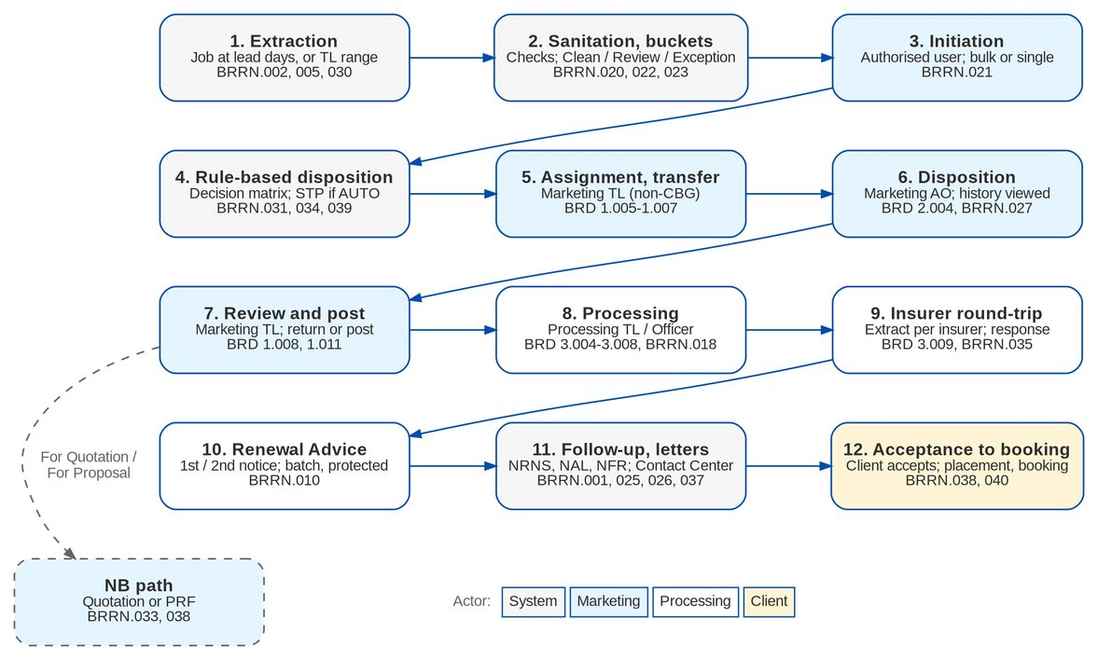
Figure 1: Renewal process by actor (BRRN.001-040, BRD 1.003-4.09)

2.3 Dispositions and paths
The disposition decides the path of the account after the TL posts it. The codes are fixed because they drive the workflow; their labels are maintained in the list RNW_DISPOSITION.
Table 5: Dispositions (BRD 2.004.3, p.107)
Code | Label | Path after posting
FOR_RENEWAL | For Renewal | Processing (FOR_PROCESSING), insurer round-trip, Renewal Advice, acceptance, placement and booking
NOT_FOR_RENEWAL | Not for Renewal | Letter step (NFR or NAL), then closed as NOT_RENEWED; can be reopened until expiry plus the reopen days
FOR_QUOTATION | For Quotation | New Business path: a package quotation pre-filled from the expiring account
FOR_PROPOSAL | For Proposal | New Business path: a PRF (non-package) pre-filled from the expiring account
LOST_BUSINESS | Lost Business | Closed as LOST

3 Personas and roles

3.1 Personas
Table 6: Personas and BIBS roles
Persona | BIBS role | Responsibilities in Renewal | BRD
Marketing Team Leader | MKT_TL | Generates the expiring list; initiates; assigns and re-assigns AOs; transfers and receives accounts; reviews, returns and posts; overrides the outstanding-balance flag; RAs; reports | BRD 1.001-1.011
Marketing AO / Admin, Account Broker | MKT_AO | Views assigned accounts; dispositions; remarks; requests transfers; updates returned accounts; RAs; reports | BRD 2.001-2.009
Processing Team Leader | PROCESSING_TL | Generates the list for processing; uploads dispositioned files; assigns to POs; updates data; computations; insurer extract and responses; RAs; reports | BRD 3.001-3.011
Processing Officer / Broker | PROCESSOR | Processes assigned accounts; uploads; updates data; computations; insurer extract and responses; RAs; reports | BRD 4.001-4.09
Business Administrator | BUSINESS_ADMIN | Maintains lists of values, renewal rules and templates; assigns user profiles | BRD 5.001-5.005
System Administrator | SYSADMIN | Defines profiles and assigns functions to them | BRD 6.001-6.002
LAMD user | LAMD (new) | Uploads paid-off and RMU reports; validation and eligibility checks only | BRRN.024, 029
Contact Center user | CONTACT_CENTER (new) | Views renewal lists; records follow-up remarks; uploads client documents | BRRN.026
Client | - (external) | Receives the RA and letters; accepts by e-mail, signed RA or payment | BRRN.010, 040
Insurer | - (external) | Receives the renewal extract; returns its decision file | BRD 3.009; BRRN.035

The Processing Officer section of the BRD says "Log in with a Operations Team Leader user profile" (4.001.1.1, p.174). BIBS reads it as the Processing Officer profile. The final role-to-function matrix is open (OQ48, RQ20, RQ21).

3.2 Permissions
The BRD lists 25 functions that the System Administrator assigns to profiles (6.002.2.1-25, p.207-211). BIBS gives each function a permission.
Table 7: Renewal permissions and the BRD functions they carry
Permission | Allows | BRD function (6.002.2.n)
RNW_VIEW | Renewal home, lists, record page, account history | 4, 11, 13, 17
RNW_EXTRACT | Generate the expiring list for a range, run the extraction, initiate candidates | 3, 15
RNW_ASSIGN | Assign and re-assign AOs, transfer, receive transfers (an AO only requests transfers) | 5, 6, 7
RNW_DISPOSE | Give the disposition, remarks, update returned accounts, start the NB path | 12, 14
RNW_REVIEW | TL review, return and post | 8, 22
RNW_OVERRIDE | Outstanding-balance, bucket, disposition and insurer-mismatch overrides; RA cancellation | BRD 1.011; BRRN.023, 031, 035
RNW_PROCESS_ASSIGN | Assign accounts to Processing Officers | 5 (processing)
RNW_PROCESS | Update data, review computations, return to Marketing | 18, 19, 22
RNW_UPLOAD | Upload dispositioned files | 16
RNW_INSURER | Extract per insurer, send, upload insurer responses | 20
RNW_RA_GENERATE | Generate, view and download RA, NAL and NFR | 10, 21
RNW_RA_SEND | Send letters in batch | 10
RNW_ACCEPT | Record client acceptance | BRRN.040
RNW_FOLLOWUP | Contact Center remarks, documents and follow-ups | BRRN.026
RNW_LAMD_UPLOAD, RNW_VALIDATE | LAMD reports and validation checks | BRRN.024, 029
RNW_REPORT_VIEW, RNW_EXPORT | Renewal reports; exports | 9
RNW_SETUP | Non-renewable risk codes, check settings, bucket rules, decision matrix, lead days | 23 (rules)
RNW_TEMPLATE_MAINTAIN | Update the renewal templates | 25
RNW_PACKAGE_REMAP | Choose the BIBS package version of a migrated policy whose legacy package is not mapped (FR-RN-028) | BRRN.020; DMQ36
ATTACHMENT_MANAGE, LOV_MANAGE, ACCESS_REQUEST (existing) | Acquire documents, maintain LOVs, request user access | 1, 23, 24

Function 2 (open the application in several tabs) needs no permission; it is the platform behaviour for every user.

3.3 Permissions matrix
The table is the proposed role-to-permission matrix ("Y" = granted; "T" = transfer request only). The System Administrator maintains it through role-permission change requests (FR-RN-003).
Table 8: Role-to-permission matrix for Renewal (proposal until OQ48 / RQ20 / RQ21)
Permission | MKT TL | MKT AO | Proc. TL | Proc. Officer | Bus. Admin | Sys. Admin | LAMD | Contact Center
RNW_VIEW | Y | Y | Y | Y | Y |  | Y | Y
RNW_EXTRACT | Y |  | Y
RNW_ASSIGN | Y | T
RNW_DISPOSE | Y | Y
RNW_REVIEW | Y
RNW_OVERRIDE | Y
RNW_PROCESS_ASSIGN |  |  | Y
RNW_PROCESS |  |  | Y | Y
RNW_UPLOAD |  |  | Y | Y
RNW_INSURER |  |  | Y | Y
RNW_RA_GENERATE | Y | Y | Y | Y
RNW_RA_SEND | Y | Y | Y | Y
RNW_ACCEPT | Y | Y | Y | Y
RNW_FOLLOWUP |  |  |  |  |  |  |  | Y
RNW_LAMD_UPLOAD |  |  |  |  |  |  | Y
RNW_VALIDATE |  |  |  |  |  |  | Y
RNW_REPORT_VIEW | Y | Y | Y | Y | Y
RNW_EXPORT | Y | Y | Y
RNW_SETUP |  |  |  |  | Y
RNW_TEMPLATE_MAINTAIN |  |  |  |  | Y
RNW_PACKAGE_REMAP |  |  | Y | Y
LOV_MANAGE |  |  |  |  | Y
Role-permission change requests |  |  |  |  |  | Y

Data scope. Marketing users see the candidates of their sales units, and an AO sees the candidates assigned to him. Processing users see the processing stages. LAMD and Contact Center users see a read-only projection without premium columns (to confirm, RQ21). The scope is applied by the server, never by the screen only.
Segregation of duties. Activation of a bucket rule set, a decision matrix or a non-renewable risk code needs a checker other than the maker (MASTER_AUTHORIZE). The LAMD role never holds a placement, booking, issuance, letter, disposition or messaging permission (BRRN.024).

4 Functional requirements

4.1 Access, security and audit

FR-RN-001 Log in, session warnings and multiple tabs
BRD trace | BRD 1.001.1-1.001.3.1, 2.001.1-2.001.1.3, 3.001.1-3.001.1.3, 4.001.1-4.001.1.3, 5.001.1-5.001.1.3, 6.001.1-6.001.1.1 (p.70, 104-105, 134, 174, 205-206), BRD 1.002.1, 2.002.1, 3.002.1, 4.002.1, 5.002.1 (p.70, 105, 135, 174, 205) | Actor | All Renewal personas
Priority | Must have | Screens | Login; session warning dialog; any Renewal screen in a second tab

Description
Users of every Renewal persona log in on any BDO-issued device with their BIBS user ID and the profile of their persona. Renewal uses the platform log-in, session policy and multi-tab behaviour of BRD-1; it adds no screen of its own.
BIBS warns the user after 15 minutes of inactivity and 30 minutes before the system-triggered log-out, as the BRD asks for each persona.
Preconditions
• The user has an active BIBS account with a Renewal role.
Main flow
1. The user enters the user ID and password on the Login screen.
2. BIBS checks the credentials and opens the home page with the menu of the user's roles (section Renewal).
3. The user opens Renewal screens in several browser tabs; each tab works on its own and the session is shared.
Alternate and exception flows
• Idle user. After the idle-warning minutes BIBS shows the warning; the user continues or is logged out at the idle limit.
• End of session. The warning appears the configured minutes before the system log-out.
• Wrong credentials. BIBS refuses the log-in; after the configured failed attempts the account locks (3 attempts, decision D5).
Business rules
Rule | Statement | Kind | Maintained in
R1 | Idle warning after 15 minutes; warning 30 minutes before the system log-out. | Configurable | Parameters SESSION_IDLE_WARNING_MINUTES, SESSION_EXPIRY_WARNING_MINUTES
R2 | Account lock after 3 failed attempts for all users (decision D5). | Configurable | Parameter LOGIN_MAX_FAILED_ATTEMPTS
R3 | Directory sign-in (BDO EUA / Windows ID) is added when BDO supplies the interface; until then the BIBS sign-in applies (decision D6). | Fixed | -

Validations and messages
Check | Message shown | Code
User ID or password wrong | Invalid user name or password | AUTHENTICATION_FAILED

Notifications
• None.
Audit
• Every successful and failed log-in is recorded with user, time and source address.
Acceptance criteria
1. A user with the Processing TL profile logs in and sees the Renewal section with the Processing screens only.
2. The idle warning appears after 15 minutes of inactivity.
3. The user works on the Expiry List in one tab and on a record page in a second tab without losing either.

FR-RN-002 Restrict each function and each record to authorised users
BRD trace | BRD 6.002.2.1-6.002.2.24 (p.207-211), BRRN.024 (p.32; p.6, 21), BRD p.69 key capability (Team Leaders view only their team's accounts) | Actor | System
Priority | Must have | Screens | All Renewal screens; User Access Matrix

Description
Every Renewal screen, button and action requires a permission (section 3.2). Menus show only the screens that the user's roles allow; buttons for actions the user may not perform are hidden.
Every list, record, report and export is limited to the user's data scope. A Marketing TL sees the candidates of his sales units, an AO those assigned to him, Processing the processing stages. LAMD and Contact Center users see a projection without premium columns.
The LAMD role is limited to validation and never holds booking, issuance, placement, letter or customer-communication permissions (BRRN.024).
Preconditions
• The user is logged in.
Main flow
1. The user opens a screen or starts an action.
2. BIBS checks the permission of the action and the scope of the record.
3. BIBS shows the screen or performs the action.
Alternate and exception flows
• No permission. The screen is not in the menu; a direct link shows "You do not have access to this screen. Contact your administrator if you need it.". A direct request is refused and logged.
• Out of scope. A record outside the user's scope is not listed and cannot be opened.
Business rules
Rule | Statement | Kind | Maintained in
R1 | Roles are granted permissions as in section 3.3 until BDOI confirms the matrix (OQ48, RQ20, RQ21). | Configurable | Role-permission change request (FR-RN-003)
R2 | Data scope is applied by the server in every query, report and export. | Fixed | -
R3 | The LAMD role cannot be granted placement, booking, issuance, letter or messaging permissions. | Fixed | -

Validations and messages
Check | Message shown | Code
Action without permission | You are not permitted to perform this action | ACCESS_DENIED

Notifications
• None.
Audit
• Refused requests are logged with the user and time.
• All LAMD actions are logged (BRRN.024 AC3).
Acceptance criteria
1. A Marketing AO sees My Dispositions and the record pages of his accounts, and does not see the Processing Worklist or Renewal Setup.
2. A Marketing TL does not see candidates of another sales unit.
3. A LAMD user can upload a LAMD report and view match results, and cannot generate or send an RA.

FR-RN-003 Define profiles and assign Renewal functions
BRD trace | BRD 6.002.1, 6.002.1.2-6.002.1.6 (p.206-207), BRD 6.002.2, 6.002.2.1-6.002.2.25 (p.207-211), BRD 5.004.1 (p.206) | Actor | System Administrator; Business Administrator (requester); access approver
Priority | Must have | Screens | Access Requests; User Access Matrix; Roles

Description
The profiles Marketing TL, Marketing AO / Admin, Processing TL, Processing Officer and Business Administrator exist as BIBS roles (MKT_TL, MKT_AO, PROCESSING_TL, PROCESSOR, BUSINESS_ADMIN). The workshop adds LAMD and CONTACT_CENTER.
Each of the 25 BRD functions maps to a permission (section 3.2). The System Administrator assigns functions to a profile through an approved role-permission change request, and the Business Administrator assigns profiles to users through an access request (BRD 5.004.1). Both are the User Access Maintenance flow of BRD-11.
Preconditions
• The requester has ACCESS_REQUEST.
Main flow
1. The requester opens Access Requests and chooses the type (assign role to a user, or modify role permissions).
2. The requester selects the user or role and the roles or permissions, and writes the justification.
3. An approver other than the requester approves the request.
4. BIBS applies the change and records it on the role or user history.
Alternate and exception flows
• The approver rejects the request with a reason; nothing changes.
Business rules
Rule | Statement | Kind | Maintained in
R1 | The approver is never the requester. | Fixed | -
R2 | Users may hold several roles (decision D5); there is no single-role check. | Fixed | -

Validations and messages
Check | Message shown | Code
No role or permission selected | Select at least one role or permission | -

Notifications
• The approvers when a request is submitted; the requester when it is decided.
Audit
• Request, decision and the applied change with users and times.
Acceptance criteria
1. The function "Extract accounts for renewal per insurer" (6.002.2.20) is granted to the Processing Officer profile only after another user approves the request.
2. A user assigned the Marketing AO profile sees the Renewal screens of that profile at the next log-in.

FR-RN-004 Keep a complete audit trail of renewal actions
BRD trace | BRRN.021 (p.30), BRRN.022 (p.30), BRRN.023 (p.30-32; p.5-6, 21), BRRN.031 (p.35-36), BRRN.035 (p.37-38; p.9-11, 23-24), BRRN.040 (p.40-41) | Actor | System; any user with RNW_VIEW (read)
Priority | Must have | Screens | Record page (History tab); Renewal Reports (RNW-DECISIONS, RNW-SANITATION)

Description
The workshop addendum asks, requirement by requirement, that every action is logged with the user, the time and the data source. BIBS records extraction, initiation, reference matching, every check run and bucket change, every disposition (user, matrix or upload), override, transfer, return, post, letter generation and sending, insurer response, LAMD match and acceptance.
The History tab of a record shows the workflow history, the disposition rows and the audit rows in time order. Extraction and initiation are different events, so the audit tells them apart (BRRN.021 AC3).
Preconditions
• None.
Main flow
1. A user or a job performs an action on a candidate.
2. BIBS writes the history row and the audit row (who, when, what, source, before and after values) together with the change; one is never kept without the other.
3. A user opens the History tab and reads the trail.
Business rules
Rule | Statement | Kind | Maintained in
R1 | Audit and history entries can only be added; no user can change or delete them. | Fixed | -
R2 | System actions are recorded with the job or rule that made them (for example matrix version and rule id). | Fixed | -

Notifications
• None.
Audit
• This FR is the audit.
Acceptance criteria
1. For a renewed account, the History tab lists extraction, initiation, bucket, disposition, post, insurer response, RA, acceptance and booking with user or source and time.
2. An extraction and the later initiation of the same candidate appear as two events with different users and times.
3. No screen or direct request allows history or audit rows to be edited or deleted.

4.2 Extraction and the expiring list

FR-RN-010 Extract renewal candidates automatically at the lead days
BRD trace | BRRN.030 (p.34-35; p.8), BRRN.005 (p.50-51), restating BRD 1.003.4.1.2, 3.003.4.2 (p.76, 140) | Actor | System (job RNW_EXTRACTION)
Priority | Must have | Screens | Renewal Home (extraction runs); Expiry List

Description
Every day BIBS extracts as renewal candidates the booked root invoices (policy years) whose policy expiry date equals the business date plus the lead days (default 140 days; a value per segment may override it). Extraction is expiry-based, not maturity-based (BRRN.030 AC1).
Each candidate gets a renewal reference and keeps the expiring invoice number, ARN, policy number and a snapshot of the listing fields. Expired and expiring accounts that are not yet renewed stay listed until the candidate closes, so the list has no omissions and no duplicates (BRRN.005).
After extraction BIBS runs the checks of FR-RN-020. A candidate does nothing more until it is initiated (FR-RN-015).
Preconditions
• The job is active.
Main flow
1. The job runs at 01:00 PHT.
2. BIBS selects the booked root invoices whose expiry falls on the target date, skipping invoices already extracted and excluded lines.
3. BIBS creates one candidate per invoice with stage EXTRACTED, records the run (RXR-yyyy) with its counts, and runs the checks.
Alternate and exception flows
• Multi-year account. Only the last policy year of the term produces a candidate.
• Run failure. The run is marked failed, alert RNW_EXTRACTION_FAILED is raised, and the next run picks up the missed dates.
• Placed or issued accounts that are not yet booked ("unbooked", BRRN.005) are included when their period ends in the window (interpretation to confirm, RQ06).
Business rules
Rule | Statement | Kind | Maintained in
R1 | Lead days 140 (default); per-segment values override it. | Configurable | Parameters RNW_EXTRACTION_LEAD_DAYS, RNW_EXTRACTION_LEAD_DAYS_BY_SEGMENT
R2 | One open candidate per expiring invoice (unique company + expiring invoice no.). | Fixed | -
R3 | Employee Benefits lines (HMO, GLI, GPA) are excluded (decision D3). | Configurable | Parameter RNW_EXCLUDED_LINES
R4 | Extraction never starts the renewal and never guarantees renewability (BRRN.021, BRRN.030 AC3). | Fixed | -
R5 | Job time 01:00 PHT. | Configurable | Job schedule (System Administrator)

Notifications
• Alert RNW_EXTRACTION_FAILED to the job owners when a run fails.
Audit
• Each run with trigger, range, counts (read, new, existing, skipped), start and end.
Acceptance criteria
1. A policy expiring 140 days after the business date becomes a candidate that day, with a renewal reference, and does not appear twice after a second run.
2. A change of the lead days to 150 takes effect at the next run without a release.
3. An HMO policy is not extracted.
4. The extraction run records its date, time and trigger, and a policy is never extracted twice in the same cycle (BRRN.030, Walkthrough addendum p.8).

FR-RN-011 Generate the list of expiring accounts for a date range
BRD trace | BRRN.002 (p.48-49), restating BRD 1.003.1, 1.003.1.1, 1.003.2, 3.003.1, 3.003.1.1, 3.003.2 (p.70-71, 135), BRD 3.003.4, 3.003.4.1 (p.137) | Actor | Marketing TL; Processing TL
Priority | Must have | Screens | Expiry List (Generate Expiry List dialog)

Description
The TL opens the Expiry List and clicks Generate Expiry List. He selects a start and end date (month, day, year) and BIBS shows the expiring accounts in that range. Changing the range refreshes the list at once.
When the range goes beyond what the job has already extracted, BIBS extracts the missing dates on demand. This is recorded as an extraction, not as an initiation (BRRN.021).
Preconditions
• The user has RNW_EXTRACT (generate) or RNW_VIEW (view the list).
Main flow
1. The user clicks Generate Expiry List.
2. The user picks the start and end dates (MM/DD/YYYY) and clicks Generate.
3. BIBS extracts any missing dates and lists the candidates whose expiry falls in the range, within the user's scope.
4. The user changes the range; the list refreshes.
Alternate and exception flows
• No account matches. BIBS shows "No expiring accounts in the selected range".
Business rules
Rule | Statement | Kind | Maintained in
R1 | An on-demand extraction uses the same selection as the job and is recorded with trigger MANUAL_RANGE. | Fixed | -
R2 | Users may extract on demand for any range; the scheduled run and the on-demand run share the same duplicate guard (RQ04). | Fixed | -

Validations and messages
Check | Message shown | Code
Start or end date missing or not a date | Enter a valid start and end date | -
End date before start date | The end date must be on or after the start date | -

Screens and fields: Generate Expiry List
Field | Type | Mand. | Source / LOV | Validation
Expiry from | Date | Yes | - | MM/DD/YYYY
Expiry to | Date | Yes | - | On or after expiry from

Notifications
• None.
Audit
• On-demand extractions are recorded as runs with the user, range and counts.
Acceptance criteria
1. A TL generates the list for 01-Mar to 31-Mar and sees every candidate of his units expiring in March, and only those.
2. An end date before the start date cannot be submitted.
3. A range with no expiring account shows the empty-list message.

FR-RN-012 Filter the expiring list with multi-select criteria
BRD trace | BRRN.003 (p.49), restating BRD 1.003.3, 1.003.3.1-1.003.3.1.13, 3.003.3, 3.003.3.1-3.003.3.13 (p.71-73, 135-137) | Actor | Marketing TL; Processing TL
Priority | Must have | Screens | Expiry List (Filters panel)

Description
The Filters panel offers Unit Head, Business Origin, Account Type, Region, Area, Invoicing Branch, Risk Code, Market Segment, Department Name and Account Officer, plus Bucket, Disposition and Stage. Each criterion supports single, multiple, "all except" and all selections, with a search in the drop-down.
Apply filters the list at once; Cancel closes the panel without change; Clear restores all. The selected values stay visible above the grid and in the page address, so a filtered list can be shared.
Preconditions
• The list is displayed.
Main flow
1. The user opens Filters and, per criterion, ticks values or chooses "all except" and ticks the values to exclude.
2. The user clicks Apply; BIBS filters the list and shows the active filters as chips.
Alternate and exception flows
• The user clicks Clear; all criteria return to "All".
Business rules
Rule | Statement | Kind | Maintained in
R1 | Selection types: single, multiple, all except, all. | Fixed | -
R2 | An 'all except' and an 'only' selection on the same criterion cannot be combined. | Fixed | -

Validations and messages
Check | Message shown | Code
Conflicting selection on one criterion | Choose either 'only' or 'all except' for <criterion> | -

Screens and fields: Filters
Field | Type | Mand. | Source / LOV | Validation
Unit Head / Business Origin / Account Type / Region / Area / Invoicing Branch / Risk Code / Market Segment / Department Name / Account Officer | Multi-select with search | No | Masters and LOVs of each field | Include or exclude mode
Bucket | Multi-select | No | Clean, Review, Exception | -
Disposition / Stage | Multi-select | No | LOV RNW_DISPOSITION; RNW_CASE stages | -

Notifications
• None.
Audit
• None (read only).
Acceptance criteria
1. Choosing Risk Code "all except" MC01 lists every expiring account except those with risk code MC01.
2. Two Unit Heads selected together list the accounts of both.
3. Clear returns the full list.

FR-RN-013 Show the expiring list in one scrollable grid with column filters and search
BRD trace | BRRN.004 (p.49-50), restating BRD 1.003.4.1, 1.003.4.1.1, 1.003.4.1.1.2-1.003.4.1.1.24, 3.003.4.1, 3.003.4.1.2-3.003.4.1.21 (p.73-76, 137-140), BRRN.006 (p.51), restating BRD 1.003.4.1.3, 1.003.4.1.4, 3.003.4.3, 3.003.4.4, 3.006.1.5, 4.003.1.5 (p.76, 140-141, 145, 175-176) | Actor | Marketing TL; Processing TL; Processing Officer
Priority | Must have | Screens | Expiry List (tabs Unassigned Disposition, For Renewal, For Quotation, For Proposal, Not for Renewal, Lost Business, Exceptions, All)

Description
The list shows every candidate of the range in one scrollable view, without pages, with a row count. The columns are those of BRD 1.003.4.1.1 (section 6.2), plus the Classification pill (Clean / Review / Exception) and the flag chips (Returned, Transferred, Endorsed, Claims, Outstanding, KYC due, NRNS). The Processing list has the first 21 columns (3.003.4.1) and not the claims and outstanding-premium columns.
Columns can be resized and reordered, and the layout is kept per user. Each column has a filter (text, list, date or amount). A keyword search across all columns filters and highlights the matches, like Ctrl+F.
Preconditions
• The list is generated (FR-RN-011).
Main flow
1. The user scrolls the list; BIBS loads further rows as the user scrolls.
2. The user types in a column filter or in the search box; the list filters and the matches are highlighted.
3. The user resizes or drags a column; the layout is saved for the next visit.
Alternate and exception flows
• More than 5,000 rows. Filters and search run on the server; the grid keeps the same behaviour.
Business rules
Rule | Statement | Kind | Maintained in
R1 | No pagination: one scrollable view with a row count (BRRN.004; UX-6 / RQ05 to confirm against the UX pager rule). | Fixed | -
R2 | The EBIX invoice number and BDOIsys reference columns are out of scope; the BIBS expiring invoice number and the renewal reference take their place. | Fixed | -
R3 | Claims columns read the Claims module; until it is connected they show 'claims not connected' (decision D4). | Fixed | -

Screens and fields: Expiry List grid (main columns)
Field | Type | Mand. | Source / LOV | Validation
Expiring Invoice No. | Display | - | Booked invoice | BIBS invoice number
Renewal Reference No. | Display | - | Candidate | RNW-yyyy-nnnnnn
Cover No. / Version No. | Display | - | Invoice | -
Invoicing Branch / Department Code / Department Name / Unit Head | Display | - | Sales organisation | -
Client Name / Assured's Name / Business Origin / Account Officer | Display | - | Account and client | -
Expiring Policy No. / Insurance Company / Risk Code / Risk Name / Risk Description | Display | - | Account and catalogue | -
Renewal Stage / Status / Renewal Disposition / Disposition Remarks | Display | - | Candidate | -
Number of Claims / Status of Each Claim | Display | - | Claims module | Marketing list only
Amount of Outstanding Premium | Amount | - | Operations ledger | Marketing list only
Classification | Pill | - | Bucket | Clean (green), Review (yellow), Exception (red)

Notifications
• None.
Audit
• None (read only).
Acceptance criteria
1. A list of 20,000 candidates scrolls from the first to the last row without a pager, and the row count shows 20,000.
2. Typing a client name in the search box filters the list and highlights the name in each matching row.
3. A column moved to the first position stays first after the user logs out and in.

FR-RN-014 Export and print the expiring list
BRD trace | BRRN.007 (p.51-52), restating BRD 1.003.5, 1.003.6, 1.003.7, 3.003.5, 3.003.6, 3.003.7 (p.76-77, 141), BRRN.008 (p.52), restating BRD 1.003.7.1, 1.003.7.2, 3.003.7.1, 3.003.7.2 (p.77, 141) | Actor | Marketing TL; Processing TL
Priority | Must have | Screens | Expiry List (Export, Print)

Description
The user downloads the list as .xlsx with the columns and filters of the current view, saves it, and prints it. The export is the report RNW-EXPIRY-LIST run with the grid's filter state, so the file equals the displayed list.
Print opens a PDF preview (landscape, A4 or Legal) that matches the printout; the browser print dialog sets margins and scaling.
Preconditions
• The user has RNW_EXPORT.
Main flow
1. The user clicks Export and chooses Excel, or Print.
2. BIBS produces the file from the current view and downloads it, or opens the print preview.
Alternate and exception flows
• The user ticks "Keep a copy"; BIBS also stores the file in the report archive.
Business rules
Rule | Statement | Kind | Maintained in
R1 | The export has the same rows and columns as the view; nothing is truncated. | Fixed | -
R2 | Page size A4 or Legal; orientation landscape by default. | Configurable | Report parameters pageSize / orientation

Notifications
• None.
Audit
• Each export is logged with user, filters and time.
Acceptance criteria
1. The Excel file of a filtered list has exactly the rows and columns shown on screen.
2. The print preview shows the same rows as the printed pages.

FR-RN-015 Initiate renewal processing explicitly
BRD trace | BRRN.021 (p.30) | Actor | Authorised user (Marketing TL, Processing TL with RNW_EXTRACT)
Priority | Must have | Screens | Expiry List (Initiate); record page

Description
Extracted accounts are displayed, but renewal processing starts only when an authorised user initiates them. Segments flagged for bulk initiation (for example CLG) are initiated in bulk from the list; the others (for example Non-Mortgage) one by one.
Initiation records the user and time and moves the candidate to EVALUATING, where BIBS applies the bucket and the decision matrix (FR-RN-022, FR-RN-023). Candidates handed over by Submitted Policies are initiated by the hand-off itself (FR-RN-090).
Preconditions
• The candidate is EXTRACTED; the user has RNW_EXTRACT.
Main flow
1. The user selects candidates (single, multiple, all except, all) and clicks Initiate.
2. BIBS records the initiation and routes each candidate by its bucket and the matrix.
Alternate and exception flows
• A bulk selection includes a segment that is initiated one by one. BIBS initiates the others and lists the refused ones.
Business rules
Rule | Statement | Kind | Maintained in
R1 | No extracted candidate progresses without initiation. | Fixed | -
R2 | Segments initiated in bulk: CLG (default). | Configurable | Parameter RNW_BULK_INITIATION_SEGMENTS (RQ02)

Validations and messages
Check | Message shown | Code
Candidate not EXTRACTED | Renewal <ref> is already initiated | To be confirmed
Bulk initiation of a single-initiation segment | Segment <segment> is initiated one account at a time | To be confirmed

Notifications
• The assigned TL queue when candidates reach UNASSIGNED.
Audit
• INITIATED event with user and time, separate from EXTRACTED.
Acceptance criteria
1. An extracted candidate stays EXTRACTED and appears in no worklist until it is initiated.
2. Bulk initiation of 200 CLG candidates records the user and time on each.
3. A Non-Mortgage candidate in a bulk selection is refused with the segment message.

FR-RN-016 Take over the expiries of the go-live window
BRD trace | BRRN.005 (p.50-51), BRRN.030 (p.34-35; p.8) | Actor | Processing TL (runs the go-live extraction from the cut-over runbook); Renewal processing team
Priority | Must have | Screens | Renewal Home (extraction runs); Expiry List (Urgent pill); Processing Worklist (Upload RA already sent)

Description
At go-live BIBS takes over every renewal that expires from go-live to 31 May 2028. BDOI decided on 26-Sep-2026 that these renewals are processed in BIBS after go-live and that no renewal in progress is carried from the legacy systems (BRD-13 question DMQ37).
Once, right after the migration load is signed off, the go-live extraction creates a candidate for every migrated in-force policy expiring in that window. The candidates are ordered by expiry date. Those expiring in January 2028 carry the flag Urgent, which the Expiry List shows as a pill and every worklist sorts first.
Renewal Advices already sent by hand before go-live are recorded from the Excel trackers of the business units, so BIBS does not send them again. Rejected tracker rows are reviewed by the Renewal processing team on a maker-checker basis (DMQ38).
From the next day the daily extraction (FR-RN-010) takes the later expiries; expiries already taken over are not extracted twice.
Preconditions
• The migrated in-force policies are loaded and signed off (BRD-13 cut-over runbook).
• The user has RNW_EXTRACT (go-live extraction) or RNW_RA_SEND (tracker upload).
Main flow
1. The Processing TL runs job RNW_GOLIVE_EXTRACTION from Administration > Scheduled Jobs.
2. BIBS creates one candidate in stage EXTRACTED per migrated policy expiring from go-live to RNW_GOLIVE_EXTRACTION_TO, with source Legacy and the legacy policy reference, flags Urgent those expiring up to RNW_GOLIVE_URGENT_TO, and runs the checks (FR-RN-020, FR-RN-028).
3. A member of the Renewal processing team uploads the tracker of Renewal Advices already sent (legacy policy reference, RA date, RA reference, recipient).
4. BIBS records each matched row as an RA of status Sent with its legacy date. The candidate is not offered for RA generation or sending again; the second notice and the NRNS checkpoint count from the legacy RA date.
5. The candidates are initiated as in FR-RN-015 (bulk initiation of the go-live run is allowed).
Alternate and exception flows
• Policy already renewed in legacy (a later term of the same cover is migrated). BIBS skips it and counts it as skipped.
• Tracker row without a matching candidate, or a second row for the same policy. The row is rejected to the upload result. A team member corrects it (maker) and a second member approves the corrected row (checker) before it is applied.
• RA generated for a January expiry fewer than RNW_RA_MIN_NOTICE_DAYS before expiry. The late-RA warning of FR-RN-080 applies.
Business rules
Rule | Statement | Kind | Maintained in
R1 | Window from the go-live date to 31 May 2028; urgent up to 31 January 2028. | Configurable | Parameters RNW_GOLIVE_EXTRACTION_TO, RNW_GOLIVE_URGENT_TO
R2 | One candidate per legacy policy reference; the daily extraction skips policies already taken over. | Fixed | -
R3 | An RA recorded from the tracker is never generated or sent again for the same candidate. | Fixed | -
R4 | Rejected tracker rows are applied only after a second member of the Renewal processing team approves the correction (maker-checker). | Fixed | -
R5 | The job runs once; a second run creates nothing new and is recorded with zero new candidates. | Fixed | -

Validations and messages
Check | Message shown | Code
Tracker row whose legacy policy reference has no candidate | Row <n>: no renewal candidate for legacy policy <reference> | To be confirmed
Second tracker row for the same policy | Row <n>: the Renewal Advice of legacy policy <reference> is already recorded | To be confirmed
RA date missing or after the go-live date | Row <n>: enter the date the Renewal Advice was sent (before go-live) | To be confirmed

Notifications
• The Processing TL and the Marketing TLs of the units when the go-live run completes, with the counts per expiry month and the number of urgent candidates.
Audit
• The go-live run with user, window, counts (read, extracted, urgent, skipped) and time; each tracker row applied with maker, checker, file and row number.
Acceptance criteria
1. After the go-live run every migrated policy expiring from go-live to 31 May 2028 is a candidate exactly once, and the January expiries show Urgent and come first in the lists.
2. A candidate whose RA is recorded from the tracker shows the RA as Sent with the legacy date and cannot be sent again.
3. A rejected tracker row is applied only after a second team member approves the correction.
4. The first daily extraction after go-live creates no second candidate for a policy expiring on 31 May 2028.

4.3 Sanitation, buckets and rules

FR-RN-020 Run the sanitation, matching and eligibility checks
BRD trace | BRRN.020 (p.30; p.5, 20-21), BRRN.022 (p.30) | Actor | System (check engine); Renewal processor (view)
Priority | Must have | Screens | Record page (Checks & Bucket tab); Renewal Reports (RNW-SANITATION)

Description
After extraction, after every upload and on every relevant event, BIBS runs the checks of section 5.3 on the candidate - reference match, PN present, risk code renewable, risk code defined, insurer renewable list, TSI threshold, LAMD status, claims, pending endorsement, outstanding premium, financial impact, insurer response match, mandatory fields, product renewable, insurer usable, duplicate candidate and KYC due. Eligibility no longer depends on manual pre-cleaning of the list.
Each check writes a result PASS, WARN, FAIL, INFO or NOT_APPLICABLE with its detail. The Checks & Bucket tab shows the latest results, and the RNW-SANITATION report lists them for any range.
The sanitation criteria of the Walkthrough addendum (SC-01 to SC-13, p.20-21) are the defaults of the check settings: missing key fields make an exception record (MANDATORY_FIELDS, REFERENCE_MATCH); a risk code that is not renewable, such as Bonds or CAR, is excluded (RISK_CODE_RENEWABLE); a risk code not defined in the criteria goes to manual review (RISK_CODE_DEFINED, Review); a risk not on the insurer's renewable list stops the continuation (INSURER_RENEWABLE_LIST, Review); a total sum insured above PHP 250M goes to TSU or proposal handling (TSI_THRESHOLD, Review, with the decision matrix proposing For Proposal). The criteria are configurable, changed only by the authorised group with an effective date, applied at policy level, and a change never affects a candidate already initiated.
Preconditions
• A candidate exists.
Main flow
1. A trigger occurs (extraction, upload, insurer or LAMD file, endorsement posted, payment, nightly job).
2. BIBS runs every active check and stores the run and its results.
3. BIBS recomputes the bucket (FR-RN-022).
Alternate and exception flows
• Claims cannot be read for the candidate (a migrated policy without a BIBS account, or the Claims module not reachable). The claims check reports Not applicable or INFO and does not block (decision D4); how claims of migrated policies are found is listed for confirmation (CLR-RN-28).
• An existing claims record requires manual evaluation (Walkthrough addendum R23-05, R28-05): open claims fail the check with severity Review, so the candidate is never disposed automatically.
Business rules
Rule | Statement | Kind | Maintained in
R1 | Checks and their default severities are those of section 5.3, set from the sanitation criteria of the Walkthrough addendum (RQ01 answered in part). | Configurable | Check settings (Renewal Setup)
R4 | TSI threshold PHP 250,000,000.00; above it the candidate is Review and the matrix proposes For Proposal to TSU (SC-12, SC-13, R23-02, R24-02). | Configurable | Check setting TSI_THRESHOLD (parameter amount)
R5 | A change of the check settings applies to the candidates not yet initiated; candidates in progress keep their results until their next event. | Fixed | -
R2 | Re-evaluation when an invoice is booked or moves, when the account status changes, after every upload and nightly (job RNW_REEVALUATE). | Fixed | -
R3 | KYC due is information only and never blocks (BRRN.028). | Fixed | -

Notifications
• None; the bucket change of FR-RN-022 notifies.
Audit
• Every check run with trigger, time and the results per check.
Acceptance criteria
1. A candidate with an open endorsement request on the expiring invoice shows ENDORSEMENT_PENDING = FAIL on the Checks & Bucket tab.
2. When the endorsement is posted, the check turns PASS at the next event without user action.
3. The RNW-SANITATION report lists the failed checks of a date range with the candidate and detail.
4. A candidate with a total sum insured of PHP 300M fails TSI_THRESHOLD, is Review and is proposed For Proposal; one of PHP 200M passes the check.
5. A candidate on a risk code that is not in the check criteria fails RISK_CODE_DEFINED and is Review (manual review).

FR-RN-021 Use a unique renewal reference as the matching key
BRD trace | BRRN.022 (p.30), BRD 1.003.4.1.1.2 (p.73) | Actor | System; Renewal user
Priority | Must have | Screens | Expiry List; record page; every upload

Description
BIBS issues a renewal reference RNW-yyyy-nnnnnn at extraction and stores it with the expiring ARN and invoice number. The reference is mandatory on every upload (dispositioned file, insurer response, acceptance list) and is the primary key that links a renewal record to its expiring policy; the expiring invoice number is the alternate key.
The check REFERENCE_MATCH records the outcome per record (MATCHED, MISSING, INVALID, AMBIGUOUS). A record without a valid reference goes to exception handling and is never dropped.
Preconditions
• None.
Main flow
1. BIBS generates the reference when the candidate is created.
2. An upload row carries the reference; BIBS matches it to the candidate.
3. The match outcome is visible on the record and in the upload result.
Alternate and exception flows
• Missing or unknown reference. The row is kept as an exception line with the reason.
Business rules
Rule | Statement | Kind | Maintained in
R1 | Reference format RNW-<yyyy>-<nnnnnn>, unique per company. | Configurable | Parameter RNW_REFERENCE_PREFIX (format RQ03)
R2 | Uploads without a valid reference never update a candidate. | Fixed | -

Validations and messages
Check | Message shown | Code
Upload row without reference | Row <n> has no renewal reference | To be confirmed
Reference not found | Row <n>: renewal reference <ref> does not exist | To be confirmed

Notifications
• None.
Audit
• Match result and status per record.
Acceptance criteria
1. Every candidate has a unique renewal reference.
2. A dispositioned-file row with an unknown reference is listed as an exception and updates nothing.

FR-RN-022 Classify candidates into Clean, Review and Exception buckets
BRD trace | BRRN.023 (p.30-32; p.5-6, 21), BRRN.029 (p.34; p.7-8, 23; rule R29-05, exception ageing) | Actor | System; authorised user (override)
Priority | Must have | Screens | Expiry List (Classification pill, Exceptions tab, Bucket filter); record page (Checks & Bucket tab, Override Bucket)

Description
After each check run BIBS computes the bucket from the active bucket rule set. By default any check that fails with severity FAIL_EXCEPTION gives Exception; any FAIL_REVIEW or WARN gives Review; otherwise Clean. Records move between buckets when conditions change.
Users filter and export by bucket. A bucket is changed by hand only through a controlled override with mandatory remarks, and an override can never make a record with a failed check Clean (BRRN.023 negative scenario).
Classification is immediate after the checks, deterministic and explainable: the record shows the rule and rule-set version that set its bucket (Walkthrough addendum p.5-6). The annex rules R23-01 to R23-05 (p.21) are the default rule set: TSI up to the threshold with a renewable risk code is eligible (Clean when no other check fails); TSI above the threshold goes to TSU or proposal handling (Review); a non-renewable risk code is not eligible; missing mandatory data is a sanitation failure (Exception); an existing claims record requires manual evaluation (Review).
An exception that stays open beyond the exception ageing days raises the alert RNW_EXCEPTION_AGEING to the owner of the stage, for follow-up by the business (R29-05); no record is moved by the alert.
Preconditions
• A check run exists.
Main flow
1. BIBS evaluates the bucket rules on the latest results and stores the bucket with the rule-set version.
2. The Classification pill shows the bucket; the Checks & Bucket tab shows why.
Alternate and exception flows
• Override. A user with RNW_OVERRIDE clicks Override Bucket, chooses the bucket and writes remarks; BIBS records the override.
Business rules
Rule | Statement | Kind | Maintained in
R1 | Default rule set: FAIL_EXCEPTION gives EXCEPTION; FAIL_REVIEW or WARN gives REVIEW; otherwise CLEAN. | Configurable | Bucket rule sets (versioned, maker-checker; content RQ01)
R2 | A failed check never gives CLEAN, by rule or by override. | Fixed | -
R3 | Every bucket change is logged with the rule-set version, rule, check run, cause and user. | Fixed | -
R4 | Exception ageing: 5 working days by default (R29-05; days and recipients to confirm, CLR-RN-27). | Configurable | Parameter RNW_EXCEPTION_AGEING_DAYS

Validations and messages
Check | Message shown | Code
Override to Clean with a failed check | Renewal <ref> has failed checks and cannot be Clean | To be confirmed
Override without remarks | Enter the remarks of the override | -

Screens and fields: Override Bucket
Field | Type | Mand. | Source / LOV | Validation
Bucket | List | Yes | Review, Exception (Clean only when no check fails) | -
Remarks | Text | Yes | - | Up to 200 characters

Notifications
• The owners of the stage when a candidate enters Exception.
Audit
• Bucket history: from, to, rule-set version, rule, check run, cause (RULE or OVERRIDE), user, remarks.
Acceptance criteria
1. A candidate with an open claim is Review, never Clean.
2. When the claim closes, the candidate becomes Clean at the next re-evaluation and the bucket history shows both entries.
3. An override to Clean on a record with a failed check is refused.
4. The Checks & Bucket tab shows, for each bucket change, the rule-set version and the rule that set it.

FR-RN-023 Apply the decision matrix and rule-based disposition
BRD trace | BRRN.031 (p.35-36), BRRN.034 (p.37; p.9, 23) | Actor | System; Business Administrator (matrix); authorised user (override)
Priority | Must have | Screens | Renewal Setup (Decision Matrix); record page (disposition proposal); Renewal Reports (RNW-DECISIONS)

Description
After initiation BIBS evaluates the active decision matrix on Clean and Review candidates. The first rule by priority gives a proposed disposition and an automation flag. A Clean candidate whose rule says AUTO receives a system disposition (source MATRIX) and proceeds without user action; otherwise the proposal is shown to the AO as the default.
Matrix rules refer to segment, line, product, mortgaged flag, bucket, claims, endorsements, payment status and days to expiry; outcomes are disposition options (BRRN.034 AC1-2). Candidates with claims, endorsements, a missing or invalid PN or unresolved payment go to manual review (BRRN.031 AC2).
The matrix is versioned; a version is activated by a checker other than its maker. Every system decision stores the matrix version and the rule id.
Preconditions
• An active matrix exists; without one, every candidate is manual.
Main flow
1. The Business Administrator drafts a matrix version with its rules and submits it.
2. A checker with MASTER_AUTHORIZE activates it from its effective date.
3. On initiation BIBS evaluates the matrix and applies or proposes the disposition.
Alternate and exception flows
• Override of a system disposition. An authorised user chooses another disposition with mandatory remarks; the override is logged.
• TL review of automatic dispositions. With parameter RNW_STP_SKIP_TL_REVIEW = true (default), an AUTO disposition skips the TL review.
Business rules
Rule | Statement | Kind | Maintained in
R1 | AUTO applies only to CLEAN candidates; any failed check means manual review. | Fixed | -
R2 | Only one ACTIVE matrix version at a time; activation by a checker who is not the maker. | Fixed | -
R3 | Matrix content is supplied by BDOI (RQ24); none ships with production. | Configurable | Decision matrix (Renewal Setup)
R4 | The condition TOTAL_LOSS is inactive until Claims defines a total-loss indicator (CLQ28). | Fixed | -

Validations and messages
Check | Message shown | Code
Activation by the maker | A matrix version is activated by someone other than its maker | To be confirmed
Override without remarks | Enter the remarks of the override | -
Rule without outcome | Select the disposition of the rule | -

Screens and fields: Decision rule
Field | Type | Mand. | Source / LOV | Validation
Priority | Number | Yes | - | Unique in the version
Segment / Line / Product | List | No | Masters | Blank = any
Mortgaged | Option | No | Yes / No / Any | -
Bucket | List | No | Clean, Review | -
Claims condition | List | No | None, Open, Paid (Total loss to be defined, CLQ28) | -
Endorsement condition | List | No | None, Posted in term, Pending | -
Payment condition | List | No | Paid, Outstanding, DP | -
Days to expiry from / to | Number | No | - | From <= to
Outcome disposition | List | Yes | LOV RNW_DISPOSITION | -
Automation | Option | Yes | AUTO / MANUAL | -
Letter hint | List | No | RA, NFR, NAL | -

Notifications
• The checkers when a matrix version is submitted.
Audit
• Matrix versions with maker, checker and dates; each decision with version, rule id and user or MATRIX.
Acceptance criteria
1. A Clean CBG Motor candidate matching an AUTO rule receives disposition For Renewal with source MATRIX and moves on without user action.
2. A candidate with an open claim is not disposed automatically and shows the proposal to the AO.
3. The RNW-DECISIONS report shows, for each system disposition, the matrix version and rule.
4. The scenarios of the Walkthrough addendum (Annex BRRN.034, p.23) hold - a Clean renewal answered Renew As Is moves forward without user action; a rejected or revised insurer answer stops or reroutes the renewal; a failed rule sends it to manual handling; an unresolved endorsement blocks it.

FR-RN-024 Tag non-renewable risk codes and send the NFR
BRD trace | BRRN.009 (p.52-53), restating BRD 1.003.7.3, 1.003.7.3.1 (p.77) | Actor | System; Business Administrator (codes)
Priority | Must have | Screens | Renewal Setup (Non-renewable Risk Codes); Letters (NFR tab)

Description
The Business Administrator maintains the risk codes that are not renewable, with line, reason and effective dates. Each change is authorised by a checker.
The check RISK_CODE_RENEWABLE tags a candidate on such a code Not for Renewal with reason "Non-renewable Accounts" and source SYSTEM, excludes it from the assignment list, and queues a Not for Renewal Letter (NFR) to the client. The delivery outcome is read from the e-mail log.
Preconditions
• The user has RNW_SETUP (codes).
Main flow
1. The Business Administrator adds a risk code with reason and effective dates; a checker authorises it.
2. At the next check run, candidates on that code are tagged and moved to LETTER_PENDING.
3. BIBS generates the NFR from template RNW_NFR and sends it protected to the client's registered e-mail.
Alternate and exception flows
• The client later decides to renew. The AO re-dispositions the account (FR-RN-047); the NFR stays in the history with the flag "NFR sent".
Business rules
Rule | Statement | Kind | Maintained in
R1 | Codes are never deleted; they are end-dated. | Fixed | -
R2 | The NFR is queued on tagging without a human review step; BDOI confirms this under RQ07. | Fixed | -

Validations and messages
Check | Message shown | Code
Effective to before effective from | The effective-to date is before the effective-from date | LOV_EFFECTIVITY_INVALID
Risk code not in the catalogue | Risk code <code> does not exist | To be confirmed

Screens and fields: Non-renewable risk code
Field | Type | Mand. | Source / LOV | Validation
Risk code | List | Yes | Product catalogue | Active risk code
Product line | List | No | Product lines | -
Reason | Text | Yes | - | Up to 200 characters
Effective from / to | Date | Yes (from) | - | To on or after from

Notifications
• NFR to the client; confirmation of delivery on the Letters tab.
Audit
• Changes to codes (maker, checker, before and after) and every NFR action, including failures.
Acceptance criteria
1. A candidate on a non-renewable risk code is tagged Not for Renewal, does not appear in Unassigned Disposition, and an NFR is generated.
2. The Letters tab shows the NFR with its sent status.
3. A code change takes effect only after the checker authorises it.

FR-RN-025 Ingest LAMD reports and route paid-off and RMU accounts
BRD trace | BRRN.029 (p.34; p.7-8, 23), BRRN.039 (p.40), BRRN.024 (p.32; p.6, 21) | Actor | LAMD user (upload); System (matching)
Priority | Must have | Screens | LAMD Reports (upload, match results, routing)

Description
The LAMD user uploads the paid-off and RMU loan reports. BIBS matches each line to the expiring candidates by PN, the primary matching key, and applies the routing. A paid-off loan tags the account Not for Renewal with reason "Loan fully paid"; an RMU loan tags it Not for Renewal with reason "RMU" or transfers it to the Corporate RMU unit.
For CBG Motor and Fire, PN matching is mandatory. A CBG candidate without a PN fails PN_PRESENT, and matched Clean candidates follow the straight-through path to the RA or the NFR without AO assignment (BRRN.039).
Preconditions
• The user has RNW_LAMD_UPLOAD.
Main flow
1. The LAMD user chooses the report type (Paid-off or RMU) and the period, and uploads the file.
2. BIBS validates the rows, matches them by PN and shows matched, unmatched and ambiguous lines.
3. BIBS applies the routing to matched candidates and re-runs their checks.
Alternate and exception flows
• Unmatched PN. The line is kept as unmatched and listed in RNW-LAMD-MATCH.
• Paid-off client wants to renew without a mortgage. The AO re-dispositions (FR-RN-047; RQ23).
Business rules
Rule | Statement | Kind | Maintained in
R1 | PN is the primary matching key. | Fixed | -
R2 | RMU routing: tag Not for Renewal, or transfer to the unit in RNW_RMU_UNIT when set. | Configurable | Parameter RNW_RMU_UNIT (RQ23)
R3 | CBG lines on the STP path: Motor and Property. | Configurable | Parameter RNW_CBG_STP_LINES (RQ08)
R4 | Report layout: column mapping of the upload handler. | Configurable | Bulk template RNW_LAMD_REPORT (RQ20)

Validations and messages
Check | Message shown | Code
File type not allowed | The file type is not allowed | BULK_FILE_TYPE
Row without PN | Row <n> has no PN number | To be confirmed
PN matches several candidates | Row <n>: PN <pn> matches several renewals | To be confirmed

Screens and fields: Upload LAMD report
Field | Type | Mand. | Source / LOV | Validation
Report type | Option | Yes | Paid-off, RMU | -
Period | Month | Yes | - | -
File | Attachment | Yes | Document type LAMD_REPORT | Platform file rules

Notifications
• The owning TL when an account is tagged or routed by LAMD.
Audit
• Upload, each match and routing with time and data source (BRRN.029 AC3).
Acceptance criteria
1. A paid-off PN matching an expiring candidate tags it Not for Renewal with reason Loan fully paid.
2. A CBG Motor candidate without a PN is Exception.
3. A LAMD user cannot see the RA or disposition actions.

FR-RN-026 Flag accounts due for KYC review
BRD trace | BRRN.028 (p.33-34; p.6-7, 21-23) | Actor | System; any list user
Priority | Must have | Screens | Expiry List (flag chip KYC due); record page; Renewal Reports

Description
BIBS flags candidates whose client is due or upcoming for KYC review, using the client's KYC review date and the KYC due window. The flag shows as a chip in the lists and a column in the reports, with the date it was first identified. It is for visibility and reporting only and never blocks, stops or reroutes the renewal.
Note: the annex of the Walkthrough addendum describes a KYC determination process in which a missing, incomplete or expired KYC blocks the renewal (KYC-01 to KYC-06, p.22-23), while BRRN.028 (p.6-7) and the scope statement (p.4) keep KYC for visibility, non-blocking. This FR applies BRRN.028; the point is listed for confirmation with BDOI Compliance (CLR-RN-30).
Preconditions
• None.
Main flow
1. The check KYC_DUE runs with the other checks.
2. When the client is due within the window, BIBS sets the flag and records when it was identified.
Business rules
Rule | Statement | Kind | Maintained in
R1 | Severity INFO only; the flag is never an input of the bucket rules. | Fixed | -
R2 | Segments in scope: all (default); list to confirm (bank / non-bank, CLG, BBG, Motor). | Configurable | Parameter RNW_KYC_SEGMENTS (RQ22)
R3 | Due window from the client master. | Configurable | Parameter KYC_DUE_WINDOW_DAYS

Notifications
• None.
Audit
• The date and time the flag was set and cleared.
Acceptance criteria
1. A candidate whose client KYC review is due in 20 days shows the KYC due chip, and its bucket is unchanged.
2. The renewal status report shows the flag and the date it was identified.

FR-RN-027 Reflect endorsements on the mother policy before approval
BRD trace | BRRN.032 (p.36), BRD 1.008.1.4 (p.82) | Actor | System
Priority | Must have | Screens | Record page (Checks & Bucket, Account History); TL Review

Description
Endorsements booked before or during the renewal update the expiring policy (the mother policy). The renewal account is created from the policy as of the last posted endorsement, so the renewal computation reflects the latest policy state.
While an endorsement request on the expiring invoice family is neither posted nor cancelled, the check ENDORSEMENT_PENDING fails and the renewal cannot be posted, have its RA generated or be accepted. BIBS records the link between each endorsement and the candidate.
Preconditions
• None.
Main flow
1. An endorsement request is opened on the expiring invoice family.
2. The check fails; the candidate moves to Review and shows the Endorsed flag.
3. The endorsement is posted; the check passes at the next re-evaluation and the link is recorded.
Business rules
Rule | Statement | Kind | Maintained in
R1 | Post, RA generation and acceptance are refused while a blocking check is open, unless it is overridden with remarks. | Fixed | -

Validations and messages
Check | Message shown | Code
Post or RA with an open endorsement | Renewal <ref> has an endorsement in progress (<endorsement no.>) | To be confirmed

Notifications
• The owner of the stage when the check fails.
Audit
• Endorsement-to-renewal link with the endorsement number, source and status at link time.
Acceptance criteria
1. The TL cannot post a candidate while an endorsement request on the expiring invoice is open.
2. After the endorsement is posted, the renewal account shows the endorsed sum insured.
3. The record lists the linked endorsement numbers.

FR-RN-028 Resolve the package of a migrated policy at sanitation
BRD trace | BRRN.020 (p.30; p.5, 20-21) | Actor | System (check PACKAGE_REMAP); Renewal processing team (Processing TL, Processing Officer)
Priority | Must have | Screens | Record page (Checks & Bucket, Package panel); Expiry List (bucket Exception)

Description
A migrated policy carries its legacy package code. BDOI decided on 26-Sep-2026 that legacy packages are remapped to the BIBS packages at sanitation, not at the data migration (BRD-13 question DMQ36). The migration only loads the legacy package code and the package code map.
For each candidate of source Legacy the check PACKAGE_REMAP looks the legacy package up in the package code map. When the map gives one active BIBS package version, the check passes and the candidate takes that version. When the package is not in the map, is retired, or maps to several versions, the check fails and the candidate goes to the Exception bucket.
A member of the Renewal processing team chooses the BIBS package version on the record page and a second member approves the choice (maker-checker). The choice is logged and listed so that the code map can be completed for later candidates.
Preconditions
• The candidate has source Legacy; the user has RNW_PACKAGE_REMAP.
Main flow
1. The check runs after the go-live extraction and at every re-evaluation.
2. The processor opens a candidate of the Exception bucket with PACKAGE_REMAP failed and chooses the package version with a reason.
3. A second processor approves the choice; the check passes and the bucket is recomputed.
Alternate and exception flows
• Candidate booked in BIBS. The check is Not applicable.
• The checker rejects the choice. The candidate stays in Exception and the maker is told the reason.
Business rules
Rule | Statement | Kind | Maintained in
R1 | Only active package versions sellable for renewal can be chosen (PRODUCT_RENEWABLE still applies). | Fixed | -
R2 | Maker and checker are different users. | Fixed | -
R3 | A failed PACKAGE_REMAP puts the candidate in the Exception bucket. | Configurable | Bucket rule set (FR-RN-022)

Validations and messages
Check | Message shown | Code
No package version chosen, or no reason | Choose the package version and give the reason | To be confirmed
Checker is the maker | The package choice must be approved by another user | To be confirmed

Notifications
• The Processing TL queue when candidates fail PACKAGE_REMAP; the maker when the checker rejects the choice.
Audit
• Legacy package, chosen version, reason, maker, checker and times; listed in report RNW-PACKAGE-REMAP.
Acceptance criteria
1. A migrated policy whose legacy package maps to one BIBS version passes the check and shows that version.
2. A migrated policy with an unmapped package is in the Exception bucket until a processor's choice is approved by a second processor.
3. The same user cannot choose and approve the package.

4.4 Assignment and transfer (Marketing TL)

FR-RN-030 Assign and re-assign accounts to Marketing AOs
BRD trace | BRD 1.005.1, 1.005.1.1, 1.005.1.1.1, 1.005.1.1.2, 1.005.1.2, 1.005.1.2.1-1.005.1.2.4 (p.79-80), BRD 1.005.2 (p.80) | Actor | Marketing TL
Priority | Must have | Screens | Expiry List (tab Unassigned Disposition; Assign Disposition, Re-assign Officer)

Description
The TL selects accounts of the Unassigned Disposition tab (single, multiple, all except, all), searches the AO by name or ID or picks him from the list of his unit's officers, tags the accounts to the AO and pushes them. The accounts move to the AO's list (stage FOR_DISPOSITION).
The TL re-assigns accounts to another AO with Re-assign Officer until the RA locks the account. Assignment applies to non-CBG accounts only; CBG accounts follow the LAMD-driven path (BRRN.039).
Preconditions
• The candidates are UNASSIGNED or FOR_DISPOSITION; the user has RNW_ASSIGN.
Main flow
1. The TL ticks the accounts and clicks Assign Disposition.
2. The TL searches and selects the AO.
3. The TL clicks Assign and Push. BIBS records the assignment and notifies the AO.
Alternate and exception flows
• Unselect. The TL clears the selection before pushing; nothing changes.
• Re-assign. The TL ticks assigned accounts, clicks Re-assign Officer, selects the new AO and, optionally, a reason.
Business rules
Rule | Statement | Kind | Maintained in
R1 | The AO list is limited to the officers of the TL's sales unit. | Fixed | -
R2 | CBG accounts are not assigned to AOs (definition of CBG to confirm, RQ08). | Fixed | -
R3 | Re-assignment is allowed until the RA is generated (Marketing lock). | Fixed | -

Validations and messages
Check | Message shown | Code
No account selected | Select at least one account | -
AO outside the unit | <AO> is not an officer of your unit | To be confirmed
Account locked by the RA | Renewal <ref> is locked since the Renewal Advice was generated | To be confirmed

Screens and fields: Assign Disposition
Field | Type | Mand. | Source / LOV | Validation
Account Officer | Look-up (name or ID) | Yes | Sales officers of the TL's unit | Active officer
Reason (re-assign only) | List | No | LOV RNW_TRANSFER_REASON | -

Notifications
• RNW_ASSIGNED to the AO (in-app; e-mail per preference).
Audit
• Assignment and re-assignment with from, to, user and time.
Acceptance criteria
1. Accounts assigned to an AO leave the Unassigned Disposition tab and appear in the AO's My Dispositions.
2. A TL cannot assign an account to an officer of another unit.
3. A CBG account never appears in Unassigned Disposition.

FR-RN-031 Transfer an account to another Marketing unit
BRD trace | BRD 1.006.1-1.006.5 (p.80-81), BRD 2.005.1, 2.005.2, 2.005.3, 2.005.3.1, 2.005.3.2, 2.005.4, 2.005.5 (p.110-111), BRD 2.004.4.8 (p.109) | Actor | Marketing TL; Marketing AO (request)
Priority | Must have | Screens | Expiry List and My Dispositions (Transfer); Transfers (Outgoing)

Description
The TL or the AO selects an account, views it, chooses the receiving Marketing unit, writes remarks and submits the transfer request. The account moves to TRANSFER_PENDING and leaves the sender's list; the receiving unit's TLs are notified.
The non-renewal reason "Transfer to Another Marketing Unit" (2.004.4.8) opens the same transfer.
Preconditions
• The account is UNASSIGNED or FOR_DISPOSITION and not locked by an RA.
Main flow
1. The user selects the account and clicks Transfer.
2. The user selects the receiving unit and writes the remarks.
3. The user clicks Submit and Push.
Alternate and exception flows
• The sender cancels an open request before it is decided; the account returns to its stage.
Business rules
Rule | Statement | Kind | Maintained in
R1 | One open transfer request per account. | Fixed | -
R2 | The receiving unit must be another active Marketing unit. | Fixed | -

Validations and messages
Check | Message shown | Code
Unit not selected | Select the receiving unit | -
Remarks blank | Enter the remarks | -
Same unit | The receiving unit must be another unit | To be confirmed
Transfer already open | Renewal <ref> already has a transfer request | To be confirmed

Screens and fields: Transfer account
Field | Type | Mand. | Source / LOV | Validation
Receiving unit | List | Yes | Sales units | Active Marketing unit other than the account's
Reason | List | No | LOV RNW_TRANSFER_REASON | -
Remarks | Text | Yes | - | Up to 200 characters

Notifications
• RNW_TRANSFER_REQUESTED to the TLs of the receiving unit.
Audit
• Request with from unit, to unit, remarks, user and time.
Acceptance criteria
1. A submitted transfer removes the account from the sender's list and shows it in the receiving TL's Transfers inbox.
2. A transfer to the same unit is refused.

FR-RN-032 Receive, accept or decline transferred accounts
BRD trace | BRD 1.007.1, 1.007.2, 1.007.3, 1.007.3.1, 1.007.4, 1.007.4.1, 1.007.4.2, 1.007.5 (p.81-82) | Actor | Marketing TL (receiving unit)
Priority | Must have | Screens | Transfers (Incoming)

Description
The receiving TL is notified of the request and sees the transferred accounts flagged "Transferred". He accepts the account, which is added to his unit's assignment list (UNASSIGNED), or declines it with remarks, which returns it to the sending unit at its previous stage.
Preconditions
• The request is REQUESTED; the user is a TL of the receiving unit.
Main flow
1. The TL opens Transfers, tab Incoming, and views the account.
2. The TL clicks Accept and pushes; the account joins the unit's Unassigned Disposition tab with the Transferred chip.
Alternate and exception flows
• Decline. The TL clicks Decline, writes the remarks and pushes; the account returns to the sender with the remarks.
Business rules
Rule | Statement | Kind | Maintained in
R1 | Only a TL of the receiving unit decides the request. | Fixed | -

Validations and messages
Check | Message shown | Code
Decline without remarks | Enter the remarks of the decline | -
Request already decided | The transfer of <ref> is already decided | To be confirmed

Screens and fields: Decide transfer
Field | Type | Mand. | Source / LOV | Validation
Decision | Option | Yes | Accept, Decline | -
Remarks | Text | Cond. | - | Required for Decline; up to 200 characters

Notifications
• RNW_TRANSFER_DECIDED to the requester and the sending TL.
Audit
• Decision, decided by, remarks and time.
Acceptance criteria
1. An accepted account appears in the receiving unit's Unassigned Disposition tab with the Transferred flag.
2. A declined account returns to the sender with the decline remarks visible.

4.5 Disposition (Marketing AO)

FR-RN-040 View all my accounts in one scrollable list
BRD trace | BRRN.011 (p.54-55), restating BRD 2.003.1 (p.105), BRRN.012 (p.55), restating BRD 2.003.1.1 (p.105), BRRN.014 (p.56), restating BRD 2.003.1.3 (p.105), BRRN.015 (p.56), restating BRD 2.003.1.4 (p.106), BRRN.016 (p.56-57), restating BRD 2.003.1.5 (p.106), BRRN.017 (p.57), restating BRD 2.003.1.6 without the QPS / EBIX references (p.106) | Actor | Marketing AO
Priority | Must have | Screens | My Dispositions (quick filters Returned to me, Due in 30 days, NRNS)

Description
My Dispositions lists every account ever assigned to the AO in one scrollable view, whatever its status (active, expiring, expired, previous years). Filters are optional; the default is all statuses and years.
Policy fields are read from the current account and invoice, not copied, so endorsements and updates on the mother policy show at once.
The AO selects any row to view or edit it, filters and sorts on every column, searches like Ctrl+F, and searches an account by name or reference (renewal reference, ARN, expiring invoice or policy number, PN, client code).
Preconditions
• The user has RNW_DISPOSE.
Main flow
1. The AO opens My Dispositions.
2. The AO filters, sorts or searches.
3. The AO clicks a row; the record page opens (FR-RN-041).
Business rules
Rule | Statement | Kind | Maintained in
R1 | Default view: all statuses and years, no pagination. | Fixed | -
R2 | Search fields: renewal reference, ARN, expiring invoice no., expiring policy no., PN, client code and names. | Fixed | -

Screens and fields: My Dispositions (toolbar)
Field | Type | Mand. | Source / LOV | Validation
Search Renewal Ref / Proposal No. / Name | Text | No | - | -
Quick filter | Chips | No | Returned to me, Due in 30 days, NRNS | -

Notifications
• None.
Audit
• None (read only).
Acceptance criteria
1. An AO sees his accounts of the current and previous years without choosing a filter.
2. Sorting by expiry date ascending and descending works on every column.
3. A search by the client's name returns the AO's accounts of that client.
4. An endorsement posted on the mother policy shows in the list without a new extraction.

FR-RN-041 View a renewal account and download its details
BRD trace | BRRN.013 (p.55-56), restating BRD 2.003.1.2 (p.105), BRD 1.004.1, 1.004.1.1, 1.004.1.2, 1.008.1.2, 1.008.1.3, 3.006.1.1, 3.006.1.2, 4.003.1.1, 4.003.1.2 (p.77-78, 82, 144-145, 175), BRD 1.004.1.3-1.004.1.5.2, 2.003.2, 2.003.3, 2.003.3.1, 2.003.3.2, 3.006.2, 3.006.3, 3.006.3.1, 3.006.3.2, 4.003.2, 4.003.3, 4.003.3.1, 4.003.3.2 (p.78-79, 106, 145-146, 176) | Actor | Marketing TL / AO; Processing TL / Officer
Priority | Must have | Screens | Renewal record page (tabs Details, Checks & Bucket, Account History, Computations, Insurer, Letters, Documents, Remarks & Follow-ups, History)

Description
The record page shows the summary card (renewal reference, Classification pill, disposition, flag chips) and every renewal field of the account, read live from the expiring account and invoice, so any update is reflected.
The user downloads the account details as PDF or Excel, saves them, and prints them with a preview and print settings.
Preconditions
• The user has RNW_VIEW and the record is in scope.
Main flow
1. The user opens a record from a list.
2. The user reads the tabs.
3. The user clicks Download (PDF or Excel) or Print.
Business rules
Rule | Statement | Kind | Maintained in
R1 | The details are generated from template RNW_ACCOUNT_DETAILS. | Configurable | Document templates

Notifications
• None.
Audit
• Downloads are logged with user and time.
Acceptance criteria
1. The Details tab shows every field of the expiring list for the account.
2. The PDF and Excel downloads contain the same values as the Details tab.

FR-RN-042 View the full account history before the disposition
BRD trace | BRRN.027 (p.33) | Actor | Renewal user (Marketing, Processing)
Priority | Must have | Screens | Record page (Account History tab)

Description
The Account History tab shows, read-only, the prior policies and renewals of the account (the chain of ARNs), the endorsements, the payment history and the claims. It is sourced from the mother policy in BIBS, not from the extraction file. The user extracts or prints it as the role allows.
The final disposition is refused until the user has opened the history (BRRN.027 AC4); BIBS records who opened it and when.
Preconditions
• The user has RNW_VIEW.
Main flow
1. The user opens the Account History tab.
2. BIBS records the view and shows the sections.
3. The user disposes of the account (FR-RN-043).
Alternate and exception flows
• Claims not connected. Until the Claims module is connected, the claims section shows "claims not connected" (decision D4).
Business rules
Rule | Statement | Kind | Maintained in
R1 | The disposition is refused until the history was viewed by the user. | Fixed | -
R2 | History before BIBS (legacy EBIX / QPS) is not shown (RQ13, RQ27). | Fixed | -

Validations and messages
Check | Message shown | Code
Disposition before the history was opened | Open the Account History before you give the disposition | To be confirmed

Notifications
• None.
Audit
• History view with user, time and sections viewed.
Acceptance criteria
1. The history of a renewed account lists the previous year's ARN, its endorsements, payments and claims.
2. A disposition submitted without opening the history is refused with the message.
3. Once opened, the disposition is accepted.

FR-RN-043 Give the disposition of an account
BRD trace | BRD 2.004.1, 2.004.2, 2.004.3, 2.004.3.1-2.004.3.5 (p.106-107), BRD 2.004.4, 2.004.4.1-2.004.4.10 (p.108-109), BRD 2.004.5, 2.004.5.1, 2.004.5.2, 2.004.5.3 (p.109-110) | Actor | Marketing AO
Priority | Must have | Screens | Record page (Disposition panel); My Dispositions

Description
The AO selects the account, views its current renewal details and gives the disposition - For Renewal, Not for Renewal, For Quotation, For Proposal or Lost Business. The decision-matrix proposal, if any, is the default.
Not for Renewal needs a reason from the list of ten (RMU, With submitted policy, Loan fully paid, Direct to Insurer, Total Loss Claim, Unit Sold, Canceled Policy, Transfer to Another Marketing Unit, Non-renewable Accounts, Booked to New Invoice). "Transfer to Another Marketing Unit" opens the transfer (FR-RN-031); "Booked to New Invoice" asks for the new invoice number.
Mandatory fields are marked; BIBS lists every missing one and refuses the push until they are complete. The AO may save and push later. Pushing sends the account to TL review ("Review in progress").
Preconditions
• The account is FOR_DISPOSITION, assigned to the user, not locked, and its history has been viewed.
Main flow
1. The AO opens the account and the Disposition panel.
2. The AO selects the disposition and, for Not for Renewal, the reason.
3. The AO completes the mandatory details and the remarks (FR-RN-044) and clicks Save.
4. The AO clicks Push. BIBS checks completeness and moves the account to FOR_TL_REVIEW.
Alternate and exception flows
• Missing fields. BIBS names each missing field and keeps the account in FOR_DISPOSITION.
• For Quotation or For Proposal. After posting, the account takes the NB path (FR-RN-048).
Business rules
Rule | Statement | Kind | Maintained in
R1 | Disposition codes are fixed; their labels are in LOV RNW_DISPOSITION. | Fixed | -
R2 | Non-renewal reasons (ten values). | Configurable | LOV RNW_NONRENEWAL_REASON (attributes NAL-eligible, requires invoice no.)
R3 | Mandatory fields per disposition, plus the product field rules when the renewal account is created. | Configurable | LOV attributes and product field rules
R4 | Every disposition is a new row; earlier ones are kept (source USER, MATRIX, UPLOAD, INSURER, LAMD or SYSTEM_CHECK). | Fixed | -
R5 | Total Loss Claim stays a manual reason until Claims defines a total-loss indicator (CLQ28). | Fixed | -

Validations and messages
Check | Message shown | Code
Disposition not selected | Select the disposition | -
Not for Renewal without reason | Select the reason for Not for Renewal | -
Booked to New Invoice without invoice no. | Enter the new invoice number | -
New invoice no. not found | Invoice <no.> does not exist | To be confirmed
Mandatory fields missing on push | Complete the mandatory fields: <fields> | To be confirmed
Account locked by the RA | Renewal <ref> is locked since the Renewal Advice was generated | To be confirmed

Screens and fields: Disposition panel
Field | Type | Mand. | Source / LOV | Validation
Disposition | List | Yes | LOV RNW_DISPOSITION | -
Reason for Not for Renewal | List | Cond. | LOV RNW_NONRENEWAL_REASON | Required for Not for Renewal
New invoice no. | Text | Cond. | Operations ledger | Required for Booked to New Invoice; must exist
Receiving unit | List | Cond. | Sales units | Required for Transfer to Another Marketing Unit
Remarks | Text | No | - | Up to 200 characters

Notifications
• The TL queue when the account is pushed (RNW_POSTED on posting).
Audit
• Each disposition row with code, reason, remarks, source, user and time.
Acceptance criteria
1. An AO disposes an account For Renewal and pushes it; it appears in the TL Review list with status Review in progress.
2. Not for Renewal without a reason cannot be pushed.
3. A push with missing mandatory fields names every missing field.

FR-RN-044 Add remarks to an account
BRD trace | BRD 2.004.6, 2.004.7, 2.004.8 (p.110), BRD 2.006.1.5, 2.006.1.5.1, 2.006.1.5.2, 2.006.1.6 (p.112-113) | Actor | Marketing AO; Marketing TL; Processing
Priority | Must have | Screens | Record page (Remarks & Follow-ups tab); Disposition panel

Description
The user adds remarks of up to 200 characters. BIBS stamps each remark with the date, time and user ID and the stage, saves it and shows it on the Remarks tab and in the listing column "Remarks of Acct Officer".
Preconditions
• The user has RNW_DISPOSE, RNW_REVIEW or RNW_PROCESS.
Main flow
1. The user types the remarks and clicks Save.
2. The user pushes the account when the step is complete.
Business rules
Rule | Statement | Kind | Maintained in
R1 | Remarks are at most 200 characters; saved remarks are not edited. | Fixed | -

Validations and messages
Check | Message shown | Code
Remarks longer than 200 characters | Remarks may have at most 200 characters | -

Screens and fields: Remarks
Field | Type | Mand. | Source / LOV | Validation
Remarks | Text | Yes | - | Up to 200 characters

Notifications
• None.
Audit
• Remark with user, time and stage.
Acceptance criteria
1. A saved remark shows the user ID, date and time.
2. A 201-character remark cannot be saved.

FR-RN-045 List my dispositioned accounts with status, flags and lock
BRD trace | BRD 2.006.1, 2.006.1.1, 2.006.1.1.1, 2.006.1.1.2, 2.006.1.3, 2.006.1.4, 2.006.1.5.3 (p.111-113) | Actor | Marketing AO
Priority | Must have | Screens | My Dispositions (Dispositioned view)

Description
The AO lists his dispositioned accounts with their renewal status. Accounts with endorsements and with claims carry the flag chips Endorsed and Claims; the latest endorsement effective on the mother policy is shown. A padlock marks accounts that are closed or locked. The AO selects and views any of them.
Preconditions
• The user has RNW_DISPOSE.
Main flow
1. The AO opens My Dispositions and chooses the Dispositioned view.
2. BIBS lists the accounts with status, flags and padlock.
Business rules
Rule | Statement | Kind | Maintained in
R1 | Flags are chips next to the reference, never inside the status pill (UX guidelines). | Fixed | -
R2 | Claims flag from the Claims module; 'claims not connected' until it is connected (decision D4). | Fixed | -

Notifications
• None.
Audit
• None (read only).
Acceptance criteria
1. An account with a posted endorsement shows the Endorsed chip and the endorsement's effective date.
2. A closed account shows the padlock and cannot be edited.

FR-RN-046 Update returned accounts
BRD trace | BRD 2.007.1, 2.007.2, 2.007.3, 2.007.4, 2.007.4.2-2.007.4.7, 2.007.5 (p.113-115) | Actor | Marketing AO
Priority | Must have | Screens | My Dispositions (quick filter Returned to me); record page

Description
The AO is notified when the TL or Processing returns an account. Returned accounts carry a red Returned flag. The AO reads the return remarks, searches, selects and edits the account, adds remarks, saves or cancels, and pushes it back to the TL.
Preconditions
• The account is FOR_DISPOSITION with the Returned flag.
Main flow
1. The AO opens the notification or the quick filter Returned to me.
2. The AO reads the reason and remarks of the return.
3. The AO corrects the disposition or details, adds remarks and pushes. The Returned flag clears.
Alternate and exception flows
• Cancel. The AO leaves without saving; the account stays returned.
Business rules
Rule | Statement | Kind | Maintained in
R1 | The Returned flag stays until the AO pushes the account again. | Fixed | -

Validations and messages
Check | Message shown | Code
Push with missing fields | Complete the mandatory fields: <fields> | To be confirmed

Notifications
• RNW_RETURNED to the AO when the account is returned.
Audit
• Return reason and remarks; the resubmission.
Acceptance criteria
1. A returned account shows the red Returned chip and the TL's remarks.
2. After the AO pushes it, the account is back in the TL Review list without the chip.

FR-RN-047 Re-open accounts tagged Not for Renewal
BRD trace | BRD 2.004.10 (p.110), BRD 3.004.5 (p.143) | Actor | Marketing AO; Processing TL
Priority | Must have | Screens | Record page (Re-open Disposition)

Description
When a client decides to renew after the account was tagged Not for Renewal (by the AO, by the system or by the upload of 3.004.4), the AO or the Processing TL re-opens it and gives a new disposition. The new disposition row supersedes the old one. If an NFR was already sent, the history keeps it and the record shows the chip "NFR sent".
Preconditions
• The account is closed NOT_RENEWED or in LETTER_PENDING, and today is not later than the expiry date plus the reopen days.
Main flow
1. The user clicks Re-open Disposition and writes the reason.
2. BIBS moves the account back to FOR_DISPOSITION.
3. The AO disposes it again (FR-RN-043).
Business rules
Rule | Statement | Kind | Maintained in
R1 | Re-opening is allowed until expiry plus 30 days (default). | Configurable | Parameter RNW_REOPEN_DAYS

Validations and messages
Check | Message shown | Code
Re-open after the limit | Renewal <ref> can no longer be re-opened (expired on <date>) | To be confirmed
Reason blank | Enter the reason for re-opening | -

Notifications
• The assigned AO and TL.
Audit
• Re-open with user, reason and time; superseded disposition kept.
Acceptance criteria
1. A Not for Renewal account re-opened ten days before expiry returns to FOR_DISPOSITION.
2. The earlier disposition and the sent NFR stay in the history.

FR-RN-048 Route renewals with financial or structural changes to the New Business path
BRD trace | BRRN.033 (p.36; p.8-9), BRRN.038 (p.40) | Actor | Marketing AO; System
Priority | Must have | Screens | Record page (Start NB Path); Quotation; Proposal (PRF)

Description
Note: the Walkthrough addendum asks BIBS to tell a renewal as-is from one that needs a proposal or the New Business flow, on financial or structural changes, and to route it when the defined criteria are met (BRRN.033, p.8-9). The financial change is the FINANCIAL_IMPACT check; a structural change (insured, risk or cover) and whether the routing is automatic are listed for confirmation (CLR-RN-31).
A renewal takes the New Business path when the disposition is For Quotation or For Proposal, or when the financial-impact check finds a change in premium, sum insured, rate or charges beyond the tolerance (BRRN.038). The account is tagged "For Proposal / New Business Path" and the audit trail records the reason of the conversion.
Start NB Path creates a package quotation or a non-package PRF pre-filled from the expiring account and linked by the renewal reference. The accounts it produces have business type RENEWAL and point to the expiring ARN (shared change BT0, decision D1). The candidate follows the quotation or PRF and closes RENEWED on booking or LOST on decline.
When the financial-impact check fails, the acceptance of the client must be recorded with its method (e-mail, signed RA or payment), whichever path the renewal takes (BRRN.038 AC3).
Preconditions
• The candidate is posted with For Quotation or For Proposal, or FINANCIAL_IMPACT = FAIL.
Main flow
1. The AO clicks Start NB Path and confirms the quotation or PRF type.
2. BIBS creates the quotation or PRF with the renewal reference and opens it.
3. The quotation or PRF follows the BRD-1 flow; its accounts are created as RENEWAL.
Alternate and exception flows
• The quotation or PRF is declined or voided. The candidate closes LOST.
Business rules
Rule | Statement | Kind | Maintained in
R1 | Financial-impact tolerance 0.00 (any change) by default. | Configurable | Parameter RNW_FIN_IMPACT_TOLERANCE (RQ25)
R2 | An NB-path renewal rates as New Business on the current package version. | Fixed | -
R3 | One NB path per candidate; no second quotation for the same renewal. | Fixed | -

Validations and messages
Check | Message shown | Code
NB path already started | Renewal <ref> already has quotation <no.> | To be confirmed

Notifications
• The AO when the quotation's accounts are booked or the quotation is declined.
Audit
• Conversion to the NB path with reason, user and time; link to the quotation or PRF.
Acceptance criteria
1. A renewal with a 10% premium increase from the insurer is tagged For Proposal / New Business Path with the reason.
2. The quotation created from the candidate carries the renewal reference, and its booked invoice has business type RENEWAL.
3. The candidate closes RENEWED when the quotation's account is booked.

4.6 Team Leader review

FR-RN-050 Review, return and post dispositioned accounts
BRD trace | BRD 1.008.1, 1.008.1.1, 1.008.1.4 (p.82), BRD 1.008.2, 1.008.2.1-1.008.2.7 (p.83), BRD 1.008.3, 1.008.3.1-1.008.3.4 (p.83-84) | Actor | Marketing TL (non-CBG)
Priority | Must have | Screens | TL Review (Review in progress list; Return, Post)

Description
The TL sees every dispositioned account of the unit in one scrollable view with status "Review in progress" until it is posted. Endorsements are reflected on the mother policy (FR-RN-027).
The TL returns accounts (single, multiple, all except, all) to the assigned AO with a reason and remarks; BIBS sets status Returned and the red flag. Or the TL posts them after reviewing the details; each posted account moves on by its disposition.
Preconditions
• The accounts are FOR_TL_REVIEW; the user has RNW_REVIEW.
Main flow
1. The TL opens TL Review and reviews the accounts.
2. The TL selects accounts and clicks Post.
3. BIBS routes each account - For Renewal to Processing, For Quotation and For Proposal to the NB path, Not for Renewal to the letter step, Lost Business to closure.
Alternate and exception flows
• Return. The TL selects accounts, clicks Return, chooses a reason and writes remarks, and pushes.
• Blocking check open. BIBS refuses to post the account and names the failing check.
Business rules
Rule | Statement | Kind | Maintained in
R1 | An account cannot be posted while a blocking check fails, unless it is overridden with remarks. | Fixed | -
R2 | Return reasons in LOV RNW_RETURN_REASON; the value DISAPPROVED counts as 'Disapproved' in the summary (RQ10). | Configurable | LOV RNW_RETURN_REASON

Validations and messages
Check | Message shown | Code
Return without reason | Select a reason for 'Return' | WORKFLOW_REASON_REQUIRED
Post with a failing check | Renewal <ref> cannot be posted: <check> failed | To be confirmed

Screens and fields: Return accounts
Field | Type | Mand. | Source / LOV | Validation
Reason | List | Yes | LOV RNW_RETURN_REASON | -
Remarks | Text | Yes | - | Up to 200 characters

Notifications
• RNW_RETURNED to the AO; RNW_POSTED to Processing for For Renewal accounts.
Audit
• Return and post with user, time, reason and remarks.
Acceptance criteria
1. A posted For Renewal account appears in the Processing Worklist, tab For Processing.
2. A returned account is back in the AO's list with the Returned flag and the TL's remarks.
3. An account with a failing outstanding-premium check cannot be posted until the TL overrides it.

FR-RN-051 Override the outstanding-balance flag and other controlled overrides
BRD trace | BRD 1.011.1, 1.011.1.1, 1.011.1.2, 1.011.1.3 (p.104), BRRN.023 AC5 (p.31), BRRN.031 AC4 (p.36), BRRN.035 negative scenario 2d (p.38) | Actor | Marketing TL (RNW_OVERRIDE)
Priority | Must have | Screens | TL Review (Override Outstanding Balance); record page (Override)

Description
The check OUTSTANDING_PREMIUM flags an account whose expiring invoice family has an open premium balance above the threshold, and routes it to Review. The TL sees the flag, selects one or several flagged accounts and overrides it with mandatory remarks; the block clears for those accounts. This is the renewal override that BRD-1 deferred (OOS-1).
The same controlled override clears a bucket, a system disposition or an insurer-response mismatch, and cancels an RA to unlock an account. There is no approver step; every override is explicit, needs remarks and is logged.
Preconditions
• The account carries the flag or failing check; the user has RNW_OVERRIDE.
Main flow
1. The TL filters the flagged accounts and selects them.
2. The TL clicks Override, chooses the kind, a reason and writes remarks.
3. BIBS records the override and re-evaluates the accounts.
Business rules
Rule | Statement | Kind | Maintained in
R1 | Outstanding threshold 0.00 (default), on the expiring invoice family. | Configurable | Parameter RNW_OUTSTANDING_THRESHOLD (scope RQ09)
R2 | Override kinds: outstanding balance, bucket, disposition, insurer mismatch, RA unlock. | Fixed | -
R3 | An override never turns a failed check into Clean (FR-RN-022). | Fixed | -

Validations and messages
Check | Message shown | Code
Override without remarks | Enter the remarks of the override | -
Override reason missing | Select the reason of the override | -

Screens and fields: Override
Field | Type | Mand. | Source / LOV | Validation
Kind | List | Yes | Outstanding balance, Bucket, Disposition, Insurer mismatch, RA unlock | -
Reason | List | Yes | LOV RNW_OVERRIDE_REASON | -
Remarks | Text | Yes | - | Up to 200 characters

Notifications
• None.
Audit
• Override log: kind, from, to, reason, remarks, user and time; RNW-DECISIONS report.
Acceptance criteria
1. An account with an unpaid premium shows the Outstanding flag; after the TL's override it can be posted.
2. An override without remarks is refused.
3. The RNW-DECISIONS report lists the override with the TL and the remarks.

4.7 Processing

FR-RN-060 Upload dispositioned files
BRD trace | BRRN.018 (p.57), restating BRD 3.004.1, 3.004.1.1, 3.004.1.2, 4.004.1, 4.004.1.1, 4.004.1.2 (p.141-142, 176-177), BRD 3.004.2, 3.004.3, 3.004.3.1, 4.004.2, 4.004.3, 4.004.3.1 (p.142, 177), BRD 3.004.4 (p.142) | Actor | Processing TL; Processing Officer
Priority | Must have | Screens | Processing Worklist (Upload Dispositioned File); bulk upload wizard RNW_DISPOSITION_UPLOAD

Description
When dispositioning is done outside the system, Processing selects one or more dispositioned files and uploads them. BIBS validates each row (renewal reference mandatory; disposition, reason, remarks and updated fields), updates the valid accounts in bulk, pushes them to the processing list and shows a confirmation with the errors per row.
When the user declares the file complete for an expiry range and unit, the candidates of that range and unit missing from the file are tagged Not for Renewal with reason "Non-renewable Accounts" by the system and kept out of processing (3.004.4). The tag can be reviewed and re-opened (FR-RN-047).
Preconditions
• The user has RNW_UPLOAD.
Main flow
1. The user clicks Upload Dispositioned File, selects the files and, optionally, ticks "Complete file for" with the range and unit.
2. BIBS validates the rows and shows valid and invalid counts.
3. The user confirms; BIBS updates the valid rows (disposition source UPLOAD) and pushes them to FOR_PROCESSING.
Alternate and exception flows
• Rows with errors. They are listed with the reason, can be downloaded, and do not update any account; the valid rows are applied.
• Several files. Each file is its own upload job with its own result.
Business rules
Rule | Statement | Kind | Maintained in
R1 | The renewal reference is the key of every row (BRRN.022). | Fixed | -
R2 | The 'not in file' tag applies only when the complete-file scope is declared on the upload. | Fixed | -
R3 | Online and uploaded dispositions write the same disposition history with their source (RQ14). | Fixed | -

Validations and messages
Check | Message shown | Code
File type not allowed | The file type is not allowed | BULK_FILE_TYPE
File without header row | The file has no header row | BULK_FILE_EMPTY
Row without valid reference | Row <n> has no valid renewal reference | To be confirmed
Disposition not in the list | Row <n>: disposition <value> is not valid | To be confirmed
Account locked or closed | Row <n>: renewal <ref> cannot be updated in stage <stage> | To be confirmed

Screens and fields: Upload Dispositioned File
Field | Type | Mand. | Source / LOV | Validation
Files | Attachment (several) | Yes | Template RNW_DISPOSITION_UPLOAD | Excel or CSV; platform file rules
Complete file for (range and unit) | Date range + List | No | Sales units | Required together when ticked

Notifications
• The uploader receives the job result; the Processing TL queue for pushed accounts.
Audit
• Upload job with file, scope, user, counts; each updated account and each system tag.
Acceptance criteria
1. A file of 500 rows with 3 unknown references updates 497 accounts and lists the 3 errors.
2. With "Complete file for March, unit X" ticked, a March account of unit X absent from the file is tagged Not for Renewal (Non-renewable Accounts).
3. Without the complete-file tick, no account is tagged.

FR-RN-061 Assign accounts to Processing Officers
BRD trace | BRD 3.005.1, 3.005.1.1, 3.005.1.1.1, 3.005.1.1.2, 3.005.1.2, 3.005.1.2.1, 3.005.1.2.2, 3.005.1.3, 3.005.1.4, 3.005.1.5, 3.005.1.6 (p.143-144) | Actor | Processing TL
Priority | Must have | Screens | Processing Worklist (Assign PO, Assign to Me)

Description
The Processing TL selects accounts of the For Processing tab (single, multiple, all except, all), searches the Processing Officer by name or ID or assigns them to himself, and pushes them. He also re-assigns accounts to another PO.
Preconditions
• The accounts are FOR_PROCESSING or IN_PROCESSING; the user has RNW_PROCESS_ASSIGN.
Main flow
1. The TL ticks accounts and clicks Assign PO, or Assign to Me.
2. The TL selects the officer and pushes. The accounts move to IN_PROCESSING with the officer as assignee.
Business rules
Rule | Statement | Kind | Maintained in
R1 | Only Processing Officers (and the TL himself) are selectable. | Fixed | -

Validations and messages
Check | Message shown | Code
No account selected | Select at least one account | -
Officer not selected | Select the Processing Officer | -

Screens and fields: Assign PO
Field | Type | Mand. | Source / LOV | Validation
Processing Officer | Look-up (name or ID) | Yes | Users with PROCESSOR | Active user

Notifications
• RNW_ASSIGNED to the officer.
Audit
• Assignment with from, to, user and time.
Acceptance criteria
1. Accounts assigned to an officer appear in his In Processing tab.
2. Assign to Me makes the TL the assignee.

FR-RN-062 Work the processing list
BRD trace | BRD 3.006.1, 3.006.1.3, 3.006.1.4 (p.144-145), BRD 4.003.1, 4.003.1.3, 4.003.1.4 (p.175) | Actor | Processing TL; Processing Officer
Priority | Must have | Screens | Processing Worklist (tabs For Processing, In Processing, With Insurer, Insurer Responded, Returned)

Description
The Processing Worklist shows the accounts of the processing stages in one scrollable view with filter and sort on every column, the search of FR-RN-013 and the tabs by stage. An officer sees his own accounts; the TL sees the unit's.
Preconditions
• The user has RNW_PROCESS.
Main flow
1. The user opens the worklist and a tab.
2. The user filters, sorts or searches, and opens an account.
Business rules
Rule | Statement | Kind | Maintained in
R1 | Same grid behaviour as the expiring list (FR-RN-013). | Fixed | -

Notifications
• None.
Audit
• None (read only).
Acceptance criteria
1. A Processing Officer sees only the accounts assigned to him in In Processing.
2. Sorting and column filters work on every column.

FR-RN-063 Update data on the renewal account
BRD trace | BRD 3.007.1, 3.007.2, 3.007.3, 3.007.3.1-3.007.3.4 (p.146-147), BRD 4.005.1, 4.005.2, 4.005.3, 4.005.3.1-4.005.3.4 (p.177-178) | Actor | Processing TL; Processing Officer
Priority | Must have | Screens | Record page (Renewal Account); Account (BRD-1 draft edit)

Description
When a For Renewal candidate reaches FOR_PROCESSING, BIBS creates the renewal account as a draft BRD-1 account of business type RENEWAL, with the same client, product, items, insurer, PN and mortgage, and contact as the expiring account, the next period (start = old end + 1 day, same term), and a link to the expiring ARN. A renew-as-is keeps the package version of the expiring account.
Processing updates the data of the renewal account. Mandatory fields are prompted and the push is refused while any are missing. Editing is disabled once placement is completed.
Preconditions
• The candidate is IN_PROCESSING; the user has RNW_PROCESS.
Main flow
1. The officer opens the Renewal Account section of the record.
2. The officer edits the fields and saves.
3. BIBS checks the mandatory fields of the product and the rated premium.
Alternate and exception flows
• Missing fields. BIBS lists them; the officer completes them or saves the draft.
• Account already placed. BIBS refuses the edit.
Business rules
Rule | Statement | Kind | Maintained in
R1 | The renewal account is created from the policy as of the last posted endorsement (BRRN.032). | Fixed | -
R2 | Rating with purpose RENEWAL and the expiring account's package version (PQ11); an expired version is RQ30. | Fixed | -
R3 | Edits after placement are refused by the account workflow. | Fixed | -

Validations and messages
Check | Message shown | Code
Mandatory fields missing | Complete the mandatory fields of <product>: <fields> | ACCOUNT_INCOMPLETE
Product not sellable for renewal | Product <code> is <status> and cannot be sold | PRODUCT_NOT_SELLABLE

Notifications
• None.
Audit
• Account changes are audited by the account module with before and after values.
Acceptance criteria
1. The renewal account of a Motor policy has the next period and the same vehicle, insurer and PN as the expiring account.
2. An update that leaves a mandatory field blank cannot be pushed.
3. After placement the renewal account cannot be edited.

FR-RN-064 Review computations and the financial impact
BRD trace | BRD 3.008.1, 3.008.1.1 (p.147), BRD 4.006.1, 4.006.1.1 (p.178), BRRN.038 (p.40) | Actor | Processing TL; Processing Officer; System
Priority | Must have | Screens | Record page (Computations tab)

Description
The Computations tab shows every calculated field of the renewal account (premium breakdown by component, taxes, commission, total), rated with purpose RENEWAL, next to the expiring invoice (premium, sum insured, rate, commission and charges) with the difference.
The check FINANCIAL_IMPACT compares them. A difference beyond the tolerance fails the check, routes the account to Review and, by the matrix, to the NB path (FR-RN-048); the acceptance of the client must then be recorded with its method.
Preconditions
• The renewal account exists.
Main flow
1. The officer opens the Computations tab.
2. BIBS shows the breakdown and the comparison, and the result of the financial-impact check.
Business rules
Rule | Statement | Kind | Maintained in
R1 | Financial-impact tolerance 0.00 (default). | Configurable | Parameter RNW_FIN_IMPACT_TOLERANCE (RQ25)
R2 | The financial-impact check is mandatory; it runs on every change of the renewal account or insurer revision. | Fixed | -

Notifications
• The owner of the stage when the check fails.
Audit
• Check result with the compared values.
Acceptance criteria
1. The Computations tab shows the same premium components as the renewal account's premium breakdown.
2. A renewal premium different from the expiring premium fails FINANCIAL_IMPACT and shows the difference.

FR-RN-065 Return accounts to Marketing
BRD trace | BRD 3.008.2, 3.008.2.1-3.008.2.7 (p.147-148), BRD 4.006.2, 4.006.2.1-4.006.2.7 (p.178-179) | Actor | Processing TL; Processing Officer
Priority | Must have | Screens | Processing Worklist; record page (Return to Marketing)

Description
Processing returns accounts (single, multiple, all except, all) to the assigned Marketing AO (stage FOR_DISPOSITION) or to the Marketing TL (FOR_TL_REVIEW) with a reason and remarks. BIBS flags them Returned and pushes them.
Preconditions
• The accounts are FOR_PROCESSING or IN_PROCESSING; the user has RNW_PROCESS.
Main flow
1. The user selects accounts and clicks Return to Marketing.
2. The user chooses AO or TL, the reason and the remarks, and pushes.
Business rules
Rule | Statement | Kind | Maintained in
R1 | The BRD title says 'Marketing TL' and the result 'Marketing AO or Marketing TL' (3.008.2.5); BIBS offers both. | Fixed | -

Validations and messages
Check | Message shown | Code
Return without reason | Select a reason for 'Return to Marketing' | WORKFLOW_REASON_REQUIRED
Remarks blank | Enter the remarks | -

Screens and fields: Return to Marketing
Field | Type | Mand. | Source / LOV | Validation
Return to | Option | Yes | Account Officer, Team Leader | -
Reason | List | Yes | LOV RNW_RETURN_REASON | -
Remarks | Text | Yes | - | Up to 200 characters

Notifications
• RNW_RETURNED to the AO or TL.
Audit
• Return with user, time, reason and remarks.
Acceptance criteria
1. An account returned to the AO appears in his Returned to me filter with the red flag.
2. A return without a reason is refused.

4.8 Insurer round-trip

FR-RN-070 Extract For Renewal accounts per insurer and send them
BRD trace | BRD 3.009.1, 3.009.1.1-3.009.1.4, 3.009.1.4.1-3.009.1.4.28 (p.148-152), BRD 4.007.1, 4.007.1.1-4.007.1.4, 4.007.1.4.1-4.007.1.4.28 (p.179-184), BRD 3.009.2-3.009.5.1, 4.007.2-4.007.5.1 (p.152-153, 184-185) | Actor | Processing TL; Processing Officer
Priority | Must have | Screens | Insurer Batches (create, preview, download, send)

Description
Processing selects the expiry range and the insurer from a searchable list. BIBS creates a batch (RIB-yyyy) of the For Renewal accounts of that insurer with the 28 columns of BRD 3.009.1.4 (section 6.4) and shows them in one scrollable view.
The user downloads the extract as .xlsx, saves and prints it with preview and settings, and sends it to the insurer's renewal (or placement) mailbox, encrypted and password-protected; the password goes in a separate e-mail.
Preconditions
• The accounts are IN_PROCESSING and For Renewal; the user has RNW_INSURER.
Main flow
1. The user clicks New Batch, selects the range and the insurer.
2. BIBS lists the accounts and the 28 columns.
3. The user clicks Download or Send. On send BIBS protects the file, e-mails it, records the send and moves the accounts to WITH_INSURER.
Alternate and exception flows
• Delivery failure. The batch shows the failed send; the user resends it.
Business rules
Rule | Statement | Kind | Maintained in
R1 | One batch per insurer and range; an account is in one open batch at a time. | Fixed | -
R2 | Files leave BIBS protected; the password is sent separately (convention Q07). | Fixed | -
R3 | 'Encoder Name' is the user who booked the expiring invoice. | Fixed | -
R4 | Reply due date = send date + reply days; alert RNW_INSURER_OVERDUE after it. | Configurable | Insurer batch reply days (RQ15)

Validations and messages
Check | Message shown | Code
Insurer not selected | Select the insurer | -
No account in the batch | No For Renewal account of <insurer> expires in the range | To be confirmed
Insurer without renewal or placement e-mail | <insurer> has no e-mail address for renewals | To be confirmed

Screens and fields: New insurer batch
Field | Type | Mand. | Source / LOV | Validation
Expiry from / to | Date | Yes | - | To on or after from
Insurer | Searchable list | Yes | Insurer master | Active insurer

Notifications
• E-mail with the protected file to the insurer, and the password e-mail.
Audit
• Batch creation, download, send (recipient, time, file hash) and failures.
Acceptance criteria
1. A batch for insurer X and March lists every For Renewal account of X expiring in March with the 28 columns.
2. The insurer receives a password-protected Excel file and, separately, the password.
3. The accounts of a sent batch move to With Insurer.

FR-RN-071 Receive and apply insurer responses
BRD trace | BRD 3.009.6, 3.009.6.1, 3.009.6.2 (p.153), BRD 4.007.6, 4.007.6.1, 4.007.6.2 (p.185), BRRN.035 (p.37-38; p.9-11, 23-24) | Actor | Processing TL; Processing Officer; System
Priority | Must have | Screens | Insurer Batches (Upload Response, Match Review); record page (Insurer tab)

Description
The insurer's answer is captured once and drives the workflow; a Renew As Is that matches moves the renewal on without user action, a Reject or Revise stops or reroutes it, and a mismatch or a conflicting answer (data conflict) stops it for review (Walkthrough addendum p.9-11, 23-24). Where the automation does not apply, an authorised user moves the renewal on by hand with remarks (manual push, the insurer-mismatch override of FR-RN-051); every change is logged.
Processing uploads the insurer's dispositioned file and views it. Each row carries the renewal reference and the expiring policy number, the response (Renew As Is / Approve, Revise, Reject), the insurer reference and, for Revise, the revised premium, sum insured, rate or terms. The response is captured once and is the single source of truth of the renewal's progress.
A matched Renew As Is advances the account to RA_READY without re-keying and without changing terms, price or structure. Revise returns it to processing and runs the financial-impact check. Reject tags it Not for Renewal (reason insurer declined) or sends it back to Marketing to re-market.
Late, conflicting or revised responses block straight-through progress, RA and booking, and route the account to Review or Exception on the latest valid response. A mismatch (reference, policy number, ambiguous row) never progresses the account; only an explicit override with remarks does.
Preconditions
• The accounts are WITH_INSURER; the user has RNW_INSURER.
Main flow
1. The user clicks Upload Response on the batch and selects the file.
2. BIBS validates and matches each row and shows matched, mismatched and late rows.
3. The user confirms. BIBS stores each response and applies it to the account.
Alternate and exception flows
• Manual response. For a single account the user records the response on the Insurer tab.
• Mismatch. The row is kept as an exception; the account stays WITH_INSURER in Exception until the file is corrected or an override is recorded (FR-RN-051).
Business rules
Rule | Statement | Kind | Maintained in
R1 | Responses are only added, never changed; the latest valid response drives the account. | Fixed | -
R2 | Response codes: Renew As Is, Revise, Reject (layout and codes RQ15). | Configurable | LOV RNW_INSURER_RESPONSE; bulk template
R3 | A response received after the reply due date is late and blocks STP. | Fixed | -

Validations and messages
Check | Message shown | Code
Reference or policy number do not match | Row <n>: <ref> does not match policy <no.> | To be confirmed
Response code unknown | Row <n>: response <value> is not valid | To be confirmed
Revise without revised values | Row <n>: enter the revised premium, sum insured or rate | To be confirmed
Conflicting responses in one file | Row <n>: <ref> has conflicting responses | To be confirmed

Screens and fields: Insurer response (manual)
Field | Type | Mand. | Source / LOV | Validation
Response | List | Yes | LOV RNW_INSURER_RESPONSE | -
Insurer reference | Text | No | - | -
Revised premium / sum insured / rate | Amount / Number | Cond. | - | Required for Revise; >= 0
Received on | Date | Yes | - | Not in the future
Remarks | Text | No | - | Up to 200 characters

Notifications
• RNW_INSURER_RESPONDED to the assigned officer; alert RNW_INSURER_OVERDUE past the reply date.
Audit
• Each response with timestamp, response type, source (upload or manual), match outcome and the resulting status.
Acceptance criteria
1. A matched Renew As Is moves the account to RA Ready with unchanged premium and terms.
2. A row whose policy number differs from the candidate's is not applied and the account shows Exception.
3. A Revise with a higher premium returns the account to In Processing and fails FINANCIAL_IMPACT.

4.9 Letters, acceptance and follow-up

FR-RN-080 Generate the Renewal Advice
BRD trace | BRRN.010 (p.53-54), restating BRD 1.010.1-1.010.7, 2.009.1-2.009.7.1, 3.011.1-3.011.7.1, 4.09.1-4.09.7 (p.102-104, 132-134, 172-174, 203-205), BRD 2.004.9 (p.110) | Actor | Marketing TL / AO; Processing TL / Officer (RNW_RA_GENERATE)
Priority | Must have | Screens | Letters (tabs RA Ready, RA Generated, RA Sent; Generate, Preview, Download ZIP)

Description
Authorised users select RA Ready accounts (single, multiple, all except, all) and generate the RA as First Notice or Second Notice from the latest approved template. The RA contains the policy details, the renewal terms, the premium and the BDOI contacts. Generation runs as a job with progress.
Generation locks the account on the Marketing side, so disposition and editing are disabled (2.004.9). Only an RA cancellation by a user with RNW_OVERRIDE unlocks it.
The user views, previews and closes each RA, and downloads it as PDF, one by one or as a batch (ZIP). Every RA is stored as document type RENEWAL_ADVICE linked to the renewal account, the client and the candidate (decision D3).
Preconditions
• The accounts are RA_READY with no failing blocking check; the user has RNW_RA_GENERATE.
Main flow
1. The user opens Letters, tab RA Ready, and selects accounts.
2. The user clicks Generate RA and chooses First or Second Notice.
3. BIBS generates the RAs (RA-yyyy numbers), stores them and locks the accounts.
4. The user previews or downloads them.
Alternate and exception flows
• Less than 30 days to expiry. BIBS warns that the RA is generated late; the user confirms to continue, and the confirmation is recorded.
• Second notice. Offered when a first notice was sent at least the second-notice days earlier without acceptance.
Business rules
Rule | Statement | Kind | Maintained in
R1 | Templates RNW_RA_FIRST and RNW_RA_SECOND, latest approved version; drafts until BDOI provides the layouts (RQ26). | Configurable | Document templates
R2 | Warning when the RA is generated less than 30 days before expiry. | Configurable | Parameter RNW_RA_MIN_NOTICE_DAYS
R3 | Second notice after 15 days without acceptance (default). | Configurable | Parameter RNW_RA_SECOND_NOTICE_DAYS
R4 | Only authorised roles generate RAs. | Fixed | -

Validations and messages
Check | Message shown | Code
User without the permission | You are not permitted to perform this action | ACCESS_DENIED
Account locked or already with an RA of that notice | Renewal <ref> already has a <notice> Renewal Advice | To be confirmed
Blocking check open | Renewal <ref> cannot get a Renewal Advice: <check> failed | To be confirmed
Late RA not confirmed | The Renewal Advice is less than <n> days before expiry; confirm to continue | -

Screens and fields: Generate RA
Field | Type | Mand. | Source / LOV | Validation
Notice | Option | Yes | First Notice, Second Notice | -
Confirm late notice | Check box | Cond. | - | Required when less than 30 days to expiry

Notifications
• None until sending.
Audit
• Generation with user, time, accounts, template code and version; failures logged (BRRN.010 AC).
Acceptance criteria
1. A Marketing AO generates First Notice RAs for 50 accounts; each has an RA number and a PDF on the Letters tab.
2. After generation the AO cannot change the disposition of those accounts.
3. An RA generated 20 days before expiry requires the user's confirmation.
4. A user without RNW_RA_GENERATE cannot generate an RA.

FR-RN-081 Send Renewal Advices in batch, encrypted and password-protected
BRD trace | BRRN.010 (p.53-54), restating BRD 1.010.6, 1.010.7, 1.010.7.1, 2.009.6, 2.009.7, 2.009.7.1, 3.011.6, 3.011.7, 3.011.7.1, 4.09.6, 4.09.7 (p.103-104, 133-134, 173-174, 204-205) | Actor | Marketing TL / AO; Processing TL / Officer (RNW_RA_SEND)
Priority | Must have | Screens | Letters (tab RA Generated; Send in Batch, Extract Details)

Description
The user extracts the details needed for sending (report RNW-RA-DISPATCH) and sends the generated RAs in batch. Each client receives one e-mail with the RA as an encrypted, password-protected PDF, and the password in a separate e-mail. The account status becomes RA Sent / Awaiting Response.
Every action, including failures, is logged with the user, the time and the accounts.
Preconditions
• The RAs are GENERATED; the user has RNW_RA_SEND.
Main flow
1. The user selects RAs and clicks Send in Batch.
2. BIBS checks each recipient, queues one protected e-mail per client and the password e-mail.
3. BIBS shows the send status per RA (Queued, Sent, Failed).
Alternate and exception flows
• Recipient refused by the recipient policy. The RA stays GENERATED with the reason.
• Delivery failure. The RA is FAILED; alert RNW_LETTER_FAILED; the user resends it.
Business rules
Rule | Statement | Kind | Maintained in
R1 | RAs are sent only protected; protection cannot be switched off. | Fixed | -
R2 | Recipient policy (approved domains, TLS): every domain is allowed until BDOI defines the approved domains (RQ16). | Configurable | Recipient policy (RQ16)
R3 | Password convention per Q07; until then a generated password per e-mail. | Configurable | Messaging settings (Q07)

Validations and messages
Check | Message shown | Code
Client without e-mail | Client <name> has no registered e-mail address | To be confirmed
Recipient refused | <address> is not an approved recipient domain | To be confirmed

Notifications
• Protected RA and separate password e-mail to the client.
Audit
• Each send with recipient, time, subject, attachment hash and status; failures.
Acceptance criteria
1. Sending 50 RAs produces 50 protected e-mails and 50 password e-mails, and the accounts show RA Sent / Awaiting Response.
2. A failed send is listed with the error and can be resent.

FR-RN-082 Generate and send the closing letters (NAL and NRL)
BRD trace | BRRN.001 (p.48; updated p.15-16), BRRN.037 (p.39; p.12, 24-26; rules R37-HC-07 to 12) | Actor | Operations / Processing user (NAL); Marketing AO (NRL / NFR); System (eligibility)
Priority | Must have | Screens | Letters (NAL / NFR tab, with the period, segment, unit head and status filters)

Description
The Letters screen lists the accounts eligible for each letter on its criteria - Renewal Advice (FR-RN-080), No Advice Letter (NAL) and Non-Renewal Letter (NRL, the Not for Renewal Letter of FR-RN-024) - with the filters period, market segment and unit head (updated BRRN.001). The user selects one or several accounts and generates and sends the letters from the approved templates; BIBS stores them, updates the account status (NAL Sent or NRL Sent), confirms the result and notifies the user of letters that could not be produced or sent.
An account that reaches its effective expiry date without renewal (FR-RN-083) is routed by the letter it needs. When a Renewal Advice was sent, the account goes to Operations for the NAL (R37-HC-07); when no RA exists, it goes to the Marketing AO for the NRL (R37-HC-08). The two letters are mutually exclusive: an account that qualifies for one can never receive the other (R37-HC-09, 10).
Note: the earlier BRRN.001 described the NAL for accounts that need neither an RA nor an NFR; the Walkthrough addendum sends the NAL when an RA exists. The NAL and NRL definitions are listed for confirmation (CLR-RN-32).
Preconditions
• The accounts are eligible for the letter; the user holds the letter permission of his unit.
Main flow
1. The user opens the Letters tab of the letter, which lists the eligible accounts, and filters them.
2. The user selects accounts and clicks Send Letters.
3. BIBS generates, stores and sends the letters, updates each account status and confirms.
Alternate and exception flows
• A letter cannot be generated or sent. The account stays in the tab with the failure, and the user receives the alert RNW_LETTER_FAILED.
Business rules
Rule | Statement | Kind | Maintained in
R1 | NAL when the account is unrenewed at its effective expiry date and an RA was sent; NRL when no RA exists (R37-HC-07, 08); eligibility to confirm (RQ17, CLR-RN-32). | Configurable | LOV RNW_NONRENEWAL_REASON attribute; letter routing
R2 | NAL and NRL are mutually exclusive for an account (R37-HC-09, 10). | Fixed | -
R3 | No closing letter before the effective expiry date (R37-HC-05). | Fixed | -

Validations and messages
Check | Message shown | Code
Ineligible account selected | Renewal <ref> already has a <letter> and cannot receive a NAL | To be confirmed

Notifications
• The letter to the client's registered e-mail; RNW_LETTER_FAILED to the user for a letter that failed.
Audit
• Routing, generation and sending with user, time, account, letter and recipient (R37-HC-11, 12).
Acceptance criteria
1. A NAL is sent to an eligible account and the account shows NAL Sent.
2. An account with a NAL cannot receive an NRL, and an account with an NRL cannot receive a NAL.
3. An unrenewed account without RA at its effective expiry date is listed for its Marketing AO for the NRL; one with an RA sent is listed for Operations for the NAL.

FR-RN-083 NRNS reminders and non-acceptance letters
BRD trace | BRRN.025 (p.32), BRRN.037 (p.39; p.12, 24-26) | Actor | System (job RNW_NRNS_LETTERS, RNW_EXPIRY_SWEEP)
Priority | Must have | Screens | Letters (NRNS tab); Expiry List (NRNS chip)

Description
BIBS classifies as NRNS (No Renew / No Submit) the accounts that are not yet submitted at the checkpoint (no disposition, or For Renewal without RA acceptance). At the checkpoint (90 days before expiry by default) the daily job generates a reminder letter; policies already submitted or in progress are excluded.
The NRNS tag and the closing letters use the effective expiry date: the end date of a confirmed hold cover (FR-RN-086), otherwise the policy expiry date (R37-HC-01 to 04). Before that date no account is tagged NRNS and no closing letter is sent (R37-HC-05). An account that reaches it without renewal becomes an unrenewed NRNS candidate (R37-HC-06); after the waiting period it is tagged NRNS and routed to its closing letter, NAL or NRL (FR-RN-082), for the AO's follow-up and final disposition (Annex BRRN.037, p.24-25).
At the non-acceptance point (the effective expiry date by default) BIBS sends the non-acceptance letter, closes the candidate as EXPIRED_UNRENEWED and notifies the owners. CBG and non-CBG accounts may follow different waiting periods (to confirm, CLR-RN-33).
Preconditions
• None.
Main flow
1. The job runs daily at 06:00 PHT and sets the NRNS flag.
2. BIBS generates reminder letters (template RNW_NRNS_REMINDER) once per candidate and checkpoint, and logs recipients.
3. The expiry sweep sends the non-acceptance letters (RNW_NON_ACCEPTANCE) and closes the candidates.
Business rules
Rule | Statement | Kind | Maintained in
R1 | Reminder checkpoint 90 days before expiry (the BRD also writes '+90 days'; RQ18). | Configurable | Parameter RNW_NRNS_REMINDER_DAYS
R2 | Non-acceptance at expiry (0 days) by default. | Configurable | Parameter RNW_NON_ACCEPTANCE_DAYS
R3 | One reminder per candidate and checkpoint. | Fixed | -
R4 | Waiting period after the effective expiry date before the NRNS tag: 0 days by default, per segment (CBG, non-CBG; CLR-RN-33). | Configurable | Parameter RNW_NRNS_WAITING_DAYS
R5 | Effective expiry date = end of the confirmed hold cover, otherwise the policy expiry date. | Fixed | -

Notifications
• Reminder and non-acceptance letters to the client; owners notified of closures.
Audit
• Reminder generation and recipients; NRNS classification; closure.
Acceptance criteria
1. A candidate without disposition 90 days before expiry gets one reminder letter and the NRNS chip.
2. A candidate already disposed For Renewal and accepted gets no reminder.
3. At expiry without acceptance the candidate closes EXPIRED_UNRENEWED with a non-acceptance letter.
4. A candidate with a confirmed 30-day hold cover is not tagged NRNS and gets no closing letter until the hold cover ends.

FR-RN-084 Record client acceptance and proceed to placement and booking
BRD trace | BRRN.040 (p.40-41), BRRN.038 AC3 (p.40), BRRN.035 (p.37-38; p.9-11, 23-24; client confirmation, manual placement and booking) | Actor | Marketing AO (confirmation, RNW_ACCEPT); Processing (placement); booking user (BRD-1); System
Priority | Must have | Screens | Record page (Record Acceptance); bulk upload RNW_ACCEPTANCE

Description
The user records the client's acceptance of the RA with its method - e-mail (attachment RA_ACCEPTANCE), signed RA (attachment SIGNED_RA) or payment (the payment gate's evidence) - and the evidence. BIBS marks the renewal Accepted.
When there is no unresolved exception and the payment rules are satisfied, BIBS moves the renewal account through the account workflow without resubmission (system fast track) to placement and booking. The client's confirmation is recorded through Marketing (the AO), and placement, booking and the completion of the renewal stay under manual control: the Processing user places the account and the booking user books it, without re-keying (Walkthrough addendum p.4, p.9-11). The booked invoice carries business type RENEWAL and the candidate closes RENEWED. Standard placement, booking and issuance SLAs apply.
Note: the Workshop addendum moved an accepted renewal to placement and booking automatically (BRRN.040). The Walkthrough addendum keeps the automated progression up to the confirmation and leaves placement and booking to the user; automatic placement is therefore off by default for renewals, and the point is listed for confirmation (CLR-RN-34).
Preconditions
• The candidate is RA_SENT; the user has RNW_ACCEPT.
Main flow
1. The user clicks Record Acceptance, chooses the method and attaches the evidence.
2. BIBS sets ACCEPTED and runs the account completeness checks.
3. BIBS moves the account to awaiting payment; the payment gate, placement, issuance and booking follow.
4. When the renewal account is booked, the candidate closes RENEWED.
Alternate and exception flows
• Payment received before the confirmation. A payment on the renewal account is shown to the AO as evidence; the AO records the acceptance with method Payment.
• Account incomplete. The fast track fails with the account's message; the account stays in draft for Processing.
• Bulk acceptance by e-mail list through the upload RNW_ACCEPTANCE.
Business rules
Rule | Statement | Kind | Maintained in
R1 | No duplicate proposal, resubmission or new initiation: the renewal account is the one created at processing. | Fixed | -
R2 | Automatic placement off by default for renewals: placement and booking are user actions (Walkthrough addendum p.4). | Configurable | Parameter RNW_AUTO_PLACEMENT
R3 | Evidence is mandatory when FINANCIAL_IMPACT failed (BRRN.038). | Fixed | -
R4 | Payment rules are the BRD-1 payment gate (RQ19). | Fixed | -

Validations and messages
Check | Message shown | Code
Method not selected | Select the acceptance method | -
Evidence missing | Attach the acceptance evidence | -
Blocking check open | Renewal <ref> cannot be accepted: <check> failed | To be confirmed
Renewal account incomplete | Complete the mandatory fields of <product>: <fields> | ACCOUNT_INCOMPLETE

Screens and fields: Record Acceptance
Field | Type | Mand. | Source / LOV | Validation
Method | Option | Yes | E-mail, Signed RA, Payment | -
Evidence | Attachment | Cond. | Document types RA_ACCEPTANCE, SIGNED_RA | Required for e-mail and signed RA
Accepted on | Date | Yes | - | Not in the future

Notifications
• RNW_ACCEPTED to the assigned users; RNW_RENEWED when booked.
Audit
• Acceptance with method, evidence, user or SYSTEM and time; payment-rule outcome; every status change and its trigger.
Acceptance criteria
1. After the AO records the acceptance and the payment gate passes, the Processing user places and the booking user books the renewal account without re-keying; nothing is placed without a user action.
2. The booked invoice shows business type RENEWAL and the candidate is RENEWED.
3. Acceptance of a renewal with a failed financial-impact check needs evidence.

FR-RN-085 Contact Center follow-up
BRD trace | BRRN.026 (p.32-33) | Actor | Contact Center user
Priority | Must have | Screens | Follow-ups (list); record page (Remarks & Follow-ups, Documents)

Description
Contact Center users view the renewal lists in a read-only projection and record follow-ups on an account - channel, outcome, remarks and next action date - to show the renewal status. They upload documents received from the client. Every change is logged with user and time; access is role-restricted.
Preconditions
• The user has RNW_FOLLOWUP.
Main flow
1. The user opens Follow-ups and selects an account.
2. The user records the follow-up and, if any, uploads the client's documents.
Business rules
Rule | Statement | Kind | Maintained in
R1 | Follow-up outcomes in LOV RNW_FOLLOWUP_OUTCOME (codes RQ21). | Configurable | LOV RNW_FOLLOWUP_OUTCOME
R2 | Contact Center cannot dispose, send letters or see premium columns. | Fixed | -

Validations and messages
Check | Message shown | Code
Outcome not selected | Select the outcome | -
File type not allowed | The file type is not allowed | -

Screens and fields: Follow-up
Field | Type | Mand. | Source / LOV | Validation
Channel | List | Yes | Call, E-mail, SMS | -
Outcome | List | Yes | LOV RNW_FOLLOWUP_OUTCOME | -
Remarks | Text | Yes | - | Up to 200 characters
Next action date | Date | No | - | Today or later
Client document | Attachment | No | Document types | Platform file rules

Notifications
• The assigned AO sees new follow-ups on the record.
Audit
• Each follow-up and upload with user and time.
Acceptance criteria
1. A Contact Center user records a call outcome and uploads a signed RA; the AO sees both on the record.
2. A Contact Center user cannot see the premium columns.

FR-RN-086 Request and confirm a hold cover from the renewal
BRD trace | BRRN.042 (p.14-15), BRRN.037 (p.39; p.12, 24-26; rules R37-HC-01 to 04) | Actor | Marketing AO (request, tag); Processing (insurer confirmation); System
Priority | Must have | Screens | Record page (Hold Cover panel of the renewal account, Request Hold Cover, Record Confirmation, Cancel Hold Cover); Expiry List and Letters (HC confirmed chip)

Description
When a renewal will not complete before the policy expires, the user sends a hold cover request to the insurer from the renewal, with the insurer, the coverage start date (the policy expiry date by default), the duration (30 or 60 days), the expiring policy number and remarks. BIBS records the request date, the requester and, when known, the insurer reference, and e-mails the request from the hold cover template (the request of FR-NB-082, opened from the renewal account).
When the insurer confirms, the user records the confirmation date, the validity period, the conditions and the insurer's reference (FR-NB-083). The renewal lists and the record show the chip HC confirmed, and the end of the confirmed hold cover becomes the effective expiry date of the renewal (FR-RN-083).
A second request for the same renewal is refused while a hold cover is requested or confirmed; it is allowed once the previous hold cover has expired or been cancelled. A requested or confirmed hold cover can be cancelled with a reason.
Note: the annex has the Marketing AO tag the hold cover, while the New Business placement gives the request to Processing (FR-NB-082). Who requests the hold cover of a renewal is listed for confirmation (CLR-RN-36).
Preconditions
• The renewal has a renewal account and an insurer; the user holds the hold cover permission of the account.
Main flow
1. The user opens the renewal, clicks Request Hold Cover, completes the request and sends it.
2. The insurer answers; the user clicks Record Confirmation and records the confirmation.
3. The HC confirmed chip shows on the renewal and the effective expiry date moves to the end of the hold cover.
Alternate and exception flows
• The insurer declines. The user records the decline; the effective expiry date stays the policy expiry date.
• The hold cover is no longer needed. The user clicks Cancel Hold Cover with a reason.
Business rules
Rule | Statement | Kind | Maintained in
R1 | Durations 30 or 60 days; default 30. | Configurable | Parameter RNW_HOLD_COVER_DAYS (values)
R2 | One open hold cover per renewal; a new request needs the previous one expired or cancelled. | Fixed | -
R3 | The effective expiry date is the end of the confirmed hold cover, otherwise the policy expiry date. | Fixed | -

Validations and messages
Check | Message shown | Code
Hold cover already open | Account <arn> already has a hold cover requested or confirmed | HOLD_COVER_OPEN
Duration not chosen | Select the duration of the hold cover | -
Confirmation without reference or validity | Enter the insurer reference and the validity period | -

Screens and fields: Request Hold Cover
Field | Type | Mand. | Source / LOV | Validation
Insurer | Display | Yes | Insurer of the renewal account | -
Coverage start date | Date | Yes | - | Policy expiry date by default
Duration | Option | Yes | 30 days, 60 days | -
Expiring policy number | Display | Yes | Expiring policy | -
Remarks | Text | No | - | Up to 200 characters

Notifications
• The request e-mail to the insurer; the hold cover expiring alert of FR-NB-083 to Processing.
Audit
• Each request, confirmation, decline and cancellation with user, time, dates, reference and remarks.
Acceptance criteria
1. A hold cover of 60 days requested from a renewal is e-mailed to the insurer and the request shows its date and requester.
2. After the confirmation is recorded, the renewal shows HC confirmed and its effective expiry date is the end of the hold cover.
3. A second request while the first is confirmed is refused; after it is cancelled, a new request is accepted.

FR-RN-087 Evaluate the incentive eligibility of a renewal after booking and full payment
BRD trace | BRRN.041 (p.12-14) | Actor | System (incentive evaluation); report and invoice users (view)
Priority | Must have | Screens | Booked Invoice (incentive indicator); Booked Accounts Register; renewal record (Details); Renewal Reports

Description
A renewal is evaluated for incentive eligibility only when all of these hold - the renewal account is placed and booked, the client's acceptance is confirmed through Marketing (FR-RN-084), the payment status is Fully Paid and no payment rule is unmet. No evaluation is made at the insurer response, processing or pre-booking stages.
The evaluation uses the active incentive criteria of New Business (FR-NB-118, Incentive Criteria of BRD-3) on the policy attributes, the renewal details and the endorsements of the term. BIBS stores the indicator with the matched criteria after booking, full payment and endorsement consideration, and shows it on the transaction details, in the reports and to the downstream processes.
An endorsement of the term re-evaluates the indicator; a renewal cancelled after booking invalidates it. The indicator is never set before booking or full payment and never assigned by hand without the rule evaluation.
Note: New Business sets the indicator at booking (FR-NB-118); the Walkthrough addendum sets it after full payment and confirmed acceptance for renewals, and the New Business walkthrough addendum asks the same (BRNB.107). One evaluation shared by New Business and Renewal is proposed; the criteria are those of BDOI's answer to Q33 (CLR-RN-37).
Preconditions
• Active incentive criteria exist.
Main flow
1. The renewal account is booked; the acceptance is confirmed; the payment becomes Fully Paid.
2. BIBS evaluates the criteria and stores the indicator with the matched criteria and the time.
3. An endorsement or a cancellation re-evaluates or invalidates the indicator.
Business rules
Rule | Statement | Kind | Maintained in
R1 | Evaluation only after booking, confirmed acceptance and full payment, with no unmet payment rule. | Fixed | -
R2 | The indicator cannot be set or changed by hand. | Fixed | -
R3 | Criteria content from the incentive criteria of Product Maintenance (Q33). | Configurable | Incentive Criteria (BRD-3)

Validations and messages
Check | Message shown | Code
Manual change of the indicator | The incentive indicator is set by the incentive rules and cannot be changed by hand | To be confirmed

Notifications
• None.
Audit
• Each evaluation with the trigger (booking, full payment, endorsement, cancellation), the criteria matched, the result and the time.
Acceptance criteria
1. A booked renewal not yet fully paid has no incentive indicator; when it becomes Fully Paid and the acceptance is confirmed, the indicator is set from the matching criteria.
2. A renewal cancelled after booking shows the indicator invalidated, with the reason in the history.
3. No user can set the indicator by hand.

4.10 Submitted policies hand-off

FR-RN-090 Renew submitted policies handed over by Submitted Policies
BRD trace | Cross-BRD decision D2 (R6); BRD-12 BRIDSP-22, 23, 25, 26 (BRD-12 p.11), BRRN.021 (p.30), BRRN.010 (p.53-54) | Actor | System (hand-off from Submitted Policies); Marketing AO (Non-CBG Retail)
Priority | Must have | Screens | Record page (source Submitted Policy); Letters

Description
Renewal owns the renewal of submitted policies from the hand-off on (decision D2). When the Submitted Policies expiry scan or the "Renew with BDOI" action hands a masterlist record over, Renewal creates a candidate with source SUBMITTED_POLICY and the SBM number, initiates it at once (the scan is the explicit initiation), runs the checks and the matrix, creates the renewal account (business type RENEWAL, renewal-of reference = SBM number, the assigned insurer), requests the 30-day hold cover and queues the letters - RA (generic or FFY template), reminder, SFU for mortgaged accounts, NRNS and NAL - in the one renewal letter engine. Print letters go through the Submitted Policies mail-house port.
Renewal answers the status query of Submitted Policies (open, or closed as renewed, not renewed, lost or expired unrenewed, with the reason) so the masterlist can close records whose renewal never books.
A Non-CBG Retail hand-off starts at UNASSIGNED for a manual disposition.
Preconditions
• The hand-off carries the SBM number, the policy and risk data, the RA template and the assigned insurer.
Main flow
1. Submitted Policies hands the record over.
2. Renewal creates or finds the candidate (one per SBM number) and initiates it.
3. Renewal creates the renewal account, requests the hold cover and queues the letters.
Alternate and exception flows
• Hand-offs recorded as PENDING by Submitted Policies are taken once, one candidate per SBM number.
Business rules
Rule | Statement | Kind | Maintained in
R1 | One candidate per SBM number; one RA per client. | Fixed | -
R2 | RA timing of submitted policies: 90 days before expiry (BRD-12 p.5). | Configurable | Hand-off parameters
R3 | Submitted policies are never found by RNW_EXTRACTION, so there is no double extraction. | Fixed | -

Validations and messages
Check | Message shown | Code
Hold cover already open | Account <arn> already has a hold cover requested or confirmed | HOLD_COVER_OPEN

Notifications
• As the letters and hold cover of this document.
Audit
• Hand-off receipt, candidate, account, hold cover and letters with the SBM number.
Acceptance criteria
1. A submitted CBG Motor policy handed over creates one candidate, one renewal account with a hold cover request and one RA.
2. A second hand-off of the same SBM number creates nothing new.
3. When the renewal account is booked, the masterlist record shows BOOKED.

4.11 Monitoring and reports

FR-RN-100 Renewal home and officer dashboards
BRD trace | BRD 1.009.7 (p.101-102), BRD 3.010.7 (p.171) | Actor | Marketing TL; Processing TL; all Renewal users
Priority | Must have | Screens | Renewal Home

Description
The Renewal Home shows tiles by stage and bucket, accounts expiring in 30, 60, 90 and 140 days, renewals at risk, exceptions, insurer batches overdue and letters failed. The Marketing TL sees the accounts assigned per AO and the Processing TL per Processing Officer (open, overdue against expiry, returned), with the ageing to expiry. Each tile opens its filtered list, which can be exported.
Preconditions
• The user has RNW_VIEW.
Main flow
1. The user opens Renewal Home.
2. The user clicks a tile or an officer row; the filtered list opens.
Business rules
Rule | Statement | Kind | Maintained in
R1 | Counts follow the user's data scope. | Fixed | -

Notifications
• None.
Audit
• Exports are logged.
Acceptance criteria
1. A Marketing TL sees, for each AO of his unit, the number of assigned open accounts.
2. Clicking "Expiring in 30 days" opens the list filtered to 30 days.

FR-RN-101 Renewal status report with summary
BRD trace | BRRN.019 (p.58-59), restating BRD 1.009.3.1.6, 2.008.3.1.6, 3.010.3.1.6, 4.008.3.1.6, BRD 1.009.1-1.009.6, 2.008.1-2.008.6, 3.010.1-3.010.6, 4.008.1-4.008.6 with their sub-IDs (p.84-101, 115-132, 154-171, 185-203) | Actor | All report users (RNW_REPORT_VIEW)
Priority | Must have | Screens | Renewal Reports (RNW-STATUS)

Description
The user selects and changes the expiry date range and the twenty criteria of section 6.1, each with single, multiple, all except and all selection and search in the drop-down. The report shows the overall renewal status per invoice, all rows in one scrollable view, with 37 columns for Marketing and 40 for Processing (section 6.3), and a summary of 34 counters (section 6.5).
The report exports to .xlsx and .pdf, is saved, printed with preview and settings, and can be saved as a variant. Data is limited to the user's scope; the report is generated within 20 seconds.
Preconditions
• The user has RNW_REPORT_VIEW.
Main flow
1. The user opens RNW-STATUS and sets the range and criteria.
2. BIBS runs the report and shows rows and summary.
3. The user exports, prints or saves the variant.
Business rules
Rule | Statement | Kind | Maintained in
R1 | Column set by persona variant: MARKETING (37) or PROCESSING (40). | Fixed | -
R2 | Counters are documented predicates on stage, disposition, reason and mortgage flag (section 6.5); four counters have no source in the BRD and show 0 with 'pending definition' until RQ10 is answered. | Configurable | Report definition (RQ10)
R3 | Presets current, prior and next month. | Fixed | -

Validations and messages
Check | Message shown | Code
Range missing or end before start | The end date must be on or after the start date | -

Notifications
• None.
Audit
• Each run and export with user, parameters and time.
Acceptance criteria
1. RNW-STATUS for March with Risk Code "all except" MC01 lists the March invoices except MC01 and shows the 34 counters.
2. The Excel and PDF exports have the same rows as the screen.
3. The Processing variant shows the renewal processor, the assigned AO and the sum insured per cover.

FR-RN-102 Centralised renewal listings with attention flags
BRD trace | BRRN.036 (p.38-39; p.11-12, 24) | Actor | User (Marketing TL, Unit Head, Marketing AO); System (attention flags)
Priority | Must have | Screens | Renewal Reports (RNW-LISTING); Renewal Home (At risk tile)

Description
Users generate one centralised renewal listing, filtered by unit and segment (for example UH, IBG, Leasing), by expiry window (current month, prior month, future or chosen months) and by status (Renewed, Unrenewed, Expired). The listing is live, viewed on screen and extracted, with the ageing to expiry, and the user acts on the listed accounts from it (open, assign, disposition).
The listing shows the accounts that require attention, each with the rule that flagged it: ageing (not progressing within the escalation days before expiry), overdue (past the expected processing time), high risk, and the portfolio priority of IBG and Leasing (Annex BRRN.036, p.24).
Escalation is supported by visibility only: the AO escalates outside the system, and BIBS never escalates an account by itself (Walkthrough addendum p.11-12). The at-risk tile of Renewal Home counts the flagged accounts.
Preconditions
• The user has RNW_REPORT_VIEW.
Main flow
1. The user chooses unit, segment, window and status, and runs the listing.
2. The daily job sets the attention flags with their rule; the user reviews the flagged accounts and acts on them.
Business rules
Rule | Statement | Kind | Maintained in
R1 | Ageing days IBG 60, Leasing 60, others 30 (default); overdue and high-risk criteria to confirm (RQ11, CLR-RN-35). | Configurable | Parameter RNW_ESCALATION_DAYS (RQ11)
R3 | No automatic escalation: no alert is sent to the unit head without a user action (BRRN.036 negative scenario). | Fixed | -
R2 | Status groups: Renewed = closed RENEWED; Unrenewed = open; Expired = past expiry and not renewed. | Fixed | -

Notifications
• None to the unit head; the attention flags show in the listing and on Renewal Home.
Audit
• Runs, exports and alerts.
Acceptance criteria
1. A listing of IBG for the next month shows each account with its status and days to expiry.
2. An IBG account not disposed 59 days before expiry shows the ageing flag with its rule in the listing, and no alert is sent to the unit head.

FR-RN-103 Operational renewal reports
BRD trace | BRRN.020 (p.30; p.5, 20-21), BRRN.023 (p.30-32; p.5-6, 21), BRRN.029 (p.34; p.7-8, 23), BRRN.031 (p.35-36), BRRN.034 (p.37; p.9, 23), BRD 3.009.2-3.009.4.2, 4.007.2-4.007.4.2 (p.152-153, 184), BRRN.001, 010, 025, 037 (p.32, 39, 48, 53-54) | Actor | Report users (RNW_REPORT_VIEW)
Priority | Must have | Screens | Renewal Reports

Description
Beside the status report and listings, the Renewal report category holds the check results and bucket changes (RNW-SANITATION), the dispositions with matrix rule and version and the overrides with rationale (RNW-DECISIONS), the LAMD match and routing (RNW-LAMD-MATCH), the 28-column extract per insurer (RNW-INSURER-EXTRACT), the letter log with delivery status (RNW-RA-DISPATCH) and the accounts per AO and PO by stage (RNW-WORKLOAD). Section 6.1 lists them.
Preconditions
• The user has RNW_REPORT_VIEW.
Main flow
1. The user selects a report, sets the parameters, runs and exports it.
Business rules
Rule | Statement | Kind | Maintained in
R1 | Every report exports to PDF, XLSX, ODS and CSV, supports saved variants and applies the user's scope. | Fixed | -

Notifications
• None.
Audit
• Each run and export.
Acceptance criteria
1. RNW-DECISIONS lists each system disposition with the matrix version and rule, and each override with user and remarks.
2. RNW-RA-DISPATCH lists every RA of a range with recipient and send status.

4.12 Administration

FR-RN-110 Maintain the renewal lists of values
BRD trace | BRD 5.003.1, 5.003.2, 5.003.3, 5.003.4, 5.003.5 (p.205-206), BRD 6.002.2.23 (p.211) | Actor | Business Administrator (LOV_MANAGE)
Priority | Must have | Screens | Lists of Values (Broking Setup)

Description
The Business Administrator views, adds, edits and ends the values of the renewal lists (section 9.2) with an effective date; a change takes effect on its date. "Delete" end-dates a value, since records that used it must stay readable. Each change is authorised by a checker.
Preconditions
• The user has LOV_MANAGE.
Main flow
1. The user opens the list, adds or edits a value with its effective dates, and saves.
2. A checker authorises the change; it takes effect on the effective date.
Business rules
Rule | Statement | Kind | Maintained in
R1 | Values are end-dated, never physically deleted. | Fixed | -
R2 | Disposition codes are fixed; only their labels change. | Fixed | -

Validations and messages
Check | Message shown | Code
Effective to before effective from | The effective-to date is before the effective-from date | LOV_EFFECTIVITY_INVALID
List maintained by the system | The list <type> is maintained by the system | LOV_NOT_MAINTAINABLE

Screens and fields: List value
Field | Type | Mand. | Source / LOV | Validation
Code | Text | Yes | - | Unique in the list
Label | Text | Yes | - | Up to 120 characters
Effective from / to | Date | Yes (from) | - | To on or after from
Attributes | Per list | No | for example NAL-eligible, requires invoice no. | -

Notifications
• Checkers in My Approvals.
Audit
• Changes with maker, checker, before and after values.
Acceptance criteria
1. A new non-renewal reason effective next month is selectable from that date only.
2. An end-dated reason stays visible on the accounts that used it.

FR-RN-111 Update the Renewal Advice and letter templates
BRD trace | BRD 5.005.1 (p.206), BRD 6.002.2.25 (p.211) | Actor | Business Administrator (RNW_TEMPLATE_MAINTAIN)
Priority | Must have | Screens | Document Templates

Description
The Business Administrator updates the RA template and the other renewal templates (section 6.6). A new template version is used for every document generated after its activation; documents already generated keep their version.
Preconditions
• The user has RNW_TEMPLATE_MAINTAIN.
Main flow
1. The user opens the template, edits it and saves a new version.
2. The user activates the version; later RAs use it.
Business rules
Rule | Statement | Kind | Maintained in
R1 | Every generated letter records the template code and version. | Fixed | -

Validations and messages
Check | Message shown | Code
Unknown placeholder | The template uses an unknown field <name> | To be confirmed

Notifications
• None.
Audit
• Template versions with user and time.
Acceptance criteria
1. An RA generated after the new version is activated shows the new layout and version.

FR-RN-112 Maintain renewal rules and parameters
BRD trace | BRRN.023 (p.30-32; p.5-6, 21), BRRN.030 (p.34-35; p.8), BRRN.034 (p.37; p.9, 23), BRRN.009 (p.52-53), BRRN.020 (p.30; p.5, 20-21; sanitation criteria SC-05 to SC-07) | Actor | Business Administrator (RNW_SETUP); checker (MASTER_AUTHORIZE)
Priority | Must have | Screens | Renewal Setup (Check Settings, Bucket Rules, Decision Matrix, Non-renewable Risk Codes, Parameters)

Description
The Renewal Setup screen holds the business rules that govern the renewal without IT - the severity and parameters of each check, the bucket rule sets, the decision matrix, the non-renewable risk codes and the renewal parameters (lead days, thresholds, notice days). Rule sets and matrices are versioned drafts until a checker activates them; parameters are changed through the platform parameter screen.
Preconditions
• The user has RNW_SETUP.
Main flow
1. The user drafts a new version of a rule set or matrix and submits it.
2. A checker compares it with the active version and activates it with an effective date.
Business rules
Rule | Statement | Kind | Maintained in
R1 | Lead days must be configurable, never hard-coded (BRRN.030 AC2). | Fixed | -
R2 | A bucket rule can never map a failed check to Clean (checked whenever a rule is saved and whenever it is applied). | Fixed | -
R3 | Rules are changed only by the authorised group, effective-dated, and a new version applies to the candidates not yet initiated; candidates in progress are not affected (Annex BRRN.020, p.20). | Fixed | -

Validations and messages
Check | Message shown | Code
Rule maps a failure to Clean | A failed check cannot give the Clean bucket | To be confirmed
Activation by the maker | A version is activated by someone other than its maker | To be confirmed

Notifications
• Checkers when a version is submitted.
Audit
• Versions with maker, checker, dates and differences.
Acceptance criteria
1. Changing the lead days from 140 to 120 applies from the next extraction run.
2. A bucket rule that maps a failed check to Clean cannot be saved.
3. A user without RNW_SETUP who tries to change a check setting is refused (SC-07).

5 Workflow and status model

5.1 Stages
Figure 2 and Figure 3 show the workflow RNW_CASE, one work case per candidate. Solid arrows are the main path, dashed arrows are returns, system routes and optional paths, and dotted arrows close a case. The system routes from EVALUATING to FOR_PROCESSING (CBG straight-through) and to LETTER_PENDING (system Not for Renewal) are in Table 11. The SLA of a renewal is measured against the expiry date, not the age of the stage.
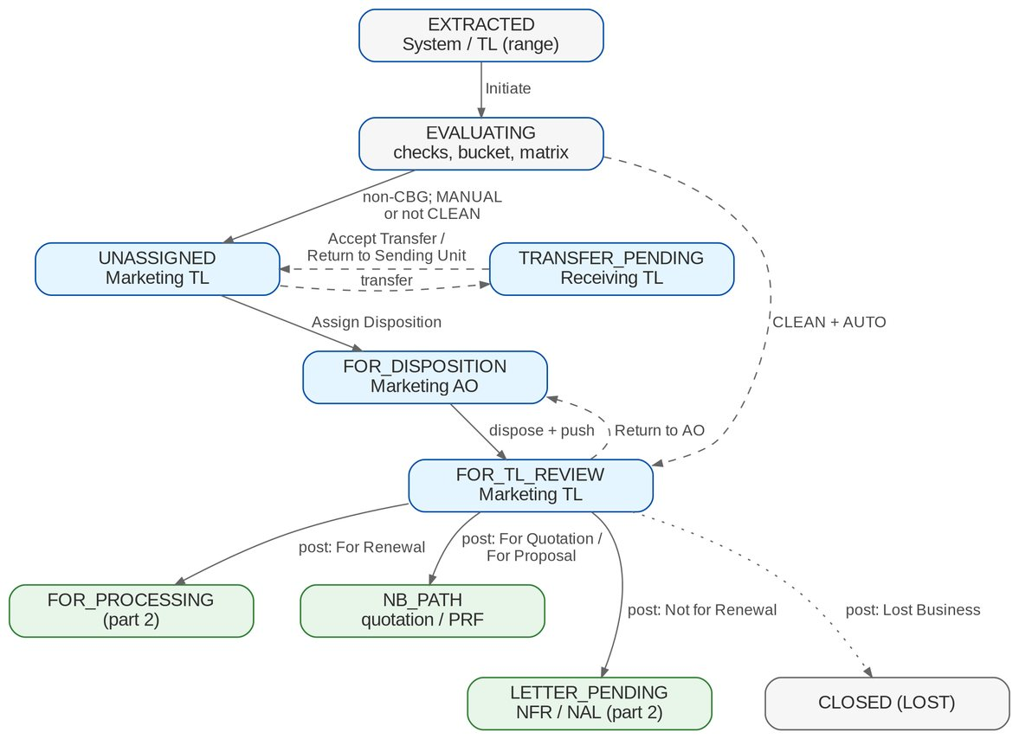
Figure 2: Workflow RNW_CASE part 1: extraction to posting
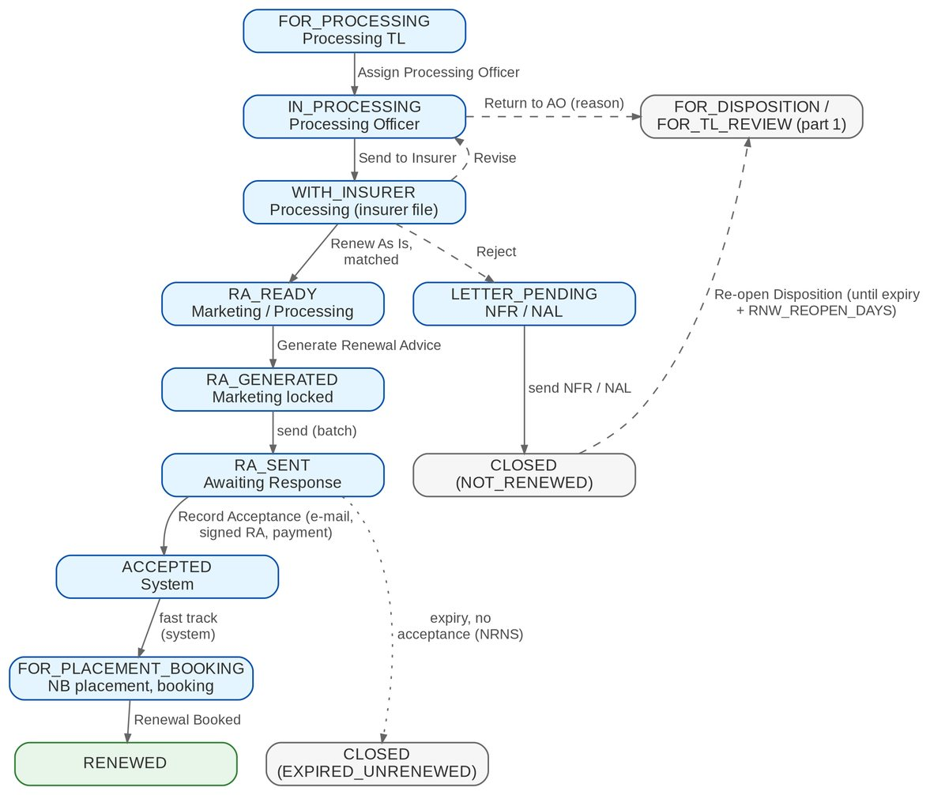
Figure 3: Workflow RNW_CASE part 2: processing to closure
Table 9: Stages of RNW_CASE
Stage | Owner (permission) | Business actions | Screen label
EXTRACTED | Marketing / Processing TL (RNW_EXTRACT) | Initiate | Extracted
EVALUATING | System | Checks, bucket, matrix; route | Evaluating
UNASSIGNED | Marketing TL (RNW_ASSIGN) | Assign, transfer | Unassigned Disposition
TRANSFER_PENDING | Receiving TL (RNW_ASSIGN) | Accept, decline | Transfer pending
FOR_DISPOSITION | Marketing AO (RNW_DISPOSE) | Dispose, remarks, push, transfer request, re-assign | For disposition / Returned
FOR_TL_REVIEW | Marketing TL (RNW_REVIEW) | Return, post, override | Review in progress
NB_PATH | Marketing (RNW_DISPOSE) | Start quotation or PRF; follow it | For Proposal / New Business Path
FOR_PROCESSING | Processing TL (RNW_PROCESS_ASSIGN) | Assign PO, upload, return | For processing
IN_PROCESSING | Processing Officer (RNW_PROCESS) | Update data, computations, return, send to insurer | In processing
WITH_INSURER | Processing (RNW_INSURER) | Upload response, override mismatch | With insurer
RA_READY | Marketing / Processing (RNW_RA_GENERATE) | Generate RA | RA ready
RA_GENERATED | Marketing / Processing (RNW_RA_SEND) | Send, cancel RA (override) | RA generated
RA_SENT | Marketing / Processing (RNW_ACCEPT) | Record acceptance, second notice | RA Sent / Awaiting Response
ACCEPTED | System | Fast track of the renewal account | Accepted
FOR_PLACEMENT_BOOKING | NB placement and booking users | BRD-1 payment gate, placement, issuance, booking | For Placement and Booking
LETTER_PENDING | Marketing / Processing (RNW_RA_GENERATE) | Send NFR or NAL; re-open | Letter pending
RENEWED | - | terminal | Renewed
CLOSED | - | terminal; closed as NOT_RENEWED, LOST, EXPIRED_UNRENEWED or BOOKED_OTHER_INVOICE | Closed

5.2 Transitions
Table 10: Transitions of RNW_CASE
From | Action | To | Permission | Condition / reason
EXTRACTED | Initiate | EVALUATING | RNW_EXTRACT | Bulk only for the bulk segments
EVALUATING | Route to Unassigned Disposition (automatic) | UNASSIGNED | - | Non-CBG, MANUAL or not Clean
EVALUATING | Route to Team Leader Review; Route to Processing (automatic) | FOR_TL_REVIEW or FOR_PROCESSING | - | Clean and AUTO; CBG STP
EVALUATING | Route to Letter Pending (automatic) | LETTER_PENDING | - | System Not for Renewal
UNASSIGNED | Assign Disposition | FOR_DISPOSITION | RNW_ASSIGN | -
UNASSIGNED, FOR_DISPOSITION | Transfer | TRANSFER_PENDING | RNW_ASSIGN | Remarks
TRANSFER_PENDING | Accept Transfer; Return to Sending Unit | UNASSIGNED (receiving unit) / previous stage | RNW_ASSIGN | Decline remarks
FOR_DISPOSITION | Push to Team Leader | FOR_TL_REVIEW | RNW_DISPOSE | History viewed
FOR_TL_REVIEW | Return to AO | FOR_DISPOSITION | RNW_REVIEW | RNW_RETURN_REASON
FOR_TL_REVIEW | Post to Processing; Post to the New Business Path; Post to Letter Pending; Post and Close | FOR_PROCESSING, NB_PATH, LETTER_PENDING or CLOSED | RNW_REVIEW | By disposition; no blocking check
FOR_PROCESSING | Assign Processing Officer | IN_PROCESSING | RNW_PROCESS_ASSIGN | -
FOR_PROCESSING, IN_PROCESSING | Return to AO; Return to Marketing TL | FOR_DISPOSITION or FOR_TL_REVIEW | RNW_PROCESS | RNW_RETURN_REASON
IN_PROCESSING | Send to Insurer | WITH_INSURER | RNW_INSURER | Batch sent
WITH_INSURER | Insurer Renews As Is; Insurer Revises; Insurer Rejects - Re-market; Insurer Rejects - Not for Renewal | RA_READY / IN_PROCESSING / FOR_DISPOSITION / LETTER_PENDING | RNW_INSURER or automatic (response file) | Renew As Is matched / Revise / Reject
RA_READY | Generate Renewal Advice | RA_GENERATED | RNW_RA_GENERATE | No blocking check
RA_GENERATED | Send Renewal Advice | RA_SENT | RNW_RA_SEND | -
RA_SENT | Record Acceptance | ACCEPTED | RNW_ACCEPT or automatic (payment) | Evidence
ACCEPTED | Fast Track to Placement and Booking (automatic) | FOR_PLACEMENT_BOOKING | - | Account checks pass
FOR_PLACEMENT_BOOKING | Renewal Booked (automatic) | RENEWED | - | Booking of the renewal ARN
NB_PATH | Renewal Booked; Close as Lost (automatic) | RENEWED / CLOSED (LOST) | - | Quotation or PRF outcome
LETTER_PENDING | Send Letter and Close | CLOSED (NOT_RENEWED) | RNW_RA_SEND | -
CLOSED (NOT_RENEWED) | Re-open Disposition | FOR_DISPOSITION | RNW_DISPOSE | Until expiry + RNW_REOPEN_DAYS
RA_SENT, FOR_DISPOSITION, UNASSIGNED | Expiry (automatic) | CLOSED (EXPIRED_UNRENEWED) | - | Expiry + RNW_NON_ACCEPTANCE_DAYS
any open stage | Override | target of the override | RNW_OVERRIDE | Mandatory remarks

5.3 Checks, buckets and decision matrix
Figure 4 shows how a trigger runs the checks, how the bucket rule set turns the results into a bucket, and how the decision matrix decides between an automatic and a manual disposition.
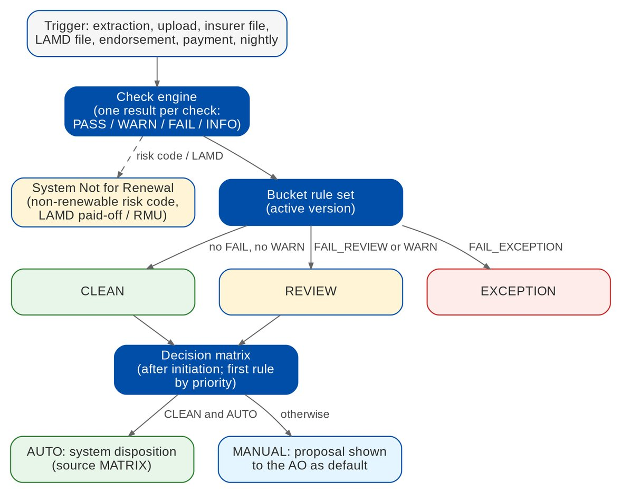
Figure 4: Checks, buckets and decision matrix (BRRN.020, 023, 031, 034)
Table 11: Checks and default severities (sanitation criteria SC-01 to SC-13 of the Walkthrough addendum; RQ01 answered in part)
Check | BRD | Source | Default severity
REFERENCE_MATCH | BRRN.022 | Candidate against expiring invoice, ARN and policy | FAIL_EXCEPTION
PN_PRESENT | BRRN.029, 031, 039 | PN on the account or invoice (mortgaged and CBG lines) | FAIL_EXCEPTION
RISK_CODE_RENEWABLE | BRRN.009; SC-08, SC-09 | Non-renewable risk codes (for example Bonds, CAR) | System Not for Renewal
RISK_CODE_DEFINED | BRRN.020; SC-11 | Risk code defined in the check criteria | FAIL_REVIEW (manual review)
INSURER_RENEWABLE_LIST | BRRN.020; SC-10 | Risk in the renewable list given by the insurer | FAIL_REVIEW
TSI_THRESHOLD | BRRN.020, 023, 024; SC-12, SC-13, R23-02, R24-02 | Total sum insured against the threshold (PHP 250M) | FAIL_REVIEW; For Proposal to TSU by the matrix
LAMD_STATUS | BRRN.029, 039 | LAMD lines matched by PN | System Not for Renewal / RMU routing
CLAIMS | BRRN.031, 034; R23-05, R28-05 | Claims of the expiring term (Not applicable when they cannot be read) | FAIL_REVIEW when claims are open (manual evaluation)
ENDORSEMENT_PENDING | BRRN.032 | Open endorsement requests on the invoice family | FAIL_REVIEW
OUTSTANDING_PREMIUM | BRD 1.011; BRRN.031 | Invoice family balance above the threshold | FAIL_REVIEW (TL override)
FINANCIAL_IMPACT | BRRN.038 | Renewal account or insurer revision against the expiring invoice | FAIL_REVIEW; NB path by the matrix
INSURER_RESPONSE_MATCH | BRRN.035 | Latest valid response matched, not late or conflicting | FAIL_EXCEPTION
MANDATORY_FIELDS | BRD 2.004.5, 3.007.3 | Disposition requirements and product field rules | FAIL_REVIEW
PRODUCT_RENEWABLE | PQ11 | Package version sellable for renewal | FAIL_REVIEW (RQ30)
INSURER_USABLE | - | Insurer active and usable | FAIL_EXCEPTION
DUPLICATE_CANDIDATE | BRRN.005 | Another open candidate or live renewal on the same risk | FAIL_EXCEPTION
KYC_DUE | BRRN.028 | Client KYC review within the due window | INFO only, never blocks
PACKAGE_REMAP | BRRN.020; DMQ36 | Legacy package of a migrated policy against the package code map | FAIL_EXCEPTION when unmapped, retired or ambiguous

5.4 Insurer batch and letter states
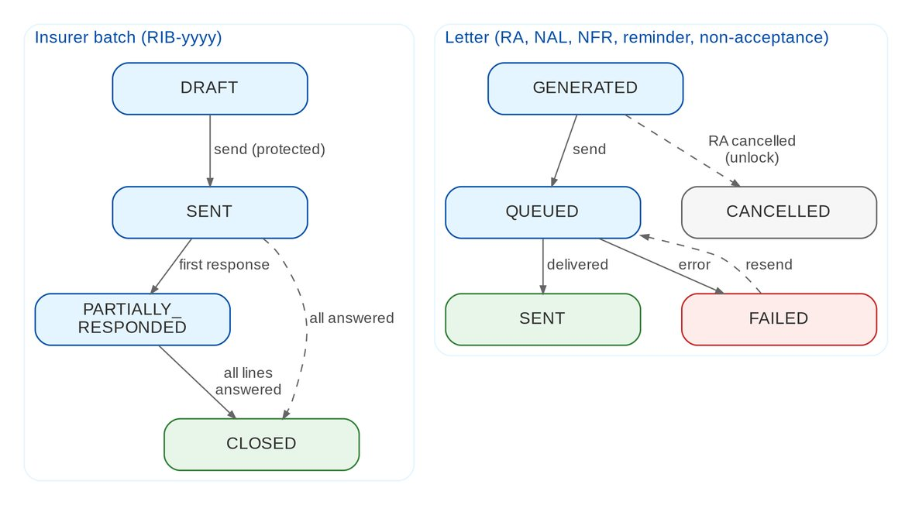
Figure 5: Insurer batch and letter states
Table 12: Letter types and numbers
Letter | Number | When
Renewal Advice (first, second notice) | RA-yyyy | RA_READY; second notice after RNW_RA_SECOND_NOTICE_DAYS without acceptance
No Advice Letter | NAL-yyyy | Eligible accounts that need neither RA nor NFR
Not for Renewal Letter | NFR-yyyy | System or user Not for Renewal (LETTER_PENDING)
NRNS reminder | RNL-yyyy | RNW_NRNS_REMINDER_DAYS before expiry, not yet submitted
Non-acceptance letter | NAC-yyyy | RNW_NON_ACCEPTANCE_DAYS after expiry without acceptance
SFU letter | - | Submitted mortgaged accounts (FR-RN-090)

5.5 SLA and escalation
• A renewal's urgency is its days to expiry, counted to the effective expiry date (FR-RN-083). The attention flags of the listing use RNW_ESCALATION_DAYS per segment (FR-RN-102); BIBS never escalates by itself. Alert RNW_EXCEPTION_AGEING flags exceptions that stay open beyond RNW_EXCEPTION_AGEING_DAYS (FR-RN-022).
• Insurer batches past their reply date raise RNW_INSURER_OVERDUE; failed letters raise RNW_LETTER_FAILED; failed extraction runs raise RNW_EXTRACTION_FAILED.
• After acceptance, the standard BRD-1 placement, booking and issuance SLAs apply (BRRN.040 AC5).
• The BRD gives no stage SLA in hours; none is configured until BDOI states one.

6 Reports and documents

6.1 Reports
Table 13: Renewal reports (category Renewal)
Code | Name | Purpose | BRD
RNW-EXPIRY-LIST | Expiring list | The grid as displayed, with its filters (section 6.2 columns) | BRRN.004, 007, 008
RNW-STATUS | Renewal status report | Per invoice, 37 or 40 columns, 34-line summary; variants MARKETING and PROCESSING | BRD 1.009, 2.008, 3.010, 4.008; BRRN.019
RNW-LISTING | Renewal listing | Unit, segment, window and status; ageing to expiry; escalation flag | BRRN.036
RNW-INSURER-EXTRACT | Extract per insurer | 28 columns per insurer (section 6.4) | BRD 3.009, 4.007
RNW-RA-DISPATCH | Letter dispatch | Details for RA sending; RA, NAL, NFR and NRNS letters with recipient and status | BRD 1.010.6; BRRN.001, 010, 025, 037
RNW-SANITATION | Sanitation | Check results, bucket and changes | BRRN.020, 023
RNW-DECISIONS | Decision log | Dispositions, matrix rule and version, overrides with rationale | BRRN.031, 034; BRD 1.011
RNW-LAMD-MATCH | LAMD match | LAMD lines matched and unmatched, with the routing | BRRN.029
RNW-WORKLOAD | Workload | Accounts per AO and PO by stage | BRD 1.009.7, 3.010.7
RNW-GOLIVE | Go-live extraction | Per expiry month: migrated policies, candidates, urgent, skipped, RA already sent | BRRN.005; DMQ37
RNW-PACKAGE-REMAP | Package choices | Legacy package, chosen package version, maker and checker | BRRN.020; DMQ36

Every report needs RNW_REPORT_VIEW, applies the user's scope, exports to PDF, XLSX, ODS and CSV, has print preview and saved variants, and answers within 20 seconds at 30,000 rows.
Report criteria (BRD 1.009.2.1-40, the same in 2.008.2, 3.010.2 and 4.008.2). Each criterion supports single, multiple, all except and all, and a search in the drop-down: Unit Head, Risk Code, Insurance Company, Insurance Group, Business Origin, Market Category, BDO Branch, BDO Area, Region, Bank Officer, Bank Unit, Product Code, Account Type, BDOI Branch, Location, Account Broker, Business Type, Customer Segment, Specific Client, Renewal Status.

6.2 Expiring list columns
Table 14: Expiring list columns (BRD 1.003.4.1.1.1-24, p.73-76; 3.003.4.1.1-21, p.137-140)
# | Column | Marketing | Processing | Content in BIBS
1 | Expiring EBIX Invoice No. | OUT | OUT | Replaced by the BIBS expiring invoice number (p.60)
2 | Renewal Reference No. | Y | Y | RNW-yyyy-nnnnnn
3 | BDOIsys Reference No. | OUT | OUT | Replaced by the renewal reference and ARN (p.60)
4-5 | Cover No.; Version No. | Y | Y | From the expiring invoice
6-9 | Invoicing Branch; Department Code; Department Name; Unit Head | Y | Y | Sales organisation of the account
10-13 | Client Name; Assured's Name; Business Origin; Account Officer | Y | Y | Account and client master
14-18 | Expiring Policy No.; Insurance Company; Risk Code; Risk Name; Risk Description | Y | Y | Account, insurer and catalogue
19-21 | Renewal Stage / Status; Renewal Disposition; Disposition Remarks | Y | Y | Candidate
22-23 | Number of Claims; Status of Each Claim | Y | - | Claims module (decision D4)
24 | Amount of Outstanding Premium | Y | - | Operations ledger, invoice family
+ | Classification; flags (Returned, Transferred, Endorsed, Claims, Outstanding, KYC due, NRNS) | Y | Y | Workshop addendum

6.3 Renewal status report columns
Columns 1-37 are in every variant; 38-40 only in the Processing variant (BRD 1.009.3.1.1-37, 3.010.3.1.38-40).
Table 15: RNW-STATUS columns
# | Column | # | Column | # | Column
1 | Unit Head | 15 | Basic Premium | 29 | Location
2 | Account Broker | 16 | Gross Premium | 30 | Mortgaged To BDO
3 | Business Origin | 17 | Premium Rate | 31 | Mortgagee Bank
4 | Bank Officer | 18 | Commission Rate | 32 | PN Number
5 | Renewal Reference | 19 | Total Sum Insured | 33 | Hold Cover (HC)
6 | Expiring Invoice No. (BIBS; BRRN.019) | 20 | Risk Description | 34 | HC End Date
7 | Assured | 21 | Location of Risk | 35 | Renewal Status
8 | Type of Risk | 22 | Address | 36 | Reason for "Not for Renewal"
9 | Expiring Invoice Inception Date | 23 | Contact No(s). | 37 | Remarks of Acct Officer
10 | Expiring Invoice Expiry Date | 24 | Email Address | 38 | Name of Renewal Processor
11 | Renewal Reference Inception Date | 25 | Region | 39 | Name of Assigned Marketing AO
12 | Renewal Reference Expiry Date | 26 | Area | 40 | Sum Insured per Cover
13 | Expiring Invoice Policy Number | 27 | Branch
14 | Account Type | 28 | Insurer

Hold Cover and HC End Date are read from the hold cover of the renewal account. The Expiring Ebix Invoice No. of the BRD is the BIBS expiring invoice number (BRRN.019, p.60).

6.4 Insurer extract columns
Table 16: RNW-INSURER-EXTRACT columns (BRD 3.009.1.4.1-28, p.148-152)
# | Column | # | Column | # | Column
1 | Insurance Company | 11 | Is Mortgaged (Yes / No) | 21 | Branch
2 | Invoice No | 12 | Premium Rate (per cover) | 22 | Account Officer Name
3 | Assured Name | 13 | Policy No | 23 | Remarks
4 | Risk Code | 14 | Risk Description | 24 | BIPD for Motor
5 | Inception Date | 15 | Encoder Name (user who booked) | 25 | Seating Capacity for Motor
6 | Expiry Date | 16 | Unit Head | 26 | Auto Personal Accident for Motor
7 | Sum Insured | 17 | Business Origin | 27 | Sum Insured (per cover)
8 | Premium Amount | 18 | Account Type | 28 | Packaged / Non-Packaged
9 | Commission Rate | 19 | Region
10 | AR Client (Unpaid Balance) | 20 | Area

6.5 Summary counters
The mapping below is the project's proposal; BDOI confirms each counter under RQ10. Counters marked "pending" have no disposition, reason or step in the BRD that produces them and show 0 until defined.
Table 17: RNW-STATUS summary counters (BRD 1.009.3.2.1-34, p.96-100)
# | Counter | Predicate in BIBS
1 | Booked | Candidate closed RENEWED
2 | Cancelled | Renewal account cancelled
3 | Renewal - For Placement | Stage FOR_PLACEMENT_BOOKING
4 | Renewal - For Proposal | NB_PATH with a PRF
5 | Renewal - For ARF | NB_PATH with a quotation (ARF to define: pending)
6 | RA Processed | RA_SENT or later
7 | Renewal - For RA Processing | RA_READY or RA_GENERATED
8 | Renew to TSU | NB path routed to TSU (pending)
9 | Returned to Marketing | Returned flag set
10-13 | Awaiting Marketing TL Approval (For Renewal, For Quotation, Not For Renewal, Lost Business) | FOR_TL_REVIEW by disposition
14 | Disapproved Accounts | TL return with reason DISAPPROVED (pending)
15 | Not For Renewal Accounts | Disposition Not for Renewal
16-23 | Mortgaged: Lost Business; Unrenewed For Proposal; Transferred to Other Unit; Loan Fully Paid; Awaiting Confirmation; Booked under New Invoice; No Disposition; to Other Bank | Mortgaged = Yes, split by disposition, reason or stage; "Awaiting Confirmation" = RA_SENT; "to Other Bank" pending
24-31 | Non-Mortgaged: the same eight counters | Mortgaged = No, same predicates
32 | Non-Renewable Accounts | Reason Non-renewable Accounts
33 | No Disposition | UNASSIGNED or FOR_DISPOSITION without disposition
34 | Total No. of Accounts | All candidates in scope

6.6 Documents
Documents are generated from versioned templates. The layouts are drafts until BDOI provides its own (RQ26).
Table 18: Renewal documents
Template | Output | Content
RNW_RA_FIRST, RNW_RA_SECOND | PDF, protected e-mail | Client and policy details; renewal period; renewal terms and premium; payment instructions; BDOI contacts; notice (first or second)
RNW_RA_FFY, RNW_SFU | PDF, e-mail or print | Submitted-policy variants (FFY RA; SFU for mortgaged accounts)
RNW_NAL | PDF, e-mail | No Advice Letter
RNW_NFR | PDF, e-mail | Not for Renewal Letter with the reason
RNW_NRNS_REMINDER | PDF, e-mail | Reminder that the renewal has not been submitted
RNW_NON_ACCEPTANCE | PDF, e-mail | Non-acceptance notice after expiry
RNW_INSURER_COVER | E-mail | Cover e-mail of the insurer extract
RNW_ACCOUNT_DETAILS | PDF, XLSX | Account details of the record page (BRD 1.004.1.3)

RAs are stored as document type RENEWAL_ADVICE; the other letters as RENEWAL_LETTER; both are linked to the candidate, the renewal account and the client (decision D3).

7 Interfaces and integration
Figure 6 shows the interfaces of Renewal. Renewal reads the expiring population from the Operations ledger and the account, and hands the renewal back to the BRD-1 modules as an account of business type RENEWAL.
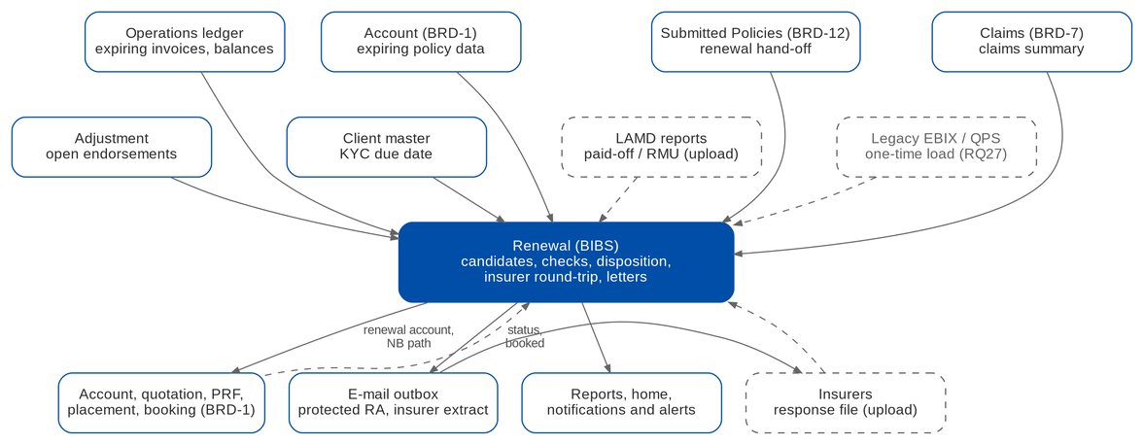
Figure 6: Interfaces of Renewal (dashed = upload or on hold)
Table 19: Interfaces
Interface | Direction | Content and trigger | BRD | Scope
Operations ledger | In | Booked root invoices, balances, movements; booking and movement notices | BRRN.005, 030; BRD 1.011 | IN SCOPE
Account (BRD-1) | In / Out | Expiring policy data; renewal account (business type RENEWAL, BT0), fast track, status events | BRRN.033, 040 | IN SCOPE
Quotation, PRF (BRD-1) | Out | NB path with the renewal reference | BRRN.033 | IN SCOPE
Placement, issuance, booking (BRD-1) | Out | Slip, hold cover, booking queue source RENEWAL; booking notice back | BRRN.040 | IN SCOPE
Product catalogue (BRD-3) | In | Rating purpose RENEWAL; package version of the expiring account | PQ11 | IN SCOPE
Adjustment | In | Open endorsement requests of the invoice family | BRRN.032 | IN SCOPE
Claims (BRD-7) | In | Claims summary per ARN and policy year (decision D4) | BRRN.027, 031, 034 | IN SCOPE
Client master | In | KYC review date | BRRN.028 | IN SCOPE
Submitted Policies (BRD-12) | In | Renewal hand-off; status query back | Decision D2 | IN SCOPE
Outgoing e-mail | Out | Protected RA, letters, insurer extract; send log | BRRN.010; BRD 3.009.5 | IN SCOPE
Insurers | In | Response file by upload; no system-to-system or file transfer channel with the insurers | BRD 3.009.6; BRRN.035 | ON HOLD
LAMD | In | Paid-off and RMU reports by upload | BRRN.029 | ON HOLD
Data migration (BRD-13) | In | Migrated in-force policies for the go-live and daily extraction (NB path only); legacy package codes and the package code map; no renewal carried from legacy (DMQ37) | RQ27; DMQ36, DMQ37 | IN SCOPE
Renewal Advice trackers (Excel) | In | RAs sent by hand before go-live, by upload once at go-live | DMQ37, DMQ38 | IN SCOPE
Directory sign-in | In | BDO EUA / Windows ID (decision D6) | BRD x.001 | ON HOLD

Interfaces on hold. Insurer channels, the LAMD feed, legacy policies, the recipient-domain policy and directory sign-in each start with an upload or "not connected". Adding a channel later does not change the workflow.

8 Non-functional requirements
Table 20: Non-functional requirements (BRD p.212-214)
Topic | BRD value | BIBS target and approach
Users | Marketing TL 75 (23 concurrent); AO / Account Broker 319 (50); Processing TL 50 (15) for lists, 9 (3) for assignment and upload; Processing Officer / Broker 73 (22); reports and RA 485 (145) | Within the BRD-1 sizing of 145 concurrent users; Renewal adds load, not users
Volumes | 25,800 transactions a month per process, growth 20% a year | About 26,000 candidates a month; indexes on company, stage, expiry, assignee and bucket; no partitioning for 5 years
Response time | 10 seconds online; 20 seconds for reports and RA generation | Grid served in chunks; RA generation and batch sending as jobs with progress; reports within 20 seconds at 30,000 rows
Peak | Month-end; 08:00-10:00 and 15:00-17:00 daily | Extraction, re-evaluation and letter jobs run at night
Devices | Same performance on mobile and desktop | Responsive screens
Availability | Use 07:00-22:00 Monday to Saturday; availability, downtime and maintenance "follow existing QPS set up" | BRD-1 window; QPS is out of scope, so BDOI gives the values (RQ28, XQ08)
Recovery | "Follow existing QPS set up" | Platform backup and recovery; one BIBS-wide NFR set is being agreed (XQ08)
Retention | "Follow existing QPS set up" | BRD-1 retention framework with record type RENEWAL_CANDIDATE; values to confirm (RQ28)
Security | Encrypted, password-protected RA and insurer files; role-based access; approved domains and TLS | Protected e-mails; permissions and data scope; recipient policy (RQ16)
Audit | Every action logged with user, time and source | History and audit that no user can change (FR-RN-004)

9 Configuration items owned by the Business and System Administrators
The items below are changed in BIBS without a release. Changes are audited.

9.1 Parameters
Table 21: Renewal parameters (category RENEWAL)
Parameter | Default | Meaning
RNW_EXTRACTION_LEAD_DAYS | 140 | Days before expiry at which the job extracts a policy
RNW_EXTRACTION_LEAD_DAYS_BY_SEGMENT | empty | Lead days per segment (segment=days)
RNW_GOLIVE_EXTRACTION_TO | 31 May 2028 | Last expiry date taken by the go-live extraction
RNW_GOLIVE_URGENT_TO | 31 January 2028 | Expiries up to this date are flagged Urgent at go-live
RNW_BULK_INITIATION_SEGMENTS | CLG | Segments initiated in bulk
RNW_CBG_STP_LINES | MOTOR, PROPERTY (CBG) | Lines of the CBG straight-through path
RNW_STP_SKIP_TL_REVIEW | true | AUTO dispositions skip the TL review
RNW_OUTSTANDING_THRESHOLD | 0.00 | Open premium above which the outstanding flag is raised
RNW_FIN_IMPACT_TOLERANCE | 0.00 | Difference above which a renewal has a financial impact
RNW_RA_MIN_NOTICE_DAYS | 30 | RA later than this before expiry needs a confirmation
RNW_RA_SECOND_NOTICE_DAYS | 15 | Days after the first notice before a second notice
RNW_NRNS_REMINDER_DAYS | 90 | Days before expiry of the NRNS reminder
RNW_NON_ACCEPTANCE_DAYS | 0 | Days after expiry of the non-acceptance letter and closure
RNW_REOPEN_DAYS | 30 | Days after expiry during which Not for Renewal can be re-opened
RNW_ESCALATION_DAYS | IBG=60, LEASING=60, *=30 | Days to expiry of the ageing attention flag per segment (no automatic escalation)
RNW_EXCEPTION_AGEING_DAYS | 5 | Working days an exception stays open before its ageing alert (R29-05)
RNW_NRNS_WAITING_DAYS | CBG=0, *=0 | Days after the effective expiry date before the NRNS tag (R37 annex)
RNW_HOLD_COVER_DAYS | 30 (30 or 60) | Duration of a renewal hold cover (BRRN.042, R37-HC-01)
TSI_THRESHOLD (check setting) | 250,000,000.00 | Total sum insured above which a renewal goes to TSU or proposal handling (SC-12, SC-13)
RNW_KYC_SEGMENTS | empty (all) | Segments where the KYC flag applies
RNW_RMU_UNIT | empty | Unit that receives RMU accounts (empty = tag only)
RNW_AUTO_PLACEMENT | false | Slip generated and sent automatically after acceptance; off for renewals, placement is a user action (Walkthrough addendum)
RNW_REFERENCE_PREFIX | RNW-<yyyy> | Prefix of renewal references
RNW_EXCLUDED_LINES | HMO, GLI, GPA | Lines excluded from extraction (Employee Benefits)
Job schedules | 01:00, 01:30, 06:00 PHT; sweep 00:15 PHT | RNW_EXTRACTION, RNW_REEVALUATE, RNW_NRNS_LETTERS, RNW_EXPIRY_SWEEP

9.2 Lists of values
Table 22: Lists of values
List | Values provided
RNW_DISPOSITION | For Renewal; Not for Renewal; For Quotation; For Proposal; Lost Business (labels only; codes fixed)
RNW_NONRENEWAL_REASON | RMU; With submitted policy; Loan fully paid; Direct to Insurer; Total Loss Claim; Unit Sold; Canceled Policy; Transfer to Another Marketing Unit; Non-renewable Accounts; Booked to New Invoice (attributes NAL-eligible, requires invoice no.)
RNW_RETURN_REASON | Values to be supplied by BDOI; Disapproved is provided for the summary counter 14 (RQ10)
RNW_TRANSFER_REASON | Values to be supplied by BDOI
RNW_FOLLOWUP_OUTCOME | To be supplied by BDOI (RQ21)
RNW_OVERRIDE_REASON | To be supplied by BDOI
RNW_INSURER_RESPONSE | Renew As Is; Revise; Reject
RNW_LAMD_STATUS | Paid-off; RMU
DOCUMENT_TYPE (Renewal values) | RA_ACCEPTANCE; SIGNED_RA; LAMD_REPORT; INSURER_RENEWAL_FILE; RENEWAL_LETTER; RENEWAL_ADVICE

9.3 Masters and rules maintained by the business
Table 23: Masters and rules
Item | Maintained by (authorised by) | FR
Non-renewable risk codes | Business Administrator (MASTER_AUTHORIZE) | FR-RN-024
Check settings (active, severity, parameters) | Business Administrator (MASTER_AUTHORIZE) | FR-RN-020, 112
Bucket rule sets | Business Administrator (MASTER_AUTHORIZE) | FR-RN-022, 112
Decision matrix | Business Administrator (MASTER_AUTHORIZE) | FR-RN-023, 112
Lists of values | Business Administrator (checker) | FR-RN-110
Renewal templates | Business Administrator | FR-RN-111
Upload templates (dispositioned file, insurer response, LAMD, acceptance) | System Administrator | FR-RN-060, 071, 025, 084
Roles and function grants | System Administrator via access request (approver) | FR-RN-003

10 Assumptions, dependencies and open questions

10.1 Assumptions
Table 24: Assumptions
ID | Assumption | Related
A-RN-01 | The Walkthrough addendum (R0) is the latest layer and governs the BRRN it restates; the Workshop addendum (R1) governs the other BRRN.020-040; a BRRN of Addendum 1 governs the main-BRD IDs it restates; the main BRD governs the rest | R0-R3
A-RN-02 | The expiring population is the booked root invoices in BIBS; one candidate per root invoice and policy year | BRRN.005, RQ06
A-RN-03 | The "unique reference number" is the renewal reference generated by BIBS; the expiring invoice number is the alternate key | BRRN.022, RQ03
A-RN-04 | Online disposition (main BRD) and dispositioned-file upload (BRRN.018) are both needed and write the same history | RQ14
A-RN-05 | Straight-through processing starts only after explicit initiation and only for Clean candidates whose matrix rule says AUTO | BRRN.021, 031, RQ02
A-RN-06 | CBG accounts skip AO assignment and TL review; non-CBG accounts follow the manual path | BRD 1.005, 1.008, RQ08
A-RN-07 | The NRNS checkpoint is 90 days before expiry (the BRD also writes "+90 days") | BRRN.025, RQ18
A-RN-08 | The renewal is a new BRD-1 account of business type RENEWAL; the expiring invoice is never endorsed to renew it | Decision D1
A-RN-09 | The payment rules of BRRN.040 and BRRN.041 are the BRD-1 payment gate | RQ19
A-RN-12 | KYC stays for visibility only (BRRN.028, Walkthrough addendum scope) until BDOI Compliance confirms otherwise | CLR-RN-30
A-RN-13 | The hold cover of a renewal uses the hold cover request and confirmation of New Business on the renewal account | BRRN.042; FR-NB-082, 083
A-RN-10 | "Approved domains" for RA e-mails is a recipient policy that BDOI will define; until then any well-formed address is accepted with protection | RQ16
A-RN-11 | Renewal volume is 25,800 transactions a month per process, growing 20% a year | NFR p.212

10.2 Dependencies
Table 25: Dependencies
ID | Dependency | Needed for
D-RN-01 | The account business type RENEWAL (BT0) is shared with New Business booking | FR-RN-048, 063, 084 (D1)
D-RN-02 | The Claims module gives the claims summary | FR-RN-013, 020, 042 (D4)
D-RN-03 | Submitted Policies hands its expiring records over to Renewal | FR-RN-090 (D2)
D-RN-04 | BDOI provides the check list, bucket rules and decision matrix content | FR-RN-020, 022, 023 (RQ01, RQ24)
D-RN-05 | BDOI provides the letter layouts, insurer and LAMD file layouts and the password convention | FR-RN-025, 071, 080-083 (RQ15, RQ20, RQ26, Q07)
D-RN-06 | The e-mail relay of the BIBS environment is available for client and insurer e-mails | FR-RN-070, 081
D-RN-07 | The Operations ledger carries the business type of booked invoices for ACSL (requested of the Operations owner) | Section 7
D-RN-08 | The incentive criteria of Product Maintenance (BRD-3) and the incentive indicator of New Business booking (FR-NB-118) | FR-RN-087 (Q33)
D-RN-09 | The hold cover request and confirmation of New Business placement (FR-NB-082, 083) | FR-RN-086

10.3 Open questions
Table 26: Open questions on BRD-6 (status from the cross-BRD decisions, R6)
ID | Question | Affects | Status
RQ01 | List of sanitation, matching and eligibility checks and, for each, Review or Exception on failure | FR-RN-020, 022 | PARTIAL (Walkthrough addendum annex: SC-01 to SC-13, R23-01 to 05; TSI above PHP 250M to TSU)
RQ02 | Segments initiated in bulk and individually; who initiates; is CBG STP initiated automatically | FR-RN-015 | OPEN
RQ03 | Meaning of the "unique reference number"; key carried by insurer and LAMD files | FR-RN-021 | OPEN
RQ04 | Lead days per segment or line; daily or monthly extraction; on-demand ranges | FR-RN-010, 011 | OPEN
RQ05 | One scrollable view without pagination against the UX pager rule (UX-6) | FR-RN-013 | OPEN
RQ06 | Meaning of "unbooked" accounts in the expiring list | FR-RN-010 | OPEN
RQ07 | NFR sent automatically on the system tag; NFR after the "not in file" tag; NFR vs NRL | FR-RN-024, 060, 082 | PARTIAL (NRL by the Marketing AO when no RA exists, R37-HC-08; CLR-RN-32)
RQ08 | Definition of CBG and non-CBG; does CBG skip assignment and review | FR-RN-025, 030 | OPEN
RQ09 | Threshold and scope of the outstanding-balance flag; who overrides | FR-RN-051 | OPEN
RQ10 | Definition of the 34 summary counters, including For ARF, Renew to TSU, Disapproved, to Other Bank | FR-RN-101 | OPEN
RQ11 | IBG and Leasing escalation thresholds, recipients and "high-risk renewals" | FR-RN-102 | PARTIAL (criteria of Annex BRRN.036, escalation by the AO outside the system; thresholds open, CLR-RN-35)
RQ12 | What unlocks an account after RA generation; may Processing still edit | FR-RN-080 | OPEN
RQ13 | Claims summary sufficiency; total-loss flag (CLQ28); legacy history | FR-RN-042, 043 | OPEN
RQ14 | Online vs offline disposition; file layout; scope of the "not in file" tag | FR-RN-060 | OPEN
RQ15 | Insurer response file layout, codes, late cut-off; Reject followed by re-marketing or Not for Renewal | FR-RN-070, 071 | OPEN
RQ16 | RA recipients and "approved domains"; TLS on the BDO relay | FR-RN-081 | OPEN
RQ17 | Which accounts are NAL-eligible | FR-RN-082 | PARTIAL (NAL when an RA exists, R37-HC-07; CLR-RN-32)
RQ18 | Definition of "not yet submitted"; checkpoint; timing and recipients of non-acceptance letters | FR-RN-083 | PARTIAL (effective expiry date and waiting period, Annex BRRN.037; CLR-RN-33)
RQ19 | Approved acceptance inputs; payment rules; renewal e-policy | FR-RN-084 | OPEN
RQ20 | LAMD organisation, log-in, report layouts and frequency (XQ01: one or two LAMD intakes) | FR-RN-025 | OPEN
RQ21 | Contact Center lists, statuses and outcome codes (XQ02) | FR-RN-085 | OPEN
RQ22 | Source of KYC data for bank clients | FR-RN-026 | OPEN
RQ23 | Paid-off loans: Not for Renewal or non-mortgaged renewal; RMU tag or routing | FR-RN-025 | OPEN
RQ24 | Initial decision-matrix content; who maintains and approves it | FR-RN-023 | OPEN
RQ25 | Financial-impact tolerance; NB path or explicit acceptance for revised premiums | FR-RN-048, 064 | OPEN
RQ26 | Layouts of the RA, NAL, NFR, reminder, non-acceptance and insurer cover letters | FR-RN-080-083, 111 | OPEN
RQ27 | One-time load of expiring legacy EBIX / QPS policies at go-live | FR-RN-016; section 7 | PARTIAL
DMQ36 | Package remapping at upload or at sanitation, and its owner (BRD-13) | FR-RN-028 | ANSWERED
DMQ37 | Renewals expiring January to May 2028: carried from legacy or processed in BIBS after go-live (BRD-13) | FR-RN-016 | ANSWERED
DMQ38 | Where the RMEL and dispositions are kept; who reviews rejected rows (BRD-13) | FR-RN-016 | ANSWERED
RQ28 | Availability, maintenance, DR, retention and backup values ("follow QPS") | Section 8 | OPEN
RQ29 | Late Renewal Requests Report (BRNB.018) as a listing variant (XQ09) | FR-RN-102 | OPEN
RQ30 | Renewal of an account whose package version is expired with no current version | FR-RN-063 | OPEN
SP SQ10 | Renewal of submitted policies | FR-RN-090 | ANSWERED
OOS-1 | Renewal overrides deferred by BRD-1 | FR-RN-051 | ANSWERED
RQ31 | KYC at renewal: blocking (annex KYC-01 to 06) or visibility only (BRRN.028) | FR-RN-026 | OPEN (CLR-RN-30)
RQ32 | Who requests the hold cover of a renewal; durations | FR-RN-086 | OPEN (CLR-RN-36)
RQ33 | Incentive criteria and the shared evaluation with New Business (Q33) | FR-RN-087 | OPEN (CLR-RN-37)

11 Traceability
Every BRD-6 requirement ID is met by at least one FR or is out of scope by the BRD itself. Section 11.1 traces the 42 BRRN IDs of the addenda; section 11.2 traces every one of the 1,033 line IDs of the main BRD with its page; section 11.3 lists the nine out-of-scope IDs.
Table 27: Traceability summary
Source | IDs | Traced to
Walkthrough addendum BRRN.041-042, restated BRRN.001, 020, 023, 024, 028-030, 033-037 | 2 new, 13 restated | Section 11.1
Walkthrough addendum BRRN.041-042, restated BRRN.001, 020, 023, 024, 028-030, 033-037 | 2 new, 13 restated | Section 11.1
Walkthrough addendum BRRN.041-042, restated BRRN.001, 020, 023, 024, 028-030, 033-037 | 2 new, 13 restated | Section 11.1
Walkthrough addendum BRRN.041-042, restated BRRN.001, 020, 023, 024, 028-030, 033-037 | 2 new, 13 restated | Section 11.1
Walkthrough addendum BRRN.041-042, restated BRRN.001, 020, 023, 024, 028-030, 033-037 | 2 new, 13 restated | Section 11.1
Walkthrough addendum BRRN.041-042, restated BRRN.001, 020, 023, 024, 028-030, 033-037 | 2 new, 13 restated | Section 11.1
Workshop addendum BRRN.020-040 | 21 | Section 11.1
Addendum 1 BRRN.001-019 | 19 (with the main-BRD IDs they restate) | Section 11.1
Main BRD 1.001-6.002 | 1,033 line IDs, of which 9 out of scope | Section 11.2
Usage requirements (NFR) p.212-214 | 10 topics | Section 8

11.1 BRRN requirements
Table 28: BRRN ID to FR, screen and test cases
BRD ID | FR | Screen | Test cases
BRRN.001 (p.48; updated p.15-16) | FR-RN-082 | Letters (NAL) | TC-RN-082.1, 082.2, 082.4 (4 cases)
BRRN.002 (p.48-49) | FR-RN-011 | Expiry List (Generate Expiry List) | TC-RN-011.1, 011.2, 011.3, 011.4 (6 cases)
BRRN.003 (p.49) | FR-RN-012 | Expiry List (Filters) | TC-RN-012.1, 012.2, 012.3 (4 cases)
BRRN.004 (p.49-50) | FR-RN-013 | Expiry List grid | TC-RN-013.1, 013.2, 013.3, 013.4, 013.5 (5 cases)
BRRN.005 (p.50-51) | FR-RN-010, FR-RN-016 | Expiry List; Renewal Home | TC-RN-010.1, 010.2, 010.4, 010.5, 010.6, 016.1, 016.2, 016.3, 016.4, 016.5 (14 cases)
BRRN.006 (p.51) | FR-RN-013 | Expiry List (column filters, search) | TC-RN-013.2, 013.3, 013.4, 013.5 (5 cases)
BRRN.007 (p.51-52) | FR-RN-014 | Expiry List (Export) | TC-RN-014.1, 014.3, 014.4 (3 cases)
BRRN.008 (p.52) | FR-RN-014 | Expiry List (Print) | TC-RN-014.2, 014.3, 014.4 (3 cases)
BRRN.009 (p.52-53) | FR-RN-024 | Renewal Setup; Letters (NFR) | TC-RN-024.1, 024.2, 024.3, 024.4 (6 cases)
BRRN.010 (p.53-54) | FR-RN-080, FR-RN-081 | Letters | TC-RN-080.1, 080.3, 080.4, 080.5, 081.1, 081.2, 081.3, 081.4 (13 cases)
BRRN.011 (p.54-55) | FR-RN-040 | My Dispositions | TC-RN-040.1, 040.4, 040.5 (3 cases)
BRRN.012 (p.55) | FR-RN-040 | My Dispositions | TC-RN-040.1, 040.5 (2 cases)
BRRN.013 (p.55-56) | FR-RN-041 | Record page | TC-RN-041.1, 041.4 (2 cases)
BRRN.014 (p.56) | FR-RN-040 | My Dispositions (column filters) | TC-RN-040.2, 040.5 (2 cases)
BRRN.015 (p.56) | FR-RN-040 | My Dispositions (sort) | TC-RN-040.2, 040.5 (2 cases)
BRRN.016 (p.56-57) | FR-RN-040 | My Dispositions (search) | TC-RN-040.2, 040.5 (2 cases)
BRRN.017 (p.57) | FR-RN-040 | My Dispositions (name / reference search) | TC-RN-040.3, 040.5 (3 cases)
BRRN.018 (p.57) | FR-RN-060 | Processing Worklist (upload) | TC-RN-060.1, 060.4 (4 cases)
BRRN.019 (p.58-59) | FR-RN-101, FR-RN-103 | Renewal Reports | TC-RN-101.1, 101.2 (2 cases)
BRRN.020 (p.30; p.5, 20-21) | FR-RN-020, FR-RN-028, FR-RN-112 | Record page (Checks & Bucket) | TC-RN-020.1, 020.2, 020.3, 020.4, 020.5, 020.6, 028.1, 028.2, 028.3, 028.4, 112.4 (15 cases)
BRRN.021 (p.30) | FR-RN-015, FR-RN-004 | Expiry List (Initiate) | TC-RN-004.1, 004.2, 004.4, 015.1, 015.2, 015.3, 015.4 (8 cases)
BRRN.022 (p.30) | FR-RN-021, FR-RN-020 | Record page; uploads | TC-RN-020.1, 020.2, 020.3, 020.4, 021.1, 021.2, 021.3 (9 cases)
BRRN.023 (p.30-32; p.5-6, 21) | FR-RN-022, FR-RN-051, FR-RN-112 | Expiry List (pill, Exceptions); record page | TC-RN-022.1, 022.2, 022.3, 022.4, 022.5, 022.6, 051.3, 051.4, 112.1, 112.3, 112.4 (14 cases)
BRRN.024 (p.32; p.6, 21) | FR-RN-002, FR-RN-025 | LAMD Reports | TC-RN-002.2, 002.4, 002.5, 025.3, 025.5 (9 cases)
BRRN.025 (p.32) | FR-RN-083 | Letters (NRNS) | TC-RN-083.1, 083.2 (3 cases)
BRRN.026 (p.32-33) | FR-RN-085 | Follow-ups | TC-RN-085.1, 085.2, 085.3 (4 cases)
BRRN.027 (p.33) | FR-RN-042 | Record page (Account History) | TC-RN-042.1, 042.2, 042.3 (4 cases)
BRRN.028 (p.33-34; p.6-7, 21-23) | FR-RN-026 | Expiry List (KYC chip) | TC-RN-026.1, 026.2, 026.3, 026.4 (4 cases)
BRRN.029 (p.34; p.7-8, 23) | FR-RN-025, FR-RN-022 | LAMD Reports | TC-RN-022.7, 025.1, 025.2, 025.3, 025.5 (7 cases)
BRRN.030 (p.34-35; p.8) | FR-RN-010, FR-RN-016, FR-RN-112 | Renewal Home; Renewal Setup | TC-RN-010.1, 010.2, 010.3, 010.4, 010.6, 010.7, 016.1, 016.2, 016.3, 016.4, 016.5, 112.2 (14 cases)
BRRN.031 (p.35-36) | FR-RN-023, FR-RN-051 | Record page; Renewal Setup | TC-RN-023.1, 023.2, 023.3, 023.4, 023.5, 051.3, 051.4 (9 cases)
BRRN.032 (p.36) | FR-RN-027 | Record page (Checks, Account History) | TC-RN-027.1, 027.2, 027.3 (4 cases)
BRRN.033 (p.36; p.8-9) | FR-RN-048 | Record page (Start NB Path) | TC-RN-048.2, 048.3, 048.4 (5 cases)
BRRN.034 (p.37; p.9, 23) | FR-RN-023, FR-RN-112 | Renewal Setup (Decision Matrix) | TC-RN-023.1, 023.3, 023.4, 023.5, 023.6, 023.7, 112.1 (8 cases)
BRRN.035 (p.37-38; p.9-11, 23-24) | FR-RN-071, FR-RN-051, FR-RN-084 | Insurer Batches (responses) | TC-RN-051.3, 071.1, 071.2, 071.3, 084.3 (9 cases)
BRRN.036 (p.38-39; p.11-12, 24) | FR-RN-102 | Renewal Reports (RNW-LISTING) | TC-RN-102.1, 102.2, 102.3 (3 cases)
BRRN.037 (p.39; p.12, 24-26) | FR-RN-083, FR-RN-082, FR-RN-086 | Letters (NRNS) | TC-RN-082.3, 082.4, 083.2, 083.3, 083.4, 086.2 (6 cases)
BRRN.038 (p.40) | FR-RN-048, FR-RN-064, FR-RN-084 | Record page (Computations, Acceptance) | TC-RN-048.1, 064.2, 064.3, 084.4 (4 cases)
BRRN.039 (p.40) | FR-RN-025, FR-RN-023 | LAMD Reports | TC-RN-025.3, 025.4 (4 cases)
BRRN.040 (p.40-41) | FR-RN-084 | Record page (Record Acceptance) | TC-RN-084.1, 084.2, 084.3, 084.4, 084.5 (6 cases)
BRRN.041 (p.12-14) | FR-RN-087 | Booked invoice (incentive indicator) | TC-RN-087.1, 087.2, 087.3 (4 cases)
BRRN.042 (p.14-15) | FR-RN-086 | Record page (Hold Cover) | TC-RN-086.1, 086.2, 086.3 (4 cases)

11.2 Main BRD line IDs
The table lists every line ID of the main BRD in page order, grouped by BRD function. Where a BRRN restates the ID, the FR is the one of that BRRN (section 11.1). The label numbers printed next to some IDs in the BRD are shifted (for example 1.003.4.1.1.21-24 all read "1.21", p.76); the table uses the IDs of the BR ID column.
Table 29: Main BRD line IDs to FR (every line ID of pages 44-185) and test cases
BRD function | Line IDs | Pages | FR | Test cases
1.001 Log in | 1.001.1, 1.001.1.1, 1.001.2.1, 1.001.3.1 | p.70 | FR-RN-001 | TC-RN-001.1, 001.2, 001.3, 001.4, 001.5, 001.6 (13 cases)
1.002 Open in several tabs | 1.002.1 | p.70 | FR-RN-001 | TC-RN-001.1, 001.2, 001.3, 001.4, 001.5, 001.6 (13 cases)
1.003 Generate the list of expiring accounts | 1.003.1, 1.003.1.1, 1.003.2 | p.70-71 | FR-RN-011 | TC-RN-011.1, 011.2, 011.3, 011.4 (7 cases)
 | 1.003.3, 1.003.3.1, 1.003.3.1.2, 1.003.3.1.3, 1.003.3.1.4, 1.003.3.1.5, 1.003.3.1.6, 1.003.3.1.7, 1.003.3.1.8, 1.003.3.1.9, 1.003.3.1.10, 1.003.3.1.11, 1.003.3.1.12, 1.003.3.1.13 | p.71-73 | FR-RN-012 | TC-RN-012.1, 012.2, 012.3 (6 cases)
 | 1.003.4.1, 1.003.4.1.1 | p.73 | FR-RN-013 | TC-RN-013.1, 013.2, 013.3, 013.4, 013.5 (9 cases)
 | 1.003.4.1.1.1 | p.73 | OUT (p.60) | -
 | 1.003.4.1.1.2 | p.73 | FR-RN-013 | TC-RN-013.1, 013.2, 013.3, 013.4, 013.5 (9 cases)
 | 1.003.4.1.1.3 | p.73 | OUT (p.60) | -
 | 1.003.4.1.1.4, 1.003.4.1.1.5, 1.003.4.1.1.6, 1.003.4.1.1.7, 1.003.4.1.1.8, 1.003.4.1.1.9, 1.003.4.1.1.10, 1.003.4.1.1.11, 1.003.4.1.1.12, 1.003.4.1.1.13, 1.003.4.1.1.14, 1.003.4.1.1.15, 1.003.4.1.1.16, 1.003.4.1.1.17, 1.003.4.1.1.18, 1.003.4.1.1.19, 1.003.4.1.1.20, 1.003.4.1.1.21, 1.003.4.1.1.22, 1.003.4.1.1.23, 1.003.4.1.1.24 | p.74-76 | FR-RN-013 | TC-RN-013.1, 013.2, 013.3, 013.4, 013.5 (9 cases)
 | 1.003.4.1.2 | p.76 | FR-RN-010 | TC-RN-010.1, 010.2, 010.3, 010.4, 010.5, 010.6 (7 cases)
 | 1.003.4.1.3, 1.003.4.1.4 | p.76 | FR-RN-013 | TC-RN-013.1, 013.2, 013.3, 013.4, 013.5 (9 cases)
 | 1.003.5, 1.003.6, 1.003.7, 1.003.7.1, 1.003.7.2 | p.76-77 | FR-RN-014 | TC-RN-014.1, 014.2, 014.3, 014.4 (6 cases)
 | 1.003.7.3, 1.003.7.3.1 | p.77 | FR-RN-024 | TC-RN-024.1, 024.2, 024.3, 024.4 (6 cases)
1.004 View account | 1.004.1, 1.004.1.1, 1.004.1.2, 1.004.1.3, 1.004.1.4, 1.004.1.5, 1.004.1.5.1, 1.004.1.5.2 | p.77-78 | FR-RN-041 | TC-RN-041.1, 041.2, 041.3, 041.4 (8 cases)
1.005 Assign accounts | 1.005.1, 1.005.1.1, 1.005.1.1.1, 1.005.1.1.2, 1.005.1.2, 1.005.1.2.1, 1.005.1.2.2, 1.005.1.2.3, 1.005.1.2.4, 1.005.2 | p.79-80 | FR-RN-030 | TC-RN-030.1, 030.2, 030.3, 030.4, 030.5 (7 cases)
1.006 Transfer account to other units | 1.006.1, 1.006.2, 1.006.3, 1.006.4, 1.006.5 | p.80-81 | FR-RN-031 | TC-RN-031.1, 031.2, 031.3, 031.4 (7 cases)
1.007 Receive account transfer | 1.007.1, 1.007.2, 1.007.3, 1.007.3.1, 1.007.4, 1.007.4.1, 1.007.4.2, 1.007.5 | p.81-82 | FR-RN-032 | TC-RN-032.1, 032.2, 032.3, 032.4 (6 cases)
1.008 Review and post | 1.008.1, 1.008.1.1 | p.82 | FR-RN-050 | TC-RN-050.1, 050.2, 050.3, 050.4 (6 cases)
 | 1.008.1.2, 1.008.1.3 | p.82 | FR-RN-050, FR-RN-041 | TC-RN-041.1, 041.2, 041.3, 041.4, 050.1, 050.2, 050.3, 050.4 (14 cases)
 | 1.008.1.4 | p.82 | FR-RN-050, FR-RN-027 | TC-RN-027.1, 027.2, 027.3, 050.1, 050.2, 050.3, 050.4 (10 cases)
 | 1.008.2, 1.008.2.1, 1.008.2.2, 1.008.2.3, 1.008.2.4, 1.008.2.5, 1.008.2.6, 1.008.2.7, 1.008.3, 1.008.3.1, 1.008.3.2, 1.008.3.3, 1.008.3.4 | p.82-84 | FR-RN-050 | TC-RN-050.1, 050.2, 050.3, 050.4 (6 cases)
1.009 Generate report | 1.009.1, 1.009.1.1, 1.009.1.2, 1.009.2, 1.009.2.1, 1.009.2.2, 1.009.2.3, 1.009.2.4, 1.009.2.5, 1.009.2.6, 1.009.2.7, 1.009.2.8, 1.009.2.9, 1.009.2.10, 1.009.2.11, 1.009.2.12, 1.009.2.13, 1.009.2.14, 1.009.2.15, 1.009.2.16, 1.009.2.17, 1.009.2.18, 1.009.2.19, 1.009.2.20, 1.009.2.21, 1.009.2.22, 1.009.2.23, 1.009.2.24, 1.009.2.25, 1.009.2.26, 1.009.2.27, 1.009.2.28, 1.009.2.29, 1.009.2.30, 1.009.2.31, 1.009.2.32, 1.009.2.33, 1.009.2.34, 1.009.2.35, 1.009.2.36, 1.009.2.37, 1.009.2.38, 1.009.2.39, 1.009.2.40, 1.009.3, 1.009.3.1, 1.009.3.1.1, 1.009.3.1.2, 1.009.3.1.3, 1.009.3.1.4, 1.009.3.1.5, 1.009.3.1.6, 1.009.3.1.7, 1.009.3.1.8, 1.009.3.1.9, 1.009.3.1.10, 1.009.3.1.11, 1.009.3.1.12, 1.009.3.1.13, 1.009.3.1.14, 1.009.3.1.15, 1.009.3.1.16, 1.009.3.1.17, 1.009.3.1.18, 1.009.3.1.19, 1.009.3.1.20, 1.009.3.1.21, 1.009.3.1.22, 1.009.3.1.23, 1.009.3.1.24, 1.009.3.1.25, 1.009.3.1.26, 1.009.3.1.27, 1.009.3.1.28, 1.009.3.1.29, 1.009.3.1.30, 1.009.3.1.31, 1.009.3.1.32, 1.009.3.1.33, 1.009.3.1.34, 1.009.3.1.35, 1.009.3.1.36, 1.009.3.1.37, 1.009.3.2, 1.009.3.2.1, 1.009.3.2.2, 1.009.3.2.3, 1.009.3.2.4, 1.009.3.2.5, 1.009.3.2.6, 1.009.3.2.7, 1.009.3.2.8, 1.009.3.2.9, 1.009.3.2.10, 1.009.3.2.11, 1.009.3.2.12, 1.009.3.2.13, 1.009.3.2.14, 1.009.3.2.15, 1.009.3.2.16, 1.009.3.2.17, 1.009.3.2.18, 1.009.3.2.19, 1.009.3.2.20, 1.009.3.2.21, 1.009.3.2.22, 1.009.3.2.23, 1.009.3.2.24, 1.009.3.2.25, 1.009.3.2.26, 1.009.3.2.27, 1.009.3.2.28, 1.009.3.2.29, 1.009.3.2.30, 1.009.3.2.31, 1.009.3.2.32, 1.009.3.2.33, 1.009.3.2.34, 1.009.4, 1.009.4.1, 1.009.4.2, 1.009.5, 1.009.5.1, 1.009.5.2, 1.009.6 | p.84-101 | FR-RN-101 | TC-RN-101.1, 101.2, 101.3, 101.4, 101.5 (8 cases)
 | 1.009.7 | p.101 | FR-RN-100 | TC-RN-100.1, 100.2, 100.3 (4 cases)
1.010 Generate Renewal Advice | 1.010.1, 1.010.2, 1.010.2.1, 1.010.2.2, 1.010.3, 1.010.3.1, 1.010.3.2, 1.010.3.3, 1.010.4, 1.010.4.1, 1.010.4.2, 1.010.5, 1.010.5.1, 1.010.5.2 | p.102-103 | FR-RN-080 | TC-RN-080.1, 080.2, 080.3, 080.4, 080.5 (12 cases)
 | 1.010.6, 1.010.7, 1.010.7.1 | p.103-104 | FR-RN-081 | TC-RN-081.1, 081.2, 081.3, 081.4 (8 cases)
1.011 Override accounts | 1.011.1, 1.011.1.1, 1.011.1.2, 1.011.1.3 | p.104 | FR-RN-051 | TC-RN-051.1, 051.2, 051.3, 051.4, 051.5 (8 cases)
2.001 Log in | 2.001.1, 2.001.1.1, 2.001.1.2, 2.001.1.3 | p.104-105 | FR-RN-001 | TC-RN-001.1, 001.2, 001.3, 001.4, 001.5, 001.6 (13 cases)
2.002 Open in several tabs | 2.002.1 | p.105 | FR-RN-001 | TC-RN-001.1, 001.2, 001.3, 001.4, 001.5, 001.6 (13 cases)
2.003 View accounts for disposition | 2.003.1, 2.003.1.1 | p.105 | FR-RN-040 | TC-RN-040.1, 040.2, 040.3, 040.4, 040.5 (7 cases)
 | 2.003.1.2 | p.105 | FR-RN-040, FR-RN-041 | TC-RN-040.1, 040.2, 040.3, 040.4, 040.5, 041.1, 041.2, 041.3, 041.4 (15 cases)
 | 2.003.1.3, 2.003.1.4, 2.003.1.5 | p.105-106 | FR-RN-040 | TC-RN-040.1, 040.2, 040.3, 040.4, 040.5 (7 cases)
 | 2.003.1.6 | p.106 | OUT (p.60) | -
 | 2.003.2, 2.003.3, 2.003.3.1, 2.003.3.2 | p.106 | FR-RN-041 | TC-RN-041.1, 041.2, 041.3, 041.4 (8 cases)
2.004 Provide disposition | 2.004.1, 2.004.2, 2.004.3, 2.004.3.1, 2.004.3.2, 2.004.3.3, 2.004.3.4, 2.004.3.5, 2.004.4, 2.004.4.1, 2.004.4.2, 2.004.4.3, 2.004.4.4, 2.004.4.5, 2.004.4.6, 2.004.4.7 | p.106-109 | FR-RN-043 | TC-RN-043.1, 043.2, 043.3, 043.4, 043.5 (10 cases)
 | 2.004.4.8 | p.109 | FR-RN-043, FR-RN-031 | TC-RN-031.1, 031.2, 031.3, 031.4, 043.1, 043.2, 043.3, 043.4, 043.5 (17 cases)
 | 2.004.4.9, 2.004.4.10, 2.004.5, 2.004.5.1, 2.004.5.2, 2.004.5.3 | p.109-110 | FR-RN-043 | TC-RN-043.1, 043.2, 043.3, 043.4, 043.5 (10 cases)
 | 2.004.6, 2.004.7, 2.004.8 | p.110 | FR-RN-044 | TC-RN-044.1, 044.2 (5 cases)
 | 2.004.9 | p.110 | FR-RN-080 | TC-RN-080.1, 080.2, 080.3, 080.4, 080.5 (12 cases)
 | 2.004.10 | p.110 | FR-RN-047 | TC-RN-047.1, 047.2, 047.3 (6 cases)
2.005 Transfer account to other units | 2.005.1, 2.005.2, 2.005.3, 2.005.3.1, 2.005.3.2, 2.005.4, 2.005.5 | p.110-111 | FR-RN-031 | TC-RN-031.1, 031.2, 031.3, 031.4 (7 cases)
2.006 View the list of dispositioned accounts | 2.006.1, 2.006.1.1, 2.006.1.1.1, 2.006.1.1.2 | p.111-112 | FR-RN-045 | TC-RN-045.1, 045.2, 045.3 (3 cases)
 | 2.006.1.2 | p.112 | OUT (p.60) | -
 | 2.006.1.3, 2.006.1.4 | p.112 | FR-RN-045 | TC-RN-045.1, 045.2, 045.3 (3 cases)
 | 2.006.1.5, 2.006.1.5.1, 2.006.1.5.2, 2.006.1.5.3, 2.006.1.6 | p.112-113 | FR-RN-044 | TC-RN-044.1, 044.2 (5 cases)
2.007 Update the returned accounts | 2.007.1, 2.007.2, 2.007.3, 2.007.4 | p.113 | FR-RN-046 | TC-RN-046.1, 046.2, 046.3 (4 cases)
 | 2.007.4.1 | p.114 | OUT (p.60) | -
 | 2.007.4.2, 2.007.4.3, 2.007.4.4, 2.007.4.5, 2.007.4.6, 2.007.4.7, 2.007.5 | p.114 | FR-RN-046 | TC-RN-046.1, 046.2, 046.3 (4 cases)
2.008 Generate report | 2.008.1, 2.008.1.1, 2.008.1.2, 2.008.2, 2.008.2.1, 2.008.2.2, 2.008.2.3, 2.008.2.4, 2.008.2.5, 2.008.2.6, 2.008.2.7, 2.008.2.8, 2.008.2.9, 2.008.2.10, 2.008.2.11, 2.008.2.12, 2.008.2.13, 2.008.2.14, 2.008.2.15, 2.008.2.16, 2.008.2.17, 2.008.2.18, 2.008.2.19, 2.008.2.20, 2.008.2.21, 2.008.2.22, 2.008.2.23, 2.008.2.24, 2.008.2.25, 2.008.2.26, 2.008.2.27, 2.008.2.28, 2.008.2.29, 2.008.2.30, 2.008.2.31, 2.008.2.32, 2.008.2.33, 2.008.2.34, 2.008.2.35, 2.008.2.36, 2.008.2.37, 2.008.2.38, 2.008.2.39, 2.008.2.40, 2.008.3, 2.008.3.1, 2.008.3.1.1, 2.008.3.1.2, 2.008.3.1.3, 2.008.3.1.4, 2.008.3.1.5, 2.008.3.1.6, 2.008.3.1.7, 2.008.3.1.8, 2.008.3.1.9, 2.008.3.1.10, 2.008.3.1.11, 2.008.3.1.12, 2.008.3.1.13, 2.008.3.1.14, 2.008.3.1.15, 2.008.3.1.16, 2.008.3.1.17, 2.008.3.1.18, 2.008.3.1.19, 2.008.3.1.20, 2.008.3.1.21, 2.008.3.1.22, 2.008.3.1.23, 2.008.3.1.24, 2.008.3.1.25, 2.008.3.1.26, 2.008.3.1.27, 2.008.3.1.28, 2.008.3.1.29, 2.008.3.1.30, 2.008.3.1.31, 2.008.3.1.32, 2.008.3.1.33, 2.008.3.1.34, 2.008.3.1.35, 2.008.3.1.36, 2.008.3.1.37, 2.008.3.2, 2.008.3.2.1, 2.008.3.2.2, 2.008.3.2.3, 2.008.3.2.4, 2.008.3.2.5, 2.008.3.2.6, 2.008.3.2.7, 2.008.3.2.8, 2.008.3.2.9, 2.008.3.2.10, 2.008.3.2.11, 2.008.3.2.12, 2.008.3.2.13, 2.008.3.2.14, 2.008.3.2.15, 2.008.3.2.16, 2.008.3.2.17, 2.008.3.2.18, 2.008.3.2.19, 2.008.3.2.20, 2.008.3.2.21, 2.008.3.2.22, 2.008.3.2.23, 2.008.3.2.24, 2.008.3.2.25, 2.008.3.2.26, 2.008.3.2.27, 2.008.3.2.28, 2.008.3.2.29, 2.008.3.2.30, 2.008.3.2.31, 2.008.3.2.32, 2.008.3.2.33, 2.008.3.2.34, 2.008.4, 2.008.4.1, 2.008.4.2, 2.008.5, 2.008.5.1, 2.008.5.2, 2.008.6 | p.115-132 | FR-RN-101 | TC-RN-101.1, 101.2, 101.3, 101.4, 101.5 (8 cases)
2.009 Generate Renewal Advice | 2.009.1, 2.009.2, 2.009.2.1, 2.009.2.2, 2.009.3, 2.009.3.1, 2.009.3.2, 2.009.3.3, 2.009.4, 2.009.4.1, 2.009.4.2, 2.009.5, 2.009.5.1, 2.009.5.2 | p.132-133 | FR-RN-080 | TC-RN-080.1, 080.2, 080.3, 080.4, 080.5 (12 cases)
 | 2.009.6, 2.009.7, 2.009.7.1 | p.134 | FR-RN-081 | TC-RN-081.1, 081.2, 081.3, 081.4 (8 cases)
3.001 Log in | 3.001.1, 3.001.1.1, 3.001.1.2, 3.001.1.3 | p.134 | FR-RN-001 | TC-RN-001.1, 001.2, 001.3, 001.4, 001.5, 001.6 (13 cases)
3.002 Open in several tabs | 3.002.1 | p.134 | FR-RN-001 | TC-RN-001.1, 001.2, 001.3, 001.4, 001.5, 001.6 (13 cases)
3.003 Generate list of accounts for processing | 3.003.1, 3.003.1.1, 3.003.2 | p.135 | FR-RN-011 | TC-RN-011.1, 011.2, 011.3, 011.4 (7 cases)
 | 3.003.3, 3.003.3.1, 3.003.3.2, 3.003.3.3, 3.003.3.4, 3.003.3.5, 3.003.3.6, 3.003.3.7, 3.003.3.8, 3.003.3.9, 3.003.3.10, 3.003.3.11, 3.003.3.12, 3.003.3.13 | p.135-137 | FR-RN-012 | TC-RN-012.1, 012.2, 012.3 (6 cases)
 | 3.003.4, 3.003.4.1 | p.137 | FR-RN-013 | TC-RN-013.1, 013.2, 013.3, 013.4, 013.5 (9 cases)
 | 3.003.4.1.1 | p.137 | OUT (p.60) | -
 | 3.003.4.1.2 | p.138 | FR-RN-013 | TC-RN-013.1, 013.2, 013.3, 013.4, 013.5 (9 cases)
 | 3.003.4.1.3 | p.138 | OUT (p.60) | -
 | 3.003.4.1.4, 3.003.4.1.5, 3.003.4.1.6, 3.003.4.1.7, 3.003.4.1.8, 3.003.4.1.9, 3.003.4.1.10, 3.003.4.1.11, 3.003.4.1.12, 3.003.4.1.13, 3.003.4.1.14, 3.003.4.1.15, 3.003.4.1.16, 3.003.4.1.17, 3.003.4.1.18, 3.003.4.1.19, 3.003.4.1.20, 3.003.4.1.21 | p.138-140 | FR-RN-013 | TC-RN-013.1, 013.2, 013.3, 013.4, 013.5 (9 cases)
 | 3.003.4.2 | p.140 | FR-RN-010 | TC-RN-010.1, 010.2, 010.3, 010.4, 010.5, 010.6 (7 cases)
 | 3.003.4.3, 3.003.4.4 | p.140 | FR-RN-013 | TC-RN-013.1, 013.2, 013.3, 013.4, 013.5 (9 cases)
 | 3.003.4.5 | p.141 | OUT (p.60) | -
 | 3.003.5, 3.003.6, 3.003.7, 3.003.7.1, 3.003.7.2 | p.141 | FR-RN-014 | TC-RN-014.1, 014.2, 014.3, 014.4 (6 cases)
3.004 Upload dispositioned file | 3.004.1, 3.004.1.1, 3.004.1.2, 3.004.2, 3.004.3, 3.004.3.1, 3.004.4 | p.141-142 | FR-RN-060 | TC-RN-060.1, 060.2, 060.3, 060.4 (8 cases)
 | 3.004.5 | p.143 | FR-RN-047 | TC-RN-047.1, 047.2, 047.3 (6 cases)
3.005 Assign accounts | 3.005.1, 3.005.1.1, 3.005.1.1.1, 3.005.1.1.2, 3.005.1.2, 3.005.1.2.1, 3.005.1.2.2, 3.005.1.3, 3.005.1.4, 3.005.1.5, 3.005.1.6 | p.143-144 | FR-RN-061 | TC-RN-061.1, 061.2, 061.3 (5 cases)
3.006 View accounts for processing | 3.006.1 | p.144 | FR-RN-062 | TC-RN-062.1, 062.2 (3 cases)
 | 3.006.1.1, 3.006.1.2 | p.144 | FR-RN-062, FR-RN-041 | TC-RN-041.1, 041.2, 041.3, 041.4, 062.1, 062.2 (11 cases)
 | 3.006.1.3, 3.006.1.4 | p.145 | FR-RN-062 | TC-RN-062.1, 062.2 (3 cases)
 | 3.006.1.5 | p.145 | FR-RN-013 | TC-RN-013.1, 013.2, 013.3, 013.4, 013.5 (9 cases)
 | 3.006.1.6 | p.145 | FR-RN-062 | TC-RN-062.1, 062.2 (3 cases)
 | 3.006.2, 3.006.3, 3.006.3.1, 3.006.3.2 | p.145 | FR-RN-041 | TC-RN-041.1, 041.2, 041.3, 041.4 (8 cases)
3.007 Update data on an account | 3.007.1, 3.007.2, 3.007.3, 3.007.3.1, 3.007.3.2, 3.007.3.3, 3.007.3.4 | p.146 | FR-RN-063 | TC-RN-063.1, 063.2, 063.3, 063.4 (5 cases)
3.008 Review computations; return | 3.008.1, 3.008.1.1 | p.147 | FR-RN-064 | TC-RN-064.1, 064.2, 064.3 (3 cases)
 | 3.008.2, 3.008.2.1, 3.008.2.2, 3.008.2.3, 3.008.2.4, 3.008.2.5, 3.008.2.6, 3.008.2.7 | p.147-148 | FR-RN-065 | TC-RN-065.1, 065.2 (4 cases)
3.009 Extract accounts per insurer | 3.009.1, 3.009.1.1, 3.009.1.2, 3.009.1.3, 3.009.1.4, 3.009.1.4.1, 3.009.1.4.2, 3.009.1.4.3, 3.009.1.4.4, 3.009.1.4.5, 3.009.1.4.6, 3.009.1.4.7, 3.009.1.4.8, 3.009.1.4.9, 3.009.1.4.10, 3.009.1.4.11, 3.009.1.4.12, 3.009.1.4.13, 3.009.1.4.14, 3.009.1.4.15, 3.009.1.4.16, 3.009.1.4.17, 3.009.1.4.18, 3.009.1.4.19, 3.009.1.4.20, 3.009.1.4.21, 3.009.1.4.22, 3.009.1.4.23, 3.009.1.4.24, 3.009.1.4.25, 3.009.1.4.26, 3.009.1.4.27, 3.009.1.4.28 | p.148-152 | FR-RN-070 | TC-RN-070.1, 070.2, 070.3, 070.4, 070.5 (9 cases)
 | 3.009.2, 3.009.3, 3.009.4, 3.009.4.1, 3.009.4.2 | p.152-153 | FR-RN-070, FR-RN-103 | TC-RN-070.1, 070.2, 070.3, 070.4, 070.5, 103.1, 103.2, 103.3 (17 cases)
 | 3.009.5, 3.009.5.1 | p.153 | FR-RN-070 | TC-RN-070.1, 070.2, 070.3, 070.4, 070.5 (9 cases)
 | 3.009.6, 3.009.6.1, 3.009.6.2 | p.153 | FR-RN-071 | TC-RN-071.1, 071.2, 071.3, 071.4 (9 cases)
3.010 Generate report | 3.010.1, 3.010.1.1, 3.010.1.2, 3.010.2, 3.010.2.1, 3.010.2.2, 3.010.2.3, 3.010.2.4, 3.010.2.5, 3.010.2.6, 3.010.2.7, 3.010.2.8, 3.010.2.9, 3.010.2.10, 3.010.2.11, 3.010.2.12, 3.010.2.13, 3.010.2.14, 3.010.2.15, 3.010.2.16, 3.010.2.17, 3.010.2.18, 3.010.2.19, 3.010.2.20, 3.010.2.21, 3.010.2.22, 3.010.2.23, 3.010.2.24, 3.010.2.25, 3.010.2.26, 3.010.2.27, 3.010.2.28, 3.010.2.29, 3.010.2.30, 3.010.2.31, 3.010.2.32, 3.010.2.33, 3.010.2.34, 3.010.2.35, 3.010.2.36, 3.010.2.37, 3.010.2.38, 3.010.2.39, 3.010.2.40, 3.010.3, 3.010.3.1, 3.010.3.1.1, 3.010.3.1.2, 3.010.3.1.3, 3.010.3.1.4, 3.010.3.1.5, 3.010.3.1.6, 3.010.3.1.7, 3.010.3.1.8, 3.010.3.1.9, 3.010.3.1.10, 3.010.3.1.11, 3.010.3.1.12, 3.010.3.1.13, 3.010.3.1.14, 3.010.3.1.15, 3.010.3.1.16, 3.010.3.1.17, 3.010.3.1.18, 3.010.3.1.19, 3.010.3.1.20, 3.010.3.1.21, 3.010.3.1.22, 3.010.3.1.23, 3.010.3.1.24, 3.010.3.1.25, 3.010.3.1.26, 3.010.3.1.27, 3.010.3.1.28, 3.010.3.1.29, 3.010.3.1.30, 3.010.3.1.31, 3.010.3.1.32, 3.010.3.1.33, 3.010.3.1.34, 3.010.3.1.35, 3.010.3.1.36, 3.010.3.1.37, 3.010.3.1.38, 3.010.3.1.39, 3.010.3.1.40, 3.010.3.2, 3.010.3.2.1, 3.010.3.2.2, 3.010.3.2.3, 3.010.3.2.4, 3.010.3.2.5, 3.010.3.2.6, 3.010.3.2.7, 3.010.3.2.8, 3.010.3.2.9, 3.010.3.2.10, 3.010.3.2.11, 3.010.3.2.12, 3.010.3.2.13, 3.010.3.2.14, 3.010.3.2.15, 3.010.3.2.16, 3.010.3.2.17, 3.010.3.2.18, 3.010.3.2.19, 3.010.3.2.20, 3.010.3.2.21, 3.010.3.2.22, 3.010.3.2.23, 3.010.3.2.24, 3.010.3.2.25, 3.010.3.2.26, 3.010.3.2.27, 3.010.3.2.28, 3.010.3.2.29, 3.010.3.2.30, 3.010.3.2.31, 3.010.3.2.32, 3.010.3.2.33, 3.010.3.2.34, 3.010.4, 3.010.4.1, 3.010.4.2, 3.010.5, 3.010.5.1, 3.010.5.2, 3.010.6 | p.153-171 | FR-RN-101 | TC-RN-101.1, 101.2, 101.3, 101.4, 101.5 (8 cases)
 | 3.010.7 | p.171 | FR-RN-100 | TC-RN-100.1, 100.2, 100.3 (4 cases)
3.011 Generate Renewal Advice | 3.011.1, 3.011.2, 3.011.2.1, 3.011.2.2, 3.011.3, 3.011.3.1, 3.011.3.2, 3.011.3.3, 3.011.4, 3.011.4.1, 3.011.4.2, 3.011.5, 3.011.5.1, 3.011.5.2 | p.171-173 | FR-RN-080 | TC-RN-080.1, 080.2, 080.3, 080.4, 080.5 (12 cases)
 | 3.011.6, 3.011.7, 3.011.7.1 | p.173 | FR-RN-081 | TC-RN-081.1, 081.2, 081.3, 081.4 (8 cases)
4.001 Log in | 4.001.1, 4.001.1.1, 4.001.1.2, 4.001.1.3 | p.174 | FR-RN-001 | TC-RN-001.1, 001.2, 001.3, 001.4, 001.5, 001.6 (13 cases)
4.002 Open in several tabs | 4.002.1 | p.174 | FR-RN-001 | TC-RN-001.1, 001.2, 001.3, 001.4, 001.5, 001.6 (13 cases)
4.003 View accounts for processing | 4.003.1 | p.174 | FR-RN-062 | TC-RN-062.1, 062.2 (3 cases)
 | 4.003.1.1, 4.003.1.2 | p.175 | FR-RN-062, FR-RN-041 | TC-RN-041.1, 041.2, 041.3, 041.4, 062.1, 062.2 (11 cases)
 | 4.003.1.3, 4.003.1.4 | p.175 | FR-RN-062 | TC-RN-062.1, 062.2 (3 cases)
 | 4.003.1.5 | p.175 | FR-RN-013 | TC-RN-013.1, 013.2, 013.3, 013.4, 013.5 (9 cases)
 | 4.003.1.6 | p.175 | OUT (p.60) | -
 | 4.003.2, 4.003.3, 4.003.3.1, 4.003.3.2 | p.176 | FR-RN-041 | TC-RN-041.1, 041.2, 041.3, 041.4 (8 cases)
4.004 Upload dispositioned file | 4.004.1, 4.004.1.1, 4.004.1.2, 4.004.2, 4.004.3, 4.004.3.1 | p.176-177 | FR-RN-060 | TC-RN-060.1, 060.2, 060.3, 060.4 (8 cases)
4.005 Update data on an account | 4.005.1, 4.005.2, 4.005.3, 4.005.3.1, 4.005.3.2, 4.005.3.3, 4.005.3.4 | p.177-178 | FR-RN-063 | TC-RN-063.1, 063.2, 063.3, 063.4 (5 cases)
4.006 Review computations; return | 4.006.1, 4.006.1.1 | p.178 | FR-RN-064 | TC-RN-064.1, 064.2, 064.3 (3 cases)
 | 4.006.2, 4.006.2.1, 4.006.2.2, 4.006.2.3, 4.006.2.4, 4.006.2.5, 4.006.2.6, 4.006.2.7 | p.178-179 | FR-RN-065 | TC-RN-065.1, 065.2 (4 cases)
4.007 Extract accounts per insurer | 4.007.1, 4.007.1.1, 4.007.1.2, 4.007.1.3, 4.007.1.4, 4.007.1.4.1, 4.007.1.4.2, 4.007.1.4.3, 4.007.1.4.4, 4.007.1.4.5, 4.007.1.4.6, 4.007.1.4.7, 4.007.1.4.8, 4.007.1.4.9, 4.007.1.4.10, 4.007.1.4.11, 4.007.1.4.12, 4.007.1.4.13, 4.007.1.4.14, 4.007.1.4.15, 4.007.1.4.16, 4.007.1.4.17, 4.007.1.4.18, 4.007.1.4.19, 4.007.1.4.20, 4.007.1.4.21, 4.007.1.4.22, 4.007.1.4.23, 4.007.1.4.24, 4.007.1.4.25, 4.007.1.4.26, 4.007.1.4.27, 4.007.1.4.28 | p.179-183 | FR-RN-070 | TC-RN-070.1, 070.2, 070.3, 070.4, 070.5 (9 cases)
 | 4.007.2, 4.007.3, 4.007.4, 4.007.4.1, 4.007.4.2 | p.184 | FR-RN-070, FR-RN-103 | TC-RN-070.1, 070.2, 070.3, 070.4, 070.5, 103.1, 103.2, 103.3 (17 cases)
 | 4.007.5, 4.007.5.1 | p.184 | FR-RN-070 | TC-RN-070.1, 070.2, 070.3, 070.4, 070.5 (9 cases)
 | 4.007.6, 4.007.6.1, 4.007.6.2 | p.185 | FR-RN-071 | TC-RN-071.1, 071.2, 071.3, 071.4 (9 cases)
4.008 Generate report | 4.008.1, 4.008.1.1, 4.008.1.2, 4.008.2, 4.008.2.1, 4.008.2.2, 4.008.2.3, 4.008.2.4, 4.008.2.5, 4.008.2.6, 4.008.2.7, 4.008.2.8, 4.008.2.9, 4.008.2.10, 4.008.2.11, 4.008.2.12, 4.008.2.13, 4.008.2.14, 4.008.2.15, 4.008.2.16, 4.008.2.17, 4.008.2.18, 4.008.2.19, 4.008.2.20, 4.008.2.21, 4.008.2.22, 4.008.2.23, 4.008.2.24, 4.008.2.25, 4.008.2.26, 4.008.2.27, 4.008.2.28, 4.008.2.29, 4.008.2.30, 4.008.2.31, 4.008.2.32, 4.008.2.33, 4.008.2.34, 4.008.2.35, 4.008.2.36, 4.008.2.37, 4.008.2.38, 4.008.2.39, 4.008.2.40, 4.008.3, 4.008.3.1, 4.008.3.1.1, 4.008.3.1.2, 4.008.3.1.3, 4.008.3.1.4, 4.008.3.1.5, 4.008.3.1.6, 4.008.3.1.7, 4.008.3.1.8, 4.008.3.1.9, 4.008.3.1.10, 4.008.3.1.11, 4.008.3.1.12, 4.008.3.1.13, 4.008.3.1.14, 4.008.3.1.15, 4.008.3.1.16, 4.008.3.1.17, 4.008.3.1.18, 4.008.3.1.19, 4.008.3.1.20, 4.008.3.1.21, 4.008.3.1.22, 4.008.3.1.23, 4.008.3.1.24, 4.008.3.1.25, 4.008.3.1.26, 4.008.3.1.27, 4.008.3.1.28, 4.008.3.1.29, 4.008.3.1.30, 4.008.3.1.31, 4.008.3.1.32, 4.008.3.1.33, 4.008.3.1.34, 4.008.3.1.35, 4.008.3.1.36, 4.008.3.1.37, 4.008.3.1.38, 4.008.3.1.39, 4.008.3.1.40, 4.008.3.2, 4.008.3.2.1, 4.008.3.2.2, 4.008.3.2.3, 4.008.3.2.4, 4.008.3.2.5, 4.008.3.2.6, 4.008.3.2.7, 4.008.3.2.8, 4.008.3.2.9, 4.008.3.2.10, 4.008.3.2.11, 4.008.3.2.12, 4.008.3.2.13, 4.008.3.2.14, 4.008.3.2.15, 4.008.3.2.16, 4.008.3.2.17, 4.008.3.2.18, 4.008.3.2.19, 4.008.3.2.20, 4.008.3.2.21, 4.008.3.2.22, 4.008.3.2.23, 4.008.3.2.24, 4.008.3.2.25, 4.008.3.2.26, 4.008.3.2.27, 4.008.3.2.28, 4.008.3.2.29, 4.008.3.2.30, 4.008.3.2.31, 4.008.3.2.32, 4.008.3.2.33, 4.008.3.2.34, 4.008.4, 4.008.4.1, 4.008.4.2, 4.008.5, 4.008.5.1, 4.008.5.2, 4.008.6 | p.185-203 | FR-RN-101 | TC-RN-101.1, 101.2, 101.3, 101.4, 101.5 (8 cases)
4.09 Generate Renewal Advice | 4.09.1, 4.09.2, 4.09.2.1, 4.09.2.2, 4.09.2.3, 4.09.3, 4.09.3.1, 4.09.3.2, 4.09.4, 4.09.4.1, 4.09.4.2, 4.09.5, 4.09.5.1, 4.09.5.2 | p.203-204 | FR-RN-080 | TC-RN-080.1, 080.2, 080.3, 080.4, 080.5 (12 cases)
 | 4.09.6, 4.09.7 | p.204-205 | FR-RN-081 | TC-RN-081.1, 081.2, 081.3, 081.4 (8 cases)
5.001 Log in | 5.001.1, 5.001.1.1, 5.001.1.2, 5.001.1.3 | p.205 | FR-RN-001 | TC-RN-001.1, 001.2, 001.3, 001.4, 001.5, 001.6 (13 cases)
5.002 Open in several tabs | 5.002.1 | p.205 | FR-RN-001 | TC-RN-001.1, 001.2, 001.3, 001.4, 001.5, 001.6 (13 cases)
5.003 Maintain lists of values | 5.003.1, 5.003.2, 5.003.3, 5.003.4, 5.003.5 | p.205-206 | FR-RN-110 | TC-RN-110.1, 110.2, 110.3, 110.4 (4 cases)
5.004 Maintain users | 5.004.1 | p.206 | FR-RN-003 | TC-RN-003.1, 003.2, 003.3, 003.4 (6 cases)
5.005 Update the RA template | 5.005.1 | p.206 | FR-RN-111 | TC-RN-111.1, 111.2 (2 cases)
6.001 Access the application | 6.001.1, 6.001.1.1 | p.206 | FR-RN-001 | TC-RN-001.1, 001.2, 001.3, 001.4, 001.5, 001.6 (13 cases)
6.002 Manage users, profiles and functions | 6.002.1, 6.002.1.2, 6.002.1.3, 6.002.1.4, 6.002.1.5, 6.002.1.6, 6.002.2, 6.002.2.1, 6.002.2.2, 6.002.2.3, 6.002.2.4, 6.002.2.5, 6.002.2.6, 6.002.2.7, 6.002.2.8, 6.002.2.9, 6.002.2.10, 6.002.2.11, 6.002.2.12, 6.002.2.13, 6.002.2.14, 6.002.2.15, 6.002.2.16, 6.002.2.17, 6.002.2.18, 6.002.2.19, 6.002.2.20, 6.002.2.21, 6.002.2.22 | p.206-211 | FR-RN-003 | TC-RN-003.1, 003.2, 003.3, 003.4 (6 cases)
 | 6.002.2.23 | p.211 | FR-RN-003, FR-RN-110 | TC-RN-003.1, 003.2, 003.3, 003.4, 110.1, 110.2, 110.3, 110.4 (10 cases)
 | 6.002.2.24 | p.211 | FR-RN-003 | TC-RN-003.1, 003.2, 003.3, 003.4 (6 cases)
 | 6.002.2.25 | p.211 | FR-RN-003, FR-RN-111 | TC-RN-003.1, 003.2, 003.3, 003.4, 111.1, 111.2 (8 cases)

11.3 Out-of-scope IDs
Table 30: IDs out of scope (Addendum 1, p.60) and test cases
BRD ID | Requirement | Replaced by | Test cases
1.003.4.1.1.1 (p.73) | Expiring EBIX Invoice No. column | BIBS expiring invoice no. (FR-RN-013) | -
1.003.4.1.1.3 (p.73) | BDOIsys Reference No. column | Renewal reference and ARN (FR-RN-013) | -
2.003.1.6 (p.106) | Search via QPS / EBIX reference numbers | Name and BIBS reference search (FR-RN-040) | -
2.006.1.2 (p.112) | Search via QPS / EBIX reference numbers | As above | -
2.007.4.1 (p.114) | Search via QPS / EBIX reference numbers | As above | -
3.003.4.1.1 (p.137) | Expiring EBIX Invoice No. column | BIBS expiring invoice no. (FR-RN-013) | -
3.003.4.1.3 (p.138) | BDOIsys Reference No. column | Renewal reference and ARN (FR-RN-013) | -
3.003.4.5 (p.141) | Search via QPS / EBIX reference numbers | Name and BIBS reference search (FR-RN-013) | -
4.003.1.6 (p.176) | Search via QPS / EBIX reference numbers | Name and BIBS reference search (FR-RN-013) | -

12 Navigation
This chapter shows how each user of Renewal reaches the screens. The sidebar shows a screen only when the user's role holds its permission (section 3.2), so each persona sees a different menu. The tables follow the proposed role grants.

12.1 Screens of Renewal
The 20 screens specified in chapter 13, with the menu path and the roles that can open them. A screen without its own menu entry (a record tab, a dialog) is reached from the screen before it; its path ends with that screen.
Table 31: Renewal screens
ID | Screen | Menu path | Personas
SCR-RN-01 | Renewal Home | Client & Policy › Renewal › Renewal Home | Marketing Team Leader, Marketing Account Officer (Account Broker), Processing Team Leader, Processing Officer (Broker), Contact Center, LAMD (loan status reports), Business Administrator, Auditor
SCR-RN-02 | Expiry List | Client & Policy › Renewal › Expiry List | Marketing Team Leader, Marketing Account Officer (Account Broker), Processing Team Leader, Processing Officer (Broker), Contact Center, LAMD (loan status reports), Business Administrator, Auditor
SCR-RN-03 | Renewal | Client & Policy › Renewal › Expiry List › Renewal | Marketing Team Leader, Marketing Account Officer (Account Broker), Processing Team Leader, Processing Officer (Broker), Contact Center, LAMD (loan status reports), Business Administrator, Auditor
SCR-RN-04 | Renewal: Checks, Account History and Computations | Client & Policy › Renewal › Expiry List › Renewal | Marketing Team Leader, Marketing Account Officer (Account Broker), Processing Team Leader, Processing Officer (Broker), Contact Center, LAMD (loan status reports), Business Administrator, Auditor
SCR-RN-05 | Renewal: Insurer, Letters, Documents, Remarks and History | Client & Policy › Renewal › Expiry List › Renewal | Marketing Team Leader, Marketing Account Officer (Account Broker), Processing Team Leader, Processing Officer (Broker), Contact Center, LAMD (loan status reports), Business Administrator, Auditor
SCR-RN-06 | My Dispositions | Client & Policy › Renewal › My Dispositions | Marketing Team Leader, Marketing Account Officer (Account Broker)
SCR-RN-07 | Set Disposition, Add Remark and Re-open | Client & Policy › Renewal › My Dispositions › Renewal | Marketing Team Leader, Marketing Account Officer (Account Broker), Processing Team Leader, Processing Officer (Broker), Contact Center, LAMD (loan status reports), Business Administrator, Auditor
SCR-RN-08 | TL Review | Client & Policy › Renewal › TL Review | Marketing Team Leader
SCR-RN-09 | Transfers | Client & Policy › Renewal › Transfers | Marketing Team Leader, Marketing Account Officer (Account Broker)
SCR-RN-10 | Processing Worklist | Client & Policy › Renewal › Processing Worklist | Processing Team Leader, Processing Officer (Broker)
SCR-RN-11 | Insurer Batches | Client & Policy › Renewal › Insurer Batches | Processing Team Leader, Processing Officer (Broker)
SCR-RN-12 | Record Insurer Response | Client & Policy › Renewal › Processing Worklist › Renewal | Marketing Team Leader, Marketing Account Officer (Account Broker), Processing Team Leader, Processing Officer (Broker), Contact Center, LAMD (loan status reports), Business Administrator, Auditor
SCR-RN-13 | Letters | Client & Policy › Renewal › Letters | Marketing Team Leader, Marketing Account Officer (Account Broker), Processing Team Leader, Processing Officer (Broker)
SCR-RN-14 | Record Acceptance | Client & Policy › Renewal › Letters › Renewal | Marketing Team Leader, Marketing Account Officer (Account Broker), Processing Team Leader, Processing Officer (Broker), Contact Center, LAMD (loan status reports), Business Administrator, Auditor
SCR-RN-15 | Follow-ups | Client & Policy › Renewal › Follow-ups | Contact Center
SCR-RN-16 | LAMD Reports | Client & Policy › Renewal › LAMD Reports | LAMD (loan status reports)
SCR-RN-17 | Renewal Setup: Non-renewable Risk Codes and Checks | Client & Policy › Renewal › Renewal Setup | Processing Team Leader, Processing Officer (Broker), Business Administrator
SCR-RN-18 | Renewal Setup: Classification Rules and Decision Matrix | Client & Policy › Renewal › Renewal Setup | Processing Team Leader, Processing Officer (Broker), Business Administrator
SCR-RN-19 | Renewal Setup: Package Map, Package Choices and Propose Package | Client & Policy › Renewal › Renewal Setup | Processing Team Leader, Processing Officer (Broker), Business Administrator
SCR-RN-20 | Renewal Setup: Go-live | Client & Policy › Renewal › Renewal Setup | Processing Team Leader, Processing Officer (Broker), Business Administrator

12.2 Screen flow
How the screens link: from a list to its record, from a record action to the next screen, and from Marketing to Processing, the insurer and the letters. The walkthroughs of chapter 14 follow these links with real steps.
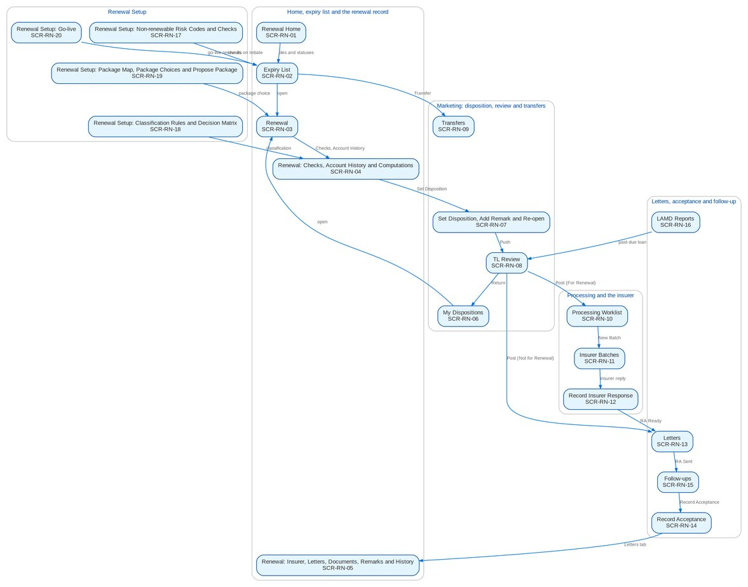
Figure 7: Screen flow of Renewal: how the screens link (list, record, action, next screen)

12.3 Menu by persona
For each persona, the SIT and UAT user of the seed data and the sidebar that user sees, section by section. The BRD column shows which BRD owns a section; entries of other BRDs are listed so the business unit sees the whole menu of its users.

12.3.1 Marketing Team Leader
SIT/UAT user mkttl. 72 menu entries, 6 of them Renewal screens; the other entries belong to the BRD shown.
Table 32: Sidebar of the Marketing Team Leader
Group | Section | Screens | BRD
Home | Overview | My Approvals | Platform
Home | New Business Dashboard | NB Dashboard | BRD-1
Home | My Work | My Work | BRD-1
Client & Policy | Clients | Clients, New Client, KYC Reviews Due | BRD-1
Client & Policy | Quotation / Proposal | Quotations, New Quotation, Quotation Requests | BRD-1
Client & Policy | Accounts & Placement | Accounts, New Account, FFY Register, Direct Payment | BRD-1
Client & Policy | Non-Package Management | Proposal Requests, New Proposal Request | BRD-1
Client & Policy | Placement & Booking | Placement Workbench, Placement Slips | BRD-1
Client & Policy | Policy Issuance | Issuance Workbench, Insurance Advice | BRD-1
Client & Policy | Renewal | Renewal Home, Expiry List, My Dispositions, TL Review, Transfers, Letters | BRD-6
Client & Policy | Submitted Policies | Submitted Policies Home, Masterlist, Processing Runs, Reviews & IAAF, Terms of Reference, Renewal Work List, Submitted Policies Setup | BRD-12
Client & Policy | Adjustment | Adjustment Workbench, New Request | BRD-2
Client & Policy | Product Maintenance | Product Maintenance Home, Package Requests, Package Expiry, Products, Coverages & Clauses, Incentive Criteria, Premium Calculator | BRD-3
Client & Policy | Bulk Processing | Bulk Uploads | BRD-1
Operations | Operations | Operations Home, Invoice Search, Hand-offs and Extracts, Report Archive, Notification Settings | BRD-2
Finance | Collections | Collections Home, PR Worklist, Installment Plans, Installments Due, Promises to Pay, Escalations, Escalation Rules, Billing Statements, Unapplied Payments, Requests to Cashiering, Assignments, Collections Files | BRD-4
Finance | Cashiering | Cashiering Workbench, BIR 2307 | BRD-2
Finance | Remittance | Remittance Workbench, Remittance Holds, Special Remittance | BRD-2
Finance | Refund & Cash Advance Requests | Requests Home, Liquidation Accounts | BRD-5
Claims & Insurance | Claims Handling | Claims Reports | BRD-7
Reports | New Business Reports | New Business Reports, Production Targets | BRD-1
Reports | Reports | Report Centre | Platform
Setup & Administration | Help | Help Center, My Profile | Platform

12.3.2 Marketing Account Officer (Account Broker)
SIT/UAT user ao. 61 menu entries, 5 of them Renewal screens; the other entries belong to the BRD shown.
Table 33: Sidebar of the Marketing Account Officer (Account Broker)
Group | Section | Screens | BRD
Home | Overview | My Approvals | Platform
Home | New Business Dashboard | NB Dashboard | BRD-1
Home | My Work | My Work | BRD-1
Client & Policy | Clients | Clients, New Client, KYC Reviews Due | BRD-1
Client & Policy | Quotation / Proposal | Quotations, New Quotation, Quotation Requests | BRD-1
Client & Policy | Accounts & Placement | Accounts, New Account, FFY Register, Direct Payment | BRD-1
Client & Policy | Non-Package Management | Proposal Requests, New Proposal Request | BRD-1
Client & Policy | Placement & Booking | Placement Workbench, Placement Slips | BRD-1
Client & Policy | Policy Issuance | Issuance Workbench, Insurance Advice | BRD-1
Client & Policy | Renewal | Renewal Home, Expiry List, My Dispositions, Transfers, Letters | BRD-6
Client & Policy | Submitted Policies | Submitted Policies Home, Masterlist, Extraction Review, Processing Runs, Reviews & IAAF, Terms of Reference, Renewal Work List | BRD-12
Client & Policy | Product Maintenance | Product Maintenance Home, Package Requests, Products, Coverages & Clauses, Incentive Criteria, Premium Calculator | BRD-3
Client & Policy | Bulk Processing | Bulk Uploads | BRD-1
Operations | Operations | Operations Home, Invoice Search, Hand-offs and Extracts, Notification Settings | BRD-2
Finance | Collections | Collections Home, PR Worklist, Installment Plans, Installments Due, Promises to Pay, Escalations, Billing Statements, Unapplied Payments, Requests to Cashiering, Collections Files | BRD-4
Finance | Refund & Cash Advance Requests | Requests Home, New Refund Request, New Cash Advance, Cancel a Check | BRD-5
Claims & Insurance | Claims Handling | Claims Reports | BRD-7
Reports | New Business Reports | New Business Reports | BRD-1
Reports | Reports | Report Centre | Platform
Setup & Administration | Help | Help Center, My Profile | Platform

12.3.3 Processing Team Leader
SIT/UAT user proctl. 40 menu entries, 6 of them Renewal screens; the other entries belong to the BRD shown.
Table 34: Sidebar of the Processing Team Leader
Group | Section | Screens | BRD
Home | Overview | My Approvals | Platform
Home | New Business Dashboard | NB Dashboard | BRD-1
Home | My Work | My Work | BRD-1
Client & Policy | Clients | Clients, KYC Reviews Due | BRD-1
Client & Policy | Quotation / Proposal | Quotations, Quotation Requests | BRD-1
Client & Policy | Accounts & Placement | Accounts, New Account, FFY Register, Direct Payment | BRD-1
Client & Policy | Placement & Booking | Placement Workbench, Placement Slips, CLPC Billing | BRD-1
Client & Policy | Policy Issuance | Issuance Workbench, E-policy Upload, Insurance Advice, E-policy Dispatch | BRD-1
Client & Policy | Booking | Booking Workbench, Endorsements, Service Invoices, Batch Runs, Booking Setup | BRD-1
Client & Policy | Renewal | Renewal Home, Expiry List, Processing Worklist, Insurer Batches, Letters, Renewal Setup | BRD-6
Client & Policy | Product Maintenance | Premium Calculator | BRD-3
Client & Policy | Bulk Processing | Bulk Uploads | BRD-1
Operations | Operations | Operations Home, Invoice Search, Hand-offs and Extracts, Notification Settings | BRD-2
Reports | New Business Reports | New Business Reports, Production Targets | BRD-1
Reports | Reports | Report Centre | Platform
Setup & Administration | Help | Help Center, My Profile | Platform

12.3.4 Processing Officer (Broker)
SIT/UAT user proc. 54 menu entries, 6 of them Renewal screens; the other entries belong to the BRD shown.
Table 35: Sidebar of the Processing Officer (Broker)
Group | Section | Screens | BRD
Home | Overview | My Approvals | Platform
Home | New Business Dashboard | NB Dashboard | BRD-1
Home | My Work | My Work | BRD-1
Client & Policy | Clients | Clients, KYC Reviews Due | BRD-1
Client & Policy | Quotation / Proposal | Quotations, Quotation Requests | BRD-1
Client & Policy | Accounts & Placement | Accounts, New Account, FFY Register, Direct Payment | BRD-1
Client & Policy | Placement & Booking | Placement Workbench, Placement Slips, CLPC Billing | BRD-1
Client & Policy | Policy Issuance | Issuance Workbench, E-policy Upload, Insurance Advice, E-policy Dispatch | BRD-1
Client & Policy | Booking | Booking Workbench, Endorsements, Service Invoices, Batch Runs, Booking Setup | BRD-1
Client & Policy | Renewal | Renewal Home, Expiry List, Processing Worklist, Insurer Batches, Letters, Renewal Setup | BRD-6
Client & Policy | Submitted Policies | Submitted Policies Home, Masterlist, Processing Runs, Reviews & IAAF, Terms of Reference, Renewal Work List | BRD-12
Client & Policy | Product Maintenance | Premium Calculator | BRD-3
Client & Policy | Bulk Processing | Bulk Uploads | BRD-1
Operations | Operations | Operations Home, Invoice Search, Hand-offs and Extracts, Notification Settings | BRD-2
Finance | Collections | Collections Home, PR Worklist, Installment Plans, Installments Due, Promises to Pay, Escalations, Billing Statements, Unapplied Payments, Requests to Cashiering | BRD-4
Reports | New Business Reports | New Business Reports | BRD-1
Reports | Reports | Report Centre | Platform
Setup & Administration | Help | Help Center, My Profile | Platform

12.3.5 Contact Center
SIT/UAT user contactc. 6 menu entries, 3 of them Renewal screens; the other entries belong to the BRD shown.
Table 36: Sidebar of the Contact Center
Group | Section | Screens | BRD
Home | Overview | My Approvals | Platform
Client & Policy | Renewal | Renewal Home, Expiry List, Follow-ups | BRD-6
Setup & Administration | Help | Help Center, My Profile | Platform

12.3.6 LAMD (loan status reports)
SIT/UAT user lamd. 7 menu entries, 3 of them Renewal screens; the other entries belong to the BRD shown.
Table 37: Sidebar of the LAMD (loan status reports)
Group | Section | Screens | BRD
Home | Overview | My Approvals | Platform
Client & Policy | Renewal | Renewal Home, Expiry List, LAMD Reports | BRD-6
Client & Policy | Bulk Processing | Bulk Uploads | BRD-1
Setup & Administration | Help | Help Center, My Profile | Platform

12.3.7 Business Administrator
SIT/UAT user badmin. 84 menu entries, 3 of them Renewal screens; the other entries belong to the BRD shown.
Table 38: Sidebar of the Business Administrator
Group | Section | Screens | BRD
Home | Overview | My Approvals | Platform
Home | New Business Dashboard | NB Dashboard | BRD-1
Home | My Work | My Work | BRD-1
Client & Policy | Employee Benefits | EB Home, Programmes, Member Changes, Pending Items, EB Setup | BRD-8
Client & Policy | Booking | Booking Setup | BRD-1
Client & Policy | Renewal | Renewal Home, Expiry List, Renewal Setup | BRD-6
Client & Policy | Product Maintenance | Product Maintenance Home, Package Requests, Package Expiry, Products, Validation Queue, Coverages & Clauses, Incentive Criteria, Insurers, Rates & Taxes, Sales Organisation | BRD-3
Client & Policy | Bulk Processing | Bulk Uploads | BRD-1
Operations | Operations | Operations Home, Invoice Search, Hand-offs and Extracts, Interfaces, Notification Settings | BRD-2
Finance | Collections | Collections Home, PR Worklist, Installment Plans, Installments Due, Promises to Pay, Escalations, Escalation Rules, Billing Statements, Unapplied Payments, Requests to Cashiering, Collections Setup | BRD-4
Finance | Accounting Reports | Account Schedules | BRD-5
Finance | General Ledger | Chart of Accounts, Financial Periods | BRD-5
Finance | Payables & Cash | Bank Accounts | BRD-5
Finance | Assets & Investments | Asset Categories, Asset Register, Depreciation Run, Investment Portfolios, Investments, Accrual & Amortization, Maturities & Sales | BRD-5
Finance | Accounting Engine | Event Types, Accounting Rules, Rule Simulator | BRD-5
Reports | New Business Reports | New Business Reports, Production Targets | BRD-1
Reports | Reports | Report Centre | Platform
Setup & Administration | Broking Setup | Lists of Values, Data Retention, Document Templates, Outbound Messages | BRD-1
Setup & Administration | Setup | Companies, Branches, Currencies & Rates, Dimensions, Business Partners, Employees, Cost-Centre Rules, Holiday Calendar | Platform
Setup & Administration | User Access | Access Requests, Group Profile Requests, Bulk Request, User Access Matrix, Separation of Duties, User Access Reports | BRD-11
Setup & Administration | Administration | Audit Trail, System Parameters, Scheduled Jobs, Record Classes, Legal Holds, Content Migration, Product Modules, Application Info | Platform / BRD-11
Setup & Administration | Help | Help Center, My Profile | Platform

12.3.8 System Administrator
SIT/UAT user admin. 122 menu entries, 0 of them Renewal screens; the other entries belong to the BRD shown.
Table 39: Sidebar of the System Administrator
Group | Section | Screens | BRD
Home | Overview | My Approvals, Dashboard, Alerts | Platform
Home | New Business Dashboard | NB Dashboard | BRD-1
Home | My Work | My Work | BRD-1
Client & Policy | Sanction Screening | Screening Home, Cases, Matches, Screening Runs, High-risk Clients | BRD-10
Client & Policy | Employee Benefits | EB Home, Programmes, Member Changes, Pending Items | BRD-8
Client & Policy | Booking | Booking Setup | BRD-1
Client & Policy | Product Maintenance | Product Maintenance Home, Package Requests, Products, Coverages & Clauses, Incentive Criteria, Insurers, Rates & Taxes, Sales Organisation | BRD-3
Client & Policy | Bulk Processing | Bulk Uploads | BRD-1
Operations | Operations | Operations Home, Invoice Search, Hand-offs and Extracts, Interfaces, Report Archive, Notification Settings | BRD-2
Finance | Collections | Collections Home, PR Worklist, Installment Plans, Installments Due, Promises to Pay, Escalations, Escalation Rules, Billing Statements, Unapplied Payments, Requests to Cashiering, Collections Files, Collections Setup | BRD-4
Finance | Remittance | Remittance Deductions | BRD-2
Finance | Disbursement | Disbursement Workbench, Payees, Disbursement End of Day, Account Funding, Bank Accounts and Checks, Disbursement Reports | BRD-5
Finance | Refund & Cash Advance Requests | Requests Home | BRD-5
Finance | ACSL | ACSL Cases, Correction Entries, Insurer SOA Reconciliation, GL-SL Reconciliation | BRD-5
Finance | Accounting Reports | Report Pack, Account Schedules, Service Fee Runs, Service Fee Rates | BRD-5
Finance | General Ledger | Chart of Accounts, Financial Periods | BRD-5
Finance | Payables & Cash | Bank Accounts | BRD-5
Finance | Assets & Investments | Asset Categories, Asset Register, Depreciation Run, Investment Portfolios, Investments, Accrual & Amortization, Maturities & Sales | BRD-5
Finance | Accounting Engine | Event Types, Accounting Rules, Rule Simulator | BRD-5
Claims & Insurance | Claims Handling | Claims Home, Claims Worklist, My Diary, Claims Reports | BRD-7
Data Migration | Data Migration | Migration Home, Data Objects, Code Maps, Layouts and Rules, Batches, Reconciliation, Opening Adjustments, Cutover, Run-off and Decommissioning, Sign-off | BRD-13
Reports | New Business Reports | New Business Reports, Production Targets | BRD-1
Reports | Reports | Report Centre | Platform
Setup & Administration | Broking Setup | Lists of Values, Data Retention, Document Templates, Outbound Messages | BRD-1
Setup & Administration | Compliance Setup | Watchlist | BRD-10
Setup & Administration | Setup | Companies, Branches, Currencies & Rates, Dimensions, Business Partners, Employees, Cost-Centre Rules, Holiday Calendar | Platform
Setup & Administration | User Access | Access Requests, Group Profile Requests, Bulk Request, User Access Matrix, User Access Reports | BRD-11
Setup & Administration | Administration | Users, Roles & Permissions, Second Factor, Audit Trail, System Parameters, Exception Codes, Scheduled Jobs, Integration Events, Caches, Record Classes, Legal Holds, Content Migration, Product Modules, Application Info | Platform / BRD-11
Setup & Administration | Help | Help Center, My Profile | Platform

12.3.9 Auditor
SIT/UAT user auditor. 154 menu entries, 2 of them Renewal screens; the other entries belong to the BRD shown.
Table 40: Sidebar of the Auditor
Group | Section | Screens | BRD
Home | Overview | My Approvals, Dashboard, Alerts | Platform
Home | New Business Dashboard | NB Dashboard | BRD-1
Home | My Work | My Work | BRD-1
Client & Policy | Clients | Clients, KYC Reviews Due | BRD-1
Client & Policy | Sanction Screening | Screening Home, Cases, Matches, Screening Runs, High-risk Clients, STR | BRD-10
Client & Policy | Quotation / Proposal | Quotations, Quotation Requests | BRD-1
Client & Policy | Accounts & Placement | Accounts, FFY Register, Direct Payment | BRD-1
Client & Policy | Employee Benefits | EB Home, Programmes, Member Changes, Pending Items | BRD-8
Client & Policy | Placement & Booking | Placement Workbench, Placement Slips | BRD-1
Client & Policy | Policy Issuance | Issuance Workbench, Insurance Advice | BRD-1
Client & Policy | Booking | Booking Setup | BRD-1
Client & Policy | Renewal | Renewal Home, Expiry List | BRD-6
Client & Policy | Product Maintenance | Product Maintenance Home, Package Requests, Package Expiry, Products, Coverages & Clauses, Incentive Criteria, Insurers, Rates & Taxes, Sales Organisation, Premium Calculator | BRD-3
Operations | Operations | Operations Home, Invoice Search, Hand-offs and Extracts, Report Archive, Notification Settings | BRD-2
Finance | Collections | Collections Home, PR Worklist, Installment Plans, Installments Due, Promises to Pay, Escalations, Billing Statements, Unapplied Payments, Requests to Cashiering, Collections Files | BRD-4
Finance | Remittance | Remittance Deductions | BRD-2
Finance | Disbursement | Disbursement Workbench, Payees, Disbursement End of Day, Account Funding, Bank Accounts and Checks, Disbursement Reports | BRD-5
Finance | Refund & Cash Advance Requests | Requests Home | BRD-5
Finance | ACSL | ACSL Cases, Correction Entries, Insurer SOA Reconciliation, GL-SL Reconciliation | BRD-5
Finance | Accounting Reports | Report Pack, Account Schedules, Service Fee Runs, Service Fee Rates | BRD-5
Finance | General Ledger | Journals, Recurring Journals, Account Inquiry, Party Statement, Chart of Accounts, Financial Periods | BRD-5
Finance | Receivables & Banking | Receipts, Cheques & Deposits, PDC Received, Receivables Reports | BRD-5
Finance | Payables & Cash | Supplier Invoices, Payment Vouchers, PDC Issued, Petty Cash, Bank Accounts | BRD-5
Finance | Assets & Investments | Asset Categories, Asset Register, Depreciation Run, Investment Portfolios, Investments, Accrual & Amortization, Maturities & Sales | BRD-5
Finance | Planning & Closing | Budget vs Actual | BRD-5
Finance | Tax & Statutory | Tax Calendar, VAT Worksheet, Withholding Tax, Documentary Stamp Tax, Premium Tax, LGT & FST, Tax Returns, BIR Form 2307, Certificates Received, BIR Forms & Books, IC Schedules, Tax Codes & Forms, Party Tax Profiles, IC Mapping | BRD-5
Finance | Accounting Engine | Event Types, Accounting Rules, Rule Simulator, Event Register | BRD-5
Claims & Insurance | Claims Handling | Claims Home, Claims Worklist, My Diary, Claims Reports | BRD-7
Data Migration | Data Migration | Migration Home, Data Objects, Code Maps, Layouts and Rules, Batches, Reconciliation, Opening Adjustments, Cutover, Run-off and Decommissioning, Sign-off | BRD-13
Reports | New Business Reports | New Business Reports, Production Targets | BRD-1
Reports | Reports | Report Centre | Platform
Setup & Administration | Broking Setup | Data Retention, Document Templates, Outbound Messages | BRD-1
Setup & Administration | Compliance Setup | Watchlist | BRD-10
Setup & Administration | Setup | Companies, Branches, Currencies & Rates, Dimensions, Business Partners, Employees, Cost-Centre Rules, Holiday Calendar | Platform
Setup & Administration | User Access | Access Requests, Group Profile Requests, User Access Matrix, User Access Reports | BRD-11
Setup & Administration | Administration | Audit Trail, System Parameters, Exception Codes, Scheduled Jobs, Record Classes, Legal Holds, Content Migration, Product Modules, Application Info | Platform / BRD-11
Setup & Administration | Help | Help Center, My Profile | Platform

12.4 Common screen elements
Elements that behave the same on every screen of this set are described once here and not repeated in the screen specifications.
Table 41: Common screen elements
Element | What the user sees and does
Page header and company | Every page shows its section (Client & Policy · Renewal) and title, a one-line description and its actions on the right. The company in the header decides the renewals shown, and each user sees the renewals of the scope of the role: the own unit for Marketing, the processing stages for Processing.
Renewal Home and work tiles | The Renewal Home shows the renewals due in 30, 60, 90 and 140 days as figures, then the work queues as tiles: a Title Case label and the live count; a queue that needs action has a coloured bar and "Needs attention". A tile opens the list behind it. Under the tiles, the renewals by status and by classification and the workload of the officers.
Renewal lists | The Expiry List, My Dispositions, TL Review, Processing Worklist, Letters and Follow-ups are one list with the tabs of the screen: a search box (renewal reference, policy, PN or client), a Filters button for the multi-select criteria and the expiry range, quick filters, the actions of the tab for the rows ticked and Download. Rows alternate white and Background Blue; a long list scrolls inside its card with the header row in view; "Showing 1 to n of N results" pages the list by 200 rows. A row opens its renewal.
Renewal reference, classification and flags | Each renewal has its renewal reference (RNW-yyyy-nnnnnn), its status (the stage of the renewal workflow) as an outlined pill, its classification (Clean, Review or Exception) as a pill of its own, and its flags as tags next to the reference: Urgent, Returned, Transferred, Endorsed, Claims, Outstanding, KYC due, NRNS, Straight-through, NFR sent and Locked.
Renewal record and workflow header | A renewal opens with the client as the title, the ARN chip, the status, classification and disposition, its flags and the key facts (client, product, insurer, expiry with the days left, gross premium, unit). The blocking checks are listed in an amber notice. Under the header, the workflow header of the renewal: a stepper of the stages in their order (passed stages ticked in blue, the current stage highlighted, the stages ahead in grey; a returned stage in amber, the last stage in green once reached), and one row with Current Stage, Since, Due and Assigned To, with the actions the user may take now on the right. The record has the tabs Details, Checks, Account History, Computations, Insurer, Letters, Documents, Remarks & Follow-ups and History.
Bulk actions and their outcome | Assign, Push, Post, Return, Override, Initiate, Generate RA and Send act on every renewal ticked. Each renewal is processed on its own: the message gives the count done and refused, and a dialog lists every refused renewal with the reason, so one refusal never stops the others.
Maker-checker | A non-renewable risk code, a check setting and a package mapping apply only once another user authorizes them; the maker cannot authorize. The classification rules and the decision matrix are versions: a draft is submitted, then activated or rejected by another user, and activation retires the active version. A package choice for a migrated policy and a correction of a Renewal Advice already sent are approved by a second member of the Renewal processing team.
Status pills and tags | Statuses are outlined pills of one size and colour per state group; a pill never wraps. The renewal statuses read as the stages of the renewal (Unassigned Disposition, For Disposition, Review in Progress, For Processing, With Insurer, RA Ready, RA Sent / Awaiting Response and so on); an agreed short form, with the full label in the tooltip, is used only for a label longer than 21 characters. Flags are tags next to the reference, never inside the pill.
Dates, amounts and names | Dates are entered with one date picker and shown as dd-MMM-yyyy; times as dd-MMM-yyyy HH:mm in Philippine time. Amounts show two decimals and thousand separators. The expiry reads with the days left ("45 days"). Insurers, products, units and lists of values show their names, and users are shown by their names.
Letters and protected e-mails | Renewal Advices and the other letters are generated from versioned templates with the BDO Insure letterhead, kept in the documents of the renewal, and e-mailed to the client as a password-protected PDF with the password in a separate e-mail. The extract sent to an insurer is protected the same way.
Notifications and help | The bell in the header shows the unread count and opens the notifications panel, grouped by day; each notice shows its title, a one-line summary, the renewal reference and the time, and opens the renewal. Mark Read, Mark All Read and View All are offered. Each user chooses the channels of the Renewal events on Notification Settings. The Help button of each page explains the screen.
Messages | Every message follows one notice standard: a white notice with a thin bar and an icon in the colour of its kind (red error, amber warning, blue information, green success), a bold short title, then the business message with one bullet per missing item. Field errors appear under the field. A refusal by a business rule shows the business message only, without codes; only an unexpected system error offers Retry and a reference for support. Success is confirmed by a short message in the same standard.
Confirmations and reasons | Every post, send, authorize, activate, deactivate and cancel asks for confirmation in a dialog that names the record and the effect; a return, an override, a transfer and a re-open need a reason or remarks (up to 200 characters) before they can be confirmed. The reason is kept in the history of the renewal and sent with the notification.
Uploads | The uploads of Renewal (dispositioned file, insurer responses, acceptances, LAMD reports, package map, migrated policies, Renewal Advices already sent) use the upload wizard: download the template, upload the filled file, review every row with its message, then process the valid rows; the rejected rows come back in the error file. A file uploaded before is refused.

13 Screen specifications
One specification per screen, grouped by area: the expiry list and the renewal record; Marketing; Processing and the insurer; letters, acceptance and follow-up; Renewal Setup. Each gives:
• Purpose, who can open it (personas and the permission), navigation (menu path and the other ways in) and the related FRs;
• the screenshots taken with seed data; the first carries numbered callouts that match the Fields table;
• the Fields table: section, label, type, length or format, mandatory, source list, default, the statuses in which the field can be changed, the validation and the message shown when it fails;
• the Actions table: button, who sees it, when it is enabled, what happens, the resulting status and the notification sent;
• the business rules, the expected outcome and the test cases of the test plan that exercise the screen.

13.1 Home, expiry list and the renewal record

13.1.1 SCR-RN-01 Renewal Home
Purpose | The renewals of the user's scope at a glance: the renewals due in 30, 60, 90 and 140 days, the work queues that need attention (at risk, urgent, returned, NRNS, insurer reply overdue, letters failed), the renewals by status and by classification and the workload of the officers. Each tile and status opens the list behind it.
Who can open it | Marketing Team Leader, Marketing Account Officer (Account Broker), Processing Team Leader, Processing Officer (Broker), Contact Center, LAMD (loan status reports), Business Administrator, Auditor (permission Renewal view)
Navigation | • Menu: Client & Policy › Renewal › Renewal Home  • Client & Policy › Renewal › Renewal Home
FRs | FR-RN-100, FR-RN-102

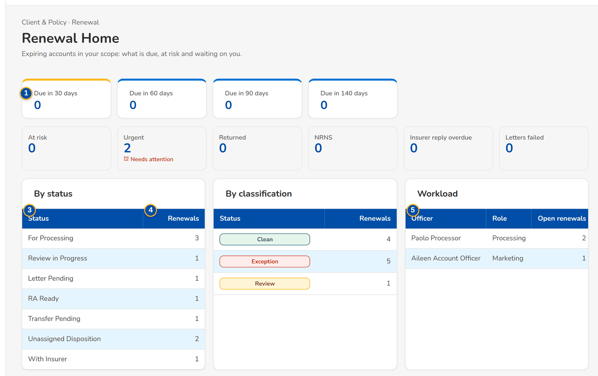
Figure 8: SCR-RN-01 Renewal Home of the Marketing Team Leader: due dates, work queues, renewals by status and classification, workload
1 | Due in 30 days / Due in 60 days / Due in 90 days / Due in 140 days | 3 | Status / Renewals | 5 | Officer / Role / Open renewals
2 | At risk / Urgent / Returned / NRNS / Insurer reply overdue / Letters failed | 4 | [Classification pill] / Renewals

Fields (No. = callout number on the first screenshot)
No. | Section | Field | Type | Length / format | Mand. | Source / list | Default | Editable in | Validation | Message when it fails
1 | Figures | Due in 30 days / Due in 60 days / Due in 90 days / Due in 140 days | Figure | Number of renewals expiring within the days | - | Renewals of the user's scope | - | Read only | - | -
2 | Work tiles | At risk / Urgent / Returned / NRNS / Insurer reply overdue / Letters failed | Tile | Title and live count; Needs attention when the queue needs action | - | Renewals of the user's scope | - | Read only | - | -
3 | By status | Status / Renewals | Column | Stage of the renewal and the number of renewals | - | Renewals | - | Read only | - | No renewals
4 | By classification | [Classification pill] / Renewals | Column | Clean, Review or Exception and the number of renewals | - | Renewals | - | Read only | - | No renewals
5 | Workload | Officer / Role / Open renewals | Column | Name of the officer; Marketing or Processing; number of open renewals | - | Assignments | - | Read only | - | No renewals assigned

Actions
Button | Who | Enabled when | What happens | Resulting status | Notification
Tile or status row | Every Renewal user | Always | Opens the list and tab of those renewals (Expiry List, My Dispositions, Processing Worklist, Letters) | - | -

Business rules
• The counts cover the renewals of the user's scope: the own unit for Marketing, the processing stages for Processing (FR-RN-100).
• A renewal is at risk when it is not disposed or not accepted within the escalation days of its segment before expiry (FR-RN-102).
Expected outcome
The user sees what is due and opens the work waiting.
Test cases: TC-RN-010.1-01, TC-RN-010.2-01, TC-RN-010.4-01, TC-RN-010.5-01, TC-RN-010.1-02, TC-RN-016.1-01, TC-RN-016.1-02, TC-RN-016.5-01, TC-RN-100.1-01, TC-RN-100.2-01, TC-RN-100.2-02, TC-RN-100.3-01, TC-RN-SCR-01.

13.1.2 SCR-RN-02 Expiry List
Purpose | The expiring accounts from extraction to disposition, by tab: extracted, unassigned, by disposition, exceptions, transfers pending and all. Generate Expiry List reads the accounts expiring in a range; Initiate starts the checks of the extracted renewals; Assign Disposition gives renewals to an Account Officer; Push sends the dispositioned ones to the Team Leader; Transfer moves one renewal to another unit.
Who can open it | Marketing Team Leader, Marketing Account Officer (Account Broker), Processing Team Leader, Processing Officer (Broker), Contact Center, LAMD (loan status reports), Business Administrator, Auditor (permission Renewal view)
Navigation | • Menu: Client & Policy › Renewal › Expiry List  • Client & Policy › Renewal › Expiry List  • Renewal Home › At risk, Urgent or a status
FRs | FR-RN-010, FR-RN-011, FR-RN-012, FR-RN-013, FR-RN-014, FR-RN-015, FR-RN-030, FR-RN-031

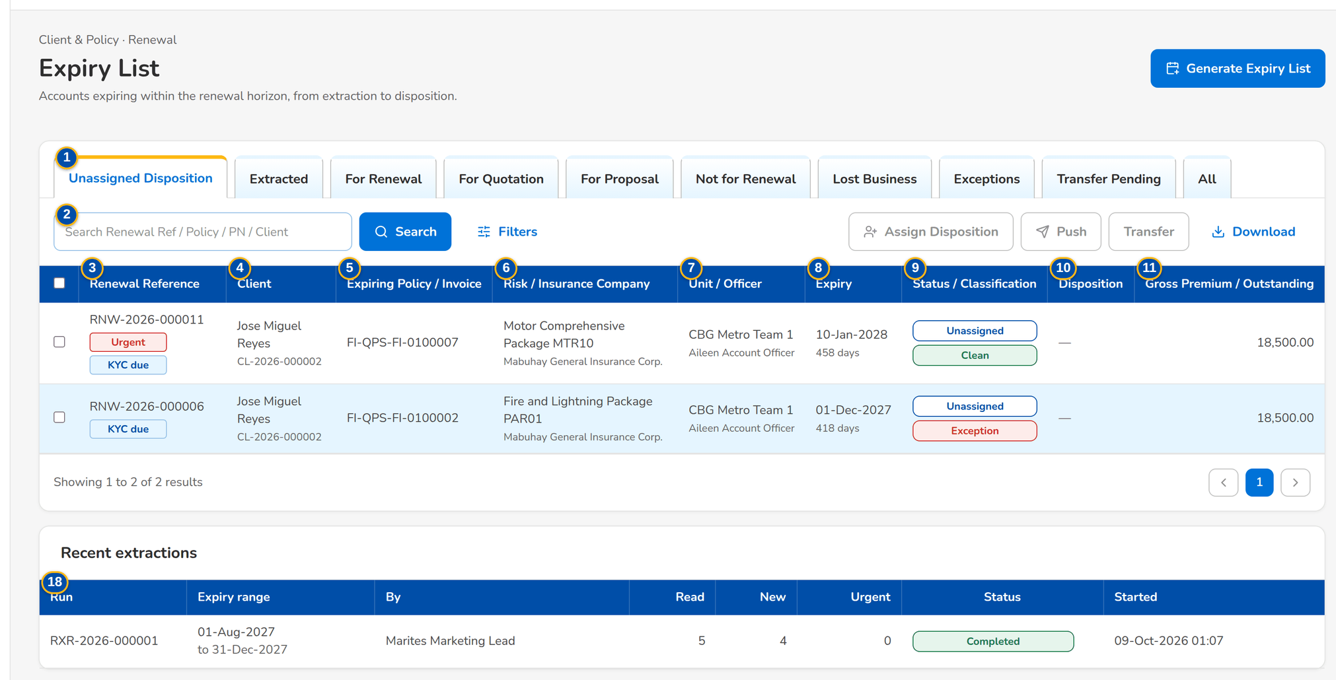
Figure 9: SCR-RN-02 Expiry List of the Marketing Team Leader, tab Unassigned Disposition: classification, flags and the actions of the tab
1 | Unassigned Disposition / Extracted / For Renewal / For Quotation / For Proposal / Not for Renewal / Lost Business / Exceptions / Transfer Pending / All | 7 | Unit / Officer | 13 | Unit Head, Business Origin, Account Type, Region, Department, Invoicing Branch, Risk Code, Segment, Account Officer, Insurance Company, Classification, Disposition, Status
2 | Search Renewal Ref / Policy / PN / Client | 8 | Expiry | 14 | Expiry From / Expiry To
3 | Renewal Reference | 9 | Status / Classification | 15 | Account Officer
4 | Client | 10 | Disposition | 16 | Reason (re-assignment)
5 | Expiring Policy / Invoice | 11 | Gross Premium / Outstanding | 17 | Receiving Unit / Reason / Remarks
6 | Risk / Insurance Company | 12 | Expiry From / Expiry To | 18 | Run / Expiry range / By / Read / New / Urgent / Status / Started

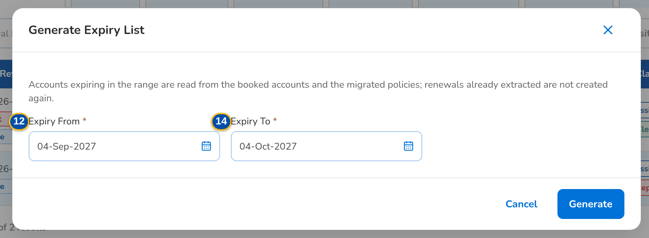
Figure 10: SCR-RN-02 Generate Expiry List dialog with the expiry range
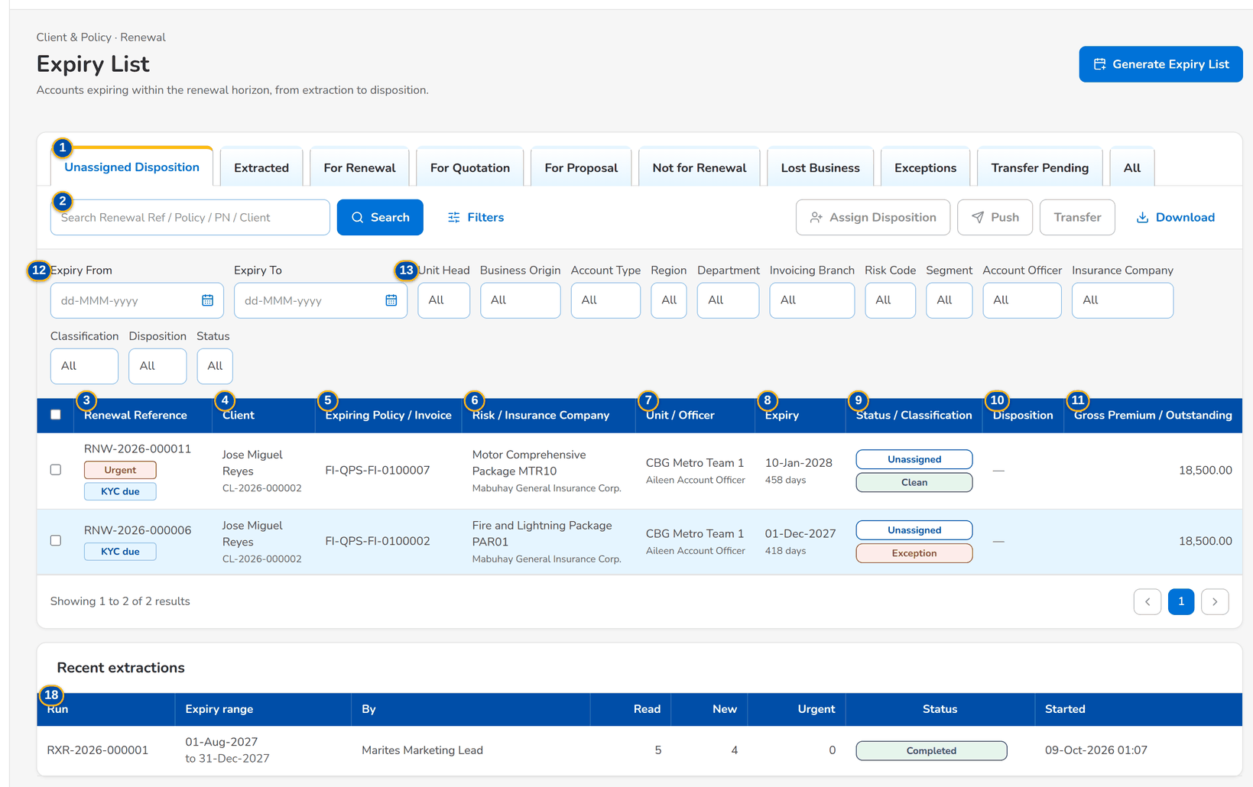
Figure 11: SCR-RN-02 The Filters panel: the expiry range and the multi-select criteria
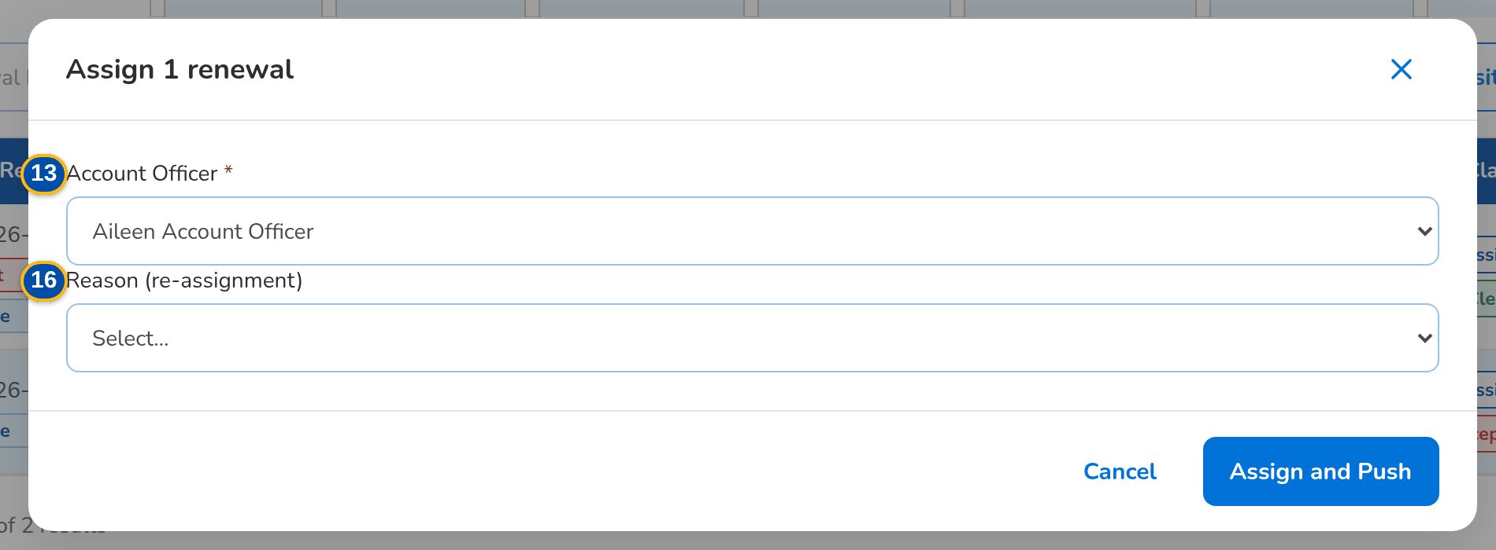
Figure 12: SCR-RN-02 Assign Disposition dialog: the Account Officer of the unit and the reason of a re-assignment
Fields (No. = callout number on the first screenshot)
No. | Section | Field | Type | Length / format | Mand. | Source / list | Default | Editable in | Validation | Message when it fails
1 | Tabs | Unassigned Disposition / Extracted / For Renewal / For Quotation / For Proposal / Not for Renewal / Lost Business / Exceptions / Transfer Pending / All | Tab | - | - | Stage and disposition of the renewal | Unassigned Disposition | - | - | -
2 | Toolbar | Search Renewal Ref / Policy / PN / Client | Text | - | N | Renewals | Blank | - | Contains | -
3 | List | Renewal Reference | Column | RNW-yyyy-nnnnnn with the flag tags next to it | - | Renewals | - | Read only | - | No renewals to display
4 | List | Client | Column | Name of the client with the client code under it | - | Renewal | - | Read only | - | -
5 | List | Expiring Policy / Invoice | Column | Policy number with the invoice under it | - | Renewal | - | Read only | - | -
6 | List | Risk / Insurance Company | Column | Product name with the insurer name under it | - | Product catalogue, insurers | - | Read only | - | -
7 | List | Unit / Officer | Column | Name of the owner unit with the officer's name under it | - | Sales organisation, assignments | - | Read only | - | -
8 | List | Expiry | Column | dd-MMM-yyyy with the days left under it | - | Renewal | - | Read only | - | -
9 | List | Status / Classification | Column | Stage pill with the Clean, Review or Exception pill under it | - | Renewal | - | Read only | - | -
10 | List | Disposition | Column | Disposition with the remarks under it | - | Renewal | - | Read only | - | -
11 | List | Gross Premium / Outstanding | Column | Two decimals; the outstanding of the expiring invoice family and the claims count under it (hidden for LAMD and Contact Center) | - | Expiring invoice, checks | - | Read only | - | -
12 | Filters panel | Expiry From / Expiry To | Date | dd-MMM-yyyy | N | - | Blank | - | - | -
13 | Filters panel | Unit Head, Business Origin, Account Type, Region, Department, Invoicing Branch, Risk Code, Segment, Account Officer, Insurance Company, Classification, Disposition, Status | Multi-select | Several values, or all except the values chosen | N | Values of the renewals | All | - | - | -
14 | Generate Expiry List dialog | Expiry From / Expiry To | Date | dd-MMM-yyyy; the end on or after the start | Y | - | Blank | - | Valid range | The end date must be on or after the start date
15 | Assign Disposition dialog | Account Officer | Drop-down | Name of the officer | Y | Officers of the Marketing units | Blank | Unassigned Disposition, For Disposition | Active officer of the unit of the renewal | Select the account officer
16 | Assign Disposition dialog | Reason (re-assignment) | Drop-down | Renewal transfer reason list | N | Renewal transfer reason | Blank | For Disposition | - | -
17 | Transfer dialog | Receiving Unit / Reason / Remarks | Drop-down, drop-down, text area | Name of the unit; renewal transfer reason; up to 200 characters | Y / N / Y | Marketing units, Renewal transfer reason | Blank | Unassigned Disposition, For Disposition | Another active unit | The receiving unit must be another unit
18 | Recent extractions | Run / Expiry range / By / Read / New / Urgent / Status / Started | Column | The last five runs: the range or Daily run, the user's name, the counts, the status and the start time | - | Extraction runs | - | Read only | - | No extraction yet

Actions
Button | Who | Enabled when | What happens | Resulting status | Notification
Generate Expiry List | Marketing and Processing Team Leaders | Always | Opens the dialog; Generate reads the accounts expiring in the range and creates their renewals once | Extracted | -
Initiate | Team Leaders (extract or assign permission) | Tab Extracted, renewals ticked | Starts the checks: each renewal gets its classification and the decision matrix proposes its disposition | Unassigned Disposition, For Processing or Letter Pending by the rules | -
Assign Disposition | Marketing Team Leader | Renewals ticked | Opens the dialog; Assign and Push gives the renewals to the officer | For Disposition | Renewal assigned (NT-01)
Push | Account Officers and Team Leaders (dispose permission) | Renewals ticked | Sends the dispositioned renewals to the Team Leader | Review in Progress | -
Transfer | Marketing Team Leader | One renewal ticked | Opens the dialog; Submit and Push requests the transfer to the receiving unit | Transfer Pending | Renewal transfer requested (NT-02)
Download | Users with the export permission | Always | Downloads the list as shown, with its filters, as a spreadsheet | - | -
Row | Every Renewal user | Always | Opens the renewal | - | -

Business rules
• An account is extracted once per policy year: a second extraction of the same range creates no duplicate (FR-RN-011, FR-RN-021).
• The daily extraction takes the policies at the lead days before expiry (140 by default); Generate Expiry List takes any range (FR-RN-010, FR-RN-011).
• Extraction does not start the renewal: the renewals are initiated explicitly, in bulk for the bulk segments and one by one for the others (FR-RN-015).
• Each filter accepts several values or all except the values chosen; the filters run on the whole list (FR-RN-012).
• A renewal is assigned to an officer of its own unit; a renewal on the loan-driven straight-through path needs no officer (FR-RN-030).
• A renewal has one open transfer request at a time, to another active unit (FR-RN-031).
Expected outcome
The expiring accounts are extracted, initiated and assigned for disposition.
Test cases: TC-RN-001.4-01, TC-RN-001.4-02, TC-RN-002.3-01, TC-RN-010.7-01, TC-RN-011.1-01, TC-RN-011.1-02, TC-RN-011.2-01, TC-RN-011.2-02, TC-RN-011.3-01, TC-RN-011.3-02, TC-RN-011.4-01, TC-RN-012.1-01, TC-RN-012.1-02, TC-RN-012.1-03, TC-RN-012.2-01, TC-RN-012.2-02, TC-RN-012.3-01, TC-RN-013.1-01, TC-RN-013.2-01, TC-RN-013.2-02, TC-RN-013.2-03, TC-RN-013.3-01, TC-RN-013.3-03, TC-RN-013.4-01, TC-RN-013.5-01, TC-RN-014.1-01, TC-RN-014.1-02, TC-RN-014.2-01, TC-RN-014.2-02, TC-RN-014.3-01, TC-RN-015.1-01, TC-RN-015.2-01, TC-RN-015.3-01, TC-RN-015.3-02, TC-RN-016.2-01, TC-RN-021.1-01, TC-RN-022.3-01, TC-RN-026.1-01, TC-RN-030.1-01, TC-RN-030.1-02, TC-RN-030.3-01, TC-RN-030.3-02, TC-RN-030.4-01, TC-RN-030.5-01, TC-RN-031.1-01, TC-RN-031.2-01, TC-RN-031.2-02, TC-RN-031.3-01, TC-RN-090.3-01, TC-RN-SCR-02, TC-RN-MSG-01, TC-RN-MSG-02.

13.1.3 SCR-RN-03 Renewal
Purpose | One renewal: the client, the ARN chip, the status, classification and disposition, the flags and key facts, the blocking checks, the workflow header with the actions the user may take now, and the Details tab with the expiring account, the client and officers, the amounts and the renewal itself.
Who can open it | Marketing Team Leader, Marketing Account Officer (Account Broker), Processing Team Leader, Processing Officer (Broker), Contact Center, LAMD (loan status reports), Business Administrator, Auditor (permission Renewal view)
Navigation | • Menu: Client & Policy › Renewal › Expiry List › Renewal  • Expiry List, My Dispositions, TL Review, Processing Worklist, Letters or Follow-ups › open a row  • A Renewal notification
FRs | FR-RN-002, FR-RN-041, FR-RN-021, FR-RN-026

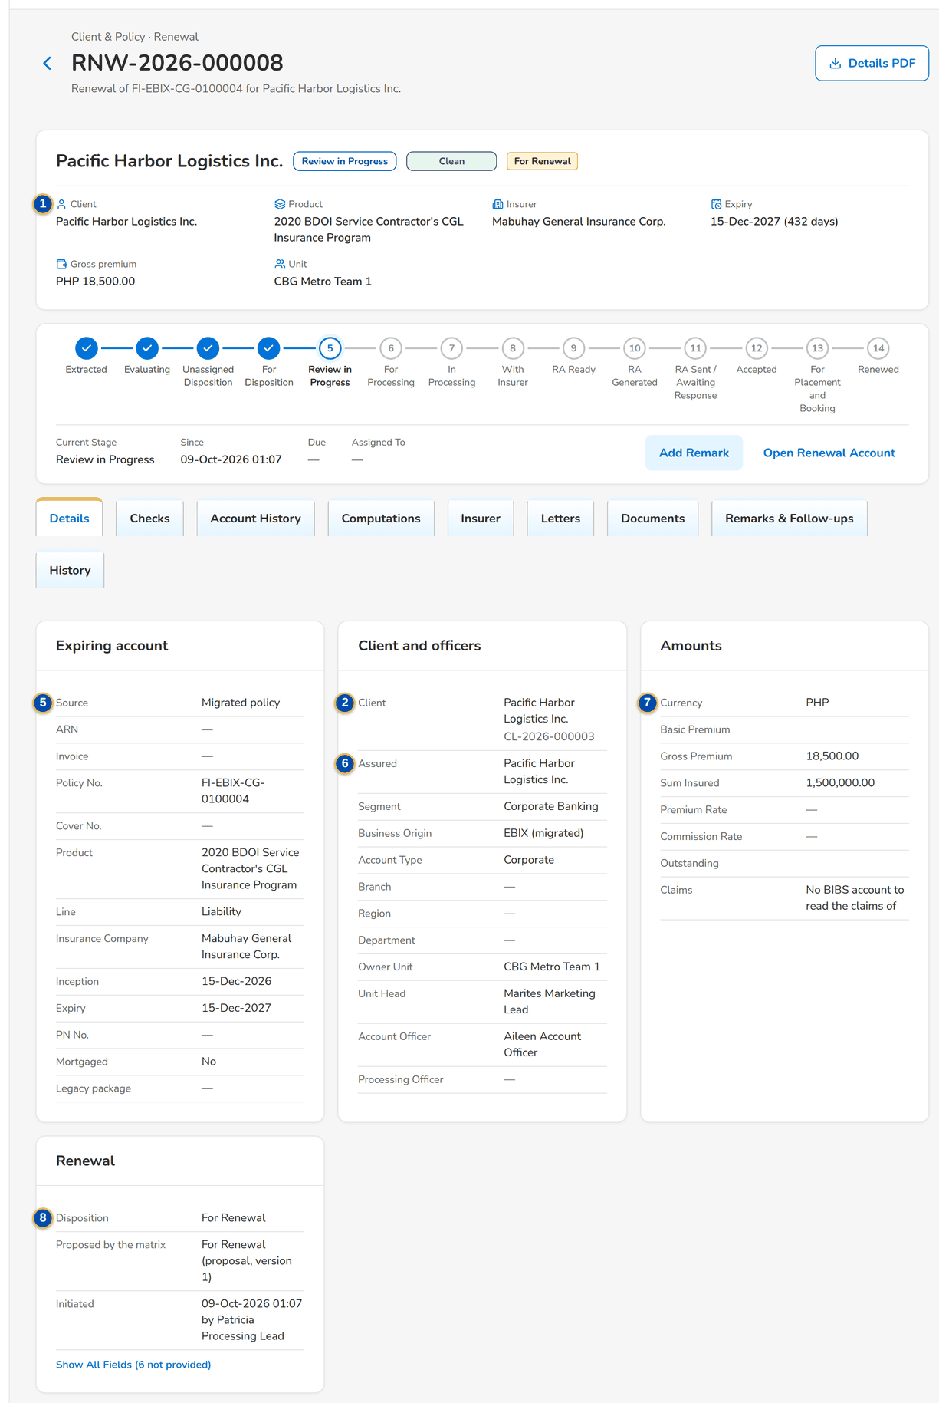
Figure 13: SCR-RN-03 A renewal in review: header, flags, workflow header and the Details tab
1 | Client, ARN chip, status pill, classification pill, disposition tag, flags | 4 | Renewal workflow header | 7 | Currency / Basic Premium / Gross Premium / Sum Insured / Premium Rate / Commission Rate / Outstanding / Claims
2 | Client / Product / Insurer / Expiry / Gross premium / Unit | 5 | Source / ARN / Invoice / Policy No. / Cover No. / Product / Line / Insurance Company / Inception / Expiry / PN No. / Mortgaged / Legacy package | 8 | Disposition / Reason / Proposed by the matrix / Renewal ARN / Quotation / Proposal / Renewed Invoice / Initiated / Closed
3 | Amber notice with the failed checks | 6 | Client / Assured / Segment / Business Origin / Account Type / Branch / Region / Department / Owner Unit / Unit Head / Account Officer / Processing Officer

Fields (No. = callout number on the first screenshot)
No. | Section | Field | Type | Length / format | Mand. | Source / list | Default | Editable in | Validation | Message when it fails
1 | Header | Client, ARN chip, status pill, classification pill, disposition tag, flags | Reference chip, pills, tags | - | - | Renewal | - | Read only | - | -
2 | Facts | Client / Product / Insurer / Expiry / Gross premium / Unit | Display | Names; expiry dd-MMM-yyyy with the days left; amount with the currency | - | Renewal | - | Read only | - | -
3 | Blocking checks | Amber notice with the failed checks | Notice | One bullet per failed blocking check | - | Latest checks | - | Read only | - | -
4 | Workflow | Renewal workflow header | Stepper | The stages of the renewal with Current Stage, Since, Due and Assigned To and the history table | - | Renewal workflow | - | Read only | - | -
5 | Details tab: Expiring account | Source / ARN / Invoice / Policy No. / Cover No. / Product / Line / Insurance Company / Inception / Expiry / PN No. / Mortgaged / Legacy package | Display | Names of the product, line and insurer; dates dd-MMM-yyyy | - | Expiring account or migrated policy | - | Read only | - | -
6 | Details tab: Client and officers | Client / Assured / Segment / Business Origin / Account Type / Branch / Region / Department / Owner Unit / Unit Head / Account Officer / Processing Officer | Display | Names of the units and users | - | Client, sales organisation, assignments | - | Read only | - | -
7 | Details tab: Amounts | Currency / Basic Premium / Gross Premium / Sum Insured / Premium Rate / Commission Rate / Outstanding / Claims | Display | Two decimals; rates as keyed | - | Expiring invoice, checks | - | Read only | - | -
8 | Details tab: Renewal | Disposition / Reason / Proposed by the matrix / Renewal ARN / Quotation / Proposal / Renewed Invoice / Initiated / Closed | Display | Labels; the officer's name; dd-MMM-yyyy HH:mm | - | Renewal | - | Read only | - | -

Actions
Button | Who | Enabled when | What happens | Resulting status | Notification
Details PDF | Users with the export permission | Always | Downloads the account details of the renewal as a PDF | - | -
Actions of the stage | By stage and permission | The renewal is in the stage | Set Disposition, Push, Start Quotation / Proposal, Create Renewal Account, Record Insurer Response, Record Acceptance, Add Follow-up, Add Remark, Propose Package, Re-open (SCR-RN-07, SCR-RN-12, SCR-RN-14, SCR-RN-15, SCR-RN-19) | - | -
Open Renewal Account | Every Renewal user | The renewal account exists | Opens the renewal account in New Business | - | -

Business rules
• Every user sees the renewals of the scope of the role; LAMD and Contact Center users see the renewal without the premium amounts (FR-RN-002, FR-RN-041).
• A renewal locks on the Marketing side when its Renewal Advice is generated (FR-RN-080).
Expected outcome
The user sees the whole renewal and the actions possible now.
Test cases: TC-RN-001.5-01, TC-RN-023.1-01, TC-RN-023.5-01, TC-RN-023.5-02, TC-RN-025.4-02, TC-RN-041.1-01, TC-RN-041.1-02, TC-RN-041.1-03, TC-RN-041.1-04, TC-RN-041.2-01, TC-RN-041.3-01, TC-RN-041.3-02, TC-RN-041.4-01, TC-RN-047.1-01, TC-RN-047.1-02, TC-RN-047.3-01, TC-RN-047.3-02, TC-RN-047.3-03, TC-RN-048.1-01, TC-RN-048.2-01, TC-RN-048.3-02, TC-RN-048.4-01, TC-RN-051.3-01, TC-RN-051.3-02, TC-RN-051.5-01, TC-RN-084.1-01, TC-RN-084.4-01, TC-RN-084.4-02, TC-RN-084.4-03, TC-RN-084.5-01, TC-RN-086.1-01, TC-RN-086.2-01, TC-RN-086.3-01, TC-RN-086.3-02, TC-RN-090.1-01, TC-RN-090.2-01, TC-RN-090.2-02, TC-RN-090.5-01, TC-RN-SCR-03, TC-RN-MSG-03.

13.1.4 SCR-RN-04 Renewal: Checks, Account History and Computations
Purpose | The tabs the officers read before the disposition and the processing: the results of the sanitation checks with the classification history and the endorsements linked; the account history (prior renewals, endorsements, payments and claims), whose viewing is recorded and required before the disposition; the expiring and renewal terms side by side.
Who can open it | Marketing Team Leader, Marketing Account Officer (Account Broker), Processing Team Leader, Processing Officer (Broker), Contact Center, LAMD (loan status reports), Business Administrator, Auditor (permission Renewal view)
Navigation | • Menu: Client & Policy › Renewal › Expiry List › Renewal  • Renewal › Checks, Account History or Computations tab
FRs | FR-RN-020, FR-RN-022, FR-RN-027, FR-RN-042, FR-RN-064

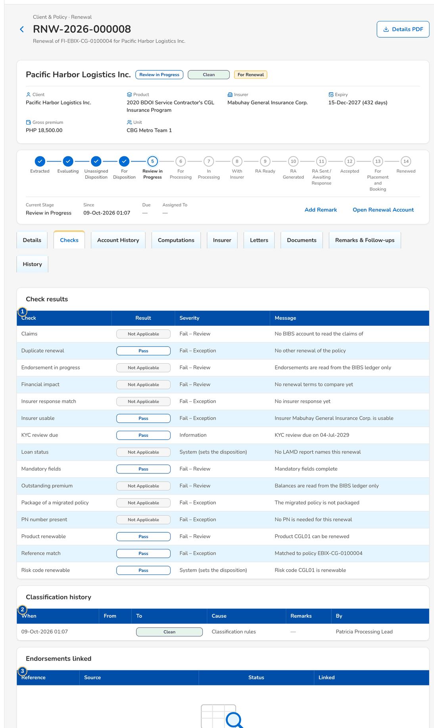
Figure 14: SCR-RN-04 Checks tab: the result of each check, the classification history and the endorsements
1 | Check / Result / Severity / Message | 3 | Reference / Source / Status / Linked | 5 | Prior renewals / Endorsements / Payments / Claims
2 | When / From / To / Cause / Remarks / By | 4 | View Account History | 6 | Expiring / Renewal

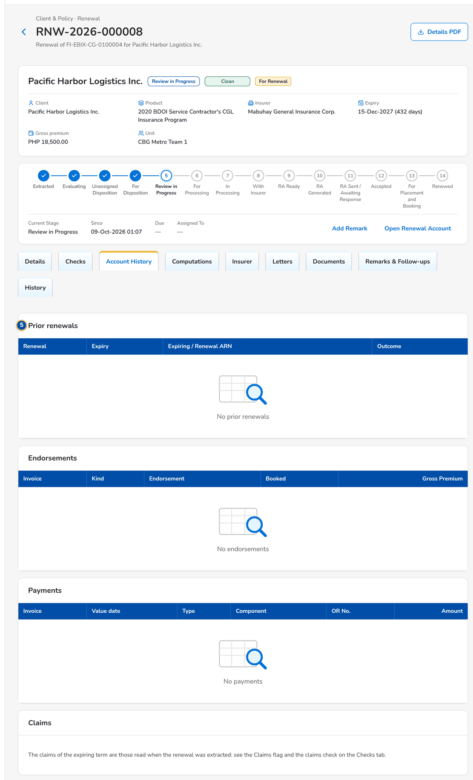
Figure 15: SCR-RN-04 Account History tab after View Account History: prior renewals, endorsements, payments and claims

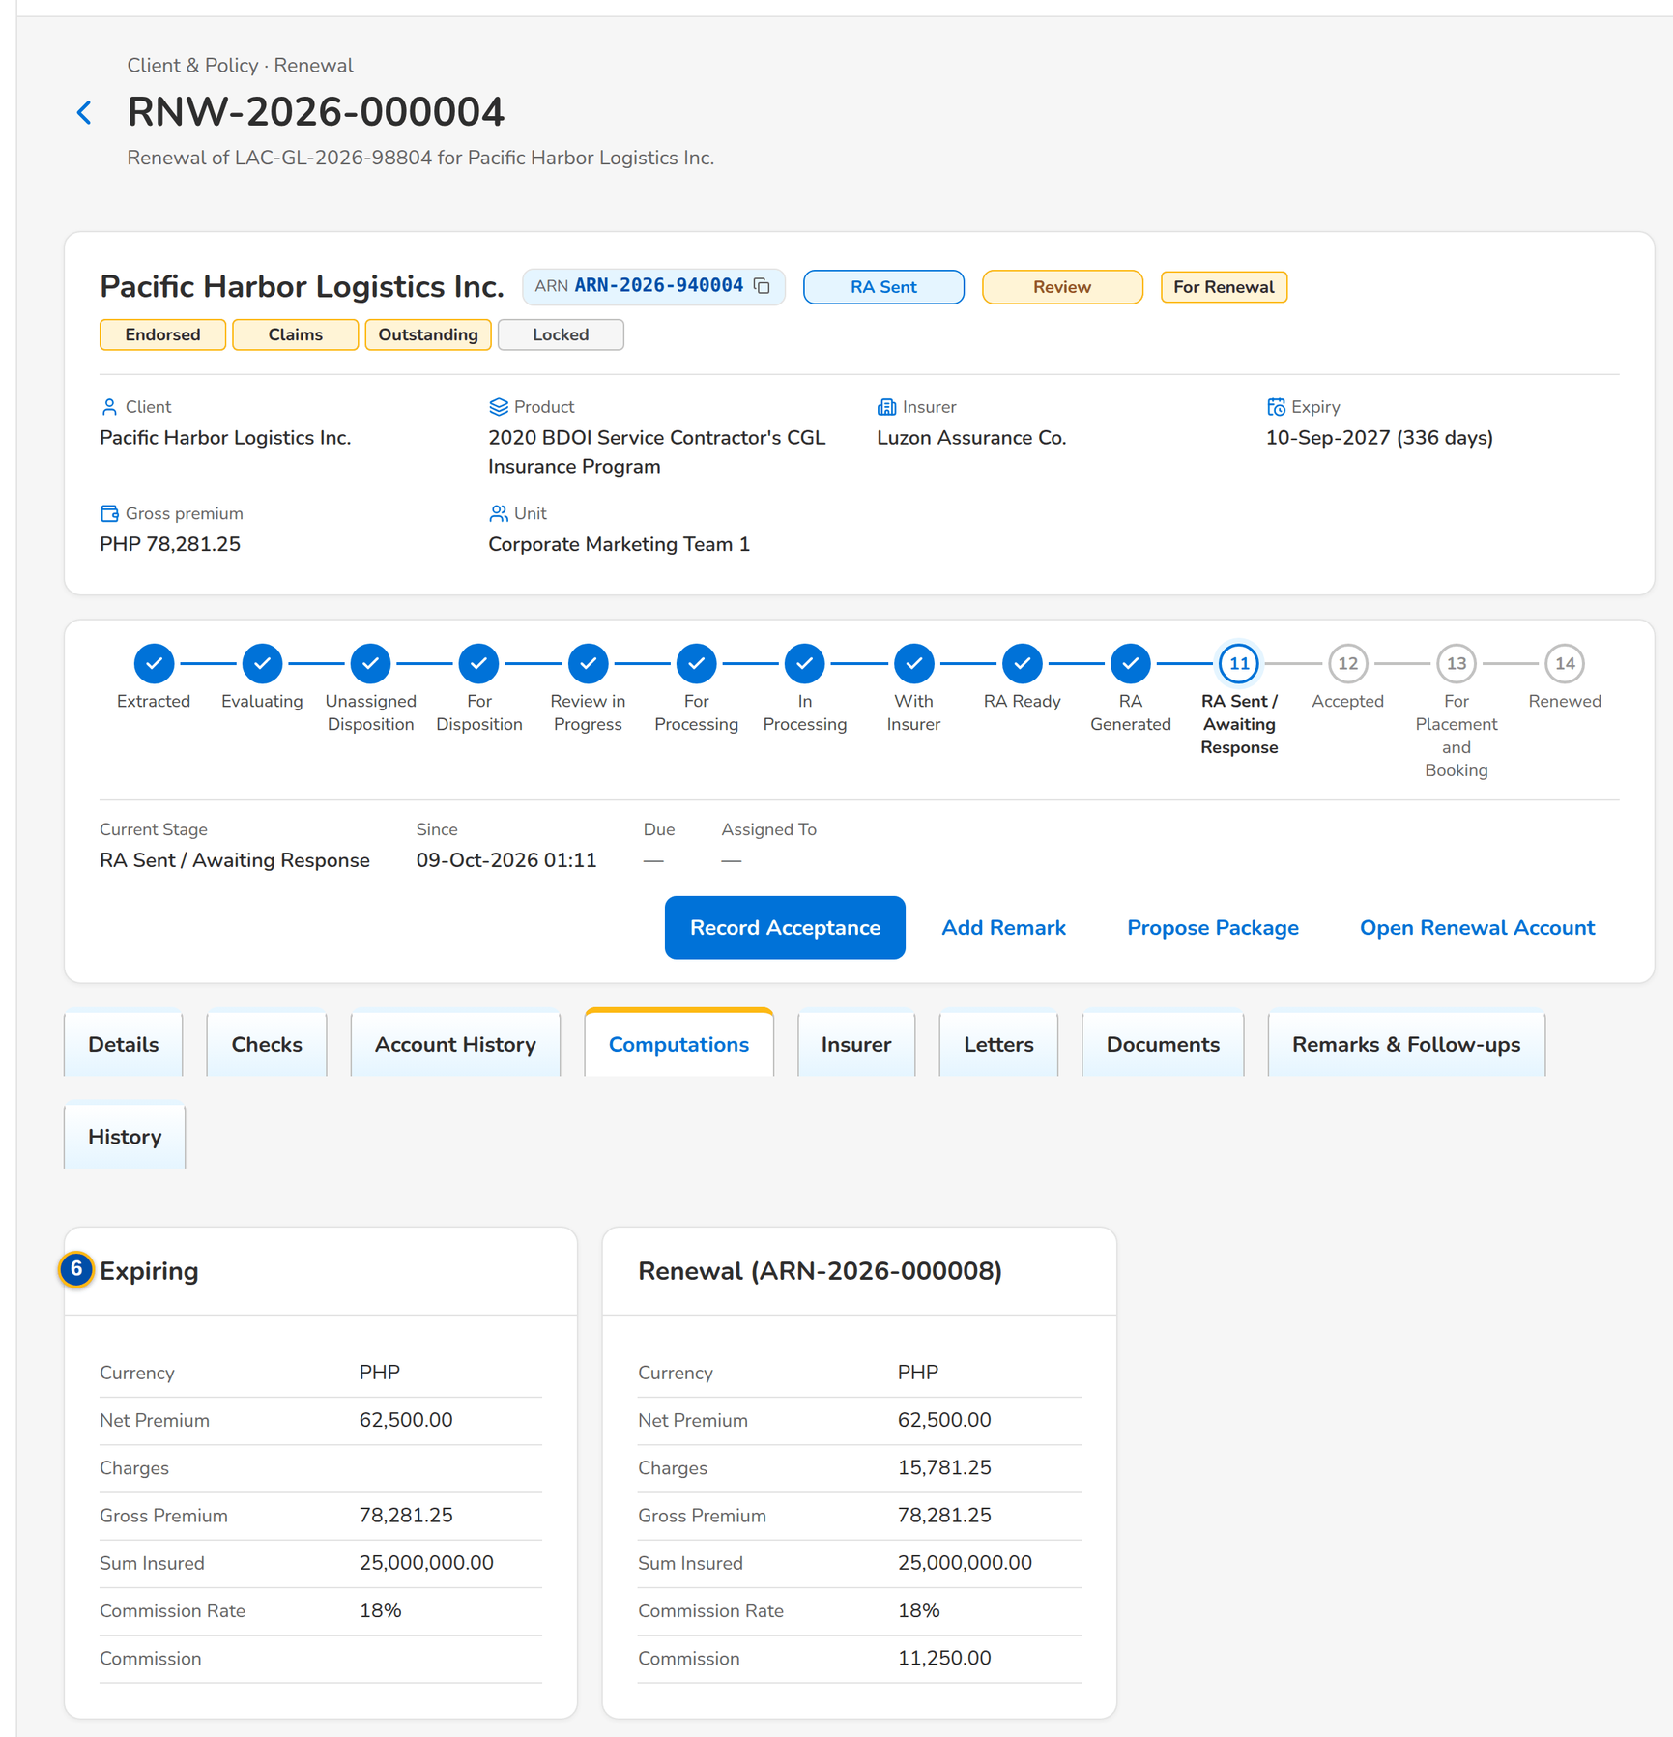
Figure 16: SCR-RN-04 Computations tab: the expiring terms and the renewal terms

Fields (No. = callout number on the first screenshot)
No. | Section | Field | Type | Length / format | Mand. | Source / list | Default | Editable in | Validation | Message when it fails
1 | Check results | Check / Result / Severity / Message | Column | Name of the check; Pass, Warning, Fail, Information or Not applicable; severity as on Renewal Setup; the finding | - | Latest check run | - | Read only | - | The checks have not run yet
2 | Classification history | When / From / To / Cause / Remarks / By | Column | dd-MMM-yyyy HH:mm; classification pills; Classification rules or Override; the user's name | - | Classification changes | - | Read only | - | No classification yet
3 | Endorsements linked | Reference / Source / Status / Linked | Column | The endorsements of the term of the expiring policy | - | Booking and Adjustment | - | Read only | - | No endorsements in the term
4 | Account History | View Account History | Button | Records that the officer read the history | - | - | - | - | - | -
5 | Account History | Prior renewals / Endorsements / Payments / Claims | Table | Renewal, Expiry, Expiring / Renewal ARN, Outcome; Invoice, Kind, Endorsement, Booked, Gross Premium; Invoice, Value date, Type, Component, OR No., Amount; the claims count | - | Booking, Operations ledger, Claims | - | Read only | - | No prior renewals
6 | Computations | Expiring / Renewal | Display | Currency, Net Premium, Charges, Gross Premium, Sum Insured, Commission Rate, Commission | - | Expiring invoice, renewal account | - | Read only | - | -

Actions
Button | Who | Enabled when | What happens | Resulting status | Notification
View Account History | Every Renewal user | Always | Shows the history and records that it was viewed | - | -

Business rules
• The disposition is refused until the officer has opened the account history of the renewal (FR-RN-042).
• A failed check never gives the Clean classification; the classification follows the active classification rules (FR-RN-020, FR-RN-022).
• A pending endorsement of the expiring policy fails its check until it is posted or cancelled (FR-RN-027).
• A difference between the renewal and the expiring terms beyond the tolerance is a financial impact (FR-RN-064).
Expected outcome
The officer gives the disposition knowing the history and the checks of the account.
Test cases: TC-RN-020.1-01, TC-RN-020.1-02, TC-RN-020.2-01, TC-RN-020.3-01, TC-RN-020.5-01, TC-RN-020.5-02, TC-RN-020.6-01, TC-RN-021.3-01, TC-RN-022.1-01, TC-RN-022.2-01, TC-RN-022.4-01, TC-RN-022.4-02, TC-RN-022.4-03, TC-RN-022.6-01, TC-RN-025.4-01, TC-RN-026.2-01, TC-RN-027.3-01, TC-RN-028.1-01, TC-RN-028.2-01, TC-RN-028.3-01, TC-RN-028.3-02, TC-RN-028.3-03, TC-RN-028.4-01, TC-RN-042.1-01, TC-RN-042.3-01, TC-RN-064.1-01, TC-RN-064.2-01, TC-RN-SCR-04.

13.1.5 SCR-RN-05 Renewal: Insurer, Letters, Documents, Remarks and History
Purpose | The tabs that keep the record of the renewal: the insurer responses (append-only, the latest valid one drives the renewal), the letters with their delivery and the acceptance, the documents of the renewal, the remarks and the Contact Center follow-ups, and the history of dispositions, assignments and overrides.
Who can open it | Marketing Team Leader, Marketing Account Officer (Account Broker), Processing Team Leader, Processing Officer (Broker), Contact Center, LAMD (loan status reports), Business Administrator, Auditor (permission Renewal view)
Navigation | • Menu: Client & Policy › Renewal › Expiry List › Renewal  • Renewal › Insurer, Letters, Documents, Remarks & Follow-ups or History tab
FRs | FR-RN-004, FR-RN-044, FR-RN-071, FR-RN-080, FR-RN-084

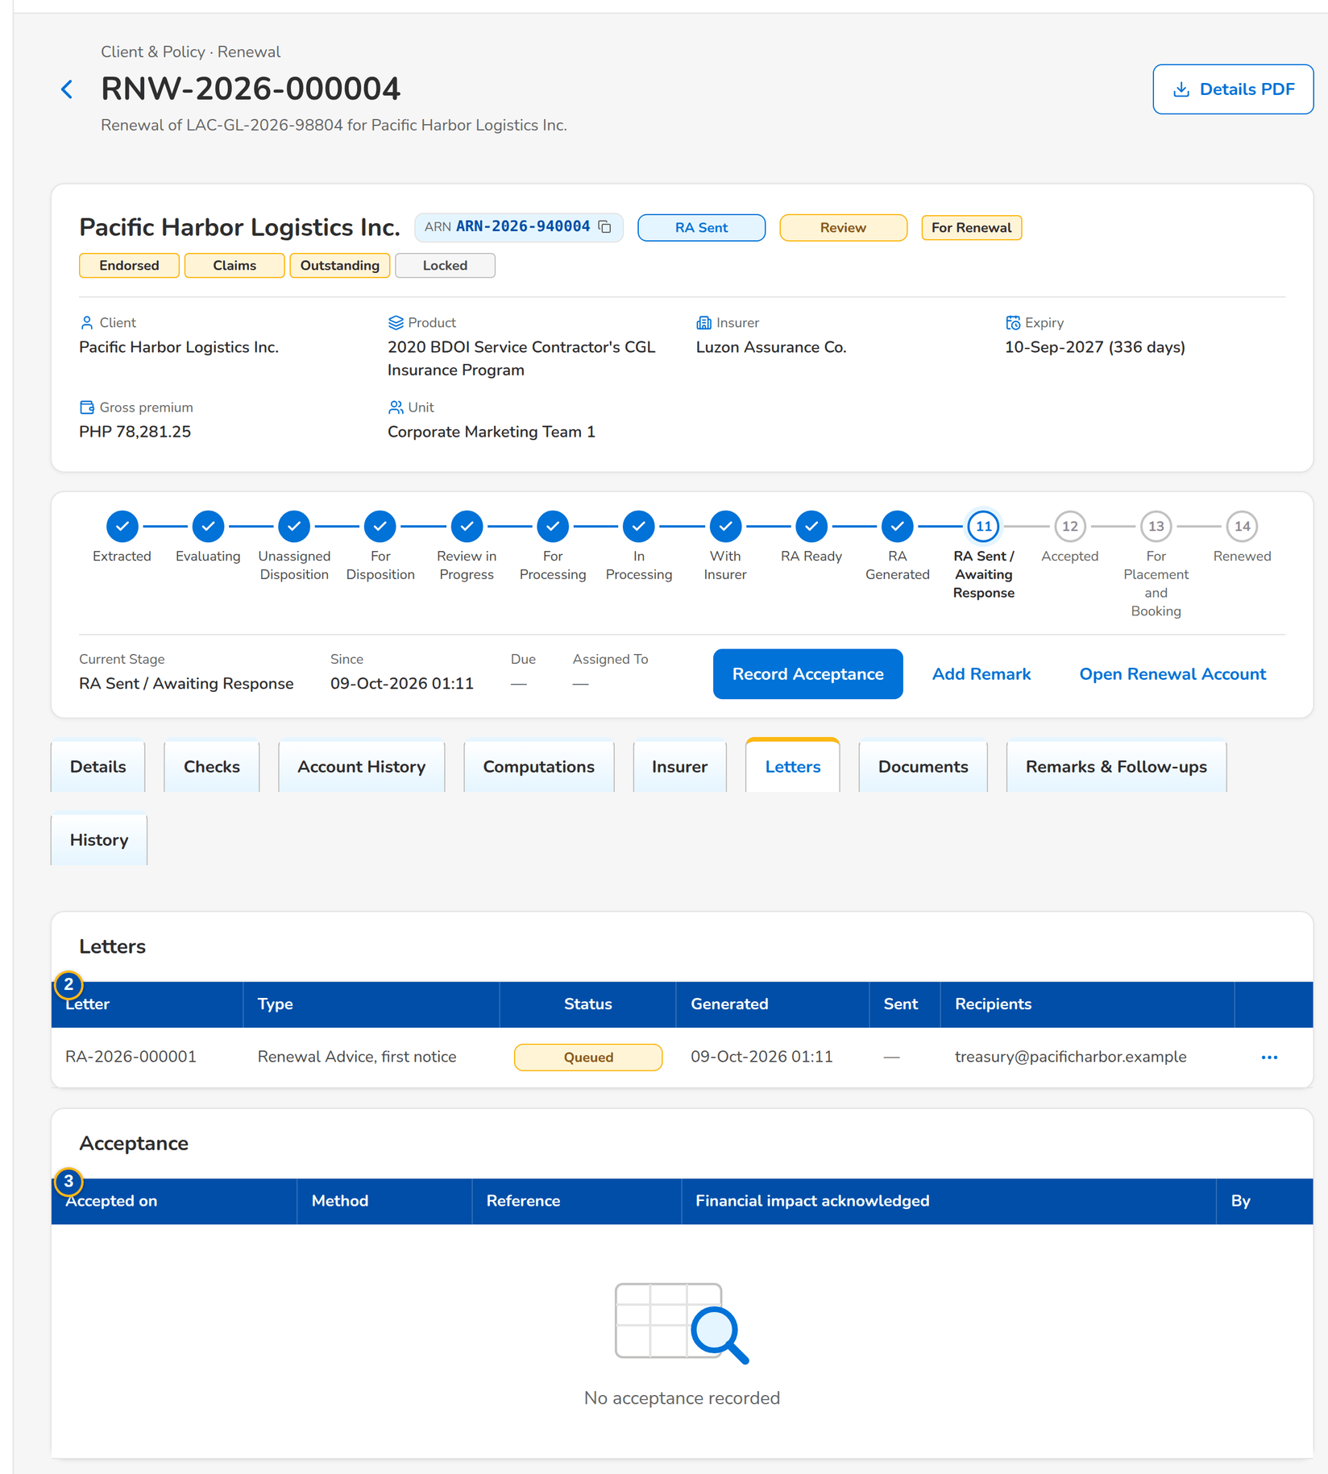
Figure 17: SCR-RN-05 Letters tab: the Renewal Advice sent to the client
1 | Received / Response / Insurer Ref / Revised Premium / Revised Sum Insured / Match / Used / Source / By | 4 | Documents of the renewal | 7 | When / Disposition / Reason / Source / Remarks / Current / By
2 | Letter / Type / Status / Generated / Sent / Recipients | 5 | When / By / Stage / Remark | 8 | When / Role / Assigned to / Previous / By
3 | Accepted on / Method / Reference / Financial impact acknowledged / By | 6 | When / Channel / Outcome / Remarks / Next action / By | 9 | When / Override / Change / Reason / Remarks / By

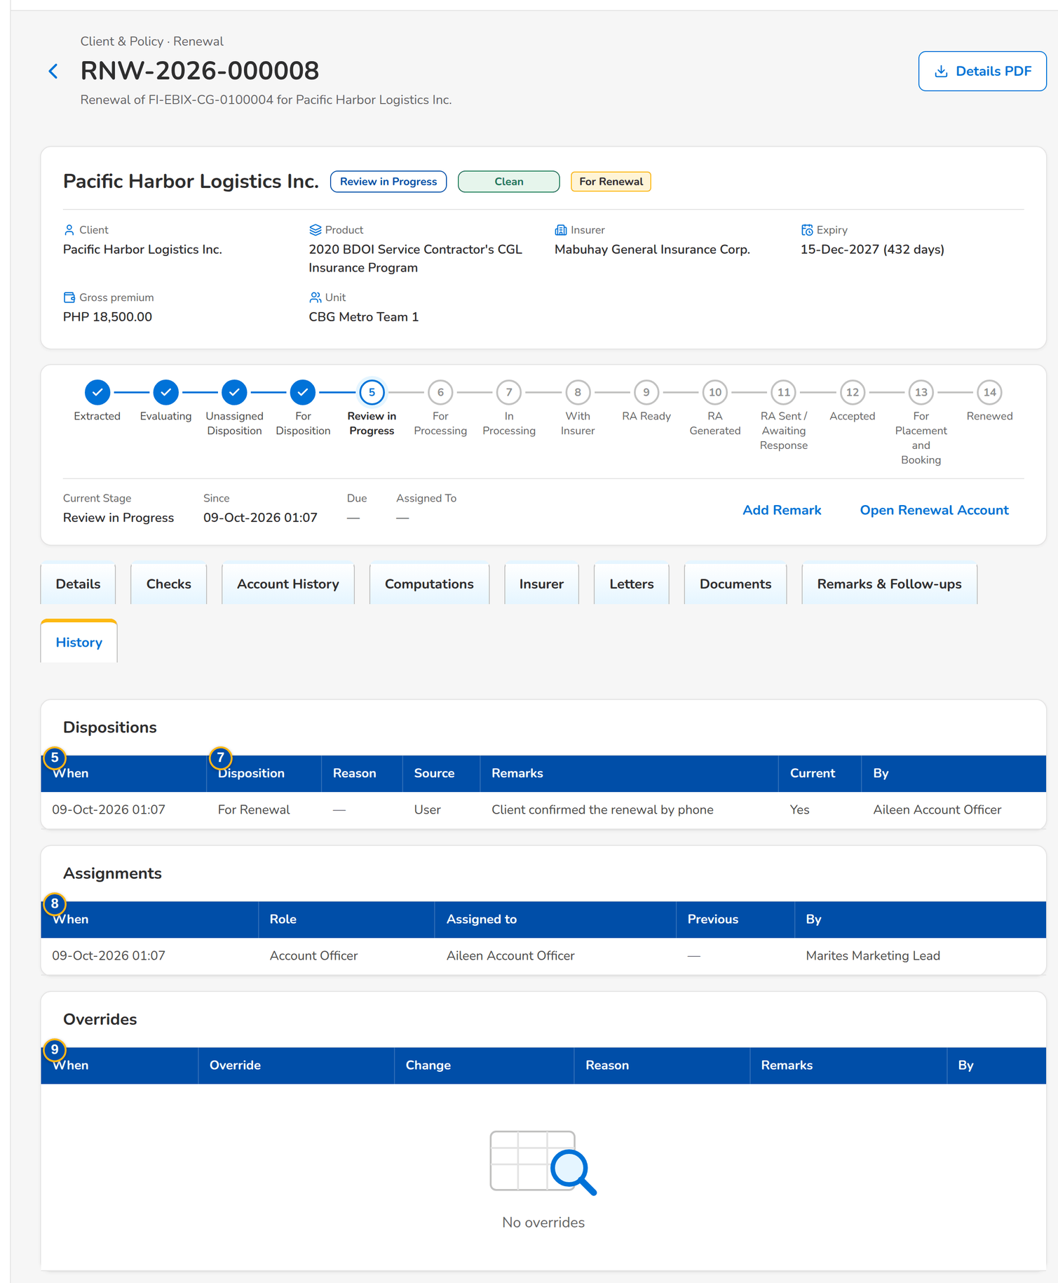
Figure 18: SCR-RN-05 History tab: the dispositions, assignments and overrides of the renewal

Fields (No. = callout number on the first screenshot)
No. | Section | Field | Type | Length / format | Mand. | Source / list | Default | Editable in | Validation | Message when it fails
1 | Insurer responses | Received / Response / Insurer Ref / Revised Premium / Revised Sum Insured / Match / Used / Source / By | Column | dd-MMM-yyyy; Renew as is, Renew with revised terms or Declined; two decimals; Matched or the mismatch; Latest valid or Late; Manual or the upload; the user's name | - | Insurer responses | - | Read only | - | No response from the insurer
2 | Letters | Letter / Type / Status / Generated / Sent / Recipients | Column | Letter number; Renewal Advice with its notice, No Advice Letter, Not for Renewal Letter; status pill; dd-MMM-yyyy HH:mm; e-mail addresses or the failure | - | Letters | - | Read only | - | No letters
3 | Acceptance | Accepted on / Method / Reference / Financial impact acknowledged / By | Column | dd-MMM-yyyy; E-mail from the client, Signed Renewal Advice or Payment; Yes or No; the user's name | - | Acceptances | - | Read only | - | No acceptance recorded
4 | Documents | Documents of the renewal | Table | Type, file, uploaded by and when; Upload | - | Documents | - | - | - | -
5 | Remarks | When / By / Stage / Remark | Column | dd-MMM-yyyy HH:mm; the user's name; stage pill | - | Remarks | - | Read only | - | No remarks
6 | Follow-ups | When / Channel / Outcome / Remarks / Next action / By | Column | Labels of the follow-up channel and outcome; dd-MMM-yyyy | - | Follow-ups | - | Read only | - | No follow-ups
7 | History: Dispositions | When / Disposition / Reason / Source / Remarks / Current / By | Column | Labels; User, System check, Decision matrix, Upload, Insurer response or LAMD report | - | Dispositions | - | Read only | - | No dispositions
8 | History: Assignments | When / Role / Assigned to / Previous / By | Column | Account Officer or Processing Officer; users' names | - | Assignments | - | Read only | - | No assignments
9 | History: Overrides | When / Override / Change / Reason / Remarks / By | Column | What was overridden; the change in words (Review to Clean); the override reason | - | Overrides | - | Read only | - | No overrides

Actions
Button | Who | Enabled when | What happens | Resulting status | Notification
Download PDF (row menu) | Every Renewal user | The letter has its PDF | Downloads the letter | - | -

Business rules
• Every action on a renewal is recorded with the user and the time; no user can change the history (FR-RN-004).
• Insurer responses are kept; only the latest valid one drives the renewal (FR-RN-071).
• Every disposition is kept; a new one supersedes the previous one (FR-RN-043).
Expected outcome
The renewal keeps its full history for review and audit.
Test cases: TC-RN-004.1-01, TC-RN-004.2-01, TC-RN-004.3-01, TC-RN-004.3-02, TC-RN-024.2-01, TC-RN-043.4-01, TC-RN-044.1-01, TC-RN-044.2-01, TC-RN-044.2-02, TC-RN-044.2-03, TC-RN-047.2-01, TC-RN-071.4-01, TC-RN-071.4-02, TC-RN-084.3-01, TC-RN-SCR-05.

13.2 Marketing: disposition, review and transfers

13.2.1 SCR-RN-06 My Dispositions
Purpose | The renewals assigned to the Account Officer, by disposition, with quick filters for the renewals to disposition, returned to the officer, due in 30 days and with no response (NRNS). The officer opens a renewal to read its history and give the disposition, pushes the dispositioned renewals to the Team Leader and transfers one to another unit.
Who can open it | Marketing Team Leader, Marketing Account Officer (Account Broker) (permission Renewal dispose)
Navigation | • Menu: Client & Policy › Renewal › My Dispositions  • Client & Policy › Renewal › My Dispositions  • Renewal Home › Returned  • Notification Renewal assigned
FRs | FR-RN-040, FR-RN-045, FR-RN-046

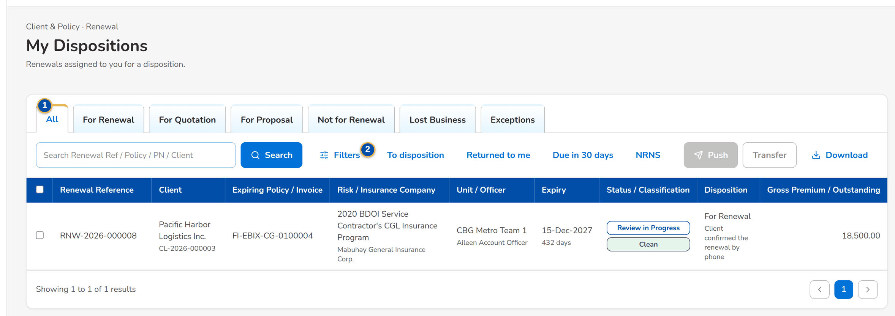
Figure 19: SCR-RN-06 My Dispositions of the Account Officer with the quick filters
1 | All / For Renewal / For Quotation / For Proposal / Not for Renewal / Lost Business / Exceptions | 2 | To disposition / Returned to me / Due in 30 days / NRNS | 3 | Columns of the renewal lists

Fields (No. = callout number on the first screenshot)
No. | Section | Field | Type | Length / format | Mand. | Source / list | Default | Editable in | Validation | Message when it fails
1 | Tabs | All / For Renewal / For Quotation / For Proposal / Not for Renewal / Lost Business / Exceptions | Tab | - | - | Disposition and classification | All | - | - | -
2 | Quick filters | To disposition / Returned to me / Due in 30 days / NRNS | Toggle button | One at a time | - | - | None | - | - | -
3 | List | Columns of the renewal lists | Column | As on the Expiry List (SCR-RN-02), the renewals assigned to the officer | - | Renewals | - | Read only | - | No renewals assigned to you

Actions
Button | Who | Enabled when | What happens | Resulting status | Notification
Push | The Account Officer | Renewals ticked | Sends the dispositioned renewals to the Team Leader; each renewal without a complete disposition is refused with the reason | Review in Progress | -
Transfer | Users with the assign permission | One renewal ticked | Opens the Transfer dialog (SCR-RN-02) | Transfer Pending | Renewal transfer requested (NT-02)
Download | Users with the export permission | Always | Downloads the list as shown | - | -

Business rules
• The officer sees the renewals assigned to him; a returned renewal carries the red Returned tag until it is pushed again (FR-RN-040, FR-RN-046).
• A renewal is pushed only with a complete disposition: Not for Renewal needs its reason (FR-RN-043, FR-RN-045).
Expected outcome
The officer works the assigned renewals and pushes them for review.
Test cases: TC-RN-002.1-01, TC-RN-031.1-02, TC-RN-040.1-01, TC-RN-040.2-01, TC-RN-040.2-02, TC-RN-040.3-01, TC-RN-040.3-02, TC-RN-040.4-01, TC-RN-040.5-01, TC-RN-044.1-02, TC-RN-045.1-01, TC-RN-045.2-01, TC-RN-045.3-01, TC-RN-046.1-01, TC-RN-046.2-01, TC-RN-046.2-02, TC-RN-046.3-01, TC-RN-SCR-06.

13.2.2 SCR-RN-07 Set Disposition, Add Remark and Re-open
Purpose | The disposition of the renewal by the Account Officer (or the Team Leader): For Renewal, For Quotation, For Proposal, Not for Renewal with its reason, or Lost Business, with remarks; Push sends it to the Team Leader. Add Remark keeps a remark on the renewal. A renewal tagged Not for Renewal can be re-opened with a reason until the re-open days after expiry. A renewal posted For Quotation or For Proposal starts its quotation or proposal request here.
Who can open it | Marketing Team Leader, Marketing Account Officer (Account Broker), Processing Team Leader, Processing Officer (Broker), Contact Center, LAMD (loan status reports), Business Administrator, Auditor (permission Renewal view)
Navigation | • Menu: Client & Policy › Renewal › My Dispositions › Renewal  • Renewal › Set Disposition, Add Remark, Re-open or Start Quotation / Proposal
FRs | FR-RN-042, FR-RN-043, FR-RN-044, FR-RN-047, FR-RN-048

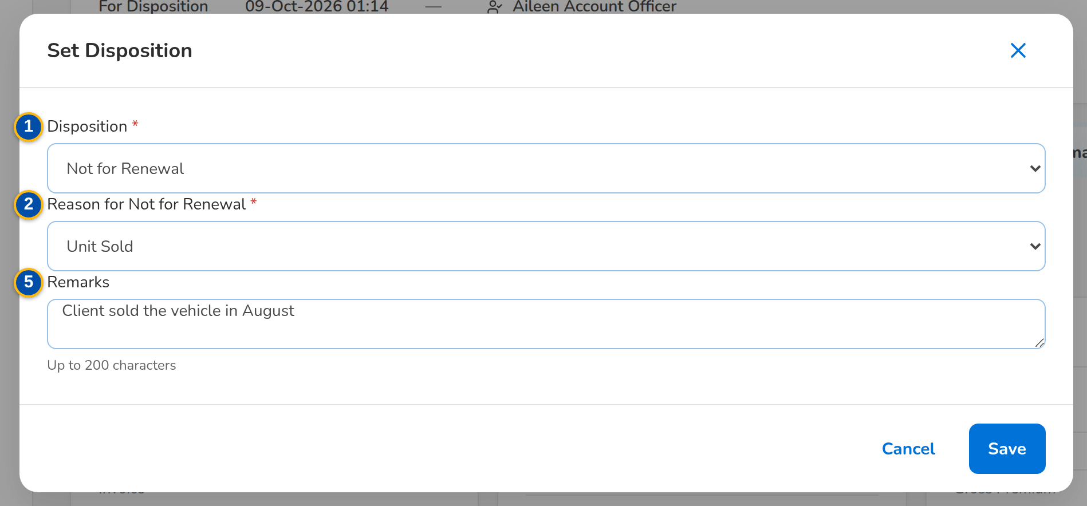
Figure 20: SCR-RN-07 Set Disposition dialog: Not for Renewal with its reason and remarks
1 | Disposition | 4 | Receiving Unit | 7 | Reason
2 | Reason for Not for Renewal | 5 | Remarks
3 | New Invoice No. | 6 | Remark

Fields (No. = callout number on the first screenshot)
No. | Section | Field | Type | Length / format | Mand. | Source / list | Default | Editable in | Validation | Message when it fails
1 | Set Disposition dialog | Disposition | Drop-down | For Renewal, Not for Renewal, For Quotation, For Proposal, Lost Business | Y | Renewal disposition list | The current disposition | For Disposition | Account history viewed | Select the disposition
2 | Set Disposition dialog | Reason for Not for Renewal | Drop-down | Reason for Not for Renewal list | Cond.: Not for Renewal | Reason for Not for Renewal | Blank | For Disposition | - | Select the reason for Not for Renewal
3 | Set Disposition dialog | New Invoice No. | Text | The invoice the policy was booked under | Cond.: reason Booked to New Invoice | Booking | Blank | For Disposition | Invoice of the ledger | Enter the new invoice number
4 | Set Disposition dialog | Receiving Unit | Drop-down | Name of the unit | Cond.: reason Transfer to Another Marketing Unit | Marketing units | Blank | For Disposition | Another active unit | Select the receiving unit
5 | Set Disposition dialog | Remarks | Text area | Up to 200 characters | N | - | Blank | For Disposition | At most 200 characters | Remarks may have at most 200 characters
6 | Add Remark dialog | Remark | Text area | Up to 200 characters | Y | - | Blank | Any open stage | Not blank | Enter the remarks
7 | Re-open dialog | Reason | Text area | Up to 200 characters | Y | - | Blank | Letter Pending, Closed as not renewed | Within the re-open days after expiry | Only a renewal tagged Not for Renewal can be re-opened

Actions
Button | Who | Enabled when | What happens | Resulting status | Notification
Set Disposition | The assigned officer or a Team Leader | For Disposition | Opens the dialog; Save keeps the disposition, which supersedes the previous one | For Disposition | -
Push | The assigned officer or a Team Leader | For Disposition with a disposition | Sends the renewal to the Team Leader | Review in Progress | -
Start Quotation / Proposal | Account Officers and Team Leaders | Posted For Quotation or For Proposal, none started | Creates the quotation or the proposal request from the expiring account | For Proposal / New Business Path | -
Add Remark | Marketing, Processing and Contact Center users | Any open stage | Keeps the remark on the Remarks & Follow-ups tab | - | -
Re-open | Account Officers and the Processing Team Leader | Letter Pending or closed as not renewed | Asks for the reason and returns the renewal for a new disposition | For Disposition | Renewal returned (NT-04)

Business rules
• The disposition needs the account history viewed first (FR-RN-042, FR-RN-043).
• Not for Renewal needs its reason; Booked to New Invoice needs the invoice and Transfer to Another Marketing Unit the receiving unit (FR-RN-043).
• A renewal with financial or structural changes is posted For Quotation or For Proposal and continues as a New Business quotation or proposal request (FR-RN-048).
• A Not for Renewal renewal can be re-opened until the re-open days after expiry (30 by default) (FR-RN-047).
Expected outcome
Each renewal has its disposition, with its reason and remarks.
Test cases: TC-RN-023.2-01, TC-RN-031.4-01, TC-RN-042.2-01, TC-RN-042.2-02, TC-RN-043.1-01, TC-RN-043.1-02, TC-RN-043.2-01, TC-RN-043.2-02, TC-RN-043.2-03, TC-RN-043.2-04, TC-RN-043.3-01, TC-RN-043.3-02, TC-RN-043.5-01, TC-RN-044.1-01, TC-RN-044.2-01, TC-RN-044.2-02, TC-RN-044.2-03, TC-RN-080.2-01, TC-RN-SCR-07, TC-RN-MSG-04.

13.2.3 SCR-RN-08 TL Review
Purpose | The dispositions of the unit waiting for the Team Leader, the exceptions, the unassigned renewals and the renewals on the quotation or proposal path. The Team Leader posts the reviewed renewals (each moves on by its disposition), returns them to the officer with a reason, overrides a failed check, the classification, the disposition or the outstanding balance with a reason, and re-assigns them.
Who can open it | Marketing Team Leader (permission Renewal review)
Navigation | • Menu: Client & Policy › Renewal › TL Review  • Client & Policy › Renewal › TL Review  • Notification of a pushed renewal
FRs | FR-RN-050, FR-RN-051, FR-RN-023

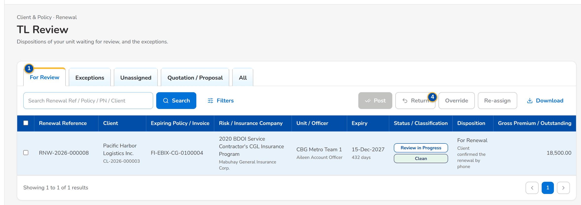
Figure 21: SCR-RN-08 TL Review: the dispositions of the unit waiting for review with the actions of the Team Leader
1 | For Review / Exceptions / Unassigned / Quotation / Proposal / All | 3 | Reason / Remarks | 5 | Check / New value
2 | Columns of the renewal lists | 4 | Override | 6 | Reason / Remarks

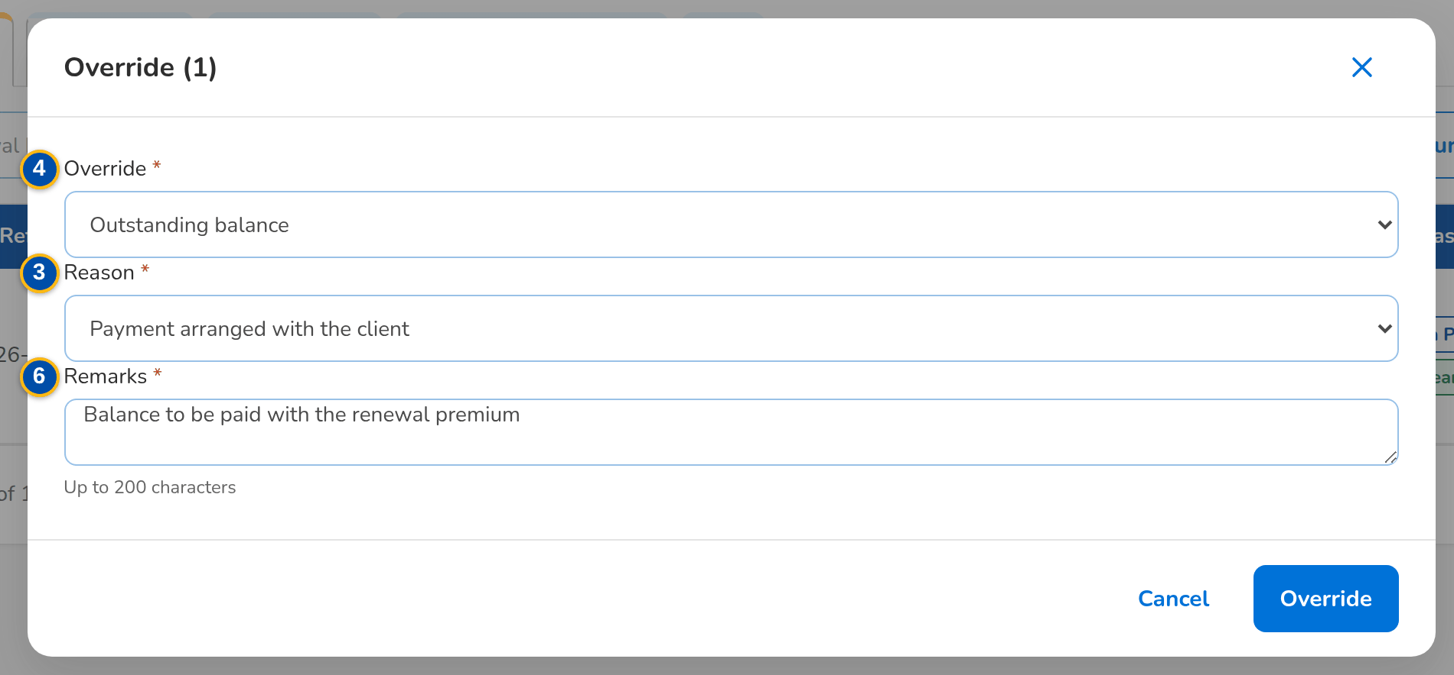
Figure 22: SCR-RN-08 Override dialog: the outstanding balance with the reason and remarks
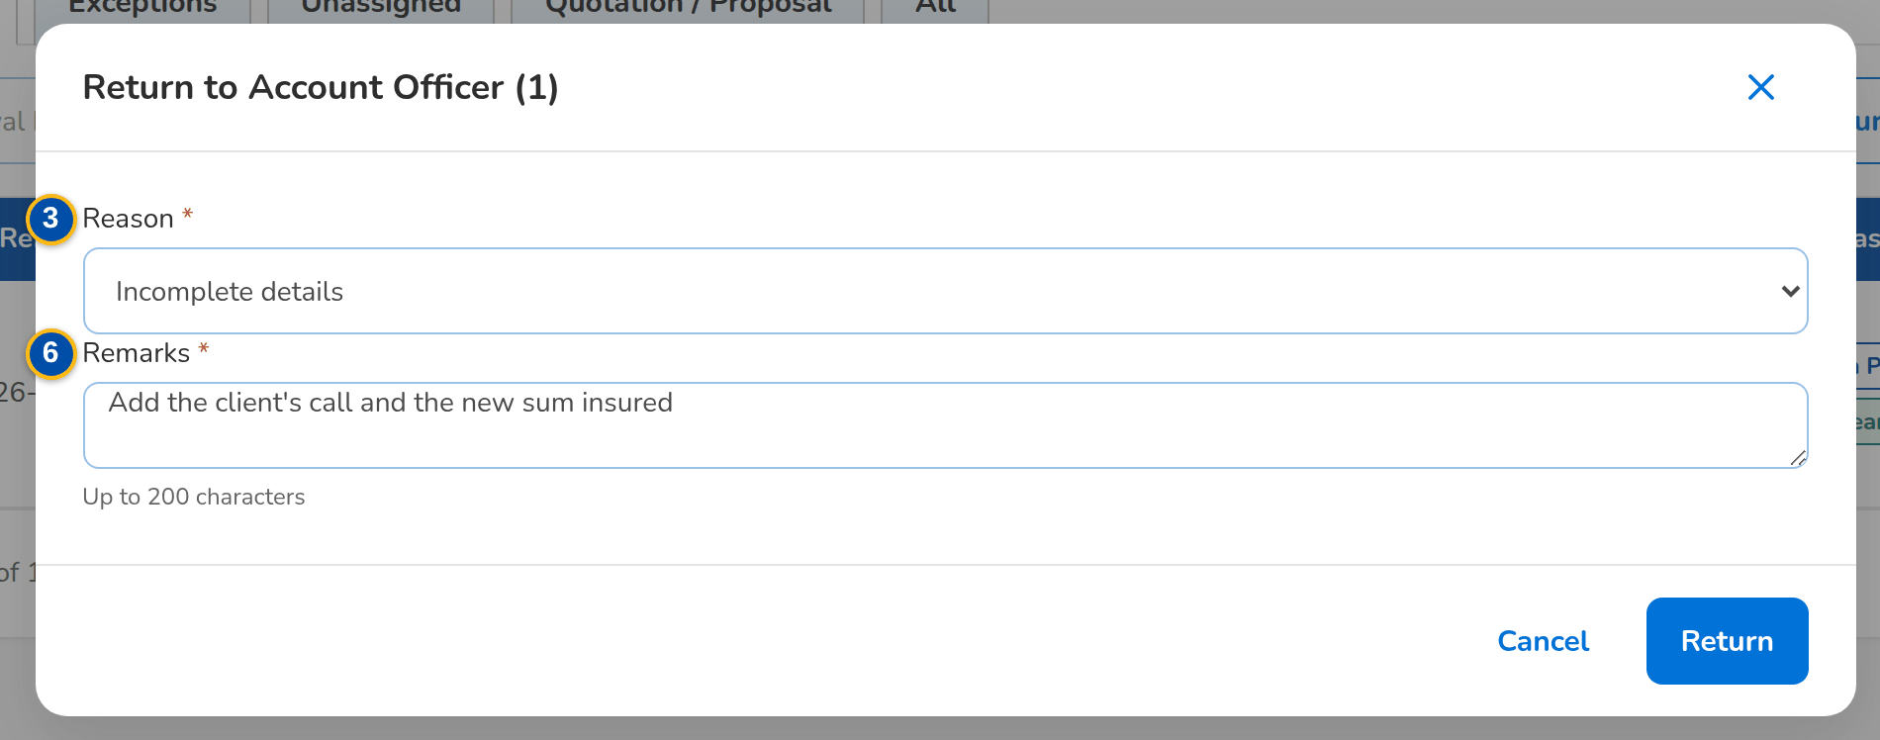
Figure 23: SCR-RN-08 Return to Account Officer dialog with the reason and remarks
Fields (No. = callout number on the first screenshot)
No. | Section | Field | Type | Length / format | Mand. | Source / list | Default | Editable in | Validation | Message when it fails
1 | Tabs | For Review / Exceptions / Unassigned / Quotation / Proposal / All | Tab | - | - | Stage and classification | For Review | - | - | -
2 | List | Columns of the renewal lists | Column | As on the Expiry List (SCR-RN-02), the renewals of the unit | - | Renewals | - | Read only | - | No renewals to display
3 | Return dialog | Reason / Remarks | Drop-down, text area | Renewal return reason list; up to 200 characters | Y / Y | Renewal return reason | Blank | Review in Progress | - | Select a reason for 'Return'
4 | Override dialog | Override | Drop-down | Outstanding balance, Failed check, Classification, Disposition, Insurer response mismatch, Unlock the Renewal Advice | Y | Fixed list | Blank | Any open stage | - | Select the kind of override
5 | Override dialog | Check / New value | Drop-down | The failing check; the new classification or disposition | Cond.: failed check, classification or disposition | Checks, classifications, dispositions | Blank | Any open stage | A failed check never turns Clean | An override never turns a failed check into Clean
6 | Override dialog | Reason / Remarks | Drop-down, text area | Renewal override reason list; up to 200 characters | Y / Y | Renewal override reason | Blank | Any open stage | - | Select the reason of the override

Actions
Button | Who | Enabled when | What happens | Resulting status | Notification
Post | Marketing Team Leader | Renewals ticked | Asks for confirmation; For Renewal goes to Processing, For Quotation and For Proposal to the New Business path, Not for Renewal to the letter step, Lost Business is closed | For Processing, For Proposal / New Business Path, Letter Pending or Closed | Renewal posted (NT-05)
Return | Marketing Team Leader | Renewals ticked | Opens the dialog; the renewal goes back to its officer with the Returned tag | For Disposition | Renewal returned (NT-04)
Override | Marketing Team Leader (override permission) | Renewals ticked | Opens the dialog; the override is kept with its reason in the history | The stage the override allows | -
Re-assign | Marketing Team Leader | Renewals ticked | Opens the Assign Disposition dialog (SCR-RN-02) | For Disposition | Renewal assigned (NT-01)

Business rules
• A renewal For Renewal or on the New Business path with a failing blocking check is not posted until the check passes or is overridden (FR-RN-050).
• Straight-through renewals (an automatic disposition of a Clean renewal) move on without review (FR-RN-023).
• The outstanding balance of the expiring invoice is overridden by the Team Leader with mandatory remarks (FR-RN-051).
• Not for Renewal is given through the disposition with its reason, never by an override (FR-RN-051).
Expected outcome
The reviewed renewals move on by their disposition.
Test cases: TC-RN-027.1-01, TC-RN-050.1-01, TC-RN-050.2-01, TC-RN-050.2-02, TC-RN-050.3-01, TC-RN-050.3-02, TC-RN-050.4-01, TC-RN-051.1-01, TC-RN-051.2-01, TC-RN-051.4-01, TC-RN-051.4-02, TC-RN-SCR-08, TC-RN-MSG-05.

13.2.4 SCR-RN-09 Transfers
Purpose | The requests to move a renewal to another Marketing unit: Incoming for the receiving Team Leader, who accepts or declines them with remarks; Outgoing for the requesting unit, which may cancel an open request.
Who can open it | Marketing Team Leader, Marketing Account Officer (Account Broker) (permission Renewal assign)
Navigation | • Menu: Client & Policy › Renewal › Transfers  • Client & Policy › Renewal › Transfers  • Notification Renewal transfer requested
FRs | FR-RN-031, FR-RN-032

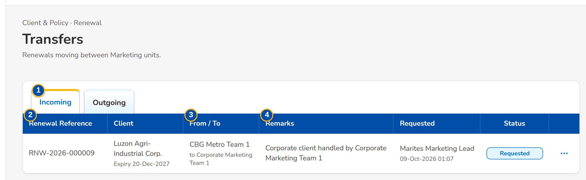
Figure 24: SCR-RN-09 Transfers, Incoming: the request from another unit with its row action menu
1 | Incoming / Outgoing | 3 | From / To | 5 | Remarks
2 | Renewal Reference / Client | 4 | Remarks / Requested / Status

Fields (No. = callout number on the first screenshot)
No. | Section | Field | Type | Length / format | Mand. | Source / list | Default | Editable in | Validation | Message when it fails
1 | Tabs | Incoming / Outgoing | Tab | - | - | Transfer requests | Incoming | - | - | -
2 | List | Renewal Reference / Client | Column | Reference; client with the expiry under it | - | Transfers | - | Read only | - | No transfers
3 | List | From / To | Column | Name of the sending unit with the receiving unit under it | - | Sales organisation | - | Read only | - | -
4 | List | Remarks / Requested / Status | Column | Remarks of the request; the requester's name with the time; Requested, Accepted, Declined or Cancelled | - | Transfers | - | Read only | - | -
5 | Accept or Decline dialog | Remarks | Text area | Up to 200 characters | Cond.: decline | - | Blank | Requested | Not blank to decline | Enter the remarks

Actions
Button | Who | Enabled when | What happens | Resulting status | Notification
Accept (row menu) | A Team Leader of the receiving unit | Requested | Asks for remarks; the renewal joins the unit, unassigned | Unassigned Disposition | Renewal transfer decided (NT-03)
Decline (row menu) | A Team Leader of the receiving unit | Requested | Asks for the remarks; the renewal returns to the sending unit | The stage before the request | Renewal transfer decided (NT-03)
Cancel Request (row menu) | The requester | Requested | Asks for confirmation; the renewal stays with the unit | The stage before the request | -

Business rules
• Only a Team Leader of the receiving unit decides a transfer; only the requester cancels it (FR-RN-032).
• An accepted renewal waits in the Unassigned tab of the receiving unit for its Account Officer (FR-RN-032).
Expected outcome
The renewal is with the unit that handles the client.
Test cases: TC-RN-031.3-02, TC-RN-032.2-01, TC-RN-032.3-01, TC-RN-032.3-02, TC-RN-032.4-01, TC-RN-SCR-09, TC-RN-MSG-06.

13.3 Processing and the insurer

13.3.1 SCR-RN-10 Processing Worklist
Purpose | The renewals posted For Renewal, by tab: for processing, in processing, with the insurer, insurer responded and returned. The Processing Team Leader assigns a Processing Officer (or takes them); the officer creates the renewal account and works the renewal; a renewal that cannot proceed is returned to Marketing with a reason. The dispositioned file of Marketing is uploaded here.
Who can open it | Processing Team Leader, Processing Officer (Broker) (permission Renewal process)
Navigation | • Menu: Client & Policy › Renewal › Processing Worklist  • Client & Policy › Renewal › Processing Worklist  • Renewal Home › Insurer reply overdue  • Notification Renewal posted
FRs | FR-RN-060, FR-RN-061, FR-RN-062, FR-RN-063, FR-RN-065

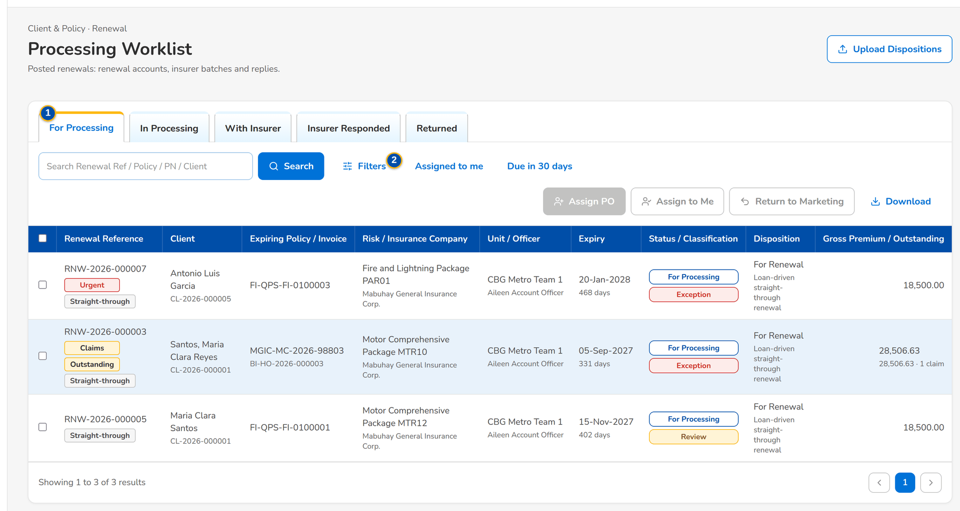
Figure 25: SCR-RN-10 Processing Worklist of the Processing Team Leader with the actions of the tab
1 | For Processing / In Processing / With Insurer / Insurer Responded / Returned | 4 | Processing Officer | 7 | Upload wizard: Renewal Reference, Disposition, Reason, New Invoice No, Remarks
2 | Assigned to me / Due in 30 days | 5 | Return to | 8 | Expiry From / Expiry To / Unit
3 | Columns of the renewal lists | 6 | Reason / Remarks

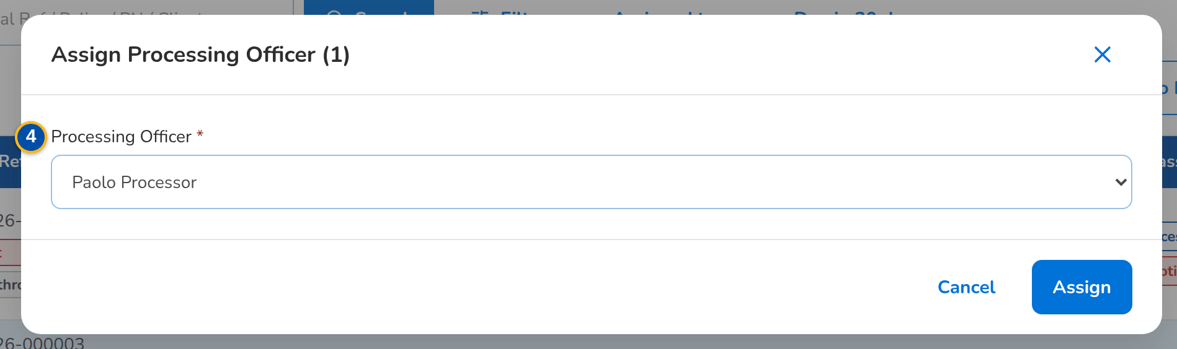
Figure 26: SCR-RN-10 Assign Processing Officer dialog
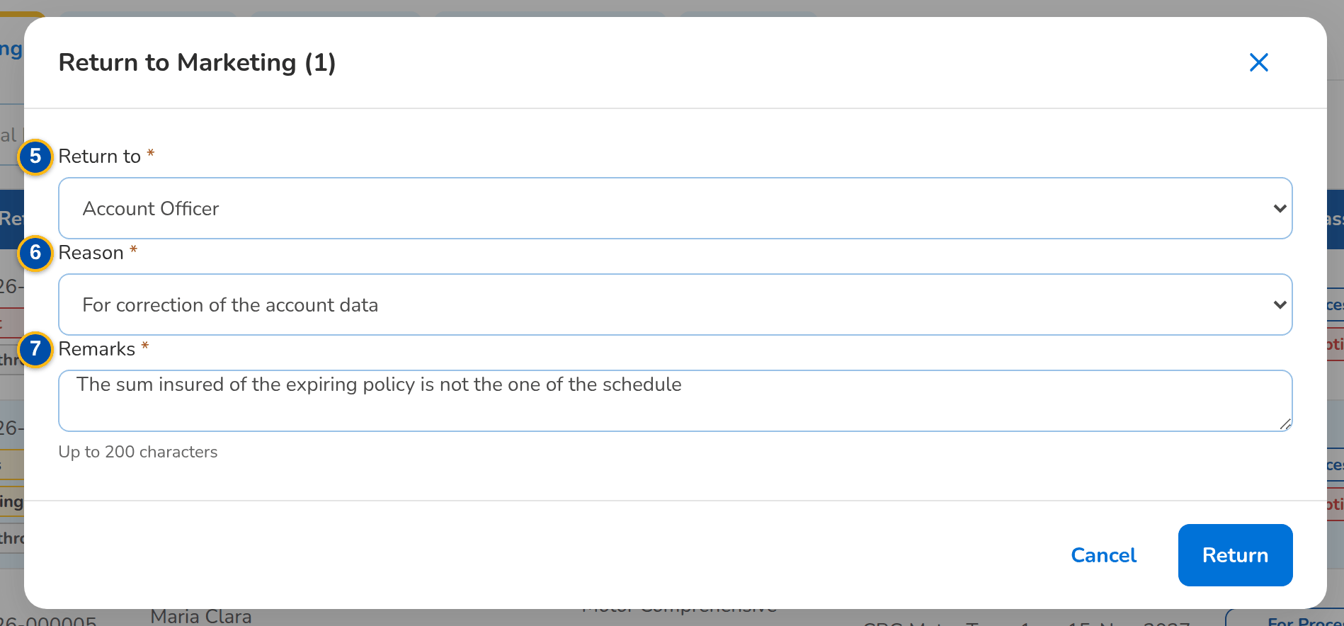
Figure 27: SCR-RN-10 Return to Marketing dialog: to the officer or the Team Leader, with the reason
Fields (No. = callout number on the first screenshot)
No. | Section | Field | Type | Length / format | Mand. | Source / list | Default | Editable in | Validation | Message when it fails
1 | Tabs | For Processing / In Processing / With Insurer / Insurer Responded / Returned | Tab | - | - | Processing stage | For Processing | - | - | -
2 | Quick filters | Assigned to me / Due in 30 days | Toggle button | One at a time | - | - | None | - | - | -
3 | List | Columns of the renewal lists | Column | As on the Expiry List (SCR-RN-02) | - | Renewals | - | Read only | - | No renewals to display
4 | Assign Processing Officer dialog | Processing Officer | Drop-down | Name of the officer | Y | Processing Officers | Blank | For Processing, In Processing | Active Processing Officer | <officer> is not a Processing Officer
5 | Return to Marketing dialog | Return to | Drop-down | Account Officer or Team Leader | Y | Fixed list | Account Officer | For Processing, In Processing | - | -
6 | Return to Marketing dialog | Reason / Remarks | Drop-down, text area | Renewal return reason list; up to 200 characters | Y / Y | Renewal return reason | Blank | For Processing, In Processing | - | Select a reason for 'Return to Marketing'
7 | Upload Dispositions | Upload wizard: Renewal Reference, Disposition, Reason, New Invoice No, Remarks | Upload | Template of the dispositioned file | - | Renewals | - | For Disposition | Every row checked before anything is saved | Disposition <disposition> is not valid
8 | Complete file | Expiry From / Expiry To / Unit | Date, date, text | The expiry range and the unit the file covers | Y | - | Blank | After the upload | - | Enter the expiry range and the unit of the complete file

Actions
Button | Who | Enabled when | What happens | Resulting status | Notification
Assign PO | Processing Team Leader | Renewals ticked | Opens the dialog; Assign gives the renewals to the officer | In Processing | Renewal assigned (NT-01)
Assign to Me | Processing Team Leader | Renewals ticked | Assigns the renewals to the user | In Processing | -
Return to Marketing | Processing Team Leader and Officers | Renewals ticked | Opens the dialog; the renewal goes back to the officer or the Team Leader | For Disposition or Review in Progress | Renewal returned (NT-04)
Upload Dispositions | Processing Team Leader and Officers (upload permission) | Always | Opens the upload of the dispositioned file; Declare Complete File tags the renewals of the range and unit missing from it | For Disposition with the dispositions of the file | -
Create Renewal Account (renewal) | Processing Officers | For Processing or In Processing without a renewal account | Creates the renewal account (business type Renewal) from the expiring account | - | -

Business rules
• A renewal is assigned to one Processing Officer at a time; the Team Leader may re-assign it (FR-RN-061).
• The renewal account is created once, from the expiring account, and books as business type Renewal (FR-RN-063).
• A return to Marketing needs a reason and remarks; the renewal goes back to the officer or to the Team Leader (FR-RN-065).
• A file declared complete tags the renewals of the range and unit missing from it as not in the file (FR-RN-060).
Expected outcome
The posted renewals are processed by their officers.
Test cases: TC-RN-002.2-01, TC-RN-013.3-02, TC-RN-014.4-01, TC-RN-016.3-01, TC-RN-016.3-02, TC-RN-016.4-01, TC-RN-016.4-02, TC-RN-021.2-01, TC-RN-021.2-02, TC-RN-060.1-01, TC-RN-060.1-02, TC-RN-060.2-01, TC-RN-060.3-01, TC-RN-060.3-02, TC-RN-060.4-01, TC-RN-060.4-02, TC-RN-060.4-03, TC-RN-061.1-01, TC-RN-061.1-02, TC-RN-061.2-01, TC-RN-061.3-01, TC-RN-061.3-02, TC-RN-062.1-01, TC-RN-062.1-02, TC-RN-062.2-01, TC-RN-065.1-01, TC-RN-065.1-02, TC-RN-065.2-01, TC-RN-065.2-02, TC-RN-SCR-10, TC-RN-MSG-07.

13.3.2 SCR-RN-11 Insurer Batches
Purpose | The renewals sent to each insurer for its renewal terms: New Batch takes the renewals of an insurer in processing for an expiry range with the 28 columns of the insurer extract; the batch is downloaded or sent to the insurer, protected; Upload Insurer Responses records the replies of the insurer's file.
Who can open it | Processing Team Leader, Processing Officer (Broker) (permission Renewal insurer)
Navigation | • Menu: Client & Policy › Renewal › Insurer Batches  • Client & Policy › Renewal › Insurer Batches
FRs | FR-RN-070, FR-RN-071

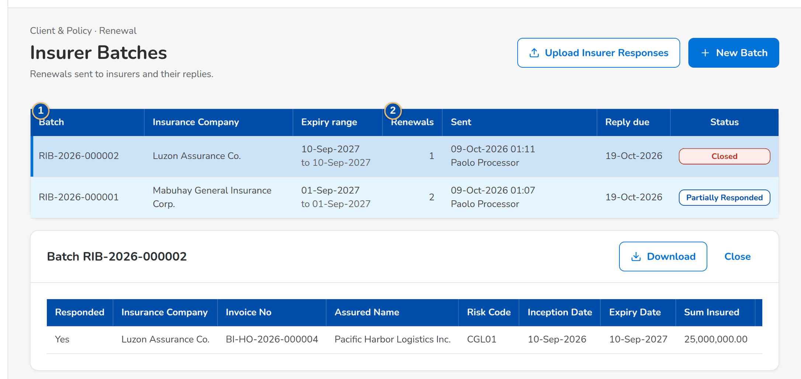
Figure 28: SCR-RN-11 Insurer Batches with the batch opened: the renewals and the columns of the extract
1 | Batch / Insurance Company / Expiry range | 3 | Responded / [the 28 columns of the insurer extract] | 5 | Expiry From / Expiry To
2 | Renewals / Sent / Reply due / Status | 4 | Insurance Company | 6 | Upload wizard: Renewal Reference, Policy No, Response, Insurer Reference, Revised Premium, Revised Sum Insured, Revised Rate, Terms, Received On, Reject Action, Remarks

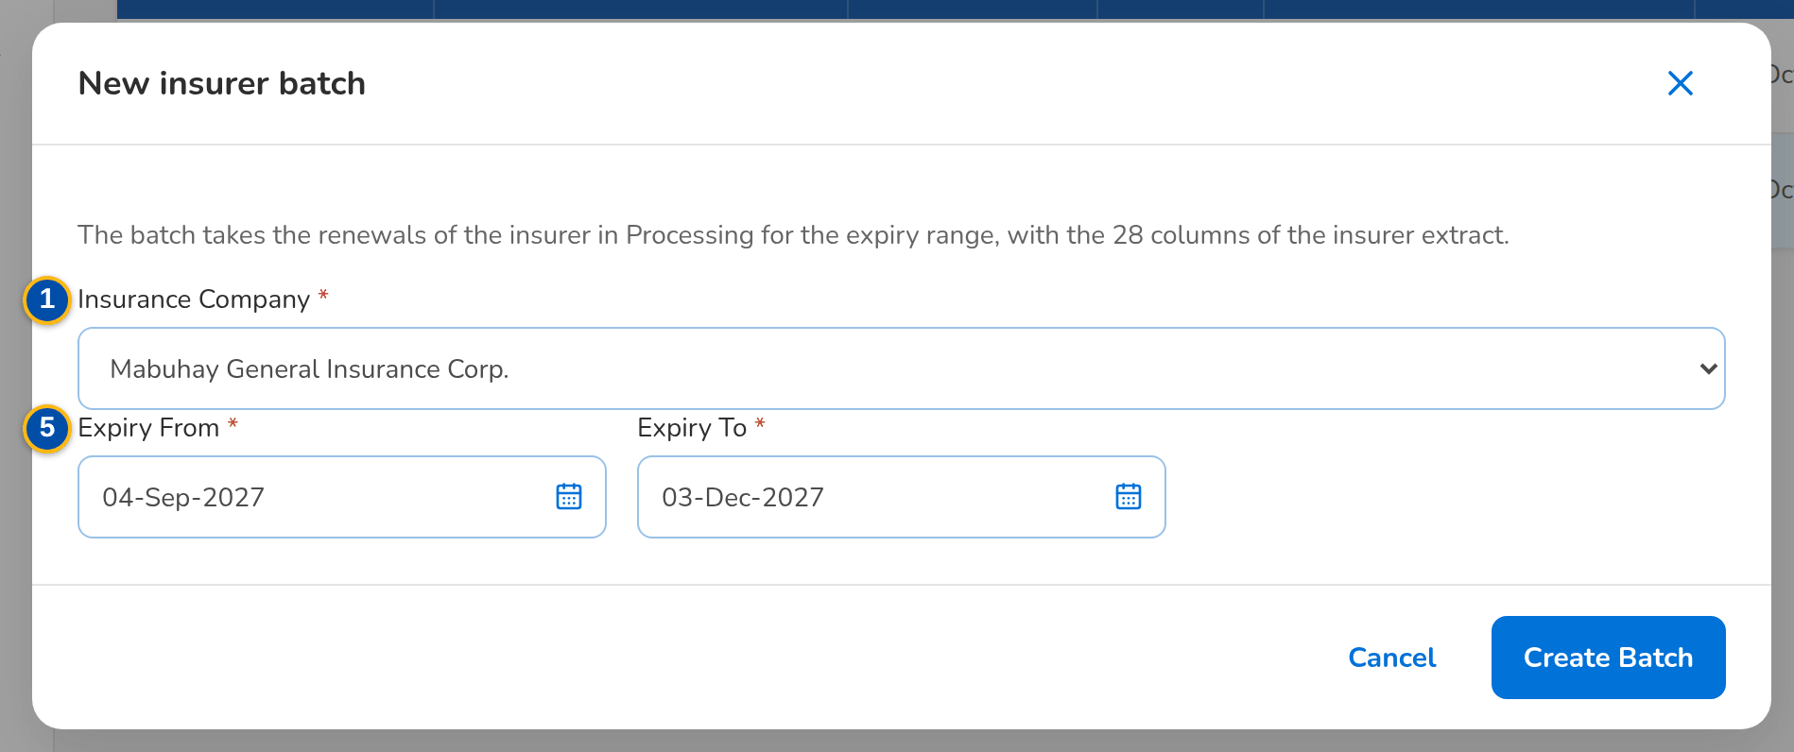
Figure 29: SCR-RN-11 New insurer batch dialog: the insurer and the expiry range
Fields (No. = callout number on the first screenshot)
No. | Section | Field | Type | Length / format | Mand. | Source / list | Default | Editable in | Validation | Message when it fails
1 | List | Batch / Insurance Company / Expiry range | Column | Batch number; name of the insurer; the range as a period | - | Insurer batches | - | Read only | - | No insurer batches
2 | List | Renewals / Sent / Reply due / Status | Column | Number of renewals; time and the sender's name; dd-MMM-yyyy; Draft, Sent, Partially Responded or Closed | - | Insurer batches | - | Read only | - | -
3 | Batch | Responded / [the 28 columns of the insurer extract] | Table | Yes or No for each renewal; Insurance Company, Invoice No, Assured Name, Risk Code, Inception Date, Expiry Date, Sum Insured, Premium Amount and the other columns of FRS section 6.4 | - | Renewals of the batch | - | Read only | - | -
4 | New insurer batch dialog | Insurance Company | Drop-down | Name of the insurer | Y | Insurers of the renewals | Blank | New | - | Select the insurer
5 | New insurer batch dialog | Expiry From / Expiry To | Date | dd-MMM-yyyy; the end on or after the start | Y | - | Blank | New | Valid range | Enter a valid start and end date
6 | Upload Insurer Responses | Upload wizard: Renewal Reference, Policy No, Response, Insurer Reference, Revised Premium, Revised Sum Insured, Revised Rate, Terms, Received On, Reject Action, Remarks | Upload | Template of the insurer responses | - | Renewals with the insurer | - | With Insurer | Every row checked before anything is saved | Response <response> is not valid

Actions
Button | Who | Enabled when | What happens | Resulting status | Notification
New Batch | Processing (insurer permission) | Always | Opens the dialog; Create Batch takes the renewals of the insurer in the range | Draft | -
Download | Every user of the screen | A batch is open | Downloads the insurer extract | - | -
Send to Insurer | Processing (insurer permission) | Draft | Asks for confirmation; the extract is e-mailed protected to the insurer's renewal contacts | Sent; the renewals With Insurer | Insurer extract e-mail (NT-18)
Upload Insurer Responses | Processing (insurer permission) | Always | Opens the upload of the insurer's file; each response is matched to its renewal | Insurer Responded | Insurer renewal response (NT-06)
Close | Every user of the screen | A batch is open | Closes the batch | - | -

Business rules
• A batch takes the For Renewal renewals of one insurer in processing for the expiry range; a batch is sent once (FR-RN-070).
• The insurer has the reply days (10 by default) to answer; a batch past its reply date raises the insurer overdue alert (FR-RN-070).
• Responses are captured once and kept; Renew As Is with a match moves the renewal to the Renewal Advice without re-keying; a revision raises the financial impact; a rejection re-markets or closes the renewal (FR-RN-071).
Expected outcome
The insurers receive the renewals and their decisions are recorded.
Test cases: TC-RN-070.1-01, TC-RN-070.1-02, TC-RN-070.2-01, TC-RN-070.3-02, TC-RN-070.4-01, TC-RN-070.4-02, TC-RN-070.4-03, TC-RN-071.1-01, TC-RN-071.2-01, TC-RN-071.2-02, TC-RN-071.3-01, TC-RN-071.3-02, TC-RN-071.3-03, TC-RN-071.3-04, TC-RN-SCR-11, TC-RN-MSG-08.

13.3.3 SCR-RN-12 Record Insurer Response
Purpose | The insurer's answer for one renewal, recorded by hand when it does not come in the insurer's file: renew as is, renew with revised terms (the revised premium and sum insured) or declined, with the insurer reference and the date received; a declined renewal is re-marketed to another insurer or goes to the No Advice Letter.
Who can open it | Marketing Team Leader, Marketing Account Officer (Account Broker), Processing Team Leader, Processing Officer (Broker), Contact Center, LAMD (loan status reports), Business Administrator, Auditor (permission Renewal view)
Navigation | • Menu: Client & Policy › Renewal › Processing Worklist › Renewal  • Renewal (With Insurer) › Record Insurer Response
FRs | FR-RN-071

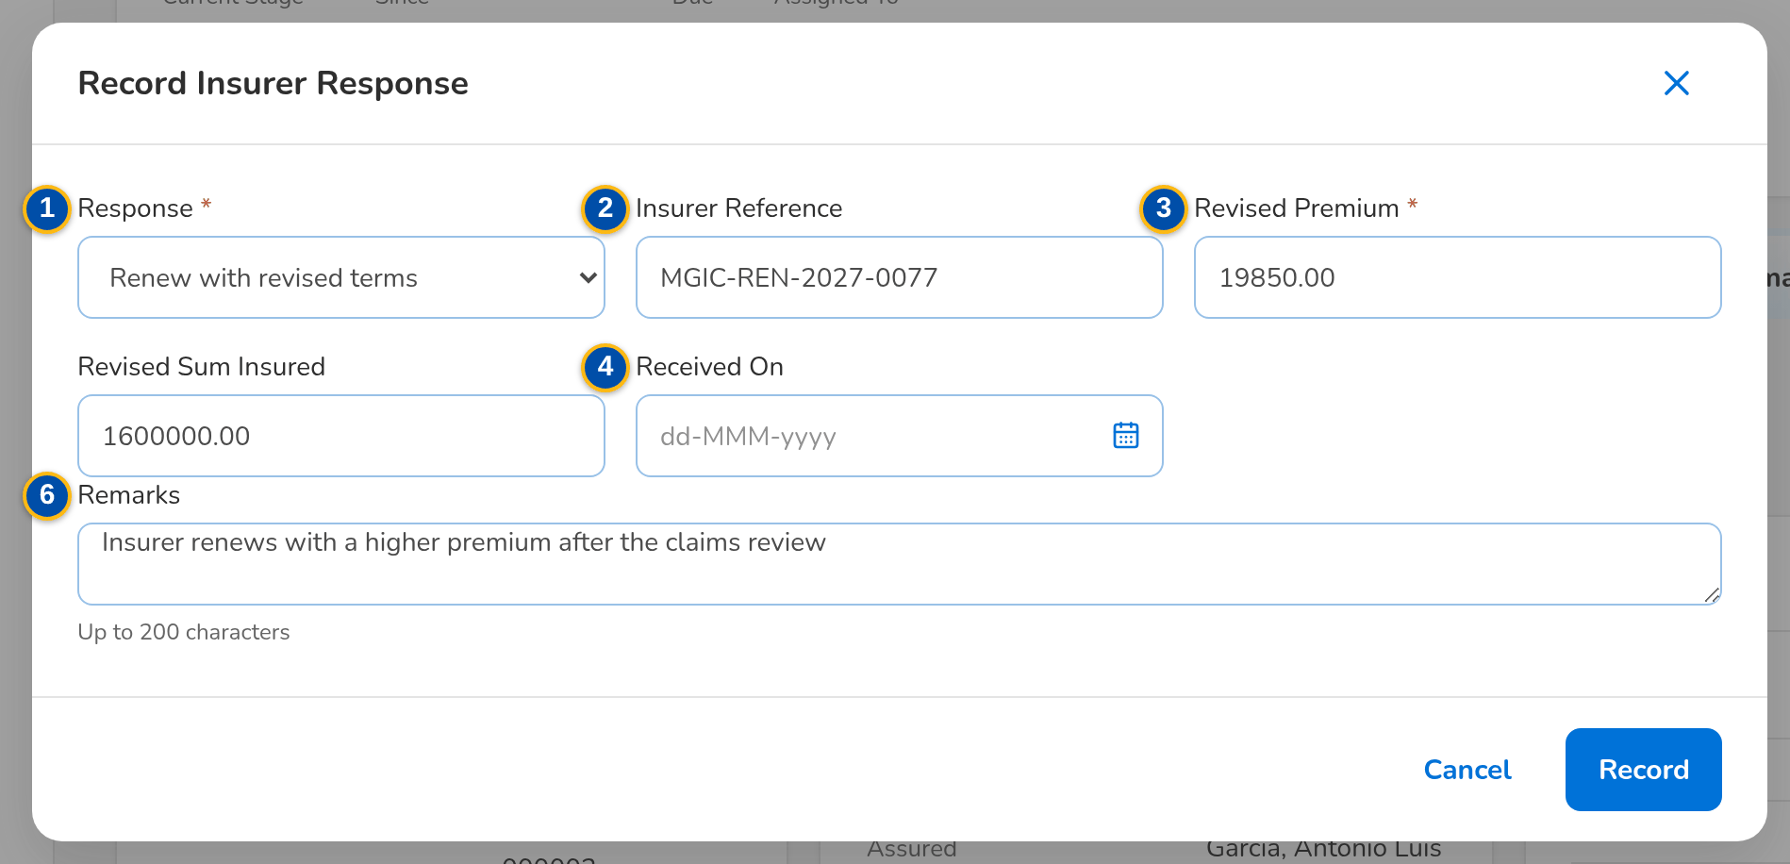
Figure 30: SCR-RN-12 Record Insurer Response dialog: renew with revised terms
1 | Response | 3 | Revised Premium / Revised Sum Insured | 5 | Re-market to another insurer
2 | Insurer Reference | 4 | Received On | 6 | Remarks

Fields (No. = callout number on the first screenshot)
No. | Section | Field | Type | Length / format | Mand. | Source / list | Default | Editable in | Validation | Message when it fails
1 | Record Insurer Response dialog | Response | Drop-down | Renew as is, Renew with revised terms, Declined | Y | Insurer renewal response | Renew as is | With Insurer | - | -
2 | Record Insurer Response dialog | Insurer Reference | Text | Reference of the insurer | N | - | Blank | With Insurer | - | -
3 | Record Insurer Response dialog | Revised Premium / Revised Sum Insured | Amount | Two decimals | Cond.: revised terms (premium) / N | - | Blank | With Insurer | Above zero | Enter the revised premium
4 | Record Insurer Response dialog | Received On | Date | dd-MMM-yyyy | N | - | Today | With Insurer | - | -
5 | Record Insurer Response dialog | Re-market to another insurer | Check box | Declined only | N | - | Unticked | With Insurer | - | -
6 | Record Insurer Response dialog | Remarks | Text area | Up to 200 characters | N | - | Blank | With Insurer | At most 200 characters | Remarks may have at most 200 characters

Actions
Button | Who | Enabled when | What happens | Resulting status | Notification
Record Insurer Response | Processing (insurer permission) | With Insurer | Opens the dialog; Record keeps the response, which drives the renewal when it is the latest valid one | RA Ready, In Processing (revised terms), For Disposition (re-market) or Letter Pending (declined) | Insurer renewal response (NT-06)

Business rules
• A late, conflicting or mismatched response does not move the renewal; the mismatch is overridden by the Team Leader with remarks (FR-RN-071, FR-RN-051).
• Revised terms are a financial impact: the client accepts them explicitly (FR-RN-064, FR-RN-084).
Expected outcome
The insurer's decision drives the renewal without re-keying.
Test cases: TC-RN-071.4-01, TC-RN-071.4-02, TC-RN-SCR-12.

13.4 Letters, acceptance and follow-up

13.4.1 SCR-RN-13 Letters
Purpose | The letters of the renewals by tab: RA Ready (generate the Renewal Advice, first or second notice), RA Generated (send it, protected, to the client), RA Sent, NAL / NFR (send the No Advice or Not for Renewal letter that closes the renewal) and NRNS (renewals with no response). Client acceptances are recorded on the renewal or uploaded here.
Who can open it | Marketing Team Leader, Marketing Account Officer (Account Broker), Processing Team Leader, Processing Officer (Broker) (permission Renewal ra generate)
Navigation | • Menu: Client & Policy › Renewal › Letters  • Client & Policy › Renewal › Letters  • Renewal Home › NRNS or Letters failed
FRs | FR-RN-080, FR-RN-081, FR-RN-082, FR-RN-083, FR-RN-024

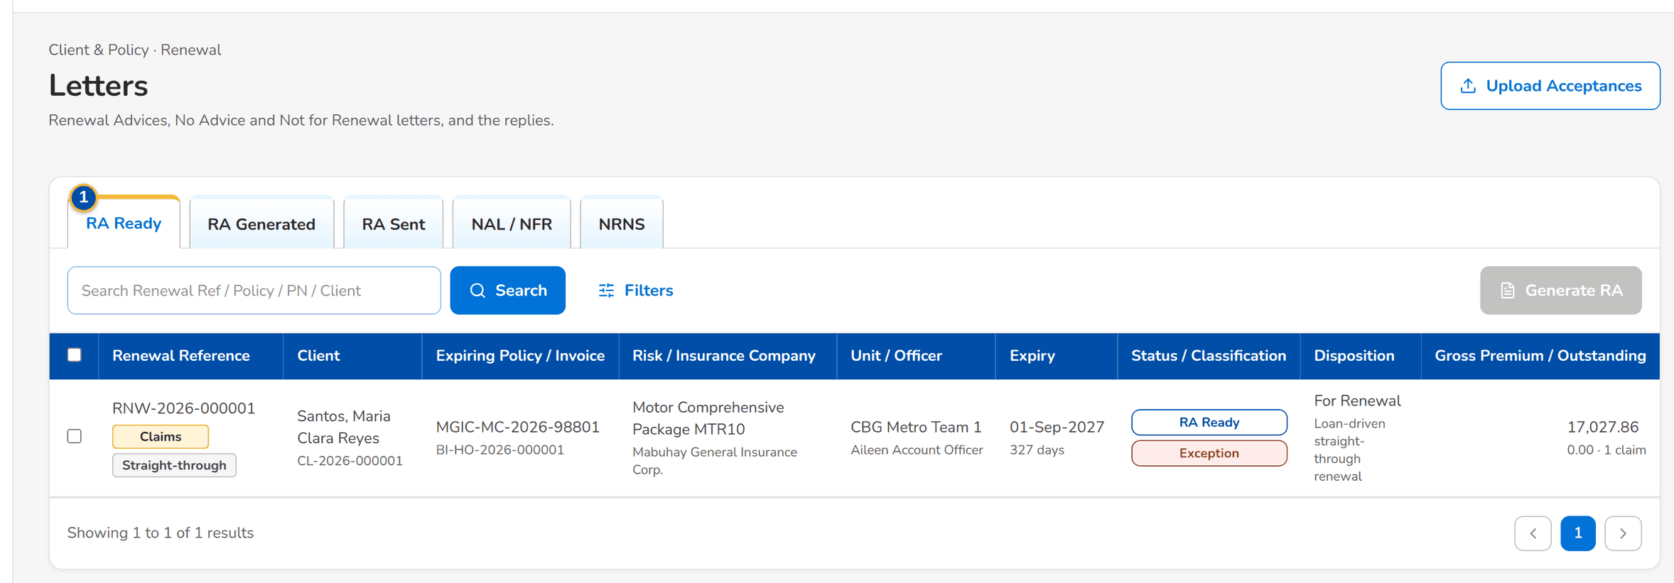
Figure 31: SCR-RN-13 Letters, tab RA Ready: the renewals whose Renewal Advice can be generated
1 | RA Ready / RA Generated / RA Sent / NAL / NFR / NRNS | 3 | Notice | 5 | Upload wizard: Renewal Reference, Method, Evidence Reference, Accepted On, Remarks
2 | Columns of the renewal lists | 4 | Generate also when the minimum notice before expiry has passed (the confirmation is recorded)

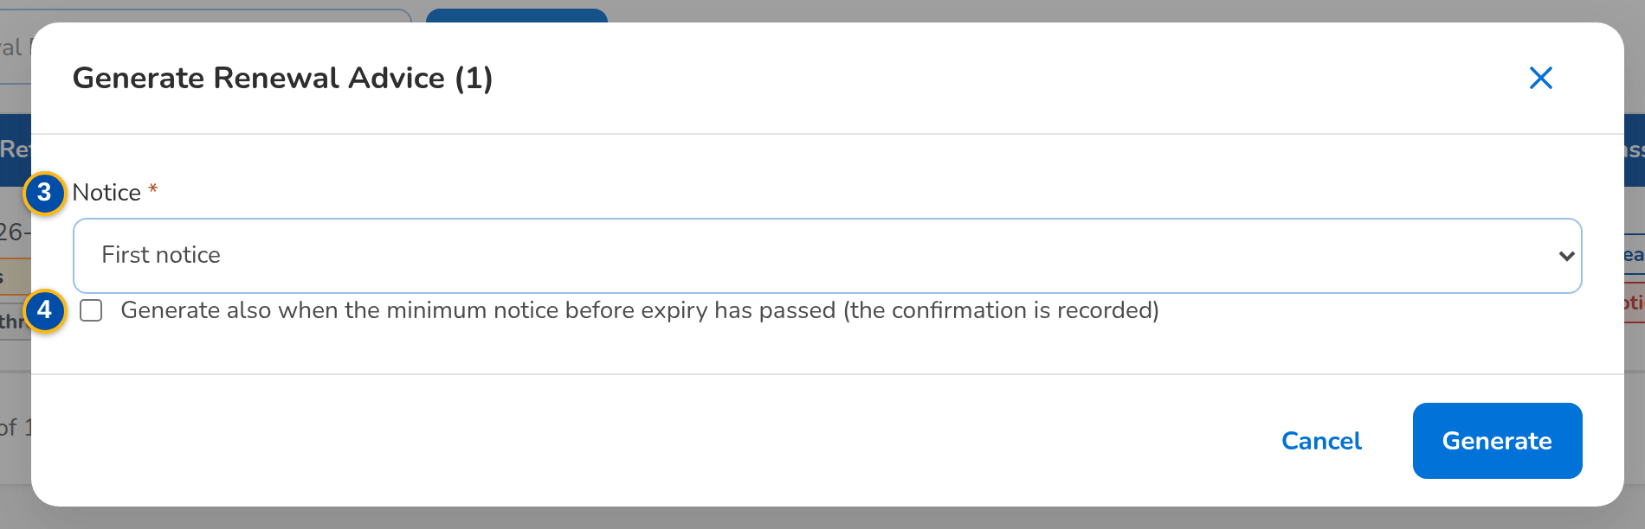
Figure 32: SCR-RN-13 Generate Renewal Advice dialog: first or second notice and the confirmation of a late Renewal Advice
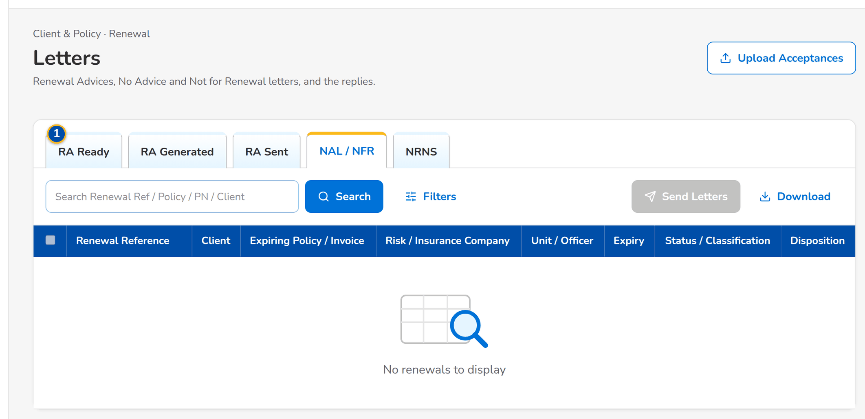
Figure 33: SCR-RN-13 Letters, tab NAL / NFR: the renewals waiting for their closing letter
Fields (No. = callout number on the first screenshot)
No. | Section | Field | Type | Length / format | Mand. | Source / list | Default | Editable in | Validation | Message when it fails
1 | Tabs | RA Ready / RA Generated / RA Sent / NAL / NFR / NRNS | Tab | - | - | Letter stage of the renewal | RA Ready | - | - | -
2 | List | Columns of the renewal lists | Column | As on the Expiry List (SCR-RN-02) | - | Renewals | - | Read only | - | No renewals to display
3 | Generate Renewal Advice dialog | Notice | Drop-down | First notice or Second notice | Y | Fixed list | First notice | RA Ready, RA Sent, NRNS | The second notice after the days from the first | The second notice of <renewal ref> is due <ra second notice days> days after the first
4 | Generate Renewal Advice dialog | Generate also when the minimum notice before expiry has passed (the confirmation is recorded) | Check box | - | Cond.: fewer than 30 days to expiry | - | Unticked | RA Ready | - | Renewal <renewal ref> expires in <days> day(s): confirm the late Renewal Advice
5 | Upload Acceptances | Upload wizard: Renewal Reference, Method, Evidence Reference, Accepted On, Remarks | Upload | Template of the client acceptances | - | Renewals | - | RA Sent / Awaiting Response | Every row checked before anything is saved | Method <method> is not valid (E-mail or Payment)

Actions
Button | Who | Enabled when | What happens | Resulting status | Notification
Generate RA | Marketing and Processing (generate permission) | Tab RA Ready, RA Sent or NRNS, renewals ticked | Opens the dialog; Generate creates the Renewal Advice from the latest template and locks the renewal on the Marketing side | RA Generated | -
Send | Marketing and Processing (send permission) | Tab RA Generated, renewals ticked | Asks for confirmation; the Renewal Advice is e-mailed protected to the client | RA Sent / Awaiting Response | Renewal Advice e-mail and password (NT-16, NT-17)
Send Letters | Users with the generate and send permissions | Tab NAL / NFR, renewals ticked | Asks for confirmation; the No Advice or Not for Renewal letter is generated and e-mailed and the renewal is closed | Closed | Closing letter e-mail (NT-19)
Upload Acceptances | Users with the acceptance permission | Always | Opens the upload of the client acceptances | Accepted | Renewal accepted (NT-07)

Business rules
• A Renewal Advice is generated only for renewals without a failing blocking check, from the latest approved template (FR-RN-080).
• A Renewal Advice generated fewer days than the minimum notice before expiry (30 by default) needs the confirmation, which is recorded (FR-RN-080).
• The second notice is offered the second-notice days (15 by default) after the first without acceptance (FR-RN-080).
• Renewal Advices are sent one protected e-mail per client with the password in a separate e-mail; every send and failure is recorded (FR-RN-081).
• A reason for Not for Renewal of the No Advice list is answered with the No Advice Letter, the others with the Not for Renewal Letter (FR-RN-082, FR-RN-024).
Expected outcome
The clients receive their Renewal Advice or closing letter.
Test cases: TC-RN-002.4-02, TC-RN-027.1-02, TC-RN-080.1-01, TC-RN-080.1-02, TC-RN-080.1-03, TC-RN-080.1-04, TC-RN-080.3-01, TC-RN-080.3-02, TC-RN-080.4-01, TC-RN-080.4-02, TC-RN-080.4-03, TC-RN-080.5-01, TC-RN-080.5-02, TC-RN-081.1-03, TC-RN-081.1-04, TC-RN-081.3-01, TC-RN-081.3-02, TC-RN-082.1-02, TC-RN-082.3-01, TC-RN-082.4-01, TC-RN-083.1-01, TC-RN-083.1-02, TC-RN-083.2-01, TC-RN-083.4-01, TC-RN-SCR-13, TC-RN-MSG-09.

13.4.2 SCR-RN-14 Record Acceptance
Purpose | The client's acceptance of the Renewal Advice: by e-mail or signed Renewal Advice (the file uploaded in the Documents tab first) or by payment (with its reference), with the date and remarks. When the renewal terms differ from the expiring terms, the user confirms that the client acknowledged the change. Once accepted, the renewal account goes to placement and booking without re-keying.
Who can open it | Marketing Team Leader, Marketing Account Officer (Account Broker), Processing Team Leader, Processing Officer (Broker), Contact Center, LAMD (loan status reports), Business Administrator, Auditor (permission Renewal view)
Navigation | • Menu: Client & Policy › Renewal › Letters › Renewal  • Renewal (RA Sent / Awaiting Response) › Record Acceptance
FRs | FR-RN-084

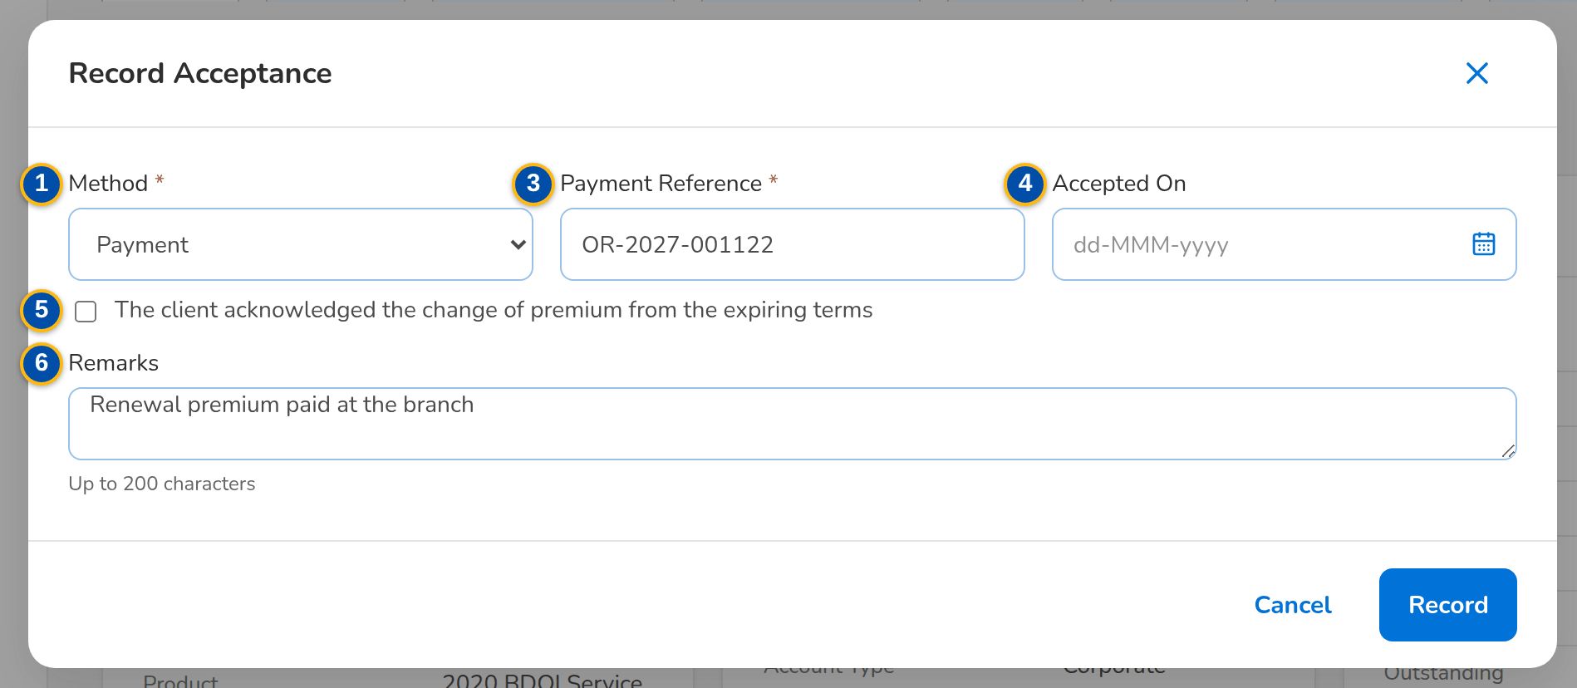
Figure 34: SCR-RN-14 Record Acceptance dialog: acceptance by payment with its reference
1 | Method | 3 | Payment Reference / Reference | 5 | The client acknowledged the change of premium from the expiring terms
2 | Evidence | 4 | Accepted On | 6 | Remarks

Fields (No. = callout number on the first screenshot)
No. | Section | Field | Type | Length / format | Mand. | Source / list | Default | Editable in | Validation | Message when it fails
1 | Record Acceptance dialog | Method | Drop-down | E-mail from the client, Signed Renewal Advice, Payment | Y | Fixed list | E-mail from the client | RA Sent / Awaiting Response | - | Select the acceptance method
2 | Record Acceptance dialog | Evidence | Drop-down | A document of the renewal (Documents tab) | Cond.: e-mail or signed Renewal Advice | Documents of the renewal | Blank | RA Sent / Awaiting Response | A document of this renewal | The evidence is not a document of this renewal
3 | Record Acceptance dialog | Payment Reference / Reference | Text | The payment or e-mail reference | Cond.: payment | - | Blank | RA Sent / Awaiting Response | - | -
4 | Record Acceptance dialog | Accepted On | Date | dd-MMM-yyyy | N | - | Today | RA Sent / Awaiting Response | Not in the future | The acceptance date cannot be in the future
5 | Record Acceptance dialog | The client acknowledged the change of premium from the expiring terms | Check box | - | Cond.: financial impact | - | Unticked | RA Sent / Awaiting Response | - | The renewal terms differ from the expiring terms: confirm that the client accepted them
6 | Record Acceptance dialog | Remarks | Text area | Up to 200 characters | N | - | Blank | RA Sent / Awaiting Response | - | -

Actions
Button | Who | Enabled when | What happens | Resulting status | Notification
Record Acceptance | Marketing and Processing (acceptance permission) | RA Sent / Awaiting Response | Opens the dialog; Record keeps the acceptance and moves the renewal account on to placement and booking | Accepted, then For Placement and Booking | Renewal accepted (NT-07)

Business rules
• The acceptance is refused while a blocking check fails (FR-RN-084).
• Acceptance moves the renewal account to placement and booking under the standard New Business payment rules; the renewal books as business type Renewal (FR-RN-084).
Expected outcome
The accepted renewal goes to placement and booking.
Test cases: TC-RN-027.2-01, TC-RN-063.1-01, TC-RN-063.2-01, TC-RN-063.2-02, TC-RN-063.3-01, TC-RN-063.4-01, TC-RN-SCR-14, TC-RN-MSG-10.

13.4.3 SCR-RN-15 Follow-ups
Purpose | The renewals waiting for the client's reply after the Renewal Advice, for the Contact Center, with the renewals with no response and those on the quotation or proposal path. The Contact Center user opens a renewal to record a call, e-mail or SMS with its outcome and next action date, and uploads the client's documents.
Who can open it | Contact Center (permission Renewal followup)
Navigation | • Menu: Client & Policy › Renewal › Follow-ups  • Client & Policy › Renewal › Follow-ups
FRs | FR-RN-083, FR-RN-085

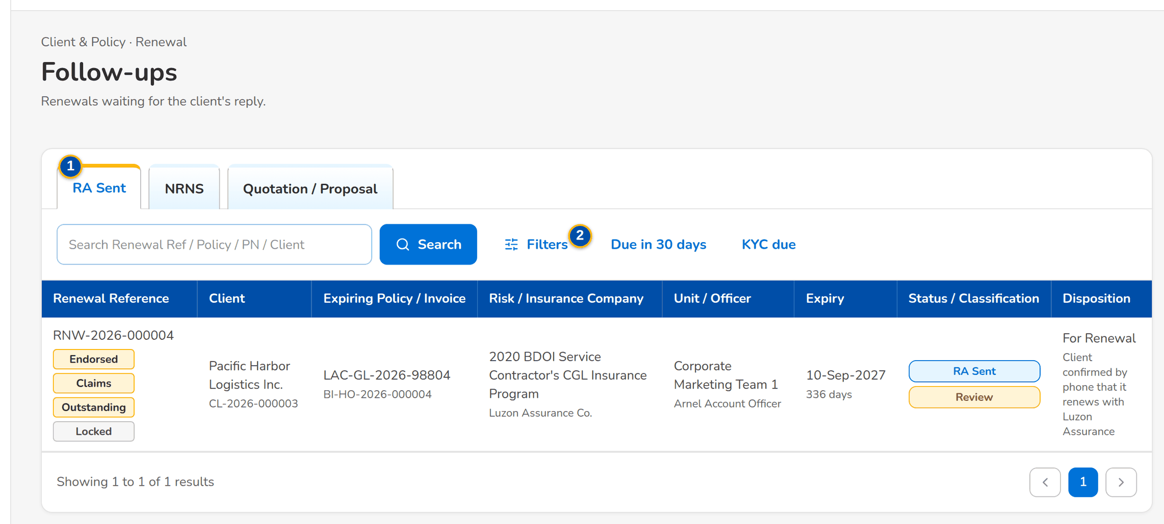
Figure 35: SCR-RN-15 Follow-ups of the Contact Center, tab RA Sent
1 | RA Sent / NRNS / Quotation / Proposal | 3 | Columns of the renewal lists | 5 | Next Action Date
2 | Due in 30 days / KYC due | 4 | Channel / Outcome | 6 | Remarks

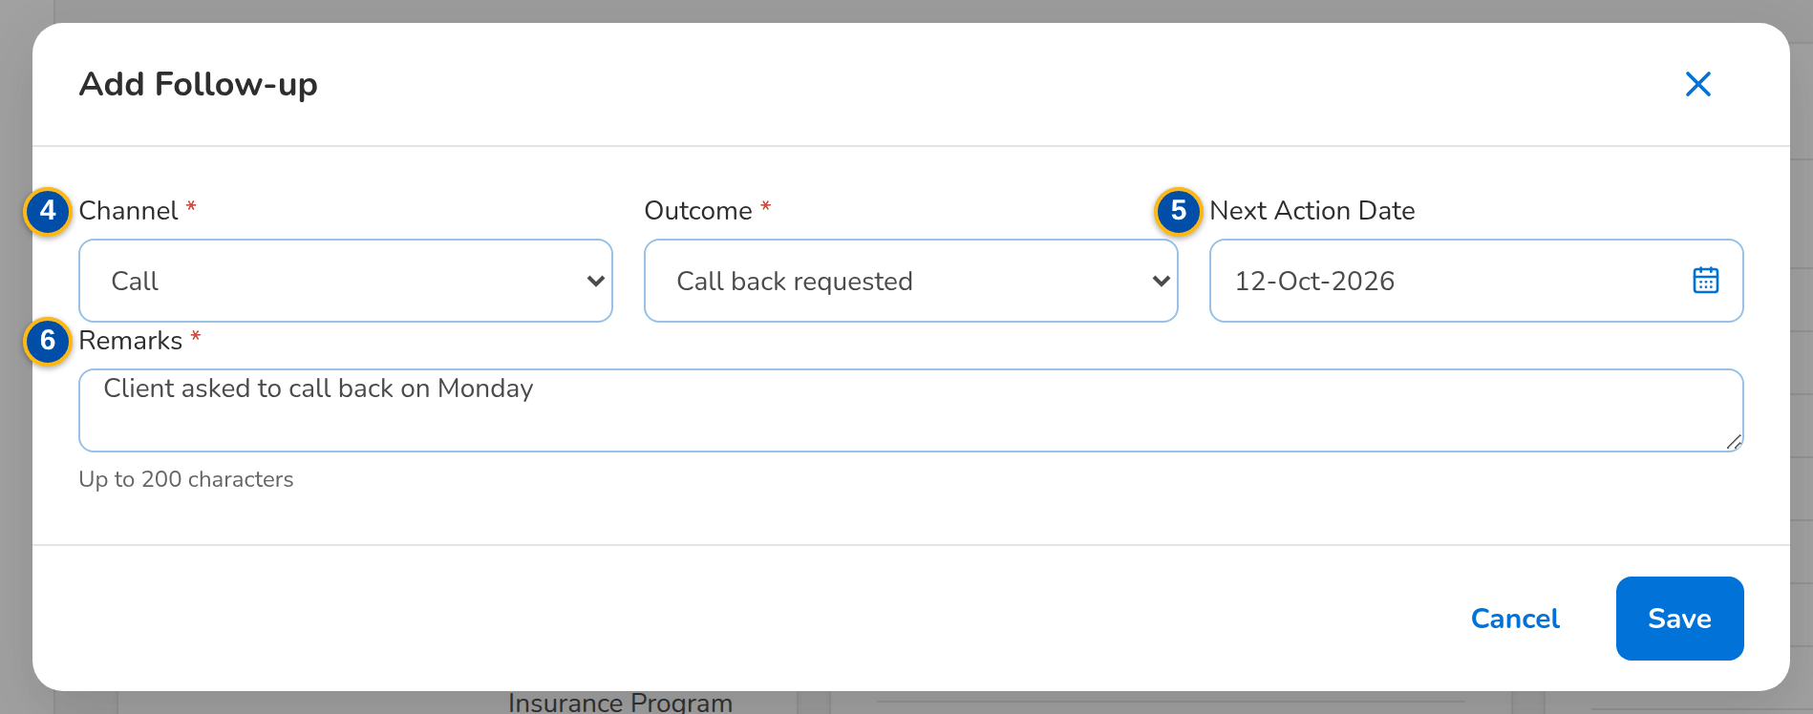
Figure 36: SCR-RN-15 Add Follow-up dialog: the channel, outcome, next action date and remarks
Fields (No. = callout number on the first screenshot)
No. | Section | Field | Type | Length / format | Mand. | Source / list | Default | Editable in | Validation | Message when it fails
1 | Tabs | RA Sent / NRNS / Quotation / Proposal | Tab | - | - | Stage of the renewal | RA Sent | - | - | -
2 | Quick filters | Due in 30 days / KYC due | Toggle button | One at a time | - | - | None | - | - | -
3 | List | Columns of the renewal lists | Column | As on the Expiry List (SCR-RN-02), without the premium amounts | - | Renewals | - | Read only | - | No renewals to follow up
4 | Add Follow-up dialog | Channel / Outcome | Drop-down | Renewal follow-up channel; renewal follow-up outcome | Y / Y | Lists of values | Blank | Any open stage | - | Select the channel and the outcome
5 | Add Follow-up dialog | Next Action Date | Date | dd-MMM-yyyy, from today on | N | - | Blank | Any open stage | Not in the past | The next action date cannot be in the past
6 | Add Follow-up dialog | Remarks | Text area | Up to 200 characters | Y | - | Blank | Any open stage | Not blank | Enter the remarks

Actions
Button | Who | Enabled when | What happens | Resulting status | Notification
Add Follow-up (renewal) | Contact Center | Any open stage | Opens the dialog; Save keeps the follow-up on the Remarks & Follow-ups tab | - | -
Row | Contact Center | Always | Opens the renewal | - | -

Business rules
• The Contact Center sees the renewals without the premium amounts and never changes the disposition, the letters or the placement (FR-RN-085).
• A renewal not yet submitted at the reminder days before expiry (90 by default) is flagged NRNS and its reminder letter is sent (FR-RN-083).
Expected outcome
The client's replies are recorded for the officers.
Test cases: TC-RN-002.5-01, TC-RN-085.1-01, TC-RN-085.2-01, TC-RN-085.2-02, TC-RN-085.3-01, TC-RN-SCR-15, TC-RN-MSG-11.

13.4.4 SCR-RN-16 LAMD Reports
Purpose | The monthly paid-off and past-due (RMU) loan reports of the Loan and Mortgage department. Each line is matched to the renewals by PN number: a paid-off loan proposes Not for Renewal, a past-due loan routes the renewal to the Team Leader of its unit.
Who can open it | LAMD (loan status reports) (permission Renewal LAMD upload)
Navigation | • Menu: Client & Policy › Renewal › LAMD Reports  • Client & Policy › Renewal › LAMD Reports
FRs | FR-RN-025

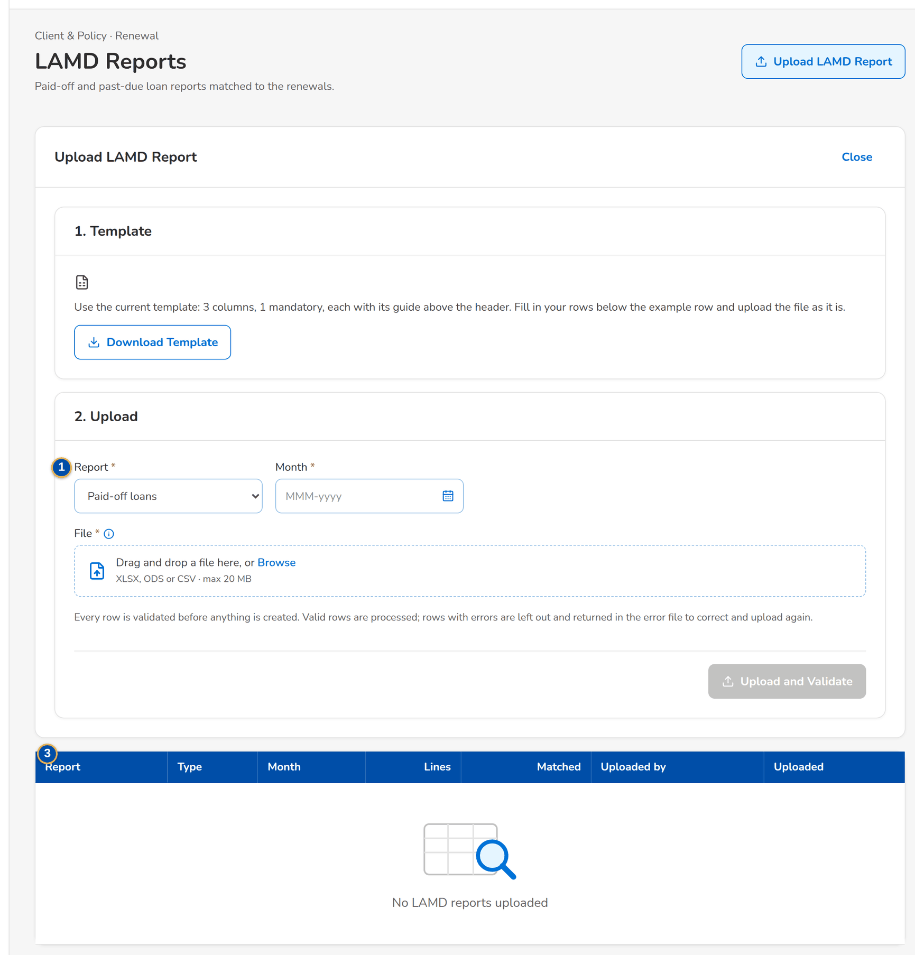
Figure 37: SCR-RN-16 LAMD Reports with the upload of a paid-off or past-due loan report
1 | Report / Month | 3 | Report / Type / Month / Lines / Matched / Uploaded by / Uploaded
2 | Upload wizard: PN Number, Status Date, Borrower | 4 | Row / PN / Borrower / Loan Status / Status date / Match / Renewal / Outcome

Fields (No. = callout number on the first screenshot)
No. | Section | Field | Type | Length / format | Mand. | Source / list | Default | Editable in | Validation | Message when it fails
1 | Upload LAMD Report | Report / Month | Drop-down, month | Paid-off loans or RMU (past due); the month of the report | Y / Y | Fixed list | Paid-off loans | New | - | Choose the period of the report
2 | Upload LAMD Report | Upload wizard: PN Number, Status Date, Borrower | Upload | Template of the LAMD loan report | - | - | - | New | Every row checked before anything is saved | The row has no PN number
3 | List | Report / Type / Month / Lines / Matched / Uploaded by / Uploaded | Column | Report number; Paid-off loans or RMU (past due); the month; counts; the user's name and the time | - | LAMD reports | - | Read only | - | No LAMD reports uploaded
4 | Lines | Row / PN / Borrower / Loan Status / Status date / Match / Renewal / Outcome | Column | The line of the report, the renewal matched and what followed | - | LAMD lines | - | Read only | - | No lines

Actions
Button | Who | Enabled when | What happens | Resulting status | Notification
Upload LAMD Report | LAMD | Always | Opens the upload; each line is matched to the renewals by PN | - | Renewal assigned (NT-01) to the Team Leaders of the unit
Row | LAMD | Always | Opens the lines of the report | - | -

Business rules
• A paid-off loan proposes Not for Renewal (reason Loan fully paid); a past-due loan routes the renewal to the Team Leader (FR-RN-025).
• The LAMD role never places, books, sends letters or gives dispositions (FR-RN-025).
Expected outcome
The loan status of the mortgaged renewals is reflected before the disposition.
Test cases: TC-RN-002.4-01, TC-RN-025.1-01, TC-RN-025.2-01, TC-RN-025.2-02, TC-RN-025.3-01, TC-RN-025.3-02, TC-RN-025.5-02, TC-RN-SCR-16.

13.5 Renewal Setup

13.5.1 SCR-RN-17 Renewal Setup: Non-renewable Risk Codes and Checks
Purpose | The risk codes that are never renewed (the renewal gets Not for Renewal and the Not for Renewal Letter) and the sanitation checks with their severity and parameters. A new or changed risk code or check applies once another user authorizes it; a risk code is end-dated or deactivated, never deleted.
Who can open it | Processing Team Leader, Processing Officer (Broker), Business Administrator (permission Renewal setup or Renewal package remap)
Navigation | • Menu: Client & Policy › Renewal › Renewal Setup  • Client & Policy › Renewal › Renewal Setup › Non-renewable Risk Codes or Checks
FRs | FR-RN-020, FR-RN-024, FR-RN-112

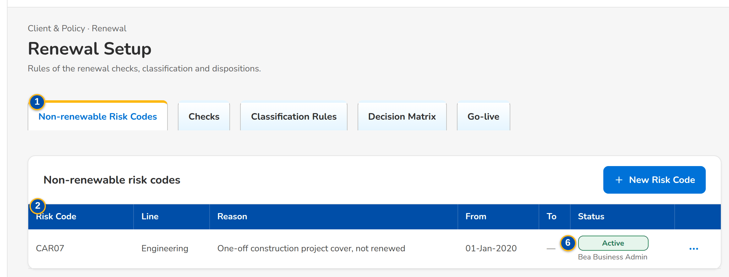
Figure 38: SCR-RN-17 Non-renewable Risk Codes with their row action menu
1 | Non-renewable Risk Codes / Checks / Classification Rules / Decision Matrix / Package Map / Package Choices / Go-live | 4 | Effective From / Effective To | 7 | Active / Severity / Parameters
2 | Risk Code / Line / Reason / From / To / Status | 5 | Reason
3 | Risk Code / Line of Business | 6 | Check / Active / Severity / Parameters / Status

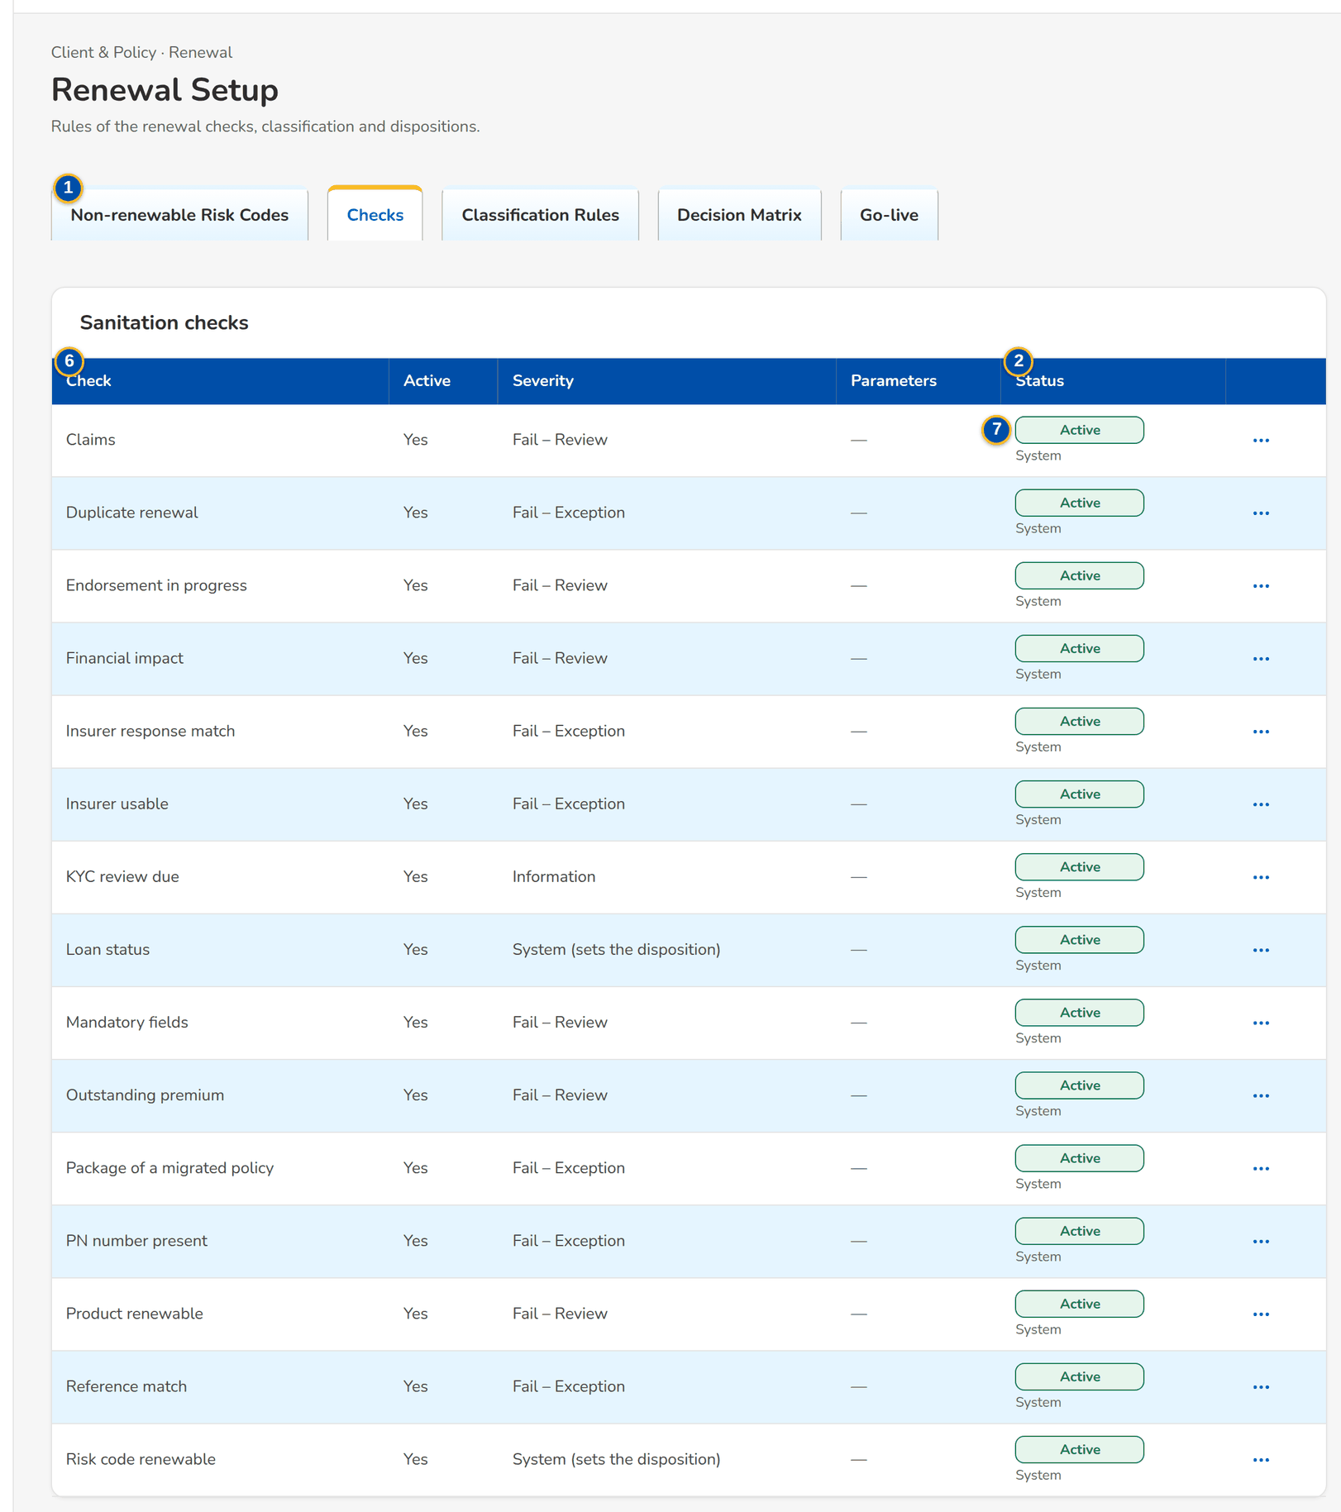
Figure 39: SCR-RN-17 Checks: the sanitation checks with their severity

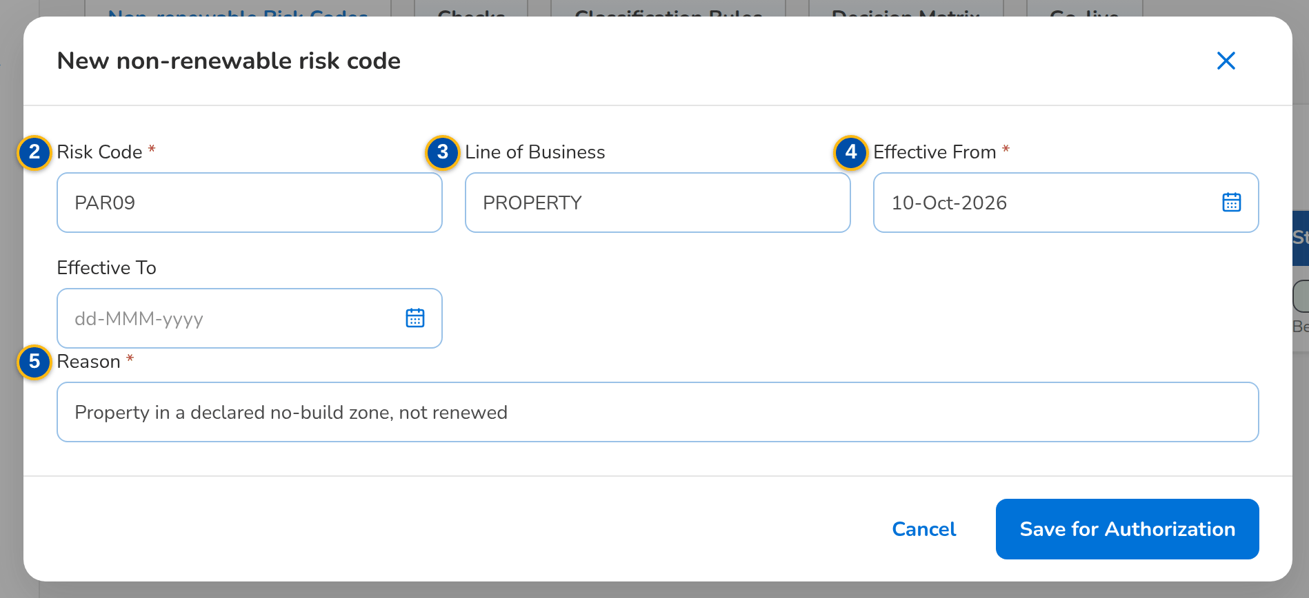
Figure 40: SCR-RN-17 New non-renewable risk code dialog
Fields (No. = callout number on the first screenshot)
No. | Section | Field | Type | Length / format | Mand. | Source / list | Default | Editable in | Validation | Message when it fails
1 | Tabs | Non-renewable Risk Codes / Checks / Classification Rules / Decision Matrix / Package Map / Package Choices / Go-live | Tab | - | - | By permission | Non-renewable Risk Codes | - | - | -
2 | Risk codes | Risk Code / Line / Reason / From / To / Status | Column | Code; name of the line or All; dates dd-MMM-yyyy; Active, Pending Authorization or Inactive with the maker's name | - | Non-renewable risk codes | - | Read only | - | No non-renewable risk codes
3 | Risk code dialog | Risk Code / Line of Business | Text | The risk code; the line, blank for every line | Y / N | Product catalogue | Blank | Pending, Active | Not blank | Enter the risk code
4 | Risk code dialog | Effective From / Effective To | Date | dd-MMM-yyyy; the end after the start | Y / N | - | Blank | Pending, Active | The end after the start | The effective-to date is before the effective-from date
5 | Risk code dialog | Reason | Text | Up to 200 characters | Y | - | Blank | Pending, Active | Not blank | Enter the reason and the effective date
6 | Checks | Check / Active / Severity / Parameters / Status | Column | Name of the check; Yes or No; Fail – Exception, Fail – Review, Warning, Information or System (sets the disposition); the settings of the check | - | Check settings | - | Read only | - | No checks
7 | Check dialog | Active / Severity / Parameters | Check box, drop-down, text | Optional settings of the check, e.g. days=30 | N / Y / N | Severities | As set | Pending, Active | - | Choose the severity of the check

Actions
Button | Who | Enabled when | What happens | Resulting status | Notification
New Risk Code | Business Administrator | Always | Opens the dialog; Save for Authorization keeps the code waiting for a second user | Pending Authorization | -
Authorize (row menu) | Another Business Administrator than the maker | Pending Authorization | Asks for confirmation; the change takes effect | Active | -
Edit (row menu) | Business Administrator | Always | Opens the dialog; the change waits for authorization | Pending Authorization | -
Deactivate (row menu) | Business Administrator | Active | Asks for confirmation; the code is no longer used for new renewals | Inactive | -

Business rules
• A renewal whose risk code is non-renewable gets Not for Renewal (reason Non-renewable Accounts) by the system and its Not for Renewal Letter (FR-RN-024).
• The checks run on initiation and again when the expiring account changes; their severity decides the classification through the classification rules (FR-RN-020, FR-RN-112).
• Maker-checker: the maker of a change cannot authorize it (FR-RN-112).
Expected outcome
The business keeps the non-renewable risk codes and the checks.
Test cases: TC-RN-023.3-01, TC-RN-023.3-02, TC-RN-023.4-01, TC-RN-023.7-01, TC-RN-024.1-01, TC-RN-024.3-01, TC-RN-024.3-02, TC-RN-024.4-01, TC-RN-024.4-02, TC-RN-112.1-01, TC-RN-112.1-02, TC-RN-112.3-01, TC-RN-112.4-01, TC-RN-112.4-02, TC-RN-SCR-17, TC-RN-MSG-12.

13.5.2 SCR-RN-18 Renewal Setup: Classification Rules and Decision Matrix
Purpose | The versioned rules: the classification rules turn the check results into Clean, Review or Exception; the decision matrix proposes the disposition by segment, line, product, mortgage, classification, claims, endorsement, payment and days to expiry, automatic or as a proposal to the officer, with the letter. A new version is a draft from the active one, submitted, then activated or rejected by another user; activation retires the active version.
Who can open it | Processing Team Leader, Processing Officer (Broker), Business Administrator (permission Renewal setup or Renewal package remap)
Navigation | • Menu: Client & Policy › Renewal › Renewal Setup  • Client & Policy › Renewal › Renewal Setup › Classification Rules or Decision Matrix
FRs | FR-RN-022, FR-RN-023, FR-RN-112

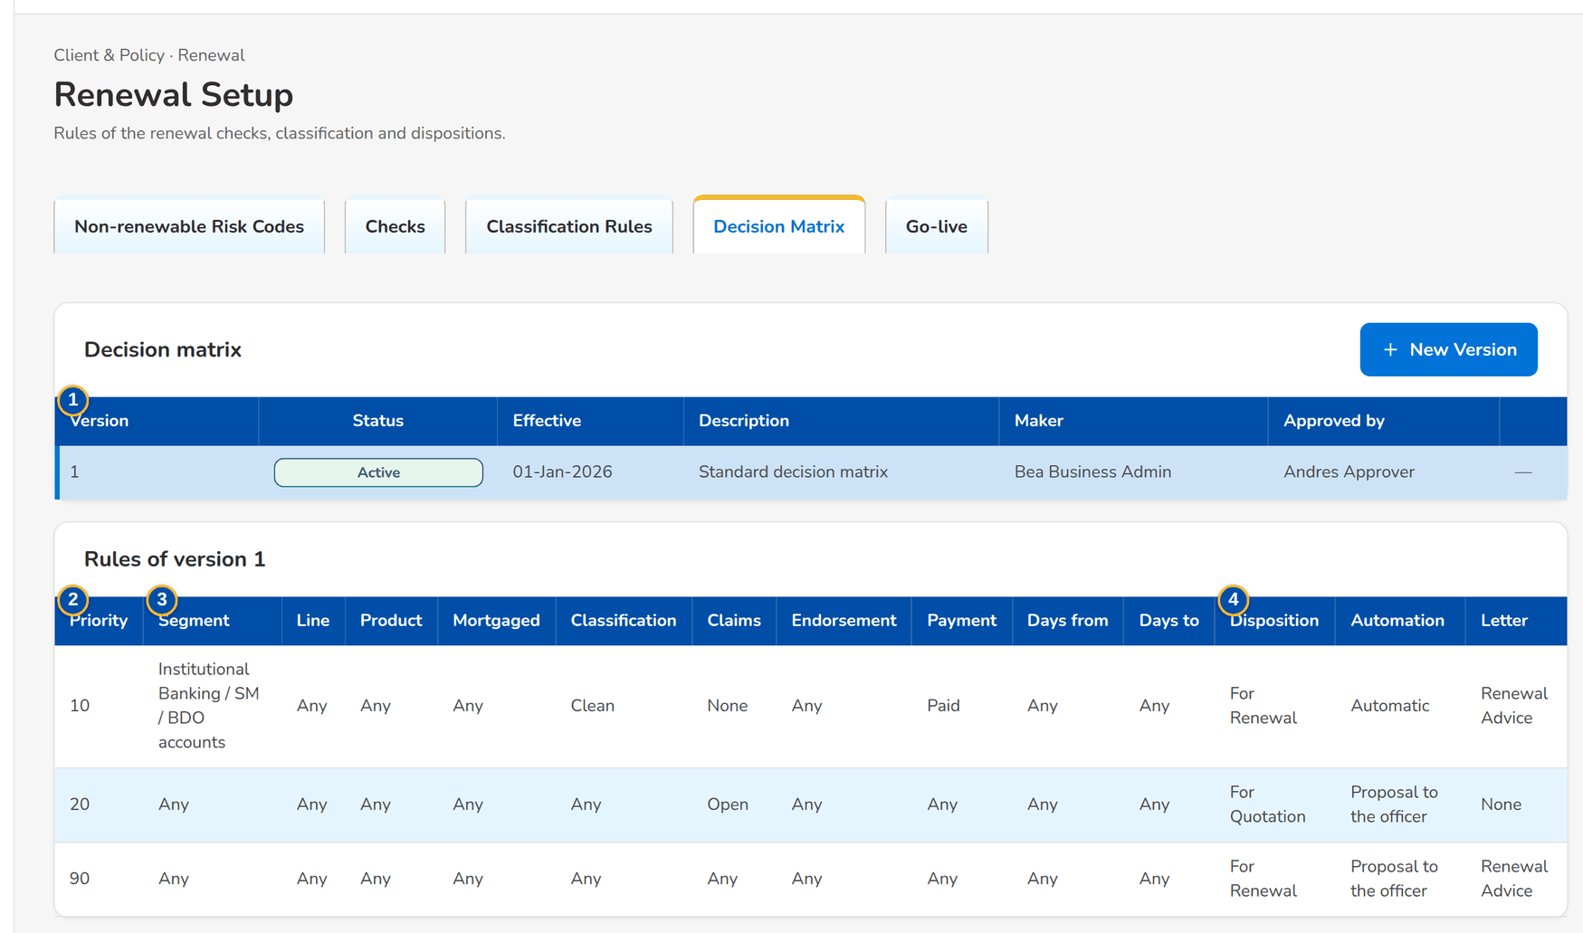
Figure 41: SCR-RN-18 Decision Matrix: the versions with their row action menu and the rules of the active version
1 | Version / Status / Effective / Description / Maker / Approved by | 3 | Priority / Segment / Line / Product / Mortgaged / Classification / Claims / Endorsement / Payment / Days from / Days to | 5 | Effective From / Description
2 | Priority / Check / Severity / Outcome / Classification | 4 | Disposition / Automation / Letter | 6 | The rules of the version, one row each, with Add Rule and Remove rule

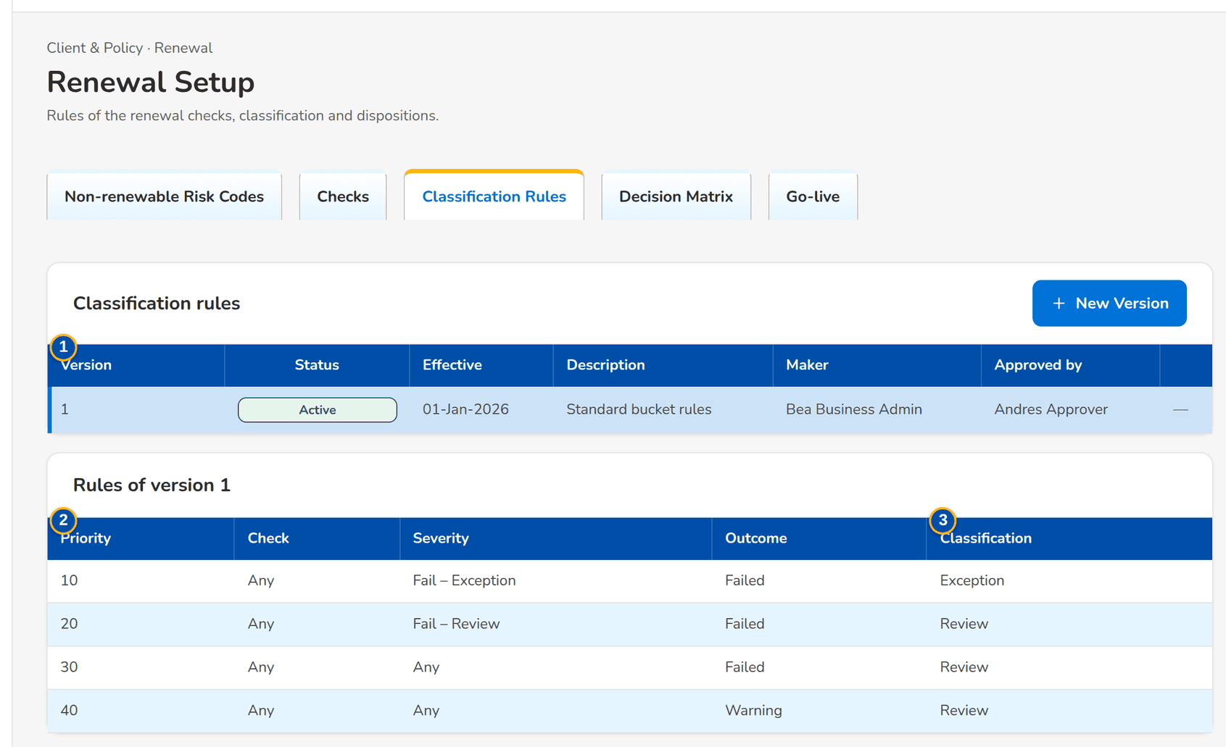
Figure 42: SCR-RN-18 Classification Rules: the versions and the rules of the active version
Fields (No. = callout number on the first screenshot)
No. | Section | Field | Type | Length / format | Mand. | Source / list | Default | Editable in | Validation | Message when it fails
1 | Versions | Version / Status / Effective / Description / Maker / Approved by | Column | Number; Draft, Submitted, Active, Retired or Rejected; dd-MMM-yyyy; users' names | - | Rule versions | - | Read only | - | No versions
2 | Classification rules | Priority / Check / Severity / Outcome / Classification | Column | Order of the rule; the check or Any; the severity or Any; Failed or Warning; Clean, Review or Exception | - | Classification rules | - | Read only | - | No rules
3 | Decision matrix | Priority / Segment / Line / Product / Mortgaged / Classification / Claims / Endorsement / Payment / Days from / Days to | Column | The conditions of the rule; Any when blank | - | Decision matrix | - | Read only | - | No rules
4 | Decision matrix | Disposition / Automation / Letter | Column | The disposition proposed; Automatic or Proposal to the officer; Renewal Advice, Not for Renewal, No Advice Letter or None | - | Decision matrix | - | Read only | - | -
5 | New version dialog | Effective From / Description | Date, text | dd-MMM-yyyy; up to 200 characters | N / N | - | Blank | Draft | - | -
6 | New version dialog | The rules of the version, one row each, with Add Rule and Remove rule | Table | The columns of the rules | Y | - | The rules of the active version | Draft | Each rule its own priority; a failed check never gives Clean | Two rules have the priority <p>

Actions
Button | Who | Enabled when | What happens | Resulting status | Notification
New Version | Business Administrator | Always | Opens the dialog with the rules of the active version; Save Draft keeps the draft | Draft | -
Submit (row menu) | Business Administrator | Draft | Submits the version for a second user | Submitted | -
Activate (row menu) | Another Business Administrator than the maker | Submitted | Asks for confirmation; the version replaces the active one from its effective date | Active | -
Reject (row menu) | Another Business Administrator than the maker | Submitted | Asks for the reason; the version returns to its maker | Rejected | -

Business rules
• A failed check never gives the Clean classification (FR-RN-022).
• The first matching rule of the active matrix proposes the disposition; an automatic rule on a Clean renewal disposes it without the officer (FR-RN-023).
• A version is activated by another user than its maker; activation retires the active version (FR-RN-112).
Expected outcome
The rules agreed by the business classify the renewals and propose their dispositions.
Test cases: TC-RN-023.3-01, TC-RN-023.3-02, TC-RN-023.4-01, TC-RN-023.7-01, TC-RN-024.1-01, TC-RN-024.3-01, TC-RN-024.3-02, TC-RN-024.4-01, TC-RN-024.4-02, TC-RN-112.1-01, TC-RN-112.1-02, TC-RN-112.3-01, TC-RN-112.4-01, TC-RN-112.4-02, TC-RN-SCR-18, TC-RN-MSG-13.

13.5.3 SCR-RN-19 Renewal Setup: Package Map, Package Choices and Propose Package
Purpose | The package of a migrated policy: the package map gives the BIBS product and version a legacy package renews on (or rejects it), by risk code, insurer and sum insured band; when the map gives no answer, a Processing Officer proposes the package on the renewal and another member of the team approves or rejects the choice.
Who can open it | Processing Team Leader, Processing Officer (Broker), Business Administrator (permission Renewal setup or Renewal package remap)
Navigation | • Menu: Client & Policy › Renewal › Renewal Setup  • Client & Policy › Renewal › Renewal Setup › Package Map or Package Choices  • Renewal (migrated packaged policy) › Propose Package
FRs | FR-RN-028

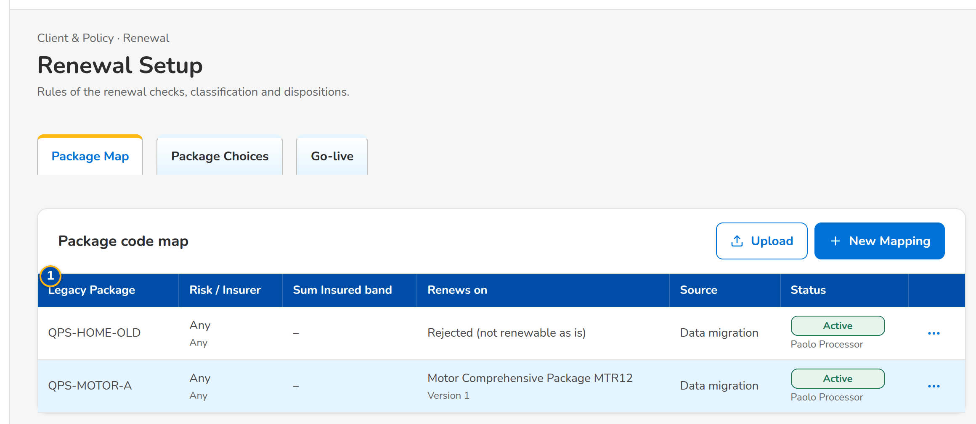
Figure 43: SCR-RN-19 Package Map of the migrated policies with the row action menu
1 | Legacy Package / Risk / Insurer / Sum Insured band / Renews on / Source / Status | 3 | Product Code (blank to reject) / Product Version / Remarks | 5 | Product Code / Product Version / Reason
2 | Legacy Package Code / Legacy Package Version / Risk Code / Insurance Company / Sum Insured From / Sum Insured To | 4 | Renewal / Client / Legacy Package / Proposed / Reason / Proposed by

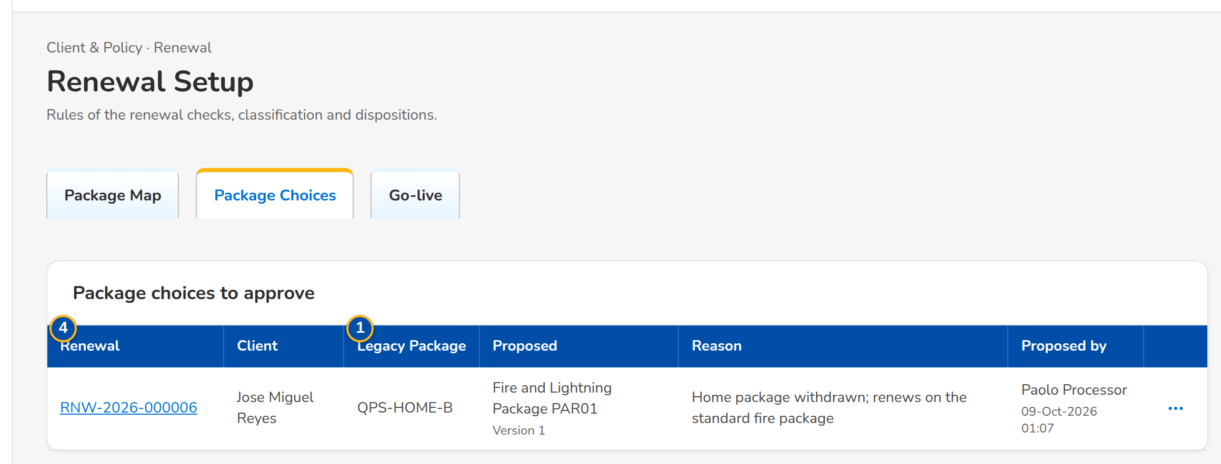
Figure 44: SCR-RN-19 Package Choices waiting for a second team member
Fields (No. = callout number on the first screenshot)
No. | Section | Field | Type | Length / format | Mand. | Source / list | Default | Editable in | Validation | Message when it fails
1 | Package map | Legacy Package / Risk / Insurer / Sum Insured band / Renews on / Source / Status | Column | Legacy code with its version; risk code and insurer name or Any; the band or Any; product name with its version, or Rejected (not renewable as is); Data migration, Entered on screen or Upload; the approval status | - | Package map | - | Read only | - | No package mappings
2 | Mapping dialog | Legacy Package Code / Legacy Package Version / Risk Code / Insurance Company / Sum Insured From / Sum Insured To | Text, amount | The legacy package and its qualifiers, blank for any | Y / N | - | Blank | Pending, Active | - | -
3 | Mapping dialog | Product Code (blank to reject) / Product Version / Remarks | Text, number | The BIBS product and version | N | Product catalogue | Blank | Pending, Active | - | -
4 | Package choices | Renewal / Client / Legacy Package / Proposed / Reason / Proposed by | Column | Renewal reference; client; legacy package; product name with its version; the reason; the maker's name with the time | - | Package choices | - | Read only | - | No package choices waiting
5 | Propose Package dialog | Product Code / Product Version / Reason | Text, number, text area | A product that can be sold for renewal; version 1 or more; up to 200 characters | Y / Y / Y | Product catalogue | Blank | Open renewal of a migrated packaged policy | - | Enter the reason of the choice

Actions
Button | Who | Enabled when | What happens | Resulting status | Notification
New Mapping | Processing (package permission) | Always | Opens the dialog; Save for Authorization keeps the mapping waiting for a second user | Pending Authorization | -
Upload | Processing (package permission) | Always | Opens the upload of the package map | Pending Authorization | -
Authorize, Edit, Deactivate (row menu) | Processing (package permission); Authorize by another user than the maker | By status | As for the risk codes (SCR-RN-17) | Active, Pending Authorization or Inactive | -
Approve, Reject (row menu) | Another member of the Renewal processing team than the maker | Choice waiting | Asks for remarks (mandatory to reject); an approved choice applies to the renewal | Approved or Rejected | Package choice decided (NT-10)
Propose Package (renewal) | Processing Officers | Open renewal of a migrated packaged policy | Opens the dialog; Submit for Approval keeps the choice waiting | Pending | -

Business rules
• A migrated packaged policy whose legacy package is not mapped, retired or ambiguous is an Exception until its package is chosen (FR-RN-028).
• A package choice is approved by another member of the team than its maker (FR-RN-028).
Expected outcome
Every migrated packaged policy renews on a BIBS package version.
Test cases: TC-RN-023.3-01, TC-RN-023.3-02, TC-RN-023.4-01, TC-RN-023.7-01, TC-RN-024.1-01, TC-RN-024.3-01, TC-RN-024.3-02, TC-RN-024.4-01, TC-RN-024.4-02, TC-RN-112.1-01, TC-RN-112.1-02, TC-RN-112.3-01, TC-RN-112.4-01, TC-RN-112.4-02, TC-RN-SCR-19, TC-RN-MSG-14.

13.5.4 SCR-RN-20 Renewal Setup: Go-live
Purpose | The take-over of the renewals of the migrated policies expiring from the go-live date within the renewal horizon, the upload of the migrated policies when the migration source is not connected, and the Renewal Advices sent by hand before go-live, recorded so they are never sent again, with the corrections approved by a second team member.
Who can open it | Processing Team Leader, Processing Officer (Broker), Business Administrator (permission Renewal setup or Renewal package remap)
Navigation | • Menu: Client & Policy › Renewal › Renewal Setup  • Client & Policy › Renewal › Renewal Setup › Go-live
FRs | FR-RN-016

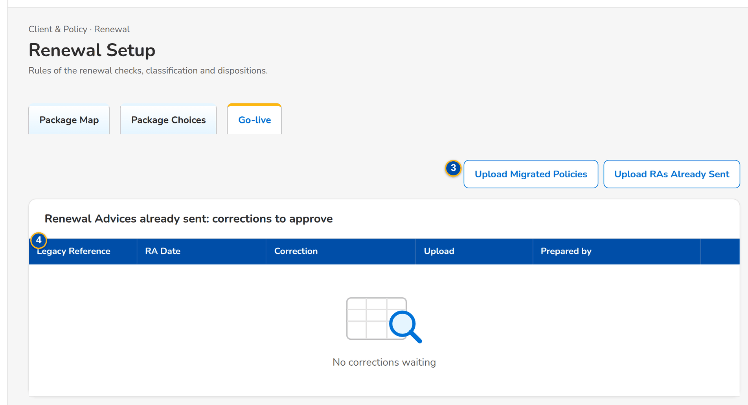
Figure 45: SCR-RN-20 Go-live tab of the Processing Team Leader: the uploads of the go-live and the corrections to approve
1 | Go-live Date | 3 | Upload Migrated Policies / Upload RAs Already Sent
2 | Migrated policies source: connected or loaded by upload | 4 | Legacy Reference / RA Date / Correction / Upload / Prepared by

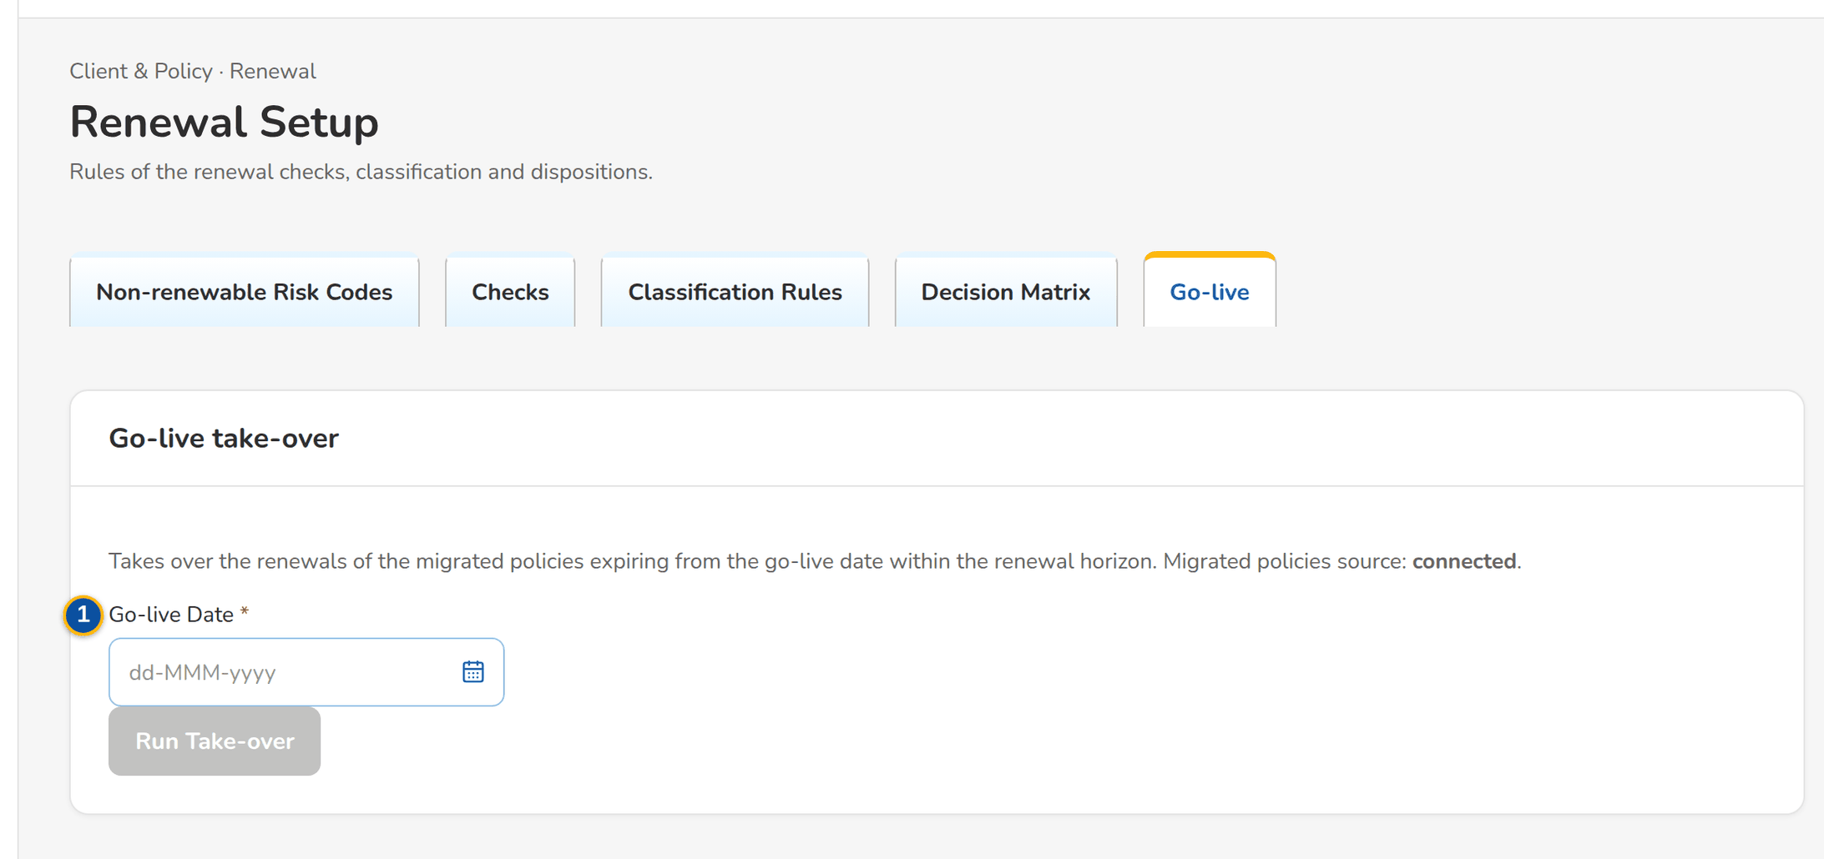
Figure 46: SCR-RN-20 Go-live tab of the Business Administrator: the take-over
Fields (No. = callout number on the first screenshot)
No. | Section | Field | Type | Length / format | Mand. | Source / list | Default | Editable in | Validation | Message when it fails
1 | Go-live take-over | Go-live Date | Date | dd-MMM-yyyy | Y | - | Blank | - | - | -
2 | Go-live take-over | Migrated policies source: connected or loaded by upload | Text | - | - | Data migration | - | Read only | - | -
3 | Uploads | Upload Migrated Policies / Upload RAs Already Sent | Upload | Templates of the expiring policies of the legacy systems and of the Renewal Advices sent before go-live | - | - | - | - | Every row checked before anything is saved | Legacy policy <legacy ref> is already a renewal
4 | Corrections | Legacy Reference / RA Date / Correction / Upload / Prepared by | Column | The Renewal Advice recorded and the correction proposed; the upload and row; the maker's name | - | Renewal Advices already sent | - | Read only | - | No corrections waiting

Actions
Button | Who | Enabled when | What happens | Resulting status | Notification
Run Take-over | Business Administrator | Go-live date entered | Takes over the renewals of the migrated policies expiring from the date within the horizon; expiries up to the urgent date are flagged Urgent | Extracted | Go-live renewal extraction completed (NT-09)
Upload Migrated Policies | Users with the extract permission | Always | Opens the upload of the migrated policies | - | -
Upload RAs Already Sent | Users with the send permission | Always | Opens the upload of the Renewal Advices sent by hand | - | -
Approve, Reject (row menu) | Another member of the Renewal processing team than the maker | Correction waiting | Asks for remarks (mandatory to reject) | Approved or Rejected | -

Business rules
• The renewals expiring from go-live to 31 May 2028 are taken over; those up to 31 January 2028 are Urgent (FR-RN-016).
• A Renewal Advice recorded as sent before go-live is never sent again (FR-RN-016).
Expected outcome
The renewals of the go-live window continue in BIBS without a second Renewal Advice.
Test cases: TC-RN-023.3-01, TC-RN-023.3-02, TC-RN-023.4-01, TC-RN-023.7-01, TC-RN-024.1-01, TC-RN-024.3-01, TC-RN-024.3-02, TC-RN-024.4-01, TC-RN-024.4-02, TC-RN-112.1-01, TC-RN-112.1-02, TC-RN-112.3-01, TC-RN-112.4-01, TC-RN-112.4-02, TC-RN-SCR-20, TC-RN-MSG-15.

14 End-to-end walkthroughs
Five walkthroughs follow a renewal through the screens, persona by persona, with what the user does, what the user sees and the result of each step. They use seed data only and run in this order on the SIT environment. They are the script of the SIT review sessions of the Start Here guide. The storyboard index (appendix) lists every step with its screen, figure and FR.

14.1 WT-A An expiring account from the Expiry List to the Team Leader's post
The booked accounts expiring in the renewal horizon are extracted and initiated; the renewal of Pacific Harbor Logistics Inc. waits in the Unassigned Disposition tab of Corporate Marketing Team 1, classified Review: its expiring premium is outstanding, a claim is open and an endorsement is in progress. The Team Leader assigns it to the Account Officer, who reads the account history, gives the disposition For Renewal and pushes it. The Team Leader's post is refused while the blocking checks fail; she overrides them with a reason and posts the renewal to Processing.
Seed data: renewal of account ARN-2026-940004 (Pacific Harbor Logistics Inc., Luzon Assurance Co.), Corporate Marketing Team 1
Step 1. Marketing Team Leader – Expiry List (SCR-RN-02)
Does | Opens the Expiry List, tab Unassigned Disposition, ticks the renewal of Pacific Harbor Logistics Inc. and clicks Assign Disposition: Arnel Account Officer, then Assign and Push
Sees | Message: 1 assigned; the renewal leaves the tab
Result | Assigned

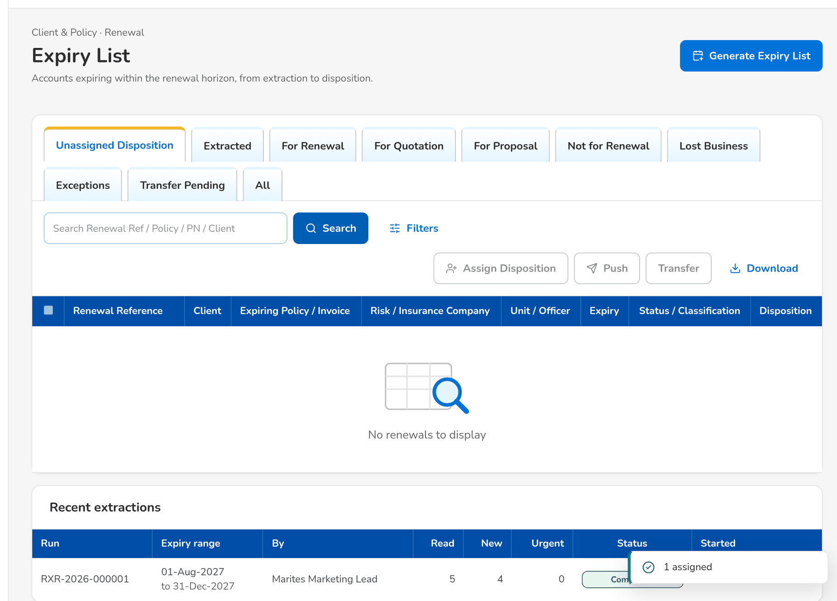
Figure 47: WT-A step 1: Expiry List
Step 2. Marketing Account Officer (Account Broker) – My Dispositions (SCR-RN-06)
Does | Opens My Dispositions
Sees | The renewal assigned to him with its expiry, the Review classification and the flags Outstanding and Claims
Result | For disposition

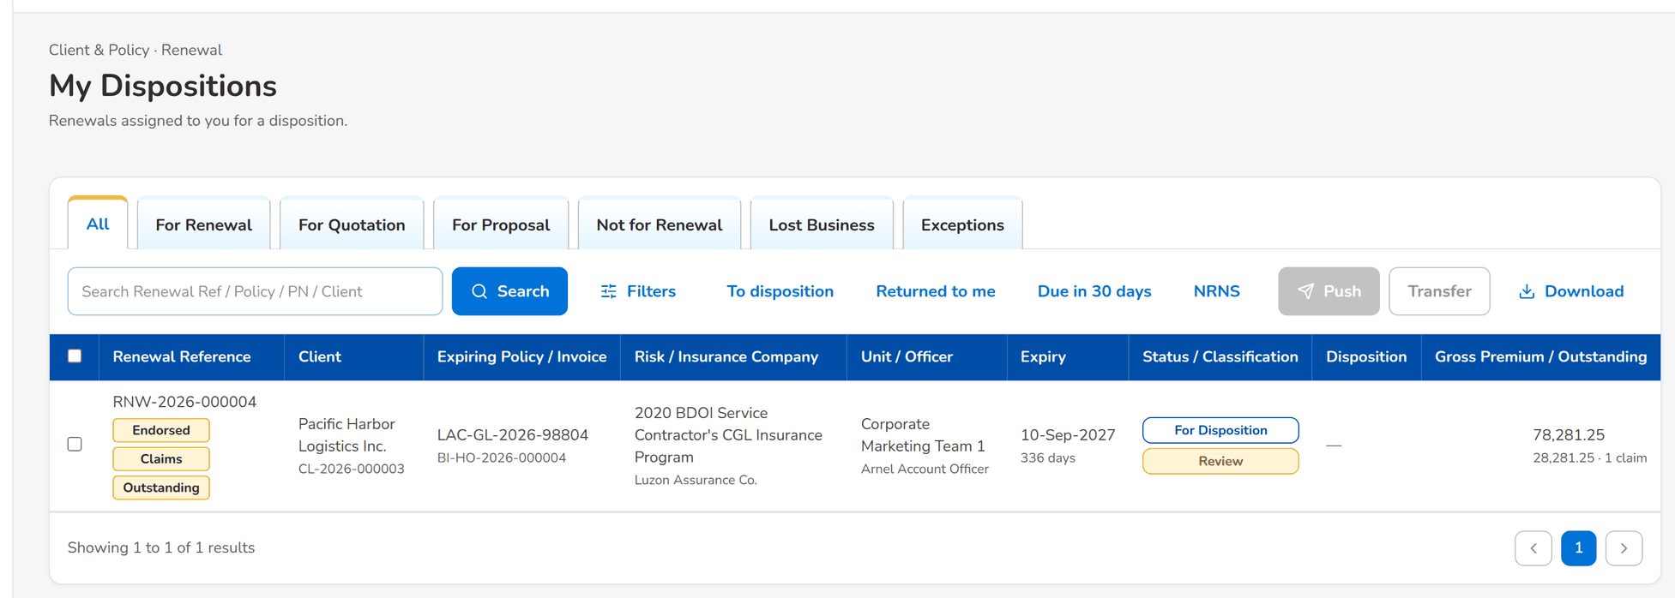
Figure 48: WT-A step 2: My Dispositions
Step 3. Marketing Account Officer (Account Broker) – Renewal: Checks, Account History and Computations (SCR-RN-04)
Does | Opens the renewal, tab Account History, and clicks View Account History
Sees | The payments of the expiring invoice and the open claim; the viewing is recorded
Result | History viewed

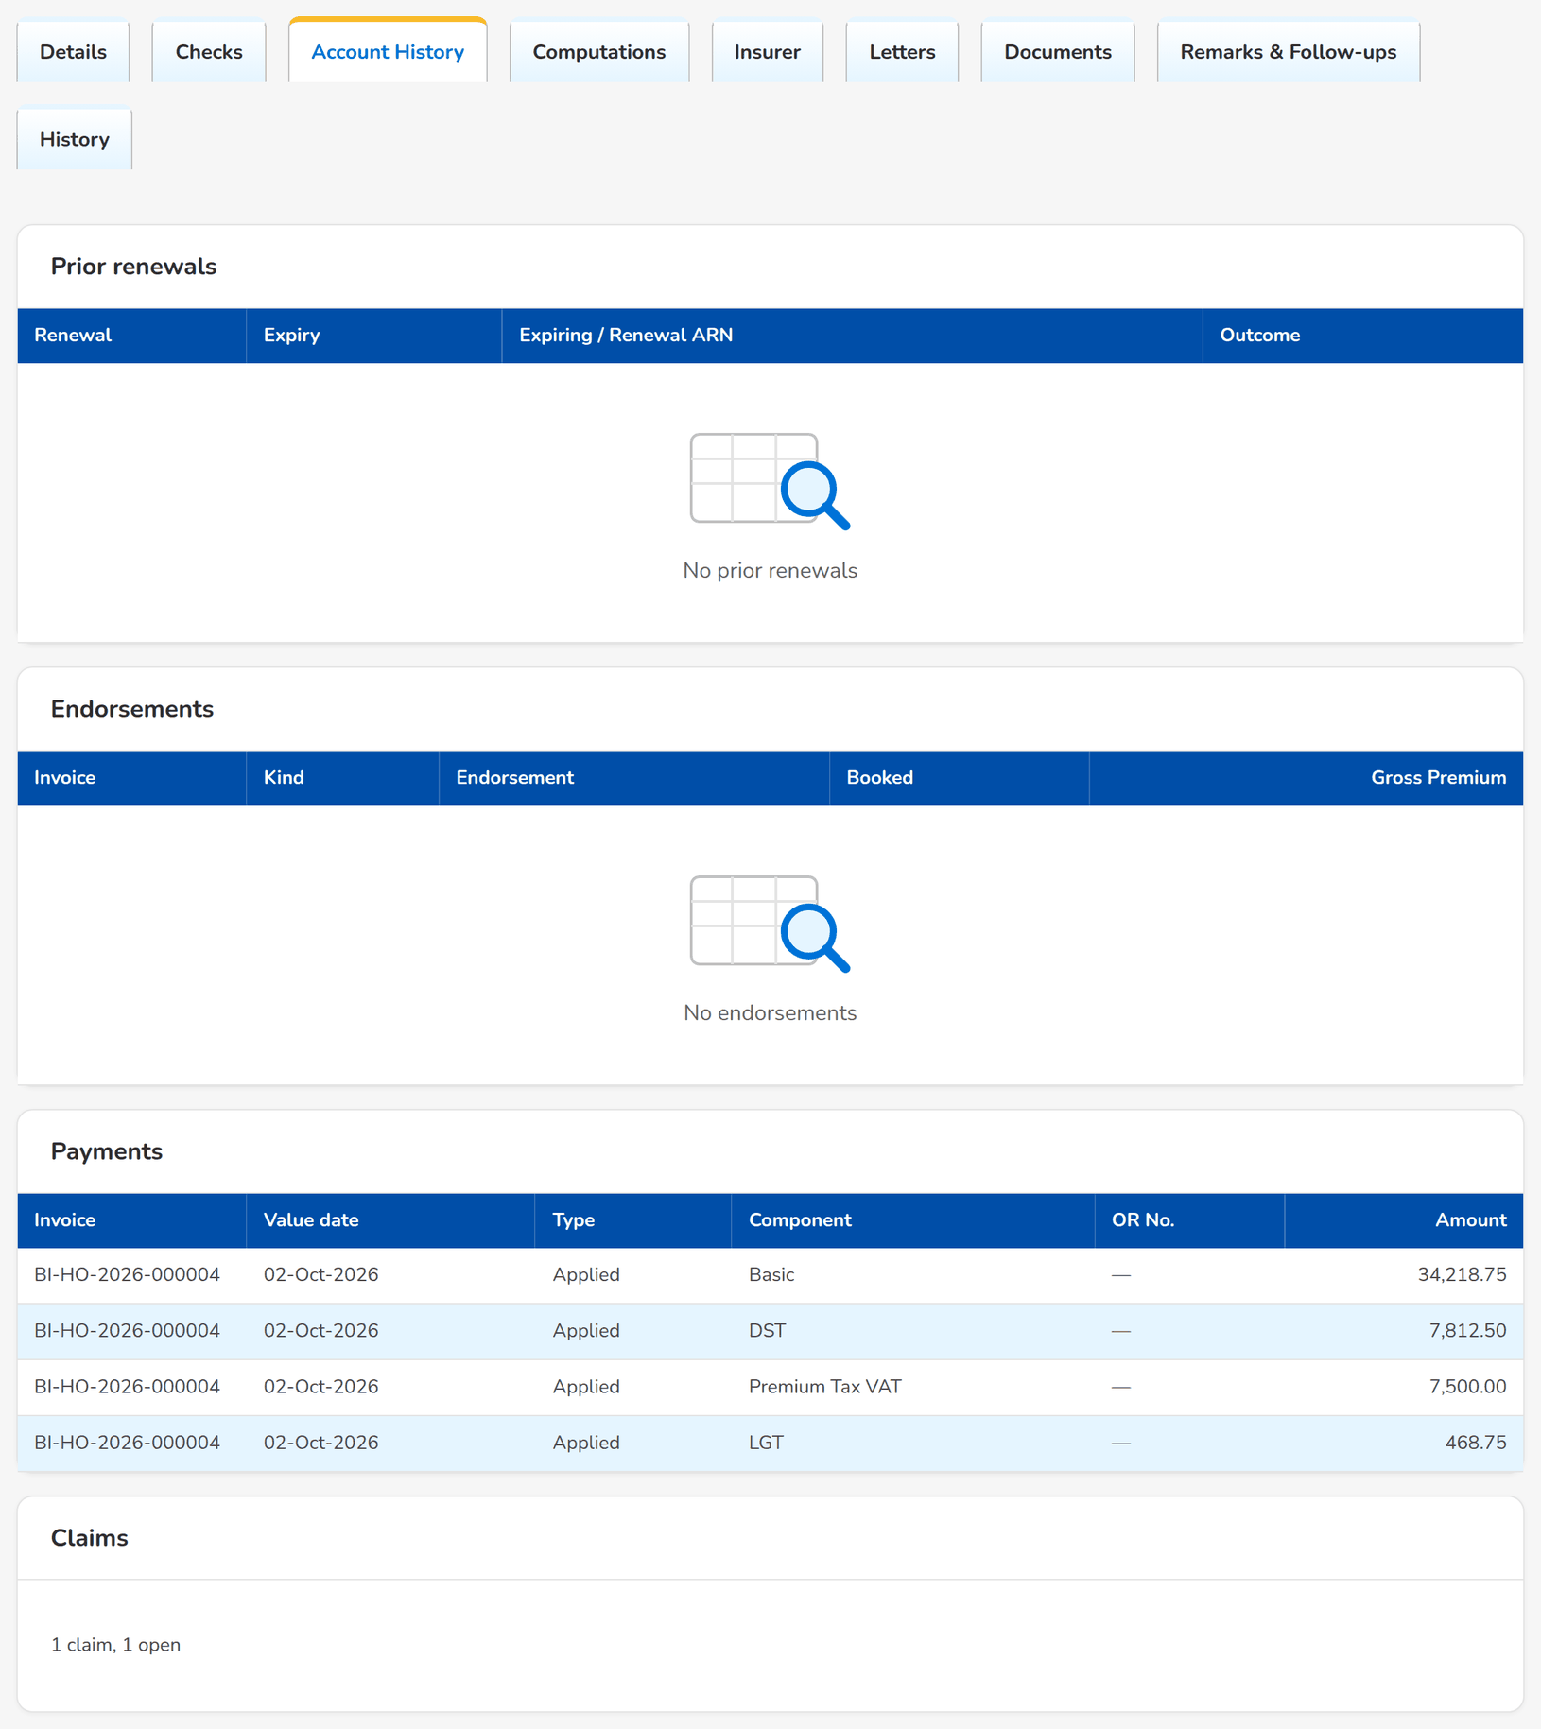
Figure 49: WT-A step 3: Renewal: Checks, Account History and Computations
Step 4. Marketing Account Officer (Account Broker) – Set Disposition, Add Remark and Re-open (SCR-RN-07)
Does | Clicks Set Disposition: For Renewal with the remarks of the client's call, then Save
Sees | Message: Saved; the disposition For Renewal on the renewal
Result | Dispositioned

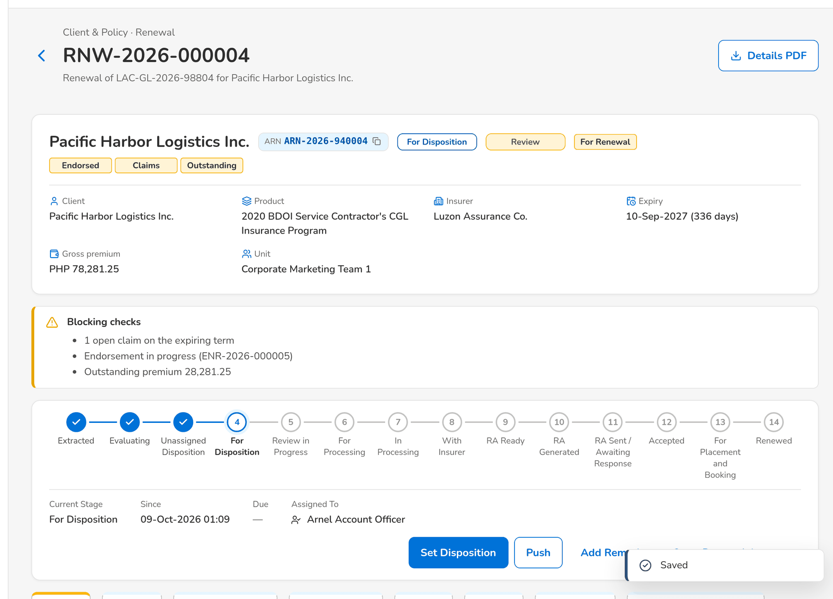
Figure 50: WT-A step 4: Set Disposition, Add Remark and Re-open
Step 5. Marketing Account Officer (Account Broker) – Set Disposition, Add Remark and Re-open (SCR-RN-07)
Does | Clicks Push
Sees | Message: Pushed to the Team Leader; the status Review in Progress
Result | Pushed

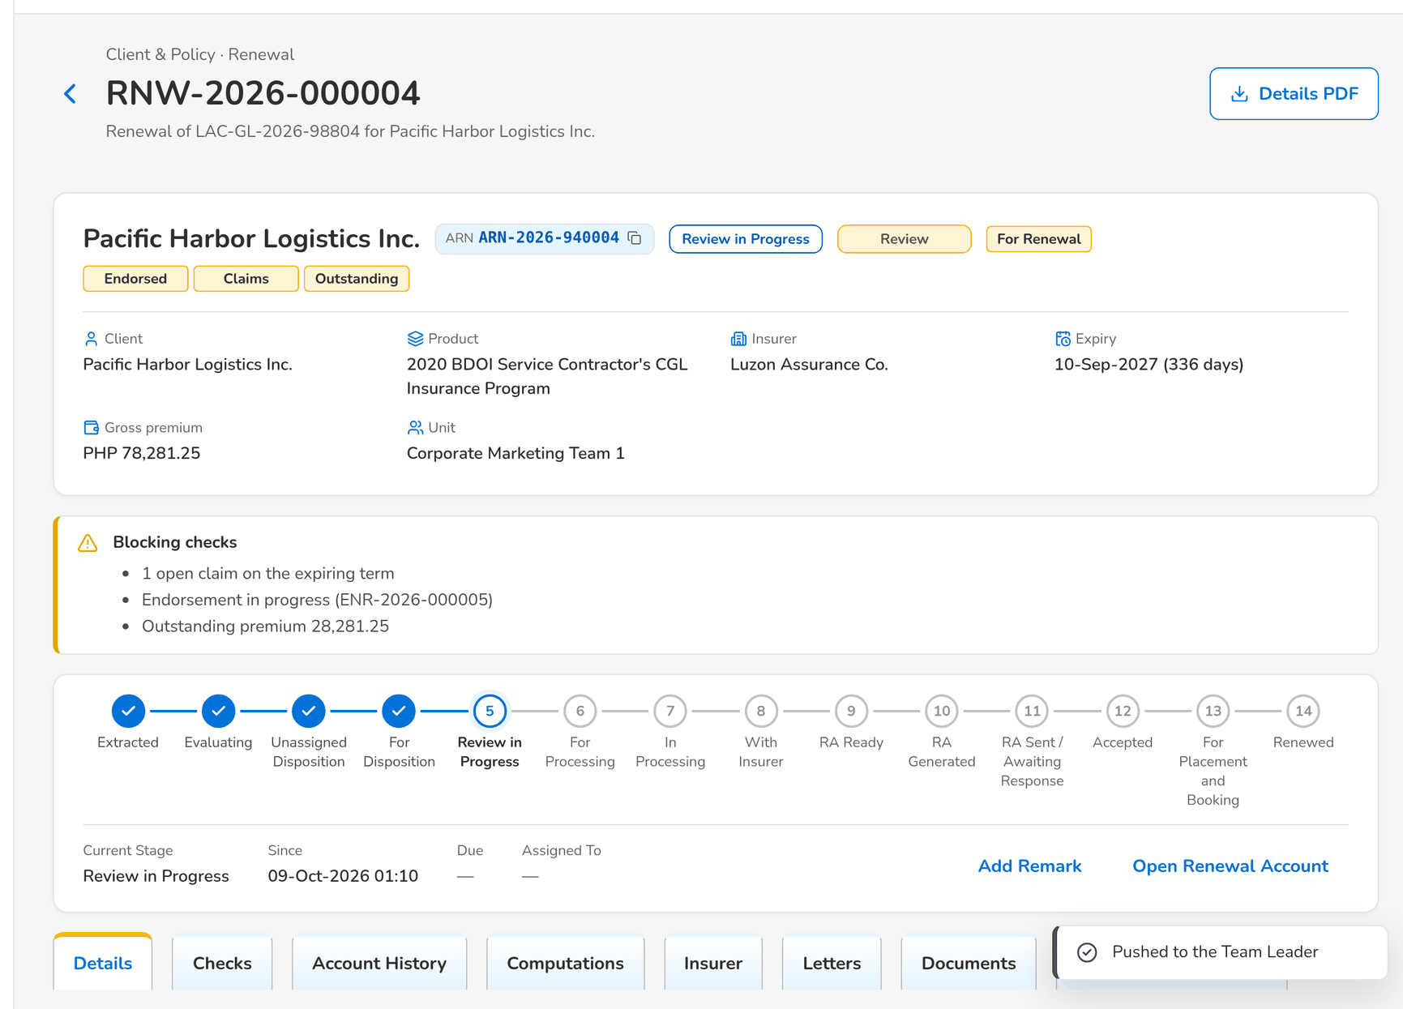
Figure 51: WT-A step 5: Set Disposition, Add Remark and Re-open
Step 6. Marketing Team Leader – TL Review (SCR-RN-08)
Does | Opens TL Review, tab For Review, ticks the renewal and clicks Post, then confirms
Sees | The outcome: 1 refused, the renewal cannot be posted while the claims, endorsement and outstanding premium checks fail
Result | Refused

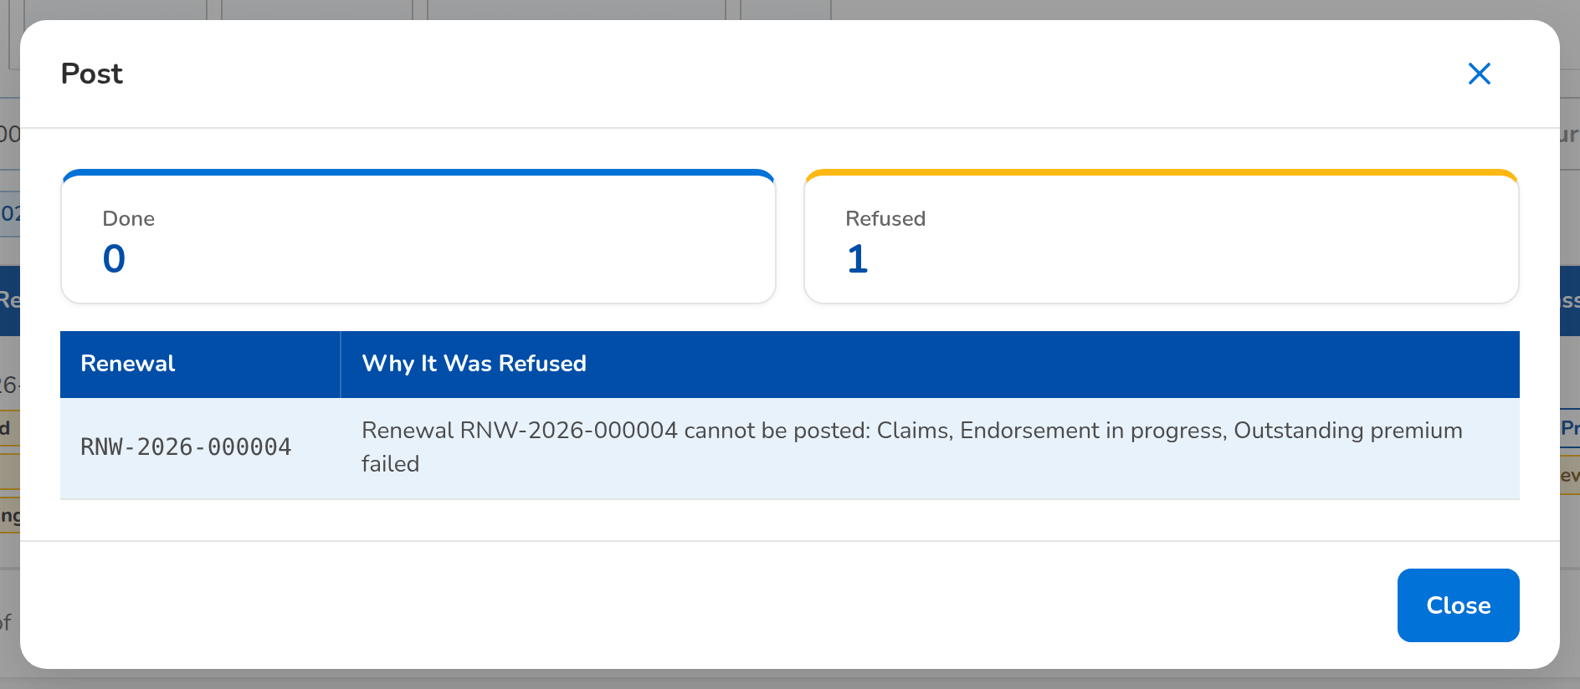
Figure 52: WT-A step 6: TL Review
Step 7. Marketing Team Leader – TL Review (SCR-RN-08)
Does | Clicks Override: Outstanding balance, reason Approved by the Team Leader, with remarks (the open claim and the endorsement are overridden the same way)
Sees | Message: 1 overridden; the override kept in the History tab of the renewal
Result | Overridden

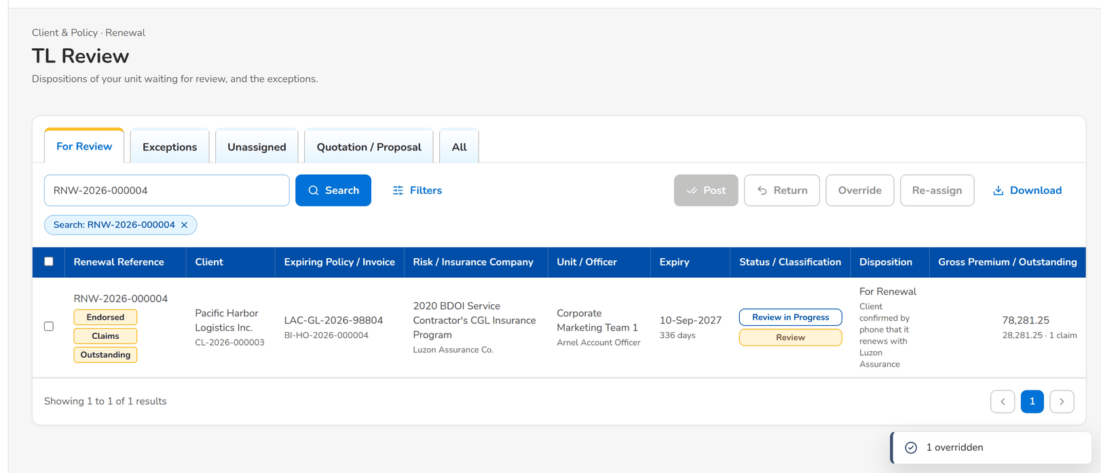
Figure 53: WT-A step 7: TL Review
Step 8. Marketing Team Leader – TL Review (SCR-RN-08)
Does | Clicks Post again and confirms
Sees | Message: 1 posted; the renewal moves to Processing
Result | Posted

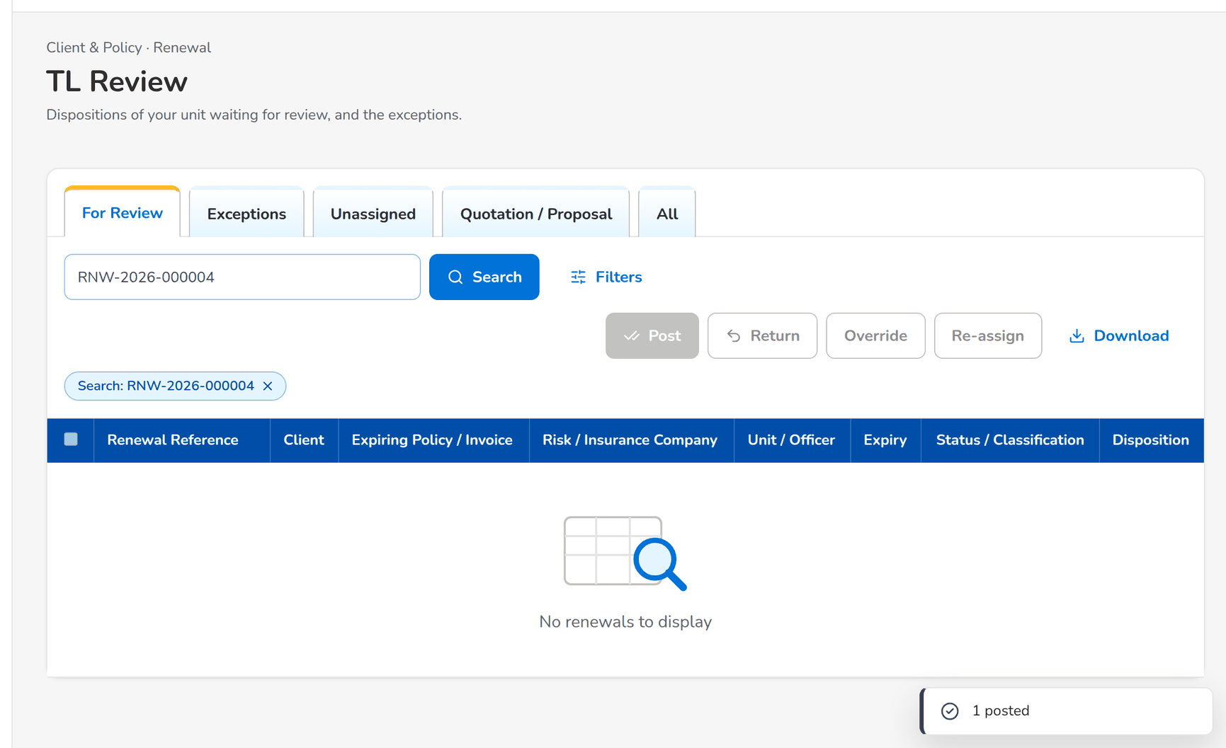
Figure 54: WT-A step 8: TL Review
What happens next, downstream
• The Processing Team Leaders are notified of the renewal posted for processing (walkthrough B); the renewal account is created from the expiring account.
• A renewal posted For Quotation or For Proposal continues as a New Business quotation or proposal request.

14.2 WT-B Processing, the insurer's answer and the Renewal Advice
The Processing Team Leader assigns the renewal of walkthrough A to a Processing Officer, who sends it to the insurer in a batch and records the insurer's answer Renew as is. The renewal is then ready for its Renewal Advice: the Account Officer generates the first notice and sends it to the client, protected.
Seed data: the renewal posted in walkthrough A; Patricia Processing Lead and Paolo Processor
Step 1. Processing Team Leader – Processing Worklist (SCR-RN-10)
Does | Opens the Processing Worklist, tab For Processing, ticks the renewal and clicks Assign PO: Paolo Processor, then Assign
Sees | Message: 1 assigned; the renewal In Processing
Result | In processing

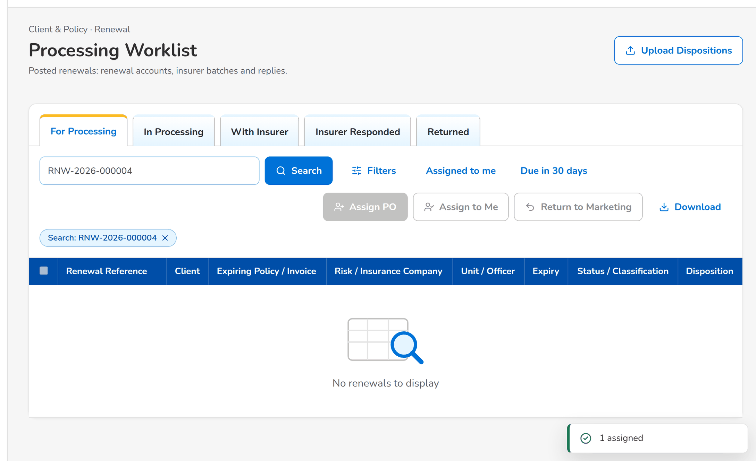
Figure 55: WT-B step 1: Processing Worklist
Step 2. Processing Officer (Broker) – Insurer Batches (SCR-RN-11)
Does | Opens Insurer Batches, clicks New Batch with Luzon Assurance Co. and the expiry date of the renewal, then Create Batch, and opens the batch
Sees | The batch Draft with the renewal and the columns of the insurer extract
Result | Batch ready

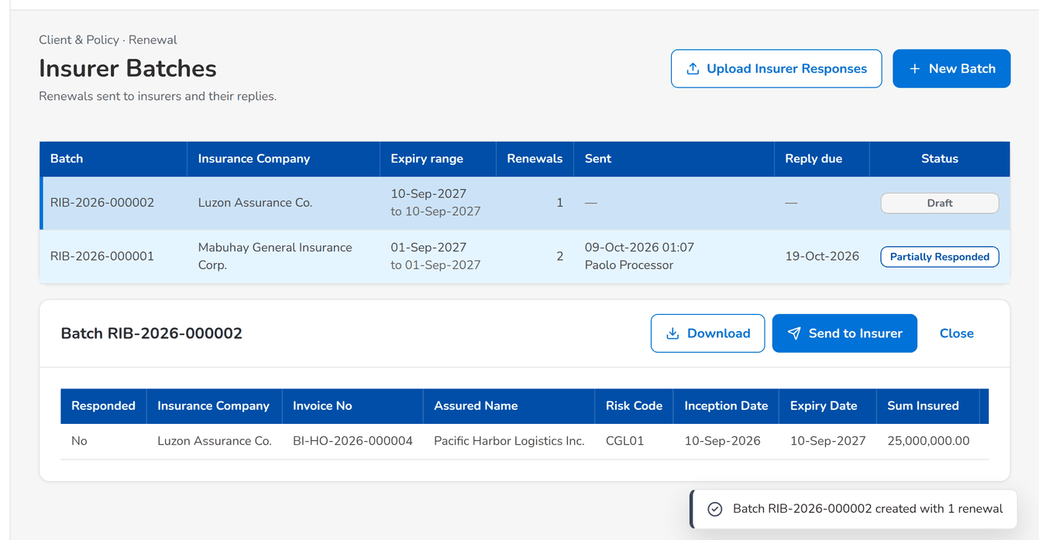
Figure 56: WT-B step 2: Insurer Batches
Step 3. Processing Officer (Broker) – Insurer Batches (SCR-RN-11)
Does | Clicks Send to Insurer and confirms
Sees | Message: Batch sent to the insurer; the batch Sent with its reply date
Result | With the insurer

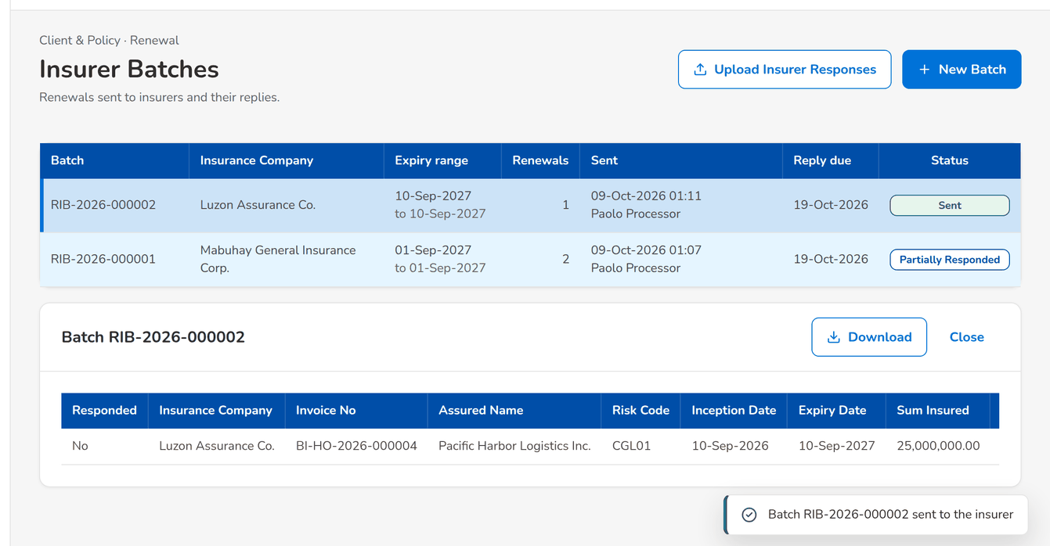
Figure 57: WT-B step 3: Insurer Batches
Step 4. Processing Officer (Broker) – Record Insurer Response (SCR-RN-12)
Does | Opens the renewal and clicks Record Insurer Response: Renew as is with the insurer reference, then Record
Sees | Message: Saved; the renewal RA Ready
Result | RA ready

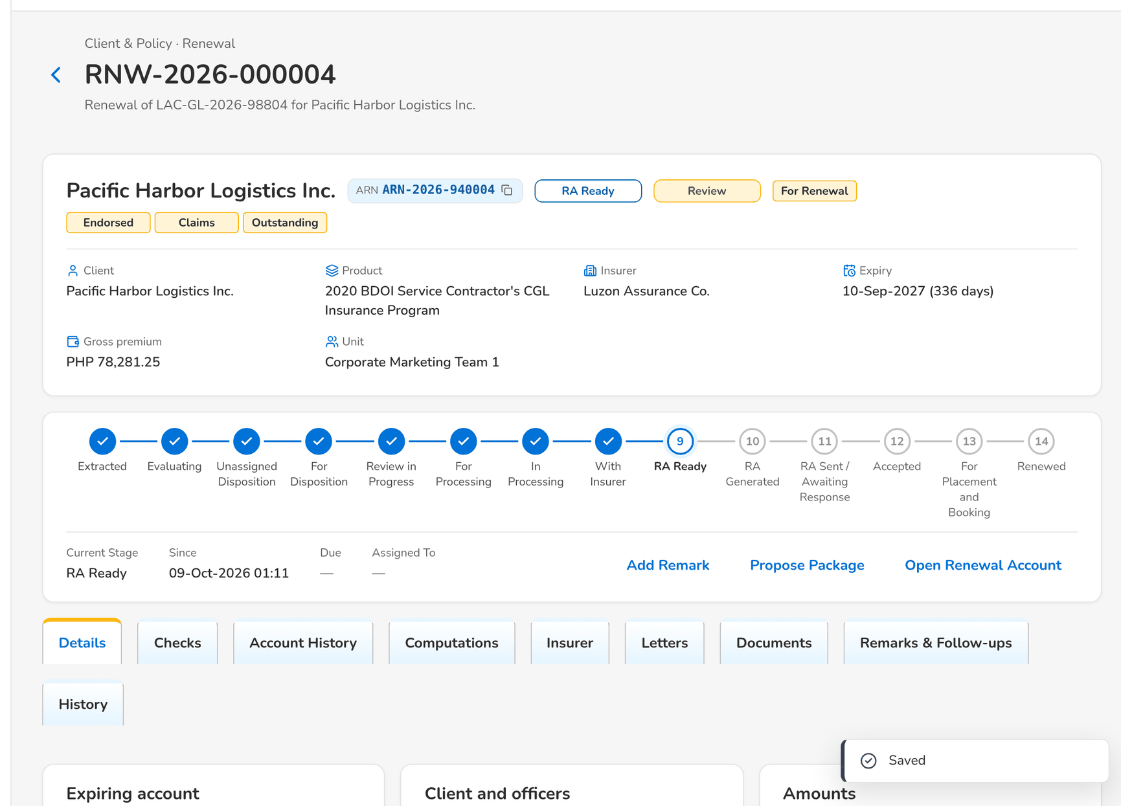
Figure 58: WT-B step 4: Record Insurer Response
Step 5. Marketing Account Officer (Account Broker) – Letters (SCR-RN-13)
Does | Opens Letters, tab RA Ready, ticks the renewal, clicks Generate RA: First notice, then Generate
Sees | Message: 1 generated; the renewal in RA Generated, locked on the Marketing side
Result | RA generated

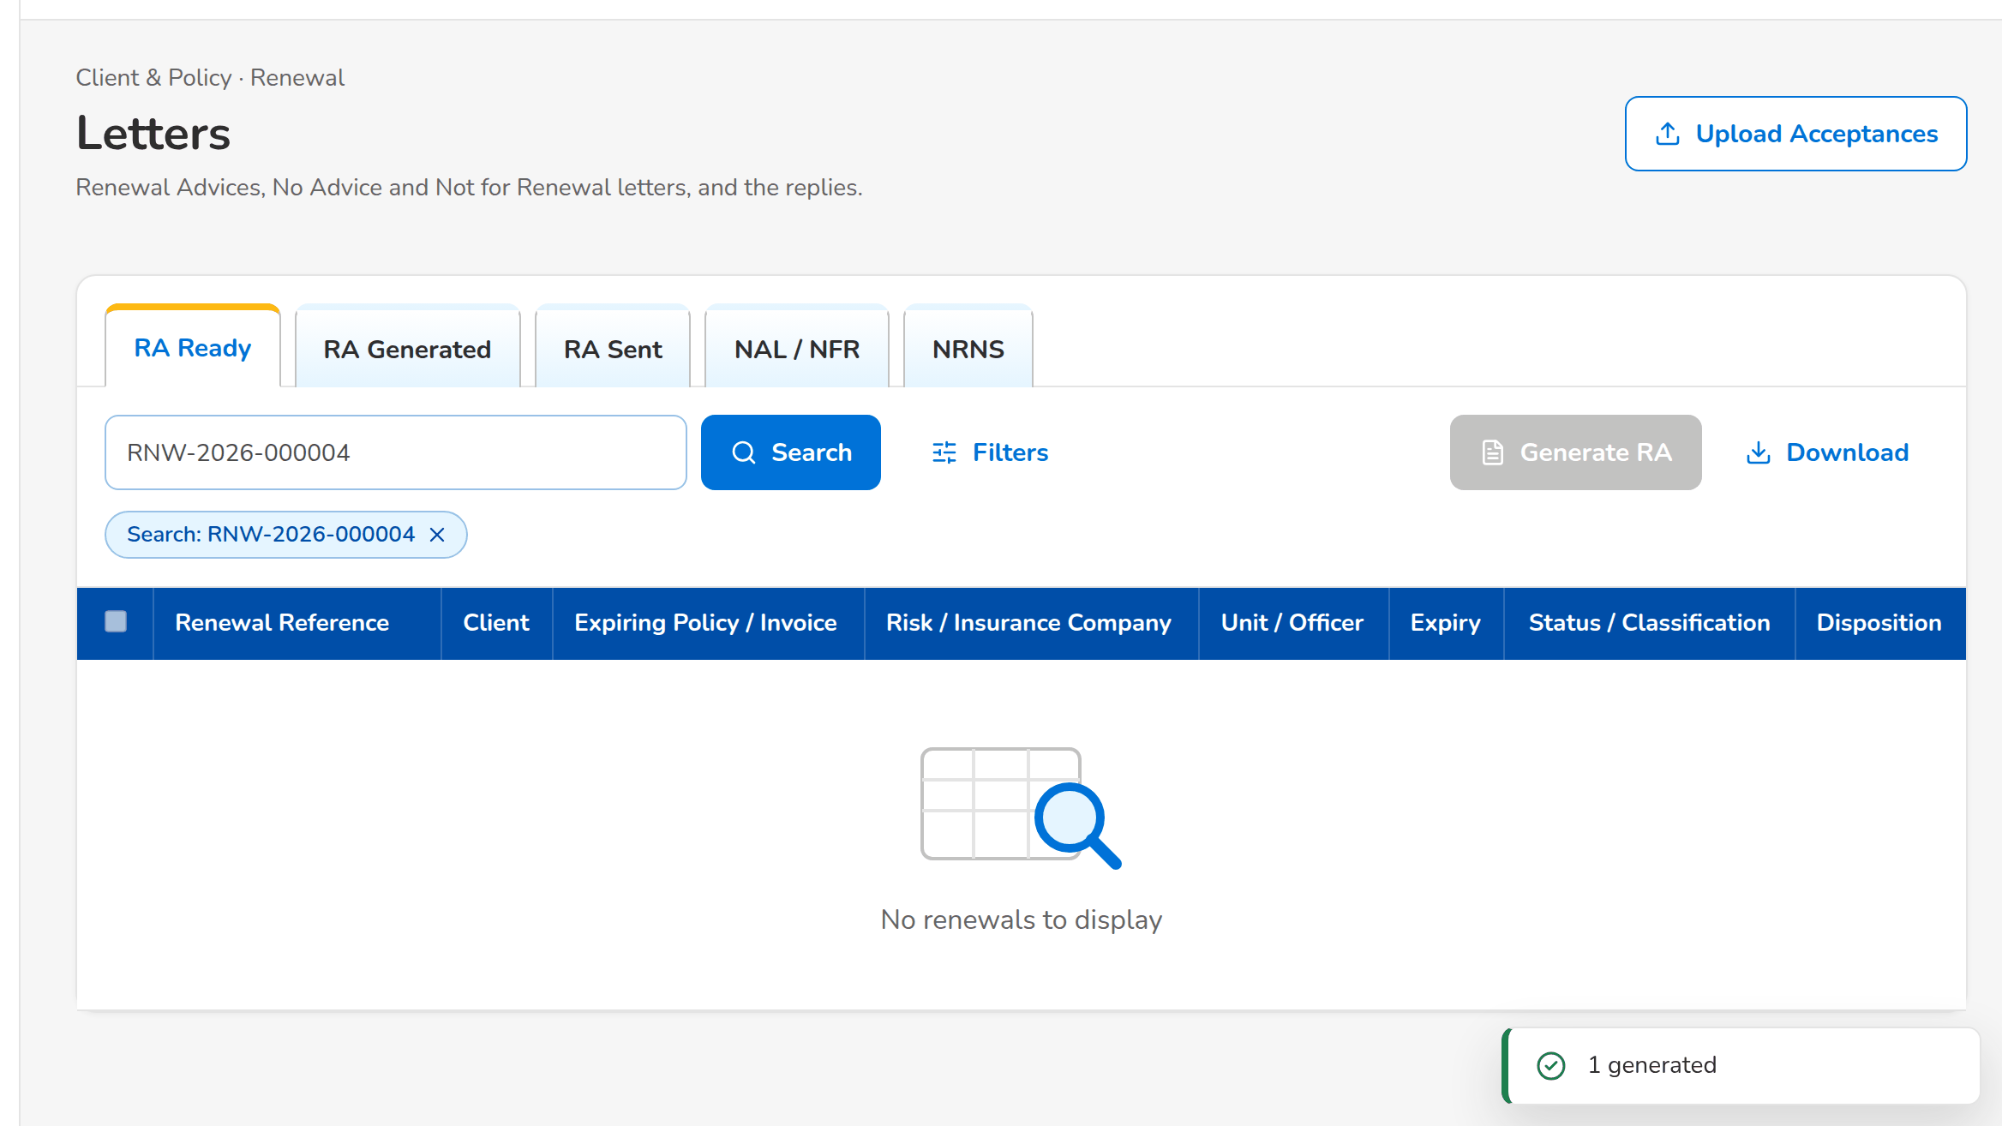
Figure 59: WT-B step 5: Letters
Step 6. Marketing Account Officer (Account Broker) – Letters (SCR-RN-13)
Does | Opens the tab RA Generated, ticks the renewal, clicks Send and confirms
Sees | Message: 1 sent; the Renewal Advice e-mailed protected to the client
Result | RA sent

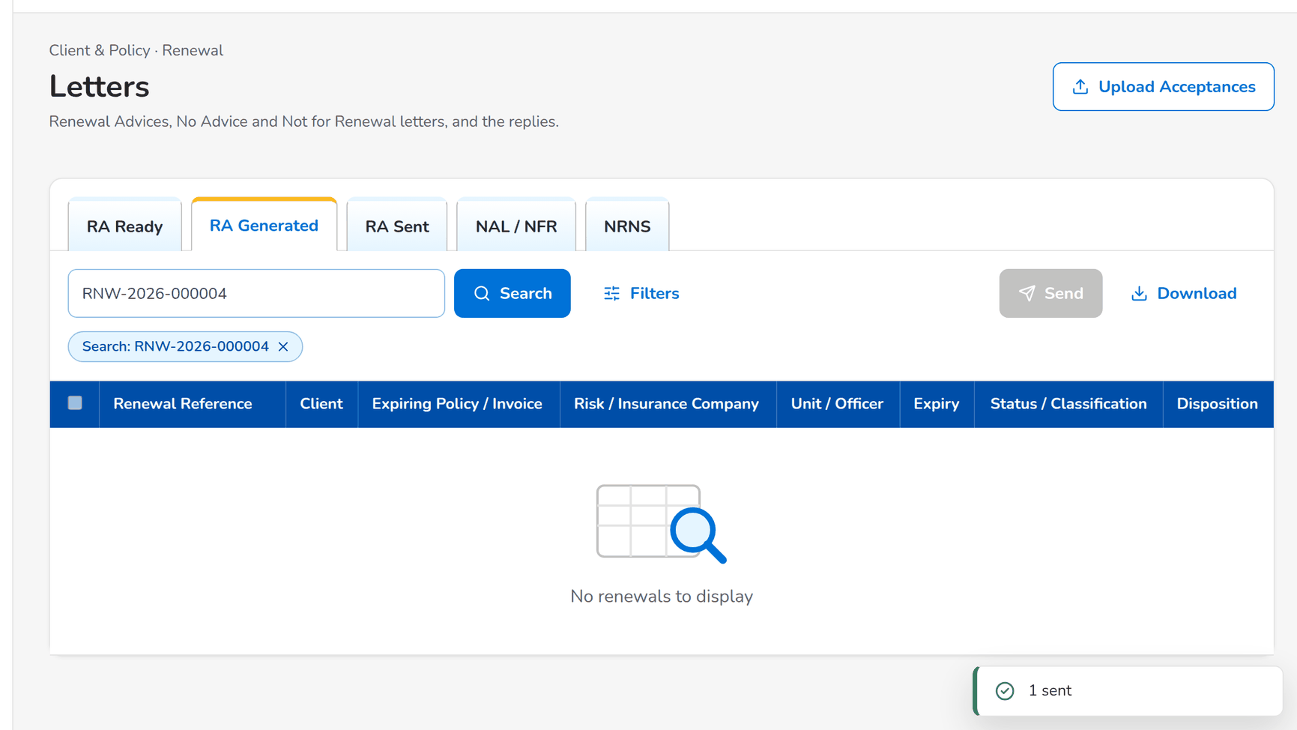
Figure 60: WT-B step 6: Letters
What happens next, downstream
• The client receives the Renewal Advice as a protected PDF and its password in a separate e-mail.
• Without acceptance after the second-notice days, the second notice is generated from the RA Sent tab.

14.3 WT-C The Contact Center follow-up and the client's acceptance
The renewal of walkthrough B waits for the client's reply. The Contact Center calls the client and records the follow-up; the client pays the renewal premium, and the Account Officer records the acceptance by payment. The renewal account goes on to placement and booking without re-keying.
Seed data: the renewal sent in walkthrough B; Cecilia Contact Center
Step 1. Contact Center – Follow-ups (SCR-RN-15)
Does | Opens Follow-ups, tab RA Sent
Sees | The renewal waiting for the client's reply
Result | Awaiting response

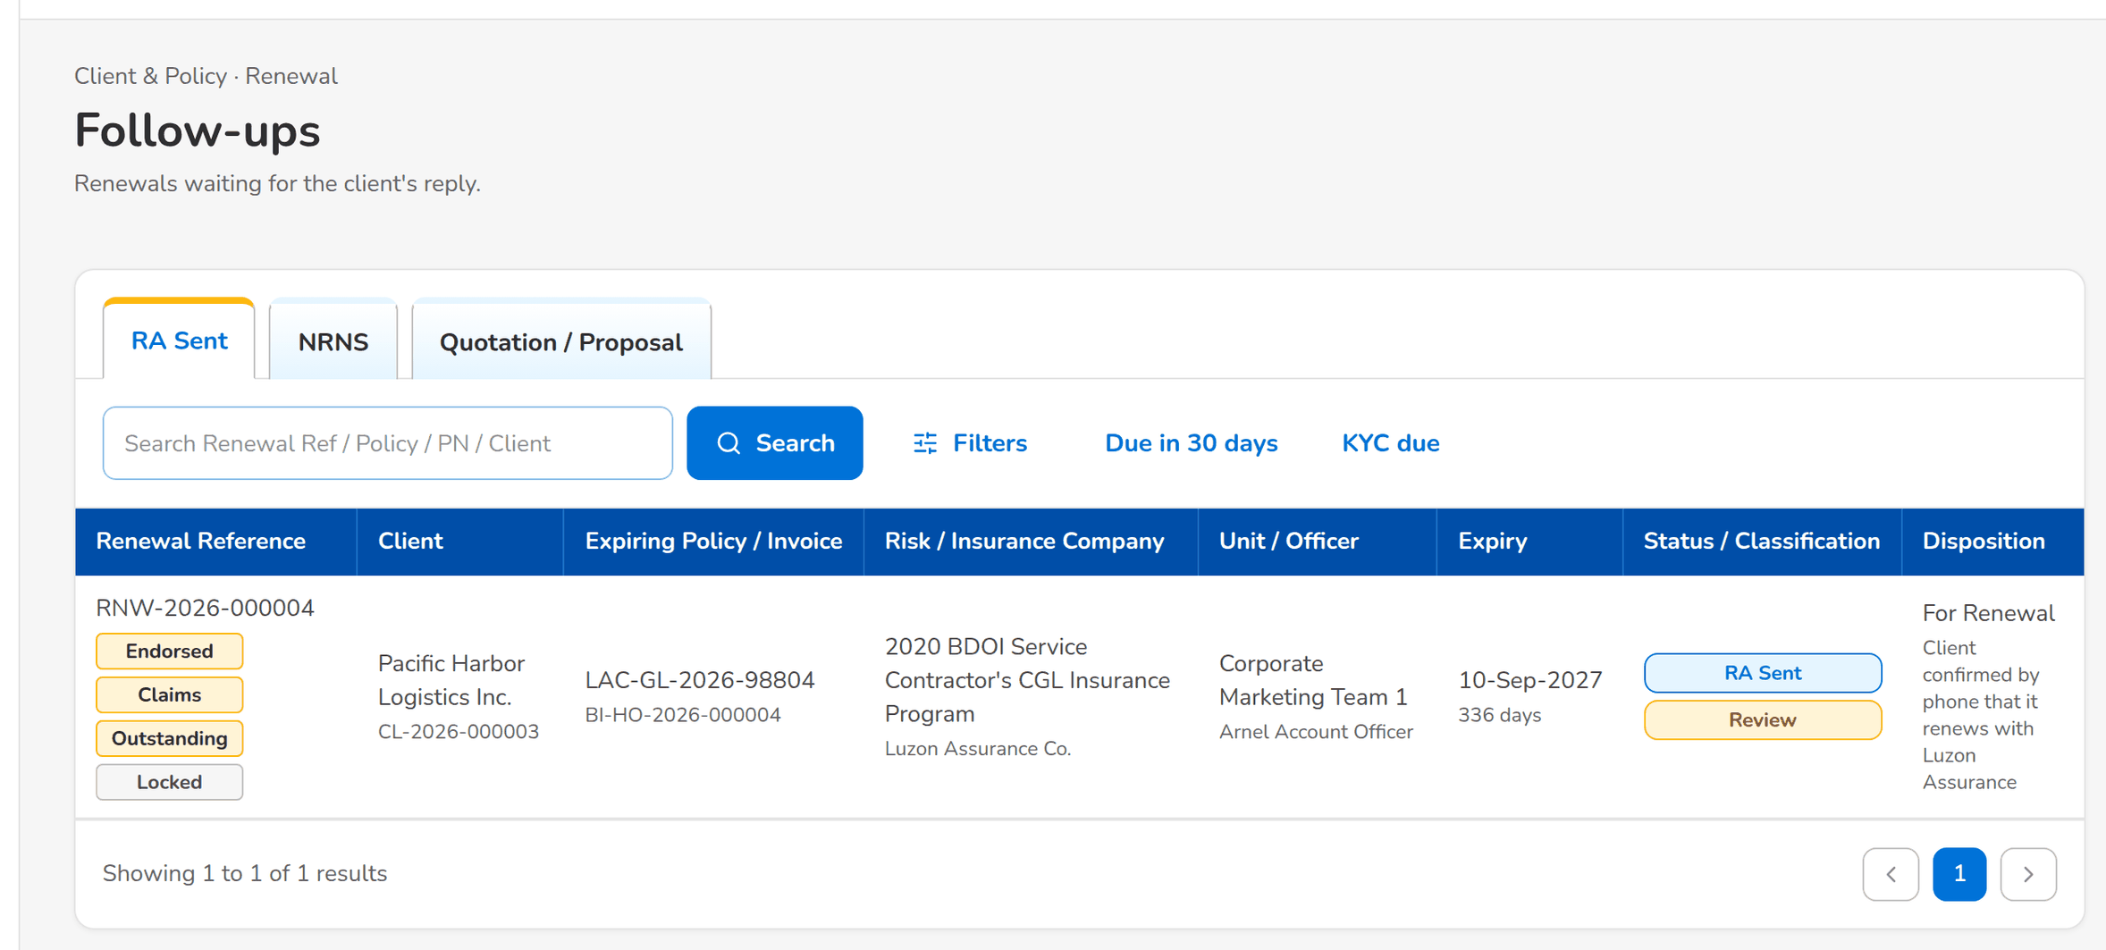
Figure 61: WT-C step 1: Follow-ups
Step 2. Contact Center – Follow-ups (SCR-RN-15)
Does | Opens the renewal and clicks Add Follow-up: Call, Client will renew, the next action date and the remarks, then Save
Sees | Message: Saved; the follow-up on the Remarks & Follow-ups tab
Result | Followed up

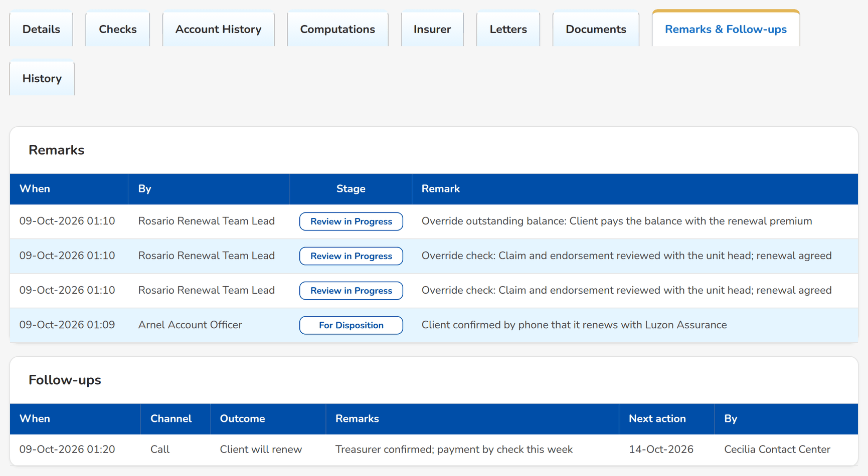
Figure 62: WT-C step 2: Follow-ups
Step 3. Marketing Account Officer (Account Broker) – Record Acceptance (SCR-RN-14)
Does | Opens the renewal and clicks Record Acceptance: Payment with the payment reference, then Record
Sees | Message: Saved; the renewal For Placement and Booking
Result | Accepted

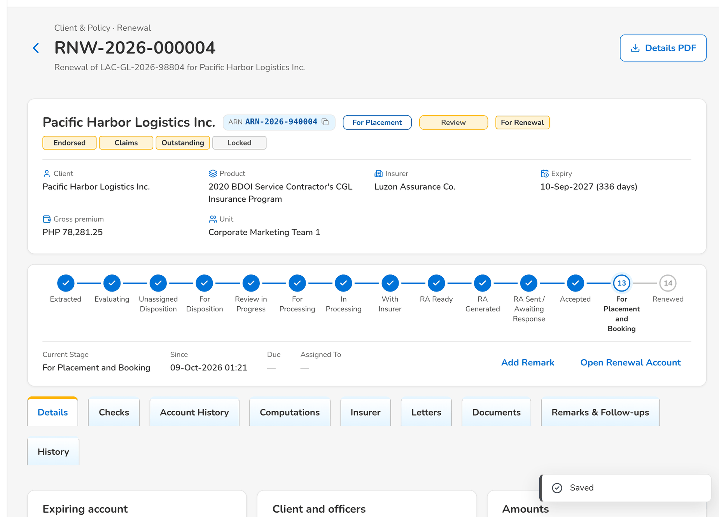
Figure 63: WT-C step 3: Record Acceptance
Step 4. Marketing Account Officer (Account Broker) – Renewal: Insurer, Letters, Documents, Remarks and History (SCR-RN-05)
Does | Opens the tab Letters
Sees | The Renewal Advice in the e-mail queue to the client and the acceptance by payment
Result | Kept

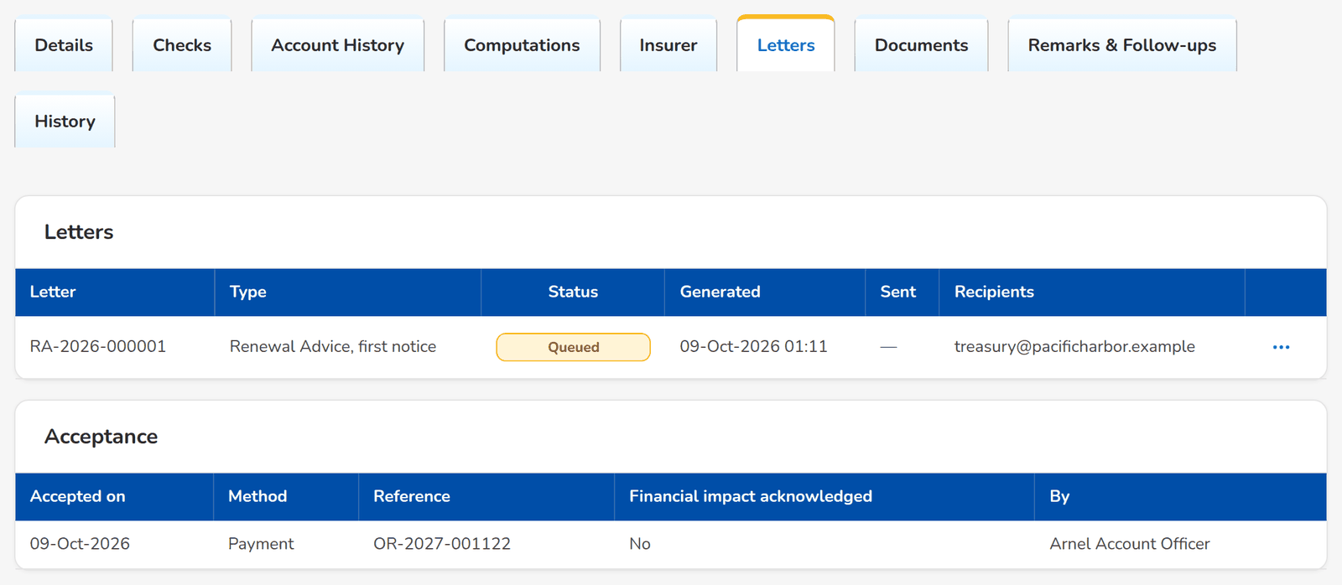
Figure 64: WT-C step 4: Renewal: Insurer, Letters, Documents, Remarks and History
What happens next, downstream
• The renewal account is fast-tracked to the payment gate, placed and booked through New Business as business type Renewal; the booking closes the renewal as renewed.

14.4 WT-D Not for Renewal and the closing letter
Aileen Account Officer learns that the client's loan is fully paid: she gives the disposition Not for Renewal with that reason and pushes it; the Team Leader posts it to the letter step and the Not for Renewal Letter is sent, which closes the renewal.
Seed data: the renewal of the migrated motor policy QPS-FI-0100007 (Jose Miguel Reyes), CBG Metro Team 1, assigned to Aileen Account Officer by the Team Leader
Step 1. Marketing Account Officer (Account Broker) – Set Disposition, Add Remark and Re-open (SCR-RN-07)
Does | Opens the renewal, views its account history, clicks Set Disposition: Not for Renewal, reason Loan fully paid, with remarks, then Save
Sees | Message: Saved; the disposition Not for Renewal with its reason
Result | Dispositioned

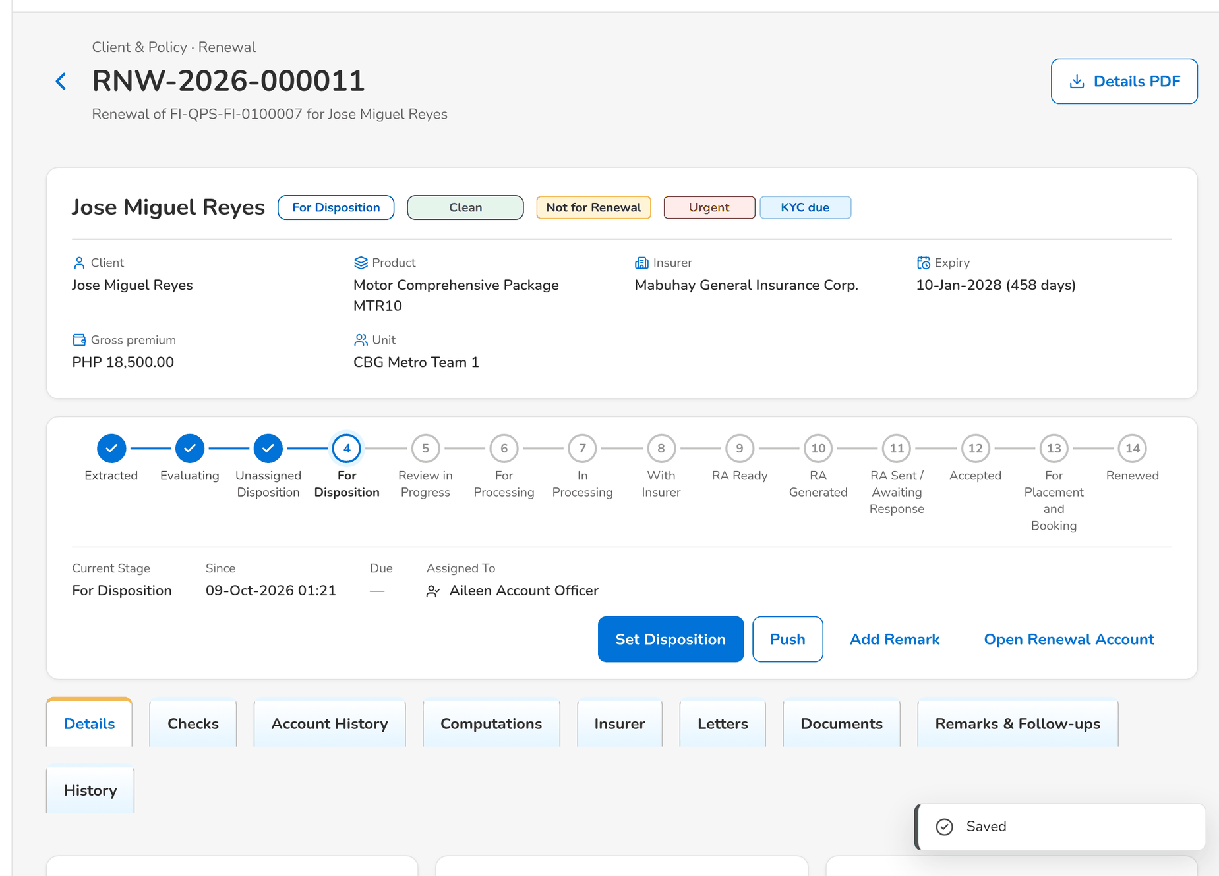
Figure 65: WT-D step 1: Set Disposition, Add Remark and Re-open
Step 2. Marketing Team Leader – TL Review (SCR-RN-08)
Does | After the Account Officer's push, ticks the renewal on TL Review, clicks Post and confirms
Sees | Message: 1 posted; the renewal goes to the closing letters
Result | Letter pending

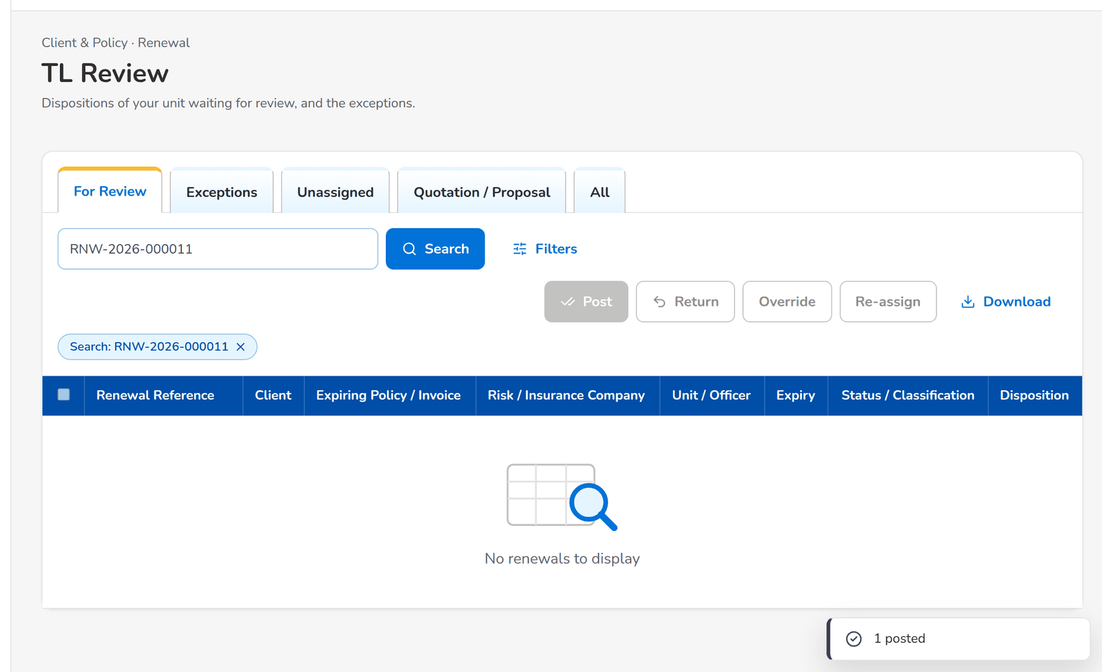
Figure 66: WT-D step 2: TL Review
Step 3. Marketing Account Officer (Account Broker) – Letters (SCR-RN-13)
Does | Opens Letters, tab NAL / NFR, ticks the renewal, clicks Send Letters and confirms
Sees | Message: 1 sent; the renewal is closed
Result | Closed

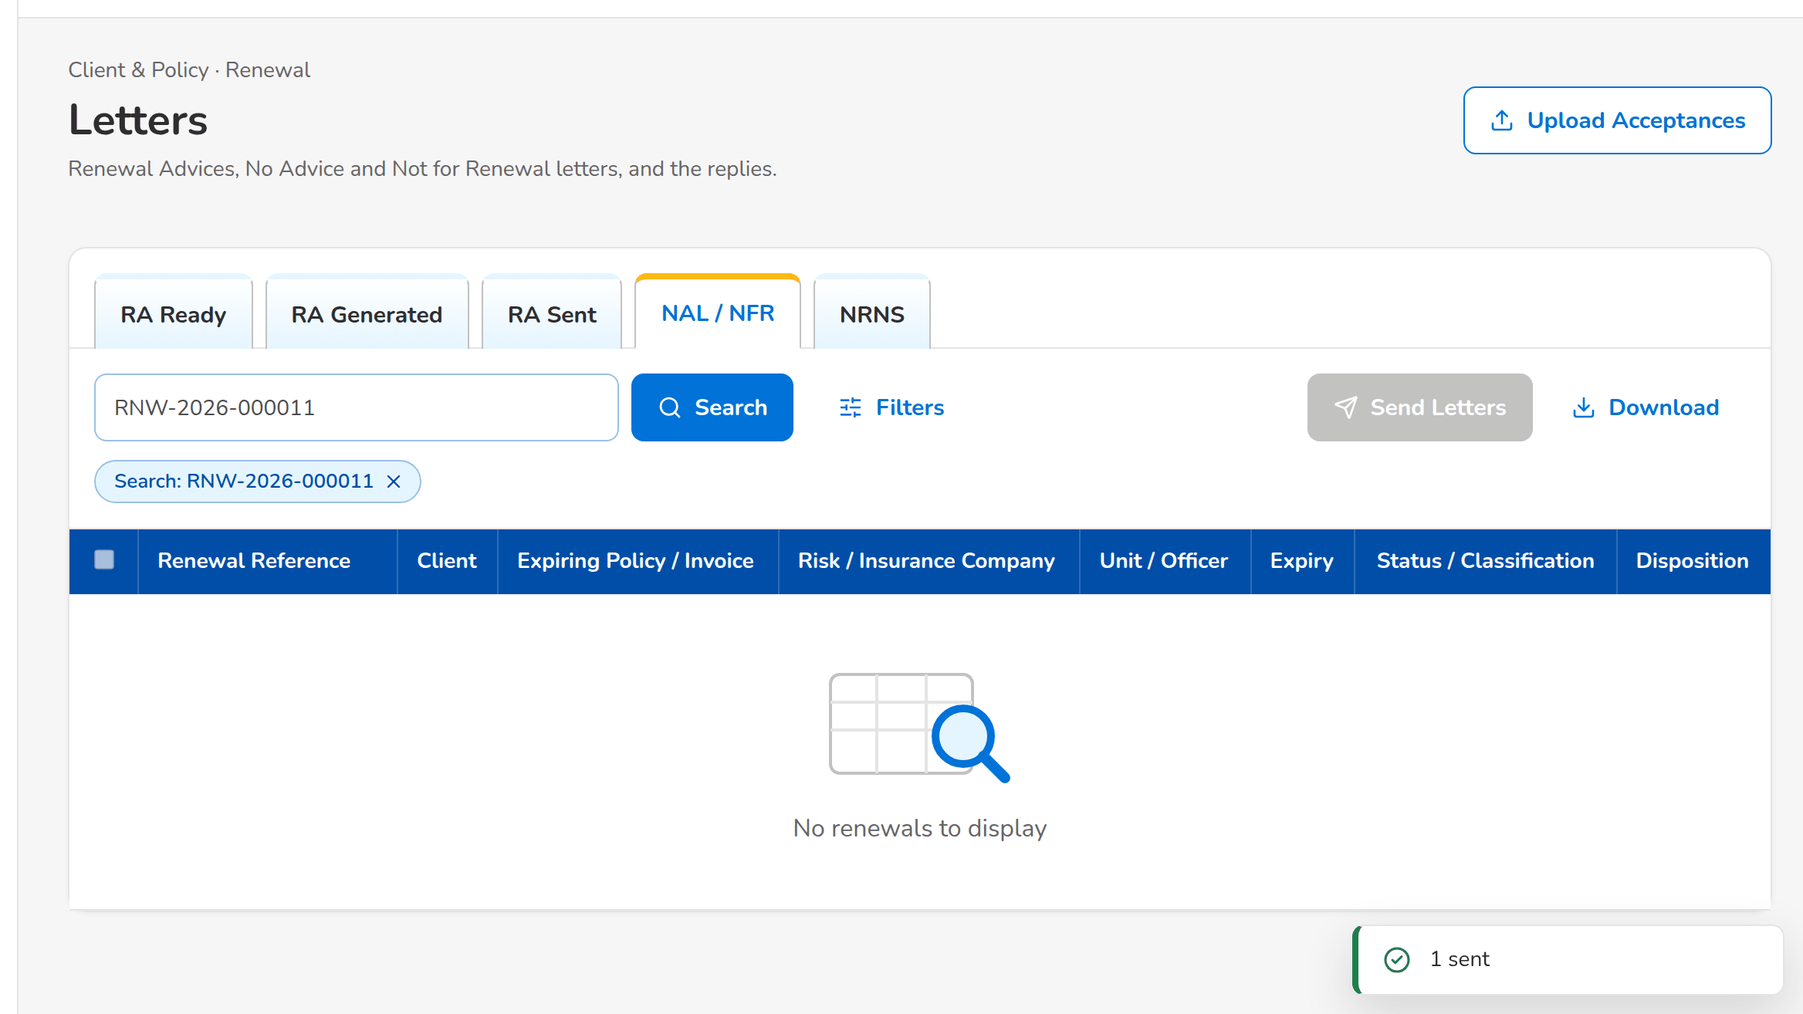
Figure 67: WT-D step 3: Letters
Step 4. Marketing Account Officer (Account Broker) – Renewal: Insurer, Letters, Documents, Remarks and History (SCR-RN-05)
Does | Opens the renewal, tab Letters
Sees | The Not for Renewal Letter in the e-mail queue to the client
Result | Letter kept

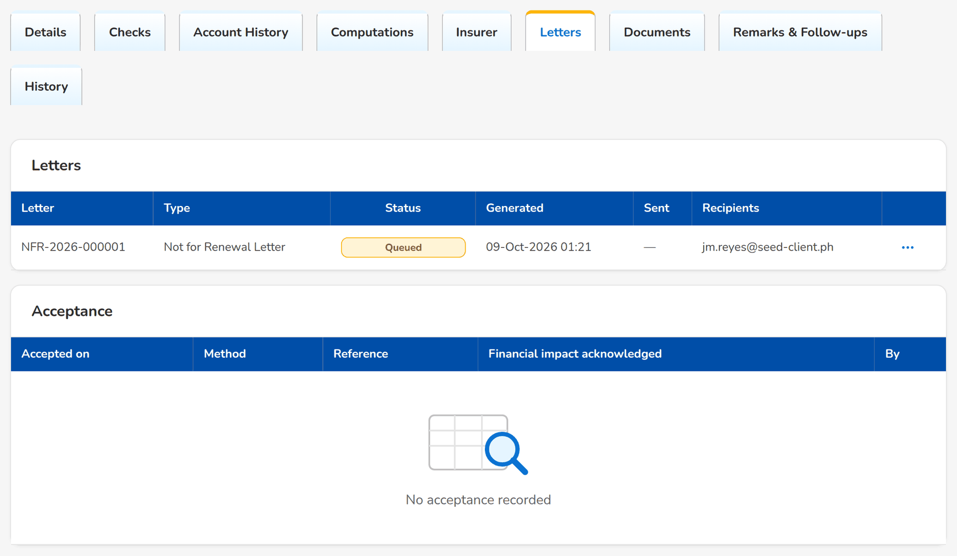
Figure 68: WT-D step 4: Renewal: Insurer, Letters, Documents, Remarks and History
What happens next, downstream
• Until the re-open days after expiry, the Account Officer may re-open the renewal for a new disposition.

14.5 WT-E A transfer to another unit, and the controls the user sees
CBG Metro Team 1 transferred the renewal of a corporate client to Corporate Marketing Team 1; its Team Leader accepts it. Then two controls of Renewal with the message the user sees: a disposition before the account history, and a transfer to the own unit.
Seed data: the transfer request of the migrated policy EBIX-CG-0100005 (Luzon Agri-Industrial Corp.) to Corporate Marketing Team 1; the renewal of the migrated policy QPS-FI-0100002 (Jose Miguel Reyes) of CBG Metro Team 1
Step 1. Marketing Team Leader – Transfers (SCR-RN-09)
Does | The Team Leader of Corporate Marketing Team 1 opens Transfers, tab Incoming, chooses Accept in the row action menu and confirms with remarks
Sees | Message: Transfer accepted; the renewal joins the Unassigned tab of the unit
Result | Transferred

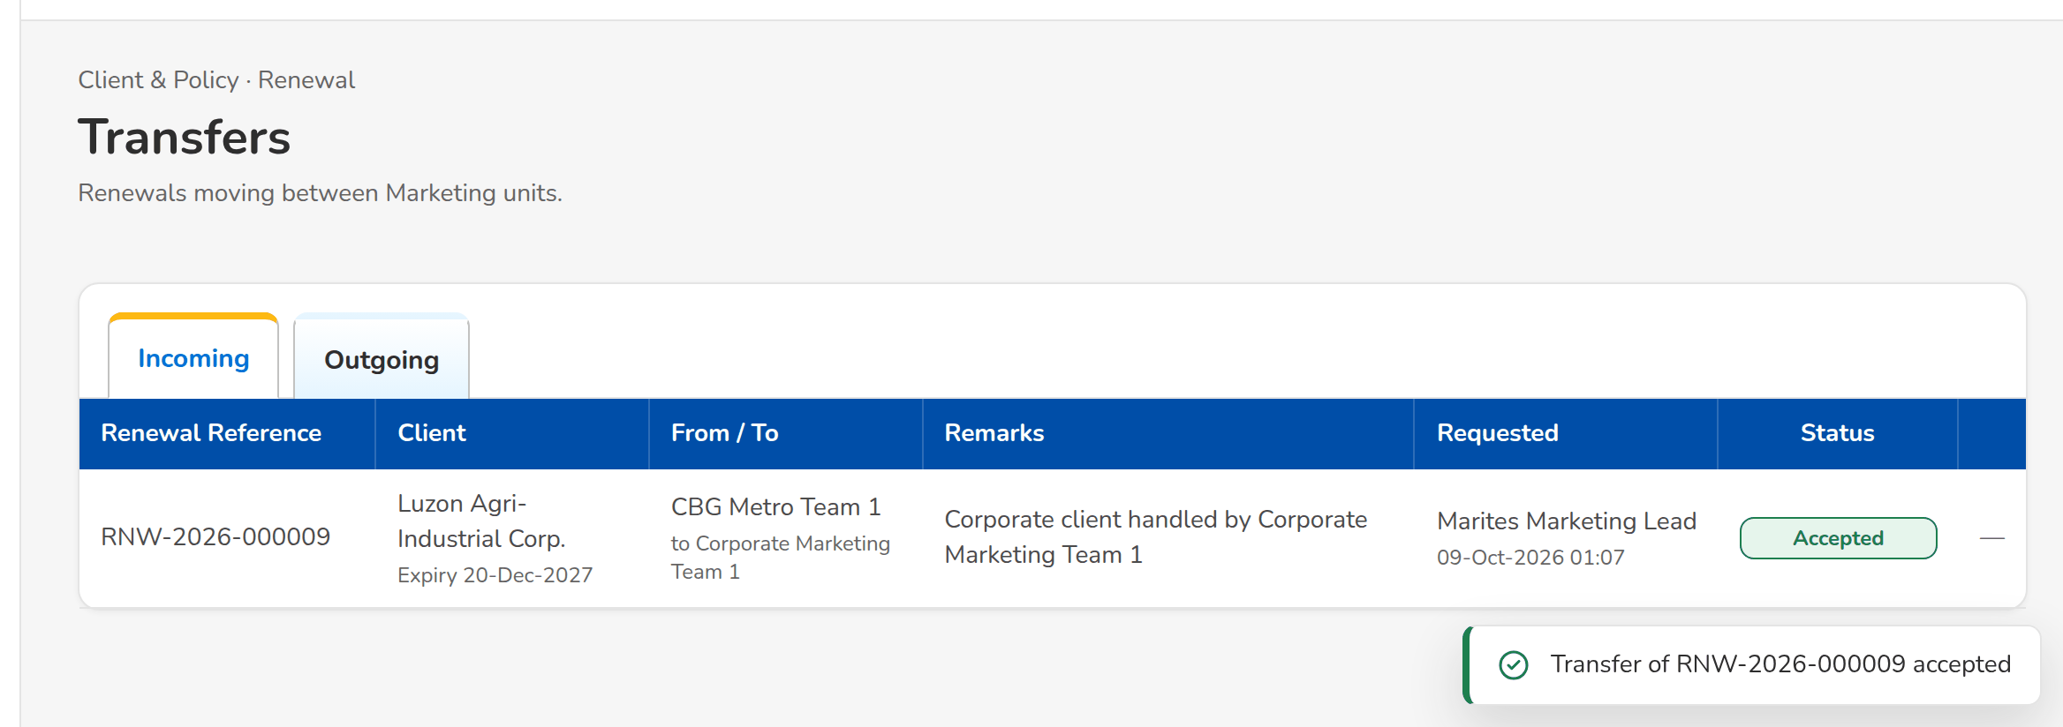
Figure 69: WT-E step 1: Transfers
Step 2. Marketing Account Officer (Account Broker) – Set Disposition, Add Remark and Re-open (SCR-RN-07)
Does | Aileen Account Officer gives a disposition on a renewal without opening its account history
Sees | Open the Account History before you give the disposition
Result | Refused

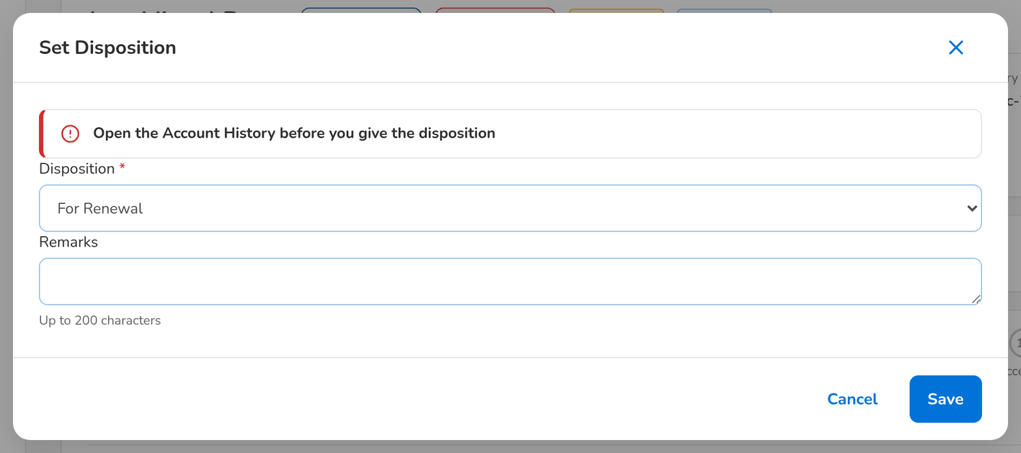
Figure 70: WT-E step 2: Set Disposition, Add Remark and Re-open
Step 3. Marketing Team Leader – Expiry List (SCR-RN-02)
Does | Marites Marketing Lead transfers a renewal of her unit to CBG Metro Team 1, her own unit
Sees | The receiving unit must be another unit
Result | Refused

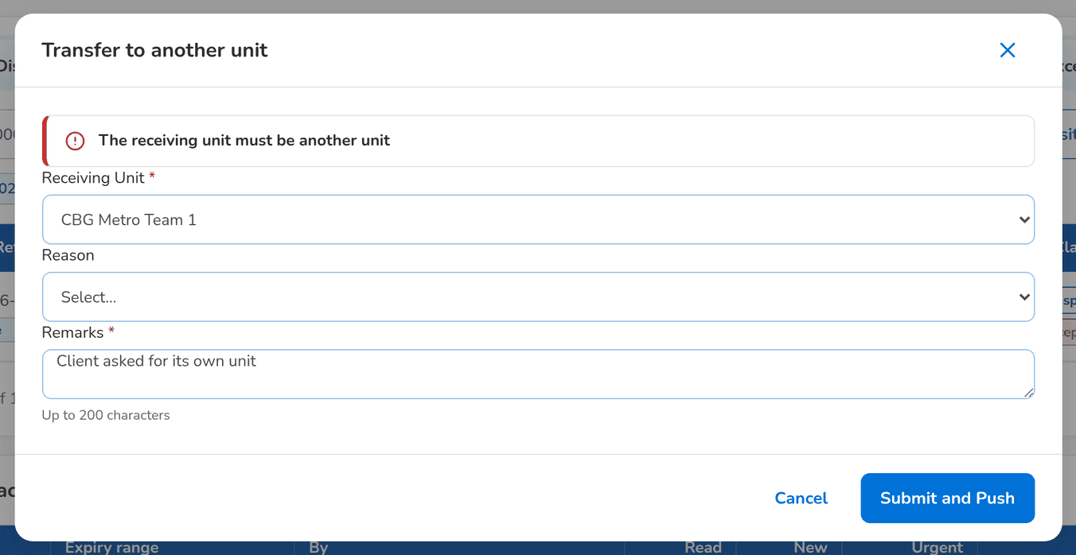
Figure 71: WT-E step 3: Expiry List

15 Messages catalogue
Every message a user of Renewal can see, grouped by the screen or dialog that shows it, with its code, its type and what the user does. The texts are quoted exactly as the screens show them.
• Validation: shown on the screen while the user fills in a field or before the form is sent.
• Error: the system refused the action; nothing was saved. The code is shown under the message as the Reference.
• Warning: the action is possible, but the user should check something first.
• Confirmation and Information: the outcome of an action, or a hint on the screen.
151 messages: 12 confirmation, 94 error, 30 information, 15 validation. The text is quoted exactly as the system shows it; <name> marks a value filled in by the system. The user sees the message only, in the notice standard of the screen standards appendix; the code identifies the message for the project team and support and is not shown on the screen.

15.1 Renewal Home (SCR-RN-01)
ID | Code (not shown) | Message | Type | What the user does
MSG-RN-001 | - | No renewals | Information | No action.
MSG-RN-002 | - | No renewals assigned | Information | No action.

15.2 Expiry List: Generate Expiry List, Initiate and the Filters panel (SCR-RN-02)
ID | Code (not shown) | Message | Type | What the user does
MSG-RN-003 | - | <created> extracted | Confirmation | No action.
MSG-RN-004 | - | No extraction yet | Information | No action.
MSG-RN-005 | - | Transfer requested | Confirmation | No action.
MSG-RN-006 | RNW_RANGE_INVALID | The end date must be on or after the start date | Error | Correct the dates so that the range does not end before it starts.
MSG-RN-007 | RNW_RANGE_REQUIRED | Enter a valid start and end date | Error | Enter a valid start and end date.
MSG-RN-008 | RNW_SELECTION_EMPTY | Select at least one account | Error | Tick at least one renewal in the list.

15.3 Assign Disposition and Re-assign dialogs (SCR-RN-02, SCR-RN-08)
ID | Code (not shown) | Message | Type | What the user does
MSG-RN-009 | RNW_ASSIGN_AO | <ao> is not an active user | Error | Choose an active officer who gives renewal dispositions.
MSG-RN-010 | RNW_ASSIGN_AO | <full name> cannot give renewal dispositions | Error | Choose an active officer who gives renewal dispositions.
MSG-RN-011 | RNW_ASSIGN_AO | Select the account officer | Error | Choose an active officer who gives renewal dispositions.
MSG-RN-012 | RNW_ASSIGN_SAME | Renewal <renewal ref> is already assigned to <ao> | Error | Remove the renewal from the selection, or choose another officer.
MSG-RN-013 | RNW_ASSIGN_STP | Renewal <renewal ref> follows the loan-driven path | Error | No action; the renewal follows the loan-driven straight-through path and needs no officer.
MSG-RN-014 | RNW_ASSIGN_UNIT | <full name> is not an officer of unit <unit> | Error | Choose an officer of the unit of the renewal, or transfer the renewal to the officer's unit.

15.4 Renewal record (SCR-RN-03)
ID | Code (not shown) | Message | Type | What the user does
MSG-RN-015 | RENEWAL_LOCKED | Renewal <renewal ref> is locked since the Renewal Advice was generated | Error | Ask the Team Leader to unlock the Renewal Advice (override) before the renewal is changed.
MSG-RN-016 | RNW_CHECK_BLOCKING | Renewal <renewal ref> cannot <action>: <details> | Error | Have the failed checks named in the message passed or overridden by the Team Leader, then try again.
MSG-RN-017 | RNW_STAGE_INVALID | Renewal <renewal ref> cannot be updated in stage <label>; allowed: <details> | Error | Refresh the renewal; the action is not possible in its current stage.

15.5 Renewal record tabs (SCR-RN-04, SCR-RN-05)
ID | Code (not shown) | Message | Type | What the user does
MSG-RN-018 | - | No acceptance recorded | Information | No action.
MSG-RN-019 | - | No assignments | Information | No action.
MSG-RN-020 | - | No classification yet | Information | No action.
MSG-RN-021 | - | No dispositions | Information | No action.
MSG-RN-022 | - | No endorsements | Information | No action.
MSG-RN-023 | - | No endorsements in the term | Information | No action.
MSG-RN-024 | - | No follow-ups | Information | No action.
MSG-RN-025 | - | No letters | Information | No action.
MSG-RN-026 | - | No overrides | Information | No action.
MSG-RN-027 | - | No payments | Information | No action.
MSG-RN-028 | - | No prior renewals | Information | No action.
MSG-RN-029 | - | No remarks | Information | No action.
MSG-RN-030 | - | No response from the insurer | Information | No action.
MSG-RN-031 | - | The checks have not run yet | Information | No action.

15.6 My Dispositions (SCR-RN-06)
ID | Code (not shown) | Message | Type | What the user does
MSG-RN-032 | - | No renewals assigned to you | Information | No action.
MSG-RN-033 | - | Transfer requested | Confirmation | No action.

15.7 Set Disposition, Add Remark and Re-open (SCR-RN-07)
ID | Code (not shown) | Message | Type | What the user does
MSG-RN-034 | HISTORY_NOT_VIEWED | Open the Account History before you give the disposition | Error | Open the Account History tab and click View Account History, then give the disposition.
MSG-RN-035 | RNW_DISPOSITION_INCOMPLETE | Complete the mandatory fields: <missing> | Error | Complete the disposition named in the message, then push it again.
MSG-RN-036 | RNW_DISPOSITION_REQUIRED | Select the disposition | Error | Return the renewal to the Account Officer to give the disposition.
MSG-RN-037 | RNW_NB_PATH_EXISTS | Renewal <renewal ref> already has quotation <quotation ref> / proposal request <proposal ref> | Error | Open the quotation or proposal request already linked to the renewal.
MSG-RN-038 | RNW_NEW_INVOICE | Enter the new invoice number | Error | Enter the invoice number the policy was booked under, as shown in Booking.
MSG-RN-039 | RNW_NEW_INVOICE | Invoice <value> does not exist | Error | Enter the invoice number the policy was booked under, as shown in Booking.
MSG-RN-040 | RNW_NONRENEWAL_REASON | Select the reason for Not for Renewal | Error | Select the reason for Not for Renewal.
MSG-RN-041 | RNW_NOT_ASSIGNED | Renewal <renewal ref> is not assigned to you | Error | Ask the Team Leader to assign the renewal to you, or to give the disposition.
MSG-RN-042 | RNW_REMARKS_TOO_LONG | Remarks may have at most 200 characters | Error | Shorten the remarks to 200 characters.
MSG-RN-043 | RNW_REOPEN_LATE | Renewal <renewal ref> can no longer be re-opened (expired on <expiry date>) | Error | No action; the policy expired more than the re-open days ago. Start a new business quotation if the client still wants the cover.
MSG-RN-044 | RNW_REOPEN_STAGE | Only a renewal tagged Not for Renewal can be re-opened | Error | No action; only a renewal tagged Not for Renewal can be re-opened.

15.8 TL Review: Post, Return and Override (SCR-RN-08)
ID | Code (not shown) | Message | Type | What the user does
MSG-RN-045 | RNW_BLOCKING_CHECK | Renewal <renewal ref> cannot be posted: <details> failed | Error | Have the failed checks named in the message passed or overridden, then post the renewal again.
MSG-RN-046 | RNW_DISPOSITION_REQUIRED | Renewal <renewal ref> has no disposition | Error | Return the renewal to the Account Officer to give the disposition.
MSG-RN-047 | RNW_OVERRIDE_CLEAN | An override never turns a failed check into Clean | Error | Override the failed check first, or choose the Review classification.
MSG-RN-048 | RNW_OVERRIDE_KIND | Select the kind of override | Error | Select the kind of override.
MSG-RN-049 | RNW_OVERRIDE_NFR | Give Not for Renewal through the disposition with its reason | Error | Return the renewal to the Account Officer to give Not for Renewal with its reason.
MSG-RN-050 | RNW_OVERRIDE_NOT_FAILING | Renewal <renewal ref>: <check code> is not failing | Error | Remove the renewal from the selection; the check passes and needs no override.
MSG-RN-051 | RNW_OVERRIDE_REASON | Select the reason of the override | Error | Select the reason of the override.
MSG-RN-052 | RNW_OVERRIDE_SAME | Renewal <renewal ref> is already <label> | Error | Choose another classification, or remove the renewal from the selection.
MSG-RN-053 | WORKFLOW_REASON_REQUIRED | Select a reason for 'Return' | Error | Choose the reason.

15.9 Transfers and the Transfer dialog (SCR-RN-09)
ID | Code (not shown) | Message | Type | What the user does
MSG-RN-054 | - | No transfers | Information | No action.
MSG-RN-055 | - | Transfer of <renewal ref> <status> | Confirmation | No action.
MSG-RN-056 | RNW_TRANSFER_DECIDED | The transfer is already <root> | Error | No action; the transfer is already decided. Refresh the list.
MSG-RN-057 | RNW_TRANSFER_DECIDED | The transfer is already decided | Error | No action; the transfer is already decided. Refresh the list.
MSG-RN-058 | RNW_TRANSFER_NOT_RECEIVER | Only a Team Leader of unit <to unit> decides it | Error | Ask a Team Leader of the receiving unit to decide the transfer.
MSG-RN-059 | RNW_TRANSFER_NOT_REQUESTER | Only the requester can cancel the transfer | Error | Ask the user who requested the transfer to cancel it.
MSG-RN-060 | RNW_TRANSFER_OPEN | Renewal <renewal ref> already has a transfer request | Error | Wait for the receiving unit to decide the open request, or cancel it on Transfers.
MSG-RN-061 | RNW_TRANSFER_SAME_UNIT | The receiving unit must be another unit | Error | Choose another unit than the unit of the renewal.
MSG-RN-062 | RNW_TRANSFER_UNIT | <unit> is not an active unit | Error | Choose an active Marketing unit.
MSG-RN-063 | RNW_TRANSFER_UNIT | Select the receiving unit | Error | Choose an active Marketing unit.

15.10 Processing Worklist, the dispositioned file and the renewal account (SCR-RN-10)
ID | Code (not shown) | Message | Type | What the user does
MSG-RN-064 | - | <tagged> tagged not in the file | Confirmation | No action.
MSG-RN-065 | RNW_ACCOUNT_DATA | Renewal <renewal ref> needs a BIBS client and package before its renewal account is created | Error | Propose the BIBS package of the migrated policy (Propose Package) and make sure the client is in BIBS, then create the renewal account.
MSG-RN-066 | RNW_ACCOUNT_MISSING | Renewal account <renewal arn> not found | Error | Report the renewal to the System Administrator; the renewal account linked to it is missing.
MSG-RN-067 | RNW_PO_INVALID | <officer> is not a Processing Officer | Error | Choose a Processing Officer from the list.
MSG-RN-068 | RNW_SCOPE_APPLIED | The scope of upload <job no> is already applied | Error | No action; the file is already declared complete.
MSG-RN-069 | RNW_SCOPE_JOB | Upload <job no> is not a dispositioned file | Error | Upload and process the dispositioned file first, then declare it complete.
MSG-RN-070 | RNW_SCOPE_JOB | Upload <job no> is not committed yet | Error | Upload and process the dispositioned file first, then declare it complete.
MSG-RN-071 | RNW_SCOPE_RANGE | Enter the expiry range and the unit of the complete file | Error | Enter the expiry range and the unit of the complete file.
MSG-RN-072 | RNW_SELECTION_EMPTY | Select at least one account | Error | Tick at least one renewal in the list.
MSG-RN-073 | WORKFLOW_REASON_REQUIRED | Select a reason for 'Return to Marketing' | Error | Choose the reason.

15.11 Insurer Batches (SCR-RN-11)
ID | Code (not shown) | Message | Type | What the user does
MSG-RN-074 | - | Batch <batch no> created with <line count> | Confirmation | No action.
MSG-RN-075 | - | Batch <batch no> sent to the insurer | Confirmation | No action.
MSG-RN-076 | - | No insurer batches | Information | No action.
MSG-RN-077 | RNW_BATCH_EMPTY | No For Renewal account of <name> expires in the range | Error | Choose another expiry range or insurer; only renewals For Renewal in processing are sent to the insurer.
MSG-RN-078 | RNW_BATCH_INSURER | Select the insurer | Error | Select the insurer.
MSG-RN-079 | RNW_BATCH_MAILBOX | <name> has no e-mail address for renewals | Error | Ask the Business Administrator to give the insurer its renewal e-mail address, then send the batch again.
MSG-RN-080 | RNW_BATCH_SENT | Batch <batch no> is already sent | Error | No action; the batch is already sent. Upload the insurer's responses when they arrive.
MSG-RN-081 | RNW_RANGE_INVALID | Enter a valid start and end date | Error | Correct the dates so that the range does not end before it starts.

15.12 Letters: Generate RA, Send and Send Letters (SCR-RN-13)
ID | Code (not shown) | Message | Type | What the user does
MSG-RN-082 | RNW_LETTER_NONE | Renewal <renewal ref> has no letter to send | Error | Remove the renewal from the selection; it has no letter to send.
MSG-RN-083 | RNW_LETTER_STATUS | Letter <letter no> is <status> and cannot be sent | Error | Refresh the list; generate the letter again if it was cancelled.
MSG-RN-084 | RNW_RA_LATE | Renewal <renewal ref> expires in <days> day(s): confirm the late Renewal Advice | Error | Tick the confirmation of a late Renewal Advice in the Generate dialog when the client must still receive it.
MSG-RN-085 | RNW_RA_SECOND | Renewal <renewal ref> has no first notice sent | Error | Send the first notice first, or wait for the days given before the second notice.
MSG-RN-086 | RNW_RA_SECOND | The second notice of <renewal ref> is due <ra second notice days> days after the first | Error | Send the first notice first, or wait for the days given before the second notice.

15.13 Record Acceptance (SCR-RN-14)
ID | Code (not shown) | Message | Type | What the user does
MSG-RN-087 | RNW_ACCEPTANCE_DATE | The acceptance date cannot be in the future | Error | Enter the date the client accepted, today or earlier.
MSG-RN-088 | RNW_ACCEPTANCE_EVIDENCE | The evidence is not a document of this renewal | Error | Upload the e-mail or the signed Renewal Advice in the Documents tab of the renewal and choose it as the evidence.
MSG-RN-089 | RNW_ACCEPTANCE_IMPACT | The renewal terms differ from the expiring terms: confirm that the client accepted them | Error | Tick that the client acknowledged the change of premium, after checking the evidence.
MSG-RN-090 | RNW_ACCEPTANCE_METHOD | Select the acceptance method | Error | Select the acceptance method.
MSG-RN-091 | RNW_CHECK_BLOCKING | Renewal <renewal ref> cannot be accepted: <details> failed | Error | Have the failed checks named in the message passed or overridden by the Team Leader, then try again.

15.14 Follow-ups and Add Follow-up (SCR-RN-15)
ID | Code (not shown) | Message | Type | What the user does
MSG-RN-092 | - | No renewals to follow up | Information | No action.
MSG-RN-093 | RNW_FOLLOWUP_DATE | The next action date cannot be in the past | Error | Enter a next action date from today on, or leave it empty.
MSG-RN-094 | RNW_FOLLOWUP_REQUIRED | Select the channel and the outcome | Error | Select the channel and the outcome.

15.15 LAMD Reports (SCR-RN-16)
ID | Code (not shown) | Message | Type | What the user does
MSG-RN-095 | - | No LAMD reports uploaded | Information | No action.
MSG-RN-096 | - | No lines | Information | No action.

15.16 Renewal Setup: Non-renewable Risk Codes and Checks (SCR-RN-17)
ID | Code (not shown) | Message | Type | What the user does
MSG-RN-097 | - | <check name> authorized | Confirmation | No action.
MSG-RN-098 | - | No checks | Information | No action.
MSG-RN-099 | - | No non-renewable risk codes | Information | No action.
MSG-RN-100 | LOV_EFFECTIVITY_INVALID | The effective-to date is before the effective-from date | Error | Correct the dates so that the risk code does not end before it starts.
MSG-RN-101 | RNW_CHECK_SEVERITY | Choose the severity of the check | Error | Choose the severity of the check.
MSG-RN-102 | RNW_RISK_CODE_INCOMPLETE | Enter the reason and the effective date | Error | Enter the reason and the effective date.
MSG-RN-103 | RNW_RISK_CODE_REQUIRED | Enter the risk code | Error | Enter the risk code.

15.17 Renewal Setup: Classification Rules and Decision Matrix (SCR-RN-18)
ID | Code (not shown) | Message | Type | What the user does
MSG-RN-104 | - | No rules | Information | No action.
MSG-RN-105 | - | No versions | Information | No action.
MSG-RN-106 | - | Version <version no> <status> | Confirmation | No action.
MSG-RN-107 | RNW_BUCKET_RULE_FAIL_CLEAN | A failed check cannot give the Clean bucket | Error | Give a failed check the Review or Exception classification.
MSG-RN-108 | RNW_RULES_MAKER_CHECKER | A version is activated by someone other than its maker | Error | Ask another user to activate the version.
MSG-RN-109 | RNW_RULES_NOT_DRAFT | Version <version no> is <status> and cannot change | Error | Create a new version from the active one to change the rules.
MSG-RN-110 | RNW_RULES_NOT_SUBMITTED | Version <version no> is not waiting for a checker | Error | Submit the draft version first, or refresh the list.
MSG-RN-111 | RNW_RULES_REJECT_REMARKS | Enter the reason | Error | Enter the reason of the rejection.
MSG-RN-112 | RNW_RULE_PRIORITY_DUPLICATE | Two rules have the priority <p> | Error | Give each rule of the version its own priority.

15.18 Renewal Setup: Package Map, Package Choices and Propose Package (SCR-RN-19)
ID | Code (not shown) | Message | Type | What the user does
MSG-RN-113 | - | No package choices waiting | Information | No action.
MSG-RN-114 | - | No package mappings | Information | No action.
MSG-RN-115 | - | Package choice <status> | Confirmation | No action.
MSG-RN-116 | RNW_PACKAGE_CHOICE_DECIDED | The package choice is already <status> | Error | No action; the package choice is already decided. Refresh the list.
MSG-RN-117 | RNW_PACKAGE_CHOICE_MAKER | The package choice must be approved by another user | Error | Ask another member of the Renewal processing team to approve the choice.
MSG-RN-118 | RNW_PACKAGE_CLOSED | The renewal is closed | Error | No action; the renewal is closed.
MSG-RN-119 | RNW_PACKAGE_NOT_MIGRATED | Only a migrated packaged policy needs a package choice | Error | No action; the renewal is not a migrated packaged policy.
MSG-RN-120 | RNW_PACKAGE_PENDING | A package choice is already waiting for approval | Error | Wait for the package choice already waiting for approval to be decided.
MSG-RN-121 | RNW_PACKAGE_REASON | Enter the reason of the choice | Error | Enter the reason of the package choice.
MSG-RN-122 | RNW_PACKAGE_REJECT_REMARKS | Enter the reason | Error | Enter the reason of the rejection.

15.19 Renewal Setup: Go-live (SCR-RN-20)
ID | Code (not shown) | Message | Type | What the user does
MSG-RN-123 | - | <created> taken over | Confirmation | No action.
MSG-RN-124 | - | Correction <status> | Confirmation | No action.
MSG-RN-125 | - | No corrections waiting | Information | No action.
MSG-RN-126 | RNW_GOLIVE_FAILED | The go-live take-over failed: <message> | Error | Report the message to the System Administrator; correct the migrated policies named and run the take-over again.
MSG-RN-127 | RNW_RA_SENT_CORRECTION | Describe the correction | Error | Describe the correction.
MSG-RN-128 | RNW_RA_SENT_DECIDED | The correction is already <status> | Error | No action; the correction is already decided. Refresh the list.
MSG-RN-129 | RNW_RA_SENT_MAKER | The correction must be approved by another team member | Error | Ask another member of the Renewal processing team to approve the correction.

15.20 Upload panel of the Renewal screen: every upload type
ID | Code (not shown) | Message | Type | What the user does
MSG-RN-130 | - | <Column> '<value>' is not a valid <number, date (yyyy-mm-dd), Y/N value> | Validation | Correct the value in the file in the format of the column and upload the file again.
MSG-RN-131 | - | <Column> is mandatory | Validation | Fill in the column in the file and upload the file again.

15.21 Upload panel of the Renewal screen: Renewal - LAMD loan report
ID | Code (not shown) | Message | Type | What the user does
MSG-RN-132 | - | Choose the period of the report | Validation | Choose the month of the report before the upload.
MSG-RN-133 | - | Choose the report type (Paid-off or RMU) | Validation | Choose the report type before the upload.
MSG-RN-144 | - | The row has no PN number | Validation | Enter the PN number of the loan in the row.

15.22 Upload panel of the Renewal screen: Renewal - dispositioned file
ID | Code (not shown) | Message | Type | What the user does
MSG-RN-134 | - | Disposition <disposition> is not valid | Validation | Enter For Renewal, Not for Renewal, For Quotation, For Proposal or Lost Business.
MSG-RN-137 | - | Remarks may have at most 200 characters | Validation | Shorten the remarks of the row to 200 characters.
MSG-RN-140 | - | Renewal <reference> does not exist | Validation | Correct the renewal reference of the row.
MSG-RN-141 | - | Renewal <renewal ref> cannot be updated in stage <label> | Validation | Remove the row; the renewal is past the disposition.

15.23 Upload panel of the Renewal screen: Renewal - expiring policies of the legacy systems
ID | Code (not shown) | Message | Type | What the user does
MSG-RN-135 | - | Legacy policy <legacy ref> is already a renewal | Validation | Remove the row; the policy is already taken over.

15.24 Upload panel of the Renewal screen: Renewal - client acceptances
ID | Code (not shown) | Message | Type | What the user does
MSG-RN-136 | - | Method <method> is not valid (E-mail or Payment) | Validation | Enter E-mail or Payment in the Method column.
MSG-RN-138 | - | Renewal <reference> does not exist | Validation | Correct the renewal reference of the row.
MSG-RN-142 | - | Renewal <renewal ref> is not awaiting a response | Validation | Remove the row; the renewal is not waiting for the client's reply.

15.25 Upload panel of the Renewal screen: Renewal - insurer responses
ID | Code (not shown) | Message | Type | What the user does
MSG-RN-139 | - | Renewal <reference> does not exist | Validation | Correct the renewal reference of the row.
MSG-RN-143 | - | Response <response> is not valid | Validation | Enter Renew As Is, Revise or Reject in the Response column.

15.26 Every screen (Common screen elements)
ID | Code (not shown) | Message | Type | What the user does
MSG-RN-145 | ACCESS_DENIED | You are not permitted to perform this action | Error | Ask for the permission; the menu shows only the screens of your role.
MSG-RN-146 | CONCURRENT_MODIFICATION | The record was changed by another user. Please reload and try again. | Error | Reload the record; another user changed it. Enter the change again.
MSG-RN-147 | INTERNAL_ERROR | The system could not complete the request. Try again; if it continues, contact support with the reference. | Error | Report the message with its reference to the System Administrator.
MSG-RN-148 | MALFORMED_REQUEST | Parameter '<name>' has an invalid value | Error | Reload the screen and try again; if it persists, report it with the time to the System Administrator.
MSG-RN-149 | MALFORMED_REQUEST | Required parameter '<parameter name>' is missing | Error | Reload the screen and try again; if it persists, report it with the time to the System Administrator.
MSG-RN-150 | UPLOAD_TOO_LARGE | The uploaded file is too large | Error | Reduce the file (split it) and upload it again.
MSG-RN-151 | VALIDATION_FAILED | Invalid request | Error | Correct the fields listed under the message.

16 Notifications catalogue
The in-app notifications, alerts and e-mails of Renewal: what triggers each, who receives it and what it contains. Each user chooses the in-app and e-mail channels of the events on Notification Settings. Letters to clients and extracts to insurers are e-mailed protected.
Table 42: Notifications and e-mails of Renewal
ID | Channel | Trigger | Recipient | Template and content | FR
NT-01 | In-app | Renewals are assigned (event Renewal assigned): to an Account Officer by the Team Leader, to a Processing Officer; a renewal turns Exception on a new check; a LAMD line routes a renewal | The officer assigned; on an Exception the Account Officer and the Processing Officer; on a LAMD line the Team Leaders of the unit | Title: <renewal ref> assigned to you, <renewal ref> assigned to you for processing, <renewal ref>: Exception or <renewal ref>: LAMD <loan status>. Text: Give the disposition of the renewal of <client>, expiring <expiry date>; <client>; A check failed on the renewal of <client>; or the routing | FR-RN-030, FR-RN-061, FR-RN-020, FR-RN-025
NT-02 | In-app, e-mail | A renewal is transferred to another Marketing unit (event Renewal transfer requested) | The Team Leaders of the receiving unit | Title: <renewal ref> transferred to your unit. Text: Accept or decline the renewal of <client>: <remarks> | FR-RN-031
NT-03 | In-app | The receiving unit accepts or declines a transfer (event Renewal transfer decided) | The user who requested the transfer | Title: <renewal ref>: transfer accepted or declined. Text: The transfer to <unit> was accepted, or was declined: <remarks> | FR-RN-032
NT-04 | In-app, e-mail | A renewal is returned (event Renewal returned): by the Team Leader to the officer, by Processing to Marketing, or re-opened | The Account Officer (or the Team Leaders of the unit for a return to the Team Leader and a re-open) | Title: <renewal ref> returned to you, <renewal ref> returned by Processing or <renewal ref> re-opened. Text: <reason>: <remarks>, or Give a new disposition: <reason> | FR-RN-046, FR-RN-047, FR-RN-050, FR-RN-065
NT-05 | In-app | The Team Leader posts a renewal For Renewal (event Renewal posted) | The users who assign the Processing Officers (Processing Team Leaders) | Title: <renewal ref> posted for processing. Text: <client> | FR-RN-050
NT-06 | In-app | An insurer response is recorded, by hand or from the insurer's file (event Insurer renewal response) | The Processing Officer of the renewal | Title: <renewal ref>: insurer response <response>. Text: Applied to the renewal, or Not applied: check the Insurer tab | FR-RN-071
NT-07 | In-app | The client accepts the renewal, and the accepted renewal account is ready for placement (event Renewal accepted) | The Account Officer and the Processing Officer of the renewal | Title: <renewal ref> accepted by the client, or <renewal ref>: ready for placement. Text: <client> accepted the renewal by <method>, or the progress of the renewal account | FR-RN-084
NT-08 | In-app | The renewal is booked, or the policy expired without renewal (event Renewal booked) | The Account Officer and the Processing Officer of the renewal | Title: <renewal ref> renewed, or <renewal ref> closed: expired without renewal. Text: Booked with invoice <invoice>, or The policy of <client> expired on <expiry date> | FR-RN-084, FR-RN-083
NT-09 | In-app, e-mail | The go-live take-over of the migrated policies is completed (event Go-live renewal extraction completed) | The users who extract renewals (Team Leaders) | Title: Go-live renewals taken over (<n>). Text: <n> renewals, <n> urgent; by expiry month <month: count> | FR-RN-016
NT-10 | In-app | A package choice of a migrated policy is approved or rejected (event Renewal package choice decided) | The user who proposed the package | Title: <renewal ref>: package choice approved or rejected. Text: <product version> applies to the renewal, or was rejected: <remarks> | FR-RN-028
NT-11 | Alert | An expiring account is not disposed or not accepted within the escalation days of its segment before expiry (Renewal at risk) | The administrators and Team Leaders who receive the alerts of Renewal | Renewal at risk: <renewal ref> of <client> expires on <expiry date> without a disposition or an acceptance | FR-RN-102
NT-12 | Alert | The daily extraction of expiring accounts fails (Renewal extraction failed) | The administrators who receive the alerts of Renewal | Renewal extraction failed: <reason>; the next run takes the missed dates | FR-RN-010
NT-13 | Alert | An insurer has not answered a renewal batch by its reply date (Insurer renewal batch overdue) | The administrators and the Processing Team Leaders who receive the alerts of Renewal | Insurer renewal batch overdue: <batch no> of <insurer>, reply due <date> | FR-RN-070
NT-14 | Alert | A Renewal Advice or renewal letter could not be sent to the client (Renewal letter not delivered) | The administrators who receive the alerts of Renewal | Renewal letter not delivered: <letter no> of <renewal ref> to <recipient>: <reason> | FR-RN-081
NT-15 | Alert | A renewal stays in the Exception classification longer than the allowed days, 7 by default (Renewal exception ageing) | The administrators and Team Leaders who receive the alerts of Renewal | Renewal exception ageing: <renewal ref> has been an Exception for <days> days | FR-RN-022
NT-16 | E-mail | Send on the Letters screen (Renewal Advice, first or second notice) | The client's e-mail address | Subject: Renewal Advice <letter no> - <client>. Body: the renewal of policy <policy no> expiring on <expiry date>, the renewal terms and premium, the payment instructions and the BDOI contacts; the attachment is protected and the password follows in a separate e-mail | FR-RN-080, FR-RN-081
NT-17 | E-mail | Follows every protected Renewal Advice, letter and insurer extract e-mail | The same recipients | The password of the attachment of the e-mail <subject>, with the password hint for the recipient | FR-RN-081, FR-RN-070
NT-18 | E-mail | Send to Insurer on an insurer batch | The renewal e-mail addresses of the insurer | Subject: Renewal extract <batch no> - <insurer>. Body: the renewals expiring in <period> for the insurer's renewal terms, the reply date; the attachment is protected and the password follows in a separate e-mail | FR-RN-070
NT-19 | E-mail | Send Letters on the NAL / NFR tab; the NRNS reminder and the non-acceptance letter sent by the nightly letter run | The client's e-mail address | Subject: <letter type> <letter no> - <client>. Body: the letter (No Advice Letter, Not for Renewal Letter with its reason, NRNS reminder or non-acceptance notice); the attachment is protected and the password follows in a separate e-mail | FR-RN-082, FR-RN-083, FR-RN-024

17 Document outputs
The documents Renewal generates, with the BDO Insure letterhead, the "Confidential" footer and page numbers on the PDF documents. For each: the template, the format, the screen that produces it, the password protection, where every field comes from and the first page as generated from seed data. The spreadsheets are shown with a selection of their columns.

17.1 DO-01 Renewal Advice (first and second notice)
Template | Renewal Advice first notice and second notice templates (wording to confirm, RQ26)
Format | PDF, one per renewal; e-mailed to the client
Produced by | Letters › Generate RA, then Send; Renewal › Letters tab › Download PDF
Password protected | Yes when e-mailed (password in a separate e-mail)
FRs | FR-RN-080, FR-RN-081

Fields and their source
• Title: Renewal Advice - the assured - policy number (second notice: Second notice) – from the renewal
• Client and policy: client name, policy number, insurer name and expiry date – from the expiring account
• Renewal terms: renewal period, product, sum insured and renewal premium with the currency – from the renewal account, else the expiring terms
• How to accept: reply to the e-mail, sign and return the Renewal Advice, or pay the renewal premium on or before the expiry date
• Renewal reference and the name of the Account Officer – from the renewal
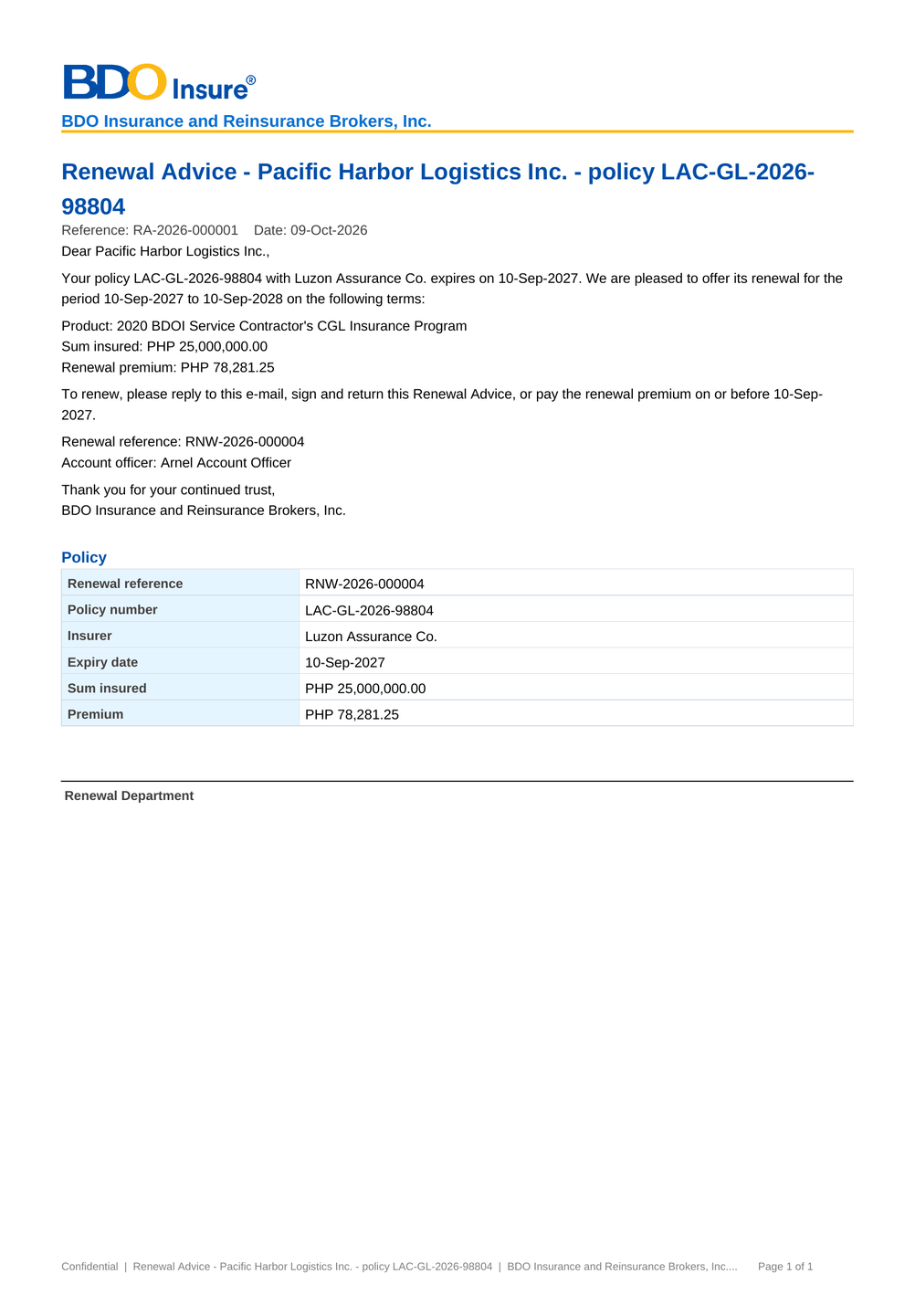
Figure 72: DO-01 Renewal Advice (first and second notice): first page as generated

17.2 DO-02 Not for Renewal Letter and No Advice Letter
Template | Not for Renewal Letter and No Advice Letter templates (wording to confirm, RQ26)
Format | PDF, one per renewal; e-mailed to the client
Produced by | Letters, tab NAL / NFR › Send Letters
Password protected | Yes when e-mailed (password in a separate e-mail)
FRs | FR-RN-082, FR-RN-024

Fields and their source
• Client and policy: client name, policy number, insurer name and expiry date – from the expiring account
• Not for Renewal Letter: the reason for Not for Renewal and the name of the Account Officer; No Advice Letter: that the policy is not renewed through BDOI and no action is needed
• Reference: the renewal reference
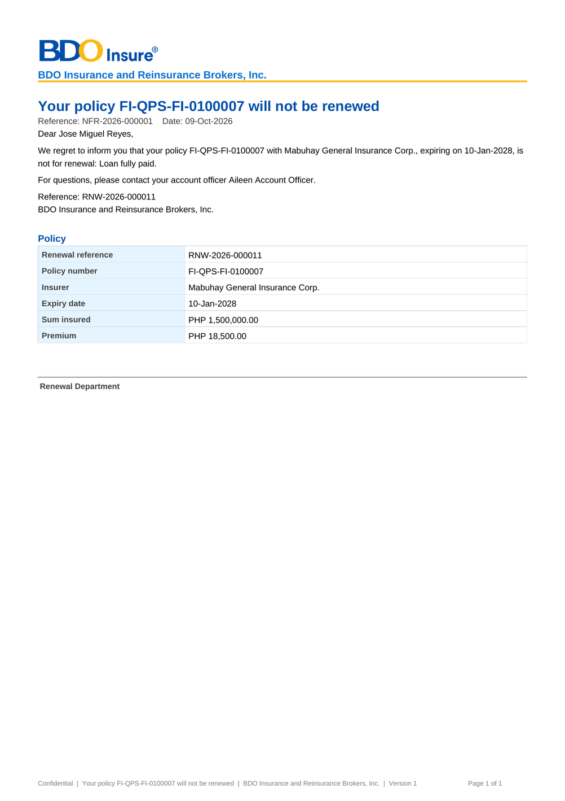
Figure 73: DO-02 Not for Renewal Letter and No Advice Letter: first page as generated

17.3 DO-03 Insurer extract
Template | (fixed layout of the extract per insurer, 28 columns of the BRD)
Format | Excel workbook, one per insurer batch; e-mailed to the insurer
Produced by | Insurer Batches › New Batch, then Download or Send to Insurer
Password protected | Yes when e-mailed (password in a separate e-mail)
FRs | FR-RN-070

Fields and their source
• Insurance Company, Invoice No, Assured Name, Risk Code, Inception Date, Expiry Date, Sum Insured, Premium Amount, Commission Rate, AR Client (Unpaid Balance), Is Mortgaged – from the expiring account and the ledger
• Premium Rate (per cover), Policy No, Risk Description, Encoder Name, Unit Head, Business Origin, Account Type, Region, Area, Branch, Account Officer Name, Remarks – from the account and the sales organisation
• BIPD for Motor, Seating Capacity for Motor, Auto Personal Accident for Motor, Sum Insured (per cover), Packaged / Non-Packaged – from the policy

Figure 74: DO-03 Insurer extract: first page as generated

17.4 DO-04 Expiry list download
Template | (columns of the renewal lists)
Format | Excel workbook of the list as shown, with its filters
Produced by | Expiry List, My Dispositions, TL Review, Processing Worklist, Letters › Download
Password protected | No
FRs | FR-RN-014

Fields and their source
• Renewal Reference, Status, Classification, Disposition, Expiring Invoice, Expiring ARN, Policy No., Client – from the renewal
• Product, Line, Insurer, Segment, Branch, Unit, Account Officer, Assigned AO, Assigned PO, Expiry – from the expiring account and the assignments
• Currency, Gross Premium, Sum Insured – from the expiring account (empty for LAMD and Contact Center)

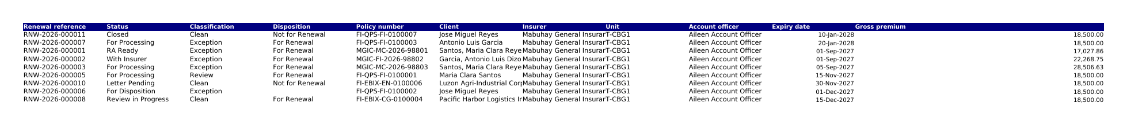
Figure 75: DO-04 Expiry list download: first page as generated

17.5 DO-05 Renewal account details
Template | (layout of the record details)
Format | PDF, one per renewal
Produced by | Renewal › Details PDF
Password protected | No
FRs | FR-RN-041

Fields and their source
• Renewal: renewal reference, status, classification, client, expiring invoice and ARN, policy number, insurer, expiry date, Account Officer and Processing Officer, gross premium and sum insured – from the renewal
• Checks: the check, its outcome, severity and message – from the latest check run
• Dispositions: disposition, reason, remarks, source, by and on – from the dispositions of the renewal
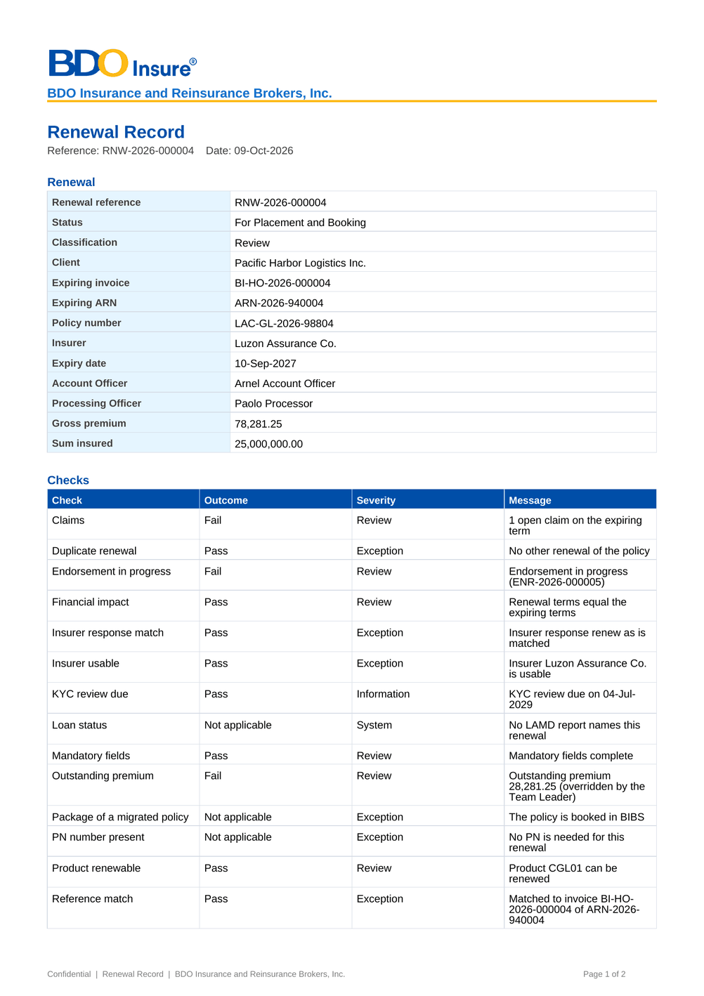
Figure 76: DO-05 Renewal account details: first page as generated

18 Upload screens
The uploads of Renewal run on the screen of the team that owns them: download the template, upload the filled file, review every row with its message, then process the valid rows. A file uploaded before is refused. Each upload type below has its template columns; the column checks (mandatory, number, date, Y/N) apply to every type, and the row checks listed with each type come on top.

18.1 Renewal - client acceptances (RNW_ACCEPTANCE)
Permission | BULK_PROCESS and <name>
Instructions | -

Table 43: Template columns of Renewal - client acceptances
No. | Column | Mand. | Type | Content | Example
1 | Renewal Reference | Y | Text | Renewal reference | RNW-2027-000001
2 | Method | Y | Text | How the client accepted | Payment
3 | Evidence Reference | Y | Text | E-mail reference or payment reference | OR-2027-001122
4 | Accepted On | N | Date | Date accepted | 2027-08-20
5 | Remarks | N | Text | Remarks

Row checks of this upload (besides the column checks)
• Renewal <reference> does not exist
• Renewal <renewal ref> is not awaiting a response
• Method <method> is not valid (E-mail or Payment)

18.2 Renewal - expiring policies of the legacy systems (RNW_LEGACY_POLICIES)
Permission | BULK_PROCESS and <name>
Instructions | -

Table 44: Template columns of Renewal - expiring policies of the legacy systems
No. | Column | Mand. | Type | Content | Example
1 | Legacy Policy Reference | Y | Text | Policy reference in the legacy system | QPS-FI-0012345
2 | Source System | Y | Text | Legacy system of the policy | QPS
3 | Policy No | Y | Text | Policy number | FI-2027-0012345
4 | Client Code | Y | Text | Client code in BIBS | CL-2026-000001
5 | Client Name | Y | Text | Client name | Juan Dela Cruz
6 | Risk Code | N | Text | Risk code in BIBS when known | PAR01
7 | Product Line | N | Text | Product line | PROPERTY
8 | Legacy Package | N | Text | Package code in the legacy system | QPS-HOME-A
9 | Legacy Package Version | N | Text | Package version in the legacy system | 3
10 | Insurer | Y | Text | Insurer of the policy | INS-MGIC
11 | Inception Date | N | Date | Start of the term | 2027-03-01
12 | Expiry Date | Y | Date | End of the term | 2028-03-01
13 | Sum Insured | N | Number | Total sum insured | 3500000.00
14 | Gross Premium | N | Number | Gross premium | 12500.00
15 | PN Numbers | N | Text | Promissory note numbers of the loan | PN-778812
16 | Account Officer | N | Text | User ID of the account officer | jdelacruz
17 | Sales Unit | N | Text | Sales team | T-CBG1
18 | Market Segment | N | Text | Market segment | CBG
19 | Mortgagee Bank | N | Text | Mortgagee bank when mortgaged | Philippine National Bank
20 | Urgent | N | Yes/No | Y to flag the renewal urgent | N

Row checks of this upload (besides the column checks)
• Legacy policy <legacy ref> is already a renewal

18.3 Renewal - Renewal Advices sent before go-live (RNW_RA_ALREADY_SENT)
Permission | BULK_PROCESS and <name>
Instructions | One row per migrated policy whose Renewal Advice was sent before go-live. Rejected rows are corrected and approved by a second team member on the Expiry List.

Table 45: Template columns of Renewal - Renewal Advices sent before go-live
No. | Column | Mand. | Type | Content | Example
1 | Legacy Policy Reference | Y | Text | Policy reference in the legacy system | QPS-FI-0012345
2 | RA Date | Y | Date | Date the Renewal Advice was sent | 2027-12-10
3 | RA Reference | N | Text | Reference of the Renewal Advice in the tracker | RA-1207
4 | Channel | N | Text | How the Renewal Advice was sent | E-mail
5 | Recipient | N | Text | Who received it (name or e-mail) | client@example.ph

18.4 Renewal - insurer responses (RNW_INSURER_RESPONSE)
Permission | BULK_PROCESS and <name>
Instructions | -

Table 46: Template columns of Renewal - insurer responses
No. | Column | Mand. | Type | Content | Example
1 | Renewal Reference | Y | Text | Renewal reference | RNW-2027-000001
2 | Policy No | N | Text | Expiring policy number | MC-2026-000123
3 | Response | Y | Text | Response of the insurer | Renew As Is
4 | Insurer Reference | N | Text | Insurer reference | REN-55012
5 | Revised Premium | N | Number | Revised gross premium
6 | Revised Sum Insured | N | Number | Revised sum insured
7 | Revised Rate | N | Number | Revised rate in percent
8 | Terms | N | Text | Revised terms
9 | Received On | N | Date | Date received | 2027-08-15
10 | Reject Action | N | Text | What follows a rejection; blank for Not for renewal
11 | Remarks | N | Text | Remarks

Row checks of this upload (besides the column checks)
• Renewal <reference> does not exist
• Response <response> is not valid

18.5 Renewal - LAMD loan report (RNW_LAMD_REPORT)
Permission | BULK_PROCESS and <name>
Instructions | -

Table 47: Template columns of Renewal - LAMD loan report
No. | Column | Mand. | Type | Content | Example
1 | PN Number | Y | Text | PN number of the loan | PN-778812
2 | Status Date | N | Date | Date of the loan status | 2027-05-31
3 | Borrower | N | Text | Borrower name | Juan Dela Cruz

Row checks of this upload (besides the column checks)
• Choose the report type (Paid-off or RMU)
• Choose the period of the report
• The row has no PN number

18.6 Renewal - dispositioned file (RNW_DISPOSITION_UPLOAD)
Permission | BULK_PROCESS and <name>
Instructions | -

Table 48: Template columns of Renewal - dispositioned file
No. | Column | Mand. | Type | Content | Example
1 | Renewal Reference | Y | Text | Renewal reference | RNW-2027-000001
2 | Disposition | Y | Text | Disposition of the renewal | For Renewal
3 | Reason | N | Text | Reason for Not for Renewal (code or label)
4 | New Invoice No | N | Text | New invoice number
5 | Remarks | N | Text | Remarks | Client confirmed

Row checks of this upload (besides the column checks)
• Renewal <reference> does not exist
• Renewal <renewal ref> cannot be updated in stage <label>
• Disposition <disposition> is not valid
• Remarks may have at most 200 characters

18.7 Renewal - package map of migrated policies (RNW_PACKAGE_MAP)
Permission | BULK_PROCESS and <name>
Instructions | -

Table 49: Template columns of Renewal - package map of migrated policies
No. | Column | Mand. | Type | Content | Example
1 | Legacy Package | Y | Text | Package code in the legacy system | QPS-HOME-A
2 | Legacy Package Version | N | Text | Legacy version; blank for any | 3
3 | Risk Code | N | Text | Qualifier: risk code; blank for any | PAR01
4 | Insurer | N | Text | Qualifier: insurer; blank for any | INS-MGIC
5 | Sum Insured From | N | Number | Qualifier: sum insured from
6 | Sum Insured To | N | Number | Qualifier: sum insured to
7 | BIBS Package | N | Text | Package in BIBS; blank when not renewable | PKG-HOME
8 | BIBS Package Version | N | Number | Version of the package in BIBS | 2
9 | Remarks | N | Text | Remarks | Home package, standard

19 Cross-BRD dependencies and interface contract
Renewal reads the booked accounts of New Business and Operations, creates the renewal account that New Business places and books, hands accounts to Submitted Policies and reads the claims and the loan reports. The contract below lists each exchange: the BRD or system, the direction, what is exchanged, when and how, and who owns the data. Chapter 7 describes the interfaces with the external systems; the technical detail is in the Technical Specification, reviewed by BDOI IT.
Table 50: Interface contract of Renewal
ID | BRD or system | Direction | What | When and how | Owner of the data | FR
IC-01 | BRD-2 Operations (invoice ledger) | In | The booked root invoices of the expiring policies with their balances, payments and the endorsements booked in the term | Read by the daily extraction at the lead days before expiry and by Generate Expiry List; the outstanding balance is read again at every check run and after each payment | Operations (Cashiering, Remittance) | FR-RN-010, FR-RN-011, FR-RN-042, FR-RN-051
IC-02 | BRD-1 New Business (account) | In | The expiring account, client, policy, insurer, product, sales unit and account officer of each renewal | Read with the invoice at extraction and refreshed at each evaluation | Processing (BRD-1) | FR-RN-010, FR-RN-041
IC-03 | BRD-1 New Business (account, placement, issuance, booking) | Out | The renewal account (business type Renewal), created from the expiring account; after acceptance it is fast-tracked to placement and booking, and booked through the New Business booking with the booking source Renewal | Created by Create Renewal Account; acceptance moves it to the payment gate, the placement slip and the booking queue without re-keying; the booking is reported back and closes the renewal as renewed | Renewal (renewal), New Business (placement, issuance, booking) | FR-RN-063, FR-RN-084
IC-04 | BRD-1 New Business (quotation and proposal request) | Out | A quotation (For Quotation) or a proposal request (For Proposal) pre-filled from the expiring account, with the renewal reference | Started from the renewal once the Team Leader posts it; the outcome of the quotation or proposal closes the renewal as renewed or lost | Renewal (start), New Business (quotation and proposal) | FR-RN-048
IC-05 | BRD-3 Product Maintenance | In | The product and package version of the expiring account, whether it can be sold for renewal, and the BIBS package of a migrated policy | Read at the checks (product renewable) and on the package map and package choices | Product Maintenance | FR-RN-020, FR-RN-028
IC-06 | BRD-2 Operations (Adjustment) | In | The open endorsement requests of the expiring invoice family | Read at each check run; a pending endorsement fails its check until it is posted or cancelled | Adjustment | FR-RN-027
IC-07 | BRD-7 Claims | In | The claims summary of the account and policy year (number and status of the claims) | Read at each check run; open claims fail the claims check and feed the decision matrix | Claims | FR-RN-020, FR-RN-023, FR-RN-042
IC-08 | BRD-1 New Business (client) | In | The KYC review date of the client | Read at each check run; a review due in the window flags the renewal KYC due, which never blocks it | New Business (client maintenance) | FR-RN-026
IC-09 | BRD-12 Submitted Policies | In | The renewal of a submitted policy handed over by Submitted Policies (free first year and mortgaged submitted policies) | The hand-off creates the renewal with the source Submitted Policy; its letters use the submitted-policy templates; the status is reported back | Submitted Policies (hand-off), Renewal (renewal) | FR-RN-090
IC-10 | BRD-13 Data Migration | In | The migrated in-force policies of the go-live window with their legacy package, and the Renewal Advices sent by hand before go-live | The go-live take-over reads the migrated policies (or their upload); the Renewal Advices already sent are uploaded once at go-live | Data Migration | FR-RN-016, FR-RN-028
IC-11 | Insurers (outside BIBS) | Out / In | The insurer extract of the renewals (28 columns); the insurer's responses (Renew As Is, Revise, Reject) | The extract is e-mailed protected from Insurer Batches; the insurer's file is uploaded on Insurer Batches or a response is recorded on the renewal; no system-to-system channel with the insurers | Processing (extract), the insurer (responses) | FR-RN-070, FR-RN-071
IC-12 | LAMD of the bank (outside BIBS) | In | The monthly paid-off and past-due (RMU) loan reports | Uploaded by the LAMD user on LAMD Reports; each line is matched to the renewals by PN number | LAMD | FR-RN-025
IC-13 | Clients (outside BIBS) | Out / In | The Renewal Advice and the closing letters; the client's acceptance (e-mail, signed Renewal Advice or payment) | The letters are e-mailed protected from Letters; the acceptance is recorded on the renewal or uploaded on Letters; a payment of the renewal premium is evidence of acceptance | Marketing and Processing | FR-RN-080, FR-RN-081, FR-RN-082, FR-RN-084
IC-14 | BRD-11 User Access Maintenance | In | The users, their roles and units (Account Officers, Team Leaders, Processing Officers, LAMD and Contact Center) | Read at each assignment and for the data scope of every list | User Access Maintenance | FR-RN-002, FR-RN-003

Change against this signed set. A change of an exchange below is assessed with the owner of the other BRD; when it changes what the other BRD receives or shows, both owners approve it and the affected pages of both sets are signed again (delta sign-off).

20 Sign-off and change control

20.1 What is signed
The business sign-off covers the release set BRD-06 Renewal v2.0:
Table 51: Documents of the release set
Document | Content
00 Start Here | The map of the pack, the reading order per role, the steps up to closure, who signs what and the dates
01 Sign-off Pack Guide (deck) | Purpose, approach and steps with who does what, the module at a glance, caveats and impacts on other modules, entry and exit criteria, handover and change control
02 This FRS v2.0 | Requirements (chapters 1-11), the business view of the system (chapters 12-19), sign-off (chapter 20), the proposed rules for confirmation (chapter 21), the user-story view, the storyboard index and the screen standards (appendices)
03 Sign-off workbook v2.0 | The screen standards, screens, fields, actions, rules, messages, notifications, menus, upload templates and contract of this FRS, one row each, with the BU review columns; the comments log, meeting minutes, version history and sign-off certificate
04 and 05 Test plan v2.0 and its summary | The test cases traced to the FRs and to the screens of chapter 13
07 to 09 UX screen documents | The UX Screen Deck, the UX screen register and the image package for the BDOI UX Design team, with the screens as specified in this FRS

Table 52: The set in numbers
Content of the set | Count
Screens specified | 20
Fields and columns described | 130
Actions described | 65
Business rules on screens | 59
Messages (server, screen and upload row) | 151
Notifications and e-mails | 19
Upload types | 7
Generated documents | 5
Walkthroughs | 5
Interface contract lines | 14
Personas with their menus | 9

20.2 How the review is recorded
Each team records its review in the sign-off workbook: Accept, Change requested or Comment on each row of the screen standards, screen catalogue, field register, business rules and messages, with the comment, the reviewer and the date. Questions, corrections and change requests go to the comments log of the workbook, where the project team answers them. The project team answers every Change requested row in the comments log before sign-off: either the row is corrected in the next version of the set, or the change is raised as a change request (below) and the row is signed as specified.

20.3 What signing freezes
Signing this release set freezes, for Renewal:
• the screens and their navigation (chapters 12 and 13), the fields with their order, labels, types, mandatory rules, lists and validations;
• the actions with their conditions and resulting statuses, and the business rules;
• the messages (chapter 15), the notifications (chapter 16) and the generated documents and files (chapter 17);
• the upload templates (chapter 18) and the interface contract with the other BRDs (chapter 19).
Configuration values marked "default" (lead days, thresholds such as the TSI threshold, notice, reminder, waiting and ageing days, hold cover durations, list entries, check settings, classification rules, the decision matrix and the templates, section 9) are not frozen; the Business Administrator and the System Administrator change them in the system without a change request.

20.4 Change after sign-off
A change to anything frozen is raised in the Change Management Register. The request states the screen, field, rule or message concerned, the reason and the business priority. The project team assesses it, including its effect on the other BRDs through the interface contract of chapter 19 (for example a change of the acceptance changes what New Business places and books), and the owners of every BRD it touches approve it. An approved change is delivered as a new version of this release set (v2.1, v2.2 and so on) with its own Start Here guide, and only the changed pages and rows are reviewed and signed again (delta sign-off).

20.5 Proposed rules for confirmation
Chapter 21 lists the proposed business rules and screen behaviour that differ from the BRD or need a decision of BDOI. BDOI records its decision on each item with its review; a decision that changes a screen, field, rule or message is applied in the next version of this set.

20.6 Signatures
By signing, BDOI confirms that this FRS and the sign-off workbook describe the Renewal functions, screens and messages it expects in BIBS, accepts the assumptions in section 10.1 and records its decisions on the items of chapter 21. Open questions in section 10.3 stay open; their answers are applied as configuration or through a change request. The signatories are those of the approval sheets of the Renewal BRD, the Walkthrough addendum of May 2026 included; the Renewal BRD marks the approval of Comptrollership as not required.
Name | Role | Organisation | Signature | Date
Zean C. Ibay | Business Analyst, ESG - Business Project Services (prepared by) | BDO Unibank ESG
Rose Marie Lique | Marketing and Processing (input provider) | BDOI
Berna Corpuz | Marketing and Processing (input provider) | BDOI
Rhommel Mark Galler | Marketing Business Services and System Support (reviewer) | BDOI
 | Information Technology Group (reviewer) | BDOI
Dan Ace R. Cauton | Program Manager, ESG - Business Project Services (reviewer) | BDO Unibank ESG
Edward Kenneth Cadena | BA Unit Head, ESG - Business Project Services (reviewer) | BDO Unibank ESG
Shellah Marie C. Miranda | AVP, Product Owner | BDOI
Jose Melvin Jarin | AVP, Product Owner | BDOI
Mark Joseph C. Makalintal | SAVP, Unit Head - Combank and Corbank | BDOI
Edmundante F. Ramirez | VP, Head - Retail Marketing | BDOI
Roderick Lim | FVP, Head - Corporate and Retail Marketing (Officer-in-Charge) | BDOI
 | Project Manager | iorta TechNXT

21 Proposed business rules and clarifications for confirmation
The table lists each point where the proposed screen or rule differs from the BRD text, fills a gap the BRD leaves open, or rests on a decision that BDOI confirms. None of them removes a BRD requirement; most are settled by an answer of BDOI that is applied as configuration. The open questions of section 10.3 stay open; each item gives the proposed rule that applies until BDOI answers. Items CLR-RN-17 to CLR-RN-26 are the screen presentation points found on the screens of this set; items CLR-RN-27 to CLR-RN-40 come from the Walkthrough addendum of May 2026. BDOI records its decision with the review of this set (section 20.5); a decision that changes a screen, field, rule or message is applied in the next version of the FRS.
Table 53: Proposed business rules and clarifications for confirmation
Ref | Topic | Proposed rule or screen behaviour | Reason | Decision requested from BDOI
CLR-RN-01 | Several roles per user (NFR; FR-RN-003) | A user may hold several roles; there is no single-role check. | Cross-BRD decision D5. | Confirm decision D5 for Renewal.
CLR-RN-02 | Log-in (BRD x.001; FR-RN-001) | The BIBS sign-in applies, with an account lock after 3 failed attempts for all users; directory sign-in (BDO EUA / Windows ID) is added when BDO supplies the interface. | Cross-BRD decisions D5 and D6. | Confirm the sign-in until the directory interface is given.
CLR-RN-03 | Employee Benefits renewals (FR-RN-010) | HMO, GLI and GPA lines are excluded from the renewal lists; they are renewed in the Employee Benefits module (BRD-8). | Cross-BRD decision D3. | Confirm the exclusion.
CLR-RN-04 | Unbooked accounts (BRRN.005; FR-RN-010) | Placed or issued accounts not yet booked are included when their period ends in the window. | The meaning of "unbooked" is open (RQ06). | Confirm the meaning of unbooked (RQ06).
CLR-RN-05 | Expiring list without paging (BRRN.004; FR-RN-013) | The list is one scrollable view with a row count and no pager. | The BRD asks for one view; the BDO UX guidelines use a pager (RQ05). | Confirm one scrollable view (RQ05).
CLR-RN-06 | Renewals at go-live (FR-RN-016) | Every renewal expiring from go-live to 31 May 2028 is processed in BIBS after go-live; January expiries are urgent; Renewal Advices sent by hand before go-live are recorded by a one-time upload. | BDOI decision of 26-Sep-2026 (DMQ37, DMQ38). | Confirm the go-live transition.
CLR-RN-07 | Package of a migrated policy (FR-RN-028) | The legacy package is remapped at sanitation from the package code map; when the map gives no single active version, a Processing member chooses the version and another member approves it. | BDOI decision of 26-Sep-2026 (DMQ36). | Confirm the maker-checker choice of the package.
CLR-RN-08 | Endorsements before renewal (BRRN.032; FR-RN-027) | The renewal account is created from the policy as of the last posted endorsement; an endorsement in progress blocks the post and the Renewal Advice. | The BRD asks that endorsements reflect on the mother policy before approval. | Confirm the block while an endorsement is open.
CLR-RN-09 | CBG accounts (FR-RN-030) | CBG accounts are not assigned to AOs and follow straight-through processing when Clean. | The definition of CBG is open (RQ08). | Give the definition of CBG (RQ08).
CLR-RN-10 | Checks and buckets (FR-RN-020, 022, 023) | The checks of section 5 run with the default severities; the decision matrix starts with the proposed content and is maintained by the Business Administrator with maker-checker. | The list of checks, their severities and the matrix content are open (RQ01, RQ24). | Give the checks, severities and matrix content (RQ01, RQ24).
CLR-RN-11 | Claims summary (BRRN.027, 031, 034; FR-RN-042, 043) | The claims section reads the Claims module; when the claims cannot be read it says so and the claims check does not block. Total Loss Claim stays a manual reason until Claims defines a total-loss indicator. | Cross-BRD decision D4; CLQ28. | Confirm the claims summary and the manual Total Loss reason (RQ13).
CLR-RN-12 | Recipients of the Renewal Advice (FR-RN-081) | Every recipient domain is allowed until BDOI defines the approved domains; RAs are always sent protected, with the password in a separate e-mail. | The approved domains and TLS rule are open (RQ16, Q07). | Give the approved domains and the password convention (RQ16, Q07).
CLR-RN-13 | No Advice Letter (FR-RN-082) | Eligibility comes from the NAL-eligible attribute of the non-renewal reason and from the routing at the effective expiry date (CLR-RN-32). | Which accounts are NAL-eligible was open (RQ17). | Confirm the NAL-eligible reasons (RQ17).
CLR-RN-14 | NRNS and non-acceptance (FR-RN-083) | Accounts not yet submitted at the checkpoint (90 days before expiry by default) are NRNS; reminders and non-acceptance letters follow the default days. | The definition, checkpoint and letter timing are open (RQ18). | Confirm the definition and the timing (RQ18).
CLR-RN-15 | Lock after the Renewal Advice (FR-RN-080) | An account is locked for changes once its Renewal Advice is generated; cancelling the RA through the controlled override (RNW_OVERRIDE) unlocks it. | What unlocks an account is open (RQ12). | Confirm the lock and the unlock (RQ12).
CLR-RN-16 | Submitted policies (BRD-12; FR-RN-090) | Renewal takes over the renewal of submitted policies from the hand-off of Submitted Policies, with one candidate per SBM number and the RA 90 days before expiry. | Cross-BRD decision D2. | Confirm decision D2 for Renewal.
CLR-RN-17 | Upload of dispositioned files (BRRN.018; FR-RN-060) | The Upload Dispositions action is on the Processing Worklist, where the Processing team works, and not on My Dispositions of the AO. | The BRD gives the upload to the Processing Team Leader and Officer (BRD 3.004, 4.003). | Confirm the place of the upload.
CLR-RN-18 | Go-live uploads (FR-RN-016) | The Go-live tab of Renewal Setup (upload of the migrated policies and of the Renewal Advices already sent) is open to the Processing team and the Business Administrator; the corrections are approved by a second user. | The BRD does not name who loads the go-live data (DMQ37, DMQ38). | Confirm who loads and who approves the go-live data.
CLR-RN-19 | Contact Center and LAMD on the record (BRRN.024, 026; FR-RN-085) | The Contact Center and LAMD users see the renewal record without the work queue header (stage, due date, owner) and with the actions of their role only (Add Follow-up; the LAMD validation). | Their roles do not read the work queues of Marketing and Processing. | Confirm what these users see on the record.
CLR-RN-20 | Letter names on the screens (BRRN.001; FR-RN-082) | The screens write the letters in full: Renewal Advice, No Advice Letter, Not for Renewal Letter; the tab of the closing letters is "NAL / NFR". | The BRD uses NAL, NFR and NRL; users read the full names. | Confirm the letter names and the tab label (see CLR-RN-32).
CLR-RN-21 | Codes typed in Renewal Setup (FR-RN-024, 112) | The new non-renewable risk code takes the risk code and the line of business as typed codes, checked against the catalogue; the decision matrix shows its segments, lines and products by name. | The set-up dialogs follow the catalogue codes the Business Administrator knows. | Confirm, or ask for drop-downs by name in the set-up dialogs.
CLR-RN-22 | Side stages on the step bar (FR-RN-031, 048, 082) | Transfer Pending, the New Business path and Letter Pending show apart from the main stages of the step bar, after the stage they come from. | They are detours, not steps every renewal passes. | Confirm the step bar.
CLR-RN-23 | Renewal account of a migrated policy (FR-RN-016, 063, 080) | The renewal account of a migrated policy is created from the migrated data; when mandatory fields of the product are missing, the Renewal Advice is refused with the list of fields until Processing completes them. | Migrated policies may lack fields BIBS needs for the RA and the booking. | Confirm that Processing completes the missing fields before the RA.
CLR-RN-24 | Short stage labels in lists (FR-RN-013) | In lists the stage pill shows "Unassigned" for Unassigned Disposition and "For Placement" for For Placement and Booking; the full label is in the tooltip and on the record. | One pill size in the lists (screen standards). | Confirm the short forms.
CLR-RN-25 | Insurer extract (BRD 3.009; FR-RN-070) | The extract per insurer keeps the 28 columns of the BRD in one sheet; on screen the batch shows them in a table that scrolls sideways. | The insurers read the 28 columns; the screen shows the same file. | Confirm the 28 columns, or name the columns to keep on screen.
CLR-RN-26 | Landing page of the Renewal users (FR-RN-100) | After sign-in the Marketing and Processing users land on the New Business dashboard, the Contact Center and LAMD users on My Approvals; Renewal Home is one click away. | The landing page is that of every broking role. | Confirm, or land the Renewal personas on Renewal Home.
CLR-RN-27 | Exception ageing (Annex BRRN.029 R29-05; FR-RN-022) | An exception open beyond 5 working days raises one alert to the owner of the stage; the record is not moved. | The SLA and the recipient of the escalation are not given. | Give the ageing days and the recipients.
CLR-RN-28 | Claims before the Claims module (R23-05, R28-05; FR-RN-020, 023) | Open claims of a booked account fail the claims check with severity Review (manual evaluation, never automatic); for a migrated policy without a BIBS account the check is Not applicable until its claims are migrated. | The annex requires manual evaluation of claims; the claims of migrated policies are not yet in BIBS (decision D4). | Confirm how the claims of migrated policies are found (migrated claims data or a manual flag).
CLR-RN-29 | TSI threshold and TSU (SC-12, SC-13, R23-02, R24-02; FR-RN-020, 023) | Above PHP 250M of total sum insured the renewal is Review and the decision matrix proposes For Proposal to TSU; there is no separate TSU queue or "Pending Insurer Validation" status: a missing insurer answer keeps the renewal With Insurer. Auto / Manual / Proposal (R24-05) is read as the automation of the matrix, not a second classification. | The annex adds the TSU routing, a hold status and a second "bucket" set. | Confirm the threshold, the routing to TSU and the reading of R24-04 and R24-05 (RQ01, RQ10).
CLR-RN-30 | KYC at renewal (BRRN.028 and its annex; FR-RN-026) | KYC stays for visibility only and never blocks the renewal (BRRN.028, scope of the Walkthrough addendum). | The annex KYC-01 to KYC-06 blocks a renewal with a missing, incomplete or expired KYC; BRRN.028 says KYC gating needs a separate approved compliance requirement. | BDOI Compliance and the Product Owner: decide whether KYC blocks the renewal; if it does, the KYC queue, EDD and override are added by change request.
CLR-RN-31 | Structural change and the NB path (BRRN.033; FR-RN-048) | The financial change is the financial-impact check; the NB path starts with Start NB Path by the AO or with a For Quotation or For Proposal disposition. | The BRD asks for routing on "structural changes" when "defined criteria" are met, without defining them. | Define a structural change and say whether the routing must be automatic.
CLR-RN-32 | NAL and NRL (updated BRRN.001, R37-HC-07 to 10; FR-RN-024, 082) | At the effective expiry date an unrenewed account with an RA sent goes to Operations for the NAL; one without RA goes to its Marketing AO for the NRL, which is the Not for Renewal Letter; the two letters exclude each other. | The earlier BRRN.001 sent the NAL when there was no RA; the annex sends it when an RA exists. | Confirm the NAL definition and that the NRL is the Not for Renewal Letter (RQ07, RQ17).
CLR-RN-33 | NRNS waiting period (Annex BRRN.037; FR-RN-083) | NRNS is tagged at the effective expiry date with no waiting period by default; the waiting days are a parameter per segment (CBG, non-CBG). | The annex mentions a waiting period and a CBG / non-CBG variation without values. | Give the waiting days per segment (RQ18).
CLR-RN-34 | Placement and booking after acceptance (BRRN.035, 040; FR-RN-084) | The AO records the client's confirmation; placement and booking are user actions (automatic placement off for renewals); the account moves on without re-keying. | The Workshop addendum moved an accepted renewal to placement and booking automatically; the Walkthrough addendum keeps them under manual control. | Confirm that automatic placement of BRRN.040 is superseded (RQ19).
CLR-RN-35 | Attention flags without escalation (BRRN.036; FR-RN-102) | The listing flags accounts by ageing (escalation days 60 for IBG and Leasing, 30 for the others), overdue and high risk, each with its rule; no alert goes to the unit head. | The annex lists the criteria without thresholds and forbids automatic escalation. | Give the ageing, overdue and high-risk criteria and say whether the AO may be notified (RQ11).
CLR-RN-36 | Hold cover of a renewal (BRRN.042, R37-HC-01; FR-RN-086) | The Marketing AO requests the hold cover from the renewal (30 or 60 days); Processing records the insurer's confirmation; the confirmed end date is the effective expiry date. | The annex has the AO tag the hold cover; New Business gives the request to Processing (FR-NB-082). | Confirm who requests and who records the hold cover, and the durations.
CLR-RN-37 | Incentive eligibility (BRRN.041; FR-RN-087) | One evaluation shared with New Business, run after booking, confirmed acceptance and full payment, on the incentive criteria of Product Maintenance; re-evaluated on endorsement, invalidated on cancellation. | New Business sets the indicator at booking (FR-NB-118); the criteria are not given (Q33). | Confirm the shared evaluation and give the incentive criteria (Q33).
CLR-RN-38 | Insurer renewable list (SC-10; FR-RN-020) | The insurer's renewable list is kept per insurer as a list of risk codes in Renewal Setup; a risk outside it fails INSURER_RENEWABLE_LIST with severity Review. | The annex names the list without its source or format. | Say how the insurers provide the list and who maintains it.
CLR-RN-39 | Filter and export by classification (BRRN.023; FR-RN-022) | The Expiry List keeps the classification filter, the Exceptions tab and the export by classification. | The Walkthrough addendum no longer lists the filter and export by bucket of the Workshop addendum. | Confirm that the filter and export stay.
CLR-RN-40 | Signatories (approval sheets) | The set is signed by the approvers of the Renewal BRD and its addenda; Comptrollership is informed but does not sign, as the approval sheets mark it not required. | A renewal books through the New Business booking and posts nothing itself. | Confirm the signatories.

22 Appendix: User-story view
One row per requirement of the Renewal BRD issued on 8-Oct-2026: the BRRN requirements of the three addenda, then the functions of the main BRD by persona (each function stands for the line IDs listed in section 11.2). The user story keeps the BRD's own wording where the BRD writes the requirement as a story, and is derived from the FR otherwise. The acceptance criteria are the numbered criteria of the FRs (for example FR-RN-020 AC1-5); the test cases are those of the test plan.
Table 54: User-story view of the Renewal BRD
BRD ID | User story | FR IDs | Acceptance criteria | Test cases
BRRN.001 (p.48; updated p.15-16) | As a Processing Officer or Marketing AO, I need to generate and send the No Advice Letter, the Non-Renewal Letter and the Renewal Advice to the accounts that meet their criteria, so that every client receives the right letter and the account status follows. | FR-RN-082 | FR-RN-082 AC1-3 | TC-RN-082.1, 082.2, 082.4 (4 cases)
BRRN.002 (p.48-49) | As a Marketing Team Leader or Processing Team Leader, I need to generate the list of expiring accounts for a date range, so that renewals are prepared ahead of expiry. | FR-RN-011 | FR-RN-011 AC1-3 | TC-RN-011.1, 011.2, 011.3, 011.4 (6 cases)
BRRN.003 (p.49) | As a Marketing Team Leader or Processing Team Leader, I need to filter the list with the specified criteria, so that I work only the accounts I need. | FR-RN-012 | FR-RN-012 AC1-3 | TC-RN-012.1, 012.2, 012.3 (4 cases)
BRRN.004 (p.49-50) | As a Renewal user, I need the generated list in one scrollable view with all required columns, so that I review the accounts without paging. | FR-RN-013 | FR-RN-013 AC1-3 | TC-RN-013.1, 013.2, 013.3, 013.4, 013.5 (5 cases)
BRRN.005 (p.50-51) | As a Marketing Team Leader, I need the expiring and expired, booked and unbooked accounts captured, so that no renewal is missed. | FR-RN-010, FR-RN-016 | FR-RN-010 AC1-4; FR-RN-016 AC1-4 | TC-RN-010.1, 010.2, 010.4, 010.5, 010.6, 016.1, 016.2, 016.3, 016.4, 016.5 (14 cases)
BRRN.006 (p.51) | As a Renewal user, I need to filter and search each column of the list, so that I find accounts quickly. | FR-RN-013 | FR-RN-013 AC1-3 | TC-RN-013.2, 013.3, 013.4, 013.5 (5 cases)
BRRN.007 (p.51-52) | As a Renewal user, I need to download and save the list in .xlsx, so that I can share and keep it. | FR-RN-014 | FR-RN-014 AC1-2 | TC-RN-014.1, 014.3, 014.4 (3 cases)
BRRN.008 (p.52) | As a Renewal user, I need a print preview with print settings, so that I print the list as needed. | FR-RN-014 | FR-RN-014 AC1-2 | TC-RN-014.2, 014.3, 014.4 (3 cases)
BRRN.009 (p.52-53) | As a Business Administrator, I need non-renewable risk codes tagged, excluded and maintained with the Not for Renewal Letter sent, so that such accounts are closed without manual work. | FR-RN-024 | FR-RN-024 AC1-3 | TC-RN-024.1, 024.2, 024.3, 024.4 (6 cases)
BRRN.010 (p.53-54) | As a Marketing or Processing user, I need to generate the Renewal Advice (first and second notice) and send it in batch, protected, so that clients receive the renewal terms on time. | FR-RN-080, FR-RN-081 | FR-RN-080 AC1-4; FR-RN-081 AC1-2 | TC-RN-080.1, 080.3, 080.4, 080.5, 081.1, 081.2, 081.3, 081.4 (13 cases)
BRRN.011 (p.54-55) | As a Marketing AO, I need all the accounts assigned to me in one scrollable list, so that I see my whole workload. | FR-RN-040 | FR-RN-040 AC1-4 | TC-RN-040.1, 040.4, 040.5 (3 cases)
BRRN.012 (p.55) | As a Marketing AO, I need to select any account of the list, so that I can work on it. | FR-RN-040 | FR-RN-040 AC1-4 | TC-RN-040.1, 040.5 (2 cases)
BRRN.013 (p.55-56) | As a Marketing AO, I need all renewal fields of the selected account, so that I decide on full information. | FR-RN-041 | FR-RN-041 AC1-2 | TC-RN-041.1, 041.4 (2 cases)
BRRN.014 (p.56) | As a Marketing AO, I need a filter on each column of my list, so that I narrow it down. | FR-RN-040 | FR-RN-040 AC1-4 | TC-RN-040.2, 040.5 (2 cases)
BRRN.015 (p.56) | As a Marketing AO, I need to sort my list on any column, so that I work in the order I choose. | FR-RN-040 | FR-RN-040 AC1-4 | TC-RN-040.2, 040.5 (2 cases)
BRRN.016 (p.56-57) | As a Marketing AO, I need to search my list, so that I find a specific account. | FR-RN-040 | FR-RN-040 AC1-4 | TC-RN-040.2, 040.5 (2 cases)
BRRN.017 (p.57) | As a Marketing AO, I need to search an account by name or unique reference, so that I open it directly. | FR-RN-040 | FR-RN-040 AC1-4 | TC-RN-040.3, 040.5 (3 cases)
BRRN.018 (p.57) | As a Processing Team Leader or Processing Officer, I need to upload the dispositioned files, so that offline dispositions reach the system. | FR-RN-060 | FR-RN-060 AC1-3 | TC-RN-060.1, 060.4 (4 cases)
BRRN.019 (p.58-59) | As a Renewal user, I need comprehensive reports on the renewal status with a summary, so that renewals are monitored. | FR-RN-101, FR-RN-103 | FR-RN-101 AC1-3; FR-RN-103 AC1-2 | TC-RN-101.1, 101.2 (2 cases)
BRRN.020 (p.30; p.5, 20-21) | As a renewal processor, I want data sanitation to occur within the system after extraction or upload, so that renewal eligibility is determined consistently and does not depend on manual pre-cleaning. | FR-RN-020, FR-RN-028, FR-RN-112 | FR-RN-020 AC1-5; FR-RN-028 AC1-3; FR-RN-112 AC1-3 | TC-RN-020.1, 020.2, 020.3, 020.4, 020.5, 020.6, 028.1, 028.2, 028.3, 028.4, 112.4 (15 cases)
BRRN.021 (p.30) | As an authorised user, I need to initiate renewal processing explicitly, in bulk or one by one, so that extraction alone never starts a renewal. | FR-RN-015, FR-RN-004 | FR-RN-015 AC1-3; FR-RN-004 AC1-3 | TC-RN-004.1, 004.2, 004.4, 015.1, 015.2, 015.3, 015.4 (8 cases)
BRRN.022 (p.30) | As a Renewal user, I need every renewal record matched by a unique reference, so that uploads and responses update the right renewal. | FR-RN-021, FR-RN-020 | FR-RN-021 AC1-2; FR-RN-020 AC1-5 | TC-RN-020.1, 020.2, 020.3, 020.4, 021.1, 021.2, 021.3 (9 cases)
BRRN.023 (p.30-32; p.5-6, 21) | As a Renewal user, I want the system to classify renewal records automatically into rule-based buckets (Clean, Review, Exception), so that renewal work is prioritised, straight-through cases are processed efficiently, and exceptions are controlled and isolated. | FR-RN-022, FR-RN-051, FR-RN-112 | FR-RN-022 AC1-4; FR-RN-051 AC1-3; FR-RN-112 AC1-3 | TC-RN-022.1, 022.2, 022.3, 022.4, 022.5, 022.6, 051.3, 051.4, 112.1, 112.3, 112.4 (14 cases)
BRRN.024 (p.32; p.6, 21) | As an authorised user, I want the LAMD role limited to early validation only, so that booking, placement and customer communications remain role-appropriate and controlled. | FR-RN-002, FR-RN-025 | FR-RN-002 AC1-3; FR-RN-025 AC1-3 | TC-RN-002.2, 002.4, 002.5, 025.3, 025.5 (9 cases)
BRRN.025 (p.32) | As a Marketing AO, I need NRNS reminders and non-acceptance letters sent at the checkpoints, so that lapses are prevented and recorded. | FR-RN-083 | FR-RN-083 AC1-4 | TC-RN-083.1, 083.2 (3 cases)
BRRN.026 (p.32-33) | As a Contact Center user, I need to view the renewal lists, record follow-ups and upload client documents, so that the renewal status is followed up with the client. | FR-RN-085 | FR-RN-085 AC1-2 | TC-RN-085.1, 085.2, 085.3 (4 cases)
BRRN.027 (p.33) | As a Marketing AO, I need the full account history before the disposition, so that my disposition is informed. | FR-RN-042 | FR-RN-042 AC1-3 | TC-RN-042.1, 042.2, 042.3 (4 cases)
BRRN.028 (p.33-34; p.6-7, 21-23) | As a Renewal user, I want the system to identify and show the accounts due or upcoming for KYC review, so that compliance monitoring and follow-up are performed without blocking or interrupting the renewal process. | FR-RN-026 | FR-RN-026 AC1-2 | TC-RN-026.1, 026.2, 026.3, 026.4 (4 cases)
BRRN.029 (p.34; p.7-8, 23) | As a LAMD user, I need the LAMD reports ingested and the paid-off and RMU loans matched to the expiring policies by PN, so that renewal eligibility and routing are right. | FR-RN-025, FR-RN-022 | FR-RN-025 AC1-3; FR-RN-022 AC1-4 | TC-RN-022.7, 025.1, 025.2, 025.3, 025.5 (7 cases)
BRRN.030 (p.34-35; p.8) | As a Marketing Team Leader, I need renewal candidates extracted automatically on the policy expiry date with configurable lead days, so that the renewal population is complete without starting any renewal. | FR-RN-010, FR-RN-016, FR-RN-112 | FR-RN-010 AC1-4; FR-RN-016 AC1-4; FR-RN-112 AC1-3 | TC-RN-010.1, 010.2, 010.3, 010.4, 010.6, 010.7, 016.1, 016.2, 016.3, 016.4, 016.5, 112.2 (14 cases)
BRRN.031 (p.35-36) | As a Marketing Team Leader, I need rule-based dispositions for clean cases and manual review for the others, so that straight-through cases move on and risky ones are checked. | FR-RN-023, FR-RN-051 | FR-RN-023 AC1-4; FR-RN-051 AC1-3 | TC-RN-023.1, 023.2, 023.3, 023.4, 023.5, 051.3, 051.4 (9 cases)
BRRN.032 (p.36) | As a Marketing Team Leader, I need endorsements reflected on the mother policy before approval, so that the renewal uses the latest policy terms. | FR-RN-027 | FR-RN-027 AC1-3 | TC-RN-027.1, 027.2, 027.3 (4 cases)
BRRN.033 (p.36; p.8-9) | As a Marketing AO, I need renewals with financial or structural changes to follow the New Business flow, so that they are repriced or restructured and tagged with the reason. | FR-RN-048 | FR-RN-048 AC1-3 | TC-RN-048.2, 048.3, 048.4 (5 cases)
BRRN.034 (p.37; p.9, 23) | As a Business Administrator, I need a configurable decision matrix that defines which renewal scenarios are automated and which are manual, so that decisions are consistent and explainable. | FR-RN-023, FR-RN-112 | FR-RN-023 AC1-4; FR-RN-112 AC1-3 | TC-RN-023.1, 023.3, 023.4, 023.5, 023.6, 023.7, 112.1 (8 cases)
BRRN.035 (p.37-38; p.9-11, 23-24) | As a Renewal user, I want the system to capture insurer responses (Renew As Is, Reject, Revise) and apply them to the renewal workflow, so that the status progression is accurate, controlled and does not rely on manual re-encoding; client confirmation stays required before placement and booking. | FR-RN-071, FR-RN-051, FR-RN-084 | FR-RN-071 AC1-3; FR-RN-051 AC1-3; FR-RN-084 AC1-3 | TC-RN-051.3, 071.1, 071.2, 071.3, 084.3 (9 cases)
BRRN.036 (p.38-39; p.11-12, 24) | As a Marketing Team Leader, I want a centralised and customisable renewal listing that shows renewal exposure and the accounts requiring attention and supports escalation, so that renewals are managed proactively and not by manual tracking. | FR-RN-102 | FR-RN-102 AC1-2 | TC-RN-102.1, 102.2, 102.3 (3 cases)
BRRN.037 (p.39; p.12, 24-26) | As a Marketing AO, I want the system to identify NRNS (No Renew / No Submit) accounts and trigger reminder or non-acceptance letters, so that lapse risk is managed. | FR-RN-083, FR-RN-082, FR-RN-086 | FR-RN-083 AC1-4; FR-RN-082 AC1-3; FR-RN-086 AC1-3 | TC-RN-082.3, 082.4, 083.2, 083.3, 083.4, 086.2 (6 cases)
BRRN.038 (p.40) | As a Processing Officer, I need financial impact between the expiring and renewal terms detected and acknowledged, so that the client accepts the changed terms knowingly. | FR-RN-048, FR-RN-064, FR-RN-084 | FR-RN-048 AC1-3; FR-RN-064 AC1-2; FR-RN-084 AC1-3 | TC-RN-048.1, 064.2, 064.3, 084.4 (4 cases)
BRRN.039 (p.40) | As a LAMD user, I need CBG Motor and Fire accounts matched by PN to follow the straight-through path, so that they renew without AO assignment. | FR-RN-025, FR-RN-023 | FR-RN-025 AC1-3; FR-RN-023 AC1-4 | TC-RN-025.3, 025.4 (4 cases)
BRRN.040 (p.40-41) | As a Marketing AO, I need the accepted renewal to move to placement and booking without re-keying, so that the renewal completes quickly and books as a renewal. | FR-RN-084 | FR-RN-084 AC1-3 | TC-RN-084.1, 084.2, 084.3, 084.4, 084.5 (6 cases)
BRRN.041 (p.12-14) | As a Marketing Team Leader, I need renewals evaluated for incentive eligibility after placement, booking and full payment on rule-based criteria including endorsements, so that incentive processing and reporting are accurate, consistent and auditable. | FR-RN-087 | FR-RN-087 AC1-3 | TC-RN-087.1, 087.2, 087.3 (4 cases)
BRRN.042 (p.14-15) | As a Marketing AO, I want to send a hold cover request to the insurer and record the hold cover confirmation it returns, so that the cover continues while the renewal completes. | FR-RN-086 | FR-RN-086 AC1-3 | TC-RN-086.1, 086.2, 086.3 (4 cases)
1.001 (p.70) | As a Marketing Team Leader, I want to be able to log in with my user profile, so that only authorised users work on renewals. | FR-RN-001 | FR-RN-001 AC1-3 | TC-RN-001.1, 001.2, 001.3, 001.4, 001.5, 001.6 (13 cases)
1.002 (p.70) | As a Marketing Team Leader, I want to be able to open the application in several tabs, so that I can work on several accounts at once. | FR-RN-001 | FR-RN-001 AC1-3 | TC-RN-001.1, 001.2, 001.3, 001.4, 001.5, 001.6 (13 cases)
1.003 (p.70-71) | As a Marketing Team Leader, I want to be able to generate the list of expiring accounts, so that renewals are prepared ahead of expiry. | FR-RN-011 | FR-RN-011 AC1-3 | TC-RN-011.1, 011.2, 011.3, 011.4 (7 cases)
1.004 (p.77-78) | As a Marketing Team Leader, I want to be able to view an account and its details, so that I decide on full information. | FR-RN-041 | FR-RN-041 AC1-2 | TC-RN-041.1, 041.2, 041.3, 041.4 (8 cases)
1.005 (p.79-80) | As a Marketing Team Leader, I want to be able to assign the accounts to the officers of my team, so that every account has an owner. | FR-RN-030 | FR-RN-030 AC1-3 | TC-RN-030.1, 030.2, 030.3, 030.4, 030.5 (7 cases)
1.006 (p.80-81) | As a Marketing Team Leader, I want to be able to transfer an account to another unit, so that the account is handled by the right unit. | FR-RN-031 | FR-RN-031 AC1-2 | TC-RN-031.1, 031.2, 031.3, 031.4 (7 cases)
1.007 (p.81-82) | As a Marketing Team Leader, I want to be able to receive, accept or decline the accounts transferred to my unit, so that transferred accounts are taken over. | FR-RN-032 | FR-RN-032 AC1-2 | TC-RN-032.1, 032.2, 032.3, 032.4 (6 cases)
1.008 (p.82) | As a Marketing Team Leader, I want to be able to review, return or post the dispositioned accounts, so that only checked dispositions move to processing. | FR-RN-050 | FR-RN-050 AC1-3 | TC-RN-050.1, 050.2, 050.3, 050.4 (6 cases)
1.009 (p.84-101) | As a Marketing Team Leader, I want to be able to generate the renewal reports, so that renewals are monitored. | FR-RN-101 | FR-RN-101 AC1-3 | TC-RN-101.1, 101.2, 101.3, 101.4, 101.5 (8 cases)
1.010 (p.102-103) | As a Marketing Team Leader, I want to be able to generate and send the Renewal Advice, so that clients receive the renewal terms on time. | FR-RN-080 | FR-RN-080 AC1-4 | TC-RN-080.1, 080.2, 080.3, 080.4, 080.5 (12 cases)
1.011 (p.104) | As a Marketing Team Leader, I want to be able to override the outstanding-balance flag of an account, so that controlled exceptions can proceed. | FR-RN-051 | FR-RN-051 AC1-3 | TC-RN-051.1, 051.2, 051.3, 051.4, 051.5 (8 cases)
2.001 (p.104-105) | As a Marketing AO, I want to be able to log in with my user profile, so that only authorised users work on renewals. | FR-RN-001 | FR-RN-001 AC1-3 | TC-RN-001.1, 001.2, 001.3, 001.4, 001.5, 001.6 (13 cases)
2.002 (p.105) | As a Marketing AO, I want to be able to open the application in several tabs, so that I can work on several accounts at once. | FR-RN-001 | FR-RN-001 AC1-3 | TC-RN-001.1, 001.2, 001.3, 001.4, 001.5, 001.6 (13 cases)
2.003 (p.105) | As a Marketing AO, I want to be able to view the accounts assigned to me for disposition, so that I see my whole workload. | FR-RN-040 | FR-RN-040 AC1-4 | TC-RN-040.1, 040.2, 040.3, 040.4, 040.5 (7 cases)
2.004 (p.106-109) | As a Marketing AO, I want to be able to give the disposition of an account with its reason and remarks, so that each account has a recorded decision. | FR-RN-043 | FR-RN-043 AC1-3 | TC-RN-043.1, 043.2, 043.3, 043.4, 043.5 (10 cases)
2.005 (p.110-111) | As a Marketing AO, I want to be able to transfer an account to another unit, so that the account is handled by the right unit. | FR-RN-031 | FR-RN-031 AC1-2 | TC-RN-031.1, 031.2, 031.3, 031.4 (7 cases)
2.006 (p.111-112) | As a Marketing AO, I want to be able to view the list of my dispositioned accounts, so that I follow their status. | FR-RN-045 | FR-RN-045 AC1-2 | TC-RN-045.1, 045.2, 045.3 (3 cases)
2.007 (p.113) | As a Marketing AO, I want to be able to update the accounts returned to me, so that returned accounts are corrected and pushed again. | FR-RN-046 | FR-RN-046 AC1-2 | TC-RN-046.1, 046.2, 046.3 (4 cases)
2.008 (p.115-132) | As a Marketing AO, I want to be able to generate the renewal reports, so that renewals are monitored. | FR-RN-101 | FR-RN-101 AC1-3 | TC-RN-101.1, 101.2, 101.3, 101.4, 101.5 (8 cases)
2.009 (p.132-133) | As a Marketing AO, I want to be able to generate and send the Renewal Advice, so that clients receive the renewal terms on time. | FR-RN-080 | FR-RN-080 AC1-4 | TC-RN-080.1, 080.2, 080.3, 080.4, 080.5 (12 cases)
3.001 (p.134) | As a Processing Team Leader, I want to be able to log in with my user profile, so that only authorised users work on renewals. | FR-RN-001 | FR-RN-001 AC1-3 | TC-RN-001.1, 001.2, 001.3, 001.4, 001.5, 001.6 (13 cases)
3.002 (p.134) | As a Processing Team Leader, I want to be able to open the application in several tabs, so that I can work on several accounts at once. | FR-RN-001 | FR-RN-001 AC1-3 | TC-RN-001.1, 001.2, 001.3, 001.4, 001.5, 001.6 (13 cases)
3.003 (p.135) | As a Processing Team Leader, I want to be able to generate the list of accounts for processing, so that processing starts on time. | FR-RN-011 | FR-RN-011 AC1-3 | TC-RN-011.1, 011.2, 011.3, 011.4 (7 cases)
3.004 (p.141-142) | As a Processing Team Leader, I want to be able to upload the dispositioned file, so that offline dispositions reach the system. | FR-RN-060 | FR-RN-060 AC1-3 | TC-RN-060.1, 060.2, 060.3, 060.4 (8 cases)
3.005 (p.143-144) | As a Processing Team Leader, I want to be able to assign the accounts to the officers of my team, so that every account has an owner. | FR-RN-061 | FR-RN-061 AC1-2 | TC-RN-061.1, 061.2, 061.3 (5 cases)
3.006 (p.144) | As a Processing Team Leader, I want to be able to view the accounts assigned to me for processing, so that I see my whole workload. | FR-RN-062 | FR-RN-062 AC1-2 | TC-RN-062.1, 062.2 (3 cases)
3.007 (p.146) | As a Processing Team Leader, I want to be able to update the data of a renewal account, so that the renewal terms are complete and correct. | FR-RN-063 | FR-RN-063 AC1-3 | TC-RN-063.1, 063.2, 063.3, 063.4 (5 cases)
3.008 (p.147) | As a Processing Team Leader, I want to be able to review the computations and return accounts to Marketing, so that the renewal premium is right before it goes out. | FR-RN-064 | FR-RN-064 AC1-2 | TC-RN-064.1, 064.2, 064.3 (3 cases)
3.009 (p.148-152) | As a Processing Team Leader, I want to be able to extract the For Renewal accounts per insurer and send them, so that each insurer receives its renewal accounts. | FR-RN-070 | FR-RN-070 AC1-3 | TC-RN-070.1, 070.2, 070.3, 070.4, 070.5 (9 cases)
3.010 (p.153-171) | As a Processing Team Leader, I want to be able to generate the renewal reports, so that renewals are monitored. | FR-RN-101 | FR-RN-101 AC1-3 | TC-RN-101.1, 101.2, 101.3, 101.4, 101.5 (8 cases)
3.011 (p.171-173) | As a Processing Team Leader, I want to be able to generate and send the Renewal Advice, so that clients receive the renewal terms on time. | FR-RN-080 | FR-RN-080 AC1-4 | TC-RN-080.1, 080.2, 080.3, 080.4, 080.5 (12 cases)
4.001 (p.174) | As a Processing Officer, I want to be able to log in with my user profile, so that only authorised users work on renewals. | FR-RN-001 | FR-RN-001 AC1-3 | TC-RN-001.1, 001.2, 001.3, 001.4, 001.5, 001.6 (13 cases)
4.002 (p.174) | As a Processing Officer, I want to be able to open the application in several tabs, so that I can work on several accounts at once. | FR-RN-001 | FR-RN-001 AC1-3 | TC-RN-001.1, 001.2, 001.3, 001.4, 001.5, 001.6 (13 cases)
4.003 (p.174) | As a Processing Officer, I want to be able to view the accounts assigned to me for processing, so that I see my whole workload. | FR-RN-062 | FR-RN-062 AC1-2 | TC-RN-062.1, 062.2 (3 cases)
4.004 (p.176-177) | As a Processing Officer, I want to be able to upload the dispositioned file, so that offline dispositions reach the system. | FR-RN-060 | FR-RN-060 AC1-3 | TC-RN-060.1, 060.2, 060.3, 060.4 (8 cases)
4.005 (p.177-178) | As a Processing Officer, I want to be able to update the data of a renewal account, so that the renewal terms are complete and correct. | FR-RN-063 | FR-RN-063 AC1-3 | TC-RN-063.1, 063.2, 063.3, 063.4 (5 cases)
4.006 (p.178) | As a Processing Officer, I want to be able to review the computations and return accounts to Marketing, so that the renewal premium is right before it goes out. | FR-RN-064 | FR-RN-064 AC1-2 | TC-RN-064.1, 064.2, 064.3 (3 cases)
4.007 (p.179-183) | As a Processing Officer, I want to be able to extract the For Renewal accounts per insurer and send them, so that each insurer receives its renewal accounts. | FR-RN-070 | FR-RN-070 AC1-3 | TC-RN-070.1, 070.2, 070.3, 070.4, 070.5 (9 cases)
4.008 (p.185-203) | As a Processing Officer, I want to be able to generate the renewal reports, so that renewals are monitored. | FR-RN-101 | FR-RN-101 AC1-3 | TC-RN-101.1, 101.2, 101.3, 101.4, 101.5 (8 cases)
4.09 (p.203-204) | As a Processing Officer, I want to be able to generate and send the Renewal Advice, so that clients receive the renewal terms on time. | FR-RN-080 | FR-RN-080 AC1-4 | TC-RN-080.1, 080.2, 080.3, 080.4, 080.5 (12 cases)
5.001 (p.205) | As a Business Administrator, I want to be able to log in with my user profile, so that only authorised users work on renewals. | FR-RN-001 | FR-RN-001 AC1-3 | TC-RN-001.1, 001.2, 001.3, 001.4, 001.5, 001.6 (13 cases)
5.002 (p.205) | As a Business Administrator, I want to be able to open the application in several tabs, so that I can work on several accounts at once. | FR-RN-001 | FR-RN-001 AC1-3 | TC-RN-001.1, 001.2, 001.3, 001.4, 001.5, 001.6 (13 cases)
5.003 (p.205-206) | As a Business Administrator, I want to be able to maintain the renewal lists of values, so that the lists stay current without a change to the system. | FR-RN-110 | FR-RN-110 AC1-2 | TC-RN-110.1, 110.2, 110.3, 110.4 (4 cases)
5.004 (p.206) | As a Business Administrator, I want to be able to assign user profiles, so that users get the right access. | FR-RN-003 | FR-RN-003 AC1-2 | TC-RN-003.1, 003.2, 003.3, 003.4 (6 cases)
5.005 (p.206) | As a Business Administrator, I want to be able to update the Renewal Advice template, so that letters follow the approved layout. | FR-RN-111 | FR-RN-111 AC1 | TC-RN-111.1, 111.2 (2 cases)
6.001 (p.206) | As a System Administrator, I want to be able to access the application with my profile, so that only authorised users work on renewals. | FR-RN-001 | FR-RN-001 AC1-3 | TC-RN-001.1, 001.2, 001.3, 001.4, 001.5, 001.6 (13 cases)
6.002 (p.206-211) | As a System Administrator, I want to be able to define profiles and assign the Renewal functions to them, so that users get the right access. | FR-RN-003 | FR-RN-003 AC1-2 | TC-RN-003.1, 003.2, 003.3, 003.4 (6 cases)

23 Appendix: Storyboard index
One row per step of the five walkthroughs of chapter 14: the frame, the persona, the screen, what the user does, what the user sees, the screenshot (figure number in chapter 14), the FR and the slide of the step in the UX Screen Deck (07).
Table 55: Storyboard index of the walkthroughs
Frame | Persona | Screen | Action | What the user sees / outcome | Figure | FR | UX slide
WT-A.1 | Marketing Team Leader | SCR-RN-02 Expiry List | Opens the Expiry List, tab Unassigned Disposition, ticks the renewal of Pacific Harbor Logistics Inc. and clicks Assign Disposition: Arnel Account Officer, then Assign and Push | Message: 1 assigned; the renewal leaves the tab. Assigned | 47 | FR-RN-030 | 78
WT-A.2 | Marketing Account Officer (Account Broker) | SCR-RN-06 My Dispositions | Opens My Dispositions | The renewal assigned to him with its expiry, the Review classification and the flags Outstanding and Claims. For disposition | 48 | FR-RN-040 | 79
WT-A.3 | Marketing Account Officer (Account Broker) | SCR-RN-04 Renewal: Checks, Account History and Computations | Opens the renewal, tab Account History, and clicks View Account History | The payments of the expiring invoice and the open claim; the viewing is recorded. History viewed | 49 | FR-RN-042 | 80
WT-A.4 | Marketing Account Officer (Account Broker) | SCR-RN-07 Set Disposition, Add Remark and Re-open | Clicks Set Disposition: For Renewal with the remarks of the client's call, then Save | Message: Saved; the disposition For Renewal on the renewal. Dispositioned | 50 | FR-RN-043 | 83
WT-A.5 | Marketing Account Officer (Account Broker) | SCR-RN-07 Set Disposition, Add Remark and Re-open | Clicks Push | Message: Pushed to the Team Leader; the status Review in Progress. Pushed | 51 | FR-RN-043 | 84
WT-A.6 | Marketing Team Leader | SCR-RN-08 TL Review | Opens TL Review, tab For Review, ticks the renewal and clicks Post, then confirms | The outcome: 1 refused, the renewal cannot be posted while the claims, endorsement and outstanding premium checks fail. Refused | 52 | FR-RN-050 | 85
WT-A.7 | Marketing Team Leader | SCR-RN-08 TL Review | Clicks Override: Outstanding balance, reason Approved by the Team Leader, with remarks (the open claim and the endorsement are overridden the same way) | Message: 1 overridden; the override kept in the History tab of the renewal. Overridden | 53 | FR-RN-051 | 86
WT-A.8 | Marketing Team Leader | SCR-RN-08 TL Review | Clicks Post again and confirms | Message: 1 posted; the renewal moves to Processing. Posted | 54 | FR-RN-050 | 87
WT-B.1 | Processing Team Leader | SCR-RN-10 Processing Worklist | Opens the Processing Worklist, tab For Processing, ticks the renewal and clicks Assign PO: Paolo Processor, then Assign | Message: 1 assigned; the renewal In Processing. In processing | 55 | FR-RN-061 | 90
WT-B.2 | Processing Officer (Broker) | SCR-RN-11 Insurer Batches | Opens Insurer Batches, clicks New Batch with Luzon Assurance Co. and the expiry date of the renewal, then Create Batch, and opens the batch | The batch Draft with the renewal and the columns of the insurer extract. Batch ready | 56 | FR-RN-070 | 91
WT-B.3 | Processing Officer (Broker) | SCR-RN-11 Insurer Batches | Clicks Send to Insurer and confirms | Message: Batch sent to the insurer; the batch Sent with its reply date. With the insurer | 57 | FR-RN-070 | 92
WT-B.4 | Processing Officer (Broker) | SCR-RN-12 Record Insurer Response | Opens the renewal and clicks Record Insurer Response: Renew as is with the insurer reference, then Record | Message: Saved; the renewal RA Ready. RA ready | 58 | FR-RN-071 | 93
WT-B.5 | Marketing Account Officer (Account Broker) | SCR-RN-13 Letters | Opens Letters, tab RA Ready, ticks the renewal, clicks Generate RA: First notice, then Generate | Message: 1 generated; the renewal in RA Generated, locked on the Marketing side. RA generated | 59 | FR-RN-080 | 94
WT-B.6 | Marketing Account Officer (Account Broker) | SCR-RN-13 Letters | Opens the tab RA Generated, ticks the renewal, clicks Send and confirms | Message: 1 sent; the Renewal Advice e-mailed protected to the client. RA sent | 60 | FR-RN-081 | 95
WT-C.1 | Contact Center | SCR-RN-15 Follow-ups | Opens Follow-ups, tab RA Sent | The renewal waiting for the client's reply. Awaiting response | 61 | FR-RN-085 | 98
WT-C.2 | Contact Center | SCR-RN-15 Follow-ups | Opens the renewal and clicks Add Follow-up: Call, Client will renew, the next action date and the remarks, then Save | Message: Saved; the follow-up on the Remarks & Follow-ups tab. Followed up | 62 | FR-RN-085 | 99
WT-C.3 | Marketing Account Officer (Account Broker) | SCR-RN-14 Record Acceptance | Opens the renewal and clicks Record Acceptance: Payment with the payment reference, then Record | Message: Saved; the renewal For Placement and Booking. Accepted | 63 | FR-RN-084 | 100
WT-C.4 | Marketing Account Officer (Account Broker) | SCR-RN-05 Renewal: Insurer, Letters, Documents, Remarks and History | Opens the tab Letters | The Renewal Advice in the e-mail queue to the client and the acceptance by payment. Kept | 64 | FR-RN-084 | 101
WT-D.1 | Marketing Account Officer (Account Broker) | SCR-RN-07 Set Disposition, Add Remark and Re-open | Opens the renewal, views its account history, clicks Set Disposition: Not for Renewal, reason Loan fully paid, with remarks, then Save | Message: Saved; the disposition Not for Renewal with its reason. Dispositioned | 65 | FR-RN-043 | 104
WT-D.2 | Marketing Team Leader | SCR-RN-08 TL Review | After the Account Officer's push, ticks the renewal on TL Review, clicks Post and confirms | Message: 1 posted; the renewal goes to the closing letters. Letter pending | 66 | FR-RN-050 | 105
WT-D.3 | Marketing Account Officer (Account Broker) | SCR-RN-13 Letters | Opens Letters, tab NAL / NFR, ticks the renewal, clicks Send Letters and confirms | Message: 1 sent; the renewal is closed. Closed | 67 | FR-RN-082 | 106
WT-D.4 | Marketing Account Officer (Account Broker) | SCR-RN-05 Renewal: Insurer, Letters, Documents, Remarks and History | Opens the renewal, tab Letters | The Not for Renewal Letter in the e-mail queue to the client. Letter kept | 68 | FR-RN-082 | 107
WT-E.1 | Marketing Team Leader | SCR-RN-09 Transfers | The Team Leader of Corporate Marketing Team 1 opens Transfers, tab Incoming, chooses Accept in the row action menu and confirms with remarks | Message: Transfer accepted; the renewal joins the Unassigned tab of the unit. Transferred | 69 | FR-RN-032 | 110
WT-E.2 | Marketing Account Officer (Account Broker) | SCR-RN-07 Set Disposition, Add Remark and Re-open | Aileen Account Officer gives a disposition on a renewal without opening its account history | Open the Account History before you give the disposition. Refused | 70 | FR-RN-042 | 111
WT-E.3 | Marketing Team Leader | SCR-RN-02 Expiry List | Marites Marketing Lead transfers a renewal of her unit to CBG Metro Team 1, her own unit | The receiving unit must be another unit. Refused | 71 | FR-RN-031 | 112

24 Appendix: Screen standards
The screens of this set follow the screen standards of BIBS. They are the same standards in every FRS and are listed here so that BDOI can agree the look of the screens once and check the screenshots against it; they are not repeated in each screen specification.
Table 56: Screen standards of BIBS
Area | Standard
Record pages | Back arrow and breadcrumb, title, then the record header: name, reference chips, status pill, flags (for example Urgent, Claims or Locked on a renewal) and the key facts. Page actions on the right in one order: secondary, primary, and the destructive action last and apart.
Workflow header (step bar) | Every record with a workflow shows a stepper under the record header: the stages of the main path in their order, passed stages ticked in blue, the current stage highlighted, the stages ahead in grey with their number. A returned or on-hold stage shows in amber after the stage it came from; a rejected, cancelled or voided record shows that stage in red and the path ends there; the last stage turns green when it is reached. Under the stepper one row gives Current Stage, Since, Due (with the Overdue pill) and Assigned To, with the actions of the stage on the right. The history is a table (Stage, From Stage, Action, By, Date and Time, Remarks, Duration in Stage), newest first.
Messages (notice standard) | One standard for errors, warnings, information and success: a white notice with a thin bar and an icon in the colour of its kind (red, amber, blue, green), a bold short title, then the business message with one bullet per missing item. No codes, internal references or technical terms in what the user reads. Field errors appear under the field; a long form lists its errors at the top with a link to the first field. Only an unexpected system error offers Retry and a reference for support behind Details. Special instructions are one short information notice.
Tables, not highlight boxes | Records and lists of records are rows of a titled table (for example the letters of a renewal: Letter, Type, Status, Generated, Sent, Recipients); key data is a label and value grid. A coloured box carries a short message only, never a record.
Tables | Header row in BDO blue that stays in view; rows alternate white and Background Blue, with a light hover and a stronger blue for the selected row; a list scrolls inside its card, the card as high as its rows and never higher than the window; text left, amounts right, dates in one format; one value per cell with at most one muted line under it; a dash for an empty value; the kind of a mixed list of records in a Type column; a due date on one line, in red with the warning icon once past due; ages and durations in words (for example 3 days); "Showing x to y of n results" with page numbers. A table fits the page: related values share a column (one under the other) rather than scrolling sideways.
Row actions | The actions on a record of a list are in one row action menu at the end of the row (the three-dot button), never buttons or links in the row; a destructive action is listed last, in red, and asks for confirmation.
Status labels | Statuses are outlined pills (a border and text in the colour of the state group on a light tint) of one size and never wrap. The full label is shown (for example For Disposition, With Insurer); an agreed short form, with the full label in the tooltip, only for a label longer than 21 characters.
Labels and names | List values are shown by their label, never by their code; products by name with the code as a second line; insurers by name; users by their names, never by their user ID.
Dates, amounts and rates | One date picker; dates entered and shown as dd-MMM-yyyy, times as dd-MMM-yyyy HH:mm (Philippine time). Amounts with two decimals and thousand separators, negatives in brackets, the currency in the column header or before the amount. Rates as percentages with two to four decimals, as keyed; exchange rates with six decimals.
Period cell | A period (period of cover, the expiry range of an extraction, an effective period) is shown in lists on two lines, the start date and "to" the end date, each date kept whole; an open end reads "to open". In a sentence or a label and value grid it is one line: "01-Sep-2026 to 30-Sep-2026".
Forms | Labels above the fields, fields of one height on one line, required fields marked, the error under the field, and the actions in one place (Cancel, then the main action). Format hints only; other guidance is in the tooltip of the label.
Uploads | Download Template next to the upload; a drop zone with the accepted types and maximum size; every row checked before anything is saved; Rows Read, Valid and Rejected with the rows; valid rows are processed and the rejected rows are returned in the error file (the template layout with an Error column and the wrong cells highlighted); Upload Corrected File keeps the link to the first upload; a file uploaded before is refused.
Confirmations and reasons | Every approve, authorise, post, release, cancel, void or deactivate asks for confirmation in a dialog that names the record and the effect. Every reject, return, cancel and void needs a reason (from its list where there is one) before it can be confirmed. Destructive actions are confirmed with the red button. The reason is kept in the history and sent with the notification.
Notifications | The bell shows the unread count and opens the panel grouped by day (Today, Yesterday, then the date), each notice with its title, one-line summary, record reference and time; Mark Read, Mark All Read and View All; the Notifications page lists every notice with filters.
Documents | Generated documents carry the BDO Insure letterhead, the document name and reference, and a business footer with "Confidential" and page x of y.

The project team checks each screen against these standards before UAT and records the result in the screen readiness checklist. A screen found not to follow a standard during the review is recorded as Change requested in the sign-off workbook and corrected before UAT without a change request. The presentation choices that BDOI is asked to confirm are items of the clarifications chapter.

