

API SPECIFICATION
API Specification
API standards, the OpenAPI description and the catalogue of the BIBS backend operations
BIBS – BDOI Broker System
Client | BDO Insurance and Reinsurance Brokers, Inc.
Document | BIBS-ARC-05
Version | 1.0
Date | 08 October 2026
Status | Issued for BDOI review
Classification | Confidential

Prepared by iorta TechNXT for BDOI 
iNXT BrokerVerse. This document is confidential to BDO Insurance and Reinsurance Brokers, Inc. and iorta TechNXT.
Document Control
Version | Date | Author | Reviewer | Approver | Change
1.0 | 08 Oct 2026 | iorta TechNXT Solution Architect | iorta TechNXT Tech Lead; iorta TechNXT Integration Lead | BDOI IT Application Development and Integration (pending) | First issue, with the API Catalogue v1.0 generated from the request mappings of the backend (broker-only scope of 8 October 2026)

Distribution List
Name / Unit | Role | Organisation | Purpose
Application Development and Integration | Approver | BDOI IT | API standards and catalogue
BDO API team (Apigee X) | Reviewer | BDO Unibank IT | System integration interface
Information Security Office | Reviewer | BDOI IT | Authentication, authorization, data scope
Enterprise Architecture | Reviewer | BDOI IT | API-first standards
Project team | Delivery | iorta TechNXT | Contract for the web client and the interfaces

Contents

1 Introduction 4
1.1 Purpose and audience 4
1.2 Scope 4
1.3 Sources 4
1.4 Conventions 4
2 API overview 4
2.1 Three interfaces on one backend 4
2.2 Operations per bounded context 5
2.3 The API Catalogue workbook 5
3 What every request passes through 6
4 OpenAPI description 7
5 API standards 7
5.1 Paths and naming 7
5.2 Versioning 8
5.3 Methods and status codes 8
5.4 Errors 8
5.5 Pagination, sorting and filtering 9
5.6 Idempotency and concurrency 9
5.7 Security 9
5.8 Data formats 10
5.9 Tracing and support 10
6 Governance of the API 10
7 Decisions and open points for BDOI 11
Glossary 11

1 Introduction

1.1 Purpose and audience
This document specifies the application programming interface of the BIBS backend: the standards every operation follows, how the OpenAPI description is obtained, and how to read the API Catalogue (Excel) that lists every operation. It is written for BDOI IT developers and integration analysts, the BDO API team that publishes the system integration operations on Apigee X, and the Information Security Office.

1.2 Scope
All operations of the backend: the user interface operations called by the BIBS web client, the administration operations, and the system integration operations published through Apigee X. Modules of the insurer-company suite are not part of BIBS and are not listed (ADR-11). Business behaviour of each operation is specified in the FRS of its BRD; this document covers the technical contract.

1.3 Sources
Table 1: Sources
Ref | Document | Used for
S1 | Request mappings, access rules and descriptions of the backend operations (generated into the API Catalogue v1.0 on 08-Oct-2026) | Catalogue and figures of this document
S2 | BIBS configuration reference and security controls | Tokens, single sign-on, integration tokens, limits, start-up safeguards
S3 | Platform cache and events architecture | Correlation identifier, events, support operations
S4 | Company and branch data scope architecture | Data scope checks
S5 | Application architecture option decision, section 5 | Apigee X path for system calls

1.4 Conventions
Paths are written relative to the BIBS host name without the leading slash, and path variables as :name - for example api/v1/acsl/cases/:id. Open points are numbered AP-01 to AP-06 (chapter 7).

2 API overview

2.1 Three interfaces on one backend
Table 2: Interfaces of the backend
Interface | Path prefix | Served by | Who calls it
User interface | api/v1 | bibs-web | The BIBS web client for the signed-in user (1,795 operations)
Administration | api/v1/admin | bibs-web | Administration screens: users, roles, data scope, parameters, caches, integration events (36 operations)
System integration | integration/v1 | bibs-integration only | BDO systems through Apigee X (1 operation today, the connectivity check; the system interfaces of the Integration Architecture are added under this prefix)

The catalogue holds 1,832 operations in 64 modules and 17 bounded contexts: 805 GET, 875 POST, 140 PUT and 12 DELETE. 520 operations name a company or branch in the path or query (data scope checked); 282 permission codes protect them.

2.2 Operations per bounded context
Table 3: Operations per bounded context
ID | Bounded context | BRD | Operations | GET | POST | PUT | DELETE or PATCH
BC01 | Client management | BRD-01 | 25 | 12 | 11 | 2 | 0
BC02 | Product catalogue and maintenance | BRD-03 | 118 | 42 | 54 | 22 | 0
BC03 | New business broking | BRD-01 | 167 | 74 | 80 | 12 | 1
BC04 | Renewal | BRD-06 | 79 | 34 | 42 | 3 | 0
BC05 | Submitted policies | BRD-12 | 99 | 47 | 44 | 7 | 1
BC06 | Operations | BRD-02 | 272 | 120 | 138 | 12 | 2
BC07 | Collections | BRD-04 | 78 | 40 | 31 | 6 | 1
BC08 | Accounting, disbursement and ACSL | BRD-05 | 143 | 53 | 75 | 14 | 1
BC09 | Finance core | BRD-05 | 281 | 116 | 143 | 22 | 0
BC10 | Claims handling | BRD-07 | 63 | 27 | 27 | 8 | 1
BC11 | Employee benefits | BRD-08 | 91 | 31 | 50 | 8 | 2
BC12 | Customer servicing | BRD-09 | 18 | 12 | 6 | 0 | 0
BC13 | Sanction screening and risk profiling | BRD-10 | 71 | 34 | 32 | 5 | 0
BC14 | User access and identity | BRD-11 | 82 | 34 | 42 | 6 | 0
BC15 | Data migration | BRD-13 | 105 | 51 | 49 | 4 | 1
BC16 | Platform services | BRD-00 | 129 | 72 | 46 | 9 | 2
BC17 | Integration and shared state | BRD-00 | 11 | 6 | 5 | 0 | 0
- | Total | - | 1832 | 805 | 875 | 140 | 12

2.3 The API Catalogue workbook
The API Catalogue (BIBS_Architecture_BRD-00_API_Catalogue_v1.0.xlsx) is generated from the request mappings of the backend at each release, so it always matches the delivered system. Its sheets:
Table 4: Sheets of the API Catalogue
Sheet | Content
API catalogue | One row per operation: bounded context, module, BRD, drop, interface, method, path, purpose (first sentence of the operation's description), permission, and whether the company or branch is named in the path or query
Summary by module | Operations per module by method, and those naming a company or branch
Standards | The API standards of chapter 5 in short
README | The meaning of every column

3 What every request passes through
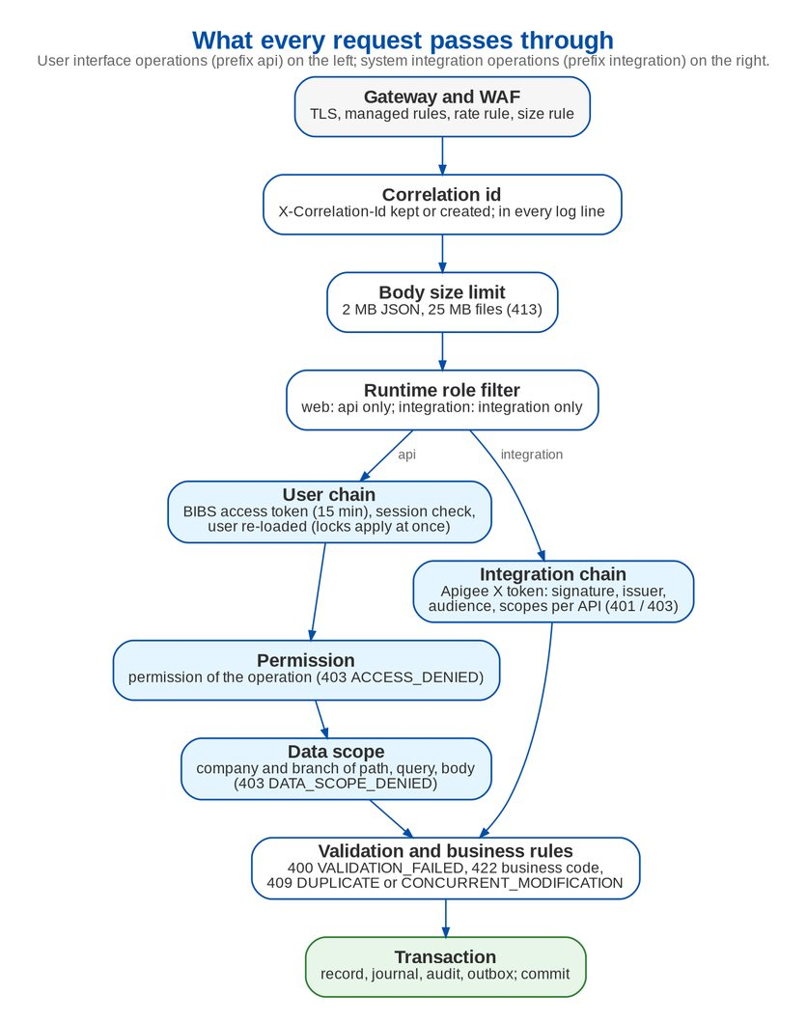
Figure 1: What every request passes through
1. Gateway and WAF - TLS, AWS WAF managed rules, the sign-in rate rule and the upload size rule; the integration prefix only from the Apigee ranges.
2. Correlation identifier - the X-Correlation-Id of the caller is kept when valid, otherwise created; it is in every log line, in the answer and in the events the request publishes.
3. Body size - JSON bodies up to 2 MB (413 REQUEST_TOO_LARGE above), files up to 25 MB (413 UPLOAD_TOO_LARGE).
4. Runtime role - bibs-web answers only the user and administration prefixes, bibs-integration only the integration prefix and its probes.
5. Authentication - user operations need the BIBS access token; the session is checked and the user re-loaded on every request, so a lock or deactivation applies at once. Integration operations need an Apigee X token (chapter 5.7).
6. Permission - every operation names its permission; 403 ACCESS_DENIED otherwise.
7. Data scope - the company and branch named in the path, the query or the body are checked against the user's scope; 403 DATA_SCOPE_DENIED otherwise.
8. Validation and business rules - bean validation of the request record (400 VALIDATION_FAILED with the field errors) and the business rules of the service (422 with the business code).
9. Transaction - the record, its accounting, the audit entry and any outgoing event commit together.

4 OpenAPI description
BIBS publishes an OpenAPI 3 description of its operations through springdoc-openapi 2.8, with the bearer token as the security scheme.
• Where. The backend serves the description at the path v3/api-docs (JSON) and an interactive viewer at swagger-ui.html, relative to the backend address.
• When. Only on a developer machine (environment local) or with the dev profile. A start-up safeguard switches the description and the viewer off in every other environment - SIT, UAT, Pre-Prod and production - so the production surface does not advertise its operations.
• How to obtain it. Run the backend of the release with the dev profile on a developer workstation or the VDI (database, signing key and second-factor key from the local environment, as for any start), then download v3/api-docs from the running backend. The proposal (AP-01) is that the pipeline does the same at each release and stores the description as a file with the release record, next to the API Catalogue, so BDOI IT receives both without starting the application.
• Title. The description is titled "iNXT BrokerVerse API"; the delivered description for BDOI is retitled "BIBS API" with the BIBS version (AP-02).
• System integration. Each API published on Apigee X gets its own OpenAPI document as part of its interface specification (Integration Architecture, chapter 8); Apigee publishes it to its developer portal for the BDO teams.

5 API standards

5.1 Paths and naming
• Paths are nouns in the plural, lower-case with hyphens, under the module: api/v1/<module>/<resources>/:id. Examples: api/v1/collections/plans, api/v1/product-maintenance/advisories/:advisoryId/send.
• Business actions that change state are POST sub-resources named by the verb of the business: api/v1/catalog/records/:kind/:id/authorize, api/v1/migration/decisions/:decisionNo/return.
• Business keys may stand in for identifiers where the business uses them (api/v1/placement/gate/:arn, api/v1/ops/invoices/:invoiceNo).
• JSON field names are camelCase; codes of lists and statuses are upper-case codes; labels are resolved by the lists of values.

5.2 Versioning
• The major version is in the path: api/v1 and integration/v1. Adding an operation, an optional field or a code value keeps the version.
• A breaking change (field removed or renamed, meaning changed, required field added) is a new version served next to the old one until every caller has moved; the old version is announced as deprecated with a date at least one release ahead (AP-04).
• The web client and the backend are released together, so the user interface moves in step; system integration versions are agreed with each counterpart.

5.3 Methods and status codes
Table 5: Methods
Method | Use | Success
GET | Read a record, a list, a report or a file link; never changes data | 200 with the body; file content with Content-Disposition attachment
POST | Create a record, upload a file, or run a business action (authorize, approve, send, book) | 200 or 201 with the resulting record; 204 when there is nothing to return
PUT | Update a record (with its version) | 200 with the record
DELETE | Remove a draft or a configuration row that may be removed; business records are cancelled or reversed by an action, never deleted | 204

PATCH is not used: updates replace the record with its version.

5.4 Errors
Every error is an RFC 7807 problem document with the fields type, title, status, detail (a business text without internal references), code (stable machine code), correlationId and, where relevant, errors (field errors) or reference (unexpected errors). The code never changes; only its text may.
Table 6: Error codes of the platform
Status | Code | When
400 | VALIDATION_FAILED | Bean validation failed; errors lists each field and message
400 | MALFORMED_REQUEST, BAD_REQUEST | Unreadable body or invalid argument (generic text, no internal message)
401 | AUTHENTICATION_FAILED | Missing, expired or invalid token
403 | ACCESS_DENIED | The user lacks the permission of the operation
403 | DATA_SCOPE_DENIED | The company or branch is outside the user's data scope
404 | NOT_FOUND, MODULE_NOT_IN_USE | Record or path not found; module switched off for the deployment
409 | DUPLICATE | A record with the same business key exists (also a repeated source reference)
409 | CONCURRENT_MODIFICATION | The record changed since it was read (optimistic locking); reload and try again
413 | REQUEST_TOO_LARGE, UPLOAD_TOO_LARGE | JSON body over 2 MB; file over 25 MB
422 | Business code of the rule | A business rule refused the action, for example PARAMETER_NOT_SET, NO_ACCOUNTING_RULE, PERIOD_NOT_OPEN, MAKER_CHECKER_VIOLATION
429 | LOGIN_RATE_LIMITED, RESET_RATE_LIMITED | Sign-in or password reset above the limit per address, with Retry-After
500 | INTERNAL_ERROR | Unexpected error; reference is also in the log line for support
503 | SIGN_IN_CHECK_UNAVAILABLE | The session store cannot be read; the client retries

5.5 Pagination, sorting and filtering
• List operations take page (zero-based) and size, and sort=field,asc or sort=field,desc; the default size is 20 and the maximum 2,000.
• A paged answer is an envelope with content, page, size, totalElements and totalPages, independent of the framework.
• Filters are query parameters named after the fields (status, companyId, branchId, dateFrom, dateTo); companyId and branchId are checked against the data scope.
• Large exports are reports run as jobs; the answer is a link to the file in S3, not a page of thousands of rows.

5.6 Idempotency and concurrency
• GET is safe and can be repeated.
• Creations carry a business reference (receipt number, source reference of an inbound file or request, request number) that BIBS refuses twice with 409 DUPLICATE, so a retry after a time-out never creates a second record.
• Updates carry the version of the record read; a stale version is refused with 409 CONCURRENT_MODIFICATION.
• Business actions check the current stage of the record (workflow), so repeating an action that already took effect is refused with a business code instead of acting twice.
• System integration creations carry an Idempotency-Key header (a UUID of the caller); BIBS keeps the key and its answer for 24 hours and returns the same answer to a repeat (standard for every integration API, AP-03).
• Events are delivered at least once; consumers deduplicate on the event identifier.

5.7 Security
Table 7: Security of the operations
Topic | Rule
User authentication | Sign-in by EIAM single sign-on (OIDC, or SAML 2.0) or, for break-glass administrators, password and TOTP; the backend then issues an access token (JWT, HS256, 15 minutes by default, 5 to 60 by parameter) sent as a bearer token, and a refresh token in an HttpOnly, SameSite=Strict cookie limited to the sign-in path, rotated on every renewal; inactivity time-out and an absolute end after 8 hours
Authorization | Every operation names its permission (the Permission column of the catalogue); roles are permission bundles granted by access requests under four eyes; maker-checker and authorization limits apply in the services
Data scope | Company and branch in path, query or body checked centrally; list operations filter on the allowed companies
System integration | OAuth 2.0 access token issued by Apigee X; BIBS checks signature against the Apigee key set, issuer, audience, validity (60-second tolerance), asymmetric algorithms only (RS256), and the scopes configured for the path of the API; answers 401 or 403
Transport and headers | TLS 1.2 or higher; HSTS for one year; Content-Security-Policy default-src 'none' on API answers; X-Content-Type-Options nosniff; no-referrer; CORS limited to the BIBS origin
Limits | Sign-in 20 attempts a minute per address, password reset 10 per 15 minutes; Apigee quotas and spike arrest per product
Output | No stack traces or internal messages in answers; CSV exports protected against formula injection; personal data only where the permission allows it

5.8 Data formats
• JSON in UTF-8. Dates are ISO-8601 dates (2026-10-08); timestamps are ISO-8601 in UTC with Z; the business date is the date in the business zone (Asia/Manila).
• Amounts are decimal numbers with two decimals, never floating point in the backend; every amount comes with its currency (ISO 4217 code); foreign-currency lines carry the base-currency amount too.
• Files are uploaded as multipart form data (Excel template, CSV or TXT where the upload screen allows it) and downloaded through a link valid 5 minutes, or streamed for protected e-mail attachments and ZIP bundles.

5.9 Tracing and support
Every answer carries X-Correlation-Id; the same identifier is in the log lines of the request and in the envelope of every integration event it published, so support can follow a request from the screen to the event archive. Unexpected errors also carry a reference that is in the log line.

6 Governance of the API
Table 8: API responsibilities (R responsible, A accountable, C consulted, I informed)
Activity | BDOI IT integration | BDO API team | BDOI Information Security | iorta TechNXT Tech Lead | iorta TechNXT Solution Architect
API standards (this document) | A | C | C | R | R
New or changed user interface operation | I | I | I | A, R | C
New system integration API | A | R | C | R | C
Apigee proxy, product, scopes, quotas | C | A, R | C | C | I
API Catalogue and OpenAPI file per release | I | I | I | A, R | C
Security review of new operations | I | I | A | R | C

Rules for a change: a new operation names its permission and is covered by the data scope check (the compile fails otherwise); a breaking change follows the versioning rule; the catalogue and the OpenAPI file are regenerated with the release and listed in the release note.

7 Decisions and open points for BDOI
Table 9: Decisions and open points for BDOI
ID | Topic | Our proposal | Owner | Needed by
AP-01 | OpenAPI file per release | The pipeline starts the release on a dev profile, exports the OpenAPI description and stores it with the release record and the API Catalogue; no environment beyond development serves it | iorta TechNXT Tech Lead; BDOI IT informed | 31-Jan-2027
AP-02 | Title of the OpenAPI description | "BIBS API" with the BIBS release version and BDOI contact, instead of the platform title | iorta TechNXT | 31-Jan-2027
AP-03 | Idempotency-Key on system integration | Every creation through integration/v1 carries an Idempotency-Key; BIBS keeps key and answer for 24 hours | BDOI IT integration, BDO API team | 30-Nov-2026
AP-04 | Deprecation period | A deprecated system integration version stays for at least two releases or three months, whichever is longer | BDOI IT integration | 30-Nov-2026
AP-05 | Apigee developer portal | Each published BIBS API with its OpenAPI document on the Apigee developer portal of BDO | BDO API team | 31-Mar-2027
AP-06 | Quotas | Default Apigee quota of 600 calls a minute per client application with spike arrest of 20 a second; adjusted per interface in its specification | BDO API team | 30-Nov-2026

Glossary
Term | Meaning
API | Application programming interface
JWT | JSON Web Token
OIDC | OpenID Connect
OpenAPI | Standard description format of HTTP APIs (version 3)
RFC 7807 | Problem details for HTTP APIs
SAML | Security Assertion Markup Language 2.0
TOTP | Time-based one-time password

