

INTEGRATION ARCHITECTURE
Integration Architecture
Interface catalogue, patterns, security, error handling, reconciliation and ownership of the BIBS interfaces
BIBS – BDOI Broker System
Client | BDO Insurance and Reinsurance Brokers, Inc.
Document | BIBS-ARC-04
Version | 1.0
Date | 08 October 2026
Status | Issued for BDOI review
Classification | Confidential

Prepared by iorta TechNXT for BDOI 
iNXT BrokerVerse. This document is confidential to BDO Insurance and Reinsurance Brokers, Inc. and iorta TechNXT.
Document Control
Version | Date | Author | Reviewer | Approver | Change
1.0 | 08 Oct 2026 | iorta TechNXT Solution Architect | iorta TechNXT Integration Lead; iorta TechNXT Tech Lead | BDOI IT Application Development and Integration (pending) | First issue, from the integration inventory of the Programme Alignment pack v1.0 and the interfaces named in the BRDs

Distribution List
Name / Unit | Role | Organisation | Purpose
Application Development and Integration (integration owners) | Approver | BDOI IT | Interface catalogue, patterns, ownership
BDO API team (Apigee X) | Reviewer | BDO Unibank IT | API proxies, tokens, private route
Information Security Office | Reviewer | BDOI IT | Security per interface
Owners of BRD-1 to BRD-13 | Reviewers | BDOI | Reconciliation owners, file layouts
Treasury, Operations, Comptrollership | Reviewers | BDOI | Bank channels, insurer files, EGL
Project team | Delivery | iorta TechNXT | Interface delivery and testing

Contents

1 Introduction 4
1.1 Purpose and audience 4
1.2 Scope 4
1.3 Sources 4
1.4 Conventions 4
2 Integration principles 5
3 Integration landscape 6
4 Integration patterns 8
4.1 Synchronous APIs through Apigee X 8
4.2 Events (Kafka) 8
4.3 Files 9
4.4 Sign-in redirect, e-mail and manual steps 9
4.5 Choosing the pattern 9
5 Transport and data per interface 10
6 Security per interface 11
7 Error handling and reconciliation 12
7.1 Handling errors by pattern 12
7.2 Error handling and reconciliation per interface 13
8 Ownership and governance 14
8.1 Interface ownership 14
8.2 Interface specification 16
8.3 Lifecycle 16
9 Schedule 16
10 Decisions and open points for BDOI 17
Glossary 17

1 Introduction

1.1 Purpose and audience
This document describes every interface between BIBS and other systems: what flows, by which pattern, how it is secured, how errors are handled and reconciled, and who owns each side. It is written for BDOI IT Application Development and Integration (owner of every external touch-point, BDOI answer A2 of 26 September 2026), the BDO API team, the Information Security Office and the business units that reconcile the data.

1.2 Scope
The interfaces INT-01 to INT-20 of the integration inventory of the Programme Alignment pack (same numbers; INT-11 ICBS is struck through on the drop plan and not listed), the interfaces named in the BRDs but not on the drop plan (INT-21 to INT-25), the document store (INT-26), the legacy extracts of data migration (INT-27) and the SMS question (INT-28). Each interface gets an interface specification agreed with its owner before delivery (chapter 8).

1.3 Sources
Table 1: Sources
Ref | Document | Used for
S1 | Programme Alignment pack v1.0 and its Integration Inventory workbook (26-Sep-2026) | INT-01 to INT-20, questions IQ04 to IQ19
S2 | BDOI answers of 26-Sep-2026 (A2 integration names and ownership, A4 documents in S3) | Meanings, ownership
S3 | Application architecture option decision, section 5 (edge paths, Apigee X) | Patterns and security of system calls
S4 | Platform cache and events architecture | Topics, outbox, consumers, dead letters
S5 | Document storage decision record | S3 buckets, malware scan, ECM archive
S6 | Design notes of the BRD modules (operations, collections, screening, submitted policies, user access) | Ports and file interfaces of each module
S7 | BRDs 01 to 13 | Data exchanged, frequencies, reconciliation needs

1.4 Conventions
Open points of this document are numbered IN-01 to IN-10 (chapter 10). "To confirm" marks a value BDOI IT has not given yet; the question number says where it is asked.

2 Integration principles
Table 2: Integration principles
# | Principle | Practice
I1 | One governed entry for system calls | Every synchronous call between BIBS and a BDO system passes through Apigee X proxies in both directions (ADR-16); no system calls BIBS directly and no system reads the BIBS database
I2 | The right pattern for the job | Synchronous APIs for requests that need an immediate answer; events for facts that others react to; files for bulk, scheduled or bank and insurer exchanges; manual steps only where the counterpart offers no interface
I3 | Business transaction first | Outbound work never runs inside the user's transaction: events through the outbox, files by jobs; a counterpart that is down never blocks a BIBS user
I4 | Safe to repeat | Every inbound message or file carries a source reference that BIBS refuses twice; every event carries an identifier that consumers deduplicate on
I5 | Controlled and reconciled | Every file has control totals; every interface has a reconciliation report and a business owner who signs it off
I6 | Secure by default | TLS on every hop; OAuth 2.0 tokens with scopes per API; files encrypted at rest with BDOI keys and scanned for malware before processing; no personal data in event payloads or object keys
I7 | Ports in BIBS | Each interface is a port of the owning module with a connector chosen by configuration, so a file interface can become an API without a change in the module
I8 | Specified and versioned | Each interface has a specification (layout, transport, schedule, errors, reconciliation) agreed with its owner; breaking changes are new versions run side by side

3 Integration landscape
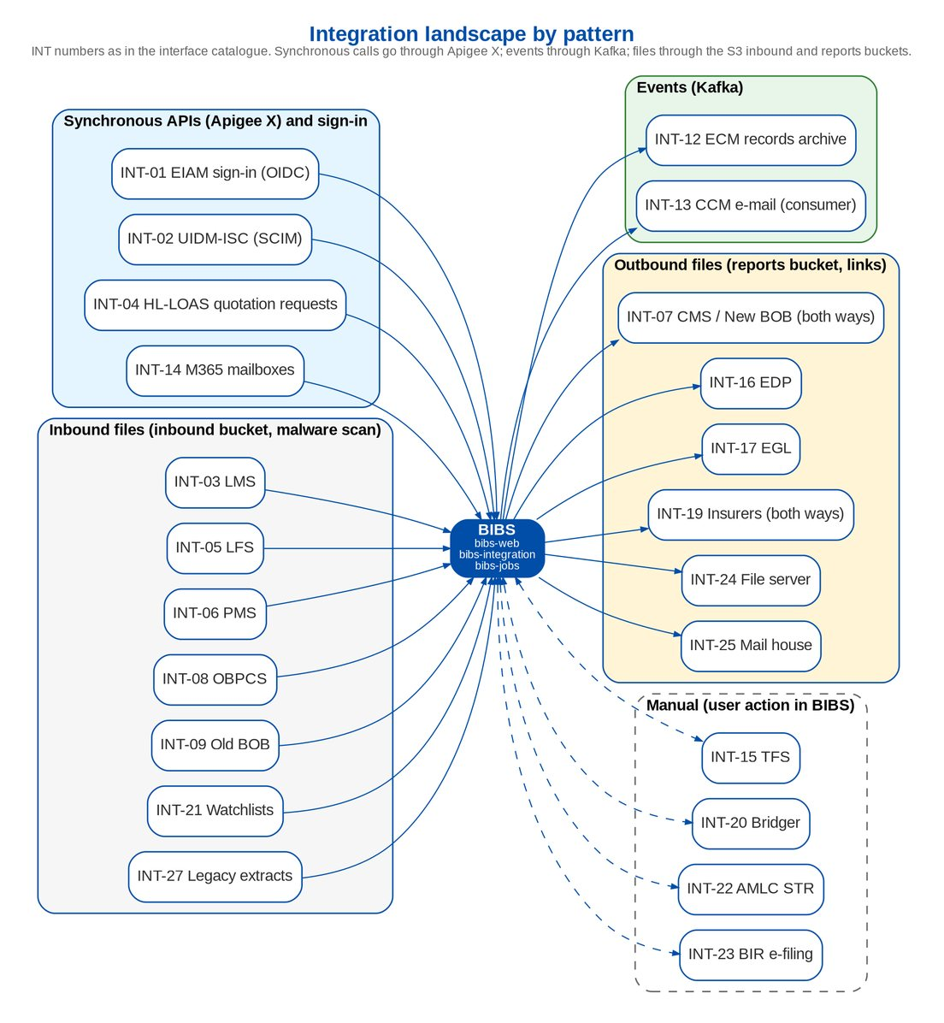
Figure 1: Integration landscape by pattern
Table 3: Interface catalogue
ID | Interface | Counterpart | Drop | Pattern | Direction | Open
INT-01 | EIAM single sign-on | Microsoft Entra ID (EIAM) | Drop 0 | Browser redirect | Both | IQ04
INT-02 | UIDM-ISC provisioning | UIDM-ISC (identity governance) | Drop 0 | Sync API | Both | IQ05
INT-03 | LMS loan data | Loans Management System | Drop 0 | File | Inbound | IQ06
INT-04 | HL-LOAS quotation requests and loan data | Home Loan System (Loan Origination and Admin) | Drop 0 (HLS) and Drop 2 (LOAS) | Sync API | Inbound | IQ07
INT-05 | LFS insurance report | Loan Front-End System (SaaS) | Not on the drop plan; proposed Drop 1 | File | Inbound | IQ08
INT-06 | PMS post-dated checks | PDC Management System | Drop 0 | File | Inbound (status outbound to confirm) | IQ09
INT-07 | CMS / New BOB outward payments | Cash Management System (New BOB) | Drop 0 | File | Both | IQ10
INT-08 | OBPCS bills payment collections | Online Bills Payment Consolidation System | Drop 0 | File | Inbound | IQ10
INT-09 | Old BOB SOA funds transfers | Old Business Online Banking Collection System | Drop 0 | File | Inbound | IQ10
INT-10 | AFTS automatic fund transfer | Automatic Fund Transfer System | Drop 0 | File | To confirm | IQ10
INT-12 | ECM records archive | Enterprise Content Management | Drop 0 | Event | Outbound | IQ13, DSQ02
INT-13 | CCM outbound e-mail | Centralized Communications Management | Drop 0 | E-mail | Outbound | IQ11
INT-14 | M365 Exchange mailboxes | Microsoft 365 Exchange | Drop 0 | Sync API | Inbound | IQ12
INT-15 | TFS trade clients (manual) | Trade Finance System | Drop 0 | Manual | Inbound | IQ14
INT-16 | EDP data ingestion (SD 11) | Enterprise Data Platform | Drop 2 | File | Outbound | IQ15
INT-17 | EGL general ledger feed | Enterprise General Ledger | Drop 2 | File | Outbound | IQ16
INT-18 | CARMS | CARMS | Drop 2 | To confirm | To confirm | IQ17
INT-19 | Insurer interfaces | Insurer systems (per insurer) | Drop 2 | File | Both | IQ18
INT-20 | Bridger Insight XG screening (manual) | Bridger Insight XG | Drop 2 | Manual | Inbound | IQ19
INT-21 | Watchlist feeds (AML advisory, NLDS PEP) | AMLC advisory lists, BDO Negative List Database System | Drop 1 | File | Inbound | SQ01
INT-22 | AMLC STR filing | AMLC portal | Drop 1 | Manual | Outbound | SQ09
INT-23 | BIR e-filing | BIR eFPS and eBIRForms | Drop 1 | Manual | Outbound | AQ31
INT-24 | Shared folders and file server (extract repository) | BDOI file server FS04 and shared drive folders | Drop 1 | File | Outbound | OQ17
INT-25 | Mail house print batches | Mail house (COG) | Drop 1 | File | Outbound | SQ09
INT-26 | Document store | Amazon S3 (BDOI AWS account) | Drop 0 | Internal store | Both | IQ31, DSQ01-DSQ04
INT-27 | Legacy systems for data migration | EBIX, QPS, ISYS, Collection Management System, Excel trackers | Drop 0 | File | Inbound | DMQ28
INT-28 | SMS notifications | BDO SMS gateway (if required) | - | Not in scope | Outbound | IN-05

Table 4: Interfaces per drop
Drop | Interfaces
Drop 0 | INT-01 EIAM, INT-02 UIDM-ISC, INT-03 LMS, INT-04 HL-LOAS (HLS side), INT-06 PMS, INT-07 CMS / New BOB, INT-08 OBPCS, INT-09 Old BOB, INT-10 AFTS, INT-12 ECM, INT-13 CCM, INT-14 M365, INT-15 TFS, INT-26 document store, INT-27 legacy extracts
Drop 1 | INT-05 LFS (proposed), INT-21 watchlist feeds, INT-22 AMLC STR filing, INT-23 BIR e-filing, INT-24 file server, INT-25 mail house
Drop 2 | INT-04 HL-LOAS (LOAS side), INT-16 EDP, INT-17 EGL, INT-18 CARMS, INT-19 insurer interfaces, INT-20 Bridger Insight XG

4 Integration patterns

4.1 Synchronous APIs through Apigee X
Inbound (a BDO system calls BIBS). The system obtains an OAuth 2.0 access token from Apigee X (client credentials) and calls the Apigee proxy of the BIBS API; Apigee applies quotas, spike arrest and analytics and forwards the call over the private route to the internal load balancer, where only the integration path prefix is admitted from the Apigee source ranges. bibs-integration validates the token in its own security chain - signature against the Apigee key set, issuer, audience, validity, asymmetric algorithms only - and the scopes configured for the path of the API; a path without a rule is refused. A BIBS user token is refused there, and an Apigee token is refused on the user operations.
• Operations are versioned in the path (integration/v1) and follow the API standards of the API Specification (problem details, correlation identifier, Idempotency-Key header on creations).
• Answers: 401 for a missing or invalid token, 403 for a missing scope or an unconfigured path, 409 for a repeated source reference, 422 for a business rule.
• The connectivity check of the integration interface answers the client identifier and scopes of the token, so each Apigee proxy can be tested end to end before its first business call.
Outbound (BIBS calls a BDO system). BIBS calls the Apigee proxy of the target with its own client credentials; connect time-out 5 seconds and response time-out 30 seconds (proposed); safe reads are retried twice with back-off; a failed call never fails the user's transaction - it leaves the item in the work queue of the module with the reason, and the job retries it.

4.2 Events (Kafka)
Integration events leave BIBS through the transactional outbox on the ten topics bibs.<domain>.<event>.v1 (Solution Architecture, chapter 6). Consumers inside BIBS deliver e-mail (INT-13), archive events and archive final records to ECM (INT-12). A BDO system that needs a BIBS event subscribes through a consumer group agreed with BDOI IT on MSK, or receives it through Apigee from a BIBS connector; the payloads carry identifiers, status and amounts, never personal data.
Table 5: Kafka topics available to consumers
Topic | Event | Record key | Published by
bibs.booking.invoice-booked.v1 | Invoice booked | Invoice number | Booking
bibs.cashiering.payment-applied.v1 | Payment applied or unapplied | Invoice number | Operations invoice ledger
bibs.cashiering.receipt-issued.v1 | Receipt issued | Receipt number | Cashiering
bibs.remittance.batch-status.v1 | Remittance batch stage changed | Batch number | Remittance
bibs.disbursement.status-changed.v1 | Disbursement request status changed | Request number | Disbursement
bibs.collections.feed-ready.v1 | Collection feed ready | Feed code | Operations invoice ledger
bibs.catalog.product-version-released.v1 | Package version released | Product code | Product catalogue
bibs.crm.client-changed.v1 | Client registered or changed | Client identifier | Clients (CRM)
bibs.messaging.notification-requested.v1 | E-mail or notification queued | Message identifier | Messaging
bibs.storage.ecm-archive-requested.v1 | Final record ready for the ECM archive | Stored file | File storage

4.3 Files
Inbound files (bank, loan, PDC, watchlist, insurer, migration) arrive in the incoming prefix of the inbound bucket of the environment - by AWS Transfer Family (SFTP) for host-to-host senders, by a presigned upload link, or by a user upload on the BIBS screen - with a declared SHA-256. The malware scan tags each object; only clean objects are processed (chapter 7).
Outbound files (payment instructions, extracts for EGL and EDP, collection and remittance files, print batches) are written by bibs-jobs to the reports bucket with a control file and recorded in the file register (name, size, SHA-256, run). Recipients download them with a presigned link valid 5 minutes after the BIBS permission check, or receive them by managed transfer to their own landing area.
Table 6: File standards
Topic | Standard
Naming | <SOURCE>_<FILE TYPE>_<company>_<yyyyMMdd>_<HHmmss>.<ext>, unique per run; the date is the business date
Encoding | UTF-8 text without control characters (CSV, TXT, pipe-delimited) or the Excel template of the upload screen; fixed-width only where a bank layout requires it
Control | Header and trailer (or a separate control file) with record count and amount totals per currency; a file whose totals do not match is refused as a whole
Size | Up to 25 MB through the application; larger files by presigned upload or transfer, up to 5 GB
Duplicates | A file with the same name or SHA-256 as an accepted file is refused
Retention | Inbound 90 days, reports per the report archive setting (default 400 days), migration extracts 5 days

4.4 Sign-in redirect, e-mail and manual steps
• Browser redirect (INT-01): OpenID Connect with Entra ID; SAML 2.0 supported as the alternative (ADR-09).
• E-mail (INT-13): SMTP relay of CCM with STARTTLS, password-protected PDF attachments; the queue and the retry job make delivery independent of the user transaction.
• Manual (INT-15, INT-20, INT-22, INT-23): BIBS produces or records the data (Trade client and payment file, Bridger result, STR file, BIR returns); a user carries it to or from the counterpart and records its reference in BIBS.

4.5 Choosing the pattern
Table 7: Pattern selection
Need | Pattern | Examples
Immediate answer to a request | Synchronous API through Apigee X | Quotation request from HL-LOAS, account provisioning from UIDM-ISC
A fact others react to, no answer needed | Event | Invoice booked, receipt issued, record to archive
Bulk or scheduled exchange, bank or insurer layouts | File | Payment instructions, collection files, EGL and EDP extracts
User identity | Browser redirect | EIAM sign-in
Counterpart without an interface | Manual with a reference recorded | BIR e-filing, AMLC STR filing

5 Transport and data per interface
Table 8: Transport and data per interface
ID | Interface | Transport and format | Data
INT-01 | EIAM single sign-on | OpenID Connect authorisation code with PKCE S256 (SAML 2.0 supported as the alternative); BIBS issues its own session after the identity is linked to an active BIBS user | User name claim (UPN or Windows ID), name, e-mail; optional group claim for the group check
INT-02 | UIDM-ISC provisioning | SCIM 2.0 Users (and Groups for option b) published through Apigee X; account and entitlement aggregation for certification | User accounts (create, update, enable, disable), group profiles (BIBS roles) as entitlements, data scope
INT-03 | LMS loan data | Daily file to the inbound bucket (managed transfer or presigned upload through Apigee X) | PN number, loan status (paid-off, RMU), loan release and amortisation for CLPC billing
INT-04 | HL-LOAS quotation requests and loan data | Quotation requests through Apigee X into the quotation request inbox; HLS insurance report and amortised loan data as daily files | Borrower, property, sum insured, PN; HLS insurance report; amortised loan release
INT-05 | LFS insurance report | Daily file to the inbound bucket | Loan-linked policies submitted by borrowers
INT-06 | PMS post-dated checks | Daily PDC list to the inbound bucket | PDC number, bank, date, amount, payor, account or invoice reference
INT-07 | CMS / New BOB outward payments | Payment instruction file from Disbursement; status and debit confirmation file back (host-to-host or user upload, IQ10) | Payee, account, amount, currency, value date, voucher reference; status per transaction
INT-08 | OBPCS bills payment collections | Consolidated bills-payment file uploaded to Cashiering | Payment date, reference (ARN, invoice, PN), payor, amount, channel
INT-09 | Old BOB SOA funds transfers | Collection file applied in Cashiering | Funds-transfer credits with SOA or invoice reference
INT-10 | AFTS automatic fund transfer | To be agreed with BDOI IT (IQ10) | To be agreed
INT-12 | ECM records archive | Final records of the "archive to ECM" record classes published on the topic bibs.storage.ecm-archive-requested.v1; the ECM connector stores the ECM reference back on the file record | Stored file identifier, record class, document type, owner, content type, size, SHA-256, object location (no file name)
INT-13 | CCM outbound e-mail | SMTP relay with STARTTLS on port 587 (or the CCM API, IQ11) through the private route | Recipient, subject, body, password-protected PDF attachments, template
INT-14 | M365 Exchange mailboxes | Microsoft Graph read of the quotation-request and insurer-reply mailboxes, if BDOI confirms the use (IQ12) | E-mails and attachments
INT-15 | TFS trade clients (manual) | Users key the client in BIBS and upload the Trade payment file | Trade client details; Trade payment file
INT-16 | EDP data ingestion (SD 11) | Daily extracts written to an EDP landing bucket (or events, IQ15) | Clients, accounts, invoices, receipts, remittances, GL; history and daily changes
INT-17 | EGL general ledger feed | Daily journal detail or balance file (IQ16) through Apigee X or a file exchange | Journals or trial balance by account, branch, cost centre, currency, mapped to EGL accounts
INT-18 | CARMS | To be agreed (IQ17) | To be agreed
INT-19 | Insurer interfaces | Per insurer: e-mail with protected attachments today; SFTP or API through Apigee X where the insurer offers it (IQ18) | Placement slips, production reports and feedback, remittance schedules and ORs, DP billing responses, renewal responses, SOAs, e-policies, claims
INT-20 | Bridger Insight XG screening (manual) | Compliance screens names in Bridger and records the result in the BIBS screening case | Screening result and evidence
INT-21 | Watchlist feeds (AML advisory, NLDS PEP) | List files uploaded or dropped in the inbound bucket; daily ingestion job before business hours | Sanction and PEP entries with aliases
INT-22 | AMLC STR filing | STR file extracted by BIBS in the configured layout; filed by Compliance on the AMLC portal; the AMLC reference recorded in BIBS | Suspicious transaction report and its transactions
INT-23 | BIR e-filing | Returns, certificates (2307) and alphalists produced by BIBS; filed by Comptrollership on eFPS or eBIRForms; filing reference recorded | 2550Q, 0619-E, 1601-EQ with QAP, 2307, alphalists
INT-24 | Shared folders and file server (extract repository) | Scheduled files (Collections daily files, application-to-invoice file, remittance and DP lists) written to the reports bucket and offered for download; delivery to FS04 when the folder route is agreed | Report and extract files
INT-25 | Mail house print batches | Merged PDF print batch with a control list per run | Renewal advice and submitted-policy letters for printing
INT-26 | Document store | AWS SDK over the S3 VPC gateway; presigned links of 5 minutes for the browser | Attachments, generated documents, report files, inbound files, migration extracts
INT-27 | Legacy systems for data migration | Extracts with a control file uploaded to the migration bucket (expiry after 5 days) | Migration objects R, C, P and the opening balances
INT-28 | SMS notifications | No BRD requires SMS; notifications go by e-mail (INT-13) and in-app. An SMS channel would be added as a further transport of the messaging module through Apigee X | -

6 Security per interface
General controls that apply to every interface:
• TLS 1.2 or higher on every hop; no plaintext protocol anywhere (the backend refuses to start in production with a plaintext connection).
• Synchronous calls: OAuth 2.0 client credentials through Apigee X with scopes per API; tokens validated by BIBS; source ranges limited at the WAF.
• Files: encrypted at rest with the BDOI KMS key of the bucket class; malware scan before processing; access by IAM role of the workload; presigned links valid 5 minutes, issued after the permission check and audited.
• Events: SASL_SSL; topics created by the application only; payloads without personal data.
• Personal data in extracts for non-production or for EDP is masked unless the recipient is authorised (IN-06).
Table 9: Security per interface
ID | Interface | Security controls
INT-01 | EIAM single sign-on | Confidential client; ID token signature from the tenant key set, issuer, audience, expiry and nonce checked; roles stay in BIBS; break-glass administrators keep a local password with TOTP
INT-02 | UIDM-ISC provisioning | Apigee X OAuth 2.0 client credentials token with the SCIM scopes; TLS over the private route from Apigee X to the internal load balancer
INT-03 | LMS loan data | File encrypted in transit (TLS); SSE-KMS at rest; malware scan before processing
INT-04 | HL-LOAS quotation requests and loan data | Apigee X token with the quotation-request scope; files as INT-03
INT-05 | LFS insurance report | As INT-03
INT-06 | PMS post-dated checks | As INT-03
INT-07 | CMS / New BOB outward payments | Signed and encrypted file per bank standard; approvals in BIBS before the file is released
INT-08 | OBPCS bills payment collections | As INT-03
INT-09 | Old BOB SOA funds transfers | As INT-03
INT-10 | AFTS automatic fund transfer | As INT-07
INT-12 | ECM records archive | Kafka SASL_SSL; S3 read through a presigned link or the ECM role; payload without personal data
INT-13 | CCM outbound e-mail | TLS; authenticated relay; attachments protected with the document password policy
INT-14 | M365 Exchange mailboxes | Application permission limited to the named mailboxes
INT-15 | TFS trade clients (manual) | User permissions and upload checks
INT-16 | EDP data ingestion (SD 11) | Cross-account bucket policy with the EDP role; SSE-KMS; personal data masked unless EDP is authorised
INT-17 | EGL general ledger feed | Apigee X token or signed file; SSE-KMS
INT-18 | CARMS | Apigee X or file exchange, per the agreed pattern
INT-19 | Insurer interfaces | Password-protected PDFs by e-mail; for files, insurer-specific keys; inbound files scanned for malware
INT-20 | Bridger Insight XG screening (manual) | User permissions; evidence stored as an attachment
INT-21 | Watchlist feeds (AML advisory, NLDS PEP) | As INT-03; list changes under maker-checker
INT-22 | AMLC STR filing | Extraction permission; file under legal hold
INT-23 | BIR e-filing | Tax permissions; filed forms under legal hold
INT-24 | Shared folders and file server (extract repository) | Presigned links of 5 minutes after the permission check; SSE-KMS
INT-25 | Mail house print batches | Presigned link or managed transfer; SSE-KMS
INT-26 | Document store | IRSA role per workload; SSE-KMS with BDOI-owned keys; Object Lock governance mode and legal hold; GuardDuty malware protection
INT-27 | Legacy systems for data migration | Migration role only; masking of personal data outside production
INT-28 | SMS notifications | -

7 Error handling and reconciliation

7.1 Handling errors by pattern
Table 10: Error handling by pattern
Pattern | Handling
Inbound API | Validation and business errors answered at once as problem details with a code; the caller corrects and calls again; a repeated source reference is refused (409) so a retry after a time-out never creates a duplicate
Outbound API | Safe reads retried twice with back-off; other failures leave the item in the module's work queue with the reason; a job retries; repeated failures raise an exception code alert to the owner unit
Events | Outbox retries with back-off, failed after 10 attempts and visible on the Integration Events screen; consumer retries 3 times, then the dead-letter topic with retry and discard on the same screen
Inbound file | Whole-file checks (scan, structure, totals, duplicate) refuse the file with a result; row errors are listed per row while valid rows are processed in their own transaction; the sender corrects and re-sends only the rejected rows when the layout allows it
Outbound file | A failed run raises JOB_FAILURE; the job is re-run for the same business date and replaces the file (same name with a new run time); the recipient takes the latest run

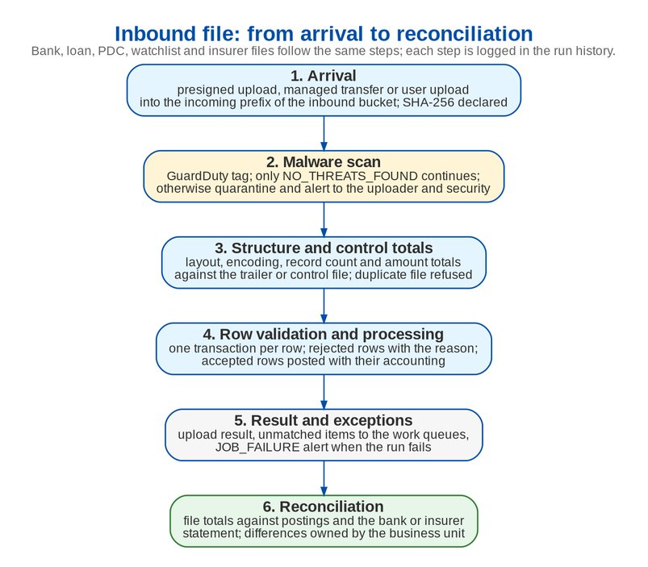
Figure 2: Inbound file: from arrival to reconciliation

7.2 Error handling and reconciliation per interface
Table 11: Error handling and reconciliation
ID | Interface | Error handling | Reconciliation
INT-01 | EIAM single sign-on | Unknown, inactive or locked user refused with the standard sign-in message; provider errors logged with a reference; break-glass sign-in meanwhile | Monthly comparison of active BIBS users with the EIAM directory through the UIDM-ISC aggregation (INT-02)
INT-02 | UIDM-ISC provisioning | SCIM error responses; a change that breaks a BIBS rule (separation of duties, data scope) is refused and returned to the requester in UIDM-ISC | Daily aggregation; differences listed in the access change log report
INT-03 | LMS loan data | Row errors listed in the upload result; the file is re-sent after correction | Record count and control totals per file against the file trailer
INT-04 | HL-LOAS quotation requests and loan data | Invalid request refused with a problem response; duplicates refused on the source reference | Daily count of requests received against HL-LOAS sent
INT-05 | LFS insurance report | As INT-03 | Count per file; unmatched rows listed for Submitted Policies
INT-06 | PMS post-dated checks | Rejected rows in the upload result | PDC count and amount per file; maturity run reconciles warehoused PDCs
INT-07 | CMS / New BOB outward payments | Rejected instructions return to the disbursement queue with the bank reason | Voucher totals against the bank confirmation; bank reconciliation in Receivables
INT-08 | OBPCS bills payment collections | Unmatched payments go to the unapplied queue | File total against the bank credit; automatching report
INT-09 | Old BOB SOA funds transfers | Unmatched credits to the unapplied queue | File total against the bank statement
INT-10 | AFTS automatic fund transfer | As INT-07 | As INT-07
INT-12 | ECM records archive | Retries, then dead-letter topic and the Integration Events screen | ECM status per stored file (pending, archived, failed) in the file store report
INT-13 | CCM outbound e-mail | Failed sends stay queued and are retried by the mail dispatch job up to the MAIL_MAX_ATTEMPTS parameter; bounces reported | Send log per message; daily sent and failed counts
INT-14 | M365 Exchange mailboxes | Mail not read stays in the mailbox and is listed for manual capture | Mailbox count against requests captured
INT-15 | TFS trade clients (manual) | Upload result per row | Upload totals
INT-16 | EDP data ingestion (SD 11) | Extract job failure raises the JOB_FAILURE alert; re-run for the business date | Control file with counts and amount totals per extract
INT-17 | EGL general ledger feed | Rejected lines returned and corrected by Accounting; the feed is re-sent for the business date | Trial balance of BIBS against EGL per period, owned by Comptrollership
INT-18 | CARMS | Per the agreed pattern | Per the agreed pattern
INT-19 | Insurer interfaces | Insurer file errors in the insurer file inbox with the reason; follow-up in the Operations work queues | Production reconciliation (PRCID), SOA reconciliation in ACSL, remittance confirmation
INT-20 | Bridger Insight XG screening (manual) | - | Screening case report
INT-21 | Watchlist feeds (AML advisory, NLDS PEP) | Ingestion errors listed per run; error digest to Compliance | Entries added, changed and removed per run; delta screening of clients
INT-22 | AMLC STR filing | - | STR register with the AMLC reference per report
INT-23 | BIR e-filing | - | Tax worksheet against the ledger per tax account
INT-24 | Shared folders and file server (extract repository) | Job failure alert; re-run for the business date | File register per run with name, size and SHA-256
INT-25 | Mail house print batches | Batch re-generated on request | Control list count against letters printed
INT-26 | Document store | Files without a clean scan cannot be downloaded; infected files quarantined with an alert | Nightly orphan reconciliation (objects without a record after 24 hours); SHA-256 on every file
INT-27 | Legacy systems for data migration | Batch validation report; rejected batch resubmitted | Control totals per object and the reconciliation reports of the Migration Console
INT-28 | SMS notifications | - | -

Reconciliation reports are part of the interface: each one shows what was sent or received (count and totals), what was processed, what was rejected and the differences, and is signed off by the business owner of the interface on the frequency of the interface (daily for bank and collection files, per period for EGL).

8 Ownership and governance

8.1 Interface ownership
All external touch-points are owned by BDOI IT (answer A2); the business owner of each interface is the unit that reconciles it.
Table 12: Interface ownership
ID | Interface | BDOI owner (counterpart system) | BIBS module and workload
INT-01 | EIAM single sign-on | BDOI IT Identity and Access Management | User access and identity (security); bibs-web
INT-02 | UIDM-ISC provisioning | BDOI IT Identity Governance | User access and identity (nbadmin, security); bibs-integration
INT-03 | LMS loan data | BDOI IT (LMS owner) | Renewal, Submitted policies, Placement; bibs-integration
INT-04 | HL-LOAS quotation requests and loan data | BDOI IT (HL-LOAS owner) | Package quotations, Placement; bibs-integration
INT-05 | LFS insurance report | BDOI IT (LFS owner) | Submitted policies; bibs-integration
INT-06 | PMS post-dated checks | BDOI IT (PMS owner) | Cashiering; bibs-jobs
INT-07 | CMS / New BOB outward payments | BDOI Treasury with BDOI IT | Disbursement; bibs-jobs
INT-08 | OBPCS bills payment collections | BDOI Operations with BDOI IT | Cashiering; bibs-jobs
INT-09 | Old BOB SOA funds transfers | BDOI Operations with BDOI IT | Cashiering; bibs-jobs
INT-10 | AFTS automatic fund transfer | BDOI IT | Cashiering or Disbursement
INT-12 | ECM records archive | BDOI IT (ECM owner) | File storage; bibs-integration
INT-13 | CCM outbound e-mail | BDOI IT (CCM owner) | Messaging; bibs-integration (consumer) and bibs-jobs (dispatch)
INT-14 | M365 Exchange mailboxes | BDOI IT (M365) | Package quotations; bibs-integration
INT-15 | TFS trade clients (manual) | BDOI Operations | Clients, Cashiering; bibs-web
INT-16 | EDP data ingestion (SD 11) | BDO Data Office with BDOI IT | Report centre and extracts; bibs-jobs
INT-17 | EGL general ledger feed | BDOI Comptrollership with BDO EGL team | Finance core; bibs-jobs
INT-18 | CARMS | BDOI IT | To be placed
INT-19 | Insurer interfaces | BDOI Operations with each insurer | Placement, Issuance, Remittance, Production reconciliation, ACSL, Claims handling; bibs-integration and bibs-jobs
INT-20 | Bridger Insight XG screening (manual) | BDOI Compliance | Sanction screening; bibs-web
INT-21 | Watchlist feeds (AML advisory, NLDS PEP) | BDOI Compliance with BDO AML unit | Sanction screening; bibs-integration
INT-22 | AMLC STR filing | BDOI Compliance | Sanction screening; bibs-web
INT-23 | BIR e-filing | BDOI Comptrollership | Finance core (tax); bibs-web
INT-24 | Shared folders and file server (extract repository) | BDOI IT (file server) | Collections, Remittance, Production reconciliation; bibs-jobs
INT-25 | Mail house print batches | BDOI Operations | Submitted policies, Renewal; bibs-jobs
INT-26 | Document store | BDOI IT cloud platform | File storage; all backend workloads
INT-27 | Legacy systems for data migration | BDOI data stewards with BDOI IT | Data migration; bibs-jobs
INT-28 | SMS notifications | BDOI IT | Messaging

Table 13: Interface responsibilities (R responsible, A accountable, C consulted, I informed)
Activity | BDOI IT integration owner | Counterpart system owner | BDO API team | BDOI business owner | iorta TechNXT
Interface specification | A | R | C | C | R
Apigee proxy, product and scopes | C | I | A, R | I | C
Connector in BIBS | I | I | I | I | A, R
Connection test in SIT | A | R | R | I | R
Reconciliation sign-off | I | I | I | A, R | C
Change of layout or version | A | R | C | C | R

8.2 Interface specification
Every interface has a specification agreed before delivery, with these sections: purpose and BRD references; counterpart and owners; pattern, direction, transport and schedule; layout or message contract with field rules and code lists; security (identity, scopes, keys, network route); volumes and time windows; error handling and reprocessing; reconciliation report and owner; environments and test data; versioning and change procedure.

8.3 Lifecycle
1. Specify - BDOI IT and the counterpart owner give the layout and transport; iorta TechNXT writes the specification; BDOI IT approves it.
2. Connect - the BDO API team publishes the Apigee proxy, the network team opens the route, the connector is configured in SIT.
3. Test - connection test, then integration test cycles in SIT with the counterpart's test system and reconciliation reports.
4. Accept - UAT with the business owner, including a reconciliation cycle.
5. Operate - monitoring and alerts per interface; changes through the versioning rule (a breaking change is a new version run side by side).

9 Schedule
Table 14: Integration schedule
By | What | From whom
16-Oct-2026 | Answers to the priority-1 integration questions (IQ04, IQ05, IQ10, IQ15, IQ16) | BDOI IT
30-Nov-2026 | Apigee X onboarding of BIBS (private route, source ranges, token issuer and key set); EIAM app registration | BDO API and network teams, BDOI IT Identity
15-Jan-2027 | Interface specifications of Drop 0 and Drop 1 (layouts of the bank, loan and PDC files, CCM) | BDOI IT and counterpart owners with iorta TechNXT
31-Jan-2027 | Specifications of EGL, EDP, CARMS and the insurer channels (Drop 2) | BDOI IT, Comptrollership, Operations
30-Apr-2027 | Integration test connections for EGL, EDP and the insurer channels in SIT | BDOI IT
Jan - Sep 2027 | SIT of the interfaces with each drop; reconciliation reports reviewed | iorta TechNXT, BDOI IT
Aug - Nov 2027 | UAT with reconciliation cycles per interface | BDOI business owners

10 Decisions and open points for BDOI
Table 15: Decisions and open points for BDOI
ID | Topic | Our proposal | Owner | Needed by
IN-01 | Bank, loan and PDC file layouts | BDOI IT provides the layouts, schedules and transport of INT-03 to INT-10, and says what AFTS is used for (IQ06 to IQ10) | BDOI IT, Treasury | 15-Jan-2027
IN-02 | File transport | AWS Transfer Family (SFTP) into the inbound bucket for host-to-host senders; presigned upload or the BIBS upload screen otherwise | BDO IT Cloud, network team | 30-Nov-2026
IN-03 | Apigee X onboarding | One Apigee product per counterpart with scopes per API; private route from Apigee X to the BIBS load balancer; BIBS registered as an Apigee client for outbound calls | BDO API team | 30-Nov-2026
IN-04 | EGL feed | Daily journal detail file mapped to EGL accounts and segments, reconciled per period by Comptrollership (IQ16) | BDOI Comptrollership, BDO EGL team | 16-Oct-2026
IN-05 | SMS | No SMS channel at go-live: no BRD requires it; notifications by e-mail and in-app | BIBS Product Owner | 30-Nov-2026
IN-06 | EDP ingestion (SD 11) | Daily extracts with control file to an EDP landing bucket; personal data masked unless EDP is authorised (IQ15) | BDO Data Office | 16-Oct-2026
IN-07 | Insurer channels | Keep e-mail with protected attachments for insurers without an interface; SFTP or API through Apigee for insurers that offer one, per insurer (IQ18) | BDOI Operations | 31-Jan-2027
IN-08 | CCM transport | SMTP relay with STARTTLS on port 587 from the BIBS pods through the private route (IQ11) | BDOI IT (CCM) | 30-Nov-2026
IN-09 | ECM interface | ECM receives final records of the "archive to ECM" classes through a connector consuming the ECM topic; ECM API, metadata and acknowledgement from BDOI IT (DSQ02, IQ13) | BDOI IT (ECM) | 31-Jan-2027
IN-10 | Reconciliation owners | The business owner of each interface in chapter 8 signs off its reconciliation report | BRD owners | 30-Nov-2026

Glossary
Term | Meaning
AFTS | Automatic Fund Transfer System
AMLC | Anti-Money Laundering Council
CARMS | System named on the drop plan, to be explained by BDOI (IQ17)
CCM | Centralized Communications Management (e-mail sending)
CMS / New BOB | Cash Management System, outward payments
ECM | Enterprise Content Management
EDP | Enterprise Data Platform
EGL | Enterprise General Ledger
HL-LOAS | Home Loan System (Loan Origination and Admin)
LFS | Loan Front-End System
LMS | Loans Management System
OBPCS | Online Bills Payment Consolidation System
PMS | PDC Management System
SCIM | System for Cross-domain Identity Management
TFS | Trade Finance System
UIDM-ISC | User ID Maintenance - Identity Security Cloud

