

DELIVERY METHODOLOGY
Delivery Methodology
Hybrid delivery by drops and iterations, definitions of ready and done, quality gates, configuration and release management, change control, documentation standards and governance
BIBS – BDOI Broker System
Client | BDO Insurance and Reinsurance Brokers, Inc.
Document | BIBS-DM-BRD-00
Version | 1.0
Date | 08 October 2026
Status | Issued for BDOI review
Classification | Confidential

Prepared by iorta TechNXT for BDOI 
iNXT BrokerVerse. This document is confidential to BDO Insurance and Reinsurance Brokers, Inc. and iorta TechNXT.
Document Control
Version | Date | Author | Reviewer | Approver | Change
1.0 | 08 Oct 2026 | iorta TechNXT Project Manager | iorta TechNXT Solution Architect; iorta TechNXT QA lead | Program Manager, Business Project Services (pending) | First issue

Distribution List
Name / Unit | Role | Organisation | Purpose
Program Manager, Business Project Services | Approver | BDO Unibank ESG | Approval of the delivery approach and governance
BIBS Product Owner | Approver | BDOI | Ready and done, change control
Head, BDOI IT | Reviewer | BDOI | Quality gates, release and configuration management
Head, BDOI Information Security | Reviewer | BDOI | Security scans and patching
Business owners of BRD-01 to BRD-13 | Reviewers | BDOI | Ceremonies, sign-off and change control
Project team | Delivery | iorta TechNXT | Applies the methodology

Contents

1 Purpose, audience and scope 4
1.1 Purpose 4
1.2 Audience 4
1.3 Scope 4
2 Delivery approach 4
2.1 Principles 5
2.2 Drops and development waves 6
3 Iterations and ceremonies 6
4 Definition of ready and definition of done 7
4.1 Definition of ready (an item may enter an iteration) 7
4.2 Definition of done 7
5 Quality gates 7
5.1 Test levels and incident severities 9
6 Configuration and release management 9
6.1 Configuration items 9
6.2 Release flow 10
7 Requirement change control 10
7.1 When change control applies 10
7.2 Process 11
8 Documentation standards 12
9 Governance cadence 12
9.1 Status reporting 13
10 Roles and responsibilities 13
11 References 15
12 Decisions and open points for BDOI 15

1 Purpose, audience and scope

1.1 Purpose
This document states how the BIBS programme is delivered: how the BDOI drops and the iterations of the delivery team fit together, when a requirement is ready for development and when a change is done, the quality gates every change passes, how configuration and releases are managed, how requirement changes are controlled, which documentation standards apply and how the programme is governed. It is the agreement between BDOI and iorta TechNXT on the way of working; the dates are in the Project Plan.

1.2 Audience
The Program Manager of Business Project Services and the BIBS Product Owner (approval), the business owners of each BRD and their key users (ceremonies, reviews, sign-off), BDOI IT and Information Security (quality, release, security), and the iorta TechNXT project team.

1.3 Scope
All work of the programme from requirements to the hand-over to production support: Drop 0, Drop 1, Drop 2, the data migration stream, the integrations with BDO systems and the readiness activities. Production support after the hypercare follows the support model agreed in the Knowledge Transfer Plan.

2 Delivery approach
BIBS is delivered in a hybrid way. The plan-driven frame comes from BDOI: three drops that split the requirements, test and sign-off workload, one end-to-end UAT, and one go-live of all modules together in January 2028. Inside that frame the delivery team works in two-week iterations: each iteration takes requirements that meet the definition of ready, delivers them through the quality gates, shows them to the key users and feeds the release that goes to SIT.
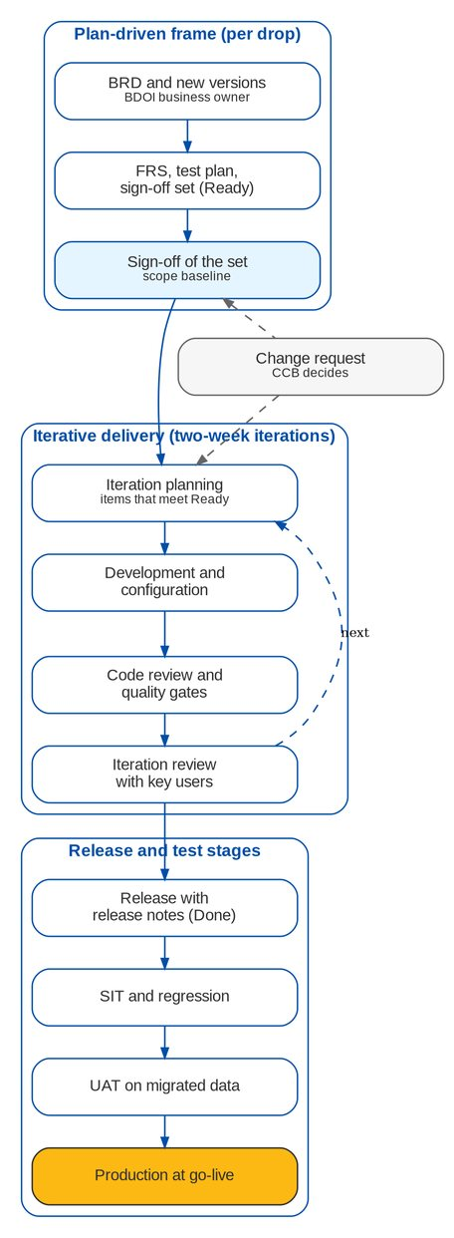
Figure 1: Hybrid delivery: drops, iterations, releases and test stages

2.1 Principles
• Configure before changing. A requirement is met by configuration (lists, parameters, rules, templates, workflow stages) where the platform allows it; a change to the application is the second choice and is traced to its FR.
• One source of truth per item. BRD (what BDOI needs) - FRS (how BIBS meets it) - test case - UAT result - release note; every link carries the BRD requirement ID and page.
• Business content in the sign-off sets. Sign-off sets hold business content only; technical detail goes to the Technical Specification reviewed by BDOI IT.
• Seed data outside production. SIT, UAT and training use seed data and masked extracts; production data never leaves production unmasked.
• Small, frequent releases. A release into SIT at the end of every iteration; regression on every release; nothing reaches UAT that has not passed SIT.
• Decisions are recorded. Every clarification, decision and change has an ID, an owner and a date (clarification chapters, decision logs, Change Management Register, RAID log).

2.2 Drops and development waves
Table 1: Drops, development waves and releases
Drop | BRDs | Development | Content of the releases
Drop 0 | BRD-03, BRD-11, BRD-13 (and GL accounts of BRD-05) | First wave, Nov - Dec 2026; Migration Console Nov 2026 - Mar 2027 | Setup, sign-in and user access, product maintenance, data management, workflow; migration functions
Drop 1 | BRD-01, 02, 04, 05, 06, 09, 10, 12 | First wave (upstream) Nov - Dec 2026; second wave (downstream) Jan - Feb 2027 | Client onboarding to booking, renewal, submitted policies; cashiering, remittance, adjustment, accounting, disbursement, commission receivables, reports
Drop 2 | BRD-07, BRD-08; Production Reconciliation; Marketing Collection extraction | Third wave, Mar - Apr 2027 | Claims, Employee Benefits without portal, other reports, EGL, EDP and insurer exchanges; CSF Case Management if approved

3 Iterations and ceremonies
Table 2: Ceremonies of the delivery team
Ceremony | When | Length | Who | Output
Daily stand-up | Every working day, 09:15 PHT | 15 minutes | Delivery team; iorta Project Manager | Impediments raised; plan of the day
Refinement | Weekly, Wednesday | 60 minutes | Business Analyst lead, Solution Architect, QA lead, key user of the BRD when needed | Items meet the definition of ready
Iteration planning | First Monday of the iteration | 2 hours | Delivery team; BIBS Product Owner or delegate | Iteration goal and committed items
Iteration review | Last Thursday of the iteration | 60 to 90 minutes | Delivery team; key users and business owner of the BRDs shown | Feedback recorded; accepted items
Retrospective | Last Friday of the iteration | 45 minutes | Delivery team | Two improvement actions per iteration
Release planning | At each drop start and monthly | 2 hours | iorta Project Manager, Solution Architect, BIBS Product Owner, BDOI IT | Release calendar into SIT and UAT
Business working group | Weekly per BRD in requirements and UAT | 60 minutes | Business owner, key users, Business Analyst lead | Clarifications decided; UAT progress

The iteration review is held on the SIT environment with seed data, never on a developer workstation. Key users see the screens they will test, which keeps the UAT short.

4 Definition of ready and definition of done

4.1 Definition of ready (an item may enter an iteration)
Table 3: Definition of ready
No. | Criterion | Evidence
R1 | The item traces to a BRD requirement (ID and page) or to an approved CR | FRS traceability chapter; CR number
R2 | The FR has actor, main flow, alternate flows, rules, validations with the messages word for word, fields and acceptance criteria | FR block of the FRS
R3 | The screens are specified (fields, actions, statuses, messages) and placed in the screen register | Screen specification; UX screen register
R4 | Open clarifications are decided, or the working assumption is recorded with its decision date | Clarification chapter of the FRS
R5 | Test cases exist for every acceptance criterion | Test plan and its cases
R6 | Dependencies are available or simulated in SIT only with the agreement of BDOI IT (interfaces, configuration inputs, seed data) | Dependency list of the Project Plan
R7 | The effort is estimated and fits the iteration | Iteration plan

4.2 Definition of done
Table 4: Definition of done at three levels
Level | Criteria | Evidence
Item | Code reviewed and approved by a second developer; every quality gate passed; tests of the acceptance criteria pass; screens follow the BDO UX guidelines (labels not codes, names not logins, dd-MMM-yyyy dates, formatted amounts, tables with row action menus); Help Center text updated; FRS updated where the behaviour changed | Review record; gate results; test results
Release | All items of the release done; regression passed in SIT; release notes per persona; deployment configuration versioned; SBOM produced; no open Severity 1 or 2 incident introduced by the release | Release notes; regression report; SBOM
Drop | All FRs of the drop delivered or deferred by an approved CR; SIT exit criteria met; UAT signed per BRD; user guides and quick-reference guides updated; training material updated; knowledge base updated | SIT exit report; UAT sign-off certificates; documentation versions

5 Quality gates
Every change passes the same gates in the continuous integration pipeline; a change that fails a gate is not accepted into the mainline. The gates are set in the project configuration and are the same on every developer machine and in the pipeline. No rule is weakened or suppressed without a written reason next to the exclusion.
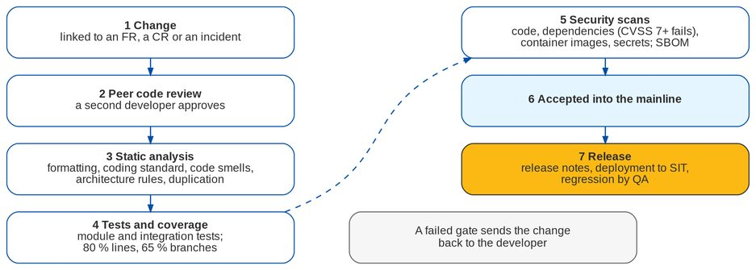
Figure 2: Quality gates of every change
Table 5: Gates and thresholds
Gate | What is checked | Threshold
Code review | A second developer reviews every change against the FR, the coding standard and the security checklist | One approval; the author never approves his own change
Formatting | Java and TypeScript formatting | No difference allowed
Coding standard | Naming, size and complexity (Checkstyle; ESLint with the SonarSource rules, TypeScript strict) | 600 lines per file, 60 lines per method, 120 columns; cognitive complexity 15, cyclomatic 12
Code smells and correctness | PMD, SpotBugs with security rules, compiler warnings as errors | No finding
Duplication | Copy-paste detection | Blocks of 120 tokens or more fail
Architecture | Layering and module boundaries (ArchUnit) | No module cycle; no access across bounded contexts outside their published services
Tests | Module and integration tests on PostgreSQL 16; web client tests | All pass
Coverage | Line and branch coverage of the server code | 80 percent lines, 65 percent branches
Accessibility | Accessibility lint of the web client | No finding
Code scanning | CodeQL on Java and TypeScript | No new high finding
Dependencies | OWASP dependency-check (server), audit of the web packages | Fails at CVSS 7.0 or higher, or on a high or critical advisory
Container images | Trivy on the server and web images | Fails on a high or critical vulnerability with a fix available
Secrets | gitleaks over the whole history | Any finding fails
Software bill of materials | CycloneDX SBOM of the server and the web client | Produced and kept with every release

Accepted findings. A finding is fixed by upgrading the library, the base image or the package. An accepted finding is the exception: its record names the reason it does not apply, the reviewer, the review date and an expiry date at most six months ahead; after the expiry the gate fails again. Information Security sees every accepted finding in the release notes.
Patching. Security advisories of the components of the baseline (for example the Spring Framework 6.2 line under Spring Boot 3.5) are applied in a monthly patch release; a critical finding is patched within 7 days and a high finding within 30 days, with the regression run before the patch reaches UAT or production.

5.1 Test levels and incident severities
Table 6: Test levels
Level | Scope | Who | Environment
Developer tests | Module and integration tests of every change | iorta development team | Pipeline
SIT | Test cases of the test plan per BRD; end-to-end walkthroughs; regression per release | iorta QA | SIT
Integration test | Exchanges with EIAM, UIDM-ISC, Apigee X and the BDO systems | iorta QA with BDOI IT and the BDO IT teams | SIT, UAT
Trial migrations | Loads, reconciliation L1 to L5, timings | Data Migration Lead, iorta Migration Lead | SIT, UAT, Pre-Prod
UAT | Business scenarios end to end on migrated data | Key users and UAT testers | UAT
Usability tests | Task-based sessions with users per persona | iorta change and training lead with key users | UAT, training
Performance test | Peak of 429 concurrent users and the batch window | BDOI IT with iorta QA | Pre-Prod
Penetration test | Application and infrastructure | BDOI Information Security or its provider | Pre-Prod

Table 7: Incident severities and targets during SIT and UAT
Severity | Meaning | Response | Fix delivered
1 Critical | A process stops for all users or data is wrong with no workaround | 2 hours | Next working day (patch release)
2 High | A process stops for some users or a control fails; workaround hard | 1 working day | Within 5 working days
3 Medium | Wrong behaviour with an acceptable workaround | 2 working days | Next release
4 Low | Cosmetic or wording | 5 working days | Planned release

6 Configuration and release management

6.1 Configuration items
Table 8: Configuration items and where they are versioned
Item | How it is versioned | Change route
Application (server and web client) | One mainline; each release tagged with its number; release lines for patches of a released version | Iteration and patch releases
Container images | Packaged once per release and promoted unchanged from SIT to production; base images pinned by digest | Release
Deployment configuration per environment | Versioned Kubernetes configuration per environment (replicas, resources, Gateway API routes, settings) | Release with BDOI IT approval for Pre-Prod and production
Data structure changes | Versioned with the application, applied automatically at deployment, forward only | Release
Business configuration (lists, parameters, rules, templates, products) | Entered on the screens with maker-checker, or loaded through the configuration inputs workbook; every change in the audit trail | Configuration owner until the due date; then CR
Reference data and code maps of the migration | Versioned code maps in the Migration Console; frozen at T-7 (27-Dec-2027) | Data Migration Lead; CR after the freeze
Secrets and keys | Secret store of the environment; never in files or documents | BDOI IT
Documents | Version in the file name and on the cover; one current version per folder | Document owner; review and approval

6.2 Release flow
1. Iteration release every two weeks into SIT, with release notes listing the FRs, CRs and incidents it closes.
2. UAT release when SIT has passed the release; the UAT calendar fixes the release days so that testers are not interrupted (proposed Monday evenings).
3. Pre-Prod and production release through the BDOI change management: a change record approved by BDOI IT, the deployment by the iorta infrastructure team and BDO IT operations, a smoke test and a rollback plan for each release.
4. Patch release for a Severity 1 or 2 incident or a security finding, from the release line of the version in use, with the same gates and a reduced regression agreed with the QA lead.
5. Release freeze. From 10-Dec-2027 (proposed) only Severity 1 and 2 fixes enter the go-live release; after go-live, the first planned release follows the hypercare exit.
Release numbers are year.drop.iteration with a patch digit (for example 2027.1.06.1); the version shows on the Application Info screen and in the release notes.

7 Requirement change control

7.1 When change control applies
• Before signature, a question on a set is answered in its comments log; a correction is made once, in the next version of the set (for example 2.1), with the changed rows marked.
• After signature, nothing in a signed set changes without a change request (CR) in the Change Management Register: new BRD versions, scope changes (for example Customer Servicing Case Management), new or changed rules, screens, reports, interfaces and data objects.
• A configuration value is changed by its owner until its due date; after it, by a CR. Code maps and reference values freeze at T-7.

7.2 Process
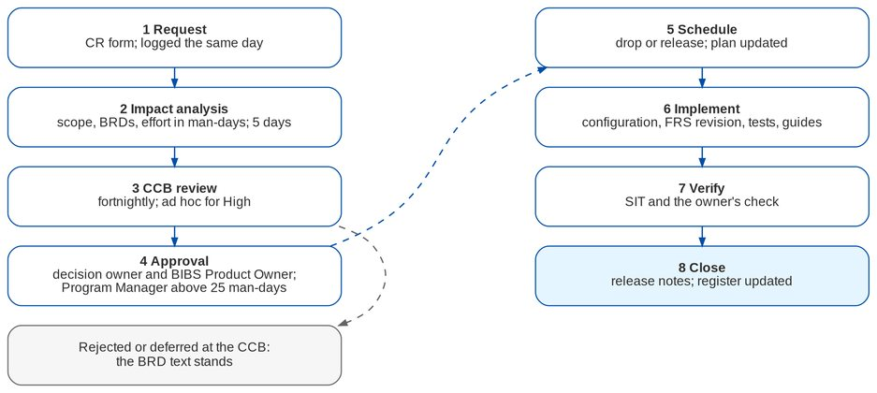
Figure 3: Requirement change control
Table 9: Steps of the change request process
Step | What happens | Who | Time
1 Request | The requester raises a CR on the CR form, or the project team raises one from a recorded deviation | Requester; iorta Project Manager logs it | Same day
2 Impact analysis | Scope, BRD and FRS references, affected modules, data, interfaces, tests, documents, drop; effort in man-days (analysis, development, test, documentation) | iorta Business Analyst and Solution Architect; business owner of the BRD | 5 working days (10 for L and XL)
3 CCB review | Accept, reject, defer, or ask for more analysis | Change Control Board | Fortnightly; ad hoc for High priority
4 Approval | CR form signed by the decision owner and the BIBS Product Owner; above 25 man-days or when a drop date moves, also the Program Manager | Decision owner; BIBS Product Owner; Program Manager | 5 working days after the CCB
5 Schedule | Placed in a drop or release; plan, FRS change list and test plan updated | iorta Project Manager; Program Manager | Next planning cycle
6 Implement | Configuration, development, FRS revision, test cases, guides | Delivery team | As scheduled
7 Verify | SIT and regression; the owner checks the behaviour in SIT or UAT | iorta QA; business owner | Drop test window
8 Close | Result and FRS version recorded; listed in the release notes | iorta Project Manager; BIBS Product Owner | At release

CR sizes: S 1 to 3 man-days, M 4 to 10, L 11 to 25, XL above 25. The Change Control Board is chaired by the BIBS Product Owner with the Program Manager of Business Project Services, the owner of the BRD concerned, the Head of Comptrollership (postings, GL, tax), the Chief Compliance Officer (screening, KYC, access, retention), BDOI IT (interfaces and infrastructure) and, for iorta TechNXT, the Project Manager (secretary), the Solution Architect and the Business Analyst lead.

8 Documentation standards
Table 10: Documentation standards
Topic | Standard
Template | BDO Insure template for Word, Excel and PowerPoint: cover, document control, distribution list, table of contents, numbered chapters, "Confidential - BDOI" footer
File names | BIBS_<document type>_BRD-nn_<name>_v<version>, for example BIBS_FRS_BRD-03_Product_Maintenance_v2.0.docx; programme documents use BRD-00
Folders | One release-set folder per BRD in the folder of its drop; programme documents by kind under Programme
Versions | x.0 for an issue for review or sign-off; x.1, x.2 for corrections; only the current version stays in a folder; every version has a row in the document control table
Writing | Specific and active ("the Team Lead approves"); BRD requirement IDs with pages; dates dd-MMM-yyyy; amounts formatted; no filler; terms of the glossary
Business sign-off sets | Business content only; every set carries a "Who signs what" matrix from the BRD approval sheet; technical content in the Technical Specification
Screens in documents | Screenshots of the SIT environment with seed data; screen IDs from the screen register; changed screens re-captured with each release and marked in the register
Figures | Drawn from versioned sources in BDO colours; legible at page width
Review and approval | Author, reviewer and approver named in the document control; BDOI comments in the comments log of the set
Storage | Masters (Word, Excel, PowerPoint) in the programme document store; PDFs produced at issue

9 Governance cadence
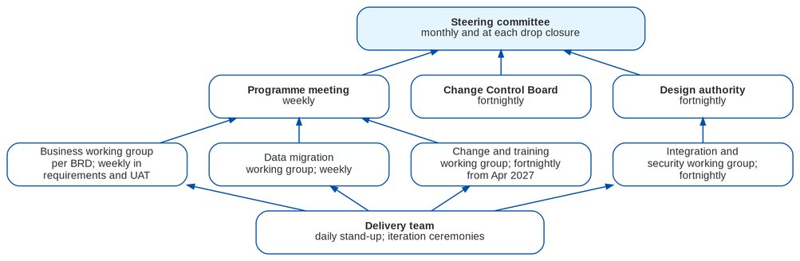
Figure 4: Governance bodies and cadence
Table 11: Governance bodies
Body | Chair | Members | Cadence | Decides or produces
Steering committee | Program Manager, Business Project Services | BIBS Product Owner; heads of Operations, Comptrollership, Marketing, Compliance, BDOI IT, Information Security; iorta TechNXT engagement lead | Monthly; at each drop closure; go / no-go | Direction, milestone changes, drop closure, go-live, escalations
Programme meeting | iorta Project Manager | Program Manager, BIBS Product Owner, workstream leads | Weekly (Tuesday) | Status, dependencies due in four weeks, RAID review, actions
Change Control Board | BIBS Product Owner | See change control | Fortnightly | CR decisions
Design authority | Head, BDOI IT | iorta Solution Architect, Information Security, BDO IT EIAM, IGA and API teams | Fortnightly | Architecture, integration and security decisions
Business working group | Business owner of the BRD | Key users, iorta Business Analyst lead, QA lead | Weekly in requirements and UAT | Clarifications, UAT progress, sign-off readiness
Data migration working group | Data Migration Lead | Data owners and stewards, BDOI IT, iorta Migration Lead | Weekly | Extracts, code maps, trial results, gates
Change and training working group | BIBS Product Owner | Change champions, key users, iorta change and training lead | Fortnightly from April 2027, weekly from October 2027 | Communications, training, adoption KPIs

9.1 Status reporting
The weekly status report gives: milestones of the next eight weeks with their status (on track, at risk, late); dependencies due in the next four weeks; High risks and issues; CRs by status; SIT or UAT progress (cases run, passed, failed, blocked; incidents by severity and age); and the decisions needed from BDOI. The steering committee receives the monthly summary with the plan, the RAID heat map and the decisions.
Table 12: Delivery indicators
Indicator | Measure | Target
Milestone adherence | Milestones met on their date | 90 percent; none on the critical path late
Sign-off cycle | Days from issue of a set to signature | 30 days or less
CR cycle time | Days from request to CCB decision | 15 working days or less
SIT pass rate | Cases passed at first run per release | 85 percent or more
Incident ageing | Open Severity 1 and 2 incidents older than their fix target | Zero
Gate health | Pipeline runs failing a gate, fixed the same day | 95 percent

10 Roles and responsibilities
The full RACI is in the workbook BIBS_Delivery_BRD-00_RACI_Matrix_v1.0.xlsx. The extract below covers governance, requirements, development and test.
Table 13: RACI extract (all roles in the RACI workbook)
Activity | BPO | BO | KU | BIT | ISEC | APS | OPS | IPM | ISA | IDEV | IQA | ICT
Steering committee: direction, drop closure, go-live decision | C | C |  | I | I |  |  | R
Programme plan and weekly programme meeting | C | C |  | C |  |  |  | R
RAID log upkeep and escalation of High items | C | C |  | C | C |  |  | R
Change Control Board: CR approval, rejection, deferral | A | C |  | C |  |  |  | R | C
Issue BRDs and new BRD versions |  | A | C |  |  |  |  | I
Write and re-base the FRS, test plans and sign-off sets | I | C | C |  |  |  |  | A | C |  | C
Review the FRS and record comments |  | A | R | C | C |  |  | I
Decide the proposed business rules and clarifications | I | A | R |  |  |  |  | I
Sign the FRS and sign-off set of a BRD |  | A/R |  | C | C |  |  | I
Traceability check against the BRD |  | I
Application development and configuration | I |  |  |  |  |  |  | A | C | R
Code review and quality gates on every change |  |  |  |  |  |  |  | I | A | R | C
Security scans and remediation of findings |  |  |  | I | C |  |  |  | A | R
EIAM application registration and conditional access |  |  |  | I | C |  |  |  | C
UIDM-ISC connector and provisioning set-up |  |  |  | I | C |  |  |  | C
Apigee X proxies, products and credentials |  |  |  | C |  |  |  | I | C
Integration development on the BIBS side |  |  |  | C |  |  |  | I | A | R
Configuration inputs (lists, parameters, products, chart of accounts) |  | A | R |  |  |  |  | I
Test plans and test cases per BRD |  | A | C |  |  |  |  | I |  |  | R
System integration test (SIT) and regression | I | I |  |  |  |  |  | A |  | C | R
Integration test with BDO systems |  |  |  | A/R |  |  |  | I | C |  | R
UAT preparation: scenarios, testers, data, sign-off forms | A | C | R |  |  |  |  | I |  |  | R
UAT execution | I | A | R |  |  |  |  | I |  |  | C
Performance test |  |  |  | A |  |  | C |  | C |  | R
Penetration test and security sign-off |  |  |  | C | A/R |  |  |  | C
Usability tests with users | A | I | C |  |  |  |  |  |  |  |  | R

Table 14: Roles of the programme
Code | Role | Organisation | Responsibility
SC | Steering committee | BDOI | Chaired by the Program Manager, Business Project Services; BIBS Product Owner, heads of Operations, Comptrollership, Marketing, Compliance, BDOI IT and Information Security; iorta TechNXT engagement lead
PGM | Program Manager, Business Project Services | BDO Unibank ESG | Plan, drops, budget and traceability check against the BRDs
BPO | BIBS Product Owner | BDOI | Owner of the BIBS scope and backlog of change requests; chairs the Change Control Board
BO | Business owner of the BRD | BDOI | Product owner or department head named on the BRD approval sheet (for example Head, Comptrollership for BRD-05; Product Owner, Renewal for BRD-06)
BPS | Business Project Services analysts | BDO Unibank ESG | BRD owners; traceability review of the FRS
KU | Key users and UAT testers | BDOI | Named business users per unit and persona; test, coach and feed back
DML | Data Migration Lead and data owners | BDOI | Owner of the migration objects, extracts, code maps and reconciliation
COMP | Head, Comptrollership | BDOI | Owner of the finance set-up, the GL opening and the reconciliation of the financial objects
CMP | Compliance | BDOI | Chief Compliance Officer and unit: screening, KYC, retention, audit
BIT | BDOI IT | BDOI | Owner of the environments, extracts, interfaces and the Technical Specification review
ISEC | BDOI Information Security | BDOI | Owner of the security settings, role matrix, separation of duties and security tests
EIAM | BDO IT EIAM team | BDO Unibank | Microsoft Entra ID: application registration, single sign-on, conditional access
IGA | BDO IT IGA team | BDO Unibank | UIDM-ISC: joiner, mover and leaver provisioning, aggregation and certification
API | BDO IT API team | BDO Unibank | Apigee X gateway: proxies, products, credentials, policies
OPS | BDO IT operations | BDO Unibank | ITIO-SRE and ITSD-AMS: monitoring, backups, DR, service desk tooling
APS | BDOI application support | BDOI | L1 and L2 support of BIBS after hypercare
IPM | iorta Project Manager | iorta TechNXT | Plan, RAID log, status, change requests, releases
ISA | iorta Solution Architect | iorta TechNXT | Architecture, integrations, security design, technical specification
IBA | iorta Business Analyst lead | iorta TechNXT | FRS, clarifications, traceability, functional configuration
IDEV | iorta development team | iorta TechNXT | Application development, configuration and code review
IQA | iorta QA lead and testers | iorta TechNXT | Test plans, SIT, regression, UAT support
IDO | iorta infrastructure team | iorta TechNXT | Deployment pipeline, environments set-up support, monitoring, releases
IML | iorta Migration Lead | iorta TechNXT | Migration Console, loads, reconciliation reports, cut-over runbook
ICT | iorta change and training lead | iorta TechNXT | Change management, training, user guides, knowledge base

11 References
• Project Plan workbook and summary, version 1.0 (8-Oct-2026); RACI Matrix; Risk Register (RAID log).
• Change Management Register and summary, version 1.0 (CR process, CCB, sizes).
• Drop 0 closure summary, version 2.0 (change control after signature, configuration inputs).
• Quality gates of the BIBS platform; security baseline of BIBS; BDO UX guidelines and UX readiness checklist.
• Deliverables writing standard and toolkit conventions of the BIBS client pack.
• Client decisions of 8-Oct-2026 on the component baseline.

12 Decisions and open points for BDOI
Table 15: Decisions and open points
No. | Decision or open point (our proposal) | Owner | Needed by | Ref.
DM-01 | Approve the hybrid approach: two-week iterations inside the BDOI drops, with an iteration review for key users on SIT | Program Manager; BIBS Product Owner | 30-Oct-2026 | -
DM-02 | Approve the definitions of ready and done and the incident severities | BIBS Product Owner; BDOI IT | 30-Oct-2026 | -
DM-03 | Confirm the patch times for security findings: critical 7 days, high 30 days | BDOI Information Security | 30-Nov-2026 | R-05
DM-04 | Confirm the BDOI change management route for Pre-Prod and production releases (change record, approvers, release windows) | BDOI IT | 31-Mar-2027 | -
DM-05 | Confirm the release freeze for the go-live release from 10-Dec-2027 | Steering committee | 1-Oct-2027 | -
DM-06 | Name the members of the design authority, including the BDO IT EIAM, IGA and API teams | Head, BDOI IT | 30-Nov-2026 | R-04
DM-07 | Confirm the SonarQube instance and the container registry to use in the BDOI environments | BDOI IT | 31-Dec-2026 | IQ29

