

DATA MIGRATION HANDBOOK
Data Migration Handbook
BRD-13 Data Migration - strategy, functional specification, reconciliation and cut-over, release set v2.1
BIBS – BDOI Broker System
Client | BDO Insurance and Reinsurance Brokers, Inc.
Document | BIBS-DMH-BRD-13
Version | 2.1
Date | 8 October 2026
Status | Issued for BDOI business sign-off
Classification | Confidential

Prepared by iorta TechNXT for BDOI 
iNXT BrokerVerse. This document is confidential to BDO Insurance and Reinsurance Brokers, Inc. and iorta TechNXT.
Document Control
Version | Date | Author | Reviewer | Approver | Change
1.2 | 26 Sep 2026 | iorta TechNXT Business Analysis and Solution Architect | iorta TechNXT Project Manager | BDOI Program Manager (pending) | Previous issue as separate documents: FRS BRD-13 v1.2, Data Migration Strategy and Approach, Reconciliation Approach and Sign-off, Cutover Runbook (BDOI answers of 26-Sep-2026 to DMQ36-DMQ39)
2.0 | 5 Oct 2026 | iorta TechNXT Business Analysis and Solution Architect | iorta TechNXT Project Manager | Product Owner, Marketing Business System (at sign-off) | One handbook for the business sign-off of BRD-13: Part A strategy and approach, Part B functional specification of the Migration Console with one specification per screen (screenshots, fields, actions, rules, messages, outcome), the markers of migrated data and the legacy batches, Part C reconciliation and the sign-off gates per object, Part D the cut-over runbook, run-off and decommissioning; the proposed business rules and clarifications for confirmation
2.1 | 8 Oct 2026 | iorta TechNXT Business Analysis and Solution Architect | iorta TechNXT Project Manager | Product Owner, Marketing Business System (at sign-off) | Re-based on the Data Migration BRD V0.03 (signed 15-19 May 2026); user-story view and storyboard index added. Requirement IDs renumbered to BRID_MIG 1.1 to 14.2 with the new pages; new requirements BRID_MIG 1.3, 1.4, 10.2, the second 12.1 (read as 12.2), 13.1, 14.1 and 14.2 traced; new FR-DM-101, FR-DM-126, FR-DM-130 and FR-DM-131; FR-DM-015, 050, 061, 070, 071, 091 and 100 changed; personas of the DP PR and PR 2307 reversals per V0.03; clarifications CLR-DM-01 to CLR-DM-20 for the points where V0.03 differs from earlier BDOI answers or needs a decision (Drop 0 questions DM-Q01 to DM-Q51)

Distribution List
Name / Unit | Role | Organisation | Purpose
Product Owner, Marketing Business System | Approver of the set | BDOI | Sign-off (owns the set and approves all of its contents)
Program Manager, Business Project Services | BRD author; reviewer of traceability and completeness | BDO Unibank ESG | Review; owner of the cut-over
Head, Comptrollership; Product Owners FRBS / ACSL and Disbursement | Approver | BDOI | Open items, GL opening, legacy accounts, reconciliation, opening-balance adjustments
Head, Operations; Operations - Financial Transactions, Cashiering, Remittance, Collections, Placement | Data owners | BDOI | Insurers, policy headers, legacy invoices, unapplied payments, collection state, e-policies
Product Owner, Marketing Business System; Heads of Retail and Corporate Marketing; TSU | Data owners | BDOI | Reference data, clients, packages, renewal transition
Head, Renewal processing team | Data owner | BDOI | Renewal advices already sent; day-1 renewal queue
Compliance; Unit Head - Claims, Analytics, Risk Management, Reinsurance and Technical Underwriting | Data owners | BDOI | Masking, archive, Legacy Inquiry and its access log; claims data
BDOI IT (legacy EBIX, QPS, ISYS, CMS) | Reviewer | BDOI | Extracts, transfer, freeze, read-only access, decommissioning
Project team | Delivery | iorta TechNXT | Sessions, answers, revisions, the migration runs and the cut-over

Contents

1 Introduction 10
1.1 Purpose 10
1.2 The BRD-13 set 10
1.3 Scope and basis 11
1.4 How to read this handbook 13
1.5 References 13
1.6 Definitions and acronyms 14
Part A - Strategy and approach 16
2 Objectives and principles 17
2.1 Objectives 17
2.2 Principles 17
2.3 What this migration does not do 18
3 Scope and decisions per data object 19
3.1 The decision gate 19
3.2 Data object register 19
3.3 Depth, delta and due dates 22
3.4 Business owners and data stewards 24
3.5 Client migration "2020 to present" and daily client batches 25
4 Source systems 27
4.1 Legacy systems in scope 27
4.2 Source per object 27
5 Target in BIBS 29
5.1 Target per object and load order 29
5.2 How migrated records are marked 30
6 Migration approach 31
6.1 End-to-end process 31
6.2 Extract templates 32
6.3 Secure transfer and staging 35
6.4 Profiling 35
6.5 Cleansing: who fixes what 36
6.6 Mapping and code maps 36
6.6.1 Package remapping 38
6.7 Validation 39
6.8 Client matching and survivorship 39
6.9 Load through the BIBS services 39
6.10 Reconciliation and sign-off 40
7 Legacy invoices after go-live 41
7.1 What a legacy invoice is 41
7.2 Legacy sub-ledgers 42
7.3 Worked example: one legacy invoice from load to remittance 42
7.4 Unapplied premium payments (UPP) 43
7.5 Payments, reversals, remittance, endorsements and Prod Recon 44
7.6 When the legacy context closes 44
8 In-force policies and the renewal-driven transition 46
8.1 In-force policy headers 46
8.2 Renewal by RMEL cohort 46
9 History, archive and read-only access 49
10 Migration cycles 50
10.1 Trial migrations, dress rehearsal and production 50
10.2 Test data and masking 51
11 Cutover strategy 52
11.1 Approach 52
11.2 Freeze windows 53
11.3 Parallel run 54
11.4 Go / no-go 54
11.5 Rollback 54
11.6 Hypercare 55
11.7 In-flight items at the freeze 55
11.8 Decommissioning 55
12 Data security 56
13 Roles and responsibilities 57
13.1 Migration organisation 57
13.2 RACI 57
14 Risks and mitigations 59
15 Dependencies 61
16 Timeline 62
16.1 Alignment with the BDOI timeline 62
Part B - Functional specification of the Migration Console 64
17 Personas, roles and navigation 65
17.1 Personas 65
17.2 Screens of BRD-13 66
17.3 Screen flow 68
17.4 Menu by persona 68
17.4.1 Data Migration Lead 68
17.4.2 Data Steward 69
17.4.3 Data owner (business owner of an object) 69
17.4.4 Migration Operator 69
17.4.5 Reconciliation approver (Head of Comptrollership) 70
17.4.6 Go / no-go board 70
17.4.7 Comptrollership GL lead 70
17.4.8 Audit / Compliance user 71
17.4.9 Compliance reviewer of the access log 71
17.4.10 Cashiering user 72
17.4.11 Cashiering team lead 72
17.4.12 Top management approver 73
17.4.13 Commission user 73
17.4.14 Commission team lead 74
17.4.15 Marketing Account Officer 74
18 Common screen elements 76
19 Screen specifications 77
19.1 Migration Console 77
19.1.1 SCR-DM-01 Migration Home 77
19.1.2 SCR-DM-02 Data Objects and the decision of an object 80
19.1.3 SCR-DM-03 Code Maps and the versions of a code map 84
19.1.4 SCR-DM-04 Layouts and Rules 92
19.1.5 SCR-DM-05 Extracts 98
19.1.6 SCR-DM-06 Batches and resubmissions 102
19.1.7 SCR-DM-07 Batch 107
19.1.8 SCR-DM-08 Client Matching 115
19.1.9 SCR-DM-09 Reconciliation 119
19.1.10 SCR-DM-10 Sign-off 123
19.2 Cut-over, adjustments and run-off 125
19.2.1 SCR-DM-11 Opening-Balance Adjustments 125
19.2.2 SCR-DM-12 Cutover 129
19.2.3 SCR-DM-13 Run-off and Decommissioning 134
19.3 Legacy Inquiry 137
19.3.1 SCR-DM-14 Legacy Inquiry 137
19.3.2 SCR-DM-15 Access Log 141
19.4 Migrated data on the business screens 143
19.4.1 SCR-DM-16 LEGACY badge and Origin filter on the lists 143
19.4.2 SCR-DM-17 Legacy invoice on Invoice 360 146
19.5 Legacy batches 149
19.5.1 SCR-DM-18 Unapplied to Income 149
19.5.2 SCR-DM-19 Legacy PR 2307 Reversal 154
19.5.3 SCR-DM-20 DP PR Legacy Reversal 156
20 Functional requirements 159
20.1 Governance and decision gates 159
FR-DM-001 Maintain the data object register 159
FR-DM-002 Decide the migration class of a data object 161
FR-DM-003 Sign off each object through gates 162
20.2 Extract intake, code maps, validation and load 163
FR-DM-010 Receive a source extract with control totals 163
FR-DM-011 Maintain and approve versioned code maps 165
FR-DM-012 Report unmapped and invalid codes before load 167
FR-DM-013 Validate staged data against data-quality rules 168
FR-DM-014 Load a batch through the BIBS services 169
FR-DM-015 Rerun and roll back a batch 170
20.3 Reconciliation 172
FR-DM-020 Reconcile each data object from source to target 172
FR-DM-021 Reconcile carried-forward balances to the GL 173
FR-DM-022 Load the provisional GL opening at the year-end boundary 175
FR-DM-023 Post the FY2027 true-ups as opening-balance adjustment journals 176
FR-DM-024 Reconcile each true-up to the legacy trial balance and close the FY2027 cut-off 178
20.4 Client master and reference data 180
FR-DM-030 Load reference data through the code maps 180
FR-DM-031 Match and deduplicate legacy clients 181
FR-DM-032 Create migrated clients in the Client Master 182
FR-DM-033 Find migrated clients and policies by legacy reference 183
FR-DM-034 Load the package code map for the Renewal package remapping 184
20.5 In-force policy headers 186
FR-DM-040 Load in-force policy headers 186
FR-DM-041 Search migrated policies for servicing 188
20.6 Legacy open items and UPP 189
FR-DM-050 Carry forward legacy invoices with their open balances 189
FR-DM-051 Carry forward legacy UPP 190
FR-DM-052 Automatch rerun of UPP across legacy and new invoices 191
FR-DM-053 Apply legacy UPP to another invoice 192
FR-DM-054 Refund legacy UPP 193
FR-DM-055 Reclassify UPP to other income with top-management approval 194
20.7 Payments on legacy invoices 196
FR-DM-060 Apply an OTC payment to a legacy invoice 196
FR-DM-061 Match autopay payments to legacy invoices 197
20.8 DP PR and PR2307 batch reversals 198
FR-DM-070 Reverse DP PR legacy invoices in batch 198
FR-DM-071 Reverse PR2307 legacy invoices in batch 199
20.9 Remittance 200
FR-DM-080 Include legacy invoices in remittance extracts 200
20.10 Endorsements on legacy invoices 201
FR-DM-090 Process a positive endorsement on a legacy invoice 201
FR-DM-091 Process a negative endorsement on a legacy invoice 202
FR-DM-092 Process a non-financial endorsement on a legacy policy 203
20.11 Prod Recon visibility 204
FR-DM-100 Report changes made to legacy invoices 204
FR-DM-101 Include migrated records in the reports 205
20.12 Legacy read-only and archive 207
FR-DM-110 Search the legacy archive 207
FR-DM-111 Log and review access to legacy history 208
20.13 Cutover and coexistence 209
FR-DM-120 Plan the cutover and run rehearsals 209
FR-DM-121 Decide go / no-go on measured criteria 210
FR-DM-122 Transition renewals by RMEL cohort and track the run-off 211
FR-DM-123 Decommission legacy systems on agreed criteria 212
FR-DM-124 Renew the January to May 2028 expiries in BIBS from go-live 213
FR-DM-125 Load the renewal advices already sent before go-live 215
FR-DM-126 Continue the renewals in progress at the freeze (proposed position) 217
20.14 Claims and e-policies (proposed, for BDOI decision) 219
FR-DM-130 Carry forward open legacy claims (on BDOI confirmation) 219
FR-DM-131 Link e-policies to the migrated accounts (on BDOI confirmation) 220
21 Messages 222
22 Notifications and alerts 233
23 Reports 234
24 Workflow and status model 235
24.1 Data object and batch states 235
24.2 Approval workflows 235
24.3 Sign-off gates 236
24.4 Documents 236
25 Interfaces and integration 237
26 Non-functional requirements 239
27 Configuration items 240
27.1 Parameters 240
27.2 Lists of values 241
27.3 Masters and rules maintained by the business 241
28 Cross-BRD interface contract 242
Part C - Reconciliation and the sign-off gates per object 244
29 Purpose and scope 245
30 Reconciliation levels 246
31 Control totals BDOI sends 247
32 Reconciliation per data object 249
33 GL reconciliation: Migration Clearing 250
33.1 True-up reconciliation (FY2027 closing and audit adjustments) 251
34 Business verification on screen (gate G6) 253
34.1 Sample plan 253
34.2 Acceptance rule 253
35 Breaks, waivers and exclusions 255
36 Evidence and retention 256
37 Sign-off forms 257
37.1 Object reconciliation and acceptance (G5 and G6) 258
37.2 Cutover reconciliation summary (go / no-go GNG-3) 259
37.3 True-up reconciliation and sign-off (FY2027) 260
37.4 Archive reconciliation (before decommissioning) 261
Part D - Cut-over runbook, run-off and decommissioning 262
38 Purpose and use 263
39 Cutover organisation 264
39.1 Command centre 264
39.2 Roles 264
40 Timeline 265
40.1 Calendar 265
40.2 Freeze windows 266
41 Go / no-go checkpoints 268
42 Task list 270
42.1 Phase A - Readiness 270
42.2 Phase B - Pre-load and daily deltas 271
42.3 Phase C - Legacy freeze and final extracts 272
42.4 Phase D - Production load 273
42.5 Phase E - Reconciliation, verification and go / no-go 274
42.6 Phase F - Go-live 275
42.7 Phase G - Hypercare 275
42.8 Phase H - Final true-up and legacy GL close 277
43 Rollback 278
44 Year-end cut-over and FY2027 true-ups 279
45 Communication plan 280
46 Hypercare 281
46.1 Roster 281
46.2 Exit criteria 281
47 Decommissioning checklists 283
Decisions for BDOI and traceability 285
48 Proposed business rules and clarifications for confirmation 286
48.1 Open decisions and the date each is needed by 292
48.2 Assumptions 294
49 Traceability 296
50 Appendix: User-story view 298
51 Appendix: Storyboard index 302
Sign-off 305

1 Introduction

1.1 Purpose
This handbook describes how BDO Insurance and Reinsurance Brokers, Inc. (BDOI) moves from its legacy systems to BIBS (BDOI Broker System, on iNXT BrokerVerse), and how BIBS supports the move. It is the document the business owner, the data owners, Comptrollership, the Renewal processing team and BDOI IT read and sign for BRD-13 Data Migration. It answers five questions:
1. What data moves, object by object, in which class (migrate, carry forward, conditional, archive, excluded), and who owns it (Part A).
2. What BDOI provides, in which form and by when: the load templates and the control files (Part A and the Migration Workbook).
3. How the migration is run in BIBS: the Migration Console screen by screen, the rules, the messages, how migrated records are told apart from new ones, and the batches that work the legacy balances down after go-live (Part B).
4. How every object is proven from source to target and signed off (Part C).
5. How the cut-over is run: the runbook from 30 days before go-live to the close of the opening-balance adjustments, the go / no-go, the rollback, the hypercare, the run-off and the decommissioning of the legacy systems (Part D).
The last chapter lists the business rules the project team proposes where the BRD is silent or where BDOI must confirm a recommendation, each with the decision requested.

1.2 The BRD-13 set
This handbook is file 02 of the BRD-13 business sign-off set, release set v2.1, in the folder BRD-13_Data_Migration of Drop 0. It replaces the separate documents issued before (the FRS, the Strategy and Approach, the Reconciliation Approach and Sign-off, the Cutover Runbook, the Cutover Task Plan, the Data Requirements Workbook and the loose extract templates).
Table 1: The documents of the set, in reading order
File | What it is for | Who reads it | When
00_BIBS_StartHere_BRD-13_Data_Migration_v2.1.docx | Start Here: the map of the set, who reads what, the steps up to sign-off and the dates | Everyone | First, on issue
01_BIBS_GuideDeck_BRD-13_Data_Migration_v2.1.pptx | Guide deck: the migration approach, the objects and decisions, roles and data owners, trial migrations and dress rehearsal, sign-off gates, cut-over and go / no-go, migrated and new data, caveats, entry and exit criteria, handover | Business owner, data owners, Comptrollership, BDOI IT; presented at the kick-off | Kick-off session
02_BIBS_Handbook_BRD-13_Data_Migration_v2.1.docx | Data Migration Handbook: A strategy and approach; B functional specification of the Migration Console with screenshots, fields, actions, rules and messages, the markers of migrated data and the legacy batches; C reconciliation and the sign-off gates per object; D the cut-over runbook, run-off and decommissioning; the proposed rules for confirmation | Data owners and Comptrollership for their objects and parts; BDOI IT; the Renewal processing team | During the review, with the console walkthroughs
03_BIBS_Workbook_BRD-13_Data_Migration_v2.1.xlsx | Migration Workbook: object catalogue and decisions, extract planning, the load templates (one sheet per layout), code maps, validation rules, data owners, cut-over task plan, reconciliation sign-off per object, proposed rules with the BDOI decision, the screens; comments log, meeting minutes, version history, sign-off certificate | Every reviewer; the signatories sign it | During the review and at sign-off
04_BIBS_TestPlan_BRD-13_Data_Migration_v2.1.xlsx | Test plan workbook: the test cases traced to the requirements and to the screens, with the trial migration, reconciliation, rollback, rerun and cut-over rehearsal scenarios | Data owners who verify the trial migrations; BDOI IT | After the handbook; used again in the trial migrations
05_BIBS_TestPlan_BRD-13_Data_Migration_Summary_v2.1.docx | Test plan summary: scope, approach, coverage and the cases by area | Business owner, BDOI IT | Before sign-off
07_BIBS_UXDeck_BRD-13_Data_Migration_v2.1.pptx | UX Screen Deck for the BDOI UX Design team: design foundation, navigation and personas, every flow step by step and every screen with all its states | BDOI UX Design team | From the issue, in parallel with the review; re-issued with each version of the set
08_BIBS_UXScreens_BRD-13_Data_Migration_v2.1.xlsx | UX screen register: one row per screen image with the screen, personas, flow and step, state, FRS section and requirements, UXD status and comments, and the Changed in this issue flag | BDOI UX Design team | Kept by the UX Design team; the changed rows are flagged at each issue
09_BIBS_UXScreens_BRD-13_Data_Migration_v2.1.zip | Image package: every screen image at twice the screen resolution (PNG), the component crops and the register as CSV | BDOI UX Design team | Imported into the design tool at each issue

The load templates are not issued as loose files. The Migration Console exports them from the layouts it holds (Layouts and Rules: a CSV template per layout, a workbook per object and one workbook of all templates, with the control-file template and the filling rules); the Migration Workbook lists the same layouts column for column for the review: the sheet Load templates is the index in load order, and each layout has a sheet of its own with the guide of every column (mandatory, format, allowed values or code map, what to enter, the check applied when the file is loaded) directly above the header row, the BU review rows, one made-up example row and the allowed values on the sheet Reference lists.

1.3 Scope and basis
The basis is the Data Migration BRD V0.03 (R1): the revisions of 14 May 2026 (IT walkthrough) and 15 May 2026 (business walkthrough), signed by its preparers, reviewers and approvers between 15 and 19 May 2026 (p.2, p.19-20). It replaces the unsigned draft v0.01 of 14 April 2026 on which release set v2.0 was based (register DCR-189); BDOI confirms V0.03 as the baseline and the form in which the agreed deviations are recorded (CLR-DM-01, Drop 0 questions DM-Q01 and DM-Q02). V0.03 numbers the requirements BRID_MIG 1.1 to 14.2 and adds seven requirements: 1.3 (data objects in scope, migrated flag and legacy source), 1.4 (remigration of fall-out records), 10.2 (reports on migrated and new data), a second 12.1 (renewals in progress, read here as BRID_MIG 12.2, CLR-DM-02), 13.1 (accounting data), 14.1 (claims data) and 14.2 (e-policies linked to migrated accounts). The BRD asks for a selective, continuity-focused migration (p.3): migrate clean master and reference data for Day 1, carry forward only the open operational financial positions, keep history in read-only legacy or an archive, and let renewals recreate clean records in BIBS (p.5). This handbook follows that approach and fills the gaps the BRD leaves with proposals, each tied to an open decision (DMQnn, DM-Qnn) or to a proposed rule or clarification of the last chapter. Where V0.03 differs from an answer BDOI gave later (26 September 2026) or needs a decision, the handbook states the proposed position as a clarification (CLR-DM-nn) and keeps the scope of release set v2.0 until BDOI decides.
Table 2: Scope of BRD-13
Area | In scope | BRD
Governance | Data object register, decision gates, sign-off gates, reconciliation of every object; the migrated flag and legacy source on every migrated record; remigration of fall-out records | BRID_MIG 1.1, 1.2, 1.3, 1.4
Master and reference data | Client master with matching and deduplication; lists of values, insurers, products, packages, risk codes and MIS values through versioned code maps | BRID_MIG 2.1, 3.1
Policies | In-force policy headers; renewal-driven transition by expiry month | BRID_MIG 4.1, 12.1
Open items | Legacy invoices with open balances; legacy unapplied payments; opening entries and legacy sub-ledgers | BRID_MIG 5.1-8.1
Legacy invoice processing | Counter and automated payments, automatch, dispositions, reclassification to income, direct-payment and PR 2307 reversals, remittance, endorsements, the legacy change report of Prod Recon; migrated records in the reports | BRID_MIG 5.1-10.2
Accounting data | Provisional GL opening, opening-balance adjustments, legacy sub-ledgers of premium receivable, DTIP, commission receivable and unapplied payments with their open items | BRID_MIG 13.1
History | Read-only legacy and the BIBS archive with logged access | BRID_MIG 11.1
Cut-over | Trial migrations, dress rehearsal and the production cut-over on the BDOI timeline (go-live January 2028) at the year-end boundary; go / no-go; provisional GL opening and the FY2027 opening-balance adjustments; go-live renewal extraction with the renewal advices already sent; run-off and decommissioning | BRID_MIG 1.2, 3.1, 12.1, 12.2
Claims and e-policies (proposed, pending BDOI decision) | Open claims carried through the claims migration upload of the Claims module; e-policies of in-force migrated accounts linked to their accounts | BRID_MIG 14.1, 14.2 (CLR-DM-08, CLR-DM-09)

Objects V0.03 names that release set v2.0 held as conditional (DMQ30). BRID_MIG 1.3 names claims data, submitted policies, endorsements and adjustments kept outside the legacy systems and in-progress renewal data among the data to migrate; BRID_MIG 3.1 adds the payee list; BRID_MIG 14.1 asks for legacy claims. The handbook does not change their scope on its own: each has a clarification with the proposed position (CLR-DM-05 to CLR-DM-09) and stays conditional in the data object register until BDOI decides. Employee Benefits programmes stay out of scope until BDOI decides; users are not migrated (they are created through User Access requests). Where BDOI brings an object into scope, it is loaded through the upload of its own module with the same reconciliation and gates (proposed rule PR-DM-05).
Programme calendar. The migration follows the BDOI drop plan and timeline (R9): data migration is part of Drop 0; requirements and mapping run in September-October 2026, the preparation of the migration from November 2026 to March 2027, the SIT migration from April to July 2027, the UAT migration from August to October 2027, and the full migration and cut-over from November 2027 to January 2028, with go-live in January 2028. The concept paper on an early renewal release (R10), signed on 6 September 2026, is superseded by BDOI's decision of 26 September 2026 that everything goes live together; there is one production cut-over (register DCR-240). Of its points, the trial-migration load order still applies: reference data and clients load first in every trial migration.
BDOI answers of 26 September 2026. Legacy packages are remapped at Renewal sanitation and the migration only loads the package code map (DMQ36); the renewals of the January-May 2028 expiries are processed in BIBS after go-live from a go-live extraction of the migrated policy headers, with the renewal advices already sent loaded so they are not sent again (DMQ37); the RMEL and dispositions are kept in Excel, and the Renewal processing team reviews rejected rows with a maker and a checker (DMQ38); and, as a recommendation that Comptrollership confirms, the go-live sits on the year-end boundary with a provisional GL opening and controlled adjustments of the FY2027 closing and audit entries (DMQ39, proposed rule PR-DM-01).

1.4 How to read this handbook
• Part A is the approach, for every reader. Its tables of objects, owners, templates and code maps are the same rows as the Migration Workbook.
• Part B is the functional specification. Each screen has its purpose, who opens it, its navigation, screenshots with numbered callouts, the field table (No. = callout number), the actions, the business rules and the expected outcome, with the requirements (FR) and the test cases. The functional requirements follow, each with its BRD trace, actor, flows, rules, validations, fields, notifications, audit and acceptance criteria; then the messages, notifications, reports, configuration and the interface contract with the other BRDs.
• Part C says how each object is reconciled and verified and who signs each gate, with the forms.
• Part D is the cut-over runbook.
• Rules marked Configurable are settings of BIBS (a parameter, a list of values, a code map or a master record); rules marked Fixed change only through a change request. Values marked "default" (thresholds, retention days, timings) are proposals that BDOI confirms; a changed answer is a change of setting.
• The requirement IDs are those of BRD V0.03 (BRID_MIG 1.1 to 14.2). V0.03 numbers two requirements BRID_MIG 12.1 (p.13); this handbook keeps BRID_MIG 12.1 for the cut-over aligned to the RMEL and reads the second one (renewals in progress) as BRID_MIG 12.2. BRID_MIG 14.2 is listed under capability 15, which is not in the list of capabilities (p.6); it is read as part of capability 14 (CLR-DM-02). Release set v2.0 called BRID_MIG 1.1 and 1.2 "BRID 1.1a" and "BRID 1.1b".
• The appendices give a user-story view (one row per BRD requirement, with its FRs, acceptance criteria and test cases) and a storyboard index (one row per step of the four end-to-end flows of the UX Screen Deck).
• The screenshots are taken on the SIT environment with seed data. Names, numbers and amounts are fictitious.

1.5 References
Table 3: Reference documents
Ref. | Document | Version / date
R1 | BDO Insure Core Modernization - Data Migration - Business Requirements Document (BRD) | V0.03 (revisions of 14-May-2026 and 15-May-2026), signed 15 to 19 May 2026; received 8-Oct-2026; replaces draft v0.01 of 14-Apr-2026
R2 | Data Migration (BRD-13) requirements baseline | current
R5 | BRD BDOI Core Replacement (umbrella BRD) | v01
R6 | BRD discrepancy and clarification register | 1.2
R7 | Deliverables plan, hosting appendix and UAT readiness programme | current
R8 | Sign-off sets and FRS of Operations, Collections, Accounting / ACSL and Renewal | current
R9 | BDOI drop plan and programme timeline | received 26-Sep-2026
R10 | Concept Paper - Advance Implementation of Renewal Processing | V1.0, signed 06-Sep-2026; superseded 26-Sep-2026
R11 | Drop 0 questions to BDOI, BRD-13 Data Migration (DM-Q01 to DM-Q51) | October 2026

Page references ("p.8") are pages of the Data Migration BRD (R1) unless another document is named.

1.6 Definitions and acronyms
Term | Meaning
AR | Acknowledgment Receipt, issued for premium collected on behalf of an insurer
Archive | Read-only store of legacy history in BIBS, searched in Legacy Inquiry (BRID_MIG 11.1)
Autopay | Automated premium payments received in payment files (bills payment, trade, CLPC, direct credit) and matched by BIBS
Batch | One load of one data object in one environment, from validation to acceptance
Carry forward | Treatment of an open operational or financial item that continues to be processed in BIBS
CMS | Collection Management System (legacy)
Code map | Versioned table that maps a legacy code of a source system to a BIBS value (BRID_MIG 3.1)
Cohort | The legacy policies expiring in one month (RMEL expiry month)
Control file | File sent with each extract with its row count, hash total, amount totals and SHA-256
DP PR | Premium receivable of an invoice paid by the client directly to the insurer (reading to be confirmed, DMQ19)
DTIP | Due to Insurer - Premium
EBIX | Legacy booking, receivables and accounting system
Extract | A file of one layout from one source system, with its control file
Freeze | The time from which legacy data may no longer change (T-3 22:00; 31 December 2027 for the proposed date); only FY2027 GL adjustments by named Comptrollership users follow it
G1-G7 | Sign-off gates of a data object - decision, mapping, validation, load approval, reconciliation, acceptance, go-live
Go / no-go | The decision to go live, taken on measured criteria
Go-live renewal extraction | One Renewal extraction at go-live of every migrated policy header expiring from go-live to 31 May 2028
ISYS | Legacy reporting system (claims and ACSL reports, Marketing Diary)
Layout | The column list of one extract file; the load template of the Migration Console
Legacy invoice | An invoice booked in EBIX or QPS before go-live, still open at the freeze, carried into BIBS and processed there
Legacy sub-ledger | The legacy control accounts and ledger items that hold the legacy positions apart from the new ones
LOV | List of values
Migration Clearing | GL account that takes the offset of every opening entry; must net to 0.00
MIS | Management information fields (market segment, department, unit head, AO, region, area, branch, business origin, customer segment)
Opening period | The first GL period of BIBS, January 2028, into which the opening entries and the adjustments post (value date 1 January 2028)
Opening-balance adjustment | A journal in the opening period that brings a FY2027 closing or audit adjustment of the legacy GL into the BIBS opening balances (also called a true-up)
OTC | Over-the-counter payment at a cashier
PR | Premium receivable
PR 2307 | Premium receivable covered by the client's BIR Form 2307
Provisional opening | The GL opening loaded at cut-over from the preliminary December 2027 trial balance, balance-sheet accounts only
QPS | Legacy quotation, client and policy system
RA-sent file | Reference file (P03) of the renewal advices sent by hand before go-live
RMEL | Renewal Master Expiry List
Run-off | The period in which legacy policies expire and renew into BIBS
Staging | Area in BIBS where extract rows are checked, mapped and validated before they load
T | Go-live date - January 2028 (BDOI timeline), proposed Monday 3 January 2028
Trial migration | A rehearsal of the migration on a test environment with masked data
TSU | Technical Support Unit; maintains the BIBS products and packages (BRD-3)
UPP | Unapplied premium payment

Part A - Strategy and approach
Part A says what moves from the legacy systems to BIBS, in which class and by which steps, who owns each object and each step, how the migration is rehearsed, how the cut-over is run and how the legacy items are processed after go-live. Its tables are the same rows as the sheets of the Migration Workbook.

2 Objectives and principles

2.1 Objectives
The BRD states the objective as "a stable Core go-live by ensuring Day-1 operational continuity for marketing, operations, and accounting while establishing a clean and trusted data foundation" (p.3). In measurable terms, at go-live:
Table 4: Migration objectives and how they are measured
# | Objective | Measure at go-live
1 | Marketing finds every in-scope client and uses it without re-encoding (BRID_MIG 2.1) | Every in-scope legacy client number resolves to one BIBS client; client review queue empty
2 | Every code used by a migrated record exists in BIBS (BRID_MIG 3.1) | Unmapped-code report empty for all Day-1 objects
3 | Every open receivable, payable and unapplied payment continues in BIBS (BRID_MIG 5.1-8.1) | Open balances in BIBS equal the legacy extract per currency; Migration Clearing 0.00 per branch and currency
4 | Legacy invoices are processed with the normal BIBS screens (BRID_MIG 5.2-10.1) | Smoke test on production passed (payment, automatch, remittance, Invoice 360)
5 | Every migrated object is reconcilable from source to target (BRID_MIG 1.2) | Reconciliation L1-L5 signed per object (gate G5)
6 | History remains retrievable with logged access (BRID_MIG 11.1) | Legacy read-only link or archive inquiry available per legacy system
7 | Renewals move to BIBS by expiry month (BRID_MIG 12.1) | Every policy expiring from go-live to 31 May 2028 and not renewed in legacy is a candidate in BIBS Renewal at go-live, January expiries flagged urgent, RAs already sent recorded; later expiries extracted by BIBS on the normal lead time
8 | The GL opens correctly at the year end (DMQ39) | Balance-sheet opening equals the signed preliminary December TB per branch and currency; FY2028 P&L at zero; every FY2027 adjustment reaches BIBS through a signed true-up

2.2 Principles
1. Selective, not a conversion. Every data object gets one class through a decision gate (BRID_MIG 1.1). History is never loaded into business tables; it stays in read-only legacy or goes to the archive.
2. Continuity first. Anything BDOI must act on after go-live (a receivable, a payable, an unapplied payment, a promise to pay) is carried forward, so no business process depends on legacy after the freeze.
3. Clean start. Master data is cleansed and deduplicated before it is loaded. Data that fails the rules is fixed at source or excluded by its owner; it is not loaded "as is".
4. One processing system per item. From the freeze, a legacy open item is processed only in BIBS. Legacy becomes read-only (BRD p.5). There is no two-way synchronisation.
5. Load through the BIBS services. Records are created by the same services the screens use, so every BIBS rule, audit entry and accounting entry applies. Nothing is written directly into a business table.
6. Reconcile everything, and keep the evidence. Every extract carries control totals; every object is reconciled by counts, amounts, hash totals, fields and GL; a break is fixed or explained and approved before sign-off.
7. Rehearse before production. Four trial migrations and a dress rehearsal run the full cutover with masked data and measured timings, in the SIT and UAT migration windows of the BDOI timeline. Production follows the rehearsed plan.
8. Protect personal data. Masked data outside production, staging purged within 5 days of sign-off, access only for migration roles and only from the Philippines (hosting appendix, R7).

2.3 What this migration does not do
• It does not convert closed transactions, GL history or expired policies into BIBS business tables (BRD p.3).
• It does not re-book legacy invoices. A legacy invoice keeps its legacy number and is processed as a legacy invoice until it is settled.
• It does not create users from legacy. Users are created through User Access requests (BRD-11); legacy user IDs are only mapped so that AO, handler and collector fields resolve.
• It does not run legacy and BIBS in parallel for the same items (chapter Cut-over strategy, Parallel run).
• It does not write back to QPS or EBIX after the freeze (register DCR-202).

3 Scope and decisions per data object

3.1 The decision gate
BRID_MIG 1.1 asks that each data object is classed Migrate, Carry forward (open items), Archive or Excluded once the business owners have assessed four criteria: Day-1 need, compliance need, read-only / archival option and data trust (p.7). The BRD does not give the rule that turns the criteria into a class (DMQ02, DCR-192). The proposal:
Table 5: Proposed decision rule (DMQ02)
Class | When | Examples
Migrate | Day-1 need = Yes and the data is master or reference data; data trust High or Medium after cleansing | Clients, LOVs, insurers, products, GL opening balances
Carry forward | Day-1 need = Yes and the record is an open operational or financial position that BDOI must still act on | Open legacy invoices, UPP, open promises to pay
Conditional | Day-1 need depends on a business condition that BDOI states (BRID_MIG 4.1 "when operationally required") | In-force policy headers; objects not named in the BRD (claims, EB, submitted policies, payees)
Archive | Day-1 need = No and compliance need = Yes, or the read-only / archival option is required | Closed invoices, receipts, remittances, expired policies, GL history, documents
Excluded | Day-1 need = No and compliance need = No, or the data is set up again in BIBS | Users and roles, screening results

The Data Migration Lead records the four criteria and the proposed class per object in the Migration Console; the business owner of the object approves it (gate G1, FR-DM-002). A later change of class needs a new approval, and an object whose data is loaded cannot be moved to Archive or Excluded until the load is rolled back.

3.2 Data object register
The register below is the proposal for gate G1 (DMQ01, DCR-195). The Migration Workbook sheet Object catalogue holds the same rows with the review columns; the sheets Data owners and Extract planning add the columns BDOI fills in (named owners and stewards, volumes). The Migration Console holds the same register (Data Objects).
Table 6: Data objects and proposed decisions (confirmed by the business owner at gate G1)
Object | Data object | Decision | Rationale
R01 | Lists of values and MIS values | Migrate | Every coded field of clients, policies and open items needs its BIBS value on Day 1 (BRID_MIG 3.1). Legacy values are mapped to BIBS values; missing values are created through the LOV master with maker-checker.
R02 | Branches and invoicing branches | Migrate | Branch codes are mapped only; BIBS branches are configured by Comptrollership before the load.
R03 | Sales organisation (regions, departments, teams, unit heads, account officers) | Migrate | Clients, policies and open items carry the AO and unit; MIS reporting and Collections assignment need them on Day 1.
R04 | Insurers and insurer branches | Migrate | Every open invoice, header and remittance position is owed to or by an insurer.
R05 | Product lines, cover types, products and risk codes | Migrate | The risk code decides the premium components, taxes and commission of every open invoice and header.
R06 | Package code map (legacy package and version to BIBS package version) | Migrate | Packages are remapped at sanitation in Renewal, not at migration intake (DMQ36, answered 26-Sep-2026). The migration loads the package code map as reference data only; the Renewal package check uses it and sends unmapped packages to the Exception bucket, worked by the Renewal processing team. The BIBS packages themselves are maintained by TSU in Product Maintenance (BRD-3) and are not migrated.
R07 | Commission rates by insurer and product | Migrate | Endorsements and renewals of legacy policies compute commission from the rate table.
R08 | Chart of accounts mapping (legacy GL account to BIBS account) | Migrate | The GL opening trial balance (G01) is loaded through this map; legacy control accounts are mapped to Migration Clearing.
R09 | Payees | Conditional | Payees are loaded through the payee migration upload of Disbursement; in scope if BDOI confirms (AQ11, DMQ30).
R10 | Users and roles | Excluded | Users are created through User Access requests and approvals (BRD-11); legacy user IDs are only mapped (user code map) so that the AO, handler and collector fields resolve.
R11 | Receipt series in use (AR and OR, ATP and next number) | Carry forward | Receipts issued in BIBS after go-live must continue the BIR-authorised series without gap or overlap.
C01 | Client master (individual and corporate) | Migrate | Marketing, Operations and Renewal must find and use clients on Day 1 without re-encoding (BRID_MIG 2.1); clients are deduplicated before load. Umbrella BRD p.43 asks for clients "2020 to present" and daily client batches (DCR-173).
C03 | Client payout accounts (for refunds) | Migrate | Refunds of legacy UPP (BRID_MIG 5.4) need the client's payout account.
C04 | KYC documents and IDs | Archive | Documents stay retrievable for audit; BIBS keeps the KYC status and review date on the client (DMQ07 may change this to MIGRATE).
C05 | Screening results and risk ratings | Excluded | One full screening run after the client load gives current results (BRD-10); legacy results are archived with the client history.
P01 | In-force policy headers | Conditional | Needed to locate active coverage, to endorse legacy invoices (BRID_MIG 9) and to renew in BIBS (BRID_MIG 12.1); the scope condition is decided by BDOI (DMQ09). Whatever it is, every policy expiring from T to 31-May-2028 and every renewal term booked in legacy that starts on or after T are in scope, because the go-live renewal extraction works only from the headers (DMQ37). The legacy package is kept as given; it is remapped at Renewal sanitation (DMQ36).
P02 | Expired policies and policy history | Archive | History is not converted (BRD p.3); kept for inquiry.
P03 | Renewal advices already sent before go-live (RA-sent file) | Migrate | The January-May 2028 expiries are processed in BIBS after go-live from a go-live extraction of the migrated headers (DMQ37, answered 26-Sep-2026); no renewal candidate is carried. The RAs already sent by hand before go-live, kept in the Excel trackers of the Renewal processing team (DMQ38), are loaded as a small reference file so that BIBS does not send them again.
P04 | Submitted-policy masterlists | Conditional | Loaded through the masterlist upload of Submitted Policies if BDOI confirms (SP SQ16, DMQ30); the layout is issued with that module.
P05 | Employee Benefits programmes | Conditional | Loaded through the programme upload of Employee Benefits if BDOI confirms (DMQ30); the layout is issued with that module.
F01 | Open legacy invoices (premium receivable, paid not remitted, commission receivable, PR2307), with components and insurer shares | Carry forward | Receivables and payables open at cutover must be collected, remitted, reversed and endorsed in BIBS (BRID_MIG 5.1-10.1).
F02 | Unapplied premium payments (UPP) with disposition in progress | Carry forward | Unapplied cash must not be lost after cutover (BRID_MIG 5.1); it is applied, refunded or reclassified in BIBS.
F03 | Open collection state (dispositions, promises to pay, installment plans, collector assignments) | Carry forward | Collectors continue their follow-up without re-keying (CQ07); only the open state is carried, history is archived (DMQ34).
F04 | Remittance in flight (batches not yet paid, holds, special remittances) | Conditional | Proposal - complete legacy batches before the freeze; carry only holds and special remittances that cannot complete (DMQ21).
F05 | DP billing in process and DP commission receivable | Carry forward | Carried inside F01 (dp_flag and the COMMISSION components of direct-payment invoices); no separate file.
F06 | PDCs in the warehouse, check pick-ups and refunds in process | Conditional | Proposal - carry PDCs in the warehouse; complete pick-ups and refunds in legacy before the freeze where possible (DMQ33).
F07 | Open claims | Conditional | Loaded through the Claims migration if BDOI decides (CLQ14, DMQ30); closed claims are archived.
G01 | GL trial balance per account, branch and currency (provisional opening; legacy TB at each true-up) | Migrate | At the year-end go-live (DMQ39, option A recommended) the BIBS GL opens from the preliminary December 2027 TB - balance-sheet accounts only, the FY2027 net result to retained earnings, legacy control-account lines to Migration Clearing, which the F01 and F02 opening entries clear to 0.00. The opening is provisional; at each true-up the legacy TB after the adjustments is sent again as reconciliation input (G03).
G02 | GL history (journals and balances before cutover) | Archive | Kept for audit; BIBS starts from the opening trial balance.
G03 | FY2027 opening-balance true-ups (legacy adjustment journals after the freeze and their open-item detail) | Migrate | The legacy GL stays open after the freeze only for the FY2027 closing and audit adjustments of Comptrollership (DMQ39). Each adjustment reaches BIBS as a controlled opening-balance adjustment journal in the opening period - after the legacy year-end close and after the audited FS - with approvals, cut-off controls and a reconciliation to the legacy TB.
H01 | Closed transactions (paid and remitted invoices, receipts, remittances, endorsements, claims, renewal advices, letters) | Archive | History stays in read-only legacy or the BIBS archive with logged access (BRID_MIG 11.1).
H02 | Legacy documents (policies, SOAs, ORs, certificates, letters) | Archive | Documents are kept with their archive record and a checksum.

The four criteria of the BRD, as proposed for each object in the Migration Console:
Table 7: The four criteria of the BRD per object, as proposed in the Migration Console
Object | Day-1 need | Compliance need | Archive option | Data trust | Proposed class | Condition
R01 | Yes | No | No | Medium | Migrate | -
R02 | Yes | No | No | Medium | Migrate | -
R03 | Yes | No | No | Medium | Migrate | -
R04 | Yes | No | No | Medium | Migrate | -
R05 | Yes | No | No | Medium | Migrate | -
R06 | Yes | No | No | Medium | Migrate | -
R07 | Yes | No | No | Medium | Migrate | -
R08 | Yes | No | No | Medium | Migrate | -
R09 | Yes | No | No | Medium | Conditional | Loaded through the payee registration of Disbursement if BDOI confirms (DMQ30).
R10 | No | No | Yes | Medium | Excluded | -
R11 | Yes | No | No | Medium | Carry forward | -
C01 | Yes | No | No | Medium | Migrate | -
C03 | Yes | No | No | Medium | Migrate | -
C04 | No | Yes | Yes | Medium | Archive | -
C05 | No | No | Yes | Medium | Excluded | -
P01 | Yes | No | No | Medium | Conditional | Needed to locate active coverage, to endorse legacy invoices and to renew in BIBS; the scope condition is decided by BDOI. Whatever it is, every policy expiring from T to 31-May-2028 and every renewal term booked in legacy that starts on or after T are in scope, because the go-live renewal extraction works only from the headers. The legacy package is kept as given; it is remapped at Renewal sanitation.
P02 | No | Yes | Yes | Medium | Archive | -
P03 | Yes | No | No | Medium | Migrate | -
P04 | Yes | No | No | Medium | Conditional | Loaded through the policy registration of Submitted Policies if BDOI confirms (DMQ30); the layout is issued with the Submitted Policies set.
P05 | Yes | No | No | Medium | Conditional | Loaded through the programme set-up of Employee Benefits if BDOI confirms (DMQ30); the layout is issued with the Employee Benefits set.
F01 | Yes | No | No | Medium | Carry forward | -
F02 | Yes | No | No | Medium | Carry forward | -
F03 | Yes | No | No | Medium | Carry forward | -
F04 | Yes | No | No | Medium | Conditional | Proposal - complete legacy batches before the freeze; carry only holds and special remittances that cannot complete.
F05 | Yes | No | No | Medium | Carry forward | -
F06 | Yes | No | No | Medium | Conditional | Proposal - carry PDCs in the warehouse; complete pick-ups and refunds in legacy before the freeze where possible.
F07 | Yes | No | No | Medium | Conditional | Loaded through the claim registration of Claims if BDOI decides (DMQ30); closed claims are archived.
G01 | Yes | No | No | Medium | Migrate | -
G02 | No | Yes | Yes | Medium | Archive | -
G03 | Yes | No | No | Medium | Migrate | -
H01 | No | Yes | Yes | Medium | Archive | -
H02 | No | Yes | Yes | Medium | Archive | -

3.3 Depth, delta and due dates
Table 8: Depth, delta frequency, format and due dates per object
Object | History depth | Delta after the first full extract | Format | Due
R01 | Current values and values used by any migrated record | None after the map freeze (T-7 days); changes by change request and a new map version | CSV | M3 (29 Jan 2027)
R02 | Current | None | CSV | M3 (29 Jan 2027)
R03 | Current, plus inactive AOs referenced by open items | Weekly until the freeze | CSV | M3 (29 Jan 2027)
R04 | Active insurers, and inactive insurers with open items | None | CSV | M3 (29 Jan 2027)
R05 | Current, plus codes used by in-force policies and open items | None | CSV | M3 (29 Jan 2027)
R06 | Legacy packages of in-force policies | New map versions until the map freeze (T-7 days) | XLSX or CSV | M5 (18 Jun 2027); final at T-7
R07 | Rates effective at cutover and later | None | CSV | M3 (29 Jan 2027)
R08 | Current chart | None | XLSX or CSV | M3 (29 Jan 2027)
R09 | Active payees | None | CSV | M3 (29 Jan 2027)
R11 | Series in use at the freeze | Final values at the freeze (T-3) | CSV | M3 (29 Jan 2027); final at T-3
C01 | Clients from 2020 to present (umbrella p.43); filter per DMQ05 | Daily new and changed clients from T-14 days until the freeze | CSV | M3 (29 Jan 2027); deltas daily from T-14 days
C03 | Active accounts | None | CSV | M3 (29 Jan 2027)
C04 | Per retention | None | CSV index plus files | Before decommissioning
P01 | Policies in force at T (DMQ09); at least every expiry from T to 31-May-2028 and every booked renewal term starting on or after T | Single load after the freeze | CSV | M3 (29 Jan 2027); final at T-2
P02 | Per retention (5 years online, 15 years archive, umbrella p.45) | None | CSV | Before decommissioning
P03 | RAs sent before go-live for expiries from T to 31-May-2028 | One file in every trial migration; final file with the RAs sent up to T-5; resubmissions of corrected rows until T-1 12:00 | XLSX template (P03_template.xlsx) or CSV | M4 (9 Apr 2027) (Trial migration 1); final at T-5
P04 | All active records | None | XLSX | M3 (29 Jan 2027) if in scope
P05 | Active programmes | None | XLSX | M3 (29 Jan 2027) if in scope
F01 | Every invoice with any open component at T (DMQ10) | Single load after the freeze | CSV with control file | M3 (29 Jan 2027); final at T-2
F02 | Every UPP item with a balance at T | Single load after the freeze | CSV with control file | M3 (29 Jan 2027); final at T-2
F03 | Open items only | Single load after the freeze | CSV | M3 (29 Jan 2027); final at T-2
F04 | Open at T | Single load after the freeze | CSV | M3 (29 Jan 2027); final at T-2
F05 | Open at T | - | In F01 | With F01
F06 | Open at T | Single load after the freeze | CSV | M3 (29 Jan 2027); final at T-2
F07 | Open at T | Single load after the freeze | CSV | M3 (29 Jan 2027) if in scope
G01 | Preliminary December 2027 TB after the last legacy EOD; the legacy TB at each true-up | Single load after the freeze; one TB per true-up (about 18-Jan-2028 and after the audited FS) | XLSX or CSV with control file | M3 (29 Jan 2027); final at T-2; at each true-up
G02 | Per retention | None | CSV | Before decommissioning
G03 | Legacy journals posted after the freeze, dated in FY2027 | One set per true-up (true-up 1 about 18-Jan-2028; final after the audited FS, about March-April 2028) | XLSX or CSV with control file | T+16 (true-up 1); T+92 (final)
H01 | Per retention (5 years online, 15 years archive, umbrella p.45) | None | CSV | Before decommissioning
H02 | Per retention | None | CSV index plus files | Before decommissioning

The milestones in the Due column are:
Table 9: Milestones of the BDOI inputs
Milestone | What is due | When
M0 | Business sign-off set issued to BDOI (release set v2.0, with the BDOI answers to DMQ36-DMQ39) | 5 Oct 2026
M1 | Scope-shaping decisions (answers that change the migration functions) | 16 Oct 2026
M2 | Owners, stewards, keys and remaining business rules; object decisions signed (gate G1); layouts frozen, version 1 (G2 part 1) - end of requirements and mapping | 30 Oct 2026
M3 | First full extracts in the templates, with control files and volumes (profiling, performance sizing) | 29 Jan 2027
M4 | Extracts for Trial migration 1 (SIT migration starts); reference data and clients first | 9 Apr 2027
M5 | Code maps approved for Trial migration 2 (G2), including the package code map | 18 Jun 2027
M6 | Cut-over date and window, fallback and decommissioning criteria agreed; Comptrollership confirms the year-end option A (DMQ39) | 1 Oct 2027

3.4 Business owners and data stewards
Each object has a business owner who signs its decision (G1), its code maps (G2) and its acceptance (G6), and a data steward who prepares the code maps, resolves the data-quality issues and fixes records at source. The table is the proposal from the BRD approvers (p.19-20); BDOI names the people (DMQ01).
Table 10: Business owner and data steward per object (proposal; BDOI names the people, DMQ01)
Object | Data object | Business owner (signs G1, G2 and G6) | Data steward
R01 | Lists of values and MIS values | Product Owner, Marketing Business System (MBS) | MBS data steward (to name)
R02 | Branches and invoicing branches | Head, Comptrollership | Comptrollership data steward (to name)
R03 | Sales organisation (regions, departments, teams, unit heads, account officers) | Heads, Retail and Corporate Marketing | Marketing data steward (to name)
R04 | Insurers and insurer branches | Head, Operations | Operations data steward (to name)
R05 | Product lines, cover types, products and risk codes | Product Owner, MBS | MBS data steward (to name)
R06 | Package code map (legacy package and version to BIBS package version) | Product Owner, MBS (approves); TSU (prepares) | TSU (to name)
R07 | Commission rates by insurer and product | Head, Operations | Operations data steward (to name)
R08 | Chart of accounts mapping (legacy GL account to BIBS account) | Head, Comptrollership; Product Owner FRBS and ACSL | Comptrollership data steward (to name)
R09 | Payees | Product Owner, Comptrollership - Disbursement | Disbursement data steward (to name)
R11 | Receipt series in use (AR and OR, ATP and next number) | Operations - Financial Transactions | Cashiering data steward (to name)
C01 | Client master (individual and corporate) | Product Owner, MBS; Heads, Retail and Corporate Marketing | Marketing data steward (to name)
C03 | Client payout accounts (for refunds) | Product Owner, Comptrollership - Disbursement | Disbursement data steward (to name)
C04 | KYC documents and IDs | Compliance | Compliance data steward (to name)
P01 | In-force policy headers | Head, Operations | Operations data steward (to name)
P02 | Expired policies and policy history | Head, Operations | Operations data steward (to name)
P03 | Renewal advices already sent before go-live (RA-sent file) | Head of the Renewal processing team | Renewal processing team - makers (corrections) and checkers (resubmission approval)
P04 | Submitted-policy masterlists | CBG and Non-CBG Marketing (Submitted Policies) | Submitted Policies data steward (to name)
P05 | Employee Benefits programmes | Head, Employee Benefits | EB data steward (to name)
F01 | Open legacy invoices (premium receivable, paid not remitted, commission receivable, PR2307), with components and insurer shares | Operations - Financial Transactions; Head, Comptrollership | Operations data steward (to name)
F02 | Unapplied premium payments (UPP) with disposition in progress | Operations - Financial Transactions | Cashiering data steward (to name)
F03 | Open collection state (dispositions, promises to pay, installment plans, collector assignments) | Head, Operations (Collections) | Collections data steward (to name)
F04 | Remittance in flight (batches not yet paid, holds, special remittances) | Operations - Remittance | Remittance data steward (to name)
F05 | DP billing in process and DP commission receivable | Operations - Financial Transactions | Operations data steward (to name)
F06 | PDCs in the warehouse, check pick-ups and refunds in process | Operations - Cashiering | Cashiering data steward (to name)
F07 | Open claims | Unit Head, Claims, RI and TU | Claims data steward (to name)
G01 | GL trial balance per account, branch and currency (provisional opening; legacy TB at each true-up) | Head, Comptrollership | Comptrollership data steward (to name)
G02 | GL history (journals and balances before cutover) | Head, Comptrollership | Comptrollership data steward (to name)
G03 | FY2027 opening-balance true-ups (legacy adjustment journals after the freeze and their open-item detail) | Head, Comptrollership | Comptrollership GL lead (prepares each true-up)
H01 | Closed transactions (paid and remitted invoices, receipts, remittances, endorsements, claims, renewal advices, letters) | Audit / Compliance; legacy system owners | Compliance data steward (to name)
H02 | Legacy documents (policies, SOAs, ORs, certificates, letters) | Audit / Compliance | Compliance data steward (to name)

3.5 Client migration "2020 to present" and daily client batches
The umbrella BRD sizes a "one-time migration from Broker and source", "2020 to present", plus a daily "midday batch (new transactions)", an "EOD batch (new clients)" and a "client modification report" (R5 p.43; register DCR-173). The Data Migration BRD asks for a deduplicated client master (BRID_MIG 2.1). This handbook reconciles the two as follows, for BDOI to confirm:
• One-time load. Clients created from 1-Jan-2020 to the freeze, plus older clients that have an in-force policy, an open item or activity since 2020 (DMQ05), are extracted in layouts C01 and C02, matched and deduplicated, and loaded two weeks before go-live.
• Daily batches until the freeze. From the pre-load until the freeze, the legacy EOD produces a daily delta of new clients and of changed clients (the modification report) in the same layouts; BIBS loads it overnight (daily client delta job). New transactions of the day ("midday batch") are not migrated as transactions: open items are loaded once, after the freeze.
• No feed after go-live. After the freeze, legacy is read-only and BIBS is the system of record of the client master (BRD p.5), so the daily batches stop. If BDOI needs a client feed from another source after go-live (for example bank referrals), it is a separate interface and not part of this migration.

4 Source systems

4.1 Legacy systems in scope
The BRD names QPS and EBIX "e.g." (p.3). The other BRDs also name ISYS, the CMS and Excel masterlists. BDOI IT confirms the list and the system of record per object (DMQ03, DCR-195).
Table 11: Legacy systems and their role in the migration
System | Holds (as known from the BRDs) | Role after the freeze
EBIX | Booking, invoices, receipts (AR / OR), remittance, UPP, GL, payees, branches | Read-only for inquiry until the archive is loaded and the decommissioning checklist is signed
QPS | Quotations, clients (assured), covers and policies, packages, rates, sales organisation, renewals | Read-only; decommissioned after the last QPS-issued policy has renewed or lapsed
ISYS | Claims and ACSL reports, Marketing Diary, GL reports | Read-only; archived before decommissioning
CMS (Collection Management System) | Collection dispositions, promises, installment plans, assignments; client data from the bank | Read-only; archived before decommissioning
Excel masterlists and file shares | Submitted-policy masterlists, KYC documents, legacy documents | Migrated (P04) or archived with checksums, then removed per retention

4.2 Source per object
Table 12: Source systems per data object (system of record per DMQ03)
Object | Data object | EBIX | QPS | ISYS | CMS | Excel | File shares
R01 | Lists of values and MIS values | Y | Y | - | - | - | -
R02 | Branches and invoicing branches | Y | - | - | - | - | -
R03 | Sales organisation (regions, departments, teams, unit heads, account officers) | Y | Y | - | - | - | -
R04 | Insurers and insurer branches | Y | Y | - | - | - | -
R05 | Product lines, cover types, products and risk codes | Y | Y | - | - | - | -
R06 | Package code map (legacy package and version to BIBS package version) | - | Y | - | - | - | -
R07 | Commission rates by insurer and product | Y | Y | - | - | - | -
R08 | Chart of accounts mapping (legacy GL account to BIBS account) | Y | - | Y | - | - | -
R09 | Payees | Y | - | - | - | - | -
R10 | Users and roles | Y | Y | - | - | - | -
R11 | Receipt series in use (AR and OR, ATP and next number) | Y | - | - | - | - | -
C01 | Client master (individual and corporate) | Y | Y | - | Y | - | -
C03 | Client payout accounts (for refunds) | Y | - | - | - | - | -
C04 | KYC documents and IDs | - | Y | - | - | - | Y
C05 | Screening results and risk ratings | - | - | - | - | Y | -
P01 | In-force policy headers | Y | Y | - | - | - | -
P02 | Expired policies and policy history | Y | Y | - | - | - | -
P03 | Renewal advices already sent before go-live (RA-sent file) | - | - | - | - | Y | -
P04 | Submitted-policy masterlists | - | - | - | - | Y | -
P05 | Employee Benefits programmes | Y | - | - | - | - | -
F01 | Open legacy invoices (premium receivable, paid not remitted, commission receivable, PR2307), with components and insurer shares | Y | Y | - | - | - | -
F02 | Unapplied premium payments (UPP) with disposition in progress | Y | - | - | Y | - | -
F03 | Open collection state (dispositions, promises to pay, installment plans, collector assignments) | - | - | - | Y | - | -
F04 | Remittance in flight (batches not yet paid, holds, special remittances) | Y | - | - | - | - | -
F05 | DP billing in process and DP commission receivable | Y | - | - | - | - | -
F06 | PDCs in the warehouse, check pick-ups and refunds in process | Y | - | - | - | - | -
F07 | Open claims | Y | - | Y | - | - | -
G01 | GL trial balance per account, branch and currency (provisional opening; legacy TB at each true-up) | Y | - | Y | - | - | -
G02 | GL history (journals and balances before cutover) | Y | - | Y | - | - | -
G03 | FY2027 opening-balance true-ups (legacy adjustment journals after the freeze and their open-item detail) | Y | - | Y | - | - | -
H01 | Closed transactions (paid and remitted invoices, receipts, remittances, endorsements, claims, renewal advices, letters) | Y | Y | Y | - | - | -
H02 | Legacy documents (policies, SOAs, ORs, certificates, letters) | Y | - | - | - | - | Y

Where two systems hold the same object (clients in QPS, EBIX and the CMS; products in QPS and EBIX), each system sends its own extract. BIBS matches the records across systems and keeps one BIBS record with a cross-reference to every legacy key. The survivorship rule decides which value wins per field (Client matching and survivorship, below).

5 Target in BIBS

5.1 Target per object and load order
Every object lands in a BIBS module through that module's service. The load order follows the dependencies: reference data first, then clients, then policy headers, then open items, then the GL, so every record finds the records it refers to.
Table 13: Target in BIBS and load order
Object | Where it lands in BIBS | BRD | Load order | Loads after
R01 | Lists of Values (maker-checker); MIS field catalogue | BRID_MIG 3.1 | 1 | -
R02 | Branches (check only, code map BRANCH) | BRID_MIG 3.1 | 1 | -
R03 | Sales organisation: sales units and account officers | BRID_MIG 3.1 | 2 | R02
R04 | Insurers and insurer branches (insurer and party records) | BRID_MIG 3.1 | 2 | -
R05 | Product catalogue: product lines, cover types and products | BRID_MIG 3.1 | 3 | -
R06 | Renewal package map, used by the package check of the Renewal sanitation | BRID_MIG 3.1, 12.1 | 3 | -
R07 | Commission rates of the product catalogue | BRID_MIG 3.1 | 3 | R04
R08 | GL account code map to the BIBS chart of accounts (chart configured by Comptrollership) | BRID_MIG 5.1-8.1; AQ01 | 3 | -
R09 | Payees (party and payee records, loaded by the payee migration) | BRID_MIG 3.1; AQ11 | 4 | -
R11 | Receipt series of Cashiering | BRID_MIG 6.1 | 4 | R02
C01 | Client master, registered as migrated clients | BRID_MIG 1.3, 2.1 | 5 | R01,R02,R03
C03 | Client payout accounts | BRID_MIG 5.4 | 6 | C01
C04 | BIBS archive (legacy document attachments) | BRID_MIG 11.1 | 16 | -
P01 | Accounts, imported as legacy policy headers | BRID_MIG 1.3, 4.1 | 7 | C01,R04,R05
P02 | BIBS archive, record type POLICY | BRID_MIG 11.1 | 16 | -
P03 | Renewal Advices already sent, given to Renewal with the policy header in the go-live extraction | BRID_MIG 12.1, 12.2 | 13 | P01
P04 | Submitted Policies masterlist (migration upload) | BRID_MIG 1.3; BRIDSP-33 | 14 | -
P05 | Employee Benefits programmes (programme load) | BRD-8 | 14 | -
F01 | Operations invoice ledger (invoices, insurer shares, components) with an opening accounting entry on the legacy sub-ledgers | BRID_MIG 5.2, 6.1-6.4, 7.1, 7.2, 8.1, 9.1-9.3, 10.1, 13.1 | 8 | C01,R04,R05,P01
F02 | Cashiering unapplied payments, as migrated items, with an opening accounting entry | BRID_MIG 5.1-5.5, 6.3, 6.4, 13.1 | 9 | C01
F03 | Legacy follow-up of the Collections worklist items | CQ07 | 10 | F01
F04 | Remittance holds and special remittances | BRID_MIG 8.1 | 11 | F01
F05 | Part of F01; Commission DP list | BRID_MIG 7.1 | 8 | -
F06 | Cashiering PDC warehouse and check pick-up | BRID_MIG 5.1 | 11 | C01
F07 | Claims, through the claims migration | BRID_MIG 1.3, 14.1; CLQ14 | 14 | -
G01 | General ledger journals of type OPENING (value date 1-Jan-2028); at a true-up, reconciliation input only | BRID_MIG 1.2, 5.1-8.1, 13.1 | 12 | R08,F01,F02
G02 | BIBS archive, record type GL journal | BRID_MIG 11.1 | 16 | -
G03 | General ledger journals of type OPENING (reference MIG-TU-<n>); opening adjustments of the legacy open items and unapplied payments | BRID_MIG 1.2, 5.1-8.1, 13.1 | 17 | G01
H01 | BIBS archive (Legacy Inquiry) | BRID_MIG 11.1 | 16 | -
H02 | Legacy documents attached to the archive records | BRID_MIG 11.1 | 16 | -

5.2 How migrated records are marked
• Origin. Every migrated record carries the origin Migrated with its source system, legacy reference and migration batch: the migration identifier and the originating legacy system that BRID_MIG 1.3 asks for (CLR-DM-12). Legacy invoices and legacy unapplied payments also belong to the legacy ledger context: their postings go to the legacy accounts. The lists and records show a LEGACY badge, and the lists that hold migrated records have an Origin filter (All origins, BIBS, Migrated) (Part B, Migrated data on the business screens).
• Key cross-reference. Every loaded record has a cross-reference from its legacy key (source system, object, legacy key) to the BIBS record. Users search clients and policies by their legacy numbers (FR-DM-033); reruns skip what is already loaded.
• No side effects. Loads send no notification to clients or insurers, do not start onboarding workflows, and do not trigger sanction screening per client (one full screening run follows the client load, DMQ06, DCR-208).
• Values at cut-over. The values of each legacy invoice at load are kept as loaded and shown on Invoice 360. The report Changes to Legacy Invoices compares every later change with them (BRID_MIG 10.1).

6 Migration approach

6.1 End-to-end process
Figure 1 shows the steps every object goes through, and who does each step.
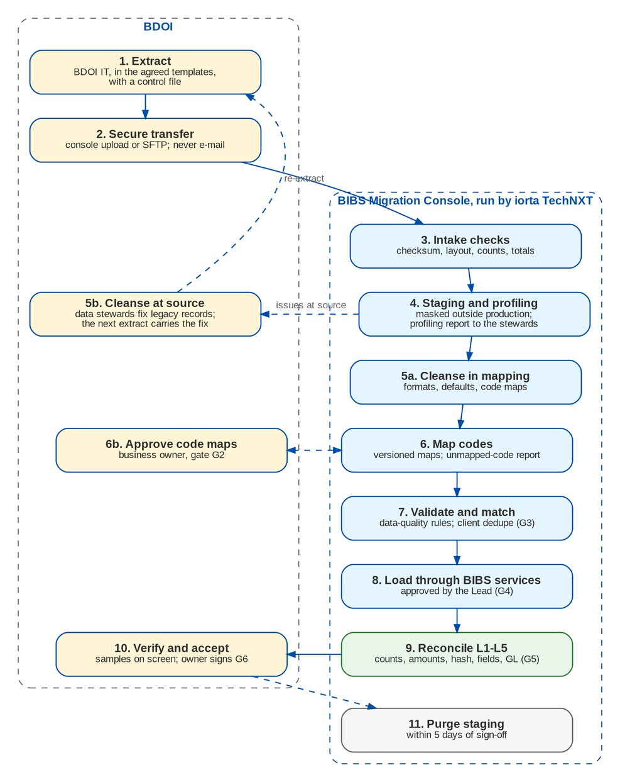
Figure 1: Migration pipeline per data object: BDOI steps (left) and BIBS Migration Console steps (right)
Table 14: Steps, responsibilities and evidence
# | Step | What happens | Who | Evidence
1 | Extract | BDOI IT extracts each object in the agreed layout with its control file | BDOI IT | Data file and control file
2 | Secure transfer | Files are uploaded on the Extracts screen of the Migration Console, or dropped on the secure file drop once BDOI IT names it (PR-DM-03); never e-mailed | BDOI IT | Upload log with SHA-256
3 | Intake checks | BIBS checks checksum, header, row count, amount totals and hash total against the control file; a failing file is rejected as a whole | iorta Migration Operator | Extract status Staged or Rejected
4 | Staging and profiling | Rows are staged (masked outside production) and profiled; the profiling report goes to the data stewards | iorta Migration Lead | Profiling report per object
5 | Cleansing | Issues at source are fixed in legacy by the stewards; formats, defaults and mapped values are handled in staging | BDOI data stewards; iorta | Data-Quality Issues report
6 | Mapping | Legacy codes are mapped to BIBS codes in versioned code maps; the business owner approves each version (G2) | Data steward prepares; owner approves | Code Map Versions and Unmapped Legacy Codes reports
7 | Validation and matching | Data-quality rules run on every row; clients are matched and deduplicated (G3) | BIBS; Data steward | Data-Quality Issues and Client Matching reports
8 | Load | Approved batches load through the BIBS services (G4) | Data Migration Lead approves; iorta runs | Run log of the batch; Rejected Rows report
9 | Reconciliation | L1 counts, L2 amounts, L3 hash totals, L4 fields, L5 GL; breaks explained (G5) | Reconciliation approver | Reconciliation Summary and Migration Clearing reports
10 | Acceptance | Business owner checks samples on the BIBS screens and accepts the object (G6) | Business owner; Data Migration Lead | Sign-off form
11 | Purge | Staged records and files are deleted within 5 days of sign-off; counts, hashes and totals are kept | BIBS (daily staging purge) | Purge date on the batch

6.2 Extract templates
BDOI extracts each object in its layouts. The layouts are held by the Migration Console (Layouts and Rules), which exports them as load templates: a CSV template per layout with the column names as its header row, a workbook per object and one workbook of all templates with the column descriptions, the control-file template and the filling rules. A layout gives, per column: name, description, type and length, mandatory flag, allowed values or code map, format, example and validation. The Migration Workbook lists every layout on a sheet of its own, with the same sheet name as the console workbook, for the review: the guide of each column sits directly above the header row of the file, with the BU review rows above it; the sheet Load templates lists the layouts in load order.
Table 15: The 29 extract layouts in force (366 columns): the load templates of the Migration Console
Layout | Content | Object | Columns | Mandatory | Key | Amount totals | Template
R01 | Lists of values and MIS values | R01 | 8 | 4 | list_type, code | - | R01_template.csv
R02 | Branches and invoicing branches | R02 | 5 | 4 | branch_code | - | R02_template.csv
R03 | Sales organisation (units and account officers) | R03 | 11 | 3 | record_type, unit_code, ao_user_id | - | R03_template.csv
R04 | Insurers | R04 | 10 | 3 | insurer_code | - | R04_template.csv
R04B | Insurer branches | R04 | 7 | 4 | insurer_code, branch_code | - | R04B_template.csv
R05 | Product lines, cover types, products and risk codes | R05 | 9 | 4 | risk_code | - | R05_template.csv
R06 | Package code map (legacy package to BIBS package version) | R06 | 8 | 4 | legacy_package_code, legacy_package_version, qualifier, qualifier_value | - | R06_template.csv
R07 | Commission rates by insurer and product | R07 | 5 | 4 | insurer_code, risk_code, effective_from | - | R07_template.csv
R08 | Chart of accounts mapping | R08 | 8 | 4 | legacy_account_code | - | R08_template.csv
R09 | Payees | R09 | 11 | 6 | payee_code | - | R09_template.csv
R11 | Receipt series in use | R11 | 8 | 7 | branch_code, kind, prefix | - | R11_template.csv
C01 | Client master | C01 | 36 | 6 | legacy_client_no | - | C01_template.csv
C02 | Client addresses and contacts | C01 | 13 | 4 | legacy_client_no, record_type, seq_no | - | C02_template.csv
C03 | Client payout accounts | C03 | 6 | 4 | legacy_client_no, account_no | - | C03_template.csv
P01 | In-force policy headers | P01 | 31 | 20 | legacy_policy_ref | sum_insured, gross_premium, net_premium | P01_template.csv
P01S | Policy insurer shares | P01 | 6 | 5 | legacy_policy_ref, share_seq | - | P01S_template.csv
P03 | Renewal advices already sent before go-live (RA-sent file) | P03 | 13 | 6 | legacy_policy_ref | proposed_premium | P03_template.csv
F01 | Open legacy invoices - header | F01 | 38 | 24 | legacy_invoice_no | gross_premium, commission, vat_on_commission | F01_template.csv
F01S | Open legacy invoices - insurer shares | F01 | 5 | 5 | legacy_invoice_no, share_seq | - | F01S_template.csv
F01C | Open legacy invoices - components and positions | F01 | 8 | 8 | legacy_invoice_no, component | booked, adjusted, paid, remitted, written_off, open_balance | F01C_template.csv
F02 | Unapplied premium payments (UPP) | F02 | 21 | 11 | legacy_upp_ref | amount, balance | F02_template.csv
F03 | Open collection state | F03 | 12 | 3 | legacy_invoice_no, record_type, seq_no | promise_amount, installment_amount | F03_template.csv
F04 | Remittance in flight | F04 | 10 | 6 | legacy_batch_no, legacy_invoice_no | amount | F04_template.csv
F06 | PDCs, check pick-ups and refunds in process | F06 | 14 | 6 | record_type, reference | amount | F06_template.csv
G01 | GL opening trial balance | G01 | 11 | 9 | tb_version, branch_code, currency, legacy_account_code, cost_center | debit_fc, credit_fc, debit_php, credit_php | G01_template.csv
G03 | FY2027 true-up - legacy adjustment journal lines after the freeze | G03 | 19 | 17 | legacy_journal_no, line_no | debit_fc, credit_fc, debit_php, credit_php | G03_template.csv
G03D | FY2027 true-up - open-item detail of the lines on legacy control accounts | G03 | 10 | 10 | legacy_journal_no, line_no, item_ref, component | amount | G03D_template.csv
H01 | Archive records (closed transactions and history) | H01 | 15 | 3 | record_type, legacy_key | amount | H01_template.csv
H02 | Archive documents index | H02 | 8 | 6 | record_type, legacy_key, file_name | - | H02_template.csv

Four objects have sub-layouts sent as separate files with the same as-of date: R04 and R04B (insurers and their branches), P01 and P01S (policy headers and their insurer shares), F01, F01S and F01C (invoice headers, insurer shares and components), G03 and G03D (adjustment journal lines and their open-item detail). The rules of every file (Migration Workbook sheet File rules; the first rows are the delivery rules the console templates carry):
Table 16: Rules of every extract file
Topic | Rule
File name | <LAYOUT>_<SOURCE>_<yyyyMMdd>_<nn>.xlsx or .csv, for example F01C_EBIX_20271231_01.xlsx: the layout code, the source system, the as-of date and the sequence of the day
One file per | Layout, source system and extract; an object with several layouts sends one file per layout with the same as-of date
Excel | The load template of the console, uploaded as it is: its guide rows and example row are skipped and the sheet of the layout is read; a workbook of several layouts is uploaded once per layout, named after that layout. A plain workbook has the header in row 1 of its first sheet, no merged cells, no formulas
CSV | For large extracts: UTF-8 without byte order mark, comma separator, double quotes around values that hold a comma, a quote or a line break, one header row with the column names exactly as in the template
Values | Dates as Excel dates or yyyy-MM-dd; timestamps yyyy-MM-dd HH:mm:ss (Philippine time); amounts with a dot decimal, 2 decimals, no thousands separator, minus sign for negatives; currency ISO 4217; codes exactly as stored in the legacy system; blank means no value
Control file | <data file name>.ctl.xlsx or .ctl.csv in the control layout: the row count, the hash total of the key column, the total of each amount column per currency and the SHA-256 of the data file, one row per measure
Delivery | Upload the data file and its control file together on the Extracts screen of the Migration Console; never by e-mail
Checks | A file whose checksum, header, row count, amount totals or hash total does not agree with its control file is rejected with the reason; nothing of it is loaded
Personal data | Production extracts are loaded only in production. Every other environment receives masked data: names, addresses, TIN, ID, account and phone numbers, e-mail addresses and birth dates are masked when the file is received. Staged rows and files are deleted within 5 days of the batch sign-off
Layout changes | A layout is frozen at gate G2. A file whose header does not match the layout in force is rejected. A change of layout is a new layout version agreed with the Data Migration Lead
Load template workbook of P03 | The Renewal processing team may send the RA-sent file in the load template workbook of layout P03 exported by the Migration Console (the template sheet with the guide rows Mandatory, Format, Allowed values and What to enter directly above the header row, and the Lists sheet with the allowed values); the CSV template is also accepted

The control file sent with every data file:
Table 17: Columns of the control file (one row per measure)
No. | Column | What it holds | Mand. | Format | Example
1 | object | Object code of the data file | Y | Upper case; matches the file name | F01
2 | layout | Layout (template) code | Y | Upper case; matches the header row | F01C
3 | source_system | Source system: EBIX, QPS, ISYS, CMS or EXCEL | Y | Upper case; matches the file name | EBIX
4 | data_file | Name of the data file the control file belongs to | Y | <LAYOUT>_<SOURCE>_<yyyyMMdd>_<nn>.csv or .xlsx | F01C_EBIX_20271231_01.csv
5 | as_of | Date and time the data represents | Y | yyyy-MM-dd HH:mm:ss; not earlier than the previous extract of the layout | 2027-12-31 22:00:00
6 | extracted_at | When the extract ran | Y | yyyy-MM-dd HH:mm:ss; after as_of | 2028-01-01 00:40:12
7 | extracted_by | BDOI IT user who ran the extract | Y | Free text | bdoi.it.jramos
8 | measure | Kind of control: ROW_COUNT, HASH_TOTAL, AMOUNT_TOTAL or SHA256 | Y | Upper case | AMOUNT_TOTAL
9 | column_name | Column the measure applies to | C | As in the header; mandatory for HASH_TOTAL and AMOUNT_TOTAL | open_balance
10 | currency | Currency of an AMOUNT_TOTAL | C | ISO 4217; mandatory for AMOUNT_TOTAL | PHP
11 | filter | Optional filter of the measure | N | column=value | component=BASIC
12 | value | Value of the measure | Y | Digits with a dot decimal for amounts; 64 hexadecimal characters for SHA256 | 98450221.40

6.3 Secure transfer and staging
• Files are received through the Extracts screen of the Migration Console, or through a secure file drop once BDOI IT names it (DMQ28, PR-DM-03). E-mail is never used.
• Files land in an encrypted intake bucket in AWS ap-southeast-1 with a 5-day lifecycle.
• The intake checks run before any row is staged. A file that fails is rejected as a whole; the rejection lists every failed check with its reason and the difference, and BDOI IT re-sends the file.
• Staged rows keep the raw values as received and the mapped values. Outside production, names, addresses, TIN, ID, account and phone numbers, e-mail addresses and birth dates are masked at intake with a keyed, repeatable masking, so dedupe still works on masked data.

6.4 Profiling
After the first full extract (M3, 29 January 2027) and after each trial migration, iorta TechNXT profiles every staged object and sends the report to the data stewards. The report gives, per field: fill rate, distinct values, top values, values out of format, codes without a map entry, duplicates of the key, and, per object, the rows that fail each data-quality rule. For clients it gives the candidate duplicate pairs by score band; for open items it gives the totals by component, currency, branch and age band. The stewards use it to plan the cleansing and the code maps.

6.5 Cleansing: who fixes what
Cleansing is shared. BDOI owns the data and fixes it where it lives; iorta TechNXT fixes what is a matter of format or mapping.
Table 18: Cleansing responsibilities
Issue | Example | Fixed by | Where
Wrong or missing business data | Client without birth date, invoice without insurer, TIN of another client | BDOI data steward | In legacy, before the next extract
Duplicate clients | Same person in QPS and EBIX with different numbers | BIBS matching; data steward decides doubtful pairs | Client Matching queue
Legacy codes without a BIBS value | Discontinued segment code, insurer branch not in BIBS | Data steward proposes; business owner approves | Code map version (Map, Default, Create or Reject)
Format differences | Date as dd/MM/yyyy, TIN with dashes, mobile without prefix | BDOI IT with iorta TechNXT | BDOI IT extract
Records out of scope | Client not active since 2019, invoice fully settled | Business owner decides | Exclusion recorded in the batch
Open balances that do not add up | Components do not equal gross premium; open not equal to booked less paid | BDOI data steward with Comptrollership | In legacy (correction entry) before the freeze
Data that cannot be fixed before go-live | UPP without payor reference | Business owner waives with a reason and a plan | Waiver in the batch (G3)

Thresholds for loading an object (configurable): master data may be loaded with at most 0.5 percent of rows rejected or waived; financial objects (open invoices, UPP, trial balance) load only with 0 errors, or with each excluded row approved by the business owner with a manual-entry plan.

6.6 Mapping and code maps
Legacy codes are mapped to BIBS codes through code map sets, one per domain. Each set has versions: Draft, Submitted, Approved, Superseded. The data steward prepares a version on the Code Maps screen, or in Excel (Export and Import Excel), and submits it; the business owner approves it (maker-checker). Each batch records the map versions it used, so every loaded value can be traced to the entry that produced it (BRID_MIG 3.1).
An entry maps a legacy code to a BIBS value (Map to a BIBS value), to the default of the set (Use the default value), rejects the rows that carry it (Reject the record), or creates a new BIBS value (Create in BIBS). Values created in BIBS go through the owning master (for example the lists of values or the insurers) and are authorised there before any dependent object loads.
Table 19: The 34 code map sets
Code map | What is mapped | BIBS values | Approves (G2) | Prepares | Used by
INSURER | Legacy insurer code to BIBS insurer | Insurers | Head, Operations | Operations data steward | R04, R06, R07, P01S, P03, F01S, F04
INSURER_BRANCH | Legacy insurer branch to BIBS insurer branch | Insurer branches | Head, Operations | Operations data steward | R04B, P01S
LINE | Legacy line of business to BIBS product line | Product lines | Product Owner, MBS | MBS data steward | R05, P01, F01
COVER_TYPE | Legacy cover type to BIBS cover type | Cover types | Product Owner, MBS | MBS data steward | R05, P01
PRODUCT | Legacy product / risk code to BIBS product code | Products and risk codes | Product Owner, MBS | MBS data steward | R05, R06, R07, P01, F01
PACKAGE | Legacy package and version to the BIBS package version maintained by TSU; conditional entries (risk code, insurer, sum-insured band) where one legacy package splits. Loaded as reference data (R06) for | Package versions (Renewal package map) | Product Owner, MBS (approves) | TSU (prepares) | R06
BRANCH | Legacy branch to BIBS branch | Branches | Head, Comptrollership | Comptrollership data steward | R02, R03, R11, C01, P01, F01, F02, G01, G03
SALES_UNIT | Legacy region, department and team to BIBS sales unit | Sales units | Heads, Retail and Corporate Marketing | Marketing data steward | R03, C01, P01, F01, F02
AO | Legacy AO code to BIBS account officer | Account officers | Heads, Retail and Corporate Marketing | Marketing data steward | R03
USER | Legacy user ID to BIBS username (AO, handler, collector, requester) | BIBS users (User Access) | Unit Head, Analytics and Risk Management | IT security administrator | R03, C01, P01, P03, F01, F03, F04
COST_CENTER | Legacy cost centre to BIBS cost centre | Cost centres | Head, Comptrollership | Comptrollership data steward | R03, F01, G01, G03
GL_ACCOUNT | Legacy GL account to BIBS account (legacy control accounts to Migration Clearing; lines on P&L accounts post to retained earnings in the opening and the true-ups) | Chart of accounts | Head, Comptrollership | Comptrollership data steward | R08, G01, G03
BANK | Legacy bank code to BIBS bank list | Bank list | Product Owner, Comptrollership - Disbursement | Disbursement data steward | R09, C03, P01, F06
CURRENCY | Legacy currency code to ISO 4217 | Currencies (ISO 4217) | Head, Comptrollership | Comptrollership data steward | All amount layouts
DISPOSITION_TYPE | Legacy UPP disposition types to BIBS disposition types | Cashiering disposition types | Operations - Financial Transactions | Cashiering data steward | F02
DISPOSITION_CLX | Legacy collection dispositions to BIBS collection dispositions | Collections dispositions | Head, Operations (Collections) | Collections data steward | F03
DOCUMENT_TYPE | Legacy document types to archive document types | Document types of the archive | Compliance | Compliance data steward | H02
LOV:CIVIL_STATUS | Legacy values of the list civil status | Lists of values | Product Owner, MBS | MBS data steward | R01, C01, P01, F01
LOV:ID_TYPE | Legacy values of the list ID type | Lists of values | Product Owner, MBS | MBS data steward | R01, C01, P01, F01
LOV:KYC_RISK_RATING | Legacy values of the list kyc risk rating | Lists of values | Product Owner, MBS | MBS data steward | R01, C01, P01, F01
LOV:MARKET_SEGMENT | Legacy values of the list market segment | Lists of values | Product Owner, MBS | MBS data steward | R01, C01, P01, F01
LOV:NATIONALITY | Legacy values of the list nationality | Lists of values | Product Owner, MBS | MBS data steward | R01, C01, P01, F01
LOV:PAYEE_CLASS | Legacy values of the list payee class | Lists of values | Product Owner, MBS | MBS data steward | R01, C01, P01, F01
LOV:SOURCE_OF_FUNDS | Legacy values of the list source of funds | Lists of values | Product Owner, MBS | MBS data steward | R01, C01, P01, F01
MIS:BUSINESS_ORIGIN | Legacy values of the MIS field business origin | MIS fields | Product Owner, MBS | MBS data steward | R01, C01, P01
MIS:CUSTOMER_SEGMENT | Legacy values of the MIS field customer segment | MIS fields | Product Owner, MBS | MBS data steward | R01, C01, P01
STATUS:CLIENT | Legacy statuses of client | Status of the BIBS record | Owner of the object | Steward of the object | C01, R04, R05, P01, F02, F04, F06
STATUS:INSURER | Legacy statuses of insurer | Status of the BIBS record | Owner of the object | Steward of the object | C01, R04, R05, P01, F02, F04, F06
STATUS:KYC | Legacy statuses of kyc | Status of the BIBS record | Owner of the object | Steward of the object | C01, R04, R05, P01, F02, F04, F06
STATUS:PDC | Legacy statuses of pdc | Status of the BIBS record | Owner of the object | Steward of the object | C01, R04, R05, P01, F02, F04, F06
STATUS:POLICY | Legacy statuses of policy | Status of the BIBS record | Owner of the object | Steward of the object | C01, R04, R05, P01, F02, F04, F06
STATUS:PRODUCT | Legacy statuses of product | Status of the BIBS record | Owner of the object | Steward of the object | C01, R04, R05, P01, F02, F04, F06
STATUS:REMITTANCE | Legacy statuses of remittance | Status of the BIBS record | Owner of the object | Steward of the object | C01, R04, R05, P01, F02, F04, F06
STATUS:UPP | Legacy statuses of upp | Status of the BIBS record | Owner of the object | Steward of the object | C01, R04, R05, P01, F02, F04, F06

6.6.1 Package remapping
Legacy packages (QPS package code and version) must map to the package names that TSU maintains in BIBS (BRD-3). BDOI decided on 26 September 2026 that the remapping happens at sanitation in Renewal, per renewal candidate, and not in the migration intake (DMQ36, register DCR-241). The concept paper had left "during upload processing or during sanitation" open (R10 p.2, Annex B, Annex C).
Table 20: Package remapping (DMQ36 answered)
Where | What happens
Migration | Loads the package code map as reference data (object R06): entries from a legacy package and version to a BIBS package version, with conditional entries where one legacy package splits (by risk code, insurer or sum-insured band). TSU prepares each version and the Product Owner of Marketing Business System approves it (G2). Policy headers (P01) and the RA-sent file (P03) keep the legacy package as given; no package is resolved, rejected or warned at intake
Renewal sanitation | The package check of the Renewal sanitation resolves the BIBS package of each candidate through the map. A package without an entry, with a Reject entry or with no matching qualifier sends the candidate to the Exception bucket
Exception bucket | Worked by the Renewal processing team: the processor chooses the BIBS package (or the new-business path) and records the reason; each choice goes to TSU for the next map version

Testing. The package code map is loaded in every trial migration. Profiling lists the legacy packages of the headers expiring up to 31 May 2028 that have no entry: this is the expected Exception-bucket volume at go-live, and TSU closes the gaps before the map freeze. Business verification samples cover every legacy package with more than one BIBS target.

6.7 Validation
Every staged row is checked against the data-quality rules of its layout before a batch can be approved for load. An error stops the row; a warning loads it and reports it. The catalogue (Layouts and Rules, Data-Quality Rules; Migration Workbook sheet Validation rules):
Table 21: The 54 data-quality rules by kind (full list in the Migration Workbook)
Kind | Rules | Rule IDs
Mandatory | 1 | DQ-001
Format | 6 | DQ-002, DQ-005, DQ-006, DQ-007, DQ-045, DQ-046
Code map | 2 | DQ-003, DQ-039
Unique | 4 | DQ-004, DQ-020, DQ-036, DQ-044
Plausibility | 6 | DQ-008, DQ-011, DQ-028, DQ-031, DQ-032, DQ-048
Cross-field | 16 | DQ-009, DQ-013, DQ-014, DQ-015, DQ-017, DQ-019, DQ-021, DQ-024, DQ-025, DQ-029, DQ-038, DQ-041, DQ-042, DQ-043, DQ-047, DQ-053
Duplicate client | 1 | DQ-010
Reference | 8 | DQ-012, DQ-016, DQ-018, DQ-026, DQ-033, DQ-049, DQ-054, DQ-056
Balance | 10 | DQ-022, DQ-023, DQ-027, DQ-030, DQ-034, DQ-035, DQ-037, DQ-040, DQ-052, DQ-055

6.8 Client matching and survivorship
Legacy clients of all source systems are matched with each other and with any client already in BIBS before any client is loaded (FR-DM-031). Keys and scores (proposal until DMQ04 is answered):
Table 22: Client matching keys
Key | Rule | Score
K1 | TIN, digits only | 100
K2 | ID type and number | 100
K3 | Last name, first name and birth date | 95
K4 | Normalised corporate name with registration number (90 without) | 95
K5 | Bank CIF, if BDOI confirms it as a key | 100
K6 | E-mail; PH mobile | 40 each
K7 | Similar name (at least 0.85) with the same birth date or city | 70

Pairs scoring 90 or more merge automatically; 60 to 89 go to the data steward's review queue; below 60 are separate clients. The client batch cannot be approved while the queue has open pairs. Survivorship takes, per field, the first non-blank value by source priority (proposal: QPS for contact data, EBIX for billing data) or the most recently updated value. Every value that lost is kept for review (Client Matching report).

6.9 Load through the BIBS services
An approved batch is loaded in chunks of 500 rows, four at a time; each chunk is saved as a whole; a failing chunk is retried row by row so one bad row fails alone. Loading the same batch again creates no duplicate: rows already loaded and unchanged are skipped through the key cross-reference. The planning target is 50,000 rows an hour per partition, proven in the dress rehearsal.
Before sign-off a batch can be rerun (only the rejected rows, after a fix) or rolled back (the records it created are undone through the BIBS services, unless a record was changed in BIBS since the load). In the production cut-over the rollback point is a full backup (snapshot) of the production system (chapter Cut-over strategy, Rollback).

6.10 Reconciliation and sign-off
Every object is reconciled at up to five levels. Part C gives the measures per object, the sample plan for business verification and the sign-off forms.
Table 23: Reconciliation levels (BRID_MIG 1.2)
Level | Measure | Rule
L1 | Record counts | Received = control count; loaded + skipped + rejected + excluded = staged
L2 | Amounts | Sum per amount column and currency: control total = staged = BIBS; difference 0.00
L3 | Hash totals | Hash total of the key and SHA-256 per row equal between control, staging and BIBS keys
L4 | Fields | Every mapped field of every loaded row, read back from BIBS, equals the staged value
L5 | GL | Migration Clearing is 0.00 per branch and currency; legacy control accounts equal the legacy sub-ledgers

Seven gates record the sign-offs of each object: G1 decision, G2 mapping, G3 validation, G4 load approval, G5 reconciliation, G6 object accepted, G7 go-live. A reconciliation with a break cannot be signed until the break is explained and the explanation approved. The operator who ran a batch cannot sign its reconciliation or acceptance.

7 Legacy invoices after go-live
This chapter is for the Cashiering, Remittance, Collections, Accounting and Operations users who will process legacy items in BIBS.

7.1 What a legacy invoice is
A legacy invoice is an invoice booked in EBIX or QPS before go-live that still has something open at the freeze: premium the client has not paid, premium paid but not yet remitted to the insurer, commission not yet collected from the insurer, or a PR2307 balance. It is not re-booked in BIBS. It is loaded into the BIBS Operations ledger with:
• its legacy invoice number (kept as the BIBS invoice number unless it collides with a number of another source system, DMQ11), the source system and the legacy policy reference; the acknowledgment receipt of a payment on it prints the legacy invoice number (BRID_MIG 6.2; CLR-DM-14 for a separate BIBS number);
• each component (basic premium, DST, premium tax or VAT, LGT, FST, other charges, DTIP, commission, VAT on commission, withholding tax, PR2307) with what was booked, paid, remitted, adjusted and written off in legacy, so its open balance equals the legacy open balance;
• its insurer shares, client, AO, unit, branch and flags (direct payment where legacy holds it, CLR-DM-15; 2307);
• an opening accounting entry that puts the open balances on the legacy sub-ledgers.
From then on BIBS processes it with the normal screens (Figure 2). The only difference from a BIBS invoice is where its postings go: to the legacy control accounts, so the legacy positions run off visibly and separately from the new business.
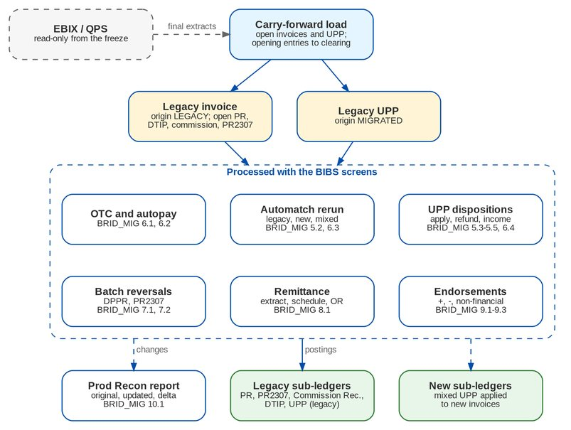
Figure 2: A legacy invoice and the processes that act on it after go-live (BRID_MIG 5.1-10.1)

7.2 Legacy sub-ledgers
BRD V0.03 asks that the Premium Receivable, Commission Receivable, DTIP and UPP sub-ledgers are updated "for legacy and/or new contexts as applicable" (BRID_MIG 5.2, 6.3); unlike draft v0.01 it no longer writes "(legacy)" after the sub-ledgers of 6.1, 6.2, 6.4, 7.1, 7.2 and 8.1. The proposal keeps separate legacy control accounts, so the legacy positions run off visibly; Comptrollership confirms them or chooses the common sub-ledgers with the origin Migrated (PR-DM-02, CLR-DM-17). Comptrollership assigns the account codes of the legacy control accounts and of the Migration Clearing account (DMQ18, DCR-197); this handbook names the accounts only.
Table 24: Legacy sub-ledgers (account codes assigned by Comptrollership, DMQ18)
Legacy control account | Holds | Moved by
Premium Receivable - Legacy (by component) | Open premium of legacy invoices | Payments, automatch, dispositions, DP PR reversals, write-offs, endorsements
PR 2307 - Legacy | Open PR2307 of legacy invoices | PR2307 reversals
Due to Insurers (DTIP) - Legacy | Premium payable to insurers on legacy invoices | Remittance, DP PR and PR2307 reversals, endorsements
Commission Receivable - Legacy | Commission and VAT on commission still due from insurers | Remittance, DP commission collection, endorsements
Unrealised Commission and Deferred Output VAT - Legacy | Commission not yet recognised as income | Realisation on collection
Unapplied Collections (UPP) - Legacy | Unapplied payments received in legacy | Automatch, dispositions, refunds, reclassification to income
Migration Clearing | Offsets of the opening entries and of the legacy control-account lines of the trial balance | Opening entries only; must be 0.00

7.3 Worked example: one legacy invoice from load to remittance
Legacy invoice I00123456 (EBIX), private car, PHP, lead insurer 100 percent. Booked in legacy before go-live: basic premium 20,000.00, DST 2,500.00, premium tax 400.00, LGT 150.00; gross premium 23,050.00; commission 4,000.00 (20 percent), VAT on commission 480.00, withholding tax on commission 400.00. Before the freeze the client paid 13,050.00, which covered DST, premium tax, LGT and 10,000.00 of the basic premium (the application order DST, premium tax / VAT, LGT, FST, other charges, basic). Nothing was remitted to the insurer. The figures are made up.
Table 25: Positions of I00123456 at the freeze (extract F01C)
Component | Booked | Paid | Remitted | Open | Legacy sub-ledger
Basic premium | 20,000.00 | 10,000.00 | 0.00 | 10,000.00 | Premium Receivable - Legacy
DST | 2,500.00 | 2,500.00 | 0.00 | 0.00 | Premium Receivable - Legacy
Premium tax / VAT | 400.00 | 400.00 | 0.00 | 0.00 | Premium Receivable - Legacy
LGT | 150.00 | 150.00 | 0.00 | 0.00 | Premium Receivable - Legacy
DTIP | 23,050.00 | - | 0.00 | 23,050.00 | DTIP - Legacy
Commission | 4,000.00 | - | 0.00 | 4,000.00 | Commission Receivable - Legacy
VAT on commission | 480.00 | - | 0.00 | 480.00 | Commission Receivable - Legacy
Withholding tax | 400.00 | - | 0.00 | 400.00 | (settled at remittance)

What happens after go-live:
Table 26: Life of I00123456 in BIBS
When | Event in BIBS | Effect
Load (T-2) | Invoice created in the Operations ledger with the origin Migrated, in the legacy ledger context; opening entry | Premium Receivable - Legacy 10,000.00 debit; DTIP - Legacy 23,050.00 credit; Commission Receivable - Legacy 4,480.00 debit; the unrealised part per DMQ13; the balance of the entry to Migration Clearing. Invoice 360 shows booked 23,050.00, applied 13,050.00, open 10,000.00 and the LEGACY badge
T+2 | The client pays 10,000.00 at the counter quoting I00123456 | BIBS finds the legacy invoice, issues a BIBS AR and applies the payment to basic. Entries: Dr Bank / Cr Unapplied Collections 10,000.00; Dr Unapplied Collections / Cr Premium Receivable - Legacy 10,000.00. The invoice is fully paid; the receipt is in the Cash Receipts Book
T+9 | Remittance extraction for the insurer | The invoice is extracted with paid AR 23,050.00 (13,050.00 paid in legacy and 10,000.00 in BIBS). Net due to the insurer 18,970.00 = 23,050.00 - 4,480.00 + 400.00. Entry: Dr DTIP - Legacy 23,050.00 and Dr CWT 400.00 / Cr Commission Receivable - Legacy 4,480.00 and Cr Due to Insurer for Disbursement 18,970.00. The schedule shows the legacy invoice number and source system; the commission OR is issued as for any batch
T+20 | Positive endorsement, additional basic premium 2,000.00 | The policy header is a migrated account (P01). BIBS books an endorsement invoice with a BI- number whose parent is I00123456 and the legacy ledger context; its entries go to the legacy accounts; the service invoice is issued for the commission increase
Month end | Changes to Legacy Invoices report | Shows for I00123456 basic premium original 20,000.00, updated 22,000.00, delta 2,000.00, with the endorsement number, date and user (BRID_MIG 10.1)

7.4 Unapplied premium payments (UPP)
Every legacy UPP item with a balance at the freeze is created in the BIBS Unapplied Payments workbench with the origin Migrated, its legacy AR number and date, payor, client, sales unit, amount, balance, status and the references the payor gave (invoice, cover, PN, bank reference). An opening entry puts the balance on Unapplied Collections - Legacy. No new AR is issued for money already acknowledged in legacy (proposal, DMQ14, DCR-204).
Table 27: Processing legacy UPP in BIBS (BRID_MIG 5.1-5.5, 6.3, 6.4)
Process | Example | Entries (by context)
Automatch rerun (after every payment upload and hourly) | Legacy UPP of 5,000.00 quotes legacy invoice I00200001 (3,000.00 open) and new invoice BI-2028-000150 (2,000.00 open). Automatch applies both and closes the item | Dr Unapplied Collections - Legacy 3,000.00 / Cr Premium Receivable - Legacy 3,000.00; Dr Unapplied Collections - Legacy 2,000.00 / Cr Premium Receivable (new) 2,000.00
Apply to another invoice (client instruction) | The client asks to apply a legacy UPP to another legacy invoice | Dr Unapplied Collections - Legacy / Cr Premium Receivable - Legacy
Refund | Approved refund of 1,500.00 | Dr Unapplied Collections - Legacy / Cr Refund Payable; payment request to Disbursement
Reclassification to other income (Unapplied to Income) | UPP of 1,500.00 unclaimed for more than 2 years; batch approved by the Cashiering team lead and then top management (DMQ16, PR-DM-06) | Dr Unapplied Collections - Legacy / Cr Other Income (account per DMQ16); item closed

7.5 Payments, reversals, remittance, endorsements and Prod Recon
Table 28: Other processes on legacy invoices
Process (BRID) | What the user does | What BIBS does
OTC payment (6.1) | Keys the legacy invoice number, ARN, policy or PN at the counter | Finds the legacy invoice, issues the AR, applies by component, posts to Premium Receivable - Legacy; Cash Receipts Book as usual
Autopay (6.2) | Uploads the bills payment, trade, CLPC or direct credit file as today | Matches rows that carry the legacy invoice number or the EBIX reference; applies and posts by the context of each invoice
DP PR Legacy Reversal (7.1) | A Cashiering or Support Team user (BRD V0.03) adds the legacy invoices tagged "DP PR for reversal" by Collections, or other legacy invoices with open premium; the Cashiering team lead approves (CLR-DM-16; the screens of this set show the Commission user and team lead of release set v2.0) | Reverses each open premium receivable against DTIP on the legacy sub-ledgers, one line at a time (Dr DTIP - Legacy / Cr Premium Receivable - Legacy); Commission Receivable effect per DMQ19
Legacy PR 2307 Reversal (7.2) | A Collections user (BRD V0.03) adds each legacy invoice with the amount to reverse; the Collections team lead approves (CLR-DM-16; the screens of this set show the Cashiering user and team lead of release set v2.0) | Offsets PR2307 - Legacy against DTIP - Legacy; commission effect per DMQ20
Remittance (8.1) | Runs the extraction as today | Includes legacy invoices with paid premium not yet remitted; never remits again what was remitted in legacy; posts legacy lines to DTIP and Commission Receivable - Legacy
Endorsements (9.1-9.3) | Raises the endorsement request on the legacy invoice | Needs the migrated policy header; books the endorsement invoice in the legacy ledger context; non-financial changes update the account with no posting; renewal uses the updated values
Collections | Works the worklist as today | Legacy invoices above the threshold appear with the LEGACY badge; carried promises and assignments (F03) are shown
Prod Recon (10.1) | The Prod Recon Analyst or a Reporting User runs the report Changes to Legacy Invoices | Lists original, updated and delta per change, including payments and remittances; legacy invoices are not part of the production register extract unless BDOI asks for a separate filter (CLR-DM-19)
Reports (10.2) | Runs the usual reports | Position reports include migrated records with an Origin column and filter; reports of transaction periods cover BIBS transactions from go-live (FR-DM-101, CLR-DM-20)

7.6 When the legacy context closes
The legacy sub-ledgers run off as legacy invoices are paid, remitted, reversed or written off and as legacy UPP is applied, refunded or reclassified. The report Open Legacy Positions shows the open legacy positions by component, insurer, client and age each month. When no legacy invoice or UPP is open and the legacy control accounts and Migration Clearing are 0.00, Comptrollership decides whether to close the legacy accounts.

8 In-force policies and the renewal-driven transition

8.1 In-force policy headers
BRID_MIG 4.1 asks for a minimal header of in-force policies "when operationally required" (p.9); capability 4 is conditional (p.6). BIBS needs the header for three things: to locate active coverage for servicing, to endorse a legacy invoice (BRID_MIG 9 cannot be met without it), and to renew the policy in BIBS. The proposal is therefore to migrate the header of every policy in force at go-live (DMQ09, DCR-194), in layouts P01 (header) and P01S (insurer shares).
A header becomes a BIBS account with the origin Migrated and the status Booked: client, product and line, insurer and shares, policy number, inception and expiry, sum insured, premium, currency, payment arrangement, PN numbers, AO, unit and branch. It has no quotation, placement or BIBS invoice. Its legacy invoices link to it. It is found by ARN, policy number, legacy reference or client.

8.2 Renewal by RMEL cohort
The transition follows the renewal expiry month (RMEL, BRID_MIG 12.1). BDOI answered on 26 September 2026 that the renewals of the January-May 2028 expiries are processed in BIBS after go-live, and that no renewal candidate is carried from legacy (DMQ37, register DCR-240). BIBS Renewal normally extracts policies 140 days before expiry; at go-live it runs one extraction of every expiry from go-live to 31 May 2028 instead.
Renewals in progress (BRID_MIG 12.2). BRD V0.03, signed in May 2026, adds a requirement (numbered as a second 12.1) that every renewal record in progress in the legacy renewal tracking system is migrated and continued in BIBS from its last stage. It conflicts with the BDOI answer of 26 September 2026 above. The set keeps the 26 September 2026 answer as its proposed position and asks BDOI to confirm it in the annex of agreed deviations (CLR-DM-07, Drop 0 question DM-Q08): the renewals whose new term starts before go-live are completed and booked in legacy before the freeze, the January-May 2028 expiries continue in BIBS from the go-live extraction with the renewal advices already sent (P03), and the P03 batch gives the audit trail of the rows loaded, rejected and resubmitted (FR-DM-126). If BDOI decides that stages must be carried, a tracker layout with a stage map is added through a change request.
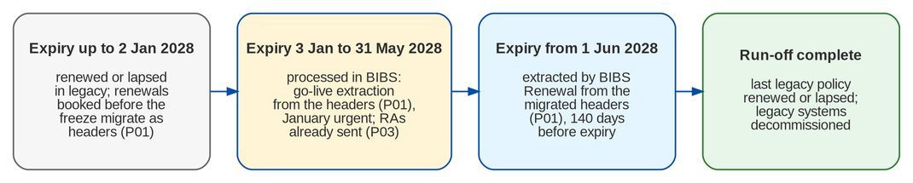
Figure 3: Transition by expiry month (go-live 3 January 2028, recommended)
Table 29: Treatment of each cohort (DMQ37 answered)
Expiry | Treatment
Before go-live (up to 2 January 2028) | Renewed or lapsed in legacy; a renewal whose new term starts before go-live is placed and booked in legacy before the freeze and migrates as an in-force header with its open invoice
Go-live to 31 May 2028 | Processed in BIBS after go-live. At 04:00 on go-live day BIBS extracts every migrated policy header expiring in this window that was not renewed in legacy, prioritised by expiry date, with the January expiries flagged urgent. A renewal advice already sent by hand before go-live is recorded on the candidate and is not sent again
From 1 June 2028 | Extracted by BIBS Renewal from the migrated headers on the normal lead time of 140 days; 1 June 2028 is extracted on 13 January 2028

What this needs from the migration.
• Policy headers (P01). The go-live extraction works only from the migrated headers, so P01 must hold every policy in force at go-live that expires up to 31 May 2028, and every renewal term booked in legacy that starts on or after go-live (so that the expiring term is recognised as renewed). The P01 reconciliation against the legacy in-force list and the go-live extraction check (per expiry month, headers = candidates + renewals booked in legacy) prove that no expiry is missed.
• Renewal advices already sent (P03). The RMEL and the dispositions are kept in Excel trackers today (DMQ38, register DCR-243). The migration takes only the RAs already sent from them, in a small reference file: one row per expiring term with the legacy policy reference, cover, expiry, RA date and reference, channel, recipient, proposed insurer and premium quoted, sender, and the tracker and sheet it comes from.
Table 30: Excel intake of the RA-sent file (DMQ38)
Step | What happens | Who
Template | The load template workbook of object P03, exported by the Migration Console (the template sheet with the guide rows Mandatory, Format, Allowed values and What to enter directly above the header row, and the Lists sheet with the allowed values); the CSV template is also accepted | Migration Console
Compilation and check | The maker copies the RA rows of the Retail and Corporate trackers into the template; the checker compares the file with the trackers (counts per tracker, 10 sample rows) and releases it | Renewal processing team - maker, checker
Validation | Header in P01; expiry equal to the header and from go-live to 31 May 2028; RA date not after the last legacy business day (warning when more than 140 days before expiry); cover not already renewed in legacy; one row per expiring term | BIBS
Rejection report | The rejected rows of the P03 batch in Excel (Rejects on the batch) with the row, column, value and message, and columns for the maker's correction and the checker's review | BIBS
Resubmission | The maker corrects the rows and uploads a resubmission file with the corrected rows only (Resubmit Corrected Rows); the checker reviews each correction against the tracker and approves it on the Resubmissions tab of Batches (never the same person); it loads as a rerun batch. In production resubmissions close at 12:00 on the day before go-live; rows still rejected are checked against the tracker before any RA is sent | Maker, checker; Migration Operator

The Head of the Renewal processing team owns the object (signs G1, G2 and G6). In the trial migrations the file is sent from Trial migration 1; in production once, with the RAs sent up to the last legacy business day.
The January lead time. The January expiries get days to four weeks instead of 140 days for insurer requests and RAs (risk 16). The mitigation: the day-1 priority queue (go-live extraction at 04:00, January expiries flagged urgent, earliest expiry first); a staffing plan for January signed by the Head of the Renewal processing team; and a Renewal team that is trained and has worked the day-1 queue on the Trial migration 4 and dress-rehearsal data before go-live.
A legacy policy renews on the new-business path pre-filled from its header, or as is when the Renewal sanitation resolves its package. The renewal account refers to the legacy reference, so the run-off tracker can link them. The Run-off and Decommissioning screen and the Legacy Run-off report show, per expiry month, the legacy policies in force at go-live, renewed in BIBS, not renewed, lapsed and still open. Legacy systems are decommissioned when their last cohort has run off and the other checklist criteria are met (Part D, Decommissioning checklists).

9 History, archive and read-only access
History is not migrated into BIBS business tables. For each legacy system BDOI chooses how history stays available (DMQ24, DCR-209):
Table 31: Options for history
Option | What it means | When
Read-only legacy | The legacy application stays up in read-only mode, with its own access logging (BDOI IT). Legacy Inquiry shows its address to the users who still need it | From the freeze until the system is decommissioned
BIBS archive | Closed transactions, expired policies, GL history and documents are loaded into the BIBS archive (layouts H01 and H02) and searched in Legacy Inquiry | Before a legacy system is decommissioned

Legacy Inquiry searches the archive by client, policy or cover number, invoice, receipt, claim, date and record type, and shows each record read-only with its documents. Every search, view, download and export is logged (user, time, criteria, records, reason); the log cannot be changed; Compliance reviews it on screen and receives a monthly digest (FR-DM-110, FR-DM-111).
Retention. Archive records and access logs follow the retention rules: the umbrella BRD gives 5 years online and 15 years archive for historical data (R5 p.45). Reconciliation reports, sign-offs and run logs are kept as project records and are not purged with the staging data (proposed 10 years, DMQ29).
Archive reconciliation. Each archive load is reconciled against legacy by counts, amount totals and hash totals per record type, and Audit / Compliance checks samples in Legacy Inquiry before the system is decommissioned.

10 Migration cycles

10.1 Trial migrations, dress rehearsal and production
The migration is run five times before it counts, inside the SIT and UAT migration windows of the BDOI timeline and the full migration and cut-over window. Each run is a cut-over plan in the Migration Console (Cutover), so timings and issues are measured and the production cut-over repeats a rehearsed plan.
Trial-migration load order. In every run, reference data (R01-R07) and the client master (C01-C03) are loaded and accepted first, before any policy header, RA-sent file or open item. This follows the load order, and it gives the SIT and UAT of the Drop 1 modules, Renewal first, migrated clients and reference data to test with from the first trial migration: the prerequisite the concept paper sets for renewal (R10 section VI).
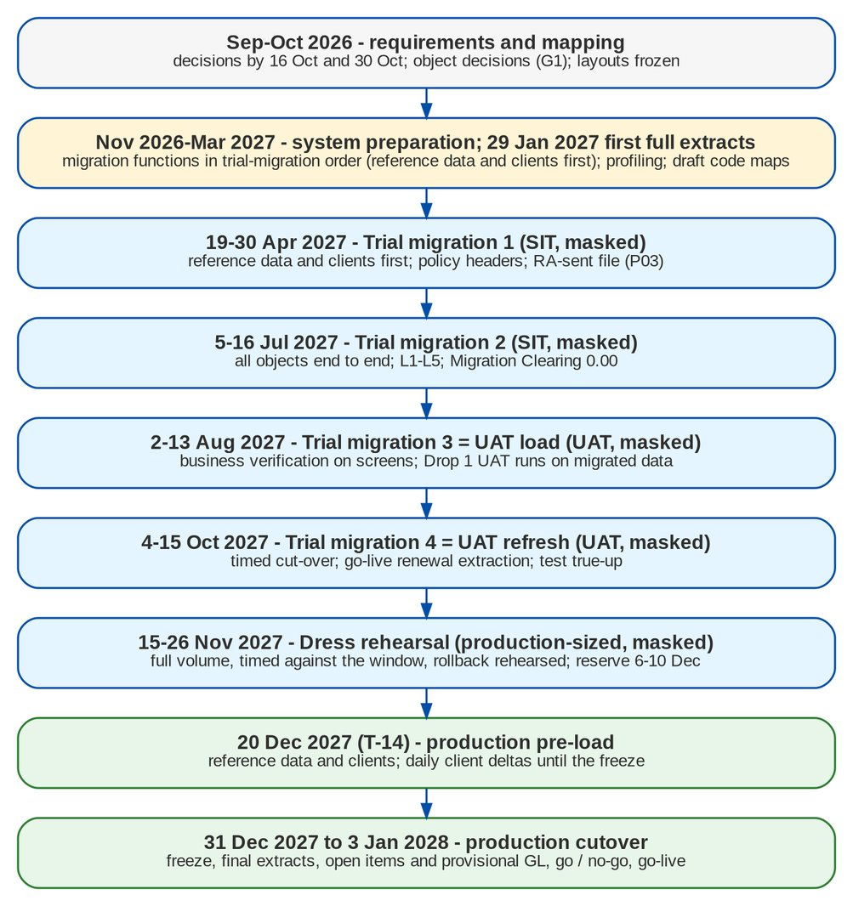
Figure 4: Migration cycles on the BDOI timeline (go-live January 2028)
Table 32: Migration cycles with entry and exit criteria
Cycle | When / where | Data and objects | Entry criteria | Exit criteria
Trial migration 1 | 19-30 Apr 2027; SIT | Masked full extracts; reference data and clients first, then policy headers and the RA-sent file (P03) | SIT environment set up with the Migration Console and the Renewal module by 9 Apr 2027; layouts frozen (M2); draft code maps; extracts for Trial migration 1 received (M4) | Objects loaded; L1-L4 run; issues logged; timing per object recorded; profiling report to the owners; P03 rejects reviewed by the Renewal processing team (maker-checker)
Trial migration 2 | 5-16 Jul 2027; SIT | Masked full extracts; all objects | Trial migration 1 exit met; code maps approved (M5); legacy accounts and accounting rules set up on SIT by Comptrollership by 18 Jun 2027 | All objects loaded; L1-L5 reconciled; Migration Clearing 0.00 per branch and currency; no open Critical migration issue
Trial migration 3 (UAT load) | 2-13 Aug 2027; UAT | Masked extracts refreshed; all objects | Trial migration 2 exit met; UAT readiness statement issued (R7, programme item 11) | Business owners verify samples on screen (G6 rehearsal); the Drop 1 end-to-end UAT (Aug-Dec 2027) runs on the migrated data; data-quality issues below the thresholds
Trial migration 4 (UAT refresh) | 4-15 Oct 2027; UAT | Fresh masked extracts; all objects; go-live renewal extraction of the January-May 2028 expiries; a test true-up | Trial migration 3 exit met; cut-over date, year-end option, fallback and decommissioning criteria agreed (M6) | Run as a timed cut-over; go-live extraction check balanced and the day-1 queue worked by the Renewal team; test true-up reconciled; UAT continues on the refreshed data
Dress rehearsal | 15-26 Nov 2027 (reserve 6-10 Dec 2027); production-sized environment | Masked full-volume extracts taken after a legacy EOD | Trial migration 4 exit met; production-sized environment (performance test window); cutover plan frozen | Full cutover within the window with at least 20 percent margin; rollback (snapshot restore) rehearsed; go / no-go criteria measured
Production | 20 Dec 2027 (T-14) to 3 Jan 2028 (T) | Real data in production only | GNG-1 passed (Part D) | GNG-3 GO; hypercare exit criteria (Part D)

Issues found in a cycle are resolved before the next one: in legacy (cleansing), in the code maps, in the layouts or in the load settings. The next cycle uses fresh extracts, so every fix is proven with new data.

10.2 Test data and masking
SIT and UAT receive masked extracts only. Masking is done at intake in BIBS with a keyed, repeatable method: the same person gets the same masked name and numbers in every file, so dedupe and matching behave as in production. Amounts, codes and transaction dates are not masked, so reconciliation and business verification work on real figures. Unmasked extracts never leave production (DMQ31, DCR-200).

11 Cutover strategy

11.1 Approach
• Big bang for open items. All open items (invoices, UPP, collection state, remittance items, PDCs), the policy headers, the RA-sent file and the provisional GL opening are loaded once, after the legacy freeze, over one weekend. They change every day, so a delta approach would add reconciliation risk for no benefit.
• Pre-load and deltas for master data. Reference data and clients are loaded two weeks before go-live and kept current with daily client deltas until the freeze. This takes the largest objects out of the cutover window.
• Year-end cut-over. The BDOI timeline sets go-live in January 2028 (DMQ25). The recommendation below (DMQ39, register DCR-242) awaits Comptrollership confirmation at M6 (1 October 2027).
Table 33: Year-end cut-over options (DMQ39)
Option | What it means | Assessment
A. Go-live at the year-end boundary (recommended) | Go-live Monday 3 January 2028. Legacy processes to 31 December 2027 and closes FY2027. BIBS opens with the open items at 31 December and a provisional GL opening trial balance from the preliminary December TB: balance sheet only, the FY2027 result in retained earnings, P&L at zero in FY2028. The legacy GL stays open only for FY2027 closing and audit adjustments, restricted to Comptrollership, with no new business. Each adjustment reaches BIBS as a controlled opening-balance adjustment journal in the opening period: true-up 1 after the legacy year-end close (about mid to late January 2028), the final true-up after the audited financial statements (about March-April 2028). December soft close by about 20 December 2027. FY2027 BIR annual returns and the FY2027 audit from legacy; FY2028 from BIBS | Recommended. One fiscal year per system; no P&L migration; books of accounts and BIR returns never split inside a year; the late adjustments are few, approved and reconciled
B. Go-live after the first-quarter close (April 2028) | Legacy runs January-March 2028; BIBS opens in April with the open items and the TB at 31 March, including the year-to-date P&L by account, branch and month | Not recommended. Go-live moves three months off the BDOI timeline; FY2028 is split across two systems (first-quarter books and returns from legacy, the rest and the annual returns from BIBS); the year-to-date P&L must be migrated and reconciled month by month; the FY2027 audit and the renewal peak fall in the cut-over period
C. Two books in parallel for the first quarter of 2028 | BIBS goes live in January and legacy also keeps the books for January-March | Not recommended. Every transaction is keyed twice for three months; two ledgers must be reconciled every day and diverge on every rule difference; it breaks the rule of one processing system per item (BRD p.5); the book of record for BIR is unclear; the extra work falls in the January renewal peak

If BDOI wants more assurance in January, Comptrollership compares reports instead of keeping two books: the BIBS opening reports against their legacy counterparts at 31 December (trial balance; premium receivable, DTIP, commission receivable and UPP by insurer and age), and the January month-end reports of BIBS (trial balance, GL schedules, Cash Receipts and Cash Disbursements Books, remittance schedules) against the opening position and the January activity.
True-ups and their controls. The last legacy business day is Wednesday 29 December 2027 (30 and 31 December are holidays); the last legacy EOD runs on 31 December and the business freeze follows. From then on:
Table 34: FY2027 true-up controls
# | Control | Evidence
1 | Legacy business modules read-only from the freeze; no new business in legacy | Freeze test in the runbook
2 | Legacy GL open only for FY2027 periods and only for the Comptrollership users named on a signed access list; FY2028 periods never opened in legacy | Access list; legacy period status
3 | Every legacy journal after the freeze entered in the FY2027 adjustment register (kind closing or audit, reason, preparer, approver) | Register
4 | Each true-up is prepared by the Comptrollership GL lead and approved by the Head of Comptrollership (never the same person); it posts as an opening-balance adjustment journal dated 1 January 2028; FY2027 P&L effects go to retained earnings; adjustments on the legacy control accounts come with their invoice or UPP detail | Opening-Balance Adjustments screen
5 | Each true-up is reconciled before sign-off: cut-off (legacy journal listing = register = true-up), movement (true-up = change of the legacy TB), balance (BIBS opening = legacy TB), Migration Clearing 0.00 | Opening-Balance Adjustment Reconciliation report, signed (Part C)
6 | When January 2028 is already closed, it is reopened for the posting only and closed again the same day; no other journal may post in the window | Period audit trail
7 | After the final true-up the legacy GL is locked and the true-ups are closed (about 2 May 2028); a later FY2027 finding is a prior-period adjustment in BIBS outside the migration | Closure sign-off

11.2 Freeze windows
Table 35: Freeze windows
Freeze | From | Until | Scope | Exception route
Reference data | T-7 (map freeze) | Go-live | Insurers, products, risk codes, packages, AOs, branches, LOVs in EBIX and QPS | Change request approved by the data owner; new code map version; delta load of R objects
Client master | T-3 22:00 (last delta) | Go-live | New and changed clients in QPS / EBIX / CMS | None after the freeze; changes keyed in BIBS after go-live
Business transactions | T-3 22:00 (after the last legacy EOD) | Go-live | All postings of the business modules of EBIX, QPS, CMS - bookings, receipts, UPP, dispositions, remittances, endorsements; GL journals other than the FY2027 adjustments | None; an urgent item is recorded on paper and keyed in BIBS on T
Legacy GL (FY2027 adjustments) | T-3 22:00 | Legacy GL lock (T+106) | Only FY2027 closing and audit adjustments, by the Comptrollership users on the signed access list; FY2028 periods never opened in legacy; no new business | Each journal in the FY2027 adjustment register; it reaches BIBS in the next true-up
BIBS configuration | T-2 00:00 | T+3 | Parameters, accounting rules, code maps, workflows in production | Emergency change approved by the go / no-go board
BIBS releases | T-7 | T+14 | Deployments to production | Hotfix of a Critical issue approved by the go / no-go board

11.3 Parallel run
There is no parallel run of legacy and BIBS on the same items. A parallel run would need each receipt, application, remittance and endorsement keyed twice and reconciled daily, and it contradicts the principle that an open item is processed in one system only (BRD p.5). The controls that replace it are the four trial migrations and the dress rehearsal on full extracts, the go / no-go criteria measured on production data, the rollback point until the go / no-go, and the daily hypercare reconciliation after go-live.

11.4 Go / no-go
Three checkpoints decide the cutover. The criteria are measured by BIBS and recorded with their values (FR-DM-121). GNG-3 is the go-live decision on the Sunday before go-live at 18:00 (2 January 2028 for the recommended date):
Table 36: Go-live criteria (GNG-3)
# | Criterion | Threshold
1 | Day-1 objects accepted (G6) | 100 percent
2 | Count reconciliation per object | Received = control; loaded + skipped + rejected + excluded = staged
3 | Financial rejects (open invoices, UPP, trial balance) | 0, or each excluded item approved with a manual-entry plan
4 | Amount reconciliation of open items, UPP and trial balance | 0.00 per currency
5 | Migration Clearing | 0.00 per branch and currency
6 | Legacy control accounts vs legacy sub-ledgers | 0.00
7 | Client review queue; screening run | Empty; complete
8 | Business smoke test on production | Passed
9 | Rollback point (snapshot) | Taken and verified
10 | Hypercare roster and support channels | In place
11 | Preliminary December TB signed as the provisional opening; legacy GL restricted to the named FY2027 adjustment users | Signed
12 | Headers of every expiry up to 31 May 2028 loaded; RA-sent file loaded; Renewal January staffing plan | Complete; confirmed

GNG-1 (T-15, start the pre-load) and GNG-2 (T-5, enter the freeze) are in Part D.

11.5 Rollback
Until the go / no-go decision the rollback is a restore of the production backup (snapshot) taken at the start of the production load, and legacy is reopened for business on Monday. After go-live, until the point of no return at 18:00 on the first business day, the same restore is possible with re-keying in legacy of the transactions keyed in BIBS that day. After the point of no return, issues are fixed forward in BIBS (DMQ32, DCR-200). The steps are in Part D.

11.6 Hypercare
Hypercare runs from go-live to the first month-end close. Every day: Migration Clearing 0.00, legacy control accounts against their sub-ledgers, automatch results, the urgent January renewals, exception queues and failed jobs; issue triage twice a day. True-up 1 is posted and reconciled before the January close. Exit requires no open Critical or High issue, 10 consecutive business days of clean daily checks, true-up 1 signed, and the first month-end close with the ACSL GL-SL reconciliation (legacy ledger context) without difference.

11.7 In-flight items at the freeze
Items in process in legacy at the freeze (pending endorsements, un-booked accounts, placements, PDCs, check pick-ups, refunds, remittance batches) are, in order of preference, completed in legacy before the freeze, carried forward in a layout (F04, F06), or re-keyed in BIBS after go-live from a list signed by the business owner (DMQ33, DMQ21). A renewal placed or bound in legacy but not booked is such an item: it is booked in legacy before the freeze so that its new term migrates as a header. The runbook schedules the completion drives from T-12.

11.8 Decommissioning
Each legacy system is decommissioned only against a signed checklist (FR-DM-123): final extracts reconciled, for EBIX and ISYS the final true-up reconciled and the legacy GL locked, archive loaded and reconciled, Legacy Inquiry verified by Audit / Compliance, no open inquiry or claim that needs the system, the last legacy-booked policy expired plus the claims tail, access logs archived, retention covered, and sign-off by the system owner, Compliance and Comptrollership (DMQ27). The checklists per system are in Part D.

12 Data security
The migration follows the hosting appendix (R7) and the security controls of BIBS.
Table 37: Data protection controls
Control | How it is applied
Hosting | All migration data (intake bucket, staging, archive) is in the BIBS environment in AWS ap-southeast-1
Masked non-production data | Every non-production environment (SIT, UAT, dress rehearsal) receives data masked at intake; unmasked extracts never leave production
Staging purge within 5 days | Staged records and extract files are deleted within 5 days of the batch sign-off or rollback, or of an extract rejection (daily purge of the staging area and of the file intake area); an alert is raised when a signed-off batch still has staged records after the limit. Counts, hashes and totals are kept as evidence
Access restricted to the Philippines | The Migration Console, the staging area and the file intake area are reachable only by migration roles and only from the Philippines (network restrictions of the infrastructure team, specified in the Technical Specification, reviewed by BDOI IT)
Encrypted transfer and storage | Files move through the console or the secure file drop over encrypted connections; stored files are encrypted; never by e-mail or removable media
Access logging | Every console action (upload, validation, load, rerun, rollback, reconciliation, sign-off, decision) is audited; every access to archived history is written to the legacy access log, which no user can change
Segregation of duties | The maker of a decision, map version, load or rollback never approves it; the operator of a batch cannot sign its reconciliation or acceptance
Least privilege | Migration roles are granted through User Access requests for the migration period and removed at hypercare exit

13 Roles and responsibilities

13.1 Migration organisation
• Go / no-go board: BDOI Program Manager (chair), Heads of Operations, Comptrollership, Marketing and Compliance, BDOI IT head, iorta TechNXT Project Manager. Decides at GNG-1, GNG-2, GNG-3 and the point of no return.
• BDOI Data Migration Lead: runs the migration on the BDOI side: object register, decisions, load approvals (G4), acceptance with the owners (G6), cutover plan.
• Data owners: department heads who own an object; approve its class, code maps, waivers and acceptance.
• Data stewards: named staff per object; profile review, cleansing at source, code maps, client match review.
• BDOI IT: extracts, control files, transfer, legacy freeze and read-only mode, archive extracts, decommissioning.
• Comptrollership: legacy control accounts, Migration Clearing and accounting rules; reconciliation approver for financial objects (G5).
• iorta TechNXT: Project Manager; Migration Lead (loads, reconciliation, profiling, the Migration Console); Migration Operator (intake, validation, loads); infrastructure team (environments, snapshots, access); test team (smoke tests, migration test plan).

13.2 RACI
R = responsible, A = accountable, C = consulted, I = informed.
Table 38: RACI. PM = BDOI Program Manager; DML = Data Migration Lead; OWN = data owners; STW = data stewards; BIT = BDOI IT; COMP = Comptrollership; CMP = Compliance; IPM = iorta Project Manager; IML = iorta Migration Lead; IOP = iorta Operator and infrastructure team; GNG = go / no-go board
Activity | PM | DML | OWN | STW | BIT | COMP | CMP | IPM | IML | IOP | GNG
Migration approach and this handbook | A | R | C | I | C | C | C | R | R | I | I
Object register and decisions (G1) | I | R | A | C | C | C | C | I | C | I | I
Extract layouts and templates | I | A | C | C | R | C | I | I | R | I | -
Extracts and control files | I | A | I | C | R | I | I | I | C | I | -
Secure transfer and intake | I | A | - | - | R | - | C | I | C | R | -
Profiling report | I | I | I | C | I | I | - | I | R | C | -
Cleansing at source | I | A | C | R | R | C | - | I | C | - | -
Code maps (G2) | I | C | A | R | C | C | - | I | C | - | -
Client matching and survivorship | I | C | A | R | I | - | C | I | R | C | -
Validation and waivers (G3) | I | C | A | R | I | C | - | I | R | C | -
Load approval (G4) and loads | I | A | I | I | I | I | - | I | C | R | -
Reconciliation (G5) | I | C | C | C | I | A | - | I | R | C | -
Legacy accounts, clearing, rules | I | I | C | - | - | A | - | I | C | - | -
Business verification and acceptance (G6) | I | R | A | R | - | C | - | I | C | - | -
Trial migrations and dress rehearsal | A | R | C | C | R | C | I | R | R | R | I
Legacy freeze and read-only mode | C | A | I | - | R | I | I | I | I | - | I
Go / no-go (G7) | R | C | C | - | C | C | C | C | C | - | A
Rollback | C | C | - | - | R | I | - | R | R | R | A
Hypercare | A | R | C | C | C | C | I | R | R | R | I
RA-sent file (P03) - template, rejects review, resubmission | I | C | A | R | - | - | - | I | C | R | -
Provisional GL opening and FY2027 true-ups | I | C | - | - | R | A | - | I | R | R | I
Archive loads and Legacy Inquiry verification | I | R | C | C | R | C | A | I | R | C | -
Decommissioning | A | R | C | - | R | C | C | I | C | - | I

14 Risks and mitigations
Table 39: Migration risks
# | Risk | Impact | Mitigation
1 | Legacy cannot give open balances per component or the paid / remitted split (DMQ12, DCR-207) | High | Profiling of the first full extracts (29 January 2027); open-balance mode (the open balance loaded as booked; the Legacy Invoice card says so); split rules as configuration agreed with Comptrollership
2 | Migration Clearing not 0.00 at cutover (detail and trial balance disagree) | High | Reconciliation in every trial migration from Trial migration 2; trial balance extracted after the same EOD as the detail; break explanations agreed with Comptrollership before GNG-3
3 | Duplicate clients merged wrongly, or not merged | High | Auto-merge only on hard keys; review queue for the rest; every lost value kept; client batches can be rolled back before sign-off
4 | Answers to the scope-shaping decisions arrive late (M1) | High | Decisions listed with dates in the chapter Proposed business rules and clarifications for confirmation; defaults in configuration where possible, so late answers change configuration
5 | Load time exceeds the cutover window | Medium | Pre-load of reference data and clients; four partitions; dress rehearsal at full volume with 20 percent margin
6 | Endorsements of legacy invoices without policy headers (BRID_MIG 9 depends on BRID_MIG 4.1) | High | Decide DMQ09 / DMQ22 by M1; proposal: headers of every in-force policy
7 | Real personal data in a test environment | High | Masking at intake; unmasked files never leave production; 5-day purge; access only from the Philippines
8 | Legacy postings after the freeze | High | Legacy set read-only at T-3 22:00 and tested; any late legacy transaction is a reconciliation break and is re-keyed in BIBS
9 | In-flight items forgotten at the freeze | Medium | Completion drives from T-9; carry-forward layouts F04, F06; signed re-keying list
10 | Code maps incomplete when transactions load | Medium | Unmapped-code report before load; gate G3 blocks the batch; map freeze at T-7
11 | BDOI steward capacity for cleansing and review | Medium | Named stewards per object by M2; profiling report per trial migration with the top issues; review queue sized from Trial migration 1
12 | Legacy system decommissioned before history is archived | Medium | Decommissioning only against the signed checklist; archive reconciled and verified by Audit / Compliance
13 | Foreign-currency openings at the wrong rate (DMQ35) | Medium | Rate decision by M2; booking rate carried in the extract; reconciliation per currency
14 | BRD V0.03 (signed May 2026) differs from BDOI answers given later (renewals in progress, claims, history), and the BRD changes again | Medium | This set is re-based on V0.03 (release set v2.1); each difference is a clarification with the proposed position (CLR-DM-01 to CLR-DM-20); agreed deviations recorded in a signed annex; decisions are configuration where possible
15 | Cut-over over the year-end holidays (24 December 2027 to 1 January 2028) | High | Year-end option confirmed by Comptrollership at M6 (DMQ39); tasks moved off holidays in the runbook; roster confirmed at T-29
16 | Tight lead time for the January 2028 expiries, processed in BIBS after go-live (DMQ37) | High | Day-1 priority queue (go-live extraction at 04:00, January expiries urgent, earliest first); January staffing plan signed at T-20; Renewal team trained and rehearsed on the Trial migration 4 and dress-rehearsal data; RAs already sent loaded so none is re-sent
17 | Many candidates in the Renewal Exception bucket because packages are remapped at sanitation (DMQ36) | Medium | package code map loaded and tested in every trial migration; profiling of the legacy packages of the headers expiring up to 31 May 2028 without an entry, closed by TSU before the map freeze; each Exception-bucket choice fed into the next map version
18 | A header missing from P01 means a renewal never extracted | High | P01 scope includes every expiry up to 31 May 2028 and every booked renewal term starting on or after go-live; P01 reconciled to the legacy in-force list; extraction check at go-live; go / no-go criterion
19 | Late or large FY2027 adjustments after go-live (provisional opening, DMQ39) | Medium | December soft close by 20 December 2027; legacy GL restricted to named users and FY2027 periods; adjustment register; cut-off checks and reconciliation at every true-up; true-ups closed about 2 May 2028

15 Dependencies
Table 40: Dependencies
# | Dependency | Owner | Needed by
D1 | SIT environment with the Migration Console and the seed users of the migration roles | iorta TechNXT | Trial migration 1 (by 9 Apr 2027)
D2 | UAT and production-sized environments with the migration settings of each environment | iorta TechNXT | Trial migration 3; dress rehearsal
D3 | Performance run at full volume on the production-sized environment | iorta TechNXT | Dress rehearsal
D4 | Renewal module (BRD-6) in SIT for Trial migration 1 and live at go-live, with the go-live extraction (priority, urgent flag, RAs already sent) and the package check of the sanitation with the Exception bucket | iorta TechNXT | Trial migration 1; go-live
D5 | Legacy control accounts, Migration Clearing and the legacy accounting rules set up by Comptrollership | BDOI Comptrollership | Trial migration 2 (SIT); T-25 (production)
D6 | Extracts in the templates with control files, and volumes per object | BDOI IT | M3 (29 Jan 2027), M4 (9 Apr 2027) and every trial migration
D7 | Named data owners and stewards | BDOI | M2
D8 | Legacy systems can be set read-only with access logging; secure file drop and document transfer folder named (PR-DM-03, PR-DM-04) | BDOI IT | Dress rehearsal
D9 | Users of every persona created through User Access requests | BDOI and iorta TechNXT | T-24
D10 | Renewal processing team - RA-sent file from the trackers, maker-checker review of rejects, January staffing plan and training | BDOI Renewal processing team | Trial migration 1 (first file); T-20 (readiness); T-5 (final file)
D11 | Comptrollership - confirmation of option A, December soft close, legacy GL access list and FY2027 adjustment register, true-up preparation and approval | BDOI Comptrollership | M6; 20 Dec 2027; T-5; T+15 to T+120
D12 | External audit of FY2027 timed so that the audited financial statements are available by about April 2028 | BDOI Comptrollership | Final true-up (T+92)

The open decisions of BDOI, with the date each is needed by, are in the chapter Proposed business rules and clarifications for confirmation.

16 Timeline

16.1 Alignment with the BDOI timeline
The migration timeline follows the BDOI drop plan and timeline (R9): Drop 0 "Setup & Data Migration", go-live January 2028 (DMQ25), recommended Monday 3 January 2028 at the year-end boundary (DMQ39). It ties into the SIT and UAT of the programme and into the UAT readiness programme (R7) as follows.
Table 41: Migration timeline on the BDOI calendar
When (BDOI timeline stream) | Migration step | Link to SIT, UAT and go-live readiness
5 Oct 2026 (M0) | This business sign-off set issued (release set v2.0) | Business review until the sign-off on 30 Oct 2026
8 Oct 2026 | Release set v2.1 re-based on BRD V0.03, with the clarifications CLR-DM-01 to CLR-DM-20 | Decisions on the clarifications by 16 and 30 Oct 2026
16 Oct 2026 (M1) - requirements and mapping | Remaining scope-shaping decisions answered (package remapping DMQ36 and the January-May 2028 renewals DMQ37 answered on 26 Sep 2026) | Proposed rules decided (chapter Proposed business rules)
30 Oct 2026 (M2) - requirements and mapping | Owners, stewards, keys, remaining rules; object decisions signed (G1); layouts frozen, version 1 | Sign-off of this set; the first full extracts are prepared in the frozen layouts; migration test plan agreed
Nov 2026 to Mar 2027 | Code maps drafted from the profiling; legacy accounts and accounting rules prepared by Comptrollership; SIT environment set up | SIT environment ready by 9 Apr 2027
29 Jan 2027 (M3) | First full extracts with volumes; profiling | Performance run sized from the volumes
9 Apr 2027 (M4) - SIT migration | Extracts for Trial migration 1 | -
19-30 Apr 2027 - SIT migration | Trial migration 1 on SIT: reference data and clients first, then headers and the RA-sent file | Drop 1 SIT (Renewal first) tests on migrated clients and reference data
18 Jun 2027 (M5) | Code maps approved for Trial migration 2, including the package code map loaded for Renewal | -
5-16 Jul 2027 - SIT migration | Trial migration 2 on SIT, all objects, L1-L5 | Provides the "data migration dry run with reconciliation" of UAT readiness item 11
2-13 Aug 2027 - UAT migration | Trial migration 3 = UAT load | UAT readiness statement issued; the Drop 1 end-to-end UAT (Aug-Dec 2027) runs on migrated data
1 Oct 2027 (M6) | Cut-over date and window, fallback and decommissioning criteria agreed; Comptrollership confirms the year-end option A (DMQ39) | -
4-15 Oct 2027 - UAT migration | Trial migration 4 = UAT refresh, timed as a cut-over, with the go-live renewal extraction and a test true-up | Business owners verify migrated data during UAT; the Renewal team works the day-1 queue
15-26 Nov 2027 - full migration and cut-over; performance test | Dress rehearsal on the production-sized environment (reserve 6-10 Dec 2027) | Performance and penetration test Nov-Dec 2027
4 Dec 2027 (T-30) to 3 Jan 2028 (T) - full migration and cut-over; ORR / PRR | Production cut-over (Part D): December soft close by 20 Dec, pre-load from 20 Dec, freeze 31 Dec 22:00, load and provisional GL opening 1 Jan, go / no-go 2 Jan 18:00, go-live renewal extraction 3 Jan 04:00 | ORR / PRR Dec 2027-Jan 2028; production release frozen from T-7
3 Jan 2028 (T) to the January month-end close | Hypercare; day-1 renewal queue, January expiries first; true-up 1 after the legacy year-end close (about 18-21 Jan 2028) | Production support runbook (deliverable 24)
About March to 2 May 2028 (T+85 to T+120) | Final true-up after the audited FY2027 financial statements; legacy GL locked; true-ups closed | FY2027 BIR annual returns and audit from legacy
Run-off (about 12-15 months) | Monthly run-off tracking; archive loads; decommissioning | -

If the extracts for Trial migration 1 are late, Trial migration 1 moves within the SIT migration window (to May 2027) and Trial migration 2 stays in July; the reserve slot of the dress rehearsal (6-10 December 2027) is the last buffer before the cut-over.

Part B - Functional specification of the Migration Console
Part B specifies the Migration Console screen by screen: who uses each screen, what it shows (screenshot and fields), what the user can do, the rules it applies, the messages it gives and the outcome of each action. It then specifies how migrated data is marked on the business screens (the LEGACY badge and the Origin filter) and the legacy batches of Cashiering and Commission (Unapplied to Income, Legacy PR 2307 Reversal and DP PR Legacy Reversal), and gives the functional requirements with their acceptance criteria, the messages, the reports, the states and the settings.

17 Personas, roles and navigation

17.1 Personas
The migration roles are given to named people through User Access requests for the migration period and removed at hypercare exit. The business personas at the end of the table work the migrated records and the legacy batches with their usual roles.
Table 42: Personas of BRD-13
Persona | Responsibilities | BRD
Data Migration Lead | Runs the migration on the BDOI side: object register and decisions, load approvals (G4), acceptance with the owners (G6), rerun and rollback requests, cut-over plans, decommissioning checklists | BRID_MIG 1.1, 1.2, 1.3, 1.4, 12.1
Data Steward | Code maps and layouts; data-quality issues; doubtful client matches; signs the validation (G3) | BRID_MIG 2.1, 3.1
Data owner (business owner of an object) | Decides the class (G1), approves the code map versions and signs the mapping (G2), waives or excludes rows, accepts the object (G6) | BRID_MIG 1.1, 3.1
Migration Operator | Uploads extracts, plans, validates, loads and reconciles batches | BRID_MIG 1.2
Reconciliation approver (Head of Comptrollership for financial objects) | Approves break explanations, signs the reconciliation (G5), approves rollbacks and the opening-balance adjustments | BRID_MIG 1.2
Program Manager (Business Project Services) | Owns the cut-over plan and the transition model by renewal expiry month; chairs the go / no-go board | BRID_MIG 12.1, 12.2
Go / no-go board | Measures and records the criteria and decides GO or NO-GO (G7 on the production plan) | BRID_MIG 12.1
Comptrollership GL lead | Prepares each opening-balance adjustment | BRID_MIG 1.2
Audit / Compliance user | Searches, views, downloads and exports the legacy archive | BRID_MIG 11.1
Compliance reviewer | Reviews the access log of the archive and its monthly digest | BRID_MIG 11.1
Renewal processing team (maker and checker) | Compiles the renewal advices already sent from the Excel trackers, corrects rejected rows (maker) and approves resubmissions (checker) | BRID_MIG 12.1, 12.2
Cashiering user and team lead; top management (Finance Approver) | Unapplied to Income batches; payments and dispositions on legacy items | BRID_MIG 5.1-5.5, 6.1-6.4
Cashiering / Support Team user and Cashiering team lead | DP PR Legacy Reversal batches (BRD V0.03; shown in this set with the Commission user and team lead, CLR-DM-16) | BRID_MIG 7.1
Collections user and team lead | Legacy PR 2307 Reversal batches (BRD V0.03; shown in this set with the Cashiering user and team lead, CLR-DM-16) | BRID_MIG 7.2
Accounting User (Comptrollership) | Works the GL opening, the legacy sub-ledgers and the open items in daily accounting, reconciliation and reporting | BRID_MIG 13.1
Marketing, Operations, Remittance and Prod Recon users; Reporting User | Find and use migrated clients, policies and invoices on their usual screens and reports | BRID_MIG 2.1, 4.1, 8.1-10.2
Claims User | Processes the open claims carried from legacy, linked to the legacy policy header (on BDOI confirmation, CLR-DM-08) | BRID_MIG 14.1
Placement User | Links the e-policies of the migrated accounts and works the unmatched files (on BDOI confirmation, CLR-DM-09) | BRID_MIG 14.2

Segregation of duties is enforced by BIBS whatever the roles held: the maker of a decision, code map version, load, rollback, reclassification batch, reversal batch, opening-balance adjustment or resubmission never approves it; the operator who ran a batch cannot sign its reconciliation or acceptance; one person cannot sign two gates of the same batch.

17.2 Screens of BRD-13
Table 43: Data Migration screens
ID | Screen | Menu path | Personas
SCR-DM-01 | Migration Home | Data Migration › Data Migration › Migration Home | Data Migration Lead, Data Steward, Data owner (business owner of an object), Migration Operator, Reconciliation approver (Head of Comptrollership), Go / no-go board, Comptrollership GL lead
SCR-DM-02 | Data Objects and the decision of an object | Data Migration › Data Migration › Data Objects | Data Migration Lead, Data Steward, Data owner (business owner of an object), Migration Operator, Reconciliation approver (Head of Comptrollership), Go / no-go board, Comptrollership GL lead
SCR-DM-03 | Code Maps and the versions of a code map | Data Migration › Data Migration › Code Maps | Data Migration Lead, Data Steward, Data owner (business owner of an object), Migration Operator, Reconciliation approver (Head of Comptrollership), Go / no-go board, Comptrollership GL lead
SCR-DM-04 | Layouts and Rules | Data Migration › Data Migration › Layouts and Rules | Data Migration Lead, Data Steward, Data owner (business owner of an object), Migration Operator, Reconciliation approver (Head of Comptrollership), Go / no-go board, Comptrollership GL lead
SCR-DM-05 | Extracts | Data Migration › Data Migration › Extracts | Migration Operator
SCR-DM-06 | Batches and resubmissions | Data Migration › Data Migration › Batches | Data Migration Lead, Data Steward, Data owner (business owner of an object), Migration Operator, Reconciliation approver (Head of Comptrollership), Go / no-go board, Comptrollership GL lead
SCR-DM-07 | Batch | Data Migration › Data Migration › Batches › Batch | Data Migration Lead, Data Steward, Data owner (business owner of an object), Migration Operator, Reconciliation approver (Head of Comptrollership), Go / no-go board, Comptrollership GL lead
SCR-DM-08 | Client Matching | Data Migration › Data Migration › Client Matching | Data Steward
SCR-DM-09 | Reconciliation | Data Migration › Data Migration › Reconciliation | Data Migration Lead, Data Steward, Data owner (business owner of an object), Migration Operator, Reconciliation approver (Head of Comptrollership), Go / no-go board, Comptrollership GL lead
SCR-DM-10 | Sign-off | Data Migration › Data Migration › Sign-off | Data Migration Lead, Data Steward, Data owner (business owner of an object), Migration Operator, Reconciliation approver (Head of Comptrollership), Go / no-go board, Comptrollership GL lead
SCR-DM-11 | Opening-Balance Adjustments | Data Migration › Data Migration › Opening Adjustments | Data Migration Lead, Data Steward, Data owner (business owner of an object), Migration Operator, Reconciliation approver (Head of Comptrollership), Go / no-go board, Comptrollership GL lead
SCR-DM-12 | Cutover | Data Migration › Data Migration › Cutover | Data Migration Lead, Data Steward, Data owner (business owner of an object), Migration Operator, Reconciliation approver (Head of Comptrollership), Go / no-go board, Comptrollership GL lead
SCR-DM-13 | Run-off and Decommissioning | Data Migration › Data Migration › Run-off and Decommissioning | Data Migration Lead, Data Steward, Data owner (business owner of an object), Migration Operator, Reconciliation approver (Head of Comptrollership), Go / no-go board, Comptrollership GL lead
SCR-DM-14 | Legacy Inquiry | Data Migration › Legacy Inquiry › Legacy Inquiry | Audit / Compliance user
SCR-DM-15 | Access Log | Data Migration › Legacy Inquiry › Access Log | Compliance reviewer of the access log
SCR-DM-16 | LEGACY badge and Origin filter on the lists | Client & Policy › Clients › Clients | Comptrollership GL lead, Cashiering user, Cashiering team lead, Commission user, Commission team lead, Marketing Account Officer
SCR-DM-17 | Legacy invoice on Invoice 360 | Operations › Operations › Invoice Search › Invoice 360 | Comptrollership GL lead, Cashiering user, Cashiering team lead, Commission user, Commission team lead, Marketing Account Officer
SCR-DM-18 | Unapplied to Income | Finance › Cashiering › Unapplied to Income | Cashiering user, Cashiering team lead, Top management approver
SCR-DM-19 | Legacy PR 2307 Reversal | Finance › Cashiering › Legacy PR 2307 Reversal | Cashiering user, Cashiering team lead, Commission user, Commission team lead
SCR-DM-20 | DP PR Legacy Reversal | Finance › Commission Receivables › DP PR Legacy Reversal | Cashiering user, Cashiering team lead, Commission user, Commission team lead

17.3 Screen flow
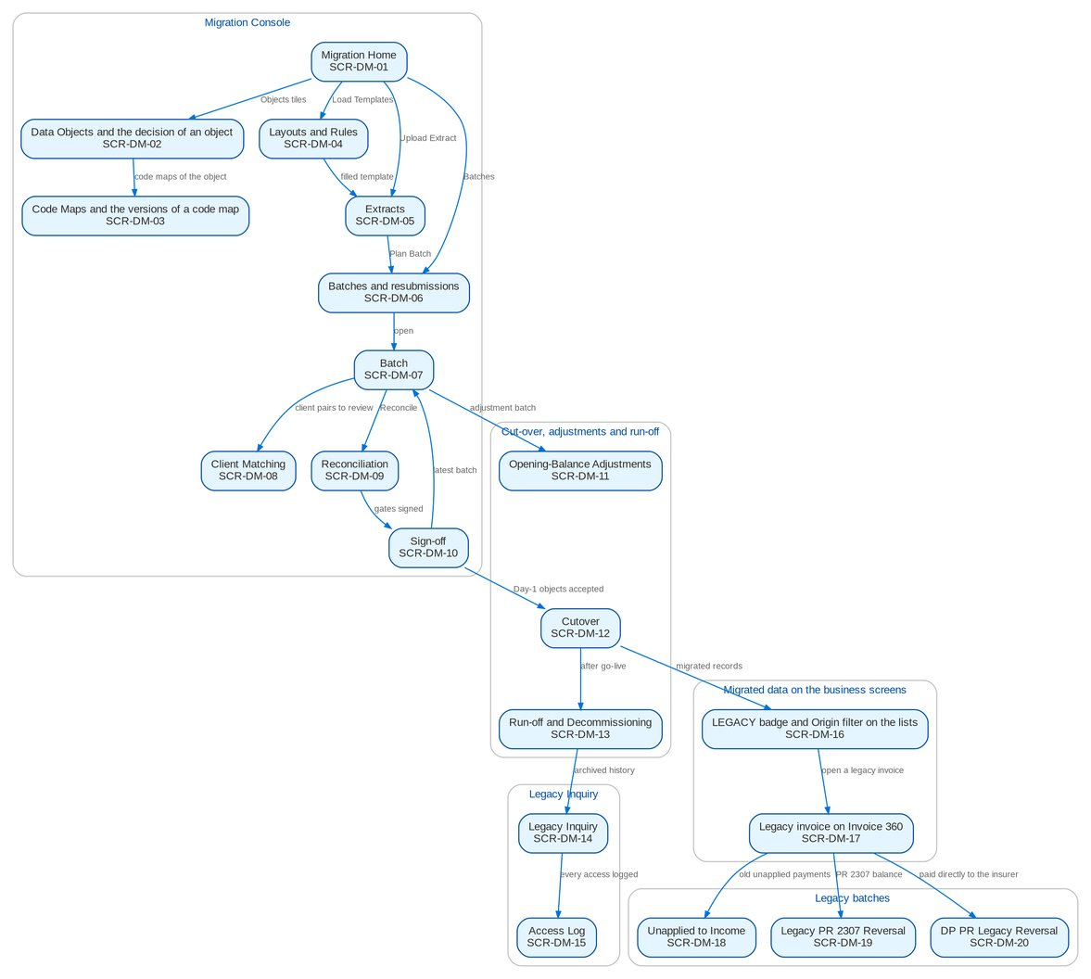
Figure 5: Screen flow of Data Migration: how the screens link (list, record, action, next screen)

17.4 Menu by persona
The Migration Console and Legacy Inquiry are sections of the sidebar group Data Migration. Each persona sees only the entries of its role; the menus below are read from the role grants of BIBS.

17.4.1 Data Migration Lead
SIT/UAT user miglead. 15 menu entries, 10 of them Data Migration screens; the other entries belong to the BRD shown.
Table 44: Sidebar of the Data Migration Lead
Group | Section | Screens | BRD
Home | Overview | My Approvals | Platform
Data Migration | Data Migration | Migration Home, Data Objects, Code Maps, Layouts and Rules, Batches, Reconciliation, Opening Adjustments, Cutover, Run-off and Decommissioning, Sign-off | BRD-13
Reports | New Business Reports | New Business Reports | BRD-1
Reports | Reports | Report Centre | Platform
Setup & Administration | Help | Help Center, My Profile | Platform

17.4.2 Data Steward
SIT/UAT user migsteward. 16 menu entries, 11 of them Data Migration screens; the other entries belong to the BRD shown.
Table 45: Sidebar of the Data Steward
Group | Section | Screens | BRD
Home | Overview | My Approvals | Platform
Data Migration | Data Migration | Migration Home, Data Objects, Code Maps, Layouts and Rules, Batches, Client Matching, Reconciliation, Opening Adjustments, Cutover, Run-off and Decommissioning, Sign-off | BRD-13
Reports | New Business Reports | New Business Reports | BRD-1
Reports | Reports | Report Centre | Platform
Setup & Administration | Help | Help Center, My Profile | Platform

17.4.3 Data owner (business owner of an object)
SIT/UAT user migowner. 15 menu entries, 10 of them Data Migration screens; the other entries belong to the BRD shown.
Table 46: Sidebar of the Data owner (business owner of an object)
Group | Section | Screens | BRD
Home | Overview | My Approvals | Platform
Data Migration | Data Migration | Migration Home, Data Objects, Code Maps, Layouts and Rules, Batches, Reconciliation, Opening Adjustments, Cutover, Run-off and Decommissioning, Sign-off | BRD-13
Reports | New Business Reports | New Business Reports | BRD-1
Reports | Reports | Report Centre | Platform
Setup & Administration | Help | Help Center, My Profile | Platform

17.4.4 Migration Operator
SIT/UAT user migops. 16 menu entries, 11 of them Data Migration screens; the other entries belong to the BRD shown.
Table 47: Sidebar of the Migration Operator
Group | Section | Screens | BRD
Home | Overview | My Approvals | Platform
Data Migration | Data Migration | Migration Home, Data Objects, Code Maps, Layouts and Rules, Extracts, Batches, Reconciliation, Opening Adjustments, Cutover, Run-off and Decommissioning, Sign-off | BRD-13
Reports | New Business Reports | New Business Reports | BRD-1
Reports | Reports | Report Centre | Platform
Setup & Administration | Help | Help Center, My Profile | Platform

17.4.5 Reconciliation approver (Head of Comptrollership)
SIT/UAT user migrecon. 15 menu entries, 10 of them Data Migration screens; the other entries belong to the BRD shown.
Table 48: Sidebar of the Reconciliation approver (Head of Comptrollership)
Group | Section | Screens | BRD
Home | Overview | My Approvals | Platform
Data Migration | Data Migration | Migration Home, Data Objects, Code Maps, Layouts and Rules, Batches, Reconciliation, Opening Adjustments, Cutover, Run-off and Decommissioning, Sign-off | BRD-13
Reports | New Business Reports | New Business Reports | BRD-1
Reports | Reports | Report Centre | Platform
Setup & Administration | Help | Help Center, My Profile | Platform

17.4.6 Go / no-go board
SIT/UAT user miggonogo. 15 menu entries, 10 of them Data Migration screens; the other entries belong to the BRD shown.
Table 49: Sidebar of the Go / no-go board
Group | Section | Screens | BRD
Home | Overview | My Approvals | Platform
Data Migration | Data Migration | Migration Home, Data Objects, Code Maps, Layouts and Rules, Batches, Reconciliation, Opening Adjustments, Cutover, Run-off and Decommissioning, Sign-off | BRD-13
Reports | New Business Reports | New Business Reports | BRD-1
Reports | Reports | Report Centre | Platform
Setup & Administration | Help | Help Center, My Profile | Platform

17.4.7 Comptrollership GL lead
SIT/UAT user comptrol. 71 menu entries, 10 of them Data Migration screens; the other entries belong to the BRD shown.
Table 50: Sidebar of the Comptrollership GL lead
Group | Section | Screens | BRD
Home | Overview | My Approvals | Platform
Home | New Business Dashboard | NB Dashboard | BRD-1
Home | My Work | My Work | BRD-1
Client & Policy | Clients | Clients, KYC Reviews Due | BRD-1
Client & Policy | Accounts & Placement | Accounts, FFY Register, Direct Payment | BRD-1
Client & Policy | Placement & Booking | Placement Workbench, Placement Slips | BRD-1
Client & Policy | Policy Issuance | Issuance Workbench, Insurance Advice | BRD-1
Client & Policy | Product Maintenance | Premium Calculator | BRD-3
Operations | Operations | Operations Home, Invoice Search, Hand-offs and Extracts, Report Archive, Notification Settings | BRD-2
Finance | Collections | Collections Home, PR Worklist, Installment Plans, Installments Due, Promises to Pay, Escalations, Billing Statements, Unapplied Payments, Requests to Cashiering, Collections Files | BRD-4
Finance | Remittance | Remittance Deductions | BRD-2
Finance | Commission Receivables | Commission Workbench, BIR Certificates | BRD-2 / BRD-4
Finance | Disbursement | Disbursement Workbench, Payees, Disbursement End of Day, Account Funding, Bank Accounts and Checks, Disbursement Reports | BRD-5
Finance | ACSL | ACSL Cases, Correction Entries, Insurer SOA Reconciliation, GL-SL Reconciliation | BRD-5
Finance | Accounting Reports | Report Pack, Account Schedules, Service Fee Runs, Service Fee Rates | BRD-5
Finance | General Ledger | Journals, Recurring Journals, Account Inquiry, Party Statement | BRD-5
Finance | Receivables & Banking | Receipts, Cheques & Deposits, PDC Received | BRD-5
Finance | Payables & Cash | Supplier Invoices, Payment Vouchers, PDC Issued, Petty Cash | BRD-5
Finance | Accounting Engine | Event Register | BRD-5
Data Migration | Data Migration | Migration Home, Data Objects, Code Maps, Layouts and Rules, Batches, Reconciliation, Opening Adjustments, Cutover, Run-off and Decommissioning, Sign-off | BRD-13
Reports | New Business Reports | New Business Reports | BRD-1
Reports | Reports | Report Centre | Platform
Setup & Administration | Help | Help Center, My Profile | Platform

17.4.8 Audit / Compliance user
SIT/UAT user legacyaudit. 4 menu entries, 1 of them Data Migration screens; the other entries belong to the BRD shown.
Table 51: Sidebar of the Audit / Compliance user
Group | Section | Screens | BRD
Home | Overview | My Approvals | Platform
Data Migration | Legacy Inquiry | Legacy Inquiry | BRD-13
Setup & Administration | Help | Help Center, My Profile | Platform

17.4.9 Compliance reviewer of the access log
SIT/UAT user legacyrev. 6 menu entries, 1 of them Data Migration screens; the other entries belong to the BRD shown.
Table 52: Sidebar of the Compliance reviewer of the access log
Group | Section | Screens | BRD
Home | Overview | My Approvals | Platform
Data Migration | Legacy Inquiry | Access Log | BRD-13
Reports | New Business Reports | New Business Reports | BRD-1
Reports | Reports | Report Centre | Platform
Setup & Administration | Help | Help Center, My Profile | Platform

17.4.10 Cashiering user
SIT/UAT user cashier. 50 menu entries, 0 of them Data Migration screens; the other entries belong to the BRD shown.
Table 53: Sidebar of the Cashiering user
Group | Section | Screens | BRD
Home | Overview | My Approvals | Platform
Home | New Business Dashboard | NB Dashboard | BRD-1
Home | My Work | My Work | BRD-1
Client & Policy | Clients | Clients, KYC Reviews Due | BRD-1
Client & Policy | Accounts & Placement | Accounts, FFY Register, Direct Payment | BRD-1
Client & Policy | Placement & Booking | Placement Workbench, Placement Slips | BRD-1
Client & Policy | Policy Issuance | Issuance Workbench, Insurance Advice | BRD-1
Client & Policy | Product Maintenance | Premium Calculator | BRD-3
Client & Policy | Bulk Processing | Bulk Uploads | BRD-1
Operations | Operations | Operations Home, Invoice Search, Hand-offs and Extracts, Report Archive, Notification Settings | BRD-2
Finance | Collections | Collections Home, PR Worklist, Installment Plans, Installments Due, Promises to Pay, Escalations, Billing Statements, Unapplied Payments, Requests to Cashiering, Collections Files | BRD-4
Finance | Cashiering | Cashiering Workbench, Receive Payment, Receipts, Unapplied Payments, Incoming Requests, Pre-booked Payments, Payment Uploads, PDC Warehouse, Check Pick-up, Batch Print, BIR 2307, Unapplied to Income, Legacy PR 2307 Reversal, Commission ORs, Receipt Series, Cashiering Setup | BRD-2
Finance | Commission Receivables | DP PR Legacy Reversal | BRD-2 / BRD-4
Reports | New Business Reports | New Business Reports | BRD-1
Reports | Reports | Report Centre | Platform
Setup & Administration | Help | Help Center, My Profile | Platform

17.4.11 Cashiering team lead
SIT/UAT user cashtl. 80 menu entries, 0 of them Data Migration screens; the other entries belong to the BRD shown.
Table 54: Sidebar of the Cashiering team lead
Group | Section | Screens | BRD
Home | Overview | My Approvals | Platform
Home | New Business Dashboard | NB Dashboard | BRD-1
Home | My Work | My Work | BRD-1
Client & Policy | Clients | Clients, KYC Reviews Due | BRD-1
Client & Policy | Accounts & Placement | Accounts, FFY Register, Direct Payment | BRD-1
Client & Policy | Placement & Booking | Placement Workbench, Placement Slips | BRD-1
Client & Policy | Policy Issuance | Issuance Workbench, Insurance Advice | BRD-1
Client & Policy | Booking | Booking Setup | BRD-1
Client & Policy | Product Maintenance | Products, Coverages & Clauses, Insurers, Rates & Taxes, Sales Organisation, Premium Calculator | BRD-3
Client & Policy | Bulk Processing | Bulk Uploads | BRD-1
Operations | Operations | Operations Home, Invoice Search, Hand-offs and Extracts, Report Archive, Notification Settings | BRD-2
Finance | Collections | Collections Home, PR Worklist, Installment Plans, Installments Due, Promises to Pay, Escalations, Billing Statements, Unapplied Payments, Requests to Cashiering, Collections Files | BRD-4
Finance | Cashiering | Cashiering Workbench, Receive Payment, Receipts, Unapplied Payments, Incoming Requests, Pre-booked Payments, Payment Uploads, PDC Warehouse, Check Pick-up, Batch Print, BIR 2307, Unapplied to Income, Legacy PR 2307 Reversal, Commission ORs, Receipt Series, Cashiering Setup | BRD-2
Finance | Commission Receivables | DP PR Legacy Reversal | BRD-2 / BRD-4
Finance | General Ledger | Chart of Accounts, Financial Periods | BRD-5
Finance | Payables & Cash | Bank Accounts | BRD-5
Finance | Assets & Investments | Asset Categories, Asset Register, Depreciation Run, Investment Portfolios, Investments, Accrual & Amortization, Maturities & Sales | BRD-5
Finance | Accounting Engine | Event Types, Accounting Rules, Rule Simulator | BRD-5
Reports | New Business Reports | New Business Reports, Production Targets | BRD-1
Reports | Reports | Report Centre | Platform
Setup & Administration | Broking Setup | Data Retention, Document Templates | BRD-1
Setup & Administration | Setup | Companies, Branches, Currencies & Rates, Dimensions, Business Partners, Employees, Cost-Centre Rules, Holiday Calendar | Platform
Setup & Administration | Help | Help Center, My Profile | Platform

17.4.12 Top management approver
SIT/UAT user topmgmt. 4 menu entries, 0 of them Data Migration screens; the other entries belong to the BRD shown.
Table 55: Sidebar of the Top management approver
Group | Section | Screens | BRD
Home | Overview | My Approvals | Platform
Finance | Cashiering | Unapplied to Income | BRD-2
Setup & Administration | Help | Help Center, My Profile | Platform

17.4.13 Commission user
SIT/UAT user commrec. 34 menu entries, 0 of them Data Migration screens; the other entries belong to the BRD shown.
Table 56: Sidebar of the Commission user
Group | Section | Screens | BRD
Home | Overview | My Approvals | Platform
Home | New Business Dashboard | NB Dashboard | BRD-1
Home | My Work | My Work | BRD-1
Client & Policy | Clients | Clients, KYC Reviews Due | BRD-1
Client & Policy | Accounts & Placement | Accounts, FFY Register, Direct Payment | BRD-1
Client & Policy | Placement & Booking | Placement Workbench, Placement Slips | BRD-1
Client & Policy | Policy Issuance | Issuance Workbench, Insurance Advice | BRD-1
Client & Policy | Product Maintenance | Premium Calculator | BRD-3
Client & Policy | Bulk Processing | Bulk Uploads | BRD-1
Operations | Operations | Operations Home, Invoice Search, Hand-offs and Extracts, Report Archive, Notification Settings | BRD-2
Finance | Cashiering | Legacy PR 2307 Reversal | BRD-2
Finance | Commission Receivables | Commission Workbench, DP Lists, DP Accounts, DP Billings, Insurer Responses, Incentive Schemes, Incentive Runs, BIR Certificates, DP PR Legacy Reversal, Estimated Items | BRD-2 / BRD-4
Reports | New Business Reports | New Business Reports | BRD-1
Reports | Reports | Report Centre | Platform
Setup & Administration | Help | Help Center, My Profile | Platform

17.4.14 Commission team lead
SIT/UAT user commtl. 35 menu entries, 0 of them Data Migration screens; the other entries belong to the BRD shown.
Table 57: Sidebar of the Commission team lead
Group | Section | Screens | BRD
Home | Overview | My Approvals | Platform
Home | New Business Dashboard | NB Dashboard | BRD-1
Home | My Work | My Work | BRD-1
Client & Policy | Clients | Clients, KYC Reviews Due | BRD-1
Client & Policy | Accounts & Placement | Accounts, FFY Register, Direct Payment | BRD-1
Client & Policy | Placement & Booking | Placement Workbench, Placement Slips | BRD-1
Client & Policy | Policy Issuance | Issuance Workbench, Insurance Advice | BRD-1
Client & Policy | Product Maintenance | Premium Calculator | BRD-3
Client & Policy | Bulk Processing | Bulk Uploads | BRD-1
Operations | Operations | Operations Home, Invoice Search, Hand-offs and Extracts, Report Archive, Notification Settings | BRD-2
Finance | Cashiering | Legacy PR 2307 Reversal | BRD-2
Finance | Commission Receivables | Commission Workbench, DP Lists, DP Accounts, DP Billings, Insurer Responses, Incentive Schemes, Incentive Runs, BIR Certificates, DP PR Legacy Reversal, Estimated Items | BRD-2 / BRD-4
Reports | New Business Reports | New Business Reports, Production Targets | BRD-1
Reports | Reports | Report Centre | Platform
Setup & Administration | Help | Help Center, My Profile | Platform

17.4.15 Marketing Account Officer
SIT/UAT user ao. 61 menu entries, 0 of them Data Migration screens; the other entries belong to the BRD shown.
Table 58: Sidebar of the Marketing Account Officer
Group | Section | Screens | BRD
Home | Overview | My Approvals | Platform
Home | New Business Dashboard | NB Dashboard | BRD-1
Home | My Work | My Work | BRD-1
Client & Policy | Clients | Clients, New Client, KYC Reviews Due | BRD-1
Client & Policy | Quotation / Proposal | Quotations, New Quotation, Quotation Requests | BRD-1
Client & Policy | Accounts & Placement | Accounts, New Account, FFY Register, Direct Payment | BRD-1
Client & Policy | Non-Package Management | Proposal Requests, New Proposal Request | BRD-1
Client & Policy | Placement & Booking | Placement Workbench, Placement Slips | BRD-1
Client & Policy | Policy Issuance | Issuance Workbench, Insurance Advice | BRD-1
Client & Policy | Renewal | Renewal Home, Expiry List, My Dispositions, Transfers, Letters | BRD-6
Client & Policy | Submitted Policies | Submitted Policies Home, Masterlist, Extraction Review, Processing Runs, Reviews & IAAF, Terms of Reference, Renewal Work List | -
Client & Policy | Product Maintenance | Product Maintenance Home, Package Requests, Products, Coverages & Clauses, Incentive Criteria, Premium Calculator | BRD-3
Client & Policy | Bulk Processing | Bulk Uploads | BRD-1
Operations | Operations | Operations Home, Invoice Search, Hand-offs and Extracts, Notification Settings | BRD-2
Finance | Collections | Collections Home, PR Worklist, Installment Plans, Installments Due, Promises to Pay, Escalations, Billing Statements, Unapplied Payments, Requests to Cashiering, Collections Files | BRD-4
Finance | Refund & Cash Advance Requests | Requests Home, New Refund Request, New Cash Advance, Cancel a Check | BRD-5
Claims & Insurance | Claims Handling | Claims Reports | BRD-7
Reports | New Business Reports | New Business Reports | BRD-1
Reports | Reports | Report Centre | Platform
Setup & Administration | Help | Help Center, My Profile | Platform

18 Common screen elements
Table 59: Common screen elements
Element | What the user sees and does
Page header and section | Every page shows its section (Data Migration, Legacy Inquiry, Cashiering or Commission) and title, a one-line description and its actions on the right. The migration screens are the Migration Console: one catalogue of objects, layouts, code maps and rules for the programme, and the extracts, batches, reconciliations and plans of the company chosen in the header.
Work lists and record panels | Lists show a filter row where the list has filters and a paged table ("Showing 1 to n of N results"). Rows alternate white and Background Blue; a long list scrolls inside its card with the header row in view. A row opens its record in a panel under the list (object, code map, layout, reconciliation, cut-over plan, legacy record) or on a page of its own (batch, legacy batch). Dates show as dd-MMM-yyyy and times as dd-MMM-yyyy HH:mm in Philippine time; amounts with two decimals and thousand separators.
Status pills and the batch steps | Statuses are outlined pills of one colour per state group (Proposed, For decision, Decided; Planned, Validated, Loaded, Loaded with rejects, Reconciled, Accepted, Rolled back; Matched, Break, Explained). A batch shows its steps as a stepper: Planned, Validated, Load approved, Loaded, Reconciled, Accepted, with the steps done marked.
Confirmation and reason | Every submit, approve, return, sign, load, rollback, post and decide action opens a confirmation dialog that names the record and the effect of the action. A return, a rejection, a rollback request, a NO-GO and a blocked task need a reason; an approval takes an optional comment. The reason is kept with the record and in the audit trail.
Maker-checker and gates | The user who prepares a decision, code map version, load, rollback, opening-balance adjustment, resubmission or legacy batch never approves it: the approve button is not offered to that user and the system refuses it. The operator who ran a batch cannot sign its reconciliation or acceptance, and one person cannot sign two gates of the same batch. Gates G1 to G7 are signed in order.
Downloads | Templates, workbooks, rejection files, evidence and reports download as Excel or CSV files. Extract files and staged rows are kept only until the staging purge (5 days after the batch is accepted or rolled back); counts, totals and sign-offs stay.
Migrated records in the business screens | A record migrated from a legacy system shows a LEGACY badge next to its number on its list and record, with the source system, legacy reference and migration batch in the tooltip. Lists that hold migrated records have an Origin filter (All origins, BIBS, Migrated). Migrated records raise no notification to clients or insurers.
Messages | Field errors appear under the field in red; a banner at the top of a dialog or card lists the refusal of a business rule with its message and a reference for support. Success is confirmed by a short message at the bottom right of the page. Intake, validation and load results are also written to the run log of the batch.
Notifications and alerts | The migration raises alerts to the Data Migration Lead and the owners concerned: extract rejected, load failed, unmapped codes, reconciliation break, Migration Clearing not zero, staging purge overdue, unusual access to the legacy archive, and a break of an opening-balance adjustment. The bell in the header opens them.

19 Screen specifications

19.1 Migration Console

19.1.1 SCR-DM-01 Migration Home
Purpose | Shows the progress of the migration at a glance: objects decided and waiting for a decision, batches in progress, failed or with rejects, open reconciliation breaks, unmapped legacy codes, open validation errors and client pairs to review, with the next cut-over tasks and the run-off of the legacy policies. Each tile opens the screen where the item is worked.
Who can open it | Data Migration Lead, Data Steward, Data owner (business owner of an object), Migration Operator, Reconciliation approver (Head of Comptrollership), Go / no-go board, Comptrollership GL lead (permission Data migration view)
Navigation | • Menu: Data Migration › Data Migration › Migration Home  • Sidebar › Data Migration › Migration Home  • Landing page after sign-in of the migration roles
FRs | FR-DM-003, FR-DM-120, FR-DM-122

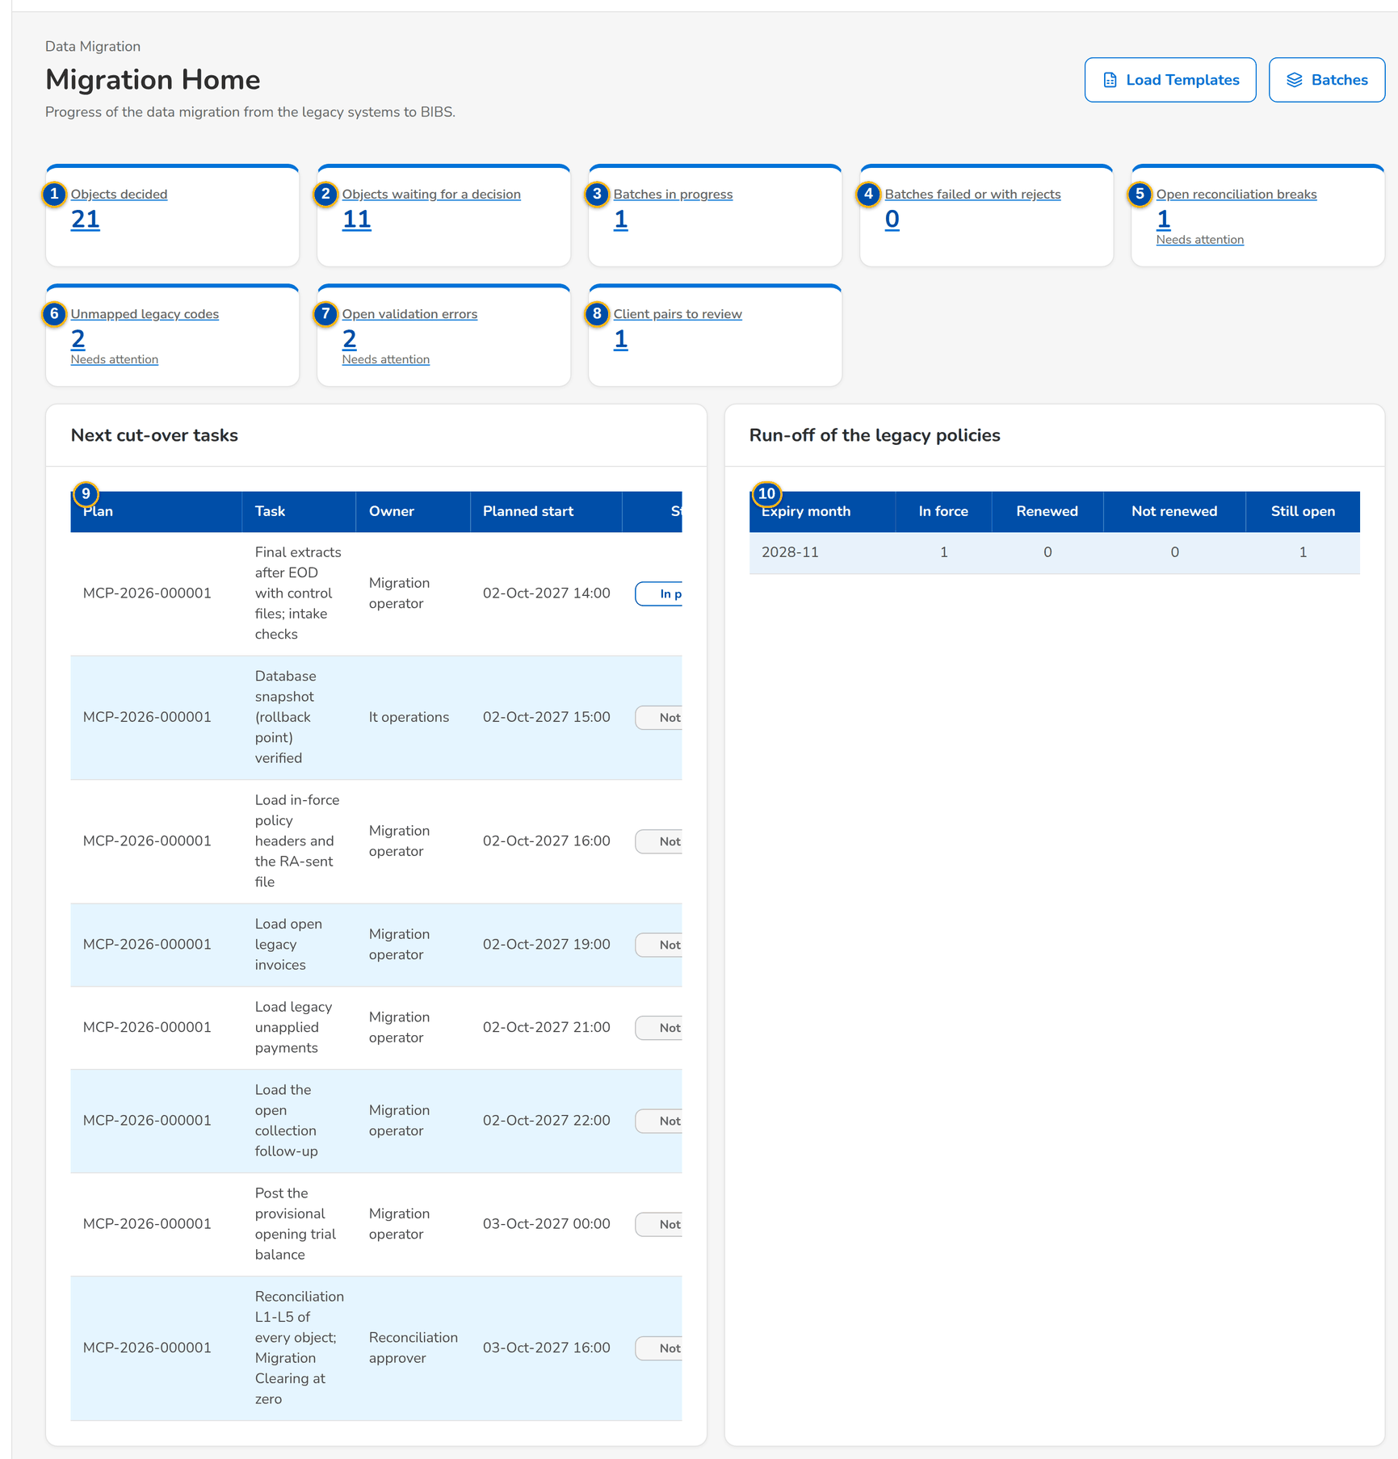
Figure 6: SCR-DM-01 Migration Home with the tiles
1 | Objects decided | 5 | Open reconciliation breaks | 9 | Plan, Task, Owner, Planned start, Status
2 | Objects waiting for a decision | 6 | Unmapped legacy codes | 10 | Expiry month, In force, Renewed, Not renewed, Still open
3 | Batches in progress | 7 | Open validation errors
4 | Batches failed or with rejects | 8 | Client pairs to review

Fields (No. = callout number on the first screenshot)
No. | Section | Field | Type | Length / format | Mand. | Source / list | Default | Editable in | Validation | Message when it fails
1 | Tiles | Objects decided | Tile | Count | - | Data objects | - | - | - | -
2 | Tiles | Objects waiting for a decision | Tile | Count of Proposed and For decision objects | - | Data objects | - | - | - | -
3 | Tiles | Batches in progress | Tile | Count of Planned, Validated, Load approved and Loading batches | - | Batches | - | - | - | -
4 | Tiles | Batches failed or with rejects | Tile | Count; Needs attention when above 0 | - | Batches | - | - | - | -
5 | Tiles | Open reconciliation breaks | Tile | Count; Needs attention when above 0 | - | Reconciliation | - | - | - | -
6 | Tiles | Unmapped legacy codes | Tile | Count; Needs attention when above 0 | - | Code Maps, Unmapped Codes tab | - | - | - | -
7 | Tiles | Open validation errors | Tile | Count; Needs attention when above 0 | - | Batch issues | - | - | - | -
8 | Tiles | Client pairs to review | Tile | Count | - | Client Matching | - | - | - | -
9 | Next cut-over tasks | Plan, Task, Owner, Planned start, Status | Columns | dd-MMM-yyyy HH:mm | - | Open tasks of the cut-over plans | - | - | - | -
10 | Run-off of the legacy policies | Expiry month, In force, Renewed, Not renewed, Still open | Columns | Month yyyy-MM | - | Latest run-off snapshot | - | - | - | -

Actions
Button | Who | Enabled when | What happens | Resulting status | Notification
Load Templates | Every migration role | Always | Opens Layouts and Rules with the templates | - | -
Batches | Every migration role | Always | Opens the batch list | - | -
Upload Extract | Migration Operator | Always | Opens Extracts to upload a file with its control file | - | -
A tile | Every migration role | Always | Opens the screen of the tile | - | -

Business rules
• A tile marked Needs attention has at least one item that blocks a gate: a failed batch, a break, an unmapped code or an open error (FR-DM-003).
• The migration roles (operator, steward, owner, lead, reconciliation approver, go / no-go board) land on Migration Home after sign-in; My Approvals stays one click away in the header (FR-DM-003).
• The run-off table is the latest monthly snapshot of the legacy policies in force at go-live (FR-DM-122).
Expected outcome
The Data Migration Lead sees what blocks the next gate and opens it in one click.
Test cases: TC-DM-SCR-01.

19.1.2 SCR-DM-02 Data Objects and the decision of an object
Purpose | The register of the legacy data objects: what moves, in which class (migrate, carry forward, conditional, archive or excluded), from which systems, into which part of BIBS and in which load order. An object opens in a panel with the four criteria of the BRD, the owners, the rationale and the decision history; the Data Migration Lead submits the proposed class and the business owner approves or returns it (gate G1). The load template of each object downloads from its row.
Who can open it | Data Migration Lead, Data Steward, Data owner (business owner of an object), Migration Operator, Reconciliation approver (Head of Comptrollership), Go / no-go board, Comptrollership GL lead (permission Data migration view)
Navigation | • Menu: Data Migration › Data Migration › Data Objects  • Migration Home › Objects decided  • Sign-off › object
FRs | FR-DM-001, FR-DM-002, FR-DM-003

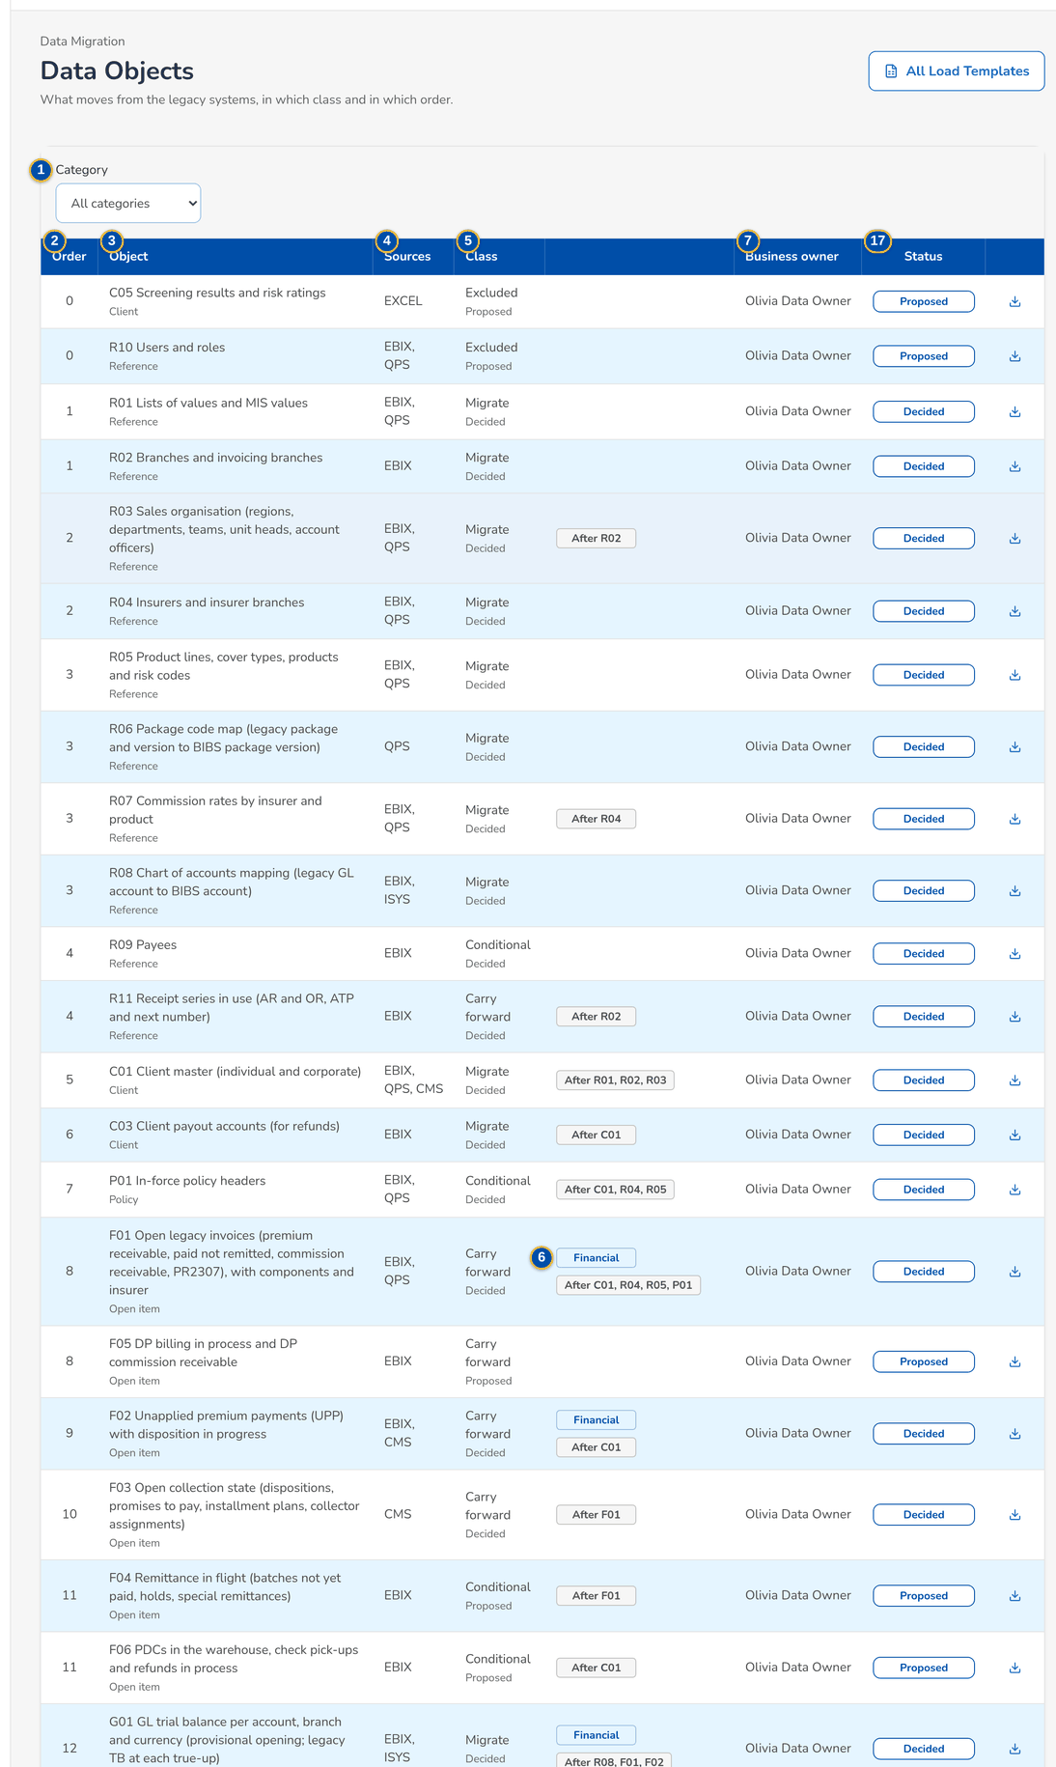
Figure 7: SCR-DM-02 Data Objects register with the class and status of each object
1 | Category | 7 | Business owner | 13 | Data trust
2 | Order | 8 | Status | 14 | Business owner, Data steward
3 | Object | 9 | Category, Sources, Target in BIBS | 15 | Depends on, Load order
4 | Sources | 10 | Proposed class, Decided class | 16 | Rationale
5 | Class | 11 | Condition | 17 | Decision, Class, Submitted by, Submitted, Decided by, Return reason, Status
6 | Financial and After tags | 12 | Day-1 need, Compliance need, Archive option

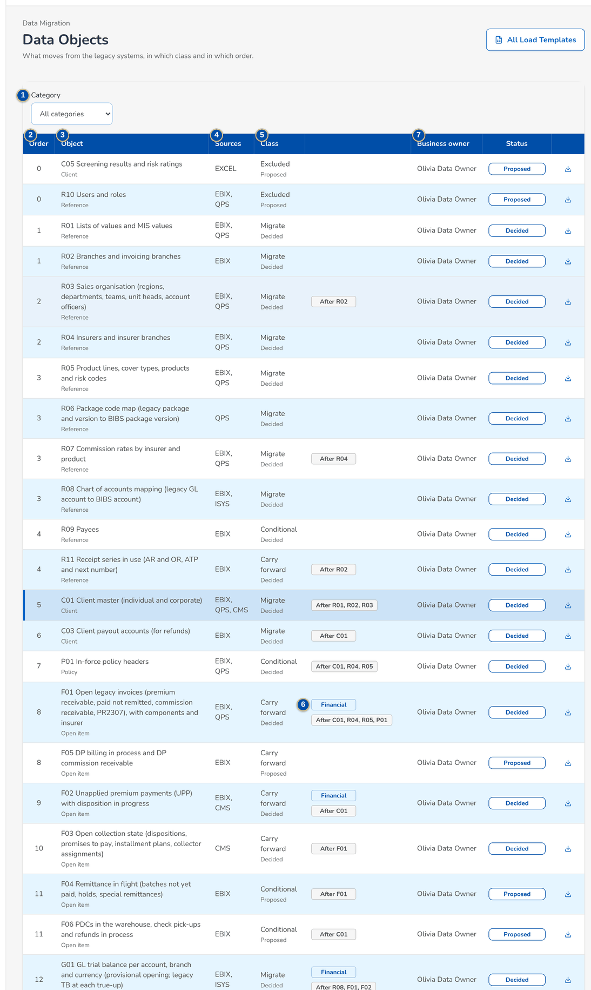
Figure 8: SCR-DM-02 Object C01 with the four criteria, the rationale and the decision history

Fields (No. = callout number on the first screenshot)
No. | Section | Field | Type | Length / format | Mand. | Source / list | Default | Editable in | Validation | Message when it fails
1 | Filter | Category | Drop-down | All categories, Reference, Client, Policy, Open item, GL, History | N | Categories of the register | All categories | - | - | -
2 | Register | Order | Column | Load order | - | Object | - | - | - | -
3 | Register | Object | Column | Code and name, category under it | - | Object | - | - | - | -
4 | Register | Sources | Column | Legacy systems | - | Object | - | - | - | -
5 | Register | Class | Column | Decided class, or the proposed class marked Proposed | - | Decision | Proposed class | - | - | -
6 | Register | Financial and After tags | Tag | Financial object; objects it loads after | - | Object | - | - | - | -
7 | Register | Business owner | Column | Name | - | Object | - | - | - | -
8 | Register | Status | Pill | Proposed, For decision, Decided | - | Decision | Proposed | - | - | -
9 | Object panel | Category, Sources, Target in BIBS | Text | - | - | Object | - | - | - | -
10 | Object panel | Proposed class, Decided class | Text | Migrate, Carry forward, Conditional, Archive, Excluded | - | Decision | - | - | - | -
11 | Object panel | Condition | Text | Condition of a conditional object | - | Object | - | - | - | -
12 | Object panel | Day-1 need, Compliance need, Archive option | Text | Yes or No, with the note | - | The four criteria of the BRD | - | - | - | -
13 | Object panel | Data trust | Text | High, Medium, Low | - | Object | - | - | - | -
14 | Object panel | Business owner, Data steward | Text | Name, or the proposed role until named | - | Object | - | - | - | -
15 | Object panel | Depends on, Load order | Text | Objects and number | - | Object | - | - | - | -
16 | Object panel | Rationale | Text | Up to 2,000 characters | - | Object | - | - | - | -
17 | Decision history | Decision, Class, Submitted by, Submitted, Decided by, Return reason, Status | Columns | Decision number MGD-yyyy-nnnnnn | - | Decisions of the object | - | - | - | -

Actions
Button | Who | Enabled when | What happens | Resulting status | Notification
All Load Templates | Every migration role | Always | Downloads the workbook of every load template with the columns, the control file and the How to fill rules | - | -
Download on a row | Every migration role | Always | Downloads the load template workbook of the object | - | -
Submit for Decision | Data Migration Lead | Object not waiting for a decision | Sends the proposed class to the business owner after a confirmation | For decision | Alert to the business owner
Approve | Data owner (business owner of the object) | Decision For decision and submitted by another user | Decides the class of the object (gate G1), with an optional comment | Decided | -
Return | Data owner | Decision For decision and submitted by another user | Returns the proposal to the Data Migration Lead with the reason | Proposed | -
Close | Every migration role | Always | Closes the panel | - | -

Business rules
• An object loads only after the objects it depends on are accepted in the same environment; its load order follows theirs (FR-DM-001).
• The business owner of the object decides its class, never the user who submitted it (FR-DM-002).
• The class of an object whose batches are loaded changes only after the batches are rolled back (FR-DM-002).
• Only objects decided as Migrate, Carry forward or Conditional (with its condition met) can be planned in a batch; archive objects load into the legacy archive (FR-DM-002).
Expected outcome
Every object has a decided class signed by its business owner (gate G1) and its load template.
Test cases: TC-DM-001.1-01, TC-DM-001.2-01, TC-DM-001.4-01, TC-DM-002.1-01, TC-DM-002.2-01, TC-DM-002.4-01, TC-DM-SCR-02, TC-DM-MSG-01.

19.1.3 SCR-DM-03 Code Maps and the versions of a code map
Purpose | The code maps that turn the legacy codes of each source system into BIBS values (lists of values, insurers, products, packages, branches, sales units, users, GL accounts, statuses and more). A code map opens with its versions and the entries of the chosen version. The Data Steward prepares a draft version on screen or in Excel and submits it; the business owner approves or returns it (gate G2). The Unmapped Codes tab lists the legacy codes found without an entry in the batches under validation.
Who can open it | Data Migration Lead, Data Steward, Data owner (business owner of an object), Migration Operator, Reconciliation approver (Head of Comptrollership), Go / no-go board, Comptrollership GL lead (permission Data migration view)
Navigation | • Menu: Data Migration › Data Migration › Code Maps  • Migration Home › Unmapped legacy codes  • Batch › Issues
FRs | FR-DM-011, FR-DM-012, FR-DM-034

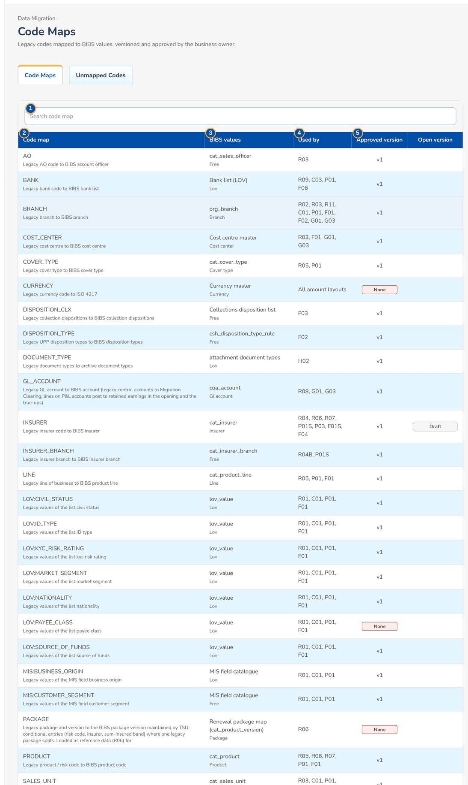
Figure 9: SCR-DM-03 Code Maps with the approved and open version of each map
1 | Search code map | 7 | Version, Comment, Prepared by, Approved by, Approved, Return reason, Status | 13 | BIBS value
2 | Code map | 8 | Source, Legacy code, Legacy description, Condition, Action, BIBS value, Remarks | 14 | Condition column, Condition value
3 | BIBS values | 9 | Source | 15 | Remarks
4 | Used by | 10 | Legacy code | 16 | Code map, Source, Legacy code, Rows, Example records, Blocks the load
5 | Approved version | 11 | Legacy description
6 | Open version | 12 | Action

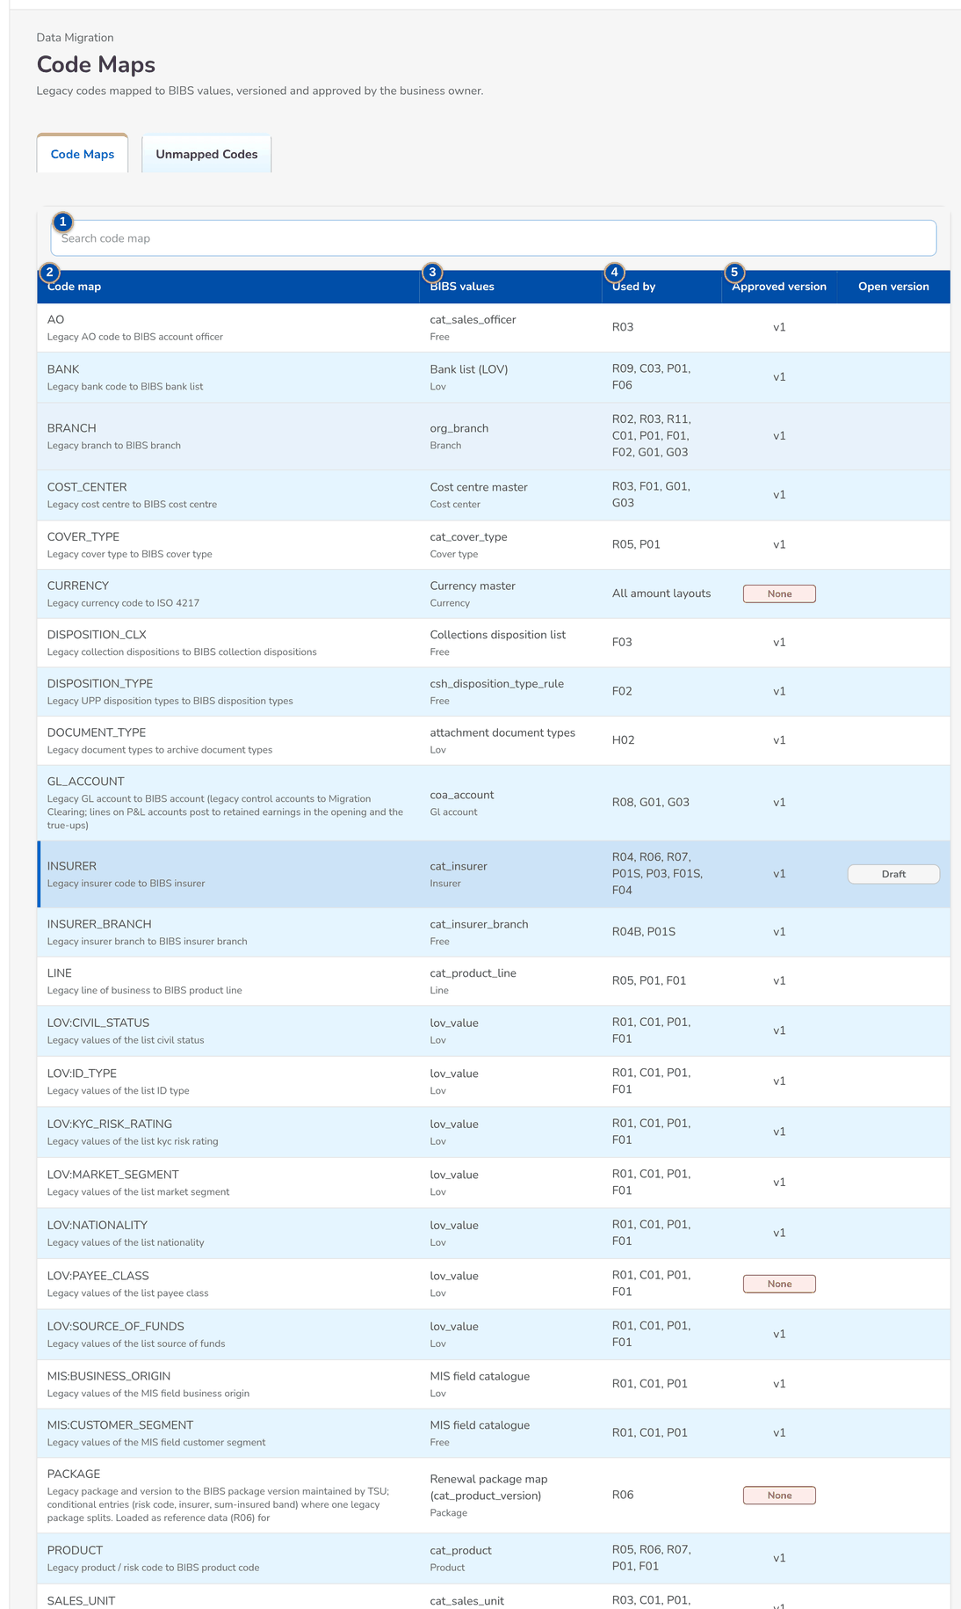
Figure 10: SCR-DM-03 Code map INSURER with its versions and the entries of the version

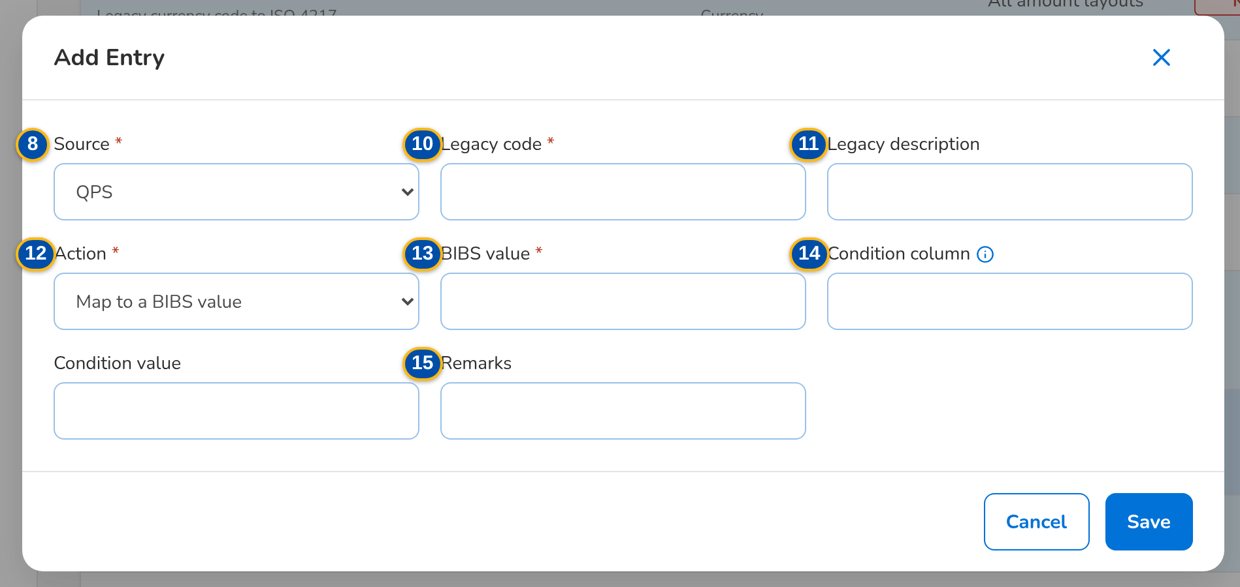
Figure 11: SCR-DM-03 Add Entry dialog of a draft version
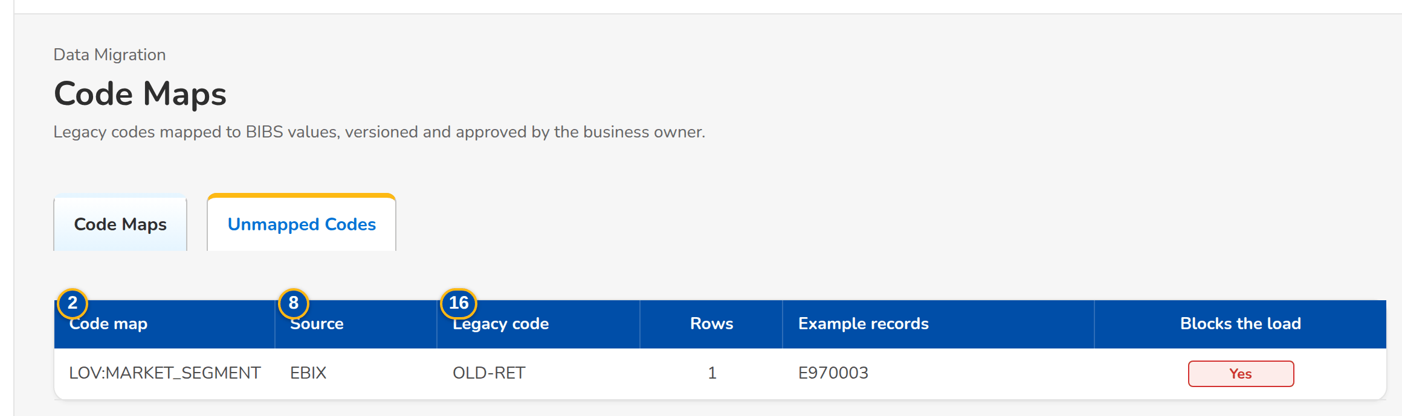
Figure 12: SCR-DM-03 Unmapped Codes tab
Fields (No. = callout number on the first screenshot)
No. | Section | Field | Type | Length / format | Mand. | Source / list | Default | Editable in | Validation | Message when it fails
1 | Code Maps tab | Search code map | Search | Code or name | N | - | - | - | - | -
2 | Code Maps tab | Code map | Column | Set code with its name under it | - | Code map sets | - | - | - | -
3 | Code Maps tab | BIBS values | Column | What the codes map to | - | Code map sets | - | - | - | -
4 | Code Maps tab | Used by | Column | Layouts whose columns use the map | - | Code map sets | - | - | - | -
5 | Code Maps tab | Approved version | Column | vN, or None in red | - | Versions | - | - | - | -
6 | Code Maps tab | Open version | Pill | Draft or Submitted | - | Versions | - | - | - | -
7 | Versions | Version, Comment, Prepared by, Approved by, Approved, Return reason, Status | Columns | Draft, Submitted, Approved, Superseded | - | Versions of the map | - | - | - | -
8 | Entries | Source, Legacy code, Legacy description, Condition, Action, BIBS value, Remarks | Columns | - | - | Entries of the version | - | - | - | -
9 | Add Entry | Source | Drop-down | EBIX, QPS, ISYS, EXCEL, CMS | Y | Source systems | QPS | Draft | - | -
10 | Add Entry | Legacy code | Text | Up to 80 characters | Y | - | - | Draft | Unique per source and condition in the version | Legacy code <legacy code> of <source system> is mapped twice
11 | Add Entry | Legacy description | Text | Up to 250 characters | N | - | - | Draft | - | -
12 | Add Entry | Action | Drop-down | Map to a BIBS value, Create in BIBS, Use the default value, Reject the record | Y | - | Map to a BIBS value | Draft | - | Enter the source system, the legacy code and the action
13 | Add Entry | BIBS value | Text | A value of the BIBS master | C | The master of the map | - | Draft | Mandatory for Map; the value exists in BIBS | Enter the target code of legacy code <legacy code>
14 | Add Entry | Condition column, Condition value | Text | Column and value of a conditional entry, for example insurer_code | N | Layout columns | - | Draft | - | -
15 | Add Entry | Remarks | Text | Up to 300 characters | N | - | - | Draft | - | -
16 | Unmapped Codes tab | Code map, Source, Legacy code, Rows, Example records, Blocks the load | Columns | Blocks the load Yes for a mandatory column | - | Validation issues of the batches | - | - | - | -

Actions
Button | Who | Enabled when | What happens | Resulting status | Notification
New Version | Data Steward | No version is being edited or waiting for approval | Creates a draft from the approved version, with an optional comment | Draft | -
Import Excel | Data Steward | No open version | Creates a draft version from an Excel file with the columns source_system, legacy_code and action | Draft | -
Export | Every migration role | A version is chosen | Downloads the entries of the version in Excel | - | -
Add Entry | Data Steward | Version is a draft | Adds an entry; a row of a draft opens it for change; the bin removes it | Draft | -
Submit | Data Steward | Version is a draft with at least one entry | Sends the version to the business owner after a confirmation | Submitted | -
Approve | Data owner | Version submitted by another user | Makes the version the approved one; values marked Create are created through the reference-data load | Approved; the previous version Superseded | -
Return | Data owner | Version submitted by another user | Returns the version to the Data Steward as a draft with the reason | Draft | -

Business rules
• Only the approved version of a map is used by a batch, and the batch records the versions it used (FR-DM-011).
• A map has one version being edited or waiting for approval at a time (FR-DM-011).
• The business owner approves a version, never the Data Steward who submitted it (FR-DM-011).
• A batch with an unmapped code in a mandatory column cannot be approved for load (FR-DM-012).
• Legacy packages are mapped to package versions in the package code map, which Renewal uses at sanitation; the migration does not resolve packages on the policy headers (FR-DM-034).
Expected outcome
Every legacy code used by a record in scope has an approved entry, and every batch records the versions it used.
Test cases: TC-DM-011.1-01, TC-DM-011.2-01, TC-DM-011.3-01, TC-DM-011.4-01, TC-DM-012.1-01, TC-DM-012.2-02, TC-DM-034.4-01, TC-DM-034.6-01, TC-DM-SCR-03, TC-DM-MSG-02.

19.1.4 SCR-DM-04 Layouts and Rules
Purpose | The extract layouts in force with their columns: the single source of the load templates BDOI fills. A layout opens with its columns (name, description, type and length, mandatory, code map, format, example, validation). The screen downloads the CSV template of a layout, the workbook of an object, the workbook of all templates and the control-file template. The Data-Quality Rules tab lists the checks run on every row; the Masking Rules tab lists the personal data masked outside production.
Who can open it | Data Migration Lead, Data Steward, Data owner (business owner of an object), Migration Operator, Reconciliation approver (Head of Comptrollership), Go / no-go board, Comptrollership GL lead (permission Data migration view)
Navigation | • Menu: Data Migration › Data Migration › Layouts and Rules  • Migration Home › Load Templates  • Data Objects › All Load Templates
FRs | FR-DM-010, FR-DM-013, FR-DM-003

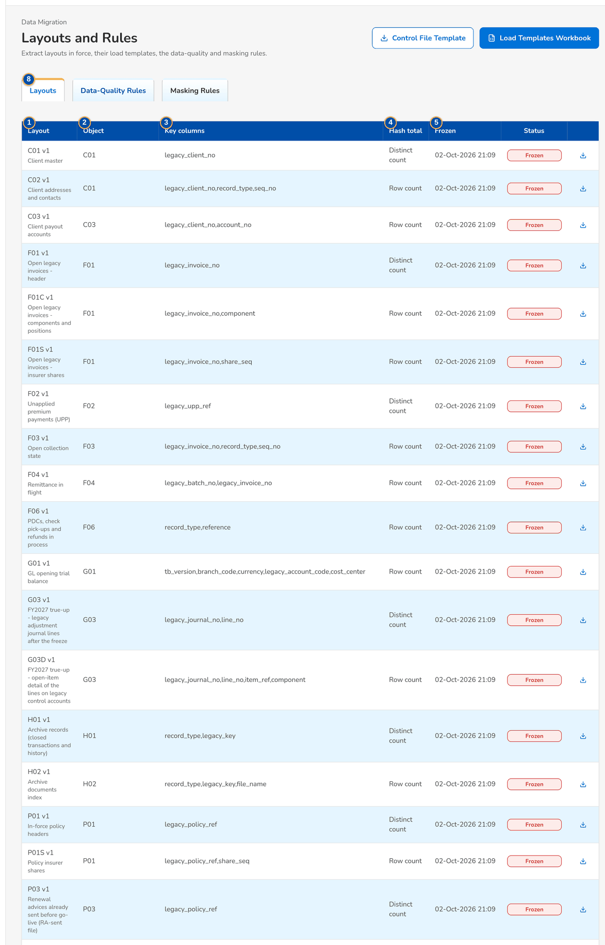
Figure 13: SCR-DM-04 Layouts in force with their key columns and hash total
1 | Layout | 4 | Hash total | 7 | #, Column, Type, Mandatory, Code map, Format, Example, Validation
2 | Object | 5 | Frozen | 8 | Rule, Layouts, Columns, Check, Severity, Fixed by, Active
3 | Key columns | 6 | Status | 9 | Layout, Column, Masking, Active

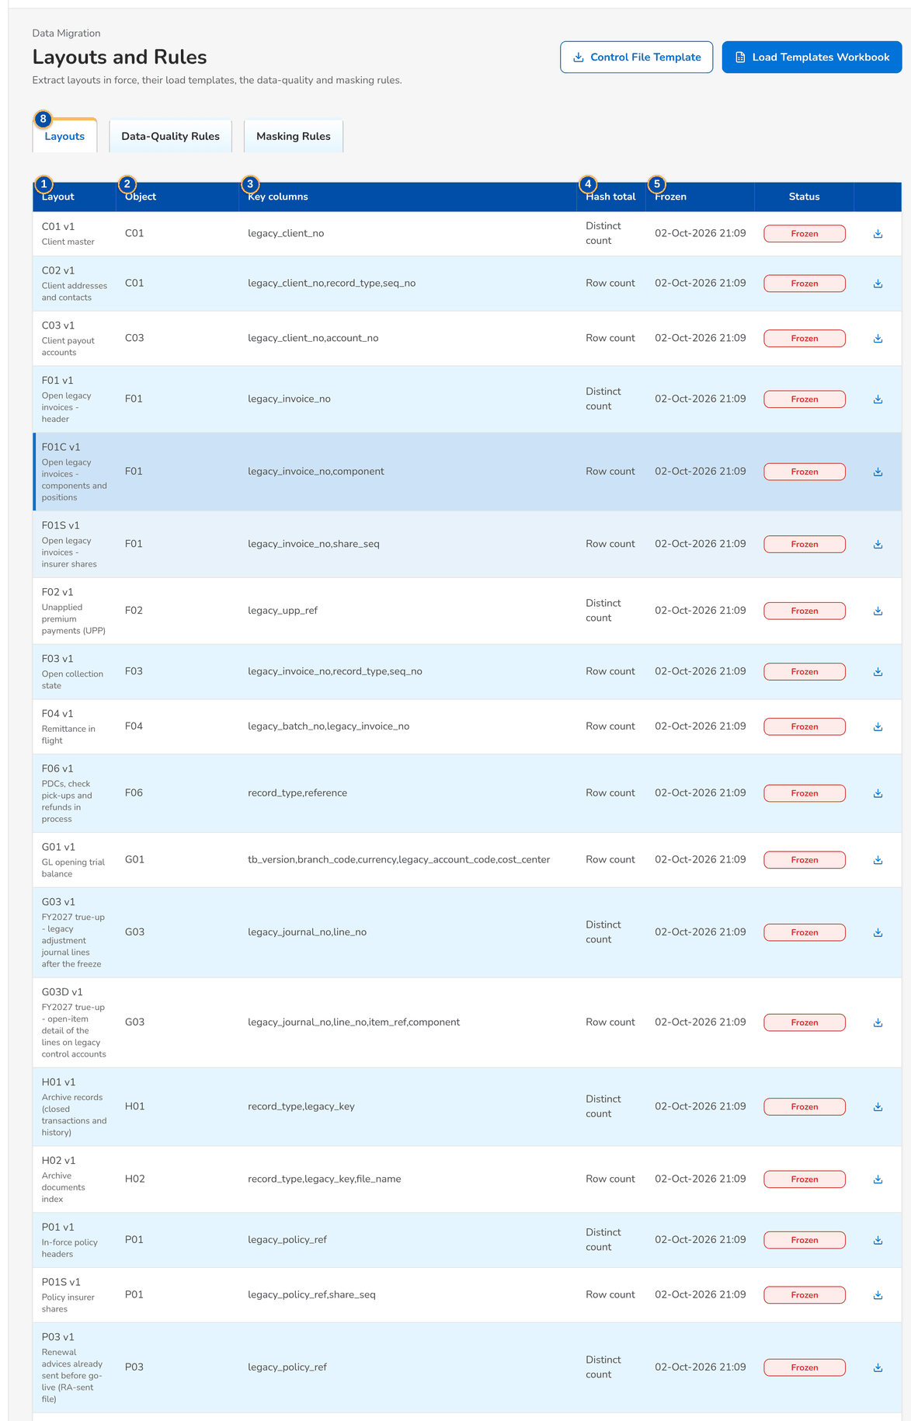
Figure 14: SCR-DM-04 Columns of layout F01C (open invoice components)

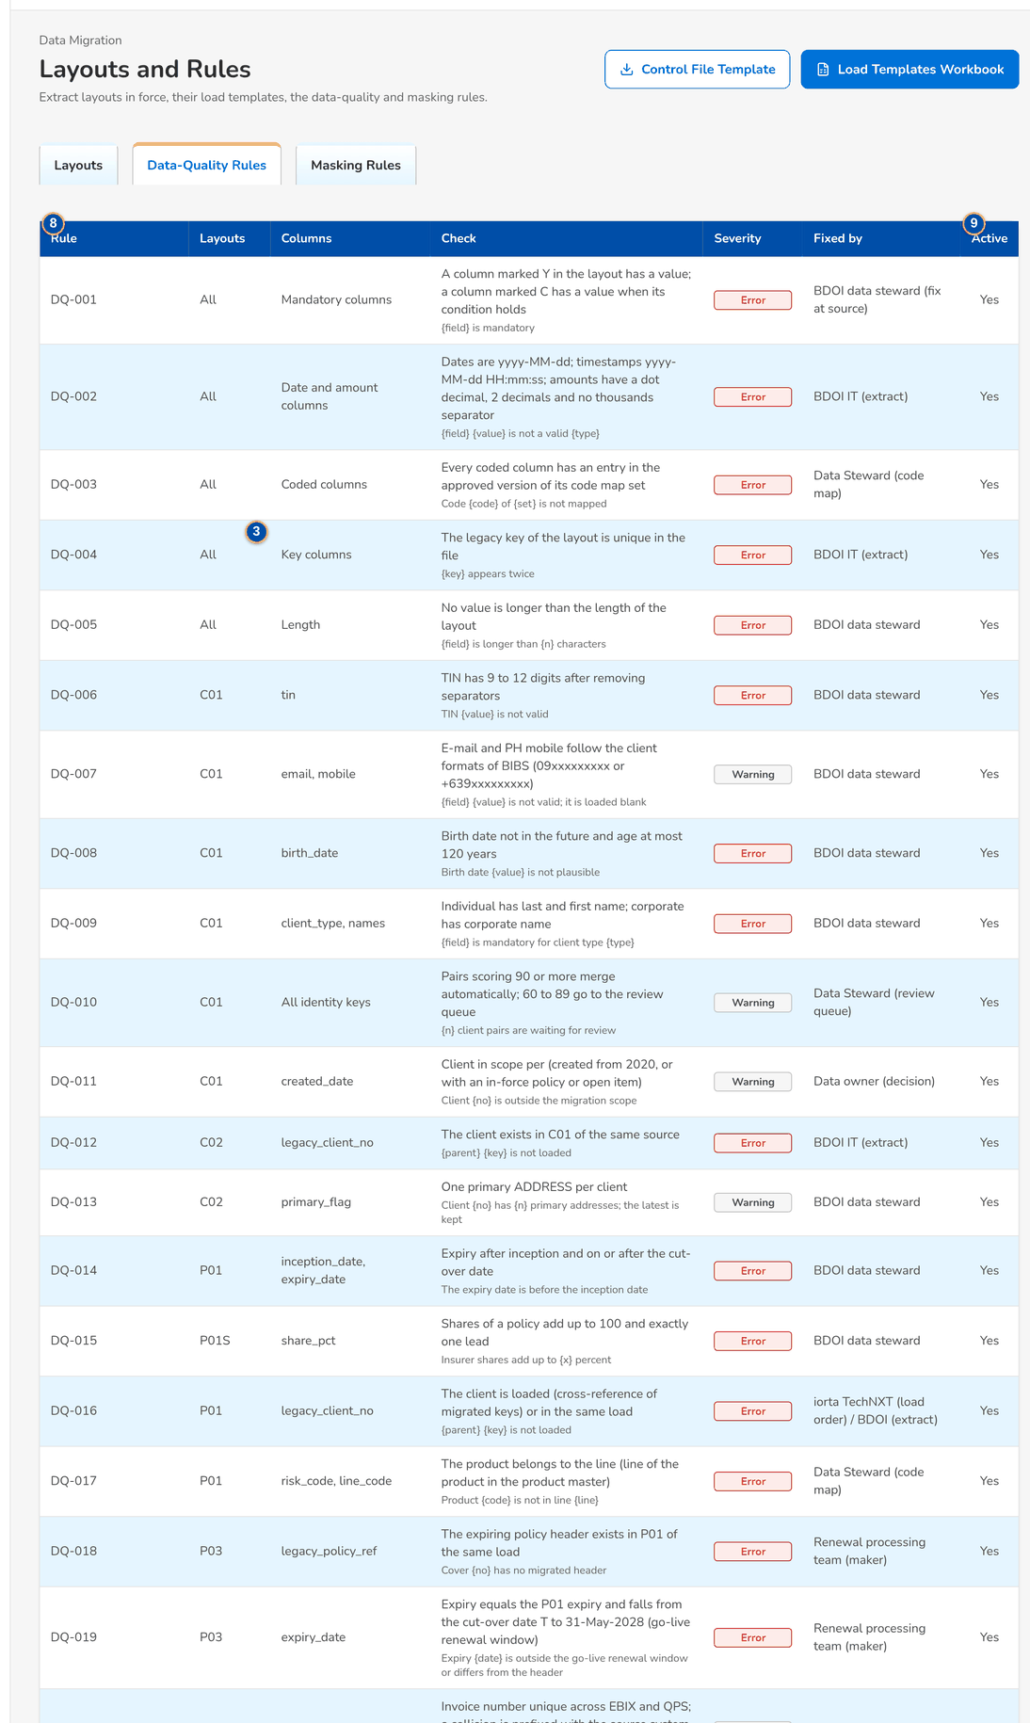
Figure 15: SCR-DM-04 Data-Quality Rules tab

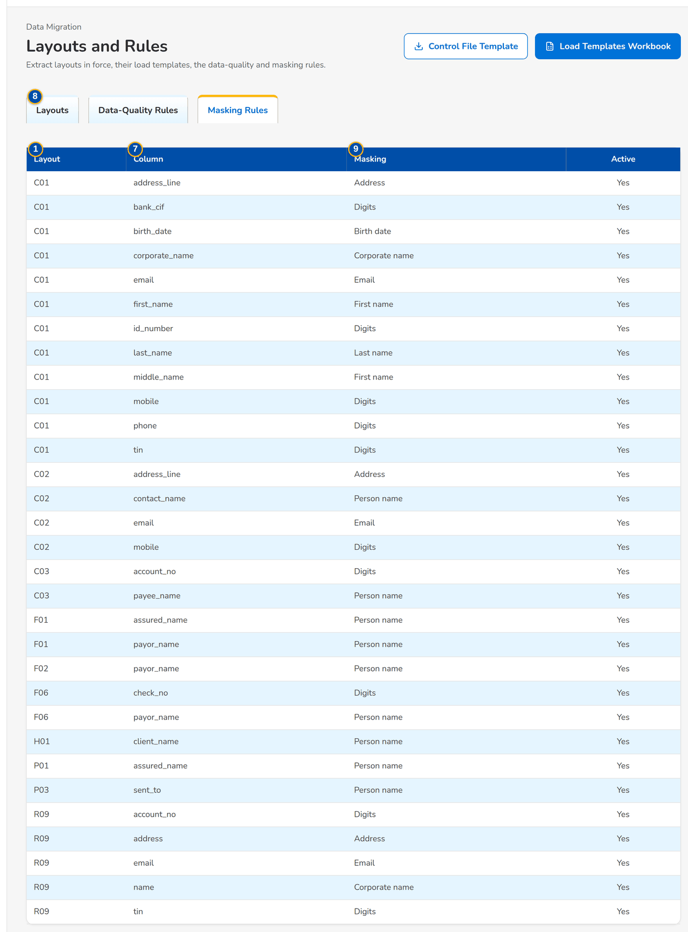
Figure 16: SCR-DM-04 Masking Rules tab

Fields (No. = callout number on the first screenshot)
No. | Section | Field | Type | Length / format | Mand. | Source / list | Default | Editable in | Validation | Message when it fails
1 | Layouts tab | Layout | Column | Code and version, title under it | - | Layouts in force | - | - | - | -
2 | Layouts tab | Object | Column | Object code | - | Layout | - | - | - | -
3 | Layouts tab | Key columns | Column | Legacy key of a row | - | Layout | - | - | - | -
4 | Layouts tab | Hash total | Column | Count of distinct keys, Row count, Sum of the numeric part | - | Layout | - | - | - | -
5 | Layouts tab | Frozen | Column | dd-MMM-yyyy HH:mm | - | Layout | - | - | - | -
6 | Layouts tab | Status | Pill | Draft, Frozen, Retired | - | Layout | - | - | - | -
7 | Columns | #, Column, Type, Mandatory, Code map, Format, Example, Validation | Columns | Type with its length; description under the column name | - | Columns of the layout | - | - | - | -
8 | Data-Quality Rules tab | Rule, Layouts, Columns, Check, Severity, Fixed by, Active | Columns | Severity Error or Warning; the message under the check | - | Rule catalogue | - | - | - | -
9 | Masking Rules tab | Layout, Column, Masking, Active | Columns | - | - | Masking rules | - | - | - | -

Actions
Button | Who | Enabled when | What happens | Resulting status | Notification
Control File Template | Every migration role | Always | Downloads the header of the control file (CONTROL_template.ctl.csv) | - | -
Load Templates Workbook | Every migration role | Always | Downloads one workbook with a Start here sheet (the rules of a delivery and the order) and one guided sheet per layout (a guide above every column) | - | -
Download on a layout row | Every migration role | Always | Downloads the CSV template of the layout (header row only) | - | -
Object Workbook | Every migration role | A layout is open | Downloads the workbook of the object of the layout | - | -
Freeze | Data Steward | Layout version is a draft | Makes the version the one in force after a confirmation; extracts and templates follow it and the previous version is retired | Frozen | -

Business rules
• A file whose header does not match the layout version in force is rejected at intake (FR-DM-010).
• The layouts of an object are frozen before its mapping is signed (gate G2) (FR-DM-003).
• Outside production the columns listed on Masking Rules are masked before a row is staged (FR-DM-010).
• An error stops the row; a warning loads it and reports it (FR-DM-013).
Expected outcome
BDOI IT and the stewards download the templates that match the layouts in force, and see every check a row must pass.
Test cases: TC-DM-SCR-04, TC-DM-MSG-03.

19.1.5 SCR-DM-05 Extracts
Purpose | Receives each legacy extract with its control file and runs the intake checks: file name, checksum, header, row count, amount totals and hash total. A file that passes is staged (masked outside production); a file that fails is rejected as a whole, with every failed check and its reason. The list shows every extract with its layout, source, as-of date, rows received and staged, masking, who received it and its status.
Who can open it | Migration Operator (permission Data migration intake)
Navigation | • Menu: Data Migration › Data Migration › Extracts  • Migration Home › Upload Extract
FRs | FR-DM-010

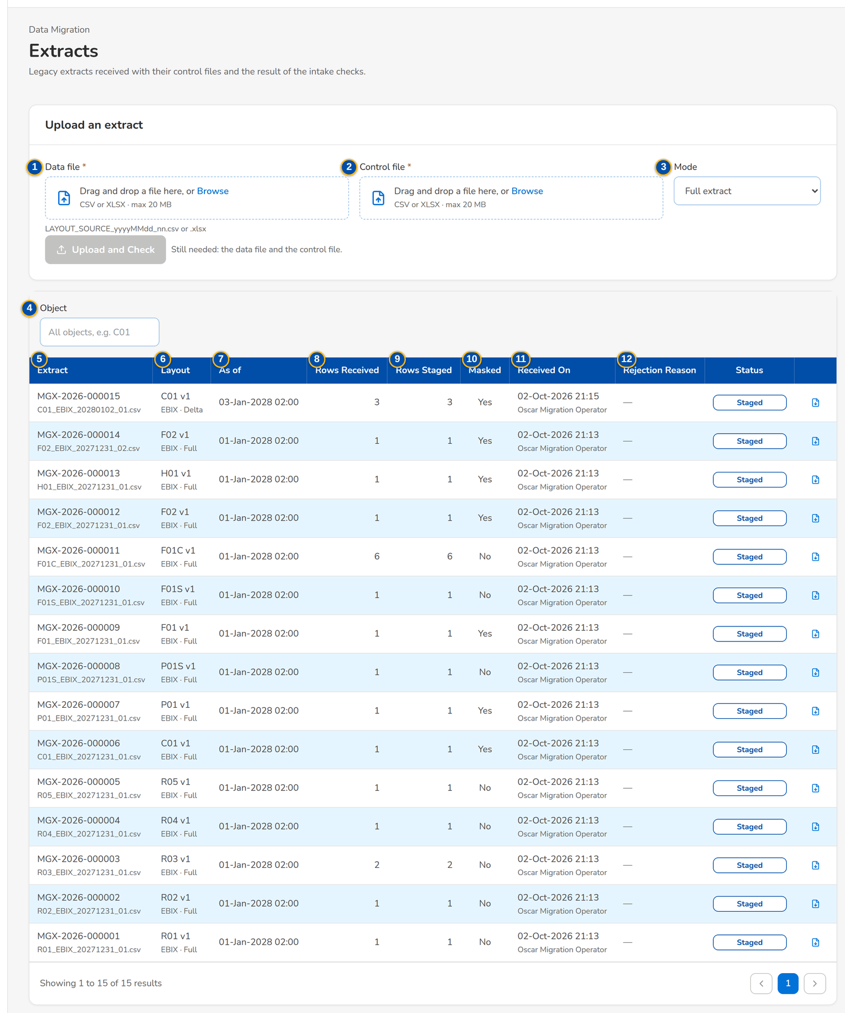
Figure 17: SCR-DM-05 Extracts with the upload card (Still needed: the files to choose) and the intake results
1 | Data file | 6 | Layout | 11 | Received On
2 | Control file | 7 | As of | 12 | Rejection Reason
3 | Mode | 8 | Rows Received | 13 | Status
4 | Object | 9 | Rows Staged
5 | Extract | 10 | Masked

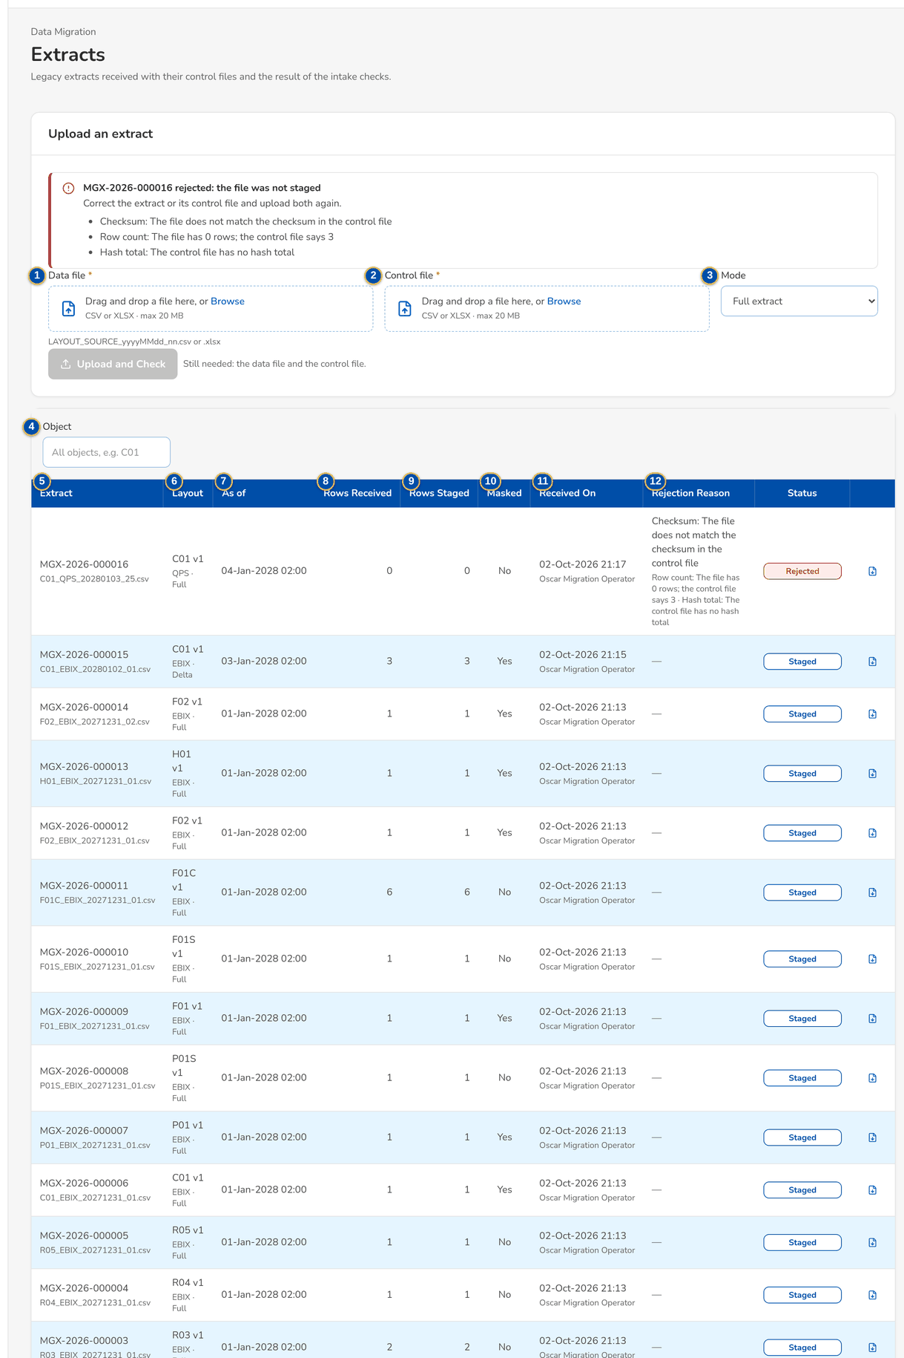
Figure 18: SCR-DM-05 An extract rejected at intake with every failed check and its reason

Fields (No. = callout number on the first screenshot)
No. | Section | Field | Type | Length / format | Mand. | Source / list | Default | Editable in | Validation | Message when it fails
1 | Upload an extract | Data file | File | LAYOUT_SOURCE_yyyyMMdd_nn.csv or .xlsx | Y | - | - | - | Name, layout, source system and date of the name are valid; the object is decided | Name the file <LAYOUT>_<SOURCE>_<yyyyMMdd>_<nn>.csv or .xlsx, for example F01C_EBIX_20271231_01.csv
2 | Upload an extract | Control file | File | <data file name>.ctl.csv | Y | - | - | - | Row count, hash total, amount totals and SHA-256 agree with the data file | The file has <n> rows; the control file says <m>
3 | Upload an extract | Mode | Drop-down | Full extract, Delta since the previous extract | Y | - | Full extract | - | A delta is later than the previous extract of the layout | -
4 | Filter | Object | Text | Object code, for example C01 | N | - | All objects | - | - | -
5 | Extracts | Extract | Column | MGX-yyyy-nnnnnn with the file name under it | - | Extracts | - | - | - | -
6 | Extracts | Layout | Column | Layout and version; source system and mode under it | - | Extracts | - | - | - | -
7 | Extracts | As of | Column | dd-MMM-yyyy HH:mm | - | Control file | - | - | - | -
8 | Extracts | Rows Received | Column | Number of rows read from the data file | - | Intake | - | - | - | -
9 | Extracts | Rows Staged | Column | Number of rows staged (0 when rejected) | - | Intake | - | - | - | -
10 | Extracts | Masked | Column | Yes or No | - | Environment | - | - | - | -
11 | Extracts | Received On | Column | Date and time, user under it | - | Intake | - | - | - | -
12 | Extracts | Rejection Reason | Column | Each failed check with its reason (Row count, Checksum, Columns, Amount total, Hash total) | - | Intake | - | - | - | -
13 | Extracts | Status | Pill | Received, Checked, Staged, Rejected, Purged | - | Intake | - | - | - | -

Actions
Button | Who | Enabled when | What happens | Resulting status | Notification
Upload and Check | Migration Operator | A data file and a control file are chosen (until then the card says what is still needed) | Receives the files and runs every intake check; the message gives the extract number and the staged rows, or the rejection with the number of failed checks, listed on the card | Staged or Rejected | Alert Extract rejected to the Data Migration Lead
Download on a row | Migration Operator | File not yet purged | Downloads the data file as received | - | -

Business rules
• The file name starts with the layout code, then the source system, the as-of date and the sequence of the day (FR-DM-010).
• A file whose checksum, header, row count, amount totals or hash total do not agree with its control file is rejected; nothing of it is staged. Every check runs, and the rejection lists each failed check with its own reason (FR-DM-010).
• Extracts are received only for objects decided for migration (FR-DM-002).
• Staged rows and files are purged 5 days after the batch is accepted or rolled back, or after the rejection (FR-DM-010).
Expected outcome
Every file BDOI sends is either staged exactly as extracted or rejected with the reason and the difference.
Test cases: TC-DM-010.1-01, TC-DM-010.2-01, TC-DM-010.2-02, TC-DM-010.2-03, TC-DM-010.3-01, TC-DM-125.1-01, TC-DM-126.4-01, TC-DM-SCR-05, TC-DM-MSG-04.

19.1.6 SCR-DM-06 Batches and resubmissions
Purpose | Every load batch with its object, environment, counts, error rate and status. The Migration Operator plans a batch from the staged extracts of a decided object; a batch opens on its own page. The Resubmissions tab lists the corrected rejected rows that a maker has prepared and that a checker approves before they load (used for the renewal advices already sent, object P03).
Who can open it | Data Migration Lead, Data Steward, Data owner (business owner of an object), Migration Operator, Reconciliation approver (Head of Comptrollership), Go / no-go board, Comptrollership GL lead (permission Data migration view)
Navigation | • Menu: Data Migration › Data Migration › Batches  • Migration Home › Batches  • Extracts › Plan Batch
FRs | FR-DM-014, FR-DM-015, FR-DM-125

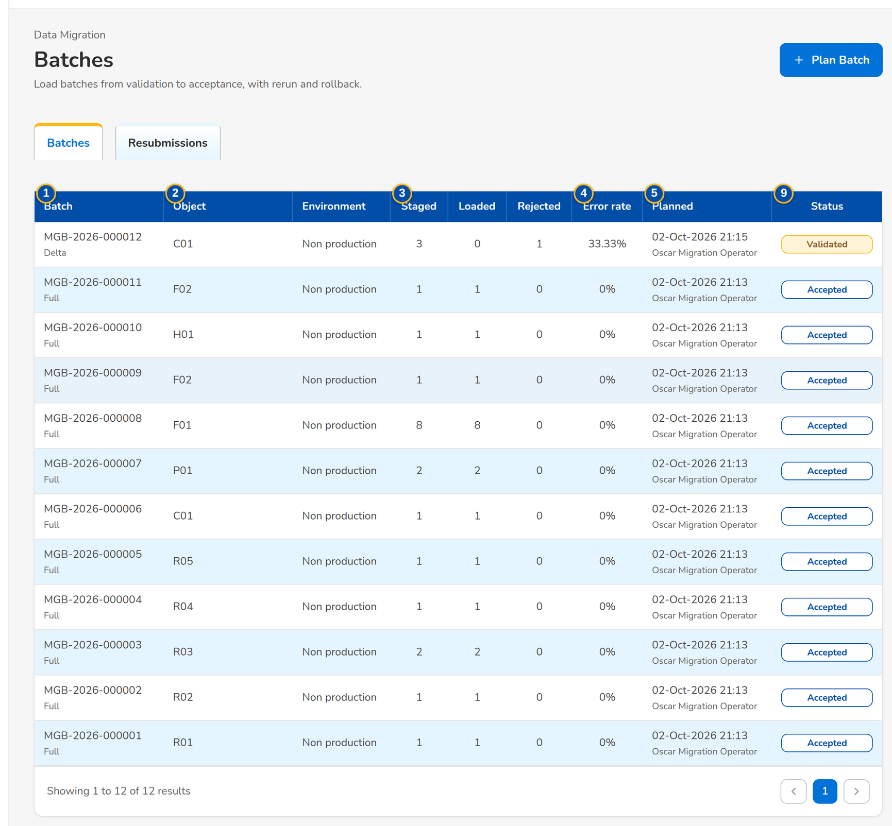
Figure 19: SCR-DM-06 Batches with their counts and status
1 | Batch | 4 | Error rate | 7 | Object
2 | Object, Environment | 5 | Planned | 8 | Extracts
3 | Staged, Loaded, Rejected | 6 | Status | 9 | Resubmission, Object, Corrected rows, Prepared, Decided by, Note, Status

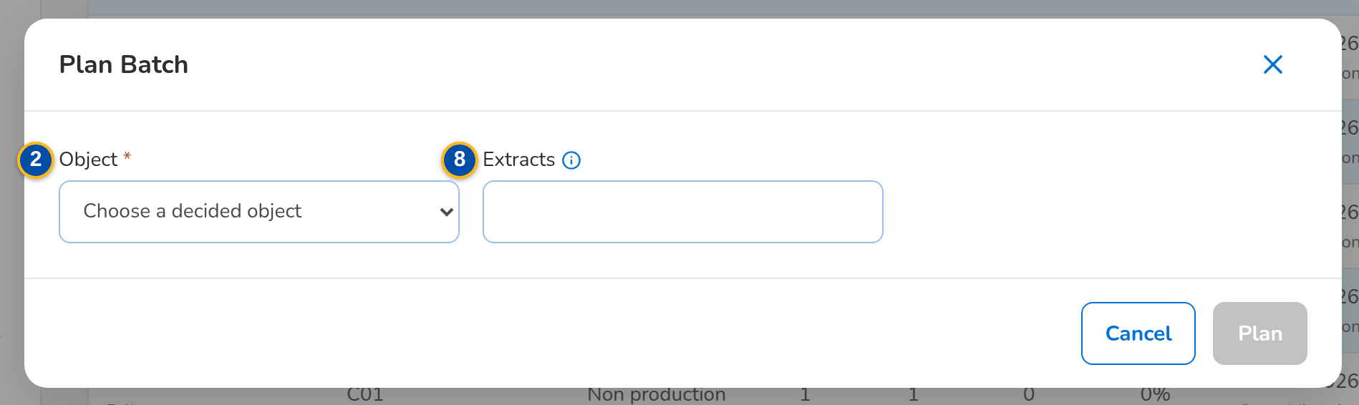
Figure 20: SCR-DM-06 Plan Batch dialog
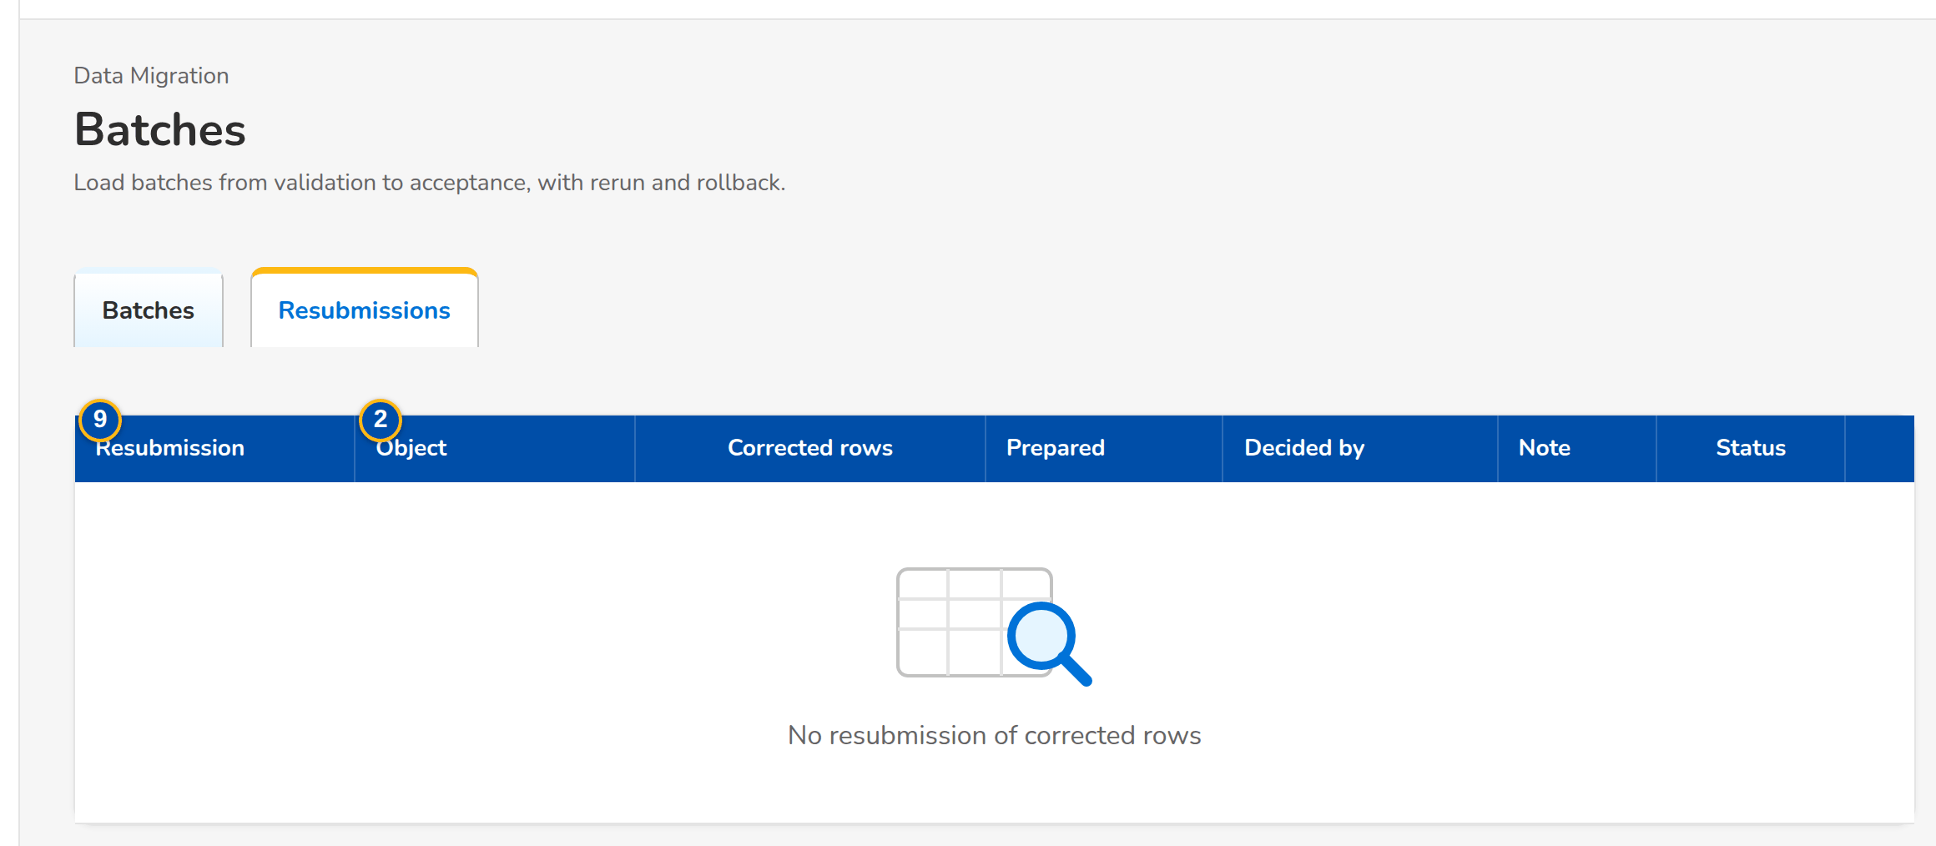
Figure 21: SCR-DM-06 Resubmissions of corrected rows waiting for the checker
Fields (No. = callout number on the first screenshot)
No. | Section | Field | Type | Length / format | Mand. | Source / list | Default | Editable in | Validation | Message when it fails
1 | Batches tab | Batch | Column | MGB-yyyy-nnnnn; Full, Delta or Rerun of the parent batch under it | - | Batches | - | - | - | -
2 | Batches tab | Object, Environment | Column | Object code; SIT, UAT, performance or production | - | Batch | - | - | - | -
3 | Batches tab | Staged, Loaded, Rejected | Column | Counts | - | Batch | - | - | - | -
4 | Batches tab | Error rate | Column | Percent | - | Validation | - | - | - | -
5 | Batches tab | Planned | Column | Date and time; user under it | - | Batch | - | - | - | -
6 | Batches tab | Status | Pill | Planned, Validated, Load approved, Loading, Loaded, Loaded with rejects, Failed, Reconciled, Accepted, Rollback requested, Rolled back | - | Batch | - | - | - | -
7 | Plan Batch | Object | Drop-down | Objects decided as Migrate, Carry forward or Conditional | Y | Data objects | - | - | The object has a staged extract | Object <code> has no staged extract to load
8 | Plan Batch | Extracts | Text | Extract numbers separated by commas; empty for the latest staged extract of each layout | N | Staged extracts | - | - | Same as-of date; staged; not in another batch | The extracts of a batch must have the same as-of date: <days>
9 | Resubmissions tab | Resubmission, Object, Corrected rows, Prepared, Decided by, Note, Status | Columns | Prepared, Approved, Returned | - | Resubmissions | - | - | - | -

Actions
Button | Who | Enabled when | What happens | Resulting status | Notification
Plan Batch | Migration Operator | Always | Plans a batch from the staged extracts and opens it | Planned | -
A batch row | Every migration role | Always | Opens the batch page | - | -
Approve | Checker of the object (resubmission approval) | Resubmission Prepared by another user | Creates a rerun batch of the corrected rows, with an optional note | Approved | -
Return | Checker of the object | Resubmission Prepared by another user | Returns the corrected rows to the maker with the reason | Returned | -

Business rules
• The extracts of one batch have the same as-of date and one layout each (FR-DM-010).
• Resubmissions of the RA-sent file are accepted until the resubmission deadline (12:00 on the day before go-live) (FR-DM-125).
• The checker of a resubmission is never its maker (FR-DM-125).
Expected outcome
Each object is loaded in batches that can be followed from planning to acceptance, and corrected rows load only after a checker approves them.
Test cases: TC-DM-001.3-01, TC-DM-011.5-01, TC-DM-012.2-01, TC-DM-013.3-01, TC-DM-013.4-01, TC-DM-014.1-01, TC-DM-014.3-01, TC-DM-014.4-01, TC-DM-014.4-02, TC-DM-015.1-01, TC-DM-015.2-01, TC-DM-015.3-01, TC-DM-015.4-01, TC-DM-015.5-01, TC-DM-015.6-01, TC-DM-015.6-02, TC-DM-022.3-01, TC-DM-030.1-01, TC-DM-030.2-01, TC-DM-031.3-01, TC-DM-032.3-01, TC-DM-032.4-01, TC-DM-034.1-01, TC-DM-051.4-01, TC-DM-120.4-01, TC-DM-125.3-02, TC-DM-125.4-01, TC-DM-130.2-01, TC-DM-131.2-01, TC-DM-SCR-06, TC-DM-MSG-05.

19.1.7 SCR-DM-07 Batch
Purpose | One batch from validation to acceptance. The header shows the status and the actions allowed now: validate, sign the validation (G3), approve the load (G4), load, reconcile, rerun the rejected rows, sign the reconciliation (G5), accept the object as data owner and as Data Migration Lead (G6), request, approve or reject a rollback. The steps, the counts and the facts of the batch are followed by tabs for the issues, the rows (with waivers and exclusions), the reconciliation, the gates signed with their evidence and the run log.
Who can open it | Data Migration Lead, Data Steward, Data owner (business owner of an object), Migration Operator, Reconciliation approver (Head of Comptrollership), Go / no-go board, Comptrollership GL lead (permission Data migration view)
Navigation | • Menu: Data Migration › Data Migration › Batches › Batch  • Batches › a batch row  • Sign-off › Latest batch
FRs | FR-DM-013, FR-DM-014, FR-DM-015, FR-DM-003, FR-DM-020

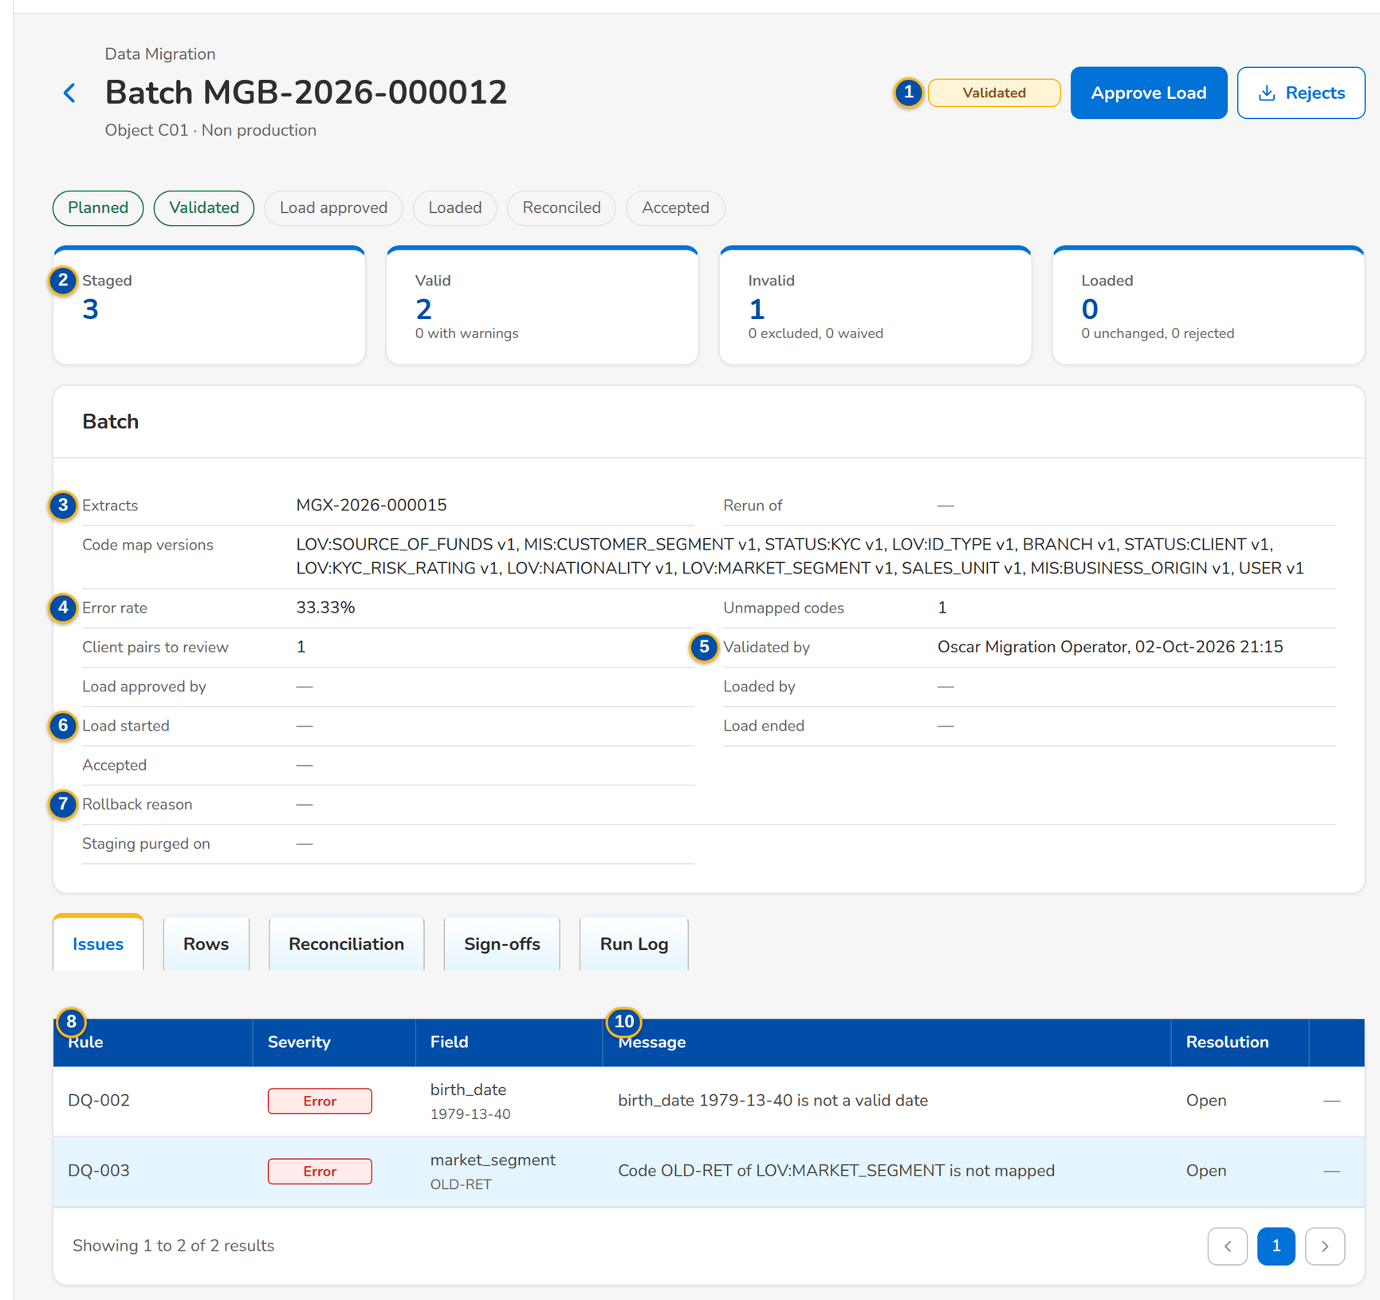
Figure 22: SCR-DM-07 A validated batch: steps, counts, facts and the Issues tab
1 | Planned, Validated, Load approved, Loaded, Reconciled, Accepted | 6 | Load started, Load ended, Accepted | 11 | Reason
2 | Staged, Valid, Invalid, Loaded | 7 | Rollback reason, Staging purged on | 12 | Note / Manual-entry plan
3 | Extracts, Rerun of, Code map versions | 8 | Rule, Severity, Field, Message, Resolution | 13 | Extract of the corrected rows
4 | Error rate, Unmapped codes, Client pairs to review | 9 | Row status | 14 | Gate, Role, Signed by, Signed, Comment, Decision, Evidence
5 | Validated by, Load approved by, Loaded by | 10 | Layout, Row, Legacy key, BIBS record, Message, Status | 15 | Time, Step, Level, Message, Counts, By

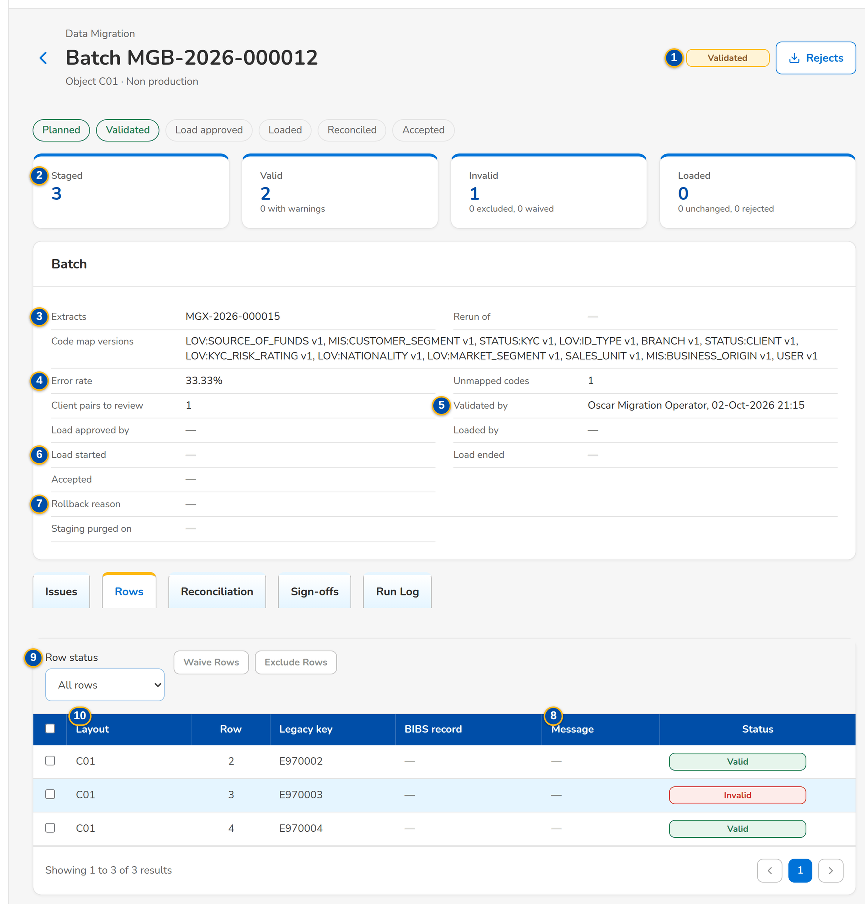
Figure 23: SCR-DM-07 Rows tab with the waiver and exclusion of failing rows

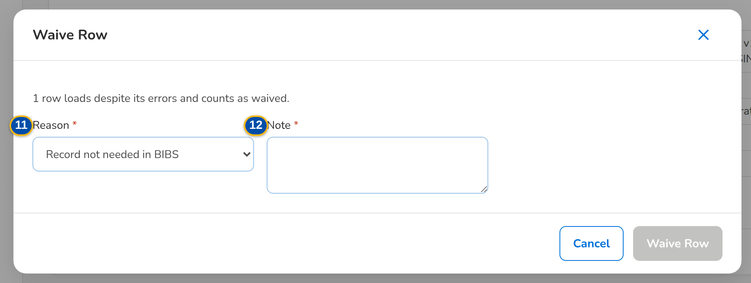
Figure 24: SCR-DM-07 Waive Rows dialog

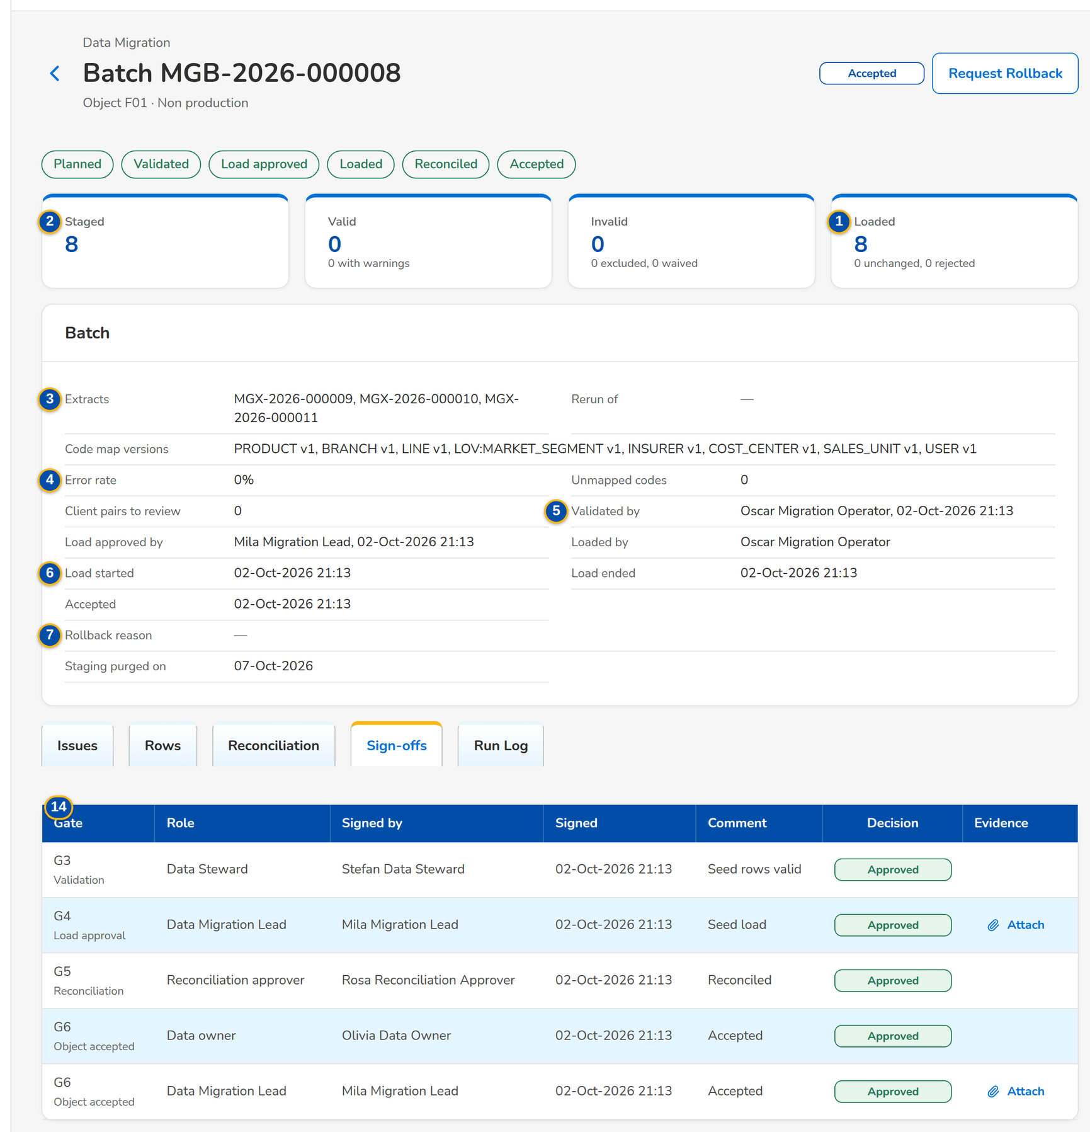
Figure 25: SCR-DM-07 Sign-offs tab of an accepted batch

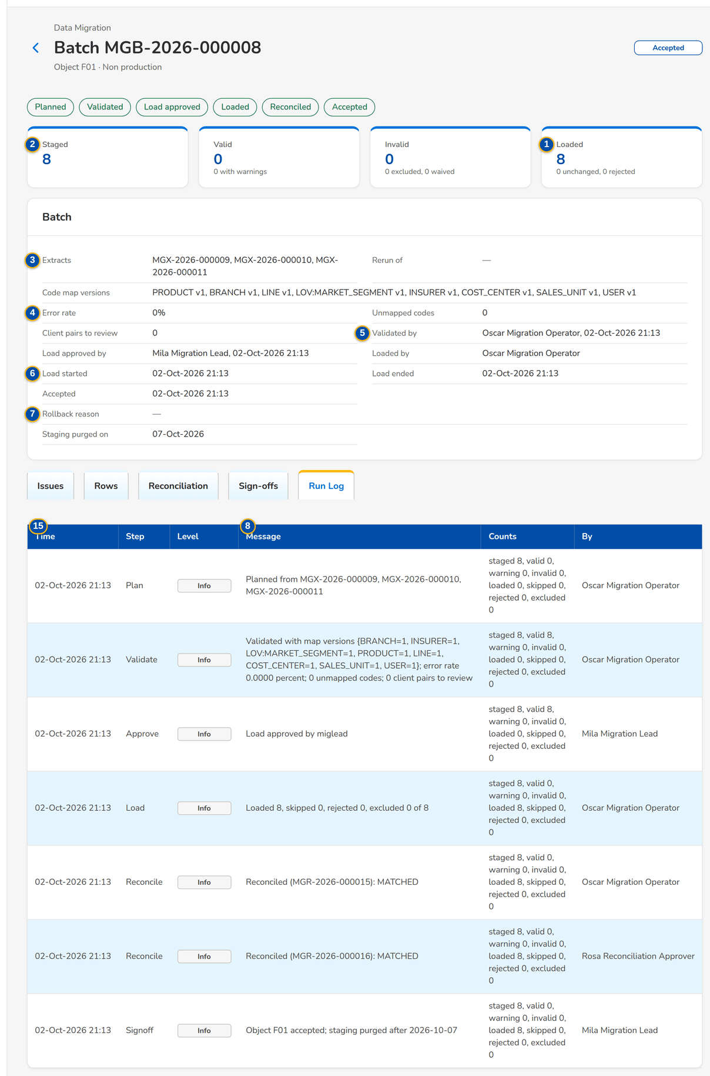
Figure 26: SCR-DM-07 Run Log tab

Fields (No. = callout number on the first screenshot)
No. | Section | Field | Type | Length / format | Mand. | Source / list | Default | Editable in | Validation | Message when it fails
1 | Steps | Planned, Validated, Load approved, Loaded, Reconciled, Accepted | Stepper | Steps done are marked | - | Batch status | - | - | - | -
2 | Counts | Staged, Valid, Invalid, Loaded | Tile | Warnings, excluded and waived, unchanged and rejected under them | - | Batch | - | - | - | -
3 | Batch | Extracts, Rerun of, Code map versions | Text | Extract numbers; parent batch; map and version | - | Batch | - | - | - | -
4 | Batch | Error rate, Unmapped codes, Client pairs to review | Text | Percent; counts | - | Validation | - | - | - | -
5 | Batch | Validated by, Load approved by, Loaded by | Text | Name, date and time | - | Batch | - | - | - | -
6 | Batch | Load started, Load ended, Accepted | Text | dd-MMM-yyyy HH:mm | - | Batch | - | - | - | -
7 | Batch | Rollback reason, Staging purged on | Text | Text; date | - | Batch | - | - | - | -
8 | Issues tab | Rule, Severity, Field, Message, Resolution | Columns | Error or Warning; the value under the field; Open, Fixed at source, Mapped, Waived | - | Validation issues | - | - | - | -
9 | Rows tab | Row status | Drop-down | All rows, Valid, Warning, Invalid, Loaded, Skipped, Rejected, Excluded, Waived | N | - | All rows | - | - | -
10 | Rows tab | Layout, Row, Legacy key, BIBS record, Message, Status | Columns | The BIBS record created, with its kind under it | - | Staged rows | - | - | - | -
11 | Waive Rows / Exclude Rows | Reason | Drop-down | Record not needed in BIBS, Entered manually in BIBS after go-live | Y | Waiver reasons | Record not needed in BIBS | Validated | - | -
12 | Waive Rows / Exclude Rows | Note / Manual-entry plan | Text area | Free text | Y | - | - | Validated | Not blank | Enter the reason and the manual-entry plan of the excluded rows
13 | Resubmit Corrected Rows | Extract of the corrected rows | Text | Extract number of the uploaded correction file | Y | Staged extracts of the object | - | - | Staged extract of the same object | Extract <extract no> is not a staged extract of object <object code>
14 | Sign-offs tab | Gate, Role, Signed by, Signed, Comment, Decision, Evidence | Columns | Gate and its name; evidence file | - | Gates signed | - | - | - | -
15 | Run Log tab | Time, Step, Level, Message, Counts, By | Columns | - | - | Run log | - | - | - | -

Actions
Button | Who | Enabled when | What happens | Resulting status | Notification
Validate | Migration Operator | Planned | Maps the rows with the approved code maps and checks them against the data-quality rules | Validated | Alert Unmapped codes when a code has no entry
Sign Validation | Data Steward | Validated | Signs gate G3: the error rate is within the limit, no mandatory code is unmapped and no client pair waits for review | Validated (G3 signed) | -
Approve Load | Data Migration Lead | Validated, by a user other than the validator | Signs gate G4: the batch may be loaded by an operator other than the approver | Load approved | -
Load | Migration Operator | Load approved, by a user other than the approver | Loads the valid rows through the BIBS services without notifications, then reconciles the batch | Loaded or Loaded with rejects | Alert Load failed when a chunk fails
Reconcile | Migration Operator | Loaded, Loaded with rejects or Reconciled | Compares counts, amounts, hash totals and fields again between the source, the staging and BIBS | Reconciled when no break is open | Alert Reconciliation break
Rerun Rejects | Migration Operator | Rejected rows exist | Plans a new batch of the rejected rows for validation and load | Planned (rerun batch) | -
Sign Reconciliation | Reconciliation approver | Loaded and every break explained and approved | Signs gate G5 | Reconciled | -
Accept as Data Owner, Accept as Migration Lead | Data owner; Data Migration Lead | Reconciled | Sign gate G6; with both acceptances the object is accepted and its staging data is purged after the retention days | Accepted | -
Request Rollback | Data Migration Lead | Loaded, Reconciled, Accepted or Failed | Asks for the records loaded by the batch to be undone, with the reason | Rollback requested | -
Approve Rollback, Reject Rollback | Reconciliation approver | Rollback requested by another user | Undoes the records loaded by the batch through the BIBS services, or keeps the batch loaded with the reason | Rolled back, or the previous status | -
Rejects | Every migration role | The batch has rejected or invalid rows | Downloads the rejected rows with their messages and the correction columns | - | -
Fixed at Source | Data Steward | Issue open | Records that the legacy source is corrected, with a note | Issue Fixed at source | -
Waive Rows, Exclude Rows | Data owner | Batch validated; rows selected | Loads the rows despite their errors (waiver), or leaves them out with a manual-entry plan | Rows Waived or Excluded | -
Resubmit Corrected Rows | Data Steward or Migration Operator | The batch has rejected rows | Prepares a resubmission of the corrected rows for the checker | Resubmission Prepared | -
Attach | The signer of a gate | Own gate without evidence | Attaches the evidence file to the gate signed | - | -

Business rules
• The load of a batch is approved by the Data Migration Lead and run by an operator other than the approver; the validator does not approve the load (FR-DM-014).
• Master data loads with at most 0.5 percent of rows failing or waived; open items, unapplied payments and the trial balance load with none, unless each excluded row has a manual-entry plan (FR-DM-013).
• A row already loaded and unchanged is skipped; a rerun loads only the rejected and changed rows (FR-DM-015).
• A rollback undoes the records of the batch newest first, unless a record was changed in BIBS since the load; the requester never approves it (FR-DM-015).
• The operator who ran a batch cannot sign its reconciliation or acceptance; one person cannot sign two gates of one batch (FR-DM-003).
• The reconciliation cannot be signed while a break is open (FR-DM-020).
Expected outcome
The batch is loaded, reconciled and accepted by its owner and the Data Migration Lead, or rolled back, with every step recorded.
Test cases: TC-DM-001.3-01, TC-DM-010.4-01, TC-DM-011.5-01, TC-DM-012.2-01, TC-DM-013.1-01, TC-DM-013.1-02, TC-DM-013.2-01, TC-DM-013.3-01, TC-DM-013.4-01, TC-DM-014.1-01, TC-DM-014.3-01, TC-DM-014.4-01, TC-DM-014.4-02, TC-DM-015.1-01, TC-DM-015.2-01, TC-DM-015.3-01, TC-DM-015.4-01, TC-DM-015.5-01, TC-DM-015.6-01, TC-DM-015.6-02, TC-DM-022.3-01, TC-DM-022.5-01, TC-DM-023.3-01, TC-DM-023.6-01, TC-DM-030.1-01, TC-DM-030.2-01, TC-DM-031.3-01, TC-DM-032.3-01, TC-DM-032.4-01, TC-DM-034.1-01, TC-DM-034.5-01, TC-DM-040.3-01, TC-DM-050.4-01, TC-DM-051.3-01, TC-DM-051.4-01, TC-DM-120.4-01, TC-DM-125.2-01, TC-DM-125.3-01, TC-DM-125.5-01, TC-DM-125.6-01, TC-DM-130.2-01, TC-DM-131.2-01, TC-DM-SCR-07, TC-DM-MSG-06, TC-DM-MSG-07.

19.1.8 SCR-DM-08 Client Matching
Purpose | The review queue of the client pairs whose match score is between the review and the automatic thresholds: two legacy client records, or a legacy record and a BIBS client, side by side with the keys that matched. The Data Steward merges them into one client or keeps them separate; the load of a client batch waits until the queue is empty.
Who can open it | Data Steward (permission Data migration match decide)
Navigation | • Menu: Data Migration › Data Migration › Client Matching  • Migration Home › Client pairs to review  • Batch › Client pairs to review
FRs | FR-DM-030, FR-DM-031

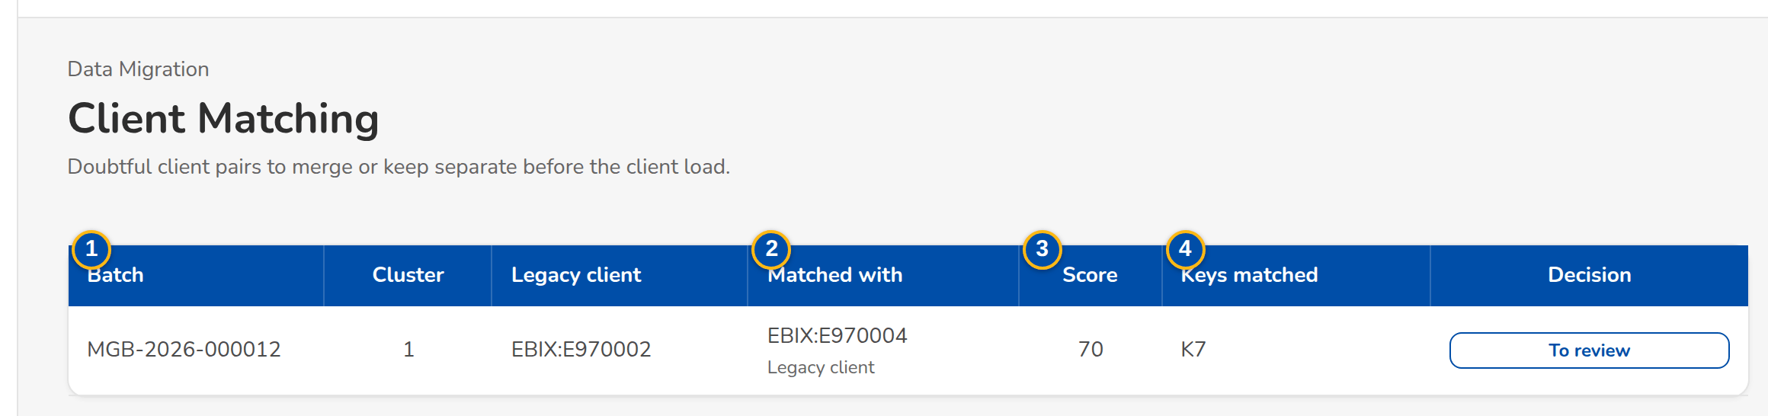
Figure 27: SCR-DM-08 Client pairs waiting for review
1 | Batch, Cluster, Legacy client | 3 | Score | 5 | Decision
2 | Matched with | 4 | Keys matched | 6 | Field

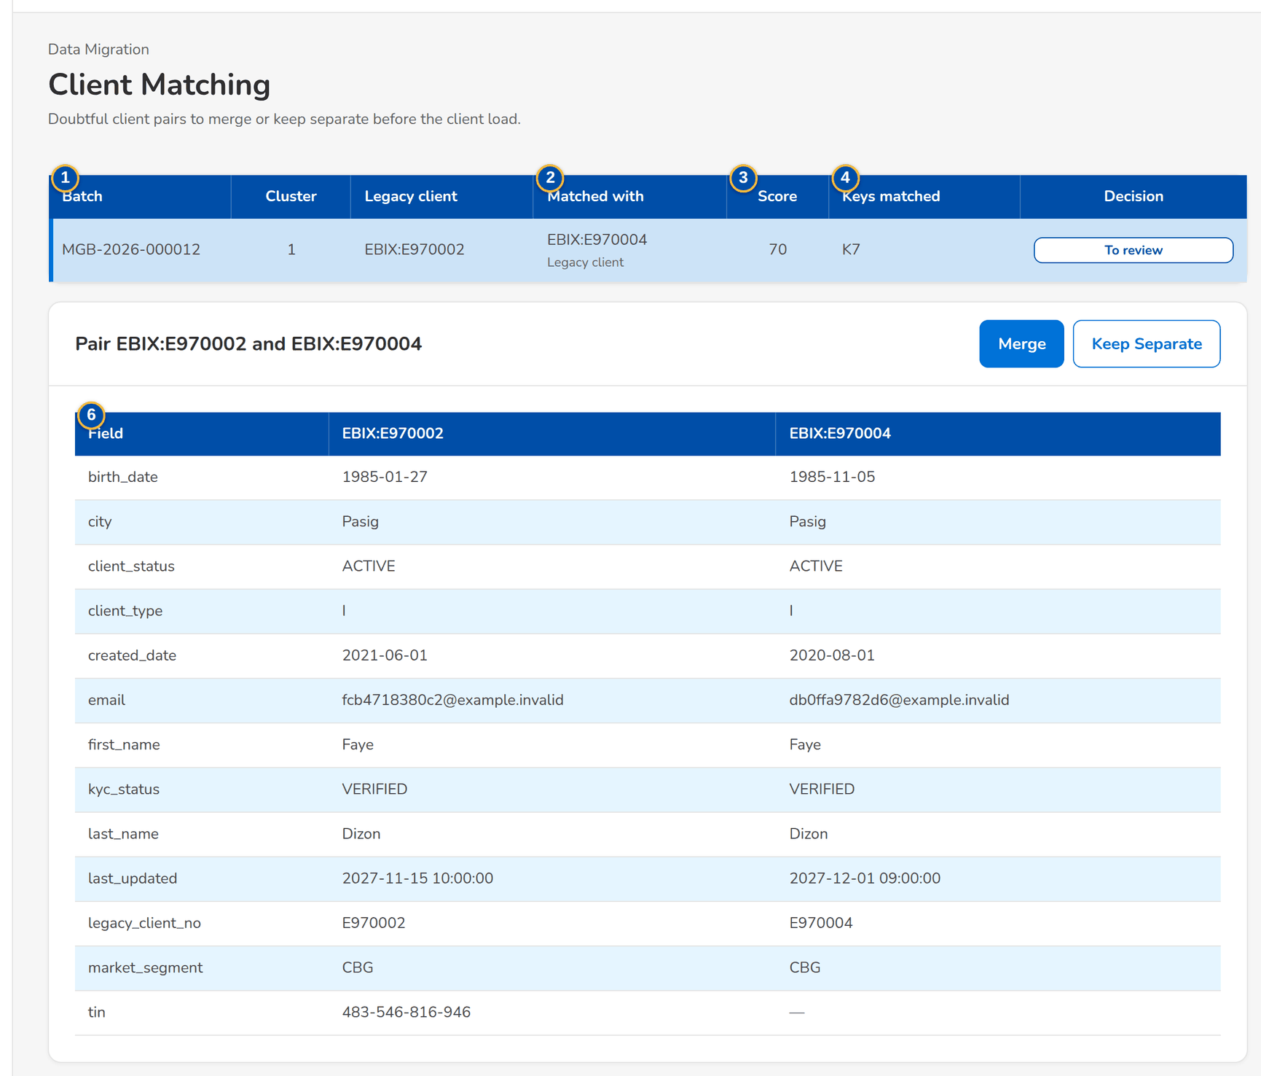
Figure 28: SCR-DM-08 A pair side by side with the matched keys marked

Fields (No. = callout number on the first screenshot)
No. | Section | Field | Type | Length / format | Mand. | Source / list | Default | Editable in | Validation | Message when it fails
1 | Queue | Batch, Cluster, Legacy client | Column | Batch number; cluster number; legacy client number | - | Matching | - | - | - | -
2 | Queue | Matched with | Column | Legacy client or BIBS client | - | Matching | - | - | - | -
3 | Queue | Score | Column | 60 to 89 in the queue | - | Matching keys | - | - | - | -
4 | Queue | Keys matched | Column | TIN, ID, name and birth date, corporate name, CIF, e-mail, mobile, similar name | - | Matching | - | - | - | -
5 | Queue | Decision | Pill | To review, Merged, Kept separate, Merged automatically | - | Matching | To review | - | - | -
6 | Pair | Field | Column | Matched fields shown as tags | - | Both records | - | - | - | -

Actions
Button | Who | Enabled when | What happens | Resulting status | Notification
Merge | Data Steward | Pair To review | Makes the two records one BIBS client; every value that lost is kept for review | Merged | -
Keep Separate | Data Steward | Pair To review | Keeps two clients | Kept separate | -

Business rules
• Pairs scoring 90 or more merge automatically; 60 to 89 go to this queue; below 60 are different clients (FR-DM-031).
• The load of a client batch is not approved while pairs wait for review (FR-DM-031).
• Per field the surviving value is the first non-blank value by source priority, or the latest updated value (FR-DM-031).
Expected outcome
One BIBS client per person or company, with every legacy client number pointing to it.
Test cases: TC-DM-031.1-01, TC-DM-031.2-01, TC-DM-031.4-01, TC-DM-SCR-08, TC-DM-MSG-08.

19.1.9 SCR-DM-09 Reconciliation
Purpose | The loaded batches with their reconciliation and, for the chosen batch, the lines by level: L1 counts, L2 amounts, L3 hash totals, L4 fields, L5 general ledger, and the opening-balance adjustment checks. Every difference is a break; the Data Steward or the operator explains it with a reason and the reconciliation approver approves the explanation.
Who can open it | Data Migration Lead, Data Steward, Data owner (business owner of an object), Migration Operator, Reconciliation approver (Head of Comptrollership), Go / no-go board, Comptrollership GL lead (permission Data migration view)
Navigation | • Menu: Data Migration › Data Migration › Reconciliation  • Migration Home › Open reconciliation breaks  • Batch › Reconciliation tab
FRs | FR-DM-020, FR-DM-021

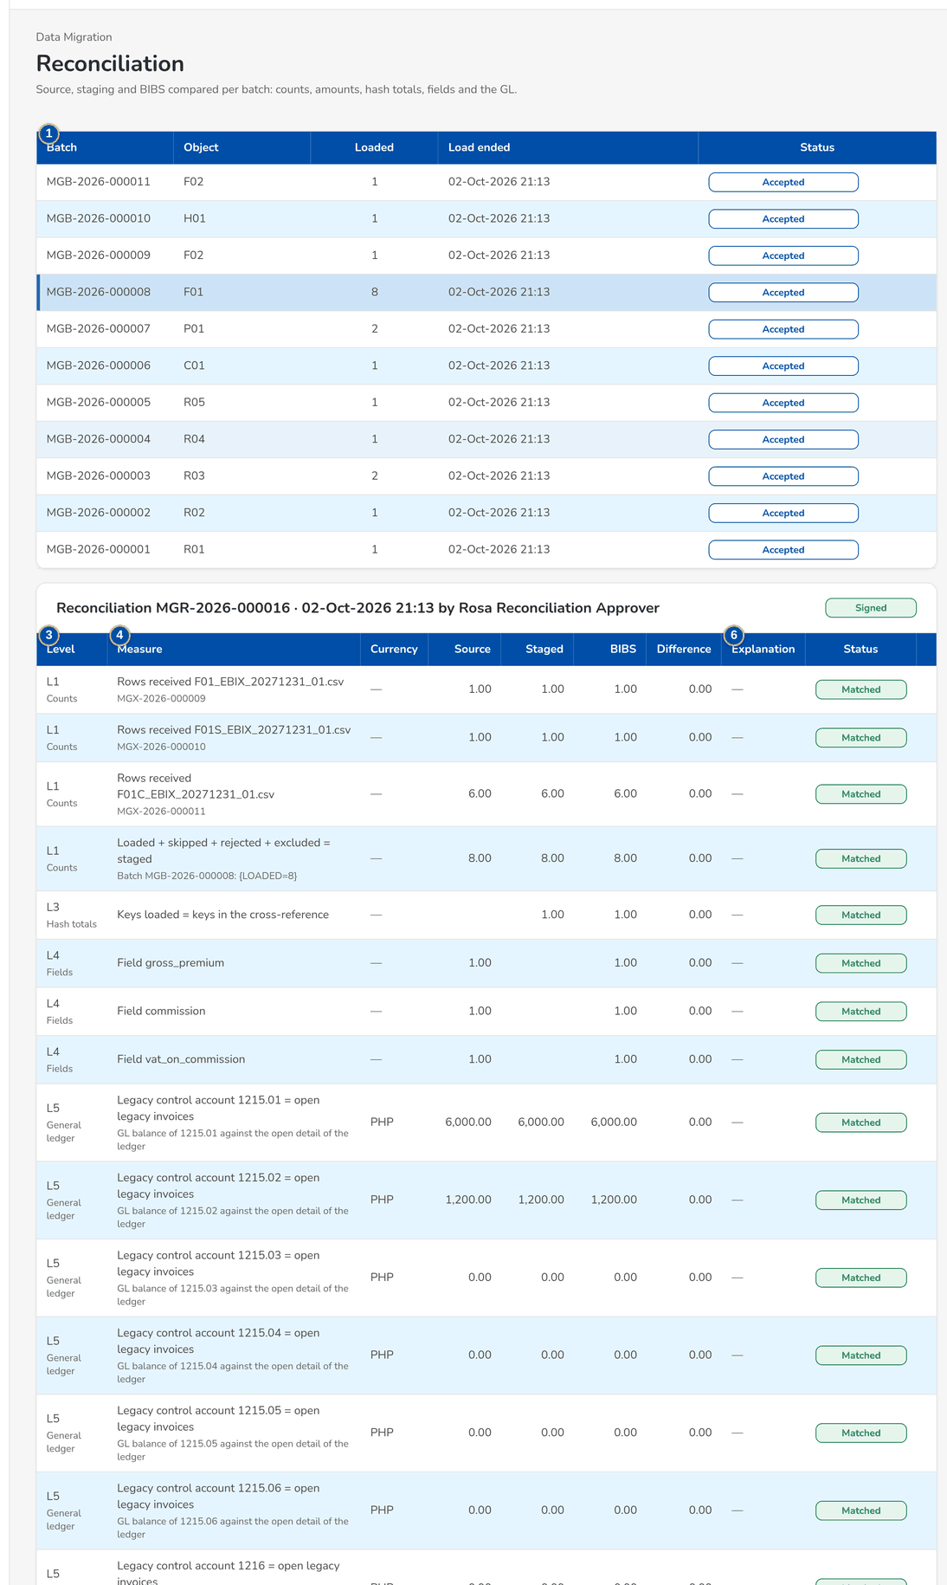
Figure 29: SCR-DM-09 A loaded batch and its reconciliation lines by level
1 | Batch, Object, Loaded, Load ended, Status | 4 | Measure, Currency | 7 | Status
2 | Title | 5 | Source, Staged, BIBS, Difference | 8 | Reason
3 | Level | 6 | Explanation | 9 | Explanation

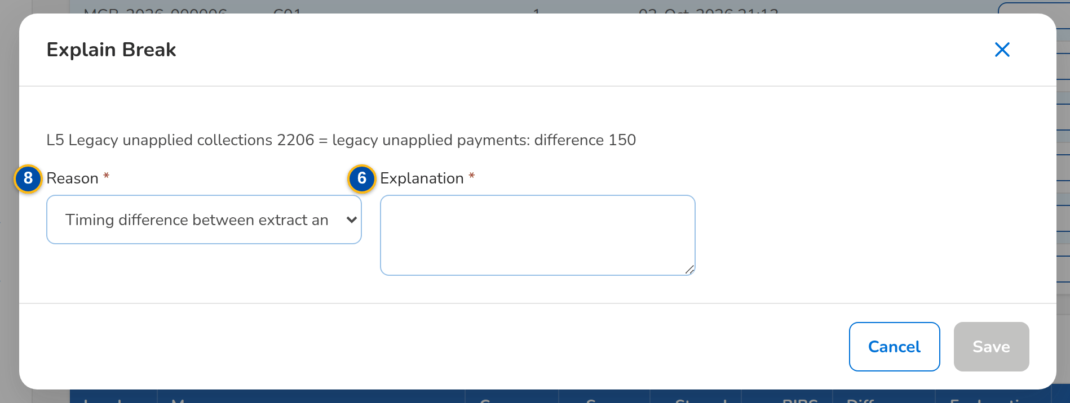
Figure 30: SCR-DM-09 Explain Break dialog
Fields (No. = callout number on the first screenshot)
No. | Section | Field | Type | Length / format | Mand. | Source / list | Default | Editable in | Validation | Message when it fails
1 | Loaded batches | Batch, Object, Loaded, Load ended, Status | Columns | - | - | Batches loaded, reconciled or accepted | - | - | - | -
2 | Reconciliation | Title | Text | Run number, date and time, user; status on the right | - | Latest run | - | - | - | -
3 | Reconciliation | Level | Column | L1 Counts, L2 Amounts, L3 Hash totals, L4 Fields, L5 General ledger, Opening-balance adjustment | - | Run | - | - | - | -
4 | Reconciliation | Measure, Currency | Column | Measure with its detail under it | - | Run | - | - | - | -
5 | Reconciliation | Source, Staged, BIBS, Difference | Amount | Two decimals | - | Control file, staging, BIBS | - | - | Difference within the tolerance (0.00) | -
6 | Reconciliation | Explanation | Column | Text; reason, who explained, who approved under it | - | Break | - | - | - | -
7 | Reconciliation | Status | Pill | Matched, Break, Explained | - | Run | - | - | - | -
8 | Explain Break | Reason | Drop-down | Timing difference between extract and ledger, Rounding in the legacy extract, Rows excluded by the data owner, Error in the legacy source corrected by manual entry, Code map difference, Other | Y | Break reasons | Timing difference between extract and ledger | Break | - | -
9 | Explain Break | Explanation | Text area | Free text | Y | - | - | Break | Not blank | Enter the explanation of the break

Actions
Button | Who | Enabled when | What happens | Resulting status | Notification
Explain | Data Steward or Migration Operator | Line in Break | Records the reason and the explanation | Explained | -
Approve | Reconciliation approver | Line Explained by another user | Approves the explanation | Explained (approved) | -

Business rules
• Counts: received equals the control count and loaded + skipped + rejected + excluded equals staged (FR-DM-020).
• Amounts: the control total, the staged sum and the value in BIBS agree per amount column and currency (FR-DM-020).
• GL: Migration Clearing is 0.00 per branch and currency and each legacy control account equals its legacy sub-ledger (FR-DM-021).
• The explanation of a break is approved by a user other than the one who explained it (FR-DM-020).
Expected outcome
Every loaded object is reconcilable from source to target, each break explained and approved before G5.
Test cases: TC-DM-020.1-01, TC-DM-020.2-01, TC-DM-020.3-01, TC-DM-021.1-01, TC-DM-021.3-01, TC-DM-021.4-01, TC-DM-021.5-01, TC-DM-040.5-01, TC-DM-126.3-01, TC-DM-130.3-01, TC-DM-SCR-09, TC-DM-MSG-09.

19.1.10 SCR-DM-10 Sign-off
Purpose | The gates G1 to G7 of every object and of its latest batch as a matrix: decision, mapping, validation, load approval, reconciliation, acceptance and go-live, each with who signed and when. The business owner signs the mapping of an object here (gate G2); the other batch gates are signed on the batch page.
Who can open it | Data Migration Lead, Data Steward, Data owner (business owner of an object), Migration Operator, Reconciliation approver (Head of Comptrollership), Go / no-go board, Comptrollership GL lead (permission Data migration view)
Navigation | • Menu: Data Migration › Data Migration › Sign-off  • Sidebar › Data Migration › Sign-off
FRs | FR-DM-003

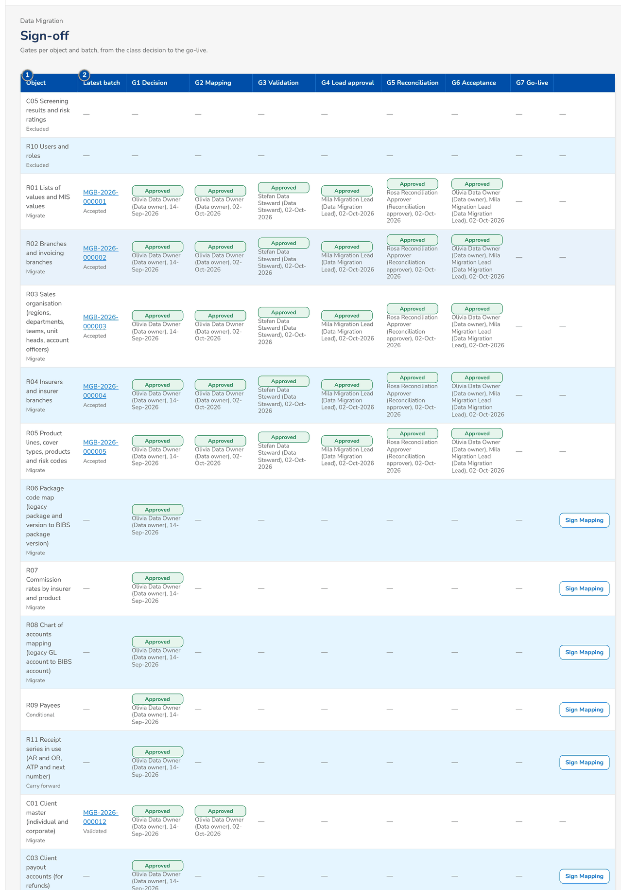
Figure 31: SCR-DM-10 Gate matrix per object with the signer and date of each gate
1 | Object | 2 | Latest batch | 3 | Decision, Mapping, Validation, Load approval, Reconciliation, Acceptance, Go-live

Fields (No. = callout number on the first screenshot)
No. | Section | Field | Type | Length / format | Mand. | Source / list | Default | Editable in | Validation | Message when it fails
1 | Matrix | Object | Column | Code and name; class under it | - | Data objects | - | - | - | -
2 | Matrix | Latest batch | Column | Batch number and status | - | Batches | - | - | - | -
3 | Matrix | Decision, Mapping, Validation, Load approval, Reconciliation, Acceptance, Go-live | Column | One column per gate G1 to G7; decision pill with the signer and date | - | Gates signed | - | - | - | -

Actions
Button | Who | Enabled when | What happens | Resulting status | Notification
Sign Mapping | Data owner | G1 approved and G2 not yet signed | Signs gate G2: the layouts of the object are frozen and every code map its columns use has an approved version | G2 signed | -
Latest batch link | Every migration role | A batch exists | Opens the batch page | - | -

Business rules
• Gates are signed in order; a gate refused returns the object to the step of that gate (FR-DM-003).
• The mapping is signed only when the layouts are frozen and every map used has an approved version (FR-DM-003).
Expected outcome
The Data Migration Lead sees what is missing per object before a trial migration or the cut-over.
Test cases: TC-DM-003.1-01, TC-DM-003.1-02, TC-DM-003.2-01, TC-DM-003.3-01, TC-DM-003.4-01, TC-DM-SCR-10.

19.2 Cut-over, adjustments and run-off

19.2.1 SCR-DM-11 Opening-Balance Adjustments
Purpose | The FY2027 closing and audit adjustments of the legacy books after go-live (year-end option A). The Comptrollership GL lead prepares an adjustment on a validated batch of the adjustment journals (object G03) and the legacy trial balance of the same version (object G01); the Head of Comptrollership approves or returns it. The load of the batch posts the opening-balance adjustment journals into the opening period (value date 1 January 2028) and adjusts the open legacy items; the adjustment is then reconciled to the legacy trial balances and signed.
Who can open it | Data Migration Lead, Data Steward, Data owner (business owner of an object), Migration Operator, Reconciliation approver (Head of Comptrollership), Go / no-go board, Comptrollership GL lead (permission Data migration view)
Navigation | • Menu: Data Migration › Data Migration › Opening Adjustments  • Sidebar › Data Migration › Opening Adjustments
FRs | FR-DM-022, FR-DM-023, FR-DM-024

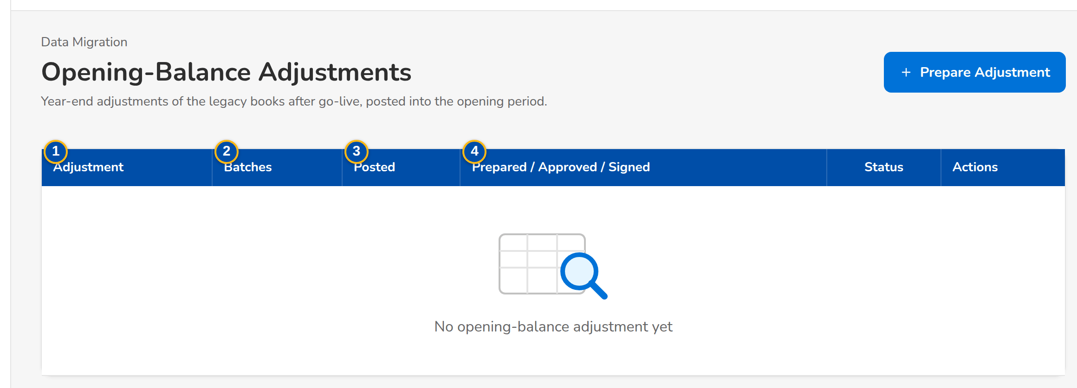
Figure 32: SCR-DM-11 Opening-balance adjustments with their batches and status
1 | Adjustment | 4 | Prepared / Approved / Signed | 7 | Legacy Trial Balance As Of
2 | Batches | 5 | Status | 8 | Adjustment Batch
3 | Posted | 6 | Adjustment | 9 | Legacy Trial Balance Batch

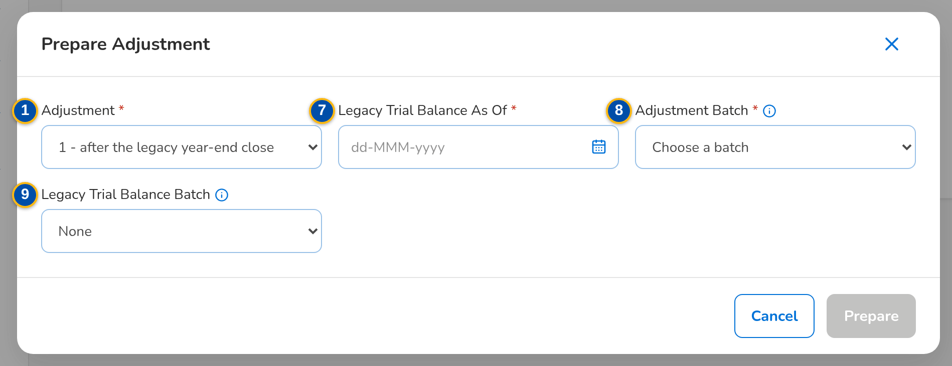
Figure 33: SCR-DM-11 Prepare Adjustment dialog
Fields (No. = callout number on the first screenshot)
No. | Section | Field | Type | Length / format | Mand. | Source / list | Default | Editable in | Validation | Message when it fails
1 | List | Adjustment | Column | Reference MIG-TU-n; as-of date under it | - | Adjustments | - | - | - | -
2 | List | Batches | Column | Adjustment batch; trial balance batch under it | - | Adjustment | - | - | - | -
3 | List | Posted | Column | Journals and items adjusted; date and time | - | Posting | - | - | - | -
4 | List | Prepared / Approved / Signed | Column | Names | - | Adjustment | - | - | - | -
5 | List | Status | Pill | Prepared, For approval, Approved, Posted, Reconciled, Signed | - | Adjustment | Prepared | - | - | -
6 | Prepare Adjustment | Adjustment | Drop-down | 1 after the legacy year-end close, 2 interim, 3 interim, F final after the audited statements | Y | - | 1 | - | Not yet prepared | Opening-balance adjustment <no> already exists
7 | Prepare Adjustment | Legacy Trial Balance As Of | Date | dd-MMM-yyyy | Y | - | - | - | - | -
8 | Prepare Adjustment | Adjustment Batch | Drop-down | A validated batch of the adjustment journals (G03) | Y | Batches of object G03 | - | - | A batch of the adjustment object | Batch <batch no> is not a batch of object <object>
9 | Prepare Adjustment | Legacy Trial Balance Batch | Drop-down | The trial balance of the same version (G01), or None | N | Batches of object G01 | None | - | - | -

Actions
Button | Who | Enabled when | What happens | Resulting status | Notification
Prepare Adjustment | Comptrollership GL lead | Year-end option A | Prepares the adjustment on the chosen batches | Prepared | -
Submit | Comptrollership GL lead | Prepared | Sends the adjustment to the Head of Comptrollership | For approval | -
Approve | Head, Comptrollership | For approval, prepared by another user | Allows the adjustment batch to be loaded; its journals post into the opening period | Approved | -
Return | Head, Comptrollership | For approval | Returns the adjustment to the preparer with the reason | Prepared | -
Reconcile | Comptrollership GL lead or Head, Comptrollership | Posted or Reconciled | Compares the adjustment with the legacy trial balances and checks that Migration Clearing is zero | Reconciled when every check is met | Alert when a check breaks
Sign | Head, Comptrollership | Reconciled | Signs the reconciled adjustment | Signed | -

Business rules
• Only journals dated in FY2027, posted in legacy after the freeze and entered in the FY2027 adjustment register are accepted (FR-DM-023).
• FY2027 profit and loss lines post to retained earnings; lines on legacy control accounts post to Migration Clearing with their open-item detail (FR-DM-023).
• The preparer never approves; a wrong adjustment is corrected by the next adjustment, never by changing a posted journal (FR-DM-023).
• An adjustment is signed only when the cut-off, movement, balance, clearing and opening-period checks are met (FR-DM-024).
Expected outcome
Every FY2027 adjustment made in legacy after the freeze is in the BIBS opening balances, approved and reconciled.
Test cases: TC-DM-023.1-01, TC-DM-023.4-01, TC-DM-023.5-01, TC-DM-024.2-01, TC-DM-024.3-01, TC-DM-024.4-01, TC-DM-SCR-11, TC-DM-MSG-10.

19.2.2 SCR-DM-12 Cutover
Purpose | The mock runs, the dress rehearsal and the production cut-over, each a plan with its runbook of tasks planned from the go-live date, the twelve go / no-go criteria and the decisions of the board. Task owners start, complete or block their tasks; the criteria are measured by BIBS or recorded with their evidence; the board decides GO or NO-GO. The runbook downloads as a workbook.
Who can open it | Data Migration Lead, Data Steward, Data owner (business owner of an object), Migration Operator, Reconciliation approver (Head of Comptrollership), Go / no-go board, Comptrollership GL lead (permission Data migration view)
Navigation | • Menu: Data Migration › Data Migration › Cutover  • Migration Home › Next cut-over tasks
FRs | FR-DM-120, FR-DM-121

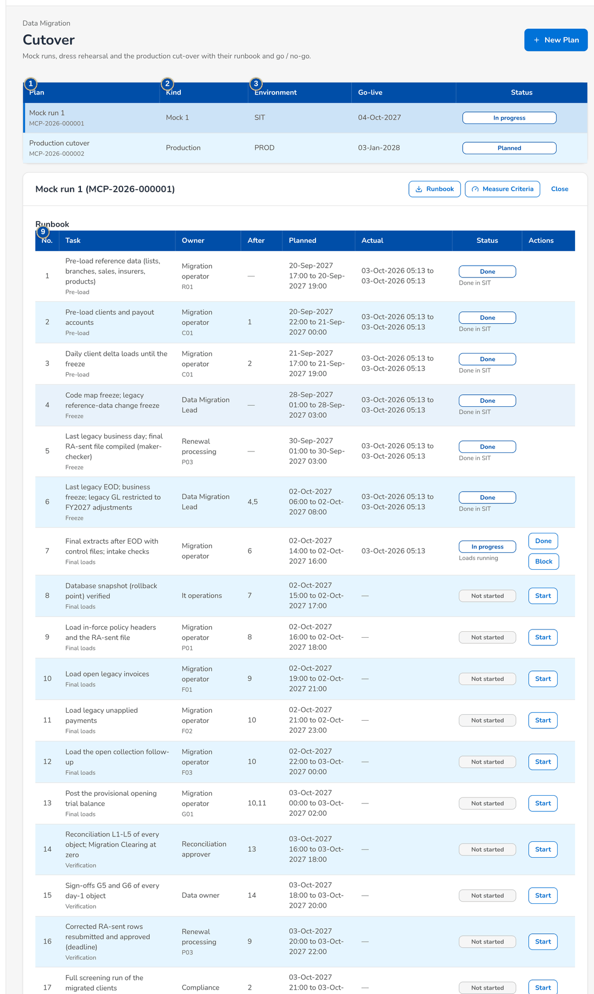
Figure 34: SCR-DM-12 Cut-over plans and the runbook of a mock run
1 | Plan | 5 | Kind | 9 | No., Task, Owner, After, Planned, Actual, Status
2 | Kind | 6 | Mock No. | 10 | No., Criterion, Kind, Measured, Result
3 | Environment, Go-live, Status | 7 | Environment | 11 | Decision, Criteria met, Decided by, At, Comment
4 | Name | 8 | Go-live Date

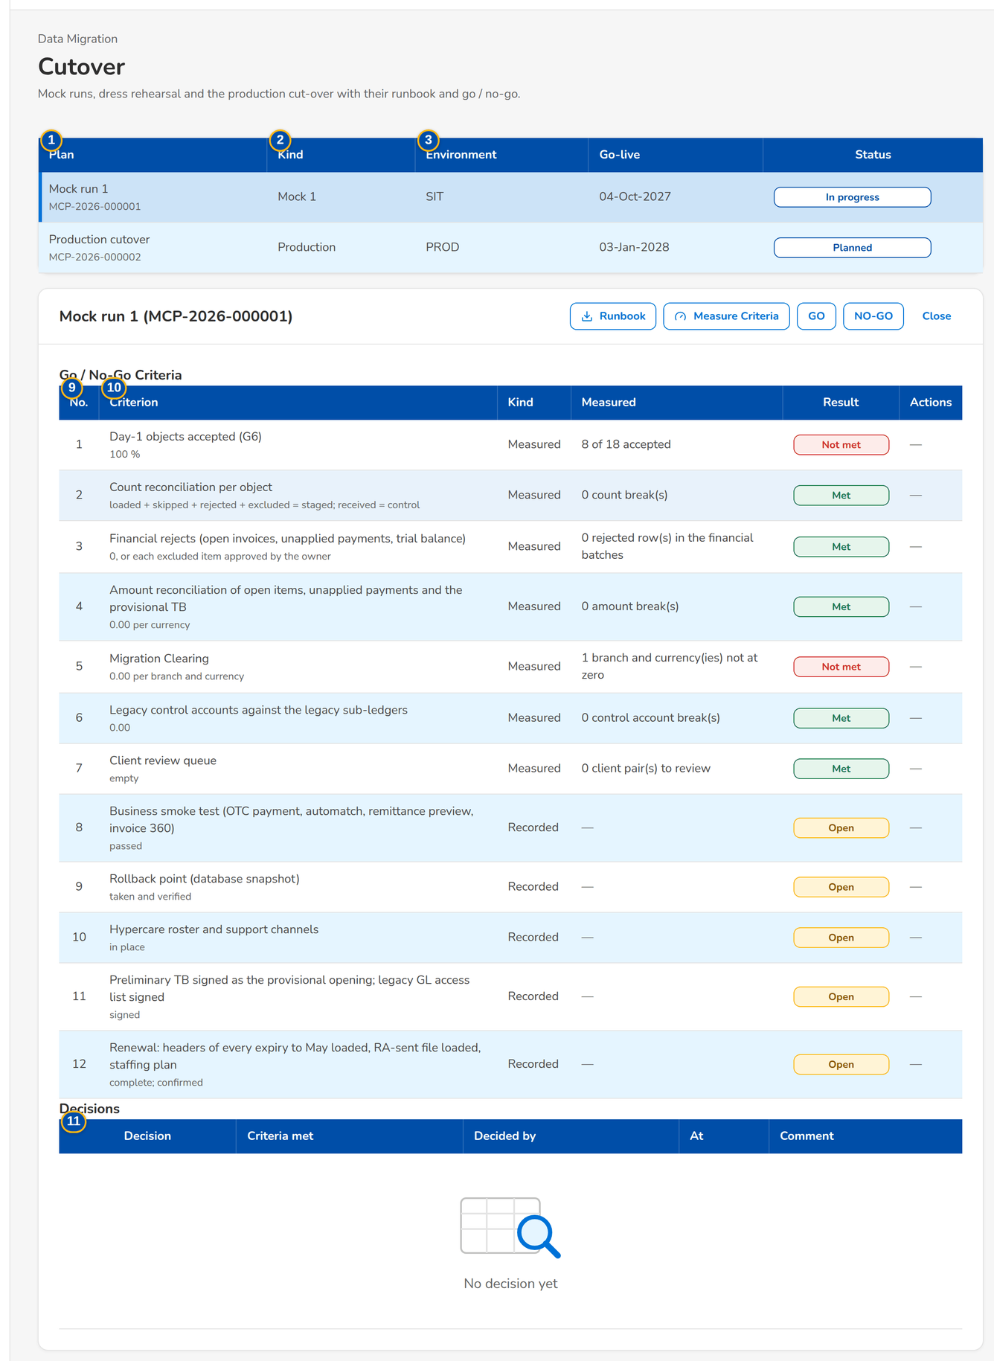
Figure 35: SCR-DM-12 Go / No-Go Criteria and Decisions of a plan

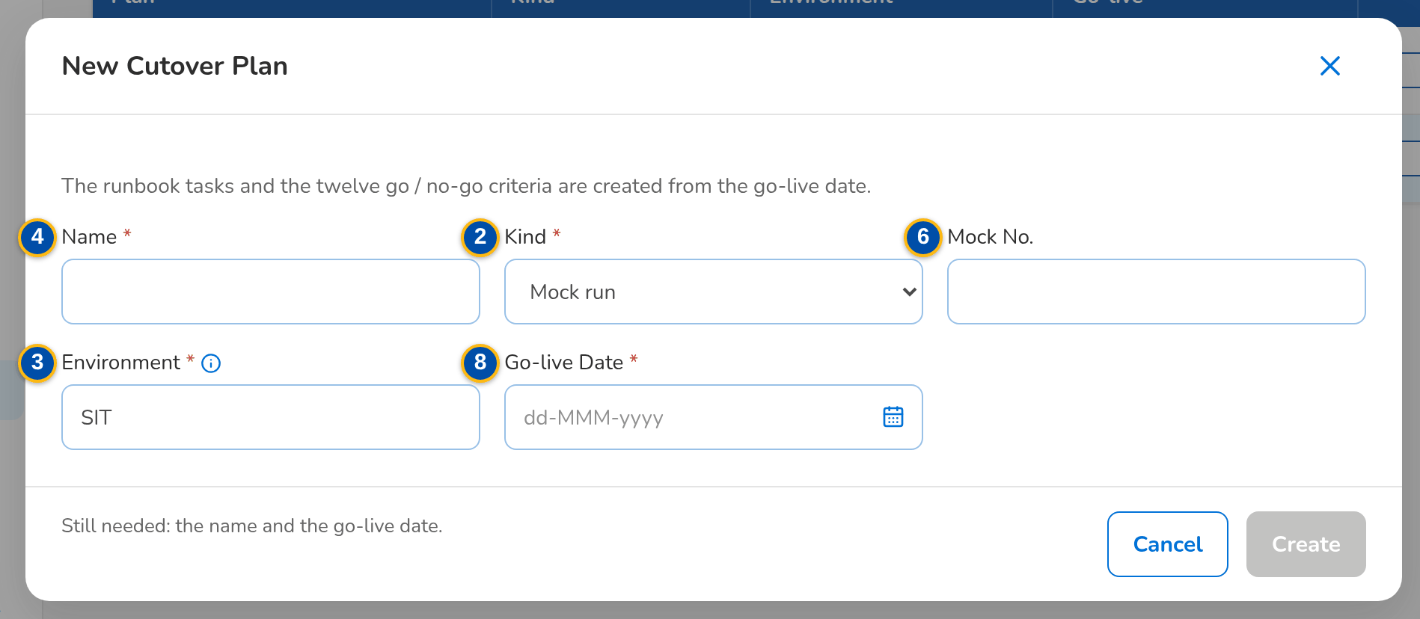
Figure 36: SCR-DM-12 New Cutover Plan dialog
Fields (No. = callout number on the first screenshot)
No. | Section | Field | Type | Length / format | Mand. | Source / list | Default | Editable in | Validation | Message when it fails
1 | Plans | Plan | Column | Name; plan number under it | - | Plans | - | - | - | -
2 | Plans | Kind | Column | Mock run with its number, Dress rehearsal, Production cut-over | - | Plan | - | - | - | -
3 | Plans | Environment, Go-live, Status | Column | SIT, UAT, PERF or PROD; dd-MMM-yyyy | - | Plan | - | - | - | -
4 | New Cutover Plan | Name | Text | Up to 120 characters | Y | - | - | - | Not blank | -
5 | New Cutover Plan | Kind | Drop-down | Mock run, Dress rehearsal, Production cut-over | Y | - | Mock run | - | - | -
6 | New Cutover Plan | Mock No. | Number | 1 or more | N | - | - | - | For a mock run | -
7 | New Cutover Plan | Environment | Text | SIT, UAT, PERF or PROD | Y | - | SIT | - | Not blank | -
8 | New Cutover Plan | Go-live Date | Date | dd-MMM-yyyy | Y | - | - | - | - | Give the go-live date of the plan
9 | Runbook | No., Task, Owner, After, Planned, Actual, Status | Columns | Phase under the task; object under the owner; reason under the status | - | Runbook tasks | - | - | - | -
10 | Go / No-Go Criteria | No., Criterion, Kind, Measured, Result | Columns | Threshold under the criterion; Measured or Recorded; Open, Met, Not met | - | Criteria | - | - | - | -
11 | Decisions | Decision, Criteria met, Decided by, At, Comment | Columns | GO or NO-GO | - | Decisions of the board | - | - | - | -

Actions
Button | Who | Enabled when | What happens | Resulting status | Notification
New Plan | Data Migration Lead | Always | Creates a plan; its runbook tasks and the twelve criteria are created from the go-live date | Planned | -
Create | Data Migration Lead | Name, environment and go-live date given (until then the dialog says what is still needed) | Creates the plan of the New Cutover Plan dialog | Planned | -
Runbook | Every migration role | A plan is open | Downloads the runbook workbook of the plan | - | -
Measure Criteria | Data Migration Lead or the board | A plan is open | Measures the criteria that BIBS measures (acceptance, counts, financial rejects, amounts, clearing, legacy accounts, client queue) | - | -
Start, Done, Block | Data Migration Lead | Task not started, in progress or blocked | Records the actual start or end; a block needs its reason | In progress, Done, Blocked | -
Met, Not met | Data Migration Lead | Recorded criterion | Records a criterion that BIBS does not measure, with its evidence | Met or Not met | -
GO | Go / no-go board | A plan is open | Records GO; when a criterion is not met the justification is mandatory; on the production plan it signs gate G7 | GO | -
NO-GO | Go / no-go board | A plan is open | Records NO-GO with the reason; the cut-over stops and rolls back to the snapshot | NO-GO | -

Business rules
• A task starts only when the tasks it depends on are done (FR-DM-120).
• Criteria measured by BIBS cannot be recorded by hand (FR-DM-121).
• A GO with criteria not met needs the board's justification; the financial and clearing criteria of the go-live decision are never waived (FR-DM-121).
• Until the go / no-go decision the rollback restores the snapshot taken before the production load (FR-DM-121).
Expected outcome
The cut-over follows a rehearsed plan and go-live is decided on measured criteria.
Test cases: TC-DM-120.1-01, TC-DM-120.2-01, TC-DM-120.3-01, TC-DM-120.5-01, TC-DM-120.5-02, TC-DM-120.6-01, TC-DM-121.1-01, TC-DM-121.2-01, TC-DM-121.3-01, TC-DM-121.4-01, TC-DM-121.5-01, TC-DM-SCR-12, TC-DM-MSG-11.

19.2.3 SCR-DM-13 Run-off and Decommissioning
Purpose | The monthly run-off of the legacy policies in force at go-live by expiry month and source system (renewed in BIBS, not renewed, lapsed, still open), and the checklists that close each legacy system and, once every legacy item is settled, the legacy context of BIBS.
Who can open it | Data Migration Lead, Data Steward, Data owner (business owner of an object), Migration Operator, Reconciliation approver (Head of Comptrollership), Go / no-go board, Comptrollership GL lead (permission Data migration view)
Navigation | • Menu: Data Migration › Data Migration › Run-off and Decommissioning  • Migration Home › Run-off of the legacy policies
FRs | FR-DM-122, FR-DM-123

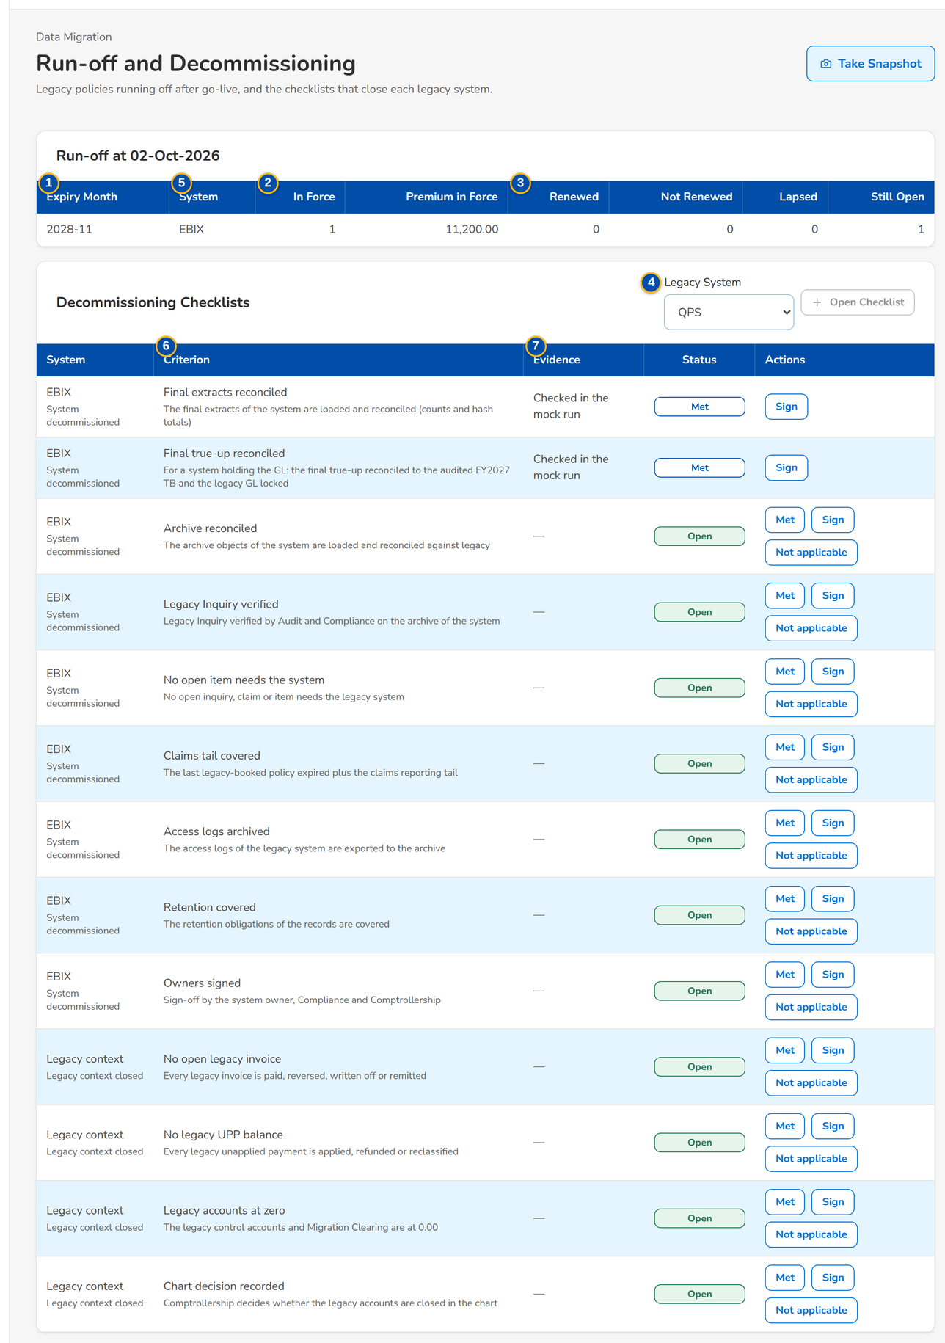
Figure 37: SCR-DM-13 Run-off by expiry month and the decommissioning checklists
1 | Expiry Month, System | 4 | Legacy System | 7 | Evidence
2 | In Force, Premium in Force | 5 | System | 8 | Status
3 | Renewed, Not Renewed, Lapsed, Still Open | 6 | Criterion

Fields (No. = callout number on the first screenshot)
No. | Section | Field | Type | Length / format | Mand. | Source / list | Default | Editable in | Validation | Message when it fails
1 | Run-off | Expiry Month, System | Column | yyyy-MM; EBIX, QPS, ISYS, CMS | - | Run-off snapshot | - | - | - | -
2 | Run-off | In Force, Premium in Force | Column | Count; amount | - | Run-off snapshot | - | - | - | -
3 | Run-off | Renewed, Not Renewed, Lapsed, Still Open | Column | Counts | - | Run-off snapshot | - | - | - | -
4 | Decommissioning Checklists | Legacy System | Drop-down | EBIX, QPS, ISYS, CMS without an open checklist | Y | Legacy systems | EBIX | - | - | The checklist of <system> is already open
5 | Decommissioning Checklists | System | Column | System, or Legacy context; the milestone under it | - | Checklist | - | - | - | -
6 | Decommissioning Checklists | Criterion | Column | Name; description under it | - | Checklist template | - | - | - | -
7 | Decommissioning Checklists | Evidence | Column | Text; who signed and when under it | - | Checklist | - | - | Evidence given | Give the evidence of the criterion
8 | Decommissioning Checklists | Status | Pill | Open, Met, Signed, Not applicable | - | Checklist | Open | - | - | -

Actions
Button | Who | Enabled when | What happens | Resulting status | Notification
Take Snapshot | Data Migration Lead | Always | Takes the run-off snapshot of today (it is also taken on the first of each month) | - | -
Open Checklist | Data Migration Lead | The system has no checklist | Opens the decommissioning checklist of the system | Open | -
Met, Sign, Not applicable | Data Migration Lead | Criterion open or met | Records the criterion with its evidence | Met, Signed or Not applicable | -

Business rules
• A legacy system is decommissioned only when every criterion of its checklist is signed (FR-DM-123).
• The legacy context closes when no legacy invoice or unapplied payment is open and the legacy accounts and Migration Clearing are at 0.00 (FR-DM-123).
Expected outcome
The run-off of the legacy policies is visible month by month and each legacy system is closed against a signed checklist.
Test cases: TC-DM-123.1-01, TC-DM-123.2-01, TC-DM-123.3-01, TC-DM-123.4-01, TC-DM-SCR-13, TC-DM-MSG-12.

19.3 Legacy Inquiry

19.3.1 SCR-DM-14 Legacy Inquiry
Purpose | The read-only archive of the legacy systems for Audit and Compliance: closed clients, policies, invoices, receipts, remittances, endorsements, claims, GL journals, renewal advices and letters with their documents. The user gives the reason of the inquiry once per session; each search, view, download and export is logged with it. A record opens read-only with all its legacy columns and documents.
Who can open it | Audit / Compliance user (permission Legacy inquiry view)
Navigation | • Menu: Data Migration › Legacy Inquiry › Legacy Inquiry  • Sidebar › Data Migration › Legacy Inquiry
FRs | FR-DM-110

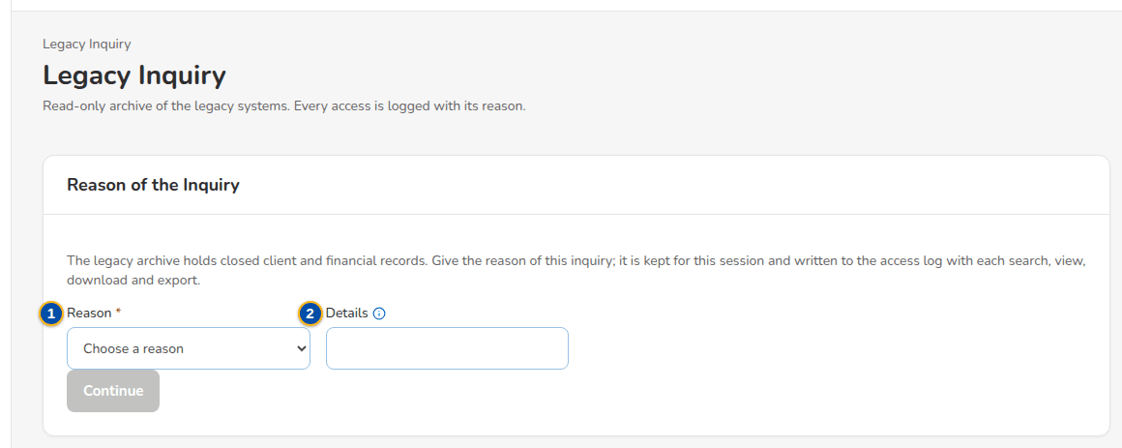
Figure 38: SCR-DM-14 Reason of the Inquiry asked once per session
1 | Reason | 6 | Record | 11 | Date, Period, Amount, Legacy status, Archived
2 | Details | 7 | Client | 12 | Legacy details
3 | Client Name or No., Policy / Cover No., Invoice No., Receipt No., Claim No. | 8 | Policy / Invoice / Receipt | 13 | File, Document, Size
4 | Record Type | 9 | Date, Amount, Legacy Status, Documents
5 | Date From, Date To | 10 | Legacy system, Client, Policy / cover, Invoice, Receipt, Claim

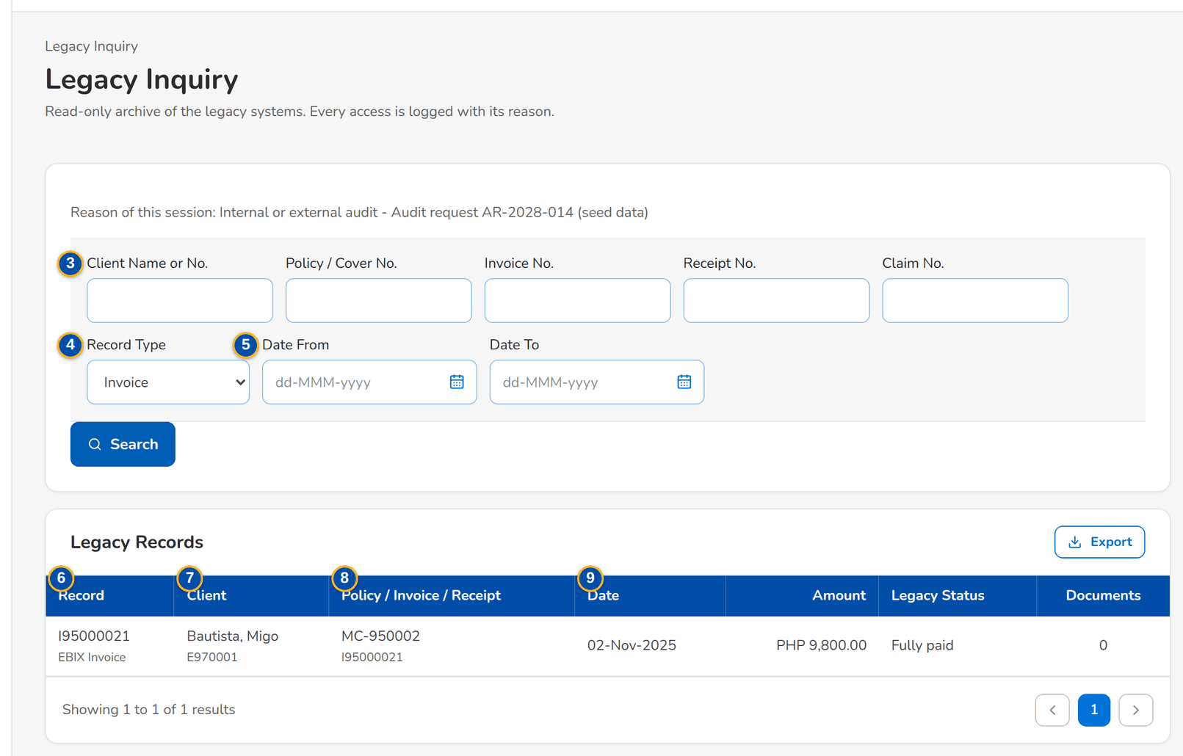
Figure 39: SCR-DM-14 Search criteria and the legacy records found

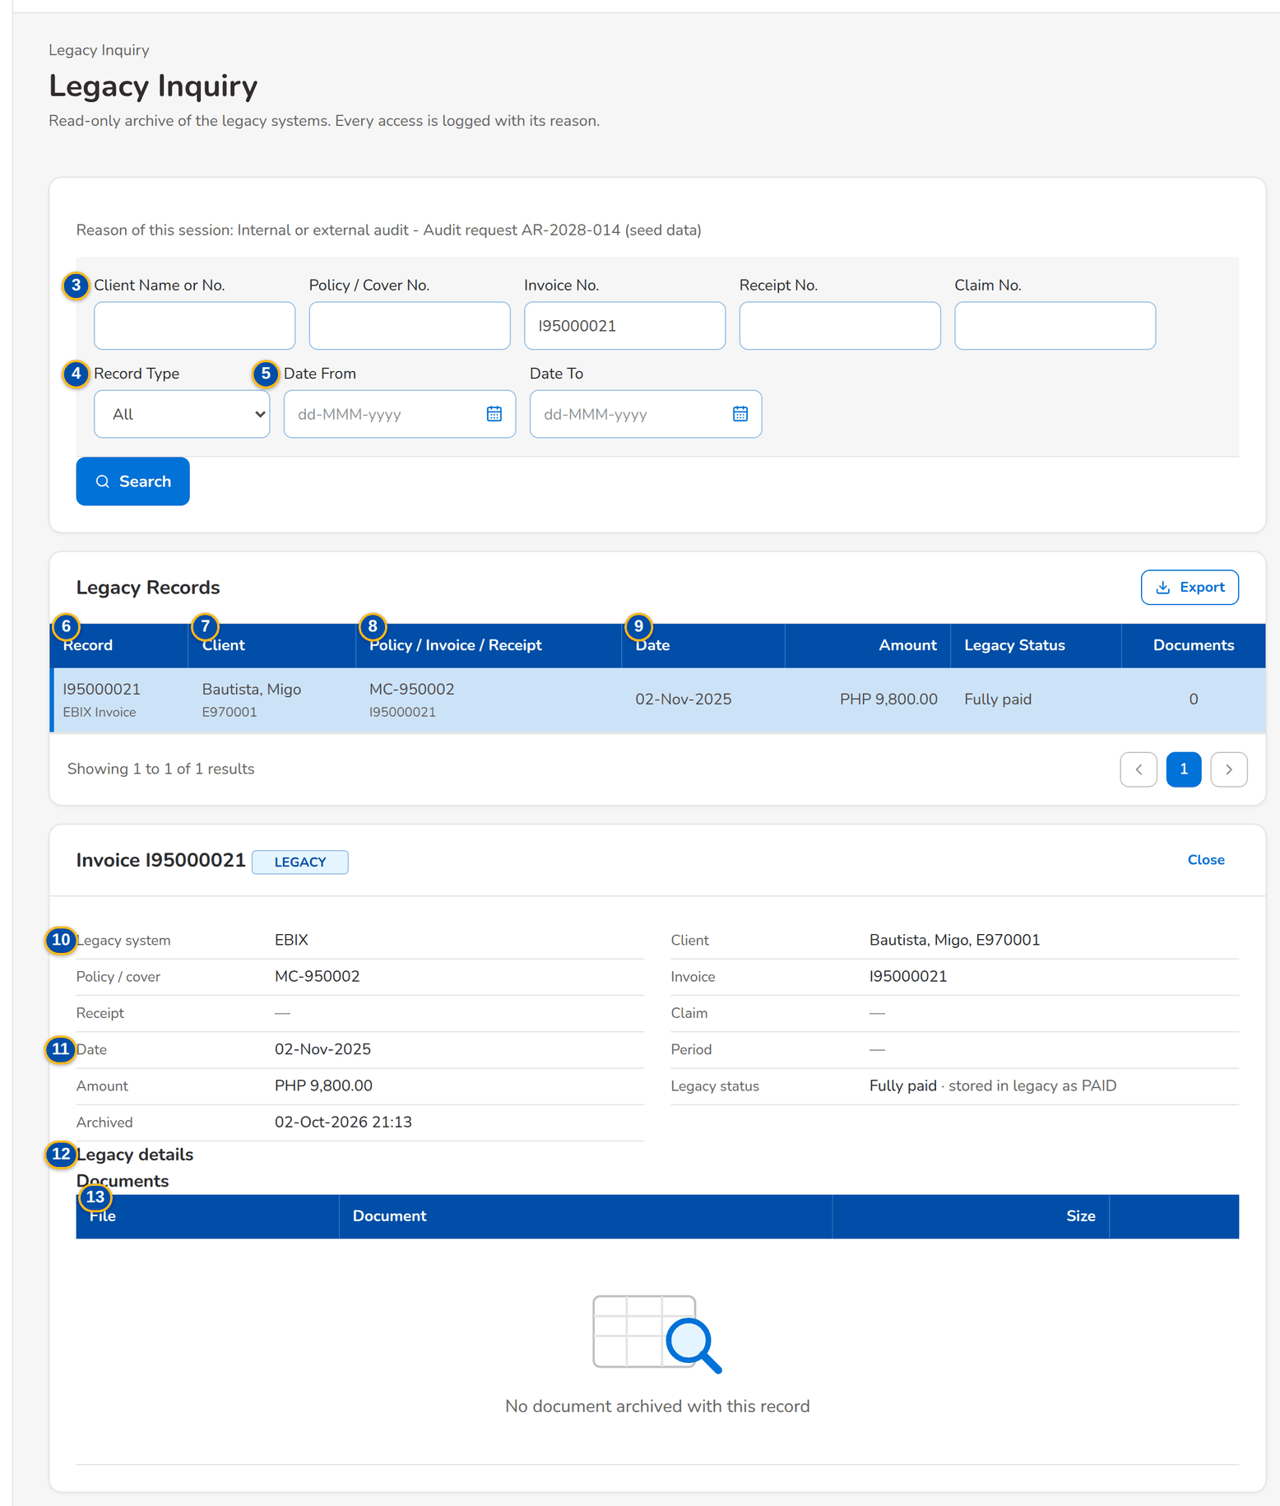
Figure 40: SCR-DM-14 A legacy record with its legacy details and documents

Fields (No. = callout number on the first screenshot)
No. | Section | Field | Type | Length / format | Mand. | Source / list | Default | Editable in | Validation | Message when it fails
1 | Reason of the Inquiry | Reason | Drop-down | Reasons of the list | Y | Access reasons | - | - | - | Give the reason for opening the legacy archive
2 | Reason of the Inquiry | Details | Text | Audit reference, request or case; up to 500 characters | C | - | - | - | Mandatory for the reason Other | -
3 | Search | Client Name or No., Policy / Cover No., Invoice No., Receipt No., Claim No. | Text | - | C | - | - | - | At least one criterion | Give a client, policy, invoice, receipt or claim, a record type or a date range
4 | Search | Record Type | Drop-down | All, client, policy, invoice, receipt, remittance, endorsement, claim, GL journal, renewal advice, letter, other | N | - | All | - | - | -
5 | Search | Date From, Date To | Date | dd-MMM-yyyy | N | - | - | - | Valid dates | Give the date as yyyy-MM-dd: <value>
6 | Legacy Records | Record | Column | Legacy key; source system and record type under it | - | Archive | - | - | - | -
7 | Legacy Records | Client | Column | Name; legacy client number under it | - | Archive | - | - | - | -
8 | Legacy Records | Policy / Invoice / Receipt | Column | Policy; invoice, receipt and claim under it | - | Archive | - | - | - | -
9 | Legacy Records | Date, Amount, Legacy Status, Documents | Column | dd-MMM-yyyy; currency and amount; status; count | - | Archive | - | - | - | -
10 | Record | Legacy system, Client, Policy / cover, Invoice, Receipt, Claim | Text | - | - | Archive record | - | - | - | -
11 | Record | Date, Period, Amount, Legacy status, Archived | Text | dd-MMM-yyyy; amounts with two decimals | - | Archive record | - | - | - | -
12 | Record | Legacy details | Text | Every legacy column with its label | - | Archive record | - | - | - | -
13 | Record | File, Document, Size | Columns | Documents archived with the record | - | Archive documents | - | - | - | -

Actions
Button | Who | Enabled when | What happens | Resulting status | Notification
Continue | Audit / Compliance user | A reason is chosen (and details for Other) | Keeps the reason for the session and opens the search | - | -
Search | Audit / Compliance user | At least one criterion | Lists the matching records; the search is logged | - | -
Export | Audit / Compliance user with the export right | Records found | Exports the records to Excel, up to 1,000 at a time; the export is logged | - | Alert Unusual access when a user exports more than 5,000 records in a day
Download a document | Audit / Compliance user | Record open | Downloads the document; the download is logged | - | -
Close | Audit / Compliance user | Record open | Closes the record | - | -

Business rules
• The legacy archive is read-only; no record or document is changed (FR-DM-110).
• A reason is required before the archive is searched and is written with every search, view, download and export (FR-DM-110).
• An export is limited to 1,000 records; a narrower search is asked for above it (FR-DM-110).
• The addresses of the read-only legacy applications are shown to the users who still need them until each system is decommissioned (FR-DM-110).
Expected outcome
Legacy history stays retrievable with its documents, and every access is logged with its reason.
Test cases: TC-DM-110.1-01, TC-DM-110.2-01, TC-DM-110.3-01, TC-DM-SCR-14, TC-DM-MSG-13.

19.3.2 SCR-DM-15 Access Log
Purpose | Every access to the legacy archive with the user, the time and address, the action, the criteria, the records and the reason, for the Compliance reviewer. The log cannot be changed or deleted; a monthly digest is sent to the reviewers.
Who can open it | Compliance reviewer of the access log (permission Legacy access log view)
Navigation | • Menu: Data Migration › Legacy Inquiry › Access Log  • Sidebar › Data Migration › Access Log
FRs | FR-DM-111

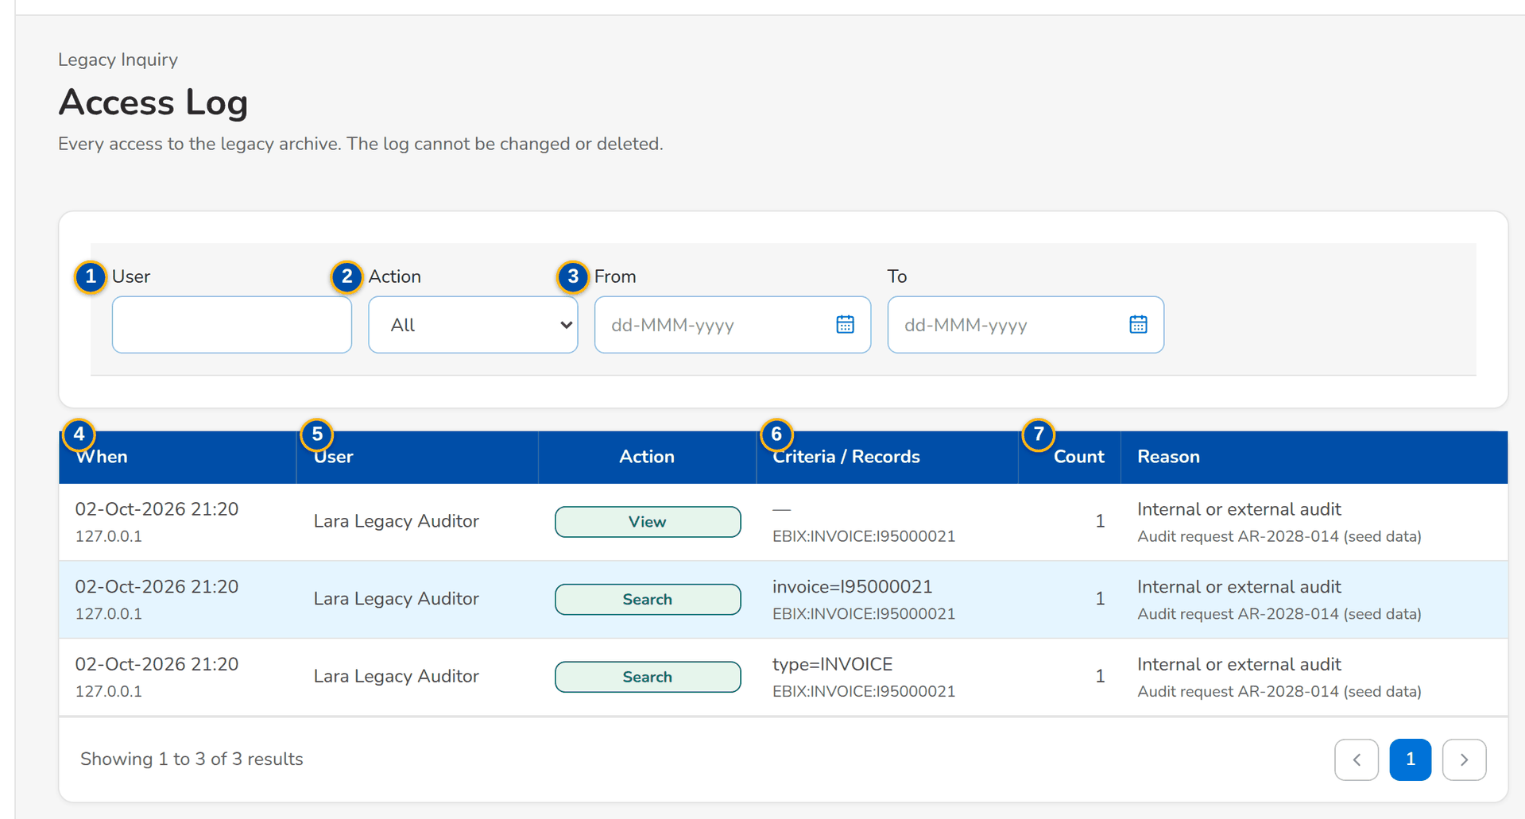
Figure 41: SCR-DM-15 Access Log with its filters
1 | User | 4 | When | 7 | Count, Reason
2 | Action | 5 | User, Action
3 | From, To | 6 | Criteria / Records

Fields (No. = callout number on the first screenshot)
No. | Section | Field | Type | Length / format | Mand. | Source / list | Default | Editable in | Validation | Message when it fails
1 | Filters | User | Text | User name | N | - | - | - | - | -
2 | Filters | Action | Drop-down | All, Search, View, Download, Export | N | - | All | - | - | -
3 | Filters | From, To | Date | dd-MMM-yyyy | N | - | - | - | - | -
4 | Log | When | Column | dd-MMM-yyyy HH:mm; source address under it | - | Access log | - | - | - | -
5 | Log | User, Action | Column | Name; Search, View, Download or Export | - | Access log | - | - | - | -
6 | Log | Criteria / Records | Column | Search criteria; record keys under them | - | Access log | - | - | - | -
7 | Log | Count, Reason | Column | Records returned; reason and details | - | Access log | - | - | - | -

Actions
Button | Who | Enabled when | What happens | Resulting status | Notification
Filters | Compliance reviewer | Always | Narrows the log | - | -

Business rules
• No entry of the access log can be changed or deleted (FR-DM-111).
• The reviewers receive a monthly digest of the log (FR-DM-111).
Expected outcome
Compliance sees who looked at which legacy records, when and why.
Test cases: TC-DM-111.1-01, TC-DM-111.3-01, TC-DM-SCR-15.

19.4 Migrated data on the business screens

19.4.1 SCR-DM-16 LEGACY badge and Origin filter on the lists
Purpose | Records migrated from a legacy system are used with the normal BIBS screens. They are told apart from records created in BIBS by a LEGACY badge next to their number on the lists and records (Clients, Accounts, Invoice Search, Unapplied Payments, the PR Worklist and its accounts, Products, Insurers, Payees), with the source system, the legacy reference and the migration batch in its tooltip, and by the Origin filter of the lists that hold migrated records.
Who can open it | Comptrollership GL lead, Cashiering user, Cashiering team lead, Commission user, Commission team lead, Marketing Account Officer (permission Client view)
Navigation | • Menu: Client & Policy › Clients › Clients  • Client & Policy › Clients › Clients  • Client & Policy › Accounts & Placement › Accounts  • Operations › Operations › Invoice Search  • Finance › Cashiering › Unapplied Payments  • Finance › Collections › PR Worklist
FRs | FR-DM-032, FR-DM-033, FR-DM-040

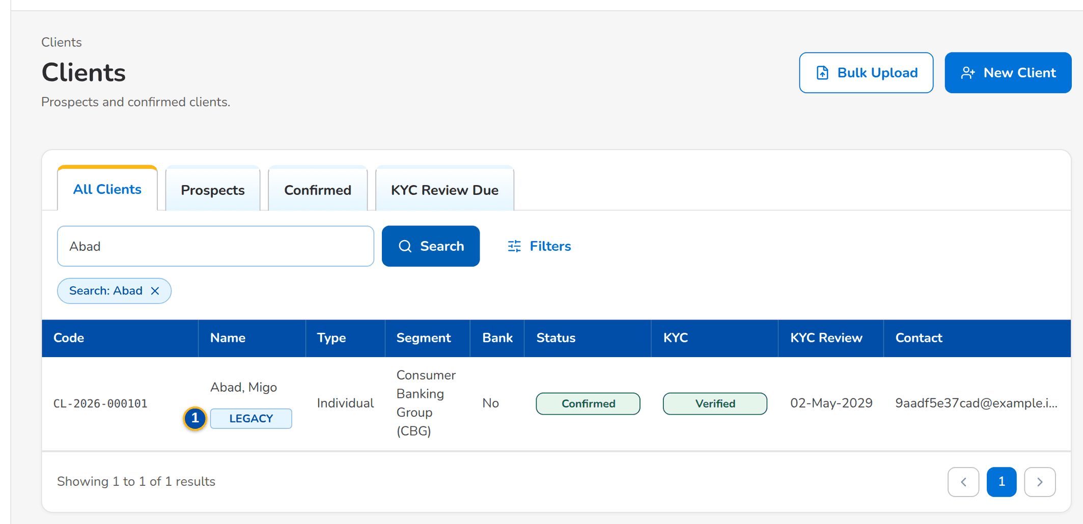
Figure 42: SCR-DM-16 Clients list with a migrated client marked LEGACY
1 | LEGACY | 3 | Legacy client number
2 | Origin | 4 | Legacy policy reference

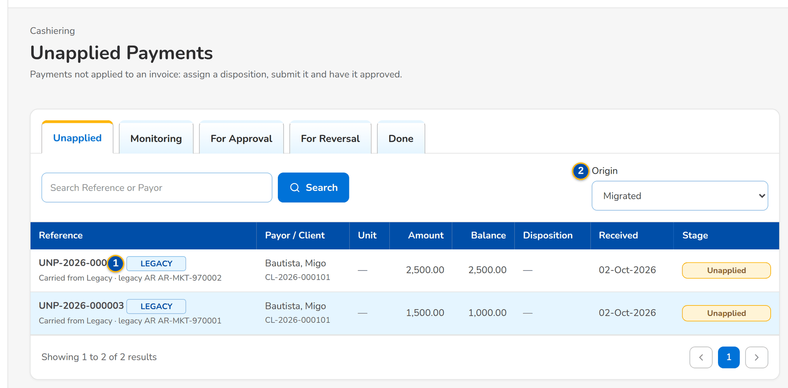
Figure 43: SCR-DM-16 Unapplied Payments with the Origin filter set to Migrated
Fields (No. = callout number on the first screenshot)
No. | Section | Field | Type | Length / format | Mand. | Source / list | Default | Editable in | Validation | Message when it fails
1 | Every list with migrated records | LEGACY | Badge | Next to the number; tooltip: Migrated from <system>, legacy reference <ref>, batch <batch> | - | Origin of the record | - | - | - | -
2 | Lists with the Origin filter | Origin | Drop-down | All origins, BIBS, Migrated | N | - | All origins | - | - | -
3 | Client search | Legacy client number | Text | A legacy client number finds the BIBS client it was merged into | N | Key cross-reference | - | - | - | -
4 | Account search | Legacy policy reference | Text | A legacy policy number finds the migrated policy header | N | Key cross-reference | - | - | - | -

Actions
Button | Who | Enabled when | What happens | Resulting status | Notification
Search and filters | Users of each list | Always | Find migrated records by their BIBS or legacy number, or only the migrated or BIBS records | - | -

Business rules
• Every migrated record keeps the origin Migrated, its source system, legacy reference and migration batch (FR-DM-032).
• Migrated records raise no notification to clients or insurers and no outbound integration message (FR-DM-014).
• A migrated client is found by any of its legacy client numbers (FR-DM-033).
Expected outcome
Users work migrated and new records on the same screens and always know which is which.
Test cases: TC-DM-014.2-01, TC-DM-014.5-01, TC-DM-032.1-01, TC-DM-032.2-01, TC-DM-033.1-01, TC-DM-033.2-01, TC-DM-033.3-01, TC-DM-040.1-01, TC-DM-040.2-01, TC-DM-040.4-01, TC-DM-041.1-01, TC-DM-041.2-01, TC-DM-041.3-01, TC-DM-090.3-01, TC-DM-126.1-01, TC-DM-SCR-16.

19.4.2 SCR-DM-17 Legacy invoice on Invoice 360
Purpose | An open legacy invoice is carried into the BIBS Operations ledger with its open balances and processed like a BIBS invoice. Invoice 360 shows its LEGACY badge and legacy invoice number, and a Legacy Invoice card with the source system, the legacy reference, the migration batch and the values at cut-over, kept as loaded: the original gross premium, commission and VAT, and per component what was booked, adjusted, paid and remitted in legacy, written off and open at cut-over.
Who can open it | Comptrollership GL lead, Cashiering user, Cashiering team lead, Commission user, Commission team lead, Marketing Account Officer (permission Ops view)
Navigation | • Menu: Operations › Operations › Invoice Search › Invoice 360  • Operations › Operations › Invoice Search › a legacy invoice  • PR Worklist › a legacy item
FRs | FR-DM-050, FR-DM-051, FR-DM-060, FR-DM-100

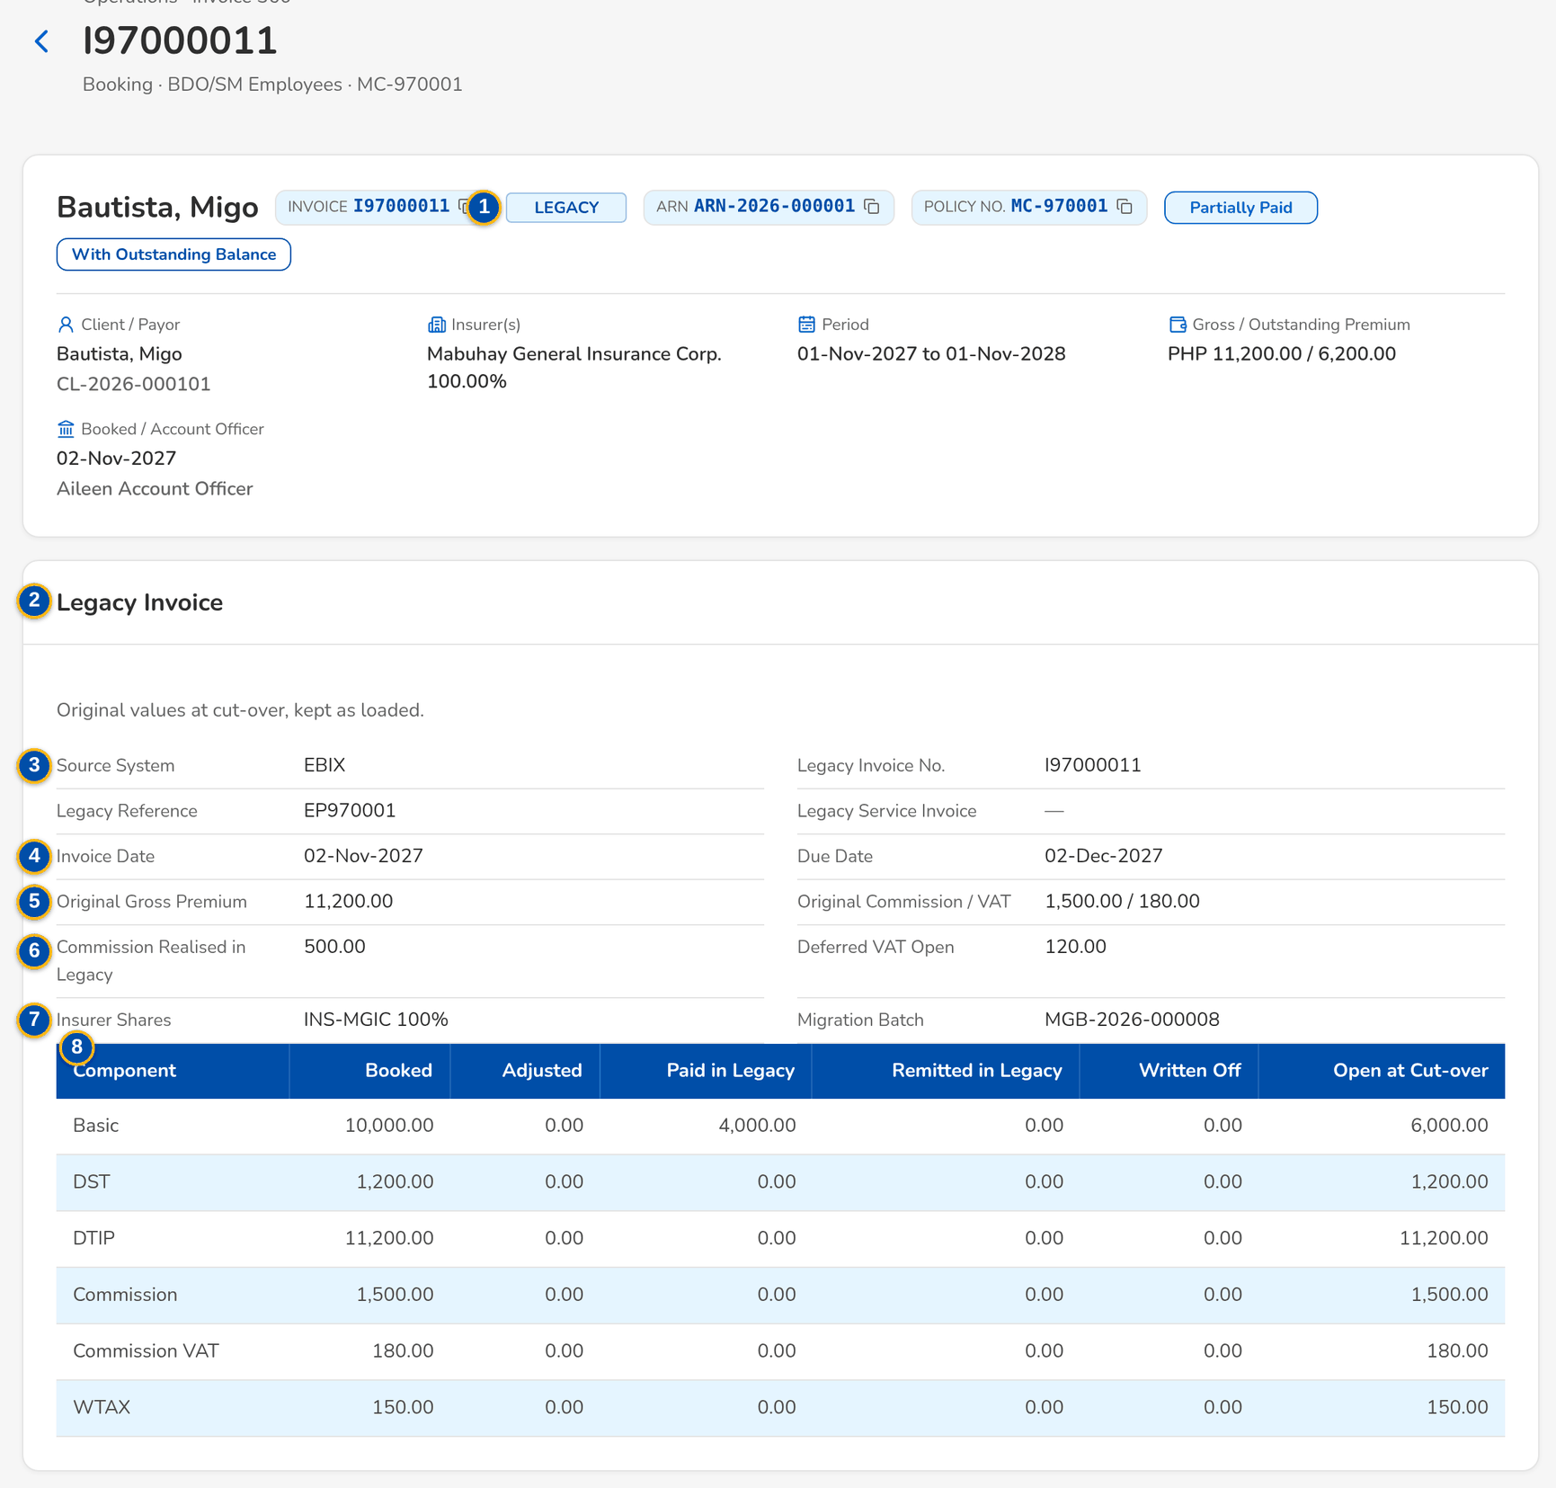
Figure 44: SCR-DM-17 Invoice 360 of a legacy invoice with the Legacy Invoice card
1 | LEGACY | 4 | Invoice Date, Due Date | 7 | Insurer Shares, Migration Batch
2 | Legacy Invoice | 5 | Original Gross Premium, Original Commission / VAT | 8 | Component, Booked, Adjusted, Paid in Legacy, Remitted in Legacy, Written Off, Open at Cut-over
3 | Source System, Legacy Invoice No., Legacy Reference, Legacy Service Invoice | 6 | Commission Realised in Legacy, Deferred VAT Open

Fields (No. = callout number on the first screenshot)
No. | Section | Field | Type | Length / format | Mand. | Source / list | Default | Editable in | Validation | Message when it fails
1 | Header | LEGACY | Badge | Next to the invoice number | - | Origin | - | - | - | -
2 | Header | Legacy Invoice | Chip | Legacy invoice number when it differs from the BIBS number | - | Legacy invoice | - | - | - | -
3 | Legacy Invoice | Source System, Legacy Invoice No., Legacy Reference, Legacy Service Invoice | Text | - | - | Values at cut-over | - | - | - | -
4 | Legacy Invoice | Invoice Date, Due Date | Date | dd-MMM-yyyy | - | Values at cut-over | - | - | - | -
5 | Legacy Invoice | Original Gross Premium, Original Commission / VAT | Amount | Two decimals | - | Values at cut-over | - | - | - | -
6 | Legacy Invoice | Commission Realised in Legacy, Deferred VAT Open | Amount | Two decimals | - | Values at cut-over | - | - | - | -
7 | Legacy Invoice | Insurer Shares, Migration Batch | Text | - | - | Values at cut-over | - | - | - | -
8 | Legacy positions at cut-over | Component, Booked, Adjusted, Paid in Legacy, Remitted in Legacy, Written Off, Open at Cut-over | Columns | One row per component | - | Values at cut-over | - | - | - | -

Actions
Button | Who | Enabled when | What happens | Resulting status | Notification
The actions of Invoice 360 | Users of Invoice 360 | As for a BIBS invoice | Payments, automatch, refunds, reclassifications, remittance and endorsements work on the legacy invoice; its postings go to the legacy accounts | - | -

Business rules
• A legacy invoice is not re-booked; it keeps its legacy number and its postings go to the legacy control accounts (FR-DM-050).
• The values at cut-over are never changed; the report Changes to Legacy Invoices compares every later change with them (FR-DM-100).
• When legacy could give only the open balances, the card says so and the original amounts are blank (FR-DM-050).
Expected outcome
The user sees what was open at cut-over and what has happened in BIBS since, on one screen.
Test cases: TC-DM-023.2-01, TC-DM-050.1-01, TC-DM-050.3-01, TC-DM-061.5-01, TC-DM-SCR-17.

19.5 Legacy batches

19.5.1 SCR-DM-18 Unapplied to Income
Purpose | Batches of old unapplied payments, new and legacy, reclassified to other income (unclaimed collections). A Cashiering user opens a batch with its reason and currency and adds the unapplied payments received at least a chosen number of days ago; the Cashiering team lead approves, then top management; after the second approval each line posts on its own and the payment closes. Legacy items come from Unapplied Collections - Legacy, new ones from Unapplied Collections.
Who can open it | Cashiering user, Cashiering team lead, Top management approver (permission Cash UPP income request or Cash UPP income approve or Cash disposition approve)
Navigation | • Menu: Finance › Cashiering › Unapplied to Income  • Finance › Cashiering › Unapplied to Income  • Unapplied Payments › an old item
FRs | FR-DM-055

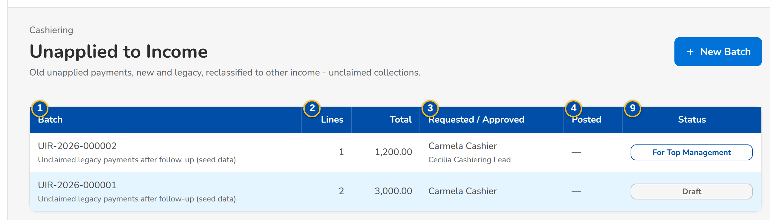
Figure 45: SCR-DM-18 Unapplied to Income batches
1 | Batch | 6 | Reason | 11 | Origin
2 | Lines, Total | 7 | Currency | 12 | Reason for the Lines
3 | Requested / Approved | 8 | Status, Reason, Total, Lines, Requested By, Submitted, Approved By, Posted, Returned Because | 13 | Unapplied Payment, Payor / Client, Age (days), Stage, Balance
4 | Posted | 9 | #, Unapplied Payment, Amount, Result, Status
5 | Status | 10 | Received At Least (days ago)

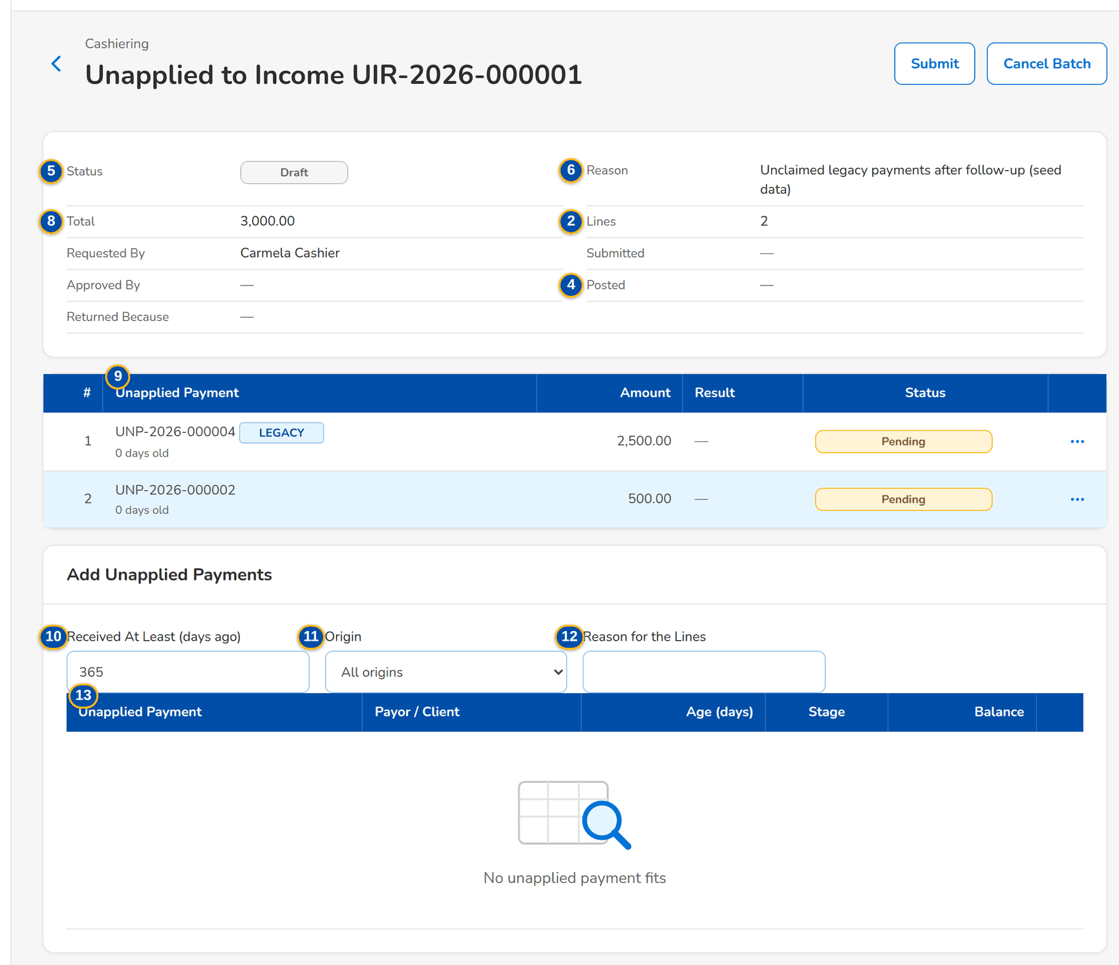
Figure 46: SCR-DM-18 A draft batch with its lines and the payments that may be added

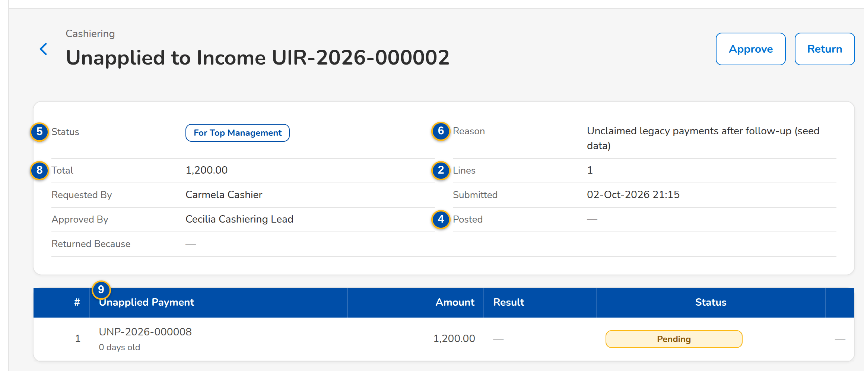
Figure 47: SCR-DM-18 A batch waiting for top management
Fields (No. = callout number on the first screenshot)
No. | Section | Field | Type | Length / format | Mand. | Source / list | Default | Editable in | Validation | Message when it fails
1 | List | Batch | Column | Batch number; reason under it | - | Batches | - | - | - | -
2 | List | Lines, Total | Column | Count; amount | - | Batch | - | - | - | -
3 | List | Requested / Approved | Column | Requester; approvers under it | - | Batch | - | - | - | -
4 | List | Posted | Column | Lines posted and refused; date and time | - | Batch | - | - | - | -
5 | List | Status | Pill | Draft, For approval, For top management, Posted, Returned, Cancelled | - | Batch | Draft | - | - | -
6 | New Batch | Reason | Text area | Up to 500 characters | Y | - | - | Draft | Not blank | -
7 | New Batch | Currency | Drop-down | PHP, USD | Y | - | PHP | Draft | - | -
8 | Batch | Status, Reason, Total, Lines, Requested By, Submitted, Approved By, Posted, Returned Because | Text | - | - | Batch | - | - | - | -
9 | Lines | #, Unapplied Payment, Amount, Result, Status | Columns | LEGACY tag on a legacy item; age in days under it; journal or refusal message | - | Lines | - | - | - | -
10 | Add Unapplied Payments | Received At Least (days ago) | Number | Days | N | - | 365 | Draft | - | -
11 | Add Unapplied Payments | Origin | Drop-down | All origins, BIBS, Migrated | N | - | All origins | Draft | - | -
12 | Add Unapplied Payments | Reason for the Lines | Text | Up to 250 characters | N | - | - | Draft | - | -
13 | Add Unapplied Payments | Unapplied Payment, Payor / Client, Age (days), Stage, Balance | Columns | Legacy AR number under a legacy item | - | Open unapplied payments of the currency, old enough, not in another batch | - | - | - | -

Actions
Button | Who | Enabled when | What happens | Resulting status | Notification
New Batch | Cashiering user | Always | Opens a draft batch | Draft | -
Add | Cashiering user | Draft | Adds the payment as a line | Draft | -
Remove | Cashiering user | Draft | From the row action menu of the line: removes the line | Draft | -
Submit | Cashiering user | Draft with lines | Sends the batch to the Cashiering team lead | For approval | -
Cancel Batch | Cashiering user | Draft | Closes the batch without posting; its lines may be taken again | Cancelled | -
Approve | Cashiering team lead, then top management | For approval, For top management; never the requester | First approval sends the batch to top management; the second posts each line in its own transaction | For top management, Posted | -
Return | Approver of the step | For approval, For top management | Returns the batch to its requester as a draft with the reason | Draft | -

Business rules
• Two approvals by two different people, the Cashiering team lead and then top management; the requester approves neither (FR-DM-055).
• A line whose payment changed since it was added is refused at posting; the other lines still post (FR-DM-055).
• Legacy payments post from Unapplied Collections - Legacy, new ones from Unapplied Collections, to other income - unclaimed collections (FR-DM-055).
Expected outcome
Old unapplied payments are taken to income under two approvals, line by line.
Test cases: TC-DM-055.1-01, TC-DM-055.4-01, TC-DM-055.4-02, TC-DM-SCR-18, TC-DM-MSG-14.

19.5.2 SCR-DM-19 Legacy PR 2307 Reversal
Purpose | Batches that settle the PR 2307 balance of legacy invoices against the amount due to the insurer. A Cashiering user adds each legacy invoice with the amount to reverse; when the PR 2307 is short, the premium receivable needed is first moved to PR 2307. The Cashiering team lead approves and each line posts on its own.
Who can open it | Cashiering user, Cashiering team lead, Commission user, Commission team lead (permission Legacy reversal request or Legacy reversal approve)
Navigation | • Menu: Finance › Cashiering › Legacy PR 2307 Reversal  • Finance › Cashiering › Legacy PR 2307 Reversal
FRs | FR-DM-071

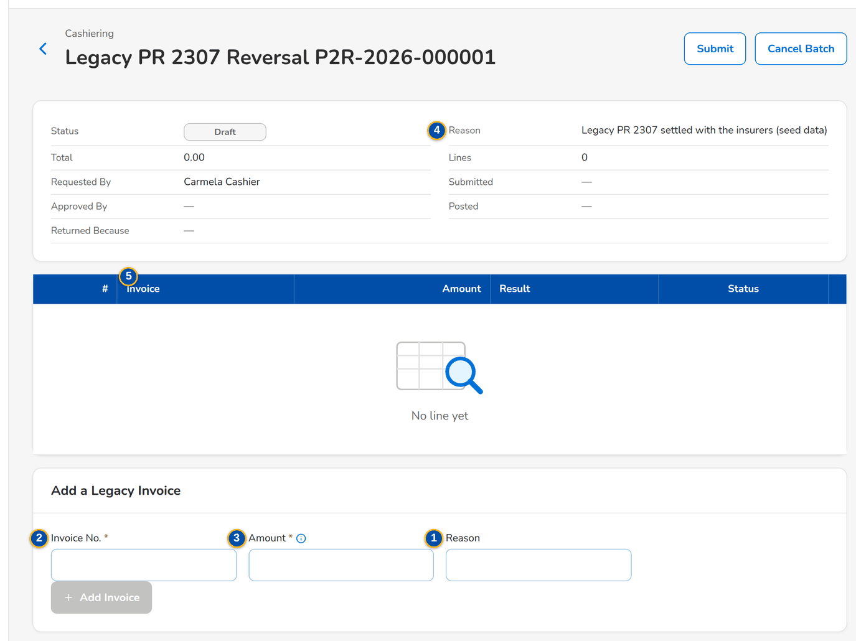
Figure 48: SCR-DM-19 A draft PR 2307 reversal batch with the legacy invoice to add
1 | Reason, Currency | 3 | Amount | 5 | #, Invoice, Amount, Result, Status
2 | Invoice No. | 4 | Reason

Fields (No. = callout number on the first screenshot)
No. | Section | Field | Type | Length / format | Mand. | Source / list | Default | Editable in | Validation | Message when it fails
1 | New Batch | Reason, Currency | Text area; Drop-down | Up to 500 characters; PHP or USD | Y | - | PHP | Draft | - | -
2 | Add a Legacy Invoice | Invoice No. | Text | Legacy invoice number | Y | Legacy invoices | - | Draft | A legacy invoice with an open PR 2307 | -
3 | Add a Legacy Invoice | Amount | Amount | Within the open PR 2307 and the due to insurer | Y | - | - | Draft | Above 0 | -
4 | Add a Legacy Invoice | Reason | Text | Up to 250 characters | N | - | - | Draft | - | -
5 | Lines | #, Invoice, Amount, Result, Status | Columns | LEGACY tag; journal or refusal message | - | Lines | - | - | - | -

Actions
Button | Who | Enabled when | What happens | Resulting status | Notification
Add Invoice | Cashiering user | Draft; invoice and amount given | Adds the line | Draft | -
Submit, Cancel Batch | Cashiering user | Draft | Sends the batch for approval, or closes it without posting | For approval, Cancelled | -
Approve, Return | Cashiering team lead | For approval; never the requester | Posts each line in its own transaction, or returns the batch with the reason | Posted, Draft | -

Business rules
• The amount of a line is within the open PR 2307 (after the move from the premium receivable) and the due to insurer of the invoice (FR-DM-071).
• The Cashiering team lead approves; the requester never approves (FR-DM-071).
Expected outcome
The PR 2307 balances of legacy invoices are settled against the insurer, line by line.
Test cases: TC-DM-071.1-01, TC-DM-071.2-01, TC-DM-071.2-02, TC-DM-SCR-19.

19.5.3 SCR-DM-20 DP PR Legacy Reversal
Purpose | Batches that reverse the open premium receivable of legacy invoices paid directly to the insurer, with the same amount of the due to insurer; what was collected through the broker stays to remit. The candidates are the legacy invoices that Collections tagged "DP PR for reversal", or any legacy invoice with an open premium. A Commission user prepares the batch, the Commission team lead approves it and each invoice posts on its own.
Who can open it | Cashiering user, Cashiering team lead, Commission user, Commission team lead (permission Legacy reversal request or Legacy reversal approve)
Navigation | • Menu: Finance › Commission Receivables › DP PR Legacy Reversal  • Finance › Commission Receivables › DP PR Legacy Reversal
FRs | FR-DM-070

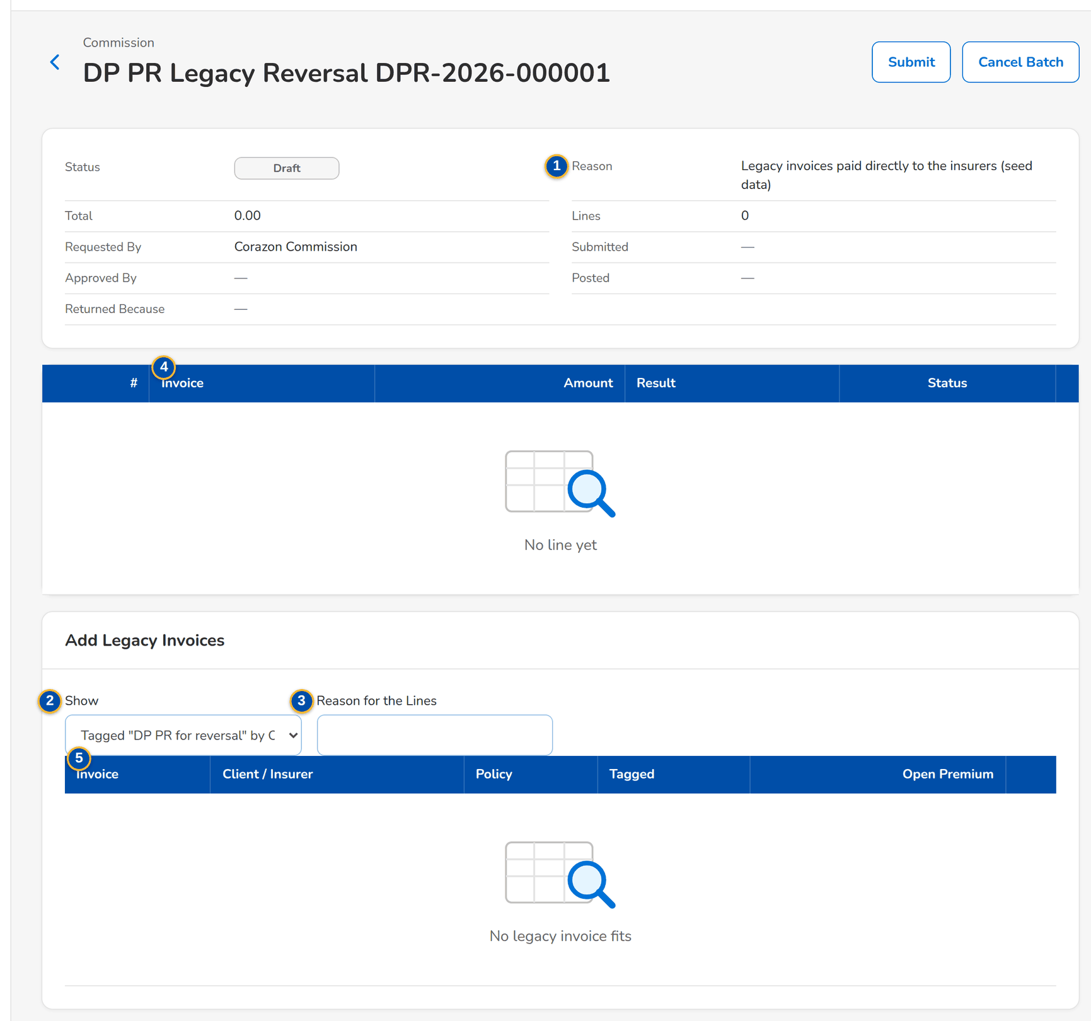
Figure 49: SCR-DM-20 A draft batch with the tagged legacy invoices to add
1 | Reason | 3 | Reason for the Lines | 5 | #, Invoice, Amount, Result, Status
2 | Show | 4 | Invoice, Client / Insurer, Policy, Tagged, Open Premium

Fields (No. = callout number on the first screenshot)
No. | Section | Field | Type | Length / format | Mand. | Source / list | Default | Editable in | Validation | Message when it fails
1 | New Batch | Reason | Text area | Up to 500 characters | Y | - | - | Draft | Not blank | -
2 | Add Legacy Invoices | Show | Drop-down | Tagged DP PR for reversal by Collections, Every legacy invoice with open premium | N | - | Tagged | Draft | - | -
3 | Add Legacy Invoices | Reason for the Lines | Text | Up to 250 characters | N | - | - | Draft | - | -
4 | Add Legacy Invoices | Invoice, Client / Insurer, Policy, Tagged, Open Premium | Columns | LEGACY tag; source system and legacy number under the invoice | - | Legacy invoices with open premium | - | - | - | -
5 | Lines | #, Invoice, Amount, Result, Status | Columns | The whole open premium receivable of the invoice | - | Lines | - | - | - | -

Actions
Button | Who | Enabled when | What happens | Resulting status | Notification
Add | Commission user | Draft | Adds the invoice as a line | Draft | -
Submit, Cancel Batch | Commission user | Draft | Sends the batch for approval, or closes it without posting | For approval, Cancelled | -
Approve, Return | Commission team lead | For approval; never the requester | Posts each invoice on its own, or returns the batch with the reason | Posted, Draft | -

Business rules
• The line amount is the whole open premium receivable of the invoice (FR-DM-070).
• An invoice whose balance changed since it was added is refused at posting; the other lines still post (FR-DM-070).
• The Commission team lead approves; the requester never approves (FR-DM-070).
Expected outcome
Legacy invoices paid directly to the insurer leave the legacy receivable and payable in one approved batch.
Test cases: TC-DM-070.1-01, TC-DM-070.2-01, TC-DM-070.3-01, TC-DM-070.3-02, TC-DM-SCR-20.

20 Functional requirements

20.1 Governance and decision gates

FR-DM-001 Maintain the data object register
BRD trace | BRID_MIG 1.1 (p.7), BRID_MIG 1.3 (p.7-8) | Actor | Data Migration Lead
Priority | Must have | Screens | Data Objects

Description
BIBS keeps one register of every data object that could be migrated, with its source systems, target in BIBS, business owner, data steward, dependencies and load order. The register starts from the catalogue of data objects of this handbook (Part A, Data object register), for example clients, policy headers, open legacy invoices, UPP, GL trial balance and history.
For each object the Data Migration Lead records the four criteria of the BRD, Day-1 need, compliance need, read-only / archival option and data trust, and proposes a class.
Preconditions
• The user has the right "Data migration object manage".
Main flow
1. The Data Migration Lead opens Data Objects and chooses New Object or an existing object.
2. The lead enters or updates the object fields and the four criteria.
3. The lead chooses the proposed class (Migrate, Carry-forward, Archive, Excluded or Conditional) and writes the rationale.
4. BIBS saves the object in status Proposed and shows it in the register with its dependencies.
Alternate and exception flows
• Object with dependencies. BIBS lists the objects it depends on and refuses a load order lower than theirs.
• Conditional object (for example policy headers, BRID_MIG 4.1). The lead enters the condition; the object cannot be loaded until the decision (FR-DM-002) states the condition as met.
Business rules
Rule | Statement | Kind | Maintained in
R1 | Object codes are unique; an object is never deleted, only set to Excluded. | Fixed | -
R2 | Classes are Migrate, Carry-forward (open items), Archive, Excluded and Conditional. | Fixed | -
R3 | Data trust is High, Medium or Low; Day-1 need, compliance need and read-only / archival option are Yes / No with a note. | Configurable | the list of data trust levels
R4 | An object loads only after every object it depends on is accepted in the same environment (gate G6). | Fixed | -

Validations and messages
Check | Message shown | Code
Code already used | This object code already exists | -
Load order lower than a dependency | The load order must follow the objects this object depends on | -
No rationale | Enter the rationale for the proposed class | -

Screens and fields: Data Object
Field | Type | Mand. | Source / LOV | Validation
Object code | Text | Yes | - | Unique; letters and digits
Name | Text | Yes | - | Up to 120 characters
Category | List | Yes | the list of object categories | Reference, Client, Policy, Open item, GL, History
Source systems | Multi-select | Yes | the list of source systems | EBIX, QPS, ISYS, Excel, CMS
Target in BIBS | Text | Yes | - | Module and record
Business owner | User | Yes | Users with data owner | -
Data steward | User | Yes | Users with Data Steward | -
Day-1 need | Yes / No + note | Yes | - | -
Compliance need | Yes / No + note | Yes | - | -
Read-only / archival option | Yes / No + note | Yes | - | -
Data trust | List | Yes | High, Medium, Low | -
Proposed class | List | Yes | Migrate, Carry-forward, Archive, Excluded, Conditional | -
Condition | Text | Cond. | - | Mandatory for Conditional
Depends on | Multi-select | No | Objects | No cycle
Load order | Number | Yes | - | At least the load order of each dependency plus one
Rationale | Text | Yes | - | Up to 2,000 characters

Notifications
• None.
Audit
• Creation and every change of an object are recorded with old and new values.
Acceptance criteria
1. A new object is saved as Proposed with its four criteria and shown in the register.
2. An object cannot be given a load order before an object it depends on.
3. An Excluded object stays in the register and cannot be loaded.

FR-DM-002 Decide the migration class of a data object
BRD trace | BRID_MIG 1.1 (p.7), BRID_MIG 1.3 (p.7-8) | Actor | Data Migration Lead (maker); business owner (approver)
Priority | Must have | Screens | Data Objects (Decision tab); My Approvals

Description
The class of an object is decided through a recorded approval (gate G1). The Data Migration Lead submits the proposal; the business owner of the object approves or returns it. The approved class is the one BIBS enforces.
The objects BRID_MIG 1.3 names beyond the legacy systems (claims data, submitted policies, endorsements and adjustments kept outside legacy, renewals in progress, payees) are registered as Conditional until BDOI decides their scope (CLR-DM-05 to CLR-DM-08); a decided object is "actioned" as BRID_MIG 1.3 asks.
This meets the BRD acceptance criterion that each data object is "actioned upon" as Migrate / Carry-Forward (Open Items) / Archive / Excluded once the business owners have assigned the four criteria.
Preconditions
• The object is Proposed or its decision was returned.
Main flow
1. The Data Migration Lead opens the object and clicks Submit Decision.
2. BIBS moves the object to For decision and puts it in the business owner's My Approvals.
3. The business owner reviews the criteria and the rationale and clicks Approve.
4. BIBS sets the object to Decided with the class and records the decision with date and approver.
Alternate and exception flows
• Return. The business owner returns the decision with a reason; the object goes back to Proposed.
• Change of class later. A new decision is submitted and approved; the history keeps every decision. A change from Migrate or Carry-forward to Archive or Excluded is refused while a batch of the object is loaded and not rolled back.
Business rules
Rule | Statement | Kind | Maintained in
R1 | The approver is the business owner of the object and never the submitter. | Fixed | -
R2 | Only Decided objects of class Migrate or Carry-forward (or Conditional with the condition met) can be loaded. | Fixed | -
R3 | Archive objects are loaded only into the legacy archive (FR-DM-110). | Fixed | -

Validations and messages
Check | Message shown | Code
Approver is the submitter | A record cannot be authorized by the user who maintained it | MAKER_CHECKER_VIOLATION
Class change with loaded data | Roll back the loaded batches before changing the class of this object | -
Return without reason | Enter the reason for the return | -

Notifications
• On submission, the business owner is notified in My Approvals and by e-mail.
• On approval or return, the Data Migration Lead is notified.
Audit
• Every decision is kept with class, criteria, rationale, submitter, approver and dates (report Migration Decisions).
Acceptance criteria
1. A decision approved by the business owner sets the object to Decided with the approved class.
2. The submitter cannot approve their own decision.
3. An object classed Excluded cannot be selected for a batch.
4. The report Migration Decisions lists every decision with its approver.

FR-DM-003 Sign off each object through gates
BRD trace | BRID_MIG 1.1 (p.7), BRID_MIG 1.2 (p.7) | Actor | Data owner, Data Steward, Data Migration Lead, reconciliation approver
Priority | Must have | Screens | Sign-off; Batches

Description
Every object passes seven gates, each recorded with the role, user, decision, comment, time and evidence. The gates are G1 Decision, G2 Mapping, G3 Validation, G4 Load approval, G5 Reconciliation, G6 Object accepted and G7 Go-live.
The Sign-off screen shows the gates per object and environment as a matrix, so the Data Migration Lead sees what is missing before a trial migration or the cutover.
Preconditions
• The previous gate of the object or batch is signed.
Main flow
1. The signer opens the batch or object and the gate to sign.
2. BIBS shows the evidence of the gate (map versions, issue counts, reconciliation summary, sample checks).
3. The signer approves or rejects with a comment and optional evidence file.
4. BIBS records the sign-off and updates the matrix.
Alternate and exception flows
• Rejected gate. The object returns to the step of the gate; the reason is shown to the Data Migration Lead.
Business rules
Rule | Statement | Kind | Maintained in
R1 | G1 and G2 by the data owner; G3 by the Data Steward (waivers by the data owner); G4 by the Data Migration Lead; G5 by the reconciliation approver; G6 by the data owner and the Data Migration Lead; G7 by the go / no-go board. | Configurable | Role-permission matrix
R2 | The operator who ran a batch cannot sign its G5 or G6; one person cannot sign two gates of the same batch. | Fixed | -
R3 | G5 cannot be signed while a reconciliation break is not explained and approved. | Fixed | -

Validations and messages
Check | Message shown | Code
Previous gate not signed | Sign the previous gate first | -
Signer ran the batch or signed another gate of it | A record cannot be authorized by the user who maintained it | MAKER_CHECKER_VIOLATION
Open break at G5 | Explain and approve every break before signing the reconciliation | -

Notifications
• When a gate is ready to sign, the users of the signing role are notified.
Audit
• Every sign-off is recorded and cannot be changed; a correction is a new sign-off.
Acceptance criteria
1. An object reaches G6 only after G1-G5 are signed in order.
2. The operator of a batch cannot sign its reconciliation.
3. The Sign-off screen shows, per object and environment, which gates are signed, by whom and when.

20.2 Extract intake, code maps, validation and load

FR-DM-010 Receive a source extract with control totals
BRD trace | BRID_MIG 1.2 (p.7) | Actor | Migration Operator
Priority | Must have | Screens | Extracts

Description
BDOI sends one file per layout and source system with a control file. Most objects have one layout; R04 (insurers and insurer branches R04B), P01 (headers and insurer shares P01S) and F01 (invoice headers, insurer shares F01S and components F01C) have sub-layouts sent as separate files with the same as-of date. BIBS checks each file before any row is staged, so that what BIBS loads is exactly what BDOI extracted.
The file contract (names, CSV or Excel (.xlsx), date and amount formats, control file content) is published to BDOI in the data requirements workbook, which BIBS generates from the layouts.
Preconditions
• The object is Decided (Migrate or Carry-forward) and has an approved layout version.
• The user has the right "Data migration intake".
Main flow
1. The operator opens Extracts, chooses the object, the layout and the source system and uploads the data file and the control file.
2. BIBS checks the SHA-256 of the file against the control file, the header against the layout, the parsed row count against the control count, the amount sums per currency and the hash total of the key column.
3. When every check passes, BIBS gives the extract a number (MGX-yyyy-nnnnnn), masks personal data when the environment is not production, and stages the rows.
4. BIBS shows the extract as Staged with its counts and control totals.
Alternate and exception flows
• Checks fail. The extract is Rejected with every failed check and its difference, listed on the Extracts screen; nothing is staged; the Data Migration Lead is notified.
• Same file sent twice. BIBS refuses it as a duplicate.
• Delta extract with an as-of date earlier than the last one of the object. BIBS refuses it.
Business rules
Rule | Statement | Kind | Maintained in
R1 | File names are <LAYOUT>_<SOURCE>_<yyyyMMdd>_<nn>.csv or .xlsx, where LAYOUT is the layout code (for example F01C), not the object code; the control file adds .ctl.csv. | Fixed | -
R5 | A batch of an object takes one checked extract of each of its layouts with the same as-of date. | Fixed | -
R2 | CSV is UTF-8 with comma separator and one header row; dates are yyyy-MM-dd; amounts use a dot decimal and 2 decimals without thousands separator. | Fixed | -
R3 | Outside production, names, addresses, TIN, ID, account and phone numbers, e-mail addresses and birth dates are masked before staging; the same value is always masked the same way. | Configurable | Masking rules; parameter the environment class parameter
R4 | Files are received through the console or the secure file drop and are never e-mailed. | Fixed | -

Validations and messages
Check | Message shown | Code
Checksum differs | The file does not match the checksum in the control file | -
Header differs from the layout | The file columns do not match layout version {n}: missing {columns}, extra {columns} | -
Row count differs | The file has {n} rows; the control file says {m} | -
Amount total differs | The total of {column} in {currency} is {x}; the control file says {y} | -
Hash total differs | The hash total of the key column does not match the control file | -
Duplicate file | This file was already received as extract {no} | -
As-of date out of order | The as-of date is earlier than the last extract of this object | -

Screens and fields: Extract upload
Field | Type | Mand. | Source / LOV | Validation
Object | List | Yes | Decided objects | Migrate or Carry-forward
Layout | List | Yes | Layouts of the object | Matches the file name and the header row
Source system | List | Yes | Source systems of the object | -
Mode | List | Yes | Full, Delta | -
Data file | File | Yes | - | CSV or Excel (.xlsx)
Control file | File | Yes | - | CSV in the control layout

Notifications
• A rejected extract notifies the Data Migration Lead and the Migration Operator (alert Migration extract rejected).
Audit
• Every upload is recorded with file names, checksum, user and result.
Acceptance criteria
1. A file whose rows, amounts and hash total agree with its control file is staged and numbered.
2. A file with one row fewer than the control count is rejected and nothing is staged.
3. In a non-production environment the staged client names and TINs are masked; in production they are not.

FR-DM-011 Maintain and approve versioned code maps
BRD trace | BRID_MIG 3.1 (p.9) | Actor | Data Steward (maker); data owner (approver)
Priority | Must have | Screens | Code Maps

Description
A code map set exists per domain, for example each LOV type, insurers, insurer branches, products and risk codes, packages, lines, branches, sales units, account officers, each MIS field, GL accounts and the status lists of each object. An entry maps a legacy code of a source system to a BIBS code, or says Default, Reject or Create.
A set has versions. Only the approved version is used by a batch, and the batch records which version it used, so every loaded row can be traced to the mapping that produced it.
Preconditions
• The user has the right "Data migration mapping edit" to edit, the right "Data migration mapping approve" to approve.
Main flow
1. The Data Steward opens Code Maps, chooses a set and creates a Draft version (empty, copied from the approved version, or imported from Excel).
2. The steward edits entries and submits the version.
3. The data owner compares the version with the approved one (added, changed and removed entries) and approves it.
4. BIBS marks it Approved and the previous version Superseded.
Alternate and exception flows
• Return. The owner returns the version with a reason; it goes back to Draft.
• Create entries. On approval, BIBS lists the reference values to create; the Data Steward creates them through the reference-data load (FR-DM-030), where the normal maker-checker of each master applies.
Business rules
Rule | Statement | Kind | Maintained in
R1 | One approved version per set; a batch uses the approved version current at validation. | Fixed | -
R2 | The approver is never the user who submitted the version. | Fixed | -
R3 | An entry action is Map (to a target code), Default (to the set default), Reject (the row fails) or Create (a new BIBS value). | Fixed | -
R4 | The target code of a MAP entry must exist and be active in BIBS when the version is approved. | Fixed | -

Validations and messages
Check | Message shown | Code
Target code does not exist | Target code {code} does not exist in {domain} | -
Same legacy code twice | Legacy code {code} of {source} is mapped twice | -
Approver is the submitter | A record cannot be authorized by the user who maintained it | MAKER_CHECKER_VIOLATION

Screens and fields: Code map entry
Field | Type | Mand. | Source / LOV | Validation
Source system | List | Yes | the list of source systems | -
Legacy code | Text | Yes | - | Unique per source in the version
Legacy description | Text | No | - | -
Action | List | Yes | Map, Default, Reject, Create | -
Target code | List | Cond. | Values of the target domain | Mandatory for MAP
Remarks | Text | No | - | -

Notifications
• Submitted versions go to the data owner's My Approvals.
Audit
• Versions and entries keep their history; the report Code Map Versions lists versions, approvers and the batches that used them.
Acceptance criteria
1. An approved version supersedes the previous one and is used by the next validated batch.
2. A version mapping to a BIBS code that does not exist cannot be approved.
3. Each batch shows the map versions it used.

FR-DM-012 Report unmapped and invalid codes before load
BRD trace | BRID_MIG 3.1 (p.9) | Actor | Data Steward
Priority | Must have | Screens | Code Maps (Unmapped tab); Batches

Description
When staged rows are validated, every coded column is looked up in its code map. Codes without an entry, and entries whose target is no longer active, are reported with the number of rows and sample keys. A batch with unmapped codes in a mandatory column cannot be approved for load, so "all required codes exist" before any transaction loads.
Preconditions
• At least one extract of the object is staged.
Main flow
1. The Data Steward opens the Unmapped tab or runs the report Unmapped Legacy Codes.
2. BIBS lists set, source system, legacy code, rows and sample legacy keys.
3. The steward adds the entries in a new map version and submits it (FR-DM-011).
4. After approval the batch is validated again and the codes disappear from the report.
Business rules
Rule | Statement | Kind | Maintained in
R1 | An unmapped code in a mandatory coded column is an Error; in an optional column a Warning. | Configurable | Rule catalogue

Validations and messages
Check | Message shown | Code
Load approval with unmapped codes | The batch has {n} unmapped codes; map them before approving the load | -

Notifications
• Alert Unmapped legacy codes to the Data Steward when a validation finds unmapped codes.
Audit
• The report run is recorded.
Acceptance criteria
1. A staged row whose insurer code is not mapped appears on the Unmapped tab and in the report Unmapped Legacy Codes with its legacy key.
2. The load of that batch cannot be approved until the code is mapped and the batch validated again.
3. The report exports to Excel and PDF.

FR-DM-013 Validate staged data against data-quality rules
BRD trace | BRID_MIG 1.2 (p.7), BRID_MIG 2.1 (p.8-9), BRID_MIG 3.1 (p.9) | Actor | BIBS (validation); Data Steward
Priority | Must have | Screens | Batches (Issues tab); Layouts and Rules

Description
A batch is validated before it can load. Each staged row is mapped and checked against the rules of its object - mandatory fields, formats, lookups, uniqueness, references to loaded parents, cross-field rules (for example components that add up to the gross premium, open balance equal to booked less paid) and plausibility warnings.
Each failed rule is an issue with severity Error (the row is not loaded) or Warning (the row loads and is reported).
Preconditions
• The batch is Planned with at least one staged extract.
Main flow
1. The operator clicks Validate.
2. BIBS maps each row with the approved map versions, runs the rules and, for clients, the matching (FR-DM-031).
3. BIBS sets each row Valid, Warning or Invalid and the batch Validated with the counts.
4. The Data Steward resolves the issues - fixed at source (new extract), mapped (new map version) or waived by the data owner with a reason.
Alternate and exception flows
• Error rate above the threshold. The batch cannot be approved for load; the steward sees the rate and the threshold.
Business rules
Rule | Statement | Kind | Maintained in
R1 | Master data may be loaded with at most the error-rate limit of master data percent of rows rejected or waived (default 0.5). | Configurable | Parameters: the error-rate limit of master data
R2 | Financial objects (open invoices, UPP, GL trial balance) load only with 0 errors, or with each excluded row approved by the data owner with a manual-entry plan. The error rate is (invalid rows not waived + waived rows) / (staged rows - excluded rows); excluded rows are not errors and not in the base. | Configurable | Parameters: the error-rate limit of financial objects
R3 | For each component of a legacy invoice - open = booked + adjusted - paid - written off (premium receivable) and open = booked + adjusted - remitted (DTIP and commission). | Fixed | -

Validations and messages
Check | Message shown | Code
Mandatory field blank | {field} is mandatory | -
Wrong format | {field} {value} is not a valid {type} | -
Parent not loaded | {parent} {key} is not loaded | -
Components do not add up | The premium components add up to {x}; the gross premium is {y} | -
Error rate above threshold | {rate} percent of rows have errors; the limit for this object is {limit} percent | -

Notifications
• None; the batch page shows the result.
Audit
• Every validation run and every issue resolution or waiver is recorded with user and time.
Acceptance criteria
1. A legacy invoice whose components do not add up to its gross premium is Invalid with that message.
2. A waived row shows the waiver reason and the data owner who approved it.
3. A batch of open invoices with one Invalid row cannot be approved for load unless the row is excluded by the data owner; once it is excluded, the error rate shown is 0.00%.

FR-DM-014 Load a batch through the BIBS services
BRD trace | BRID_MIG 1.2 (p.7), BRID_MIG 1.3 (p.7-8) | Actor | Data Migration Lead (approval); Migration Operator; BIBS (load)
Priority | Must have | Screens | Batches

Description
A validated batch is approved for load (gate G4) and then loaded. Each row is loaded through the same BIBS service that the screens use (for example client registration, account import, the Operations ledger, the unapplied workbench, the journal service), so every BIBS rule, audit entry and accounting entry applies. BIBS never writes directly into business tables.
Each loaded record gets a key cross-reference from its legacy key, which makes the load rerunnable and the record traceable.
Preconditions
• The batch is Validated within the error threshold; the objects it depends on are accepted (G6) in the same environment.
Main flow
1. The Data Migration Lead reviews the counts and clicks Approve Load.
2. The operator clicks Load, or the cutover plan starts it.
3. BIBS loads Valid and Warning rows in chunks, several at a time, and marks each row Loaded, Skipped (already loaded, unchanged) or Rejected (with the reason).
4. BIBS sets the batch Loaded or Loaded with rejects and starts the reconciliation (FR-DM-020).
Alternate and exception flows
• A chunk fails. BIBS retries its rows one by one so that one bad row fails alone.
• The row was loaded before with different content. A client or header is updated (delta, before the freeze); an open item is Rejected as changed after load.
• Load interrupted. The load resumes from the last committed chunk; loaded rows are skipped.
Business rules
Rule | Statement | Kind | Maintained in
R1 | Rows are loaded in transactions of the rows per load transaction (default 500), in the partitions loaded in parallel (default 4). | Configurable | Parameters: the rows per load transaction, the partitions loaded in parallel
R2 | One load at a time per object and environment. | Fixed | -
R3 | Records created by a load carry the origin Migrated (clients, accounts, UPP) or Legacy (invoices); they trigger no notification to customers or insurers. | Fixed | -
R4 | The approver of the load is not the operator who runs it. | Fixed | -

Validations and messages
Check | Message shown | Code
Dependency not accepted | Object {object} must be accepted before this object can load | -
Approver is the operator | A record cannot be authorized by the user who maintained it | MAKER_CHECKER_VIOLATION

Notifications
• A failed load raises alert Migration load failed to the Data Migration Lead and the operator.
Audit
• The batch run log records each step with counts and times; every created record has its own audit entry from the owning module.
Acceptance criteria
1. Loading the same batch twice creates no duplicate; the second run marks the rows Skipped.
2. A client created by a load is found in client search and has a cross-reference to its legacy key.
3. The batch page shows staged, loaded, skipped, rejected and excluded counts that add up.
4. Every record created by a load carries the origin Migrated with its source system, legacy reference and batch, shown by the LEGACY badge and its tooltip (BRID_MIG 1.3).

FR-DM-015 Rerun and roll back a batch
BRD trace | BRID_MIG 1.2 (p.7), BRID_MIG 1.4 (p.8) | Actor | Data Migration Lead (request); reconciliation approver (approval); Migration Operator
Priority | Must have | Screens | Batches

Description
Rejected rows (the fall-out records of BRID_MIG 1.4) are corrected and loaded again in a rerun batch that belongs to the original batch and is reconciled with it (all rejected rows, or the rows the Data Migration Lead selects). Each row of the rerun shows its result, and the rerun summary gives the rows reprocessed, migrated and failed, with times and error details.
A batch that is not yet signed off can be rolled back when rollback is offered for its object and the records have not been changed since the load. Otherwise the environment is restored from the snapshot taken before the load.
Preconditions
• Rerun - the batch has rejected rows and corrections are available (new extract, new map version or waiver).
• Rollback - the batch is Loaded or Reconciled and not signed off (G6).
Main flow
1. For a rerun, the Data Migration Lead clicks Rerun Rejects for all rejected rows, or selects rows on the Rows tab first; BIBS creates a child batch with those rows, validates it (dependencies, code maps, data-quality rules) and, after approval, loads it. Each row ends as migrated on the rerun or failed again with its error details (proposed labels, CLR-DM-13).
2. For a rollback, the lead clicks Request Rollback with a reason; the reconciliation approver approves it.
3. BIBS undoes the records of the batch newest first through the owning services (for example deactivation of a migrated client without activity, reversal of an opening entry) and marks the batch Rolled back.
Alternate and exception flows
• A record was changed after the load (for example a payment applied to a legacy invoice). BIBS lists the records and refuses the rollback; the environment snapshot is the remaining option.
Business rules
Rule | Statement | Kind | Maintained in
R1 | No rollback after the object is accepted (G6); after go-live, corrections are made through the normal business functions. | Fixed | -
R2 | Opening entries are reversed with negative entries of the same event; the original entries stay. | Fixed | -
R3 | A rerun is allowed until the object is accepted (G6) in the cycle; after go-live a financial row that still fails is keyed in BIBS from the manual-entry plan approved by its owner (CLR-DM-13). | Fixed | -

Validations and messages
Check | Message shown | Code
Record changed after load | {n} records were changed after the load and cannot be rolled back | -
Approver is the requester | A record cannot be authorized by the user who maintained it | MAKER_CHECKER_VIOLATION

Notifications
• The approver is notified of a rollback request; the requester of the decision.
Audit
• Rerun and rollback steps are in the batch log with the rows reprocessed, migrated and failed, the times and the error details; each undone record is audited by its module.
Acceptance criteria
1. A rerun batch loads only the previously rejected rows and its counts are added to the parent batch reconciliation.
2. A rerun of rows selected among the rejected rows reprocesses only those rows; each shows whether it was migrated or failed again, a row that fails again keeps its error details, and the run log gives the counts reprocessed, migrated and failed with the times (BRID_MIG 1.4).
3. A rollback of a client batch without later activity leaves no active migrated client of that batch.
4. A rollback is refused when a payment was applied to a legacy invoice of the batch.

20.3 Reconciliation

FR-DM-020 Reconcile each data object from source to target
BRD trace | BRID_MIG 1.2 (p.7) | Actor | Reconciliation approver; BIBS (reconciliation)
Priority | Must have | Screens | Reconciliation

Description
After each load BIBS reconciles the object at four levels, and financial objects at a fifth. L1 counts - control file, received, staged, loaded, skipped, rejected and excluded. L2 amounts - sums per amount column and currency against the control totals and the values in BIBS. L3 hash totals - key column hash and a checksum per row. L4 fields - every mapped field of every loaded row read back from BIBS and compared with the staged value. L5 GL - see FR-DM-021.
Every difference is a break. A break is fixed (rerun) or explained; the explanation is approved by the reconciliation approver. This makes "all data objects and items reconcilable from source to target" (BRD acceptance criterion) a signed, reproducible result.
Preconditions
• The batch is Loaded or Loaded with rejects.
Main flow
1. BIBS runs the reconciliation after the load, or the approver clicks Reconcile.
2. BIBS shows the object by level with Matched or Break and the difference.
3. The Data Steward writes an explanation for each break (reason from a list and text).
4. The reconciliation approver approves the explanations and signs the reconciliation (gate G5).
Business rules
Rule | Statement | Kind | Maintained in
R1 | L1 - received = control count, and loaded + skipped + rejected + excluded = staged. | Fixed | -
R2 | L2 - amount difference within the amount tolerance (default 0.00) per currency. | Configurable | Parameters: the amount tolerance
R3 | L4 - a field difference is a break unless the code map explains it (mapped value). | Fixed | -

Validations and messages
Check | Message shown | Code
Sign-off with unexplained break | Explain and approve every break before signing the reconciliation | -

Screens and fields: Break explanation
Field | Type | Mand. | Source / LOV | Validation
Level | Text | Yes | L1-L5 | Read only
Measure | Text | Yes | - | Read only
Difference | Amount / Number | Yes | - | Read only
Reason | List | Yes | the list of break reasons | -
Explanation | Text | Yes | - | Up to 2,000 characters

Notifications
• A break raises alert Migration reconciliation break to the Data Migration Lead and the Data Steward.
Audit
• Reconciliation runs, lines, explanations and approvals are kept as evidence and are not purged with the staging data.
Acceptance criteria
1. For a batch of 1,000 open invoices loaded without rejects, L1 shows 1,000 at every stage and L2 shows 0.00 difference per currency.
2. A field changed in BIBS after the load appears as an L4 break on the next reconciliation.
3. The reconciliation cannot be signed while a break has no approved explanation.
4. The reports Reconciliation Summary and Reconciliation Detail export to Excel and PDF.

FR-DM-021 Reconcile carried-forward balances to the GL
BRD trace | BRID_MIG 1.2 (p.7), BRID_MIG 5.1 (p.9), BRID_MIG 13.1 (p.14) | Actor | Reconciliation approver (Comptrollership)
Priority | Must have | Screens | Reconciliation (GL tab); ACSL GL to Sub-ledger Reconciliation

Description
Each open legacy invoice and each legacy UPP item is loaded with an opening entry against the Migration Clearing account. The GL trial balance of the legacy systems is loaded as an opening journal in which the lines of the legacy control accounts are replaced by Migration Clearing. When the detail and the trial balance agree, Migration Clearing is 0.00 per branch and currency.
The legacy control accounts are reconciled to the legacy sub-ledgers in the ACSL GL to Sub-ledger Reconciliation, which gets a ledger-context filter (legacy / new).
Preconditions
• Open invoices, UPP and the GL trial balance are loaded for the environment.
Main flow
1. The approver runs the report Migration Clearing and Legacy Control Accounts.
2. BIBS shows the Migration Clearing balance per branch and currency and the legacy control accounts against their sub-ledgers.
3. Any non-zero balance is investigated and explained or corrected by a rerun.
4. The approver signs the GL level of the reconciliation.
Business rules
Rule | Statement | Kind | Maintained in
R1 | Migration Clearing must be 0.00 per branch and currency before go-live. | Fixed | -
R2 | The legacy control accounts and the Migration Clearing account are set up by Comptrollership; the GL account code map says which legacy accounts go to Migration Clearing. | Configurable | Chart of accounts; GL account code map
R3 | A difference on Migration Clearing has the sign of the trial balance - for an invoice missing from the load, a debit equal to its net receivable position (open PR + PR2307 + commission receivable - open DTIP - unrealised commission - deferred VAT) when positive, a credit when negative; for a missing UPP item, a credit equal to its balance. | Fixed | -
R4 | The report Migration Clearing and Legacy Control Accounts also compares, per branch, currency and legacy control account, the trial balance line with the opening detail posted to that account, so a missing invoice whose net is zero is still found. | Fixed | -
R5 | The same checks run again after each FY2027 true-up (FR-DM-024). | Fixed | -

Validations and messages
Check | Message shown | Code
Clearing not zero at sign-off | Migration Clearing is {amount} in {branch} {currency}; it must be zero | -
Control account line differs from the detail | {account} differs from the opening detail by {amount} in {branch} {currency} | -

Notifications
• Alert Migration clearing not zero to Comptrollership and the Data Migration Lead.
Audit
• The report runs and the sign-off are recorded.
Acceptance criteria
1. After the loads of open invoices, UPP and the trial balance of a branch, Migration Clearing is 0.00 in PHP and USD.
2. The ACSL reconciliation of the legacy Premium Receivable account against the legacy invoices shows no difference.
3. The Premium Receivable, DTIP, Commission Receivable and unapplied-payment balances of the opening equal the legacy trial balance and the legacy sub-ledgers per branch and currency with a difference of 0.00 (BRID_MIG 13.1; tolerance CLR-DM-04).
4. An invoice paid in full and not remitted, with 5,000.00 open DTIP and 800.00 commission receivable, missing from the load leaves a credit of 4,200.00 on Migration Clearing; an unpaid invoice with 3,000.00 premium receivable and 3,000.00 DTIP missing from the load leaves Migration Clearing at 0.00 and shows a 3,000.00 difference on Premium Receivable - Legacy and on DTIP - Legacy.

FR-DM-022 Load the provisional GL opening at the year-end boundary
BRD trace | BRID_MIG 1.2 (p.7), BRID_MIG 5.1 (p.9), BRID_MIG 12.1 (p.13), BRID_MIG 13.1 (p.14) | Actor | Head, Comptrollership; Migration Operator
Priority | Must have | Screens | Batches (object G01); Reconciliation (GL tab); Journal inquiry

Description
For a go-live on 3 January 2028 at the year-end boundary (DMQ39, option A, recommended and awaiting Comptrollership confirmation), the BIBS GL opens from the preliminary December 2027 trial balance of legacy, taken after the December soft close and the last legacy EOD. Only the balance-sheet accounts are opened. The FY2027 P&L accounts are not opened; their net result per branch and currency goes to retained earnings, so the FY2028 P&L in BIBS starts at zero.
The opening is provisional. The FY2027 closing and audit adjustments that Comptrollership posts in legacy after the freeze reach BIBS as true-ups (FR-DM-023). The FY2027 BIR annual returns and the FY2027 audit use legacy; FY2028 uses BIBS.
Preconditions
• The GL account code map is approved and the company's retained earnings account is set.
• Comptrollership has signed the preliminary December trial balance as the provisional opening.
Main flow
1. The operator validates and loads G01 (trial balance version Provisional).
2. BIBS posts one opening journal per branch and currency, value date 1 January 2028, reference MIG-TB-<as-of>, flag Provisional - balance-sheet lines on their mapped accounts, legacy control-account lines on Migration Clearing, and the lines whose mapped account is a P&L account on retained earnings.
3. The reconciliation compares the journals with the legacy trial balance and Migration Clearing with the open-item detail (FR-DM-020, FR-DM-021).
Business rules
Rule | Statement | Kind | Maintained in
R1 | The opening journals are system journals of type Opening, source Migration, value date the opening value date (default 1 January 2028, the first day of the opening period). | Configurable | Parameters: the opening value date
R2 | No FY2027 P&L balance is opened in BIBS; a line whose mapped account is a P&L account posts to retained earnings, with the mapped account kept in the line description. | Fixed | -
R3 | The opening stays marked Provisional until the closure of the true-ups (FR-DM-024). | Fixed | -

Validations and messages
Check | Message shown | Code
Trial balance out of balance | The trial balance of {branch} {currency} is out of balance by {amount} | -
Retained earnings account missing | The retained earnings account of the company is not set | -
Opening not signed as provisional | The preliminary trial balance is not signed by Comptrollership | -

Notifications
• Alert Migration clearing not zero when Migration Clearing is not 0.00 after the load.
Audit
• The journals, the trial balance extract and the sign-off are kept as evidence.
Acceptance criteria
1. After the load of a branch, its balance-sheet accounts in BIBS equal the legacy preliminary trial balance and its P&L accounts are 0.00 at 1 January 2028.
2. A legacy trial balance with a FY2027 net income of 1,250,000.00 in a branch gives a credit of 1,250,000.00 to retained earnings in that branch.
3. The load cannot be approved while the preliminary trial balance is not signed.
4. The opening journals show the flag Provisional until the true-ups are closed.

FR-DM-023 Post the FY2027 true-ups as opening-balance adjustment journals
BRD trace | BRID_MIG 1.2 (p.7), BRID_MIG 5.1 (p.9), BRID_MIG 12.1 (p.13), BRID_MIG 13.1 (p.14) | Actor | Comptrollership GL lead (prepares); Head, Comptrollership (approves); Migration Operator
Priority | Must have | Screens | True-ups; Extracts; Batches (object G03); Journal inquiry

Description
After the freeze the legacy GL stays open only for the FY2027 closing and audit adjustments, restricted to named Comptrollership users, with no new business. Each adjustment reaches BIBS in a true-up - the first after the legacy year-end close (about mid to late January 2028), the final one after the audited financial statements (about March-April 2028), and interim ones only when Comptrollership posts material adjustments in between.
A true-up is an opening-balance adjustment journal in the opening period (January 2028, value date 1 January 2028), never a FY2028 transaction. FY2027 P&L effects go to retained earnings. Adjustments on legacy control accounts, which BIBS holds invoice by invoice and UPP by UPP, come with their open-item detail and change those items.
Preconditions
• The provisional opening is loaded (FR-DM-022).
• BDOI IT has sent, each with its control file, the legacy trial balance after the adjustments (G01, version TU1, TU2 or Final), the adjustment journal lines since the previous true-up (G03), the open-item detail of the lines on legacy control accounts (G03D) and the legacy journal listing since the freeze.
Main flow
1. The operator runs the intake checks and the validation of the true-up batch.
2. The Comptrollership GL lead reviews the validation result against the FY2027 adjustment register and submits the true-up.
3. The Head of Comptrollership reviews the journals per branch and currency and approves; BIBS posts the opening-balance adjustment journals and the open-item adjustments.
4. BIBS runs the true-up reconciliation (FR-DM-024).
Alternate and exception flows
• Opening period closed. When January 2028 is already closed, Comptrollership reopens it with a reason for the posting only; BIBS posts; Comptrollership closes it again the same day. The reconciliation lists every journal posted into the period during the window.
• Return. The approver returns the true-up with a reason; the GL lead corrects the input (new extract) and submits again.
• Error found after posting. A posted true-up is never changed; the next true-up corrects it.
Business rules
Rule | Statement | Kind | Maintained in
R1 | A true-up posts as a system journal of type Opening, source Migration, reference MIG-TU-<n>-<branch>-<currency>, value date the opening value date (1 January 2028). | Fixed | -
R2 | FY2027 P&L lines post to retained earnings. Lines on legacy control accounts post to Migration Clearing and are matched by the open-item detail, which changes the open balance of each legacy invoice or UPP item (movement Legacy adjusted or Legacy written off) against Migration Clearing. | Fixed | -
R3 | Only journals dated in FY2027, posted in legacy after the freeze and entered in the FY2027 adjustment register are accepted. | Fixed | -
R4 | The preparer and the approver are different users; the approver holds the permission Data migration trueup approve. | Fixed | -
R5 | Posting happens once per reference; the same true-up posted twice creates no second journal. | Fixed | -

Validations and messages
Check | Message shown | Code
Journal dated outside FY2027 | Journal {no} is dated {date}, outside FY2027 | -
Journal not in the register | Journal {no} is not in the FY2027 adjustment register | -
Journal out of balance | Journal {no} is out of balance by {amount} in {branch} {currency} | -
Control-account line without detail | {account} adjustment of {amount} has no matching open-item detail | -
Detail beyond the item balance | Adjustment of {component} on {item} makes the open balance {amount} | -
Approver is the preparer | A record cannot be authorized by the user who maintained it | MAKER_CHECKER_VIOLATION

Screens and fields: True-up
Field | Type | Mand. | Source / LOV | Validation
True-up no. | Text | Yes | 1, 2, ..., F (final) | Read only; from the extract
Legacy trial balance as of | Date | Yes | - | Read only
Journals | Read-only list | - | - | Legacy journal no., date, kind, register reference, total per branch and currency
Open-item detail | Read-only list | - | - | Item, component, movement, amount
Approval remarks | Text | Cond. | - | Mandatory to return

Notifications
• A submitted true-up goes to the Head of Comptrollership in My Approvals; the posting and a return are notified to the GL lead and the Data Migration Lead.
Audit
• Preparation, approval, posting, and the reopening and closing of the period are audited; the true-up record keeps the evidence and is not purged with the staging data.
Acceptance criteria
1. True-up 1 with a FY2027 accrual of 80,000.00 (Dr expense, Cr accrued expenses) posts, after approval, a journal MIG-TU-1 dated 1 January 2028 with Dr retained earnings 80,000.00 and Cr accrued expenses 80,000.00; the FY2028 P&L does not change.
2. An audit write-off of 3,000.00 of premium receivable on legacy invoice I00300002, sent with its detail line, reduces the open basic premium of the invoice and Premium Receivable - Legacy by 3,000.00 and leaves Migration Clearing at 0.00.
3. A journal dated 5 January 2028, or a journal not in the register, stops the validation with its message.
4. The GL lead who prepared a true-up cannot approve it.
5. With January 2028 closed, the final true-up posts after Comptrollership reopens the period, and the period is closed again the same day.

FR-DM-024 Reconcile each true-up to the legacy trial balance and close the FY2027 cut-off
BRD trace | BRID_MIG 1.2 (p.7), BRID_MIG 12.1 (p.13), BRID_MIG 13.1 (p.14) | Actor | Head, Comptrollership; Data Migration Lead; Program Manager
Priority | Must have | Screens | True-ups (Reconciliation tab); Run-off and Decommissioning

Description
Each true-up is reconciled to the legacy trial balance before it is signed, and the legacy GL stays under cut-off controls until the final true-up. The checks are cut-off (every legacy journal since the freeze is in the register and in a true-up, dated in FY2027 and posted by a named Comptrollership user, and no legacy business module posted after the freeze), movement (the true-up equals the change of the legacy trial balance since the previous true-up), balance (the BIBS opening balances equal the legacy trial balance of the true-up), Migration Clearing and the legacy sub-ledgers, and, when the opening period was reopened, no other journal in it during the window.
After the final true-up, the balance check against the audited FY2027 trial balance is signed and shared with the external auditor, the legacy GL is locked for all users, and the true-ups are closed. A FY2027 finding after that is a prior-period adjustment in BIBS through the normal Comptrollership journal, outside the migration.
Preconditions
• The true-up is posted (FR-DM-023).
Main flow
1. BIBS runs the report Opening-Balance Adjustment Reconciliation after the posting.
2. The Head of Comptrollership reviews each check and signs the true-up reconciliation.
3. After the final true-up, BDOI IT locks the legacy GL, Comptrollership closes the adjustment register, and the Head of Comptrollership and the Program Manager sign the closure of the true-ups.
Alternate and exception flows
• Break. A failed check raises Opening-balance adjustment break; the cause is found and corrected by a corrected extract before sign-off or by the next true-up.
Business rules
Rule | Statement | Kind | Maintained in
R1 | Movement - per BIBS account, branch and currency, the true-up lines equal the legacy trial balance of the true-up minus the legacy trial balance of the previous true-up (or of the provisional opening), both mapped through the GL account code map, with the P&L netted into retained earnings. | Fixed | -
R2 | Balance - per BIBS account, branch and currency, the provisional opening plus true-ups 1 to n equal the legacy trial balance of true-up n; Migration Clearing is 0.00; the legacy control accounts equal their sub-ledgers. | Fixed | -
R3 | Cut-off - the legacy journal listing since the freeze equals the FY2027 adjustment register and the true-up journals; no journal is dated outside FY2027; no posting user is outside the Comptrollership access list; no legacy business module posted after the freeze. | Fixed | -
R4 | A true-up with a break cannot be signed. | Fixed | -
R5 | After the closure no further true-up can be created, and the opening journals lose the Provisional flag. | Fixed | -

Validations and messages
Check | Message shown | Code
Legacy journal not in the true-up | Legacy journal {no} posted on {date} is not in the adjustment register or the true-up | -
Movement differs | {account} {branch} {currency} - true-up {x}, legacy trial balance change {y} | -
Balance differs | {account} {branch} {currency} - BIBS opening {x}, legacy trial balance {y} | -
Sign-off with a break | Check {check} is not met | -
New true-up after closure | The FY2027 true-ups are closed | -

Notifications
• Alert Opening-balance adjustment break to the Head of Comptrollership and the Data Migration Lead.
Audit
• Reconciliation runs, sign-offs, the legacy lock evidence and the closure are kept as evidence.
Acceptance criteria
1. For true-up 1, the report Opening-Balance Adjustment Reconciliation shows each account's true-up equal to the change of the legacy trial balance, the BIBS opening equal to the legacy post-close trial balance, and Migration Clearing 0.00.
2. A legacy journal that is in the legacy journal listing but not in the register stops the sign-off with the message.
3. After the final true-up is signed and the closure recorded, a new true-up cannot be created and the opening journals are no longer marked Provisional.

20.4 Client master and reference data

FR-DM-030 Load reference data through the code maps
BRD trace | BRID_MIG 3.1 (p.9) | Actor | Data Steward; data owner
Priority | Must have | Screens | Code Maps; Batches; the reference-data screens of each master

Description
Reference data (LOV and MIS values, sales organisation, insurers and branches, product lines, products and risk codes, packages, commission rates) is loaded first. Legacy values already present in BIBS are mapped; values marked Create are created through the master's own service and authorised through its maker-checker.
Preconditions
• The code map versions of the object are approved (G2).
Main flow
1. The operator validates and loads the reference batch.
2. BIBS creates the Create values as pending authorisation in the master.
3. The authoriser of each master authorises them (existing maker-checker).
4. The Data Steward confirms that every required code exists; the batch is reconciled and accepted.
Alternate and exception flows
• A created value is rejected by the master's authoriser. The code map entry is changed to Map or Reject in a new version.
Business rules
Rule | Statement | Kind | Maintained in
R1 | Dependent objects (clients, headers, invoices) do not load until every code they use is mapped to an active, authorised value. | Fixed | -

Validations and messages
Check | Message shown | Code
Required code missing | Code {code} of {domain} does not exist or is not authorised | -

Notifications
• Created values appear in the authorisers' My Approvals.
Audit
• Each created or authorised value is audited by its master.
Acceptance criteria
1. A legacy LOV value marked Create becomes an authorised BIBS value after the master authorisation, and the batch reconciles.
2. A client batch using a segment that is not yet authorised cannot be approved for load.

FR-DM-031 Match and deduplicate legacy clients
BRD trace | BRID_MIG 2.1 (p.8-9) | Actor | BIBS; Data Steward
Priority | Must have | Screens | Client Matching

Description
Legacy clients of all source systems are matched with each other and with clients already in BIBS before any is loaded. Exact matches on hard keys merge automatically; likely matches go to the Data Steward's review queue; the rest become new clients. The keys start from the BIBS duplicate keys (TIN, ID type and number, name with birth date, corporate name) and the keys BDOI agrees (DMQ04).
Clients that match form one cluster and become one BIBS client, completed field by field from the best source (survivorship rules).
Preconditions
• The client batch is being validated (FR-DM-013).
Main flow
1. BIBS scores every candidate pair on the keys.
2. Pairs at or above the auto-merge score merge; pairs between the review and auto-merge scores go to the review queue; lower pairs are separate clients.
3. The Data Steward opens Client Matching, compares the records side by side with the matching keys and decides merge or keep separate.
4. BIBS prepares each cluster's record with the survivorship rules and shows the result before load.
Alternate and exception flows
• Match with a client already in BIBS. The legacy record merges into the existing client; the load updates only blank fields and adds the cross-reference.
Business rules
Rule | Statement | Kind | Maintained in
R1 | Scores - TIN 100; ID type and number 100; name with birth date 95; corporate name with registration number 95, without 90; bank CIF 100 if agreed; e-mail 40; mobile 40; similar name with the same birth date or city 70. | Configurable | Matching rules
R2 | Auto-merge at the automatic merge score (default 90); review from the review score (default 60). | Configurable | Parameters: the automatic merge score, the review score
R3 | Survivorship per field - first non-blank by source priority, or the latest updated value when the update date is given. | Configurable | Survivorship rules
R4 | The client batch cannot be approved for load while the review queue has open pairs. | Fixed | -

Validations and messages
Check | Message shown | Code
Load approval with open review pairs | {n} client pairs are waiting for review | -

Screens and fields: Client match review
Field | Type | Mand. | Source / LOV | Validation
Legacy record A / B | Read-only panel | - | - | Names, IDs, TIN, birth date, addresses, contacts, source
Matching keys | Read-only list | - | - | Keys that matched and score
Decision | List | Yes | Merge, Keep separate | -
Remarks | Text | No | - | -

Notifications
• None.
Audit
• Every decision and every value that lost in survivorship is kept (report Client Matching).
Acceptance criteria
1. Two legacy clients with the same TIN from EBIX and QPS become one BIBS client with both legacy keys in the cross-reference.
2. Two legacy clients with similar names and the same birth date but different IDs go to the review queue.
3. The client batch cannot load while a pair is open in the review queue.

FR-DM-032 Create migrated clients in the Client Master
BRD trace | BRID_MIG 2.1 (p.8-9) | Actor | BIBS (client load)
Priority | Must have | Screens | Batches; Client (existing screens)

Description
Migrated clients are created as active clients, not as prospects, with their contacts, addresses, payout accounts and the KYC status and review date given by legacy. The onboarding workflow is not repeated.
Sanction screening does not run client by client during the load. After the client object is loaded, one full screening run covers every client (DMQ06).
Until the freeze, new and changed legacy clients are loaded every day as delta batches (umbrella BRD p.43).
Preconditions
• The client batch is validated and matched; reference codes exist.
Main flow
1. BIBS creates each client cluster through the client service for migrated clients.
2. BIBS records the cross-reference of every legacy key of the cluster.
3. After the batch, the cutover plan starts the full screening run.
Alternate and exception flows
• Delta - changed client. BIBS updates the fields of the delta layout through the client service; the change is audited.
• Screening hit. The hit follows the Sanction Screening case process; the client stays active unless Compliance decides otherwise.
Business rules
Rule | Statement | Kind | Maintained in
R1 | Migrated clients have the origin Migrated and the status Active; KYC status and review date are taken from legacy. | Fixed | -
R2 | Delta loads stop at the freeze; after go-live the client master is maintained only in BIBS. | Fixed | -

Validations and messages
Check | Message shown | Code
Hard duplicate at load | This client matches an existing client on TIN or ID; decide the match first | -

Notifications
• None to clients.
Audit
• Each client creation and update is audited by the client module with the batch number.
Acceptance criteria
1. A migrated client is Active and can be selected on a new quotation without re-encoding.
2. No screening case is created during the load; after the full run, hits appear in the screening queue.
3. A client changed in legacy the day before the freeze is updated in BIBS by the delta batch.

FR-DM-033 Find migrated clients and policies by legacy reference
BRD trace | BRID_MIG 1.3 (p.7-8), BRID_MIG 2.1 (p.8-9), BRID_MIG 4.1 (p.9) | Actor | Marketing User, Operations User, Contact Center
Priority | Must have | Screens | Client search; Account search; Customer Servicing search

Description
Users find a migrated client or policy by its BIBS code and also by its legacy client number, cover number or policy number. The record shows the source system and the legacy reference.
Preconditions
• The records are loaded.
Main flow
1. The user enters a legacy reference in the search.
2. BIBS looks it up in the cross-reference and opens the BIBS record.
Alternate and exception flows
• Reference not migrated. BIBS says the reference is not in BIBS and, if the user has the right "Legacy inquiry view", offers the legacy archive search.
Business rules
Rule | Statement | Kind | Maintained in
R1 | Legacy references are read only. | Fixed | -

Validations and messages
Check | Message shown | Code
Reference not found | No BIBS record has this legacy reference | -

Notifications
• None.
Audit
• Searches follow the audit rules of each screen.
Acceptance criteria
1. Searching an EBIX client number opens the BIBS client created from it.
2. The client page shows the source systems and legacy numbers of the cluster.

FR-DM-034 Load the package code map for the Renewal package remapping
BRD trace | BRID_MIG 3.1 (p.9), BRID_MIG 12.1 (p.13) | Actor | TSU (prepares the package code map); Product Owner, Marketing Business System (approves); Renewal processing team (Exception bucket)
Priority | Must have | Screens | Code Maps (the package code map); Batches (object R06); Renewal candidates (Exception bucket)

Description
Legacy packages are remapped to the package versions that TSU maintains in BIBS (BRD-3) at Renewal sanitation, per candidate, and not at migration intake (DMQ36, answered 26 September 2026). The migration loads the package code map as reference data only - entries from a legacy package and version to a BIBS package version, with conditional entries where one legacy package splits (one qualifier - risk code, insurer or sum-insured band).
Policy headers (FR-DM-040) and the renewal advices already sent (FR-DM-125) keep the legacy package as given; no package is resolved, rejected or warned at intake. At renewal the package check of the Renewal sanitation resolves the BIBS package through the map. A package without an entry, with a Reject entry or with no matching qualifier sends the candidate to the Exception bucket, where the Renewal processing team chooses the package; each choice is passed to TSU for the next map version.
Preconditions
• The BIBS package versions exist in Product Maintenance.
• The user has the right "Data migration mapping edit" (TSU) or the right "Data migration mapping approve" (Product Owner).
Main flow
1. TSU creates a Draft version of the package code map (copied from the approved version or imported from Excel), enters one entry per legacy package and version, with a qualifier where the package splits, and submits it.
2. The Product Owner compares the version with the approved one and approves it (FR-DM-011).
3. The operator loads object R06; BIBS hands the approved version to the Renewal package map and reconciles it (L1-L4).
4. In each trial migration BIBS lists the legacy packages of the headers expiring up to 31 May 2028 that have no entry (information report); TSU closes the gaps before the map freeze.
Alternate and exception flows
• Overlapping qualifiers. The version cannot be submitted until the entries are corrected.
• Package not resolved at renewal. The candidate goes to the Exception bucket of Renewal.
Business rules
Rule | Statement | Kind | Maintained in
R1 | Packages are remapped at Renewal sanitation (package check) with the package code map loaded by the migration; TSU prepares each version and the Product Owner of Marketing Business System approves it. | Configurable | Package code map; role-permission matrix
R2 | A conditional entry has one qualifier - risk code, insurer or sum-insured band; the qualifiers of one legacy package do not overlap. | Fixed | -
R3 | The migration intake does not resolve or check the package of a policy header or of a renewal advice. | Fixed | -
R4 | An unresolved package at renewal sends the candidate to the Exception bucket, worked by the Renewal processing team. | Fixed | -

Validations and messages
Check | Message shown | Code
Overlapping qualifiers | Legacy package {code} has overlapping entries for {qualifier} | -
Target package not active | Target code {code} does not exist in {domain} | -

Screens and fields: package code map entry
Field | Type | Mand. | Source / LOV | Validation
Legacy package and version | Text | Yes | - | As in P01
Qualifier | List | No | Risk code, Insurer, Sum-insured band | One per entry
Qualifier value | Text | Cond. | - | Mandatory with a qualifier; a band is given as from and to amounts
Action | List | Yes | Map, Reject | Reject = no BIBS package; the candidate goes to the Exception bucket at renewal
BIBS package version | List | Cond. | Active package versions (Product Maintenance) | Mandatory for MAP

Notifications
• None at intake; the Exception bucket is part of the Renewal worklist.
Audit
• Versions and entries keep their history; the R06 batch records the version it loaded (report Code Map Versions).
Acceptance criteria
1. An approved package code map version with 120 entries loads into the Renewal package map and reconciles with 120 entries.
2. At renewal, a candidate on a legacy package with one entry for a sum insured up to 2,000,000.00 and one above gets the first BIBS package for a sum insured of 950,000.00 and the second for 2,500,000.00.
3. A candidate whose legacy package has a Reject entry is in the Exception bucket.
4. A version with two entries of the same legacy package whose sum-insured bands overlap cannot be submitted.
5. A header on a legacy package without an entry loads with no warning and keeps its legacy package.

20.5 In-force policy headers

FR-DM-040 Load in-force policy headers
BRD trace | BRID_MIG 4.1 (p.9) | Actor | BIBS (header load); Data Migration Lead
Priority | Must have | Screens | Batches; Account (existing screens, read only for header fields)

Description
When the condition of BRID_MIG 4.1 is met (DMQ09), the in-force legacy policies are loaded as BIBS accounts with a minimal header - status, key dates, insurer and shares, line of business and product, policy number, sum insured, currency, AO, unit and branch, payment arrangement and PN numbers - linked to the migrated client.
The header is created without quotation, placement, issuance or invoice. It is what allows legacy invoices to be endorsed in BIBS (FR-DM-090 to 092) and the policy to be renewed in BIBS (FR-DM-122, FR-DM-124).
The header keeps the legacy package code and version as stored in legacy; packages are remapped at Renewal sanitation, not at load (FR-DM-034).
Whatever the condition of BRID_MIG 4.1, the headers of every policy expiring from go-live to 31 May 2028 and of every renewal term booked in legacy that starts on or after go-live are loaded, because the go-live renewal extraction works only from the migrated headers (FR-DM-124).
Preconditions
• Clients and reference data are accepted.
Main flow
1. The operator validates and loads the header batch.
2. BIBS creates each account with the origin Migrated and the status Booked and records the cross-reference of the cover or policy number.
3. BIBS links the legacy invoices of the policy to the account when they are loaded.
Alternate and exception flows
• Client not migrated. The row is Invalid ("client not loaded").
Business rules
Rule | Statement | Kind | Maintained in
R1 | A migrated header has the origin Migrated, the status Booked and the legacy reference; it has no BIBS invoice of its own. | Fixed | -
R2 | Headers in scope follow the condition decided for the object (all in-force policies, or those with open legacy invoices, as BDOI decides). | Configurable | Object decision (FR-DM-002)
R3 | Always in scope - every policy expiring from go-live to the end of the go-live renewal window (31 May 2028) and every renewal term booked in legacy that starts on or after go-live. | Fixed | -
R4 | The legacy package code and version are kept as given; no package is resolved at load. | Fixed | -

Validations and messages
Check | Message shown | Code
Expiry before inception | The expiry date is before the inception date | -
Insurer shares not 100 | Insurer shares add up to {x} percent | -

Notifications
• None.
Audit
• Each account creation is audited by the account module with the batch number.
Acceptance criteria
1. A migrated in-force policy is found by its policy number and shows status, dates, insurer and line, linked to the correct client.
2. A migrated header has no quotation or placement and cannot be booked again.
3. A packaged header shows the legacy package and version as sent, with no warning.
4. The P01 reconciliation against the legacy in-force list shows every policy expiring from go-live to 31 May 2028.

FR-DM-041 Search migrated policies for servicing
BRD trace | BRID_MIG 4.1 (p.9) | Actor | Operations User
Priority | Must have | Screens | Account search; Account page; Invoice 360

Description
The Operations User searches a migrated policy by ARN, policy number, legacy reference or client and sees the key header details and its legacy invoices with their balances.
Preconditions
• Headers and legacy invoices are loaded.
Main flow
1. The user searches the policy.
2. BIBS shows the header with a LEGACY badge, source system and legacy reference.
3. The Invoices tab lists the legacy invoices with open balances; each opens in Invoice 360.
Business rules
Rule | Statement | Kind | Maintained in
R1 | Header fields of a migrated account change only through endorsements (FR-DM-090 to 092). | Fixed | -

Validations and messages
Check | Message shown | Code
No match | No policy matches the search | -

Notifications
• None.
Audit
• As the account screens.
Acceptance criteria
1. A migrated policy shows status, inception and expiry, insurer and line, and its client.
2. Its legacy invoices are listed with their open balances.

20.6 Legacy open items and UPP

FR-DM-050 Carry forward legacy invoices with their open balances
BRD trace | BRID_MIG 5.2 (p.9-10), BRID_MIG 6.1 (p.10), BRID_MIG 8.1 (p.11-12), BRID_MIG 10.1 (p.12), BRID_MIG 13.1 (p.14) | Actor | BIBS (open invoice load); Reconciliation approver
Priority | Must have | Screens | Batches; Invoice 360; Operations invoice lists

Description
Every legacy invoice open at cutover (premium receivable, premium paid and not remitted, commission receivable or PR2307 still open) enters the BIBS Operations ledger with the origin Legacy. It keeps its legacy number, source system and legacy reference. Each component is loaded with its original amount and what was paid, remitted, adjusted or written off in legacy, so its open balance equals the legacy open balance.
The original values are frozen at load. Every later change is compared with them (FR-DM-100).
An opening entry per invoice puts the open balances on the legacy sub-ledgers against Migration Clearing (FR-DM-021).
The movements of each open invoice in legacy (booked, adjusted, paid, remitted and written off per component) are its transaction history in BIBS; settled invoices and their history are archived and searched in Legacy Inquiry (BRID_MIG 13.1, CLR-DM-03).
Preconditions
• Clients, insurers, products and, where applicable, headers are accepted.
Main flow
1. The operator validates and loads the open invoice batch.
2. BIBS creates each legacy invoice in the Operations ledger with its components, insurer shares and movements.
3. BIBS posts the opening entry and records the sub-ledger items.
4. Collections, Cashiering and Remittance see the invoice from then on.
Alternate and exception flows
• Legacy gives only open balances (DMQ12). BIBS loads the open balance as the booked amount; the original values exist only in the frozen snapshot.
• Legacy invoice number already used by another source system. BIBS prefixes the source system to the invoice number and keeps the original as the legacy number.
• Settled invoice of the current term of a migrated policy header (proposed for negative endorsements with zero premium receivable, CLR-DM-18). Loaded with zero open balance and no opening entry, only when BDOI confirms.
• Direct-payment flag not held by legacy (note of BRID_MIG 6.1). The flag is left blank; DP PR invoices are identified by the Collections tag or an approved list (CLR-DM-15).
Business rules
Rule | Statement | Kind | Maintained in
R1 | A legacy invoice has the origin Legacy and the legacy ledger context; all its postings use the legacy components that Comptrollership maps to the legacy sub-ledgers. | Fixed | -
R2 | Legacy invoices are not part of the production register extract (they were reconciled in legacy). | Fixed | -
R3 | Opening entries are dated the cutover date; foreign-currency amounts use the rate decided in DMQ35. | Configurable | Parameters: the go-live date parameter; booking rate

Validations and messages
Check | Message shown | Code
Open balance outside 0 and booked | The open balance of {component} is outside the booked amount | -
Invoice number used twice in one source | Invoice {no} appears twice | -

Notifications
• None.
Audit
• Each invoice creation and its movements are audited by the Operations ledger with the batch number.
Acceptance criteria
1. A legacy invoice with PR 10,000.00 of which 4,000.00 was paid shows booked 10,000.00, applied 4,000.00 and balance 6,000.00 in Invoice 360, with the LEGACY badge.
2. A legacy invoice paid in full before cutover and not remitted is offered for remittance (FR-DM-080) and not for collection.
3. Invoice 360 of a legacy invoice shows the source system, legacy number and original values.

FR-DM-051 Carry forward legacy UPP
BRD trace | BRID_MIG 5.1 (p.9), BRID_MIG 13.1 (p.14) | Actor | BIBS (UPP load); Cashiering User
Priority | Must have | Screens | Unapplied Payments workbench; Batches

Description
Every legacy UPP item open at cutover is created in the Unapplied Payments workbench with the origin Migrated, its legacy AR number and date, payor, client, sales unit, amount, balance, status and the references that help to match it. A disposition in progress in legacy keeps its type and details.
An opening entry puts the balance on the UPP legacy sub-ledger against Migration Clearing.
Preconditions
• Clients are accepted.
Main flow
1. The operator validates and loads the UPP batch.
2. BIBS creates each item in the tab of its legacy status and posts the opening entry.
3. The Cashiering User sees the items with the LEGACY badge, the legacy AR and the balance.
Alternate and exception flows
• Receipt for a migrated UPP (DMQ14). No new AR is issued at load; the legacy AR number is shown. If BDOI requires an acknowledgment, parameter the setting Issue an AR for a migrated unapplied payment set to true makes the load issue a BIBS AR without a cash posting, referring to the legacy AR number.
Business rules
Rule | Statement | Kind | Maintained in
R1 | Legacy statuses map to the tabs Unapplied, Monitoring and For Approval through the UPP status code map. | Configurable | UPP status code map
R3 | No BIBS AR is issued for a migrated UPP unless the setting Issue an AR for a migrated unapplied payment is true (default false, DMQ14); the AR then has no cash posting. | Configurable | Parameters: the setting Issue an AR for a migrated unapplied payment
R2 | A migrated UPP stays in the legacy ledger context; its applications, refunds and reclassifications post to the UPP legacy sub-ledger. | Fixed | -

Validations and messages
Check | Message shown | Code
Balance above amount | The balance is more than the amount received | -

Notifications
• None.
Audit
• Each item creation is audited by Cashiering with the batch number.
Acceptance criteria
1. A migrated UPP shows amount, balance, legacy AR, reference and status in the workbench.
2. The UPP legacy control account equals the total of the migrated UPP balances.
3. With the setting Issue an AR for a migrated unapplied payment false, no AR is issued at load; with true, each migrated UPP gets a BIBS AR that refers to its legacy AR and posts no cash entry.

FR-DM-052 Automatch rerun of UPP across legacy and new invoices
BRD trace | BRID_MIG 5.2 (p.9-10), BRID_MIG 6.3 (p.11) | Actor | BIBS (payment automatch); Cashiering User
Priority | Must have | Screens | Unapplied Payments workbench; Payments

Description
The payment automatch also takes migrated UPP items. It matches them on the references carried from legacy (invoice number, cover number, PN, payor reference) and applies the balance, oldest invoice first, to the booked invoices found - legacy or new. One item can be applied to both kinds (mixed UPP).
Each application posts the UPP side to the sub-ledger of the item (legacy or new) and the invoice side to the sub-ledger of the invoice, and updates the invoice's balances.
Preconditions
• The item has a balance and at least one reference; the invoice is booked or loaded.
Main flow
1. Automatch runs after every payment upload and hourly, or the Cashiering User clicks Run Matching.
2. BIBS matches each item's references against the Operations ledger.
3. BIBS applies the balance by the component hierarchy to the matched invoices and closes the item when it is used up.
Business rules
Rule | Statement | Kind | Maintained in
R1 | Posting by context - legacy UPP to legacy invoice - Dr UPP legacy / Cr PR legacy; legacy UPP to new invoice - Dr UPP legacy / Cr PR; new UPP to legacy invoice - Dr unapplied collections / Cr PR legacy. | Configurable | Accounting rules of the accounting rule of the payment application (Comptrollership)
R2 | Application order is the component hierarchy DST, premium tax / VAT, LGT, FST, other charges, basic (CSHID.022). | Fixed | -
R3 | Commission is realised on collection on the sub-ledger of the invoice (parameter the commission realisation setting of Operations). | Configurable | Parameters: the commission realisation setting of Operations

Validations and messages
Check | Message shown | Code
No reference on the item | This item has no reference to match; apply it through a disposition | -

Notifications
• None; the run result is on the Payments screen.
Audit
• Each application is audited with the item, invoice and amount.
Acceptance criteria
1. A migrated UPP of 5,000.00 referring to a legacy invoice with 3,000.00 open and a new invoice with 2,000.00 open is applied to both and closes; the legacy sub-ledger is credited 3,000.00 and the new PR 2,000.00.
2. The journal of each application shows the UPP legacy account on the debit side.
3. A migrated UPP without a matching invoice stays in the Unapplied tab.

FR-DM-053 Apply legacy UPP to another invoice
BRD trace | BRID_MIG 5.3 (p.10), BRID_MIG 6.4 (p.11) | Actor | Cashiering User; Cashiering TL where approval applies
Priority | Must have | Screens | Unapplied Payments workbench (disposition drawer)

Description
On client instruction the Cashiering User applies a legacy UPP item to another invoice, legacy or new, with the existing dispositions "Apply to other invoice" and "DST application". The application posts by context as in FR-DM-052.
Preconditions
• The item has a balance; the target invoice is booked or loaded and has an open balance.
Main flow
1. The user opens the item, chooses the disposition and the target invoice and enters the amount.
2. BIBS shows the application preview by component.
3. The user confirms; BIBS applies, posts and updates both sub-ledgers.
Business rules
Rule | Statement | Kind | Maintained in
R1 | The amount is above zero and at most the item balance. | Fixed | -

Validations and messages
Check | Message shown | Code
Amount above balance | The amount must be above zero and at most the balance {balance} | DISPOSITION_AMOUNT
Target invoice not found | Invoice {no} is not in the Operations ledger | -

Notifications
• As the existing dispositions.
Audit
• Disposition and application are audited.
Acceptance criteria
1. A legacy UPP applied to another legacy invoice credits the PR legacy sub-ledger and debits the UPP legacy sub-ledger.
2. The disposition is refused when the amount is above the balance.

FR-DM-054 Refund legacy UPP
BRD trace | BRID_MIG 5.4 (p.10) | Actor | Cashiering User (request); Cashiering TL (approval); Disbursement
Priority | Must have | Screens | Unapplied Payments workbench; Disbursement queue

Description
An approved refund of a legacy UPP item is recorded, posted from the UPP legacy sub-ledger to the refund payable and sent to Disbursement as a payment request, as for any UPP refund.
Preconditions
• The client's payout details exist; the refund disposition is approved.
Main flow
1. The user chooses Refund, enters the amount and submits.
2. The Cashiering TL approves.
3. BIBS posts the refund and creates the payment request to Disbursement.
Alternate and exception flows
• Disbursement returns the request. The refund can then be reversed; the balance comes back to the item.
Business rules
Rule | Statement | Kind | Maintained in
R1 | Refund entry - Dr UPP legacy / Cr refund payable; Disbursement pays the refund payable. | Configurable | Accounting rules of the accounting rule of the refund
R2 | A refund is reversed only after Disbursement returned the request. | Fixed | -

Validations and messages
Check | Message shown | Code
Reversal before return | A refund is reversed only after Disbursement returned the request | REFUND_NOT_RETURNED

Notifications
• As the existing refund disposition.
Audit
• Request, approval, posting and payment request are audited.
Acceptance criteria
1. An approved refund of 1,500.00 from a legacy UPP reduces the UPP legacy sub-ledger by 1,500.00 and appears in the Disbursement queue.

FR-DM-055 Reclassify UPP to other income with top-management approval
BRD trace | BRID_MIG 5.5 (p.10) | Actor | Cashiering User (maker); Cashiering TL; Finance Approver (top management)
Priority | Must have | Screens | UPP Income Reclassification; My Approvals

Description
Exceptional dispositions of UPP to other income are made in a reclassification batch. The Cashiering User selects the items (filters on age, amount, origin), the batch is approved by the Cashiering TL and then by top management, and only then executed. On execution each item's balance is posted from the UPP sub-ledger (legacy or new) to other income and the item is closed.
Preconditions
• The user has the right "Cash UPP income request"; the items have a balance and no disposition in progress.
Main flow
1. The user creates a batch (UIR-yyyy-nnnn), adds items and a reason per item.
2. The user submits; the Cashiering TL approves.
3. The top-management approver reviews the batch (list, ages, total) in My Approvals and approves.
4. BIBS executes the batch - posts each reclassification, closes each item and shows the batch as Executed.
Alternate and exception flows
• Return at either approval, with a reason; the batch goes back to Draft.
• An item changes before execution (applied or refunded). BIBS removes it from the batch and reports it.
Business rules
Rule | Statement | Kind | Maintained in
R1 | Two approvals - Cashiering TL, then top management; neither is the maker. | Fixed | -
R2 | Entry - Dr UPP (legacy or new) / Cr other income account per DMQ16. | Configurable | Accounting rules of the accounting rule of the reclassification to income
R3 | An executed reclassification is reversed only by a new approved batch of type Reversal. | Fixed | -

Validations and messages
Check | Message shown | Code
Item with a disposition in progress | Item {ref} has a disposition in progress | -
Approver is the maker | A record cannot be authorized by the user who maintained it | MAKER_CHECKER_VIOLATION

Screens and fields: UPP Income Reclassification
Field | Type | Mand. | Source / LOV | Validation
Batch no. | Text | - | System | UIR-yyyy-nnnn
Items | Grid | Yes | Unapplied items with balance | At least one
Reason per item | List | Yes | the list of reclassification reasons | -
Total | Amount | - | System | Sum of balances
Remarks | Text | No | - | -

Notifications
• Submission and each approval notify the next approver; execution notifies the maker.
Audit
• The batch, its approvals and every posting are audited.
Acceptance criteria
1. A batch executes only after the Cashiering TL and top management approve it.
2. On execution, the UPP legacy sub-ledger decreases and other income increases by the batch total, and the items are closed.
3. A batch returned by top management does not post.

20.7 Payments on legacy invoices

FR-DM-060 Apply an OTC payment to a legacy invoice
BRD trace | BRID_MIG 6.1 (p.10) | Actor | Cashiering User
Priority | Must have | Screens | Receive payment (OTC)

Description
The Cashiering User receives a payment at the counter against a legacy invoice number or reference. BIBS finds the legacy invoice in the Operations ledger, issues the AR, applies the payment by component and posts it - the cash to unapplied collections and the application from unapplied collections to the Premium Receivable legacy sub-ledger. The receipt appears in the Cash Receipts Book.
Preconditions
• The legacy invoice is loaded and has an open balance; the user has the permission Cash receipt.
Main flow
1. The user enters the legacy invoice number (or ARN, policy or PN).
2. BIBS shows the invoice with the LEGACY badge and the application preview.
3. The user enters the payment details and confirms.
4. BIBS issues the AR, applies, posts and updates the invoice balances.
Alternate and exception flows
• Payment above the balance. The excess becomes a new UPP item (new context) as today.
Business rules
Rule | Statement | Kind | Maintained in
R1 | Entries - AR - Dr bank / Cr unapplied collections; application - Dr unapplied collections / Cr PR legacy by component. | Configurable | Accounting rules of the accounting rule of the receipt and the accounting rule of the payment application
R2 | BIBS AR numbering applies to payments received after cutover. | Fixed | -

Validations and messages
Check | Message shown | Code
Invoice not found | No invoice matches {reference} | -

Notifications
• As the existing OTC flow.
Audit
• Receipt, application and postings are audited.
Acceptance criteria
1. An OTC payment of 6,000.00 on a legacy invoice with 6,000.00 open issues an AR, brings the balance to 0.00 and credits the PR legacy sub-ledger.
2. The receipt is listed in the Cash Receipts Book report for the day.
3. The AR shows the legacy invoice number the payment was applied to.

FR-DM-061 Match autopay payments to legacy invoices
BRD trace | BRID_MIG 6.2 (p.10-11) | Actor | BIBS (payment file handlers and matching); Cashiering User
Priority | Must have | Screens | Payment uploads

Description
Autopay payment files are uploaded as today. Payment rows that carry a legacy invoice number or reference (for example the EBIX reference of the Direct Credit file) are matched to the legacy invoice and applied as in FR-DM-060.
The acknowledgment receipt is issued with the legacy invoice number, which is the BIBS invoice number of the legacy invoice; the cross-reference keeps the source system and the legacy number (BRID_MIG 6.2; CLR-DM-14 if BDOI requires a separate BIBS number).
Preconditions
• The legacy invoice is loaded.
Main flow
1. The Cashiering User uploads the file.
2. BIBS matches each row, issues ARs, applies and posts by the context of each invoice.
3. The run summary shows applied, unapplied, pre-booked, excess and failed rows.
Business rules
Rule | Statement | Kind | Maintained in
R1 | The matcher tries the BIBS invoice number, the legacy invoice number, ARN, policy number and PN in the order the row carries them. | Fixed | -
R2 | A legacy invoice number is recognised by the patterns of the legacy invoice number patterns (default the EBIX pattern I followed by 8 digits). The QPS pattern is added to it and to the invoice number patterns of Collections when DMQ11 gives the QPS format; until then a row for a QPS invoice is matched by ARN, policy number or PN, or stays unapplied. | Configurable | Parameters: the legacy invoice number patterns, the invoice number patterns of Collections

Validations and messages
Check | Message shown | Code
Invalid row | As the payment file handlers | -

Notifications
• As the existing uploads.
Audit
• As the existing uploads.
Acceptance criteria
1. A Direct Credit row with an EBIX invoice reference is applied to the legacy invoice and credits the PR legacy sub-ledger.
2. The AR issued for that row shows the legacy invoice number, and Invoice 360 of the invoice lists the AR.
3. A file with rows for legacy and new invoices posts each application to the right sub-ledger.
4. Before the QPS pattern is configured, a row that quotes only a QPS invoice number stays unapplied, and a row that also quotes the ARN is applied to the QPS legacy invoice.

20.8 DP PR and PR2307 batch reversals

FR-DM-070 Reverse DP PR legacy invoices in batch
BRD trace | BRID_MIG 7.1 (p.11) | Actor | Cashiering / Support Team user (request); Cashiering TL (approval) - per BRD V0.03, CLR-DM-16
Priority | Must have | Screens | DP PR Legacy Reversal; My Approvals

Description
Legacy invoices whose premium was paid directly to the insurer (DP PR) are reversed in a batch. The list comes from an upload (invoice number, amount, reason) or from the Collections "DP PR for Reversal" tags of legacy invoices. The batch is approved before it runs. Each line reverses the premium receivable against DTIP on the legacy sub-ledgers and records the reversal on the invoice.
Preconditions
• The invoices are legacy invoices with an open premium receivable.
Main flow
1. The Cashiering or Support Team user creates the batch from an upload or from the tagged invoices.
2. BIBS validates each line (invoice, amount, open balance).
3. The approver approves the batch.
4. BIBS reverses each line in its own transaction and shows the run report with posted and failed lines.
Alternate and exception flows
• A line fails (for example balance changed). It is reported; the other lines post.
Business rules
Rule | Statement | Kind | Maintained in
R1 | For legacy invoices the reversal always posts to the GL, whatever the direct-payment reversal posting says, because the legacy premium receivable is in the GL. | Fixed | -
R2 | Entry - Dr DTIP legacy / Cr PR legacy; the Commission Receivable effect follows the entries Comptrollership confirms (DMQ19). | Configurable | Accounting rules of the accounting rule of the direct-payment reversal
R3 | The approver is never the maker. | Fixed | -
R4 | The batch is requested by the Cashiering or Support Team user and approved by the Cashiering team lead (BRD V0.03, CLR-DM-16). The screens of this set show the Commission user and team lead of release set v2.0; on confirmation the access follows the role matrix of User Access (BRD-11) and the screen is unchanged. | Configurable | Role matrix of User Access

Validations and messages
Check | Message shown | Code
Not a legacy invoice | Invoice {no} is not a legacy invoice | -
Amount above open PR | The reversal of {x} is more than the open premium receivable {y} | -
Approver is the maker | A record cannot be authorized by the user who maintained it | MAKER_CHECKER_VIOLATION

Notifications
• Submission notifies the approvers; completion notifies the maker.
Audit
• Batch, approval, each reversal and posting are audited.
Acceptance criteria
1. An approved batch of 20 DP PR legacy invoices reverses each open premium receivable and reduces the PR and DTIP legacy sub-ledgers by the same total.
2. A line whose balance changed after the upload fails alone and is reported.

FR-DM-071 Reverse PR2307 legacy invoices in batch
BRD trace | BRID_MIG 7.2 (p.11) | Actor | Collections user (request); Collections TL (approval) - per BRD V0.03, CLR-DM-16
Priority | Must have | Screens | PR2307 Legacy Reversal; My Approvals

Description
Legacy PR2307 balances (premium receivable covered by the client's BIR 2307) are reversed in an approved batch. Each line offsets the PR2307 legacy balance against DTIP legacy, first moving any amount still on premium receivable to PR2307.
Preconditions
• The invoices are legacy invoices with an open PR2307 or 2% portion.
Main flow
1. The Collections user creates the batch (upload or Collections "PR 2307 for Reversal" tags).
2. BIBS validates each line.
3. The approver approves.
4. BIBS posts each line and shows the run report.
Business rules
Rule | Statement | Kind | Maintained in
R1 | Entries - Dr PR2307 legacy / Cr PR legacy (when the amount is still on PR), then Dr DTIP legacy / Cr PR2307 legacy; Commission Receivable effect per DMQ20. | Configurable | Accounting rules of the accounting rule of the 2307 reclassification, the accounting rule of the 2307 offset against the due to insurer
R2 | The approver is never the maker. | Fixed | -
R3 | The batch is requested by the Collections user and approved by the Collections team lead (BRD V0.03, CLR-DM-16). The screens of this set show the Cashiering user and team lead of release set v2.0; on confirmation the access follows the role matrix of User Access (BRD-11) and the screen is unchanged. | Configurable | Role matrix of User Access

Validations and messages
Check | Message shown | Code
No PR2307 balance | Invoice {no} has no PR2307 balance to reverse | -
Approver is the maker | A record cannot be authorized by the user who maintained it | MAKER_CHECKER_VIOLATION

Notifications
• Submission notifies the approvers; completion notifies the maker.
Audit
• Batch, approval and postings are audited.
Acceptance criteria
1. An approved PR2307 batch brings the PR2307 legacy balance of each line to 0.00 and reduces DTIP legacy by the same amount.
2. The maker of a batch cannot approve it.

20.9 Remittance

FR-DM-080 Include legacy invoices in remittance extracts
BRD trace | BRID_MIG 8.1 (p.11-12) | Actor | Remittance User
Priority | Must have | Screens | Extraction workbench; Remittance batch; Remittance reports

Description
The remittance extraction takes every invoice with applied premium not yet remitted - legacy or new. Premium paid in legacy before cutover counts as applied, and amounts remitted in legacy before cutover are not remitted again. The batch, schedule, commission OR and push to Disbursement work as today; the lines of legacy invoices post to the DTIP and Commission Receivable legacy sub-ledgers; the disbursement flows to the Cash Disbursements Book.
Preconditions
• Legacy invoices are loaded with their paid and remitted amounts.
Main flow
1. The Remittance User runs the extraction for an insurer.
2. BIBS lists legacy and new invoices with paid AR, DTIP, commission, VAT, WTAX and net due.
3. The user processes the batch as today; on approval BIBS posts each line by its invoice's context.
Business rules
Rule | Statement | Kind | Maintained in
R1 | Legacy line entry - Dr DTIP legacy (+ CWT) / Cr Commission Receivable legacy / Cr due to insurer for disbursement. | Configurable | Accounting rules of the accounting rule of the remittance
R2 | Schedules show the legacy invoice number and source system for legacy lines. | Fixed | -

Validations and messages
Check | Message shown | Code
Exclusion reasons | As the remittance module (hold, pending negative adjustment, check holding, paid AR above DTIP) | -

Notifications
• As the remittance module.
Audit
• As the remittance module.
Acceptance criteria
1. A legacy invoice fully paid before cutover and not remitted appears in the next extraction for its insurer with its full net due.
2. A legacy invoice remitted in legacy does not appear.
3. The approved batch reduces DTIP legacy for legacy lines and DTIP for new lines.

20.10 Endorsements on legacy invoices

FR-DM-090 Process a positive endorsement on a legacy invoice
BRD trace | BRID_MIG 9.1 (p.12) | Actor | Operations User (Adjustment processor); Adjustment TL
Priority | Must have | Screens | New Endorsement Request; Request page; Posting batches

Description
A positive financial endorsement (additional premium) of a legacy policy is processed in BIBS with the Adjustment screens. The policy header must be migrated (FR-DM-040). BIBS computes the change from the legacy original invoice, books an endorsement invoice (BIBS number) whose parent is the legacy invoice, issues the service invoice, posts the entries to the legacy sub-ledgers and keeps the before / after snapshot linked to the endorsement number.
Preconditions
• The legacy invoice is loaded and its policy header is migrated (capability 9 is subject to the coexistence decision, DMQ22).
Main flow
1. The user selects the legacy invoice and the endorsement type.
2. BIBS shows the recompute preview per insurer from the legacy original.
3. The request is validated, approved and posted in a batch as for BIBS invoices.
4. BIBS books the endorsement invoice in the legacy ledger context, issues the service invoice and updates the account.
Alternate and exception flows
• Header not migrated. BIBS refuses the request.
Business rules
Rule | Statement | Kind | Maintained in
R1 | The endorsement invoice of a legacy invoice is in the legacy ledger context; its booking entries use the legacy components. | Fixed | -
R2 | Endorsement numbering, approval, duplicate check and service invoice rules are those of the Adjustment module. | Fixed | -

Validations and messages
Check | Message shown | Code
Policy header not migrated | Invoice {no} has no migrated policy header; it cannot be endorsed in BIBS | -

Notifications
• As the adjustment module.
Audit
• Request, approvals, postings and the before / after snapshot are kept with the endorsement number.
Acceptance criteria
1. An additional premium of 2,000.00 on a legacy invoice books an endorsement invoice with the legacy invoice as parent and increases the PR and DTIP legacy sub-ledgers.
2. The service invoice is issued for the commission increase.
3. The account shows the increased premium and sum insured.

FR-DM-091 Process a negative endorsement on a legacy invoice
BRD trace | BRID_MIG 9.2 (p.12) | Actor | Operations User; Adjustment TL
Priority | Must have | Screens | New Endorsement Request; Request page; Posting batches

Description
A negative financial endorsement (return premium, decrease, cancellation) of a legacy policy is processed like FR-DM-090, also when the legacy invoice has zero premium receivable (BRID_MIG 9.2) with a return invoice. Payments already applied are re-applied and any excess goes to UPP; if the premium was already remitted, the AR Insurer is set up; all on the legacy sub-ledgers. The account is updated, so the renewal is based on the net values.
Preconditions
• As FR-DM-090.
Main flow
1. As FR-DM-090 with a negative type.
2. BIBS books the return invoice, credits the service invoice (referring to the legacy service invoice where needed), re-applies payments and sets up AR Insurer where applicable.
Alternate and exception flows
• Legacy invoice with zero premium receivable (paid in full in legacy). The return goes to an unapplied payment of the client, or to AR Insurer when the premium was already remitted. The settled invoice is in BIBS only when BDOI confirms the load of the settled invoices of the current term (CLR-DM-18); until then the endorsement is raised on the migrated policy header and the return invoice refers to the legacy invoice number.
Business rules
Rule | Statement | Kind | Maintained in
R1 | Re-application and AR Insurer set-up of a legacy invoice use the legacy components. | Fixed | -
R2 | For a decrease of commission, the credit refers to the legacy service invoice number held on the frozen snapshot. | Fixed | -

Validations and messages
Check | Message shown | Code
Over-adjustment (ADJID.028; the original premium is taken from the frozen snapshot of the legacy invoice) | Cumulative adjustments of {amount} exceed the baseline of {n}% of the original premium {amount}: review the previous adjustments and give the justification to proceed | ADJ_OVER_BASELINE

Notifications
• As the adjustment module.
Audit
• As FR-DM-090.
Acceptance criteria
1. A return premium of 1,000.00 on a legacy invoice with 1,000.00 open reduces the PR and DTIP legacy balances by 1,000.00.
2. After the endorsement the account premium is the net premium used by Renewal.
3. A return premium of 500.00 on a legacy invoice paid in full and not remitted (zero premium receivable) creates an unapplied payment of 500.00 for the client and reduces DTIP legacy by 500.00.

FR-DM-092 Process a non-financial endorsement on a legacy policy
BRD trace | BRID_MIG 9.3 (p.12) | Actor | Operations User; approver per the Adjustment workflow
Priority | Must have | Screens | New Endorsement Request; Request page

Description
A non-financial change (for example address, mortgagee, description) of a legacy policy goes through the Adjustment approval workflow and updates the migrated account without any posting. Renewal uses the updated values.
Preconditions
• The policy header is migrated.
Main flow
1. The user raises the request with the changed data.
2. The request is validated and approved.
3. BIBS applies the change to the account and records the endorsement.
Business rules
Rule | Statement | Kind | Maintained in
R1 | No accounting entry for a non-financial endorsement. | Fixed | -

Validations and messages
Check | Message shown | Code
Financial field changed | As the adjustment module (financial change under a non-financial type is refused) | -

Notifications
• As the adjustment module.
Audit
• The change is kept with old and new values and the endorsement number.
Acceptance criteria
1. An approved address change of a migrated policy is shown on the account and in the renewal candidate.
2. No journal is posted.

20.11 Prod Recon visibility

FR-DM-100 Report changes made to legacy invoices
BRD trace | BRID_MIG 10.1 (p.12) | Actor | Prod Recon Analyst; Reporting User
Priority | Must have | Screens | Reports (Operations - Production Reconciliation)

Description
The report lists every change made in BIBS to a legacy invoice in a period, with the original value (frozen at load), the updated value and the delta, per field and component. Changes are endorsement invoices of the invoice's family, corrections, DP PR and PR2307 reversals, write-offs, minimal balance reversals and non-financial changes. BRD V0.03 asks that "all data from the legacy system" is considered; the proposal adds payments and remittances on legacy invoices to the report, and keeps the production register to BIBS bookings with legacy invoices on a separate filter if BDOI requires (CLR-DM-19).
Preconditions
• The user has the permission Recon process (Production reconciliation), or the report permission of the Reporting User.
Main flow
1. The analyst opens the report and sets the period and filters.
2. BIBS lists the changes.
3. The analyst exports to Excel or PDF.
Business rules
Rule | Statement | Kind | Maintained in
R1 | The original value is the value frozen at load and never changes. | Fixed | -

Validations and messages
Check | Message shown | Code
Period too long | As the report framework limits | -

Notifications
• None.
Audit
• The report run and export are logged.
Acceptance criteria
1. After a positive endorsement of 2,000.00 on a legacy invoice with original premium 10,000.00, the report shows original 10,000.00, updated 12,000.00 and delta 2,000.00 with the endorsement number.
2. The report exports to Excel with the same rows.
3. A Reporting User without the Production reconciliation permission runs and exports the report.

FR-DM-101 Include migrated records in the reports
BRD trace | BRID_MIG 10.2 (p.13) | Actor | Reporting User; Prod Recon Analyst; Accounting User
Priority | Must have | Screens | Reports (Report Centre); report screens of Operations, Cashiering, Collections, Remittance and Accounting

Description
Every BIBS report that shows positions (open receivables, DTIP, commission receivable, unapplied payments, in-force policies, clients) includes the migrated records with the records created in BIBS, so the user gets one consolidated view. The report shows the origin of each record (BIBS or Migrated) in an Origin column and has an Origin filter (All origins, BIBS, Migrated).
Reports of transaction periods (production, Cash Receipts and Cash Disbursements Books, BIR books and returns) cover the BIBS transactions from go-live; the figures of periods before go-live come from legacy and the archive (Legacy Inquiry). Each report's specification in its module says how migrated records are included (proposed, CLR-DM-20).
Preconditions
• The user holds the permission of the report.
Main flow
1. The user opens the report and sets the period and the filters, with the Origin filter on All origins by default.
2. BIBS lists the BIBS and the migrated records together, with the origin of each record.
3. The user exports the report to Excel or PDF with the same rows and the Origin column.
Alternate and exception flows
• Origin filter set to Migrated. BIBS lists only the migrated records, for example the open legacy positions by insurer and age.
• Period before go-live on a transaction report. BIBS shows the transactions from go-live only and the report notes that earlier periods are read in legacy or the archive.
Business rules
Rule | Statement | Kind | Maintained in
R1 | Position reports include migrated records by default; the Origin column and filter are shown on every report that can hold migrated records. | Fixed | -
R2 | Transaction-period reports cover BIBS transactions from the go-live date; FY2027 figures and BIR returns come from legacy (A-DM-12). | Configurable | Parameters: the go-live date parameter
R3 | The list of reports and the inclusion rule of each is agreed with BDOI (CLR-DM-20). | Configurable | Report catalogue of the Report Centre

Validations and messages
Check | Message shown | Code
Period too long | As the report framework limits | -

Notifications
• None.
Audit
• Report runs and exports are logged by the report framework.
Acceptance criteria
1. The premium receivable ageing at go-live lists the legacy invoices and the BIBS invoices together; their total equals the open legacy invoices plus the open BIBS invoices.
2. With the Origin filter on Migrated, the same report lists only the legacy invoices and each row shows the origin Migrated.
3. The export to Excel has the same rows and the Origin column.
4. A Cash Receipts Book for January 2028 lists the receipts issued in BIBS, including the receipts on legacy invoices, and no receipt issued in legacy.

20.12 Legacy read-only and archive

FR-DM-110 Search the legacy archive
BRD trace | BRID_MIG 11.1 (p.13) | Actor | Audit / Compliance User
Priority | Must have | Screens | Legacy Inquiry

Description
Historical records not migrated into BIBS (closed invoices, receipts, remittances, endorsements, claims, renewal advices, GL journals, expired policies, documents) are kept either in the legacy system in read-only mode or in the BIBS archive. The BIBS archive is loaded before a legacy system is decommissioned (DMQ24).
The Legacy Inquiry screen searches the archive by client, policy or cover number, invoice, receipt, claim, dates and record type, and shows each record read only with its documents.
Preconditions
• The user has the right "Legacy inquiry view"; archive records are loaded.
Main flow
1. The user opens Legacy Inquiry and enters a reason for the session (when required).
2. The user searches; BIBS lists the matching records.
3. The user opens a record and its documents.
4. The user exports results (with the right "Legacy inquiry export").
Alternate and exception flows
• Record in read-only legacy only. BIBS shows the legacy reference and the link to the legacy system.
Business rules
Rule | Statement | Kind | Maintained in
R1 | Archive records and documents are read only; no user can change or delete them. | Fixed | -
R2 | Exports are limited to the archive export limit rows (default 1,000). | Configurable | Parameters: the archive export limit
R3 | Archive records are kept per the retention rules (proposed 5 years online, 15 years archive, umbrella BRD p.45). | Configurable | Retention rules

Validations and messages
Check | Message shown | Code
No criteria | Enter at least one search criterion | -
No reason | Enter the reason for this inquiry | -
Export above the limit | The export is limited to {1,000} rows; narrow the search | -

Screens and fields: Legacy Inquiry
Field | Type | Mand. | Source / LOV | Validation
Record type | List | No | the list of legacy record types | -
Source system | List | No | the list of source systems | -
Client name or no. | Text | No | - | At least 3 characters
Policy / cover no. | Text | No | - | -
Invoice / receipt / claim no. | Text | No | - | -
Date from / to | Date | No | - | From not after To
Reason | List + text | Cond. | the list of access reasons | Mandatory when the access-reason setting

Notifications
• None.
Audit
• Every search, view, download and export is written to the legacy access log (FR-DM-111).
Acceptance criteria
1. A closed legacy invoice of 2022 is found by its invoice number and opens read only with its documents.
2. An export above the row limit is refused with the limit message; an export at the limit works.

FR-DM-111 Log and review access to legacy history
BRD trace | BRID_MIG 11.1 (p.13) | Actor | Compliance reviewer
Priority | Must have | Screens | Legacy Access Log

Description
Every access to legacy history in BIBS is logged - user, time, source address, action (search, view, download, export), criteria, records and reason. The log cannot be changed or deleted. Compliance reviews it on screen and receives a monthly digest; unusual exports raise an alert.
Preconditions
• The user has the right "Legacy access log view".
Main flow
1. The reviewer opens the log and filters by user, date, action or record.
2. BIBS shows the entries; the reviewer exports them.
Business rules
Rule | Statement | Kind | Maintained in
R1 | Entries can only be added; no entry can be changed or deleted. | Fixed | -
R2 | An alert is raised when a user exports more than the unusual-export alert limit rows in a day (default 5,000). | Configurable | Parameters: the unusual-export alert limit

Validations and messages
Check | Message shown | Code
Access without permission | You are not permitted to perform this action | ACCESS_DENIED

Notifications
• Monthly digest to the reviewers; alert Unusual legacy archive access.
Audit
• Views of the access log are themselves logged.
Acceptance criteria
1. A search in Legacy Inquiry creates a log entry with the user, criteria and result count.
2. No user can edit or delete a log entry.

20.13 Cutover and coexistence

FR-DM-120 Plan the cutover and run rehearsals
BRD trace | BRID_MIG 12.1 (p.13) | Actor | Data Migration Lead; Program Manager
Priority | Must have | Screens | Cutover

Description
The cutover is run from a plan in the console - tasks with phase, owner role, dependencies, planned and actual times, status and evidence. The same plan structure is used for the four trial migrations, the dress rehearsal and the production cutover, so timings are measured before go-live. The runbook is an export of the plan.
In every plan the reference data and the client master are loaded and accepted first. They are the prerequisites of renewal testing, which the Drop 1 SIT and UAT run on the trial-migration data (concept paper R10, section VI).
Preconditions
• The user has the right "Data migration cutover manage".
Main flow
1. The lead creates a plan of kind Mock run, Dress rehearsal or Production cut-over from the template.
2. The owners start and complete tasks; BIBS records actual times and evidence.
3. BIBS shows progress against the plan and the critical path.
4. At the end the lead records the outcome and timings.
Business rules
Rule | Statement | Kind | Maintained in
R1 | Calendar (default, BDOI timeline R9) - object decisions and layouts by 30 October 2026; Trial migrations 1 and 2 in SIT (April and July 2027); Trial migrations 3 and 4 in UAT (August and October 2027); dress rehearsal November 2027; December soft close in legacy by about 20 December 2027; pre-load of reference data and clients T-14 days; map freeze T-7 days; last legacy business day 29 December 2027; business freeze after the last legacy EOD (31 December 2027 for the recommended go-live of 3 January 2028); go-live renewal extraction at T 04:00; FY2027 true-ups from T+15 to T+120. | Configurable | Plan template
R4 | Trial-migration load order - the tasks of objects R01-R07 and C01-C03 come first in every plan, and no policy, open-item or GL load starts before they are accepted (G6). | Fixed | -
R2 | The dress rehearsal must finish within the cutover window with at least 20 percent margin. | Configurable | Go / no-go criteria
R3 | Non-production rehearsals use masked data only. | Fixed | -

Validations and messages
Check | Message shown | Code
Task started before its dependency | Task {task} depends on {dependency}, which is not complete | -

Notifications
• Task owners are notified when their task can start.
Audit
• Every task change is audited.
Acceptance criteria
1. A trial-migration plan records planned and actual times per task and per object load.
2. The runbook export lists every task with owner and timing.
3. In a trial-migration plan, the load of P01 cannot start while C01 is not accepted.

FR-DM-121 Decide go / no-go on measured criteria
BRD trace | BRID_MIG 12.1 (p.13) | Actor | Go / no-go board
Priority | Must have | Screens | Cutover (Go / No-go tab)

Description
Go-live is decided on criteria that BIBS measures - all Day-1 objects accepted, counts and amounts reconciled, zero financial rejects, Migration Clearing 0.00, legacy control accounts equal to their sub-ledgers, empty client review queue, business smoke test passed, rollback snapshot taken, hypercare in place, the preliminary trial balance signed as the provisional opening with the legacy GL restricted to the named FY2027 adjustment users, and, for Renewal, the headers of every expiry up to 31 May 2028 loaded, the RA-sent file loaded and the January staffing plan confirmed. The board records the decision with the values it saw.
Preconditions
• The production plan has reached the go / no-go task.
Main flow
1. BIBS computes the criteria and shows each with its value and status.
2. The board decides GO or NO-GO with a comment.
3. On NO-GO the fallback task starts - BIBS is restored to the rollback backup (snapshot) and legacy is reopened.
Business rules
Rule | Statement | Kind | Maintained in
R1 | GO is possible only when every mandatory criterion is met; a board member may record a waiver of a non-mandatory criterion with a reason. | Configurable | Go / no-go criteria
R2 | Point of no return - end of the first business day after go-live (DMQ32). | Configurable | Cutover plan

Validations and messages
Check | Message shown | Code
GO with an unmet mandatory criterion | Criterion {criterion} is not met | -

Notifications
• The decision is sent to the distribution list of the plan.
Audit
• The decision with every criterion value is kept.
Acceptance criteria
1. GO cannot be recorded while Migration Clearing is not 0.00.
2. GO cannot be recorded while the preliminary trial balance is not signed as the provisional opening.
3. The decision record shows each criterion value at the time of the decision.

FR-DM-122 Transition renewals by RMEL cohort and track the run-off
BRD trace | BRID_MIG 12.1 (p.13), BRID_MIG 4.1 (p.9) | Actor | Program Manager; Renewal (BIBS module); Marketing
Priority | Must have | Screens | Run-off and Decommissioning; Renewal screens

Description
Renewal in BIBS is enabled from go-live. Policies expiring before go-live renew or lapse in legacy. The policies expiring from go-live to 31 May 2028 are extracted by BIBS at go-live from the migrated headers (FR-DM-124); later expiries are extracted by BIBS from the migrated headers on the normal lead time. A legacy policy renews on the new-business path pre-filled from its header, or as is on the package that the Renewal sanitation resolves (FR-DM-034), and the new BIBS account refers to the legacy policy.
The run-off tracker shows, per expiry month, how many legacy policies were in force at go-live, renewed in BIBS, not renewed, lapsed or still open.
Preconditions
• Headers and the RA-sent file are loaded; the Renewal module is live.
Main flow
1. At go-live, the go-live extraction creates the candidates of the expiries up to 31 May 2028 with the source Migrated policy (FR-DM-124).
2. Each day, Renewal extraction asks for migrated headers expiring at the lead date.
3. Each month, BIBS refreshes the run-off tracker.
Business rules
Rule | Statement | Kind | Maintained in
R1 | Daily extraction after go-live - migrated headers expiring at the business date + the renewal extraction lead time (default 140); headers that already have a candidate from the go-live extraction are skipped, so the first new expiry is 1 June 2028, extracted on 13 January 2028. | Configurable | Parameters: the renewal extraction lead time
R2 | A renewal of a legacy policy refers to the legacy reference. | Fixed | -

Validations and messages
Check | Message shown | Code
Extraction of an expiry before go-live | Expiry {date} is before go-live; the policy renews in legacy | -

Notifications
• As Renewal.
Audit
• As Renewal; the tracker keeps monthly snapshots.
Acceptance criteria
1. A legacy policy expiring 60 days after go-live appears in BIBS Renewal at go-live from the go-live extraction.
2. A legacy policy expiring 200 days after go-live is extracted by BIBS at 140 days before expiry.
3. The run-off report shows renewed, not renewed and open counts per expiry month.

FR-DM-123 Decommission legacy systems on agreed criteria
BRD trace | BRID_MIG 12.1 (p.13), BRID_MIG 11.1 (p.13) | Actor | Program Manager; system owners; Compliance; Comptrollership
Priority | Must have | Screens | Run-off and Decommissioning

Description
Each legacy system has a decommissioning checklist with measurable criteria and sign-offs. A second checklist closes the legacy context in BIBS when the legacy positions have run off.
Preconditions
• The user has the right "Data migration cutover manage" (checklist) or the right "Data migration signoff" (sign-off).
Main flow
1. The Program Manager opens the checklist of a system.
2. Owners attach evidence and mark each criterion met.
3. The system owner, Compliance and Comptrollership sign.
Business rules
Rule | Statement | Kind | Maintained in
R1 | Legacy system decommissioned - default criteria of the template (names as shown on screen and in messages) - Final extracts reconciled; Final true-up reconciled (EBIX and ISYS, which hold the GL - final true-up signed against the audited FY2027 trial balance and legacy GL locked); Archive reconciled (against legacy); Legacy Inquiry verified (by Audit / Compliance); No open item needs the system (including the last legacy policy expired); Claims tail covered; Access logs archived; Retention covered; Owners signed. | Configurable | Checklist template (Cutover Runbook section 9)
R2 | Legacy context closed in BIBS - criteria No open legacy invoice; No legacy UPP balance; Legacy accounts at zero (legacy control accounts and Migration Clearing at 0.00); Chart decision recorded. | Fixed | -

Validations and messages
Check | Message shown | Code
Sign-off with an unmet criterion | Criterion {criterion} is not met | -

Notifications
• Sign-off requests go to the signers.
Audit
• Evidence and sign-offs are kept.
Acceptance criteria
1. A system cannot be marked decommissioned while its archive reconciliation is open ("Criterion Archive reconciled is not met").
2. The legacy context cannot be closed while a legacy UPP has a balance ("Criterion No legacy UPP balance is not met").
3. EBIX cannot be marked decommissioned while the final true-up is not signed ("Criterion Final true-up reconciled is not met").

FR-DM-124 Renew the January to May 2028 expiries in BIBS from go-live
BRD trace | BRID_MIG 12.1 (p.13), BRID_MIG 4.1 (p.9), BRID_MIG 12.2 (p.13-14; second BRID_MIG 12.1) | Actor | Renewal (BIBS module); Renewal processing team; Data Migration Lead
Priority | Must have | Screens | Renewal candidates (day-1 worklist); Reconciliation

Description
The renewals of the policies expiring from go-live to 31 May 2028 are processed in BIBS after go-live; no renewal candidate is carried from legacy (DMQ37, answered 26 September 2026). At go-live, before business opens, BIBS extracts every migrated policy header expiring in this window into the renewal pipeline, prioritised by expiry date, with the January expiries flagged urgent.
A renewal advice already sent by hand before go-live is recorded on the candidate from the RA-sent file (FR-DM-125) and is not sent again. A header whose cover has a later term booked in legacy that starts on its expiry is not extracted, because it is already renewed.
The January expiries get days to four weeks instead of 140 days. The day-1 priority queue, a staffing plan for January, and a Renewal team trained and rehearsed on the Trial migration 4 and dress-rehearsal data before go-live mitigate this (Cutover Runbook).
Preconditions
• The go / no-go decision is GO.
• The policy headers (P01) include every policy expiring from go-live to 31 May 2028 and every renewal term booked in legacy that starts on or after go-live (FR-DM-040); the RA-sent file is loaded (FR-DM-125).
Main flow
1. At go-live 04:00 the Renewal go-live extraction runs.
2. BIBS creates a candidate with the source Migrated policy for each header in the window not renewed in legacy - at the first stage, with the expiry date as priority, the flag Urgent when the expiry is on or before 31 January 2028, and the RA already sent when the RA-sent file has a row.
3. BIBS runs the go-live renewal extraction check per expiry month.
4. From 08:00 the Renewal processing team works the day-1 worklist, urgent January expiries first.
Alternate and exception flows
• Daily extraction. From the day after go-live the daily Renewal extraction skips headers that already have a candidate; the first new expiry is 1 June 2028, extracted on 13 January 2028.
• Rerun. A rerun of the go-live extraction creates no duplicate candidate.
Business rules
Rule | Statement | Kind | Maintained in
R1 | Go-live extraction window - expiries from the go-live date to the end of the go-live renewal window (default 31 May 2028). | Configurable | Parameters: the go-live date parameter, the end of the go-live renewal window
R2 | Candidates expiring on or before the urgent-renewal date (default 31 January 2028) are flagged Urgent; the worklist is ordered by expiry date. | Configurable | Parameters: the urgent-renewal date
R3 | An RA recorded as already sent is not sent again; a revised RA is a user action. | Fixed | -
R4 | A header whose cover has a later migrated term starting on its expiry is not extracted. | Fixed | -
R5 | Extraction check per expiry month - headers expiring in the window = candidates created + headers renewed in legacy; RA-sent rows loaded = candidates with the RA already sent. | Fixed | -

Validations and messages
Check | Message shown | Code
Extraction check break | {month} - {x} headers expiring, {y} candidates, {z} renewed in legacy | -

Notifications
• A break raises alert Migration reconciliation break to the Renewal processing team and the Data Migration Lead.
Audit
• Each candidate keeps the legacy reference, the extraction run and, when given, the RA-sent batch.
Acceptance criteria
1. At go-live the header C-2027-004512-01, expiring on 15 January 2028, is a candidate flagged Urgent among the January expiries at the top of the worklist in expiry-date order; its RA sent on 16 November 2027 is recorded and no RA is queued for it.
2. A header expiring on 31 May 2028 is extracted at go-live; a header expiring on 1 June 2028 is not, and the daily extraction takes it on 13 January 2028.
3. The header C-2027-004600-01, whose renewal term C-2027-004600-02 was booked in legacy, is not extracted.
4. For each month January to May 2028 the go-live renewal extraction check balances.

FR-DM-125 Load the renewal advices already sent before go-live
BRD trace | BRID_MIG 12.1 (p.13), BRID_MIG 12.2 (p.13-14; second BRID_MIG 12.1) | Actor | Renewal processing team (maker and checker); Migration Operator; Head of the Renewal processing team (data owner)
Priority | Must have | Screens | Extracts; Batches (Issues tab); Resubmissions; Reconciliation

Description
The RMEL and the dispositions are kept in Excel trackers today (DMQ38, answered 26 September 2026). The migration takes one thing from them - the renewal advices (RAs) already sent by hand before go-live for the expiries from go-live to 31 May 2028 - so that BIBS does not send them again. The trackers themselves are not migrated.
The Renewal processing team compiles the RAs in the Excel template of layout P03, one row per expiring term (legacy policy reference, cover, expiry, RA date and reference, channel, recipient, proposed insurer and premium quoted, sender, tracker and sheet). The rows are validated; rejected rows come back in an Excel rejection report with correction columns; the maker corrects them and the checker approves the resubmission. The Head of the Renewal processing team owns the object.
Preconditions
• The policy headers (P01) of the same load are loaded.
Main flow
1. The maker compiles the file from the trackers; the checker compares it with the trackers (row counts per tracker and 10 sample rows) and releases it.
2. The operator uploads the file with its control file and validates the batch.
3. The rejected rows of the P03 batch are available to the maker and the checker on the batch (Rejects, export to Excel).
4. The maker corrects each rejected row, fills the correction columns and prepares a resubmission file with the corrected rows only.
5. The checker reviews each correction against the tracker and approves the resubmission; the operator loads it as a rerun batch.
6. After the load approval (G4) BIBS loads the valid rows; the go-live extraction records them on the candidates (FR-DM-124).
Alternate and exception flows
• Return. The checker returns the resubmission with a reason; the maker corrects it.
• Deadline passed. Rows still rejected at the deadline are not loaded; they are listed for the day-1 queue, and the processor checks the tracker before sending an RA for such a policy.
• Trial migrations. The file is sent in every trial migration from Trial migration 1; in production once, with the RAs sent up to the last legacy business day.
Business rules
Rule | Statement | Kind | Maintained in
R1 | Rows are accepted for expiries from the go-live date to the end of the go-live renewal window (default 31 May 2028) whose header is in P01 and was not renewed in legacy. | Configurable | Parameters: the go-live date parameter, the end of the go-live renewal window
R2 | The RA date is not after the last legacy business day; an RA date more than 140 days before the expiry is a warning. | Fixed | -
R3 | A resubmission is approved by a checker who is not its maker; the checker holds the permission Data migration resubmit approve for object P03. | Fixed | -
R4 | In production, resubmissions are accepted until the resubmission deadline (default T-1 12:00). | Configurable | Parameters: the resubmission deadline

Validations and messages
Check | Message shown | Code
Header not in P01 | Cover {no} has no migrated header | -
Expiry outside the window or different from the header | Expiry {date} is outside the go-live renewal window or differs from the header | -
RA date after the last business day | RA date {date} is after the last legacy business day | -
RA date early | RA date {date} is more than 140 days before expiry {expiry}; check the tracker | -
Already renewed in legacy | Cover {no} was already renewed in legacy as {ref}; remove the row | -
Checker is the maker | A record cannot be authorized by the user who maintained it | MAKER_CHECKER_VIOLATION
Deadline passed | Resubmissions closed at {deadline} | -

Screens and fields: Rejection report (Excel) and resubmission
Field | Type | Mand. | Source / LOV | Validation
Row | Number | - | - | Row of the file
Legacy policy reference | Text | - | - | As in the file
Column, value, rule and message | Text | - | - | From the validation
Correction | Text | Yes | - | Filled by the maker - the new value, or Remove row
Corrected by and date | Text | Yes | - | Maker
Checked by | Text | Yes | - | Checker; recorded on approval in the console

Notifications
• The rejected rows of P03 are available to the maker and the checker after each validation; a submitted resubmission goes to the checkers in My Approvals.
Audit
• Each loaded row keeps its tracker, batch and resubmission; corrections and approvals are kept.
Acceptance criteria
1. A file with the RA of C-2027-004512-01 sent on 16 November 2027 by e-mail loads, and at go-live the candidate shows the RA as already sent.
2. A row whose cover C-2027-009999 has no header, a row expiring on 15 June 2028 and a row with an RA date of 30 December 2027 are rejected with their messages and appear in the rejection report with the correction columns.
3. A resubmission prepared and approved by the same user is refused; approved by the checker, it loads as a rerun batch.
4. A row still rejected at the deadline is not loaded and is listed for the day-1 queue.

FR-DM-126 Continue the renewals in progress at the freeze (proposed position)
BRD trace | BRID_MIG 12.2 (p.13-14; second BRID_MIG 12.1), BRID_MIG 1.3 (p.7-8) | Actor | Renewal processing team; Renewal Processor; Data Migration Lead
Priority | Must have | Screens | Renewal candidates; Batches (P03); Reconciliation

Description
BRD V0.03 asks that the renewal records in progress in the legacy renewal tracking system are migrated and continued in BIBS from their last stage, with an audit trail of migrated, skipped and failed records. BDOI answered on 26 September 2026 that no renewal in progress is carried (DMQ37, DMQ38). This FR states the proposed position for BDOI to confirm (CLR-DM-07, Drop 0 question DM-Q08); it does not add a migration of tracker stages.
Renewals whose new term starts before go-live are completed and booked in legacy before the freeze, so their new term migrates as an in-force header (FR-DM-040). The January-May 2028 expiries are continued in BIBS from the go-live extraction of the migrated headers (FR-DM-124), with the renewal advices already sent recorded on the candidates (FR-DM-125). Renewal premiums received in legacy are carried as unapplied payments (FR-DM-051) and applied to the renewal invoice in BIBS.
The P03 batch and the go-live extraction check give the audit trail BRID_MIG 12.2 asks for (rows loaded, rejected and resubmitted with their times and errors, and per expiry month the headers, the candidates and the renewals booked in legacy).
Preconditions
• The policy headers (P01) and the RA-sent file (P03) are loaded; the go-live extraction has run.
Main flow
1. Before the freeze, the Renewal processing team completes in legacy every renewal whose new term starts before go-live (completion drives from T-12).
2. At go-live, BIBS extracts the January-May 2028 expiries as candidates, January first and flagged urgent, with the RAs already sent.
3. The Renewal Processor opens a candidate and continues the renewal in BIBS (disposition, insurer request, quotation, placement, payment).
4. The Data Migration Lead checks the go-live extraction per expiry month and the P03 batch log.
Alternate and exception flows
• BDOI decides that stages must be carried (CLR-DM-07 not confirmed). A tracker layout with a stage map is added through a change request; until then no stage is carried.
• A renewal premium was received in legacy for a January expiry. The unapplied payment carried from legacy is applied to the renewal invoice by automatch or by the Cashiering user.
Business rules
Rule | Statement | Kind | Maintained in
R1 | No renewal stage is migrated from the legacy trackers; only the RAs already sent (P03) are loaded (BDOI answer of 26 September 2026, to be confirmed against BRD V0.03, CLR-DM-07). | Fixed | -
R2 | Per expiry month January-May 2028, headers expiring from the go-live date = candidates + renewals booked in legacy; a difference stops the go / no-go criterion 12. | Fixed | -

Validations and messages
Check | Message shown | Code
Header not in P01 | Cover {no} has no migrated header | -

Notifications
• As the Renewal module (urgent candidates in the day-1 queue).
Audit
• The P03 batch log keeps the rows loaded, rejected and resubmitted with times and errors; the go-live extraction keeps the counts per expiry month.
Acceptance criteria
1. A legacy renewal whose new term starts on 15 December 2027 is booked in legacy before the freeze and its new term is found in BIBS as a migrated account with the origin Migrated.
2. At go-live the candidate of C-2027-004512-01 (expiry 15 January 2028) is urgent, shows the RA sent on 16 November 2027, and the processor records its disposition in BIBS.
3. The P03 batch log lists the loaded, rejected and resubmitted rows with their times and messages, and the extraction check balances for each expiry month January-May 2028.

20.14 Claims and e-policies (proposed, for BDOI decision)
BRD V0.03 adds the migration of legacy claims (BRID_MIG 14.1) and the linking of e-policies to the migrated accounts (BRID_MIG 14.2). Release set v2.0 held open claims as conditional (DMQ30) and had no e-policy object. The two FRs below state the proposed position; they apply when BDOI confirms CLR-DM-08 and CLR-DM-09 (Drop 0 questions DM-Q06 and DM-Q07), and the objects stay Conditional in the data object register until then.

FR-DM-130 Carry forward open legacy claims (on BDOI confirmation)
BRD trace | BRID_MIG 14.1 (p.15), BRID_MIG 1.3 (p.7-8) | Actor | Claims User; Data Migration Lead; Unit Head, Claims (data owner)
Priority | Must have | Screens | Batches (F07); Claims work list and claim record; Legacy Inquiry

Description
Each claim open at the freeze is loaded through the claims migration upload of the Claims module (object F07, Carry forward on confirmation) with its notification, insurer reference, reserve, payments made and documents, and is linked to the legacy policy header of its policy (loaded even if the policy has expired) and to the BIBS claim it becomes. The Claims User processes it end to end in BIBS (validation, adjudication, settlement, reporting).
The movements of the open claim in legacy are its history in BIBS; closed claims are archived and searched in Legacy Inquiry (CLR-DM-03). The claim carries the origin Migrated, its source system and its legacy claim number.
Preconditions
• BDOI has confirmed CLR-DM-08; the policy headers of the open claims are loaded; the Claims module is set up in the environment (Claims SIT before Trial migration 3).
Main flow
1. BDOI IT extracts the open claims and their policies; the operator uploads them with their control files.
2. BIBS validates each claim (policy header found, insurer, amounts, status) and loads it through the claims migration upload after the load approval (G4).
3. BIBS reconciles the claims by count, reserve and paid amounts per currency (G5); the Unit Head, Claims accepts the object after the sample check (G6).
4. The Claims User finds the claim by its legacy claim number or policy and continues it.
Alternate and exception flows
• Policy expired before go-live. Its header is loaded as a legacy policy header with the status Expired, only to carry the claim.
• Claim without a matching policy. The row is rejected with its reason and corrected at source or rerun (FR-DM-015).
Business rules
Rule | Statement | Kind | Maintained in
R1 | Only claims open at the freeze are carried; closed claims are archived (CLR-DM-08). | Configurable | Decision of the data object F07
R2 | A carried claim keeps the legacy claim number and is linked to the legacy policy header and to its BIBS claim; it sends no notification to the client or the insurer at load. | Fixed | -
R3 | Reserve and paid amounts reconcile to the legacy claims extract with a difference of 0.00 per currency. | Fixed | -

Validations and messages
Check | Message shown | Code
Policy header not found | Policy {no} of claim {claim} has no migrated header | -
Claim already loaded | Claim {claim} is already loaded | -

Notifications
• None at load; afterwards as the Claims module.
Audit
• Each claim creation is audited by the Claims module with the batch; the batch log keeps the counts, times and errors.
Acceptance criteria
1. An open claim with a reserve of 150,000.00 and 50,000.00 paid in legacy is found by its legacy claim number, shows the origin Migrated, the reserve and the payment, and opens its legacy policy header.
2. A claim whose policy has no header is rejected with its message.
3. The claim reconciliation shows counts, reserves and paid amounts per currency with no difference.

FR-DM-131 Link e-policies to the migrated accounts (on BDOI confirmation)
BRD trace | BRID_MIG 14.2 (p.15-16) | Actor | Placement User; Migration Operator; Head, Operations (data owner)
Priority | Must have | Screens | Extracts; Batches (e-policy index); account record (Documents); exception and audit reports

Description
The e-policies received from insurers for the in-force migrated accounts are loaded once, from an index file that names for each file the legacy account reference, the insurer, the insurer policy number, the file name and its checksum. BIBS matches each file to the migrated account on the insurer and the insurer policy number (the unique reference number of BRID_MIG 14.2) and links it to the account's documents, where it can be viewed and downloaded.
A file that matches no account, or more than one, or whose checksum differs, is not linked; it is flagged with its reason on the exception report, so no incorrect link is made. The audit report lists the linked and the failed files with times and reasons. E-policies received after go-live are attached through the normal e-policy function of Placement (CLR-DM-09).
Preconditions
• BDOI has confirmed CLR-DM-09 and the matching reference; the policy headers (P01) are loaded.
Main flow
1. BDOI IT places the e-policy files and the index file in the transfer folder; the operator uploads the index with its control file.
2. BIBS checks each file against the index (name, checksum) and matches it to the migrated account.
3. After the load approval, BIBS links the matched files to the accounts and produces the exception and audit reports.
4. The Placement User works the exception report, corrects the reference in the index and reruns the rows, or records that the file is not linked.
Alternate and exception flows
• Two accounts match. The file is not linked and is listed as ambiguous.
• The checksum differs. The file is rejected as changed in transfer and requested again.
Business rules
Rule | Statement | Kind | Maintained in
R1 | A file is linked only when exactly one migrated account matches on insurer and insurer policy number (CLR-DM-09). | Configurable | Matching keys of the e-policy index
R2 | A linked e-policy is a document of the account: viewable and downloadable by the users who may open the account; every download is logged. | Fixed | -

Validations and messages
Check | Message shown | Code
No matching account | E-policy {file} matches no migrated account | -
Several matching accounts | E-policy {file} matches more than one account | -
Checksum differs | File {file} does not match its checksum | -

Notifications
• None.
Audit
• Each link and each rejection is recorded with the file, account, time and reason (audit report).
Acceptance criteria
1. An e-policy whose insurer and insurer policy number match one migrated account is linked to it and can be viewed and downloaded from the account's documents.
2. An e-policy that matches no account is not linked and appears on the exception report with its reason.
3. The audit report lists every linked and failed file with the time and the reason.

21 Messages
217 messages: 1 confirmation, 145 error, 35 information, 36 validation. The text is quoted exactly as the system shows it; <name> marks a value filled in by the system. The user sees the message only, in the notice standard of the screen standards appendix; the code identifies the message for the project team and support and is not shown on the screen.

21.1 Migration Home (SCR-DM-01)
ID | Code (not shown) | Message | Type | What the user does
MSG-DM-001 | - | No open cut-over task | Information | No action.
MSG-DM-002 | - | No run-off snapshot yet | Information | No action.

21.2 Data Objects and the decision of an object (SCR-DM-02)
ID | Code (not shown) | Message | Type | What the user does
MSG-DM-003 | - | No data object in the register | Information | No action.
MSG-DM-004 | - | No decision submitted yet | Information | No action.
MSG-DM-005 | - | The proposal goes back to the Data Migration Lead. | Validation | Confirm to go ahead, or cancel to leave the record as it is.
MSG-DM-006 | - | The proposed class <proposed class> goes to the business owner for approval. | Validation | Confirm to go ahead, or cancel to leave the record as it is.
MSG-DM-007 | DUPLICATE | Data object already exists: <key> | Error | Use another code; the code is already used.
MSG-DM-008 | MAKER_CHECKER_VIOLATION | A record cannot be authorized by the user who maintained it | Error | Ask another user with the approval right to approve; the maker, submitter or operator of the record cannot.
MSG-DM-009 | MIG_CLASS_CHANGE_LOADED | Roll back the loaded batches before changing the class of this object | Error | Request the rollback of the loaded batches of the object first.
MSG-DM-010 | MIG_CONDITION_REQUIRED | Enter the condition of a conditional object | Error | Enter the condition of a conditional object.
MSG-DM-011 | MIG_DECISION_NOT_PENDING | Decision <decision no> is not waiting for approval | Error | Refresh the object; the decision was already approved or returned.
MSG-DM-012 | MIG_DECISION_PENDING | A decision of object <code> is already waiting for approval | Error | Wait for the business owner to approve or return the decision already submitted.
MSG-DM-013 | MIG_DEPENDENCY_CYCLE | Object <code> cannot depend on itself through <deps> | Error | Remove the dependency that makes the object depend on itself.
MSG-DM-014 | MIG_LOAD_ORDER | The load order must follow the objects this object depends on | Error | Give a load order after the load order of every object it depends on.
MSG-DM-015 | MIG_NOT_OBJECT_OWNER | Only the business owner of object <code> can decide its class | Error | Ask the business owner of the object to decide; only the owner can.
MSG-DM-016 | MIG_OBJECT_CODE | The object code is 2 to 10 letters and digits | Error | Use 2 to 10 letters and digits for the object code.
MSG-DM-017 | MIG_OBJECT_UNKNOWN | Object <dep> does not exist | Error | Choose objects of the register as dependencies.
MSG-DM-018 | MIG_RATIONALE_LENGTH | The rationale is limited to 2,000 characters | Error | Shorten the rationale to 2,000 characters.
MSG-DM-019 | MIG_RATIONALE_REQUIRED | Enter the rationale for the proposed class | Error | Enter the rationale for the proposed class.
MSG-DM-020 | MIG_REASON_REQUIRED | Enter the reason for the return | Error | Enter the reason for the return.

21.3 Code Maps (SCR-DM-03)
ID | Code (not shown) | Message | Type | What the user does
MSG-DM-021 | - | A draft is created from the approved version, ready for your changes. | Validation | Confirm to go ahead, or cancel to leave the record as it is.
MSG-DM-022 | - | Add Entry | Validation | Add Entry.
MSG-DM-023 | - | Every legacy code of the batches in validation is mapped | Information | No action.
MSG-DM-024 | - | No code map | Information | No action.
MSG-DM-025 | - | No entry in this version | Information | No action.
MSG-DM-026 | - | No version yet | Information | No action.
MSG-DM-027 | - | The version goes back to the Data Steward as a draft. | Validation | Confirm to go ahead, or cancel to leave the record as it is.
MSG-DM-028 | - | The version goes to the business owner for approval. | Validation | Confirm to go ahead, or cancel to leave the record as it is.
MSG-DM-029 | - | The version replaces the approved one for the next batches; values marked Create are created through the reference-data load. | Validation | Confirm to go ahead, or cancel to leave the record as it is.
MSG-DM-030 | - | Use the default value | Validation | Use the default value.
MSG-DM-031 | MAKER_CHECKER_VIOLATION | A record cannot be authorized by the user who maintained it | Error | Ask another user with the approval right to approve; the maker, submitter or operator of the record cannot.
MSG-DM-032 | MIG_MAP_DRAFT_EXISTS | Set <set code> already has a version being edited or waiting for approval | Error | Complete, submit or return the version being edited before starting another.
MSG-DM-033 | MIG_MAP_DUPLICATE | Legacy code <legacy code> of <source system> is mapped twice | Error | Keep one entry per legacy code and source system (a conditional entry needs its condition).
MSG-DM-034 | MIG_MAP_EMPTY | Add at least one entry before submitting | Error | Add at least one entry before submitting.
MSG-DM-035 | MIG_MAP_ENTRY | Enter the source system, the legacy code and the action | Error | Enter the source system, the legacy code and the action.
MSG-DM-036 | MIG_MAP_IMPORT_ACTION | Row <row no>: the action must be MAP, DEFAULT, REJECT or CREATE | Error | Correct the action of the row to MAP, DEFAULT, REJECT or CREATE.
MSG-DM-037 | MIG_MAP_IMPORT_LAYOUT | The file must have the columns source_system, legacy_code and action | Error | Use the columns of the exported version in the Excel file (source_system, legacy_code, action and the others).
MSG-DM-038 | MIG_MAP_NOT_DRAFT | Version <version no> of <set code> is no longer a draft | Error | Create a new version to change the entries; this one is no longer a draft.
MSG-DM-039 | MIG_MAP_NOT_SUBMITTED | Version <version no> of <set code> is not submitted | Error | Ask the Data Steward to submit the version first.
MSG-DM-040 | MIG_MAP_TARGET_MISSING | Target code <missing> does not exist in <target domain> | Error | Correct the BIBS value, or create it in its master and have it authorised first.
MSG-DM-041 | MIG_MAP_TARGET_REQUIRED | Enter the target code of legacy code <legacy code> | Error | Enter the BIBS value of an entry with the action Map to a BIBS value.
MSG-DM-042 | MIG_REASON_REQUIRED | Enter the reason for the return | Error | Enter the reason for the return.

21.4 Layouts and Rules (SCR-DM-04)
ID | Code (not shown) | Message | Type | What the user does
MSG-DM-043 | - | Check | Validation | Check.
MSG-DM-044 | - | No column | Information | No action.
MSG-DM-045 | - | No layout | Information | No action.
MSG-DM-046 | - | No masking rule | Information | No action.
MSG-DM-047 | - | No rule | Information | No action.
MSG-DM-048 | - | The layout becomes the version in force: extracts and templates follow it and the previous version is retired. | Validation | Confirm to go ahead, or cancel to leave the record as it is.
MSG-DM-049 | MIG_LAYOUT_EMPTY | The layout has no columns | Error | Add the columns of the layout before freezing it.
MSG-DM-050 | MIG_LAYOUT_FROZEN | Layout <code> version <version no> is frozen | Error | Create a new layout version to change the columns.
MSG-DM-051 | MIG_LAYOUT_NOT_FROZEN | Layout <code> has no version in force | Error | Ask the Data Steward to freeze the layouts of the object on Layouts and Rules first.
MSG-DM-052 | MIG_MASKING_EXISTS | Column <column> of <layout code> is already masked | Error | Change the masking rule of the column already listed.
MSG-DM-053 | MIG_RULE_SEVERITY | The severity is ERROR or WARNING | Error | Choose Error or Warning.

21.5 Extracts (SCR-DM-05)
ID | Code (not shown) | Message | Type | What the user does
MSG-DM-054 | - | <extract no> rejected: <length> failed | Error | Read the failed checks listed on the Upload an extract card, correct the extract or its control file and upload both again.
MSG-DM-055 | - | <extract no> staged with <staged rows> | Confirmation | No action.
MSG-DM-056 | - | No extract received | Information | No action.
MSG-DM-057 | MIG_FILE_MISSING | The file is no longer kept. | Error | No action; the file was purged after the retention days. Ask BDOI IT for the extract if it is needed again.
MSG-DM-058 | MIG_FILE_NAME | Name the file <LAYOUT>_<SOURCE>_<yyyyMMdd>_<nn>.csv or .xlsx, for example F01C_EBIX_20271231_01.csv | Error | Rename the file as <LAYOUT>_<SOURCE>_<yyyyMMdd>_<nn>.csv or .xlsx and upload it again.
MSG-DM-059 | MIG_FILE_NAME | The date in the file name is not a valid yyyyMMdd date | Error | Rename the file as <LAYOUT>_<SOURCE>_<yyyyMMdd>_<nn>.csv or .xlsx and upload it again.
MSG-DM-060 | MIG_FILE_OBJECT | File layout <layout> belongs to object <code>, not <expected object> | Error | Use the layout code of the object in the file name.
MSG-DM-061 | MIG_FILE_SOURCE | Source system <source> is not a source of object <code> | Error | Use a source system of the object in the file name, or ask the Data Migration Lead to add the source to the object.
MSG-DM-062 | MIG_MASKING_KEY | The masking key of this environment is not configured; extracts cannot be staged | Error | Ask the infrastructure team to configure the masking key of the environment.
MSG-DM-063 | MIG_OBJECT_NOT_DECIDED | Object <code> is not decided for migration; extracts cannot be received | Error | Ask the business owner to decide the object for migration first (gate G1).

21.6 Batches and resubmissions (SCR-DM-06)
ID | Code (not shown) | Message | Type | What the user does
MSG-DM-064 | - | A rerun batch of the corrected rows is created for validation and load. | Validation | Confirm to go ahead, or cancel to leave the record as it is.
MSG-DM-065 | - | Corrected rows | Validation | No action; the screen shows the change.
MSG-DM-066 | - | No batch planned yet | Information | No action.
MSG-DM-067 | - | No resubmission of corrected rows | Information | No action.
MSG-DM-068 | - | The corrected rows go back to the maker. | Validation | Confirm to go ahead, or cancel to leave the record as it is.
MSG-DM-069 | MAKER_CHECKER_VIOLATION | A record cannot be authorized by the user who maintained it | Error | Ask another user with the approval right to approve; the maker, submitter or operator of the record cannot.
MSG-DM-070 | MIG_ASOF_MISMATCH | The extracts of a batch must have the same as-of date: <days> | Error | Plan the batch with extracts of the same as-of date.
MSG-DM-071 | MIG_EXTRACT_NOT_STAGED | Extract <extract no> is not a staged extract of object <code> | Error | Choose a staged extract of the object.
MSG-DM-072 | MIG_EXTRACT_USED | Extract <extract no> is already in a batch | Error | Choose an extract that is not in another batch.
MSG-DM-073 | MIG_NOTHING_TO_RERUN | Batch <batch no> has no rejected rows to load again | Error | No action; the batch has no rejected rows.
MSG-DM-074 | MIG_NO_EXTRACT | Object <code> has no staged extract to load | Error | Upload and stage an extract of the object first.
MSG-DM-075 | MIG_OBJECT_NOT_LOADABLE | Object <object code> is not decided as Migrate, Carry-forward or Archive | Error | Choose an object decided as Migrate, Carry forward or Archive.
MSG-DM-076 | MIG_REASON_REQUIRED | Enter the reason for the return | Error | Enter the reason for the return.
MSG-DM-077 | MIG_RESUBMISSION_DECIDED | Resubmission <resubmission no> is already decided | Error | No action; refresh the list.
MSG-DM-078 | MIG_RESUBMISSION_EXTRACT | Extract <extract no> is not a staged extract of object <object code> | Error | Upload the corrected rows as an extract of the same object, then prepare the resubmission.
MSG-DM-079 | MIG_RESUBMIT_DEADLINE | Resubmissions were accepted until <resubmit deadline> | Error | No action; rows still rejected are checked against the tracker before any renewal advice is sent.

21.7 Batch (SCR-DM-07)
ID | Code (not shown) | Message | Type | What the user does
MSG-DM-080 | - | A new batch is planned with the rejected rows for validation and load. | Validation | Confirm to go ahead, or cancel to leave the record as it is.
MSG-DM-081 | - | No data-quality issue | Information | No action.
MSG-DM-082 | - | No gate signed on this batch | Information | No action.
MSG-DM-083 | - | No log line | Information | No action.
MSG-DM-084 | - | No row | Information | No action.
MSG-DM-085 | - | Record the fix of issue <rule code> | Validation | Record the fix of issue <rule code>.
MSG-DM-086 | - | The batch stays loaded. | Validation | Confirm to go ahead, or cancel to leave the record as it is.
MSG-DM-087 | - | The legacy source is corrected; the next extract carries the fixed value. | Validation | Confirm to go ahead, or cancel to leave the record as it is.
MSG-DM-088 | - | The records loaded by this batch are undone now. | Validation | Confirm to go ahead, or cancel to leave the record as it is.
MSG-DM-089 | - | The rows are mapped with the approved code maps and checked against the data-quality rules. | Validation | Confirm to go ahead, or cancel to leave the record as it is.
MSG-DM-090 | - | The valid rows are loaded through the BIBS services, without notifications or outbound events, and the batch is reconciled. | Validation | Confirm to go ahead, or cancel to leave the record as it is.
MSG-DM-091 | MAKER_CHECKER_VIOLATION | A record cannot be authorized by the user who maintained it | Error | Ask another user with the approval right to approve; the maker, submitter or operator of the record cannot.
MSG-DM-092 | MIG_BATCH_STATUS | Batch <batch no> is <status>; it cannot be <action> | Error | Refresh the batch; the action is not allowed in its current status.
MSG-DM-093 | MIG_BATCH_STATUS | Batch <batch no> is <status>; it cannot be rolled back | Error | Refresh the batch; the action is not allowed in its current status.
MSG-DM-094 | MIG_DEPENDENCY_NOT_ACCEPTED | Object <dep> must be accepted before this object can load | Error | Accept the objects this object depends on first.
MSG-DM-095 | MIG_ERROR_RATE | <to plain string> percent of rows have errors; the limit for this object is <to plain string> percent | Error | Fix the failing rows at source, map the codes, or ask the data owner to waive or exclude rows, then validate again.
MSG-DM-096 | MIG_GATE_ORDER | Sign gate <gate> (<label>) first | Error | Sign the gates in order.
MSG-DM-097 | MIG_GATE_ROLE | Accept the object as data owner or Data Migration Lead | Error | Ask a user who holds the role of the gate.
MSG-DM-098 | MIG_GATE_ROLE | This gate is signed in the role <role>, which you do not hold | Error | Ask a user who holds the role of the gate.
MSG-DM-099 | MIG_GATE_SIGNED | You have already signed gate <gate> of this batch | Error | Ask another signer; one person signs one gate of a batch.
MSG-DM-100 | MIG_LAYOUT_NOT_FROZEN | Freeze the layouts of object <object code> before signing the mapping | Error | Ask the Data Steward to freeze the layouts of the object on Layouts and Rules first.
MSG-DM-101 | MIG_LOAD_RUNNING | Another batch of object <object code> is loading | Error | Wait until the other batch of the object has loaded.
MSG-DM-102 | MIG_MAP_NOT_APPROVED | These code maps have no approved version: <missing> | Error | Have the listed code maps approved first.
MSG-DM-103 | MIG_NOT_RECONCILED | Reconcile the batch before signing it | Error | Reconcile the batch first.
MSG-DM-104 | MIG_OPEN_BREAKS | Explain and approve every break before signing the reconciliation | Error | Explain every break and have the explanation approved first.
MSG-DM-105 | MIG_REASON_REQUIRED | Enter the reason and the manual-entry plan of the excluded rows | Error | Enter the reason and the manual-entry plan of the excluded rows.
MSG-DM-106 | MIG_REASON_REQUIRED | Enter the reason and the remarks of the waiver | Error | Enter the reason and the remarks of the waiver.
MSG-DM-107 | MIG_REASON_REQUIRED | Enter the reason for the rejection | Error | Enter the reason for the rejection.
MSG-DM-108 | MIG_REASON_REQUIRED | Enter the reason for the rollback | Error | Enter the reason for the rollback.
MSG-DM-109 | MIG_RESOLUTION | The Data Steward resolves an issue as fixed at source or mapped | Error | Record the issue as fixed at source, or change the code map; a waiver is recorded on the Rows tab by the data owner.
MSG-DM-110 | MIG_REVIEW_QUEUE | <review> client pairs are waiting for review; decide them before approving the load | Error | Decide the client pairs on Client Matching first.
MSG-DM-111 | MIG_ROLLBACK_CHANGED | <changed> records were changed after the load and cannot be rolled back | Error | Correct the changed records in BIBS instead; the batch cannot be rolled back.
MSG-DM-112 | MIG_ROLLBACK_NOT_SUPPORTED | Object <object code> cannot be rolled back record by record; restore the environment snapshot | Error | Ask the infrastructure team to restore the environment snapshot taken before the load.
MSG-DM-113 | MIG_UNMAPPED_CODES | The batch has <unmapped> unmapped codes; map them before approving the load | Error | Add the missing entries to a new version of the code maps, have it approved and validate again.

21.8 Batch (SCR-DM-07): rows refused at load
ID | Code (not shown) | Message | Type | What the user does
MSG-DM-114 | MIG_ARCHIVE_DETAIL | The other legacy fields must be label and value pairs separated by ;, for example Insurer: MAL; Remitted on: 01-Jul-2022 | Error | Correct the other legacy fields of the record in the extract (label and value pairs separated by ;).
MSG-DM-115 | MIG_BRANCH_UNKNOWN | Branch <branch code> not found | Error | Map the legacy branch in the branch code map, or correct the extract.
MSG-DM-116 | MIG_BRANCH_UNKNOWN | Branch <branch> not found | Error | Map the legacy branch in the branch code map, or correct the extract.
MSG-DM-117 | MIG_BRANCH_UNKNOWN | Branch <code> does not exist in BIBS | Error | Map the legacy branch in the branch code map, or correct the extract.
MSG-DM-118 | MIG_BRANCH_UNKNOWN | Branch <code> not found | Error | Map the legacy branch in the branch code map, or correct the extract.
MSG-DM-119 | MIG_C01_NOT_LOADED | Client <legacy client> is not migrated | Error | Load the client first, or correct the legacy client number.
MSG-DM-120 | MIG_CLIENT_NOT_LOADED | Client <legacy client> is not migrated | Error | Load the client first, or correct the legacy client number.
MSG-DM-121 | MIG_CODE_NOT_MAPPED | Legacy code <legacy> is not in the approved <set> map | Error | Add the legacy code to the code map named and have it approved.
MSG-DM-122 | MIG_CODE_REQUIRED | The legacy code is missing | Error | Correct the extract; the legacy code is mandatory.
MSG-DM-123 | MIG_DATE_REQUIRED | The rate has no effective date | Error | Correct the extract; the date is mandatory.
MSG-DM-124 | MIG_DATE_REQUIRED | The record has no document date | Error | Correct the extract; the date is mandatory.
MSG-DM-125 | MIG_DOCUMENT_SIZE | The file size is missing | Error | Ask BDOI IT to copy the file again; its size differs from the index.
MSG-DM-126 | MIG_F01_NOT_LOADED | Legacy invoice <legacy no> is not loaded | Error | Load the invoice (F01) first, or remove the row.
MSG-DM-127 | MIG_HEADER_NOT_LOADED | Policy <legacy key> is not among the migrated headers | Error | Correct the policy reference, or load its policy header first.
MSG-DM-128 | MIG_INSURER_NOT_MAPPED | Insurer <legacy> is not in the approved INSURER map | Error | Add the insurer to the insurer code map and have it approved.
MSG-DM-129 | MIG_INVOICE_MISSING | Invoice <target code> not found | Error | Rerun the batch; the invoice of the row was not created.
MSG-DM-130 | MIG_MAP_TARGET | Code map <set code> names no BIBS list | Error | Ask the Data Steward to name the BIBS list of the code map.
MSG-DM-131 | MIG_NO_INSURER | Invoice <legacy key> has no insurer share | Error | Send the insurer share of the invoice (F01S).
MSG-DM-132 | MIG_NUMBER_REQUIRED | The <column> is missing | Error | Correct the extract; the number is mandatory.
MSG-DM-133 | MIG_OFFICER_UNKNOWN | Account officer <user> is not in the sales organisation | Error | Map the account officer in the user code map, or add the officer to the sales organisation.
MSG-DM-134 | MIG_PARENT_NOT_LOADED | Original invoice <legacy parent> is not loaded | Error | Load the original invoice first, or correct the parent invoice number.
MSG-DM-135 | MIG_PRODUCT_NOT_MAPPED | Risk code <legacy code> is not in the approved PRODUCT map | Error | Add the risk code to the product code map and have it approved.
MSG-DM-136 | MIG_RA_DUPLICATE | An advice of <ref> is already loaded | Error | Keep one renewal advice per expiring policy term.
MSG-DM-137 | MIG_SI_BAND | The sum-insured band <value> is not from-to amounts | Error | Write the sum-insured band as from-to amounts.
MSG-DM-138 | MIG_SNAPSHOT_MISSING | Invoice <invoice no> has no snapshot | Error | Rerun the batch; the values at cut-over of the invoice were not kept.
MSG-DM-139 | MIG_TARGET_MISSING | Value <code> of list <type> does not exist in BIBS | Error | Create the value in its list first, or map the legacy value to an existing value.
MSG-DM-140 | MIG_TRUEUP_ITEM_KIND | Unapplied payment <ref> is adjusted with the unapplied payments object | Error | Send the adjustment of an unapplied payment with the unapplied payments.
MSG-DM-141 | MIG_TRUEUP_ITEM_MISSING | Legacy invoice <ref> is not loaded | Error | Correct the invoice reference of the detail line; the invoice must be migrated.
MSG-DM-142 | MIG_TRUEUP_NOT_APPROVED | The opening-balance adjustment of batch <batch no> is not approved by the Head of Comptrollership | Error | Ask the Head of Comptrollership to approve the adjustment first.
MSG-DM-143 | MIG_TRUEUP_OUT_OF_RANGE | The adjustment would take <c> of invoice <ref> below zero; it moved in BIBS since go-live - settle it with Comptrollership | Error | Settle the difference with Comptrollership; the invoice moved in BIBS since go-live.
MSG-DM-144 | MIG_UNIT_UNKNOWN | Sales unit <code> does not exist in BIBS | Error | Map the legacy unit in the sales unit code map.
MSG-DM-145 | MIG_UPP_MISSING | Unapplied item <target code> not found | Error | Rerun the batch; the unapplied payment of the row was not created.

21.9 Client Matching (SCR-DM-08)
ID | Code (not shown) | Message | Type | What the user does
MSG-DM-146 | - | No client pair waiting for review | Information | No action.
MSG-DM-147 | - | No values | Information | No action.
MSG-DM-148 | MIG_PAIR_DECIDED | This pair is already decided | Error | No action; refresh the queue.

21.10 Reconciliation (SCR-DM-09)
ID | Code (not shown) | Message | Type | What the user does
MSG-DM-149 | - | No loaded batch to reconcile | Information | No action.
MSG-DM-150 | - | The batch is not reconciled yet | Information | No action.
MSG-DM-151 | MAKER_CHECKER_VIOLATION | A record cannot be authorized by the user who maintained it | Error | Ask another user with the approval right to approve; the maker, submitter or operator of the record cannot.
MSG-DM-152 | MIG_BATCH_STATUS | Batch <batch no> is <status>; it has no load to reconcile | Error | Refresh the batch; the action is not allowed in its current status.
MSG-DM-153 | MIG_LINE_MATCHED | This line has no difference to explain | Error | No action; the line has no difference.
MSG-DM-154 | MIG_NOT_EXPLAINED | Explain the break before approving it | Error | Explain the break first.
MSG-DM-155 | MIG_REASON_REQUIRED | Enter the explanation of the break | Error | Enter the explanation of the break.

21.11 Sign-off (SCR-DM-10)
ID | Code (not shown) | Message | Type | What the user does
MSG-DM-156 | - | No data object | Information | No action.

21.12 Opening-Balance Adjustments (SCR-DM-11)
ID | Code (not shown) | Message | Type | What the user does
MSG-DM-157 | - | No opening-balance adjustment yet | Information | No action.
MSG-DM-158 | - | The Head of Comptrollership approves or returns the adjustment. | Validation | Confirm to go ahead, or cancel to leave the record as it is.
MSG-DM-159 | - | The adjustment batch may then be loaded; its journals post into the opening period. | Validation | Confirm to go ahead, or cancel to leave the record as it is.
MSG-DM-160 | - | The adjustment goes back to the preparer. | Validation | Confirm to go ahead, or cancel to leave the record as it is.
MSG-DM-161 | MAKER_CHECKER_VIOLATION | A record cannot be authorized by the user who maintained it | Error | Ask another user with the approval right to approve; the maker, submitter or operator of the record cannot.
MSG-DM-162 | MIG_REASON_REQUIRED | Enter the reason for the return | Error | Enter the reason for the return.
MSG-DM-163 | MIG_TRUEUP_BATCH | Batch <batch no> is not a batch of object <object> | Error | Choose a batch of the adjustment journals (G03), and a trial balance batch (G01).
MSG-DM-164 | MIG_TRUEUP_EXISTS | Opening-balance adjustment <no> already exists | Error | Open the adjustment already prepared.
MSG-DM-165 | MIG_TRUEUP_NO | The adjustment number is 1, 2, 3 or F | Error | Choose 1, 2, 3 or F.
MSG-DM-166 | MIG_TRUEUP_OPTION | Opening-balance adjustments apply to the year-end go-live; the cut-over option is B | Error | No action; opening-balance adjustments apply only to the year-end go-live (option A).
MSG-DM-167 | MIG_TRUEUP_STATUS | True-up <trueup no> is <status>; it cannot be <action> | Error | Refresh the adjustment; the action is not allowed in its current status.

21.13 Cutover (SCR-DM-12)
ID | Code (not shown) | Message | Type | What the user does
MSG-DM-168 | - | Checklist updated | Validation | No action; the screen shows the change.
MSG-DM-169 | - | No cutover plan yet | Information | No action.
MSG-DM-170 | - | No decision yet | Information | No action.
MSG-DM-171 | - | Recorded | Validation | No action; the screen shows the change.
MSG-DM-172 | - | The actual end is recorded and the tasks after it may start. | Validation | Confirm to go ahead, or cancel to leave the record as it is.
MSG-DM-173 | - | The actual start is recorded; the tasks it depends on must be finished. | Validation | Confirm to go ahead, or cancel to leave the record as it is.
MSG-DM-174 | - | The cut-over stops and rolls back to the snapshot.<gate> | Validation | Confirm to go ahead, or cancel to leave the record as it is.
MSG-DM-175 | - | The task is marked blocked with its reason for the cut-over call. | Validation | Confirm to go ahead, or cancel to leave the record as it is.
MSG-DM-176 | MIG_CRITERION_MEASURED | Criterion <criterion no> is measured by the system | Error | No action; the criterion is measured by BIBS (Measure Criteria).
MSG-DM-177 | MIG_EVIDENCE_REQUIRED | Give the evidence of the criterion | Error | Give the evidence of the criterion.
MSG-DM-178 | MIG_GOLIVE_REQUIRED | Give the go-live date of the plan | Error | Give the go-live date of the plan.
MSG-DM-179 | MIG_GONOGO_JUSTIFY | <unmet> criteria are not met; give the justification of the GO | Error | Give the justification of the GO, or wait until the criteria are met.
MSG-DM-180 | MIG_REASON_REQUIRED | Give the reason of the NO-GO | Error | Give the reason of the NO-GO.
MSG-DM-181 | MIG_REASON_REQUIRED | Give the reason of the block | Error | Give the reason of the block.
MSG-DM-182 | MIG_TASK_DEPENDENCY | Task <dep> must be finished before task <seq> | Error | Complete the tasks it depends on first.

21.14 Run-off and Decommissioning (SCR-DM-13)
ID | Code (not shown) | Message | Type | What the user does
MSG-DM-183 | - | No run-off snapshot yet; the snapshot is taken on the first of each month | Information | No action.
MSG-DM-184 | MIG_DECOMMISSION_EXISTS | The checklist of <system> is already open | Error | Open the checklist already listed.
MSG-DM-185 | MIG_EVIDENCE_REQUIRED | Give the evidence of the criterion | Error | Give the evidence of the criterion.

21.15 Legacy Inquiry (SCR-DM-14)
ID | Code (not shown) | Message | Type | What the user does
MSG-DM-186 | - | No document archived with this record | Information | No action.
MSG-DM-187 | - | No legacy record matches the search | Information | No action.
MSG-DM-188 | MIG_ACCESS_REASON_REQUIRED | Give the reason for opening the legacy archive | Error | Give the reason for opening the legacy archive.
MSG-DM-189 | MIG_ARCHIVE_EXISTS | Archive record <record type> <legacy key> is already loaded | Error | No action; the record is already archived.
MSG-DM-190 | MIG_ARCHIVE_RECORD_MISSING | Archive record <record type> <legacy key> is not loaded | Error | Load the archive record before its documents.
MSG-DM-191 | MIG_CRITERIA_REQUIRED | Give a client, policy, invoice, receipt or claim, a record type or a date range | Error | Give a client, policy, invoice, receipt or claim, a record type or a date range.
MSG-DM-192 | MIG_DATE_INVALID | Give the date as yyyy-MM-dd: <value> | Error | Give the date as yyyy-MM-dd.
MSG-DM-193 | MIG_DOCUMENT_CHECKSUM | The SHA-256 of file <file name> does not match the index | Error | Ask BDOI IT to copy the file again; it differs from the index.
MSG-DM-194 | MIG_DOCUMENT_MISSING | File <file name> is not in the transfer folder | Error | Ask BDOI IT to copy the file into the transfer folder.
MSG-DM-195 | MIG_DOCUMENT_SIZE | File <file name> has <length> bytes; the index says <size bytes> | Error | Ask BDOI IT to copy the file again; its size differs from the index.
MSG-DM-196 | MIG_EXPORT_TOO_LARGE | <total elements> records match; narrow the search to at most <max> records to export | Error | Narrow the search (dates, record type, client) to export at most the number shown.
MSG-DM-197 | MIG_SOURCE_REQUIRED | Give the legacy system | Error | Give the legacy system of the documents.

21.16 Access Log (SCR-DM-15)
ID | Code (not shown) | Message | Type | What the user does
MSG-DM-198 | - | No access in the period | Information | No action.

21.17 Unapplied to Income and Legacy PR 2307 Reversal (SCR-DM-18, SCR-DM-19)
ID | Code (not shown) | Message | Type | What the user does
MSG-DM-199 | - | A line is being removed | Validation | No action; wait until the line being removed is gone, then choose the next action.
MSG-DM-200 | - | No batch yet | Information | No action.
MSG-DM-201 | - | No legacy invoice fits | Information | No action.
MSG-DM-202 | - | No line yet | Information | No action.
MSG-DM-203 | - | No unapplied payment fits | Information | No action.
MSG-DM-204 | - | The Cashiering team lead approves first, then top management; the lines post after the second approval. | Validation | Confirm to go ahead, or cancel to leave the record as it is.
MSG-DM-205 | - | The Cashiering team lead approves; any premium receivable needed is first moved to PR 2307. | Validation | Confirm to go ahead, or cancel to leave the record as it is.
MSG-DM-206 | - | The Commission team lead approves; each invoice then posts on its own. | Validation | Confirm to go ahead, or cancel to leave the record as it is.
MSG-DM-207 | - | The batch goes back to its requester as a draft. | Validation | Confirm to go ahead, or cancel to leave the record as it is.
MSG-DM-208 | - | The batch is closed without posting; its lines may be taken again. | Validation | Confirm to go ahead, or cancel to leave the record as it is.

21.18 Every migration screen (Common screen elements)
ID | Code (not shown) | Message | Type | What the user does
MSG-DM-209 | - | Checked | Validation | No action; the screen shows the change.

21.19 Every screen (Common screen elements)
ID | Code (not shown) | Message | Type | What the user does
MSG-DM-210 | ACCESS_DENIED | You are not permitted to perform this action | Error | Ask for the permission; the menu shows only the screens of your role.
MSG-DM-211 | CONCURRENT_MODIFICATION | The record was changed by another user. Please reload and try again. | Error | Reload the record; another user changed it. Enter the change again.
MSG-DM-212 | INTERNAL_ERROR | The system could not complete the request. Try again; if it continues, contact support with the reference. | Error | Report the message with its reference to the System Administrator.
MSG-DM-213 | MALFORMED_REQUEST | Parameter '<name>' has an invalid value | Error | Reload the screen and try again; if it persists, report it with the time to the System Administrator.
MSG-DM-214 | MALFORMED_REQUEST | Required parameter '<parameter name>' is missing | Error | Reload the screen and try again; if it persists, report it with the time to the System Administrator.
MSG-DM-216 | UPLOAD_TOO_LARGE | The uploaded file is too large | Error | Split the file (for example by branch) and upload the parts, or use the secure file drop when it is named.
MSG-DM-217 | VALIDATION_FAILED | Invalid request | Error | Correct the fields listed under the message.

21.20 Several screens
ID | Code (not shown) | Message | Type | What the user does
MSG-DM-215 | MIG_NO_LAYOUT | There is no layout in force to export | Error | Freeze a layout of the object first; only the layouts in force have load templates.

22 Notifications and alerts
Table 60: Notifications and e-mails of Data Migration
ID | Channel | Trigger | Recipient | Template and content | FR
NT-01 | Alert | An extract does not agree with its control file (checksum, header, row count, amount totals or hash total) and is rejected | Data Migration Lead and the Migration Operators | Migration extract rejected (severity Medium). Text: Extract <file name> rejected: <reason> | FR-DM-010
NT-02 | Alert | A batch stops, or loads with rejected rows | Data Migration Lead and the Migration Operators | Migration load failed (severity High). Text: Batch <batch no> stopped. / Batch <batch no> loaded with rejects. <counts> | FR-DM-014
NT-03 | Alert | Validation finds legacy codes without an approved code map entry | Data Steward and the Data Migration Lead | Unmapped legacy codes (severity Medium). Text: Batch <batch no> has <n> unmapped legacy codes | FR-DM-012
NT-04 | Alert | A reconciliation run has lines that do not match | Reconciliation approver and the Data Migration Lead | Migration reconciliation break (severity High). Text: Reconciliation <run no> of batch <batch no> has <n> open breaks | FR-DM-020
NT-05 | Alert | Migration Clearing is not 0.00 for a branch and currency after an opening load | Head of Comptrollership (reconciliation approver) and the Data Migration Lead | Migration clearing not zero (severity Critical). Text: Migration Clearing of <branch> <currency> is <amount> | FR-DM-021
NT-06 | Alert | An accepted or rolled-back batch still holds staging data after its purge date (daily check) | Data Migration Lead and Compliance | Migration staging not purged (severity High). Text: Staging data of batch <batch no> is kept past its purge date <date> | FR-DM-010
NT-07 | Alert | A user exports more legacy archive records in a day than the alert limit (5,000) | Compliance reviewers of the access log | Unusual legacy archive access (severity High). Text: User <user> exported <n> legacy archive records today (limit <limit>) | FR-DM-111
NT-08 | Alert | A check of the reconciliation of an opening-balance adjustment fails | Head of Comptrollership and the Comptrollership GL lead | Opening-balance adjustment break (severity Critical). Text: Opening-balance adjustment <reference> has <n> reconciliation break(s) | FR-DM-024
NT-09 | E-mail | First day of each month | Compliance reviewers of the access log | Monthly digest of the legacy archive access log: searches, views, downloads and exports of the previous month per user, with the reasons given | FR-DM-111
NT-10 | None | Any record created by a migration load (client, account, invoice, unapplied payment, insurer, product, payee) | - | No notification to clients, insurers or users and no outbound integration message is sent for a migrated record | FR-DM-014

23 Reports
Every report exports to Excel and PDF from the Report Centre. The migration reports are in the category Data Migration; the legacy invoice and unapplied payment reports are with the Operations and Cashiering reports. The Collections item reports, the DTIP status reports, the Cashiering receivable and commission reports, the remittance schedules and the special remittance register have the Origin filter (All origins, BIBS, Migrated).
Table 61: Reports of the migration and of the legacy items (Excel and PDF; Report Centre, category Data Migration, Operations and Cashiering)
Report | What it shows
Cutover Runbook Status | Tasks of each mock run, dress rehearsal and production cut-over with their planned and actual times
Go / No-Go Criteria and Decisions | The twelve criteria of each plan as measured or recorded, and the decision of the go / no-go board
Legacy Run-off | Legacy in-force headers by expiry month and source system at each monthly snapshot: renewed, not renewed, lapsed and still open
Open Legacy Positions | Legacy invoices and legacy unapplied payments still open in BIBS, with their legacy numbers and age; the legacy context closes when this report is empty
Legacy Archive Access Log | Every search, view, download and export of the legacy archive with the user, source address, criteria, records and reason
Migration Clearing and Legacy Control Accounts | Migration Clearing per branch and currency (zero after the opening) and each legacy control account against the open legacy invoices
Opening-Balance Adjustments | FY2027 true-ups with their batches, postings, approvals and sign-off
Opening-Balance Adjustment Reconciliation | Movement against the legacy trial balances, Migration Clearing and the counts of each FY2027 true-up
Data Object Register | Objects with their class, the four criteria, owners, dependencies and status
Migration Decisions | Decision history of the data objects with the submitter and the business owner's decision
Unmapped Legacy Codes | Legacy codes without an approved code map entry, per code map and source system
Code Map Versions | Versions of each code map with entries, approvals and the batches that used them
Data-Quality Issues | Validation findings per rule and severity with their resolution
Rejected Rows | Invalid and rejected rows of each batch with the reasons
Migration Batches | Batches with their timings, counts, error rate and approvals
Reconciliation Summary | Latest reconciliation of each batch by level with matched, explained and open lines
Reconciliation Detail | Reconciliation lines with source, staged and loaded values, breaks and explanations
Client Matching | Clusters of matching client records with scores, keys, decisions and survivors
Sign-off Status | Gates signed per object and batch with the signer, role, decision and evidence
Changes to Legacy Invoices | Original, updated and delta of every change made in BIBS to a migrated invoice
Legacy Unapplied Payments | Unapplied payments carried over from the legacy systems, with legacy receipt, age, stage and disposition
Unapplied Payments Reclassified to Income | Unapplied payments, new and legacy, taken to other income after the two approvals

24 Workflow and status model

24.1 Data object and batch states
Table 62: States of the migration records
Record | State | Meaning
Data object | Proposed | Registered with its criteria; decision not submitted
Data object | For decision | Decision submitted to the business owner
Data object | Decided | Class approved (G1)
Data object | Ready | Layout frozen and code maps approved (G2)
Data object | Accepted | Loaded, reconciled and accepted in the environment (G6)
Extract | Received, Checked, Rejected | Intake checks of FR-DM-010
Extract | Staged, Purged | Rows in staging; files purged after the retention days
Batch | Planned | Created with its extracts
Batch | Validating, Validated | Rows mapped and validated (G3)
Batch | Loading | Load approved (G4) and running
Batch | Loaded, Loaded with rejects, Failed | Load result
Batch | Reconciled | L1-L5 run; breaks explained (G5)
Batch | Accepted | Accepted (G6)
Batch | Rollback requested, Rolled back | Rollback of FR-DM-015

24.2 Approval workflows
Table 63: Approval workflows
Workflow | Stages | Maker permission | Approver permission
Decision of a data object | Proposed, For decision, Decided | Data migration object manage | Data migration decision approve
Code map version | Draft, Submitted, Approved, Superseded | Data migration mapping edit | Data migration mapping approve
Rollback of a batch | Requested, Approved, Done, Rejected | Data migration rollback request | Data migration rollback approve
Unapplied to Income batch | Draft, For team lead approval, For top management, Executed | Cash UPP income request | Cash disposition approve (team lead), then Cash UPP income approve (top management)
DP PR Legacy Reversal batch | Draft, For approval, Approved, Posted | Legacy reversal request | Legacy reversal approve (Commission team lead)
Legacy PR 2307 Reversal batch | Draft, For approval, Approved, Posted | Legacy reversal request | Legacy reversal approve (Cashiering team lead)
Opening-balance adjustment | Prepared, For approval, Approved, Posted | Data migration trueup prepare | Data migration trueup approve (Head, Comptrollership)
Resubmission of corrected rows | Prepared, Approved, Returned | Data migration DQ resolve | Data migration resubmit approve

Every approval stage allows a return with a reason, which sends the record back to the maker's stage.

24.3 Sign-off gates
Table 64: Sign-off gates
Gate | What is signed | Signer | Evidence
G1 | Class of the object | Business owner | Decision record
G2 | Code map versions and layout | Business owner | Map versions
G3 | Validation result and waivers | Data Steward; waivers by the owner | Data-Quality Issues report
G4 | Approval to load | Data Migration Lead | Batch counts
G5 | Reconciliation | Reconciliation approver | Reconciliation Summary; Migration Clearing and Legacy Control Accounts
G6 | Object accepted | Business owner and Data Migration Lead | Sample checks on screen
G7 | Go-live | Go / no-go board | Go / no-go criteria

24.4 Documents
The load templates (one CSV template and one Excel workbook per layout, the control-file template and a workbook with every template), the code map templates and the rejected rows of a batch are exported from the Migration Console in the current frozen layouts; they are the same as the layouts of the Migration Workbook (file 03). The cut-over plan is exported from the Cutover screen in Excel.

25 Interfaces and integration
Figure 4 shows the interfaces of the migration module. It writes into BIBS only through the functions of the owning modules and serves the Renewal and Customer Servicing modules.
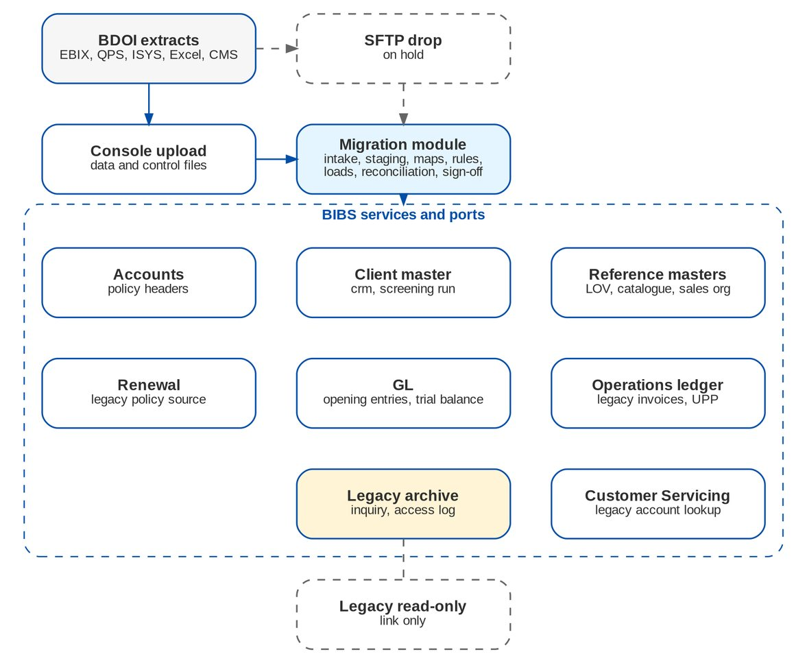
Figure 50: Interfaces of the migration module (dashed = on hold or link only)
Table 65: Interfaces
Interface | Direction | Content and trigger | BRD | Scope
Extract upload (console) | In | Data and control files per object | 1.1b | In scope
Secure file drop from BDOI IT | In | Same files, picked up by the system | 1.1b | On hold
Reference masters (LOV, catalogue, sales organisation) | Out | Mapped and created values | 3.1 | In scope
Client master and screening | Out | Migrated clients; one full screening run | 2.1 | In scope
Accounts | Out | Migrated policy headers | 4.1 | In scope
Operations ledger and Cashiering | Out | Legacy invoices, UPP | 5.1-10.1 | In scope
GL | Out | Opening entries, provisional opening trial balance and FY2027 true-ups | 1.1b | In scope
Renewal (legacy policies; package map) | Out | Migrated headers for the go-live and daily extractions; renewal advices already sent; package code map for the package check of the sanitation | 12.1 | In scope
Customer Servicing (legacy account lookup) | Out | Legacy references and archive records | 11.1 | In scope
Legacy read-only systems | Link | Address of the read-only legacy application shown on Legacy Inquiry | 11.1 | On hold
Write-back to QPS / EBIX | Out | Not needed after the freeze (legacy read-only) | - | Out of scope

Interfaces on hold. The secure file drop, delta extracts sent without an upload, the bulk transfer of legacy documents and the read-only legacy addresses depend on BDOI IT (DMQ24, DMQ28; PR-DM-03, PR-DM-04). Until they are named, files are uploaded on the Extracts screen; adding the file drop is a setting of the intake, with the same checks.

26 Non-functional requirements
The BRD refers every usage table to "the consolidated NFR requirements for BDO Insure Core Modernization project" (p.17-18), which is not in the pack (DMQ29). The values below are proposals.
Table 66: Non-functional requirements
Topic | BRD value | BIBS target and approach
Volumes | Not given | Loads sized for 1,000,000 client rows and 500,000 open-item rows; planning bounds from the umbrella BRD (clients 2020 to present, p.43; 21,200 bookings and 25,800 renewal accounts a month, p.44-45)
Cutover window | Not given | 48 hours over a weekend from the last legacy EOD to go / no-go; BIBS open 08:00 on the first business day; at the year-end boundary (recommended 3 January 2028), with FY2027 true-ups until about April 2028
Load performance | Not given | At least 50,000 rows an hour per partition, 4 partitions; reconciliation of an object within 1 hour; full production load within 20 hours, proven in the dress rehearsal
Staging security | Hosting appendix | Masked data outside production; staging and files purged within 5 days of sign-off; access only for migration roles and from the Philippines; encryption at rest and in transit
Audit | Not given | Every intake, validation, load, rerun, rollback, reconciliation, sign-off and archive access is audited
Retention | Consolidated NFR; umbrella p.45 (5 years online, 15 years archive) | Archive and access log by retention rule; migration evidence kept as project records (proposed 10 years)
Availability and recovery | Consolidated NFR | Same as BIBS; full backup (snapshot) of production before each production load gate

27 Configuration items

27.1 Parameters
Table 67: Data Migration parameters
Parameter | Default | Meaning
the environment class | Non-production | Masking applies in every environment except production
the go-live date | - | Go-live date; start of the go-live renewal extraction window
the opening value date | 1 January 2028 | Value date of the opening entries and of the true-ups (first day of the opening period)
the end of the go-live renewal window | 31 May 2028 | Last expiry of the go-live renewal extraction
the urgent-renewal date | 31 January 2028 | Candidates expiring up to this date are flagged Urgent
the resubmission deadline | T-1 12:00 | Last approval time of a resubmission in production
the staging retention days | 5 | Days after sign-off before staging and files are purged
the rows per load transaction | 500 | Rows per load transaction
the partitions loaded in parallel | 4 | Parallel load partitions
the amount tolerance | 0.00 | Tolerance of amount reconciliation
the error-rate limit of master data | 0.5 | Maximum percent of rejected or waived master-data rows
the error-rate limit of financial objects | 0 | Maximum percent of rejected financial rows
the automatic merge score | 90 | Score from which clients merge automatically
the review score | 60 | Score from which a pair goes to review
the prefix of colliding invoice numbers | Yes | Prefix the source system when a legacy invoice number is already used
the legacy invoice number patterns | EBIX pattern (I and 8 digits) | Patterns by which the payment matcher recognises a legacy invoice number; the QPS pattern is added after DMQ11
the setting Issue an AR for a migrated unapplied payment | No | Issue a BIBS AR (without cash posting) for each migrated UPP (DMQ14)
the archive export limit | 1000 | Rows per archive export
the unusual-export alert limit | 5000 | Exported rows per user and day that raise an alert
the access-reason setting | Yes | A reason is required per Legacy Inquiry session
the read-only address of EBIX, the read-only address of QPS | - | Links to the read-only legacy systems
the setting Legacy invoices count in incentive runs | No | Legacy invoices count in incentive runs

27.2 Lists of values
Table 68: Lists of values
List | Values provided
the list of source systems | EBIX; QPS; ISYS; Excel; CMS
the list of object categories | Reference; Client; Policy; Open item; GL; History
the list of data trust levels | High; Medium; Low
the list of break reasons | Timing difference between extract and ledger; Rounding in the legacy extract; Rows excluded by the data owner; Error in the legacy source, corrected by manual entry; Code map difference; Other (see explanation)
the list of waiver reasons | Record not needed in BIBS; Entered manually in BIBS after go-live
the list of access reasons | Internal or external audit; Compliance review; Regulator request; Client request or complaint; Claim on a legacy policy; Other (give details)
the list of legacy record types | Client; Policy; Invoice; Receipt; Remittance; Endorsement; Claim; GL journal; Renewal advice; Letter; Other
the list of reclassification reasons | Client cannot be identified; Unclaimed after follow-up; Below refund threshold; Other (see remarks)

27.3 Masters and rules maintained by the business
Table 69: Masters and rules
Item | Maintained by (approved by) | FR
Data object register and decisions | Data Migration Lead (business owner) | FR-DM-001, 002
Layouts, validation rules, masking rules | Data Steward (Data Migration Lead) | FR-DM-010, 013
Code maps | Data Steward (business owner) | FR-DM-011
Package code map (loaded for the Renewal sanitation) | TSU (Product Owner, Marketing Business System) | FR-DM-034
RA-sent file template and rejected-row review | Renewal processing team, maker (checker of the team; owner the Head of the Renewal processing team) | FR-DM-125
FY2027 adjustment register and the legacy GL access list | Comptrollership GL lead (Head, Comptrollership) | FR-DM-023, 024
Matching and survivorship rules | Data Steward (business owner of clients) | FR-DM-031
Legacy control accounts, Migration Clearing and the legacy accounting rules | Comptrollership (maker-checker on accounting rules) | FR-DM-021, 050-080
Go / no-go criteria and cutover plan template | Data Migration Lead (Program Manager) | FR-DM-120, 121
Decommissioning checklist template | Program Manager | FR-DM-123

28 Cross-BRD interface contract
Table 70: Interface contract of Data Migration
ID | BRD or system | Direction | What | When and how | Owner of the data | FR
IC-01 | BRD-1 New Business | Out | Migrated clients (C01) with their identity, contacts, addresses, segment, AO and KYC status; payout accounts (C03); one BIBS client per matched cluster, found by any legacy client number | Loaded two weeks before go-live through the client registration of BIBS, then daily deltas until the freeze; no onboarding workflow and no notification | Product Owner, Marketing Business System (data owner of C01) | FR-DM-030, FR-DM-031, FR-DM-032, FR-DM-033
IC-02 | BRD-1 New Business; BRD-2 Operations | Out | In-force policy headers (P01, P01S) as booked accounts of origin Migrated with the legacy package as given; the legacy invoices link to them | Loaded at the cut-over weekend after the freeze; the headers are used for endorsements, servicing and renewal | Head, Operations | FR-DM-040, FR-DM-041
IC-03 | BRD-2 Operations | Out | Open legacy invoices (F01, F01S, F01C) in the Operations ledger with their components, insurer shares and values at cut-over; endorsements of legacy invoices booked in the legacy context | Loaded after the freeze with an opening entry per insurer share; processed on Invoice 360, payments, remittance and endorsements after go-live; Changes to Legacy Invoices report for Prod Recon | Operations - Financial Transactions; Head, Comptrollership | FR-DM-050, FR-DM-051, FR-DM-060, FR-DM-080, FR-DM-090, FR-DM-091, FR-DM-092, FR-DM-100
IC-04 | BRD-2 Operations (Cashiering) | Out | Legacy unapplied payments (F02) with the legacy AR, references and disposition in progress; the Unapplied to Income and Legacy PR 2307 Reversal batches | Loaded after the freeze with an opening entry; matched by automatch on their references; worked on the Unapplied workbench and in the legacy batches | Operations - Financial Transactions | FR-DM-052, FR-DM-053, FR-DM-054, FR-DM-055, FR-DM-061, FR-DM-071
IC-05 | BRD-4 Collections | Out | Open collection state (F03) - dispositions, promises to pay, instalment plans and collector assignments of the open legacy invoices, carried as the legacy follow-up of the worklist item; tags "DP PR for reversal" | Loaded after the freeze; legacy items appear on the PR Worklist with the LEGACY badge | Head, Operations (Collections) | FR-DM-052
IC-06 | BRD-2 Operations (Commission); BRD-4 | Out | The DP PR Legacy Reversal of legacy invoices paid directly to the insurer | Batch requested by a Commission user and approved by the Commission team lead; candidates tagged by Collections | Commission team lead | FR-DM-070
IC-07 | BRD-5 Accounting (FRBS, ACSL) | In and Out | In: the chart of accounts, the legacy control accounts and Migration Clearing, and the accounting rules of the legacy components (set up by Comptrollership). Out: the provisional GL opening (G01), the opening entries of the invoices and unapplied payments, the opening-balance adjustments (G03); the legacy context of the GL to sub-ledger reconciliation | Opening journals dated 1 January 2028; Migration Clearing 0.00 per branch and currency; each adjustment approved by the Head of Comptrollership | Head, Comptrollership | FR-DM-021, FR-DM-022, FR-DM-023, FR-DM-024
IC-08 | BRD-6 Renewal | Out | The migrated policy headers expiring from go-live to 31 May 2028 and the renewal advices already sent (P03) for the go-live renewal extraction; the package code map (R06) for the package check at sanitation; the migrated headers for the daily extraction from 1 June 2028 | Go-live extraction at 04:00 on go-live day, January expiries flagged urgent; the map is maintained in Renewal after go-live | Heads, Retail and Corporate Marketing; Head, Renewal processing team; TSU (package map) | FR-DM-034, FR-DM-122, FR-DM-124, FR-DM-125
IC-09 | BRD-3 Product Maintenance | In | Products, package versions, insurers and commission rates of BIBS, which the code maps target; values created from the migration (CREATE entries) are authorised in their masters | Before the load of any dependent object; the package code map names only released package versions | Marketing Business System; TSU | FR-DM-011, FR-DM-034
IC-10 | BRD-10 Sanction Screening | Out | Migrated clients for one full screening run after the client load (no screening per client during the load) | Periodic screening with the full re-screen option before go-live; hits in the screening queue for Compliance | Compliance | FR-DM-030
IC-11 | BRD-11 User Access Maintenance | In | The users of the migration roles and of every persona, created through User Access requests; legacy user IDs are only mapped (user code map) | Before each trial migration and before the production cut-over (T-27) | BDOI IT; user access administration | FR-DM-011
IC-12 | BDOI IT (legacy EBIX, QPS, ISYS, CMS) | In | Extracts in the load templates with their control files; the legacy freeze and read-only mode; the document transfer folder; the read-only addresses of the legacy applications | Console upload (or the secure file drop when named); final extracts after the last legacy EOD | Head, BDOI IT | FR-DM-010, FR-DM-110

Change against this signed set. Data Migration loads every object through the module that owns it and hands the open items to Operations, Collections, Cashiering, Commission, Remittance, Accounting and Renewal, which process them after go-live. A later change in any of those BRDs that touches a line of this contract (a new mandatory field of a client, account or invoice, another accounting rule for the legacy items, another renewal lead time) is raised as a change request against this signed set in the Change Management Register, assessed for its effect on the layouts, the code maps, the reconciliation and the cut-over plan, and approved by the owners of both BRDs; the affected pages and layouts of this set are then re-issued and signed as a delta.

Part C - Reconciliation and the sign-off gates per object

29 Purpose and scope
BRID_MIG 1.2 asks that, after cutover, "all data objects and items are reconcilable from source to target" from the generated data migration reports (BRD p.7). This part states how each object is reconciled, what BDOI verifies on the BIBS screens, how breaks are handled, which evidence is kept, and the forms that BDOI signs. It applies to every trial migration, the dress rehearsal and the production cutover, to the FY2027 true-ups after go-live, and to the archive loads before decommissioning.
It completes Part A (Reconciliation approach) and the functional specification of Part B (FR-DM-020 to FR-DM-024, FR-DM-003). Account codes are not named: the legacy control accounts and the Migration Clearing account are assigned by Comptrollership (DMQ18, register DCR-197).

30 Reconciliation levels
Five levels are run by BIBS after each load and on demand (Reconciliation screen). Levels L1 to L4 apply to every object; L5 to the financial objects.
Table 71: Reconciliation levels
Level | Measure | How it is computed | Pass rule
L1 | Record counts | Control file row count; rows received, staged, valid, warning, invalid, loaded, skipped, rejected, excluded (per batch and its reruns) | Received = control count; loaded + skipped + rejected + excluded = staged; rejected rows are 0 for financial objects or excluded by the owner
L2 | Amounts | Per amount column and currency: control total, staged sum, and the value read from BIBS (ledger components of the origin Migrated, unapplied balances, journal lines) | Difference 0.00 (setting the amount tolerance, default 0.00) at each stage
L3 | Hash totals | Hash total of the key column as the layout defines it; SHA-256 per staged row; count of distinct keys in the cross-reference | Control = staged = cross-reference
L4 | Fields | Every mapped field of every loaded row read back through the owning service and compared with the staged, mapped value | Equal; a difference explained by the code map (mapped value) is not a break
L5 | GL | Migration Clearing balance per branch and currency, analysed per legacy control account (trial balance line against the opening detail posted to that account); each legacy control account against its legacy sub-ledger (ACSL GL-SL reconciliation in the legacy ledger context) | Migration Clearing 0.00; per control account TB line = opening detail; control account = sub-ledger

Breaks. Any difference is a break (status Break). A break is fixed by a rerun (new extract, new map version or a corrected row) or explained. An explanation gives a reason from the list of break reasons (timing difference between extract and ledger, rounding in the legacy extract, rows excluded by the data owner, error in the legacy source corrected by manual entry, code map difference, other) and a text, and is approved by the reconciliation approver. A reconciliation cannot be signed (gate G5) while a break is open.
Reports. Reconciliation Summary (object by level with status), Reconciliation Detail (lines, breaks, explanations, approvals), Rejected Rows (rejected and invalid rows with their messages), Migration Clearing and Legacy Control Accounts (Migration Clearing per branch and currency; legacy control accounts against sub-ledgers). All export to Excel and PDF.

31 Control totals BDOI sends
Every data file comes with a control file (workbook sheet "Control File" and template CONTROL_template.ctl.csv). It always carries the row count and the SHA-256 of the data file, plus the hash total of the key and the amount totals of the layout:
Table 72: Control totals per layout (every file also carries its row count and SHA-256)
Layout | Content | Hash total (L3) | Amount totals per currency (L2)
R01 | Lists of values and MIS values | Count of distinct keys of list_type, code | -
R02 | Branches and invoicing branches | Count of distinct keys of branch_code | -
R03 | Sales organisation (units and account officers) | Row count of record_type, unit_code, ao_user_id | -
R04 | Insurers | Count of distinct keys of insurer_code | -
R04B | Insurer branches | Count of distinct keys of insurer_code, branch_code | -
R05 | Product lines, cover types, products and risk codes | Count of distinct keys of risk_code | -
R06 | Package code map (legacy package to BIBS package version) | Count of distinct keys of legacy_package_code, legacy_package_version | -
R07 | Commission rates by insurer and product | Row count of insurer_code, risk_code, effective_from | -
R08 | Chart of accounts mapping | Count of distinct keys of legacy_account_code | -
R09 | Payees | Count of distinct keys of payee_code | -
R11 | Receipt series in use | Row count of branch_code, kind, prefix | -
C01 | Client master | Count of distinct keys of legacy_client_no | -
C02 | Client addresses and contacts | Row count of legacy_client_no, record_type, seq_no | -
C03 | Client payout accounts | Row count of legacy_client_no, account_no | -
P01 | In-force policy headers | Count of distinct keys of legacy_policy_ref | sum_insured, gross_premium, net_premium
P01S | Policy insurer shares | Row count of legacy_policy_ref, share_seq | -
P03 | Renewal advices already sent before go-live (RA-sent file) | Count of distinct keys of legacy_policy_ref | proposed_premium
F01 | Open legacy invoices - header | Count of distinct keys of legacy_invoice_no | gross_premium, commission, vat_on_commission
F01S | Open legacy invoices - insurer shares | Row count of legacy_invoice_no, share_seq | -
F01C | Open legacy invoices - components and positions | Row count of legacy_invoice_no, component | booked, adjusted, paid, remitted, written_off, open_balance
F02 | Unapplied premium payments (UPP) | Count of distinct keys of legacy_upp_ref | amount, balance
F03 | Open collection state | Row count of legacy_invoice_no, record_type, seq_no | promise_amount, installment_amount
F04 | Remittance in flight | Row count of legacy_batch_no, legacy_invoice_no | amount
F06 | PDCs, check pick-ups and refunds in process | Row count of record_type, reference | amount
G01 | GL opening trial balance | Row count of tb_version, branch_code, currency, legacy_account_code, cost_center | debit_fc, credit_fc, debit_php, credit_php
G03 | FY2027 true-up - legacy adjustment journal lines after the freeze | Count of distinct keys of legacy_journal_no | debit_fc, credit_fc, debit_php, credit_php
G03D | FY2027 true-up - open-item detail of the lines on legacy control accounts | Row count of legacy_journal_no, line_no, item_ref, component | amount
H01 | Archive records (closed transactions and history) | Count of distinct keys of record_type, legacy_key | amount
H02 | Archive documents index | Row count of record_type, legacy_key, file_name | -

The workbook sheet "Control Totals" lists the same measures one per row, with columns for the value from BDOI, the value in BIBS, the difference and the status. It is the tie-out sheet of L1 to L3 for each cycle.

32 Reconciliation per data object
Table 73: What is reconciled per object
Object | L1 counts | L2 amounts | L3 hash | L4 fields | L5 GL / business check
R01-R08, R11 | Values received, mapped, created, rejected; package code map entries | - | Distinct keys | Created values (name, status, dates); package code map entries in the Renewal package map | Unmapped-code report empty; every Create value authorised in its master; package code map entries loaded into the Renewal package map equal the approved version
R09 | Payees received and loaded | - | Distinct payee codes | All loaded fields | Payee list in Disbursement
C01, C02 | Legacy clients received, clusters, merged, new, loaded | - | Distinct legacy client numbers = cross-reference entries | Identity, contact, segment, KYC fields of the survivor | Client review queue empty; each legacy number resolves to one BIBS client
C03 | Accounts received and loaded | - | Distinct (client, account) | All fields | -
P01, P01S | Headers received and loaded; shares | Sum insured, gross and net premium per currency | Distinct legacy policy references | All header fields and shares | Headers linked to their clients and legacy invoices
P03 | RA-sent rows received, loaded, rejected; resubmitted rows | Proposed premium per currency | Distinct legacy policy references | RA date, reference, channel, sender, tracker | At go-live, the go-live renewal extraction check per expiry month January-May 2028: P01 headers expiring from T to 31 May 2028 = candidates + renewals booked in legacy; loaded P03 rows = candidates with the RA already sent; every January candidate flagged Urgent
F01, F01S, F01C | Invoices, share rows, component rows | Booked, adjusted, paid, remitted, written off and open per component and currency | Distinct invoice numbers | Header fields, shares, every component and bucket | L5 - Premium Receivable, PR2307, DTIP, Commission Receivable (legacy) against the legacy invoices; Migration Clearing 0.00
F02 | UPP items | Amount and balance per currency | Distinct UPP references | All fields, stage and disposition | L5 - Unapplied Collections (legacy) against the migrated UPP balances
F03 | Rows per record type | Promise and installment amounts | Distinct (invoice, type, seq) | All fields | Worklist items show the carried promises and assignments
F04, F06 | Rows per record type | Amount per currency | Distinct keys | All fields | Holds and PDCs visible in Remittance and Cashiering
G01 | Trial balance lines | Debit and credit per branch and currency, in currency and PHP | Lines per branch | Account, branch, currency and amounts per line | Provisional opening - balance sheet in BIBS = preliminary December TB per branch and currency; FY2027 result on retained earnings; P&L accounts 0.00; Migration Clearing 0.00
G03 (G03, G03D) | Journal lines and detail lines per true-up | Debit and credit per branch and currency; detail per account | Distinct legacy journals | Account, branch, currency, amounts; item and component of each detail line | True-up reconciliation (section 5.1)
H01, H02 | Records per record type; documents | Amount per record type and currency | Distinct keys per record type; SHA-256 per document | Labelled legacy columns | Samples found in Legacy Inquiry with their documents

33 GL reconciliation: Migration Clearing
The open-item objects and the trial balance are loaded from two independent sources in legacy: the invoice and UPP detail (F01, F02) and the GL (G01). Migration Clearing proves that they agree (Figure 1):
• each legacy invoice and each UPP item is loaded with an opening entry whose balancing line goes to Migration Clearing;
• the trial balance is loaded as opening journals; its lines on the legacy control accounts (premium receivable, PR2307, DTIP, commission receivable, unrealised commission, deferred VAT, unapplied collections) are mapped to Migration Clearing instead of the legacy control accounts, because the opening entries create those balances in detail;
• when the detail equals the GL, Migration Clearing is 0.00 per branch and currency.
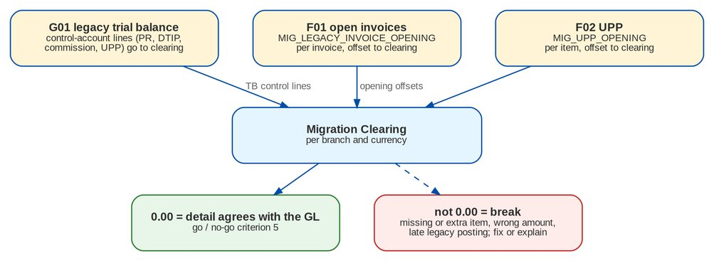
Figure 51: Migration Clearing nets to zero when the detail equals the legacy GL
Worked example (one branch, PHP, one invoice and one UPP item; made-up figures; the unrealised commission follows DMQ13 and is taken here as fully unrealised):
Table 74: Migration Clearing for one branch
Line | Debit | Credit | Effect on Migration Clearing
F01 opening of I00123456 - Premium Receivable - Legacy | 10,000.00
F01 opening - Commission Receivable - Legacy | 4,480.00
F01 opening - DTIP - Legacy |  | 23,050.00
F01 opening - Unrealised Commission and Deferred VAT - Legacy |  | 4,480.00
F01 opening - balancing line to Migration Clearing | 13,050.00 |  | Debit 13,050.00
F02 opening of UPP-2026-004321 - Unapplied Collections - Legacy |  | 5,000.00
F02 opening - balancing line to Migration Clearing | 5,000.00 |  | Debit 5,000.00
G01 trial balance - legacy control-account lines (PR 10,000.00 Dr, commission 4,480.00 Dr, DTIP 23,050.00 Cr, unrealised and deferred 4,480.00 Cr, UPP 5,000.00 Cr) mapped to Migration Clearing |  | 18,050.00 (net) | Credit 18,050.00
G01 trial balance - cash in bank 18,050.00 Dr, mapped to the BIBS bank account | 18,050.00 |  | -
Migration Clearing |  |  | 0.00

A missing invoice. A difference on Migration Clearing has the sign of the trial balance, because the TB puts the legacy control-account lines on Migration Clearing with their own sign and the opening entries put the detail there with the opposite sign. So an invoice missing from F01 leaves a debit equal to its net receivable position (open premium receivable, PR2307 and commission receivable, less open DTIP, unrealised commission and deferred VAT) when that is positive, and a credit when it is negative (FR-DM-021 acceptance 3). Two cases, made-up figures:
• F01 missed an invoice paid in full and not remitted, with DTIP 5,000.00 open and commission receivable 800.00 (realised on collection): Migration Clearing shows a credit of 4,200.00 in that branch.
• F01 missed an unpaid invoice with premium receivable 3,000.00, DTIP 3,000.00, commission receivable 480.00 and the same 480.00 unrealised: Migration Clearing nets to 0.00. The per-account comparison of the report Migration Clearing and Legacy Control Accounts finds it: the TB is 3,000.00 debit higher than the detail on Premium Receivable - Legacy, 3,000.00 credit higher on DTIP - Legacy, and 480.00 higher on each commission account.
Either break is investigated and fixed or explained before go / no-go.
Legacy control accounts against sub-ledgers. After the loads, the ACSL GL to Sub-ledger Reconciliation is run in the legacy ledger context: each legacy control account must equal the open positions of the legacy invoices (or legacy UPP) behind it. This is criterion 6 of the go / no-go and is repeated daily in hypercare and at every month-end until the legacy context closes.

33.1 True-up reconciliation (FY2027 closing and audit adjustments)
With the year-end cut-over (DMQ39, option A, recommended), the GL opening is provisional. After the freeze the legacy GL accepts only the FY2027 closing and audit adjustments of the Comptrollership users on the signed access list, and each adjustment reaches BIBS in a true-up (FR-DM-023): true-up 1 after the legacy year-end close (about 18-21 January 2028), interim true-ups only when needed, and the final true-up after the audited financial statements (about March-April 2028). Each true-up comes with the legacy trial balance after the adjustments (G01, version TU1, TU2 or Final), the adjustment journal lines (G03), their open-item detail on the legacy control accounts (G03D) and the legacy journal listing since the freeze. BIBS runs the report Opening-Balance Adjustment Reconciliation after the posting; the Head of Comptrollership signs the true-up only when every check is met (FR-DM-024).
Table 75: True-up checks (report Opening-Balance Adjustment Reconciliation)
Check | Rule | What a break usually means
Cut-off | Legacy journal listing since the freeze = FY2027 adjustment register = journals of the true-ups so far; every journal dated in FY2027, posted after the freeze by a user on the access list; no posting by a legacy business module | A journal posted outside the register, by the wrong user, or in FY2028
Movement | Per BIBS account, branch and currency: true-up n = legacy TB of true-up n - legacy TB of the previous true-up (or of the provisional opening), both mapped, P&L netted into retained earnings | A legacy journal missing from G03, or a TB extracted at a different time
Balance | Per BIBS account, branch and currency: provisional opening + true-ups 1 to n = legacy TB of true-up n, mapped (P&L netted into retained earnings; legacy control accounts replaced by the open-item detail) | An earlier true-up incomplete, or a mapping change between true-ups
Clearing and sub-ledgers | Migration Clearing 0.00 per branch and currency; each legacy control account = its legacy sub-ledger (ACSL, legacy ledger context) | A control-account adjustment whose G03D detail is missing or on the wrong item
Opening period | When January 2028 was reopened for the posting: no journal other than the true-up posted into it during the window; the period closed again the same day | The reopen window used for other postings

Worked example (one branch, PHP, made-up figures). True-up 1 brings two FY2027 adjustments: a closing accrual of professional fees of 80,000.00 (Dr expense, Cr accrued expenses) and an audit write-off of the 3,000.00 premium receivable of legacy invoice I00300002 (Dr bad debts, Cr Premium Receivable - Legacy), sent with its detail line.
Table 76: True-up 1 in BIBS (journal MIG-TU-1, value date 1 January 2028)
Line | Debit | Credit | Note
Retained earnings (FY2027 expense of the accrual) | 80,000.00 |  | P&L of FY2027, not FY2028
Accrued expenses |  | 80,000.00 | Balance-sheet account
Retained earnings (FY2027 bad debts) | 3,000.00 |  | P&L of FY2027
Migration Clearing (legacy control-account line of the write-off) |  | 3,000.00 | Replaced by the detail
Detail - Migration Clearing / Premium Receivable - Legacy, invoice I00300002 basic | 3,000.00 | 3,000.00 | Legacy written off on the invoice; open balance 0.00
Migration Clearing after true-up 1 |  |  | 0.00

Movement check: the legacy TB after the close differs from the preliminary TB by exactly these amounts on the mapped accounts; balance check: the BIBS opening plus true-up 1 equals the legacy post-close TB; the FY2028 P&L is unchanged.

34 Business verification on screen (gate G6)
L1 to L5 prove that what BDOI sent is what BIBS holds. Business verification proves that what BIBS holds means what the business expects: the right client, the right policy, the right balance, on the screens users will work with. The data owner (or the steward on the owner's behalf) checks a sample per object in the environment of the cycle and signs the object acceptance.

34.1 Sample plan
The Migration Lead draws the samples from the loaded batch (random with a fixed seed recorded on the form, plus the targeted records). Samples are checked against the legacy screen or a legacy report of the same as-of date.
Table 77: Business verification samples per object
Object | Sample | What is checked on the BIBS screen
R01-R08, R11 | Every Create value; 10 mapped values per map set; every legacy package with more than one BIBS target (conditional package code map entries); every receipt series | Value, description and status in the master; the package code map entries of each split in the Renewal package map; next AR / OR number = legacy last used + 1
C01-C03 | 30 random clients per source system; 20 merged clusters; 10 decisions of the review queue; 10 corporate clients | Client search by legacy number; name, identity, contacts, segment, AO, KYC status and review date; cluster shows every legacy number
P01 | 30 random headers; 10 with several insurers; 10 expiring within 140 days | Account search by policy and legacy reference; dates, insurer and shares, sum insured, premium, client link, legacy invoices listed
P03 | 10 rows per tracker; every resubmitted row; at go-live 20 candidates per expiry month January-May 2028 | RA date, reference and channel against the tracker; at go-live the candidate shows the RA already sent, January candidates Urgent and in expiry-date order
F01 | 20 largest open balances per currency; 30 random; 10 endorsement or cancellation invoices; 10 direct-payment; 10 with 2307; up to 20 foreign-currency | Invoice 360: legacy badge, source, legacy number, original values, booked / paid / remitted / open per component, shares; Collections item for open premium
F02 | 20 largest balances; 20 random; every item with a disposition in progress (up to 30) | Unapplied Payments workbench: legacy AR, amount, balance, tab, references, disposition
F03, F04, F06 | 20 random per object | Promise and assignment on the Collections item; hold or special request in Remittance; PDC in the warehouse list
G01 | Every branch and currency total; 20 largest account lines; retained earnings per branch | Trial balance report in BIBS against the signed preliminary trial balance; P&L accounts at 0.00
G03 | Every journal of the true-up; every detail line on a legacy control account | Journal inquiry (MIG-TU-n) against the legacy journal and the register; Invoice 360 or the Unapplied workbench for the item adjusted
H01, H02 | 10 records per record type; 10 documents | Legacy Inquiry search by the legacy key; labelled columns; document opens and matches its checksum

34.2 Acceptance rule
• Financial objects (F01, F02, G01, G03) and identity fields of clients: no error is accepted. One error stops the sign-off: the cause is found, fixed at source, in the map or in the load settings, the batch is rerun, and a new sample is drawn.
• Other fields: an error that is isolated and cosmetic (for example capitalisation of an address) is listed on the form with its fix (legacy correction before the next extract, or correction in BIBS after go-live by the owner). Two or more errors of the same kind in a sample are treated as systematic: the sample is doubled and the cause is fixed before sign-off.
• The result is recorded on the object sign-off form (Sign-off forms, Object reconciliation and acceptance) with the sample seed, the records checked and the errors found.

35 Breaks, waivers and exclusions
Table 78: How differences are closed
Situation | Handling | Approved by
Row rejected by a data-quality rule | Fixed at source and re-extracted, fixed by a new map version, or waived (master data only) | Data steward; waiver by the data owner
Financial row that cannot be fixed before go-live | Excluded from the batch with a manual-entry plan (who keys it in BIBS after go-live, when, and the amount) | Data owner and Comptrollership
Amount or count difference between control file and staging | The extract is rejected at intake; BDOI IT re-sends | -
Difference between staging and BIBS (L2, L4) | Load or mapping issue: fixed and rerun; never explained away | iorta Migration Lead
Migration Clearing not 0.00 | Traced to the invoice, UPP or TB line; fixed by rerun or by a legacy correction and a new extract; a residual rounding difference is explained with its amount | Reconciliation approver (Comptrollership)
Late legacy transaction after the freeze | Recorded as a break; the transaction is re-keyed in BIBS after go-live and the legacy system owner explains the access. A FY2027 GL adjustment by a named Comptrollership user is not a late transaction: it goes through the next true-up | Data owner; BDOI IT
True-up check not met | The true-up is not signed; the cause is corrected by a new extract before sign-off or by the next true-up; a posted journal is never edited | Head, Comptrollership

36 Evidence and retention
For each object and cycle the evidence pack holds: the extract numbers with file names, SHA-256 and control totals; the map versions used; the reports Data-Quality Issues with the waivers, Rejected Rows, Reconciliation Summary and Reconciliation Detail; Migration Clearing and Legacy Control Accounts for financial objects; the sample list with the check results; and the signed forms of this part (Sign-off forms). The pack is exported from the Migration Console and filed in the project records. Staging rows and files are purged within 5 days of sign-off, but counts, hashes, totals, reports and sign-offs are kept (proposed 10 years, DMQ29).

37 Sign-off forms
The forms below are signed in the Migration Console (gates G5 and G6) and printed for the project file. One form per object and cycle.

37.1 Object reconciliation and acceptance (G5 and G6)
Object and name | .......... ....................................................
Cycle and environment | Trial migration 1 / Trial migration 2 / Trial migration 3 / Trial migration 4 / Dress rehearsal / Production Environment: ................
Batch numbers (MGB-) | ........................................................................
Extract numbers (MGX-) and as-of | ........................................................................
Code map versions used | ........................................................................
Sample seed and size | Seed ............ Records checked ............

Table 79: Reconciliation results (from the report Reconciliation Summary)
Level | Measure | Source (control) | BIBS | Difference | Status (Matched / Explained)
L1 | Rows received / staged / loaded / skipped / rejected / excluded
L2 | Amount totals per currency (list)
L3 | Hash total of the key
L4 | Field differences (count) | -
L5 | Migration Clearing; control account vs sub-ledger | -
G6 | Business verification sample - errors found | -

Table 80: Breaks explained, waivers and exclusions
# | Break, waiver or exclusion | Reason and explanation | Approved by / manual-entry plan
1
2

Name | Role | Organisation | Signature | Date
 | Reconciliation approver - G5 (Comptrollership for financial objects) | BDOI
 | Data owner - G6 object accepted | BDOI
 | Data Migration Lead - G6 | BDOI
 | Migration Lead (reconciliation run) | iorta TechNXT

37.2 Cutover reconciliation summary (go / no-go GNG-3)
Cutover | Production Go-live date (T): ................ Freeze: T-3 22:00
Rollback point (snapshot ID and time) | ........................................................................

Table 81: Day-1 objects at go / no-go
Object | Batch | Loaded / staged | G5 signed | G6 signed
R01-R08, R11
C01-C03
P01, P03
F01
F02
F03, F04, F06
G01 (provisional)

Table 82: Migration Clearing and legacy control accounts per branch and currency
Branch / currency | Migration Clearing | Control accounts vs sub-ledgers | Status

Table 83: Go-live renewal extraction check (completed on the morning of T)
Expiry month | P01 headers expiring | Renewed in legacy | Candidates created | RA already sent (P03)
January 2028 (urgent)
February 2028
March 2028
April 2028
May 2028

Name | Role | Organisation | Signature | Date
 | Head, Comptrollership | BDOI
 | Data Migration Lead | BDOI
 | Program Manager (for the go / no-go board) | BDO Unibank ESG
 | Project Manager | iorta TechNXT

37.3 True-up reconciliation and sign-off (FY2027)
True-up | 1 / 2 / 3 / F (final) Legacy trial balance version: TU1 / TU2 / TU3 / Final (audited)
Legacy extracts (MGX-) and as-of | ........................................................................
Journals posted (MIG-TU-) | ........................................................................
Prepared by (Comptrollership GL lead) and date | ........................................................................
Opening period reopened | No / Yes - reopened at ........ closed at ........ reason ................................

Table 84: True-up checks (from the report Opening-Balance Adjustment Reconciliation)
Check | Measure | Result | Status (Met / Break)
Cut-off | Legacy journals since the freeze / in the register / in the true-ups
Movement | Accounts with a difference between the true-up and the legacy TB change
Balance | Accounts with a difference between the BIBS opening and the legacy TB
Clearing | Migration Clearing per branch and currency
Sub-ledgers | Legacy control accounts vs legacy sub-ledgers
Opening period | Other journals posted in the reopen window

Name | Role | Organisation | Signature | Date
 | Head, Comptrollership - true-up approved and reconciliation signed | BDOI
 | Data Migration Lead | BDOI
 | Program Manager - closure of the true-ups (final true-up only) | BDO Unibank ESG
 | Migration Lead (reconciliation run) | iorta TechNXT

The final true-up's reconciliation against the audited FY2027 trial balance is shared with the external auditor.

37.4 Archive reconciliation (before decommissioning)
Legacy system | EBIX / QPS / ISYS / CMS / File shares
Record types archived | ........................................................................
Archive batches (MGB-) | ........................................................................

Table 85: Archive counts and totals per record type
Record type | Legacy count | Archived count | Amount total legacy | Amount total archive | Samples checked in Legacy Inquiry

Name | Role | Organisation | Signature | Date
 | Legacy system owner | BDOI
 | Audit / Compliance | BDOI
 | Head, Comptrollership | BDOI

Part D - Cut-over runbook, run-off and decommissioning

38 Purpose and use
This runbook is the plan of the production cutover of BIBS: from 30 days before go-live (T) to the end of hypercare. It lists every task with its owner, start, duration, predecessors and the evidence that proves it is done; the go / no-go checkpoints with their criteria; the freeze windows; the rollback procedure; the communication plan; the hypercare roster and exit criteria; and the decommissioning checklists of the legacy systems.
• T is the go-live date. The BDOI timeline sets it in January 2028 (DMQ25). The recommendation, awaiting Comptrollership confirmation, is Monday 3 January 2028 at the year-end boundary (DMQ39 option A, register DCR-242): legacy processes to 31 December 2027 and closes FY2027, and BIBS opens with the open items at 31 December and a provisional GL opening. Days are calendar days; times are Philippine time (PHT). The calendar (Timeline, Calendar) maps the relative days to dates; tasks that would fall on the year-end holidays are placed on the nearest working day.
• The same tasks are on the sheet Cut-over tasks of the Migration Workbook (file 03), where names are recorded and the business reviews them, and in the Migration Console as the plan of kind Production cut-over (FR-DM-120), where the actual times and status are recorded. The console is the record during the cut-over; the workbook is the planning and review copy.
• The plan is rehearsed in four trial migrations (April, July, August and October 2027) and a dress rehearsal (November 2027) (Part A, Migration cycles). This issue gives planned durations; the update issued after the dress rehearsal gives the measured durations and the named people.
• The early renewal release of the concept paper of 6 September 2026 is superseded by the single January 2028 go-live (register DCR-240). The renewals of the January-May 2028 expiries are processed in BIBS after go-live (DMQ37): no renewal is carried from legacy. The Renewal processing team is made ready for the January expiries (CT-013), compiles the renewal advices already sent from its Excel trackers (CT-033) and reviews the rejected rows with a maker and a checker (CT-055); BIBS extracts every expiry to 31 May 2028 at T 04:00 (CT-062), and the team works the day-1 priority queue, January expiries first (CT-066).
• The FY2027 closing and audit adjustments that Comptrollership posts in the legacy GL after the freeze reach BIBS as true-ups: true-up 1 after the legacy year-end close (CT-080 to CT-084) and the final true-up after the audited financial statements, followed by the legacy GL lock and the closure (phase H, CT-087 to CT-095).

39 Cutover organisation

39.1 Command centre
• Location and channels. A command centre room at BDOI head office, a standing bridge line and a chat channel for the cutover team, open from T-3 17:00 to T+5.
• Status calls. T-3 to T: every 4 hours and at each checkpoint. T+1 to T+5: 08:00 and 17:00. Afterwards daily at 17:00 until hypercare exit.
• Decisions. Task owners report completion with the evidence in the console. The Data Migration Lead decides within the plan; anything that changes the plan, the scope or a checkpoint goes to the go / no-go board.
• Escalation. Task owner to the Data Migration Lead (15 minutes), to the iorta Project Manager and the Program Manager (30 minutes), to the go / no-go board (1 hour, or immediately for a stop condition).
Stop conditions (the board meets at once): a rejected final extract that cannot be re-sent within 2 hours; a load failure that leaves a financial object incomplete; Migration Clearing not 0.00 after the reconciliation window; a legacy posting after the freeze; loss of the production environment or of the snapshot.

39.2 Roles
Table 86: Roles of the cut-over plan
Code | Role | Organisation
PM | BDOI Program Manager (ESG - Business Project Services) | BDOI
DML | BDOI Data Migration Lead | BDOI
OWN | Data owners (department heads of each object) | BDOI
STW | Data stewards | BDOI
COMP | Comptrollership (reconciliation approver for financial objects) | BDOI
OPS | Operations (Financial Transactions, Cashiering, Remittance, Collections) | BDOI
MKT | Marketing (Retail and Corporate) | BDOI
RNW | Renewal processing team (makers and checkers; Head of the Renewal processing team) | BDOI
CMP | Compliance and Audit | BDOI
BIT | BDOI IT (legacy systems, extracts, network, secure file transfer) | BDOI
GNG | Go / no-go board (Program Manager, heads of Operations, Comptrollership, Marketing, Compliance, IT; iorta Project Manager) | BDOI and iorta TechNXT
IPM | iorta TechNXT Project Manager | iorta TechNXT
IML | iorta TechNXT Migration Lead (loads, reconciliation, Migration Console) | iorta TechNXT
IOP | iorta TechNXT Migration Operator (intake, validation, loads) | iorta TechNXT
IDO | iorta TechNXT infrastructure team (AWS environment, snapshots, access, monitoring) | iorta TechNXT
IQA | iorta TechNXT QA (smoke tests, issue triage) | iorta TechNXT

40 Timeline
Table 87: Cut-over phases
Phase | Name | When | Tasks | IDs
A | Readiness | T-30 to T-15 (4 to 19 Dec 2027) | 15 | CT-001 to CT-015
B | Pre-load and daily deltas | T-14 to T-4 (20 to 30 Dec 2027) | 19 | CT-016 to CT-034
C | Legacy freeze and final extracts | T-3 (Friday 31 Dec 2027) | 5 | CT-035 to CT-039
D | Production load | T-2 (Saturday 1 Jan 2028) | 13 | CT-040 to CT-052
E | Reconciliation, verification and go / no-go | T-1 (Sunday 2 Jan 2028) | 9 | CT-053 to CT-061
F | Go-live | T (Monday 3 Jan 2028) | 9 | CT-062 to CT-070
G | Hypercare and true-up 1 | T+1 to T+30 (4 Jan to 2 Feb 2028) | 16 | CT-071 to CT-086
H | Final true-up and legacy GL close | T+31 to T+120 (Feb to 2 May 2028) | 9 | CT-087 to CT-095

40.1 Calendar
Table 88: Relative days on the calendar of the proposed go-live
Day | Date (T = 3-Jan-2028) | Note
T-30 | Sat 4 Dec 2027 | Dress rehearsal (15-26 Nov 2027) already done; reserve slot 6-10 Dec 2027 if its exit criteria were missed
T-26 | Wed 8 Dec 2027 | Feast of the Immaculate Conception (special non-working day) - the Comptrollership set-up (CT-007) is planned from T-25
T-21 | Mon 13 Dec 2027 | Communications to branches, insurers and bank channels; legacy December soft close under way
T-20 | Tue 14 Dec 2027 | Renewal processing team readiness - January staffing plan, training, day-1 queue rehearsed
T-15 | Sun 19 Dec 2027 | GNG-1 (board meets on Friday 17 December if preferred)
T-14 | Mon 20 Dec 2027 | December soft close complete; production pre-load of reference data starts
T-12 | Wed 22 Dec 2027 | Client extract; completion drives for remittance batches and in-flight items (moved from T-9, Christmas Day)
T-11 | Thu 23 Dec 2027 | Client load and sign-off; daily client deltas start (moved from T-10, Christmas Eve)
T-10 | Fri 24 Dec 2027 | Christmas Eve (special non-working day) - no task planned
T-9 | Sat 25 Dec 2027 | Christmas Day - no task planned
T-7 | Mon 27 Dec 2027 | Code map freeze; legacy reference-data change freeze
T-5 | Wed 29 Dec 2027 | Last legacy business day; GNG-2 (moved from T-4, Rizal Day); freeze announcement; final RA-sent file; legacy GL access list for FY2027 adjustments
T-4 | Thu 30 Dec 2027 | Rizal Day (regular holiday) - no task planned
T-3 | Fri 31 Dec 2027 | Last day of the year (special non-working day) - last legacy EOD; preliminary December TB; business freeze 22:00; legacy GL restricted to FY2027 adjustments; final extracts
T-2 | Sat 1 Jan 2028 | New Year's Day - production load, provisional GL opening (cut-over team on duty)
T-1 | Sun 2 Jan 2028 | Reconciliation, verification, P03 resubmissions until 12:00, GNG-3 at 18:00
T | Mon 3 Jan 2028 | Renewal go-live extraction 04:00; go-live 08:00; day-1 renewal priority queue; point of no return 18:00
T+10 | Thu 13 Jan 2028 | First daily Renewal extraction of new expiries (1 June 2028)
T+15 | Tue 18 Jan 2028 | Legacy FY2027 year-end close complete
T+18 | Fri 21 Jan 2028 | True-up 1 posted, reconciled and signed
T+30 | Wed 2 Feb 2028 | First month-end close (January 2028) completed; hypercare exit decision
T+60 | Fri 3 Mar 2028 | Interim true-up 2, only when needed
T+85 | Tue 28 Mar 2028 | Audited FY2027 financial statements (about March-April 2028; follows the audit timetable)
T+99 | Tue 11 Apr 2028 | Final true-up posted; FY2027 BIR annual returns filed from legacy
T+106 | Tue 18 Apr 2028 | Legacy GL locked
T+120 | Tue 2 May 2028 | True-ups closed

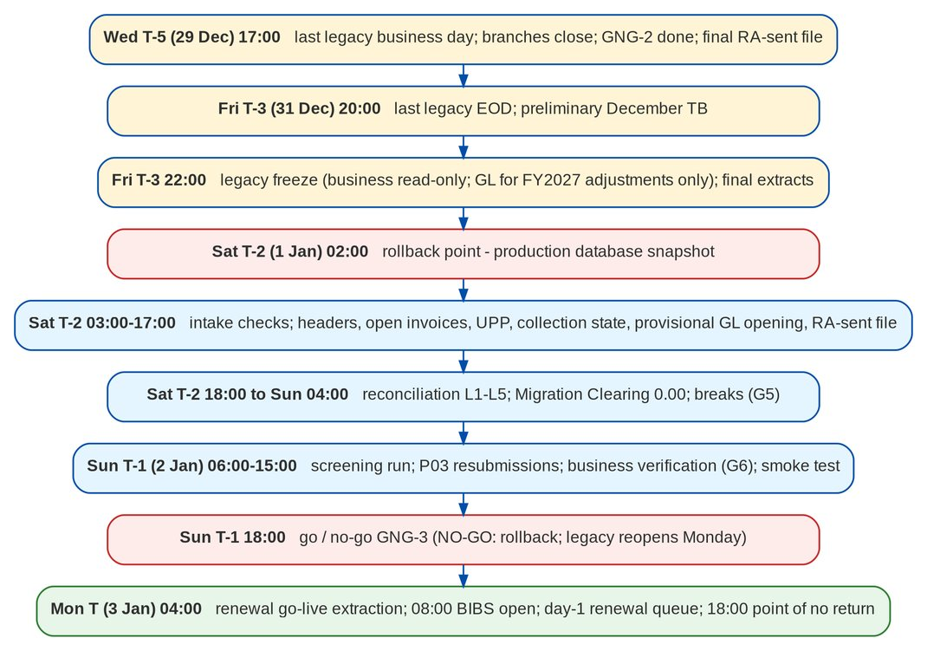
Figure 52: The cutover weekend (T = Monday 3 January 2028, recommended; times PHT)

40.2 Freeze windows
Table 89: Freeze windows
Freeze | From | Until | Scope | Exception route
Reference data | T-7 (map freeze) | Go-live | Insurers, products, risk codes, packages, AOs, branches, LOVs in EBIX and QPS | Change request approved by the data owner; new code map version; delta load of R objects
Client master | T-3 22:00 (last delta) | Go-live | New and changed clients in QPS / EBIX / CMS | None after the freeze; changes keyed in BIBS after go-live
Business transactions | T-3 22:00 (after the last legacy EOD) | Go-live | All postings of the business modules of EBIX, QPS, CMS - bookings, receipts, UPP, dispositions, remittances, endorsements; GL journals other than the FY2027 adjustments | None; an urgent item is recorded on paper and keyed in BIBS on T
Legacy GL (FY2027 adjustments) | T-3 22:00 | Legacy GL lock (T+106) | Only FY2027 closing and audit adjustments, by the Comptrollership users on the signed access list; FY2028 periods never opened in legacy; no new business | Each journal in the FY2027 adjustment register; it reaches BIBS in the next true-up
BIBS configuration | T-2 00:00 | T+3 | Parameters, accounting rules, code maps, workflows in production | Emergency change approved by the go / no-go board
BIBS releases | T-7 | T+14 | Deployments to production | Hotfix of a Critical issue approved by the go / no-go board

41 Go / no-go checkpoints
Each checkpoint is recorded in the Migration Console with the value of every criterion at the time of the decision (FR-DM-121). A criterion that is not met blocks GO unless the board records a waiver with its reason (only for criteria marked as waivable in the console; the financial and clearing criteria of GNG-3 are never waived).
Table 90: GNG-1 at T-15: Start the production pre-load
No. | Criterion
1 | Dress rehearsal completed within the window with at least 20 percent margin, rollback rehearsed
2 | Production environment, roles and PH-only access ready; masking off only in production
3 | Legacy control accounts, Migration Clearing and the legacy accounting rules approved in production (DMQ18)
4 | Code map versions for production approved
5 | Transfer path (secure file drop or console) tested
6 | December soft close on track for 20 December 2027
7 | Renewal processing team ready - January staffing plan signed, training done, day-1 queue rehearsed
8 | No open Critical issue of the migration or of a Day-1 module

Table 91: GNG-2 at T-5: Enter the legacy freeze on T-3
No. | Criterion
1 | Reference data and clients loaded and accepted (G6) in production; daily deltas running
2 | Client review queue empty
3 | Final extract jobs timed within the window (dry run)
4 | In-flight items and remittance batches closed or listed for carry-forward
5 | P01 dry run covers every expiry to 31 May 2028 and every renewal term booked in legacy starting on or after T
6 | Draft RA-sent file validated; its rejects reviewed by the Renewal processing team
7 | Comptrollership access list for the legacy GL after the freeze named
8 | Communications sent; branches and insurers informed

Table 92: GNG-3 at T-1 18:00: Go live on T
No. | Criterion
1 | Every Day-1 object at G6 (100 percent)
2 | Counts - received = control and loaded + skipped + rejected + excluded = staged, for every object
3 | Financial rejects (F01, F02, G01) - 0, or each excluded item approved by the owner with a manual-entry plan
4 | Amount reconciliation of open items, UPP and trial balance - 0.00 difference per currency
5 | Migration Clearing - 0.00 per branch and currency
6 | Legacy control accounts equal their sub-ledgers (ACSL, context LEGACY) - 0.00
7 | Client review queue empty; screening run complete
8 | Business smoke test passed
9 | Rollback point (snapshot) taken and verified
10 | Hypercare roster and support channels in place
11 | Preliminary December TB signed as the provisional opening; legacy GL restricted to the named FY2027 adjustment users
12 | Headers of every expiry to 31 May 2028 loaded; RA-sent file loaded; Renewal January staffing plan confirmed

Table 93: POINT OF NO RETURN at T 18:00: Continue in BIBS; fallback to legacy no longer offered (DMQ32)
No. | Criterion
1 | No Critical issue that stops receipts, payment application, remittance or booking
2 | Migration Clearing still 0.00; no posting in legacy since the freeze
3 | Every branch has transacted in BIBS

Table 94: TRUE-UP CLOSED at T+120: Close the FY2027 true-ups
No. | Criterion
1 | Final true-up reconciled to the audited FY2027 TB and signed by the Head of Comptrollership
2 | Legacy GL locked for all users; FY2027 adjustment register closed
3 | Migration Clearing 0.00 and legacy control accounts equal their sub-ledgers after the final true-up
4 | Opening journals no longer marked PROVISIONAL

42 Task list
Columns: When is the day relative to T and the planned start time; Owner is the accountable role (codes in Cutover organisation, Roles); Hours is the planned elapsed time; After lists the tasks that must be complete first; Verification is the evidence recorded in the console.

42.1 Phase A - Readiness
Table 95: Phase A: Readiness
ID | When | Task | Owner | Hours | After | Verification
CT-001 | T-30 | Confirm the dress rehearsal met its exit criteria (all objects loaded and reconciled L1-L5, window met with 20 percent margin, rollback rehearsed, go-live renewal extraction run) | DML | 4 | - | Dress rehearsal report signed by the Data Migration Lead and the iorta Migration Lead
CT-002 | T-30 | Confirm the go-live date, the freeze start (last legacy EOD) and the blackout dates (DMQ25) with Comptrollership's confirmation of the year-end option A (DMQ39); publish the cutover calendar | PM | 2 | CT-001 | Calendar approved by the Program Manager and circulated; option A confirmed in writing by the Head of Comptrollership
CT-003 | T-29 | Name the cutover team, the command centre room and bridge line, and the hypercare roster (section Hypercare) | PM | 4 | CT-002 | Roster with names and phone numbers in the runbook annex
CT-004 | T-28 | Freeze the production cutover plan in the Migration Console (plan kind Production cut-over, tasks and owners from this list) | IML | 4 | CT-002 | the Cutover Runbook Status report shows the plan with every task owned
CT-005 | T-28 | Production environment ready - the go-live release of BIBS installed; migration parameters set (environment class Production, go-live date T, opening value date 1-Jan-2028, go-live renewal window to 31-May-2028, urgent renewals to 31-Jan-2028); scheduled jobs set | IDO | 8 | - | Deployment record; parameter screen; job list
CT-006 | T-27 | Grant the migration roles in production (Data Migration Lead, Data Steward, data owner, Migration Operator, reconciliation approver, go / no-go board), the opening-balance adjustment rights of Comptrollership and the P03 rights of the Renewal processing team (maker and checker) through User Access requests; check the Philippines-only network access | IDO | 8 | CT-005 | User Access approvals; access test from an allowed and a blocked location
CT-007 | T-25 | Comptrollership sets up in production the legacy control accounts, Migration Clearing, the LG_ accounting rule lines (DMQ18) and the retained earnings account of the opening, through maker-checker | COMP | 16 | CT-005 | Chart and accounting rules approved; test posting in the dress rehearsal environment matched
CT-008 | T-25 | Approve the final code map versions for production (all sets, including the package code map loaded for Renewal); record versions in the plan | OWN | 16 | - | the Code Map Versions report lists one approved version per set
CT-009 | T-24 | Users of every persona created and trained; BIBS menus checked per persona (UAT readiness items 1 and 14) | PM | 40 | CT-006 | User list; training attendance; persona menu check
CT-010 | T-21 | Communicate the go-live and freeze to branches, insurers and bank channels (autopay files carry the legacy invoice number after go-live) | PM | 4 | CT-002 | Communications sent (communication plan items 1-6)
CT-011 | T-21 | Legacy December soft close - accruals and cut-offs, bank reconciliations, sub-ledger to GL reconciliations, known year-end adjustments posted - completed by 20 December 2027 (T-14) | COMP | 56 | - | Soft-close checklist signed by the Head of Comptrollership on 20 Dec 2027
CT-012 | T-20 | Legacy clean-up drives - UPP with no reference, invoices open more than 5 years, duplicate clients flagged in Trial migration 3, unmapped codes | STW | 80 | - | Clean-up tracker; counts reduced against Trial migration 3 profiling
CT-013 | T-20 | Renewal processing team ready for the January expiries - staffing plan for January (handlers, overtime, back-up) signed; BIBS Renewal training completed; day-1 priority queue worked on the Trial migration 4 and dress-rehearsal data; draft RA-sent file from the Excel trackers validated and its rejects reviewed (maker-checker) | RNW | 16 | CT-009 | Staffing plan signed by the Head of the Renewal processing team; draft P03 validated; rejects corrected and approved
CT-014 | T-18 | Secure file drop or console upload path tested end to end from BDOI IT with a masked file; checksum verified | BIT | 4 | CT-005 | Test extract accepted and purged
CT-015 | T-15 | Go / no-go checkpoint GNG-1 (readiness to start the pre-load) | GNG | 2 | CT-001, CT-004, CT-006, CT-007, CT-008, CT-013, CT-014 | Decision recorded in the console with the GNG-1 criteria

42.2 Phase B - Pre-load and daily deltas
Table 96: Phase B: Pre-load and daily deltas
ID | When | Task | Owner | Hours | After | Verification
CT-016 | T-14 08:00 | Take a full backup (snapshot) of production before the pre-load | IDO | 1 | CT-015 | Snapshot ID recorded in the plan
CT-017 | T-14 09:00 | Extract and send R01-R08 and R11 (current values; R06 is the package code map prepared by TSU) with control files | BIT | 6 | CT-016 | Files received; intake checks passed (extract status CHECKED)
CT-018 | T-14 15:00 | Validate and load reference data R01-R08 (R06 into the Renewal package map); authorise CREATE values in each master | IOP | 8 | CT-017 | Batches loaded; the Unmapped Legacy Codes report empty for R objects
CT-019 | T-13 | Reconcile and sign off the reference objects (G5, G6) | DML | 6 | CT-018 | the Sign-off Status report shows G6 for R01-R08
CT-020 | T-13 | Load payees R09 if in scope (DMQ30) | IOP | 4 | CT-019 | Batch accepted
CT-021 | T-12 | Extract and send the full client extract C01, C02, C03 (as of the previous EOD) | BIT | 8 | CT-019 | Files CHECKED; counts against the Trial migration 4 volumes within 5 percent
CT-022 | T-12 | Validate clients; run matching; clear the review queue | STW | 24 | CT-021 | Review queue empty; the Client Matching report reviewed
CT-023 | T-11 | Load clients C01-C03; reconcile L1-L4; business sample checks; sign off (G5, G6) | IOP | 16 | CT-022 | the Reconciliation Summary report all matched or explained; G6 signed
CT-024 | T-11 | Daily client delta (new and changed clients of the day) from T-11 to T-5 - extract 23:00, load 00:30 (daily client delta job) | BIT | 1 | CT-023 | Delta batch accepted each morning by 07:00
CT-025 | T-12 | Complete legacy remittance batches in process, or tag the holds and special remittances that carry forward (DMQ21) | OPS | 40 | - | List of carried items for F04 agreed by Operations - Remittance
CT-026 | T-12 | Complete in-flight legacy items where possible - pending endorsements, un-booked accounts, renewals placed or bound in legacy and not yet booked (booked before the freeze so that the new term migrates as a header), check pick-ups, refunds (DMQ33) | OPS | 40 | - | In-flight list reduced; the rest listed for carry-forward or re-keying
CT-027 | T-7 | Code map freeze - no new legacy code without a change request and a map version | OWN | 1 | CT-019 | Freeze notice sent; change log opened
CT-028 | T-7 | Legacy reference-data change freeze in EBIX and QPS (insurers, products, packages, AOs, branches) | BIT | 1 | CT-027 | Maintenance screens locked or change log reviewed daily
CT-029 | T-7 | Dry run of the final extract jobs on the current day's data (timing and control files; P01 covers every expiry to 31-May-2028 and every booked renewal term starting on or after T) | BIT | 6 | CT-017 | Extract timings within the plan; control files correct; P01 dry run checked against the legacy in-force list
CT-030 | T-5 | Go / no-go checkpoint GNG-2 (enter the legacy freeze) | GNG | 2 | CT-013, CT-023, CT-024, CT-025, CT-026, CT-029 | Decision recorded with the GNG-2 criteria
CT-031 | T-5 | Announce the freeze and the Monday opening to all users, branches and insurers | PM | 1 | CT-030 | Communication plan item 7 sent
CT-032 | T-5 17:00 | Last legacy business day - last business transactions; cashiers deposit and close; UPP of the day recorded (30 and 31 December are holidays, DMQ39) | OPS | 3 | CT-030 | Branch close checklist from every branch
CT-033 | T-5 18:00 | Final RA-sent file (P03) compiled from the Excel trackers with the RAs sent up to the last business day (maker); the checker compares it with the trackers and releases it; trackers closed for new RAs | RNW | 3 | CT-032 | File and control file ready; checker's release recorded
CT-034 | T-5 18:00 | Name the Comptrollership users who may post FY2027 closing and audit adjustments in the legacy GL after the freeze; open the FY2027 adjustment register | COMP | 2 | CT-030 | Access list signed by the Head of Comptrollership; register opened

42.3 Phase C - Legacy freeze and final extracts
Table 97: Phase C: Legacy freeze and final extracts
ID | When | Task | Owner | Hours | After | Verification
CT-035 | T-3 20:00 | Last legacy EOD (EBIX, QPS, ISYS, CMS); preliminary December 2027 trial balance run | BIT | 2 | CT-032 | EOD logs complete without error; preliminary TB printed per branch and currency
CT-036 | T-3 22:00 | Legacy business freeze - EBIX, QPS, CMS business modules set to read-only; batch jobs that post are disabled; legacy GL restricted to the named Comptrollership users and to FY2027 periods (FY2028 periods are not opened in legacy) | BIT | 1 | CT-035, CT-034 | Test posting refused in each business module and by a GL user not on the list; job list shows disabled jobs
CT-037 | T-3 22:15 | Final client delta (last changes of the day) extracted and loaded | IOP | 2 | CT-036 | Last delta batch accepted
CT-038 | T-3 22:30 | Final extracts after the EOD - P01, P01S, P03 (the RA-sent file of the Renewal processing team), F01, F01S, F01C, F02, F03, F04, F06, R11 (final numbers), G01 preliminary December TB (version PROVISIONAL) | BIT | 5 | CT-036, CT-033 | Every file and control file in the intake; SHA-256 recorded
CT-039 | T-3 23:30 | Comptrollership signs the preliminary December trial balance as the provisional opening - balanced per branch and currency, with the FY2027 result per branch and currency | COMP | 2 | CT-035 | Signed TB totals and FY2027 result per branch and currency

42.4 Phase D - Production load
Table 98: Phase D: Production load
ID | When | Task | Owner | Hours | After | Verification
CT-040 | T-2 02:00 | Take the full backup (snapshot) of production - the rollback point | IDO | 1 | CT-037, CT-038 | Snapshot ID and restore test of the snapshot metadata recorded
CT-041 | T-2 03:00 | Intake checks of all final extracts (checksum, layout, row count, control totals, hash totals) | IOP | 1 | CT-040 | Every extract CHECKED; rejected files re-sent within 1 hour
CT-042 | T-2 04:00 | Validate P01 and P01S; resolve issues; approve load (G3, G4) | IOP | 2 | CT-041 | Error rate within the master threshold; every expiry to 31-May-2028 present against the legacy in-force list; G4 signed by the Data Migration Lead
CT-043 | T-2 06:00 | Load policy headers P01; reconcile L1-L4 | IOP | 3 | CT-042 | the Reconciliation Summary report for P01 matched
CT-044 | T-2 06:00 | Validate F01, F01S, F01C; resolve issues; approve load (G3, G4) | IOP | 3 | CT-041 | 0 financial errors or owner-approved exclusions with manual-entry plan
CT-045 | T-2 09:00 | Load open legacy invoices F01 with their opening entries | IOP | 5 | CT-043, CT-044 | Batch loaded without rejects
CT-046 | T-2 09:00 | Validate and load UPP F02 with their opening entries | IOP | 3 | CT-041, CT-023 | Batch loaded without rejects
CT-047 | T-2 14:00 | Load collection state F03, remittance items F04, PDCs and pick-ups F06 | IOP | 3 | CT-045 | Batches loaded
CT-048 | T-2 15:00 | Load the provisional GL opening G01 - OPENING journals per branch and currency, value date 1-Jan-2028; balance-sheet lines; FY2027 result to retained earnings; legacy control-account lines to Migration Clearing | IOP | 2 | CT-039, CT-045, CT-046 | Journals posted and flagged PROVISIONAL; balance sheet in BIBS equals the preliminary TB; P&L accounts 0.00
CT-049 | T-2 16:00 | Validate and load the RA-sent file P03; send the Rejected Rows report of P03 to the Renewal processing team (maker and checker) | IOP | 2 | CT-043 | Batch loaded, or loaded with rejects; rejection report with correction columns sent
CT-050 | T-2 17:00 | Update the receipt series R11 to the final next numbers | IOP | 1 | CT-041 | Next AR / OR numbers = legacy last used + 1 per branch
CT-051 | T-2 18:00 | Reconcile L1-L4 of every financial object; run L5 - Migration Clearing per branch and currency, legacy control accounts vs sub-ledgers (ACSL, context LEGACY) | IML | 4 | CT-047, CT-048 | the Migration Clearing report shows 0.00 per branch and currency
CT-052 | T-2 22:00 | Explain or fix every break (rerun batches); reconciliation approver signs G5 per object | COMP | 6 | CT-051 | the Reconciliation Summary report all matched or explained with approval

42.5 Phase E - Reconciliation, verification and go / no-go
Table 99: Phase E: Reconciliation, verification and go / no-go
ID | When | Task | Owner | Hours | After | Verification
CT-053 | T-1 06:00 | Start the full sanction screening run of migrated clients (periodic screening job with the full re-screen option) | IOP | 6 | CT-023 | Run completed; hits in the screening queue for Compliance
CT-054 | T-1 07:00 | Business verification of samples per object on the BIBS screens (Reconciliation Approach, sample plan); data owners sign G6 | OWN | 6 | CT-052 | Sample checklists signed; G6 for every Day-1 object
CT-055 | T-1 08:00 | P03 rejects - the maker corrects each row and prepares the resubmission; the checker approves it by 12:00 (resubmission deadline); the operator loads the rerun batch; rows still rejected are listed for the day-1 queue | RNW | 4 | CT-049 | Resubmission approved by a checker other than the maker; rerun reconciled; list of rows still rejected
CT-056 | T-1 09:00 | Business smoke test on production with test-marked transactions reversed afterwards - OTC payment preview on a legacy invoice, automatch preview, remittance extraction preview, Invoice 360, client and policy search by legacy reference | IQA | 4 | CT-052 | Smoke test checklist passed; no posting left open
CT-057 | T-1 13:00 | Check jobs, alerts and integrations for Monday (Renewal go-live extraction at T 04:00, payment automatch hourly, payment file uploads, daily Renewal extraction, e-mail) | IDO | 2 | CT-056 | Job schedule and alert routing checked
CT-058 | T-1 15:00 | Prepare the go / no-go pack - the Go / No-Go report with measured criteria, open issues, sign-off status | IML | 2 | CT-053, CT-054, CT-055, CT-056, CT-057 | Pack circulated to the board by 17:00
CT-059 | T-1 18:00 | Go / no-go decision GNG-3 (go-live) | GNG | 1 | CT-058 | Decision recorded in the console with every criterion value
CT-060 | T-1 19:00 | If NO-GO - execute the rollback procedure (section Rollback) and reopen legacy for Monday | IDO | 6 | CT-059 | Legacy open for business Monday 08:00; BIBS restored to the rollback point
CT-061 | T-1 19:00 | If GO - send the go-live notice; open BIBS roles for business users from 06:00 Monday | PM | 1 | CT-059 | Communication plan item 8 sent

42.6 Phase F - Go-live
Table 100: Phase F: Go-live
ID | When | Task | Owner | Hours | After | Verification
CT-062 | T 04:00 | Renewal go-live extraction - a candidate for every migrated header expiring 3-Jan to 31-May-2028 that was not renewed in legacy; priority by expiry date, January expiries flagged URGENT; RAs already sent recorded from P03; extraction check the go-live renewal extraction check | IOP | 2 | CT-061 | the go-live renewal extraction check balances for every month January-May 2028; URGENT count = January headers
CT-063 | T 06:00 | Enable business logins; confirm legacy business modules stay read-only; legacy links shown in BIBS | IDO | 1 | CT-061 | Log-in test per persona; legacy posting refused
CT-064 | T 07:00 | Command centre opens; hypercare roster on duty | IPM | 1 | CT-063 | Attendance on the bridge
CT-065 | T 08:00 | BIBS open for business | PM | 0 | CT-064 | First transactions observed in each branch
CT-066 | T 08:00 | Renewal processing team works the day-1 priority queue - URGENT January expiries first, earliest expiry first; insurer requests and RAs for the expiries without an RA; the tracker is checked first for rows still rejected in P03 | RNW | 10 | CT-062, CT-065 | End-of-day count of URGENT candidates with an RA sent or an insurer request made
CT-067 | T 09:00 | First payment file uploads and the first automatch run including migrated UPP; review results | OPS | 2 | CT-065 | Run summary; legacy and new postings in the right accounts
CT-068 | T 12:00 | Midday check - issues, queues, Migration Clearing still 0.00, no legacy business posting | IML | 1 | CT-065 | Midday report to the board
CT-069 | T 18:00 | End-of-day review - point of no return (DMQ32); decide continue or fallback | GNG | 1 | CT-068 | Decision recorded
CT-070 | T 20:00 | First BIBS EOD jobs; check GL posting, sub-ledgers and the Cash Receipts Book | IDO | 2 | CT-069 | Job run log; CRB lists the day's receipts

42.7 Phase G - Hypercare
Table 101: Phase G: Hypercare and true-up 1
ID | When | Task | Owner | Hours | After | Verification
CT-071 | T+1 | Daily hypercare check - Migration Clearing 0.00, legacy control accounts vs sub-ledgers, automatch results, exception queues, URGENT January renewals without an RA or insurer request, failed jobs (daily until exit) | IML | 1 | CT-070 | Daily hypercare report
CT-072 | T+1 | Issue triage twice a day (10:00 and 16:00) with Operations, Comptrollership, Renewal and iorta QA | IQA | 1 | CT-070 | Issue log updated; severity agreed
CT-073 | T+2 | First remittance extraction with legacy invoices for the main insurers; compare with the legacy remittance pattern | OPS | 4 | CT-070 | Schedules show legacy invoice numbers; the remittance posts to DTIP - Legacy
CT-074 | T+3 | First Collections worklist refresh with legacy invoices; collectors confirm carried promises and assignments | OPS | 2 | CT-070 | Worklist counts agree with F03
CT-075 | T+5 | Staging purge - staged records and intake files of the signed-off production batches deleted within 5 days (staging purge job) | IDO | 1 | CT-059 | No staged record older than 5 days after sign-off; purge log
CT-076 | T+7 | Week-1 review with the board - issues, volumes, performance, renewal queue, user feedback | GNG | 2 | CT-071 | Minutes; actions
CT-077 | T+10 | First daily Renewal extraction that creates new candidates - expiry 1-Jun-2028 on 13-Jan-2028; headers already extracted at go-live are skipped | RNW | 1 | CT-062 | Candidates of 1-Jun-2028 created; no duplicate of a go-live candidate
CT-078 | T+10 | First DPPR or PR2307 legacy reversal batch (if any) approved and posted | COMP | 4 | CT-070 | Run report; legacy sub-ledgers reduced by the batch total
CT-079 | T+14 | Hypercare mid-point review against the exit criteria | GNG | 2 | CT-076 | Criteria status recorded
CT-080 | T+15 | Legacy FY2027 year-end close completed by Comptrollership - closing adjustments posted in legacy, each entered in the FY2027 adjustment register | COMP | 8 | CT-036 | Register complete for the close; legacy post-close TB run
CT-081 | T+16 | Extract for true-up 1 - legacy TB after the close (G01, version TU1), adjustment journal lines since the freeze (G03), open-item detail of the lines on legacy control accounts (G03D), legacy journal listing since the freeze from the audit trail; control files | BIT | 4 | CT-080 | Every file and control file CHECKED
CT-082 | T+17 | Validate true-up 1 (cut-off, FY2027 dates, register, balance, mapping, open-item detail); the Comptrollership GL lead prepares and submits it | COMP | 6 | CT-081 | Validation without error; true-up 1 submitted
CT-083 | T+18 | Head of Comptrollership approves true-up 1; BIBS posts the opening-balance adjustment journals MIG-TU-1 (opening journals, value date 1-Jan-2028) and the open-item adjustments | COMP | 2 | CT-082 | Journals posted; approver is not the preparer
CT-084 | T+18 | Reconcile true-up 1 (the Opening-Balance Adjustment Reconciliation report) - cut-off; movement = legacy TB change = register; BIBS opening = legacy post-close TB; Migration Clearing 0.00; legacy control accounts = sub-ledgers; the Head of Comptrollership signs | COMP | 4 | CT-083 | All checks met; true-up 1 signed
CT-085 | T+30 | First month-end close with legacy control accounts; ACSL GL-SL reconciliation with context LEGACY | COMP | 16 | CT-079, CT-084 | ACSL reconciliation without difference; FRBS schedules include legacy balances; opening balances include true-up 1
CT-086 | T+30 | Hypercare exit decision | GNG | 2 | CT-085 | Exit criteria met; hand-over to production support (L1 / L2 / L3)

42.8 Phase H - Final true-up and legacy GL close
Table 102: Phase H: Final true-up and legacy GL close
ID | When | Task | Owner | Hours | After | Verification
CT-087 | T+60 | Interim true-up 2 when Comptrollership has posted material FY2027 adjustments since true-up 1 - same steps as true-up 1; skipped when there are none | COMP | 16 | CT-084 | True-up 2 signed, or 'none' recorded by the Head of Comptrollership
CT-088 | T+85 | Auditor's adjustments agreed and posted in legacy; audited FY2027 financial statements signed (about March-April 2028; the date follows the audit timetable) | COMP | 16 | CT-080 | Audited FS; register complete with the AUDIT adjustments
CT-089 | T+92 | Extract for the final true-up - legacy audited TB (G01, version FINAL), adjustment lines since the previous true-up (G03), their open-item detail (G03D), legacy journal listing since the freeze; control files | BIT | 4 | CT-087, CT-088 | Every file and control file CHECKED
CT-090 | T+95 | Validate the final true-up; the Comptrollership GL lead prepares and submits it | COMP | 6 | CT-089 | Validation without error; final true-up submitted
CT-091 | T+99 | Head of Comptrollership approves the final true-up; January 2028 is reopened for the posting when closed; BIBS posts MIG-TU-F; January is closed again the same day | COMP | 4 | CT-090 | Journals posted; period reopen and close logged with the reason
CT-092 | T+99 | FY2027 BIR annual returns and the audited FS filed from legacy data by Comptrollership (not a BIBS task; BIBS is the source from FY2028) | COMP | 8 | CT-088 | Filing evidence recorded
CT-093 | T+100 | Reconcile the final true-up to the audited FY2027 TB (the Opening-Balance Adjustment Reconciliation report); re-run the February and March 2028 balance-sheet reports it changed; the Head of Comptrollership signs and shares the reconciliation with the external auditor | COMP | 8 | CT-091 | All checks met; final true-up signed; reports re-filed
CT-094 | T+106 | Lock the legacy GL for all users (FY2027 closed in legacy); close the FY2027 adjustment register | BIT | 2 | CT-093 | Test posting refused in the legacy GL; register closed
CT-095 | T+120 | Close the true-ups - final opening statement signed by the Head of Comptrollership and the Program Manager; opening journals no longer PROVISIONAL; a later FY2027 finding is a prior-period adjustment in BIBS outside the migration | PM | 2 | CT-094 | Closure recorded in the console

43 Rollback
The rollback returns BDOI to legacy with no loss of data. It is available until the point of no return, the end-of-day review on T at 18:00 (DMQ32). The rollback point is the production backup (snapshot) taken at T-2 02:00 (task CT-040), before any open item, header or trial balance is loaded; reference data and clients pre-loaded before it stay loaded and are harmless because legacy stays the system of record until go-live.
Table 103: Rollback procedure
Step | Name | Action | Owner
RB-1 | Stop | The go / no-go board records NO-GO (or a failure before T 18:00 that the board judges unrecoverable). The Program Manager announces the rollback on the bridge. | GNG
RB-2 | Lock BIBS | Disable business logins to BIBS; stop the scheduled jobs (payment automatch, payment file uploads, Renewal extraction, e-mail dispatch). | IDO
RB-3 | Capture | If business transactions were keyed in BIBS after 08:00 on T, export them (receipts, applications, bookings) with the Cutover Runbook Status report and the Operations reports for re-keying in legacy. | IML
RB-4 | Restore | Restore production to the rollback-point backup (CT-037); restore the stored attachments of the same time; verify the restore (record counts of the key records, application start). | IDO
RB-5 | Reopen legacy | Set EBIX, QPS and CMS back to read-write; lift the GL restriction; re-enable the legacy batch jobs; confirm the last legacy EOD is intact. | BIT
RB-6 | Re-key | Operations re-keys in legacy the transactions captured in RB-3, with the BIBS AR numbers voided in the receipt register. | OPS
RB-7 | Communicate | Send the rollback notice to users, branches, insurers and bank channels (communication plan item 7). | PM
RB-8 | Review | Within 2 business days - root cause, new go-live date, which trial migrations to repeat; purge the production staging of the failed cutover within 5 days. | PM

After the point of no return, there is no technical rollback. An issue is corrected forward in BIBS through the normal business functions (correction, reversal, adjustment), with the change visible in the Prod Recon legacy change report where it touches a legacy invoice. The true-ups come after the point of no return; a true-up that is wrong is corrected by the next true-up, never by editing a posted journal.

44 Year-end cut-over and FY2027 true-ups
The cut-over sits on the year-end boundary (DMQ39, option A; recommended, awaiting Comptrollership confirmation at M6). It changes three things in the plan:
• Before the freeze. Comptrollership completes a December soft close by 20 December 2027 (CT-011), so the preliminary December trial balance is close to final, and names the users who may post FY2027 adjustments in the legacy GL after the freeze (CT-034).
• At the freeze. The legacy business modules become read-only, and the legacy GL stays open only for FY2027 closing and audit adjustments by those users, in FY2027 periods (CT-036). The preliminary December trial balance is signed as the provisional opening (CT-039) and loaded as balance-sheet opening journals dated 1 January 2028, with the FY2027 result in retained earnings (CT-048). FY2028 P&L starts at zero in BIBS.
• After go-live. Each FY2027 adjustment reaches BIBS as an opening-balance adjustment journal (type Opening, value date 1 January 2028) in a true-up, prepared by the Comptrollership GL lead and approved by the Head of Comptrollership: true-up 1 after the legacy year-end close (CT-080 to CT-084, before the January close) and the final true-up after the audited financial statements (CT-088 to CT-093). Each true-up is reconciled to the legacy trial balance with the cut-off checks of the Reconciliation Approach before it is signed. The legacy GL is then locked (CT-094) and the true-ups are closed (CT-095). The FY2027 BIR annual returns and the FY2027 audit use legacy (CT-092); FY2028 uses BIBS.
Options B (go-live after the first-quarter close in April 2028, with a year-to-date P&L migration) and C (two books in parallel for the first quarter of 2028) were considered and are not recommended (Part A, Cutover strategy). If BDOI wants more assurance in January, Comptrollership compares the key BIBS reports with the opening position instead of keeping two books.

45 Communication plan
Table 104: Communication plan
No. | Message | Audience | Channel | When | Owner
1 | Go-live date, freeze and what changes for each department | All BDOI users, branch heads | E-mail from the Program Manager; team briefings | T-21 | PM
2 | Payments after go-live - legacy invoice numbers stay valid; new invoices are BI- numbers | Insurers, BDO bank channels (bills payment, CLPC, direct credit), corporate clients | Letter / e-mail from Operations | T-21 | OPS
3 | Freeze of reference data and the change request route | Product, Marketing and Operations maintainers | E-mail from the Data Migration Lead | T-8 | DML
4 | Training schedule and log-in instructions | All BIBS users per persona | E-mail; training calendar | T-20 | PM
5 | Renewals of the January-May 2028 expiries are processed in BIBS from go-live, January expiries first; RAs already sent are not sent again; RAs sent up to 29 December go in the trackers | Renewal processing team, Retail and Corporate Marketing, branches | E-mail from the Head of the Renewal processing team; team briefing | T-21 | RNW
6 | Legacy GL after the freeze - FY2027 closing and audit adjustments only, by named users; true-up timetable to April 2028 | Comptrollership, external auditor, BDOI IT | Memo from the Head of Comptrollership | T-21 | COMP
7 | Last legacy business day T-5 (29 December); legacy freeze at T-3 22:00; BIBS opens T 08:00; what to do with urgent items over the holidays | All users, branches, insurers | E-mail; branch notice | T-5 | PM
8 | Go-live confirmed; support channels and hypercare contacts | All users | E-mail; intranet | T-1 19:00 | PM
9 | Rollback notice (only if NO-GO) - legacy stays in use; next steps | All users, branches, insurers, bank channels | E-mail; phone tree for branch heads | T-1 on NO-GO | PM
10 | Daily hypercare status | Go / no-go board, department heads | Daily report and bridge call 17:00 | T to hypercare exit | IPM
11 | Hypercare exit and hand-over to production support | All users, IT | E-mail | At exit | PM
12 | True-ups closed; legacy GL locked | Comptrollership, external auditor, Program Manager | Memo | T+120 | COMP

46 Hypercare
Hypercare runs from go-live to the first month-end close with the legacy control accounts (about T+30). The command centre stays open to T+5, then the daily 17:00 call continues until exit.
Daily checks (task CT-071): Migration Clearing 0.00 per branch and currency; legacy control accounts against their sub-ledgers (ACSL, legacy ledger context); automatch runs and the unapplied items they left; urgent January renewals without an RA sent or an insurer request; payment file results; exception queues (rejected receipts, remittance exclusions, failed postings); failed jobs and alerts; open issues by severity; user tickets by department.

46.1 Roster
Table 105: Hypercare roster (names in the Migration Workbook)
Function | Who | Coverage | Escalates to
Command centre lead | iorta TechNXT Project Manager | 07:00-20:00 T to T+5; 08:00-18:00 after | Program Manager
Migration and reconciliation | iorta Migration Lead; Migration Operator | 07:00-22:00 T to T+5; business hours after | iorta Project Manager
Application support (L2 / L3) | iorta developers - Operations, Accounting, CRM, Renewal | 07:00-20:00 T to T+5; on call to 22:00 | iorta Project Manager
Infrastructure | iorta TechNXT infrastructure team | 24 x 7 on call T-3 to T+5; business hours after | iorta Project Manager
Business floor support | BDOI super-users per department (Cashiering, Remittance, Collections, Accounting, Marketing) | Branch hours T to T+10 | Data Migration Lead
Comptrollership | Reconciliation approver; GL lead | Daily 16:00 check T to first month-end; true-ups T+15 to T+120 | Head, Comptrollership
Renewal processing team | Head of the Renewal processing team; makers and checkers | 08:00-20:00 T to T+10 on the day-1 queue; P03 resubmissions on T-2 and T-1 | Program Manager
Legacy systems | BDOI IT legacy administrator | Business hours; on call T-3 to T+1 | BDOI IT head
Service desk (L1) | BDOI service desk | Service hours | BDOI IT head

46.2 Exit criteria
Table 106: Hypercare exit criteria
No. | Exit criterion
1 | No open Critical or High issue; Medium issues have an agreed fix date
2 | Migration Clearing 0.00 and legacy control accounts equal their sub-ledgers on 10 consecutive business days
3 | First month-end close completed with the ACSL GL-SL reconciliation (context LEGACY) without difference
4 | Payment files, automatch, remittance, DPPR / PR2307 batches and endorsements on legacy invoices each processed at least once in production without incident
5 | Staging and extract files of production purged within 5 days of sign-off (purge log)
6 | True-up 1 posted, reconciled and signed
7 | Every URGENT January renewal has an RA sent or an insurer request made
8 | Service desk ticket volume back to the level agreed in the support model; production support runbook (deliverable 24) accepted

47 Decommissioning checklists
A legacy system is decommissioned only when every item of its checklist is met and signed (FR-DM-123; DMQ27). The legacy context in BIBS closes separately, when the legacy positions have run off. The words before the dash are the default criterion names that the Migration Console and its messages use.
Table 107: Decommissioning checklist: EBIX
No. | Criterion
1 | Final extracts reconciled - F01, F02, F03, F04, F06, G01 and C01 signed off
2 | Final true-up reconciled - final true-up signed against the audited FY2027 TB; legacy GL locked
3 | Archive reconciled - archive objects H01, H02 and G02 of EBIX loaded and reconciled (counts and hash totals per record type against legacy)
4 | Legacy Inquiry verified - by Audit / Compliance on samples of each record type
5 | No open item needs the system - no open legacy invoice or legacy UPP needs an EBIX document; the legacy context in BIBS may still be open
6 | Claims tail covered - no open claim that needs EBIX (DMQ27, DMQ30)
7 | Access logs archived - read-only access logs exported to the archive
8 | Retention covered - production backup retained per the retention decision (DMQ27); retention obligations covered (5 years online, 15 years archive, umbrella p.45)
9 | Owners signed - EBIX system owner, Compliance and Comptrollership

Table 108: Decommissioning checklist: QPS
No. | Criterion
1 | Final extracts reconciled - C01, P01, P03 and the R objects signed off
2 | No open item needs the system - last QPS-issued policy expired and its renewal decided (run-off tracker shows no open cohort), or the policy is archived
3 | Archive reconciled - archive objects of QPS loaded and reconciled
4 | Legacy Inquiry verified - by Audit / Compliance
5 | Access logs archived - read-only access logs exported to the archive
6 | Retention covered - production backup retained per DMQ27
7 | Owners signed - QPS system owner, Compliance and the Heads of Marketing

Table 109: Decommissioning checklist: ISYS
No. | Criterion
1 | No open item needs the system - claims and ACSL reports and the Marketing Diary replaced by BIBS reports
2 | Archive reconciled - GL history (G02) and closed claims (H01 CLAIM) archived and reconciled
3 | Final true-up reconciled - ISYS GL lines of the final true-up signed; ISYS GL locked
4 | Owners signed - ISYS system owner, Claims and Comptrollership

Table 110: Decommissioning checklist: CMS
No. | Criterion
1 | Final extracts reconciled - collection state F03 and UPP F02 reconciled and signed off
2 | Archive reconciled - disposition history archived (H01) if required by DMQ34
3 | Owners signed - Head of Operations (Collections) and BDOI IT

Table 111: Decommissioning checklist: Excel masterlists and file shares
No. | Criterion
1 | Final extracts reconciled - submitted-policy masterlists migrated (P04) or archived
2 | Archive reconciled - KYC documents and legacy documents (C04, H02) archived with checksums
3 | Retention covered - folders set to read-only, then removed per the retention decision
4 | Owners signed - owning department and Compliance

Table 112: Decommissioning checklist: Legacy context in BIBS
No. | Criterion
1 | No open legacy invoice - every legacy invoice paid, reversed, written off or reclassified
2 | No legacy UPP balance - every legacy UPP applied, refunded or reclassified
3 | Legacy accounts at zero - legacy control accounts and Migration Clearing at 0.00
4 | Chart decision recorded - Comptrollership decides whether the legacy accounts are closed in the chart

Decisions for BDOI and traceability
The last chapters list the rules and clarifications BDOI confirms, the open decisions with their dates, the assumptions of the set and the traceability of the BRD requirements.

48 Proposed business rules and clarifications for confirmation
The table lists each point where the proposed rule fills a gap of the BRD, differs from its text, or rests on a recommendation that BDOI confirms. Until BDOI decides, the proposed rule is the working assumption of the migration. BDOI records its decision on the sheet Proposed rules of the Migration Workbook (Agree, Agree with change, Disagree, Need more information); a decision that changes a screen, layout, rule or message is applied in the next version of this set.
The rows PR-DM-01 to PR-DM-28 are the proposed rules of release set v2.0. The rows CLR-DM-01 to CLR-DM-20 are the clarifications raised by BRD V0.03: where V0.03 differs from an answer BDOI gave on 26 September 2026 (renewals in progress), brings in objects held as conditional (claims, submitted policies, payees, e-policies), contradicts itself (the numbering of 12.1 and 14.2, "no material variances" against reconciliation to 0.00) or needs a decision. Each names the Drop 0 question sent to BDOI (DM-Qnn, R11). The scope of release set v2.0 stays in force until BDOI decides.
Table 113: Proposed business rules and clarifications for confirmation
Ref | Topic | Proposed rule | Reason | Decision requested
PR-DM-01 | Year-end cut-over: option A or B | Option A: go live on Monday 3 January 2028 at the year-end boundary. Legacy processes to 31 December 2027 and closes FY2027; BIBS opens with the open items at 31 December and a provisional GL opening (balance sheet only, the FY2027 result in retained earnings). The legacy GL stays open only for the FY2027 closing and audit adjustments of named Comptrollership users; each reaches BIBS as an opening-balance adjustment after the legacy close (about mid-January 2028) and after the audited statements (about March-April 2028). Option B (go-live after the first-quarter close, April 2028, with a year-to-date P&L migration) is not proposed; option C (two sets of books in the first quarter) is not proposed | One fiscal year per system; no P&L migration; books of accounts and BIR returns are never split inside a year; the go-live stays on the BDOI timeline. Option B moves go-live by three months, splits FY2028 across two systems and needs a month-by-month P&L reconciliation | Comptrollership confirms option A, or chooses option B, with the date of the December soft close. Needed by M6 (1 Oct 2027) (DMQ39, DMQ25).
PR-DM-02 | Legacy control accounts and Migration Clearing | Separate legacy control accounts hold the positions of the migrated invoices and unapplied payments: Premium Receivable - Legacy (by component), PR 2307 - Legacy, Due to Insurers - Legacy, Commission Receivable - Legacy, Unrealised Commission and Deferred Output VAT - Legacy, Unapplied Collections - Legacy, and a Migration Clearing account that must net to 0.00. The account codes are assigned by Comptrollership in the production chart; the handbook names the accounts only | The legacy positions run off visibly and apart from new business; Migration Clearing proves that the invoice and payment detail equals the legacy GL | Comptrollership assigns the codes of the seven accounts in the production chart and confirms the end state of the accounts after the run-off. Needed by M1 (16 Oct 2026); production set-up at T-25 (DMQ18).
PR-DM-03 | Extract volumes and the secure file drop | BDOI IT supplies the row count per object and source system with the first full extracts (29 January 2027) and at each trial migration. Files are received through the Extracts screen of the Migration Console until BDOI IT names a secure file drop in the BIBS environment; files are never e-mailed | The volumes size the load windows and the dress rehearsal; a single agreed transfer path keeps the files encrypted and logged | BDOI IT confirms the volumes per object, the owner of each extract and whether a secure file drop is set up (host, account, schedule). Needed by M3 (29 Jan 2027) (DMQ28).
PR-DM-04 | Legacy document folder and read-only links | Legacy documents (policies, SOAs, ORs, certificates, letters, KYC files) are copied by BDOI IT into a transfer folder with an index file (layout H02) and a SHA-256 per file; BIBS archives them with their record. Each legacy application stays available read-only until it is decommissioned; its address is shown in Legacy Inquiry for the users who still need it | History stays retrievable with logged access without converting it into BIBS transactions | BDOI IT names the transfer folder and the read-only address of EBIX and QPS; Audit / Compliance confirms per system whether history is archived in BIBS or read in legacy until decommissioning. Needed by M2 (30 Oct 2026) (DMQ24, DMQ07).
PR-DM-05 | Conditional objects F04-F07, P04 and P05 | Remittance in flight (F04): complete the legacy batches before the freeze; carry only holds and special remittances that cannot complete. DP billing in process (F05): carried inside the open invoices (F01), no separate file. PDCs, cheque pick-ups and refunds in process (F06): carry the PDCs in the warehouse; complete pick-ups and refunds in legacy before the freeze. Open claims (F07), submitted-policy masterlists (P04) and Employee Benefits programmes (P05): migrated through the uploads of their own modules only if BDOI brings them into scope | Each object is either completed before the freeze or carried, so that no item is lost or processed twice; the uploads of Claims, Submitted Policies and Employee Benefits already exist and need no separate migration layout | Operations, Claims, Marketing and the EB Head decide per object: carried, completed before the freeze, or out of scope. Needed by M1 (16 Oct 2026) (DMQ21, DMQ30, DMQ33).
PR-DM-06 | Approval levels of the legacy batches | Unapplied to Income: requested by a Cashiering user, approved by the Cashiering team lead and then by top management (two different people). Legacy PR 2307 Reversal: requested by a Cashiering user, approved by the Cashiering team lead. DP PR Legacy Reversal: requested by a Commission user, approved by the Commission team lead. In every batch the requester never approves | The reclassification to income changes the P&L and needs a management approval; the two reversals move balances between the legacy accounts of one invoice and follow the team-lead approval of the other Cashiering and Commission batches | Comptrollership confirms the approvers per batch, names top management, and gives the income account and the minimum age of an unapplied payment for the reclassification. Needed by M2 (30 Oct 2026) (DMQ16, DMQ19, DMQ20).
PR-DM-07 | Decision rule of an object | Migrate when the object is needed on Day 1 and is master or reference data; Carry forward when it is an open item BDOI must still act on; Conditional when BDOI states the condition; Archive when it is not needed on Day 1 but must be kept; Excluded otherwise. The Data Migration Lead proposes; the business owner of the object approves (gate G1) | The BRD gives the four criteria but not the rule that turns them into a class | The Program Manager confirms the rule and the approver. Needed by M2 (30 Oct 2026) (DMQ02, DMQ01).
PR-DM-08 | Client scope: 2020 to present | Migrate every client created from 1 January 2020, plus older clients with an in-force policy, an open item or activity since 2020; load them two weeks before go-live and keep them current with daily deltas until the freeze; no client feed after go-live | The umbrella BRD asks for clients from 2020 and daily client batches; after the freeze legacy is read-only and BIBS is the client master | The Product Owner of MBS confirms the period and the filter, and that the daily batches stop at the freeze. Needed by M1 (16 Oct 2026) (DMQ05, DCR-173, DCR-202).
PR-DM-09 | Client matching keys and thresholds | Keys: TIN; ID type and number; name and birth date; corporate name with registration number; bank CIF if confirmed; e-mail and mobile as soft keys. Pairs scoring 90 or more merge; 60 to 89 go to the Data Steward's review queue; the client load waits until the queue is empty. Per field the first non-blank value wins by source priority (QPS for contact data, EBIX for billing data) | One client master without duplicates, with every lost value kept for review | The Product Owner of MBS confirms the keys (is the bank CIF a key?), the thresholds and the source priority. Needed by M2 (30 Oct 2026) (DMQ04).
PR-DM-10 | Loading thresholds | Master data may be loaded with at most 0.5 percent of rows rejected or waived; open invoices, unapplied payments and the trial balance only with no error, or with each excluded row approved by its owner with a manual-entry plan | Master data can be completed after go-live; a missing financial item would break the ledger and the reconciliation | Comptrollership and the data owners confirm the two thresholds. Needed by M2 (30 Oct 2026) (DMQ29).
PR-DM-11 | In-force policy headers | Migrate the header of every policy in force at go-live (and in every case every expiry from go-live to 31 May 2028 and every renewal term booked in legacy that starts on or after go-live) | Headers are needed to find active cover, to endorse legacy invoices and to renew in BIBS; the go-live renewal extraction works only from them | Operations confirms the scope and the header fields. Needed by M1 (16 Oct 2026) (DMQ09, DMQ22).
PR-DM-12 | Open invoice content | Each open invoice is sent with its components (basic premium, DST, premium tax or VAT, LGT, FST, other charges, DTIP, commission, VAT on commission, withholding tax, PR 2307) and their booked, adjusted, paid, remitted and written-off amounts, per insurer share. Invoice numbers are kept; a number found in two source systems is prefixed with the source system | The open balance in BIBS must equal the legacy open balance per component so that payments, remittances and reversals work on the right amounts | BDOI IT confirms that legacy can give the components and shares, and that EBIX and QPS numbers are unique; Comptrollership gives the commission state per invoice. Needed by M1 (16 Oct 2026) (DMQ10, DMQ11, DMQ12, DMQ13).
PR-DM-13 | Unapplied payments | A migrated unapplied payment keeps its legacy AR number and date; no new BIBS AR is issued for money already acknowledged in legacy; it is matched by automatch on its references after every payment upload and hourly | No duplicate receipt for the same cash; the references the payor gave are used again | Operations - Financial Transactions confirms the receipt handling, the statuses and the matching references. Needed by M1 (16 Oct 2026) (DMQ14, DMQ15, DMQ17).
PR-DM-14 | Foreign-currency openings | USD invoices and unapplied payments open at their legacy booking rate; the difference at collection is an exchange difference as for a BIBS invoice | The legacy receivable is carried at the value in the legacy books | Comptrollership confirms the rate. Needed by M2 (30 Oct 2026) (DMQ35).
PR-DM-15 | Trial migrations, masking and the dress rehearsal | Four trial migrations (April, July, August and October 2027) and a dress rehearsal (November 2027) on masked extracts; masking when the file is received in BIBS; unmasked files never leave production | Every step of the cut-over is timed and proven on full data before production | The Program Manager and Compliance confirm the number of runs and the masking. Needed by M2 (30 Oct 2026) (DMQ31).
PR-DM-16 | Point of no return | Until the go / no-go decision the rollback restores the snapshot and legacy reopens. After go-live, the point of no return is the end of the first business day (18:00); later issues are fixed forward in BIBS | A clear point after which legacy is never reopened for business | The Program Manager confirms the point of no return and who decides the rollback. Needed by M6 (1 Oct 2027) (DMQ32).
PR-DM-17 | Items in process at the freeze | Endorsements, un-booked accounts, placements, cheque pick-ups and refunds in process are completed in legacy before the freeze; what cannot complete is carried (F04, F06) or keyed in BIBS after go-live from a list signed by its owner | No item is lost at the freeze or processed in both systems | Operations confirms the completion drives and the re-keying list. Needed by M2 (30 Oct 2026) (DMQ33, DMQ21).
PR-DM-18 | Collection state | Carry the open dispositions, promises to pay, instalment plans and collector assignments of the open invoices; the history stays in the archive | Collectors continue their follow-up without re-keying | Collections confirms. Needed by M2 (30 Oct 2026) (DMQ34).
PR-DM-19 | Screening of migrated clients | No screening per migrated client during the load; one full screening run of all migrated clients before go-live; legacy screening results archived | Current results for every client without thousands of screening requests during the load | Compliance confirms. Needed by M2 (30 Oct 2026) (DMQ06).
PR-DM-20 | Retention of the migration evidence | Staged rows and files are deleted within 5 days of the batch sign-off; counts, hashes, totals, reports and sign-offs are kept 10 years; the archive and its access log follow the retention of historical data (5 years online, 15 years archive) | The personal data of the extracts is not kept longer than needed while the evidence of the migration stays available for audit | Compliance confirms the retention of the evidence. Needed by M2 (30 Oct 2026) (DMQ29, DMQ24).
PR-DM-21 | Decommissioning of a legacy system | A legacy system is switched off only against a signed checklist: final extracts reconciled, the final opening-balance adjustment reconciled (EBIX, ISYS), archive loaded and reconciled, Legacy Inquiry verified by Audit / Compliance, no open item or claim needing it, access logs archived, retention covered, owners signed | History and audit evidence stay available; nothing still open depends on the system | The Program Manager and BDOI IT confirm the criteria and the owner per system. Needed by M6 (1 Oct 2027) (DMQ27).
PR-DM-22 | No write-back to legacy | After the freeze no client or contact change is written back to QPS or EBIX; legacy is read-only | One system of record per item from the freeze | The Product Owner of MBS confirms. Needed by M1 (16 Oct 2026) (DCR-202).
PR-DM-23 | Treatment of a legacy invoice | A legacy invoice is not re-booked in BIBS: it enters the Operations ledger with its open balances per component and insurer share, keeps its legacy number, and is processed like a BIBS invoice (payments, remittance, reversals, endorsements) with its postings on the legacy control accounts | The legacy books stay traceable item by item and the processes after go-live are the ones users already learn for BIBS invoices | Comptrollership and Operations confirm the treatment. Needed by M1 (16 Oct 2026) (DMQ10, DMQ18).
PR-DM-24 | Package remapping at Renewal sanitation | The migration loads the policy headers with the legacy package as given and loads the package code map (object R06) prepared by TSU; each candidate is remapped at the package check of the Renewal sanitation, and a package without a map entry goes to the Exception bucket | BDOI decision of 26 September 2026; no package is guessed at load | The Product Owner of Marketing Business System confirms the decision and names the TSU preparer of the map. Needed by M2 (30 Oct 2026) (DMQ36).
PR-DM-25 | Renewals of the January-May 2028 expiries | No renewal cohort is carried from legacy: the expiries from go-live to 31 May 2028 are extracted at go-live and processed in BIBS, January expiries first and flagged Urgent; the renewal advices already sent are loaded from the Excel trackers of the Renewal processing team (object P03) with a maker and a checker | BDOI decisions of 26 September 2026; the renewal lead time of the first months is protected | The Heads of Retail and Corporate Marketing and the Head of the Renewal processing team confirm. Needed by M2 (30 Oct 2026) (DMQ26, DMQ37, DMQ38).
PR-DM-26 | Objects outside the migration | Open claims, Employee Benefits programmes, the Excel masterlists of submitted policies, payees and users are not migrated until BDOI decides; users are created through User Access requests and legacy user IDs are only mapped; an object brought into scope uses the same layouts, gates and reconciliation | The scope of these objects is open in the BRD | The Program Manager decides the scope of each object. Needed by M2 (30 Oct 2026) (DMQ30).
PR-DM-27 | Loading through the BIBS functions | Each row is loaded through the same BIBS function that the screens use, so every rule, audit entry and accounting entry applies, without notifications to clients or insurers; each record keeps a cross-reference to its legacy key | Migrated data meets the same rules as data keyed on the screens and every load is reconcilable | The Program Manager confirms the approach. Needed by M1 (16 Oct 2026).
PR-DM-28 | Reconciliation tolerance | An amount difference between the control total, staging and BIBS is a break unless it is within the amount tolerance per currency (proposed 0.00); every break is fixed by a rerun or explained with a reason from the list and approved by the reconciliation approver | Financial objects must reconcile to the centavo; the BRD gives no tolerance | Comptrollership confirms the tolerance. Needed by M2 (30 Oct 2026).
CLR-DM-01 | BRD baseline and the record of agreed deviations | BRD V0.03 (signed 15 to 19 May 2026) is the baseline of this set and replaces draft v0.01. The BDOI answers of 26 September 2026 (package remapping, January-May 2028 renewals, RMEL sources, year-end cut-over) and the decisions BDOI records on the Proposed rules sheet are listed in one signed annex to V0.03, issued with the BRD-13 sign-off; where the annex differs from the BRD text, the annex prevails | V0.03 was signed in May 2026, before the BDOI answers of 26 September 2026; without one signed record the BRD text and the later answers conflict and test cases cannot be accepted against either | The Program Manager confirms V0.03 as the baseline, its version number (the revision log shows 0.01, 0.02 and an entry of 15 May 2026 without a number) and the annex. Needed by 16 Oct 2026 (baseline); 30 Oct 2026 (annex) (DM-Q01, DM-Q02, DCR-189).
CLR-DM-02 | Requirement numbering of V0.03 | Two requirements of V0.03 are numbered BRID_MIG 12.1 (p.13). This set keeps BRID_MIG 12.1 for the cut-over aligned to the RMEL and reads the second one (renewals in progress) as BRID_MIG 12.2. BRID_MIG 14.2 (e-policies) is listed under capability 15, which is not in the list of capabilities (p.6); it is read as part of capability 14 (or as a capability 15 'E-policy linking to migrated accounts'). Capability 7 is read as 'Operations Adjustments' | Traceability and test cases cannot be keyed on a requirement ID used twice | The Program Manager confirms the numbers or gives the correct ones in the annex. Needed by 30 Oct 2026 (DM-Q03).
CLR-DM-03 | History in BRID_MIG 1.3, 10.1, 13.1 and 14.1 | The selective principle of the BRD (p.3, p.5) stands. 'Transaction history' (13.1) and 'no loss of historical information' (14.1) mean the movements of the items that are still open (booked, paid, remitted, adjusted and written off per component), loaded with each item; the GL beginning balance is the balance-sheet opening at 31 December 2027 per branch and currency, trued up after the legacy close and the audited statements. Closed transactions, expired policies, settled items and GL history go to the BIBS archive or stay in read-only legacy and are searched in Legacy Inquiry (BRID_MIG 11.1). 'Client-related data' means the client master, payout accounts and the client of every open item | Loading closed history into the business screens would change the object register, the volumes, the reconciliation and the trial-migration calendar, and contradicts the BRD's own principle | The Program Manager, the Head of Comptrollership and the Head of Operations confirm the reading of 'history'. Needed by 16 Oct 2026 (DM-Q04, DM-Q05).
CLR-DM-04 | Reconciliation tolerance and 'no material variances' | BRID_MIG 13.1 accepts the accounting data 'with no material variances'. The set keeps an amount tolerance of 0.00 per currency for every object (PR-DM-28) and no materiality threshold: every difference is a break that is fixed by a rerun or explained and approved by the reconciliation approver before gate G5 | Open items and the GL opening must reconcile to the centavo so that Migration Clearing nets to 0.00; a materiality threshold would leave unexplained differences on the legacy control accounts | The Head of Comptrollership confirms the 0.00 tolerance, or names the threshold and the objects it applies to. Needed by 30 Oct 2026 (DM-Q48).
CLR-DM-05 | Submitted policies and endorsements kept outside the legacy systems (BRID_MIG 1.3) | Submitted policies (object P04): the active records of the Excel masterlists are loaded through the masterlist upload of the Submitted Policies module with the same reconciliation and gates, and their clients are part of the client load (C01). Endorsements and adjustments kept outside the legacy systems: completed in legacy before the freeze where possible; the rest keyed in BIBS after go-live against the migrated policy header from a list signed by the Head of Operations; no migration layout. Until BDOI confirms, P04 stays Conditional in the data object register | BRID_MIG 1.3 names both among the data to migrate 'not limited to' the legacy systems; release set v2.0 held them as conditional (DMQ30) | CBG and Non-CBG Marketing confirm the submitted-policy scope and owners; the Head of Operations identifies the endorsements kept outside legacy and confirms their treatment. Needed by 16 Oct 2026 (P04); 30 Oct 2026 (endorsements) (DM-Q09, DM-Q10, DMQ30).
CLR-DM-06 | Payees (BRID_MIG 3.1) | Payees (object R09) become Migrate: the active payees are loaded through the payee migration of Disbursement with status Draft until Disbursement submits them; bank account numbers are masked outside production; owner the Product Owner, Comptrollership - Disbursement. Until BDOI confirms, R09 stays Conditional | V0.03 adds the 'List of Payee details' to the data to map and migrate for disbursement; release set v2.0 held payees as conditional | The Product Owner, Comptrollership - Disbursement confirms which payees (insurers, clients for refunds, suppliers), their source and the owner. Needed by 16 Oct 2026 (DM-Q11, DMQ30).
CLR-DM-07 | Renewals in progress (second BRID_MIG 12.1, read as 12.2) | The BDOI answer of 26 September 2026 prevails and is recorded in the annex: no renewal in progress is carried from the legacy trackers. A renewal whose new term starts before go-live is placed and booked in legacy before the freeze and migrates as an in-force header; the January-May 2028 expiries are processed in BIBS from the go-live extraction of the migrated headers, with the renewal advices already sent loaded from the trackers (P03) so they are not sent again; renewal premiums received in legacy are carried as unapplied payments (F02); the P03 batch gives the audit trail of loaded, rejected and resubmitted rows with timestamps and errors (FR-DM-126) | V0.03 (signed May 2026) asks that every renewal record in progress is migrated and continued from its last stage; BDOI answered on 26 September 2026 (DMQ37, DMQ38) that the RMEL and dispositions stay in Excel and that no candidate is carried. Carrying stages would need a tracker layout and a stage map that the Excel trackers cannot support reliably before go-live | The Heads of Retail and Corporate Marketing and the Head of the Renewal processing team confirm that the 26 September 2026 answer prevails, or list the stages and data to carry and their source. Needed by 16 Oct 2026 (DM-Q08, DMQ37, DMQ38).
CLR-DM-08 | Claims data (BRID_MIG 14.1) | Open claims at the freeze are carried forward through the claims migration upload of the Claims module (object F07 becomes Carry forward), each with its notification, reserve, payments and documents and linked to the legacy policy header (loaded even if the policy has expired) and to the BIBS claim; closed claims are archived and searched in Legacy Inquiry. Claims are first loaded in Trial migration 3 (August 2027), after the Claims SIT. Until BDOI confirms, F07 stays Conditional and FR-DM-130 applies only on confirmation | V0.03 makes claims migration a Must have with 'no loss of historical information'; release set v2.0 and the Claims set held open claims as conditional (DMQ30); Claims is in Drop 2 of the BDOI drop plan | The Unit Head, Claims confirms which claims migrate (open only, or closed claims and for how many years), their source and the data owner. Needed by 16 Oct 2026 (DM-Q06, DMQ30).
CLR-DM-09 | E-policies linked to migrated accounts (BRID_MIG 14.2) | One load of the e-policies of the in-force migrated accounts from an index file (legacy account reference, insurer, insurer policy number, file name, checksum) into the BIBS documents of the account, matched on insurer and insurer policy number; an unmatched or ambiguous file is listed on an exception report and never linked; an audit report lists the linked and failed files with times and reasons (FR-DM-131). E-policies received after go-live are attached through the normal e-policy function of Placement | V0.03 adds the requirement for the Placement User; the handbook had no e-policy object, and the e-policy receipt of New Business works on BIBS placements | The Head of Operations (Placement) says where the e-policies are held, which accounts they cover (in force only or also expired), the reference to match on and the volume, and whether the linking is a one-time load. Needed by 16 Oct 2026 (DM-Q07).
CLR-DM-10 | Source systems: 'Broker' and EBIX as client master (BRID_MIG 2.1) | Sources: EBIX (system of record for clients and billing), QPS, ISYS, the Collection Management System and Excel; 'Broker' is added as a source once BDOI IT describes it; one extract per source system per object, matched across systems. Survivorship: EBIX first for identity and billing fields; QPS first for contact fields only where its value is more recent; every losing value kept for review (amends PR-DM-09 on confirmation) | V0.03 declares EBIX the client master and names 'Broker, iSys and QPS' as other sources of client data; 'Broker' is not a system known to the set | BDOI IT says what 'Broker' is and which client data ISYS holds; the Product Owner of MBS confirms the survivorship order. Needed by 16 Oct 2026 (DM-Q13, DM-Q16, DMQ03, DMQ04).
CLR-DM-11 | Client scope: 'previous and current clients' (BRID_MIG 2.1) | Clients created from 1 January 2020, plus older clients with an in-force policy, an open item, a submitted policy or activity since 2020; prospects excluded; one-time load two weeks before go-live with daily deltas until the freeze; no feed and no write-back after the freeze (PR-DM-08, PR-DM-22) | V0.03 names 'clients with submitted policy and previous and current clients' without a date limit; the umbrella BRD sizes '2020 to present' | The Product Owner of MBS confirms the period and the filter, or the earlier date. Needed by 16 Oct 2026 (DM-Q15, DMQ05, DCR-173).
CLR-DM-12 | Marking of migrated records (BRID_MIG 1.3) | Every migrated record carries the origin Migrated, its source system, its legacy reference and its migration batch; lists and records show the LEGACY badge; lists that hold migrated records have an Origin filter; exports carry the origin and source system. Printed client documents (statements, receipts) do not show the marker | BRID_MIG 1.3 asks for a migration identifier and the originating legacy system on every migrated record | The Product Owner of MBS confirms, or names the documents and reports that must show the marker. Needed by 30 Oct 2026 (DM-Q18).
CLR-DM-13 | Remigration of fall-out records (BRID_MIG 1.4) | Rejected rows are corrected (new extract, new code map version or waiver) and loaded again in a rerun batch linked to the original batch, for all rejected rows or the rows the operator selects; each row shows its result in the rerun (proposed labels 'Migrated on rerun' and 'Failed again'); the run log and the rerun summary give the rows reprocessed, migrated and failed, the times and the error details. A rerun is allowed until the object is accepted (G6) in each cycle; after go-live a financial row that still fails is keyed in BIBS from the manual-entry plan approved by its owner | The labels and the selection of rows are the only points of BRID_MIG 1.4 not stated by release set v2.0 | The BDOI Data Migration Lead confirms the labels and the rerun window. Needed by 30 Oct 2026 (DM-Q19).
CLR-DM-14 | Legacy invoice number on the acknowledgment receipt (BRID_MIG 6.2) | No new invoice number: the legacy number is the BIBS invoice number of a legacy invoice (prefixed with the source system only if EBIX and QPS numbers collide), it is printed on the AR and searchable, and the cross-reference keeps the source system and the legacy number. If BDOI requires a separate BIBS number, one is given at load and both numbers are printed on the AR and searchable | V0.03 says the AR uses the legacy invoice number, 'properly linked to the new core system invoice number'; release set v2.0 does not re-book legacy invoices | Operations - Financial Transactions confirms; BDOI IT confirms that EBIX and QPS numbers are unique and gives the QPS format. Needed by 16 Oct 2026 (DM-Q27, DMQ11).
CLR-DM-15 | Direct-payment invoices (note of BRID_MIG 6.1) | The direct-payment flag of the legacy invoice extract (F01) is filled only where legacy holds it; the DP PR reversal list comes from the Collections tag 'DP PR for reversal' or an approved list, not from a legacy flag | V0.03 notes that the legacy invoice does not tell direct payments from regular bookings | The Head of Comptrollership and Operations confirm how a direct-payment invoice is identified and the meaning of DP PR. Needed by 30 Oct 2026 (DM-Q29, DMQ19).
CLR-DM-16 | Who requests and approves the DP PR and PR 2307 reversals (BRID_MIG 7.1, 7.2) | Aligned to V0.03: DP PR Legacy Reversal requested by a Cashiering or Support Team user and approved by the Cashiering team lead; Legacy PR 2307 Reversal requested by a Collections user and approved by the Collections team lead; the requester never approves. The screens are unchanged; the access to them follows the role matrix of User Access (BRD-11). The screens of this set are shown with the users of release set v2.0 (Commission user and Cashiering user) | V0.03 changes the persona of 7.1 to Cashiering / Support Team and of 7.2 to Collections | The Head of Comptrollership and the Head of Operations confirm the requester and approver of each batch and the entries on Commission Receivable. Needed by 30 Oct 2026 (DM-Q30, DMQ19, DMQ20).
CLR-DM-17 | Legacy sub-ledgers (BRID_MIG 5.2 to 8.1) | Seven separate legacy control accounts and the Migration Clearing account, which must net to 0.00 (PR-DM-02); codes assigned by Comptrollership; the accounts are closed by Comptrollership when no legacy item is open. If BDOI prefers the common sub-ledgers of new business, the legacy items post there with the origin Migrated and the run-off is reported by origin | V0.03 no longer writes '(legacy)' after the Premium Receivable, Commission Receivable, DTIP and UPP sub-ledgers; the BRD therefore no longer states the separate legacy sub-ledgers that release set v2.0 cited | The Head of Comptrollership confirms separate legacy control accounts or common sub-ledgers with the origin. Needed by 16 Oct 2026 (DM-Q31, DMQ18).
CLR-DM-18 | Negative endorsements with zero premium receivable (BRID_MIG 9.2) | For every migrated policy header, the legacy invoices of its current term are loaded even when fully settled, with zero open balance and no opening entry, so positive, negative (including zero premium receivable) and non-financial endorsements can reference them; endorsements of legacy invoices are processed only in BIBS from go-live. Until BDOI confirms, object F01 carries the invoices with an open component only | V0.03 asks for negative endorsements 'even those with zero Premium Receivables'; a fully settled invoice is not loaded today and cannot be endorsed | The Head of Operations confirms the load of the settled invoices of the current term. Needed by 16 Oct 2026 (DM-Q26, DMQ10, DMQ22).
CLR-DM-19 | Prod Recon 'all data from the legacy system' (BRID_MIG 10.1) | The report Changes to Legacy Invoices covers every change to a legacy invoice after load, including payments and remittances, with original, updated and delta values, exportable to Excel; the Reporting User role may run it. The production register covers BIBS bookings only; legacy invoices are added on a separate filter if BDOI requires | V0.03 adds 'all data from the legacy system should be considered' and the Reporting User persona; legacy invoices were reconciled in legacy and are not BIBS production | Operations - Production Reconciliation confirms which changes count, the period, the frequency and the recipients. Needed by 30 Oct 2026 (DM-Q36, DMQ23).
CLR-DM-20 | Reports on migrated and new data (BRID_MIG 10.2) | Position reports (receivables, DTIP, commission receivable, unapplied payments, in-force policies, clients) include migrated records by default with an Origin column and filter; transaction-period reports (production, BIR books and returns) cover BIBS transactions from go-live, and FY2027 figures come from legacy; history before go-live is read in Legacy Inquiry. Each report's specification in its module states how migrated records are included (FR-DM-101) | BRID_MIG 10.2 asks that every report consolidates migrated and new data; reports on periods before go-live would otherwise mix FY2027 legacy figures with FY2028 BIBS figures | The Product Owner of MBS lists the reports concerned (Report List of 13 May 2026); the Head of Comptrollership confirms the BIR reports. Needed by 30 Oct 2026 (DM-Q37).

48.1 Open decisions and the date each is needed by
Decisions marked M1 change the migration and are needed by 16 October 2026; M2 decisions are needed by 30 October 2026, the end of requirements and mapping on the BDOI timeline. The others are tied to the migration calendar. The register column refers to the BRD discrepancy and clarification register (R6). BDOI answered DMQ36, DMQ37 and DMQ38 on 26 September 2026 and answered DMQ39 with a recommendation that Comptrollership confirms at M6; DMQ26 is answered by DMQ37.
Table 114: Open decisions, register items and the date each is needed by
ID | Register | Decision | What waits for it | Needed by | BDOI owner | Status
DCR-189 | DCR-189 | BRD sign-off | Baseline of this set; Handbook re-issue | M1 (16 Oct 2026) | Program Manager | PARTIAL
DCR-173 | DCR-173 | Client migration period and daily client batches | C01 scope and delta extracts; client migration | M1 (16 Oct 2026) | Product Owner, MBS | OPEN
DMQ01 | DCR-195 | Data object inventory | All objects; gate G1 | M2 (30 Oct 2026) | Program Manager | OPEN
DMQ02 | DCR-192 | Decision rule | Gate G1 | M2 (30 Oct 2026) | Program Manager | OPEN
DMQ03 | DCR-195 | Source systems | All layouts | M1 (16 Oct 2026) | BDOI IT | OPEN
DMQ04 | - | Client dedupe keys | C01 matching | M2 (30 Oct 2026) | Product Owner, MBS | OPEN
DMQ05 | - | Client scope | C01 volumes; filter | M2 (30 Oct 2026) | Product Owner, MBS | PARTIAL
DMQ06 | DCR-208 | Screening of migrated clients | C01 load; cutover task CT-050 | M2 (30 Oct 2026) | Compliance | OPEN
DMQ07 | - | KYC documents | C04, H02 | M2 (30 Oct 2026) | Compliance | OPEN
DMQ08 | - | Code map owners | Gate G2; all map sets | M2 (30 Oct 2026) | Product Owner, MBS | OPEN
DMQ09 | DCR-194 | In-force header condition | P01, P01S; endorsements BRID_MIG 9 | M1 (16 Oct 2026) | Head, Operations | OPEN
DMQ10 | - | Legacy invoice scope | F01 | M1 (16 Oct 2026) | Operations - Financial Transactions | OPEN
DMQ11 | DCR-207 | Invoice numbers | F01 keys; payment matching | M1 (16 Oct 2026) | BDOI IT | OPEN
DMQ12 | DCR-207 | Components and shares | F01C | M1 (16 Oct 2026) | BDOI IT; Comptrollership | OPEN
DMQ13 | - | Commission state | F01 opening entry | M1 (16 Oct 2026) | Head, Comptrollership | OPEN
DMQ14 | DCR-204 | UPP receipt and statuses | F02 | M1 (16 Oct 2026) | Operations - Financial Transactions | OPEN
DMQ15 | - | UPP matching references | F02 ref_ columns | M2 (30 Oct 2026) | Operations - Financial Transactions | OPEN
DMQ16 | DCR-198, DCR-205 | Reclassification to income | FR-DM-055 configuration | M2 (30 Oct 2026) | Head, Comptrollership | OPEN
DMQ17 | - | Legacy UPP refunds | FR-DM-054 configuration | M2 (30 Oct 2026) | Operations - Financial Transactions | OPEN
DMQ18 | DCR-197 | Legacy sub-ledgers and GL | R08, G01; accounting rules | M1 (16 Oct 2026) | Head, Comptrollership | OPEN
DMQ19 | DCR-198, DCR-206 | DPPR | FR-DM-070 rules | M2 (30 Oct 2026) | Head, Comptrollership | OPEN
DMQ20 | - | PR2307 reversal | FR-DM-071 rules | M2 (30 Oct 2026) | Head, Comptrollership | OPEN
DMQ21 | - | Remittance positions | F04 decision | M2 (30 Oct 2026) | Operations - Remittance | OPEN
DMQ22 | DCR-194 | Endorsement coexistence | P01 condition | M1 (16 Oct 2026) | Head, Operations | OPEN
DMQ23 | - | Legacy change report | FR-DM-100 report | M2 (30 Oct 2026) | Operations - Prod Recon | OPEN
DMQ24 | DCR-209 | Read-only legacy or archive | H01, H02, C04 | M2 (30 Oct 2026) | Audit / Compliance; BDOI IT | OPEN
DMQ25 | DCR-200, DCR-242 | Cutover date and window | Whole calendar; runbook | M1 (16 Oct 2026) (month), M6 (1 Oct 2027) (date) | Program Manager | PARTIAL
DMQ26 | DCR-199, DCR-240 | RMEL transition | P01 scope; Renewal | M1 (16 Oct 2026) | Heads, Retail and Corporate Marketing | ANSWERED
DMQ27 | - | Decommissioning criteria | Decommissioning checklists | M6 (1 Oct 2027) | Program Manager; BDOI IT | OPEN
DMQ28 | DCR-193 | Volumes and quality | Register volumes; performance test | M3 (29 Jan 2027) | BDOI IT | OPEN
DMQ29 | DCR-193 | Consolidated NFR | NFR targets | M2 (30 Oct 2026) | Program Manager | OPEN
DMQ30 | DCR-196 | Objects not in the BRD | R09, P04, P05, F06, F07 | M1 (16 Oct 2026) | Program Manager | PARTIAL
DMQ31 | DCR-200 | Rehearsals and test data | Migration cycles | M2 (30 Oct 2026) | Program Manager; Compliance | OPEN
DMQ32 | DCR-200 | Fallback | Runbook rollback | M6 (1 Oct 2027) | Program Manager | OPEN
DMQ33 | DCR-200 | In-flight items at the freeze | F06; freeze plan | M2 (30 Oct 2026) | Head, Operations | OPEN
DMQ34 | DCR-203 | Collection history | F03 | M2 (30 Oct 2026) | Head, Operations (Collections) | OPEN
DCR-202 | DCR-202 | Write-back to legacy | C01 deltas; CSF contact write-back | M1 (16 Oct 2026) | Product Owner, MBS | OPEN
DMQ35 | - | Foreign currency | F01, F02, G01 | M2 (30 Oct 2026) | Head, Comptrollership | OPEN
DMQ36 | DCR-241 | Package remapping | R06, P01; package code map; package check of the Renewal sanitation | M1 (16 Oct 2026) | Product Owner, MBS; TSU | ANSWERED
DMQ37 | DCR-199, DCR-240 | January-May 2028 renewals | P01 scope; P03; Renewal go-live extraction | M1 (16 Oct 2026) | Heads, Retail and Corporate Marketing | ANSWERED
DMQ38 | DCR-243 | RMEL and disposition sources | P03 template and review | M2 (30 Oct 2026) | Head of the Renewal processing team | ANSWERED
DMQ39 | DCR-242 | Year-end cut-over | Runbook calendar; G01, G03; true-up journals | M6 (1 Oct 2027) | Program Manager; Head of Comptrollership | RECOMMENDED

48.2 Assumptions
Table 115: Assumptions
ID | Assumption | Related
A-DM-01 | BRD V0.03 (signed 15 to 19 May 2026) is the baseline; the BDOI answers of 26 September 2026 prevail where they differ, once recorded in the annex (CLR-DM-01) | R1
A-DM-02 | The second BRID_MIG 12.1 (p.13) is read as BRID_MIG 12.2, and BRID_MIG 14.2 as part of capability 14 (CLR-DM-02) | R1 p.6, p.13
A-DM-03 | Legacy open items are processed only in BIBS from the freeze; legacy becomes read-only | p.5, DMQ22
A-DM-04 | Legacy sub-ledgers are separate GL control accounts with a Migration Clearing account | DMQ18
A-DM-05 | Endorsements of legacy invoices need the policy header to be migrated | DMQ09, DMQ22
A-DM-06 | DP PR means the premium receivable of an invoice paid directly to the insurer | DMQ19
A-DM-07 | Go-live is on Monday 3 January 2028, at the year-end boundary (option A, for Comptrollership to confirm) | DMQ25, DMQ39
A-DM-08 | No BIBS AR is issued for a migrated unapplied payment at load | DMQ14
A-DM-09 | There is one production cut-over; BIBS is not used in production before go-live | R10; DCR-240
A-DM-10 | The renewals of the January-May 2028 expiries are processed in BIBS after go-live from a go-live extraction; no renewal is carried (BDOI answer) | DMQ37
A-DM-11 | Legacy packages are remapped at Renewal sanitation; the migration loads the package code map only (BDOI answer) | DMQ36
A-DM-12 | BIBS opens with a provisional balance-sheet opening; the FY2027 P&L is not opened, and the FY2027 BIR returns and the FY2027 audit use legacy | DMQ39
A-DM-13 | After the freeze the legacy GL accepts only FY2027 closing and audit adjustments by named Comptrollership users, until the final adjustment | DMQ39

49 Traceability
Every requirement of BRD V0.03 is met by at least one FR of Part B. The test cases of each FR are in the test plan (files 04 and 05 of the set); the appendix User-story view gives the same rows with the user story, the acceptance criteria and the test cases. Where the FR states a proposed position that BDOI confirms, the clarification is named.
Table 116: BRD ID to FR and screen (BRD V0.03)
BRD ID | FR | Screen | Clarification
BRID_MIG 1.1 (p.7) | FR-DM-001, 002, 003 | Data Objects; Sign-off | -
BRID_MIG 1.2 (p.7) | FR-DM-003, 010, 013, 014, 015, 020, 021, 022, 023, 024 | Extracts; Batches; Batch; Reconciliation; Opening-Balance Adjustments | CLR-DM-04
BRID_MIG 1.3 (p.7-8) | FR-DM-001, 002, 014, 033, 126, 130 | Data Objects; Batches; LEGACY badge and Origin filter on the business screens | CLR-DM-03, 05, 06, 07, 08, 12
BRID_MIG 1.4 (p.8) | FR-DM-015 | Batches; Batch (Rows tab, run log) | CLR-DM-13
BRID_MIG 2.1 (p.8-9) | FR-DM-031, 032, 033 | Client Matching; Clients | CLR-DM-10, 11
BRID_MIG 3.1 (p.9) | FR-DM-011, 012, 030, 034 | Code Maps; Layouts and Rules | CLR-DM-06
BRID_MIG 4.1 (p.9) | FR-DM-033, 040, 041, 124 | Accounts; Account | -
BRID_MIG 5.1 (p.9) | FR-DM-021, 022, 023, 051 | Unapplied Payments; Reconciliation | -
BRID_MIG 5.2 (p.9-10) | FR-DM-050, 052 | Unapplied Payments; Payments | CLR-DM-17
BRID_MIG 5.3 (p.10) | FR-DM-053 | Unapplied Payments | -
BRID_MIG 5.4 (p.10) | FR-DM-054 | Unapplied Payments; Disbursement | -
BRID_MIG 5.5 (p.10) | FR-DM-055 | Unapplied to Income | -
BRID_MIG 6.1 (p.10) | FR-DM-050, 060 | Receive payment (OTC); Invoice 360 | CLR-DM-15
BRID_MIG 6.2 (p.10-11) | FR-DM-061 | Payment uploads | CLR-DM-14
BRID_MIG 6.3 (p.11) | FR-DM-052 | Unapplied Payments | -
BRID_MIG 6.4 (p.11) | FR-DM-053 | Unapplied Payments | -
BRID_MIG 7.1 (p.11) | FR-DM-070 | DP PR Legacy Reversal | CLR-DM-16
BRID_MIG 7.2 (p.11) | FR-DM-071 | Legacy PR 2307 Reversal | CLR-DM-16
BRID_MIG 8.1 (p.11-12) | FR-DM-050, 080 | Remittance | -
BRID_MIG 9.1 (p.12) | FR-DM-090 | Endorsement request | -
BRID_MIG 9.2 (p.12) | FR-DM-091 | Endorsement request | CLR-DM-18
BRID_MIG 9.3 (p.12) | FR-DM-092 | Endorsement request | -
BRID_MIG 10.1 (p.12) | FR-DM-050, 100 | Changes to Legacy Invoices report | CLR-DM-19
BRID_MIG 10.2 (p.13) | FR-DM-101 | Report Centre and the reports of the modules | CLR-DM-20
BRID_MIG 11.1 (p.13) | FR-DM-110, 111 | Legacy Inquiry; Access Log | -
BRID_MIG 12.1 (p.13) | FR-DM-022, 023, 024, 034, 120, 121, 122, 123, 124, 125 | Cutover; Run-off and Decommissioning; Opening-Balance Adjustments; Renewal candidates | -
BRID_MIG 12.2 (second 12.1, p.13-14) | FR-DM-124, 125, 126 | Renewal candidates; Batches (P03) | CLR-DM-02, 07
BRID_MIG 13.1 (p.14) | FR-DM-021, 022, 023, 024, 050, 051 | Reconciliation (GL tab); Opening-Balance Adjustments; Invoice 360 | CLR-DM-03, 04, 17
BRID_MIG 14.1 (p.15) | FR-DM-130 | Batches (F07); claim record | CLR-DM-08
BRID_MIG 14.2 (p.15-16) | FR-DM-131 | Batches (e-policy index); account documents | CLR-DM-02, 09

The concept paper on an early renewal release (R10) is superseded by the single January 2028 go-live. Its early migration of the client master and the renewal reference data (section VI) is met by the trial-migration load order of FR-DM-120; its RMEL ingestion (Annex C) is replaced by the go-live extraction and the RA-sent file (FR-DM-124, FR-DM-125); and its package remapping question (p.2, Annex B and C) is answered by the remapping at Renewal sanitation (FR-DM-034).

50 Appendix: User-story view
One row per requirement of the Data Migration BRD V0.03. The BRD writes its requirements as user stories; the stories below keep their meaning with the personas of this handbook. The acceptance criteria are the numbered criteria (AC) of each FR in Part B; the test cases are those of the test plan (file 04) that trace to the requirement.
Table 117: User-story view: one row per BRD requirement
BRD ID | User story | FR | Acceptance criteria | Test cases
BRID_MIG 1.1 (p.7) | As the Data Migration Lead, I need to apply migration decision gates per data object, so that only Day-1 critical and compliant data is migrated and the project risk is minimised. | FR-DM-001, FR-DM-002, FR-DM-003 | FR-DM-001 AC 1-3; FR-DM-002 AC 1-4; FR-DM-003 AC 1-3 | TC-DM-001.1-01 to 001.4-01 (4), TC-DM-SCR-02, TC-DM-MSG-01; TC-DM-002.1-01 to 002.5-01 (5); TC-DM-003.1-01 to 003.4-01 (5), TC-DM-SCR-01, TC-DM-SCR-10
BRID_MIG 1.2 (p.7) | As the Data Migration Lead, I need to reconcile all migrated data per data object, so that every data object and item is reconcilable from source to target after the cut-over. | FR-DM-003, FR-DM-010, FR-DM-013, FR-DM-014, FR-DM-015, FR-DM-020, FR-DM-021, FR-DM-022, FR-DM-023, FR-DM-024 | FR-DM-003 AC 1-3; FR-DM-010 AC 1-3; FR-DM-013 AC 1-3; FR-DM-014 AC 1-4; FR-DM-015 AC 1-4; FR-DM-020 AC 1-4; FR-DM-021 AC 1-4; FR-DM-022 AC 1-4; FR-DM-023 AC 1-5; FR-DM-024 AC 1-3 | TC-DM-003.1-01 to 003.4-01 (5), TC-DM-SCR-01, TC-DM-SCR-10; TC-DM-010.1-01 to 010.4-01 (6), TC-DM-SCR-04, TC-DM-SCR-05, TC-DM-MSG-03, TC-DM-MSG-04; TC-DM-013.1-01 to 013.4-01 (5), TC-DM-SCR-07, TC-DM-MSG-06, TC-DM-MSG-07; TC-DM-014.1-01 to 014.5-01 (6), TC-DM-SCR-06, TC-DM-MSG-05; TC-DM-015.1-01 to 015.6-02 (7); TC-DM-020.1-01 to 020.4-01 (4), TC-DM-SCR-09, TC-DM-MSG-09; TC-DM-021.1-01 to 021.5-01 (5); TC-DM-022.1-01 to 022.5-01 (5), TC-DM-SCR-11, TC-DM-MSG-10; TC-DM-023.1-01 to 023.7-01 (7); TC-DM-024.1-01 to 024.4-01 (4)
BRID_MIG 1.3 (p.7-8) | As the Data Migration Lead, I need to migrate the identified BDOI data objects (client, reference, policy, invoice and accounting data, and data kept outside the legacy systems), each record with its migrated flag and legacy source system, so that Day-1 operations continue, compliance is met and the migration risk is minimised. | FR-DM-001, FR-DM-002, FR-DM-014, FR-DM-033, FR-DM-126, FR-DM-130 | FR-DM-001 AC 1-3; FR-DM-002 AC 1-4; FR-DM-014 AC 4; FR-DM-033 AC 1-2; FR-DM-126 AC 1-3; FR-DM-130 AC 1-3 | TC-DM-001.1-01 to 001.4-01 (4), TC-DM-SCR-02, TC-DM-MSG-01; TC-DM-002.1-01 to 002.5-01 (5); TC-DM-014.1-01 to 014.5-01 (6), TC-DM-SCR-06, TC-DM-MSG-05; TC-DM-033.1-01 to 033.3-01 (3); TC-DM-126.1-01 to 126.4-01 (4); TC-DM-130.1-01 to 130.3-01 (3)
BRID_MIG 1.4 (p.8) | As the Data Migration Lead, I need to remigrate selected or all fall-out records, so that failed or incomplete items are reprocessed and the data is complete. | FR-DM-015 | FR-DM-015 AC 1, 4 | TC-DM-015.1-01 to 015.6-02 (7)
BRID_MIG 2.1 (p.8-9) | As a Marketing User, I need the client master available in BIBS, so that I can service clients, renew policies and create new transactions without re-encoding identities. | FR-DM-013, FR-DM-031, FR-DM-032, FR-DM-033 | FR-DM-013 AC 1-3; FR-DM-031 AC 1-3; FR-DM-032 AC 1-3; FR-DM-033 AC 1-2 | TC-DM-013.1-01 to 013.4-01 (5), TC-DM-SCR-07, TC-DM-MSG-06, TC-DM-MSG-07; TC-DM-031.1-01 to 031.4-01 (4); TC-DM-032.1-01 to 032.4-01 (4), TC-DM-SCR-16; TC-DM-033.1-01 to 033.3-01 (3)
BRID_MIG 3.1 (p.9) | As the Data Steward, I need governed mapping and migration of all identified reference data (lists of values, insurer, product, package and risk codes, MIS values, payees), so that transactions, disbursement and reporting use the correct codes and classifications. | FR-DM-011, FR-DM-012, FR-DM-013, FR-DM-030, FR-DM-034 | FR-DM-011 AC 1-3; FR-DM-012 AC 1-3; FR-DM-013 AC 1-3; FR-DM-030 AC 1-2; FR-DM-034 AC 1-5 | TC-DM-011.1-01 to 011.5-01 (5), TC-DM-SCR-03, TC-DM-MSG-02; TC-DM-012.1-01 to 012.3-01 (4); TC-DM-013.1-01 to 013.4-01 (5), TC-DM-SCR-07, TC-DM-MSG-06, TC-DM-MSG-07; TC-DM-030.1-01 to 030.2-01 (2), TC-DM-SCR-08, TC-DM-MSG-08; TC-DM-034.1-01 to 034.6-01 (6)
BRID_MIG 4.1 (p.9) | As an Operations User, I need the minimal header of the in-force policies available in BIBS, so that I can locate active coverage for servicing when operationally required. | FR-DM-033, FR-DM-040, FR-DM-041, FR-DM-122, FR-DM-124 | FR-DM-033 AC 1-2; FR-DM-040 AC 1-4; FR-DM-041 AC 1-2; FR-DM-122 AC 1-3; FR-DM-124 AC 1-4 | TC-DM-033.1-01 to 033.3-01 (3); TC-DM-040.1-01 to 040.5-01 (5); TC-DM-041.1-01 to 041.3-01 (3); TC-DM-122.1-01 to 122.4-01 (4), TC-DM-SCR-13, TC-DM-MSG-12; TC-DM-124.1-01 to 124.4-02 (6)
BRID_MIG 5.1 (p.9) | As a Cashiering user, I need every legacy unapplied premium payment recorded in BIBS, so that unapplied cash is not lost after the cut-over. | FR-DM-021, FR-DM-022, FR-DM-023, FR-DM-051 | FR-DM-021 AC 1-4; FR-DM-022 AC 1-4; FR-DM-023 AC 1-5; FR-DM-051 AC 1-3 | TC-DM-021.1-01 to 021.5-01 (5); TC-DM-022.1-01 to 022.5-01 (5), TC-DM-SCR-11, TC-DM-MSG-10; TC-DM-023.1-01 to 023.7-01 (7); TC-DM-051.1-01 to 051.4-01 (4)
BRID_MIG 5.2 (p.9-10) | As a Cashiering user, I need legacy unapplied payments auto-applied by the automatch rerun to booked legacy and new invoices, so that payments are applied efficiently and the sub-ledgers are updated correctly. | FR-DM-050, FR-DM-052 | FR-DM-050 AC 1-3; FR-DM-052 AC 1-3 | TC-DM-050.1-01 to 050.4-01 (4), TC-DM-SCR-17; TC-DM-052.1-01 to 052.4-01 (4)
BRID_MIG 5.3 (p.10) | As a Cashiering user, I need to apply a legacy unapplied payment to another invoice, so that the cash is allocated on the client's instruction. | FR-DM-053 | FR-DM-053 AC 1-2 | TC-DM-053.1-01 to 053.2-02 (3)
BRID_MIG 5.4 (p.10) | As a Cashiering user, I need to refund a legacy unapplied payment, so that excess or misapplied payments are returned to the client. | FR-DM-054 | FR-DM-054 AC 1 | TC-DM-054.1-01 to 054.2-01 (2)
BRID_MIG 5.5 (p.10) | As the Finance Approver (top management), I need to reclassify legacy unapplied payments to other income with top-management approval, so that exceptional cash dispositions are properly accounted for. | FR-DM-055 | FR-DM-055 AC 1-3 | TC-DM-055.1-01 to 055.4-02 (5), TC-DM-SCR-18, TC-DM-MSG-14
BRID_MIG 6.1 (p.10) | As a Cashiering user, I need to receive over-the-counter payments and apply them to booked legacy invoices, so that collections on legacy invoices continue after the cut-over. | FR-DM-050, FR-DM-060 | FR-DM-050 AC 1-3; FR-DM-060 AC 1-3 | TC-DM-050.1-01 to 050.4-01 (4), TC-DM-SCR-17; TC-DM-060.1-01 to 060.4-01 (4)
BRID_MIG 6.2 (p.10-11) | As a Cashiering user, I need autopay premium payments matched and applied to legacy invoices, with the acknowledgment receipt showing the legacy invoice number, so that automated collections continue without manual intervention. | FR-DM-061 | FR-DM-061 AC 1, 4 | TC-DM-061.1-01 to 061.5-01 (5)
BRID_MIG 6.3 (p.11) | As a Cashiering user, I need unapplied payments that combine amounts for new and legacy invoices auto-applied, so that mixed payments are allocated correctly across both kinds of invoice. | FR-DM-052 | FR-DM-052 AC 1-3 | TC-DM-052.1-01 to 052.4-01 (4)
BRID_MIG 6.4 (p.11) | As a Cashiering user, I need to apply an unapplied payment to another legacy invoice, so that the unapplied cash is resolved against the correct legacy receivable. | FR-DM-053 | FR-DM-053 AC 1-2 | TC-DM-053.1-01 to 053.2-02 (3)
BRID_MIG 7.1 (p.11) | As a Cashiering / Support Team user, I need to reverse DP PR legacy invoices in batch, so that the corrections are applied consistently and efficiently. | FR-DM-070 | FR-DM-070 AC 1-2 | TC-DM-070.1-01 to 070.3-02 (4), TC-DM-SCR-20
BRID_MIG 7.2 (p.11) | As a Collections user, I need to reverse PR 2307 legacy invoices in batch, so that the withholding-related corrections are applied accurately. | FR-DM-071 | FR-DM-071 AC 1-2 | TC-DM-071.1-01 to 071.2-02 (3), TC-DM-SCR-19
BRID_MIG 8.1 (p.11-12) | As a Remittance User, I need the remittance extracts to include all applied premiums of legacy and new invoices, so that the remittances to insurers are complete and accurate. | FR-DM-050, FR-DM-080 | FR-DM-050 AC 1-3; FR-DM-080 AC 1-3 | TC-DM-050.1-01 to 050.4-01 (4), TC-DM-SCR-17; TC-DM-080.1-01 to 080.3-01 (3)
BRID_MIG 9.1 (p.12) | As an Operations User, I need to process positive endorsements on legacy invoices, so that premium increases are reflected with the right invoices and postings. | FR-DM-090 | FR-DM-090 AC 1-3 | TC-DM-090.1-01 to 090.4-01 (4)
BRID_MIG 9.2 (p.12) | As an Operations User, I need to process negative endorsements on legacy invoices, including those with zero premium receivable, so that premium decreases are reflected correctly and the renewal is based on the net endorsements. | FR-DM-091 | FR-DM-091 AC 1-3 | TC-DM-091.1-01 to 091.4-01 (4)
BRID_MIG 9.3 (p.12) | As an Operations User, I need to process non-financial endorsements on legacy invoices with an approval workflow, so that policy data changes are controlled without financial postings. | FR-DM-092 | FR-DM-092 AC 1-2 | TC-DM-092.1-01 to 092.3-01 (3)
BRID_MIG 10.1 (p.12) | As the Prod Recon Analyst or a Reporting User, I need every change made to a legacy invoice visible and extractable, considering all legacy data, so that reconciliation and audit review are performed efficiently. | FR-DM-050, FR-DM-100 | FR-DM-050 AC 1-3; FR-DM-100 AC 1-3 | TC-DM-050.1-01 to 050.4-01 (4), TC-DM-SCR-17; TC-DM-100.1-01 to 100.4-02 (5)
BRID_MIG 10.2 (p.13) | As a Reporting User, I need all relevant data, migrated and newly created, in the reports I generate, so that I can use them efficiently for operational and analytical work. | FR-DM-101 | FR-DM-101 AC 1-4 | TC-DM-101.1-01 to 101.4-01 (4)
BRID_MIG 11.1 (p.13) | As an Audit / Compliance user, I need historical transactions and documents retained in read-only legacy or the archive, so that audit and regulatory inquiries are satisfied without migrating the full history into BIBS. | FR-DM-110, FR-DM-111, FR-DM-123 | FR-DM-110 AC 1-2; FR-DM-111 AC 1-2; FR-DM-123 AC 1-3 | TC-DM-110.1-01 to 110.3-01 (3), TC-DM-SCR-14, TC-DM-MSG-13; TC-DM-111.1-01 to 111.3-01 (3), TC-DM-SCR-15; TC-DM-123.1-01 to 123.4-01 (4)
BRID_MIG 12.1 (p.13) | As the Program Manager, I need the cut-over aligned to the renewal expiry month (RMEL), so that in-force policies run off and renew into BIBS in a controlled manner. | FR-DM-022, FR-DM-023, FR-DM-024, FR-DM-034, FR-DM-120, FR-DM-121, FR-DM-122, FR-DM-123, FR-DM-124, FR-DM-125 | FR-DM-022 AC 1-4; FR-DM-023 AC 1-5; FR-DM-024 AC 1-3; FR-DM-034 AC 1-5; FR-DM-120 AC 1-3; FR-DM-121 AC 1-3; FR-DM-122 AC 1-3; FR-DM-123 AC 1-3; FR-DM-124 AC 1-4; FR-DM-125 AC 1-4 | TC-DM-022.1-01 to 022.5-01 (5), TC-DM-SCR-11, TC-DM-MSG-10; TC-DM-023.1-01 to 023.7-01 (7); TC-DM-024.1-01 to 024.4-01 (4); TC-DM-034.1-01 to 034.6-01 (6); TC-DM-120.1-01 to 120.6-01 (7), TC-DM-SCR-12, TC-DM-MSG-11; TC-DM-121.1-01 to 121.5-01 (5); TC-DM-122.1-01 to 122.4-01 (4), TC-DM-SCR-13, TC-DM-MSG-12; TC-DM-123.1-01 to 123.4-01 (4); TC-DM-124.1-01 to 124.4-02 (6); TC-DM-125.1-01 to 125.6-01 (7)
BRID_MIG 12.2 (second 12.1, p.13-14) | As the Program Manager, I need the renewals in progress in legacy carried into BIBS, so that the Renewal processing team can continue and complete them in BIBS (proposed position CLR-DM-07 - the renewals of the January-May 2028 expiries continue from the go-live extraction). | FR-DM-124, FR-DM-125, FR-DM-126 | FR-DM-124 AC 1-4; FR-DM-125 AC 1-4; FR-DM-126 AC 1-3 | TC-DM-124.1-01 to 124.4-02 (6); TC-DM-125.1-01 to 125.6-01 (7); TC-DM-126.1-01 to 126.4-01 (4)
BRID_MIG 13.1 (p.14) | As an Accounting User, I need the migrated accounting data (GL beginning balances, the DTIP, commission receivable and premium receivable sub-ledgers) and client-related data available and correct in BIBS, so that daily accounting, reconciliation, billing, collections and financial reporting continue without disruption. | FR-DM-021, FR-DM-022, FR-DM-023, FR-DM-024, FR-DM-050, FR-DM-051 | FR-DM-021 AC 4; FR-DM-022 AC 1-4; FR-DM-023 AC 1-5; FR-DM-024 AC 1-3; FR-DM-050 AC 1-3; FR-DM-051 AC 1-3 | TC-DM-021.1-01 to 021.5-01 (5); TC-DM-022.1-01 to 022.5-01 (5), TC-DM-SCR-11, TC-DM-MSG-10; TC-DM-023.1-01 to 023.7-01 (7); TC-DM-024.1-01 to 024.4-01 (4); TC-DM-050.1-01 to 050.4-01 (4), TC-DM-SCR-17; TC-DM-051.1-01 to 051.4-01 (4)
BRID_MIG 14.1 (p.15) | As a Claims User, I need the legacy claims available in BIBS and linked to their legacy policy details, so that I can continue processing claims end to end without interruption (on BDOI confirmation of CLR-DM-08). | FR-DM-130 | FR-DM-130 AC 1-3 | TC-DM-130.1-01 to 130.3-01 (3)
BRID_MIG 14.2 (p.15-16) | As a Placement User, I need the e-policies received from insurers linked to the corresponding migrated accounts, so that the policy documents are associated and accessible in BIBS (on BDOI confirmation of CLR-DM-09). | FR-DM-131 | FR-DM-131 AC 1-3 | TC-DM-131.1-01 to 131.3-01 (3)

51 Appendix: Storyboard index
The handbook has no walkthrough chapter: its storyboard is the four end-to-end flows of the UX Screen Deck (file 07), UF-A to UF-D, each step shown with a screenshot of the screen specifications of Part B. Frame UF-A.3 is step 3 of flow UF-A; the UX deck slide is the first slide of the step.
Table 118: Storyboard index: one row per step
Frame | Persona | Screen | Action | What the user sees / outcome | Screenshot | FR | UX deck slide
UF-A.1 | Data Migration Lead | SCR-DM-02 Data Objects and the decision of an object | Opens Data Objects, finds the object and submits the proposed class for decision | The object in the register with its class and status. Shows the decision as For decision and notifies the business owner | Figure 7 | FR-DM-001, FR-DM-002, FR-DM-003 | 92
UF-A.2 | Data owner (business owner of an object) | SCR-DM-02 Data Objects and the decision of an object | Opens the object, reads the four criteria and the rationale and clicks Approve | Toast: the decision is approved; the history lists the decision with the name of the owner. Decides the class (gate G1) and keeps the decision in the history | Figure 8 | FR-DM-001, FR-DM-002, FR-DM-003 | 95
UF-A.3 | Data Steward | SCR-DM-03 Code Maps and the versions of a code map | Opens the code map, creates a draft version and adds the legacy codes with their BIBS values | The Add Entry dialog with the legacy code, the action and the BIBS value. Keeps the draft; Submit sends it to the owner after a confirmation | Figure 11 | FR-DM-011, FR-DM-012, FR-DM-034 | 98
UF-A.4 | Data Steward | SCR-DM-03 Code Maps and the versions of a code map | Opens Unmapped Codes to see the legacy codes of the extracts that have no entry yet | The unmapped codes to add before the validation. Lists each unmapped code with the extract and the count of rows | Figure 12 | FR-DM-011, FR-DM-012, FR-DM-034 | 99
UF-A.5 | Data owner (business owner of an object) | SCR-DM-10 Sign-off | Approves the code map version and signs the mapping of the object | The gate matrix with the signer and date of G1 and G2. Signs gate G2: the layouts are frozen and every code map is approved | Figure 31 | FR-DM-003 | 100
UF-A.6 | Migration Operator | SCR-DM-05 Extracts | Uploads the extract with its control file and clicks Upload and Check | The extract listed as Staged with its rows and the masking applied. Runs the intake checks (name, checksum, header, row count, totals) and stages the file | Figure 17 | FR-DM-010 | 103
UF-A.7 | Migration Operator | SCR-DM-05 Extracts | Uploads a file whose control file announces more rows than the file holds | The error notice with the reason of the rejection; the extract listed as Rejected. Rejects the file as a whole with the reason | Figure 18 | FR-DM-010 | 105
UF-A.8 | Migration Operator | SCR-DM-06 Batches and resubmissions | Clicks Plan Batch, chooses the object and the staged extracts | The Plan Batch dialog with the staged extracts of the object. Plans the batch and opens it | Figure 20 | FR-DM-014, FR-DM-015, FR-DM-125 | 108
UF-A.9 | Migration Operator | SCR-DM-07 Batch | Clicks Validate on the planned batch | The batch Validated with its counts, error rate and the Issues tab. Maps the rows with the approved code maps and checks them against the data-quality rules | Figure 22 | FR-DM-013, FR-DM-014, FR-DM-015, FR-DM-003, FR-DM-020 | 109
UF-A.10 | Data Steward | SCR-DM-08 Client Matching | Opens the doubtful client pair and merges it or keeps the clients separate | The two records side by side with the matched keys marked. Records the decision; the load waits until the queue is empty | Figure 28 | FR-DM-030, FR-DM-031 | 111
UF-A.11 | Data owner (business owner of an object) | SCR-DM-07 Batch | Selects failing rows on the Rows tab and clicks Waive Rows with the reason | The Waive Rows dialog with the count of rows and the mandatory reason. Loads the rows despite their errors, with the waiver kept on the batch | Figure 24 | FR-DM-013, FR-DM-014, FR-DM-015, FR-DM-003, FR-DM-020 | 112
UF-A.12 | Reconciliation approver (Head of Comptrollership) | SCR-DM-09 Reconciliation | After the load, opens the reconciliation of the batch by level | The lines by level with the breaks to explain. Compares counts, amounts, hash totals, fields and the general ledger between the source and BIBS | Figure 29 | FR-DM-020, FR-DM-021 | 113
UF-A.13 | Data Steward | SCR-DM-09 Reconciliation | Explains a break with its reason | The Explain Break dialog with the reason and the explanation. Marks the line Explained for the approver | Figure 30 | FR-DM-020, FR-DM-021 | 116
UF-A.14 | Data Migration Lead | SCR-DM-07 Batch | After the reconciliation is signed, accepts the object as Migration Lead, after the owner | The Sign-offs tab with every gate, its signer and date. Signs gate G6; with both acceptances the object is accepted | Figure 25 | FR-DM-013, FR-DM-014, FR-DM-015, FR-DM-003, FR-DM-020 | 117
UF-B.1 | Data Migration Lead | SCR-DM-12 Cutover | Clicks New Plan, chooses the kind of run and the go-live date | The New Cutover Plan dialog. Creates the plan with its runbook tasks and the twelve criteria planned from the go-live date | Figure 36 | FR-DM-120, FR-DM-121 | 121
UF-B.2 | Data Migration Lead | SCR-DM-12 Cutover | Records the start and end of each runbook task, or blocks a task with its reason | The plans and the runbook of the mock run. Keeps the actual times and the owner of each task | Figure 34 | FR-DM-120, FR-DM-121 | 122
UF-B.3 | Go / no-go board | SCR-DM-12 Cutover | Clicks Measure Criteria, reads the criteria and records GO or NO-GO | The Go / No-Go Criteria and the Decisions of the plan. Measures the criteria that BIBS measures; a GO with a criterion not met needs its justification | Figure 35 | FR-DM-120, FR-DM-121 | 125
UF-B.4 | Comptrollership GL lead | SCR-DM-11 Opening-Balance Adjustments | After go-live, prepares an opening-balance adjustment on the validated adjustment batch | The Prepare Adjustment dialog with the batches of the same version. Prepares the adjustment and sends it to the Head of Comptrollership on Submit | Figure 33 | FR-DM-022, FR-DM-023, FR-DM-024 | 128
UF-B.5 | Reconciliation approver (Head of Comptrollership) | SCR-DM-11 Opening-Balance Adjustments | Approves the adjustment prepared by the GL lead, then signs it once reconciled | The adjustments with their batches and status. Allows the load of the adjustment journals into the opening balances | Figure 32 | FR-DM-022, FR-DM-023, FR-DM-024 | 129
UF-B.6 | Data Migration Lead | SCR-DM-13 Run-off and Decommissioning | Opens Run-off and Decommissioning each month and records the checklist of a legacy system | The run-off and the decommissioning checklists. Shows the run-off by expiry month and source system and keeps the signed criteria | Figure 37 | FR-DM-122, FR-DM-123 | 130
UF-C.1 | Marketing Account Officer | SCR-DM-16 LEGACY badge and Origin filter on the lists | Searches the clients list for a migrated client | The Clients list with the LEGACY badge. Lists the client with the LEGACY badge and the legacy reference in its tooltip | Figure 42 | FR-DM-032, FR-DM-033, FR-DM-040 | 135
UF-C.2 | Cashiering user | SCR-DM-16 LEGACY badge and Origin filter on the lists | Sets the Origin filter of Unapplied Payments to Migrated | The Origin filter set to Migrated. Lists only the migrated unapplied payments | Figure 43 | FR-DM-032, FR-DM-033, FR-DM-040 | 136
UF-C.3 | Cashiering user | SCR-DM-17 Legacy invoice on Invoice 360 | Opens a legacy invoice from Invoice Search | The Legacy Invoice card. Shows Invoice 360 with the LEGACY badge and the Legacy Invoice card with the values at cut-over | Figure 44 | FR-DM-050, FR-DM-051, FR-DM-060, FR-DM-100 | 137
UF-C.4 | Cashiering user | SCR-DM-18 Unapplied to Income | Opens a draft Unapplied to Income batch, adds old unapplied payments and clicks Submit | The draft batch with its lines and the payments that may be added. Sends the batch to the Cashiering team lead | Figure 46 | FR-DM-055 | 139
UF-C.5 | Top management approver | SCR-DM-18 Unapplied to Income | After the team lead, approves the batch | The batch waiting for top management with Approve and Return. Posts each line on its own and closes the payments | Figure 47 | FR-DM-055 | 141
UF-C.6 | Cashiering user | SCR-DM-19 Legacy PR 2307 Reversal | Adds a legacy invoice with the PR 2307 amount to reverse and submits the batch | The draft PR 2307 reversal batch. Sends the batch to the team lead, who posts each line | Figure 48 | FR-DM-071 | 142
UF-C.7 | Commission user | SCR-DM-20 DP PR Legacy Reversal | Adds the legacy invoices tagged DP PR for reversal and submits the batch | The draft DP PR reversal batch. Sends the batch to the Commission team lead, who posts each invoice | Figure 49 | FR-DM-070 | 143
UF-D.1 | Audit / Compliance user | SCR-DM-14 Legacy Inquiry | Opens Legacy Inquiry and gives the reason of the inquiry | The Reason of the Inquiry card. Keeps the reason for the session | Figure 38 | FR-DM-110 | 147
UF-D.2 | Audit / Compliance user | SCR-DM-14 Legacy Inquiry | Searches the closed invoices | The search criteria and the records found. Lists the matching records and logs the search | Figure 39 | FR-DM-110 | 148
UF-D.3 | Audit / Compliance user | SCR-DM-14 Legacy Inquiry | Opens a record and downloads a document | The legacy record with its legacy details and documents. Shows the record read-only and logs the view and the download | Figure 40 | FR-DM-110 | 149
UF-D.4 | Compliance reviewer of the access log | SCR-DM-15 Access Log | Opens the Access Log and filters it by user and date | The access log, which cannot be changed. Shows every access with the user, time, action, criteria and reason | Figure 41 | FR-DM-111 | 151

Frames UF-C.6 and UF-C.7 show the Legacy PR 2307 Reversal and the DP PR Legacy Reversal with the users of release set v2.0; BRD V0.03 gives them to a Collections user and to a Cashiering or Support Team user (CLR-DM-16).

Sign-off
By signing, BDOI approves this handbook and the Migration Workbook of the same version: the decisions per data object, the load templates, the screens, rules and messages, the reconciliation and gates, and the cut-over plan as the plan of the production cut-over. The confirmed go-live date, the Comptrollership confirmation of the year-end option (M6), the named people and the measured durations are added in the update issued after the dress rehearsal. Open decisions stay open with their dates; their answers are applied as configuration or through a change request. Signing freezes the content of the set; a later change goes through the Change Management Register.
Name | Role | Organisation | Signature | Date
 | Program Manager, Business Project Services | BDO Unibank ESG
 | Data Migration Lead | BDOI
 | Head, Comptrollership | BDOI
 | Head, Operations | BDOI
 | Product Owner, Marketing Business System | BDOI
 | Heads, Retail and Corporate Marketing | BDOI
 | Head, Renewal processing team | BDOI
 | Compliance; Unit Head - Claims, Analytics, Risk Management, Reinsurance and Technical Underwriting | BDOI
 | Head, BDOI IT | BDOI
 | Project Manager | iorta TechNXT

