

SYSTEM REQUIREMENTS SPECIFICATION
System Requirements Specification
BIBS - BDOI Broker System on iNXT BrokerVerse, all BRDs of phase 1
BIBS – BDOI Broker System
Client | BDO Insurance and Reinsurance Brokers, Inc.
Document | BIBS-SRS-BRD-00
Version | 1.0
Date | 8 October 2026
Status | Issued for BDOI review
Classification | Confidential

Prepared by iorta TechNXT for BDOI 
iNXT BrokerVerse. This document is confidential to BDO Insurance and Reinsurance Brokers, Inc. and iorta TechNXT.
Document Control
Version | Date | Author | Reviewer | Approver | Change
1.0 | 08 Oct 2026 | iorta TechNXT Business Analyst lead | iorta TechNXT Solution Architect; iorta TechNXT QA lead | BIBS Product Owner (pending) | First issue, from the BRD versions of 8 October 2026, the FRS of every BRD, the test plans, the programme alignment pack and the IER workbook v20

Distribution List
Name / Unit | Role | Organisation | Purpose
BIBS Product Owner | Approver | BDOI | Programme requirements baseline
Program Manager, Business Project Services | Approver | BDO Unibank ESG | Scope, drops and acceptance approach
Product owners of BRD-1 to BRD-13 | Reviewers | BDOI | Module summaries and open points of their BRD
BDOI IT (integration owners) | Reviewer | BDOI | External interfaces, constraints
BDOI Information Security; Data Protection Officer; Compliance Officer | Reviewers | BDOI | Security, privacy and compliance requirements
Head, Comptrollership | Reviewer | BDOI | BIR and Insurance Commission requirements
Project team | Delivery | iorta TechNXT | Specification, test and acceptance

Contents

1 Introduction 4
1.1 Purpose 4
1.2 Audience 4
1.3 Scope 4
1.4 Document hierarchy 5
1.5 References 5
1.6 Definitions and acronyms 6
2 System context 7
2.1 Business context 7
2.2 System context diagram 7
2.3 Modules and drops 7
3 Users and personas 9
3.1 User population 9
3.2 Access principles 9
4 Functional requirements 10
4.1 Approach 10
4.2 Cross-cutting services (BRD-00) 10
4.3 Module summaries 11
5 User-story approach 12
6 External interfaces 13
6.1 User interface 13
6.2 System interfaces 13
6.3 Documents, e-mail and files 14
7 Data requirements 15
7.1 Data domains 15
7.2 Data rules 15
7.3 Volumes, migration and retention 15
8 Non-functional requirements 17
9 Constraints 18
10 Assumptions and dependencies 19
10.1 Assumptions 19
10.2 Dependencies on BDOI 19
11 Compliance requirements 20
12 Acceptance approach 21
12.1 Acceptance steps 21
12.2 Requirements coverage 21
12.3 Change control 22
13 Decisions and open points for BDOI 23
Sign-off 24

1 Introduction

1.1 Purpose
This System Requirements Specification (SRS) states, in one document, what BIBS - the BDOI Broker System on iNXT BrokerVerse - must do for BDO Insurance and Reinsurance Brokers, Inc. (BDOI). It is the programme-level view above the Functional Requirements Specifications (FRS) of the thirteen BRDs: it gives the system context, the users, the functional scope of each module with a reference to its FRS, the external interfaces, the data and compliance requirements, the constraints and the way BDOI accepts the system.
The SRS does not repeat the FRS. Each functional requirement, with its rules, fields, messages and acceptance criteria, lives in the FRS of its BRD; where this document and an FRS describe the same behaviour, the FRS governs. The non-functional requirements are summarised here and specified in full in the companion document Non-Functional Requirements v1.0 and its register.

1.2 Audience
Table 1: Readers and what they use the SRS for
Reader | Use
BIBS Product Owner and the product owners of each BRD | Confirm the scope of phase 1 and the summary of their module; decide the open points of chapter 13
Program Manager, Business Project Services | Scope per drop, acceptance approach, dependencies
BDOI IT and BDO Cloud and Digital Operations Engineering | System context, interfaces, constraints and the non-functional baseline
BDOI Information Security, Data Protection Officer, Compliance Officer | Security, privacy and regulatory requirements (chapters 7, 8 and 11)
iorta TechNXT project team | One reference for specification, development, test and acceptance

1.3 Scope
BIBS is the enterprise-wide insurance broking system of BDOI. Phase 1 covers the twelve function BRDs (BRD-1 to BRD-12), the Data Migration BRD (BRD-13) and the cross-cutting requirements of the Core Replacement umbrella BRD (BRD-00). All modules go live together in January 2028 (BDOI answer A1 of 26 September 2026); the proposed go-live date is Monday 3 January 2028.
Table 2: In and out of scope of phase 1
Area | Scope
In scope | Client onboarding, quotation and proposal, package products, placement, issuance and booking, renewal, submitted policies, customer servicing, sanction screening and risk profiling, cashiering, remittance (including the reinsurance transactions that pass through Remittance), adjustment and cancellation, production reconciliation, commission receivables, collections, accounting, disbursement and ACSL, claims logging and monitoring, employee benefits without the partner portal, user access maintenance, data migration and the cross-cutting platform services
Phase 2 | The reinsurance module (ReInsurance BRD, CORE-15)
Not part of BIBS | Insurer-company functions: insurer underwriting, insurer claims processing, reinsurance treaty and cession accounting, actuarial reserves, group consolidation and insurer taxes. BDOI is a broker: the insurers issue the policies, pay the claims and keep their own books
Excluded by BDOI answers | Employee Benefits partner portal (no portal feature on the drop plan); documents in ECM (every BIBS document is held in the S3 document store, answer A4); early renewal release (superseded by the single go-live)

1.4 Document hierarchy
Table 3: Where each kind of requirement is specified
Document | Holds | Governs
BRDs of BDOI (versions of 8 October 2026) | Business requirements with IDs and pages | The business need
This SRS | Context, scope, users, interfaces, data, constraints, compliance, acceptance | Programme-level requirements
FRS of each BRD (Data Migration Handbook for BRD-13) | Functional requirements FR-xx-nnn, screens, workflows, reports, messages, user-story view | Functional behaviour
Non-Functional Requirements v1.0 and register | 99 measurable NFRs with verification, owner and test type | Quality attributes
Requirements Traceability Matrix v1.0 | BRD requirement to FR, test cases, screens and drop | Coverage
Test plans of each BRD and the Test Strategy v1.0 | Test conditions, cases, levels, environments, criteria | Verification
Technical Specification (reviewed by BDOI IT) | Technical design, interfaces in detail, deployment | Technical realisation

1.5 References
Table 4: Reference documents
Ref. | Document | Version / date
R1 | BDOI Core Replacement BRD (umbrella) and the function BRDs BRD-1 to BRD-12, Data Migration BRD | Versions held on 8 October 2026
R2 | FRS of BRD-00 to BRD-12 and the Data Migration Handbook (BRD-13) | Versions listed in chapter 4
R3 | Test plans of BRD-1 to BRD-13 | Versions listed in chapter 4
R4 | BIBS Non-Functional Requirements and NFR register | v1.0, 8 October 2026
R5 | BIBS Requirements Traceability Matrix | v1.0, 8 October 2026
R6 | BIBS Test Strategy | v1.0, 8 October 2026
R7 | Programme alignment pack: drops, integrations, infrastructure, and the integration inventory | v1.0, 26 September 2026
R8 | BDOI drop plan and programme timeline; BDOI answers A1 to A6 | 26 September 2026
R9 | IER workbook v20 (BDO Cloud and Digital Operations Engineering) | v20
R10 | BRD discrepancy and clarification register | v1.2
R11 | Change management register | v1.0
R12 | BDOI feature list against the OOTB edition and broking best practice (716 features) | v1.0
R13 | BDO UX guidelines and BDOI UX design | Current
R14 | Client decisions on the component baseline (PostgreSQL 16, Valkey 8, Kafka 3.9, OpenJDK 21, Spring Boot 3.5, Node 22, nginx, managed Kubernetes, Gateway API) | 8 October 2026

1.6 Definitions and acronyms
Term | Meaning
ACSL | Accounting Controls and Subsidiary Ledger
AMLA | Anti-Money Laundering Act (RA 9160, as amended)
AMLC | Anti-Money Laundering Council
BDOI | BDO Insurance and Reinsurance Brokers, Inc.
BIBS | BDOI Broker System, on iNXT BrokerVerse
BIR | Bureau of Internal Revenue
BRD | Business Requirements Document of BDOI
CCB | Change Control Board
CCM | Centralized Communications Management (BDO e-mail sending)
DPA | Data Privacy Act of 2012 (RA 10173)
DPO | Data Protection Officer
EIAM | Enterprise Identity Access Management on Microsoft Entra ID
EOPT | Ease of Paying Taxes Act (RA 11976)
FR | Functional requirement of an FRS (FR-xx-nnn)
FRS | Functional Requirements Specification
IC | Insurance Commission; Insurance Code (RA 10607)
IER | Infrastructure Estimation and Recommendation workbook of BDO IT
KYC | Know your customer
NFR | Non-functional requirement (NFR-xxx-nn)
NFT | Non-functional testing (performance, volume, resilience, security)
ORR / PRR | Operational and production readiness review
PEP | Politically exposed person
PHT | Philippine time (Asia/Manila)
RTM | Requirements Traceability Matrix
SIT | System integration test
STR | Suspicious Transaction Report
TSU | Technical Support Unit
UAT | User acceptance test
UIDM-ISC | User ID Maintenance - Identity Security Cloud (identity governance)
WCAG | Web Content Accessibility Guidelines

2 System context

2.1 Business context
BDOI is a non-life insurance and reinsurance broker of the BDO group. It places the risks of retail, corporate and bank clients with insurers, collects premiums and remits them to the insurers, earns commission, services clients and follows their claims. Today the work runs on several legacy systems (QPS, EBIX and others), spreadsheets and e-mail; the umbrella BRD asks for one integrated platform from client onboarding to accounting, with automated workflows, dashboards for every role, system reports and audit logs (umbrella BRD p.4-5).
BIBS replaces these systems. It is one application with a module per BRD, one set of users and roles, one client and account base, one invoice ledger and one general ledger.

2.2 System context diagram
Figure 1 shows BIBS with its users and the BDO and external systems it exchanges data with. Every system-to-system interface passes the Apigee X gateway; users sign in through EIAM.
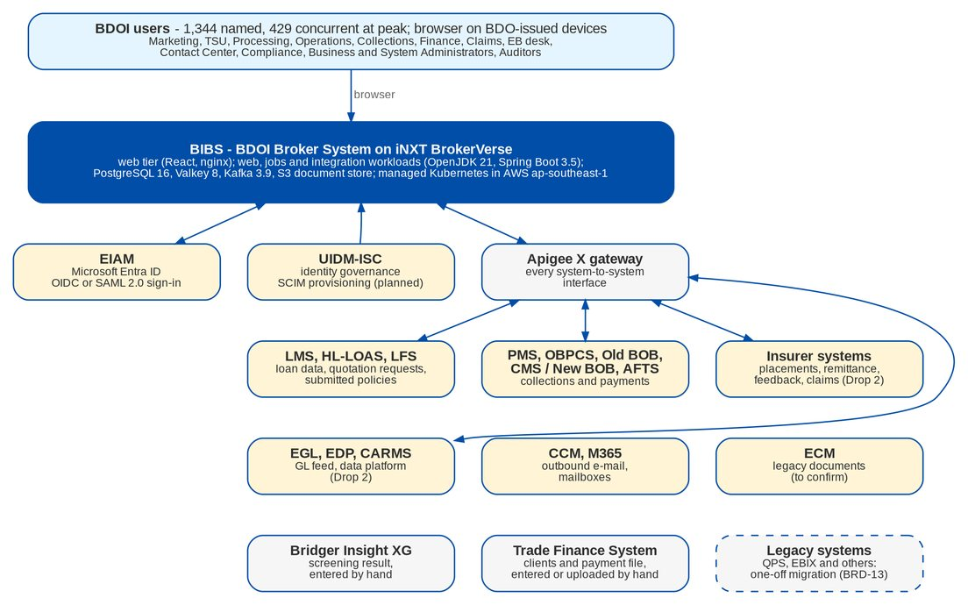
Figure 1: System context of BIBS: identity and gateway (first row), systems behind Apigee X (second row and EGL, EDP, CARMS), e-mail and content services, and sources entered by hand or migrated once (last row)

2.3 Modules and drops
BDOI splits requirements, development, test and sign-off into three drops; the platform is developed end to end and all modules go live together. Figure 2 places each BRD in its drop.
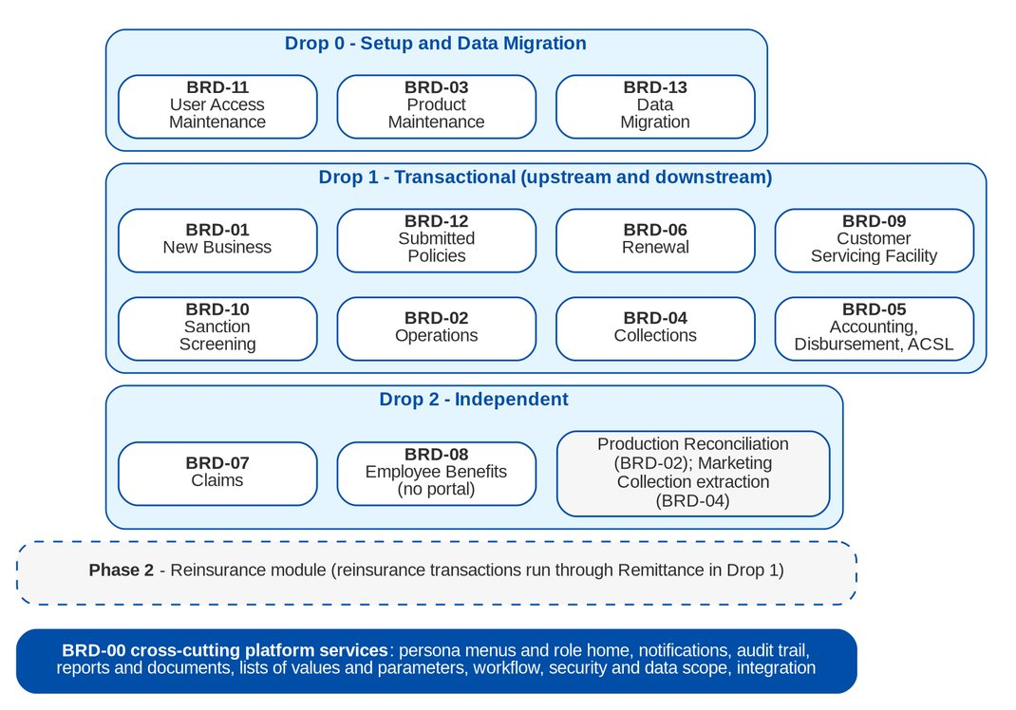
Figure 2: BIBS modules by BDOI drop
Table 5: Drops, BRDs and windows (BDOI drop plan and timeline)
Drop | BRDs | Requirements | SIT and UAT
Drop 0 - Setup and Data Migration | BRD-11, BRD-03, BRD-13 | Sep to Nov 2026 (with Drop 1) | Setup tested with Drop 1; trial migrations Apr to Oct 2027
Drop 1 - Transactional | BRD-01, 02, 04, 05, 06, 09, 10, 12 | Sep to Nov 2026 | SIT 4 Jan to 30 Jul 2027; UAT 2 Aug to 17 Dec 2027
Drop 2 - Independent | BRD-07, BRD-08; Production Reconciliation (BRD-02); Marketing Collection extraction (BRD-04) | Dec 2026 to Feb 2027 | SIT 1 Jul to 30 Sep 2027; UAT 1 Oct to 30 Nov 2027
Programme | BRD-00 cross-cutting services | With Drop 1 | Performance and penetration test 1 Nov to 15 Dec 2027; ORR / PRR Dec 2027; go-live 3 Jan 2028

3 Users and personas

3.1 User population
The umbrella BRD counts 1,344 named and 429 concurrent users (p.42). The function BRDs give the users per module; the table groups them by persona family. The FRS of each BRD names the personas, their BIBS roles and permissions.
Table 6: Persona families, BRDs and user numbers (named / concurrent, from the BRDs)
Persona family | Personas | BRDs | Users (named / concurrent)
Marketing | Account Officer (AO), Team Lead, Team Head, Unit Head; EB desk | BRD-1, 3, 4, 6, 8 | 485 / 145 (BRD-1); EB 13
Technical Support Unit and MBS | TSU Officer, Team Lead, Head; Marketing Business Services | BRD-1, 3 | TSU 13 / 13; MBS 5 / 5
Processing | Processing Officer, Processing TL, e-policy sender, Submitted Policies checker and handler | BRD-1, 6, 8, 12 | 82 (BRD-1); Renewal 73 / 22; SP 38 / 21
Operations | Cashiering, Remittance, Production Reconciliation, Adjustment, Commission users and their TL / TH | BRD-2 | About 50 named
Collections | Collection Handler, Team Lead, Section Head, Unapplied Payment Handler | BRD-4 | 130 / 56
Finance | FRBS GL officers, Disbursement, ACSL, Comptrollership | BRD-5, 2 | Accounting 5, Disbursement 8, ACSL 6
Claims | Claims and Risk users, Team Lead, Team Head, Unit Head; Marketing view | BRD-7 | 47 / 25
Customer servicing | Contact Center personnel, supervisors, management | BRD-9 | 24 concurrent
Compliance | Compliance Officer, Investigator, Unit Head, AML Committee | BRD-10 | Under 300 named
Administration and control | Business Administrator, System Administrator, UAM requestor and approver, Information Security, Auditor | BRD-11, all | Requestors 14 / 5, approvers 8 / 3, administrators 7

3.2 Access principles
• Every persona sees only the menus and screens of its roles (FR-CR-001) and starts on a role home page with its work (FR-CR-010).
• Every action is checked against the user's permissions and every record against the user's companies and branches (data scope); a refused access is logged (NFR-SEC-04).
• Makers never approve their own work; approvals follow the configured matrices of each workflow (NFR-CFG-03).
• BDO users sign in through EIAM; only the named break-glass administrators keep local passwords with a second factor (NFR-SEC-01, NFR-SEC-02).
• No insurer, client or partner user signs in to BIBS in phase 1: the Employee Benefits portal is not part of the drop plan.

4 Functional requirements

4.1 Approach
The functional requirements are specified in the FRS of each BRD. Each FR carries the BRD requirement IDs and pages it meets, the actor, the priority, the screens, the main and alternate flows, the business rules (each marked Configurable or Fixed with the place where it is maintained), the validations with their messages, the fields and the acceptance criteria. The 14 FRS hold 728 FRs. Of their 1605 business rules, 633 (39%) are configurable by the business or the System Administrator; the others are fixed by the BRD or by regulation.
Table 7: FRS of each BRD: version, FRs, traced BRD requirement IDs, test plan and user-story view
BRD | Module | Drop | FRS version | FRs | BRD IDs traced | Test plan | User stories
BRD-00 | Core Replacement (umbrella) | Programme | v1.0 (26 September 2026) | 25 | 215 | No test plan | Next issue
BRD-01 | New Business | Drop 1 | v2.1 (8 October 2026) | 95 | 119 | v2.1 | 117
BRD-02 | Operations | Drop 1 | v2.1 (08 October 2026) | 82 | 177 | v2.1 | 177
BRD-03 | Product Maintenance | Drop 0 | v2.1 (8 October 2026) | 39 | 31 | v2.1 | 31
BRD-04 | Collections | Drop 1 | v2.1 (8 October 2026) | 51 | 64 | v2.1 | 64
BRD-05 | Accounting Disbursement ACSL | Drop 1 | v2.1 (8 October 2026) | 119 | 277 | v2.1 | 277
BRD-06 | Renewal | Drop 1 | v1.1 (26 September 2026) | 56 | 1081 | v1.1 | Next issue
BRD-07 | Claims | Drop 2 | v1.0 (25 September 2026) | 39 | 43 | v1.0 | Next issue
BRD-08 | Employee Benefits | Drop 2 | v1.0 (25 September 2026) | 39 | 34 | v1.0 | Next issue
BRD-09 | Customer Servicing Facility | Drop 1 | v1.0 (25 September 2026) | 17 | 23 | v1.0 | Next issue
BRD-10 | Sanction Screening | Drop 1 | v1.0 (25 September 2026) | 44 | 37 | v1.0 | Next issue
BRD-11 | User Access Maintenance | Drop 0 | v2.1 (8 October 2026) | 40 | 160 | v2.1 | 187
BRD-12 | Submitted Policies | Drop 1 | v1.0 (25 September 2026) | 31 | 34 | v1.0 | Next issue
BRD-13 | Data Migration | Drop 0 | v2.1 (8 October 2026) | 48 | 30 | v2.1 | 30

FRS versions move as BDOI re-issues the BRDs; the traceability matrix states the FRS version of every row. FRS issued at v2.0 move to v2.1 and FRS-only BRDs to the next minor version with the re-base on the BRD versions of 8 October 2026.

4.2 Cross-cutting services (BRD-00)
The umbrella FRS specifies the services that no function BRD owns: persona menus and the role home page (FR-CR-001, 010, 011), notifications (FR-CR-020), the audit trail and the master-data change log (FR-CR-030, 031), standard, tailored and scheduled reports (FR-CR-040 to 043), document generation from templates (FR-CR-050), lists of values, insurer records, MIS fields and products (FR-CR-060 to 063), sign-in and access requests (FR-CR-070), document protection (FR-CR-071), workflow routing (FR-CR-080), the insurer invoice batch (FR-CR-081), migrated clients during coexistence (FR-CR-082), bulk and individual processing (FR-CR-083), the Invoice Master List (FR-CR-090), multi-currency (FR-CR-091), the BDO brand and design system (FR-CR-092) and the SOA and service invoice at booking (FR-CR-093).

4.3 Module summaries
Table 8: What each module does (summary of the FRS scope chapters)
Module | Summary | FRS
BRD-01 New Business | Client onboarding and KYC, tags and lifecycle rules; quotation and proposal (package and non-package through the TSU); Proposal Request Form, quotation slip and insurer comparatives; placement with the EOPT details of the client, hold cover, issuance and e-policy; booking with GL entry and service invoice; bulk processing; New Business reports | FR-NB
BRD-02 Operations | Invoice ledger and Invoice 360; Cashiering (AR and OR series, payment files, PDC warehouse, application by premium component, unapplied payments); Remittance to insurers (extraction, eligibility, approval, schedule, insurer OR, early remittance incentive, special remittance); Adjustment and Cancellation; Production Reconciliation; Commission Receivables for direct payment; BIR 2307 certificates | FR-OP
BRD-03 Product Maintenance | Package products: product structure and clause library, package request, insurer negotiation and comparatives, ManCom sign-off, set-up and validation, versions and rate schemes, expiry and renewal, incentive criteria | FR-PM
BRD-04 Collections | Premium-receivable worklist per invoice, assignment, collector dispositions, promises to pay, installments, escalation, billing statements, collector side of unapplied payments, scheduled reversal files and daily reports | FR-CL
BRD-05 Accounting, Disbursement and ACSL | Chart of accounts, posting and manual entries, closing and revaluation, bank reconciliation, service fee, report pack and BIR outputs; disbursement vouchers, instruments and BIR 2307 for suppliers; Marketing payment requests; ACSL reconciliation; business and system administration requests | FR-AC, FR-DS, FR-PQ, FR-AS
BRD-06 Renewal | Extraction of expiring accounts, governance rules and buckets, Marketing disposition and review, Processing and insurer round-trip, Renewal Advice and other letters, acceptance and progression to placement and booking, renewal of submitted policies | FR-RN
BRD-07 Claims | Claims logging and monitoring for the client: cover lookup and premium check, locations and insurer claim numbers, insurer reserve and settlement as reported, statuses, follow-up and ageing, claims special remittance, reports | FR-CM
BRD-08 Employee Benefits | Group benefit programmes (HMO, group life, group personal accident): renewal start, broker on record, franchise and TOR, proposals and comparative sign-off, processing, billing and roster servicing, reports; without the partner portal | FR-EB
BRD-09 Customer Servicing Facility | Servicing workspace for the Contact Center: search and view of client, account, invoice and payment; contact-detail updates with audit; resend of renewal advices and e-policies; document upload; CSF reports | FR-CSF
BRD-10 Sanction Screening | Sanctions and PEP list intake, name matching, risk-profile tagging, cases with SLA and escalation, investigation, Unit Head and AML Committee approval, STR in the AMLC format, audit | FR-SS
BRD-11 User Access Maintenance | Sign-in and session rules, user access requests (enrol, modify, deactivate, reactivate, bulk) with approval, group profiles, segregation-of-duties rules, access reports and logs | FR-UA
BRD-12 Submitted Policies | Intake of policies that bank borrowers submit, masterlist, sanitation and classification rules, policy review (IAAF), limits and TOR, renewal hand-off, handling fee, monitoring | FR-SP
BRD-13 Data Migration | Migration Console: data object register, extracts and batches, validation, client matching, code maps, loads, reconciliation L1 to L5, legacy invoices after go-live, legacy inquiry, cut-over and run-off | FR-DM

5 User-story approach
Each FRS carries an appendix User-story view with one row per BRD requirement of the BRD version it is based on: the BRD ID, the user story, the FRs that meet it, their acceptance criteria and the test conditions of the test plan. A second appendix, Storyboard index, gives one row per walkthrough frame: persona, screen, action, outcome, screenshot and FR.
• Wording. "As <persona>, I need <capability>, so that <business outcome>." Where the BRD writes its requirements as stories, its wording is kept with tidied grammar; otherwise the story is taken from the FR actor, title and purpose. Personas are the persona names of the FRS.
• Acceptance. The acceptance criteria of a story are the numbered acceptance criteria of its FRs (for example FR-NB-004 AC1-3). Each acceptance criterion maps to at least one test condition, and each condition has at least one positive and one negative case where the FR allows.
• Status today. 7 of the 14 FRS carry the appendix (883 story rows); the FRS of the other BRDs add it at their re-issue on the BRD versions of 8 October 2026.
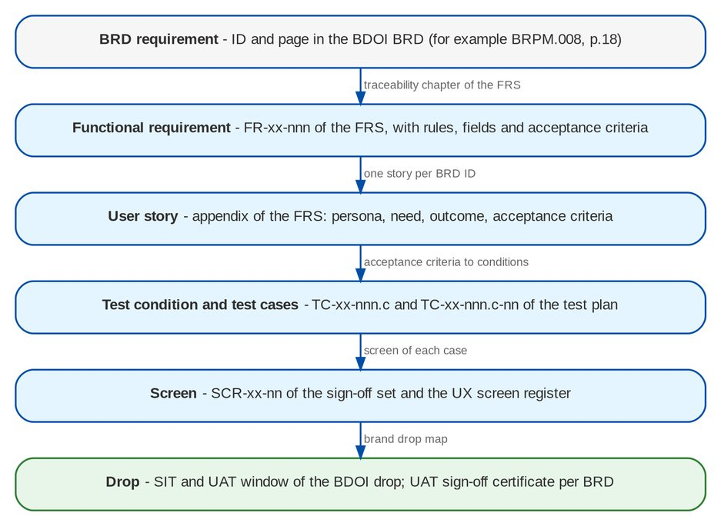
Figure 3: Traceability chain from the BRD requirement to the drop

6 External interfaces

6.1 User interface
• Browser application on BDO-issued desktops, laptops, tablets and phones; no plug-in or local install (NFR-RSP-01 to 03).
• BDO brand and the BDO UX guidelines on every screen: tables or tree tables with row action menus, labels not codes, user names not log-ins, dates dd-MMM-yyyy, formatted amounts (NFR-USE-03, NFR-USE-04).
• WCAG 2.2 level AA (NFR-ACC-01 to 04).

6.2 System interfaces
All external touch-points are owned by BDOI IT. Every system-to-system interface passes the Apigee X gateway with its own credentials (NFR-SEC-09, NFR-INT-01); sign-in uses EIAM by OpenID Connect or SAML 2.0, and user provisioning from UIDM-ISC uses SCIM 2.0 (planned). The 20 interfaces of the integration inventory are:
Table 9: External interfaces of BIBS (integration inventory of the programme alignment pack)
ID | System | Drop | Direction | Data exchanged
INT-01 | EIAM (Entra ID) | Drop 0 | Both (browser redirect; tokens to BIBS) | User identity (UPN or Windows ID, name, e-mail); optional group claims
INT-02 | UIDM-ISC (IGA) | Drop 0 | Inbound (provisioning) and outbound (account and entitlement aggregation) | User accounts, enable / disable, group profiles (BIBS roles) as entitlements
INT-03 | LMS | Drop 0 | Inbound | PN number, loan status (paid-off, RMU), loan release and amortisation for CLPC
INT-04 | HL-LOAS (HLS / LOAS) | Drop 0 (HLS) and Drop 2 (LOAS) | Inbound | Quotation requests (borrower, property, sum insured, PN); HLS insurance report; amortised loan release
INT-05 | LFS SaaS | Not on the slide | Inbound | Loan-linked policies submitted by borrowers
INT-06 | PMS | Drop 0 | Inbound; outbound status to confirm | PDC number, bank, date, amount, payor, account / invoice reference; possibly deposit, return and pull-out status
INT-07 | CMS / New BOB | Drop 0 | Outbound (payment instructions); inbound (status, debit confirmation) | Payee, account, amount, currency, value date, voucher reference; status per transaction
INT-08 | OBPCS | Drop 0 | Inbound | Payment date, reference (ARN, invoice, PN), payor, amount, channel
INT-09 | Old BOB | Drop 0 | Inbound | Funds-transfer credits with SOA or invoice reference
INT-10 | AFTS | Drop 0 | To confirm | To confirm
INT-11 | ICBS | Drop 0 (struck through) | - | -
INT-12 | ECM | Drop 0 | To confirm (possibly inbound legacy documents only) | Legacy documents (H02) if ECM holds them
INT-13 | CCM | Drop 0 | Outbound; delivery status inbound | Recipient, subject, body, attachments (password-protected PDFs), template id
INT-14 | M365 Exchange | Drop 0 | Inbound (mailbox reading) and/or outbound | E-mails and attachments
INT-15 | TFS (manual) | Drop 0 | Manual inbound | Trade client details; Trade payment file
INT-16 | EDP - Data Ingestion (SD 11) | Drop 2 | Outbound | To agree (clients, accounts, invoices, receipts, remittances, GL; history and daily changes)
INT-17 | EGL | Drop 2 | Outbound | Journals or trial balance by account, branch, cost centre, currency; mapping to EGL accounts
INT-18 | CARMS | Drop 2 | To confirm | To confirm
INT-19 | Insurer System | Drop 2 | Both | Per process
INT-20 | Bridger Insight XG (manual) | Drop 2 | Manual | Screening result and evidence

6.3 Documents, e-mail and files
• Business documents (slips, advices, receipts, statements of account, vouchers, letters) are generated from templates the Business Administrator maintains; documents that leave BDOI are password-protected PDF or Excel files (FR-CR-050, FR-CR-071, NFR-SEC-10).
• Outbound e-mail goes through CCM with its delivery status (NFR-INT-05).
• Every document and attachment is held in the S3 document store (answer A4), encrypted with BDOI keys, versioned and replicated to the DR region (NFR-SEC-06, NFR-REC-03).
• File interfaces (PDC list, bills payment, bank and insurer files) are validated per layout and reconciled to control totals (NFR-INT-04).

7 Data requirements

7.1 Data domains
Table 10: Data domains of BIBS and their owners
Domain | Content | Owner (BDOI)
Client and account | Clients (individual and corporate) with EOPT details (taxpayer name, TIN, registered address), KYC and risk profile, accounts, tags, contacts | Marketing; Compliance for the risk profile
Product and insurer | Lines, covers and clauses, packages and versions, rate schemes, insurers, insurer contacts and terms, commission rates | MBS, TSU
Placement and policy | Quotations, proposals, placements, policies and endorsements as issued by the insurers, e-policies, submitted policies | Processing
Money | Invoice ledger, receipts, payments and their application, unapplied payments, remittances, commission receivables, disbursement vouchers | Operations; Comptrollership
Accounting | Chart of accounts, journals, sub-ledgers, periods, revaluation rates, BIR worksheets and books | Comptrollership
Claims and employee benefits | Claim case files with locations, insurer claim numbers, statuses; EB programmes, rosters and billing | Claims; EB desk
Compliance | Sanctions and PEP list entries, screening cases, STRs | Compliance
Access and audit | Users, roles, permissions, data scope, access requests, audit trail, change log | Information Security; Business Administration
Configuration | Lists of values, parameters, rule tables, workflows, templates, job schedules | Business and System Administrators

7.2 Data rules
• One record of each client across modules; duplicates are matched at onboarding and at migration (FR-DM-031 to 033).
• Configuration as data. Every business rule value is a parameter, list of values, rule table or template with an effective date and a second-user approval (NFR-CFG-01, NFR-CFG-02).
• Data scope. Records carry their company and branch; users act only within their scope.
• Integrity of money and ledger. Ledger entries are never changed: corrections are reversals; document numbers are gapless; journals balance.
• Base currency PHP from the company record; other currencies with daily and month-end rates (NFR-LOC-03).
• Time. The business date follows Asia/Manila; time stamps are kept in UTC (NFR-LOC-02).
• Masking. Personal data is masked in every non-production environment (NFR-PRV-01).

7.3 Volumes, migration and retention
• Volumes and growth follow NFR-CAP-02 and NFR-CAP-03: Year 1: New Business 21,200 transactions and 1,300 endorsements a month; Renewal 25,800 a month; Collections 1,200 updates a day; Claims 55 bookings and 1,096 updates a day; CSF 144,400 a year; Submitted Policies 63,000 sanitations a year. Growth 20% a year (Submitted Policies 25%).
• Migration (BRD-13) moves reference data, clients, accounts, open items and the legacy invoices BIBS still needs, reconciled at levels L1 to L5, in four trial migrations, a dress rehearsal and the production load of the cut-over (Data Migration Handbook).
• Retention is set per record type (NFR-RET-01): Default 5 years online and 15 years archive; Claims 10 years online and 15 archive; Accounting vouchers and reports, Sanction Screening and Submitted Policies 5 years online and 5 archive. Archive and purge run only after BDOI's retention decision (Q39).

8 Non-functional requirements
The non-functional requirements are specified in the companion document Non-Functional Requirements v1.0: 99 NFRs in 18 categories, each with an ID, a measurable target, the verification method, the owner and the test type (53 aligned with the sources, 15 waiting for a BDOI decision between conflicting BRD values, 31 proposed by iorta TechNXT). The headline targets are:
Table 11: Headline non-functional targets (full catalogue in the NFR document and register)
NFR | Topic | Target | Status
NFR-PRF-01 | Screen response time | p95 at most 2.0 seconds and p99 at most 4.0 seconds | DECISION
NFR-PRF-02 | Search and work-list response time | First page (up to 50 rows) p95 at most 3.0 seconds; each further page p95 at most 2.0 seconds | PROPOSED
NFR-PRF-03 | Interactive reports | At most 20 seconds (p95) for a report of up to 30,000 rows | DECISION
NFR-CAP-01 | Users | 1,344 named users; design load 150 concurrent users in year 1, growing 20% a year (311 in year 5); peak test at 429 concurrent sessions | DECISION
NFR-CAP-02 | Transaction volumes | Year 1: New Business 21,200 transactions and 1,300 endorsements a month; Renewal 25,800 a month; Collections 1,200 updates a day; Claims 55 bookings and 1,096 updates a day; CSF 144,400 a year; Submitted Policies 63,000 sanitations a year. Growth 20% a year (Submitted Policies 25%) | ALIGNED
NFR-AVL-01 | Availability in the service window | 99.9% of the service window each month (about 25 minutes of unplanned unavailability in a month of 26 service days) | DECISION
NFR-AVL-02 | Service window | 06:00 to 22:00 PHT Monday to Saturday, plus month-end weekends; production infrastructure 24 x 7 | DECISION
NFR-AVL-03 | Planned maintenance | 00:00 to 04:00 PHT; at most 45 minutes of planned downtime a month; announced 5 business days ahead; releases without downtime where the change allows | DECISION
NFR-REC-01 | Recovery point objective (RPO) | RPO at most 15 minutes for data and documents | ALIGNED
NFR-REC-02 | Recovery time objective (RTO) | RTO at most 4 hours; sign-in, Cashiering, Remittance, booking and the GL first | ALIGNED
NFR-REC-03 | Backup | Continuous transaction-log archiving plus a base backup every 4 hours; backups encrypted and kept 7 years; document store versioned with cross-region replication | DECISION
NFR-SEC-01 | Single sign-on with EIAM | Every BDO user signs in through EIAM (Microsoft Entra ID) by OpenID Connect or SAML 2.0; local passwords only for the named break-glass administrators | ALIGNED
NFR-SEC-05 | Session and lock-out | Inactivity warning at 15 minutes and sign-out at 30 minutes; absolute session end 8 hours; lock-out after 3 consecutive failed attempts | DECISION
NFR-ACC-01 | WCAG 2.2 level AA | 0 open level A or AA failures on the screens of each sign-off set; 0 serious or critical issues in the scan of every screen | PROPOSED
NFR-USE-01 | Low-click navigation | Any daily task reached in at most 2 clicks from the role home page or the menu; a record opened from a search result in 1 click; the main action of a record (submit, approve) at most 1 click away | PROPOSED
NFR-RSP-01 | Responsive layout | Every screen usable from 360 to 1920 pixels wide with no horizontal page scroll; wide tables scroll inside their frame or collapse to cards on phones | ALIGNED
NFR-RET-01 | Retention per record type | Default 5 years online and 15 years archive; Claims 10 years online and 15 archive; Accounting vouchers and reports, Sanction Screening and Submitted Policies 5 years online and 5 archive | DECISION
NFR-MNT-02 | Code coverage | Line coverage above 90% on new and changed code (new-code gate of SonarQube); overall line coverage at least 80% and branch coverage at least 65% | PROPOSED

9 Constraints
Table 12: Constraints on the solution
Constraint | Statement | Source
Single go-live | All modules go live together in January 2028; proposed T = Monday 3 January 2028, legacy freeze after the end of day of 31 December 2027 | BDOI answer A1; project plan
Broker scope | BIBS records the insurer's policy, premium, reserve and settlement as information; it does not underwrite, pay claims or keep insurer books | BRD-7 scope; client instruction of 8 October 2026
Component baseline | PostgreSQL 16, Valkey 8 (in place of Redis), Apache Kafka 3.9, OpenJDK 21 LTS, Spring Boot 3.5, React, with Node 22 LTS used only to compile the web screens, nginx web tier, managed Kubernetes with the Gateway API (in place of ingress-nginx) | Client decisions of 8 October 2026
Application structure | One modular application with a module per business area and separate web, jobs and integration workloads | Architecture option decision
Hosting | AWS ap-southeast-1; production access only by named personnel in the Philippines; DR region named by BDOI IT after the data-residency check | Hosting appendix; IER; IQ26
Documents | Every document and attachment in the S3 document store; no document storage in ECM | BDOI answer A4
Identity | Sign-in through EIAM; provisioning from UIDM-ISC; integrations through Apigee X | Drop plan integrations
Environments | DEV, SIT, UAT, Pre-Prod, PROD and DR; non-production runs 12 x 5, production 24 x 7 | IER assumptions 3 and 4
Devices | Browser only; same functions on mobile and desktop | BRD usage requirements
Reinsurance | Reinsurance module in phase 2; reinsurance transactions through Remittance in phase 1 | BDOI answer A3

10 Assumptions and dependencies

10.1 Assumptions
Table 13: Assumptions
ID | Assumption | Related
SA-01 | The function BRDs and their FRS govern the business processes; the umbrella BRD adds the cross-cutting requirements | FRS BRD-00 A-CR-01
SA-02 | The BRD versions of 8 October 2026 are the baseline of phase 1; later changes pass the change-control process | Change management register
SA-03 | The insurers keep issuing policies, invoices and claim decisions in their own systems; BIBS exchanges files or messages with them | Integration INT-19
SA-04 | Users work on BDO-issued devices on the BDO network | BRD usage requirements
SA-05 | The BIBS-wide NFR values of the register apply until BDOI decides otherwise (XQ08) | NFR document
SA-06 | Non-production environments use seed data or masked migrated data only | NFR-PRV-01

10.2 Dependencies on BDOI
Table 14: Dependencies (project plan DEP items)
ID | Dependency | Provided by | Needed by
DEP-04 | Sign-off of the Drop 0 sets and the Drop 1 FRS | Product owners | 30 Nov 2026
DEP-06 | SIT environment on managed Kubernetes with PostgreSQL 16, Valkey 8, Kafka 3.9, document store and Gateway API | BDOI IT | 4 Jan 2027
DEP-07 | EIAM sign-in specification and application registration | BDO IT EIAM team | 31 Jan 2027
DEP-08 | UIDM-ISC option and SCIM provisioning connector | BDO IT IGA team | 31 Jan 2027
DEP-10 | Drop 2 integration specifications: EGL, EDP, CARMS, insurer exchanges | BDOI IT | 31 Jan 2027
DEP-11 | Bank channel layouts and transport: CMS / New BOB, OBPCS, Old BOB, AFTS, PMS | BDOI IT | 26 Feb 2027
DEP-13 | Apigee X proxies, products and credentials for SIT, UAT and production | BDO IT API team | 31 Mar 2027
DEP-15 | DR region and data residency | BDOI IT; Information Security | 31 Mar 2027
DEP-20 | UAT testers named per BRD and released for the UAT windows | Business owners | 16 Jul 2027
DEP-23 | Pre-Prod at production size | BDOI IT | 1 Oct 2027

11 Compliance requirements
BIBS supports BDOI's obligations; it does not replace BDOI's compliance processes or filings. The table maps each law or regulation to the BIBS requirements that support it.
Table 15: Regulatory requirements and the BIBS requirements that support them
Law or regulation | Obligation BIBS supports | BIBS requirement | BDOI owner
Insurance Code (RA 10607) and Insurance Commission | Premiums collected for insurers tracked per invoice until remitted and the insurer's official receipt recorded; placement records with slips and insurer terms; Insurance Commission Broker's Annual Statement of Business Operations | FR-OP-030 to 041 (Remittance), FR-OP-110 to 112, FR-NB-053 to 055, FR-AC-063; audit trail NFR-AUD-01 | Head, Operations; Head, Comptrollership
BIR - books, returns and certificates | Loose-leaf books of accounts (general journal, sales, purchase, cash receipts and disbursements, general ledger); worksheets of 2550-Q, 1601-EQ, 0619-F, 1603, 1702-Q, 1702; alphalists (QAP, MAP, 1604-E) and SAWT; BIR Form 2307 received, released and issued; receipt series with the BIR Authority to Print | FR-AC-063 (outputs are worksheets and loose-leaf books, not eFPS, DAT or CAS files), FR-OP-010 to 014, FR-OP-096, FR-OP-113, FR-OP-121, FR-DS-058 | Head, Comptrollership
BIR - Ease of Paying Taxes (RA 11976) | EOPT details of the client (taxpayer name, TIN, registered address) on the placement sent to the insurer; service invoices numbered, produced and sent from BIBS | FR-NB-087, FR-NB-117, FR-CR-093; transmission to BIR CAS / e-invoicing is not in phase 1 (CLR-NB-33) | Head, Comptrollership
AMLA (RA 9160, as amended); AMLC; BSP Circular 1182 (2023), BSP CL-2023-030, BSP M-2025-017; IC CL 2019-65 | Screening of clients against sanctions and PEP lists; risk profiling; case investigation and approval; STR prepared and extracted in the AMLC format (filing on the AMLC portal outside BIBS); records kept at least 5 years | FR-SS-010 to 072, FR-SS-091; NFR-RET-05 | Compliance Officer
Data Privacy Act 2012 (RA 10173) | Lawful, proportionate processing with security measures; masked non-production data; access control and data scope; sensitive personal information of EB members; data-subject access and correction; breach detection; retention | NFR-SEC-04, NFR-SEC-06, NFR-PRV-01 to 06, NFR-AUD-01, NFR-RET-01; FR-CSF-040 | Data Protection Officer
BSP MORB and Circular 808 (IT risk management), BDO standards | Four eyes on access changes, least privilege, segregation of duties, dormant-user deactivation, audit trail no user can change | FRS BRD-11 (FR-UA-006, 053), NFR-SEC-03, NFR-AUD-02 | BDOI Information Security

12 Acceptance approach

12.1 Acceptance steps
Table 16: How BDOI accepts BIBS
Step | What is accepted | Signed by | When
FRS sign-off | FRS of each BRD, with its clarifications decided or parked under change control | Product owner of the BRD | Drop 0 and 1 by 30 Nov 2026 (BRD-11 1 Dec 2026); Drop 2 by 26 Feb 2027
Test plan approval | Test conditions and cases of each BRD; coverage of every in-scope BRD ID in the traceability matrix | Business owners; iorta QA lead | Drop 1 by 18 Dec 2026; Drop 2 by 30 Jun 2027
SIT exit | All Must-have cases passed; no open Severity 1 or 2 incident; Severity 3 with an agreed workaround | iorta QA lead; BIBS Product Owner | Drop 1 30 Jul 2027; Drop 2 30 Sep 2027
UAT sign-off | Business scenarios of each BRD on migrated, masked data; UAT sign-off certificate per BRD | Product owner of each BRD; BIBS Product Owner | Drop 2 by 30 Nov 2027; Drop 1 by 17 Dec 2027
NFR acceptance | Evidence of each NFR (test report, inspection record or analysis) against its target | BDOI acceptor named per NFR | By 15 Dec 2027 (NFT); ORR / PRR Dec 2027
Migration acceptance | Reconciliation L1 to L5 and business verification of each data object; dress rehearsal report | Data Migration Lead; data owners | Dress rehearsal 26 Nov 2027; go / no-go 2 Jan 2028
Go-live | Go / no-go decision on T-1 | Go / no-go board | 2 Jan 2028

12.2 Requirements coverage
The traceability matrix v1.0 traces 2325 BRD requirement IDs: 2279 are covered by FRs and test cases (usage requirements by the NFR catalogue), 4 by FRs without a test case yet (umbrella FRs), 6 wait for a BDOI decision on a proposed rule, 35 are out of scope, replaced or removed, and 1 have no FR named. Coverage of the in-scope IDs is 99.8%. The test plans hold 3630 test cases.
Table 17: Coverage per BRD (Summary sheet of the traceability matrix)
BRD | Module | BRD IDs | Covered | FR only | Clarif. | Out | Gap | Coverage % | Cases
BRD-00 | Core Replacement (umbrella) | 215 | 193 | 4 | 6 | 11 | 1 | 97.5 | 0
BRD-01 | New Business | 119 | 118 | 0 | 0 | 1 | 0 | 100.0 | 497
BRD-02 | Operations | 177 | 174 | 0 | 0 | 3 | 0 | 100.0 | 415
BRD-03 | Product Maintenance | 31 | 31 | 0 | 0 | 0 | 0 | 100.0 | 270
BRD-04 | Collections | 64 | 64 | 0 | 0 | 0 | 0 | 100.0 | 286
BRD-05 | Accounting Disbursement ACSL | 277 | 277 | 0 | 0 | 0 | 0 | 100.0 | 569
BRD-06 | Renewal | 1081 | 1063 | 0 | 0 | 18 | 0 | 100.0 | 343
BRD-07 | Claims | 43 | 43 | 0 | 0 | 0 | 0 | 100.0 | 185
BRD-08 | Employee Benefits | 34 | 33 | 0 | 0 | 1 | 0 | 100.0 | 154
BRD-09 | Customer Servicing Facility | 23 | 22 | 0 | 0 | 1 | 0 | 100.0 | 116
BRD-10 | Sanction Screening | 37 | 37 | 0 | 0 | 0 | 0 | 100.0 | 214
BRD-11 | User Access Maintenance | 160 | 160 | 0 | 0 | 0 | 0 | 100.0 | 213
BRD-12 | Submitted Policies | 34 | 34 | 0 | 0 | 0 | 0 | 100.0 | 122
BRD-13 | Data Migration | 30 | 30 | 0 | 0 | 0 | 0 | 100.0 | 246

Rule for UAT entry: every in-scope BRD ID of the drop is covered by at least one test case, and every FR has at least one positive and one negative case.

12.3 Change control
A change to an approved requirement goes through the change-control process of the change management register: impact analysis, effort, decision by the Change Control Board, FRS revision citing the CR ID, new or changed test cases and an updated traceability row.

13 Decisions and open points for BDOI
Table 18: Decisions requested from BDOI
No. | Decision or open point | Owner (BDOI) | Needed by | Status
1 | Accept this SRS as the programme-level baseline, with the FRS governing functional behaviour | BIBS Product Owner | 23 Oct 2026 | OPEN
2 | Decide the BIBS-wide NFR values that conflict between BRDs (response time, availability, service and maintenance windows, backup and record retention) - see the NFR document | BIBS Product Owner with the BRD owners | 30 Nov 2026 | OPEN
3 | Confirm EIAM single sign-on in place of the EUA directory sign-in of BRD-11 (IQ04) and the split of access requests between UIDM-ISC and BIBS (IQ05) | BDOI Information Security; BDOI IT | 31 Jan 2027 | OPEN
4 | Name the DR region after the data-residency check (IQ26) | BDOI IT | 31 Mar 2027 | OPEN
5 | Confirm that transmission of service invoices to BIR CAS / e-invoicing is outside phase 1 (CLR-NB-33) | Head, Comptrollership | 30 Nov 2026 | OPEN
6 | Decide the umbrella rows waiting for a proposed rule: claim cheques held by BDOI (CRQ03), CSF case resolution (CRQ04), emerging capabilities (CRQ10), ALeA e-mail encoding (CRQ20) | BIBS Product Owner | 30 Nov 2026 | OPEN
7 | Scope and drop of Customer Servicing Case Management (CSF addendum) | Product Owner, CSF; Change Control Board | 30 Oct 2026 | OPEN
8 | Accept WCAG 2.2 level AA as the accessibility level of BIBS | BIBS Product Owner | 30 Nov 2026 | OPEN
9 | Plan the privacy impact assessment of BIBS by the Data Protection Officer before UAT | Data Protection Officer | 30 Jun 2027 | OPEN
10 | Confirm the re-issue of the FRS of BRD-06 to BRD-10 and BRD-12 with the user-story view and storyboard index | BIBS Product Owner | 13 Nov 2026 | OPEN

Sign-off
By signing, BDOI accepts this System Requirements Specification as the programme-level requirements baseline of BIBS phase 1. The FRS of each BRD remain the specification of the functional behaviour and are signed separately.
Name | Role | Organisation | Signature | Date
 | BIBS Product Owner | BDOI
 | Program Manager, Business Project Services | BDO Unibank ESG
 | Head, BDOI IT | BDOI
 | Head, BDOI Information Security | BDOI
 | Project Manager | iorta TechNXT

