
PRJ0012475 - BDO Insure Brokering System (BIBS) - User Access Maintenance: To-Be Process and Storyboards -
Release 1 / Drop 0
Prepared by: iorta TechNXT Project Team (drafting support); for review by John Barbachano

Template Reference No. | D051
FR Document No. | PRJ0012475-BPS
Prepared by: | iorta TechNXT Project Team (drafting support); for review by John Barbachano
Drafting support: | iorta TechNXT Project Team (drafting support); for review by John Barbachano
Creation Date: | 10/16/2026
Revision No. | 1.5
Last Updated by: | iorta TechNXT Project Team (drafting support); for review by John Barbachano
Last Updated Date: | 10/16/2026

Document Revision Log
Date | Revision | Description | Updated by
16 Oct 2026 | 1.5 | First issue as a separate document of the User Access Maintenance set (taken out of the FRS v1.4 annexes and rewritten for the agreed access model). Numbered 1.5 to match the FRS. | iorta TechNXT Project Team (drafting support); for review by John Barbachano

Table of Contents
Document Revision Log 3
Table of Contents 4
Introduction 5
End-to-end Journey 6
To-be Processes 8
P-01 Joiner to first sign-in 8
P-02 Mover 8
P-03 Leaver 8
P-04 Group-profile change under maker-checker 8
P-05 Refused event and reconciliation 8
P-06 Evidence for the auditor and certification 9
Statuses of a group-profile change 9
Storyboards 10
SB-1 Joiner to first sign-in 10
SB-2 Mover and leaver 17
SB-3 Group-profile change under maker-checker 22
SB-4 Refused event and reconciliation 29
SB-5 Evidence for the auditor and certification 33

Introduction
This document shows how User Access works end to end once UIDM-ISC, Microsoft Entra ID and BIBS are connected. The requirements are in the FRS v1.5; the screens in the UX Design v1.5; the interfaces in the Interface Specification v1.0.
Each storyboard step is illustrated by a full-page screenshot taken on a test environment. The people and records are fictitious. Events from UIDM-ISC were sent through the provisioning test tool of that environment, which feeds the same processing as the SCIM interface.
Table 1: Personas
Persona | Does | Screens | Walkthrough account
User Access Administrator | Looks after the users received from UIDM-ISC: data access, unlock, end of sessions; watches Identity Sync and resolves refused events and reconciliation mismatches; proposes UAM settings. | Users, Group Profiles (read), Identity Sync, Separation of Duties (read), Access Matrix, Reports & Certification, Audit Log, UAM Settings | Ursula Access Administrator
Group Profile Maker | Proposes new group profiles and changes, deactivations and reactivations of group profiles; corrects a returned change; withdraws an own change. | Group Profiles, Access Matrix, Reports & Certification | Rhea Access Requestor
Group Profile Checker | Approves, returns or rejects a group-profile change made by someone else. A second checker gives the second approval of a High or Admin profile or of a change outside the working hours. | Group Profiles, Access Matrix, Reports & Certification | Ulysses Access Approver
Information Security | Authorises separation-of-duties rules, follows the violations, approves UAM settings, receives the alerts and oversees certification. | Group Profiles (read), Separation of Duties, Access Matrix, Reports & Certification, Audit Log, UAM Settings | Ingrid Security Officer
Auditor | Reads every User Access screen, runs the reports and takes the certification extract. Changes nothing. | Users, Group Profiles, Separation of Duties, Access Matrix, Reports & Certification, Audit Log | Audrey Access Auditor

End-to-end Journey
Fifteen steps from the access request in UIDM-ISC to the evidence for the auditor.
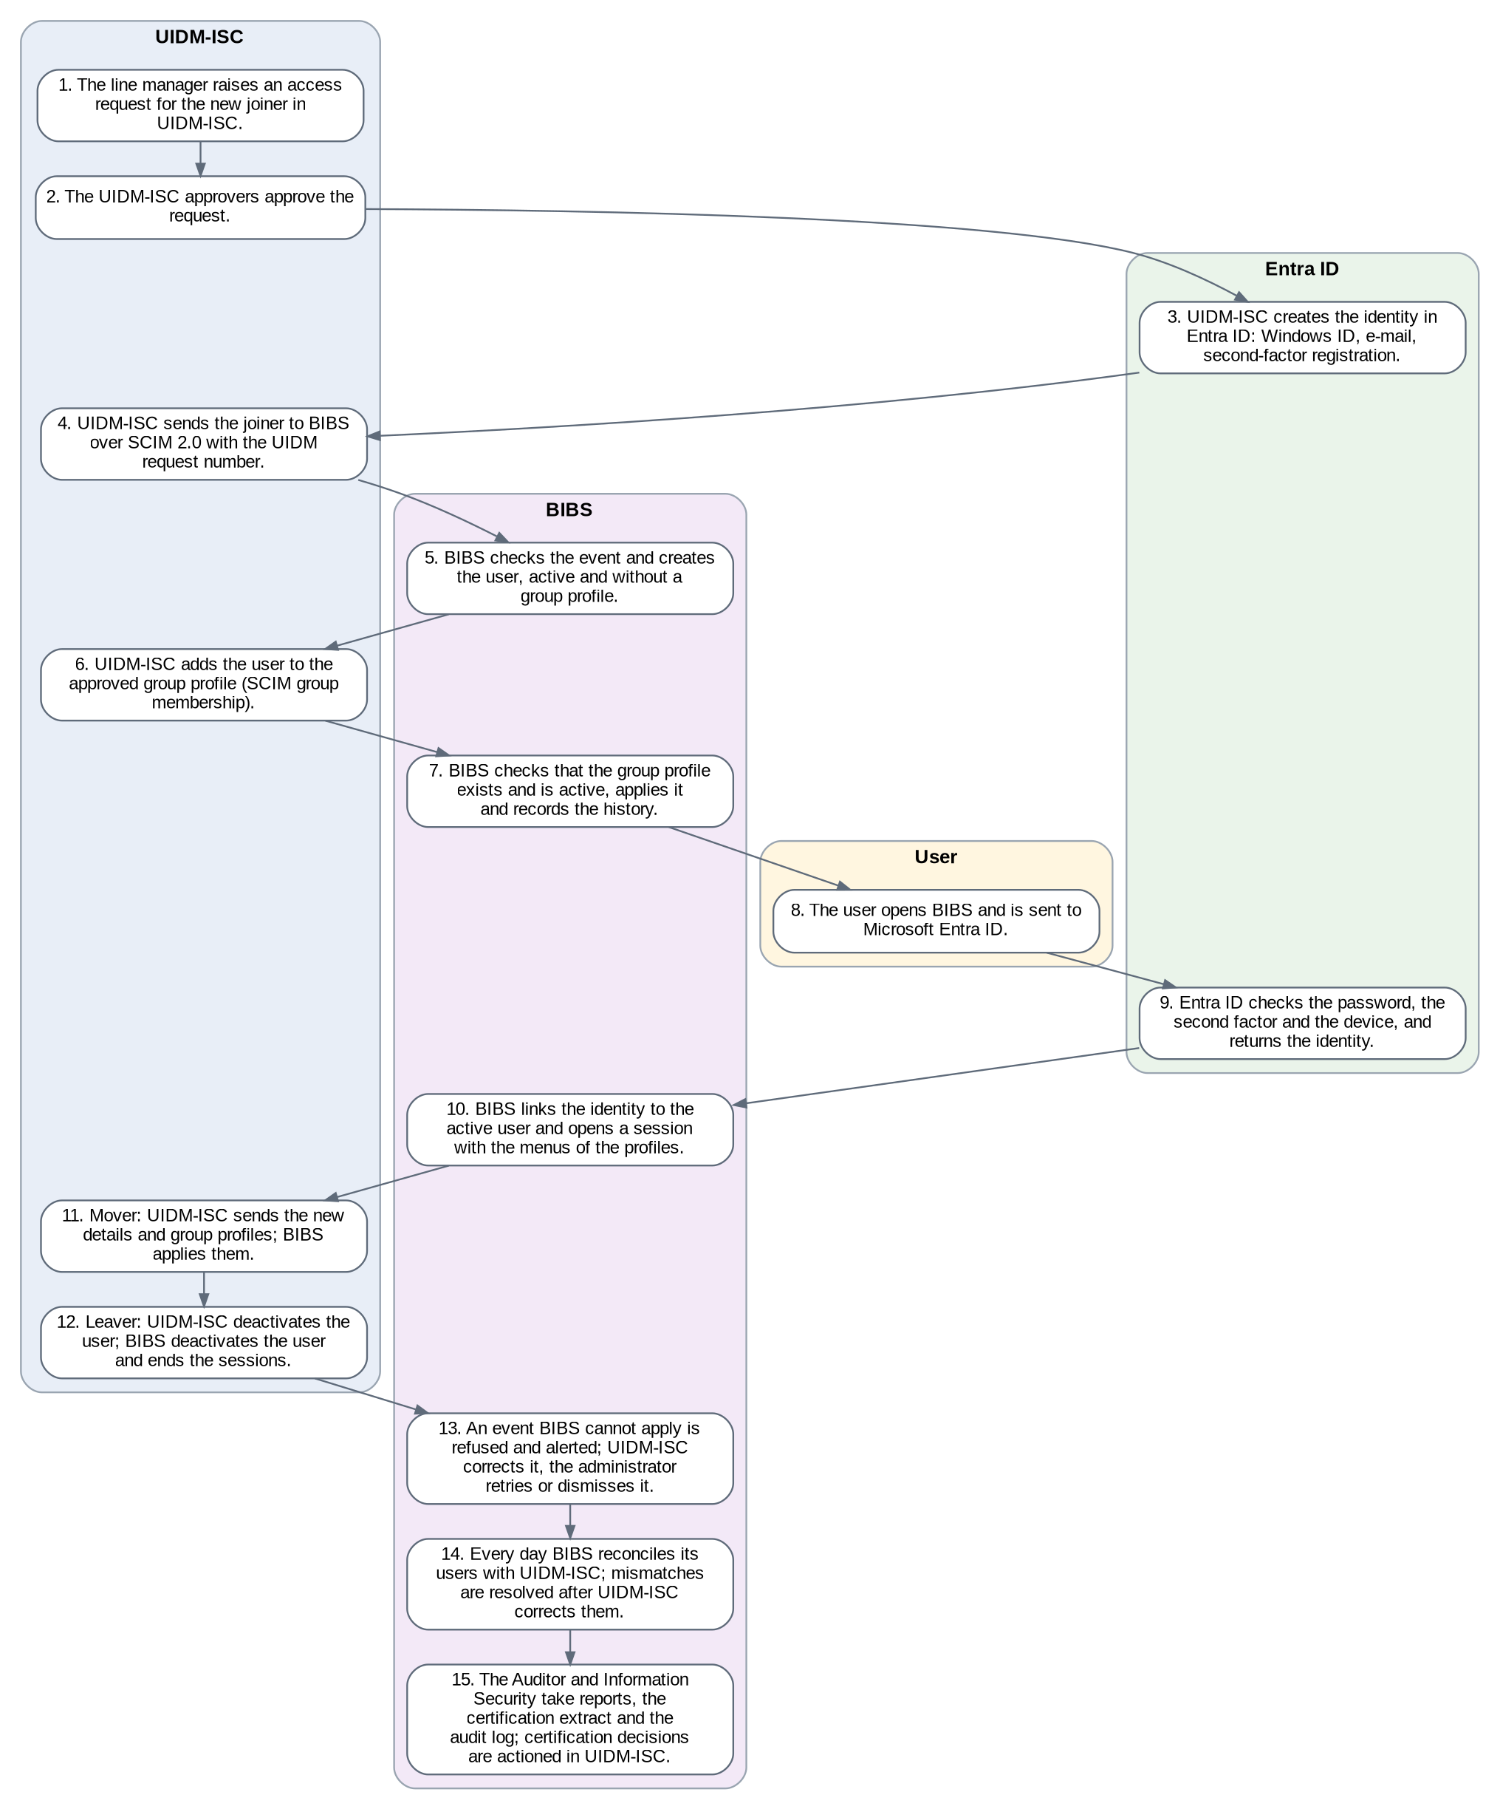
Figure 1: User access journey across UIDM-ISC, Microsoft Entra ID and BIBS
Table 2: The 15 steps
Step | System | What happens
1 | UIDM-ISC | The line manager raises an access request for the new joiner in UIDM-ISC.
2 | UIDM-ISC | The UIDM-ISC approvers approve the request.
3 | Entra ID | UIDM-ISC creates the identity in Entra ID: Windows ID, e-mail, second-factor registration.
4 | UIDM-ISC | UIDM-ISC sends the joiner to BIBS over SCIM 2.0 with the UIDM request number.
5 | BIBS | BIBS checks the event and creates the user, active and without a group profile.
6 | UIDM-ISC | UIDM-ISC adds the user to the approved group profile (SCIM group membership).
7 | BIBS | BIBS checks that the group profile exists and is active, applies it and records the history.
8 | User | The user opens BIBS and is sent to Microsoft Entra ID.
9 | Entra ID | Entra ID checks the password, the second factor and the device, and returns the identity.
10 | BIBS | BIBS links the identity to the active user and opens a session with the menus of the profiles.
11 | UIDM-ISC | Mover: UIDM-ISC sends the new details and group profiles; BIBS applies them.
12 | UIDM-ISC | Leaver: UIDM-ISC deactivates the user; BIBS deactivates the user and ends the sessions.
13 | BIBS | An event BIBS cannot apply is refused and alerted; UIDM-ISC corrects it, the administrator retries or dismisses it.
14 | BIBS | Every day BIBS reconciles its users with UIDM-ISC; mismatches are resolved after UIDM-ISC corrects them.
15 | BIBS | The Auditor and Information Security take reports, the certification extract and the audit log; certification decisions are actioned in UIDM-ISC.

To-be Processes

P-01 Joiner to first sign-in
Item | Value
Journey steps | 1 to 10
Trigger | A new employee needs BIBS access.
Actors | Line manager, UIDM-ISC approvers, user, User Access Administrator
Outcome | Active user with the approved group profiles, signed in through Entra ID.
Controls | Request approved in UIDM-ISC; second factor in Entra ID; history with the UIDM request number.

P-02 Mover
Item | Value
Journey steps | 11
Trigger | A transfer or a change of job.
Actors | UIDM-ISC, BIBS
Outcome | New details and group profiles in force; old profiles removed.
Controls | Attribute-level history; SoD rules checked daily.

P-03 Leaver
Item | Value
Journey steps | 12
Trigger | Resignation, end of contract, long leave.
Actors | UIDM-ISC, BIBS
Outcome | User inactive; every session ended at once.
Controls | Reconciliation finds a leaver still active in BIBS.

P-04 Group-profile change under maker-checker
Item | Value
Journey steps | -
Trigger | A business need to add or change a group profile.
Actors | Group Profile Maker, Group Profile Checker, second checker, System Administrator
Outcome | Group profile created, changed, deactivated or reactivated.
Controls | Maker never decides; second approval for High or Admin and out-of-hours; SoD rules; notices.

P-05 Refused event and reconciliation
Item | Value
Journey steps | 13, 14
Trigger | An event BIBS cannot apply, or a difference found by the daily reconciliation.
Actors | User Access Administrator, UIDM-ISC team
Outcome | BIBS and UIDM-ISC agree again.
Controls | Nothing is corrected in BIBS; remark on every dismissal and resolution.

P-06 Evidence for the auditor and certification
Item | Value
Journey steps | 15
Trigger | Audit request or periodic certification.
Actors | Auditor, Information Security
Outcome | Reports, extract with its SHA-256, audit log.
Controls | Every extract is logged and notified.

Statuses of a group-profile change
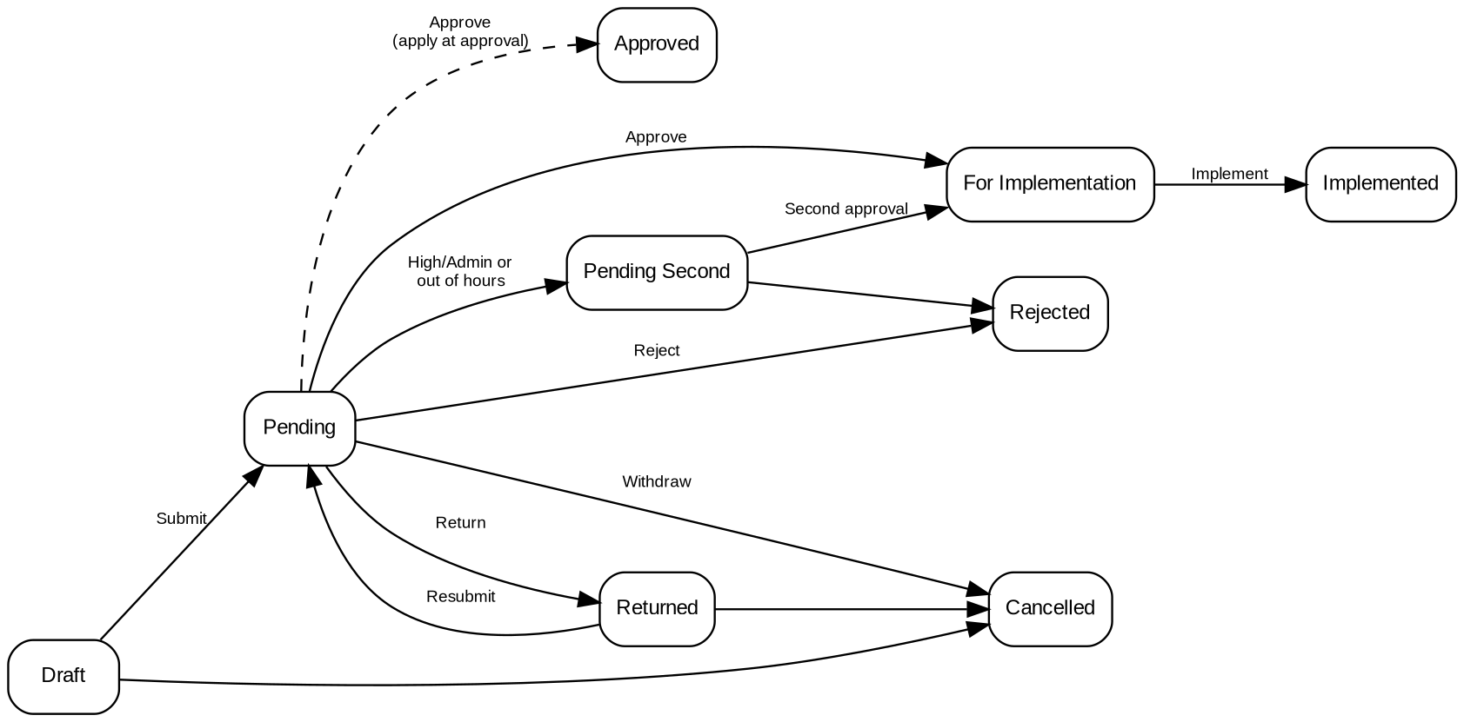
Figure 2: Statuses of a group-profile change

Storyboards

SB-1 Joiner to first sign-in
Marketing hires Isabel Navarro as account officer. UIDM-ISC sends the joiner and the group profile Marketing Account Officer. She signs in through Entra ID and sees the menus of her profile.
Table 3: SB-1 steps
Step | Who | Screen | Does | Sees
1 | UIDM-ISC | Identity Sync › Events | Sends the joiner and the group-profile event of UIDM-2026-005196. | Two events for BDO\inavarro, both Applied.
2 | User Access Administrator | Users | Searches a01300019. | Isabel Navarro is Active with Marketing Account Officer.
3 | User Access Administrator | User › Profile | Opens the user. | Account data and the data sent by UIDM-ISC, with the request number.
4 | User Access Administrator | User › Group Profiles | Opens Group Profiles. | Marketing Account Officer, source UIDM-ISC, with the date and request number.
5 | Isabel Navarro | Sign in | Opens BIBS and clicks Sign in with Microsoft Entra ID. | Entra ID asks for her password and second factor.
6 | Isabel Navarro | Home | Is signed in. | The New Business Dashboard and only the menus of a Marketing Account Officer.
7 | User Access Administrator | User › Sessions | Checks the first session. | One open session with the sign-in time.

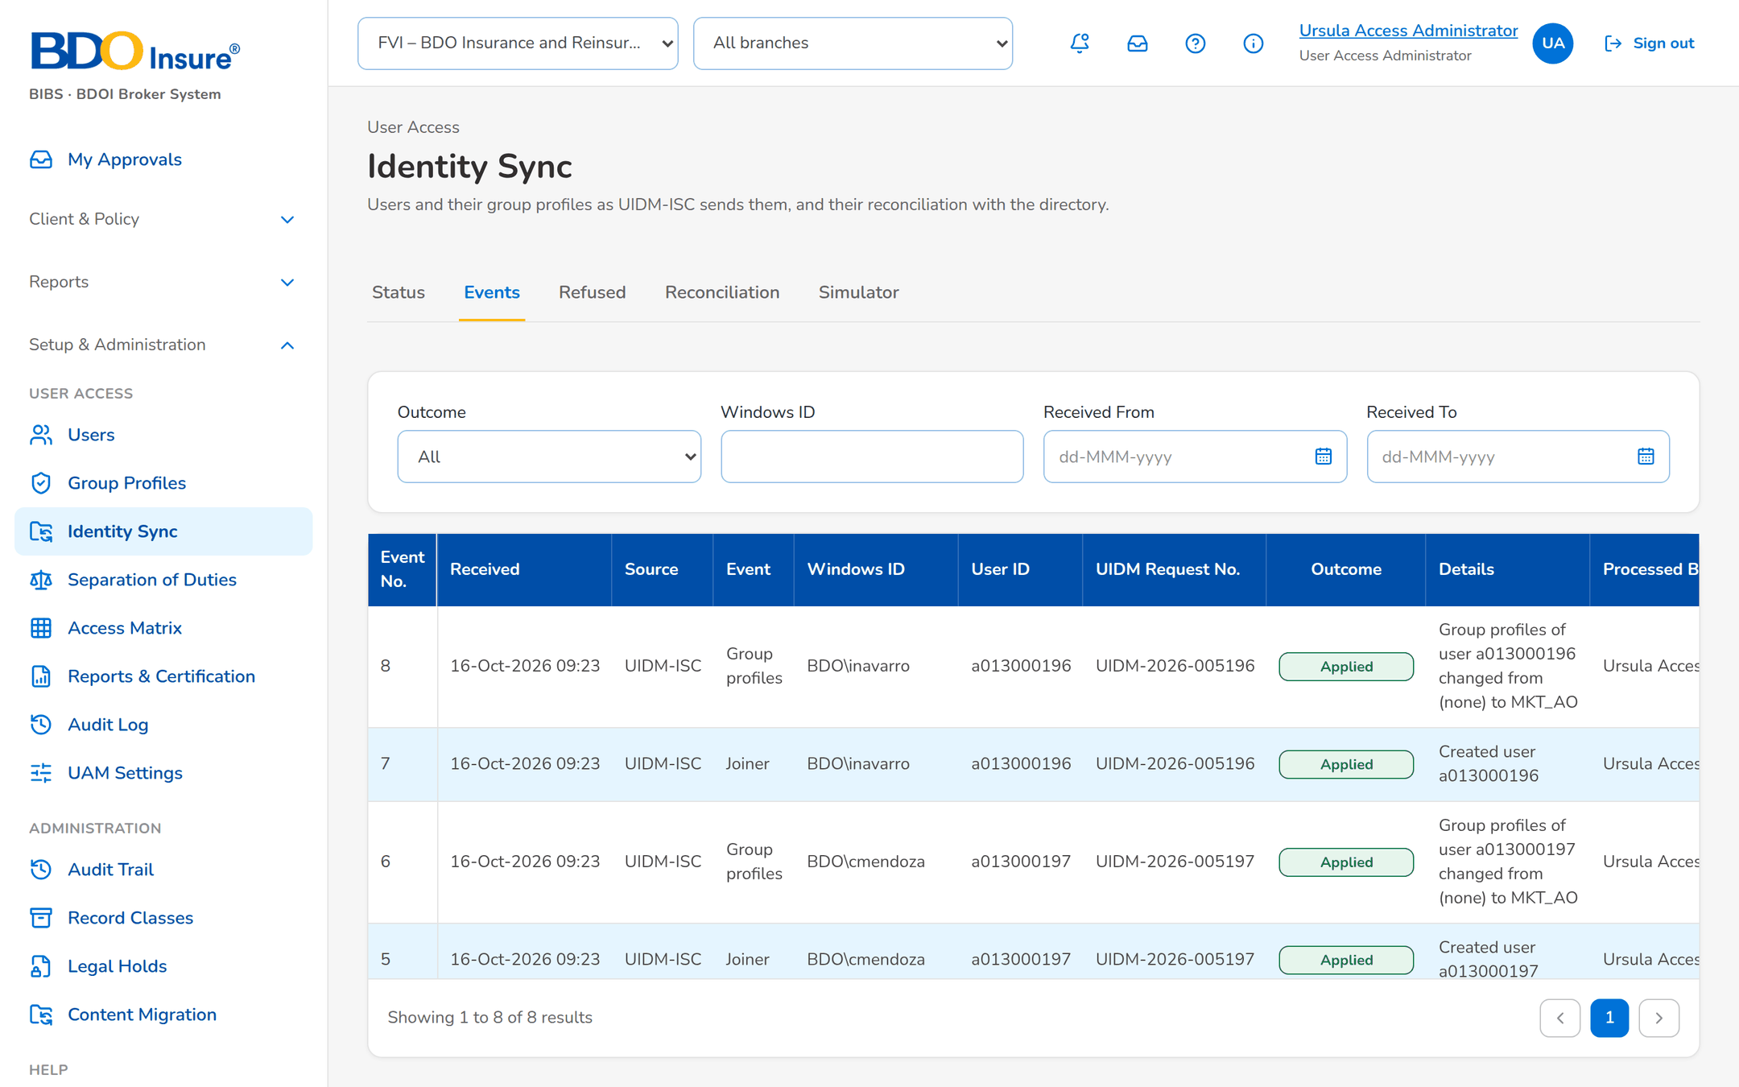
Figure 3: SB-1 step 1: UIDM-ISC, Identity Sync › Events
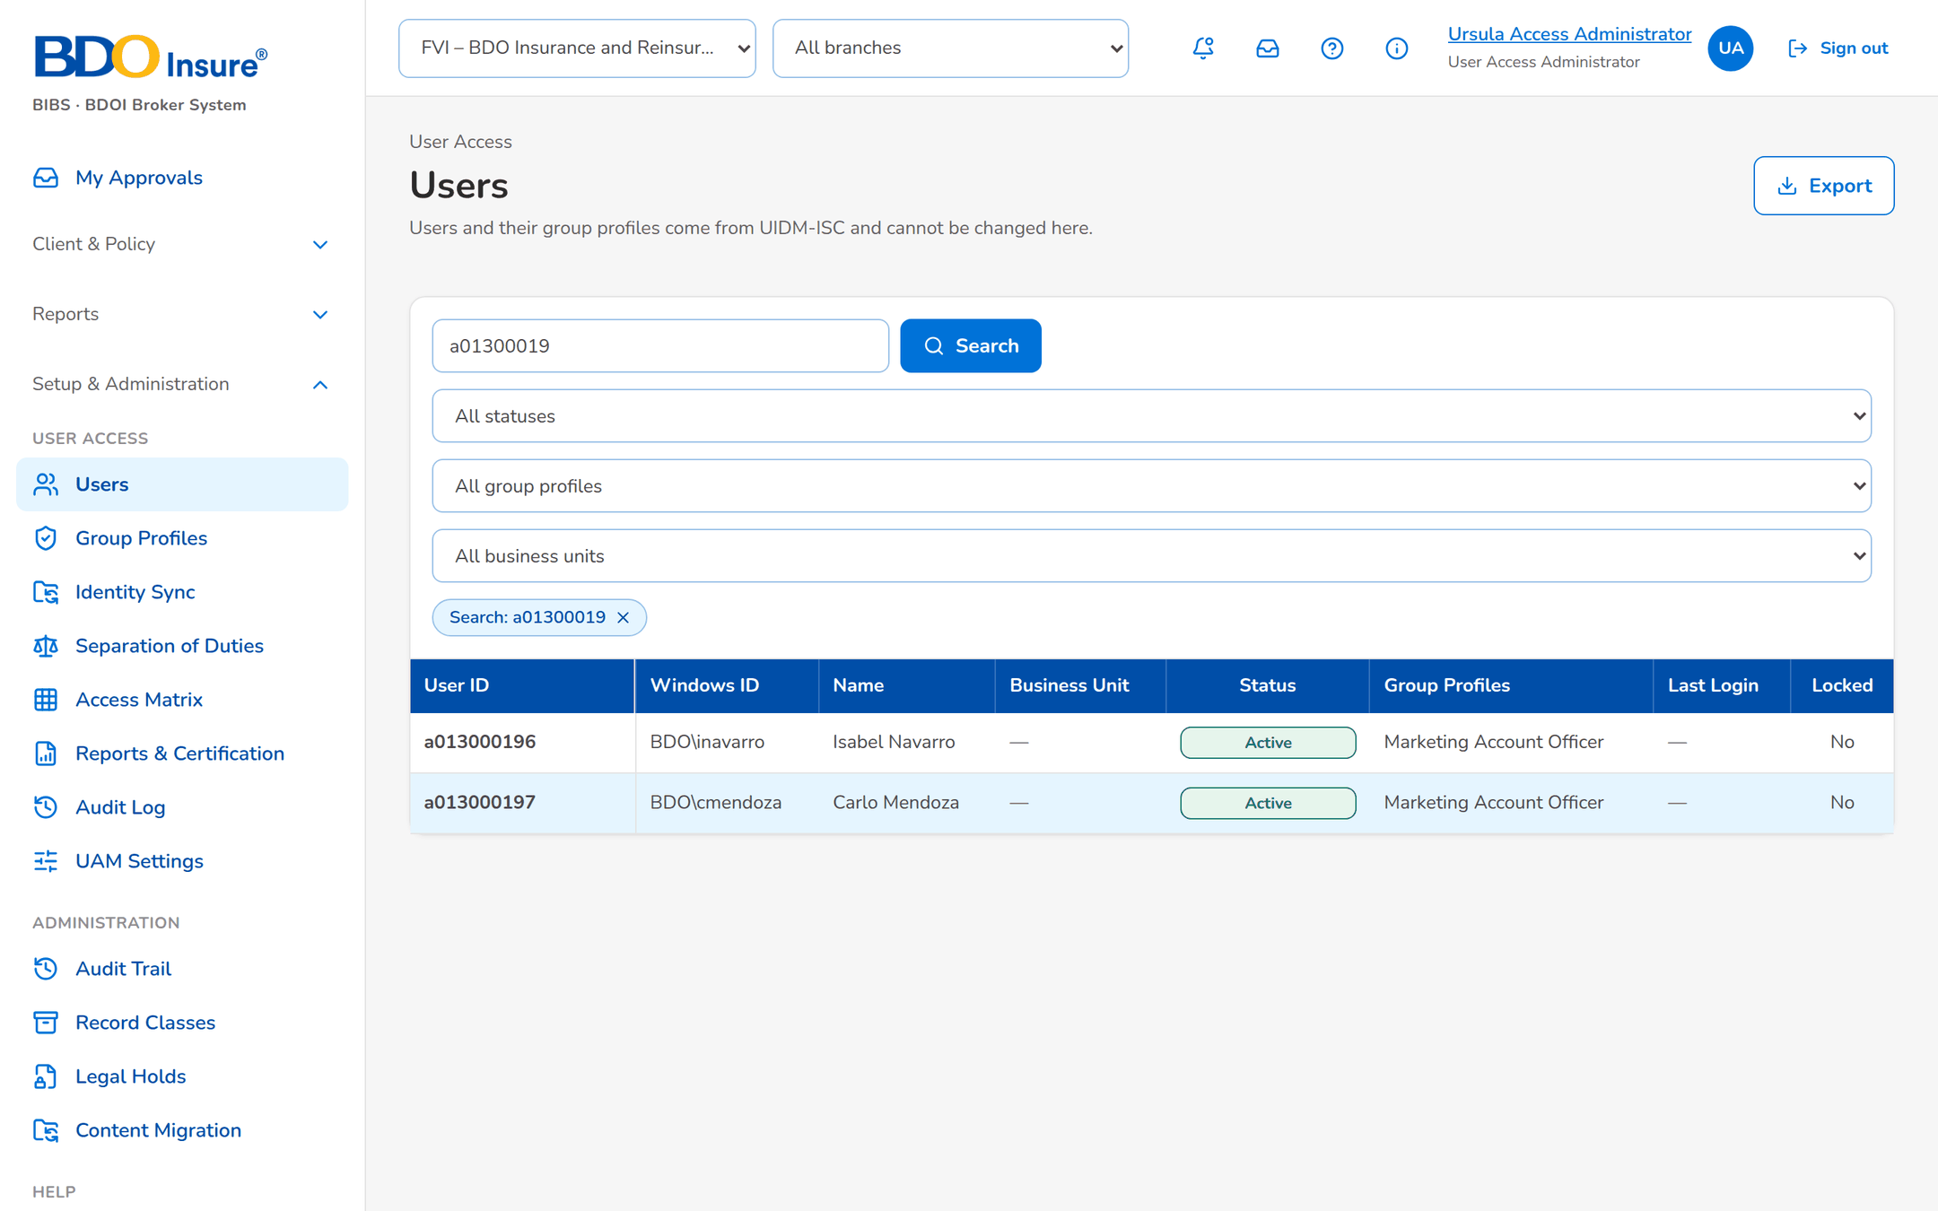
Figure 4: SB-1 step 2: User Access Administrator, Users
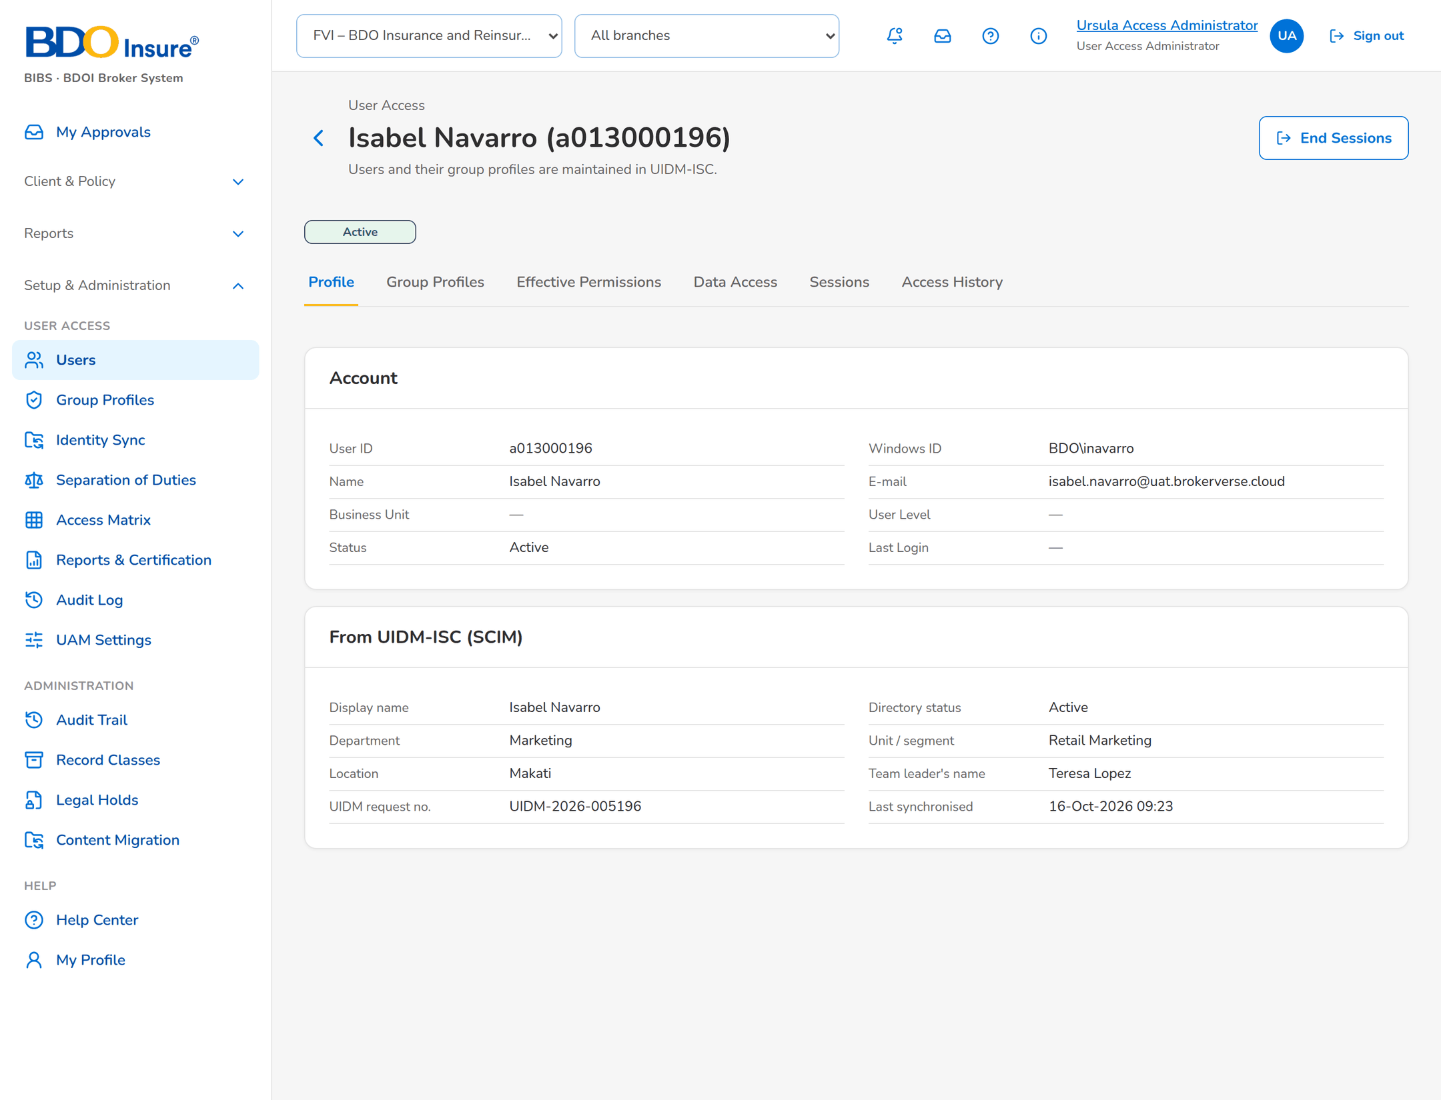
Figure 5: SB-1 step 3: User Access Administrator, User › Profile
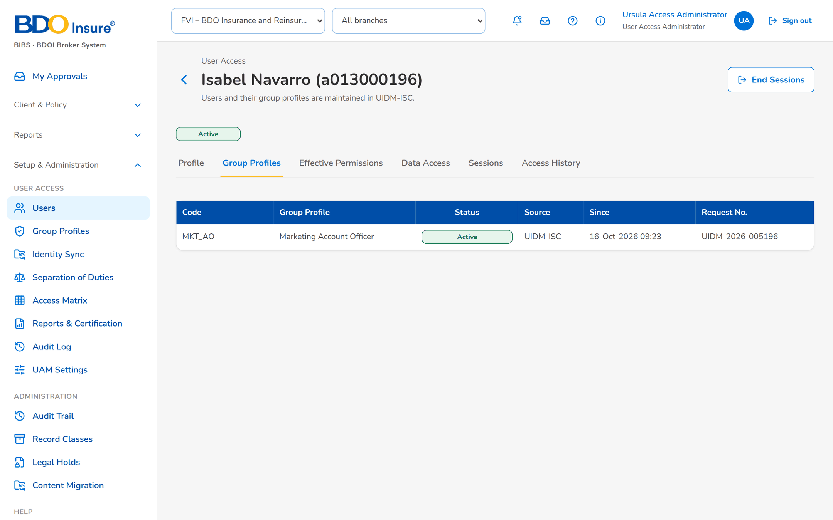
Figure 6: SB-1 step 4: User Access Administrator, User › Group Profiles
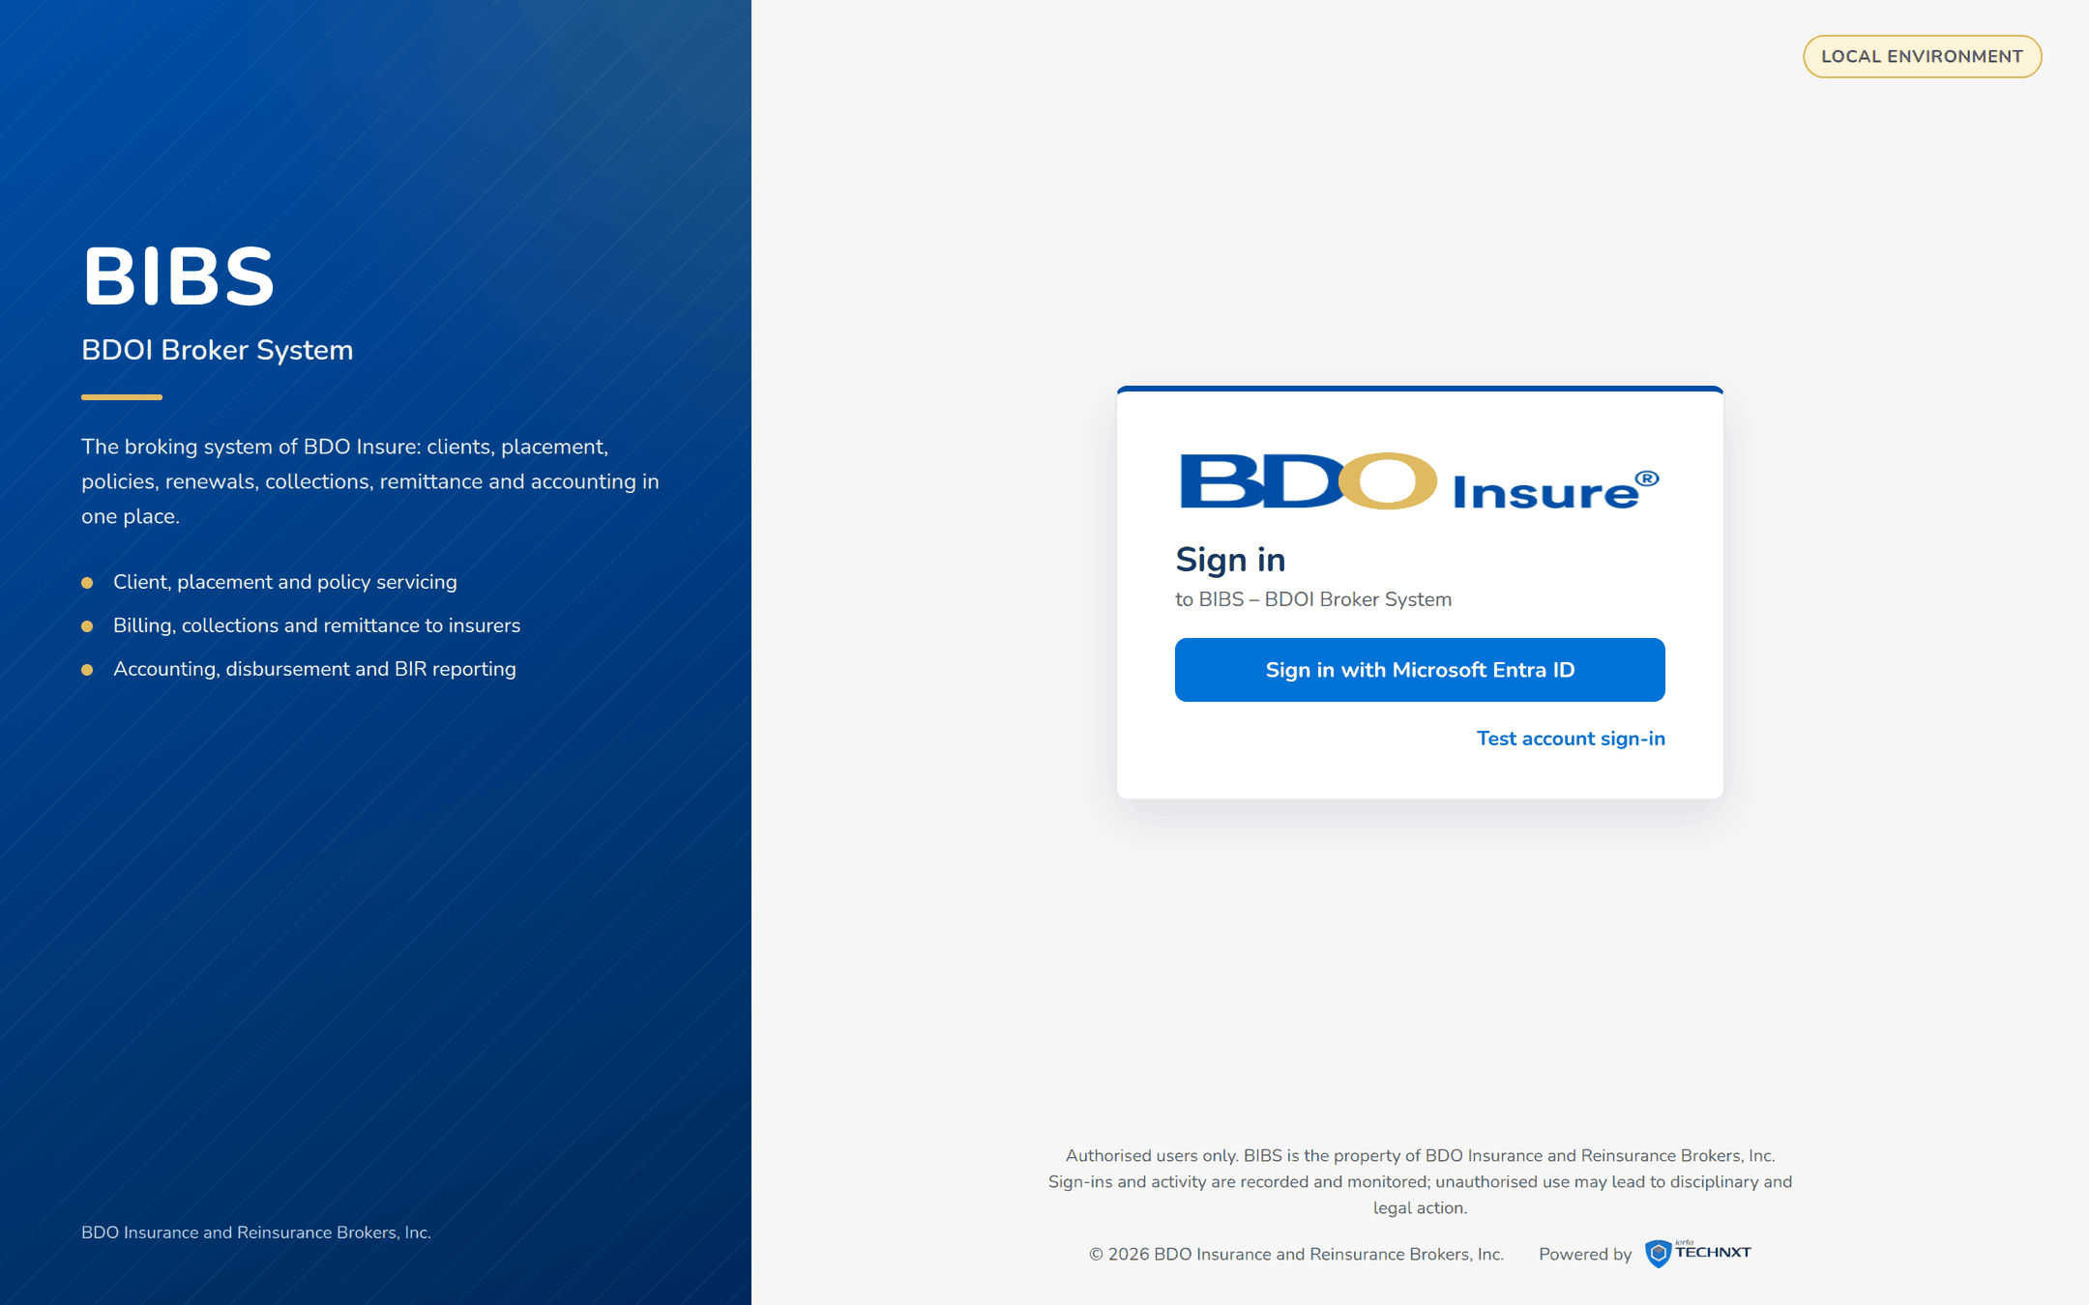
Figure 7: SB-1 step 5: Isabel Navarro, Sign in
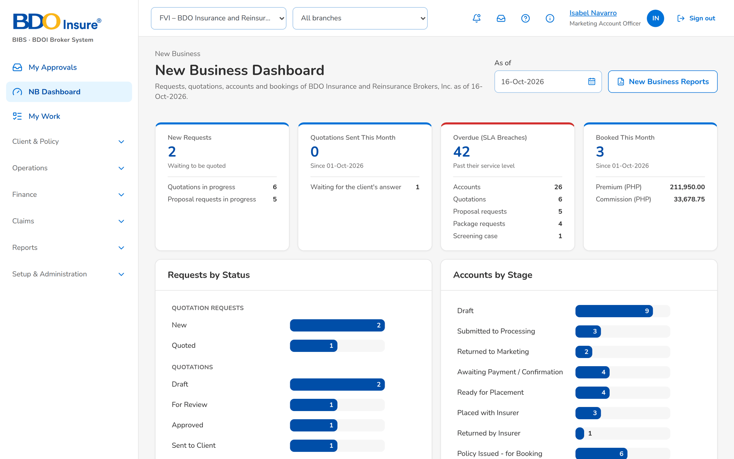
Figure 8: SB-1 step 6: Isabel Navarro, Home
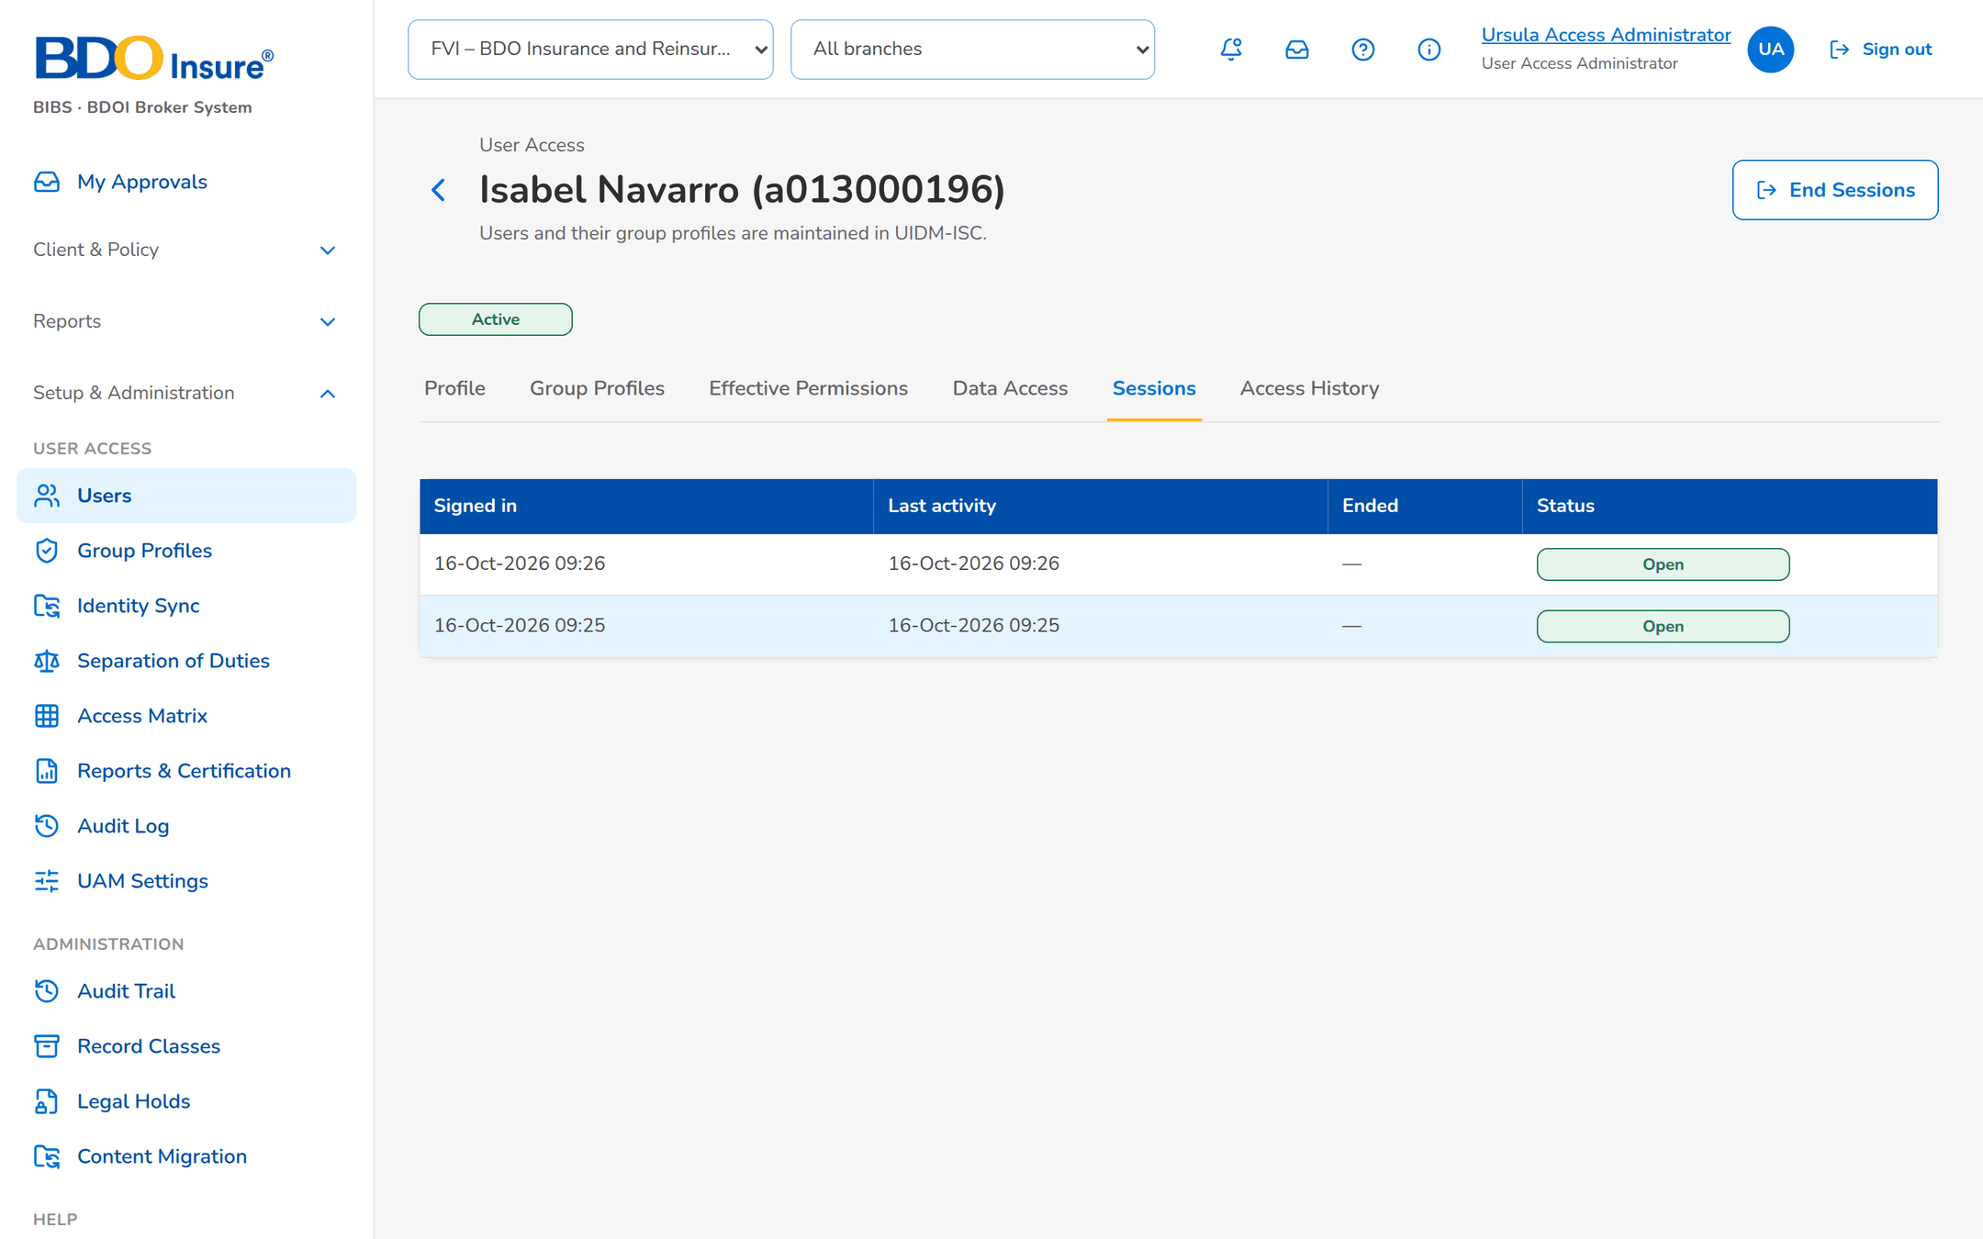
Figure 9: SB-1 step 7: User Access Administrator, User › Sessions

SB-2 Mover and leaver
Isabel Navarro moves to Corporate Marketing as team leader. Carlo Mendoza leaves BDOI.
Table 4: SB-2 steps
Step | Who | Screen | Does | Sees
1 | UIDM-ISC | Identity Sync › Events | Sends the mover and group-profile events of UIDM-2026-005240. | Mover and Group profiles events Applied.
2 | User Access Administrator | User › Group Profiles | Opens Isabel's group profiles. | Marketing Team Leader active; Marketing Account Officer removed.
3 | User Access Administrator | User › Access History | Opens the history. | Each attribute with its from and to value and the UIDM request number.
4 | UIDM-ISC | User › Profile | Sends the leaver of UIDM-2026-005251 for Carlo Mendoza. | Carlo is Inactive; his sessions are ended.
5 | Auditor | User › Access History | Reads Carlo's history. | Deactivation with the UIDM request number.

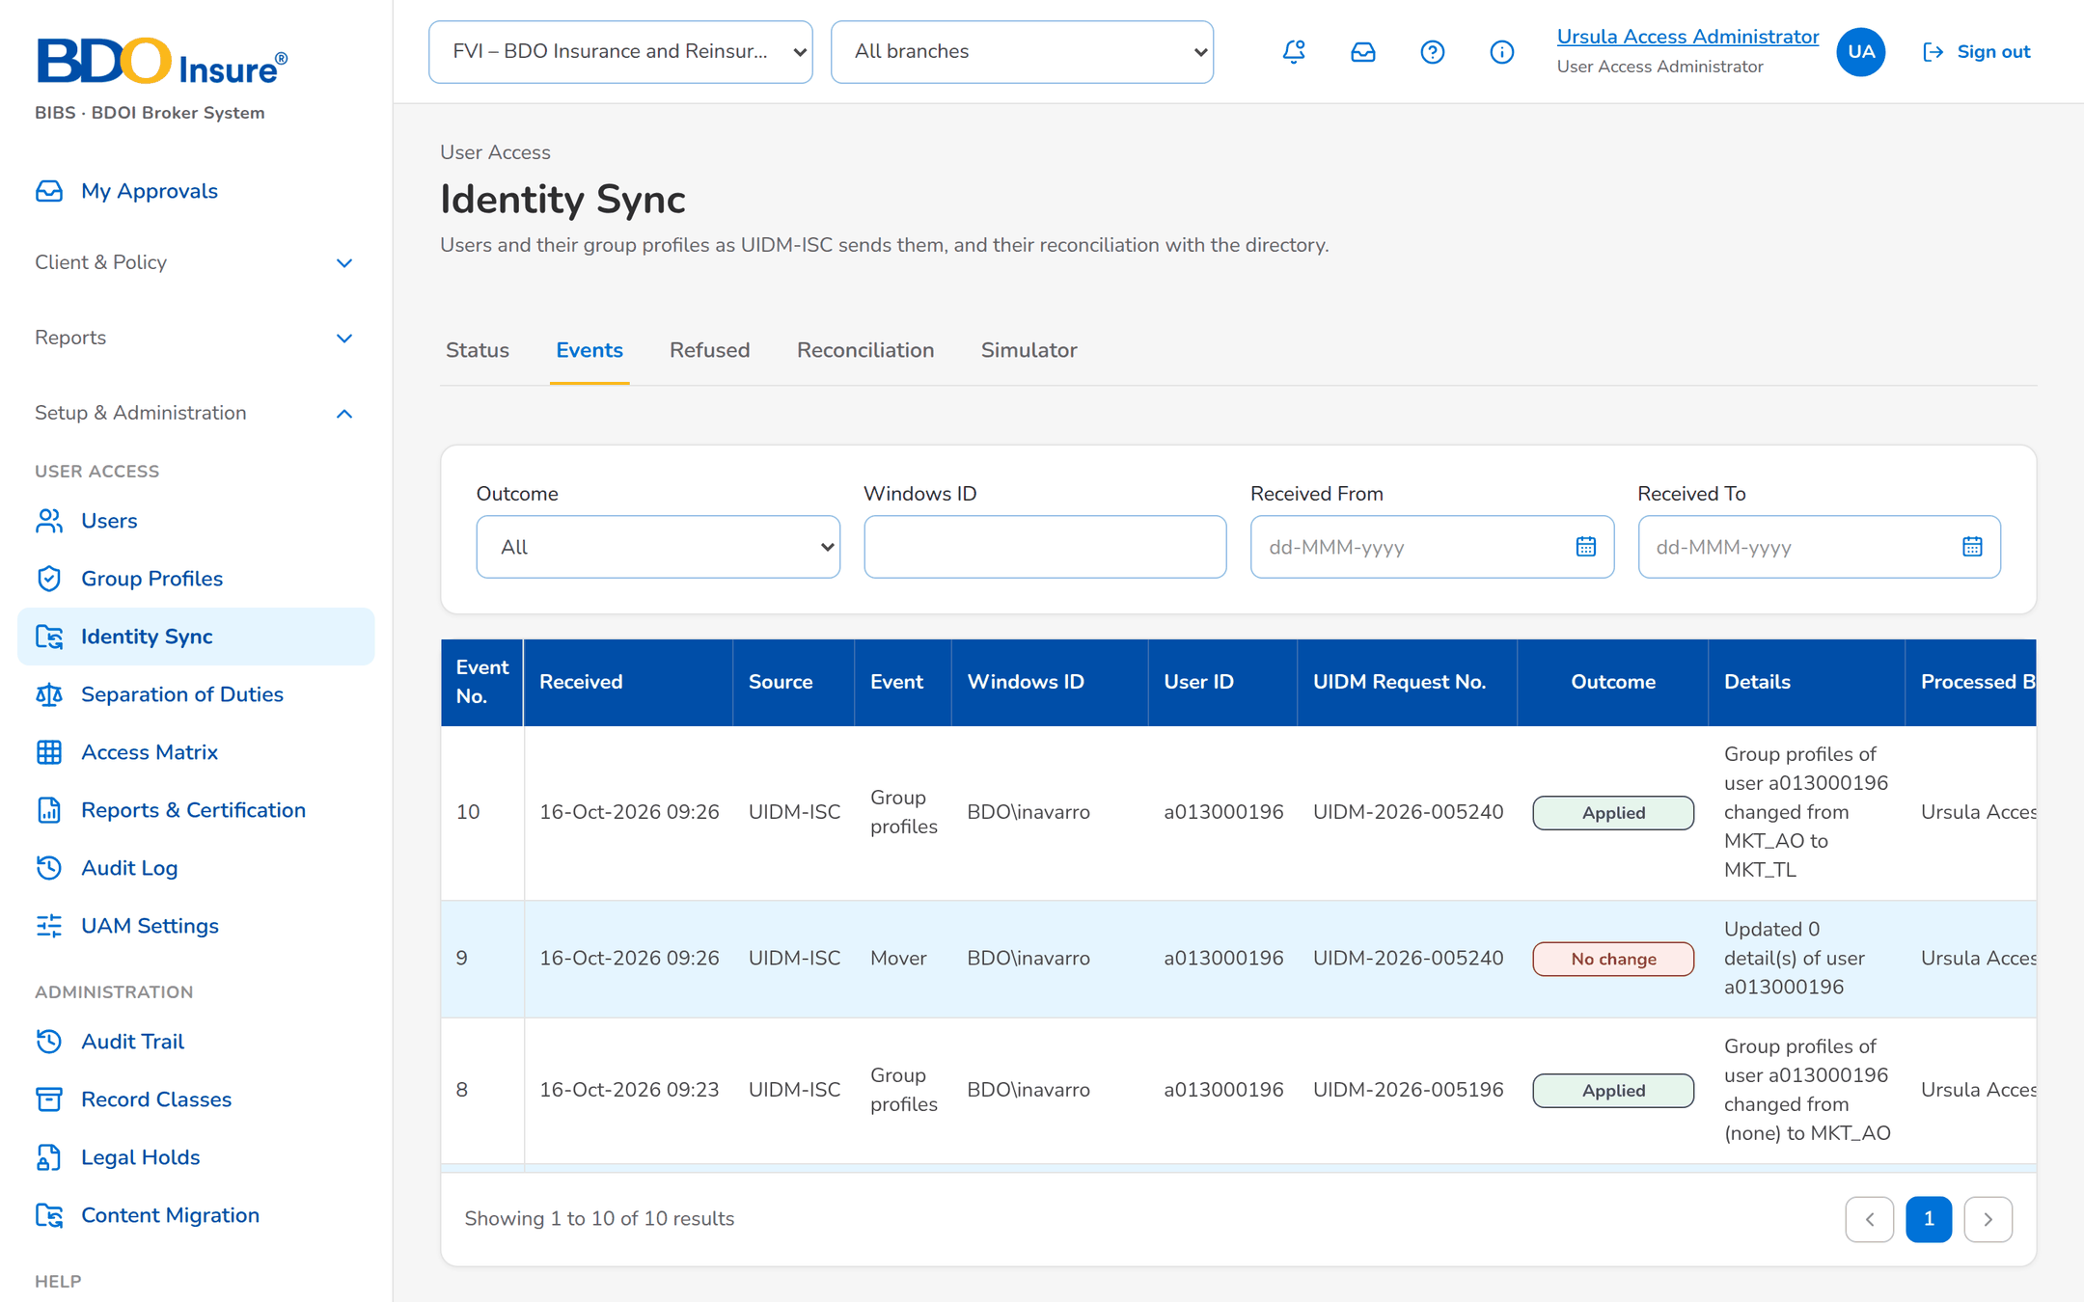
Figure 10: SB-2 step 1: UIDM-ISC, Identity Sync › Events
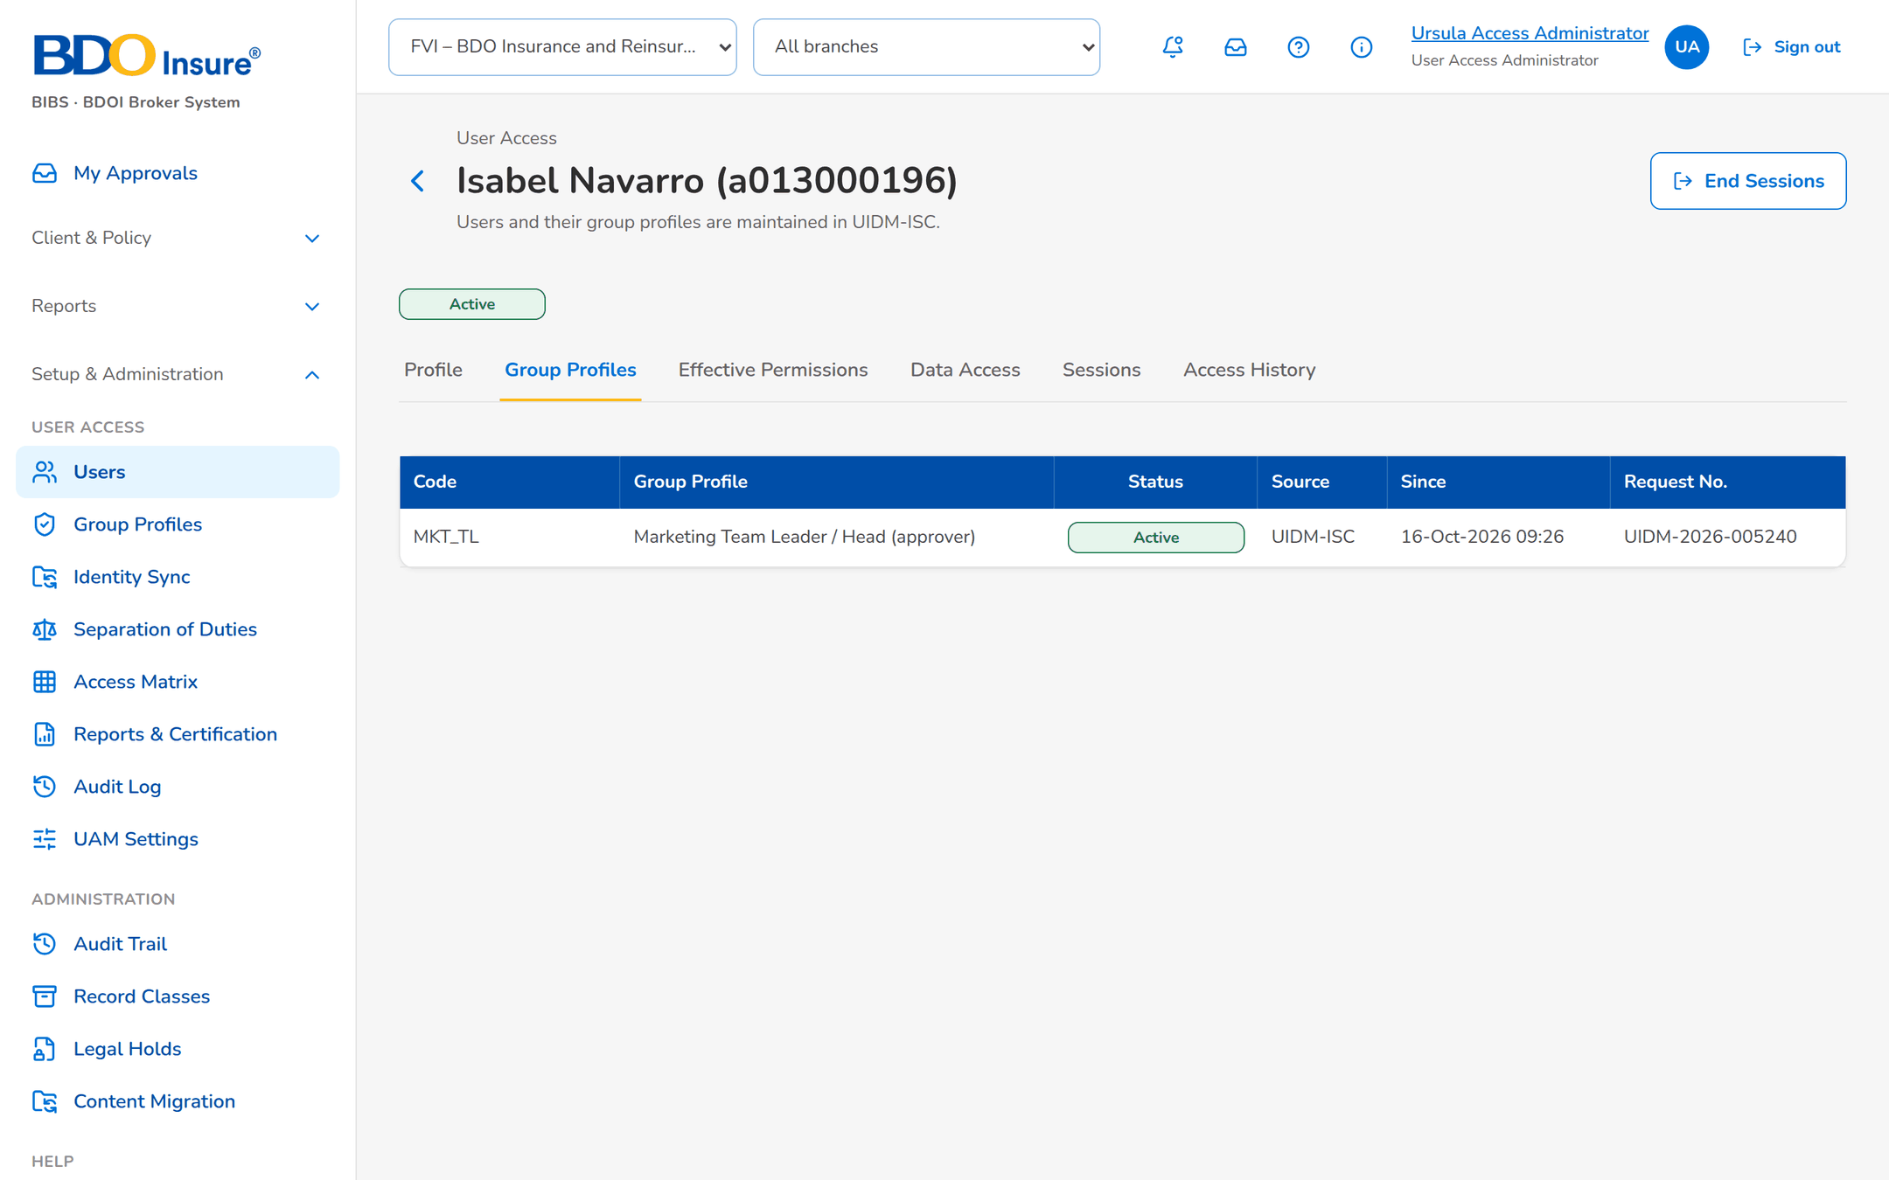
Figure 11: SB-2 step 2: User Access Administrator, User › Group Profiles
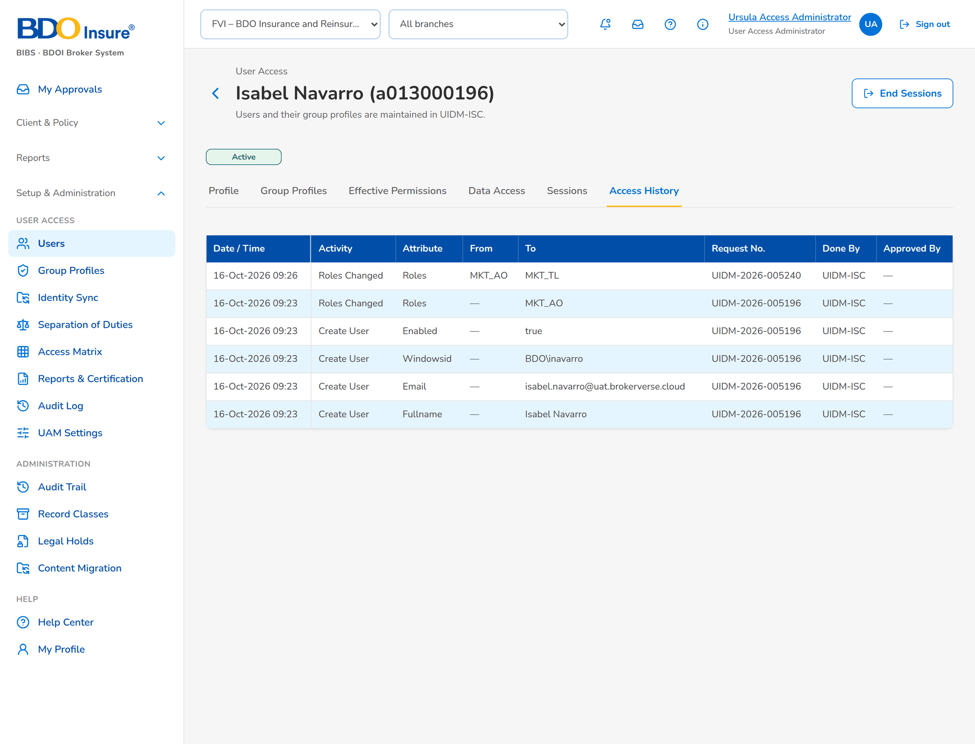
Figure 12: SB-2 step 3: User Access Administrator, User › Access History
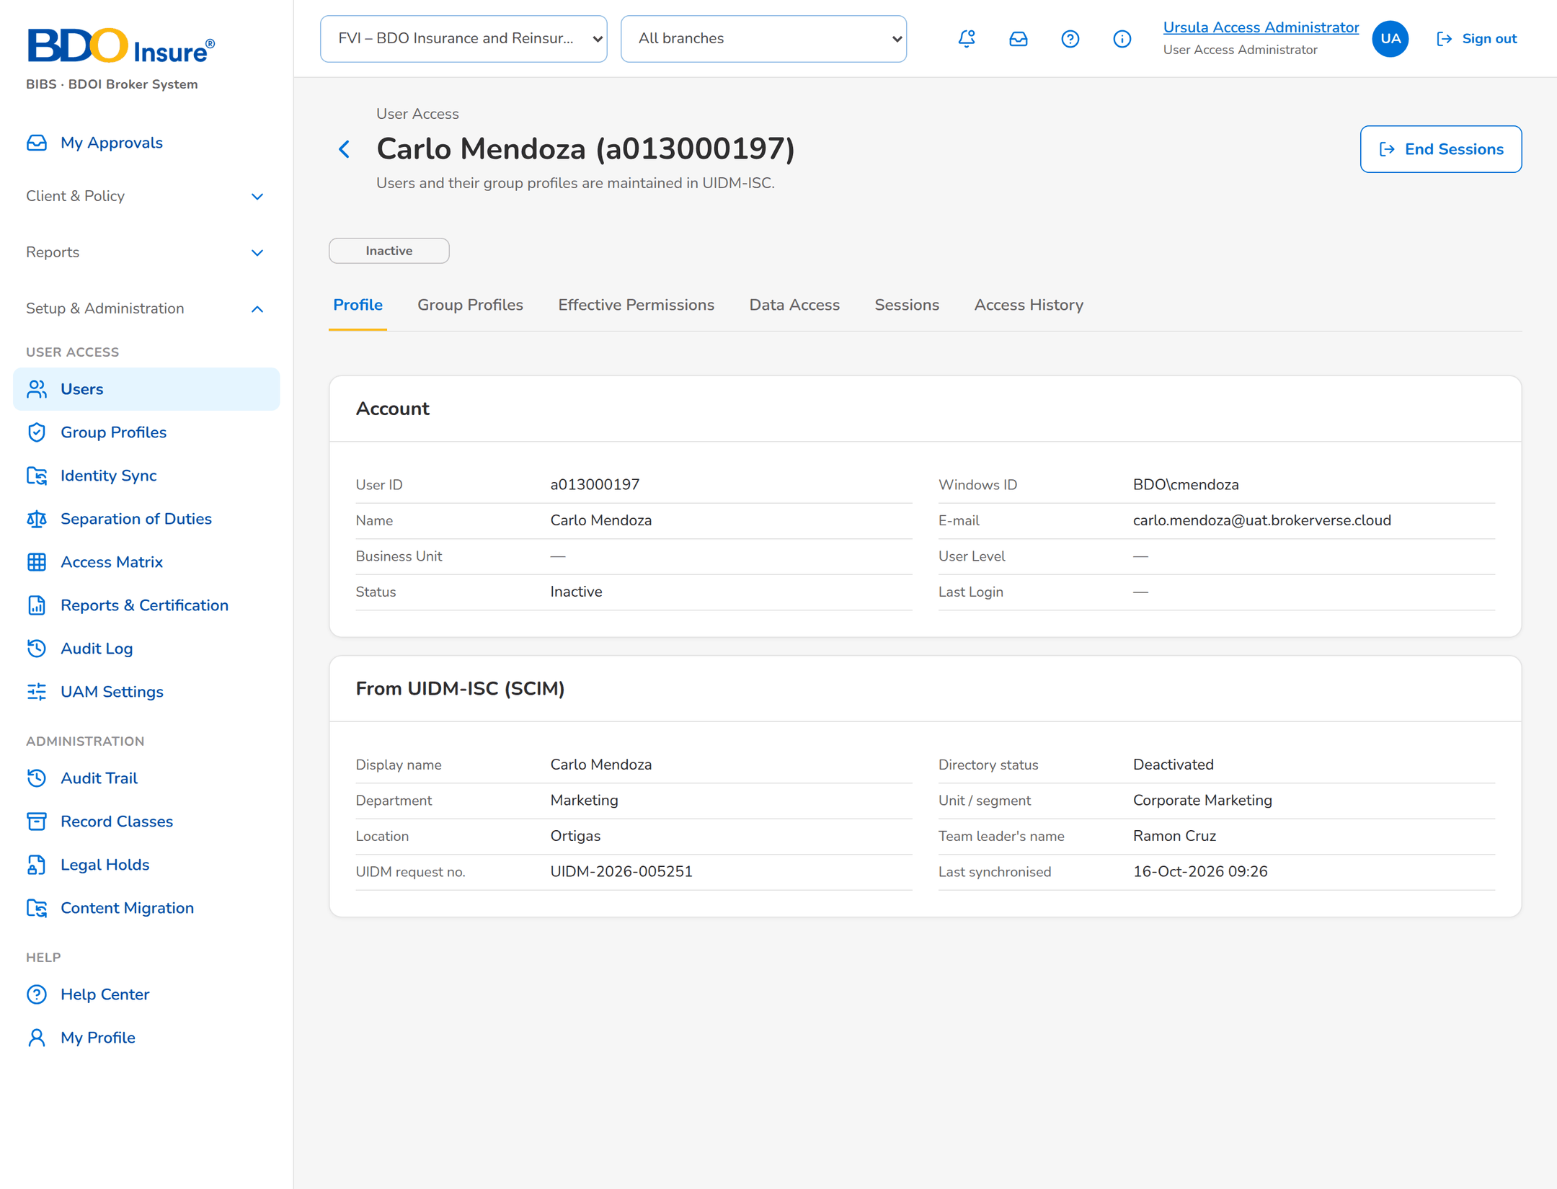
Figure 13: SB-2 step 4: UIDM-ISC, User › Profile
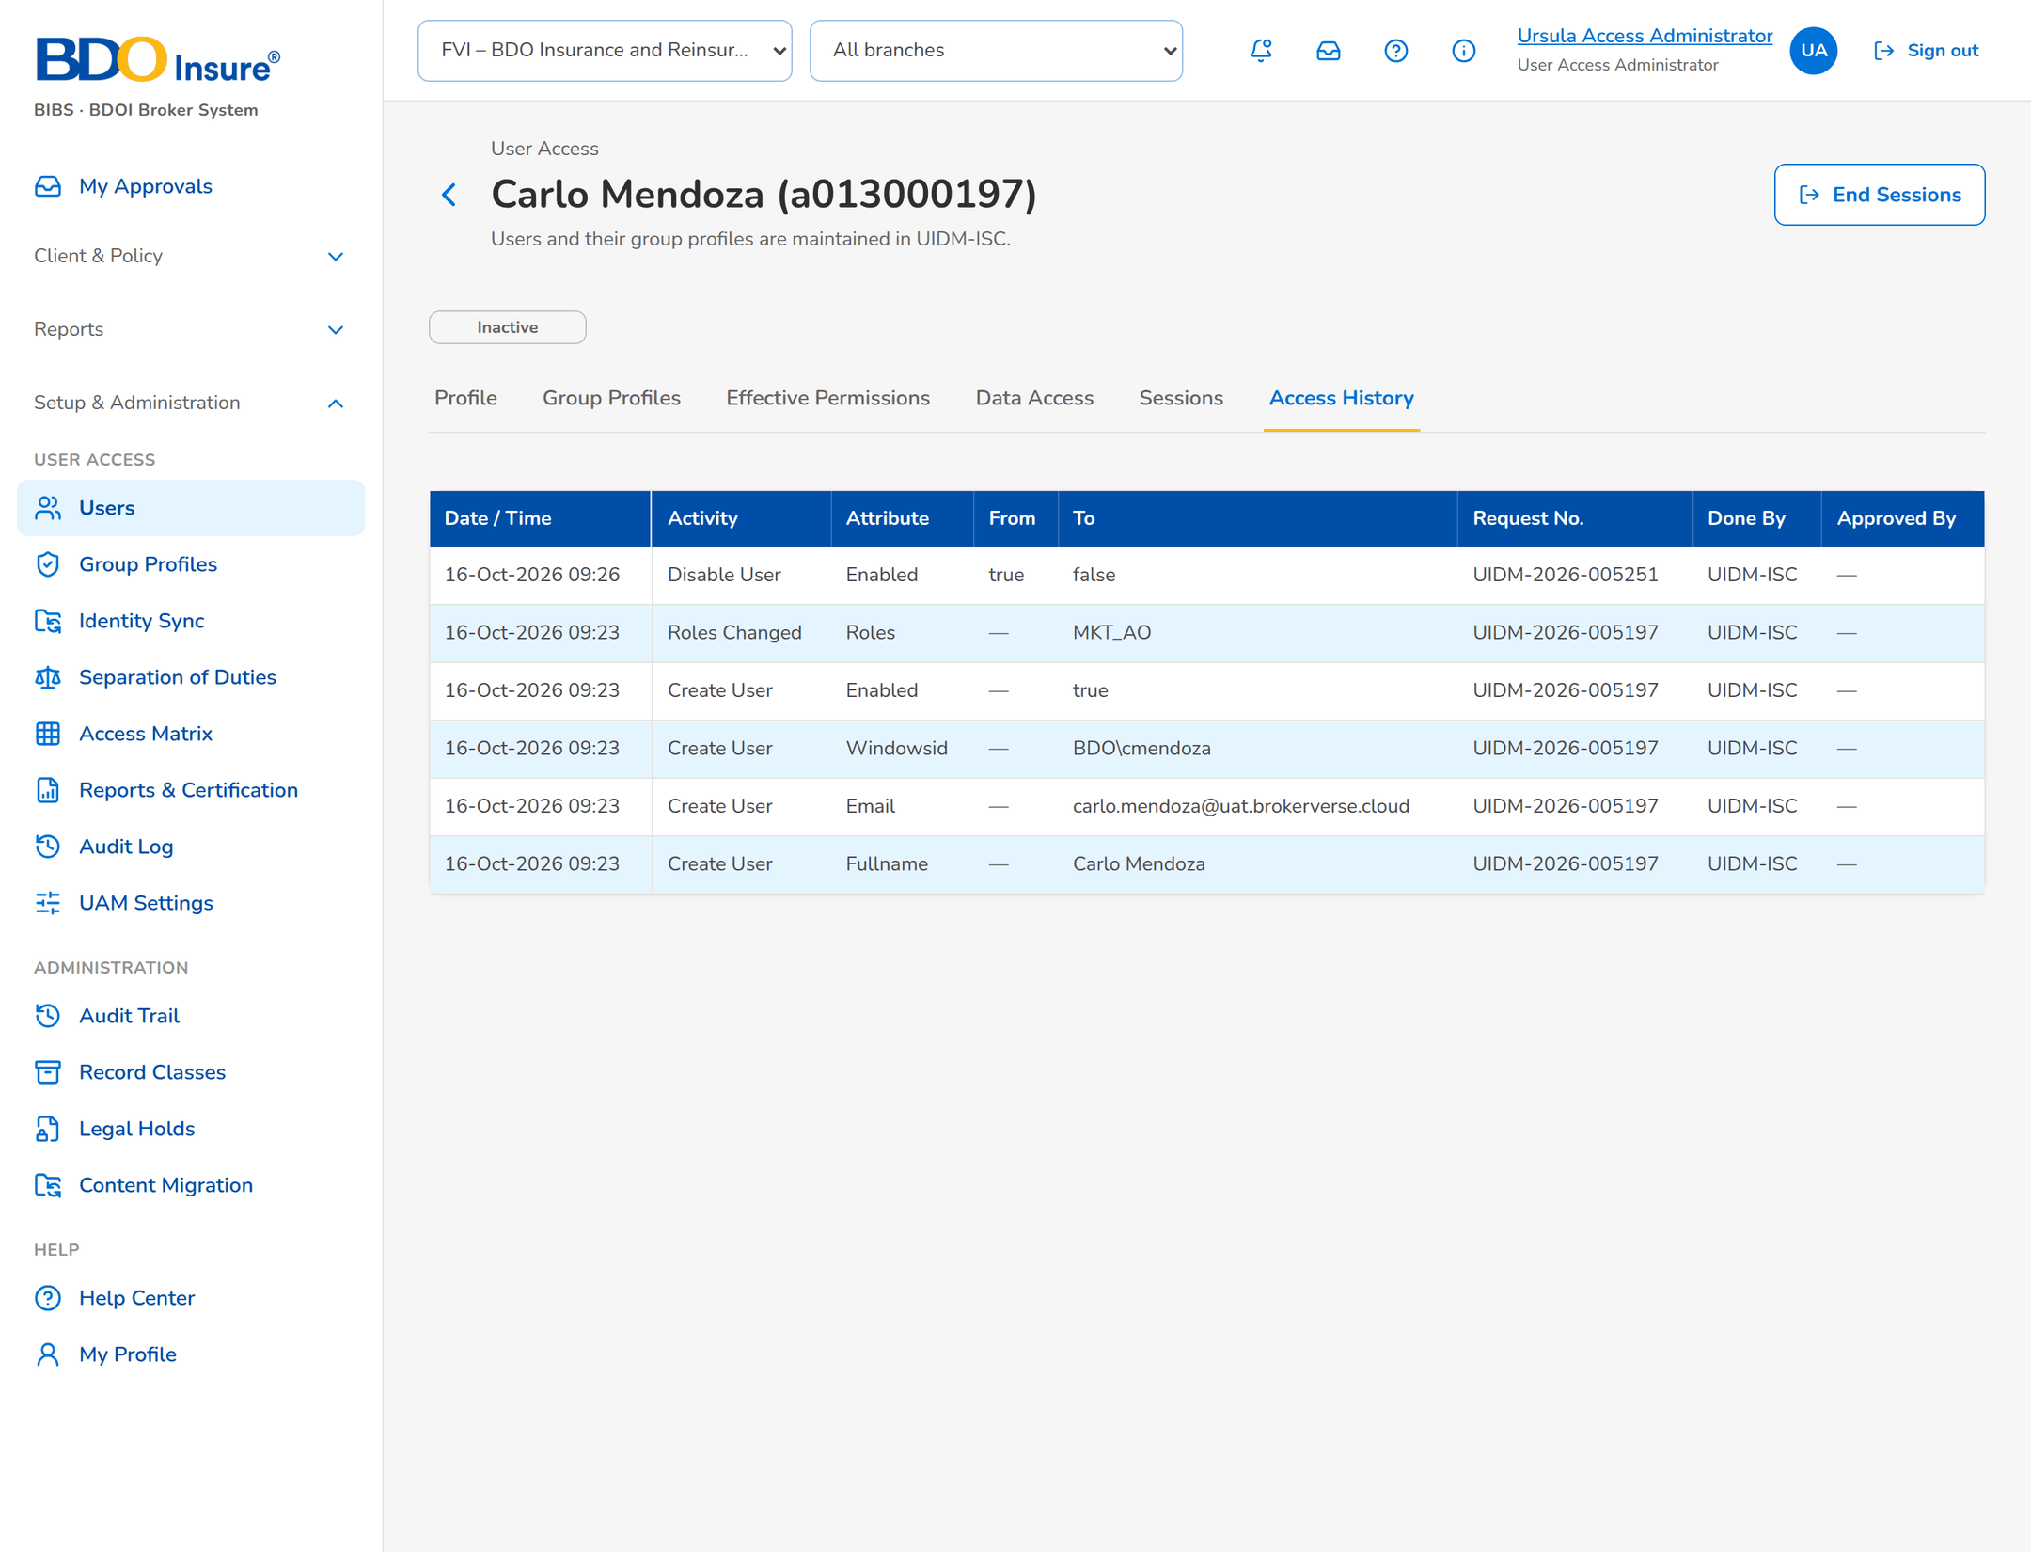
Figure 14: SB-2 step 5: Auditor, User › Access History

SB-3 Group-profile change under maker-checker
Rhea Access Requestor (maker) adds Client approve to Marketing Account Officer. Ulysses Access Approver (checker) approves. The System Administrator implements it.
Table 5: SB-3 steps
Step | Who | Screen | Does | Sees
1 | Group Profile Maker | Group Profile › Definition | Opens Marketing Account Officer. | Definition, members and the Propose Change button.
2 | Group Profile Maker | Propose Change | Adds the permission, enters the reason, clicks Submit for Approval. | The permission picker by area and the reason field.
3 | Group Profile Maker | Pending Change | Reads the submitted change. | AR-2026-000001 Pending, maker Rhea, permission added.
4 | Group Profile Checker | Pending Change | Opens the change from the notice. | Approve, Return for Correction and Reject.
5 | Group Profile Checker | Approve | Enters a remark and confirms. | The change goes to implementation.
6 | System Administrator | Pending Change | Implements the approved change. | For Implementation with the Implement button; then Implemented.
7 | Auditor | Group Profile › History | Reads the history. | Change number, maker, checker, date and status.

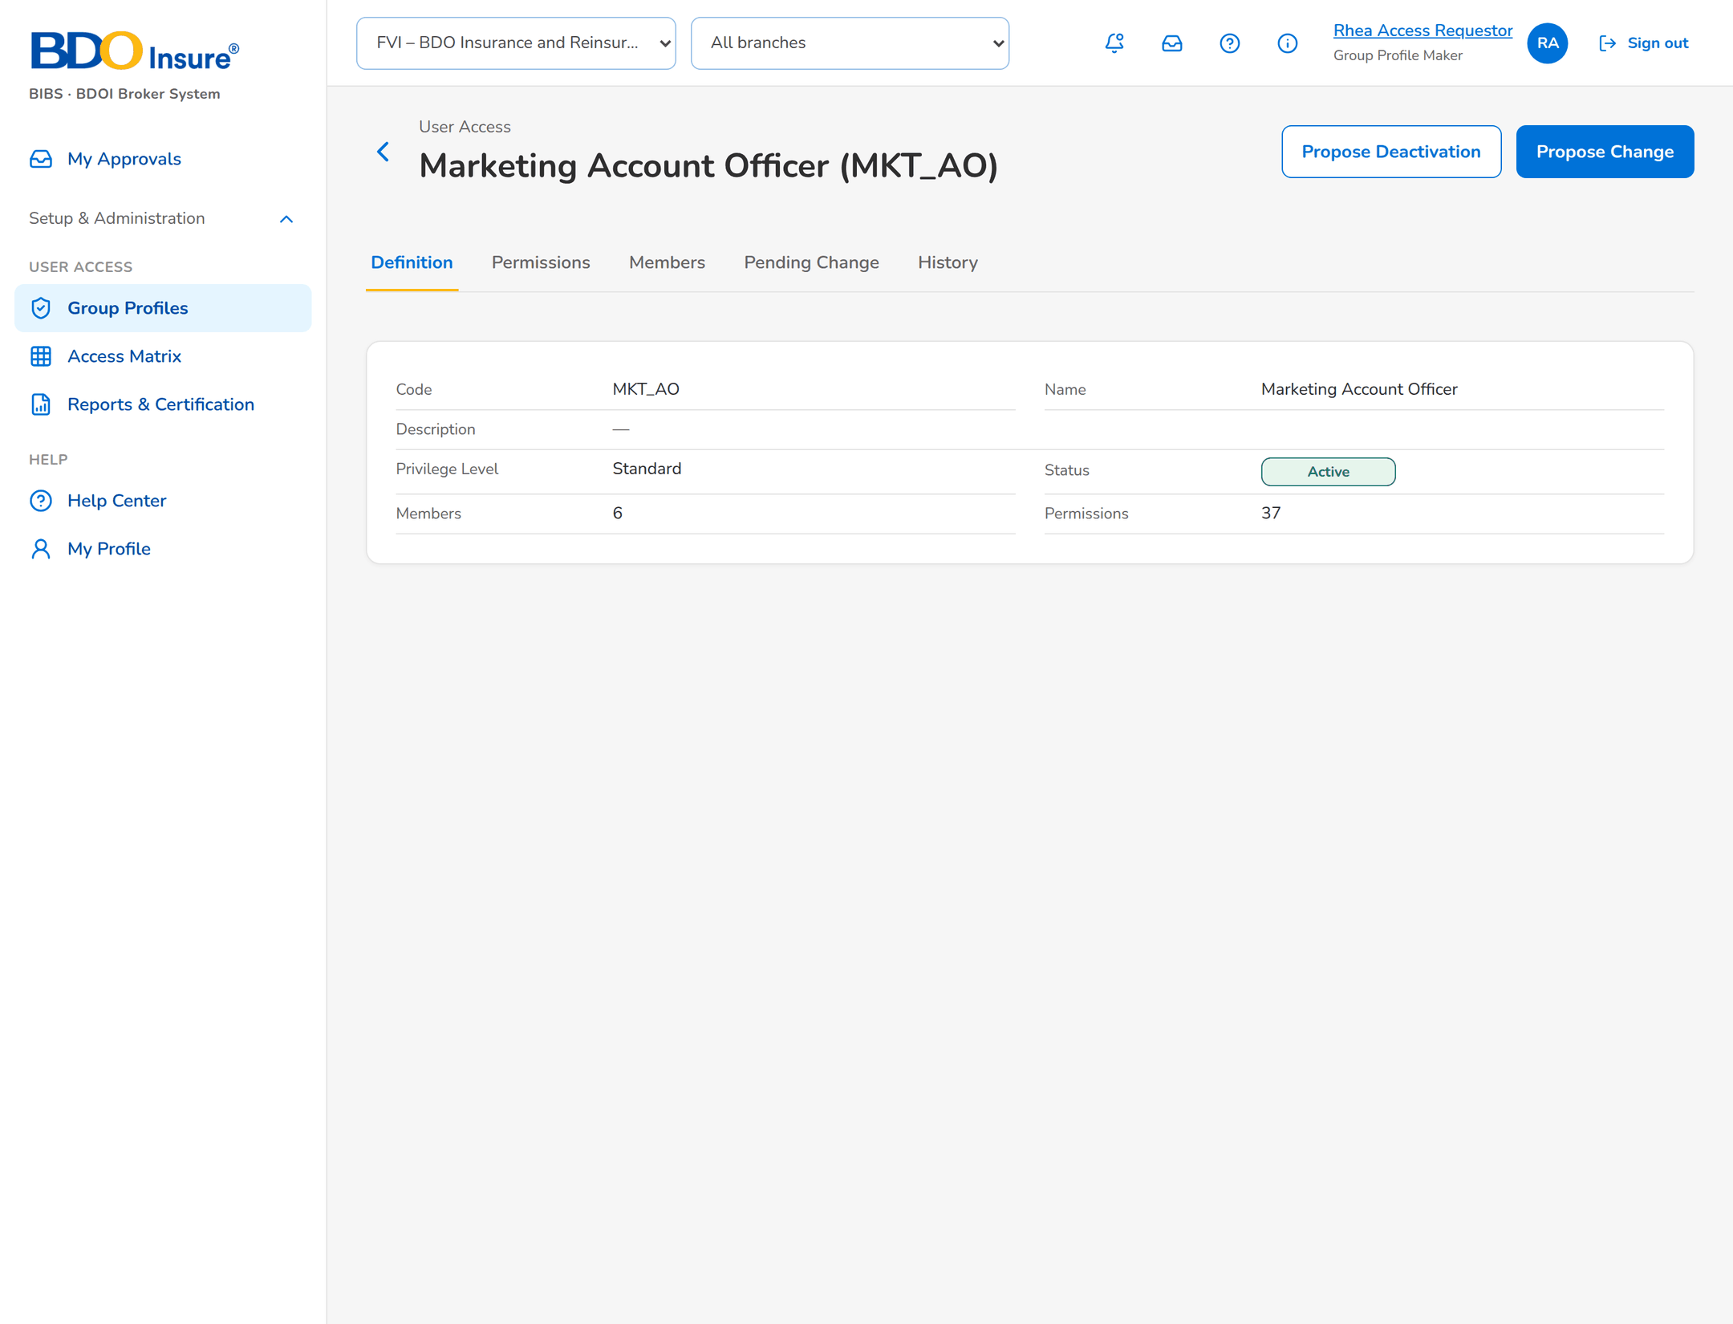
Figure 15: SB-3 step 1: Group Profile Maker, Group Profile › Definition
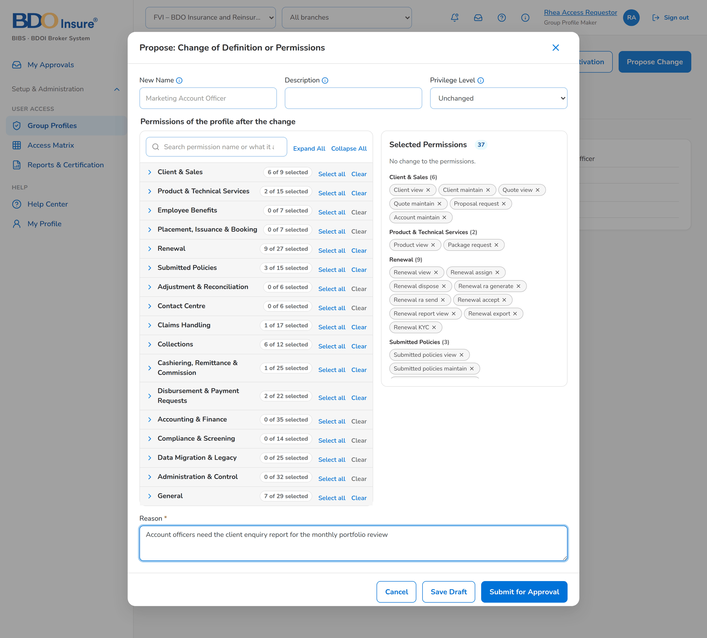
Figure 16: SB-3 step 2: Group Profile Maker, Propose Change
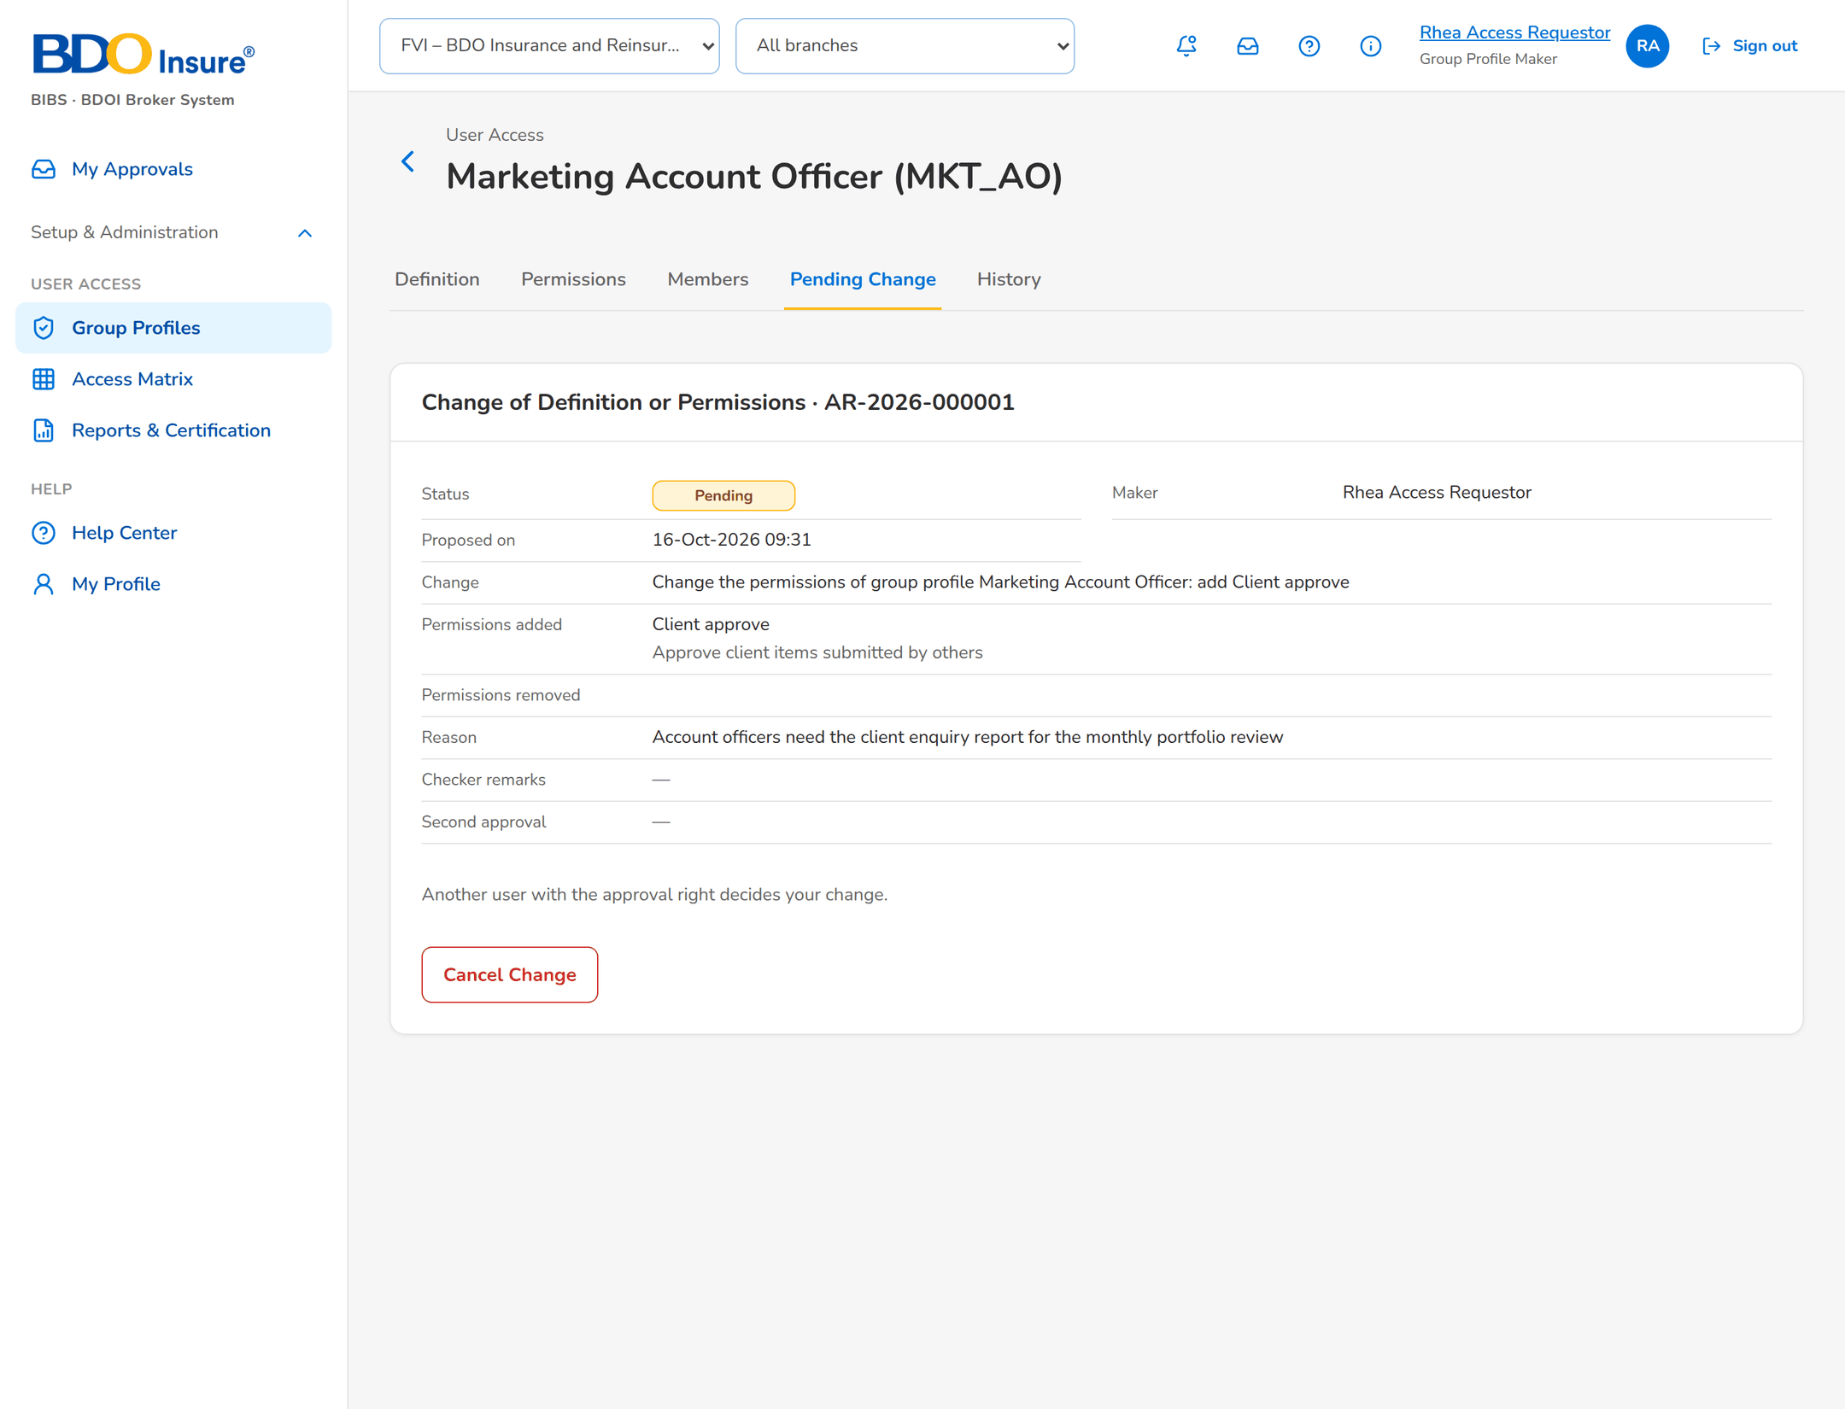
Figure 17: SB-3 step 3: Group Profile Maker, Pending Change
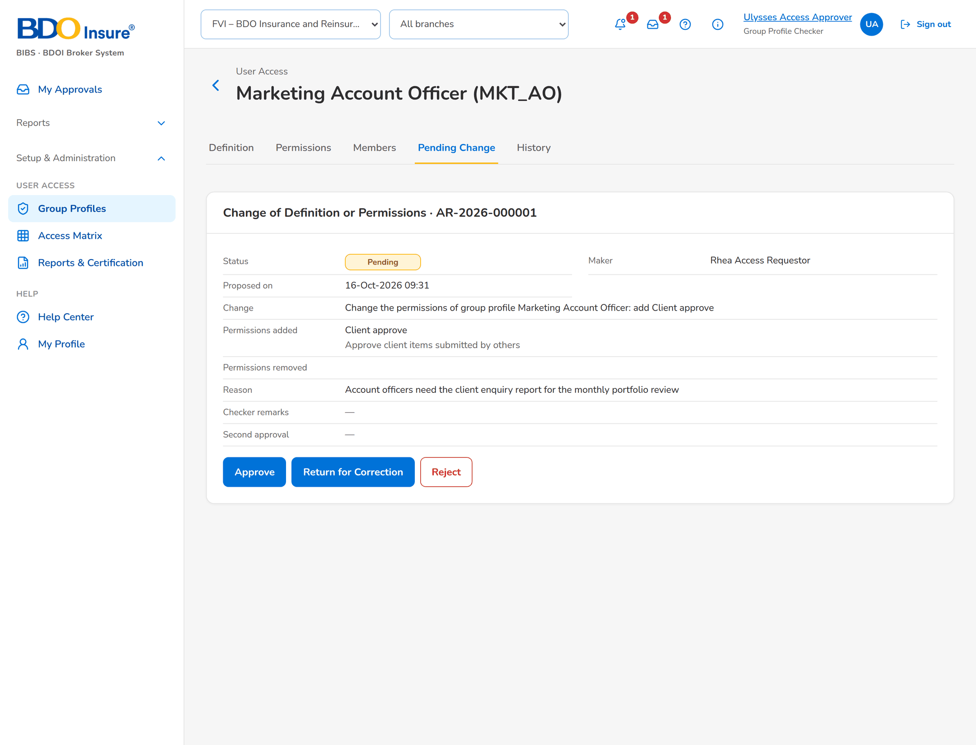
Figure 18: SB-3 step 4: Group Profile Checker, Pending Change
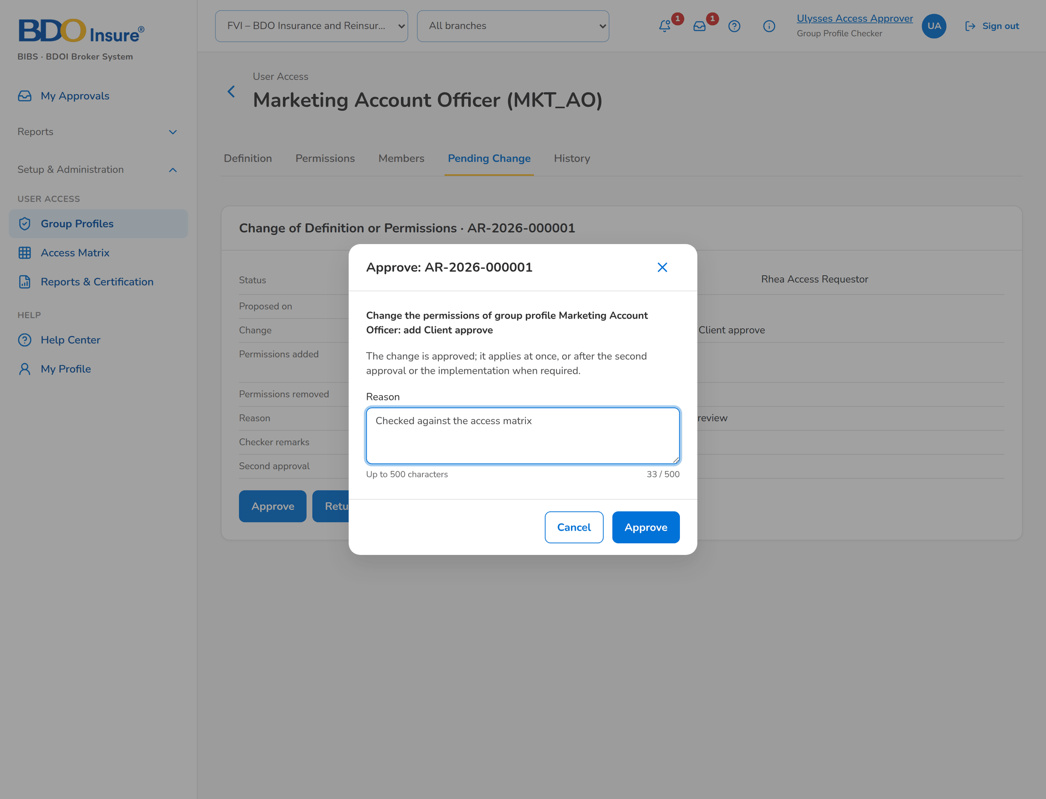
Figure 19: SB-3 step 5: Group Profile Checker, Approve
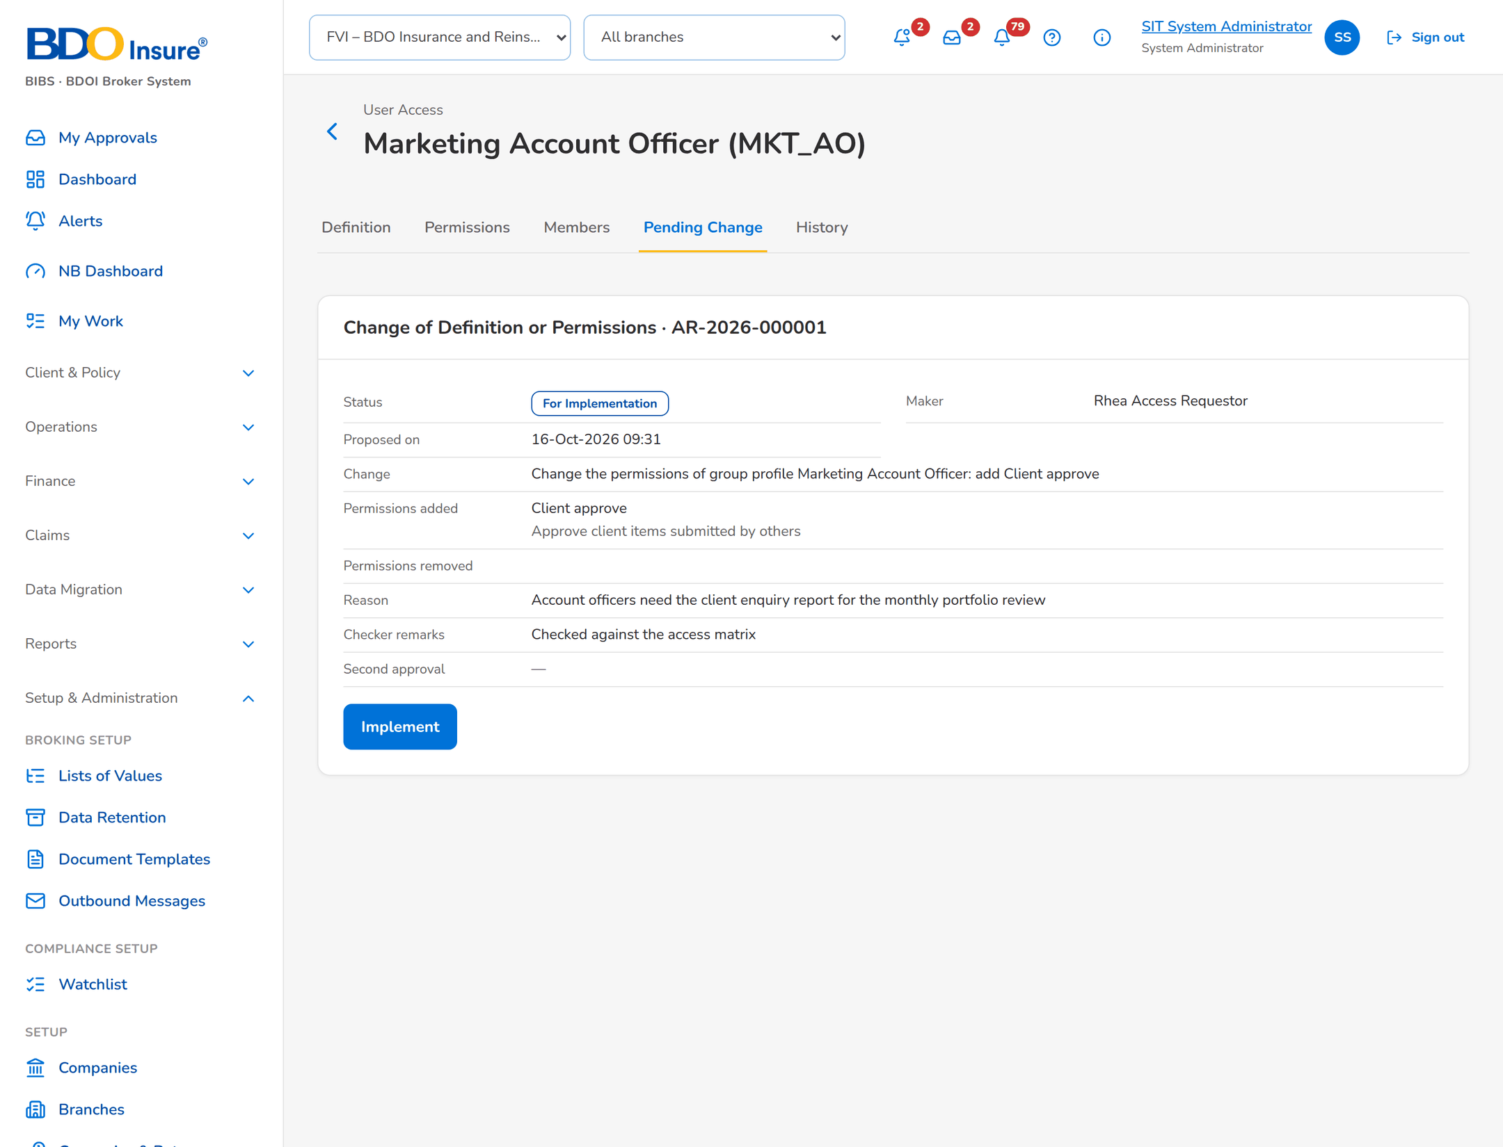
Figure 20: SB-3 step 6: System Administrator, Pending Change
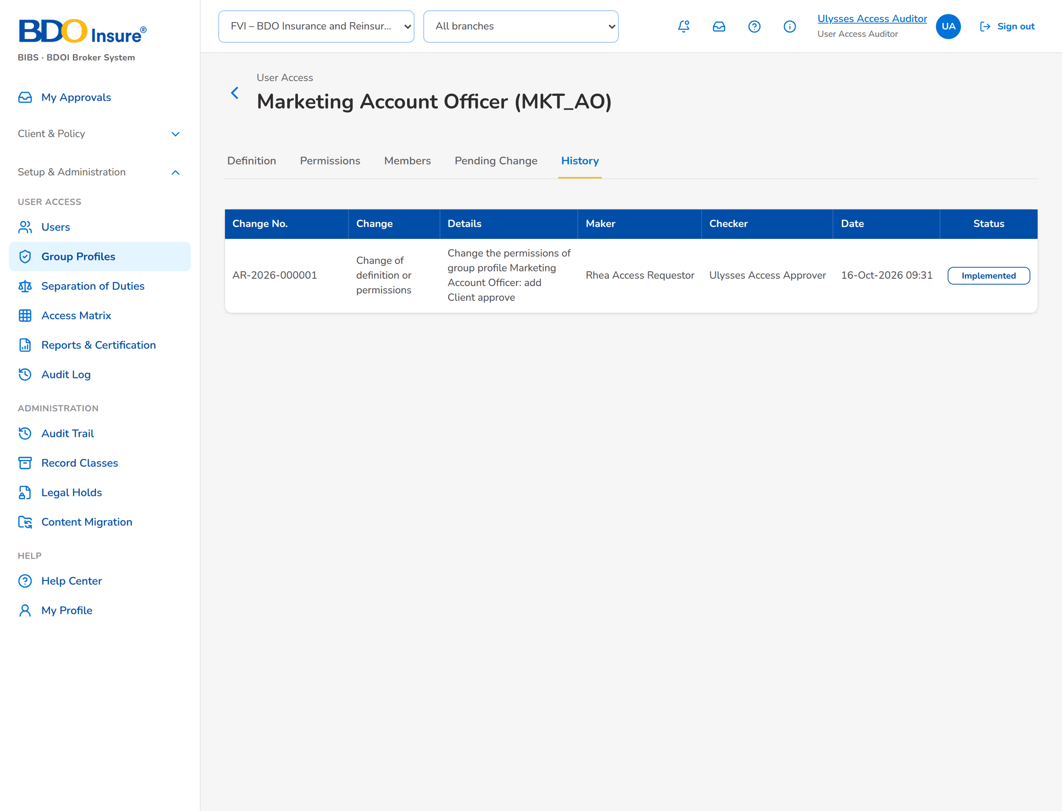
Figure 21: SB-3 step 7: Auditor, Group Profile › History

SB-4 Refused event and reconciliation
UIDM-ISC sends a group profile that does not exist in BIBS. Later the daily reconciliation finds a user active in BIBS but not in the directory.
Table 6: SB-4 steps
Step | Who | Screen | Does | Sees
1 | User Access Administrator | Identity Sync › Refused | Opens the alert. | Event refused: no group profile MKT_SUPERVISOR.
2 | User Access Administrator | Dismiss | Enters the remark after UIDM-ISC corrected the request. | The event is closed with the remark.
3 | User Access Administrator | Identity Sync › Reconciliation | Clicks Synchronise Now. | Mismatch: status differs for a013000196.
4 | User Access Administrator | Identity Sync › Status | Checks the connection. | Last call, last success, errors, refused events and open mismatches.

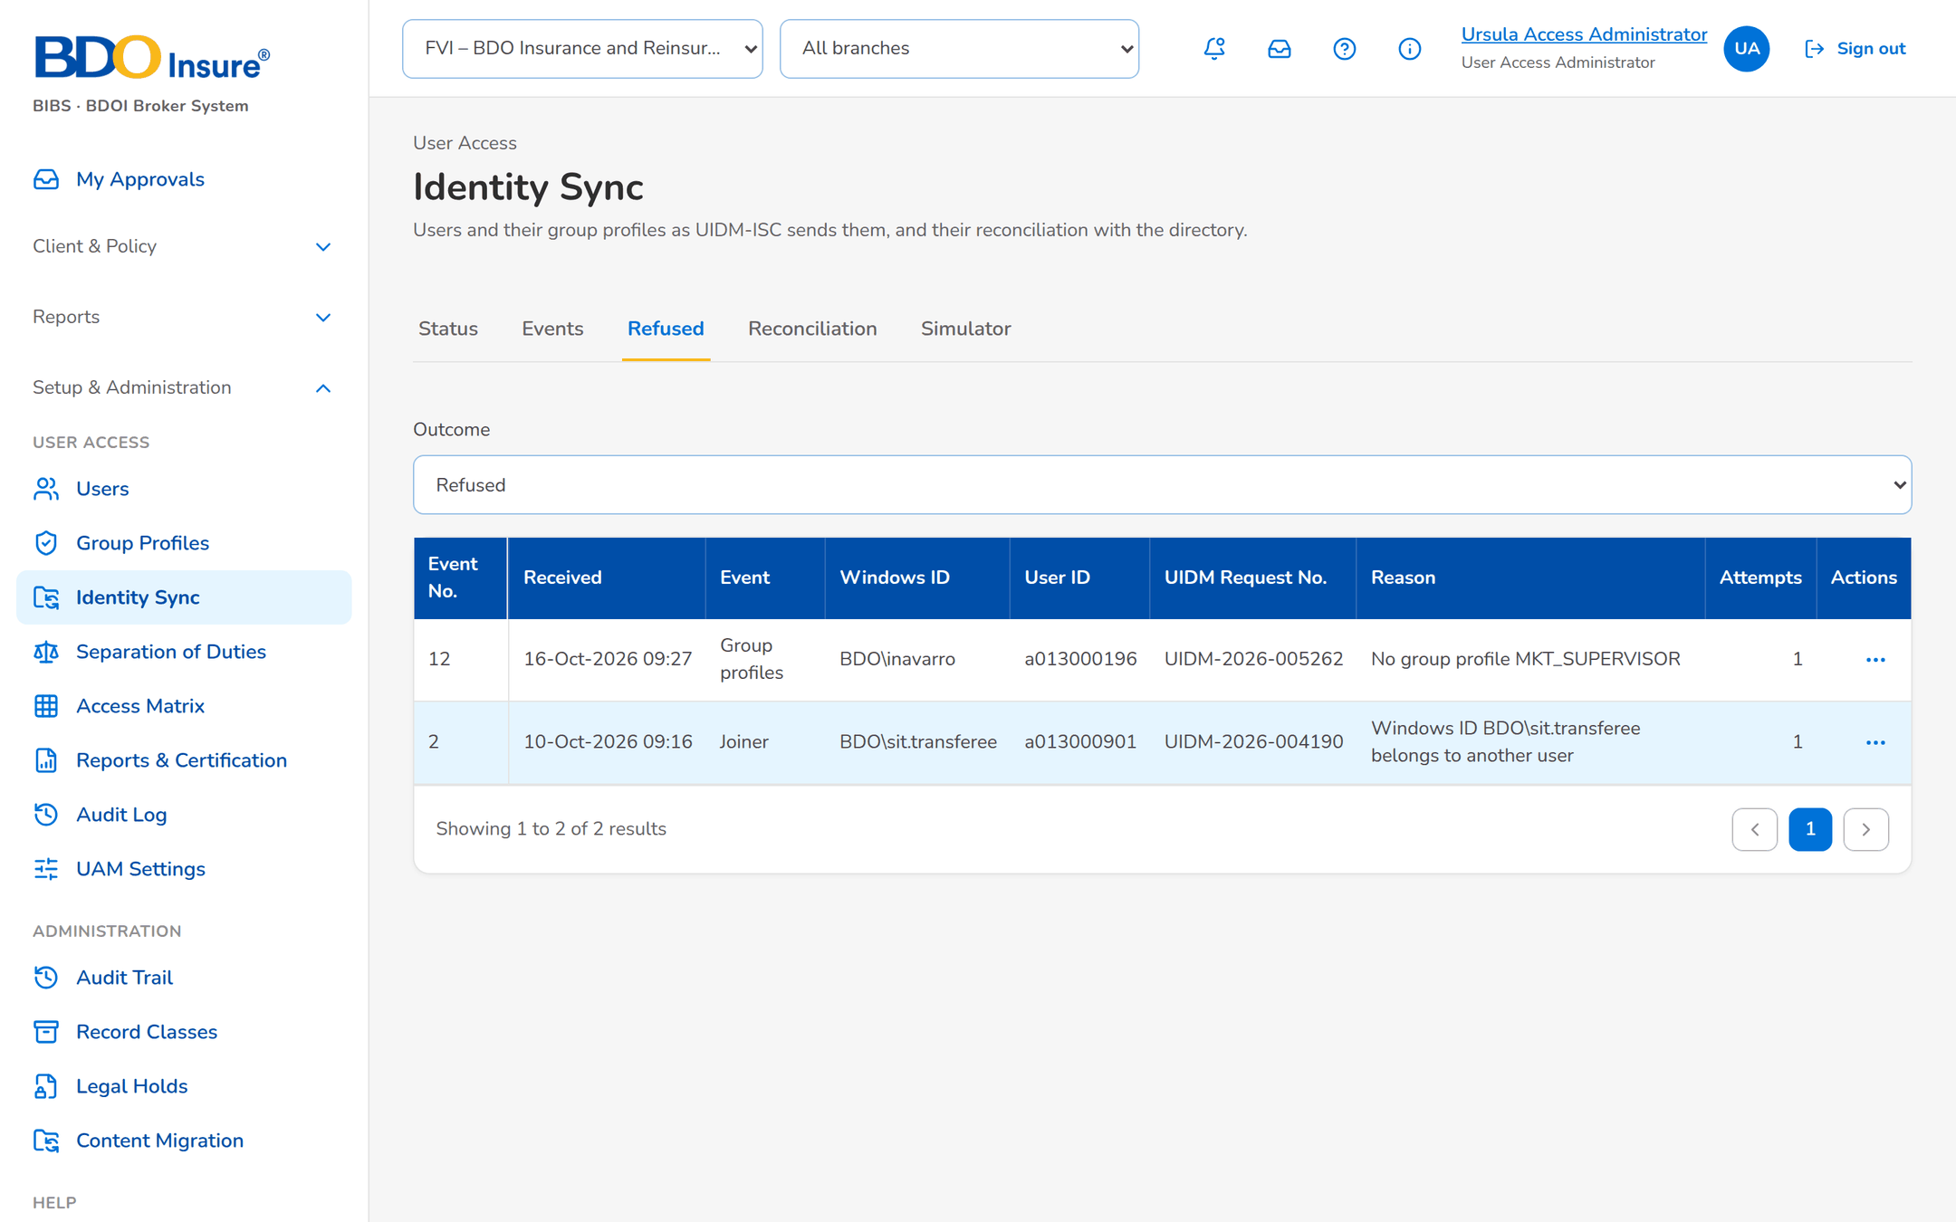
Figure 22: SB-4 step 1: User Access Administrator, Identity Sync › Refused
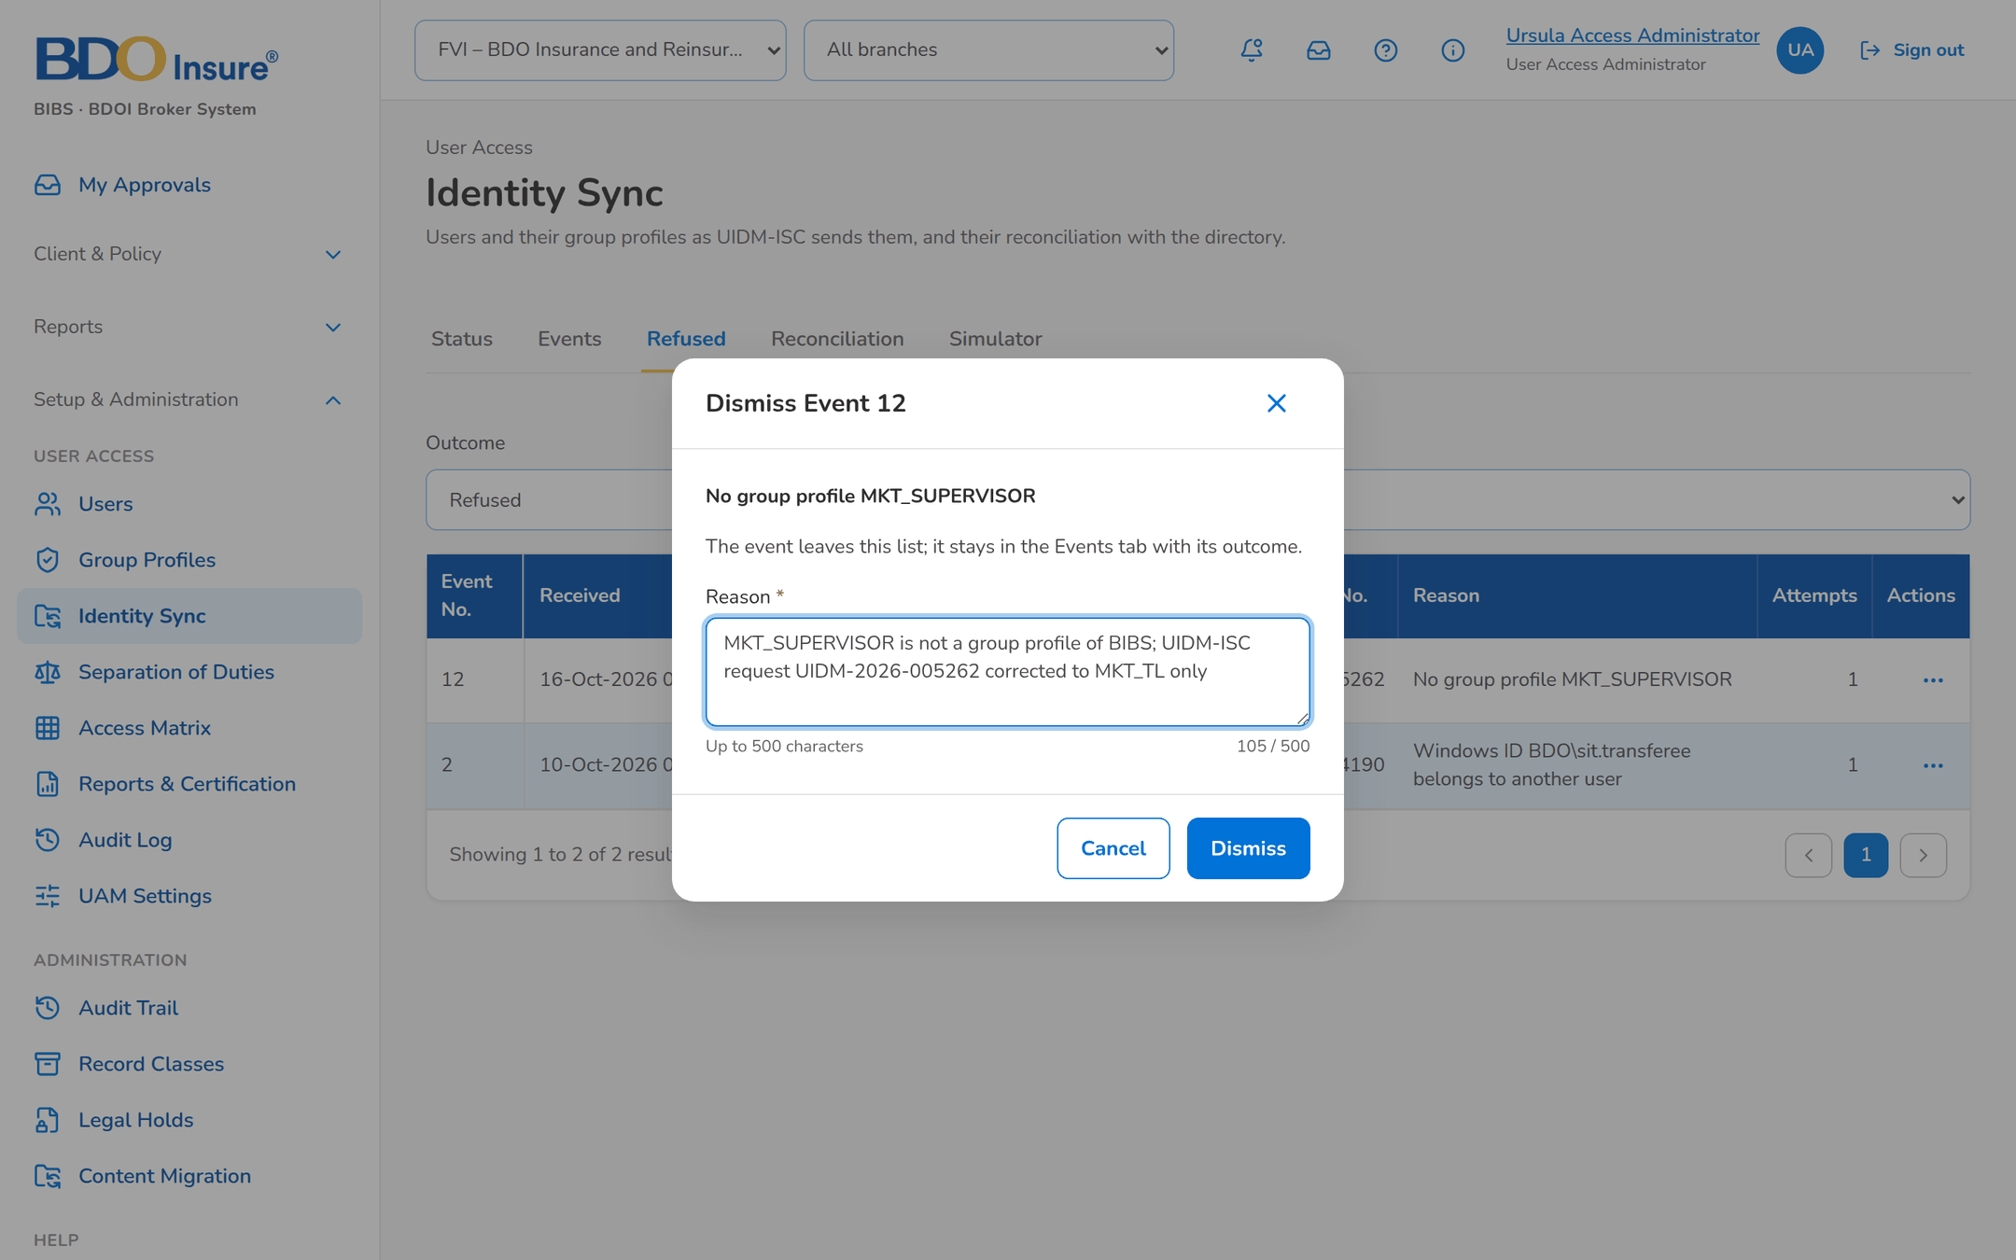
Figure 23: SB-4 step 2: User Access Administrator, Dismiss
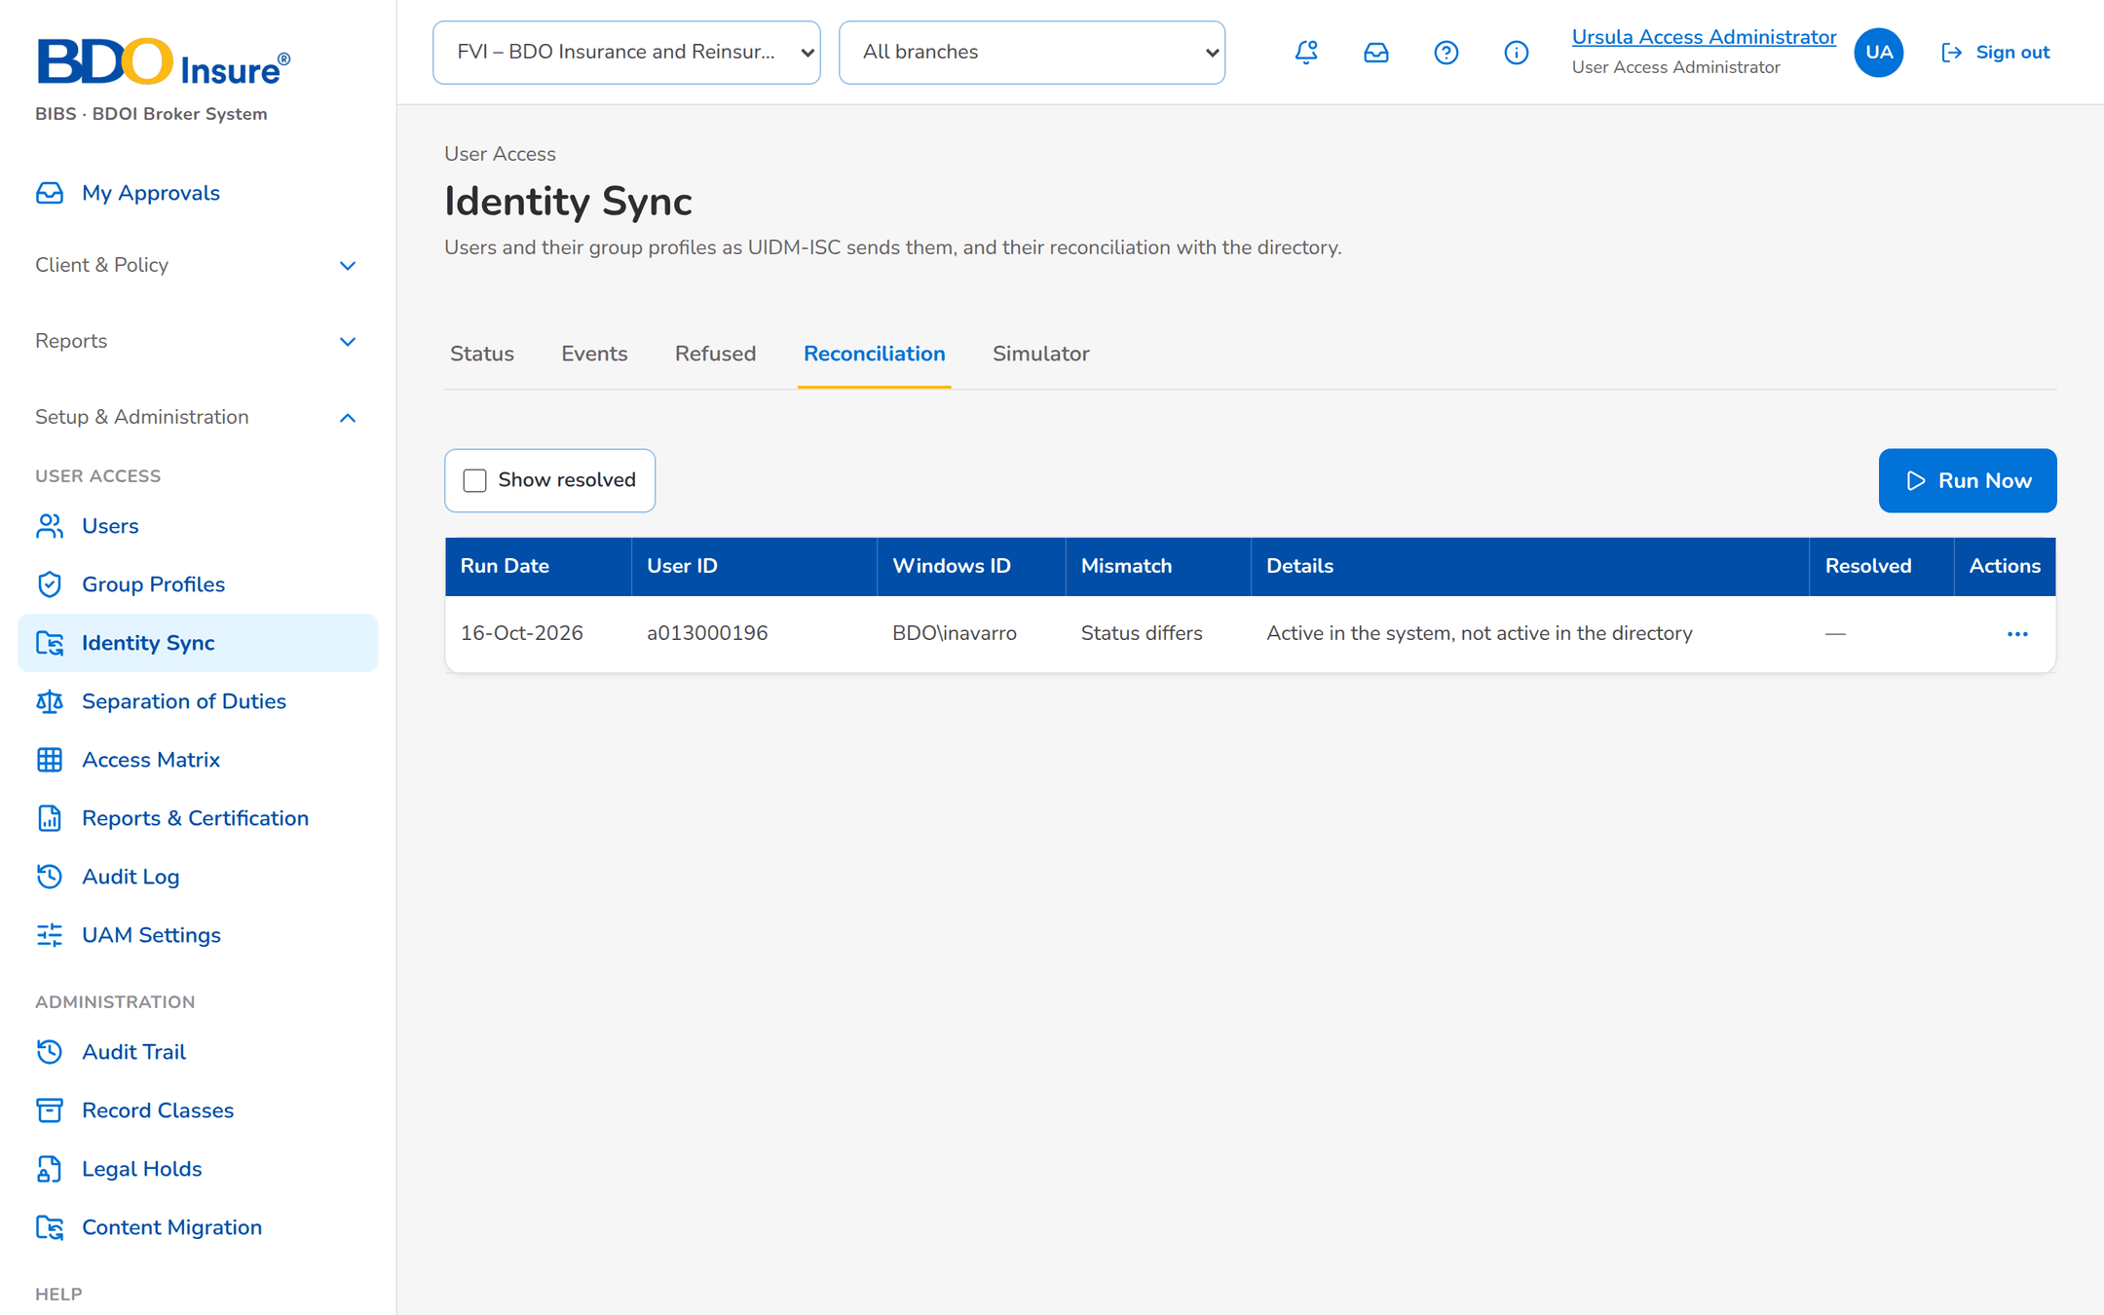
Figure 24: SB-4 step 3: User Access Administrator, Identity Sync › Reconciliation
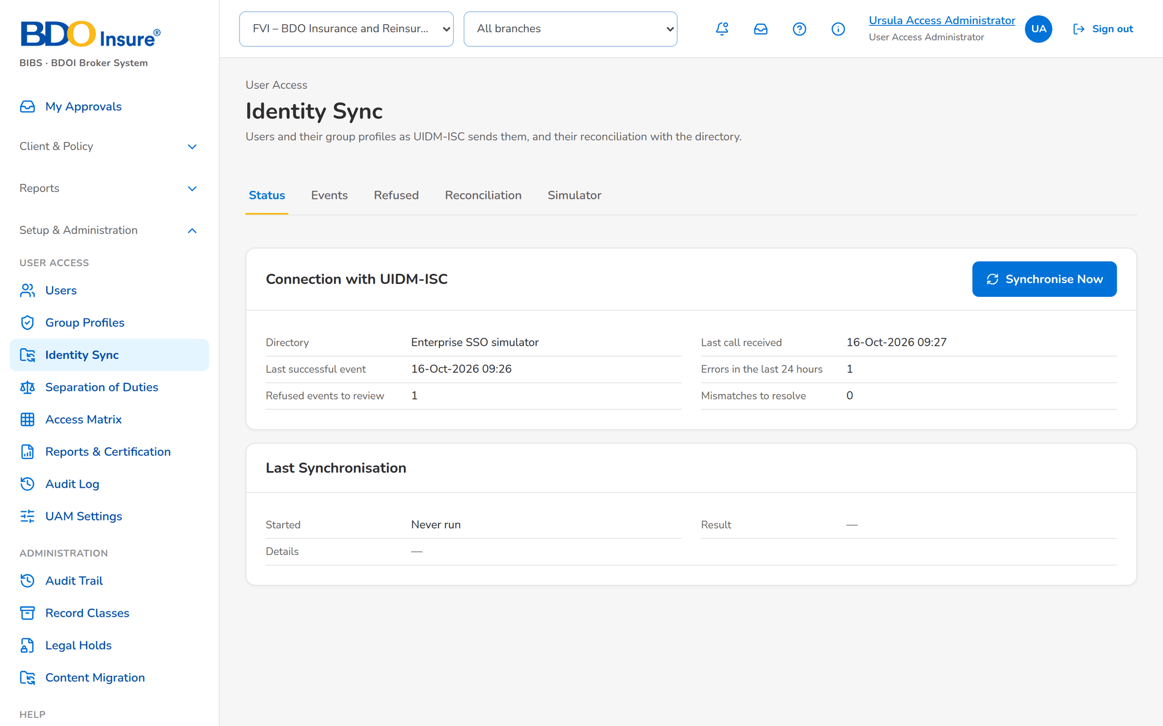
Figure 25: SB-4 step 4: User Access Administrator, Identity Sync › Status

SB-5 Evidence for the auditor and certification
Audrey Access Auditor prepares the quarterly access certification.
Table 7: SB-5 steps
Step | Who | Screen | Does | Sees
1 | Auditor | Reports & Certification | Opens the reports. | Five reports and the certification extract.
2 | Auditor | Take Extract | Chooses XLSX and confirms. | The extract is logged with rows and SHA-256; Information Security is told.
3 | Auditor | Audit Log | Reads the user access events. | Every event with from and to values, who and when.
4 | Auditor | Access Matrix | Checks the group profiles against the permissions. | The matrix, exportable to Excel.

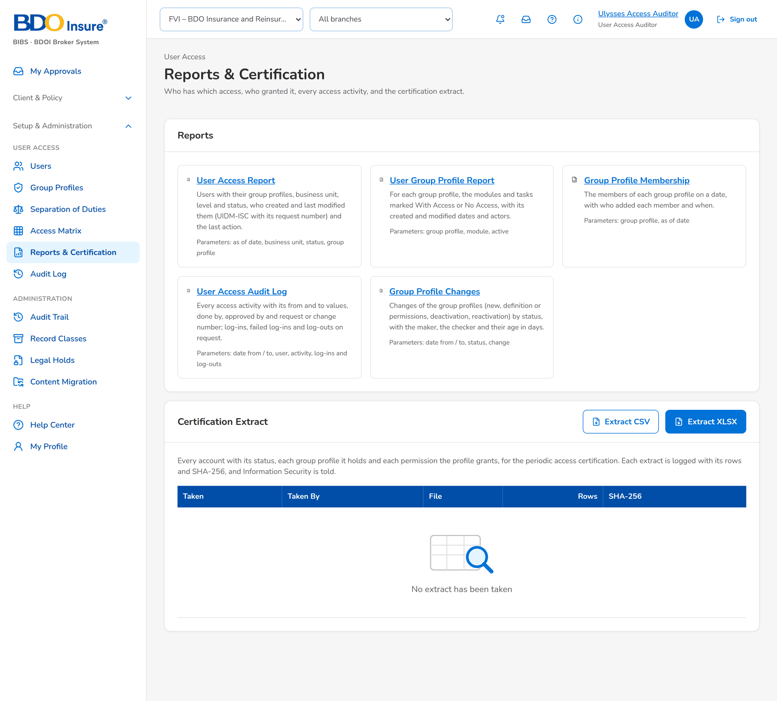
Figure 26: SB-5 step 1: Auditor, Reports & Certification
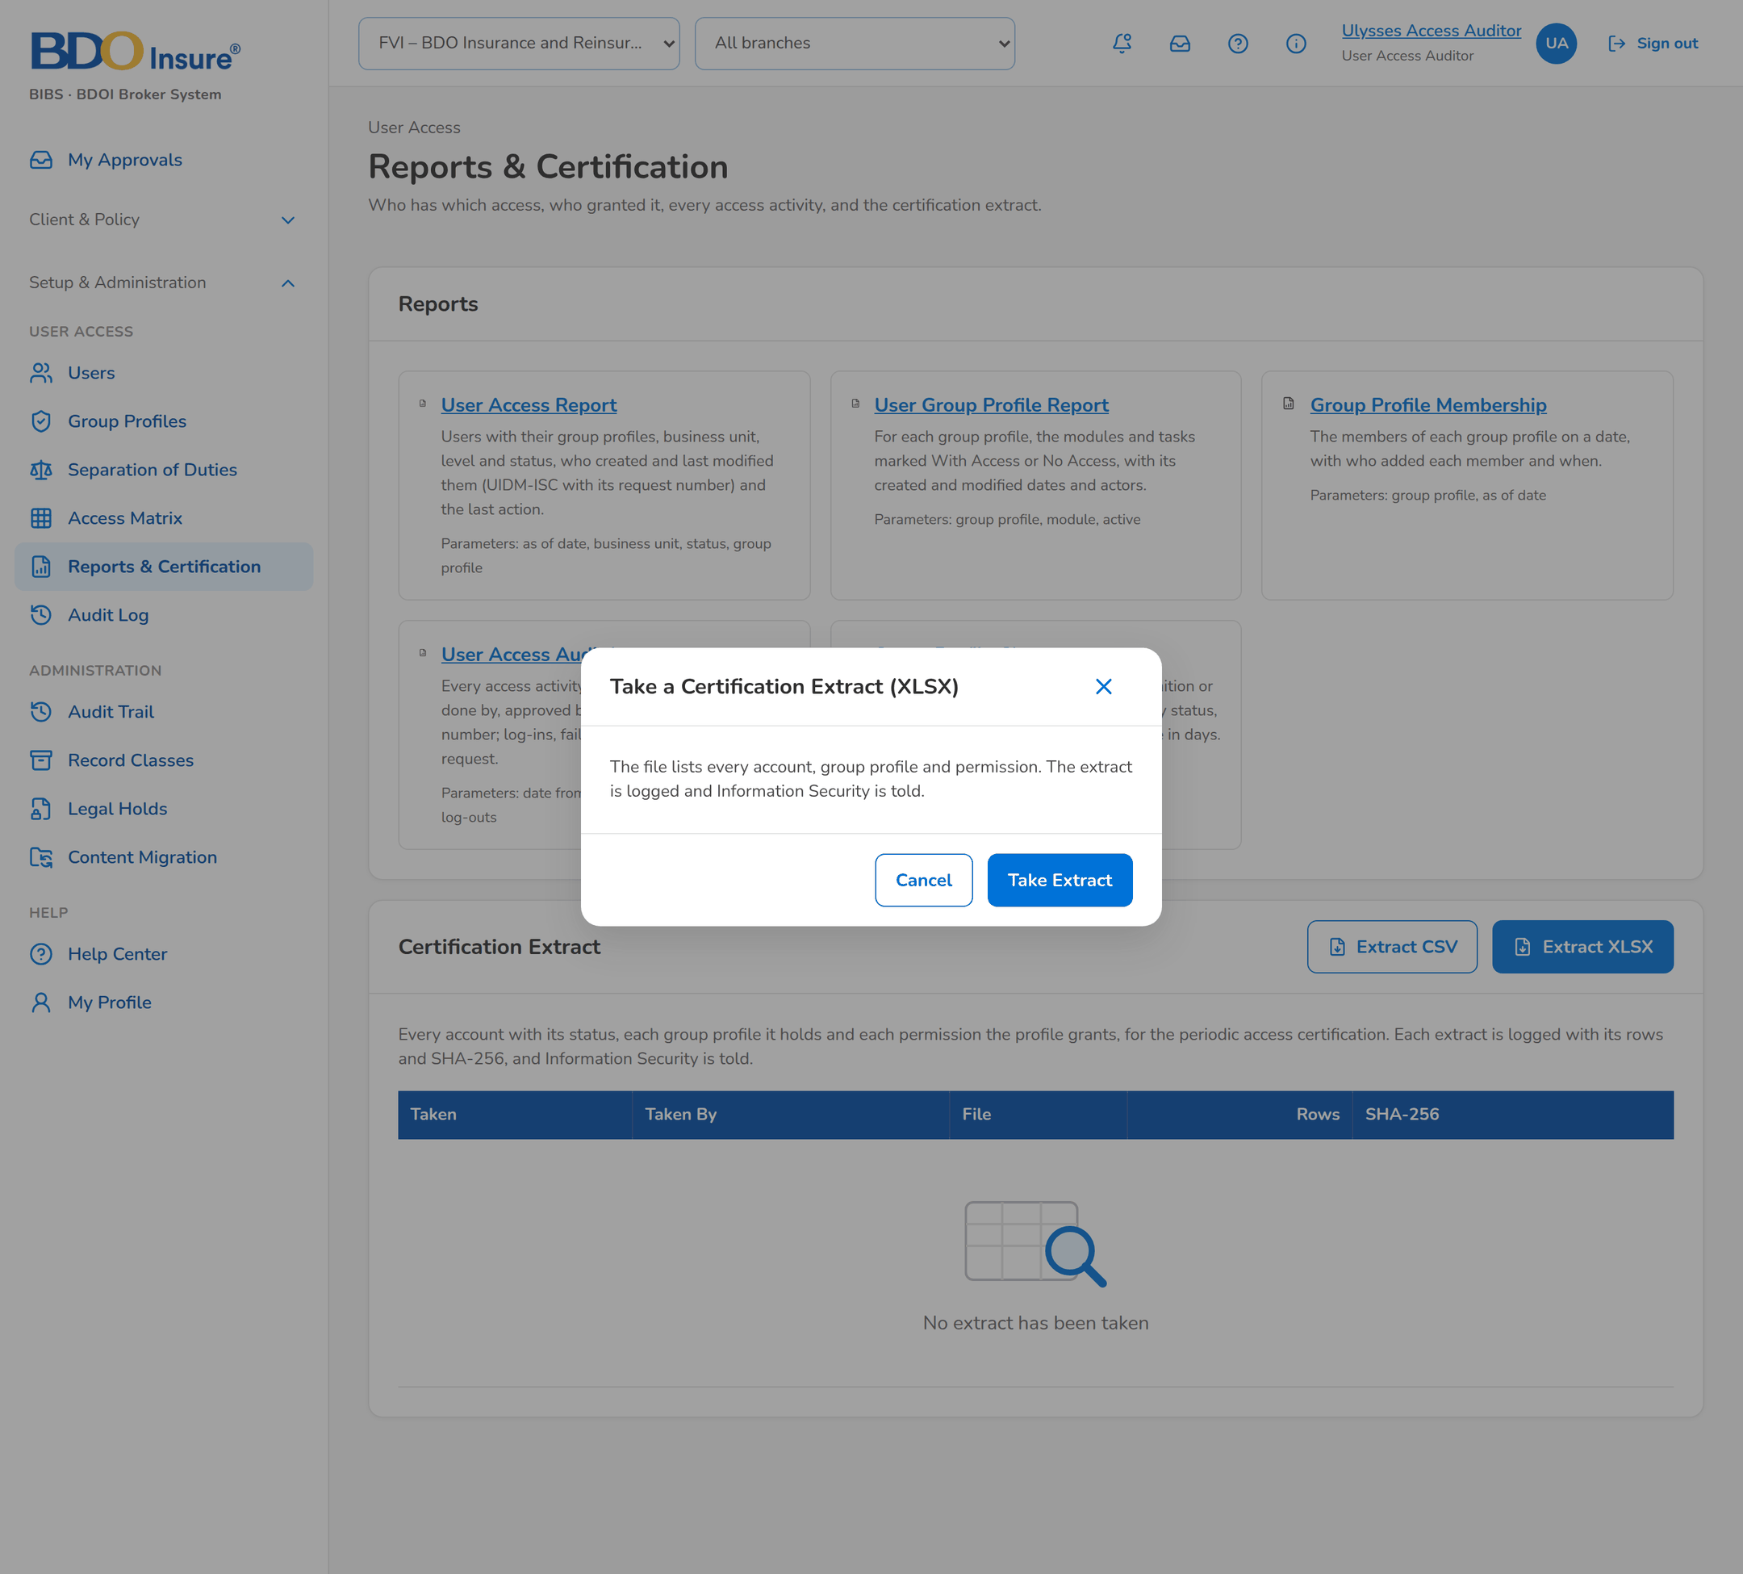
Figure 27: SB-5 step 2: Auditor, Take Extract
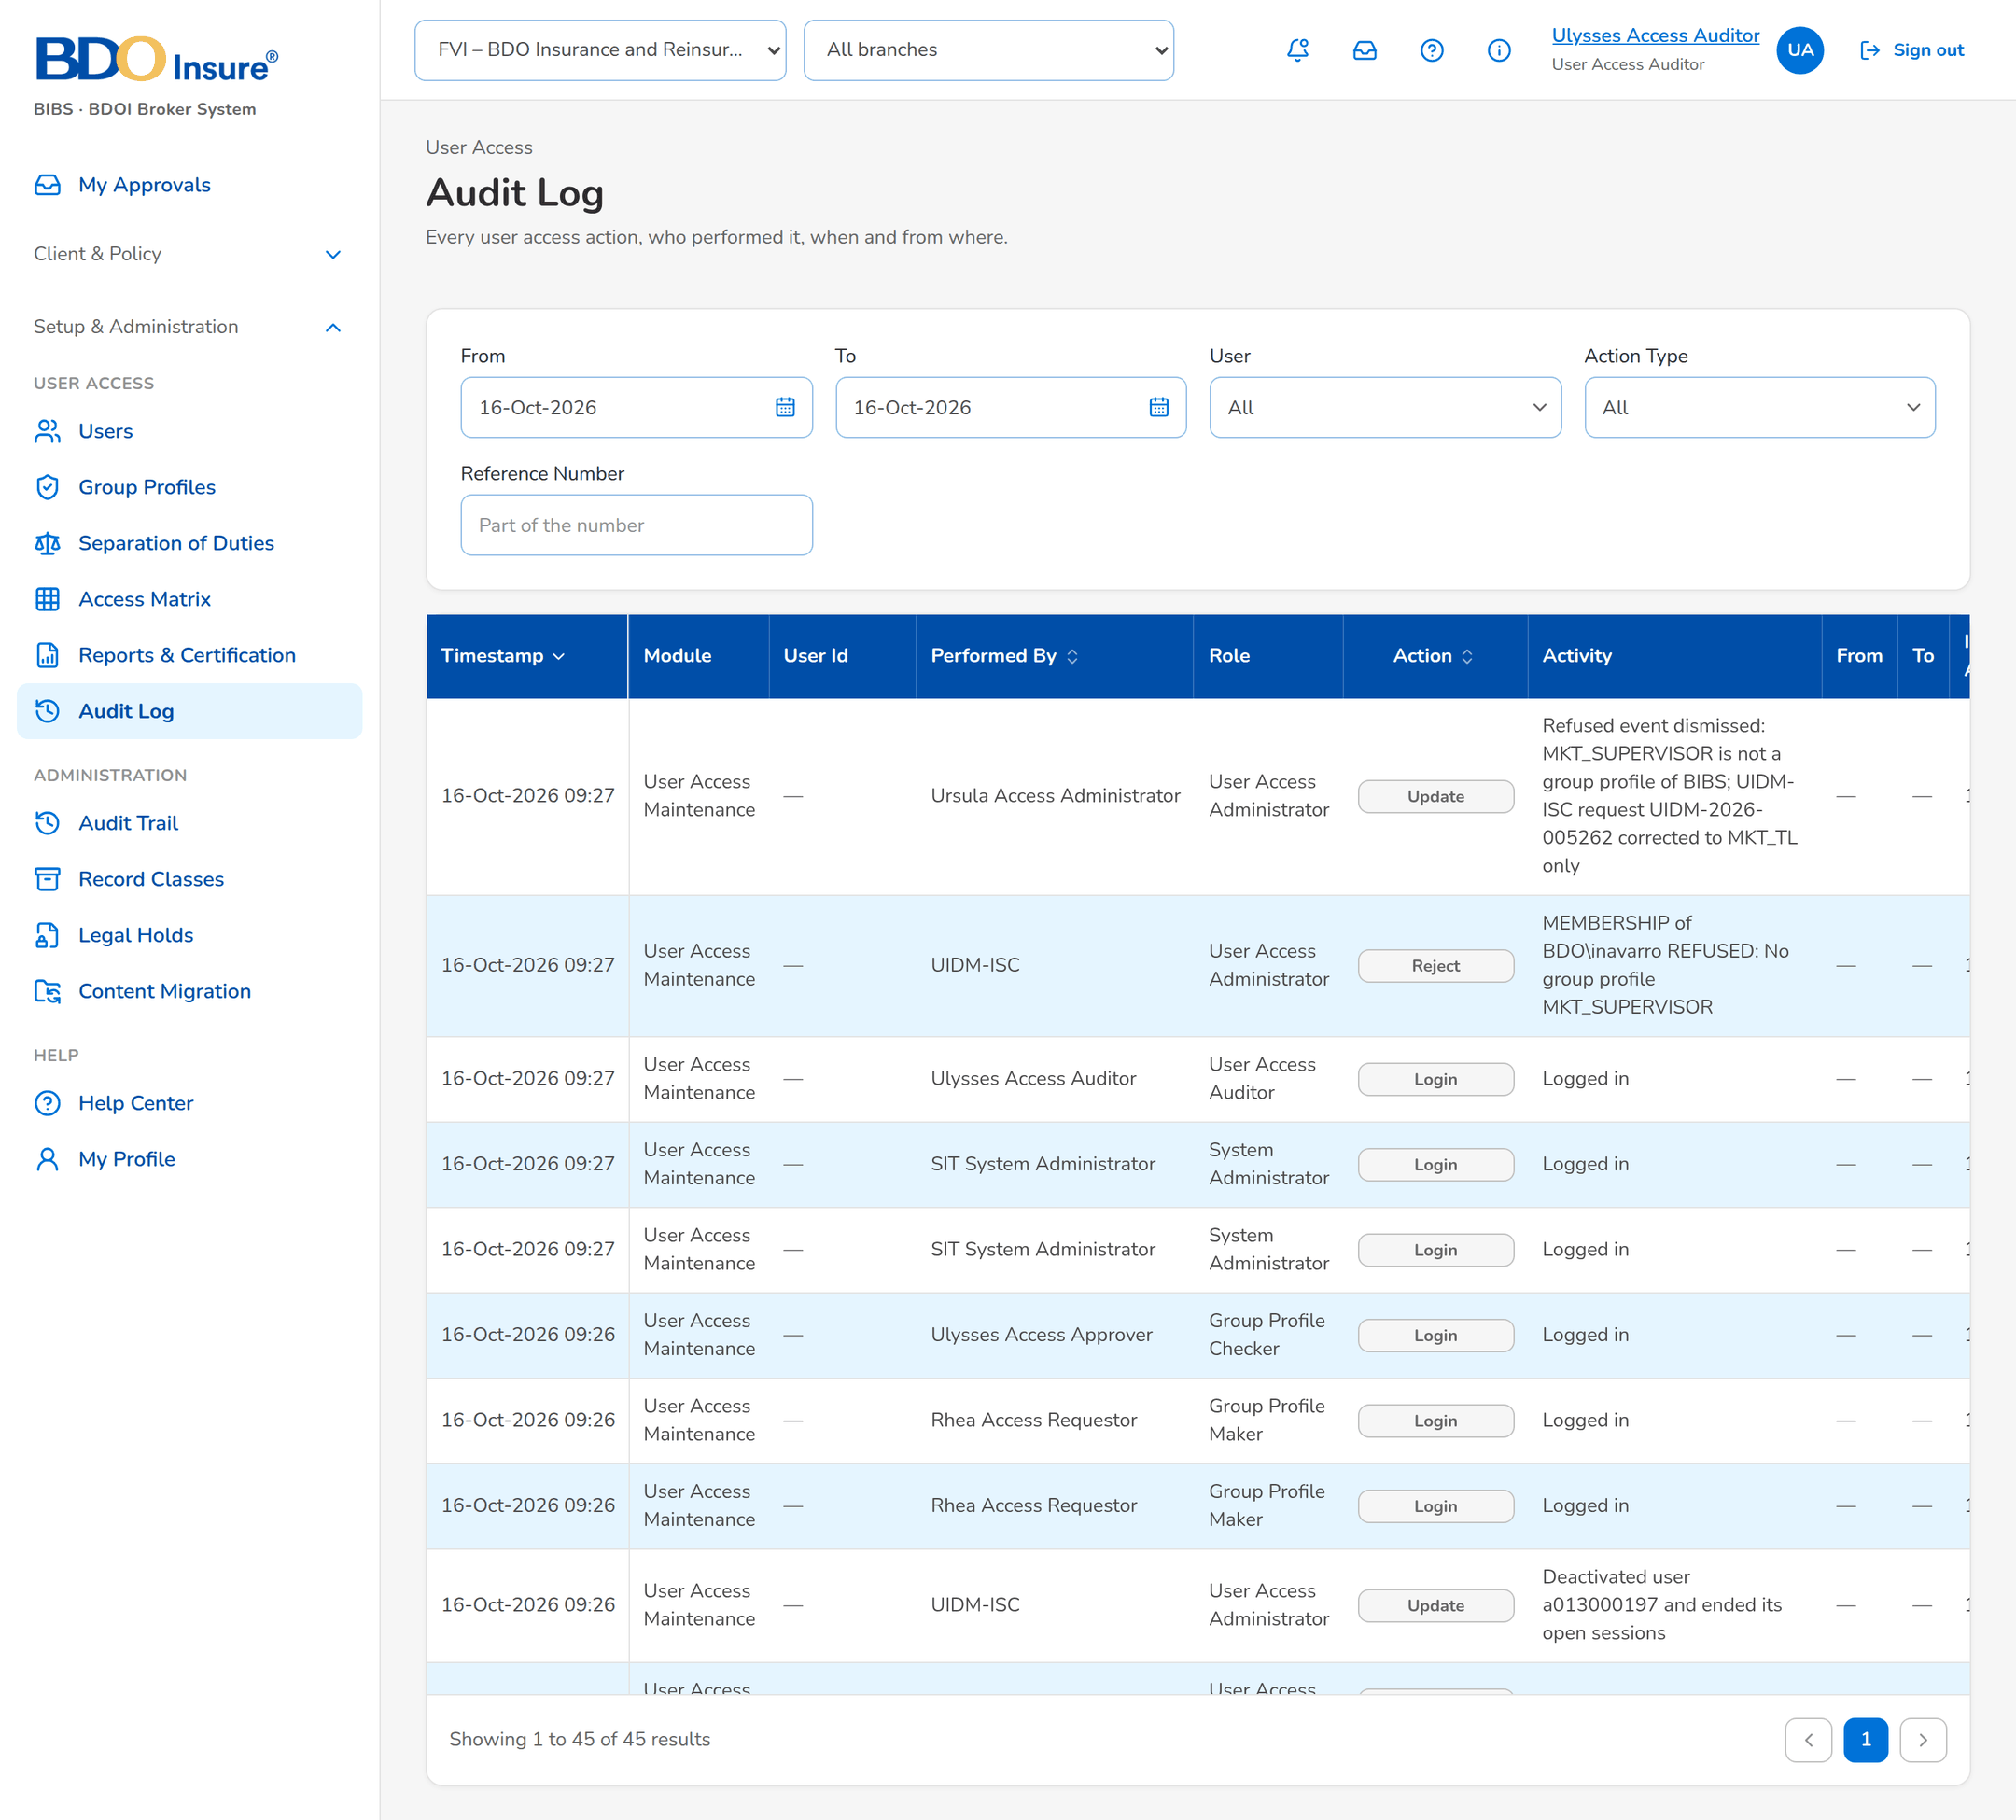
Figure 28: SB-5 step 3: Auditor, Audit Log
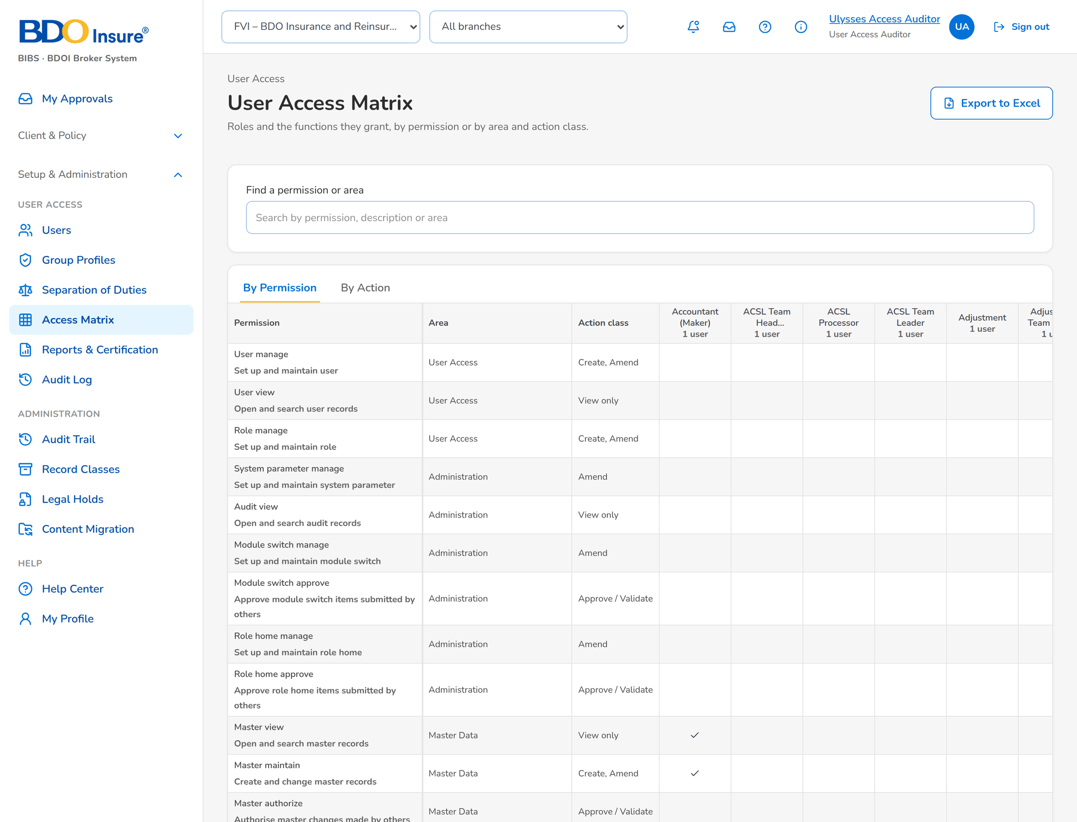
Figure 29: SB-5 step 4: Auditor, Access Matrix

