

FUNCTIONAL REQUIREMENTS SPECIFICATION
User Access Maintenance
BRD-11 User Access Maintenance (QPS User Access Maintenance Module)
BIBS – BDOI Broker System
Client | BDO Insurance and Reinsurance Brokers, Inc.
Document | BIBS-FRS-BRD-11
Version | 2.1
Date | 8 October 2026
Status | Issued for BDOI business sign-off
Classification | Confidential

Prepared by iorta TechNXT for BDOI 
iNXT BrokerVerse. This document is confidential to BDO Insurance and Reinsurance Brokers, Inc. and iorta TechNXT.
Document Control
Version | Date | Author | Reviewer | Approver | Change
0.9 | 18 Sep 2026 | iorta TechNXT Business Analysis | iorta TechNXT Solution Architect |  | Internal draft from the BRD-11 baseline
1.0 | 25 Sep 2026 | iorta TechNXT Business Analysis | iorta TechNXT Project Manager | BDOI Product Owner (pending) | First issue for BDOI review; aligned with the cross-BRD decisions
1.1 | 26 Sep 2026 | iorta TechNXT Business Analysis | iorta TechNXT Solution Architect | BDOI Product Owner (pending) | BDOI Drop 0 integrations of 26-Sep-2026: sign-in through EIAM (Microsoft Entra ID, OpenID Connect) as the target of FR-UA-003; UIDM-ISC (IGA) provisioning against the BIBS request rule, options for BDOI (IQ04, IQ05; register DCR-229, DCR-230); portal users of decision D7 dormant (EB without portal, IQ22)
2.0 | 27 Sep 2026 | iorta TechNXT Business Analysis | iorta TechNXT Project Manager | BDOI business owner, Information Security and BDOI IT (sign-off) | Business sign-off pack: the messages and codes of the screens in every FR, the access functions of section 2.3, proposed business rules and clarifications for confirmation (chapter 22), the menu of every persona, screen specifications with screenshots, walkthroughs, messages, notifications, reports as documents, the bulk upload, configuration inputs the business provides, cross-BRD contract, sign-off and change control (chapters 12-21). Issued 27-Sep-2026. FR, BRD and test IDs kept
2.1 | 8 Oct 2026 | iorta TechNXT Business Analysis | iorta TechNXT Project Manager | BDOI business owner, Information Security and BDOI IT (sign-off) | Re-based on the User Access Maintenance BRD v1 (15-Apr-2025; no newer version received) and the Drop 0 decisions of 26-Sep-2026; user-story view and storyboard index added. Single sign-on with OpenID Connect and SAML 2.0 stated as part of BIBS, switched on by configuration, with EIAM on Microsoft Entra ID as the provider (FR-UA-003, chapter 7: SSO no longer on hold); EIAM sign-out on Log Out (FR-UA-004) and user matching by Windows ID or UPN as proposed rules; clarifications CLR-UA-21 to CLR-UA-27 and the Drop 0 question of every clarification (UA-Q01 to UA-Q57); reference to the Authentication and Identity Integration Requirements v1.0 (03-Oct-2026); screen count corrected to 19

Distribution List
Name / Unit | Role | Organisation | Purpose
Product Owner, Marketing Business System | Approver | BDOI | Review and sign-off
Business Administrators (process owner) | Business owner | BDOI | Review of all FRs
Unit Heads, Combank and Corbank Marketing / Corporate Processing | Approver | BDOI | Review of the request and approval steps
BDOI Information Security | Signatory | BDOI | Review and sign-off of the role matrix, the menus by persona and the separation-of-duties rules
BDOI IT | Signatory | BDOI | Review and sign-off of the sign-in and identity integration assumptions (EIAM, UIDM-ISC) and the System Administrator functions
ITIO-SRE and ITSD-AMS | System administration | BDO Unibank | Review of the System Administrator functions, sign-in and logs
ES-BPDS, Business Project Services | BRD owner | BDO Unibank ESG | Traceability check against the BRD
Project team | Delivery | iorta TechNXT | Delivery, test and UAT preparation

Contents

1 Introduction 10
1.1 Purpose 10
1.2 Scope 10
1.3 References 11
1.4 Definitions and acronyms 11
1.5 How to read the functional requirements 12
2 Business context and process overview 14
2.1 Business context 14
2.2 Process overview 14
2.3 Access functions 16
3 Personas and roles 17
3.1 Personas 17
3.2 Permissions 17
3.3 Permissions matrix 18
4 Functional requirements 20
4.1 Sign-in, session and password 20
FR-UA-001 Log in with a persona profile from a BDO-issued device 20
FR-UA-002 Warn before the inactivity and system log-out 21
FR-UA-003 Sign in with the BDO account (single sign-on through EIAM) 22
FR-UA-004 Log out and keep a session log 24
FR-UA-005 Enforce the password policy and self-service reset 25
FR-UA-006 Deactivate dormant users 27
4.2 User access requests (Requestor) 28
FR-UA-010 Draft, edit, cancel and submit an access request 28
FR-UA-011 Enrol a new user 30
FR-UA-012 Modify an existing user 31
FR-UA-013 Deactivate a user 32
FR-UA-014 Reactivate a user 33
FR-UA-015 Choose the approver 34
FR-UA-016 Apply correction on a returned request 35
FR-UA-017 Cancel a submitted request 36
FR-UA-018 View submitted requests and their status 37
FR-UA-019 Submit a bulk request 38
FR-UA-020 Apply changes on an effective date 40
4.3 Review and approval (Approver) 41
FR-UA-030 Receive, list and open requests for approval 41
FR-UA-031 Approve a request and grant the access 41
FR-UA-032 Reject a request 43
FR-UA-033 Return a request to the Requestor 43
FR-UA-034 Escalate privileged and out-of-hours changes for a second approval 44
4.4 Group-profile requests (Business Administrator) 45
FR-UA-040 Request a new group profile 45
FR-UA-041 Request a change to a group profile 47
FR-UA-042 Request the deactivation of a group profile 48
FR-UA-043 Request the reactivation of a group profile 49
FR-UA-044 Route group-profile requests to approvers in order 50
FR-UA-045 Implement an approved group-profile request 51
4.5 System Administrator functions 52
FR-UA-050 Define the group profiles of the access personas 52
FR-UA-051 Assign functions to a group profile 53
FR-UA-052 Maintain user data and the user ID format 54
FR-UA-053 Keep profiles that one user may not hold apart (separation of duties) 55
FR-UA-054 Second approval of the security settings 56
4.6 Reports and logs 57
FR-UA-060 User Access Report 57
FR-UA-061 User Group Profile Report 58
FR-UA-062 Group Profile Membership list 59
FR-UA-063 User Access Audit Log 59
FR-UA-064 Keep an access-change log that no user can change 60
4.7 Notifications 61
FR-UA-070 Notify requesters, approvers and affected users 61
FR-UA-071 E-mail designated users on failed batch runs 62
5 Request lifecycle 64
5.1 User access requests 64
5.2 Group-profile requests 65
6 Reports 66
6.1 Report list 66
6.1.1 User Access Report (UAM-USER-ACCESS) 66
6.1.2 User Group Profile Report (UAM-GROUP-PROFILE) 66
6.1.3 Group Profile Membership (UAM-GROUP-MEMBERS) 67
6.1.4 User Access Audit Log (UAM-AUDIT-LOG) 67
7 Interfaces and integration 68
8 Non-functional requirements 70
9 Configuration items 74
9.1 Parameters and jobs 74
9.2 Lists of values 75
10 Assumptions, dependencies and open questions 76
10.1 Assumptions 76
10.2 Dependencies 76
10.3 Open questions 76
11 Traceability 78
12 Navigation 85
12.1 Screens of User Access Maintenance 85
12.2 Screen flow 86
12.3 Menu by persona 88
12.3.1 Requestor (UAM_REQUESTOR) 88
12.3.2 Approver (UAM_APPROVER) 88
12.3.3 Second Approver (UAM_SECOND_APPROVER) 88
12.3.4 Business Administrator (BUSINESS_ADMIN) 89
12.3.5 System Administrator (SYSADMIN) 89
12.3.6 Auditor (AUDITOR) 90
12.3.7 Information Security Officer (INFOSEC_OFFICER) 92
12.3.8 New Business Approver (keeps the access approval right) (NB_APPROVER) 92
12.3.9 Marketing Account Officer (MKT_AO) 93
12.3.10 Marketing Team Leader / Head (approver) (MKT_TL) 94
12.3.11 Processing Team Leader (PROCESSING_TL) 94
12.3.12 Processing (PROCESSOR) 95
12.3.13 LAMD (loan status validation) (LAMD) 96
12.3.14 Contact Center (renewal follow-up) (CONTACT_CENTER) 96
12.3.15 Compliance Officer (COMPLIANCE_OFFICER) 96
12.3.16 Compliance Officer (Checker) (COMPLIANCE_CHECKER) 97
12.3.17 Unit Compliance Coordinator (UNIT_COMPLIANCE_COORD) 97
12.3.18 Screening Investigator (SCR_INVESTIGATOR) 97
12.3.19 Screening Approver / Unit Head (SCR_APPROVER) 98
12.3.20 AML Committee Member (AML_COMMITTEE) 98
12.3.21 Marketing Account Officer (Employee Benefits) (EB_AO) 98
12.3.22 Marketing Team Lead / Unit Head (Employee Benefits) (EB_TL) 99
12.3.23 BDOI Management (Employee Benefits threshold approver) (EB_MANAGEMENT) 99
12.3.24 Processing (Employee Benefits) (EB_PROCESSOR) 100
12.3.25 Processing Supervisor (Employee Benefits) (EB_PROC_SUPERVISOR) 100
12.3.26 Collection (Employee Benefits) (EB_COLLECTION) 101
12.3.27 Claims Officer / Claims Assistant (CLM_OFFICER) 101
12.3.28 Claims Team Lead (CLM_TL) 102
12.3.29 Claims Team Head (CLM_TH) 102
12.3.30 Claims Unit Head (CLM_UH) 103
12.3.31 Claims / Risk Analyst (CLM_RISK) 103
12.3.32 Data Migration Lead (DATA_MIGRATION_LEAD) 104
12.3.33 Data Steward (DATA_STEWARD) 104
12.3.34 Data Owner (DATA_OWNER) 104
12.3.35 Migration Operator (MIGRATION_OPERATOR) 105
12.3.36 Migration Reconciliation Approver (MIGRATION_RECON_APPROVER) 105
12.3.37 Go-Live Board (migration go / no-go) (MIGRATION_GONOGO) 105
12.3.38 Legacy Inquiry (auditor) (LEGACY_INQUIRY) 106
12.3.39 Legacy Access Reviewer (LEGACY_ACCESS_REVIEWER) 106
12.3.40 Submitted Handler (SBM_HANDLER) 106
12.3.41 Submitted Checker (SBM_CHECKER) 106
12.3.42 Sanitation Handler (Submitted Policies) (SBM_SANITATION) 107
12.3.43 Submitted Policies Team Lead (SBM_TL) 107
12.3.44 Policy Review Officer (Submitted Policies) (SBM_POLICY_REVIEWER) 107
12.3.45 Handling Fee Handler (Unapplied Payments) (SBM_UPP_HANDLER) 108
12.3.46 Customer Service Agent (CSF_AGENT) 108
12.3.47 Customer Service Supervisor (CSF_SUPERVISOR) 108
12.3.48 Customer Service Management (CSF_MANAGEMENT) 108
12.4 Common screen elements 109
13 Screen specifications 111
13.1 Sign-in, password and session 111
13.1.1 SCR-UA-01 Login 111
13.1.2 SCR-UA-02 Forgot Password and Set a New Password 116
13.1.3 SCR-UA-03 Change Your Password (forced change) 121
13.1.4 SCR-UA-04 Inactivity and Session-end Warnings 124
13.1.5 SCR-UA-05 My Profile 125
13.2 User access requests 128
13.2.1 SCR-UA-06 Access Requests 128
13.2.2 SCR-UA-07 New Request and Edit Request (user requests) 133
13.2.3 SCR-UA-08 Access Request record 140
13.2.4 SCR-UA-09 Bulk Request 150
13.2.5 SCR-UA-10 Bulk Request Batch 154
13.3 Group profiles 156
13.3.1 SCR-UA-11 Group Profile Requests 156
13.3.2 SCR-UA-12 New Group Profile Request and Edit Request 159
13.4 Access evidence and administration 164
13.4.1 SCR-UA-13 User Access Matrix 164
13.4.2 SCR-UA-14 User Access Reports 169
13.4.3 SCR-UA-15 Users 171
13.4.4 SCR-UA-16 Roles & Permissions 175
13.4.5 SCR-UA-17 User access report (report runner) 178
13.4.6 SCR-UA-18 System Parameters (sign-in, password and access settings) 184
13.4.7 SCR-UA-19 Separation of Duties 188
14 End-to-end walkthroughs 193
14.1 WT-A A new user from the enrolment request to the first sign-in with the menus of the persona 193
14.2 WT-B A change and a revocation under four eyes, and a group-profile change approved in order and implemented 205
14.3 WT-C Refused cases and the messages the user sees 221
14.4 WT-D The evidence of access, and the insurer roles hidden from BDOI 238
15 Messages catalogue 245
16 Notifications catalogue 258
17 Document outputs 260
17.1 DO-01 User Access Report 260
17.2 DO-02 User Group Profile Report 261
17.3 DO-03 Group Profile Membership 262
17.4 DO-04 User Access Audit Log 263
17.5 DO-05 Access Requests 264
17.6 DO-06 User Access Matrix (Excel) 265
18 Upload screens 267
18.1 Bulk access requests (UAM_ACCESS_REQUEST) 267
19 Configuration inputs the business provides 268
19.1 CI-02 Role-to-permission matrix 269
19.2 CI-06 Lists of values 270
19.3 CI-01 Users and roles load 270
19.4 CI-04 Separation-of-duties rules 271
19.5 CI-03 Approvers, approval rules and limits 272
19.6 CI-05 Password, session and sign-in parameters 273
20 Cross-BRD dependencies and interface contract 275
21 Sign-off and change control 277
21.1 What is signed 277
21.2 How the review is recorded 277
21.3 What each signatory confirms 278
21.4 What signing freezes 278
21.5 Change after sign-off 278
21.6 Proposed rules for confirmation 278
21.7 Signatures 280
22 Proposed business rules and clarifications for confirmation 281
23 Appendix: User-story view 284
24 Appendix: Storyboard index 298
25 Appendix: Screen standards 303

1 Introduction

1.1 Purpose
This Functional Requirements Specification (FRS) states how BIBS (BDOI Broker System, on iNXT BrokerVerse) meets the User Access Maintenance business requirements of BDO Insurance and Reinsurance Brokers, Inc. (BDOI). It turns each BRD requirement into functional requirements with actors, flows, rules, validations, screens, fields, notifications, audit and acceptance criteria.
BDOI uses this document to confirm that user access will be managed as the business expects. The project team uses it to deliver, test and prepare user acceptance testing (UAT). Every functional requirement (FR) cites the BRD requirement it meets and the BRD page.
User access in BIBS covers users, group profiles (roles) and permissions, sign-in with lock-out, the session policy, access requests under four eyes and the User Access Matrix; section 2.3 summarises each access function. The FRs quote the screen names, messages and codes that the users see. Where the proposed rule or screen differs from the BRD, or needs a decision of BDOI, chapter 22 lists it for confirmation. Chapters 12 to 21 are the business view of the system for the sign-off: the menu of every persona, the screens with their fields and messages, the walkthroughs, the reports, the configuration inputs and the interface contract.

1.2 Scope
The BRD was written in April 2025 for the Quotation and Pre-processing System (QPS), before BIBS. In BIBS it becomes the system-wide user access maintenance: every BIBS module uses the same users, group profiles (BIBS roles) and permissions (UQ19).
Table 1: Scope of this FRS
Area | In scope | Source
Sign-in and session | Log-in by persona; single sign-on with the BDO identity provider (EIAM on Microsoft Entra ID) through OpenID Connect or SAML 2.0; directory authentication (EUA / Windows ID) until EIAM replaces it; inactivity warning and log-out, lock-out, password policy for local accounts, log-out and session log | BRD 1.001, 2.001, 3.001, 4.001; NFR p.13-14, 17
User access requests | Enrol, modify, deactivate and reactivate users; drafts, remarks, chosen approver, correction of returned requests, cancellation, view of own requests, bulk requests, effective dates | BRD 1.002 to 1.009; NFR p.13, 17
Approval | Notification, list and filter, details, approve, reject, return; second approval of risky changes | BRD 2.002; NFR p.17
Group profiles | Requests to create, modify, deactivate and reactivate group profiles with approvers in order; implementation by the System Administrator | BRD 3.002; p.6
System Administrator | Group profiles of the UAM personas; functions assigned to profiles; user data maintenance | BRD 4.002; NFR p.13-14
Reports and logs | User Access Report, User Group Profile Report, Group Profile Membership list, User Access Audit Log; structured access-change log | BRD 3.003, 4.003; p.18

Out of scope for this phase:
• Infrastructure items the BRD answers with "Follow existing QPS set up" (servers, network, DR, environments, support). They follow the BIBS deployment standards (section 8).
• Data and user migration: "N/A" in the BRD (p.12). Existing users can be loaded with the bulk request (FR-UA-019).
• Automatic joiner and leaver feeds from HR. The BRD does not ask for them; bulk requests cover mass changes.
• The EUA and LDAP / Active Directory connections, which the project team proposes to replace by EIAM (CLR-UA-21), and an external ACL (UQ14). Single sign-on is in scope: BIBS signs users in through the BDO identity provider with OpenID Connect or SAML 2.0, switched on by configuration once BDOI IT registers BIBS in EIAM for each environment (FR-UA-003, CLR-UA-01). The protocol, registration and provisioning details are in the Authentication and Identity Integration Requirements v1.0, 03-Oct-2026 (R9), reviewed by BDOI IT.

1.3 References
Table 2: Reference documents
Ref. | Document | Version / date
R1 | Business Requirements Document - QPS User Access Maintenance Module, 39 pages (pp.1-19 text; pp.20-38 the signed scanned copy; p.39 e-mail sign-off) | v1, 15-Apr-2025; signed April-May 2025
R2 | BDOI User Access Maintenance (BRD-11) requirements baseline | current
R4 | Cross-BRD decisions and answered questions | current
R6 | FRS BRD-3 Product Maintenance (role-permission change requests, PMADD05) | v2.0
R7 | BDO UX guidelines (brand, screen patterns) | current
R8 | BRD-1 New Business business sign-off set (My Approvals, Lists of Values, Data Retention) | v2.0
R9 | Authentication and Identity Integration Requirements (single sign-on with OpenID Connect and SAML 2.0 through EIAM, provisioning and aggregation with UIDM-ISC; issued separately, reviewed by BDOI IT) | v1.0, 03-Oct-2026
R10 | Drop 0 questions to BDOI, BRD-11 User Access Maintenance (UA-Q01 to UA-Q57) | October 2026

Page references in this document ("p.8") are pages of the BRD PDF (R1). The BRD has no NFR IDs; the NFR rows carry the analyst's IDs UAM-NFR-01 to UAM-NFR-41 of R2.

1.4 Definitions and acronyms
Term | Meaning
Access request | A request to create, change, deactivate or reactivate a user, or to change a group profile, decided under four eyes; numbered AR-yyyy-nnnnnn
Approver | The user who reviews and approves, rejects or returns access requests (BRD section B)
BRD | Business Requirements Document
Break-glass administrator | A named System Administrator account that keeps a local BIBS password and second factor so that BIBS can be administered when the identity provider is not available
Business Administrator | The BDOI user who defines and manages group profiles and raises group-profile requests (BRD section C)
EIAM | BDO Enterprise Identity Access Management on Microsoft Entra ID, the target sign-in of BDO users named by BDOI for Drop 0 (owned by BDOI IT)
EUA | BDO end-user authentication service that validates the Windows ID and password (NFR p.14)
FR | Functional requirement of this document (FR-UA-nnn)
Group profile | A set of permissions assigned to a group of users (BRD p.4); a role in BIBS
LDAP / AD | Lightweight Directory Access Protocol / Active Directory
OIDC | OpenID Connect, a single sign-on standard; BIBS signs a user in with the identity the BDO identity provider returns
Permission | One function or capability in BIBS, with an area (module) and an action class (VIEW, CREATE, AMEND, APPROVE)
QPS | Quotation and Pre-processing System, the legacy system the BRD was written for
Requestor | The user who submits user access requests (BRD section A)
SAML 2.0 | Security Assertion Markup Language, the other single sign-on standard BIBS supports
Seed data | The fictitious data of the SIT environment (users, requests, profiles) used in the screenshots and walkthroughs
SSO | Single sign-on - the user signs in once with the BDO account at the BDO identity provider (EIAM) and BIBS opens a session without a BIBS password
System Administrator | The IT user who implements group profiles and maintains users and roles (BRD section D)
UA-Qnn | Question on BRD-11 sent to BDOI with the Drop 0 questions (R10)
UAM-NFR-nn | ID given by the analyst to a non-functional requirement of the BRD (R2 section 7)
UAT | User acceptance testing
UIDM-ISC | BDO's identity governance and administration (IGA) tool, named by BDOI for Drop 0 for joiner, mover and leaver provisioning (owned by BDOI IT)
UPN | User principal name, the sign-in name of a BDO account in Microsoft Entra ID (for example name@bdo.com.ph)
UQnn | Open question on BRD-11 raised by the project team (section 10.3)
User Access | The permissions and privileges granted to a user (BRD p.4)
User Access Matrix | The screen and export that show which roles hold which permissions, by permission and by action class
Windows ID | The user's BDO network log-on name, held on every user; used to match the EIAM account to the BIBS user (proposed, CLR-UA-22) and for EUA authentication

1.5 How to read the functional requirements
Each FR in section 4 has the same parts:
• A header table with the BRD trace (requirement ID and page), the actor, the priority ("Must have" for the rows the BRD marks "Mandatory: Yes"; rows without a flag are noted) and the screens where the user performs it.
• Description, preconditions, main flow and alternate and exception flows. The description states the proposed behaviour of the function.
• Business rules. Configurable rules are maintained by the System Administrator in BIBS (parameter or list of values, section 9). Fixed rules are part of the system and change only through a change request.
• Validations and messages: the check, the message the user sees and its code. A "-" marks a screen check (for example a blank mandatory field), which has no business code. Chapter 15 lists every message, as the screens show it.
• Screens and fields, notifications, audit and numbered acceptance criteria, which are the basis of the BRD-11 test plan.
The BRD lists 160 requirement lines, many of them sub-steps of one function ("create request", "add remarks", "save remarks"). The FRs group them by function; section 11 lists every line with its FR.
The 160 requirement lines split into 67 FIT, 4 CONFIGURE, 61 CHANGE and 28 NEW; the 41 NFR rows into 13 FIT, 8 CONFIGURE, 12 CHANGE and 8 NEW (R2, section 3).

2 Business context and process overview

2.1 Business context
Today BDOI coordinates every QPS user access request with IT, which causes delays (p.5). The BRD asks for a module in which the business unit manages user permissions, roles and access levels itself, securely and with self-service requests, and changes roles simply. It assumes that a User Access Matrix is defined (p.5).
Table 3: Current and envisioned process (BRD p.5-6)
# | Current process (before) | Envisioned process in BIBS (after)
1 | Access requests are sent to IT and coordinated by the business unit | The Requestor raises the request in BIBS, as a draft or submitted, alone or in bulk
2 | The approver is reached by e-mail | The Requestor chooses the approver; BIBS notifies the approver and lists the request under "Assigned to me"
3 | IT grants the access | BIBS grants the access on approval, or on the effective date
4 | Group profiles are created or changed by IT on request | The Business Administrator requests the change, the approvers approve in order, and the System Administrator implements it in BIBS
5 | Access lists are compiled by hand | Four reports and a structured audit log show who has which access, since when and who changed it

2.2 Process overview
The BRD shows two processes (p.6). The table lists the steps and Figure 1 shows them with the BIBS additions (risk rules, effective date, reports).
Table 4: Process steps
# | Step | Owner | What happens in BIBS | BRD
1 | Draft | Requestor | Creates a request to enrol, modify, deactivate or reactivate a user, or a bulk file; enters data, group profiles, effective date and remarks; chooses the approver; saves, edits or cancels the draft | 1.002-1.005, 1.009
2 | Submit | Requestor | BIBS checks the request; status PENDING; the chosen approver is notified | 1.00x.4, 2.002.1
3 | Risk check | System | A change to a high-privilege profile, or a submission outside working hours, needs a second approval and raises an alert | NFR 11 (p.17)
4 | Decide | Approver | Approves, rejects with a reason, or returns with remarks | 2.002.5-2.002.7
5 | Correct | Requestor | Corrects the returned request and re-submits it, or cancels it | 1.006, 1.007
6 | Apply | System | Applies the change on approval or on the effective date; logs from / to values; notifies the requester and the affected user | p.6; 1.008.1.4; NFR 10
7 | Group profile | Business Administrator, Approvers, System Administrator | Requests a new, changed, deactivated or reactivated profile; approvers decide in order; the System Administrator implements the approved request | 3.002; p.6
8 | Reports and logs | Business Administrator, System Administrator, Auditor | User access, group profile, membership and audit log reports | 3.003, 4.003

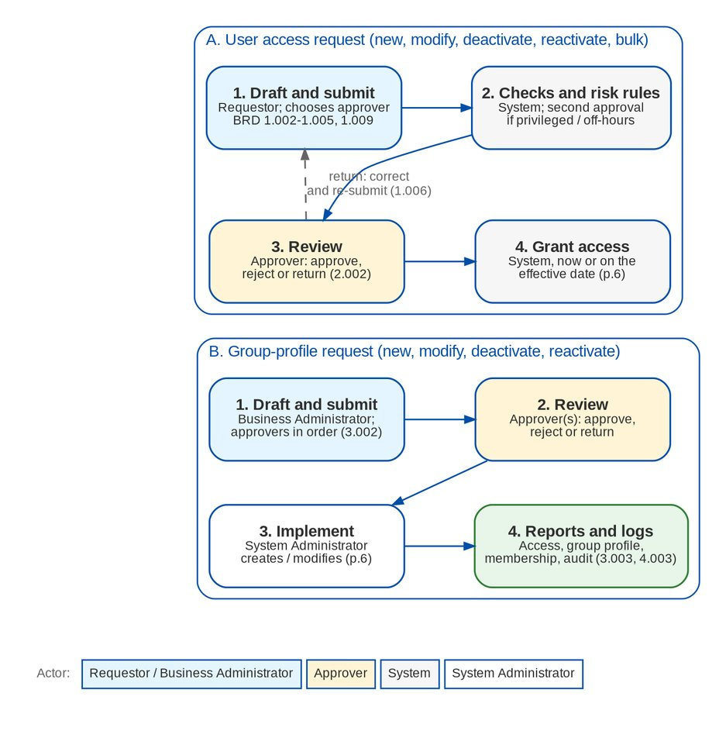
Figure 1: User access request and group-profile request by actor (BRD p.6)

2.3 Access functions
The table summarises each access function of BIBS: the screen, the permission and the proposed behaviour. The Access Requests and User Access Matrix screens are in the User Access section of the menu.
Table 5: Access functions of BIBS
Function | Screen, permission and main behaviour | Further proposed behaviour
Sign-in and lock-out | Login screen; user name and password; the account locks after LOGIN_MAX_FAILED_ATTEMPTS = 3 failed attempts until an administrator unlocks it; every success and failure is in the audit trail | Directory authentication with the Windows ID when BDO supplies the interface; log-out and session log
Session policy | Inactivity warning after SESSION_IDLE_WARNING_MINUTES = 15; sign-out after SESSION_TIMEOUT_MINUTES = 30 of inactivity; warning SESSION_EXPIRY_WARNING_MINUTES = 30 before the fixed session expiry | Confirmed by the BRD (Q42)
Users | Administration > Users (USER_MANAGE): user name, full name, e-mail, roles, authorisation limit, last login, status; unlock and reset password | Windows ID, business unit group, user level, status incl. online; changes through requests
Roles | Administration > Roles & Permissions (ROLE_MANAGE): create a role, name it, tick permissions | Active flag, description, privilege level; changes by implementing an approved group-profile request
Access requests | User Access > Access Requests (ACCESS_REQUEST to raise, ACCESS_APPROVE to decide): types Create user, Change roles, Disable user, Enable user, Change role permissions; the approver cannot be the requester; approval applies the change and shows a temporary password once | Drafts, return, correction, cancellation, chosen approver(s), new types (modify user, group-profile create / deactivate / reactivate), effective date, bulk, second approval, history, implementation step
Notifications | The chosen approver on submission; the requester on the decision | Returned, cancelled, second approval, implementation; the affected user
User Access Matrix | User Access > User Access Matrix: roles by permission and by area / action class, Excel export | Every permission gets an area, so the group-profile report shows a module for every task
Password | My Profile > Change password: at least 10 characters with upper and lower case, digit and symbol; administrator reset | Password history, maximum and minimum age, forced change after reset, self-service reset
Audit | Audit trail that no user can change; Administration > Audit Trail report (CTL-AUDIT) with summary text | Access-change log with from / to values that no user can change; four reports

3 Personas and roles

3.1 Personas
Table 6: Personas and BIBS roles
Persona | BIBS role | Responsibilities in User Access Maintenance | BRD
Requestor | UAM_REQUESTOR | Raises user access requests: enrol, modify, deactivate, reactivate, bulk; corrects and cancels them; views own requests | Section A (1.001-1.009)
Approver | UAM_APPROVER; NB_APPROVER keeps its approval right | Reviews and approves, rejects or returns requests assigned to him or her | Section B (2.001-2.002)
Second approver | UAM_SECOND_APPROVER | Reviews privileged or out-of-hours changes after the first approval | NFR 11 (p.17)
Business Administrator | BUSINESS_ADMIN | Raises group-profile requests; generates the reports; maintains the separation-of-duties rules; uploads bulk requests; supports users | Section C (3.001-3.003)
System Administrator | SYSADMIN | Implements approved group-profile requests; defines the UAM group profiles and their functions; unlocks users and resets passwords; audit logs | Section D (4.001-4.003)
Auditor | AUDITOR | Views requests and runs the reports and the audit log | NFR 6 (p.17)
Information Security Officer | INFOSEC_OFFICER | Views the access requests, the group-profile requests and the User Access Matrix, and the audit trail; runs the user access reports; authorises the separation-of-duties rules; approves the changes of the security settings | NFR 11 (p.17)
System | - | Validates, grants the access, applies dated changes, logs, notifies | p.6

The BRD's stakeholders also list ITIO-SRE (system administration), ITIO-ES (Storage Administrator) and ITSD-AMS (application support) (p.7). They support the platform and have no functional role in BIBS beyond the System Administrator. Who the 14 Requestors and 8 Approvers are is UQ01.

3.2 Permissions
BRD 4.002.2 asks that each function can be assigned to any group profile. BIBS gives each function its own permission (area USER_ACCESS). ACCESS_REQUEST is the umbrella permission of the request functions for the roles that hold it.
Table 7: User Access Maintenance permissions (area USER_ACCESS)
Permission | Action class | Allows | BRD
UAM_ENROLL | CREATE | Enrol a new user | 4.002.2.1
UAM_MODIFY | AMEND | Modify an existing user | 4.002.2.2
UAM_DEACTIVATE | AMEND | Deactivate a user | 4.002.2.3
UAM_REACTIVATE | AMEND | Reactivate a user | 4.002.2.4
UAM_CORRECT | AMEND | Apply correction to a returned request | 4.002.2.5
UAM_CANCEL | AMEND | Cancel a request | 4.002.2.6
UAM_VIEW | VIEW | View requests (own; all with ACCESS_APPROVE, USER_MANAGE or AUDIT_VIEW) | 4.002.2.7
ACCESS_APPROVE | APPROVE | Review and approve requests | 4.002.2.8
UAM_GROUP_REQUEST | CREATE | Submit group-profile requests | 4.002.2.9
UAM_REPORT_VIEW | VIEW | Generate the user access reports | 4.002.2.10
UAM_SECOND_APPROVE | APPROVE | Second approval of privileged or out-of-hours changes | NFR 11
UAM_SOD_MAINTAIN | AMEND | Add and deactivate separation-of-duties rules | NFR 11
UAM_SOD_AUTHORIZE | APPROVE | Authorise the separation-of-duties rules | NFR 11
SECURITY_PARAMETER_APPROVE (area ADMINISTRATION) | APPROVE | Approve a change of a security setting | NFR 11
ACCESS_REQUEST | CREATE | Umbrella of the request functions | -
USER_MANAGE, ROLE_MANAGE | AMEND | Users and Roles screens; implementation of group-profile requests | 4.002.1

3.3 Permissions matrix
Table 8: Role-to-action matrix for User Access Maintenance (proposal until UQ01 / OQ48)
Permission | Requestor | Approver | Second approver | Business Admin | System Admin | NB Approver | Auditor | InfoSec Officer
UAM_ENROLL | Y
UAM_MODIFY | Y
UAM_DEACTIVATE | Y
UAM_REACTIVATE | Y
UAM_CORRECT | Y |  |  | Y
UAM_CANCEL | Y |  |  | Y
UAM_VIEW | Y | Y | Y | Y | Y |  | Y
ACCESS_APPROVE |  | Y |  |  |  | Y
UAM_SECOND_APPROVE |  |  | Y
UAM_GROUP_REQUEST |  |  |  | Y
UAM_REPORT_VIEW |  | Y |  | Y | Y |  | Y | Y
ACCESS_REQUEST |  |  |  | Y | Y
USER_MANAGE, ROLE_MANAGE |  |  |  |  | Y
BULK_PROCESS (bulk upload) | Y |  |  | Y | Y
UAM_SOD_MAINTAIN |  |  |  | Y
UAM_SOD_AUTHORIZE |  |  |  |  |  |  |  | Y
SECURITY_PARAMETER_APPROVE |  |  |  |  |  |  |  | Y

Segregation of duties is enforced by the system, whatever the roles grant: the requester and the user the request is about never decide it, the second approver differs from the first, and the implementer of a group-profile request is not its requester. On top of this, the separation-of-duties rules name the pairs of group profiles one user may not hold together; every request and bulk line is checked against them (FR-UA-053).

4 Functional requirements

4.1 Sign-in, session and password

FR-UA-001 Log in with a persona profile from a BDO-issued device
BRD trace | BRD 1.001.1 (p.8), BRD 1.001.1.1 (p.8), BRD 2.001.1 (p.8), BRD 2.001.1.1 (p.8), BRD 3.001.1 (p.9), BRD 3.001.1.1 (p.9), BRD 4.001.1 (p.9), BRD 4.001.1.1 (p.9), UAM-NFR-18 (p.14), UAM-NFR-19 (p.14) | Actor | Requestor, Approver, Business Administrator, System Administrator
Priority | Must have (4.001.x has no flag in the BRD) | Screens | Login; home page with the menu of the user's roles

Description
Users sign in to BIBS in a browser with their user ID and password. BIBS checks the credentials and the account status, counts failed attempts and locks the account after LOGIN_MAX_FAILED_ATTEMPTS failed attempts (3, for every BIBS user). Every successful and failed attempt is written to the audit trail. The menu shows only the screens of the user's roles.
The Requestor and Approver profiles are the roles UAM_REQUESTOR and UAM_APPROVER. Access only from BDO-issued devices is enforced by the BDO network and device policy, not by BIBS.
Preconditions
• The user has an enabled BIBS account with at least one role.
Main flow
1. The user opens BIBS from a BDO-issued device and enters the user ID and password.
2. BIBS checks the credentials and the account status.
3. BIBS opens the home page with the menu of the user's roles.
Alternate and exception flows
• Wrong credentials. BIBS refuses the log-in and counts the failed attempt.
• Third failed attempt. The account locks; the System Administrator unlocks it (Administration > Users, Unlock) or reactivates it through a request.
• Deactivated account. BIBS refuses the log-in with the same message as a wrong password; the attempt does not count towards the lock-out and is written to the audit trail.
• Single sign-on or directory mode (FR-UA-003). The password is checked by the BDO identity provider (EIAM) or by EUA instead of BIBS.
Business rules
Rule | Statement | Kind | Maintained in
R1 | Lock-out after LOGIN_MAX_FAILED_ATTEMPTS consecutive failures (3); applies to all users (CQ23 answered by this BRD). | Configurable | Parameter LOGIN_MAX_FAILED_ATTEMPTS
R2 | A user may hold several roles; the menu is the union of their screens (NFR 1.c-d). | Fixed | -

Validations and messages
Check | Message shown | Code
User ID or password wrong | Invalid user name or password | AUTHENTICATION_FAILED
Account locked (the same message as a wrong password; the lock shows to the System Administrator on Users) | Invalid user name or password | AUTHENTICATION_FAILED
Account deactivated (the same message as a wrong password; the status shows to the System Administrator on Users) | Invalid user name or password | AUTHENTICATION_FAILED

Notifications
• None.
Audit
• Every successful and failed log-in is recorded (LOGIN, LOGIN_FAILED) with user and time.
Acceptance criteria
1. A user with the Requestor profile logs in and sees the User Access screens of the Requestor only.
2. The third wrong password locks the account; the fourth attempt, with the correct password, is refused with the same message as a wrong password ("Invalid user name or password"), and Users shows the account as locked to the System Administrator.
3. A deactivated user is refused with the same message as a wrong password ("Invalid user name or password") and the count of failed attempts does not change.
4. The audit trail lists the failed and successful attempts.

FR-UA-002 Warn before the inactivity and system log-out
BRD trace | BRD 1.001.1.2 (p.8), BRD 1.001.1.3 (p.8), BRD 2.001.1.2 (p.8), BRD 2.001.1.3 (p.8), BRD 3.001.1.2 (p.9), BRD 3.001.1.3 (p.9), BRD 4.001.1.2 (p.9), BRD 4.001.1.3 (p.9), UAM-NFR-34 (p.17) | Actor | All users
Priority | Must have (4.001.x has no flag in the BRD) | Screens | Every screen (session guard dialog)

Description
After 15 minutes without activity BIBS shows a warning; after 30 minutes without activity it signs the user out. Activity in any browser tab keeps all tabs signed in. Separately, BIBS warns 30 minutes before the fixed end of the session ("For your security the system signs you out in n minute(s)...").
The BRD reads "warning prior to system triggered log out (30 minutes)" and "inactivity warning (after 15 minutes)" (p.8, p.17). The inactivity sign-out at 30 minutes with the warning at 15 minutes meets both (Q42 answered, R4).
Preconditions
• The user is signed in.
Main flow
1. The user stops working for 15 minutes; BIBS shows the inactivity warning.
2. The user continues; the warning closes and the timer restarts.
Alternate and exception flows
• No activity for 30 minutes. BIBS signs the user out and shows the log-in screen; the session ends with reason IDLE_TIMEOUT in the session log (FR-UA-004).
Business rules
Rule | Statement | Kind | Maintained in
R1 | Inactivity warning after SESSION_IDLE_WARNING_MINUTES (15). | Configurable | Parameter SESSION_IDLE_WARNING_MINUTES
R2 | Inactivity sign-out after SESSION_TIMEOUT_MINUTES (30). | Configurable | Parameter SESSION_TIMEOUT_MINUTES
R3 | Warning SESSION_EXPIRY_WARNING_MINUTES (30) before the fixed session expiry. | Configurable | Parameter SESSION_EXPIRY_WARNING_MINUTES

Notifications
• On-screen warnings only.
Audit
• The sign-out is recorded in the session log (FR-UA-004).
Acceptance criteria
1. After 15 minutes without activity the warning appears.
2. After 30 minutes without activity the user is signed out.

FR-UA-003 Sign in with the BDO account (single sign-on through EIAM)
BRD trace | UAM-NFR-11 (p.13), UAM-NFR-17 (p.14), UAM-NFR-33 (p.17) | Actor | All users; System
Priority | Must have | Screens | Login

Description
The BRD asks for sign-in with the Windows ID checked by BDO EUA (p.14), for LDAP or Active Directory authentication (p.13) and for integration with single sign-on (SSO) or LDAP (p.17). BDOI named EIAM, BDO's Enterprise Identity Access Management on Microsoft Entra ID, as the sign-in of BDO users for Drop 0 (decisions of 26 September 2026).
Single sign-on is part of BIBS, with OpenID Connect and with SAML 2.0. The sign-in mode parameter AUTH_MODE selects LOCAL (password held in BIBS), DIRECTORY (password checked by EUA), OIDC or SAML (single sign-on). In OIDC or SAML mode the Login page shows Sign in with the name of the BDO identity provider; the user signs in at EIAM, and BIBS checks the answer of the provider and opens the session with the user's BIBS roles. BIBS keeps no password of such a user.
In single sign-on, the password, the lock-out and the second factor belong to EIAM (Entra ID); the BIBS inactivity warning and sign-out, the session log and the audit stay. Named break-glass System Administrators keep a local password and the BIBS second factor, so that BIBS can be administered when EIAM is not available (CLR-UA-24).
Switching to single sign-on is configuration, not a change request; it needs BIBS registered in EIAM for each environment by BDOI IT (CLR-UA-01). Until then SIT uses LOCAL mode. The protocol, the registration, the claims and the session settings are in the Authentication and Identity Integration Requirements v1.0, 03-Oct-2026 (R9), reviewed by BDOI IT.
Proposed rules for confirmation: EIAM replaces the EUA and LDAP sign-in (CLR-UA-21); the account returned by EIAM is matched to the BIBS user by the Windows ID, or by the user principal name (UPN) where the Windows ID is not released (CLR-UA-22); OpenID Connect is the protocol, SAML 2.0 the fall-back (CLR-UA-01); roles stay in BIBS (CLR-UA-26).
Preconditions
• AUTH_MODE = OIDC or SAML, with BIBS registered in EIAM; the user exists in BIBS, is active and carries the Windows ID or UPN that EIAM returns (FR-UA-052).
Main flow
1. The user opens BIBS and clicks Sign in with the BDO identity provider on the Login page.
2. EIAM signs the user in with the BDO account (and its second factor) and returns the user to BIBS.
3. BIBS checks the answer of EIAM, finds the active BIBS user that matches the returned identity and opens the session with the user's BIBS roles; the sign-in is audited with the sign-in method.
Alternate and exception flows
• The identity is not linked to an active BIBS user. BIBS refuses the sign-in with the message below and audits the attempt.
• EIAM cannot complete the sign-in or is not available. BIBS shows the message below; a break-glass System Administrator signs in locally with the password and the second factor (CLR-UA-24).
• DIRECTORY mode (EUA), if BDOI keeps it (CLR-UA-21). The user enters the Windows ID and password; BIBS passes them to EUA; on refusal BIBS shows the EUA message, counts the failed attempt and applies the lock-out.
Business rules
Rule | Statement | Kind | Maintained in
R1 | Sign-in mode LOCAL, DIRECTORY, OIDC or SAML; the identity provider, its registration and the claim that identifies the user are set per environment. | Configurable | Parameter AUTH_MODE and the sign-in settings of the environment
R2 | Authorisation (roles and permissions) stays in BIBS in every mode; no group of the identity provider is mapped to a BIBS role, and an external ACL is on hold (UQ14, CLR-UA-26). | Fixed | -
R3 | In OIDC or SAML mode only the named break-glass System Administrators sign in with a local password, always with the second factor; every such sign-in is alerted to Information Security (CLR-UA-24). | Configurable | Break-glass administrators of the environment
R4 | The returned identity is matched to the Windows ID held on the user, or to the user principal name where the Windows ID is not released (proposed, CLR-UA-22). | Configurable | The sign-in settings of the environment

Validations and messages
Check | Message shown | Code
The identity is not linked to an active user | Your sign-in was accepted by your organisation, but it is not linked to an active user of this system. Contact your administrator. | SSO_NOT_LINKED
The identity provider could not complete the sign-in | Your organisation’s sign-in service could not complete the sign-in. Try again in a moment. | SSO_PROVIDER_ERROR
Single sign-on not set up in the environment | Single sign-on is not available. Contact your administrator. | SSO_NOT_CONFIGURED
DIRECTORY mode - the directory refuses the log-on | The message returned by the directory | AUTHENTICATION_FAILED

Notifications
• A sign-in of a break-glass administrator in OIDC or SAML mode alerts Information Security.
Audit
• As FR-UA-001, with the sign-in method (LOCAL, DIRECTORY, OIDC or SAML).
Acceptance criteria
1. In OIDC mode a user signs in with the BDO account at EIAM and BIBS opens the session with the user's BIBS roles; BIBS stores no password for the user.
2. An identity that is not linked to an active BIBS user is refused with the message SSO_NOT_LINKED and the attempt is audited.
3. In OIDC mode a break-glass System Administrator signs in with the local password and the second factor; another user cannot sign in with a local password.
4. The menu after a single sign-on is that of the user's BIBS roles, whatever groups the identity provider holds.

FR-UA-004 Log out and keep a session log
BRD trace | UAM-NFR-35 (p.17), UAM-NFR-15 (p.14) | Actor | All users; System Administrator
Priority | Must have | Screens | User menu (Log Out); Administration > Users (status Online)

Description
Log-in and failed log-in are audited. Log Out ends the session in BIBS and records LOGOUT in the audit trail. Every session is kept in a session log - user, start, last activity, end and end reason (log-out, inactivity, session expiry, ended by an administrator, account locked). The user list shows a user as Online while a session is open (UQ13).
Preconditions
• The user is signed in.
Main flow
1. The user clicks Log Out.
2. BIBS ends the session, records LOGOUT and shows the log-in screen.
Alternate and exception flows
• A page left open after the session ended is used again. BIBS refuses the action and asks the user to log in.
• Single sign-on (OIDC or SAML). After ending the BIBS session, BIBS sends the user to the EIAM sign-out page, so the BDO session ends too (proposed, CLR-UA-23); after an inactivity sign-out the next sign-in goes through EIAM again.
Business rules
Rule | Statement | Kind | Maintained in
R1 | Last activity is updated at most every 5 minutes. | Fixed | -
R2 | Single session per device is not enforced; the session log prepares it (UQ09). | Fixed | -
R3 | In single sign-on, Log Out also ends the user's EIAM session (proposed rule, CLR-UA-23; BDOI IT confirms that this is acceptable to the other BDO applications that share the session). | Configurable | The sign-in settings of the environment

Notifications
• None.
Audit
• LOGOUT audited; the session log is kept with the audit trail.
Acceptance criteria
1. After Log Out, the audit log report shows the log-out with user and time.
2. The Users screen shows a signed-in user as Online.
3. In single sign-on, after Log Out the user is at the EIAM sign-out page, and opening BIBS again asks for the BDO sign-in.

FR-UA-005 Enforce the password policy and self-service reset
BRD trace | UAM-NFR-31 (p.17), UAM-NFR-36 (p.17), UAM-NFR-37 (p.17) | Actor | All users (local accounts); System Administrator
Priority | Must have | Screens | My Profile (Change password, Details); Login (Forgot password?); Administration > Users (Reset password)

Description
Users change their own password on My Profile; the password has at least 10 characters with upper and lower case letters, a digit and a symbol. The System Administrator resets a password and BIBS shows a temporary password once.
BIBS refuses the last PASSWORD_HISTORY_COUNT passwords, requires a change after PASSWORD_MAX_AGE_DAYS, refuses a second change within PASSWORD_MIN_AGE_DAYS and forces a change at the first log-in after a reset. Forgot password? e-mails a single-use link valid for 30 minutes. Users update their own e-mail and mobile number on My Profile (UQ17).
These rules apply to local accounts (LOCAL mode and the break-glass administrators). With single sign-on through EIAM, or with EUA, the password belongs to BDO (UQ08, UA-Q16).
Preconditions
• AUTH_MODE = LOCAL.
Main flow
1. The user opens My Profile and enters the current and the new password twice.
2. BIBS checks the policy and saves the new password.
Alternate and exception flows
• Forgot password. The user enters the user ID on the log-in screen; BIBS e-mails the reset link to the registered address; the user sets a new password.
• Password expired. At log-in BIBS asks for a new password before opening the home page.
Business rules
Rule | Statement | Kind | Maintained in
R1 | Length and complexity - at least 10 characters, upper and lower case, digit, symbol. | Fixed | -
R2 | History 8, maximum age 90 days, minimum age 1 day (values of the Collections NFR, to confirm, UQ08). | Configurable | Parameters PASSWORD_HISTORY_COUNT, PASSWORD_MAX_AGE_DAYS, PASSWORD_MIN_AGE_DAYS
R3 | Reset links are single-use and expire after 30 minutes. | Fixed | -

Validations and messages
Check | Message shown | Code
Current password wrong | Current password is incorrect | INVALID_PASSWORD
New password too weak | Still needed: At least 10 characters; An upper-case letter; A lower-case letter; A digit; A symbol (on the screen, as the user types) | -
Password used before | You used this password recently. Choose another one | PASSWORD_REUSED
Changed too soon | You changed your password less than a day ago | PASSWORD_CHANGED_TOO_SOON

Notifications
• PASSWORD_EXPIRY_NOTICE to users whose password expires within 7 days (job, 06:00 daily).
Audit
• Password change and reset recorded (no password value).
Acceptance criteria
1. A new password equal to one of the last 8 is refused.
2. After an administrator reset, the user must change the password at the next log-in.
3. The reset link works once and not after 30 minutes.

FR-UA-006 Deactivate dormant users
BRD trace | UAM-NFR-06 (p.12), UAM-NFR-09 (p.13) | Actor | System (daily job); Requestor (told of the result)
Priority | Should have | Screens | Access Requests (the requests of the job); Notifications

Description
Every night BIBS deactivates the users who have not signed in for UAM_DORMANT_DAYS days (90), counted from the last sign-in, or from the creation or the last reactivation when later. UAM_DORMANT_NOTICE_DAYS days before (7) the user is told to sign in. Each deactivation is a Deactivate user request with the reason "No sign-in for the dormancy period", approved and applied by the system, so it has the request history, the change log and the notice to the user like any other request. The holders of the System Administrator profile are never deactivated this way.
Preconditions
• UAM_DORMANT_DAYS is more than 0.
Main flow
1. The job finds the active users without a sign-in for the dormancy period.
2. For each, BIBS raises, approves and applies a Deactivate user request as the system.
3. BIBS tells the user, and tells the holders of the request right which users were deactivated.
Alternate and exception flows
• Notice day. A user whose deactivation date is UAM_DORMANT_NOTICE_DAYS days away is told to sign in, in the app and by e-mail.
• A deactivated user who needs access again is reactivated by a request (FR-UA-014).
Business rules
Rule | Statement | Kind | Maintained in
R1 | Dormancy period 90 days; 0 switches the job off. | Configurable | Parameter UAM_DORMANT_DAYS
R2 | Notice 7 days before; 0 sends no notice. | Configurable | Parameter UAM_DORMANT_NOTICE_DAYS
R3 | The System Administrator profile is never deactivated by the job, so the administration stays reachable. | Fixed | -

Notifications
• UAM_DORMANT_WARNING to the user on the notice day (in the app and by e-mail); UAM_ACCESS_CHANGED to the deactivated user; UAM_DORMANT_DEACTIVATED to the holders of the request right.
Audit
• The request of the job, its history and the change log DISABLE_USER, done by SYSTEM.
Acceptance criteria
1. A user without a sign-in for 91 days is deactivated by the job with a request whose reason is "No sign-in for the dormancy period".
2. A user whose deactivation date is 7 days away receives the notice and stays active.

4.2 User access requests (Requestor)

FR-UA-010 Draft, edit, cancel and submit an access request
BRD trace | BRD 1.002.1.1 (p.8), BRD 1.002.1.1.4-1.002.1.1.5 (p.8), BRD 1.002.1.2-1.002.1.4 (p.8), BRD 1.003.1.1 (p.8), BRD 1.003.1.1.5-1.003.1.1.6 (p.8), BRD 1.003.1.2-1.003.1.4 (p.8), BRD 1.004.1.1 (p.8), BRD 1.004.1.1.2-1.004.1.1.3 (p.8), BRD 1.004.1.2-1.004.1.4 (p.8), BRD 1.005.1 (p.8), BRD 1.005.1.1.1-1.005.1.1.2 (p.8), BRD 1.005.1.2-1.005.1.4 (p.8) | Actor | Requestor
Priority | Must have (the 'add / save remarks' lines have no flag in the BRD) | Screens | User Access > Access Requests; New Request; Edit Request

Description
The Requestor clicks New Request on Access Requests and fills the request. Every request type (enrol, modify, deactivate, reactivate, and the group-profile types of section 4.4) can be saved as a DRAFT. Only its creator sees and edits a draft. The creator cancels a draft (CANCELLED, kept, never deleted) or submits it. Remarks - justification, reason for deactivation or reactivation - are saved with the draft, and every remark is also kept in the request history. A request gets the number AR-yyyy-nnnnnn.
On submission BIBS runs the full checks - the user exists or not, group profiles active, user ID format, approver eligible, one open request per user - evaluates the risk rules (FR-UA-034) and moves the request to PENDING.
Preconditions
• The user holds the permission of the request type (UAM_ENROLL, UAM_MODIFY, UAM_DEACTIVATE, UAM_REACTIVATE or UAM_GROUP_REQUEST) or ACCESS_REQUEST.
Main flow
1. The Requestor clicks New Request and chooses the type.
2. The Requestor enters the data (FR-UA-011 to FR-UA-014), the effective date, the approver (FR-UA-015) and the remarks.
3. The Requestor clicks Save Draft. BIBS saves the draft with light checks (formats only).
4. The Requestor opens the draft later and edits it.
5. The Requestor clicks Submit. BIBS runs the full checks and moves the request to PENDING.
Alternate and exception flows
• Cancel draft. The Requestor clicks Cancel Request, enters the reason; the request becomes CANCELLED.
• A check fails on submission. BIBS keeps the draft and shows the message.
• Compatibility. The existing one-step submission (used by the Product Maintenance role-permission requests) still creates and submits in one call.
Business rules
Rule | Statement | Kind | Maintained in
R1 | Request numbers are AR-<yyyy>-<nnnnnn>. | Fixed | -
R2 | A draft is visible and editable only by its creator. | Fixed | -
R3 | Only one open request (DRAFT excluded) per user or per group profile. | Fixed | -
R4 | Remarks (justification) are mandatory on submission, up to 1000 characters. | Fixed | -
R5 | Requests are never deleted; a cancelled request stays visible with its reason. | Fixed | -

Validations and messages
Check | Message shown | Code
Justification blank | Enter the justification | ACCESS_JUSTIFICATION
Another request for the user is pending | A request for user <user> is already waiting for approval | ACCESS_REQUEST_PENDING
Edit of a draft by another user | Only the creator can edit request <request no> | ACCESS_NOT_REQUESTER
Cancel without reason | Enter the reason for the cancellation | ACCESS_CANCEL_REASON

Screens and fields: New Request (common part)
Field | Type | Mand. | Source / LOV | Validation
Request type | List | Yes | Enrol new user, Modify user, Deactivate user, Reactivate user | Fixed after first save
Effective date | Date | No | - | Today or later; blank = on approval (FR-UA-020)
Approver | List | Yes | Eligible approvers (FR-UA-015) | Required on submission
Remarks (justification) | Long text | Yes | - | Up to 1000 characters

Notifications
• On submission, the chosen approver is notified (FR-UA-070).
Audit
• Save, submit and cancel are recorded in the request history with remarks, user and time, and in the audit trail.
Acceptance criteria
1. A Requestor saves an enrolment request as a draft, edits it the next day and submits it; it becomes PENDING with the same number.
2. A cancelled draft stays in My Requests with status CANCELLED and its reason.
3. Another Requestor cannot open the draft.

FR-UA-011 Enrol a new user
BRD trace | BRD 1.002.1 (p.8), BRD 1.002.1.1.1 (p.8), BRD 1.002.1.1.2 (p.8), UAM-NFR-13 (p.13) | Actor | Requestor
Priority | Must have | Screens | New Request (type Enrol new user)

Description
A Create user request carries the user name, full name, e-mail, home branch and group profiles, and also the Windows ID, the business unit group, the user level, the authorisation limit and an optional effective date (NFR p.13-14). The user ID follows the BDOI format (a letter followed by nine digits, parameter USER_ID_PATTERN, shown to the requester in words from USER_ID_FORMAT_TEXT). Only active group profiles are offered. On approval BIBS creates the user and shows a temporary password once to the approver.
Preconditions
• The user has UAM_ENROLL (or ACCESS_REQUEST).
Main flow
1. The Requestor chooses Enrol new user.
2. The Requestor enters the new user's data and selects the group profiles.
3. The Requestor completes the common part (FR-UA-010) and submits.
Alternate and exception flows
• In DIRECTORY mode (FR-UA-003) no temporary password is created; the user signs in with the Windows ID.
Business rules
Rule | Statement | Kind | Maintained in
R1 | User ID pattern (default ^[a-zA-Z][0-9]{9}$, to confirm UQ05); existing service and SIT/UAT users are exempt. | Configurable | Parameter USER_ID_PATTERN
R2 | Windows ID is unique across users. | Fixed | -
R3 | At least one active group profile. | Fixed | -

Validations and messages
Check | Message shown | Code
User ID with wrong characters or length | The user name has 3 to 50 letters, digits, dots, dashes or underscores | ACCESS_USERNAME
User ID not in the BDOI format | The user ID must be <user ID format in words> | ACCESS_USER_ID_FORMAT
User already exists | User <user> already exists | ACCESS_USER_EXISTS
Full name blank | Enter the full name of the new user | ACCESS_FULL_NAME
No group profile | Select at least one role | ACCESS_ROLES
Unknown group profile | Unknown role(s): <codes> | ACCESS_UNKNOWN_ROLE
Inactive group profile | Group profile <name> is not active | ACCESS_ROLE_INACTIVE
Profiles one user may not hold together | One user may not hold both <profile> and <profile> (separation-of-duties rule <rule>) | ACCESS_SOD_CONFLICT
Windows ID already used | Windows ID <id> belongs to another user | ACCESS_WINDOWS_ID_IN_USE

Screens and fields: New Request (Enrol new user)
Field | Type | Mand. | Source / LOV | Validation
User ID | Text | Yes | - | USER_ID_PATTERN; unique
Windows ID | Text | Cond. | - | Unique; required in DIRECTORY mode
Full name | Text | Yes | - | Up to 120 characters
E-mail | Text | No | - | Valid e-mail; up to 120 characters
Home branch | List | No | Branches | -
Business unit group | List | No | LOV UAM_BUSINESS_UNIT | Values from BDOI (UQ05)
User level | List | No | LOV UAM_USER_LEVEL | Values from BDOI (UQ05)
Group profiles | Multi-select | Yes | Active roles | At least one; no pair of an active separation-of-duties rule (FR-UA-053)
Authorisation limit | Amount | No | - | Zero or more, 2 decimals; blank = no limit

Notifications
• As FR-UA-010; on application the new user receives the access notice (FR-UA-070).
Audit
• On application, the change log records every attribute of the new user with the request number (FR-UA-064).
Acceptance criteria
1. An enrolment for user ID a013000196 with the Marketing Account Officer profile is applied after approval and the user can sign in.
2. An enrolment for an existing user ID is refused with ACCESS_USER_EXISTS.
3. An inactive group profile is not offered.

FR-UA-012 Modify an existing user
BRD trace | BRD 1.003.1 (p.8), BRD 1.003.1.1.1 (p.8), BRD 1.003.1.1.2 (p.8), BRD 1.003.1.1.3 (p.8) | Actor | Requestor
Priority | Must have (1.003.1.1.2 has no flag in the BRD) | Screens | New Request (type Modify user)

Description
A Modify user request changes the user data (full name, e-mail, home branch, business unit group, user level, Windows ID, authorisation limit) and / or the group profiles in one request. The Requestor searches the user by user ID, Windows ID or name; the form shows the current values next to the new ones. A Change roles request, which replaces the group profiles only, stays available.
Preconditions
• The user has UAM_MODIFY (or ACCESS_REQUEST).
Main flow
1. The Requestor chooses Modify user and searches the user.
2. BIBS loads the current data and group profiles.
3. The Requestor changes the data and / or the group profiles.
4. The Requestor completes the common part and submits.
Business rules
Rule | Statement | Kind | Maintained in
R1 | Only the changed attributes are applied; each is logged with from and to values. | Fixed | -
R2 | A user never requests a change of his or her own roles. | Fixed | -

Validations and messages
Check | Message shown | Code
User not found | User <user> does not exist | ACCESS_UNKNOWN_USER
Nothing changed | The request does not change the user | ACCESS_NOTHING_CHANGED
Own roles | You cannot change your own roles | SELF_ROLE_CHANGE

Screens and fields: New Request (Modify user)
Field | Type | Mand. | Source / LOV | Validation
User | Look-up | Yes | Users (user ID, Windows ID, name) | Existing user
Current / new values | Pairs | No | Full name, e-mail, home branch, business unit group, user level, Windows ID, authorisation limit | At least one change
Group profiles | Multi-select | No | Active roles | -

Notifications
• As FR-UA-010; the affected user is notified on application (FR-UA-070).
Audit
• Change log with from and to values per attribute (FR-UA-064).
Acceptance criteria
1. A request that moves a user from Marketing Team Lead to Processing Team Lead is applied after approval, and the audit log report shows "Marketing Team Lead" to "Processing Team Lead".
2. A request that changes the e-mail only leaves the group profiles unchanged.

FR-UA-013 Deactivate a user
BRD trace | BRD 1.004.1 (p.8), BRD 1.004.1.1.1 (p.8) | Actor | Requestor
Priority | Must have | Screens | New Request (type Deactivate user)

Description
A Disable user request disables the account on approval; the user can no longer sign in. Only enabled users are offered. An optional reason code (list UAM_DEACTIVATION_REASON) is kept with the remarks, and an effective date allows a future deactivation, for example on the last working day.
Preconditions
• The user has UAM_DEACTIVATE (or ACCESS_REQUEST).
Main flow
1. The Requestor chooses Deactivate user and searches the user.
2. The Requestor selects the reason and enters the remarks.
3. The Requestor completes the common part and submits.
Business rules
Rule | Statement | Kind | Maintained in
R1 | A deactivated user keeps the group profiles so a reactivation restores them. | Fixed | -
R2 | Reasons - Resigned, Transferred, Long leave, Security, Others (to confirm with BDOI); No sign-in for the dormancy period is used by the dormant-user job (FR-UA-006). | Configurable | LOV UAM_DEACTIVATION_REASON

Validations and messages
Check | Message shown | Code
User not found | User <user> does not exist | ACCESS_UNKNOWN_USER
User already disabled | User <user> is already deactivated | ACCESS_USER_ALREADY_INACTIVE

Screens and fields: New Request (Deactivate user)
Field | Type | Mand. | Source / LOV | Validation
User | Look-up | Yes | Enabled users | -
Reason | List | No | LOV UAM_DEACTIVATION_REASON | -
Remarks | Long text | Yes | - | Up to 1000 characters

Notifications
• As FR-UA-010.
Audit
• Change log DISABLE_USER with the request number.
Acceptance criteria
1. After approval the user cannot sign in, and the User Access Report shows the deactivation with the approver.
2. A deactivation dated the 30th is applied on the 30th (FR-UA-020).

FR-UA-014 Reactivate a user
BRD trace | BRD 1.005 (p.8), BRD 1.005.1.1 (p.8) | Actor | Requestor
Priority | Must have | Screens | New Request (type Reactivate user)

Description
An Enable user request enables a disabled account on approval. Only disabled or locked users are offered, and the request can also unlock a locked account. The BRD numbers this function one level up (BRD 1.005 and 1.005.1.1 for the sub-steps); the traceability keeps the printed IDs.
Preconditions
• The user has UAM_REACTIVATE (or ACCESS_REQUEST).
Main flow
1. The Requestor chooses Reactivate user and searches the user.
2. The Requestor enters the reason for reactivation.
3. The Requestor completes the common part and submits.
Business rules
Rule | Statement | Kind | Maintained in
R1 | The user's group profiles are restored as they were; changed profiles need a Modify user request. | Fixed | -

Validations and messages
Check | Message shown | Code
User not found | User <user> does not exist | ACCESS_UNKNOWN_USER
User already active | User <user> is already active | ACCESS_USER_ALREADY_ACTIVE

Screens and fields: New Request (Reactivate user)
Field | Type | Mand. | Source / LOV | Validation
User | Look-up | Yes | Disabled or locked users | -
Unlock account | Check box | No | - | Shown when the account is locked
Remarks | Long text | Yes | - | Up to 1000 characters

Notifications
• As FR-UA-010.
Audit
• Change log ENABLE_USER (and UNLOCK) with the request number.
Acceptance criteria
1. After approval the reactivated user signs in with the group profiles held before deactivation.

FR-UA-015 Choose the approver
BRD trace | BRD 1.002.1.1.3 (p.8), BRD 1.003.1.1.4 (p.8), BRD 1.004.1.1.4 (p.8), BRD 1.005.1.1.3 (p.8) | Actor | Requestor
Priority | Must have | Screens | New Request (Approver)

Description
The Requestor selects the approver from a drop-down of eligible approvers - enabled holders of ACCESS_APPROVE, excluding the requester and the user the request is about. The notice goes to that approver, and the request appears in that approver's My Approvals and "Assigned to me". Other approvers see it only when UAM_ANY_APPROVER is true.
Preconditions
• A request is being drafted (FR-UA-010).
Main flow
1. The Requestor opens the Approver drop-down.
2. BIBS lists the eligible approvers.
3. The Requestor selects one and submits.
Alternate and exception flows
• The chosen approver is disabled before deciding. The Requestor chooses another approver (re-submit), or any approver decides when UAM_ANY_APPROVER is true.
Business rules
Rule | Statement | Kind | Maintained in
R1 | The requester and the subject user are never eligible. | Fixed | -
R2 | Who may be chosen (any holder of the approval right, or the approver of the requester's unit) is UQ02. | Configurable | Parameter UAM_ANY_APPROVER

Validations and messages
Check | Message shown | Code
Approver not selected | Select the approver | ACCESS_APPROVER_REQUIRED
Approver not eligible | <user> cannot approve this request | ACCESS_APPROVER_NOT_ELIGIBLE

Notifications
• UAM_REQUEST_TO_APPROVE to the chosen approver.
Audit
• Chosen approver kept on the request and in the history.
Acceptance criteria
1. The drop-down does not list the requester or the user the request is about.
2. Only the chosen approver receives the notification and sees the request under "Assigned to me".

FR-UA-016 Apply correction on a returned request
BRD trace | BRD 1.006.1 (p.8), BRD 1.006.1.1 (p.8), BRD 1.006.1.2 (p.8), BRD 1.006.1.3 (p.8), BRD 1.006.1.4 (p.8), BRD 1.006.1.5 (p.8) | Actor | Requestor (UAM_CORRECT)
Priority | Must have | Screens | Access Requests (My Requests); Edit Request

Description
A request returned by the approver (FR-UA-033) is RETURNED. The Requestor receives a notification with the return remarks, edits the data, adds a correction remark and re-submits it to the same approver or a newly chosen one. The history keeps every round.
Preconditions
• The request is RETURNED; the user is its creator and has UAM_CORRECT (or ACCESS_REQUEST).
Main flow
1. The Requestor opens the notification; the request opens.
2. The Requestor reads the return remarks and edits the data.
3. The Requestor adds the correction remark and clicks Re-submit.
4. BIBS runs the checks of FR-UA-010 and moves the request to PENDING.
Alternate and exception flows
• The Requestor cancels the returned request instead (FR-UA-017).
Business rules
Rule | Statement | Kind | Maintained in
R1 | A correction remark is mandatory on re-submission. | Fixed | -

Validations and messages
Check | Message shown | Code
Correction remark blank | Enter the correction remarks | ACCESS_CORRECTION_REMARKS

Notifications
• UAM_REQUEST_RETURNED to the requester; UAM_REQUEST_TO_APPROVE to the approver on re-submission.
Audit
• RETURN and RESUBMIT events with remarks in the request history.
Acceptance criteria
1. A returned request shows the approver's remarks; after correction and re-submission it is PENDING again.
2. The history shows both rounds with their remarks.

FR-UA-017 Cancel a submitted request
BRD trace | BRD 1.007.1 (p.8), BRD 1.007.1.1 (p.8), BRD 1.007.1.2 (p.8), BRD 1.007.1.3 (p.8), BRD 1.007.1.4 (p.8) | Actor | Requestor (UAM_CANCEL)
Priority | Must have | Screens | Access Requests (My Requests)

Description
The Requestor searches the request by status, type, text (user, group profile or request number), requester, approver and date range, and cancels a PENDING or RETURNED request with a mandatory reason. The request becomes CANCELLED, leaves the approver's My Approvals and the approver is notified. An approved request with a future effective date (SCHEDULED) can be cancelled before its date (UQ06).
Preconditions
• The request is PENDING, PENDING_SECOND, RETURNED or SCHEDULED; the user is its creator and has UAM_CANCEL (or ACCESS_REQUEST).
Main flow
1. The Requestor searches the request and opens it.
2. The Requestor clicks Cancel Request and enters the reason.
3. BIBS cancels the request and notifies the approver.
Business rules
Rule | Statement | Kind | Maintained in
R1 | A cancelled request is kept with its reason; it cannot be re-opened. | Fixed | -

Validations and messages
Check | Message shown | Code
Reason blank | Enter the reason for the cancellation | ACCESS_CANCEL_REASON
Request already decided | Request <request no> is already <status> | ACCESS_REQUEST_DECIDED

Notifications
• UAM_REQUEST_CANCELLED to the approver.
Audit
• CANCEL event with reason, user and time.
Acceptance criteria
1. A pending request cancelled by its creator disappears from the approver's My Approvals and shows CANCELLED with the reason.
2. An approved and applied request cannot be cancelled.

FR-UA-018 View submitted requests and their status
BRD trace | BRD 1.008.1 (p.8), BRD 1.008.1.1 (p.8), BRD 1.008.1.2 (p.8), BRD 1.008.1.3 (p.8), BRD 1.008.1.4 (p.8) | Actor | Requestor (UAM_VIEW)
Priority | Must have (1.008.1 has no flag in the BRD) | Screens | Access Requests (My Requests); request detail (History)

Description
The Access Requests screen lists requests with number, type, change, requested by, requested on, status and decided by, with filters by status, type and text; a row opens the request detail with a History tab of every event and remark. A Requestor sees his or her own requests on the tab My Requests; holders of ACCESS_APPROVE, USER_MANAGE or AUDIT_VIEW see all. The requester is notified of each decision.
Preconditions
• The user has UAM_VIEW (or ACCESS_REQUEST / ACCESS_APPROVE).
Main flow
1. The Requestor opens Access Requests, tab My Requests.
2. The Requestor filters by status or type.
3. The Requestor opens a request to see its details and history.
Business rules
Rule | Statement | Kind | Maintained in
R1 | Without ACCESS_APPROVE, USER_MANAGE or AUDIT_VIEW, a user sees only the requests he or she created. | Fixed | -

Screens and fields: Access Requests (columns)
Field | Type | Mand. | Source / LOV | Validation
Request | Link | - | - | AR-yyyy-nnnnnn
Type | Text | - | - | -
Change | Text | - | - | Summary of the change
Requested by / Requested | Text / Date-time | - | - | -
Approver | Text | - | - | Chosen approver
Status | Pill | - | - | DRAFT to IMPLEMENTED (section 5)
Decided by | Text | - | - | -

Notifications
• UAM_REQUEST_DECIDED to the requester on approval or rejection (FR-UA-070).
Audit
• None (read only).
Acceptance criteria
1. A Requestor sees only his or her requests, with the current status.
2. The History tab lists submission, return, re-submission and approval with remarks.

FR-UA-019 Submit a bulk request
BRD trace | BRD 1.009.1 (p.8), BRD 1.009.1.1 (p.8), BRD 1.009.1.2 (p.8), BRD 1.009.1.3 (p.8), BRD 1.009.1.4 (p.8), BRD 1.009.1.5 (p.8), BRD 1.009.1.6 (p.8), UAM-NFR-38 (p.17) | Actor | Requestor
Priority | Must have (1.009.1 has no flag in the BRD) | Screens | User Access > Bulk Request

Description
The Requestor downloads the template, fills one row per user - action (enrol, modify, deactivate, reactivate), user ID, Windows ID, name, e-mail, branch, business unit group, user level, group profiles, effective date, remarks - and attaches it. BIBS validates every row and shows a validation report before the batch is created.
A valid file creates a draft batch with one line request per row. The Requestor adds the batch remarks, edits the draft (replaces the file or removes lines), cancels it or submits it to the chosen approver. On approval every line is applied in its own transaction; failures are listed and the other lines stand.
Preconditions
• The user has UAM_ENROLL or UAM_MODIFY (and the permissions of the actions in the file), and the bulk upload right BULK_PROCESS. BULK_PROCESS is granted to the Requestor, the Business Administrator and the System Administrator.
Main flow
1. The Requestor opens Bulk Request and downloads the template.
2. The Requestor attaches the completed file.
3. BIBS validates each row and shows the report.
4. The Requestor enters the remarks and saves the draft batch.
5. The Requestor chooses the approver and submits the batch.
Alternate and exception flows
• Rows with errors. The report lists each row and error; the Requestor corrects the file and attaches it again.
• A line fails when applied. The line is marked failed with the reason; the batch status shows the counts.
Business rules
Rule | Statement | Kind | Maintained in
R1 | Each row is checked as a single request (FR-UA-011 to FR-UA-014). | Fixed | -
R2 | The batch is decided as a whole; line-by-line decisions, maximum rows and mixed actions are UQ10. | Configurable | Bulk settings (UQ10)

Validations and messages
Check | Message shown | Code
Row with an unknown action | Action <action> is not valid | ACCESS_BULK_ACTION
Row fails a request check | The message of the check of a single request (for example User <user> already exists) | Code of the check
File type not allowed | The file type is not allowed | -

Screens and fields: Bulk Request
Field | Type | Mand. | Source / LOV | Validation
File | Attachment | Yes | Template UAM_ACCESS_REQUEST | XLSX or CSV
Remarks | Long text | Yes | - | Up to 1000 characters
Approver | List | Yes | Eligible approvers | -

Notifications
• As FR-UA-010; the requester receives the result of the batch application.
Audit
• Batch and each line in the request history; each applied line in the change log.
Acceptance criteria
1. A file of three enrolments creates a draft batch of three lines; after approval the three users exist.
2. A row with an existing user ID is reported before the batch is created.

FR-UA-020 Apply changes on an effective date
BRD trace | UAM-NFR-14 (p.13) | Actor | Requestor; System
Priority | Must have | Screens | New Request (Effective date); Access Requests (status SCHEDULED)

Description
A request may carry an effective date. When it is approved before that date, the request becomes SCHEDULED and the daily job applies it on the date, after checking it again. A blank date means the change applies on approval. A scheduled request can be cancelled before its date (FR-UA-017).
Preconditions
• The request has an effective date later than the approval date.
Main flow
1. The approver approves; BIBS sets the request to SCHEDULED.
2. On the effective date the job re-checks and applies the change.
3. BIBS sets the request to APPROVED, logs the change and notifies the requester and the affected user.
Alternate and exception flows
• The re-check fails (for example the user was deactivated meanwhile). The request stays SCHEDULED and alert UAM_SCHEDULED_APPLY_FAILED is raised to the System Administrator.
Business rules
Rule | Statement | Kind | Maintained in
R1 | Effective date is today or later. | Fixed | -
R2 | Temporary access with an end date follows BDOI's answer to UQ06 (chapter 22, CLR-UA-13). | Fixed | -

Validations and messages
Check | Message shown | Code
Effective date in the past | The effective date cannot be before today | ACCESS_EFFECTIVE_DATE

Notifications
• UAM_ACCESS_CHANGED to the affected user on application.
Audit
• SCHEDULE and APPLY events; change log on application.
Acceptance criteria
1. A deactivation approved on the 10th with effective date the 15th is applied on the 15th.
2. A failed scheduled application raises UAM_SCHEDULED_APPLY_FAILED.

4.3 Review and approval (Approver)

FR-UA-030 Receive, list and open requests for approval
BRD trace | BRD 2.002.1 (p.8), BRD 2.002.2 (p.8), BRD 2.002.2.1 (p.8), BRD 2.002.3 (p.8), BRD 2.002.4 (p.8) | Actor | Approver (ACCESS_APPROVE)
Priority | Must have | Screens | My Approvals; Access Requests (tab Assigned to Me); request detail

Description
Pending requests appear in My Approvals of the chosen approver (never the requester's own) and on the Access Requests screen with status PENDING. The approver receives a notification for each request assigned to him or her and filters the list with Assigned to me. The detail shows the current values next to the requested ones (user data and group profiles), the members affected (group profiles) and the history.
Preconditions
• The user has ACCESS_APPROVE.
Main flow
1. The approver opens the notification, My Approvals or the tab Assigned to Me.
2. The approver selects a request.
3. BIBS shows the details, current and requested values, risk flags and history.
Business rules
Rule | Statement | Kind | Maintained in
R1 | A request appears for its chosen approver; for every approver only when UAM_ANY_APPROVER = true. | Configurable | Parameter UAM_ANY_APPROVER

Notifications
• UAM_REQUEST_TO_APPROVE on submission or re-submission.
Audit
• None (read only).
Acceptance criteria
1. The chosen approver receives a notification and finds the request under Assigned to Me.
2. The detail shows "Marketing Team Lead" as current and "Processing Team Lead" as requested for a role change.

FR-UA-031 Approve a request and grant the access
BRD trace | BRD 2.002.5 (p.8); p.6 "System to grant the access" | Actor | Approver; System
Priority | Must have | Screens | Request detail (Approve and Apply)

Description
Approve and Apply records the decision and applies the change - creates the user, changes the user data or group profiles, disables or enables the user - and notifies the requester. For a new user BIBS shows a temporary password once; it is never stored in clear. Neither the requester nor the subject user can approve. After approval, a request with a risk flag goes to the second approver (FR-UA-034); a request with a future effective date becomes SCHEDULED (FR-UA-020); a group-profile request goes to the next approver or to the System Administrator (FR-UA-044, FR-UA-045). Every applied attribute is logged with from and to values (FR-UA-064), and the affected user is notified.
Preconditions
• The request is PENDING and assigned to the user (or UAM_ANY_APPROVER); the user has ACCESS_APPROVE and is neither the requester nor the subject user.
Main flow
1. The approver reviews the request and enters an optional comment.
2. The approver clicks Approve and Apply.
3. BIBS applies the change and records the decision.
4. BIBS notifies the requester and the affected user.
Business rules
Rule | Statement | Kind | Maintained in
R1 | Four eyes - the requester and the subject user never decide. | Fixed | -
R2 | The temporary password of a new user is shown once to the approver (LOCAL mode). | Fixed | -
R3 | The applied change is checked again at approval (the user or role may have changed since submission). | Fixed | -
R4 | An enrolment is approved on its own, from its page: Approve Selected on Access Requests cannot select it and My Approvals refuses it, so its temporary password is always shown to the approver. | Fixed | -

Validations and messages
Check | Message shown | Code
Approver is the requester | A request cannot be decided by the user who submitted it | ACCESS_FOUR_EYES
Approver is the subject user | You cannot decide a request about your own access | ACCESS_SUBJECT_DECIDES

Notifications
• UAM_REQUEST_DECIDED to the requester; UAM_ACCESS_CHANGED to the affected user.
Audit
• AUTHORIZE in the audit trail ('Approved and applied - <change>'); APPROVE and APPLY in the history; change log rows.
Acceptance criteria
1. An approved enrolment creates the user and shows the temporary password once.
2. The requester cannot approve his or her own request (ACCESS_FOUR_EYES).

FR-UA-032 Reject a request
BRD trace | BRD 2.002.6 (p.8), BRD 2.002.6.1 (p.8), BRD 2.002.6.2 (p.9) | Actor | Approver
Priority | Must have (2.002.6.1-6.2 have no flag in the BRD) | Screens | Request detail (Reject)

Description
The approver enters the rejection reason in Comment ("Mandatory to reject; sent to the requester") and clicks Reject. BIBS records the decision, notifies the requester and changes nothing. The reason is also written to the request history.
Preconditions
• As FR-UA-031.
Main flow
1. The approver enters the reason and clicks Reject.
2. BIBS sets the request to REJECTED and notifies the requester.
Business rules
Rule | Statement | Kind | Maintained in
R1 | A rejected request is final; the requester raises a new request. | Fixed | -

Validations and messages
Check | Message shown | Code
Reason blank | Enter the reason of the rejection | ACCESS_REJECT_REASON
Approver is the requester | A request cannot be decided by the user who submitted it | ACCESS_FOUR_EYES

Notifications
• UAM_REQUEST_DECIDED to the requester with the reason.
Audit
• REJECT in the audit trail and the history with the reason.
Acceptance criteria
1. A rejection without a reason is refused with ACCESS_REJECT_REASON.
2. The requester sees the reason on the rejected request.

FR-UA-033 Return a request to the Requestor
BRD trace | BRD 2.002.7 (p.9), BRD 2.002.7.1 (p.9) | Actor | Approver
Priority | Must have | Screens | Request detail (Return)

Description
The approver clicks Return, enters the remarks (reason for return) and saves. The request becomes RETURNED, the remarks are saved in the history and the requester is notified to correct it (FR-UA-016). The BRD uses ID 2.002.7.1 twice, for "add remarks" and "save remarks".
Preconditions
• As FR-UA-031; also PENDING_SECOND for the second approver.
Main flow
1. The approver enters the remarks and clicks Return.
2. BIBS sets the request to RETURNED and notifies the requester.
Business rules
Rule | Statement | Kind | Maintained in
R1 | Return remarks are mandatory. | Fixed | -

Validations and messages
Check | Message shown | Code
Remarks blank | Enter the remarks for the requester | ACCESS_RETURN_REASON

Notifications
• UAM_REQUEST_RETURNED to the requester.
Audit
• RETURN event with remarks, user and time.
Acceptance criteria
1. A returned request is RETURNED with the approver's remarks and appears in the requester's list for correction.

FR-UA-034 Escalate privileged and out-of-hours changes for a second approval
BRD trace | UAM-NFR-40 (p.17) | Actor | System; Second approver (UAM_SECOND_APPROVE)
Priority | Must have | Screens | My Approvals; Access Requests (tab Second Approval)

Description
The BRD asks that changes to user privileges are monitored, evaluated and escalated for additional review, for example modifications outside working hours or from low to high privilege (p.17).
Each group profile has a privilege level (LOW, STANDARD, HIGH, ADMIN). On submission and on approval, BIBS flags a request that raises a user to a HIGH or ADMIN profile (PRIVILEGE_INCREASE) or that is submitted or approved outside UAM_WORKING_HOURS (OUTSIDE_HOURS). A flagged request needs a second approval by a holder of UAM_SECOND_APPROVE other than the first approver, and raises alert UAM_PRIVILEGED_CHANGE.
Preconditions
• A request has a risk flag and the first approver approved it.
Main flow
1. BIBS sets the request to PENDING_SECOND and raises the alert.
2. The second approver reviews the flags and the request.
3. The second approver approves; BIBS continues as FR-UA-031.
Alternate and exception flows
• The second approver rejects or returns the request (as FR-UA-032, FR-UA-033).
Business rules
Rule | Statement | Kind | Maintained in
R1 | Privilege level per group profile; SYSADMIN is ADMIN; the high-privilege profiles are UQ07. | Configurable | Group profile privilege level
R2 | Working hours 08:00-18:00 Monday to Friday (to confirm, UQ07). | Configurable | Parameter UAM_WORKING_HOURS
R3 | The second approver differs from the first approver, the requester and the subject user. | Fixed | -

Validations and messages
Check | Message shown | Code
Second approver is the first approver | The second approval is given by another approver | ACCESS_SECOND_SAME_APPROVER

Notifications
• UAM_SECOND_APPROVAL to the holders of UAM_SECOND_APPROVE; alert UAM_PRIVILEGED_CHANGE.
Audit
• Risk flags kept on the request; SECOND_APPROVE event.
Acceptance criteria
1. A request that adds the System Administrator profile to a user needs a second approval.
2. A request submitted at 21:00 on a weekday is flagged OUTSIDE_HOURS.

4.4 Group-profile requests (Business Administrator)

FR-UA-040 Request a new group profile
BRD trace | BRD 3.002.1 (p.9), BRD 3.002.1.1 (p.9), BRD 3.002.1.3 (p.9), BRD 3.002.1.4 (p.9), BRD 3.002.1.5 (p.9), BRD 3.002.1.6 (p.9), BRD 3.002.1.7 (p.9) | Actor | Business Administrator (UAM_GROUP_REQUEST)
Priority | Must have (3.002.1.6-1.7 have no flag in the BRD) | Screens | User Access > Group Profile Requests (New); permission picker by area and action

Description
The Business Administrator requests a new group profile - code, name, description, privilege level and the permissions, picked by area and action class. The request follows the lifecycle of FR-UA-010 (draft, edit, cancel, submit, remarks) and the approvers of FR-UA-044. After the last approval it waits for the System Administrator (FR-UA-045).
Preconditions
• The user has UAM_GROUP_REQUEST.
Main flow
1. The Business Administrator clicks New Group Profile Request, type Create.
2. The Business Administrator enters the profile data and picks the permissions.
3. The Business Administrator chooses the approvers, enters the remarks and submits.
Business rules
Rule | Statement | Kind | Maintained in
R1 | Profile code - capital letters, digits and underscore, up to 40 characters; unique. | Fixed | -
R2 | At least one permission. | Fixed | -

Validations and messages
Check | Message shown | Code
Code already used | Role <code> already exists | DUPLICATE
No permission | Select at least one permission | ACCESS_NO_PERMISSION
Unknown permission | Unknown permission(s): <codes> | ACCESS_UNKNOWN_PERMISSION
Too many permissions in one request | Split the change into several requests | ACCESS_PERMISSION_LIST_TOO_LONG

Screens and fields: Group Profile Request (Create)
Field | Type | Mand. | Source / LOV | Validation
Code | Text | Yes | - | A-Z, 0-9, _; up to 40; unique
Name | Text | Yes | - | Up to 120 characters
Description | Text | No | - | Up to 500 characters
Privilege level | List | Yes | Low, Standard, High, Admin | -
Permissions | Picker | Yes | Permissions by area and action class | At least one
Approvers | Ordered list | Yes | Eligible approvers | At least one (FR-UA-044)
Remarks | Long text | Yes | - | Up to 1000 characters

Notifications
• UAM_REQUEST_TO_APPROVE to the first approver.
Audit
• History of the request; change log CREATE_ROLE on implementation.
Acceptance criteria
1. A request for a new profile "Processing Team Lead" with its permissions reaches FOR_IMPLEMENTATION after its approvers approve.
2. A code that already exists is refused.

FR-UA-041 Request a change to a group profile
BRD trace | BRD 3.002.2 (p.9), BRD 3.002.2.1 (p.9), BRD 3.002.2.2 (p.9), BRD 3.002.2.4 (p.9), BRD 3.002.2.5 (p.9), BRD 3.002.2.6 (p.9), BRD 3.002.2.7 (p.9), BRD 3.002.2.8 (p.9) | Actor | Business Administrator
Priority | Must have (3.002.2.2, 2.7, 2.8 have no flag in the BRD) | Screens | Group Profile Requests (Modify); Change role permissions fields

Description
A Change group profile request names the profile, the permissions to add and to remove, any change of its name, description and privilege level, and the justification. The request has drafts and approvers in order, and after approval waits for the System Administrator (FR-UA-045), unless UAM_ROLE_APPLY_ON_APPROVAL is true (UQ03). The difference is applied to the profile as it is at implementation, so concurrent changes are not lost.
Preconditions
• The user has UAM_GROUP_REQUEST (or ACCESS_REQUEST).
Main flow
1. The Business Administrator chooses Modify and selects the profile.
2. The Business Administrator picks the permissions to add and to remove and edits the profile data.
3. The Business Administrator chooses the approvers, enters the remarks and submits.
Business rules
Rule | Statement | Kind | Maintained in
R1 | The change applied is the difference between the role at implementation and the request. | Fixed | -
R2 | Implementation step after approval (p.6); switch to apply on approval. | Configurable | Parameter UAM_ROLE_APPLY_ON_APPROVAL (UQ03)

Validations and messages
Check | Message shown | Code
No role selected | Select the role to change | ACCESS_ROLE
Unknown role | Unknown role(s): <code> | ACCESS_UNKNOWN_ROLE
Permission both added and removed | Permission(s) both added and removed: <codes> | ACCESS_PERMISSION_CONFLICT
No change | The request does not change the permissions of role <code> | ACCESS_NO_PERMISSION_CHANGE
Another request for the role pending | A request for role <code> is already waiting for approval | ACCESS_REQUEST_PENDING

Screens and fields: Group Profile Request (Modify)
Field | Type | Mand. | Source / LOV | Validation
Group profile | List | Yes | Active roles | -
Permissions to add | Multi-select | No | Permissions | Not already granted
Permissions to remove | Multi-select | No | Permissions of the role | Granted to the role
Name / description / privilege level | Text / List | No | - | -
Approvers | Ordered list | Yes | Eligible approvers | -
Remarks | Long text | Yes | - | Up to 1000 characters

Notifications
• As FR-UA-040.
Audit
• Change log ROLE_PERMISSIONS with added and removed permissions on implementation.
Acceptance criteria
1. A request that adds one permission and removes another is implemented with exactly that difference.
2. A request that adds and removes the same permission is refused with ACCESS_PERMISSION_CONFLICT.
For confirmation (chapter 22, CLR-UA-12). The BRD-11 diagram (p.6) has the System Administrator implement group-profile changes after approval. BIBS applies an approved change of role permissions at the implementation step (UAM_ROLE_APPLY_ON_APPROVAL = false), for every module, including Product Maintenance (BRD-3 PMADD05); BDOI confirms under UQ03 (PQ17 answered, R4).

FR-UA-042 Request the deactivation of a group profile
BRD trace | BRD 3.002.3 (p.9), BRD 3.002.3.1 (p.9), BRD 3.002.3.2 (p.9), BRD 3.002.3.4 (p.9), BRD 3.002.3.5 (p.9), BRD 3.002.3.6 (p.9), BRD 3.002.3.7 (p.9), BRD 3.002.3.8 (p.9) | Actor | Business Administrator
Priority | Must have (3.002.3.2, 3.7, 3.8 have no flag in the BRD) | Screens | Group Profile Requests (Deactivate)

Description
The Business Administrator requests the deactivation of an active profile. The request lists the members of the profile. When implemented, the profile is inactive - it grants nothing, is not offered on requests and keeps its permissions for a reactivation. Whether a profile with active members may be deactivated, or members must be moved first, is UQ16.
Preconditions
• The user has UAM_GROUP_REQUEST.
Main flow
1. The Business Administrator chooses Deactivate and selects an active profile.
2. BIBS shows the members.
3. The Business Administrator chooses the approvers, enters the remarks and submits.
Business rules
Rule | Statement | Kind | Maintained in
R1 | An inactive profile grants no permission to its members. | Fixed | -
R2 | SYSADMIN cannot be deactivated. | Fixed | -

Validations and messages
Check | Message shown | Code
Profile already inactive | Group profile <code> is already inactive | ACCESS_ROLE_ALREADY_INACTIVE
System Administrator profile | Group profile SYSADMIN cannot be deactivated | ACCESS_ROLE_PROTECTED

Notifications
• As FR-UA-040; members are notified on implementation (UAM_ACCESS_CHANGED).
Audit
• Change log DEACTIVATE_ROLE.
Acceptance criteria
1. After implementation, the members of the deactivated profile lose its screens at their next action.
2. The deactivated profile is not offered on new requests.

FR-UA-043 Request the reactivation of a group profile
BRD trace | BRD 3.002.4 (p.9), BRD 3.002.4.1 (p.9), BRD 3.002.4.2 (p.9), BRD 3.002.4.4 (p.9), BRD 3.002.4.5 (p.9), BRD 3.002.4.6 (p.9), BRD 3.002.4.7 (p.9), BRD 3.002.4.8 (p.9) | Actor | Business Administrator
Priority | Must have (3.002.4.2, 4.7, 4.8 have no flag in the BRD) | Screens | Group Profile Requests (Reactivate)

Description
The Business Administrator requests the reactivation of an inactive profile, searched from the drop-down of inactive profiles. When implemented, the profile is active again with its last permissions, and its members regain them.
Preconditions
• The user has UAM_GROUP_REQUEST.
Main flow
1. The Business Administrator chooses Reactivate and selects an inactive profile.
2. The Business Administrator chooses the approvers, enters the remarks and submits.
Business rules
Rule | Statement | Kind | Maintained in
R1 | The profile is restored with the permissions it had at deactivation. | Fixed | -

Validations and messages
Check | Message shown | Code
Profile already active | Group profile <code> is already active | ACCESS_ROLE_ALREADY_ACTIVE

Notifications
• As FR-UA-040.
Audit
• Change log REACTIVATE_ROLE.
Acceptance criteria
1. A reactivated profile grants its permissions again to its members.

FR-UA-044 Route group-profile requests to approvers in order
BRD trace | BRD 3.002.1.2 (p.9), BRD 3.002.2.3 (p.9), BRD 3.002.3.3 (p.9), BRD 3.002.4.3 (p.9) | Actor | Business Administrator; Approvers
Priority | Not flagged in the BRD | Screens | Group Profile Requests (Approvers); My Approvals

Description
The BRD lets the Business Administrator select "approver/s" from the drop-down. The request holds one or more approvers in order. Each approver decides in turn; the request moves to the next approver on approval. All must approve. Any approver can reject or return it. User requests have one approver (FR-UA-015).
Preconditions
• A group-profile request is being drafted.
Main flow
1. The Business Administrator adds the approvers in order.
2. On submission the first approver is notified.
3. Each approval notifies the next approver; the last approval moves the request to FOR_IMPLEMENTATION.
Alternate and exception flows
• An approver rejects. The request is REJECTED; later approvers are not asked.
• An approver returns. The request is RETURNED; after re-submission it starts again with the first approver.
Business rules
Rule | Statement | Kind | Maintained in
R1 | Approvers in sequence and all required (default until UQ02). | Fixed | -
R2 | An approver appears once; the requester is never an approver. | Fixed | -

Validations and messages
Check | Message shown | Code
No approver | Add at least one approver | ACCESS_APPROVER_REQUIRED
Same approver twice | <user> is already an approver of this request | ACCESS_APPROVER_TWICE

Notifications
• UAM_REQUEST_TO_APPROVE to each approver in turn.
Audit
• Each approver's decision, remarks and time on the request.
Acceptance criteria
1. With two approvers, the second is notified only after the first approves.
2. A rejection by the first approver ends the request.

FR-UA-045 Implement an approved group-profile request
BRD trace | p.6 "System Administrator to create / modify group profile"; BRD 4.002.1 (p.9) | Actor | System Administrator (ROLE_MANAGE)
Priority | Must have | Screens | Access Requests (tab For Implementation); Administration > Roles & Permissions (Implement Request)

Description
The System Administrator maintains group profiles only by implementing approved requests. The For Implementation tab lists approved group-profile requests; Implement Request opens the Roles screen with the approved change, and saving it applies the change and sets the request to IMPLEMENTED. Direct profile edits are refused unless the audited emergency parameter UAM_DIRECT_ROLE_EDIT is true, which raises alert UAM_DIRECT_ROLE_EDIT.
Preconditions
• The request is FOR_IMPLEMENTATION; the user has ROLE_MANAGE and is not the requester.
Main flow
1. The System Administrator opens the For Implementation tab and selects the request.
2. The System Administrator clicks Implement Request and reviews the change.
3. The System Administrator saves; BIBS applies it, logs it and sets the request to IMPLEMENTED.
Alternate and exception flows
• Emergency. With UAM_DIRECT_ROLE_EDIT = true the System Administrator edits a role directly; the edit is audited and alerted.
Business rules
Rule | Statement | Kind | Maintained in
R1 | The implementer is never the requester. | Fixed | -
R2 | Emergency direct edit off by default. | Configurable | Parameter UAM_DIRECT_ROLE_EDIT

Validations and messages
Check | Message shown | Code
Direct role edit without a request | Roles are changed through an approved group-profile request; implement the request instead | ROLE_EDIT_BY_REQUEST
Implementer is the requester | A request is implemented by someone other than its requester | ACCESS_IMPLEMENTER_IS_REQUESTER

Notifications
• UAM_FOR_IMPLEMENTATION to the System Administrators; UAM_REQUEST_DECIDED to the requester on implementation.
Audit
• IMPLEMENT event; change log of the role.
Acceptance criteria
1. An approved new profile is created only when the System Administrator implements it.
2. A direct role edit is refused while UAM_DIRECT_ROLE_EDIT is false.

4.5 System Administrator functions

FR-UA-050 Define the group profiles of the access personas
BRD trace | BRD 4.002.1 (p.9), BRD 4.002.1.1 (p.9), BRD 4.002.1.2 (p.9), BRD 4.002.1.3 (p.9) | Actor | System Administrator
Priority | Must have | Screens | Administration > Roles & Permissions

Description
BIBS provides the group profiles of the BRD personas - UAM_REQUESTOR (Requestor), UAM_APPROVER (Approver) and UAM_SECOND_APPROVER - and grants the user access permissions to BUSINESS_ADMIN (Business Administrator) and SYSADMIN, as in section 3.3. Later changes to these profiles are group-profile requests (FR-UA-040 to FR-UA-045).
Preconditions
• None (provided with the system).
Main flow
1. The System Administrator opens Roles & Permissions.
2. BIBS lists the delivered profiles with their permissions.
Business rules
Rule | Statement | Kind | Maintained in
R1 | Roles holding ACCESS_REQUEST also receive the type-specific request permissions, so their users keep their functions. | Fixed | -

Notifications
• None.
Audit
• The permissions delivered with the profiles are the starting point; every later change is in the change log.
Acceptance criteria
1. The Requestor, Approver and Business Administrator profiles exist with the permissions of section 3.3.

FR-UA-051 Assign functions to a group profile
BRD trace | BRD 4.002.2 (p.9), BRD 4.002.2.1 to 4.002.2.7 (p.9-10), BRD 4.002.2.8 (p.10), BRD 4.002.2.9 (p.10), BRD 4.002.2.10 (p.10), UAM-NFR-32 (p.17) | Actor | System Administrator (through approved group-profile requests)
Priority | Must have | Screens | Roles & Permissions; User Access Matrix

Description
Every BIBS screen, button and action requires a permission; group profiles are bundles of permissions; the User Access Matrix shows them by permission and by area / action class and exports to Excel. Each access-maintenance function of BRD 4.002.2 has its own permission (section 3.2), so it can be assigned to any profile, and every permission has an area and action class, so the matrix and the group-profile report show a module for every task. A request is accepted with the type-specific permission or with ACCESS_REQUEST.
Preconditions
• An approved group-profile request (FR-UA-045).
Main flow
1. The System Administrator implements a request that adds, for example, UAM_CANCEL to a profile.
2. BIBS grants the function to all members of the profile.
Business rules
Rule | Statement | Kind | Maintained in
R1 | Functions and permissions - section 3.2. | Fixed | -

Validations and messages
Check | Message shown | Code
Action without permission | You are not permitted to perform this action | ACCESS_DENIED

Notifications
• None.
Audit
• Change log ROLE_PERMISSIONS.
Acceptance criteria
1. A profile without UAM_CANCEL does not show Cancel Request, and a direct call is refused with ACCESS_DENIED.
2. The User Access Matrix shows UAM_ENROLL under area USER_ACCESS, action CREATE.

FR-UA-052 Maintain user data and the user ID format
BRD trace | UAM-NFR-09 (p.13), UAM-NFR-13 (p.13), UAM-NFR-15 (p.14), UAM-NFR-16 (p.14) | Actor | System Administrator; Requestor (through requests)
Priority | Must have | Screens | Administration > Users; Lists of Values (UAM_BUSINESS_UNIT, UAM_USER_LEVEL)

Description
Users are listed with user name, user ID, Windows ID, full name, business unit group, user level, group profiles, authorisation limit, last login and status (Active, Disabled, Locked or Online). A user can hold several group profiles and a profile many users. User IDs follow USER_ID_PATTERN. Users are created and changed through requests ("Raise request"); only the System Administrator edits directly, in an emergency (UAM_DIRECT_ROLE_EDIT). Unlock and password reset are direct administrator actions and are logged.
Preconditions
• The user has USER_MANAGE.
Main flow
1. The System Administrator opens Users and filters by status, business unit or profile.
2. The System Administrator unlocks an account or resets a password, or raises a request for other changes.
Business rules
Rule | Statement | Kind | Maintained in
R1 | Status is derived from the enabled flag, the lock and an open session. | Fixed | -
R2 | Business unit groups and user levels are lists maintained by the Business Administrator (values UQ05). | Configurable | LOV UAM_BUSINESS_UNIT and UAM_USER_LEVEL

Validations and messages
Check | Message shown | Code
Own roles changed directly | You cannot change your own roles | SELF_ROLE_CHANGE
Unknown role | One or more roles do not exist: <codes> | UNKNOWN_ROLE

Screens and fields: Users (columns)
Field | Type | Mand. | Source / LOV | Validation
User ID / Windows ID | Text | - | - | -
Full name | Text | - | - | -
Group profiles | Text | - | - | -
Business unit group / User level | Text | - | LOVs | -
Last login | Date-time | - | - | -
Status | Pill | - | - | Active, Disabled, Locked, Online

Notifications
• None.
Audit
• Unlock and reset in the change log (UNLOCK, PASSWORD_RESET).
Acceptance criteria
1. The Users screen shows the Windows ID, business unit, user level and status of each user.
2. An unlock is listed in the audit log report with the administrator.

FR-UA-053 Keep profiles that one user may not hold apart (separation of duties)
BRD trace | UAM-NFR-40 (p.17), UAM-NFR-06 (p.12) | Actor | Business Administrator (maker); Information Security Officer (checker)
Priority | Must have | Screens | User Access > Separation of Duties; My Approvals

Description
BIBS keeps the requester, the approver and the implementer of a request apart. The Business Administrator also records the pairs of group profiles that one user may not hold together, with the reason. Each new rule and each deactivation waits for the authorisation of Information Security (maker-checker). Every user request and every line of a bulk request that would give a user both profiles of an active rule is refused, on submission and again at approval.
Preconditions
• The maker has UAM_SOD_MAINTAIN; the checker has UAM_SOD_AUTHORIZE.
Main flow
1. The Business Administrator opens Separation of Duties, chooses New Rule, selects the two group profiles and enters the reason.
2. BIBS saves the rule as pending and tells the Information Security Officers.
3. The Information Security Officer authorises the rule from the screen or My Approvals; the rule is active at once.
Alternate and exception flows
• Rejection. The rule is closed and never applies.
• Deactivation. The Business Administrator asks for it; the rule stays active until Information Security authorises the deactivation.
Business rules
Rule | Statement | Kind | Maintained in
R1 | The maker of a rule or of its deactivation never authorises it. | Fixed | -
R2 | One rule per pair of profiles; the order of the two profiles does not matter. | Fixed | -
R3 | The rules are checked on single requests, bulk lines and again at approval; existing users are not changed by a new rule and are found with the reports. | Fixed | -

Validations and messages
Check | Message shown | Code
Same profile twice | Choose two different group profiles | SOD_SAME_PROFILE
Rule exists | A rule for these two group profiles already exists | SOD_RULE_EXISTS
Maker authorises | A record cannot be authorized by the user who maintained it | MAKER_CHECKER_VIOLATION
Request breaks a rule | One user may not hold both <profile> and <profile> (separation-of-duties rule <rule>) | ACCESS_SOD_CONFLICT

Screens and fields: Separation of Duties (New Rule)
Field | Type | Mand. | Source / LOV | Validation
Group profile | List | Yes | Active group profiles | -
May not be held with | List | Yes | Active group profiles | Different from the first
Reason | Long text | Yes | - | Up to 500 characters

Notifications
• UAM_SOD_TO_AUTHORIZE to the holders of UAM_SOD_AUTHORIZE for each new rule and each deactivation.
Audit
• Creation, deactivation request, authorisation and rejection of each rule in the audit trail.
Acceptance criteria
1. A rule on the Requestor and Approver profiles, once authorised, refuses a request that gives one user both, with the names of the two profiles.
2. The Business Administrator who created the rule cannot authorise it.

FR-UA-054 Second approval of the security settings
BRD trace | UAM-NFR-40 (p.17), UAM-NFR-16 (p.14) | Actor | System Administrator (maker); Information Security Officer (checker)
Priority | Must have | Screens | Administration > System Parameters; My Approvals

Description
A change of a security setting (category Security - sign-in, lock-out, password, session and access settings, including the emergency direct edit of profiles UAM_DIRECT_ROLE_EDIT) is kept as pending and applies only when a holder of SECURITY_PARAMETER_APPROVE other than the requester approves it. The other parameters change at once, with an audit of the old and new value.
Preconditions
• The maker has SYSTEM_PARAMETER_MANAGE; the checker has SECURITY_PARAMETER_APPROVE.
Main flow
1. The System Administrator opens System Parameters, changes a security setting and saves.
2. BIBS keeps the new value as waiting for approval, shows it under the current value and tells the approvers.
3. The Information Security Officer opens the setting from System Parameters or My Approvals and approves; the value applies at once.
Alternate and exception flows
• Rejection. The approver rejects, or the requester withdraws the change; the current value stays.
Business rules
Rule | Statement | Kind | Maintained in
R1 | One pending change per setting; the requester never approves it. | Fixed | -
R2 | The settings of the Security category need the second approval. | Fixed | -

Validations and messages
Check | Message shown | Code
Change already pending | A change of <setting> already waits for approval; approve or reject it first | PARAMETER_CHANGE_PENDING
Requester approves | A change cannot be approved by the user who asked for it | MAKER_CHECKER_VIOLATION

Notifications
• UAM_PARAMETER_TO_APPROVE to the holders of SECURITY_PARAMETER_APPROVE.
Audit
• The request, the approval with the requester and the change with the old and new value, or the rejection, in the audit trail.
Acceptance criteria
1. A change of LOGIN_MAX_FAILED_ATTEMPTS by the System Administrator applies only after the Information Security Officer approves it.
2. Opening the emergency direct edit (UAM_DIRECT_ROLE_EDIT = true) needs the same approval.

4.6 Reports and logs

FR-UA-060 User Access Report
BRD trace | BRD 3.003.1 (p.9), BRD 3.003.1.1 (p.9), BRD 3.003.1.1 (2nd) (p.9), BRD 3.003.1.2 to 3.003.1.6 (p.9), UAM-NFR-10 (p.13), UAM-NFR-41 (p.18) | Actor | Approver; Business Administrator; System Administrator; Information Security Officer; Auditor (UAM_REPORT_VIEW)
Priority | Must have | Screens | User Access > User Access Reports; Reports (category Control & Audit)

Description
The report lists users with their group profiles and who created, modified, deactivated or reactivated them, as of a date (sample A, p.18). The "created by" column shows the approver and the request number from the change log, not the session that applied the change. Layout in section 6.
Preconditions
• The user has UAM_REPORT_VIEW.
Main flow
1. The user opens User Access Reports and selects the User Access Report.
2. The user sets the as-of date and filters.
3. BIBS generates the report; the user exports it.
Business rules
Rule | Statement | Kind | Maintained in
R1 | As-of date shows the access held at the end of that date, from the change log (meaning to confirm, UQ11). | Fixed | -

Validations and messages
Check | Message shown | Code
As-of date in the future | The as-of date cannot be in the future | AS_OF_IN_FUTURE

Notifications
• None.
Audit
• Report runs and exports logged.
Acceptance criteria
1. The report shows user a024000000 with profile Processing Officer, created by the approver of its request and modified by the approver of the later change.
2. The report exports to PDF, XLSX and CSV.

FR-UA-061 User Group Profile Report
BRD trace | BRD 3.003.2 (p.9), BRD 3.003.2.1 to 3.003.2.6 (p.9), UAM-NFR-41 (p.18) | Actor | Business Administrator; System Administrator; Auditor
Priority | Must have | Screens | User Access Reports

Description
The report lists each group profile with the modules and tasks it can access - module = permission area, task = permission and action class - marked With Access or No Access (sample B, p.18), and the profile's created, modified, deactivated and reactivated dates and actors.
Preconditions
• The user has UAM_REPORT_VIEW.
Main flow
1. The user selects the report, the profile(s), area and active flag.
2. BIBS generates the report; the user exports it.
Business rules
Rule | Statement | Kind | Maintained in
R1 | Module and task come from the permission areas and action classes; the BRD sample's QPS task names are UQ11. | Fixed | -

Notifications
• None.
Audit
• Report runs logged.
Acceptance criteria
1. For the Marketing Account Officer profile, the report lists Client Management tasks with "With Access" or "No Access".

FR-UA-062 Group Profile Membership list
BRD trace | BRD 3.003.3 (p.9), BRD 3.003.3.1 (p.9), BRD 3.003.3.1.1 (p.9), BRD 3.003.3.1.2 (p.9), UAM-NFR-10 (p.13) | Actor | Business Administrator; System Administrator; Auditor
Priority | Must have | Screens | User Access Reports

Description
The report lists the members of each profile - user name and user ID, added by and date, modified by and date - grouped by profile (sample C, p.18, titled "User Group Profile Report" in the BRD). The User Access Matrix also shows the number of enabled users per profile.
Preconditions
• The user has UAM_REPORT_VIEW.
Main flow
1. The user selects the report, the profile(s) and the as-of date.
2. BIBS generates the list; the user exports it.
Notifications
• None.
Audit
• Report runs logged.
Acceptance criteria
1. The list shows every member of Marketing Team Lead with the user who added each member and the date.

FR-UA-063 User Access Audit Log
BRD trace | BRD 4.003.1 (p.10), UAM-NFR-35 (p.17), UAM-NFR-41 (p.18) | Actor | System Administrator; Business Administrator; Auditor
Priority | Must have | Screens | User Access Reports; Administration > Audit Trail (CTL-AUDIT, exists)

Description
The User Access Audit Log lists, for a date range, each access activity - date, activity, from, to, done by, approved by, request number (sample D, p.18) - from the access-change log and the request history. Log-ins, failed log-ins and log-outs can be included. The general Audit Trail report (CTL-AUDIT) lists audit entries by date range, user and entity type, and exports to PDF, Excel and CSV.
Preconditions
• The user has UAM_REPORT_VIEW (or AUDIT_VIEW).
Main flow
1. The user selects the report and the date range, user and activity.
2. BIBS generates the log; the user exports it.
Business rules
Rule | Statement | Kind | Maintained in
R1 | Activities - request created, approved, rejected, returned, cancelled, implemented; user created, modified, deactivated, reactivated, unlocked; password reset; group profile created, changed, deactivated, reactivated; log-in, failed log-in, log-out. | Fixed | -

Validations and messages
Check | Message shown | Code
Date to before date from | The end date must be on or after the start date | DATE_RANGE_REVERSED

Notifications
• None.
Audit
• Report runs logged.
Acceptance criteria
1. A profile change of User 123 appears as "Modify User Group Profile" from "Marketing Team Lead" to "Processing Team Lead" with the user who did it.
2. Log-outs appear when the option is selected.

FR-UA-064 Keep an access-change log that no user can change
BRD trace | BRD 4.003.1 (p.10), UAM-NFR-09 (p.13), UAM-NFR-22 (p.14) | Actor | System
Priority | Must have | Screens | Reports of section 6; request History tab

Description
Every change is in the audit trail as summary text, and every applied change also records one line per attribute in the access-change log (time, user or profile, activity, attribute, from value, to value, request number, done by, approved by) together with the change, so that a change is never applied without its log lines. No user can change or delete it. The reports read it.
Preconditions
• None.
Main flow
1. A change is applied (approval, scheduled application, implementation, unlock, reset).
2. BIBS applies the change and records its log lines together.
Business rules
Rule | Statement | Kind | Maintained in
R1 | Entries can only be added; no user, including the System Administrator, can change or delete them. | Fixed | -
R2 | Kept at least as long as the audit trail; QPS retention values are UQ12. | Configurable | Retention rules

Notifications
• None.
Audit
• This FR is the audit.
Acceptance criteria
1. An attempt to change or delete a log entry outside the screens is refused.
2. Each attribute of a modified user has one row with from and to values and the request number.

4.7 Notifications

FR-UA-070 Notify requesters, approvers and affected users
BRD trace | BRD 1.006.1.1 (p.8), BRD 1.008.1.4 (p.8), BRD 2.002.1 (p.8), UAM-NFR-39 (p.17) | Actor | System
Priority | Must have | Screens | Notifications (bell); e-mail

Description
The notice of a submitted request goes to the chosen approver; the decision goes to the requester, each with a link to the request. The requester is also notified of a return and of the application of a scheduled change; the approver of a cancellation; the second approvers and the System Administrators of the requests waiting for them; the affected user (in the app and by e-mail) when his or her access changes, and each member of a group profile that is deactivated or reactivated (NFR 10, p.17); the users of the dormant-user deactivation (FR-UA-006); the authorisers of the separation-of-duties rules (FR-UA-053) and the approvers of the security settings (FR-UA-054).
Preconditions
• None.
Main flow
1. A request event occurs.
2. BIBS notifies the users concerned in the app and, per their preferences, by e-mail.
Business rules
Rule | Statement | Kind | Maintained in
R1 | Users choose in-app or e-mail per event type; the affected-user notice is always sent by e-mail too. | Configurable | Notification preferences

Notifications
• This FR is the notification set.
Audit
• Notifications logged with recipient, type and time.
Acceptance criteria
1. A returned request notifies the requester with the remarks.
2. An applied deactivation notifies the affected user by e-mail.

FR-UA-071 E-mail designated users on failed batch runs
BRD trace | UAM-NFR-24 (p.15), UAM-NFR-25 (p.15) | Actor | System; System Administrator (recipient)
Priority | Must have | Screens | Administration > Jobs (run history); e-mail

Description
Batch jobs are scheduled, run on demand from the screen, monitored and re-run; each run is logged with success or failure. A failed run raises the in-app alert JOB_FAILURE and is e-mailed to the designated users in parameter JOB_FAILURE_RECIPIENTS, with the job, time and error.
Preconditions
• A batch run fails.
Main flow
1. The job run fails.
2. BIBS logs the failure, raises JOB_FAILURE and e-mails the recipients.
Business rules
Rule | Statement | Kind | Maintained in
R1 | Recipients. | Configurable | Parameter JOB_FAILURE_RECIPIENTS

Validations and messages
Check | Message shown | Code
Invalid e-mail in the recipients | <address> is not a valid e-mail address | -

Notifications
• E-mail to the recipients; in-app alert JOB_FAILURE.
Audit
• Job run history.
Acceptance criteria
1. A failed UAM_EFFECTIVE_CHANGES run sends an e-mail to the recipients with the error.

5 Request lifecycle

5.1 User access requests
Figure 2 shows the statuses of a user access request. On the screens the statuses are shown as Draft, Pending, Pending Second, Returned, Scheduled, Approved, Rejected, Cancelled, For Implementation and Implemented.
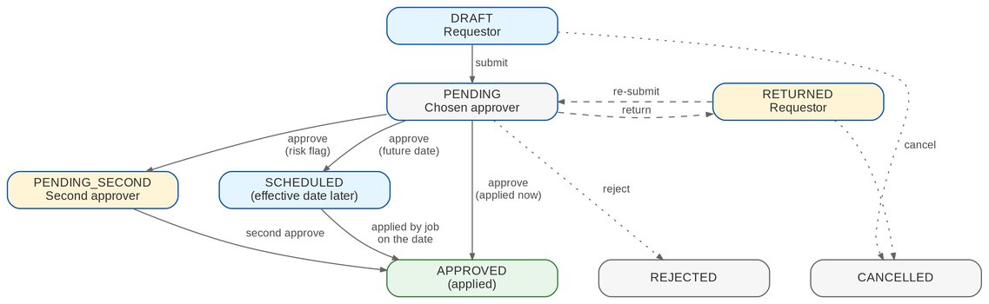
Figure 2: Status of a user access request (BRD 1.002-1.009, 2.002)
Table 9: Request statuses
Status | Meaning | Who acts
DRAFT | Saved, not submitted; visible to its creator only | Creator (edit, submit, cancel)
PENDING | Submitted; waiting for the chosen approver (group profiles - the current approver in order) | Approver; creator may cancel
PENDING_SECOND | Approved once; waiting for a second approval because of a risk flag | Second approver
RETURNED | Returned with remarks for correction | Creator (correct and re-submit, or cancel)
SCHEDULED | Approved; applied by the daily job on the effective date | System; creator or approver may cancel
APPROVED | Approved and applied | -
REJECTED | Rejected with a reason | -
CANCELLED | Cancelled by the creator with a reason | -
FOR_IMPLEMENTATION | Group profile - approved; waiting for the System Administrator | System Administrator
IMPLEMENTED | Group profile - implemented | -

Table 10: Transitions
From | Action | To | Who | Remarks
(new) | save | DRAFT | Requestor (type permission) | Optional
DRAFT | submit | PENDING | Creator | Mandatory
DRAFT | cancel | CANCELLED | Creator | Mandatory
PENDING | approve | APPROVED, SCHEDULED, PENDING_SECOND, FOR_IMPLEMENTATION or next approver | Chosen approver (ACCESS_APPROVE) | Optional
PENDING_SECOND | second approve | APPROVED, SCHEDULED or FOR_IMPLEMENTATION | UAM_SECOND_APPROVE, not the first approver | Optional
PENDING, PENDING_SECOND | return | RETURNED | Approver | Mandatory
PENDING, PENDING_SECOND | reject | REJECTED | Approver | Mandatory
RETURNED | re-submit | PENDING | Creator (UAM_CORRECT) | Mandatory
PENDING, RETURNED, SCHEDULED | cancel | CANCELLED | Creator (UAM_CANCEL); approver for SCHEDULED | Mandatory
SCHEDULED | apply (job) | APPROVED | System | -
FOR_IMPLEMENTATION | implement | IMPLEMENTED | System Administrator (ROLE_MANAGE), not the requester | Optional

5.2 Group-profile requests
Figure 3 shows a group-profile request with approvers in order and the implementation step.
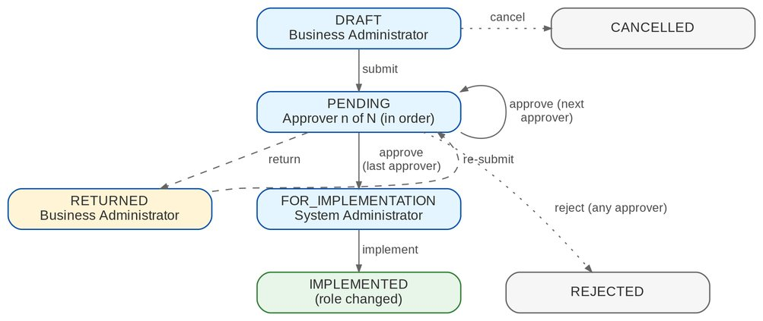
Figure 3: Status of a group-profile request (BRD 3.002; p.6)

6 Reports

6.1 Report list
Table 11: User Access Maintenance reports (category Control & Audit)
Code | Name | Purpose | BRD
UAM-USER-ACCESS | User Access Report | Users, their group profiles and who created and changed them | 3.003.1; sample A
UAM-GROUP-PROFILE | User Group Profile Report | Modules and tasks each profile can access | 3.003.2; sample B
UAM-GROUP-MEMBERS | Group Profile Membership | Members of each profile | 3.003.3; sample C
UAM-AUDIT-LOG | User Access Audit Log | Access activities with from and to values | 4.003.1; sample D
UAM-REQUESTS | Access Requests | Requests by status, type, requester, approver and age | 1.008

All reports need UAM_REPORT_VIEW, export to PDF, XLSX and CSV, and print in the header the report name, the user who generated it, the date coverage ("as of" or "from / to") and the date and time generated (p.18).

6.1.1 User Access Report (UAM-USER-ACCESS)
Parameters: As of Date; Business Unit Group; Status; Group Profile. Layout: landscape, sorted by user name.
Table 12: UAM-USER-ACCESS columns
Column | Format | Content
User Name | Text | Full name
User ID / Windows ID | Text | -
User Group Profile | Text | Group profiles held on the as-of date
Business Unit / User Level | Text | -
Status | Text | Active, Disabled, Locked
Created by / Date Created | Text / Date | Approver of the enrolment (request number) and date
Modified by / Date Modified | Text / Date | Approver of the last change and date
Last Action / by | Text | Added, modified, deactivated or reactivated, and by whom

6.1.2 User Group Profile Report (UAM-GROUP-PROFILE)
Parameters: Group Profile; Area; Active. Layout: portrait, grouped by profile and module.
Table 13: UAM-GROUP-PROFILE columns
Column | Format | Content
Group Profile | Text | Profile name (and code)
Module Name | Text | Permission area
Task Name | Text | Permission and action class
Access | Text | With Access / No Access
Date Created / Created by | Date / Text | -
Date Modified / Modified by | Date / Text | Last change and actor (added, modified, deactivated, reactivated)

6.1.3 Group Profile Membership (UAM-GROUP-MEMBERS)
Parameters: Group Profile; As of Date. Layout: portrait, grouped by profile.
Table 14: UAM-GROUP-MEMBERS columns
Column | Format | Content
Group Profile | Text | -
Member Username | Text | Full name
Member User ID | Text | -
Created by / Date Created | Text / Date | Who added the member to the profile, and when
Modified by / Date Modified | Text / Date | Last change to the membership

6.1.4 User Access Audit Log (UAM-AUDIT-LOG)
Parameters: Date From / To; User; Activity; include log-ins and log-outs (yes / no). Layout: landscape, sorted by date and time.
Table 15: UAM-AUDIT-LOG columns
Column | Format | Content
Date | Date-time | -
Activity | Text | For example "Approved Request to Enroll New User", "Modify User Group Profile of <user>"
From | Text | Value before, or "Null"
To | Text | Value after
Done By | Text | User who did it
Approved By / Request No. | Text | Where the activity came from a request

7 Interfaces and integration
Figure 4 shows the interfaces. Every BIBS module reads the effective permissions of the signed-in user. Single sign-on through EIAM is in scope and is switched on by configuration once BIBS is registered in EIAM; the EUA and LDAP sign-in are proposed to be replaced by EIAM (CLR-UA-21); the external ACL is on hold. The protocol and provisioning details are in the Authentication and Identity Integration Requirements v1.0, 03-Oct-2026 (R9), reviewed by BDOI IT.
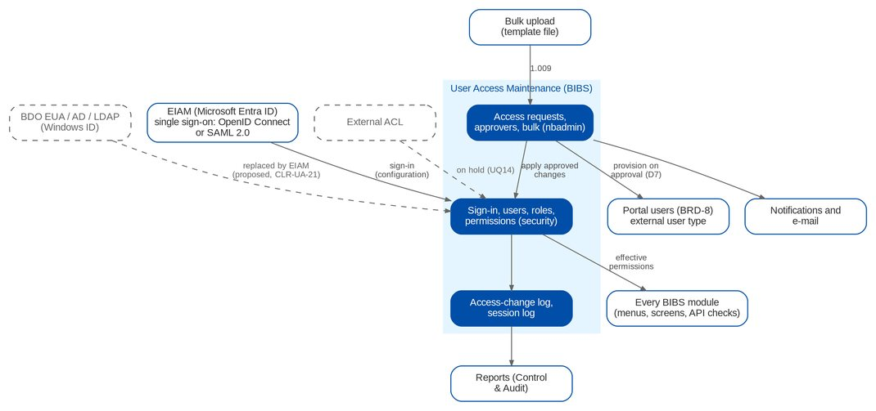
Figure 4: Interfaces of User Access Maintenance (dashed = on hold or proposed to be replaced)
Table 16: Interfaces
Interface | Direction | Content and trigger | BRD | Scope
EIAM (Microsoft Entra ID), Drop 0 | Out / In | The BDO identity provider of BIBS: sign-in with the BDO account through single sign-on (FR-UA-003); proposed rules for confirmation - the account is matched to the BIBS user by the Windows ID or the user principal name (CLR-UA-22), and Log Out also ends the EIAM session (CLR-UA-23). BDOI IT registers BIBS per environment (CLR-UA-01); details in R9 | NFR p.13-14, p.17 | IN SCOPE
UIDM-ISC (identity governance), Drop 0 | In / Out | Joiner, mover and leaver provisioning and access certification. Options: the IGA provisions user accounts while role changes stay BIBS requests (proposal), the IGA provisions users and roles, or aggregation only (IQ05, DCR-229, UA-Q18 to UA-Q21); the provisioning and aggregation interface is described in R9 | 1.001-1.009 (request rule, p.6) | OPEN
BDO EUA with Windows ID | Out / In | User ID and password passed at log-in; success or failure with message returned (sign-in mode DIRECTORY). Proposed to be replaced by EIAM (CLR-UA-21, UA-Q05) | NFR p.14 | OPEN
LDAP / Active Directory | Out / In | User ID and password checked against the BDO directory. Proposed to be replaced by EIAM, which holds the BDO directory accounts (CLR-UA-21, UA-Q05) | NFR 1.h (p.13) | OPEN
Single sign-on (OpenID Connect or SAML 2.0) | In | The sign-in of the BDO identity provider opens a BIBS session; part of BIBS and switched on by configuration (sign-in mode OIDC or SAML); EIAM is the provider (row above); OpenID Connect proposed, SAML 2.0 the fall-back (CLR-UA-01, UA-Q06) | Other BU NFR 4 (p.17) | IN SCOPE
External ACL | In | Authorisation by an external access-control list | NFR 1.i (p.13) | ON HOLD
All BIBS modules | Out | Effective permissions of the user (menus, buttons and system functions) | 4.002.2 | IN SCOPE
Portal users (BRD-8 Employee Benefits) | Out | External user requests provisioned on approval (decision D7). Dormant: BDOI drops the EB portal (drop plan item 2.4, IQ22); EXTERNAL requests stay refused | D7 (R4) | OUT
Notifications and e-mail | Out | Request, access-change and batch-failure notices | 1.006.1.1, 1.008.1.4, 2.002.1; NFR 10 | IN SCOPE
Bulk upload | In | Template file of access requests (Bulk Request) | 1.009 | IN SCOPE
Remote log server / syslog | Out | Application and error logs | NFR p.14 | ON HOLD

Sign-in through EIAM. Single sign-on with OpenID Connect and SAML 2.0 is part of BIBS: the BDO identity provider (EIAM on Microsoft Entra ID) is set for each environment and the sign-in mode switched to OIDC or SAML, without a change to the screens, users, group profiles or requests. BDOI IT registers BIBS in EIAM for each environment (CLR-UA-01); until then SIT uses local sign-in. The Windows ID is held on every user so that the EIAM account can be matched (CLR-UA-22). The protocol, the claims, the registration and the provisioning interface of UIDM-ISC are in the Authentication and Identity Integration Requirements v1.0, 03-Oct-2026 (R9).

8 Non-functional requirements
The BRD's NFR section has no IDs; R2 numbers the rows UAM-NFR-01 to UAM-NFR-41. Most infrastructure rows are answered "Follow existing QPS set up" in the BRD; BIBS follows its own deployment standards for them. Rows that describe functions are specified as FRs in section 4 and cross-referenced here.
Table 17: Non-functional requirements (BRD p.11-18)
ID | Topic | BRD requirement | BIBS approach | FR
UAM-NFR-01 | Capacity and performance | Requestor 14 users / 5 concurrent (enrol, modify, deactivate, reactivate, view: 10 tpm each; bulk 3 tpm); Approver 8 / 3 (10 tpm); BU Admin 4 / 2 (group profile 2 tpm); System Admin 1 / 1 (10 tpm, group profile 2 tpm); reports BU / System Admin 5 / 3 (10 tpm). Response 10 s, reports 20 s (p.11) | Within the BIBS sizing (145 concurrent users); online p95 under 3 seconds, reports under 20 seconds | -
UAM-NFR-02 | Projected volume | 10 transactions per month (average); login / logout, start-up and event reports 14 users / 5 concurrent, 10 per month, 5% growth, 10 s, 0% error; audit log report 5 / 3, 10 per month, 20% growth, 20 s, 0% error (p.11) | No specific sizing needed | -
UAM-NFR-03 | Data retention (records, logs) | Follow QPS retention policy (p.11) | Retention rules per record type; access requests, change log and session log kept at least as long as the audit trail; QPS values UQ12 | -
UAM-NFR-04 | Scalability, availability, reliability, DR, audit and data management, portability, interoperability, maintainability, environments, migration, support | "Follow existing QPS set up" for every item (scaling, operating hours, maintenance windows, high availability, uptime, recovery point and time, backup, disaster recovery, delivery models, integration with other systems, core banking, monitoring, environments from development to disaster recovery, data and user migration, QA, training, 24/7 support) (p.11-12) | The same BIBS standards for every BRD, specified in the Technical Specification, reviewed by BDOI IT; existing users loaded with the bulk request (FR-UA-019) | -
UAM-NFR-05 | Accessibility and channels | Accessibility options for impaired vision or colour blindness; website and mobile website: "Follow existing QPS set up" (p.12) | BDO UX contrast rules; responsive screens for desktop and mobile browsers | -
UAM-NFR-06 | Regulatory and compliance | MORB (BSP), Circular 808 of 2013, AMLA 2001, Data Privacy Act 2012 (p.12) | Four eyes on every access change, least privilege, separation-of-duties rules, deactivation of dormant users, an audit trail no user can change, retention | FR-UA-006, 053
UAM-NFR-07 | Hardware, software, file locations, embedded IDs | Server / workstation specifications; binaries and logs in standard locations; embedded application user IDs named e_appshortname_description (e.g. p_appname_sftp) (p.12-13) | Service accounts named by the BDO convention; servers and software as specified in the Technical Specification, reviewed by BDOI IT | -
UAM-NFR-08 | Network | No impact on branch / ATM operations, no change to network design; ports, devices, bandwidth, latency, interfaces (p.13) | Encrypted connections only; no change to the BDO network; hosts and ports as specified in the Technical Specification, reviewed by BDOI IT | -
UAM-NFR-09 | User and role management 1.a-f | Online modules to view, add, modify, delete master data incl. users and roles; access via roles; more than one user per role; a user can have more than one role; accounts can be disabled and re-enabled; maintenance recorded in the application log (p.13) | Users, roles and permissions; several roles per user and users per role; enable / disable, also of dormant users by a job; every change audited (CQ23 answered) | FR-UA-006, 052, 064
UAM-NFR-10 | User and role management 1.g | Query or report showing the roles assigned to users; exportable (p.13) | Reports UAM-USER-ACCESS and UAM-GROUP-MEMBERS, exportable | FR-UA-060, 062
UAM-NFR-11 | User and role management 1.h | Supports LDAP or Active Directory authentication (p.13) | Directory sign-in through EIAM on Microsoft Entra ID, which holds the BDO directory accounts: single sign-on with OpenID Connect or SAML 2.0, switched on by configuration (CLR-UA-01, CLR-UA-21) | FR-UA-003
UAM-NFR-12 | User and role management 1.i | Can support authorisation of users by interfacing with an external ACL (p.13) | On hold until BDOI answers UQ14 | -
UAM-NFR-13 | User and role management 1.j | User ID of at least ten (10) alphanumeric characters, supports the format a999999999 (p.13) | Parameter USER_ID_PATTERN checked on requests (default a999999999 format, UQ05) | FR-UA-011, 052
UAM-NFR-14 | User and role management 1.k | Ability to specify an effective date for user and role changes (p.13) | Effective date on requests; daily job applies scheduled changes (UQ06) | FR-UA-020
UAM-NFR-15 | User ID maintenance fields | Windows ID, user name, user status (active, disabled, locked out, online, etc.), Business Unit Group, User Level (p.14) | Windows ID, business unit group, user level; status Active, Disabled, Locked, Online (UQ05, UQ13) | FR-UA-052, 004
UAM-NFR-16 | System Administrator capabilities | Access rights per group per role; user administrator maintenance; group administration; maintain reference tables; workflow set-up; screen update and maintenance (p.14) | Access rights per profile, user and group administration and reference tables exist; approver rules are parameters, and a change of a security setting needs a second approval; screens change by release | FR-UA-052, 054
UAM-NFR-17 | Authentication through EUA | Interface the user ID with EUA using the Windows ID to authenticate access if the user exists in the BDO network, with password validation: the system passes the user ID and password; EUA returns whether the logon succeeded; on failure the error message is forwarded (p.14) | Windows ID sign-in through EUA when AUTH_MODE = DIRECTORY, with the EUA message shown; proposed to be replaced by the single sign-on through EIAM, where the Windows ID identifies the user (CLR-UA-21, CLR-UA-22) | FR-UA-003
UAM-NFR-18 | Login logging | Log all valid and invalid attempts (p.14) | Every valid and invalid log-in is audited | FR-UA-001
UAM-NFR-19 | Lockout | Users are locked out after 3 invalid attempts (p.14) | LOGIN_MAX_FAILED_ATTEMPTS = 3 for local accounts; with single sign-on the EIAM lock-out policy applies (CLR-UA-25) | FR-UA-001
UAM-NFR-20 | Reference / master data management | Online view / add / modify / delete; referential integrity and validation; logical deletion; changes logged; role-based access (p.14) | Lists of Values with maker-checker, effective dates and deactivation instead of delete; audited | -
UAM-NFR-21 | Error logging | Error log that records each failed action with its details: description, time, user ID and module ID; enable / disable; location; rotation; size; one line per entry; level and message-type selection; sent to a remote log server (p.14) | Every error is logged in one line with the user, the module and the failed action; the log details, levels and the transfer to the BDO log server are specified in the Technical Specification, reviewed by BDOI IT | -
UAM-NFR-22 | Transaction logging and audit trail | Transaction log with type, time, user ID, module ID; enable / disable; location; transmit; all user activities logged through the audit trail and retrievable by the administrator; allow automatic save option (p.14) | Audit trail that no user can change and the Audit Trail screen; meaning of 'automatic save option' is UQ15 | FR-UA-064
UAM-NFR-23 | Logs retention and archiving | Retention / archival / purging / backup for application, system, audit and infrastructure logs, historical data, snapshots, video, documents: "Follow existing QPS set up" (p.14) | As UAM-NFR-03 (UQ12) | -
UAM-NFR-24 | Batch processing a-l | Schedule, invoke manually, monitor, re-run, graceful terminate, UI without command line, publish status, single instance, restart at the interruption point, no privileged access, multi-core, parallel independent jobs (p.15) | Job scheduler with run history, run on demand, re-run, failure alert; restart without duplicates; status in monitoring | FR-UA-071
UAM-NFR-25 | Batch failure e-mail | Monitor batch runs, log success and failure; forward an e-mail notification to designated users on failed batch runs (stated twice) (p.15) | Failed runs e-mailed to JOB_FAILURE_RECIPIENTS | FR-UA-071
UAM-NFR-26 | System monitoring; network configuration; DR | Monitor and start / stop application processes without command line; DNS aliases; configurable ports; no hosts file; standard ports; Netbackup / Bacula, clustering, offsite replication, active-active, disk estimates (p.15) | Monitoring, start and stop from the platform tools without a command line, as specified in the Technical Specification, reviewed by BDOI IT | -
UAM-NFR-27 | Data purging and archiving | Automated archiving and purging of transactional data, logs, reports, temporary files; schedule; restricted access; configurable rules (p.15-16) | Retention rules and the monthly retention review; physical archive and purge follow the BIBS retention decision (Q39, UQ12) | -
UAM-NFR-28 | Server and workstation software | Documented install / deploy / update; deploy from repository; runs as a service; multiple instances; dynamic configuration reload; least privilege; browser only on workstations; no proprietary office software; not tied to third-party versions (p.16) | Installation, deployment, instances and service accounts as specified in the Technical Specification, reviewed by BDOI IT; users need only a browser on their workstations | -
UAM-NFR-29 | System documentation | Functional design, technical design, user manual, installation guide, release notes, instruction guide on how to manage users and extract the users list and group profile list; troubleshooting guide; training; capacity planning; performance benchmarks (p.16-17) | User-administration guide in the in-app Help Center and the administration guide (UQ18) | -
UAM-NFR-30 | System development, testing and production support | Access to resources outside the BDO network, off-site / on-site development, performance testing; maintenance access (p.17) | Engagement terms | -
UAM-NFR-31 | Other BU NFR 1 | Password management (reset, change) (p.17) | Administrator reset and own change exist | FR-UA-005
UAM-NFR-32 | Other BU NFR 2-3 | Role-based access control (define roles, assign permissions, map users to roles); permission management (p.17) | Roles, permissions, user-role mapping, Roles screen and User Access Matrix exist | FR-UA-051
UAM-NFR-33 | Other BU NFR 4 | Integration with Single Sign-On (SSO) or LDAP (p.17) | Single sign-on with OpenID Connect and SAML 2.0 is part of BIBS; EIAM (Entra ID) is the provider, switched on by configuration (CLR-UA-01) | FR-UA-003
UAM-NFR-34 | Other BU NFR 5 | Session management: inactivity warning after 15 minutes; warning prior to system-triggered log out after 30 minutes (p.17) | Session policy parameters and the web session guard | FR-UA-002
UAM-NFR-35 | Other BU NFR 6 | Audit logging: track changes in user roles and permissions; log user login / log out; audit log reports (p.17) | Role and permission changes in the structured change log; log-out and session log added; audit log report | FR-UA-004, 063
UAM-NFR-36 | Other BU NFR 7 | Enforce strong password policies (p.17) | Complexity and length exist; history, maximum and minimum age and forced change added (UQ08) | FR-UA-005
UAM-NFR-37 | Other BU NFR 8 | Self-service and admin tools: self-service password reset; user-friendly screens to manage access; a defined user can update profile information (p.17) | Self-service reset by e-mailed single-use link (local accounts); own e-mail and mobile update (UQ08, UQ17) | FR-UA-005
UAM-NFR-38 | Other BU NFR 9 | Bulk uploads or batch updates of user profiles (p.17) | Bulk request (UQ10) | FR-UA-019
UAM-NFR-39 | Other BU NFR 10 | Notification for access changes (p.17) | Affected user notified in the app and by e-mail when the change is applied | FR-UA-070
UAM-NFR-40 | Other BU NFR 11 | Configurable workflow for access requests and approvals; changes to user privileges systematically monitored, evaluated and, if necessary, escalated for additional review (e.g. modifications outside working hours, low to high privilege) (p.17) | Privilege level per profile; privilege increase or out-of-hours change needs a second approval and raises an alert (UQ07); separation-of-duties rules refuse combinations of profiles; security settings change under a second approval | FR-UA-034, 053, 054
UAM-NFR-41 | Report requirements (section 7) | Samples A User Access Report, B User Group Profile Report, C Group Profile membership (titled "User Group Profile Report"), D User Access Audit Log (date, activity, from, to, done by); generated by, date coverage, date and time generated (p.18) | Four reports with generated by, coverage and time generated in the header | FR-UA-060 to 063

9 Configuration items
The items below are changed in BIBS without a release. Changes to parameters and lists are audited.

9.1 Parameters and jobs
Table 18: User Access Maintenance parameters and jobs
Parameter / job | Default | Meaning
LOGIN_MAX_FAILED_ATTEMPTS (exists) | 3 | Failed attempts before lock-out; all users
SESSION_IDLE_WARNING_MINUTES (exists) | 15 | Inactivity warning
SESSION_TIMEOUT_MINUTES (exists) | 30 | Inactivity sign-out
SESSION_EXPIRY_WARNING_MINUTES (exists) | 30 | Warning before the fixed end of the session
AUTH_MODE | LOCAL | LOCAL, DIRECTORY (EUA), OIDC or SAML (single sign-on through EIAM, Entra ID; CLR-UA-01)
USER_ID_PATTERN | ^[a-zA-Z][0-9]{9}$ | User ID format (to confirm, UQ05)
PASSWORD_HISTORY_COUNT | 8 | Previous passwords refused (UQ08)
PASSWORD_MAX_AGE_DAYS | 90 | Password expiry (UQ08)
PASSWORD_MIN_AGE_DAYS | 1 | Minimum days between changes (UQ08)
UAM_WORKING_HOURS | 08:00-18:00, MON-FRI | Working hours for the out-of-hours flag (UQ07)
UAM_ANY_APPROVER | false | Any approver may decide, not only the chosen one (UQ02)
UAM_DIRECT_ROLE_EDIT | false | Emergency direct role edit (audited, alerted)
UAM_ROLE_APPLY_ON_APPROVAL | false | Group-profile requests applied on approval instead of implemented (UQ03)
JOB_FAILURE_RECIPIENTS | empty | E-mail recipients of failed batch runs
USER_ID_FORMAT_TEXT | a letter followed by nine digits, for example a013000196 | The user ID format in words, shown to the requester with the format check
UAM_EXTERNAL_USERS | false | Requests for external (portal) users; false while no portal is installed
UAM_DORMANT_DAYS | 90 | Days without a sign-in after which the job deactivates a user; 0 = never (FR-UA-006)
UAM_DORMANT_NOTICE_DAYS | 7 | Days before the deactivation on which the user is told to sign in; 0 = no notice
Job UAM_EFFECTIVE_CHANGES | 00:05 daily | Applies scheduled requests
Job UAM_DORMANT_USERS | 00:15 daily | Deactivates the dormant users and sends the notices (FR-UA-006)
Job PASSWORD_EXPIRY_NOTICE | 06:00 daily | Notifies users whose password expires within 7 days (LOCAL mode)

Every parameter of this table belongs to the Security category: a change waits for the approval of Information Security (FR-UA-054).

9.2 Lists of values
Table 19: Lists of values
List | Values delivered
UAM_BUSINESS_UNIT | Empty until BDOI supplies the business unit groups (UQ05)
UAM_USER_LEVEL | Empty until BDOI supplies the user levels (UQ05)
UAM_DEACTIVATION_REASON | Resigned; Transferred; Long leave; Security; Others (to confirm with BDOI); No sign-in for the dormancy period (dormant-user job)
Group profile privilege level | Low; Standard; High; Admin

10 Assumptions, dependencies and open questions

10.1 Assumptions
Table 20: Assumptions
ID | Assumption | Related
A-UA-01 | The QPS BRD applies to BIBS as a whole: every module and persona | UQ19
A-UA-02 | Group profiles are BIBS roles; a user may hold several (NFR 1.c-d) | CQ23 (answered)
A-UA-03 | BDOI has a User Access Matrix (p.5); its content per unit is supplied separately | OQ48
A-UA-04 | Group-profile requests are implemented by the System Administrator after approval, as on p.6 | UQ03
A-UA-05 | Approvers of a group-profile request decide in order and all must approve | UQ02
A-UA-06 | Single sign-on through EIAM is switched on by configuration once BDOI IT registers BIBS for each environment; SIT uses local sign-in until then, and the break-glass administrators keep it | UA-Q06, UA-Q07, UA-Q13
A-UA-07 | Infrastructure answers "Follow existing QPS set up" are met by the BIBS deployment standards | Section 8
A-UA-08 | Duplicate IDs 2.002.7.1 and 3.003.1.1 are kept as printed and marked "(2nd)" | R2 section 10

10.2 Dependencies
Table 21: Dependencies
ID | Dependency | Needed for
D-UA-01 | BDOI IT registers BIBS in EIAM (Entra ID) for each environment: tenant, application registration, sign-in and sign-out addresses, the claim that identifies the user, test accounts for SIT and UAT (R9) | FR-UA-003 (UA-Q07, UA-Q08)
D-UA-02 | BDOI supplies the business unit groups, user levels and the user ID format | FR-UA-011, 052 (UQ05)
D-UA-03 | BDOI names the Requestors, Approvers and high-privilege profiles | Section 3, FR-UA-034 (UQ01, UQ07)
D-UA-04 | BDOI supplies the bulk file layout and limits | FR-UA-019 (UQ10)
D-UA-05 | The e-mail relay of the BIBS environment is available | FR-UA-005, 070, 071
D-UA-06 | The Employee Benefits portal implements the provisioning port for external users | Section 7 (D7)

10.3 Open questions
Table 22: Open questions on BRD-11 (R2 section 9; status from R4)
ID | Question | Affects | Status
UQ01 | Who are the 14 Requestors and 8 Approvers; is the Requestor separate from the Business Administrator | Section 3 | OPEN
UQ02 | Which users may be chosen as approver; several approvers in sequence or in parallel, all required | FR-UA-015, 044 | OPEN
UQ03 | Must the System Administrator implement group profiles by hand, or may BIBS apply them on approval | FR-UA-041, 045 | OPEN
UQ04 | EUA interface: protocol, host, Windows ID format, messages; break-glass administrator; password policy with EUA (proposed to be replaced by EIAM, UA-Q05, CLR-UA-21) | FR-UA-003 | OPEN
IQ04 | EIAM (Entra ID): tenant and app registration, claims, MFA and conditional access, session life against the 30-minute rule, non-BDO users (programme alignment; Drop 0 questions UA-Q06 to UA-Q15) | FR-UA-003 | OPEN
IQ05 | UIDM-ISC: which access changes are requested and approved in the IGA and which stay as BIBS requests; connector type; certification (programme alignment) | Section 5, FR-UA-010 to 045 | OPEN
UQ05 | Values of business unit group and user level; user ID format and relation to the Windows ID | FR-UA-011, 052 | OPEN
UQ06 | Effective date: start only or also end (temporary access); cancelling a scheduled request | FR-UA-020 | OPEN
UQ07 | Which profiles are high privilege; working hours; who does the additional review | FR-UA-034 | OPEN
UQ08 | Password values for local accounts; channel of the self-service reset | FR-UA-005 | OPEN
UQ09 | Single session per device; single-role rule dropped | FR-UA-004 | PARTIAL
UQ10 | Bulk file layout, maximum rows, batch or line decisions, mixed actions | FR-UA-019 | OPEN
UQ11 | Module / task of sample B; meaning of "as of" | FR-UA-060, 061 | OPEN
UQ12 | QPS retention values for requests, audit and log-in logs | FR-UA-064 | OPEN
UQ13 | Real-time online status; administrator ending a session | FR-UA-004, 052 | OPEN
UQ14 | Which external ACL system is meant | FR-UA-003 | OPEN
UQ15 | Meaning of "allow automatic save option" in the audit-trail requirement | Section 8 | OPEN
UQ16 | Deactivation of a profile with active members | FR-UA-042 | OPEN
UQ17 | Profile fields users update themselves; approval of the change | FR-UA-005 | OPEN
UQ18 | The truncated documentation requirement on p.17 | Section 8 | OPEN
UQ19 | The QPS BRD applies to BIBS as a whole | Section 1.2 | OPEN

BRD-11 answers questions raised on other BRDs: Q42 (directory sign-in required; inactivity sign-out at 30 minutes with a 15-minute warning), CQ23 (lock-out at 3 for all users; several roles per user) and PQ17 (group-profile changes are approved and then implemented by the System Administrator) (R4, decisions D5 and D6).

11 Traceability
Every BRD-11 requirement line is met by at least one FR; the appendix User-story view gives each line as a user story with its FRs, acceptance criteria and test cases. The BRD prints 160 lines; IDs 2.002.7.1 and 3.003.1.1 appear twice and the second occurrence is marked "(2nd)". "Flag" repeats the BRD's Pilot Phase / Mandatory columns ("-" = not flagged). The NFR rows are traced in section 8.
Table 23: BRD requirement line to FR (160 lines) and test cases
BRD ID | Page | Activity and requirement | Flag | FR | Test cases
BRD 1.001.1 | p.8 | Log in as a Requestor - Access the application using any BDO-issued device | Yes | FR-UA-001 | TC-UA-001.1, 001.2, 001.3, 001.4, 001.5 (7 cases)
BRD 1.001.1.1 | p.8 | Log in as a Requestor - Log in with a Requestor user profile | Yes | FR-UA-001 | TC-UA-001.1, 001.2, 001.3, 001.4, 001.5 (7 cases)
BRD 1.001.1.2 | p.8 | Log in as a Requestor - Receive the inactivity warning (15 minutes) | Yes | FR-UA-002 | TC-UA-002.1, 002.2, 002.3, 002.4 (5 cases)
BRD 1.001.1.3 | p.8 | Log in as a Requestor - Receive a warning prior to the system-triggered log out (30 minutes) | Yes | FR-UA-002 | TC-UA-002.1, 002.2, 002.3, 002.4 (5 cases)
BRD 1.002.1 | p.8 | Enroll New User - Submit a new User Access request | Yes | FR-UA-011 | TC-UA-011.1, 011.2, 011.3, 011.4 (9 cases)
BRD 1.002.1.1 | p.8 | Enroll New User - 1. Create request | Yes | FR-UA-010, FR-UA-011 | TC-UA-010.1, 010.2, 010.3, 010.4, 010.5 (8 cases)
BRD 1.002.1.1.1 | p.8 | Enroll New User - 1.1 Input new user data | Yes | FR-UA-011 | TC-UA-011.1, 011.2, 011.3, 011.4 (9 cases)
BRD 1.002.1.1.2 | p.8 | Enroll New User - 1.2 Select User Access Group profile | Yes | FR-UA-011 | TC-UA-011.1, 011.2, 011.3, 011.4 (9 cases)
BRD 1.002.1.1.3 | p.8 | Enroll New User - 1.3 Select approver from the drop-down | Yes | FR-UA-015 | TC-UA-015.1, 015.2, 015.3 (4 cases)
BRD 1.002.1.1.4 | p.8 | Enroll New User - 1.4 Add remarks (i.e. justification, etc.) | - | FR-UA-010 | TC-UA-010.1, 010.2, 010.3, 010.4, 010.5 (8 cases)
BRD 1.002.1.1.5 | p.8 | Enroll New User - 1.5 Save remarks | - | FR-UA-010 | TC-UA-010.1, 010.2, 010.3, 010.4, 010.5 (8 cases)
BRD 1.002.1.2 | p.8 | Enroll New User - 2. Edit drafted request | Yes | FR-UA-010 | TC-UA-010.1, 010.2, 010.3, 010.4, 010.5 (8 cases)
BRD 1.002.1.3 | p.8 | Enroll New User - 3. Cancel drafted request | Yes | FR-UA-010 | TC-UA-010.1, 010.2, 010.3, 010.4, 010.5 (8 cases)
BRD 1.002.1.4 | p.8 | Enroll New User - 4. Submit request | Yes | FR-UA-010 | TC-UA-010.1, 010.2, 010.3, 010.4, 010.5 (8 cases)
BRD 1.003.1 | p.8 | Modify Existing User - Submit a modify User Access / permission request | Yes | FR-UA-012 | TC-UA-012.1, 012.2, 012.3 (5 cases)
BRD 1.003.1.1 | p.8 | Modify Existing User - 1. Create request | Yes | FR-UA-010, FR-UA-012 | TC-UA-010.1, 010.2, 010.3, 010.4, 010.5 (8 cases)
BRD 1.003.1.1.1 | p.8 | Modify Existing User - 1.1 Search existing user | Yes | FR-UA-012 | TC-UA-012.1, 012.2, 012.3 (5 cases)
BRD 1.003.1.1.2 | p.8 | Modify Existing User - 1.2 Edit / update selected user data | - | FR-UA-012 | TC-UA-012.1, 012.2, 012.3 (5 cases)
BRD 1.003.1.1.3 | p.8 | Modify Existing User - 1.3 Select User Access Group profile | Yes | FR-UA-012 | TC-UA-012.1, 012.2, 012.3 (5 cases)
BRD 1.003.1.1.4 | p.8 | Modify Existing User - 1.4 Select approver from the drop-down | Yes | FR-UA-015 | TC-UA-015.1, 015.2, 015.3 (4 cases)
BRD 1.003.1.1.5 | p.8 | Modify Existing User - 1.5 Add remarks (i.e. justification, etc.) | - | FR-UA-010 | TC-UA-010.1, 010.2, 010.3, 010.4, 010.5 (8 cases)
BRD 1.003.1.1.6 | p.8 | Modify Existing User - 1.6 Save remarks | - | FR-UA-010 | TC-UA-010.1, 010.2, 010.3, 010.4, 010.5 (8 cases)
BRD 1.003.1.2 | p.8 | Modify Existing User - 2. Edit drafted request | Yes | FR-UA-010 | TC-UA-010.1, 010.2, 010.3, 010.4, 010.5 (8 cases)
BRD 1.003.1.3 | p.8 | Modify Existing User - 3. Cancel drafted request | Yes | FR-UA-010 | TC-UA-010.1, 010.2, 010.3, 010.4, 010.5 (8 cases)
BRD 1.003.1.4 | p.8 | Modify Existing User - 4. Submit request | Yes | FR-UA-010 | TC-UA-010.1, 010.2, 010.3, 010.4, 010.5 (8 cases)
BRD 1.004.1 | p.8 | Deactivate User - Submit a User Access deactivation request | Yes | FR-UA-013 | TC-UA-013.1, 013.2, 013.3 (4 cases)
BRD 1.004.1.1 | p.8 | Deactivate User - 1. Create a request | Yes | FR-UA-010, FR-UA-013 | TC-UA-010.1, 010.2, 010.3, 010.4, 010.5 (8 cases)
BRD 1.004.1.1.1 | p.8 | Deactivate User - 1.1 Search an existing user | Yes | FR-UA-013 | TC-UA-013.1, 013.2, 013.3 (4 cases)
BRD 1.004.1.1.2 | p.8 | Deactivate User - 1.2 Add remarks (i.e. reason for deactivation) | - | FR-UA-010, FR-UA-013 | TC-UA-010.1, 010.2, 010.3, 010.4, 010.5, 013.1, 013.2, 013.3 (12 cases)
BRD 1.004.1.1.3 | p.8 | Deactivate User - 1.3 Save remarks | Yes | FR-UA-010, FR-UA-013 | TC-UA-010.1, 010.2, 010.3, 010.4, 010.5, 013.1, 013.2, 013.3 (12 cases)
BRD 1.004.1.1.4 | p.8 | Deactivate User - 1.4 Select approver from the drop-down | Yes | FR-UA-015 | TC-UA-015.1, 015.2, 015.3 (4 cases)
BRD 1.004.1.2 | p.8 | Deactivate User - 2. Edit drafted request | Yes | FR-UA-010 | TC-UA-010.1, 010.2, 010.3, 010.4, 010.5 (8 cases)
BRD 1.004.1.3 | p.8 | Deactivate User - 3. Cancel drafted request | Yes | FR-UA-010 | TC-UA-010.1, 010.2, 010.3, 010.4, 010.5 (8 cases)
BRD 1.004.1.4 | p.8 | Deactivate User - 4. Submit request | Yes | FR-UA-010 | TC-UA-010.1, 010.2, 010.3, 010.4, 010.5 (8 cases)
BRD 1.005 | p.8 | Reactivate User - Submit a User Access reactivation request | Yes | FR-UA-014 | TC-UA-014.1, 014.2 (3 cases)
BRD 1.005.1 | p.8 | Reactivate User - 1. Create a request | Yes | FR-UA-010, FR-UA-014 | TC-UA-010.1, 010.2, 010.3, 010.4, 010.5 (8 cases)
BRD 1.005.1.1 | p.8 | Reactivate User - 1.1 Search an existing user | Yes | FR-UA-014 | TC-UA-014.1, 014.2 (3 cases)
BRD 1.005.1.1.1 | p.8 | Reactivate User - 1.2 Add remarks (i.e. reason for reactivation) | - | FR-UA-010, FR-UA-014 | TC-UA-010.1, 010.2, 010.3, 010.4, 010.5, 014.1, 014.2 (11 cases)
BRD 1.005.1.1.2 | p.8 | Reactivate User - 1.3 Save remarks | Yes | FR-UA-010, FR-UA-014 | TC-UA-010.1, 010.2, 010.3, 010.4, 010.5, 014.1, 014.2 (11 cases)
BRD 1.005.1.1.3 | p.8 | Reactivate User - 1.4 Select approver from the drop-down | Yes | FR-UA-015 | TC-UA-015.1, 015.2, 015.3 (4 cases)
BRD 1.005.1.2 | p.8 | Reactivate User - 2. Edit a drafted request | Yes | FR-UA-010 | TC-UA-010.1, 010.2, 010.3, 010.4, 010.5 (8 cases)
BRD 1.005.1.3 | p.8 | Reactivate User - 3. Cancel a drafted request | Yes | FR-UA-010 | TC-UA-010.1, 010.2, 010.3, 010.4, 010.5 (8 cases)
BRD 1.005.1.4 | p.8 | Reactivate User - 4. Submit a request | Yes | FR-UA-010 | TC-UA-010.1, 010.2, 010.3, 010.4, 010.5 (8 cases)
BRD 1.006.1 | p.8 | Apply Correction - Apply correction on returned requests | Yes | FR-UA-016 | TC-UA-016.1, 016.2, 016.3 (4 cases)
BRD 1.006.1.1 | p.8 | Apply Correction - 1. Receive notification on the returned request | Yes | FR-UA-016, FR-UA-070 | TC-UA-016.1, 016.2, 016.3, 070.1, 070.2, 070.3 (7 cases)
BRD 1.006.1.2 | p.8 | Apply Correction - 2. Edit data on the returned request | Yes | FR-UA-016 | TC-UA-016.1, 016.2, 016.3 (4 cases)
BRD 1.006.1.3 | p.8 | Apply Correction - 3. Add remarks | Yes | FR-UA-016 | TC-UA-016.1, 016.2, 016.3 (4 cases)
BRD 1.006.1.4 | p.8 | Apply Correction - 4. Save remarks | Yes | FR-UA-016 | TC-UA-016.1, 016.2, 016.3 (4 cases)
BRD 1.006.1.5 | p.8 | Apply Correction - 5. Re-submit request | Yes | FR-UA-016 | TC-UA-016.1, 016.2, 016.3 (4 cases)
BRD 1.007.1 | p.8 | Cancel a Request - Cancel a submitted request for approval | Yes | FR-UA-017 | TC-UA-017.1, 017.2, 017.3, 017.4 (5 cases)
BRD 1.007.1.1 | p.8 | Cancel a Request - 1. Search request | Yes | FR-UA-017 | TC-UA-017.1, 017.2, 017.3, 017.4 (5 cases)
BRD 1.007.1.2 | p.8 | Cancel a Request - 2. Add remarks (i.e. reason for cancellation, etc.) | Yes | FR-UA-017 | TC-UA-017.1, 017.2, 017.3, 017.4 (5 cases)
BRD 1.007.1.3 | p.8 | Cancel a Request - 3. Save remarks | Yes | FR-UA-017 | TC-UA-017.1, 017.2, 017.3, 017.4 (5 cases)
BRD 1.007.1.4 | p.8 | Cancel a Request - 4. Cancel submitted request | Yes | FR-UA-017 | TC-UA-017.1, 017.2, 017.3, 017.4 (5 cases)
BRD 1.008.1 | p.8 | View Request/s - View the submitted request/s | - | FR-UA-018 | TC-UA-018.1, 018.2, 018.3 (5 cases)
BRD 1.008.1.1 | p.8 | View Request/s - 1. View the list of the submitted request/s | Yes | FR-UA-018 | TC-UA-018.1, 018.2, 018.3 (5 cases)
BRD 1.008.1.2 | p.8 | View Request/s - 2. View the status of the submitted request/s | Yes | FR-UA-018 | TC-UA-018.1, 018.2, 018.3 (5 cases)
BRD 1.008.1.3 | p.8 | View Request/s - 3. View the details of the submitted request/s | Yes | FR-UA-018 | TC-UA-018.1, 018.2, 018.3 (5 cases)
BRD 1.008.1.4 | p.8 | View Request/s - 4. Receive notification on the approved / rejected request | Yes | FR-UA-018, FR-UA-070 | TC-UA-018.1, 018.2, 018.3, 070.1, 070.2, 070.3 (8 cases)
BRD 1.009.1 | p.8 | Bulk Request - Submit request for bulk creation / modification / deactivation / reactivation | - | FR-UA-019 | TC-UA-019.1, 019.2, 019.3, 019.4 (5 cases)
BRD 1.009.1.1 | p.8 | Bulk Request - 1. Attach a file for bulk processing | Yes | FR-UA-019 | TC-UA-019.1, 019.2, 019.3, 019.4 (5 cases)
BRD 1.009.1.2 | p.8 | Bulk Request - 2. Add remarks | Yes | FR-UA-019 | TC-UA-019.1, 019.2, 019.3, 019.4 (5 cases)
BRD 1.009.1.3 | p.8 | Bulk Request - 3. Save remarks | Yes | FR-UA-019 | TC-UA-019.1, 019.2, 019.3, 019.4 (5 cases)
BRD 1.009.1.4 | p.8 | Bulk Request - 4. Edit a drafted request | Yes | FR-UA-019 | TC-UA-019.1, 019.2, 019.3, 019.4 (5 cases)
BRD 1.009.1.5 | p.8 | Bulk Request - 5. Cancel a drafted request | Yes | FR-UA-019 | TC-UA-019.1, 019.2, 019.3, 019.4 (5 cases)
BRD 1.009.1.6 | p.8 | Bulk Request - 6. Submit a request | Yes | FR-UA-019 | TC-UA-019.1, 019.2, 019.3, 019.4 (5 cases)
BRD 2.001.1 | p.8 | Log in as an Approver - Access the application using any BDO-issued device | Yes | FR-UA-001 | TC-UA-001.1, 001.2, 001.3, 001.4, 001.5 (7 cases)
BRD 2.001.1.1 | p.8 | Log in as an Approver - Log in with an Approver user profile | Yes | FR-UA-001 | TC-UA-001.1, 001.2, 001.3, 001.4, 001.5 (7 cases)
BRD 2.001.1.2 | p.8 | Log in as an Approver - Receive the inactivity warning (15 minutes) | Yes | FR-UA-002 | TC-UA-002.1, 002.2, 002.3, 002.4 (5 cases)
BRD 2.001.1.3 | p.8 | Log in as an Approver - Receive a warning prior to the system-triggered log out (30 minutes) | Yes | FR-UA-002 | TC-UA-002.1, 002.2, 002.3, 002.4 (5 cases)
BRD 2.002.1 | p.8 | Review and Approve Request/s - a. Receive notification on the request for approval | Yes | FR-UA-030, FR-UA-015, FR-UA-070 | TC-UA-030.1, 030.2, 030.3, 070.1, 070.2, 070.3 (6 cases)
BRD 2.002.2 | p.8 | Review and Approve Request/s - b. View the list of requests for approval | Yes | FR-UA-030 | TC-UA-030.1, 030.2, 030.3 (3 cases)
BRD 2.002.2.1 | p.8 | Review and Approve Request/s - 1. Filter the list assigned to me | Yes | FR-UA-030 | TC-UA-030.1, 030.2, 030.3 (3 cases)
BRD 2.002.3 | p.8 | Review and Approve Request/s - c. Select request | Yes | FR-UA-030 | TC-UA-030.1, 030.2, 030.3 (3 cases)
BRD 2.002.4 | p.8 | Review and Approve Request/s - d. View request details | Yes | FR-UA-030 | TC-UA-030.1, 030.2, 030.3 (3 cases)
BRD 2.002.5 | p.8 | Review and Approve Request/s - e. Approve request | Yes | FR-UA-031 | TC-UA-031.1, 031.2, 031.3 (4 cases)
BRD 2.002.6 | p.8 | Review and Approve Request/s - f. Reject request | Yes | FR-UA-032 | TC-UA-032.1, 032.2 (3 cases)
BRD 2.002.6.1 | p.8 | Review and Approve Request/s - 1. Add remarks (i.e. rejection reason, etc.) | - | FR-UA-032 | TC-UA-032.1, 032.2 (3 cases)
BRD 2.002.6.2 | p.9 | Review and Approve Request/s - 2. Save remarks | - | FR-UA-032 | TC-UA-032.1, 032.2 (3 cases)
BRD 2.002.7 | p.9 | Review and Approve Request/s - g. Return request to Requestor | Yes | FR-UA-033 | TC-UA-033.1, 033.2 (2 cases)
BRD 2.002.7.1 | p.9 | Review and Approve Request/s - 1. Add remarks (i.e. reason for return, etc.) | Yes | FR-UA-033 | TC-UA-033.1, 033.2 (2 cases)
BRD 2.002.7.1 (2nd) | p.9 | Review and Approve Request/s - 2. Save remarks | Yes | FR-UA-033 | TC-UA-033.1, 033.2 (2 cases)
BRD 3.001.1 | p.9 | Log in as a Business Administrator - Access the application using any BDO-issued device | Yes | FR-UA-001 | TC-UA-001.1, 001.2, 001.3, 001.4, 001.5 (7 cases)
BRD 3.001.1.1 | p.9 | Log in as a Business Administrator - Log in with a Business Administrator user profile | Yes | FR-UA-001 | TC-UA-001.1, 001.2, 001.3, 001.4, 001.5 (7 cases)
BRD 3.001.1.2 | p.9 | Log in as a Business Administrator - Receive the inactivity warning (15 minutes) | Yes | FR-UA-002 | TC-UA-002.1, 002.2, 002.3, 002.4 (5 cases)
BRD 3.001.1.3 | p.9 | Log in as a Business Administrator - Receive a warning prior to the system-triggered log out (30 minutes) | Yes | FR-UA-002 | TC-UA-002.1, 002.2, 002.3, 002.4 (5 cases)
BRD 3.002.1 | p.9 | Submit a User Access Group Profile Request - a. Submit a new User Access Group Profiles request | Yes | FR-UA-040 | TC-UA-040.1, 040.2, 040.3 (6 cases)
BRD 3.002.1.1 | p.9 | Submit a User Access Group Profile Request - 1. Create a request | Yes | FR-UA-040 | TC-UA-040.1, 040.2, 040.3 (6 cases)
BRD 3.002.1.2 | p.9 | Submit a User Access Group Profile Request - 2. Select approver/s from the drop-down | - | FR-UA-044 | TC-UA-044.1, 044.2, 044.3 (5 cases)
BRD 3.002.1.3 | p.9 | Submit a User Access Group Profile Request - 3. Edit a drafted request | Yes | FR-UA-040 | TC-UA-040.1, 040.2, 040.3 (6 cases)
BRD 3.002.1.4 | p.9 | Submit a User Access Group Profile Request - 4. Cancel a drafted request | Yes | FR-UA-040 | TC-UA-040.1, 040.2, 040.3 (6 cases)
BRD 3.002.1.5 | p.9 | Submit a User Access Group Profile Request - 5. Submit a request | Yes | FR-UA-040 | TC-UA-040.1, 040.2, 040.3 (6 cases)
BRD 3.002.1.6 | p.9 | Submit a User Access Group Profile Request - 6. Add remarks | - | FR-UA-040 | TC-UA-040.1, 040.2, 040.3 (6 cases)
BRD 3.002.1.7 | p.9 | Submit a User Access Group Profile Request - 7. Save remarks | - | FR-UA-040 | TC-UA-040.1, 040.2, 040.3 (6 cases)
BRD 3.002.2 | p.9 | Submit a User Access Group Profile Request - b. Submit a modify User Access Group Profiles request | Yes | FR-UA-041 | TC-UA-041.1, 041.2, 041.3 (6 cases)
BRD 3.002.2.1 | p.9 | Submit a User Access Group Profile Request - 1. Create a request | Yes | FR-UA-041 | TC-UA-041.1, 041.2, 041.3 (6 cases)
BRD 3.002.2.2 | p.9 | Submit a User Access Group Profile Request - 2. Search existing group profile from the drop-down | - | FR-UA-041 | TC-UA-041.1, 041.2, 041.3 (6 cases)
BRD 3.002.2.3 | p.9 | Submit a User Access Group Profile Request - 3. Select approver/s from the drop-down | - | FR-UA-044 | TC-UA-044.1, 044.2, 044.3 (5 cases)
BRD 3.002.2.4 | p.9 | Submit a User Access Group Profile Request - 4. Edit a drafted request | Yes | FR-UA-041 | TC-UA-041.1, 041.2, 041.3 (6 cases)
BRD 3.002.2.5 | p.9 | Submit a User Access Group Profile Request - 5. Cancel a drafted request | Yes | FR-UA-041 | TC-UA-041.1, 041.2, 041.3 (6 cases)
BRD 3.002.2.6 | p.9 | Submit a User Access Group Profile Request - 6. Submit a request | Yes | FR-UA-041 | TC-UA-041.1, 041.2, 041.3 (6 cases)
BRD 3.002.2.7 | p.9 | Submit a User Access Group Profile Request - 7. Add remarks | - | FR-UA-041 | TC-UA-041.1, 041.2, 041.3 (6 cases)
BRD 3.002.2.8 | p.9 | Submit a User Access Group Profile Request - 8. Save remarks | - | FR-UA-041 | TC-UA-041.1, 041.2, 041.3 (6 cases)
BRD 3.002.3 | p.9 | Submit a User Access Group Profile Request - c. Submit a User Access Group Profiles deactivation request | Yes | FR-UA-042 | TC-UA-042.1, 042.2, 042.3 (4 cases)
BRD 3.002.3.1 | p.9 | Submit a User Access Group Profile Request - 1. Create a request | Yes | FR-UA-042 | TC-UA-042.1, 042.2, 042.3 (4 cases)
BRD 3.002.3.2 | p.9 | Submit a User Access Group Profile Request - 2. Search existing group profile from the drop-down | - | FR-UA-042 | TC-UA-042.1, 042.2, 042.3 (4 cases)
BRD 3.002.3.3 | p.9 | Submit a User Access Group Profile Request - 3. Select approver/s from the drop-down | - | FR-UA-044 | TC-UA-044.1, 044.2, 044.3 (5 cases)
BRD 3.002.3.4 | p.9 | Submit a User Access Group Profile Request - 4. Edit a drafted request | Yes | FR-UA-042 | TC-UA-042.1, 042.2, 042.3 (4 cases)
BRD 3.002.3.5 | p.9 | Submit a User Access Group Profile Request - 5. Cancel a drafted request | Yes | FR-UA-042 | TC-UA-042.1, 042.2, 042.3 (4 cases)
BRD 3.002.3.6 | p.9 | Submit a User Access Group Profile Request - 6. Submit a request | Yes | FR-UA-042 | TC-UA-042.1, 042.2, 042.3 (4 cases)
BRD 3.002.3.7 | p.9 | Submit a User Access Group Profile Request - 7. Add remarks | - | FR-UA-042 | TC-UA-042.1, 042.2, 042.3 (4 cases)
BRD 3.002.3.8 | p.9 | Submit a User Access Group Profile Request - 8. Save remarks | - | FR-UA-042 | TC-UA-042.1, 042.2, 042.3 (4 cases)
BRD 3.002.4 | p.9 | Submit a User Access Group Profile Request - d. Submit a User Access Group Profiles reactivation request | Yes | FR-UA-043 | TC-UA-043.1, 043.2 (2 cases)
BRD 3.002.4.1 | p.9 | Submit a User Access Group Profile Request - 1. Create a request | Yes | FR-UA-043 | TC-UA-043.1, 043.2 (2 cases)
BRD 3.002.4.2 | p.9 | Submit a User Access Group Profile Request - 2. Search existing group profile from the drop-down | - | FR-UA-043 | TC-UA-043.1, 043.2 (2 cases)
BRD 3.002.4.3 | p.9 | Submit a User Access Group Profile Request - 3. Select approver/s from the drop-down | - | FR-UA-044 | TC-UA-044.1, 044.2, 044.3 (5 cases)
BRD 3.002.4.4 | p.9 | Submit a User Access Group Profile Request - 4. Edit a drafted request | Yes | FR-UA-043 | TC-UA-043.1, 043.2 (2 cases)
BRD 3.002.4.5 | p.9 | Submit a User Access Group Profile Request - 5. Cancel a drafted request | Yes | FR-UA-043 | TC-UA-043.1, 043.2 (2 cases)
BRD 3.002.4.6 | p.9 | Submit a User Access Group Profile Request - 6. Submit a request | Yes | FR-UA-043 | TC-UA-043.1, 043.2 (2 cases)
BRD 3.002.4.7 | p.9 | Submit a User Access Group Profile Request - 7. Add remarks | - | FR-UA-043 | TC-UA-043.1, 043.2 (2 cases)
BRD 3.002.4.8 | p.9 | Submit a User Access Group Profile Request - 8. Save remarks | - | FR-UA-043 | TC-UA-043.1, 043.2 (2 cases)
BRD 3.003.1 | p.9 | Generate Reports - a. Generate customized report | Yes | FR-UA-060 | TC-UA-060.1, 060.2, 060.3 (5 cases)
BRD 3.003.1.1 | p.9 | Generate Reports - 1. User Access Report | Yes | FR-UA-060 | TC-UA-060.1, 060.2, 060.3 (5 cases)
BRD 3.003.1.1 (2nd) | p.9 | Generate Reports - 1.1 User name | Yes | FR-UA-060 | TC-UA-060.1, 060.2, 060.3 (5 cases)
BRD 3.003.1.2 | p.9 | Generate Reports - 1.2 Group profile | Yes | FR-UA-060 | TC-UA-060.1, 060.2, 060.3 (5 cases)
BRD 3.003.1.3 | p.9 | Generate Reports - 1.3 Date created | Yes | FR-UA-060 | TC-UA-060.1, 060.2, 060.3 (5 cases)
BRD 3.003.1.4 | p.9 | Generate Reports - 1.4 Date modified | Yes | FR-UA-060 | TC-UA-060.1, 060.2, 060.3 (5 cases)
BRD 3.003.1.5 | p.9 | Generate Reports - 1.5 Created by | Yes | FR-UA-060 | TC-UA-060.1, 060.2, 060.3 (5 cases)
BRD 3.003.1.6 | p.9 | Generate Reports - 1.6 Added / Modified / deactivated / reactivated by | Yes | FR-UA-060 | TC-UA-060.1, 060.2, 060.3 (5 cases)
BRD 3.003.2 | p.9 | Generate Reports - 2. User Group Profile Report | Yes | FR-UA-061 | TC-UA-061.1, 061.2 (2 cases)
BRD 3.003.2.1 | p.9 | Generate Reports - 2.1 Group profile name | Yes | FR-UA-061 | TC-UA-061.1, 061.2 (2 cases)
BRD 3.003.2.2 | p.9 | Generate Reports - 2.2 Modules accessed under each group profile | Yes | FR-UA-061 | TC-UA-061.1, 061.2 (2 cases)
BRD 3.003.2.3 | p.9 | Generate Reports - 2.3 Date created | Yes | FR-UA-061 | TC-UA-061.1, 061.2 (2 cases)
BRD 3.003.2.4 | p.9 | Generate Reports - 2.4 Date modified | Yes | FR-UA-061 | TC-UA-061.1, 061.2 (2 cases)
BRD 3.003.2.5 | p.9 | Generate Reports - 2.5 Created by | Yes | FR-UA-061 | TC-UA-061.1, 061.2 (2 cases)
BRD 3.003.2.6 | p.9 | Generate Reports - 2.6 Added / Modified / deactivated / reactivated by | Yes | FR-UA-061 | TC-UA-061.1, 061.2 (2 cases)
BRD 3.003.3 | p.9 | Generate Reports - 3. Group Profile Membership list | Yes | FR-UA-062 | TC-UA-062.1, 062.2 (2 cases)
BRD 3.003.3.1 | p.9 | Generate Reports - 1. List of members under each profile | Yes | FR-UA-062 | TC-UA-062.1, 062.2 (2 cases)
BRD 3.003.3.1.1 | p.9 | Generate Reports - 1.1 Group profile | Yes | FR-UA-062 | TC-UA-062.1, 062.2 (2 cases)
BRD 3.003.3.1.2 | p.9 | Generate Reports - 1.2 User name | Yes | FR-UA-062 | TC-UA-062.1, 062.2 (2 cases)
BRD 4.001.1 | p.9 | Log in as a System Administrator - Access the application using any BDO-issued device | - | FR-UA-001 | TC-UA-001.1, 001.2, 001.3, 001.4, 001.5 (7 cases)
BRD 4.001.1.1 | p.9 | Log in as a System Administrator - Log in with a System Administrator user profile | - | FR-UA-001 | TC-UA-001.1, 001.2, 001.3, 001.4, 001.5 (7 cases)
BRD 4.001.1.2 | p.9 | Log in as a System Administrator - Receive the inactivity warning (15 minutes) | - | FR-UA-002 | TC-UA-002.1, 002.2, 002.3, 002.4 (5 cases)
BRD 4.001.1.3 | p.9 | Log in as a System Administrator - Receive a warning prior to the system-triggered log out (30 minutes) | - | FR-UA-002 | TC-UA-002.1, 002.2, 002.3, 002.4 (5 cases)
BRD 4.002.1 | p.9 | Manage Users of the System - a. Define user profile / role | Yes | FR-UA-050, FR-UA-045 | TC-UA-045.1, 045.2, 045.3, 050.1, 050.2, 050.3 (7 cases)
BRD 4.002.1.1 | p.9 | Manage Users of the System - 1. Create user profile / role for Requestor | Yes | FR-UA-050 | TC-UA-050.1, 050.2, 050.3 (3 cases)
BRD 4.002.1.2 | p.9 | Manage Users of the System - 2. Create user profile / role for Approver | Yes | FR-UA-050 | TC-UA-050.1, 050.2, 050.3 (3 cases)
BRD 4.002.1.3 | p.9 | Manage Users of the System - 3. Create user profile / role for Business Administrator | Yes | FR-UA-050 | TC-UA-050.1, 050.2, 050.3 (3 cases)
BRD 4.002.2 | p.9 | Manage Users of the System - b. Define specific functionality or capability for a specific user profile / role | Yes | FR-UA-051 | TC-UA-051.1, 051.2, 051.3 (3 cases)
BRD 4.002.2.1 | p.9 | Manage Users of the System - 1. Assign Enroll New User to a specific user profile / role | Yes | FR-UA-051 | TC-UA-051.1, 051.2, 051.3 (3 cases)
BRD 4.002.2.2 | p.9 | Manage Users of the System - 2. Assign Modify Existing User function to a specific user profile / role | Yes | FR-UA-051 | TC-UA-051.1, 051.2, 051.3 (3 cases)
BRD 4.002.2.3 | p.9 | Manage Users of the System - 3. Assign Deactivate User function to a specific user profile / role | Yes | FR-UA-051 | TC-UA-051.1, 051.2, 051.3 (3 cases)
BRD 4.002.2.4 | p.9 | Manage Users of the System - 4. Assign Reactivate User function to a specific user profile / role | Yes | FR-UA-051 | TC-UA-051.1, 051.2, 051.3 (3 cases)
BRD 4.002.2.5 | p.9 | Manage Users of the System - 5. Assign Apply Correction function to a specific user profile / role | Yes | FR-UA-051 | TC-UA-051.1, 051.2, 051.3 (3 cases)
BRD 4.002.2.6 | p.9 | Manage Users of the System - 6. Assign Cancel a Request function to a specific user profile / role | Yes | FR-UA-051 | TC-UA-051.1, 051.2, 051.3 (3 cases)
BRD 4.002.2.7 | p.10 | Manage Users of the System - 7. Assign View Request/s function to a specific user profile / role | Yes | FR-UA-051 | TC-UA-051.1, 051.2, 051.3 (3 cases)
BRD 4.002.2.8 | p.10 | Manage Users of the System - 8. Assign Review and Approve Request/s function to a specific user profile / role | Yes | FR-UA-051 | TC-UA-051.1, 051.2, 051.3 (3 cases)
BRD 4.002.2.9 | p.10 | Manage Users of the System - 9. Assign Submit a User Access Group Profiles Request function to a specific user profile / role | Yes | FR-UA-051 | TC-UA-051.1, 051.2, 051.3 (3 cases)
BRD 4.002.2.10 | p.10 | Manage Users of the System - 10. [Assign] Generate Reports Request function to a specific user profile / role | Yes | FR-UA-051 | TC-UA-051.1, 051.2, 051.3 (3 cases)
BRD 4.003.1 | p.10 | Generate Logs - a. Generate audit logs for compliance and audit purposes as needed | Yes | FR-UA-063, FR-UA-064 | TC-UA-063.1, 063.2, 063.3, 064.1, 064.2 (6 cases)

12 Navigation
This chapter shows how each user reaches the screens, and what every persona of BIBS sees. Signing BRD-11 signs the role matrix: the sidebar shows a screen only when one of the user's active group profiles holds its permission (section 3.2), so each persona sees a different menu. The tables follow the proposed role grants.

12.1 Screens of User Access Maintenance
The 19 screens specified in chapter 13, with the menu path and the roles that can open them. A screen without its own menu entry (a record, a form, a dialog) is reached from the screen before it; its path ends with that screen.
Table 24: User Access Maintenance screens
ID | Screen | Menu path | Personas (role codes)
SCR-UA-01 | Login | Before sign-in
SCR-UA-02 | Forgot Password and Set a New Password | Before sign-in: Login › Forgot password?, and the e-mailed link
SCR-UA-03 | Change Your Password (forced change) | Shown after Login, before the home page | UAM_REQUESTOR, UAM_APPROVER, UAM_SECOND_APPROVER, BUSINESS_ADMIN, SYSADMIN, AUDITOR, INFOSEC_OFFICER, NB_APPROVER
SCR-UA-04 | Inactivity and Session-end Warnings | Dialog over any screen | UAM_REQUESTOR, UAM_APPROVER, UAM_SECOND_APPROVER, BUSINESS_ADMIN, SYSADMIN, AUDITOR, INFOSEC_OFFICER, NB_APPROVER
SCR-UA-05 | My Profile | Setup & Administration › Help › My Profile | UAM_REQUESTOR, UAM_APPROVER, UAM_SECOND_APPROVER, BUSINESS_ADMIN, SYSADMIN, AUDITOR, INFOSEC_OFFICER, NB_APPROVER
SCR-UA-06 | Access Requests | Setup & Administration › User Access › Access Requests | UAM_REQUESTOR, UAM_APPROVER, UAM_SECOND_APPROVER, BUSINESS_ADMIN, SYSADMIN, AUDITOR, INFOSEC_OFFICER, NB_APPROVER
SCR-UA-07 | New Request and Edit Request (user requests) | Setup & Administration › User Access › Access Requests › New Request | UAM_REQUESTOR, BUSINESS_ADMIN, SYSADMIN
SCR-UA-08 | Access Request record | Setup & Administration › User Access › Access Requests › Access Request | UAM_REQUESTOR, UAM_APPROVER, UAM_SECOND_APPROVER, BUSINESS_ADMIN, SYSADMIN, AUDITOR, INFOSEC_OFFICER, NB_APPROVER
SCR-UA-09 | Bulk Request | Setup & Administration › User Access › Bulk Request | UAM_REQUESTOR, UAM_APPROVER, BUSINESS_ADMIN, SYSADMIN, NB_APPROVER
SCR-UA-10 | Bulk Request Batch | Setup & Administration › User Access › Bulk Request › Bulk Request Batch | UAM_REQUESTOR, UAM_APPROVER, UAM_SECOND_APPROVER, BUSINESS_ADMIN, SYSADMIN, AUDITOR, NB_APPROVER
SCR-UA-11 | Group Profile Requests | Setup & Administration › User Access › Group Profile Requests | UAM_APPROVER, UAM_SECOND_APPROVER, BUSINESS_ADMIN, SYSADMIN, AUDITOR, INFOSEC_OFFICER, NB_APPROVER
SCR-UA-12 | New Group Profile Request and Edit Request | Setup & Administration › User Access › Group Profile Requests › New Request | UAM_REQUESTOR, BUSINESS_ADMIN, SYSADMIN
SCR-UA-13 | User Access Matrix | Setup & Administration › User Access › User Access Matrix | UAM_APPROVER, BUSINESS_ADMIN, SYSADMIN, AUDITOR, INFOSEC_OFFICER, NB_APPROVER
SCR-UA-14 | User Access Reports | Setup & Administration › User Access › User Access Reports | UAM_APPROVER, BUSINESS_ADMIN, SYSADMIN, AUDITOR, INFOSEC_OFFICER
SCR-UA-15 | Users | Setup & Administration › Administration › Users | SYSADMIN
SCR-UA-16 | Roles & Permissions | Setup & Administration › Administration › Roles & Permissions | SYSADMIN
SCR-UA-17 | User access report (report runner) | Setup & Administration › User Access › User Access Reports › Report | UAM_APPROVER, BUSINESS_ADMIN, SYSADMIN, AUDITOR, INFOSEC_OFFICER, NB_APPROVER
SCR-UA-18 | System Parameters (sign-in, password and access settings) | Setup & Administration › Administration › System Parameters | BUSINESS_ADMIN, SYSADMIN, AUDITOR, INFOSEC_OFFICER
SCR-UA-19 | Separation of Duties | Setup & Administration › User Access › Separation of Duties | BUSINESS_ADMIN, INFOSEC_OFFICER

12.2 Screen flow
How the screens link: from a list to its record, from a record action to the next screen, from the sign-in to the forced password change, and from the Users and Roles screens to the requests. The walkthroughs of chapter 14 follow these links with real steps.
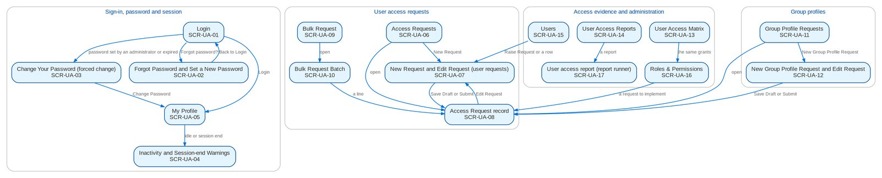
Figure 5: Screen flow of User Access Maintenance: how the screens link (list, record, action, next screen)

12.3 Menu by persona
For each persona, the SIT and UAT user of the seed data and the sidebar that user sees, section by section. The first eight tables are the personas of User Access Maintenance; the others are the personas of the persona suites of the other BRDs. The BRD column shows which BRD owns a section. The workbook of this set has the same table as one sheet per persona, with the review columns. The Auditor's and the System Administrator's menus are wide by design (read access for audit; administration).

12.3.1 Requestor (UAM_REQUESTOR)
SIT/UAT user requestor. 6 menu entries, 2 of them User Access Maintenance screens; the other entries belong to the BRD shown.
Table 25: Sidebar of the Requestor
Group | Section | Screens | BRD
Home | Overview | My Approvals | Platform
Client & Policy | Bulk Processing | Bulk Uploads | BRD-1
Setup & Administration | User Access | Access Requests, Bulk Request | BRD-11
Setup & Administration | Help | Help Center, My Profile | Platform

12.3.2 Approver (UAM_APPROVER)
SIT/UAT user uamapprover. 10 menu entries, 5 of them User Access Maintenance screens; the other entries belong to the BRD shown.
Table 26: Sidebar of the Approver
Group | Section | Screens | BRD
Home | Overview | My Approvals | Platform
Reports | New Business Reports | New Business Reports | BRD-1
Reports | Reports | Report Centre | Platform
Setup & Administration | User Access | Access Requests, Group Profile Requests, Bulk Request, User Access Matrix, User Access Reports | BRD-11
Setup & Administration | Help | Help Center, My Profile | Platform

12.3.3 Second Approver (UAM_SECOND_APPROVER)
SIT/UAT user secapprover. 5 menu entries, 2 of them User Access Maintenance screens; the other entries belong to the BRD shown.
Table 27: Sidebar of the Second Approver
Group | Section | Screens | BRD
Home | Overview | My Approvals | Platform
Setup & Administration | User Access | Access Requests, Group Profile Requests | BRD-11
Setup & Administration | Help | Help Center, My Profile | Platform

12.3.4 Business Administrator (BUSINESS_ADMIN)
SIT/UAT user badmin. 84 menu entries, 6 of them User Access Maintenance screens; the other entries belong to the BRD shown.
Table 28: Sidebar of the Business Administrator
Group | Section | Screens | BRD
Home | Overview | My Approvals | Platform
Home | New Business Dashboard | NB Dashboard | BRD-1
Home | My Work | My Work | BRD-1
Client & Policy | Employee Benefits | EB Home, Programmes, Member Changes, Pending Items, EB Setup | BRD-8
Client & Policy | Booking | Booking Setup | BRD-1
Client & Policy | Renewal | Renewal Home, Expiry List, Renewal Setup | BRD-6
Client & Policy | Product Maintenance | Product Maintenance Home, Package Requests, Package Expiry, Products, Validation Queue, Coverages & Clauses, Incentive Criteria, Insurers, Rates & Taxes, Sales Organisation | BRD-3
Client & Policy | Bulk Processing | Bulk Uploads | BRD-1
Operations | Operations | Operations Home, Invoice Search, Hand-offs and Extracts, Interfaces, Notification Settings | BRD-2
Finance | Collections | Collections Home, PR Worklist, Installment Plans, Installments Due, Promises to Pay, Escalations, Escalation Rules, Billing Statements, Unapplied Payments, Requests to Cashiering, Collections Setup | BRD-4
Finance | Accounting Reports | Account Schedules | BRD-5
Finance | General Ledger | Chart of Accounts, Financial Periods | BRD-5
Finance | Payables & Cash | Bank Accounts | BRD-5
Finance | Assets & Investments | Asset Categories, Asset Register, Depreciation Run, Investment Portfolios, Investments, Accrual & Amortization, Maturities & Sales | BRD-5
Finance | Accounting Engine | Event Types, Accounting Rules, Rule Simulator | BRD-5
Reports | New Business Reports | New Business Reports, Production Targets | BRD-1
Reports | Reports | Report Centre | Platform
Setup & Administration | Broking Setup | Lists of Values, Data Retention, Document Templates, Outbound Messages | BRD-1
Setup & Administration | Setup | Companies, Branches, Currencies & Rates, Dimensions, Business Partners, Employees, Cost-Centre Rules, Holiday Calendar | Platform
Setup & Administration | User Access | Access Requests, Group Profile Requests, Bulk Request, User Access Matrix, Separation of Duties, User Access Reports | BRD-11
Setup & Administration | Administration | Audit Trail, System Parameters, Scheduled Jobs, Record Classes, Legal Holds, Content Migration, Product Modules, Application Info | Platform / BRD-11
Setup & Administration | Help | Help Center, My Profile | Platform

12.3.5 System Administrator (SYSADMIN)
SIT/UAT user admin. 122 menu entries, 5 of them User Access Maintenance screens; the other entries belong to the BRD shown.
Table 29: Sidebar of the System Administrator
Group | Section | Screens | BRD
Home | Overview | My Approvals, Dashboard, Alerts | Platform
Home | New Business Dashboard | NB Dashboard | BRD-1
Home | My Work | My Work | BRD-1
Client & Policy | Sanction Screening | Screening Home, Cases, Matches, Screening Runs, High-risk Clients | BRD-10
Client & Policy | Employee Benefits | EB Home, Programmes, Member Changes, Pending Items | BRD-8
Client & Policy | Booking | Booking Setup | BRD-1
Client & Policy | Product Maintenance | Product Maintenance Home, Package Requests, Products, Coverages & Clauses, Incentive Criteria, Insurers, Rates & Taxes, Sales Organisation | BRD-3
Client & Policy | Bulk Processing | Bulk Uploads | BRD-1
Operations | Operations | Operations Home, Invoice Search, Hand-offs and Extracts, Interfaces, Report Archive, Notification Settings | BRD-2
Finance | Collections | Collections Home, PR Worklist, Installment Plans, Installments Due, Promises to Pay, Escalations, Escalation Rules, Billing Statements, Unapplied Payments, Requests to Cashiering, Collections Files, Collections Setup | BRD-4
Finance | Remittance | Remittance Deductions | BRD-2
Finance | Disbursement | Disbursement Workbench, Payees, Disbursement End of Day, Account Funding, Bank Accounts and Checks, Disbursement Reports | BRD-5
Finance | Refund & Cash Advance Requests | Requests Home | BRD-5
Finance | ACSL | ACSL Cases, Correction Entries, Insurer SOA Reconciliation, GL-SL Reconciliation | BRD-5
Finance | Accounting Reports | Report Pack, Account Schedules, Service Fee Runs, Service Fee Rates | BRD-5
Finance | General Ledger | Chart of Accounts, Financial Periods | BRD-5
Finance | Payables & Cash | Bank Accounts | BRD-5
Finance | Assets & Investments | Asset Categories, Asset Register, Depreciation Run, Investment Portfolios, Investments, Accrual & Amortization, Maturities & Sales | BRD-5
Finance | Accounting Engine | Event Types, Accounting Rules, Rule Simulator | BRD-5
Claims & Insurance | Claims Handling | Claims Home, Claims Worklist, My Diary, Claims Reports | BRD-7
Data Migration | Data Migration | Migration Home, Data Objects, Code Maps, Layouts and Rules, Batches, Reconciliation, Opening Adjustments, Cutover, Run-off and Decommissioning, Sign-off | BRD-13
Reports | New Business Reports | New Business Reports, Production Targets | BRD-1
Reports | Reports | Report Centre | Platform
Setup & Administration | Broking Setup | Lists of Values, Data Retention, Document Templates, Outbound Messages | BRD-1
Setup & Administration | Compliance Setup | Watchlist | BRD-10
Setup & Administration | Setup | Companies, Branches, Currencies & Rates, Dimensions, Business Partners, Employees, Cost-Centre Rules, Holiday Calendar | Platform
Setup & Administration | User Access | Access Requests, Group Profile Requests, Bulk Request, User Access Matrix, User Access Reports | BRD-11
Setup & Administration | Administration | Users, Roles & Permissions, Second Factor, Audit Trail, System Parameters, Exception Codes, Scheduled Jobs, Integration Events, Caches, Record Classes, Legal Holds, Content Migration, Product Modules, Application Info | Platform / BRD-11
Setup & Administration | Help | Help Center, My Profile | Platform

12.3.6 Auditor (AUDITOR)
SIT/UAT user auditor. 154 menu entries, 4 of them User Access Maintenance screens; the other entries belong to the BRD shown.
Table 30: Sidebar of the Auditor
Group | Section | Screens | BRD
Home | Overview | My Approvals, Dashboard, Alerts | Platform
Home | New Business Dashboard | NB Dashboard | BRD-1
Home | My Work | My Work | BRD-1
Client & Policy | Clients | Clients, KYC Reviews Due | BRD-1
Client & Policy | Sanction Screening | Screening Home, Cases, Matches, Screening Runs, High-risk Clients, STR | BRD-10
Client & Policy | Quotation / Proposal | Quotations, Quotation Requests | BRD-1
Client & Policy | Accounts & Placement | Accounts, FFY Register, Direct Payment | BRD-1
Client & Policy | Employee Benefits | EB Home, Programmes, Member Changes, Pending Items | BRD-8
Client & Policy | Placement & Booking | Placement Workbench, Placement Slips | BRD-1
Client & Policy | Policy Issuance | Issuance Workbench, Insurance Advice | BRD-1
Client & Policy | Booking | Booking Setup | BRD-1
Client & Policy | Renewal | Renewal Home, Expiry List | BRD-6
Client & Policy | Product Maintenance | Product Maintenance Home, Package Requests, Package Expiry, Products, Coverages & Clauses, Incentive Criteria, Insurers, Rates & Taxes, Sales Organisation, Premium Calculator | BRD-3
Operations | Operations | Operations Home, Invoice Search, Hand-offs and Extracts, Report Archive, Notification Settings | BRD-2
Finance | Collections | Collections Home, PR Worklist, Installment Plans, Installments Due, Promises to Pay, Escalations, Billing Statements, Unapplied Payments, Requests to Cashiering, Collections Files | BRD-4
Finance | Remittance | Remittance Deductions | BRD-2
Finance | Disbursement | Disbursement Workbench, Payees, Disbursement End of Day, Account Funding, Bank Accounts and Checks, Disbursement Reports | BRD-5
Finance | Refund & Cash Advance Requests | Requests Home | BRD-5
Finance | ACSL | ACSL Cases, Correction Entries, Insurer SOA Reconciliation, GL-SL Reconciliation | BRD-5
Finance | Accounting Reports | Report Pack, Account Schedules, Service Fee Runs, Service Fee Rates | BRD-5
Finance | General Ledger | Journals, Recurring Journals, Account Inquiry, Party Statement, Chart of Accounts, Financial Periods | BRD-5
Finance | Receivables & Banking | Receipts, Cheques & Deposits, PDC Received, Receivables Reports | BRD-5
Finance | Payables & Cash | Supplier Invoices, Payment Vouchers, PDC Issued, Petty Cash, Bank Accounts | BRD-5
Finance | Assets & Investments | Asset Categories, Asset Register, Depreciation Run, Investment Portfolios, Investments, Accrual & Amortization, Maturities & Sales | BRD-5
Finance | Planning & Closing | Budget vs Actual | BRD-5
Finance | Tax & Statutory | Tax Calendar, VAT Worksheet, Withholding Tax, Documentary Stamp Tax, Premium Tax, LGT & FST, Tax Returns, BIR Form 2307, Certificates Received, BIR Forms & Books, IC Schedules, Tax Codes & Forms, Party Tax Profiles, IC Mapping | BRD-5
Finance | Accounting Engine | Event Types, Accounting Rules, Rule Simulator, Event Register | BRD-5
Claims & Insurance | Claims Handling | Claims Home, Claims Worklist, My Diary, Claims Reports | BRD-7
Data Migration | Data Migration | Migration Home, Data Objects, Code Maps, Layouts and Rules, Batches, Reconciliation, Opening Adjustments, Cutover, Run-off and Decommissioning, Sign-off | BRD-13
Reports | New Business Reports | New Business Reports, Production Targets | BRD-1
Reports | Reports | Report Centre | Platform
Setup & Administration | Broking Setup | Data Retention, Document Templates, Outbound Messages | BRD-1
Setup & Administration | Compliance Setup | Watchlist | BRD-10
Setup & Administration | Setup | Companies, Branches, Currencies & Rates, Dimensions, Business Partners, Employees, Cost-Centre Rules, Holiday Calendar | Platform
Setup & Administration | User Access | Access Requests, Group Profile Requests, User Access Matrix, User Access Reports | BRD-11
Setup & Administration | Administration | Audit Trail, System Parameters, Exception Codes, Scheduled Jobs, Record Classes, Legal Holds, Content Migration, Product Modules, Application Info | Platform / BRD-11
Setup & Administration | Help | Help Center, My Profile | Platform

12.3.7 Information Security Officer (INFOSEC_OFFICER)
SIT/UAT user infosec. 17 menu entries, 5 of them User Access Maintenance screens; the other entries belong to the BRD shown.
Table 31: Sidebar of the Information Security Officer
Group | Section | Screens | BRD
Home | Overview | My Approvals | Platform
Reports | New Business Reports | New Business Reports | BRD-1
Reports | Reports | Report Centre | Platform
Setup & Administration | User Access | Access Requests, Group Profile Requests, User Access Matrix, Separation of Duties, User Access Reports | BRD-11
Setup & Administration | Administration | Second Factor, Audit Trail, System Parameters, Record Classes, Legal Holds, Content Migration, Product Modules | Platform / BRD-11
Setup & Administration | Help | Help Center, My Profile | Platform

12.3.8 New Business Approver (keeps the access approval right) (NB_APPROVER)
SIT/UAT user approver. 59 menu entries, 4 of them User Access Maintenance screens; the other entries belong to the BRD shown.
Table 32: Sidebar of the New Business Approver (keeps the access approval right)
Group | Section | Screens | BRD
Home | Overview | My Approvals | Platform
Home | New Business Dashboard | NB Dashboard | BRD-1
Home | My Work | My Work | BRD-1
Client & Policy | Clients | Clients, KYC Reviews Due | BRD-1
Client & Policy | Quotation / Proposal | Quotations, Quotation Requests | BRD-1
Client & Policy | Accounts & Placement | Accounts, FFY Register, Direct Payment | BRD-1
Client & Policy | Placement & Booking | Placement Workbench, Placement Slips | BRD-1
Client & Policy | Policy Issuance | Issuance Workbench, Insurance Advice | BRD-1
Client & Policy | Booking | Booking Setup | BRD-1
Client & Policy | Product Maintenance | Product Maintenance Home, Package Requests, Products, Coverages & Clauses, Incentive Criteria, Insurers, Rates & Taxes, Sales Organisation, Premium Calculator | BRD-3
Finance | Collections | Escalation Rules | BRD-4
Finance | Cashiering | Receipt Series | BRD-2
Finance | General Ledger | Chart of Accounts, Financial Periods | BRD-5
Finance | Payables & Cash | Bank Accounts | BRD-5
Finance | Assets & Investments | Asset Categories, Asset Register, Depreciation Run, Investment Portfolios, Investments, Accrual & Amortization, Maturities & Sales | BRD-5
Finance | Accounting Engine | Event Types, Accounting Rules, Rule Simulator | BRD-5
Reports | New Business Reports | New Business Reports, Production Targets | BRD-1
Reports | Reports | Report Centre | Platform
Setup & Administration | Broking Setup | Lists of Values, Data Retention, Document Templates | BRD-1
Setup & Administration | Setup | Companies, Branches, Currencies & Rates, Dimensions, Business Partners, Employees, Cost-Centre Rules, Holiday Calendar | Platform
Setup & Administration | User Access | Access Requests, Group Profile Requests, Bulk Request, User Access Matrix | BRD-11
Setup & Administration | Help | Help Center, My Profile | Platform

12.3.9 Marketing Account Officer (MKT_AO)
SIT/UAT user ao. 61 menu entries, 0 of them User Access Maintenance screens; the other entries belong to the BRD shown.
Table 33: Sidebar of the Marketing Account Officer
Group | Section | Screens | BRD
Home | Overview | My Approvals | Platform
Home | New Business Dashboard | NB Dashboard | BRD-1
Home | My Work | My Work | BRD-1
Client & Policy | Clients | Clients, New Client, KYC Reviews Due | BRD-1
Client & Policy | Quotation / Proposal | Quotations, New Quotation, Quotation Requests | BRD-1
Client & Policy | Accounts & Placement | Accounts, New Account, FFY Register, Direct Payment | BRD-1
Client & Policy | Non-Package Management | Proposal Requests, New Proposal Request | BRD-1
Client & Policy | Placement & Booking | Placement Workbench, Placement Slips | BRD-1
Client & Policy | Policy Issuance | Issuance Workbench, Insurance Advice | BRD-1
Client & Policy | Renewal | Renewal Home, Expiry List, My Dispositions, Transfers, Letters | BRD-6
Client & Policy | Submitted Policies | Submitted Policies Home, Masterlist, Extraction Review, Processing Runs, Reviews & IAAF, Terms of Reference, Renewal Work List | BRD-12
Client & Policy | Product Maintenance | Product Maintenance Home, Package Requests, Products, Coverages & Clauses, Incentive Criteria, Premium Calculator | BRD-3
Client & Policy | Bulk Processing | Bulk Uploads | BRD-1
Operations | Operations | Operations Home, Invoice Search, Hand-offs and Extracts, Notification Settings | BRD-2
Finance | Collections | Collections Home, PR Worklist, Installment Plans, Installments Due, Promises to Pay, Escalations, Billing Statements, Unapplied Payments, Requests to Cashiering, Collections Files | BRD-4
Finance | Refund & Cash Advance Requests | Requests Home, New Refund Request, New Cash Advance, Cancel a Check | BRD-5
Claims & Insurance | Claims Handling | Claims Reports | BRD-7
Reports | New Business Reports | New Business Reports | BRD-1
Reports | Reports | Report Centre | Platform
Setup & Administration | Help | Help Center, My Profile | Platform

12.3.10 Marketing Team Leader / Head (approver) (MKT_TL)
SIT/UAT user mkttl. 72 menu entries, 0 of them User Access Maintenance screens; the other entries belong to the BRD shown.
Table 34: Sidebar of the Marketing Team Leader / Head (approver)
Group | Section | Screens | BRD
Home | Overview | My Approvals | Platform
Home | New Business Dashboard | NB Dashboard | BRD-1
Home | My Work | My Work | BRD-1
Client & Policy | Clients | Clients, New Client, KYC Reviews Due | BRD-1
Client & Policy | Quotation / Proposal | Quotations, New Quotation, Quotation Requests | BRD-1
Client & Policy | Accounts & Placement | Accounts, New Account, FFY Register, Direct Payment | BRD-1
Client & Policy | Non-Package Management | Proposal Requests, New Proposal Request | BRD-1
Client & Policy | Placement & Booking | Placement Workbench, Placement Slips | BRD-1
Client & Policy | Policy Issuance | Issuance Workbench, Insurance Advice | BRD-1
Client & Policy | Renewal | Renewal Home, Expiry List, My Dispositions, TL Review, Transfers, Letters | BRD-6
Client & Policy | Submitted Policies | Submitted Policies Home, Masterlist, Processing Runs, Reviews & IAAF, Terms of Reference, Renewal Work List, Submitted Policies Setup | BRD-12
Client & Policy | Adjustment | Adjustment Workbench, New Request | BRD-2
Client & Policy | Product Maintenance | Product Maintenance Home, Package Requests, Package Expiry, Products, Coverages & Clauses, Incentive Criteria, Premium Calculator | BRD-3
Client & Policy | Bulk Processing | Bulk Uploads | BRD-1
Operations | Operations | Operations Home, Invoice Search, Hand-offs and Extracts, Report Archive, Notification Settings | BRD-2
Finance | Collections | Collections Home, PR Worklist, Installment Plans, Installments Due, Promises to Pay, Escalations, Escalation Rules, Billing Statements, Unapplied Payments, Requests to Cashiering, Assignments, Collections Files | BRD-4
Finance | Cashiering | Cashiering Workbench, BIR 2307 | BRD-2
Finance | Remittance | Remittance Workbench, Remittance Holds, Special Remittance | BRD-2
Finance | Refund & Cash Advance Requests | Requests Home, Liquidation Accounts | BRD-5
Claims & Insurance | Claims Handling | Claims Reports | BRD-7
Reports | New Business Reports | New Business Reports, Production Targets | BRD-1
Reports | Reports | Report Centre | Platform
Setup & Administration | Help | Help Center, My Profile | Platform

12.3.11 Processing Team Leader (PROCESSING_TL)
SIT/UAT user proctl. 40 menu entries, 0 of them User Access Maintenance screens; the other entries belong to the BRD shown.
Table 35: Sidebar of the Processing Team Leader
Group | Section | Screens | BRD
Home | Overview | My Approvals | Platform
Home | New Business Dashboard | NB Dashboard | BRD-1
Home | My Work | My Work | BRD-1
Client & Policy | Clients | Clients, KYC Reviews Due | BRD-1
Client & Policy | Quotation / Proposal | Quotations, Quotation Requests | BRD-1
Client & Policy | Accounts & Placement | Accounts, New Account, FFY Register, Direct Payment | BRD-1
Client & Policy | Placement & Booking | Placement Workbench, Placement Slips, CLPC Billing | BRD-1
Client & Policy | Policy Issuance | Issuance Workbench, E-policy Upload, Insurance Advice, E-policy Dispatch | BRD-1
Client & Policy | Booking | Booking Workbench, Endorsements, Service Invoices, Batch Runs, Booking Setup | BRD-1
Client & Policy | Renewal | Renewal Home, Expiry List, Processing Worklist, Insurer Batches, Letters, Renewal Setup | BRD-6
Client & Policy | Product Maintenance | Premium Calculator | BRD-3
Client & Policy | Bulk Processing | Bulk Uploads | BRD-1
Operations | Operations | Operations Home, Invoice Search, Hand-offs and Extracts, Notification Settings | BRD-2
Reports | New Business Reports | New Business Reports, Production Targets | BRD-1
Reports | Reports | Report Centre | Platform
Setup & Administration | Help | Help Center, My Profile | Platform

12.3.12 Processing (PROCESSOR)
SIT/UAT user proc. 54 menu entries, 0 of them User Access Maintenance screens; the other entries belong to the BRD shown.
Table 36: Sidebar of the Processing
Group | Section | Screens | BRD
Home | Overview | My Approvals | Platform
Home | New Business Dashboard | NB Dashboard | BRD-1
Home | My Work | My Work | BRD-1
Client & Policy | Clients | Clients, KYC Reviews Due | BRD-1
Client & Policy | Quotation / Proposal | Quotations, Quotation Requests | BRD-1
Client & Policy | Accounts & Placement | Accounts, New Account, FFY Register, Direct Payment | BRD-1
Client & Policy | Placement & Booking | Placement Workbench, Placement Slips, CLPC Billing | BRD-1
Client & Policy | Policy Issuance | Issuance Workbench, E-policy Upload, Insurance Advice, E-policy Dispatch | BRD-1
Client & Policy | Booking | Booking Workbench, Endorsements, Service Invoices, Batch Runs, Booking Setup | BRD-1
Client & Policy | Renewal | Renewal Home, Expiry List, Processing Worklist, Insurer Batches, Letters, Renewal Setup | BRD-6
Client & Policy | Submitted Policies | Submitted Policies Home, Masterlist, Processing Runs, Reviews & IAAF, Terms of Reference, Renewal Work List | BRD-12
Client & Policy | Product Maintenance | Premium Calculator | BRD-3
Client & Policy | Bulk Processing | Bulk Uploads | BRD-1
Operations | Operations | Operations Home, Invoice Search, Hand-offs and Extracts, Notification Settings | BRD-2
Finance | Collections | Collections Home, PR Worklist, Installment Plans, Installments Due, Promises to Pay, Escalations, Billing Statements, Unapplied Payments, Requests to Cashiering | BRD-4
Reports | New Business Reports | New Business Reports | BRD-1
Reports | Reports | Report Centre | Platform
Setup & Administration | Help | Help Center, My Profile | Platform

12.3.13 LAMD (loan status validation) (LAMD)
SIT/UAT user lamd. 7 menu entries, 0 of them User Access Maintenance screens; the other entries belong to the BRD shown.
Table 37: Sidebar of the LAMD (loan status validation)
Group | Section | Screens | BRD
Home | Overview | My Approvals | Platform
Client & Policy | Renewal | Renewal Home, Expiry List, LAMD Reports | BRD-6
Client & Policy | Bulk Processing | Bulk Uploads | BRD-1
Setup & Administration | Help | Help Center, My Profile | Platform

12.3.14 Contact Center (renewal follow-up) (CONTACT_CENTER)
SIT/UAT user contactc. 6 menu entries, 0 of them User Access Maintenance screens; the other entries belong to the BRD shown.
Table 38: Sidebar of the Contact Center (renewal follow-up)
Group | Section | Screens | BRD
Home | Overview | My Approvals | Platform
Client & Policy | Renewal | Renewal Home, Expiry List, Follow-ups | BRD-6
Setup & Administration | Help | Help Center, My Profile | Platform

12.3.15 Compliance Officer (COMPLIANCE_OFFICER)
SIT/UAT user compoff. 19 menu entries, 0 of them User Access Maintenance screens; the other entries belong to the BRD shown.
Table 39: Sidebar of the Compliance Officer
Group | Section | Screens | BRD
Home | Overview | My Approvals | Platform
Home | New Business Dashboard | NB Dashboard | BRD-1
Home | My Work | My Work | BRD-1
Client & Policy | Clients | Clients, KYC Reviews Due | BRD-1
Client & Policy | Sanction Screening | Screening Home, Cases, Matches, Screening Runs, High-risk Clients, STR | BRD-10
Reports | New Business Reports | New Business Reports | BRD-1
Reports | Reports | Report Centre | Platform
Setup & Administration | Compliance Setup | Configuration Versions, Templates, Watchlist, List Sources and Runs | BRD-10
Setup & Administration | Help | Help Center, My Profile | Platform

12.3.16 Compliance Officer (Checker) (COMPLIANCE_CHECKER)
SIT/UAT user compchk. 16 menu entries, 0 of them User Access Maintenance screens; the other entries belong to the BRD shown.
Table 40: Sidebar of the Compliance Officer (Checker)
Group | Section | Screens | BRD
Home | Overview | My Approvals | Platform
Client & Policy | Clients | Clients, KYC Reviews Due | BRD-1
Client & Policy | Sanction Screening | Screening Home, Cases, Matches, Screening Runs, High-risk Clients | BRD-10
Reports | New Business Reports | New Business Reports | BRD-1
Reports | Reports | Report Centre | Platform
Setup & Administration | Compliance Setup | Configuration Versions, Templates, Watchlist, List Sources and Runs | BRD-10
Setup & Administration | Help | Help Center, My Profile | Platform

12.3.17 Unit Compliance Coordinator (UNIT_COMPLIANCE_COORD)
SIT/UAT user ucc. 15 menu entries, 0 of them User Access Maintenance screens; the other entries belong to the BRD shown.
Table 41: Sidebar of the Unit Compliance Coordinator
Group | Section | Screens | BRD
Home | Overview | My Approvals | Platform
Home | New Business Dashboard | NB Dashboard | BRD-1
Home | My Work | My Work | BRD-1
Client & Policy | Clients | Clients, KYC Reviews Due | BRD-1
Client & Policy | Sanction Screening | Screening Home, Cases, Matches, Screening Runs, High-risk Clients | BRD-10
Reports | New Business Reports | New Business Reports | BRD-1
Reports | Reports | Report Centre | Platform
Setup & Administration | Compliance Setup | Watchlist | BRD-10
Setup & Administration | Help | Help Center, My Profile | Platform

12.3.18 Screening Investigator (SCR_INVESTIGATOR)
SIT/UAT user investigator. 21 menu entries, 0 of them User Access Maintenance screens; the other entries belong to the BRD shown.
Table 42: Sidebar of the Screening Investigator
Group | Section | Screens | BRD
Home | Overview | My Approvals | Platform
Home | New Business Dashboard | NB Dashboard | BRD-1
Home | My Work | My Work | BRD-1
Client & Policy | Clients | Clients, KYC Reviews Due | BRD-1
Client & Policy | Sanction Screening | Screening Home, Cases, Matches, Screening Runs, High-risk Clients | BRD-10
Client & Policy | Accounts & Placement | Accounts, FFY Register, Direct Payment | BRD-1
Client & Policy | Placement & Booking | Placement Workbench, Placement Slips | BRD-1
Client & Policy | Policy Issuance | Issuance Workbench, Insurance Advice | BRD-1
Client & Policy | Product Maintenance | Premium Calculator | BRD-3
Setup & Administration | Compliance Setup | Watchlist | BRD-10
Setup & Administration | Help | Help Center, My Profile | Platform

12.3.19 Screening Approver / Unit Head (SCR_APPROVER)
SIT/UAT user scrapprover. 13 menu entries, 0 of them User Access Maintenance screens; the other entries belong to the BRD shown.
Table 43: Sidebar of the Screening Approver / Unit Head
Group | Section | Screens | BRD
Home | Overview | My Approvals | Platform
Home | New Business Dashboard | NB Dashboard | BRD-1
Home | My Work | My Work | BRD-1
Client & Policy | Clients | Clients, KYC Reviews Due | BRD-1
Client & Policy | Sanction Screening | Screening Home, Cases, Matches, Screening Runs, High-risk Clients | BRD-10
Setup & Administration | Compliance Setup | Watchlist | BRD-10
Setup & Administration | Help | Help Center, My Profile | Platform

12.3.20 AML Committee Member (AML_COMMITTEE)
SIT/UAT user amlcom1. 11 menu entries, 0 of them User Access Maintenance screens; the other entries belong to the BRD shown.
Table 44: Sidebar of the AML Committee Member
Group | Section | Screens | BRD
Home | Overview | My Approvals | Platform
Client & Policy | Clients | Clients, KYC Reviews Due | BRD-1
Client & Policy | Sanction Screening | Screening Home, Cases, Matches, Screening Runs, High-risk Clients | BRD-10
Setup & Administration | Compliance Setup | Watchlist | BRD-10
Setup & Administration | Help | Help Center, My Profile | Platform

12.3.21 Marketing Account Officer (Employee Benefits) (EB_AO)
SIT/UAT user ebao. 25 menu entries, 0 of them User Access Maintenance screens; the other entries belong to the BRD shown.
Table 45: Sidebar of the Marketing Account Officer (Employee Benefits)
Group | Section | Screens | BRD
Home | Overview | My Approvals | Platform
Home | New Business Dashboard | NB Dashboard | BRD-1
Home | My Work | My Work | BRD-1
Client & Policy | Clients | Clients, New Client, KYC Reviews Due | BRD-1
Client & Policy | Accounts & Placement | Accounts, New Account, FFY Register, Direct Payment | BRD-1
Client & Policy | Employee Benefits | EB Home, Programmes, New Programme, Member Changes, Pending Items | BRD-8
Client & Policy | Placement & Booking | Placement Workbench, Placement Slips | BRD-1
Client & Policy | Policy Issuance | Issuance Workbench, Insurance Advice | BRD-1
Client & Policy | Product Maintenance | Premium Calculator | BRD-3
Client & Policy | Bulk Processing | Bulk Uploads | BRD-1
Reports | New Business Reports | New Business Reports | BRD-1
Reports | Reports | Report Centre | Platform
Setup & Administration | Help | Help Center, My Profile | Platform

12.3.22 Marketing Team Lead / Unit Head (Employee Benefits) (EB_TL)
SIT/UAT user ebtl. 22 menu entries, 0 of them User Access Maintenance screens; the other entries belong to the BRD shown.
Table 46: Sidebar of the Marketing Team Lead / Unit Head (Employee Benefits)
Group | Section | Screens | BRD
Home | Overview | My Approvals | Platform
Home | New Business Dashboard | NB Dashboard | BRD-1
Home | My Work | My Work | BRD-1
Client & Policy | Clients | Clients, KYC Reviews Due | BRD-1
Client & Policy | Accounts & Placement | Accounts, FFY Register, Direct Payment | BRD-1
Client & Policy | Employee Benefits | EB Home, Programmes, Member Changes, Pending Items | BRD-8
Client & Policy | Placement & Booking | Placement Workbench, Placement Slips | BRD-1
Client & Policy | Policy Issuance | Issuance Workbench, Insurance Advice | BRD-1
Client & Policy | Product Maintenance | Premium Calculator | BRD-3
Reports | New Business Reports | New Business Reports, Production Targets | BRD-1
Reports | Reports | Report Centre | Platform
Setup & Administration | Help | Help Center, My Profile | Platform

12.3.23 BDOI Management (Employee Benefits threshold approver) (EB_MANAGEMENT)
SIT/UAT user ebmgmt. 21 menu entries, 0 of them User Access Maintenance screens; the other entries belong to the BRD shown.
Table 47: Sidebar of the BDOI Management (Employee Benefits threshold approver)
Group | Section | Screens | BRD
Home | Overview | My Approvals | Platform
Home | New Business Dashboard | NB Dashboard | BRD-1
Home | My Work | My Work | BRD-1
Client & Policy | Clients | Clients, KYC Reviews Due | BRD-1
Client & Policy | Accounts & Placement | Accounts, FFY Register, Direct Payment | BRD-1
Client & Policy | Employee Benefits | EB Home, Programmes, Member Changes, Pending Items | BRD-8
Client & Policy | Placement & Booking | Placement Workbench, Placement Slips | BRD-1
Client & Policy | Policy Issuance | Issuance Workbench, Insurance Advice | BRD-1
Client & Policy | Product Maintenance | Premium Calculator | BRD-3
Reports | New Business Reports | New Business Reports | BRD-1
Reports | Reports | Report Centre | Platform
Setup & Administration | Help | Help Center, My Profile | Platform

12.3.24 Processing (Employee Benefits) (EB_PROCESSOR)
SIT/UAT user ebproc. 23 menu entries, 0 of them User Access Maintenance screens; the other entries belong to the BRD shown.
Table 48: Sidebar of the Processing (Employee Benefits)
Group | Section | Screens | BRD
Home | Overview | My Approvals | Platform
Home | New Business Dashboard | NB Dashboard | BRD-1
Home | My Work | My Work | BRD-1
Client & Policy | Clients | Clients, KYC Reviews Due | BRD-1
Client & Policy | Accounts & Placement | Accounts, FFY Register, Direct Payment | BRD-1
Client & Policy | Employee Benefits | EB Home, Programmes, Member Changes, Pending Items, SOA Register | BRD-8
Client & Policy | Placement & Booking | Placement Workbench, Placement Slips | BRD-1
Client & Policy | Policy Issuance | Issuance Workbench, Insurance Advice | BRD-1
Client & Policy | Product Maintenance | Premium Calculator | BRD-3
Client & Policy | Bulk Processing | Bulk Uploads | BRD-1
Reports | New Business Reports | New Business Reports | BRD-1
Reports | Reports | Report Centre | Platform
Setup & Administration | Help | Help Center, My Profile | Platform

12.3.25 Processing Supervisor (Employee Benefits) (EB_PROC_SUPERVISOR)
SIT/UAT user ebprocsup. 24 menu entries, 0 of them User Access Maintenance screens; the other entries belong to the BRD shown.
Table 49: Sidebar of the Processing Supervisor (Employee Benefits)
Group | Section | Screens | BRD
Home | Overview | My Approvals | Platform
Home | New Business Dashboard | NB Dashboard | BRD-1
Home | My Work | My Work | BRD-1
Client & Policy | Clients | Clients, KYC Reviews Due | BRD-1
Client & Policy | Accounts & Placement | Accounts, FFY Register, Direct Payment | BRD-1
Client & Policy | Employee Benefits | EB Home, Programmes, Member Changes, Pending Items, SOA Register | BRD-8
Client & Policy | Placement & Booking | Placement Workbench, Placement Slips | BRD-1
Client & Policy | Policy Issuance | Issuance Workbench, Insurance Advice | BRD-1
Client & Policy | Product Maintenance | Premium Calculator | BRD-3
Client & Policy | Bulk Processing | Bulk Uploads | BRD-1
Reports | New Business Reports | New Business Reports, Production Targets | BRD-1
Reports | Reports | Report Centre | Platform
Setup & Administration | Help | Help Center, My Profile | Platform

12.3.26 Collection (Employee Benefits) (EB_COLLECTION)
SIT/UAT user ebcoll. 31 menu entries, 0 of them User Access Maintenance screens; the other entries belong to the BRD shown.
Table 50: Sidebar of the Collection (Employee Benefits)
Group | Section | Screens | BRD
Home | Overview | My Approvals | Platform
Home | New Business Dashboard | NB Dashboard | BRD-1
Home | My Work | My Work | BRD-1
Client & Policy | Clients | Clients, KYC Reviews Due | BRD-1
Client & Policy | Accounts & Placement | Accounts, FFY Register, Direct Payment | BRD-1
Client & Policy | Employee Benefits | EB Home, Programmes, Member Changes, Pending Items, SOA Register | BRD-8
Client & Policy | Placement & Booking | Placement Workbench, Placement Slips | BRD-1
Client & Policy | Policy Issuance | Issuance Workbench, Insurance Advice | BRD-1
Client & Policy | Product Maintenance | Premium Calculator | BRD-3
Finance | Collections | Collections Home, PR Worklist, Installment Plans, Installments Due, Promises to Pay, Escalations, Billing Statements, Unapplied Payments, Requests to Cashiering | BRD-4
Reports | New Business Reports | New Business Reports | BRD-1
Reports | Reports | Report Centre | Platform
Setup & Administration | Help | Help Center, My Profile | Platform

12.3.27 Claims Officer / Claims Assistant (CLM_OFFICER)
SIT/UAT user clmofficer. 29 menu entries, 0 of them User Access Maintenance screens; the other entries belong to the BRD shown.
Table 51: Sidebar of the Claims Officer / Claims Assistant
Group | Section | Screens | BRD
Home | Overview | My Approvals | Platform
Home | New Business Dashboard | NB Dashboard | BRD-1
Home | My Work | My Work | BRD-1
Client & Policy | Clients | Clients, KYC Reviews Due | BRD-1
Client & Policy | Accounts & Placement | Accounts, FFY Register, Direct Payment | BRD-1
Client & Policy | Placement & Booking | Placement Workbench, Placement Slips | BRD-1
Client & Policy | Policy Issuance | Issuance Workbench, Insurance Advice | BRD-1
Client & Policy | Product Maintenance | Premium Calculator | BRD-3
Client & Policy | Bulk Processing | Bulk Uploads | BRD-1
Operations | Operations | Operations Home, Invoice Search, Hand-offs and Extracts, Notification Settings | BRD-2
Claims & Insurance | Claims Handling | Claims Home, Claims Worklist, Record Claim, Cover Lookup, My Diary, Insurer Location References, Claims Reports | BRD-7
Reports | New Business Reports | New Business Reports | BRD-1
Reports | Reports | Report Centre | Platform
Setup & Administration | Help | Help Center, My Profile | Platform

12.3.28 Claims Team Lead (CLM_TL)
SIT/UAT user clmtl. 30 menu entries, 0 of them User Access Maintenance screens; the other entries belong to the BRD shown.
Table 52: Sidebar of the Claims Team Lead
Group | Section | Screens | BRD
Home | Overview | My Approvals | Platform
Home | New Business Dashboard | NB Dashboard | BRD-1
Home | My Work | My Work | BRD-1
Client & Policy | Clients | Clients, KYC Reviews Due | BRD-1
Client & Policy | Accounts & Placement | Accounts, FFY Register, Direct Payment | BRD-1
Client & Policy | Placement & Booking | Placement Workbench, Placement Slips | BRD-1
Client & Policy | Policy Issuance | Issuance Workbench, Insurance Advice | BRD-1
Client & Policy | Product Maintenance | Premium Calculator | BRD-3
Client & Policy | Bulk Processing | Bulk Uploads | BRD-1
Operations | Operations | Operations Home, Invoice Search, Hand-offs and Extracts, Notification Settings | BRD-2
Claims & Insurance | Claims Handling | Claims Home, Claims Worklist, Record Claim, Cover Lookup, My Diary, Insurer Location References, Claims Reports | BRD-7
Reports | New Business Reports | New Business Reports, Production Targets | BRD-1
Reports | Reports | Report Centre | Platform
Setup & Administration | Help | Help Center, My Profile | Platform

12.3.29 Claims Team Head (CLM_TH)
SIT/UAT user clmth. 30 menu entries, 0 of them User Access Maintenance screens; the other entries belong to the BRD shown.
Table 53: Sidebar of the Claims Team Head
Group | Section | Screens | BRD
Home | Overview | My Approvals | Platform
Home | New Business Dashboard | NB Dashboard | BRD-1
Home | My Work | My Work | BRD-1
Client & Policy | Clients | Clients, KYC Reviews Due | BRD-1
Client & Policy | Accounts & Placement | Accounts, FFY Register, Direct Payment | BRD-1
Client & Policy | Placement & Booking | Placement Workbench, Placement Slips | BRD-1
Client & Policy | Policy Issuance | Issuance Workbench, Insurance Advice | BRD-1
Client & Policy | Product Maintenance | Premium Calculator | BRD-3
Client & Policy | Bulk Processing | Bulk Uploads | BRD-1
Operations | Operations | Operations Home, Invoice Search, Hand-offs and Extracts, Notification Settings | BRD-2
Claims & Insurance | Claims Handling | Claims Home, Claims Worklist, Record Claim, Cover Lookup, My Diary, Insurer Location References, Claims Reports | BRD-7
Reports | New Business Reports | New Business Reports, Production Targets | BRD-1
Reports | Reports | Report Centre | Platform
Setup & Administration | Help | Help Center, My Profile | Platform

12.3.30 Claims Unit Head (CLM_UH)
SIT/UAT user clmuh. 28 menu entries, 0 of them User Access Maintenance screens; the other entries belong to the BRD shown.
Table 54: Sidebar of the Claims Unit Head
Group | Section | Screens | BRD
Home | Overview | My Approvals | Platform
Home | New Business Dashboard | NB Dashboard | BRD-1
Home | My Work | My Work | BRD-1
Client & Policy | Clients | Clients, KYC Reviews Due | BRD-1
Client & Policy | Accounts & Placement | Accounts, FFY Register, Direct Payment | BRD-1
Client & Policy | Placement & Booking | Placement Workbench, Placement Slips | BRD-1
Client & Policy | Policy Issuance | Issuance Workbench, Insurance Advice | BRD-1
Client & Policy | Product Maintenance | Premium Calculator | BRD-3
Operations | Operations | Operations Home, Invoice Search, Hand-offs and Extracts, Notification Settings | BRD-2
Claims & Insurance | Claims Handling | Claims Home, Claims Worklist, Cover Lookup, My Diary, Claims Reports, Claims Setup | BRD-7
Reports | New Business Reports | New Business Reports, Production Targets | BRD-1
Reports | Reports | Report Centre | Platform
Setup & Administration | Help | Help Center, My Profile | Platform

12.3.31 Claims / Risk Analyst (CLM_RISK)
SIT/UAT user clmrisk. 26 menu entries, 0 of them User Access Maintenance screens; the other entries belong to the BRD shown.
Table 55: Sidebar of the Claims / Risk Analyst
Group | Section | Screens | BRD
Home | Overview | My Approvals | Platform
Home | New Business Dashboard | NB Dashboard | BRD-1
Home | My Work | My Work | BRD-1
Client & Policy | Clients | Clients, KYC Reviews Due | BRD-1
Client & Policy | Accounts & Placement | Accounts, FFY Register, Direct Payment | BRD-1
Client & Policy | Placement & Booking | Placement Workbench, Placement Slips | BRD-1
Client & Policy | Policy Issuance | Issuance Workbench, Insurance Advice | BRD-1
Client & Policy | Product Maintenance | Premium Calculator | BRD-3
Operations | Operations | Operations Home, Invoice Search, Hand-offs and Extracts, Notification Settings | BRD-2
Claims & Insurance | Claims Handling | Claims Home, Claims Worklist, Cover Lookup, My Diary, Claims Reports | BRD-7
Reports | New Business Reports | New Business Reports | BRD-1
Reports | Reports | Report Centre | Platform
Setup & Administration | Help | Help Center, My Profile | Platform

12.3.32 Data Migration Lead (DATA_MIGRATION_LEAD)
SIT/UAT user miglead. 15 menu entries, 0 of them User Access Maintenance screens; the other entries belong to the BRD shown.
Table 56: Sidebar of the Data Migration Lead
Group | Section | Screens | BRD
Home | Overview | My Approvals | Platform
Data Migration | Data Migration | Migration Home, Data Objects, Code Maps, Layouts and Rules, Batches, Reconciliation, Opening Adjustments, Cutover, Run-off and Decommissioning, Sign-off | BRD-13
Reports | New Business Reports | New Business Reports | BRD-1
Reports | Reports | Report Centre | Platform
Setup & Administration | Help | Help Center, My Profile | Platform

12.3.33 Data Steward (DATA_STEWARD)
SIT/UAT user migsteward. 16 menu entries, 0 of them User Access Maintenance screens; the other entries belong to the BRD shown.
Table 57: Sidebar of the Data Steward
Group | Section | Screens | BRD
Home | Overview | My Approvals | Platform
Data Migration | Data Migration | Migration Home, Data Objects, Code Maps, Layouts and Rules, Batches, Client Matching, Reconciliation, Opening Adjustments, Cutover, Run-off and Decommissioning, Sign-off | BRD-13
Reports | New Business Reports | New Business Reports | BRD-1
Reports | Reports | Report Centre | Platform
Setup & Administration | Help | Help Center, My Profile | Platform

12.3.34 Data Owner (DATA_OWNER)
SIT/UAT user migowner. 15 menu entries, 0 of them User Access Maintenance screens; the other entries belong to the BRD shown.
Table 58: Sidebar of the Data Owner
Group | Section | Screens | BRD
Home | Overview | My Approvals | Platform
Data Migration | Data Migration | Migration Home, Data Objects, Code Maps, Layouts and Rules, Batches, Reconciliation, Opening Adjustments, Cutover, Run-off and Decommissioning, Sign-off | BRD-13
Reports | New Business Reports | New Business Reports | BRD-1
Reports | Reports | Report Centre | Platform
Setup & Administration | Help | Help Center, My Profile | Platform

12.3.35 Migration Operator (MIGRATION_OPERATOR)
SIT/UAT user migops. 16 menu entries, 0 of them User Access Maintenance screens; the other entries belong to the BRD shown.
Table 59: Sidebar of the Migration Operator
Group | Section | Screens | BRD
Home | Overview | My Approvals | Platform
Data Migration | Data Migration | Migration Home, Data Objects, Code Maps, Layouts and Rules, Extracts, Batches, Reconciliation, Opening Adjustments, Cutover, Run-off and Decommissioning, Sign-off | BRD-13
Reports | New Business Reports | New Business Reports | BRD-1
Reports | Reports | Report Centre | Platform
Setup & Administration | Help | Help Center, My Profile | Platform

12.3.36 Migration Reconciliation Approver (MIGRATION_RECON_APPROVER)
SIT/UAT user migrecon. 15 menu entries, 0 of them User Access Maintenance screens; the other entries belong to the BRD shown.
Table 60: Sidebar of the Migration Reconciliation Approver
Group | Section | Screens | BRD
Home | Overview | My Approvals | Platform
Data Migration | Data Migration | Migration Home, Data Objects, Code Maps, Layouts and Rules, Batches, Reconciliation, Opening Adjustments, Cutover, Run-off and Decommissioning, Sign-off | BRD-13
Reports | New Business Reports | New Business Reports | BRD-1
Reports | Reports | Report Centre | Platform
Setup & Administration | Help | Help Center, My Profile | Platform

12.3.37 Go-Live Board (migration go / no-go) (MIGRATION_GONOGO)
SIT/UAT user miggonogo. 15 menu entries, 0 of them User Access Maintenance screens; the other entries belong to the BRD shown.
Table 61: Sidebar of the Go-Live Board (migration go / no-go)
Group | Section | Screens | BRD
Home | Overview | My Approvals | Platform
Data Migration | Data Migration | Migration Home, Data Objects, Code Maps, Layouts and Rules, Batches, Reconciliation, Opening Adjustments, Cutover, Run-off and Decommissioning, Sign-off | BRD-13
Reports | New Business Reports | New Business Reports | BRD-1
Reports | Reports | Report Centre | Platform
Setup & Administration | Help | Help Center, My Profile | Platform

12.3.38 Legacy Inquiry (auditor) (LEGACY_INQUIRY)
SIT/UAT user legacyaudit. 4 menu entries, 0 of them User Access Maintenance screens; the other entries belong to the BRD shown.
Table 62: Sidebar of the Legacy Inquiry (auditor)
Group | Section | Screens | BRD
Home | Overview | My Approvals | Platform
Data Migration | Legacy Inquiry | Legacy Inquiry | BRD-13
Setup & Administration | Help | Help Center, My Profile | Platform

12.3.39 Legacy Access Reviewer (LEGACY_ACCESS_REVIEWER)
SIT/UAT user legacyrev. 6 menu entries, 0 of them User Access Maintenance screens; the other entries belong to the BRD shown.
Table 63: Sidebar of the Legacy Access Reviewer
Group | Section | Screens | BRD
Home | Overview | My Approvals | Platform
Data Migration | Legacy Inquiry | Access Log | BRD-13
Reports | New Business Reports | New Business Reports | BRD-1
Reports | Reports | Report Centre | Platform
Setup & Administration | Help | Help Center, My Profile | Platform

12.3.40 Submitted Handler (SBM_HANDLER)
SIT/UAT user sbmhandler. 16 menu entries, 0 of them User Access Maintenance screens; the other entries belong to the BRD shown.
Table 64: Sidebar of the Submitted Handler
Group | Section | Screens | BRD
Home | Overview | My Approvals | Platform
Home | New Business Dashboard | NB Dashboard | BRD-1
Home | My Work | My Work | BRD-1
Client & Policy | Submitted Policies | Submitted Policies Home, Masterlist, Upload & Intake, Extraction Review, Processing Runs, Reviews & IAAF, Terms of Reference, Renewal Work List | BRD-12
Client & Policy | Bulk Processing | Bulk Uploads | BRD-1
Reports | New Business Reports | New Business Reports | BRD-1
Reports | Reports | Report Centre | Platform
Setup & Administration | Help | Help Center, My Profile | Platform

12.3.41 Submitted Checker (SBM_CHECKER)
SIT/UAT user sbmchecker. 13 menu entries, 0 of them User Access Maintenance screens; the other entries belong to the BRD shown.
Table 65: Sidebar of the Submitted Checker
Group | Section | Screens | BRD
Home | Overview | My Approvals | Platform
Home | New Business Dashboard | NB Dashboard | BRD-1
Home | My Work | My Work | BRD-1
Client & Policy | Submitted Policies | Submitted Policies Home, Masterlist, Processing Runs, Reviews & IAAF, Terms of Reference, Renewal Work List | BRD-12
Reports | New Business Reports | New Business Reports | BRD-1
Reports | Reports | Report Centre | Platform
Setup & Administration | Help | Help Center, My Profile | Platform

12.3.42 Sanitation Handler (Submitted Policies) (SBM_SANITATION)
SIT/UAT user sanitation. 17 menu entries, 0 of them User Access Maintenance screens; the other entries belong to the BRD shown.
Table 66: Sidebar of the Sanitation Handler (Submitted Policies)
Group | Section | Screens | BRD
Home | Overview | My Approvals | Platform
Home | New Business Dashboard | NB Dashboard | BRD-1
Home | My Work | My Work | BRD-1
Client & Policy | Submitted Policies | Submitted Policies Home, Masterlist, Upload & Intake, Extraction Review, Processing Runs, Reviews & IAAF, Terms of Reference, Renewal Work List, Letters & Print Batches | BRD-12
Client & Policy | Bulk Processing | Bulk Uploads | BRD-1
Reports | New Business Reports | New Business Reports | BRD-1
Reports | Reports | Report Centre | Platform
Setup & Administration | Help | Help Center, My Profile | Platform

12.3.43 Submitted Policies Team Lead (SBM_TL)
SIT/UAT user sbmtl. 21 menu entries, 0 of them User Access Maintenance screens; the other entries belong to the BRD shown.
Table 67: Sidebar of the Submitted Policies Team Lead
Group | Section | Screens | BRD
Home | Overview | My Approvals | Platform
Home | New Business Dashboard | NB Dashboard | BRD-1
Home | My Work | My Work | BRD-1
Client & Policy | Submitted Policies | Submitted Policies Home, Masterlist, Upload & Intake, Extraction Review, Processing Runs, Reviews & IAAF, Terms of Reference, Renewal Work List, Letters & Print Batches, Handling Fees, No Touch Billing, Submitted Policies Setup | BRD-12
Client & Policy | Bulk Processing | Bulk Uploads | BRD-1
Reports | New Business Reports | New Business Reports, Production Targets | BRD-1
Reports | Reports | Report Centre | Platform
Setup & Administration | Help | Help Center, My Profile | Platform

12.3.44 Policy Review Officer (Submitted Policies) (SBM_POLICY_REVIEWER)
SIT/UAT user polreview. 14 menu entries, 0 of them User Access Maintenance screens; the other entries belong to the BRD shown.
Table 68: Sidebar of the Policy Review Officer (Submitted Policies)
Group | Section | Screens | BRD
Home | Overview | My Approvals | Platform
Home | New Business Dashboard | NB Dashboard | BRD-1
Home | My Work | My Work | BRD-1
Client & Policy | Submitted Policies | Submitted Policies Home, Masterlist, Extraction Review, Processing Runs, Reviews & IAAF, Terms of Reference, Renewal Work List | BRD-12
Reports | New Business Reports | New Business Reports | BRD-1
Reports | Reports | Report Centre | Platform
Setup & Administration | Help | Help Center, My Profile | Platform

12.3.45 Handling Fee Handler (Unapplied Payments) (SBM_UPP_HANDLER)
SIT/UAT user sbmfee. 11 menu entries, 0 of them User Access Maintenance screens; the other entries belong to the BRD shown.
Table 69: Sidebar of the Handling Fee Handler (Unapplied Payments)
Group | Section | Screens | BRD
Home | Overview | My Approvals | Platform
Client & Policy | Submitted Policies | Submitted Policies Home, Masterlist, Processing Runs, Reviews & IAAF, Terms of Reference, Renewal Work List, Handling Fees, No Touch Billing | BRD-12
Setup & Administration | Help | Help Center, My Profile | Platform

12.3.46 Customer Service Agent (CSF_AGENT)
SIT/UAT user csfagent. 5 menu entries, 0 of them User Access Maintenance screens; the other entries belong to the BRD shown.
Table 70: Sidebar of the Customer Service Agent
Group | Section | Screens | BRD
Home | Overview | My Approvals | Platform
Client & Policy | Customer Service Facility | Customer Search, Contact Changes | BRD-9
Setup & Administration | Help | Help Center, My Profile | Platform

12.3.47 Customer Service Supervisor (CSF_SUPERVISOR)
SIT/UAT user csfsup. 8 menu entries, 0 of them User Access Maintenance screens; the other entries belong to the BRD shown.
Table 71: Sidebar of the Customer Service Supervisor
Group | Section | Screens | BRD
Home | Overview | My Approvals | Platform
Client & Policy | Customer Service Facility | Customer Search, Contact Changes, Customer Service Reports | BRD-9
Reports | New Business Reports | New Business Reports | BRD-1
Reports | Reports | Report Centre | Platform
Setup & Administration | Help | Help Center, My Profile | Platform

12.3.48 Customer Service Management (CSF_MANAGEMENT)
SIT/UAT user csfmgmt. 15 menu entries, 3 of them User Access Maintenance screens; the other entries belong to the BRD shown.
Table 72: Sidebar of the Customer Service Management
Group | Section | Screens | BRD
Home | Overview | My Approvals | Platform
Client & Policy | Customer Service Facility | Customer Search, Contact Changes, Customer Service Reports | BRD-9
Reports | New Business Reports | New Business Reports | BRD-1
Reports | Reports | Report Centre | Platform
Setup & Administration | User Access | Access Requests, Group Profile Requests, User Access Matrix | BRD-11
Setup & Administration | Administration | Audit Trail, Record Classes, Legal Holds, Content Migration | Platform / BRD-11
Setup & Administration | Help | Help Center, My Profile | Platform

12.4 Common screen elements
Elements that behave the same on every User Access Maintenance screen are described once here and not repeated in the screen specifications.
Table 73: Common screen elements
Element | What the user sees and does
Page header | Every page shows its section (User Access, Administration or Account) and title, a one-line description and its actions on the right. A record page has a back arrow to its list.
Work lists | Lists show tabs, a search box with its Search button, a Filters button where the list has advanced filters, and the paged table ("Showing 1 to n of N results"). Rows alternate white and Background Blue; a long list scrolls inside its card with the header row in view. A row opens its record. Dates show as dd-MMM-yyyy and times as dd-MMM-yyyy HH:mm in Philippine time. Users are shown by their names, not their user IDs.
Record summary and reference chips | A request opens with its reference (AR-yyyy-nnnnnn for a request, BLK-yyyy-nnnnnn for a bulk batch), its status pill, its risk flags (Privilege Increase, Outside Hours) and the key facts: requested by and when, approver, effective date and decision. A reference chip copies the reference. Under the header a stepper shows the stages of the request: Draft, Pending Approval, Second approval (where one is needed), then Approved, or For implementation and Implemented for a group profile; Scheduled while an approved change waits for its effective date; a returned request in amber, a rejected or cancelled one in red. Under the stepper one row gives Current Stage, Since and Assigned To (the approver's name).
Decisions with a reason | Approve, Return, Reject, Cancel and Implement open a dialog that names the request and its change. Return, Reject and Cancel need a text (remarks, reason); an approval comment is optional. The text is kept in the history of the request and sent with the notice.
Separation of duties | Nothing changes access until a second person approves. The requester and the user the request is about never decide it; a request goes to the approver chosen by the requester; a second approval is given by someone other than the first approver; a group-profile request is implemented by a System Administrator who did not raise it. The screens offer a decision only to the users who may take it, and the server refuses it for anyone else.
Status pills and tags | Request statuses (Draft, Pending Approval, Pending Second Approval, Returned, Scheduled, Approved, For Implementation, Implemented, Rejected, Cancelled) and user statuses (Active, Online, Disabled, Locked) are outlined pills of one size and colour per state group; a pill never wraps. Risk flags are tags next to the request title.
Dates | Dates are entered with the date picker and shown as dd-MMM-yyyy (for example 27-Sep-2026). An effective date cannot be before today; blank means the change applies on approval.
Notifications and help | The bell in the header shows the unread count and opens the notifications panel, grouped by day; each notice opens its request. Mark Read, Mark All Read and View All are offered. The Help button of each page explains the screen.
Session guard | On every screen, after 15 minutes without activity a dialog warns that the user will be signed out and counts down; Stay Signed In keeps the session and Sign Out Now ends it. After 30 minutes without activity the user is signed out. Activity in any browser tab keeps every tab signed in. Separately, the session ends at a fixed time after sign-in, whatever the activity, and a dialog warns 30 minutes before.
Messages | Every message follows one notice standard: a white notice with a thin bar and an icon in the colour of its kind (red error, amber warning, blue information, green success), a bold short title, then the business message with one bullet per missing item. Field errors appear under the field with the field outlined, and a long form lists its errors in a notice at the top with a link to the first field. A refusal by a business rule shows the business message only, without codes or references; only an unexpected system error offers Retry and a reference for support behind Details. Success is confirmed by a short message in the same standard.

13 Screen specifications
One specification per screen, grouped by area. Each gives:
• Purpose, who can open it (personas and the permission), navigation (menu path and the other ways in) and the related FRs;
• screenshots of the SIT environment with seed data; the numbered markers on the first screenshot match the No. column of the field table;
• the field table: section of the screen, label as shown, type, length or format, mandatory (Y, N or the condition), source list or master, default, the statuses in which the field can be changed, the validation and the message shown when it fails, word for word;
• the actions table: button, who sees it, when it is enabled, what happens, the resulting status and the notification sent;
• the business rules of the screen with their FRs, the expected outcome and the test cases of the test plan that run on the screen.
A message in angle brackets (<request no>) is completed by the system with the value shown. "The approval right" is the permission ACCESS_APPROVE; the other rights are named in section 3.2.

13.1 Sign-in, password and session

13.1.1 SCR-UA-01 Login
Purpose | The sign-in page of BIBS, on the BDO Insure portal layout. The user enters the user ID and password; BIBS checks the account and the password, counts failed attempts and locks the account at the third, and opens the home page with the menu of the user's group profiles. A user whose password was set by an administrator or has expired changes it first (SCR-UA-03).
Who can open it | Every user (permission none, before sign-in)
Navigation | • Menu: Before sign-in  • The BIBS address in the browser of a BDO-issued device  • Every page when the session has ended (inactivity, end of the session, Log Out)  • Reset password › Back to Login
FRs | FR-UA-001, FR-UA-003

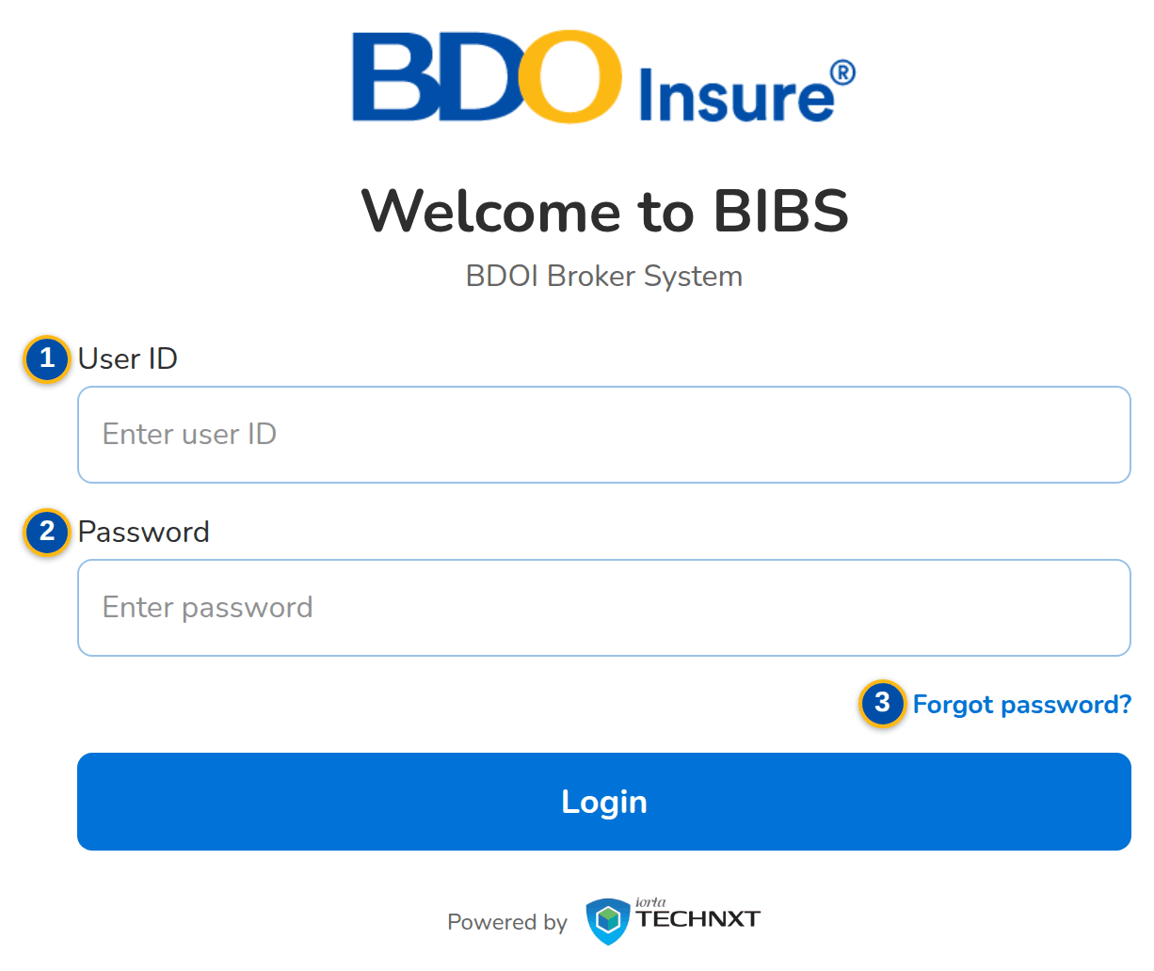
Figure 6: SCR-UA-01 Login page
1 | User ID | 2 | Password | 3 | Forgot password?

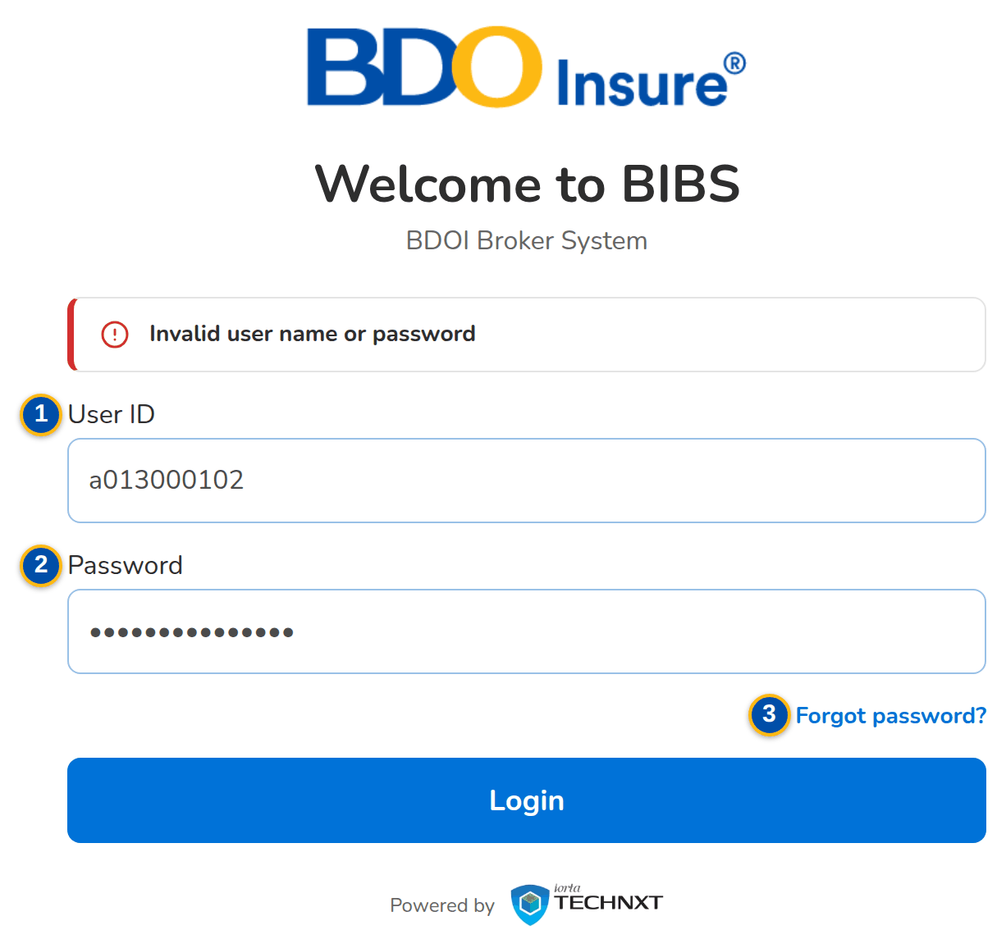
Figure 7: SCR-UA-01 Login refused with a wrong password

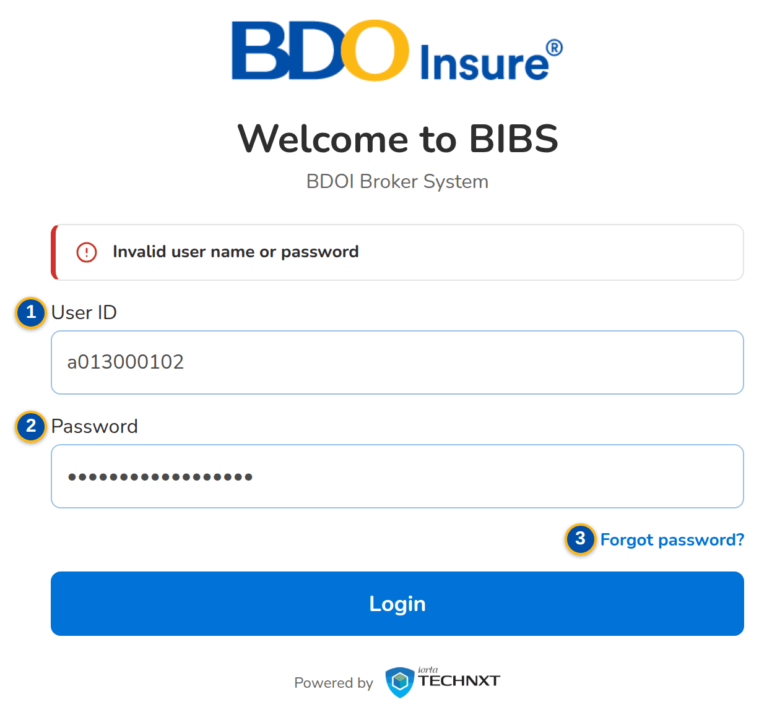
Figure 8: SCR-UA-01 Login refused for a locked account

Fields (No. = callout number on the first screenshot)
No. | Section | Field | Type | Length / format | Mand. | Source / list | Default | Editable in | Validation | Message when it fails
1 | Sign-in | User ID | Text | BIBS user ID (for example a013000196); with directory sign-in, the Windows ID | Y | User master | Blank | Before sign-in | Required by the browser; the account must exist, be active and not locked | Invalid user name or password
2 | Sign-in | Password | Password | Masked | Y | - | Blank | Before sign-in | Required by the browser; checked against the stored password (or by the directory) | Invalid user name or password
3 | Sign-in | Forgot password? | Link | - | - | - | - | Before sign-in | - | -

Actions
Button | Who | Enabled when | What happens | Resulting status | Notification
Login | Every user | User ID and password entered | Checks the account and the password. Success: opens the home page with the menu of the user's active group profiles and records the sign-in; a password set by an administrator or expired opens Change Your Password first. Failure: counts the failed attempt; the third consecutive failure locks the account and ends its open sessions | Signed in, or refused | -
Forgot password? | Every user | Always | Opens Forgot Password (SCR-UA-02) | - | -

Business rules
• The account locks after 3 consecutive failed sign-ins (parameter LOGIN_MAX_FAILED_ATTEMPTS, all users); only the System Administrator unlocks it (Users › Unlock), or a reactivation request with Also unlock the account (FR-UA-001).
• The message never says whether the user ID or the password was wrong; a deactivated user is refused with the same message and the attempt counts (FR-UA-001).
• Every successful and failed sign-in is written to the audit trail with the user and the time (FR-UA-001, FR-UA-064).
• More than 20 sign-in attempts within a minute from one computer are refused until the minute ends: Too many sign-in attempts. Wait a minute and try again. (FR-UA-001).
• The menu shows only the screens of the user's active group profiles; a deactivated group profile grants nothing (FR-UA-001, FR-UA-042).
• In directory mode the password is checked by the BDO directory and never stored in BIBS; until BDO supplies the directory interface that mode refuses every sign-in (FR-UA-003).
Expected outcome
The user is signed in with exactly the menus of the assigned group profiles, or refused with a message that does not reveal which credential was wrong.
Test cases: TC-UA-001.1-01, TC-UA-001.1-02, TC-UA-001.2-01, TC-UA-001.3-01, TC-UA-001.4-01, TC-UA-001.3-02, TC-UA-003.1-01, TC-UA-003.2-01, TC-UA-003.3-01, TC-UA-003.3-02, TC-UA-003.4-01, TC-UA-005.3-02, TC-UA-005.4-01, TC-UA-SCR-01, TC-UA-MSG-01.

13.1.2 SCR-UA-02 Forgot Password and Set a New Password
Purpose | Self-service reset of a forgotten password (local sign-in). On Forgot Password the user enters the user ID; BIBS e-mails a single-use link, valid for 30 minutes, to the address registered for the user. The link opens Set a New Password, where the user chooses the new password under the password rules.
Who can open it | Every user (permission none, before sign-in)
Navigation | • Menu: Before sign-in: Login › Forgot password?, and the e-mailed link  • Login › Forgot password?  • The link in the e-mail BIBS: reset your password
FRs | FR-UA-005

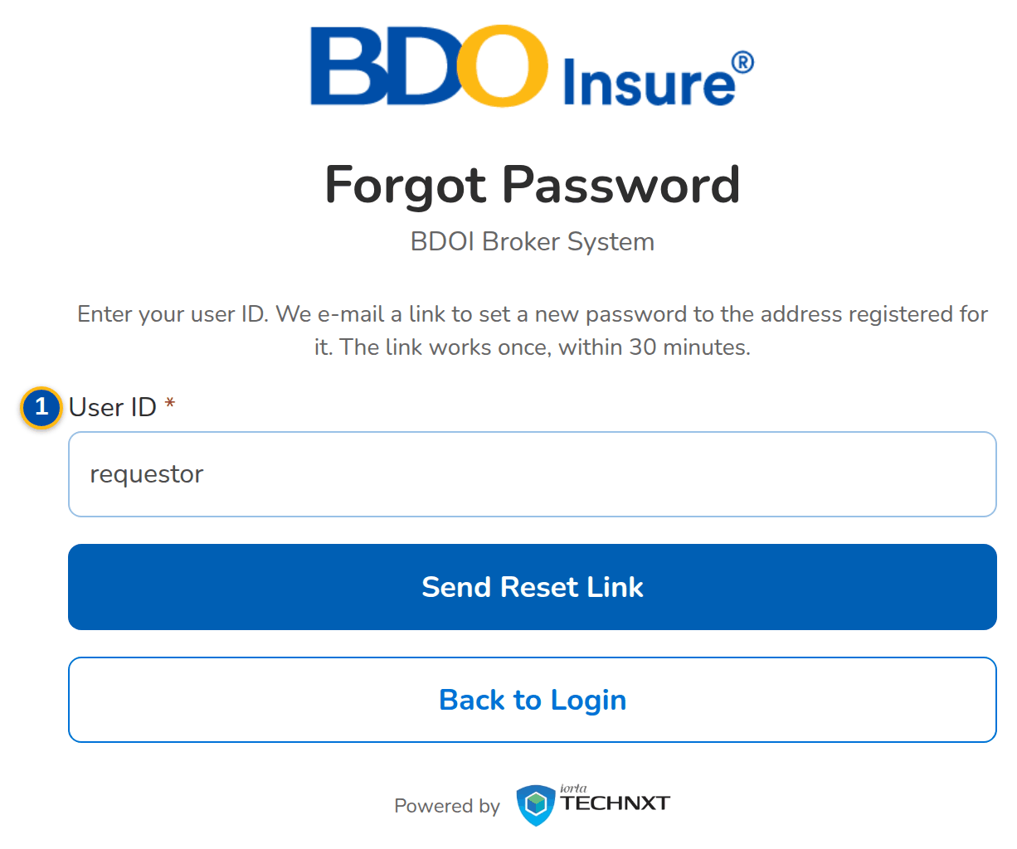
Figure 9: SCR-UA-02 Forgot Password with the user ID entered
1 | User ID | 3 | Confirm new password
2 | New password | 4 | Still needed

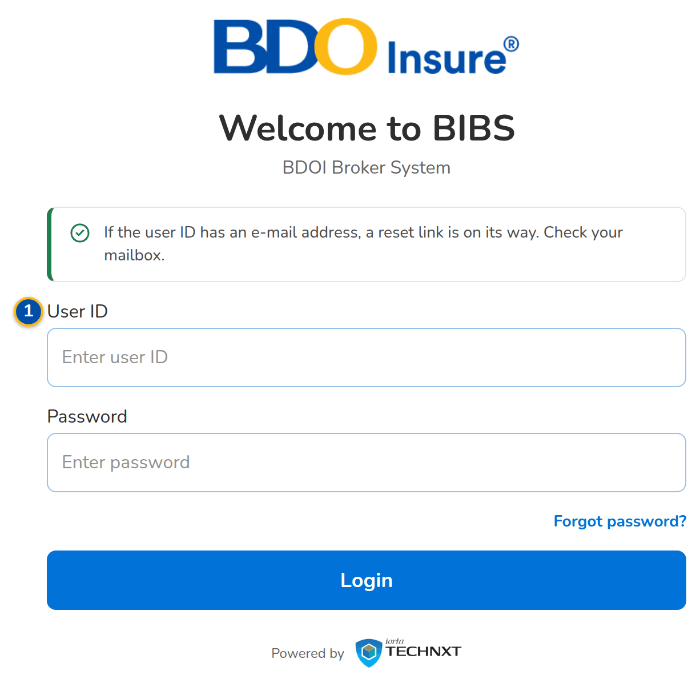
Figure 10: SCR-UA-02 Confirmation on the Login page after the request

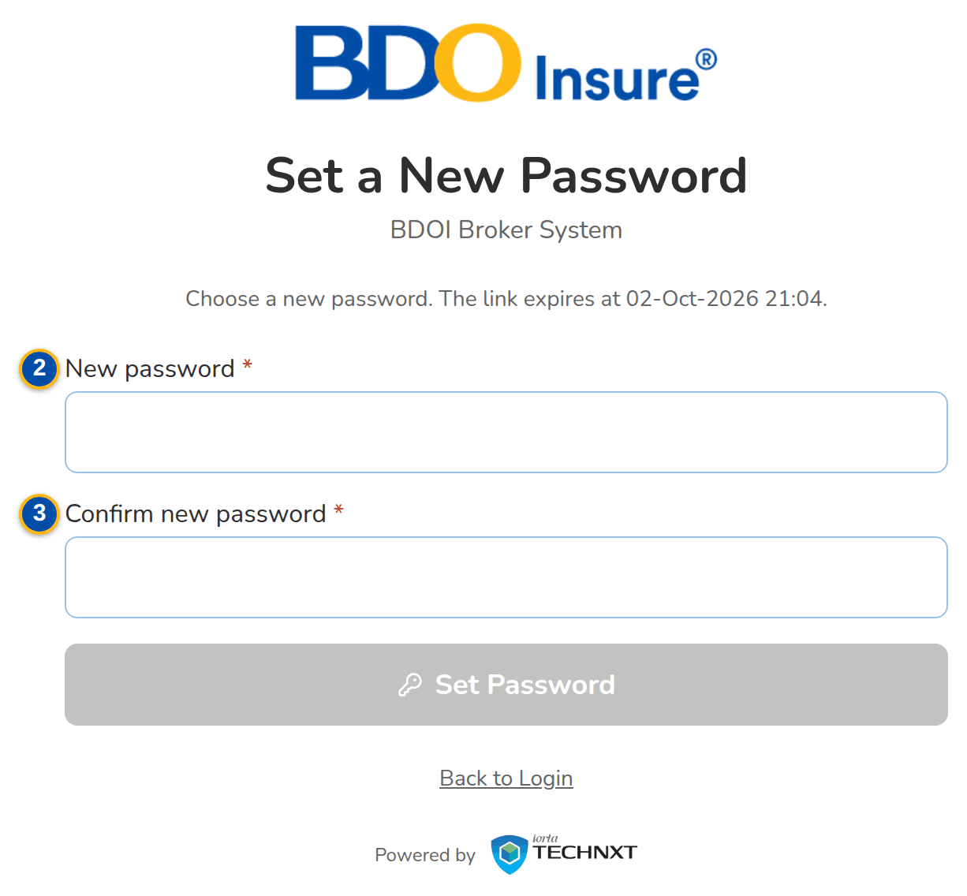
Figure 11: SCR-UA-02 Set a New Password opened from the e-mailed link

Fields (No. = callout number on the first screenshot)
No. | Section | Field | Type | Length / format | Mand. | Source / list | Default | Editable in | Validation | Message when it fails
1 | Forgot Password | User ID | Text | BIBS user ID | Y | User master | Blank | Before sign-in | Required | -
2 | Set a New Password | New password | Password | At least 10 characters with an upper-case letter, a lower-case letter, a digit and a symbol | Y | - | Blank | While the link is valid | Checked as the user types; not one of the last 8 passwords | You used this password recently. Choose another one
3 | Set a New Password | Confirm new password | Password | Same as New password | Y | - | Blank | While the link is valid | Both new passwords must match | Both new passwords must match
4 | Set a New Password | Still needed | Checklist | At least 10 characters; An upper-case letter; A lower-case letter; A digit; A symbol | - | Password rules | - | Read only | Shown until every rule is met | -

Actions
Button | Who | Enabled when | What happens | Resulting status | Notification
Send Reset Link | Every user | User ID entered | Withdraws the older links of the user and e-mails a new single-use link to the registered address; the same confirmation is shown for every user ID, so the page never reveals whether a user exists | - | E-mail BIBS: reset your password
Back to Login | Every user | Always | Returns to the Login page | - | -
Set Password | Holder of a valid link | New password meets the rules and is confirmed | Sets the password, marks the link used and confirms: Your password was changed. Sign in with the new password. | Password changed | -

Business rules
• A link works once and expires 30 minutes after it was sent; an older link of the same user stops working when a new one is requested (FR-UA-005).
• The link is sent only to an active user with an e-mail address, in local sign-in mode; a reset link does not unlock a locked account (FR-UA-005).
• The new password follows the password rules: at least 10 characters with upper and lower case, a digit and a symbol, and none of the last 8 passwords (parameter PASSWORD_HISTORY_COUNT) (FR-UA-005).
Expected outcome
A user who forgot the password sets a new one without the help desk, through a link that only the owner of the registered mailbox receives.
Test cases: TC-UA-001.1-01, TC-UA-001.1-02, TC-UA-001.2-01, TC-UA-001.3-01, TC-UA-001.4-01, TC-UA-001.3-02, TC-UA-003.1-01, TC-UA-003.2-01, TC-UA-003.3-01, TC-UA-003.3-02, TC-UA-003.4-01, TC-UA-005.3-02, TC-UA-005.4-01, TC-UA-SCR-02, TC-UA-MSG-02, TC-UA-MSG-03.

13.1.3 SCR-UA-03 Change Your Password (forced change)
Purpose | Shown after sign-in, instead of the home page, while the password must be changed: after the account was created or the password reset by an administrator, and when the password is older than the maximum age. The user chooses a new password or signs out.
Who can open it | Requestor, Approver, Second Approver, Business Administrator, System Administrator, Auditor, Information Security Officer, New Business Approver (keeps the access approval right) (permission none, every signed-in user)
Navigation | • Menu: Shown after Login, before the home page  • Login, for a user whose password was set by an administrator or has expired
FRs | FR-UA-005

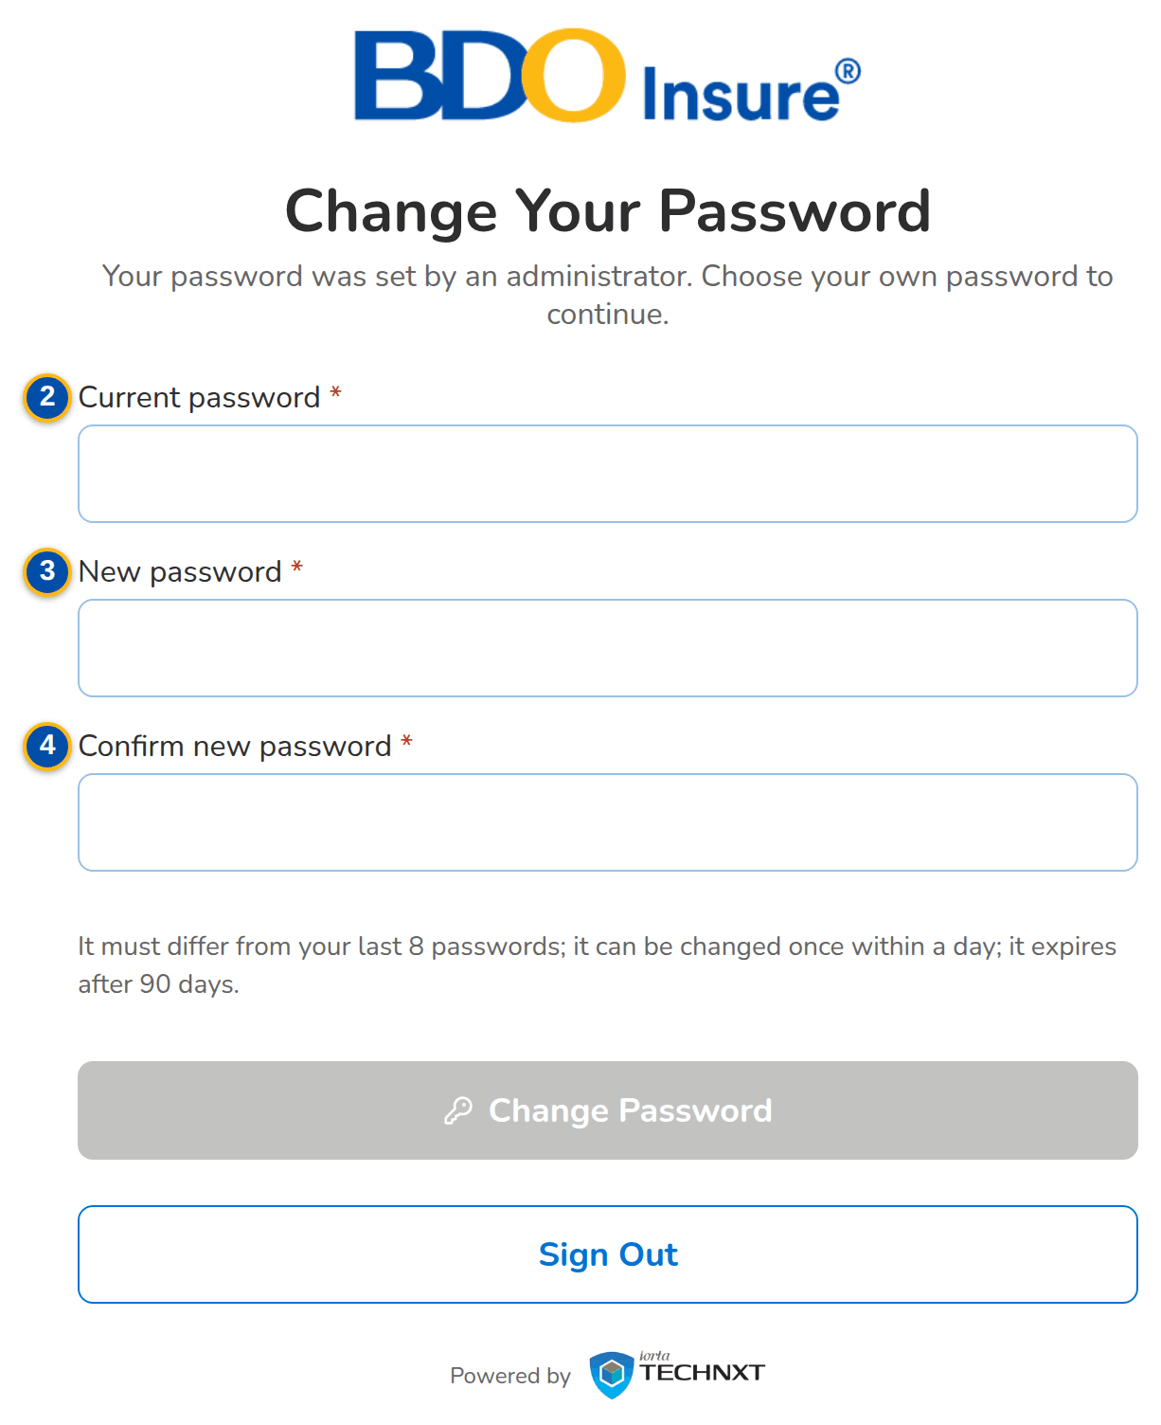
Figure 12: SCR-UA-03 Change Your Password after a password set by an administrator
1 | Reason | 3 | New password | 5 | Password rules
2 | Current password | 4 | Confirm new password

Fields (No. = callout number on the first screenshot)
No. | Section | Field | Type | Length / format | Mand. | Source / list | Default | Editable in | Validation | Message when it fails
1 | Change Your Password | Reason | Text | Your password was set by an administrator. Choose your own password to continue. / Your password is older than 90 days and has expired. Choose a new password to continue. | - | Password status | - | Read only | - | -
2 | Change Your Password | Current password | Password | Masked | Y | - | Blank | Always | Must be the current password | Current password is incorrect
3 | Change Your Password | New password | Password | At least 10 characters with an upper-case letter, a lower-case letter, a digit and a symbol | Y | - | Blank | Always | Rules checked as the user types; not one of the last 8 passwords | You used this password recently. Choose another one
4 | Change Your Password | Confirm new password | Password | Same as New password | Y | - | Blank | Always | Both new passwords must match | Both new passwords must match
5 | Change Your Password | Password rules | Text | It must differ from your last 8 passwords; it can be changed once within a day; it expires after 90 days. | - | Parameters PASSWORD_HISTORY_COUNT, PASSWORD_MIN_AGE_DAYS, PASSWORD_MAX_AGE_DAYS | - | Read only | - | -

Actions
Button | Who | Enabled when | What happens | Resulting status | Notification
Change Password | The signed-in user | Current password entered and the new password meets the rules | Saves the new password and opens the home page | Password changed | -
Sign Out | The signed-in user | Always | Ends the session and returns to the Login page | Signed out | -

Business rules
• A password set by someone else (enrolment, administrator reset) must be changed at the next sign-in (FR-UA-005).
• A password older than PASSWORD_MAX_AGE_DAYS (90 as delivered) must be changed before work continues; a password never changed since the release does not expire until changed once (FR-UA-005).
• The minimum age (PASSWORD_MIN_AGE_DAYS, one day) does not apply to a forced change (FR-UA-005).
Expected outcome
No user works with a password that an administrator knows or that has expired.
Test cases: TC-UA-001.1-01, TC-UA-001.1-02, TC-UA-001.2-01, TC-UA-001.3-01, TC-UA-001.4-01, TC-UA-001.3-02, TC-UA-003.1-01, TC-UA-003.2-01, TC-UA-003.3-01, TC-UA-003.3-02, TC-UA-003.4-01, TC-UA-005.3-02, TC-UA-005.4-01, TC-UA-SCR-03.

13.1.4 SCR-UA-04 Inactivity and Session-end Warnings
Purpose | The two warnings of the session guard, shown over any screen: the inactivity warning, 15 minutes before the sign-out after 30 minutes without activity, and the warning before the fixed end of the session, 30 minutes before BIBS signs the user out whatever the activity.
Who can open it | Requestor, Approver, Second Approver, Business Administrator, System Administrator, Auditor, Information Security Officer, New Business Approver (keeps the access approval right) (permission none, every signed-in user)
Navigation | • Menu: Dialog over any screen  • Any screen after 15 minutes without activity  • Any screen 30 minutes before the fixed end of the session
FRs | FR-UA-002, FR-UA-004

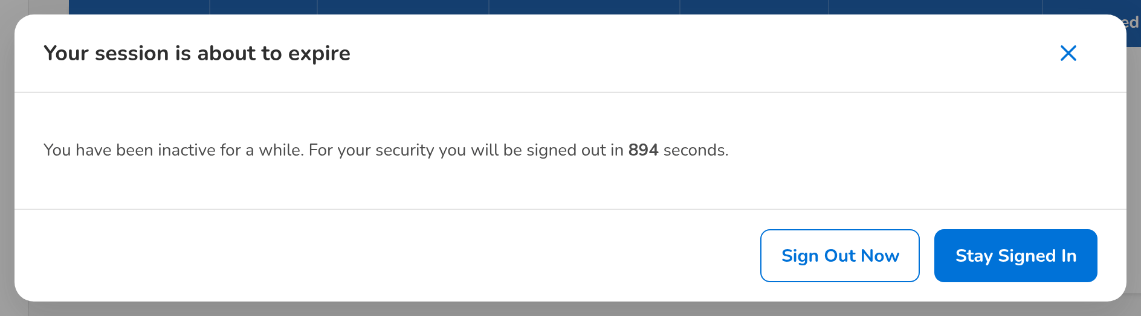
Figure 13: SCR-UA-04 Your session is about to expire (inactivity warning)
1 | Countdown | 2 | Session end

Fields (No. = callout number on the first screenshot)
No. | Section | Field | Type | Length / format | Mand. | Source / list | Default | Editable in | Validation | Message when it fails
1 | Your session is about to expire | Countdown | Text | You have been inactive for a while. For your security you will be signed out in n seconds. | - | Parameters SESSION_IDLE_WARNING_MINUTES, SESSION_TIMEOUT_MINUTES | - | Read only | - | -
2 | Your session will end soon | Session end | Text | For your security the system signs you out in n minute(s), at dd-MMM-yyyy HH:mm, whatever your activity. | - | Parameter SESSION_EXPIRY_WARNING_MINUTES | - | Read only | - | -

Actions
Button | Who | Enabled when | What happens | Resulting status | Notification
Stay Signed In | The signed-in user | Inactivity warning shown | Closes the warning and restarts the inactivity timer in every tab | Signed in | -
Sign Out Now | The signed-in user | Inactivity warning shown | Ends the session and returns to the Login page | Signed out | -
I Understand | The signed-in user | Session-end warning shown | Closes the warning; the session still ends at the time shown | Signed in | -

Business rules
• After 15 minutes without activity the inactivity warning is shown; after 30 minutes the user is signed out and sees: You were signed out after 30 minutes of inactivity. (parameters SESSION_IDLE_WARNING_MINUTES, SESSION_TIMEOUT_MINUTES) (FR-UA-002).
• Activity in any browser tab keeps every tab signed in (FR-UA-002).
• Every sign-out is kept in the session log with its reason: log-out, inactivity, end of the session, ended by an administrator or account locked (FR-UA-004).
Expected outcome
An unattended screen is closed automatically, and the user is warned in time to keep working.
Test cases: TC-UA-002.1-01, TC-UA-002.1-02, TC-UA-002.2-01, TC-UA-002.3-01, TC-UA-002.4-01, TC-UA-SCR-04, TC-UA-MSG-04.

13.1.5 SCR-UA-05 My Profile
Purpose | The signed-in user's own page: account details, contact details the user maintains, the group profiles and permissions held, the password with its rules and dates, and the recent sign-in sessions.
Who can open it | Requestor, Approver, Second Approver, Business Administrator, System Administrator, Auditor, Information Security Officer, New Business Approver (keeps the access approval right) (permission Every signed-in user)
Navigation | • Menu: Setup & Administration › Help › My Profile  • User menu in the page header › My Profile  • The notice Your password expires soon
FRs | FR-UA-004, FR-UA-005

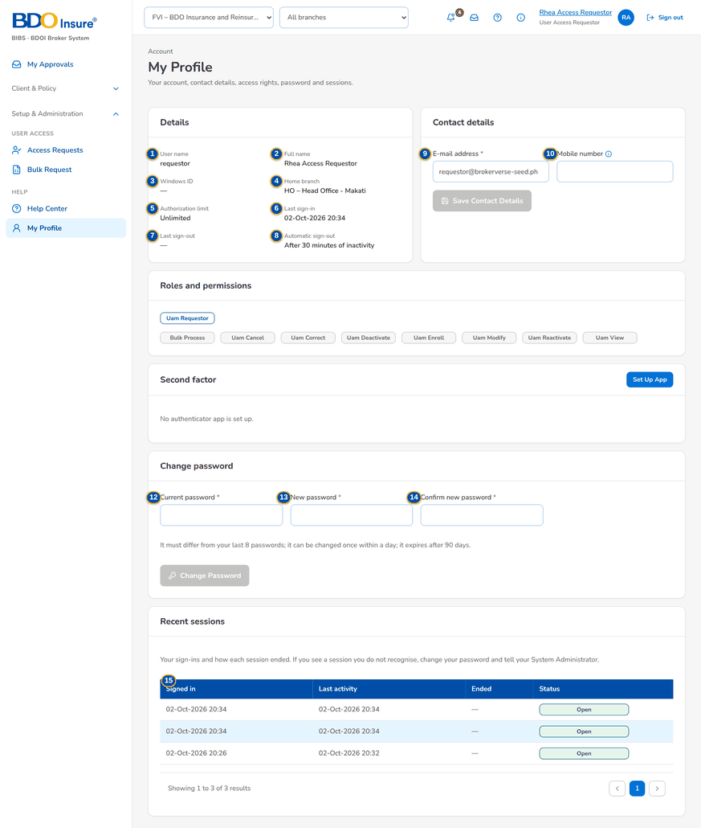
Figure 14: SCR-UA-05 My Profile of the Requestor
1 | User name | 6 | Last sign-in | 11 | Group profiles and permissions
2 | Full name | 7 | Last sign-out | 12 | Current password
3 | Windows ID | 8 | Automatic sign-out | 13 | New password
4 | Home branch | 9 | E-mail address | 14 | Confirm new password
5 | Authorization limit | 10 | Mobile number | 15 | Signed in / Last activity / Ended / Status

Fields (No. = callout number on the first screenshot)
No. | Section | Field | Type | Length / format | Mand. | Source / list | Default | Editable in | Validation | Message when it fails
1 | Details | User name | Text | User ID | - | User master | - | Read only | - | -
2 | Details | Full name | Text | - | - | User master | - | Read only (changed through a Modify user request) | - | -
3 | Details | Windows ID | Text | - | - | User master | - | Read only | - | -
4 | Details | Home branch | Text | Code – name | - | Branches | - | Read only | - | -
5 | Details | Authorization limit | Amount | PHP, two decimals; Unlimited when blank | - | User master | - | Read only | - | -
6 | Details | Last sign-in | Date and time | dd-MMM-yyyy HH:mm | - | Session log | - | Read only | - | -
7 | Details | Last sign-out | Date and time | dd-MMM-yyyy HH:mm | - | Session log | - | Read only | - | -
8 | Details | Automatic sign-out | Text | After 30 minutes of inactivity | - | Parameter SESSION_TIMEOUT_MINUTES | - | Read only | - | -
9 | Contact details | E-mail address | E-mail | Valid e-mail address | Y | User master | Current address | Always | A valid address | Enter your e-mail address
10 | Contact details | Mobile number | Telephone | Digits with an optional +, spaces, brackets and dashes, 7 to 25 characters | N | User master | Current number | Always | Digits only, for example +63 917 123 4567 | Enter the mobile number with digits only, for example +63 917 123 4567
11 | Roles and permissions | Group profiles and permissions | Tags | Names of the group profiles and of the permissions | - | Role grants | - | Read only | - | -
12 | Change password | Current password | Password | Masked | Y | - | Blank | Local sign-in | Must be the current password | Current password is incorrect
13 | Change password | New password | Password | At least 10 characters with upper and lower case, a digit and a symbol | Y | - | Blank | Local sign-in | Rules checked as the user types; history and minimum age checked on save | You changed your password less than a day ago
14 | Change password | Confirm new password | Password | Same as New password | Y | - | Blank | Local sign-in | Both new passwords must match | Both new passwords must match
15 | Recent sessions | Signed in / Last activity / Ended / Status | Columns | Date and time; status Open, Logout, Idle Timeout, Expired, Admin Ended, Locked | - | Session log | - | Read only | - | -

Actions
Button | Who | Enabled when | What happens | Resulting status | Notification
Save Contact Details | The signed-in user | Address or number changed | Saves the e-mail address and mobile number; each changed value is written to the access change log without a request | - | -
Change Password | The signed-in user (local sign-in) | Current password entered and the new password meets the rules | Saves the new password; the dates under the card are updated | - | -

Business rules
• Users update their own e-mail address and mobile number without a request; every other attribute changes only through an approved access request (FR-UA-005, FR-UA-012).
• With directory sign-in the password card reads: You sign in with your organisation's network password. Change it through your organisation's directory, not here. (FR-UA-003, FR-UA-005).
• A password cannot be changed twice within PASSWORD_MIN_AGE_DAYS (one day as delivered) and must differ from the last PASSWORD_HISTORY_COUNT passwords (8) (FR-UA-005).
• The recent sessions show how each session ended; a session the user does not recognise is reported to the System Administrator (FR-UA-004).
Expected outcome
Each user sees exactly which access is held, keeps the contact details current and changes the password under the password rules.
Test cases: TC-UA-005.1-01, TC-UA-005.1-02, TC-UA-005.1-03, TC-UA-005.2-01, TC-UA-005.2-02, TC-UA-SCR-05, TC-UA-MSG-05.

13.2 User access requests

13.2.1 SCR-UA-06 Access Requests
Purpose | The work list of access requests: the requests the user raised, the requests assigned to the user for approval or second approval, the approved group-profile requests waiting for implementation, and all requests the user may see. Approvers approve several selected requests at once; a new-user request is approved on its own.
Who can open it | Requestor, Approver, Second Approver, Business Administrator, System Administrator, Auditor, Information Security Officer, New Business Approver (keeps the access approval right) (permission UAM_VIEW or ACCESS_REQUEST or ACCESS_APPROVE or UAM_SECOND_APPROVE or ROLE_MANAGE or AUDIT_VIEW)
Navigation | • Menu: Setup & Administration › User Access › Access Requests  • The notice Access request AR-yyyy-nnnnnn to approve (opens the request)  • Access Request record › back arrow  • The old address Broking Setup › Access Requests opens this screen
FRs | FR-UA-018, FR-UA-030, FR-UA-031

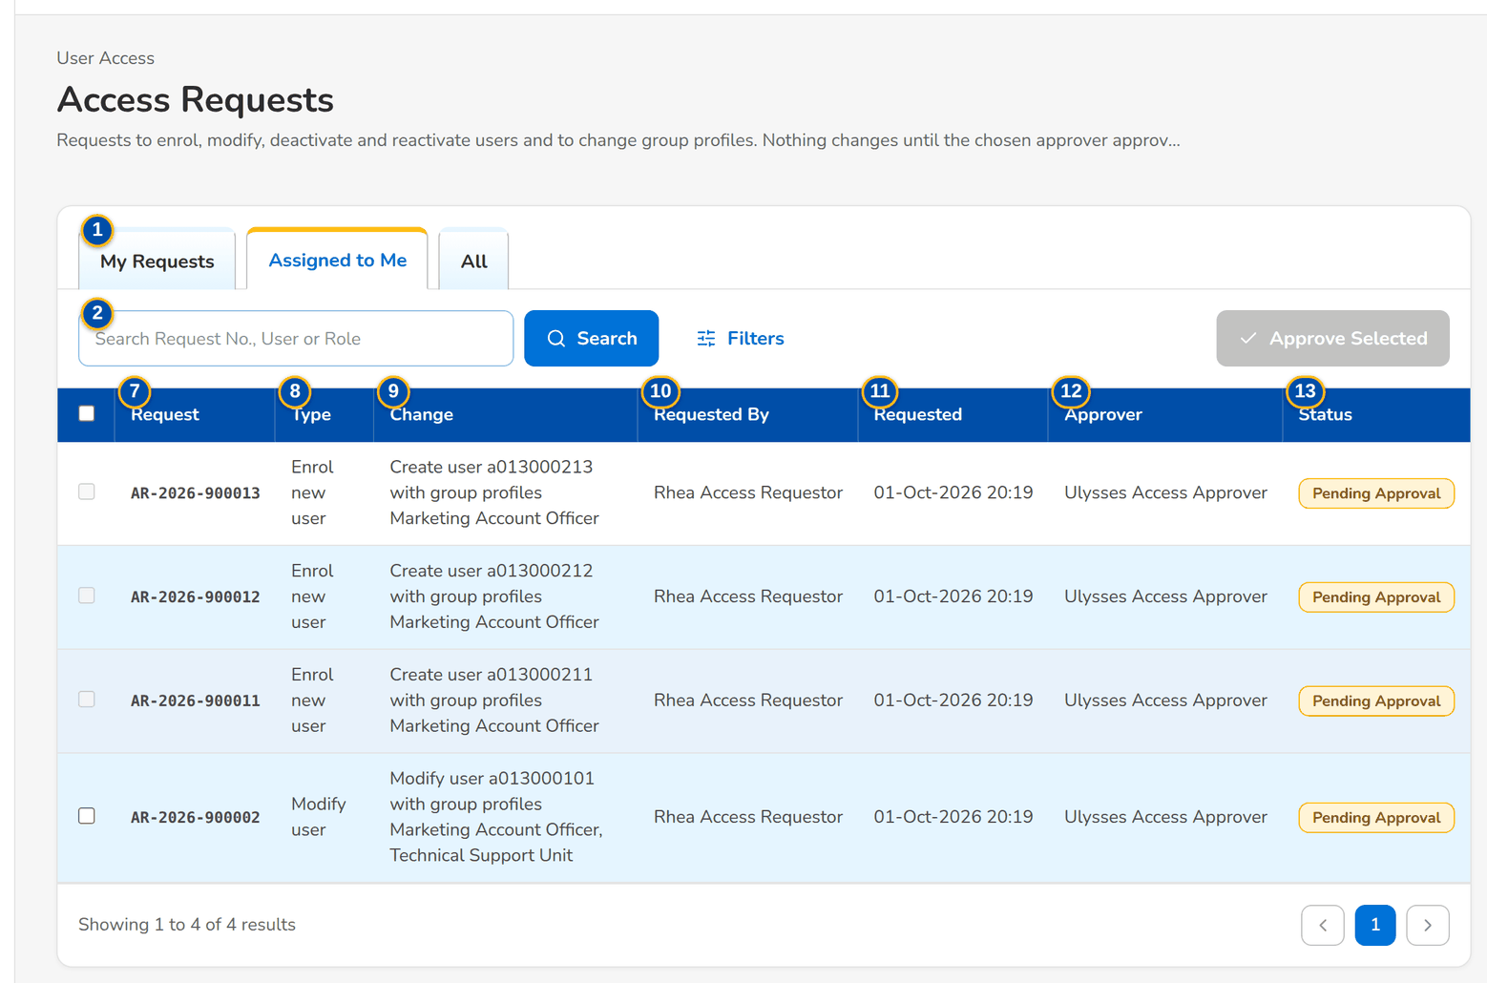
Figure 15: SCR-UA-06 Access Requests of the Approver, Assigned to Me tab
1 | My Requests / Assigned to Me / Second Approval / For Implementation / All | 6 | Requested From / Requested To | 11 | Requested
2 | Search Request No., User or Role | 7 | Request | 12 | Approver
3 | Status | 8 | Type | 13 | Status
4 | Request Type | 9 | Change | 14 | Select
5 | Requested By / Approver | 10 | Requested By

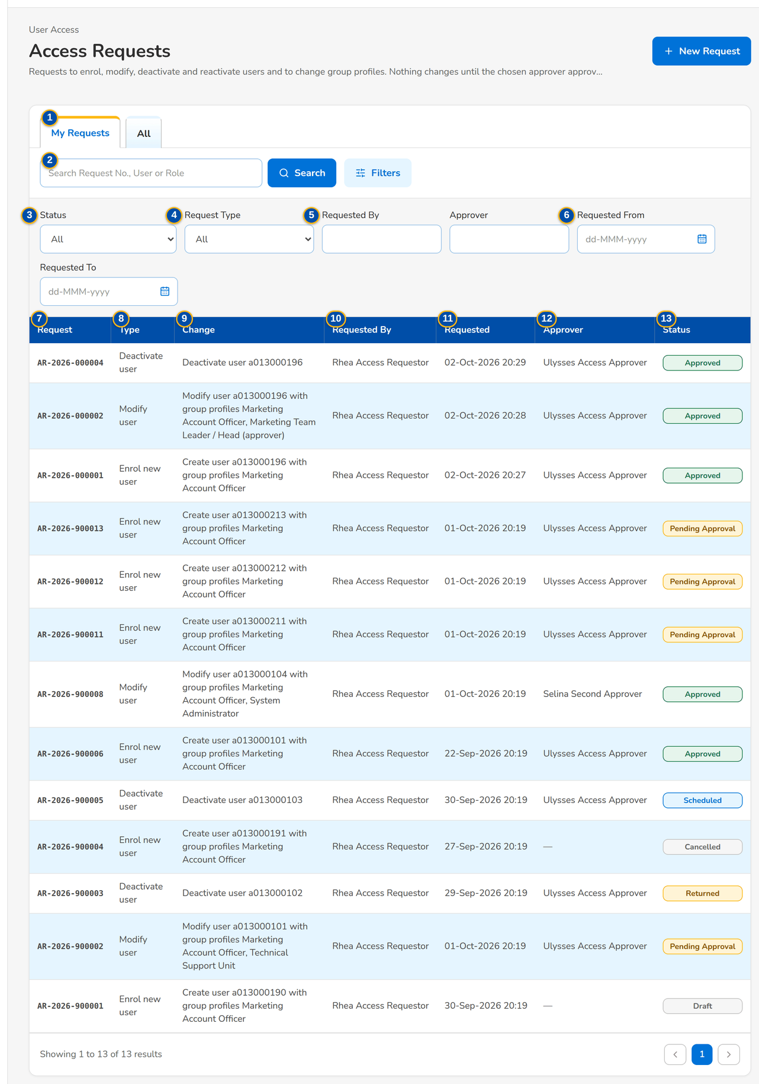
Figure 16: SCR-UA-06 Access Requests of the Requestor, My Requests tab with the filters

Fields (No. = callout number on the first screenshot)
No. | Section | Field | Type | Length / format | Mand. | Source / list | Default | Editable in | Validation | Message when it fails
1 | Tabs | My Requests / Assigned to Me / Second Approval / For Implementation / All | Tab | - | - | Fixed; a tab is shown only to the users who work it | Assigned to Me for an approver, Second Approval for a second approver, else My Requests | - | My Requests: raised by the user; Assigned to Me: waiting for the user (approval right); Second Approval: waiting for a second approval (second approval right); For Implementation: approved group-profile requests (role management right); All: every request the user may see | -
2 | Search | Search Request No., User or Role | Text | Part of a request number, user ID or group profile | N | - | Blank | - | Contains search | -
3 | Filters | Status | Drop-down | All, Draft, Pending Approval, Pending Second Approval, Returned, Scheduled, Approved, For Implementation, Implemented, Rejected, Cancelled | N | Fixed list | All | - | - | -
4 | Filters | Request Type | Drop-down | All, Enrol new user, Modify user, Deactivate user, Reactivate user, Change roles, New group profile, Modify group profile, Deactivate group profile, Reactivate group profile | N | Fixed list | All | - | - | -
5 | Filters | Requested By / Approver | Text | User ID | N | - | Blank | - | Exact user | -
6 | Filters | Requested From / Requested To | Date | dd-MMM-yyyy | N | - | Blank | - | - | -
7 | List | Request | Column | AR-yyyy-nnnnnn | - | Access request | - | Read only | - | -
8 | List | Type | Column | Request type | - | Access request | - | Read only | - | -
9 | List | Change | Column | One-line description with the names of the group profiles, for example Modify user a013000101 with group profiles Marketing Account Officer | - | Access request | - | Read only | - | -
10 | List | Requested By | Column | Name of the requester | - | Access request | - | Read only | - | -
11 | List | Requested | Column | dd-MMM-yyyy HH:mm | - | Access request | - | Read only | - | -
12 | List | Approver | Column | Name of the chosen approver, or of the decider | - | Access request | - | Read only | - | -
13 | List | Status | Column | Status pill | - | Access request | - | Read only | - | -
14 | List | Select | Check box | One per row on Assigned to Me and Second Approval; disabled on a new-user request, with the tooltip Open the request to approve it: the temporary password of the new user is shown only once | N | - | Not ticked | Assigned to Me; Second Approval | - | -

Actions
Button | Who | Enabled when | What happens | Resulting status | Notification
New Request | Requestor, Business Administrator, System Administrator (enrol, modify, deactivate or reactivate right) | Always | Opens New Request (SCR-UA-07) | - | -
Approve Selected | Approver on Assigned to Me; Second Approver on Second Approval | Rows selected | Approves each selected request in turn, with the same rules as one approval; a new-user request cannot be selected. Toast: n request(s) approved | Approved, Scheduled, Pending Second Approval or For Implementation | Decision notice to each requester; access-changed notice to each user
Filters | Every user of the screen | Always | Shows or hides the filters | - | -
Open a row | Every user of the screen | Always | Opens the request (SCR-UA-08) | - | -

Business rules
• A draft is seen only by its creator. Holders of the approval, user management or audit right (Approver, New Business Approver, System Administrator, Business Administrator, Auditor, Information Security Officer) see every submitted request; the others see the requests they raised and those waiting for them (FR-UA-018).
• Assigned to Me lists the pending requests whose chosen approver is the user; when UAM_ANY_APPROVER is on, every approver sees every pending request (FR-UA-030, FR-UA-015).
• An enrolment is approved on its own, on the request, so that its temporary password is shown: its row cannot be selected here, and My Approvals refuses it among several: Approve <reference> on its own: the new user's temporary password is shown once (FR-UA-031).
Expected outcome
Each user finds the requests to act on at once; approvers clear routine requests in one step.
Test cases: TC-UA-010.3-01, TC-UA-015.2-01, TC-UA-017.1-01, TC-UA-017.2-01, TC-UA-017.3-02, TC-UA-017.4-01, TC-UA-018.1-01, TC-UA-018.1-02, TC-UA-018.1-03, TC-UA-030.1-01, TC-UA-045.3-01, TC-UA-SCR-06.

13.2.2 SCR-UA-07 New Request and Edit Request (user requests)
Purpose | One form for the four user requests: enrol a new user, modify a user (data and group profiles), deactivate and reactivate a user. The requester enters the user, the new values with the current ones shown beside them, the group profiles, the effective date, the approver and the justification; saves a draft to finish later or submits it. A returned request is corrected here and resubmitted with correction remarks.
Who can open it | Requestor, Business Administrator, System Administrator (permission UAM_ENROLL or UAM_MODIFY or UAM_DEACTIVATE or UAM_REACTIVATE or UAM_GROUP_REQUEST or UAM_CORRECT or ACCESS_REQUEST)
Navigation | • Menu: Setup & Administration › User Access › Access Requests › New Request  • Access Requests › New Request  • Access Request record › Edit Request (draft or returned request)  • Users › Raise Request, or a user row (opens a Modify user request for that user)
FRs | FR-UA-010, FR-UA-011, FR-UA-012, FR-UA-013, FR-UA-014, FR-UA-015, FR-UA-016, FR-UA-020, FR-UA-053

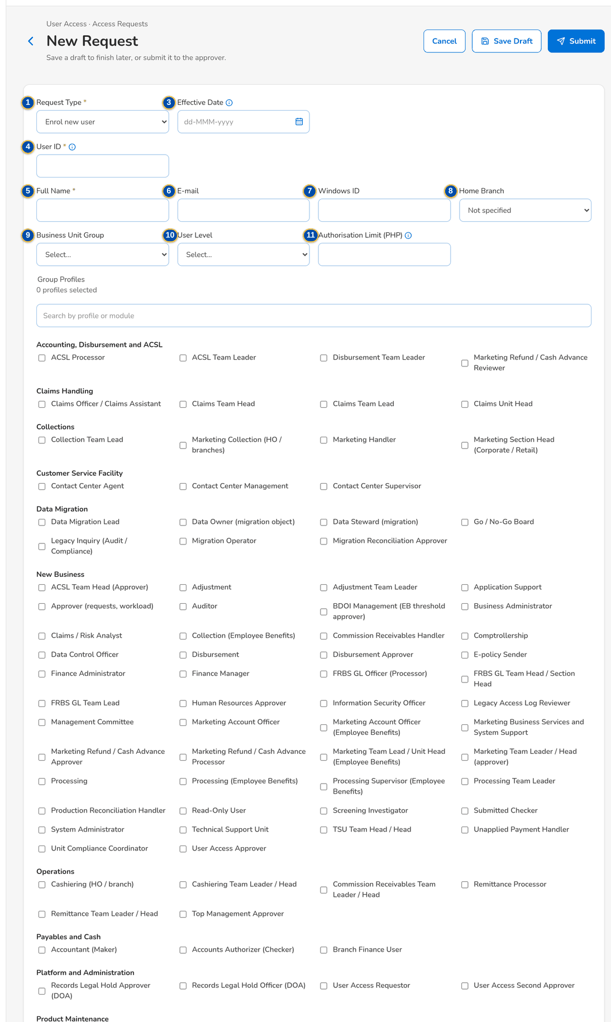
Figure 17: SCR-UA-07 New Request, Enrol new user
1 | Request Type | 7 | Windows ID | 13 | Group profile check boxes
2 | User Type | 8 | Home Branch | 14 | Reason
3 | Effective Date | 9 | Business Unit Group | 15 | Also unlock the account
4 | User ID | 10 | User Level | 16 | Approver
5 | Full Name | 11 | Authorisation Limit (PHP) | 17 | Remarks (Justification)
6 | E-mail | 12 | Search group profiles | 18 | Correction Remarks

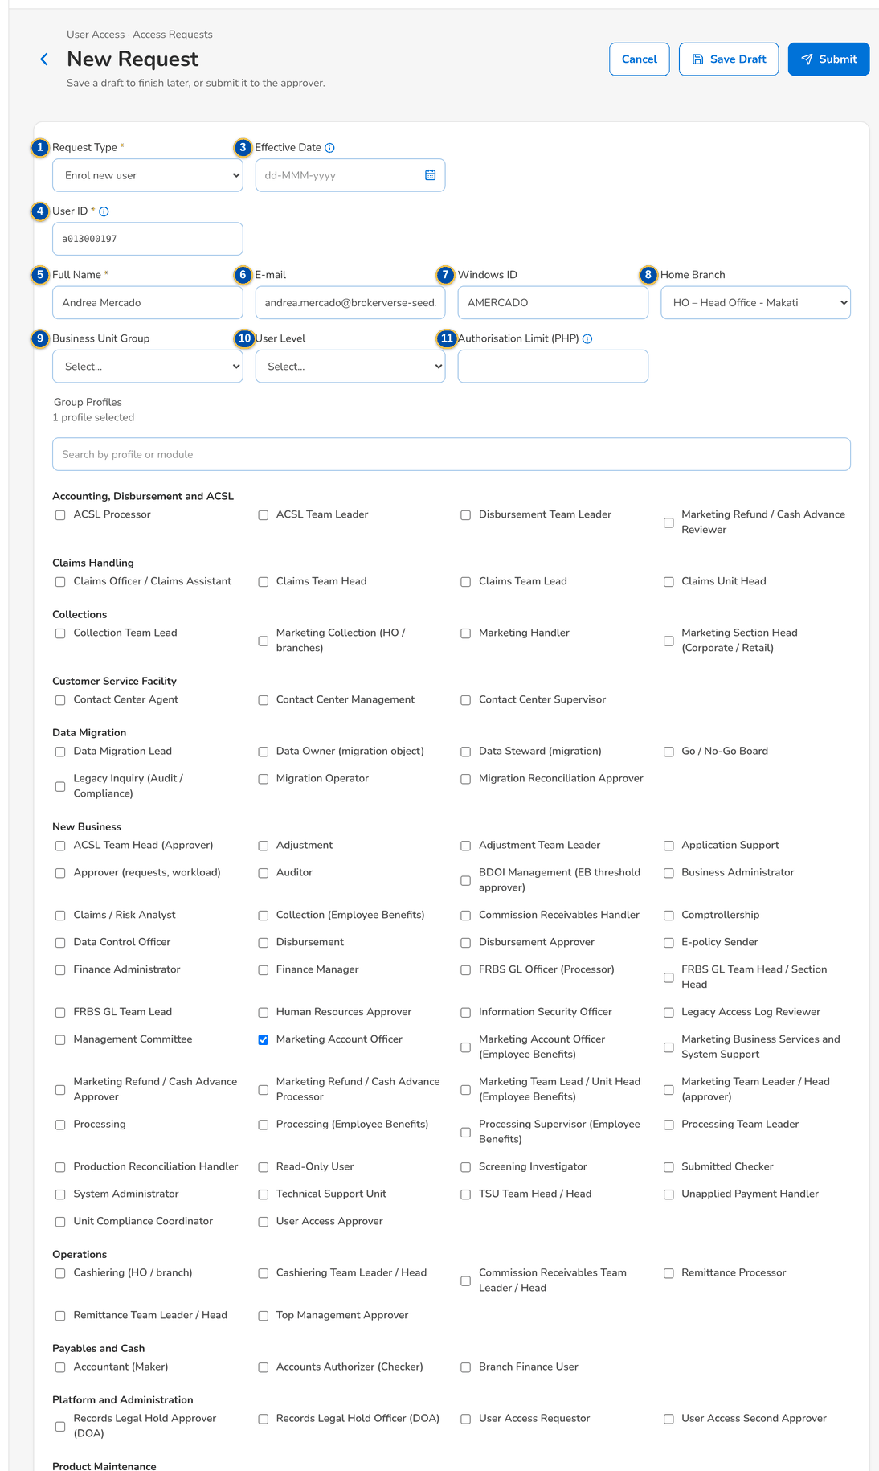
Figure 18: SCR-UA-07 New Request with the new user's data, group profile and approver

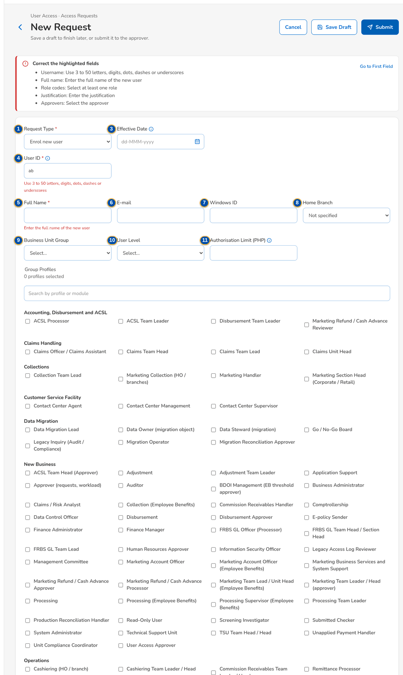
Figure 19: SCR-UA-07 Field messages after Submit with a short user ID and no justification

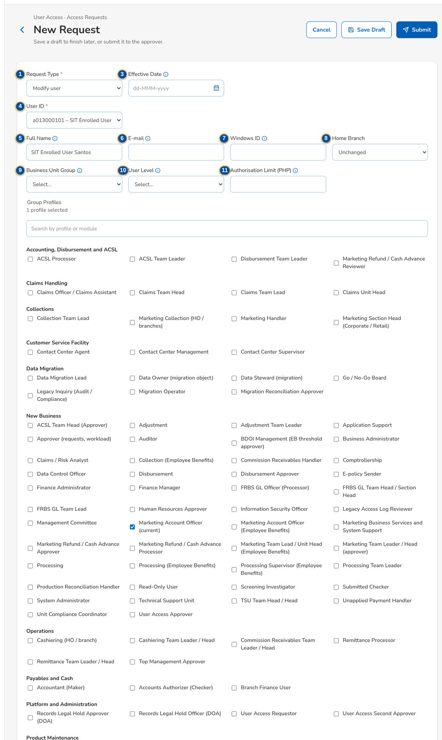
Figure 20: SCR-UA-07 Modify user: current values beside the requested ones

Fields (No. = callout number on the first screenshot)
No. | Section | Field | Type | Length / format | Mand. | Source / list | Default | Editable in | Validation | Message when it fails
1 | Request | Request Type | Drop-down | Enrol new user, Modify user, Deactivate user, Reactivate user | Y | Fixed list | Enrol new user (or the type of the link) | New request only (fixed after the first save) | The type of a saved request cannot change | The type of request <request no> cannot change
2 | Request | User Type | Drop-down | Internal (BIBS user); External (portal user) | Y | Fixed list | Internal (BIBS user) | New request only | Not shown while UAM_EXTERNAL_USERS is false (no portal installed, as delivered); every request is then for an internal user | Requests for external (portal) users are switched off: no portal is installed
3 | Request | Effective Date | Date | dd-MMM-yyyy; blank = applies on approval | N | - | Blank | Draft; Returned | Today or later | The effective date cannot be before today
4 | User | User ID | Text (new user); Drop-down (existing user) | 3 to 50 letters, digits, dots, dashes or underscores; a new user ID in the BDOI format, shown in words under the field (BDOI format: a letter followed by nine digits, for example a013000196) | Y | User master (existing users: user ID – name (Windows ID)) | Blank | Draft; Returned | A new user ID must not exist and must follow the format; an existing user must be active to deactivate and deactivated or locked to reactivate | Use 3 to 50 letters, digits, dots, dashes or underscores; The user ID must be a letter followed by nine digits, for example a013000196
5 | User data | Full Name | Text | Up to 120 characters; Current: value shown for a modification | Cond.: enrolment | User master | Blank | Draft; Returned | Not blank for a new user | Enter the full name of the new user
6 | User data | E-mail | E-mail | Up to 120 characters | N | User master | Blank | Draft; Returned | - | -
7 | User data | Windows ID | Text | Up to 120 characters; unique | N | User master | Blank | Draft; Returned | Not the Windows ID of another user | Windows ID <windows id> belongs to another user
8 | User data | Home Branch | Drop-down | Code – name; Not specified (new) or Unchanged (modify) | N | Branches | Not specified / Unchanged | Draft; Returned | - | -
9 | User data | Business Unit Group | Drop-down | Values of the list | N | List UAM_BUSINESS_UNIT (values from BDOI) | Blank | Draft; Returned | - | -
10 | User data | User Level | Drop-down | Values of the list | N | List UAM_USER_LEVEL (values from BDOI) | Blank | Draft; Returned | - | -
11 | User data | Authorisation Limit (PHP) | Amount | Zero or more with up to 2 decimals; Blank: no limit (new) or Current: amount (modify) | N | User master | Blank | Draft; Returned | Zero or more, 2 decimals | Enter an amount of zero or more, with up to 2 decimals
12 | Group Profiles | Search group profiles | Text | Part of a profile name, code or module | N | - | Blank | Draft; Returned | The chosen profiles stay listed | -
13 | Group Profiles | Group profile check boxes | Check boxes | Name of each active group profile, grouped by product module; the count of profiles selected; (current) after a profile the user holds | Cond.: enrolment (at least one) | Active group profiles | None (new); the profiles held (modify) | Draft; Returned | Active profiles only; a user cannot change his own profiles; no two profiles of an active separation-of-duties rule | Select at least one role; One user may not hold both <profile> and <profile> (separation-of-duties rule <rule>)
14 | Deactivation | Reason | Drop-down | Resigned, Transferred to another unit, Long leave, Security, Others, No sign-in for the dormancy period (values to confirm with BDOI) | N | List UAM_DEACTIVATION_REASON | Blank | Draft; Returned | - | -
15 | Reactivation | Also unlock the account | Check box | Shown when the user is locked | N | - | Not ticked | Draft; Returned | - | -
16 | Approval | Approver | Drop-down | Name (user ID) of each eligible approver | Y | Holders of the approval right, less the requester and the user concerned | Blank | Draft; Returned | An eligible approver; one approver for a user request | Select the approver
17 | Approval | Remarks (Justification) | Text area | Up to 1,000 characters | Y | - | Blank | Draft; Returned | Not blank on submission | Enter the justification
18 | Approval | Correction Remarks | Text area | Up to 1,000 characters; shown for a returned request | Cond.: resubmission | - | Blank | Returned | Not blank on resubmission | Enter the correction remarks

Actions
Button | Who | Enabled when | What happens | Resulting status | Notification
Cancel | The requester | Always | Leaves the form without saving | Unchanged | -
Save Draft | Requestor, Business Administrator, System Administrator (type right) | User ID in a valid format; effective date not in the past | Saves the draft with format checks only; a new request is numbered AR-yyyy-nnnnnn. Toast: AR-yyyy-nnnnnn saved as a draft | Draft (new); unchanged (edit) | -
Submit | As Save Draft | Every field check passes | Runs the full checks (user state, format, active profiles, free Windows ID, one open request per user, eligible approver), evaluates the risk rules and sends the request to the approver. Toast: AR-yyyy-nnnnnn submitted | Pending Approval | Access request AR-yyyy-nnnnnn to approve, to the chosen approver
Resubmit | The requester (correction right) | Returned request with correction remarks | Resubmits the corrected request to the approver | Pending Approval | Access request AR-yyyy-nnnnnn to approve

Business rules
• The type and the user of a saved request cannot change; a different change is a new request (FR-UA-010).
• Only one request per user can be open (draft excluded) at a time: A request for user <user> is already waiting for approval (FR-UA-010).
• A new user ID must follow USER_ID_PATTERN (a letter followed by nine digits as delivered, shown in words from USER_ID_FORMAT_TEXT) and must not exist (FR-UA-011, FR-UA-052).
• The group profiles of the user must not include both profiles of an active separation-of-duties rule; the check runs on submission and again at approval (FR-UA-053).
• The authorisation limit (used by the journal and payables approvals) is set on an enrolment and changed by a Modify user request; blank keeps the current limit (FR-UA-011, FR-UA-012).
• An enrolment needs the full name and at least one active group profile; a modification must change something: The request does not change the user (FR-UA-011, FR-UA-012).
• Only active users are deactivated and only deactivated or locked users are reactivated; a locked user can be unlocked with the reactivation (FR-UA-013, FR-UA-014).
• The approver is chosen among the holders of the approval right, never the requester nor the user the request is about; a user request has one approver (FR-UA-015).
• A user cannot change his own group profiles through a request: You cannot change your own roles (FR-UA-012).
• An effective date in the future makes the approved change wait until that date; blank applies it on approval (FR-UA-020).
• A returned request is corrected by its creator and resubmitted with correction remarks, kept in the history (FR-UA-016).
Expected outcome
A complete, checked request waits for the chosen approver; nothing in the user's access changes yet.
Test cases: TC-UA-010.1-01, TC-UA-010.1-02, TC-UA-010.4-01, TC-UA-010.4-02, TC-UA-010.4-03, TC-UA-010.5-01, TC-UA-011.1-01, TC-UA-011.2-01, TC-UA-011.2-02, TC-UA-011.2-03, TC-UA-011.2-04, TC-UA-011.2-05, TC-UA-011.3-01, TC-UA-011.4-01, TC-UA-012.1-01, TC-UA-012.2-01, TC-UA-012.3-01, TC-UA-012.3-03, TC-UA-013.1-01, TC-UA-013.3-01, TC-UA-014.1-01, TC-UA-014.1-02, TC-UA-015.1-01, TC-UA-015.3-01, TC-UA-020.2-01, TC-UA-020.3-01, TC-UA-050.2-01, TC-UA-SCR-07, TC-UA-MSG-07.

13.2.3 SCR-UA-08 Access Request record
Purpose | One access request: its number, type and subject, status and risk flags, who requested it and when, the approver, the effective date and the decision; the tabs Details (current and requested values), Approvers (in order, with each decision) and History (every event with its remarks); and the actions the viewer may take: edit, cancel, approve, give the second approval, return, reject or implement.
Who can open it | Requestor, Approver, Second Approver, Business Administrator, System Administrator, Auditor, Information Security Officer, New Business Approver (keeps the access approval right) (permission UAM_VIEW or ACCESS_REQUEST or ACCESS_APPROVE or UAM_SECOND_APPROVE or ROLE_MANAGE or AUDIT_VIEW)
Navigation | • Menu: Setup & Administration › User Access › Access Requests › Access Request  • Access Requests or Group Profile Requests › a row  • My Approvals › an access request  • The notices of the request (to approve, returned, decided, for second approval, to implement)  • Bulk Request Batch › a line
FRs | FR-UA-017, FR-UA-018, FR-UA-030, FR-UA-031, FR-UA-032, FR-UA-033, FR-UA-034, FR-UA-045, FR-UA-064

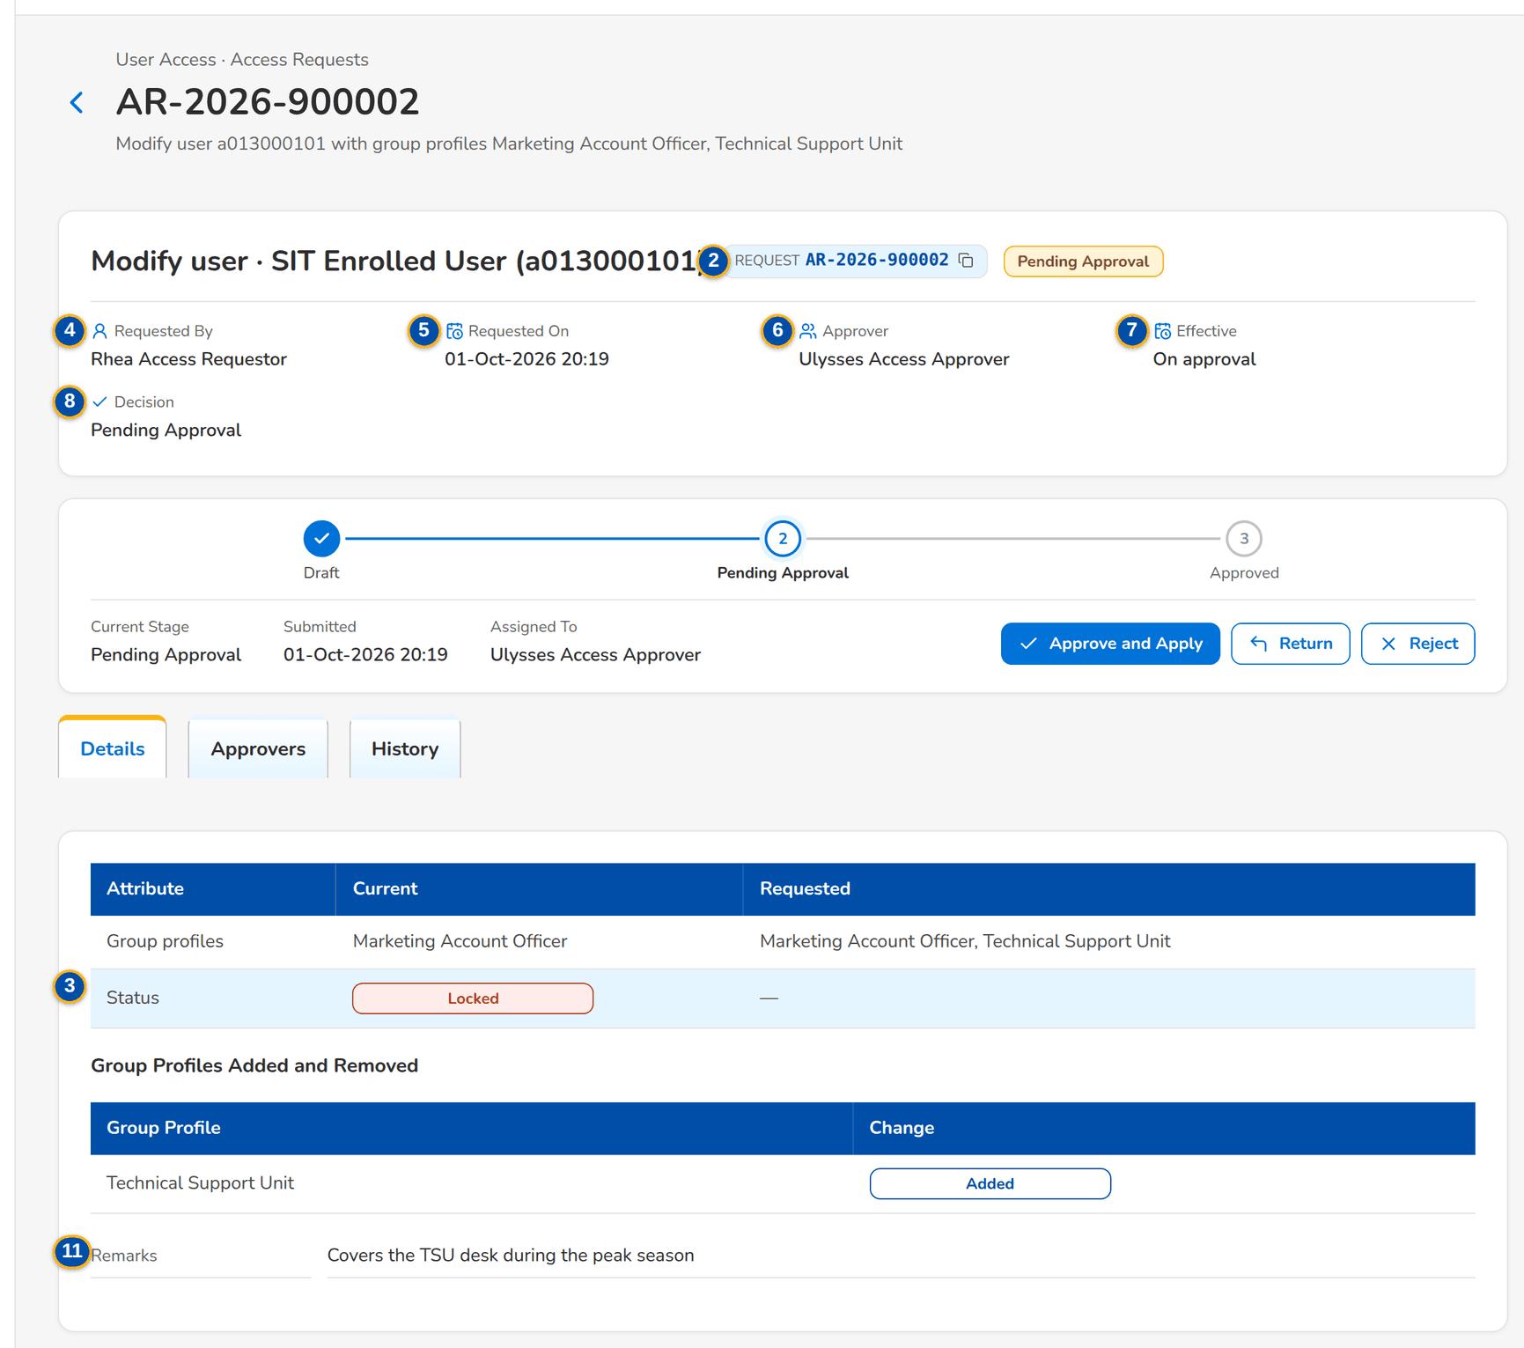
Figure 21: SCR-UA-08 A request waiting for the Approver, Details tab
1 | Title | 6 | Approver | 11 | Remarks / Effective date / Reason / Members / Could not be applied
2 | Request | 7 | Effective | 12 | Order / Approver / Decision / Remarks / Decided
3 | Status and risk flags | 8 | Decision | 13 | Date / Action / Status / By / Remarks
4 | Requested By | 9 | Attribute / Current / Requested | 14 | Comment / Remarks / Reason
5 | Requested On | 10 | Group Profile / Change

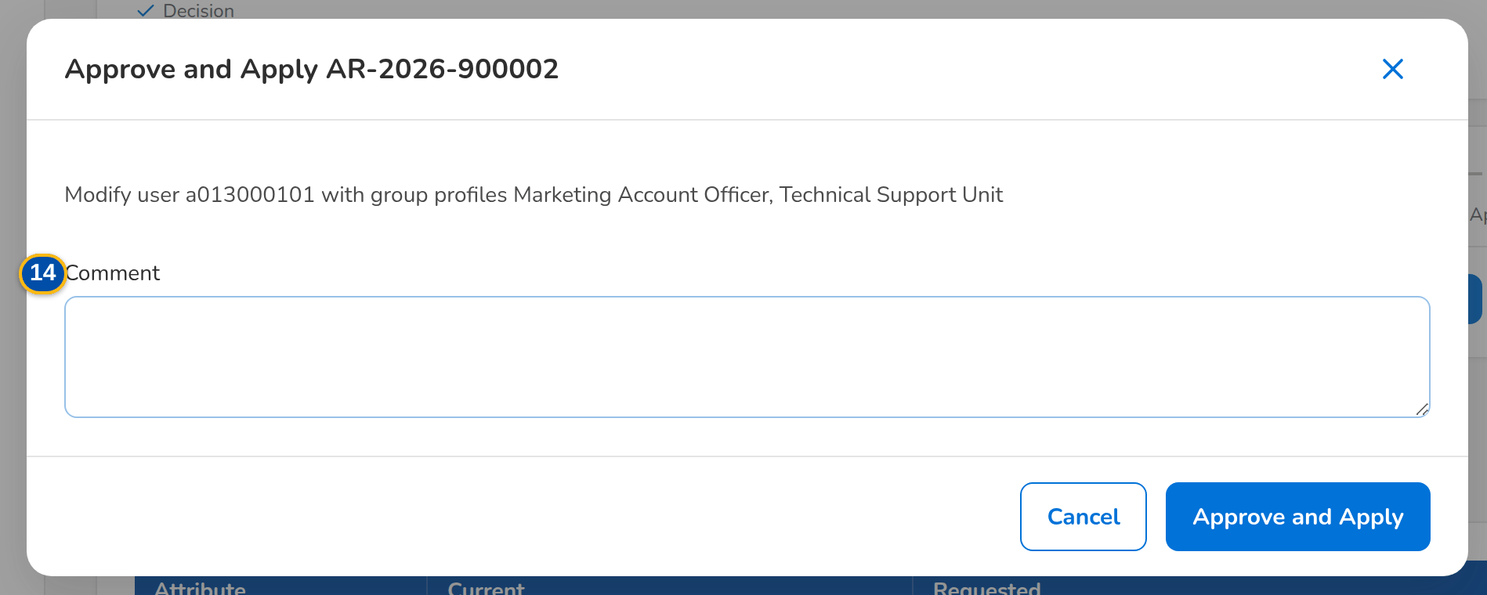
Figure 22: SCR-UA-08 Approve and Apply dialog

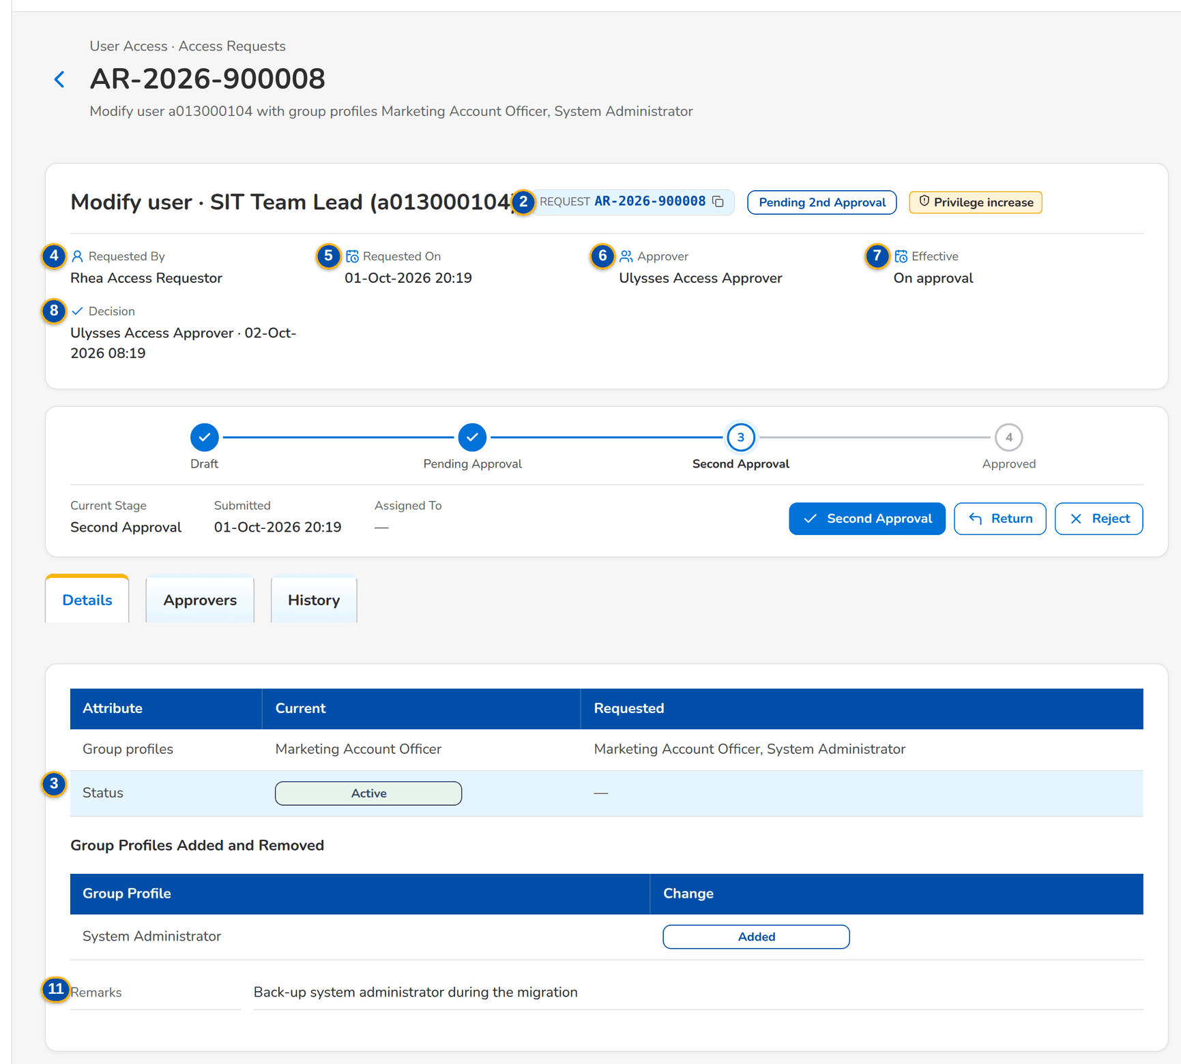
Figure 23: SCR-UA-08 A privileged change waiting for the second approval

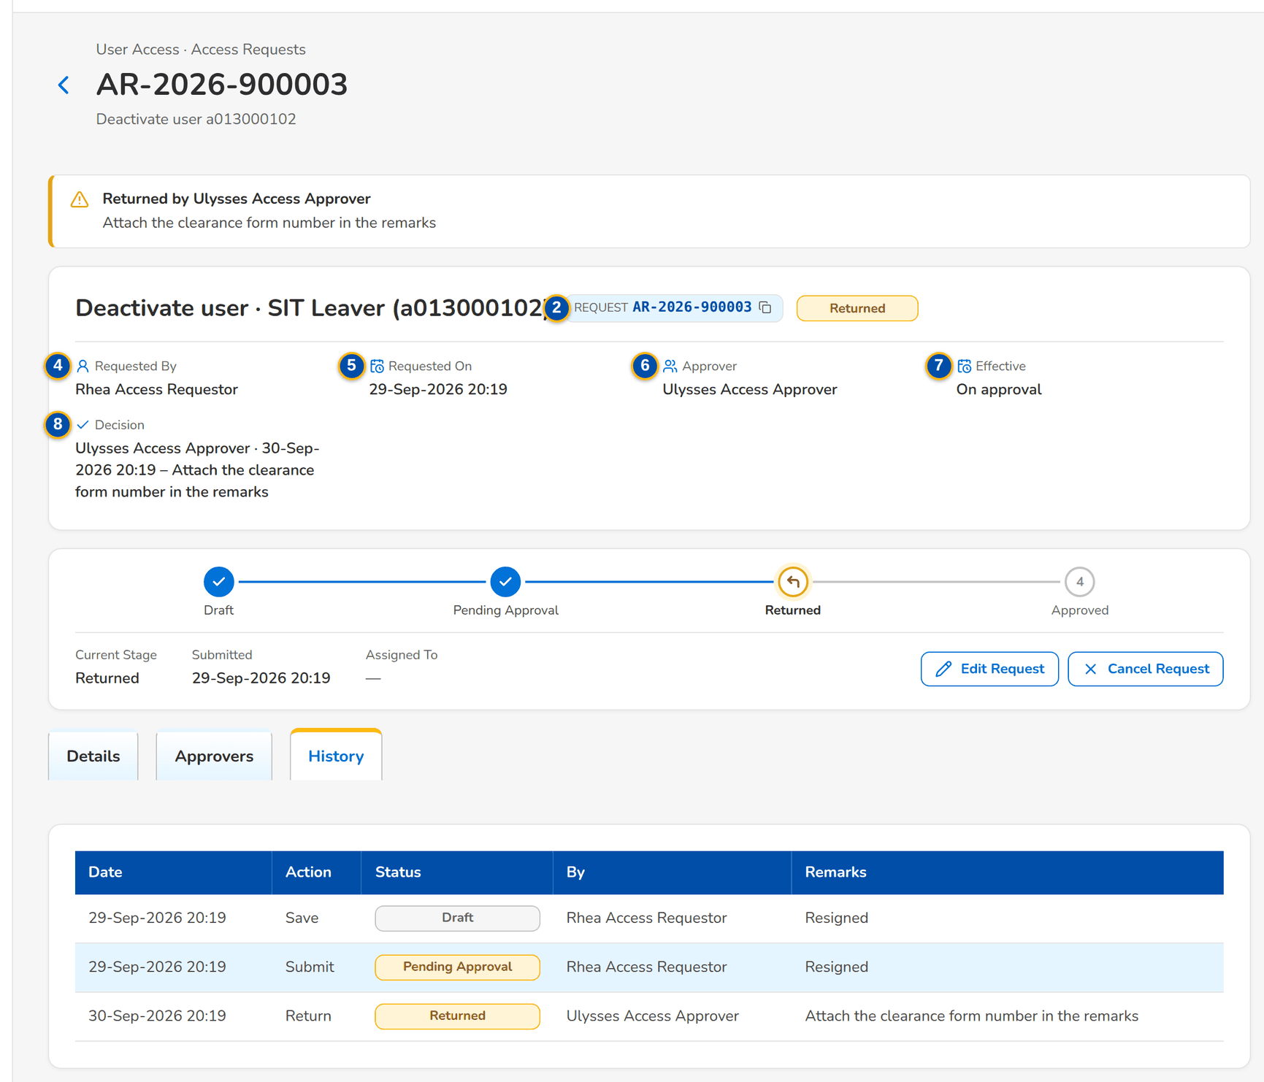
Figure 24: SCR-UA-08 A returned request with its remarks, History tab

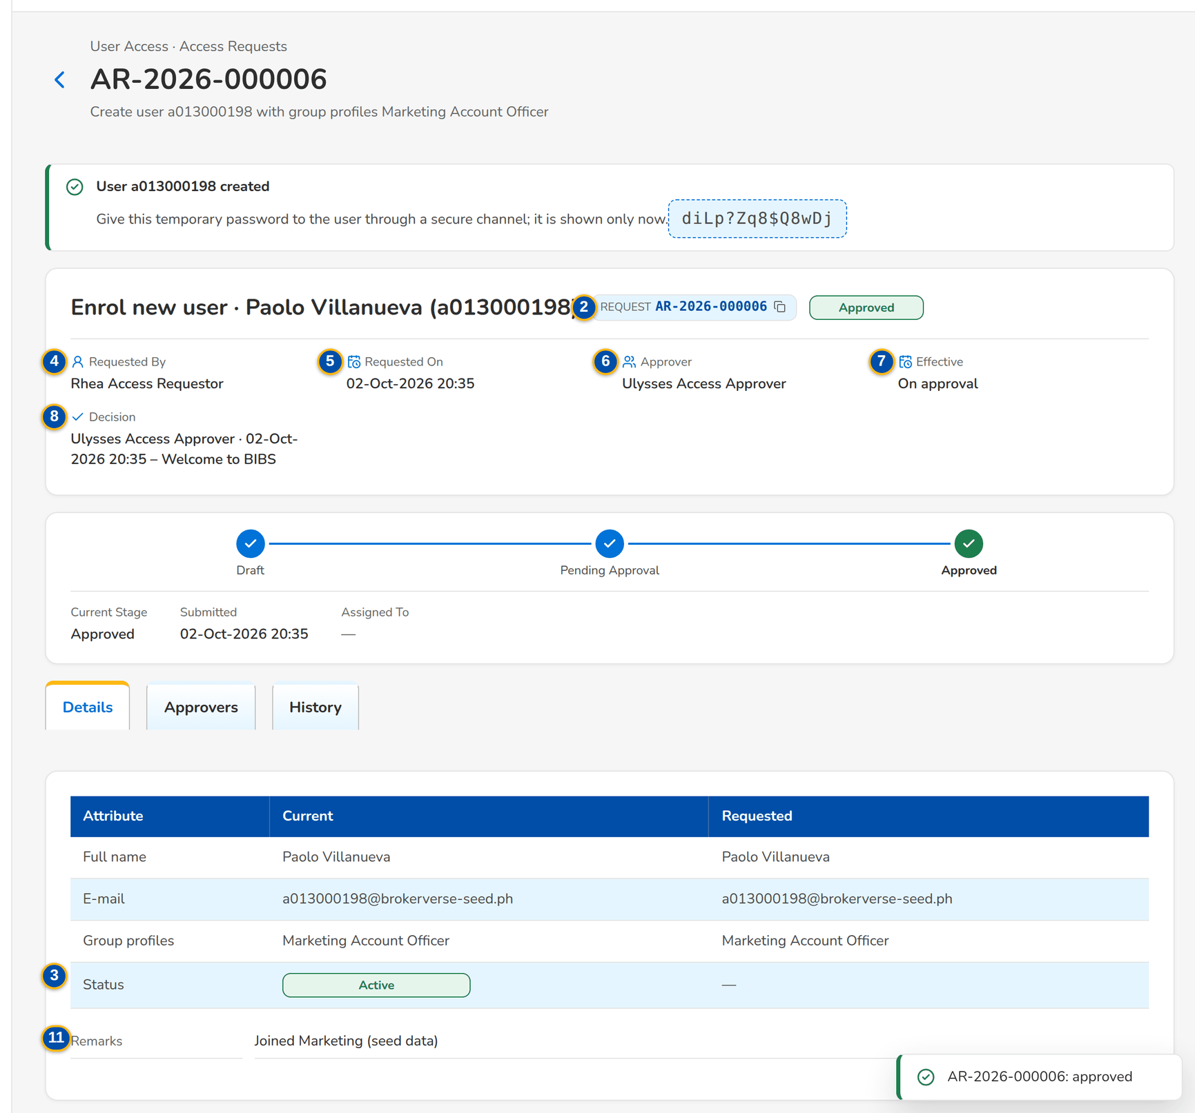
Figure 25: SCR-UA-08 The temporary password of a new user, shown once after the approval

Fields (No. = callout number on the first screenshot)
No. | Section | Field | Type | Length / format | Mand. | Source / list | Default | Editable in | Validation | Message when it fails
1 | Summary | Title | Text | Request type · full name of the user with the user ID in brackets, or group profile name | - | Access request | - | Read only | - | -
2 | Summary | Request | Reference chip | AR-yyyy-nnnnnn | - | Access request | - | Read only | - | -
3 | Summary | Status and risk flags | Pill and tags | Status; Privilege increase, Outside working hours | - | Access request | - | Read only | - | -
4 | Summary | Requested By | Text | Name of the requester | - | Access request | - | Read only | - | -
5 | Summary | Requested On | Date and time | dd-MMM-yyyy HH:mm | - | Access request | - | Read only | - | -
6 | Summary | Approver | Text | Name of the chosen approver or of the decider; Chosen on submission for a draft | - | Access request | - | Read only | - | -
7 | Summary | Effective | Date | dd-MMM-yyyy, or On approval | - | Access request | - | Read only | - | -
8 | Summary | Decision | Text | Pending Approval, or name · dd-MMM-yyyy HH:mm – comment | - | Access request | - | Read only | - | -
9 | Details | Attribute / Current / Requested | Table | Full name, E-mail, Windows ID, Business unit, User level (list labels), Authorisation limit, Group profiles by name, Status; for a group profile: Group profile (name), Name, Description, Privilege level, Permissions added, Permissions removed (permission names) | - | User or group profile; access request | - | Read only | - | -
10 | Details | Group Profile / Change | Table | One row per group profile the request adds (Added) or removes (Removed), by name | - | User and access request | - | Read only | - | -
11 | Details | Remarks / Effective date / Reason / Members / Could not be applied | Text | Justification; effective date (dd-MMM-yyyy); deactivation reason (list label); members of a profile to deactivate; the error of a scheduled change that failed | - | Access request | - | Read only | - | -
12 | Approvers | Order / Approver / Decision / Remarks / Decided | Table | One row per approver in order | - | Approvers of the request | - | Read only | - | -
13 | History | Date / Action / Status / By / Remarks | Table | Every event: saved, submitted, returned, resubmitted, cancelled, approved, second approval, rejected, scheduled, applied, failed to apply, for implementation, implemented | - | Request history (insert only) | - | Read only | - | -
14 | Dialogs | Comment / Remarks / Reason | Text area | Up to 1,000 characters | Cond.: Return, Reject, Cancel | - | Blank | While the dialog is open | Not blank for a return, rejection or cancellation | Enter the remarks

Actions
Button | Who | Enabled when | What happens | Resulting status | Notification
Edit Request | The creator (correction right for a returned request) | Draft or Returned | Opens Edit Request (SCR-UA-07) | Unchanged | -
Cancel Request | The creator (cancel right); the approver of a scheduled request | Draft, Pending Approval, Pending Second Approval, Returned or Scheduled | Asks the reason and cancels the request; it is kept, never deleted | Cancelled | Access request AR-yyyy-nnnnnn cancelled, to the approver
Approve and Apply | The chosen approver (approval right), not the requester nor the user concerned | Pending Approval | Applies the change now, schedules it for the effective date, passes it to the next approver in order, sends it for a second approval when a risk flag is found, or (group profile) sends it to the System Administrator. For an enrolment, shows the temporary password once | Approved, Scheduled, Pending Approval, Pending Second Approval or For Implementation | Decision notice to the requester; Your access changed to the user (in the app and by e-mail); for a second approval or implementation, notices to the second approvers or System Administrators
Second Approval | A second approver who did not give the first approval | Pending Second Approval | Applies, schedules or sends for implementation as above | Approved, Scheduled or For Implementation | As Approve and Apply
Return | The deciding approver | Pending Approval or Pending Second Approval | Asks the remarks and returns the request to the requester for correction | Returned | Access request AR-yyyy-nnnnnn returned, with the remarks
Reject | The deciding approver | Pending Approval or Pending Second Approval | Asks the reason and closes the request; a rejection is final | Rejected | Access request AR-yyyy-nnnnnn rejected
Implement Request | System Administrator (role management right), not the requester | For Implementation | Applies the approved group-profile change now | Implemented | Access request AR-yyyy-nnnnnn implemented, to the requester

Business rules
• The requester and the user the request is about never decide it: A request cannot be decided by the user who submitted it; You cannot decide a request about your own access (FR-UA-031).
• Only the approver chosen by the requester decides a pending request: Request <request no> is assigned to <approver> for approval (FR-UA-015, FR-UA-031).
• A request that gives a High or Admin group profile, creates or raises a profile to High or Admin, reactivates a High or Admin profile, or is submitted or approved outside the working hours (UAM_WORKING_HOURS, 08:00-18:00 Monday to Friday as delivered) needs a second approval by another approver and raises an alert (FR-UA-034).
• Return and rejection need a text; the requester receives it with the notice (FR-UA-032, FR-UA-033).
• The temporary password of a new user is shown once to the approver, never stored in clear and never e-mailed; the user must change it at the first sign-in (FR-UA-011, FR-UA-031).
• A scheduled request is re-checked and applied by the daily job on its effective date; if it can no longer be applied it stays scheduled with the reason and an alert is raised (FR-UA-020).
• Every applied change writes the access change log with the from and to values, the request number, the approver and the time; the history cannot be changed (FR-UA-064).
Expected outcome
The request is decided under four eyes, and an approved change is applied, scheduled or passed on with a complete, unchangeable history.
Test cases: TC-UA-016.1-01, TC-UA-016.2-01, TC-UA-016.3-01, TC-UA-018.2-01, TC-UA-030.2-01, TC-UA-031.1-01, TC-UA-031.2-01, TC-UA-031.2-02, TC-UA-031.3-01, TC-UA-032.1-01, TC-UA-032.2-01, TC-UA-032.2-02, TC-UA-033.1-01, TC-UA-033.2-01, TC-UA-SCR-08, TC-UA-MSG-08.

13.2.4 SCR-UA-09 Bulk Request
Purpose | Many user requests in one file: the requester downloads the template, fills in one row per user (enrol, modify, deactivate or reactivate), uploads it and reviews the check of every row; the valid rows become the draft lines of a batch, which is submitted to one approver from the batch page. The list shows the batches.
Who can open it | Requestor, Approver, Business Administrator, System Administrator, New Business Approver (keeps the access approval right) (permission UAM_ENROLL or UAM_MODIFY or ACCESS_APPROVE)
Navigation | • Menu: Setup & Administration › User Access › Bulk Request  • Setup & Administration › User Access › Bulk Request
FRs | FR-UA-019

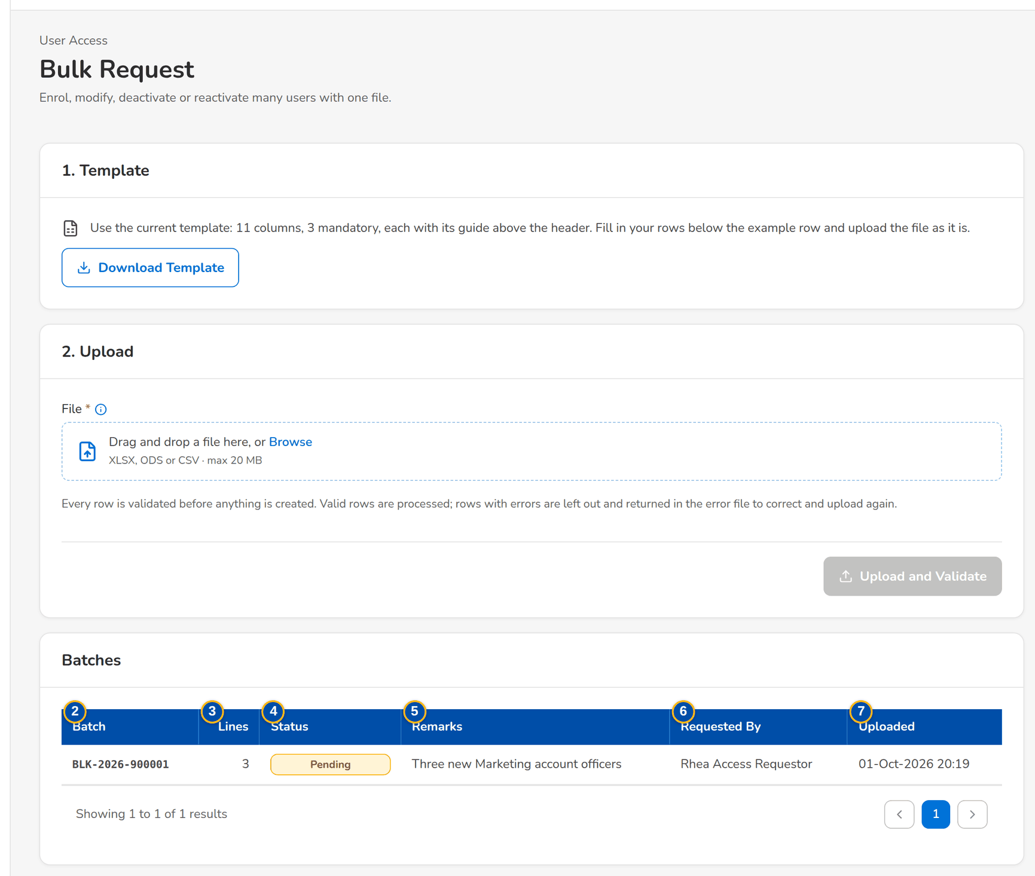
Figure 26: SCR-UA-09 Bulk Request with the upload wizard and the batches
1 | Upload wizard | 4 | Status | 7 | Uploaded
2 | Batch | 5 | Remarks
3 | Lines | 6 | Requested By

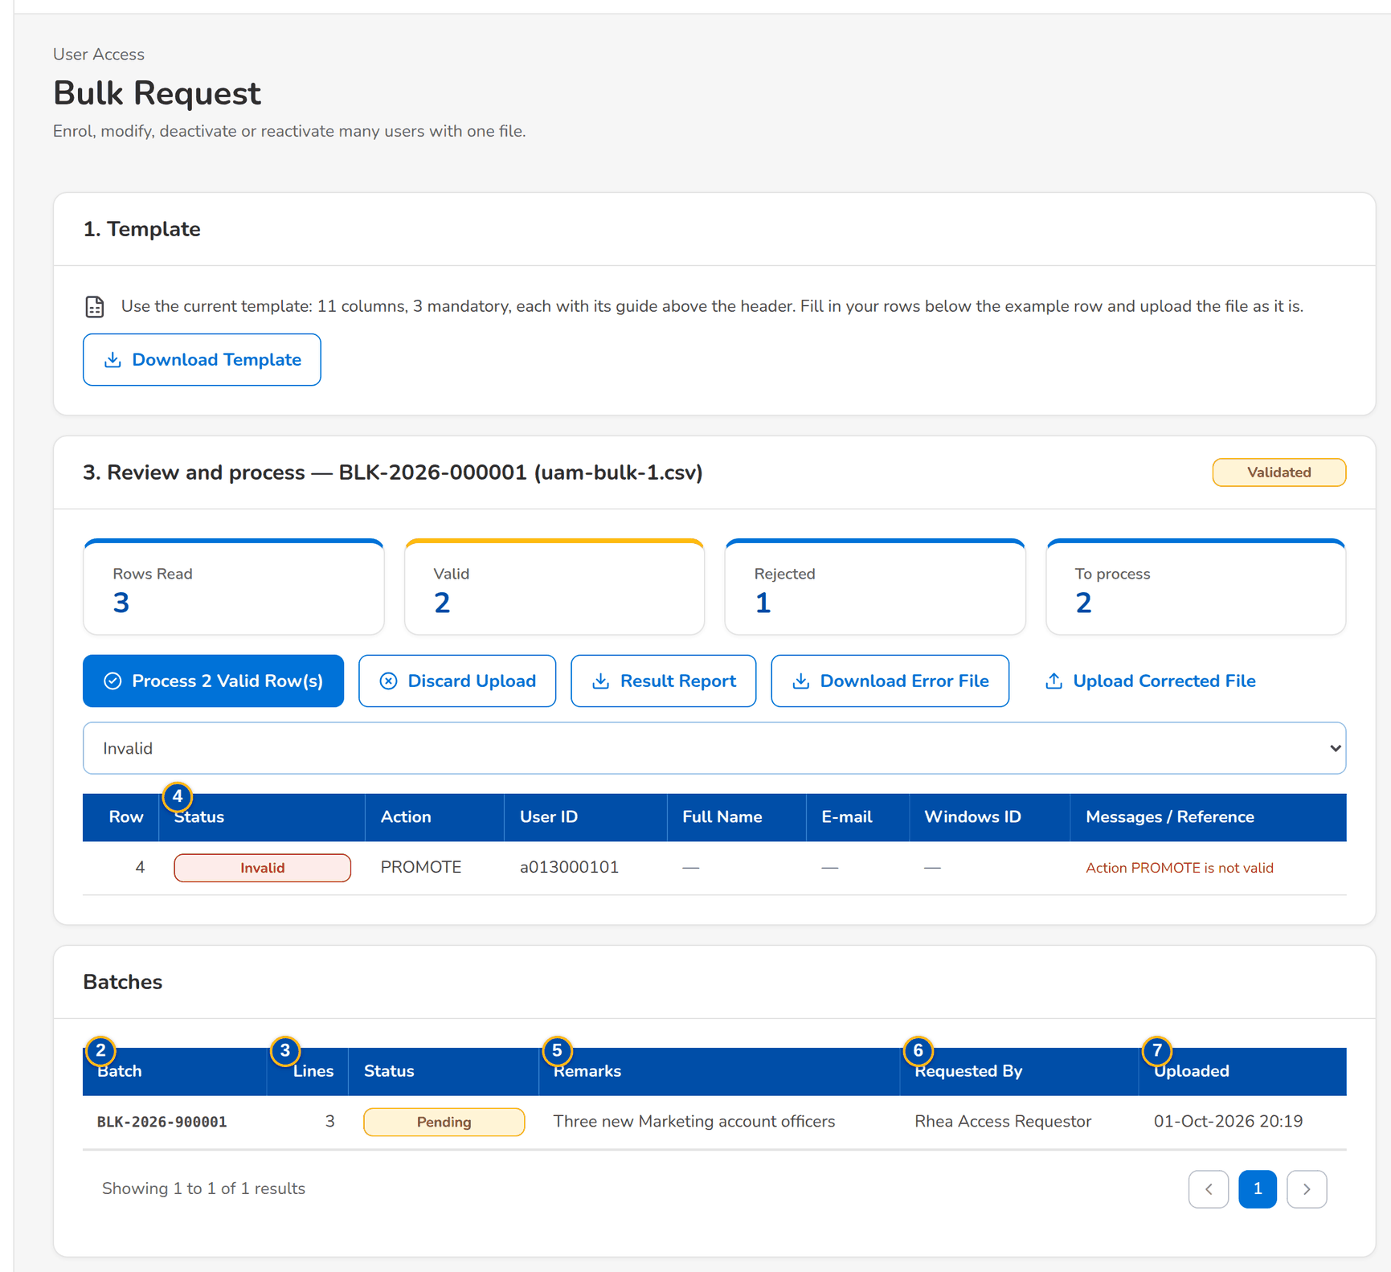
Figure 27: SCR-UA-09 Bulk Request: the check of each row after the upload

Fields (No. = callout number on the first screenshot)
No. | Section | Field | Type | Length / format | Mand. | Source / list | Default | Editable in | Validation | Message when it fails
1 | Upload | Upload wizard | Upload | Template Bulk access requests (Excel); see Upload screens | Y | Upload template | - | Before the batch is saved | File checks; every row checked as a request | -
2 | Batches | Batch | Column | BLK-yyyy-nnnnnn | - | Bulk batch | - | Read only | - | -
3 | Batches | Lines | Column | Number of lines | - | Bulk batch | - | Read only | - | -
4 | Batches | Status | Column | Draft, Pending Approval, Returned, Approved, Rejected, Cancelled | - | Bulk batch | - | Read only | - | -
5 | Batches | Remarks | Column | Batch remarks | - | Bulk batch | - | Read only | - | -
6 | Batches | Requested By | Column | Name | - | Bulk batch | - | Read only | - | -
7 | Batches | Uploaded | Column | dd-MMM-yyyy HH:mm | - | Bulk batch | - | Read only | - | -

Actions
Button | Who | Enabled when | What happens | Resulting status | Notification
Upload and commit the file | Requestor, Business Administrator, System Administrator (enrol or modify right, and bulk upload right) | A file of the template is chosen | Checks every row; the valid rows are saved as the draft lines of a new batch. Toast: Batch BLK-yyyy-nnnnnn saved as a draft | Draft batch | -
Open a batch | Every user of the screen | Always | Opens Bulk Request Batch (SCR-UA-10) | - | -

Business rules
• Each row is checked with the rules of a single request of its action, the separation-of-duties rules included; a row in error is reported with its message and is not saved (FR-UA-019, FR-UA-053).
• The actions of the file are ENROL, MODIFY, DEACTIVATE and REACTIVATE; group profiles are listed by their codes separated by a semicolon (FR-UA-019).
Expected outcome
Mass changes, such as the users of a new team, are prepared in one file and follow the same checks and four-eyes decision as single requests.
Test cases: TC-UA-019.1-01, TC-UA-019.2-01, TC-UA-019.2-02, TC-UA-019.3-01, TC-UA-019.4-01, TC-UA-053.3-01, TC-UA-SCR-09, TC-UA-MSG-09, TC-UA-MSG-18.

13.2.5 SCR-UA-10 Bulk Request Batch
Purpose | One bulk batch: its lines with their status and error; the requester submits it to one approver with the batch remarks, or cancels it; the approver approves (each line applied on its own), returns or rejects it.
Who can open it | Requestor, Approver, Second Approver, Business Administrator, System Administrator, Auditor, New Business Approver (keeps the access approval right) (permission UAM_ENROLL or UAM_MODIFY or ACCESS_APPROVE or UAM_VIEW)
Navigation | • Menu: Setup & Administration › User Access › Bulk Request › Bulk Request Batch  • Bulk Request › a batch
FRs | FR-UA-019

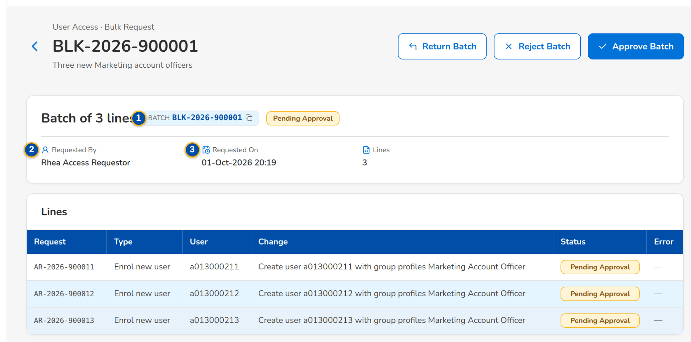
Figure 28: SCR-UA-10 The seed batch of three lines waiting for the Approver
1 | Batch | 3 | Requested On | 5 | Approver
2 | Requested By | 4 | Request / Type / User / Change / Status / Error | 6 | Remarks

Fields (No. = callout number on the first screenshot)
No. | Section | Field | Type | Length / format | Mand. | Source / list | Default | Editable in | Validation | Message when it fails
1 | Summary | Batch | Reference chip | BLK-yyyy-nnnnnn | - | Bulk batch | - | Read only | - | -
2 | Summary | Requested By | Text | Name of the requester | - | Bulk batch | - | Read only | - | -
3 | Summary | Requested On | Date and time | dd-MMM-yyyy HH:mm | - | Bulk batch | - | Read only | - | -
4 | Lines | Request / Type / User / Change / Status / Error | Table | One access request per line | - | Line requests | - | Read only | - | -
5 | Submit Batch | Approver | Drop-down | Name (user ID) of each eligible approver | Y | Holders of the approval right, less the requester | Blank | Draft or Returned batch | An eligible approver | Select the approver
6 | Submit Batch | Remarks | Text area | Up to 1,000 characters | Y | - | Blank | Draft or Returned batch | Not blank | Enter the remarks

Actions
Button | Who | Enabled when | What happens | Resulting status | Notification
Submit Batch | The creator of the batch | Draft or Returned | Submits every draft line to the chosen approver with the batch remarks | Pending Approval | Access request AR-yyyy-nnnnnn to approve, per line
Approve Batch | The approver (approval right), not the creator | Pending Approval | Approves each line on its own; the outcome lists each line with its status or error and the temporary passwords of new users, shown once | Approved (lines applied, scheduled or for second approval) | As Approve and Apply, per line
Return Batch | The approver | Pending Approval | Returns the batch with the remarks | Returned | Returned notice per line
Reject Batch | The approver | Pending Approval | Rejects every line with the reason | Rejected | Rejected notice per line
Cancel Batch | The creator of the batch | Draft, Returned or Pending Approval | Cancels every line with the reason | Cancelled | Cancelled notice to the approver
Open a line | Every user of the screen | Always | Opens the line's request (SCR-UA-08) | - | -

Business rules
• A batch is submitted only by its creator and decided by another user: Only the creator can submit batch <batch no> (FR-UA-019).
• Each line is decided and applied on its own, with the checks and the risk rules of a single request; a line that needs a second approval waits for it (FR-UA-019, FR-UA-034).
Expected outcome
The whole file is decided in one step, line by line, with the evidence of each line kept on its own request.
Test cases: TC-UA-019.1-01, TC-UA-019.2-01, TC-UA-019.2-02, TC-UA-019.3-01, TC-UA-019.4-01, TC-UA-053.3-01, TC-UA-SCR-10, TC-UA-MSG-10.

13.3 Group profiles

13.3.1 SCR-UA-11 Group Profile Requests
Purpose | The work list of the group-profile requests: new profiles, changes to the permissions, name, description or privilege level of a profile, and the deactivation and reactivation of a profile. The approvers decide in the order chosen by the requester; the System Administrator implements the approved request.
Who can open it | Approver, Second Approver, Business Administrator, System Administrator, Auditor, Information Security Officer, New Business Approver (keeps the access approval right) (permission UAM_GROUP_REQUEST or ACCESS_REQUEST or ACCESS_APPROVE or UAM_SECOND_APPROVE or ROLE_MANAGE or AUDIT_VIEW)
Navigation | • Menu: Setup & Administration › User Access › Group Profile Requests  • The notice Access request AR-yyyy-nnnnnn to implement (System Administrator)  • Access Request record of a group-profile request › back arrow
FRs | FR-UA-040, FR-UA-044, FR-UA-045

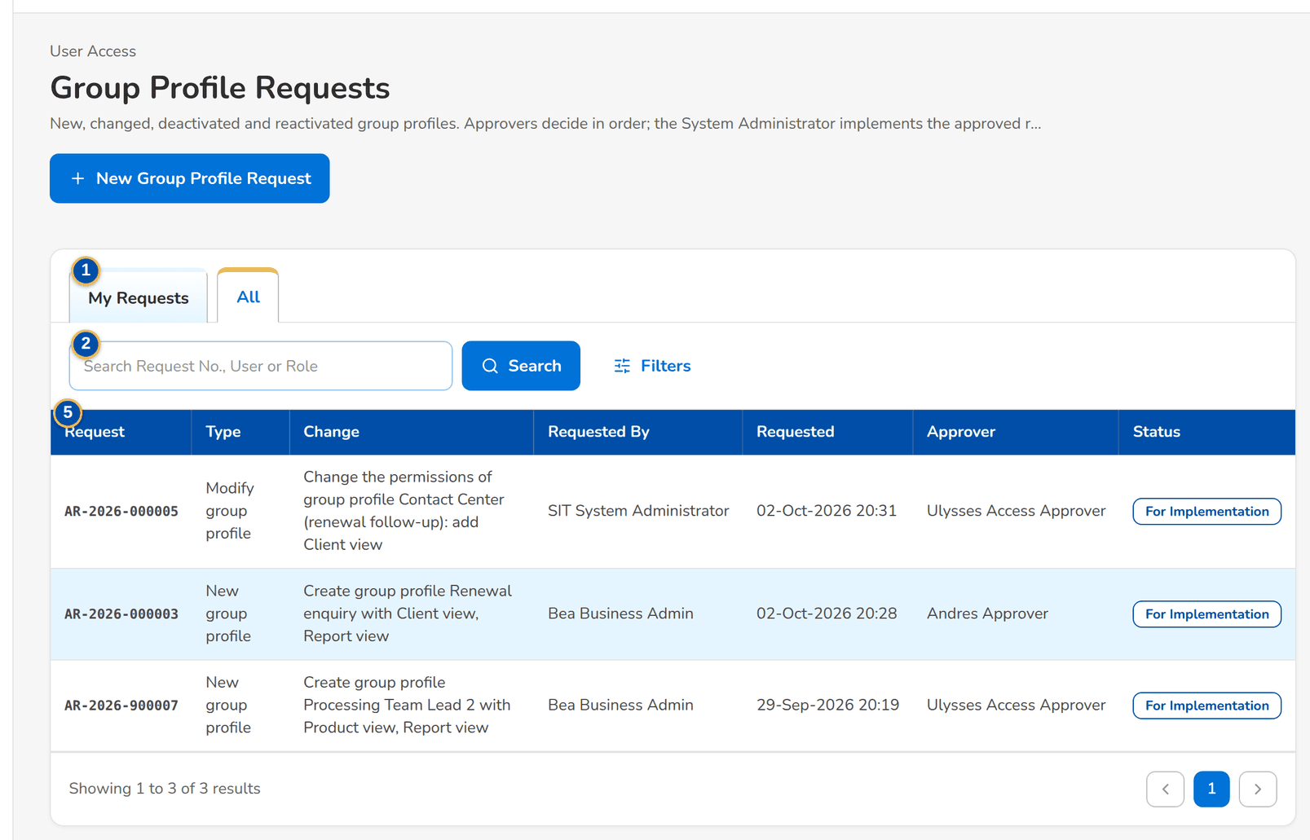
Figure 29: SCR-UA-11 Group Profile Requests of the Business Administrator, All tab
1 | My Requests / Assigned to Me / Second Approval / For Implementation / All | 3 | Status | 5 | Request / Type / Change / Requested By / Requested / Approver / Status
2 | Search Request No., User or Role | 4 | Request Type

Fields (No. = callout number on the first screenshot)
No. | Section | Field | Type | Length / format | Mand. | Source / list | Default | Editable in | Validation | Message when it fails
1 | Tabs | My Requests / Assigned to Me / Second Approval / For Implementation / All | Tab | - | - | Fixed; a tab is shown only to the users who work it | As Access Requests | - | As Access Requests, limited to group-profile requests | -
2 | Search | Search Request No., User or Role | Text | Part of a request number or group profile code | N | - | Blank | - | Contains search | -
3 | Filters | Status | Drop-down | All and the request statuses | N | Fixed list | All | - | - | -
4 | Filters | Request Type | Drop-down | All, New group profile, Modify group profile, Deactivate group profile, Reactivate group profile | N | Fixed list | All | - | - | -
5 | List | Request / Type / Change / Requested By / Requested / Approver / Status | Columns | As Access Requests | - | Access request | - | Read only | - | -

Actions
Button | Who | Enabled when | What happens | Resulting status | Notification
New Group Profile Request | Business Administrator, System Administrator (group-profile request right) | Always | Opens New Request on the group-profile types (SCR-UA-12) | - | -
Approve Selected | Approver on Assigned to Me; Second Approver on Second Approval | Rows selected | Approves each selected request in turn | Pending Approval (next approver), Pending Second Approval or For Implementation | Notice to the next approver, second approvers or System Administrators
Filters | Every user of the screen | Always | Shows or hides the filters | - | -
Open a row | Every user of the screen | Always | Opens the request (SCR-UA-08) | - | -

Business rules
• Only one group-profile request per profile can be open at a time: A request for role <code> is already waiting for approval (FR-UA-040).
• Every approver in the list decides in turn; the request goes to the System Administrator only after the last approval (FR-UA-044).
Expected outcome
The Business Administrator follows each profile change from the request to its implementation.
Test cases: TC-UA-040.1-01, TC-UA-040.2-01, TC-UA-040.2-02, TC-UA-040.2-03, TC-UA-041.2-01, TC-UA-041.2-02, TC-UA-041.2-03, TC-UA-041.2-04, TC-UA-042.1-01, TC-UA-042.2-01, TC-UA-042.3-01, TC-UA-042.3-02, TC-UA-043.1-01, TC-UA-043.2-01, TC-UA-044.3-01, TC-UA-044.3-02, TC-UA-051.1-01, TC-UA-SCR-11.

13.3.2 SCR-UA-12 New Group Profile Request and Edit Request
Purpose | The request form on the group-profile types. New group profile: code, name, description, privilege level and the permissions, grouped by functional area. Modify group profile: the profile, the permissions it should hold after the change (added and removed shown against the current ones) and a new name, description or level. Deactivate and reactivate: the profile, with the members who lose its screens. Approvers are listed in order.
Who can open it | Requestor, Business Administrator, System Administrator (permission UAM_ENROLL or UAM_MODIFY or UAM_DEACTIVATE or UAM_REACTIVATE or UAM_GROUP_REQUEST or UAM_CORRECT or ACCESS_REQUEST)
Navigation | • Menu: Setup & Administration › User Access › Group Profile Requests › New Request  • Group Profile Requests › New Group Profile Request  • Access Request record of a draft or returned group-profile request › Edit Request
FRs | FR-UA-040, FR-UA-041, FR-UA-042, FR-UA-043, FR-UA-044, FR-UA-051

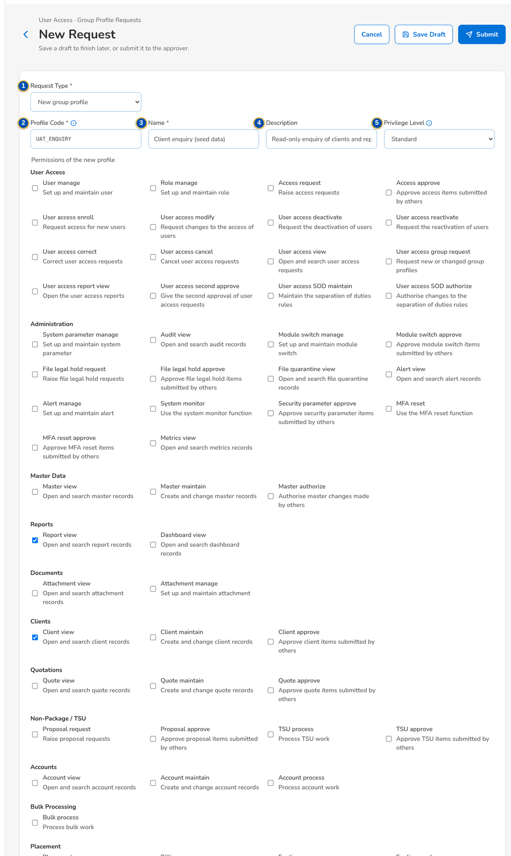
Figure 30: SCR-UA-12 New group profile with its permissions and two approvers in order
1 | Request Type | 5 | Privilege Level | 9 | Added / Removed
2 | Profile Code | 6 | Group Profile | 10 | Members
3 | Name | 7 | New Name | 11 | Approvers in Order
4 | Description | 8 | Permission check boxes by area | 12 | Remarks (Justification)

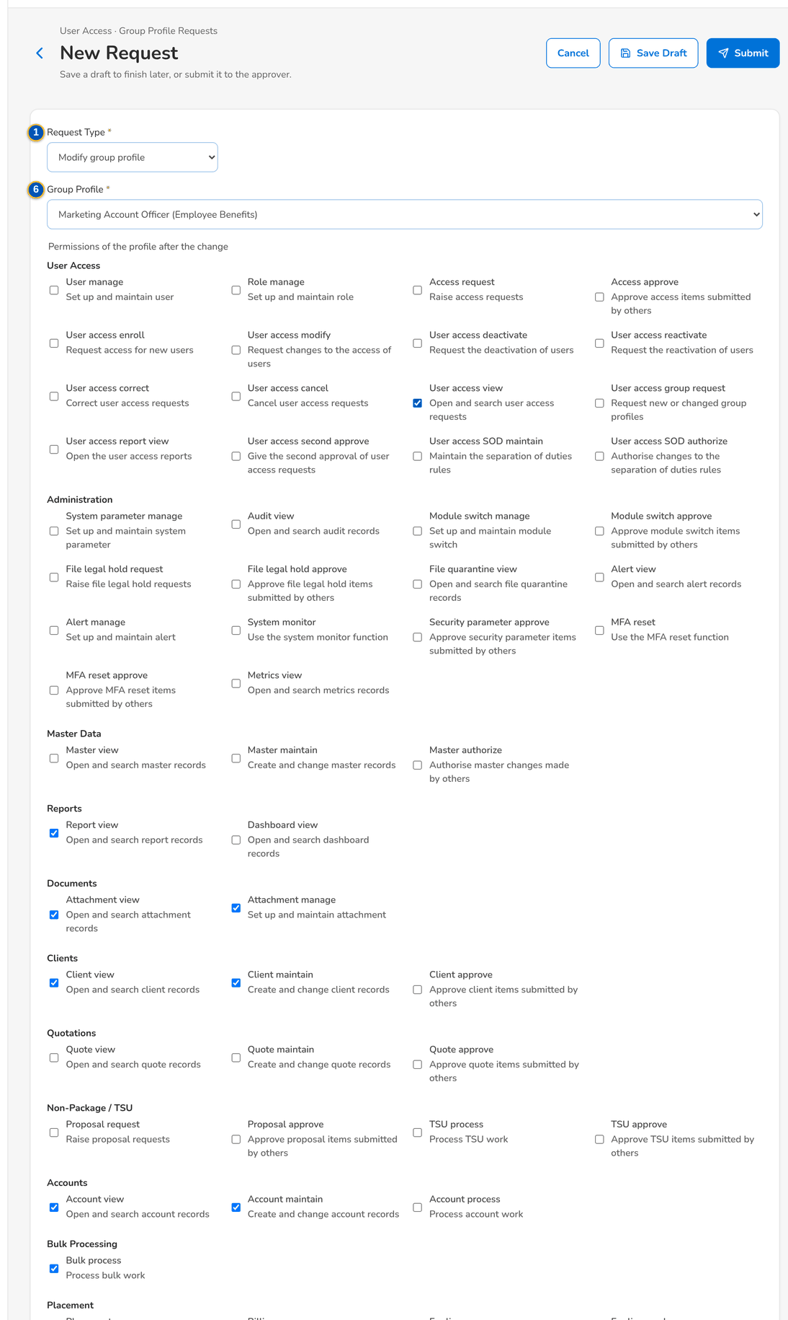
Figure 31: SCR-UA-12 Modify group profile: permissions added and removed against the current ones

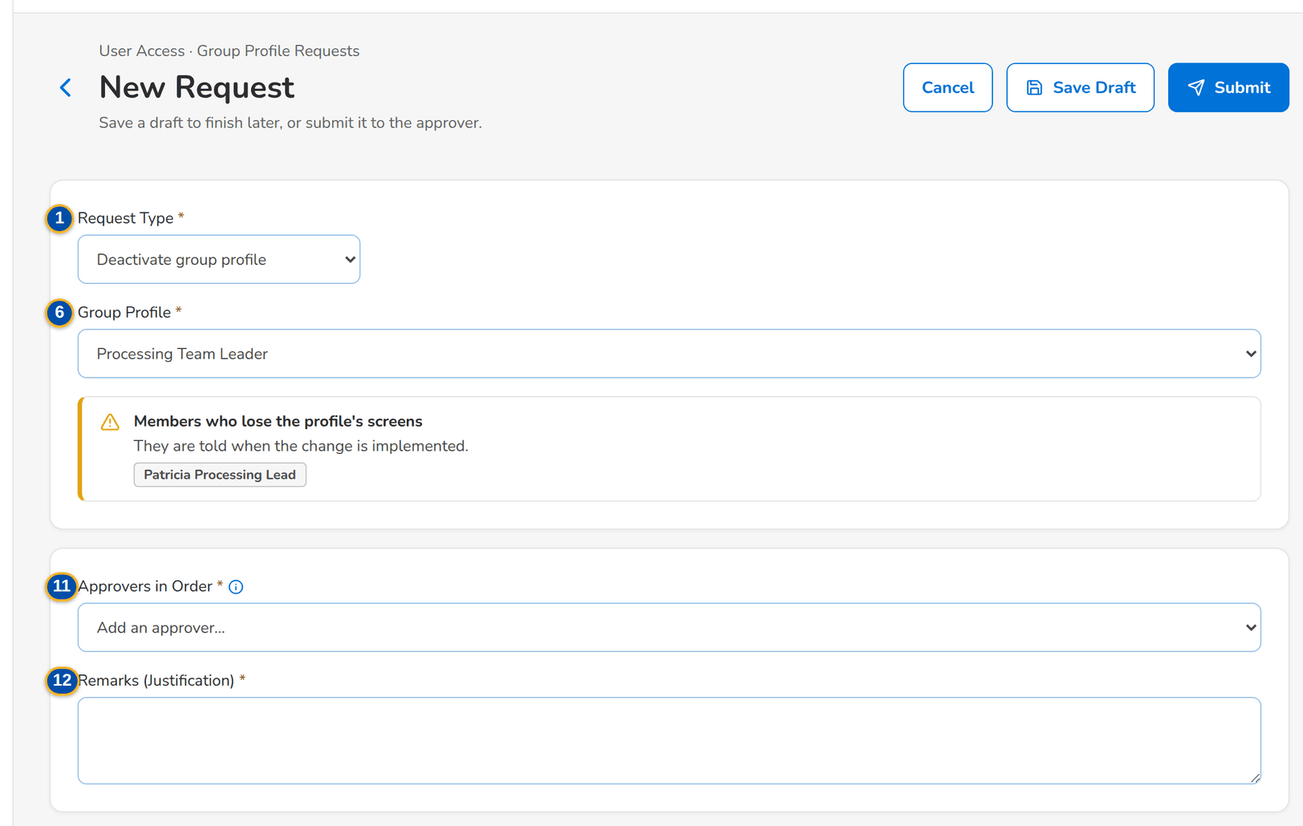
Figure 32: SCR-UA-12 Deactivate group profile with the members who lose its screens
Fields (No. = callout number on the first screenshot)
No. | Section | Field | Type | Length / format | Mand. | Source / list | Default | Editable in | Validation | Message when it fails
1 | Request | Request Type | Drop-down | New group profile, Modify group profile, Deactivate group profile, Reactivate group profile | Y | Fixed list | New group profile | New request only (fixed after the first save) | The type of a saved request cannot change | The type of request <request no> cannot change
2 | New group profile | Profile Code | Text | Up to 40 capital letters, digits or underscores (A-Z, 0-9 and _) | Y | - | Blank | Draft; Returned | Format; not the code of an existing profile | Use up to 40 capital letters, digits or underscores
3 | New group profile | Name | Text | Up to 120 characters | Y | - | Blank | Draft; Returned | Not blank | Enter the name of the group profile
4 | Profile data | Description | Text | Up to 500 characters | N | - | Blank | Draft; Returned | - | -
5 | Profile data | Privilege Level | Drop-down | Low, Standard, High, Admin; Standard (new) or Unchanged (modify) when blank | N | Fixed list | Standard / Unchanged | Draft; Returned | High and Admin profiles need a second approval | -
6 | Modify / Deactivate / Reactivate | Group Profile | Drop-down | Profile name; active profiles (modify, deactivate, the System Administrator profile excluded) or inactive profiles (reactivate) | Y | Group profiles | Blank | Draft; Returned | An existing profile in the right state | Select the role to change
7 | Modify group profile | New Name | Text | Up to 120 characters | N | - | Blank | Draft; Returned | - | -
8 | Permissions | Permission check boxes by area | Check boxes | Permission names with the code below in small print, grouped by functional area (User Access, Administration, Clients, Product Maintenance...), unclassified permissions last | Cond.: new profile (at least one); a change must add or remove one, or change the data | Permissions of BIBS, less the insurer-only permissions | None (new); the current permissions (modify) | Draft; Returned | Known permissions; not both added and removed | Select at least one permission
9 | Permissions | Added / Removed | Text | Names of the permissions added and removed against the current ones | - | Computed | - | Read only | A change must grant or withdraw at least one permission, or change the name, description or level | Grant or withdraw at least one permission
10 | Deactivate group profile | Members | Warning | Members who lose the profile's screens, and are told when it is implemented: user IDs, or The profile has no members. | - | Users holding the profile | - | Read only | - | -
11 | Approval | Approvers in Order | List and drop-down | Name (user ID); arrows move an approver up; each approver decides in turn | Y | Holders of the approval right, less the requester | Blank | Draft; Returned | At least one; eligible; no approver twice | Add at least one approver
12 | Approval | Remarks (Justification) | Text area | Up to 1,000 characters | Y | - | Blank | Draft; Returned | Not blank on submission | Enter the justification

Actions
Button | Who | Enabled when | What happens | Resulting status | Notification
Save Draft | Business Administrator, System Administrator (group-profile request right) | Profile code or profile chosen | Saves the draft with format checks only | Draft | -
Submit | As Save Draft | Every field check passes | Runs the full checks, evaluates the risk rules and sends the request to the first approver in order | Pending Approval | Access request AR-yyyy-nnnnnn to approve, to the first approver
Resubmit | The requester | Returned request with correction remarks | Resubmits the corrected request to the approvers | Pending Approval | As Submit
Cancel | The requester | Always | Leaves the form without saving | Unchanged | -

Business rules
• A group-profile request has no effective date; it applies when the System Administrator implements it: An effective date applies to user requests; group profiles are implemented (FR-UA-040).
• The System Administrator profile cannot be deactivated: Group profile System Administrator cannot be deactivated (FR-UA-042).
• A deactivated profile grants nothing at once to its members and is no longer offered on requests; the members are listed on the request, a deactivation with members is allowed, and each member is told when the request is implemented, in the app and by e-mail (FR-UA-042, FR-UA-043).
• The insurer-only permissions and the insurer roles hidden from BDOI are neither listed nor accepted: Permission(s) not available in BIBS: <permissions> (FR-UA-051).
• Creating or raising a profile to High or Admin, and reactivating a High or Admin profile, need a second approval (FR-UA-034).
• A change that lists too many permissions for one request is refused: Split the change into several requests (FR-UA-041).
Expected outcome
The profile change is checked, decided by every approver in order and waits for the System Administrator to implement it.
Test cases: TC-UA-040.1-01, TC-UA-040.2-01, TC-UA-040.2-02, TC-UA-040.2-03, TC-UA-041.2-01, TC-UA-041.2-02, TC-UA-041.2-03, TC-UA-041.2-04, TC-UA-042.1-01, TC-UA-042.2-01, TC-UA-042.3-01, TC-UA-042.3-02, TC-UA-043.1-01, TC-UA-043.2-01, TC-UA-044.3-01, TC-UA-044.3-02, TC-UA-051.1-01, TC-UA-SCR-12, TC-UA-MSG-11.

13.4 Access evidence and administration

13.4.1 SCR-UA-13 User Access Matrix
Purpose | Every group profile against every permission as granted today, or against the functional areas and action classes (view only, create, amend, approve / validate) with the permissions behind each cell, with the number of active users of each profile. Read only; the Excel export holds both views.
Who can open it | Approver, Business Administrator, System Administrator, Auditor, Information Security Officer, New Business Approver (keeps the access approval right) (permission ACCESS_REQUEST or ACCESS_APPROVE or ROLE_MANAGE or AUDIT_VIEW)
Navigation | • Menu: Setup & Administration › User Access › User Access Matrix  • The old address Broking Setup › User Access Matrix opens this screen
FRs | FR-UA-051, FR-UA-061

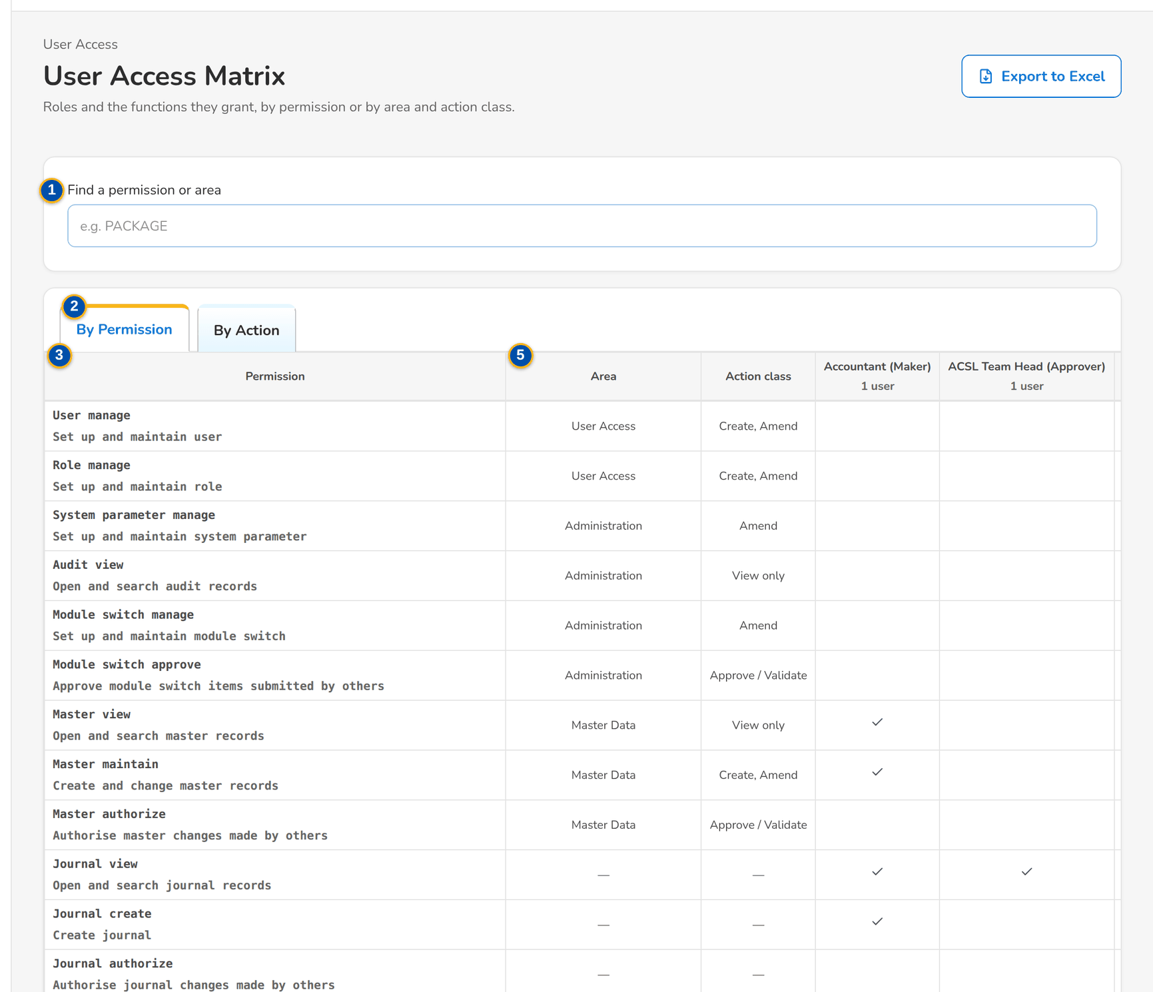
Figure 33: SCR-UA-13 User Access Matrix by permission
1 | Find a permission or area | 3 | Permission / Area / Action class | 5 | Area / Action class
2 | By Permission / By Action | 4 | Group profile columns

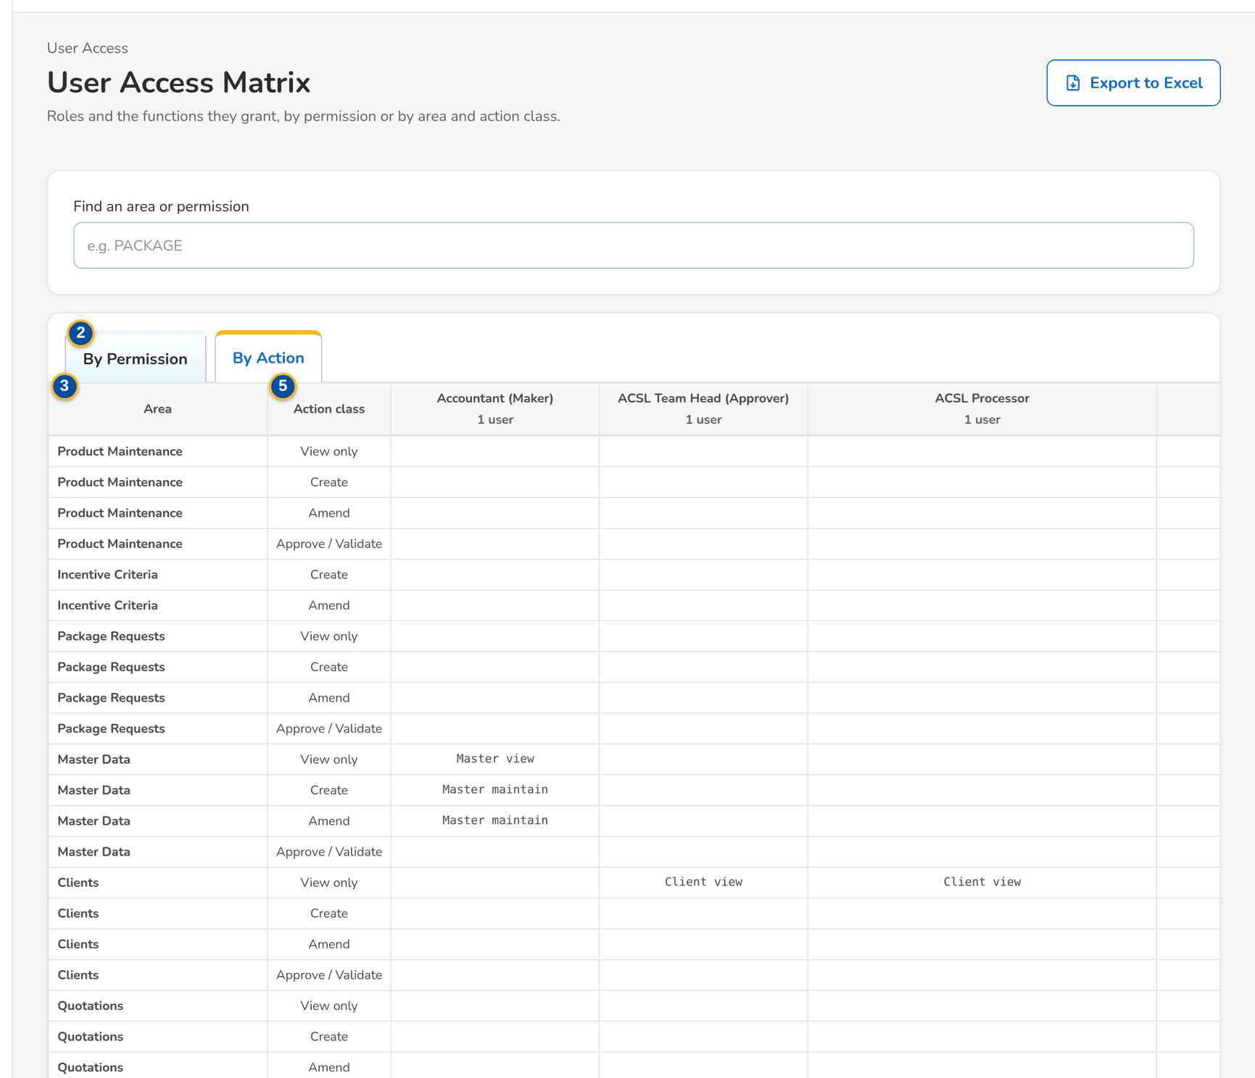
Figure 34: SCR-UA-13 User Access Matrix by area and action class

Fields (No. = callout number on the first screenshot)
No. | Section | Field | Type | Length / format | Mand. | Source / list | Default | Editable in | Validation | Message when it fails
1 | Search | Find a permission or area | Text | Part of a permission name, code or area | N | - | Blank | - | - | -
2 | Views | By Permission / By Action | Tab | - | - | Fixed | By Permission | - | - | -
3 | By Permission | Permission / Area / Action class | Columns | Permission name with the code below in small print; functional area; View only, Create, Amend, Approve / Validate | - | Permission catalogue | - | Read only | - | -
4 | Matrix | Group profile columns | Columns | Profile name with the number of active users; a tick where the profile holds the permission | - | Role grants | - | Read only | - | -
5 | By Action | Area / Action class | Columns | One row per area and action class; each cell lists the names of the permissions the profile holds there | - | Role grants | - | Read only | - | -

Actions
Button | Who | Enabled when | What happens | Resulting status | Notification
Export to Excel | Every user of the screen | Always | Downloads the matrix (both views) as an Excel file | - | -

Business rules
• The matrix is read from the grants in force; it changes only when a group-profile request is implemented (FR-UA-051).
• The matrix is open to the holders of the request, approval, role management and audit rights (the Information Security Officer among them); the Requestor and the Second Approver do not have it, as the permissions matrix of the FRS grants them no such right (FR-UA-051).
• The insurer-only permissions and the insurer roles hidden from BDOI are not listed (FR-UA-051).
Expected outcome
Business, Information Security and audit see in one table which profile can do what, and keep the export as evidence.
Test cases: TC-UA-051.3-01, TC-UA-SCR-13.

13.4.2 SCR-UA-14 User Access Reports
Purpose | The five user access reports, each opened in the report runner with its parameters and its PDF, Excel and CSV exports: User Access Report, User Group Profile Report, Group Profile Membership, User Access Audit Log and Access Requests.
Who can open it | Approver, Business Administrator, System Administrator, Auditor, Information Security Officer (permission UAM_REPORT_VIEW)
Navigation | • Menu: Setup & Administration › User Access › User Access Reports  • Reports › Report Centre, category Control & Audit
FRs | FR-UA-060, FR-UA-061, FR-UA-062, FR-UA-063

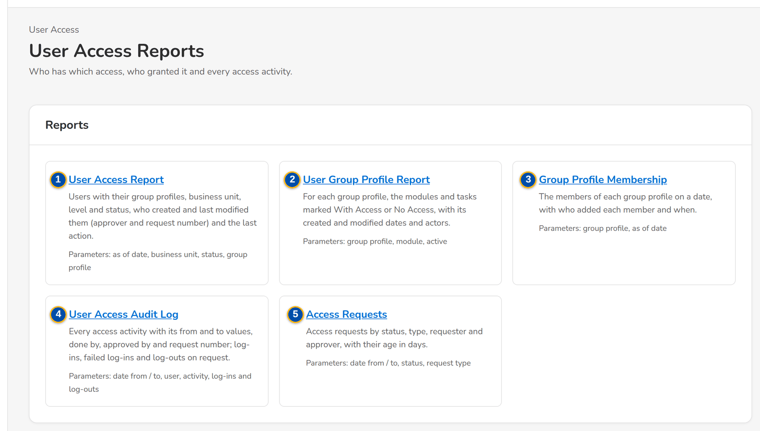
Figure 35: SCR-UA-14 User Access Reports
1 | User Access Report | 3 | Group Profile Membership | 5 | Access Requests
2 | User Group Profile Report | 4 | User Access Audit Log

Fields (No. = callout number on the first screenshot)
No. | Section | Field | Type | Length / format | Mand. | Source / list | Default | Editable in | Validation | Message when it fails
1 | Reports | User Access Report | Link | Users with their group profiles, business unit, level and status, who created and last modified them and the last action | - | Report catalogue | - | Read only | - | -
2 | Reports | User Group Profile Report | Link | For each group profile, the modules and tasks With Access or No Access, with created and modified dates and actors | - | Report catalogue | - | Read only | - | -
3 | Reports | Group Profile Membership | Link | The members of each group profile on a date, with who added each member and when | - | Report catalogue | - | Read only | - | -
4 | Reports | User Access Audit Log | Link | Every access activity with from and to values, done by, approved by and request number; sign-ins and sign-outs on request | - | Report catalogue | - | Read only | - | -
5 | Reports | Access Requests | Link | Requests by status, type, requester and approver, with their age in days | - | Report catalogue | - | Read only | - | -

Actions
Button | Who | Enabled when | What happens | Resulting status | Notification
A report | Holders of the user access report right | Always | Opens the report in the report runner (SCR-UA-17) | - | -

Business rules
• The reports are run by the Approver, the Business Administrator, the System Administrator, the Information Security Officer and the Auditor (user access report right) (FR-UA-060, FR-UA-063).
Expected outcome
The evidence of who has which access, who granted it and every access activity is one click away.
Test cases: TC-UA-004.1-01, TC-UA-052.2-01, TC-UA-060.1-01, TC-UA-060.1-02, TC-UA-060.2-01, TC-UA-060.3-01, TC-UA-060.3-02, TC-UA-061.1-01, TC-UA-061.2-01, TC-UA-062.1-01, TC-UA-062.2-01, TC-UA-063.1-01, TC-UA-063.2-01, TC-UA-063.2-02, TC-UA-063.3-01, TC-UA-064.1-01, TC-UA-SCR-14, TC-UA-MSG-12.

13.4.3 SCR-UA-15 Users
Purpose | The System Administrator's list of users with their Windows ID, group profiles, business unit, user level, authorisation limit, last sign-in and status (Active, Online, Disabled, Locked); unlock of a locked account and the sessions of a user, with End Session. Users are created and changed only through access requests: Raise Request, or a row, opens a request.
Who can open it | System Administrator (permission USER_MANAGE)
Navigation | • Menu: Setup & Administration › Administration › Users  • Setup & Administration › Administration › Users
FRs | FR-UA-052, FR-UA-004, FR-UA-064

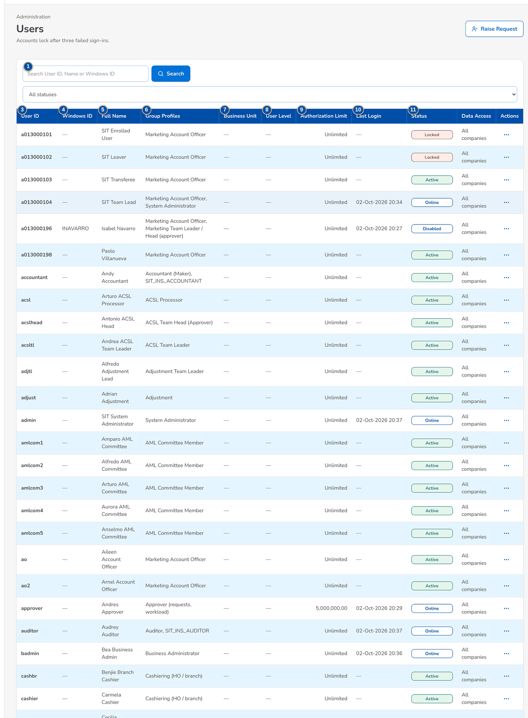
Figure 36: SCR-UA-15 Users with their status
1 | Search User ID, Name or Windows ID | 5 | Full Name | 9 | Authorization Limit
2 | Status | 6 | Group Profiles | 10 | Last Login
3 | User ID | 7 | Business Unit | 11 | Status
4 | Windows ID | 8 | User Level | 12 | Signed in / Last activity / Ended / Status

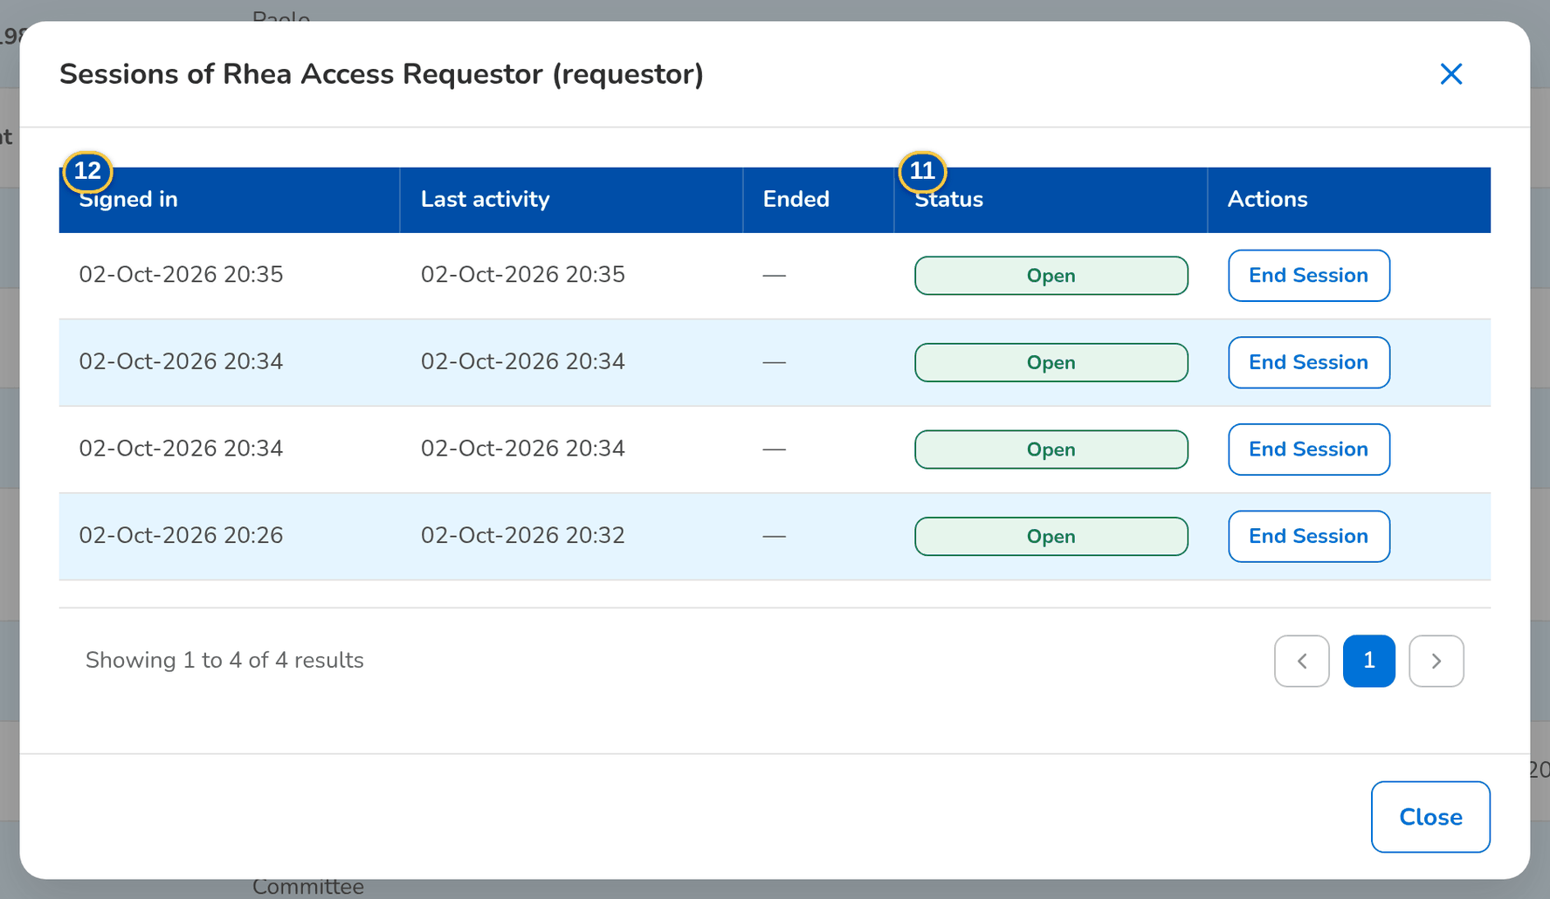
Figure 37: SCR-UA-15 Sessions of a user, with End Session
Fields (No. = callout number on the first screenshot)
No. | Section | Field | Type | Length / format | Mand. | Source / list | Default | Editable in | Validation | Message when it fails
1 | Search | Search User ID, Name or Windows ID | Text | Part of the user ID, name or Windows ID | N | - | Blank | - | Contains search | -
2 | Search | Status | Drop-down | All statuses, Active, Online, Disabled, Locked | N | Fixed list | All statuses | - | - | -
3 | List | User ID | Column | User ID | - | User master | - | Read only | - | -
4 | List | Windows ID | Column | Windows ID | - | User master | - | Read only | - | -
5 | List | Full Name | Column | Name | - | User master | - | Read only | - | -
6 | List | Group Profiles | Column | Names of the profiles held | - | User master | - | Read only | - | -
7 | List | Business Unit | Column | Business unit group (list label) | - | User master | - | Read only | - | -
8 | List | User Level | Column | User level (list label) | - | User master | - | Read only | - | -
9 | List | Authorization Limit | Column | Amount in PHP, or Unlimited | - | User master | - | Read only | - | -
10 | List | Last Login | Column | dd-MMM-yyyy HH:mm | - | Session log | - | Read only | - | -
11 | List | Status | Column | Active, Online (open session), Disabled, Locked | - | User master and session log | - | Read only | - | -
12 | Sessions of a user | Signed in / Last activity / Ended / Status | Columns | Date and time; Open, Logout, Idle Timeout, Expired, Admin Ended, Locked | - | Session log | - | Read only | - | -

Actions
Button | Who | Enabled when | What happens | Resulting status | Notification
Raise Request | System Administrator | Always | Opens New Request (SCR-UA-07) | - | -
Open a row | System Administrator | Always | Opens a Modify user request for the user (SCR-UA-07) | - | -
Unlock | System Administrator (user management right) | The user is locked | Unlocks the account and resets the failed attempts; written to the access change log | Active | -
Sessions | System Administrator | Always | Opens the sessions of the user | - | -
End Session | System Administrator | The session is open | Ends the session at once on every server; the user is signed out at the next action. Toast: Session ended | Admin Ended | -
New User (Emergency) | System Administrator, only while UAM_DIRECT_ROLE_EDIT is on | Emergency path open | Creates or edits a user directly (audited, alert raised); not offered as delivered | - | Alert UAM_DIRECT_ROLE_EDIT

Business rules
• Users, their data and their group profiles change only through an approved access request; the direct edit is an audited emergency path, closed as delivered (UAM_DIRECT_ROLE_EDIT = false) (FR-UA-052).
• A user is shown Online while a session is open; Locked after 3 failed sign-ins; Disabled after a deactivation, by a request or by the dormant-user job (FR-UA-052, FR-UA-004, FR-UA-006).
• A deactivated or locked user's open sessions end at once (FR-UA-013, FR-UA-004).
• Unlock, password reset and the end of a session are written to the access change log or the audit trail with the administrator's name (FR-UA-064).
Expected outcome
The System Administrator sees every user's access and state, unlocks accounts and ends sessions, while every access change still goes through a request.
Test cases: TC-UA-004.2-01, TC-UA-005.3-01, TC-UA-052.1-01, TC-UA-052.3-01, TC-UA-052.3-02, TC-UA-SCR-15, TC-UA-MSG-13.

13.4.4 SCR-UA-16 Roles & Permissions
Purpose | The group profiles (roles) against the permissions, with the privilege level and the active flag of each profile, read only as delivered; and the approved group-profile requests waiting for the System Administrator, each implemented with Implement Request.
Who can open it | System Administrator (permission ROLE_MANAGE)
Navigation | • Menu: Setup & Administration › Administration › Roles & Permissions  • Setup & Administration › Administration › Roles & Permissions  • The notice Access request AR-yyyy-nnnnnn to implement
FRs | FR-UA-045, FR-UA-050, FR-UA-051

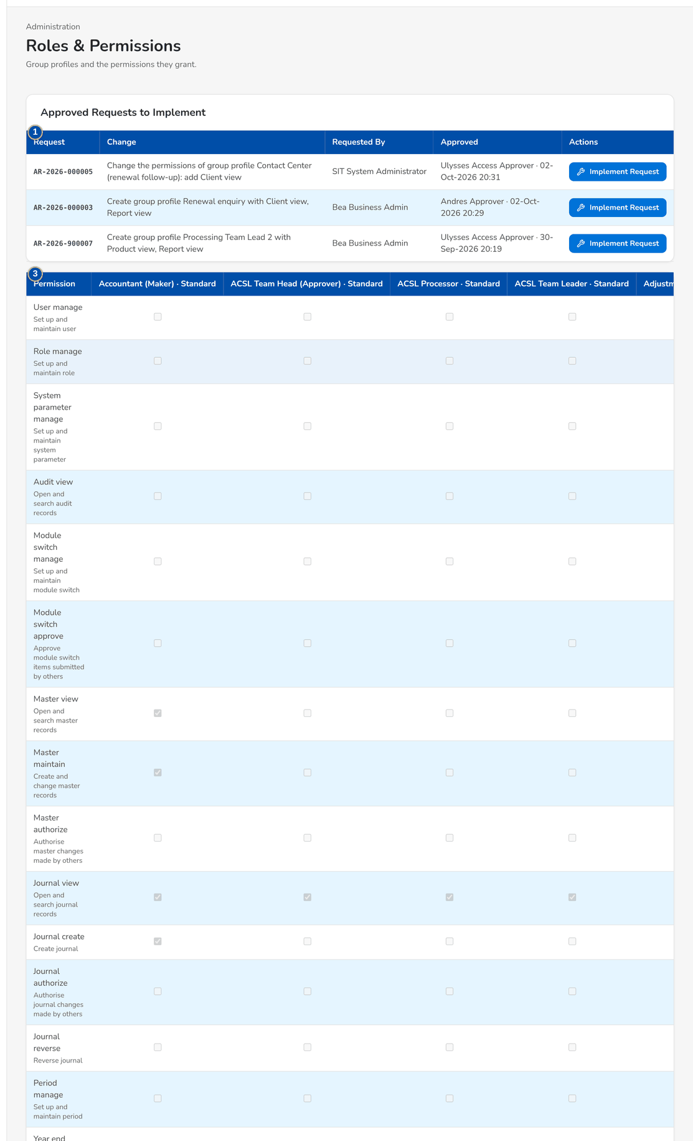
Figure 38: SCR-UA-16 Roles & Permissions with the approved requests to implement
1 | Request / Change / Requested By / Approved | 3 | Permission
2 | Permissions added / Permissions removed / Approved by | 4 | Profile columns

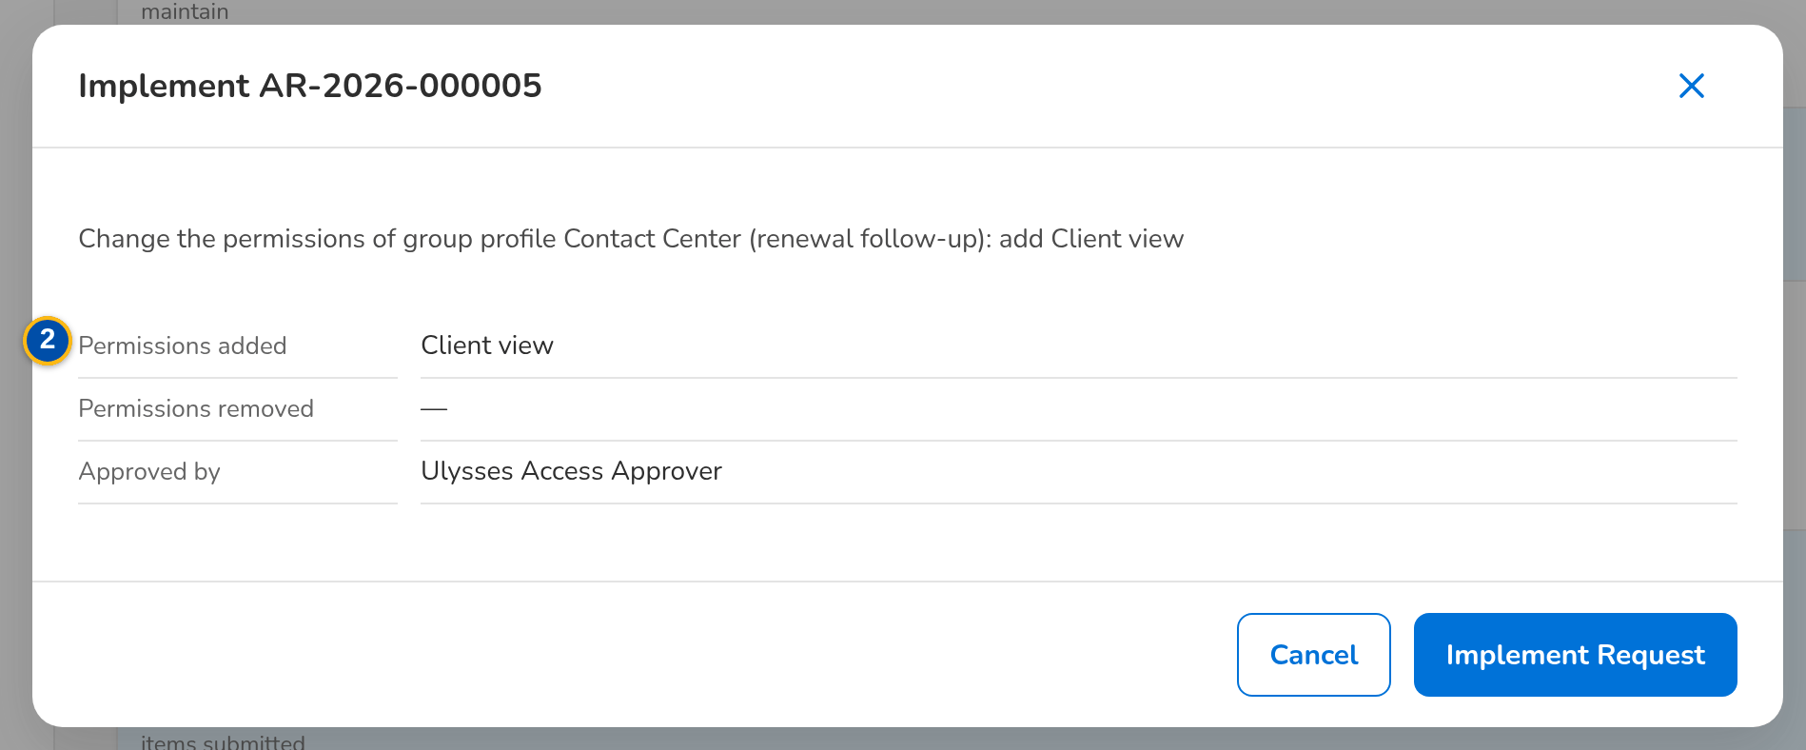
Figure 39: SCR-UA-16 Implement Request dialog with the permissions added and removed
Fields (No. = callout number on the first screenshot)
No. | Section | Field | Type | Length / format | Mand. | Source / list | Default | Editable in | Validation | Message when it fails
1 | Approved Requests to Implement | Request / Change / Requested By / Approved | Columns | AR-yyyy-nnnnnn; description; name; approver · dd-MMM-yyyy HH:mm | - | Access requests For Implementation | - | Read only | - | -
2 | Implement dialog | Permissions added / Permissions removed / Approved by | Text | Permission names; approver's name | - | Access request | - | Read only | - | -
3 | Matrix | Permission | Column | Permission name with the code below in small print | - | Permission catalogue | - | Read only | - | -
4 | Matrix | Profile columns | Check boxes | Profile name · privilege level, (inactive) and the Inactive pill for a deactivated profile | - | Role grants | - | Read only as delivered; editable only on the emergency path | - | -

Actions
Button | Who | Enabled when | What happens | Resulting status | Notification
Implement Request | System Administrator (role management right), not the requester | Request For Implementation | Applies the approved change to the group profile now; the request becomes Implemented. Toast: AR-yyyy-nnnnnn implemented | Implemented | Access request AR-yyyy-nnnnnn implemented, to the requester
Save | System Administrator, only while UAM_DIRECT_ROLE_EDIT is on | Emergency path open and a profile column changed | Saves the profile directly; audited and alerted | - | Alert UAM_DIRECT_ROLE_EDIT

Business rules
• Group profiles change only by implementing an approved group-profile request: Roles are changed through an approved group-profile request; implement the request instead (FR-UA-045).
• The implementer is never the requester: A request is implemented by someone other than its requester (FR-UA-045).
• While the emergency path is open the page says so, and every direct edit is audited and raises an alert (FR-UA-045, FR-UA-052).
Expected outcome
The approved profile change is applied by the System Administrator and recorded with the request number, the approver and the implementer.
Test cases: TC-UA-041.1-01, TC-UA-045.1-01, TC-UA-045.2-01, TC-UA-045.2-02, TC-UA-050.1-01, TC-UA-050.3-01, TC-UA-SCR-16, TC-UA-MSG-14.

13.4.5 SCR-UA-17 User access report (report runner)
Purpose | A user access report in the report runner: its parameters with their defaults, Run Report, Print, the PDF, Excel and CSV downloads, and the result with the parameters echoed and the notes of the report.
Who can open it | Approver, Business Administrator, System Administrator, Auditor, Information Security Officer, New Business Approver (keeps the access approval right) (permission REPORT_VIEW)
Navigation | • Menu: Setup & Administration › User Access › User Access Reports › Report  • User Access Reports › a report  • Reports › Report Centre › a report of the category Control & Audit
FRs | FR-UA-060, FR-UA-061, FR-UA-062, FR-UA-063

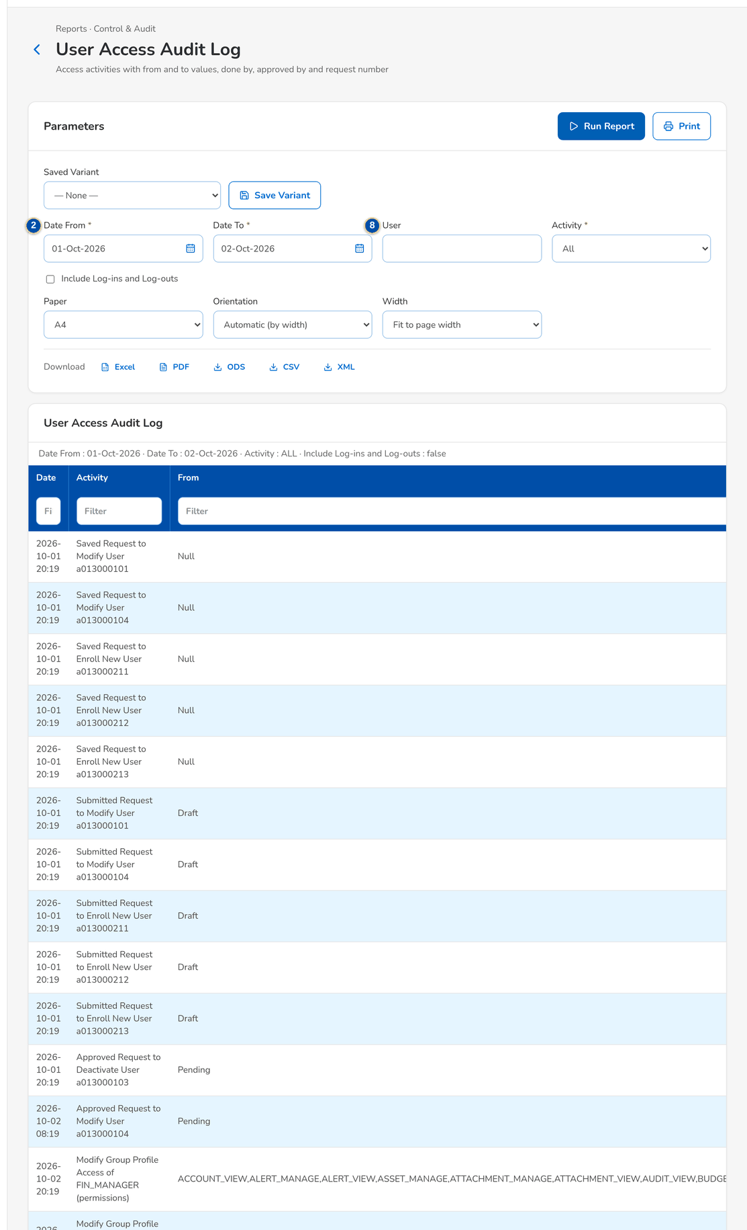
Figure 40: SCR-UA-17 User Access Audit Log with the from and to values
1 | As of Date | 5 | Group Profile (code) | 9 | Request Type
2 | Date From / Date To | 6 | Module (area code) | 10 | Columns of the report
3 | Business Unit Group | 7 | Active
4 | Status | 8 | User / Activity / Include Log-ins and Log-outs

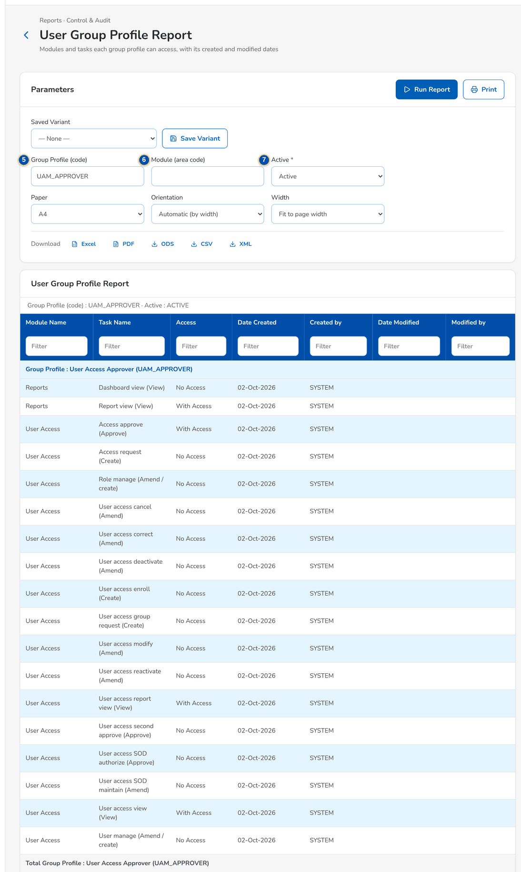
Figure 41: SCR-UA-17 User Group Profile Report of one profile

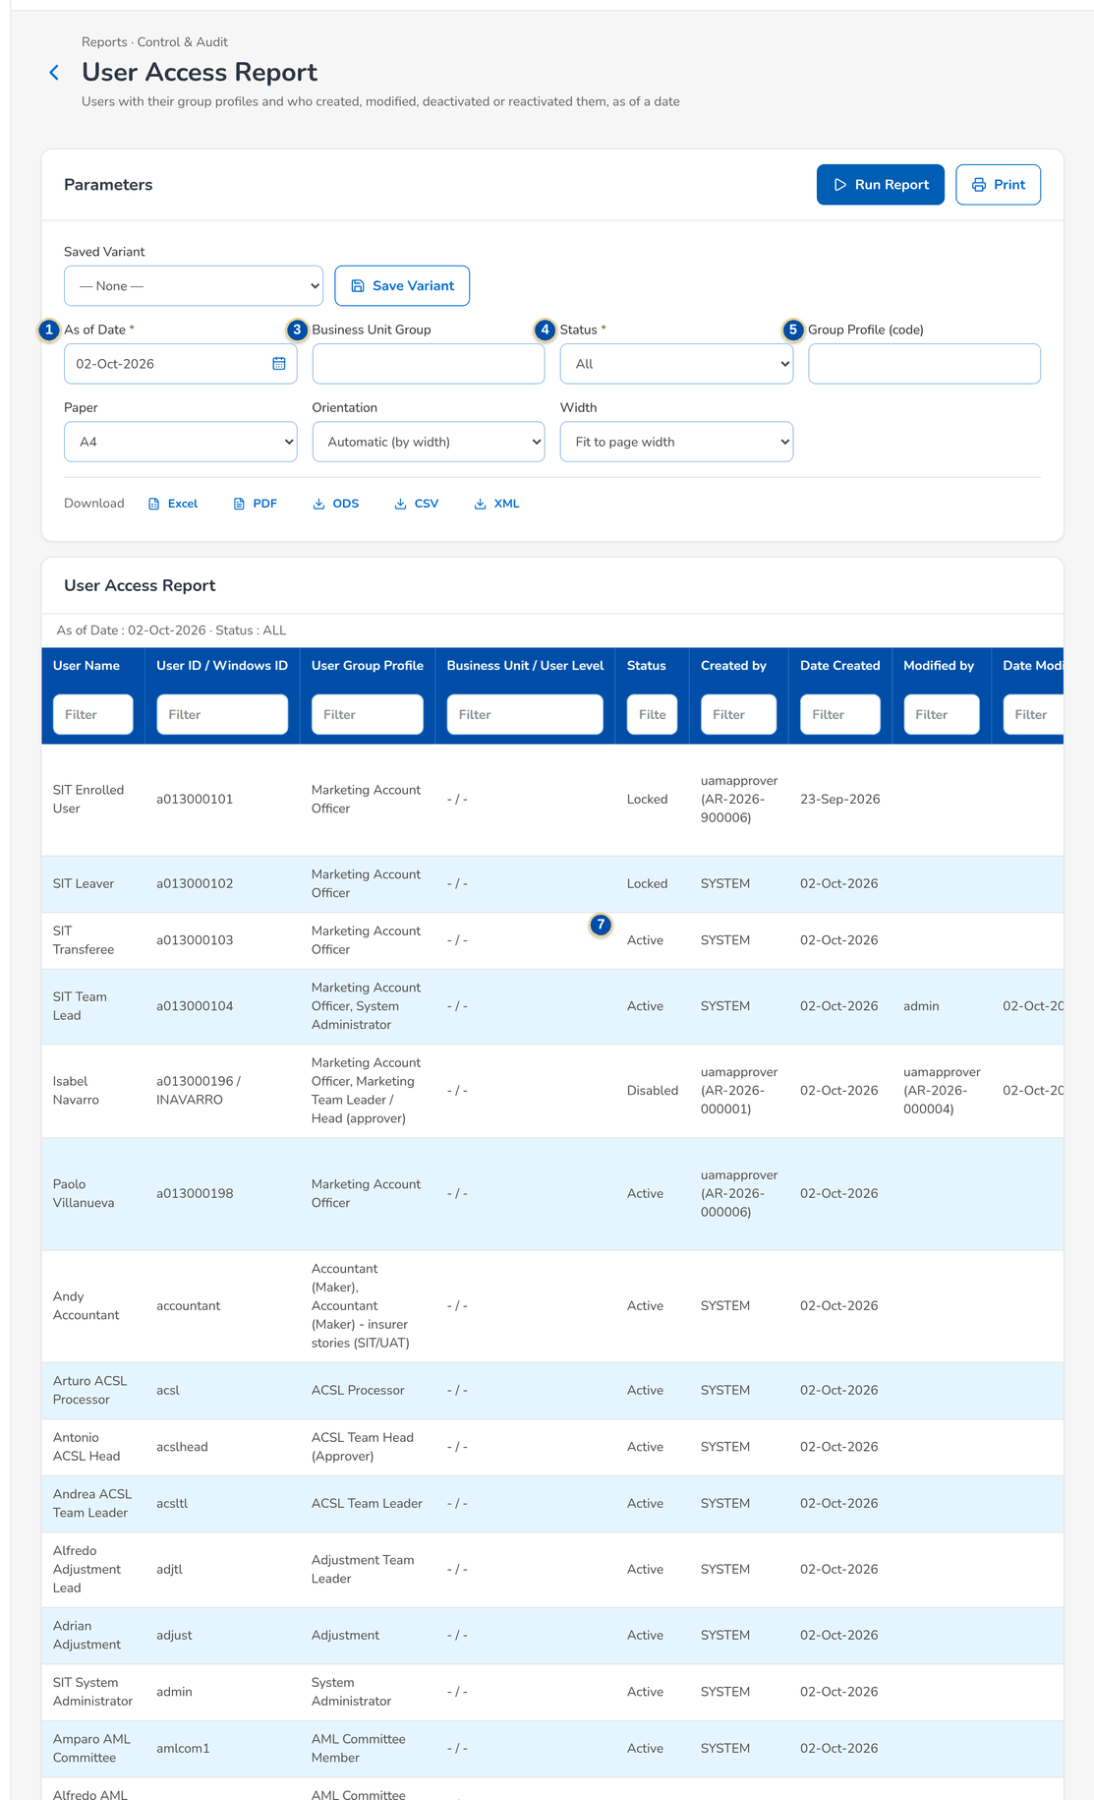
Figure 42: SCR-UA-17 User Access Report as of today

Fields (No. = callout number on the first screenshot)
No. | Section | Field | Type | Length / format | Mand. | Source / list | Default | Editable in | Validation | Message when it fails
1 | Parameters | As of Date | Date | dd-MMM-yyyy; not in the future | Y | - | Today | Before the run | Not after today | The as-of date cannot be in the future
2 | Parameters | Date From / Date To | Date | dd-MMM-yyyy | Y | - | Start of the month / today | Before the run | The end on or after the start | The end date must be on or after the start date
3 | Parameters | Business Unit Group | Text | Business unit code | N | - | Blank | Before the run | - | -
4 | Parameters | Status | Drop-down | All, Active, Disabled, Locked (users); the request statuses (Access Requests) | N | Fixed list | All | Before the run | - | -
5 | Parameters | Group Profile (code) | Text | Profile code | N | - | Blank | Before the run | - | -
6 | Parameters | Module (area code) | Text | Area code | N | - | Blank | Before the run | - | -
7 | Parameters | Active | Drop-down | All, Yes, No | N | Fixed list | All | Before the run | - | -
8 | Parameters | User / Activity / Include Log-ins and Log-outs | Text / Drop-down / Check box | User ID; the access activities; sign-ins and sign-outs of the audit trail | N | - | Blank; All; not ticked | Before the run | - | -
9 | Parameters | Request Type | Drop-down | All and the request types | N | Fixed list | All | Before the run | - | -
10 | Result | Columns of the report | Table | User Access Report: User Name, User ID / Windows ID, User Group Profile, Business Unit / User Level, Status, Created by, Date Created, Modified by, Date Modified, Last Action / by. User Group Profile Report: Module Name, Task Name, Access, Date Created, Created by, Date Modified, Modified by. Group Profile Membership: Member Username, Member User ID, Created by, Date Created, Modified by, Date Modified. User Access Audit Log: Date, Activity, From, To, Done By, Approved By, Request No. Access Requests: Request No., Request Type, User / Group Profile, Requester, Approver, Date Created, Date Decided, Effective Date, Age (days), Requests | - | Access change log, request history, audit trail | - | Read only | - | -

Actions
Button | Who | Enabled when | What happens | Resulting status | Notification
Run Report | Holders of the user access report right | Required parameters valid | Runs the report on screen | - | -
Print | As Run Report | Required parameters valid | Opens the printable report with the paper, orientation and width chosen | - | -
PDF / Excel / CSV download | As Run Report | Required parameters valid | Downloads the report; the header carries the report name, the user who generated it, the date coverage and the time generated | - | -

Business rules
• The as-of reports show the access held at the end of the as-of date (Philippine time), derived from the access change log (FR-UA-060, FR-UA-062).
• Created by and Modified by show the approver and the request number, or the user of a direct change (FR-UA-060).
• The audit log merges the access change log, the request history and, on request, the sign-ins, failed sign-ins and sign-outs (FR-UA-063).
Expected outcome
The reports of the BRD samples A to D, and the request list, are produced with their coverage and exported for audit.
Test cases: TC-UA-004.1-01, TC-UA-052.2-01, TC-UA-060.1-01, TC-UA-060.1-02, TC-UA-060.2-01, TC-UA-060.3-01, TC-UA-060.3-02, TC-UA-061.1-01, TC-UA-061.2-01, TC-UA-062.1-01, TC-UA-062.2-01, TC-UA-063.1-01, TC-UA-063.2-01, TC-UA-063.2-02, TC-UA-063.3-01, TC-UA-064.1-01, TC-UA-SCR-17.

13.4.6 SCR-UA-18 System Parameters (sign-in, password and access settings)
Purpose | The list of the business parameters, with the security category holding the sign-in, password, session and access-request settings of this set. The System Administrator changes a value in a dialog, checked by type and range; a change of a security setting waits until the Information Security Officer approves it.
Who can open it | Business Administrator, System Administrator, Auditor, Information Security Officer (permission SYSTEM_MONITOR or SYSTEM_PARAMETER_MANAGE or SECURITY_PARAMETER_APPROVE)
Navigation | • Menu: Setup & Administration › Administration › System Parameters  • Setup & Administration › Administration › System Parameters  • The notice Security setting to approve, and My Approvals (Information Security Officer)
FRs | FR-UA-001, FR-UA-002, FR-UA-005, FR-UA-006, FR-UA-052, FR-UA-054

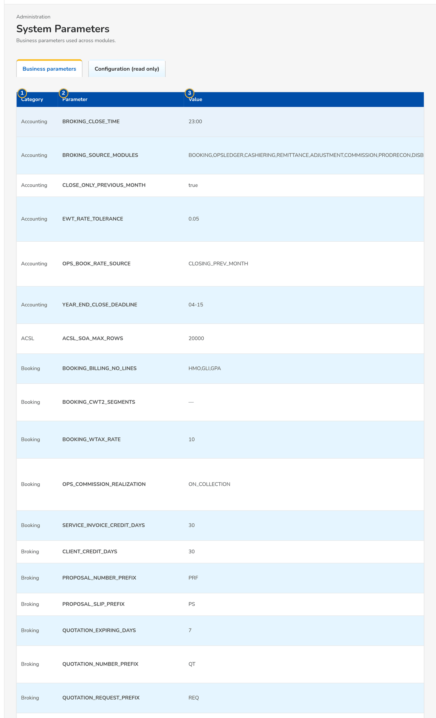
Figure 43: SCR-UA-18 System Parameters, security settings
1 | Category | 4 | Description | 7 | Current value / New value / Requested by / Requested on
2 | Parameter | 5 | Last Changed
3 | Value | 6 | Value

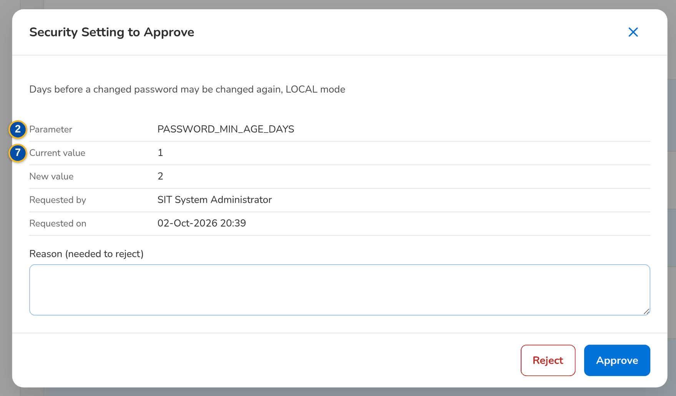
Figure 44: SCR-UA-18 System Parameters as the Information Security Officer sees it
Fields (No. = callout number on the first screenshot)
No. | Section | Field | Type | Length / format | Mand. | Source / list | Default | Editable in | Validation | Message when it fails
1 | Parameters | Category | Column | Security for the settings of this set | - | Parameters | - | Read only | - | -
2 | Parameters | Parameter | Column | LOGIN_MAX_FAILED_ATTEMPTS, SESSION_IDLE_WARNING_MINUTES, SESSION_TIMEOUT_MINUTES, SESSION_EXPIRY_WARNING_MINUTES, AUTH_MODE, USER_ID_PATTERN, USER_ID_FORMAT_TEXT, PASSWORD_HISTORY_COUNT, PASSWORD_MAX_AGE_DAYS, PASSWORD_MIN_AGE_DAYS, UAM_WORKING_HOURS, UAM_ANY_APPROVER, UAM_DIRECT_ROLE_EDIT, UAM_ROLE_APPLY_ON_APPROVAL, UAM_EXTERNAL_USERS, UAM_DORMANT_DAYS, UAM_DORMANT_NOTICE_DAYS, JOB_FAILURE_RECIPIENTS | - | Parameters | - | Read only | - | -
3 | Parameters | Value | Column | Value in force; under it, Waiting for approval: <new value>, asked by <name> while a change waits | - | Parameters | - | Read only | - | -
4 | Parameters | Description | Column | What the parameter does | - | Parameters | - | Read only | - | -
5 | Parameters | Last Changed | Column | Name, dd-MMM-yyyy HH:mm | - | Parameters | - | Read only | - | -
6 | Edit dialog | Value | Text | Up to 1,000 characters; the hint gives the type and range; a security setting says that the change applies once another user approves it | Y | - | Current value | System Administrator (parameter management right) | Type and range of the parameter | <parameter> <error of the type or range>
7 | Approval dialog | Current value / New value / Requested by / Requested on | Text | The two values; the name of the requester and dd-MMM-yyyy HH:mm | - | Parameters | - | Read only | - | -

Actions
Button | Who | Enabled when | What happens | Resulting status | Notification
Open a row | System Administrator (parameter management right); Information Security Officer (security setting approval right) | Always | Opens the edit dialog; for a setting whose change waits, the approval dialog | - | -
Save | System Administrator (parameter management right) | Value valid | A security setting: keeps the change as waiting for approval and tells the approvers. Toast: <description>: change sent for approval. Another parameter: saves it at once. Toast: <description>: updated | Waiting for approval, or changed | Security setting to approve, to the Information Security Officers
Approve | Information Security Officer (security setting approval right), not the requester | A change waits | Applies the new value at once, audited with the requester and the approver. Toast: <description>: change approved | Changed | -
Reject | Information Security Officer; Withdraw for the requester | A change waits | Drops the change; the current value stays. Toast: Change rejected | Unchanged | -

Business rules
• Only the System Administrator asks for a change of a parameter; every change is written to the audit trail with the old and new value and the user (FR-UA-052).
• A change of a security setting, the emergency path UAM_DIRECT_ROLE_EDIT included, applies only when a holder of the approval right other than the requester approves it: A change cannot be approved by the user who asked for it (FR-UA-054).
• One change per setting waits at a time: A change of <setting> already waits for approval; approve or reject it first (FR-UA-054).
• The session, lock-out and password values are those of chapter 9 and of the configuration input template of the sign-in parameters (FR-UA-001, FR-UA-002, FR-UA-005).
Expected outcome
The security settings agreed with BDOI Information Security change only under four eyes, and every change is kept under audit.
Test cases: TC-UA-041.3-01, TC-UA-054.1-01, TC-UA-054.2-01, TC-UA-054.2-02, TC-UA-054.3-01, TC-UA-054.3-02, TC-UA-071.2-01, TC-UA-SCR-18, TC-UA-MSG-15.

13.4.7 SCR-UA-19 Separation of Duties
Purpose | The pairs of group profiles that one user may not hold together, with the reason of each. The Business Administrator adds a rule or asks for its deactivation; the Information Security Officer authorises or rejects each change. Every user request and bulk line is checked against the active rules.
Who can open it | Business Administrator, Information Security Officer (permission UAM_SOD_MAINTAIN or UAM_SOD_AUTHORIZE)
Navigation | • Menu: Setup & Administration › User Access › Separation of Duties  • Setup & Administration › User Access › Separation of Duties  • The notice Separation-of-duties rule <rule> to authorise, and My Approvals (Information Security Officer)
FRs | FR-UA-053

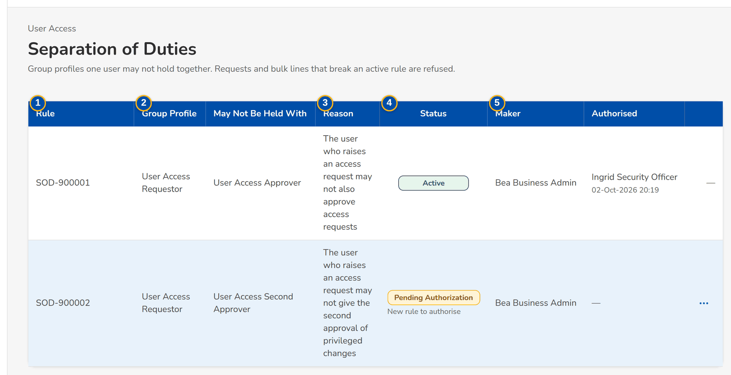
Figure 45: SCR-UA-19 Separation of Duties with a rule to authorise
1 | Rule | 4 | Status | 7 | Group Profile
2 | Group Profile / May Not Be Held With | 5 | Maker / Authorised | 8 | May Not Be Held With
3 | Reason | 6 | Row action menu | 9 | Reason

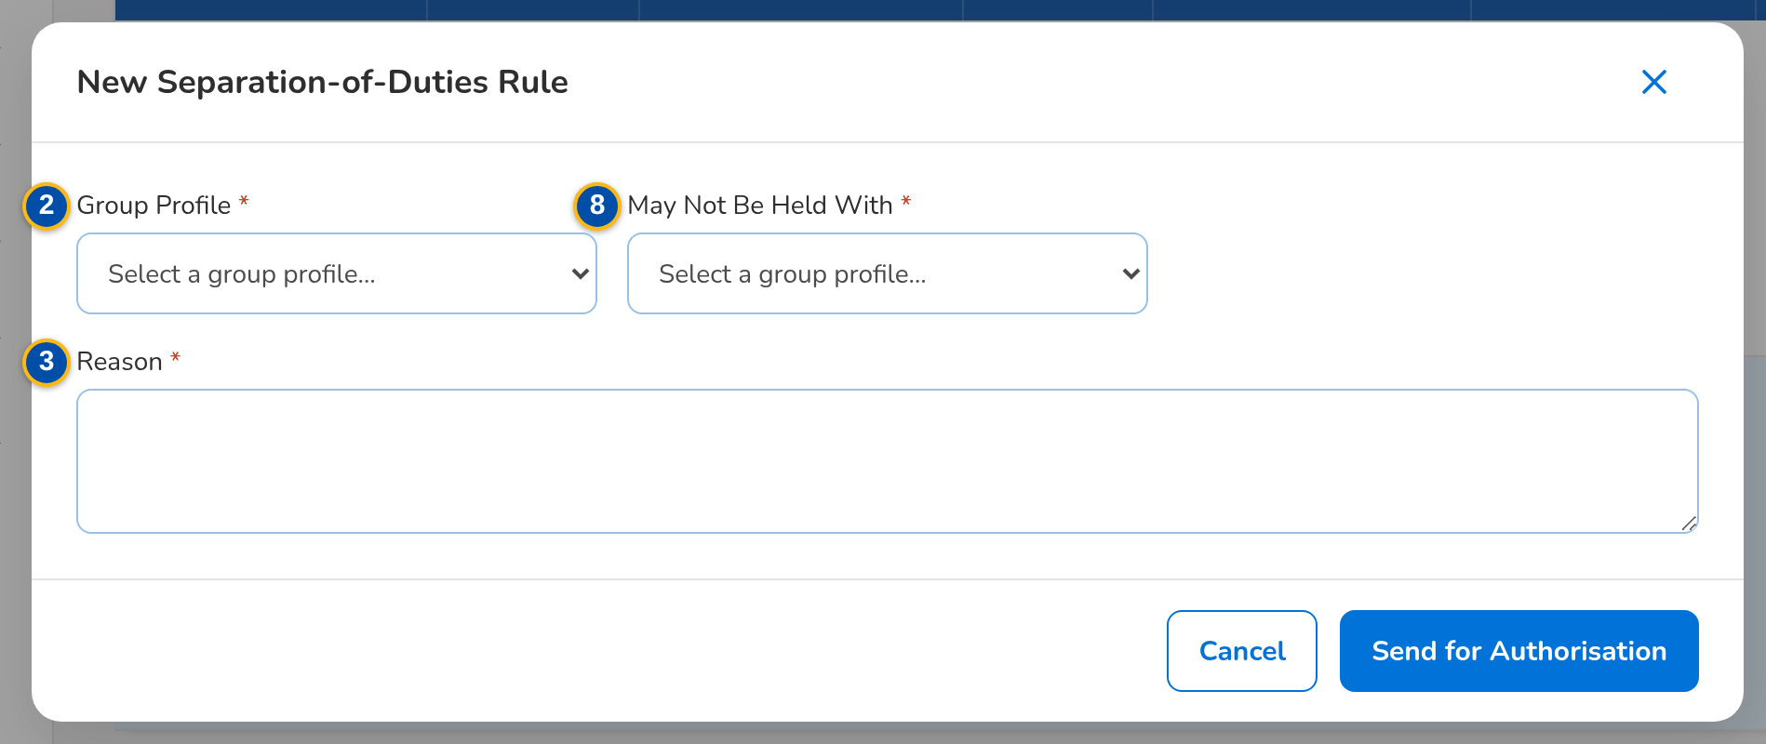
Figure 46: SCR-UA-19 New separation-of-duties rule
Fields (No. = callout number on the first screenshot)
No. | Section | Field | Type | Length / format | Mand. | Source / list | Default | Editable in | Validation | Message when it fails
1 | Rules | Rule | Column | SOD-nnnnnn | - | Rules | - | Read only | - | -
2 | Rules | Group Profile / May Not Be Held With | Columns | Profile names | - | Rules | - | Read only | - | -
3 | Rules | Reason | Column | Why one user may not hold both | - | Rules | - | Read only | - | -
4 | Rules | Status | Column | Pending Authorization, Active, Inactive; under it New rule to authorise or Deactivation to authorise | - | Rules | - | Read only | - | -
5 | Rules | Maker / Authorised | Columns | Name; name and dd-MMM-yyyy HH:mm | - | Rules | - | Read only | - | -
6 | Rules | Row action menu | Row action menu | Authorise and Reject of a waiting change, Deactivate of an active rule, each confirmed in a dialog | - | - | - | - | - | -
7 | New Rule | Group Profile | Drop-down | Active group profiles by name | Y | Group profiles | Blank | New rule | - | Select the first group profile
8 | New Rule | May Not Be Held With | Drop-down | Active group profiles by name | Y | Group profiles | Blank | New rule | Different from the first | Choose two different group profiles
9 | New Rule | Reason | Text area | Up to 500 characters | Y | - | Blank | New rule | Not blank | Enter why the two profiles are not held together

Actions
Button | Who | Enabled when | What happens | Resulting status | Notification
New Rule | Business Administrator (rule maintenance right) | Always | Opens the New Rule dialog | - | -
Send for Authorisation | Business Administrator | Both profiles and the reason entered | Saves the rule as pending. Toast: Rule SOD-nnnnnn sent for authorisation | Pending Authorization | Separation-of-duties rule to authorise, to the Information Security Officers
Deactivate | Business Administrator | Active rule, nothing waiting | Asks for the deactivation; the rule stays active until authorised | Active (deactivation to authorise) | Separation-of-duties rule to authorise
Authorise | Information Security Officer (rule authorisation right), not the maker | A creation or deactivation waits | A new rule becomes active; a deactivated rule becomes inactive. Toast: Rule <rule> authorised | Active or Inactive | -
Reject | Information Security Officer, not the maker | A creation or deactivation waits | A new rule is closed; a rule whose deactivation is rejected stays active. Toast: Rule <rule> rejected | Inactive or Active | -

Business rules
• A rule applies only once authorised, and the maker never authorises it: A record cannot be authorized by the user who maintained it (FR-UA-053).
• One rule per pair of profiles, in either order: A rule for these two group profiles already exists (FR-UA-053).
• A request or bulk line that gives one user both profiles of an active rule is refused, on submission and at approval: One user may not hold both <profile> and <profile> (separation-of-duties rule <rule>) (FR-UA-053).
• A new rule does not change the users who already hold both profiles; they are found with the User Access Report and changed by requests (FR-UA-053, FR-UA-060).
Expected outcome
The combinations of profiles that Information Security forbids are refused by the system, not found afterwards.
Test cases: TC-UA-053.1-01, TC-UA-053.2-01, TC-UA-053.2-02, TC-UA-053.3-02, TC-UA-SCR-19, TC-UA-MSG-16.

14 End-to-end walkthroughs
Four walkthroughs follow user access through the screens, persona by persona, with what the user does, what the user sees and the result of each step. They use seed data only and run in order. They are the script of the SIT review sessions of the Start Here guide.

14.1 WT-A A new user from the enrolment request to the first sign-in with the menus of the persona
Marketing hires an account officer. The Requestor raises an enrolment request with the user's data, the group profile Marketing Account Officer and the chosen approver, saves it as a draft and submits it. The Approver finds it in Assigned to Me and approves it; BIBS creates the user and shows the temporary password once. The new user signs in, must choose a personal password first, and then sees exactly the sidebar of the Marketing Account Officer given in chapter 12 and checked by the persona menu test. The Auditor finds the enrolment, the approval and the first sign-in in the User Access Audit Log.
Seed data: new user a013000196, Isabel Navarro (fictitious), e-mail isabel.navarro@brokerverse-seed.ph, Windows ID INAVARRO, home branch HO, group profile Marketing Account Officer; Requestor requestor, Approver uamapprover, Auditor auditor
Step 1. Requestor – New Request and Edit Request (user requests) (SCR-UA-07)
Does | Opens User Access › Access Requests › New Request, keeps Enrol new user, enters the user ID a013000196, the full name, e-mail, Windows ID and home branch, ticks Marketing Account Officer, chooses the approver Ulysses Access Approver, writes the justification and clicks Save Draft
Sees | Toast: AR-yyyy-nnnnnn saved as a draft; the request opens as Draft with Approver Chosen on submission
Result | Draft request

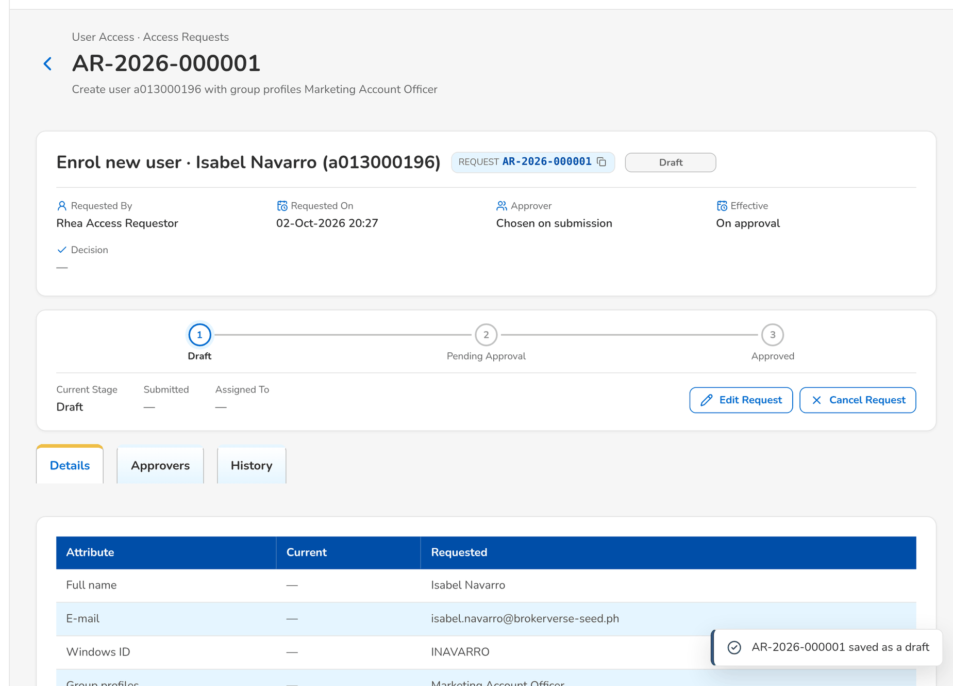
Figure 47: WT-A step 1: New Request and Edit Request (user requests)
Step 2. Requestor – Access Request record (SCR-UA-08)
Does | Clicks Edit Request, checks the data and clicks Submit
Sees | Toast: AR-yyyy-nnnnnn submitted; the status is Pending Approval and the History tab lists Saved and Submitted
Result | Pending Approval

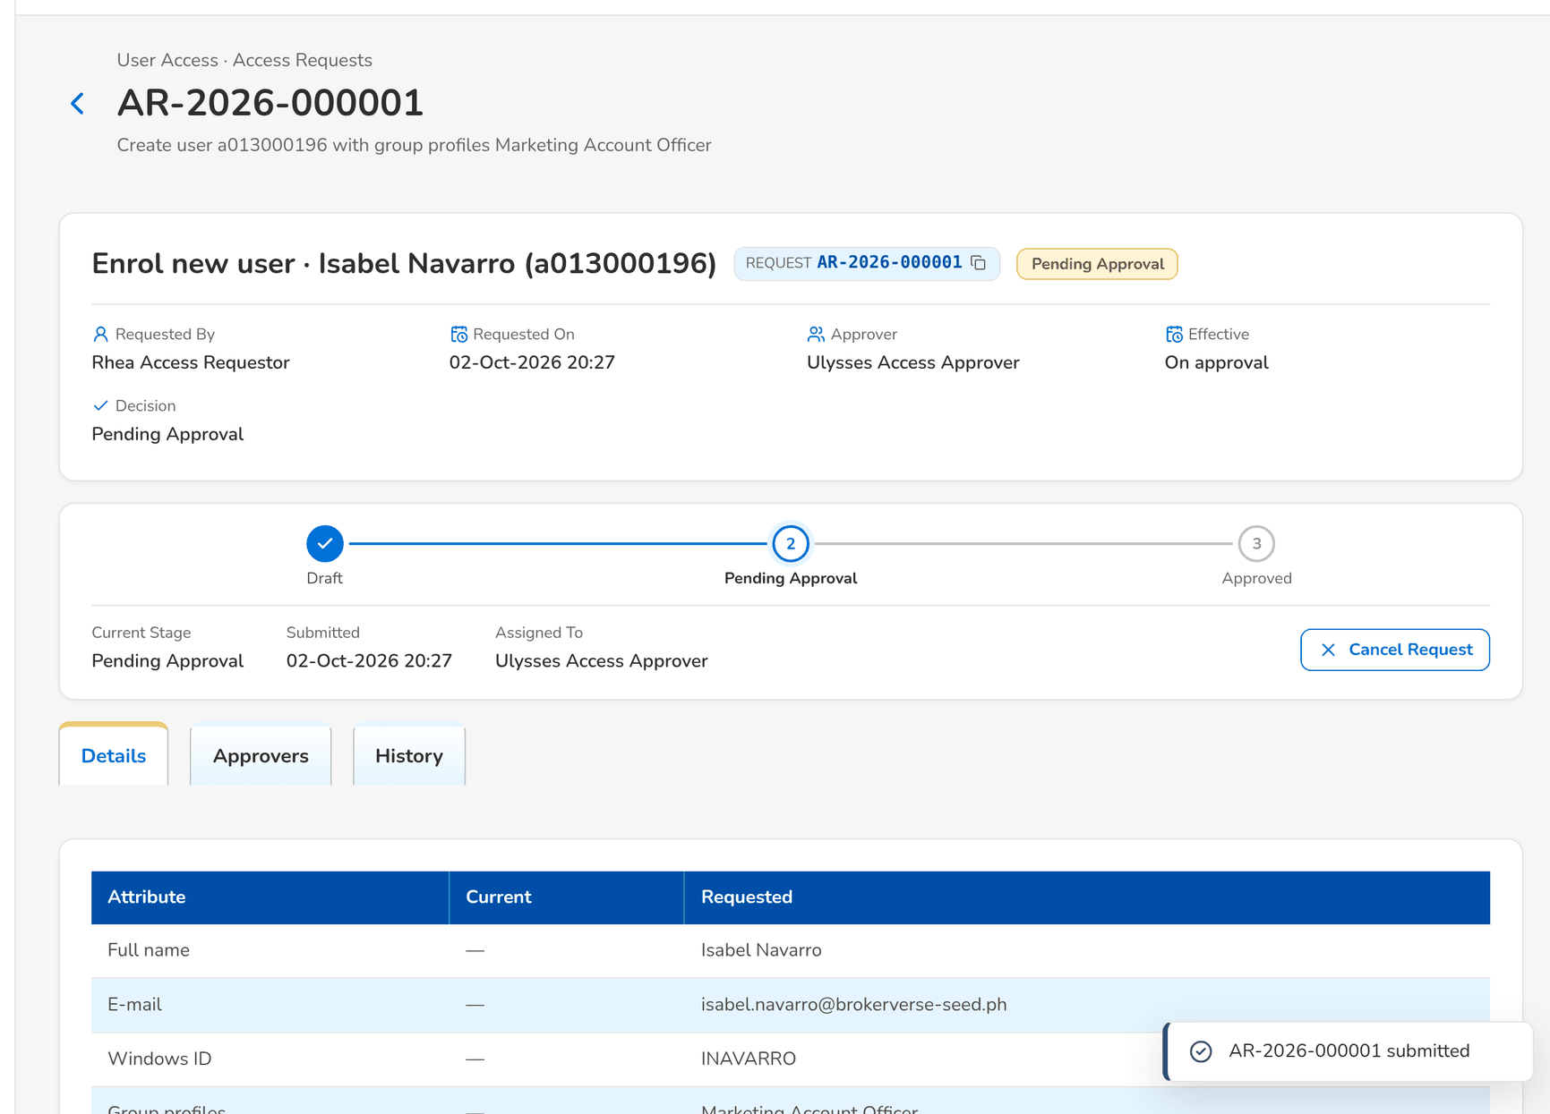
Figure 48: WT-A step 2: Access Request record
Step 3. Approver – Access Requests (SCR-UA-06)
Does | Opens the notice Access request AR-yyyy-nnnnnn to approve, or User Access › Access Requests
Sees | The request is on the Assigned to Me tab with its change: Create user a013000196 with group profiles Marketing Account Officer
Result | Request found

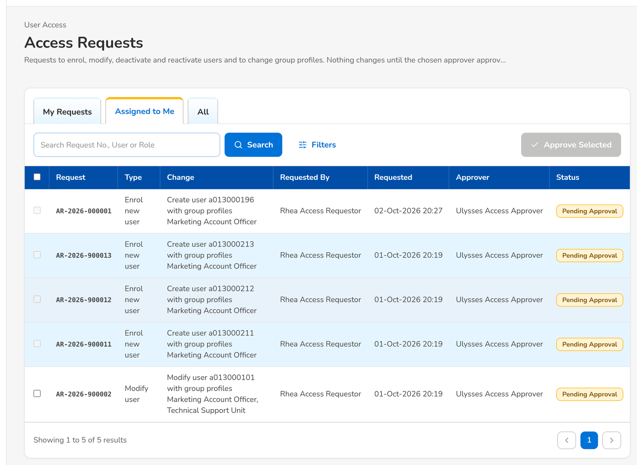
Figure 49: WT-A step 3: Access Requests
Step 4. Approver – Access Request record (SCR-UA-08)
Does | Opens the request, reads the Details tab (current and requested values), clicks Approve and Apply, adds a comment and confirms
Sees | User a013000196 was created, with the temporary password shown once to be given through a secure channel; the status is Approved
Result | Approved and applied

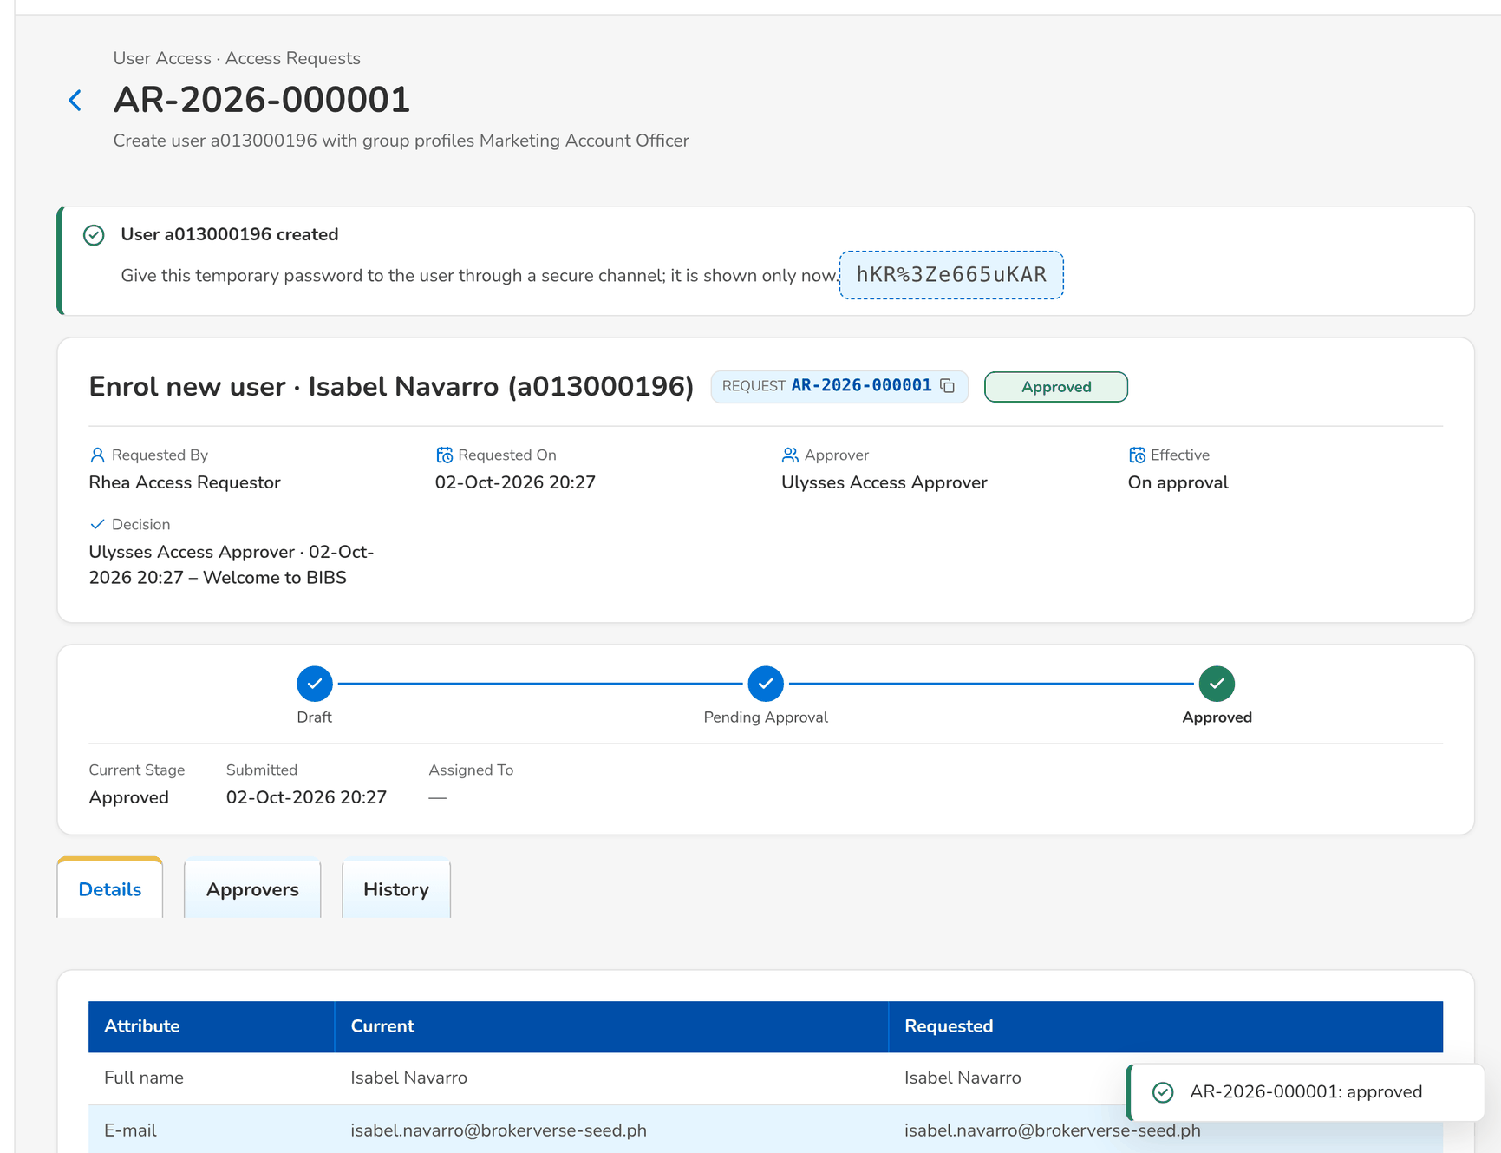
Figure 50: WT-A step 4: Access Request record
Step 5. Marketing Account Officer – Login (SCR-UA-01)
Does | The new user opens BIBS and signs in with a013000196 and the temporary password
Sees | Change Your Password: Your password was set by an administrator. Choose your own password to continue.
Result | Forced change

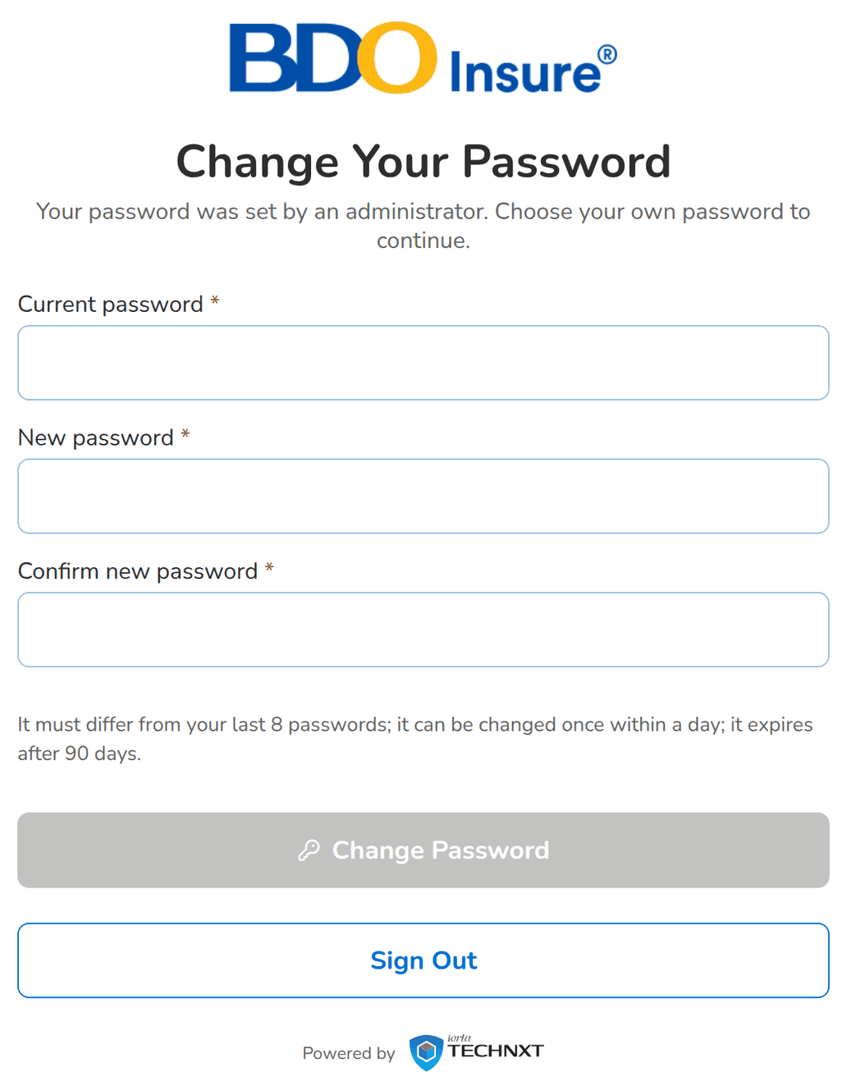
Figure 51: WT-A step 5: Login
Step 6. Marketing Account Officer – Change Your Password (forced change) (SCR-UA-03)
Does | Enters the temporary password as the current password and a personal password twice, and clicks Change Password
Sees | Toast: Password changed; the home page opens
Result | Signed in

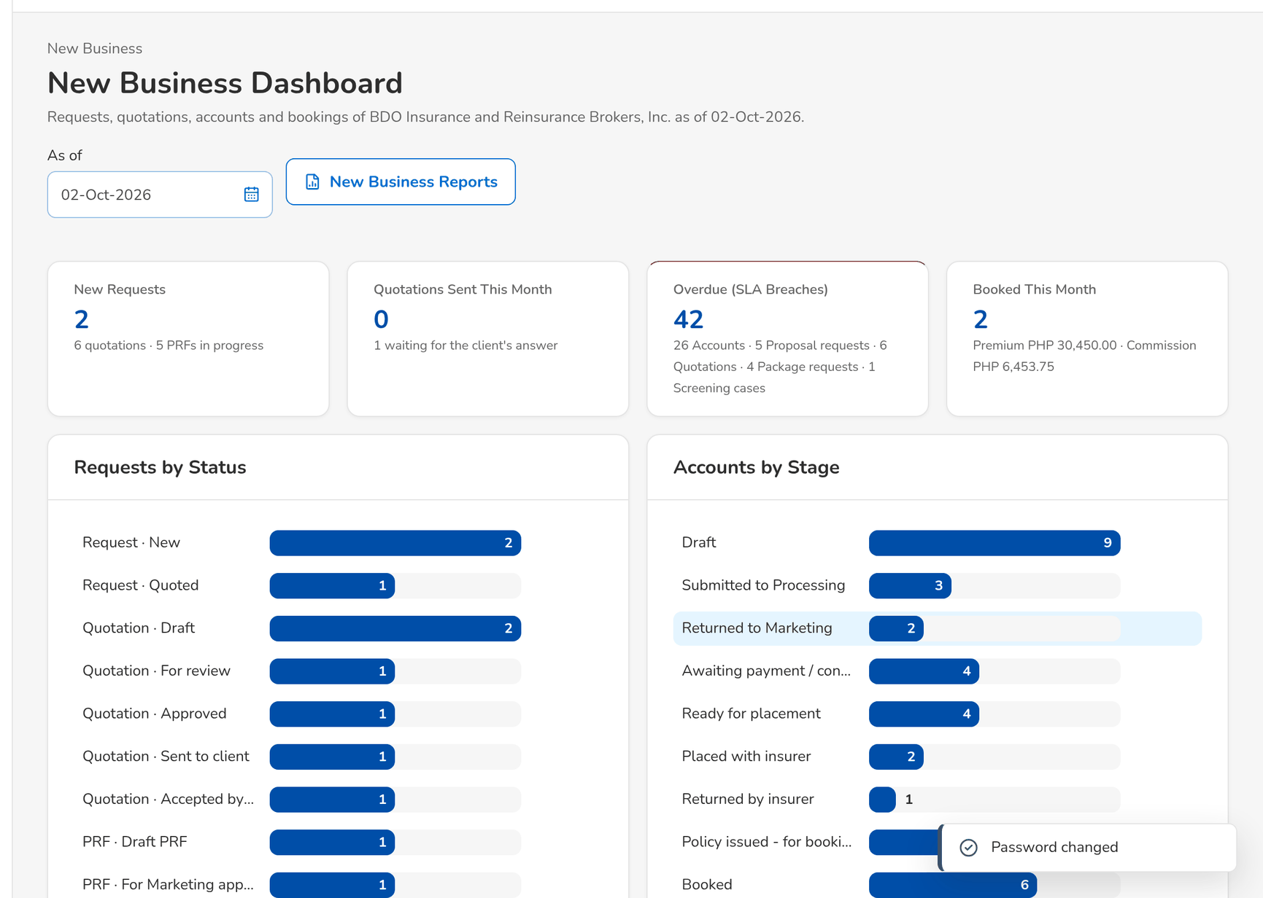
Figure 52: WT-A step 6: Change Your Password (forced change)
Step 7. Marketing Account Officer – My Profile (SCR-UA-05)
Does | Opens the sidebar and My Profile
Sees | The sidebar holds exactly the entries of the Marketing Account Officer (chapter 12); My Profile lists the group profile Marketing Account Officer and its permissions, and the first session
Result | Menus of the persona

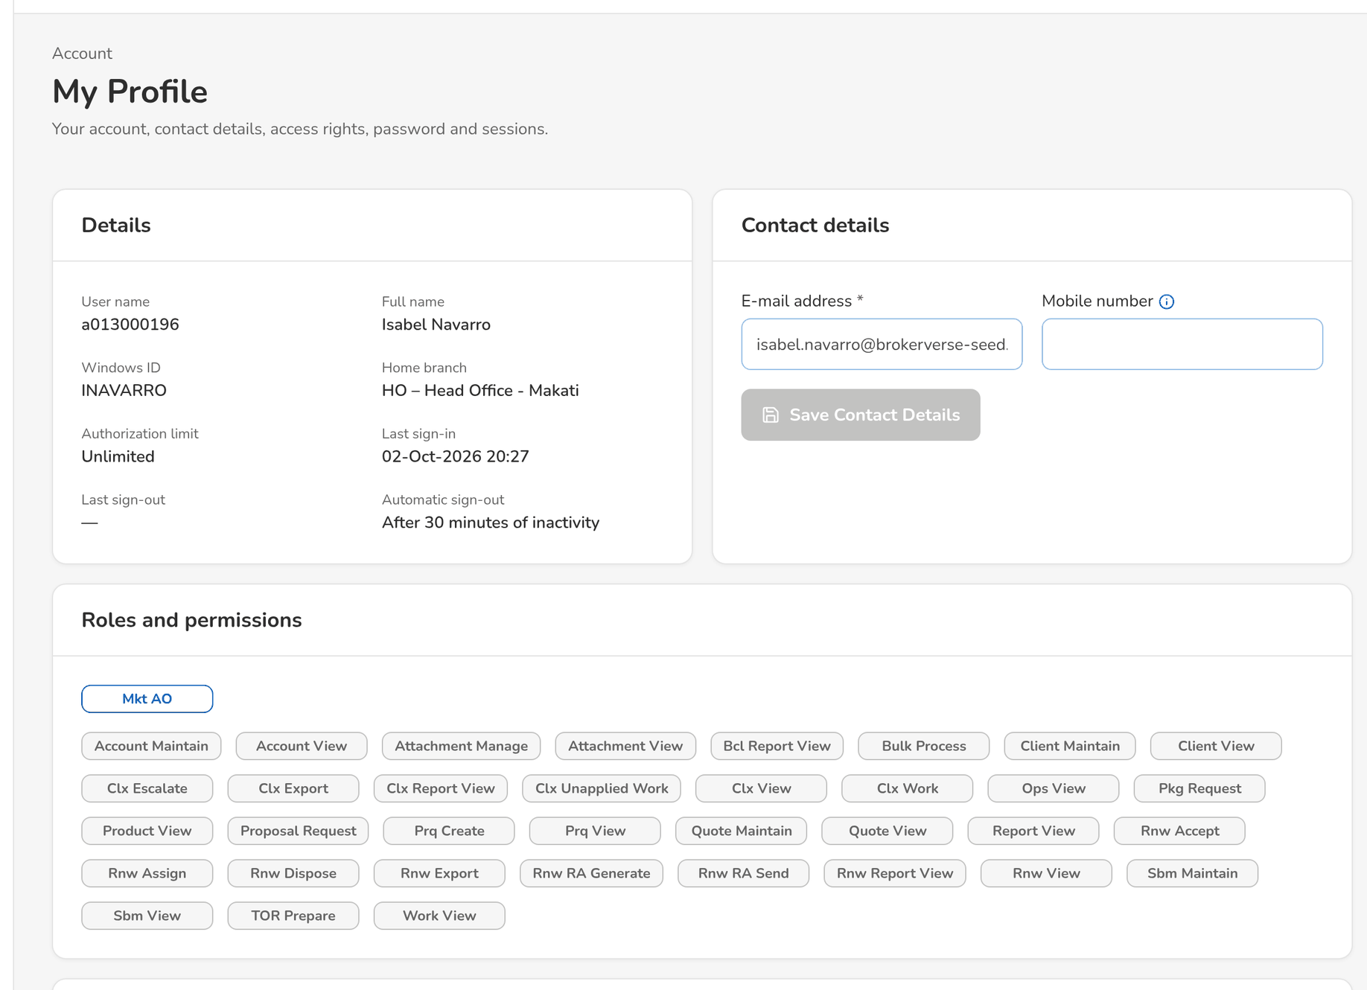
Figure 53: WT-A step 7: My Profile
Step 8. Auditor – User access report (report runner) (SCR-UA-17)
Does | Opens User Access Reports › User Access Audit Log for today, ticks Include Log-ins and Log-outs and clicks Run Report
Sees | Enroll New User a013000196 with the from and to values of the full name, e-mail and profiles, Done By and Approved By the Approver, the request number, and the Log-in of the new user
Result | Evidence of the enrolment

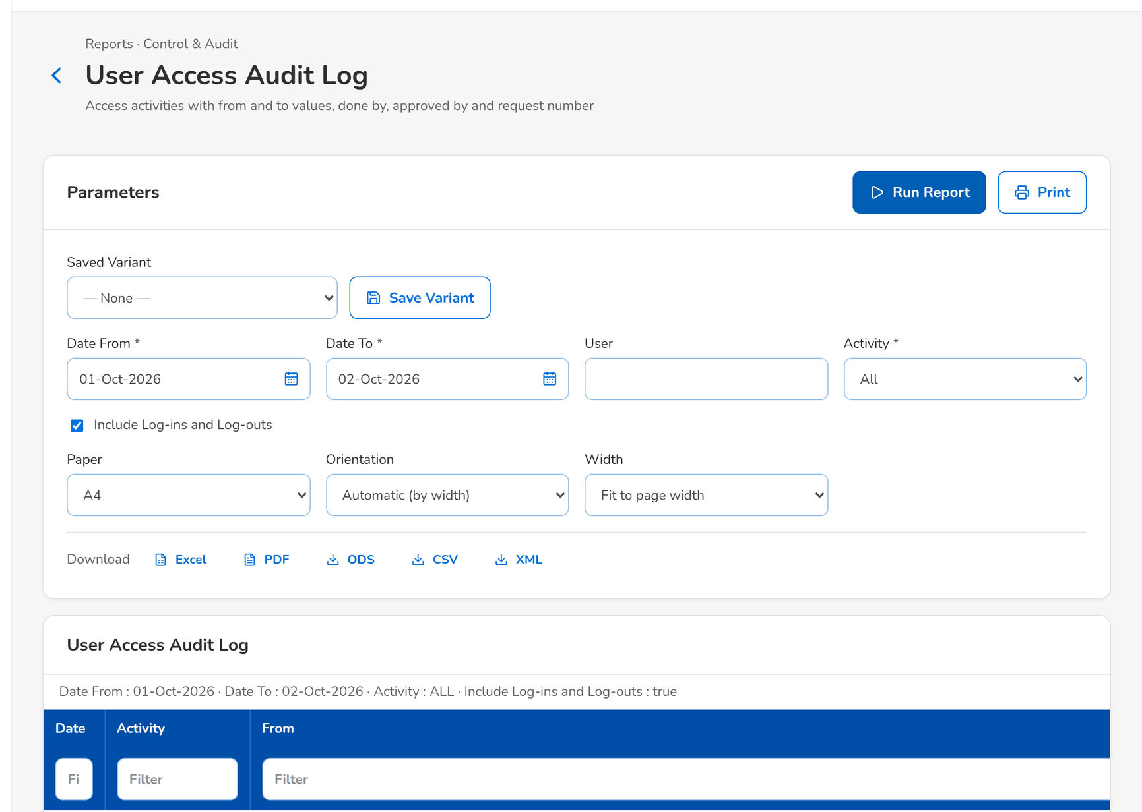
Figure 54: WT-A step 8: User access report (report runner)
What happens next, downstream
• Every BIBS module now opens its screens to the new user according to the Marketing Account Officer profile: Clients, Quotation / Proposal, Accounts & Placement, Renewal and the reports of that profile (menu of chapter 12); nothing else is shown or accepted.
• The user appears in the User Access Report and in the Group Profile Membership of Marketing Account Officer, with the approver and the request number as Created by.
• The change is logged once: the access change log cannot be edited by any user.

14.2 WT-B A change and a revocation under four eyes, and a group-profile change approved in order and implemented
The new account officer also covers as team leader: the Requestor asks to add the profile, the Approver approves it and the user is told. A privileged change (a back-up System Administrator) is flagged and needs the Second Approver. The Business Administrator asks for a new group profile; two approvers approve it in order and the System Administrator implements it. When the officer resigns, the Requestor deactivates the user; the Approver approves and the user's sessions end at once.
Seed data: user a013000196 of walkthrough A; seed request AR-2026-900008 (privileged change of a013000104 waiting for the second approval); new group profile RENEWAL_ENQUIRY (fictitious) with two permissions; approvers uamapprover and approver
Step 1. Requestor – New Request and Edit Request (user requests) (SCR-UA-07)
Does | Opens a New Request of type Modify user for a013000196, ticks Marketing Team Leader / Head (approver) besides the current profile, chooses the approver, writes the justification and clicks Submit
Sees | The Group Profiles show (current) after Marketing Account Officer; toast AR-yyyy-nnnnnn submitted
Result | Pending Approval

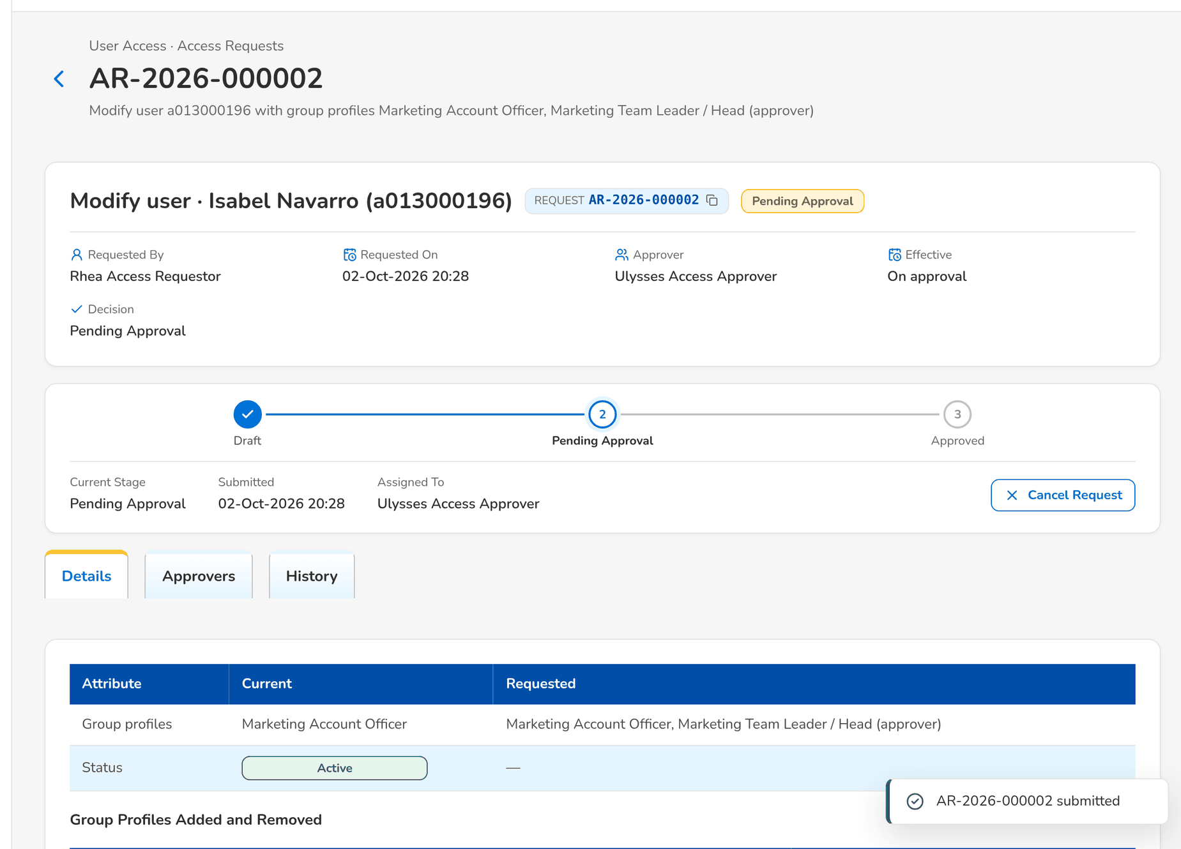
Figure 55: WT-B step 1: New Request and Edit Request (user requests)
Step 2. Approver – Access Request record (SCR-UA-08)
Does | Opens the request: the Details tab shows the group profiles added; clicks Approve and Apply
Sees | The status is Approved; the user receives Your access changed in the app and by e-mail
Result | Change applied

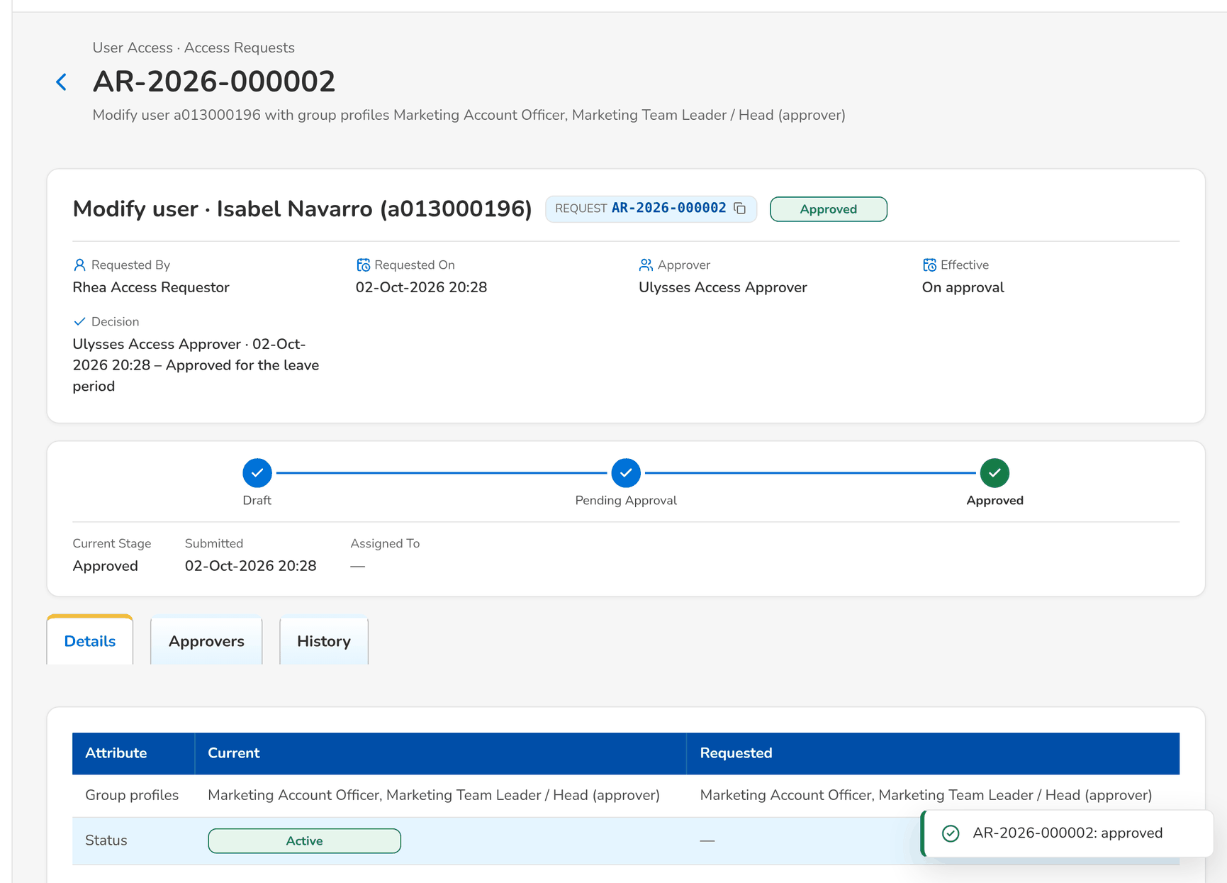
Figure 56: WT-B step 2: Access Request record
Step 3. Second Approver – Access Request record (SCR-UA-08)
Does | Opens AR-2026-900008 from the Second Approval tab: the tag Privilege increase, first approved by the Approver; clicks Second Approval and confirms
Sees | The status is Approved; the alert Privileged access change stays in the Alert inbox as evidence
Result | Second approval given

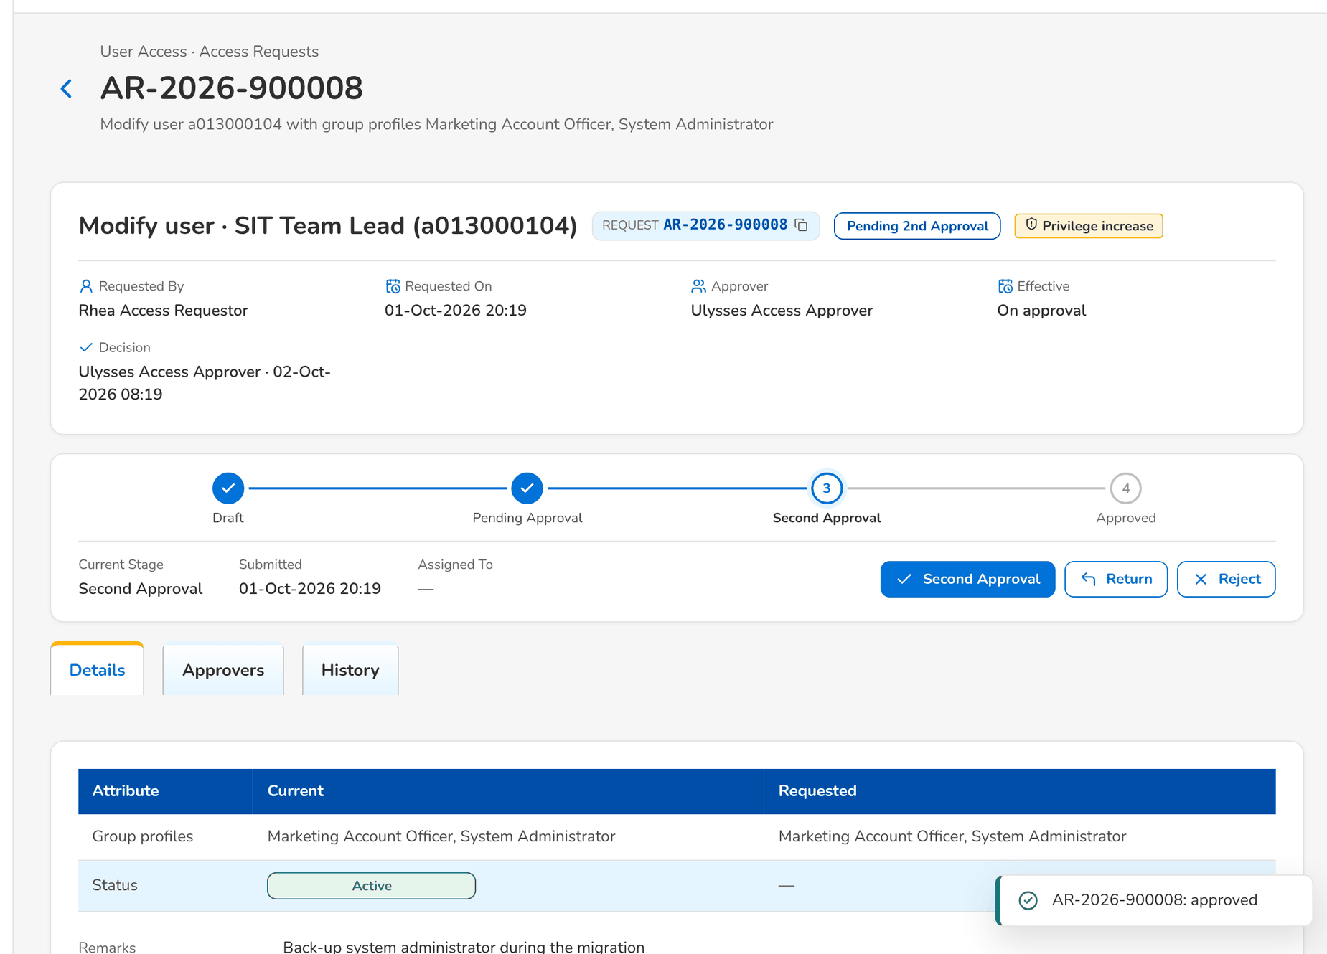
Figure 57: WT-B step 3: Access Request record
Step 4. Business Administrator – New Group Profile Request and Edit Request (SCR-UA-12)
Does | Opens Group Profile Requests › New Group Profile Request, enters the code RENEWAL_ENQUIRY, the name and description, keeps the level Standard, ticks two permissions, adds the approvers Ulysses Access Approver then the New Business Approver, writes the justification and clicks Submit
Sees | Toast: AR-yyyy-nnnnnn submitted; the Approvers tab lists the two approvers in order
Result | Pending Approval (first approver)

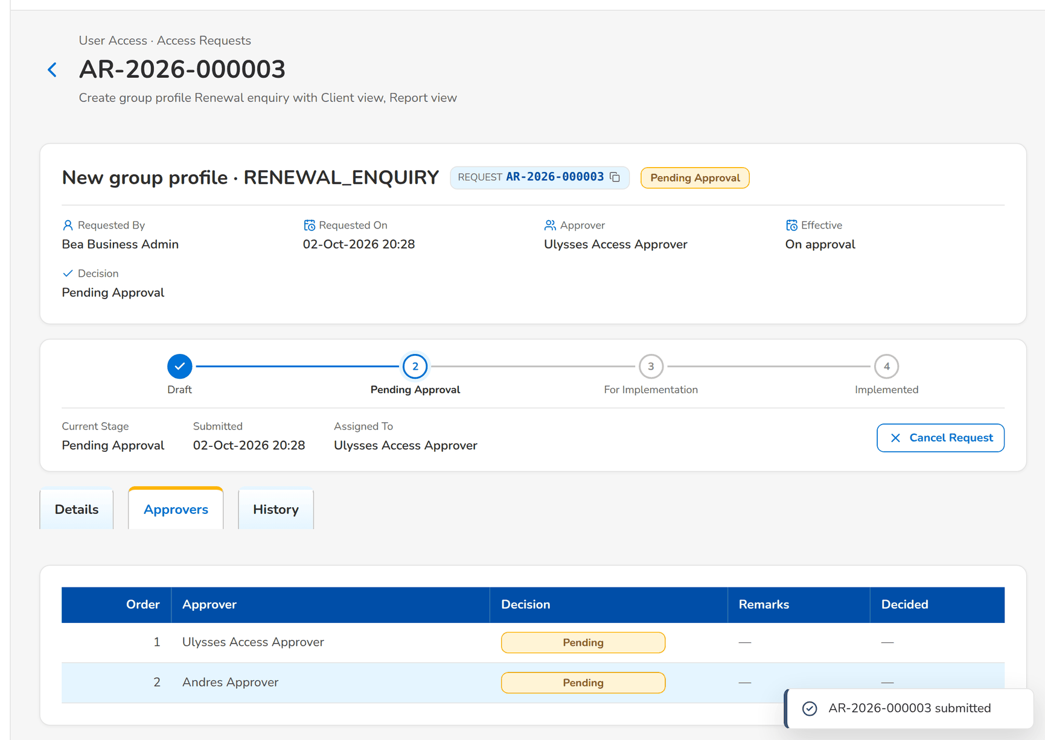
Figure 58: WT-B step 4: New Group Profile Request and Edit Request
Step 5. Approver – Access Request record (SCR-UA-08)
Does | Approves the group-profile request
Sees | The status stays Pending Approval; the request moves to the New Business Approver, who receives the notice
Result | Next approver

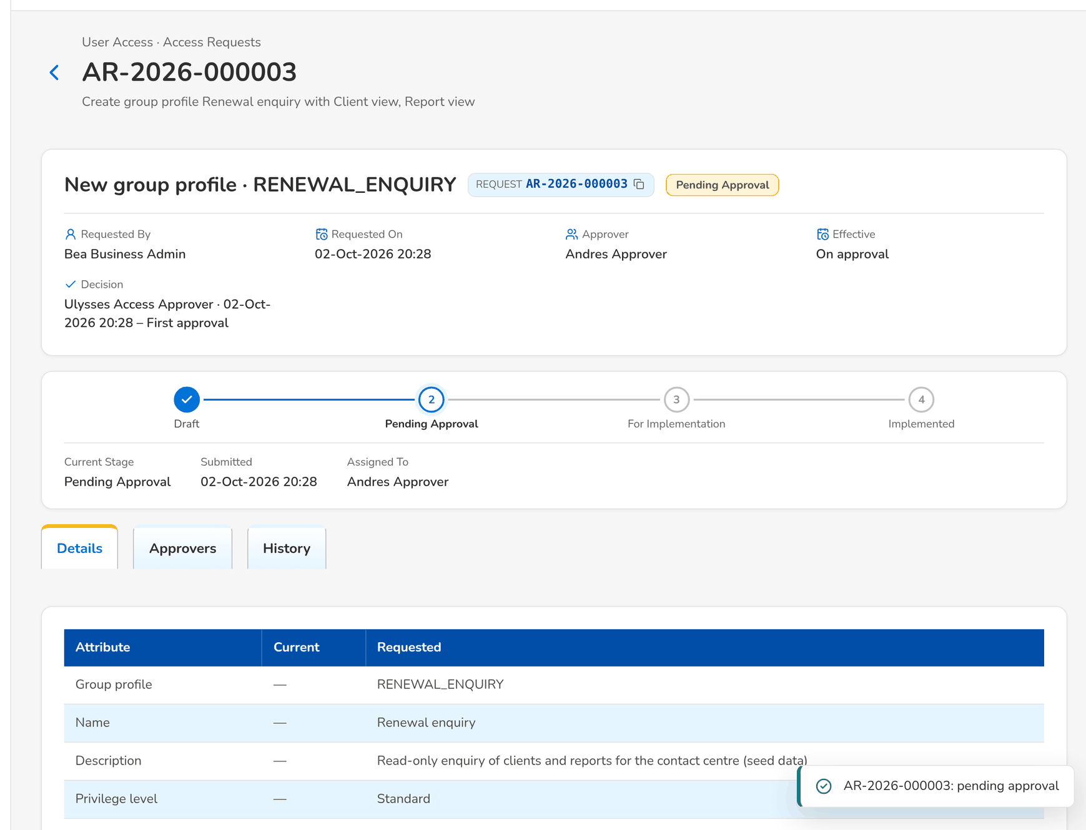
Figure 59: WT-B step 5: Access Request record
Step 6. New Business Approver (keeps the access approval right) – Access Request record (SCR-UA-08)
Does | Opens the request from My Approvals and approves it
Sees | The status is For Implementation; the System Administrators receive Access request AR-yyyy-nnnnnn to implement
Result | For implementation

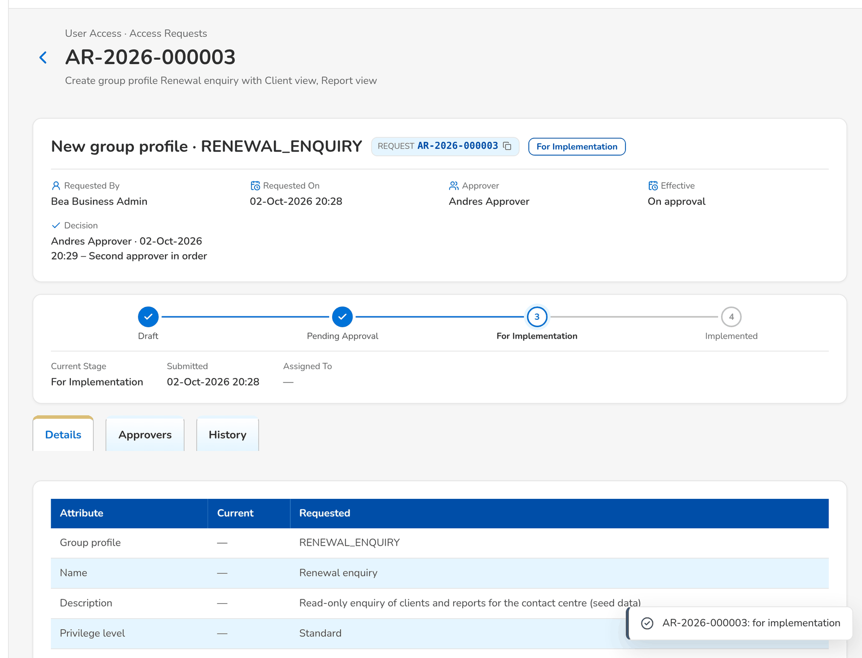
Figure 60: WT-B step 6: Access Request record
Step 7. System Administrator – Roles & Permissions (SCR-UA-16)
Does | Opens Roles & Permissions, finds the request under Approved Requests to Implement, clicks Implement Request and confirms
Sees | Toast: AR-yyyy-nnnnnn implemented; the profile appears in the matrix with its two permissions
Result | Implemented

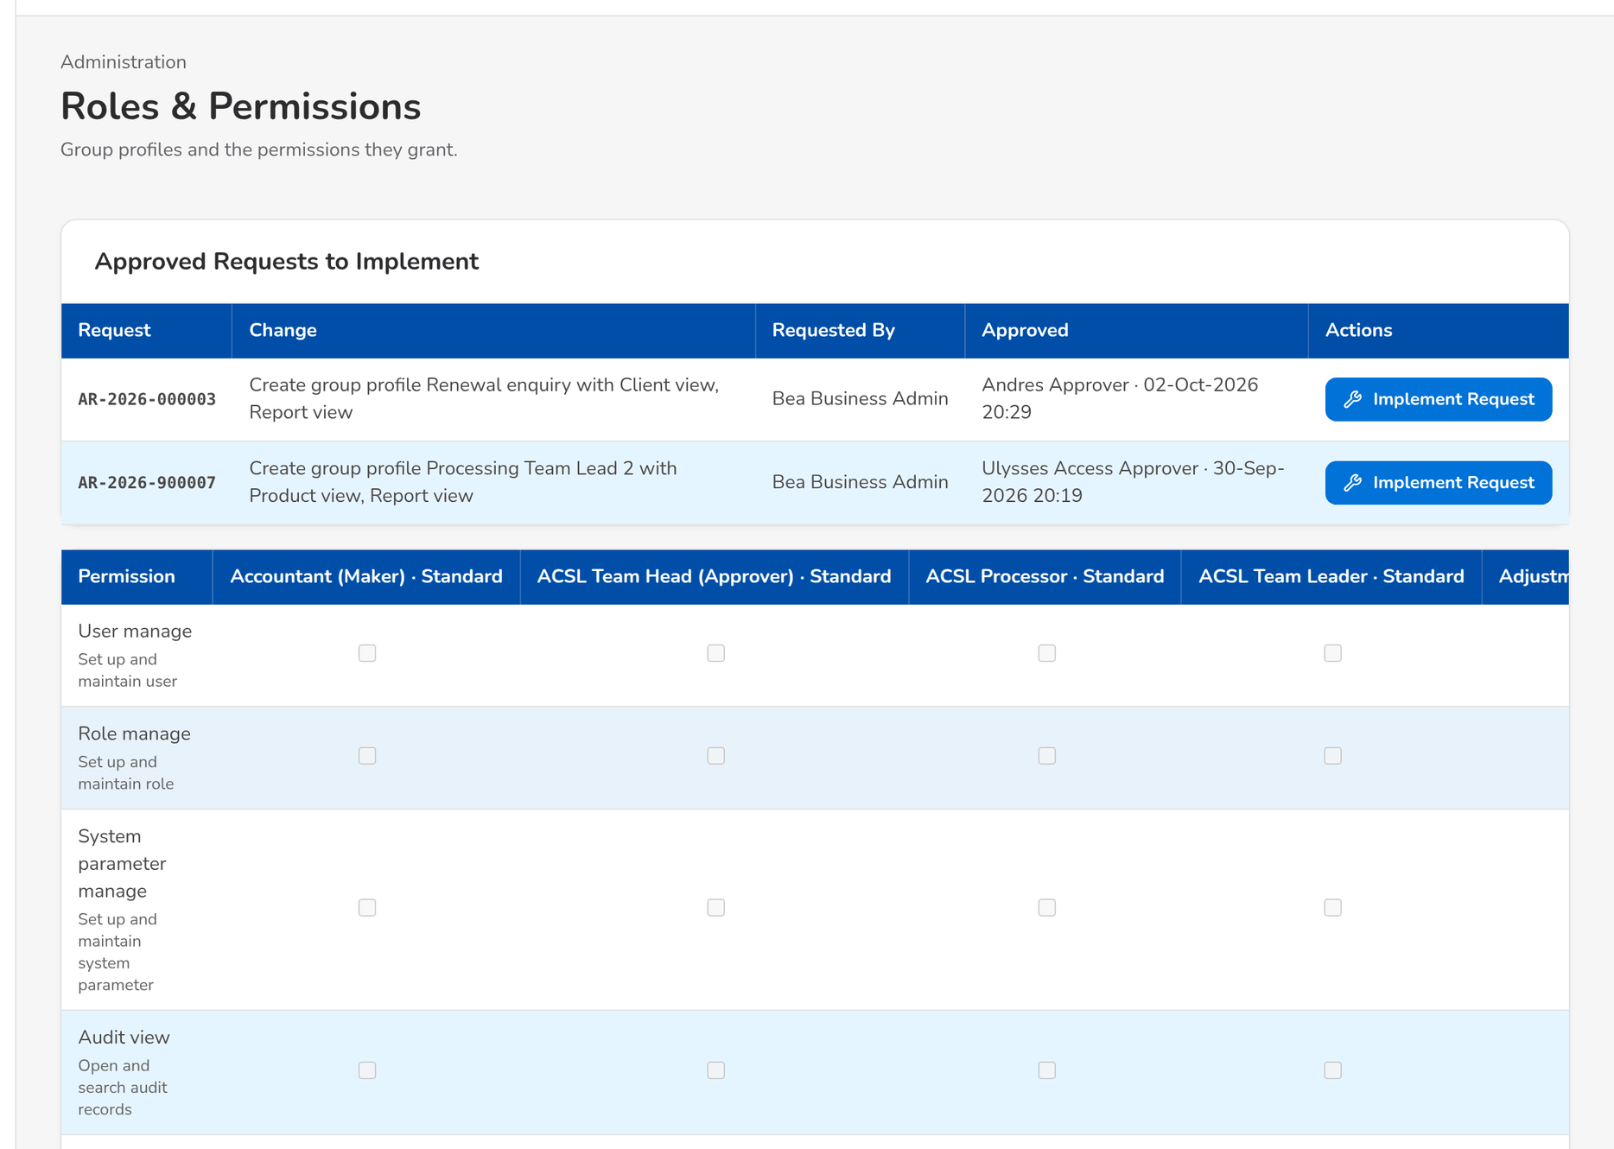
Figure 61: WT-B step 7: Roles & Permissions
Step 8. Requestor – New Request and Edit Request (user requests) (SCR-UA-07)
Does | Opens a New Request of type Deactivate user for a013000196, chooses the reason Resigned, leaves the effective date blank, chooses the approver and clicks Submit
Sees | Toast: AR-yyyy-nnnnnn submitted
Result | Pending Approval

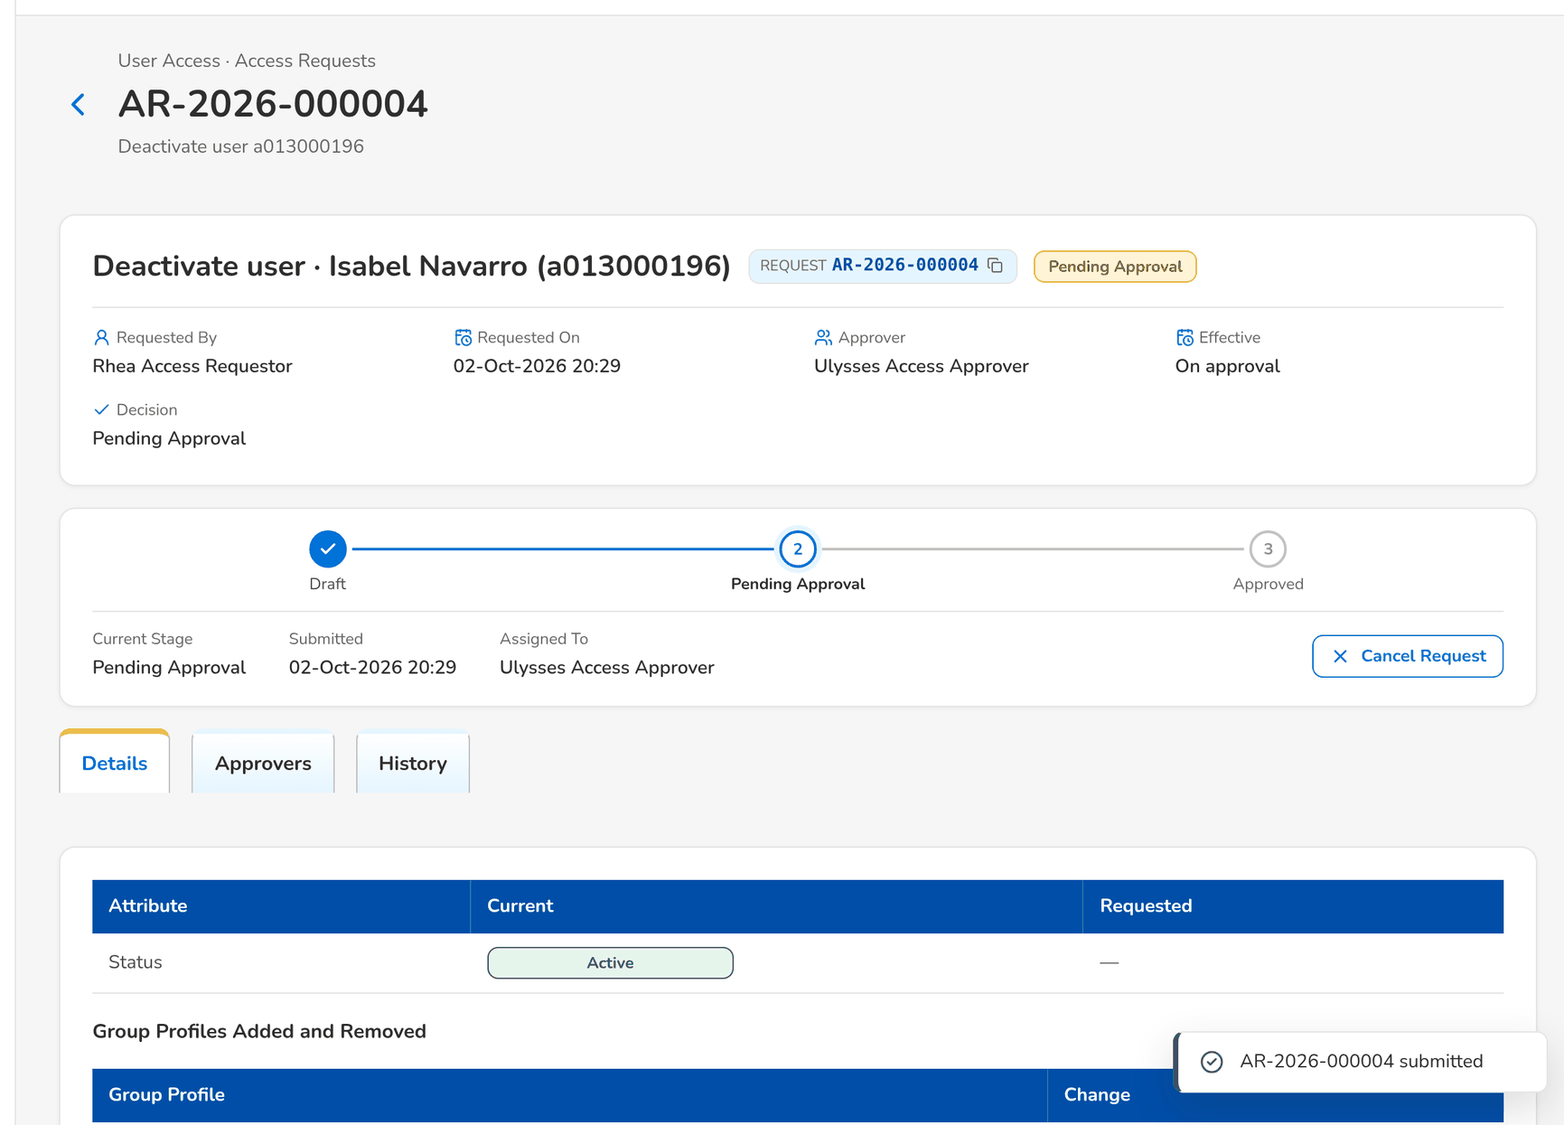
Figure 62: WT-B step 8: New Request and Edit Request (user requests)
Step 9. Approver – Access Request record (SCR-UA-08)
Does | Approves the deactivation
Sees | The status is Approved; the user is Disabled and every open session of the user has ended
Result | User deactivated

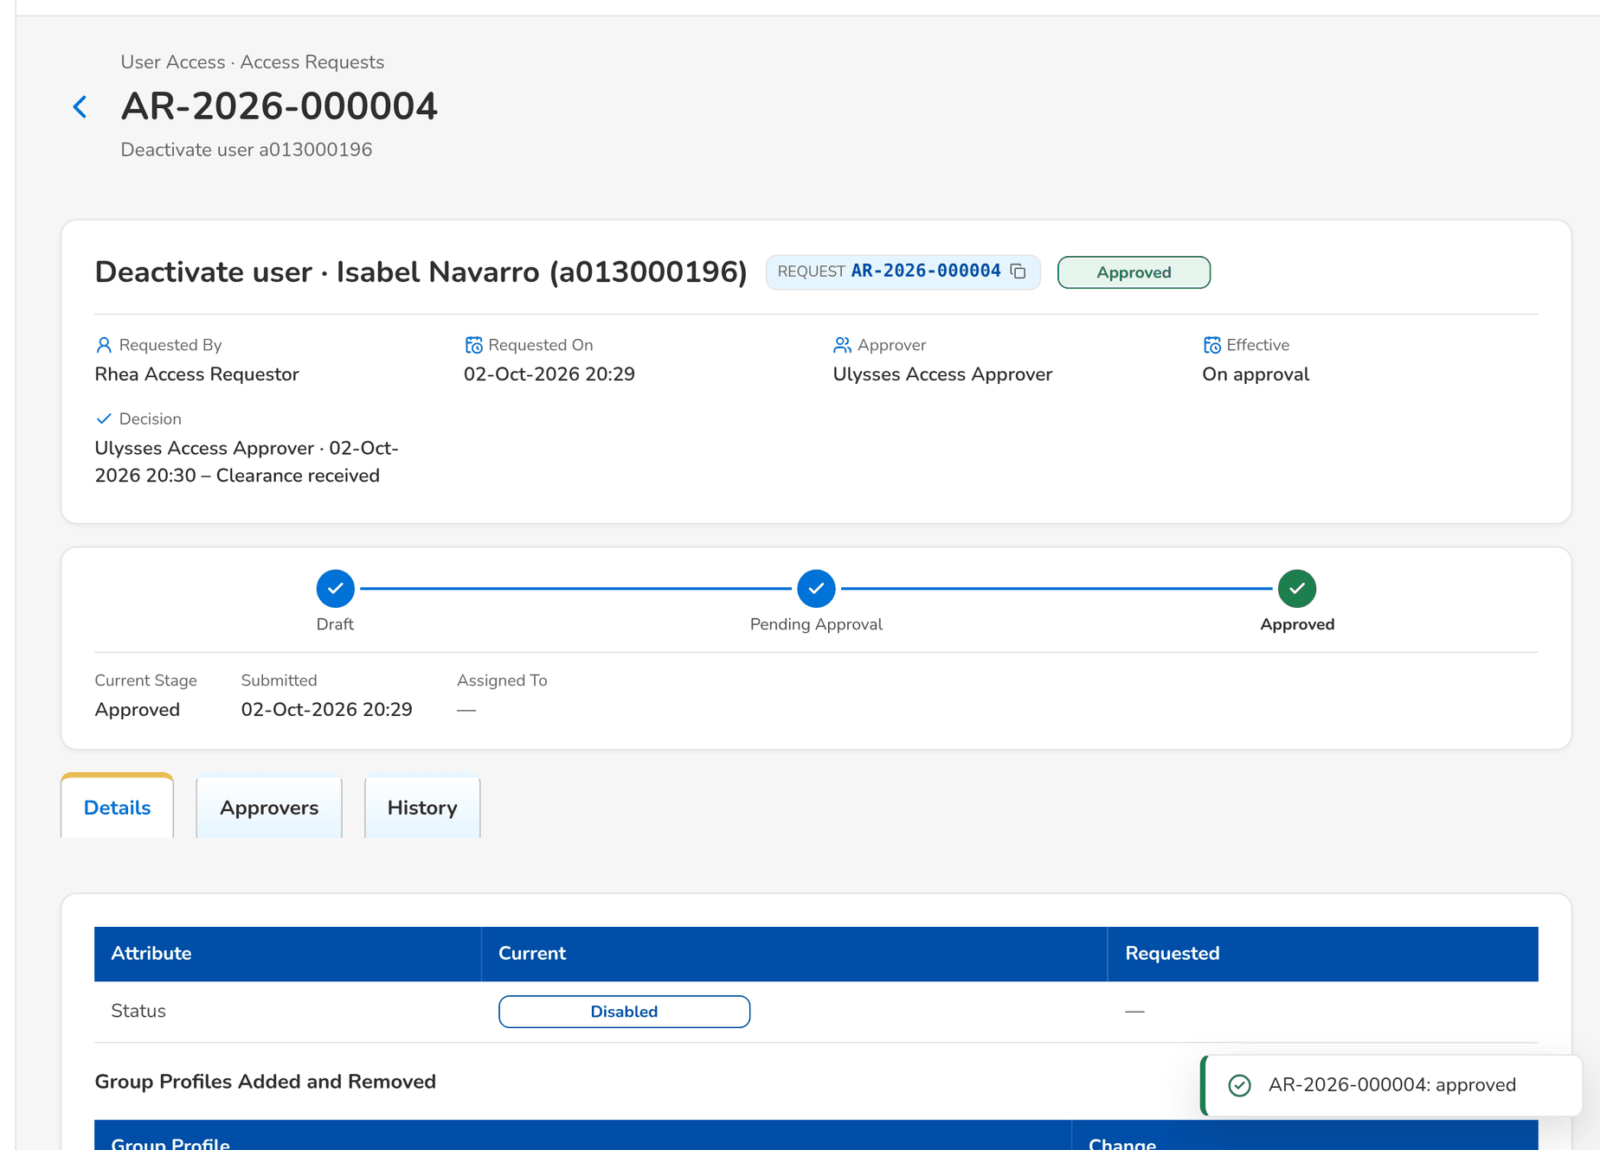
Figure 63: WT-B step 9: Access Request record
Step 10. System Administrator – Users (SCR-UA-15)
Does | Opens Administration › Users with the status Disabled
Sees | a013000196 is listed Disabled with the profiles it held; Sessions shows the last session ended by the administrator
Result | Evidence of the revocation

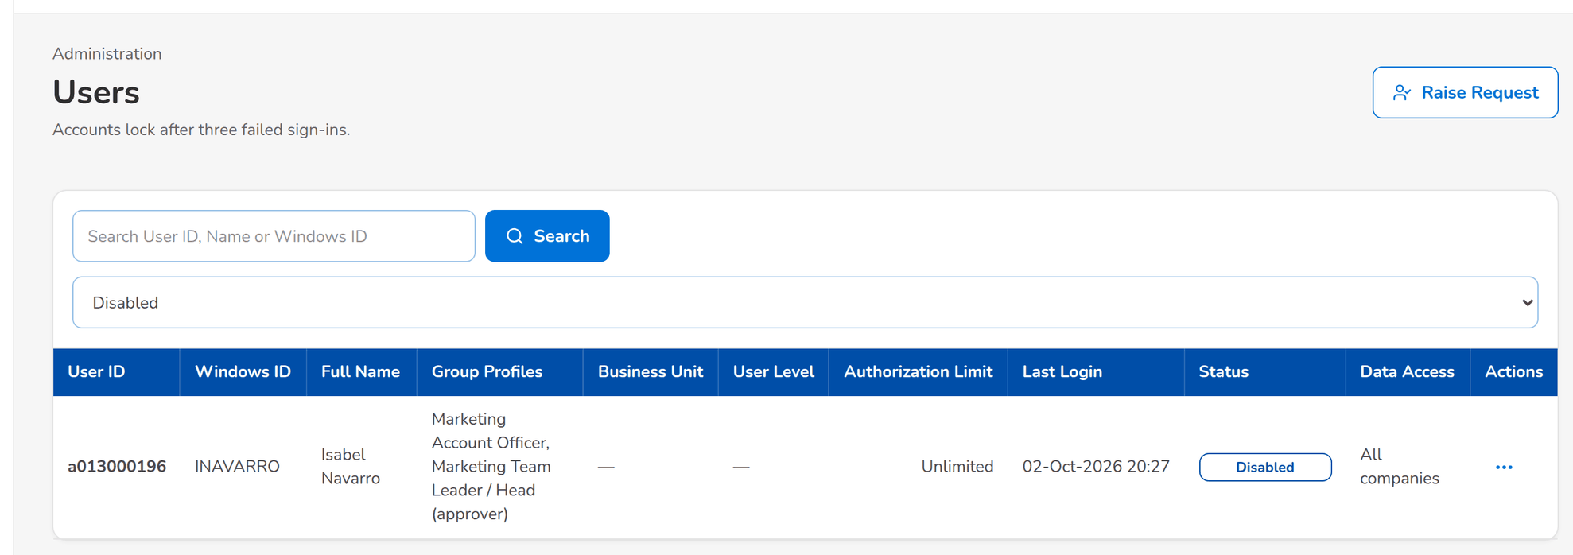
Figure 64: WT-B step 10: Users
What happens next, downstream
• Each change is in the User Access Audit Log with its from and to values, the approver and the request number; the deactivated user keeps the history but can no longer sign in.
• The new group profile can be given to users by access requests at once; its content is in the User Group Profile Report and the User Access Matrix.

14.3 WT-C Refused cases and the messages the user sees
The same processes when something is wrong or not allowed: an incomplete or badly formatted enrolment, a second request for a user who already has one open, a change of one's own profiles, a decision by someone other than the chosen approver, an implementation by the requester, a locked account, a deactivated user signing in, and a password that breaks the rules, and two profiles that one user may not hold together. Each step shows the message and what the user does next.
Seed data: seed requests AR-2026-900002 (pending for uamapprover); users a013000101 (active) and a013000196 (deactivated in walkthrough B); a group-profile request raised by the System Administrator and approved for implementation (prepared by the capture)
Step 1. Requestor – New Request and Edit Request (user requests) (SCR-UA-07)
Does | Opens New Request, enters the user ID ab and clicks Submit without a full name, profile, approver or justification
Sees | Under the fields: Use 3 to 50 letters, digits, dots, dashes or underscores; Enter the full name of the new user; Select at least one role; Select the approver; Enter the justification. Nothing is saved
Result | Form corrected

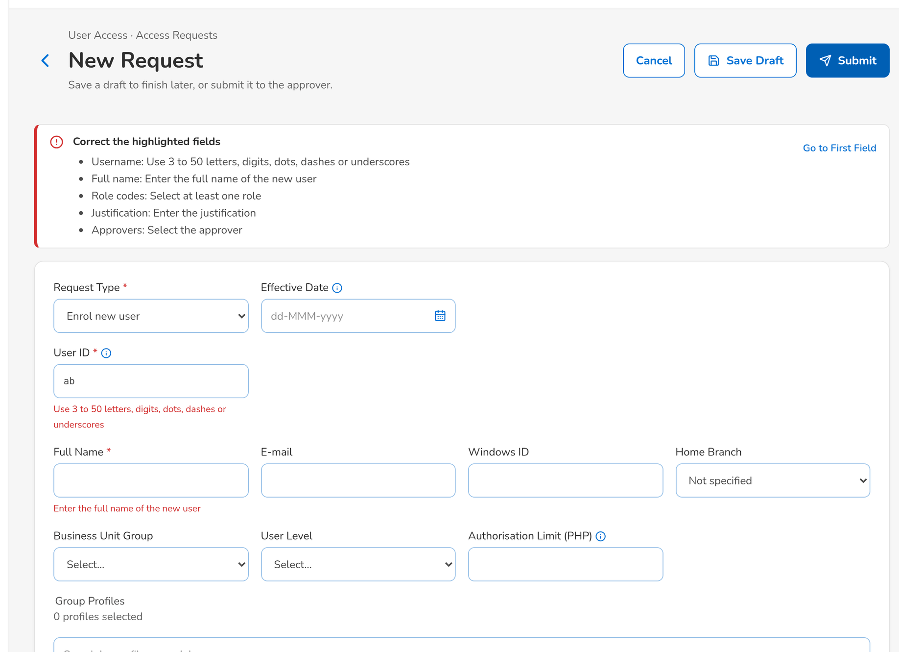
Figure 65: WT-C step 1: New Request and Edit Request (user requests)
Step 2. Requestor – New Request and Edit Request (user requests) (SCR-UA-07)
Does | Enters the user ID a01300019X with the other fields complete and clicks Submit
Sees | Under the user ID: The user ID must be a letter followed by nine digits, for example a013000196
Result | User ID corrected

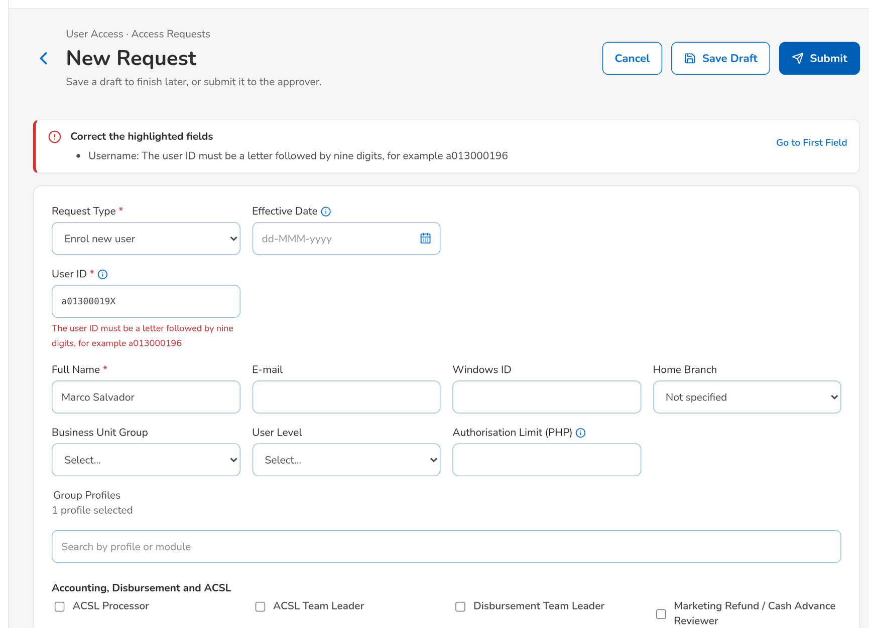
Figure 66: WT-C step 2: New Request and Edit Request (user requests)
Step 3. Requestor – New Request and Edit Request (user requests) (SCR-UA-07)
Does | Raises a Modify user request for a013000101, which already has a pending request, and clicks Submit
Sees | A request for user a013000101 is already waiting for approval, with its reference
Result | Wait for the open request

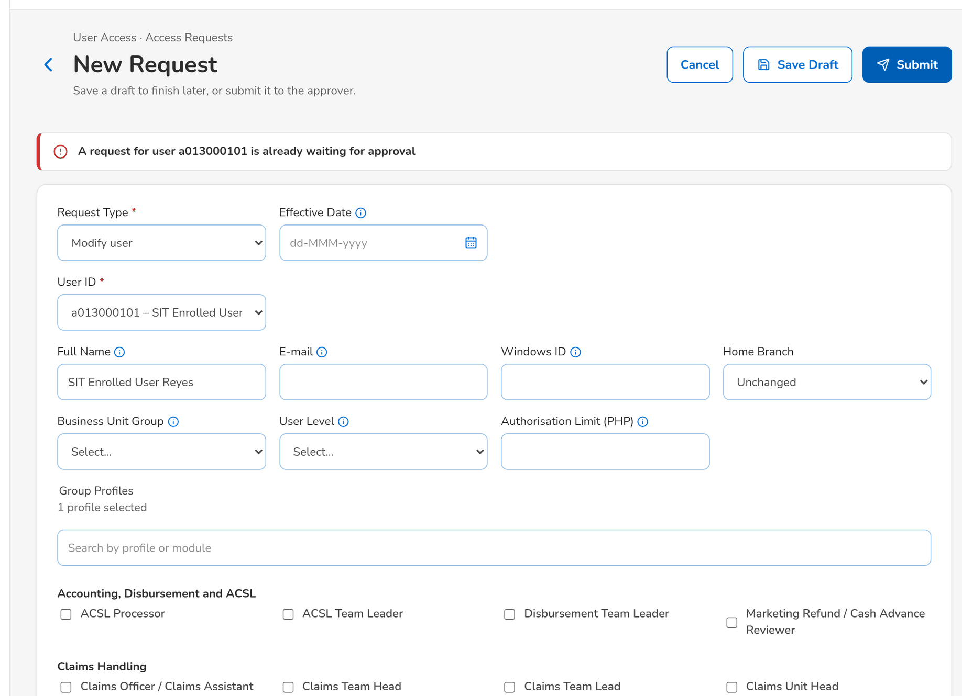
Figure 67: WT-C step 3: New Request and Edit Request (user requests)
Step 4. Requestor – New Request and Edit Request (user requests) (SCR-UA-07)
Does | Raises a Modify user request for himself (requestor), ticks an additional profile and clicks Submit
Sees | You cannot change your own roles
Result | Another requester raises it

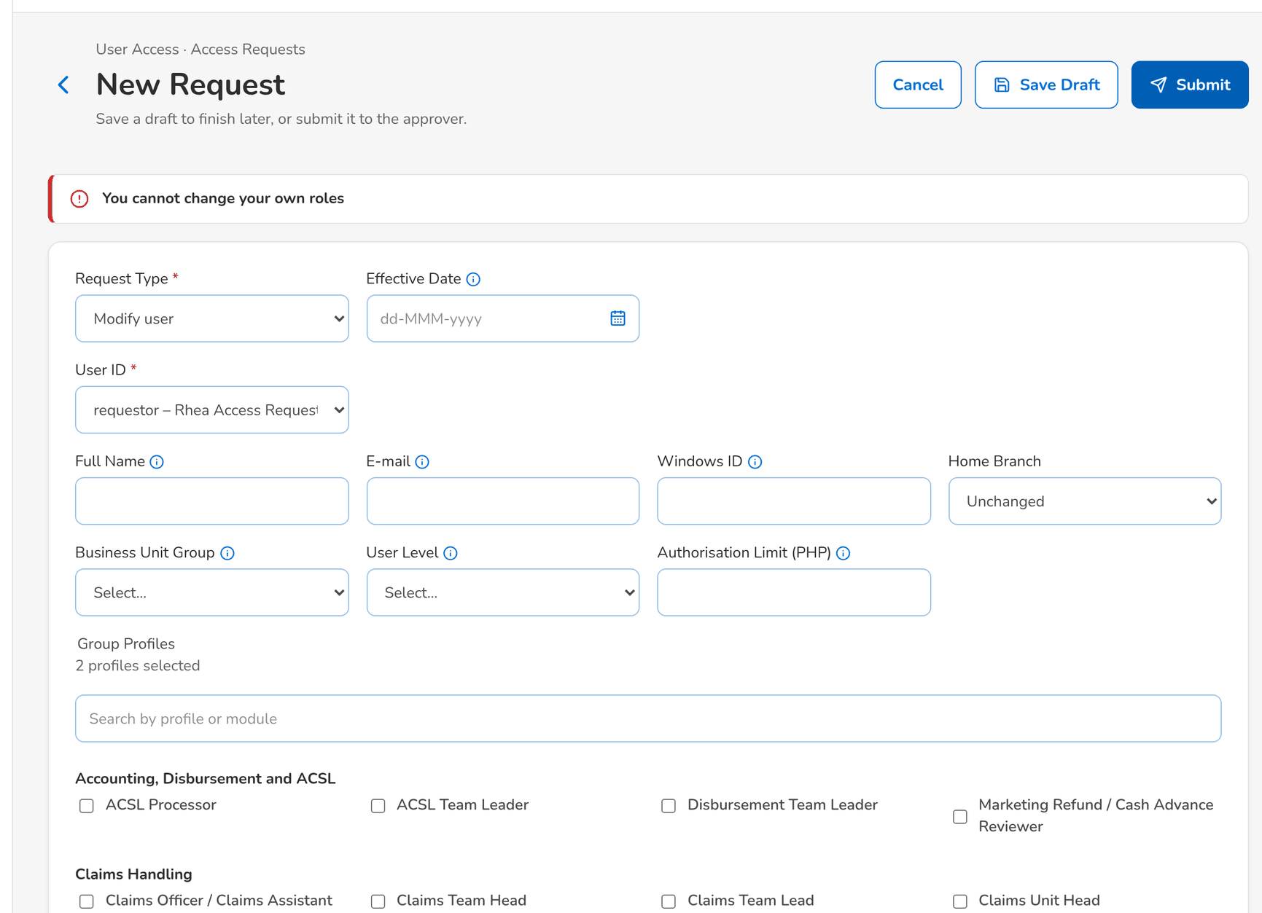
Figure 68: WT-C step 4: New Request and Edit Request (user requests)
Step 5. Requestor – New Request and Edit Request (user requests) (SCR-UA-07)
Does | Enrols a new user with both the User Access Requestor and the User Access Approver profiles and clicks Submit
Sees | One user may not hold both User Access Requestor and User Access Approver (separation-of-duties rule SOD-900001): the rule authorised by Information Security
Result | One of the two profiles removed

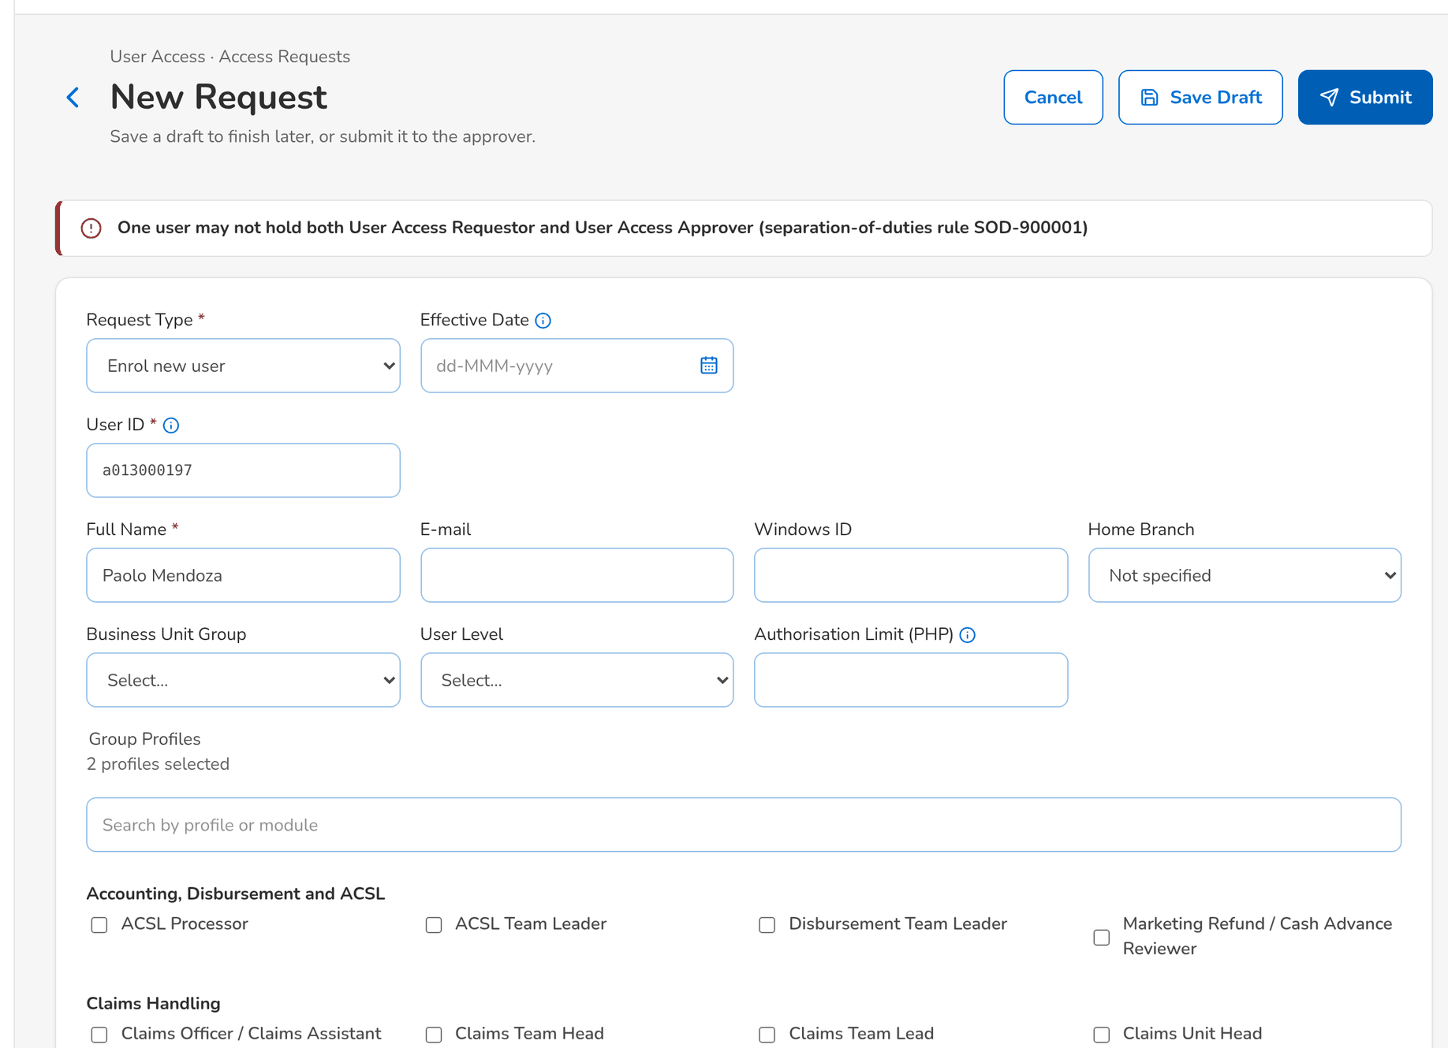
Figure 69: WT-C step 5: New Request and Edit Request (user requests)
Step 6. New Business Approver (keeps the access approval right) – Access Request record (SCR-UA-08)
Does | Opens AR-2026-900002, assigned to Ulysses Access Approver
Sees | The request shows no decision button for this approver; a decision would be refused: Request AR-2026-900002 is assigned to uamapprover for approval
Result | Left to the chosen approver

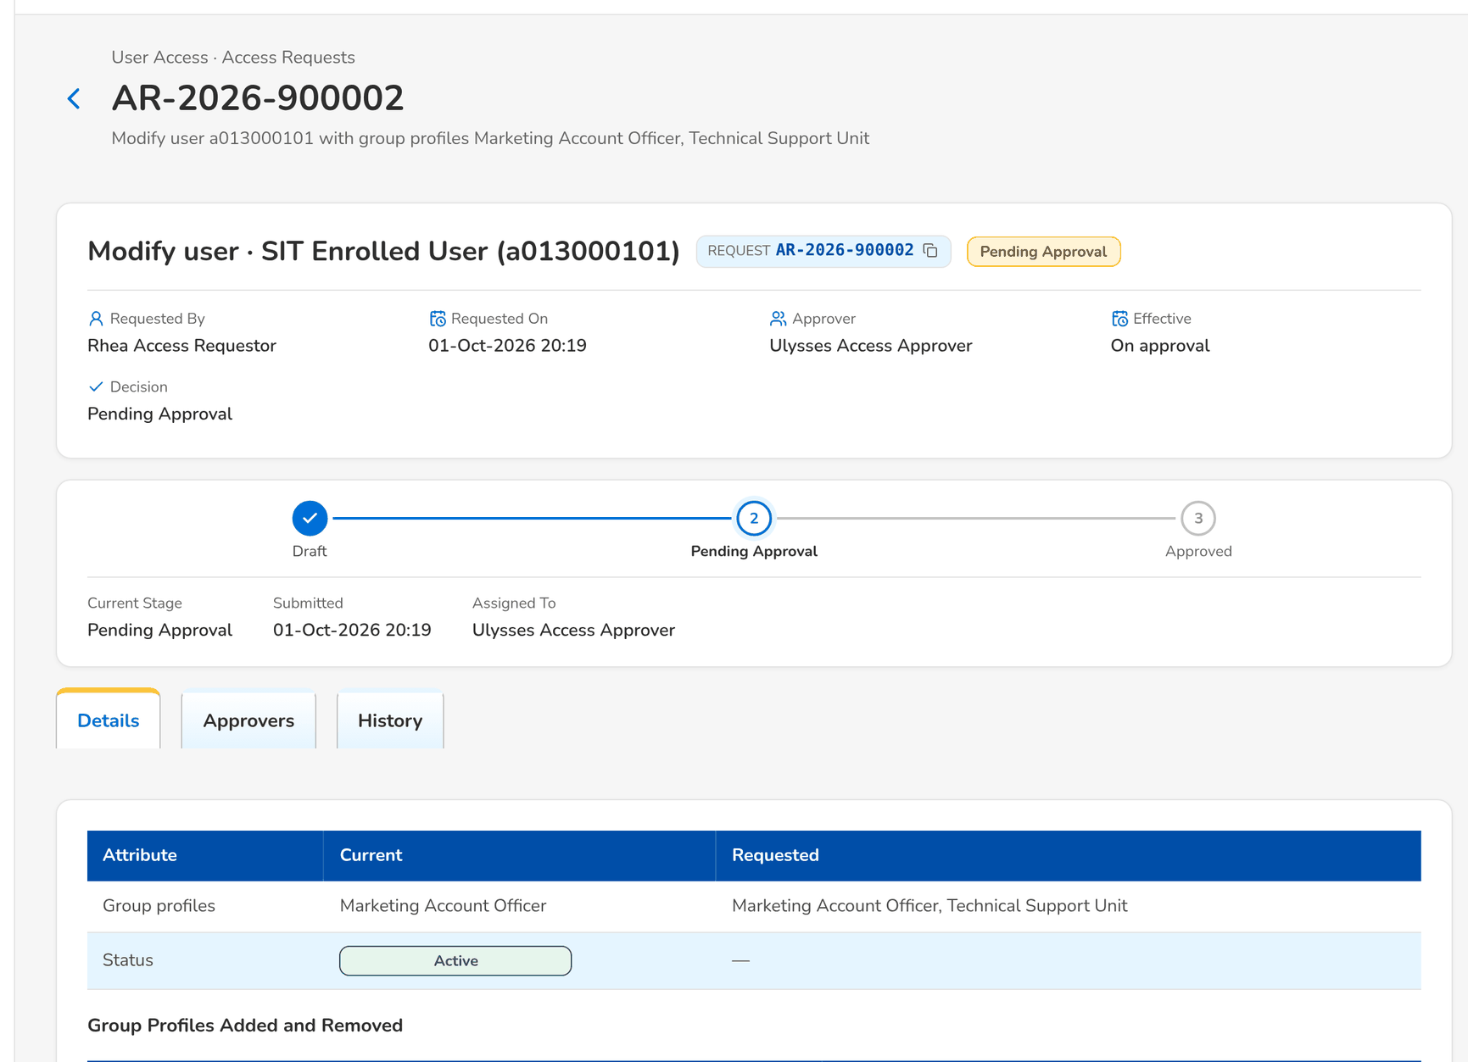
Figure 70: WT-C step 6: Access Request record
Step 7. System Administrator – Roles & Permissions (SCR-UA-16)
Does | Clicks Implement Request on a group-profile request he raised himself
Sees | A request is implemented by someone other than its requester
Result | Another System Administrator implements it

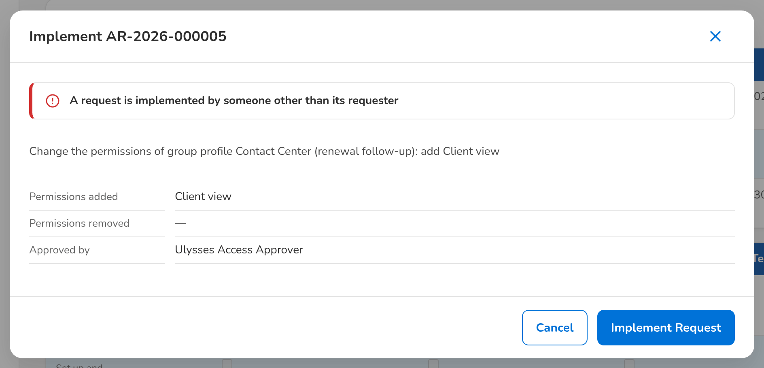
Figure 71: WT-C step 7: Roles & Permissions
Step 8. Marketing Account Officer – Login (SCR-UA-01)
Does | User a013000101 enters a wrong password three times, then the right one
Sees | Invalid user name or password each time, also for the right password: a locked account is refused with the same message as a wrong password; Users shows the lock to the System Administrator
Result | Account locked

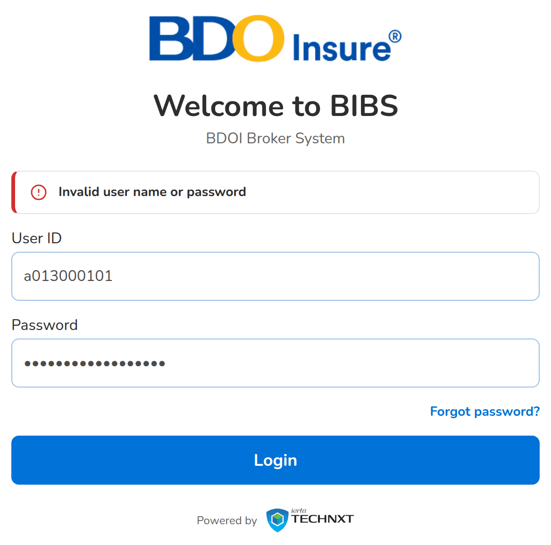
Figure 72: WT-C step 8: Login
Step 9. System Administrator – Users (SCR-UA-15)
Does | Opens Users with the status Locked and clicks Unlock on a013000101
Sees | The user is Active again; the unlock is in the access change log
Result | Account unlocked

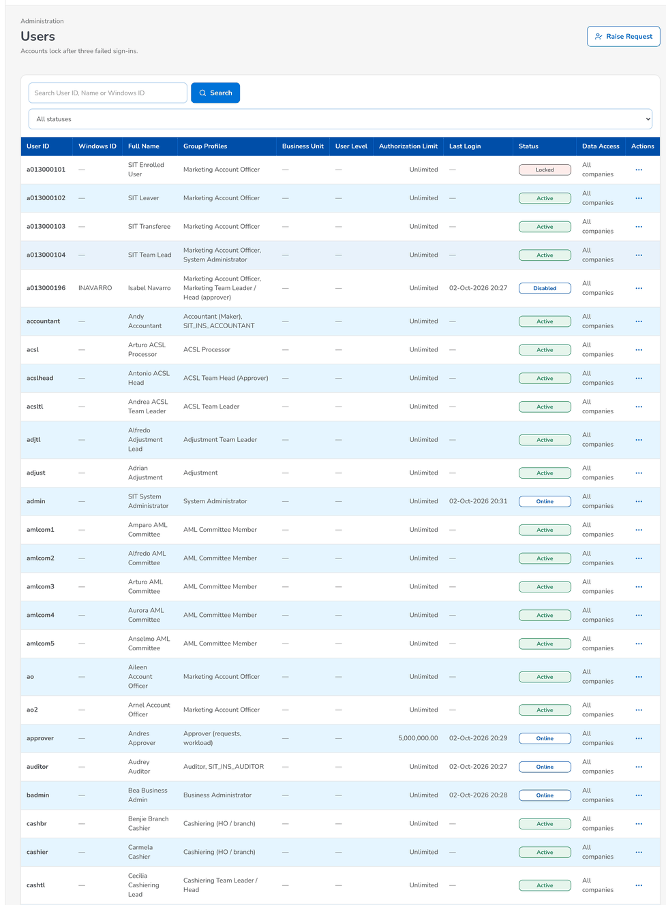
Figure 73: WT-C step 9: Users
Step 10. Marketing Account Officer – Login (SCR-UA-01)
Does | The deactivated user a013000196 tries to sign in
Sees | Invalid user name or password, the same message as a wrong password; the attempt does not count towards the lock-out
Result | Refused

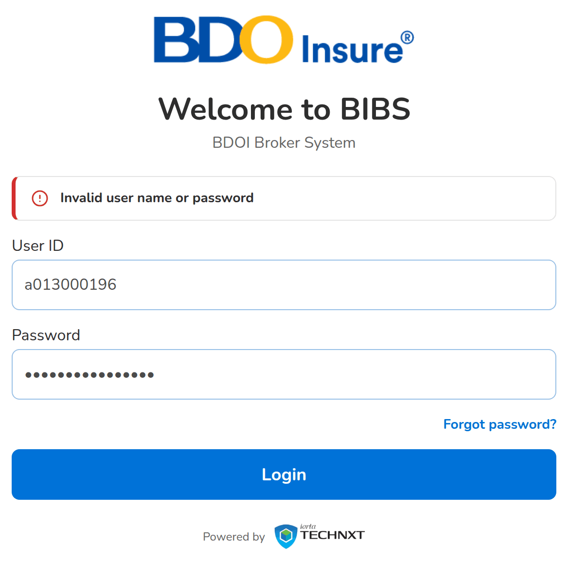
Figure 74: WT-C step 10: Login
Step 11. Requestor – My Profile (SCR-UA-05)
Does | On My Profile, types a new password that is too short and has no symbol
Sees | Still needed: At least 10 characters; A symbol; Change Password stays disabled
Result | Password rules shown

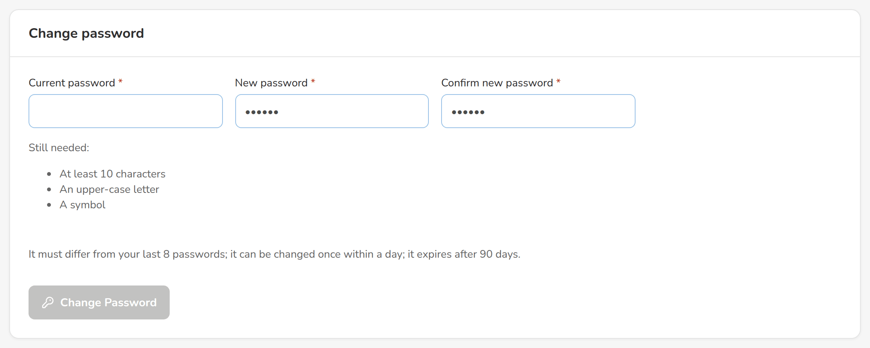
Figure 75: WT-C step 11: My Profile
Step 12. Requestor – My Profile (SCR-UA-05)
Does | Enters the current password as the new password and clicks Change Password
Sees | You used this password recently. Choose another one
Result | Another password chosen

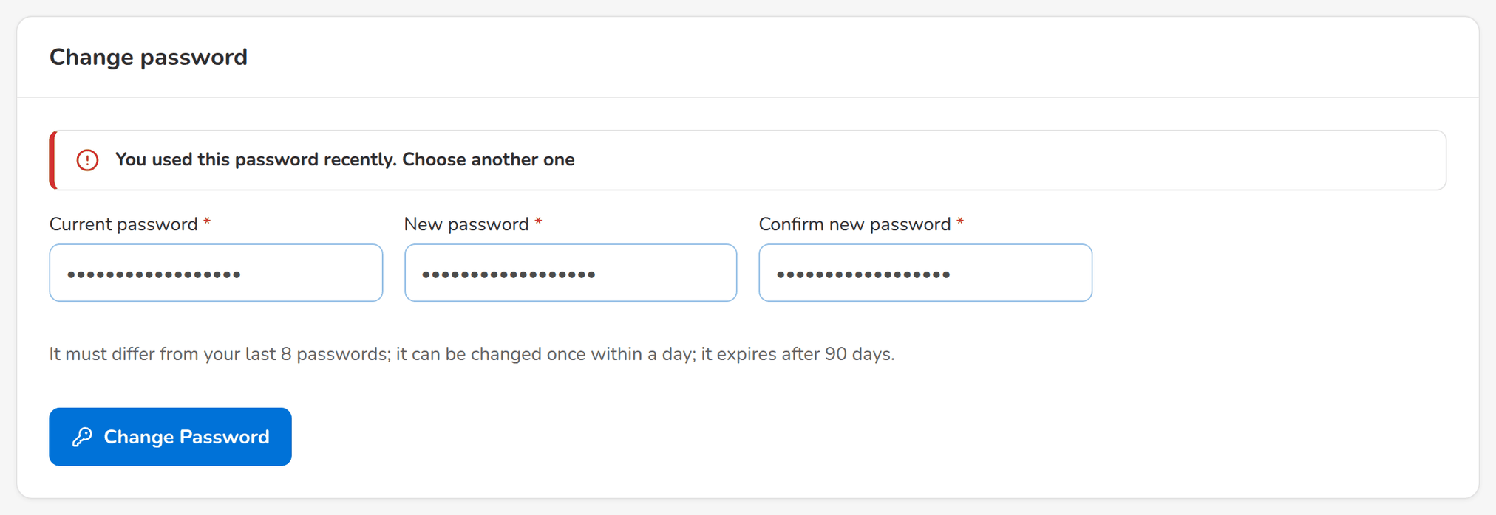
Figure 76: WT-C step 12: My Profile
What happens next, downstream
• A refused action changes nothing; the message names what to correct, and a server refusal shows its reference for support.
• Every failed sign-in, lock and unlock is in the audit trail and the User Access Audit Log.
• A combination of profiles refused by a separation-of-duties rule is refused the same way on a bulk line and again at approval.

14.4 WT-D The evidence of access, and the insurer roles hidden from BDOI
The Auditor and Information Security review who can do what: the User Access Matrix, the User Group Profile Report and the Group Profile Membership of a profile, and the audit log of the changes. The insurer functions of the platform (underwriting, insurer claims, reinsurance, reserves) are not used by BDOI: their permissions are withdrawn from every BDOI profile, the three insurer roles are deactivated, and no User Access screen lists or accepts them.
Seed data: the delivered profiles and grants; the seed users of the personas; the withdrawal of the insurer permissions and the deactivation of the insurer roles recorded at installation
Step 1. Auditor – User Access Matrix (SCR-UA-13)
Does | Opens User Access › User Access Matrix, By Action, and searches USER ACCESS
Sees | The User Access area by action class, with the permissions each profile holds: the Requestor creates and amends, the Approver approves, the Second Approver gives the second approval
Result | Matrix reviewed

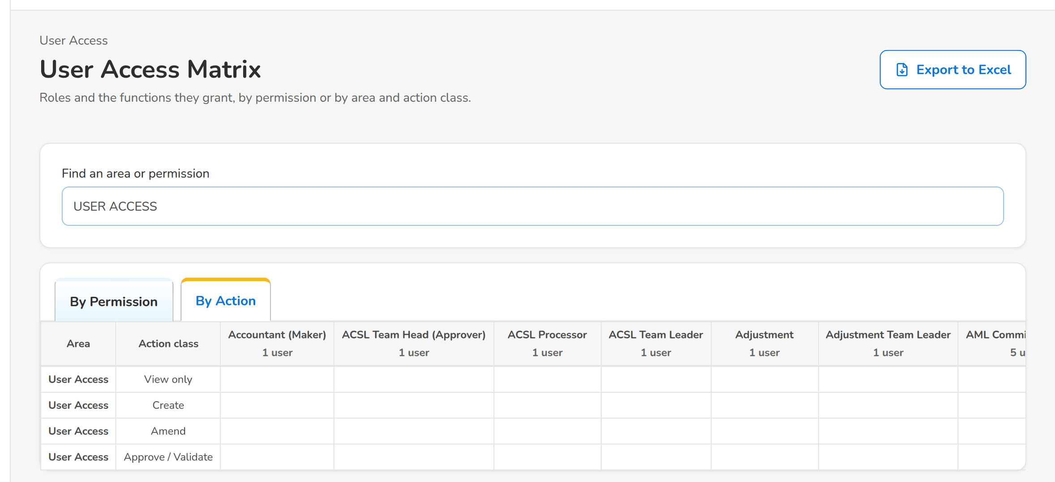
Figure 77: WT-D step 1: User Access Matrix
Step 2. Auditor – User access report (report runner) (SCR-UA-17)
Does | Runs the User Group Profile Report for the profile UAM_APPROVER
Sees | The modules and tasks of the Approver with With Access, and the dates and actors of its creation and last change
Result | Profile content reviewed

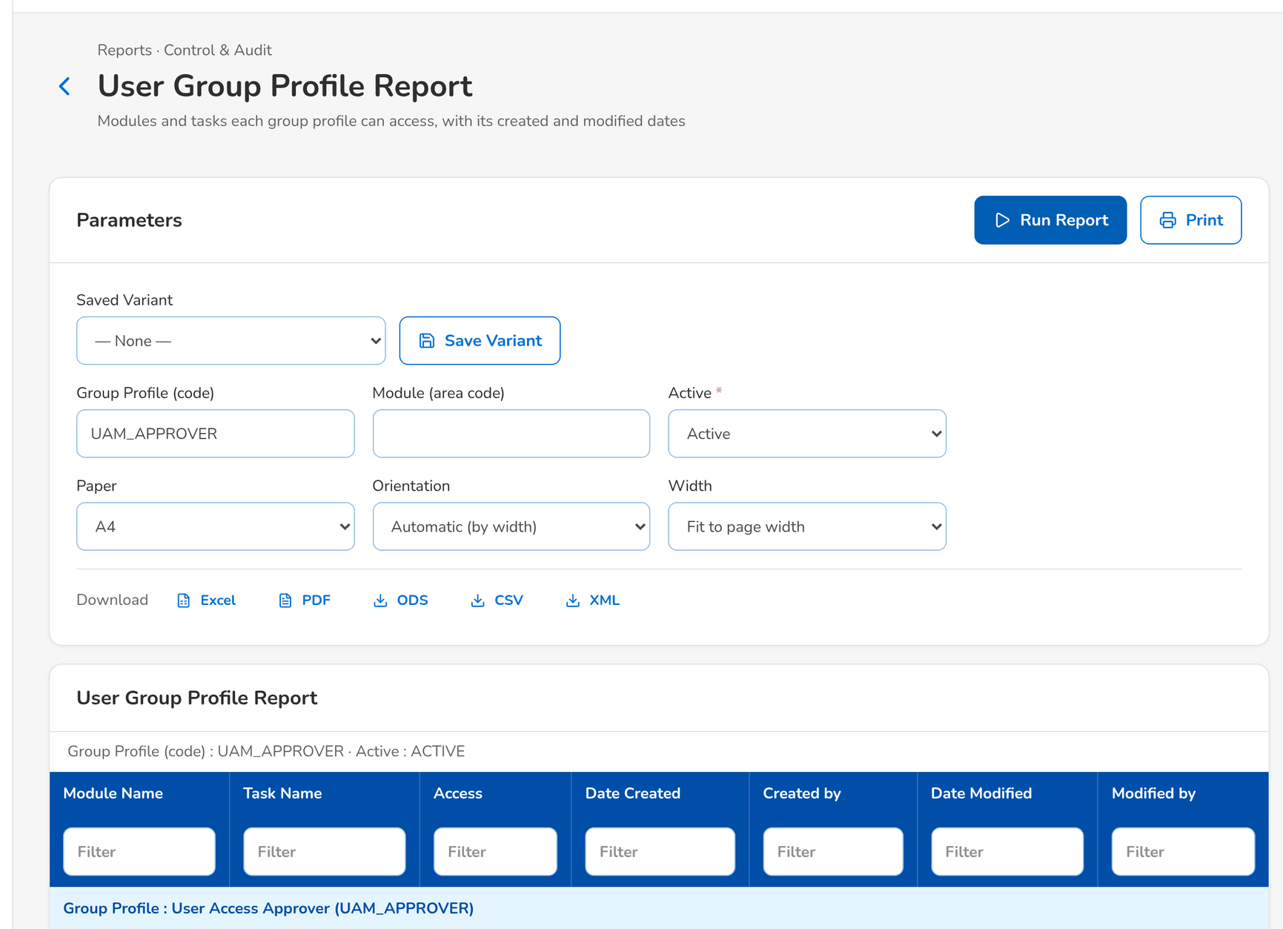
Figure 78: WT-D step 2: User access report (report runner)
Step 3. Auditor – User access report (report runner) (SCR-UA-17)
Does | Runs Group Profile Membership for MKT_AO as of today
Sees | The members of the Marketing Account Officer profile with who added each and when
Result | Members reviewed

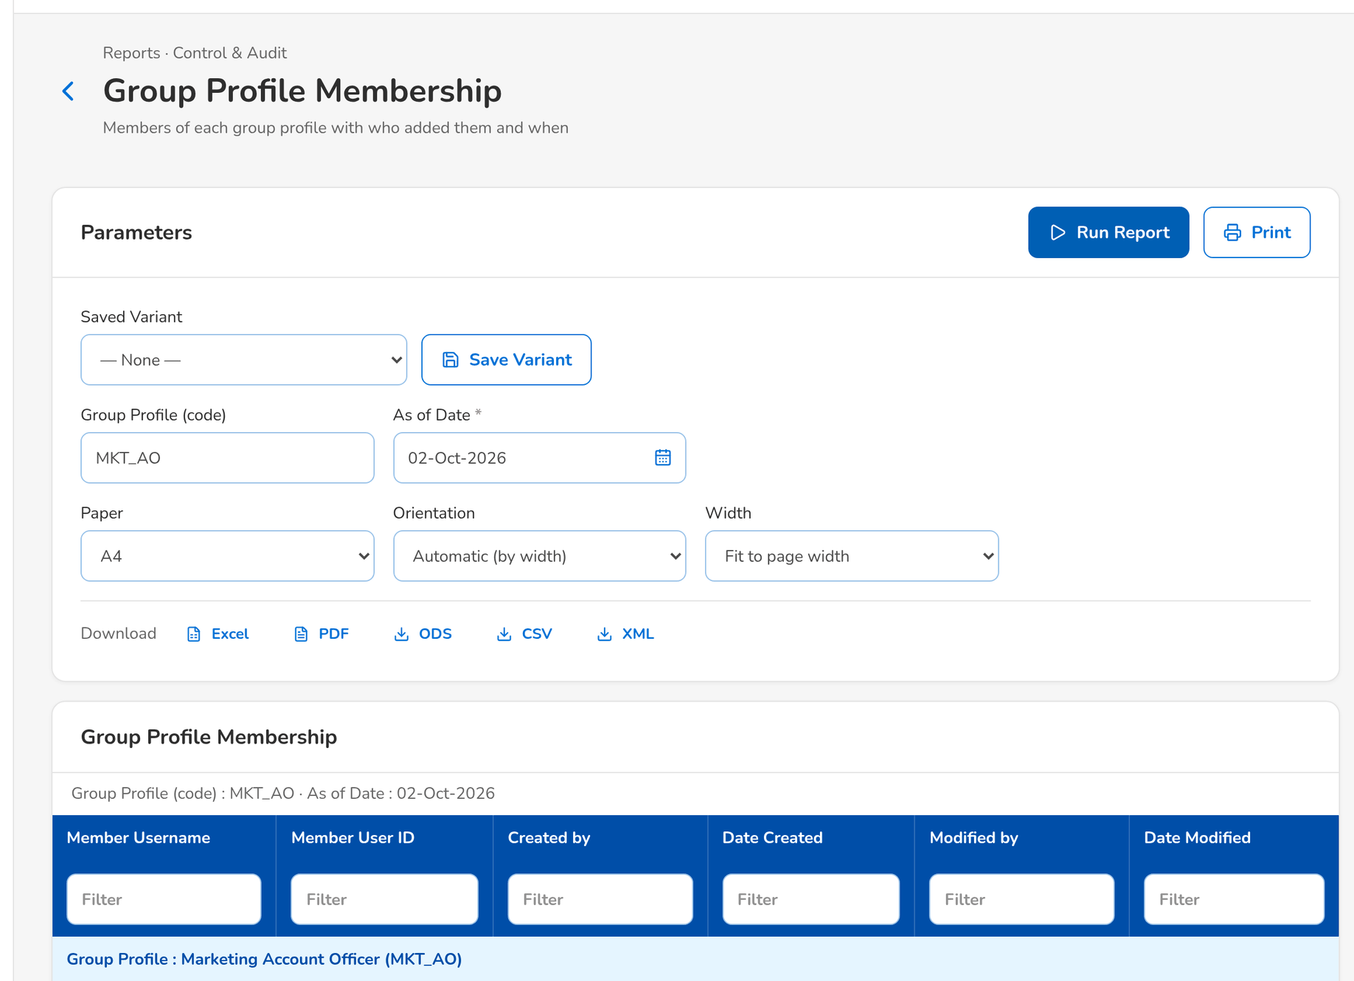
Figure 79: WT-D step 3: User access report (report runner)
Step 4. Auditor – User access report (report runner) (SCR-UA-17)
Does | Runs the User Access Audit Log from the installation date with the activity Group Profile Changes
Sees | Deactivate Group Profile of the three insurer roles, Done By the system at installation, with their from and to values
Result | Insurer roles deactivated

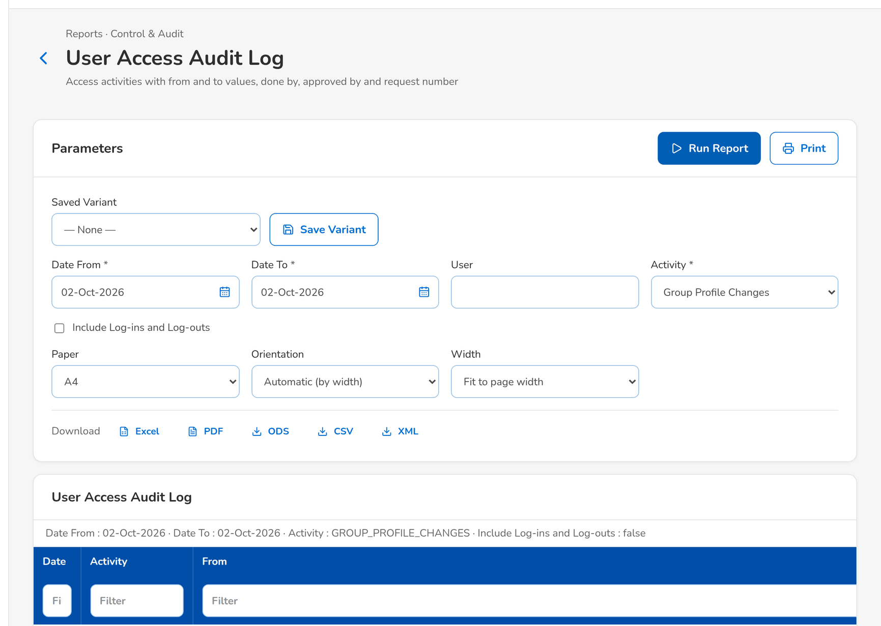
Figure 80: WT-D step 4: User access report (report runner)
Step 5. Business Administrator – New Group Profile Request and Edit Request (SCR-UA-12)
Does | Opens New Group Profile Request of type New group profile and looks for the underwriting, insurer claims, reinsurance and reserve permissions
Sees | The permission picker lists no insurer permission; the Reactivate group profile list offers no insurer role
Result | Nothing to request

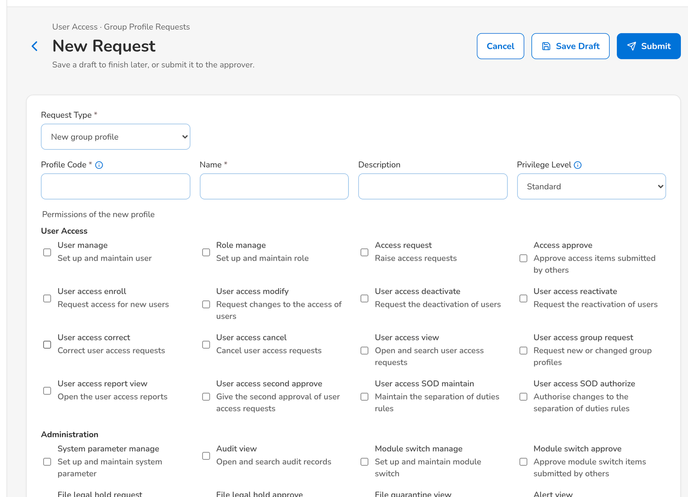
Figure 81: WT-D step 5: New Group Profile Request and Edit Request
What happens next, downstream
• Information Security signs the role matrix of chapter 12 and the separation-of-duties rules of chapter 13 on the basis of these reports; later changes to the matrix are group-profile requests and show in the same reports.

15 Messages catalogue
Every message a User Access Maintenance user can see, grouped by the screen or dialog that shows it, with its code, its type and what the user does. The texts are quoted exactly as the screens show them.
• Validation: shown on the screen while the user fills in a field or before the form is sent.
• Error: the system refused the action; nothing was saved. The code is shown under the message as the Reference.
• Warning: the action is possible, but the user should check something first.
• Confirmation and Information: the outcome of an action, or a hint on the screen.
220 messages: 13 confirmation, 153 error, 5 information, 49 validation. The text is quoted exactly as the system shows it; <name> marks a value filled in by the system. The user sees the message only, in the notice standard of the screen standards appendix; the code identifies the message for the project team and support and is not shown on the screen.

15.1 Login (SCR-UA-01)
ID | Code (not shown) | Message | Type | What the user does
MSG-UA-001 | AUTHENTICATION_FAILED | Invalid token | Error | Check the user ID and the password and sign in again. After three failed attempts the account locks; ask the System Administrator to unlock it (Users › Unlock), or ask for a reactivation request with Also unlock the account. A deactivated user asks for a reactivation request.
MSG-UA-002 | LOGIN_RATE_LIMITED | Too many sign-in attempts. Wait a minute and try again. | Error | Wait a minute before signing in again; repeated attempts from one computer are slowed down.
MSG-UA-003 | RESET_RATE_LIMITED | Too many password reset requests. Wait a few minutes and try again. | Error | Wait a few minutes, then request the link again; use the latest e-mail only.

15.2 Forgot Password and Set a New Password (SCR-UA-02)
ID | Code (not shown) | Message | Type | What the user does
MSG-UA-004 | INVALID_PASSWORD | Current password is incorrect | Error | Enter your current password again; use Forgot password? on the Login page if you no longer know it.
MSG-UA-005 | RESET_LINK_EXPIRED | This password reset link has expired. Request a new one | Error | Request a new link with Forgot password? on the Login page and use it within 30 minutes.
MSG-UA-006 | RESET_LINK_INVALID | This password reset link is not valid or was already used | Error | Request a new link with Forgot password?; only the latest link works, once.
MSG-UA-007 | UNKNOWN_USER | Unknown user | Error | Sign in again; if it persists, report it to the System Administrator.

15.3 Password rules: Change Your Password, My Profile, Set a New Password (SCR-UA-02, SCR-UA-03, SCR-UA-05)
ID | Code (not shown) | Message | Type | What the user does
MSG-UA-008 | - | A digit | Validation | Add a digit to the new password.
MSG-UA-009 | - | A lower-case letter | Validation | Add a lower-case letter to the new password.
MSG-UA-010 | - | A symbol | Validation | Add a symbol to the new password.
MSG-UA-011 | - | An upper-case letter | Validation | Add an upper-case letter to the new password.
MSG-UA-012 | - | At least 10 characters | Validation | Lengthen the new password to at least 10 characters.
MSG-UA-013 | - | Both new passwords must match | Validation | Type the same new password in both fields.
MSG-UA-014 | - | Password changed | Confirmation | No action.
MSG-UA-015 | - | Your password is older<age> and has expired. Choose a new password to continue. | Validation | Enter the current password and choose a new one.
MSG-UA-016 | - | Your password was set by an administrator. Choose your own password to continue. | Validation | Enter the password you were given as the current password and choose your own.
MSG-UA-017 | PASSWORD_CHANGED_TOO_SOON | You changed your password less than a day / <min age> days ago | Error | Wait until the minimum age has passed, or ask the System Administrator to reset the password.
MSG-UA-018 | PASSWORD_MANAGED_BY_DIRECTORY | Your password is managed by the corporate directory; change it there | Error | Change the password through the BDO directory (BDO network password).
MSG-UA-019 | PASSWORD_REUSED | You used this password recently. Choose another one | Error | Choose a password you have not used for your last 8 changes.

15.4 Inactivity and Session-end Warnings (SCR-UA-04)
ID | Code (not shown) | Message | Type | What the user does
MSG-UA-020 | - | You were signed out after <timeout minutes> minutes of inactivity. | Error | Sign in again.
MSG-UA-021 | - | Your session has ended. Please sign in again. | Error | Sign in again; save work regularly before the session ends.
MSG-UA-022 | NOT_FOUND | Session not found: <session id> | Error | Refresh the screen; the record was changed or removed. Report the message with its reference if it persists.
MSG-UA-023 | SESSION_ALREADY_ENDED | The session has already ended | Error | No action; refresh the list of sessions.

15.5 My Profile (SCR-UA-05)
ID | Code (not shown) | Message | Type | What the user does
MSG-UA-024 | - | <email> is not a valid e-mail address | Validation | Correct the e-mail address.
MSG-UA-025 | - | Contact details saved | Confirmation | No action.
MSG-UA-026 | - | Enter the mobile number with digits only, for example +63 917 123 4567 | Validation | Enter the mobile number with digits only, for example +63 917 123 4567.
MSG-UA-027 | - | Enter your e-mail address | Validation | Enter your e-mail address.
MSG-UA-028 | - | No sessions recorded yet | Information | No action.
MSG-UA-029 | - | Password changed | Confirmation | No action.
MSG-UA-030 | PROFILE_INVALID | Check the highlighted fields | Validation | Correct the fields marked in red.
MSG-UA-031 | UNKNOWN_USER | Unknown user | Error | Sign in again; if it persists, report it to the System Administrator.

15.6 My Approvals: approval of several requests (New Business set, SCR-NB-39)
ID | Code (not shown) | Message | Type | What the user does
MSG-UA-032 | ACCESS_APPROVE_INDIVIDUALLY | Approve <reference> on its own: the new user's temporary password is shown once | Error | Open the enrolment request and approve it on its own, so that its temporary password is shown.

15.7 Access Requests (SCR-UA-06)
ID | Code (not shown) | Message | Type | What the user does
MSG-UA-033 | - | <count> request(s) approved | Confirmation | No action.
MSG-UA-034 | - | No access request in this list. | Information | No action.

15.8 New Request and Edit Request (SCR-UA-07)
ID | Code (not shown) | Message | Type | What the user does
MSG-UA-035 | - | <request no> saved as a draft / submitted | Confirmation | No action.
MSG-UA-036 | - | Add at least one approver | Validation | Add at least one approver.
MSG-UA-037 | - | Enter an amount of zero or more, with up to 2 decimals | Validation | Enter an amount of zero or more, with up to 2 decimals.
MSG-UA-038 | - | Enter the full name of the new user | Validation | Enter the full name of the new user.
MSG-UA-039 | - | Enter the justification | Validation | Enter the justification.
MSG-UA-040 | - | Enter the name of the group profile | Validation | Enter the name of the group profile.
MSG-UA-041 | - | Enter the party code | Validation | Enter the party code.
MSG-UA-042 | - | Enter the profile code | Validation | Enter the profile code.
MSG-UA-043 | - | Grant or withdraw at least one permission | Validation | Tick or untick at least one permission, or change the name, description or level.
MSG-UA-044 | - | Select an existing user | Validation | Choose the user from the list.
MSG-UA-045 | - | Select at least one permission | Validation | Select at least one permission.
MSG-UA-046 | - | Select at least one role | Validation | Select at least one role.
MSG-UA-047 | - | Select the approver | Validation | Select the approver.
MSG-UA-048 | - | Select the insurer or client | Validation | Select the insurer or client.
MSG-UA-049 | - | Select the role to change | Validation | Select the role to change.
MSG-UA-050 | - | The effective date cannot be before today | Validation | Enter today or a later date, or leave the date blank to apply the change on approval.
MSG-UA-051 | - | The user ID does not have the required format | Validation | Enter the user ID in the format of the parameter USER_ID_PATTERN (for BDOI a letter followed by nine digits, for example a013000196).
MSG-UA-052 | - | The user ID must be <user id format text> | Validation | Enter the user ID in the BDOI format given in the message.
MSG-UA-053 | - | This user already exists | Validation | Choose Modify user for an existing user, or enter another user ID.
MSG-UA-054 | - | This user is already active | Validation | No action; the user is already active and not locked.
MSG-UA-055 | - | This user is already deactivated | Validation | No action; the user is already deactivated.
MSG-UA-056 | - | Use 3 to 50 letters, digits, dots, dashes or underscores | Validation | Use 3 to 50 letters, digits, dots, dashes or underscores.
MSG-UA-057 | - | Use up to 40 capital letters, digits or underscores | Validation | Use up to 40 capital letters, digits or underscores.
MSG-UA-058 | ACCESS_APPROVER_NOT_ELIGIBLE | <name> cannot approve this request | Error | Choose an approver from the list; the requester and the user concerned cannot approve.
MSG-UA-059 | ACCESS_APPROVER_REQUIRED | Add at least one approver | Error | Add at least one approver.
MSG-UA-060 | ACCESS_APPROVER_REQUIRED | Select the approver | Error | Select the approver.
MSG-UA-061 | ACCESS_APPROVER_TWICE | <name> is already an approver of this request | Error | Remove the duplicate approver.
MSG-UA-062 | ACCESS_CORRECTION_REMARKS | Enter the correction remarks | Error | Enter the correction remarks.
MSG-UA-063 | ACCESS_EFFECTIVE_DATE | The effective date cannot be before today | Error | Enter today or a later date, or leave the date blank to apply the change on approval.
MSG-UA-064 | ACCESS_EFFECTIVE_DATE_USER_ONLY | An effective date applies to user requests; group profiles are implemented | Error | Leave the effective date blank; a group-profile change applies when it is implemented.
MSG-UA-065 | ACCESS_EXTERNAL_PARTY | Select the insurer or client of the external user | Error | Choose Internal (BIBS user); external users are not available in this release.
MSG-UA-066 | ACCESS_EXTERNAL_TYPE | External users are created, disabled or enabled only | Error | Choose Internal (BIBS user); external users are not available in this release.
MSG-UA-067 | ACCESS_FULL_NAME | Enter the full name of the new user | Error | Enter the full name of the new user.
MSG-UA-068 | ACCESS_JUSTIFICATION | Enter the justification | Error | Enter the justification.
MSG-UA-069 | ACCESS_NOTHING_CHANGED | The request does not change the user | Error | Change at least one value or group profile, or cancel the request.
MSG-UA-070 | ACCESS_NOT_REQUESTER | Only the creator can <what> request <request no> | Error | Ask the creator of the request or batch to take the action.
MSG-UA-071 | ACCESS_ONE_APPROVER | A user request is decided by one approver | Error | Choose one approver.
MSG-UA-072 | ACCESS_REQUEST_PENDING | A request for <subject> is already waiting for approval | Error | Wait for the decision on the open request of that user or profile, or cancel it first.
MSG-UA-073 | ACCESS_ROLE | Select the role to change | Error | Select the role to change.
MSG-UA-074 | ACCESS_ROLES | Select at least one role | Error | Select at least one role.
MSG-UA-075 | ACCESS_ROLE_INACTIVE | Group profile <name> is not active | Error | Choose an active group profile, or request the reactivation of the profile first.
MSG-UA-076 | ACCESS_SOD_CONFLICT | One user may not hold both <profile> and <other profile> (separation-of-duties rule <rule code>) | Error | Remove one of the two group profiles named in the message, or ask Information Security whether the rule still applies.
MSG-UA-077 | ACCESS_TYPE | Choose the type of request | Error | Choose the type of request.
MSG-UA-078 | ACCESS_UNKNOWN_ROLE | Unknown role(s): <unknown> | Error | Choose the group profiles from the list.
MSG-UA-079 | ACCESS_UNKNOWN_USER | User <username> does not exist | Error | Choose an existing user from the list.
MSG-UA-080 | ACCESS_USERNAME | The user name has 3 to 50 letters, digits, dots, dashes or underscores | Error | Enter a user ID of 3 to 50 letters, digits, dots, dashes or underscores.
MSG-UA-081 | ACCESS_USER_ALREADY_ACTIVE | User <username> is already active | Error | No action; the user is already active and not locked.
MSG-UA-082 | ACCESS_USER_ALREADY_INACTIVE | User <username> is already deactivated | Error | No action; the user is already deactivated.
MSG-UA-083 | ACCESS_USER_EXISTS | User <username> already exists | Error | Choose Modify user for an existing user, or enter another user ID.
MSG-UA-084 | ACCESS_USER_ID_FORMAT | The user ID must be <user id format text> | Error | Enter the user ID in the BDOI format given in the message.
MSG-UA-085 | ACCESS_WINDOWS_ID_IN_USE | Windows ID <windows id> belongs to another user | Error | Enter the user's own Windows ID; a Windows ID belongs to one user only.
MSG-UA-086 | NOT_FOUND | Access request not found: <id> | Error | Refresh the screen; the record was changed or removed. Report the message with its reference if it persists.
MSG-UA-087 | NOT_FOUND | Access request not found: <request no> | Error | Refresh the screen; the record was changed or removed. Report the message with its reference if it persists.
MSG-UA-088 | SELF_ROLE_CHANGE | You cannot change your own roles | Error | Ask another requester to raise the change of your own group profiles.

15.9 Access Request record: decisions (SCR-UA-08)
ID | Code (not shown) | Message | Type | What the user does
MSG-UA-089 | - | Enter the <label> | Validation | Enter the <label>.
MSG-UA-090 | - | The approvers are chosen on submission. | Validation | No action; the approvers are listed once the request is submitted.
MSG-UA-091 | ACCESS_CANCEL_REASON | Enter the reason for the cancellation | Error | Enter the reason for the cancellation.
MSG-UA-092 | ACCESS_FOUR_EYES | A request cannot be decided by the user who submitted it | Error | Ask another approver to decide; the requester never decides his own request.
MSG-UA-093 | ACCESS_JUSTIFICATION | Enter the justification | Error | Enter the justification.
MSG-UA-094 | ACCESS_NOT_ASSIGNED | Request <request no> is assigned to <assigned> for approval | Error | Leave the request to the approver chosen by the requester.
MSG-UA-095 | ACCESS_NOT_REQUESTER | Only <created by> can resubmit this request | Error | Ask the creator of the request or batch to take the action.
MSG-UA-096 | ACCESS_NOT_REQUESTER | Only the creator can cancel request <request no> | Error | Ask the creator of the request or batch to take the action.
MSG-UA-097 | ACCESS_NOT_SECOND_APPROVAL | Request <request no> is <status>, not waiting for a second approval | Error | Refresh the request; it is not waiting for a second approval.
MSG-UA-098 | ACCESS_REJECT_REASON | Enter the reason of the rejection | Error | Enter the reason of the rejection.
MSG-UA-099 | ACCESS_REQUEST_DECIDED | Request <request no> is already <status> | Error | Refresh the request; another user has already decided it.
MSG-UA-100 | ACCESS_REQUEST_NOT_RETURNED | Request <request no> is <status>, not returned | Error | Refresh the request; only a returned request is resubmitted.
MSG-UA-101 | ACCESS_REQUEST_TYPE_FIXED | The type of request <request no> cannot change | Error | Cancel the request and raise a new one of the right type.
MSG-UA-102 | ACCESS_RETURN_REASON | Enter the remarks for the requester | Error | Enter the remarks for the requester.
MSG-UA-103 | ACCESS_SECOND_APPROVAL_PENDING | Request <request no> waits for the second approval | Error | Leave the request to a second approver.
MSG-UA-104 | ACCESS_SECOND_SAME_APPROVER | The second approval is given by another approver | Error | Ask another second approver; the first approver cannot give the second approval.
MSG-UA-105 | ACCESS_SUBJECT_DECIDES | You cannot decide a request about your own access | Error | Ask another approver to decide; nobody decides a request about his own access.
MSG-UA-106 | NOT_AVAILABLE | External (portal) users are not available: the portal is not installed | Error | Choose Internal (BIBS user); external (portal) users are not available in this release.
MSG-UA-107 | NOT_FOUND | Access request not found: <id> | Error | Refresh the screen; the record was changed or removed. Report the message with its reference if it persists.
MSG-UA-108 | NOT_FOUND | Role not found: <code> | Error | Refresh the screen; the record was changed or removed. Report the message with its reference if it persists.

15.10 Bulk Request (SCR-UA-09)
ID | Code (not shown) | Message | Type | What the user does
MSG-UA-109 | - | Batch <job no> saved as a draft | Confirmation | No action.
MSG-UA-110 | - | No bulk request yet. | Information | No action.
MSG-UA-111 | ACCESS_BULK_ACTION | Action <action> is not valid | Error | Use ENROL, MODIFY, DEACTIVATE or REACTIVATE in the Action column and upload the file again.
MSG-UA-112 | ACCESS_BULK_BRANCH | Unknown branch <code> | Error | Use the code of an existing branch in Home Branch Code and upload the file again.

15.11 Bulk Request Batch (SCR-UA-10)
ID | Code (not shown) | Message | Type | What the user does
MSG-UA-113 | ACCESS_BATCH_NOTHING_TO_SUBMIT | Batch <batch no> has no draft | Error | Upload a file with at least one valid row.
MSG-UA-114 | ACCESS_BATCH_NO_LINE | Batch <batch no> has no line to decide | Error | Refresh the batch; its lines were already decided.
MSG-UA-115 | ACCESS_JUSTIFICATION | Enter the justification | Error | Enter the justification.
MSG-UA-116 | ACCESS_NOT_REQUESTER | Only the creator can submit batch <batch no> | Error | Ask the creator of the request or batch to take the action.
MSG-UA-117 | NOT_FOUND | Batch not found: <id> | Error | Refresh the screen; the record was changed or removed. Report the message with its reference if it persists.

15.12 New Group Profile Request (SCR-UA-12)
ID | Code (not shown) | Message | Type | What the user does
MSG-UA-118 | ACCESS_NO_PERMISSION | Select at least one permission | Error | Select at least one permission.
MSG-UA-119 | ACCESS_NO_PERMISSION_CHANGE | The request does not change the permissions of group profile <name> | Error | Grant or withdraw at least one permission, or change the name, description or level.
MSG-UA-120 | ACCESS_PERMISSION_CONFLICT | Permission(s) both added and removed: <overlap> | Error | Tick or untick the permission once; a permission is either added or removed.
MSG-UA-121 | ACCESS_PERMISSION_LIST_TOO_LONG | Split the change into several requests | Error | Split the change into several requests.
MSG-UA-122 | ACCESS_ROLE | Select the role to change | Error | Select the role to change.
MSG-UA-123 | ACCESS_ROLE_ALREADY_ACTIVE | Group profile <name> is already active | Error | Choose an inactive profile to reactivate.
MSG-UA-124 | ACCESS_ROLE_ALREADY_INACTIVE | Group profile <name> is already inactive | Error | Choose an active profile to deactivate.
MSG-UA-125 | ACCESS_ROLE_CODE | The profile code has up to 40 capital letters, digits or underscores | Error | Enter a profile code of up to 40 capital letters, digits or underscores.
MSG-UA-126 | ACCESS_ROLE_NAME | Enter the name of the group profile | Error | Enter the name of the group profile.
MSG-UA-127 | ACCESS_ROLE_PROTECTED | Group profile <name> cannot be deactivated | Error | Choose another profile; the System Administrator profile always stays active.
MSG-UA-128 | ACCESS_UNKNOWN_PERMISSION | Unknown permission(s): <unknown> | Error | Choose the permissions from the list.
MSG-UA-129 | ACCESS_UNKNOWN_ROLE | Unknown role(s): <code> | Error | Choose the group profiles from the list.
MSG-UA-130 | DUPLICATE | Role <code> already exists | Error | Use another code; the code already exists.

15.13 User Access Matrix (SCR-UA-13)
ID | Code (not shown) | Message | Type | What the user does
MSG-UA-131 | - | <file name> downloaded | Confirmation | No action.

15.14 User access reports (SCR-UA-14, SCR-UA-17)
ID | Code (not shown) | Message | Type | What the user does
MSG-UA-132 | AS_OF_IN_FUTURE | The as-of date cannot be in the future | Error | Enter today or an earlier date.
MSG-UA-133 | DATE_RANGE_REVERSED | The end date must be on or after the start date | Error | Enter an end date on or after the start date.

15.15 Users (SCR-UA-15)
ID | Code (not shown) | Message | Type | What the user does
MSG-UA-134 | - | Selected companies | Validation | No action; the user sees only the companies and branches of the user's data access (Users › Data Access).
MSG-UA-135 | - | Session ended | Confirmation | No action.
MSG-UA-136 | - | User <username> saved | Confirmation | No action.
MSG-UA-137 | DATA_SCOPE_BEYOND_OWN | You can grant only companies and branches that are within your own data access | Error | Grant only companies and branches within your own data access, or ask an administrator with wider access.
MSG-UA-138 | DATA_SCOPE_EMPTY | Select at least one company, or give access to all companies | Error | Select at least one company, or give access to all companies.
MSG-UA-139 | DATA_SCOPE_INVALID | The requested data access is not valid | Error | Choose All companies, or at least one company with its branches, and save again.
MSG-UA-140 | DATA_SCOPE_NO_BRANCH | Select at least one branch of <name>, or give access to all its branches | Error | Select at least one branch of <name>, or give access to all its branches.
MSG-UA-141 | DATA_SCOPE_SELF_CHANGE | You cannot change your own data access | Error | Ask another administrator to change your data access.
MSG-UA-142 | DATA_SCOPE_UNKNOWN_BRANCH | A selected branch is not a branch of <name> | Error | Choose the branches again from the list of the company and save.
MSG-UA-143 | DATA_SCOPE_UNKNOWN_COMPANY | A selected company does not exist | Error | Refresh the page and choose the companies again from the list.
MSG-UA-144 | DUPLICATE | Role already exists: <key> | Error | Use another code; the code already exists.
MSG-UA-145 | DUPLICATE | User already exists: <key> | Error | Use another code; the code already exists.
MSG-UA-146 | INVALID_PASSWORD | Current password is incorrect | Error | Enter your current password again; use Forgot password? on the Login page if you no longer know it.
MSG-UA-147 | NOT_FOUND | Role not found: <id> | Error | Refresh the screen; the record was changed or removed. Report the message with its reference if it persists.
MSG-UA-148 | NOT_FOUND | User not found: <id> | Error | Refresh the screen; the record was changed or removed. Report the message with its reference if it persists.
MSG-UA-149 | NOT_FOUND | User not found: <username> | Error | Refresh the screen; the record was changed or removed. Report the message with its reference if it persists.
MSG-UA-150 | PERMISSION_NOT_OFFERED | Permission(s) not available in BIBS: <insurer only> | Error | Remove the insurer permissions; they are not offered to BDOI profiles.
MSG-UA-151 | SELF_ROLE_CHANGE | You cannot change your own roles | Error | Ask another requester to raise the change of your own group profiles.
MSG-UA-152 | UNKNOWN_ROLE | One or more roles do not exist: <role codes> | Error | Choose the group profiles from the list.
MSG-UA-153 | WINDOWS_ID_IN_USE | Windows ID <windows id> is already used by another user | Error | Enter the user's own Windows ID; a Windows ID belongs to one user only.

15.16 Roles & Permissions: implementation (SCR-UA-16)
ID | Code (not shown) | Message | Type | What the user does
MSG-UA-154 | - | <request no> implemented | Confirmation | No action.
MSG-UA-155 | - | No approved group-profile request waits for implementation. | Information | No action.
MSG-UA-156 | - | Role <name> updated (emergency edit, audited) | Confirmation | No action.
MSG-UA-157 | ACCESS_IMPLEMENTER_IS_REQUESTER | A request is implemented by someone other than its requester | Error | Ask another System Administrator to implement the request.
MSG-UA-158 | ACCESS_REQUEST_NOT_FOR_IMPLEMENTATION | Request <request no> is <status>, not waiting for implementation | Error | Refresh the request; it is not waiting for implementation.
MSG-UA-159 | NOT_FOUND | Access request not found: <id> | Error | Refresh the screen; the record was changed or removed. Report the message with its reference if it persists.
MSG-UA-160 | ROLE_ALREADY_ACTIVE | Role <code> is already active | Error | No action; the group profile is already active.
MSG-UA-161 | ROLE_ALREADY_INACTIVE | Role <code> is already inactive | Error | No action; the group profile is already inactive.
MSG-UA-162 | ROLE_EDIT_BY_REQUEST | Roles are changed through an approved group-profile request; implement the request instead | Error | Raise a group-profile request, or implement the approved one from Roles & Permissions.
MSG-UA-163 | ROLE_REQUEST_NOT_APPROVED | Request <request no> is not an approved group-profile request for role <role code> | Error | Implement the request from Roles & Permissions once it is approved.

15.17 System Parameters (SCR-UA-18)
ID | Code (not shown) | Message | Type | What the user does
MSG-UA-164 | - | Enter the reason for the rejection | Validation | Enter the reason for the rejection.
MSG-UA-165 | INVALID_PARAMETER_VALUE | <key> is too long | Error | Enter a value of the type and range shown under the field.
MSG-UA-166 | MAKER_CHECKER_VIOLATION | A change cannot be approved by the user who requested it | Error | Ask another authoriser; the user who made the change never authorises it.
MSG-UA-167 | PARAMETER_CHANGE_PENDING | A change of <key> already waits for approval; approve or reject it first | Error | Wait for the decision on the change already asked for, or withdraw it first.
MSG-UA-168 | PARAMETER_NO_PENDING_CHANGE | No change of <key> waits for approval | Error | Refresh the list; the change was already decided.
MSG-UA-169 | REASON_REQUIRED | Give the reason for the rejection | Error | Give the reason for the rejection.

15.18 Separation of Duties (SCR-UA-19)
ID | Code (not shown) | Message | Type | What the user does
MSG-UA-170 | - | Choose two different group profiles | Validation | Choose two different group profiles.
MSG-UA-171 | - | Enter why the two profiles are not held together | Validation | Enter why the two profiles are not held together.
MSG-UA-172 | - | No separation-of-duties rule yet. | Information | No action.
MSG-UA-173 | - | Rule <rule code> <done> | Confirmation | No action.
MSG-UA-174 | - | Rule <rule code> sent for authorisation | Confirmation | No action.
MSG-UA-175 | - | Select the first group profile | Validation | Select the first group profile.
MSG-UA-176 | - | Select the second group profile | Validation | Select the second group profile.
MSG-UA-177 | - | The deactivation is sent to Information Security; the rule stays active until it is authorised. | Validation | Confirm to send the deactivation for authorisation, or cancel to keep the rule.
MSG-UA-178 | - | The pending change is rejected and the rule stays as it was. | Validation | Enter the reason and confirm the rejection, or cancel to leave the change pending.
MSG-UA-179 | MAKER_CHECKER_VIOLATION | A record cannot be authorized by the user who maintained it | Error | Ask another authoriser; the user who made the change never authorises it.
MSG-UA-180 | NOT_FOUND | Separation of duties rule not found: <id> | Error | Refresh the screen; the record was changed or removed. Report the message with its reference if it persists.
MSG-UA-181 | REASON_REQUIRED | Give the reason for the rejection | Error | Give the reason for the rejection.
MSG-UA-182 | SOD_DESCRIPTION | Enter why the two profiles are not held together | Error | Enter why the two profiles are not held together.
MSG-UA-183 | SOD_RULE_EXISTS | A rule for these two group profiles already exists | Error | No action; the pair of profiles already has a rule. Deactivate the old rule first to replace it.
MSG-UA-184 | SOD_RULE_NOT_PENDING | Rule <rule code> does not wait for an authorisation | Error | Refresh the list; the rule was already decided or is not active.
MSG-UA-185 | SOD_RULE_NOT_PENDING | Rule <rule code> is not active or already waits for an authorisation | Error | Refresh the list; the rule was already decided or is not active.
MSG-UA-186 | SOD_SAME_PROFILE | Choose two different group profiles | Error | Choose two different group profiles.
MSG-UA-187 | SOD_UNKNOWN_PROFILE | Choose the group profiles from the list | Error | Choose the group profiles from the list.

15.19 Several screens
ID | Code (not shown) | Message | Type | What the user does
MSG-UA-188 | - | The sign-in could not be completed. Start again from the sign-in page. | Validation | Open the Login page and sign in again.
MSG-UA-189 | - | Your organisation’s sign-in service could not complete the sign-in. Try again in a moment. | Validation | Try again; if it persists, report the time to BDOI IT, who look after the organisation's sign-in service.
MSG-UA-190 | - | Your sign-in was accepted by your organisation, but it is not linked to an active user of this system. Contact your administrator. | Validation | Ask the System Administrator to link your organisation account to your BIBS user.
MSG-UA-193 | ACCESS_DENIED | Only an approver or the requester may close this request | Error | Ask for the permission through an access request; the menu shows only the screens of your group profiles.
MSG-UA-195 | AUTHENTICATION_FAILED | Invalid user name or password | Error | Check the user ID and the password and sign in again. After three failed attempts the account locks; ask the System Administrator to unlock it (Users › Unlock), or ask for a reactivation request with Also unlock the account. A deactivated user asks for a reactivation request.
MSG-UA-196 | AUTHENTICATION_FAILED | The sign-in link is not valid | Error | Check the user ID and the password and sign in again. After three failed attempts the account locks; ask the System Administrator to unlock it (Users › Unlock), or ask for a reactivation request with Also unlock the account. A deactivated user asks for a reactivation request.
MSG-UA-197 | AUTHENTICATION_FAILED | Your session has ended. Sign in again. | Error | Check the user ID and the password and sign in again. After three failed attempts the account locks; ask the System Administrator to unlock it (Users › Unlock), or ask for a reactivation request with Also unlock the account. A deactivated user asks for a reactivation request.
MSG-UA-199 | FOUR_EYES | Another administrator must approve a reset you requested | Error | Ask another administrator to approve the reset; nobody approves a reset he requested or his own reset.
MSG-UA-200 | FOUR_EYES | You cannot approve the reset of your own second factor | Error | Ask another administrator to approve the reset; nobody approves a reset he requested or his own reset.
MSG-UA-204 | MFA_CODE_INVALID | The code does not match | Error | Enter the current six-digit code of the authenticator app; check that the time of the phone is set automatically.
MSG-UA-205 | MFA_CODE_INVALID | The code does not match. Check the time of your phone and retry | Error | Enter the current six-digit code of the authenticator app; check that the time of the phone is set automatically.
MSG-UA-206 | MFA_ENROLMENT_NOT_STARTED | Start the enrolment of the app first | Error | Start the enrolment of the authenticator app again from My Profile.
MSG-UA-207 | MFA_NOT_AVAILABLE | The second factor is not set up on this system | Error | No action; the second factor is not switched on for this system. Ask the System Administrator if it should be.
MSG-UA-208 | MFA_NOT_ENROLLED | No authenticator app | Error | Set up the authenticator app from My Profile first.
MSG-UA-209 | MFA_NOT_ENROLLED | This user has no authenticator app to reset | Error | Set up the authenticator app from My Profile first.
MSG-UA-210 | MFA_RESET_PENDING | A reset of this user's second factor already waits for approval | Error | Wait for another administrator to approve the reset already requested.
MSG-UA-211 | NOT_FOUND | Second factor reset request not found: <id> | Error | Refresh the screen; the record was changed or removed. Report the message with its reference if it persists.
MSG-UA-212 | NOT_FOUND | System parameter not found: <key> | Error | Refresh the screen; the record was changed or removed. Report the message with its reference if it persists.
MSG-UA-213 | NOT_FOUND | User not found: <username> | Error | Refresh the screen; the record was changed or removed. Report the message with its reference if it persists.
MSG-UA-214 | PARAMETER_NOT_SET | Business parameter <key> has no value | Error | Ask the System Administrator to give the business parameter named in the message a value (System Parameters), then repeat the action.
MSG-UA-215 | REASON_REQUIRED | Give the reason for the rejection | Error | Give the reason for the rejection.
MSG-UA-216 | REASON_REQUIRED | Give the reason for the reset | Error | Give the reason for the reset.
MSG-UA-217 | REQUEST_CLOSED | This request is already closed | Error | Refresh the list; the reset was already decided.
MSG-UA-218 | SIGN_IN_CHECK_UNAVAILABLE | The sign-in could not be checked. Try again in a moment. | Error | Wait a moment and repeat the action; if it persists, report the time to the System Administrator.

15.20 Bulk Request (SCR-UA-09): every upload type
ID | Code (not shown) | Message | Type | What the user does
MSG-UA-191 | - | <Column> '<value>' is not a valid <number, date (yyyy-mm-dd), Y/N value> | Validation | Correct the value in the file in the format of the column and upload the file again.
MSG-UA-192 | - | <Column> is mandatory | Validation | Fill in the column in the file and upload the file again.

15.21 Every screen (Common screen elements)
ID | Code (not shown) | Message | Type | What the user does
MSG-UA-194 | ACCESS_DENIED | You are not permitted to perform this action | Error | Ask for the permission through an access request; the menu shows only the screens of your group profiles.
MSG-UA-198 | CONCURRENT_MODIFICATION | The record was changed by another user. Please reload and try again. | Error | Reload the record; another user changed it. Enter the change again.
MSG-UA-201 | INTERNAL_ERROR | The system could not complete the request. Try again; if it continues, contact support with the reference. | Error | Report the message with its reference to the System Administrator.
MSG-UA-202 | MALFORMED_REQUEST | Parameter '<name>' has an invalid value | Error | Reload the screen and try again; if it persists, report it with the time to the System Administrator.
MSG-UA-203 | MALFORMED_REQUEST | Required parameter '<parameter name>' is missing | Error | Reload the screen and try again; if it persists, report it with the time to the System Administrator.
MSG-UA-219 | UPLOAD_TOO_LARGE | The uploaded file is too large | Error | Reduce the file and upload it again.
MSG-UA-220 | VALIDATION_FAILED | Invalid request | Error | Correct the fields listed under the message.

16 Notifications catalogue
The in-app notifications, e-mails and alerts that User Access Maintenance sends: what triggers each, who receives it and what it contains. The temporary password of a new user is never sent by e-mail; it is shown once to the approver.
Table 74: Notifications and e-mails of User Access Maintenance
ID | Channel | Trigger | Recipient | Template and content | FR
NT-01 | In-app (and e-mail by preference) | A request is submitted or resubmitted; a group-profile request is approved by one approver and waits for the next in order | The approver chosen by the requester (the next approver in order); for a request raised without a chosen approver, every holder of the approval right | Title: Access request <request no> to approve. Text: <description of the change> | FR-UA-030, FR-UA-044, FR-UA-070
NT-02 | In-app (and e-mail by preference) | The first approval of a request with a risk flag (privilege increase, outside working hours) | Every holder of the second approval right (Second Approver) | Title: Access request <request no> for second approval. Text: <description of the change> <risk flags> | FR-UA-034, FR-UA-070
NT-03 | In-app (and e-mail by preference) | The last approval of a group-profile request (the request waits for implementation) | Every holder of the role management right (System Administrator) | Title: Access request <request no> to implement. Text: <description of the change> | FR-UA-045, FR-UA-070
NT-04 | In-app (and e-mail by preference) | A request is decided or completed: approved (applied), approved with a future effective date, approved for implementation, rejected, implemented, applied on its effective date by the daily job | The requester (the user who submitted the request) | Title: Access request <request no> approved | approved, applies on <dd-MMM-yyyy> | approved, for implementation | rejected | implemented | applied on its effective date. Text: <description of the change> (<comment of the decider>) | FR-UA-020, FR-UA-031, FR-UA-032, FR-UA-045, FR-UA-070
NT-05 | In-app (and e-mail by preference) | The approver returns a request (Return) | The requester | Title: Access request <request no> returned. Text: <description of the change> - <remarks> | FR-UA-033, FR-UA-016, FR-UA-070
NT-06 | In-app | The creator cancels a request that was assigned to an approver | The approver the request was assigned to | Title: Access request <request no> cancelled. Text: <description of the change> - <reason> | FR-UA-017, FR-UA-070
NT-07 | In-app and e-mail | An approved change to a user is applied (at approval, or on the effective date) | The user whose access changed (e-mail to the user's registered address) | In-app title: Your access changed. Text: Your access changed: <description of the change> (request <request no>). E-mail subject: BIBS: your access changed; body: the same text | FR-UA-070
NT-14 | In-app and e-mail | A request that deactivates or reactivates a group profile is implemented (or applied on approval) | Each active member of the group profile (e-mail to the member's registered address) | In-app title: Your access changed. Text: Your access changed: <description of the change>, a group profile you hold (request <request no>). E-mail subject: BIBS: your access changed; body: the same text | FR-UA-042, FR-UA-043, FR-UA-070
NT-15 | In-app and e-mail | The daily job UAM_DORMANT_USERS (00:15) finds a user whose deactivation date is UAM_DORMANT_NOTICE_DAYS days away (7) | The dormant user | Title: Your account will be deactivated. Text: You have not signed in to BIBS for a long time. Sign in before <dd-MMM-yyyy>, or your account is deactivated and a new access request is needed. E-mail subject: BIBS: sign in to keep your account | FR-UA-006
NT-16 | In-app | The daily job UAM_DORMANT_USERS deactivates one or more users (each also receives NT-07) | Every holder of the request right (Business Administrator, System Administrator) | Title: Dormant users deactivated. Text: <count> user(s) without a sign-in for <days> days were deactivated: <user IDs> | FR-UA-006
NT-08 | E-mail | A user asks for a reset link (Forgot password?, local sign-in) | The registered e-mail address of the user, when the user is active and has one | Subject: BIBS: reset your password. Body: Dear <full name>, A new BIBS password was requested for user <user ID>. Open this link to set it: <link>. The link works once and expires at <date and time> (Philippine time). If you did not ask for it, ignore this e-mail; your password stays as it is. | FR-UA-005
NT-09 | In-app and e-mail (by preference) | The daily job PASSWORD_EXPIRY_NOTICE (06:00) finds a password that expires within 7 days (local sign-in) | The user whose password expires | Title: Your password expires soon. Text: Your BIBS password expires on <date and time> (Philippine time). Change it on My Profile before then. E-mail subject: BIBS: your password expires soon | FR-UA-005
NT-10 | E-mail | A scheduled batch job fails (for example the daily application of dated access changes) | The addresses of the parameter JOB_FAILURE_RECIPIENTS | Subject: BIBS: batch job <job> failed. Body: The batch job <job> failed. Run: <run>. Started: <date and time> (Philippine time). Trigger: <trigger>. Error: <message>. Open Administration > Scheduled Jobs to see the run history and run the job again. | FR-UA-071
NT-11 | Alert inbox | A request with a risk flag passes its first approval (alert Privileged access change, medium) | Holders of the alert right (System Administrator, Auditor) | Access request <request no> <risk flags>: <description of the change> | FR-UA-034
NT-12 | Alert inbox | A scheduled request cannot be applied on its effective date (alert Scheduled access change failed, high) | Holders of the alert right (System Administrator, Auditor) | Access request <request no> could not be applied on <dd-MMM-yyyy>: <reason> | FR-UA-020
NT-13 | Alert inbox | A group profile is created or changed directly while the emergency path UAM_DIRECT_ROLE_EDIT is open (alert Role edited outside a request, medium) | Holders of the alert right (System Administrator, Auditor) | Role <code> <change> directly by <user> (emergency path UAM_DIRECT_ROLE_EDIT) | FR-UA-045, FR-UA-052
NT-17 | In-app (and e-mail by preference) | A separation-of-duties rule is created, or its deactivation is asked | Every holder of the rule authorisation right (Information Security Officer) | Title: Separation-of-duties rule <rule> to authorise. Text: The new rule | deactivation of rule <rule>: <reason> | FR-UA-053
NT-18 | In-app and e-mail (by preference) | The System Administrator changes a security setting on System Parameters | Every holder of the security setting approval right (Information Security Officer) | Title: Security setting to approve: <description of the setting>. Text: <user> asks to change it from '<current value>' to '<new value>' | FR-UA-054

17 Document outputs
User Access Maintenance produces no letter. Its documents are the five user access reports, downloaded from the report runner as PDF, Excel or CSV with the BDO Insure header (report name, generated by, the date coverage and the date and time generated, BRD p.18), and the Excel export of the User Access Matrix. For each: the layout, the formats, the screen that produces it, where every field comes from and the first page as generated from seed data.

17.1 DO-01 User Access Report
Template | Report layout of the report runner (sample A of the BRD)
Format | PDF (landscape), Excel, CSV
Produced by | User Access Reports › User Access Report › PDF, Excel or CSV
Password protected | No (kept by the user; the report is archived with its parameters)
FRs | FR-UA-060

Fields and their source
• Header: report name, generated by (user), as-of date, date and time generated – from the run
• User Name, User ID / Windows ID, Business Unit / User Level, Status – from the user master as at the end of the as-of date
• User Group Profile – the profiles held on the as-of date, derived from the access change log
• Created by / Date Created, Modified by / Date Modified – the approver and the request number of the enrolment and of the last change, or the user of a direct change
• Last Action / by – added, modified, deactivated or reactivated, and by whom
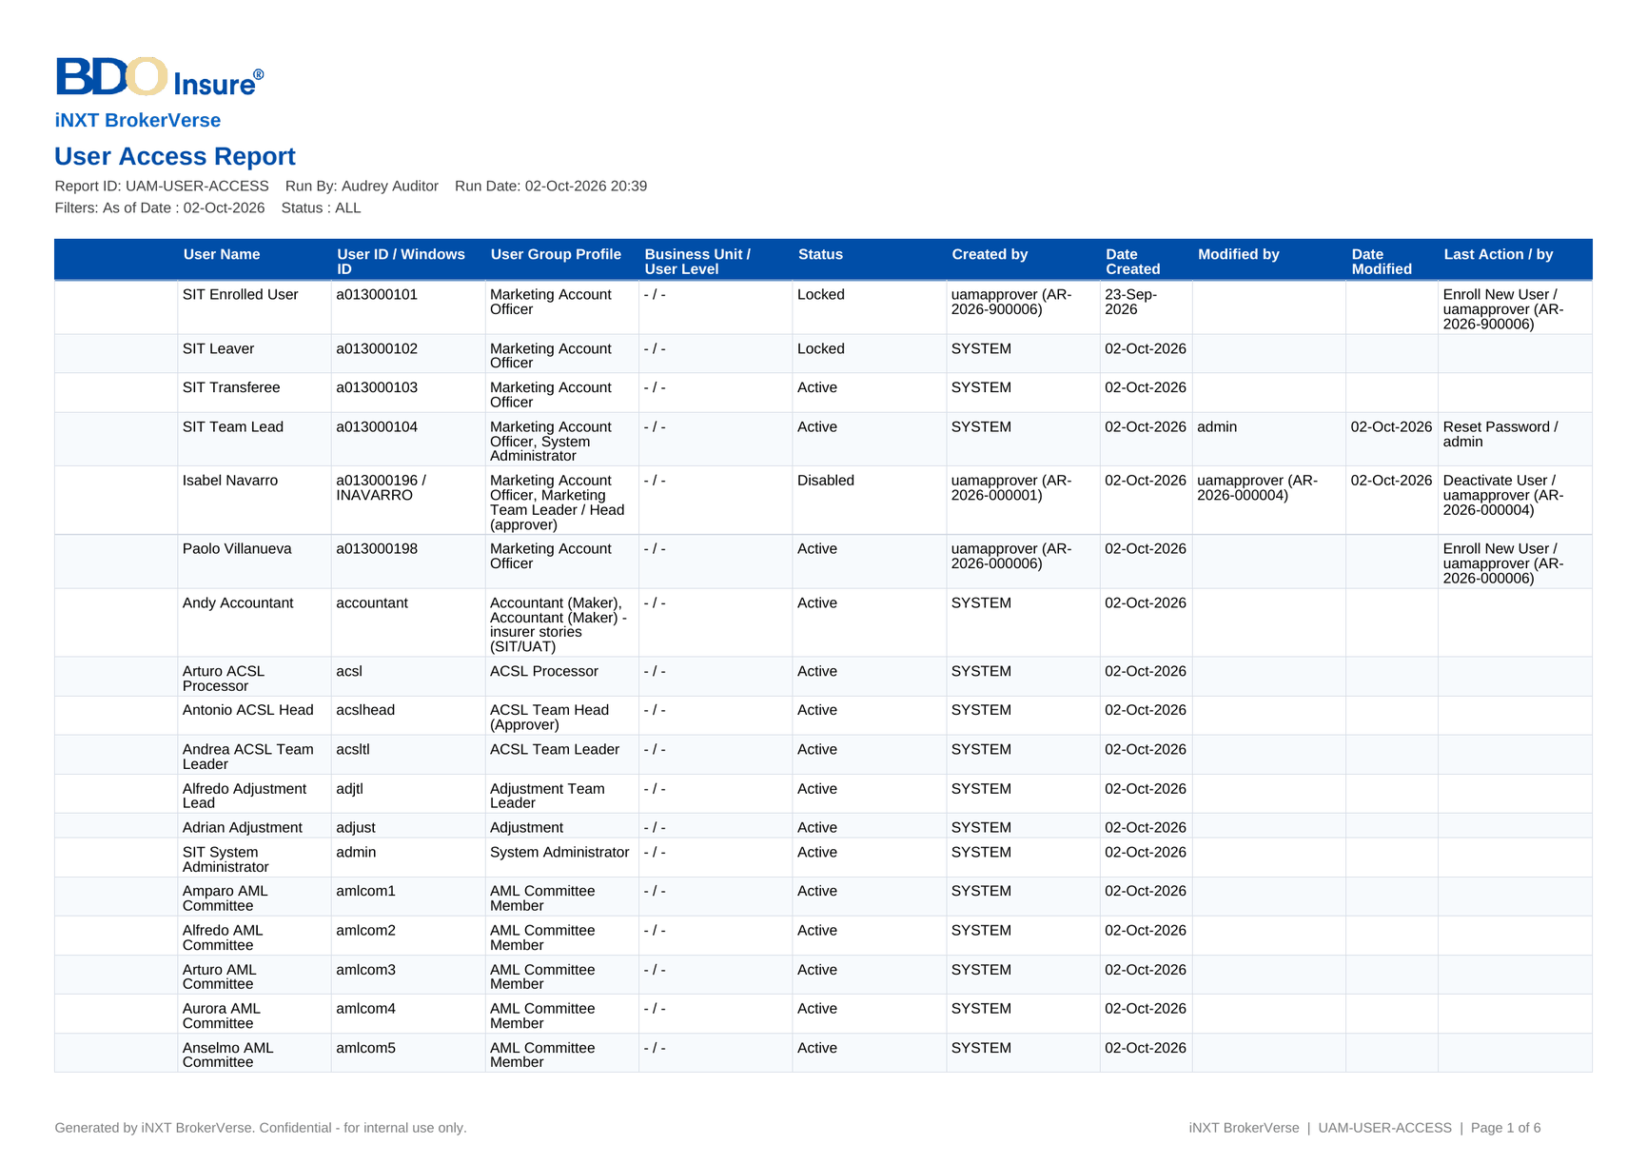
Figure 82: DO-01 User Access Report: first page as generated

17.2 DO-02 User Group Profile Report
Template | Report layout of the report runner (sample B of the BRD)
Format | PDF, Excel, CSV
Produced by | User Access Reports › User Group Profile Report
Password protected | False
FRs | FR-UA-061

Fields and their source
• Header as DO-01, with the profile, module and active filters
• Group profile – code and name, as a group heading
• Module Name, Task Name – the functional area and the permission
• Access – With Access or No Access
• Date Created, Created by, Date Modified, Modified by – from the access change log of the profile
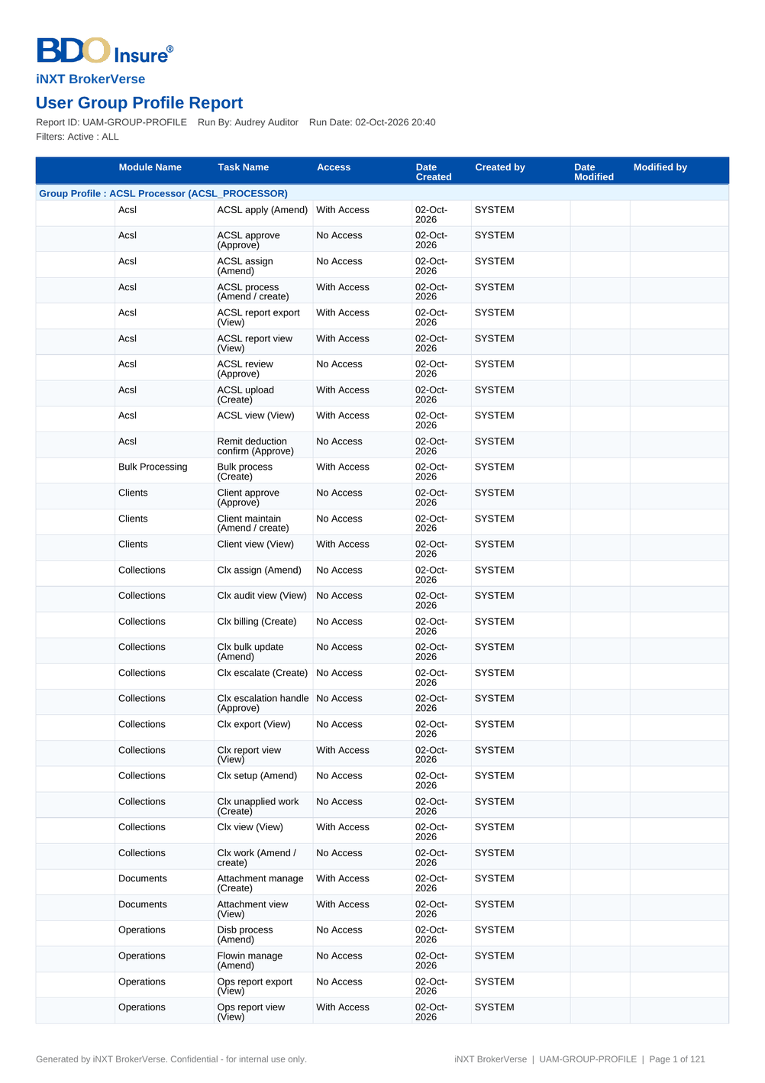
Figure 83: DO-02 User Group Profile Report: first page as generated

17.3 DO-03 Group Profile Membership
Template | Report layout of the report runner (sample C of the BRD)
Format | PDF, Excel, CSV
Produced by | User Access Reports › Group Profile Membership
Password protected | False
FRs | FR-UA-062

Fields and their source
• Header as DO-01, with the profile and the as-of date
• Member Username, Member User ID – the members of each profile on the as-of date
• Created by, Date Created, Modified by, Date Modified – who added the member and when, from the access change log
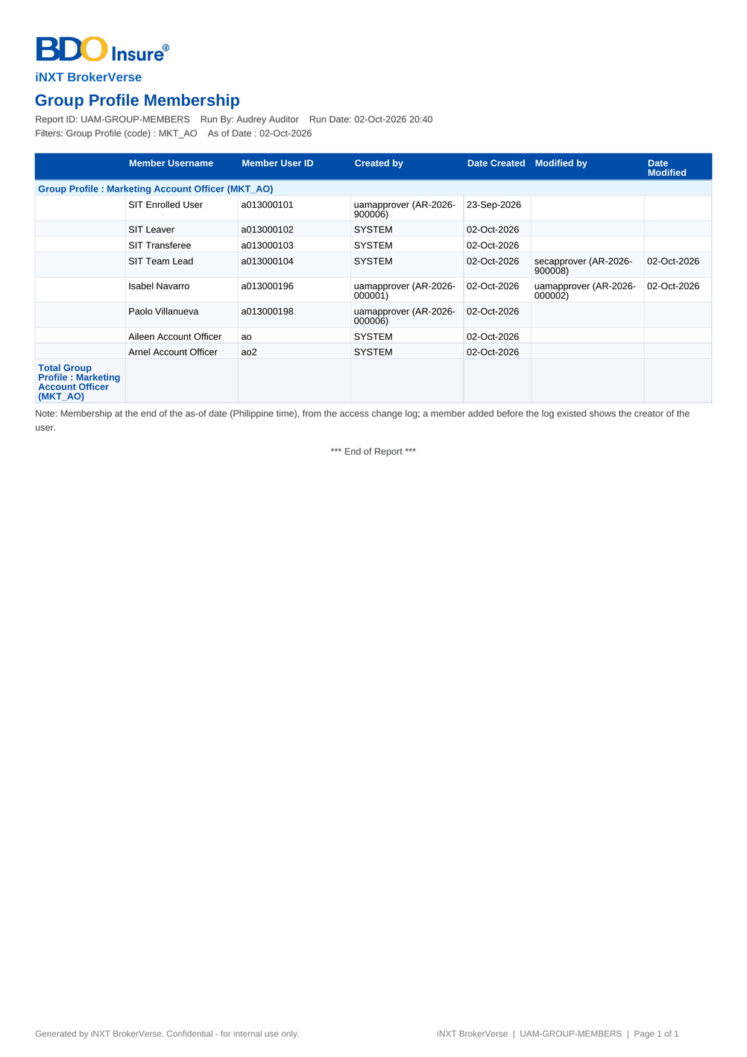
Figure 84: DO-03 Group Profile Membership: first page as generated

17.4 DO-04 User Access Audit Log
Template | Report layout of the report runner (sample D of the BRD)
Format | PDF, Excel, CSV
Produced by | User Access Reports › User Access Audit Log
Password protected | False
FRs | FR-UA-063, FR-UA-064

Fields and their source
• Header as DO-01, with the period, user and activity filters
• Date, Activity – the time and the activity in the words of the BRD sample (Enroll New User, Modify User Group Profile of, Deactivate User, Reset Password of, Create Group Profile, Modify Group Profile Access of...)
• From, To – the value before and after (Null when none; profile codes shown as profile names)
• Done By, Approved By, Request No. – from the access change log and the request history
• Log-in, Failed Log-in, Log-out – from the audit trail when Include Log-ins and Log-outs is ticked
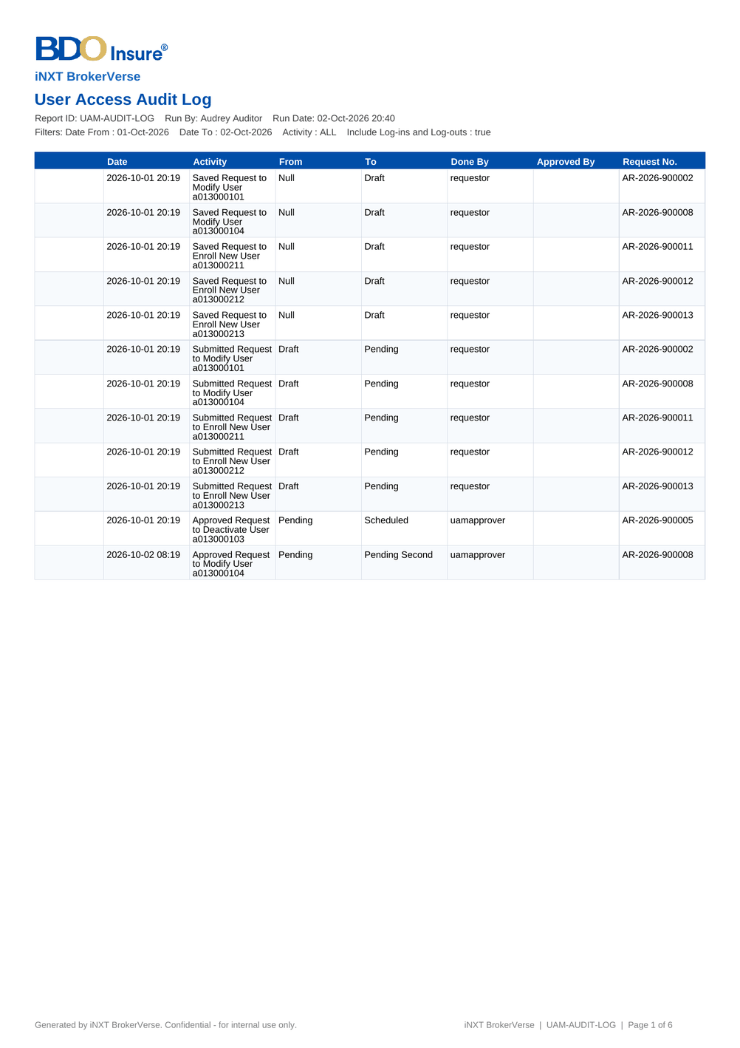
Figure 85: DO-04 User Access Audit Log: first page as generated

17.5 DO-05 Access Requests
Template | Report layout of the report runner
Format | PDF, Excel, CSV
Produced by | User Access Reports › Access Requests
Password protected | False
FRs | FR-UA-018

Fields and their source
• Header as DO-01, with the period, status and request type
• Request No., Request Type, User / Group Profile, Requester, Approver – from the access request
• Date Created, Date Decided, Effective Date, Age (days) – from the request and its history; open requests age to today
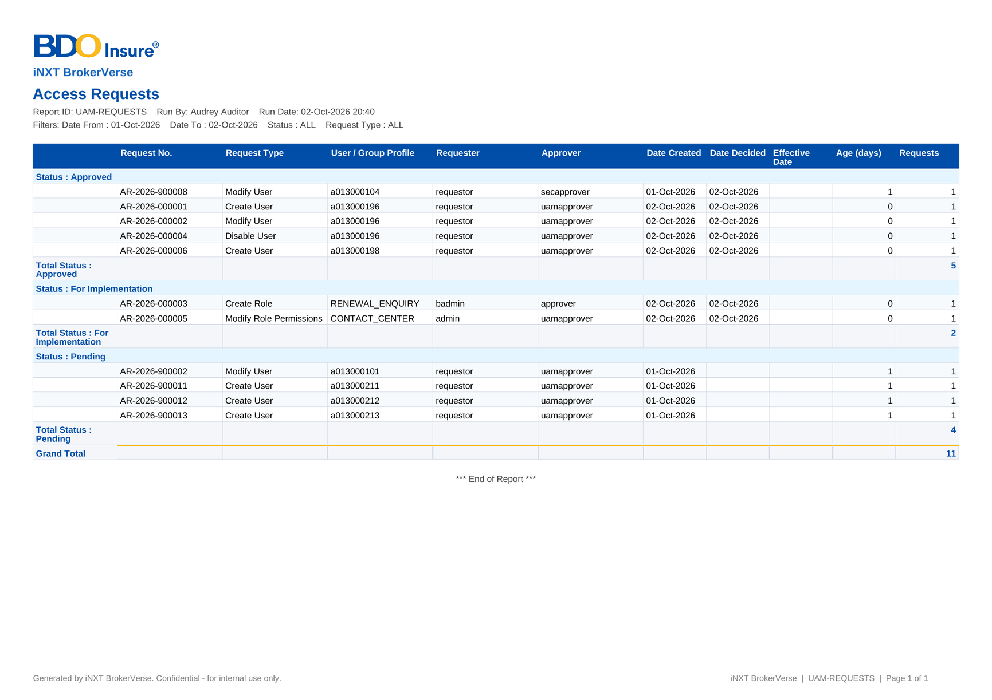
Figure 86: DO-05 Access Requests: first page as generated

17.6 DO-06 User Access Matrix (Excel)
Template | Workbook of the User Access Matrix
Format | Excel, two sheets (by permission; by area and action class)
Produced by | User Access Matrix › Export to Excel
Password protected | False
FRs | FR-UA-051

Fields and their source
• Sheet User Access Matrix: Permission, Area (area code), Action class and one column per group profile code, with Y where the profile holds the permission; the first row gives the enabled users of each profile – from the role grants in force
• Sheet By Action: Area, Action class, Permissions and, per profile, the permissions it holds there


Figure 87: DO-06 User Access Matrix (Excel): first page as generated

18 Upload screens
User Access Maintenance has one bulk upload: the Bulk Request (SCR-UA-09), which turns a file of user requests into a batch decided by an approver (FR-UA-019). The file is uploaded in the upload wizard of the Bulk Request screen: download the template, fill in one row per user, upload the file, review the check of every row (the rows in error are listed with their message and can be downloaded as an error file), correct and upload again, then save the valid rows as the draft lines of a batch. The batch is submitted from Bulk Request Batch (SCR-UA-10). The upload needs the bulk upload right besides the enrolment right (section 10.4).

18.1 Bulk access requests (UAM_ACCESS_REQUEST)
Permission | BULK_PROCESS and UAM_ENROLL
Instructions | One row per user. The batch is submitted to one approver with the batch remarks on the Bulk Request screen; every line is checked and applied as a single request.

Table 75: Template columns of Bulk access requests
No. | Column | Mand. | Type | Content | Example
1 | Action | Y | Text | What the request does for the user | ENROL
2 | User ID | Y | Text | User ID of the user | a013000201
3 | Full Name | N | Text | Full name of the user | Juan Dela Cruz
4 | E-mail | N | Text | E-mail address of the user | juan.delacruz@company.com.ph
5 | Windows ID | N | Text | Windows ID of the user; unique | JDELACRUZ
6 | Home Branch Code | N | Text | Home branch of the user | HO
7 | Business Unit | N | Text | Business unit group
8 | User Level | N | Text | User level
9 | Group Profiles | N | Text | Group profiles given to the user | MKT_AO
10 | Effective Date | N | Date | Date the change applies; blank to apply it on approval
11 | Remarks | Y | Text | Justification of the line | Joined Marketing

The users of go-live are loaded with this upload, from the template CI-01 of chapter 19 (users are out of the scope of the data migration, DMQ30).

19 Configuration inputs the business provides
User Access Maintenance is a setup object of Drop 0: before any other BRD is tested with its real users, BDOI provides the users and their group profiles, the role-to-permission matrix, the approvers and the approval limits, the separation-of-duties rules, the password, session and sign-in values, and the lists of values. The users are loaded with the bulk request; the matrix is implemented by group-profile requests; the parameters are set on System Parameters. Each input has a template in the workbook of configuration input templates of this set (06). The workbook opens on a Start here sheet that lists the templates in the order they are filled in (a template whose codes others use comes first), with who provides each, when it is due, how it is loaded, the rows entered, the mandatory cells still missing and a status. Each template sheet is self-contained: its purpose, owner, due date and the templates it depends on, then directly above each column its guide (mandatory or not, format, allowed values, what to enter), one fictitious example row to overwrite, and drop-downs with the allowed values and the codes of the templates filled in before. The allowed values are listed on the sheet Reference lists; questions per template and column are raised on the sheet Questions and comments. The sections below follow the same order.
Table 76: Configuration inputs of User Access Maintenance, in the order they are filled in
Step | ID | Template | Content | Provided by | Uses the codes of
1 | CI-02 | Role-to-permission matrix | The group profiles BDOI keeps, their privilege level and the permissions of each, starting from the User Access Matrix as delivered | Business Administration with the unit heads; reviewed and signed by BDOI Information Security | -
2 | CI-06 | Lists of values | The values of the lists of user access (business unit groups and user levels, empty as delivered; deactivation reasons, to confirm with BDOI; the reason No sign-in for the dormancy period is used by the dormant-user job and stays) | Business Administration | -
3 | CI-01 | Users and roles load | Every BIBS user at go-live with the user data and the group profiles, in the columns of the Bulk Request template | Business Administration, with the unit heads who name their users | CI-06, CI-02
4 | CI-04 | Separation-of-duties rules | The rules BIBS enforces, for confirmation, and the combinations of profiles or permissions that BDOI Information Security does not allow one user to hold | BDOI Information Security | CI-02
5 | CI-03 | Approvers, approval rules and limits | Who requests and who approves user access, the order of the approvers of group-profile requests, the second approvers, the implementers, and the authorisation limits of the users whose work other modules approve by amount | Business Administration; BDOI Information Security for the second approval; Comptrollership for the authorisation limits | CI-01
6 | CI-05 | Password, session and sign-in parameters | The values of the sign-in, password, session and access-request parameters, as delivered and as BDOI Information Security wants them | BDOI Information Security; BDOI IT for the sign-in mode | -

19.1 CI-02 Role-to-permission matrix
Content | The group profiles BDOI keeps, their privilege level and the permissions of each, starting from the User Access Matrix as delivered
Provided by | Business Administration with the unit heads; reviewed and signed by BDOI Information Security
Source | The User Access Matrix export of this set (DO-06) and the menus by persona of FRS chapter 12
How it is loaded | Group-profile requests (SCR-UA-12): one request per new or changed profile, approved in order and implemented by the System Administrator; checked with the User Group Profile Report
Uses the codes of | -
FRs | FR-UA-040, FR-UA-041, FR-UA-050, FR-UA-051

Table 77: Columns of the template Role-to-permission matrix
No. | Column | Mand. | Format | Allowed values | What to enter | Example (fictitious)
1 | Group profile code | Y | Up to 40 capital letters, digits or _ | - | Code of the profile; an existing code changes the profile | MKT_AO
2 | Name | Y | Up to 120 characters | - | Name shown on screens | Marketing Account Officer
3 | Description | N | Up to 500 characters | - | What the profile is for | Marketing account officers of the Combank and Corbank units
4 | Privilege level | Y | Low, Standard, High or Admin | List Privilege level | High and Admin need a second approval when given or raised | Standard
5 | Permission | Y | Permission code of the User Access Matrix | - | One row per permission of the profile | QUOTE_MAINTAIN
6 | Action class | N | View only, Create, Amend, Approve / Validate | - | As shown by the matrix, for the review | Create, Amend
7 | Keep / Add / Remove | Y | KEEP, ADD or REMOVE | List Change against the matrix | Change against the matrix as delivered | KEEP
8 | Approved by unit head | Y | Name | - | Unit head who confirms the row | Carla Reyes

19.2 CI-06 Lists of values
Content | The values of the lists of user access (business unit groups and user levels, empty as delivered; deactivation reasons, to confirm with BDOI; the reason No sign-in for the dormancy period is used by the dormant-user job and stays)
Provided by | Business Administration
Source | BDOI organisation (UQ05)
How it is loaded | Lists of Values (New Business set) under maker-checker; before the users of CI-01 are loaded
Uses the codes of | -
FRs | FR-UA-011, FR-UA-013, FR-UA-052

Table 78: Columns of the template Lists of values
No. | Column | Mand. | Format | Allowed values | What to enter | Example (fictitious)
1 | List | Y | UAM_BUSINESS_UNIT, UAM_USER_LEVEL or UAM_DEACTIVATION_REASON | List User access list | The list | UAM_BUSINESS_UNIT
2 | Code | Y | Up to 30 capitals, digits or _ | - | Code of the value | COMBANK_MKT
3 | Label | Y | Up to 120 characters | - | Label shown on screens | Combank Marketing
4 | Sort order | N | Whole number | Whole number | Order in the drop-down | 10
5 | Effective from | Y | dd-MMM-yyyy | Date | Date the value may be used | 04-Jan-2027

19.3 CI-01 Users and roles load
Content | Every BIBS user at go-live with the user data and the group profiles, in the columns of the Bulk Request template
Provided by | Business Administration, with the unit heads who name their users
Source | The users of the legacy systems and the unit rosters; the HR list of employees for the full names and e-mails
How it is loaded | Bulk Request (SCR-UA-09): the file of this template is uploaded as a bulk batch, checked row by row and approved by an approver like single requests; users are out of the data migration scope (DMQ30)
Uses the codes of | CI-06, CI-02
FRs | FR-UA-011, FR-UA-019

Table 79: Columns of the template Users and roles load
No. | Column | Mand. | Format | Allowed values | What to enter | Example (fictitious)
1 | Action | Y | ENROL, MODIFY, DEACTIVATE or REACTIVATE | List Bulk request action | ENROL for the go-live load | ENROL
2 | User ID | Y | A letter and nine digits (BDOI format a999999999) | - | The BIBS user ID; unique | a013000201
3 | Full Name | Cond.: ENROL | Up to 120 characters | - | Name shown on screens and reports | Andrea Mercado
4 | E-mail | N | Company e-mail address | - | Receives the access-changed notices and the reset links | andrea.mercado@brokerverse-seed.ph
5 | Windows ID | N | Windows log-on name; unique | - | Used for the BDO directory sign-in when it is enabled | AMERCADO
6 | Home Branch Code | N | Branch code | - | Home branch of the user | HO
7 | Business Unit | N | Code of the list Business unit group (CI-06) | Codes of CI-06 Lists of values (Code) | Business unit group | -
8 | User Level | N | Code of the list User level (CI-06) | Codes of CI-06 Lists of values (Code) | User level | -
9 | Group Profiles | Cond.: ENROL | Profile codes of CI-02 separated by ';' | Codes of CI-02 Role-to-permission matrix (Group profile code) | The group profiles of the user | MKT_AO
10 | Effective Date | N | yyyy-MM-dd; blank = on approval | - | Date the change applies | -
11 | Remarks | Y | Up to 1,000 characters | - | Justification of the line | Joined Marketing

19.4 CI-04 Separation-of-duties rules
Content | The rules BIBS enforces, for confirmation, and the combinations of profiles or permissions that BDOI Information Security does not allow one user to hold
Provided by | BDOI Information Security
Source | BDOI information security policy; the separation-of-duties rules of FRS chapter 13
How it is loaded | The rules marked Enforced are fixed in BIBS; the privileged profiles are set by the privilege level of CI-02. Each combination of two profiles is entered on Separation of Duties (SCR-UA-19) by the Business Administrator and authorised by Information Security; BIBS then refuses every request and bulk line that breaks it. A combination of permissions is reviewed with the reports
Uses the codes of | CI-02
FRs | FR-UA-031, FR-UA-034, FR-UA-045, FR-UA-053

Table 80: Columns of the template Separation-of-duties rules
No. | Column | Mand. | Format | Allowed values | What to enter | Example (fictitious)
1 | Rule ID | Y | SOD-nn | - | Identifier of the rule | SOD-01
2 | Rule | Y | Text | - | The rule | The requester never decides his own request
3 | Status | Y | Enforced, To confirm, New | List Separation-of-duties rule status | Enforced = a fixed rule of BIBS | Enforced
4 | Profile or permission A | Cond.: combination rule | Profile or permission of CI-02 | Codes of CI-02 Role-to-permission matrix (Group profile code) | First profile or permission of a combination | User Access Requestor
5 | Profile or permission B | Cond.: combination rule | Profile or permission of CI-02 | Codes of CI-02 Role-to-permission matrix (Group profile code) | Profile or permission that may not be held with A | User Access Approver
6 | Control | Y | Prevent (a rule of Separation of Duties, for two profiles), Detect by review, Second approval | List Separation-of-duties control | How the rule is controlled | Prevent
7 | Review frequency | Cond.: Detect by review | Monthly, Quarterly | List Review frequency | How often the reports are reviewed | Quarterly

19.5 CI-03 Approvers, approval rules and limits
Content | Who requests and who approves user access, the order of the approvers of group-profile requests, the second approvers, the implementers, and the authorisation limits of the users whose work other modules approve by amount
Provided by | Business Administration; BDOI Information Security for the second approval; Comptrollership for the authorisation limits
Source | BDOI's approval matrix (UQ01, UQ02)
How it is loaded | The users are given the Requestor, Approver, Second Approver and System Administrator profiles by requests (CI-01); the approvers are chosen on each request; UAM_ANY_APPROVER is set on System Parameters. The authorisation limit is set by an Enrol new user or Modify user request (field Authorisation Limit) decided by an approver; the bulk file has no limit column, so the limits are requested after the users are loaded
Uses the codes of | CI-01
FRs | FR-UA-011, FR-UA-012, FR-UA-015, FR-UA-034, FR-UA-044, FR-UA-045

Table 81: Columns of the template Approvers, approval rules and limits
No. | Column | Mand. | Format | Allowed values | What to enter | Example (fictitious)
1 | Role in user access | Y | Requestor, Approver, Second Approver, Group-profile requester, Implementer | List Role in user access | The user access role of the user | Approver
2 | User ID | Y | User ID of CI-01 | Codes of CI-01 Users and roles load (User ID) | The user who holds the role | a013000205
3 | Unit | Y | Business unit | - | Unit the user requests or approves for | Combank Marketing
4 | Approver order for group profiles | Cond.: Approver | 1, 2, 3 | Whole number 1 to 9 | Usual order of the approvers of a group-profile request | 1
5 | Any approver may decide | N | Y or N | Y or N | Y sets UAM_ANY_APPROVER: any approver decides any request, not only the chosen one | N
6 | Authorisation limit | N | Amount in PHP; blank = unlimited | Number | Limit of the user's approvals by amount in the modules that use it (journals, payables) | 500000.00

19.6 CI-05 Password, session and sign-in parameters
Content | The values of the sign-in, password, session and access-request parameters, as delivered and as BDOI Information Security wants them
Provided by | BDOI Information Security; BDOI IT for the sign-in mode
Source | BDOI security policy (UQ07, UQ08); the values delivered (FRS section 9.1)
How it is loaded | System Parameters (SCR-UA-18): entered by the System Administrator and approved by the Information Security Officer, audited; checked in SIT with the test plan
Uses the codes of | -
FRs | FR-UA-001, FR-UA-002, FR-UA-005, FR-UA-006, FR-UA-034, FR-UA-052, FR-UA-054

Table 82: Columns of the template Password, session and sign-in parameters
No. | Column | Mand. | Format | Allowed values | What to enter | Example (fictitious)
1 | Parameter | Y | LOGIN_MAX_FAILED_ATTEMPTS, SESSION_IDLE_WARNING_MINUTES, SESSION_TIMEOUT_MINUTES, SESSION_EXPIRY_WARNING_MINUTES, AUTH_MODE, USER_ID_PATTERN, USER_ID_FORMAT_TEXT, PASSWORD_HISTORY_COUNT, PASSWORD_MAX_AGE_DAYS, PASSWORD_MIN_AGE_DAYS, UAM_WORKING_HOURS, UAM_ANY_APPROVER, UAM_ROLE_APPLY_ON_APPROVAL, UAM_EXTERNAL_USERS, UAM_DORMANT_DAYS, UAM_DORMANT_NOTICE_DAYS, JOB_FAILURE_RECIPIENTS | List Sign-in | One row per parameter | PASSWORD_MAX_AGE_DAYS
2 | Value as delivered | Y | As on System Parameters | - | The value proposed with the system | 90
3 | Value wanted | Y | Same type and range | - | The value BDOI wants | 90
4 | Reason | Cond.: value changed | Text | - | Policy reference or reason | BDO password policy
5 | Approved by | Y | Name | - | Information Security or BDOI IT approver of the value | Ramon Dizon

20 Cross-BRD dependencies and interface contract
User Access Maintenance is the source of the users, group profiles and permissions that every BIBS module checks, and of the menus of every persona; it takes lists and the approval list from New Business, and it has two identity integrations owned by BDOI IT. The contract below lists each exchange: the BRD or system, the direction, what is exchanged, when and how, and who owns the data. Chapter 7 describes the interfaces with the external systems.
Table 83: Interface contract of User Access Maintenance
ID | BRD or system | Direction | What | When and how | Owner of the data | FR
IC-01 | Every BIBS module (BRD-1 to BRD-13 and the platform) | Out | The signed-in user, the active group profiles and the effective permissions; the sidebar of each persona; the inactivity and session rules | Every screen, button and server call checks the user's permissions at run time; a deactivated group profile grants nothing at once; a deactivated or locked user's sessions end at once | Business Administration (requests), approvers and Information Security (decisions), System Administrator (implementation) | FR-UA-001, FR-UA-002, FR-UA-050, FR-UA-051
IC-02 | BRD-1 New Business | Out / In | Out: the approval right of access requests kept by the New Business Approver; the access requests listed in My Approvals. In: My Approvals (the shared approval list), Lists of Values (business unit groups, user levels, deactivation reasons) and Data Retention (retention rule of cancelled and rejected access requests) | An access request waiting for a user appears in that user's My Approvals and opens the request; the lists are maintained on Lists of Values under maker-checker | Business Administration | FR-UA-030, FR-UA-011, FR-UA-013
IC-03 | BRD-3 Product Maintenance | Out | The role-permission change requests of Product Maintenance (Modify group profile) and the User Access Matrix by area and action class | A change to a Product Maintenance profile is a group-profile request, approved in order and implemented by the System Administrator (UAM_ROLE_APPLY_ON_APPROVAL = false) | Business Administration; System Administrator | FR-UA-041, FR-UA-045, FR-UA-051
IC-04 | BRD-10 Sanction Screening | Out | The Compliance roles (Compliance Officer, Checker, Unit Compliance Coordinator, Screening Investigator, Screening Approver, AML Committee) and their menus, checked by the persona menu test of the suite BRD-10/11 | Users receive these profiles through access requests; the menus are those of FRS chapter 12 | Compliance (profile content); Business Administration (requests) | FR-UA-050, FR-UA-051
IC-05 | BRD-2 Operations, BRD-4 Collections, BRD-5 Accounting, BRD-6 Renewal, BRD-7 Claims, BRD-8 Employee Benefits, BRD-12 Submitted Policies | Out | The group profiles of their personas and the menus they give; the persona suites of Renewal, Claims and Employee Benefits are checked by the persona menu test | A new persona or permission of these BRDs is added by a group-profile request once the permission exists in BIBS | The business owner of each BRD (profile content); Business Administration (requests) | FR-UA-040, FR-UA-041, FR-UA-051
IC-06 | BRD-8 Employee Benefits (partner portal) | Out | External (portal) users of insurers and client HR, provisioned through access requests of user type External | Dormant. BDOI's drop plan has Employee Benefits without a portal, so no portal is installed and every external request is refused (External (portal) users are not available: the portal is not installed) | Employee Benefits owner (if a portal is ever added) | FR-UA-011, FR-UA-013, FR-UA-014
IC-07 | BRD-13 Data Migration | In | The users and group profiles of go-live. Users are out of the migration scope (DMQ30); they are loaded with the bulk request from the users and roles template of this set, and the migration team's own profiles are given through access requests | Bulk Request files are checked row by row and decided by an approver like single requests; the role-to-permission matrix of this set is implemented before the first mock | Business Administration; migration working group | FR-UA-019
IC-08 | EIAM (BDO Enterprise Identity Access Management on Microsoft Entra ID), owned by BDOI IT | In | The sign-in of BDO users through single sign-on (OpenID Connect, or SAML 2.0 as the fall-back); BIBS keeps the roles, permissions, the inactivity sign-out and the session log | Single sign-on is part of BIBS and is switched on by configuration (sign-in mode OIDC or SAML) once BDOI IT registers BIBS in EIAM for each environment (CLR-UA-01); until then SIT uses local sign-in, and the break-glass administrators keep it. Proposed rules for confirmation - the account is matched by the Windows ID or the user principal name (CLR-UA-22), Log Out also ends the EIAM session (CLR-UA-23). Details in the Authentication and Identity Integration Requirements v1.0 (03-Oct-2026) | BDOI IT | FR-UA-003
IC-09 | UIDM-ISC (BDO identity governance), owned by BDOI IT | In / Out | Joiner, mover and leaver provisioning and access certification | In this set every access change is a BIBS request under four eyes; the options for BDOI (the governance tool provisions users while group-profile changes stay BIBS requests, the tool provisions users and profiles, or aggregation only) are open (IQ05). The reports of this set give the user and profile lists for certification | BDOI IT; BDOI Information Security | FR-UA-010, FR-UA-060, FR-UA-062
IC-10 | Messaging (e-mail relay of the BIBS environment) | Out | The access-changed e-mails, the password reset links, the password expiry notices and the batch failure e-mails | Queued and sent by the platform; every e-mail is listed in Outbound Messages | BDOI IT (relay); System Administrator (recipients of batch failures) | FR-UA-005, FR-UA-070, FR-UA-071
IC-11 | Audit trail and reports (platform) | Out | Sign-ins, failed sign-ins, sign-outs, parameter changes and every access change with its from and to values, request number, done by and approved by | Records that no user can change; read by the User Access Audit Log and the Audit Trail | System Administrator; Auditor; Information Security | FR-UA-063, FR-UA-064

Change against this signed set. User Access Maintenance is the source of the users, group profiles and permissions that every BIBS module checks, and of the menus each persona sees. A later change in any BRD that adds a permission, a persona or a screen, or that changes who may approve, is delivered as a group-profile request under this signed set (configuration, no change request) when the permission exists; a new permission, a new separation-of-duties rule, a new request type, or a change to the sign-in and identity integration is raised as a change request against this signed set in the Change Management Register, assessed with its mandays and approved by the owners of both BRDs and by BDOI Information Security; the affected pages of this set are then re-issued and signed as a delta.

21 Sign-off and change control

21.1 What is signed
The business sign-off covers the release set BRD-11 User Access Maintenance v2.1:
Table 84: Documents of the release set
Document | Content
Start Here guide | The map of the set, who reads what, the steps and the dates
Sign-off Pack Guide deck | Purpose, approach, the module at a glance, caveats, entry and exit criteria, change control
This FRS v2.1 | Requirements (chapters 1-11), the business view of the system (chapters 12-21) and the proposed rules for confirmation (chapter 22)
Sign-off workbook v2.1 | The screens, fields, actions, rules, messages, notifications, contract and the menu of every persona of this FRS, one row each, with the BU review columns
Test plan v2.1 | The test cases traced to the FRs and to the screens of chapter 13
Configuration input templates | The templates of chapter 19

Table 85: The set in numbers
Content of the set | Count
Screens specified | 19
Fields and columns described | 157
Actions described | 65
Business rules on screens | 74
Messages (server, screen and upload row) | 220
Notifications and e-mails | 18
Upload types | 1
Generated documents | 6
Walkthroughs | 4
Interface contract lines | 11
Personas with their menus | 48

21.2 How the review is recorded
Each unit records its review in the sign-off workbook: Accept, Change requested or Comment on each row of the screen catalogue, field register, business rules, messages and the menu sheets of its personas, with the comment, the reviewer and the date. The project team answers every Change requested row before sign-off: either the row is corrected in the next version of the set, or the change is raised as a change request (below) and the row is signed as specified.

21.3 What each signatory confirms
Table 86: Signatories and what they sign
Signatory | Confirms
Business owner (Product Owner, Marketing Business System) | The whole set: functions, screens, navigation, messages and the configuration inputs
Process owner, User Access Maintenance (Business Administration) | The requests, approvals, group-profile requests, bulk requests and reports, and the templates CI-01, CI-03 and CI-06
BDOI Information Security | The role matrix (the menu of every persona, chapter 12, and template CI-02), the separation-of-duties rules (chapter 13 and template CI-04), the second approval of privileged changes, the emergency path, the password, lock-out and session values (template CI-05) and the audit log
BDOI IT | The sign-in and identity integration: single sign-on through EIAM on Entra ID, switched on by configuration once BIBS is registered for each environment (local sign-in on SIT until then), the proposed rules CLR-UA-21 to CLR-UA-26, and every access change as a BIBS request until the UIDM-ISC option is chosen (chapter 7, contract lines IC-08 and IC-09; R9; these integrations are owned by BDOI IT); the System Administrator functions

21.4 What signing freezes
Signing this release set freezes, for User Access Maintenance:
• the screens and their navigation (chapters 12 and 13), the fields with their order, labels, types, mandatory rules, lists and validations;
• the actions with their conditions and resulting statuses, the separation-of-duties rules and the other business rules;
• the messages (chapter 15), the notifications (chapter 16) and the reports (chapter 17);
• the upload template (chapter 18), the configuration input templates (chapter 19) and the interface contract with the other BRDs (chapter 20).
The content of the configuration is not frozen: the group profiles and their permissions, the users, the approvers, the list values and the parameters (password, session, working hours) are maintained in the system through requests and audited changes, without a change request. The menu of a persona therefore follows its group profiles: a change to a profile made by an implemented group-profile request is not a change to this signed set, and the menu tables are refreshed in its next version.

21.5 Change after sign-off
A change to anything frozen is raised in the Change Management Register. The request states the screen, field, rule or message concerned, the reason and the business priority. The project team assesses it with its mandays, including its effect on the other BRDs through the interface contract of chapter 20, and the owners of every BRD it touches approve it; a change to a separation-of-duties rule or to the sign-in is also approved by BDOI Information Security. An approved change is delivered as a new version of this release set (v2.2, v2.3 and so on), and the changed rows are reviewed again.

21.6 Proposed rules for confirmation
Chapter 22 lists the proposed business rules and screen behaviour that differ from the BRD or need a decision of BDOI. BDOI Information Security and BDOI IT record their decisions on the items they own with the review; a decision that changes a screen, field, rule or message is applied in the next version of this set.

21.7 Signatures
By signing, BDOI confirms that this FRS and the sign-off workbook describe the User Access Maintenance functions, screens, menus and messages it expects in BIBS, accepts the assumptions in section 10.1 and records its decisions on the items of chapter 22. Open questions in section 10.3 stay open; their answers are applied as configuration or through a change request.
Name | Role | Organisation | Signature | Date
 | Product Owner, Marketing Business System | BDOI
 | Process Owner, User Access Maintenance (Business Administration) | BDOI
 | Head, BDOI Information Security | BDOI
 | Head, BDOI IT | BDOI
 | Program Manager, Business Project Services | BDO Unibank ESG
 | Project Manager | iorta TechNXT

22 Proposed business rules and clarifications for confirmation
The table lists each point where the proposed screen or rule differs from the BRD text, or where BIBS needs a decision of BDOI, BDOI Information Security or BDOI IT to complete the rule. Each item names the proposed behaviour, the reason and the decision requested. The decisions are recorded with the review of this set (section 21.6); a decision that changes a screen, field, rule or message is applied in the next version of the set, and an answer that only sets a value (a list, a parameter) is applied as configuration.
Table 87: Proposed business rules and clarifications for confirmation
Ref | Topic | Proposed rule or screen behaviour | Reason | Decision requested from BDOI
CLR-UA-01 | Single sign-on through EIAM (UAM-NFR-11, 17, 33; FR-UA-003) | Single sign-on with OpenID Connect against the BDO Entra ID tenant (EIAM), SAML 2.0 kept as the fall-back if the BDOI IT standards require it. It is part of BIBS and switched on by configuration (sign-in mode OIDC or SAML) once BDOI IT registers BIBS for each environment; SIT uses local sign-in until then. Not a change request. | BDOI named EIAM on Microsoft Entra ID for Drop 0; the protocol details are in the Authentication and Identity Integration Requirements v1.0 (R9). | BDOI IT to choose the protocol and to register BIBS in EIAM for each environment, with test accounts for SIT and UAT (UA-Q06, UA-Q07, IQ04).
CLR-UA-02 | External access-control list (UAM-NFR-12; FR-UA-003) | Roles and permissions are kept in BIBS; there is no authorisation through an external access-control list. | The external ACL is not specified (UQ14). | Confirm that authorisation stays in BIBS, or specify the external ACL (UQ14, UA-Q23).
CLR-UA-03 | Provisioning from UIDM-ISC (p.6 request rule; Drop 0; FR-UA-010) | Every access change is a BIBS request under four eyes. The reports give the user and profile lists for access certification. | BDOI named UIDM-ISC for joiner, mover and leaver provisioning; the option is open (IQ05). | BDOI IT to choose the UIDM-ISC option: accounts only, accounts and roles, or aggregation only (IQ05, UA-Q18 to UA-Q21).
CLR-UA-04 | External (portal) users (decision D7; FR-UA-011, 013, 014) | The user type External is not offered while no portal is installed (UAM_EXTERNAL_USERS = false), and a request of that type is refused. Setting the parameter to true, with the second approval of Information Security, offers it again. | BDOI drops the EB portal (drop plan item 2.4, IQ22). | Confirm that external users stay switched off (UA-Q24).
CLR-UA-05 | Business unit group and user level (1.002.1.1.1, UAM-NFR-15; FR-UA-011, 052) | Both are captured on the user; their lists stay empty until BDOI gives the values, and a value is not checked against a list until then. | The values are not in the BRD (UQ05). | Give the business unit groups and user levels (UQ05, UA-Q26).
CLR-UA-06 | Effective date of an enrolment (UAM-NFR-14; FR-UA-020) | A scheduled enrolment creates the user on its date with a password that is never shown; the System Administrator resets it and the user changes it at the first sign-in. | The temporary password is shown only once, to the approver of an immediate enrolment. | Confirm the handling of scheduled enrolments (UA-Q39).
CLR-UA-07 | Deactivation of a group profile with members (3.002.3; FR-UA-042) | A profile with members can be deactivated; the members lose its screens when the request is implemented, are listed on the request and are each told (in the app and by e-mail). | The BRD does not say whether members must be moved first (UQ16). | Decide whether members must be moved before a deactivation (UQ16, UA-Q40).
CLR-UA-08 | Dormant accounts (information security practice; FR-UA-006) | A daily deactivation of users with no sign-in for 90 days, with a notice 7 days before; the System Administrator profile is exempt. | The period and the notice are proposals; Information Security has not given its values. | Information Security to confirm the dormancy period and the notice (template CI-05, UA-Q42).
CLR-UA-09 | One session per device (UAM-NFR-35; FR-UA-004) | The session log records every session; one session per device is not enforced. | The rule is not specified (UQ09). | Decide whether one session per device must be enforced (UQ09, UA-Q44).
CLR-UA-10 | Module and task names in the reports (3.003; FR-UA-060, 061) | The User Group Profile Report shows the module as the permission area and the task as the permission name. The report parameters Group Profile and Module are offered as lists. | The module and task names of sample B are not defined (UQ11). | Confirm the module and task names (UQ11, UA-Q50).
CLR-UA-11 | User Access Matrix for requesters (4.002.2.7; FR-UA-051) | The Requestor and the Second Approver do not open the User Access Matrix; the matrix serves the request, approval, role management and audit rights. | The BRD's view function does not name the matrix. | Decide whether requesters should read the User Access Matrix (UA-Q32).
CLR-UA-12 | Group-profile changes applied at implementation (UQ03; FR-UA-041, 045) | An approved change of group-profile permissions is applied when the System Administrator implements it, for every module, including Product Maintenance (BRD-3 PMADD05). | The BRD-11 diagram (p.6) has the System Administrator implement group-profile changes (PQ17 answered). | Confirm the implementation step for every module (UQ03, UA-Q36).
CLR-UA-13 | Temporary access with an end date (UQ06; FR-UA-017, 020) | Access is given until it is removed by a request; there is no end date on a group profile of a user. | Temporary access is not specified in the BRD (UQ06). | Decide whether temporary access with an end date is needed (UQ06, UA-Q39).
CLR-UA-14 | Out-of-hours flag on public holidays (NFR 11; FR-UA-034) | A request submitted or approved outside UAM_WORKING_HOURS is flagged for second approval; the flag is evaluated at submission and again at approval. Public holidays are not treated as out of hours. | The working hours have no holiday calendar. | Decide whether public holidays count as out of hours (UA-Q37).
CLR-UA-15 | Users who already hold both profiles of a new rule (FR-UA-053) | A new separation-of-duties rule is checked on later requests; users who already hold both profiles are not changed and are found with the User Access Report. | Existing access is changed only through requests. | Information Security to confirm that it reviews the report after each new rule and raises the requests (UA-Q31).
CLR-UA-16 | Bulk requests (1.009; FR-UA-019) | A bulk request is decided as a whole. | The maximum number of rows, line-by-line decisions and mixed actions are not given (UQ10). | Give the bulk settings (UQ10, UA-Q41).
CLR-UA-17 | Access from BDO-issued devices only (1.001.1; FR-UA-001) | Access only from BDO-issued devices is enforced by the BDO network and device policy, not by BIBS. | BIBS cannot see the device a browser runs on. | BDOI IT to confirm the network and device policy that enforces it (UA-Q10).
CLR-UA-18 | Stage list of an access request | The stepper of an access request shows Draft, Pending Approval, Second approval (only where one is needed), then Approved; a group-profile request ends with For implementation and Implemented. Scheduled shows while an approved change waits for its effective date; a returned request shows in amber, a rejected or cancelled one in red. | The request is not in a configured workflow; its stages are fixed for the screen. | Confirm the stage list and its names (UA-Q36).
CLR-UA-19 | Main path with two good endings | A user request ends at Approved and a group-profile request at Implemented; the stepper shows only the ending of the request type. | Two endings on one line would read as two steps. | Confirm the ending shown for each request type.
CLR-UA-20 | Full status labels | Request and user statuses show their full label (for example Pending Approval, For implementation); a short form with the full label in the tooltip is used only above 21 characters. | The client asked for full labels where they fit (27-Sep-2026). | Confirm full labels.
CLR-UA-21 | EIAM replaces the EUA and LDAP sign-in (UAM-NFR-11, 17; FR-UA-003) | EIAM on Microsoft Entra ID is the only directory sign-in of BDO users; the EUA password check and the LDAP / Active Directory sign-in are closed as replaced by EIAM, and the sign-in mode DIRECTORY is not used. Local sign-in is kept only for the break-glass administrators (CLR-UA-24). | The BRD asks for EUA, LDAP / AD or single sign-on; BDOI named EIAM for Drop 0, which holds the BDO directory accounts. | Confirm that EIAM replaces EUA and LDAP / AD for every BDO user (UA-Q05).
CLR-UA-22 | Matching the EIAM account to the BIBS user (UAM-NFR-15, 17; FR-UA-003, 052) | EIAM returns the Windows ID in a dedicated claim (or the user principal name where the Windows ID is not released); BIBS matches it to the Windows ID held on each user. The BIBS user ID stays the employee-number format (a999999999). An account with no matching active user is refused with the message SSO_NOT_LINKED. | The BRD identifies users by the Windows ID; Entra ID identifies them by the user principal name. | BDOI IT to confirm the claim that identifies the user and the relation of the Windows ID to the user ID (UA-Q08, UA-Q25).
CLR-UA-23 | Log Out ends the EIAM session (UAM-NFR-35; FR-UA-004) | Log Out ends the BIBS session, records it in the session log and sends the user to the EIAM sign-out page, so the BDO session ends too; after an inactivity sign-out the next sign-in goes through EIAM again. | Ending the Entra ID session also signs the user out of the other BDO applications opened with the same session. | BDOI IT to confirm that single sign-out is acceptable, and the re-authentication after an inactivity sign-out (UA-Q11, UA-Q12).
CLR-UA-24 | Break-glass administrators (FR-UA-003, 006) | Two named System Administrator accounts keep a local password and the BIBS second factor; their credentials are sealed by Information Security, every sign-in is alerted to Information Security and reviewed monthly; single sign-on is switched on only once these accounts exist. | BIBS must stay manageable when EIAM is not available. | Information Security to confirm the number, the holders and the review (UA-Q13).
CLR-UA-25 | Lock-out, second factor and BDO devices with EIAM (BRD 1.001.1, UAM-NFR-19; FR-UA-001, 003) | For users who sign in through EIAM, Entra ID enforces the password, the lock-out, the second factor and the BDO-device rule (conditional access); BIBS does not ask a second code after the single sign-on. The BIBS lock-out after 3 attempts and the BIBS second factor stay for local accounts. | With single sign-on BIBS no longer sees the password or the device. | BDOI IT and Information Security to confirm that the Entra ID policies meet the BRD rules (UA-Q10, UA-Q15).
CLR-UA-26 | Roles stay in BIBS with single sign-on (FR-UA-003) | Group profiles and permissions stay in BIBS and change only by BIBS requests; no Entra ID group is mapped to a BIBS role. EIAM may restrict who reaches BIBS through an assignment to a 'BIBS users' group kept by BDOI IT. | The BRD keeps every access change under four eyes in BIBS (p.6). | Confirm that roles are not taken from Entra ID groups (UA-Q09).
CLR-UA-27 | Acceptance criteria and NFR numbering written by the project team (all FRs; section 8) | The numbered acceptance criteria of each FR and the NFR IDs UAM-NFR-01 to 41 are the acceptance basis of BRD-11; rows without a Mandatory flag are treated as Must have; the duplicate IDs are marked "(2nd)". The appendix User-story view sets each BRD line next to its acceptance criteria. | The BRD has user-story lines but no acceptance criteria and no NFR IDs. | Business Administration and Information Security to accept the acceptance criteria and the numbering (UA-Q04).

23 Appendix: User-story view
One row per requirement of the User Access Maintenance BRD. The BRD writes its requirements as user stories; the stories below keep their meaning with the personas of this FRS. The acceptance criteria are the numbered criteria (AC) of each FR; the test cases are those of the test plan (file 04) that trace to the requirement.
Table 88: User-story view: one row per BRD requirement
BRD ID | User story | FR | Acceptance criteria | Test cases
BRD 1.001.1 (p.8) | As a Requestor, I need to access the application using any BDO-issued device (Log in as a Requestor), so that only authorised staff on BDO devices reach BIBS and an unattended session is closed safely. | FR-UA-001 | FR-UA-001 AC 1-4 | TC-UA-001.1-01 to 001.5-01 (7), TC-UA-SCR-01, TC-UA-SCR-18, TC-UA-MSG-01, TC-UA-MSG-15
BRD 1.001.1.1 (p.8) | As a Requestor, I need to log in with a Requestor user profile (Log in as a Requestor), so that only authorised staff on BDO devices reach BIBS and an unattended session is closed safely. | FR-UA-001 | FR-UA-001 AC 1-4 | TC-UA-001.1-01 to 001.5-01 (7), TC-UA-SCR-01, TC-UA-SCR-18, TC-UA-MSG-01, TC-UA-MSG-15
BRD 1.001.1.2 (p.8) | As a Requestor, I need to receive the inactivity warning (15 minutes) (Log in as a Requestor), so that only authorised staff on BDO devices reach BIBS and an unattended session is closed safely. | FR-UA-002 | FR-UA-002 AC 1-2 | TC-UA-002.1-01 to 002.4-01 (5), TC-UA-SCR-04, TC-UA-MSG-04
BRD 1.001.1.3 (p.8) | As a Requestor, I need to receive a warning prior to the system-triggered log out (30 minutes) (Log in as a Requestor), so that only authorised staff on BDO devices reach BIBS and an unattended session is closed safely. | FR-UA-002 | FR-UA-002 AC 1-2 | TC-UA-002.1-01 to 002.4-01 (5), TC-UA-SCR-04, TC-UA-MSG-04
BRD 1.002.1 (p.8) | As a Requestor, I need to submit a new User Access request (Enrol New User), so that a new employee gets the access the job needs, decided by an approver. | FR-UA-011 | FR-UA-011 AC 1-3 | TC-UA-011.1-01 to 011.4-01 (9)
BRD 1.002.1.1 (p.8) | As a Requestor, I need to create the request (Enrol New User), so that a new employee gets the access the job needs, decided by an approver. | FR-UA-010 | FR-UA-010 AC 1-3 | TC-UA-010.1-01 to 010.5-01 (8), TC-UA-SCR-07, TC-UA-MSG-07
BRD 1.002.1.1.1 (p.8) | As a Requestor, I need to input the new user data (Enrol New User), so that a new employee gets the access the job needs, decided by an approver. | FR-UA-011 | FR-UA-011 AC 1-3 | TC-UA-011.1-01 to 011.4-01 (9)
BRD 1.002.1.1.2 (p.8) | As a Requestor, I need to select the User Access Group profile (Enrol New User), so that a new employee gets the access the job needs, decided by an approver. | FR-UA-011 | FR-UA-011 AC 1-3 | TC-UA-011.1-01 to 011.4-01 (9)
BRD 1.002.1.1.3 (p.8) | As a Requestor, I need to select the approver from the drop-down (Enrol New User), so that a new employee gets the access the job needs, decided by an approver. | FR-UA-015 | FR-UA-015 AC 1-2 | TC-UA-015.1-01 to 015.3-02 (4)
BRD 1.002.1.1.4 (p.8) | As a Requestor, I need to add remarks (for example justification) (Enrol New User), so that a new employee gets the access the job needs, decided by an approver. | FR-UA-010 | FR-UA-010 AC 1-3 | TC-UA-010.1-01 to 010.5-01 (8), TC-UA-SCR-07, TC-UA-MSG-07
BRD 1.002.1.1.5 (p.8) | As a Requestor, I need to save remarks (Enrol New User), so that a new employee gets the access the job needs, decided by an approver. | FR-UA-010 | FR-UA-010 AC 1-3 | TC-UA-010.1-01 to 010.5-01 (8), TC-UA-SCR-07, TC-UA-MSG-07
BRD 1.002.1.2 (p.8) | As a Requestor, I need to edit the drafted request (Enrol New User), so that a new employee gets the access the job needs, decided by an approver. | FR-UA-010 | FR-UA-010 AC 1-3 | TC-UA-010.1-01 to 010.5-01 (8), TC-UA-SCR-07, TC-UA-MSG-07
BRD 1.002.1.3 (p.8) | As a Requestor, I need to cancel the drafted request (Enrol New User), so that a new employee gets the access the job needs, decided by an approver. | FR-UA-010 | FR-UA-010 AC 1-3 | TC-UA-010.1-01 to 010.5-01 (8), TC-UA-SCR-07, TC-UA-MSG-07
BRD 1.002.1.4 (p.8) | As a Requestor, I need to submit the request (Enrol New User), so that a new employee gets the access the job needs, decided by an approver. | FR-UA-010 | FR-UA-010 AC 1-3 | TC-UA-010.1-01 to 010.5-01 (8), TC-UA-SCR-07, TC-UA-MSG-07
BRD 1.003.1 (p.8) | As a Requestor, I need to submit a modify User Access / permission request (Modify Existing User), so that a user's access follows a change of job, decided by an approver. | FR-UA-012 | FR-UA-012 AC 1-2 | TC-UA-012.1-01 to 012.3-03 (5)
BRD 1.003.1.1 (p.8) | As a Requestor, I need to create the request (Modify Existing User), so that a user's access follows a change of job, decided by an approver. | FR-UA-010 | FR-UA-010 AC 1-3 | TC-UA-010.1-01 to 010.5-01 (8), TC-UA-SCR-07, TC-UA-MSG-07
BRD 1.003.1.1.1 (p.8) | As a Requestor, I need to search the existing user (Modify Existing User), so that a user's access follows a change of job, decided by an approver. | FR-UA-012 | FR-UA-012 AC 1-2 | TC-UA-012.1-01 to 012.3-03 (5)
BRD 1.003.1.1.2 (p.8) | As a Requestor, I need to edit or update the selected user data (Modify Existing User), so that a user's access follows a change of job, decided by an approver. | FR-UA-012 | FR-UA-012 AC 1-2 | TC-UA-012.1-01 to 012.3-03 (5)
BRD 1.003.1.1.3 (p.8) | As a Requestor, I need to select the User Access Group profile (Modify Existing User), so that a user's access follows a change of job, decided by an approver. | FR-UA-012 | FR-UA-012 AC 1-2 | TC-UA-012.1-01 to 012.3-03 (5)
BRD 1.003.1.1.4 (p.8) | As a Requestor, I need to select the approver from the drop-down (Modify Existing User), so that a user's access follows a change of job, decided by an approver. | FR-UA-015 | FR-UA-015 AC 1-2 | TC-UA-015.1-01 to 015.3-02 (4)
BRD 1.003.1.1.5 (p.8) | As a Requestor, I need to add remarks (for example justification) (Modify Existing User), so that a user's access follows a change of job, decided by an approver. | FR-UA-010 | FR-UA-010 AC 1-3 | TC-UA-010.1-01 to 010.5-01 (8), TC-UA-SCR-07, TC-UA-MSG-07
BRD 1.003.1.1.6 (p.8) | As a Requestor, I need to save remarks (Modify Existing User), so that a user's access follows a change of job, decided by an approver. | FR-UA-010 | FR-UA-010 AC 1-3 | TC-UA-010.1-01 to 010.5-01 (8), TC-UA-SCR-07, TC-UA-MSG-07
BRD 1.003.1.2 (p.8) | As a Requestor, I need to edit the drafted request (Modify Existing User), so that a user's access follows a change of job, decided by an approver. | FR-UA-010 | FR-UA-010 AC 1-3 | TC-UA-010.1-01 to 010.5-01 (8), TC-UA-SCR-07, TC-UA-MSG-07
BRD 1.003.1.3 (p.8) | As a Requestor, I need to cancel the drafted request (Modify Existing User), so that a user's access follows a change of job, decided by an approver. | FR-UA-010 | FR-UA-010 AC 1-3 | TC-UA-010.1-01 to 010.5-01 (8), TC-UA-SCR-07, TC-UA-MSG-07
BRD 1.003.1.4 (p.8) | As a Requestor, I need to submit the request (Modify Existing User), so that a user's access follows a change of job, decided by an approver. | FR-UA-010 | FR-UA-010 AC 1-3 | TC-UA-010.1-01 to 010.5-01 (8), TC-UA-SCR-07, TC-UA-MSG-07
BRD 1.004.1 (p.8) | As a Requestor, I need to submit a User Access deactivation request (Deactivate User), so that a leaver, or a user who no longer needs access, loses it under four eyes. | FR-UA-013 | FR-UA-013 AC 1-2 | TC-UA-013.1-01 to 013.3-02 (4)
BRD 1.004.1.1 (p.8) | As a Requestor, I need to create a request (Deactivate User), so that a leaver, or a user who no longer needs access, loses it under four eyes. | FR-UA-010 | FR-UA-010 AC 1-3 | TC-UA-010.1-01 to 010.5-01 (8), TC-UA-SCR-07, TC-UA-MSG-07
BRD 1.004.1.1.1 (p.8) | As a Requestor, I need to search an existing user (Deactivate User), so that a leaver, or a user who no longer needs access, loses it under four eyes. | FR-UA-013 | FR-UA-013 AC 1-2 | TC-UA-013.1-01 to 013.3-02 (4)
BRD 1.004.1.1.2 (p.8) | As a Requestor, I need to add remarks (for example reason for deactivation) (Deactivate User), so that a leaver, or a user who no longer needs access, loses it under four eyes. | FR-UA-010 | FR-UA-010 AC 1-3 | TC-UA-010.1-01 to 010.5-01 (8), TC-UA-SCR-07, TC-UA-MSG-07
BRD 1.004.1.1.3 (p.8) | As a Requestor, I need to save remarks (Deactivate User), so that a leaver, or a user who no longer needs access, loses it under four eyes. | FR-UA-010 | FR-UA-010 AC 1-3 | TC-UA-010.1-01 to 010.5-01 (8), TC-UA-SCR-07, TC-UA-MSG-07
BRD 1.004.1.1.4 (p.8) | As a Requestor, I need to select the approver from the drop-down (Deactivate User), so that a leaver, or a user who no longer needs access, loses it under four eyes. | FR-UA-015 | FR-UA-015 AC 1-2 | TC-UA-015.1-01 to 015.3-02 (4)
BRD 1.004.1.2 (p.8) | As a Requestor, I need to edit the drafted request (Deactivate User), so that a leaver, or a user who no longer needs access, loses it under four eyes. | FR-UA-010 | FR-UA-010 AC 1-3 | TC-UA-010.1-01 to 010.5-01 (8), TC-UA-SCR-07, TC-UA-MSG-07
BRD 1.004.1.3 (p.8) | As a Requestor, I need to cancel the drafted request (Deactivate User), so that a leaver, or a user who no longer needs access, loses it under four eyes. | FR-UA-010 | FR-UA-010 AC 1-3 | TC-UA-010.1-01 to 010.5-01 (8), TC-UA-SCR-07, TC-UA-MSG-07
BRD 1.004.1.4 (p.8) | As a Requestor, I need to submit the request (Deactivate User), so that a leaver, or a user who no longer needs access, loses it under four eyes. | FR-UA-010 | FR-UA-010 AC 1-3 | TC-UA-010.1-01 to 010.5-01 (8), TC-UA-SCR-07, TC-UA-MSG-07
BRD 1.005 (p.8) | As a Requestor, I need to submit a User Access reactivation request (Reactivate User), so that a returning user regains access under four eyes. | FR-UA-014 | FR-UA-014 AC 1 | TC-UA-014.1-01 to 014.2-01 (3)
BRD 1.005.1 (p.8) | As a Requestor, I need to create a request (Reactivate User), so that a returning user regains access under four eyes. | FR-UA-010 | FR-UA-010 AC 1-3 | TC-UA-010.1-01 to 010.5-01 (8), TC-UA-SCR-07, TC-UA-MSG-07
BRD 1.005.1.1 (p.8) | As a Requestor, I need to search an existing user (Reactivate User), so that a returning user regains access under four eyes. | FR-UA-014 | FR-UA-014 AC 1 | TC-UA-014.1-01 to 014.2-01 (3)
BRD 1.005.1.1.1 (p.8) | As a Requestor, I need to add remarks (for example reason for reactivation) (Reactivate User), so that a returning user regains access under four eyes. | FR-UA-010 | FR-UA-010 AC 1-3 | TC-UA-010.1-01 to 010.5-01 (8), TC-UA-SCR-07, TC-UA-MSG-07
BRD 1.005.1.1.2 (p.8) | As a Requestor, I need to save remarks (Reactivate User), so that a returning user regains access under four eyes. | FR-UA-010 | FR-UA-010 AC 1-3 | TC-UA-010.1-01 to 010.5-01 (8), TC-UA-SCR-07, TC-UA-MSG-07
BRD 1.005.1.1.3 (p.8) | As a Requestor, I need to select the approver from the drop-down (Reactivate User), so that a returning user regains access under four eyes. | FR-UA-015 | FR-UA-015 AC 1-2 | TC-UA-015.1-01 to 015.3-02 (4)
BRD 1.005.1.2 (p.8) | As a Requestor, I need to edit a drafted request (Reactivate User), so that a returning user regains access under four eyes. | FR-UA-010 | FR-UA-010 AC 1-3 | TC-UA-010.1-01 to 010.5-01 (8), TC-UA-SCR-07, TC-UA-MSG-07
BRD 1.005.1.3 (p.8) | As a Requestor, I need to cancel a drafted request (Reactivate User), so that a returning user regains access under four eyes. | FR-UA-010 | FR-UA-010 AC 1-3 | TC-UA-010.1-01 to 010.5-01 (8), TC-UA-SCR-07, TC-UA-MSG-07
BRD 1.005.1.4 (p.8) | As a Requestor, I need to submit a request (Reactivate User), so that a returning user regains access under four eyes. | FR-UA-010 | FR-UA-010 AC 1-3 | TC-UA-010.1-01 to 010.5-01 (8), TC-UA-SCR-07, TC-UA-MSG-07
BRD 1.006.1 (p.8) | As a Requestor, I need to apply correction on returned requests (Apply Correction), so that a returned request is corrected and decided without starting again. | FR-UA-016 | FR-UA-016 AC 1-2 | TC-UA-016.1-01 to 016.3-02 (4)
BRD 1.006.1.1 (p.8) | As a Requestor, I need to receive notification on the returned request (Apply Correction), so that a returned request is corrected and decided without starting again. | FR-UA-016, FR-UA-070 | FR-UA-016 AC 1-2; FR-UA-070 AC 1-2 | TC-UA-016.1-01 to 016.3-02 (4); TC-UA-070.1-01 to 070.3-01 (3)
BRD 1.006.1.2 (p.8) | As a Requestor, I need to edit data on the returned request (Apply Correction), so that a returned request is corrected and decided without starting again. | FR-UA-016 | FR-UA-016 AC 1-2 | TC-UA-016.1-01 to 016.3-02 (4)
BRD 1.006.1.3 (p.8) | As a Requestor, I need to add remarks (Apply Correction), so that a returned request is corrected and decided without starting again. | FR-UA-016 | FR-UA-016 AC 1-2 | TC-UA-016.1-01 to 016.3-02 (4)
BRD 1.006.1.4 (p.8) | As a Requestor, I need to save remarks (Apply Correction), so that a returned request is corrected and decided without starting again. | FR-UA-016 | FR-UA-016 AC 1-2 | TC-UA-016.1-01 to 016.3-02 (4)
BRD 1.006.1.5 (p.8) | As a Requestor, I need to re-submit the request (Apply Correction), so that a returned request is corrected and decided without starting again. | FR-UA-016 | FR-UA-016 AC 1-2 | TC-UA-016.1-01 to 016.3-02 (4)
BRD 1.007.1 (p.8) | As a Requestor, I need to cancel a submitted request for approval (Cancel a Request), so that a request no longer needed is withdrawn before it is decided. | FR-UA-017 | FR-UA-017 AC 1-2 | TC-UA-017.1-01 to 017.4-01 (5), TC-UA-SCR-08, TC-UA-MSG-08
BRD 1.007.1.1 (p.8) | As a Requestor, I need to search the request (Cancel a Request), so that a request no longer needed is withdrawn before it is decided. | FR-UA-017 | FR-UA-017 AC 1-2 | TC-UA-017.1-01 to 017.4-01 (5), TC-UA-SCR-08, TC-UA-MSG-08
BRD 1.007.1.2 (p.8) | As a Requestor, I need to add remarks (for example reason for cancellation) (Cancel a Request), so that a request no longer needed is withdrawn before it is decided. | FR-UA-017 | FR-UA-017 AC 1-2 | TC-UA-017.1-01 to 017.4-01 (5), TC-UA-SCR-08, TC-UA-MSG-08
BRD 1.007.1.3 (p.8) | As a Requestor, I need to save remarks (Cancel a Request), so that a request no longer needed is withdrawn before it is decided. | FR-UA-017 | FR-UA-017 AC 1-2 | TC-UA-017.1-01 to 017.4-01 (5), TC-UA-SCR-08, TC-UA-MSG-08
BRD 1.007.1.4 (p.8) | As a Requestor, I need to cancel the submitted request (Cancel a Request), so that a request no longer needed is withdrawn before it is decided. | FR-UA-017 | FR-UA-017 AC 1-2 | TC-UA-017.1-01 to 017.4-01 (5), TC-UA-SCR-08, TC-UA-MSG-08
BRD 1.008.1 (p.8) | As a Requestor, I need to view the submitted requests (View Requests), so that I know where each of my requests stands. | FR-UA-018 | FR-UA-018 AC 1-2 | TC-UA-018.1-01 to 018.3-01 (5), TC-UA-SCR-06
BRD 1.008.1.1 (p.8) | As a Requestor, I need to view the list of the submitted requests (View Requests), so that I know where each of my requests stands. | FR-UA-018 | FR-UA-018 AC 1-2 | TC-UA-018.1-01 to 018.3-01 (5), TC-UA-SCR-06
BRD 1.008.1.2 (p.8) | As a Requestor, I need to view the status of the submitted requests (View Requests), so that I know where each of my requests stands. | FR-UA-018 | FR-UA-018 AC 1-2 | TC-UA-018.1-01 to 018.3-01 (5), TC-UA-SCR-06
BRD 1.008.1.3 (p.8) | As a Requestor, I need to view the details of the submitted requests (View Requests), so that I know where each of my requests stands. | FR-UA-018 | FR-UA-018 AC 1-2 | TC-UA-018.1-01 to 018.3-01 (5), TC-UA-SCR-06
BRD 1.008.1.4 (p.8) | As a Requestor, I need to receive notification on the approved / rejected request (View Requests), so that I know where each of my requests stands. | FR-UA-018, FR-UA-070 | FR-UA-018 AC 1-2; FR-UA-070 AC 1-2 | TC-UA-018.1-01 to 018.3-01 (5), TC-UA-SCR-06; TC-UA-070.1-01 to 070.3-01 (3)
BRD 1.009.1 (p.8) | As a Requestor, I need to submit the request for the bulk creation, modification, deactivation or reactivation of users (Bulk Request), so that many users are enrolled or changed at once under the same controls. | FR-UA-019 | FR-UA-019 AC 1-2 | TC-UA-019.1-01 to 019.4-01 (5), TC-UA-SCR-09, TC-UA-SCR-10, TC-UA-MSG-09, TC-UA-MSG-10, TC-UA-MSG-18
BRD 1.009.1.1 (p.8) | As a Requestor, I need to attach a file for bulk processing (Bulk Request), so that many users are enrolled or changed at once under the same controls. | FR-UA-019 | FR-UA-019 AC 1-2 | TC-UA-019.1-01 to 019.4-01 (5), TC-UA-SCR-09, TC-UA-SCR-10, TC-UA-MSG-09, TC-UA-MSG-10, TC-UA-MSG-18
BRD 1.009.1.2 (p.8) | As a Requestor, I need to add remarks (Bulk Request), so that many users are enrolled or changed at once under the same controls. | FR-UA-019 | FR-UA-019 AC 1-2 | TC-UA-019.1-01 to 019.4-01 (5), TC-UA-SCR-09, TC-UA-SCR-10, TC-UA-MSG-09, TC-UA-MSG-10, TC-UA-MSG-18
BRD 1.009.1.3 (p.8) | As a Requestor, I need to save remarks (Bulk Request), so that many users are enrolled or changed at once under the same controls. | FR-UA-019 | FR-UA-019 AC 1-2 | TC-UA-019.1-01 to 019.4-01 (5), TC-UA-SCR-09, TC-UA-SCR-10, TC-UA-MSG-09, TC-UA-MSG-10, TC-UA-MSG-18
BRD 1.009.1.4 (p.8) | As a Requestor, I need to edit a drafted request (Bulk Request), so that many users are enrolled or changed at once under the same controls. | FR-UA-019 | FR-UA-019 AC 1-2 | TC-UA-019.1-01 to 019.4-01 (5), TC-UA-SCR-09, TC-UA-SCR-10, TC-UA-MSG-09, TC-UA-MSG-10, TC-UA-MSG-18
BRD 1.009.1.5 (p.8) | As a Requestor, I need to cancel a drafted request (Bulk Request), so that many users are enrolled or changed at once under the same controls. | FR-UA-019 | FR-UA-019 AC 1-2 | TC-UA-019.1-01 to 019.4-01 (5), TC-UA-SCR-09, TC-UA-SCR-10, TC-UA-MSG-09, TC-UA-MSG-10, TC-UA-MSG-18
BRD 1.009.1.6 (p.8) | As a Requestor, I need to submit a request (Bulk Request), so that many users are enrolled or changed at once under the same controls. | FR-UA-019 | FR-UA-019 AC 1-2 | TC-UA-019.1-01 to 019.4-01 (5), TC-UA-SCR-09, TC-UA-SCR-10, TC-UA-MSG-09, TC-UA-MSG-10, TC-UA-MSG-18
BRD 2.001.1 (p.8) | As an Approver, I need to access the application using any BDO-issued device (Log in as an Approver), so that only authorised staff on BDO devices reach BIBS and an unattended session is closed safely. | FR-UA-001 | FR-UA-001 AC 1-4 | TC-UA-001.1-01 to 001.5-01 (7), TC-UA-SCR-01, TC-UA-SCR-18, TC-UA-MSG-01, TC-UA-MSG-15
BRD 2.001.1.1 (p.8) | As an Approver, I need to log in with an Approver user profile (Log in as an Approver), so that only authorised staff on BDO devices reach BIBS and an unattended session is closed safely. | FR-UA-001 | FR-UA-001 AC 1-4 | TC-UA-001.1-01 to 001.5-01 (7), TC-UA-SCR-01, TC-UA-SCR-18, TC-UA-MSG-01, TC-UA-MSG-15
BRD 2.001.1.2 (p.8) | As an Approver, I need to receive the inactivity warning (15 minutes) (Log in as an Approver), so that only authorised staff on BDO devices reach BIBS and an unattended session is closed safely. | FR-UA-002 | FR-UA-002 AC 1-2 | TC-UA-002.1-01 to 002.4-01 (5), TC-UA-SCR-04, TC-UA-MSG-04
BRD 2.001.1.3 (p.8) | As an Approver, I need to receive a warning prior to the system-triggered log out (30 minutes) (Log in as an Approver), so that only authorised staff on BDO devices reach BIBS and an unattended session is closed safely. | FR-UA-002 | FR-UA-002 AC 1-2 | TC-UA-002.1-01 to 002.4-01 (5), TC-UA-SCR-04, TC-UA-MSG-04
BRD 2.002.1 (p.8) | As an Approver, I need to receive notification on the request for approval (Review and Approve Requests), so that every access change is decided by a second person with the reason recorded. | FR-UA-030, FR-UA-070 | FR-UA-030 AC 1-2; FR-UA-070 AC 1-2 | TC-UA-030.1-01 to 030.3-01 (3); TC-UA-070.1-01 to 070.3-01 (3)
BRD 2.002.2 (p.8) | As an Approver, I need to view the list of requests for approval (Review and Approve Requests), so that every access change is decided by a second person with the reason recorded. | FR-UA-030 | FR-UA-030 AC 1-2 | TC-UA-030.1-01 to 030.3-01 (3)
BRD 2.002.2.1 (p.8) | As an Approver, I need to filter the list assigned to me (Review and Approve Requests), so that every access change is decided by a second person with the reason recorded. | FR-UA-030 | FR-UA-030 AC 1-2 | TC-UA-030.1-01 to 030.3-01 (3)
BRD 2.002.3 (p.8) | As an Approver, I need to select a request (Review and Approve Requests), so that every access change is decided by a second person with the reason recorded. | FR-UA-030 | FR-UA-030 AC 1-2 | TC-UA-030.1-01 to 030.3-01 (3)
BRD 2.002.4 (p.8) | As an Approver, I need to view the request details (Review and Approve Requests), so that every access change is decided by a second person with the reason recorded. | FR-UA-030 | FR-UA-030 AC 1-2 | TC-UA-030.1-01 to 030.3-01 (3)
BRD 2.002.5 (p.8) | As an Approver, I need to approve the request (Review and Approve Requests), so that every access change is decided by a second person with the reason recorded. | FR-UA-031 | FR-UA-031 AC 1-2 | TC-UA-031.1-01 to 031.3-01 (4)
BRD 2.002.6 (p.8) | As an Approver, I need to reject the request (Review and Approve Requests), so that every access change is decided by a second person with the reason recorded. | FR-UA-032 | FR-UA-032 AC 1-2 | TC-UA-032.1-01 to 032.2-02 (3)
BRD 2.002.6.1 (p.8) | As an Approver, I need to add remarks (for example rejection reason) (Review and Approve Requests), so that every access change is decided by a second person with the reason recorded. | FR-UA-032 | FR-UA-032 AC 1-2 | TC-UA-032.1-01 to 032.2-02 (3)
BRD 2.002.6.2 (p.9) | As an Approver, I need to save remarks (Review and Approve Requests), so that every access change is decided by a second person with the reason recorded. | FR-UA-032 | FR-UA-032 AC 1-2 | TC-UA-032.1-01 to 032.2-02 (3)
BRD 2.002.7 (p.9) | As an Approver, I need to return the request to the Requestor (Review and Approve Requests), so that every access change is decided by a second person with the reason recorded. | FR-UA-033 | FR-UA-033 AC 1 | TC-UA-033.1-01 to 033.2-01 (2)
BRD 2.002.7.1 (p.9) | As an Approver, I need to add remarks (for example reason for return) (Review and Approve Requests), so that every access change is decided by a second person with the reason recorded. | FR-UA-033 | FR-UA-033 AC 1 | TC-UA-033.1-01 to 033.2-01 (2)
BRD 2.002.7.1 (2nd) (p.9) | As an Approver, I need to save remarks (Review and Approve Requests), so that every access change is decided by a second person with the reason recorded. | FR-UA-033 | FR-UA-033 AC 1 | TC-UA-033.1-01 to 033.2-01 (2)
BRD 3.001.1 (p.9) | As a Business Administrator, I need to access the application using any BDO-issued device (Log in as a Business Administrator), so that only authorised staff on BDO devices reach BIBS and an unattended session is closed safely. | FR-UA-001 | FR-UA-001 AC 1-4 | TC-UA-001.1-01 to 001.5-01 (7), TC-UA-SCR-01, TC-UA-SCR-18, TC-UA-MSG-01, TC-UA-MSG-15
BRD 3.001.1.1 (p.9) | As a Business Administrator, I need to log in with a Business Administrator user profile (Log in as a Business Administrator), so that only authorised staff on BDO devices reach BIBS and an unattended session is closed safely. | FR-UA-001 | FR-UA-001 AC 1-4 | TC-UA-001.1-01 to 001.5-01 (7), TC-UA-SCR-01, TC-UA-SCR-18, TC-UA-MSG-01, TC-UA-MSG-15
BRD 3.001.1.2 (p.9) | As a Business Administrator, I need to receive the inactivity warning (15 minutes) (Log in as a Business Administrator), so that only authorised staff on BDO devices reach BIBS and an unattended session is closed safely. | FR-UA-002 | FR-UA-002 AC 1-2 | TC-UA-002.1-01 to 002.4-01 (5), TC-UA-SCR-04, TC-UA-MSG-04
BRD 3.001.1.3 (p.9) | As a Business Administrator, I need to receive a warning prior to the system-triggered log out (30 minutes) (Log in as a Business Administrator), so that only authorised staff on BDO devices reach BIBS and an unattended session is closed safely. | FR-UA-002 | FR-UA-002 AC 1-2 | TC-UA-002.1-01 to 002.4-01 (5), TC-UA-SCR-04, TC-UA-MSG-04
BRD 3.002.1 (p.9) | As a Business Administrator, I need to submit a new User Access Group Profiles request (Submit a User Access Group Profile Request), so that group profiles are created and changed only under approval and implemented by the System Administrator. | FR-UA-040 | FR-UA-040 AC 1-2 | TC-UA-040.1-01 to 040.3-01 (6), TC-UA-SCR-11, TC-UA-SCR-12, TC-UA-MSG-11
BRD 3.002.1.1 (p.9) | As a Business Administrator, I need to create a request (Submit a User Access Group Profile Request), so that group profiles are created and changed only under approval and implemented by the System Administrator. | FR-UA-040 | FR-UA-040 AC 1-2 | TC-UA-040.1-01 to 040.3-01 (6), TC-UA-SCR-11, TC-UA-SCR-12, TC-UA-MSG-11
BRD 3.002.1.2 (p.9) | As a Business Administrator, I need to select approvers from the drop-down (Submit a User Access Group Profile Request), so that group profiles are created and changed only under approval and implemented by the System Administrator. | FR-UA-044 | FR-UA-044 AC 1-2 | TC-UA-044.1-01 to 044.3-02 (5)
BRD 3.002.1.3 (p.9) | As a Business Administrator, I need to edit a drafted request (Submit a User Access Group Profile Request), so that group profiles are created and changed only under approval and implemented by the System Administrator. | FR-UA-040 | FR-UA-040 AC 1-2 | TC-UA-040.1-01 to 040.3-01 (6), TC-UA-SCR-11, TC-UA-SCR-12, TC-UA-MSG-11
BRD 3.002.1.4 (p.9) | As a Business Administrator, I need to cancel a drafted request (Submit a User Access Group Profile Request), so that group profiles are created and changed only under approval and implemented by the System Administrator. | FR-UA-040 | FR-UA-040 AC 1-2 | TC-UA-040.1-01 to 040.3-01 (6), TC-UA-SCR-11, TC-UA-SCR-12, TC-UA-MSG-11
BRD 3.002.1.5 (p.9) | As a Business Administrator, I need to submit a request (Submit a User Access Group Profile Request), so that group profiles are created and changed only under approval and implemented by the System Administrator. | FR-UA-040 | FR-UA-040 AC 1-2 | TC-UA-040.1-01 to 040.3-01 (6), TC-UA-SCR-11, TC-UA-SCR-12, TC-UA-MSG-11
BRD 3.002.1.6 (p.9) | As a Business Administrator, I need to add remarks (Submit a User Access Group Profile Request), so that group profiles are created and changed only under approval and implemented by the System Administrator. | FR-UA-040 | FR-UA-040 AC 1-2 | TC-UA-040.1-01 to 040.3-01 (6), TC-UA-SCR-11, TC-UA-SCR-12, TC-UA-MSG-11
BRD 3.002.1.7 (p.9) | As a Business Administrator, I need to save remarks (Submit a User Access Group Profile Request), so that group profiles are created and changed only under approval and implemented by the System Administrator. | FR-UA-040 | FR-UA-040 AC 1-2 | TC-UA-040.1-01 to 040.3-01 (6), TC-UA-SCR-11, TC-UA-SCR-12, TC-UA-MSG-11
BRD 3.002.2 (p.9) | As a Business Administrator, I need to submit a modify User Access Group Profiles request (Submit a User Access Group Profile Request), so that group profiles are created and changed only under approval and implemented by the System Administrator. | FR-UA-041 | FR-UA-041 AC 1-2 | TC-UA-041.1-01 to 041.3-01 (6)
BRD 3.002.2.1 (p.9) | As a Business Administrator, I need to create a request (Submit a User Access Group Profile Request), so that group profiles are created and changed only under approval and implemented by the System Administrator. | FR-UA-041 | FR-UA-041 AC 1-2 | TC-UA-041.1-01 to 041.3-01 (6)
BRD 3.002.2.2 (p.9) | As a Business Administrator, I need to search the existing group profile from the drop-down (Submit a User Access Group Profile Request), so that group profiles are created and changed only under approval and implemented by the System Administrator. | FR-UA-041 | FR-UA-041 AC 1-2 | TC-UA-041.1-01 to 041.3-01 (6)
BRD 3.002.2.3 (p.9) | As a Business Administrator, I need to select approvers from the drop-down (Submit a User Access Group Profile Request), so that group profiles are created and changed only under approval and implemented by the System Administrator. | FR-UA-044 | FR-UA-044 AC 1-2 | TC-UA-044.1-01 to 044.3-02 (5)
BRD 3.002.2.4 (p.9) | As a Business Administrator, I need to edit a drafted request (Submit a User Access Group Profile Request), so that group profiles are created and changed only under approval and implemented by the System Administrator. | FR-UA-041 | FR-UA-041 AC 1-2 | TC-UA-041.1-01 to 041.3-01 (6)
BRD 3.002.2.5 (p.9) | As a Business Administrator, I need to cancel a drafted request (Submit a User Access Group Profile Request), so that group profiles are created and changed only under approval and implemented by the System Administrator. | FR-UA-041 | FR-UA-041 AC 1-2 | TC-UA-041.1-01 to 041.3-01 (6)
BRD 3.002.2.6 (p.9) | As a Business Administrator, I need to submit a request (Submit a User Access Group Profile Request), so that group profiles are created and changed only under approval and implemented by the System Administrator. | FR-UA-041 | FR-UA-041 AC 1-2 | TC-UA-041.1-01 to 041.3-01 (6)
BRD 3.002.2.7 (p.9) | As a Business Administrator, I need to add remarks (Submit a User Access Group Profile Request), so that group profiles are created and changed only under approval and implemented by the System Administrator. | FR-UA-041 | FR-UA-041 AC 1-2 | TC-UA-041.1-01 to 041.3-01 (6)
BRD 3.002.2.8 (p.9) | As a Business Administrator, I need to save remarks (Submit a User Access Group Profile Request), so that group profiles are created and changed only under approval and implemented by the System Administrator. | FR-UA-041 | FR-UA-041 AC 1-2 | TC-UA-041.1-01 to 041.3-01 (6)
BRD 3.002.3 (p.9) | As a Business Administrator, I need to submit a User Access Group Profiles deactivation request (Submit a User Access Group Profile Request), so that group profiles are created and changed only under approval and implemented by the System Administrator. | FR-UA-042 | FR-UA-042 AC 1-2 | TC-UA-042.1-01 to 042.3-02 (4)
BRD 3.002.3.1 (p.9) | As a Business Administrator, I need to create a request (Submit a User Access Group Profile Request), so that group profiles are created and changed only under approval and implemented by the System Administrator. | FR-UA-042 | FR-UA-042 AC 1-2 | TC-UA-042.1-01 to 042.3-02 (4)
BRD 3.002.3.2 (p.9) | As a Business Administrator, I need to search the existing group profile from the drop-down (Submit a User Access Group Profile Request), so that group profiles are created and changed only under approval and implemented by the System Administrator. | FR-UA-042 | FR-UA-042 AC 1-2 | TC-UA-042.1-01 to 042.3-02 (4)
BRD 3.002.3.3 (p.9) | As a Business Administrator, I need to select approvers from the drop-down (Submit a User Access Group Profile Request), so that group profiles are created and changed only under approval and implemented by the System Administrator. | FR-UA-044 | FR-UA-044 AC 1-2 | TC-UA-044.1-01 to 044.3-02 (5)
BRD 3.002.3.4 (p.9) | As a Business Administrator, I need to edit a drafted request (Submit a User Access Group Profile Request), so that group profiles are created and changed only under approval and implemented by the System Administrator. | FR-UA-042 | FR-UA-042 AC 1-2 | TC-UA-042.1-01 to 042.3-02 (4)
BRD 3.002.3.5 (p.9) | As a Business Administrator, I need to cancel a drafted request (Submit a User Access Group Profile Request), so that group profiles are created and changed only under approval and implemented by the System Administrator. | FR-UA-042 | FR-UA-042 AC 1-2 | TC-UA-042.1-01 to 042.3-02 (4)
BRD 3.002.3.6 (p.9) | As a Business Administrator, I need to submit a request (Submit a User Access Group Profile Request), so that group profiles are created and changed only under approval and implemented by the System Administrator. | FR-UA-042 | FR-UA-042 AC 1-2 | TC-UA-042.1-01 to 042.3-02 (4)
BRD 3.002.3.7 (p.9) | As a Business Administrator, I need to add remarks (Submit a User Access Group Profile Request), so that group profiles are created and changed only under approval and implemented by the System Administrator. | FR-UA-042 | FR-UA-042 AC 1-2 | TC-UA-042.1-01 to 042.3-02 (4)
BRD 3.002.3.8 (p.9) | As a Business Administrator, I need to save remarks (Submit a User Access Group Profile Request), so that group profiles are created and changed only under approval and implemented by the System Administrator. | FR-UA-042 | FR-UA-042 AC 1-2 | TC-UA-042.1-01 to 042.3-02 (4)
BRD 3.002.4 (p.9) | As a Business Administrator, I need to submit a User Access Group Profiles reactivation request (Submit a User Access Group Profile Request), so that group profiles are created and changed only under approval and implemented by the System Administrator. | FR-UA-043 | FR-UA-043 AC 1 | TC-UA-043.1-01 to 043.2-01 (2)
BRD 3.002.4.1 (p.9) | As a Business Administrator, I need to create a request (Submit a User Access Group Profile Request), so that group profiles are created and changed only under approval and implemented by the System Administrator. | FR-UA-043 | FR-UA-043 AC 1 | TC-UA-043.1-01 to 043.2-01 (2)
BRD 3.002.4.2 (p.9) | As a Business Administrator, I need to search the existing group profile from the drop-down (Submit a User Access Group Profile Request), so that group profiles are created and changed only under approval and implemented by the System Administrator. | FR-UA-043 | FR-UA-043 AC 1 | TC-UA-043.1-01 to 043.2-01 (2)
BRD 3.002.4.3 (p.9) | As a Business Administrator, I need to select approvers from the drop-down (Submit a User Access Group Profile Request), so that group profiles are created and changed only under approval and implemented by the System Administrator. | FR-UA-044 | FR-UA-044 AC 1-2 | TC-UA-044.1-01 to 044.3-02 (5)
BRD 3.002.4.4 (p.9) | As a Business Administrator, I need to edit a drafted request (Submit a User Access Group Profile Request), so that group profiles are created and changed only under approval and implemented by the System Administrator. | FR-UA-043 | FR-UA-043 AC 1 | TC-UA-043.1-01 to 043.2-01 (2)
BRD 3.002.4.5 (p.9) | As a Business Administrator, I need to cancel a drafted request (Submit a User Access Group Profile Request), so that group profiles are created and changed only under approval and implemented by the System Administrator. | FR-UA-043 | FR-UA-043 AC 1 | TC-UA-043.1-01 to 043.2-01 (2)
BRD 3.002.4.6 (p.9) | As a Business Administrator, I need to submit a request (Submit a User Access Group Profile Request), so that group profiles are created and changed only under approval and implemented by the System Administrator. | FR-UA-043 | FR-UA-043 AC 1 | TC-UA-043.1-01 to 043.2-01 (2)
BRD 3.002.4.7 (p.9) | As a Business Administrator, I need to add remarks (Submit a User Access Group Profile Request), so that group profiles are created and changed only under approval and implemented by the System Administrator. | FR-UA-043 | FR-UA-043 AC 1 | TC-UA-043.1-01 to 043.2-01 (2)
BRD 3.002.4.8 (p.9) | As a Business Administrator, I need to save remarks (Submit a User Access Group Profile Request), so that group profiles are created and changed only under approval and implemented by the System Administrator. | FR-UA-043 | FR-UA-043 AC 1 | TC-UA-043.1-01 to 043.2-01 (2)
BRD 3.003.1 (p.9) | As a Business Administrator, I need to generate a customised report (Generate Reports), so that the business and the auditors can review who holds which access. | FR-UA-060 | FR-UA-060 AC 1-2 | TC-UA-060.1-01 to 060.3-02 (5), TC-UA-SCR-14, TC-UA-SCR-17, TC-UA-MSG-12
BRD 3.003.1.1 (p.9) | As a Business Administrator, I need to generate the User Access Report (Generate Reports), so that the business and the auditors can review who holds which access. | FR-UA-060 | FR-UA-060 AC 1-2 | TC-UA-060.1-01 to 060.3-02 (5), TC-UA-SCR-14, TC-UA-SCR-17, TC-UA-MSG-12
BRD 3.003.1.1 (2nd) (p.9) | As a Business Administrator, I need to see the User name column on the User Access Report (Generate Reports), so that the business and the auditors can review who holds which access. | FR-UA-060 | FR-UA-060 AC 1-2 | TC-UA-060.1-01 to 060.3-02 (5), TC-UA-SCR-14, TC-UA-SCR-17, TC-UA-MSG-12
BRD 3.003.1.2 (p.9) | As a Business Administrator, I need to see the Group profile column on the User Access Report (Generate Reports), so that the business and the auditors can review who holds which access. | FR-UA-060 | FR-UA-060 AC 1-2 | TC-UA-060.1-01 to 060.3-02 (5), TC-UA-SCR-14, TC-UA-SCR-17, TC-UA-MSG-12
BRD 3.003.1.3 (p.9) | As a Business Administrator, I need to see the Date created column on the User Access Report (Generate Reports), so that the business and the auditors can review who holds which access. | FR-UA-060 | FR-UA-060 AC 1-2 | TC-UA-060.1-01 to 060.3-02 (5), TC-UA-SCR-14, TC-UA-SCR-17, TC-UA-MSG-12
BRD 3.003.1.4 (p.9) | As a Business Administrator, I need to see the Date modified column on the User Access Report (Generate Reports), so that the business and the auditors can review who holds which access. | FR-UA-060 | FR-UA-060 AC 1-2 | TC-UA-060.1-01 to 060.3-02 (5), TC-UA-SCR-14, TC-UA-SCR-17, TC-UA-MSG-12
BRD 3.003.1.5 (p.9) | As a Business Administrator, I need to see the Created by column on the User Access Report (Generate Reports), so that the business and the auditors can review who holds which access. | FR-UA-060 | FR-UA-060 AC 1-2 | TC-UA-060.1-01 to 060.3-02 (5), TC-UA-SCR-14, TC-UA-SCR-17, TC-UA-MSG-12
BRD 3.003.1.6 (p.9) | As a Business Administrator, I need to see the Added / Modified / deactivated / reactivated by column on the User Access Report (Generate Reports), so that the business and the auditors can review who holds which access. | FR-UA-060 | FR-UA-060 AC 1-2 | TC-UA-060.1-01 to 060.3-02 (5), TC-UA-SCR-14, TC-UA-SCR-17, TC-UA-MSG-12
BRD 3.003.2 (p.9) | As a Business Administrator, I need to generate the User Group Profile Report (Generate Reports), so that the business and the auditors can review who holds which access. | FR-UA-061 | FR-UA-061 AC 1 | TC-UA-061.1-01 to 061.2-01 (2)
BRD 3.003.2.1 (p.9) | As a Business Administrator, I need to see the Group profile name column on the User Group Profile Report (Generate Reports), so that the business and the auditors can review who holds which access. | FR-UA-061 | FR-UA-061 AC 1 | TC-UA-061.1-01 to 061.2-01 (2)
BRD 3.003.2.2 (p.9) | As a Business Administrator, I need to see the Modules accessed under each group profile column on the User Group Profile Report (Generate Reports), so that the business and the auditors can review who holds which access. | FR-UA-061 | FR-UA-061 AC 1 | TC-UA-061.1-01 to 061.2-01 (2)
BRD 3.003.2.3 (p.9) | As a Business Administrator, I need to see the Date created column on the User Group Profile Report (Generate Reports), so that the business and the auditors can review who holds which access. | FR-UA-061 | FR-UA-061 AC 1 | TC-UA-061.1-01 to 061.2-01 (2)
BRD 3.003.2.4 (p.9) | As a Business Administrator, I need to see the Date modified column on the User Group Profile Report (Generate Reports), so that the business and the auditors can review who holds which access. | FR-UA-061 | FR-UA-061 AC 1 | TC-UA-061.1-01 to 061.2-01 (2)
BRD 3.003.2.5 (p.9) | As a Business Administrator, I need to see the Created by column on the User Group Profile Report (Generate Reports), so that the business and the auditors can review who holds which access. | FR-UA-061 | FR-UA-061 AC 1 | TC-UA-061.1-01 to 061.2-01 (2)
BRD 3.003.2.6 (p.9) | As a Business Administrator, I need to see the Added / Modified / deactivated / reactivated by column on the User Group Profile Report (Generate Reports), so that the business and the auditors can review who holds which access. | FR-UA-061 | FR-UA-061 AC 1 | TC-UA-061.1-01 to 061.2-01 (2)
BRD 3.003.3 (p.9) | As a Business Administrator, I need to generate the Group Profile Membership list (Generate Reports), so that the business and the auditors can review who holds which access. | FR-UA-062 | FR-UA-062 AC 1 | TC-UA-062.1-01 to 062.2-01 (2)
BRD 3.003.3.1 (p.9) | As a Business Administrator, I need to generate the list of members under each profile (Generate Reports), so that the business and the auditors can review who holds which access. | FR-UA-062 | FR-UA-062 AC 1 | TC-UA-062.1-01 to 062.2-01 (2)
BRD 3.003.3.1.1 (p.9) | As a Business Administrator, I need to see the Group profile column on the Group Profile Membership list (Generate Reports), so that the business and the auditors can review who holds which access. | FR-UA-062 | FR-UA-062 AC 1 | TC-UA-062.1-01 to 062.2-01 (2)
BRD 3.003.3.1.2 (p.9) | As a Business Administrator, I need to see the User name column on the Group Profile Membership list (Generate Reports), so that the business and the auditors can review who holds which access. | FR-UA-062 | FR-UA-062 AC 1 | TC-UA-062.1-01 to 062.2-01 (2)
BRD 4.001.1 (p.9) | As the System Administrator, I need to access the application using any BDO-issued device (Log in as a System Administrator), so that only authorised staff on BDO devices reach BIBS and an unattended session is closed safely. | FR-UA-001 | FR-UA-001 AC 1-4 | TC-UA-001.1-01 to 001.5-01 (7), TC-UA-SCR-01, TC-UA-SCR-18, TC-UA-MSG-01, TC-UA-MSG-15
BRD 4.001.1.1 (p.9) | As the System Administrator, I need to log in with a System Administrator user profile (Log in as a System Administrator), so that only authorised staff on BDO devices reach BIBS and an unattended session is closed safely. | FR-UA-001 | FR-UA-001 AC 1-4 | TC-UA-001.1-01 to 001.5-01 (7), TC-UA-SCR-01, TC-UA-SCR-18, TC-UA-MSG-01, TC-UA-MSG-15
BRD 4.001.1.2 (p.9) | As the System Administrator, I need to receive the inactivity warning (15 minutes) (Log in as a System Administrator), so that only authorised staff on BDO devices reach BIBS and an unattended session is closed safely. | FR-UA-002 | FR-UA-002 AC 1-2 | TC-UA-002.1-01 to 002.4-01 (5), TC-UA-SCR-04, TC-UA-MSG-04
BRD 4.001.1.3 (p.9) | As the System Administrator, I need to receive a warning prior to the system-triggered log out (30 minutes) (Log in as a System Administrator), so that only authorised staff on BDO devices reach BIBS and an unattended session is closed safely. | FR-UA-002 | FR-UA-002 AC 1-2 | TC-UA-002.1-01 to 002.4-01 (5), TC-UA-SCR-04, TC-UA-MSG-04
BRD 4.002.1 (p.9) | As the System Administrator, I need to define a user profile or role (Manage Users of the System), so that the user access roles and their functions are defined and kept under control. | FR-UA-045, FR-UA-050 | FR-UA-045 AC 1-2; FR-UA-050 AC 1 | TC-UA-045.1-01 to 045.3-01 (4), TC-UA-SCR-16, TC-UA-MSG-14; TC-UA-050.1-01 to 050.3-01 (3)
BRD 4.002.1.1 (p.9) | As the System Administrator, I need to create user profile or role of the Requestor (Manage Users of the System), so that the user access roles and their functions are defined and kept under control. | FR-UA-050 | FR-UA-050 AC 1 | TC-UA-050.1-01 to 050.3-01 (3)
BRD 4.002.1.2 (p.9) | As the System Administrator, I need to create user profile or role of the Approver (Manage Users of the System), so that the user access roles and their functions are defined and kept under control. | FR-UA-050 | FR-UA-050 AC 1 | TC-UA-050.1-01 to 050.3-01 (3)
BRD 4.002.1.3 (p.9) | As the System Administrator, I need to create user profile or role of the Business Administrator (Manage Users of the System), so that the user access roles and their functions are defined and kept under control. | FR-UA-050 | FR-UA-050 AC 1 | TC-UA-050.1-01 to 050.3-01 (3)
BRD 4.002.2 (p.9) | As the System Administrator, I need to define specific functionality or capability for a specific user profile or role (Manage Users of the System), so that the user access roles and their functions are defined and kept under control. | FR-UA-051 | FR-UA-051 AC 1-2 | TC-UA-051.1-01 to 051.3-01 (3), TC-UA-SCR-13
BRD 4.002.2.1 (p.9) | As the System Administrator, I need to assign the Enrol New User function to a specific user profile or role (Manage Users of the System), so that the user access roles and their functions are defined and kept under control. | FR-UA-051 | FR-UA-051 AC 1-2 | TC-UA-051.1-01 to 051.3-01 (3), TC-UA-SCR-13
BRD 4.002.2.2 (p.9) | As the System Administrator, I need to assign the Modify Existing User function to a specific user profile or role (Manage Users of the System), so that the user access roles and their functions are defined and kept under control. | FR-UA-051 | FR-UA-051 AC 1-2 | TC-UA-051.1-01 to 051.3-01 (3), TC-UA-SCR-13
BRD 4.002.2.3 (p.9) | As the System Administrator, I need to assign the Deactivate User function to a specific user profile or role (Manage Users of the System), so that the user access roles and their functions are defined and kept under control. | FR-UA-051 | FR-UA-051 AC 1-2 | TC-UA-051.1-01 to 051.3-01 (3), TC-UA-SCR-13
BRD 4.002.2.4 (p.9) | As the System Administrator, I need to assign the Reactivate User function to a specific user profile or role (Manage Users of the System), so that the user access roles and their functions are defined and kept under control. | FR-UA-051 | FR-UA-051 AC 1-2 | TC-UA-051.1-01 to 051.3-01 (3), TC-UA-SCR-13
BRD 4.002.2.5 (p.9) | As the System Administrator, I need to assign the Apply Correction function to a specific user profile or role (Manage Users of the System), so that the user access roles and their functions are defined and kept under control. | FR-UA-051 | FR-UA-051 AC 1-2 | TC-UA-051.1-01 to 051.3-01 (3), TC-UA-SCR-13
BRD 4.002.2.6 (p.9) | As the System Administrator, I need to assign the Cancel a Request function to a specific user profile or role (Manage Users of the System), so that the user access roles and their functions are defined and kept under control. | FR-UA-051 | FR-UA-051 AC 1-2 | TC-UA-051.1-01 to 051.3-01 (3), TC-UA-SCR-13
BRD 4.002.2.7 (p.10) | As the System Administrator, I need to assign the View Requests function to a specific user profile or role (Manage Users of the System), so that the user access roles and their functions are defined and kept under control. | FR-UA-051 | FR-UA-051 AC 1-2 | TC-UA-051.1-01 to 051.3-01 (3), TC-UA-SCR-13
BRD 4.002.2.8 (p.10) | As the System Administrator, I need to assign the Review and Approve Requests function to a specific user profile or role (Manage Users of the System), so that the user access roles and their functions are defined and kept under control. | FR-UA-051 | FR-UA-051 AC 1-2 | TC-UA-051.1-01 to 051.3-01 (3), TC-UA-SCR-13
BRD 4.002.2.9 (p.10) | As the System Administrator, I need to assign the Submit a User Access Group Profile Request function to a specific user profile or role (Manage Users of the System), so that the user access roles and their functions are defined and kept under control. | FR-UA-051 | FR-UA-051 AC 1-2 | TC-UA-051.1-01 to 051.3-01 (3), TC-UA-SCR-13
BRD 4.002.2.10 (p.10) | As the System Administrator, I need to assign the Generate Reports function to a specific user profile or role (Manage Users of the System), so that the user access roles and their functions are defined and kept under control. | FR-UA-051 | FR-UA-051 AC 1-2 | TC-UA-051.1-01 to 051.3-01 (3), TC-UA-SCR-13
BRD 4.003.1 (p.10) | As the System Administrator, I need to generate audit logs for compliance and audit purposes as needed (Generate Logs), so that compliance and audit reviews have the evidence of every access change. | FR-UA-063, FR-UA-064 | FR-UA-063 AC 1-2; FR-UA-064 AC 1-2 | TC-UA-063.1-01 to 063.3-01 (4); TC-UA-064.1-01 to 064.2-01 (2)
UAM-NFR-06 (p.12) | As the Information Security Officer, I need four eyes on every access change, least privilege, separation-of-duties rules and the deactivation of dormant users, so that BIBS meets the BSP, AMLA and Data Privacy Act requirements. | FR-UA-006, FR-UA-053 | FR-UA-006 AC 1-2; FR-UA-053 AC 1-2 | TC-UA-006.1-01 to 006.3-01 (3); TC-UA-053.1-01 to 053.3-02 (5), TC-UA-SCR-19, TC-UA-MSG-16
UAM-NFR-09 (p.13) | As the System Administrator, I need to maintain users and roles online, with several roles per user and several users per role, and to disable and re-enable accounts, so that access matches each job and every change is logged. | FR-UA-006, FR-UA-052, FR-UA-064 | FR-UA-006 AC 1-2; FR-UA-052 AC 1-2; FR-UA-064 AC 1-2 | TC-UA-006.1-01 to 006.3-01 (3); TC-UA-052.1-01 to 052.3-02 (4), TC-UA-SCR-15, TC-UA-MSG-13; TC-UA-064.1-01 to 064.2-01 (2)
UAM-NFR-10 (p.13) | As a Business Administrator, I need an exportable report of the roles assigned to users, so that access can be reviewed outside BIBS. | FR-UA-060, FR-UA-062 | FR-UA-060 AC 1-2; FR-UA-062 AC 1 | TC-UA-060.1-01 to 060.3-02 (5), TC-UA-SCR-14, TC-UA-SCR-17, TC-UA-MSG-12; TC-UA-062.1-01 to 062.2-01 (2)
UAM-NFR-11 (p.13) | As a BIBS user, I need to sign in with my BDO directory account (EIAM, Microsoft Entra ID), so that I use one BDO identity and BIBS keeps no password for me. | FR-UA-003 | FR-UA-003 AC 1-4 | TC-UA-003.1-01 to 003.4-01 (5)
UAM-NFR-13 (p.13) | As a Requestor, I need user IDs checked against the BDO format (a999999999), so that every user ID follows the bank standard. | FR-UA-011, FR-UA-052 | FR-UA-011 AC 1-3; FR-UA-052 AC 1-2 | TC-UA-011.1-01 to 011.4-01 (9); TC-UA-052.1-01 to 052.3-02 (4), TC-UA-SCR-15, TC-UA-MSG-13
UAM-NFR-14 (p.13) | As a Requestor, I need to give an effective date for a user or role change, so that the change applies on the agreed day. | FR-UA-020 | FR-UA-020 AC 1-2 | TC-UA-020.1-01 to 020.4-01 (4)
UAM-NFR-15 (p.14) | As the System Administrator, I need the Windows ID, user name, status, business unit group and user level on every user, so that each user is identified and classified. | FR-UA-004, FR-UA-052 | FR-UA-004 AC 1-3; FR-UA-052 AC 1-2 | TC-UA-004.1-01 to 004.4-01 (4), TC-UA-SCR-05, TC-UA-MSG-05; TC-UA-052.1-01 to 052.3-02 (4), TC-UA-SCR-15, TC-UA-MSG-13
UAM-NFR-16 (p.14) | As the System Administrator, I need to maintain the access rights per group profile, the users, the groups and the reference tables, with a second approval of security settings, so that the security set-up stays under control. | FR-UA-052, FR-UA-054 | FR-UA-052 AC 1-2; FR-UA-054 AC 1-2 | TC-UA-052.1-01 to 052.3-02 (4), TC-UA-SCR-15, TC-UA-MSG-13; TC-UA-054.1-01 to 054.3-02 (5)
UAM-NFR-17 (p.14) | As a BIBS user, I need my Windows ID and network password accepted by the BDO authentication service, so that I sign in with my BDO account (proposed to be met by EIAM, CLR-UA-21). | FR-UA-003 | FR-UA-003 AC 1-4 | TC-UA-003.1-01 to 003.4-01 (5)
UAM-NFR-18 (p.14) | As the Information Security Officer, I need every valid and invalid sign-in attempt logged, so that misuse can be detected. | FR-UA-001 | FR-UA-001 AC 1-4 | TC-UA-001.1-01 to 001.5-01 (7), TC-UA-SCR-01, TC-UA-SCR-18, TC-UA-MSG-01, TC-UA-MSG-15
UAM-NFR-19 (p.14) | As the Information Security Officer, I need an account locked after 3 invalid attempts, so that passwords cannot be guessed. | FR-UA-001 | FR-UA-001 AC 1-4 | TC-UA-001.1-01 to 001.5-01 (7), TC-UA-SCR-01, TC-UA-SCR-18, TC-UA-MSG-01, TC-UA-MSG-15
UAM-NFR-22 (p.14) | As an Auditor, I need every user activity in an audit trail no user can change, so that the administrator can retrieve what was done. | FR-UA-064 | FR-UA-064 AC 1-2 | TC-UA-064.1-01 to 064.2-01 (2)
UAM-NFR-24 (p.15) | As the System Administrator, I need the batch jobs scheduled, run on demand, monitored and re-run from the screens, so that scheduled access changes run without a command line. | FR-UA-071 | FR-UA-071 AC 1 | TC-UA-071.1-01 to 071.2-02 (3)
UAM-NFR-25 (p.15) | As the System Administrator, I need an e-mail to the designated users when a batch run fails, so that a failure is handled the same day. | FR-UA-071 | FR-UA-071 AC 1 | TC-UA-071.1-01 to 071.2-02 (3)
UAM-NFR-31 (p.17) | As a BIBS user with a local account, I need to change my password and have it reset by the administrator, so that I keep access securely. | FR-UA-005 | FR-UA-005 AC 1-3 | TC-UA-005.1-01 to 005.5-01 (10), TC-UA-SCR-02, TC-UA-SCR-03, TC-UA-MSG-02, TC-UA-MSG-03
UAM-NFR-32 (p.17) | As the System Administrator, I need to define roles, assign permissions and map users to roles, so that access is role-based. | FR-UA-051 | FR-UA-051 AC 1-2 | TC-UA-051.1-01 to 051.3-01 (3), TC-UA-SCR-13
UAM-NFR-33 (p.17) | As a BIBS user, I need single sign-on with the BDO identity provider, so that I sign in once with my BDO account. | FR-UA-003 | FR-UA-003 AC 1-4 | TC-UA-003.1-01 to 003.4-01 (5)
UAM-NFR-34 (p.17) | As a BIBS user, I need a warning after 15 minutes of inactivity and a warning before the sign-out at 30 minutes, so that an unattended session is closed without losing my work by surprise. | FR-UA-002 | FR-UA-002 AC 1-2 | TC-UA-002.1-01 to 002.4-01 (5), TC-UA-SCR-04, TC-UA-MSG-04
UAM-NFR-35 (p.17) | As an Auditor, I need the changes of roles and permissions and every sign-in and sign-out logged and reported, so that access can be audited. | FR-UA-004, FR-UA-063 | FR-UA-004 AC 1-3; FR-UA-063 AC 1-2 | TC-UA-004.1-01 to 004.4-01 (4), TC-UA-SCR-05, TC-UA-MSG-05; TC-UA-063.1-01 to 063.3-01 (4)
UAM-NFR-36 (p.17) | As the Information Security Officer, I need a strong password policy for local accounts, so that local passwords resist guessing. | FR-UA-005 | FR-UA-005 AC 1-3 | TC-UA-005.1-01 to 005.5-01 (10), TC-UA-SCR-02, TC-UA-SCR-03, TC-UA-MSG-02, TC-UA-MSG-03
UAM-NFR-37 (p.17) | As a BIBS user, I need to reset a forgotten password myself and update my own contact details, so that I do not wait for the administrator. | FR-UA-005 | FR-UA-005 AC 1-3 | TC-UA-005.1-01 to 005.5-01 (10), TC-UA-SCR-02, TC-UA-SCR-03, TC-UA-MSG-02, TC-UA-MSG-03
UAM-NFR-38 (p.17) | As a Requestor, I need to upload user changes in bulk, so that many users are changed at once under the same controls. | FR-UA-019 | FR-UA-019 AC 1-2 | TC-UA-019.1-01 to 019.4-01 (5), TC-UA-SCR-09, TC-UA-SCR-10, TC-UA-MSG-09, TC-UA-MSG-10, TC-UA-MSG-18
UAM-NFR-39 (p.17) | As a BIBS user, I need to be told when my access changes, so that I know what I can now do. | FR-UA-070 | FR-UA-070 AC 1-2 | TC-UA-070.1-01 to 070.3-01 (3)
UAM-NFR-40 (p.17) | As the Information Security Officer, I need privileged and out-of-hours changes escalated for a second review and conflicting profiles refused, so that risky access changes get an additional check. | FR-UA-034, FR-UA-053, FR-UA-054 | FR-UA-034 AC 1-2; FR-UA-053 AC 1-2; FR-UA-054 AC 1-2 | TC-UA-034.1-01 to 034.3-02 (5); TC-UA-053.1-01 to 053.3-02 (5), TC-UA-SCR-19, TC-UA-MSG-16; TC-UA-054.1-01 to 054.3-02 (5)
UAM-NFR-41 (p.18) | As a Business Administrator, I need the four sample reports with who generated them, the date coverage and the time generated, so that the reports can be used as audit evidence. | FR-UA-060, FR-UA-061, FR-UA-063 | FR-UA-060 AC 1-2; FR-UA-061 AC 1; FR-UA-063 AC 1-2 | TC-UA-060.1-01 to 060.3-02 (5), TC-UA-SCR-14, TC-UA-SCR-17, TC-UA-MSG-12; TC-UA-061.1-01 to 061.2-01 (2); TC-UA-063.1-01 to 063.3-01 (4)
BRD p.6 (process diagram) - System Administrator to create / modify group profile | As the System Administrator, I need to create or modify a group profile once its request is approved, so that a group-profile change takes effect only after approval. | FR-UA-045 | FR-UA-045 AC 1-2 | TC-UA-045.1-01 to 045.3-01 (4), TC-UA-SCR-16, TC-UA-MSG-14
BRD p.6 (process diagram) - System to grant the access | As a Requestor, I need BIBS to grant the access once a request is approved, so that an approved change applies without manual work and is logged. | FR-UA-031 | FR-UA-031 AC 1-2 | TC-UA-031.1-01 to 031.3-01 (4)

24 Appendix: Storyboard index
One row per step of the end-to-end walkthroughs (chapter End-to-end walkthroughs). Frame WT-A.3 is step 3 of walkthrough WT-A; the screenshot is the figure of the step in this FRS and the UX deck slide is the first slide of the step in the UX Screen Deck (file 07).
Table 89: Storyboard index: one row per step
Frame | Persona | Screen | Action | What the user sees / outcome | Screenshot | FR | UX deck slide
WT-A.1 | Requestor | SCR-UA-07 New Request and Edit Request (user requests) | Opens User Access › Access Requests › New Request, keeps Enrol new user, enters the user ID a013000196, the full name, e-mail, Windows ID and home branch, ticks Marketing Account Officer, chooses the approver Ulysses Access Approver, writes the justification and clicks Save Draft | Toast: AR-yyyy-nnnnnn saved as a draft; the request opens as Draft with Approver Chosen on submission (Draft request) | Figure 47 | FR-UA-010, FR-UA-011, FR-UA-012, FR-UA-013, FR-UA-014, FR-UA-015, FR-UA-016, FR-UA-020, FR-UA-053 | 71
WT-A.2 | Requestor | SCR-UA-08 Access Request record | Clicks Edit Request, checks the data and clicks Submit | Toast: AR-yyyy-nnnnnn submitted; the status is Pending Approval and the History tab lists Saved and Submitted (Pending Approval) | Figure 48 | FR-UA-017, FR-UA-018, FR-UA-030, FR-UA-031, FR-UA-032, FR-UA-033, FR-UA-034, FR-UA-045, FR-UA-064 | 72
WT-A.3 | Approver | SCR-UA-06 Access Requests | Opens the notice Access request AR-yyyy-nnnnnn to approve, or User Access › Access Requests | The request is on the Assigned to Me tab with its change: Create user a013000196 with group profiles Marketing Account Officer (Request found) | Figure 49 | FR-UA-018, FR-UA-030, FR-UA-031 | 73
WT-A.4 | Approver | SCR-UA-08 Access Request record | Opens the request, reads the Details tab (current and requested values), clicks Approve and Apply, adds a comment and confirms | User a013000196 was created, with the temporary password shown once to be given through a secure channel; the status is Approved (Approved and applied) | Figure 50 | FR-UA-017, FR-UA-018, FR-UA-030, FR-UA-031, FR-UA-032, FR-UA-033, FR-UA-034, FR-UA-045, FR-UA-064 | 74
WT-A.5 | Marketing Account Officer | SCR-UA-01 Login | The new user opens BIBS and signs in with a013000196 and the temporary password | Change Your Password: Your password was set by an administrator. Choose your own password to continue. (Forced change) | Figure 51 | FR-UA-001, FR-UA-003 | 75
WT-A.6 | Marketing Account Officer | SCR-UA-03 Change Your Password (forced change) | Enters the temporary password as the current password and a personal password twice, and clicks Change Password | Toast: Password changed; the home page opens (Signed in) | Figure 52 | FR-UA-005 | 77
WT-A.7 | Marketing Account Officer | SCR-UA-05 My Profile | Opens the sidebar and My Profile | The sidebar holds exactly the entries of the Marketing Account Officer (chapter 12); My Profile lists the group profile Marketing Account Officer and its permissions, and the first session (Menus of the persona) | Figure 53 | FR-UA-004, FR-UA-005 | 78
WT-A.8 | Auditor | SCR-UA-17 User access report (report runner) | Opens User Access Reports › User Access Audit Log for today, ticks Include Log-ins and Log-outs and clicks Run Report | Enroll New User a013000196 with the from and to values of the full name, e-mail and profiles, Done By and Approved By the Approver, the request number, and the Log-in of the new user (Evidence of the enrolment) | Figure 54 | FR-UA-060, FR-UA-061, FR-UA-062, FR-UA-063 | 79
WT-B.1 | Requestor | SCR-UA-07 New Request and Edit Request (user requests) | Opens a New Request of type Modify user for a013000196, ticks Marketing Team Leader / Head (approver) besides the current profile, chooses the approver, writes the justification and clicks Submit | The Group Profiles show (current) after Marketing Account Officer; toast AR-yyyy-nnnnnn submitted (Pending Approval) | Figure 55 | FR-UA-010, FR-UA-011, FR-UA-012, FR-UA-013, FR-UA-014, FR-UA-015, FR-UA-016, FR-UA-020, FR-UA-053 | 83
WT-B.2 | Approver | SCR-UA-08 Access Request record | Opens the request: the Details tab shows the group profiles added; clicks Approve and Apply | The status is Approved; the user receives Your access changed in the app and by e-mail (Change applied) | Figure 56 | FR-UA-017, FR-UA-018, FR-UA-030, FR-UA-031, FR-UA-032, FR-UA-033, FR-UA-034, FR-UA-045, FR-UA-064 | 84
WT-B.3 | Second Approver | SCR-UA-08 Access Request record | Opens AR-2026-900008 from the Second Approval tab: the tag Privilege increase, first approved by the Approver; clicks Second Approval and confirms | The status is Approved; the alert Privileged access change stays in the Alert inbox as evidence (Second approval given) | Figure 57 | FR-UA-017, FR-UA-018, FR-UA-030, FR-UA-031, FR-UA-032, FR-UA-033, FR-UA-034, FR-UA-045, FR-UA-064 | 85
WT-B.4 | Business Administrator | SCR-UA-12 New Group Profile Request and Edit Request | Opens Group Profile Requests › New Group Profile Request, enters the code RENEWAL_ENQUIRY, the name and description, keeps the level Standard, ticks two permissions, adds the approvers Ulysses Access Approver then the New Business Approver, writes the justification and clicks Submit | Toast: AR-yyyy-nnnnnn submitted; the Approvers tab lists the two approvers in order (Pending Approval (first approver)) | Figure 58 | FR-UA-040, FR-UA-041, FR-UA-042, FR-UA-043, FR-UA-044, FR-UA-051 | 86
WT-B.5 | Approver | SCR-UA-08 Access Request record | Approves the group-profile request | The status stays Pending Approval; the request moves to the New Business Approver, who receives the notice (Next approver) | Figure 59 | FR-UA-017, FR-UA-018, FR-UA-030, FR-UA-031, FR-UA-032, FR-UA-033, FR-UA-034, FR-UA-045, FR-UA-064 | 87
WT-B.6 | New Business Approver (keeps the access approval right) | SCR-UA-08 Access Request record | Opens the request from My Approvals and approves it | The status is For Implementation; the System Administrators receive Access request AR-yyyy-nnnnnn to implement (For implementation) | Figure 60 | FR-UA-017, FR-UA-018, FR-UA-030, FR-UA-031, FR-UA-032, FR-UA-033, FR-UA-034, FR-UA-045, FR-UA-064 | 88
WT-B.7 | System Administrator | SCR-UA-16 Roles & Permissions | Opens Roles & Permissions, finds the request under Approved Requests to Implement, clicks Implement Request and confirms | Toast: AR-yyyy-nnnnnn implemented; the profile appears in the matrix with its two permissions (Implemented) | Figure 61 | FR-UA-045, FR-UA-050, FR-UA-051 | 89
WT-B.8 | Requestor | SCR-UA-07 New Request and Edit Request (user requests) | Opens a New Request of type Deactivate user for a013000196, chooses the reason Resigned, leaves the effective date blank, chooses the approver and clicks Submit | Toast: AR-yyyy-nnnnnn submitted (Pending Approval) | Figure 62 | FR-UA-010, FR-UA-011, FR-UA-012, FR-UA-013, FR-UA-014, FR-UA-015, FR-UA-016, FR-UA-020, FR-UA-053 | 90
WT-B.9 | Approver | SCR-UA-08 Access Request record | Approves the deactivation | The status is Approved; the user is Disabled and every open session of the user has ended (User deactivated) | Figure 63 | FR-UA-017, FR-UA-018, FR-UA-030, FR-UA-031, FR-UA-032, FR-UA-033, FR-UA-034, FR-UA-045, FR-UA-064 | 91
WT-B.10 | System Administrator | SCR-UA-15 Users | Opens Administration › Users with the status Disabled | a013000196 is listed Disabled with the profiles it held; Sessions shows the last session ended by the administrator (Evidence of the revocation) | Figure 64 | FR-UA-052, FR-UA-004, FR-UA-064 | 92
WT-C.1 | Requestor | SCR-UA-07 New Request and Edit Request (user requests) | Opens New Request, enters the user ID ab and clicks Submit without a full name, profile, approver or justification | Under the fields: Use 3 to 50 letters, digits, dots, dashes or underscores; Enter the full name of the new user; Select at least one role; Select the approver; Enter the justification. Nothing is saved (Form corrected) | Figure 65 | FR-UA-010, FR-UA-011, FR-UA-012, FR-UA-013, FR-UA-014, FR-UA-015, FR-UA-016, FR-UA-020, FR-UA-053 | 96
WT-C.2 | Requestor | SCR-UA-07 New Request and Edit Request (user requests) | Enters the user ID a01300019X with the other fields complete and clicks Submit | Under the user ID: The user ID must be a letter followed by nine digits, for example a013000196 (User ID corrected) | Figure 66 | FR-UA-010, FR-UA-011, FR-UA-012, FR-UA-013, FR-UA-014, FR-UA-015, FR-UA-016, FR-UA-020, FR-UA-053 | 97
WT-C.3 | Requestor | SCR-UA-07 New Request and Edit Request (user requests) | Raises a Modify user request for a013000101, which already has a pending request, and clicks Submit | A request for user a013000101 is already waiting for approval, with its reference (Wait for the open request) | Figure 67 | FR-UA-010, FR-UA-011, FR-UA-012, FR-UA-013, FR-UA-014, FR-UA-015, FR-UA-016, FR-UA-020, FR-UA-053 | 98
WT-C.4 | Requestor | SCR-UA-07 New Request and Edit Request (user requests) | Raises a Modify user request for himself (requestor), ticks an additional profile and clicks Submit | You cannot change your own roles (Another requester raises it) | Figure 68 | FR-UA-010, FR-UA-011, FR-UA-012, FR-UA-013, FR-UA-014, FR-UA-015, FR-UA-016, FR-UA-020, FR-UA-053 | 99
WT-C.5 | Requestor | SCR-UA-07 New Request and Edit Request (user requests) | Enrols a new user with both the User Access Requestor and the User Access Approver profiles and clicks Submit | One user may not hold both User Access Requestor and User Access Approver (separation-of-duties rule SOD-900001): the rule authorised by Information Security (One of the two profiles removed) | Figure 69 | FR-UA-010, FR-UA-011, FR-UA-012, FR-UA-013, FR-UA-014, FR-UA-015, FR-UA-016, FR-UA-020, FR-UA-053 | 100
WT-C.6 | New Business Approver (keeps the access approval right) | SCR-UA-08 Access Request record | Opens AR-2026-900002, assigned to Ulysses Access Approver | The request shows no decision button for this approver; a decision would be refused: Request AR-2026-900002 is assigned to uamapprover for approval (Left to the chosen approver) | Figure 70 | FR-UA-017, FR-UA-018, FR-UA-030, FR-UA-031, FR-UA-032, FR-UA-033, FR-UA-034, FR-UA-045, FR-UA-064 | 101
WT-C.7 | System Administrator | SCR-UA-16 Roles & Permissions | Clicks Implement Request on a group-profile request he raised himself | A request is implemented by someone other than its requester (Another System Administrator implements it) | Figure 71 | FR-UA-045, FR-UA-050, FR-UA-051 | 102
WT-C.8 | Marketing Account Officer | SCR-UA-01 Login | User a013000101 enters a wrong password three times, then the right one | Invalid user name or password each time, also for the right password: a locked account is refused with the same message as a wrong password; Users shows the lock to the System Administrator (Account locked) | Figure 72 | FR-UA-001, FR-UA-003 | 103
WT-C.9 | System Administrator | SCR-UA-15 Users | Opens Users with the status Locked and clicks Unlock on a013000101 | The user is Active again; the unlock is in the access change log (Account unlocked) | Figure 73 | FR-UA-052, FR-UA-004, FR-UA-064 | 105
WT-C.10 | Marketing Account Officer | SCR-UA-01 Login | The deactivated user a013000196 tries to sign in | Invalid user name or password, the same message as a wrong password; the attempt does not count towards the lock-out (Refused) | Figure 74 | FR-UA-001, FR-UA-003 | 108
WT-C.11 | Requestor | SCR-UA-05 My Profile | On My Profile, types a new password that is too short and has no symbol | Still needed: At least 10 characters; A symbol; Change Password stays disabled (Password rules shown) | Figure 75 | FR-UA-004, FR-UA-005 | 110
WT-C.12 | Requestor | SCR-UA-05 My Profile | Enters the current password as the new password and clicks Change Password | You used this password recently. Choose another one (Another password chosen) | Figure 76 | FR-UA-004, FR-UA-005 | 111
WT-D.1 | Auditor | SCR-UA-13 User Access Matrix | Opens User Access › User Access Matrix, By Action, and searches USER ACCESS | The User Access area by action class, with the permissions each profile holds: the Requestor creates and amends, the Approver approves, the Second Approver gives the second approval (Matrix reviewed) | Figure 77 | FR-UA-051, FR-UA-061 | 114
WT-D.2 | Auditor | SCR-UA-17 User access report (report runner) | Runs the User Group Profile Report for the profile UAM_APPROVER | The modules and tasks of the Approver with With Access, and the dates and actors of its creation and last change (Profile content reviewed) | Figure 78 | FR-UA-060, FR-UA-061, FR-UA-062, FR-UA-063 | 115
WT-D.3 | Auditor | SCR-UA-17 User access report (report runner) | Runs Group Profile Membership for MKT_AO as of today | The members of the Marketing Account Officer profile with who added each and when (Members reviewed) | Figure 79 | FR-UA-060, FR-UA-061, FR-UA-062, FR-UA-063 | 116
WT-D.4 | Auditor | SCR-UA-17 User access report (report runner) | Runs the User Access Audit Log from the installation date with the activity Group Profile Changes | Deactivate Group Profile of the three insurer roles, Done By the system at installation, with their from and to values (Insurer roles deactivated) | Figure 80 | FR-UA-060, FR-UA-061, FR-UA-062, FR-UA-063 | 117
WT-D.5 | Business Administrator | SCR-UA-12 New Group Profile Request and Edit Request | Opens New Group Profile Request of type New group profile and looks for the underwriting, insurer claims, reinsurance and reserve permissions | The permission picker lists no insurer permission; the Reactivate group profile list offers no insurer role (Nothing to request) | Figure 81 | FR-UA-040, FR-UA-041, FR-UA-042, FR-UA-043, FR-UA-044, FR-UA-051 | 118

25 Appendix: Screen standards
The User Access Maintenance screens follow the screen standards of BIBS. They are listed here, in the same words in every FRS, so that BDOI can agree the look of the screens once and check the screenshots against it; they are not repeated in each screen specification.
Table 90: Screen standards of BIBS
Area | Standard
Record pages | Back arrow and breadcrumb, title, then the record header: name, reference chips, status pill, tags (for example a client tag such as BDO employee) and the key facts. Page actions on the right in one order: secondary, primary, and the destructive action last and apart.
Workflow header (step bar) | Every record with a workflow shows a stepper under the record header: the stages of the main path in their order, passed stages ticked in blue, the current stage highlighted, the stages ahead in grey with their number. A returned or on-hold stage shows in amber after the stage it came from; a rejected, cancelled or voided record shows that stage in red and the path ends there; the last stage turns green when it is reached. Under the stepper one row gives Current Stage, Since, Due (with the Overdue pill) and Assigned To, with the actions of the stage on the right. The history is a table (Stage, From Stage, Action, By, Date and Time, Remarks, Duration in Stage), newest first.
Messages (notice standard) | One standard for errors, warnings, information and success: a white notice with a thin bar and an icon in the colour of its kind (red, amber, blue, green), a bold short title, then the business message with one bullet per missing item. No codes, internal references or technical terms in what the user reads. Field errors appear under the field; a long form lists its errors at the top with a link to the first field. Only an unexpected system error offers Retry and a reference for support behind Details. Special instructions are one short information notice.
Tables, not highlight boxes | Records and lists of records are rows of a titled table (for example the Rate Exceptions of a quotation: Exception No., Requested Rate, Scheme Rate, Difference, Valid Until, Requested By, Decided By, Status); key data is a label and value grid. A coloured box carries a short message only, never a record.
Tables | Header row in BDO blue that stays in view; rows alternate white and Background Blue, with a light hover and a stronger blue for the selected row; a list scrolls inside its card, the card as high as its rows and never higher than the window; text left, amounts right, dates in one format; one value per cell with at most one muted line under it; a dash for an empty value; the kind of a mixed list of records in a Type column; a due date on one line, in red with the warning icon once past due; ages and durations in words (for example 3 days); "Showing x to y of n results" with page numbers.
Status labels | Statuses are outlined pills (a border and text in the colour of the state group on a light tint) of one size and never wrap. The full label is shown (for example Returned to Marketing, Pending Authorization); an agreed short form, with the full label in the tooltip, only for a label longer than 21 characters.
Labels and names | List values are shown by their label, never by their code; products by name with the code as a second line; insurers by name; users by their names, never by their user ID.
Dates, amounts and rates | One date picker; dates entered and shown as dd-MMM-yyyy, times as dd-MMM-yyyy HH:mm (Philippine time). Amounts with two decimals and thousand separators, negatives in brackets, the currency in the column header or before the amount. Rates as percentages with two to four decimals, as keyed.
Period cell | A period (period of cover, package term, statement period) is shown in lists on two lines, the start date and "to" the end date, each date kept whole; an open end reads "to open". In a sentence or a label and value grid it is one line: "20-Oct-2026 to 20-Oct-2027".
Forms | Labels above the fields, fields of one height on one line, required fields marked, the error under the field, and the actions in one place (Cancel, then the main action). Format hints only; other guidance is in the tooltip of the label.
Uploads | Download Template next to the upload; a drop zone with the accepted types and maximum size; every row checked before anything is saved; Rows Read, Valid and Rejected with the rows; valid rows are processed and the rejected rows are returned in the error file (the template layout with an Error column and the wrong cells highlighted); Upload Corrected File keeps the link to the first upload; a file uploaded before is refused.
Confirmations and reasons | Every approve, authorise, post, release, cancel, void or deactivate asks for confirmation in a dialog that names the record and the effect. Every reject, return, cancel and void needs a reason (from its list where there is one) before it can be confirmed. Destructive actions are confirmed with the red button. The reason is kept in the history and sent with the notification.
Notifications | The bell shows the unread count and opens the panel grouped by day (Today, Yesterday, then the date), each notice with its title, one-line summary, record reference and time; Mark Read, Mark All Read and View All; the Notifications page lists every notice with filters.
Documents | Generated documents carry the BDO Insure letterhead, the document name and reference, and a business footer with "Confidential" and page x of y.
Four eyes | Nothing changes access until a second person approves; the screens offer a decision only to the users who may take it.

The project team checks each screen against these standards before UAT and records the result in the screen readiness checklist. A screen found not to follow a standard during the review is recorded as Change requested in the sign-off workbook and corrected before UAT without a change request. The presentation choices that BDOI is asked to confirm are items of the clarifications chapter.

