

FUNCTIONAL REQUIREMENTS SPECIFICATION
Submitted Policies
BRD-12 BDOI Submitted Policies (with the Submitted Policies rows of the Report List of 27-Apr-2026)
BIBS – BDOI Broker System
Client | BDO Insurance and Reinsurance Brokers, Inc.
Document | BIBS-FRS-BRD-12
Version | 1.0
Date | 25 September 2026
Status | Issued for BDOI review
Classification | Confidential

Prepared by iorta TechNXT for BDOI 
iNXT BrokerVerse. This document is confidential to BDO Insurance and Reinsurance Brokers, Inc. and iorta TechNXT.

Document Control
Version | Date | Author | Reviewer | Approver | Change
0.9 | 18 Sep 2026 | iorta TechNXT Business Analysis | iorta TechNXT Solution Architect |  | Internal draft from the BRD-12 baseline and the build design
1.0 | 25 Sep 2026 | iorta TechNXT Business Analysis | iorta TechNXT Project Manager | BDOI Product Owner (pending) | First issue for BDOI review; aligned with the cross-BRD decisions D1 and D2

Distribution List
Name / Unit | Role | Organisation | Purpose
Product Owner, Submitted Policies | Approver | BDOI | Review and sign-off
Unit Head, Combank and Corbank | Approver | BDOI | Review and sign-off
CBG Admin / Marketing (Submitted Handlers, Sanitation Handlers, Team Leads) | Business user | BDOI | Review of intake, processing and renewal hand-off
Non-CBG Corporate Policy Review Officers | Business user | BDOI | Review of policy review, IAAF and TOR
Admin Team (UPP handlers), NB Team Leads | Business user | BDOI | Review of the handling-fee tagging
Business Project Services | BRD owner | BDO Unibank ESG | Traceability check against the BRD
Project team | Delivery | iorta TechNXT | Build, test and UAT preparation

Contents

1 Introduction 5
1.1 Purpose 5
1.2 Scope 5
1.3 References 6
1.4 Definitions and acronyms 6
1.5 How to read the functional requirements 7
2 Business context and process overview 9
2.1 Business context 9
2.2 Process overview 9
2.3 Segments and business types 11
3 Personas and roles 12
3.1 Personas 12
3.2 Permissions 12
3.3 Permissions matrix 13
4 Functional requirements 14
4.1 Intake of submissions 14
FR-SP-001 Receive submitted policy details from the approved sources 14
FR-SP-002 Extract policy details from documents and save them after confirmation 15
FR-SP-003 Create or update a policy manually and tag its renewal opportunity 17
FR-SP-004 Migrate the existing Excel masterlists 18
4.2 Masterlist and access 19
FR-SP-010 Keep one Submitted Masterlist 19
FR-SP-011 View and extract the masterlist by role 20
FR-SP-012 Monitor handler, conversion status and remarks 21
4.3 Rules and processing 22
FR-SP-020 Define sanitation, matching, classification and disposition criteria 22
FR-SP-021 Run processing automatically after intake 24
FR-SP-022 Report fallout after processing 25
4.4 Classification and buckets 25
FR-SP-030 Classify policies as Inforced or Submitted 25
FR-SP-031 Group Submitted policies into qualification buckets 26
FR-SP-032 Choose the RA template from the LAMD loan 27
FR-SP-033 Assign policies to non-renewal buckets 28
FR-SP-034 Group Inforced policies and create RAs and proposals 29
4.5 Policy review and IAAF 29
FR-SP-040 Record policy reviews and generate one IAAF per policy 29
FR-SP-041 Route the IAAF for approval and signature 31
4.6 Limits and TOR 32
FR-SP-050 Detect accounts exceeding acceptance or coverage limits 32
FR-SP-051 Generate the Terms of Reference 33
FR-SP-052 Route the TOR for approval per the TSU Approval Matrix 34
FR-SP-053 Hand the approved TOR over to the Account Officer 35
4.7 Renewal hand-off 35
FR-SP-060 Detect expiring policies and hand them to Renewal 35
FR-SP-061 List the policies subject for renewal 37
FR-SP-062 Send letters and proposals when the criteria are met 37
FR-SP-063 Re-assign the insurer while a hold cover request is open 39
FR-SP-064 Process placement of the renewal account 40
FR-SP-065 Show the booked status in the masterlist 40
4.8 Handling fee 41
FR-SP-070 Tag handling-fee payments in the Unapplied Payment List 41
4.9 Monitoring, reports and notifications 43
FR-SP-080 Generate Submitted Policies reports 43
FR-SP-081 View, download and print reports in several formats 44
FR-SP-082 Send notifications and alerts for key events 44
5 Workflow and status model 46
5.1 Masterlist record (SBM_POLICY) 46
5.2 Processing run 47
5.3 IAAF approval (SBM_IAAF) 49
5.4 TOR approval (SBM_TOR) 49
5.5 Handling-fee tagging 50
5.6 Notifications and alerts 50
6 Reports and documents 52
6.1 Reports 52
6.2 Sanitation report grouping 53
6.3 Documents 53
7 Interfaces and integration 54
8 Non-functional requirements 55
9 Configuration items owned by the business and the System Administrator 56
9.1 Parameters 56
9.2 Lists of values 56
9.3 Masters and rules maintained by the business 57
10 Assumptions, dependencies and open questions 58
10.1 Assumptions 58
10.2 Dependencies 58
10.3 Open questions 58
11 Traceability 60
12 Sign-off 62

1 Introduction

1.1 Purpose
This Functional Requirements Specification (FRS) states how BIBS (BDOI Broker System, on iNXT BrokerVerse) meets the Submitted Policies business requirements of BDO Insurance and Reinsurance Brokers, Inc. (BDOI). It turns each BRD requirement into functional requirements with actors, flows, rules, validations, screens, fields, notifications, audit and acceptance criteria.
BDOI uses this document to confirm that the system will behave as the business expects. The project team uses it to build the Submitted Policies module, to test it and to prepare user acceptance testing (UAT). Every functional requirement (FR) cites the BRD requirements it meets and their BRD pages.
Submitted Policies is designed and not yet built. The FRs describe the behaviour of the build design (R3). Screen names and API paths are those of the design and are confirmed at build. Error codes are assigned at build; this document gives the message text only, except where a check reuses a platform code that already exists (section 1.5).

1.2 Scope
A submitted policy is a policy that a bank borrower bought elsewhere and submitted to the bank to insure the collateral of an auto, housing, leasing or corporate loan. BDOI did not place it and earns nothing on it, but it has two interests in it (BRD p.2-5): the adequacy of the collateral cover, which a Policy Reviewer checks and certifies with an IAAF, and the renewal, which BDOI tries to win when the policy expires.
Table 1: Scope of this FRS
Area | In scope | Source
Intake | Submissions from the approved sources, document extraction with confirmation, manual entry and tagging, migration of the Excel masterlists | BRIDSP-01, 02, 03, 33
Masterlist and access | One Submitted Masterlist with history; role-based view and extract; handler, conversion status and remarks | BRIDSP-04, 28, 29
Rules and processing | Configurable sanitation, matching, classification and disposition criteria; automatic processing runs; fallout reports | BRIDSP-08, 09, 10
Classification | Inforced / Submitted; qualification, non-renewal and inforced buckets; RA template choice | BRIDSP-11 to 15
Policy review | IAAF per policy with reviews, approval matrix and signature | BRIDSP-05, 06, 07
Limits and TOR | Limit breaches, Terms of Reference, TSU approval, hand-over to the AO | BRIDSP-16 to 19
Renewal hand-off | Expiry detection, list of renewable policies, hand-off to Renewal, letters and proposals, hold cover re-assignment, placement and booking status | BRIDSP-22, 23, 25, 26, 27, 32
Handling fee | Tagging of handling-fee payments in the Unapplied Payment List | BRIDSP-31
Monitoring | Reports in several formats, notifications and alerts | BRIDSP-20, 21, 24, 30

Out of scope for this phase:
• The renewal process itself after the hand-off: renewal account, hold cover request, RA, NRNS, NAL and SFU letters. It belongs to BRD-6 Renewal, which implements the hand-off port (cross-BRD decision D2, R5). This document specifies what Submitted Policies does before and around the hand-off.
• Direct feeds from LFS, HLS, CIU, SPI and LAMD, OCR of scanned documents, a qualified electronic signature and the mail-house (COG) transport. They are built as ports whose default is an upload, manual entry, a stamped signature or a print batch.
• The ISYS reference and the ARF of the current process. The BIBS ARN replaces them (SP SQ20).

1.3 References
Table 2: Reference documents
Ref. | Document | Version / date | Location
R1 | BDOI Submitted Policies BRD (16 pages; pages 1-12 scanned) | v1.3, 20-Apr-2026; e-signed 24 to 28-Apr-2026 | docs/source-documents/BRD - Submitted Policies (with e-sig MCM 4.24.2026).pdf
R2 | BDOI Report List (Submitted Policies rows #133-#164) | 27-Apr-2026 | docs/source-documents/Report List as of APR-27-2026.pdf
R3 | Submitted Policies build design | current | docs/architecture/SUBMITTED_POLICIES_DESIGN.md
R4 | BDOI Submitted Policies (BRD-12) requirements baseline and fit/gap | current | docs/requirements/BDOI_SP_BRD_SPEC.md
R5 | Cross-BRD decisions and answered questions (BRD-6 to BRD-12) | current | docs/requirements/BDOI_CROSS_BRD_DECISIONS.md
R6 | Renewal build design (implementation of RenewalHandOff) and FRS BRD-6 Renewal | current | docs/architecture/RENEWAL_DESIGN.md; BIBS-FRS-BRD-06
R7 | BDO UX guidelines (brand, screen patterns) | current | docs/design/BDO_UX_GUIDELINES.md
R8 | BRD-1 New Business requirements baseline (shared platform capabilities) | current | docs/requirements/BDOI_NB_BRD_SPEC.md

Page references in this document ("p.9") are pages of the BRD PDF (R1); "RL #nnn" is a row of the Report List (R2). The question prefix SQ is shared by two BRDs; this document writes the Submitted Policies questions as SP SQnn (cross-BRD question XQ07).

1.4 Definitions and acronyms
Term | Meaning
AO | Account Officer (Marketing); MAO in the BRD process pages
ARN | Account Reference Number of a BIBS account (BRD-1)
BRIDSP | Requirement ID prefix of this BRD (BRIDSP-01 to BRIDSP-33)
Bucket | Qualification group of a policy after classification, which decides its next action (BRIDSP-12, 14, 15)
CBG | Consumer Banking Group segment (CBG Motor, CBG Fire)
CIU | Source report of CBG Motor policy details (not expanded in the BRD, SP SQ19)
CLPC | Payment channel whose payments carry the PN number (BRIDSP-31)
COG | Unit that prints and mails letters today (mail house)
FFY | Free First Year promotion of auto loans
HLS | Home loan system; source of the daily insurance report (CBG Fire)
IAAF | Insurance Adequacy Assessment Form, issued to the bank counterpart after a policy review
Inforced | Policy whose PN does not match an active LAMD loan (BRIDSP-15; definition SP SQ04)
LAMD | Bank loan unit whose loan report is matched by PN (not expanded in the BRD)
LFS | Loan system of the auto loans; source of the insurance report (CBG Motor)
LOV | List of values maintained by the business administrator
NAL | No Advice Letter
No Touch | Submitted CBG Motor accounts that BDOI sends to the insurer for validation and billing (Report List row 164)
NRNS | No Renew / No Submit letter or notification
OTC | Over-the-counter payment channel; payments carry a location reference number
PN | Promissory note number of the bank loan; the key of LAMD matching
RA | Renewal Advice letter (generic or FFY template)
RMU | Remedial Management Unit
SBM | Prefix of masterlist numbers (SBM-yyyy-nnnnnn) and of the module's codes
SFU | Letter to mortgaged CBG accounts (not expanded in the BRD)
SP SQnn | Open question on BRD-12 raised by the project team (section 10.3)
SPI | Consolidated list of submitted policies (not expanded in the BRD)
Submitted | Policy whose PN matches an active LAMD loan and that BDOI did not place (BRIDSP-12)
TOR | Terms of Reference, prepared when an account exceeds acceptance or coverage limits (BRIDSP-17)
TSU | Technical Support Unit
UPP | Unapplied Payment List

1.5 How to read the functional requirements
Each FR in section 4 has the same parts:
• A header table with the BRD trace (requirement ID and page), the actor (the BRD persona and the BIBS role), the BRD priority, the fit class of the baseline (R4), and the screens and API of the build design (R3).
• Description, preconditions, main flow and alternate and exception flows.
• Business rules. Configurable rules are maintained by the business (rule sets, matrices, parameters, lists of values; section 9). Fixed rules are part of the system and change only through a change request.
• Validations and messages: the check, the message the user sees and its code. Codes of the Submitted Policies module are assigned at build ("To be assigned at build"). A code is quoted only where the check reuses a platform code that exists today. A "-" marks a screen check (for example a blank mandatory field).
• Screens and fields, notifications, audit and numbered acceptance criteria, the basis of the BRD-12 test plan.
The BRD writes its personas as "As a System", "As a Marketing User", "As an Account Officer", "As a Placement User", "As a Booking User" and "As a User". The FRs name the BIBS roles that act for them (section 3).
Note. Values marked "default" (lead days, acceptance days, thresholds, list entries) are placeholders that BDOI confirms through the open questions in section 10.3. They are configuration, so a changed answer does not need a new build.

Table 3: Fit classes (from the requirements baseline, R4)
Class | Meaning
FIT | Works today with the platform built for BRD-1
CONFIGURE | Needs set-up only (parameters, templates, rules)
CHANGE | Extends or re-purposes an existing capability
NEW | A capability that did not exist before BRD-12

2 Business context and process overview

2.1 Business context
Today submitted policies are tracked per segment in Excel masterlists on a shared drive, with e-mail and SharePoint (p.4-5). CBG Motor Team Leads extract policy details from LFS and CIU and the Submitted Handler consolidates them within 30 days; CBG Fire policies come from Home Loan AOs and are reviewed for adequacy; Non-CBG Corporate and Branch policies are reviewed by a Policy Reviewer who issues an IAAF; Non-CBG Retail policies come from the LAMD report. At renewal a Sanitation Handler matches the list against LAMD, excludes accounts that must not be renewed, assigns an insurer and sends a proposal with a 30-day hold cover request, and an RA text file goes to COG for mailing.
Table 4: Current and envisioned process (BRD p.4-7)
# | Current process (before) | Envisioned process in BIBS (after)
1 | Policy details arrive as Excel reports and documents per segment | Each source is uploaded into BIBS; documents are extracted and confirmed by a user
2 | Separate Excel masterlists per segment on Drive H:\ | One Submitted Masterlist with history and role-based access
3 | Sanitation and LAMD matching by hand | Configurable rules sanitise, match, classify and bucket every policy; fallout is reported
4 | Policy reviews and IAAFs by e-mail and paper signature | Reviews, IAAF and approval matrix in BIBS, with stamped signatures
5 | Limit breaches handled by e-mail with TSU | TOR generated, approved by the TSU matrix and handed over to the AO
6 | Renewal proposals, hold covers and RA text files prepared by hand | The expiry scan hands renewable policies to the Renewal module, which creates the account, requests the hold cover and sends the letters
7 | Handling-fee payments filtered from the UPP list on SharePoint | Handling-fee payments tagged automatically by PN or location reference
8 | Status monitored in the masterlists | Reports, alerts and notifications from live data

2.2 Process overview
The table lists the steps and Figure 1 shows them by actor. The masterlist record follows the workflow SBM_POLICY (section 5.1).
Table 5: Process steps
# | Step | Owner | What happens in BIBS | BRD
1 | Intake | Handlers; System | Source files uploaded and validated; one masterlist record per policy; migration of the Excel masterlists | BRIDSP-01, 33
2 | Extraction and confirmation | Handler, Policy Reviewer | Fields proposed from the policy document; saved only after confirmation; manual entry | BRIDSP-02, 03
3 | Masterlist | All | Record, history, handler, conversion status, remarks; role-based view and extract | BRIDSP-04, 28, 29
4 | Processing run | System | Sanitation, matching against LAMD by PN, classification, disposition, limits | BRIDSP-08, 09
5 | Classification and buckets | System | Inforced / Submitted; buckets; renewal tag; RA template | BRIDSP-11 to 15
6 | Fallout | Sanitation Handler | Exceptions and failures listed with reason codes and resolved | BRIDSP-10
7 | Policy review and IAAF | Policy Reviewer; approvers | Reviews recorded; IAAF generated, approved by the matrix and issued to the bank counterpart | BRIDSP-05, 06, 07
8 | Limits and TOR | Marketing user; TSU | Limit breach flagged; TOR prepared, approved and handed over to the AO | BRIDSP-16 to 19
9 | Expiry scan and hand-off | System; Marketing user | Renewable policies within the lead days are handed to Renewal with the assigned insurer | BRIDSP-23, 25
10 | Renewal | Renewal module (BRD-6) | Renewal account, 30-day hold cover, RA and letters; insurer re-assignment when the insurer does not accept | BRIDSP-22, 26, 32
11 | Placement and booking | Placement and Booking users (BRD-1) | Placement file to the insurer; booking; masterlist shows BOOKED | BRIDSP-26, 27
12 | Monitoring | All | Reports, alerts and notifications | BRIDSP-20, 21, 24, 30
- | Handling fee | System; UPP handler | Handling-fee payments tagged in the Unapplied Payment List | BRIDSP-31

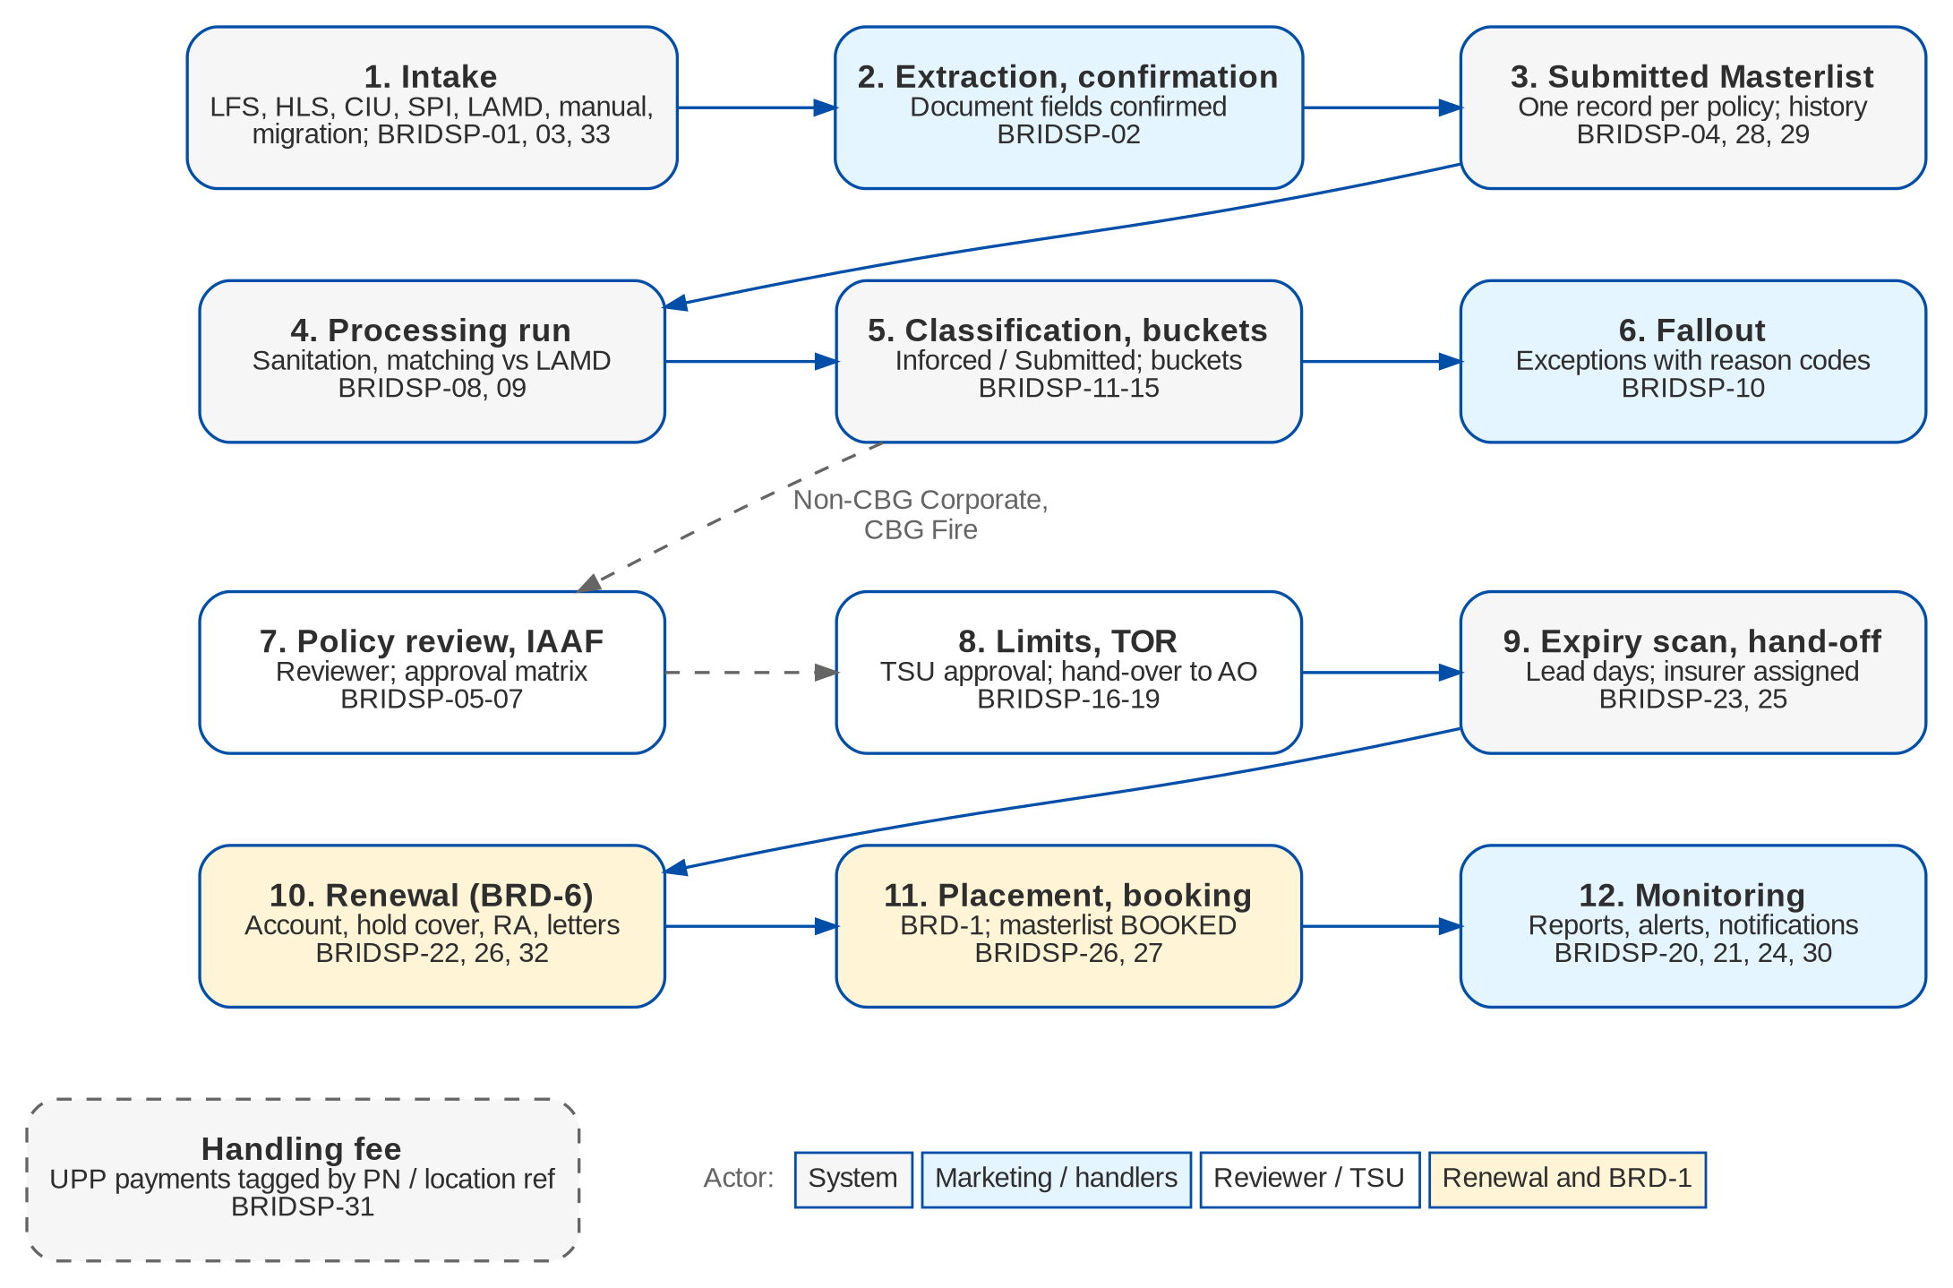
Figure 1: Submitted Policies process by actor (BRIDSP-01-33)

2.3 Segments and business types
Table 6: Segments (BRD p.2, 4-5)
Segment | New business intake | Renewal
CBG Motor | LFS and CIU reports; masterlist within 30 days of extraction | Match with LAMD; exclude FFY, BDO / SM Group employees and No Touch; insurer by vehicle type; hold cover; RA 90 days before expiry; NRNS list for call-out
CBG Fire | Home Loan AO sends the documents; adequacy review; IAAF to the Home Loan AO; HLS daily report | Match with LAMD; insurer different from the expiring one; hold cover; RA
Non-CBG Corporate and Branches | Policy Reviewer receives the documents from IBG / Leasing, reviews them and issues an IAAF | Same as new business; conversion opportunity monitored
Non-CBG Retail | Marketing AO encodes the policies of the LAMD report | AO asks an insurer to quote on the expiring terms; quotation, placement and booking; NRNS on decline

Each record carries its business type, New Business (NB) or Renewal Business (RB), as the BRD's process pages separate them (p.4-5).

3 Personas and roles

3.1 Personas
Table 7: Personas and BIBS roles
Persona (current process) | BIBS role | Responsibilities in Submitted Policies | BRD persona
Submitted Handler (CBG) | SBM_HANDLER | Uploads sources; confirms extractions; maintains records; prepares IAAF and TOR | System, Marketing User
Submitted Checker | SBM_CHECKER | Approves IAAFs (level 1) | System
Sanitation Handler | SBM_SANITATION | Uploads sources and LAMD; runs processing; resolves fallout; hand-off; sends letters | System, Marketing User
Team Lead | SBM_TL | All Submitted Policies functions except rule approval; assigns handlers | Marketing User
Policy Review Officer (Non-CBG Corporate) | SBM_POLICY_REVIEWER | Reviews policies; prepares IAAFs | Marketing User
Rule administrator | SBM_RULE_ADMIN | Maintains rule sets, limits, insurer and letter rules, matrices (maker) | Marketing User (BRIDSP-08)
Admin Team UPP handler | SBM_UPP_HANDLER | Handling-fee records and tagging results | System (BRIDSP-31)
Marketing AO / MAO | MKT_AO | Own records; manual entry; receives TORs; Renew with BDOI | Account Officer, Marketing User
NB Team Lead | MKT_TL | Views records; approves IAAFs (level 2) and rule sets | Marketing User
TSU | TSU | Approves TORs | System (TSU matrix)
Placement and Booking users | PROCESSOR and booking roles | Place and book the renewal accounts (BRD-1 screens) | Placement User, Booking User

The BRD does not give an access matrix; the roles above are the project's proposal until BDOI confirms them (SP SQ15, OQ48).

3.2 Permissions
Table 8: Submitted Policies permissions
Permission | Allows
SBM_VIEW | Masterlist, records, home page (within the user's scope)
SBM_MAINTAIN | Manual entry and edit, renewal tag, handler, remarks, document upload, confirm extraction
SBM_INTAKE | Source uploads, intake runs, LAMD snapshot upload
SBM_PROCESS | Processing runs, fallout resolution, manual disposition, renewal hand-off, insurer re-assignment
SBM_RULE_MAINTAIN, SBM_RULE_APPROVE | Rule sets, limit, insurer and letter rules, approval matrices (maker and checker)
IAAF_PREPARE, IAAF_APPROVE | Reviews and IAAF; IAAF approval levels
TOR_PREPARE, TOR_APPROVE | TOR; TSU approval levels
SBM_LETTER_SEND | Generate, send and print the letters of this module; print batches
SBM_HANDLING_FEE | Handling-fee records, tagger results, manual tag
SBM_MIGRATE | Migration upload
SBM_EXPORT | Masterlist extract
SBM_REPORT_VIEW, SBM_REPORT_EXPORT | Submitted Policies reports (view; export and archive)

3.3 Permissions matrix
Table 9: Role-to-permission matrix (proposal until SP SQ15 / OQ48)
Permission | SBM Hand. | SBM Check. | Sanit. | SBM TL | Pol. Rev. | Rule Admin | UPP | MKT AO | MKT TL | TSU
SBM_VIEW | Y | Y | Y | Y | Y |  | Y | Y (own) | Y
SBM_MAINTAIN | Y |  | Y | Y | Y |  |  | Y
SBM_INTAKE | Y |  | Y | Y
SBM_PROCESS |  |  | Y | Y
SBM_RULE_MAINTAIN |  |  |  | Y |  | Y
SBM_RULE_APPROVE |  |  |  |  |  |  |  |  | Y
IAAF_PREPARE | Y |  |  | Y | Y
IAAF_APPROVE |  | L1 |  | Y |  |  |  |  | L2
TOR_PREPARE | Y |  |  | Y |  |  |  | Y
TOR_APPROVE |  |  |  |  |  |  |  |  |  | Y
SBM_LETTER_SEND |  |  | Y | Y
SBM_HANDLING_FEE |  |  |  | Y |  |  | Y
SBM_MIGRATE |  |  |  | Y
SBM_EXPORT | Y |  | Y | Y
SBM_REPORT_VIEW | Y | Y | Y | Y | Y
SBM_REPORT_EXPORT | Y |  | Y | Y

"L1" and "L2" are IAAF approval levels of the demo matrix. Placement and Booking users also receive SBM_VIEW.
Data scope. Every query, report and export is limited to the user's scope: a list of segments, and for Marketing AOs only the records they handle or whose renewal account they own (BRIDSP-28).
Segregation of duties. A rule set is approved by someone other than its maker; an IAAF or TOR level is never approved by the preparer.

4 Functional requirements

4.1 Intake of submissions

FR-SP-001 Receive submitted policy details from the approved sources
BRD trace | BRIDSP-01 (p.8) | Actor | System; Submitted Handler, Sanitation Handler (SBM_INTAKE)
Priority | Must have | Fit | CHANGE
Screens | Upload & Intake (source uploads, intake runs) | API | Bulk handlers SBM_LFS_INSURANCE, SBM_HLS_INSURANCE, SBM_CIU, SBM_SPI, SBM_LOAN_BOOKING, SBM_LAMD, SBM_IA_MASTERLIST

Description
BIBS keeps a register of the approved sources (LFS insurance report, HLS daily insurance report, CIU report, SPI list, LAMD report, Loan Booking Report, IA masterlist, IBG / Leasing documents, manual entry, migration) with segment, format and upload template. Each source file is uploaded with its own template, validated row by row and recorded as an intake run.
Each valid row creates or updates one masterlist record on the natural key (segment, business type, PN or policy number, expiry date). New records get the number SBM-yyyy-nnnnnn and status RECEIVED. A file already uploaded (same content) is refused.
Transports from the bank systems are parked; the default is an upload.
Preconditions
• The user has SBM_INTAKE.
Main flow
1. The user opens Upload & Intake and chooses the source.
2. The user downloads the template if needed, and uploads the file.
3. BIBS validates the rows and shows valid and invalid counts.
4. The user confirms; BIBS creates or updates the records, records the run (SBI-yyyy-nnnnnn) and starts a processing run for them (FR-SP-021).
Alternate and exception flows
• Invalid rows. They are listed with the reason and can be downloaded; valid rows are committed.
• Duplicate file. BIBS refuses it and names the earlier run.
Business rules
Rule | Statement | Kind | Maintained in
R1 | One upload template per source layout; layouts to be supplied by BDOI (SP SQ01, SQ02). | Configurable | Source register and bulk templates
R2 | Natural key - segment, business type, PN or policy no., expiry date; a changed row writes the record history. | Fixed | -
R3 | A file is identified by its SHA-256; the same file cannot be loaded twice. | Fixed | -

Validations and messages
Check | Message shown | Code
File type not allowed | The file type is not allowed | BULK_FILE_TYPE
File without header row | The file has no header row | BULK_FILE_EMPTY
Same file loaded before | This file was already loaded in run <run no.> | To be assigned at build
Mandatory column blank | Row <n>: <column> is required | To be assigned at build

Screens and fields: Source upload
Field | Type | Mand. | Source / LOV | Validation
Source | List | Yes | Source register | Active source
File | Attachment | Yes | Template of the source | Excel or CSV; platform file rules

Notifications
• SBM_NEW_SUBMISSION to the handlers of the segment; SBM_INTAKE_FAILED alert on failure.
Audit
• Intake run with source, file name, hash, counts (received, created, updated, duplicate, failed), user and time.
Acceptance criteria
1. An LFS insurance report of 300 rows creates 300 CBG Motor records with status RECEIVED.
2. Loading the same file a second time is refused.
3. A row updating an existing policy changes the record and writes the history.

FR-SP-002 Extract policy details from documents and save them after confirmation
BRD trace | BRIDSP-02 (p.8) | Actor | System; Submitted Handler, Policy Reviewer (SBM_MAINTAIN)
Priority | Must have | Fit | CHANGE
Screens | Extraction Review (proposal side by side with the record) | API | POST /api/v1/submitted/extractions; POST .../{id}/confirm | reject

Description
The user uploads a policy document (policy copy, scanned or PDF) to a new or existing record. BIBS extracts the fields - assured, PN, policy number, insurer, period, sum insured, premium, vehicle or property details - and shows each proposed value with its confidence next to an editable field.
Nothing is saved to the masterlist before the user confirms. On Confirm the fields are written and the record becomes VALIDATED; on Reject the file is kept with a reason and the user enters the data by hand.
Preconditions
• The user has SBM_MAINTAIN.
Main flow
1. The user uploads the document on the record, or as a new record.
2. BIBS extracts the fields and opens Extraction Review.
3. The user checks and corrects the values and clicks Confirm.
Alternate and exception flows
• Scanned document without text. Extraction returns "not readable" (OCR is parked, SP SQ03); the user enters the fields by hand (FR-SP-003).
• Reject. The user rejects the proposal with a reason.
Business rules
Rule | Statement | Kind | Maintained in
R1 | Extraction never writes to the masterlist without confirmation. | Fixed | -
R2 | Extraction patterns per insurer are maintained as data. | Configurable | Extraction patterns (kind SUBMITTED_POLICY)

Validations and messages
Check | Message shown | Code
Confirm with a mandatory field blank | <Field> is required | -
Reject without reason | Enter the reason of the rejection | -

Screens and fields: Extraction Review
Field | Type | Mand. | Source / LOV | Validation
Assured / PN / Policy no. / Insurer | Text and list | Yes | Proposal and masters | -
Inception / Expiry | Date | Yes | Proposal | Expiry after inception
Sum insured / Premium | Amount | Yes | Proposal | >= 0
Risk details (unit, serial, motor no., plate / location, occupancy) | Text | Cond. | Proposal | By segment

Notifications
• SBM_MANUAL_VALIDATION to the handlers when a document waits for confirmation.
Audit
• Proposal, confirmation or rejection with user and time; the document is kept as an attachment.
Acceptance criteria
1. A text PDF of a motor policy produces a proposal; after confirmation the record shows the confirmed values and status VALIDATED.
2. Before confirmation the masterlist is unchanged.
3. A scanned document without text leads to manual entry.

FR-SP-003 Create or update a policy manually and tag its renewal opportunity
BRD trace | BRIDSP-03 (p.8) | Actor | Marketing user (Submitted Handler, Policy Reviewer, Marketing AO; SBM_MAINTAIN)
Priority | Must have | Fit | NEW
Screens | Masterlist (New Policy); Policy record (Edit, Tag Renewable / Non-Renewable) | API | POST /api/v1/submitted/policies; PUT .../{id}; POST .../{id}/renewal-tag

Description
A Marketing user creates a policy record by hand when data is incomplete or cannot be extracted, or updates an existing one. Mandatory fields depend on the segment.
The user tags a record Renewable or Non-Renewable with a reason. The tag is saved with user and time, shown as a flag chip on the record and available in filters and reports. A manual tag overrides the rule result; the processing run records the rule result but keeps the manual tag.
Preconditions
• The user has SBM_MAINTAIN.
Main flow
1. The user clicks New Policy (or Edit on a record) and enters the fields.
2. The user saves; the record is VALIDATED.
3. The user clicks Tag Renewable or Tag Non-Renewable, selects the reason and saves.
Business rules
Rule | Statement | Kind | Maintained in
R1 | Mandatory fields per segment are those of the MANUAL source. | Configurable | Source register
R2 | A manual tag overrides the rule tag until it is changed by hand. | Fixed | -
R3 | Who may override a rule-set tag is to be confirmed (SP SQ17). | Configurable | Permissions

Validations and messages
Check | Message shown | Code
Mandatory field blank | <Field> is required | -
Non-Renewable without reason | Select the reason for Non-Renewable | -
Same policy already in the masterlist | Policy <no.> is already in the masterlist (<SBM no.>) | To be assigned at build

Screens and fields: Policy record (main fields)
Field | Type | Mand. | Source / LOV | Validation
Segment | List | Yes | LOV SBM_SEGMENT | -
Business type | Option | Yes | NB, RB | -
PN no. / Loan application no. / CIF | Text | Cond. | - | PN required for CBG
Borrower / Assured / Mailing address / Contacts | Text | Yes | - | Assured required
Insurer / Policy no. | List / Text | Yes | Insurer master | -
Inception / Expiry | Date | Yes | - | Expiry after inception
Amount insured / Total premium | Amount | Yes | - | >= 0
Risk details | Text | Cond. | - | Unit and serial for Motor; location for Fire
Renewal tag | Option | No | Renewable, Non-Renewable | -
Reason | List | Cond. | LOV SBM_NON_RENEWAL_REASON | Required for Non-Renewable

Notifications
• None.
Audit
• Create, edit and tag with before and after values, user and time.
Acceptance criteria
1. A manually created Non-CBG Corporate policy is saved and appears in the masterlist.
2. A record tagged Non-Renewable shows the chip and appears in the Non-Renewal filter and report.
3. A later processing run does not change a manual tag.

FR-SP-004 Migrate the existing Excel masterlists
BRD trace | BRIDSP-33 (p.12) | Actor | System; Team Lead (SBM_MIGRATE)
Priority | Must have | Fit | CHANGE
Screens | Upload & Intake (Migration); Reports (SBM-MIGRATION-ERRORS) | API | Bulk handler SBM_MIGRATION

Description
The existing masterlists in Excel (NB Motor, RB Motor, Fire, Non-CBG) are read with a column mapping per legacy layout. Valid records are migrated completely, keep their original submission status (mapped to a BIBS status and bucket), submission date and reference ID, and are flagged Migrated. Invalid, incomplete or failed records are captured in an error log with reason codes.
The migration can be run again; it is idempotent on the legacy reference.
Preconditions
• The user has SBM_MIGRATE; the status map is set up.
Main flow
1. The user uploads a legacy file and chooses its layout.
2. BIBS validates, maps the statuses and shows the result.
3. The user confirms; BIBS creates the records and writes the errors to the log.
Business rules
Rule | Statement | Kind | Maintained in
R1 | Legacy status to BIBS status and bucket through the status map. | Configurable | Status map
R2 | Migrated records keep legacy reference and date received; flag Migrated. | Fixed | -

Validations and messages
Check | Message shown | Code
Status not in the map | Row <n>: status <value> has no mapping | To be assigned at build
Mandatory column blank | Row <n>: <column> is required | To be assigned at build

Screens and fields: Migration upload
Field | Type | Mand. | Source / LOV | Validation
Layout | List | Yes | NB Motor, RB Motor, Fire, Non-CBG | -
File | Attachment | Yes | - | .xlsx

Notifications
• None.
Audit
• Migration job with counts; error log rows with reason codes (report SBM-MIGRATION-ERRORS).
Acceptance criteria
1. A legacy file with 1,000 rows and 12 invalid rows migrates 988 records flagged Migrated and logs 12 errors with reason codes.
2. A migrated record shows its original date received and legacy reference.
3. Running the same file again creates no duplicates.

4.2 Masterlist and access

FR-SP-010 Keep one Submitted Masterlist
BRD trace | BRIDSP-04 (p.9) | Actor | System; all Submitted Policies users
Priority | Must have | Fit | NEW
Screens | Masterlist (tabs All, For Validation, Classified, For Renewal, Manual Disposition, Non-Renewal, Fallout); Policy record | API | GET /api/v1/submitted/policies; GET .../{id}

Description
All submitted policy details are held in one masterlist, one record per submitted or inforced policy, segment and business type - with loan data, risk details, insurer and policy, classification, bucket, renewal tag, handler, conversion status and the linked renewal ARN and booked invoice. When a record is saved or updated, the masterlist shows the latest data.
The Policy record page has the summary card with flag chips (Renewable, FFY, No Touch, Migrated, Insurer approval) and the tabs Details, Loan & Matching, Rule Results, Review & IAAF, TOR, Renewal, Letters, Documents and History.
Preconditions
• The user has SBM_VIEW.
Main flow
1. The user opens the Masterlist, chooses a tab and filters by segment, business type, bucket, expiry month, insurer, handler, conversion status or Migrated.
2. The user opens a record.
Business rules
Rule | Statement | Kind | Maintained in
R1 | Every change writes the record history and the audit trail. | Fixed | -

Notifications
• None.
Audit
• Record history per field with source (intake, extraction, manual, run, renewal, booking).
Acceptance criteria
1. After a record is updated by an upload, the masterlist shows the new values at once.
2. Filters by segment and expiry month return only the matching records.

FR-SP-011 View and extract the masterlist by role
BRD trace | BRIDSP-28 (p.12) | Actor | User (SBM_VIEW, SBM_EXPORT)
Priority | Must have | Fit | CHANGE
Screens | Masterlist (Export); Reports (SBM-MASTERLIST) | API | GET /api/v1/reports/SBM-MASTERLIST/export?format=

Description
Viewing and downloading the masterlist follow role-based access. Viewing needs SBM_VIEW and extracting needs SBM_EXPORT. Every record, list, report and extract is limited to the user's scope - the segments of the user, and for Marketing AOs only their own records.
The extract is the report SBM-MASTERLIST with the fields of Report List row 151 per segment, including migrated records, in XLSX, CSV or PDF, archived.
Preconditions
• The user has SBM_VIEW.
Main flow
1. The user filters the masterlist and clicks Export.
2. BIBS produces the extract within the user's scope and archives it.
Alternate and exception flows
• User without SBM_EXPORT. The Export button is not shown; a direct call is refused.
Business rules
Rule | Statement | Kind | Maintained in
R1 | Scope by segment; own records only for AOs (user scope table). | Configurable | User scope (Setup)

Validations and messages
Check | Message shown | Code
Export without permission | You are not permitted to perform this action | ACCESS_DENIED

Notifications
• None.
Audit
• Every view of a record and every extract with user and time.
Acceptance criteria
1. A CBG Motor handler does not see CBG Fire records.
2. An AO sees only his records.
3. A user without SBM_EXPORT cannot extract the masterlist.

FR-SP-012 Monitor handler, conversion status and remarks
BRD trace | BRIDSP-29 (p.12) | Actor | Marketing user (SBM_MAINTAIN)
Priority | Must have | Fit | NEW
Screens | Masterlist (Assign Handler; quick filter Changed since); Policy record (History) | API | PUT /api/v1/submitted/policies/{id} (handler, conversion status, remarks)

Description
The user updates the handler, the conversion status and the remarks of a record, one by one or in bulk (Assign Handler). The masterlist shows the latest values; the History tab shows every change per field; a "Changed since" quick filter lists the records changed after a date.
Preconditions
• The user has SBM_MAINTAIN.
Main flow
1. The user edits the handler, conversion status or remarks and saves.
2. BIBS records the change and shows it in the list.
Business rules
Rule | Statement | Kind | Maintained in
R1 | Conversion statuses in LOV SBM_CONVERSION_STATUS (Renewed, Unrenewed, Process Placement per group; RL #163). | Configurable | LOV SBM_CONVERSION_STATUS

Validations and messages
Check | Message shown | Code
Handler not an active user | <user> is not an active user | To be assigned at build

Screens and fields: Policy record (tracking)
Field | Type | Mand. | Source / LOV | Validation
Handler | Look-up | No | Users with SBM_MAINTAIN | Active user
Conversion status | List | No | LOV SBM_CONVERSION_STATUS | -
Remarks | Text | No | - | -

Notifications
• The new handler is notified.
Audit
• Field change log with old and new value, user and time.
Acceptance criteria
1. A handler change shows at once in the masterlist and in the record history.
2. The quick filter Changed since yesterday lists the records updated today.

4.3 Rules and processing

FR-SP-020 Define sanitation, matching, classification and disposition criteria
BRD trace | BRIDSP-08 (p.9) | Actor | Marketing user as rule administrator (SBM_RULE_MAINTAIN); approver (SBM_RULE_APPROVE)
Priority | Must have | Fit | NEW
Screens | Submitted Policies Setup (Rule Sets) | API | /api/v1/submitted/setup/rule-sets

Description
The criteria of each processing step are rule sets - per step (Sanitation, Matching, Classification, Disposition), segment and business type - with versions and effective dates. A rule has a priority, conditions (field, operator, value), an outcome (bucket, tag, classification, RA template, flag), a reason code and a stop flag.
A new or changed rule set is approved by someone other than its maker before it applies. Every run result stores the rule id and rule-set version, so the rules are applied consistently and explained.
The seeds are the BRD lists (section 9.2); rules whose meaning is disputed are seeded inactive until SP SQ05 is answered.
Preconditions
• The user has SBM_RULE_MAINTAIN.
Main flow
1. The user creates a draft version of a rule set and edits its rules.
2. The user submits it; an approver compares it with the active version and approves it with an effective date.
Alternate and exception flows
• The approver rejects the version with a reason; it stays a draft.
• Rules can be imported from a file (upload SBM_RULES).
Business rules
Rule | Statement | Kind | Maintained in
R1 | The first matching rule with stop = true ends the step; a record with no matching rule is fallout (reason SBM_NO_RULE). | Fixed | -
R2 | Maker-checker on every rule set. | Fixed | -

Validations and messages
Check | Message shown | Code
Approval by the maker | A rule set is approved by someone other than its maker | To be assigned at build
Rule without outcome | Select the outcome of the rule | -
Condition on an unknown field | Field <name> cannot be used in a rule | To be assigned at build

Screens and fields: Rule
Field | Type | Mand. | Source / LOV | Validation
Priority | Number | Yes | - | Unique in the version
Conditions | Table | Yes | Field / operator / value | At least one
Outcome | Composite | Yes | Bucket (LOV SBM_BUCKET), tag, classification, RA template, flag | -
Reason code | List | No | LOV SBM_REASON | -
Stop | Check box | No | - | -

Notifications
• Approvers see pending rule sets in My Approvals.
Audit
• Versions with maker, approver, dates and differences.
Acceptance criteria
1. A new exclusion rule for SM Group employee accounts applies to the next run only after the approver approves it.
2. Each run result shows the rule and version that produced it.

FR-SP-021 Run processing automatically after intake
BRD trace | BRIDSP-09 (p.9) | Actor | System (SbmProcessingService, job SBM_PROCESSING); Sanitation Handler (SBM_PROCESS)
Priority | Must have | Fit | NEW
Screens | Processing Runs (list, run detail); Masterlist (Run Processing) | API | POST /api/v1/submitted/runs; job SBM_PROCESSING

Description
When documents or files are uploaded and confirmed, BIBS runs the processing steps in order - sanitation, matching against LAMD, classification, disposition and limits - and triggers the workflow of each record by its result (renewal hand-off, manual disposition queue, non-renewal, policy review, TOR). Account tagging is applied as the criteria define.
A run also starts from the daily job at 21:30 PHT and on demand. Each run (SBR-yyyy-nnnnnn) records one result per record and step.
Preconditions
• Active rule sets exist for the steps.
Main flow
1. An intake commit, the job or a user starts the run for a scope.
2. BIBS runs the steps set-based and writes the results.
3. BIBS moves each record in SBM_POLICY and notifies the owners of the new bucket.
Business rules
Rule | Statement | Kind | Maintained in
R1 | Step order - SANITATION, MATCHING, CLASSIFICATION, DISPOSITION, LIMITS. | Fixed | -
R2 | Sanitation marks duplicates (same PN or same serial / motor number) For Review and incomplete records as fallout. | Configurable | Sanitation rule set
R3 | Matching checks PN against the LAMD snapshot and PN against serial / motor number and assured name / address / contacts (RL #151). | Configurable | Matching rule set
R4 | Job time 21:30 PHT. | Configurable | Job schedule

Notifications
• SBM_BUCKET_CHANGED to the handlers; SBM_FALLOUT alert when the run has fallout.
Audit
• Run with trigger, scope, counts per outcome and job run; result rows per record and step.
Acceptance criteria
1. Uploading an LFS file starts a run; each new record ends with a classification and a bucket or fallout.
2. A record matched to an active LAMD loan is moved to the right bucket and the handlers are notified.

FR-SP-022 Report fallout after processing
BRD trace | BRIDSP-10 (p.9) | Actor | System; Sanitation Handler
Priority | Must have | Fit | CHANGE
Screens | Processing Runs (Fallout tab); Masterlist (Fallout tab); Reports (SBM-DOC-FALLOUT, SBM-PROCESS-FALLOUT) | API | Reports SBM-DOC-FALLOUT, SBM-PROCESS-FALLOUT

Description
When document processing or a run ends with errors or exceptions, BIBS produces the fallout - intake and extraction failures (SBM-DOC-FALLOUT) and the records that no rule could place or that failed a step (SBM-PROCESS-FALLOUT), each with its reason code. The fallout of each run is archived and the handler resolves it on the record (correct and re-run, dispose by hand, or exclude).
Preconditions
• A run or intake has ended.
Main flow
1. The run ends; BIBS writes the fallout rows and raises SBM_FALLOUT when the count is above zero.
2. The handler opens the Fallout tab, corrects the records and re-runs them.
Business rules
Rule | Statement | Kind | Maintained in
R1 | Every fallout row has a reason code (LOV SBM_REASON). | Fixed | -

Notifications
• SBM_FALLOUT to the Sanitation Handlers.
Audit
• Fallout rows per run; resolution on the record history.
Acceptance criteria
1. A run with five records without PN produces a fallout report listing the five with their reason code.
2. A corrected record leaves the fallout after the next run.

4.4 Classification and buckets

FR-SP-030 Classify policies as Inforced or Submitted
BRD trace | BRIDSP-11 (p.9) | Actor | System
Priority | Must have | Fit | NEW
Screens | Policy record (Loan & Matching, Rule Results); Reports (SBM-CLASSIFICATION) | API | Classification step

Description
When the policy details are evaluated, the classification step sets the record Submitted when its PN matches an active LAMD loan and BDOI did not place the policy, and Inforced otherwise, so the right renewal and disposition rules apply. The definition is rule data and is to be confirmed (SP SQ04).
Preconditions
• The matching step has run.
Main flow
1. BIBS evaluates the classification rules on the matching result and stores the classification.
Business rules
Rule | Statement | Kind | Maintained in
R1 | Default - PN matched to an active LAMD loan gives SUBMITTED; unmatched gives INFORCED. | Configurable | Classification rule set (SP SQ04)

Notifications
• None.
Audit
• Result row with rule and version.
Acceptance criteria
1. A record whose PN matches an active LAMD loan is Submitted; a record whose PN is not in LAMD is Inforced.

FR-SP-031 Group Submitted policies into qualification buckets
BRD trace | BRIDSP-12 (p.9) | Actor | System
Priority | Must have | Fit | NEW
Screens | Masterlist (bucket tabs and filter); Policy record | API | Disposition step

Description
Submitted policies (PN matched against LAMD) are grouped into For Renewal, For Manual Disposition, Non-Renewal, No Touch, FFY, BDO / SM Group Employee Accounts or RMU. Entering a bucket triggers the next workflow - renewal hand-off at the lead days, the manual disposition queue, or exclusion with a fallout entry.
Preconditions
• The record is classified Submitted.
Main flow
1. BIBS evaluates the disposition rules and stores the bucket, the renewal tag and the reason.
2. BIBS moves the record to FOR_RENEWAL, FOR_MANUAL_DISPOSITION or EXCLUDED.
Alternate and exception flows
• Manual disposition. A Sanitation Handler disposes the record by hand with a reason (For Renewal or Exclude).
Business rules
Rule | Statement | Kind | Maintained in
R1 | Buckets are a list with the attribute renewal_action (RENEW, MANUAL, EXCLUDE). | Configurable | LOV SBM_BUCKET
R2 | Bucket precedence and the RMU / FFY conflicts are open (SP SQ05); the conflicting rules are seeded inactive. | Configurable | Disposition rule set

Validations and messages
Check | Message shown | Code
Manual disposition without reason | Select a reason for 'Dispose' | WORKFLOW_REASON_REQUIRED

Notifications
• SBM_BUCKET_CHANGED to the handlers of the segment.
Audit
• Bucket with rule and version; manual dispositions with user and reason.
Acceptance criteria
1. A Submitted CBG Motor policy of an active loan with no exclusion goes to For Renewal.
2. A policy on the employee list goes to BDO / SM Group Employee Accounts and is not handed to renewal.

FR-SP-032 Choose the RA template from the LAMD loan
BRD trace | BRIDSP-13 (p.10) | Actor | System
Priority | Must have | Fit | NEW
Screens | Upload & Intake (LAMD snapshot); Policy record (Loan & Matching) | API | Bulk handler SBM_LAMD; disposition step

Description
The LAMD snapshot holds per PN the loan status, the amortised flag and the maturity date. For an active loan that is not amortised, the disposition rules mark the record ready for the Generic RA or the FFY RA template, and the next workflow is triggered. The chosen template travels with the renewal hand-off; the RA itself is generated by the Renewal module.
Preconditions
• A LAMD snapshot is loaded.
Main flow
1. The Sanitation Handler uploads the LAMD snapshot.
2. The run reads the loan and sets the RA template on the record.
Business rules
Rule | Statement | Kind | Maintained in
R1 | Rule for Generic vs FFY RA to be confirmed (SP SQ06). | Configurable | Disposition rule set

Validations and messages
Check | Message shown | Code
Snapshot row without PN | Row <n>: PN is required | To be assigned at build

Notifications
• None.
Audit
• Snapshot upload and the template decision per record.
Acceptance criteria
1. An FFY account with an active non-amortised loan gets the FFY RA template.

FR-SP-033 Assign policies to non-renewal buckets
BRD trace | BRIDSP-14 (p.10) | Actor | System
Priority | Must have | Fit | NEW
Screens | Masterlist (Non-Renewal tab); Reports (SBM-NON-RENEWAL) | API | Disposition step; report SBM-NON-RENEWAL

Description
Policies that meet the non-renewal criteria (Free First Year, SM Group Employee, No Touch, CARI, Bonds, RMU and the other exclusions of Report List row 156) are tagged Non-Renewal, excluded from renewal and recorded in the non-renewal report with the exclusion reason. A manual tag can override the result (FR-SP-003).
Preconditions
• The disposition step runs.
Main flow
1. BIBS applies the non-renewal rules and stores the tag and reason.
2. The record moves to EXCLUDED and appears in SBM-NON-RENEWAL.
Alternate and exception flows
• Reinstate. A handler reinstates an excluded record with a reason; it is classified again at the next run.
Business rules
Rule | Statement | Kind | Maintained in
R1 | Exclusion reasons in LOV SBM_NON_RENEWAL_REASON. | Configurable | LOV SBM_NON_RENEWAL_REASON

Validations and messages
Check | Message shown | Code
Reinstate without reason | Select a reason for 'Reinstate' | WORKFLOW_REASON_REQUIRED

Notifications
• SBM_BUCKET_CHANGED.
Audit
• Tag and reason with rule and version.
Acceptance criteria
1. A No Touch account is tagged Non-Renewal and listed in the non-renewal report with reason No Touch.
2. An excluded record is never handed to renewal.

FR-SP-034 Group Inforced policies and create RAs and proposals
BRD trace | BRIDSP-15 (p.10) | Actor | System
Priority | Must have | Fit | NEW
Screens | Masterlist; Policy record (Renewal tab) | API | Disposition step; RenewalHandOff

Description
Inforced policies (PN not matched to LAMD) are grouped into Fully Paid Loan, OPM, BDOFC or Sold. For an eligible inforced policy, the RA and the renewal proposal are generated - by the Renewal module after the hand-off (decision D2), with the RA template of its bucket and the proposal template SBM_RENEWAL_PROPOSAL.
Preconditions
• The record is classified Inforced.
Main flow
1. BIBS evaluates the inforced bucket rules and stores the bucket.
2. For an eligible bucket, the record becomes For Renewal and is handed over at the lead days (FR-SP-060).
Business rules
Rule | Statement | Kind | Maintained in
R1 | Inforced buckets Fully Paid Loan, OPM, BDOFC, Sold; eligibility per bucket (SP SQ05). | Configurable | Disposition rule set

Notifications
• SBM_BUCKET_CHANGED.
Audit
• Bucket and eligibility with rule and version.
Acceptance criteria
1. An inforced Fully Paid Loan policy marked eligible reaches For Renewal and, after hand-off, has an RA and a proposal.

4.5 Policy review and IAAF

FR-SP-040 Record policy reviews and generate one IAAF per policy
BRD trace | BRIDSP-05 (p.9), BRIDSP-06 (p.9) | Actor | Marketing user (Policy Reviewer, Submitted Handler; IAAF_PREPARE)
Priority | Must have | Fit | NEW
Screens | Policy Reviews / IAAF (review queue, IAAF page); Policy record (Review & IAAF tab) | API | POST /api/v1/submitted/policies/{id}/reviews; POST .../iaaf

Description
Non-CBG Corporate and Branch records and CBG Fire records with documents enter the review queue. The reviewer records each review - review number, date, adequacy (Adequate or With findings), findings and remarks. With findings, the reviewer e-mails the bank counterpart from the record and a new review follows. The IAAF shows the review history and the review count.
When the policy is adequate, the reviewer generates the IAAF (IAAF-yyyy-nnnnnn). Only one IAAF exists per policy; it can be linked to related policies (for example the previous term or the same borrower) by their reference numbers.
Preconditions
• The record is IN_REVIEW; the user has IAAF_PREPARE.
Main flow
1. The reviewer opens the record from the review queue and records the review.
2. When adequate, the reviewer clicks Generate IAAF and links related policies.
3. The reviewer submits the IAAF for approval (FR-SP-041).
Alternate and exception flows
• With findings. The reviewer sends the findings to the bank counterpart; the record stays IN_REVIEW.
Business rules
Rule | Statement | Kind | Maintained in
R1 | One IAAF per policy; the BRD's current-process note that one IAAF may cover several policies is handled with links (SP SQ07). | Fixed | -
R2 | Template SBM_IAAF; draft until BDOI provides the layout. | Configurable | Document templates

Validations and messages
Check | Message shown | Code
Second IAAF for the policy | Policy <SBM no.> already has IAAF <no.> | To be assigned at build
Adequacy not selected | Select the adequacy | -
IAAF with findings open | The last review has findings; record an adequate review first | To be assigned at build

Screens and fields: Review
Field | Type | Mand. | Source / LOV | Validation
Review date | Date | Yes | - | Not in the future
Adequacy | Option | Yes | Adequate, With findings | -
Findings | Multi-select | Cond. | LOV SBM_IAAF_FINDING | Required for With findings
Remarks | Text | No | - | -
Related policies | Look-up | No | Masterlist | By SBM number

Notifications
• The bank counterpart receives the findings by e-mail from the record.
Audit
• Each review and the IAAF generation with user and time.
Acceptance criteria
1. A policy reviewed twice shows two reviews and a review count of 2 on its IAAF.
2. A second IAAF for the same policy is refused.
3. An IAAF linked to the previous term's record shows the link.

FR-SP-041 Route the IAAF for approval and signature
BRD trace | BRIDSP-07 (p.9) | Actor | System; approvers (IAAF_APPROVE)
Priority | Must have | Fit | CHANGE
Screens | My Approvals; IAAF page (approvals); Submitted Policies Setup (Approval Matrix) | API | Workflow SBM_IAAF; POST /api/v1/submitted/iaaf/{id}/approve | return

Description
The IAAF Approval Matrix gives, for the document IAAF, the segment and the sum-insured band, the approval levels and the permission or named signatory of each level. When the IAAF is submitted, BIBS routes it to the first level; each approval moves it to the next level until the last one.
At the last approval BIBS stamps the signatures (name, position, time and hash of each approver), renders the PDF and sets the IAAF APPROVED. Send to bank counterpart e-mails it and sets ISSUED. The record then either waits for expiry as a conversion opportunity or receives a reminder letter (p.7).
Preconditions
• The IAAF is FOR_APPROVAL; the user holds the permission of the current level and did not prepare the IAAF.
Main flow
1. The approver opens the IAAF from My Approvals and reviews it.
2. The approver clicks Approve; BIBS moves it to the next level or to APPROVED.
3. The reviewer sends the approved IAAF to the bank counterpart.
Alternate and exception flows
• Return. The approver returns the IAAF with a reason; it goes back to the reviewer.
Business rules
Rule | Statement | Kind | Maintained in
R1 | Levels, criteria and signatories of the matrix are to be supplied by BDOI (SP SQ07). | Configurable | Approval matrix (document IAAF)
R2 | The preparer never approves a level. | Fixed | -
R3 | The signature is a stamped signature until a qualified e-signature is connected. | Fixed | -

Validations and messages
Check | Message shown | Code
Approver is the preparer | An IAAF is approved by someone other than its preparer | To be assigned at build
Return without reason | Select a reason for 'Return' | WORKFLOW_REASON_REQUIRED
No matrix row for the IAAF | No approval level is defined for segment <segment> and sum insured <amount> | To be assigned at build

Notifications
• SBM_IAAF_PENDING to the approvers of each level; alert SBM_IAAF_SLA past the review SLA.
Audit
• Each level with approver, time, decision and signature hash.
Acceptance criteria
1. An IAAF of a Non-CBG Corporate policy goes to level 1 and, after approval, to level 2.
2. The preparer cannot approve it.
3. The issued IAAF PDF shows the stamped name, position and time of every approver.

4.6 Limits and TOR

FR-SP-050 Detect accounts exceeding acceptance or coverage limits
BRD trace | BRIDSP-16 (p.10) | Actor | System
Priority | Must have | Fit | CHANGE
Screens | Policy record (Rule Results, flag Insurer approval); Submitted Policies Setup (Limit Rules) | API | Limits step

Description
The limits step compares each record with the limit rules - per insurer and line or product, the maximum sum insured, the maximum vehicle age and other attribute limits - and with the package limit of the catalogue. A breach flags the record "Insurer approval required", records the breached limit and creates a TOR task for the handling Marketing user.
Preconditions
• Active limit rules exist.
Main flow
1. The run evaluates the limits and stores each check.
2. On a breach BIBS sets the flag and creates the TOR task.
Business rules
Rule | Statement | Kind | Maintained in
R1 | Limit rules per insurer and product until Product Maintenance takes them over (SP SQ08). | Configurable | Limit rules (Setup)

Notifications
• The handling Marketing user receives the TOR task.
Audit
• Limit check rows (rule, attribute, limit, value, breached).
Acceptance criteria
1. A motor policy whose vehicle is older than the insurer's maximum age is flagged Insurer approval required with the limit and value.

FR-SP-051 Generate the Terms of Reference
BRD trace | BRIDSP-17 (p.10) | Actor | Marketing user (TOR_PREPARE)
Priority | Must have | Fit | NEW
Screens | TOR (list, TOR page); Policy record (TOR tab) | API | POST /api/v1/submitted/tors

Description
For an account that exceeds the limits, the Marketing user generates a TOR (TOR-yyyy-nnnnnn) from template SBM_TOR. It lists the breached limits and the proposed terms. The TOR is created for the account (masterlist record or renewal ARN).
Preconditions
• The record carries the flag Insurer approval required; the user has TOR_PREPARE.
Main flow
1. The user opens the TOR task and clicks Generate TOR.
2. The user completes the proposed terms and saves the draft.
3. The user submits it (FR-SP-052).
Business rules
Rule | Statement | Kind | Maintained in
R1 | Template SBM_TOR; draft until BDOI provides the layout (SP SQ08). | Configurable | Document templates

Validations and messages
Check | Message shown | Code
Proposed terms blank | Enter the proposed terms | -
No breach on the account | Policy <SBM no.> exceeds no limit | To be assigned at build

Screens and fields: TOR
Field | Type | Mand. | Source / LOV | Validation
Breaches | Display | - | Limit checks | -
Proposed terms | Long text | Yes | - | -
Account Officer | Look-up | Yes | Sales officers | Active officer

Notifications
• None until submission.
Audit
• TOR creation and edits.
Acceptance criteria
1. A TOR generated for a flagged record lists its breached limits.

FR-SP-052 Route the TOR for approval per the TSU Approval Matrix
BRD trace | BRIDSP-18 (p.10) | Actor | System; TSU (TOR_APPROVE)
Priority | Must have | Fit | CHANGE
Screens | My Approvals; TOR page; Submitted Policies Setup (Approval Matrix) | API | Workflow SBM_TOR

Description
The submitted TOR is routed by the TSU Approval Matrix (document TOR, segment and sum-insured band) to the approvers of each level for signature. The last approval attaches the signed PDF and sets APPROVED.
Preconditions
• The TOR is FOR_APPROVAL.
Main flow
1. The TSU approver opens the TOR in My Approvals and approves it.
2. BIBS moves it to the next level or to APPROVED with the signed PDF.
Alternate and exception flows
• Return with a reason to the preparer.
Business rules
Rule | Statement | Kind | Maintained in
R1 | TSU matrix levels and signatories to be supplied by BDOI (SP SQ08). | Configurable | Approval matrix (document TOR)
R2 | The preparer never approves a level. | Fixed | -

Validations and messages
Check | Message shown | Code
Approver is the preparer | A TOR is approved by someone other than its preparer | To be assigned at build
Return without reason | Select a reason for 'Return' | WORKFLOW_REASON_REQUIRED

Notifications
• SBM_TOR_PENDING to the approvers; alert SBM_TOR_SLA.
Audit
• Each level with approver, time, decision and signature hash.
Acceptance criteria
1. A TOR reaches the TSU approver of its level and, after the last approval, carries the signed PDF.

FR-SP-053 Hand the approved TOR over to the Account Officer
BRD trace | BRIDSP-19 (p.10) | Actor | Account Officer
Priority | Must have | Fit | CHANGE
Screens | Notifications; TOR page (Download) | API | GET /api/v1/submitted/tors/{id}.pdf

Description
When the TOR is approved, BIBS stores the signed PDF as an attachment of type TOR and notifies the assigned AO, who views or downloads it to proceed with the renewal and the insurer. The TOR becomes RELEASED when the AO opens or downloads it.
Preconditions
• The TOR is APPROVED.
Main flow
1. The AO opens the notification and the TOR.
2. The AO downloads the PDF; BIBS sets RELEASED.
Business rules
Rule | Statement | Kind | Maintained in
R1 | Meaning of Released to be confirmed (SP SQ08); default is the AO's first opening. | Fixed | -

Notifications
• SBM_TOR_RELEASED to the assigned AO.
Audit
• Opening and download with user and time.
Acceptance criteria
1. The assigned AO is notified of the approved TOR and can download it; the TOR then shows Released.

4.7 Renewal hand-off

FR-SP-060 Detect expiring policies and hand them to Renewal
BRD trace | BRIDSP-23 (p.11) | Actor | System (job SBM_EXPIRY_SCAN); Marketing AO (Renew with BDOI)
Priority | Must have | Fit | NEW
Screens | Renewal Work List (For Renewal, Hand-off Pending); Masterlist (Renew with BDOI) | API | Job SBM_EXPIRY_SCAN; port RenewalHandOff

Description
Every day the expiry scan selects For Renewal records whose expiry falls within the lead days of their segment (for example CBG Fire 150 days, CBG Motor 120 days), assigns the insurer with the insurer rules (by vehicle type for CBG Motor; different from the expiring insurer for CBG Fire), and hands each record to the Renewal module through the port RenewalHandOff with the policy and risk data, the RA template and the assigned insurer. The record moves to RENEWAL_IN_PROGRESS.
From the hand-off on, the Renewal module owns the renewal - renewal account, 30-day hold cover request and letters (decision D2; FRS BRD-6 FR-RN-090). For Non-CBG Retail, the AO starts the renewal by hand with Renew with BDOI, which calls the same port.
Preconditions
• The record is FOR_RENEWAL.
Main flow
1. The job runs at 22:00 PHT and selects the records.
2. BIBS assigns the insurer and calls the port; it records the hand-off (renewal reference returned by Renewal).
Alternate and exception flows
• Renewal module not yet deployed. The default adapter records the hand-off as PENDING and lists it on the Renewal Work List; it creates no account and sends no letter. The hand-offs are replayed when the Renewal adapter is deployed.
• No insurer rule applies. The record stays For Renewal and appears in the fallout with reason no insurer.
Business rules
Rule | Statement | Kind | Maintained in
R1 | Lead days per segment - CBG Fire 150, CBG Motor 120 (defaults). | Configurable | Parameter SBM_RENEWAL_LEAD_DAYS
R2 | Insurer rules by segment, vehicle type or occupancy; exclude the expiring insurer where set. | Configurable | Insurer rules (SP SQ11)
R3 | One hand-off per record and term; the port is idempotent on the SBM number. | Fixed | -

Validations and messages
Check | Message shown | Code
Renew with BDOI on a record not For Renewal | Policy <SBM no.> is not For Renewal | To be assigned at build

Notifications
• SBM_EXPIRY_NEAR and SBM_RENEWAL_STARTED to the handler and AO.
Audit
• Hand-off with insurer assigned, renewal reference and time.
Acceptance criteria
1. A For Renewal CBG Fire record 150 days before expiry is handed over with an insurer different from the expiring one.
2. A second scan does not hand the same record over again.
3. Before the Renewal adapter exists, the hand-off shows as pending and no letter is sent.

FR-SP-061 List the policies subject for renewal
BRD trace | BRIDSP-25 (p.11) | Actor | Marketing user
Priority | Must have | Fit | NEW
Screens | Renewal Work List (tabs For Renewal, Hand-off Pending, Hold Cover Pending, Insurer Not Accepted, Converted, Not Renewed); Reports (SBM-RENEWABLE) | API | GET /api/v1/submitted/renewals; report SBM-RENEWABLE

Description
When the renewal cycle starts, the Marketing user sees the complete list of renewable policies, by expiry month, bucket, AO and insurer, for call-out and placement. The user assigns or re-assigns the AO in bulk, exports the list (SBM-RENEWABLE) and opens the Renewal record of a handed-over policy for its letters and progress.
Preconditions
• The user has SBM_VIEW.
Main flow
1. The user opens the Renewal Work List and filters by expiry month.
2. The user assigns AOs and exports the list.
Business rules
Rule | Statement | Kind | Maintained in
R1 | The list shows every record For Renewal or in progress within the user's scope. | Fixed | -

Notifications
• The assigned AO is notified.
Audit
• Assignments with user and time.
Acceptance criteria
1. The For Renewal tab for March lists every renewable record expiring in March in the user's scope.
2. The export has the same rows as the screen.

FR-SP-062 Send letters and proposals when the criteria are met
BRD trace | BRIDSP-22 (p.11) | Actor | System (job SBM_LETTER_DISPATCH; Renewal letter engine)
Priority | Must have | Fit | CHANGE
Screens | Letters & Print Batches; Policy record (Letters tab) | API | Job SBM_LETTER_DISPATCH; letter rules

Description
When policy evaluation meets the sending criteria of a letter rule (letter type, segment, bucket, days relative to expiry, channel), the letter is generated and sent automatically, by e-mail, through the bank counterpart, or printed in a batch for the mail house (COG).
Renewal letters of handed-over policies - RA (generic or FFY), NRNS, NAL, SFU and renewal reminders - are generated by the Renewal module's letter engine, one RA per client (decision D2); the RA is sent 90 days before expiry. Submitted Policies sends the letters that are not renewal letters, namely the policy-review reminder to the client c/o the bank counterpart, and the renewal notice and renewal proposal until their owner is confirmed (XQ03). Printed renewal letters use this module's mail-house port.
Preconditions
• Active letter rules exist.
Main flow
1. The daily job (06:30 PHT) finds the records that meet a rule.
2. BIBS generates the letters from their templates and sends them by the rule's channel.
3. For the print channel BIBS builds a merged PDF batch with a control list for COG.
Alternate and exception flows
• Delivery failure. The letter is FAILED; alert SBM_LETTER_FAILED; the user resends it.
Business rules
Rule | Statement | Kind | Maintained in
R1 | Letter rules - type, segment, bucket, days relative to expiry, channel, template. | Configurable | Letter rules (Setup)
R2 | RA, NRNS, NAL, SFU and renewal reminders are not letters of this module (decision D2). | Fixed | -
R3 | Templates SBM_REMINDER, SBM_RENEWAL_NOTICE, SBM_RENEWAL_PROPOSAL; drafts until BDOI provides the layouts (SP SQ09). | Configurable | Document templates

Validations and messages
Check | Message shown | Code
Client without e-mail for an e-mail rule | Client <name> has no e-mail address | To be assigned at build

Notifications
• The letter to the client or bank counterpart.
Audit
• Each letter with number SBL-yyyy-nnnnnn, channel, status, template version; print batches with count and hand-over date.
Acceptance criteria
1. A reviewed policy with a renewal opportunity gets the reminder letter by the rule's channel and date.
2. A print batch contains one PDF with all letters of the day and a control list.
3. No RA is produced by this module; the RA of a handed-over policy appears on its Renewal record.

FR-SP-063 Re-assign the insurer while a hold cover request is open
BRD trace | BRIDSP-32 (p.12) | Actor | Marketing user (SBM_PROCESS)
Priority | Must have | Fit | CHANGE
Screens | Renewal Work List (Insurer Not Accepted; Re-assign Insurer) | API | POST /api/v1/submitted/renewals/{id}/reassign-insurer (HoldCoverService.reassign)

Description
When the insurer has not accepted the hold cover within the acceptance days (3-5 days in the BRD), the watch job alerts the handler to follow up or re-assign. The user updates the assigned insurer even with a hold cover request open. BIBS closes the open request as Reassigned, updates the insurer of the renewal account, sends a new hold cover request to the new insurer and keeps both in the history.
Preconditions
• The renewal account has an open hold cover request.
Main flow
1. The user selects the record and clicks Re-assign Insurer.
2. The user selects the new insurer and the reason and saves.
3. BIBS re-assigns and sends the new request.
Business rules
Rule | Statement | Kind | Maintained in
R1 | Acceptance window 5 days (default). | Configurable | Parameter SBM_INSURER_ACCEPT_DAYS (SP SQ12)
R2 | The new insurer must differ from the current one. | Fixed | -

Validations and messages
Check | Message shown | Code
Same insurer selected | Select an insurer other than the current one | To be assigned at build
Reason not selected | Select the reason | -

Screens and fields: Re-assign Insurer
Field | Type | Mand. | Source / LOV | Validation
New insurer | List | Yes | Insurer master | Active insurer
Reason | List | Yes | LOV SBM_DECLINE_REASON | -

Notifications
• Hold cover request e-mail to the new insurer; alert SBM_INSURER_NOT_ACCEPTED past the acceptance days.
Audit
• Both requests in the hold cover history; re-assign count on the record.
Acceptance criteria
1. After re-assignment the old request shows Reassigned and a new request is sent to the new insurer.
2. The renewal account shows the new insurer.

FR-SP-064 Process placement of the renewal account
BRD trace | BRIDSP-26 (p.11) | Actor | Placement user (BRD-1 placement roles)
Priority | Must have | Fit | CHANGE
Screens | BRD-1 Placement screens; Renewal Work List (Converted) | API | BRD-1 placement (payment gate, slip generation and sending)

Description
When the client confirms the renewal with BDOI, the renewal account created by the Renewal module follows the BRD-1 path - payment gate, placement slip, protected send to the insurer - and the placement file is transmitted to the insurer. The masterlist conversion status follows the account (Process Placement, Placed).
Preconditions
• The renewal account exists and the client has confirmed.
Main flow
1. The payment gate passes; the placement user generates and sends the slip (or the Renewal module does it automatically).
2. AccountStatusChanged updates the masterlist record to PLACED.
Business rules
Rule | Statement | Kind | Maintained in
R1 | Placement files are the existing BRD-1 placement slips. | Fixed | -

Notifications
• SBM_PLACEMENT_READY and SBM_PLACEMENT_SENT to the handler.
Audit
• Placement events on the account; conversion status change on the record.
Acceptance criteria
1. After the client confirms and pays, the slip is sent to the insurer and the masterlist record shows Placed.

FR-SP-065 Show the booked status in the masterlist
BRD trace | BRIDSP-27 (p.11) | Actor | Booking user (BRD-1 booking roles); System
Priority | Must have | Fit | CHANGE
Screens | BRD-1 Booking; Masterlist; Policy record (Renewal tab) | API | InvoiceBooked event (business type RENEWAL)

Description
When the renewal account is booked, the booking carries business type RENEWAL and the origin Submitted Policy (shared change BT0, decision D1). The listener of this module sets the masterlist record BOOKED with the invoice number and booking date. A renewal that never books is closed Not Renewed with the reason read from the Renewal module.
Preconditions
• Placement is successful.
Main flow
1. The booking user books the account.
2. BIBS publishes InvoiceBooked; the record becomes BOOKED.
Alternate and exception flows
• The renewal is declined, lost or expires. The record becomes NOT_RENEWED with the reason given by the port's status query.
Business rules
Rule | Statement | Kind | Maintained in
R1 | Booking stays in the booking module; this module only follows it. | Fixed | -

Notifications
• None.
Audit
• Status change with invoice number and time.
Acceptance criteria
1. A booked renewal shows BOOKED, the invoice number and the booking date in the masterlist.
2. The booked invoice has business type RENEWAL.

4.8 Handling fee

FR-SP-070 Tag handling-fee payments in the Unapplied Payment List
BRD trace | BRIDSP-31 (p.12) | Actor | System (job SBM_HANDLING_FEE_TAGGER); UPP handler (SBM_HANDLING_FEE)
Priority | Must have | Fit | CHANGE
Screens | Handling Fees (records, tagger results, unmatched items); Collections unapplied view | API | Job SBM_HANDLING_FEE_TAGGER; UnappliedDispositionRequests (RECOGNIZE_INCOME)

Description
Handling-fee records exist for the CBG Motor submitted accounts that BDOI bills, with PN, location reference, amount and billing date. Every 30 minutes the tagger reads the open unapplied payments and matches CLPC payments on the PN and OTC payments on the location reference against billed records.
A match tags the payment Handling Fee - BIBS sends a disposition request (action RECOGNIZE_INCOME, income type HANDLING_FEE) to Cashiering, which applies it and issues the OR; the record becomes TAGGED then APPLIED, and the payment is available for reporting, audit and application. Unmatched or ambiguous payments stay for the UPP handler, who can apply the Handling Fee disposition by hand.
Preconditions
• Billed handling-fee records exist.
Main flow
1. The tagger runs and matches the payments.
2. BIBS sends the disposition requests and updates the records.
3. Cashiering applies them and issues the ORs.
Alternate and exception flows
• Several records match one payment. The payment is left untagged and listed as ambiguous.
Business rules
Rule | Statement | Kind | Maintained in
R1 | Match key - PN for CLPC, location reference for OTC. | Fixed | -
R2 | Amount, VAT, OR and GL account of the handling fee to be confirmed (SP SQ13). | Configurable | Cashiering disposition type and accounting rules

Validations and messages
Check | Message shown | Code
Manual tag of an already tagged payment | Payment <ref> is already tagged | To be assigned at build

Screens and fields: Handling-fee record
Field | Type | Mand. | Source / LOV | Validation
Policy | Look-up | Yes | Masterlist | CBG Motor
PN no. / Location reference | Text | Yes (one) | - | -
Amount | Amount | Yes | - | > 0
Billing date | Date | Yes | - | -

Notifications
• None; the Handling Fees screen shows the tagger results.
Audit
• Each match, request and application with time; report SBM-HANDLING-FEE.
Acceptance criteria
1. A CLPC payment carrying the PN of a billed record is tagged Handling Fee and applied with an OR.
2. An OTC payment with an unknown location reference stays in the unapplied list for the UPP handler.

4.9 Monitoring, reports and notifications

FR-SP-080 Generate Submitted Policies reports
BRD trace | BRIDSP-20 (p.10), BRIDSP-30 (p.12) | Actor | Marketing user (SBM_REPORT_VIEW)
Priority | Must have | Fit | NEW
Screens | Reports (category Submitted Policies); Submitted Policies home | API | Report service, codes of section 6.1

Description
The Marketing user generates the reports of section 6.1 to monitor sanitation, disposition, classification and the other results - including the fallout reports for exceptions. BRIDSP-30 repeats BRIDSP-20 word for word; both are met by this FR.
The Submitted Policies home shows tiles (received today, awaiting validation, fallout of the last run, for renewal this month, IAAF and TOR pending, insurer not accepted, hold cover unbooked, handling fees tagged today); each tile opens its filtered list.
Preconditions
• The user has SBM_REPORT_VIEW.
Main flow
1. The user selects a report and sets its parameters.
2. BIBS runs it within the user's scope.
Business rules
Rule | Statement | Kind | Maintained in
R1 | Layouts without fields in the Report List are built with the obvious columns and flagged 'layout to confirm' (SP SQ25). | Configurable | Report definitions

Validations and messages
Check | Message shown | Code
Date range invalid | The end date must be on or after the start date | -

Notifications
• None.
Audit
• Each run with user, parameters and time.
Acceptance criteria
1. The Sanitation Report of a month shows the counts per the grouping of Report List row 156.
2. The process fallout report of a run lists every fallout record with its reason code.

FR-SP-081 View, download and print reports in several formats
BRD trace | BRIDSP-21 (p.10) | Actor | System; report users (SBM_REPORT_EXPORT)
Priority | Must have | Fit | FIT
Screens | Reports (Export, Print) | API | GET /api/v1/reports/{code}/export?format=PDF|XLSX|ODS|CSV|XML

Description
Every report is rendered in the chosen format - Excel, PDF, ODS, CSV or XML - with print preview, saved variants and an archive of the exported files. This is the report framework built for BRD-1.
Preconditions
• The user has SBM_REPORT_EXPORT.
Main flow
1. The user runs a report and clicks Export with a format, or Print.
Business rules
Rule | Statement | Kind | Maintained in
R1 | Exports are archived with user and parameters. | Fixed | -

Validations and messages
Check | Message shown | Code
Export without permission | You are not permitted to perform this action | ACCESS_DENIED

Notifications
• None.
Audit
• Every export.
Acceptance criteria
1. SBM-MASTERLIST exported as Excel and as PDF has the same rows.

FR-SP-082 Send notifications and alerts for key events
BRD trace | BRIDSP-24 (p.11) | Actor | System
Priority | Must have | Fit | CHANGE
Screens | Notifications (bell); notification preferences; alerts | API | Notification events and alert codes of section 5.6

Description
BIBS evaluates the notification rules and thresholds on each lifecycle event and notifies the users concerned in the app and, per their preferences, by e-mail. The events are those of BRIDSP-24 (section 5.6) - new submission or manual validation, pending IAAF or TOR, bucket moves, exceptions and fallout, nearing expiry and renewal start, TOR hand-over, placement file ready or sent, and the alert for hold covers of unbooked accounts.
Client-facing items (RA, SFU, NAL, renewal notices, proposals, reminders, NRNS) are the letters of FR-SP-062 and of the Renewal module.
Preconditions
• None.
Main flow
1. An event occurs.
2. BIBS notifies the owners and raises the alert where a threshold is passed.
Business rules
Rule | Statement | Kind | Maintained in
R1 | Hold cover of an unbooked account is alerted 5 days (default) before the hold cover ends. | Configurable | Parameter SBM_HOLD_COVER_UNBOOKED_ALERT_DAYS
R2 | Users choose in-app and e-mail per event type. | Configurable | Notification preferences

Notifications
• This FR is the notification service of the module.
Audit
• Notifications and alerts are logged.
Acceptance criteria
1. The approvers of level 1 are notified when an IAAF is submitted.
2. A confirmed hold cover whose account is not booked 5 days before it ends raises SBM_HOLD_COVER_UNBOOKED.

5 Workflow and status model

5.1 Masterlist record (SBM_POLICY)
Figure 2 shows the workflow of a masterlist record. System transitions are driven by the processing run and by the account and booking events; user transitions are dispose, exclude, reinstate, renew (Renew with BDOI) and close. The figure shows the main path; Table 10 lists every status and what sets it.
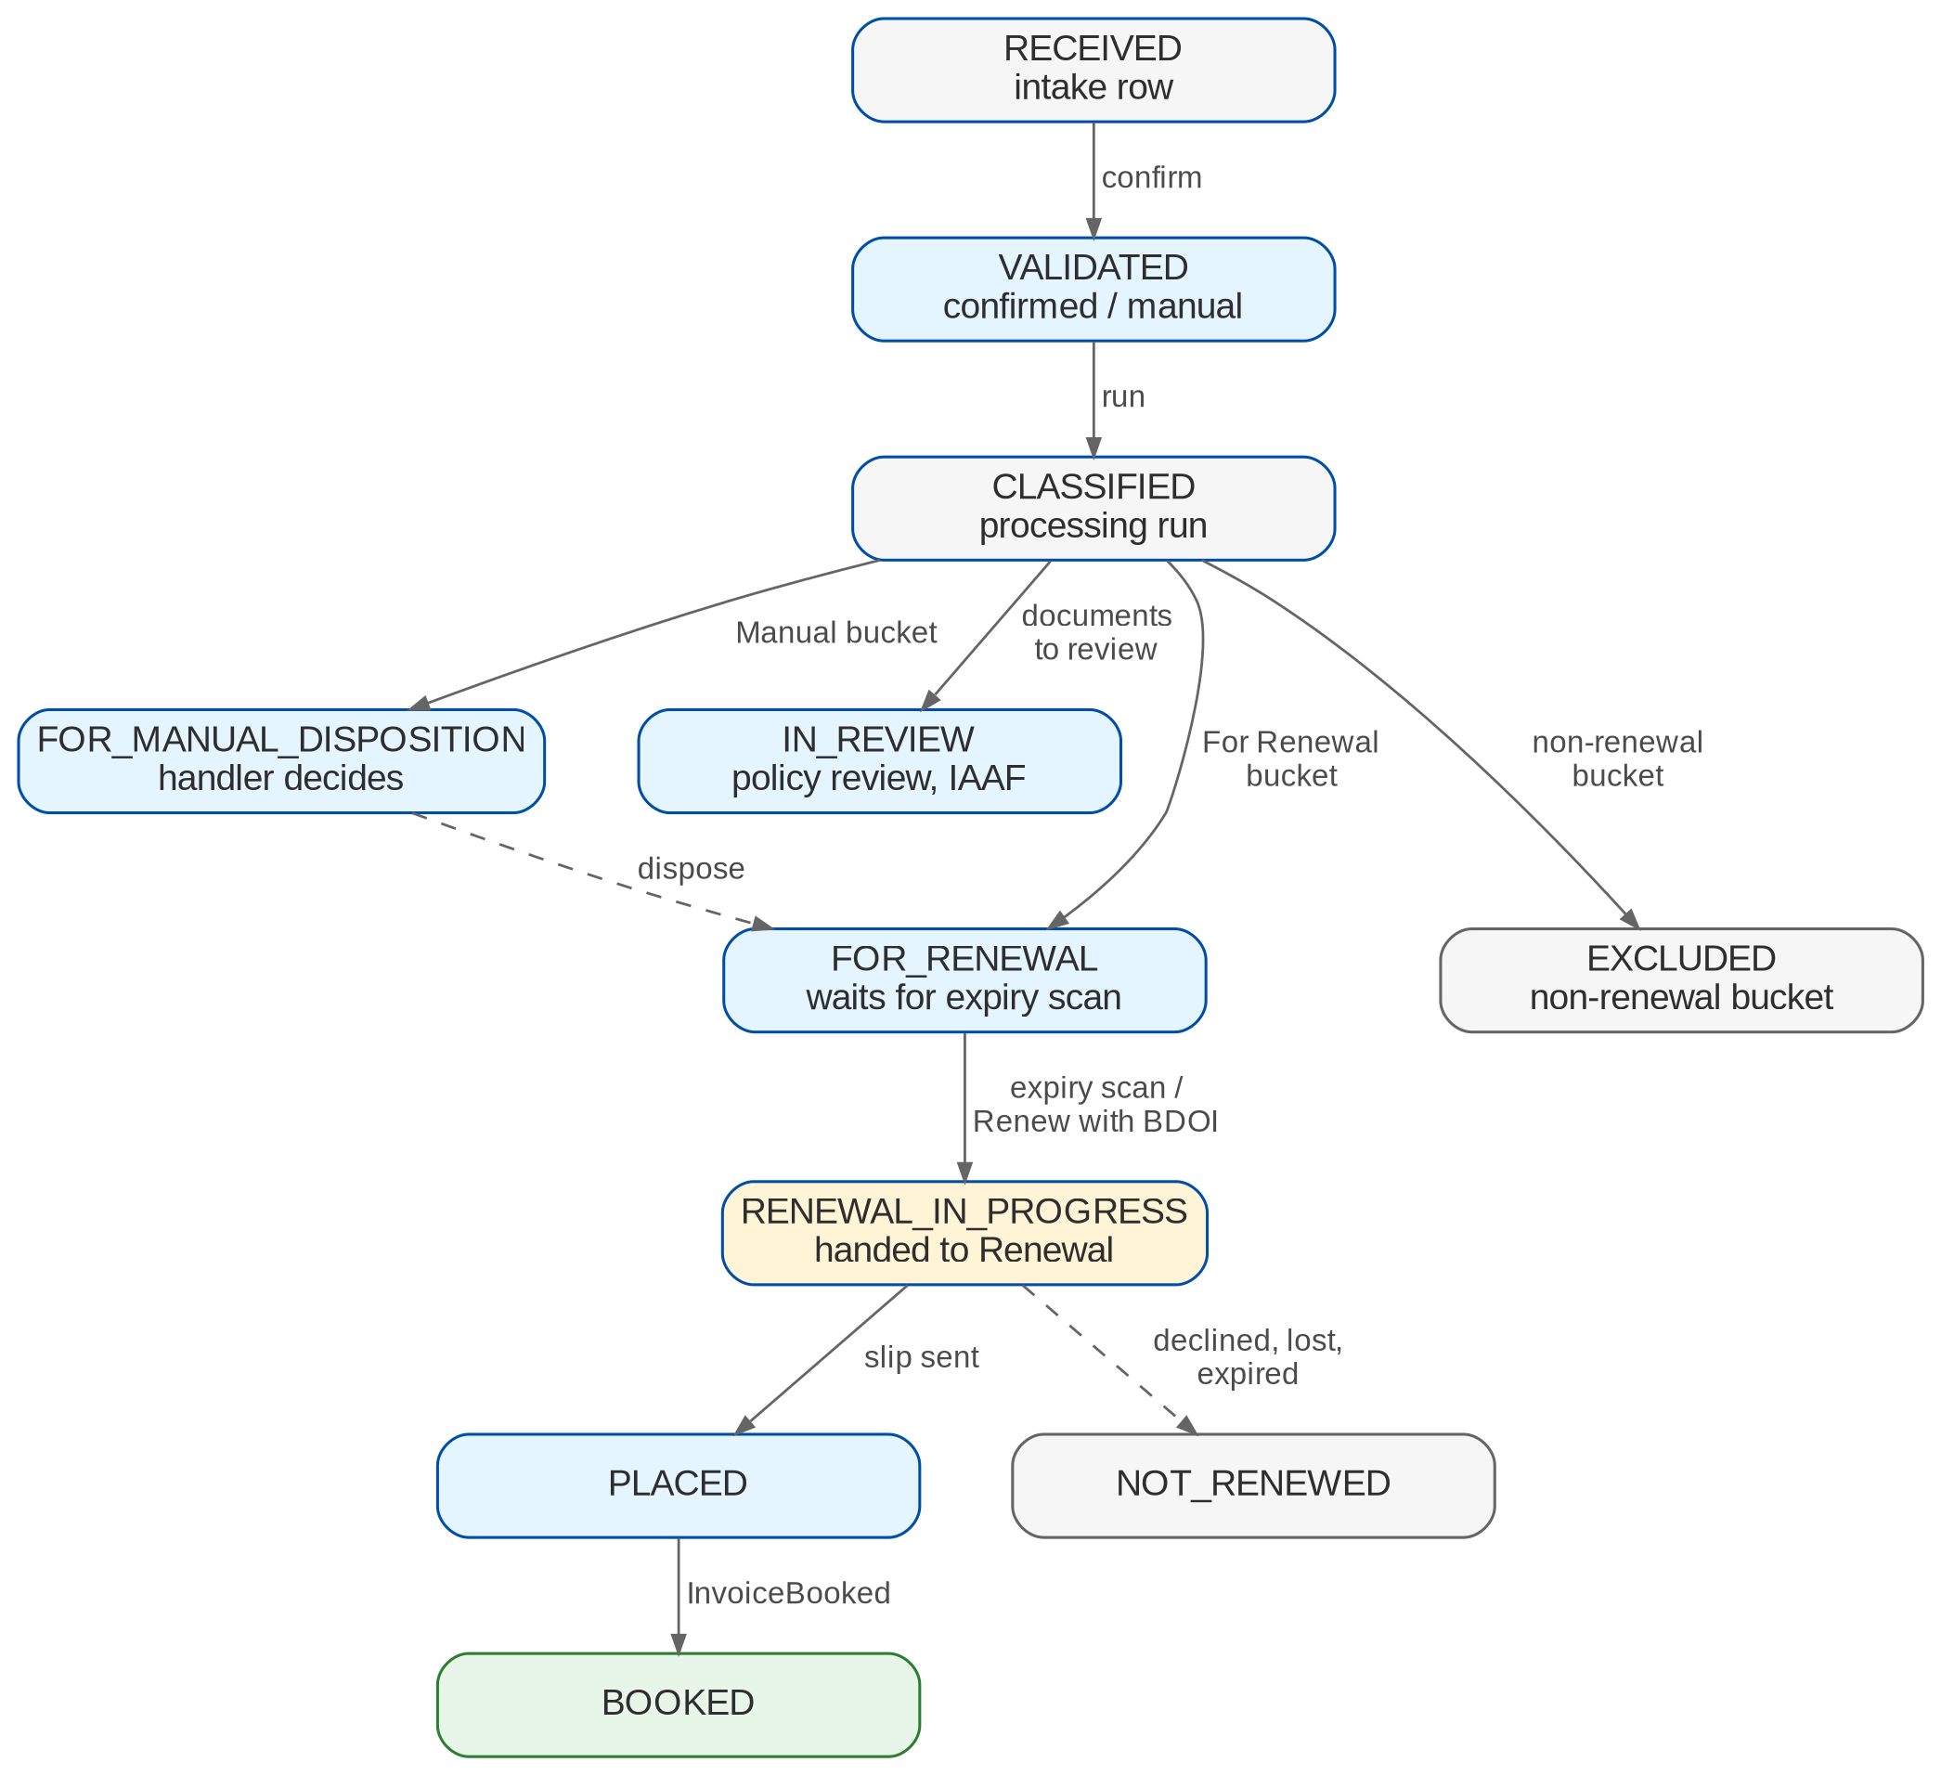
Figure 2: Workflow SBM_POLICY of a masterlist record
Table 10: Statuses of a masterlist record
Status | Set by | Meaning
RECEIVED | Intake | Row loaded from a source; not yet confirmed
VALIDATED | Extraction confirmation, manual entry | Data confirmed by a user
CLASSIFIED | Processing run | Classification and bucket set
FOR_RENEWAL | Run or manual disposition | Renewable; waits for the expiry scan
FOR_MANUAL_DISPOSITION | Run | A handler decides
IN_REVIEW | Run (documents to review) | Policy review and IAAF in progress
EXCLUDED | Run or handler | Non-renewal bucket or manual exclusion
RENEWAL_IN_PROGRESS | Expiry scan, Renew with BDOI | Handed to the Renewal module
PLACED | Account event | Placement slip sent
BOOKED | InvoiceBooked | Renewal booked; invoice no. and date on the record
NOT_RENEWED | Renewal status query | Declined, lost or expired unrenewed, with the reason
CLOSED | Handler or system | No further action

5.2 Processing run
Figure 3 shows the steps of a processing run. Each step writes one result per record (outcome, bucket, reason code, rule id and rule-set version).
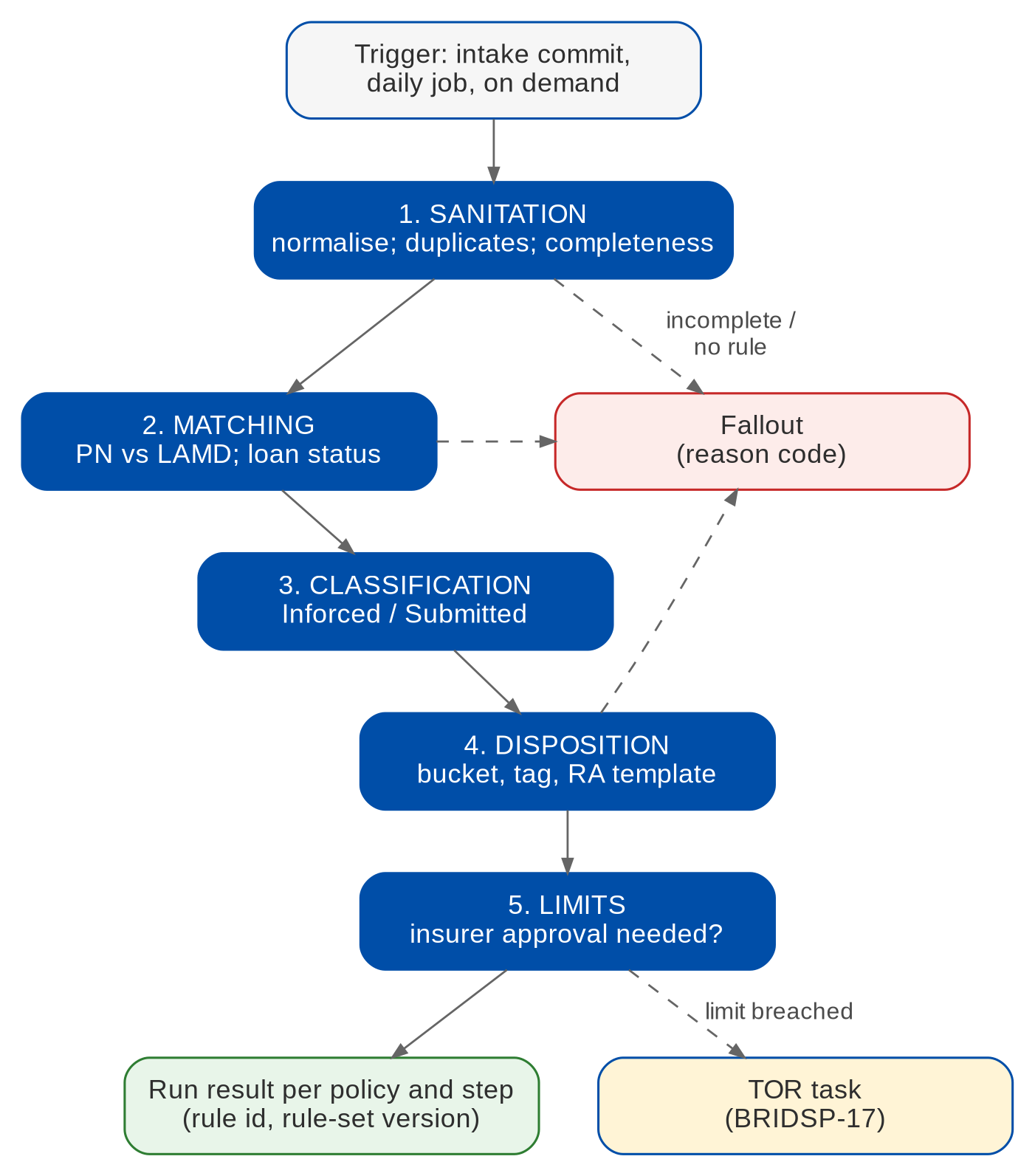
Figure 3: Processing run steps (BRIDSP-08-16)

5.3 IAAF approval (SBM_IAAF)
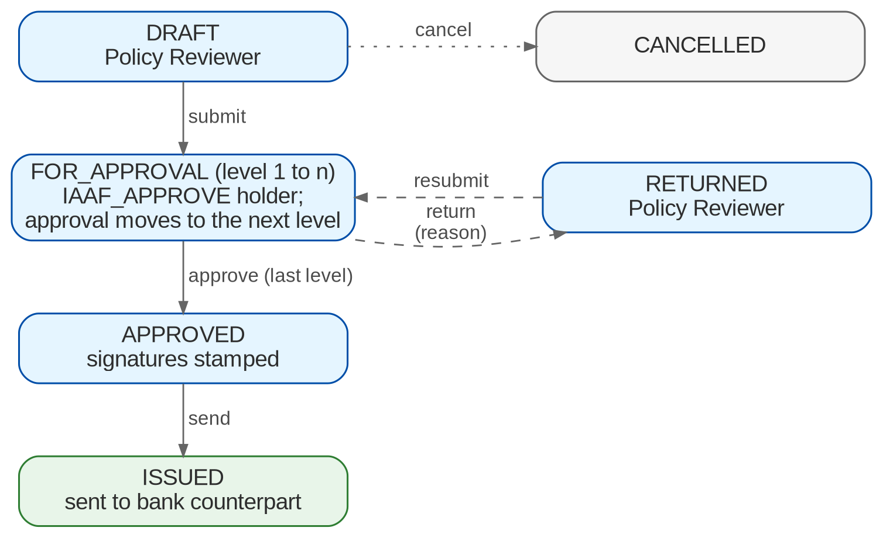
Figure 4: Workflow SBM_IAAF

5.4 TOR approval (SBM_TOR)
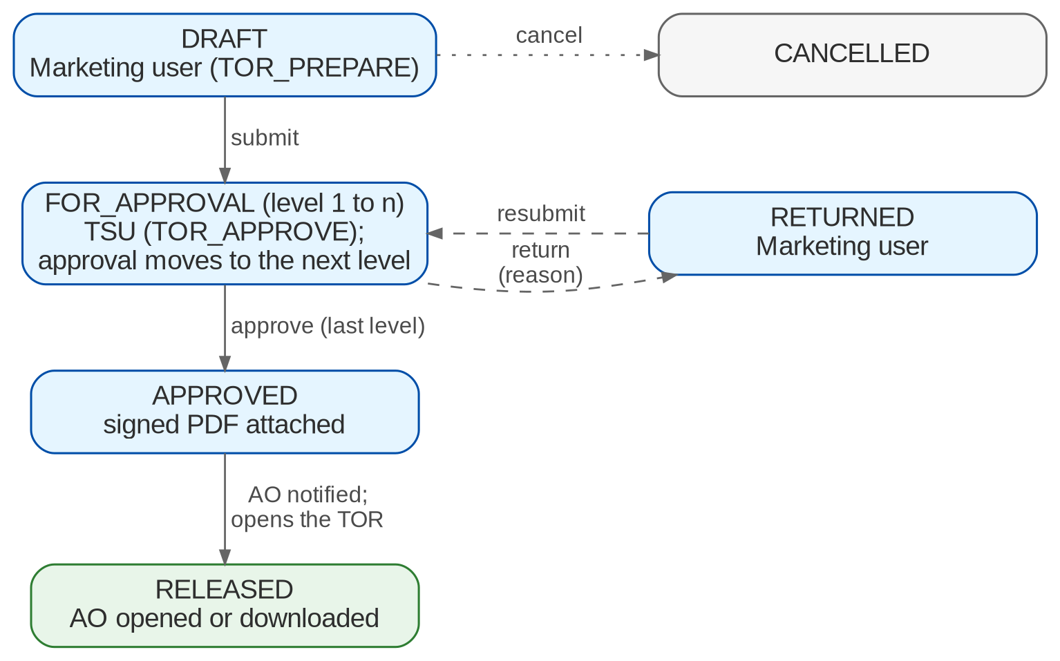
Figure 5: Workflow SBM_TOR

5.5 Handling-fee tagging
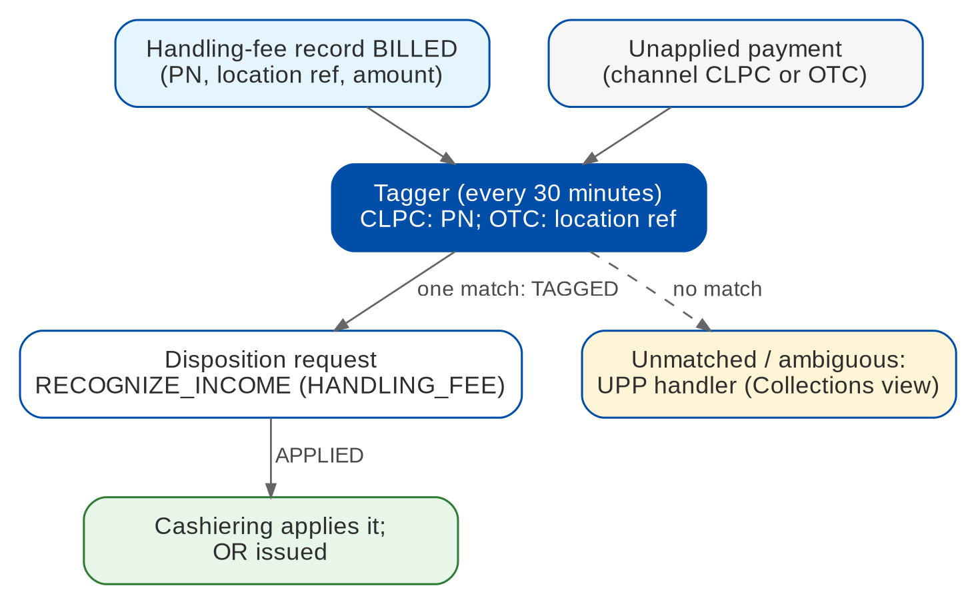
Figure 6: Handling-fee tagging (BRIDSP-31)
Table 11: Handling-fee record statuses
Status | Meaning
BILLED | Record created from the billing list or a processing rule; waits for payment
TAGGED | A payment matched and the disposition request was sent to Cashiering
APPLIED | Cashiering applied the payment and issued the OR
CANCELLED | Record cancelled by the handler

5.6 Notifications and alerts
Table 12: Notification events and alerts (BRIDSP-24, p.7 and 11)
Event / alert | When | Recipients
SBM_NEW_SUBMISSION | New records from an intake run | Handlers of the segment
SBM_MANUAL_VALIDATION | A document waits for confirmation | Handlers of the segment
SBM_IAAF_PENDING, SBM_TOR_PENDING | An approval level is waiting | Approvers of the level
SBM_BUCKET_CHANGED | Move to renewal, manual or non-renewal buckets | Handlers
SBM_FALLOUT | A run ends with fallout | Sanitation Handlers
SBM_EXPIRY_NEAR, SBM_RENEWAL_STARTED | Policy within the lead days; hand-off made | Handler, AO
SBM_TOR_RELEASED | TOR approved and handed over | Assigned AO
SBM_PLACEMENT_READY, SBM_PLACEMENT_SENT | Placement file ready or transmitted | Handler
SBM_HOLD_COVER_UNBOOKED (alert) | Hold cover confirmed, account not booked n days before it ends | Handler, TL
SBM_INSURER_NOT_ACCEPTED (alert) | Insurer has not accepted within the acceptance days | Handler
SBM_INTAKE_FAILED, SBM_LETTER_FAILED, SBM_IAAF_SLA, SBM_TOR_SLA (alerts) | Intake or letter failure; approval past its SLA | Job owners, approvers
Letters to clients (RA, SFU, NAL, renewal notices, proposals, reminders, NRNS) | Letter rules; Renewal letter engine | Client or bank counterpart

6 Reports and documents

6.1 Reports
Table 13: Submitted Policies reports (category Submitted Policies)
Code | Report | Content | BRD / Report List
SBM-MASTERLIST | Submitted Masterlist Report / Extract | Fields of RL #151 per segment; migrated records included | BRIDSP-04, 28; RL #151
SBM-DOC-FALLOUT | Document Processing Fallout | Intake and extraction failures | BRIDSP-10; RL #152
SBM-PROCESS-FALLOUT | Fallout: sanitation, matching, disposition, classification | Per run or period, with reason code | BRIDSP-10, 20; RL #153
SBM-NON-RENEWAL | Non-renewal Report | Exclusions with reason codes | BRIDSP-14; RL #154
SBM-MIGRATION-ERRORS | Migration Error Log | Rows of the migration jobs that failed | BRIDSP-33; RL #155
SBM-SANITATION | Sanitation Report (RMEL certification) | Counts per the RL #156 grouping | BRIDSP-20; RL #156
SBM-DISPOSITION | Disposition Report | Buckets and dispositions | BRIDSP-20; RL #157
SBM-CLASSIFICATION | Account Classification Report | Inforced / Submitted | BRIDSP-20; RL #158
SBM-RENEWABLE | Renewable Accounts / Policies | By bucket and expiry month | BRIDSP-25; RL #159
SBM-IAAF | IAAF Tracking / Review | Reviews, approvals, audit | BRIDSP-05-07; RL #160
SBM-TOR | TOR Status and Approval | Pending, Approved, Released; AO | BRIDSP-17-19; RL #161
SBM-HANDLING-FEE | Handling Fee Payment Classification | CLPC / OTC, status, OR | BRIDSP-31; RL #162
SBM-CONVERSION | Submitted Policies Conversion | Renewed, Unrenewed, Process Placement by group; persistency; accounts for review | BRIDSP-29; RL #163
SBM-NO-TOUCH | Submitted Policies No Touch | Billing list to insurers; re-upload builds the billing statement | BRIDSP-14; RL #164
SBM-PR-CONVERSION | Policy Review Conversion | Reviewed policies converted | RL #133
SBM-PR-MONITORING | Policy Review Monitoring | Ageing from bank request to endorsement (SP SQ24) | RL #134
SBM-PERSISTENCY | Renewal Persistency (submitted accounts) | Renewal rate of submitted accounts | RL #135
SBM-PENETRATION, SBM-HOLD-COVER-GAP | Penetration Report; Hold Cover with Gap | CBG Motor per channel; hold covers with gaps | RL #138
SBM-LETTERS | Letters register | Letters of this module and print batches | BRIDSP-22, 24

All reports need SBM_REPORT_VIEW (export SBM_REPORT_EXPORT), apply the user's scope, export to PDF, XLSX, ODS, CSV and XML, and support saved variants and the archive. Rows without fields in the Report List are delivered with the obvious columns and marked "layout to confirm" (SP SQ25). The renewal letters of submitted policies are listed in the Renewal report RNW-RA-DISPATCH (source Submitted Policy).

6.2 Sanitation report grouping
Table 14: SBM-SANITATION grouping (RL #156, Motor)
Group | Lines
Expiring accounts | Inforce; Submitted; Pending from previous months
For renewal | Regular; RMU; Open Market; CTPL; Auto Promo (FFY)
Not for renewal | SM / BDO Employee; No Touch; Mortgaged; Fully Paid; Cancelled / Did Not Materialize; Branch Account; Total Loss; Endorsement; Duplicate; Incorrect Expiry / Encoding; No Record with LAMD
Other | Pending for disposition; RB Submitted

6.3 Documents
Table 15: Submitted Policies documents
Template | Output | Content
SBM_IAAF | PDF, e-mail to the bank counterpart | Policy and borrower; reviews with dates, adequacy and findings; review count; linked policies; approval levels with stamped signatures
SBM_TOR | PDF, attachment TOR | Account; breached limits with limit and value; proposed terms; approvals with stamped signatures
SBM_REMINDER | PDF, e-mail or print | Policy-review follow-up to the client c/o the bank counterpart
SBM_RENEWAL_NOTICE, SBM_RENEWAL_PROPOSAL | PDF, e-mail or print | Renewal notice and proposal (owner to confirm, XQ03)
SBM_NO_TOUCH_BILLING | XLSX, PDF | No Touch billing list and statement

All templates are drafts until BDOI supplies the layouts (SP SQ07-SQ09). The RA (generic and FFY), NRNS, NAL and SFU templates belong to the Renewal module (RNW_RA_FIRST, RNW_RA_FFY, RNW_NRNS_REMINDER, RNW_NAL, RNW_SFU).

7 Interfaces and integration
Figure 7 shows the interfaces. Sources arrive as uploads; the renewal leaves through the hand-off port to the Renewal module; handling-fee payments are applied by Cashiering through the Operations ports.
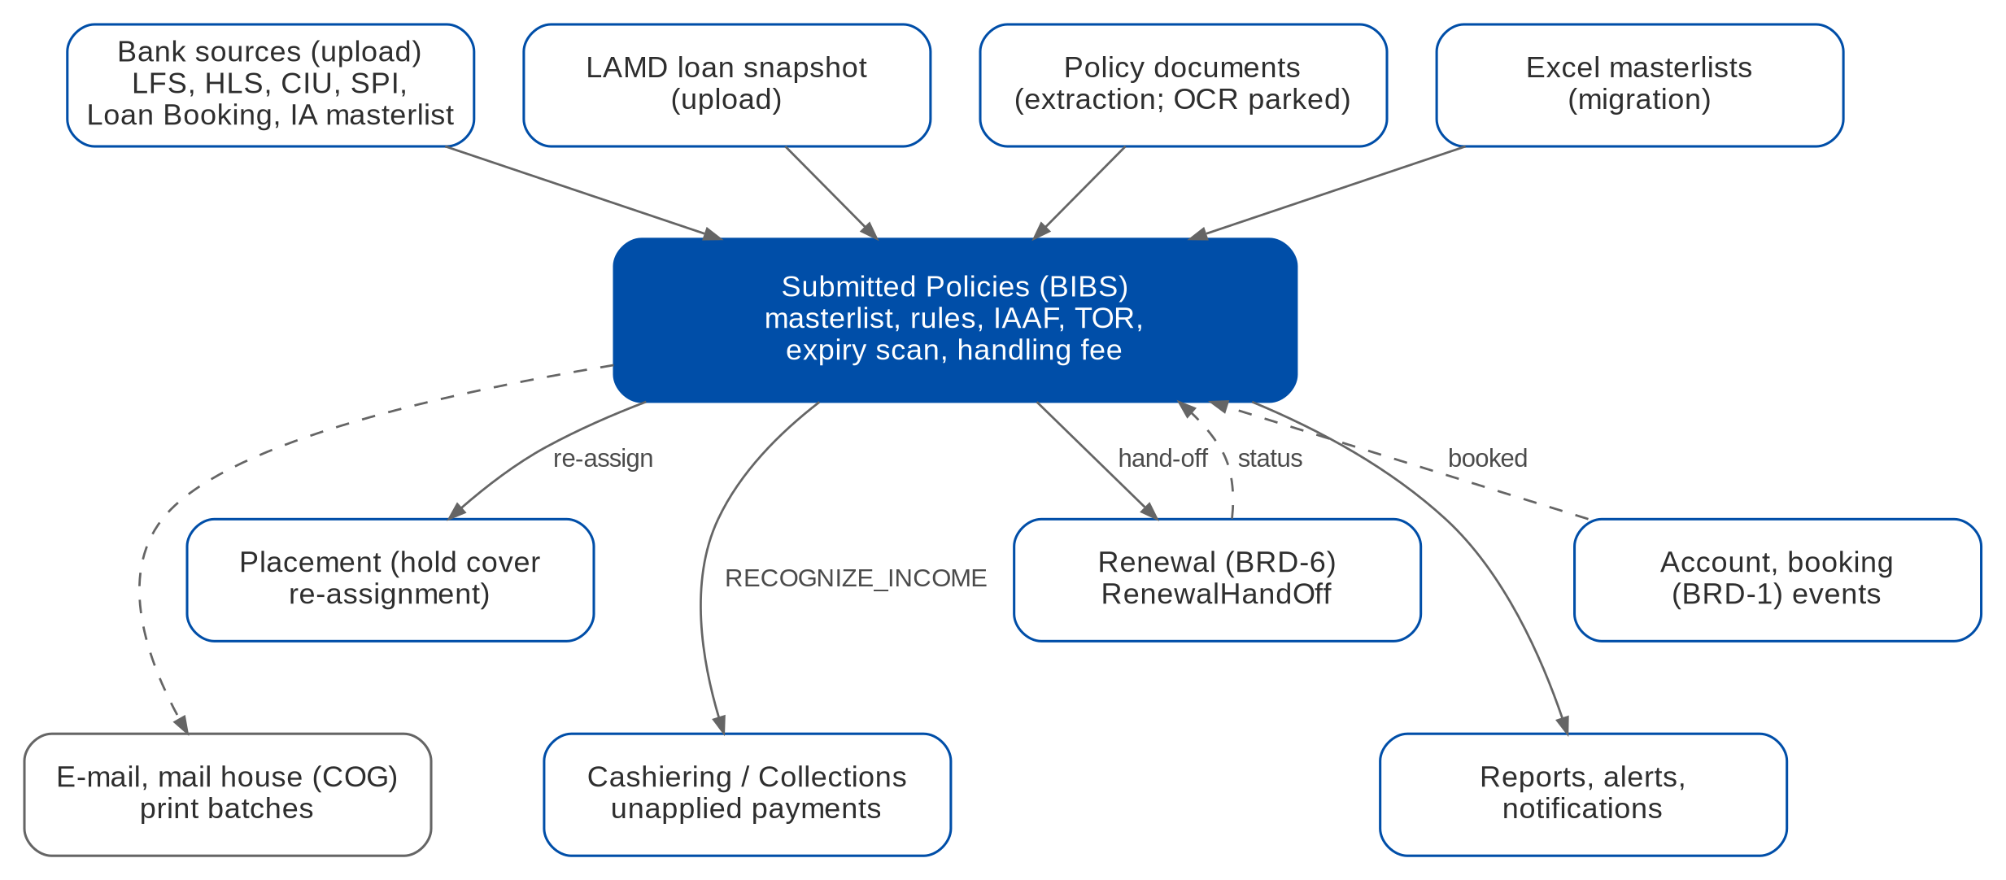
Figure 7: Interfaces of Submitted Policies (dashed = parked or upload)
Table 16: Interfaces
Interface | Direction | Content and trigger | BRD | Status
LFS, HLS, CIU, SPI, Loan Booking Report, IA masterlist | In | Excel uploads per source layout; feeds parked (SubmittedSourceFeed) | BRIDSP-01 | PARKED
LAMD | In | Loan snapshot upload by PN | BRIDSP-13 | PARKED
Policy documents | In | Extraction of text PDFs; OCR parked | BRIDSP-02 | CHANGE
Excel masterlists | In | One-time migration | BRIDSP-33 | NEW
Renewal (BRD-6) | Out / In | RenewalHandOff; status query of a hand-off | BRIDSP-22, 23, 25, 26 | NEW
Placement (BRD-1) | Out | Hold cover re-assignment | BRIDSP-32 | CHANGE
Account and booking (BRD-1) | In | AccountStatusChanged; InvoiceBooked with business type RENEWAL (BT0) | BRIDSP-26, 27 | CHANGE
Cashiering and Collections | Out | Disposition request RECOGNIZE_INCOME for handling fees | BRIDSP-31 | CHANGE
E-mail outbox | Out | IAAF, TOR, letters | BRIDSP-07, 22 | BUILT
Mail house (COG) | Out | Print batches (merged PDF and control list) | BRIDSP-22 | PARKED
E-signature | Out | Qualified e-signature of IAAF and TOR; stamped signature until then | BRIDSP-07, 18 | PARKED
ISYS / ARF | - | Not fed; the ARN is the reference (SP SQ20) | p.5 | OUT

8 Non-functional requirements
Table 17: Non-functional requirements (BRD p.13-14)
Topic | BRD value | BIBS target and approach | Status
Users | CBG Admin / Mktg 30 (15 concurrent) for log-in and sanitation; Non-CBG Corporate Policy Review officers 8 (6) for log-in and policy review | Within the BRD-1 sizing of 145 concurrent users | FIT
Volumes | Log-ins 22,000 a year (+5%); sanitation 63,000 a year (+25% a year); Non-CBG log-ins and policy reviews 2,000 a year each (+5%) | Processing runs set-based per step; about 154,000 sanitations in year 5 | FIT
Response time | 2 seconds for all listed transactions | Screens and single-record actions within 2 seconds; runs, exports and letters asynchronous with progress. Tighter than BRD-1 (10 s) and Operations (5 s) (SP SQ21) | CHANGE
Peak | End of month and year-end; 08:00-18:00 daily; no mobile vs desktop difference | Batch jobs at night (processing 21:30, expiry scan 22:00, letters 06:30 PHT) | FIT
Availability | 99.9%; business hours; at most 45 minutes of planned downtime a month; maintenance 00:00-04:00 | Platform deployment; one BIBS-wide NFR set is being agreed (XQ08) | FIT
Continuity | Critical services restored within 4 hours; full recovery within 24 hours | Platform backup and recovery | FIT
Retention | Transaction and submitted policy records 5 years online, 5 years archive; daily backup kept 5 years; no anonymisation | Retention rule SUBMITTED_POLICY; differs from BRD-1 (5 / 15 years) (SP SQ22) | CONFIGURE

9 Configuration items owned by the business and the System Administrator
The items below are changed in BIBS without a release. Changes are audited.

9.1 Parameters
Table 18: Submitted Policies parameters (category SUBMITTED)
Parameter | Default | Meaning
SBM_RENEWAL_LEAD_DAYS | CBG_FIRE=150, CBG_MOTOR=120 | Days before expiry of the hand-off to Renewal, per segment
SBM_MASTERLIST_DAYS_FROM_EXTRACTION | 30 | Target days from extraction to masterlist (CBG Motor)
SBM_INSURER_ACCEPT_DAYS | 5 | Days for the insurer to accept the hold cover before the alert
SBM_HOLD_COVER_UNBOOKED_ALERT_DAYS | 5 | Days before the hold cover ends to alert an unbooked account
SBM_REVIEW_SLA_DAYS | to confirm | SLA of IAAF and TOR approval levels
RA timing of submitted policies | 90 days before expiry | Hand-off parameter of the Renewal module (V1017), not of this module
Job schedules | 21:30, 22:00, 06:30, 07:00 PHT; tagger every 30 minutes | SBM_PROCESSING, SBM_EXPIRY_SCAN, SBM_LETTER_DISPATCH, SBM_HOLD_COVER_WATCH, SBM_HANDLING_FEE_TAGGER

9.2 Lists of values
Table 19: Lists of values
List | Values delivered
SBM_SEGMENT | CBG Motor; CBG Fire; Non-CBG Corporate and Branches; Non-CBG Retail
SBM_BUCKET | For Renewal; For Manual Disposition; Non-Renewal; No Touch; FFY; BDO / SM Group Employee Accounts; RMU; For Review; Fully Paid Loan; OPM; BDOFC; Sold (attribute renewal_action)
SBM_NON_RENEWAL_REASON | Free First Year; SM Group Employee; No Touch; CARI; Bonds; RMU; and the RL #156 reasons
SBM_LOAN_STATUS | Active; Open Market; Fully Paid; Remedial (RMU)
SBM_CONVERSION_STATUS | Renewed; Unrenewed; Process Placement (each by Inforce, NB Submitted, RB Submitted, OPM, RMU); Issued SFU
SBM_REASON | Fallout and exclusion reason codes (for example SBM_NO_RULE)
SBM_LETTER_TYPE | Reminder; Renewal notice; Renewal proposal
SBM_DECLINE_REASON | Reasons of insurer re-assignment
SBM_IAAF_FINDING | Findings of a policy review (to be supplied by BDOI)

9.3 Masters and rules maintained by the business
Table 20: Masters and rules
Item | Maintained by (approved by) | FR
Source register and upload templates | System Administrator | FR-SP-001
Rule sets (sanitation, matching, classification, disposition) | Rule administrator (SBM_RULE_APPROVE) | FR-SP-020
Limit rules | Rule administrator (SBM_RULE_APPROVE) | FR-SP-050
Insurer rules | Rule administrator (SBM_RULE_APPROVE) | FR-SP-060
Letter rules | Rule administrator (SBM_RULE_APPROVE) | FR-SP-062
IAAF and TOR approval matrices | Rule administrator (SBM_RULE_APPROVE) | FR-SP-041, 052
Legacy status map | Team Lead | FR-SP-004
User scope (segments, own accounts) | System Administrator | FR-SP-011
Document templates | System Administrator | Section 6.3

10 Assumptions, dependencies and open questions

10.1 Assumptions
Table 21: Assumptions
ID | Assumption | Related
A-SP-01 | A submitted policy is not an account; it becomes one only when the client renews with BDOI | Design principle 1
A-SP-02 | Submitted = PN matched to an active LAMD loan and not BDOI-placed; Inforced = otherwise | SP SQ04
A-SP-03 | One IAAF per policy, with links to related policies | SP SQ07
A-SP-04 | The Renewal module owns the renewal of submitted policies from the hand-off on | Decision D2
A-SP-05 | BRIDSP-20 and BRIDSP-30 are the same requirement and are met once | BRD p.10, 12
A-SP-06 | The BIBS ARN replaces the ISYS reference and the ARF | SP SQ20
A-SP-07 | Sources arrive as Excel files until BDOI names the feeds | SP SQ01

10.2 Dependencies
Table 22: Dependencies
ID | Dependency | Needed for
D-SP-01 | The shared account business-type change BT0 (V822) is merged | FR-SP-065 (D1)
D-SP-02 | The Renewal module implements RenewalHandOff (wave R3); until then hand-offs wait as pending | FR-SP-060, 062 (D2)
D-SP-03 | Cashiering and Collections expose the unapplied-payment ports with the action RECOGNIZE_INCOME | FR-SP-070
D-SP-04 | Placement adds the hold cover re-assignment | FR-SP-063
D-SP-05 | BDOI supplies the source layouts, rule content, matrices, templates and the LAMD definition | FR-SP-001, 020, 041, 052, 062

10.3 Open questions
Table 23: Open questions on BRD-12 (status from the cross-BRD decisions, R5)
ID | Question | Affects | Status
SP SQ01 | Definition, owner, layout, frequency and transport of each source | FR-SP-001 | OPEN
SP SQ02 | Prescribed submission formats per segment and business type | FR-SP-001 | OPEN
SP SQ03 | Document types, share of scanned documents, OCR, mandatory fields | FR-SP-002 | OPEN
SP SQ04 | Definitions of Inforced and Submitted | FR-SP-030 | OPEN
SP SQ05 | Complete bucket list and precedence (RMU, FFY, Fully Paid conflicts); CARI, Bonds, BDOFC, OPM, Sold | FR-SP-031, 033, 034 | OPEN
SP SQ06 | LAMD fields and frequency; Generic vs FFY RA rule (XQ01: one or two LAMD intakes) | FR-SP-032 | OPEN
SP SQ07 | IAAF approval matrix, signature method, template; one IAAF per policy | FR-SP-040, 041 | OPEN
SP SQ08 | TSU matrix; limits per insurer and product; TOR template; meaning of Released | FR-SP-050 to 053 | OPEN
SP SQ09 | Letter templates, triggers, lead days and channels; COG format (XQ03) | FR-SP-062 | OPEN
SP SQ10 | Owner of the renewal of submitted policies | FR-SP-060 | ANSWERED
SP SQ11 | Insurer assignment rules | FR-SP-060 | OPEN
SP SQ12 | Acceptance window 3 or 5 days; outcome when no insurer accepts; alert lead days | FR-SP-063, 082 | OPEN
SP SQ13 | Handling fee amount, VAT, OR, GL account and record creation | FR-SP-070 | OPEN
SP SQ14 | No Touch service-fee basis and billing statement | Section 6.1 | OPEN
SP SQ15 | Access matrix and data scope of the personas | Section 3 | OPEN
SP SQ16 | Migration files, volumes, statuses and cut-over | FR-SP-004 | OPEN
SP SQ17 | Meaning of opportunity tag and conversion; who overrides a rule tag | FR-SP-003 | OPEN
SP SQ18 | Penetration report inputs and channel rule | Section 6.1 | OPEN
SP SQ19 | Expansion of the acronyms of the BRD | Section 1.4 | OPEN
SP SQ20 | BIBS ARN replaces the ISYS reference and ARF | Section 7 | OPEN
SP SQ21 | 2-second response against 10 s (BRD-1) and 5 s (Operations) | Section 8 | OPEN
SP SQ22 | Retention 5 + 5 years against 5 + 15 years (BRD-1) | Section 8 | OPEN
SP SQ23 | Non-CBG Retail employee accounts: quotation and NRNS by e-mail | FR-SP-060 | OPEN
SP SQ24 | Start and end events of the policy-review ageing | Section 6.1 | OPEN
SP SQ25 | Final fields of the reports without layouts | FR-SP-080 | OPEN

11 Traceability
Every BRD-12 requirement ID is met by at least one FR.
Table 24: BRD ID to FR, screen and API
BRD ID | FR | Screen | API / job
BRIDSP-01 (p.8) | FR-SP-001 | Upload & Intake | Bulk handlers per source
BRIDSP-02 (p.8) | FR-SP-002 | Extraction Review | /submitted/extractions
BRIDSP-03 (p.8) | FR-SP-003 | Masterlist; Policy record | /submitted/policies; .../renewal-tag
BRIDSP-04 (p.9) | FR-SP-010 | Masterlist; Policy record | /submitted/policies
BRIDSP-05 (p.9) | FR-SP-040 | Policy Reviews / IAAF | .../iaaf
BRIDSP-06 (p.9) | FR-SP-040 | Policy Reviews / IAAF | .../reviews
BRIDSP-07 (p.9) | FR-SP-041 | My Approvals; IAAF page | Workflow SBM_IAAF
BRIDSP-08 (p.9) | FR-SP-020 | Setup (Rule Sets) | /submitted/setup/rule-sets
BRIDSP-09 (p.9) | FR-SP-021 | Processing Runs | /submitted/runs; job SBM_PROCESSING
BRIDSP-10 (p.9) | FR-SP-022 | Processing Runs (Fallout) | Reports SBM-DOC-FALLOUT, SBM-PROCESS-FALLOUT
BRIDSP-11 (p.9) | FR-SP-030 | Policy record (Loan & Matching) | Classification step
BRIDSP-12 (p.9) | FR-SP-031 | Masterlist (buckets) | Disposition step
BRIDSP-13 (p.10) | FR-SP-032 | Upload & Intake (LAMD) | Bulk SBM_LAMD
BRIDSP-14 (p.10) | FR-SP-033 | Masterlist (Non-Renewal) | Report SBM-NON-RENEWAL
BRIDSP-15 (p.10) | FR-SP-034 | Masterlist; Renewal tab | Disposition step; RenewalHandOff
BRIDSP-16 (p.10) | FR-SP-050 | Policy record; Setup (Limit Rules) | Limits step
BRIDSP-17 (p.10) | FR-SP-051 | TOR | /submitted/tors
BRIDSP-18 (p.10) | FR-SP-052 | My Approvals; TOR page | Workflow SBM_TOR
BRIDSP-19 (p.10) | FR-SP-053 | Notifications; TOR page | /submitted/tors/{id}.pdf
BRIDSP-20 (p.10) | FR-SP-080 | Reports; home | Report service
BRIDSP-21 (p.10) | FR-SP-081 | Reports (Export, Print) | /reports/{code}/export
BRIDSP-22 (p.11) | FR-SP-062 | Letters & Print Batches | Job SBM_LETTER_DISPATCH
BRIDSP-23 (p.11) | FR-SP-060 | Renewal Work List | Job SBM_EXPIRY_SCAN; RenewalHandOff
BRIDSP-24 (p.11) | FR-SP-082 | Notifications | Events and alerts SBM_*
BRIDSP-25 (p.11) | FR-SP-061 | Renewal Work List | Report SBM-RENEWABLE
BRIDSP-26 (p.11) | FR-SP-064 | BRD-1 Placement | Payment gate; placement slip
BRIDSP-27 (p.11) | FR-SP-065 | BRD-1 Booking; Masterlist | InvoiceBooked
BRIDSP-28 (p.12) | FR-SP-011 | Masterlist (Export) | Report SBM-MASTERLIST
BRIDSP-29 (p.12) | FR-SP-012 | Masterlist; Policy record (History) | /submitted/policies/{id}
BRIDSP-30 (p.12) | FR-SP-080 | Reports; home | Report service
BRIDSP-31 (p.12) | FR-SP-070 | Handling Fees | Job SBM_HANDLING_FEE_TAGGER
BRIDSP-32 (p.12) | FR-SP-063 | Renewal Work List | .../reassign-insurer
BRIDSP-33 (p.12) | FR-SP-004 | Upload & Intake (Migration) | Bulk SBM_MIGRATION
Usage requirements (p.13-14) | Section 8 | - | -

API paths start with /api/v1. They are the paths of the build design (R3) and are confirmed at build.

12 Sign-off
By signing, BDOI confirms that this FRS describes the Submitted Policies functions it expects in BIBS, and accepts the assumptions in section 10.1. Open questions in section 10.3 stay open; their answers are applied as configuration or through a change request.
Name | Role | Organisation | Signature | Date
 | Product Owner | BDOI
 | Unit Head, Combank and Corbank | BDOI
 | Head, Retail Marketing | BDOI
 | Head, Corporate and Retail Marketing | BDOI
 | Program Manager, Business Project Services | BDO Unibank ESG
 | Project Manager | iorta TechNXT

