

SalesVerse 2.0
Solution Architecture
Application, data, integration, security, deployment and infrastructure architecture
IIFT Agent/Banca Portal & Back-office for Insurans Islam Family Takaful Sendirian Berhad
 | PREPARED FOR  Insurans Islam Family Takaful Sendirian Berhad  Bandar Seri Begawan, Brunei Darussalam  PREPARED BY  iorta TechNXT  https://iortatechnxt.com

Document reference | IIFT-SV2-SAD
Version | 1.0
Date | October 2026
RFP deliverable | DEL-06 (Solution Architecture)
Status | Issued with the proposal
Classification | Commercial-in-Confidence

Commercial-in-Confidence. Prepared by iorta TechNXT for Insurans Islam Family Takaful Sendirian Berhad as part of the response to IIFT's Request for Proposal for an Agent/Banca Portal and Back-office solution. Not to be disclosed to third parties without prior written consent.

Document Control
This document is the Solution Architecture for SalesVerse 2.0 as configured for IIFT. It is maintained throughout the contract and updated after every material change (NFR-21, MNT-27).

Version history
Version | Date | Author | Description
0.9 | September 2026 | iorta TechNXT | Internal technical review
1.0 | October 2026 | iorta TechNXT | Issued with the tender proposal

Review and approval
Role | Name | Signature / date
Prepared by (Solution Architect, iorta TechNXT) | [Name]
Reviewed by (Engineering Lead, iorta TechNXT) | [Name]
Approved by (Project Director, iorta TechNXT) | [Name]
Accepted by (IIFT IT) | [Name, designation]

Document pack
Reference | Document | RFP deliverable | Status
IIFT-SV2-SAD | SalesVerse 2.0 Solution Architecture | DEL-06 | This document
IIFT-SV2-DD | SalesVerse 2.0 Data Dictionary | DEL-07 | Issued
IIFT-SV2-PSH | SalesVerse 2.0 Production Support Handover | DEL-26, DEL-27, MNT-28 | Issued
IIFT-SV2-CSQ | SalesVerse 2.0 Code Standards & Quality Report | DEL-11, NFR-14 | Issued
IIFT-SV2-SAR | SalesVerse 2.0 Security Assessment Report | DEL-17, NFR-13 | Issued

Related material
- SalesVerse-2.0-Data-Dictionary (.docx and .xlsx): every table and column.
- SalesVerse-2.0-Production-Support-Handover: support model, runbooks and configuration reference.
- docs/api/openapi.json: API description generated from the code.

Conventions
- Monetary amounts are in Brunei dollars (B$). Times are Brunei time (UTC+8) unless marked UTC.
- RFP requirement identifiers (AP, BO, INT, COM, NFR, DEL, MNT) refer to IIFT's Request for Proposal. COM-01 to COM-10 in this pack are the shared platform requirements of RFP section 4.4.
- Items marked delivered during implementation are designed here but not yet present in the working application; everything else describes the application as it runs today.
- Option A, B and C are the commercial options of the proposal: on-premise with a perpetual licence, subscription hosted and managed by iorta on cloud, and source code handover. Prices and commercial terms are in the proposal and its pricing workbook; this pack quotes a figure only where a technical statement depends on it, and reads it from the same source as the proposal.
- Text in [square brackets] is to be completed with IIFT during mobilisation.

Contents
Right-click here and choose Update Field to build the table of contents.

1. Purpose and Scope

1.1 Purpose
This document describes the solution architecture of SalesVerse 2.0 as configured for Insurans Islam Family Takaful Sendirian Berhad (IIFT) as the Agent/Banca Portal and Back-office. It explains how the solution is structured, how it handles data, integration and security, how it is deployed and sized, and why the main design decisions were taken. It is the Solution Architecture deliverable (DEL-06) and the reference for the Technical Design (DEL-07), the Interface Specification (DEL-09) and the deployment plan (DEL-20).

1.2 Scope
In scope | Out of scope
Agent/Banca Portal for agents, main agents and bank officers  Back-office for IIFT staff  Participant e-signature page  REST API, database, document store, scheduled jobs  Integration with Core, FIN, AML provider, SMTP, SMS and Active Directory  Deployment, sizing, security, monitoring and DR design | Changes inside IITH core and financial systems  Claims assessment and payment (core system)  Infrastructure procurement and data-centre operation under Option A (IIFT/IITH)  Commercial terms, prices and the choice between Options A, B and C (see the proposal)

1.3 Audience
IIFT and IITH IT architecture, infrastructure, security and operations teams; the IIFT project team; iorta TechNXT engineering and support. Readers are assumed to know web applications and relational databases.

1.4 Status of the solution
SalesVerse 2.0 is a working application. The table separates what runs in the current build from what is completed during implementation, so that every statement in this document can be checked against the source code.
Capability | Today | Implementation work
Agent/Banca Portal and Back-office web application (React SPA) | Running | –
REST API with all functional modules listed in chapter 4 | Running | –
PostgreSQL schema, migrations, reference data and demonstration data | Running | –
Sessions, CSRF, Argon2id, lockout, RBAC, data scoping, maker-checker | Running | –
Field-level and document encryption, append-only audit trigger | Running | –
Transactional outbox, retry, dead-letter, integration monitor, reconciliation | Running | –
Core, FIN, AML, SMS, SMTP and LDAP adapters | Running in simulated mode | Endpoint mapping and payload formats agreed in the interface specification (DEL-09)
Container images, nginx web tier, Docker Compose, CI pipeline with CodeQL, secret scan, dependency and image scans and SBOM | Running | Image signing, registry push and CD stages to SIT, UAT and PROD
Health endpoints and Prometheus metrics | Running | Dashboards, alert rules, log shipping and SIEM forwarding
Multi-factor authentication for back-office users | – | Delivered during implementation
PostgreSQL streaming replication, pgBackRest backups, DR site | – | Delivered during implementation
Data retention and archival job; key rotation tooling | – | Delivered during implementation
Maker-checker approval for product and rate changes | Two-person check (manual) | Delivered during implementation
S3-compatible document storage adapter (only if object storage is chosen) | – | Delivered during implementation
IIFT actuarial rates, wakalah and tabarru' parameters | Indicative values loaded | IIFT values loaded and verified in design and SIT
Legacy data migration | – | Delivered during implementation (DEL-19)
Independent VAPT and re-test | – | Before go-live (DEL-17)
Table 1: Solution status at proposal submission

1.5 Sources
- Source code: apps/api (NestJS API, Prisma schema and migrations), apps/web (React SPA), deploy (Docker Compose), .github/workflows (CI).
- docs/api/openapi.json: the API description produced from the code.
- IIFT Request for Proposal, including Appendix 1 (users), Appendix 2 (policy volumes) and Appendix 3 (product flows).
- Companion documents: Data Dictionary and Production Support Handover.

2. Architecture Principles
These principles guided every design decision recorded in chapter 13.
Principle | Rationale | Implication
One system of record | Every business fact lives in PostgreSQL; external systems receive copies through the outbox. | No dual writes; integrations are replayable; reconciliation compares against one source.
Modular monolith | 26 named users and about 600 policies a year do not justify microservices. | One deployable unit; modules follow RFP areas and talk through services, so a module can be split out later (NFR-20).
Server-side enforcement | The browser is untrusted. | Authentication, permissions, data scope, maker-checker and every business rule are enforced by the API; the SPA only hides what a user cannot do.
Atomic business transactions | NFR-16 requires no partial updates. | A business change, its audit row and its outbox message commit in one database transaction.
Configuration over code | Rates, parameters, workflows and master data change more often than code. | Products, parameters, roles, workflows and code lists are maintained in the back-office and audited.
Secure by default | Regulated personal and financial data. | Deny by default; encrypted identifiers; production start-up refuses insecure settings; generic errors with correlation id.
Operable | IIFT and IITH must be able to run it. | Standard containers, JSON logs, health and metrics endpoints, documented runbooks, open-source stack without third-party licence fees.
Testable | Changes must be safe to release. | Unit and end-to-end tests against a real PostgreSQL database run in CI on every change.
Table 2: Architecture principles

3. System Context
SalesVerse 2.0 sits between IIFT's distribution partners and the IITH group systems. Agents and bank officers work in the portal; IIFT staff work in the back-office on the internal network; participants only see a one-time e-signature page. The core and financial systems stay the systems of record for in-force business and accounting, and receive every relevant event from the portal.
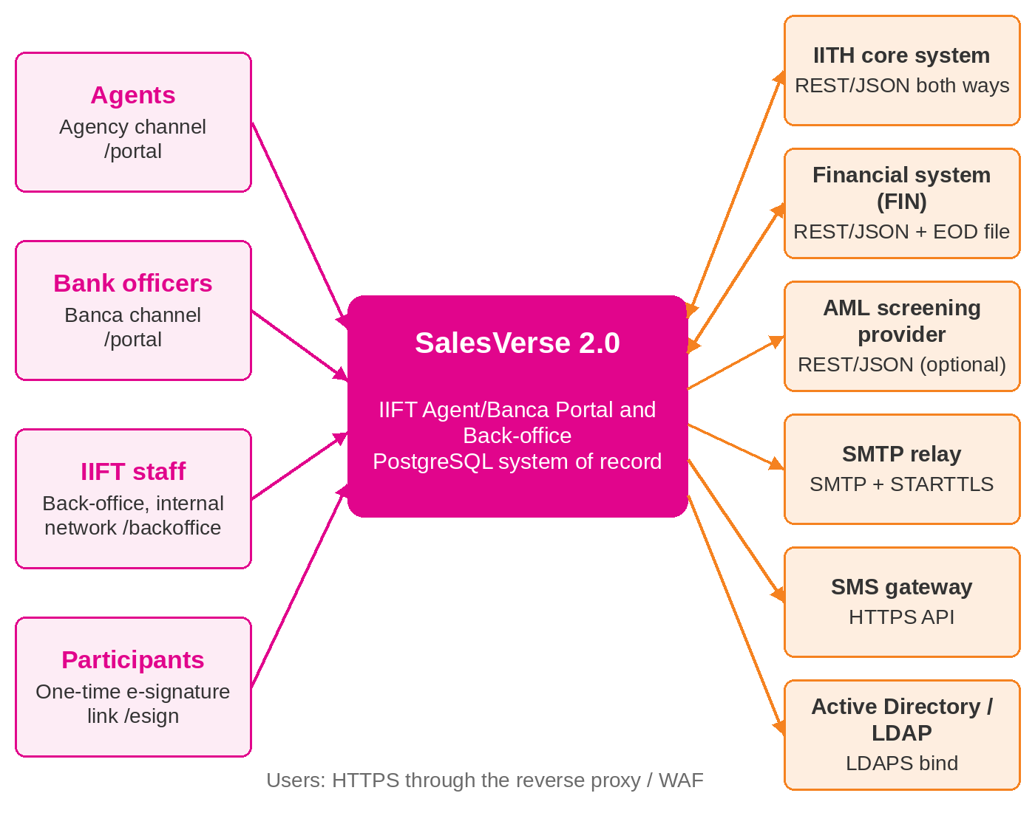
Figure 1: System context
Actor or system | Type | Channel | Interaction | RFP
Agents and main agents | Person | Agent/Banca Portal over HTTPS | Quotations, participants, policies, payments, claims, issues, reports | AP-01 to AP-62
Bank officers and supervisors | Person | Agent/Banca Portal over HTTPS | Financing takaful sales at bank branches; bank-wide view for supervisors | AP-09, AP-59
IIFT staff | Person | Back-office over HTTPS on the internal network | Approvals, administration, compliance, finance, support, reporting | BO-01 to BO-33
Participants | Person | One-time e-signature page, e-mail | Review and sign the application; receive documents | AP-45, AP-62
IITH core takaful system | System | REST/JSON both ways | Agent, participant, policy, endorsement, cancellation and claim events out; agent status and issued-policy queries in | INT-01 to INT-03, INT-09
Financial system (FIN) | System | REST/JSON and EOD file | Receipts, refunds, commission accruals and EOD postings out; posted receipts and commission payments in | INT-04, INT-05, INT-15
AML screening provider | System (optional) | REST/JSON | Name and identifier screening in addition to Compliance watch-lists | AP-16, BO-13
SMTP relay | System | SMTP with STARTTLS | Notifications, documents, e-signature links, scheduled reports | INT-07
SMS gateway | System | HTTPS API | Short notifications (agency block, approvals) | INT-08
Active Directory / LDAP | System | LDAPS bind | Back-office sign-in for directory accounts | INT-06
Table 3: Actors and external systems

4. Functional Architecture
The API is split into modules that follow the RFP functional areas. Each module owns its controllers, services, data-transfer objects and tests; shared concerns (database access, encryption, numbering, data scope, request context, error handling) live in apps/api/src/common.
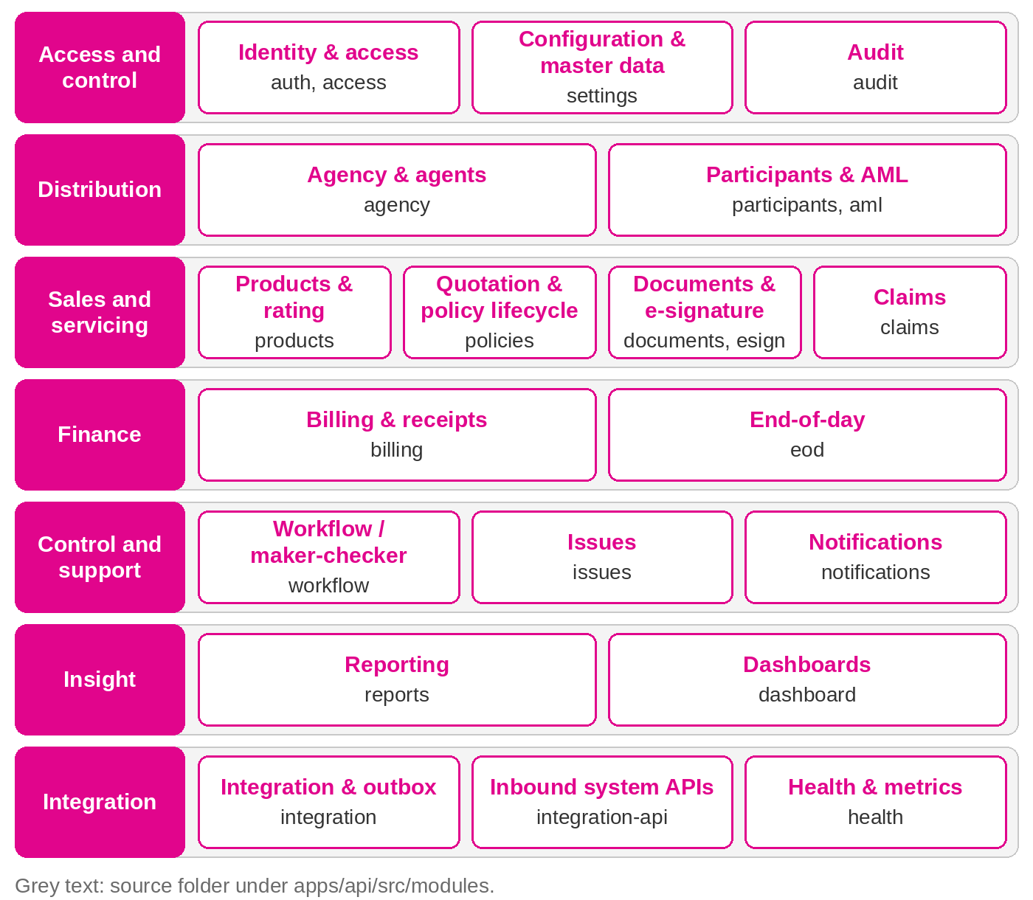
Figure 2: Functional module map
Module | Code | Responsibilities | RFP requirements
Identity & access | auth, access | Sign-in, sessions, password policy and history, lockout, directory sign-in, users, roles, permissions | AP-01 to AP-04, AP-59, BO-01 to BO-04, INT-06, COM-02
Agency & agents | agency | Agencies and banks, agent registration and approval, hierarchy, status, authority limits, issuance block override | AP-05 to AP-10, AP-42, BO-05 to BO-12
Participants & AML | participants, aml | Shared participant master with duplicate check, update requests, watch-list screening, Compliance review | AP-11 to AP-16, AP-48, BO-13 to BO-15
Products & rating | products | Catalogue, FINANCING and FIXED_PLAN rating engines, required documents, questionnaires | AP-17 to AP-19, BO-33
Quotation & policy lifecycle | policies | Quotations, validation, referral, issuance, e-Policy, renewal, endorsement, cancellation, expiry, history | AP-20 to AP-36, AP-44, AP-49 to AP-51, AP-60
Billing & receipts | billing | Outstanding contributions, bulk payments with allocation, proof, verification, e-Receipts, commission, grace-period block | AP-30, AP-37 to AP-42, INT-05
Claims | claims | Claim notification with policy validation and documents; back-office status updates | AP-43
Documents & e-signature | documents, esign | Encrypted document store, upload checks, verification queue, PDF output, e-mail of documents, on-screen and link signatures | AP-29, AP-39, AP-44 to AP-47, AP-62, BO-11, BO-12, COM-06
Workflow / maker-checker | workflow | Workflow definitions, approval requests and actions, inbox, handlers | AP-33, AP-49 to AP-51, AP-61, BO-10, BO-16 to BO-19, COM-04
Issues | issues | Issue logging, comments, attachments, assignment, priority, SLA monitoring | AP-55 to AP-57, BO-29 to BO-31
Notifications | notifications | In-app, e-mail and SMS notifications with retry and delivery log | AP-34, AP-54, INT-07, INT-08, COM-05
Reporting | reports | Report catalogue, filters, preview, export (XLSX, CSV, PDF), schedules | AP-58, BO-22 to BO-25, COM-08
Dashboards | dashboard | Agent dashboard, pending actions, management KPIs | AP-52, AP-53, BO-20, BO-21
Audit | audit | Append-only audit trail, search and facets | AP-35, BO-26 to BO-28, COM-03, NFR-11
Configuration & master data | settings | Business parameters with ranges, code lists | BO-32, BO-33, COM-09
Integration & outbox | integration, integration-api | Outbox, dispatcher, gateways, integration log, monitor and retry, reconciliation, inbound system APIs | INT-01 to INT-05, INT-09 to INT-15
End-of-day | eod | EOD issuance report, FIN interface file, EOD posting, reconciliation, re-run | Appendix 3 (FFR01-08 to FFR05-08), INT-04, INT-15
Health & metrics | health | Liveness, readiness, Prometheus metrics | NFR-26, NFR-27
Table 4: Modules and the requirements they cover

4.1 Policy lifecycle
A quotation and the policy it becomes are one record, so history, documents and payments stay attached from first quote to expiry. On submission the API re-rates the quotation with current rates, checks validity (30 days by default), the agency issuance block, required documents, nominees, participant signature and AML status, then decides whether the application must be referred.
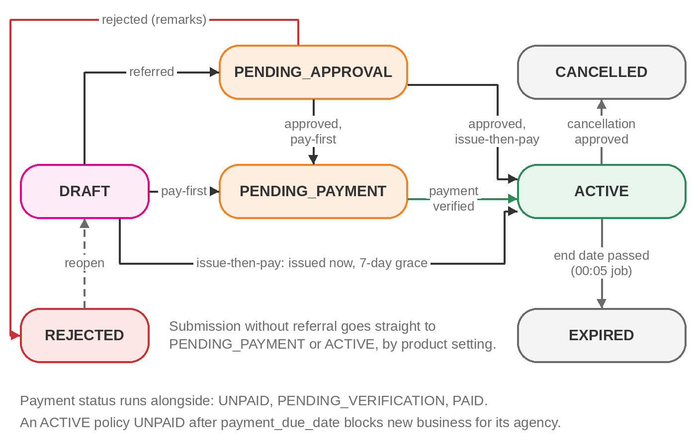
Figure 3: Quotation and policy lifecycle
Referral reason | Source
Sum covered above the agent's authority limit | agent.authority_limit (AP-60)
Product limit, e.g. financing amount above B$150,000 (high-risk limit) | Product configuration
Questionnaire answer marked 'refer if yes' | product.questionnaire
Quality check before issuance for products that require it | Product rules
Table 5: Referral triggers
Pay-first products (the annual plans) wait in PENDING_PAYMENT until Finance verifies payment, then issue. Issue-then-pay products (the financing plans) issue immediately with a payment due date of issuance plus the grace period (7 days by default). A daily job blocks every agent of an agency from submitting new business while any of its issued policies is unpaid beyond the due date, and lifts the block automatically once nothing is overdue (AP-42). An administrator can lift a block manually with a reason; the next daily run re-applies it if contributions are still overdue.
Renewal is allowed only inside the renewal window, from policy.renewal_notice_days before the end date until 30 days after it; outside it the API answers OUTSIDE_RENEWAL_WINDOW. The renewals-due list uses the same window, and products can switch renewal off.

4.2 Maker-checker workflows
Eight transaction types run through the workflow engine. Each type has a configurable sequence of levels; each level names the permission a checker needs and, optionally, an amount threshold from which it applies. The levels are resolved when the request is raised and stored with it, so a later configuration change does not alter requests already in flight. When no level applies the request is approved immediately and the change is applied in the same transaction.
Type | Default levels (seed data) | Effect on final approval
AGENT_REGISTRATION | Operations supervisor approval (bo.approve.agents) | Agent ACTIVE, portal user and role created, AGENT_UPSERT to Core
AGENT_PROFILE_UPDATE | Operations supervisor approval | Changes applied, AGENT_UPSERT to Core
AGENT_STATUS_CHANGE | Operations supervisor approval | Status applied; sessions revoked when deactivated
PARTICIPANT_UPDATE | Operations supervisor approval (bo.approve.participants) | Changes applied; re-screened on name change; PARTICIPANT_UPSERT to Core
POLICY_REFERRAL | Underwriting / quality check; second approval from sum covered B$300,000 | Policy proceeds to PENDING_PAYMENT or ACTIVE; rejection returns it with remarks
POLICY_ENDORSEMENT | Policy servicing approval (bo.approve.servicing) | Endorsement applied, POLICY_ENDORSED
POLICY_CANCELLATION | Policy servicing approval | CANCELLED, POLICY_CANCELLED, REFUND_REQUESTED when a refund is due
PAYMENT_VERIFICATION | Finance verification (bo.approve.payments) | Receipts issued, RECEIPT_POSTED, pay-first policies issued
Table 6: Approval types
Rules enforced by the server: the maker can never approve their own request; the same person cannot approve two levels of one request; rejection requires remarks; a request can be withdrawn by its maker until decided; only one pending request per record and type is allowed; and a decision fails with STALE_RECORD if another checker decided the same level first. An agent registration can be approved only once the identity document is on file: the passport copy for passport holders, otherwise the IC copy.
When Compliance confirms an AML match, the subject's pending approval requests (for example the agent registration) are rejected in the same transaction with the Compliance remarks and the maker is notified. The subject's AML status becomes REJECTED, and an agent whose registration is closed this way is REJECTED.

4.3 Scheduled processing
Job | Schedule (Brunei time) | Lock | Purpose | Source
end-of-day | Daily 23:30 (EOD_CRON, JOBS_TIMEZONE) | end-of-day | EOD report, FIN file, EOD_POSTING message, receipt reconciliation | eod/eod.service.ts
policy-expiry | Daily 00:05 | policy-expiry | ACTIVE policies past end date become EXPIRED; agent notified | policies/policy.jobs.ts
payment-grace-period | Daily 01:00 | payment-grace-period | Blocks agencies with overdue issue-then-pay policies; lifts the block when settled | billing/grace-period.service.ts
outbox-dispatch | Every 20 seconds | outbox-dispatch | Delivers up to 25 due outbox messages to Core and FIN | integration/outbox.dispatcher.ts
notification-dispatch | Every 30 seconds | notification-dispatch | Sends up to 50 pending e-mail and SMS notifications | notifications/notification.dispatcher.ts
issue-sla-monitor | Every 5 minutes | issue-sla-monitor | Flags issues past their response or resolution target and alerts support | issues/issues.service.ts
scheduled-reports | Every 15 minutes | scheduled-reports | Runs due report schedules and e-mails the files | reports/reports.service.ts
session pruning | Every 15 minutes | none (idempotent) | Deletes expired rows from user_session | connect-pg-simple
Table 7: Scheduled jobs
Each job takes a PostgreSQL transaction-scoped advisory lock (pg_try_advisory_xact_lock) named after the job before it runs. Every API replica schedules the jobs, but only the replica that gets the lock does the work; the lock is released automatically if the process stops. JOBS_ENABLED=false disables all jobs in an instance, for example in a reporting replica.

5. Logical and Application Architecture

5.1 Layers
The solution has five layers. Two single-page applications, built from one React code base, run in the browser. An nginx web tier serves them and forwards /api calls. The NestJS API holds all business logic and security enforcement. PostgreSQL holds all structured data, and an encrypted file store holds documents. Scheduled jobs run inside the API processes and coordinate through database locks, so there is no separate scheduler or message broker to operate.
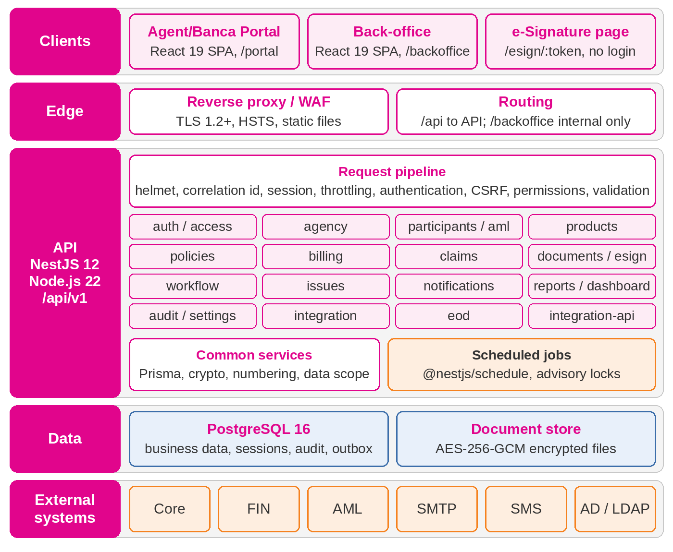
Figure 4: Logical architecture

5.2 Front end
apps/web is a React 19 and TypeScript application built with Vite 7 and Ant Design 6, themed in the Insurans Islam TAIB colours. It contains 54 page components behind three route trees: /portal for agents and bank officers, /backoffice for IIFT staff and /esign/:token for participants. Pages are loaded on demand, and vendor libraries are split into separate chunks (react, antd, charts) so the first screen stays small.
Server state is managed with TanStack Query. A thin API client sends the session cookie (same origin), adds the X-CSRF-Token header to every state-changing call, and turns error responses into a typed error that carries the correlation id the user can quote to support. A 401 response returns the user to the sign-in page. Route guards in the SPA only shape navigation; every check is repeated by the API.

5.3 API
The API is a NestJS 12 application on Node.js 22, written in TypeScript as ES modules. All business endpoints are under /api/v1 and are described in docs/api/openapi.json (128 paths, 149 operations). Namespaces separate the audiences, so the reverse proxy can publish the back-office only on the internal network.
Namespace | Ops | Purpose | Access control
/api/v1/auth | 4 | Sign-in, sign-out, current user, password change | Session (login is public)
/api/v1/portal | 45 | Agent/Banca Portal functions | Session, PORTAL audience, permissions, data scope
/api/v1/backoffice | 80 | Back-office functions | Session, BACKOFFICE audience, permissions
/api/v1/common | 15 | Functions used by both audiences: documents, notifications, issues, products, codes | Session, permissions, data scope
/api/v1/public | 2 | Participant e-signature page | One-time token (hash stored)
/api/v1/integration | 3 | System-to-system APIs for Core and FIN | API key (SHA-256 held), IP allow-list
/health/live, /health/ready, /metrics | 3 | Probes and Prometheus metrics (outside /api/v1) | Public probes; METRICS_TOKEN for metrics
Table 8: API namespaces

5.4 Request processing
Every request passes the same pipeline, configured once in app.setup.ts and used by both the server and the end-to-end tests. Global guards run in a fixed order: throttling, authentication, CSRF, then permissions. A route is protected unless it is explicitly marked public.
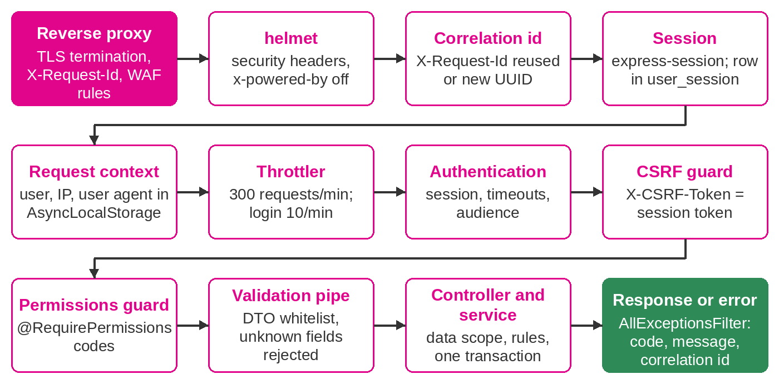
Figure 5: Request pipeline

5.5 Error handling
A global exception filter turns every error into the same JSON body: statusCode, a stable code, a message safe to show, optional details and the correlation id. Unexpected errors are logged in full on the server and reach the user only as a generic message with the correlation id (NFR-15).
HTTP | Codes | When
400 | BAD_REQUEST | Validation failed; details lists each field problem
401 | NOT_AUTHENTICATED, INVALID_CREDENTIALS, ACCOUNT_LOCKED, SESSION_EXPIRED | No valid session or sign-in refused
403 | FORBIDDEN, CSRF_TOKEN_INVALID, WRONG_AUDIENCE, PASSWORD_CHANGE_REQUIRED | Not permitted
404 | NOT_FOUND | Record does not exist or is outside the user's data scope
409 | DUPLICATE, STALE_RECORD | Unique value exists; record changed by another user
413 | PAYLOAD_TOO_LARGE | Body or file above the limit
422 | Business rule codes, e.g. AGENCY_BLOCKED, SUBMISSION_INCOMPLETE, QUOTATION_EXPIRED | Valid request that breaks a business rule
429 | TOO_MANY_REQUESTS | Rate limit reached
500 | INTERNAL_ERROR | Unexpected error; logged with stack trace on the server only
503 | NOT_READY, NOT_CONFIGURED | Database unavailable; inbound integration not configured
Table 9: Error responses

5.6 Consistency and concurrency
- Each business operation runs in one database transaction that includes its audit row and outbox message.
- Records edited by several users (agent, participant, policy) carry a version column; updates quote the version read and fail with STALE_RECORD if it changed.
- Approval decisions update the request only if it is still PENDING at the expected level, so two checkers cannot both decide.
- Reference numbers come from PostgreSQL sequences, which are safe across replicas without row locks.
- Amounts are DECIMAL end to end and rounded half-up to two places; binary floating point is never stored.

6. Data Architecture
The database has 37 tables in 13 areas. The Data Dictionary documents every column; this chapter explains the structure and the controls around it.

6.1 Entity overview
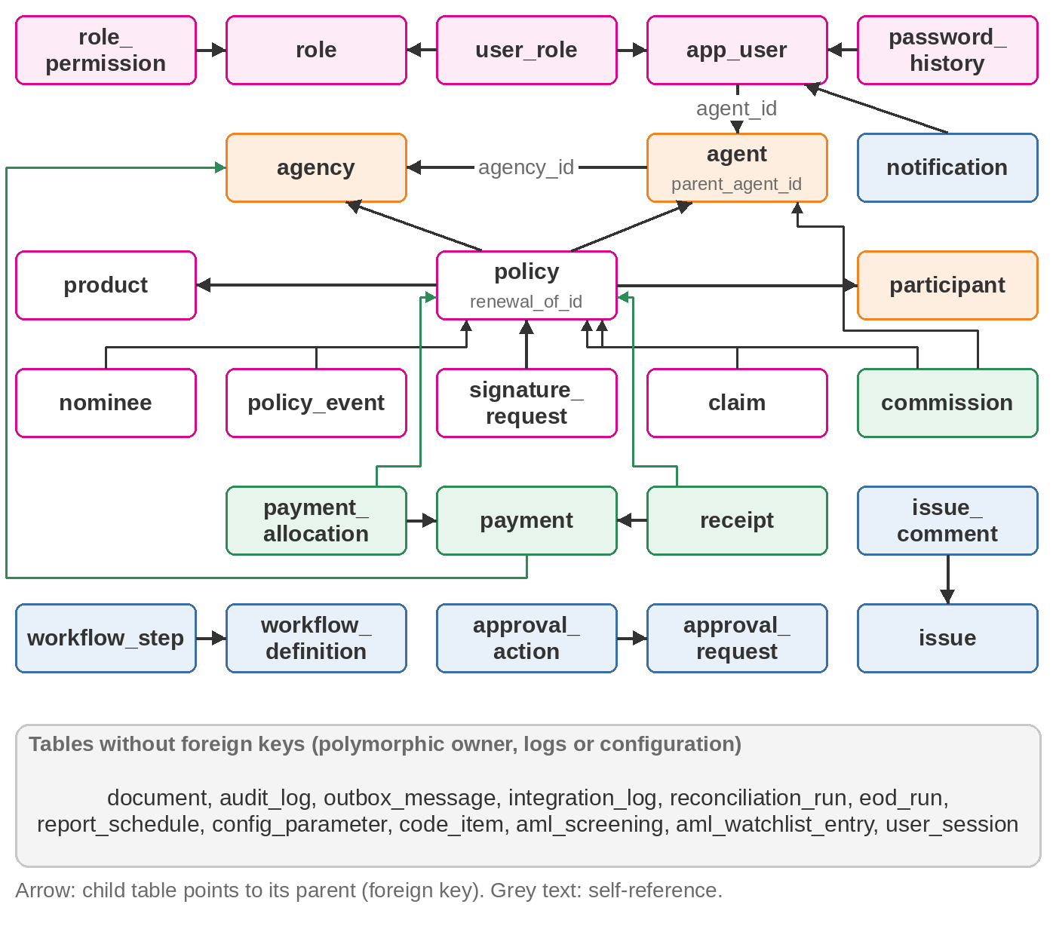
Figure 6: Entity overview
Entity | Role in the model
agency, agent | Distribution structure. Agents belong to one agency or bank; sub-agents point to their main agent. Agency carries the issuance block.
app_user, role, user_role, role_permission | Sign-in identities and role-based permissions. A portal user is linked to exactly one agent.
participant | One shared record per identification number across agencies; encrypted identifier with blind index; AML status.
product | Rating configuration, required documents and questionnaire as validated JSON.
policy | Quotation and policy in one row through the whole lifecycle; contribution breakdown and risk details as JSON; outstanding amount and due date.
payment, payment_allocation, receipt, commission | Bulk payments allocated per policy; one receipt per policy; commission accrued at issuance.
approval_request, approval_action | Maker-checker requests with payload and resolved levels; full action history.
document | Metadata for encrypted files attached to any owner type.
audit_log | Append-only audit trail with before and after values.
outbox_message, integration_log, reconciliation_run, eod_run | Integration delivery, call log, reconciliation and end-of-day history.
Table 10: Key entities

6.2 Why PostgreSQL
PostgreSQL 16 was chosen over MongoDB because IIFT's data is relational and financial, and because issuance, receipting, audit and integration must commit together.
Criterion | PostgreSQL 16 (selected) | MongoDB
Data shape | Agency, agent, sub-agent; policy, participant, nominees, payments, receipts, claims: strongly relational | Suits self-contained documents with few cross-references
Transaction integrity (NFR-16) | Issuance, receipt, audit and outbox commit in one ACID transaction | Multi-document transactions exist but are not the natural model
Financial accuracy | Exact DECIMAL, foreign keys, CHECK and UNIQUE constraints in the database | Decimal128; most integrity rules move into application code
Reporting (BO-22 to BO-25) | Joins and aggregates in SQL | Aggregation pipelines with $lookup
Flexible structures | JSONB for product configuration, questionnaires, audit values, outbox payloads | Native
Operations | Streaming replication, PITR, pgBackRest; managed service on AWS and Azure; skills common in IITH | Replica sets; a second database skill set
Licence | PostgreSQL licence, no fee | SSPL; some enterprise features paid
Fit to volume | Under 1 GB of rows after five years at Appendix 2 volumes | Strength is very large schemaless data, not needed here
Table 11: Database selection

6.3 Integrity controls
- 27 foreign keys with explicit ON DELETE rules: RESTRICT for business parents, CASCADE only for dependent detail rows (nominees, events, allocations, comments, role links).
- 24 unique indexes, including one participant and one agent per identification type and number, one receipt number, one policy number.
- 4 CHECK constraints: amounts on policy, payment and allocation; nominee share between 0 and 100.
- Validation of every request body against a whitelist DTO before it reaches a service; unknown fields are rejected (NFR-30).
- JSON columns (product configuration, questionnaire, payloads) are validated by the owning service before they are written.

6.4 Audit trail
The audit service writes one row per security or business event: actor, action, entity, before and after values, IP address, user agent and correlation id. It writes inside the caller's transaction, so an audit row exists exactly when the change exists. Passwords, hashes, encrypted identifiers, tokens and storage keys are replaced with a fixed REDACTED marker. In the database, the trigger audit_log_no_update calls audit_log_block_mutation() before any UPDATE or DELETE and raises an exception, so the trail is append-only whichever client connects. Granting the application role only INSERT and SELECT on audit_log, with a separate migration owner role, is set up during implementation.

6.5 Field-level encryption
IC, passport and business registration numbers of agents and participants, and nominee identification numbers, are encrypted by the application before they reach the database: AES-256-GCM with a random 96-bit IV per value, stored as v1:<base64(IV | tag | ciphertext)>. The version prefix allows a new key to be introduced without a big-bang re-encryption. For exact search and duplicate prevention, the application also stores a blind index: HMAC-SHA256 of the normalised number (separators removed, upper case) with a separate key. The unique constraint on (id_type, id_number_hash) therefore blocks duplicates without decrypting anything. Screens show the number masked to its last four characters, and the API never returns ciphertext: approval request views (inbox, search, detail, the portal's own requests and record history) drop payload values whose key ends in Enc, while the stored payload keeps them for the approval handler. When nominees are saved again with their existing id and the number left blank, as on a draft or an endorsement, the stored encrypted number is kept.

6.6 Reference numbers
Sequence | Format | Column
seq_agent_code | AG-000045 (agency) or BK-000012 (bank officer) | agent.agent_code
seq_participant_no | PT/26/000123 | participant.participant_no
seq_quotation_no | QT/26/000123 | policy.quotation_no
seq_policy_no | PRO/26/000045 (product code prefix) | policy.policy_no
seq_payment_no | PY/26/000123 | payment.payment_no
seq_receipt_no | RC/26/000123 | receipt.receipt_no
seq_claim_no | CL/26/000123 | claim.claim_no
seq_issue_no | IS/26/000123 | issue.issue_no
seq_request_no | RQ/26/000123 | approval_request.request_no
Table 12: Business reference numbers
The two-digit year is the calendar year of issue. Sequences never repeat a value; a rolled-back transaction can leave a gap, which is acceptable for these references and is explained to auditors.

6.7 Documents
Uploaded and generated files are encrypted with AES-256-GCM (separate key, one IV per file) and written to the document store under a generated key of the form yyyy/mm/<uuid>.bin, so no user input ever influences a file path. The document table holds the owner, type, sanitised file name, detected content type, size, SHA-256 checksum and verification status. The store is a directory: a local or NFS volume on-premise, or an encrypted Amazon EFS or Azure Files share in the cloud. An S3-compatible adapter is delivered during implementation if IIFT prefers object storage.

6.8 Configuration data
Business parameters live in config_parameter and are changed in the back-office within the allowed range; every change is audited. Values are cached briefly in each API instance.
Parameter | Default | Range | Meaning
security.password.min_length | 12 | 8 to 64 | Minimum password length
security.password.require_upper | true | – | Password must contain an upper-case letter
security.password.require_lower | true | – | Password must contain a lower-case letter
security.password.require_digit | true | – | Password must contain a digit
security.password.require_symbol | true | – | Password must contain a symbol
security.password.history_count | 5 | 0 to 24 | Number of previous passwords that cannot be reused
security.password.expiry_days | 90 | 0 to 365 | Days before a password must be changed (0 = never)
security.lockout.max_attempts | 5 | 3 to 20 | Failed login attempts before the account is locked
security.lockout.minutes | 30 | 1 to 1440 | Lock duration in minutes (administrator can unlock earlier)
security.session.idle_minutes | 15 | 5 to 120 | Session idle timeout in minutes
security.session.absolute_hours | 8 | 1 to 24 | Maximum session lifetime in hours
security.session.single_active | true | – | Signing in ends the user's other sessions
billing.payment_grace_days | 7 | 1 to 60 | Days after issuance within which contribution must be submitted before the agency is blocked
policy.quotation_validity_days | 30 | 1 to 180 | Days a draft quotation remains valid
policy.renewal_notice_days | 45 | 7 to 120 | Days before expiry that a policy is listed as due for renewal
policy.require_participant_signature | true | – | Participant signature is mandatory before submission
policy.esign_link_hours | 72 | 1 to 336 | Validity of e-signature links sent by email (hours)
aml.match_threshold | 85 | 50 to 100 | Name-match score (0-100) at or above which a screening is flagged for review
commission.default_rate | 0.10 | 0 to 1 | Default commission / referral fee rate when the product does not define one
sla.critical.response_hours | 1 | 1 to 72 | Critical issue response target (hours)
sla.critical.resolution_hours | 4 | 1 to 168 | Critical issue resolution target (hours)
sla.high.response_hours | 2 | 1 to 72 | High issue response target (hours)
sla.high.resolution_hours | 24 | 1 to 336 | High issue resolution target (hours)
sla.medium.response_hours | 8 | 1 to 168 | Medium issue response target (hours)
sla.medium.resolution_hours | 72 | 1 to 720 | Medium issue resolution target (hours)
sla.low.response_hours | 24 | 1 to 336 | Low issue response target (hours)
sla.low.resolution_hours | 168 | 1 to 2160 | Low issue resolution target (hours)
integration.max_attempts | 6 | 1 to 20 | Delivery attempts before an integration message is moved to dead-letter
notification.max_attempts | 5 | 1 to 20 | Email/SMS delivery attempts before giving up
document.expiry_warning_days | 30 | 1 to 180 | Days before expiry that documents are flagged
Table 13: Business parameters and defaults

6.9 Retention and archival
Proposed retention periods are below. They are confirmed with IIFT Compliance against the PDPO 2025, AMBD requirements and AML/CFT record-keeping rules during design. The retention job that applies them, with an archive schema and audit of every purge, is delivered during implementation. Expired sessions are already pruned automatically.
Data | Retention | Mechanism
Policies, quotations taken up, nominees, policy events | 7 years after policy end or cancellation | Archive to read-only schema, then delete
Quotations not taken up (DRAFT, REJECTED) | 2 years after last change | Delete with documents
Participants and AML screenings | 7 years after the last policy ends (AML/CFT record keeping) | Archive, then delete
Payments, receipts, commissions, EOD runs, FIN files | 7 years after the financial year | Archive, then delete
Audit log | 7 years online or in archive | Controlled archive procedure (trigger blocks normal deletion)
Integration log, delivered outbox messages | 2 years | Delete
Notifications | 1 year (sensitive bodies already removed after delivery) | Delete
Issues and comments | 3 years after closure | Delete
Sessions | Until expiry | Pruned every 15 minutes (running today)
Table 14: Proposed retention

6.10 Data migration
Legacy agents, agencies, participants and in-force policies are loaded through the same services the application uses, so encryption, blind indexes, numbering and audit apply to migrated records. Each rehearsal produces a reconciliation of counts and amounts that IIFT signs off (DEL-19); the migration tooling is delivered during implementation.

7. Integration Architecture

7.1 Approach
Outbound business events to the core and financial systems use a transactional outbox. Calls that need an answer at once (AML screening, directory sign-in, FIN posted receipts) are synchronous with timeouts. E-mail and SMS go through the notification table and its own dispatcher. Core and FIN call the portal through a small set of API-key-protected endpoints. Every call in either direction is written to integration_log, which feeds the integration monitor (INT-11, INT-14).
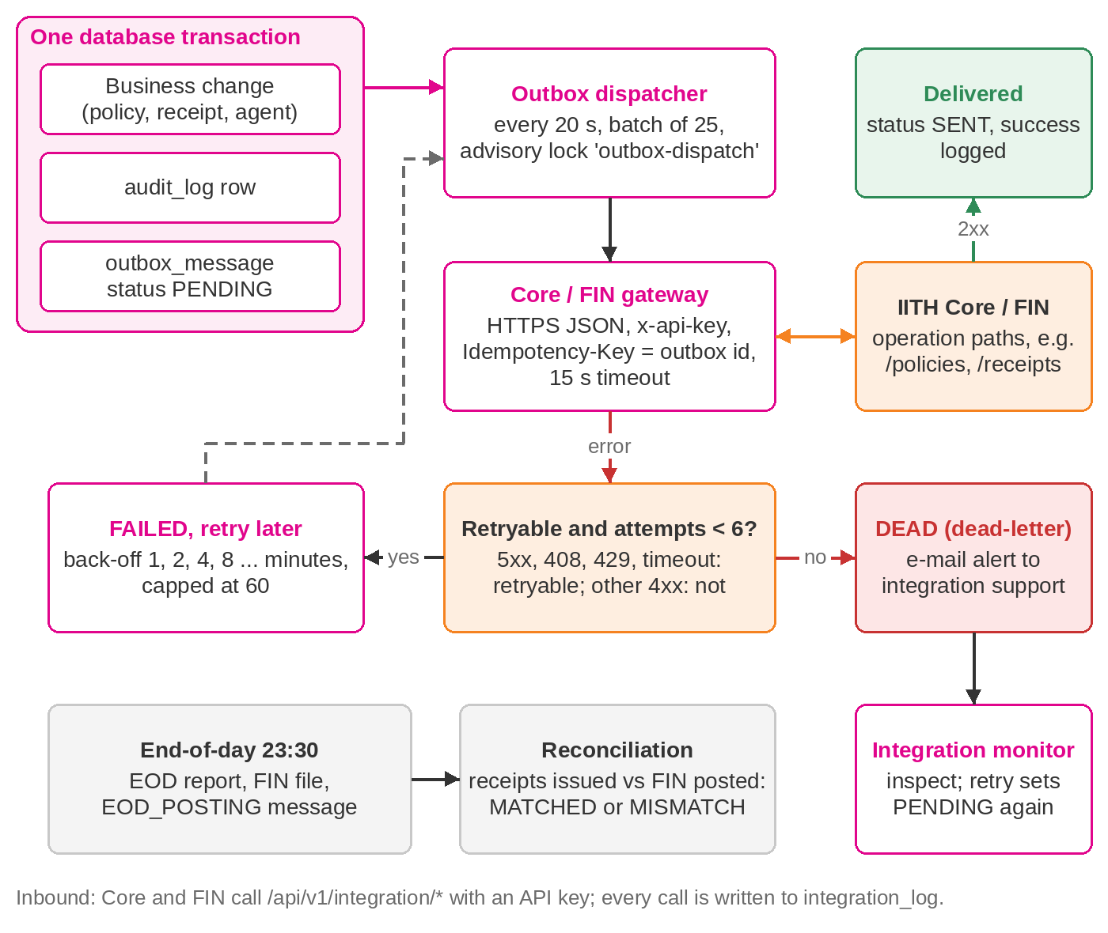
Figure 7: Outbox delivery, retry and dead-letter

7.2 Delivery guarantees
- Atomic capture. The outbox row is inserted in the same transaction as the business change, so a message is never lost and never sent for a change that rolled back.
- At-least-once delivery with idempotency. The outbox id is sent as the Idempotency-Key header, unless the payload carries its own business key (EOD postings), which is sent instead; the receiver must ignore a key it has already processed. This is part of the interface specification.
- Retry with back-off. Connection errors, timeouts, HTTP 5xx, 408 and 429 are retried after 1, 2, 4, 8 ... minutes, capped at 60 minutes. Other 4xx responses mean the message is wrong and go straight to dead-letter.
- Dead-letter and alert. After integration.max_attempts attempts (6 by default) the message becomes DEAD and every holder of bo.integration.manage receives an e-mail. The integration monitor shows the message and error; Retry resets it to PENDING.
- Ordering. Due messages are taken oldest first in batches of 25 by a single dispatcher (advisory lock), so events for one record are delivered in order unless one of them is retrying.
- Timeouts. Each endpoint has its own timeout (15 seconds by default).

7.3 Outbound operations
System | Operation | Endpoint (base URL from configuration) | Raised when
CORE | AGENT_UPSERT | POST /agents | Agent registration, profile update or status change approved
CORE | PARTICIPANT_UPSERT | POST /participants | Participant update approved
CORE | POLICY_ISSUED | POST /policies | Policy issued: directly, after referral approval or after payment verification
CORE | POLICY_ENDORSED | POST /policies/endorsements | Endorsement approved
CORE | POLICY_CANCELLED | POST /policies/cancellations | Cancellation approved
CORE | CLAIM_NOTIFIED | POST /claims | Claim notification submitted
FINANCE | RECEIPT_POSTED | POST /receipts | Payment verified and receipt issued
FINANCE | REFUND_REQUESTED | POST /refunds | Cancellation approved with a refund due
FINANCE | COMMISSION_ACCRUED | POST /commissions | Commission accrued at issuance
FINANCE | EOD_POSTING | POST /eod-postings | End-of-day run completed
Table 15: Outbox operations
System | Call | Used by | Content
FIN | GET /receipts/posted?date= | Reconciliation in live mode | Receipt references posted for a date
AML provider | POST /screen | Agent or participant screening (when AML_API_BASE_URL is set) | Name, identification number, date of birth, nationality; returns matches with scores
SMS gateway | POST /messages | Notification dispatcher | Sender id, mobile number, text up to 480 characters
SMTP relay | SMTP, STARTTLS required | Notification dispatcher | Message with optional attachments
Active Directory | LDAP bind and search | Back-office sign-in of DIRECTORY users | Service bind, user search with escaped filter, user bind
Table 16: Synchronous and notification calls
Endpoint paths, payload fields and the FIN interface file layout shown here are the working defaults. They are confirmed or mapped to IITH's formats in the Interface Specification (DEL-09) during design.

7.4 Inbound system APIs
Endpoint | Caller | RFP | Input | Effect
PUT /api/v1/integration/agents/{agentCode}/status | Core | INT-02 | {status, reason}; status ACTIVE, INACTIVE, SUSPENDED or TERMINATED | Updates the agent and its user; ends all sessions of a deactivated agent
GET /api/v1/integration/policies?issuedOn=YYYY-MM-DD | Core, FIN | INT-09 | Business date | Policies issued that day with product, participant, agent, agency, amounts and dates
POST /api/v1/integration/commissions/paid | FIN | INT-05 | items: list of {policyNo, agentCode, paidOn}, up to 1,000 items | Marks commissions PAID; returns updated count and unmatched items
Table 17: Inbound endpoints
Callers present x-api-key. The API holds only the SHA-256 of the key (INBOUND_API_KEY_SHA256) and compares in constant time; if no hash is configured the endpoints answer 503. nginx or the firewall restricts /api/v1/integration to the Core and FIN host addresses. Each call is logged as INBOUND with its outcome and duration.

7.5 End-of-day and reconciliation
At 23:30 Brunei time (EOD_CRON) the end-of-day job selects policies issued and receipts issued during the business day and, in one transaction, stores the EOD issuance report (Excel: summary by product, policies issued, receipts), stores the FIN interface file (CSV: one PI line per policy and one RC line per receipt with amounts in BND), queues an EOD_POSTING message with the day's totals and records the run. It then reconciles receipts: in live mode against the receipt references FIN reports as posted for that date; in simulated mode against RECEIPT_POSTED messages delivered from the outbox. The result is MATCHED or MISMATCH with the unmatched receipt numbers. Finance can re-run EOD for any past date from the back-office; the eod_run row for the date is updated, not duplicated. Each posting carries a revision number, the idempotency key EOD-<date>-R<n> and replacesPreviousRevision (true from the second revision). The dispatcher sends that key to FIN, so FIN can reject a repeated delivery of the same revision and replace the earlier revision for the date; the interface specification sets out this behaviour.

7.6 Simulated and live modes
INTEGRATION_MODE=simulated records every outbound message and marks its reference as simulated without calling external systems, so the full flow can be built and tested before IITH endpoints exist. In live mode the configured endpoints are called; a production instance in live mode refuses to start without the Core, FIN, SMTP and inbound key settings. E-mail and SMS are sent only when SMTP_HOST and SMS_API_BASE_URL are set, independent of the mode.

8. Security Architecture
Controls are layered so that no single failure exposes data. They are aligned with OWASP ASVS Level 2 and the OWASP Top 10, the Brunei Personal Data Protection Order 2025 and AMBD technology-risk expectations. The Security Assessment Report records the test evidence.
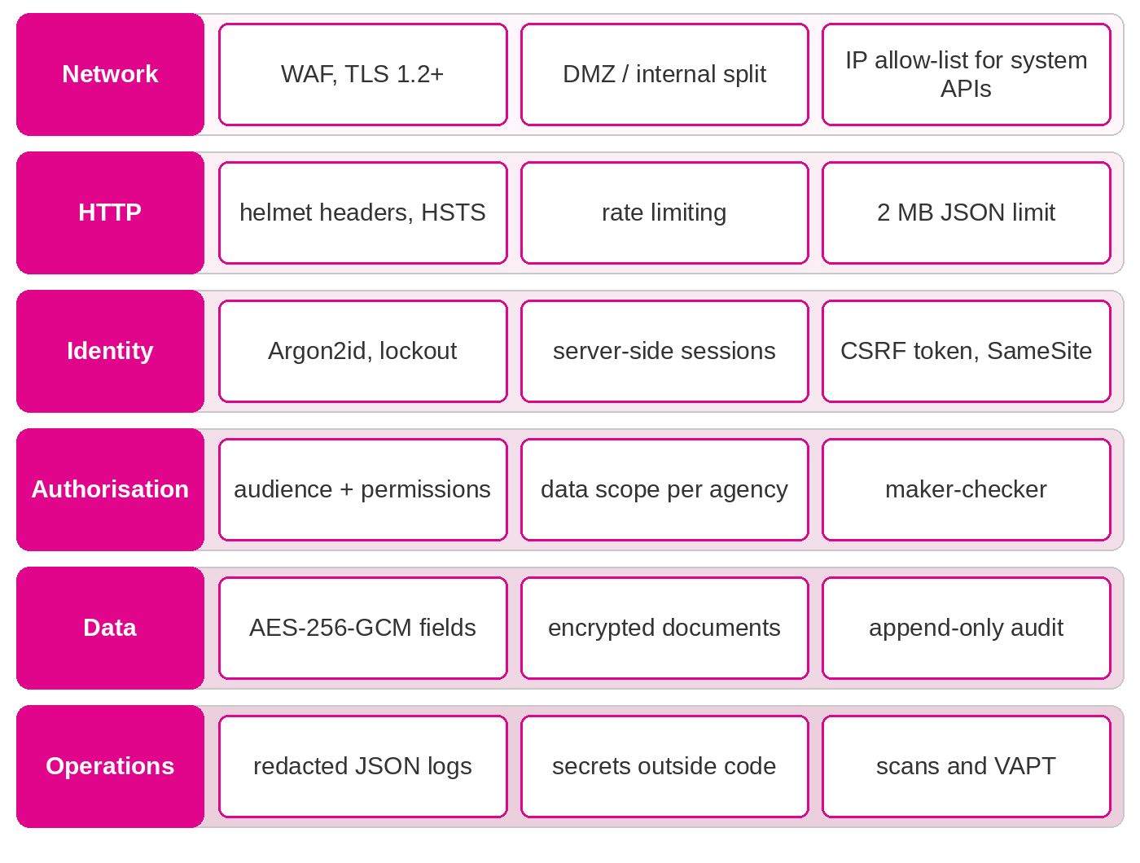
Figure 8: Defence in depth

8.1 Control catalogue
Control | Implementation | RFP
Passwords | Argon2id (19 MiB memory, 2 iterations, parallelism 1). Policy: 12+ characters, upper, lower, digit, symbol, must not contain the user name, last 5 not reusable, 90-day expiry, forced change after reset. All values are parameters. | AP-02, NFR-09
Lockout | 5 failed attempts lock the account for 30 minutes (parameters); unknown user names take the same time to reject; every success, failure and lock is audited; administrators can unlock. | AP-04
Sessions | Server-side in PostgreSQL; cookie HttpOnly, Secure, SameSite=Strict, path /; id regenerated at sign-in; idle timeout 15 minutes and absolute 8 hours (parameters); single active session option; sign-out and password change revoke sessions on the server. | AP-03
CSRF | Synchroniser token: 32 random bytes created at sign-in, held in the session, returned to the SPA and required in X-CSRF-Token on every state-changing request; compared in constant time. | NFR-14
Authorisation | 48 permission codes grouped into configurable roles; portal and back-office permissions cannot be mixed in one role; every route declares its audience and permissions; deny by default. | AP-59, BO-02, NFR-10
Data scope | Back-office: all records. Portal users with agency-wide permission: their agency or bank. Main agents: themselves and sub-agents two levels down. Others: own records. Applied in every portal query. | AP-09, AP-12, COM-02
Maker-checker | Maker cannot approve own request; one person cannot approve two levels; remarks on rejection; levels fixed at submission. | BO-17, COM-04
In transit | TLS 1.2 or later at the load balancer or nginx with HSTS; TLS to PostgreSQL (sslmode=require), STARTTLS to SMTP, LDAPS, HTTPS to all APIs. | NFR-08, COM-10
At rest | AES-256-GCM for identification numbers and documents with keys outside the database; HMAC-SHA256 blind index; encrypted volumes and backups (infrastructure). | COM-01, COM-10, NFR-08
Uploads | Content type from magic bytes (PDF, PNG, JPEG only); MAX_UPLOAD_MB (10 MB) limit; file name sanitised and extension forced to match content; SHA-256 recorded; ClamAV INSTREAM scan, and the upload fails if the scanner cannot be reached. CLAMAV_HOST is mandatory in production. | AP-46, COM-06
Rate limiting | nginx 20 requests/second per IP (burst 40) on /api; API 300 requests/minute per IP; sign-in and password change 10/minute. | NFR-14
Headers | helmet on API responses, with X-Frame-Options DENY and a CSP of default-src 'none' and frame-ancestors 'none'; nginx adds HSTS, CSP (self only, frame-ancestors none), X-Frame-Options DENY, nosniff, Referrer-Policy and Permissions-Policy; server tokens and x-powered-by removed. | NFR-14
Errors | Generic message plus correlation id to the client; full details only in server logs. | NFR-15
Logging | JSON logs; cookie, authorization, CSRF and set-cookie headers redacted; audit values redacted. | NFR-11, NFR-28
System APIs | API key compared by SHA-256 in constant time; only the hash is configured; IP allow-list at nginx or the firewall; every call logged. | INT-10
Production guard | The API refuses to start in production with a non-secure cookie, API docs enabled, no CLAMAV_HOST, or live integration without Core, FIN, SMTP and inbound key settings. | NFR-14
Multi-factor authentication | E-mail one-time code or authenticator app for back-office users; optional for portal users. Delivered during implementation. | NFR-09
Table 18: Security controls

8.2 Roles
Code | Role | Audience | Purpose
AGENCY_PRINCIPAL | Agency principal / main agent | Portal | Main agent: own business, sub-agents and agency-wide view; registers sub-agents
AGENT | Agent | Portal | Sub-agent: own quotations, policies, payments and claims
BANCA_OFFICER | Bank officer (banca) | Portal | Bank officer selling financing takaful at the branch
BANCA_SUPERVISOR | Bank supervisor (banca) | Portal | Bank branch supervisor: bank-wide view and officer registration
SYSTEM_ADMINISTRATOR | System administrator | Back-office | Users, roles, parameters, master data, workflows, products and integration
OPERATIONS_OFFICER | Operations officer (maker) | Back-office | Agent and agency administration, document checks, claims and issues
OPERATIONS_SUPERVISOR | Operations supervisor (checker) | Back-office | Approves agent, participant and servicing requests
UNDERWRITER | Underwriter / quality check | Back-office | Approves referred quotations and performs quality checks before issuance
FINANCE_OFFICER | Finance officer | Back-office | Verifies payments, issues receipts, runs end-of-day and reconciliation
COMPLIANCE_OFFICER | Compliance officer | Back-office | Reviews AML/KYC cases and maintains watch-lists
MANAGEMENT | Management | Back-office | Management dashboard, KPIs and reports (read-only)
SUPPORT_DESK | Support desk | Back-office | Handles issues reported through the portal
AUDITOR | Internal auditor | Back-office | Read-only access to records and the audit trail
Table 19: Default roles (seed data, editable in the back-office)

8.3 Keys and secrets
All secrets are supplied as environment variables from the platform's secret store (HashiCorp Vault or the IITH equivalent on-premise; AWS Secrets Manager or Azure Key Vault in the cloud) and never stored in the repository or images. Encryption keys are 256-bit random values, base64 encoded; the API checks their length at start-up.
Secret | Purpose | Rotation
SESSION_SECRET | Signs the session cookie | Rotate yearly or on staff change; all users sign in again
FIELD_ENCRYPTION_KEY | Encrypts identification numbers | Version prefix v1 in each value; re-encryption tool for a v2 key delivered during implementation
FIELD_HASH_KEY | Blind index of identification numbers | Rotation needs every blind index recomputed; same tool
DOCUMENT_ENCRYPTION_KEY | Encrypts stored files | Rotation re-encrypts the store; tool delivered during implementation
INBOUND_API_KEY_SHA256 | Hash of the key Core and FIN present | Rotate yearly; issue new key, update hash, retire old key
CORE/FINANCE/AML/SMS API keys | Outbound authentication | Per provider policy
SMTP_PASSWORD, LDAP_BIND_PASSWORD | Relay and directory service accounts | Per IITH policy
Database passwords | Application and migration roles | Per IITH policy
METRICS_TOKEN | Protects /metrics | Yearly
Table 20: Secrets

8.4 Security testing
- End-to-end tests cover authentication, access control across audiences and data scopes, and the policy lifecycle against a real database on every CI run.
- tools/security/security-checks.mjs runs repeatable OWASP Top 10 checks against a test environment before each release.
- CI runs CodeQL (security-extended queries) and a gitleaks secret scan of the full history on every push and pull request, and blocks a release on moderate or higher npm audit findings and on unfixed critical or high container image findings.
- An independent VAPT is performed before go-live; no critical or high finding may remain open (NFR-13).

9. Deployment Architecture
SalesVerse 2.0 ships as container images and runs unchanged in the IIFT/IITH data centre or in a cloud account. The two deployment models match the commercial options of the proposal: Option A, on-premise on infrastructure that IIFT procures to the sizing in chapter 10, under a perpetual licence; and Option B, hosted and managed by iorta in a cloud account dedicated to IIFT, under a subscription. A hybrid variant of Option A keeps all data on-premise and places only the portal's web tier at the edge. Option C of the proposal (source code handover) does not change the deployment; the Production Support Handover describes that transition.

9.1 Environments
Env. | Purpose | Hosted by | Shape | Data | Integration | API docs
DEV | Development, sprint demos | iorta (both options) | 1 VM or laptop compose | Synthetic, demo seed | simulated | Enabled
SIT | Integration and performance testing | A: IIFT data centre (iorta until the VM is ready). B: cloud account | 1 VM, compose; B: 1 task | Synthetic and masked | live (test endpoints) | Enabled
UAT | Acceptance, training, release rehearsal | A: IIFT data centre. B: cloud account | 1 VM, compose; B: 1 task, small database | Masked or migrated | live (test endpoints) | Disabled
PROD | Live operation | A: IIFT/IITH data centre. B: cloud, Malaysia region | 2 app + 2 DB VMs; B: 2 tasks in 2 zones, Multi-AZ database | Production | live | Disabled
DR | Disaster recovery | A: IIFT/IITH DR site. B: second cloud region | 1 app + 1 DB VM; B: pilot light | Replica of PROD | live (on invocation) | Disabled
Table 21: Environments
Every environment runs the same images; only configuration differs. Promotion is DEV to SIT to UAT to PROD, and nothing reaches PROD that has not passed UAT. DEV stays with iorta under both options.

9.2 Option A: on-premise high availability (recommended)
Two application VMs sit behind an external WAF and load balancer pair for internet users and an internal load balancer for staff and IITH systems. Each application VM runs the web, API and ClamAV containers. PostgreSQL runs natively on a primary VM with a hot standby fed by streaming replication. Documents are on an NFS share mounted by both application VMs. Losing one application VM leaves the service running; losing the database primary is handled by promoting the standby. IIFT procures the servers, storage, network and DR capacity to the sizing in chapter 10 (the proposal's bill of materials lists the same items); IITH operates the infrastructure and iorta installs, configures and supports the application and database under the maintenance agreement.
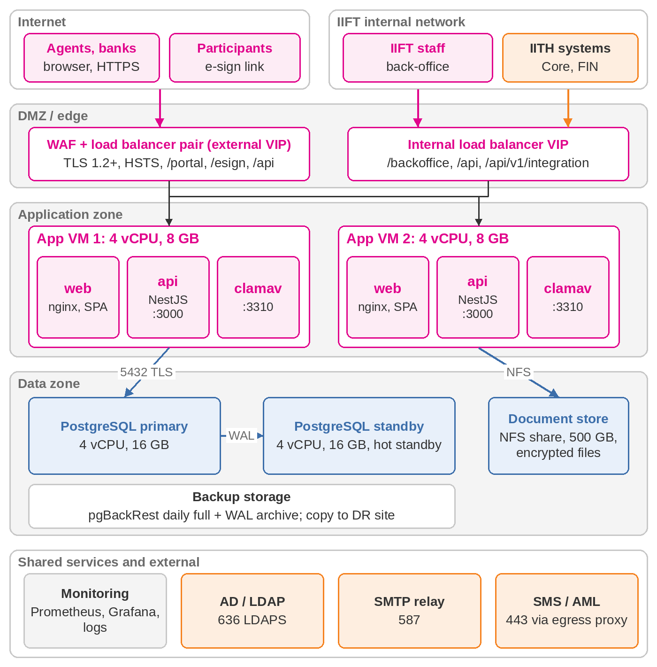
Figure 9: Option A: on-premise deployment

Hybrid variant of Option A
The back-office, API, database and documents stay in the IITH data centre; only the web tier for internet users (nginx with the SPA) runs in the DMZ or at a cloud edge and forwards /api calls over a private encrypted link. Personal data never leaves the data centre, so no cloud outsourcing step is needed. It is sized and priced as Option A; any edge hosting is at actuals.

9.3 Option B: iorta-hosted cloud
iorta hosts and operates the solution in a cloud account dedicated to IIFT in AWS Asia Pacific (Malaysia) or Azure Malaysia West, with production across two availability zones and a pilot-light DR environment in a second region approved by IIFT (the reference regions are AWS Asia Pacific (Malaysia) and Azure Malaysia West). The account may be held by iorta and recharged at cost, or held by IIFT in its own name with iorta operating it through delegated access; the design is the same. The AWS reference design is shown below and the Azure equivalent is listed in the table.
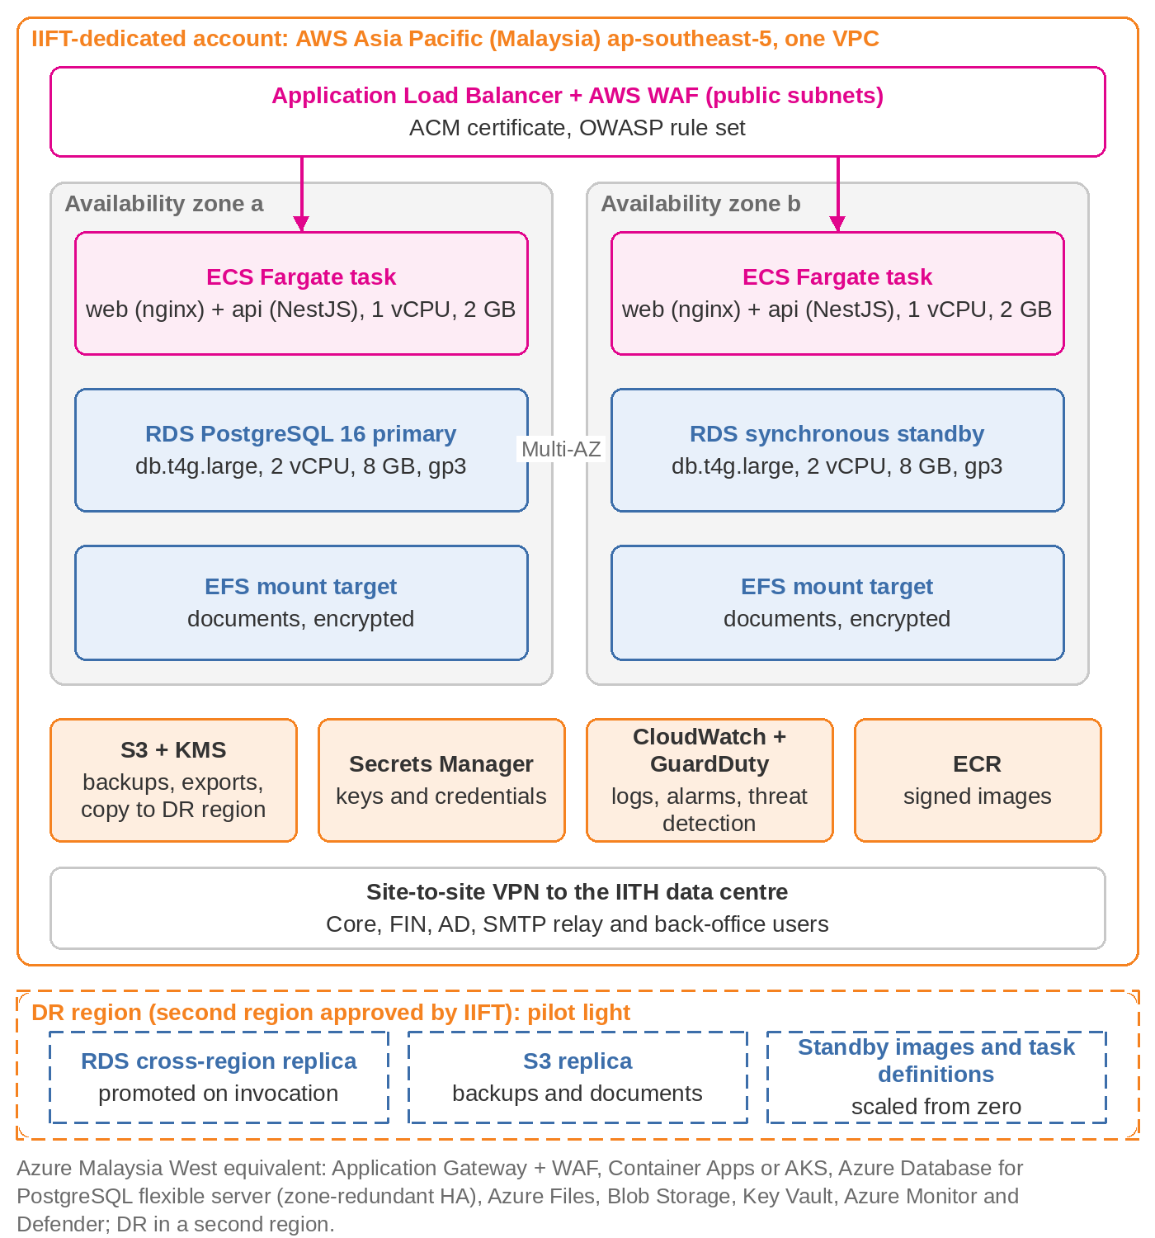
Figure 10: Option B: cloud reference deployment (AWS Asia Pacific (Malaysia))
Component | AWS Asia Pacific (Malaysia) | Azure Malaysia West
Edge | Application Load Balancer, AWS WAF with managed OWASP rules, ACM certificate | Application Gateway with WAF
Containers | ECS Fargate, 2 tasks in 2 availability zones | Container Apps or AKS, 2 replicas in 2 zones
Database | RDS for PostgreSQL 16, Multi-AZ, 35-day backups and PITR | Azure Database for PostgreSQL flexible server, zone-redundant HA
Documents | Amazon EFS, encrypted, mounted at /data/documents | Azure Files, encrypted
Backups and exports | S3 with SSE-KMS, replicated to the DR region | Blob Storage, geo-redundant
Secrets and keys | Secrets Manager and KMS (customer-managed keys) | Key Vault
Monitoring and security | CloudWatch logs, metrics, alarms; GuardDuty; Security Hub | Azure Monitor, Log Analytics, Defender for Cloud
Connectivity | Site-to-site VPN to the IITH data centre (Direct Connect optional) | VPN Gateway (ExpressRoute optional)
DR | Cross-region read replica, replicated S3, standby task definitions in the second region | Geo-replica, geo-redundant storage, standby revision in the second region
Table 22: Cloud services by provider

Landing zone
The one-off cloud set-up in the proposal builds the landing zone before the environments: a dedicated account (or subscription) for IIFT with no other tenant; separate production and non-production networks (VPC or VNet) with public subnets for the load balancer only and private subnets for tasks and databases; identity with named administrators, multi-factor authentication, least-privilege roles and no long-lived access keys; customer-managed encryption keys for database, storage and backups; central logging with 90-day retention and an immutable audit trail of console and API activity; the site-to-site VPN to the IITH data centre; a private container registry; and the security baseline (CIS benchmark checks, threat detection, vulnerability scanning) with alerts to the managed services roster. Everything is defined as infrastructure code held in the repository, so the estate can be rebuilt in the DR region or handed to IIFT.

Environments and DR region
PROD runs two tasks across two availability zones with a Multi-AZ managed database. UAT is a single task with a small single-zone database, stopped outside test periods; SIT is the same shape during the project. The DR environment in the second region is a pilot light: a cross-region database replica, replicated backups and documents, and standby task definitions scaled from zero. Invocation promotes the replica, scales the tasks up and switches DNS; the Production Support Handover gives the procedure and the yearly drill. RPO and RTO are the same as for Option A (chapter 10).

Cost controls
- Cloud charges are recharged at the provider's cost without mark-up, or paid by IIFT directly when it holds the account; the estimate in chapter 10 is for budgeting.
- Budget alerts at 80% and 100% of the monthly estimate go to iorta and the IIFT application owner.
- A monthly cost report by service and environment accompanies the monthly service report.
- A quarterly right-sizing review adjusts task sizes, database class and storage tiers; reserved capacity is bought only with IIFT's approval, and the saving passes to IIFT.
- Non-production environments are stopped outside test periods; log retention and backup lifecycle rules are enforced by policy.

Shared responsibility
Area | Option A: IIFT / IITH and iorta | Option B: iorta managed services | Option B: cloud provider | Option B: IIFT
Physical facilities, hardware, hypervisor | IITH | – | Provider | –
Network, firewall, load balancer, WAF rules | IITH (iorta specifies) | Configure and operate | Managed services | Approve rules
Operating system and container runtime patching | IITH (OS); iorta (containers) | Patch in agreed windows | Serverless container platform | Approve windows
PostgreSQL install, replication, backups, PITR | IITH runs backups; iorta configures | Configure, verify, restore tests | Managed database engine | Approve restore drills
Application deployment and configuration | iorta under IIFT change control | iorta under IIFT change control | – | Change approval (CAB)
Monitoring and alerting | IITH (infrastructure); iorta (application) | 24x7 infrastructure and application | Platform metrics and logs | Receive reports and alerts
Security monitoring and vulnerability scanning | IITH SIEM; iorta scans images | WAF, threat detection, scans of the estate | Threat detection service | Security review; VAPT sponsor
Encryption keys and secrets | IITH vault | Key management service in IIFT's account | Key management service | Key ownership; access reviews
DR site or region and the yearly DR test | IITH provides; iorta takes part | Pilot light, replication, annual drill | Second region | Approve the DR region; take part
Cloud account, budget and cost control | – | Budget alerts, monthly cost report, right-sizing | Billing | Account holder (optional); approves reserved capacity
Regulatory notification (outsourcing, cloud) | Not needed | Supporting documents | Certifications | AMBD notification
Data ownership, export and deletion at exit | IIFT | Export, deletion certificate | – | IIFT
Table 23: Shared responsibility by option
Under Option B the managed services cover 24x7 infrastructure and availability monitoring, patching in agreed windows, backups with monthly restore tests and the yearly DR drill, security monitoring of the cloud estate, capacity and cost management with a monthly report, and infrastructure incident response with the cloud provider. The scope and fee are in the proposal; the operating model is in the Production Support Handover.

Data residency and regulatory notification
Under Option B, personal data of agents, participants and staff is stored in Malaysia with copies in the DR region, encrypted at rest with keys held in IIFT's account and in transit with TLS; back-office traffic and the Core, FIN, AD and SMTP integrations run over the VPN to the IITH data centre. Cloud hosting is an outsourcing arrangement for IIFT: IIFT approves the regions and makes the AMBD outsourcing and cloud notification before production data is loaded, and iorta provides the supporting material (this architecture, the control catalogue in chapter 8, the exit plan and the provider's certifications). A Brunei-hosted alternative can be designed on request. Option A needs no such step.

9.4 Disaster recovery
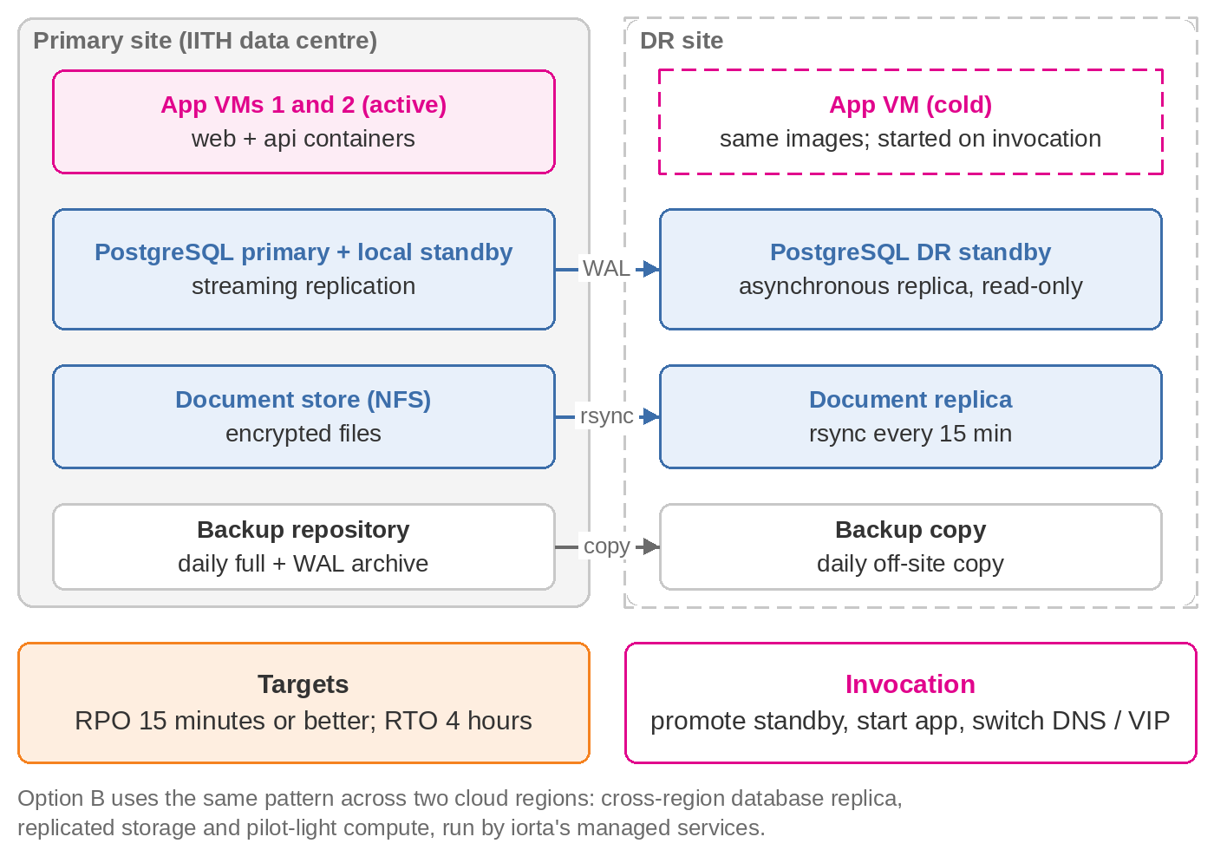
Figure 11: Disaster recovery topology
Under Option A the DR site holds an asynchronous PostgreSQL replica, a copy of the document store refreshed every 15 minutes, copies of the backups, and a cold application VM with the current images. Invocation promotes the replica, mounts the document copy, starts the containers with DR configuration and moves DNS or the load-balancer VIP. Under Option B the same pattern spans two regions with managed services. The Production Support Handover gives the step-by-step procedure and the test schedule.

9.5 Container images
Image | Source | Notes
salesverse-api (runtime) | apps/api/Dockerfile, target runtime | node:22-bookworm-slim; production dependencies only; runs as user salesverse under tini; HEALTHCHECK on /health/ready; port 3000; documents at /data/documents
salesverse-api (migrate) | apps/api/Dockerfile, target migrate | One-off job: prisma migrate deploy, then the reference-data seed (idempotent)
salesverse-web | apps/web/Dockerfile | Vite build served by nginxinc/nginx-unprivileged 1.29 on port 8080 with security headers, CSP, rate limiting and /api proxy
clamav | clamav/clamav:stable | clamd for upload scanning, port 3310, internal only
PostgreSQL 16 | postgres:16-alpine (DEV, SIT, UAT); OS packages on the PROD database VMs | Streaming replication and pgBackRest on PROD
Table 24: Images
Docker Compose (deploy/docker-compose.yml) runs the full stack on one host for DEV, SIT and UAT, and the web, API and ClamAV services on each production application VM, with the database on dedicated VMs. ECS task definitions (or the Azure equivalent) and the landing-zone infrastructure code are produced during implementation if IIFT selects Option B.

9.6 Build and release pipeline
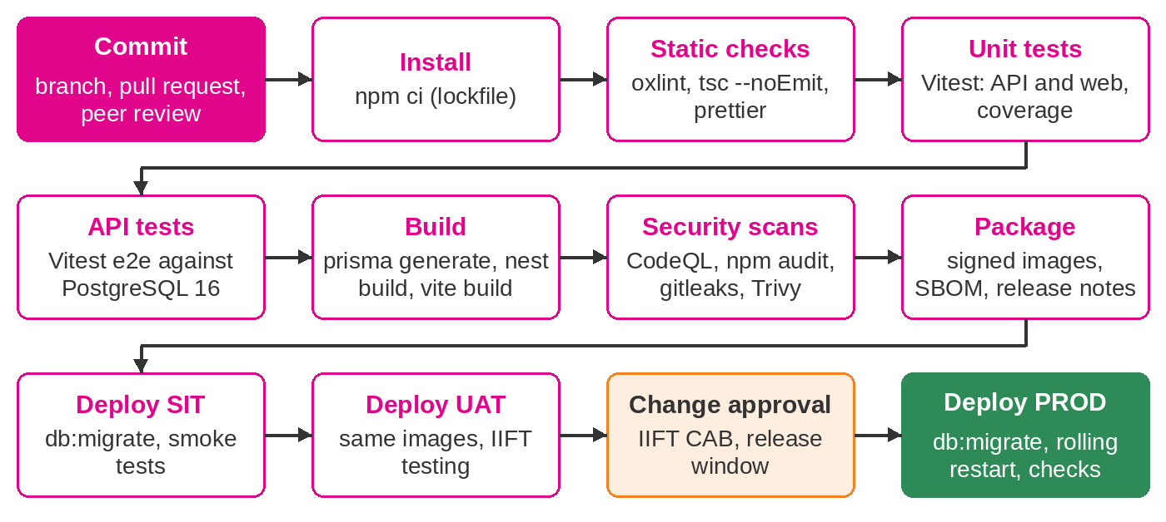
Figure 12: Build and release pipeline
Stage | Activities | Status
Verify | npm ci; prisma generate; prettier check; oxlint; tsc type check; API and web unit tests; end-to-end API tests against a PostgreSQL 16 service; production build; npm audit (moderate and above); CycloneDX SBOM of production dependencies kept as a build artifact | Running (.github/workflows/ci.yml)
Images | Build API and web images; Trivy scan fails on unfixed CRITICAL or HIGH findings | Running
Static analysis and secrets | CodeQL (JavaScript and TypeScript, security-extended queries) and a gitleaks secret scan of the full git history on every push and pull request | Running
Package | Tag images with the release version, sign them, attach the SBOM and release notes, push to the IITH registry | Delivered during implementation
Deploy SIT and UAT | Run the migrate job, roll out containers, smoke tests | Delivered during implementation
Deploy PROD | After IIFT change approval, in the agreed window, same images as UAT | Delivered during implementation
Table 25: Pipeline stages
Database changes follow expand-and-contract: a release first adds columns or tables that the previous version ignores, and removes old structures only in a later release. The previous images therefore run on the new schema, so an application rollback does not need a database restore.

10. Infrastructure Sizing

10.1 Load assumptions
Appendix 1 lists 26 named users: 12 bank portal users, 5 IIFT back-office users, 5 IIFT portal users and 4 agent portal users. The design target is 100 concurrent and 500 named users without redesign. Appendix 2 gives the policy volumes below.
Product | Line | 2025 | 2026 to July | In 5 years
Financing Takaful Plan – Hire Purchase (FTP-HP) | Mortgage Takaful | 59 | 16 | 75
Financing Takaful Plan – Non-Participating (FTP-NP) | Mortgage Takaful | 158 | 65 | 205
Property Financing Takaful (PFT) | Mortgage Takaful | 88 | 60 | 115
Personal Home Assistant Takaful (PHA) | Annual | 102 | 41 | 132
Professional Takaful Plan (PRO) | Annual | 40 | 19 | 52
Khairat Takaful Plan (KHR) | Annual | 31 | 16 | 40
Overseas Student Assist Takaful (OSA) | Annual | 7 | 2 | 9
Total |  | 485 | 219 | 628
Table 26: Appendix 2 policy volumes per year
Growing from 485 policies in 2025 to 628 a year in five years is 5.3% a year. The sizing uses that rate from go-live: 2027: 538, 2028: 566, 2029: 596, 2030: 628, 2031: 661. Every figure is then multiplied by 10 for headroom, which also covers the target of 100 concurrent users. At this scale the limiting factor is availability, not capacity.

10.2 On-premise servers (Option A, procured by IIFT)
IIFT procures the capacity below, or allocates it on the IITH virtualisation platform, before SIT (the SIT VM) and before UAT (the rest). The proposal's bill of materials repeats this table with indicative costs and is checked against it when the proposal is built.
Server | Qty | vCPU | RAM | Storage | Software
Production
WAF / load balancer | 2 (or existing) | 2 | 4 GB | – | IITH appliance or HAProxy/nginx pair
Application VM | 2 | 4 | 8 GB | 100 GB | Linux, Docker Engine; web, api, clamav containers
Database VM | 2 | 4 | 16 GB | 200 GB SSD | PostgreSQL 16 primary and hot standby, pgBackRest
Document store | 1 share | – | – | 500 GB | NFS export, encrypted volume
Backup repository | 1 | – | – | 1 TB | pgBackRest repository, document backups
Monitoring | 1 (or existing) | 2 | 4 GB | 100 GB | Prometheus, Grafana, log collector
Non-production
SIT | 1 | 4 | 16 GB | 200 GB | Compose: web, api, clamav, PostgreSQL
UAT | 1 | 4 | 16 GB | 200 GB | Compose: web, api, clamav, PostgreSQL
DR site
Application VM | 1 | 4 | 8 GB | 100 GB | Cold standby, same images
Database VM | 1 | 4 | 16 GB | 200 GB SSD | Asynchronous replica
Document and backup copies | – | – | – | 500 GB + 1 TB | rsync target, backup copy
Table 27: On-premise sizing (Option A)
Operating system: Red Hat Enterprise Linux 9 or Ubuntu 24.04 LTS, hardened to the IITH baseline. Each application VM has spare capacity for a second API container if load grows. ClamAV needs about 1.5 GB of memory for its signature database, which is included.

10.3 Cloud services (Option B)
The reference sizing below is the basis of the cloud infrastructure estimate in the proposal; both are read from the same source. Charges are recharged at the provider's cost, or paid by IIFT directly, and move with usage and exchange rates. The estimate is about B$ 1,330 a month for the production run (UAT and the DR pilot light included), plus scaled-down project environments for 5 months before go-live; the one-off set-up and the managed services fee are in the proposal.
Service | Reference sizing | Estimate B$ / month
Container compute, 2 tasks across 2 availability zones | 2 tasks × (1 vCPU, 2 GB) incl. ClamAV sidecar; scales to 4 tasks | B$ 260
Managed PostgreSQL, Multi-AZ, 100 GB, automated backups | db.t4g.large (2 vCPU, 8 GB), Multi-AZ, 100 GB gp3, 35-day backups and PITR | B$ 420
Application load balancer and web application firewall | 1 load balancer; WAF with managed OWASP rule sets; managed TLS certificate | B$ 130
NAT gateway and data transfer | NAT gateway, site-to-site VPN to the IITH data centre, outbound data | B$ 90
Object storage (encrypted) and cross-region backup copies | Shared file storage up to 100 GB; about 200 GB object storage; cross-region copy | B$ 70
Logging, metrics, alarms and threat detection | Log retention 90 days, metrics, alarms, threat detection | B$ 70
Secrets and key management | Secrets store and customer-managed encryption keys | B$ 20
UAT environment, scaled down, stopped out of hours | 1 task and a single-AZ db.t4g.medium; stopped outside test periods | B$ 120
DR environment, pilot light in a second region | Cross-region database replica or snapshots and standby images | B$ 150
Total per month |  | B$ 1,330
Total per year |  | B$ 15,960
Table 28: Option B cloud sizing and estimate (recharged at cost)
ClamAV runs as a sidecar in each task (1 GB) or as a small shared service. The document share is expected to stay under 100 GB in five years and object storage under about 200 GB with backups and exports (sections 10.5 and 10.6). RPO and RTO targets are unchanged: the Multi-AZ database fails over automatically within the region, and the DR region holds a cross-region replica.

10.4 Database sizing
Rows per issued policy were estimated from how the application writes data: quotations not taken up, policy history, documents, payments, approvals, notifications, outbox messages, integration log entries and audit rows. Index overhead is added at 60%.
Table | Rows per policy | Bytes per row | Basis
policy | 2.5 | 2,600 | issued policy plus 1.5 quotations not taken up
policy_event | 10 | 260 | history entries
nominee | 1.5 | 300
participant | 0.8 | 850 | some participants hold several policies
aml_screening | 1 | 900 | screening on registration and name change
signature_request | 0.5 | 420
document | 9 | 420 | metadata only; files counted separately
payment | 0.5 | 420 | bulk payments cover about two policies
payment_allocation | 1.1 | 130
receipt | 1.1 | 220
commission | 1 | 220
claim | 0.05 | 900
approval_request | 0.8 | 1,600 | referrals, payment verification, endorsements
approval_action | 2 | 260
notification | 14 | 900 | in-app, e-mail and SMS
outbox_message | 3.5 | 1,000
integration_log | 18 | 420 | outbound, inbound, e-mail and SMS calls
audit_log | 35 | 1,500 | before and after values
Table 29: Sizing basis
Year | Policies | Cumulative | Growth | Database size | ×10 headroom
2027 | 538 | 538 | 89 MB | 89 MB | 0.9 GB
2028 | 566 | 1,104 | 93 MB | 182 MB | 1.8 GB
2029 | 596 | 1,700 | 97 MB | 280 MB | 2.7 GB
2030 | 628 | 2,328 | 102 MB | 382 MB | 3.7 GB
2031 | 661 | 2,989 | 107 MB | 488 MB | 4.8 GB
Table 30: Database growth
After five years the database holds about 488 MB, or 4.8 GB at ten times the volume. The 200 GB database volume therefore leaves room for WAL, temporary files, local backups and growth well beyond the contract. PostgreSQL settings: shared_buffers 4 GB, effective_cache_size 12 GB, max_connections 100 (two API instances use at most 30), wal_level replica, archive_timeout 300 seconds.

10.5 Document storage
Item | Files | Average size
Uploaded supporting documents (IC, proposal form, PDS, product documents) | 5 | 0.40 MB
System-generated e-Policy schedule and e-Receipt (PDF) | 2 | 0.05 MB
Signatures (PNG) | 2 | 0.02 MB
Payment proof (shared by about two policies) | 0.5 | 0.50 MB
Per issued policy |  | 2.39 MB
Table 31: Document volume per policy
Year | Added | Cumulative | ×10 headroom
2027 | 1.4 GB | 1.4 GB | 14 GB
2028 | 1.4 GB | 2.8 GB | 28 GB
2029 | 1.5 GB | 4.3 GB | 43 GB
2030 | 1.6 GB | 5.9 GB | 59 GB
2031 | 1.7 GB | 7.6 GB | 76 GB
Table 32: Document store growth
Including 120 MB a year for EOD reports, FIN files, scheduled reports and agent, claim and issue documents, the store reaches about 8 GB in five years and 76 GB with headroom, inside the 500 GB share.

10.6 Backup, RPO and RTO
Item | Design
Database backups | pgBackRest full backup daily at 02:00, after EOD and the overnight jobs; continuous WAL archiving with archive_timeout 300 seconds
Document backups | Daily incremental, weekly full
Retention | 35 days online; monthly copies kept 12 months; yearly copies per IIFT policy
Off-site | Daily copy of backups to the DR site; backups encrypted
RPO | 15 minutes or better: streaming replication to the standby is near-real-time, and archived WAL limits loss to 5 minutes if both database nodes are lost
RTO | 4 hours for a full site loss; under 30 minutes for loss of an application VM (none, service continues) or the database primary (promote standby)
Backup storage need | About 150 GB at year 5 (database fulls and WAL, document backups, monthly copies); 1 TB provisioned
Verification | Quarterly restore test to a scratch instance with reconciliation of counts; yearly DR test
Table 33: Backup and recovery design

10.7 Network ports and firewall rules
Source | Destination | Port | Purpose
Internet | External WAF / load balancer | 443/tcp | HTTPS for /portal, /esign, /api (80 redirects)
IIFT internal network | Internal load balancer | 443/tcp | HTTPS for /backoffice and /api
Core and FIN hosts | Internal load balancer | 443/tcp | /api/v1/integration (IP allow-list)
Load balancers | App VMs (web container) | 8080/tcp | HTTP inside the zone, or TLS re-encryption if IITH policy requires
Web container | API container | 3000/tcp | Same host network; not exposed outside the VM
Load balancers, monitoring | App VMs | 3000/tcp | /health/live, /health/ready, /metrics (bearer token); published on the VM's internal interface by the production compose override
App VMs | PostgreSQL VIP / primary | 5432/tcp | TLS, application role
App VMs | Document store (NFS) | 2049/tcp | NFSv4, export restricted to app VMs
App VMs | SMTP relay | 587/tcp | STARTTLS
App VMs | Active Directory | 636/tcp | LDAPS
App VMs | Core and FIN APIs | 443/tcp | HTTPS
App VMs | Egress proxy to SMS gateway and AML provider | 443/tcp | HTTPS, destination allow-list
DB primary | DB standby (local and DR) | 5432/tcp | Streaming replication, TLS
DB VMs | Backup repository | 22/tcp | pgBackRest over SSH
Primary site | DR site | 22/tcp | Document rsync, backup copy
Monitoring | All VMs | 9100/tcp, 9187/tcp | node_exporter and postgres_exporter
Administrators (bastion) | All VMs | 22/tcp | SSH with keys, from the bastion only
All VMs | IITH NTP and DNS | 123/udp, 53 | Time and name resolution
Table 34: Firewall matrix (Option A)

11. Non-functional Design
Area | Target | Design measures
Performance (NFR-01) | Page load under 3 s; API p95 under 1 s; reports on 12 months of data under 10 s | Indexed list queries with pagination (max 100 rows); lazy-loaded pages and split bundles; gzip and long caching of hashed assets; exports capped and streamed to file
Capacity (NFR-02, 03) | 100 concurrent, 500 named users; 10× Appendix 2 volume | Stateless API instances; connection pools of 10 per instance plus 5 for sessions
Scalability (NFR-06, 07) | Growth without redesign | Add API containers or VMs behind the load balancer; jobs stay single-runner through advisory locks; database vertical scaling
Availability (NFR-04, 05) | 99.5% monthly; 99.9% in IIFT business hours | Two application VMs; hot standby database; health-checked load balancing; rolling deployment
Integrity (NFR-16) | No partial updates | Single-transaction business operations; outbox; optimistic locking
Recoverability (NFR-17 to 19) | RPO 15 minutes; RTO 4 hours | Streaming replication, WAL archiving, daily backups, DR site, tested restores
Usability and accessibility (NFR-22 to 24) | WCAG 2.1 AA; current Chrome, Edge, Firefox, Safari | Ant Design accessible components, keyboard navigation, consistent layouts in both applications
API standards (NFR-25) | REST, JSON, OpenAPI 3 | /api/v1 versioning; ISO 8601 dates; documented error body; OpenAPI description in docs/api
Maintainability (NFR-20, 21) | Modular, documented, tested | 32 API and web unit test files (150 cases) and 4 end-to-end suites (32 cases) run in CI; lint, format and type checks
Table 35: Non-functional targets and design

11.1 Monitoring and health
Endpoint or signal | Content | Use
GET /health/live | {status: ok} while the process runs | Container and load-balancer liveness
GET /health/ready | Runs SELECT 1; 503 NOT_READY if the database is unavailable | Load-balancer readiness; Docker HEALTHCHECK
GET /metrics | Prometheus default process metrics prefixed iift_api_ (CPU, memory, heap, event-loop lag, GC); bearer METRICS_TOKEN | Prometheus scrape every 30 s
Integration monitor | Per-system success rate, average time, pending, retrying and dead-letter counts for 24 hours | Back-office screen and API for support
EOD history | Status, totals and files per business date | Finance and support
Application e-mails | Dead-letter alerts, AML review, SLA breaches, agency blocks | Business and support teams
Table 36: Health and monitoring signals
Prometheus alert rules (delivered during implementation) cover: readiness failing for 2 minutes; HTTP 5xx rate above 2% for 5 minutes (from nginx logs); p95 latency above 2 s; event-loop lag above 500 ms; memory above 85%; disk above 80%; replication lag above 5 minutes; last successful backup older than 26 hours; an eod_run in FAILED status or no completed run by 01:00; any outbox message in DEAD; certificate expiry within 30 days. HTTP request histograms and business gauges (outbox backlog, open SLA breaches) are added to /metrics during implementation.

11.2 Logging
The API writes one JSON line per event to standard output with pino: level, time, message and, for HTTP requests, the request id, method, URL, status and response time. The request id is the correlation id from X-Request-Id (set by nginx) or a new UUID, and is returned in the response header and in every error body, so a user's reference leads straight to the log lines. Cookies, authorization, CSRF and set-cookie headers are redacted; health probes are not logged. Container logs are collected by the platform's log shipper (Fluent Bit to the IITH log platform, or CloudWatch) and kept 90 days online. The audit trail is separate from logs and is held in the database under the retention rules.

12. Technology Stack and Versions
Versions are the minimums declared in the package manifests at the time of writing; the lockfile pins exact versions. All third-party components are open source and carry no licence fee; the only paid choice is the operating system if IIFT standardises on RHEL. The SalesVerse 2.0 licence itself (perpetual under Option A, right to use under the Option B subscription, source code under Option C) is a commercial term of the proposal.
Component | Version | Purpose
Runtime
Node.js | 22 LTS (.nvmrc 22, engines >=22.12) | API runtime
npm | 11.21.0 | workspaces
API
@nestjs/core | 12.1.2 | Application framework
@nestjs/schedule | 12.0.2 | Scheduled jobs
@nestjs/throttler | 6.7.1 | Rate limiting
@nestjs/swagger | 12.0.2 | OpenAPI
class-validator | 0.15.1 | DTO validation
typescript | 6.0.3 | Language
Data
PostgreSQL | 16 | Database
prisma / @prisma/client | 7.10.0 | ORM and migrations
@prisma/adapter-pg, pg | 8.23.1 | Driver
Security
express-session | 1.19.0 | Sessions
connect-pg-simple | 10.0.0 | Session store
@node-rs/argon2 | 2.2.1 | Password hashing
helmet | 8.3.0 | Security headers
ldapts | 9.2.0 | Directory sign-in
Output and messaging
pdfkit | 0.20.2 | PDF documents
exceljs | 4.4.0 | Excel exports
nodemailer | 10.0.13 | E-mail
Observability
nestjs-pino / pino | 10.3.1 | JSON logging
prom-client | 15.1.3 | Metrics
Front end
react | 19.3.0 | UI library
antd | 6.6.5 | Components
@tanstack/react-query | 5.104.1 | Server state
react-router | 7.18.4 | Routing
recharts | 3.10.1 | Charts
vite | 7.3.6 | Build tool
Quality
vitest | 4.1.11 | Unit, component and API tests
supertest | 7.3.0 | HTTP tests
@testing-library/react | 16.3.3 | Web component tests
oxlint | 1.86.0 | Linting
prettier | 3.9.9 | Formatting
Delivery
Docker images | node:22-bookworm-slim, nginx-unprivileged 1.29 | Containers
GitHub Actions / GitLab CI | ci.yml | Pipeline
CodeQL | v3 action | Static analysis
gitleaks | 8.21.2 | Secret scan
Trivy | 0.28 action | Image scan
Table 37: Technology stack

13. Architecture Decisions
Each decision is recorded with the options considered and the reason for the choice. Changes to these decisions follow the change process and are added here.
Id | Decision | Options considered | Rationale
AD-01 | Modular monolith | Microservices; modular monolith | Small user base and volume; one deployment and one database transaction per operation; module boundaries keep a later split possible.
AD-02 | PostgreSQL 16 | PostgreSQL; MongoDB; SQL Server | Relational, financial data with ACID across tables; no licence fee; mature replication and PITR; JSONB where flexibility is needed (section 6.2).
AD-03 | Prisma 7 with the pg driver adapter | Prisma; TypeORM; Knex; hand-written SQL | Typed queries generated from one schema; parameterised by construction; versioned SQL migrations reviewed in code review.
AD-04 | Server-side sessions | Sessions in PostgreSQL; JWT in browser storage | Revocable at once (sign-out, lockout, deactivation, password change); no tokens readable by scripts; no extra session store.
AD-05 | Synchroniser CSRF token with SameSite=Strict | Synchroniser token; double-submit cookie; SameSite only | Token bound to the server session and checked in constant time; SameSite gives a second layer.
AD-06 | Argon2id | Argon2id; bcrypt; PBKDF2 | Current OWASP recommendation; memory-hard; native implementation without build tools.
AD-07 | Application-level field encryption with blind index | Disk encryption only; pgcrypto; application encryption | Keys never reach the database server; database administrators and backups see ciphertext; exact search and uniqueness still work.
AD-08 | Transactional outbox | Synchronous calls; message broker; outbox table | A message exists exactly when the business change commits; retries survive restarts; no broker to run for this volume.
AD-09 | In-process jobs with advisory locks | Separate scheduler; Redis queue; in-process with locks | No extra component; one runner across replicas; lock released if a process dies.
AD-10 | Encrypted files on a mounted volume | Database BLOBs; object storage; encrypted volume | Keeps the database small; works on NFS on-premise and EFS or Azure Files in the cloud; S3 adapter possible later.
AD-11 | React SPA with Ant Design | React SPA; server-rendered pages; Angular | Large talent pool; accessible component library; one code base for portal and back-office.
AD-12 | Business parameters in the database | Environment variables; database parameters | Operations staff change policy values without a release, within ranges, with audit.
AD-13 | Generic workflow engine with handlers | Per-feature approval code; BPMN engine; generic engine | Eight approval types share one inbox, rule set and history; a BPMN engine would add a product to operate.
AD-14 | Watch-list screening built in, external provider optional | External only; built in only; both | Compliance can screen from day one with UN and local lists; a commercial provider can be added by configuration; an unavailable provider forces manual review.
AD-15 | PostgreSQL sequences for reference numbers | Sequences; counter table with row locks | No lock contention across replicas; gaps are acceptable for these references.
AD-16 | Optimistic locking | Pessimistic locks; version column | Short web transactions; clear STALE_RECORD message instead of blocking users.
AD-17 | Simulated and live integration modes | Live only; switchable mode | Build and test end to end before IITH endpoints exist; production start-up checks the live settings.
AD-18 | Manual database promotion on PROD | Automatic failover; manual promotion | Two database nodes cannot form a safe quorum; a runbook promotion within the 4-hour RTO avoids split-brain.
AD-19 | JSON logs and Prometheus metrics | Vendor APM agent; open formats | Works with IITH's existing log and monitoring tools; no agent licence.
Table 38: Architecture decision log

Appendix A: API Operations
All 149 operations on 128 paths in docs/api/openapi.json, grouped by tag. Request and response schemas are in the OpenAPI file.
Method | Path
Authentication
POST | /api/v1/auth/login
POST | /api/v1/auth/logout
GET | /api/v1/auth/me
POST | /api/v1/auth/change-password
Back-office: AML/KYC
GET | /api/v1/backoffice/aml/cases
POST | /api/v1/backoffice/aml/cases/{id}/review
GET | /api/v1/backoffice/aml/watchlist
POST | /api/v1/backoffice/aml/watchlist
PUT | /api/v1/backoffice/aml/watchlist/{id}/active
POST | /api/v1/backoffice/aml/watchlist/import
Back-office: Agencies
GET | /api/v1/backoffice/agencies
POST | /api/v1/backoffice/agencies
GET | /api/v1/backoffice/agencies/options
GET | /api/v1/backoffice/agencies/{id}
PUT | /api/v1/backoffice/agencies/{id}
POST | /api/v1/backoffice/agencies/{id}/lift-block
Back-office: Agents
GET | /api/v1/backoffice/agents
POST | /api/v1/backoffice/agents
GET | /api/v1/backoffice/agents/{id}
POST | /api/v1/backoffice/agents/{id}/update-requests
POST | /api/v1/backoffice/agents/{id}/status-requests
Back-office: Approvals
GET | /api/v1/backoffice/approvals/inbox
GET | /api/v1/backoffice/approvals
GET | /api/v1/backoffice/approvals/{id}
POST | /api/v1/backoffice/approvals/{id}/approve
POST | /api/v1/backoffice/approvals/{id}/reject
POST | /api/v1/backoffice/approvals/{id}/withdraw
Back-office: Audit
GET | /api/v1/backoffice/audit
GET | /api/v1/backoffice/audit/facets
Back-office: Billing
GET | /api/v1/backoffice/billing/payments
GET | /api/v1/backoffice/billing/payments/{id}
GET | /api/v1/backoffice/billing/commissions
Back-office: Claims
GET | /api/v1/backoffice/claims
GET | /api/v1/backoffice/claims/{id}
PUT | /api/v1/backoffice/claims/{id}/status
Back-office: Configuration
GET | /api/v1/backoffice/config/parameters
PUT | /api/v1/backoffice/config/parameters/{key}
GET | /api/v1/backoffice/config/codes
POST | /api/v1/backoffice/config/codes
GET | /api/v1/backoffice/config/code-categories
PATCH | /api/v1/backoffice/config/codes/{id}
Back-office: Dashboard
GET | /api/v1/backoffice/dashboard
Back-office: Documents
GET | /api/v1/backoffice/documents
POST | /api/v1/backoffice/documents/{id}/review
Back-office: End of day
GET | /api/v1/backoffice/eod
POST | /api/v1/backoffice/eod
Back-office: Integration
GET | /api/v1/backoffice/integration/summary
GET | /api/v1/backoffice/integration/outbox
POST | /api/v1/backoffice/integration/outbox/{id}/retry
GET | /api/v1/backoffice/integration/logs
GET | /api/v1/backoffice/integration/reconciliations
POST | /api/v1/backoffice/integration/reconciliations
Back-office: Issues
GET | /api/v1/backoffice/issues/assignees
PUT | /api/v1/backoffice/issues/{id}/assignment
PUT | /api/v1/backoffice/issues/{id}/priority
Back-office: Participants
GET | /api/v1/backoffice/participants
GET | /api/v1/backoffice/participants/{id}
POST | /api/v1/backoffice/participants/{id}/update-requests
Back-office: Policies
GET | /api/v1/backoffice/policies
GET | /api/v1/backoffice/policies/{id}
POST | /api/v1/backoffice/policies/{id}/email-documents
Back-office: Products
GET | /api/v1/backoffice/products
PUT | /api/v1/backoffice/products/{id}
Back-office: Reports
GET | /api/v1/backoffice/reports
GET | /api/v1/backoffice/reports/schedules
POST | /api/v1/backoffice/reports/schedules
PUT | /api/v1/backoffice/reports/schedules/{id}/active
GET | /api/v1/backoffice/reports/{code}
GET | /api/v1/backoffice/reports/{code}/export
Back-office: Roles
GET | /api/v1/backoffice/roles
POST | /api/v1/backoffice/roles
GET | /api/v1/backoffice/roles/permissions
PUT | /api/v1/backoffice/roles/{id}
DELETE | /api/v1/backoffice/roles/{id}
Back-office: Users
GET | /api/v1/backoffice/users
POST | /api/v1/backoffice/users
GET | /api/v1/backoffice/users/{id}
PATCH | /api/v1/backoffice/users/{id}
PUT | /api/v1/backoffice/users/{id}/status
POST | /api/v1/backoffice/users/{id}/unlock
POST | /api/v1/backoffice/users/{id}/reset-password
GET | /api/v1/backoffice/role-options
Back-office: Workflow configuration
GET | /api/v1/backoffice/workflows
PUT | /api/v1/backoffice/workflows/{type}
Common: Documents
POST | /api/v1/common/documents
GET | /api/v1/common/documents
GET | /api/v1/common/documents/{id}/content
Common: Issues
GET | /api/v1/common/issues
POST | /api/v1/common/issues
GET | /api/v1/common/issues/{id}
POST | /api/v1/common/issues/{id}/comments
PUT | /api/v1/common/issues/{id}/status
Common: Master data
GET | /api/v1/common/codes
Common: Notifications
GET | /api/v1/common/notifications
GET | /api/v1/common/notifications/unread-count
POST | /api/v1/common/notifications/{id}/read
POST | /api/v1/common/notifications/read-all
Common: Products
GET | /api/v1/common/products
GET | /api/v1/common/products/{id}
Integration (system-to-system)
PUT | /api/v1/integration/agents/{agentCode}/status
GET | /api/v1/integration/policies
POST | /api/v1/integration/commissions/paid
Portal: Billing
GET | /api/v1/portal/billing/outstanding
GET | /api/v1/portal/billing/payments
POST | /api/v1/portal/billing/payments
GET | /api/v1/portal/billing/payments/{id}
GET | /api/v1/portal/billing/commissions
Portal: Claims
GET | /api/v1/portal/claims
POST | /api/v1/portal/claims
GET | /api/v1/portal/claims/validate-policy
GET | /api/v1/portal/claims/{id}
Portal: Dashboard
GET | /api/v1/portal/dashboard
Portal: Participants
GET | /api/v1/portal/participants
POST | /api/v1/portal/participants
GET | /api/v1/portal/participants/lookup
GET | /api/v1/portal/participants/{id}
POST | /api/v1/portal/participants/{id}/update-requests
Portal: Profile & agency
GET | /api/v1/portal/profile
POST | /api/v1/portal/profile/update-requests
GET | /api/v1/portal/agency
GET | /api/v1/portal/hierarchy
GET | /api/v1/portal/agents
POST | /api/v1/portal/agents
GET | /api/v1/portal/agents/{id}
Portal: Quotations & policies
GET | /api/v1/portal/policies
POST | /api/v1/portal/policies
GET | /api/v1/portal/policies/renewals-due
GET | /api/v1/portal/policies/{id}
PUT | /api/v1/portal/policies/{id}
POST | /api/v1/portal/policies/calculate
PUT | /api/v1/portal/policies/{id}/questionnaire
PUT | /api/v1/portal/policies/{id}/nominees
POST | /api/v1/portal/policies/{id}/submit
POST | /api/v1/portal/policies/{id}/discard
POST | /api/v1/portal/policies/{id}/reopen
POST | /api/v1/portal/policies/{id}/renew
POST | /api/v1/portal/policies/{id}/endorsements
POST | /api/v1/portal/policies/{id}/cancellations
POST | /api/v1/portal/policies/{id}/email-documents
Portal: Reports
GET | /api/v1/portal/reports
GET | /api/v1/portal/reports/{code}
GET | /api/v1/portal/reports/{code}/export
Portal: Requests
GET | /api/v1/portal/requests
GET | /api/v1/portal/requests/{id}
POST | /api/v1/portal/requests/{id}/withdraw
Portal: e-Signature
POST | /api/v1/portal/policies/{id}/signatures
POST | /api/v1/portal/policies/{id}/signatures/link
Public: e-Signature
GET | /api/v1/public/esign/{token}
POST | /api/v1/public/esign/{token}

Appendix B: Glossary
Term | Meaning
Advisory lock | PostgreSQL lock identified by a number, used here so one API instance runs each job
AMBD | Autoriti Monetari Brunei Darussalam, the financial regulator
Blind index | Keyed hash of a value stored next to its ciphertext so the value can be matched exactly without decrypting
CSRF | Cross-site request forgery
Dead-letter | State of a message that will not be retried automatically
EOD | End-of-day processing
FIN | IITH financial system
Idempotency key | Identifier that lets a receiver ignore a repeated delivery
Maker-checker | Control where one person raises a change and another approves it
Outbox | Table of messages written with the business change and delivered afterwards
PDPO | Personal Data Protection Order 2025 (Brunei)
PITR | Point-in-time recovery
RPO / RTO | Recovery point objective (data loss) / recovery time objective (downtime)
SPA | Single-page application
Tabarru' | Donation portion of the contribution to the participants' risk fund
Wakalah | Agency fee charged by the takaful operator

