

Proposal for Agent/Banca Portal & Back-office Solution
SalesVerse 2.0, configured for IIFT as the IIFT Agent/Banca Portal & Back-office
Technical and commercial proposal in response to IIFT's Request for Proposal
 | PREPARED FOR  Insurans Islam Family Takaful Sendirian Berhad  Insurans Islam TAIB Holding (IITH) group  Bandar Seri Begawan, Brunei Darussalam
SUBMITTED BY
iorta TechNXT
https://iortatechnxt.com

Submission date | October 2026
Proposal reference no. | [Proposal reference no.]
RFP reference | [IIFT RFP / tender reference no.]
Document version | 1.0
Classification | Commercial-in-Confidence

Commercial-in-Confidence. This proposal contains confidential commercial information of iorta TechNXT and is submitted solely for the evaluation of the above RFP by Insurans Islam Family Takaful Sendirian Berhad. It may not be disclosed to third parties without prior written consent.

Cover Letter
[Day] October 2026
Our ref: [Proposal reference no.]
Your ref: [IIFT RFP / tender reference no.]
The Management
Insurans Islam Family Takaful Sendirian Berhad
[Street address]
Bandar Seri Begawan [Postcode]
Brunei Darussalam

Dear Sir/Madam,
Re: Proposal for Agent/Banca Portal & Back-office Solution
iorta TechNXT is pleased to submit its proposal for the Agent/Banca Portal and Back-office Solution. We offer to configure, integrate, test, deploy and support the solution, with training, documentation, a six-month warranty and five years of maintenance and support.
The solution is SalesVerse 2.0, iorta TechNXT's distribution platform for Takaful and insurance, configured for IIFT as the IIFT Agent/Banca Portal & Back-office. A working version already runs the seven products in Appendix 3 of the RFP, the B$150,000 referral rule, the seven-day grace-period agency block, maker-checker approvals, AML watch-list screening, e-signature, e-Policy and e-Receipt issuance and the end-of-day FIN interface file. The remaining work (integration with IIFT's systems, IIFT's rates and templates, testing, migration and training) is set out in this proposal at a fixed fee. We offer two commercial models and one add-on:
- Option A, on-premise perpetual licence (recommended): one-time B$ 178,000 (licence B$ 48,000; implementation services B$ 130,000); annual maintenance B$ 31,350 in Year 1, being 22% of licence and customisation, +5% a year.
- Option B, subscription hosted and managed by iorta on cloud: one-time B$ 145,000 (implementation services B$ 130,000; cloud set-up B$ 15,000); subscription B$ 3,400 a month in Year 1, +5% a year, minimum term 60 months; managed services B$ 1,100 a month; cloud infrastructure recharged at cost.
- Option C, source code handover: the core platform source code after go-live and hypercare, with an 8-week knowledge transfer and transition plan, for B$ 88,000.
- Fees are inclusive of withholding tax. Out-of-pocket expenses (estimated at B$ 31,440) and cloud infrastructure are recharged at cost as disbursements, and third-party and infrastructure charges, listed in the Bill of Materials, are excluded.
- Go-live in week 24, then four weeks of hypercare.
The proposal contains the items requested in your invitation, in the order requested:
Item | Content | Where
(a) | Cover letter | This letter
(b) | Corporate profile and relevant experience | Enclosure B, attached separately
(c) | Business registration certificate | Enclosure C, attached separately
(d) | Detailed scope of work and methodology | Sections 5, 6 and 17
(e) | Detailed fee and pricing structure, stating WHT, OPE and third-party charges | Section 19 and the pricing workbook
(f) | Delivery and implementation timeline with key milestones | Section 18
(g) | Quotation validity period | Section 24: 90 days
(h) | Other supporting information | Sections 7 to 11, 16 and 25; technical documents
(i) | Terms and conditions | Section 26

We confirm that this proposal follows the RFP and would welcome the opportunity to demonstrate the working application. For clarification, please contact [Name of contact person], [Designation], at [e-mail address] or [telephone number].
Yours faithfully,

______________________________
[Name of authorised signatory]
[Designation]
For and on behalf of iorta TechNXT
[Company stamp]

Document Control

Version history
Version | Date | Author | Description
0.9 | [Date] | iorta TechNXT | Internal review draft
1.0 | October 2026 | iorta TechNXT | Submission version

Review and approval
Role | Name | Signature / date
Prepared by (Bid Manager) | [Name]
Reviewed by (Solution Architect) | [Name]
Approved by (Authorised Signatory) | [Name, designation]

Distribution
Recipient | Organisation | Format
Tender / Evaluation Committee | Insurans Islam Family Takaful Sendirian Berhad | Signed PDF and editable DOCX; pricing workbook and Bill of Materials (XLSX)
Bid file | iorta TechNXT | Archive copy

Companion documents
- IIFT-Commercial-Pricing-iorta-TechNXT.xlsx: the pricing workbook (options summary, fees in IIFT's format, Options A, B and C, RFP section 10 breakdown, OPE, rate card, payment schedules and assumptions).
- IIFT-Bill-of-Materials-iorta-TechNXT.xlsx: the Bill of Materials (on-premise infrastructure, cloud services, software licences and third-party services, with indicative costs and who pays).
- Enclosure B: corporate profile and relevant experience (attached separately).
- Enclosure C: business registration certificate (attached separately).
- Technical document pack in docs/technical: solution architecture, data dictionary, code standards and quality report, security assessment report, production support handover.

Table of Contents
Right-click here and choose Update Field to build the table of contents.

Response Checklist
The invitation asked for items (a) to (i). The checklist shows where each is answered and whether it is in this document or attached separately.
Item | Invitation requirement | Where addressed | Status
(a) | Cover letter | Cover Letter, after the cover page | Included
(b) | Corporate profile and relevant experience | Enclosure B (Section 3) | To be attached by iorta
(c) | Business registration certificate | Enclosure C (Section 4) | To be attached by iorta
(d) | Detailed scope of work and methodology | Sections 5 (scope), 6 (fitment), 17 (methodology) | Included
(e) | Detailed fees and pricing structure, stating WHT, OPE and third-party charges | Section 19; pricing workbook; Bill of Materials workbook; Annex C | Included
(f) | Delivery and implementation timeline with key milestones | Section 18 | Included
(g) | Quotation validity period | Section 24: 90 days | Included
(h) | Other supporting information | Sections 7 to 11, 16 and 25; technical document pack | Included
(i) | Terms and conditions | Section 26 | Included
Additional chapters
 | Personas and user journeys | Sections 7 and 8
 | Functional rules, products and screen catalogue | Sections 9, 10 and 11
 | Architecture, security, deployment, infrastructure | Sections 12 to 15
 | Technical document pack | Section 16
 | Five-year maintenance and support, SLA | Section 20
 | Team, assumptions and risks | Sections 21 to 23
 | Compliance and fitment matrix (every RFP requirement ID) | Annex A
 | Bill of Materials summary, software components, network flows | Annex C

Abbreviations
Takaful and technical terms are explained in the glossary in Annex D.
Abbreviation | Meaning
AD / LDAP | Active Directory / Lightweight Directory Access Protocol, used for single sign-on
AMBD | Autoriti Monetari Brunei Darussalam, the central bank and financial regulator of Brunei Darussalam
AMC | Annual maintenance charge
AML / KYC | Anti-Money Laundering / Know Your Customer screening and due diligence
API | Application Programming Interface
ASVS | OWASP Application Security Verification Standard
BRR | The issuance register / report referenced in RFP Appendix 3 against which daily issuance and FIN postings are tallied
BOM / SBOM | Bill of materials / software bill of materials (open-source components and licences)
BRS / FRS | Business Requirement Specification / Functional Requirement Specification
B$ / BND | Brunei Dollar
CI/CD | Continuous Integration / Continuous Delivery
CR | Change Request
DR | Disaster Recovery
EOD | End-of-Day processing
FIN | IIFT financial / accounting system referenced in the RFP
FFR | Functional Flow and Requirements (RFP Appendix 3)
HA | High Availability
IC | Identity Card (Brunei national identity card)
IIFT | Insurans Islam Family Takaful Sendirian Berhad
IIGT | Insurans Islam General Takaful, the sister company that operates the IIGT Agent Portal
IITH | Insurans Islam TAIB Holding, the group holding company
KT | Knowledge transfer
L1 / L2 / L3 | First-, second- and third-line support
MFA / OTP / TOTP | Multi-Factor Authentication / One-Time Password / Time-based One-Time Password
OPE | Out-of-Pocket Expenses (travel, accommodation, per diem, insurance, transfers, visas)
OWASP | Open Worldwide Application Security Project
PDPO | Personal Data Protection Order 2025 (Brunei Darussalam)
PITR | Point-in-Time Recovery
PMO | Project Management Office
QC | Quality Check
RACI | Responsible, Accountable, Consulted, Informed
RBAC | Role-Based Access Control
RPO / RTO | Recovery Point Objective (maximum data loss) / Recovery Time Objective (maximum downtime)
RTM | Requirements Traceability Matrix
SAD / TDD | Solution Architecture Document / Technical Design Document
SAST / SCA | Static Application Security Testing / Software Composition Analysis
SIT / UAT | System Integration Testing / User Acceptance Testing
SLA | Service Level Agreement
SSO | Single Sign-On
TCO | Total Cost of Ownership
VAPT | Vulnerability Assessment and Penetration Testing
WAF | Web Application Firewall
WHT | Withholding Tax

1. Executive Summary
IIFT will receive SalesVerse 2.0, configured as the IIFT Agent/Banca Portal & Back-office, live in 24 weeks at a fixed implementation price. Banca submissions, approvals, payments and reporting move from paper and e-mail to one controlled system. We recommend Option A, an on-premise perpetual licence in the IITH data centre, which keeps data in Brunei and has the lowest five-year cost.
Solution | SalesVerse 2.0, configured as the IIFT Agent/Banca Portal & Back-office: a portal for agents and bank officers and a back-office for IIFT and IITH staff.
Scope | All 29 in-scope components of RFP section 3.1, the seven Appendix 3 products, and integration with IIFT's core system, FIN, AML provider, Active Directory, SMS gateway and e-mail.
Timeline | Go-live in week 24. Hypercare in weeks 25 to 28. Warranty for six months from go-live.
Option A (recommended) | On-premise perpetual licence: B$ 178,000 (USD 136,923) one-time; AMC B$ 31,350 in Year 1 (22% of licence and customisation), +5% a year.
Option B | Subscription on iorta-managed cloud: B$ 145,000 (USD 111,538) one-time (including cloud set-up B$ 15,000); B$ 3,400 a month in Year 1, +5% a year, minimum 60 months; managed services B$ 1,100 a month; cloud recharged at cost.
Option C (add-on) | Core source code handover with 8 weeks of knowledge transfer after hypercare: B$ 88,000.
Five-year cost | Option A B$ 382,670 (USD 294,362); Option B B$ 556,144 (USD 427,803), including estimated OPE and cloud charges.
Fee basis | Inclusive of WHT. OPE and cloud infrastructure recharged at cost as disbursements. Third-party and infrastructure charges excluded (Bill of Materials).
Licence and users | Unlimited named users for IIFT under both options; no per-user or per-policy fees.
Source code | IIFT-specific source code at go-live and every release under every option; core platform source through Option C or escrow.
Compliance | 234 of 234 RFP requirement IDs addressed (Annex A); fitment in Section 6.
Table 1: What IIFT receives

1.1 Why iorta TechNXT
The platform already works. IIFT's seven products, the B$150,000 referral, the seven-day agency block, maker-checker with amount thresholds, watch-list screening, e-signature, e-Policy and e-Receipt PDFs, the EOD report and FIN interface file all run today. Discovery workshops start from working screens, which is why requirements and design take five weeks.
The price follows IIFT's scale. The RFP describes 26 named users and about 600 policies a year. There is no per-user or per-policy fee, so more bank branches or agents do not change the price.
Controls sit in the data layer. The API enforces maker-checker, a database trigger makes the audit table append-only, and IC and passport numbers are encrypted field by field with AES-256-GCM. These controls cannot be bypassed from a screen.
IIFT keeps its options open. It can own a perpetual licence or subscribe, convert from subscription to licence, and take the platform source code with a structured handover once the solution is stable.
Delivery risk is shared. Implementation is a fixed price, 85% of the services fee is paid against signed deliverables, and yearly increases are capped at 5%.

1.2 About iorta TechNXT and SalesVerse 2.0
iorta TechNXT builds and supports software for insurance and Takaful distribution. SalesVerse 2.0 is its platform for agency and bancassurance portals, back-office administration and the integrations that connect them to core, finance and compliance systems. The corporate profile and relevant experience are in Enclosure B.

2. Understanding of IIFT's Requirements

2.1 Background
IIFT sells Mortgage Takaful and Annual (Individual) Family Takaful plans through agents and bank partners. Banca work today relies on paper or e-mailed submissions and manual follow-up with the back-office. Status is hard to track and management has little real-time visibility.
The IIGT Agent Portal went live on 17 July 2026 for Motor Takaful. It covers agent onboarding, e-quotation, e-Cover Notes, AML screening, documents, e-signature, payment proof verification, audit and reporting. IIFT needs the same kind of capability for Family Takaful products and the Banca channel, plus a back-office in which IIFT staff review, approve and report on every Banca transaction.

2.2 Project objectives and our response
# | RFP objective | How the solution meets it
1 | Digitalise Agent/Banca operations | Agent/Banca Portal for onboarding, quotation, issuance, servicing, payments, claims notification and issues.
2 | Improve operational efficiency | Data captured once at source; contribution calculated by the system; e-Policy, e-Receipt and EOD files produced automatically.
3 | Strengthen Agent/Banca management | Agency and bank hierarchy, main/sub-agent links, five agent statuses and document expiry tracking.
4 | Strengthen governance and controls | Role-based access with data scoping, maker-checker with configurable levels and thresholds, append-only audit trail.
5 | AML/KYC management | Watch-list screening with fuzzy name matching at onboarding and on change; Compliance review queue.
6 | Improve data quality | Field validation, controlled master data, duplicate checks on IC and registration numbers, daily reconciliation.
7 | Improve integration | Transactional outbox with retry and dead-letter; adapters for Core, FIN, AML, Active Directory, SMS and e-mail.
8 | Improve reporting | Dashboards and standard reports with Excel, CSV and PDF export and scheduled distribution.
9 | Improve user experience | Step-by-step quotation wizards, one design system themed to Insurans Islam TAIB colours, WCAG 2.1 AA target.
10 | Strengthen security | Controls aligned with OWASP ASVS Level 2 and an independent VAPT before go-live.
11 | Ensure scalability | Sized for 100 concurrent and 500 named users, more than ten times the projected policy volume.
12 | Long-term sustainability | Five years of support with yearly increases capped at 5%, maintained documentation, IIFT-specific source code with every release and an option to take the platform source code.

2.3 Users and volumes
Appendix 1 lists 26 named users and Appendix 2 projects 628 policies a year within five years. These volumes are small for a relational database and two application servers, so we size for 100 concurrent and 500 named users and ten times the projected volume (NFR-02, NFR-03, NFR-06, NFR-07).
Company | Application | Expected users
Bank | Portal | 12
IIFT | Back-office (Admin) | 5
IIFT | Portal | 5
Agent | Portal | 4
Total |  | 26
Table 2: Expected users (RFP Appendix 1)
Line of business | Product | 2025 | 2026 (to July) | Projected in 5 years
Mortgage Takaful | Financing Takaful Plan – Hire Purchaser | 59 | 16 | 75
Mortgage Takaful | Financing Takaful Plan – Non-Participating | 158 | 65 | 205
Mortgage Takaful | Property Financing Takaful Plan | 88 | 60 | 115
Annual (Individual) | Personal Home Assistant Takaful Plan | 102 | 41 | 132
Annual (Individual) | Professional Takaful Plan | 40 | 19 | 52
Annual (Individual) | Khairat Takaful Plan | 31 | 16 | 40
Annual (Individual) | Overseas Student Assist Takaful Plan | 7 | 2 | 9
Total |  | 485 | 219 | 628
Table 3: Policy volumes (RFP Appendix 2)

2.4 Business rules that shape the design
- Financing above B$150,000 is the high-risk limit. The agent or banker cannot complete it; the case is referred to IIFT Sales (FFR01, AP-60).
- A seven-day payment grace period applies to issued policies. If payment is not submitted in time, every agent in that agency is blocked from issuing until it is settled (AP-42).
- Maker-checker covers agent registration and profile changes, participant updates, endorsements, cancellations, payment verification and AML review (BO-10, BO-17).
- End-of-day processing produces the daily issuance report and FIN entries, and issuance is reconciled with BRR for every product (FFR01 to FFR05).
- Product eligibility differs by plan: Professional is limited to Occupational Class I, Khairat has no renewal, and Overseas Student Assist requires a Brunei citizen registered as a student and aged 65 or under.

3. Enclosure B – Corporate Profile and Relevant Experience
Attached separately. iorta TechNXT's latest corporate profile and relevant experience (invitation item b) are submitted as a separate document with this proposal.
Document | [File name of the corporate profile]
Contents | Company overview, leadership, delivery capability and relevant reference projects
Contact | [Name, designation, e-mail, telephone]
Table 4: Enclosure B

4. Enclosure C – Business Registration Certificate
Attached separately. A certified copy of iorta TechNXT's business registration certificate (invitation item c) is submitted with this proposal.
Document | [File name of the certificate]
Business registration no. | [Business registration no.]
Table 5: Enclosure C

5. Scope of Work
We will configure, integrate, test, deploy and support SalesVerse 2.0 as the IIFT Agent/Banca Portal & Back-office, with training, documentation, a six-month warranty and five years of maintenance. This chapter follows the RFP structure. For each item it states what we deliver, how, and the evidence IIFT uses to accept it. Fitment against the working platform is in Section 6; the per-ID matrix is in Annex A.

5.1 In-scope components (RFP 3.1)
# | Component | What we deliver | How | Acceptance evidence
1 | Agent/Banca Portal | Web portal (/portal) for agents, main/sub-agents and bank officers | Configure the SalesVerse 2.0 portal for IIFT roles, products and branding | UAT sign-off of portal scenarios
2 | Back-office (Admin) | Internal application (/backoffice) for IIFT and IITH staff | Configure back-office roles, queues and dashboards; publish only on the internal network | UAT sign-off; network test showing no internet exposure
3 | Agent/Banca management | Registration, profile, status, agent code, hierarchy | Load agent master data; set numbering pattern and status rules | SIT cases; migrated agent reconciliation
4 | Agency/Banca management | Agencies, banks, branches and their relationships | Load agency and bank structure; map hierarchy to data scopes | Hierarchy review signed by Banca/Sales
5 | Agent/Banca onboarding | Online application, KYC data, documents, AML, approval | Configure document checklist and approval levels | Journey 1 executed in UAT
6 | Participant management | Shared participant record, search, updates with approval, AML | Set search criteria, duplicate rules and update workflow | SIT and UAT cases for AP-11 to AP-16
7 | Policy management | Seven products, quotation, drafts, issuance, statuses, servicing | Load IIFT rates, questionnaires and templates for all seven products | Rate verification sheet signed by IIFT actuarial; UAT
8 | Billing management | Payment dashboard, single and bulk payment, verification, e-Receipt, 7-day block | Configure payment rules, thresholds and receipt numbering | Journey 4 in UAT; grace-period test evidence
9 | Claims management | Claim notification with policy validation and documents | Configure claim types and document lists | UAT cases for AP-43
10 | AML/KYC | Watch-list screening with fuzzy matching, Compliance review | Connect to IIFT's AML provider or lists; set match threshold | Screening test pack agreed with Compliance
11 | Workflow management | Configurable workflows for all approval transactions | Load IIFT approval matrix as workflow definitions | Approval matrix sign-off; SIT cases
12 | Maker-checker | Segregation of duties on every configured transaction | Assign maker and checker permissions per role | Negative tests: maker cannot approve own request
13 | Document management | Encrypted document store; e-Policy, schedule and e-Receipt PDFs | Load IIFT templates and wording; deploy ClamAV in each environment | Template sign-off; upload security tests
14 | Dashboard | Agent, bank, back-office and management dashboards | Agree KPI definitions and targets | Dashboard review in UAT
15 | Reporting | Report catalogue with filters, schedules, Excel/CSV/PDF export | Configure the 12 existing reports; build the remaining catalogue items | Report sign-off against sample data
16 | Issue management | Issue reporting, assignment, priorities, SLA timers | Set categories, assignment rules and SLA targets | Journey 7 in UAT
17 | Notification | E-mail, SMS and in-portal notifications | Connect SMTP and SMS gateway; agree templates | Notification test log
18 | Audit trail | Append-only audit with search and export | Set retention; optional SIEM export | Audit tamper test (UPDATE/DELETE rejected)
19 | Administration | Users, roles, permissions, master data, parameters | Load IIFT roles and parameter values | Role matrix sign-off
20 | Integration | Core, FIN, AML, AD, SMS, e-mail adapters with monitoring and reconciliation | Build adapters against agreed interface specifications | End-to-end interface tests with each system owner
21 | Security | Controls in Section 13; MFA; independent VAPT | Apply IITH policy values; remediate VAPT findings | VAPT and re-test report (DEL-17)
22 | Data migration | Agent, agency, bank, participant and reference data | Scripted extract, cleanse, load, reconcile; two rehearsals | Signed reconciliation report
23 | Testing | Unit, API, SIT, regression, performance, security; UAT support | Automated suites in CI; SIT and UAT plans | SIT and UAT results (DEL-14, DEL-16)
24 | Deployment | DEV, SIT, UAT, PROD and DR environments; CI/CD; cut-over | Container deployment on IIFT infrastructure (Option A) or iorta-managed cloud (Option B) | Deployment plan and go-live checklist signed
25 | Training | Agents, bank officers, back-office, administrators, IT | Train-the-trainer, hands-on sessions, manuals | Attendance records and feedback
26 | Documentation | User, administrator, technical and operations manuals | Update the SalesVerse 2.0 document pack for IIFT | Document acceptance by IIFT
27 | Warranty | Six months of defect correction from go-live | Fixes under the SLA at no charge | Monthly service report
28 | Maintenance | Five years of support, patches and upgrades | Service desk, monthly patch cycle, releases | Monthly service report; quarterly review
29 | Transition | Knowledge transfer, handover and exit support | Year 5 exit plan and shadow support | Signed transition acceptance
Table 6: In-scope components 1 to 29

5.2 Agent/Banca Portal functions (RFP 4.1)
RFP area and IDs | What we deliver | How | Acceptance evidence
Authentication (AP-01–04) | Secure login, password change and reset, session control, lockout | Server-side sessions; policy values set to IITH standards | Security test cases; VAPT
Agent/Banca profile (AP-05–06) | Profile view and change requests with approval | Profile change workflow with before and after values | UAT case; audit record of approved change
Agent/Banca management (AP-07–12) | Online registration, agent code, hierarchy, agency information, shared participants | Registration journey; data scoping by agency and bank | Journey 1 in UAT
Participant management (AP-13–16) | Individual and corporate registration, search, approved updates, AML screening | Duplicate checks on encrypted IC numbers via blind index | SIT cases; AML test pack
Quotation (AP-17–20) | Authorised product list, product wizards, automatic contribution, drafts | Seven configured products with IIFT rate tables | Rate verification sheet; UAT
Issuance and status (AP-21–25, AP-32–36) | Policy list, search, details, issuance, validation, routing, restrictions, notifications, audit | Server-side validation and workflow routing | Journeys 2 and 3 in UAT
Policy servicing (AP-26–31) | Renewal, endorsement, cancellation, documents, payment status, history | Servicing requests through maker-checker | Journey 5 in UAT
Billing (AP-37–42) | Payment dashboard, bulk payment per policy, proof upload, verification, e-Receipt, 7-day block | Billing module and nightly grace-period job | Journey 4; grace-period test evidence
Claims (AP-43) | Claim notification with policy validation and documents | Claims module | Journey 6 in UAT
Documents (AP-44–47) | Policy schedule, e-Policy and e-Receipt PDFs; download, e-mail, upload, status and expiry | IIFT templates; encrypted store; ClamAV scan | Template sign-off; upload tests
AML information (AP-48) | AML/KYC data captured at onboarding | Configurable KYC fields | Compliance review of form
Workflow (AP-49–51) | Save, submit, track; status list; rejection remarks and resubmission | My requests screen over the workflow engine | Journey 9 in UAT
Dashboard (AP-52–53) | Agent dashboard and pending actions | Role-based dashboard widgets | UAT review
Notifications (AP-54) | Alerts on status changes, approvals, rejections, actions | Notification templates per event | Notification test log
Issue management (AP-55–57) | Report issues with reference number, tracking and attachments | Issues module with SLA timers | Journey 7 in UAT
Reporting (AP-58) | Role-scoped reports for agency, agent and bank | Report catalogue with data scoping | Report sign-off
Security and approvals (AP-59–61) | Role-based access, authority limits, approval history | Permissions and data scopes; amount thresholds | Role matrix sign-off; negative tests
Digital signature (AP-62) | On-screen signature, single-use e-mail link, upload of signed documents | e-Signature module with evidence record | UAT case; evidence sample reviewed by IIFT Legal

5.3 Back-office functions (RFP 4.2)
RFP area and IDs | What we deliver | How | Acceptance evidence
Authentication and access (BO-01–02) | Internal login, MFA, Active Directory sign-on, role-based access | MFA and AD adapter built during implementation | Security tests; VAPT
User management (BO-03–04) | User administration, roles and permissions | Role builder; IIFT role matrix loaded | Role matrix sign-off
Agent management (BO-05–08, BO-10) | Agent records, search, status lifecycle, hierarchy, approval of registrations and changes | Agents module with maker-checker | SIT cases; Journey 1
Agency management (BO-09) | Agency and bank records with linked agents | Agencies and banks screens | Hierarchy review
Documents (BO-11–12) | Validate, approve, reject documents; completeness and expiry | Document checks queue | UAT case
AML/KYC (BO-13–15) | Screening, results with dates, Compliance review | AML cases and watch-list screens | AML test pack
Workflow (BO-16–19) | Configurable approvals, maker-checker, status tracking, rejection remarks | Workflow definitions for the IIFT matrix | Journey 9; negative tests
Dashboards (BO-20–21) | Management KPIs and pending actions | Back-office dashboard | UAT review
Reporting (BO-22–25) | Standard reports, filters, Excel/CSV/PDF export, schedules | 12 existing reports plus the agreed catalogue | Report sign-off
Audit (BO-26–28) | Audit of activity and changes with before and after values; search | Append-only audit table protected by trigger | Tamper test; audit search demo
Issue management (BO-29–31) | Assignment, priorities, SLA monitoring | Issue rules and SLA targets | Journey 7
Administration (BO-32–33) | Master data and configurable rules, statuses, levels, parameters | Parameters and master data screens | Configuration workbook signed

5.4 Integration (RFP 4.3)
RFP area and IDs | What we deliver | How | Acceptance evidence
Core system (INT-01–03) | Agent, agency and bank master synchronisation; agent information exchange | Adapter over the outbox; API or file per IITH capability | End-to-end test with core owner
Financial system (INT-04–05) | EOD FIN interface file, receipts, commission and referral fee data | FIN file format agreed; SFTP or API delivery | Journey 8; FIN reconciliation sign-off
Identity (INT-06) | Active Directory single sign-on for back-office | LDAPS adapter | Login test with IITH accounts
Notifications (INT-07–08) | E-mail through IIFT SMTP; SMS through IIFT gateway | SMTP and SMS adapters | Delivery test log
APIs (INT-09–11) | Secure REST APIs, authentication, monitoring | OpenAPI 3; mTLS or OAuth2; integration monitor | API security tests; monitor demo
Data (INT-12–15) | Validation, error handling and retry, logging, reconciliation | Schema validation; outbox retry and dead-letter; daily reconciliation | Failure-injection tests; reconciliation report

5.5 Shared platform (RFP 4.4)
RFP area and IDs | What we deliver | How | Acceptance evidence
Security (COM-01, 02, 10) | Protection of sensitive data, access control, encryption | Controls in Section 13 | VAPT; encryption check
Audit (COM-03) | Common audit service | Append-only audit | Tamper test
Workflow (COM-04) | Configurable workflows by type, role, level, rule | Workflow engine | Approval matrix tests
Notification (COM-05) | E-mail, SMS, portal notifications | Notification service and templates | Notification test log
Documents (COM-06) | Secure document repository | Encrypted storage; access through API only | Access tests
Search (COM-07) | Global search across records | Search with configurable criteria | UAT case
Reporting (COM-08) | Common reporting framework | Report definitions, exports, schedules | Report sign-off
Configuration (COM-09) | Parameters maintained without code changes | Parameters and master data screens | Configuration workbook signed

5.6 Non-functional requirements (RFP 5)
RFP area and IDs | What we deliver | How | Acceptance evidence
Performance (NFR-01–03) | Agreed response times for 100 concurrent users and projected volume | k6 load, stress and soak tests on production-like SIT | Performance test report (DEL-18)
Availability (NFR-04–05) | 99.5% overall, 99.9% in business hours; no single point of failure | Two app nodes, database standby, load balancer pair | Monthly availability report
Scalability (NFR-06–07) | Growth in users and volume without redesign | Stateless API nodes; indexed schema | Capacity statement in SAD
Security (NFR-08–14) | Encryption, authentication, authorisation, audit, vulnerability management, VAPT, secure SDLC | Section 13 | VAPT report; scan results
Reliability (NFR-15–16) | Controlled errors; transaction integrity | Generic messages with correlation id; ACID transactions | Negative tests
Backup and DR (NFR-17–19) | Backups, DR to RPO 15 minutes and RTO 4 hours, DR tests | WAL archiving; warm standby; annual DR test | Restore test and DR test reports
Maintainability (NFR-20–21) | Modular design; maintained documentation | Modular monolith; document pack updated per release | Document acceptance
Usability and accessibility (NFR-22–24) | Consistent UI, browser support, WCAG 2.1 AA target | One design system; browser test matrix; accessibility check | UAT feedback; accessibility check report
Compatibility (NFR-25) | Standard APIs | REST/JSON, OpenAPI 3 | API specification
Monitoring and logging (NFR-26–28) | System monitoring, alerting, central logs | Prometheus, Grafana, central log store | Alert test during SIT
Data (NFR-29–30) | Retention and data quality | Retention rules; validation and constraints | Retention configuration signed

5.7 Deliverables (RFP 7)
Documents are delivered in Word or Excel and PDF. IIFT reviews within five business days and we issue the final version within three business days of comments.
ID | Deliverable | Content and approach | Due | Acceptance evidence
DEL-01 | Project charter | Objectives, scope, governance, stakeholders, assumptions, milestones | Wk 2 | Steering Committee approval
DEL-02 | Project plan | Activities, dependencies, resources, timeline; updated fortnightly | Wk 2 | IIFT PM approval
DEL-03 | Business requirement specification | Agreed processes from fit-gap workshops on the working system | Wk 4 | Business owner sign-off
DEL-04 | Functional requirement specification | Rules, screens, reports and configuration per product | Wk 5 | Business owner sign-off
DEL-05 | Requirements traceability matrix | Every RFP ID traced to design, test and acceptance | Wk 6, kept current | Final RTM at closure
DEL-06 | Solution architecture | Application, infrastructure, security, integration, deployment | Wk 6 | Design Authority sign-off
DEL-07 | Technical design | Components, database, APIs, interfaces, configuration | Wk 6 | Design Authority sign-off
DEL-08 | UI/UX design | Screen designs and journeys based on the working screens | Wk 5 | Business owner sign-off
DEL-09 | Interface specification | APIs, mappings, methods, security, error handling per interface | Wk 6 | System owner sign-off
DEL-10 | Configured solution | SalesVerse 2.0 configured and integrated for IIFT | Wk 16 | Build-complete demo (M3)
DEL-11 | Source code | Source code of IIFT-specific components (configuration, adapters, reports, templates), build scripts, migrations; core platform via Option C or escrow | Wk 24 and each release | Repository handover checklist
DEL-12 | Test strategy | Levels, roles, environments, entry and exit criteria | Wk 6 | IIFT approval
DEL-13 | SIT test cases | Scenarios traced to requirements | Wk 14 | IITH IT review
DEL-14 | SIT results | Execution evidence, defect log, closure | Wk 19 | SIT exit sign-off (M4)
DEL-15 | UAT test cases | Business scenarios per product and role | Wk 18 | Business owner review
DEL-16 | UAT results | Execution evidence and business sign-off | Wk 22 | UAT certificate (M5)
DEL-17 | Security assessment | Independent VAPT, remediation, re-test | Wk 19 | No open Critical or High findings
DEL-18 | Performance test report | Load, stress and soak results against targets | Wk 19 | Targets met
DEL-19 | Data migration plan | Extraction, transformation, validation, reconciliation | Wk 8 | Data owner sign-off
DEL-20 | Deployment plan | Sequence, roles, rollback and contingency | Wk 21 | IITH IT approval
DEL-21 | Go-live checklist | Technical, operational, security, business, support readiness | Wk 23 | Go/no-go decision
DEL-22 | User training | Agents, bank officers, back-office users | Wk 21–23 | Attendance and feedback
DEL-23 | Administrator training | Administrators and support staff | Wk 22–23 | Attendance and hands-on check
DEL-24 | User manual | Portal and back-office guides with screenshots | Wk 21 | Document acceptance
DEL-25 | Administrator manual | Configuration, user administration, operations support | Wk 21 | Document acceptance
DEL-26 | Technical manual | Architecture, database, API, integration, deployment | Wk 23 | Document acceptance
DEL-27 | Operations manual | Monitoring, backup, incidents, routine operations | Wk 23 | Document acceptance
DEL-28 | Production deployment | Deployment per approved plan | Wk 24 | Go-live confirmation (M6)
DEL-29 | Go-live support | Four weeks of hypercare | Wk 25–28 | Hypercare exit criteria met
DEL-30 | Project closure report | Status, open items, lessons, acceptance | Wk 28 | Closure sign-off (M7)
Table 7: Deliverables DEL-01 to DEL-30

5.8 Maintenance and support (RFP 8)
ID | Requirement | What we deliver and how | Acceptance evidence
MNT-01 | Helpdesk support | Service desk via issue module, e-mail and phone for five years | Ticket records
MNT-02 | Incident management | Record, classify, investigate, resolve, close | Monthly incident statistics
MNT-03 | Problem management | Root-cause analysis for P1, P2 and recurring incidents | RCA reports within 5 business days
MNT-04 | Service requests | User support, configuration and operational help | Request log
MNT-05 | Critical incident SLA | P1: 30-minute response, 4-hour restoration, 24x7 | SLA report
MNT-06 | High priority SLA | P2: 2-hour response, 1 business day | SLA report
MNT-07 | Medium/Low/Cosmetic SLA | P3: 4 business hours / 3 business days; P4: 1 business day / next release | SLA report
MNT-08 | Bug fixing | Defects fixed under warranty, then under maintenance | Release notes
MNT-09 | Corrective maintenance | Changes needed to keep functions working | Release notes
MNT-10 | Preventive maintenance | Monthly health check of logs, jobs, capacity, queries, certificates | Health check in monthly report
MNT-11 | Security patches | Monthly patch cycle; emergency patches as needed | Patch log
MNT-12 | Vulnerability remediation | Critical 7 days, High 14, Medium 30, Low 90 | Vulnerability register
MNT-13 | Certificate management | Inventory, expiry alerts, renewal support | Certificate register
MNT-14 | OS/platform compatibility | Compatibility with supported OS, Node.js, PostgreSQL | Compatibility statement per release
MNT-15 | Browser compatibility | Current and previous browser versions | Browser test record
MNT-16 | Database maintenance | Health checks, vacuum and index tuning, upgrades | Health check results
MNT-17 | Performance monitoring | Monthly review and tuning advice | Performance section of monthly report
MNT-18 | System monitoring | Availability and component monitoring with alerts | Availability figures
MNT-19 | Backup verification | Quarterly restore test | Restore test record
MNT-20 | Disaster recovery | DR planning and annual DR test | DR test report
MNT-21 | Release management | Tested, approved releases in agreed windows | Release records and approvals
MNT-22 | Version upgrade | Application and platform upgrades, including SalesVerse 2.0 updates | Upgrade release notes
MNT-23 | Minor enhancement | 60 hours a year included; more at rate card | Enhancement log
MNT-24 | Change request | Impact assessment, quotation, approval, delivery | Signed CR forms
MNT-25 | Monthly service report | Incidents, SLA, availability, changes, open issues | Report issued monthly
MNT-26 | Quarterly review | Service performance and improvement plan | Minutes and action log
MNT-27 | Documentation updates | Documents updated after material change | Document version history
MNT-28 | Knowledge transfer | Sessions for IIFT/IITH support staff | Session records
MNT-29 | Onsite support | Onsite for major incidents or upgrades (rate card plus OPE) | Visit reports
MNT-30 | Transition support | Year 5 knowledge transfer, documents and technical help | Transition acceptance
Table 8: Maintenance requirements MNT-01 to MNT-30

6. Solution Fitment
Each functional and non-functional requirement is classified against SalesVerse 2.0 as it runs today. The four categories are:
Category | Meaning
Available in SalesVerse 2.0 today | Works in the current platform; IIFT can see it in the demonstration.
Configuration | Supported by the platform; needs IIFT values, rates, templates or rules.
Integration with IIFT systems | Adapter built on the platform's integration layer; completed once IIFT provides endpoints and credentials.
Delivered during implementation | Work or services performed during the project or, for MNT items, during maintenance.

RFP area | Available today | Configuration | Integration | During implementation | Total
Agent/Banca Portal (RFP 4.1) | 49 | 12 | 1 | 0 | 62
Back-office (RFP 4.2) | 27 | 6 | 0 | 0 | 33
Integration (RFP 4.3) | 6 | 0 | 9 | 0 | 15
Shared platform (RFP 4.4) | 8 | 2 | 0 | 0 | 10
Non-functional (RFP 5) | 15 | 1 | 0 | 14 | 30
Deliverables (RFP 7) | 0 | 0 | 0 | 30 | 30
Maintenance and support (RFP 8) | 0 | 0 | 0 | 30 | 30
Total | 105 | 21 | 10 | 74 | 210
Table 9: Fitment by RFP area (number of requirement IDs)
The 24 commercial requirements (RFP section 6) are contractual commitments rather than functions; they are answered in Section 19 and listed in Annex A without a fitment category.

6.1 What runs today and what is completed in the project
Capability | Available in SalesVerse 2.0 today | Completed during implementation
Products and rating | Seven Appendix 3 products (FTP-HP, FTP-NP, PFT, PHA, PRO, KHR, OSA) with configurable rating | IIFT actuarial rate tables replace the indicative rates; questionnaires and templates loaded
Underwriting referral | Financing above B$150,000 referred to IIFT Sales | Further referral rules agreed in design
Payment control | Seven-day grace-period block on all agents of an agency | Bank-specific settlement rules, if any
Approvals | Maker-checker with configurable levels and amount thresholds, e.g. second approval from B$300,000 sum covered | IIFT approval matrix and approver roles
AML/KYC | Watch-list screening with fuzzy name matching; Compliance review queue; a confirmed match rejects the subject's pending requests | Adapter to IIFT's AML provider or lists
e-Signature | On-screen signature and single-use e-mail link | Evidence format agreed with IIFT Legal
Documents | e-Policy and e-Receipt PDFs; encrypted document storage; ClamAV scan of uploads, mandatory in production | IIFT templates, wording and branding
End of day | EOD report, FIN interface file, receipt reconciliation; re-runs sent to FIN as numbered revisions | FIN file format sign-off; BRR reconciliation
Integration | Transactional outbox with retry and dead-letter | Adapters to IIFT core, FIN, AML provider, SMS gateway, SMTP and Active Directory
Reports | 12 standard reports; Excel, CSV and PDF export; scheduling | Remaining reports from the agreed catalogue
Audit and data protection | Append-only audit enforced by a database trigger; AES-256-GCM encryption of IC and passport numbers | Retention and archival job; key rotation tooling; SIEM export
Access | Login, users, roles and permissions | IITH password and session values; MFA for back-office
Table 10: Capability status

6.2 Work that depends on IIFT
- Adapters to IIFT's core system, FIN, AML provider, SMS gateway, SMTP relay and Active Directory. Each needs IIFT's interface specification, test endpoint and credentials before it can be completed.
- IIFT's actuarial rate tables, questionnaires, product wording and document templates, replacing the indicative values in the working system.
- MFA for back-office users, production and DR infrastructure set-up, performance testing and the independent VAPT.
- Data migration, UAT, training and the IIFT-specific document set.

7. Personas
The personas below describe who uses the solution and what each needs. Roles and permissions are configurable; these are the defaults we propose for design.
Persona | Goals | Key tasks | Screens used | Role / permissions
Bank officer (branch banker) | Sell financing and annual plans quickly; keep customers informed | Quotations, participant capture, document upload, payment submission, claim notification | Dashboard, New quotation, Policies, Participants, Billing, Claims | Bank officer; own branch data
Bank supervisor | Oversee branch production and overdue payments | Review team pipeline, reports, bank-level requests | Dashboard, Team and hierarchy, Reports, My requests | Bank supervisor; whole bank
Agency principal / main agent | Grow the agency; avoid issuance blocks | Monitor sub-agents, payments, renewals, commission | Dashboard, Team and hierarchy, Billing, Commission, Reports | Main agent; whole agency
Sub-agent | Issue policies and get paid commission | Quotations, policies, payments, renewals, issues | New quotation, Policies, Renewals, Billing, Support issues | Agent; own records
IIFT Operations officer (maker) | Process Banca work accurately | Agent registrations, participant and policy changes, document checks | Agents, Participants, Policies, Document checks | Operations maker
Operations supervisor (checker) | Approve correct work promptly | Review and approve or reject requests with remarks | Approvals inbox, Approval detail, Dashboard | Operations checker
Underwriter / quality check | Accept good risk; refer the rest | Quality check, referrals above limits, endorsements, cancellations | Approvals inbox, Policies, Products | Underwriting checker
Finance officer | Match every receipt and close each day | Verify payment proofs, run EOD, review reconciliation | Payments, End of day, Integration monitor, Reports | Finance maker or checker
Compliance officer | Keep AML/KYC risk under control | Review possible matches, maintain watch-lists, compliance reports | AML/KYC cases and watch-lists, Audit trail, Reports | Compliance
Support desk | Resolve user problems within SLA | Triage, assign and resolve issues; release locked accounts on request | Issues, Users, Integration monitor | Support
Management | See production, risk and service at a glance | Read dashboards and scheduled reports | Dashboard (management KPIs), Reports and schedules | Management, read only
System administrator | Keep the platform configured and secure | Users, roles, workflows, products, parameters | Users, Roles and permissions, Workflows, Products, Parameters | Administrator
Participant (remote e-signature) | Sign without visiting a branch | Open link, confirm details, sign | Participant e-signature page | No account; single-use link
IITH core and finance systems (system actors) | Receive and send master and financial data | Agent master sync, FIN file intake, commission statements | Integration monitor (seen by IIFT IT) | System credentials; mTLS, API key or SFTP key
Table 11: Personas

8. User Journeys
Each journey shows who acts, on which screen, and what the system does. The diagram gives the flow; the table gives the detail. Journeys are rehearsed in the fit-gap workshops and become UAT scenarios.

8.1 Agent onboarding
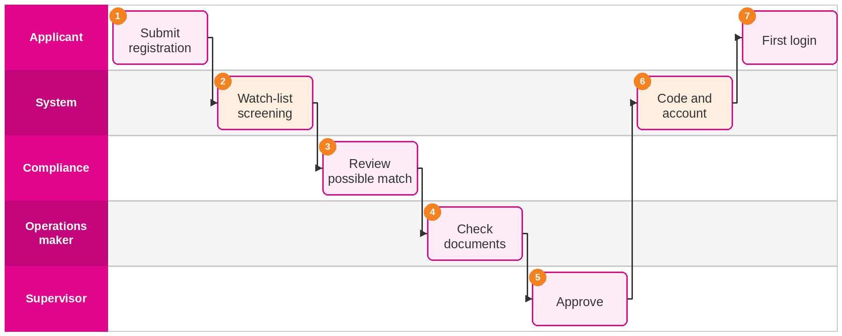
Figure 1: Agent onboarding
Step | Actor | Screen | What happens
1 | Applicant | Agent registration | Enters personal, agency or bank and KYC data; uploads documents.
2 | System | None | Screens the name with fuzzy matching; clear results pass straight on.
3 | Compliance officer | AML/KYC cases | Clears or rejects a possible match with remarks.
4 | Operations officer | Document checks | Validates documents and expiry dates.
5 | Operations supervisor | Approvals inbox | Approves; the maker cannot approve their own request.
6 | System | None | Issues the agent code, activates the account, e-mails the agent.
7 | Agent | Sign-in, Change password | Signs in, sets a new password and lands on the dashboard.

8.2 Quotation to e-Policy for an annual product (FFR02 to FFR05)
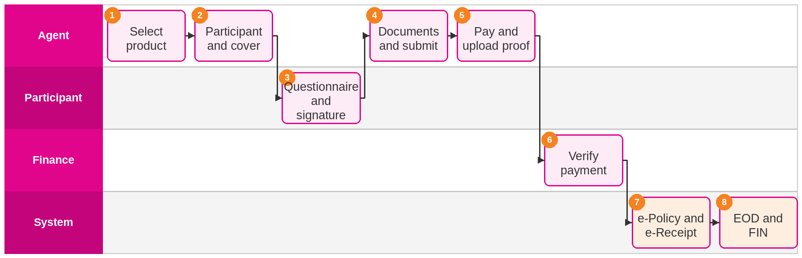
Figure 2: Quotation to e-Policy for an annual product (FFR02 to FFR05)
Step | Actor | Screen | What happens
1 | Agent | New quotation | Chooses PHA, PRO, KHR or OSA from the authorised list.
2 | Agent | New quotation | Captures participant and plan; the live quote shows the contribution.
3 | Participant | Participant e-signature page | Completes the questionnaire and signs on screen or by e-mail link.
4 | Agent | Policy detail | Uploads required documents; the checklist must be complete to submit.
5 | Agent | Billing | Pays and uploads proof of payment.
6 | Finance officer | Payments | Verifies the proof against the bank statement.
7 | System | None | Policy becomes Active; PDFs are produced and e-mailed.
8 | System | End of day | The day's issuance goes into the EOD report and FIN file.

8.3 Banca hire-purchase financing with referral and grace period (FFR01)
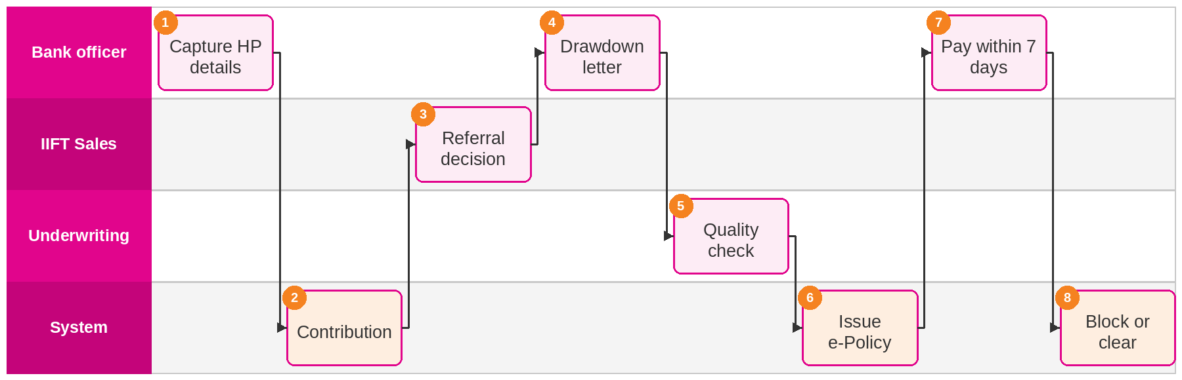
Figure 3: Banca hire-purchase financing with referral and grace period (FFR01)
Step | Actor | Screen | What happens
1 | Bank officer | New quotation | Captures participant, financing amount, tenure and profit rate.
2 | System | New quotation | Calculates the contribution; above B$150,000 the case is referred.
3 | IIFT Sales | Approvals inbox | Approves or declines cases above the high-risk limit.
4 | Bank officer | Policy detail | Uploads the drawdown letter and remaining documents.
5 | Underwriter | Approvals inbox | Approves the contract after quality check.
6 | System | None | Issues e-Policy (issue-then-pay); payment due within seven days.
7 | Bank officer | Billing | Submits payment with proof.
8 | System | Dashboard | If unpaid on day 8, blocks issuance for the agency until settled.

8.4 Payment submission, verification and e-Receipt
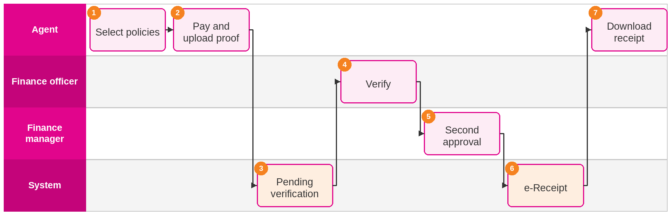
Figure 4: Payment submission, verification and e-Receipt
Step | Actor | Screen | What happens
1 | Agent | Billing (outstanding) | Selects one or many outstanding policies.
2 | Agent | Billing (bulk payment) | Allocates amounts per policy and uploads one proof.
3 | System | Payment detail | Marks the payment Pending Verification and queues it.
4 | Finance officer | Payments | Checks the proof; approves or rejects with remarks.
5 | Finance manager | Approvals inbox | Approves when the amount is above the threshold.
6 | System | None | Produces the e-Receipt, marks policies Paid, lifts any agency block.
7 | Agent | Payment detail | Downloads or e-mails the e-Receipt.

8.5 Endorsement or cancellation
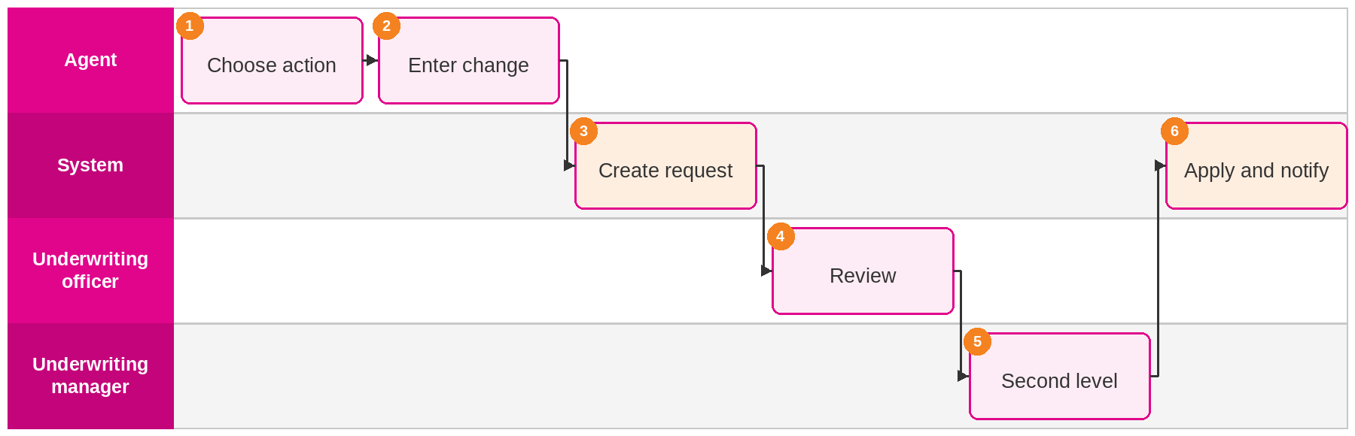
Figure 5: Endorsement or cancellation
Step | Actor | Screen | What happens
1 | Agent | Policy detail (servicing) | Selects Endorse or Cancel on an active policy.
2 | Agent | Policy detail (servicing) | Enters changes or reason and attaches documents.
3 | System | My requests | Records before and after values; routes by workflow.
4 | Underwriting officer | Approvals inbox | Reviews and approves or rejects with remarks.
5 | Underwriting manager | Approval detail | Approves cancellations and endorsements above threshold.
6 | System | Policy detail | Applies the change, records audit, notifies the agent.

8.6 Claim notification
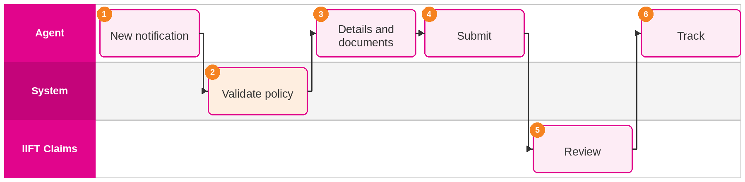
Figure 6: Claim notification
Step | Actor | Screen | What happens
1 | Agent | Claims (notification) | Opens a new claim notification.
2 | System | Claims (notification) | Checks the policy was in force on the event date.
3 | Agent | Claims (notification) | Enters claim details and uploads documents.
4 | Agent | Claims (notification) | Submits; a reference number is issued.
5 | Claims team | Claims | Reviews the notification and updates its status.
6 | Agent | Claims (detail) | Follows status and responds to requests.

8.7 Issue reporting with SLA
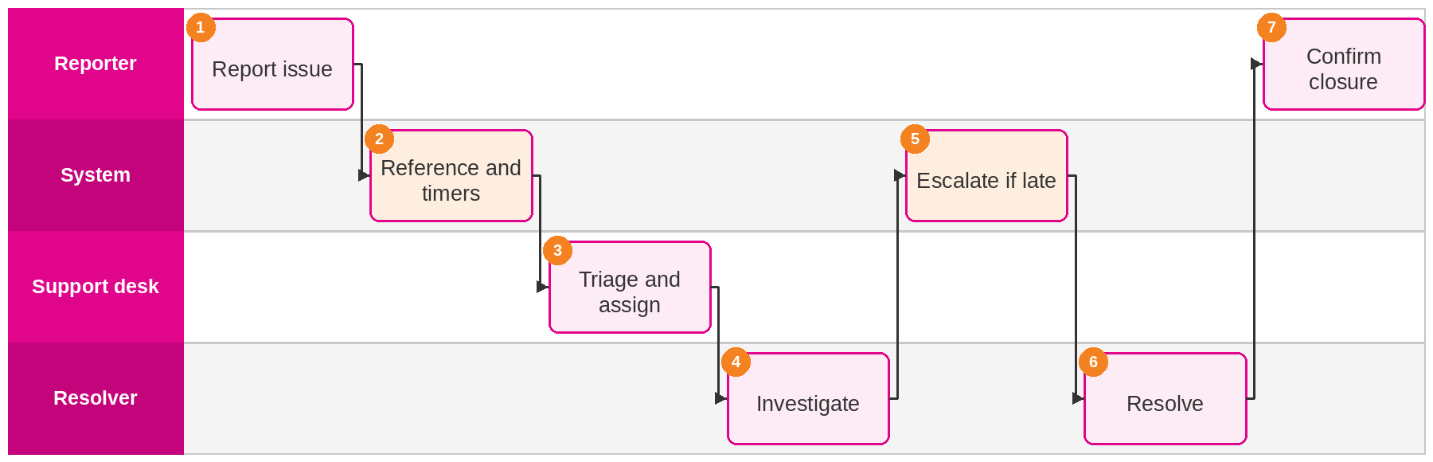
Figure 7: Issue reporting with SLA
Step | Actor | Screen | What happens
1 | Agent or IIFT user | Support issues | Describes the problem and attaches screenshots.
2 | System | None | Issues a reference number and starts SLA timers.
3 | Support desk | Issues | Sets priority and assigns by rule.
4 | Resolver | Issues | Updates the issue and the reporter.
5 | System | None | Alerts the supervisor when a target is about to be missed.
6 | Resolver | Issues | Records the fix.
7 | Reporter | Support issues | Confirms or reopens.

8.8 End of day and FIN reconciliation
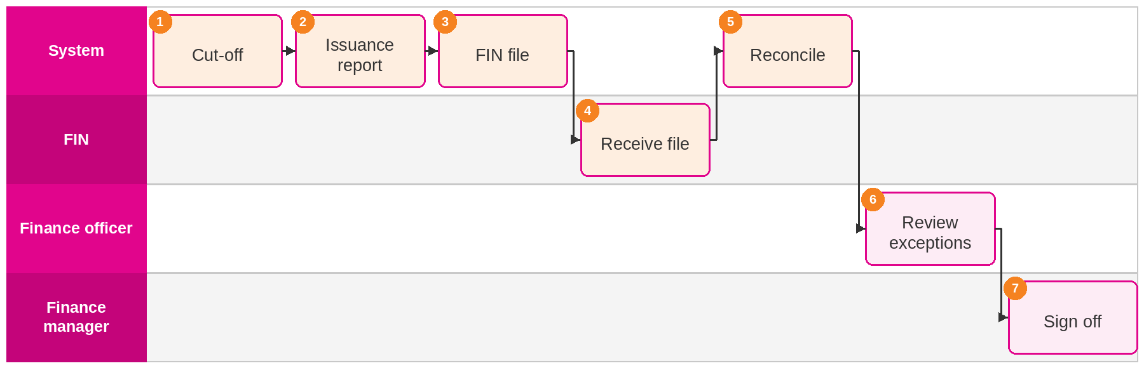
Figure 8: End of day and FIN reconciliation
Step | Actor | Screen | What happens
1 | System | End of day | Closes the business day at the configured time.
2 | System | End of day | Builds the issuance report by product, bank and agent.
3 | System | Integration monitor | Writes the FIN interface file and queues delivery.
4 | FIN system | None | Receives and posts the entries.
5 | System | End of day | Reconciles receipts; lists exceptions.
6 | Finance officer | End of day | Investigates and comments on exceptions.
7 | Finance manager | End of day | Signs off the run; history is kept.

8.9 Maker-checker approval
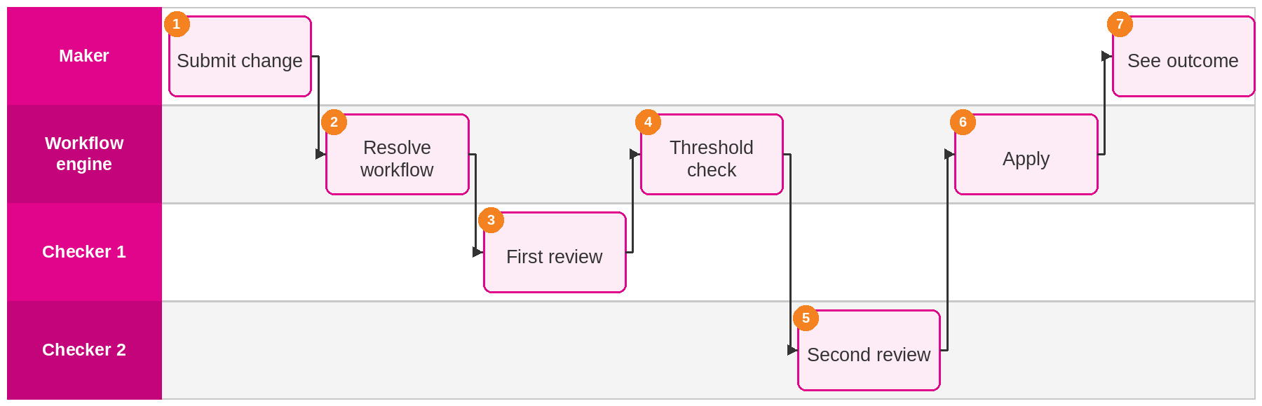
Figure 9: Maker-checker approval
Step | Actor | Screen | What happens
1 | Maker | Any maintenance screen | Submits a change; before and after values are stored.
2 | Workflow engine | None | Finds the definition, levels and thresholds.
3 | Checker 1 | Approval detail | Approves or rejects with mandatory remarks.
4 | Workflow engine | None | Adds a level, e.g. sum covered from B$300,000.
5 | Checker 2 | Approval detail | Approves or rejects with remarks.
6 | Workflow engine | None | Applies the change with audit record and notification.
7 | Maker | My requests | Sees the result and any remarks.

9. Functional Solution
SalesVerse 2.0 is iorta TechNXT's distribution platform for Takaful and insurance. For IIFT it is configured as the IIFT Agent/Banca Portal & Back-office: one portal for agents and bank officers and one back-office for IIFT and IITH staff, sharing a single database, workflow engine, document store and audit trail. A transaction submitted in the portal appears in the back-office at once, and every action on it is recorded.
Functions are listed by RFP area in Section 5, users in Section 7, journeys in Section 8 and screens in Section 11. This chapter covers the rules that tie them together.

9.1 Policy lifecycle
Only the server changes a policy's status, after validation and any required approval. Validation covers product eligibility, mandatory documents, the AML result, the agency payment block and the authority limit. Each change is written to the policy history and the audit trail.
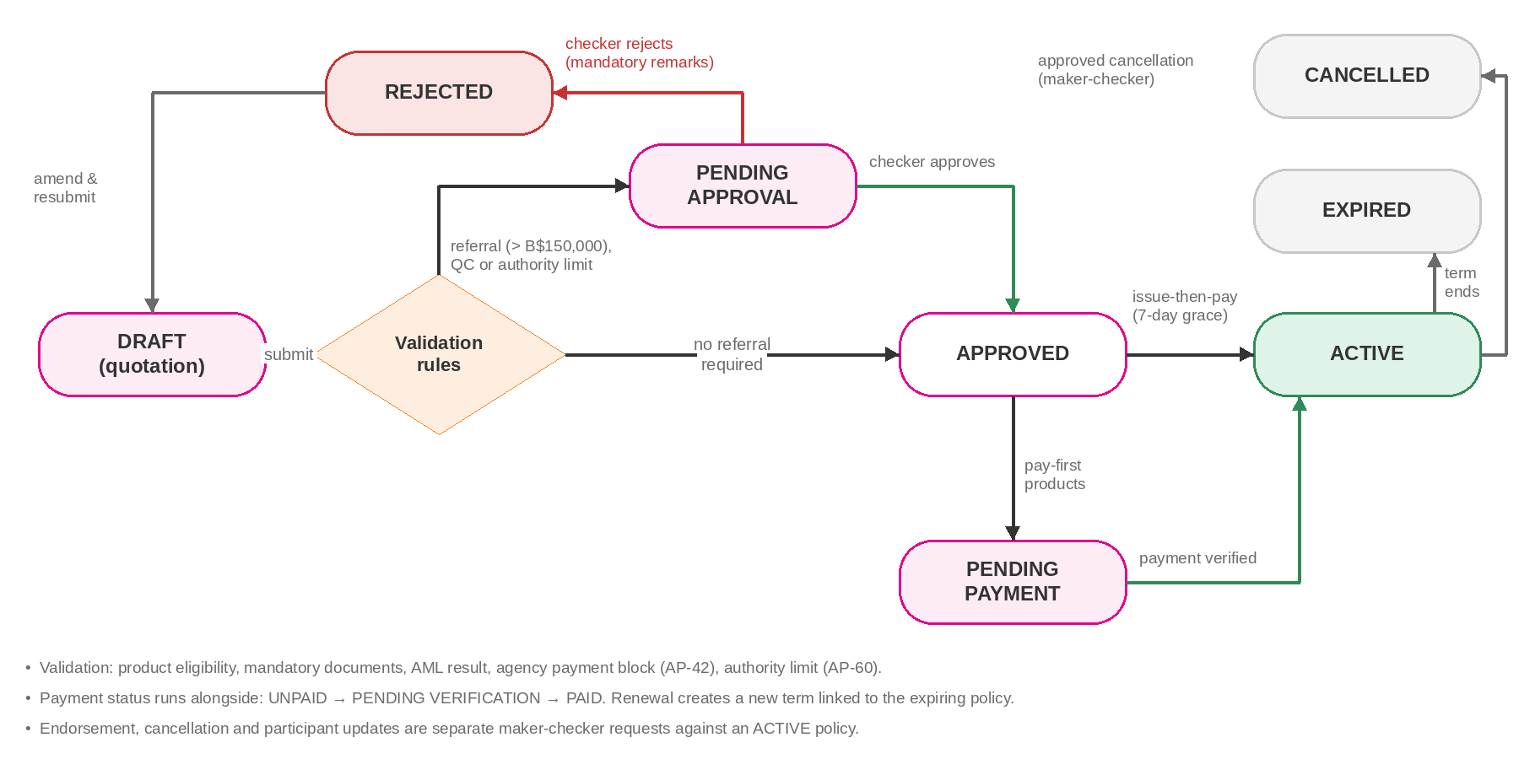
Figure 10: Policy lifecycle and status transitions
Status | Meaning | Next actions
DRAFT | Quotation saved; editable by the maker. | Submit
PENDING APPROVAL | Referral above the authority limit, quality check or other approval. | Approve or reject
PENDING PAYMENT | Approved; waiting for verified payment (pay-first products). | Payment verified
ACTIVE | In force; e-Policy and e-Receipt issued. | Endorse, cancel, renew, expire
REJECTED | Rejected with mandatory remarks. | Amend and resubmit
EXPIRED | Cover period ended. | Renew where enabled
CANCELLED | Cancellation approved. | None

9.2 Workflow engine and maker-checker
Approvals are data, not code. A workflow definition sets the transaction type, the number of levels, the permission needed at each level and amount thresholds that add a level, for example a second approval from B$300,000 sum covered. On final approval a handler applies the change in the same database transaction as the audit record and the notification event. The API rejects any attempt by the maker to approve their own request. When Compliance confirms an AML match, the pending requests for that agent or participant are rejected automatically with the Compliance remarks and the maker is notified. Journey 9 in Section 8 shows the flow.
Transaction | Level 1 checker | Level 2 checker | Rule
Agent / Banca registration | Banca/Sales officer | Banca/Sales manager | Always two levels
Agent profile update | Banca/Sales officer | None | None
Participant update | Underwriting officer | None | None
Quotation above B$150,000 financing | IIFT Sales | Underwriting manager | Referral rule
New policy, sum covered from B$300,000 | Underwriting officer | Underwriting manager | Amount threshold
Quality check (Mortgage Takaful) | Underwriting / QC | None | Product rule
Endorsement | Underwriting officer | Underwriting manager | Contribution change threshold
Cancellation | Underwriting officer | Underwriting manager | Always two levels
Payment verification | Finance officer | Finance manager | Amount threshold
AML possible match | Compliance officer | Compliance manager | On escalation
Table 12: Default workflow definitions, confirmed in design

9.3 Seven-day grace period
A nightly job finds issued policies unpaid for more than seven days and blocks issuance for every agent of that agency. Agents see the reason on their dashboard. The block lifts automatically once Finance verifies the payment.

9.4 Notifications
Event | Recipients | Channels
Request submitted, approved or rejected (with remarks) | Maker; checker queue | Portal, e-mail
Policy issued with e-Policy and e-Receipt | Agent; participant | E-mail with PDF, portal
Payment overdue: reminder on day 5, block on day 8 | Agent; agency principal; Finance | Portal, e-mail, SMS
Agency block lifted | All agents of the agency | Portal, e-mail
Renewal due (60, 30 and 7 days) and expiry | Agent | Portal, e-mail
Agent document expiring | Agent; Banca/Sales officer | Portal, e-mail
AML possible match | Compliance | Back-office, e-mail
Issue assigned, updated or SLA breached | Assignee; reporter; supervisor | Portal, e-mail
Dead-letter or EOD failure | Support team; IIFT IT | E-mail, monitoring alert
Table 13: Notification events (templates and channels configurable)

9.5 Reports
The platform has 12 standard reports with filters, Excel, CSV and PDF export and scheduled e-mail delivery. The go-live catalogue below is confirmed in design; reports not yet built are delivered during implementation within the fixed price.
Report | Primary users | Content
Daily issuance (EOD) report | Finance, Banca | Issued policies by product, bank and agent
FIN interface report | Finance | Entries sent to FIN with control totals
Receipt and BRR reconciliation | Finance | Matched and unmatched receipts and issuance
Policy register by status | Banca, Underwriting | Policies with status, dates and contribution
Production report | Management, Banca | Production by agent, agency, bank, product, period
Outstanding payments and ageing | Finance, Banca | Unpaid policies by ageing bucket
Grace-period breaches and agency blocks | Finance, Banca | Policies unpaid over 7 days; blocked agencies
Renewals due and expiries | Banca, agents | Policies due for renewal or expired
Claims notification register | Claims, Banca | Notifications and their status
AML screening and review | Compliance | Screenings, possible matches, outcomes
Agent register and document expiry | Banca/Sales | Agents, hierarchy, status, licence and document validity
Approval turnaround | Management | Requests by type, ageing and turnaround
Issue log and SLA | IT, Management | Issues by priority, status and SLA result
User access review | IT security, Audit | Users, roles, last login, dormant accounts
Commission / referral fee statement | Agents, Finance | Statement retrieved from FIN (INT-05)
Table 14: Report catalogue for go-live

10. Products, Rating and Process Flows
All seven products in RFP section 1.1 and Appendix 3 are configured in the working application. Each product definition holds plans, sums covered, eligibility, required documents, questionnaires, renewal availability, payment mode (pay first, or issue then pay within the grace period) and its rating engine.

10.1 Product configuration
Code | Product | Line | Rating inputs | Key rules
FTP-HP | Financing Takaful Plan – Hire Purchaser | Mortgage | Financing amount, tenure, profit rate, age next birthday | Above B$150,000 referred to IIFT Sales; QC before contract; issue-then-pay with 7-day grace
FTP-NP | Financing Takaful Plan – Non-Participating | Mortgage | As FTP-HP | Same engine and referral rule
PFT | Property Financing Takaful Plan | Mortgage | As FTP-HP (decreasing term) | Same engine; property financing documents
PHA | Personal Home Assistant Takaful Plan | Annual | Cover period 1 or 2 years | Employer IC, employee IC and details, passport, labour licence
PRO | Professional Takaful Plan | Annual | Plan A/B/C B$15k/30k/50k; additional cover B$90/120/140 | Occupational Class I only; nominee, beneficiary or executor IC
KHR | Khairat Takaful Plan | Annual | Plan A/B/C B$5k/10k/15k; Individual or Wider (Child) | Renewal switched off
OSA | Overseas Student Assist Takaful Plan | Annual | Basic B$20k or Tertiary B$50k | Brunei citizen, registered student, age 65 or under; student ID
Table 15: Product configuration

10.2 Contribution calculation
The Mortgage Takaful engine (FTP-HP, FTP-NP, PFT) calculates contribution from financing amount, financing period, profit rate and age next birthday using decreasing-term rate tables. Annual products use plan-based tables with riders and cover periods.
Rate tables, loadings, minimum contributions, rounding and authority limits are master data, changed in the back-office with every change audited. Maker-checker approval and effective-dated versions of rate tables, with the version recorded on each quotation, are added during implementation; until then a second person checks each rate change against IIFT's signed rate sheet. The working application holds indicative rates; IIFT's actuarial rates and wakalah fee and tabarru' split are loaded and verified during design and SIT.

10.3 Process flows (Appendix 3)

FFR01: Financing Takaful Plan, Hire Purchaser (FTPHP)
Step | RFP step | Portal / participant | Back-office / system
FTPHP01 | Capture participant details | Full name, IC number, address, phone; duplicate check and AML screening. | Possible matches go to Compliance.
FTPHP02 | Attach documents | Proposal form, product disclosure sheet, IC copy, HP agreement or financier approval; HP statement for existing HP. | Checklist enforces mandatory documents per case.
FTPHP03 | Contribution | Calculated from financing amount, period, profit rate and age next birthday. | Above B$150,000: referred to IIFT Sales.
FTPHP04 | Drawdown letter | Agent uploads the drawdown letter and remaining documents and enters drawdown details. | Back-office validates documents.
FTPHP05 | Issue receipt | e-Receipt issued for the contribution collected. | Receipt number assigned; FIN entry queued.
FTPHP06 | Quality check | Status shows Pending Approval (QC). | Underwriting approves or rejects with remarks.
FTPHP07 | e-Policy and e-Receipt | PDFs available to download and e-mailed to the participant. | Stored in the encrypted document store.
FTPHP08 | EOD and final issuance | None | EOD report, master report, FIN file, reconciliation.

FFR02: Personal Home Assistant Takaful Plan (APHA)
Step | RFP step | Portal / participant | Back-office / system
APHA01 | Capture participant details | Full name, IC number, address, phone. | Duplicate check, AML screening.
APHA02 | Select cover | New or renewal; 1 or 2 years. | Plan rules from configuration.
APHA03 | Quotation and questionnaire | Summary shown; Appendix II questionnaire completed. | Questionnaire version stored.
APHA04 | Requirements | Employer IC, employee IC, employee details, passport, labour licence. | Checklist and expiry dates.
APHA05 | Payment | Single or bulk payment with proof. | Finance verifies.
APHA06 | e-Policy and e-Receipt | Issued on payment confirmation. | Policy becomes ACTIVE.
APHA07 | FIN reporting | None | Daily report, FIN file, BRR reconciliation.

FFR03: Professional Takaful Plan (APPT)
Step | RFP step | Portal / participant | Back-office / system
APPT01 | Capture participant details | Full name, IC number, address, phone. | Duplicate check, AML screening.
APPT02 | Quotation, new or renewal | Plan A B$15,000, Plan B B$30,000, Plan C B$50,000. | Occupational Class I only.
APPT03 | Additional cover | Optional: Plan A B$90, Plan B B$120, Plan C B$140. | Configured as rider.
APPT04 | Summary and questionnaire | Summary shown; questionnaires completed. | Answers can trigger referral rules.
APPT05 | Documents | Questionnaire, IC copy, IC of nominee, beneficiary or executor. | Checklist validation.
APPT06 | Payment | Payment with proof. | Finance verifies.
APPT07 | Policy and receipt | e-Policy and e-Receipt on confirmation. | Policy becomes ACTIVE.
APPT08 | EOD reporting | None | EOD report, FIN entries, BRR reconciliation.

FFR04: Khairat Takaful Plan (APKT)
Step | RFP step | Portal / participant | Back-office / system
APKT01 | Capture participant details | Full name, IC number, address, phone. | Duplicate check, AML screening.
APKT02 | Quotation | Plan A B$5,000, B B$10,000, C B$15,000; Individual or Wider (Child). | Renewal switched off.
APKT03 | Summary and questionnaire | Summary shown; questionnaires completed. | Stored with quotation.
APKT04 | Documents | Questionnaires, IC copy, nominee's IC copy. | Checklist validation.
APKT05 | Payment | Payment with proof. | Finance verifies.
APKT06 | Policy issuance | e-Policy and e-Receipt on confirmation. | Policy becomes ACTIVE.
APKT07 | EOD reporting | None | EOD report to FIN; BRR reconciliation.

FFR05: Overseas Student Assist Takaful Plan (APAOS)
Step | RFP step | Portal / participant | Back-office / system
APAOS01 | Capture participant details | Full name, IC number, address, phone. | Duplicate check, AML screening.
APAOS02 | Select cover | Basic B$20,000 or Tertiary B$50,000. | Plan rules from configuration.
APAOS03 | Eligibility | Brunei citizen, registered student, age 65 or under. | Ineligible cases cannot proceed.
APAOS04 | Summary and questionnaire | Summary shown; Appendix IV questionnaire. | Stored with quotation.
APAOS05 | Documents | Questionnaires, IC copy, student ID, IC of nominee, beneficiary or executor. | Checklist validation.
APAOS06 | Payment | Payment with proof. | Finance verifies.
APAOS07 | e-Policy and e-Receipt | Issued on confirmation. | Policy becomes ACTIVE.
APAOS08 | EOD reporting | None | EOD report, FIN file, BRR reconciliation.

10.4 End-of-day processing
EOD runs on a schedule and can be re-run from the back-office. One locked job runs across application nodes. Each posting to FIN carries a revision number and its own idempotency key, and a re-run is marked as replacing the previous revision, so FIN can reject duplicates and keep only the latest figures for the day.
# | Step | Description
1 | Cut-off | Configurable daily cut-off; later transactions roll to the next business day.
2 | Issuance report | Policies issued, endorsed and cancelled and receipts approved, by product, bank and agent.
3 | Final issuance | Master report for Mortgage Takaful final issuance (FFR01 step 8).
4 | FIN interface file | Contribution and receipt entries, with wakalah fee and tabarru' split where applicable.
5 | Reconciliation | Receipts reconciled today; BRR reconciliation added once IIFT confirms the BRR format.
6 | Grace-period check | Policies unpaid for more than seven days found; agency blocks applied or lifted.
7 | Sign-off | Finance reviews exceptions and signs off the run; run history kept.

11. Screen Catalogue
The tables list every screen in SalesVerse 2.0 as configured for IIFT, with its purpose and the RFP requirements it serves. Sample screens follow; all data shown is test data.

11.1 Agent/Banca Portal screens
Screen | Purpose | RFP IDs
Sign-in | Secure login | AP-01, AP-03, AP-04
Change password | Password change under policy | AP-02
Dashboard | Profile summary, pending actions, production, payments | AP-37, AP-52, AP-53
New quotation | Product, participant, coverage and live quote | AP-17 to AP-20
Quotations and policies | List and search by status | AP-21 to AP-23
Policy detail | Checklist, questionnaire, nominees, documents, signatures, submit; servicing actions; history tabs | AP-24 to AP-36, AP-44 to AP-47, AP-62
Renewals | Policies due for renewal | AP-26
Participants | List, registration and detail | AP-11 to AP-16
Billing | Outstanding, bulk payment, history | AP-37 to AP-42
Payment detail | Allocation, proof, status, e-Receipt | AP-39 to AP-41
Claims | List, notification and detail | AP-43
My requests | Status of submitted requests and rejection remarks | AP-49 to AP-51
Team and hierarchy | Main agent, sub-agents and bank officers | AP-09, AP-10
Agent registration | Online registration and onboarding | AP-07, AP-08, AP-46, AP-48
Profile | Profile and change requests | AP-05, AP-06
Commission | Commission and referral fee statement | INT-05
Reports | Role-scoped reports and exports | AP-58
Support issues | Report and track issues | AP-55 to AP-57
Notifications | In-portal notifications | AP-34, AP-54
Participant e-signature page | Remote signature by single-use link | AP-62

11.2 Back-office screens
Screen | Purpose | RFP IDs
Dashboard | Pending actions and management KPIs | BO-20, BO-21
Approvals inbox and detail | Maker-checker queue with before and after values | BO-16 to BO-19
Agents | List, registration and detail | BO-05 to BO-08, BO-10
Agencies and banks | Agency, bank and branch records | BO-09
Policies | Policy search and detail | AP-21 to AP-31 (back-office view)
Participants | Participant search and detail | AP-11 to AP-15
Payments | Verification and receipts | AP-40, AP-41
Claims | Claim notifications | AP-43
AML/KYC cases and watch-lists | Screening results, review, lists | BO-13 to BO-15
Document checks | Validation, approval and expiry | BO-11, BO-12
Audit trail | Audit search and export | BO-26 to BO-28
Issues | Assignment, priority, SLA | BO-29 to BO-31
Reports and schedules | Report runs, exports, schedules | BO-22 to BO-25
End of day | EOD runs, FIN file, reconciliation, sign-off | FFR EOD, INT-04
Integration monitor and reconciliation | Outbox messages, retries, dead-letters, reconciliation | INT-11 to INT-15
Users | User administration | BO-03
Roles and permissions | Role builder and data scopes | BO-02, BO-04
Workflows | Workflow definitions and thresholds | BO-16, COM-04
Products | Products, plans, rates, questionnaires | BO-32
Parameters and master data | System parameters and reference data | BO-32, BO-33, COM-09

11.3 Sample screens
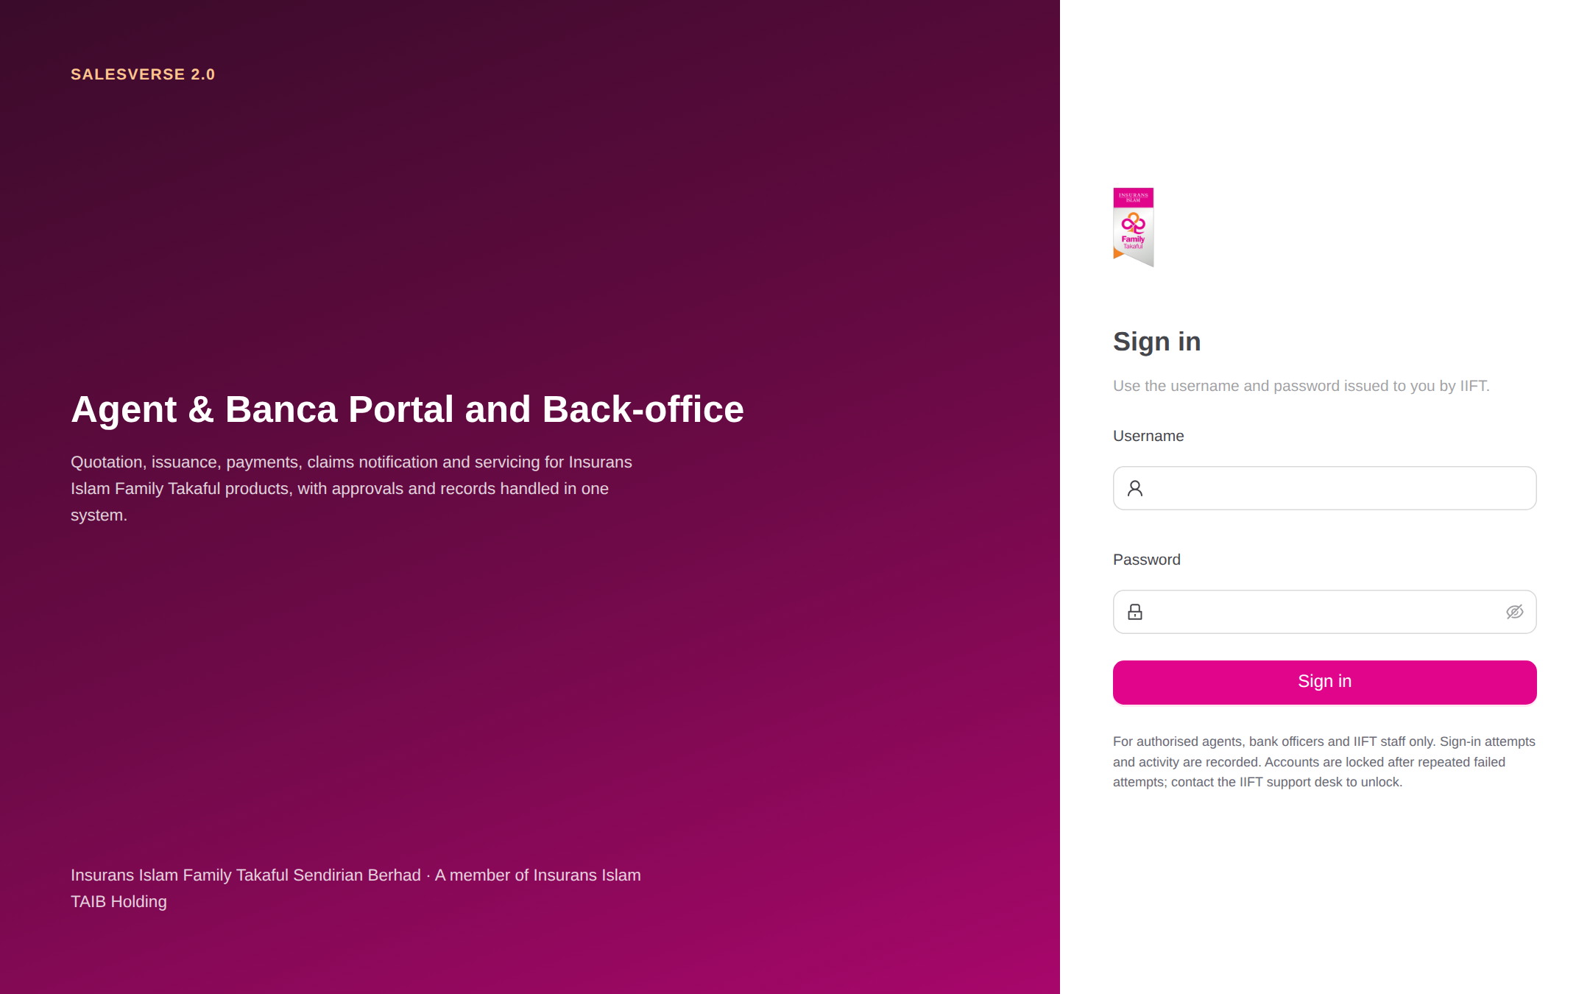  Figure 11: Secure login | 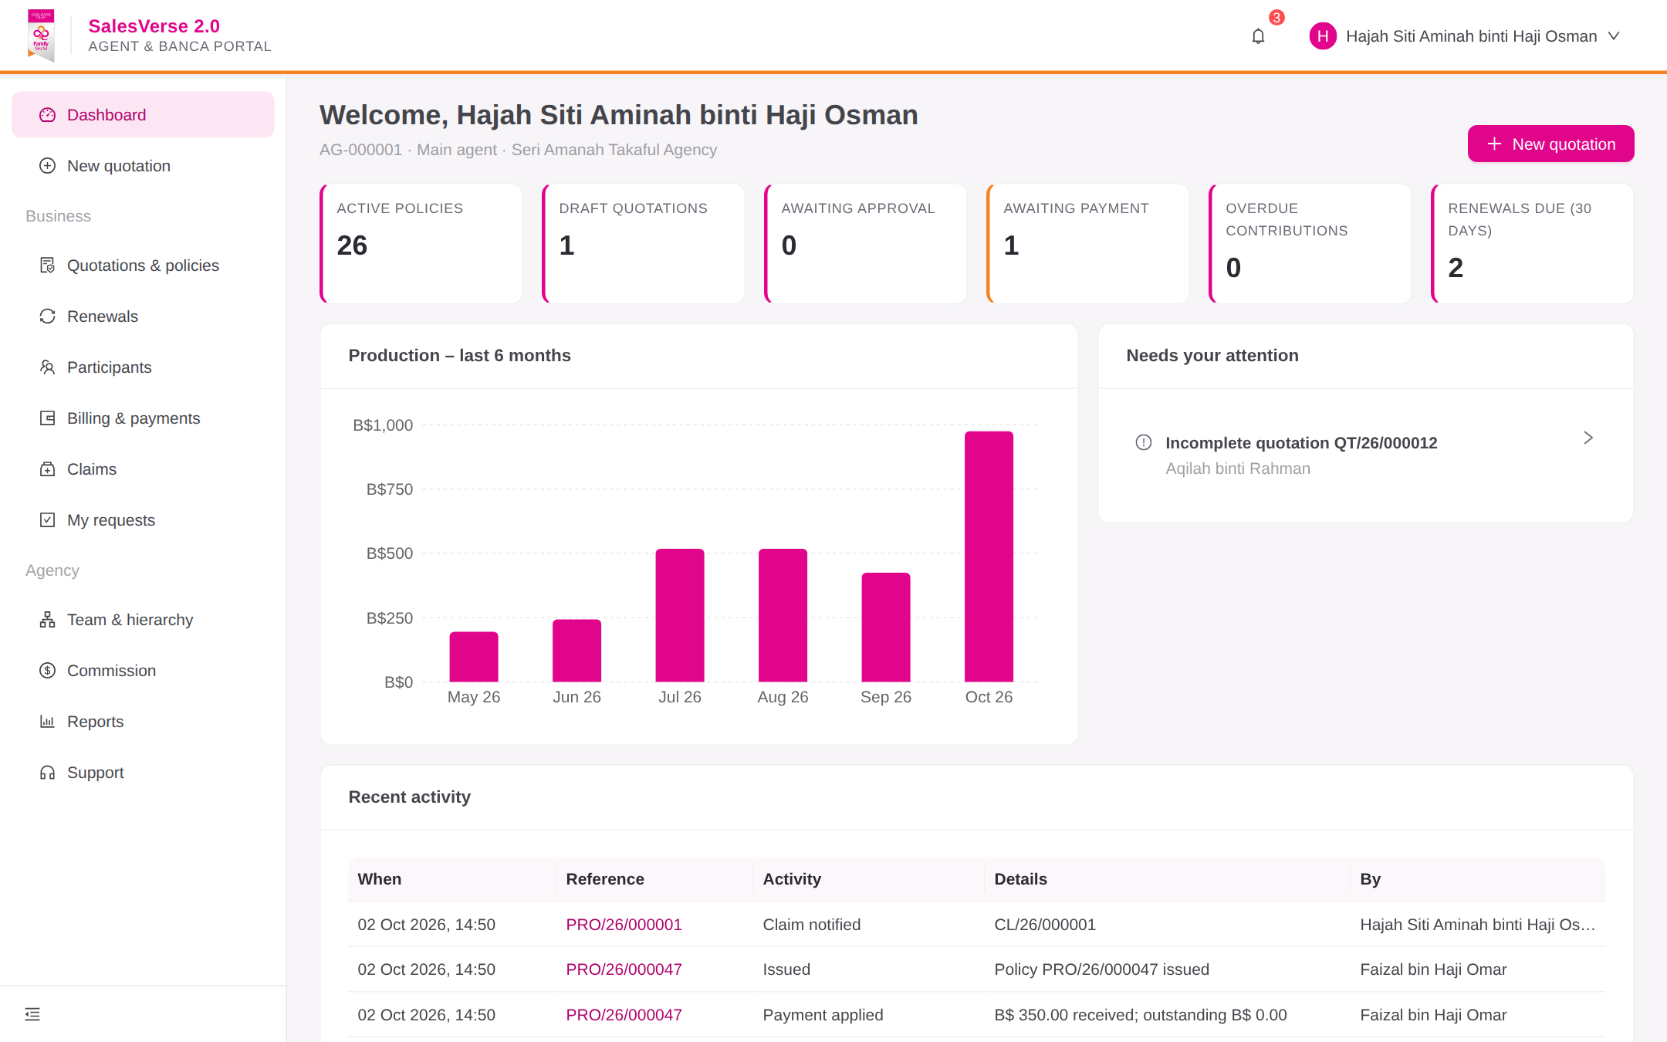  Figure 12: Agent/Banca dashboard
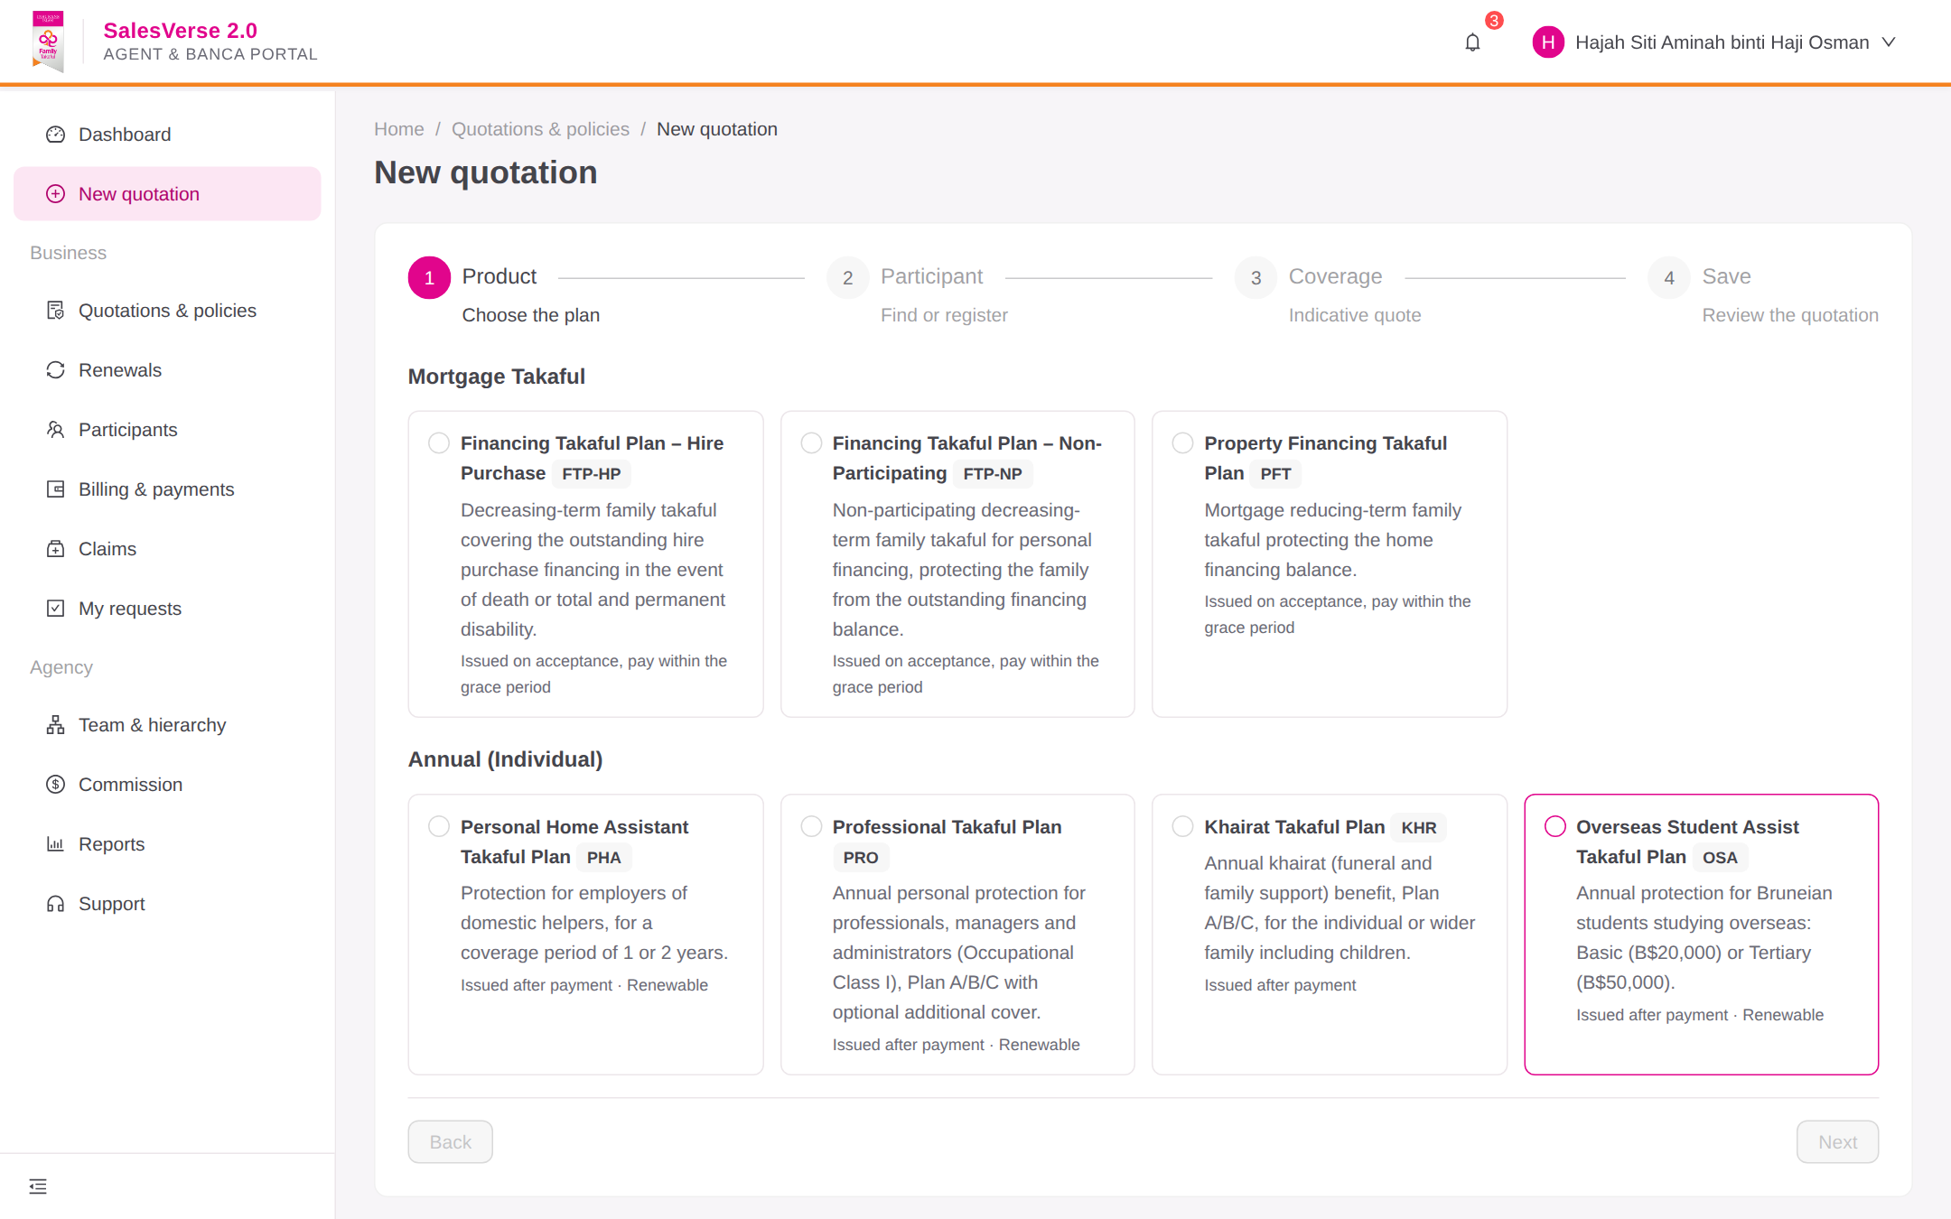  Figure 13: Product selection | 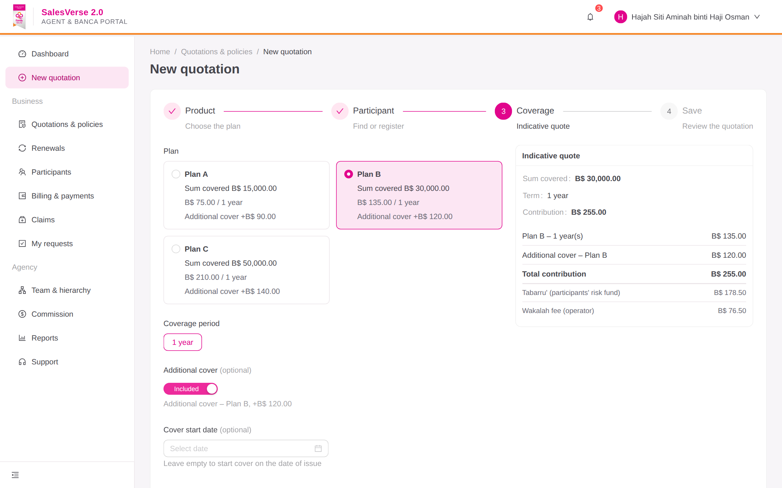  Figure 14: Quotation – participant & coverage
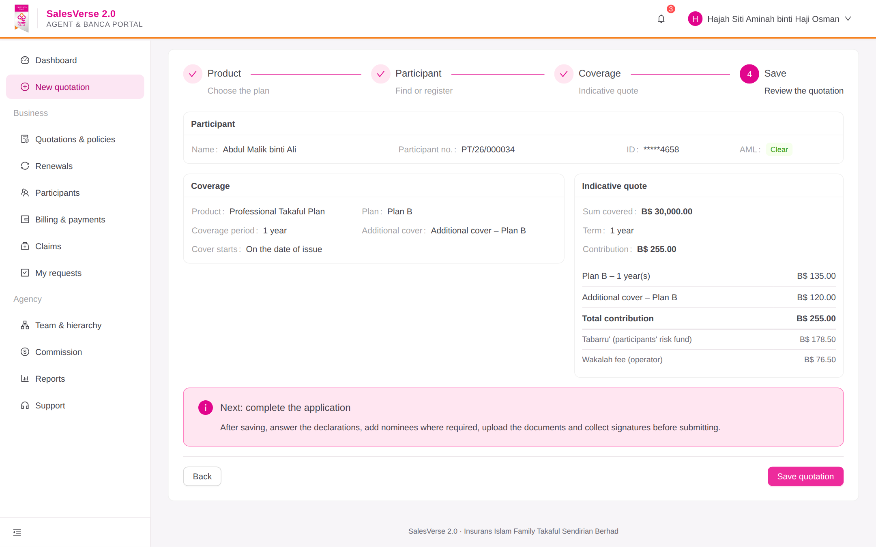  Figure 15: Quotation summary & contribution | 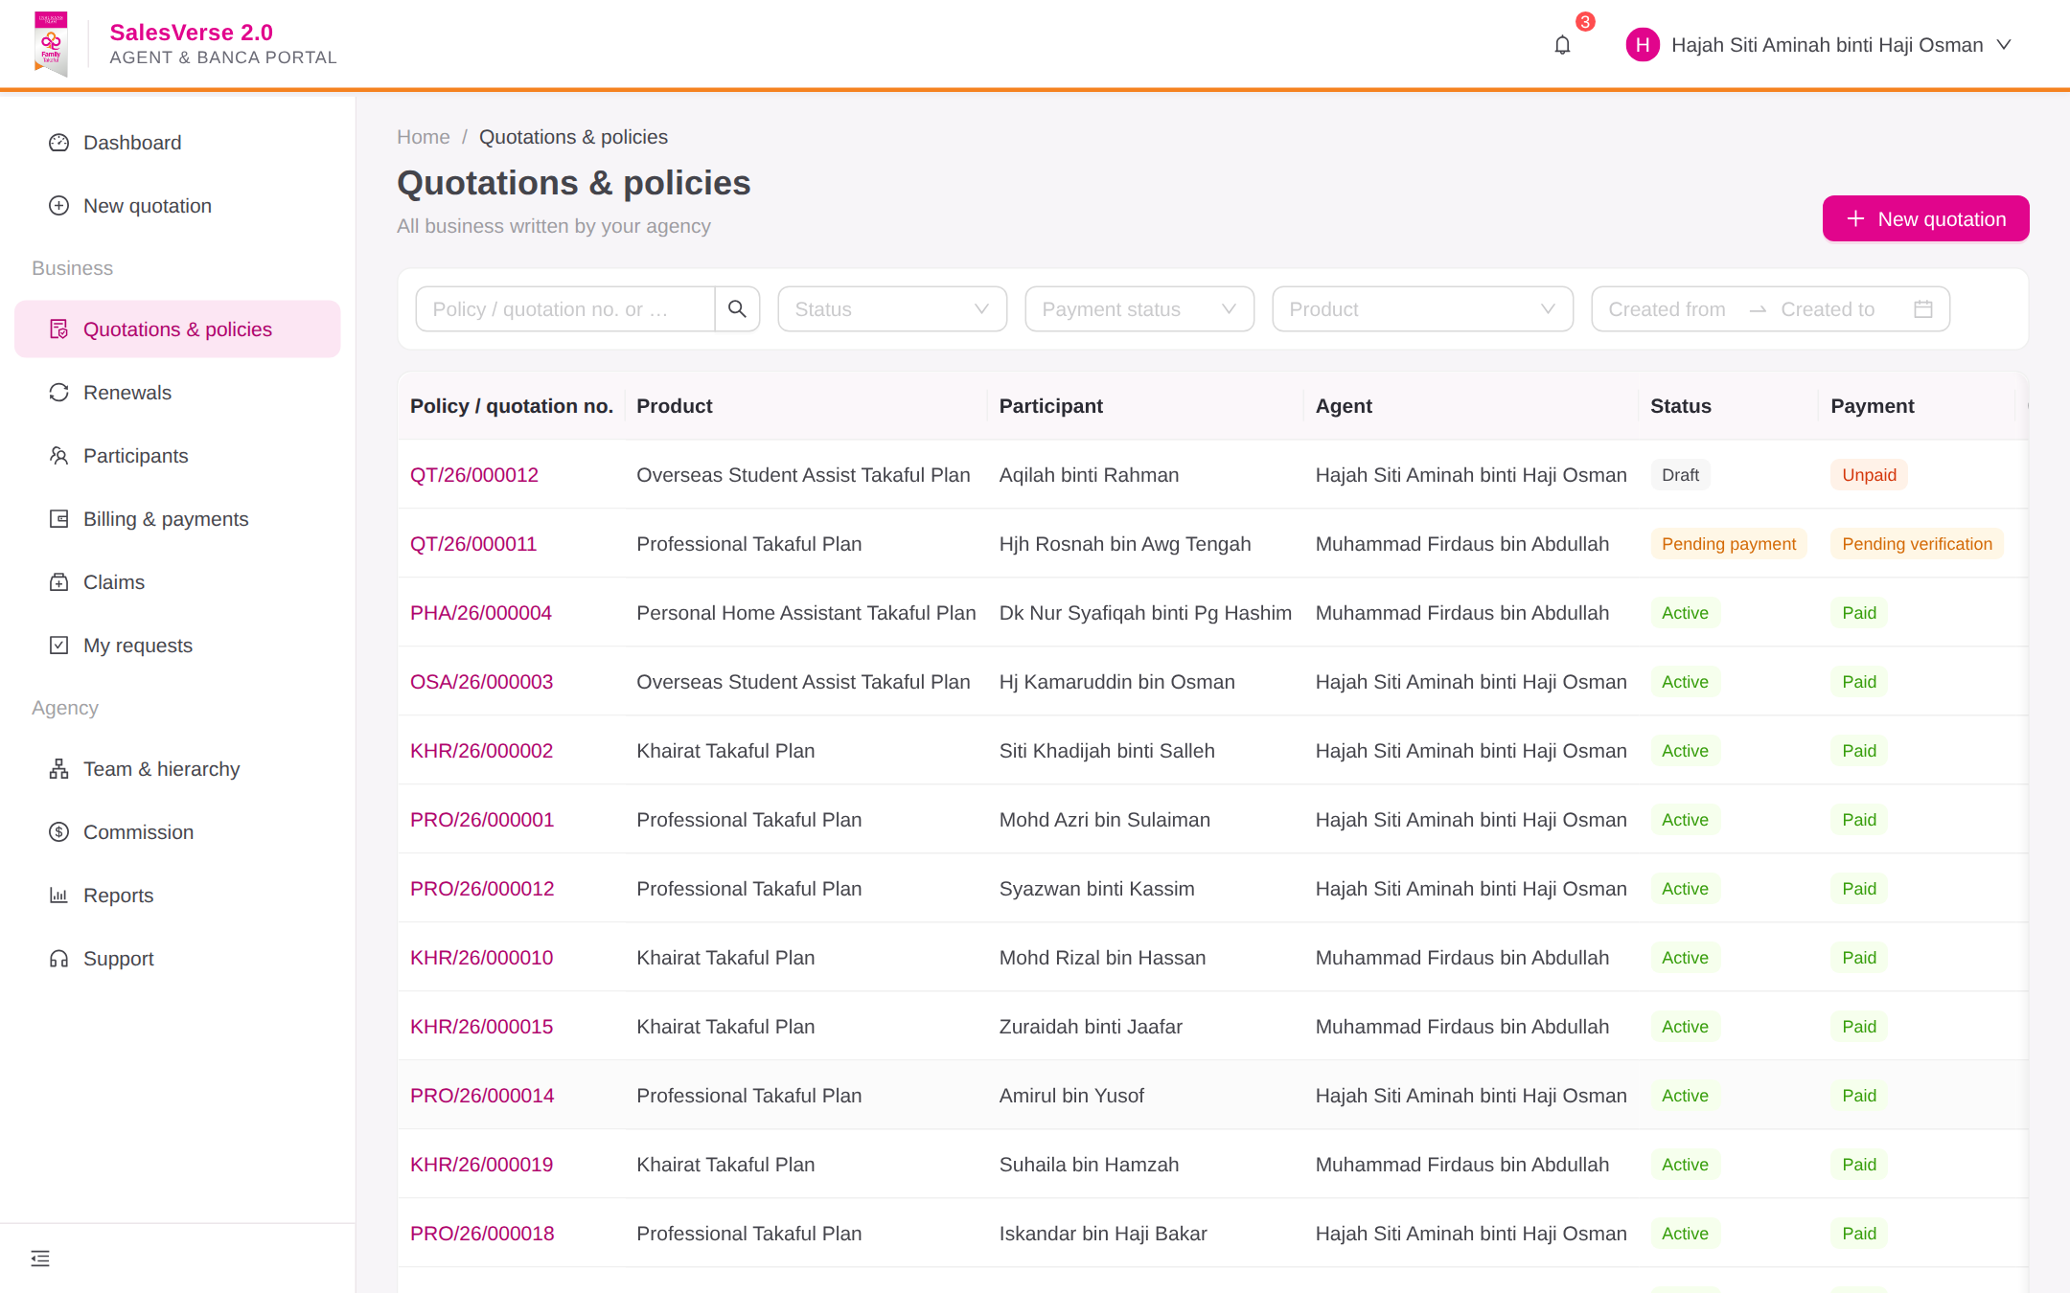  Figure 16: Policy listing & search
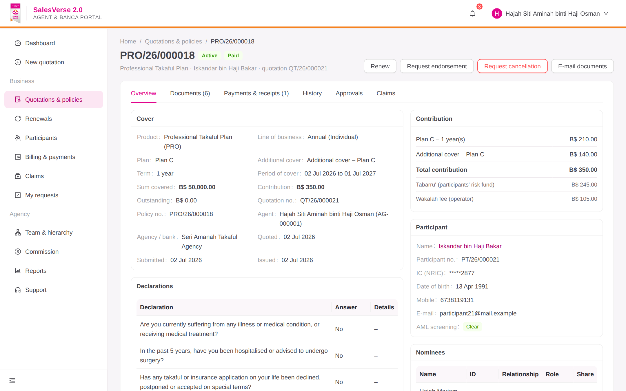  Figure 17: Policy details, documents & history | 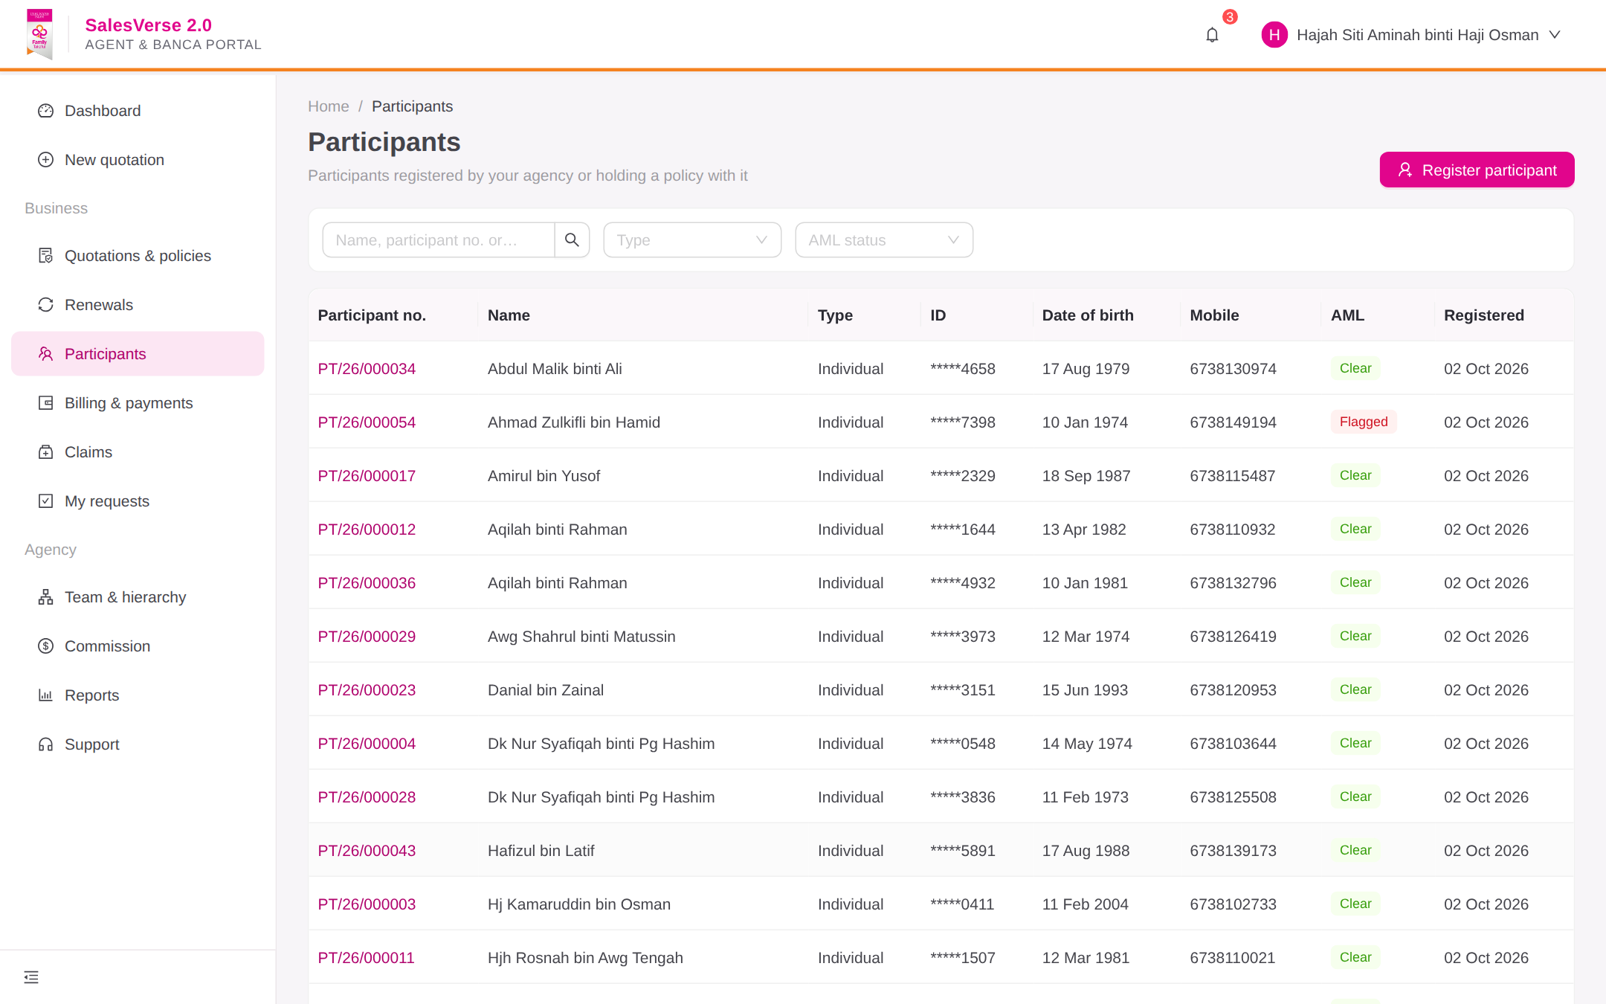  Figure 18: Participant management
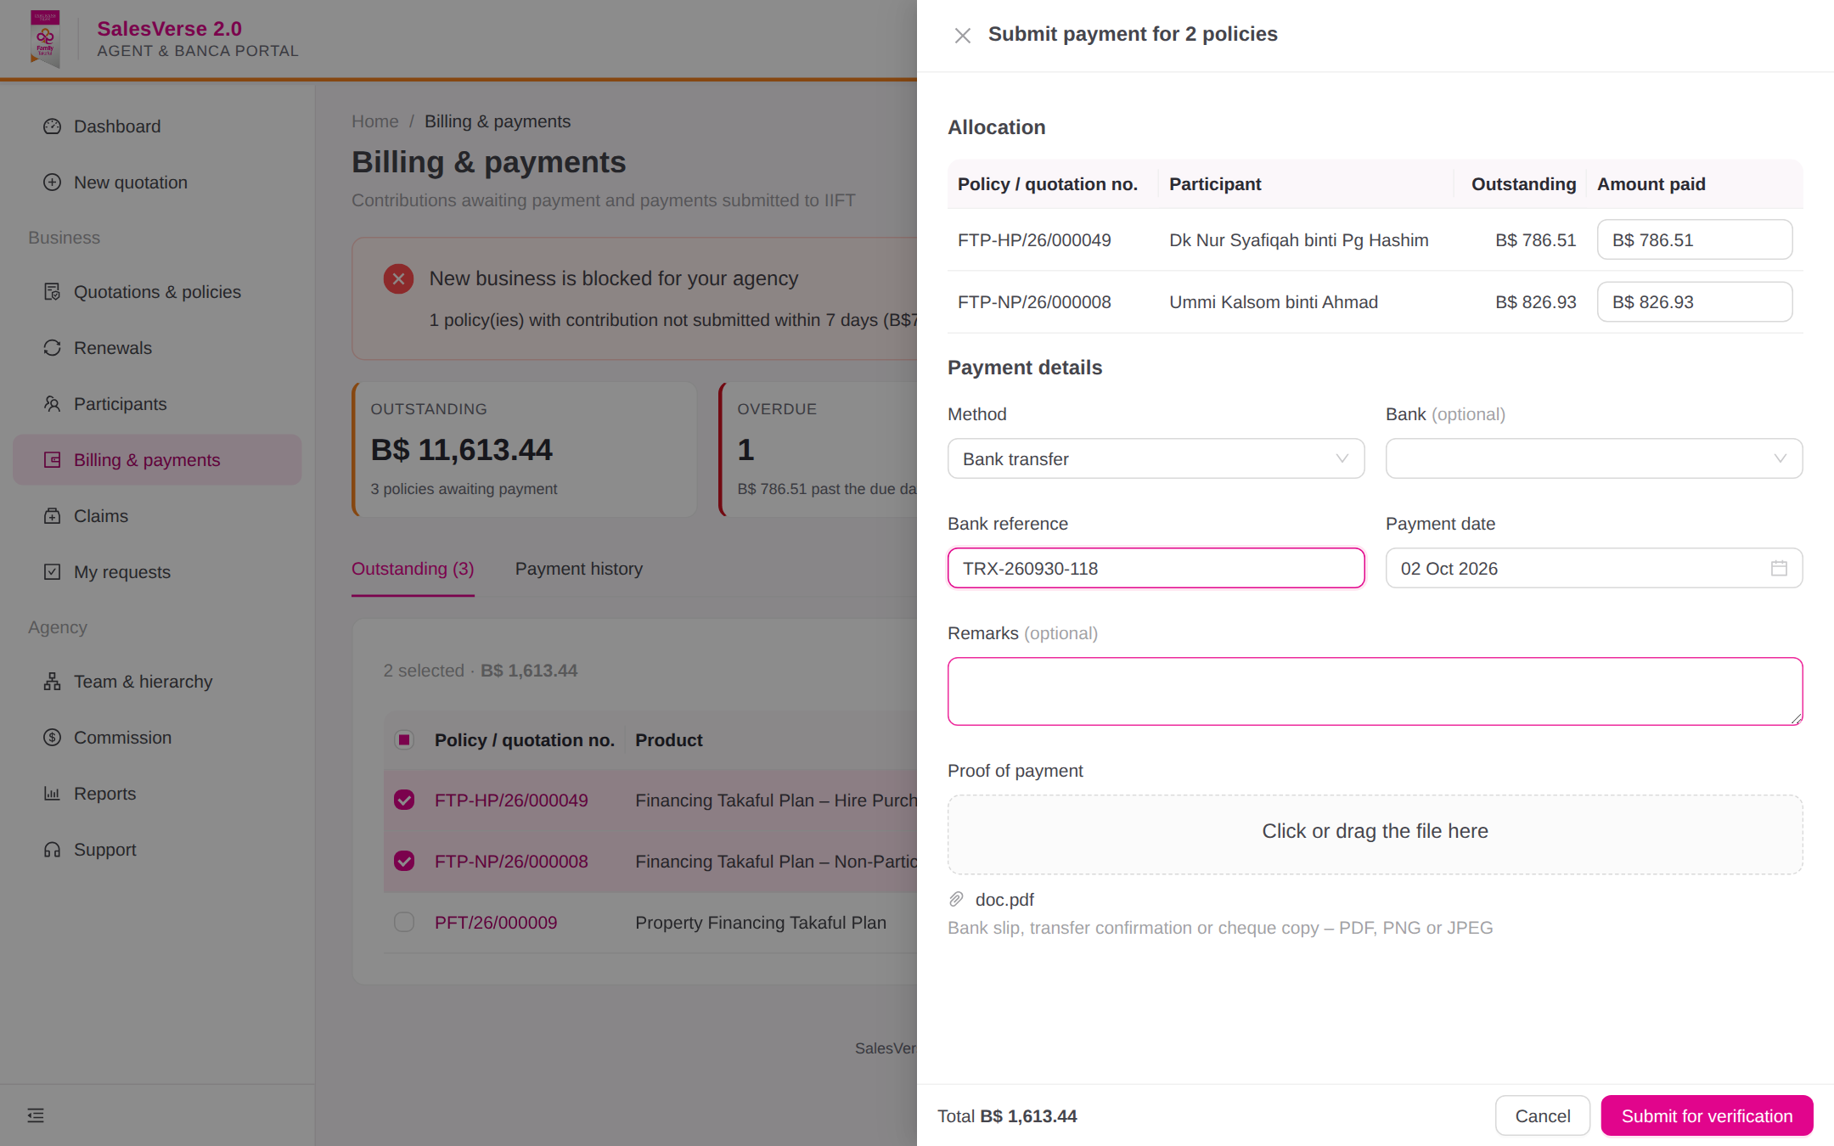  Figure 19: Payment submission (single/bulk) | 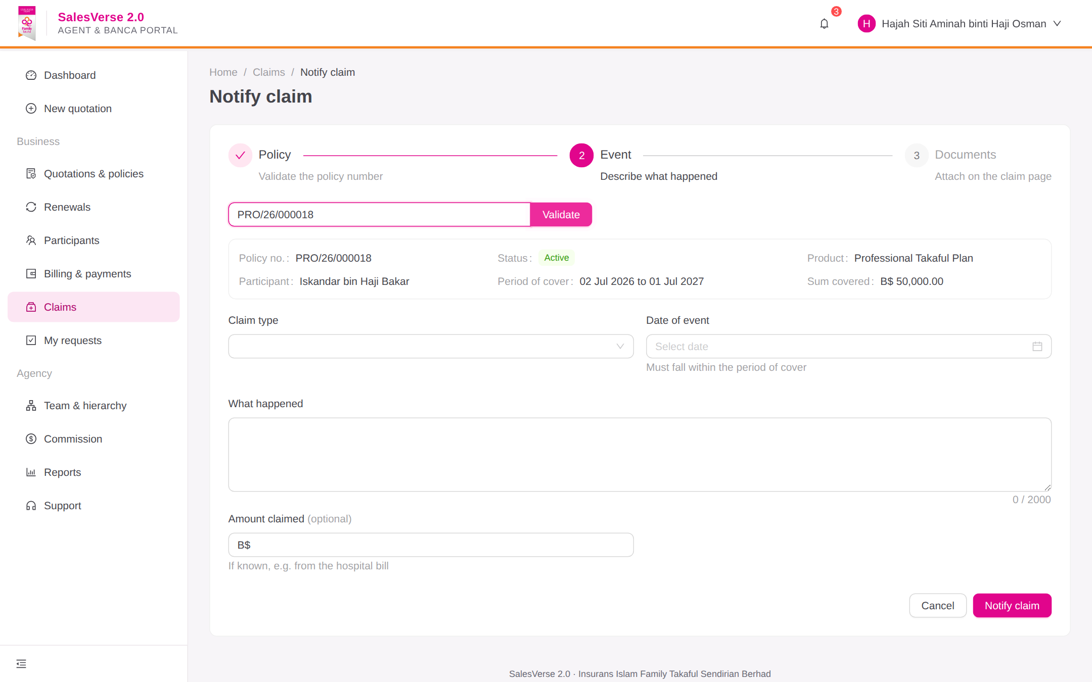  Figure 20: Claim notification
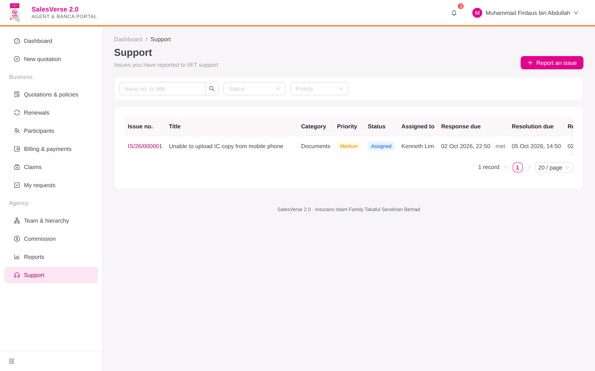  Figure 21: Issue reporting & tracking | 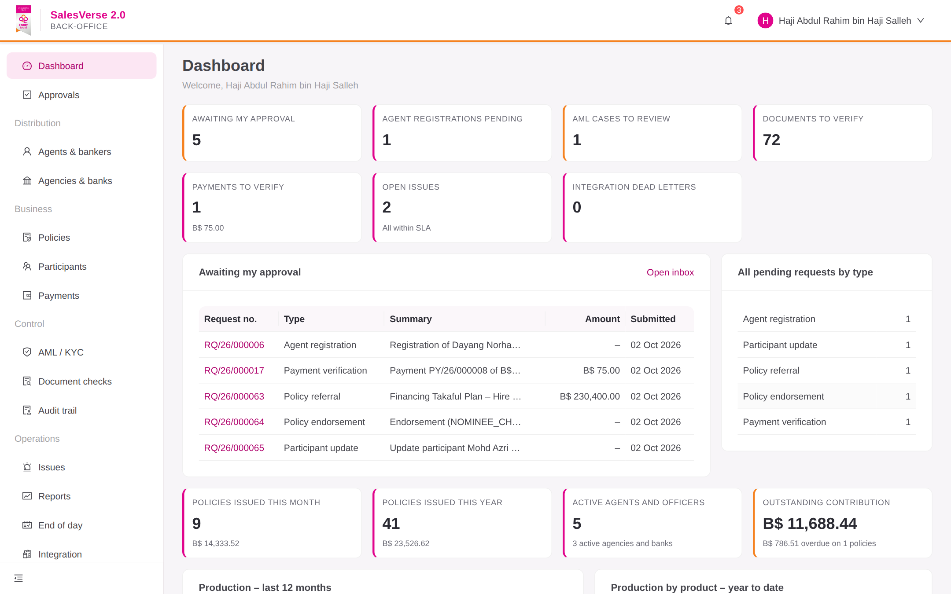  Figure 22: Back-office management dashboard
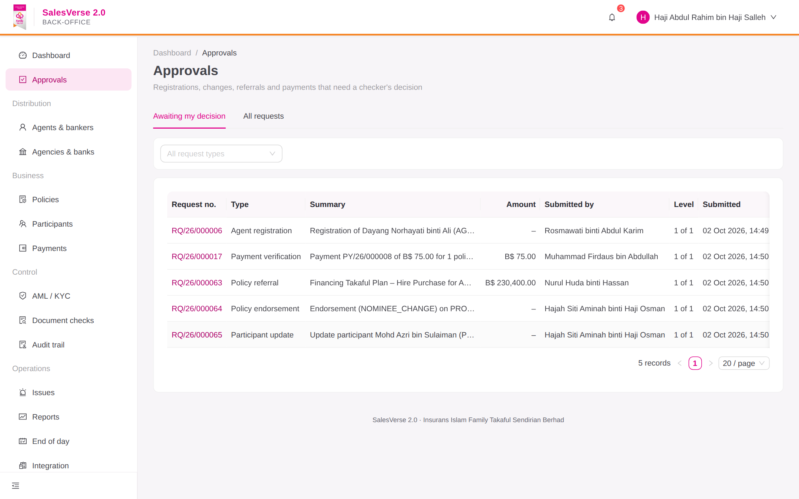  Figure 23: Maker-checker approvals inbox | 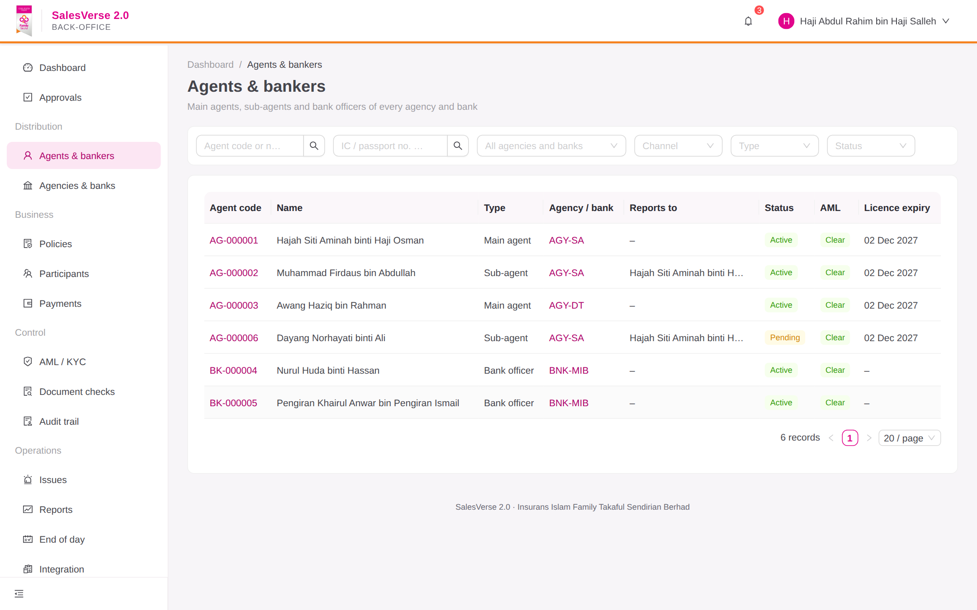  Figure 24: Agent/Banca administration
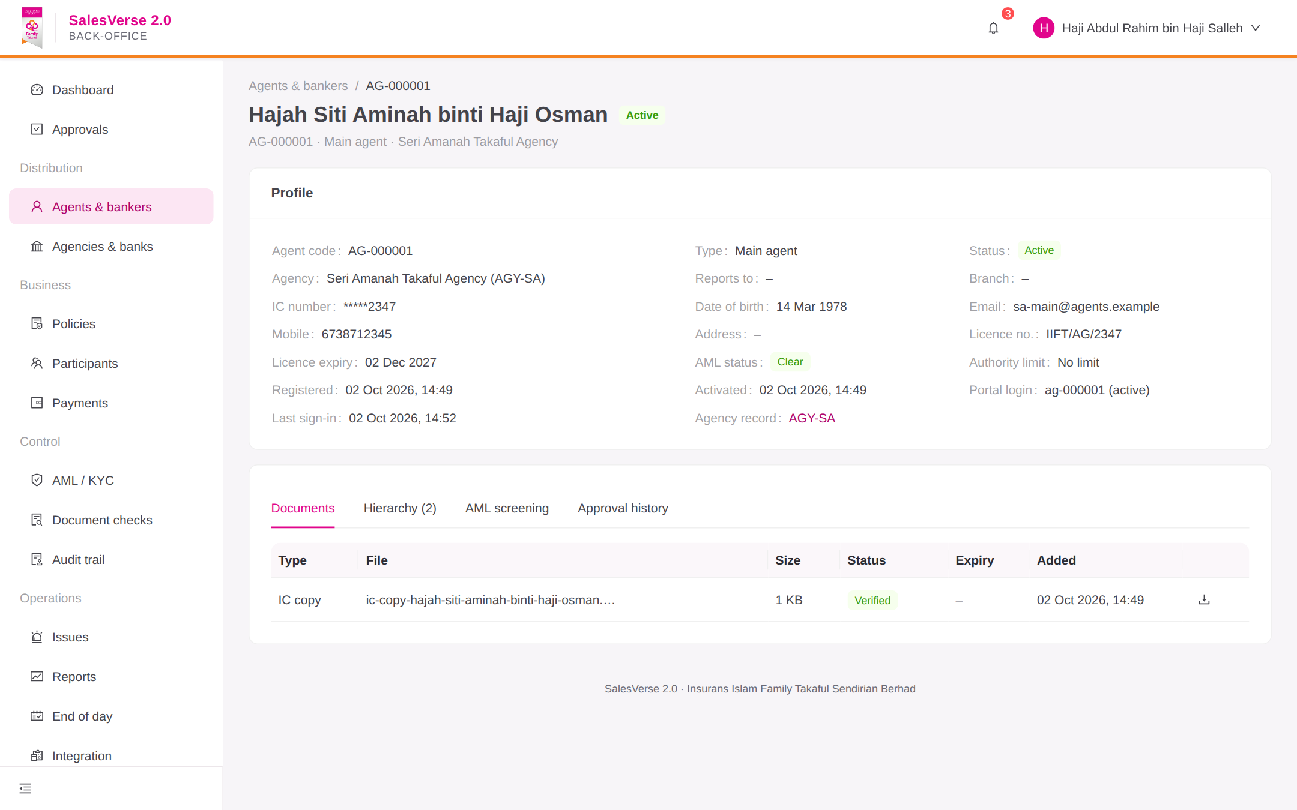  Figure 25: Agent profile, hierarchy & documents | 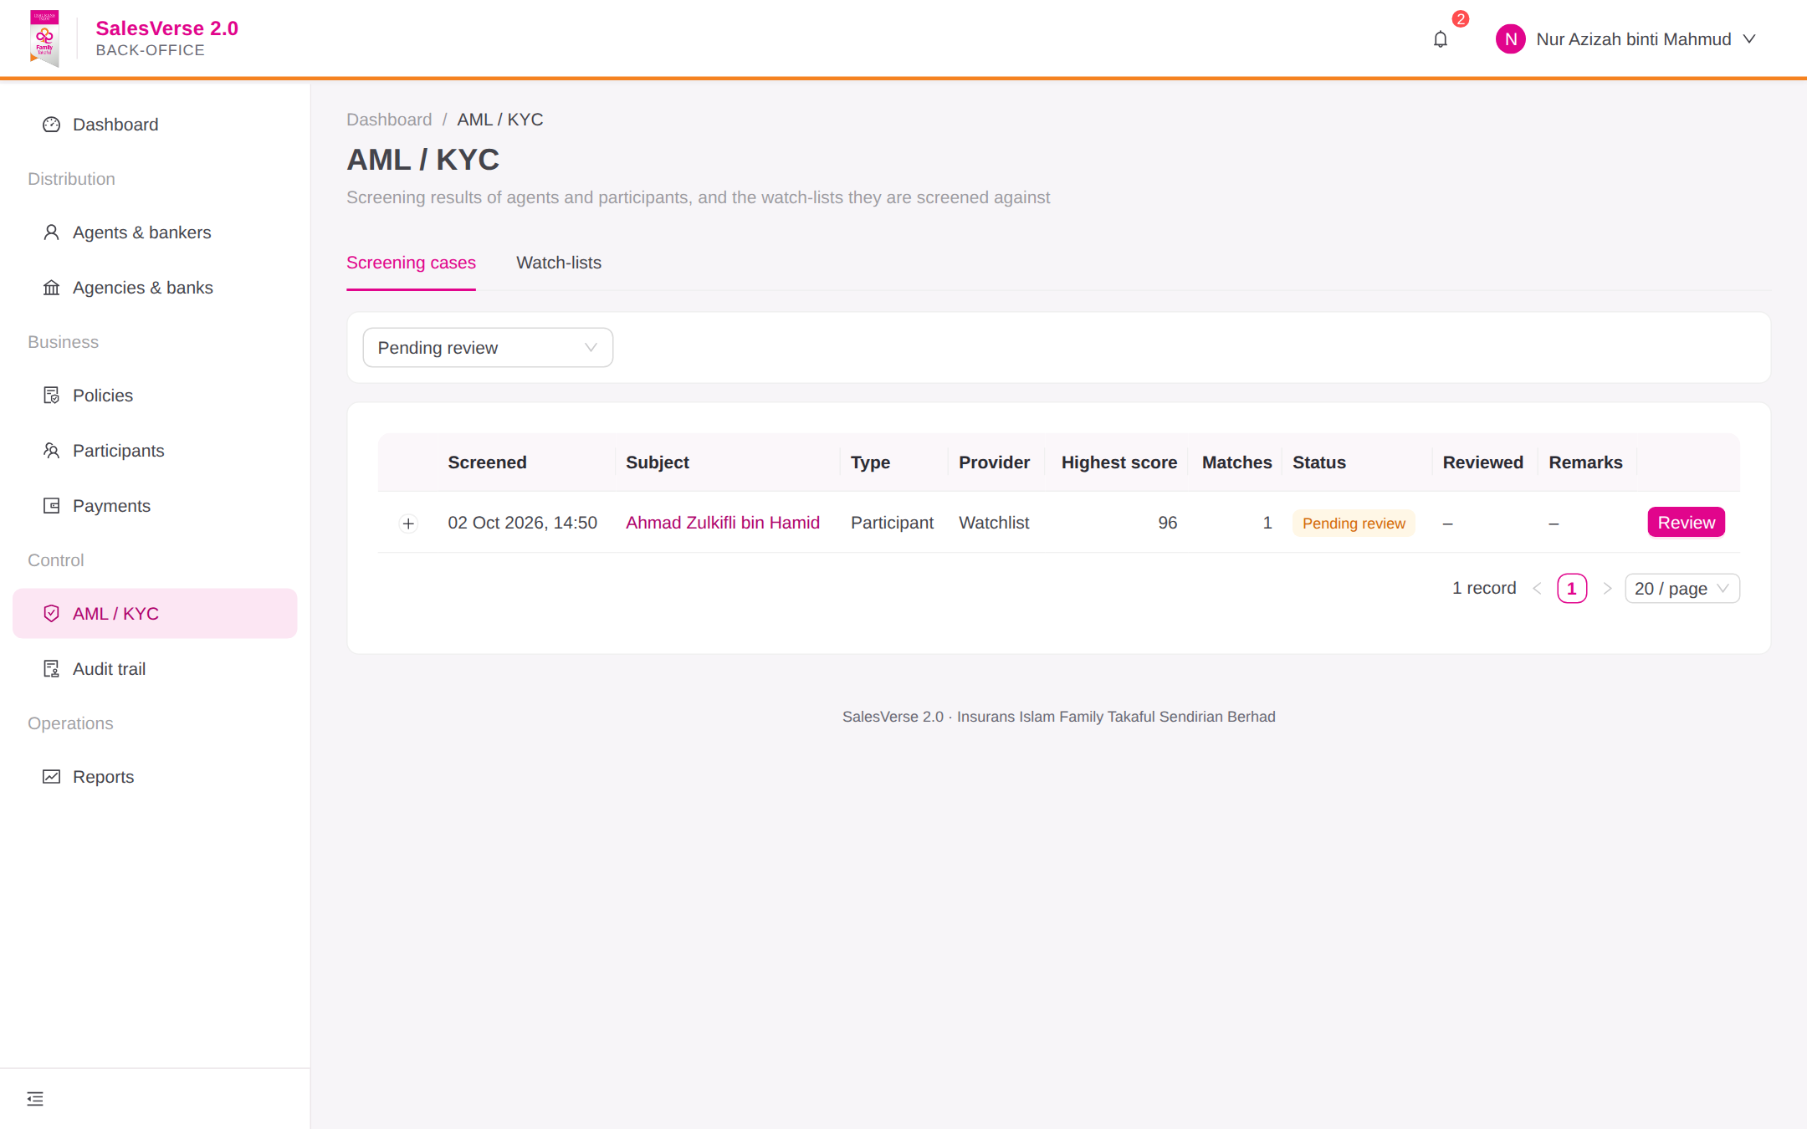  Figure 26: AML/KYC compliance review
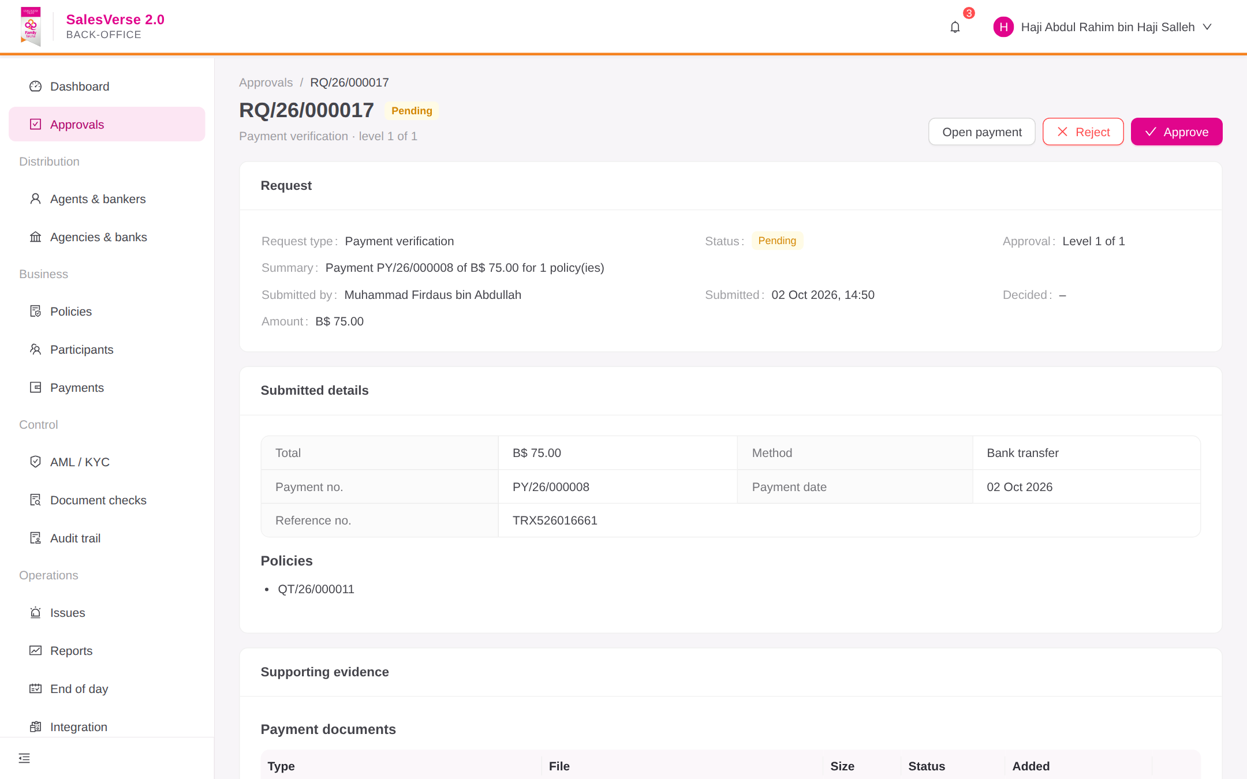  Figure 27: Payment verification & receipts | 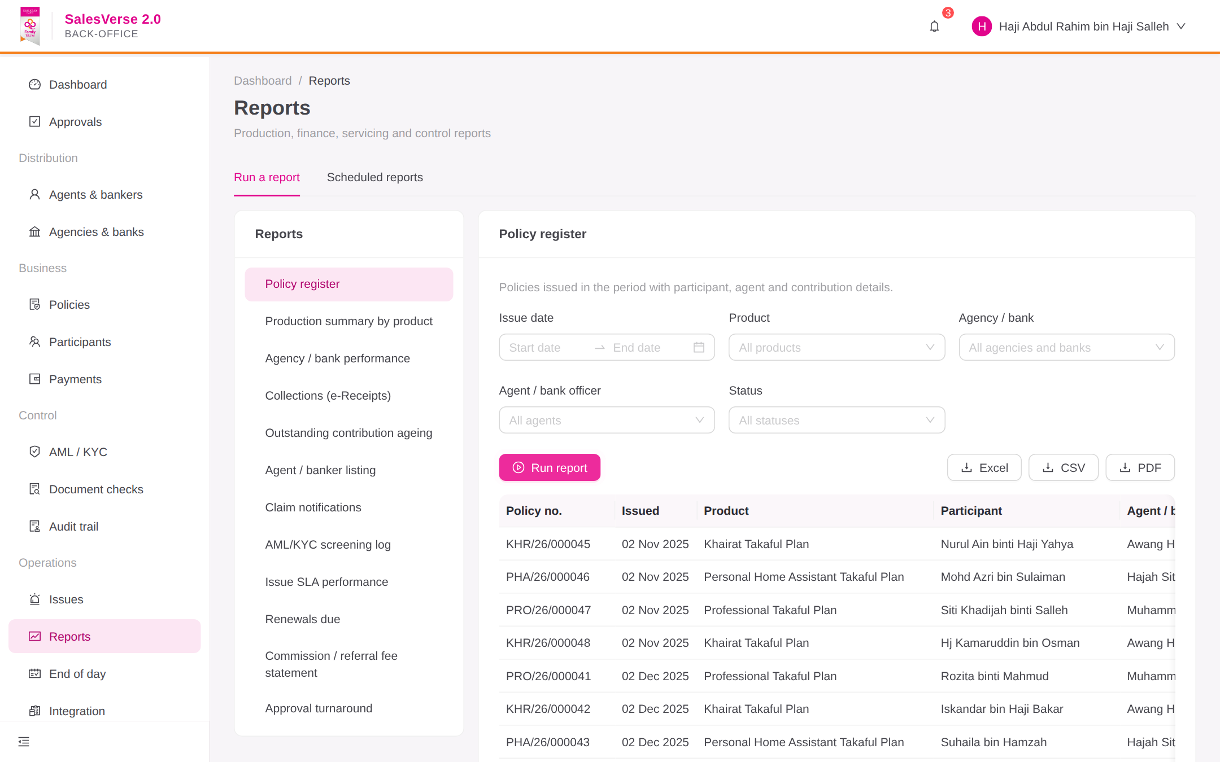  Figure 28: Reports & export
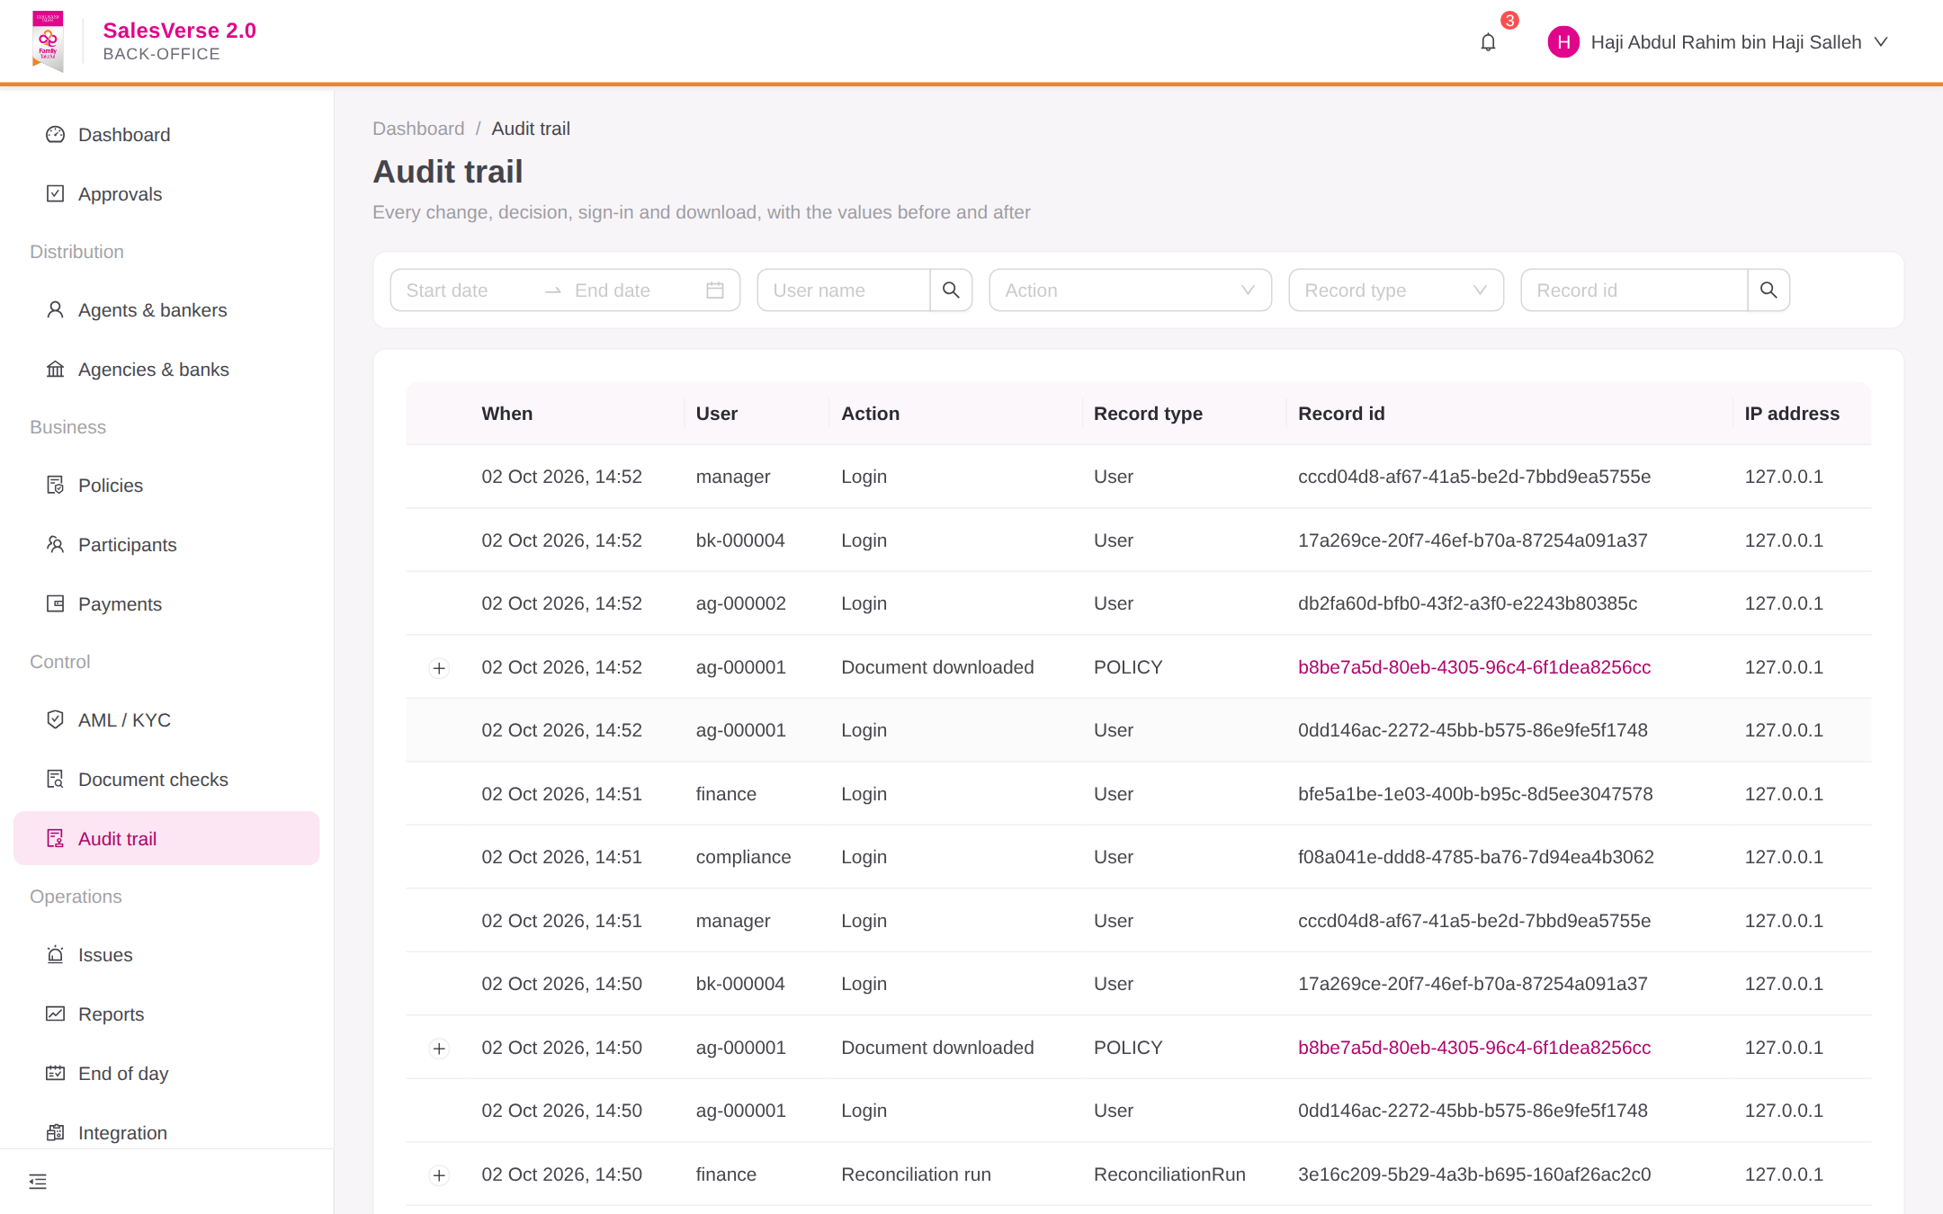  Figure 29: Audit trail search | 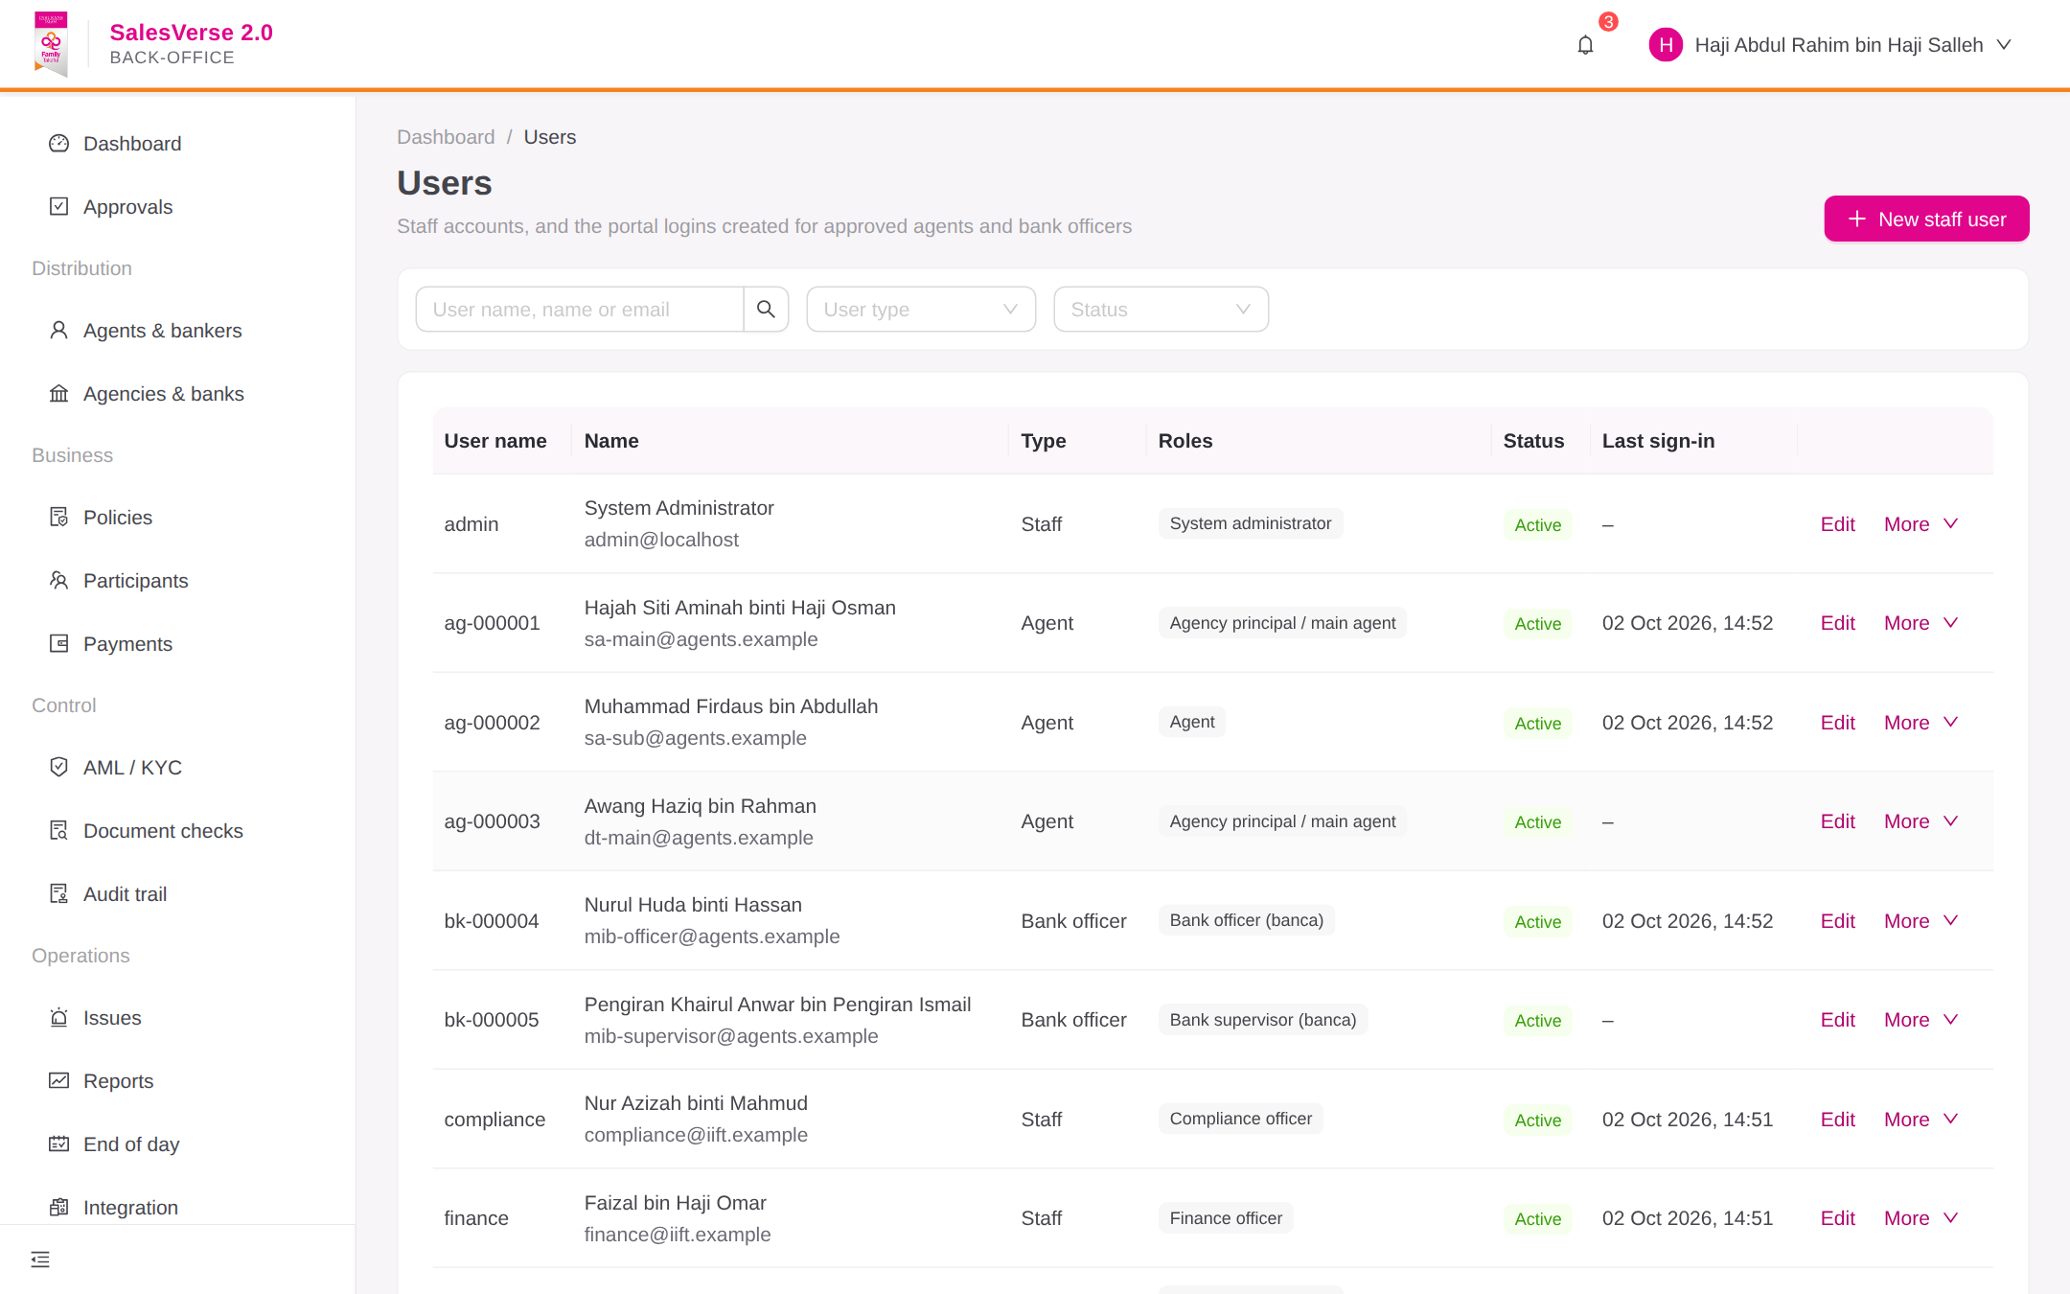  Figure 30: Users, roles & permissions
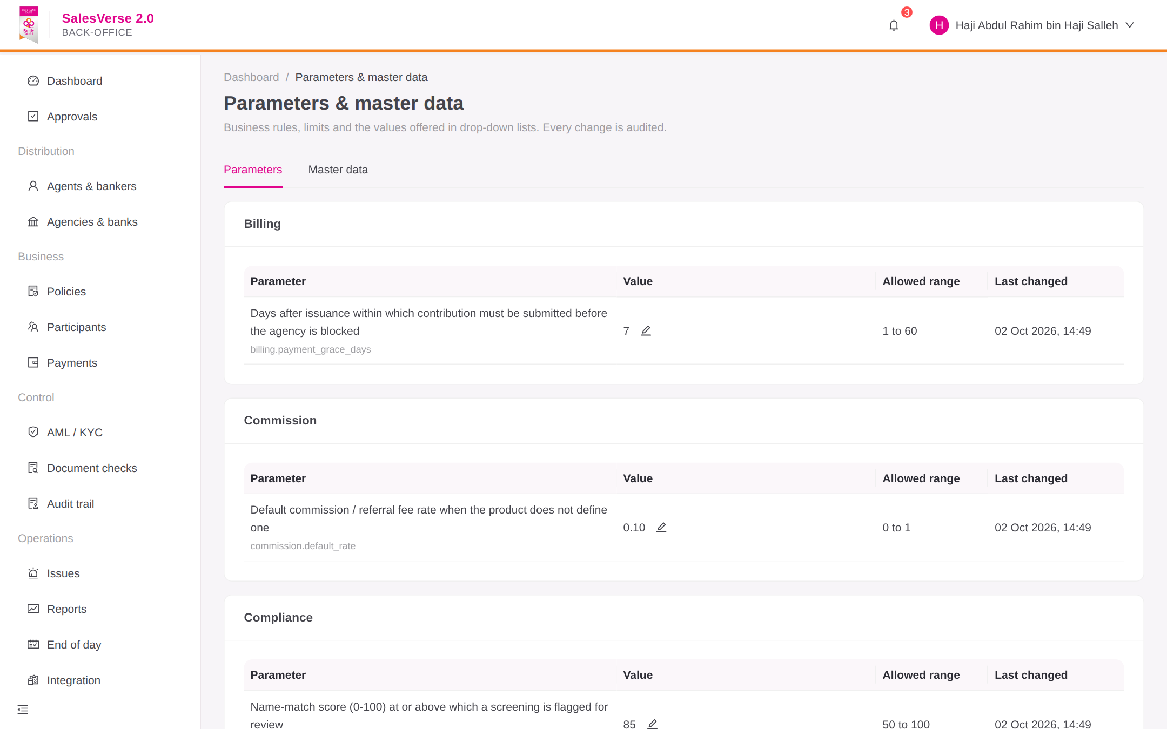  Figure 31: System parameters & master data | 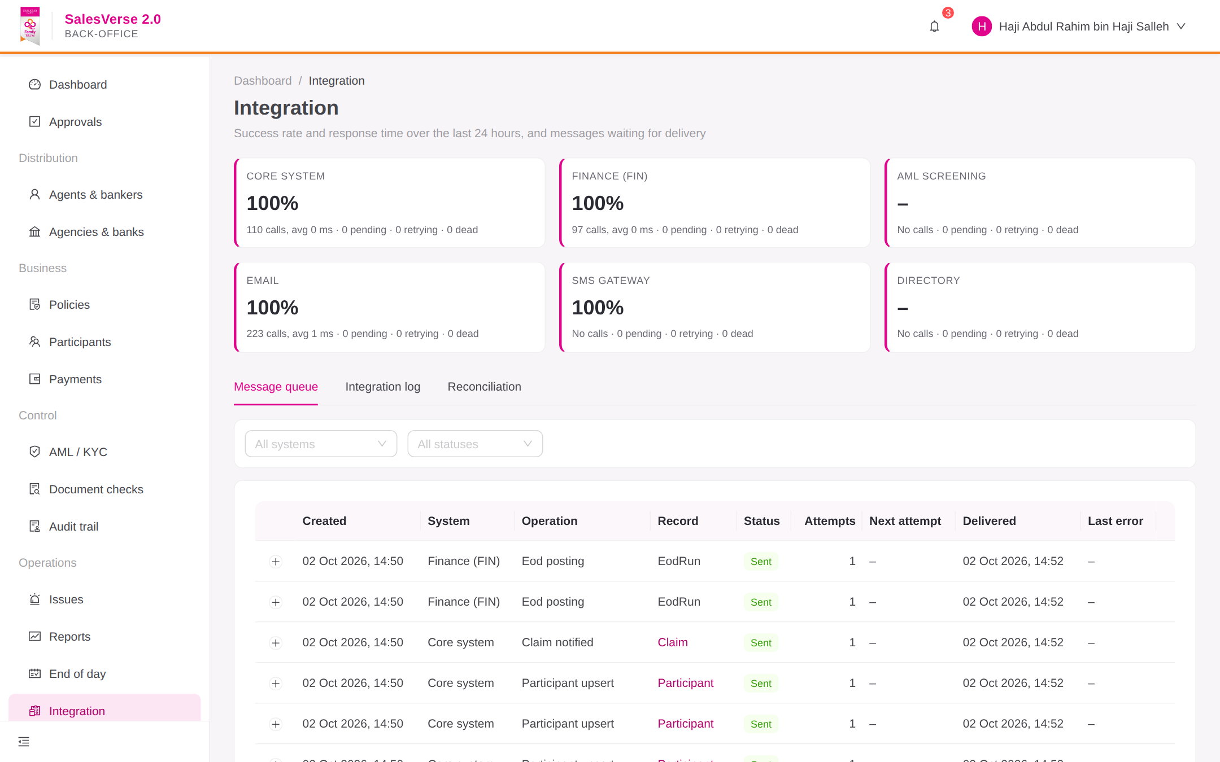  Figure 32: Integration monitor & reconciliation
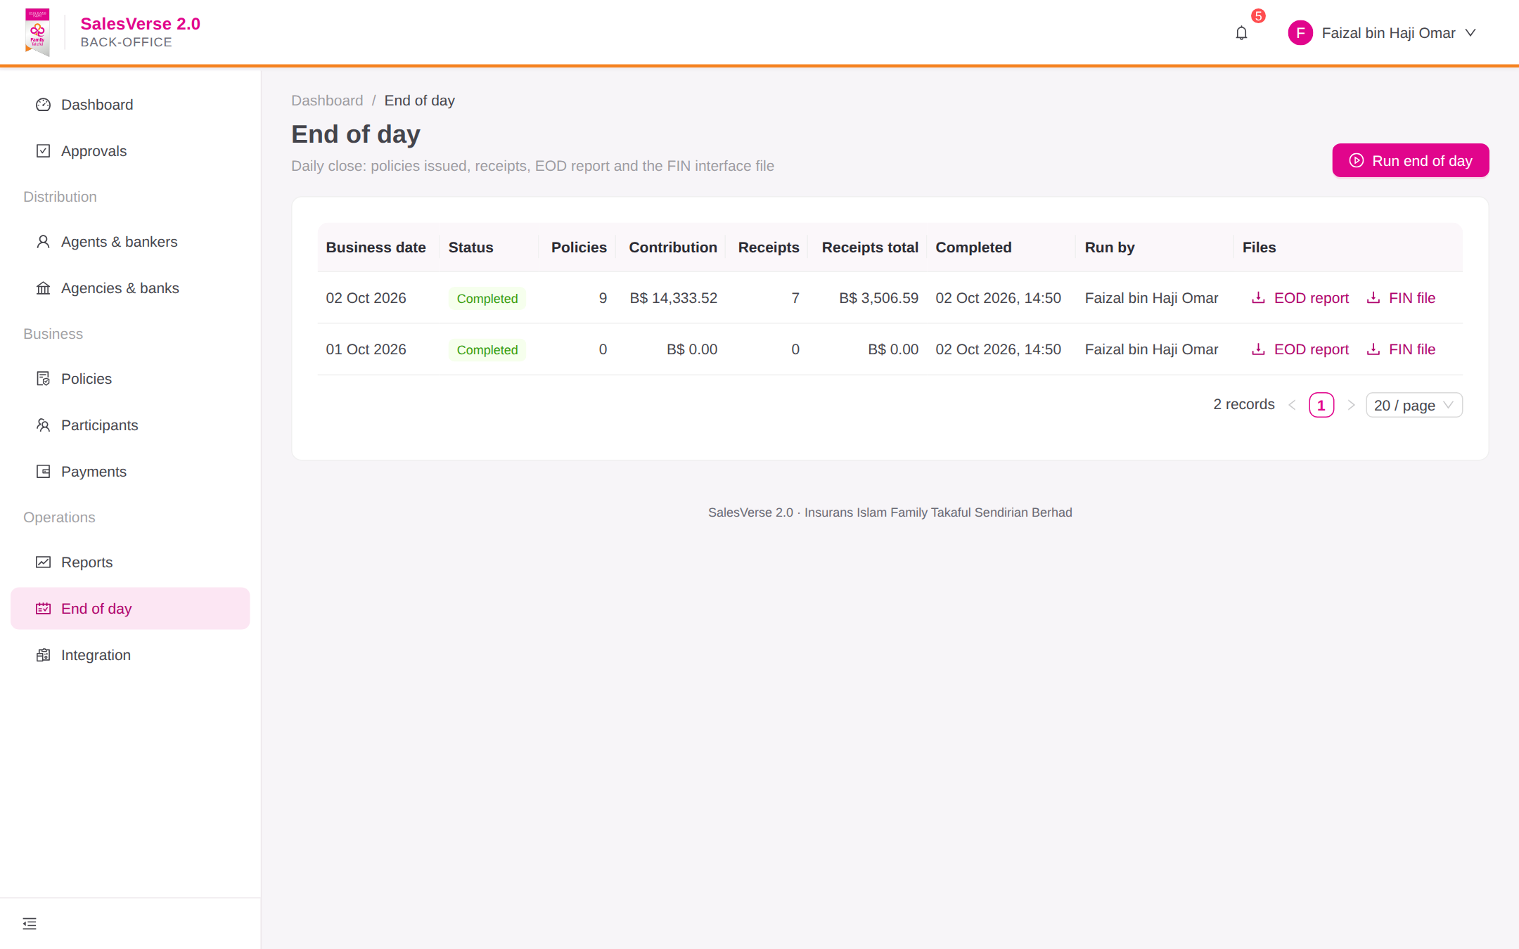  Figure 33: End-of-day processing | 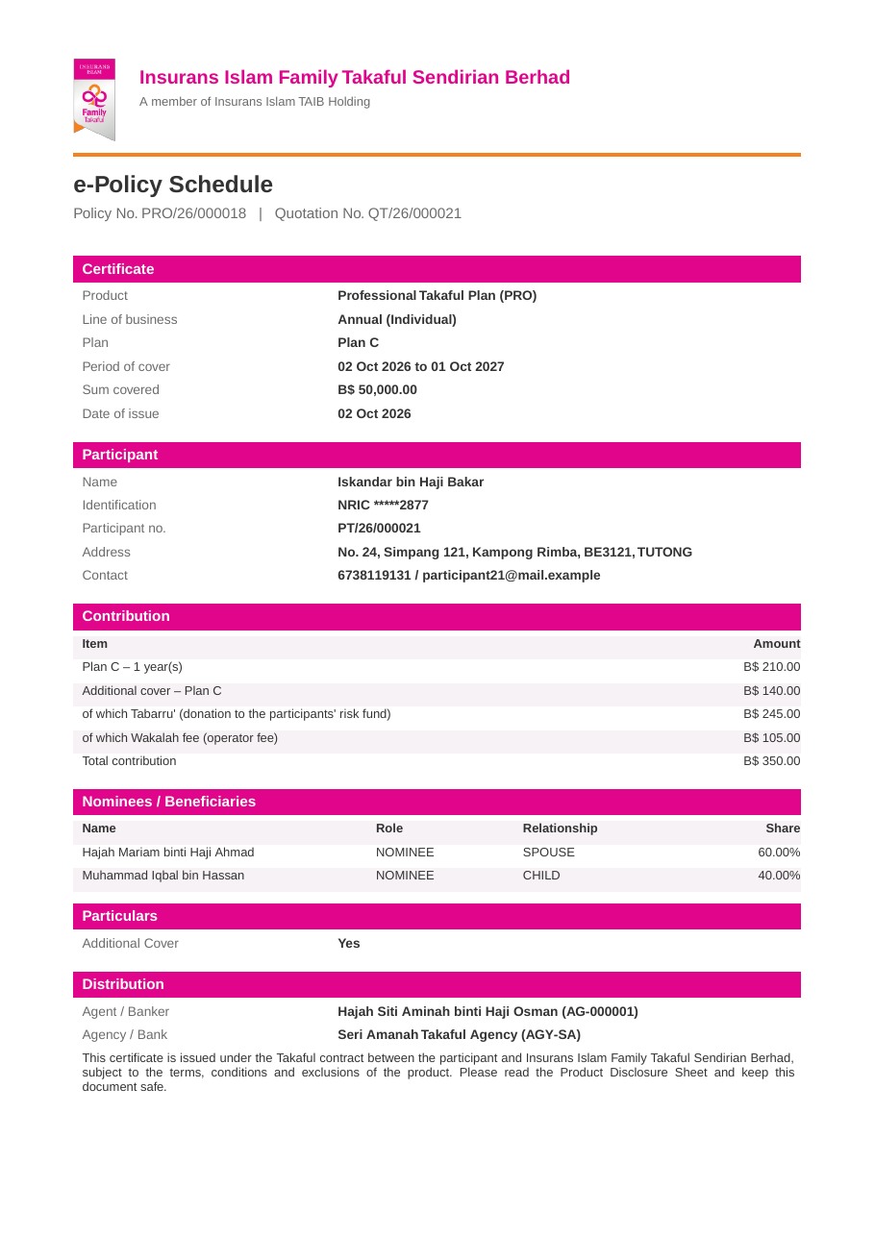  Figure 34: e-Policy schedule (PDF)

12. Solution Architecture

12.1 SalesVerse 2.0 logical architecture
SalesVerse 2.0 is a modular monolith: one deployable application split into modules that follow the RFP functional areas. For 26 named users and about 600 policies a year this is simpler to run than microservices, and a module can be split out later without a rewrite (NFR-20).
Users reach two React applications through a reverse proxy and web application firewall. The back-office path is published only on the internal network. Both applications call one versioned REST API. The integration layer isolates IITH systems through a transactional outbox, and PostgreSQL is the system of record.
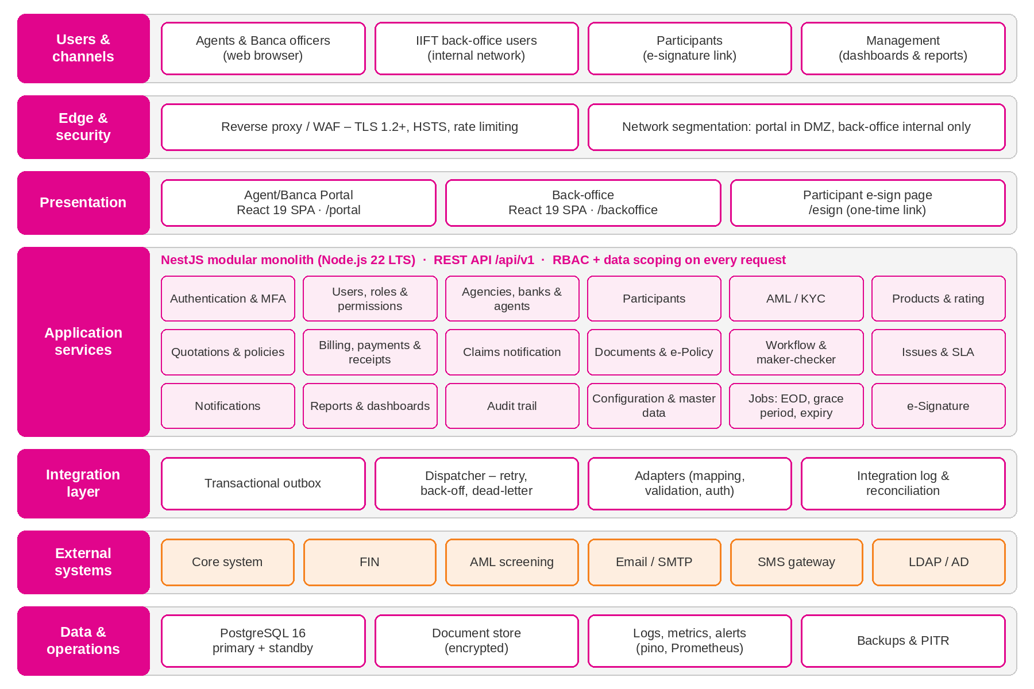
Figure 35: SalesVerse 2.0 logical architecture

12.2 SalesVerse 2.0 components
Module | Responsibilities | RFP requirements
auth, users-roles | Login, sessions, password policy, roles, permissions, data scopes | AP-01–04, AP-59, BO-01–04
agencies, agents | Agencies, banks, branches, agents, hierarchy, status, onboarding | AP-05–12, BO-05–12
participants, aml | Participant record, duplicate checks, watch-list screening, Compliance review | AP-11–16, AP-48, BO-13–15
products | Catalogue, plans, rate tables, rating engines, questionnaires | AP-17–19, BO-32
policies | Quotations, issuance, status, renewal, endorsement, cancellation, history | AP-20–36, AP-60
billing | Payments, allocation, proofs, verification, e-Receipts, grace-period rule | AP-37–42
claims, issues | Claim notifications; issues with priority and SLA timers | AP-43, AP-55–57, BO-29–31
documents, esign | Encrypted store, upload checks, PDF output, e-mail, on-screen and e-mail-link signatures | AP-44–47, AP-62, COM-06
workflow | Workflow definitions, approval requests and actions, handlers | AP-33, AP-49–51, BO-16–19, COM-04
notifications | Templates; e-mail, SMS and in-portal delivery; delivery log | AP-34, AP-54, COM-05
reports, dashboard | Report definitions, exports, schedules, KPIs | AP-52–53, AP-58, BO-20–25, COM-08
audit, config | Append-only audit; parameters, master data, numbering | BO-26–28, BO-32–33, COM-03, COM-09
integration, jobs | Outbox, dispatcher, adapters, integration log; EOD, grace period, expiry, reminders | INT-01–15, AP-42
Table 16: Application modules

12.3 Data architecture
Entity group | Purpose
Agency, Bank, Branch, Agent | Distribution structure, agent code, type, status, parent agent, licence
User, Role, Permission, Session | Access control; sessions held on the server
Participant, Nominee | Shared participant record; IC and passport numbers encrypted
Product, Plan, RateTable, Questionnaire | Versioned product configuration
Quotation, Policy, PolicyTransaction | Policy lifecycle and history
Payment, PaymentAllocation, Receipt | Billing with exact NUMERIC amounts
Claim, Issue, Document | Claim notifications, issues with SLA timestamps, document metadata and checksums
WorkflowDefinition, ApprovalRequest, ApprovalAction | Maker-checker
AmlScreening, AuditEvent | Screening results; append-only audit with before and after values
OutboxEvent, IntegrationLog, EodRun, AgencyBlock | Integration delivery, EOD runs and grace-period blocks
Table 17: Key data entities
We chose PostgreSQL over MongoDB because IIFT's data is relational and financial. The comparison below summarises the reasons.
Criterion | PostgreSQL 16 (selected) | MongoDB
Data shape | Relational: agency, main agent, sub-agent; policy, participant, nominees, payments, receipts, claims | Suits self-contained documents with few relationships
Transaction integrity (NFR-16) | Issuance, receipt, audit and outbox commit in one ACID transaction; row locks for numbering | Multi-document transactions exist but fit this model less naturally
Financial accuracy | Exact NUMERIC plus foreign keys, CHECK and UNIQUE constraints | Decimal128; integrity rules mostly in application code
Reporting (BO-22–25) | Joins and aggregates written directly in SQL | Aggregation pipelines; joins via $lookup
Flexible data | JSONB for questionnaires, product settings and audit values | Native
Operations | Streaming replication and point-in-time recovery; managed on every cloud and on-premise | Replica sets; a second skill set for IITH
Licence | PostgreSQL licence, no fee | SSPL; enterprise features are paid
Fit to volume | Under 5 GB of structured data in five years | Strength is very large schemaless data, not needed here
Table 18: Database selection

12.4 Integration architecture
Each outbound message is written to an outbox table in the same transaction as the business change. A policy therefore cannot be issued without its FIN entry being queued, and a failed call loses nothing. A dispatcher delivers messages through adapters, retries with back-off, logs every attempt and moves exhausted messages to a dead-letter queue shown in the integration monitor. The outbox, retry and dead-letter handling run in the working application; the IIFT adapters are built during implementation against the interface specification (DEL-09).
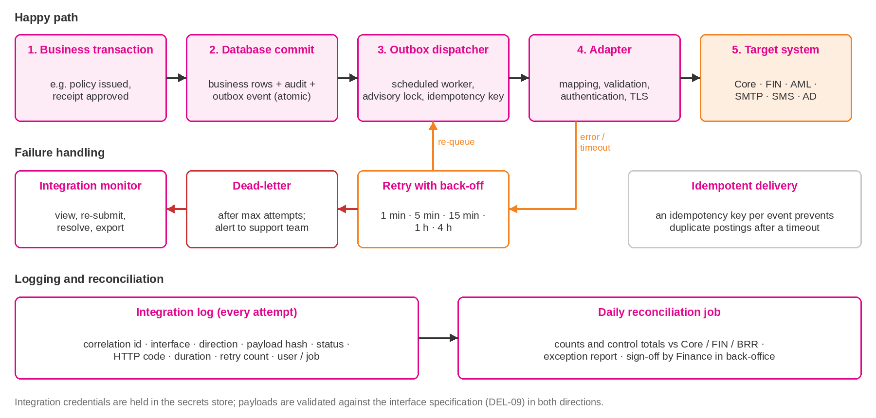
Figure 36: Integration flow with outbox, retry and reconciliation
Interface | Direction | Method | Frequency | Data | Security
Core system | Both ways | REST API or scheduled file | Event-driven plus daily sync | Agent, agency, bank master; status; policy summary | mTLS or API key; IP allow-list
FIN | Out (commission in) | Interface file over SFTP, or API | EOD; statements on demand | Contribution, receipts, allocations; commission and referral fees | SFTP keys or mTLS
AML screening | Request / response | REST API | On onboarding and change; scheduled re-screen | Name, IC, date of birth, nationality; match result | API key or OAuth2; TLS
Active Directory | Inbound | LDAPS | At login | Back-office authentication and groups | LDAPS service account
SMS gateway | Out | HTTPS API | Real time | OTP and alerts | API key; TLS
E-mail | Out | SMTP with STARTTLS | Real time | Notifications, documents, scheduled reports | Authenticated relay
Table 19: Interface catalogue

12.5 Technology stack
Layer | Technology and version | Reason
Front end | React 19, TypeScript, Vite, Ant Design 6, TanStack Query, React Router | Widely used; accessible components themed to Insurans Islam TAIB colours
API | Node.js 22 LTS, NestJS 12 (TypeScript), modular monolith | Module boundaries follow the RFP functional areas
Data access | Prisma 7 with the PostgreSQL driver adapter; versioned SQL migrations | Typed, parameterised queries only
Database | PostgreSQL 16 | See data architecture
Documents and reports | pdfkit for PDFs, exceljs for Excel; encrypted local volume, MinIO or S3 | No native dependencies
Jobs | NestJS scheduler with PostgreSQL advisory locks | One runner across replicas for EOD, grace period and outbox
Observability | pino JSON logs with correlation id; health endpoints; Prometheus metrics; Grafana | Central monitoring and alerting
Testing | Vitest (unit and API tests against PostgreSQL; web component tests with Testing Library), Playwright, k6 | Run in the CI pipeline
Delivery | Non-root Docker images; docker compose on-premise; Kubernetes or ECS optional; GitHub Actions or GitLab CI | Same images in every environment
Table 20: SalesVerse 2.0 technology stack
All components are open source under permissive licences. The CI pipeline produces a CycloneDX software bill of materials of the production dependencies on every build; it is delivered with the technical manual (COM-17).

12.6 Non-functional requirements
Security requirements (NFR-08 to NFR-14) are covered in Section 13. The remaining targets are:
Area | Target and approach
Performance (NFR-01) | Page load under 3 s; standard API calls p95 under 1 s; reports on 12 months of data under 10 s. Proven by k6 tests (DEL-18).
Capacity (NFR-02, 03, 06, 07) | 100 concurrent and 500 named users; ten times Appendix 2 volume. Stateless API nodes scale out.
Availability (NFR-04, 05) | 99.5% overall and 99.9% in IIFT business hours; two application nodes and a PostgreSQL standby.
Backup and DR (NFR-17 to 19) | Daily full backup and continuous WAL archiving; 35 days online, monthly copies for 12 months; RPO 15 minutes, RTO 4 hours; annual DR test.
Integrity and errors (NFR-15, 16) | ACID transactions and idempotency keys; users see a generic message with a correlation id.
Monitoring and logs (NFR-26 to 28) | Health, metrics, job and integration monitors; alerts on downtime, error rate, latency, failed jobs and dead-letters; logs to a central store.
Retention and quality (NFR-29, 30) | Policy and financial records kept 7 years after expiry by default; validation on every input plus database constraints.
Usability (NFR-22 to 24) | One design system; WCAG 2.1 AA target; current and previous versions of Chrome, Edge, Firefox and Safari.
API standards (NFR-25) | REST and JSON over HTTPS, OpenAPI 3, ISO 8601 dates, versioned URLs (/api/v1).

13. Security Architecture & Controls
This chapter is the single description of security controls; other chapters refer to it. Controls are aligned with OWASP ASVS Level 2, the OWASP Top 10, Brunei's Personal Data Protection Order 2025 (PDPO) and AMBD's technology risk expectations for Takaful operators. We claim alignment, not certification. IIFT's policies are mapped in detail in the Solution Architecture (DEL-06).

13.1 Controls
Control | Implementation (defaults configurable) | RFP reference
Authentication | Argon2id password hashing; rate-limited login; MFA by e-mail OTP or authenticator app for back-office (optional for portal); Active Directory single sign-on | AP-01, BO-01, NFR-09, INT-06
Password policy | 12 characters minimum with complexity; last 5 passwords blocked; 90-day expiry; change at first login. All configurable | AP-02
Sessions | Sessions held on the server; HttpOnly, Secure, SameSite=Strict cookie; CSRF token; new session id at login; 15-minute idle and 8-hour absolute timeout; optional single session; revoked at logout | AP-03
Lockout | Locked for 30 minutes after 5 failed attempts (configurable); alert on repeated lockouts | AP-04
Authorisation | Permissions per role plus data scoping by agency, bank, branch and hierarchy, checked by the API on every call; deny by default | AP-59, BO-02, COM-02, NFR-10
Encryption in transit | TLS 1.2 or later with HSTS; TLS also for database, SMTP, LDAPS and APIs | COM-10, NFR-08
Encryption at rest | IC and passport numbers encrypted per field with AES-256-GCM, keys held outside the database; HMAC-SHA256 blind index for exact search; masked on screen; encrypted document storage and backups | COM-01, COM-10, NFR-08
Input and output | Whitelist validation of every request body; parameterised queries only; output encoding; CSP and security headers | NFR-14, NFR-30
File uploads | Type allow-list with magic-byte check, size limit, SHA-256 checksum, ClamAV malware scan (mandatory in production); files served only through authorised API calls | AP-46, COM-06
Audit | Append-only table; a database trigger rejects UPDATE and DELETE; the application role can only insert and read; before and after values, user, time, IP, correlation id | BO-26–28, COM-03, NFR-11
Errors and secrets | Generic error messages with correlation id; secrets in environment or vault, rotated on staff change and yearly | NFR-15, INT-10
System APIs | mTLS or OAuth2 client credentials for integrations; rate limiting | INT-09, INT-10
Table 21: Security controls
The audit trigger, field-level encryption, encrypted document storage and the ClamAV upload scan already run in the working application; the API will not start in production without the scanner configured. MFA, Active Directory sign-on and the remaining parameters are set up during implementation. Personal data is limited to what products and AML/KYC rules need; a data inventory with purpose and retention is delivered with the Solution Architecture.

13.2 Secure development lifecycle
Stage | Practice | Mechanism
Design | Threat model for login, payment, approval and e-signature flows | Workshop, ASVS checklist
Build | Secure coding standard aligned with OWASP ASVS Level 2 and Top 10; peer review of every change | Pull-request review
Pipeline | Static analysis, dependency, secret and container image scans; a failed scan blocks release | CI security gates
Testing | Authorisation tests per role, negative tests, DAST baseline in SIT | API tests, DAST
Pre-production | Independent VAPT, remediation and re-test | Independent tester
Operation | Monthly patching, vulnerability monitoring, log review | Maintenance service

13.3 Penetration testing and remediation
An independent tester assesses the portal, back-office, APIs and hosting set-up before production (NFR-13, DEL-17). The cost is in the fixed price. Findings are fixed and re-tested, and no Critical or High finding may be open at go-live. After go-live, vulnerabilities are fixed within these limits (NFR-12, MNT-12):
Severity | Description | Timeline
Critical | Remotely exploitable; data exposure or system compromise | Contained within 24 hours; fixed within 7 days
High | Significant impact, exploitation likely | Within 14 days
Medium | Limited impact or hard to exploit | Within 30 days
Low | Minimal impact; hardening advice | Within 90 days or next release
Table 22: Vulnerability remediation timelines

13.4 Regulatory alignment
For PDPO we provide consent and purpose notices at participant capture, access and correction support, retention rules and breach-notification support. For AMBD expectations we cover access control, change management, outsourcing and cloud considerations (infrastructure options), DR testing and audit trails. AML/CFT record keeping is met by the screening history and review decisions. Screens and documents use Shariah-appropriate terms: participant, contribution, Takaful operator, wakalah and tabarru'.

13.5 Security incident response
Phase | Action
Detect | Alert, log review or user report; logged as a P1 security incident.
Contain | Within 30 minutes: assess scope, isolate the component, revoke sessions or credentials.
Notify | IIFT IT security told immediately; iorta supports regulatory and PDPO notifications.
Recover | Patch, restore from a clean backup if needed, verify integrity, monitor.
Review | Root-cause report within 5 business days; actions tracked to closure.

14. Deployment & Release Management

14.1 Environments
Environment | Purpose | Hosted by | Data | Users
DEV | Development and sprint demos | iorta (both options) | Synthetic | iorta team
SIT | Integration and performance testing | A: IIFT data centre (iorta-hosted until the IIFT VM is ready). B: cloud | Synthetic and masked samples | iorta, IIFT IT
UAT | Acceptance testing and training | A: IIFT data centre. B: cloud | Masked or migrated test data | IIFT users
PROD | Live operation | A: IIFT/IITH data centre. B: cloud, Malaysia region | Production | IIFT users; iorta under change control
DR | Disaster recovery | A: IIFT/IITH DR site. B: second cloud region | Replicated production | Activated per DR plan
Table 23: Environments

14.2 CI/CD pipeline
Every environment runs the same versioned container images, so what passes UAT is what runs in production. The pipeline can run on IITH's GitLab or on GitHub Actions; the repository is held for IIFT.
Stage | Activities
Commit and review | Branch, pull request, mandatory peer review
Build | Type check, lint, compile front end and API, build container images
Test | Unit and API tests against PostgreSQL; web component tests; coverage report
Scan | CodeQL static analysis, npm audit, gitleaks secret scan and Trivy image scan
Package | Versioned, signed images with release notes and SBOM
Deploy to SIT/UAT | Automated deployment and migration; Playwright smoke tests
Approve | Test sign-off and IIFT change approval
Deploy to PROD | Scripted deployment in the approved window; health checks; post-deployment checks

14.3 Release management and rollback
Every production change follows the agreed procedure (MNT-21): change request, impact assessment, SIT and UAT, release notes, IIFT approval and deployment in an approved window.
Release type | Content | Cadence
Emergency fix | P1/P2 defect or security patch | As needed, expedited approval
Maintenance release | Fixes, minor enhancements, patches | Monthly
Feature release | Change requests | Quarterly or as agreed
Platform upgrade | Node.js, PostgreSQL, framework and SalesVerse 2.0 updates | Typically yearly

The previous container images are kept, so the application rolls back in minutes. Database migrations follow the expand-and-contract pattern, which lets the previous version run on the new schema. A verified backup and a recovery marker are taken before each release. Rollback criteria and decision owners are set in the deployment plan (DEL-20).

14.4 Go-live checklist
Area | Readiness criteria
Business | UAT signed off; users trained; procedures and contacts issued; agents and banks informed
Technical | Production built and hardened; performance test passed; backups and monitoring running
Security | VAPT findings fixed and re-tested; certificates installed; privileged access reviewed
Data | Two migration rehearsals; reconciliation signed; master data and rates verified
Integration | All interfaces tested end to end; credentials in the vault
Operations | Operations manual, runbooks and DR plan; support rota and escalation agreed
Decision | Steering Committee go/no-go recorded with open items and rollback criteria

14.5 Cut-over plan
When | Activities
T-10 days | Scope frozen; deployment plan approved; agents and banks informed
T-5 days | Deployment rehearsal; final migration dry-run and reconciliation
T-2 days | Legacy data frozen; manual process continues where needed
T-1 day | Final extract, migration load, reconciliation, business check
T-0 | Deployment, smoke tests, integration checks, go/no-go, users enabled
T+1 to T+20 business days | Hypercare: daily health checks and stand-ups, priority fixes

15. Infrastructure Options
SalesVerse 2.0 ships as standard containers and runs unchanged on-premise or in the cloud. The two deployment models match the commercial options: on-premise in the IIFT/IITH data centre under Option A, with infrastructure procured by IIFT to iorta's sizing, and an iorta-hosted cloud under Option B, with cloud infrastructure at cost and managed services by iorta. A hybrid variant of Option A is also possible. Costs are in Section 19 and the Bill of Materials.

15.1 Option A: on-premise in the IIFT/IITH data centre (recommended)
Two application VMs run behind the load balancer. PostgreSQL runs as a primary with a streaming standby, and a warm standby at the DR site receives WAL log shipping. The solution uses IITH's network security, backup and monitoring services where capacity allows. Production needs two 4 vCPU / 8 GB application servers, two 4 vCPU / 16 GB database servers and 500 GB of document storage.
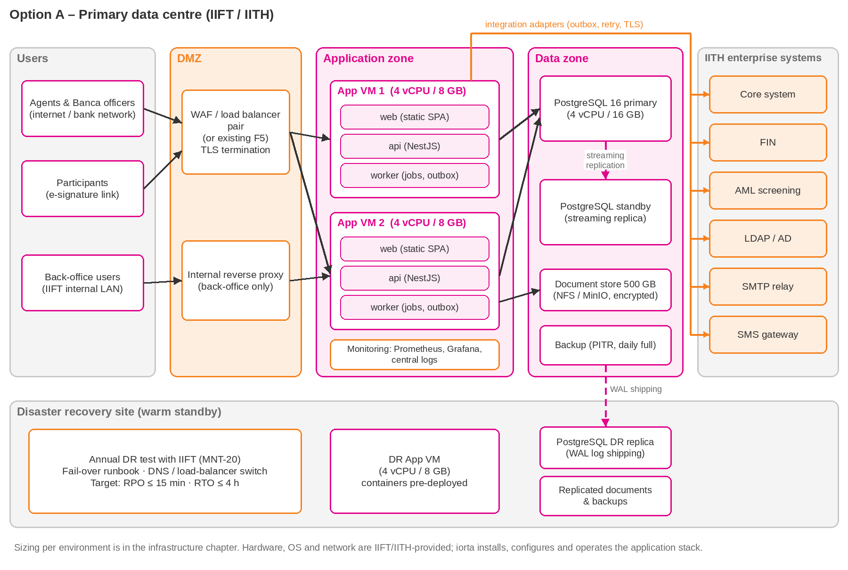
Figure 37: Option A: on-premise deployment
Server | Qty | vCPU | RAM | Storage | Software
Production
WAF / load balancer | 2 (or existing) | 2 | 4 GB | – | IITH appliance or HAProxy/nginx pair
Application VM | 2 | 4 | 8 GB | 100 GB | Linux, Docker Engine; web, api, clamav containers
Database VM | 2 | 4 | 16 GB | 200 GB SSD | PostgreSQL 16 primary and hot standby, pgBackRest
Document store | 1 share | – | – | 500 GB | NFS export, encrypted volume
Backup repository | 1 | – | – | 1 TB | pgBackRest repository, document backups
Monitoring | 1 (or existing) | 2 | 4 GB | 100 GB | Prometheus, Grafana, log collector
Non-production
SIT | 1 | 4 | 16 GB | 200 GB | Compose: web, api, clamav, PostgreSQL
UAT | 1 | 4 | 16 GB | 200 GB | Compose: web, api, clamav, PostgreSQL
DEV | Not required | – | – | – | Hosted by iorta during the project and support
DR site
Application VM | 1 | 4 | 8 GB | 100 GB | Cold standby, same images
Database VM | 1 | 4 | 16 GB | 200 GB SSD | Asynchronous replica
Document and backup copies | – | – | – | 500 GB + 1 TB | rsync target, backup copy
Table 24: Option A sizing per environment (procured by IIFT; indicative costs in Annex C)
Operating system: Ubuntu Server 24.04 LTS or Red Hat Enterprise Linux 9, hardened to the IITH baseline. DEV stays with iorta, so IIFT provides no development environment.
Item | IIFT / IITH | iorta TechNXT
Servers, storage, network, firewall, load balancer | Provide | Specify, review
Linux OS (RHEL 9 or Ubuntu 24.04 LTS) and licences | Provide, patch | Specify hardening
Container runtime, application, proxy configuration | Approve | Install, configure, operate
PostgreSQL install, replication, backup set-up | Approve; run backup infrastructure | Install, configure, tune
Monitoring and alerting | Infrastructure monitoring; receive alerts | Application monitoring
Certificates, DNS, SMTP relay, SMS account, AML subscription | Provide | Configure; support renewal
DR site and DR tests | Provide site; lead test | Replication; take part in tests
Table 25: Option A responsibilities

15.2 Option B: iorta-hosted cloud
iorta hosts and operates the solution in a cloud account dedicated to IIFT in AWS Asia Pacific (Malaysia) or Azure Malaysia West. Cloud use depends on IIFT's data-residency decision and on AMBD's outsourcing and cloud notification, which IIFT makes and iorta supports with the required documents. A Brunei-hosted alternative can be priced on request.
Service | AWS reference (Azure equivalent)
Region | AWS Asia Pacific (Malaysia), ap-southeast-5 (Azure Malaysia West); DR copies in a second region
Compute | ECS Fargate across two availability zones (AKS on Azure), or two EC2 instances
Database | RDS for PostgreSQL 16 Multi-AZ (Azure Database for PostgreSQL, zone-redundant)
Storage | S3 and EFS with encryption, versioning and lifecycle rules (Azure Blob and Files)
Edge | Application Load Balancer with AWS WAF (Azure Application Gateway with WAF)
Monitoring | CloudWatch logs, metrics and alarms; GuardDuty threat detection (Azure Monitor, Defender)
Connectivity | Site-to-site VPN to the IITH data centre for Core, FIN, AD, SMTP and back-office users
DR | Automated backups with point-in-time recovery; pilot-light DR in a second region

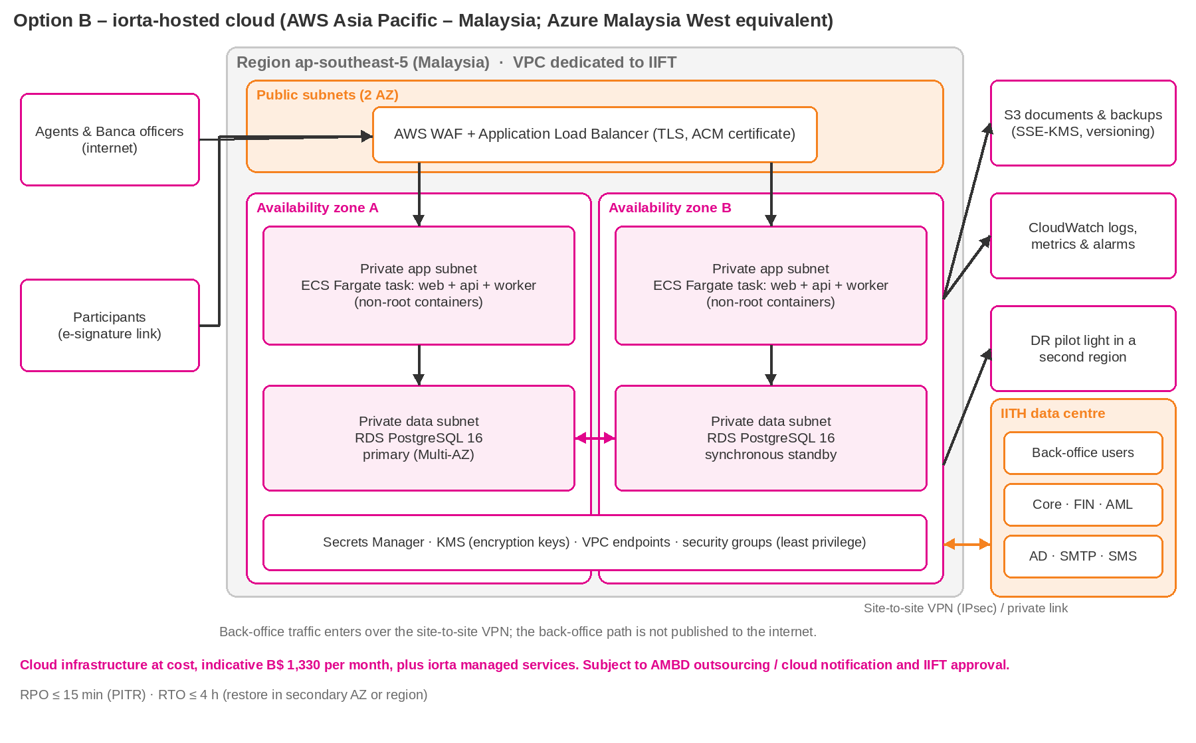
Figure 38: Option B: iorta-hosted cloud deployment (AWS reference)
Service | Reference sizing | B$ / month
Container compute, 2 tasks across 2 availability zones | 2 tasks × (1 vCPU, 2 GB) incl. ClamAV sidecar; scales to 4 tasks | B$ 260
Managed PostgreSQL, Multi-AZ, 100 GB, automated backups | db.t4g.large (2 vCPU, 8 GB), Multi-AZ, 100 GB gp3, 35-day backups and PITR | B$ 420
Application load balancer and web application firewall | 1 load balancer; WAF with managed OWASP rule sets; managed TLS certificate | B$ 130
NAT gateway and data transfer | NAT gateway, site-to-site VPN to the IITH data centre, outbound data | B$ 90
Object storage (encrypted) and cross-region backup copies | Shared file storage up to 100 GB; about 200 GB object storage; cross-region copy | B$ 70
Logging, metrics, alarms and threat detection | Log retention 90 days, metrics, alarms, threat detection | B$ 70
Secrets and key management | Secrets store and customer-managed encryption keys | B$ 20
UAT environment, scaled down, stopped out of hours | 1 task and a single-AZ db.t4g.medium; stopped outside test periods | B$ 120
DR environment, pilot light in a second region | Cross-region database replica or snapshots and standby images | B$ 150
Total per month |  | B$ 1,330
Total per year (at cost, estimate) |  | B$ 15,960
Table 26: Option B cloud infrastructure estimate (recharged at cost)
iorta's managed services (monitoring, patching, backups, DR drills, security monitoring and cost management) cost B$ 1,100 a month in Year 1. Cloud charges move with usage and exchange rates; they are recharged at the provider's cost without mark-up, or IIFT holds the account and pays the provider directly. The one-off cloud set-up fee is B$ 15,000.

15.3 Hybrid variant of Option A
The back-office, database and documents stay in the IITH data centre. Only the portal's web tier (static application and reverse proxy) sits in the DMZ or at a cloud edge and forwards API calls over an encrypted private link. Personal data never leaves the data centre. This suits IIFT if internet-facing capacity in the data centre is limited; it is priced as Option A, with any edge hosting at actuals.

15.4 Comparison and recommendation
Criterion | A: On-premise | B: iorta-hosted cloud | Hybrid variant
Commercial option | Option A: perpetual licence and AMC | Option B: subscription and managed services | Option A
Data residency | Data stays in Brunei | Malaysia region; DR copies in a second region; needs IIFT approval and AMBD notification | Personal data on-premise; portal web tier in DMZ or cloud
Regulatory steps | Internal approval only | AMBD outsourcing and cloud notification by IIFT | Depends on what sits in the cloud
Infrastructure cost | IIFT procures: indicative B$ 20,500–42,000 one-time (less where IITH capacity is reused) | Set-up B$ 15,000 one-off; cloud at cost, no mark-up: about B$ 1,330 a month | Mostly as Option A
Operations | IITH infrastructure team; iorta application support under the AMC | iorta managed services, B$ 1,100 a month in Year 1 | Shared
Provisioning time | Depends on IITH VM provisioning | Days | Mixed
Resilience | Two nodes, standby database, DR site | Multi-AZ; DR in a second region | Per component
Table 27: Deployment models compared
Recommendation: Option A, on-premise in the IITH/IIFT data centre
Participant and agent data stays in Brunei and no extra regulatory step is needed.
IITH's existing data-centre services and operating model are reused, as for other group systems, which keeps cost and support effort down.
Option A has the lowest five-year cost (Section 19). Option B remains available if IIFT prefers an operating-expense model with iorta running the infrastructure.

16. Technical Document Pack
The technical documents below accompany this proposal in the folder docs/technical. They describe SalesVerse 2.0 as it stands today and are updated for IIFT during the project. This chapter summarises them; it does not repeat their content.
Document | Content | RFP references
SalesVerse-2.0-Solution-Architecture.docx | Logical, functional and deployment architecture; integration and security architecture; on-premise and cloud infrastructure sizing | DEL-06, DEL-07, DEL-09 (baseline)
SalesVerse-2.0-Data-Dictionary.xlsx and .docx | Every table and field with type, constraints, encryption and retention | DEL-07, DEL-26
SalesVerse-2.0-Code-Standards-and-Quality-Report.docx | Coding standards, review process, automated test coverage and static analysis results | NFR-14, NFR-20
SalesVerse-2.0-Security-Assessment-Report.docx | Internal vulnerability assessment and security test results; the independent third-party penetration test follows before go-live | NFR-12 to NFR-14; DEL-17 (precursor)
SalesVerse-2.0-Production-Support-Handover.docx | Support process, runbooks, knowledge transfer and release management | DEL-27, MNT-01 to MNT-04, MNT-21, MNT-28
Table 28: Technical document pack
The security assessment report covers iorta's internal testing. It does not replace the independent penetration test, which is performed by a third party on the IIFT environment before go-live (DEL-17).

17. Implementation Methodology

17.1 Delivery approach: configure and integrate
SalesVerse 2.0 already runs IIFT's products and rules, so the project configures and integrates an existing platform instead of building one. Discovery starts with fit-gap workshops on the working system: IIFT users walk through each journey with their own products, confirm what fits, and record the gaps. The gaps become the configuration backlog.
Governance follows formal gates, so IIFT signs off scope, design, test exit and go-live at fixed points and pays against them. Configuration and integration run in two-week sprints, each ending with a demonstration to IIFT key users. SIT, an independent VAPT, UAT, two migration rehearsals and a rehearsed cut-over follow, then four weeks of hypercare.
The Steering Committee reviews each gate: design sign-off (M2), build complete (M3), SIT exit and security clearance (M4), UAT sign-off (M5), go-live (M6) and hypercare exit (M7).

17.2 Phases and activities
# | Phase | Weeks | Key activities | Outputs
0 | Mobilisation | 1–2 | Kick-off, governance set-up, environment and data requests, detailed plan | Project charter, project plan (DEL-01, 02)
1 | Discovery and fit-gap confirmation | 2–6 | Workshops per product and process on the working system; collect IIFT rates, wording, questionnaires, templates; confirm gaps | BRS, FRS, RTM, SAD, TDD, UI/UX, interface specification, test strategy (DEL-03 to 09, 12)
2 | Configuration sprints | 6–16 | Five two-week sprints configuring products, rates, workflows, roles, reports and templates; demo every sprint | Configured solution, source code (DEL-10, 11)
3 | Integration with IIFT systems | 8–17 | Adapters to core, FIN, AML provider, SMS, SMTP and Active Directory; joint tests with system owners | Working interfaces, test evidence
4 | SIT, performance and VAPT | 16–19 | SIT, regression, performance test, independent VAPT, remediation, re-test | SIT results, performance report, security assessment (DEL-13, 14, 17, 18)
5 | UAT, migration rehearsals, training | 19–23 | UAT support, two migration rehearsals, train-the-trainer and end-user training, manuals | UAT results, migration plan, training, manuals (DEL-15, 16, 19, 22 to 27)
6 | Cut-over and go-live | 24 | Production deployment, final migration, go/no-go | Deployment plan, go-live checklist, production deployment (DEL-20, 21, 28)
7 | Hypercare and closure | 25–28 | Hypercare, stabilisation, handover to support, closure | Go-live support, closure report (DEL-29, 30)
Table 29: Implementation phases

Configuration sprints
Sprint | Scope
Sprint 1 (wk 6–7) | Access set-up to IITH policy, MFA, roles and data scopes; agent, agency and bank master data loaded
Sprint 2 (wk 8–9) | Onboarding and approval matrix; participant rules; AML connection to IIFT's screening service
Sprint 3 (wk 10–11) | IIFT actuarial rates, questionnaires and document templates for all seven products
Sprint 4 (wk 12–13) | Referral and QC rules, policy servicing, e-Policy and e-Receipt wording and branding
Sprint 5 (wk 14–15) | Payment rules, EOD and FIN file sign-off, BRR reconciliation, remaining reports, notifications
Hardening (wk 16) | Performance tuning, security hardening, defect fixing, documentation; build complete (M3)

All 30 deliverables in RFP section 7 are provided; Section 5 gives the due week and acceptance evidence of each.

17.3 Project governance
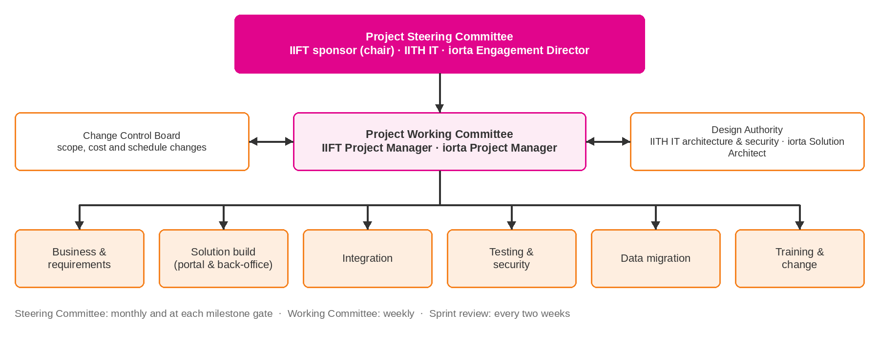
Figure 39: Project governance structure
Forum | Members | Frequency | Purpose
Steering Committee | IIFT sponsor (chair), IITH IT head, IIFT business heads, iorta Engagement Director, both PMs | Monthly and at milestone gates | Direction, milestone approval, escalated risks and changes, go/no-go
Project Working Committee | IIFT PM, iorta PM, business and IT leads | Weekly | Progress, RAID log, dependencies, decisions
Sprint review & planning | Product owner, key users, iorta team | Every two weeks | Demo of completed features, backlog priorities
Design Authority | IITH IT architecture & security, iorta Solution Architect | As needed in phases 1–4 | Architecture, security and integration decisions
Change Control Board | IIFT PM, sponsor delegate, iorta PM | As needed | Assess and approve change requests

Progress is reported weekly (status, milestones and the RAID log of risks, assumptions, issues and dependencies) and monthly to the Steering Committee. Issues that cannot be resolved by the Working Committee within five business days are escalated to the Steering Committee.

RACI matrix
R = Responsible, A = Accountable, C = Consulted, I = Informed.
Activity | IIFT Sponsor | IIFT PM | IIFT business | IITH IT | iorta PM | iorta team
Project governance & reporting | A | R | I | I | R | C
Requirements & process sign-off | A | R | R | C | C | R
Solution design & architecture | I | C | C | A | R | R
Build & configuration | I | I | C | C | A | R
Infrastructure provisioning (Option A) | I | C | I | A/R | C | C
Interface availability (Core, FIN, AML, AD) | I | C | I | A/R | C | R
SIT & performance testing | I | I | I | C | A | R
VAPT (independent) | I | C | I | C | A | R
UAT execution & sign-off | A | R | R | C | C | C
Data extraction from legacy sources | I | C | R | A | C | C
Data transformation, load & reconciliation | I | C | R | C | A | R
Training delivery | I | C | R | C | A | R
Go-live decision | A | R | C | C | C | I
Hypercare & support | I | C | C | C | A | R

17.4 Quality assurance
A feature is done when its code is reviewed, its automated tests and security scans pass, its documentation is updated and the product owner has seen it working. The traceability matrix (DEL-05) links every RFP requirement ID to design, build, test case and acceptance evidence. Each major document is reviewed internally by someone outside the delivery team before it reaches IIFT.

17.5 Testing strategy
Level | Scope | Responsibility | Environment | Tools / exit criteria
Unit | Business rules, rating engines, validators, web components | iorta developers | DEV / CI | Vitest and Testing Library; coverage ≥ 70% on core modules
API / integration | Endpoints, permissions per role, database constraints | iorta | CI with PostgreSQL | Vitest e2e; every endpoint has positive and negative tests
SIT | End-to-end flows across portal, back-office and interfaces | iorta QA, IITH system owners | SIT | No open Critical/High defects; ≥ 95% pass
Regression | Automated suite re-run every sprint and release | iorta QA | SIT | Playwright; 100% of critical paths automated
Performance | Load (100 concurrent), stress and soak | iorta | SIT (production-like) | k6; non-functional targets met
Security | SAST/SCA/DAST in pipeline; independent VAPT and re-test | iorta, independent tester | SIT / pre-prod | No open Critical/High findings
UAT | Business scenarios per product and role | IIFT users with iorta support | UAT | Signed UAT certificate; no open Critical/High defects
Migration | Dry-runs, reconciliation, sample verification | iorta, IIFT data owners | UAT | 100% record count and control-total match
Table 30: Test levels
Defect severity | Definition | Resolution in test phases
Critical | System unusable or data integrity at risk; no workaround | Fix before exit of current test phase
High | Key function fails; workaround difficult | Fix before exit of current test phase
Medium | Function impaired; workaround exists | Fix before go-live or agreed deferral
Low | Cosmetic or minor | Planned release

17.6 Data migration approach
Migration covers existing agent, agency, bank and branch records, participant records needed for servicing, and reference data. Sources and volumes are confirmed in the Data Migration Plan (DEL-19).
Step | Description
Discovery & profiling | Identify sources (spreadsheets, existing agent records, IIGT/core extracts), profile quality, agree scope
Mapping & rules | Field mapping to target model, transformation and cleansing rules, ownership of corrections
Tooling | Repeatable scripts (TypeScript/SQL) with validation reports; no manual re-keying
Dry-run 1 & 2 | Full loads in UAT; exceptions corrected at source; reconciliation reports
Reconciliation | Record counts, control totals, mandatory-field completeness, sample verification by business owners
Production load | Executed during cut-over; signed reconciliation before users are enabled

17.7 Training plan
Audience | Format | Duration | Participants | Materials
Agents & bank officers (Portal) | Train-the-trainer plus two hands-on sessions | Half day per session | Up to 21 users (12 bank, 4 agent, 5 IIFT portal) | Quick reference guide, video walkthroughs, user manual
Back-office users | Hands-on workshop per role | 1 day | IIFT admin, Finance, Compliance, Underwriting users | Role-based user manual, exercises
System administrators | Workshop | 1 day | IITH/IIFT administrators | Administrator manual, configuration guide
Technical team | Technical handover sessions | 2 days | IITH IT support, infrastructure, security | Technical and operations manuals, runbooks
Management | Briefing and dashboard demo | 1 hour | IIFT management | Dashboard guide
Table 31: Training plan

17.8 Change management
- Stakeholder map and communication plan covering IIFT teams, bank partners and agencies.
- Early involvement of key users in design workshops and sprint demos to build ownership.
- Bank and agent onboarding pack: invitation e-mail, account activation guide, FAQ and support contacts.
- Super-user network within IIFT to provide first-line help after go-live.
- Adoption metrics on the management dashboard (active users, digital submissions, turnaround times).

17.9 Hypercare
- Four weeks immediately after go-live (weeks 25–28) with the core delivery team on standby.
- Daily health checks of application, jobs, EOD and integrations; daily stand-up with IIFT during the first two weeks.
- Priority fixing of go-live defects; daily defect and usage report.
- Onsite presence for go-live and the first month of support: a Senior Developer for the month and the Project Manager in go-live week; the rest of the team supports remotely.
- Formal handover to the maintenance team and hypercare exit criteria: no open P1/P2 issues, EOD stable for ten consecutive business days, all interfaces reconciled.

18. Delivery & Implementation Timeline
Production go-live is in week 24 counted from kick-off, followed by four weeks of hypercare. The six-month warranty and Year 1 of maintenance (the AMC under Option A, the subscription under Option B) both start at go-live; defects found under warranty are fixed free of charge.
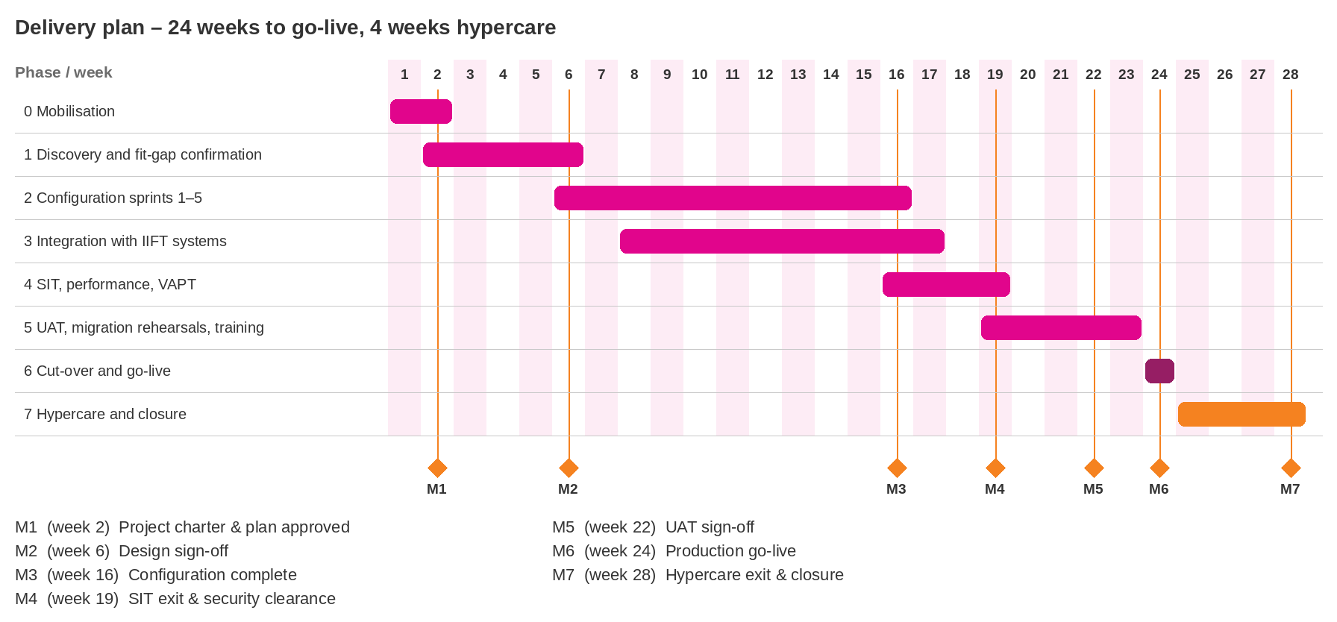
Figure 40: Delivery plan (weeks from kick-off)

18.1 Key milestones
Milestone | Description | Target | Services fee
M1 | Project charter & plan approved | Week 2 | 15%
M2 | Design sign-off | Week 6 | 15%
M3 | Configuration complete | Week 16 | –
M4 | SIT exit & security clearance | Week 19 | 25%
M5 | UAT sign-off | Week 22 | 25%
M6 | Production go-live | Week 24 | 15%
M7 | Hypercare exit & closure | Week 28 | 5%
Table 32: Milestones and linked payments
Under Option A the licence fee is paid separately: 50% at contract signing, 30% on installation in SIT and 20% at go-live. Amounts are in Section 19.

18.2 Dependencies on the critical path
- Contract signature and kick-off date (week 1 starts at kick-off).
- Availability of IIFT business owners for workshops in weeks 2–5 and sign-off of design by week 6.
- SIT and UAT environments (VMs, network, database access) available by week 8 and week 16 respectively.
- Interface specifications, test endpoints and credentials for Core, FIN, AML and AD available by week 8.
- IIFT actuarial rate tables and product documents (proposal forms, PDS, questionnaires) by week 6.
- UAT participants available in weeks 19–22; legacy data extracts available by week 12.

19. Commercial Proposal
This chapter sets out the commercial offer: the options, the fees in IIFT's format and in the RFP section 10 breakdown, the terms of each option, out-of-pocket expenses, third-party charges, the rate card and the payment schedules. The pricing workbook (IIFT-Commercial-Pricing-iorta-TechNXT.xlsx) holds the same figures with live formulas, and the Bill of Materials (IIFT-Bill-of-Materials-iorta-TechNXT.xlsx) lists every infrastructure and third-party item.

19.1 Commercial summary
iorta TechNXT offers SalesVerse 2.0 under two commercial models and one add-on. All three are priced on the same scope, team and 24-week plan; they differ in who holds the licence, who runs the infrastructure and whether IIFT takes the platform source code.
 | Option A  On-premise perpetual licence | Option B  Subscription, iorta-hosted cloud | Option C  Source code handover (add-on)
What IIFT gets | Perpetual enterprise licence, implementation and annual maintenance (AMC). Runs in the IIFT/IITH data centre. | Right to use for the term, implementation, maintenance and application management. iorta hosts and operates the solution on cloud. | Core platform source code with an 8-week knowledge transfer and transition, after go-live and hypercare.
Infrastructure | IIFT procures to iorta's sizing (Bill of Materials). | Cloud at cost (disbursement, no mark-up) or paid by IIFT directly; set-up and managed services by iorta. | Unchanged.
One-time fees | B$ 178,000  Licence 48,000; services 130,000 | B$ 145,000  Services 130,000; cloud set-up 15,000 | B$ 88,000  Source code licence 60,000; knowledge transfer 28,000
Recurring, Year 1 | AMC B$ 31,350  (22% of B$ 142,500) | Subscription B$ 40,800 (B$ 3,400 a month)  Managed services B$ 13,200  Cloud at actuals ≈ B$ 15,960 | Optional L3 support B$ 14,250 (10% of the AMC base) in place of the AMC
Yearly increase | 5% on the AMC | 5% on subscription and managed services; cloud at actuals | 5% on post-handover support
Term | Licence perpetual; AMC for five years, renewable yearly | Minimum term 60 months from go-live | Exercisable after hypercare
iorta fees, five years | B$ 351,230 | B$ 443,404 | Add-on to A, or to B on conversion
Five-year total with OPE and cloud estimates | B$ 382,670  USD 294,362 | B$ 556,144  USD 427,803 | + B$ 88,000 and OPE B$ 8,070
Table 33: Commercial options at a glance (B$)
Recommendation: Option A, with the Option C decision taken after go-live
Data stays in Brunei. The solution runs in the IITH data centre next to IIFT's core and finance systems, under IITH's existing security and DR arrangements; no cloud outsourcing notification to AMBD is needed.
Lowest five-year cost. B$ 382,670 against B$ 556,144 for Option B, a difference of B$ 173,474 (31%). Even with IIFT's own infrastructure added (indicative B$ 20,500–42,000), Option A is the cheaper option from Year 2.
IIFT owns a perpetual licence. After go-live IIFT can take the platform source code (Option C) and replace the AMC with the 10% L3 support, or keep the full AMC.
Option B suits IIFT if it prefers a lower upfront payment (B$ 145,000 instead of B$ 178,000) and an operating-expense model with iorta running the infrastructure. It can be converted to Option A during the term.

Fee basis
Currency | Brunei Dollars (B$). USD amounts are indicative at USD 1 = B$ 1.30, rounded to the nearest dollar; the B$ amounts are binding.
Withholding tax (WHT) | Inclusive. Where Brunei law requires IIFT to withhold tax from iorta's fees, IIFT deducts and remits it and pays the balance. iorta bears the tax; invoices are not grossed up. Cloud infrastructure and OPE are not fees: they are recharged at cost as disbursements with the provider and travel invoices attached.
Out-of-pocket expenses (OPE) | Exclusive. Recharged at cost as disbursements for the onsite phases in Section 19.8, with the per diem fixed at USD 50 (B$ 65) a day. Estimate B$ 31,440, plus B$ 8,070 if Option C is taken.
Third-party charges | Exclusive. SMS, AML data service, certificates, e-mail relay and optional items are listed in the Bill of Materials (Section 19.9) and are paid by IIFT or passed through at cost without mark-up.
Infrastructure | Exclusive. Option A: IIFT procures servers, storage, OS and network to iorta's sizing. Option B: cloud infrastructure is recharged at the provider's cost as a disbursement with no mark-up, or IIFT holds the cloud account in its own name and pays the provider directly. The one-off cloud set-up and iorta's managed services are fixed fees.
Indirect taxes | Brunei Darussalam has no GST or VAT at present. If an indirect tax is introduced, it is added to invoices at the statutory rate.
Price basis | One-time fees are fixed prices for the scope of this proposal. Recurring fees rise by 5% a year, which is also the cap (COM-18).
Table 34: What the fees include and exclude

19.2 Fees in IIFT's requested format
The tables follow the format in the RFP (Description, Fee, WHT, OPE, Total). Agent/Banca Portal and Back-office solution are the two modules of SalesVerse 2.0, and every fee is split between them. Amounts in B$ with indicative USD.
Fee statement
All fees are inclusive of WHT, exclusive of OPE (recharged at cost as disbursements; estimates shown) and exclusive of third-party charges and infrastructure (listed in the Bill of Materials).

Description | Fee (B$) | Fee (USD) | WHT | OPE | Total (B$) | Total (USD)
One-time fees (licence and services)
Agent/Banca Portal | 97,500 | 75,000 | Inclusive | Excluded | 97,500 | 75,000
Back-office solution | 80,500 | 61,923 | Inclusive | Excluded | 80,500 | 61,923
Total one-time fees | 178,000 | 136,923 | Inclusive | Excluded | 178,000 | 136,923
Annual maintenance (AMC), Year 1 – 22% of licence and customisation, +5% a year
Agent/Banca Portal | 17,490 | 13,454 | Inclusive | Excluded | 17,490 | 13,454
Back-office solution | 13,860 | 10,662 | Inclusive | Excluded | 13,860 | 10,662
Total AMC, Year 1 | 31,350 | 24,115 | Inclusive | Excluded | 31,350 | 24,115
Out-of-pocket expenses – disbursements at cost, estimate for the onsite phases
OPE (travel, accommodation, per diem, insurance, transfers, visas) | – | – | – | 31,440 | 31,440 | 24,185
Table 35: Option A – on-premise perpetual licence, in IIFT's format
Description | Fee (B$) | Fee (USD) | WHT | OPE | Total (B$) | Total (USD)
One-time fees (services)
Agent/Banca Portal | 71,500 | 55,000 | Inclusive | Excluded | 71,500 | 55,000
Back-office solution | 58,500 | 45,000 | Inclusive | Excluded | 58,500 | 45,000
Cloud set-up, platform (landing zone, environments, monitoring, backups, DR) | 15,000 | 11,538 | Inclusive | Excluded | 15,000 | 11,538
Total one-time fees | 145,000 | 111,538 | Inclusive | Excluded | 145,000 | 111,538
Recurring fees, Year 1 – +5% a year
Agent/Banca Portal subscription (B$ 1,850 a month) | 22,200 | 17,077 | Inclusive | Excluded | 22,200 | 17,077
Back-office solution subscription (B$ 1,550 a month) | 18,600 | 14,308 | Inclusive | Excluded | 18,600 | 14,308
Managed services, platform (B$ 1,100 a month) | 13,200 | 10,154 | Inclusive | Excluded | 13,200 | 10,154
Total recurring fees, Year 1 | 54,000 | 41,538 | Inclusive | Excluded | 54,000 | 41,538
Out-of-pocket expenses – disbursements at cost, estimate for the onsite phases
OPE (travel, accommodation, per diem, insurance, transfers, visas) | – | – | – | 31,440 | 31,440 | 24,185
Table 36: Option B – subscription, in IIFT's format
- WHT – inclusive. The fee is the full amount payable; any withholding tax is deducted from it and borne by iorta.
- OPE – exclusive. The OPE line is an estimate for the onsite phases in Section 19.8; actual costs are recharged as disbursements with the travel invoices attached, and the per diem is fixed.
- Third-party charges and infrastructure – exclusive. Under Option B, cloud infrastructure is recharged at cost as a disbursement (or paid by IIFT directly), estimated at B$ 1,330 a month (B$ 15,960 a year) plus B$ 1,500 for the project environments.

19.3 Commercial pricing breakdown (RFP section 10)
All 21 items of RFP section 10, for both options. Amounts in B$; the portal and back-office split of every amount is in the pricing workbook (IIFT-Commercial-Pricing-iorta-TechNXT.xlsx).
No | Commercial component | Basis | Option A (B$) | Option B (B$) | Remarks
1 | Software / application licence | One-off / licence | 48,000 | Included in subscription | A: perpetual, unlimited IIFT named users, all environments. B: right to use during the term.
2 | Implementation | One-off | 64,000 | 64,000 | PM, BA, design, configuration, customisation, deployment (COM-06)
3 | Integration | Per interface | 30,500 | 30,500 | Six interfaces, priced per interface (COM-05)
4 | Data migration | One-off | 7,500 | 7,500 | Two dry runs, load and reconciliation (COM-07)
5 | Infrastructure / cloud | Annual | IIFT procures (BOM) | 15,000 set-up (one-off)  + managed services 13,200 (Year 1)  + cloud at cost | A: IIFT's own procurement to iorta's sizing. B: set-up at signing; cloud recharged at cost as a disbursement; managed services +5% a year
6 | Database | Annual | 0 (PostgreSQL) | In cloud actuals | No database licence fee; support in AMC or managed services
7 | Security | One-off / annual | 8,500 | 8,500 | Independent VAPT and re-test; certificates in the BOM
8 | Testing | One-off | 10,000 | 10,000 | SIT, performance, regression and UAT support (COM-08)
9 | Training | One-off | 4,500 | 4,500 | End-user, administrator and technical training
10 | Documentation | One-off | 5,000 | 5,000 | User, administrator, technical and operations manuals
11 | Warranty | Included | Included (6 months) | Included (6 months) | Defect correction from production go-live
 | Subtotal one-time (items 1–11) |  | 178,000 | 145,000 | Fixed price; B includes the cloud set-up
12 | Year 1 maintenance | Annual | 31,350 | 40,800 | A: 22% of B$ 142,500, +5% a year. B: subscription, +5% a year
13 | Year 2 maintenance | Annual | 32,918 | 42,852 | Operational Support
14 | Year 3 maintenance | Annual | 34,564 | 44,988 | Optimisation
15 | Year 4 maintenance | Annual | 36,292 | 47,232 | Technology Refresh
16 | Year 5 maintenance | Annual | 38,106 | 49,596 | Sustainability & Transition
 | Subtotal Years 1–5 (items 12–16) |  | 173,230 | 225,468 | AMC (A) / subscription (B)
 | Managed services Years 1–5 (item 5) |  | – | 72,936 | Option B only
 | iorta fees, five years |  | 351,230 | 443,404 | Excludes OPE, cloud actuals and third-party charges
17 | Enhancement rate | Hour / day rate | 680 / man-day  90 / hour | 680 / man-day  90 / hour | Year 1 rates, +5% a year
18 | Onsite support | Per day | 850 / day + OPE | 850 / day + OPE | Unplanned visits; planned phases per the OPE schedule
19 | After-hours support | Per incident / included | P1 included  120 / hour | P1 included  120 / hour | Other after-hours work only at IIFT's request
20 | Third-party charges | Annual / usage | Excluded (BOM) | Excluded (BOM) | SMS, AML data, certificates, e-mail relay: B$ 600–4,720 a year (A), B$ 300–3,720 a year (B)
21 | Exit / transition | Fixed / included | Included (Year 5 AMC) | Included (end of term) | Transition, data extraction, knowledge transfer; core source code is Option C
Table 37: RFP section 10 commercial pricing breakdown

19.4 Option A – On-premise perpetual licence
IIFT buys a perpetual licence and a fixed-price implementation, and runs the solution in the IIFT/IITH data centre on infrastructure it procures to iorta's sizing (Section 15). Maintenance and support are charged as an AMC from go-live.

Licence terms (COM-02)
Licence type | Perpetual, non-exclusive, non-transferable enterprise licence to SalesVerse 2.0 (Agent/Banca Portal and Back-office modules), in object code, for IIFT's internal business.
Quantity | Unlimited named and concurrent users for IIFT, its agents and bank partners (Appendix 1 lists 26). No per-user, per-policy or per-transaction fees.
Environments | Production, DR and non-production (SIT, UAT, training) without further licence fees.
Duration and renewal | Perpetual. No renewal fee. The licence continues if the AMC ends.
Fee | B$ 48,000 one-off (Agent/Banca Portal 26,000; Back-office 22,000), paid against milestones L1–L3.
Transfer | Not transferable, except to a successor of IIFT's business in a merger or group reorganisation, with written notice to iorta. IITH may operate and support the solution on IIFT's behalf.
Other IITH companies | Use by another group company, such as IIGT, needs an additional entity licence, priced separately.
Updates | New SalesVerse 2.0 releases, patches and upgrades are included while the AMC is in force.
Source code | Source code of IIFT-specific components is delivered under every option (DEL-11). The core platform source code is Option C (Section 19.6) or escrow.
Table 38: Option A licence terms

One-time fees
No | Component | Portal (B$) | Back-office (B$) | Total (B$) | In AMC base
1 | SalesVerse 2.0 software licence (Agent/Banca Portal and Back-office) | 26,000 | 22,000 | 48,000 | Yes
2 | Implementation and customisation (project management, business analysis, design, configuration, customisation, deployment) | 36,000 | 28,000 | 64,000 | Yes
3 | Integration (per interface; see integration breakdown) | 17,500 | 13,000 | 30,500 | Yes
4 | Data migration | 3,000 | 4,500 | 7,500 | No
7 | Security (independent VAPT and re-test) | 4,500 | 4,000 | 8,500 | No
8 | Testing (SIT, performance, regression, UAT support) | 5,500 | 4,500 | 10,000 | No
9 | Training | 2,500 | 2,000 | 4,500 | No
10 | Documentation | 2,500 | 2,500 | 5,000 | No
 | Total one-time fees, Option A | 97,500 | 80,500 | 178,000 | 142,500
Table 39: Option A one-time fees (RFP section 10 numbering)
Item | What the fee covers
1. SalesVerse 2.0 software licence | Perpetual, non-exclusive, non-transferable enterprise licence for IIFT. Unlimited named users; production, DR and non-production environments included. Option A only.
2. Implementation and customisation | Fixed price for the functional scope in RFP section 4 and Appendix 3, configured for IIFT's seven products, workflows, documents and reports.
3. Integration | Core system, FIN, AML screening, LDAP/AD, SMS gateway and Email/SMTP.
4. Data migration | Extraction support, transformation, cleansing, two dry runs, load and reconciliation of agreed agent, agency, bank and participant data.
7. Security | Independent vulnerability assessment and penetration test before go-live, remediation and re-test.
8. Testing | Test strategy, SIT cases and execution, performance test, automated regression suite, UAT support and defect fixing.
9. Training | End-user, administrator and technical training including materials.
10. Documentation | User, administrator, technical and operations manuals; maintained throughout the contract.
Table 40: Scope of each one-time fee (COM-06 to COM-10)

Integration per interface (COM-05)
Interface | Scope | Portal (B$) | Back-office (B$) | Total (B$)
Core system | Agent, agency, bank and policy master synchronisation; agent information exchange | 4,250 | 4,250 | 8,500
Financial system (FIN) | End-of-day postings, receipts, commission / referral fee information, BRR reconciliation | 4,250 | 4,250 | 8,500
AML screening service | Participant and agent screening, result capture, re-screening | 2,500 | 2,500 | 5,000
LDAP / Active Directory | Single sign-on for back-office users; optional directory look-up for portal administration | 2,000 | 2,000 | 4,000
SMS gateway | OTP and alert delivery through IIFT-approved SMS provider | 2,500 | 0 | 2,500
Email / SMTP relay | Notification and document e-mail delivery through IIFT mail relay | 2,000 | 0 | 2,000
Total integration (item 3) |  | 17,500 | 13,000 | 30,500
Table 41: Integration cost per interface (same under Option B)

Annual maintenance charge (AMC)
The AMC is 22% of the licence and customisation fees (items 1, 2 and 3): 22% × B$ 142,500 = B$ 31,350 in Year 1, rising by 5% a year. Year 1 starts at production go-live. The 6-month warranty runs inside Year 1: defects are fixed free of charge under the warranty, while the AMC pays for the service desk, SLA, monitoring, patches, upgrades and 60 enhancement hours a year.
Year | Focus (RFP section 9) | Portal (B$) | Back-office (B$) | AMC (B$) | Per quarter (B$)
Year 1 | Stabilisation & Hypercare | 17,490 | 13,860 | 31,350 | 7,837.50
Year 2 | Operational Support | 18,365 | 14,553 | 32,918 | 8,229.50
Year 3 | Optimisation | 19,283 | 15,281 | 34,564 | 8,641.00
Year 4 | Technology Refresh | 20,247 | 16,045 | 36,292 | 9,073.00
Year 5 | Sustainability & Transition | 21,259 | 16,847 | 38,106 | 9,526.50
Total | Five years | 96,644 | 76,586 | 173,230
Table 42: AMC by year (COM-12, COM-18)
AMC inclusions:
- Helpdesk during IIFT business hours with 24x7 coverage for P1 (Critical) incidents
- Incident, problem and service request management against the agreed SLA
- Corrective and preventive maintenance; defect fixing
- Security patches, dependency updates and vulnerability remediation
- Platform and version upgrades (Node.js, PostgreSQL, frameworks) within the supported lifecycle, including SalesVerse 2.0 platform releases
- 60 hours per year of minor enhancements
- Monthly service report and quarterly service review
- Backup verification and annual DR test participation
- Documentation updates and ongoing knowledge transfer
- Exit and transition support in Year 5
Billing: quarterly in advance; year 1 starts at go-live. After Year 5 the AMC is renewable yearly, with the increase capped at 5%. The services are described in Section 20.

Warranty (COM-11)
Both options carry a 6-month warranty from production go-live: defects against the approved specifications, including IIFT-specific configuration, adapters, reports and templates, are corrected at no charge within the SLA. The warranty does not cover changes made by others, misuse, or infrastructure and third-party products outside iorta's scope.

19.5 Option B – Subscription, hosted and managed by iorta
IIFT pays the implementation fee and a monthly subscription that includes the right to use SalesVerse 2.0, maintenance and support, and application management. iorta hosts the solution on cloud in AWS Asia Pacific (Malaysia) or Azure Malaysia West. A one-off set-up fee covers building the cloud environments. Cloud infrastructure is recharged at cost as a disbursement (or paid by IIFT directly), and iorta's managed services for the infrastructure are a separate fixed fee.

Implementation fee
B$ 130,000 (Agent/Banca Portal 71,500; Back-office 58,500): the same scope and fees as Option A items 2 to 10 (Section 19.4), without the licence. It is paid against the service milestones in Section 19.11.

Cloud set-up fee
B$ 15,000 one-off, payable at contract signing: set-up of the cloud landing zone (account structure, network, VPN to the IITH data centre, identity and key management), the PROD, DR and UAT environments, monitoring and alerting, backups and the DR arrangement, with security baselines applied. It is RFP section 10 item 5 (one-off part) and is not part of the AMC base. Option B one-time fees therefore total B$ 145,000.

Subscription (COM-03)
Contract year | Portal per month (B$) | Back-office per month (B$) | Total per month (B$) | Per year (B$)
Year 1 | 1,850 | 1,550 | 3,400 | 40,800
Year 2 | 1,943 | 1,628 | 3,571 | 42,852
Year 3 | 2,040 | 1,709 | 3,749 | 44,988
Year 4 | 2,142 | 1,794 | 3,936 | 47,232
Year 5 | 2,249 | 1,884 | 4,133 | 49,596
Total |  |  |  | 225,468
Table 43: Subscription by year (+5% a year)
- Billing: monthly in advance from go-live (quarterly in advance on request).
- Term: minimum term of 60 months from go-live (B$ 225,468 of subscription). If IIFT ends the subscription earlier other than for iorta's breach, the subscription for the rest of the minimum term is payable; conversion to Option A ends it without that charge. After the minimum term it renews yearly, with the increase capped at 5%.
- Users: unlimited named users for IIFT; no per-user or per-policy charges.
The subscription includes:
- Right to use SalesVerse 2.0 (Agent/Banca Portal and Back-office) for unlimited IIFT named users
- Everything in the Option A annual maintenance: SLA support, P1 24x7, patches, upgrades, 60 enhancement hours a year, monthly reports and quarterly reviews
- Application management: releases, configuration changes, job and integration monitoring
- Production, DR and UAT environments operated by iorta (infrastructure charged separately on actuals)
- Data export in open formats at any time and at exit; data remains IIFT's property

Cloud infrastructure at cost (COM-04)
Service | Reference sizing | B$ / month | B$ / year
Container compute, 2 tasks across 2 availability zones | 2 tasks × (1 vCPU, 2 GB) incl. ClamAV sidecar; scales to 4 tasks | 260 | 3,120
Managed PostgreSQL, Multi-AZ, 100 GB, automated backups | db.t4g.large (2 vCPU, 8 GB), Multi-AZ, 100 GB gp3, 35-day backups and PITR | 420 | 5,040
Application load balancer and web application firewall | 1 load balancer; WAF with managed OWASP rule sets; managed TLS certificate | 130 | 1,560
NAT gateway and data transfer | NAT gateway, site-to-site VPN to the IITH data centre, outbound data | 90 | 1,080
Object storage (encrypted) and cross-region backup copies | Shared file storage up to 100 GB; about 200 GB object storage; cross-region copy | 70 | 840
Logging, metrics, alarms and threat detection | Log retention 90 days, metrics, alarms, threat detection | 70 | 840
Secrets and key management | Secrets store and customer-managed encryption keys | 20 | 240
UAT environment, scaled down, stopped out of hours | 1 task and a single-AZ db.t4g.medium; stopped outside test periods | 120 | 1,440
DR environment, pilot light in a second region | Cross-region database replica or snapshots and standby images | 150 | 1,800
Total, production run |  | 1,330 | 15,960
Project environments (DEV, SIT, UAT) for 5 months before go-live | Scaled-down environments | 300 | 1,500 (one-off)
Table 44: Cloud infrastructure estimate (recharged at cost as a disbursement)
- Recharged at cost as a disbursement. iorta recharges the cloud provider's charges monthly in arrears, with the provider invoice attached and no mark-up, separately from its fees and outside the fees to which withholding tax applies. The estimate above is for budgeting; IIFT pays the actual charges.
- Or paid by IIFT directly. IIFT may hold the cloud account in its own name and pay the provider directly; iorta then operates the account under the managed services with delegated access. Either way the account is dedicated to IIFT.
- Currency. Providers bill in USD; recharged amounts are converted to B$ at the bank selling rate on the provider's invoice date, shown on iorta's disbursement invoice.
- Cost control. Budget alerts at 80% and 100% of the monthly estimate, a monthly cost report and a quarterly right-sizing review. Reserved capacity is bought only with IIFT's approval, and the saving passes to IIFT.

Managed services by iorta
Contract year | Per month (B$) | Per year (B$)
Year 1 | 1,100 | 13,200
Year 2 | 1,155 | 13,860
Year 3 | 1,213 | 14,556
Year 4 | 1,273 | 15,276
Year 5 | 1,337 | 16,044
Total |  | 72,936
Table 45: Managed services fee (+5% a year), billed monthly in advance from go-live
Managed services include:
- 24x7 infrastructure and availability monitoring with alerting
- Operating system, container and database patching in agreed windows
- Backups, monthly restore tests and the annual DR drill
- Security monitoring: WAF, threat detection, vulnerability scanning of the cloud estate
- Capacity, performance and cloud cost management with a monthly report
- Infrastructure incident response and liaison with the cloud provider

Hosting region and data residency
The reference design uses AWS Asia Pacific (Malaysia) or Azure Malaysia West, with production across two availability zones and DR copies in a second region approved by IIFT (the reference regions are AWS Asia Pacific (Malaysia) and Azure Malaysia West). Data is encrypted at rest with keys held in IIFT's account and in transit with TLS; back-office traffic and integrations with Core, FIN, AD and SMTP run over a site-to-site VPN to the IITH data centre.
Cloud hosting of personal data is an outsourcing arrangement for IIFT. IIFT makes the AMBD outsourcing and cloud notification; iorta provides the supporting material (architecture, controls, exit plan, provider certifications). A Brunei-hosted alternative, such as a local data-centre provider, can be priced on request.

Exit and data return
- Data belongs to IIFT. A full export (database dump, CSV extracts, documents and audit records) is available on request during the term and is delivered at exit.
- Exit assistance is included at the end of the term: transition plan, knowledge transfer, data export and up to 30 days of parallel support.
- After IIFT confirms receipt of the data, iorta deletes it from the cloud account and backups and issues a deletion certificate. An account held in IIFT's name stays with IIFT.

Conversion to Option A
IIFT may convert to Option A at any point in the term. The perpetual licence fee of B$ 48,000 applies [bid owner to confirm any credit of subscription fees already paid]; from the conversion date the subscription, including any remaining minimum term, is replaced by the Option A AMC for that contract year. The solution moves to the IIFT/IITH data centre, or stays in the cloud account with managed services and cloud at actuals continuing. Option C becomes available once converted.

19.6 Option C – Source code handover (add-on)
Source code under every option
RFP DEL-11 (Must) asks for the source code of agreed custom-developed components. Under every option iorta delivers, at go-live and with every release, the source code of IIFT-specific components: configuration, integration adapters, reports, document templates, migration scripts and build scripts.
Option C adds the source code of the SalesVerse 2.0 core platform, with a structured knowledge transfer so that IIFT, IITH or a provider IIFT appoints can maintain and extend it.

What is delivered
- Full source code of SalesVerse 2.0 core and IIFT customisations in a Git repository with history
- Build scripts, CI/CD pipeline definitions, infrastructure and container definitions
- Database schema, migrations, reference data and seed scripts
- Automated test suites (unit, end-to-end, security checks) and test data
- Developer guide, architecture document, data dictionary, runbooks and coding standards
- Third-party component inventory and software bill of materials (SBOM)

Licence rights
Rights | Use, modify, compile, maintain and extend the source code for the internal business of IIFT and the IITH group. A group company that deploys the solution needs its own licence.
Restrictions | No sale, sublicensing, distribution or provision to third parties as a product or service. Contractors may work on the code for IIFT under confidentiality obligations.
Ownership | The SalesVerse 2.0 core remains iorta TechNXT's intellectual property. Changes IIFT makes after handover belong to IIFT.
Confidentiality | The source code is iorta's confidential information and is kept in IIFT/IITH-controlled repositories.
Third-party code | Open-source components remain under their own licences, listed in the SBOM.
Assurance | The delivered code builds the production release; this is verified by IIFT before payment C1. iorta does not warrant changes made by others.
Table 46: Option C licence rights

Timing and transition plan
Handover starts after go-live and hypercare exit (week 29 at the earliest) and takes 8 weeks. It can also start later in the contract. The plan below assumes up to six IIFT/IITH or nominated contractor staff with Node.js and React experience.
Week | Activity | Outcome
1 | Transition plan, roles, access to repositories and pipelines | Signed transition plan
2 | Architecture, data model and module walkthroughs | Architecture walkthrough sign-off
3 | Code walkthroughs: sales, policy, billing and claims modules | Module checklists
4 | Code walkthroughs: workflow, integration, reports, security | Module checklists
5 | Build, test, CI/CD, release and database migration practice | IIFT team produces a release
6 | Shadow support: IIFT developers observe live tickets | Ticket log
7 | Reverse shadow: IIFT developers resolve tickets, iorta reviews | Ticket log, code reviews
8 | Competency assessment, documentation handover, closure | Handover certificate
Table 47: Knowledge transfer and transition plan
Acceptance. The handover certificate is signed when IIFT's team has built and deployed a release to SIT from the delivered repository without iorta's help, resolved tickets in the reverse-shadow weeks, and received the documentation set; the competency assessment in week 8 records the result for each participant.
Onsite: the Solution Architect and a Senior Developer spend the code walkthrough weeks onsite (OPE estimate B$ 8,070, at actuals); the rest is delivered remotely.

Price and payment
Milestone | Payment trigger | Component | Share | Amount (B$)
C1 | Delivery of the source code repository and a verified build by IIFT | Source code licence | 100% | 60,000
C2 | Start of knowledge transfer | Knowledge transfer | 50% | 14,000
C3 | Handover certificate signed | Knowledge transfer | 50% | 14,000
 | Total Option C |  |  | 88,000
Table 48: Option C: source code licence B$ 60,000 and knowledge transfer B$ 28,000
The price holds if Option C is exercised within 12 months of go-live; later exercise is priced at this fee plus 5% for each further contract year. OPE for the onsite weeks is charged at actuals.

Support after handover
Choice | What iorta provides | Price
1. Continue the full AMC | All AMC services: service desk, SLA, patches, upgrades, enhancement hours. | AMC unchanged (B$ 31,350 in Year 1, +5% a year)
2. Platform updates and L3 support | SalesVerse 2.0 core releases and security patches, L3 advice and defect fixes in the core under the SLA. IIFT's team handles L1/L2 and its own changes. | 10% of the AMC base: B$ 14,250 in Year 1, +5% a year, in place of the AMC
3. Rate card only | No retainer; work ordered when needed. | Rate card (Section 19.10)
Table 49: Support choices after handover
Contract year | Choice 2 (B$) | Full AMC (B$) | Difference (B$)
Year 1 | 14,250 | 31,350 | 17,100
Year 2 | 14,963 | 32,918 | 17,955
Year 3 | 15,711 | 34,564 | 18,853
Year 4 | 16,496 | 36,292 | 19,796
Year 5 | 17,321 | 38,106 | 20,785
Total | 78,741 | 173,230 | 94,489
Table 50: Choice 2 compared with the full AMC (pro rata from the month after the handover certificate)

Escrow alternative
- Instead of Option C, the core source code can be deposited with an independent escrow agent chosen with IIFT, under a tripartite agreement.
- Deposits at go-live and after every major release; an optional verification test confirms the deposit builds.
- Escrow agent fees are paid by IIFT at cost (indicative B$ 2,500–4,000 a year); iorta's deposit work is included.
- Release conditions: iorta's insolvency or winding-up, iorta ceasing to trade or to support SalesVerse 2.0 without a successor, or a material breach of support obligations not remedied within 30 days of notice.
- On release IIFT receives the rights described above for Option C. Knowledge transfer is not part of escrow and can be ordered at the rate card.

19.7 Five-year cost of ownership
Cost element | Option A (B$) | Option B (B$)
One-time iorta fees (B: services and cloud set-up) | 178,000 | 145,000
AMC (A) / subscription (B), Years 1–5 | 173,230 | 225,468
Managed services, Years 1–5 | – | 72,936
iorta fees, five years | 351,230 | 443,404
OPE, core onsite phases (estimate, disbursements at cost) | 31,440 | 31,440
Cloud infrastructure at cost (estimate, incl. project environments) | – | 81,300
Five-year total (B$) | 382,670 | 556,144
Five-year total (USD, indicative) | 294,362 | 427,803
Paid by IIFT directly – indicative, not included in the totals above
Infrastructure procured by IIFT (one-time, Bill of Materials) | B$ 20,500–42,000 | –
Required third-party services, five years (SMS, AML, certificates, e-mail) | B$ 3,000–23,600 | B$ 1,500–18,600
Optional items, five years (RHEL, PostgreSQL support, escrow) | B$ 60,000–124,000 | B$ 12,500–20,000
Option C add-on (either option)
Source code handover with knowledge transfer | 88,000 | On conversion
OPE for onsite knowledge transfer (estimate) | 8,070 | –
Table 51: Five-year cost of ownership
Period | A: iorta fees | A: OPE | A: total | B: iorta fees | B: cloud | B: OPE | B: total
Year 0 (implementation) | 178,000 | 31,440 | 209,440 | 145,000 | 1,500 | 31,440 | 177,940
Year 1 | 31,350 | 0 | 31,350 | 54,000 | 15,960 | 0 | 69,960
Year 2 | 32,918 | 0 | 32,918 | 56,712 | 15,960 | 0 | 72,672
Year 3 | 34,564 | 0 | 34,564 | 59,544 | 15,960 | 0 | 75,504
Year 4 | 36,292 | 0 | 36,292 | 62,508 | 15,960 | 0 | 78,468
Year 5 | 38,106 | 0 | 38,106 | 65,640 | 15,960 | 0 | 81,600
Total | 351,230 | 31,440 | 382,670 | 443,404 | 81,300 | 31,440 | 556,144
Table 52: Cash view by contract year (B$)
Option B needs B$ 33,000 less in one-time fees. Option A costs less over five years by B$ 173,474, and becomes the cheaper option in Year 2 even when the mid-point of IIFT's infrastructure estimate (B$ 31,250) is added to it.

19.8 Out-of-pocket expenses (OPE)
The team works from Malaysia and India. Onsite presence in Bandar Seri Begawan is recommended for requirements gathering, user training and UAT support, go-live with one month of support and, if Option C is taken, knowledge transfer and handover. All other work is delivered remotely and carries no OPE.
Cost item | From Malaysia (B$) | From India (B$) | Basis
Return airfare (economy) | 500 | 1,200 | Per trip, at actuals
Accommodation | 150 | 150 | Per night, at actuals
Per diem (meals, local transport) | 65 | 65 | Per day onsite incl. travel days; fixed at USD 50
Travel insurance | 50 | 70 | Per trip, at actuals
Airport transfers | 80 | 80 | Per trip, at actuals
Visa | 0 (visa-free) | 40 | Per trip, at actuals
Table 53: OPE unit rates used for the estimate
Role | From | Nights | Airfare | Hotel | Per diem | Insurance, transfers, visa | Total (B$)
Requirements gathering and fit-gap (weeks 1–4)
Project Manager | Malaysia | 12 | 500 | 1,800 | 845 | 130 | 3,275
Business Analyst | Malaysia | 19 | 500 | 2,850 | 1,300 | 130 | 4,780
Solution Architect | India | 12 | 1,200 | 1,800 | 845 | 190 | 4,035
User training and UAT support (weeks 19–23)
Business Analyst / Trainer | Malaysia | 19 | 500 | 2,850 | 1,300 | 130 | 4,780
QA Lead | India | 12 | 1,200 | 1,800 | 845 | 190 | 4,035
Go-live and one month of support (weeks 24–28)
Senior Developer | India | 33 | 1,200 | 4,950 | 2,210 | 190 | 8,550
Project Manager | Malaysia | 6 | 500 | 900 | 455 | 130 | 1,985
Knowledge transfer and source code handover (Option C) – optional
Solution Architect | India | 12 | 1,200 | 1,800 | 845 | 190 | 4,035
Senior Developer | India | 12 | 1,200 | 1,800 | 845 | 190 | 4,035
Core onsite phases |  | 113 |  |  |  |  | 31,440
Option C knowledge transfer (optional) |  | 24 |  |  |  |  | 8,070
Total including Option C |  |  |  |  |  |  | 39,510
Table 54: Onsite plan and OPE estimate
- Billing: recharged monthly in arrears at cost as disbursements, with the travel invoices and receipts attached and no mark-up, separately from iorta's fees and outside the fees to which withholding tax applies. The per diem is fixed and needs no receipts.
- Ceiling: total OPE will not exceed the estimate by more than 10% (B$ 34,584 for the core phases) without IIFT's prior written approval.
- Standards: economy-class flights; business hotels near IIFT's office. If IIFT provides accommodation or transport, the OPE falls accordingly.
- Changes: trips are agreed with IIFT's project manager two weeks ahead. Extra onsite days that IIFT requests outside these phases are charged at the rate card (B$ 850 a day) plus OPE.

19.9 Third-party charges, licences and infrastructure (COM-04, COM-17)
Every third-party product, licence, service and infrastructure item is listed in the Bill of Materials workbook (IIFT-Bill-of-Materials-iorta-TechNXT.xlsx) and summarised in Annex C. The table gives the totals.
Category | Option A | Option B | Treatment
Runtime software: Node.js, NestJS, React, Ant Design, Prisma, PostgreSQL, nginx, ClamAV, Docker, monitoring stack | B$ 0 licence | B$ 0 licence | Open source; included
Infrastructure | B$ 20,500–42,000 one-time (indicative) | ≈ B$ 1,330 a month at cost | A: IIFT procures. B: disbursement at cost or paid by IIFT directly
Operating system | Ubuntu LTS B$ 0; RHEL optional B$ 4,500–10,800 a year | In cloud actuals | A: IIFT procures
Required services: SMS, AML data, certificates, e-mail relay | B$ 600–4,720 a year | B$ 300–3,720 a year | IIFT procures or pass-through at cost
Optional: commercial PostgreSQL support, RHEL, escrow agent | B$ 12,000–24,800 a year | B$ 2,500–4,000 a year | Only if IIFT elects them
Cloud set-up (landing zone, environments, monitoring, backups, DR) | Not applicable | B$ 15,000 one-off | iorta fee (Option B one-time fees)
Independent VAPT and re-test | Included (item 7) | Included (item 7) | Included in iorta fee
Table 55: Third-party charges and licences (detail in Annex C and the BOM workbook)
The CI pipeline produces a CycloneDX software bill of materials (SBOM) of the production dependencies on every build. It is delivered with each release and lists every open-source package with its licence.

19.10 Rate card (COM-16)
Service | Unit | Year 1 | Year 2 | Year 3 | Year 4 | Year 5
Enhancements and change requests | Per man-day | 680 | 714 | 750 | 787 | 827
Enhancements and change requests | Per hour | 90 | 95 | 99 | 104 | 109
Onsite support, unplanned visit (plus OPE) | Per day | 850 | 893 | 937 | 984 | 1,033
After-hours support other than P1 | Per hour | 120 | 126 | 132 | 139 | 146
After-hours support for P1 (Critical) incidents | Per incident | Included | Included | Included | Included | Included
Exit and transition at contract end | Fixed | Included | Included | Included | Included | Included
Table 56: Rate card in B$ (RFP section 10 items 17–19 and 21; +5% a year)
The man-day rate is blended across roles. 60 hours of minor enhancements a year are included in the AMC and the subscription. Change requests follow a written request, an impact assessment within five business days, a quotation at these rates and IIFT's written approval before work starts; quotations remain valid for 90 days.

19.11 Payment schedules

Option A licence fee
Milestone | Payment trigger | Share | Amount (B$)
L1 | Contract signing | 50% | 24,000
L2 | Installation in the SIT environment | 30% | 14,400
L3 | Production go-live | 20% | 9,600
 | Total licence fee | 100% | 48,000
Table 57: Licence milestones

Services fee (Options A and B)
Milestone | Payment trigger | Target | Share | Amount (B$)
M1 | Contract signing and project kick-off | Week 2 | 15% | 19,500
M2 | Design sign-off (BRS, FRS, SAD, TDD, UI/UX, interface specification) | Week 6 | 15% | 19,500
M4 | SIT exit and security clearance (VAPT remediated) | Week 19 | 25% | 32,500
M5 | UAT sign-off | Week 22 | 25% | 32,500
M6 | Production go-live | Week 24 | 15% | 19,500
M7 | Hypercare exit and project closure | Week 28 | 5% | 6,500
 | Total services fee |  | 100% | 130,000
Table 58: Service milestones (M3, build complete, carries no payment)

Recurring charges, OPE and Option C
Charge | Option | Billing | Year 1 invoice (B$)
Annual maintenance (AMC) | A | Quarterly in advance; Year 1 starts at go-live | 7,837.50 per quarter
Cloud set-up fee | B | At contract signing | 15,000 once
Subscription | B | Monthly in advance from go-live | 3,400 per month
Managed services | B | Monthly in advance from go-live | 1,100 per month
Cloud infrastructure | B | Monthly in arrears, disbursement at cost with provider invoices (or paid by IIFT directly) | ≈ 1,330 per month (300 during the project)
OPE | A and B | Monthly in arrears, disbursement at cost with travel invoices | As incurred
Source code handover | C | Milestones C1–C3 | 88,000 in total
Post-handover support (choice 2) | C | Quarterly in advance | 3,562.50 per quarter
Table 59: Billing of recurring charges
All invoices are payable within 30 days of receipt.

19.12 Commercial terms
Payment terms | 30 days from invoice.
Currency | B$. USD amounts are indicative at USD 1 = B$ 1.30. Cloud charges are converted at the rate on the provider's invoice date.
Taxes | Fees inclusive of WHT, borne by iorta. Cloud infrastructure and OPE are recharged at cost as disbursements with the provider and travel invoices attached, outside the fees to which WHT applies. No GST or VAT applies in Brunei Darussalam at present; any indirect tax introduced by law is added at the statutory rate.
Quotation validity | 90 days from submission (Section 24).
Price protection | One-time fees are fixed. AMC, subscription, managed services and the rate card rise by 5% a year, capped at 5% (COM-18). Cloud and third-party charges follow actual provider prices.
User growth | Unlimited named users for IIFT under both options; more agents, banks or branches do not change the fees.
Additional entities | Use by another IITH group company, such as IIGT, is priced separately (licence or subscription, configuration and integration).
Term | Implementation to hypercare exit; maintenance or subscription for five years from go-live. The subscription's minimum term is 60 months from go-live.
Changes | Through change requests at the rate card (Section 19.10).
Table 60: Commercial terms

19.13 Commercial assumptions and exclusions
Assumptions
- Scope is the RFP (sections 3–8, Appendices 1–4) as described in this proposal; changes follow the change request process.
- The contract is signed within the quotation validity and the project starts within four weeks of signature.
- IIFT meets the dependencies in Section 18. A delay of more than four weeks caused by dependencies outside iorta's control is re-planned with IIFT; extra effort is agreed as a change request.
- Option A: IIFT provides SIT and UAT by week 8 and week 16 and production and DR by week 20, to the sizing in Section 15.
- Option B: IIFT approves the cloud region and completes the AMBD notification before production data is loaded; the project environments run in the cloud from kick-off; the cloud set-up fee is paid at contract signing.
- Cloud infrastructure and OPE are recharged at cost as disbursements with the provider and travel invoices attached, outside the fees to which withholding tax applies. IIFT may instead hold the cloud account in its own name and pay the provider directly.
- Data migration covers agent, agency, bank, branch, participant and reference data: below 10,000 records from no more than three source extracts.
- Onsite presence follows the OPE schedule; all other work is remote.
Exclusions
- Infrastructure, operating system licences, network and data-centre services under Option A.
- Cloud infrastructure under Option B (recharged at cost or paid directly) and third-party charges in the Bill of Materials.
- OPE, recharged at cost as set out above.
- Changes to IIFT's core system, FIN, AML service or other third-party systems.
- Use by other IITH group companies; Malay translation of screens; payment gateway; native mobile apps.
- Penetration tests after go-live beyond the pre-go-live VAPT and re-test (quoted on request).
General assumptions, dependencies and exclusions are in Section 22.

20. Five-Year Maintenance & Support
Maintenance and support start at go-live and run for five years. Under Option A they are charged as the AMC, B$ 31,350 in Year 1 (22% of licence and customisation) rising by 5% a year; under Option B they are part of the subscription. The service is the same under both options. In the first six months the warranty covers defect fixes; the AMC or subscription pays for the service desk, SLA, monitoring, patches, upgrades, 60 enhancement hours a year and the services below. Under Option B, iorta's managed services also cover the cloud infrastructure.

20.1 Support model
Element | Description
Channels | Issue module in the portal/back-office (preferred), dedicated support e-mail and telephone hotline; P1 incidents must be reported by telephone in addition to the ticket.
Support hours | IIFT business hours as defined in the 'Insurans Islam TAIB Business Hours (Family Takaful)' schedule (COM-14); P1 incidents 24 x 7, including weekends and public holidays.
Incident management | Record, classify, prioritise, investigate, resolve and close per ITIL-aligned procedure; IIFT confirms closure (MNT-02).
Problem management | Root-cause analysis for every P1 and P2 and for recurring incidents, with report within five business days and tracked corrective actions (MNT-03).
Service requests | User support, configuration changes, data corrections and operational assistance (MNT-04).
Preventive maintenance | Monthly health check: logs, error trends, job runs, capacity, slow queries, certificate expiry, backup status (MNT-10, 16, 17).
Security maintenance | Monthly patch cycle for application dependencies and container images; emergency patches per remediation timelines; certificate management support (MNT-11 to 13).
Technology currency | Compatibility with supported OS, browser, Node.js and PostgreSQL versions; upgrades included (MNT-14, 15, 22).
Minor enhancements | 60 hours per year included; further changes via change request at the rate card (MNT-23, 24).
Onsite support | Remote by default; onsite for major incidents, upgrades or critical activities at the rate card day rate plus OPE at actuals (MNT-29).

20.2 Service levels
Priority | Definition | Response | Resolution / restoration | Coverage
P1 Critical | Production down or critical function unavailable for all users; data integrity or security breach | 30 minutes | 4 hours (restore / workaround) | 24 x 7
P2 High | Major function impaired for many users; no reasonable workaround | 2 hours | 1 business day | IIFT business hours
P3 Medium | Function impaired with workaround; limited users affected | 4 business hours | 3 business days | IIFT business hours
P4 Low / Cosmetic | Cosmetic issue, question or minor defect | 1 business day | Next scheduled release | IIFT business hours
Table 61: Incident service levels (MNT-05 to MNT-07, COM-13)
Availability target: 99.5% per month overall and 99.9% during IIFT business hours, excluding approved maintenance windows and infrastructure outside iorta's responsibility. Response is measured from ticket logging; resolution may be a workaround with a permanent fix scheduled. Service credits for repeated breaches are set out in Section 26.

20.3 Escalation matrix
Level | Role | Contact | Escalation trigger
Level 1 | Service Desk / Support Engineer | [Name, phone, e-mail] | Immediately on logging
Level 2 | Support Lead / Senior Engineer | [Name, phone, e-mail] | P1 not restored in 1 h; P2 not responded in 2 h
Level 3 | Account / Project Manager | [Name, phone, e-mail] | P1 not restored in 2 h; P2 not resolved in 1 business day
Level 4 | Engagement Director | [Name, phone, e-mail] | P1 not restored in 4 h; repeated SLA breach
Table 62: Critical incident escalation (COM-15)

20.4 Year-by-year focus
Year | Focus | Activities
Year 1 | Stabilisation & Hypercare | Intensive post-go-live support, defect resolution, performance tuning, monitoring and stabilisation of integrations. Includes the 6-month defect warranty.
Year 2 | Operational Support | BAU incident management, preventive maintenance, security patches, performance monitoring and minor enhancements.
Year 3 | Optimisation | System optimisation, reporting improvements, integration improvements and technology review.
Year 4 | Technology Refresh | Platform compatibility review, security hardening, version upgrades and capacity assessment.
Year 5 | Sustainability & Transition | Comprehensive health assessment, documentation refresh, knowledge transfer, technology roadmap and exit/renewal preparation.
Table 63: Five-year maintenance structure (RFP section 9)

20.5 Service reporting and reviews
- Monthly service report (MNT-25): incidents and service requests by priority, SLA performance, availability, changes and releases, security patches and vulnerabilities, capacity trends, outstanding issues.
- Quarterly service review (MNT-26): service performance, improvement plan, roadmap, upcoming platform changes.
- Annual DR test participation (MNT-20) and quarterly backup restore verification (MNT-19) with written results.
- Documentation updated after every material change (MNT-27) and ongoing knowledge-transfer sessions for IIFT/IITH support staff (MNT-28).

20.6 Exit and transition plan
Activity | Description
Transition planning | Exit plan agreed in Year 5 (or within 30 days of a termination notice): scope, timeline, receiving party.
Knowledge transfer | Structured sessions on architecture, code, configuration, operations and known issues.
Documentation | Final refresh of technical, operations, administrator and user manuals; runbooks.
Source code & tooling | Final source code of IIFT-specific components (and of the core platform if Option C or escrow applies), pipelines, infrastructure scripts and credentials handed over.
Data extraction | Full export of business data, documents and audit records in open formats (SQL dump, CSV, original files).
Parallel support | Shadow support to the new provider or IIFT team for up to 30 days.
Confirmation | Signed transition acceptance; secure deletion of IIFT data held by iorta, with certificate.

20.7 iorta business continuity
Source code, documentation and infrastructure scripts are kept in version-controlled repositories with off-site backup. At least two engineers know each module, support can run from more than one location, and every support role has a named backup (COM-24). [Confirm or extend with iorta's corporate BCP details.]

21. Project Team & Organisation
The team pairs Takaful business analysts with engineers who know the platform. CVs are in Annex B. Key personnel are not replaced without IIFT's consent, and any replacement has equivalent experience.
Role | Name | Responsibilities
Engagement Director | [Name] | Executive sponsor; Steering Committee member; commercial and escalation owner
Project Manager | [Name] | Plan, governance, RAID, reporting, change control; single point of contact
Solution Architect | [Name] | Architecture, security and integration design; Design Authority member
Business Analyst (Takaful) | [Name] | Workshops, BRS/FRS, product rules, RTM, UAT preparation, training
UI/UX Designer | [Name] | Screen designs, user journeys, accessibility
Technical Lead | [Name] | Code quality, technical design, reviews, deployment
Software Engineers | [Names] | Portal, back-office and API development
Integration Engineer | [Name] | Core, FIN, AML, AD, SMS and e-mail adapters; interface testing
QA Lead / Test Engineer | [Name] | Test strategy, SIT, regression automation, performance testing
DevOps & Security Engineer | [Name] | Environments, CI/CD, monitoring, hardening, VAPT coordination
Support Manager | [Name] | Hypercare, maintenance service, SLA reporting
Table 64: Proposed team

21.1 Involvement by phase
● = lead / high involvement, ○ = supporting / part-time, – = not involved.
Role | 0 Mob. | 1 Design | 2 Build | 3 Integr. | 4 SIT | 5–6 UAT & go-live | 7 Hypercare
Engagement Director | ● | ○ | ○ | ○ | ○ | ● | ○
Project Manager | ● | ● | ● | ● | ● | ● | ●
Solution Architect | ● | ● | ○ | ● | ○ | ○ | –
Business Analyst | ● | ● | ○ | ○ | ● | ○ | ○
UI/UX Designer | – | ● | ○ | – | – | – | –
Technical Lead | ○ | ● | ● | ● | ● | ● | ●
Software Engineers | – | ○ | ● | ● | ● | ○ | ●
Integration Engineer | – | ● | ● | ● | ○ | ○ | ○
QA Lead / Test Engineer | – | ○ | ● | ● | ● | ○ | ○
DevOps & Security Engineer | ○ | ○ | ● | ● | ○ | ● | ○
Support Manager | – | – | – | ○ | ○ | ● | ●

21.2 Onsite and remote delivery
The team works from Malaysia and India. Onsite presence in Bandar Seri Begawan is planned for the phases where it matters most; everything else is remote, with video conferencing and shared tools.
Phase | Role | From | Nights onsite
Requirements gathering and fit-gap (weeks 1–4) | Project Manager | Malaysia | 12
Requirements gathering and fit-gap (weeks 1–4) | Business Analyst | Malaysia | 19
Requirements gathering and fit-gap (weeks 1–4) | Solution Architect | India | 12
User training and UAT support (weeks 19–23) | Business Analyst / Trainer | Malaysia | 19
User training and UAT support (weeks 19–23) | QA Lead | India | 12
Go-live and one month of support (weeks 24–28) | Senior Developer | India | 33
Go-live and one month of support (weeks 24–28) | Project Manager | Malaysia | 6
Knowledge transfer and source code handover (Option C) | Solution Architect | India | 12
Knowledge transfer and source code handover (Option C) | Senior Developer | India | 12
Table 65: Planned onsite presence (OPE in the Commercial Proposal)

21.3 Expected IIFT roles
IIFT role | Responsibility
Project Sponsor | Chairs Steering Committee; final decisions
Project Manager | Coordinates IIFT resources, approvals and logistics
Business owners / SMEs | Banca, Underwriting, Finance and Compliance: requirements, rules, UAT
IITH IT | Infrastructure, network, security, interfaces, environments
UAT testers / super-users | Execute UAT; support colleagues after go-live

22. Assumptions, Dependencies & Exclusions

22.1 Assumptions
- Scope is as described in the RFP (sections 3–8 and Appendices 1–4) and this proposal; changes follow the change request process.
- IIFT provides timely access to business owners and decisions; document reviews are completed within five business days.
- Each external system (Core, FIN, AML, AD, SMS gateway, SMTP) offers a usable interface (API, file or protocol) with test environments; iorta does not modify those systems.
- Rate tables, product rules, document templates and questionnaires are provided by IIFT and signed off by week 6.
- Data migration covers agent, agency, bank, branch, participant and reference data, estimated below 10,000 records from no more than three source extracts; legacy data cleansing at source is IIFT's responsibility.
- Under Option A, hardware, OS licences, network, firewall, load balancer, backup infrastructure and DR site are provided by IIFT/IITH to the sizing in Section 15 and the Bill of Materials.
- Under Option B, IIFT approves the cloud region and makes the AMBD outsourcing and cloud notification before production data is loaded.
- The user interface and documents are in English; Malay translation of screens can be added as a change request.
- Delivery is remote from Malaysia and India, with onsite presence for requirements gathering, user training and UAT support, and go-live with one month of support (and knowledge transfer if Option C is taken). Travel and subsistence for these phases are recharged as OPE at cost (Section 19).
- IIFT business hours are as published in the 'Insurans Islam TAIB Business Hours (Family Takaful)' schedule.

22.2 Dependencies
- Contract signature and kick-off date; project timeline counts from kick-off.
- SIT and UAT environments by weeks 8 and 16; production and DR environments by week 20.
- Interface specifications, endpoints and credentials by week 8.
- Legacy data extracts by week 12; UAT testers available weeks 19–22.
- Independent VAPT provider access to the SIT/pre-production environment in weeks 17–19.

22.3 Exclusions
- Hardware, operating system licences, network equipment and data-centre services (Option A).
- Cloud infrastructure charges (Option B), recharged at cost without mark-up or paid by IIFT directly.
- Third-party charges listed in the Bill of Materials: SMS messages, AML data service, SSL certificates, e-mail relay services and optional items such as commercial PostgreSQL support or RHEL subscriptions.
- Out-of-pocket expenses, recharged at cost.
- Changes to the Core system, FIN, AML service or other third-party systems.
- Native mobile applications (the portal is responsive and works on tablets and mobile browsers).
- Payment gateway / online card payments (can be added later as a change request).
- Full claims administration and policy administration in the core system beyond claim notification and the portal/back-office functions described.
- Onsite visits outside the planned phases (rate card plus OPE) and work outside IIFT business hours other than P1 incidents (rate card).

23. Risk Register
The initial risk register is below. It is maintained by the project managers, reviewed weekly by the Working Committee and monthly by the Steering Committee.
ID | Risk | Impact | Likelihood | Mitigation
R1 | Delayed availability or incomplete specification of Core/FIN interfaces | High | Medium | Early interface workshops (week 3); mock services so build continues; interface specification sign-off by week 6
R2 | Late provision of SIT/UAT/production environments | High | Medium | Environment request at kick-off; iorta-hosted SIT as interim; containerised deployment reduces set-up time
R3 | Rate tables or product rules not finalised in time | High | Medium | Configurable rating with placeholder rates; rate validation as an SIT exit criterion
R4 | Scope growth during design | Medium | Medium | Workshops on working screens; scope baseline at M2; formal change control
R5 | Legacy data quality lower than expected | Medium | Medium | Early profiling; two dry-runs; cleansing rules owned by IIFT data owners
R6 | Limited availability of IIFT users for UAT | Medium | Low | UAT plan agreed at M2; scenario scripts prepared by iorta; super-user model
R7 | VAPT reveals significant findings close to go-live | High | Low | Secure SDLC with SAST/SCA/DAST from sprint 1; VAPT in weeks 17–19 leaves time for remediation
R8 | AML provider integration constraints (rate limits, formats) | Medium | Low | Adapter with queueing and retry; manual screening fallback with audit
R9 | Low adoption by bank officers and agents | Medium | Low | Change management, train-the-trainer, simple UX, onboarding pack, adoption KPIs
R10 | Regulatory feedback on cloud hosting (Option B) | Medium | Low | Recommend Option A; early AMBD engagement if Option B is chosen
R11 | Key personnel unavailability | Medium | Low | Named backups; shared code ownership; documentation as we go
R12 | Performance issues with document-heavy transactions | Low | Low | Streaming uploads, object storage, performance tests on production-like data
R13 | Cloud charges above the estimate (Option B) | Low | Medium | Recharged at cost with budget alerts, monthly cost report, quarterly right-sizing; reserved capacity only with IIFT approval
R14 | Exchange-rate movement on USD-billed cloud and third-party services | Low | Medium | B$ fees for iorta services; pass-through items converted at invoice-date rates and reported monthly
R15 | Knowledge transfer (Option C) without enough IIFT/IITH developers | Medium | Low | Skills profile agreed in week 1 of the transition; competency assessment; support choice 2 as a safety net
Table 66: Risk register

24. Quotation Validity
This proposal and the prices quoted are valid for 90 days from the date of submission ([submission date] to [expiry date]).
On award, the one-time fees are fixed for the implementation. The AMC, subscription, managed services and rate card follow the yearly schedule in the Commercial Proposal, with increases capped at 5% a year. Cloud infrastructure and third-party charges follow the providers' prices at the time they are incurred, and OPE is recharged at cost within the stated ceiling.

25. Supporting Information

25.1 Value-added items beyond the RFP
Item | Benefit to IIFT
Requirements compliance matrix | All 234 requirement IDs answered line by line, with fitment (Annex A).
Working application before contract | IIFT can test SalesVerse 2.0 with its own products before signing.
Choice of commercial model | Perpetual licence on-premise or subscription on iorta-managed cloud, priced on the same scope, with conversion from subscription to licence.
Source code handover option | Core platform source code with an eight-week knowledge transfer (Option C), or escrow; IIFT-specific source code under every option.
Bill of Materials | Every infrastructure item, licence and third-party service with indicative cost and who pays, in a separate workbook.
Multi-factor authentication | E-mail OTP or authenticator app for back-office users, delivered during implementation.
Remote participant e-signature | Single-use e-mail link, so participants can sign without visiting a branch.
Integration monitor | One screen for outbox messages, retries, dead-letters and reconciliation results.
End-of-day run screen | Run, check and sign off EOD, the FIN file and reconciliation, with run history.
Retention and archival policy | Retention period per data class, with archival of audit records and documents.
PDPO 2025 and AMBD alignment | Controls mapped to Brunei data protection law and AMBD expectations (Section 13).
Shariah-appropriate terminology | Contribution, participant, Takaful operator, wakalah and tabarru' throughout.
Accessibility | WCAG 2.1 AA target.
Exit plan | Transition, data extraction and knowledge transfer defined now (Section 20).
Hardware sizing | Sizing for every environment for the on-premise option (Section 15).
Unlimited users | More banks, branches and agents at no extra licence or subscription cost.
Table 67: Value-added items included at no extra cost
Further supporting material: the technical document pack (Section 16), the screen catalogue with sample screens (Section 11), the pricing workbook and the Bill of Materials workbook.

26. Terms & Conditions
We propose the key terms below and are willing to work from IIFT's standard contract in negotiation.
26.1 Basis of contract. This proposal, the RFP and agreed clarifications form the basis for a definitive agreement to be negotiated in good faith. In case of conflict, the signed agreement prevails.
26.2 Commercial model. IIFT selects Option A (perpetual licence) or Option B (subscription) at award; Option C may be exercised later on the terms in Section 19.6.
26.3 Prices and taxes. Prices are in Brunei Dollars as set out in Section 19. Fees are inclusive of withholding tax, which is borne by iorta TechNXT. Out-of-pocket expenses and cloud infrastructure (Option B) are recharged at cost as disbursements with the provider and travel invoices attached, outside the fees to which withholding tax applies; IIFT may instead hold the cloud account and pay the provider directly. Third-party charges are excluded and payable at cost. Any indirect tax introduced by law after submission is added at the statutory rate.
26.4 Payment terms. One-time fees are invoiced on the milestones in Section 19.11. Recurring fees are invoiced as stated there. Invoices are payable within 30 days.
26.5 Acceptance. Deliverables and milestones are accepted by written sign-off against agreed acceptance criteria. IIFT will review within ten business days; a deliverable is deemed accepted if no material non-conformity is notified within that period or if it is used in production.
26.6 Intellectual property. The SalesVerse 2.0 core platform remains the intellectual property of iorta TechNXT. Under Option A IIFT receives the perpetual licence in Section 19.4; under Option B a right to use for the subscription term. Configurations, reports, documentation and other work products produced specifically for IIFT belong to IIFT. Open-source components remain under their own licences.
26.7 Source code and escrow. Source code of IIFT-specific components (configuration, integration adapters, reports, templates, migration and build scripts) is delivered at go-live and with every release under both options. Source code of the core platform is delivered under Option C, or deposited in escrow at IIFT's cost on the release conditions in Section 19.6.
26.8 Data ownership and protection. All business data, including participant, agent and transaction data and documents, remains the property of IITH/IIGT/IIFT. iorta TechNXT processes personal data only on IIFT's instructions and for the purpose of the contract, applies the security controls in Section 13, supports IIFT's obligations under the Personal Data Protection Order 2025 and returns or securely deletes data at contract end.
26.9 Confidentiality. Each party keeps the other's confidential information confidential, uses it only for the contract and discloses it only to personnel and approved subcontractors bound by equivalent obligations. These obligations survive termination for [five] years, and indefinitely for personal data and source code.
26.10 Warranty. iorta TechNXT warrants that the solution will perform materially in accordance with the approved specifications for 6 months from production go-live and will correct reported defects at no charge within the SLA. The warranty does not cover issues caused by changes made by others, misuse, infrastructure or third-party products outside iorta's scope.
26.11 Service levels and service credits. Service levels are as defined in Section 20. Where a P1 restoration target is missed, service credits apply: [e.g. 5% of the quarterly AMC or of the quarterly subscription per breach, capped at 20% of that quarter's fee]. Service credits are IIFT's financial remedy for SLA failure without prejudice to termination rights for persistent failure.
26.12 Limitation of liability. Each party's total aggregate liability under the contract is limited to [the total fees paid and payable in the twelve months before the claim, or the one-time fees if higher]. Neither party is liable for indirect or consequential loss. The limitation does not apply to liability for fraud, wilful misconduct, breach of confidentiality or infringement of intellectual property.
26.13 Change requests. Changes to scope follow the change request process: written request, impact assessment (scope, cost, schedule, risk) within five business days, quotation using the rate card, written approval before work starts.
26.14 Price protection. The AMC, subscription, managed services fee and rate card increase by 5% a year and by no more than 5% a year (COM-18). One-time fees are fixed.
26.15 Personnel and subcontracting. Key personnel are not replaced without IIFT's consent. The independent VAPT is performed by a qualified third-party tester engaged by iorta with IIFT's approval; iorta remains responsible for its subcontractors.
26.16 Term and termination. Either party may terminate for material breach not remedied within 30 days of notice. IIFT may terminate for convenience on [90] days' notice, paying for work performed and accepted up to the termination date and, under Option B, the subscription for any remaining part of the 60-month minimum term. On any termination iorta provides the exit assistance in Section 20, hands over work in progress and the source code of IIFT-specific components, and returns IIFT's data.
26.17 Force majeure. Neither party is liable for delay or failure caused by events beyond its reasonable control (including natural disasters, pandemics, war, government action or widespread utility or network failure), provided it notifies the other party promptly and uses reasonable efforts to mitigate. If force majeure continues for more than 60 days, either party may terminate the affected services.
26.18 Governing law and disputes. The contract is governed by the laws of Brunei Darussalam. Disputes are first escalated through the governance structure; unresolved disputes are referred to [mediation / arbitration in Brunei Darussalam] and, failing that, to the courts of Brunei Darussalam.
26.19 Validity. This proposal is valid for 90 days from the submission date.

Annex A – Requirements Compliance and Fitment Matrix
Every requirement ID in the RFP is listed. Compliance: Fully Compliant is a standard capability of the delivered solution; Compliant – configuration is met by setting rules, parameters or master data; Compliant – custom is met by IIFT-specific work inside the fixed price. Fitment uses the four categories in Section 6. Priority follows RFP Appendix 4. The RFP uses the prefix COM for both shared platform (section 4.4) and commercial (section 6) requirements; each set is listed under its section, and commercial items carry no fitment.
ID | Requirement | Priority | Compliance | Fitment | How addressed
RFP 4.1 – Agent/Banca Portal functional requirements
AP-01 | Secure login | Must | Fully Compliant | Available today | Username/password with Argon2id hashing, rate-limited login, optional MFA, server-side sessions.
AP-02 | Password management | Must | Compliant – configuration | Configuration | Self-service change and reset; length, complexity, history (last 5) and 90-day expiry are parameters.
AP-03 | Session management | Must | Compliant – configuration | Configuration | 15-min idle and 8-h absolute timeout, logout revokes server session, ID regenerated at login, single-session option.
AP-04 | Account lockout | Must | Compliant – configuration | Configuration | Lock after 5 failed attempts for 30 min (configurable); manual release by an administrator is audited.
AP-05 | View agent/banca profile | Must | Fully Compliant | Available today | My Profile page: personal, contact, agency/bank, licence, hierarchy and document status.
AP-06 | Maintain profile (approval) | Must | Fully Compliant | Available today | Profile change request with before/after values routed through maker-checker workflow.
AP-07 | Agent/banca registration | Must | Fully Compliant | Available today | Online registration wizard with AML/KYC data, document upload (IC copy, or passport copy for passport holders) and back-office approval.
AP-08 | Agent ID | Must | Compliant – configuration | Configuration | Unique agent/banca code produced on approval from a configurable numbering pattern.
AP-09 | Main/sub-agent relationships | Must | Fully Compliant | Available today | Hierarchy view of main agent, sub-agents and bank officers scoped to the user's position.
AP-10 | Agency/banca information | Must | Fully Compliant | Available today | Agency/bank details, branches, contacts and status shown on dashboard and profile.
AP-11 | Cross-agency participant sharing | Must | Compliant – custom | Available today | Single participant master with de-duplication by IC/registration no.; sharing governed by RBAC and policy rules.
AP-12 | Agency-wide participant visibility | Must | Compliant – custom | Available today | Consolidated participant 360 view (policies, payments, claims, interactions) for authorised roles.
AP-13 | Participant registration | Must | Fully Compliant | Available today | Individual and corporate participant forms with validation and duplicate check.
AP-14 | Participant search | Must | Compliant – configuration | Available today | Search by name, IC/passport (blind index), phone, policy no.; criteria configurable.
AP-15 | Participant maintenance (approval) | Must | Fully Compliant | Available today | Update requests go through maker-checker; approved values applied with audit history.
AP-16 | AML screening | Must | Compliant – custom | Available today | Screening on registration and update via AML adapter; hits routed to compliance review queue.
AP-17 | Product selection | Must | Compliant – configuration | Configuration | Product catalogue from configuration showing products the agent/bank is authorised to sell.
AP-18 | New quotation | Must | Compliant – custom | Available today | Product-specific quotation wizard for all seven Appendix 3 products.
AP-19 | Automatic contribution calculation | Must | Compliant – custom | Configuration | Rating engines per product using configurable rate tables supplied by IIFT actuarial.
AP-20 | Draft quotation | Must | Fully Compliant | Available today | Quotations saved as DRAFT at any step and resumed later.
AP-21 | Policy status | Must | Fully Compliant | Available today | Draft, Pending Approval, Pending Payment, Active, Rejected, Expired and Cancelled statuses.
AP-22 | Policy listing | Must | Fully Compliant | Available today | Paginated policy list with status chips, scoped to agent, agency or bank.
AP-23 | Policy search | Must | Compliant – configuration | Available today | Filter by policy no., participant, product, status, date range; criteria configurable.
AP-24 | Policy details | Must | Fully Compliant | Available today | Coverage, participant, nominees, contribution, payment status, documents and history.
AP-25 | Policy issuance | Must | Fully Compliant | Available today | Submit eligible quotation for issuance after validation; e-Policy produced on approval/payment.
AP-26 | Policy renewal | Must | Compliant – configuration | Configuration | Renewal-due list and one-click renewal quotation inside the renewal window (notice period before expiry to 30 days after); renewal enable/disable per product (e.g. Khairat).
AP-27 | Policy endorsement | Must | Fully Compliant | Available today | Endorsement request with change details and documents, subject to approval rules.
AP-28 | Policy cancellation | Must | Fully Compliant | Available today | Cancellation request with reason and supporting documents, subject to approval.
AP-29 | Policy documents | Must | Fully Compliant | Available today | View/download e-Policy, schedule, receipts, certificates and correspondence.
AP-30 | Payment status | Must | Fully Compliant | Available today | Payment status and outstanding amount shown on policy and billing screens.
AP-31 | Policy history | Should | Fully Compliant | Available today | Timeline of every transaction and status change with user and timestamp.
AP-32 | Policy validation | Must | Compliant – configuration | Available today | Server-side rules for product, eligibility, documents, payment and AML before submission.
AP-33 | Approval workflow | Must | Compliant – configuration | Available today | Transactions needing approval routed by workflow definition to authorised checkers.
AP-34 | Notifications | Should | Compliant – configuration | Configuration | In-portal, email and SMS notifications for issuance, approval, rejection, expiry and renewal.
AP-35 | Audit trail | Must | Fully Compliant | Available today | Append-only audit of policy creation, updates and approvals with before/after values.
AP-36 | Policy restrictions | Must | Compliant – configuration | Available today | Issuance blocked when payment, AML or document requirements are not met.
AP-37 | Payment dashboard | Must | Fully Compliant | Available today | Billing dashboard with collected, outstanding and overdue amounts and ageing.
AP-38 | Bulk payment (per policy) | Must | Fully Compliant | Available today | Single or bulk payment submission with amounts allocated per policy.
AP-39 | Upload payment proof | Must | Fully Compliant | Available today | Upload bank slip / transfer evidence against one or many policies.
AP-40 | Payment verification | Must | Fully Compliant | Available today | Payment proof routed to Finance for verification (approve/reject with remarks).
AP-41 | Receipt generation | Must | Fully Compliant | Available today | PDF e-Receipt with unique number produced on approval and e-mailed.
AP-42 | Payment rules (7-day grace, agency block) | Must | Compliant – configuration | Available today | Daily job blocks all agents of an agency when any policy is unpaid > 7 days; auto-lifted on settlement.
AP-43 | Claims notification | Must | Fully Compliant | Available today | Claim notification: validate policy, capture details, upload documents, submit to IIFT.
AP-44 | Policy schedule / receipt | Must | Fully Compliant | Available today | Branded PDF policy schedule and receipt produced after issuance.
AP-45 | Document download / e-mail | Must | Fully Compliant | Integration with IIFT systems | Download and e-mail documents to participant from the portal.
AP-46 | Document upload | Must | Fully Compliant | Available today | Upload during registration and maintenance with type allow-list, size limit, checksum and ClamAV malware scan (mandatory in production).
AP-47 | Document status | Should | Fully Compliant | Available today | Document status, validity and expiry dates displayed with reminders.
AP-48 | AML information | Must | Compliant – configuration | Configuration | AML/KYC fields captured in onboarding (configurable questionnaire).
AP-49 | Application submission | Must | Fully Compliant | Available today | Save, submit and track applications and requests.
AP-50 | Application status | Must | Fully Compliant | Available today | Draft, Submitted, Pending Approval, Approved, Rejected and Completed statuses.
AP-51 | Rejection remarks | Must | Fully Compliant | Available today | Rejection reasons displayed; maker can amend and resubmit.
AP-52 | Agent dashboard | Must | Fully Compliant | Available today | Dashboard with profile, applications, pending actions, production and payments.
AP-53 | Pending actions | Must | Fully Compliant | Available today | Action list of incomplete drafts, rejected items, overdue payments and expiring documents.
AP-54 | Notifications (applications) | Should | Compliant – configuration | Configuration | Notification templates per workflow event; channels configurable.
AP-55 | Report issue | Must | Fully Compliant | Available today | Issue form with category, priority, description and attachments.
AP-56 | Issue tracking | Must | Fully Compliant | Available today | Unique issue reference and status tracking with comments.
AP-57 | Issue attachment | Should | Fully Compliant | Available today | Screenshots, documents and evidence attached to issues.
AP-58 | Agency/agent/banca reports | Should | Compliant – configuration | Configuration | Role-scoped reports (production, payments, renewals) with export.
AP-59 | Role-based access | Must | Compliant – configuration | Configuration | Permissions by agent type, hierarchy and role; data scoping enforced in the API.
AP-60 | Authority limit | Must | Compliant – configuration | Available today | Financing above B$150,000 is referred to IIFT Sales; further thresholds per product and role are configurable.
AP-61 | Approval history | Must | Fully Compliant | Available today | Approval actions with remarks retained and displayed; immutable audit.
AP-62 | Electronic signature | Must | Compliant – custom | Available today | On-screen signature by agent or participant, signature by single-use e-mail link, or upload of signed documents.
RFP 4.2 – Back-office (Admin) functional requirements
BO-01 | Secure login | Must | Fully Compliant | Available today | Internal login with optional AD/LDAP SSO and MFA (email OTP / TOTP).
BO-02 | Role-based access control | Must | Compliant – configuration | Available today | Roles, permissions and data scopes configured by administrators.
BO-03 | User administration | Must | Fully Compliant | Available today | Create, update, deactivate and reset back-office users and release lockouts; changes audited.
BO-04 | Role & permission management | Must | Compliant – configuration | Available today | Role builder with fine-grained permissions grouped by module; maker-checker optional.
BO-05 | Agent administration | Must | Fully Compliant | Available today | Create, view, update, activate, suspend and terminate agent records.
BO-06 | Agent search | Must | Compliant – configuration | Available today | Search by agent/banca ID, name, agency/bank, status and configurable criteria.
BO-07 | Agent status | Must | Fully Compliant | Available today | Pending, Active, Inactive, Suspended and Terminated with controlled transitions.
BO-08 | Main/sub-agent management | Must | Fully Compliant | Available today | Maintain hierarchy (agency → main agent → sub-agent / bank → branch → officer).
BO-09 | Agency administration | Must | Fully Compliant | Available today | Maintain agency/bank details, branches, contacts and associated agents.
BO-10 | Agent approval (maker-checker) | Must | Compliant – configuration | Configuration | Registration and profile changes approved through configurable workflow levels.
BO-11 | Agent documents | Must | Fully Compliant | Available today | View, validate, approve, reject and manage agent documents.
BO-12 | Document validation | Should | Compliant – configuration | Configuration | Mandatory document checklist per entity type; expiry tracking and reminders.
BO-13 | AML screening | Must | Compliant – custom | Available today | Watch-list screening with fuzzy name matching for agents and participants; manual re-screen.
BO-14 | AML status | Must | Fully Compliant | Available today | Screening result, score, status, reviewer and dates recorded and displayed.
BO-15 | Compliance review | Must | Fully Compliant | Available today | Compliance queue to clear, escalate or reject flagged cases with remarks; a confirmed match rejects the subject's pending approval requests.
BO-16 | Approval workflow | Must | Compliant – configuration | Configuration | Configurable levels and amount thresholds per transaction type (e.g. second approval from B$300,000 sum covered).
BO-17 | Maker-checker | Must | Fully Compliant | Available today | Server-side rule: maker cannot approve own transaction; enforced for every workflow.
BO-18 | Workflow status | Must | Fully Compliant | Available today | Tracking of every request through Submitted, Pending, Approved, Rejected, Completed.
BO-19 | Rejection & remarks | Must | Fully Compliant | Available today | Mandatory remarks on rejection; visible to maker and in audit.
BO-20 | Management dashboard | Should | Fully Compliant | Available today | KPIs, trends, production by product/channel, outstanding actions and SLA.
BO-21 | Pending action dashboard | Must | Fully Compliant | Available today | Approvals inbox, incomplete applications and outstanding actions per user/role.
BO-22 | Standard reports | Must | Compliant – custom | Available today | 12 standard reports in the working application; remaining IIFT reports added from the catalogue agreed in design.
BO-23 | Report filtering | Must | Fully Compliant | Available today | Filters by date, agent, agency/bank, product, status and other criteria.
BO-24 | Report export | Must | Fully Compliant | Available today | Export to Excel, CSV and PDF.
BO-25 | Scheduled reports | Should | Compliant – configuration | Available today | Report schedules (daily/weekly/monthly) e-mailed to authorised recipients.
BO-26 | Audit trail | Must | Fully Compliant | Available today | Records user activities, transactions, approvals, rejections and system events.
BO-27 | Change history | Must | Fully Compliant | Available today | Previous and new values, user, date/time and IP retained for critical changes.
BO-28 | Audit search | Must | Fully Compliant | Available today | Audit search by user, entity, action and date with export for authorised roles.
BO-29 | Issue assignment | Must | Compliant – configuration | Available today | Assignment to support personnel or teams with assignment rules.
BO-30 | Issue priority | Must | Compliant – configuration | Configuration | Critical, High, Medium, Low priorities (configurable).
BO-31 | Issue SLA monitoring | Should | Compliant – configuration | Configuration | Response/resolution timers per priority with breach alerts and SLA report.
BO-32 | Master data management | Must | Fully Compliant | Available today | Maintain products, plans, rates, branches, banks, occupations, document types, reasons, etc.
BO-33 | System configuration | Must | Compliant – configuration | Configuration | Business rules, statuses, approval levels and parameters maintainable without redevelopment.
RFP 4.3 – Integration functional requirements
INT-01 | Core system integration | Must | Compliant – custom | Integration with IIFT systems | Core system adapter to retrieve/update agent and policy information per interface specification.
INT-02 | Agent/banca master data synchronisation | Must | Compliant – custom | Integration with IIFT systems | Scheduled and event-driven synchronisation of agent, agency, bank and status data.
INT-03 | Agent information exchange | Must | Compliant – custom | Integration with IIFT systems | Agent-related events exchanged between portal, back-office and core via outbox.
INT-04 | Financial system integration | Must | Compliant – custom | Integration with IIFT systems | EOD postings, receipts and commission data exchanged with FIN.
INT-05 | Commission / referral fee information | Must | Compliant – custom | Integration with IIFT systems | Commission/referral statements retrieved from FIN and shown to authorised agents.
INT-06 | Enterprise authentication | Should | Compliant – custom | Integration with IIFT systems | LDAP/Active Directory SSO for back-office; SAML/OIDC possible if IITH IdP exists.
INT-07 | Email integration | Should | Compliant – configuration | Integration with IIFT systems | SMTP relay integration with TLS; templates configurable.
INT-08 | SMS integration | Should | Compliant – custom | Integration with IIFT systems | SMS gateway adapter for OTP and alerts via IIFT-approved provider.
INT-09 | API gateway / API services | Must | Fully Compliant | Available today | Versioned REST APIs (OpenAPI 3) exposed and consumed through the integration layer.
INT-10 | API security | Must | Fully Compliant | Available today | Mutual TLS or API keys/OAuth2 client credentials, RBAC, input validation, rate limiting.
INT-11 | API monitoring | Should | Fully Compliant | Available today | Integration monitor with availability, volumes, failures and response times; metrics endpoint.
INT-12 | Data validation | Must | Fully Compliant | Available today | Schema validation of inbound and outbound payloads; rejects logged with reason.
INT-13 | Error handling & retry | Must | Fully Compliant | Available today | Transactional outbox, exponential back-off retry, dead-letter and alerting.
INT-14 | Integration logging | Must | Fully Compliant | Available today | Every attempt logged with correlation id, status, duration and payload hash.
INT-15 | Data reconciliation | Should | Fully Compliant | Integration with IIFT systems | Receipt reconciliation in the working application; BRR and Core reconciliation added during implementation.
RFP 4.4 – Shared / common platform requirements
COM-01 | Sensitive data protection | Must | Fully Compliant | Available today | TLS 1.2+, AES-256-GCM field encryption for IC/passport, masking, encrypted storage.
COM-02 | Access control | Must | Fully Compliant | Available today | Least-privilege RBAC with data scoping by agency/bank/hierarchy.
COM-03 | Comprehensive audit | Must | Fully Compliant | Available today | Common append-only audit service used by all modules.
COM-04 | Configurable workflow | Must | Compliant – configuration | Configuration | Workflow definitions by transaction type, role, level and business rule.
COM-05 | Notification framework | Should | Fully Compliant | Available today | Common notification service for email, SMS and in-portal channels with templates.
COM-06 | Document repository | Must | Fully Compliant | Available today | Encrypted document store with metadata, versioning, checksum and access control.
COM-07 | Global search | Should | Fully Compliant | Available today | Global search across participants, policies, agents and requests for authorised users.
COM-08 | Reporting framework | Must | Fully Compliant | Available today | Common report engine with filters, scheduling and Excel/CSV/PDF export.
COM-09 | Parameter management | Must | Compliant – configuration | Configuration | System parameters and master data maintained in the back-office without code change.
COM-10 | Data encryption | Must | Fully Compliant | Available today | Encryption in transit (TLS) and at rest (volume/DB/object storage + field level).
RFP 5 – Non-functional requirements
NFR-01 | Response time | Must | Fully Compliant | Delivered during implementation | Targets: page < 3 s, standard API p95 < 1 s, reports < 10 s for 12 months of data.
NFR-02 | Concurrent users | Must | Fully Compliant | Delivered during implementation | Sized for 100 concurrent / 500 named users against 26 named users in Appendix 1.
NFR-03 | Transaction volume | Must | Fully Compliant | Available today | Sized for > 10x the Appendix 2 five-year projection (~628 policies per year).
NFR-04 | System availability | Must | Fully Compliant | Delivered during implementation | 99.5% overall, 99.9% during IIFT business hours, excluding approved maintenance.
NFR-05 | High availability | Should | Fully Compliant | Delivered during implementation | Two application nodes, PostgreSQL primary + standby, redundant load balancer.
NFR-06 | User scalability | Must | Fully Compliant | Available today | Stateless API nodes scale horizontally; no per-user licences.
NFR-07 | Transaction scalability | Must | Fully Compliant | Available today | Indexed relational model, partition-ready audit tables, archival policy.
NFR-08 | Encryption | Must | Fully Compliant | Available today | TLS 1.2+ in transit; encrypted volumes, backups and field-level encryption at rest.
NFR-09 | Authentication | Must | Compliant – configuration | Delivered during implementation | Password policy, lockout, MFA and AD integration aligned to IITH security policy.
NFR-10 | Authorisation | Must | Fully Compliant | Available today | Least privilege RBAC with deny-by-default API guards.
NFR-11 | Audit logging | Must | Compliant – configuration | Available today | Security and business events logged; retention period configurable (default 7 years).
NFR-12 | Vulnerability management | Must | Fully Compliant | Available today | CodeQL static analysis, dependency audit, secret and container scanning in CI; remediation within severity-based timelines.
NFR-13 | Penetration testing | Must | Fully Compliant | Delivered during implementation | Independent VAPT before go-live with remediation and re-test (included in price).
NFR-14 | Secure development | Must | Fully Compliant | Available today | OWASP ASVS Level 2 aligned SDLC, OWASP Top 10 controls, peer review.
NFR-15 | Error handling | Must | Fully Compliant | Available today | Generic user messages with correlation id; no stack traces or internals exposed.
NFR-16 | Transaction integrity | Must | Fully Compliant | Available today | ACID transactions in PostgreSQL; issuance, receipt, audit and outbox commit atomically.
NFR-17 | Data backup | Must | Fully Compliant | Delivered during implementation | Daily full backup, continuous WAL archiving (PITR), configuration backup, restore tests.
NFR-18 | DR capability | Must | Fully Compliant | Delivered during implementation | Warm standby DR with RPO ≤ 15 min and RTO ≤ 4 h.
NFR-19 | DR testing | Must | Fully Compliant | Delivered during implementation | Annual DR test with IIFT, documented results and improvement actions.
NFR-20 | Modular architecture | Should | Fully Compliant | Available today | Modular monolith with module boundaries per functional area; modules can be split later.
NFR-21 | Documentation | Must | Fully Compliant | Delivered during implementation | Technical, configuration, operations and user documentation maintained for 5 years.
NFR-22 | User interface | Must | Fully Compliant | Available today | Consistent Ant Design based UI themed to Insurans Islam TAIB branding.
NFR-23 | Browser compatibility | Must | Fully Compliant | Available today | Current and previous major versions of Chrome, Edge, Firefox and Safari.
NFR-24 | Accessibility | Should | Fully Compliant | Delivered during implementation | Designed to WCAG 2.1 AA (keyboard navigation, contrast, labels).
NFR-25 | API standards | Must | Fully Compliant | Available today | REST/JSON over HTTPS, OpenAPI 3 contracts, ISO 8601 dates, UTF-8.
NFR-26 | System monitoring | Must | Fully Compliant | Delivered during implementation | Health endpoints, Prometheus metrics, integration monitor and infrastructure checks.
NFR-27 | Alerting | Must | Fully Compliant | Delivered during implementation | Alert rules for availability, errors, latency, job failures and dead-letters to support teams.
NFR-28 | Centralised logs | Should | Fully Compliant | Delivered during implementation | Structured JSON logs with correlation id shipped to central log store.
NFR-29 | Data retention | Must | Compliant – configuration | Configuration | Retention and archival rules per data class, configurable to IIFT policy.
NFR-30 | Data quality | Must | Fully Compliant | Available today | Validation on every DTO plus database constraints (FK, CHECK, UNIQUE).
RFP 6 – Commercial requirements
COM-01 | Implementation cost | Must | Fully Compliant | Commercial | Fixed implementation price: Option A B$178,000 (licence B$48,000, services B$130,000); Option B B$145,000 (services B$130,000, cloud set-up B$15,000).
COM-02 | Software licence | Must | Fully Compliant | Commercial | Option A: perpetual, non-exclusive enterprise licence for IIFT, unlimited named users, all environments, B$48,000 one-off, no renewal fee. Option B: right to use within the subscription.
COM-03 | Subscription | Must | Fully Compliant | Commercial | Option B: subscription B$3,400 a month and managed services B$1,100 a month in Year 1 (+5% a year), minimum term 60 months; cloud recharged at cost. Option A has no subscription.
COM-04 | Infrastructure | Must | Fully Compliant | Commercial | Option A: IIFT procures to iorta's sizing (BOM, indicative B$20,500–42,000). Option B: one-off cloud set-up B$15,000; cloud recharged at cost, about B$1,330 a month, or paid by IIFT directly. PostgreSQL B$0; third-party costs in the BOM.
COM-05 | Integration cost | Must | Fully Compliant | Commercial | Cost per interface itemised (six interfaces, B$30,500).
COM-06 | Implementation services | Must | Fully Compliant | Commercial | PM, BA, design, configuration, customisation and deployment: B$64,000 (item 2).
COM-07 | Data migration | Must | Fully Compliant | Commercial | Scope, assumptions, tools and cost (B$7,500) stated.
COM-08 | Testing | Must | Fully Compliant | Commercial | SIT, UAT support and performance testing (B$10,000) and security testing (B$8,500) itemised.
COM-09 | Training | Must | Fully Compliant | Commercial | User, administrator and technical training included (B$4,500).
COM-10 | Documentation | Must | Fully Compliant | Commercial | Preparation and maintenance of documentation included (B$5,000).
COM-11 | Warranty period | Must | Fully Compliant | Commercial | 6 months from production go-live under both options, included.
COM-12 | 5-year maintenance | Must | Fully Compliant | Commercial | Detailed five-year plan. Option A AMC B$31,350 in Year 1 (22% of licence and customisation, +5% a year; B$173,230 over five years). Option B: included in the subscription.
COM-13 | Service level agreement | Must | Fully Compliant | Commercial | Response, restoration and availability targets committed (Maintenance and Support chapter).
COM-14 | Support hours | Must | Fully Compliant | Commercial | Aligned to IIFT business hours with 24x7 for P1 incidents.
COM-15 | Critical incident escalation | Must | Fully Compliant | Commercial | Four-level escalation matrix with time-based triggers.
COM-16 | Change request | Must | Fully Compliant | Commercial | Rate card (B$680 per man-day, B$90 per hour in Year 1, +5% a year) and formal CR process.
COM-17 | Third-party dependencies | Must | Fully Compliant | Commercial | All third-party products, licences, services and infrastructure disclosed in the Bill of Materials (Annex C and BOM workbook); runtime components open source, B$0; SBOM with every build.
COM-18 | Annual increase | Should | Fully Compliant | Commercial | AMC, subscription, managed services and rate card rise 5% a year, capped at 5%. Cloud and third-party items at actual cost.
COM-19 | Exit assistance | Must | Fully Compliant | Commercial | Transition, data extraction in open formats and knowledge transfer included in Year 5, at the end of the subscription or on termination.
COM-20 | IP ownership | Must | Fully Compliant | Commercial | SalesVerse 2.0 core remains iorta IP (perpetual licence under Option A, right to use under Option B); IIFT-specific configuration, reports, documentation and data belong to IIFT.
COM-21 | Source code | Should | Fully Compliant | Commercial | Source code of IIFT-specific components delivered under every option (DEL-11); core platform source via Option C (B$88,000 with 8-week knowledge transfer) or escrow.
COM-22 | Data ownership | Must | Fully Compliant | Commercial | All business data remains the property of IITH/IIGT/IIFT.
COM-23 | Vendor liability | Must | Fully Compliant | Commercial | Responsibilities, liability and service credits defined in Terms and Conditions.
COM-24 | Vendor BCP | Must | Fully Compliant | Commercial | iorta business continuity arrangements: code repositories, backup staff, remote support.
RFP 7 – Project deliverables
DEL-01 | Project charter | Must | Fully Compliant | Delivered during implementation | Week 2: objectives, scope, governance, stakeholders, assumptions, milestones.
DEL-02 | Project plan | Must | Fully Compliant | Delivered during implementation | Week 2: activities, dependencies, resources, timeline; updated fortnightly.
DEL-03 | Business requirement specification | Must | Fully Compliant | Delivered during implementation | Week 4: agreed business requirements and processes (as-is / to-be).
DEL-04 | Functional requirement specification | Must | Fully Compliant | Delivered during implementation | Week 5: detailed functional behaviour, rules, screens and reports.
DEL-05 | Requirements traceability matrix | Must | Fully Compliant | Delivered during implementation | Week 6, maintained to closure: requirement → design → build → test → acceptance.
DEL-06 | Solution architecture | Must | Fully Compliant | Delivered during implementation | Week 6: application, infrastructure, security, integration and deployment architecture.
DEL-07 | Technical design | Must | Fully Compliant | Delivered during implementation | Week 6: components, database, APIs, interfaces and configuration.
DEL-08 | UI/UX design | Must | Fully Compliant | Delivered during implementation | Week 5: clickable screen designs, navigation and user journeys.
DEL-09 | Interface specification | Must | Fully Compliant | Delivered during implementation | Week 6: APIs, data mappings, methods, security and error handling per interface.
DEL-10 | Configured solution | Must | Fully Compliant | Delivered during implementation | Week 16: complete portal and back-office, demonstrated sprint by sprint.
DEL-11 | Source code | Must | Fully Compliant | Delivered during implementation | Week 24 and every release, all options: source code of IIFT-specific components (configuration, adapters, reports, templates), build scripts and migrations. Core platform via Option C or escrow.
DEL-12 | Test strategy | Must | Fully Compliant | Delivered during implementation | Week 6: levels, responsibilities, environments, entry/exit and acceptance criteria.
DEL-13 | SIT test cases | Must | Fully Compliant | Delivered during implementation | Week 14: scenarios and expected results traced to requirements.
DEL-14 | SIT results | Must | Fully Compliant | Delivered during implementation | Week 19: execution evidence, defect log and closure.
DEL-15 | UAT test cases | Must | Fully Compliant | Delivered during implementation | Week 18: business scenarios prepared with IIFT users.
DEL-16 | UAT results | Must | Fully Compliant | Delivered during implementation | Week 22: execution evidence and business sign-off.
DEL-17 | Security assessment | Must | Fully Compliant | Delivered during implementation | Week 19: VAPT report, remediation evidence and re-test results.
DEL-18 | Performance test report | Must | Fully Compliant | Delivered during implementation | Week 19: load, stress and soak results against NFR targets.
DEL-19 | Data migration plan | Must | Fully Compliant | Delivered during implementation | Week 8: extraction, transformation, validation, migration and reconciliation.
DEL-20 | Deployment plan | Must | Fully Compliant | Delivered during implementation | Week 21: deployment sequence, responsibilities, rollback and contingency.
DEL-21 | Go-live checklist | Must | Fully Compliant | Delivered during implementation | Week 23: technical, operational, security, business and support readiness.
DEL-22 | User training | Must | Fully Compliant | Delivered during implementation | Weeks 21–23: agents, banca officers, back-office users and stakeholders.
DEL-23 | Administrator training | Must | Fully Compliant | Delivered during implementation | Weeks 22–23: system administrators and support personnel.
DEL-24 | User manual | Must | Fully Compliant | Delivered during implementation | Week 21: portal and back-office user guides with screenshots.
DEL-25 | Administrator manual | Must | Fully Compliant | Delivered during implementation | Week 21: configuration, user administration and operational support.
DEL-26 | Technical manual | Must | Fully Compliant | Delivered during implementation | Week 23: architecture, database, API, integration and deployment.
DEL-27 | Operations manual | Must | Fully Compliant | Delivered during implementation | Week 23: monitoring, backup, incident handling and routine operations.
DEL-28 | Production deployment | Must | Fully Compliant | Delivered during implementation | Week 24: production deployment per approved deployment plan.
DEL-29 | Go-live support | Must | Fully Compliant | Delivered during implementation | Weeks 25–28: hypercare with daily checks and priority defect fixing.
DEL-30 | Project closure report | Must | Fully Compliant | Delivered during implementation | Week 28: final status, outstanding items, lessons learned, formal acceptance.
RFP 8 – Five-year maintenance & support requirements
MNT-01 | Helpdesk support | Must | Fully Compliant | Delivered during implementation | Service desk via portal issue module, e-mail and phone for five years.
MNT-02 | Incident management | Must | Fully Compliant | Delivered during implementation | Record, classify, investigate, resolve and close incidents per ITIL-aligned procedure.
MNT-03 | Problem management | Must | Fully Compliant | Delivered during implementation | Root-cause analysis for P1/P2 and recurring incidents with corrective actions.
MNT-04 | Service request | Must | Fully Compliant | Delivered during implementation | User support, configuration and operational assistance requests handled.
MNT-05 | Critical incident SLA | Must | Fully Compliant | Delivered during implementation | P1: 30-min response, 4-h restoration, 24x7, immediate escalation.
MNT-06 | High-priority SLA | Must | Fully Compliant | Delivered during implementation | P2: 2-h response, resolution within 1 business day.
MNT-07 | Medium/Low/Cosmetic SLA | Must | Fully Compliant | Delivered during implementation | P3: 4 business hours / 3 business days; P4: 1 business day / next release.
MNT-08 | Bug fixing | Must | Fully Compliant | Delivered during implementation | Defects fixed under warranty (6 months) and maintenance thereafter.
MNT-09 | Corrective maintenance | Must | Fully Compliant | Delivered during implementation | Corrective changes to maintain functionality included.
MNT-10 | Preventive maintenance | Should | Fully Compliant | Delivered during implementation | Monthly health checks, log and capacity review, proactive fixes.
MNT-11 | Security patches | Must | Fully Compliant | Delivered during implementation | Application, framework and dependency patches; monthly cycle, emergency as needed.
MNT-12 | Vulnerability remediation | Must | Fully Compliant | Delivered during implementation | Critical ≤ 7 days, High ≤ 14 days, Medium ≤ 30 days, Low ≤ 90 days.
MNT-13 | Certificate management | Must | Fully Compliant | Delivered during implementation | Certificate inventory, expiry alerts and renewal support.
MNT-14 | OS/platform compatibility | Must | Fully Compliant | Delivered during implementation | Compatibility with supported OS, container runtime, Node.js and PostgreSQL versions.
MNT-15 | Browser compatibility | Must | Fully Compliant | Delivered during implementation | Compatibility maintained with supported browser versions.
MNT-16 | Database maintenance | Must | Fully Compliant | Delivered during implementation | Health checks, vacuum/index optimisation, query tuning, upgrade support.
MNT-17 | Performance monitoring | Should | Fully Compliant | Delivered during implementation | Monthly performance review and optimisation recommendations.
MNT-18 | System monitoring | Must | Fully Compliant | Delivered during implementation | Availability and critical component monitoring with alerting.
MNT-19 | Backup verification | Must | Fully Compliant | Delivered during implementation | Quarterly restore test and backup job verification.
MNT-20 | Disaster recovery | Must | Fully Compliant | Delivered during implementation | Participation in DR planning and annual DR test.
MNT-21 | Release management | Must | Fully Compliant | Delivered during implementation | Releases follow agreed testing, CAB approval and deployment procedures.
MNT-22 | Version upgrade | Must | Fully Compliant | Delivered during implementation | Application and platform upgrades during the maintenance period included.
MNT-23 | Minor enhancement | Should | Fully Compliant | Delivered during implementation | 60 hours per year of minor enhancements included; beyond that per rate card.
MNT-24 | Change request | Must | Fully Compliant | Delivered during implementation | Formal CR: impact assessment, quotation, approval, delivery.
MNT-25 | Monthly service report | Must | Fully Compliant | Delivered during implementation | Incidents, SLA performance, availability, changes and outstanding issues.
MNT-26 | Quarterly review | Should | Fully Compliant | Delivered during implementation | Quarterly service review with improvement plan.
MNT-27 | Documentation updates | Must | Fully Compliant | Delivered during implementation | System, technical and operational documents updated after material changes.
MNT-28 | Knowledge transfer | Must | Fully Compliant | Delivered during implementation | Ongoing knowledge transfer sessions to IIFT/IITH support staff.
MNT-29 | Onsite support | Should | Fully Compliant | Delivered during implementation | Onsite support for major incidents or upgrades at the rate card plus OPE; planned onsite phases per the OPE schedule.
MNT-30 | Transition support | Must | Fully Compliant | Delivered during implementation | Year 5 knowledge transfer, documentation and technical assistance for transition.
Table 68: Requirements compliance and fitment matrix

Annex B – Curricula Vitae of Key Personnel
Key personnel from Section 21 are summarised below; full CVs are attached. [Complete the table and attach one CV per person.]
Proposed role | Name | Qualifications | Years of experience (insurance/Takaful) | Relevant projects (project, client, role, year)
Project Manager | [Full name] | [Degrees, certifications] | [Years] | [3 to 5 projects]
Solution Architect | [Full name] | [Degrees, certifications] | [Years] | [3 to 5 projects]
Business Analyst (Takaful) | [Full name] | [Degrees, certifications] | [Years] | [3 to 5 projects]
Technical Lead | [Full name] | [Degrees, certifications] | [Years] | [3 to 5 projects]
QA Lead | [Full name] | [Degrees, certifications] | [Years] | [3 to 5 projects]
DevOps & Security Engineer | [Full name] | [Degrees, certifications] | [Years] | [3 to 5 projects]
Table 69: Key personnel summary

Annex C – Bill of Materials, Software Components and Network Flows
This annex summarises the Bill of Materials workbook (IIFT-Bill-of-Materials-iorta-TechNXT.xlsx). Indicative costs are for budgeting; items marked IIFT procures are bought by IIFT and are not part of iorta's fees.

On-premise infrastructure (Option A, IIFT procures)
Server / item | Qty | vCPU | RAM | Storage | Indicative cost (B$)
Production
WAF / load balancer | 2 (or existing) | 2 | 4 GB | – | B$ 0–2,000
Application VM | 2 | 4 | 8 GB | 100 GB | B$ 3,000–6,000
Database VM | 2 | 4 | 16 GB | 200 GB SSD | B$ 5,000–9,000
Document store | 1 share | – | – | 500 GB | B$ 1,000–2,000
Backup repository | 1 | – | – | 1 TB | B$ 1,500–3,000
Monitoring | 1 (or existing) | 2 | 4 GB | 100 GB | B$ 0–1,500
Non-production
SIT | 1 | 4 | 16 GB | 200 GB | B$ 2,000–3,500
UAT | 1 | 4 | 16 GB | 200 GB | B$ 2,000–3,500
DEV | Not required | – | – | – | B$ 0
DR site
Application VM | 1 | 4 | 8 GB | 100 GB | B$ 1,500–3,000
Database VM | 1 | 4 | 16 GB | 200 GB SSD | B$ 2,500–4,500
Document and backup copies | – | – | – | 500 GB + 1 TB | B$ 2,000–4,000
Total, indicative one-time |  |  |  |  | B$ 20,500–42,000
Table 70: Option A infrastructure, sized as in the Solution Architecture
Operating system: Ubuntu Server 24.04 LTS (no licence fee) or RHEL 9 (B$ 4,500–10,800 a year for 9 VMs). Virtualisation, network, firewall, backup platform and SIEM are existing IITH services. Costs fall where existing IITH capacity is used.

Software components
Component | Version | Role | Licence | Fee
Node.js | 22 LTS | API runtime (inside the container image) | MIT | B$ 0
NestJS | 12 | API framework | MIT | B$ 0
Prisma ORM and PostgreSQL driver adapter | 7 | Data access and migrations | Apache-2.0 | B$ 0
React and React DOM | 19 | Portal and back-office user interface | MIT | B$ 0
Ant Design and Ant Design Icons | 6 | UI component library | MIT | B$ 0
TanStack Query, React Router, Recharts, Day.js | 5 / 7 / 3 / 1 | UI data, routing, charts, dates | MIT | B$ 0
pdfkit, exceljs | 0.20 / 4.4 | PDF documents and Excel reports | MIT | B$ 0
Argon2 (@node-rs/argon2), helmet, express-session | 2 / 8 / 1 | Password hashing, security headers, sessions | MIT | B$ 0
pino, prom-client | 10 / 15 | Structured logs and metrics | MIT / Apache-2.0 | B$ 0
ldapts, nodemailer | 9 / 10 | Active Directory and e-mail integration | MIT / MIT-0 | B$ 0
PostgreSQL | 16 | Database | PostgreSQL Licence | B$ 0
pgBackRest | 2 | Database backup and point-in-time recovery | MIT | B$ 0
nginx (unprivileged image) | 1.29 | Web server for the user interface | BSD-2-Clause | B$ 0
ClamAV | stable | Malware scan of uploaded documents (separate container) | GPL-2.0 | B$ 0
Docker Engine, containerd | 27+ / 1.7+ | Container runtime | Apache-2.0 | B$ 0
Linux operating system | Ubuntu Server 24.04 LTS or RHEL 9 | Server OS | Ubuntu: free; RHEL: subscription | B$ 0 / RHEL optional
Prometheus, Grafana, Loki | current | Monitoring, dashboards, log aggregation | Apache-2.0 / AGPL-3.0 | B$ 0
Table 71: Runtime software components

Third-party services and optional items
Item | Option A | Option B | Indicative cost (B$)
SSL/TLS certificates | IIFT procures | Pass-through at cost | 300–1,000 a year
SMS gateway | IIFT procures | IIFT procures | 300–600 a year
AML screening data / service | IIFT procures | IIFT procures | 0–3,000 a year
E-mail relay | IIFT procures | IIFT procures | 0–120 a year
Commercial PostgreSQL support (EDB or similar) (optional) | IIFT procures | Not required | 5,000–10,000 a year
Red Hat Enterprise Linux subscriptions (optional) | IIFT procures | Not required | 4,500–10,800 a year
Source code escrow agent (optional) | Pass-through at cost | Pass-through at cost | 2,500–4,000 a year
Independent VAPT and re-test | Included in iorta fee | Included in iorta fee | Included
Backup software | IIFT procures | Pass-through at cost | –
SIEM / security monitoring | IIFT procures | Pass-through at cost | –
Virtualisation, network, firewall, DNS | IIFT procures | IIFT procures | –
Source code repository and CI/CD | Included in iorta fee | Included in iorta fee | Included
Monitoring stack (Prometheus, Grafana, Loki) | Included in iorta fee | Included in iorta fee | Included
PKI digital signature certificates (optional) | Not required | Not required | –
Payment gateway (optional) | Not required | Not required | –
Table 72: Third-party services and treatment

Network flows and storage growth
From | To | Port / protocol | Purpose
Internet / bank network | WAF / load balancer | 443 (HTTPS) | Portal and e-sign
IIFT LAN | Internal reverse proxy | 443 (HTTPS) | Back-office
Load balancer / proxy | Application VMs | 8080 (HTTP, internal only) or 443 | Application traffic
Application VMs | PostgreSQL | 5432 (TLS) | Database
Application VMs | Active Directory | 636 (LDAPS) | Back-office SSO
Application VMs | SMTP relay | 587 (STARTTLS) | E-mail
Application VMs | Core / FIN / AML / SMS | 443 (HTTPS) or 22 (SFTP) | Integrations
Monitoring server | Application VMs | 9100 / 9464 (metrics) | Monitoring
PostgreSQL primary | Standby / DR replica | 5432 (TLS) | Replication
Table 73: Network flows
Data | Year 1 | Year 5 | Notes
Structured data (PostgreSQL) | < 1 GB | < 5 GB | Policies, participants, payments, audit
Documents | 10–20 GB | 50–100 GB | Uploads and system-produced PDFs
Logs (online) | About 20 GB | About 20 GB | Rolling retention; archived to backup
Backups | About 150 GB | About 600 GB | 35 days online plus monthly copies
Table 74: Storage growth estimate

Annex D – Glossary
Term | Meaning
Takaful | Islamic insurance based on mutual co-operation and shared responsibility, in which participants contribute to a common fund to help one another against defined risks.
Takaful operator | The company (here IIFT) that manages the Takaful fund on behalf of participants.
Participant | The person or entity that joins a Takaful plan and makes contributions (the Takaful equivalent of a policyholder).
Contribution | The amount paid by the participant for Takaful cover (the Takaful equivalent of a premium).
Tabarru' | The portion of the contribution donated to the participants' risk fund to help fellow participants who suffer a covered loss.
Wakalah | An agency contract under which the Takaful operator manages the fund for a fee (wakalah fee).
Participants' risk fund | The fund made up of tabarru' contributions from which claims are paid.
Nominee / beneficiary / executor | Persons designated to receive Takaful benefits or administer them on the participant's behalf.
Mortgage Takaful | Decreasing-term Takaful protecting a financing facility (hire purchase or property).
Banca / bancassurance | Distribution of Takaful products through bank partners and bank officers.
Main agent / sub-agent | Hierarchical agency relationship in which a main agent supervises sub-agents.
e-Policy / e-Receipt | Electronic policy document and receipt issued to the participant.
Grace period | Period (seven days) within which payment for an issued policy must be submitted before the agency's issuance is blocked.
Maker-checker | Control in which a transaction prepared by one user (maker) must be approved by another (checker) before it takes effect.
Quality check (QC) | Review of an application by IIFT before contract issuance.
End-of-day (EOD) | Daily batch that produces issuance reports, interfaces postings to FIN and reconciles with BRR.
Transactional outbox | Integration pattern in which outbound messages are stored in the same database transaction as the business change and delivered asynchronously, guaranteeing no loss.
Dead-letter | Holding area for messages that could not be delivered after the maximum number of retries.
Blind index | Keyed hash of an encrypted value that allows exact-match search without decrypting data.
Modular monolith | Single deployable application internally divided into independent modules with clear boundaries.
Hypercare | Period of intensified support immediately after go-live.
Point-in-time recovery | Ability to restore the database to any moment using base backups and transaction logs.
Perpetual licence | A licence with no end date, paid once; maintenance (AMC) is charged separately.
Subscription | A right to use software for a term, paid periodically, with maintenance included.
Annual maintenance charge (AMC) | Yearly fee for support, maintenance, patches and upgrades of licensed software, here 22% of the licence and customisation fees.
At actuals / pass-through | A cost re-charged at the amount the provider invoices, without mark-up.
Per diem | Fixed daily allowance for meals and local transport during onsite work.
Source code escrow | Deposit of source code with an independent agent, released to the customer only on agreed events such as the supplier's insolvency.

