Architecture documentation — TASCO Growth Platform
TASCO Insurance × VETC Growth Platform — Architecture
iorta TechNXT
Version 1.0 · 07 October 2026
Table of Contents

TASCO Insurance × VETC motor insurance growth platform (new business, renewals, partners, claims FNOL), built by iorta TechNXT. Runtime: Node.js 22, PostgreSQL 16 (or in-memory for dev/demo), one runtime dependency (pg).
Everything here is written from the source code. Each document cites the files it describes, so a reviewer can check every claim. Where the platform currently uses a sandbox adapter rather than a production integration, the document says so. Regulatory statements are flagged "confirm with TASCO legal".

Documents
# | Document | Audience | What it answers
1 | Solution architecture | CTO, architects, delivery leads | Principles, C4 views, hexagonal layering, key flows, event catalogue, configurability model, scaling to 6M vehicles, roadmap
2 | Architecture decision records | Architects, tech leads, auditors | The 12 decisions that shape the platform, with alternatives and consequences
3 | Integration architecture | Integration teams (VETC, TASCO core, Zalo, telco, voice-AI vendor, partners) | Every port: contract, protocol, auth, idempotency, resilience, SLA, sandbox vs production
4 | Deployment & infrastructure | Platform/SRE, InfoSec, finance | Environments, Kubernetes topology, network zones, Postgres HA, secrets, CI/CD, capacity and cost, observability
5 | Data architecture | Data office, DPO, data stewards, BI | ERD, data dictionary, MDM/golden record, data quality, lineage, retention, migration, analytics feed
6 | Security architecture | CISO, InfoSec, pen-testers, auditors | STRIDE threat model, OWASP Top 10 and ASVS L2 mapping, RBAC/ABAC, crypto and keys, known gaps
7 | AI governance | Compliance, model risk, CX, product | Voice bot principles, script lifecycle, lead-score model risk, LLM policy, monitoring, RACI

ADR index
ADR | Decision | Status
ADR-001 | Hexagonal / Clean architecture | Accepted
ADR-002 | Node.js 22, minimal dependencies (pg only at runtime), JavaScript + JSDoc | Accepted
ADR-003 | JSON Logic rules engine with maker-checker governance | Accepted
ADR-004 | PostgreSQL document + indexed-columns pattern; in-memory adapter with the same behaviour | Accepted
ADR-005 | Outbox table + SKIP LOCKED relay now, message broker later | Accepted (gap noted)
ADR-006 | Field-level AES-256-GCM encryption + HMAC blind index | Accepted
ADR-007 | Local JWT + TOTP now; OIDC federation to TASCO IdP as target | Accepted (interim)
ADR-008 | Hash-chained, append-only audit log | Accepted
ADR-009 | Deterministic voice bot dialogue with a governed script; LLM only as an optional classifier behind a port | Accepted
ADR-010 | API-first route table that generates OpenAPI | Accepted
ADR-011 | Vanilla JS SPA + design tokens (no framework, strict CSP) | Accepted
ADR-012 | Containers; Kubernetes as primary target; Railway for pilots | Accepted

System at a glance
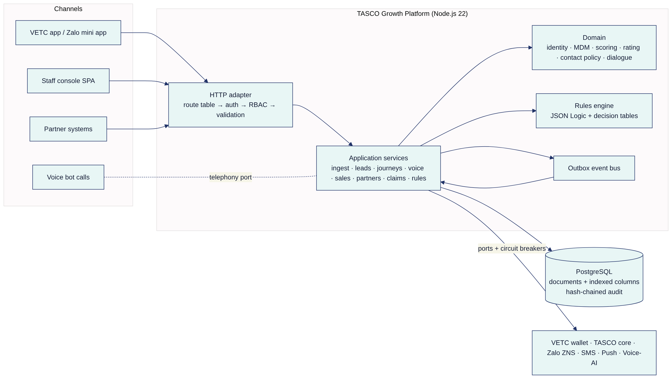

Source map
Layer | Path | Contents
Shared kernel | src/shared/ | config (12-factor, *_FILE secrets), logger (PII redaction), crypto, validation, resilience, metrics, errors, clock
Rules engine | src/rules/ | jsonLogic.js (safe subset), decisionTable.js, validators.js (per-kind validation, copy guard, statutory commission caps)
Domain | src/domain/ | identity.js, enrichment.js, leads.js, rating.js, contactPolicy.js, voicebot.js
Application | src/application/ | One service per use-case area, plus accessPolicy.js (RBAC + ABAC + masking) and rulesService.js (versioning, maker-checker)
Composition root | src/bootstrap/container.js | Chooses adapters, wires services, registers event subscribers
Persistence adapters | src/adapters/persistence/ | schema.js (collection registry), codec.js, memoryStore.js, postgresStore.js, auditChain.js, query.js
Messaging adapter | src/adapters/messaging/outboxEventBus.js | Outbox publish / relay / drain
Integration adapters | src/adapters/integrations/ | Sandbox VETC wallet, TASCO core, notifications, simulated caller, synthetic VETC source
HTTP adapter | src/adapters/http/ | app.js (pipeline), routes.js (73 routes), router.js, openapi.js, security.js
Processes | src/server.js, src/jobs/cli.js | API server with outbox relay and graceful shutdown; batch jobs
Configuration | config/rules/*.json (20 rule kinds), config/security/rbac.json | Business rules seeded as version 1; RBAC
Schema | db/migrations/001_init.sql | 19 collection tables + audit_log
Deployment | Dockerfile, docker-compose.yml, deploy/k8s/, railway.json, .github/workflows/ci.yml | See the deployment document

Conventions used in these documents
- Implemented: present in the code at the cited path.
- Sandbox: the port and the calling code are real; the adapter behind the port simulates the external system (src/adapters/integrations/*).
- Planned / target: a design commitment that is not in the code yet. Each one names an owner phase in the roadmap.
- Infra: a control delivered by the platform (Kubernetes, WAF, managed Postgres, CI) rather than by application code.

