ADR-009: Deterministic voice bot dialogue with a governed script; LLM only as an optional classifier behind a port
TASCO Insurance × VETC Growth Platform — Architecture Decision Record
iorta TechNXT
Version 1.0 · 07 October 2026
Table of Contents

- Status: Accepted
- Date: 2026-10-07
- Related: ADR-003, AI governance, Integration §3.5

Context and problem statement
Outbound renewal calls at scale are much cheaper with a voice bot than with telesales (config/rules/costs.json, insightsService.overview().economics). In Vietnam, however, customers are highly wary of insurance and "VETC" phone scams. The call must therefore:
- build trust: disclose that it is automated, never ask for an OTP or payment, and verify the customer without reading out their data;
- say only approved words: regulated pricing, no discount language (Law on Insurance Business 08/2022/QH15; confirm with TASCO legal);
- respect opt-out immediately;
- hand over to a human with a minimal summary.
Generative LLM dialogue can hallucinate prices, promise discounts, or leak data, and it is hard to approve under maker-checker.

Decision drivers
- Every customer-facing utterance must be pre-approved, versioned and copy-guarded.
- Behaviour must be predictable and testable (golden transcripts).
- The vendor ASR/TTS must be replaceable.
- NLU must be improvable without touching the script or the flow.

Considered options
- Code-defined finite-state dialogue + governed script (content.voicebot rule kind) + pluggable intent classifier (keyword default, LLM optional).
- A fully generative LLM agent with a system prompt.
- The vendor's proprietary bot builder.

Decision outcome
Chosen option: 1 (src/domain/voicebot.js).
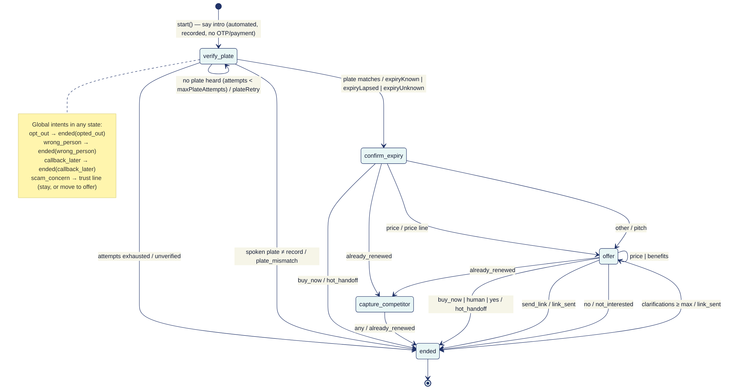
- Script as governed content. Lines (vi + en gloss), intent keywords, maxPlateAttempts and maxClarifications live in config/rules/content.voicebot.json. They are changed only through maker-checker, with the copy guard applied to lines (validators.js). Lines can only interpolate context fields such as {{plateMasked}}, {{expiryVi}} and {{premiumVi}}.
- Plate-first verification. The customer must say the plate. extractPlateFromSpeech maps spoken Vietnamese digits, and the result must equal the profile's key. The bot never reads the full plate (maskPlate) or the name.
- Classifier port. createDialogue(script, { classify }). The default is keywordClassifier(script), which strips diacritics and uses whole-word matching. An LLM classifier may be injected if it returns one of the script's intent names or unknown. It never generates speech.
- Outcome effects (voiceService.finalize): handoff, link, opt-out (DNC + consent override), already-renewed (expiry +365 d at confidence 0.6), and DQ issues for wrong-person or plate-mismatch. Every call is audited.
- Telephony port. runCall(dialogue, session, plate) streams ASR text turns. The sandbox is simulatedCaller.js (weighted personas).

Consequences
- Good: zero hallucination risk in speech. Compliance approves the exact words. Behaviour is unit-testable per state.
- Good: the LLM can improve recall later without re-approving the dialogue. It needs only model-risk sign-off (AI governance §5).
- Bad: rigid conversations, and the keyword NLU misses paraphrases. The yes intent includes short tokens (co, u, ok). Matching uses whole-word padding, so co will not match inside cong, but it can still misfire on phrases like "không có". Intent order puts no after yes, so "có" inside "không có" resolves to yes when both keywords are present. Mitigation: a labelled evaluation set, an intent precision/recall report per script version, and keyword-order review in maker-checker.
- Bad: the call transcript is stored encrypted, and recordings stay with the telephony vendor (contract and DPA required). Retention is 180 days (retention.json).
- Note: the intro says "Cuộc gọi được ghi âm" (the call is recorded). Recording consent and disclosure wording must be confirmed with TASCO legal.

Pros and cons of the options
Generative agent. Natural conversation. However, the content cannot be approved in advance, prices and discounts may be hallucinated, prompt injection via speech is possible, and PII flows to the model.
Vendor bot builder. Fast to start. However, the script would live outside maker-checker and audit, and it creates vendor lock-in.

