Solution architecture
TASCO Insurance × VETC Growth Platform — Architecture
iorta TechNXT
Version 1.0 · 07 October 2026
Table of Contents

Scope: the TASCO Growth Platform codebase (/src, /config, /db). Companion documents: integration, deployment, data, security, AI governance, ADRs.

1. Business context in one paragraph
VETC runs electronic toll collection for about 6 million vehicles. Its records hold a plate, a phone number and engagement signals for every vehicle. Only about 1 in 10 records has a verified motor insurance certificate (src/adapters/integrations/syntheticVetcSource.js reproduces this). TASCO Insurance wants to:
- win new business, meaning uninsured, lapsed and newly registered vehicles;
- retain its own TNDS (compulsory third-party liability) customers;
- work with the partners (banks, showrooms, agents, fleets, inspection centres) who close most TNDS sales today, not against them;
- give customers a trustworthy digital experience, including claims FNOL.
The TNDS premium is set by regulation (config/rules/tariff.tnds_car.json, Decree 67/2023/ND-CP; confirm with TASCO legal). Price therefore cannot be the lever. The platform competes on four things instead: data, timing, channel and service value.

2. Architecture principles
# | Principle | How the code enforces it
P1 | Domain at the centre, adapters at the edge (hexagonal) | src/domain/* imports only src/shared/* and src/rules/*. Adapters are chosen only in src/bootstrap/container.js. See ADR-001.
P2 | Business rules are data, not code | 20 rule kinds in config/rules/*.json, evaluated by a safe JSON Logic subset (src/rules/jsonLogic.js). Changes go through maker-checker (src/application/rulesService.js). See ADR-003.
P3 | Secure by default, deny by default | Every route declares auth/perm/schemas (src/adapters/http/routes.js). Validation rejects unknown fields (src/shared/validation.js). PII is encrypted per field (codec.js). Production refuses to boot without secrets (src/shared/config.js).
P4 | Explainability over black boxes | The lead score is a weighted sum of named factors with reason strings (src/domain/leads.js#score). Each NBA result carries a ruleId. Golden-record fields carry lineage and confidence (src/domain/enrichment.js).
P5 | Consent and trust first | Every outbound touch passes canContact() (src/domain/contactPolicy.js) and the copy guard. The voice bot discloses that it is automated and verifies the plate first (src/domain/voicebot.js).
P6 | Idempotent, at-least-once integration | Orders use idempotency keys (salesService.purchase). Outbound calls are wrapped in timeout + retry + circuit breaker (src/shared/resilience.js). Event handlers are named and tracked per event (outboxEventBus.js).
P7 | Minimal supply chain | One runtime dependency (pg). Crypto, HTTP, routing, metrics and validation come from node:* built-ins. See ADR-002.
P8 | Twelve-factor, stateless processes | Config comes from env or *_FILE. Logs are JSON on stdout. State lives in Postgres. Shutdown is graceful (src/server.js).
P9 | Same behaviour in every environment | The in-memory and Postgres stores share codec.js, query.js and auditChain.js, so encryption, filtering and audit chaining behave the same (ADR-004).
P10 | Tamper-evident accountability | A hash-chained audit_log with a database trigger that blocks UPDATE and DELETE (db/migrations/001_init.sql, ADR-008).

3. C4 Level 1 — System context
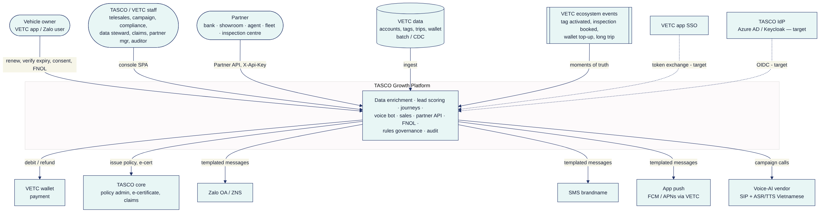

4. C4 Level 2 — Containers
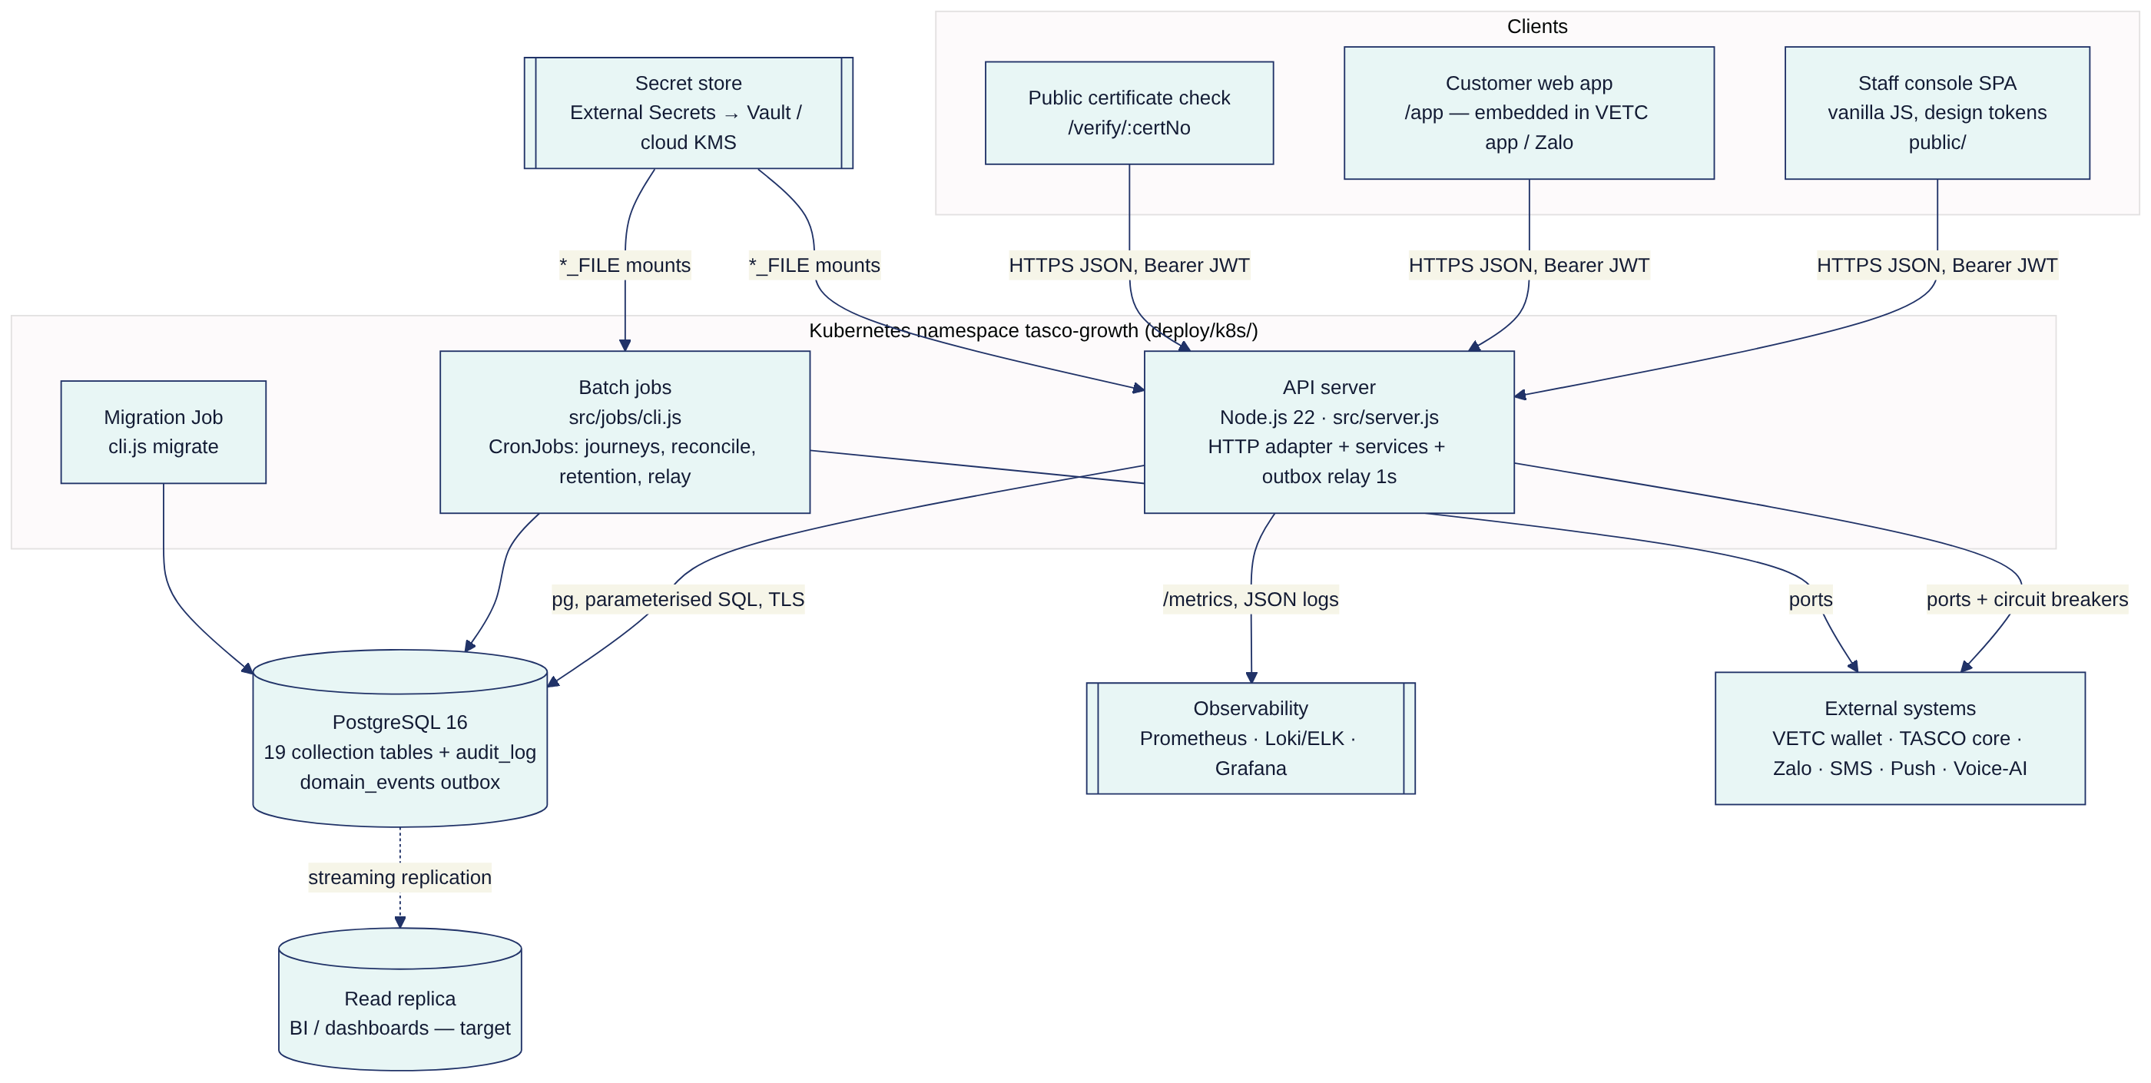
Container | Technology | Responsibility | Scaling
API server | Node.js 22, node:http, src/server.js | All synchronous APIs, static SPA, /health/*, /metrics, /api/openapi.json; background outbox relay every 1 s | Horizontal (stateless). HPA on CPU. The outbox relay is safe on N replicas (FOR UPDATE SKIP LOCKED).
Batch jobs | Same image, node src/jobs/cli.js <job> | journeys, recompute, reconcile, retention, relay, migrate, seed, rules, openapi | One pod per CronJob run. Use concurrencyPolicy: Forbid (see the deployment document).
PostgreSQL | Managed PostgreSQL 16 | System of record, outbox, audit chain | Vertical, plus a read replica. Partitioning at scale (§10).
SPA | Static files in public/ served by the API | Staff console, customer app, certificate verification | CDN-cacheable /assets/* (Cache-Control: max-age=86400)

5. C4 Level 3 — Components (API server)
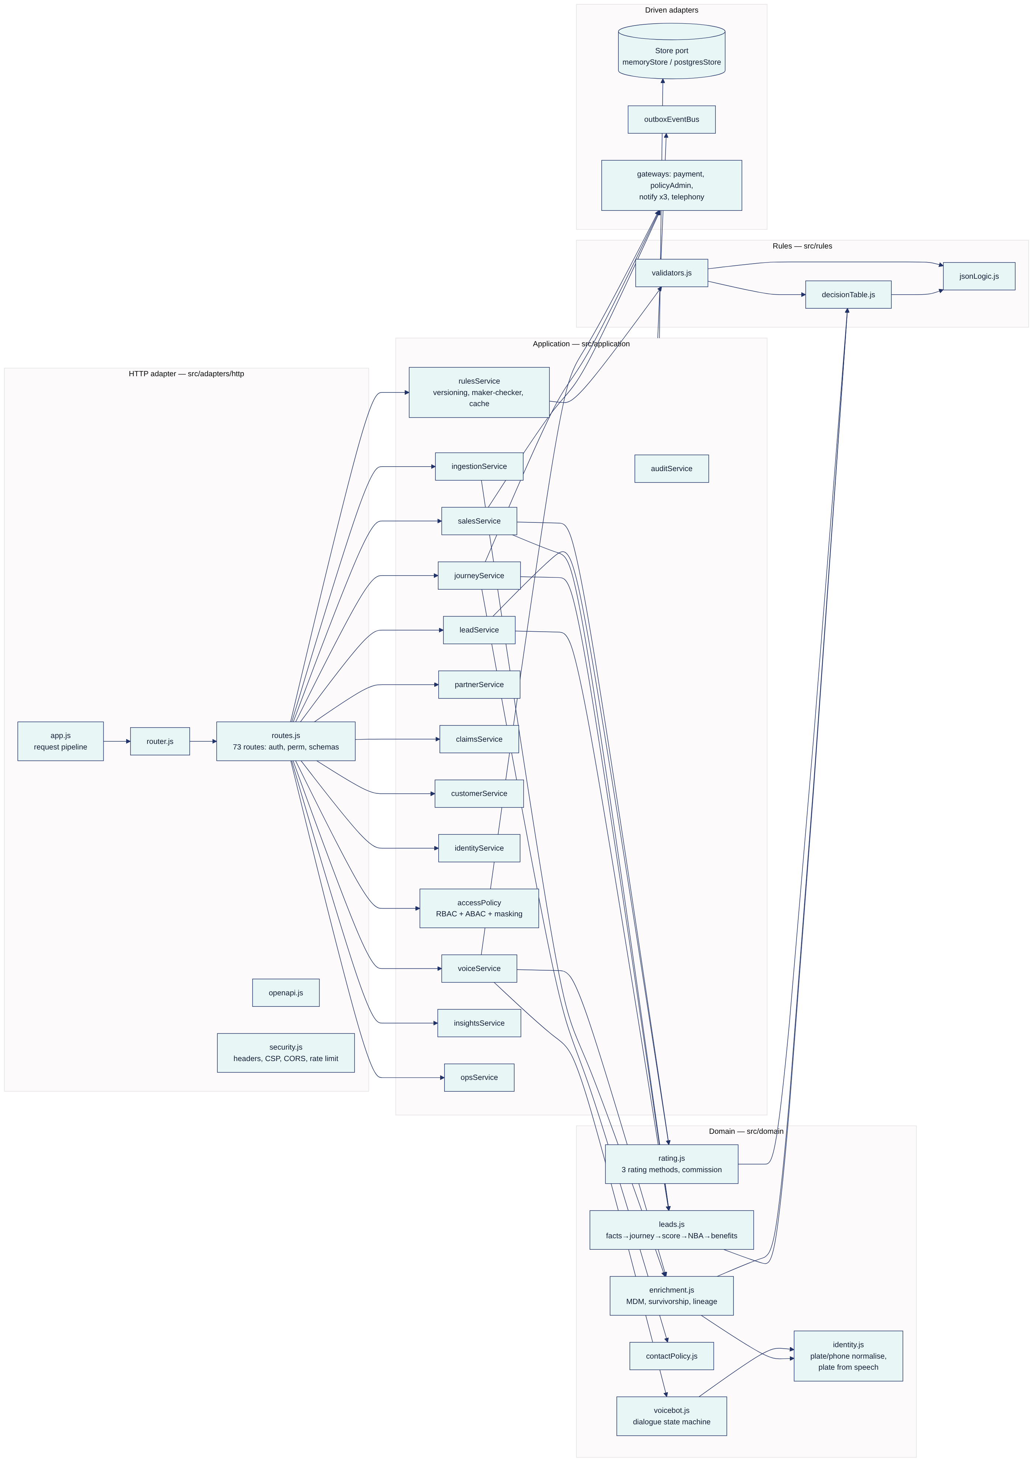

6. Hexagonal layering and the dependency rule
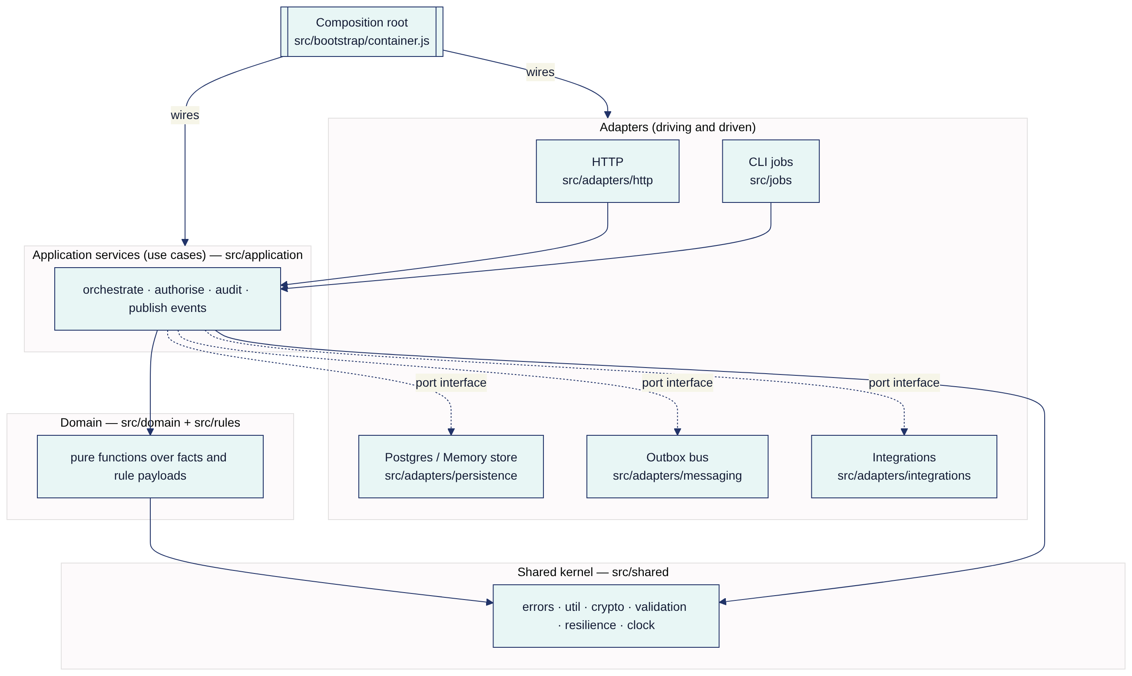
Dependency rule. Source dependencies point inward only:
- src/domain/* and src/rules/* depend only on src/shared/*. They do no I/O and read no clock (today is passed in), so they can be unit-tested deterministically.
- src/application/* depends on the domain, plus ports injected through the factory arguments { store, rules, audit, events, clock, logger, metrics, gateways }. It never requires an adapter.
- Adapters depend on application/domain types. Only src/bootstrap/container.js knows which adapter implements which port. For example, createPostgresStore is chosen when DATABASE_URL is set, and createMemoryStore otherwise.
Ports (implicit interfaces, JS + JSDoc; ADR-002)
Port | Methods | Adapters
Store / Collection | get, insert, update (optimistic version), upsert, bulkUpsert, find({where, orderBy, limit, offset}), count, countBy, delete, deleteWhere, raw | memoryStore.js, postgresStore.js
Store extras | transaction(fn), claimEvents(limit), migrate(), ping(), close(), audit.{append,list,verify,count} | same
EventBus | publish(type, payload, {actor, correlationId}), subscribe(type, name, fn), relay(limit), drain() | outboxEventBus.js
PaymentGateway | debit({idempotencyKey, customerId, amount, description}), refund({transactionId, amount}) | createVetcWalletGateway (sandbox)
PolicyAdministration | issuePolicy({...}), cancelPolicy({policyNo, reason}) | createTascoCoreGateway (sandbox)
NotificationChannel | send({to, text, templateKey, idempotencyKey}) | createNotificationGateway({channel}) ×3 (sandbox)
Telephony | runCall(dialogue, session, plateDisplay) | createSimulatedCaller (sandbox)
SourceFeed | fetchBatch() | createSyntheticVetcSource (sandbox)
RulesProvider | get(kind), getRecord(kind) | rulesService.js
Full contracts are in integration-architecture.md.

7. Key flows

7.1 Ingest → golden record → score → journey
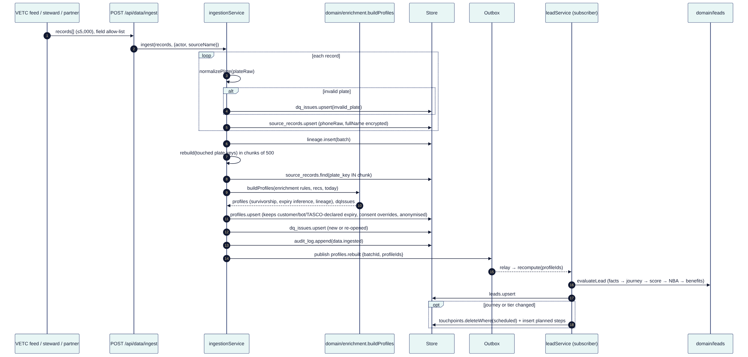
Notes. The rebuild is incremental by plate: only the plates in the batch are rebuilt. Facts captured on the platform (customer_declared, voice_bot, tasco_issued) survive a rebuild when they have higher confidence (ingestionService.rebuild). A vehicle with an active TASCO TNDS policy gets NBA insured, and its journey is cleared (leadService.recomputeOne).

7.2 Voice bot call → handoff
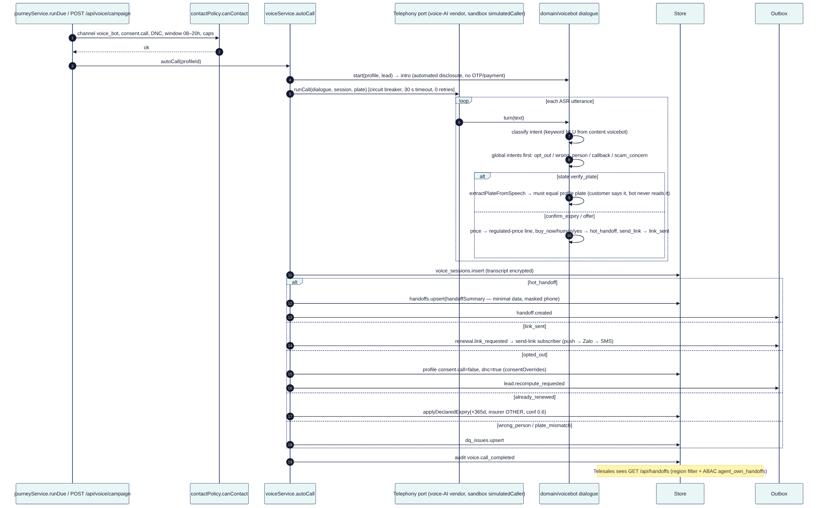

7.3 Quote → pay → issue → e-certificate (idempotency and compensation)
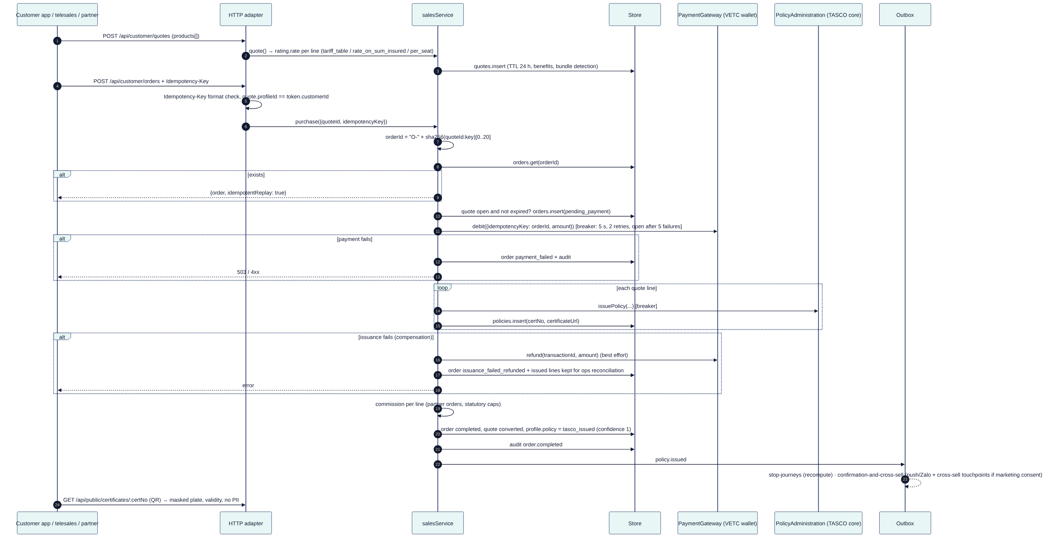
The design is idempotent at three levels:
- Order id is derived from (quoteId, Idempotency-Key). A replayed request returns the stored order.
- The payment idempotency key is the order id. The wallet adapter must deduplicate on it; the sandbox does (processed map).
- The message idempotency key is the message id.
Compensation is refund, then flag. Lines that were already issued stay in place, and opsService.reconcile reports them.
Known gaps (tracked in security-architecture.md §15):
- Two concurrent purchases of the same quote with different idempotency keys can both pass the status === 'open' check, because the check and the write are not atomic.
- The refund() call is not wrapped in the circuit breaker, and its failure is swallowed (.catch(() => {})) with no outbox retry.
Target design: a conditional update UPDATE quotes SET status='converting' WHERE id=$1 AND status='open', done in the same transaction as the order insert, plus a payment.refund_requested outbox event with retries and a dead letter.

7.4 Partner API new-business onboarding
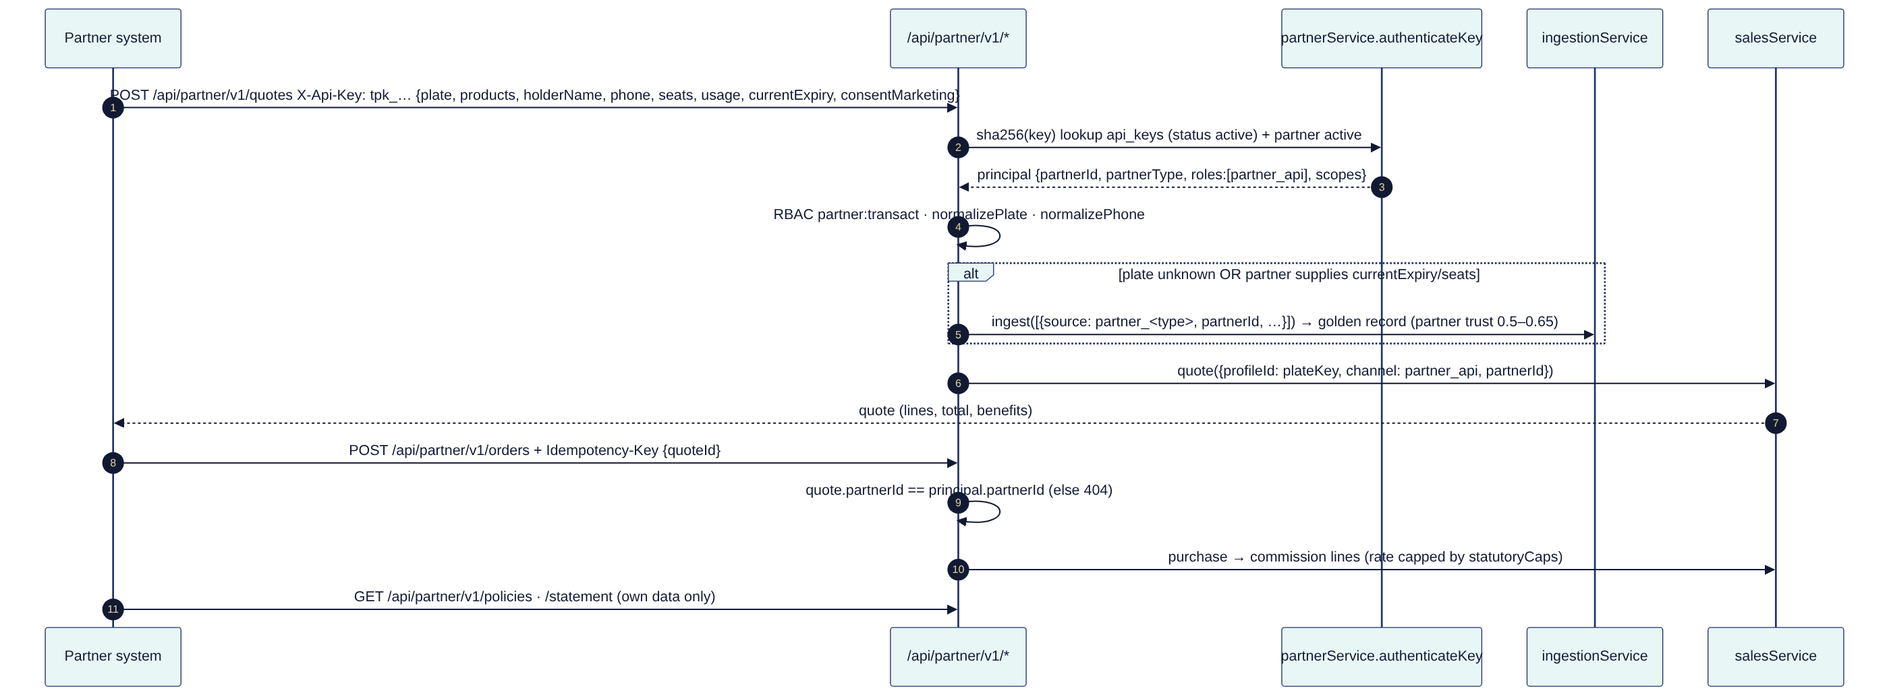

7.5 Rule change with maker-checker
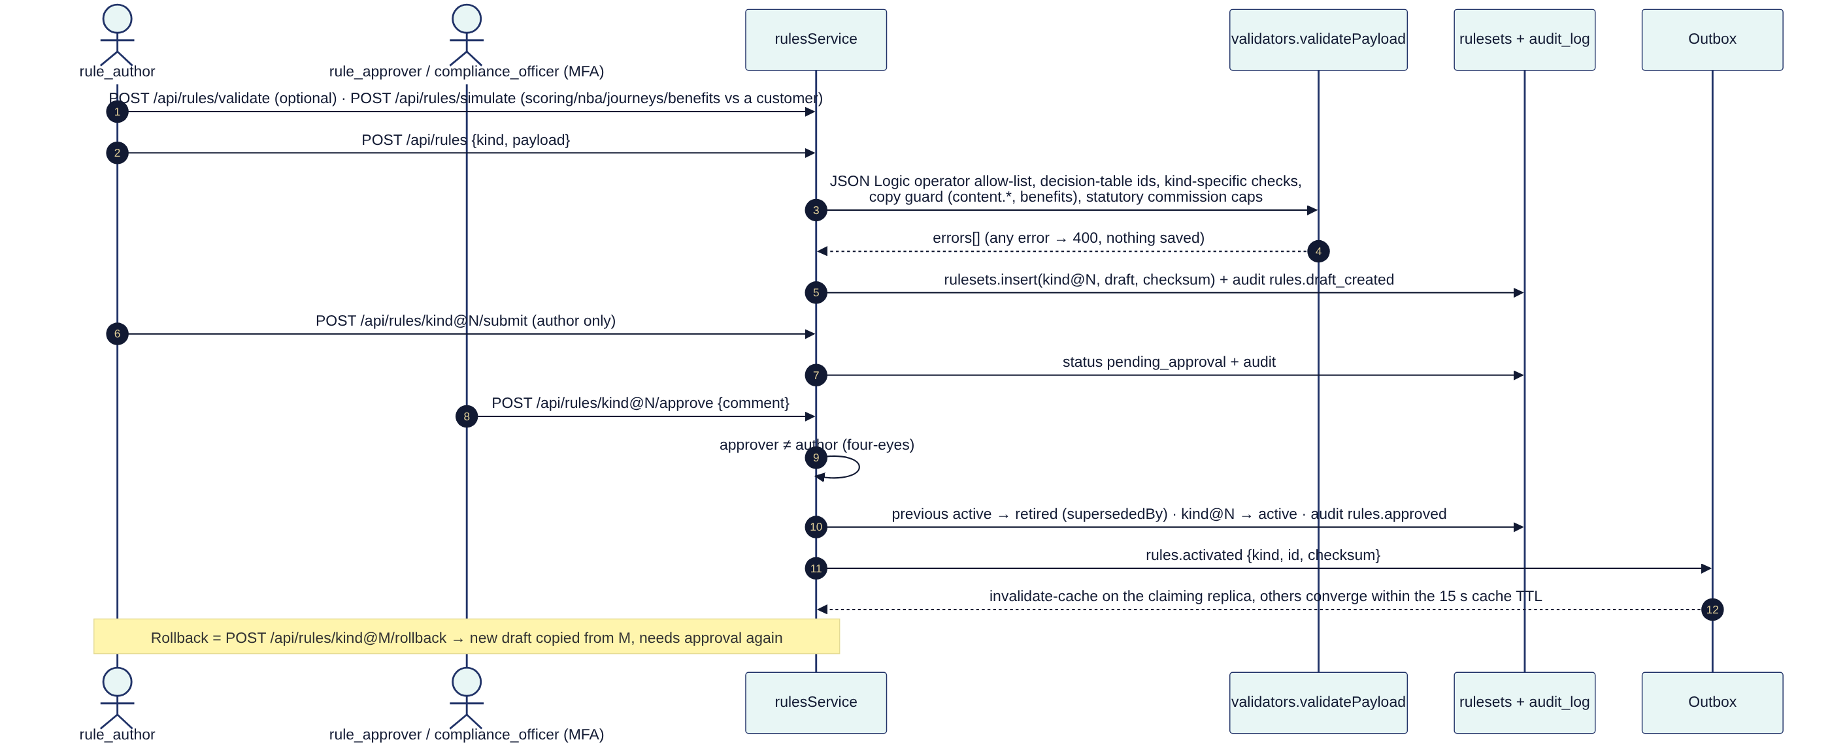

7.6 Ecosystem event trigger (moment of truth)
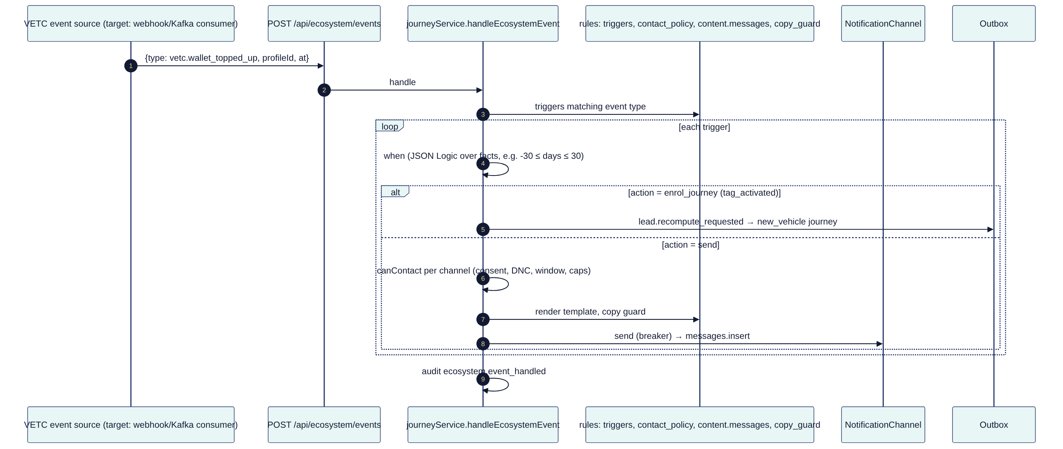
Today the ecosystem event endpoint is a staff-authenticated API (perm: journeys:run). The production source is a VETC event stream; see integration-architecture.md §3.6.

8. Event-driven design
The platform uses domain events for reactions that must not block the caller: re-scoring, sending confirmations, cache invalidation. It uses them for integration fan-out later.
The current implementation (src/adapters/messaging/outboxEventBus.js, ADR-005) works as follows:
- publish() inserts into the domain_events table with status = 'pending'.
- relay() claims a batch with UPDATE … WHERE id IN (SELECT … FOR UPDATE SKIP LOCKED) (postgresStore.claimEvents).
- Each subscriber is a named handler. Handlers that succeed are recorded in evt.handled, so on a retry only the failed handlers run again.
- After 5 attempts the event moves to dead_letter.
- Delivery is at-least-once, so handlers must be idempotent.
- The relay runs every 1 s in each API replica (src/server.js), as the relay CronJob, and synchronously via events.drain() at the end of interactive requests that need read-your-writes (for example POST /api/orders).

8.1 Event catalogue
Event | Producer (file) | Payload | Subscribers (src/bootstrap/container.js) | Idempotency of handler
profiles.rebuilt | ingestionService.ingest | {batchId, profileIds[]} | recompute-leads → leadService.recompute(ids) | Recompute is a pure function of current state; upserts by profile id
lead.recompute_requested | journeyService.handleEcosystemEvent (enrol_journey), voiceService.finalize (opt-out, already-renewed), customerService.declareExpiry/updateConsent | {profileIds[], reason} | recompute-leads | Same as above
policy.issued | salesService.purchase | {orderId, profileId, policies[{id, product, endDate}], channel, journey} | stop-journeys (recompute → NBA insured, deletes scheduled touchpoints), confirmation-and-cross-sell (service message on push/Zalo; cross-sell touchpoints with deterministic ids if marketing consent) | Touchpoint ids are deterministic (profile:cross_sell:step:due). The confirmation message is not deduplicated on replay (new message id each time). See the gap list.
renewal.link_requested | voiceService.finalize (link_sent) | {profileId, journey} | send-link (push → Zalo → SMS, non-marketing, first sent wins) | Not deduplicated on replay (same caveat)
handoff.created | voiceService.finalize (hot_handoff) | {handoffId, profileId} | none today. Target: CTI / dialler queue, supervisor alert | n/a
claim.submitted | claimsService.submit | {claimId, profileId} | none today. Target: TASCO core claims FNOL API, SLA timer (slaDueAt = +4 h) | n/a
rules.activated | rulesService.approve | {kind, id, checksum} | invalidate-cache | Naturally idempotent
Events carry id, type, actor, correlationId (nullable today; target: the HTTP X-Request-Id), occurredAt, status, attempts, handled[], lastError, processedAt.

8.2 Event lifecycle
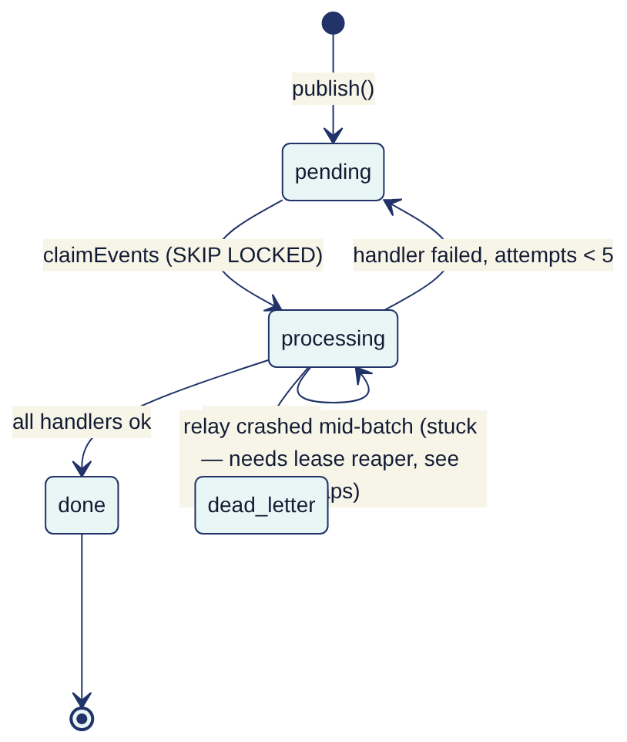

9. Configurability model
Business behaviour lives in rule sets. Each rule set is versioned in rulesets (kind@N), validated per kind (src/rules/validators.js) and activated only by a second person. Code changes are needed only for a new rating method, dialogue state, rule operator or integration.
Rule kind | File | What it controls | Business owner | Change path
products | products.json | Catalogue, channels, rating method + rate kind, bundles | Product | Rules console, maker-checker
tariff.tnds_car, tariff.tnds_motorbike | tariff.*.json | Regulated TNDS premiums (Decree 67/2023, confirm with TASCO legal), VAT | Underwriting + Compliance | Maker-checker. Approver must be compliance.
rating.motor_pd, rating.pa_seat | rating.*.json | Illustrative voluntary rates. Replace with TASCO filed rates. | Actuarial | Maker-checker
commission | commission.json | Partner commission table + statutoryCaps. The validator rejects rates above the cap. | Finance + Legal | Maker-checker
enrichment | enrichment.json | Source trust, expiry evidence weights, corroboration, category table, DQ weights | Data office | Maker-checker + DQ regression check
scoring | scoring.json | Factors (weights must sum to 100), tiers, damping, zeroWhen | Growth analytics | Maker-checker + simulate + model-risk review (AI governance)
nba | nba.json | Next-best-action decision table | Campaign | Maker-checker + simulate
journeys | journeys.json | Audiences, anchors, steps, channels, marketing flag, cross-sell | Campaign | Maker-checker + simulate
triggers | triggers.json | Ecosystem event → action | Campaign | Maker-checker
benefits | benefits.json | Value-beyond-discount catalogue. Only legalStatus=approved items reach customers. | Product + Legal | Maker-checker, copy guard
content.messages | content.messages.json | Message templates (vi/en) | Marketing + Compliance | Maker-checker, copy guard. Zalo template registration is out of band (integration §4).
content.voicebot | content.voicebot.json | Bot script lines and NLU keywords | CX + Compliance | Maker-checker, copy guard (AI governance)
copy_guard | copy_guard.json | Banned phrases (no discounts/rebates on regulated products) | Compliance | Maker-checker
contact_policy | contact_policy.json | Contact window, frequency caps, consent per channel | Compliance / DPO | Maker-checker
abac | abac.json | Attribute policies (region, own handoffs) | InfoSec | Maker-checker (security-sensitive: approver must be InfoSec)
retention | retention.json | Retention days and action per entity | DPO + Legal | Maker-checker
referral | referral.json | Referral programme (disabled pending legal) | Product + Legal | Maker-checker
costs | costs.json | Unit costs for the business-case dashboard | Finance | Maker-checker
RBAC | config/security/rbac.json | Role → permission | InfoSec | Code review + CAB (not a rule kind, deliberately)
Guard-rails present in code:
- the JSON Logic operator allow-list and forbidden keys (__proto__, prototype, constructor);
- weights must sum to 100;
- tiers.hot > tiers.warm;
- unique ids;
- a valid contact window;
- VAT between 0 and 0.2;
- the copy guard on every customer-facing string;
- commission caps.
Approval writes rules.activated. The rules cache TTL is 15 s (CACHE_TTL_MS).

10. Scalability to 6 million vehicles
Assumptions:
- 6.0 M vehicles;
- about 1.3 source records per vehicle (7.8 M rows);
- expiries spread evenly, so about 16.4 k vehicles reach expiry per day;
- about 30 % of the base in an active journey at any time;
- detailed sizing in deployment §12.
Concern | Design already in code | Required at 6 M (planned)
Golden-record build | Incremental rebuild by plate in 500-plate chunks (ingestionService.rebuild). Only touched plates are rebuilt. | Initial load: bulk COPY into a staging table, then rebuild in parallel workers partitioned by hash(plate_key) % N (each worker a Job). Steady state: VETC CDC → small batches.
Lead recompute | Event-driven for changed profiles | The full recompute (recompute(null)) uses OFFSET paging, which degrades at millions of rows. Move to keyset pagination (WHERE id > $last ORDER BY id) and shard across workers. Run nightly only for time-dependent facts (days).
Journey execution | runDue reads due touchpoints (limit 5,000) | Claim touchpoints with FOR UPDATE SKIP LOCKED (as the outbox does) so N workers can run in parallel without double sends. Today safety relies on CronJob concurrencyPolicy: Forbid.
Table growth | Indexed columns per collection | Range-partition messages and touchpoints by month, and domain_events by occurred_at with a purge of done events older than 30 days. Hash-partition profiles/leads/source_records by id only if the table exceeds about 100 GB.
Reads for BI and dashboards | countBy on indexed columns | Route /api/dashboard/* and the analytics feed to a read replica. Replace insightsService.governance() full-chain audit.verify() with incremental verification from a checkpoint (ADR-008).
Outbound volume | Breakers per channel | Queue offload: outbox → broker topic per channel → channel workers with provider rate limits (Zalo ZNS quotas, SMS TPS). See ADR-005.
Audit throughput | pg_advisory_xact_lock(724001) serialises appends to keep one linear chain | About 1–2 k appends/s on modest hardware is enough for the current audit points. If needed, use per-day chains or batched Merkle roots.
API | Stateless; HPA | Shared rate limiter and token revocation (Redis or gateway) once there is more than one replica (security gaps).

11. Quality attributes (targets)
Attribute | Target | Mechanism
Availability (API) | 99.9 % monthly | ≥ 2 replicas across zones, PDB, readiness gating on DB ping, graceful drain (src/server.js)
Latency | p95 < 300 ms for read APIs; p95 < 1.5 s for purchase (dominated by wallet and core) | Indexed column filters; statement_timeout 15 s; breaker timeouts
RPO / RTO | RPO ≤ 5 min (PITR), RTO ≤ 1 h (prod) | Managed Postgres PITR + cross-region replica in DR
Rule change lead time | ≤ 1 day from draft to active | Maker-checker console; target published in insightsService.adoption()
Explainability | 100 % of scores carry factor reasons; 100 % of NBAs carry ruleId | domain/leads.js
Auditability | Every state-changing use case audited; chain verifiable | auditService, /api/audit/verify

12. Evolution roadmap
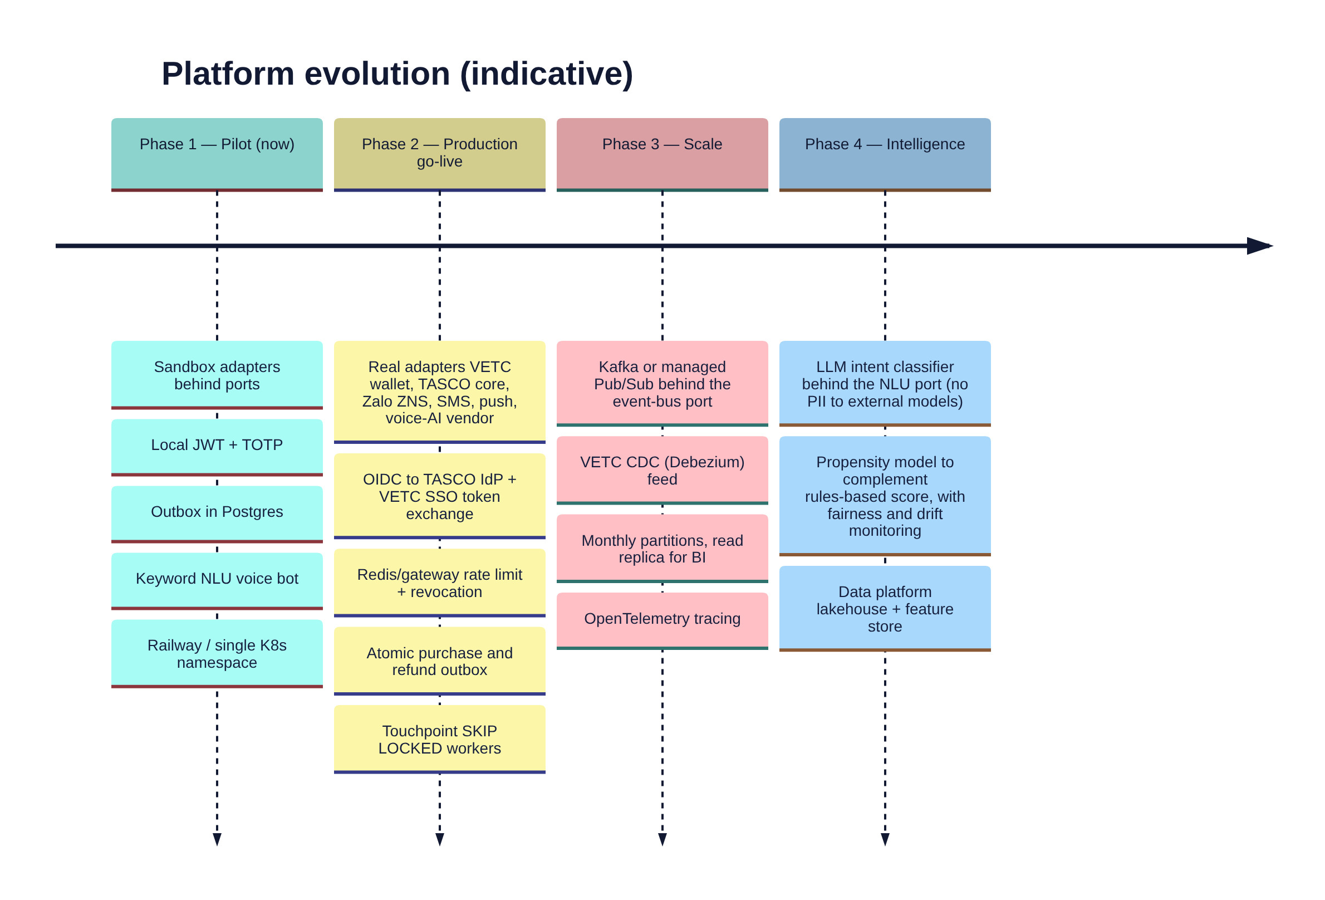
Item | Why | Approach | Constraint kept
Kafka / Pub/Sub | Fan-out to CTI, data platform, TASCO core; replay | Relay publishes outbox rows to topics; consumers keep the named-handler idempotency model | Publishers do not change (events.publish)
LLM NLU | Better intent recall on free speech | Implement classify(text) → intent with the same contract as keywordClassifier, behind a feature flag; evaluate against a labelled set | The dialogue state machine and script stay deterministic and governed (ADR-009)
Real IdP | Joiner-mover-leaver, SSO, central MFA | OIDC code flow with PKCE (staff); RS256 tokens verified by JWKS; roles from IdP groups | Principal shape {id, roles, region} unchanged (ADR-007)
Data platform | BI, model training, regulatory reporting | Logical replication / CDC of the indexed columns into pseudonymised curated marts (no decrypted PII) | PII is minimised and pseudonymised by plate-key HMAC (data §11)

