06 — Personas, Journey Maps and Service Blueprints
TASCO Insurance × VETC Growth Platform — Business & Product
iorta TechNXT
Version 1.0 · 07 October 2026
Table of Contents

TASCO Insurance × VETC Motor Insurance Growth Platform · iorta TechNXT · Version 1.0 · October 2026
Evidence base. The personas are proto-personas. They are built from the client brief (6 M drivers, 70–80% app use, a price-discount mindset, distrust of sales calls, partner-led sales, near-zero own-channel renewals) and from the behavioural signals the platform actually uses (src/domain/leads.js#factsFor: toll trips, long trips, app sessions, wallet balance, auto top-up, consent, complaints). Names, ages and quotes are illustrative. Validate them with 8–12 customer interviews per segment and a review of telesales call recordings in Phase 0.

1. Persona index
ID | Persona | Type | Segment (doc 01) | System role (rbac.json)
PC-1 | Private car owner / commuter | Customer | SEG-3 renewal, SEG-4 conquest | customer
PC-2 | Long-haul driver | Customer | SEG-3 / SEG-4, roadside-led | customer
PC-3 | New car buyer | Customer | SEG-2 new vehicle, SEG-7 partner-led | customer
PC-4 | Lapsed owner | Customer | SEG-1 lapsed / uninsured | customer
PC-5 | Fleet manager | Customer (B2B) | SEG-6 fleet | (fleet portal planned)
PS-01 | Telesales agent | Staff | — | telesales_agent
PS-02 | Telesales supervisor | Staff | — | telesales_supervisor
PS-03 | Campaign manager | Staff | — | campaign_manager
PS-04 | Rule author (product) | Staff | — | rule_author
PS-05 | Compliance approver | Staff | — | rule_approver, compliance_officer
PS-06 | Data steward | Staff | — | data_steward
PS-07 | Claims handler | Staff | — | claims_handler
PS-08 | Partner manager | Staff | — | partner_manager
PS-09 | Partner staff via API (bank or showroom) | External | SEG-7 | partner_api
PS-10 | Executive | Staff | — | executive
PS-11 | Support engineer | Staff | — | support_engineer
PS-12 | Platform admin / security | Staff | — | admin
PS-13 | Internal auditor | Staff | — | auditor

2. Customer personas

PC-1 Private car owner / commuter: "Anh Minh", 38, Hà Nội
Dimension | Detail
Vehicle and use | 5-seat sedan; commutes and makes weekend trips; about 15–25 toll trips per month
Digital | Opens the VETC app weekly to check balance and top up; uses Zalo daily
Insurance today | Bought TNDS last year from a bank partner bundled with his car loan, or at the inspection centre. Doesn't remember the expiry date or the insurer.
Goals | Stay legal at inspection and roadside checks with zero hassle; spend as little time as possible
Pain points | "Everyone calls me to sell insurance." Doesn't know when it expires. Paper certificates get lost. Believes he should get "% off".
Triggers to act | Inspection booking; wallet top-up; a credible reminder with an exact date
What wins him | One tap from a trusted app, an instant e-certificate, no calls, roadside assistance
Platform signals | appSessions30d medium, tollTrips30d medium, channels.app_push true, consent.marketing true
Typical NBA | verify_expiry (if confidence < 0.5) → digital_reminder

PC-2 Long-haul driver: "Chú Hùng", 51, Thanh Hóa ↔ Hà Nội ↔ Hải Phòng
Dimension | Detail
Vehicle and use | 7-seat MPV, often carrying family or passengers; 2,000+ highway km per quarter
Digital | Uses the VETC app for wallet auto top-up; prefers calls to reading
Goals | Help on the road if the car breaks down; passengers protected
Pain points | Breakdowns far from home; unsure what TNDS covers (it does not cover his passengers or his own car)
What wins him | roadside_24_7 (relevance driven by longTripsKm90d, tollTrips30d), upsell_pa_seat (seats ≥ 7), auto_renew (auto top-up)
Platform signals | High longTripsKm90d, autoTopUp true, wallet ≥ premium
Typical NBA | voice_bot if hot with call consent; otherwise digital_reminder

PC-3 New car buyer: "Chị Thảo", 32, TP. Hồ Chí Minh
Dimension | Detail
Moment | Just took delivery; the showroom installed the VETC tag (vetc.tag_activated)
Insurance today | The showroom sold TNDS (and maybe physical damage) at delivery
Goals | Protect a new, expensive car; avoid admin
Pain points | Paperwork overload at delivery; unclear what she has bought and until when
What wins her | Welcome message that stores her cover in the app (new_vehicle_welcome), upsell_motor_pd (vehicle age ≤ 5), inspection reminders
Channel | Showroom via partner API (SEG-7), then VETC app
Typical journey | new_vehicle: welcome +1 day, verify +7 days, value reminder +14 days

PC-4 Lapsed owner: "Anh Tuấn", 45, Bình Dương
Dimension | Detail
Situation | TNDS expired 3 weeks ago. He forgot, or lets it lapse until inspection.
Attitude | Sceptical of calls ("is this a scam?"), price-focused
Risk | Fines at roadside checks; inspection refused; personally liable after an accident
What wins him | A clear, non-pushy service notice (lapsed_notice) with an "if you already bought it, tell us" option; a quick fix in the app; a bot that proves legitimacy (plate-first)
Typical journey | lapsed_uninsured: notice today, bot +2 days (hot/warm), telesales +5 days (hot)
Typical NBA | urgent_recovery

PC-5 Fleet manager: "Ms Lan", 41, logistics SME, 40 vehicles
Dimension | Detail
Situation | Company-owned trucks and vans (ownerType = company), each renewing on different dates
Goals | No vehicle ever off-road for lack of TNDS; one invoice; one contact
Pain points | Spreadsheet tracking; many invoices; individual sales calls to her drivers
What wins her | fleet_dashboard (one view, consolidated VAT invoice), an account manager (route_b2b)
Channel | B2B team; partner type fleet
Note | Must be excluded from B2C robocalls (the campaign route already skips company; journeys do not yet, see doc 05 E-07)

3. Staff and partner personas
ID | Persona | Goals | Key pains today | Platform jobs-to-be-done | Primary screens / APIs | Success measure
PS-01 | Telesales agent | Close more with fewer calls | Cold lists; customers distrust calls; can't take payment | See hot, verified, interested customers with talking points; send a one-tap link while on the call | Telesales inbox (/api/handoffs), Customer 360 | Handoff win rate (K-08); first contact ≤ 2 business hours
PS-02 | Telesales supervisor | Team productivity and compliance | No visibility of lead quality or script adherence | Assign handoffs; rehearse bot scripts; monitor outcomes | Telesales inbox (assign), Voice bot console | Win rate; SLA adherence
PS-03 | Campaign manager | Grow policies at a controlled cost | No reliable expiry data; blunt campaigns | Prioritised queue, journeys, bot campaigns, event simulator, economics | Leads, Journeys, Voice campaign, Home dashboard | K-00, K-10
PS-04 | Rule author (product) | Change scoring, journeys and copy fast and safely | IT tickets for every change | Draft, validate, simulate, submit | Rules studio (/api/rules*) | Rule-change lead time ≤ 1 day
PS-05 | Compliance approver | Nothing unlawful reaches customers | Manual copy review; opaque bots | Four-eyes approval; copy guard; governance KPIs; DSAR | Rules studio (approve), Audit, governance dashboard | 0 copy-guard breaches; 0 contact-policy breaches
PS-06 | Data steward | Trustworthy customer data | Duplicates; 1 in 10 records verified | Ingest; DQ queue; lineage; corrections with evidence | Data quality (/api/dq/*), Customer 360 lineage | K-01 usable-expiry rate
PS-07 | Claims handler | Fast, transparent FNOL | Late, incomplete notifications | FNOL queue and status transitions within SLA | Claims queue (/api/claims) | % acknowledged within 4 h
PS-08 | Partner manager | Grow partner sales; settle commission cleanly | Manual statements; disputes | Onboard, keys, suspend, statements | Partners (/api/partners*) | Active partners on API; disputes = 0
PS-09 | Partner staff via API (bank loan officer, showroom sales) | Close insurance with the main sale | Re-keying data; slow issuance | Quote by plate, bind, instant e-certificate, statement | Partner API (/api/partner/v1/*) | Time to certificate < 1 min
PS-10 | Executive | Growth and ROI visibility | Anecdotal reporting | Growth, channel, economics, adoption | Home dashboard (/api/dashboard/*) | K-00, premium, cost per policy
PS-11 | Support engineer | Stable platform | Silent integration failures | Integration status, jobs, reconciliation | Operations (/api/ops/*), /metrics | SLOs (doc 03)
PS-12 | Platform admin / security | Least-privilege access | Shared accounts | Users, roles, regions, MFA | Users (/api/users) | 0 orphan accounts; MFA coverage of privileged roles = 100%
PS-13 | Internal auditor | Evidence on demand | Logs scattered, editable | Audit search; hash-chain verification | Audit (/api/audit*) | Chain verifies daily

4. Journey maps: current state vs future state
Scores in the journey diagrams are customer sentiment from 1 (very negative) to 5 (very positive). They are design hypotheses to validate in research.

4.1 PC-1 renewal: current state
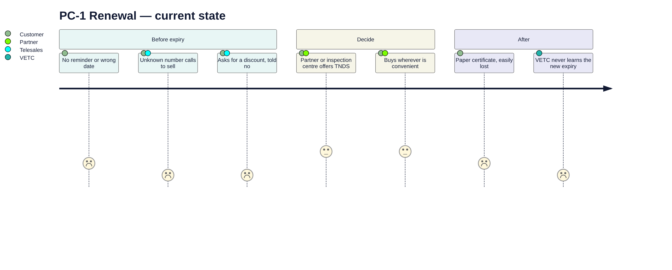

4.2 PC-1 renewal: future state
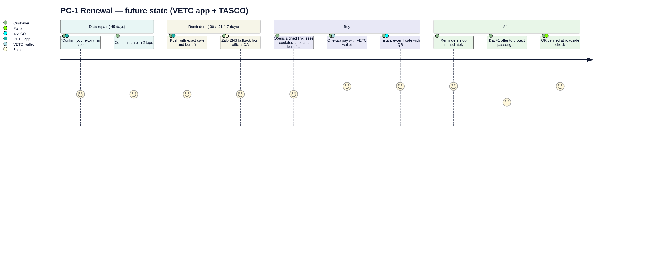

4.3 PC-4 lapsed recovery: current vs future
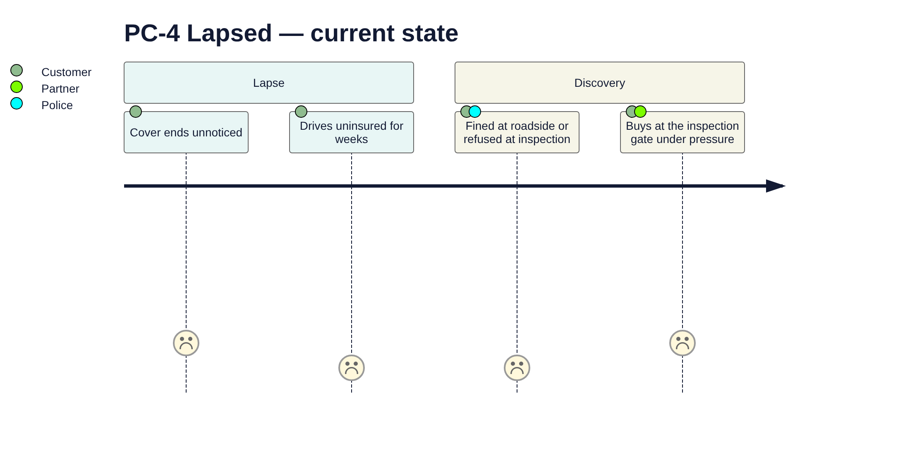
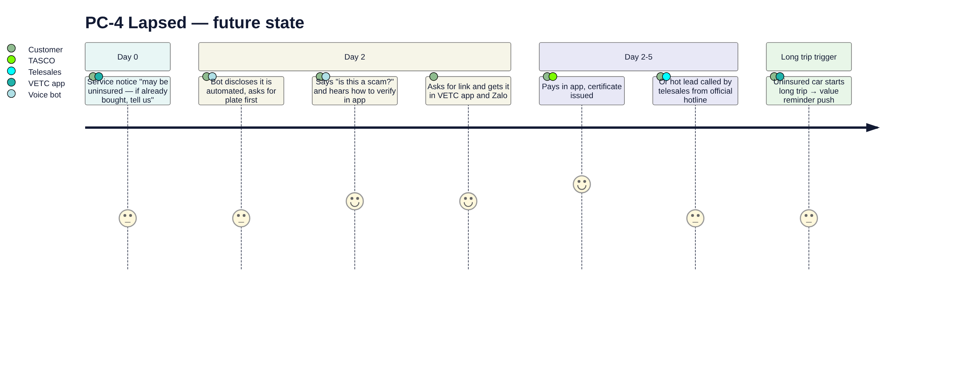

4.4 PC-3 new vehicle: future state
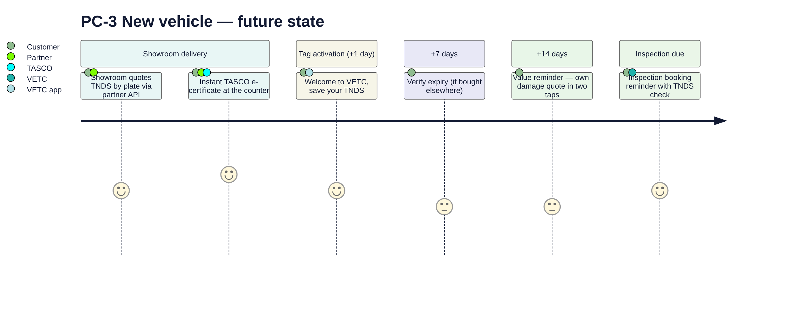

4.5 PC-5 fleet: future state
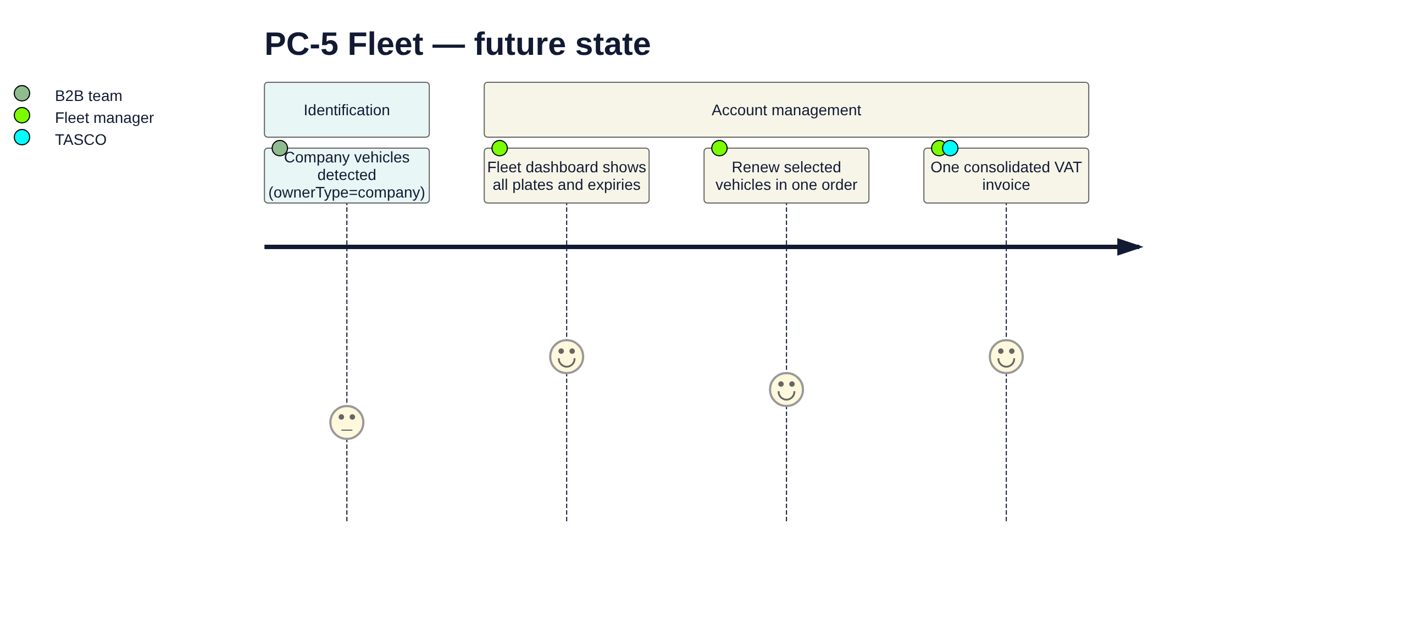

5. Service blueprint: renewal (SEG-3) and conquest (SEG-4)
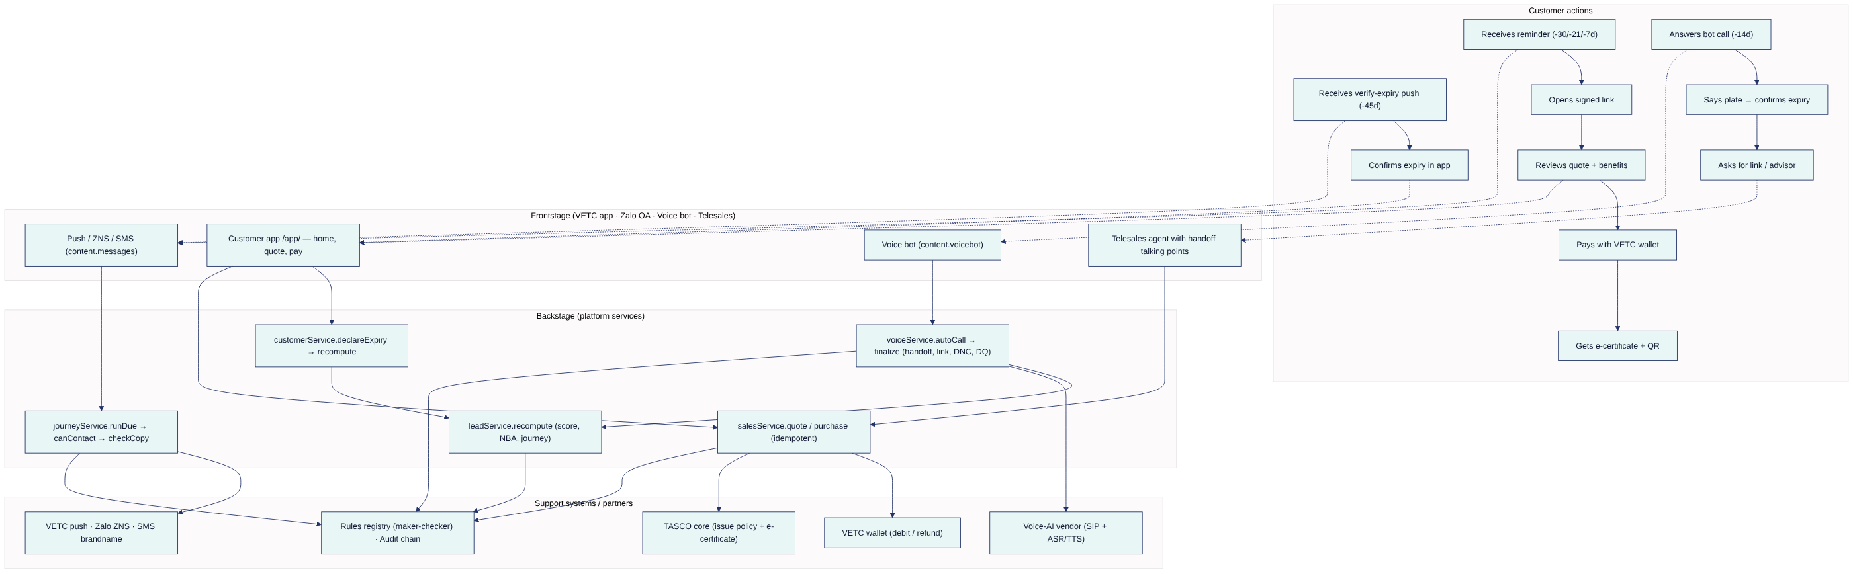
Stage | Customer action | Frontstage | Backstage | Support system | Fail point → mitigation
Data repair (−45 days) | Confirms expiry | Push / Zalo verify_expiry | declareExpiry → recompute | Rules: nba.fix_data | Customer ignores it → inference from inspection cycle and tag anniversary; bot asks "which month?"
Reminders (−30 / −21 / −7 days) | Reads and opens link | first_reminder / conquest_reminder, value_reminder, urgent_reminder | runDue → canContact → checkCopy → send | Push, ZNS, SMS | Cap or hours reached → skipped with reason; next step continues
Bot (−14 days, hot/warm for renewal, hot for conquest) | Verifies plate | Voice bot | autoCall → finalize | Voice vendor | ASR fails → 3 attempts → unverified; scam concern → trust line
Telesales (−3 days, hot) | Talks to advisor | Agent | Handoff queue | — | No payment on the call → link sent
Purchase | Pays | Customer app | quote → purchase | Wallet, TASCO core | Wallet timeout → circuit breaker; issuance failure → refund
After sale | Gets certificate | purchase_confirmation | policy.issued → stop journeys, cross-sell | QR verify page | —

6. Service blueprint: new-vehicle onboarding (SEG-2 and SEG-7)
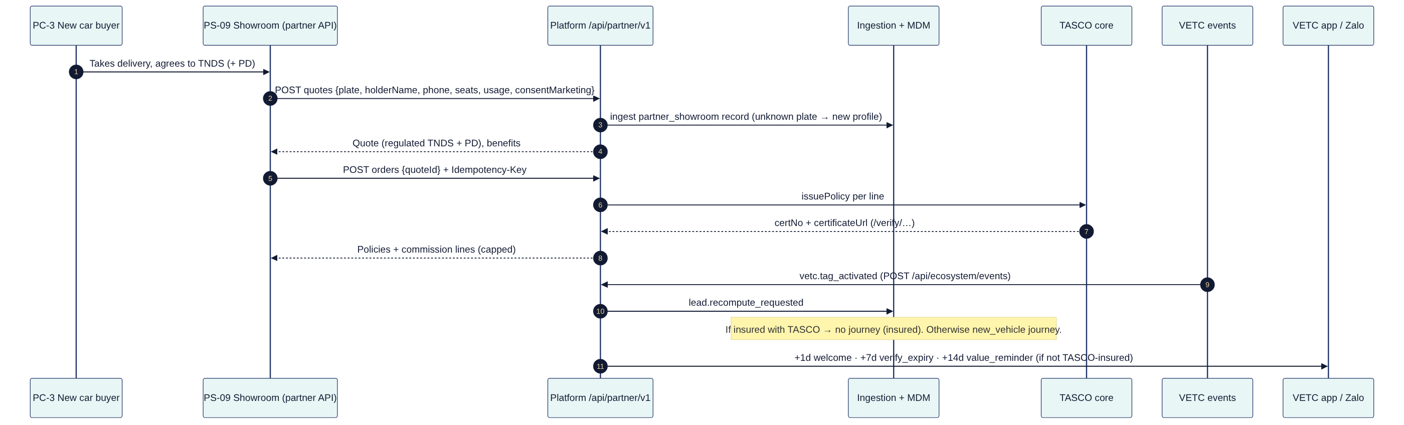
Stage | Frontstage | Backstage | Rule kinds | KPI
Showroom quote | Partner front end | POST /api/partner/v1/quotes → ingestion | products, tariff.*, rating.motor_pd, enrichment | Quote → bind conversion
Bind | Partner front end | POST /api/partner/v1/orders | commission | Time to certificate
Tag activation | — | handleEcosystemEvent → recompute | triggers, journeys | New-vehicle enrolment rate
Onboarding messages | VETC app, Zalo | runDue | content.messages, contact_policy | K-07
Cross-sell | VETC app | cross_sell touchpoint | journeys.crossSell, benefits | K-09

7. Pain points → design responses
PP ID | Pain point | Persona | Design response | FR | Evidence
PP-01 | "I don't know when my insurance expires." | PC-1, PC-4 | Expiry inference with confidence; app confirmation; exact date in every reminder | FR-005, FR-076, FR-025 | enrichment.json, /api/customer/expiry
PP-02 | "Unknown callers try to sell me things; might be a scam." | PC-1, PC-4 | Bot disclosure, plate-first verification, trust script, official hotline, no payment on calls | FR-031 – FR-035, FR-040 | content.voicebot.json
PP-03 | "I want a discount." | PC-1, PC-4 | Honest regulated-price answer plus relevant service value; copy guard | FR-035, FR-058, FR-024 | benefits.json, copy_guard.json
PP-04 | "Buying is faster at the partner." | PC-1, PC-3 | One-tap wallet purchase; partner API so partners sell TASCO instantly | FR-077, FR-065 | /api/customer/orders, /api/partner/v1/*
PP-05 | "I lose paper certificates; police doubt screenshots." | PC-1 | E-certificate with public QR verification | FR-050 | /verify/:certNo
PP-06 | "Too many messages." | All | Caps (1/day, 3/week), hours 08–20, consent centre, journeys stop on purchase | FR-023, FR-078, FR-019 | contact_policy.json
PP-07 | "TNDS doesn't cover my passengers or my car — I didn't know." | PC-2, PC-3 | Explained cover upgrades and bundles | FR-055, FR-054, FR-028 | upsell_pa_seat, upsell_motor_pd
PP-08 | "My drivers get sales calls; I manage 40 renewals in Excel." | PC-5 | B2B routing; fleet dashboard (planned) | FR-070 | nba.fleet
PP-09 | Agent: "My leads are cold and I can't close on the phone." | PS-01 | Hot, plate-verified handoffs with talking points; link-based closing | FR-040 – FR-042 | handoffSummary
PP-10 | Product: "Every change needs IT." | PS-04 | Rules studio with simulation and maker-checker | FR-082 – FR-087 | /api/rules*
PP-11 | Compliance: "I can't review every script and message." | PS-05 | Copy guard at save and send; versioned scripts; audit chain | FR-024, FR-086, FR-099 | validators.js, auditChain.js
PP-12 | Data: "Only 1 in 10 records is verified." | PS-06 | MDM, DQ queue, lineage, data-repair loop | FR-004 – FR-010 | enrichment.js
PP-13 | Partner: "Commission statements are late and disputed." | PS-08, PS-09 | Self-service statement, rules-based capped commission | FR-067 – FR-069 | commission.json
PP-14 | Claims: "Accidents reported late with poor information." | PS-07, PC-1 | In-app FNOL with location, photos and a 4 h SLA | FR-071, FR-072 | claimsService.js

8. Moments of truth
MoT ID | Moment | Who | Why it matters | Platform response | Trigger / rule
MoT-01 | First 10 seconds of a call | PC-1, PC-4 | Decides trust or hang-up | Automated-assistant disclosure; "never OTP or payment"; ask for the plate, never say it | content.voicebot.lines.intro
MoT-02 | Price question | PC-1, PC-4 | Where discount expectations meet the law | Truthful regulated-price answer plus value pivot | Line price; copy_guard
MoT-03 | Tag activation (new car) | PC-3 | Habit forms in the first weeks | Welcome, then save cover, then reminders | triggers.tag_activated → new_vehicle
MoT-04 | Inspection booking | PC-1, PC-4 | Valid TNDS is required at inspection | TNDS check message | triggers.inspection_booked
MoT-05 | Wallet top-up | PC-1, PC-2 | In the app, with funds | One-tap reminder push | triggers.wallet_topup
MoT-06 | Starting a long trip uninsured | PC-2, PC-4 | Risk is salient | Value reminder push | triggers.long_trip
MoT-07 | Expiry day | All | Legal exposure begins | Service notice that bypasses caps | journeys.renewal step expiry_day
MoT-08 | Payment tap | All | A double charge or failure destroys trust | Idempotent purchase; automatic refund on issuance failure | FR-047, FR-048
MoT-09 | Roadside or inspection check | All | Proof of cover | QR verification page | FR-050
MoT-10 | Accident | All | The moment that justifies insurance | In-app FNOL; 4 h acknowledgement SLA | FR-071
MoT-11 | Saying "stop" | All | Respect builds long-term trust | Immediate DNC; audited | FR-036, FR-078

