Test Strategy — TASCO Growth Platform
TASCO Insurance × VETC Growth Platform — Quality Engineering
iorta TechNXT
Version 1.0 · 07 October 2026
Table of Contents

Item | Value
System under test | tasco-growth-platform v1.0.0 (Node.js ≥ 22.12, PostgreSQL 16 or in-memory store)
Client | TASCO Insurance, with VETC as ecosystem and channel partner
Delivery partner | iorta TechNXT
Document owner | iorta TechNXT QA Lead
Approvers | TASCO IT Head, TASCO Business Owner, TASCO Compliance, VETC IT Lead
Status | Baseline v1.0, aligned with project plan gates G2 (build complete), G3 (go/no-go) and G4 (scale)
Related | Test case catalogue · Performance and capacity plan · UAT plan · Operations docs
Sandbox and production. The repository ships sandbox adapters only for the outbound integrations: the VETC wallet, TASCO core policy administration, Zalo ZNS, SMS, app push (src/adapters/integrations/mockGateways.js) and the voice-AI caller (src/adapters/integrations/simulatedCaller.js). Synthetic VETC source data comes from syntheticVetcSource.js. Unit, integration, API, security and performance tests in this repository run against those sandboxes. SIT against the real VETC, TASCO and Zalo UAT endpoints needs the production adapters, which are on the Sprint 2–3 backlog. SIT cases are written now so they can run as soon as the adapters exist. Do not read any result in this document as evidence about real partner behaviour unless it is labelled SIT or later.

1. Scope

1.1 In scope
Area | Components (code) | Main risks tested
HTTP pipeline and platform | src/adapters/http/app.js, router.js, security.js, openapi.js; /health/live, /health/ready, /metrics, /api/openapi.json | Wrong status codes, missing security headers, request-size abuse, CORS bypass, contract drift
Identity and access | identityService.js, accessPolicy.js, config/security/rbac.json, config/rules/abac.json, shared/crypto.js | Broken authentication, MFA bypass, privilege escalation, IDOR, PII leakage
Data enrichment and MDM | ingestionService.js, domain/enrichment.js, domain/identity.js, config/rules/enrichment.json | Wrong golden record, plate and phone normalisation errors, lost customer declarations, DQ issues not raised
Lead scoring and NBA | leadService.js, domain/leads.js, config/rules/scoring.json, nba.json, benefits.json | Mis-prioritised leads, unexplainable scores, benefits pending legal review reaching customers
Journey engine | journeyService.js, domain/contactPolicy.js, journeys.json, triggers.json, contact_policy.json, copy_guard.json, content.messages.json | Spam, contact outside 08:00–20:00 ICT, contact with DNC customers, banned discount wording, missed touchpoints
Voice bot and telesales | voiceService.js, domain/voicebot.js, content.voicebot.json; /api/voice/*, /api/handoffs/* | Plate disclosure, opt-out not honoured, wrong handoffs, agents seeing other agents' work
Sales | salesService.js, domain/rating.js, tariffs, products.json, commission.json | Wrong premium, double charge, quote reuse after expiry, payment without policy, commission above the statutory cap
Partner channel | partnerService.js, /api/partner/v1/* | Key leakage, cross-partner IDOR, unknown-plate onboarding abuse
Claims FNOL | claimsService.js | Illegal state transitions, claims against other customers' policies
Rules governance | rulesService.js, rules/validators.js, jsonLogic.js, decisionTable.js | Self-approval, invalid rule activated, cache not refreshed across replicas
Privacy and audit | customerService.js (DSAR), auditService.js, persistence/auditChain.js, persistence/codec.js | Erasure with an active policy, PII in clear at rest, audit tampering not detected
Operations | opsService.js, outboxEventBus.js, src/jobs/cli.js, src/server.js, shared/resilience.js, shared/metrics.js, shared/logger.js | Lost events, dead letters, unreconciled orders, unsafe shutdown, missing telemetry
Persistence | memoryStore.js, postgresStore.js, db/migrations/*.sql, schema.js | Adapter drift between memory and Postgres, migration failures, SQL injection
Front-ends | Staff console, customer app (/app/), public verification page (/verify/<certNo>) under public/ (UX workstream) | Accessibility, localisation, usability
Deployment assets | Dockerfile, docker-compose.yml, deploy/k8s/*, railway.json, .github/workflows/ci.yml | Image vulnerabilities, probe misconfiguration, missing CronJobs

1.2 Out of scope (tested by the owning party)
- Internal behaviour of TASCO core policy administration, the VETC wallet ledger, VETC SSO, Zalo ZNS delivery, the SMS brandname gateway and the voice-AI vendor's ASR/TTS. We test our contract with them in SIT, not their internals.
- Claims adjudication. The platform is the FNOL front door only.
- The TASCO enterprise IdP (Azure AD or Keycloak via OIDC, see the comment in identityService.js). Federation is tested in SIT once it is configured.

2. Test levels and types
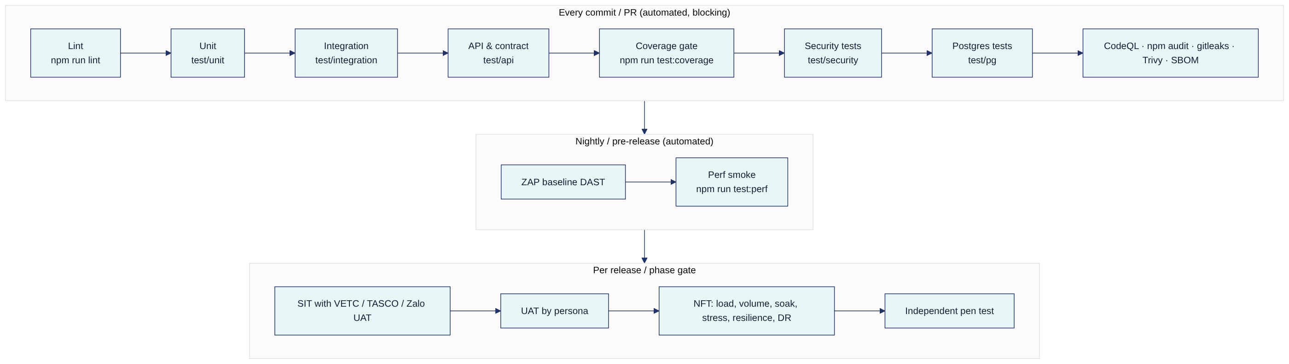

2.1 Unit tests — test/unit/*.test.js (npm run test:unit)
- Target: pure domain and shared modules. Examples: domain/identity.js (plate and phone normalisation, spoken-plate extraction), domain/enrichment.js, domain/leads.js (facts, journey assignment, scoring, NBA, benefits, touchpoint planning), domain/rating.js (three rating methods, cover start date, commission cap), domain/contactPolicy.js, domain/voicebot.js (dialogue state machine), rules/* (JSON Logic, decision tables, validators), shared/* (crypto, validation, resilience, metrics, logger redaction, config) and persistence/* (codec, audit chain, query semantics, schema ↔ migration parity).
- Runner: node:test (built into Node 22). No third-party test framework, consistent with the platform's minimal-dependency policy (one runtime dependency: pg).
- Rules: deterministic (inject clock and SIM_TODAY, and seed the RNG with SEED); no network; no real time unless the test is about time (TOTP windows, circuit-breaker reset).

2.2 Integration tests — test/integration/*.test.js
- Target: application services wired through createContainer(config) with the in-memory store and sandbox gateways. Examples: ingest → rebuild → profiles.rebuilt event → lead recompute → touchpoints; purchase → policy.issued → confirmation message and cross-sell touchpoints; rule approve → rules.activated → cache invalidation.
- Faults are injected by replacing a gateway port, for example a wallet that throws errors.upstream, or a policy admin that fails on the second line.

2.3 API and contract tests — test/api/*.test.js (npm run test:api)
- Target: every route in src/adapters/http/routes.js (76 at the time of writing: 6 public, 57 staff, 9 customer, 4 partner; tests derive the list from the route table so the count can change) over real HTTP. Each test starts createHttpApp(container) on an ephemeral port.
- Contract: GET /api/openapi.json is generated from the route table, so contract tests check that the document:
  - lists every route;
  - declares security per audience (bearerAuth or partnerApiKey);
  - marks Idempotency-Key as required on the two order routes (/api/customer/orders, /api/partner/v1/orders);
  - sets additionalProperties: false on request bodies.
- npm run job -- openapi writes docs/api/openapi.json. CI diffs it against the committed copy, and partners get a change notice when it differs (see release and change management).
- Authorisation matrix: for every route × every role in rbac.json, the expected outcome (2xx, 401 or 403) is asserted table-driven from the perm field. The matrix covers every route × 15 roles (76 × 15 at the time of writing).
- Negative paths: 400 (validation, unknown property), 404, 405, 409, 413, 415, 422, 423 and 429.

2.4 System integration testing (SIT) — VETC, TASCO and Zalo sandboxes
Interface (port) | Counterparty environment | Key SIT scenarios | Prerequisite
PaymentGateway debit / refund | VETC wallet UAT | Debit idempotency on orderId; timeout then retry returns the same transactionId; refund after an issuance failure; insufficient balance → 4xx (non-retryable, so the breaker does not count it) | Real VETC wallet adapter, test wallets with balances
Customer SSO token exchange | VETC identity UAT | VETC SSO token → POST /api/customer/session; expired token, wrong audience | Production verification in place of the sandbox issueCustomerToken
PolicyAdministration issuePolicy | TASCO core UAT | Issue TNDS car or motorbike, MOTOR_PD and PA_SEAT; certificate URL and QR; multi-line order with a failure on line 2 (compensation, see KI-02) | TASCO core adapter, product mapping signed off
NotificationChannel zalo_zns | Zalo ZNS sandbox / OA test | Approved template IDs per templateKey; parameter mapping; delivery receipts | Zalo template approval (readiness item PRC-COMP-05)
NotificationChannel sms | SMS brandname test account | Brandname registered; Vietnamese diacritics and length | Brandname registration
NotificationChannel app_push | VETC app push (FCM/APNs) test project | Deep link …/app/?r=<signed>&j=<journey> opens one-tap renewal | VETC app build with deep-link handler
Telephony runCall | Voice-AI vendor test SIP trunk | ASR text turns into the dialogue engine; plate-first verification; opt-out; transfer to telesales | Vendor contract and test numbers
Ecosystem events | VETC event feed (staging) | vetc.tag_activated, vetc.inspection_booked, vetc.wallet_topped_up, vetc.long_trip_started → POST /api/ecosystem/events | Event feed or webhook relay
Batch extracts | VETC accounts and TASCO core policy extracts (masked) | POST /api/data/ingest with batches of ≤ 5,000 records; reject handling; lineage | Data-sharing agreement, masking pipeline
SIT runs on the SIT environment (Postgres, DEMO_MODE=false, real adapters pointing at partner UAT). Exit: all SIT cases P1/P2 passed, interface defects closed or waived by both parties (milestone M6, 8 Jan 2027).

2.5 User acceptance testing (UAT)
Business scenarios by persona: campaign manager, telesales agent and supervisor, rule author and approver, compliance officer, data steward, claims handler, partner manager, partner API consumer, customer (VETC app and Zalo), executive, auditor, admin and production support. The detailed plan, scenarios and sign-off sheet are in uat-plan.md. The persona manuals in docs/manuals/ are the step-by-step scripts.

2.6 Non-functional testing (NFT)
Type | Objective | Approach | Owner | Detail
Performance (load) | Meet the p95 SLOs at expected peak | npm run test:perf (test/perf/load.js, reports p50/p95/p99 and RPS); k6 optional for distributed load | Perf engineer | Perf plan §5
Volume | 6M vehicle profiles; incremental rebuild by plate; lead recompute at full scale | Synthetic generator at 6M (SEED_RECORDS), Postgres PERF environment | Perf engineer + Data | Perf plan §5 PERF-S7–S9
Stress | Find the breaking point and confirm graceful degradation (429 and 503, no 500 storm, no data corruption) | Ramp to 2–3× peak | Perf engineer | Perf plan PERF-S10
Soak | No memory growth or connection leaks over 8–24 h | Constant 60 % peak, watch process_resident_memory_bytes | Perf engineer | Perf plan PERF-S11
Security — SAST | Code-level flaws | CodeQL (CI), ESLint | DevSecOps | §2.7
Security — dependencies | Known CVEs | npm run audit (--omit=dev --audit-level=high), SBOM (CycloneDX) | DevSecOps | §2.7
Security — secrets | No secrets in git | gitleaks (CI) | DevSecOps | §2.7
Security — container | Image CVEs and misconfiguration | Trivy image + config scan (CI) | DevSecOps | §2.7
Security — DAST | Runtime flaws | OWASP ZAP baseline against the SANDBOX deployment (CI, nightly); authenticated ZAP full scan before G3 | DevSecOps | §2.7
Security — abuse cases | IDOR, JWT tampering, lockout, MFA, rate limits, traversal, injection | test/security/*.test.js (npm run test:security) | QA + DevSecOps | Catalogue §SEC
Penetration test | Independent assurance | Third-party test (grey-box, OWASP ASVS L2 scope) in UAT week T2 | TASCO Security | Readiness PRC-SEC-08
Resilience / chaos | Circuit breakers, outbox retries, DB failover, pod loss | Fault injection (§2.8) | SRE | Catalogue §RES
DR | RPO/RTO achievable | Restore from PITR; regional failover drill | SRE + DBA | dr-bcp.md §7
Accessibility | WCAG 2.2 AA | axe-core automated scan on every page + manual screen reader (NVDA/Windows, VoiceOver/iOS, TalkBack/Android) + keyboard-only | QA + UX | §2.9
Usability | Agents and customers complete key tasks | Moderated sessions per docs/ux/usability-testing-plan.docx | UX | UAT plan §7
Localisation | Vietnamese is primary, English secondary | §2.10 | QA + TASCO Business | Catalogue §L10N
Compliance | Regulatory controls in code and rules | §2.11 | QA + Compliance | Catalogue §COMP
Data quality and reconciliation | Golden record and financial integrity | §2.12 | Data steward + QA | Catalogue §DATA, §OPS
Migration | Schema and data migrations safe and repeatable | §2.13 | DBA + QA | Catalogue §PG

2.7 Security testing
Control | Tool / test | Gate
Static analysis | CodeQL (javascript queries, security-extended) | No new high or critical alerts on the PR
Lint | npm run lint (ESLint 9 flat config) | Zero errors
Dependencies | npm run audit | No high or critical issues in production dependencies
SBOM | CycloneDX SBOM attached to each release | Generated for every tagged build
Secrets | gitleaks over the full history on PRs | Zero findings (false positives allow-listed with justification)
Container | Trivy (image, config) | No critical findings; high findings need a waiver with expiry
DAST | ZAP baseline (passive) nightly on SANDBOX; authenticated active scan pre-G3 | No high-risk alerts; mediums triaged
Abuse cases | test/security/*.test.js | All pass
Pen test | Independent vendor | No open critical or high findings at G3; mediums have a dated plan
Abuse-case coverage maps to concrete controls in the code:
Control in code | Abuse case IDs (catalogue)
verifyJwt rejects alg other than HS256, bad signature, expired, wrong audience; tokens issued before a password, role or status change are rejected (tokensValidAfter) | TC-013–TC-016, TC-011
Lockout after LOCKOUT_MAX_FAILURES (5) failures across password and TOTP steps, for LOCKOUT_MINUTES (15) → 423 ACCOUNT_LOCKED; TOTP replay rejected | TC-005, TC-006, TC-020
Login rate limit RATE_LIMIT_LOGIN_MAX (10/min per IP) → 429 with Retry-After: 60 | TC-121
Global rate limit RATE_LIMIT_MAX (300/min per IP; certificate verification costs 2) → 429 | TC-122
Body limit BODY_LIMIT_BYTES (1 MiB) → 413; non-JSON content type → 415 | TC-118, TC-119
Static path traversal guard (file.startsWith(PUBLIC_DIR + sep)) | TC-120
Allow-list validation (unknown property → 400) | TC-117
Parameterised SQL + assertColumns filter allow-list | TC-123, TC-124
Ownership checks on customer and partner quotes | TC-071, TC-081
Maker-checker | TC-090, TC-091
PII encryption at rest (AES-256-GCM) and log redaction | TC-108, TC-109

2.8 Resilience and chaos testing
Fault | Injection method | Expected behaviour (from code)
VETC wallet slow or down | Sandbox port with delay > 5 s or errors | Timeout 5 s, 2 retries with jittered backoff (baseDelayMs 100), circuit opens after 5 consecutive failed calls and short-circuits for 30 s (integration_short_circuit_total{integration="vetc-wallet"}); order goes to payment_failed; API returns 503 UPSTREAM_UNAVAILABLE
TASCO core down after capture | Policy admin port throws | Compensation: refund attempted, order goes to issuance_failed_refunded, audit order.issuance_failed (see KI-02)
Zalo ZNS or SMS down | Notification port throws | Message stored status:"failed"; the next channel in the step is tried; messages_total{status="failed"} rises
Voice-AI down | Telephony port throws | Breaker voice-ai (timeout 30 s, no retries); touchpoint execution errors
Event handler failure | Subscriber throws | Event goes back to pending, attempts increments; after 5 attempts → dead_letter; events_processed_total{status="dead_letter"}
Process crash mid-relay | kill -9 during relay | Postgres: events left in processing are re-claimed after 5 min and handlers already completed (handled[]) are skipped; in-memory store: no re-claim (dev only)
Postgres primary failover | Managed failover / pg_terminate_backend | /health/ready → 503 while SELECT 1 fails; pool reconnects; no 500 storm after recovery
Pod termination | kubectl delete pod under load | SIGTERM → readiness false → server closes in ≤ 25 s → exit 0; no failed in-flight requests if terminationGracePeriodSeconds ≥ 30
Replica scale-out during relay | 3 replicas relaying | Postgres FOR UPDATE SKIP LOCKED prevents double claim; handlers are idempotent

2.9 Accessibility (WCAG 2.2 AA)
- Automated: axe-core scan of every staff console page, the customer app and /verify/<certNo>, in light and dark themes and in vi and en. Zero serious or critical violations.
- Manual: keyboard-only pass (focus order, visible focus, no traps, 2.4.11 Focus Not Obscured); screen readers NVDA + Firefox, VoiceOver + iOS Safari and TalkBack + Android Chrome on the customer app; 2.5.8 Target Size (24×24 CSS px minimum) on the mobile app; 3.3.8 Accessible Authentication (MFA allows paste and password managers); status messages announced (quote ready, payment result).
- Content: Vietnamese diacritics read correctly (lang="vi"); currency read as "đồng".

2.10 Localisation (vi / en)
- Customer-facing copy is Vietnamese-first. content.messages.json and content.voicebot.json carry vi (sent) and en (staff review gloss).
- Tests check that placeholders resolve ({{plate}}, {{expiry}}, {{premium}}, {{link}}, {{benefit}}, {{days}}), that dates print as dd/mm/yyyy (viDate), that currency prints in the vi-VN locale with đ, and that SMS length after diacritics stays within the agreed segment count.
- The voice bot keyword NLU uses diacritic-stripped matching (stripDiacritics). Tests use both accented and unaccented utterances.

2.11 Compliance testing
Control | Source of truth | Test focus | Catalogue
Copy guard (no discount, rebate or cashback wording for price-regulated products) | copy_guard.json; validatePayload on content and benefits; checkCopy at send time | Draft with banned phrase rejected (with and without diacritics); runtime block → status:"blocked" | TC-060, TC-061, TC-095
Contact window 08:00–20:00 ICT (UTC+7) for marketing | contact_policy.json, inContactWindow | Boundary values 07:59, 08:00, 19:59, 20:00 ICT | TC-050–TC-052
Consent (marketing, call) and DNC | consentRequired, consent.dnc | No marketing without consent; no calls without call consent; DNC suppresses everything | TC-053–TC-055
Frequency caps | 1 per day and 3 per week for marketing; 2 call attempts per week | Cap boundaries; service messages bypass caps (serviceMessagesBypassCaps) | TC-056–TC-058
Maker-checker and separation of duties | rulesService.approve/reject; rbac.json separationOfDuties (e.g. rule_author + rule_approver/compliance_officer, admin + business roles cannot be combined) | Author cannot approve or reject own draft; only the author can submit; conflicting role combinations refused | TC-090–TC-092
Commission caps | commission.json statutoryCaps; validator + runtime commissionFor | Draft above cap rejected; runtime caps applied | TC-084, TC-085
PII masking and minimisation | maskProfile, profile:read_pii, handoff summary, public certificate verification | Masked for roles without PII permission; certificate verification shows masked plate and no name | TC-031, TC-074
Benefits pending legal review | benefits.json legalStatus, benefitsFor(audience) | loyalty_points never reaches customers; staff see it flagged | TC-041
Data subject rights | /api/dsar/*, /api/customer/data-export | Export complete; erasure blocked while a policy is active | TC-105–TC-107
Voice bot disclosure and plate-first | content.voicebot.json, voicebot.js | Bot never reads the full plate; discloses automation; opt-out honoured | TC-064–TC-069
Staff never take payment | salesService.purchase (customer actor only, or partner-collected) | Staff cannot debit a wallet; assisted sales send the quote to the customer's app | TC-156, TC-157
No time override in production | at parameter on journeys and voice campaign | Contact window evaluated on the real clock (KI-33) | TC-162

2.12 Data quality and reconciliation testing
- Golden record: survivorship by sourceTrust, expiry inference by evidence weight, corroboration boost, and protection of customer_declared, voice_bot and tasco_issued facts against later rebuilds (ingestionService.rebuild).
- DQ issues: invalid_plate, missing fields, conflicting_phone, wrong_person and plate_mismatch raised once, and re-raised only after resolution.
- Reconciliation: POST /api/ops/jobs/reconciliation (or npm run job -- reconcile) flags completed orders without a payment reference, missing policies, and orders stuck in pending_payment for more than 1 h. Reconciliation SIT also compares against VETC wallet settlement files and TASCO core issuance reports. The comparison is manual until a settlement adapter exists (KI-18).
- Counts: after each ingest batch, records = upserted source_records, rejected = invalid_plate DQ issues, and profilesTouched = distinct valid plate keys.

2.13 Migration testing
- db/migrations/*.sql is applied by store.migrate() in a transaction per file, recorded in schema_migrations. Tests:
  - Fresh database: all migrations apply.
  - Re-run is a no-op.
  - Schema parity: every collection, index column and blind-index column in schema.js exists in the SQL (test/unit/platform.test.js, "schema drift guard").
  - Upgrade from the previous release's schema with production-like volume (PERF environment) within the maintenance budget.
  - Applied migration files are immutable. CI fails if a file already in main changes (see release policy).
  - Concurrency and integrity: two migrators started together are serialised by advisory lock 724002, and the objects from 002_integrity_hardening.sql exist (one active rule set per kind; audit_log TRUNCATE blocked).
- Data migration (initial load): the pilot cohort and later the full 6M base are loaded through POST /api/data/ingest or a batch job using the same ingestionService. Counts and samples are reconciled against source extracts (catalogue TC-112).

3. Regression and automation strategy

3.1 Test pyramid (target distribution)
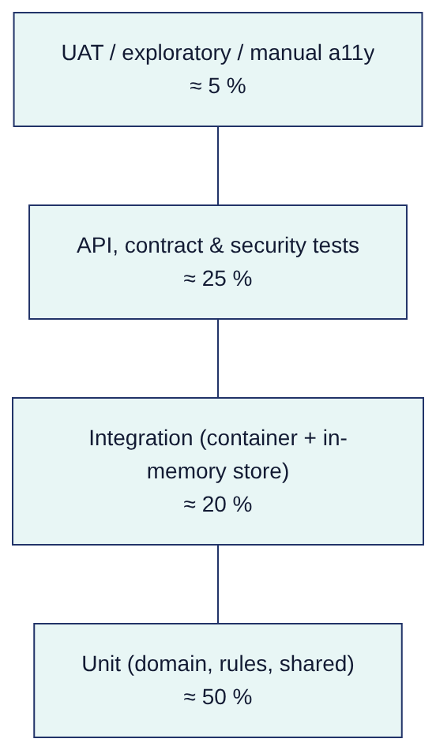

3.2 CI gates (.github/workflows/ci.yml)
Gate | Command / tool | Blocking on PR | Blocking on release tag
Lint | npm run lint | Yes | Yes
Unit + integration + API + security | npm test (now also runs test/security) | Yes | Yes
Coverage | npm run test:coverage: lines ≥ 80 %, functions ≥ 80 %, branches ≥ 70 % (excludes src/jobs/cli.js, src/server.js, postgresStore.js, which test:pg covers) | Yes | Yes
Postgres tests | npm run test:pg against a Postgres service container (TEST_DATABASE_URL) | Yes | Yes
Security tests | npm run test:security | Yes | Yes
CodeQL | GitHub CodeQL | Yes (new high/critical) | Yes
Dependency audit | npm run audit | Yes | Yes
Secrets | gitleaks | Yes | Yes
Container | Trivy | Yes (critical) | Yes (critical/high)
DAST | ZAP baseline | No (nightly report) | Yes (no high)
SBOM | CycloneDX | — | Yes (artefact)
Perf smoke | npm run test:perf against an ephemeral deployment | No | Yes (p95 within 120 % of baseline)

3.3 Regression approach
- Every PR: full automated suite. It runs in minutes because the in-memory store needs no infrastructure.
- Rule changes go through maker-checker, not code release. The rules studio's POST /api/rules/validate and POST /api/rules/simulate are the regression tools for business rules. A rule change that affects scoring, NBA, journeys or benefits must include a simulation on a reference set of profiles (listed in the UAT plan) as approval evidence.
- Release candidate: automated suite + SIT smoke (wallet debit and refund, issue, ZNS send, SSO) + targeted manual regression of the changed area.
- Defect-driven tests: every fixed defect of Sev 1–2 gets an automated regression test that references the defect ID in the test name.

4. Environments
Env | Purpose | Store | DEMO_MODE | Integrations | Data | Access
LOCAL / CI | Dev and automated tests | In-memory (Postgres service for test:pg) | true (tests choose) | Sandbox adapters | Synthetic (SEED=20261007) | Developers, CI
DEV | Integration of features | Postgres | true | Sandbox | Synthetic 2,500–50,000 records | Delivery team
SANDBOX (demo) | Stakeholder demos, ZAP baseline | Postgres or memory | true | Sandbox | Synthetic | Stakeholders (no real data)
SIT | Integration with partners | Postgres | false | Real adapters → VETC, TASCO and Zalo UAT | Synthetic + partner test accounts | Delivery + partner IT
UAT | Business acceptance | Postgres | false (seed via npm run job -- seed only in this env, see KI-01) | Real adapters → partner UAT | Synthetic and masked samples; no production PII | Business users (named)
PERF | Load, volume, soak, stress | Postgres sized like PROD | false | Sandbox adapters with latency injection | Synthetic 6M profiles | Perf team
PREPROD | Release rehearsal, DR drills | Postgres (PITR) | false | Partner UAT/prod-like | Synthetic | Ops
PROD | Live | Postgres HA (PITR) | false (startup refuses DEMO_MODE unless ALLOW_DEMO_IN_PRODUCTION) | Production adapters | Real | Least privilege
Production configuration guards that are tested (shared/config.js): with NODE_ENV=production, the process refuses to boot without JWT_SECRET, BLIND_INDEX_KEY and DATA_KEYS, and with DEMO_MODE set. DATABASE_SSL and TRUST_PROXY default to on.

5. Test data management
- Synthetic first. syntheticVetcSource.generate({ count, seed, today }) reproduces the real data problems: about 1 in 10 verified policies, dirty plates and phones, duplicates across sources, and partner-owned policies. It is deterministic per SEED. Use SEED_RECORDS to size it (2,500 by default; 6,000,000 for volume tests in batches).
- No production PII outside PROD. SIT and UAT use synthetic profiles and partner-issued test identities (test wallets, test SIM numbers for voice and SMS, test Zalo accounts). Production extracts used for data profiling during Discovery are masked: names replaced, phones replaced with the synthetic generator, plates kept only where needed and only in the PERF/UAT environments under a data-sharing agreement.
- Time control. SIM_TODAY pins the business date, so journey tests (offsets −45 to 0 days) and quote expiry (24 h TTL) are reproducible.
- Demo users (seed.js): 14 staff users, one per role, sharing the demo password, with MFA for admin, approver, compliance and steward. They exist only in LOCAL, DEV, SANDBOX and UAT. The demo TOTP helper GET /api/demo/totp/:username is demoOnly and must return 404 when DEMO_MODE=false (TC-012).
- Reset. store.reset() (tests), or dropping and re-creating the database followed by npm run migrate and npm run seed (lower environments only).

6. Entry and exit criteria
Level | Entry | Exit
Unit / integration / API | Story in progress; acceptance criteria defined | All pass; coverage gate met; no lint errors
SIT | Build complete (G2); production adapters deployed to SIT; partner UAT endpoints and credentials available; IIAs signed | 100 % of P1 and ≥ 95 % of P2 SIT cases passed; no open Sev 1/2 interface defects; reconciliation proven end to end
UAT | SIT exit met; UAT environment loaded; users trained; persona scripts issued | See uat-plan.md §4: business sign-off sheet complete
NFT | Feature-complete build in PERF; monitoring in place | SLOs met (perf plan §8); soak shows no leak; DR drill within RPO/RTO
Security | Feature-complete build | No open critical/high (SAST, DAST, dependencies, container, pen test); mediums with dated plan
Go-live (G3) | All of the above | Production readiness checklist all "Done" or waived by SteerCo

7. Defect management

7.1 Severity definitions
Severity | Definition | Examples in this system | Fix expectation (test phases)
Sev 1 — Critical | Data loss, security breach, regulatory breach, money taken without cover, or a core flow down with no workaround | Customer charged and no policy (and no refund); PII exposed to unauthorised role; message with discount wording sent to customers; contact with DNC customer; audit chain cannot be verified; maker approves own rule | Fix before the next build; blocks the gate
Sev 2 — High | Major function broken, workaround exists but costly; compliance risk | Journeys skip a whole cohort; partner commission wrong; voice bot opt-out not persisted; lockout not enforced | Fix before gate exit
Sev 3 — Medium | Function impaired, reasonable workaround | Lead filter wrong; dashboard count off; 500 instead of 400 on malformed input | Fix or plan before go-live; can be waived
Sev 4 — Low | Cosmetic or minor | Label typo, minor layout issue | Backlog
Priority (P1–P4) is set separately by the Product Owner for business urgency.

7.2 Workflow
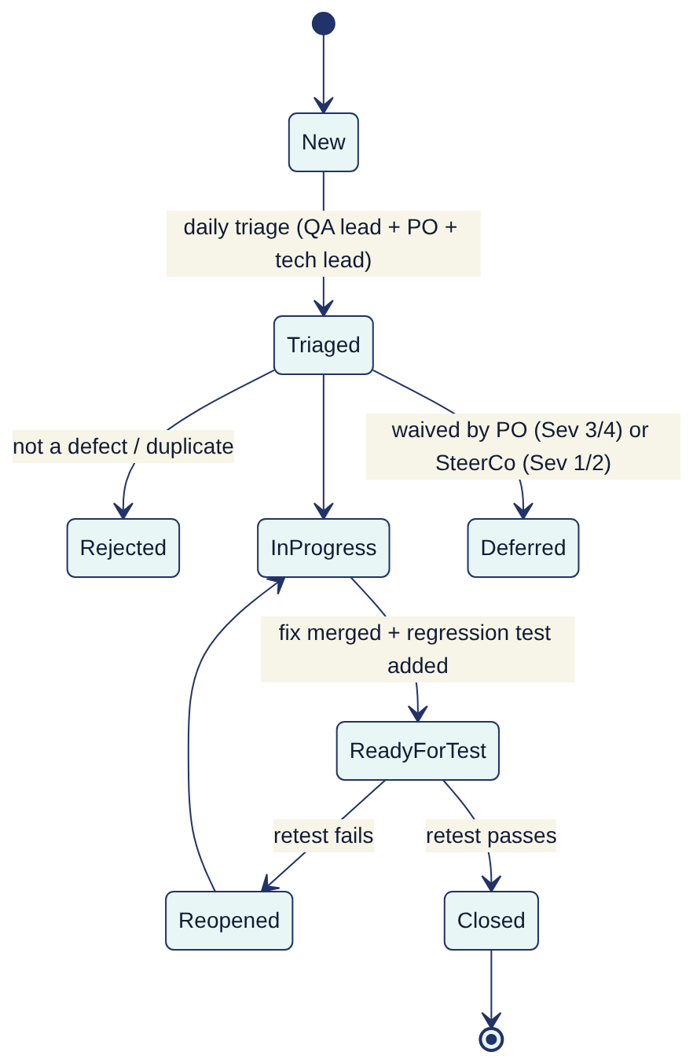
Each defect records: environment, build/commit, X-Request-Id (the API returns it in every response and every error body), route, persona, steps, expected/actual, severity, priority, and for data defects the profile id (never PII in the ticket).

8. Metrics
Metric | Target
Automated pass rate on main | 100 % (flaky tests quarantined within 24 h)
Coverage (lines / functions / branches) | ≥ 80 / 80 / 70 % (gate)
Requirements → test traceability | 100 % of MVP stories have ≥ 1 test case
Defect detection percentage (pre-prod vs total, 30 days after go-live) | ≥ 90 %
Open Sev 1/2 at gate | 0
Defect reopen rate | < 10 %
Mean time to fix Sev 1 / Sev 2 (test phases) | < 1 day / < 3 days
SIT pass rate (P1) | 100 %
a11y serious/critical violations | 0

9. Roles and responsibilities
Role | Organisation | Responsibilities
QA Lead | iorta TechNXT | Owns this strategy, catalogue, triage, reporting, gate evidence
Test engineers (2) | iorta TechNXT | Automated suites (test/*), SIT execution, regression
Performance engineer | iorta TechNXT | Perf, volume, soak, stress; capacity model
DevSecOps engineer | iorta TechNXT | CI security gates, ZAP, Trivy, pen-test coordination
SRE | iorta TechNXT → TASCO IT (BAU) | Resilience and DR tests, monitoring
Product Owner | TASCO | Acceptance criteria, defect priority, UAT coordination
Business testers | TASCO (telesales, campaign, claims, partners), VETC (app, CX) | UAT execution and sign-off
Compliance officer | TASCO | Compliance test sign-off: copy guard, contact policy, consent, scripts, benefits
Data steward | TASCO | Data-quality acceptance, reconciliation sign-off
VETC IT / TASCO core IT / Zalo account manager | Partners | SIT endpoints, test data and accounts, interface defect fixing
Independent pen tester | Third party | Penetration test and report

Appendix A — Known issues register (from code review, 2026-10-07)
These items were found while deriving the tests. The code was being changed in parallel while this register was written. Statuses were re-verified against the working tree at the time of writing ("Fixed in working tree" = fixed but not yet released), and the QA lead re-verifies them at each release. They are logged as defects (Sev as proposed) and referenced by test cases, runbooks and the readiness checklist. IDs are stable.
ID | Sev (proposed) | Area | Finding | Evidence | Recommendation
KI-01 | 1 | Security | npm run job -- seed (src/jobs/cli.js → seedDemo) is not guarded by DEMO_MODE. Run against a production DB, it creates 14 demo users with the published demo password. | cli.js JOBS.seed; the seed.js header claims a guard that only server.js applies | Refuse in cli.js unless config.demoMode; add a CI test; exclude the seed CronJob/Job from prod manifests
KI-02 | 1 | Sales | On a multi-line order where issuance fails after line 1, the full amount is refunded but already-issued policies stay active. The refund error is swallowed (.catch(() => {})) and the refund bypasses the circuit breaker. Partner orders (partner_collected) are not refunded at all, so the partner holds the premium for a failed order. Reconciliation does not inspect issuance_failed_refunded or payment_failed orders. | salesService.purchase compensation block; opsService.reconcile | Cancel issued lines via cancelPolicy or refund only the unissued part; record refund failure (refund_failed status); extend reconciliation; see RB-11
KI-03 | 3 (partly fixed) | Events | Originally events claimed as processing by a crashed replica were never reclaimed. The Postgres store now re-claims processing events older than 5 minutes (index ix_domain_events_status_occurred, migration 002); the in-memory store does not. dead_letter events still have no replay tool: the relay only claims pending | claimEvents; outboxEventBus.relay | Add an ops endpoint/job to requeue dead letters; interim SQL in RB-06
KI-04 | 2 | Performance | HTTP handlers call c.events.drain() inline (orders, partner quotes, ingest, voice turns, consent, expiry, journeys run, ecosystem events). drain processes the global backlog (up to 50 × 500 events), so one request's latency depends on everybody's events. | routes.js | Drain only the events published by the request (by correlation id), or rely on the background relay; perf plan PERF-S5 measures the impact
KI-05 | 2 | Journeys | runDue handles at most 5,000 touchpoints per run. At 6M vehicles the steady state is about 115k touchpoints/day. Touchpoints blocked by the contact window are marked skipped permanently (not deferred). A CronJob scheduled in UTC outside 01:00–13:00 UTC skips all marketing steps. | journeyService.runDue, executeTouchpoint, inContactWindow | Page through all due items; defer window-blocked items; schedule runs at 08:30 ICT; see RB-07 and the perf plan capacity model
KI-06 | — Fixed in working tree | Security | Originally POST /api/auth/mfa did not check lockedUntil or status, so a holder of a valid 5-minute mfaToken could keep guessing codes. The current verifyMfa checks status and lock, counts failures across both factors and rejects TOTP replay (lastTotpStep) | identityService.verifyMfa | Regression TC-020
KI-07 | 3 | Security / scale | Token revocation (logout) and rate limiting are in-process per replica (documented in code). With N replicas the effective limits are N×, and a logged-out token stays valid on other replicas until exp (30 min). | identityService revoked Map; security.createRateLimiter | Shared cache (Redis) or gateway/WAF rate limits; short JWT TTL
KI-08 | 4 (partly fixed) | Security | Signed renewal links now carry an expiry (LINK_TTL_DAYS, default 30) but are still keyed from JWT_SECRET. Rotating the JWT secret invalidates every link already sent | container.js links | Separate LINK_KEY
KI-09 | 1 → Fixed in working tree | Compliance | Originally POST /api/voice/campaign checked only consent.call, dnc, phone and owner type, bypassing canContact (contact window, call cap). The current code routes each call through voice.canCall (consent, DNC, window, caps), records the call as a marketing contact, and returns skipped reasons. Residual: the new at body parameter overrides the clock (KI-33) | routes.js voice campaign, voiceService.canCall | Keep TC-135 as a regression test
KI-10 | 3 (partly fixed) | Access control | ABAC region checks now apply to GET /api/customers/:id, GET /api/customers/:id/lineage, PATCH /api/customers/:id/expiry and POST /api/quotes/:id/send. These still skip it: POST /api/voice/sessions (any region), GET /api/voice/sessions/:id (any transcript), GET /api/policies?profileId= and GET /api/claims. The ABAC policy customer_self is defined but unused (ownership is enforced in code) | routes.js, abac.json | Apply access.check consistently; remove or use customer_self
KI-11 | — Fixed in working tree | API | A malformed percent-encoding in a path parameter used to return 500; the router now returns 400 "Malformed path parameter" | router.match, app.js | Regression TC-129
KI-12 | 3 | Performance | Full scans: GET /api/audit/verify loads the whole audit_log. insights.sumOrders, leads.recompute(all) and ops.reconcile page with OFFSET (O(n²) at 6M rows). | postgresStore.audit.verify, insightsService, leadService, opsService | Incremental verification checkpoint; keyset pagination; SQL aggregates
KI-13 | 2 | Compliance | Retention: only source_records and voice_sessions deletes are executed. Profile anonymisation, message, order and certificate archival are "executed by archival pipeline", which does not exist yet. domain_events, job_runs and quotes have no retention rule. | opsService.applyRetention, retention.json | Build the archival job or record a legal waiver before go-live
KI-14 | 4 (mitigated) | Security | /metrics can now be protected with METRICS_TOKEN (bearer); when unset it is open. /api/openapi.json is public by design | app.js | Set METRICS_TOKEN in every environment and still block /metrics at ingress
KI-15 | — Resolved | Front-end | At first review public/ lacked index.html, app/ and verify.html, so /verify/<certNo> (the QR target) returned 404. The UX workstream has since added them; confirm in the release image (PRC-FUNC-04) | public/ | Smoke test SYN-09
KI-16 | 4 | API | POST /api/data/ingest allows 5,000 records, but the body limit is 1 MiB: large batches get 413. | routes.js, config.bodyLimitBytes | Document a ≤ 2,000-record batch size or raise the limit per route
KI-17 | 4 | Observability | /metrics has no # TYPE/# HELP lines and no gauges for circuit state, outbox backlog or DB pool. Counters are per process and reset on restart. | shared/metrics.js | Add gauges; alert rules use rate()/increase() (see monitoring doc)
KI-18 | 2 | Sales | A wallet debit that times out on our side but is captured by VETC leaves the order in payment_failed with no refund. There is no settlement-file reconciliation adapter. | salesService.purchase; sandbox wallet has no statement API | Daily settlement reconciliation against the VETC statement; see RB-11
KI-19 | 3 | Security ops | DATA_KEYS rotation is supported for new writes, but there is no re-encryption job, so old key IDs must be retained indefinitely. BLIND_INDEX_KEY cannot be rotated without rebuilding phone_bidx (no tooling). | shared/crypto.js, codec.js | Build a re-encrypt/re-index job; see SOP-01
KI-20 | 4 | Sales | Two concurrent purchases with the same Idempotency-Key race on orders.insert. The loser gets 409 CONFLICT, not an idempotent replay. A sequential retry correctly replays. | salesService.purchase | Return the stored order on conflict
KI-21 | 4 | Rules | The commission validator checks caps only for rules whose when names the product literally. Runtime commissionFor still caps (flag capped). Products absent from statutoryCaps get a 0 % cap (silently zero commission). | validators.js commission; rating.commissionFor | Validate every product × partner type combination
KI-22 | 4 | Security | The request body is read and parsed before authentication, so an unauthenticated caller can make the server buffer up to 1 MiB. A wrong content type returns 415 before 401. | app.js handle order | Authenticate before reading the body for non-public routes
KI-23 | 4 | Security | Customer tokens (1 h) cannot be revoked by the customer (no customer logout). Erased data subjects lose their sessions (checked in authenticate) | customerService.issueCustomerToken | Add revocation, or a short TTL with refresh
KI-24 | 4 | Rollout | Journey audiences can target region, category and other facts, but no fact supports a percentage cohort (e.g. a hash bucket of the plate), so "% of base" rollout needs a code change. | domain/leads.factsFor | Add a cohortBucket fact (0–99)
KI-25 | 2 | Voice bot | extractPlateFromSpeech cannot parse Vietnamese tens words ("mươi", "trăm"), yet the bot's own plateRetry line tells customers to say "ba mươi A, một hai ba bốn năm". Verified: that utterance returns null, while "ba không A …" and "30A 123 45" work. Real callers following the prompt fail verification → unverified outcomes. | domain/identity.js, content.voicebot.json | Support tens and hundreds in the number parser, or change the prompt to digit-by-digit; SIT with real ASR (TC-154)
KI-26 | 3 | Compliance | The copy guard matches substrings literally after lowercasing and diacritic stripping. Whitespace and punctuation variants ("giảm giá", "cash back", "chiết-khấu") pass. | contactPolicy.checkCopy, validators.copyViolations | Normalise whitespace and punctuation before matching; extend the banned list
KI-27 | 3 | Identity ops | There is no admin API to unlock an account, reset MFA (lost authenticator) or reset a forgotten password. PATCH /api/users/:id only changes roles, region and status. Support needs direct DB changes (SOP-08). | routes.js, identityService.update | Add admin unlock and MFA-reset endpoints with audit; in production federate to the TASCO IdP (ADR-007)
KI-28 | 1 | Configuration | With NODE_ENV=production and no DATABASE_URL, the server boots on the in-memory store (verified). All data is lost on restart, and replicas do not share state. /health/ready still returns 200 with store:"memory". | shared/config.js, bootstrap/container.js | Refuse to boot in production without DATABASE_URL (unless an explicit override is set); readiness check PRC-OPS-02
KI-29 | — Fixed in working tree | Privacy | DSAR erasure originally skipped handoffs and claims. The current customerService.erase also clears handoff name/phoneMasked/notes, claim description/location and voice-session signals. Quotes keep the plate (non-PII on its own; legal to confirm) | customerService.erase | Regression TC-107
KI-30 | — Fixed in working tree | Deployment | Concurrent MIGRATE_ON_START on several replicas used to race on schema_migrations; migrate() now takes advisory lock 724002. Running migrations from a dedicated Job before rollout remains the recommended practice | postgresStore.migrate | Keep MIGRATE_ON_START=false in Kubernetes
KI-31 | 3 | Sales | Re-sending a purchase with the same Idempotency-Key after a failure returns HTTP 200 with the failed order (idempotentReplay:true, status:"payment_failed" or "issuance_failed_refunded"). Verified. A client that checks only the HTTP status shows success. The quote stays open, so a new key is needed to retry. | salesService.purchase | Return the original error on replay of a failed order; document in the partner API guide
KI-32 | 4 | Access control | POST /api/quotes/:id/send calls sales.markSent (updates the quote, writes audit quote.sent_to_customer) before the ABAC region check. An out-of-region agent gets 403, but the quote is already marked as sent. | routes.js quote send | Authorise before mutating
KI-33 | 2 | Compliance | POST /api/journeys/run and POST /api/voice/campaign accept an at timestamp that replaces the real clock for the contact-window check. An operator can send marketing or place calls at 21:00 ICT by passing a daytime at. | journeyService.runDue, voice campaign handler | Accept at only when DEMO_MODE or in tests; production uses the real clock

