Journey Maps and Information Architecture (v1 UI)
TASCO Insurance × VETC Growth Platform — User Experience
iorta TechNXT
Version 1.0 · 07 October 2026
Table of Contents

This document defines where things live (information architecture and sitemaps), how key tasks flow (task flows with click counts) and how people experience the end-to-end journeys (journey maps). It reflects the v1 UI: staff console at /, customer app at /app/, certificate check at /verify/<certNo>.

1. Information architecture — staff console (/)
Navigation is grouped and filtered by permission. The server enforces the same permission on every API call. Routes are hash-based (for example #/leads, #/customer/<id>).
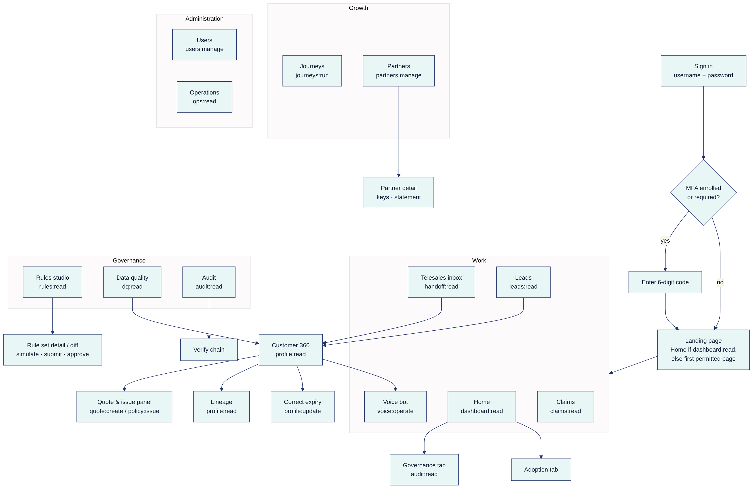
Global elements on every page: skip link, top bar (logo, page title, VI/EN, theme, "?" help drawer, user menu with roles/region and sign out), and the left navigation.

1.1 Page inventory
Page | Purpose | Main API | Permission | Primary users
Home | Role-relevant KPIs: base, leads by tier and journey, DQ, engagement, sales (GWP, by channel and journey), claims, economics. Tabs: Overview, Adoption, Governance (needs audit:read). | GET /api/dashboard/overview, /adoption, /governance | dashboard:read | Exec, campaign, supervisor, author, approver, compliance, steward, partners, auditor, admin
Telesales inbox | Handoff queue: filter by status and "mine", claim, notes, outcome, assign (supervisor) | GET/PATCH /api/handoffs | handoff:read (+ handoff:work, handoff:assign) | Agents, supervisors, campaign (read)
Leads | Prioritised list: filters tier/journey/action/region/days/score, sort by score or expiry. Recompute (campaign). | GET /api/leads, POST /api/leads/recompute | leads:read (+ leads:recompute) | Campaign, agents, supervisors, stewards
Customer 360 | Golden record, lead score breakdown, NBA, touchpoints, messages, policies, voice sessions, benefits, activity. Quote/issue panel. Lineage. Expiry correction. | GET /api/customers/:id, /lineage, PATCH /expiry, POST /api/quotes, POST /api/orders | profile:read (+ profile:read_pii, quote:create, policy:issue, profile:update) | Agents, supervisors, campaign, stewards, compliance, claims
Voice bot | Console session (type customer utterances as ASR text), transcript with Vietnamese and English gloss, outcome and handoff link | POST /api/voice/sessions, /turns, GET /:id | voice:operate | Campaign, agents, supervisors
Claims | FNOL queue with SLA countdown and status transitions | GET/PATCH /api/claims | claims:read / claims:update | Claims handlers
Journeys | Journey definitions (read-only view of the active rule set), scheduled and executed touchpoints, "Run due touchpoints", inject ecosystem event, voice campaign | GET /api/touchpoints, POST /api/journeys/run, POST /api/ecosystem/events, POST /api/voice/campaign | journeys:run | Campaign managers
Partners | List and onboard partners, suspend or activate, issue and revoke API keys, commission statement | /api/partners* | partners:manage | Partner managers
Rules studio | All rule kinds and versions, detail, JSON editor with validation, simulate, submit, approve/reject, rollback | /api/rules* | rules:read (+ rules:author, rules:approve) | Authors, approvers, compliance, auditors, campaign/admin (read)
Data quality | Open DQ issues by type, resolve, batch ingestion, open the affected customer | /api/dq/issues*, POST /api/data/ingest | dq:read (+ dq:resolve, data:ingest) | Data stewards
Audit | Search by entity, actor and action. Verify hash chain. DSAR actions (export/erase) on a customer. | GET /api/audit, /verify, POST /api/dsar/:id/* | audit:read (+ dsar:manage) | Compliance, approvers, auditors, admin
Users | List, create (with roles, region, MFA), change roles, region or status | /api/users* | users:manage | Admin
Operations | Store, integration circuits, active rule checksums, event backlog, audit count. Job history. Run reconciliation, retention or relay. | GET /api/ops/status, /jobs, POST /api/ops/jobs/:kind | ops:read (+ ops:run_jobs) | Admin, support

1.2 Navigation by role (what each demo user sees)
Role (demo user) | Home | Inbox | Leads | Voice | Claims | Journeys | Partners | Rules | DQ | Audit | Users | Ops
admin (admin) | ✓ |  |  |  |  |  |  | ✓ (read) |  | ✓ | ✓ | ✓
executive (exec) | ✓
campaign_manager (campaign) | ✓ | ✓ (read) | ✓ | ✓ |  | ✓ |  | ✓ (read)
telesales_agent (agent.hn, agent.hcm) |  | ✓ (lands here) | ✓ | ✓
telesales_supervisor (supervisor) | ✓ | ✓ | ✓ | ✓
rule_author (author) | ✓ |  |  |  |  |  |  | ✓ (author)
rule_approver (approver) | ✓ |  |  |  |  |  |  | ✓ (approve) |  | ✓
compliance_officer (compliance) | ✓ |  |  |  |  |  |  | ✓ (approve) |  | ✓ (+DSAR)
data_steward (steward) | ✓ |  | ✓ |  |  |  |  |  | ✓
claims_handler (claims) |  |  |  |  | ✓ (lands here)
partner_manager (partners) | ✓ |  |  |  |  |  | ✓
auditor (auditor) | ✓ |  |  |  |  |  |  | ✓ (read) |  | ✓
support_engineer (support) |  |  |  |  |  |  |  |  |  |  |  | ✓ (lands here)
Customer 360 has no menu entry. It opens from Leads, the Telesales inbox, Data quality or a search, for roles with profile:read.

2. Information architecture — customer app (/app/) and certificate check
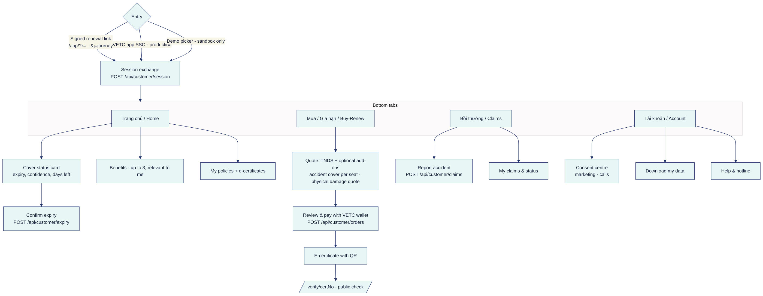
Certificate check (/verify/<certNo>) is public, has no sign-in and shows no personal data. It shows valid or not valid, status, certificate number, product, masked plate, insurer, start and end dates (GET /api/public/certificates/:certNo).

3. Key task flows with click counts
Counting convention: a tap/click is a deliberate activation (button, link, toggle). Typing into a field is not counted but is listed. Opening the link from a notification counts as entry (tap 0).

3.1 Customer: renew TNDS in ≤ 3 taps (target)
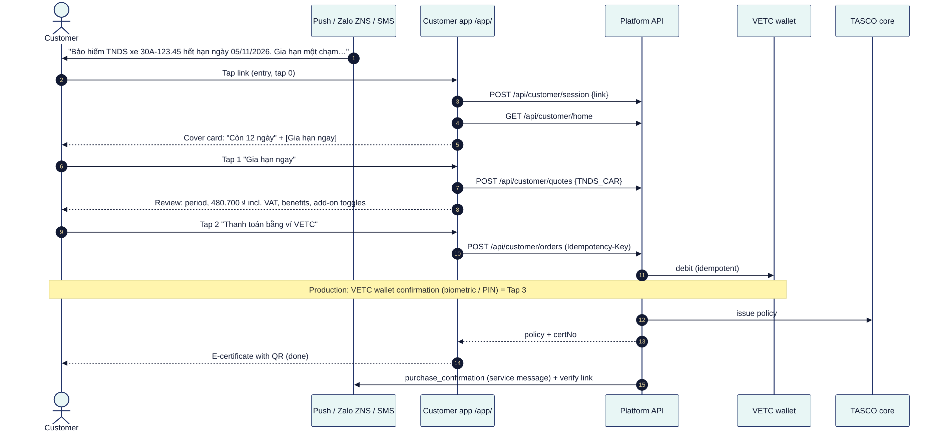
Step | Taps | What the customer sees
Open link | 0 | Cover status card with plate, expiry, days left, one primary button
"Gia hạn ngay" | 1 | Review card: product (Bảo hiểm TNDS bắt buộc ô tô), period (starts the day after current expiry), premium incl. VAT ("Phí theo quy định Nhà nước, giống mọi nơi"), up to 3 benefits, optional add-on toggles
"Thanh toán bằng ví VETC" | 2 | Payment progress
Wallet confirmation (VETC app, production) | 3 | E-certificate with QR, "Đã cấp giấy chứng nhận", "Lưu vào ứng dụng"
With add-on (accident cover per seat): +1 toggle tap on the review card, for 4 taps total. Physical damage shows a quote (sum insured input); binding in production goes through the inspection flow, so it is not part of the one-tap path.
If expiry is uncertain (confidence < 0.75, needsConfirmation): the cover card first asks "Ngày hết hạn bảo hiểm hiện tại của bạn là 05/11/2026?", with [Đúng] / [Sửa ngày]. Confirming is 1 tap and repairs the data (customer.expiry_declared). Renewal then continues as above.

3.2 Telesales agent: claim → call → quote → issue (or send link)
# | Action | Clicks | Notes
1 | Open Telesales inbox (landing page for agents) | 0 | Open handoffs in the agent's region, newest first, hot first
2 | Claim on the handoff card | 1 | Status open → claimed, assigned to the agent. Card shows talking points, trust/price flags, verified plate.
3 | Open customer (Customer 360) | 2 | Full record (PII visible for agents), score breakdown, benefits, history
4 | Call from the official hotline (click-to-call through the telephony integration, or dial manually in v1) | 3 | Reference the assistant call. Never ask for OTP or payment details.
5 | Quote: TNDS pre-selected; tick add-on (PA per seat) if accepted | 4 (+1 per add-on) | POST /api/quotes (channel telesales)
6a | Send one-tap link (preferred) | 5 | Customer pays in their VETC app
6b | or Issue (only if the customer confirms the payment in their VETC app) | 5 | POST /api/orders with Idempotency-Key. Certificate number shown.
7 | Record outcome: Won / Lost / Callback with a note | 6 | Stops or reschedules journeys
Target: ≤ 6 clicks from inbox to recorded outcome, and handoff first contact ≤ 2 business hours (proposed).

3.3 Rule change (maker-checker)
# | Actor | Action | Clicks
1 | Author | Rules studio → select kind (for example scoring) → New draft (copy of active) | 2
2 | Author | Edit JSON → Validate (inline errors with JSON paths) | 1
3 | Author | Simulate → choose customer → see current vs candidate (score, tier, NBA, journey, benefits) | 2
4 | Author | Save draft (description required) → Submit | 2
5 | Approver | Rules studio → Pending tab → open the draft → review diff and simulation | 2
6 | Approver | Approve (comment) → confirm; the previous version is retired automatically | 2
Target lead time from draft to active: ≤ 1 business day (proposed).

3.4 Other flows (summary)
Flow | Actor | Clicks (target)
Resolve a DQ issue with expiry correction | Data steward | Data quality → issue → Open customer → Correct expiry (date + evidence) → Save → Resolve (≈ 5)
Acknowledge a claim | Claims handler | Claims → claim → Acknowledge → confirm (3)
Onboard a partner and issue a key | Partner manager | Partners → New → fill → Save → Issue key → Copy → "Tôi đã lưu khóa" (≈ 6)
DSAR access export | Compliance | Audit → search customer → DSAR → Export → Download (≈ 4)
Report accident | Customer | Bồi thường → Báo tai nạn → choose policy, date, description → Gửi (3)
Change consent | Customer | Tài khoản → toggle → Lưu (3)
Verify a certificate | Anyone | Scan QR → page opens (0)

4. Journey maps

4.1 Customer — TASCO renewal (retention journey)
Journey definition: renewal in config/rules/journeys.json (anchor: expiry date).
Stage | D−45 Verify | D−30 First reminder | D−21 Value | D−14 Voice bot | D−7 Urgent | D−3 Telesales | D0 Expiry day
Touchpoint | Push/ZNS verify_expiry (service) | Push/ZNS/SMS first_reminder | ZNS/push value_reminder | AI call (hot, warm) | Push/ZNS/SMS urgent_reminder | Human call (hot) | Push/ZNS/SMS expiry_day (service)
Customer doing | Confirms or corrects expiry in app | Notices; may tap to renew | Learns benefits | Verifies plate, asks price, chooses link or advisor | Renews in app | Talks to advisor | Last chance
Thinking / feeling | "Is this real? How do they know?" → reassured by the VETC app context | "Convenient — I'm already in the app" | "Same price everywhere — what else do I get?" | Suspicion → trust (disclosure, never asks OTP) | Mild urgency | Wants help or reassurance | Worry about fines
Pain points | Wrong date erodes trust | Too many messages (capped: 1/day, 3/week) | Generic benefits | ASR mishears plate | Payment friction | Feels like a sales call
Opportunities / design response | Data repair in 1 tap | One-tap renew, ≤ 3 taps | Relevant benefits ("why for you") | Plate-first, max 3 attempts, link option | Wallet one-tap, idempotent | Talking points, trust script | Clear lapse message, no scare tactics
Metrics | Confirmation rate | Click-through, conversion | Conversion | Outcomes, opt-out rate | Conversion | Win rate | Lapse rate
All steps stop once the vehicle has an active TASCO TNDS policy (the touchpoint is cancelled with reason "already insured with TASCO").

4.2 Customer — conquest (insured elsewhere / unknown insurer)
Steps at D−45, −30, −21, −14 (voice bot, hot only) and −7. The conquest_reminder template mentions renewing "lần này" (this time) in the VETC app with TASCO, plus the top benefit. Emotional curve: indifferent ("I always renew at the inspection centre") → curious (convenience, roadside assistance) → decisive at D−7 if the wallet covers the premium. Key moment of truth: the vetc.wallet_topped_up trigger (customer is in the app with funds, within 30 days of expiry) sends first_reminder by push.

4.3 Customer — uninsured vehicle recovery (lapsed ≤ 60 days)
D0 service notice lapsed_notice ("may be driving without compulsory TNDS — if you already bought it, update us"), D+2 voice bot (hot/warm), D+5 telesales (hot). Trigger vetc.long_trip_started sends value_reminder when an uninsured vehicle starts a long highway trip. Design note: tone is helpful, never accusatory. The first action offered is "I already bought it", which repairs the data and stops the reminders.

4.4 Customer — new vehicle onboarding
Trigger vetc.tag_activated (new ETC tag ≈ new car) enrols the vehicle. D+1 welcome (new_vehicle_welcome), D+7 verify expiry, D+14 value reminder. Opportunity: the dealer or showroom partner may have sold the TNDS. The partner record raises expiry confidence and suppresses unnecessary pitching.

4.5 Customer — cross-sell after purchase
After a TNDS-only purchase with marketing consent, the D+1 cross_sell message notes that TNDS only protects third parties and offers accident cover per seat or physical damage. It is never sent if add-ons were already bought.

4.6 Telesales agent — a day with the platform
Time | Activity | Platform support | Emotion
08:00 | Sign in, check inbox | Agent lands on Telesales inbox, filtered to own region | Neutral
08:15 | Claim first hot handoff | Card shows verified plate, "customer asked price", talking points | Confident: "this person asked for me"
08:20 | Call | Trust script, official hotline | Relief: the customer is expecting the call
08:30 | Quote + send link | Quote panel, benefits list, one-tap link | Efficient
08:35 | Record outcome | Won / Callback with note | Accomplished
11:00 | Callback due | Status callback items | In control
17:00 | Review | Supervisor dashboard, wins recorded | Recognised

4.7 Rule author and approver — changing the scoring
Author: idea ("long-distance drivers convert better") → draft → validate → simulate on 5 customers → submit with description → wait. Approver: notified → reviews the diff and simulation → approves with comment → active within seconds → leads recompute. Pain points designed out: no IT ticket, no release, no spreadsheets. Self-approval is impossible, and everything is in the audit trail.

5. Content hierarchy rules
- One primary action per view (customer) or per card (staff).
- Status first, then action, then detail (progressive disclosure: talking points, lineage and JSON are collapsed by default).
- Explanations sit next to the thing they explain (score reasons, blocked reasons).
- Personal data is shown only where needed for the task, and masked otherwise.

