AI and Prompt Governance
TASCO Insurance × VETC Growth Platform — Architecture
iorta TechNXT
Version 1.0 · 07 October 2026
Table of Contents

Document | Version | Date | Owner | Status
AI and Prompt Governance | 1.0 | 07 October 2026 | iorta TechNXT Architecture | Issued for submission
Scope: every automated decision or AI component that affects customers on the platform.
- The voice bot: dialogue policy, intent classifier, and the vendor's ASR/TTS.
- The lead score, next-best action and journey assignment.
- MDM inference of policy expiry and vehicle category.
- Any future LLM or ML model.
Related: ADR-003, ADR-009. Regulatory statements are flagged "confirm with TASCO legal".

1. AI inventory and risk tiering
# | Component | Type | Code / config | Customer impact | Risk tier | Owner
1 | Voice bot dialogue | Deterministic state machine + governed script | src/domain/voicebot.js, config/rules/content.voicebot.json | Speaks to customers; captures opt-out; hands off to sales | High (direct interaction, vishing context) | CX lead
2 | Intent classifier | Keyword NLU (default); LLM optional (future) | keywordClassifier in voicebot.js | Wrong intent leads to a wrong path (a missed opt-out is critical) | High | CX lead + model risk
3 | ASR / TTS | Vendor ML (Vietnamese) | Telephony port (Integration Architecture, section 3.5) | Mis-transcription → plate mismatch or wrong intent | Medium | Vendor + CX
4 | Lead score + tier | Explainable weighted rules (white-box) | src/domain/leads.js#score, config/rules/scoring.json | Who gets contacted, how often, on which channel | Medium | Growth analytics
5 | Next-best action, journey assignment | Decision tables / JSON Logic | nba.json, journeys.json, leads.js | Channel choice, suppression, B2B routing | Medium | Campaign
6 | Expiry inference | Evidence-weighted inference | src/domain/enrichment.js#inferExpiry, enrichment.json | Timing of reminders; quote start date | Medium | Data office
7 | Vehicle category inference | Decision table | enrichment.categoryTable | Regulated premium amount if not confirmed | High for pricing correctness | Data office + underwriting
8 | Benefits relevance | JSON Logic relevance scores | benefits.json, leads.js#benefitsFor | Which value-adds are shown (only approved and available items to customers; loyalty points are never promised while pending legal review) | Low | Product
9 | Future: LLM classifier / agent assist; propensity model | ML/LLM | Not implemented | — | Assessed before introduction | Model risk

2. Voice bot design principles
Each principle is enforced in code or governed content.
# | Principle | How it is enforced
1 | Disclose automation and recording at call start | The intro line: "đây là trợ lý tự động của VETC … Cuộc gọi được ghi âm" ("this is VETC's automated assistant … this call is recorded"). Payload disclosure: "automated_assistant". Governance dashboard states the disclosure. Recording-notice wording: confirm with TASCO legal.
2 | Never ask for an OTP, card or payment on a call | Stated in intro and the trust line. The dialogue has no state that collects such data. Payment happens only in the VETC app (link, handoff lines).
3 | Plate-first verification. The customer says the plate; the bot never reads it out. | State verify_plate: extractPlateFromSpeech must equal the profile key. A mismatch ends the call (plate_mismatch), and after maxPlateAttempts (3) the call ends unverified. Afterwards the bot refers to the vehicle only by plateMasked (30A-***.45).
4 | Truthful about price. The premium is regulated and identical everywhere; no discounts. | The price line states the regulated premium incl. VAT and pivots to service value. The copy guard bans giảm giá, chiết khấu, hoàn tiền, discount, cashback, rebate, cheaper, … (copy_guard.json), including whitespace and punctuation evasions such as "giảm giá" or "cash back". Validation fails if a line contains them.
5 | Respect opt-out immediately | opt_out is a global intent checked before any state logic. It ends the call, sets consent.call=false, dnc=true and consentOverrides (which survive data rebuilds), audits consent.withdrawn and triggers a lead recompute (zeroWhen: consent.dnc → score 0, NBA suppress).
6 | Safety first | callback_later ("đang lái xe", "busy", "driving") ends politely with a drive-safely line
7 | Handle scam concerns | The scam_concern intent gives the trust line: how to verify, and that payment happens in-app only
8 | Human handoff on request or intent | human, buy_now and yes in the offer state end as hot_handoff. The handoff summary is minimal: masked phone, talking points, trust/price flags (handoffSummary). Supervisors and agents work it under ABAC.
9 | Bounded conversation | maxClarifications (2), then a link is sent instead of looping. Utterances are truncated (500 characters).
10 | Lawful targeting | Every automated call, from a journey step or from the campaign endpoint, passes canContact(): call consent, DNC, 08:00–20:00 local, weekly call cap 2 (contact_policy.json). POST /api/voice/campaign checks the contact policy per profile (voiceService.canCall), reports skip reasons and skips company-owned vehicles, which are routed to B2B. Decree 91/2020/ND-CP call rules and the national Do-Not-Call list: confirm with TASCO legal. Check against the national DNC register before calling (planned integration).
11 | Every call improves data, nothing more | Outcomes update expiry (renewed elsewhere, confidence 0.6 from service_levels), raise DQ issues (wrong person, plate mismatch) and record consent. There are no hidden profiling attributes.

3. Script and prompt lifecycle (content.voicebot)
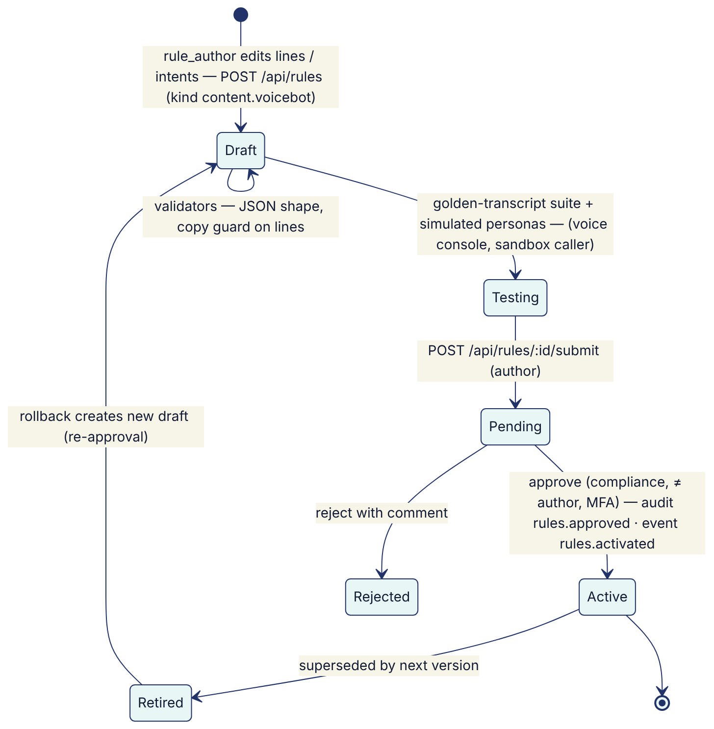
What is governed: the bot lines (vi text + en gloss), intent keyword lists and their order (first match wins), maxPlateAttempts, maxClarifications and the disclosure type. The state machine itself is code: changes go through a pull request, code review and release.
Approver checklist (compliance):
- Disclosure and recording notice unchanged, or legally re-approved.
- No request for OTP, card, password or payment.
- Price statements match the active tariff.* and say "same at every insurer".
- No banned phrases (automated) and no implied discounts (human judgement: e.g. "ưu đãi" (offer) implying a price cut).
- The opt-out keyword list is not narrowed. Every removal needs a justification.
- The intent order is reviewed (a short yes keyword can capture "không có" ("I don't have it"); see ADR-009).
- Golden-transcript results attached: 100 % pass on critical paths (opt-out, plate mismatch, scam concern, price).
- Tone and politeness in Vietnamese (Quý khách form of address), and regional dialect check.
Testing assets:
- simulatedCaller.js personas (eager, self-serve, price shopper, skeptic, already renewed, busy, opt-out, wrong plate);
- the interactive voice console (POST /api/voice/sessions, /turns);
- planned: a labelled utterance set (§5.3) and an automated regression run on POST /api/rules/validate for content.voicebot.
Prompts for future LLMs follow the same lifecycle under a new rule kind (e.g. content.llm_prompts). The system prompt, few-shot examples, model id, temperature and output schema are versioned, copy-guarded where customer-facing, and approved by compliance and model risk.

4. Model risk management: lead scoring and inference
The lead score and the MDM inferences are white-box models. This section gives the model card and the controls that apply to them.

4.1 Model card: lead score (scoring v1)
Item | Value
Purpose | Prioritise outreach (who, when, which channel) for renewal and new business. It does not affect price, eligibility or claims.
Method | score = round(Σ weight_f × clamp(value_f, 0, 1) × (0.6 + 0.4 × expiryConfidence)), set to 0 if consent.dnc
Factors (weight) | urgency (35): days to expiry/lapse · expiryConfidence (15) · engagement (20): app sessions, toll trips · reachability (15): push, Zalo, call consent, SMS · affinity (15): prior VETC purchase, TASCO customer, wallet covers premium, auto top-up, minus complaints
Tiers | hot ≥ 70, warm ≥ 45, otherwise nurture
Explainability | Every lead stores reasons[] {factor, label, points, max, why} sorted by contribution; the NBA stores ruleId. Both are shown in the customer 360 view.
Excluded attributes | Name, gender, age and date of birth are not collected. region and ownerType are available in the facts but not used by any factor.
Proxy-risk attributes | walletBalance (affluence proxy), province (via facts), complaints12m (reduces affinity)
Validation | validators.js: weights sum to 100, hot > warm. /api/rules/simulate compares current and candidate output per profile.
Limitations | Hand-set weights, not fitted. Synthetic ground truth only in demo (_hidden in synthetic records); real calibration needs production outcomes.

4.2 Controls
Control | Method | Threshold / cadence | Status
Explainability | Factor reasons and NBA rule ids on every lead | 100 % coverage | Implemented
Change control | Maker-checker + simulate; model-risk sign-off for scoring, nba, journeys | Every change | Implemented (sign-off procedural)
Reproducibility | Store the rule-set versions/checksums used on each lead | Every evaluation | Planned (Data Architecture, section 8)
Calibration | Conversion rate (order within 30 days of the first touch) by tier; hot > warm > nurture, monotonic | Monthly | Planned (needs analytics mart)
Fairness | Contact rate, tier mix and conversion by province group, owner type and vehicle category. Disparate-impact ratio of contact rate ≥ 0.8 versus the reference group, unless explained by urgency. Review of proxy features. | Quarterly + on each scoring change | Planned
Feature guard | Validator rule: scoring factors must not reference region, ownerType or any future demographic field without a model-risk waiver | On save | Recommended (add to validators.js#SPECIFIC.scoring)
Drift | PSI on the score distribution (alert > 0.2) and on key features (days, expiryConfidence, engagement); weekly tier-mix trend | Weekly | Planned
Outcome loop (refit) | Quarterly review: compare factor contributions with outcomes; propose new weights as a draft; A/B (champion/challenger) using hold-out groups | Quarterly | Planned. Needs an experiment flag, because the database allows only one active version per kind.
Human oversight | Telesales see the reasons and can reject leads (handoff lost with a note); supervisors reassign | Continuous | Implemented

4.3 Inference models (MDM)
Model | Risk | Control
Expiry inference | A wrong date means early or late reminders, and a quote start date that overlaps or leaves a gap in existing cover | Measure the accuracy of inferred expiry against later verified certificates or TASCO issuance (share within ±21 days, per method). Tune expiryEvidence confidences by maker-checker. Reminders ask the customer to verify (verify_expiry template, needsConfirmation in the app).
Category inference | A wrong category means a wrong regulated premium if the customer does not correct it | Measure accuracy against TASCO-issued categories. Recommendation: when categoryConfidence < 0.8, require explicit customer or agent confirmation of seats/usage before purchase (not enforced today; quote uses the inferred category unless options.category is passed).
The confidences for customer (0.75), steward (0.9) and voice-bot (0.6) facts are governed in the rule kind service_levels. Thresholds still hard-coded in code (TASCO issuance 1.0; voice expiryKnown ≥ 0.5; app needsConfirmation < 0.75) should move into a rule set so they are governed too.

5. LLM integration policy
No LLM is used by the platform today. This policy applies before any LLM or other generative model is introduced.

5.1 Permitted and prohibited uses
Permitted (with approval) | Prohibited
Intent classification behind the classify(text) → intent port. The output must be one of the script's intent names or unknown. | Generating customer-facing speech or messages that were not pre-approved
Internal agent assist: summarising call outcomes for telesales from structured signals | Quoting prices, eligibility, cover terms or legal advice
DQ assistance: suggesting the normalisation of messy free text for steward review | Deciding consent, claims, underwriting or any decision with legal effect without a human
Rule authoring assistant that drafts JSON Logic as a draft only, still subject to validators and maker-checker | Collecting or processing OTPs, card data or national id

5.2 Data protection
- Minimise.
  - Send only the current utterance (≤ 500 characters) and the intent list.
  - Before sending, mask digit sequences (plates, phones) and known names.
  - Never send profile data, transcript history or ids.
- Residency and DPA.
  - No personal data goes to an external model provider without a DPA, a processing-purpose record, a transfer impact assessment, and confirmation that cross-border transfer rules are met: Decree 13/2023/ND-CP transfer dossier and the PDP Law 2025 (confirm with TASCO legal).
  - Prefer an in-country or self-hosted model for anything that touches customer speech.
- No training on customer data by the provider (contractual), and zero data retention where offered.
- Logging. Log the intent, confidence, model id and prompt version, but not the raw prompt or completion when it may contain PII.

5.3 Evaluation and red-teaming
Suite | Content | Pass criteria
Intent evaluation set | ≥ 2,000 labelled Vietnamese utterances: Northern, Central and Southern dialects, diacritic-less ASR output, code-switching (vi/en), noise and filler, numbers spoken in words | Macro F1 ≥ keyword baseline + 5 pts; opt_out recall ≥ 0.99; scam_concern recall ≥ 0.95; buy_now precision ≥ 0.9
Plate extraction | Spoken plates in many styles: Vietnamese tens ("ba mươi A …"), "30A 123 45", 4-digit legacy, motorbike plates (for example 59X1-123.45) | ≥ 98 % exact match on clear audio transcripts
Red team | Prompt injection via speech ("bỏ qua hướng dẫn…" / "ignore previous instructions"), requests for discounts, impersonation scripts, abusive language, attempts to extract other customers' data | Zero policy violations: classifier output stays in the enum; no PII echoed
Regression | Golden transcripts for each script version | 100 % on critical paths
Latency | p95 classification time | ≤ 300 ms (otherwise fall back to keywords)
Runtime guard-rails:
- schema-validate the output (enum);
- timeout, then fall back to keywordClassifier;
- the keyword opt_out check always runs first and overrides the LLM;
- a feature flag per campaign for gradual rollout.

6. Monitoring
Governance dashboard (GET /api/dashboard/governance, permission audit:read; insightsService.governance) returns today:
- voiceBot.calls, voiceBot.outcomes (opted_out, hot_handoff, link_sent, already_renewed, plate_mismatch, unverified, wrong_person, callback_later, not_interested);
- plateVerificationFailureRate = (plate_mismatch + unverified) / calls;
- optOutRate = opted_out / calls;
- disclosure statement;
- rule-set counts by status (draft, pending, active, retired, rejected);
- audit-chain verification (ok, entries, head).
Metrics and thresholds:
Metric | Source | Threshold → action
Opt-out rate | governance dashboard / voice_calls_total{outcome="opted_out"} | > 8 % weekly → review script and targeting; > 15 % → pause campaign
Plate verification failure | governance dashboard | > 25 % → check ASR quality and data accuracy (wrong numbers)
Wrong-person rate | voice_calls_total{outcome="wrong_person"}, DQ issues | > 5 % → data quality incident with the VETC data office
Unknown-intent / clarification rate | Session lastIntent, clarifications (planned metric) | > 20 % → NLU review
Complaints mentioning the bot | CX ticketing (planned integration) | Any vishing-related complaint → incident (§7)
Copy-guard blocks at send | messages_total{status="blocked"} | > 0 → template defect; fix the template
Contact-policy suppressions | Touchpoint skipped reasons | Trend review monthly (consent health)
Score drift / fairness | Analytics marts (§4.2) | PSI > 0.2 or DI < 0.8 → model-risk review
Handoff conversion | handoffs won/lost | Below target → review talking points and scoring

7. AI incident handling
Incident | Examples | Immediate containment | Follow-up
Harmful or incorrect bot speech | Wrong price stated, discount implied, rude wording | Roll back content.voicebot to the previous version (rollback, then approve). Pause automated calls: suspend the journeys CronJob and stop /api/voice/campaign use. | Root cause; add a golden transcript; compliance review
Missed opt-out | Customer said stop and was called again | Pause campaigns; manually set DNC for affected profiles; review consent.withdrawn audit entries | Add utterances to the evaluation set; widen keywords; regulator and customer communication if required (confirm with TASCO legal)
Vishing wave impersonating VETC | Customers report fraudulent "VETC insurance" calls | Push and Zalo service message to affected regions: "VETC never asks for OTP/payment by phone"; strengthen the trust line | Coordinate with VETC security and the authorities
Model or ASR degradation | Vendor ASR accuracy drop; plate failures spike | The telephony breaker opens on errors. Otherwise reduce campaign concurrency or pause. | Vendor SLA escalation
Scoring defect | A bad weights version leads to the wrong customers being contacted | Roll back scoring/nba; recompute leads (POST /api/leads/recompute) | Simulation evidence required on the next change
Gap: there is no single kill switch that stops all automated calls immediately, independent of maker-checker. Today it takes a CronJob suspend plus discipline on the campaign endpoint. Recommendation: an operational flag, for example VOICE_BOT_ENABLED in config or an ops toggle with ops:run_jobs and audit, checked in voiceService.autoCall.

8. Roles and responsibilities (RACI)
R = Responsible · A = Accountable · C = Consulted · I = Informed
Business and control functions
Activity | Product owner (TASCO) | CX lead (VETC) | Compliance officer | Legal / DPO | Model risk / analytics
Voice bot script change | A | R | C | C | I
Disclosure / recording wording | C | C | R | A | —
Dialogue state-machine change (code) | A | C | C | I | I
Scoring / NBA / journey change | A | C | C | I | R (sign-off)
Fairness and drift review | I | I | C | C | R/A
LLM introduction (new model or prompt) | A | C | C | R (DPA, transfer) | R (evaluation)
Opt-out and consent handling | I | R | A | C | —
AI incident response | A | R | R | C | C
Governance dashboard review (monthly) | A | R | R | I | R
Category/expiry inference accuracy | A | — | I | — | R
Security, rule governance and delivery
Activity | InfoSec | Rule author | Rule approver | iorta TechNXT engineering | Telesales ops
Voice bot script change | I | R | R (approve) | I | C
Disclosure / recording wording | — | I | I | I | —
Dialogue state-machine change (code) | C | — | — | R | I
Scoring / NBA / journey change | — | R | R (approve) | I | C
Fairness and drift review | — | — | — | C | I
LLM introduction (new model or prompt) | R (security review) | — | R (approve prompt) | R (integration) | I
Opt-out and consent handling | — | — | — | R (code) | I
AI incident response | C | — | — | R | I
Governance dashboard review (monthly) | I | — | — | C | I
Category/expiry inference accuracy | — | C | C | C | —

9. Regulatory alignment (to confirm)
All of the following must be confirmed with TASCO legal before production:
- personal data processing basis and AI disclosure (Decree 13/2023/ND-CP; Law on Personal Data Protection 2025 and its implementing decree);
- marketing calls and messages: hours, frequency and the DNC registry (Decree 91/2020/ND-CP);
- consumer protection and call recording notice (Law on Protection of Consumers' Rights 2023);
- the prohibition on discounts or rebates for compulsory TNDS (Law on Insurance Business 08/2022/QH15; Decree 67/2023/ND-CP);
- data residency (Cybersecurity Law 2018; Decree 53/2022/ND-CP).
The platform's defaults are conservative and configurable (contact_policy, copy_guard, retention), so legal positions can be applied as maker-checker rule changes rather than code changes.

