Data Architecture
TASCO Insurance × VETC Growth Platform — Architecture
iorta TechNXT
Version 1.0 · 07 October 2026
Table of Contents

Document | Version | Date | Owner | Status
Data Architecture | 1.0 | 07 October 2026 | iorta TechNXT Architecture | Issued for submission
Sources of truth:
- the collection registry src/adapters/persistence/schema.js;
- the DDL db/migrations/001_init.sql and db/migrations/002_integrity_hardening.sql;
- the codec src/adapters/persistence/codec.js;
- MDM logic src/domain/enrichment.js;
- rule sets config/rules/enrichment.json, config/rules/service_levels.json and config/rules/retention.json.
Storage pattern: ADR-004. Encryption: ADR-006.

1. Storage pattern
Each of the 19 collections is a PostgreSQL table with:
id text PRIMARY KEY · version integer (optimistic lock) · data jsonb (the document; PII fields encrypted)
· <indexed columns extracted from the document> · <blind-index columns> · created_at · updated_at
audit_log is a separate append-only, hash-chained table (UPDATE, DELETE and TRUNCATE are blocked by triggers), and schema_migrations records applied migrations. Only the indexed columns (plus id, created_at, updated_at) can be filtered or sorted (query.js#assertColumns).

2. Conceptual model
The conceptual model groups the collections into five subject areas.
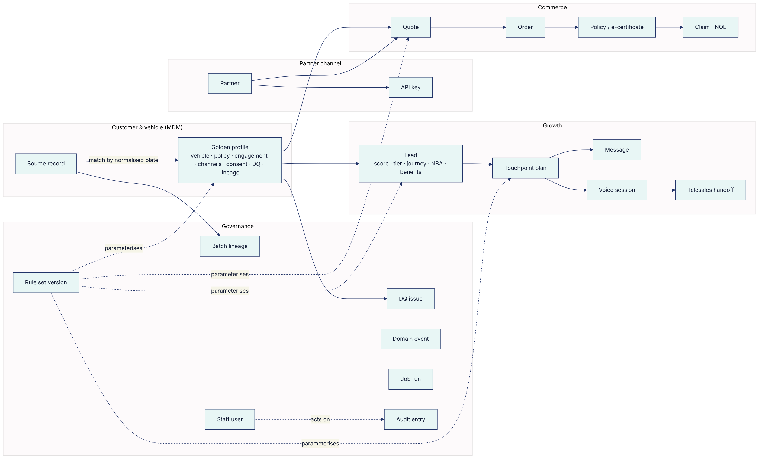

3. Logical ERD
Relationships are logical. They are enforced in the services and checked by reconciliation; there are no database foreign keys (ADR-004).
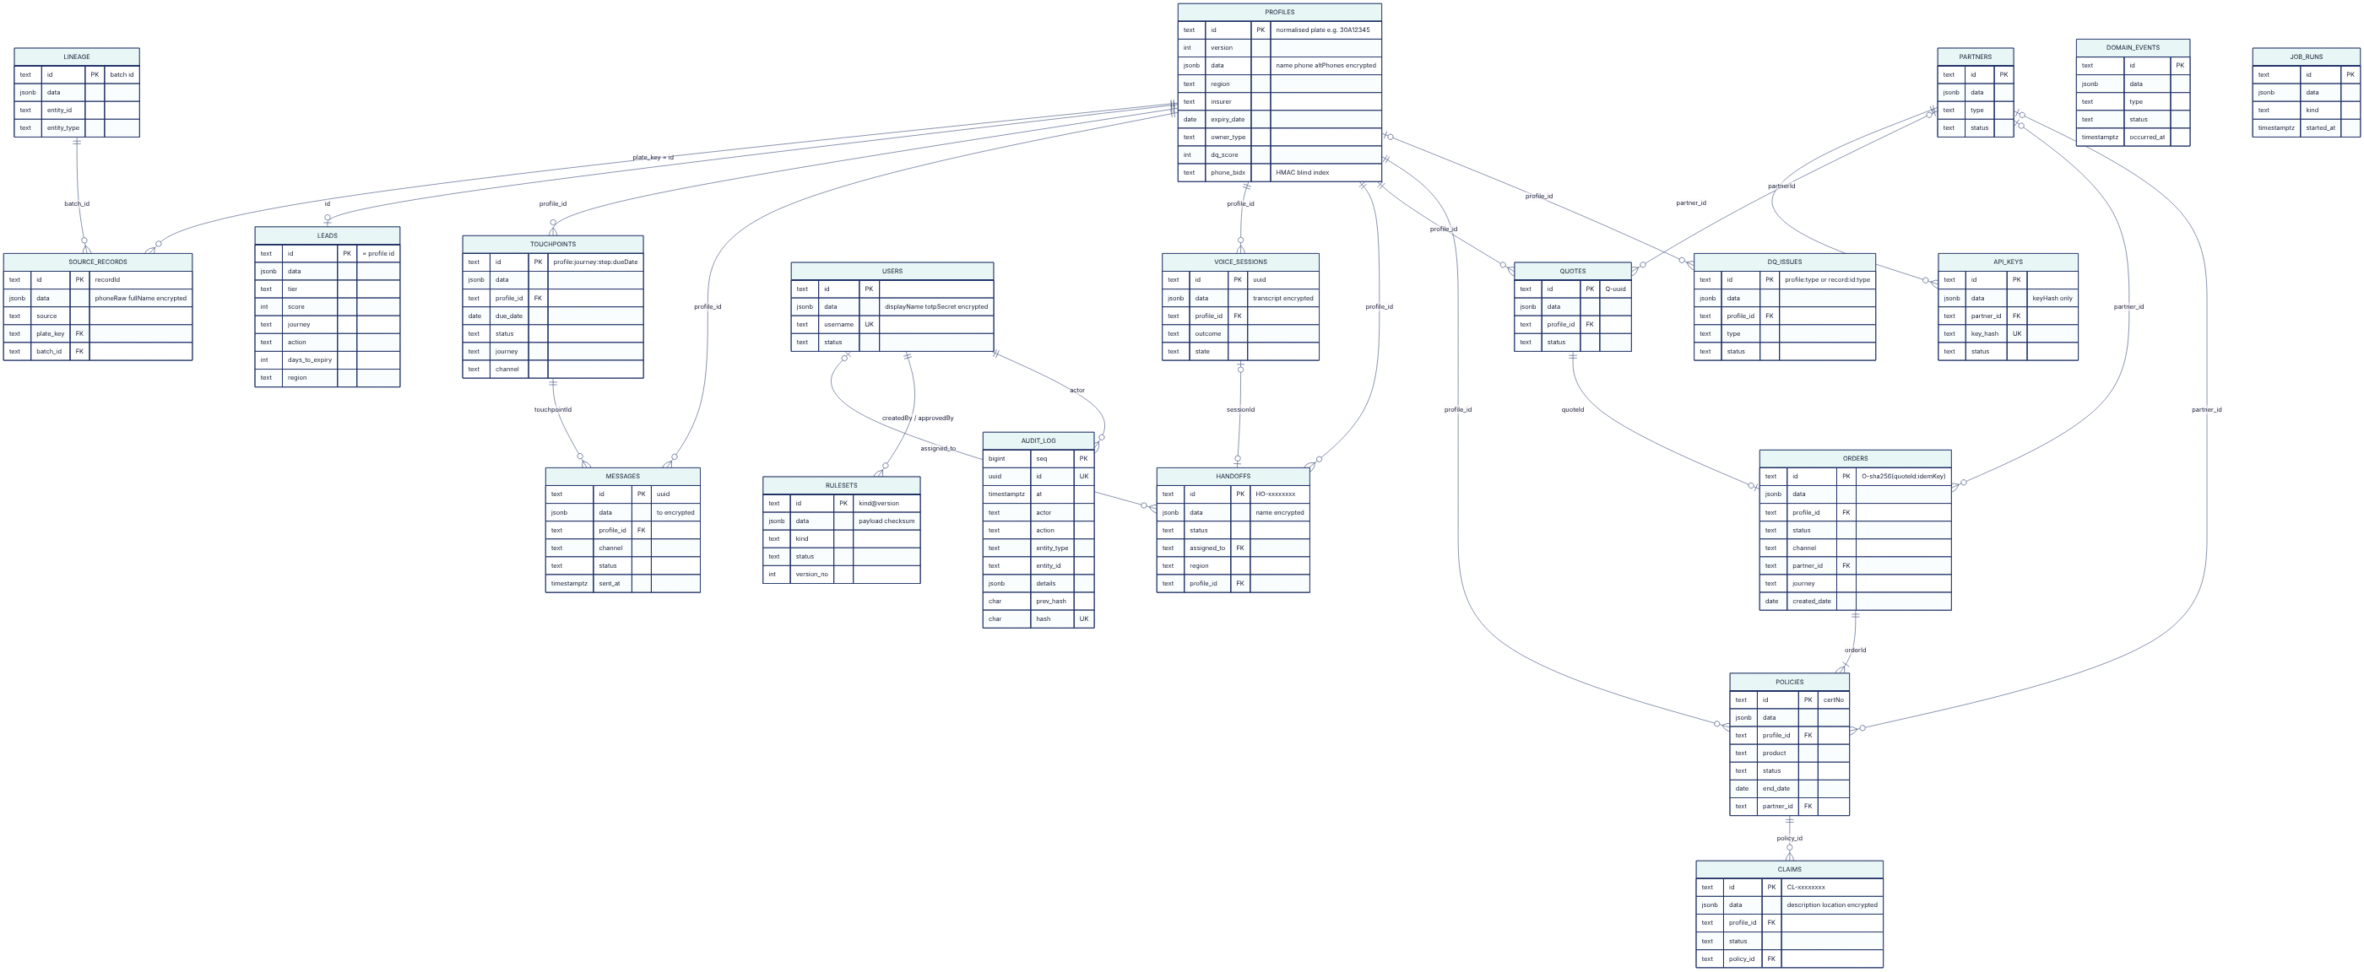

4. Data classification
Class | Examples | Controls
Restricted — personal | Customer name and phone; call transcript; claim description and location; staff TOTP secret | AES-256-GCM field encryption; masked unless profile:read_pii; redacted in logs; DSAR scope
Confidential — personal-linked | Licence plate (match key), policy expiry and insurer, engagement metrics, wallet balance, consent flags, IP addresses in audit | Clear in DB (needed for matching and filtering); access by RBAC/ABAC; pseudonymised in analytics (plate status: confirm with TASCO legal / DPO, see ADR-006)
Confidential — business | Quotes, orders, commission, rule sets (tariffs, scoring), partner data | RBAC; audit
Internal | Metrics, job runs, DQ issue counts | Staff access
Public | Certificate validity with a masked plate (/api/public/certificates/:certNo) | Rate-limited; no PII

5. Data dictionary
Legend: Idx = extracted indexed column (filterable); PII = personal data; Enc = encrypted at rest by the codec. "Doc" fields live only in data jsonb. "Source" says which code writes the field.

5.1 profiles — golden record (1 per vehicle)
Field | Column / type | Idx | PII | Enc | Description | Source
id | id text | PK | Linked | — | Normalised plate key, e.g. 30A12345 (normalizePlate) | enrichment.buildProfiles
plate | doc | — | Linked | — | Display plate 30A-123.45 | same
province | region text | ● | — | — | Province from plate prefix (PROVINCES) | same
name | doc | — | ● | ● | Survivor name (highest source trust) | same
phone | doc + phone_bidx | ● (bidx) | ● | ● | Survivor valid VN mobile 0XXXXXXXXX; blind index for equality lookup | same
altPhones[] | doc | — | ● | ● | Other valid phones (conflict → DQ conflicting_phone) | same
sources[], recordIds[] | doc | — | — | — | Contributing sources and source record ids | same
ownerType | owner_type text | ● | — | — | individual / company | VETC account
tagActivatedAt | doc | — | — | — | ETC tag activation date (new-vehicle signal) | VETC account
vehicle.{tollClass, seats, usage, category, categoryConfidence, categoryBasis, firstRegisteredYear} | doc | — | — | — | Vehicle facts; category from enrichment.categoryTable | MDM
policy.expiryDate | expiry_date date | ● | Linked | — | Best expiry estimate | MDM / customer / steward / bot / TASCO issue
policy.{expiryMethod, expiryConfidence, expiryCandidates[], certNo, verified} | doc | — | — | — | Evidence and confidence | same
policy.insurer | insurer text | ● | — | — | Current insurer (TASCO, other, OTHER, null) | same
policy.competitorNote | doc | — | ● (free text) | — (gap) | Customer's own words about the competitor policy (voice bot); cleared on erasure | voiceService.finalize
engagement.* | doc | — | Linked | — | App sessions, toll trips, long trips, wallet balance, auto top-up, prior purchase, complaints | VETC account
channels.{app_push, zalo_zns, sms, voice_bot, telesales} | doc | — | — | — | Reachability | MDM
consent.{marketing, call, dnc} | doc | — | ● | — | Consent state | VETC + platform overrides
consentOverrides | doc | — | ● | — | Platform-captured consent that survives rebuilds | customer / bot opt-out
dataQuality.score | dq_score int | ● | — | — | 0–100 (§7) | MDM
dataQuality.missing[] | doc | — | — | — | Open DQ facets | MDM
lineage[] | doc | — | — | — | {field, source, confidence, rule?, at?} | MDM + updates
partnerId | doc | — | — | — | Partner that supplied a record | MDM
anonymised, anonymisedAt | doc | — | — | — | Erasure markers (rebuild skips anonymised profiles) | customerService.erase

5.2 source_records — landed raw records
Field | Column | Idx | PII | Enc | Description
id = recordId | PK | ● | — | — | Source-unique record id
source | source | ● | — | — | vetc_account, partner_<type>, telesales_csv, …
plateRaw / plateKey | doc / plate_key | ● | Linked | — | Raw and normalised plate (null if invalid)
phoneRaw, fullName | doc | — | ● | ● | Raw contact data
batchId | batch_id | ● | — | — | Ingestion batch (B-<date>-<rand>)
tollClass, seatsDeclared, usageDeclared, ownerType, tagActivatedAt, firstRegisteredYear, policy{insurer, certNo, expiryDate, verified}, lastInspectionDate, declaredExpiry, partnerId | doc | — | Linked | — | Source attributes
VETC account attributes (appUser, appSessions30d, tollTrips30d, longTripsKm90d, walletBalance, autoTopUp, pushEnabled, zaloLinked, marketingConsent, callConsent, dnc, complaints12m, priorVetcInsurancePurchase) | doc | — | Linked / consent | — | Engagement, channel and consent. Accepted by POST /api/data/ingest (key allow-list; value types not yet checked) and by the bulk/CDC path
_hidden | doc | — | — | — | Synthetic data only (ground truth for model evaluation). Must never exist in production feeds. Stripped from DSAR export.
ingestedAt, anonymised | doc | — | — | — | Landing time; erasure marker

5.3 leads
Field | Column | Idx | Description
id = profileId | PK | ● | One lead per profile
tier | tier | ● | hot ≥ 70, warm ≥ 45, else nurture (scoring.tiers)
score | score | ● | 0–100, damped by expiry confidence; 0 when DNC
journey, objective | journey | ● | First matching journey (journeys.priority)
nextBestAction.{action,label,reason,ruleId,…} | action | ● | NBA decision-table output
daysToExpiry | days_to_expiry | ● | Negative = lapsed
region | region | ● | Province
reasons[] | doc | — | Per-factor {factor, label, points, max, why} (explainability)
benefits[], premium, plate, evaluatedAt | doc | — | Top benefits, TNDS premium incl. VAT, business date

5.4 Engagement collections
Collection | Key fields (Idx in bold) | PII / Enc | Notes
touchpoints | id (profile:journey:step:dueDate), profile_id, due_date, status, journey, channel, step, channels[], marketing, template, result, executedAt | — | Deterministic id gives idempotent planning. Status scheduled → done/skipped/cancelled. A touchpoint blocked only by the contact window stays scheduled (deferred), with lastAttemptAt and lastResult.
messages | id uuid, profile_id, channel, status, sent_at, templateKey, journey, step, touchpointId, marketing, text, blockReason, providerMessageId, error, sessionId | to ● Enc. text contains the plate and a renewal link (Linked, clear). | Status sent/failed/blocked. Contact history for caps.
voice_sessions | id uuid, profile_id (customerId), outcome, state, mode, verified, plateAttempts, clarifications, signals{priceAsked, trustConcern, expiryConfirmed, competitorInfo, expiryStatement}, ctx{plateKey, plateMasked, expiry, …}, persona, handoffId, startedAt, endedAt | transcript ● Enc. signals.competitorInfo and signals.expiryStatement are free-text customer speech stored in clear (gap); cleared on erasure. | Retention 180 d
handoffs | id, status, assigned_to, region, profile_id, sessionId, plate, plateVerifiedByCustomer, phoneMasked, journey, expiryDate, daysToExpiry, premium, score, outcome, priceAsked, trustConcern, talkingPoints[], notes[], createdAt | name ● Enc; phone masked | Minimal data for telesales (handoffSummary)

5.5 Commerce collections
Collection | Key fields (Idx in bold) | PII / Enc | Notes
quotes | id Q-uuid, profile_id, status, plate, channel, partnerId, journey, lines[{product, startDate, endDate, termDays, premiumNet, vat, total, priceRegulated, breakdown}], total, benefits, bundle, createdBy, expiresAt, inspection{passed, evidence, by, at}, sentToCustomerAt, sentBy, payingOrderId, orderId | Linked (plate) | TTL quoteTtlHours (24 h, service_levels). Status open → paying → converted; paying returns to open if payment or issuance fails.
orders | id O-…, profile_id, status, channel, partner_id, journey, created_date, quoteId, amount, paymentRef, policies[], commission[{product, rate, amount, ruleId, capped}], refund{status, refundId}, cancelFailures[], createdBy, completedAt, error | — | pending_payment → completed, or payment_failed, issuance_failed_refunded or compensation_failed. Partner orders have paymentRef PARTNER-… (partner-collected).
policies | id = certNo, profile_id, product, status, end_date, partner_id, policyNo, plate, startDate, premiumNet, vat, total, channel, orderId, certificateUrl, issuedAt, insurer | Linked (plate) | Financial and legal record (10-year archive)
claims | id CL-…, profile_id, status, policy_id, product, incidentDate, photos, history[], slaDueAt | description, location ● Enc | FNOL front door; slaDueAt from claimAckSlaHours (4 h). Adjudication happens in TASCO core.

5.6 Partner, identity and governance collections
Collection | Key fields (Idx in bold) | PII / Enc | Notes
partners | id, type, status, name, region, createdAt | — | Types: bank, showroom, agent, fleet, inspection_center
api_keys | id, partner_id, key_hash (unique), status, prefix, scopes[], createdBy, revokedAt | — (SHA-256 only) | Plaintext key returned once
users | id, username (unique), status, roles[], region, passwordHash (scrypt), failedLogins, lockedUntil, mfaEnrolled, lastTotpStep, tokensValidAfter, mustChangePassword, lastLoginAt, createdBy, passwordChangedAt | displayName, totpSecret ● Enc | Staff only. lastTotpStep blocks TOTP replay; tokensValidAfter revokes earlier tokens; mustChangePassword is set for admin-created users.
rulesets | id kind@N, kind, status, version_no, payload, checksum, description, createdBy, submittedAt, approvedBy, approvalComment, activatedAt, retiredAt, supersededBy, rejectedBy, rejectionComment | — | Maker-checker history. Unique partial index: one active version per kind (migration 002).
domain_events | id, type, status, occurred_at, payload, actor, correlationId, attempts, handled[], lastError, processedAt | Payload carries profile ids (plates) | Outbox; index on (status, occurred_at) (migration 002)
dq_issues | id, profile_id, type, status, recordId, source, batchId, detectedAt, via, resolution, resolvedBy, resolvedAt | — | §7
lineage | id = batchId, entity_id, entity_type, source, records, rejected, at | — | Batch lineage
job_runs | id, kind, started_at, actor, status, result, error, finishedAt | — | Job history
audit_log | seq, id, at, actor, action, entity_type, entity_id, details, prev_hash, hash | details hold ids, reasons and IP addresses (personal data of staff/customers) | Append-only, hash-chained

6. Master data management (golden record)
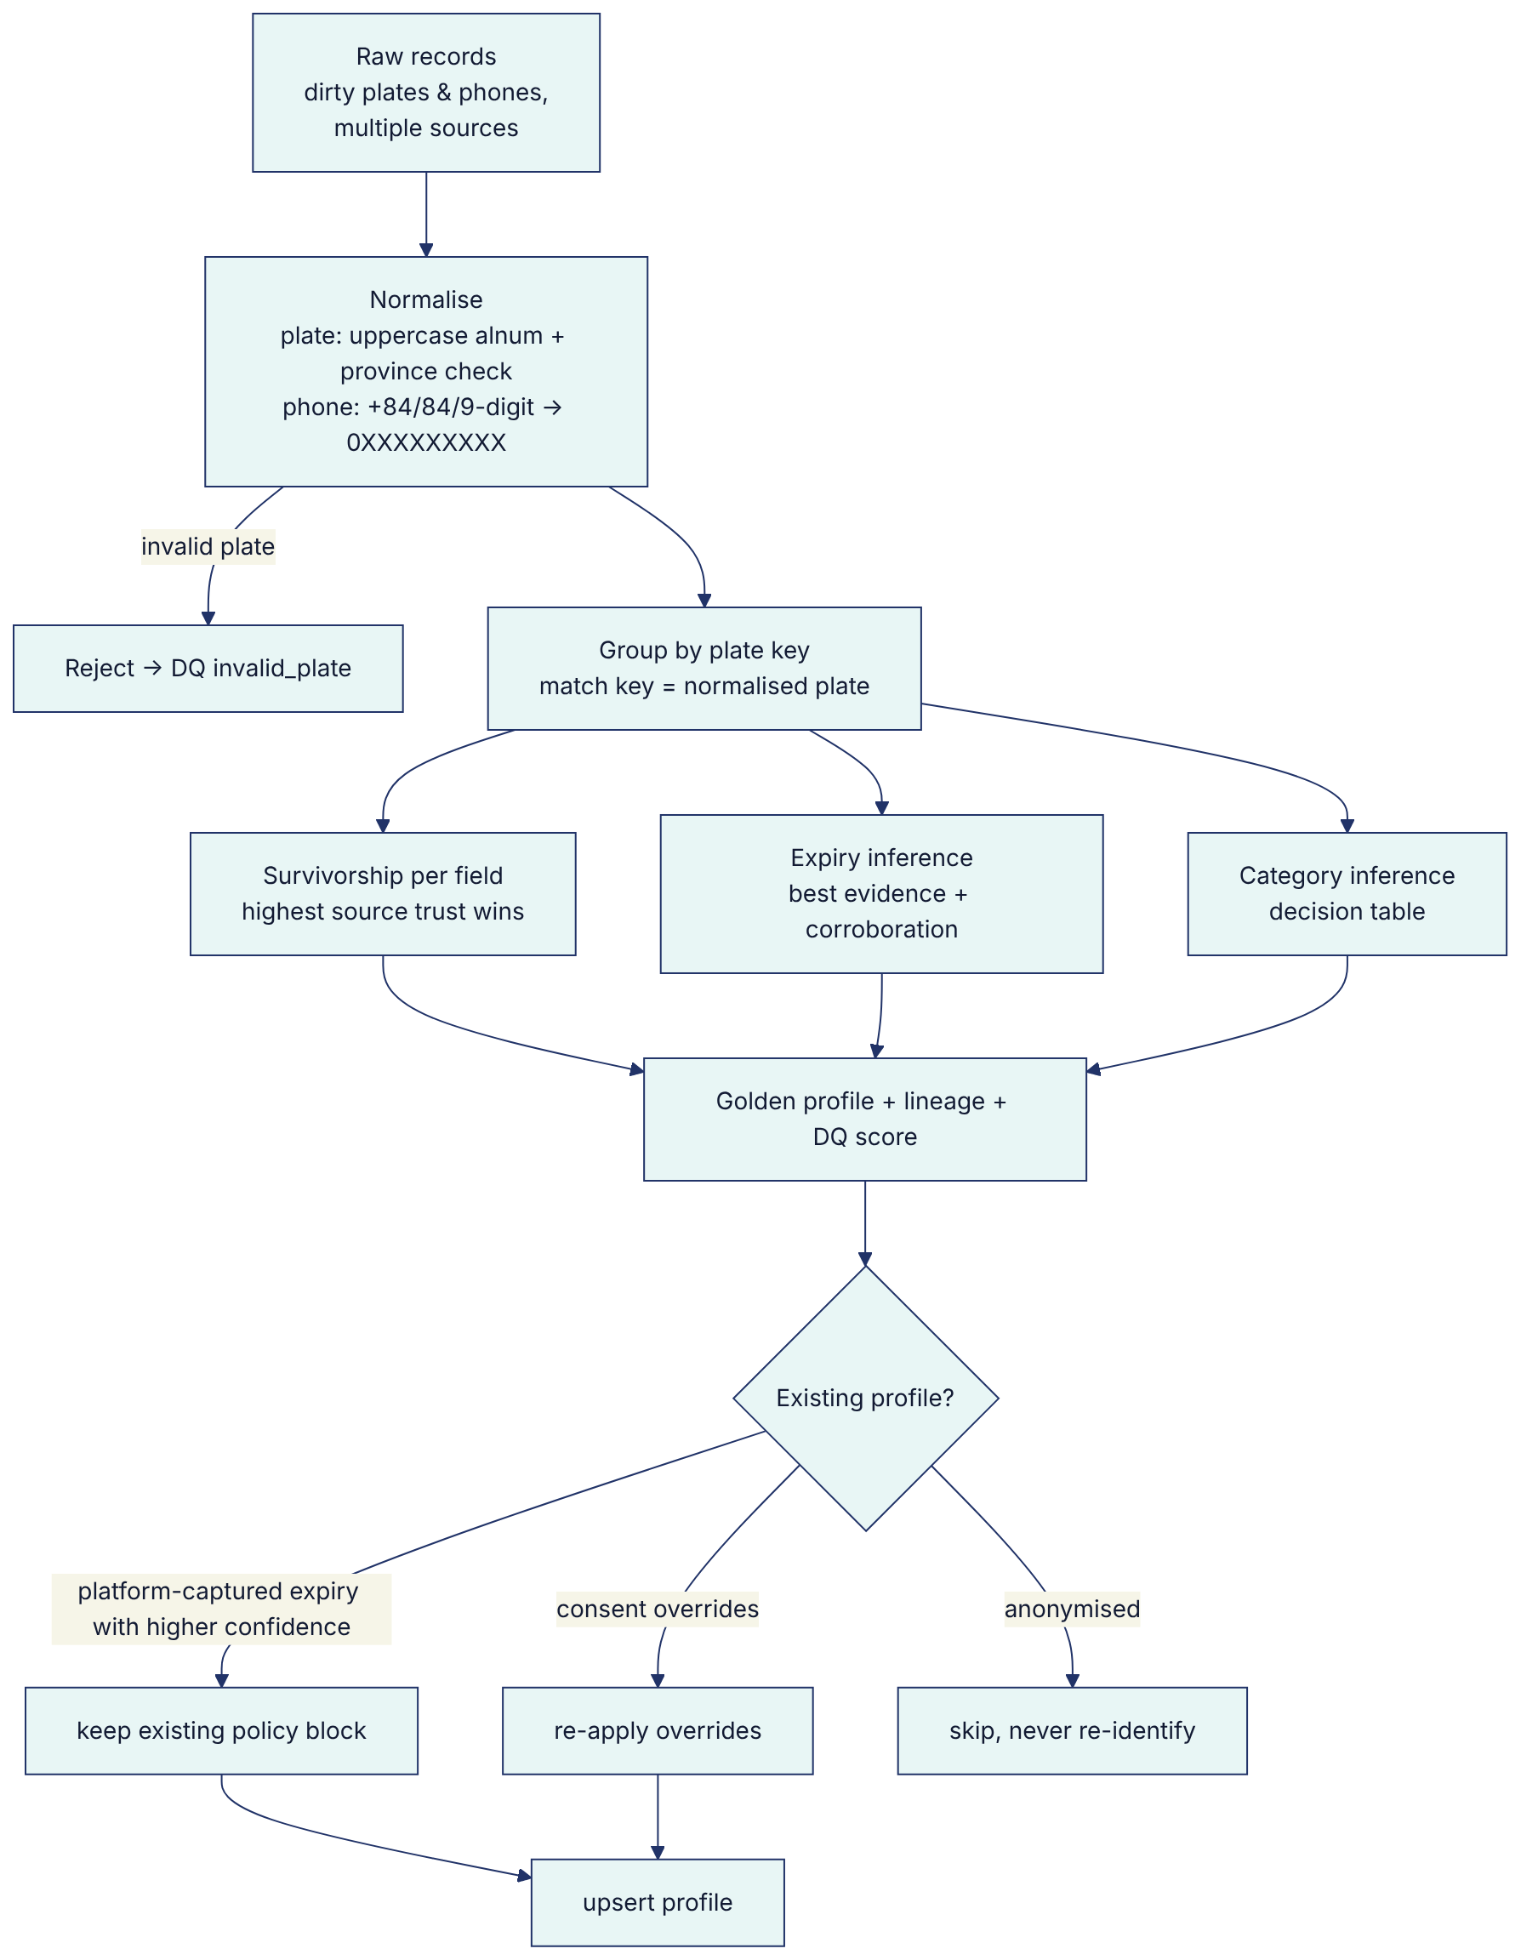
Match key. normalizePlate() (src/domain/identity.js) produces ^\d{2}[A-Z]{1,2}\d{4,5}$ with a valid province code. It handles forms such as 30a-123.45, 30A 12345, 30A.123.45 and the legacy 4-digit form. Exact match on the key only; there is no fuzzy matching. That is deliberate, because a plate is a legal identifier. Wrong-person and plate-mismatch outcomes from calls feed DQ.
Survivorship (enrichment.sourceTrust):
Source | Trust
tasco_core | 1.00
vetc_app_purchase | 0.95
vetc_account | 0.85
customer_declared | 0.75
partner_inspection_center | 0.65
partner_bank, showroom, fleet | 0.60
partner_agent | 0.50
telesales_csv, default | 0.40

Attribute | Rule
phone | Valid normalised phones sorted by trust. The first is the survivor; the rest go to altPhones. More than one distinct phone raises a DQ issue.
name, seats, usage, tollClass | Highest-trust non-empty value
ownerType, tag, engagement, channels, consent | From the vetc_account record (system of record for the account)
vehicle.category | categoryTable (first hit) over seats, toll class and commercial flag, with confidence and basis
policy.expiryDate | Evidence ranking (below)
policy.insurer | First record carrying an insurer, else the insurer from the best expiry evidence
Expiry evidence (enrichment.expiryEvidence, inferExpiry):
Method | Confidence
verified_certificate | 1.0
customer_declared | 0.75
partner_policy_record | 0.7 × trust / 0.6 (capped at 0.7)
inspection_cycle | 0.5 (last inspection + 365 d, rolled forward to ≥ today − 60 d)
tag_anniversary | 0.25
- Corroboration: each different method agreeing within 21 days adds 0.15, up to 0.95.
- Usable means confidence ≥ 0.5.
Facts captured on the platform are applied by applyDeclaredExpiry. Their confidences are governed in the rule kind service_levels (maker-checker), except TASCO issuance:
Platform source | Confidence | Where defined
customer (app) | 0.75 | service_levels.customerDeclaredConfidence
data steward | 0.9 | service_levels.stewardCorrectionConfidence
voice bot (renewed elsewhere) | 0.6 | service_levels.botRenewedElsewhereConfidence
TASCO issuance | 1.0 | salesService (verified certificate)
Rebuild protection. On rebuild, an existing policy block is kept when its method is customer_declared, voice_bot, tasco_issued or data_steward and it has higher confidence (ingestionService.rebuild). A steward correction therefore survives the next rebuild from source data.

7. Data quality
Score (per profile, 0–100):
completeness = 1 − (#missing of {phone, name, reliable_expiry, vehicle_category, current_insurer}) / 5
score = round(100 × (0.5·completeness + 0.35·expiryConfidence + 0.15·categoryConfidence)) // weights: enrichment.dataQuality
DQ dimension | Measure | Issue type(s) | Raised by
Validity | Plate and phone format, province | invalid_plate (record-level) | ingestionService.ingest
Completeness | Mandatory facets present | phone, name, current_insurer | buildProfiles
Accuracy / reliability | Expiry confidence ≥ 0.5; category confidence ≥ 0.6 | reliable_expiry, vehicle_category | buildProfiles
Consistency | One phone per vehicle | conflicting_phone | buildProfiles
Accuracy (field-verified) | Customer contradicts the data | wrong_person, plate_mismatch | voiceService.finalize
Uniqueness | Duplicates merged per plate | stats duplicatesMerged | buildProfiles
Timeliness | Freshness of the source feed | (planned: stale_source) | Feed monitoring
Workflow:
- Issues are listed at GET /api/dq/issues (dq:read).
- A data steward resolves them via POST /api/dq/issues/:id/resolve (dq:resolve), or corrects the expiry with PATCH /api/customers/:id/expiry (evidence required, audited).
- Customers fix their own data (POST /api/customer/expiry), and calls fix it too.
- A resolved issue reopens if the next rebuild detects it again.
KPIs (/api/dashboard/overview): open issues by type, and profiles with usable data. profilesWithUsableData = profiles minus open reliable_expiry issues, which matches the MDM definition (expiry confidence ≥ 0.5).

8. Metadata, lineage and reconciliation
Technical metadata.
- schema.js (collections, indexed columns, PII and blind-index fields) is machine-readable.
- Target: export it to the data catalogue (e.g. OpenMetadata/DataHub) with classification tags from §4.
- OpenAPI (/api/openapi.json) documents interface metadata.
Business metadata.
- Each rule set version carries kind, description, checksum, createdBy, approvedBy, activatedAt.
- The descriptions in config/rules/*.json act as a business glossary seed.
Lineage, at four levels:
Level | Where | API
Batch | lineage collection {batchId, source, records, rejected, at}; source_records.batchId | GET /api/customers/:id/lineage (recentBatches)
Record → profile | profiles.recordIds[], sources[] | same
Field | profiles.lineage[] {field, source, confidence, rule, at} | same
Decision | leads.reasons[] (factor, points, why), nextBestAction.ruleId, quote.lines[].breakdown[].rateRule, order.commission[].ruleId | GET /api/customers/:id, /api/leads
Gap: leads and quotes do not record which rule-set versions (kind@N or checksum) produced them. Add a rulesSnapshot (rulesService.snapshot() already returns {kind, version, checksum}) to leads, quotes and orders, so any decision can be reproduced for regulators.
Reconciliation:
Check | Implemented
Ingestion: records = landed + rejected; profiles = distinct valid plates (returned per batch) | ●
Orders (opsService.reconcile): completed ⇒ payment ref present and each policy exists; pending_payment > 1 h, payment_failed (confirm no capture) and compensation_failed flagged | ●
Wallet settlement ↔ orders; TASCO core policy register ↔ policies; partner commission ↔ finance | Planned
Event backlog / dead letters (/api/ops/status) | ● (manual)
Audit chain integrity (/api/audit/verify) | ●

9. Retention, archival, erasure and backup
Retention policy (config/rules/retention.json, rule kind retention, maker-checker; periods to be confirmed with TASCO legal):
Entity | Retain | Action | Implemented by opsService.applyRetention
source_records | 365 d | delete | ● deleteWhere(created_at < cutoff) — see note 1
profiles | 1,825 d (5 y) | anonymise when no active policy and no activity | Planned (archival pipeline)
voice_sessions | 180 d | delete (recordings + transcripts) | ●
messages | 365 d | archive | Planned
orders | 3,650 d | archive (financial records) | Planned
certificates (policies) | 3,650 d | archive | Planned
audit_log | 3,650 d | archive, never deleted early | Planned (WORM)
Notes:
- created_at is preserved on upsert, so source-record age counts from first landing, not from the last refresh. A record refreshed daily by CDC is still deleted after 365 days, after which the profile rebuild loses that source. Use updated_at, or keep the latest version per source.
- The policy description says "legal hold overrides deletion", but no legal-hold flag exists in code. Add legalHold on profiles, claims and orders, and skip held entities.
- domain_events, touchpoints, dq_issues and job_runs have no retention rule. Add 30 d (done events), 90 d (executed touchpoints), 365 d (resolved DQ) and 365 d (job runs).
Erasure (customerService.erase, POST /api/dsar/:id/erase, dsar:manage):
- Refused while an active policy exists (legal retention).
- Otherwise it:
  - nulls the profile's name, phone and competitorNote, and sets anonymised, DNC and no consent;
  - deletes the lead;
  - nulls PII in up to 100 source records;
  - erases message to and text;
  - empties voice transcripts and clears the free-text signals (competitorInfo, expiryStatement);
  - clears handoff name, masked phone and notes;
  - replaces claim description and location;
  - writes an audit entry.
- Erased data subjects lose their customer sessions, and their renewal links stop working.
- Export (exportData, POST /api/dsar/:id/export, GET /api/customer/data-export) includes the profile, lead, policies, messages, source records, voice sessions, quotes, orders, claims and telesales tasks (handoffs), with synthetic _hidden fields stripped.
- Open points:
  - claim records follow claims retention (confirm with TASCO legal);
  - VETC must also be notified (suppression list), otherwise the next feed re-lands contact data in source_records. The profile stays anonymised because the rebuild skips anonymised profiles.
Backup. Managed PITR (14 d) plus monthly snapshots (12 months), encrypted with KMS, in the same jurisdiction (Deployment and Infrastructure Architecture, section 6). Field-encrypted PII stays encrypted in backups, so data keys must be retained for as long as backups that need them. A key may only be destroyed after the re-key job has run and the backups have aged out. Erasure in backups follows "beyond use" handling: restored backups re-apply erasures from the audit log (dsar.erased entries) before use.

10. Migration strategy
Schema migrations.
- Numbered SQL files in db/migrations/NNN_description.sql (today 001_init.sql and 002_integrity_hardening.sql), applied in order and recorded in schema_migrations, each in its own transaction, under a PostgreSQL advisory lock so concurrent runners cannot race (postgresStore.migrate).
- Never edit an applied file.
- The registry (schema.js) and the DDL are kept in step by the schema test.
- Expand/contract for zero-downtime releases (Deployment and Infrastructure Architecture, section 10).
- Run them from the single migration Job in Kubernetes (MIGRATE_ON_START=false on replicas) or the Railway pre-deploy command.
- Document shape changes inside data need no DDL. Readers must tolerate missing fields; prefer additive changes. For breaking changes, use a backfill job with update() and keyset paging.
Legacy data migration:
Source | Approach | Trust / evidence
VETC account base (6 M) | Bulk file load → staging → parallel rebuild (Integration Architecture, section 6) | vetc_account 0.85
TASCO core in-force and expired TNDS policies | Extract the policy register (plate, cert no, period, holder) as source tasco_core with policy.verified = true. This makes renewal journeys (insurer = TASCO) accurate from day one. | tasco_core 1.0, verified certificate
VETC app past insurance purchases | Source vetc_app_purchase | 0.95
Partner and telesales lists | Only with a documented lawful basis (confirm with TASCO legal); sources partner_<type> / telesales_csv | 0.4–0.65
Consent and DNC registers | Loaded before any journey is enabled; consent overrides take precedence | —
Migration steps:
- Profile the source data.
- Agree the mapping with data owners.
- Run trial loads in SIT with masked data.
- Reconcile counts and samples with the business.
- Dress-rehearse in perf.
- Production load in a freeze window.
- Run the post-load DQ report.
- Enable journeys progressively by region.

11. Analytics and BI feed
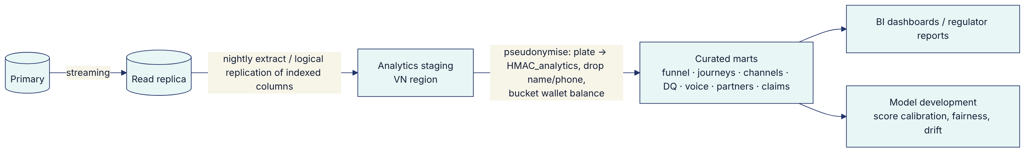
Rules:
- No decrypted PII leaves the platform for analytics.
- The analytics pseudonym uses its own key, never BLIND_INDEX_KEY.
- Join keys are stable pseudonyms.
- Small-cell suppression (n < 10) applies in reports shared outside the data office.
- Event-level facts (messages, touchpoints, voice_sessions outcomes, orders) feed attribution (journey → order via orders.journey).
The in-product dashboards (insightsService.overview/adoption/governance) cover operational KPIs. Heavy analysis belongs in the marts.

