Deployment and Infrastructure Architecture
TASCO Insurance × VETC Growth Platform — Architecture
iorta TechNXT
Version 1.0 · 07 October 2026
Table of Contents

Document | Version | Date | Owner | Status
Deployment and Infrastructure Architecture | 1.0 | 07 October 2026 | iorta TechNXT Architecture | Issued for submission
The deployment assets are Dockerfile, docker-compose.yml, deploy/k8s/, railway.json and .github/workflows/ci.yml. This document is the design those assets implement. If a value here differs from a manifest, the manifest is authoritative for what is deployed, and this document states the intent. Raise a change to bring them back in line. Decision record: ADR-012.

1. Principles
- One immutable artefact. The same signed image (digest-pinned) is promoted from SIT to perf, prod and DR. Only configuration differs. The hosted UAT on Railway builds the same Dockerfile from the same commit.
- Twelve-factor.
  - Configuration comes from the environment, and secrets from mounted files (*_FILE, src/shared/config.js).
  - Logs go to stdout as JSON.
  - Processes are stateless; state lives in Postgres.
  - API and jobs share one image with different commands (node src/server.js, node src/jobs/cli.js <job>).
- Least privilege everywhere.
  - Containers run as the image's non-root node user (uid 1000) with a read-only root filesystem, all Linux capabilities dropped and the RuntimeDefault seccomp profile.
  - Network policy is default-deny.
  - The DB uses separate owner and app roles.
- Fail safe.
  - Production refuses to boot without JWT_SECRET, BLIND_INDEX_KEY, DATA_KEYS or DATABASE_URL (no in-memory store in production), or with DEMO_MODE on (loadConfig).
  - Readiness stays false until the server listens and the DB answers.
  - SIGTERM handling drops readiness first, then drains, then exits within 25 s (src/server.js).
- Data residency. Production personal data is stored and processed in Vietnam (confirm with TASCO legal: Cybersecurity Law 2018 and Decree 53/2022/ND-CP; Decree 13/2023/ND-CP and the Law on Personal Data Protection 2025 on cross-border transfer).

2. Environments
Env | Purpose | Hosting | Data | NODE_ENV / DEMO_MODE | Integrations | Promotion gate
dev | Developer laptop | docker compose up, or npm run dev (in-memory store) | Synthetic (SEED_RECORDS, SEED) | development / true (set by the scripts) | Sandbox adapters | —
CI | Pipeline tests | GitHub Actions + PostgreSQL service container | Synthetic | test / per test | Sandbox | All checks green
UAT (live) | Business acceptance, training | Railway, https://tasco-growth-api-uat.up.railway.app, with Railway PostgreSQL | Synthetic only | uat / true (UAT demo sign-in) | Sandbox adapters | Manual approval (product owner)
SIT | System integration with VETC/TASCO test systems | K8s namespace tasco-growth-sit | Synthetic + provider test accounts | production / false | Real adapters → provider sandboxes | Automatic on merge to main
perf | Load, soak and resilience tests at 6 M scale | Dedicated namespace sized like prod | Synthetic 6 M (bulk loader) | production / false | Sandbox gateways with latency/fault injection | Perf report signed off
prod | Live | K8s cluster in a Vietnam region, 3 AZs | Real personal data | production / false | Production providers | CAB approval + change window
DR | Warm standby | Second VN region / DC | Replica of prod | production / false | Production providers (failover config) | DR drill twice a year

Demo mode. DEMO_MODE is opt-in and defaults to false; production refuses it unless ALLOW_DEMO_IN_PRODUCTION is set. When on, it enables the demo sign-in helpers (/api/demo/totp/:username, the "Sign in with demo code (UAT)" button on the MFA screen, the demoProfileId customer login), simulated dates (date, at) and the seed job. The hosted UAT runs with NODE_ENV=uat and DEMO_MODE=true, plus the UAT-only settings DEMO_PASSWORD, DEMO_TOTP_SEED and DEMO_ACCOUNT_SYNC; its password is distributed in the access workbook and never written in documents. SIT, perf, prod and DR must run with NODE_ENV=production and DEMO_MODE=false; the Kubernetes ConfigMap sets both. Once provider UAT systems are available, UAT can move to a tasco-growth-uat Kubernetes namespace with real adapters.

3. Kubernetes topology
The production topology runs in one namespace per environment behind a CDN/WAF and an ingress controller.
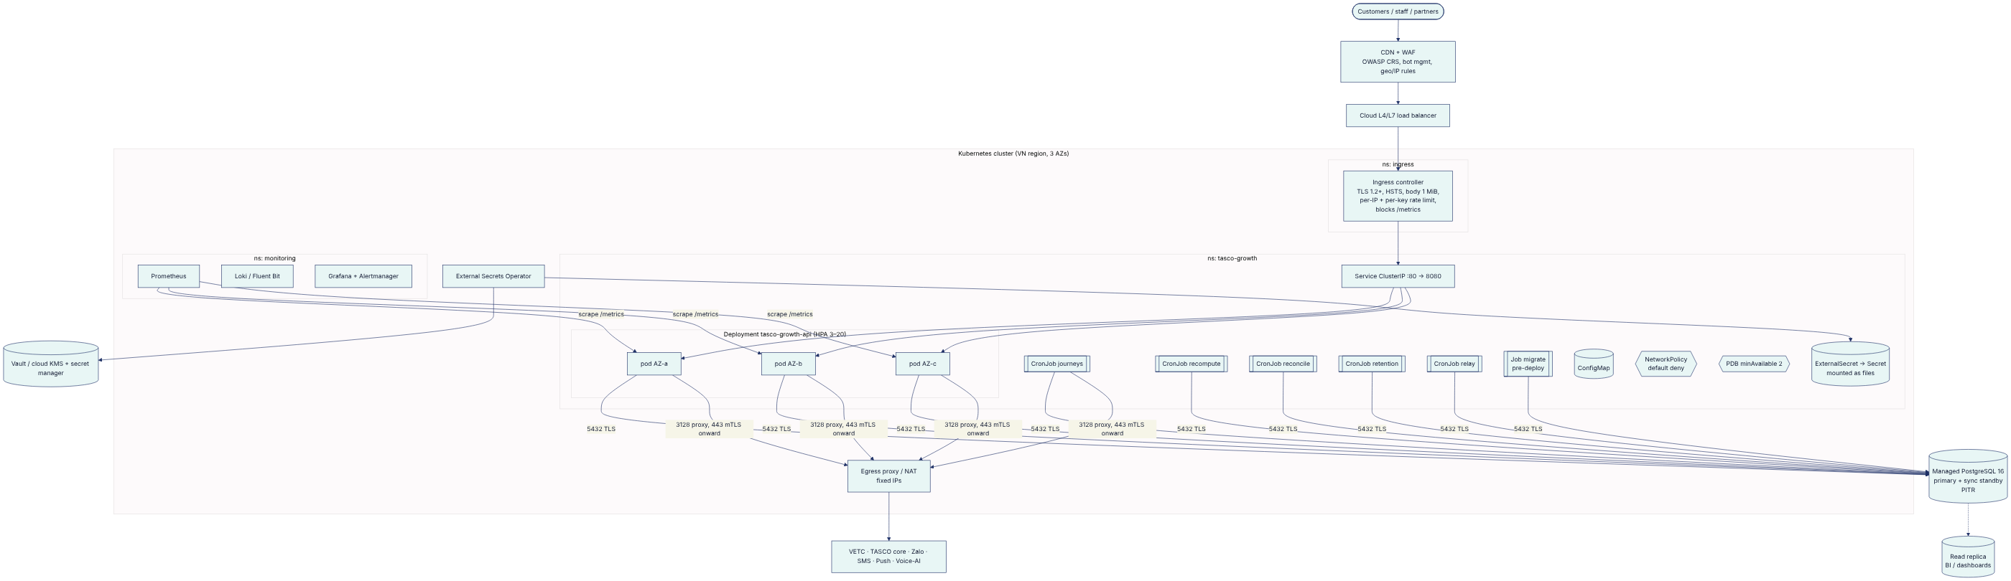

3.1 Workload specification
Values below are those in deploy/k8s/ (the manifests are authoritative).
Item | API Deployment | CronJob pods | Migration Job
Image | REGISTRY/tasco-growth-platform (pinned by digest in CD) | Same | Same
Command | node src/server.js | node src/jobs/cli.js <job> | node src/jobs/cli.js migrate (Argo CD PreSync hook)
Replicas | 3; HPA min 3, max 20; CPU target 65 %, memory 75 %; scale-down stabilisation 300 s | 1 per run | 1
Requests / limits | 250m CPU / 256 Mi → limit 1 CPU / 512 Mi | 100m / 128 Mi → 1 CPU / 768 Mi | 100m / 128 Mi → 1 CPU / 768 Mi
Node heap | NODE_OPTIONS=--max-old-space-size=384 in the image (75 % of the 512 Mi limit) | Same | Same
Probes | Liveness GET /health/live (period 10 s, failure 3); readiness GET /health/ready (period 5 s, includes a DB ping); startup probe up to 60 s | — | —
Security context | runAsNonRoot, runAsUser 1000 (the image's node user), readOnlyRootFilesystem, no privilege escalation, capabilities.drop: [ALL], RuntimeDefault seccomp, no token automount | Same | Same
Writable paths | emptyDir at /tmp only (64 Mi) | — | —
Spread | topologySpreadConstraints across zones | — | —
Termination | terminationGracePeriodSeconds: 30 (the app force-exits at 25 s) | backoffLimit: 1 | backoffLimit: 2
Environment | PORT=8080, MIGRATE_ON_START=false, TRUST_PROXY=true, TRUST_PROXY_HOPS=1, DATABASE_SSL=true, DEMO_MODE=false | Same ConfigMap | Same ConfigMap
The image has no init process (no tini). The server handles SIGTERM and SIGINT itself (graceful drain). Where zombie reaping is needed outside Kubernetes, run the container with docker run --init.

3.2 CronJobs
Job | Schedule (cron in UTC; ICT = UTC+7) | What it does (src/jobs/cli.js) | Notes
journeys | 15 1 * * * (08:15 ICT, inside the 08:00–20:00 contact window) | journeyService.runDue, then events.drain(). Pages through all due touchpoints; those blocked only by the contact window are deferred. | Add hourly runs within the window if volumes require it (runDue does not lock touchpoints, so runs must not overlap)
recompute | 30 17 * * * (00:30 ICT) | Nightly full re-score so time-dependent facts (days) advance | At 6 M, shard (see section 12)
reconcile | 0 19 * * * (02:00 ICT) | opsService.reconcile: completed orders ↔ payment ref ↔ policies; pending_payment > 1 h; payment_failed; compensation_failed | Alert if mismatches > 0
retention | 0 20 * * * (03:00 ICT) | opsService.applyRetention (deletes source_records > 365 d and voice_sessions > 180 d; other entities flagged for the archival pipeline) | —
relay | */5 * * * * | events.drain(), a safety net in addition to the 1 s in-process relay | —
All CronJobs use concurrencyPolicy: Forbid, timeZone: Etc/UTC and backoffLimit: 1. Short-lived job pods are not scraped by Prometheus. Job outcomes are recorded in job_runs (GET /api/ops/jobs) and in the JSON logs (job finished). Alert on the Kubernetes kube_job_status_failed metric.

3.3 PDB and disruption
PodDisruptionBudget minAvailable: 2 for the API, so node drains and upgrades never take the service below 2 pods. Combined with readiness gating and graceful shutdown, rolling node upgrades cause no downtime.

4. Network zones and Zero Trust
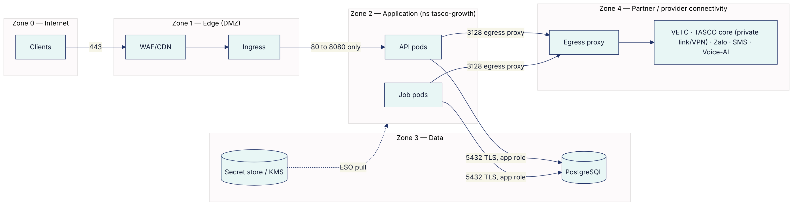
Control | Implementation
Default deny | NetworkPolicy with empty ingress/egress in tasco-growth, then allow-lists: ingress from the ingress-nginx and monitoring namespaces to port 8080; egress to PostgreSQL (CIDR, port 5432), DNS (53) and the egress-proxy namespace (3128)
Identity per workload | Distinct ServiceAccounts for the API, each job and migrations; no token automount; DB credentials per workload type (the migrator owns the schema; the app has DML only, and INSERT/SELECT only on audit_log)
Never trust the network | TLS to Postgres with rejectUnauthorized: true (postgresStore.js); mTLS to providers; JWT verified on every request; the user reloaded per request (identityService.authenticate)
Admin access | No SSH to nodes. kubectl via SSO + MFA + just-in-time RBAC. DB break-glass via a bastion with session recording.
Service mesh (optional) | Istio/Linkerd mTLS between pods once more services exist. Not required for a single deployable.

5. Ingress and WAF
Control | Setting
TLS | TLS 1.2+ (prefer 1.3); modern cipher suites; certificate via cert-manager (ACME or corporate CA); HSTS is also set by the app in production
Forwarded headers | With TRUST_PROXY=true the app takes the client IP from the right-most trusted X-Forwarded-For hop (TRUST_PROXY_HOPS, default 1, app.js#clientIp), so client-supplied values cannot spoof it. Set TRUST_PROXY_HOPS to the number of proxies in front of the app (for example 2 with a CDN in front of the ingress). The ingress should also overwrite XFF.
Rate limiting | Edge: the ingress sets limit-rps: 50 per client IP (shared across replicas); add per-partner-key quotas and a stricter limit for /api/auth/* and /api/customer/session at the gateway. The app's in-process limiter (RATE_LIMIT_MAX 300/min/IP, RATE_LIMIT_LOGIN_MAX 10/min/IP) is defence in depth per replica, so the effective limit is × replicas.
Body size | 1 MiB (matches BODY_LIMIT_BYTES)
Path rules | Block /metrics from outside the cluster (it can also require METRICS_TOKEN). Optionally restrict /api/openapi.json and staff APIs (/api/* except /api/customer/*, /api/public/*, /api/partner/*, /api/auth/*, /api/meta) to TASCO/VETC corporate egress IPs or ZTNA.
WAF | ModSecurity with the OWASP CRS enabled on the ingress (paranoia level 2 recommended on /api/*), with tuned exclusions for rules payloads (/api/rules* carries JSON Logic); bot management on customer and public endpoints
Partner mTLS (target) | A separate host partner-api.<domain> with client certificate verification

6. Database: PostgreSQL high availability
Aspect | Design
Service | Managed PostgreSQL 16 in a VN region, or Patroni-managed on VMs/K8s operators (CloudNativePG) if no managed option meets residency
HA | Primary + synchronous standby in another AZ (automatic failover, about 30–60 s). Apps reconnect via the pg pool (failed queries surface as 5xx; idempotent retries are safe).
Backups / PITR | Continuous WAL archiving + daily base backups, encrypted with KMS. PITR retention 14 days in prod (35 days if the regulator requires it), plus monthly snapshots kept 12 months. Restore drill quarterly.
Read replica | Async replica for BI extracts, /api/dashboard/* (target: route via a second pool DATABASE_READ_URL) and analytics feeds
DR | Cross-region async replica (RPO ≤ 5 min), promoted in DR (section 14)
Connections | The pool per process is DB_POOL_MAX (default 10). With 20 API pods and 6 job pods, that is up to 260 connections. Put PgBouncer (transaction pooling) in front: advisory transaction locks and SKIP LOCKED are compatible with transaction pooling.
Parameters | statement_timeout 15 s set by the app; idle_in_transaction_session_timeout 60 s; log_min_duration_statement 500 ms; pg_stat_statements enabled
Roles | tasco_owner (migrations; owns tables, triggers); tasco_app (SELECT/INSERT/UPDATE/DELETE on collections; INSERT/SELECT only on audit_log; no TRUNCATE; no DDL); tasco_ro (read replica, BI views)
Encryption | Storage encryption with KMS; TLS enforced (hostssl); PII is additionally field-encrypted by the app (ADR-006)
Partitioning (scale) | messages, touchpoints and domain_events by month (Solution Architecture, section 10) via a new numbered migration

7. Configuration
All settings come from src/shared/config.js. The ConfigMap holds non-secret values; secrets are mounted files.
Variable | Default | Prod value / note
NODE_ENV | development | production
PORT | 3000 | 8080 (set in the image and the ConfigMap)
PUBLIC_BASE_URL | http://localhost:3000 | https://growth.<tasco-domain>, used in links and certificate URLs
DATABASE_URL / _FILE | — (memory store outside production) | Secret file; required in production (ALLOW_MEMORY_STORE overrides, never in prod)
DATABASE_SSL | = production | true
DB_POOL_MAX | 10 | 10 (with PgBouncer)
JWT_SECRET / _FILE | random in dev | Secret file, ≥ 48 random bytes
JWT_TTL_SECONDS | 1,800 | 1,800 (900 for admin, once role-based TTL exists)
MFA_REQUIRED_ROLES | admin, rule_approver, compliance_officer, data_steward | Add telesales_supervisor, partner_manager and support_engineer (recommendation)
BLIND_INDEX_KEY / _FILE | random in dev | Secret file, 32 bytes base64
DATA_KEYS / _FILE | random dev key | Secret file, k1:<b64>,k2:<b64>
DATA_KEY_ACTIVE | last key | Explicit (e.g. k2)
CORS_ORIGINS | empty (same-origin only) | VETC/Zalo web origins if they call cross-origin
RATE_LIMIT_WINDOW_MS / _MAX / _LOGIN_MAX | 60,000 / 300 / 10 | Keep. The edge enforces the global limits.
LOCKOUT_MAX_FAILURES / LOCKOUT_MINUTES | 5 / 15 | Keep
BODY_LIMIT_BYTES | 1 MiB | 1 MiB
LOG_LEVEL | debug (dev) / info (prod) | info
DEMO_MODE | false (opt-in) | false
DEMO_PASSWORD, DEMO_TOTP_SEED, DEMO_ACCOUNT_SYNC | unset / unset / false | Unset (hosted UAT only)
ALLOW_DEMO_IN_PRODUCTION | false | false
SEED_RECORDS, SEED | 2,500, 20261007 | Unused when DEMO_MODE=false
SIM_TODAY | — | Unset (pins the business date; demos only)
RULES_DIR | config/rules | Default
TRUST_PROXY / TRUST_PROXY_HOPS | = production / 1 | true / number of proxies in front of the app
METRICS_TOKEN / _FILE | unset | Secret file (bearer token for /metrics)
LINK_TTL_DAYS | 30 | 30 (renewal link validity)
MIGRATE_ON_START | runs if not false | false in K8s (migration Job); Railway uses a pre-deploy command

8. Secrets and configuration
Secret | Rotation | Procedure
DATA_KEYS | Yearly, or on suspicion | Add k(n+1) → set DATA_KEY_ACTIVE → rolling restart → run the re-key job (planned) → remove the old key after verification (ADR-006)
JWT_SECRET | Every 90 days | Rotation invalidates all sessions and all unexpired renewal links (the link key is derived from JWT_SECRET in container.js). Schedule off-hours, or implement multi-key verification (kid) first. Target: IdP-signed tokens (no shared secret).
BLIND_INDEX_KEY | Only on compromise | Requires recomputing *_bidx columns (planned job)
DB credentials | 30–90 days | Dynamic DB credentials from Vault (database secrets engine) where possible
Provider credentials | Per provider policy | Store as files; adapters read on boot (restart to rotate)
Partner API keys | Partner-driven, ≤ 12 months | Issue the new key → partner switches → revoke the old one (DELETE /api/partners/keys/:keyId)
The rules: no secrets in images, Git, ConfigMaps or env literals. gitleaks runs in CI (§9). *_FILE is the only supported mechanism in K8s.

9. CI/CD pipeline and promotion
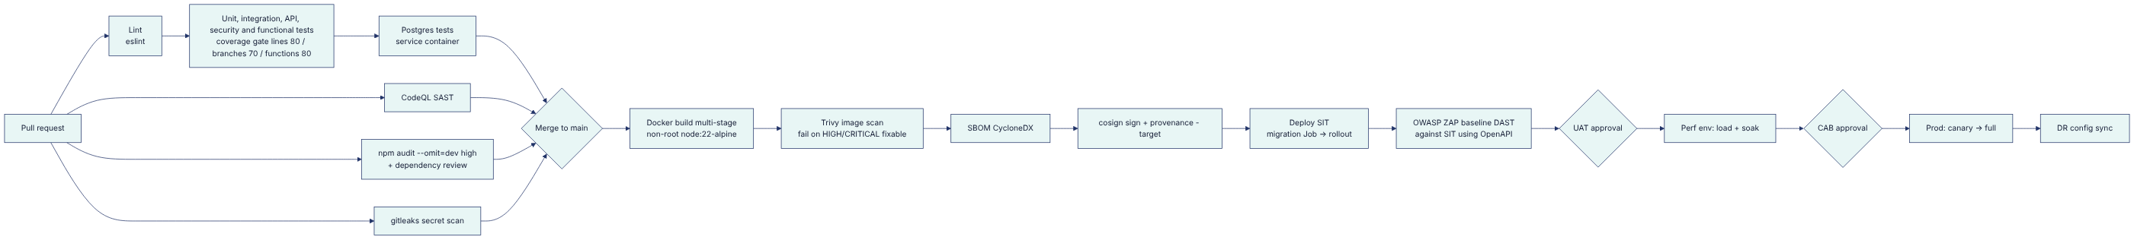
Stage | Gate (blocks promotion)
Lint, tests, coverage | Any failure; coverage below the gates (npm run test:coverage)
SAST (CodeQL) | New high/critical findings
Dependencies | npm audit --omit=dev --audit-level=high; dependency review on new packages (any new runtime dependency needs an ADR, per ADR-002)
Secrets | Any gitleaks finding
Container | Trivy HIGH/CRITICAL with an available fix; image runs as root; missing SBOM
DAST | ZAP baseline high alerts
SIT smoke | /health/ready, login + MFA, quote → send → customer order with sandbox/provider test accounts
Prod | Signed image digest only (admission policy, e.g. Kyverno/Gatekeeper: verifyImages); CAB ticket reference
Promotion is GitOps (recommended: Argo CD or Flux). The pipeline commits the new image digest to the environment overlay (deploy/k8s/overlays/<env> if overlays are used), and the cluster reconciles. There are no kubectl apply calls from CI to prod.

10. Release strategies
Strategy | When | How
Rolling (default) | Backward-compatible code and config | maxSurge: 1, maxUnavailable: 0; readiness-gated; PDB protects capacity
Canary | Risky behaviour changes (journeys, purchase) | Ingress weight split (NGINX canary annotations or Argo Rollouts): 5 % → 25 % → 100 %, with automated analysis on http_requests_total{status=~"5.."} rate, p95 http_request_duration_seconds, integration_calls_total{result="error"} and orders_completed_total
Blue-green | DB-affecting releases, major upgrades | Two Deployments (-blue/-green), with the Service selector switched after smoke tests. DB changes must be expand/contract: (1) migration adds columns/tables (compatible with old code) → (2) deploy new code → (3) a later migration removes old structures.
Caveats specific to this platform:
- The outbox relay runs in every pod, including canary pods. Old and new versions process the same event types, so handler changes must be backward compatible, or the event type must be versioned (policy.issued.v2).
- CronJobs use their own image tag. Update them in the same release, after the API rollout succeeds.
- The rules cache TTL is 15 s, and rule sets are data, not deployments. Rule changes go through maker-checker, not the release process.

11. Railway (UAT and pilots) and Docker Compose (local)
Railway (railway.json) hosts the live UAT at https://tasco-growth-api-uat.up.railway.app:
- Builder: Dockerfile. Start command node src/server.js. Pre-deploy command node src/jobs/cli.js migrate. Health check /health/ready (timeout 60 s). Restart policy on failure (maximum 5 retries). numReplicas: 2.
- Railway PostgreSQL → DATABASE_URL.
- Secrets are Railway variables. *_FILE is not used there, so set JWT_SECRET, BLIND_INDEX_KEY, DATA_KEYS and DATA_KEY_ACTIVE directly.
- UAT settings: NODE_ENV=uat, DEMO_MODE=true, plus DEMO_PASSWORD, DEMO_TOTP_SEED and DEMO_ACCOUNT_SYNC (UAT only; see section 2).
- With 2 replicas, the in-process rate limiter and the logout denylist are per replica; credential and role changes still revoke tokens on both (persisted tokensValidAfter).
- Jobs can run as a Railway cron service with the same image and a node src/jobs/cli.js <job> command.
- Constraints: synthetic data only; no NetworkPolicy; hosting is outside Vietnam; not for production personal data (confirm with TASCO legal).
Docker Compose (docker-compose.yml): app (built from the Dockerfile, port 8080, waits for a healthy DB, read-only root filesystem, all capabilities dropped) + postgres:16-alpine with a named volume. It runs NODE_ENV=development with DEMO_MODE=true and local-only secrets. docker compose up --build gives a full stack with demo data; the local demo password defaults to Tasco@Demo2026!. Without Compose, npm run dev uses the in-memory store and needs no database.

12. Capacity estimates
Assumptions (to validate in the perf environment):
# | Assumption
A1 | 6.0 M vehicles; 7.8 M source records (1.3 per vehicle)
A2 | Expiries uniform across the year: ≈ 16.4 k vehicles reach expiry per day
A3 | About 30 % of vehicles are in an active journey; the renewal journey has 7 steps; on average 5 sends per expiring vehicle
A4 | Voice bot is used for about 20 % of expiring vehicles (hot/warm + consent): ≈ 3.3 k calls/day
A5 | Platform conversion ≈ 15 % of expiring vehicles: ≈ 2.5 k orders/day (1.2 lines/order)
A6 | Staff users ≈ 300 (telesales heavy); peak customer app traffic follows push waves
A7 | Average stored document sizes (jsonb + row overhead): profile 3 KB, lead 3 KB, source record 1.2 KB, touchpoint 0.6 KB, message 0.8 KB, voice session 4 KB, quote 3 KB, order 1 KB, policy 1 KB, audit 0.4 KB
Storage (year 1, primary, excluding WAL and backups)
Collection | Rows | Size
profiles | 6 M | ≈ 18 GB + 2.5 GB indexes
leads | 6 M | ≈ 18 GB + 2 GB
source_records | 7.8 M | ≈ 9.5 GB + 1.5 GB
touchpoints | ≈ 7 M live + ≈ 42 M executed/yr | ≈ 30 GB/yr (purge or partition executed rows > 90 d)
messages | ≈ 30 M/yr | ≈ 24 GB/yr
voice_sessions | ≈ 1.2 M/yr (180 d retention) | ≈ 2.5 GB steady
quotes / orders / policies | ≈ 2.7 M / 0.9 M / 1.1 M per year | ≈ 8 + 1 + 1.1 GB/yr
audit_log | ≈ 18 M/yr (≈ 50 k entries/day) | ≈ 7 GB/yr
domain_events | ≈ 3 M/yr (purge done > 30 d) | < 1 GB steady
Total |  | ≈ 120–130 GB in year 1 → provision 500 GB with autoscaling storage
Throughput
Workload | Estimate | Implication
API (customer + staff) | Baseline 10–20 RPS; push-wave peaks about 150 RPS for 15 min | 3 pods are comfortable: the CI load smoke measured about 337 req/s from one process (25 concurrent, p95 about 103 ms, 0 % errors). HPA to 20 gives headroom for 1,000+ RPS.
Logins | 300 staff around 08:00; scrypt ≈ 50 ms CPU each | Negligible; the login rate limit is 10/min/IP
Journey executions | ≈ 115 k touchpoint evaluations/day (≈ 10 k per run if run hourly); ≈ 8 DB round-trips + 1 provider call each, sequential | ≈ 15–25 min per run with providers at 100 ms. Fits the hour, with little margin. Required before full scale: parallel workers claiming touchpoints with SKIP LOCKED, and asynchronous voice calls (today autoCall is synchronous inside runDue).
Nightly recompute | 6 M profiles × about 6 round-trips | Single-threaded about 6–10 h. Shard by hash(id) % 8 with keyset paging to finish in about 1 h. Better: recompute only profiles whose journey window changes (days crossing a step offset).
Orders | ≈ 2.5 k/day; peak ≈ 1 order/s | Bound by wallet and core latency, not by the platform
Outbox | ≈ 10 k events/day | Trivial for the SKIP LOCKED relay
Audit appends | ≈ 50 k/day (peak ≈ 20/s) | Well within serialised append capacity (≈ 1 k/s)
Database sizing (prod): primary 8 vCPU / 32 GB RAM / 500 GB SSD (≥ 6 k IOPS) + sync standby of the same size. Read replica 4 vCPU / 16 GB. Hot working set: profiles + leads + touchpoints indexes ≈ 10 GB, which fits in RAM.

13. Cost-aware sizing
Env | API | Jobs | Postgres | Notes
dev | local | local | memory or compose | $0
SIT | 2 pods (250m/512Mi) | on demand | 2 vCPU / 8 GB, single AZ, 7 d PITR | Shared cluster; scale to zero at night (KEDA/cron scaler)
UAT | 2 pods | on demand | 2 vCPU / 8 GB | Shared cluster
perf | 3–20 pods | sharded workers | 8 vCPU / 32 GB, provisioned only for test windows | Ephemeral: create, test, destroy (IaC)
prod | 3 pods baseline (HPA to 20) | ≈ 5 pod-hours/day | 8/32 primary + standby + 4/16 replica | Reserved/committed-use for the baseline; HPA for peaks
DR | 0–1 pod warm (scale on failover) | — | Async replica 4/16 | Warm standby, not active-active
Levers:
- Async voice and journey workers instead of bigger pods.
- Purge or partition high-churn tables (touchpoints, messages, events) to keep the DB on a smaller tier.
- Run BI on the read replica, not the primary.
- Use Vietnamese cloud providers if they meet InfoSec and residency requirements; they are typically cheaper than hyperscaler list prices.
- Per-message channel costs (config/rules/costs.json) dominate infrastructure costs at scale. The NBA prefers push (cheapest) over ZNS over SMS over voice over telesales.

14. Disaster recovery
Target | Value
RPO | ≤ 5 min (async cross-region replication + WAL archive)
RTO | ≤ 1 h
Strategy | Warm standby: DR cluster manifests synced by GitOps with replicas = 0/1; DB replica in the DR region
Failover runbook:
- Declare the incident (on-call + CAB emergency).
- Promote the DR replica.
- Point DATABASE_URL (secret) to the DR primary.
- Scale up the DR API and CronJobs.
- Switch DNS / global load balancer.
- Verify /health/ready, /api/audit/verify (chain intact) and the outbox backlog.
- Notify providers if the egress IPs change (pre-register DR IPs).
Drill twice a year. The PITR restore drill is quarterly.

15. Observability
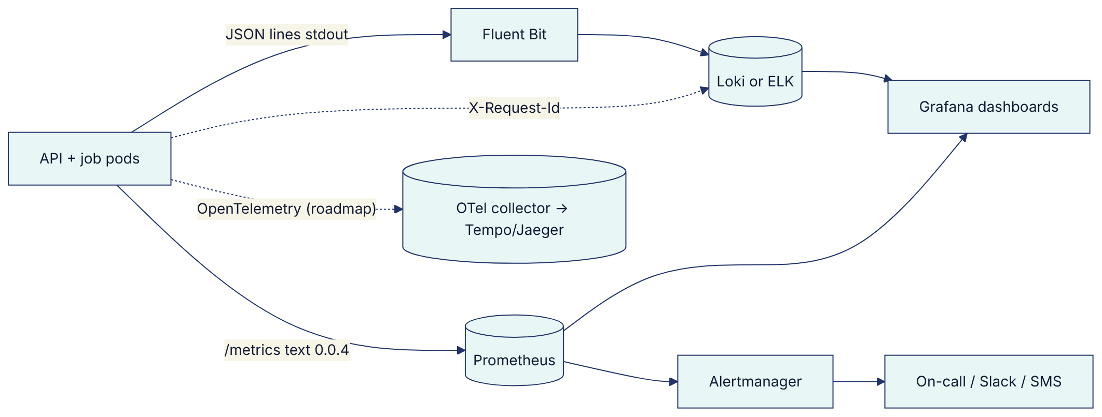
Logs (src/shared/logger.js):
- One JSON object per line: {ts, level, msg, service, ...fields}.
- PII keys are redacted (password, secret, token, authorization, cookie, phone, altPhones, name, totpSecret, apiKey, otp, code, mfaToken, refreshToken, accessToken).
- Errors include the message, code and stack.
- Every API request logs {requestId, method, route, status, ms} (health, metrics and static requests are excluded).
- Retention: 30 days hot, 1 year archive. Security events are also in the audit chain.
Metrics (src/shared/metrics.js, exposed at /metrics, cluster-internal only, optionally protected by METRICS_TOKEN):
Metric | Labels | Use
http_request_duration_seconds (histogram) | route, method | Latency SLO (p95)
http_requests_total | route, method, status | Error-rate SLO, 401/403/429 anomaly detection
integration_calls_total | integration, result | Provider health
integration_short_circuit_total | integration | Breaker open → page
events_published_total / events_processed_total | type / type, status | Outbox flow; dead_letter → alert
messages_total | channel, status, journey | Send volume, blocked/failed rates (copy guard, consent)
quotes_total, orders_completed_total | channel; channel and journey | Business KPIs
orders_compensation_total | status | Saga compensations (issuance_failed_refunded, compensation_failed) → alert on compensation_failed
voice_calls_total | outcome | Bot outcomes, opt-out rate
process_resident_memory_bytes, process_uptime_seconds | — | Runtime health
Gaps:
- No /metrics from CronJob pods (use job_runs and logs, or a Pushgateway).
- No DB pool metrics.
- No event backlog gauge (available via GET /api/ops/status; add a gauge outbox_pending and outbox_oldest_pending_seconds).
Alerts (SLO-based):
Alert | Condition | Severity
API availability burn | 5xx ratio > 1 % over 5 min (fast burn of the 99.9 % SLO) | Page
Latency | p95 > 1 s for 10 min on read routes | Ticket
Breaker open | increase(integration_short_circuit_total[5m]) > 0 for wallet or core | Page
Dead letters | increase(events_processed_total{status="dead_letter"}[15m]) > 0 | Page
Outbox lag | Oldest pending/processing event > 5 min | Page
Auth anomalies | http_requests_total{route="POST /api/auth/login",status="401"} spike; status="423" (lockouts) | Security
Reconciliation | job.reconciliation mismatches > 0 (including compensation_failed orders) | Ticket (finance ops)
Audit chain | /api/audit/verify ok=false (synthetic probe hourly) | Security page
Job failure | kube_job_status_failed > 0 | Ticket
Tracing: today correlation uses X-Request-Id, which is accepted from the client if it matches ^[\w-]{8,64}$ and generated otherwise. It is echoed in the response and in error bodies and logged per request. Gap: it is not propagated into domain events (correlationId is null) or into outbound provider calls.
OpenTelemetry roadmap:
- Instrument node:http and pg with OTel auto-instrumentation (adds dev/runtime dependencies, which need an ADR-002 exception).
- Propagate W3C traceparent to providers and put the trace id into domain_events.correlationId.
- Generate span metrics (RED) in the collector, replacing the hand-rolled histograms.
- Tail-based sampling that keeps all error traces.

