Delivery Methodology
TASCO Insurance × VETC Growth Platform — Delivery & Change
iorta TechNXT
Version 1.0 · 07 October 2026
Table of Contents

Document | Version | Date | Owner | Status
Delivery Methodology | 1.0 | 07 October 2026 | iorta TechNXT — Delivery Lead | Issued for submission
Approach: hybrid agile. We run Scrum for product increments and add stage gates for the regulated items that cannot simply be "iterated into production" in an insurance business: tariffs, customer-facing wording, consent, contact policy, partner commission, security and privacy.
The aim is fast, visible progress every two weeks, while every change that affects customers, money or personal data is approved by the right person before it reaches production, with evidence kept in the audit trail.

1. Why hybrid
Concern | Pure agile risk | Hybrid answer
Regulated premiums (TNDS, Decree 67/2023) | Rates changed by a developer in a sprint | Tariffs are rule sets with maker-checker approval (rulesService.approve refuses self-approval). Underwriting is the checker.
Discount prohibition (Law 08/2022/QH15) | Marketing copy shipped without review | Copy guard (copy_guard.json) blocks banned phrases at validation and at send time. Content changes need a Compliance approver.
Anti-spam (Decree 91/2020) and PDP (Decree 13/2023) | Journeys contacting customers too often or without consent | contact_policy rule set enforced in canContact(). Legal approves policy values at G1 and G3.
Integration with VETC and TASCO core | Late surprises | Integration contracts frozen at G1. Sandbox adapters implement the same ports, and contract tests run in CI.
Security | Findings discovered after go-live | Security gates in the DoD and at G2/G3. RBAC changes go through code review plus CAB.

2. Lifecycle overview
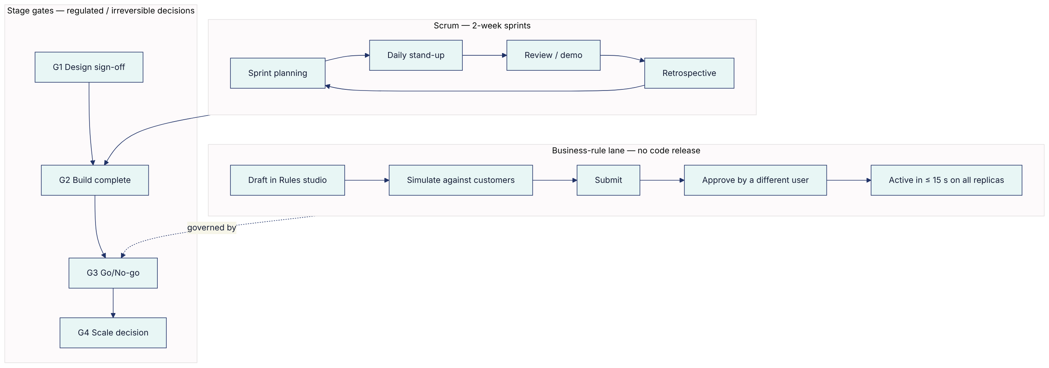
There are three lanes of change, each with its own path to production:
Lane | Examples | Path | Approver
Code | New page, new adapter, bug fix | Pull request → CI quality gates → staging → CAB (for production) | Tech lead (code review) + CAB
Security configuration | config/security/rbac.json, MFA_REQUIRED_ROLES, secrets | Pull request with Security review → CAB | CISO delegate
Business rules | Scoring weights, NBA, journeys, benefits, templates, voice script, tariffs, commission, contact policy, retention | Rules studio: draft → validate → simulate → submit → approve | Rule approver or compliance officer (four-eyes, enforced in code). Restricted kinds need a compliance officer.

3. Scrum framework

3.1 Roles
- Product Owner (TASCO) owns the backlog and accepts stories.
- Scrum Master / Delivery Lead (iorta TechNXT) owns the process, impediments and reporting.
- Development team (cross-functional): backend, frontend, data, QA, DevSecOps, UX and BA.
- Client SMEs attend refinement and reviews: VETC product, compliance and telesales supervisors.

3.2 Ceremonies
Ceremony | When | Duration | Participants | Output
Sprint planning | Day 1 of sprint | 2 h | Team, PO | Sprint goal, committed backlog
Daily stand-up | Daily 09:15 ICT | 15 min | Team (PO optional) | Impediments raised
Backlog refinement | Weekly, Wed | 1.5 h | PO, BA, Architect, QA, UX | Stories meeting DoR
Design review | Weekly, Thu | 1 h | UX, PO, FE, Accessibility champion | Approved designs
Sprint review / demo | Last day of sprint | 1.5 h | Team, PO, stakeholders (TASCO, VETC) | Accepted increment, feedback
Retrospective | Last day of sprint | 1 h | Team | Two or three improvement actions
Rules clinic | Weekly, Tue | 45 min | Rule authors, approvers, BA | Draft rule changes reviewed before submission
Integration sync | Twice weekly | 30 min | iorta Integration, VETC IT, TASCO IT | Contract changes, environment issues
Release readiness | Before each release | 45 min | DevSecOps, QA, PO, Support | Go/no-go for the release

3.3 Sprint cadence
Sprints last two weeks. A potentially shippable increment is deployed to SANDBOX at the end of each sprint for stakeholder exploration, with demo mode and synthetic data. During Pilot and Scale-out the cadence moves to weekly releases with feature flags.

4. Definition of Ready (DoR)
A story may enter a sprint when all of the following are true:
- It is written as a user story with the persona named (for example, "As a telesales agent…") and refers to a page in the Journey Maps and Information Architecture document (docs/ux/journey-maps-and-information-architecture.pdf).
- Acceptance criteria are written in Given/When/Then, including at least one negative case: permission denied, validation error or business-rule violation.
- The required permission is identified (for example handoff:work) and mapped to roles in config/security/rbac.json. Any change to that file is flagged for Security review.
- UX design is approved, or explicitly "no UI change", with Vietnamese and English copy supplied. The copy is checked against the content style guide (no discount wording).
- Data needs are known: fields, PII classification and masking rule (profile:read_pii).
- Any integration dependency has a contract in place or a sandbox adapter.
- Any regulated element is tagged REG and has a named approver (Compliance, Underwriting, Legal).
- The story is estimated and small enough for one sprint.

5. Definition of Done (DoD)
A story is done only when all applicable items are met:
# | Criterion | How verified
1 | Code merged to main through a pull request reviewed by at least one engineer other than the author | Git host branch protection
2 | Lint clean | npm run lint in CI
3 | Unit, integration, API, security and functional tests written and passing. Each Given/When/Then acceptance scenario has a functional test in test/functional. | npm test
4 | Coverage ≥ 80 % lines and functions, ≥ 70 % branches | npm run test:coverage (thresholds enforced by the script)
5 | Security tests pass, with no new critical or high findings | npm run test:security, SAST, secret scan, npm run audit (high and above fail the build)
6 | DAST baseline scan on SANDBOX for changed endpoints | ZAP baseline in pipeline
7 | Authorisation tested: allowed role succeeds, other roles get 403 | API tests per route
8 | Accessibility checks: automated (axe) with zero serious or critical issues, keyboard-only walkthrough, screen-reader smoke test (NVDA or VoiceOver) on changed screens | QA checklist in the UX Standards and Accessibility document
9 | Vietnamese and English strings present; dates dd/mm/yyyy; VND formatting | UI review
10 | Performance budget respected (page and API p95, see UX standards) | npm run test:perf for API changes, Lighthouse for UI
11 | Audit events emitted for every state change affecting customers, money, access or rules | Test asserts the audit entry
12 | OpenAPI regenerated if routes changed | npm run job -- openapi writes docs/api/openapi.json
13 | Documentation updated: user manuals in docs/manuals/, contextual help text, runbooks and ADRs where relevant | PR checklist
14 | Demo data / seed updated if needed (src/bootstrap/seed.js) | Sandbox smoke test
15 | PO acceptance in the sprint review | Story status
Definition of Done for a business-rule change (Rules studio lane):
- Payload validates (POST /api/rules/validate returns no errors). This includes JSON Logic and decision-table checks, commission caps and the copy guard.
- Simulation evidence is recorded (POST /api/rules/simulate) on at least five representative customers for the kinds scoring, nba, journeys and benefits. The before/after outcome is attached to the change ticket.
- A description explains the business reason and expected impact.
- The change is submitted by its author and approved by a different user with rules:approve. Changes to abac, copy_guard, contact_policy, commission and retention are approved by a compliance officer (enforced in code).
- After activation, the expected KPI movement is monitored for 7 days and a rollback plan is known. Rollback creates a new draft that also needs approval.

6. Quality gates
Gate | Where | Pass criteria | Blocking?
QG1 Commit | Pre-commit / PR | Lint, unit tests | Yes
QG2 Pull request | CI | All tests, coverage thresholds, npm run audit, secret scan, SAST | Yes
QG3 Integration | Nightly on SIT | Contract tests against VETC/TASCO UAT, Postgres tests (npm run test:pg) | Yes for release
QG4 Release candidate | Staging | Regression pack, DAST, performance (npm run test:perf), accessibility pack, OpenAPI diff reviewed | Yes
QG5 Production | CAB | Release notes, rollback plan, runbook updates, on-call confirmed, change window (not in Tết freeze) | Yes
QG6 Stage gate | SteerCo | Gate criteria in the project plan | Yes
Quality metrics are tracked every sprint: escaped defects, defect density, coverage trend, mean time to restore (MTTR), accessibility issues open, security findings by severity and age.

7. Environments and promotion
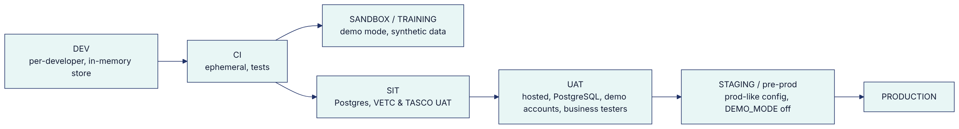
Environment rules:
- DEMO_MODE is off by default. It is on only in DEV, CI, SANDBOX and the hosted UAT (NODE_ENV=uat), never in STAGING or PRODUCTION. The demo TOTP endpoint behind Sign in with demo code (UAT) returns 404 when demo mode is off.
- UAT-only settings (DEMO_PASSWORD, DEMO_TOTP_SEED, DEMO_ACCOUNT_SYNC) are set only in the hosted UAT. The UAT password is distributed in the access workbook and is never written in documents.
- Production secrets come from the secret manager through the <NAME>_FILE convention (src/shared/config.js). Production refuses to boot without them, and without DATABASE_URL.
- Rule sets are promoted through the Rules studio in each environment, not by copying the database. Baseline rule files in config/rules/ seed new environments only (npm run job -- rules loads kinds that have no version yet).
- Production data is never copied to lower environments unmasked.

8. Governance cadence
Forum | Frequency | Chair | Members | Decides
Steering Committee | Every 2 weeks (Build to Pilot), monthly after | TASCO Business Owner | VETC Product Director, TASCO CIO, TASCO Head of Compliance, iorta Engagement Director, Delivery Lead | Gates, scope, budget, top risks, escalations
Design Authority | Weekly | iorta Solution Architect | TASCO IT architect, VETC IT, Security | Architecture, integration contracts, NFRs, ADRs
Rules Governance Board | Fortnightly (and ad hoc) | TASCO Compliance | Product, Underwriting, Marketing, Data Steward | Policy-level rule changes (contact policy, benefits legal status, tariffs), review of rule change log
Change Advisory Board | Weekly + emergency | TASCO IT Service Manager | DevSecOps, Support, Security | Production releases, RBAC changes
Data Governance Forum | Monthly | TASCO Data Owner | VETC Data, Data Steward, DPO | DQ KPIs, source trust weights (enrichment.json), retention, DSAR metrics
Pilot war-room | Daily during pilot weeks 1–2, then twice weekly | TASCO Product Owner | Telesales supervisors, Support, iorta | Operational issues, quick fixes

Escalation path
Team → Delivery Lead / PO (within 1 day) → Design Authority or Rules Governance Board (within 3 days) → Steering Committee (next session, or ad hoc for red items).

9. Reporting
Report | Audience | Frequency | Content
Weekly status | PO, SteerCo members | Weekly (Friday) | RAG by workstream, burn-up, milestones, top 10 risks and issues, decisions needed
Sprint report | PO, team | Per sprint | Goal met?, velocity, scope change, quality metrics, demo recording
SteerCo pack | SteerCo | Per session | Gate readiness, budget, risk heat map, KPI trend (from /api/dashboard/overview and /api/dashboard/adoption)
Pilot dashboard | SteerCo, business | Live + weekly digest | Funnel by journey and channel, renewals in-app vs telesales, voice outcomes, opt-out and plate-verification failure rates, contact-policy blocks, CSAT
Governance report | Compliance, Audit | Monthly | Rule changes with maker and checker, audit-chain verification result (/api/audit/verify), DSAR volumes and turnaround, access reviews
Service report | TASCO IT | Monthly (BAU) | Availability, incidents, MTTR, job success (/api/ops/jobs), integration circuit-breaker trips
RAG definitions: Green means on track. Amber means at risk, with a recovery plan owned by the workstream. Red means a milestone or gate will be missed without a SteerCo decision.

10. Tooling
Purpose | Tool (proposed; adopt client standard where one exists)
Backlog and sprints | Jira (or Azure Boards)
Source and CI | Git host with branch protection, CI pipeline (.github/workflows/ci.yml) executing the package.json scripts
Documentation | docs/ in the repository (versioned with the code), delivered as Word and PDF + Confluence for meeting notes
Design | Figma (design tokens exported to CSS variables, see the Design System, docs/ux/design-system.pdf)
Observability | Prometheus scraping /metrics, log aggregation of structured JSON logs (with requestId), alerting
Test management | Xray / TestRail, with UAT scripts derived from docs/manuals/

