Claims Handler Manual (FNOL)
TASCO Insurance × VETC Growth Platform — User Manuals
iorta TechNXT
Version 1.0 · 07 October 2026
Table of Contents

Document | Version | Date | Owner | Status
Claims Handler Manual | 1.0 | 07 October 2026 | iorta TechNXT — Business Analysis and UX | Issued for submission
Role: claims_handler · Demo user: claims · MFA: not required by default
Your permissions: read and update claims (claims:read, claims:update), read policies (policy:read), view customer records with personal data masked (profile:read).
Your landing page: Claims.
The platform is the digital front door for accident reports, or First Notice of Loss (FNOL). Customers report from the VETC app with a description, location and photo count. Full assessment and settlement stay in TASCO's core claims system. Your job here is to acknowledge quickly, move the claim through its status flow and keep the customer informed.
Fast, transparent claims handling is the strongest reason customers renew. Treat the 4-hour acknowledgement SLA as a promise made to the customer in the app: when a claim is submitted, the platform immediately sends the customer an acknowledgement message saying an assessor will call within 4 hours. The SLA is set in the service_levels rule set (claimAckSlaHours).
Read the Staff User Manual first.

1. The claims queue
- Open Claims ("Claims — first notice of loss").
- What you will see: one row per claim (the latest 100):
Column | Meaning
Claim | Claim ID, for example CL-3F9A21BC
Policy | Certificate number of the policy
Incident | Incident date
Status | Current status badge
SLA due | Deadline for acknowledgement: 4 hours after submission
Next | One button for each status the claim can move to next
- Work submitted claims in order of SLA due, earliest first.

2. Status flow
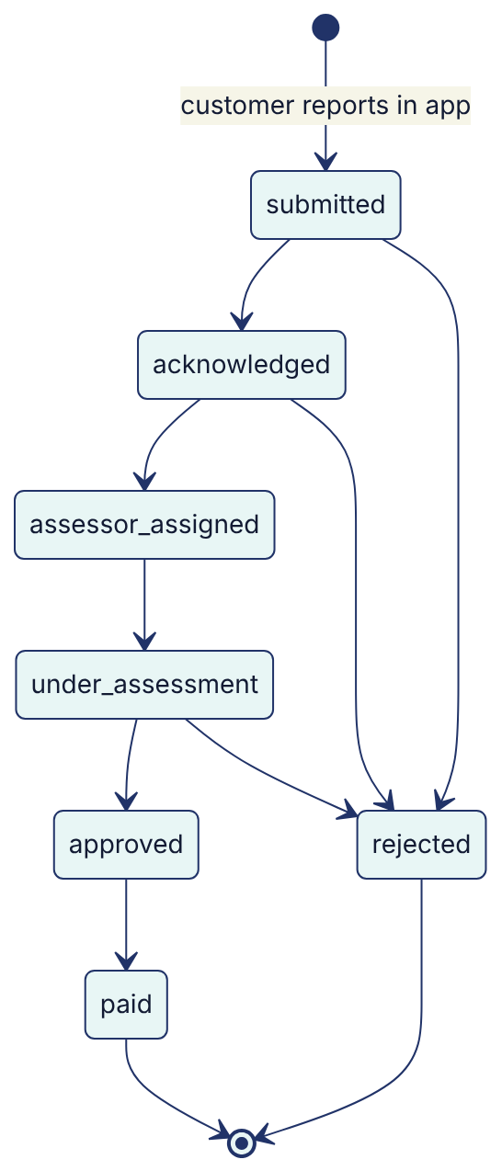
Only the transitions shown are allowed. The platform refuses others ("Cannot move claim from X to Y").
Status | Meaning | Who acts next
submitted | Customer has reported | You: acknowledge within 4 hours
acknowledged | We have contacted the customer and opened the claim in TASCO core | Claims team assigns an assessor
assessor_assigned | Assessor (giám định viên) assigned | Assessor visits or reviews photos
under_assessment | Assessment in progress | Assessor / adjuster
approved | Claim accepted | Finance
paid | Settlement paid | Closed
rejected | Not covered, or a duplicate or invalid report | Closed. Explain the reason to the customer.

3. Acknowledge a new claim (step by step)
- Open the claim with the earliest SLA due.
- Check the policy and incident:
  - The platform has already checked that the policy belongs to the customer and that the incident date is within the policy period.
  - Open the customer (Customer 360) if you need vehicle details. Name and phone are masked for your role. Use TASCO core for contact details according to the claims procedure.
- Call the customer from the official TASCO claims hotline. Confirm safety first, then the incident facts.
- Create the claim file in TASCO core and note the core reference.
- In the platform, select acknowledged in the Next column.
- Record the details (for example "Customer contacted 10:42; core claim ref TC-2026-00123; assessor visit requested") in the TASCO core claim file. The v1 console has no note field; the API accepts a note with each status change for integrations.
What you will see: the toast "Claim acknowledged" and the new status badge. The claim history records the new status, time and your user ID. The change is audited (claim.status_changed).

4. Progress the claim
Repeat for each step (assessor_assigned → under_assessment → approved → paid, or rejected), and keep the TASCO core file up to date: the assessor's name or reference, the assessment outcome, the payment reference.
Rejecting a claim: select rejected and record a clear reason in TASCO core, for example "Incident outside cover — PA_SEAT does not cover vehicle damage" or "Duplicate of CL-…". Make sure the customer is told in plain Vietnamese through the agreed channel.

5. Tips
- Check SLA due at the start and middle of each shift.
- Record the reason for every status change in TASCO core. It is part of the regulatory record.
- If a customer reports in the app but you cannot reach them, still acknowledge within SLA and note the attempts.
- Product reminder: TNDS covers damage the customer causes to others. PA_SEAT covers injury to the driver and passengers. MOTOR_PD covers damage to the customer's own car.

6. Troubleshooting
Problem | Fix
"Cannot move claim from submitted to under_assessment" | Follow the flow: acknowledged, then assessor_assigned first
Claim not in the list | The list shows the latest 100 claims. Only claims reported through the platform appear here. Phone or paper claims stay in TASCO core.
Customer name masked | Expected for your role. Use TASCO core for contact.
Many claims near SLA breach | Escalate to the claims lead. Overflow goes to the TASCO claims hotline.
See also: Staff User Manual, Customer App Guide (what the customer sees).

