Rule Author and Rule Approver Manual (Maker-Checker)
TASCO Insurance × VETC Growth Platform — User Manuals
iorta TechNXT
Version 1.0 · 07 October 2026
Table of Contents

Document | Version | Date | Owner | Status
Rule Author and Rule Approver Manual | 1.0 | 07 October 2026 | iorta TechNXT — Business Analysis and UX | Issued for submission

 | Rule author (maker) | Rule approver (checker)
Role | rule_author | rule_approver (also compliance_officer)
Demo user | author | approver (MFA), compliance (MFA)
Permissions | rules:read, rules:author, dashboard:read | rules:read, rules:approve, audit:read, dashboard:read
Can | Create drafts, validate, simulate, submit own drafts, create rollback drafts | Simulate, approve or reject drafts submitted by someone else, read the audit trail
Cannot | Approve or reject | Create or submit drafts
The platform enforces four-eyes control. Only the author can submit a draft, and the person who created a draft can never approve or reject it ("Maker-checker: you cannot approve your own change"). In addition, the roles rule_author and rule_approver (or compliance_officer) cannot be held by the same person: the platform refuses that combination.
Read the Staff User Manual first.

1. What rules control
All business behaviour is held in versioned rule sets. Each kind has exactly one active version at a time.
Kind | Controls | Typical approver
products | Product catalogue, channels where each product is sold, bundles | Product + Compliance
tariff.tnds_car, tariff.tnds_motorbike | Regulated TNDS premiums (Decree 67/2023/ND-CP) | Underwriting + Compliance
rating.motor_pd, rating.pa_seat | Voluntary product rates (currently illustrative, to be replaced with filed rates) | Underwriting / Actuarial
commission | Partner commission by product and partner type, with statutory caps | Finance + Compliance officer (enforced)
scoring | Lead score factors, weights, tier thresholds (hot ≥ 70, warm ≥ 45) | Product / Data
nba | Next-best-action decision table | Product
journeys | Journeys, audiences, step timings and channels, cross-sell | Marketing + Compliance
triggers | Ecosystem-event moments of truth | Marketing + Compliance
content.messages | Customer message templates (vi/en) | Compliance (and Zalo template approval)
content.voicebot | Voice bot script, disclosure and intent keywords | Compliance
benefits | Value-beyond-discount catalogue, eligibility, relevance, legalStatus | Legal / Compliance
copy_guard | Banned phrases for customer copy | Compliance officer (enforced)
contact_policy | Contact hours, frequency caps, consent requirements | Legal + Compliance officer (enforced)
referral | Referral programme (disabled pending legal review) | Legal
enrichment | Source trust, expiry evidence weights, vehicle category inference | Data owner
retention | Data retention periods and actions | DPO + Compliance officer (enforced)
abac | Attribute-based access policies (regional data, own handoffs) | Security + Compliance officer (enforced)
costs | Unit costs for the economics dashboard | Finance
service_levels | Quote validity (24 h), claim acknowledgement SLA (4 h), confidence given to customer-declared, steward-corrected and bot-reported expiry dates | Product + Operations
The platform enforces two checks: the approver holds rules:approve and is not the author, and the restricted kinds (abac, copy_guard, contact_policy, commission, retention) are approved only by a compliance officer (" changes must be approved by: compliance_officer"). For all other kinds, your organisation's approval matrix above decides who may approve, and approvers must follow it.

Lifecycle
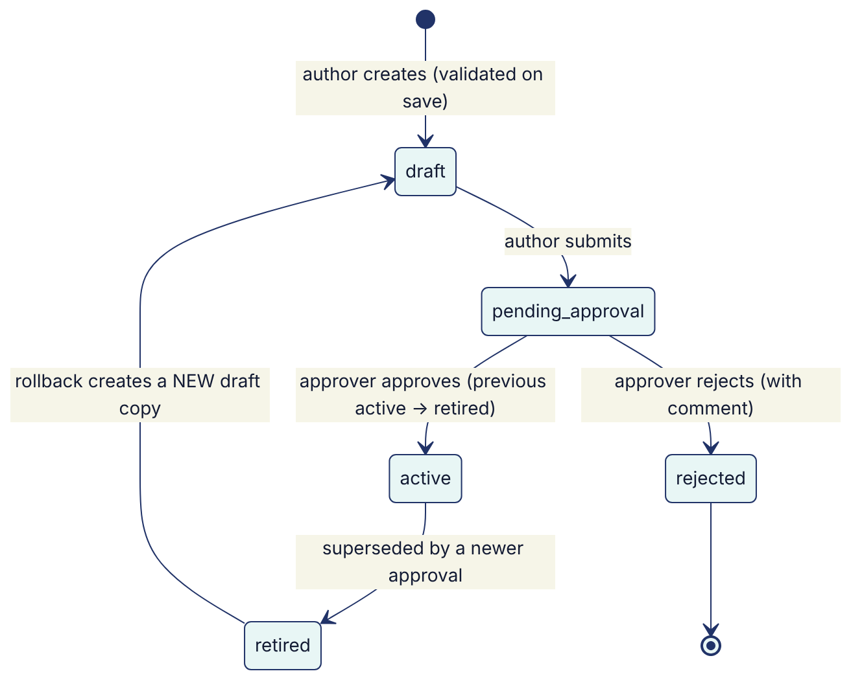
- A version's ID is <kind>@<version>, for example scoring@3.
- Approval takes effect on all servers within about 15 seconds.
- Rollback never reactivates an old version directly. It creates a new draft with the old content, which goes through approval again.

2. For the rule author: step by step

Step 1 — Find the current version
- Open Rules studio.
- In the list of rule sets, find the kind (for example scoring). The active version has the status active.
- Open it to see the description, checksum, author, approver, activation date and the payload (JSON).

Step 2 — Create a draft
- From the active version, edit the payload in the JSON editor. For example, raise the hot threshold:
- "tiers": { "hot": 75, "warm": 45 }
- Fill Description with the business reason and expected impact, for example "Raise hot threshold to 75 to focus voice bot capacity; expected −15 % hot volume."

Step 3 — Validate
- Select Validate.
- What you will see: "Valid", or a list of errors with JSON paths, for example:
  - $.factors[2].value: unsupported operator "clampp": a typo in a JSON Logic expression.
  - rule tnds_any: rate 0.08 exceeds statutory cap 0.05 for TNDS_CAR: commission above the legal cap.
  - copy guard: "giảm giá" in "Giảm giá 10% khi gia hạn…": banned wording in customer copy.
- Fix and validate again until valid.

Step 4 — Simulate (scoring, NBA, journeys, benefits)
- Select Simulate against a customer.
- Enter a customer ID (the plate key, for example 30A12345) and select Run simulation.
- What you will see: Current vs Candidate side by side: score and reasons, tier, journey, next best action and benefits.
- Repeat on at least five representative customers: hot and warm, TASCO and conquest, lapsed, low-confidence expiry, company-owned. Note the results in the description or your change ticket.
Simulation is a dry run. It changes nothing.

Step 5 — Save as a draft
- Select Save as new draft.
- What you will see: a new version <kind>@<n> with status draft. The payload is validated again on save. An invalid payload cannot be saved.

Step 6 — Submit for approval
- Open your draft and select Submit for approval.
- What you will see: status pending_approval ("Submitted for approval"). Tell your approver, or rely on the Pending list they check daily.
Only the author of a draft can submit it.

Step 7 — After approval
- Check that the version shows active and the previous one retired.
- For scoring, NBA, journeys or benefits changes, ask the campaign manager for a lead recompute (or wait for the nightly recompute job).
- Monitor the expected effect for 7 days.

Rolling back
- Open the earlier version you want to restore (status retired).
- Select Roll back to this version. A new draft is created with that content, described "Rollback to <id>".
- Submit it for approval as usual. For urgent rollbacks, call your approver.

3. For the approver: step by step

Step 1 — Find pending changes
- Sign in (MFA required).
- Open Rules studio. A banner lists the changes awaiting approval. Select one to open it.

Step 2 — Review
For each pending version:
- Read the Description: is the business reason clear?
- Compare it with the active version (This version vs active payload). Check exactly what changed.
- Check that it is within your approval authority (see the table in section 1). Restricted kinds need a compliance officer.
- Run your own Simulation on a few customers (scoring, NBA, journeys, benefits).
- For customer-facing content, read the Vietnamese text in full:
  - no discount, rebate or cashback wording, and nothing that implies a lower price;
  - no promise of loyalty points or rewards unless the related benefit's legalStatus is approved;
  - truthful and clear; the voice bot keeps its disclosure ("trợ lý tự động"), recording notice and the "never asks for OTP or payment" line.
- For benefits: items moving to legalStatus: "approved" must have a legal sign-off reference.
- For contact_policy: values must not loosen consent or caps without a Legal decision.
- For tariffs and rates: figures must match the regulation or filed rates.

Step 3 — Decide
- Approve: enter a Review comment (for example "Approved per ticket CHG-1234; simulation reviewed on 5 customers"), select Approve and confirm "Approve and activate?". The version becomes active and the previous one retired, in a single transaction.
- Reject: enter the reason and select Reject. The version becomes rejected. The author must create a new draft.
What you will see: a confirmation, and an audit entry (rules.approved or rules.rejected) with your comment and the superseded version.
Approval SLA (proposed): within 1 business day. Urgent rollbacks within 1 hour.

4. Worked example: change the conquest first reminder timing
- Author opens journeys, finds the journey conquest and changes the first_reminder step offset from -30 to -35.
- Validate: valid.
- Simulate with kind journeys on a conquest customer whose expiry is in 33 days. Current: no first reminder due yet. Candidate: first reminder due now.
- Save as new draft (journeys@2) with the description "Conquest first reminder D−35 to land before competitors' D−30 calls".
- Submit for approval.
- Approver (Compliance) checks that the cap of 3 marketing contacts per week is still respected, simulates, and approves with a comment.
- The campaign manager requests a lead recompute so that schedules are rebuilt for affected vehicles.

5. JSON Logic cheat sheet
Rules use JSON Logic expressions over customer facts.
Need | Expression
Field value | { "var": "days" }
Compare | { "<=": [{ "var": "days" }, 14] }
And / or / not | { "and": [ … ] }, { "or": [ … ] }, { "!": [ … ] }
In list | { "in": [{ "var": "category" }, ["car_under6", "car_6_11"]] }
If / else chain | { "if": [cond1, value1, cond2, value2, default] }
Arithmetic | { "+": [a, b] }, { "/": [a, b] }, { "*": [a, b] }
Clamp to a range | { "clamp": [expr, 0, 1] }
Text | { "cat": ["expires in ", { "var": "days" }, " days"] }
Round | { "round": [expr] }
Min / max | { "min": [a, b] }, { "max": [a, b] }
Common facts: days (days to expiry, negative means lapsed), expiryConfidence (0–1), insurer, tier, score, consent.marketing, consent.call, consent.dnc, channels.app_push, channels.zalo_zns, channels.sms, channels.voice_bot, hasPhone, ownerType, category, seats, vehicleAge, appSessions30d, tollTrips30d, longTripsKm90d, walletBalance, autoTopUp, premium, tagAgeDays, journey.
Decision tables (nba, commission, rate tables, category inference) use hit policy "first": rules are evaluated top to bottom and the first match wins, otherwise default applies. Order matters.

6. Troubleshooting
Message | Meaning | Fix
"Rule set is invalid" + list | Validation errors | Fix each path shown
"Only the author can submit a draft" | You are not the creator | Ask the author
"Only drafts can be submitted (status: …)" | Already submitted, approved or rejected | Create a new draft
"Maker-checker: you cannot approve your own change" | You authored it | Another approver must decide
"Only pending rule sets can be approved (status: …)" | Not submitted, or already decided | Refresh. Check the status.
" changes must be approved by: compliance_officer" | Restricted kind | Ask a compliance officer to approve
"Missing permission rules:author" | Approver accounts cannot draft | Ask an author
Change not visible after approval | Cache refresh (up to 15 seconds), or leads not recomputed | Wait. Ask for a lead recompute.
See also: Compliance Officer Manual, Campaign Manager Manual.

