Partner API Guide (v1)
TASCO Insurance × VETC Growth Platform — User Manuals
iorta TechNXT
Version 1.0 · 07 October 2026
Table of Contents

Document | Version | Date | Owner | Status
Partner API Guide | 1.0 | 07 October 2026 | iorta TechNXT — Integration Engineering | Issued for submission
For developers at partner organisations (banks, car showrooms, agencies, fleets, inspection centres) who quote and sell TASCO Insurance motor cover through the TASCO Growth Platform.
Item | Value
Base path | /api/partner/v1
Base URL | Sandbox and production URLs are given to you by your TASCO partner manager
Format | JSON over HTTPS (Content-Type: application/json)
Authentication | X-Api-Key header, with scopes per key
Payment | Partner-collected (no VETC wallet debit)
Idempotency | Idempotency-Key header required on POST /orders
Machine-readable spec | GET /api/openapi.json (OpenAPI 3.1; partner operations are tagged Partner API)
Support | Your partner manager. Quote the requestId from any error.

1. Authentication
Every request must carry your API key:
X-Api-Key: tpk_xxxxxxxxxxxxxxxxxxxxxxxxxxxxxxxx
- Keys start with tpk_. They are issued by your TASCO partner manager and shown only once. TASCO stores only a hash, so a lost key cannot be recovered. Ask for a new key and the old one will be revoked.
- Keep keys server-side only, in a secret store. Never put them in mobile apps, browsers or source code.
- Requests fail with 401 if the key is missing, wrong or revoked, or if your partner account is suspended.
- Each key carries scopes, which are enforced on every call: quote for POST /quotes, purchase for POST /orders, and policies:read for GET /policies and GET /statement. A call outside your key's scopes fails with 403 ("API key lacks scope …"). Keys normally carry all three.
- Use separate keys for test and production. Rotate at least yearly.
In the examples below:
export BASE="https://<platform-host>" # provided by TASCO
export KEY="tpk_your_key_here"

2. Typical flow
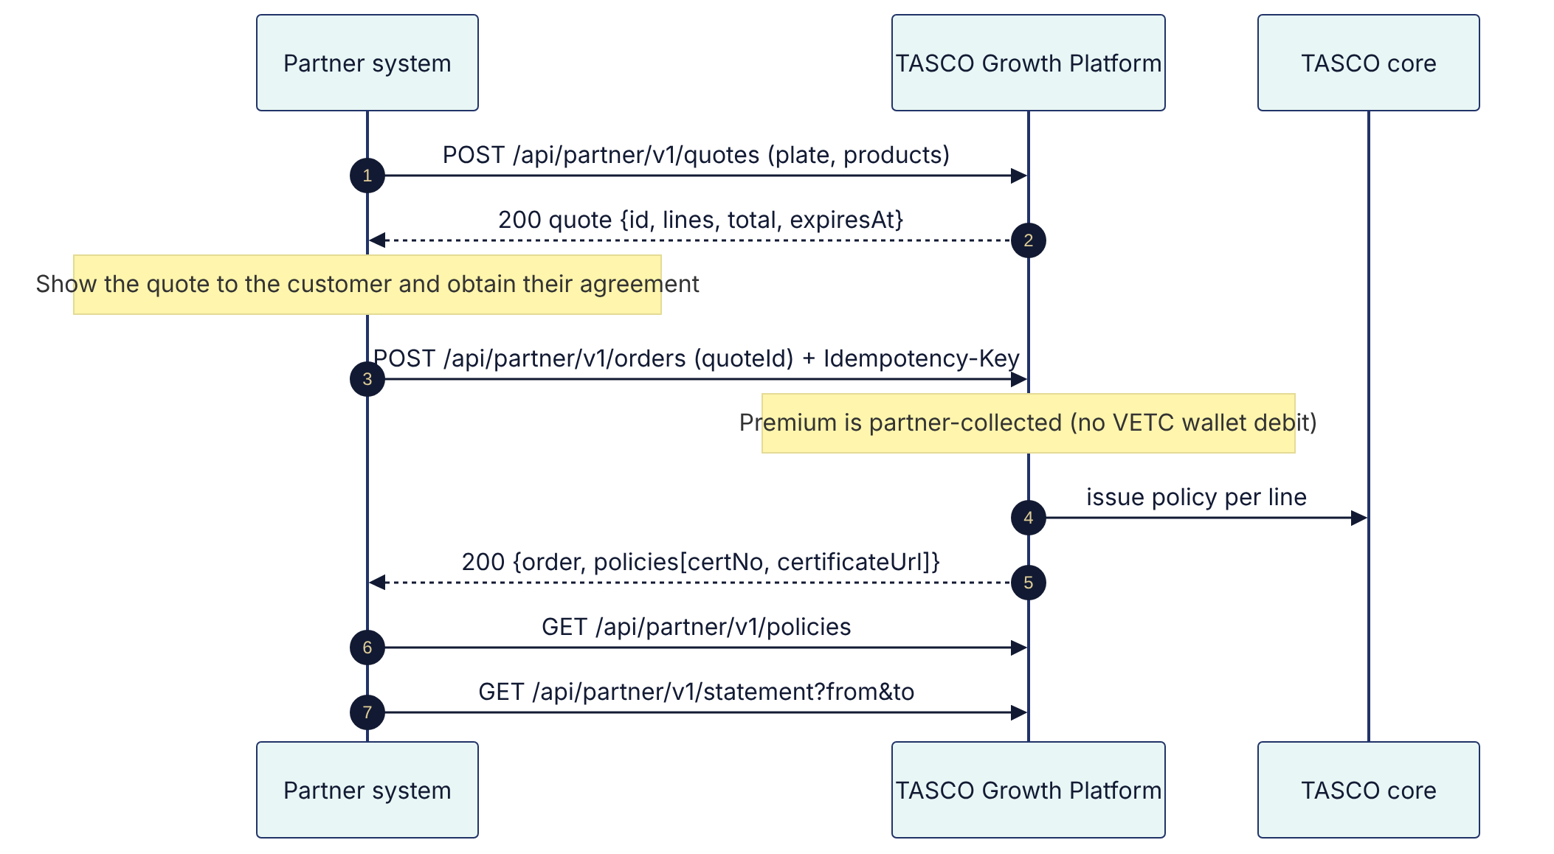

3. Endpoints

3.1 Create a quote: POST /api/partner/v1/quotes
Quotes one to five products for a vehicle identified by licence plate. If TASCO does not yet know the vehicle, it is onboarded automatically (new business) from the data you send. If you send currentExpiry or seats, those facts are added to the vehicle's record and attributed to you.
Request body
Field | Type | Required | Notes
plate | string (≤ 20) | ✓ | Any common format: 30A12345, 30A-123.45, 30a 123 45. Must be a valid Vietnamese plate.
products | array (1–5) | ✓ | Each item { "code": "...", "options": { ... } } (see the table below)
holderName | string (≤ 120) |  | Policyholder name
phone | string (≤ 20) |  | Vietnamese mobile (09…, +849…). Validated.
seats | integer 1–60 |  | Declared seats (drives vehicle category and PA pricing)
usage | personal | commercial |  | Declared use
ownerType | individual | company |  | Declared owner type (default individual)
currentExpiry | date YYYY-MM-DD |  | Expiry of the customer's current TNDS. Cover starts the next day.
Products available on the partner channel
code | Product | options
TNDS_CAR | Compulsory TNDS (car), price-regulated | category (optional override, for example car_under6, car_6_11, pickup_van, commercial_under6, truck_under3t …), termYears 1–3
PA_SEAT | Driver and passenger personal accident | seats (defaults to the vehicle's seats, or 5), sumInsuredPerSeat: one of 10000000, 20000000, 50000000, 100000000
MOTOR_PD | Voluntary physical damage | sumInsured (VND, ≤ 5,000,000,000 online), deductible: 0, 500000 or 1000000, vehicleAge (years). Requires a recorded vehicle inspection before binding (see section 3.2).
TNDS_MOTORBIKE is not available on the partner channel (VETC app and Zalo only).
Example
curl -sS -X POST "$BASE/api/partner/v1/quotes" \
-H "X-Api-Key: $KEY" \
-H "Content-Type: application/json" \
-H "X-Request-Id: bank01-req-000123" \
-d '{
"plate": "30A-123.45",
"holderName": "Nguyễn Văn An",
"phone": "0912345678",
"seats": 5,
"usage": "personal",
"currentExpiry": "2026-11-05",
"products": [
{ "code": "TNDS_CAR", "options": { "termYears": 1 } },
{ "code": "PA_SEAT", "options": { "sumInsuredPerSeat": 20000000 } }
]
}'
Response 200 (abridged)
{
"id": "Q-6f1c2d9e-3a4b-4c5d-8e9f-0a1b2c3d4e5f",
"profileId": "30A12345",
"plate": "30A-123.45",
"channel": "partner_api",
"partnerId": "P-BANK-01",
"lines": [
{
"product": "TNDS_CAR",
"productName": "Compulsory motor third-party liability (car)",
"productNameVi": "Bảo hiểm TNDS bắt buộc ô tô",
"startDate": "2026-11-06",
"endDate": "2027-11-06",
"termDays": 365,
"premiumNet": 437000,
"vat": 43700,
"total": 480700,
"priceRegulated": true,
"breakdown": [{ "label": "Car < 6 seats (non-commercial)", "labelVi": "Xe dưới 6 chỗ (không kinh doanh)", "annual": 437000, "years": 1 }],
"note": "Premium fixed by regulation — identical at every insurer."
},
{
"product": "PA_SEAT",
"startDate": "2026-11-06",
"endDate": "2027-11-06",
"premiumNet": 100000,
"vat": 0,
"total": 100000,
"priceRegulated": false,
"breakdown": [{ "label": "Personal accident", "seats": 5, "sumInsuredPerSeat": 20000000, "ratePerSeat": 0.001 }],
"note": "Premium per TASCO filed rates."
}
],
"total": 580700,
"benefits": [
{ "id": "roadside_24_7", "title": "24/7 roadside assistance", "titleVi": "Cứu hộ giao thông 24/7", "why": "peace of mind on every trip" }
],
"bundle": "SAFE_DRIVE",
"status": "open",
"createdAt": "2026-10-07T03:12:44.120Z",
"expiresAt": "2026-10-08T03:12:44.120Z"
}
Notes:
- Amounts are integers in VND. total = premiumNet + vat. Personal accident is VAT-exempt.
- TNDS premiums are regulated and identical at every insurer. Do not present any discount on them.
- Rates for PA_SEAT and MOTOR_PD in the sandbox are illustrative. Production uses TASCO's filed rates.
- A quote is valid for 24 hours (expiresAt).
- bundle is set when the products match a published bundle (SAFE_DRIVE = TNDS + PA, FULL_MOTOR = TNDS + PD + PA). Bundle price is the sum of its components.

3.2 Bind (buy) a quote: POST /api/partner/v1/orders
Binds and issues every line of a quote. Idempotent: send an Idempotency-Key that is unique per purchase attempt and reuse it on retries. A retried request with the same key and quote returns the original completed order and never issues twice. Requires the purchase scope.
Physical damage: a quote that contains MOTOR_PD can be bound only after a TASCO assessor has recorded a passed vehicle inspection on the quote. Until then the order fails with 422 ("Physical damage cover needs a vehicle inspection first — a TASCO assessor will contact you"). Arrange the inspection with your partner manager, or quote TNDS_CAR and PA_SEAT without MOTOR_PD.
Header | Required | Rules
Idempotency-Key | ✓ | 8–100 characters: letters, digits, _ or -. Use a UUID or your own order reference.

Body field | Type | Required
quoteId | string | ✓ (must be a quote created with your key)
holderName | string (≤ 120) | Optional override of the policyholder name
curl -sS -X POST "$BASE/api/partner/v1/orders" \
-H "X-Api-Key: $KEY" \
-H "Content-Type: application/json" \
-H "Idempotency-Key: bank01-order-2026-000457" \
-d '{ "quoteId": "Q-6f1c2d9e-3a4b-4c5d-8e9f-0a1b2c3d4e5f", "holderName": "Nguyễn Văn An" }'
Response 200 (first call)
{
"order": {
"id": "O-9a8b7c6d5e4f3a2b1c0d",
"quoteId": "Q-6f1c2d9e-3a4b-4c5d-8e9f-0a1b2c3d4e5f",
"profileId": "30A12345",
"channel": "partner_api",
"partnerId": "P-BANK-01",
"amount": 580700,
"status": "completed",
"paymentRef": "PARTNER-P-BANK-01-O-9a8b7c6d5e4f3a2b1c0d",
"policies": ["TAS-TNDSCA-2026-100001", "TAS-PASEAT-2026-100002"],
"commission": [
{ "product": "TNDS_CAR", "rate": 0.05, "amount": 21850, "ruleId": "tnds_any", "capped": false },
{ "product": "PA_SEAT", "rate": 0.15, "amount": 15000, "ruleId": "pa", "capped": false }
],
"completedAt": "2026-10-07T03:13:02.511Z"
},
"policies": [
{
"certNo": "TAS-TNDSCA-2026-100001",
"policyNo": "POL-100001",
"product": "TNDS_CAR",
"plate": "30A-123.45",
"startDate": "2026-11-06",
"endDate": "2027-11-06",
"total": 480700,
"status": "active",
"certificateUrl": "https://<platform-host>/verify/TAS-TNDSCA-2026-100001"
}
],
"idempotentReplay": false
}
Retry with the same key returns 200 with "idempotentReplay": true and the original order (the policies array is not repeated; fetch it with GET /policies).
Certificate: certificateUrl is the public verification page. Encode it as a QR code on your documents. Anyone (police, inspectors) can scan it to see validity, product, dates and a masked plate. No personal data is shown.
Commission is calculated on net premium, capped by statutory limits, and recorded on the order.
Payment settlement. Partner sales are partner-collected: binding does not debit the customer's VETC wallet. The order's paymentRef starts with PARTNER-, and the premium is remitted to TASCO according to your partner agreement and reconciled against your commission statement.
Failure handling (read carefully):
Situation | What happened | What to do
Network timeout or no response | Unknown: the order may or may not have completed | Retry with the same Idempotency-Key. You get either the completed order (idempotentReplay: true) or 409 if that attempt failed.
503 UPSTREAM_UNAVAILABLE (TASCO core down) | Nothing was issued. Any line already issued in this attempt was cancelled automatically. The order is flagged for reconciliation. | Wait, then retry with a new Idempotency-Key for the same quote (if it has not expired)
409 CONFLICT "A previous attempt with this Idempotency-Key ended as … — retry with a new key" | You re-sent the key of an attempt that failed | Retry with a new key. The quote is released after a failure.
409 CONFLICT "This quote is already being paid" | Another request is binding the same quote at this moment | Wait, then fetch GET /policies to check the result before retrying
Only an order with status: "completed" means the policies were issued.

3.3 List your policies: GET /api/partner/v1/policies
Returns policies sold through your partner account, newest expiry first.
Query | Type | Default
limit | 1–500 | 50
offset | ≥ 0 | 0
curl -sS "$BASE/api/partner/v1/policies?limit=100&offset=0" -H "X-Api-Key: $KEY"
Response: a JSON array of policy objects (fields as in the order response, plus premiumNet, vat, channel, partnerId, orderId, issuedAt, insurer).

3.4 Commission statement: GET /api/partner/v1/statement
Query | Type | Notes
from | date YYYY-MM-DD | Inclusive (order creation date)
to | date YYYY-MM-DD | Inclusive
curl -sS "$BASE/api/partner/v1/statement?from=2026-10-01&to=2026-10-31" -H "X-Api-Key: $KEY"
{
"partnerId": "P-BANK-01",
"from": "2026-10-01",
"to": "2026-10-31",
"orders": 42,
"totalCommission": 1287450,
"lines": [
{ "orderId": "O-9a8b7c6d5e4f3a2b1c0d", "date": "2026-10-07", "product": "TNDS_CAR", "rate": 0.05, "amount": 21850, "ruleId": "tnds_any", "capped": false }
]
}
Only completed orders appear. This is the same statement your TASCO partner manager sees.

4. Errors
All errors use one format:
{
"error": {
"code": "VALIDATION_FAILED",
"message": "Invalid licence plate",
"details": null,
"requestId": "bank01-req-000123"
}
}
- requestId echoes your X-Request-Id header (8–64 characters: letters, digits, _, -) or is generated. It is also returned in the X-Request-Id response header. Log it and quote it to support.
- details may list field-level problems for validation errors.
HTTP | code | Typical cause | What to do
400 | VALIDATION_FAILED | Missing or invalid field; invalid plate or phone; missing or badly formed Idempotency-Key; unknown product; unsupported sumInsuredPerSeat or deductible; malformed JSON | Fix the request. Do not retry unchanged.
401 | UNAUTHENTICATED | Missing, invalid or revoked X-Api-Key; partner suspended | Check the key. Contact your partner manager.
403 | FORBIDDEN | Key lacks the scope for this operation ("API key lacks scope …"); origin not allowed (CORS) | Contact your partner manager
404 | NOT_FOUND | Quote not found or created by another partner; wrong path | Check the ID and path
405 | METHOD_NOT_ALLOWED | Wrong HTTP method | Fix the method
409 | CONFLICT | Idempotency-Key of a failed attempt re-sent; quote already being paid; concurrent update | Use a new Idempotency-Key, or wait and check
415 | UNSUPPORTED_MEDIA_TYPE | Body sent without Content-Type: application/json | Set the header
422 | BUSINESS_RULE_VIOLATION | Product not sold on this channel; quote expired; quote already bought ("Quote is converted"); sum insured above the online limit; physical damage without a recorded inspection | Re-quote or change the request
429 | RATE_LIMITED | Too many requests (default 300 per minute per client IP) | Wait for the Retry-After seconds, then retry with back-off
503 | UPSTREAM_UNAVAILABLE | TASCO core temporarily unavailable | Retry with exponential back-off. For orders, use a new Idempotency-Key (see Failure handling in section 3.2).
500 | INTERNAL_ERROR | Unexpected error | Retry once. If it persists, contact support with the requestId.

Retry policy (recommended)
- Retry only 429, 503, network timeouts and the 409 cases above. Use exponential back-off with jitter (1 s, 2 s, 4 s, 8 s; maximum 5 attempts).
- For POST /orders, reuse the same Idempotency-Key only when the outcome is unknown (timeout). After a definite failure (503, or 409 for a failed attempt), use a new key.
- Never retry 400, 401, 403, 404 or 422 without changing something.

5. Data protection obligations
- Send personal data (name, phone) only when needed for the policy, and only with a lawful basis under Vietnam's personal data protection rules (Decree 13/2023/ND-CP and the PDP Law).
- The v1 API does not collect marketing consent for TASCO/VETC. Do not imply to customers that they will receive TASCO/VETC marketing.
- Do not store certificate data longer than your agreement allows. Do not scrape the public verification page.
- Never present TNDS with discount, rebate or cashback wording.

6. Testing checklist (sandbox certification)
- Quote TNDS for a known plate and for a new plate (with currentExpiry and seats).
- Quote TNDS + PA (expect bundle SAFE_DRIVE).
- Order with an Idempotency-Key. Repeat the same call and expect idempotentReplay: true, order.status: "completed" and no second issuance.
- Order an expired quote and expect 422.
- Use another partner's quote ID and expect 404.
- Missing Idempotency-Key: expect 400. Missing or invalid API key: expect 401. A key without the purchase scope on POST /orders: expect 403.
- Simulate a failed order (sandbox issuance outage), then re-send the same Idempotency-Key: expect 409. Retry with a new key: expect success.
- Quote MOTOR_PD and order it before an inspection is recorded: expect 422.
- Fetch policies and the statement for the test period. Check that commission matches the rates.
- Scan the certificateUrl QR and check that the verification page shows valid and a masked plate.
Your partner manager signs off sandbox certification before issuing a production key.

7. Change log
Version | Date | Change
v1 | October 2026 | First release: quotes, orders (idempotent, partner-collected), policies, statement, scoped keys

