Disaster Recovery and Business Continuity Plan — TASCO Growth Platform
TASCO Insurance × VETC Growth Platform — Operations
iorta TechNXT
Version 1.0 · 07 October 2026
Table of Contents

Document | Version | Date | Owner | Status
DR and BCP | 1.0 | 07 October 2026 | TASCO IT Head (accountable); SRE + DBA (responsible) | Issued for submission

Item | Value
Approvers | TASCO IT Head, TASCO Business Owner, VETC IT Lead, TASCO CISO
Related | Runbook and Support Guide · Monitoring and Alerting · Production Readiness Checklist
Hosting assumption | Hosting provider and regions are confirmed at G1. This plan assumes two data centres / regions in Vietnam (primary Hà Nội, secondary TP. Hồ Chí Minh) to meet data-localisation expectations for Vietnamese personal data (Decree 53/2022/ND-CP, PDP Law 2025; Legal confirms)

1. Scope
In scope | Out of scope (own DR plans)
Application tier (stateless Node.js pods), PostgreSQL database, secrets (JWT_SECRET, DATA_KEYS, BLIND_INDEX_KEY, DB credentials), configuration (rule sets live in the database, versioned), CronJobs, ingress/DNS, observability stack | VETC wallet, VETC SSO, VETC app, TASCO core policy admin, Zalo, SMS provider, voice-AI vendor. We plan for their unavailability (§8). The hosted UAT on Railway is a non-production environment and is not covered by this plan
Key architectural facts that make recovery simpler:
- All state is in PostgreSQL. This covers profiles, leads, touchpoints, messages, orders, policies, rule sets (all versions), the outbox (domain_events) and the hash-chained audit_log. The app pods are stateless, apart from per-pod rate-limiter buckets, the token revocation list and the 15 s rule cache, all of which are disposable.
- Outbox pattern. Events are written in the same database as the state change, so after a restore the relay re-processes pending events. Subscribers are idempotent, with the caveats in RB-06.
- Encryption keys are part of the backup set. A database backup is useless without the matching DATA_KEYS (every key ID ever active) and BLIND_INDEX_KEY. The keys live in the KMS/vault, replicated to the DR region.

2. Business impact analysis (BIA)
Business service | Components | Impact of outage | Tolerable downtime (MTPD) | Tier
Customer renewal / purchase (quote → pay → issue → e-certificate) | /api/customer/*, /api/partner/v1/orders, wallet, TASCO core | Lost premium (renewals on expiry day go to competitors); customer trust; driving uninsured is an offence for the customer | 4 h | Tier 1
Certificate verification (QR) | GET /api/public/certificates/:certNo, /verify/* | Customers cannot prove cover at roadside or inspection checks | 4 h | Tier 1
Partner API | /api/partner/v1/* | Partner sales stop; SLA penalties (contractual) | 4 h | Tier 1
Telesales console and handoffs | /api/handoffs, /api/leads, /api/customers/:id, /api/quotes | Hot leads go cold; agents idle | 8 h | Tier 2
Journey engine and messaging | journeys CronJob, notify gateways, voice bot | Reminders delayed by a day; recoverable (catch-up of 2 days in planning, catchUpDays) | 24 h | Tier 2
Claims FNOL | /api/customer/claims, /api/claims | Customers use the TASCO hotline instead | 24 h | Tier 2
Rules studio, data steward, DQ, ingestion | /api/rules, /api/dq, /api/data/ingest | Changes deferred; ingestion re-runnable from source extracts | 72 h | Tier 3
Dashboards, insights | /api/dashboard/* | Management reporting delayed | 72 h | Tier 3
Audit trail (integrity) | audit_log | Regulatory evidence; must never be lost | n/a: zero tolerated loss of committed entries within the RPO | Tier 1 (data)

3. RPO / RTO by tier
Tier | RTO (service restored) | RPO (max data loss) | Mechanism
Tier 1 | 1 h for an AZ failure (automatic); 4 h for a region loss (declared DR) | ≤ 5 min for a region loss; 0 for an AZ failure | Multi-AZ Postgres with a synchronous standby; async cross-region replica; continuous WAL archiving (PITR)
Tier 2 | 8 h | ≤ 15 min | Same database. Journeys catch up the next run (catch-up window 2 days)
Tier 3 | 72 h | ≤ 24 h | Same database; ingestion re-runnable from source extracts
Secrets/KMS: RTO 1 h, RPO 0 (replicated vault). Observability: RTO 24 h (rebuild from IaC; metrics history loss accepted).

4. Backup strategy
Asset | Method | Frequency | Retention | Location | Verified by
PostgreSQL | Managed PITR: continuous WAL archiving + daily base backup | Continuous / daily 01:00 ICT | 35 days PITR; monthly snapshot kept 12 months; yearly kept 10 years (financial and audit retention per retention.json: orders, certificates and audit_log 3,650 days) | Primary region object storage + cross-region copy (TP.HCM) | Weekly automated restore test (DR-T1 light)
audit_log chain head | Export (seq, hash) of the latest entry | Nightly | 10 years | WORM bucket (object lock) | Compare with GET /api/audit/verify head
Secrets (JWT_SECRET, DATA_KEYS all key IDs, BLIND_INDEX_KEY, DB, partner-integration credentials) | Vault/KMS with replication + sealed offline escrow (two-person) | On change | All versions forever for DATA_KEYS (old ciphertext) | KMS in both regions + escrow | Quarterly key-recovery drill
Configuration / IaC | Git (deploy/k8s/*, Dockerfile, CI) | On commit | Forever | Git hosting + mirror | Rebuild drill (DR-T4)
Container images | Registry with immutable tags (semver + git SHA) | On release | Last 20 releases | Registry replicated to the DR region | Pull test in DR
Rule sets | Inside PostgreSQL (all versions) + defaults in config/rules/*.json | — | — | Covered by DB backup | GET /api/ops/status checksums vs change log
Source extracts (VETC/TASCO) | Landing bucket | Per delivery | 365 days (source_records retention) | Primary + DR | Re-ingest test
Backups are encrypted at rest with provider KMS keys. PII inside the backup is additionally encrypted at field level (AES-256-GCM), so restores require the application keys.

5. DR topology
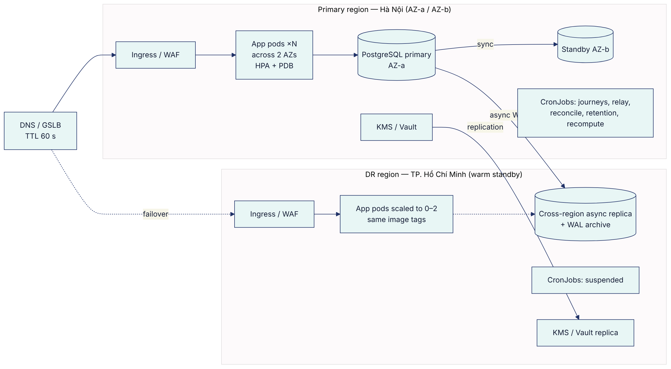
Element | Primary | DR (warm standby)
App | ≥ 3 replicas across 2 AZs; PDB minAvailable: 2; terminationGracePeriodSeconds ≥ 30 | Deployment at 0–2 replicas, same image; scaled up on declaration
Database | HA primary + synchronous standby (automatic AZ failover) | Async read replica (lag < 30 s, alert ALR-91), promotable
CronJobs | Active | Suspended. Never run two journey schedulers, or customers get duplicate contact
Outbound egress | Allow-listed to VETC, TASCO core, Zalo, SMS, voice | Pre-registered DR egress IPs with every partner (part of the IIAs)
DNS | Public hostnames (console, app API, partner API, verify) | GSLB failover record, TTL 60 s
Partner allow-lists are the usual DR blocker. VETC wallet, TASCO core and the SMS provider must allow-list the DR egress IPs before go-live (readiness PRC-DR-04).

6. Failover and failback procedures

FO-0 — AZ failure (automatic)
- The managed Postgres fails over to the synchronous standby (60–120 s). The app's /health/ready returns 503 during the switch (RB-01) and the pod pool reconnects.
- Kubernetes reschedules pods to the healthy AZ; the PDB and HPA keep capacity.
- L2 verifies: readiness, GET /api/ops/status, reconciliation for the window. No customer-facing declaration unless degradation lasts > 15 min.

FO-1 — Region loss / declared disaster (manual, RTO 4 h)
Step | T+ | Action | Owner
1 | 0 | Incident Commander declares DR after confirming the primary region is unrecoverable within RTO (provider status, ≥ 30 min outage, or data-centre loss). Decision by the TASCO IT Head (or delegate) | IC
2 | 0:05 | Communications: war room, TASCO/VETC leadership, VETC CS; customer banner (§9) | Comms
3 | 0:10 | Freeze writes at the primary if it is partially alive: scale the primary Deployment to 0, suspend its CronJobs (split-brain prevention) | L2
4 | 0:15 | Promote the DR replica (provider "promote"). Record the last applied LSN/timestamp: this is the actual RPO | DBA
5 | 0:30 | Confirm the DR KMS has every DATA_KEYS key ID, BLIND_INDEX_KEY and the JWT_SECRET, and update the DR secrets: DATABASE_URL → promoted instance | SRE
6 | 0:45 | Scale the DR Deployment to the production replica count; set MIGRATE_ON_START=false (the schema is already current) | SRE
7 | 1:00 | Smoke tests: /health/ready (store:"postgres", db:true), GET /api/audit/verify ok, staff login + MFA, customer session → home → quote, certificate verify, GET /api/ops/status (breakers closed: partner allow-lists working) | L2 + QA
8 | 1:15 | Switch DNS/GSLB to DR (TTL 60 s) | SRE
9 | 1:30 | Run POST /api/ops/jobs/relay (drain pending); events left in processing by the crash are re-claimed after 5 min, otherwise follow RB-06 | L2
10 | 1:45 | Resume CronJobs in DR (marketing touchpoints outside 08:00–20:00 ICT are deferred automatically); reconciliation for the loss window: orders between the last replicated LSN and the disaster may have been paid in VETC without a record here. Reconcile with the VETC settlement file and work any compensation_failed or payment_failed order (RB-11) | L2 + Finance
11 | 2:00 → 4:00 | Monitor SLOs; partner notifications; formal DR status report | IC

FB-1 — Failback to the primary region (planned, low-traffic window)
- Rebuild the primary-region database as a replica of the DR primary (fresh base backup + streaming). Never reuse the old primary's data files (divergence).
- When the lag is < 5 s, CAB-approved window (after 20:00 ICT): suspend DR CronJobs → scale DR app to 0 (brief outage, ~10 min) → promote the primary-region replica → point secrets → scale up → smoke tests (step 7 above) → DNS back → resume CronJobs.
- Re-establish the DR replica from the new primary. Reconcile; verify the audit chain.

FO-2 — Logical corruption / bad data change (PITR)
When data is corrupted by a bad job, a bad manual SQL statement or a defect, but the infrastructure is fine:
- Stop the source of damage (suspend CronJobs, scale writers down if necessary).
- Restore by PITR to a new instance at T−(just before the event).
- Choose between (a) full cut-over to the restored instance (loses all writes after T; only if the window is small) and (b) surgical repair: copy the affected rows from the restored instance into production under a change ticket.
- The audit chain must be verified after any repair. Rows inserted into audit_log are never edited; repairs are recorded as new audit entries or in the change ticket.

7. DR test plan and schedule
ID | Test | Scope | Frequency | Success criteria
DR-T1 | Backup restore | PITR restore to a new instance in PREPROD at a random point in the last 7 days; app connects; GET /api/audit/verify ok; row counts vs source | Weekly automated (light), quarterly full | Restore ≤ 60 min (Tier 1 budget); data consistent to the target time (RPO ≤ 5 min)
DR-T2 | AZ failover | Force a Postgres failover + drain one AZ's nodes under PERF-S1 load (TC-141, TC-142) | Before G3, then semi-annually | Readiness recovers ≤ 2 min; no lost committed orders; 5xx limited to the switch window
DR-T3 | Region failover drill | Full FO-1 in PREPROD/DR (or PROD with a planned window after W1) | Before W1 (March 2027), then annually | RTO ≤ 4 h, RPO ≤ 5 min demonstrated; partner calls succeed from DR egress IPs
DR-T4 | Rebuild from code | New cluster from IaC + image registry + secrets escrow | Annually | Platform up from scratch ≤ 8 h
DR-T5 | Key recovery | Recover DATA_KEYS (all IDs) and BLIND_INDEX_KEY from escrow; decrypt a sample in an isolated environment | Semi-annually | Two-person procedure completes ≤ 1 h
DR-T6 | Vendor outage tabletop | Walk through §8 scenarios with VETC CS, the telesales supervisor and the voice vendor | Before pilot, then semi-annually | Roles clear; templates approved; contact lists valid
DR-T7 | Outbox recovery | Kill pods mid-relay; recover stuck processing and dead letters per RB-06 | Before G3 | No lost or duplicated customer messages beyond the documented caveats

Window | Tests
January 2027 (UAT week T3) | DR-T1, DR-T2, DR-T5, DR-T6, DR-T7 (gate G3 evidence)
March 2027 (before W1) | DR-T3 full region failover
Every quarter | DR-T1 full
Semi-annual | DR-T2, DR-T5, DR-T6
Annual | DR-T3, DR-T4
Every DR test produces a report: date, scenario, actual RTO/RPO, issues, actions, sign-off by the TASCO IT Head.

8. Business continuity: telesales and voice vendor outage
Scenario | Detection | Continuity actions | Customer impact
Voice-AI vendor outage (circuit voice-ai, RB-05) | ALR-10, voice_calls_total flat | 1. Stop launching /api/voice/campaign. 2. Journeys: voice_bot steps fail. The fallback is a rule change (maker-checker) adding telesales to the voice step's channels, or raising hot-lead prioritisation for agents (GET /api/leads?tier=hot). 3. Supervisors add agent shifts. 4. Digital steps (push/ZNS/SMS) continue | Fewer proactive calls; digital reminders continue
Telesales unavailable (call centre outage, strike, telephony down) | Supervisor report; ALR-83 unworked handoffs | 1. Pause escalation to telesales: rule change removing telesales from journey steps, or temporarily suspend journeys (SOP-07) if there is no other channel. 2. The voice bot outcome hot_handoff still creates handoffs; switch the bot outcome guidance to link_sent (rule change in content.voicebot; customers receive the in-app link). 3. Partner channel unaffected | Hot leads served by self-service link
Zalo ZNS or SMS provider outage | ALR-31, RB-04 | Channel fallback is built in (app push → ZNS → SMS order per step). For a prolonged outage, a rule change reorders channels. Customers with no app and no other channel wait for recovery | Some reminders delayed
VETC wallet outage | RB-02 | No alternative payment method in scope (by design: customers pay only in the official app, staff never take payment). Banner in the app; telesales collect intent, send quotes and call back; journeys paused (SOP-07) so reminders do not drive customers into failures | Purchases delayed
TASCO core outage | RB-03 | Stop sales (pause journeys, hide the renew banner); queue handoffs for callback; orders that fail at issuance are compensated automatically (lines cancelled, full refund); any compensation_failed order is worked manually (RB-11) | Purchases delayed
VETC SSO / app outage | VETC notification | Zalo mini-app path (signed links) continues if Zalo is up; telesales assist | Partial
Platform total outage (DR invoked) | §6 | VETC CS scripts; TASCO hotline for claims FNOL; partners informed | Per RTO
Manual workaround register (kept by L2): approved customer-facing templates per scenario (vi/en), CS scripts, partner notice template, decision log template.

9. Communication plan
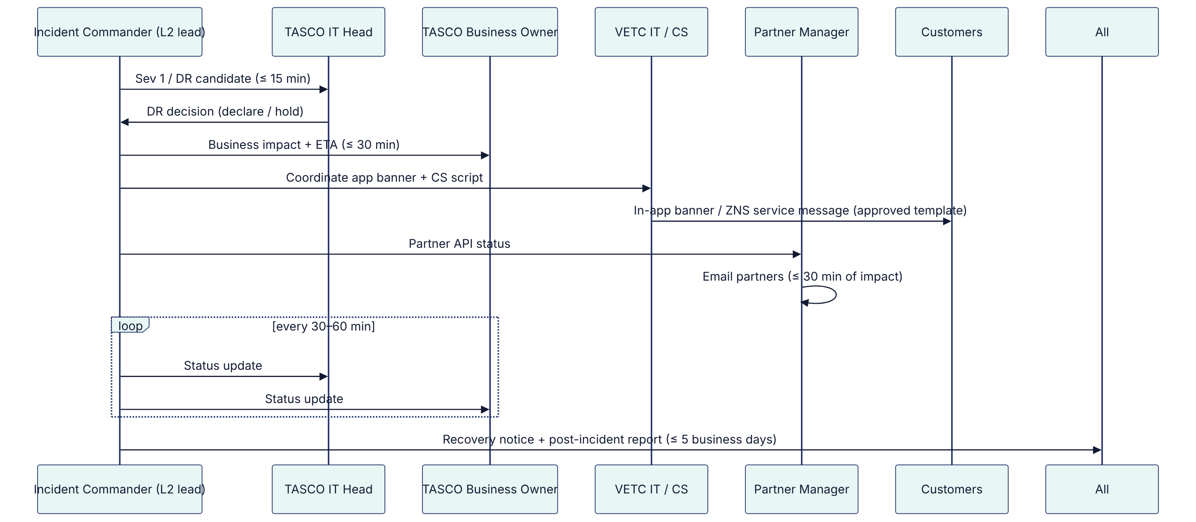
Audience | Message owner | Channel | Timing
Executive (TASCO IT Head, Business Owner, VETC IT Lead) | Incident Commander | Phone + email | Within 30 min of declaring Sev 1 / DR; then hourly
Staff users (telesales, campaign, claims) | Service desk | Teams/Zalo broadcast | Within 30 min
Customers | VETC CS + TASCO Marketing (Compliance-approved templates) | In-app banner, ZNS service message, hotline IVR | When the purchase path is down > 30 min
Partners | Partner Manager | Partner status email / portal | Within 30 min of partner API impact
Regulators / data subjects (personal data breach) | DPO with Legal | Per statutory process | Per legal deadlines

10. Plan maintenance
- Reviewed after every DR test, every Sev 1, and every architecture change (new region, provider, integration).
- Contact lists verified quarterly.
- Owners: SRE (technical procedures), TASCO IT Head (BIA and tiers), VETC CS (customer communications), Partner Manager (partner communications).

