Proposal for the TASCO Motor Insurance Growth Platform
Prepared for TASCO Insurance by iorta TechNXT
iorta TechNXT
Version 1.0 · 07 October 2026
Table of Contents

Prepared for | TASCO Insurance, in partnership with VETC
Prepared by | iorta TechNXT
Reference | ITN-TASCO-2026-001
Version | 1.0, issued 07 October 2026
Validity | 90 days from the date of issue
Classification | Commercial in confidence

1. Executive summary
Every month, around six million drivers pass through VETC toll gantries, and most of them open the VETC app to do it. Every one of those drivers is required by law to carry compulsory motor third-party liability insurance. Very few other companies in Vietnam have a relationship with drivers that is this direct or this frequent. Yet this year TASCO Insurance has closed almost no motor renewals through its own channels. The policies are still being sold, but by agents, banks and showrooms, and often only when the driver is standing in an inspection queue.
We spent time with the brief and with the data behind it, and we do not believe the problem is demand. TNDS cover is compulsory, so the need is guaranteed. The problem is that TASCO does not know when most drivers need to renew, because only about one record in ten carries a reliable expiry date. Drivers do not trust insurance sales calls. The one lever customers ask for, a discount, is one TASCO is not allowed to pull. And the VETC app, for all its reach, cannot yet complete a purchase.
Our proposal is a growth platform that fixes these four things together. It builds a clean record for every vehicle and improves it with every interaction. It decides who to contact, when, through which channel, and with what offer. It reaches drivers in ways they trust: in the VETC app they already use, by Zalo, and by an AI voice assistant that identifies itself and asks the driver to confirm their licence plate before anything else. When a driver is ready, they confirm and pay in the VETC app in a single step. TASCO's core system prices the policy and issues the e-certificate within seconds. Because price cannot be the reason to choose TASCO, the platform makes service the reason: roadside assistance, an e-certificate that police and inspectors can verify by QR code, reminders before inspection, and a faster claims start.
The platform is designed for growth, not only for retention. Alongside renewals, it runs journeys for drivers insured elsewhere, for new vehicles at the moment their VETC tag is activated, for lapsed and uninsured drivers, and for cross-sell of personal accident and physical damage cover. It also gives TASCO's partners an API to sell through, so that the platform works with the channels that perform today instead of against them.
The platform already exists. It is running in a UAT environment that TASCO can use today. It has a staff console for thirteen roles in Vietnamese and English, a customer app in Vietnamese, 80 API endpoints and 238 automated tests. That changes the economics of the MVP. TASCO's budget does not need to pay for building commodity software. It pays for what matters: connecting the platform to TASCO's core system and VETC's channels, loading and repairing real data, hardening the platform for production, and running a measured pilot.
We propose a fixed-price MVP of USD 94,800, within TASCO's MVP budget of USD 100,000, leaving USD 5,200 as a change reserve under TASCO's control. The pilot can be live 13 weeks after contract signature, followed by four weeks of hypercare. We recommend a pilot of 50,000 to 100,000 vehicles in one or two provinces, measured against a control group, so that the decision to scale is based on evidence rather than projections.

2. Our understanding of the situation

2.1 The parties and what each brings
TASCO Insurance owns the insurance products, their pricing and the policy record. Its core system is, and will remain, the system of record for the product catalogue, tariffs and rating, and for every policy issued. VETC owns the relationship with the driver: the app, the wallet, the toll tag and the stream of events that tell us a vehicle is active, new, or on the road. TASCO's partners (agents, banks, showrooms and corporate partners) sell most motor policies today and are paid regulated commission for doing so.
Each party holds part of what is needed. TASCO has the product and the licence to sell it. VETC has the customer's attention and a payment method that needs no card. The partners have the closing skills. What is missing is the layer in between, which turns these assets into the right conversation with the right driver at the right moment. That layer is what we propose to build with TASCO.

2.2 Why own-channel sales are close to zero
We see four causes, and they reinforce each other.
The first is data. Without a reliable expiry date, every message is a guess. A reminder sent six months early is ignored, and one sent two weeks late arrives after a partner has already sold the renewal. With only one record in ten carrying a usable policy date, most drivers cannot be reached at the right time.
The second is trust. Vietnamese consumers have learned to screen out unknown callers offering insurance, and for good reason. A sales call that opens by reading out the customer's personal details feels like a scam even when it is not.
The third is price. TNDS premiums are set by Decree 67/2023/ND-CP, and premium discounts and inducements are not permitted. Many customers hold back, expecting a discount that will never come. A renewal strategy built on price fails before it starts.
The fourth is channel friction. When a driver does want to renew, the VETC app cannot complete the sale. A partner can, so the partner closes it.
None of these can be fixed on its own. Better data without a trusted channel only produces better-targeted calls that still go unanswered. A trusted channel without one-tap purchase loses the customer at the last step. This is why we propose a single platform rather than four separate tools.

2.3 The regulatory frame
The solution has been designed around the rules that apply to motor insurance distribution in Vietnam. Each item below needs to be confirmed by TASCO's legal team during discovery; the platform encodes TASCO's decisions as configurable rules, so the answers can be applied without changing code.
Area | What the platform does about it
Compulsory TNDS (Decree 67/2023/ND-CP) | Shows the regulated price as returned by TASCO's core system, and never offers a premium discount
Law on Insurance Business 08/2022/QH15 | Pays commission only to licensed partners and within configured caps; keeps disclosure text under compliance control
Personal data protection (Decree 13/2023/ND-CP and the Personal Data Protection Law, effective 1 January 2026) | Purpose-based consent, a consent centre for customers, data-subject requests, retention rules and breach-ready audit evidence
Cybersecurity Law 2018 and Decree 53/2022/ND-CP | Production hosting in Vietnam; no personal data leaves the country
Electronic Transactions Law 20/2023/QH15 | E-certificates issued by TASCO's core system and verifiable by QR code
Advertising and spam rules (Decree 91/2020/ND-CP) | Contact window of 08:00 to 20:00, frequency caps, do-not-contact handling and a copy guard on every message

3. Our approach in one picture
The idea behind the platform is simple: every interaction with a driver should leave TASCO knowing more than it did before, and every decision about whom to contact should be made on that knowledge.
The loop matters more than any single step. When a driver confirms their expiry date in the app, answers a question from the voice assistant, buys a policy or reports a claim, that information flows back into their record. Next year's renewal starts from verified data, with less effort and at lower cost. Over two or three cycles, the data problem that blocks TASCO today becomes one of its advantages.

4. Why iorta TechNXT
TASCO will receive proposals that describe what a platform could do. Ours describes what a platform already does, and TASCO can verify that before making a decision. The UAT environment is available to TASCO's evaluation team now, with credentials for every role. A telesales agent can work a lead, a compliance officer can approve a rule change, and a customer can renew and receive an e-certificate, all from end to end.
We built the platform specifically for this brief. Every one of the four challenge tracks (the voice assistant, lead scoring and enrichment, the renewal engine, and value beyond discount) is implemented, and each requirement is traced through to the code that delivers it and the test that proves it.
We have engineered it to the standard an insurer should expect. Business rules are configuration, not code: products, scoring, journeys, contact policy, message copy, benefits and commission are versioned rule sets that TASCO's business teams change through a rules studio, with simulation before release and a second person's approval before anything goes live. Every decision is written to an audit trail that cannot be altered without detection. Personal data is encrypted at field level. Privileged users sign in with two-factor authentication, and incompatible roles cannot be held by the same person.
Because so much already exists, the MVP budget goes almost entirely to TASCO-specific work. That is what allows us to commit to a fixed price inside TASCO's budget and a pilot in 13 weeks.
Finally, TASCO is not locked in. The platform uses mainstream technology (Node.js, PostgreSQL, Docker and Kubernetes), documented APIs and a complete set of 66 delivery documents. TASCO receives a perpetual licence and the source code, and can run the platform with its own team or any qualified partner in future.
Company credentials. [For iorta TechNXT to complete before submission: company profile, years in operation, insurance clients and references, certifications such as ISO/IEC 27001, and delivery presence for Vietnam.]

5. How the solution answers each challenge
Challenge | What the platform does | How we will know it works
Renewals through own channels are close to zero | Renewal journey from 45 days before expiry, ending in one-tap purchase in the VETC app | Own-channel renewal rate in the pilot cohort against the control group
Data is weak and fragmented | One record per plate from all sources; expiry estimated with a stated confidence; customers confirm their own expiry; every contact writes back | Share of vehicles with a usable expiry date, measured monthly
Customers do not trust sales calls | The assistant says it is automated, asks the driver to state their plate before anything else, never asks for codes or payment, and payment happens only in the VETC app | Call completion, opt-out and complaint rates
Discounts are not allowed | A copy guard blocks discount language; the offer is built on service: roadside assistance, verifiable e-certificate, reminders, faster claims, multi-year cover | Zero copy-guard breaches; uptake of benefits
Partners close faster | Partners get an API to quote by plate and issue in under a minute, with commission capped by rule; leads are routed to the channel most likely to close | Policies through the partner API; time to certificate
Growth beyond renewals | Journeys for drivers insured elsewhere, new vehicles, lapsed and uninsured drivers, and cross-sell | Share of new-business policies
Pricing must stay correct | Every quote is priced live by TASCO's core system; the product catalogue is synchronised from core and approved before release | Zero differences between quoted and issued premium
Privacy and messaging rules | Consent centre, contact window, frequency caps, data-subject requests and a full audit trail | Zero contact-policy breaches

6. The solution

6.1 Capabilities
The platform has eight capability areas. They share one data model, one rules engine and one audit trail, which is why they behave consistently.
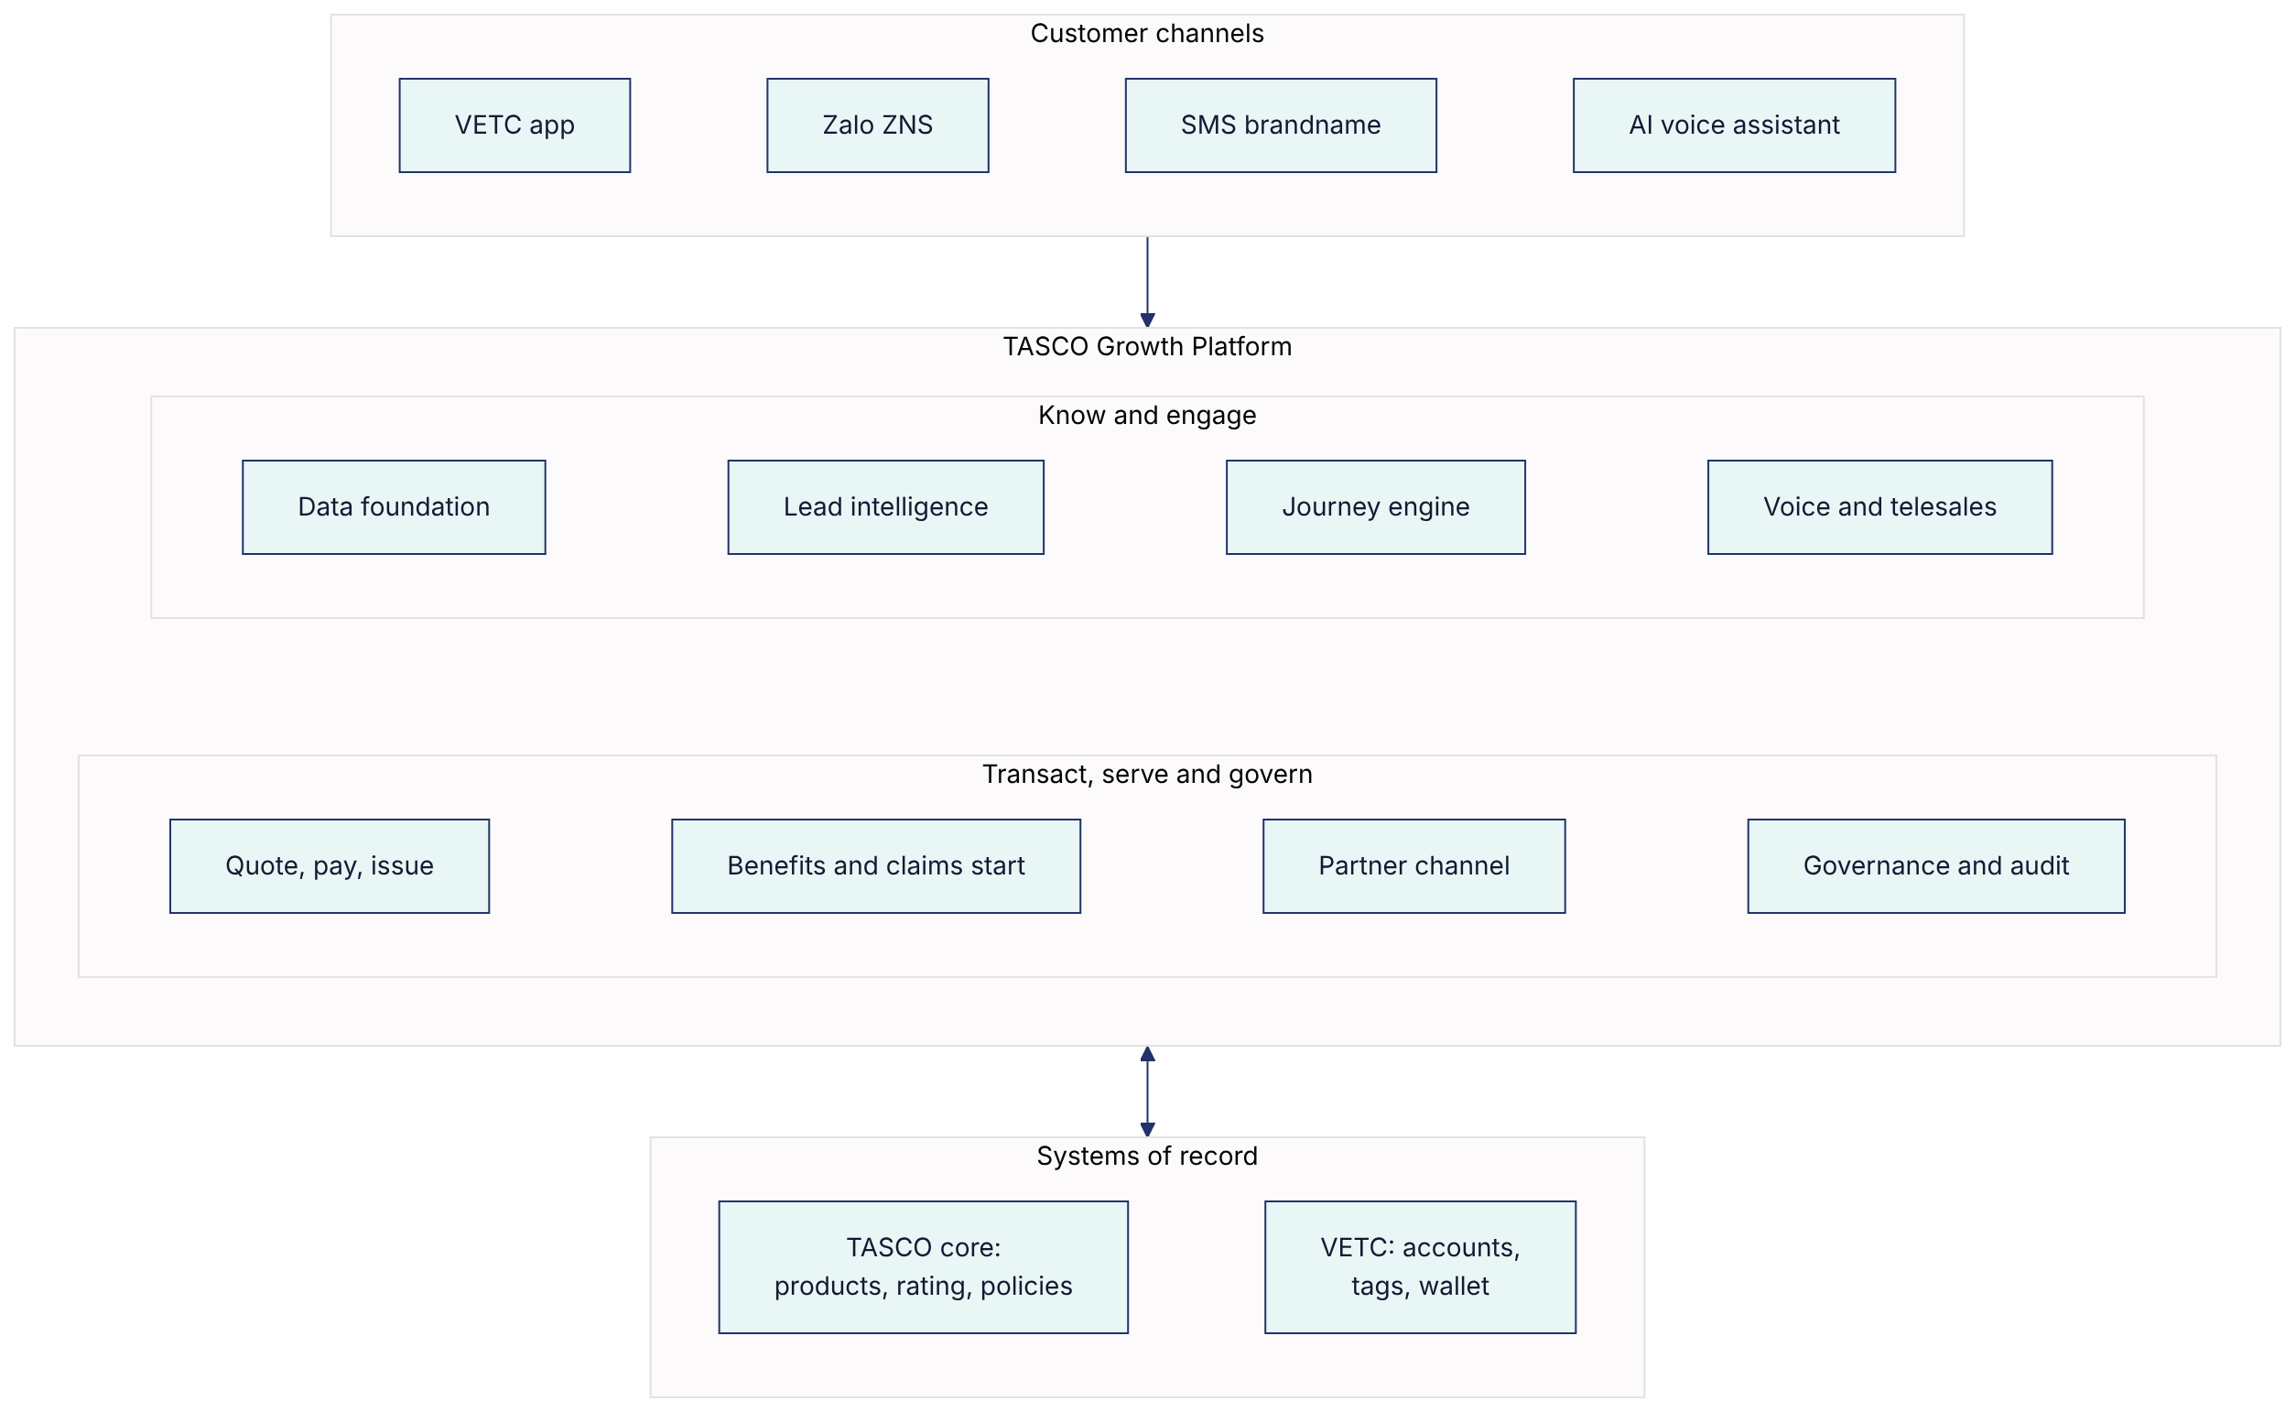
Data foundation. Records from VETC, TASCO's policy book and partner files are matched by licence plate into one profile per vehicle. Where sources disagree, the platform chooses the most trusted value and keeps the alternatives. It estimates the policy expiry date from all the evidence available and states how confident it is. Data stewards work a queue of records that need attention, and every field shows where it came from.
Lead intelligence. Each vehicle receives a score from 0 to 100, with reasons written in plain language, and a next best action. That action might be "verify the expiry first", "send the renewal", "call", or "route to the B2B team because this is a company vehicle".
Journey engine. Five journeys run on timed schedules across app push, Zalo, SMS, the voice assistant and telesales. Before any message is sent, the platform checks consent, the contact window, frequency limits and the wording. Important moments in the VETC ecosystem, such as a new tag activation, a booked inspection or a wallet top-up, can start a journey at once.
Voice assistant and telesales. The assistant identifies itself, verifies the plate, asks about current cover and interest, writes the answers back to the record and passes warm leads to a telesales agent with a summary and suggested talking points. Agents never take payment. They send the quote to the customer's VETC app, where the customer pays.
Quote, pay and issue. Quotes are priced by TASCO's core system. The customer pays from the VETC wallet. TASCO's core system binds the quote it priced and issues the policy and e-certificate. If issuance fails after payment, the platform refunds automatically.
Benefits and claims start. The offer is built on service rather than price. Customers can report an accident in the app with photos and location, and the claims team receives it in a queue.
Partner channel. Partners quote and bind through a secure API, with commission calculated and capped by rule and a monthly statement for each partner.
Governance and audit. A rules studio with simulation and four-eyes approval, a consent centre, data-subject requests, role-based dashboards, and an audit trail that can be verified for tampering.

6.2 New business, not only renewals
The brief asked about renewals. We think the larger opportunity lies in the drivers TASCO does not yet insure. The platform therefore treats the whole VETC base as a set of segments, each with its own play.
Segment | Who they are | What the platform does | Products
Lapsed or uninsured | No valid cover can be found | Recovery journey through the app first, then a voice call with consent | TNDS
New vehicle | A new VETC tag has just been activated | Welcome message and a quote at activation | TNDS, personal accident, physical damage
TASCO renewal | A TASCO policy is due to expire | Renewal journey from 45 days before expiry | TNDS (including multi-year), add-ons
Insured elsewhere | Cover is held with another insurer | Conquest journey timed to that insurer's expiry | TNDS with the service bundle
Existing TASCO customer | Holds TASCO cover today | Cross-sell journey | Personal accident, physical damage
Fleet | Company-owned vehicles | Routed to TASCO's B2B team | Fleet cover
Partner-led | Customer of a bank, showroom or agent | Partner sells through the API | TNDS and add-ons

6.3 Value beyond discount
Benefit | Why it matters to the driver | In the MVP
Instant e-certificate with QR verification | Proof of cover at inspection or a roadside check in seconds, and protection against fake certificates | Yes
Inspection and expiry reminders | Avoids driving uninsured by accident | Yes
24/7 roadside assistance | Help on the road, especially for long-distance drivers | Yes, through TASCO's assistance provider
Accident reporting in the app | A faster, clearer start to a claim | Yes
Multi-year TNDS cover | One purchase for up to three years | Yes
Personal accident and physical damage add-ons | Wider protection, priced by TASCO's core system | Yes; physical damage requires an inspection
Loyalty points | Rewards for loyal, safe drivers | Built, but switched off until TASCO legal approves

7. Business and process flows

7.1 Who does what
The responsibilities of each party stay where they belong. TASCO's core system prices and issues, VETC collects payment and hosts the customer experience, and the platform orchestrates.
Step | Customer | VETC | TASCO core | Growth platform | Telesales or partner
Bring data together |  | Accounts, vehicles, tag events | Policies and expiry dates | Matches, cleans, records lineage | Partners supply leads
Decide |  |  |  | Scores, segments, chooses journey and channel
Contact | Receives a message or call | Delivers app notifications |  | Checks consent, timing, limits and wording | Calls warm leads
Quote | Reviews the quote | Hosts the purchase screen | Rates and returns a quote reference | Requests the quote, adds benefits | Sends the quote to the customer's app
Pay | Confirms and pays | Debits the VETC wallet |  | Orchestrates, refunds if issuance fails | Never takes payment
Issue | Receives the e-certificate | Shows it in the app | Binds the quote and issues the policy | Stores the certificate, updates the record
Serve | Uses benefits, reports claims |  | Handles claims | Takes the first notice, sends reminders

7.2 Renewal with one-tap purchase
This is the flow that turns a reminder into a policy without a phone call.
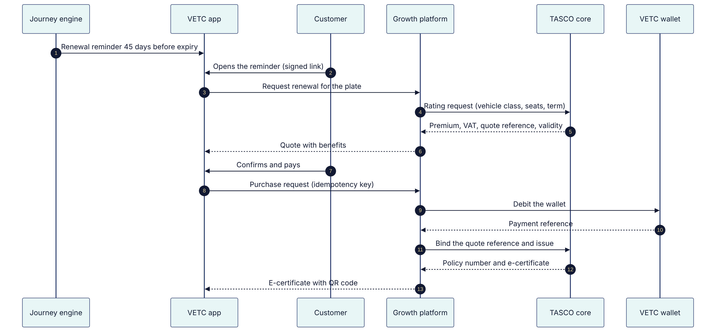
Two safeguards sit behind this flow. Each purchase carries an idempotency key, so a customer who taps twice or loses signal is never charged twice. If TASCO's core system cannot issue after the wallet has been debited, the platform refunds the customer automatically and alerts the operations team.

7.3 Voice assistant: plate first, then handoff
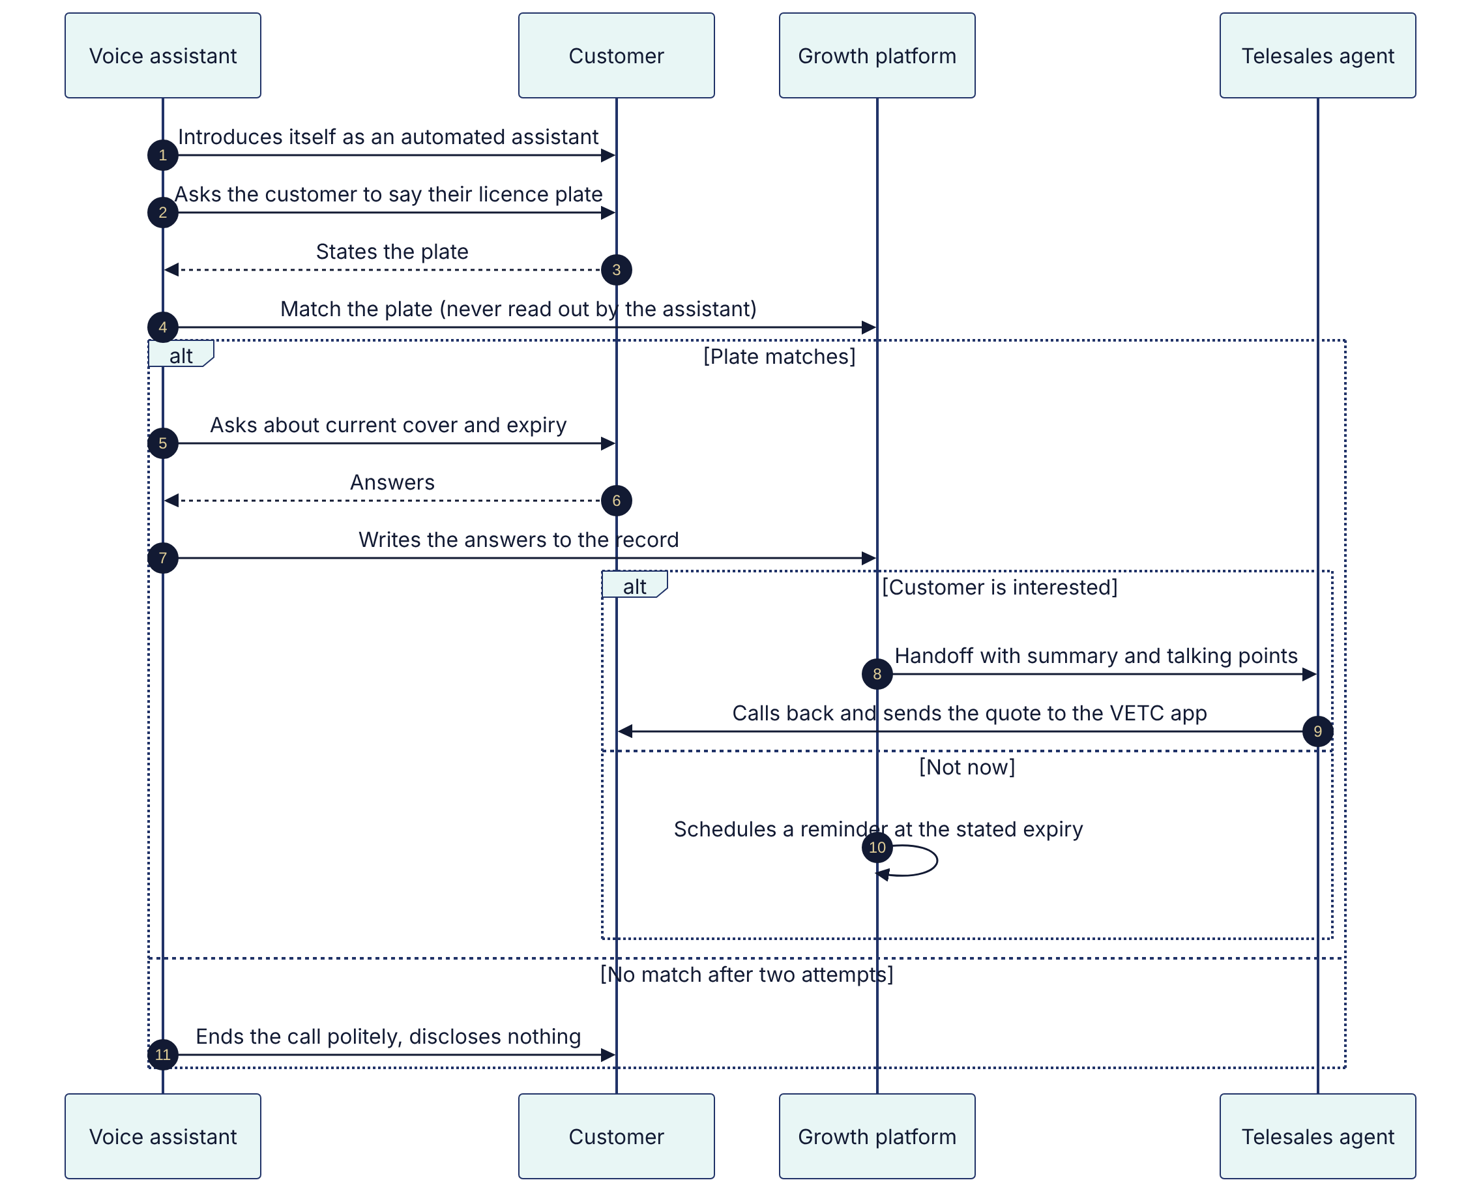
The script is governed like any other rule set: compliance approves it before it goes live. If a customer asks why they should not wait for a discount, the assistant answers truthfully: TNDS prices are set by regulation and are the same everywhere, and TASCO adds roadside assistance and an instant e-certificate.

7.4 New vehicle at tag activation
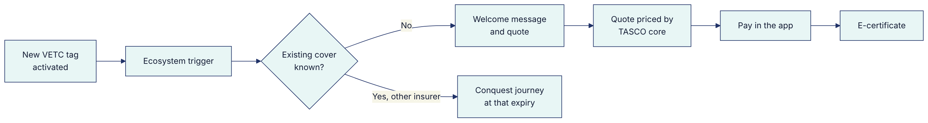

7.5 Partner sale through the API
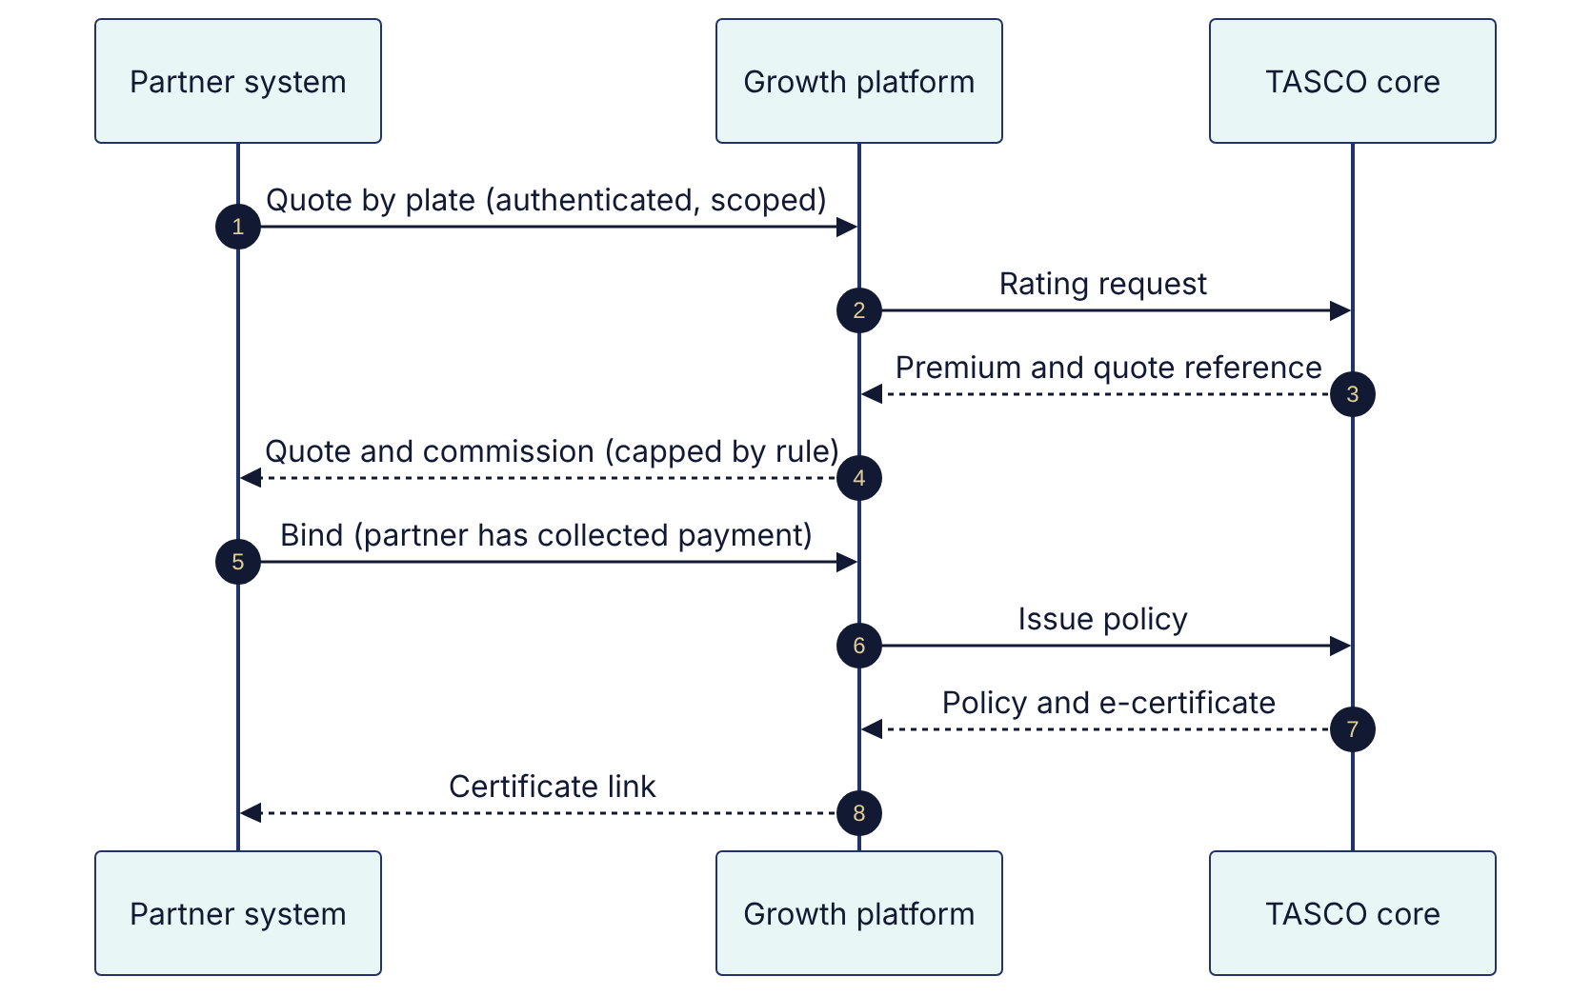

7.6 Product and tariff changes
TASCO's core system remains the master for products and rating. When a product or tariff changes there, the platform picks up the change; nobody keys it in twice.
Quotes are always priced live by the core system, so a sync delay can affect which products are displayed, but never the premium a customer pays.

8. Personas and their journeys

8.1 Customers
We designed around five customer personas drawn from the VETC base.
Persona | Situation | What they need | What the platform gives them
Anh Minh, 38, Hà Nội | Commutes daily; uses the VETC app; ignores sales calls | Renew without effort, at the right time | A reminder in the app 45 days ahead and purchase in one tap
Chú Hùng, 51, long-haul driver | Drives between Thanh Hóa, Hà Nội and Hải Phòng | Help when something goes wrong on the road | Roadside assistance as part of the offer; calls only inside the contact window
Chị Thảo, 32, TP. Hồ Chí Minh | Has just bought a car and activated a VETC tag | To be covered legally from the first day | A welcome offer at tag activation, with optional add-ons
Anh Tuấn, 45, Bình Dương | His policy lapsed months ago | To fix it without being lectured or pressured | A recovery journey that starts in the app and moves to a call only with consent
Chị Lan, 41, fleet manager | Runs 40 vehicles for a logistics company | One renewal date and one invoice | Routed to TASCO's B2B team; fleet portal in the scale phase

8.2 Anh Minh's renewal, before and after
Today, TASCO does not know when Anh Minh's cover ends. He receives no reminder from TASCO, waits in case a discount appears, and eventually buys from whoever is in front of him at his next inspection.
With the platform, the story is different. Forty-five days before his cover ends, a notification appears in the VETC app he opens every week. It tells him the date his cover ends, the regulated price, and what TASCO includes: roadside assistance, an e-certificate he can show at any checkpoint, and a reminder before his next inspection. He taps "Confirm and pay", pays from his VETC wallet, and receives his e-certificate before he has finished his coffee. Next year, his expiry date is already verified and he is offered three-year cover.

8.3 Anh Tuấn's return from lapsed
The platform finds no valid cover for Anh Tuấn's car. His record is good enough to act on, so the recovery journey starts with an app message. When he does not respond, and because he has consented to calls, the voice assistant calls him at 10:30 one morning. It introduces itself, asks him to state his plate, and asks whether he has cover elsewhere. He says he does not and would like to sort it out. A telesales agent receives the handoff with a two-line summary, calls him back within the hour and sends the quote to his VETC app, where he pays. The agent never asks for payment details on the phone.

8.4 Staff and partners
Role | What they want from the platform | Where they work
Telesales agent | Fewer, better calls, with context | Handoff inbox, customer 360 view, quote and send
Telesales supervisor | Productivity and compliance across the team | Inbox assignment, voice assistant console
Campaign manager | Growth at a controlled cost | Dashboard, leads, journeys, voice campaigns
Product rule author | Change scoring, journeys and copy without an IT project | Rules studio
Compliance approver | Nothing unlawful reaches a customer | Approvals, audit trail, governance dashboard
Data steward | Data the business can trust | Data-quality queue, lineage
Claims handler | Complete first notices, received early | Claims queue
Partner manager | More partner sales and clean commission | Partners, API keys, statements
Executive | Growth and return on investment, visible weekly | Executive dashboard
Support, administration and audit | A stable, secure and evidenced platform | Operations, users, audit

9. User stories
The full backlog contains 15 epics and 124 user-story scenarios, each written with acceptance criteria in Given/When/Then form and each backed by an automated functional test. The table below gives one representative story per epic and shows what is in the MVP.
Epic | Representative user story | In the MVP
Data foundation and repair | As a data steward, I want records from VETC, TASCO and partners merged into one profile per plate, so that each vehicle is contacted once and with the best data. | Yes
Lead prioritisation | As a campaign manager, I want every vehicle scored with reasons, so that effort goes to the drivers most likely to buy. | Yes
Renewal journeys | As a TASCO customer, I want a reminder before my cover ends, so that I am never uninsured by accident. | Yes
New-business journeys | As a new VETC tag holder, I want to buy TNDS in the app when I activate my tag, so that I am covered from day one. | Yes
Voice assistant | As a customer, I want the assistant to confirm my plate before discussing my policy, so that I know the call is genuine. | Yes
Telesales closing | As a telesales agent, I want warm handoffs with a summary, so that I can close without cold calling. | Yes
Customer app | As a customer, I want to confirm and pay in the VETC app, so that I never give payment details on a call. | Yes
Value beyond discount | As a customer, I want roadside assistance and an instant e-certificate, so that TASCO is worth choosing at the same price. | Yes
Partner channel | As a showroom salesperson, I want to quote by plate and issue in under a minute, so that insurance closes with the car sale. | Yes, one partner
Fleet and B2B | As a fleet manager, I want one renewal date and one invoice for all my vehicles. | Routing only; portal later
Claims first notice | As a customer, I want to report an accident in the app with photos. | Yes
Privacy and consent | As a customer, I want to see and change my consents and request my data. | Yes
Rule governance | As a product rule author, I want to change scoring or wording with simulation and approval, without a software release. | Yes
Identity, access and audit | As an auditor, I want a tamper-evident record of every decision. | Yes
Operations and insight | As an executive, I want a growth dashboard by channel and segment. | Yes

10. The product in use
The screens below are taken from the platform as it runs today in the UAT environment, with synthetic data.

10.1 The driver's experience in the VETC app
The customer app opens inside the VETC app from a signed link in a notification or a Zalo message, so the driver never has to sign in again or type a card number. It is written in Vietnamese for drivers.
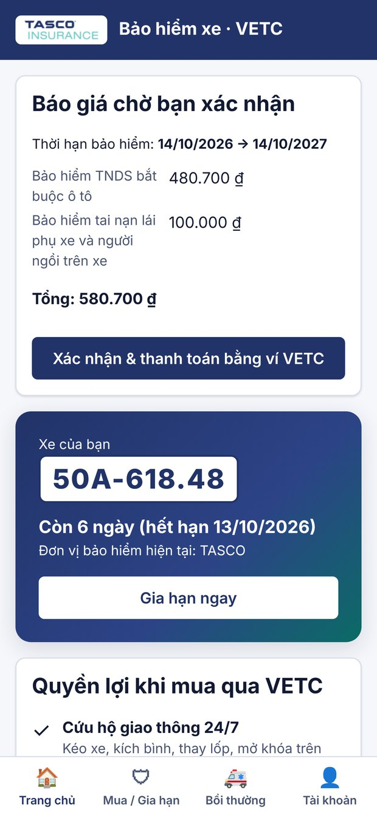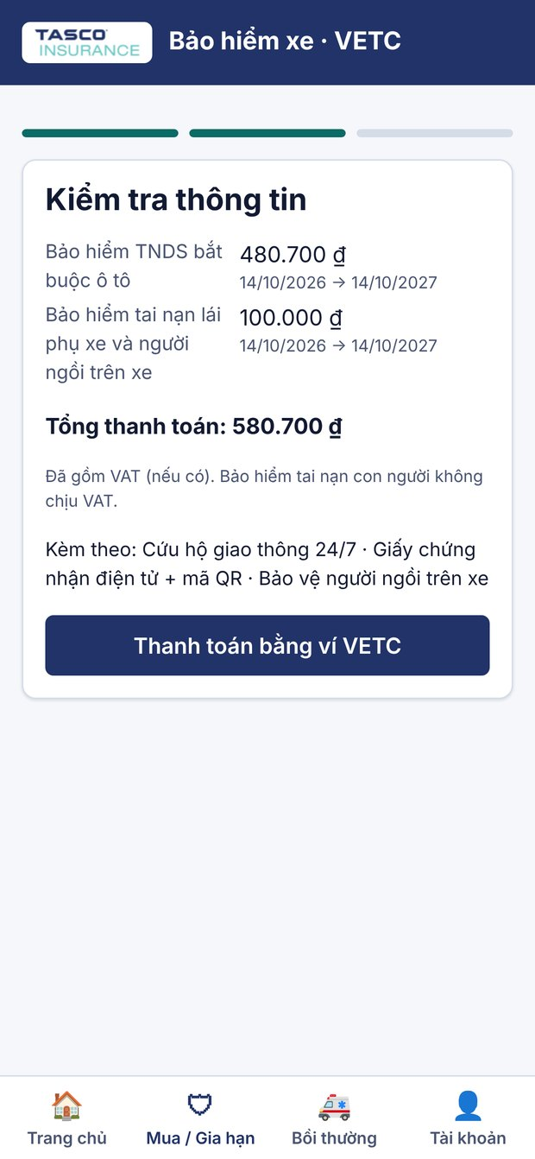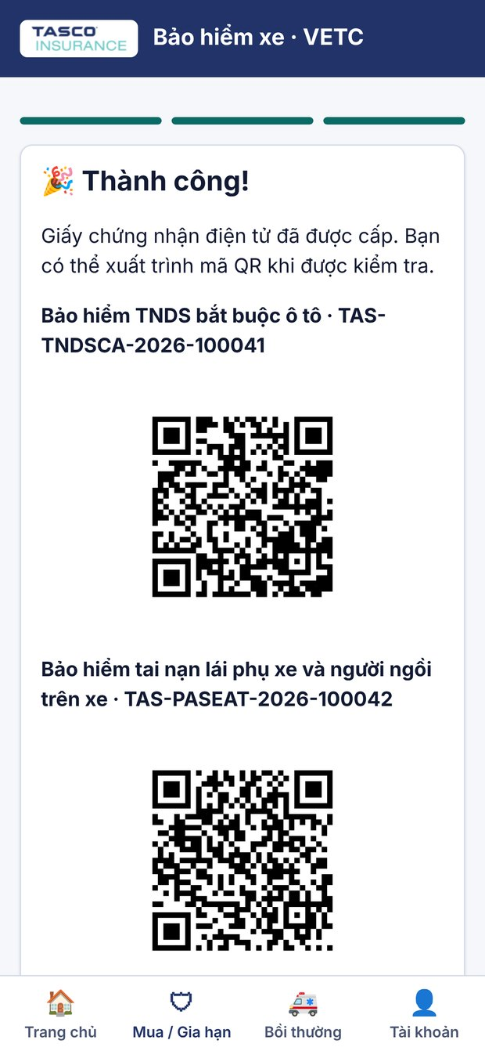
Left to right: the home screen with a quote waiting for confirmation and the renewal countdown; the review screen with the cover period, the total including VAT and the included benefits, paid from the VETC wallet; and the e-certificates issued the moment payment succeeds.
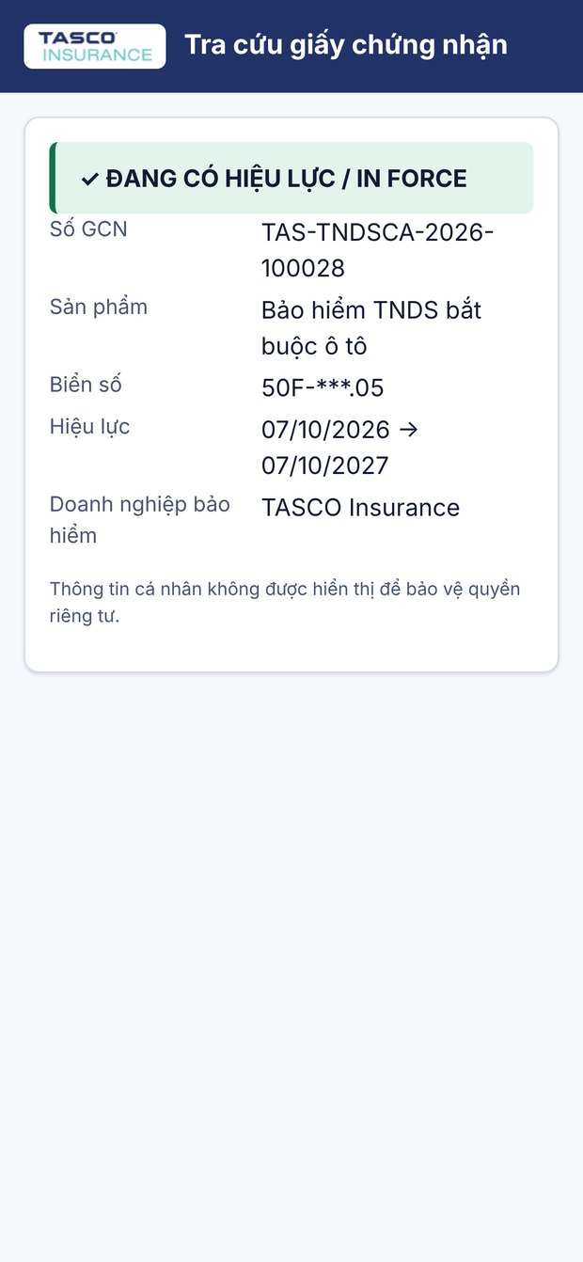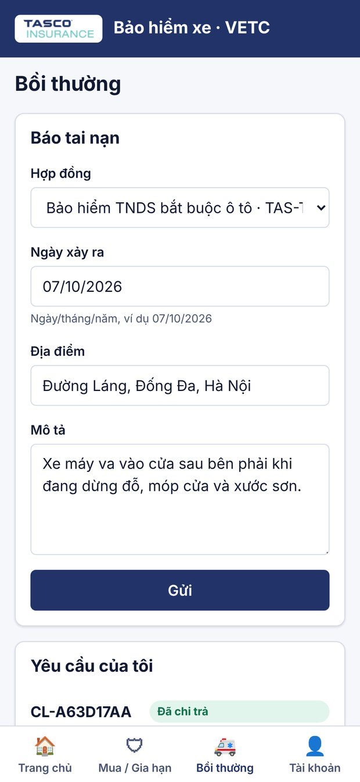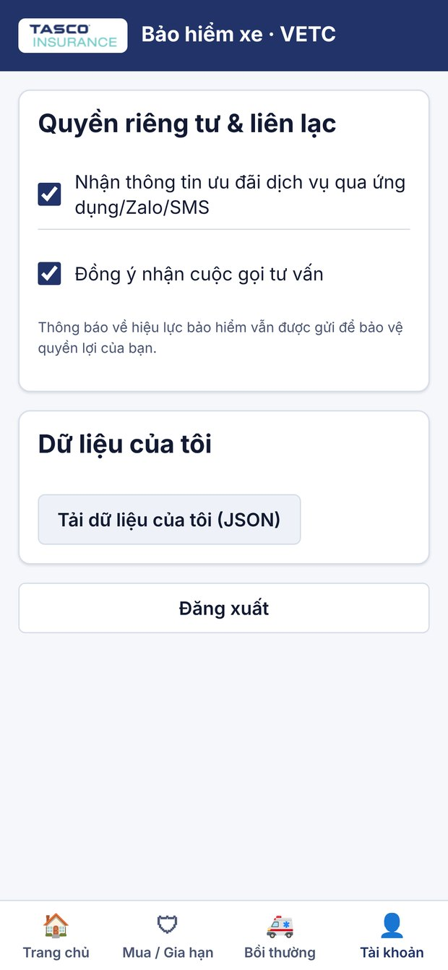
Left to right: the public verification page a police officer or inspector reaches by scanning the QR code, showing the certificate is in force with no personal data; accident reporting in the app; and the consent centre, where drivers control marketing and call consent and can download their data.

10.2 Telesales: fewer calls, better calls
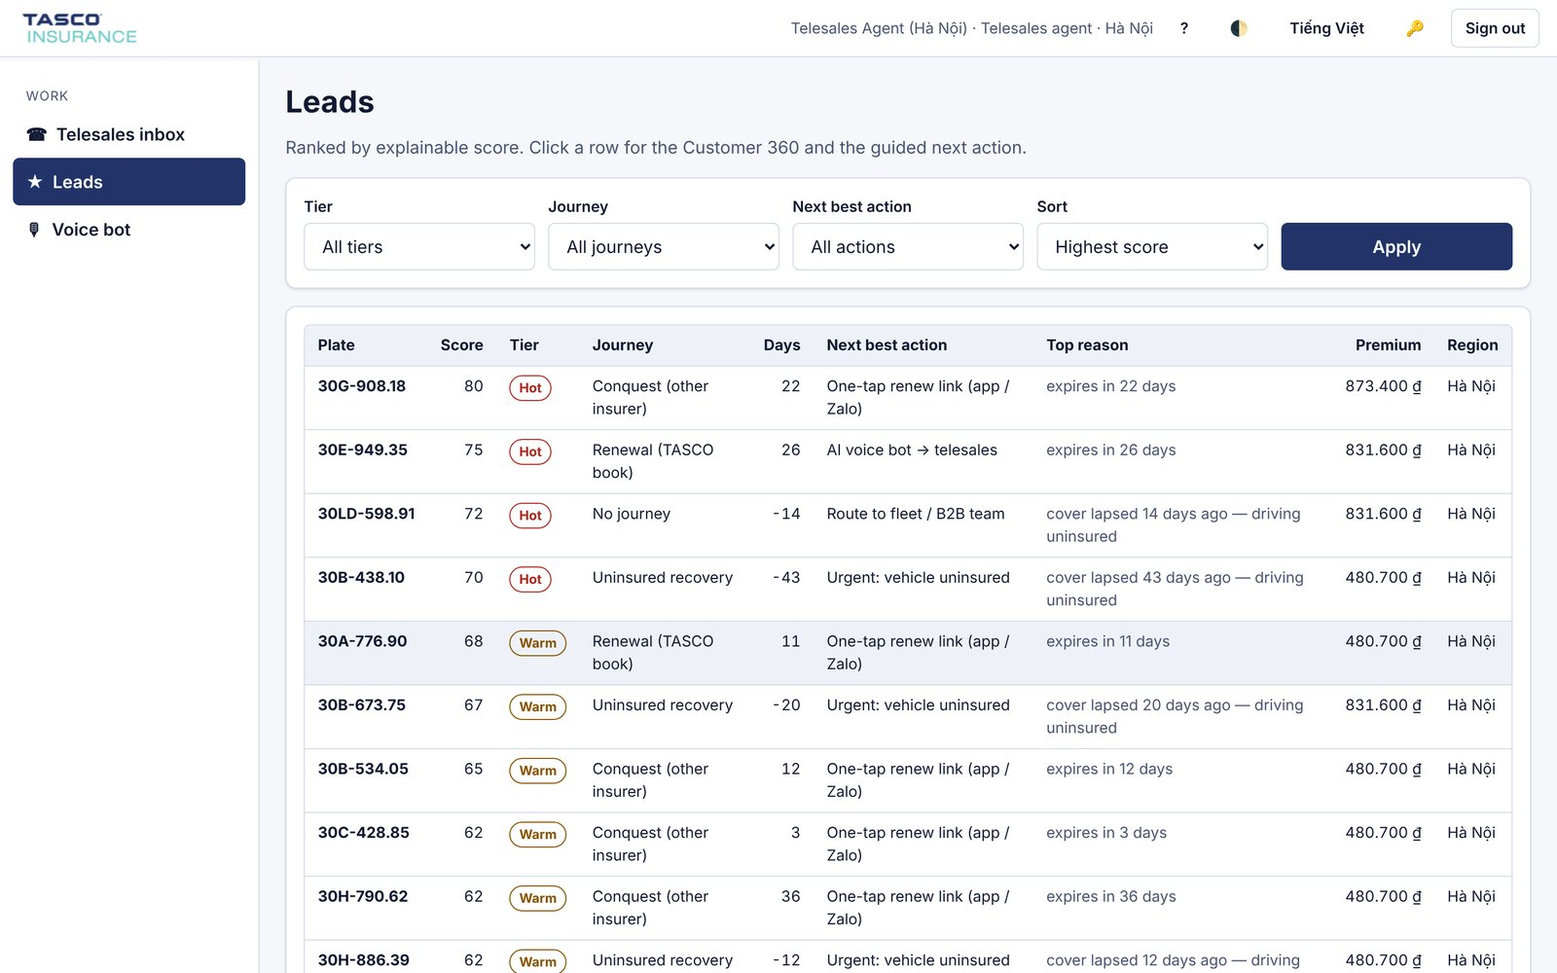
The lead queue for a Hà Nội telesales agent. Every vehicle has a score, a tier, a journey, the days to expiry, the next best action and the main reason in plain language.
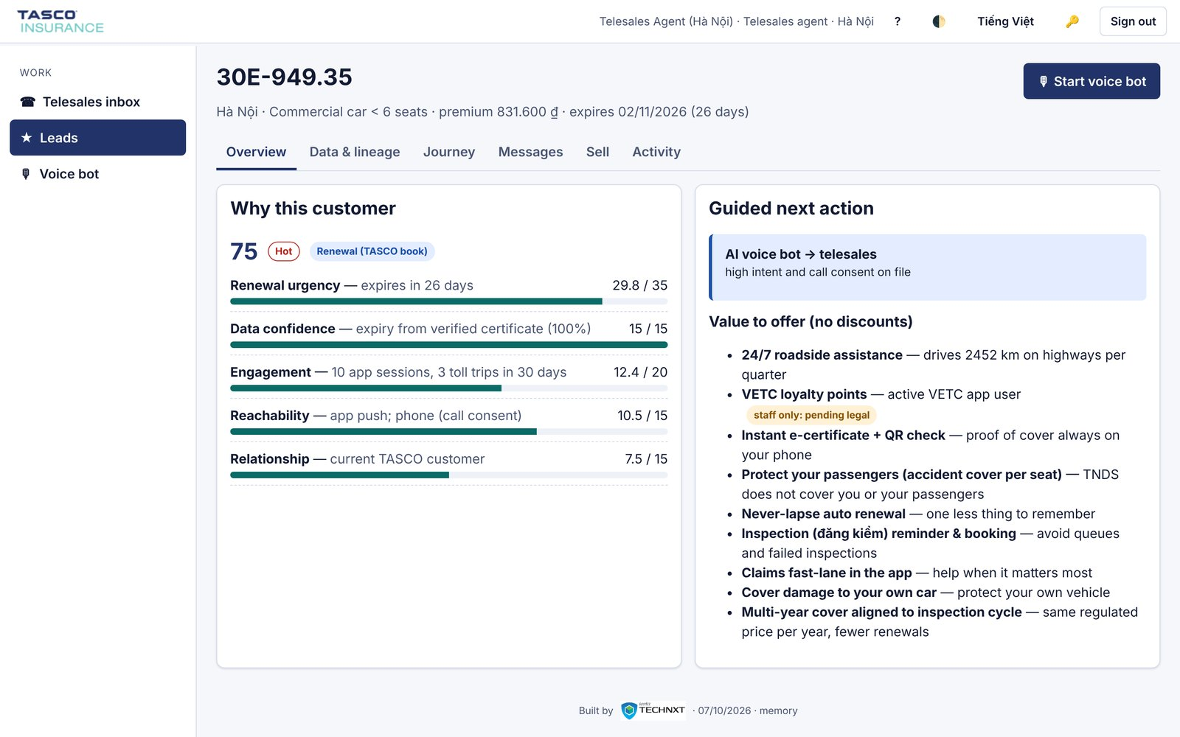
The customer 360 view explains why this driver is worth a call, factor by factor, and what to offer instead of a discount.
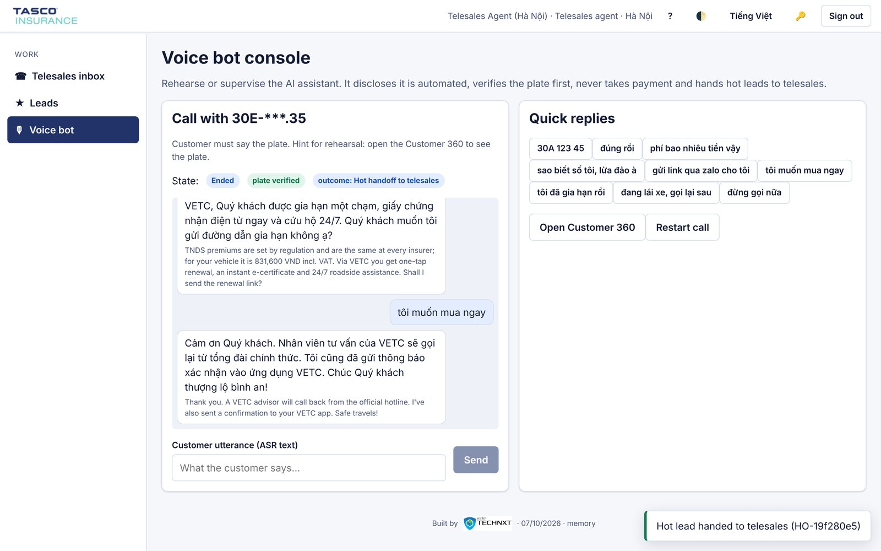
A voice assistant call. The assistant says it is automated, the driver states the plate, a price objection is answered with service value, and the interested driver is handed to telesales.
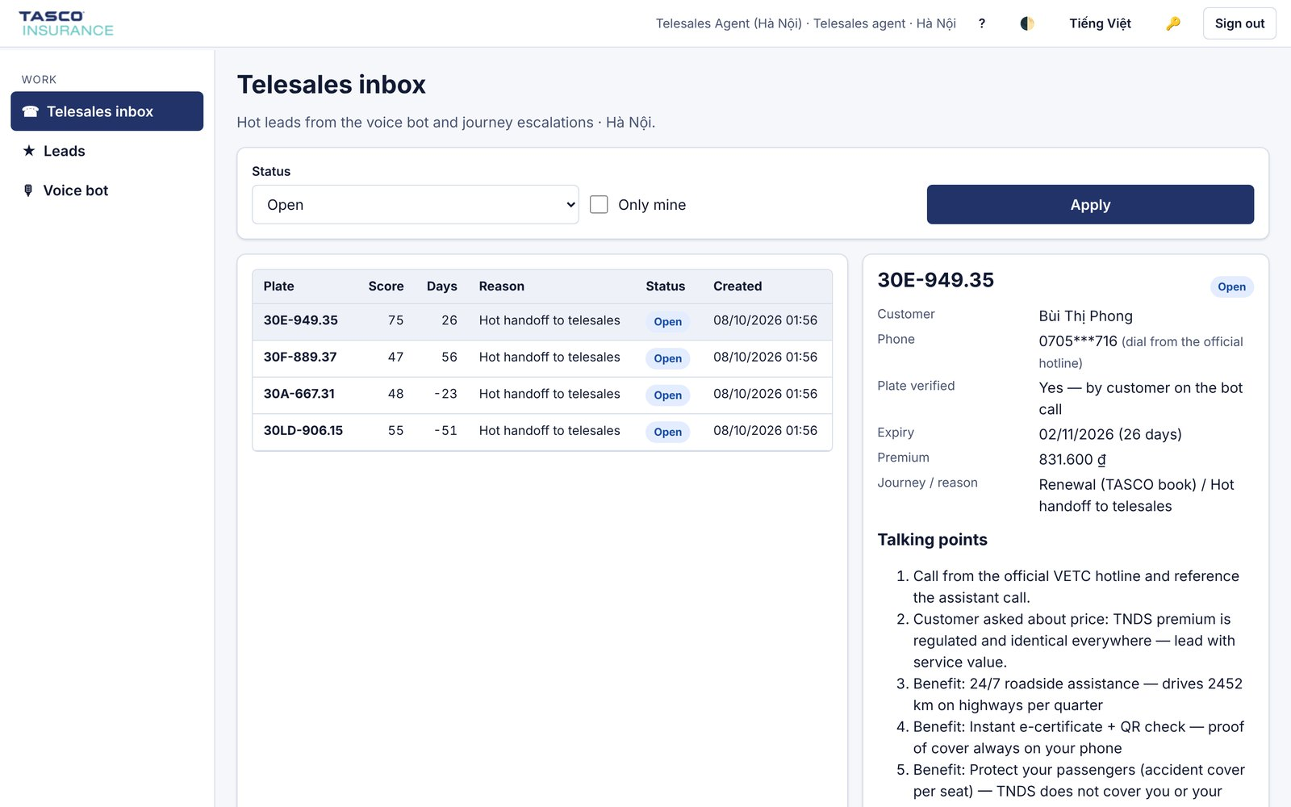
The telesales inbox: warm handoffs with plate verification status, masked phone number, expiry, premium and suggested talking points.
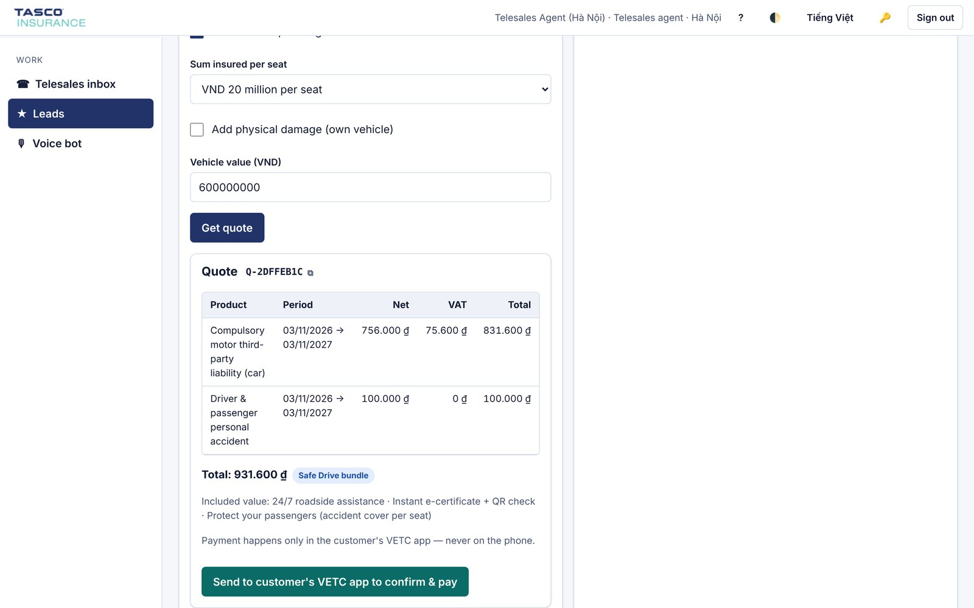
The Sell tab. The agent prepares a quote with benefits and sends it to the customer's VETC app to confirm and pay. Payment is never taken on the phone.

10.3 Management: growth at a glance
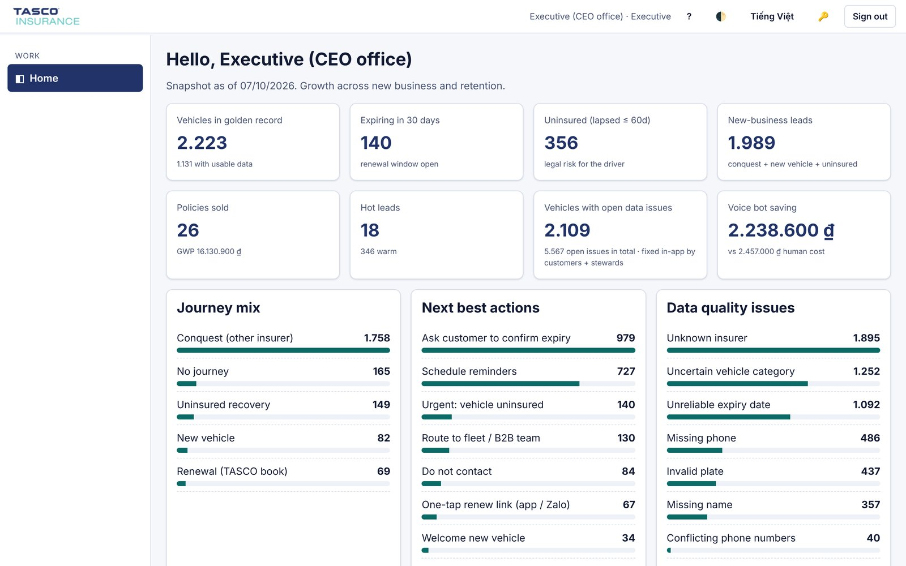
The executive dashboard: the size of the golden record, vehicles expiring in the next 30 days, uninsured vehicles, new-business leads, policies sold, vehicles with open data issues and the voice assistant's saving compared with human calls.
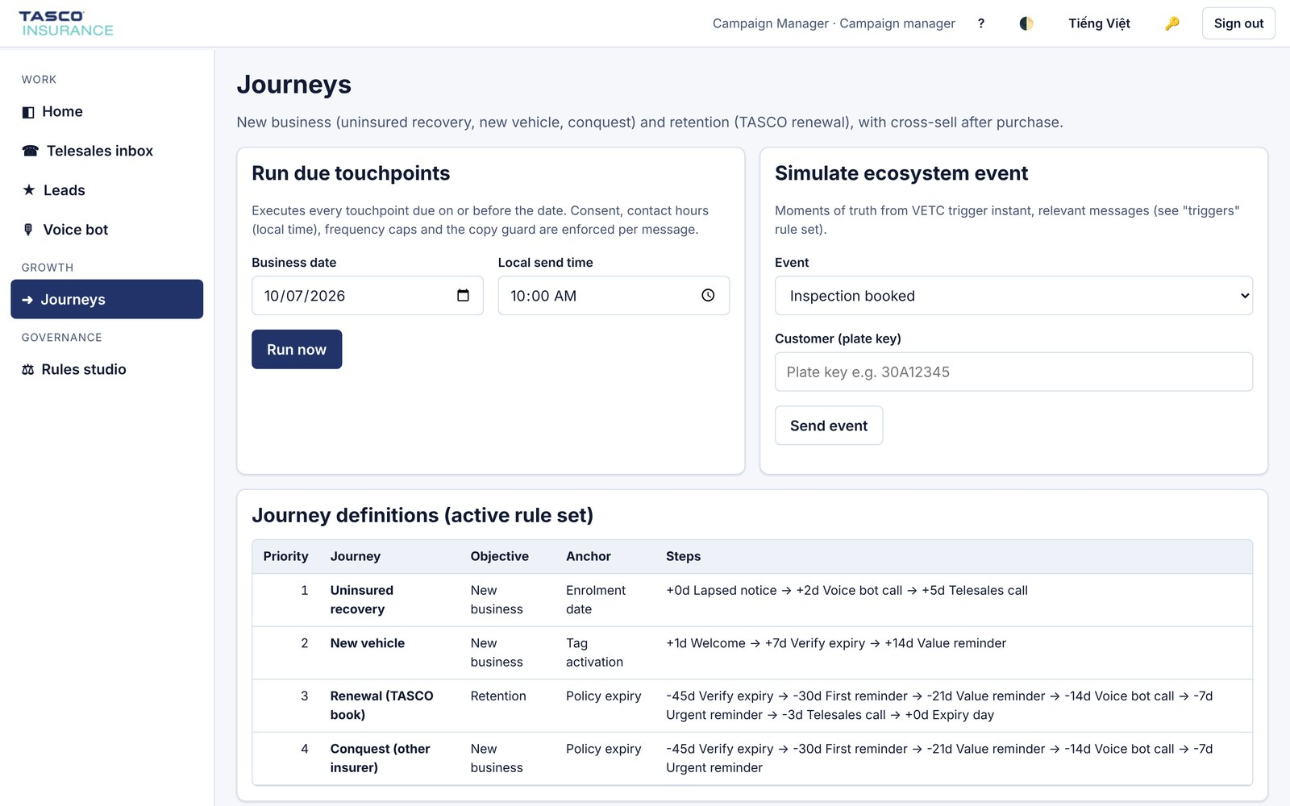
Journey orchestration for the campaign manager, with consent, contact-hour and frequency checks applied to every touchpoint.

10.4 Governance: change safely, prove everything
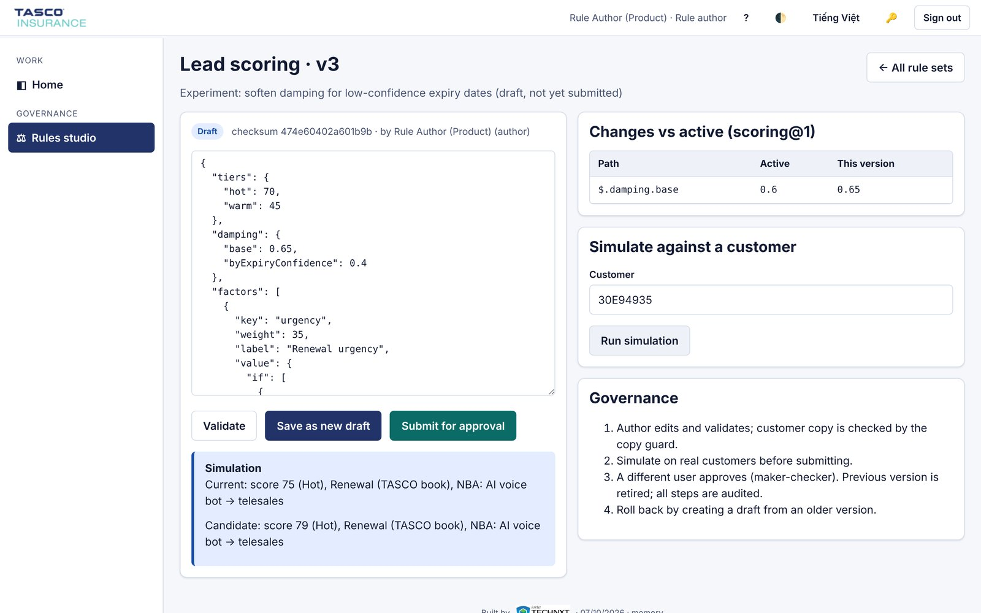
The rules studio. A product owner drafts a change to scoring, compares it with the live version and simulates it on a real customer before submitting it.
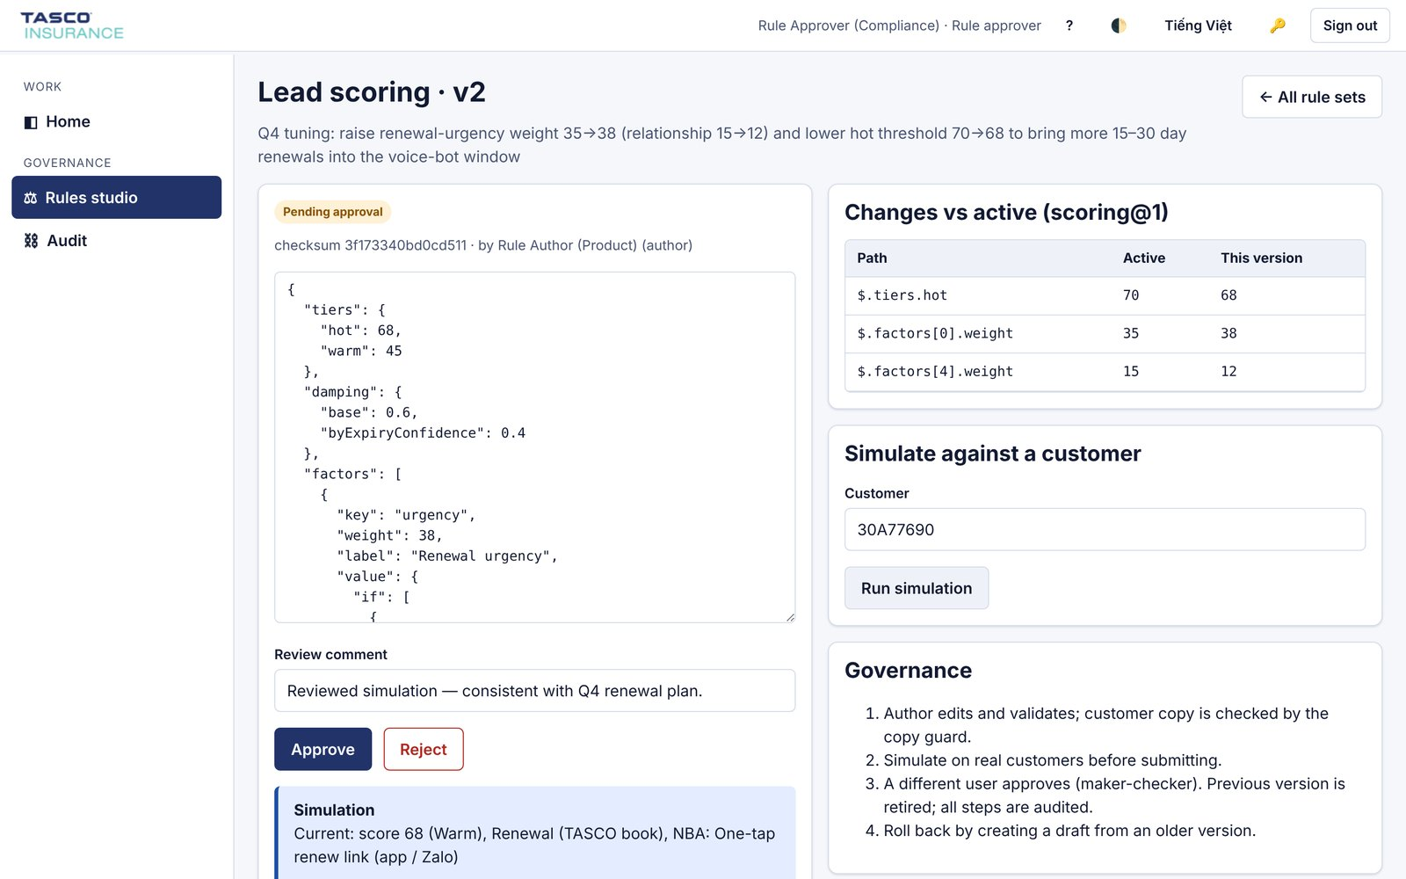
Maker-checker approval. A compliance approver sees exactly what changes and approves or rejects it. The author cannot approve their own change.
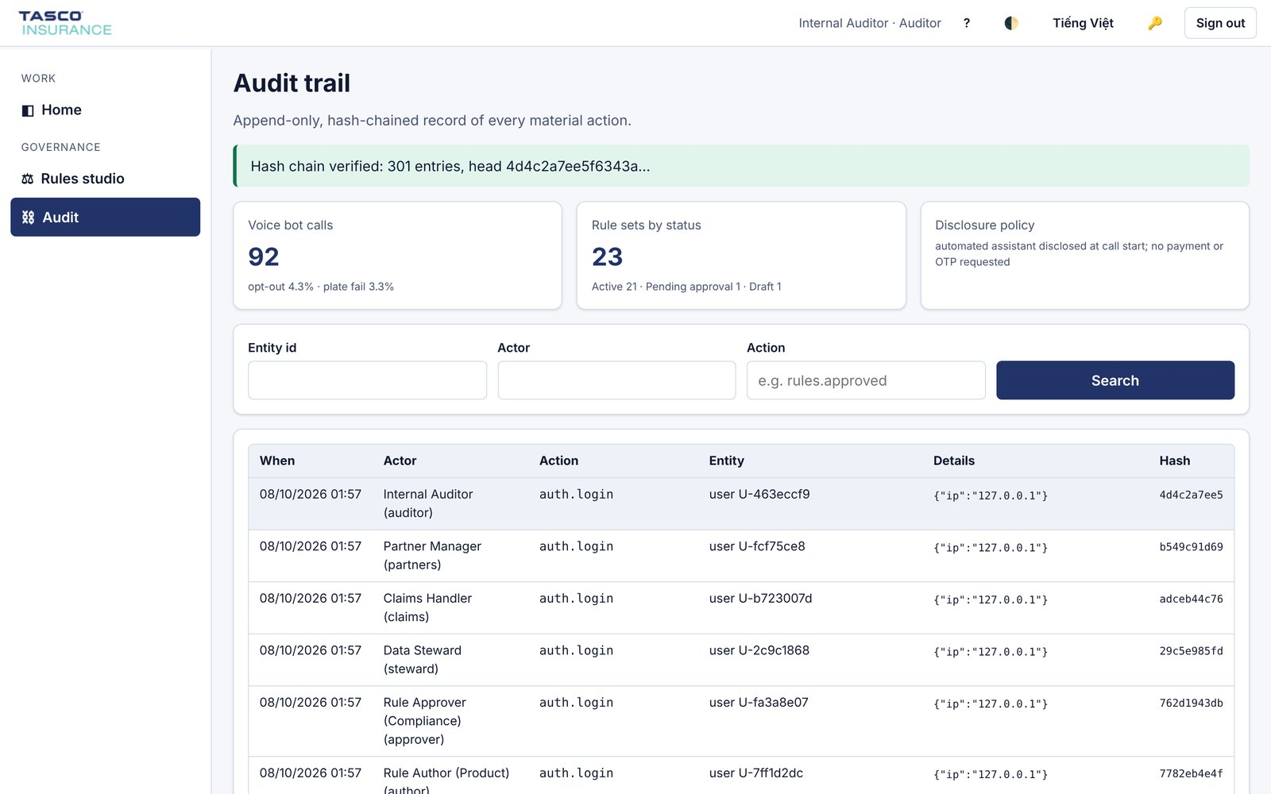
The audit trail. Every material action is recorded in a hash chain that is verified continuously, together with the voice assistant's compliance indicators.

10.5 Data, claims, partners and operations
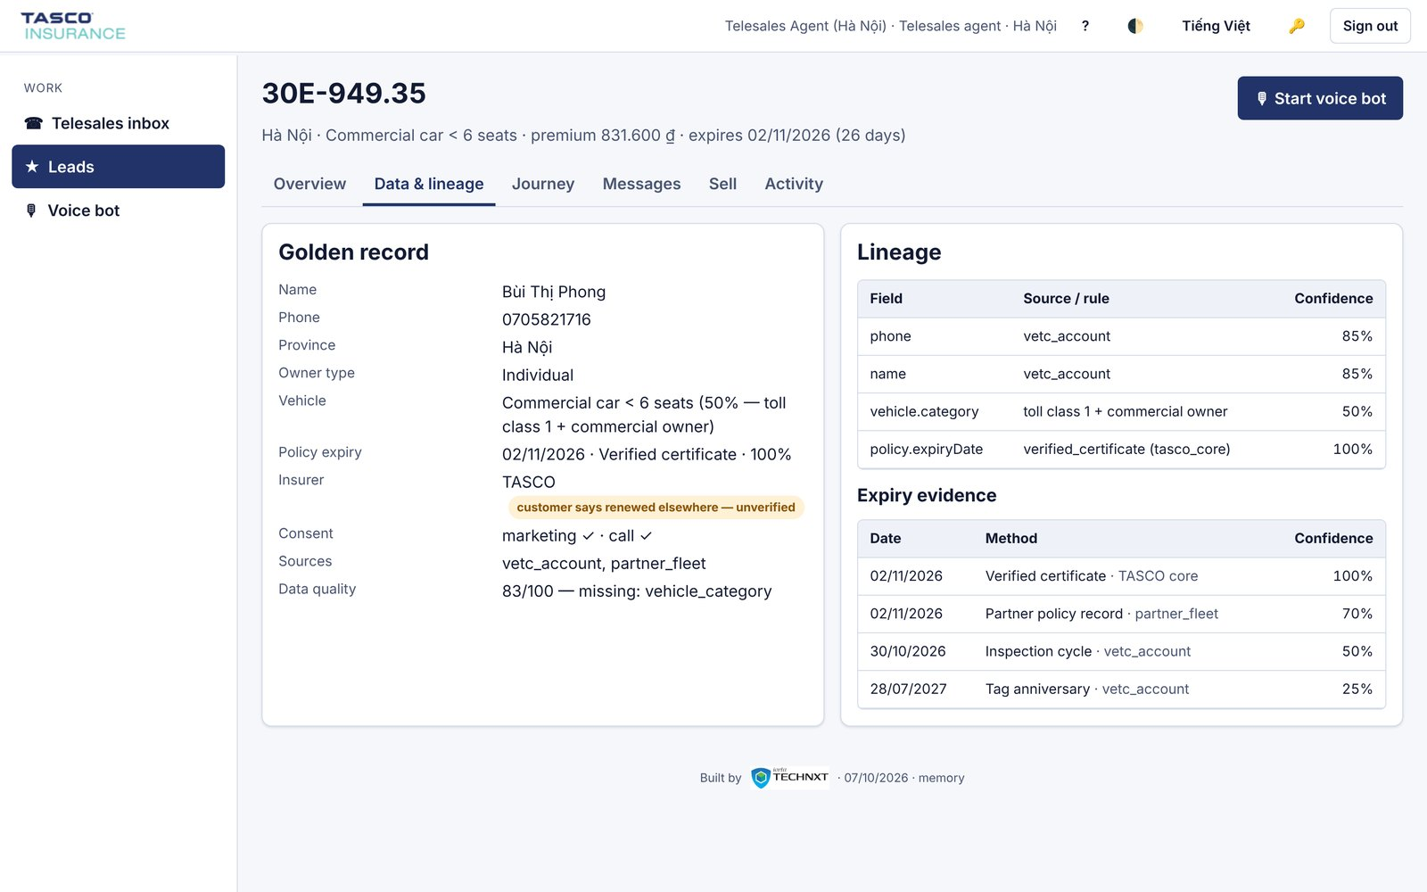
The golden record with field-level lineage: where each value came from, how confident the platform is, and the competing evidence for the expiry date.
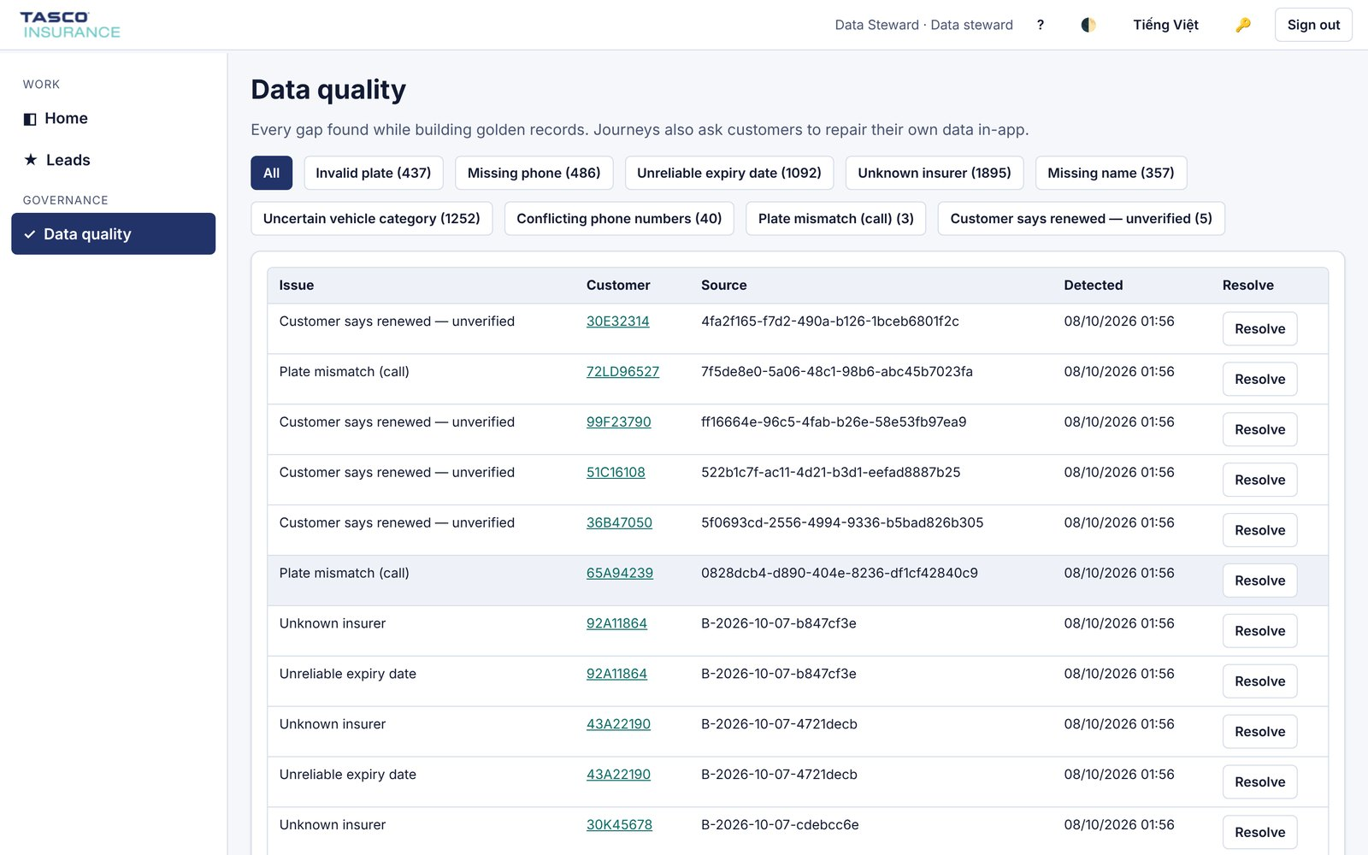
The data steward's queue of records that need attention, by issue type and source batch.
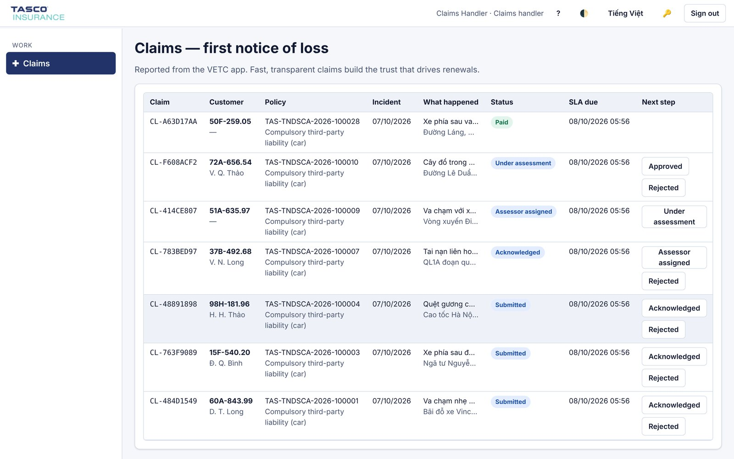
Accident reports from the app arrive in the claims queue with the plate, the policy, a description and the service-level due time.
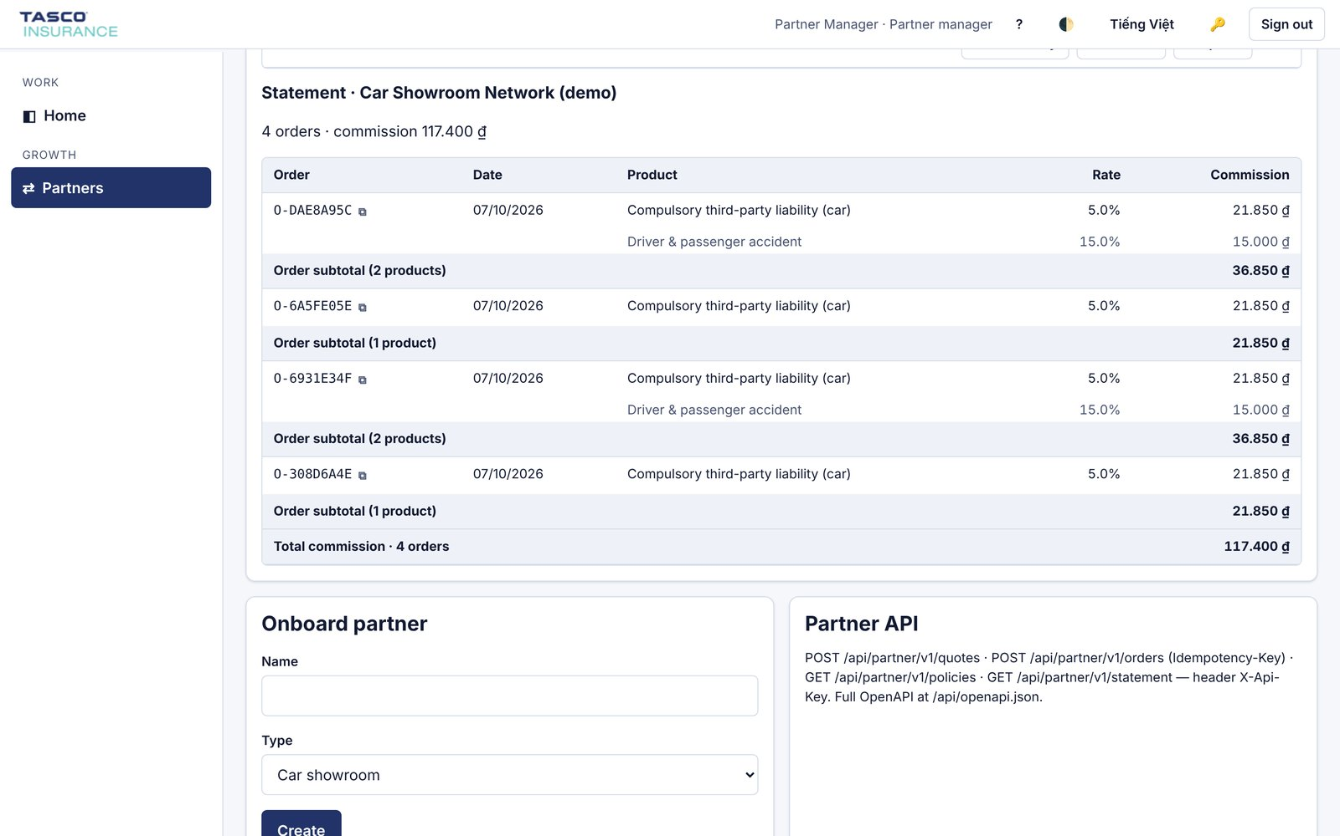
A partner commission statement, grouped by order, with commission capped by rule.
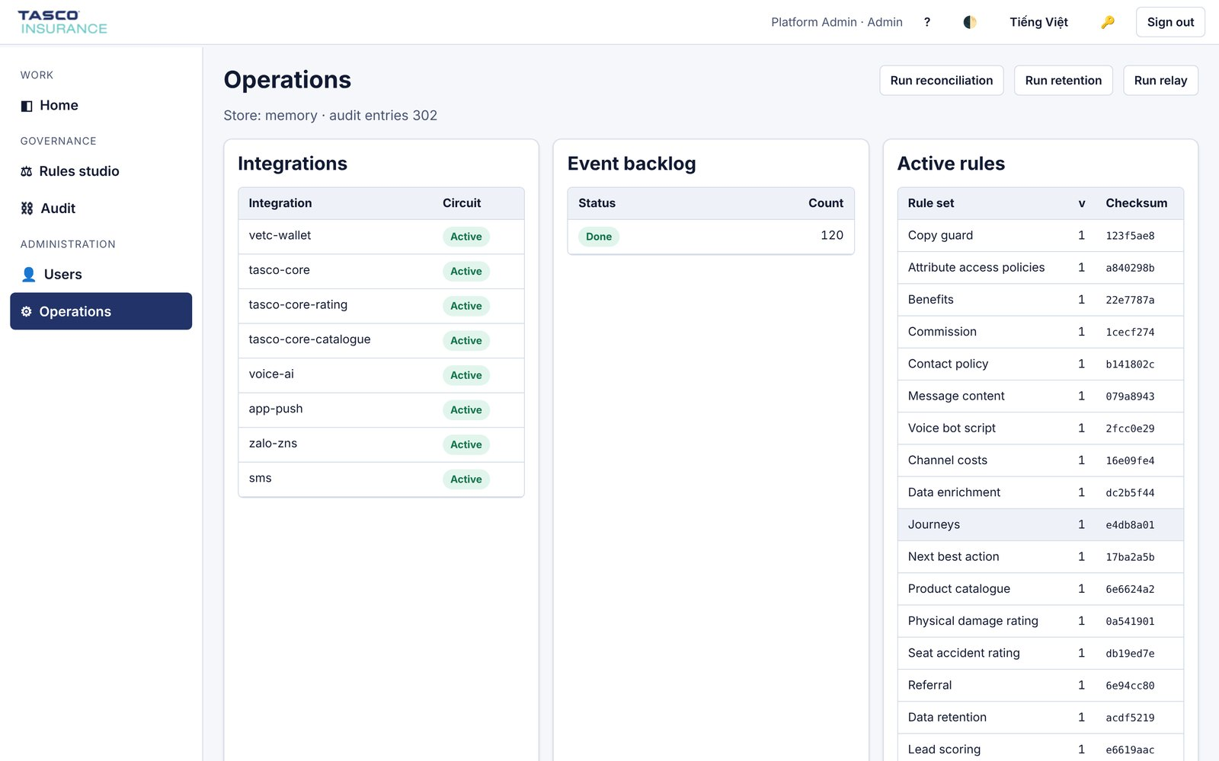
The operations view: the state of each integration (TASCO core, VETC wallet, voice, push, Zalo ZNS and SMS), the event backlog, the active rule checksums and the job runners.

11. Architecture

11.1 Principles
We have followed a small number of principles throughout, and we will hold to them during delivery.
- TASCO's core system remains the system of record for products, rating and policies. The platform never sets a premium on its own authority.
- Business rules are configuration. Anything the business may want to change is a versioned rule set, changed through the rules studio with approval, not through a software release.
- Integrations sit behind ports. Each external system is reached through a defined interface with its own adapter. Replacing a voice vendor or an SMS provider means writing one adapter, not reworking the platform.
- Every decision is explainable and audited. Scores carry reasons, journeys record why a message was or was not sent, and the audit trail is tamper-evident.
- Security and privacy by design. Least privilege, encryption, consent and data minimisation are built in, not added at the end.

11.2 Functional architecture
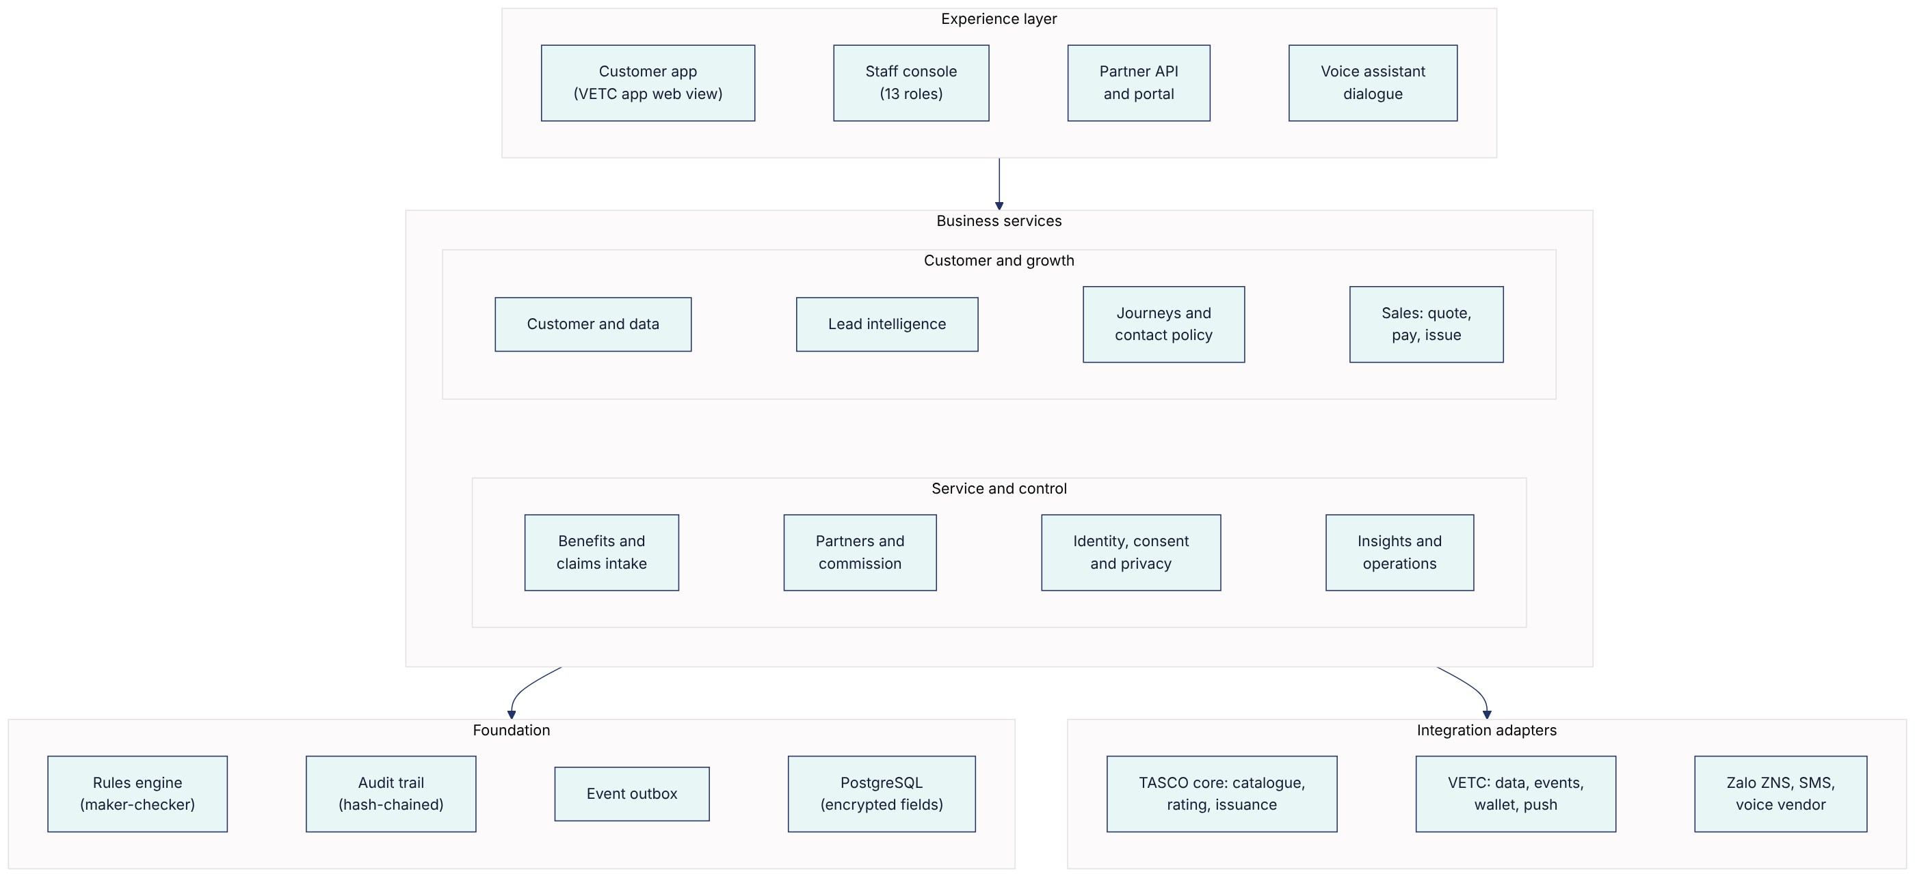

11.3 Technical architecture
The platform follows a hexagonal (ports and adapters) design. Business logic sits at the centre and has no knowledge of databases, HTTP or vendors. Use cases coordinate that logic. Adapters connect it to the outside world. The result is software that a different team can understand, test and extend for many years.
Layer | What it contains | Technology
Presentation | Staff console, customer app, certificate verification page | HTML5 and JavaScript with no third-party runtime, strict content security policy, WCAG 2.2 AA design system; console in Vietnamese and English, customer app in Vietnamese
API | 80 REST endpoints described in OpenAPI 3; rate limiting, idempotency keys, input validation | Node.js 22
Application | Use cases: ingestion, journeys, voice, sales, partners, claims, privacy, rules, audit | Node.js 22
Domain | Pure business logic: plate and phone normalisation, enrichment, scoring, rating fallback, contact policy, dialogue | Node.js 22, no dependencies
Rules | JSON Logic and decision tables, versioned, simulated and approved before publication | Built in, no code evaluation
Persistence | Relational store with indexed columns, optimistic locking, AES-256-GCM field encryption, blind indexes for search | PostgreSQL 16
Messaging | Transactional outbox and relay, so events are never lost or sent twice | PostgreSQL with SKIP LOCKED
Integration | Adapters with timeouts, retries, circuit breakers and idempotency | REST over TLS, OAuth 2.0, optional mTLS
Operations | Health checks, Prometheus metrics, structured logs, scheduled jobs | Kubernetes CronJobs

12. Integration with TASCO's core system and VETC

12.1 TASCO core: the most important integration
TASCO's core system owns the product catalogue and rating, and the platform is designed to use them rather than duplicate them. The integration has five touchpoints.
Touchpoint | Direction | Purpose | Pattern | MVP
Product catalogue | Core to platform | Products, versions, eligibility, add-ons and channel availability | Scheduled sync; changes become a draft that TASCO approves | Yes
Rating and quotation | Platform to core | Price a policy for a given vehicle and term; core returns premium, VAT, a quote reference and its validity | Real-time REST call | Yes
Bind and issue | Platform to core | Bind the quote core priced, after payment, and issue the policy and e-certificate | Real-time REST call, idempotent | Yes
Policy book | Core to platform | Active and expiring TASCO policies, to drive renewals and avoid selling to insured customers | Daily extract, then incremental | Yes
Cancellation and claims notification | Both | Cancel or refund where allowed; pass first notice of loss to the claims system | REST or file | First notice of loss by queue in the MVP; system-to-system in the scale phase
Each quote records which system rated it, the core quote reference and the rating version. Rating requests carry only the risk attributes core needs (vehicle category, use, seats, age and term); the plate and the holder's name are sent to core only at issuance, together with the quote reference, so core binds exactly the price it quoted. This integration is already built into the platform: a production connector for TASCO core's REST interface, and a simulated core used in UAT, both behind the same interface. If TASCO's core system is temporarily unavailable, the platform can be configured in one of three ways, and TASCO chooses which during discovery:
- Core only. No quote is shown while core is unavailable; the customer is asked to try again shortly. This is the safest option.
- Core with indicative fallback. The platform shows an indicative price from the approved tariff tables, clearly marked as indicative. Payment is blocked until the core system has re-rated the quote.
- Local rating. For sandbox and testing only. Production use requires TASCO's explicit approval.
If TASCO's core system does not yet expose a rating API, there is a practical interim path. The platform rates from tariff tables synchronised from core and approved by TASCO, and core re-rates at the moment of issue, rejecting any mismatch. We will confirm the right path in the first two weeks.

12.2 All integration touchpoints
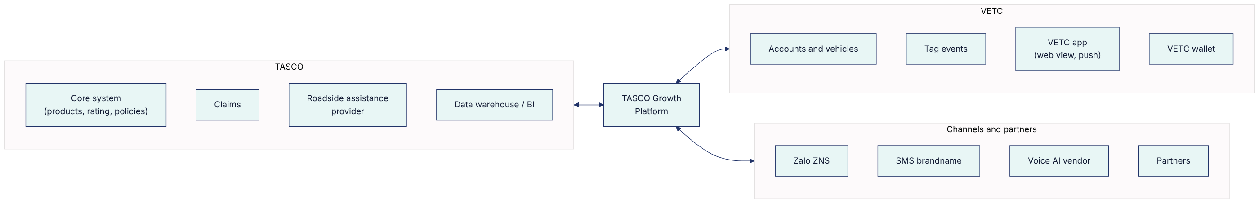
System | Interface | Data exchanged | Frequency | MVP
VETC accounts and vehicles | Secure file transfer or API | Plate, vehicle class, seats, owner name and phone (with consent basis) | Initial load, then daily changes | Yes
VETC tag events | Webhook or message queue | Tag activation, inspection booking, wallet top-up | Near real time | Yes, activation
VETC app | Web view with signed deep links; SSO in the scale phase | Customer session, notifications | Real time | Yes
VETC push service | REST | Notification content and target | Per journey step | Yes
VETC wallet | REST | Debit, refund, status, daily reconciliation | Real time, plus daily file | Yes
Zalo ZNS | Zalo OA API | Approved templates only | Per journey step | Yes
SMS brandname | Provider API | Registered templates | Per journey step | Yes
Voice AI vendor | SIP and API | Calls, transcripts, outcomes | Campaign windows | Yes, one vendor
Partners | Partner API (OAuth 2.0 client credentials, scopes) | Quotes, binds, statements | Real time | Yes, one partner
TASCO data warehouse | Daily export | Leads, journeys, sales, outcomes (pseudonymised where possible) | Daily | Scale phase

12.3 Integration standards
All synchronous calls use TLS 1.2 or higher and OAuth 2.0, with mutual TLS available where TASCO requires it. Every call has a timeout, a bounded retry and a circuit breaker, so a slow partner system cannot slow down the platform. Calls that change state carry an idempotency key. Events are published through a transactional outbox, so they are never lost and never sent twice. Every integration has a daily reconciliation report, and differences raise an alert.

13. Deployment and infrastructure

13.1 Hosting
We propose production hosting in Vietnam on a managed Kubernetes and managed PostgreSQL service from a local cloud provider (for example Viettel IDC, VNG Cloud or FPT Cloud), or on TASCO's or Tasco group's existing private cloud if preferred. The choice will be confirmed in discovery against TASCO's data-residency position and existing contracts. The platform is containerised and portable, so it is not tied to any provider.
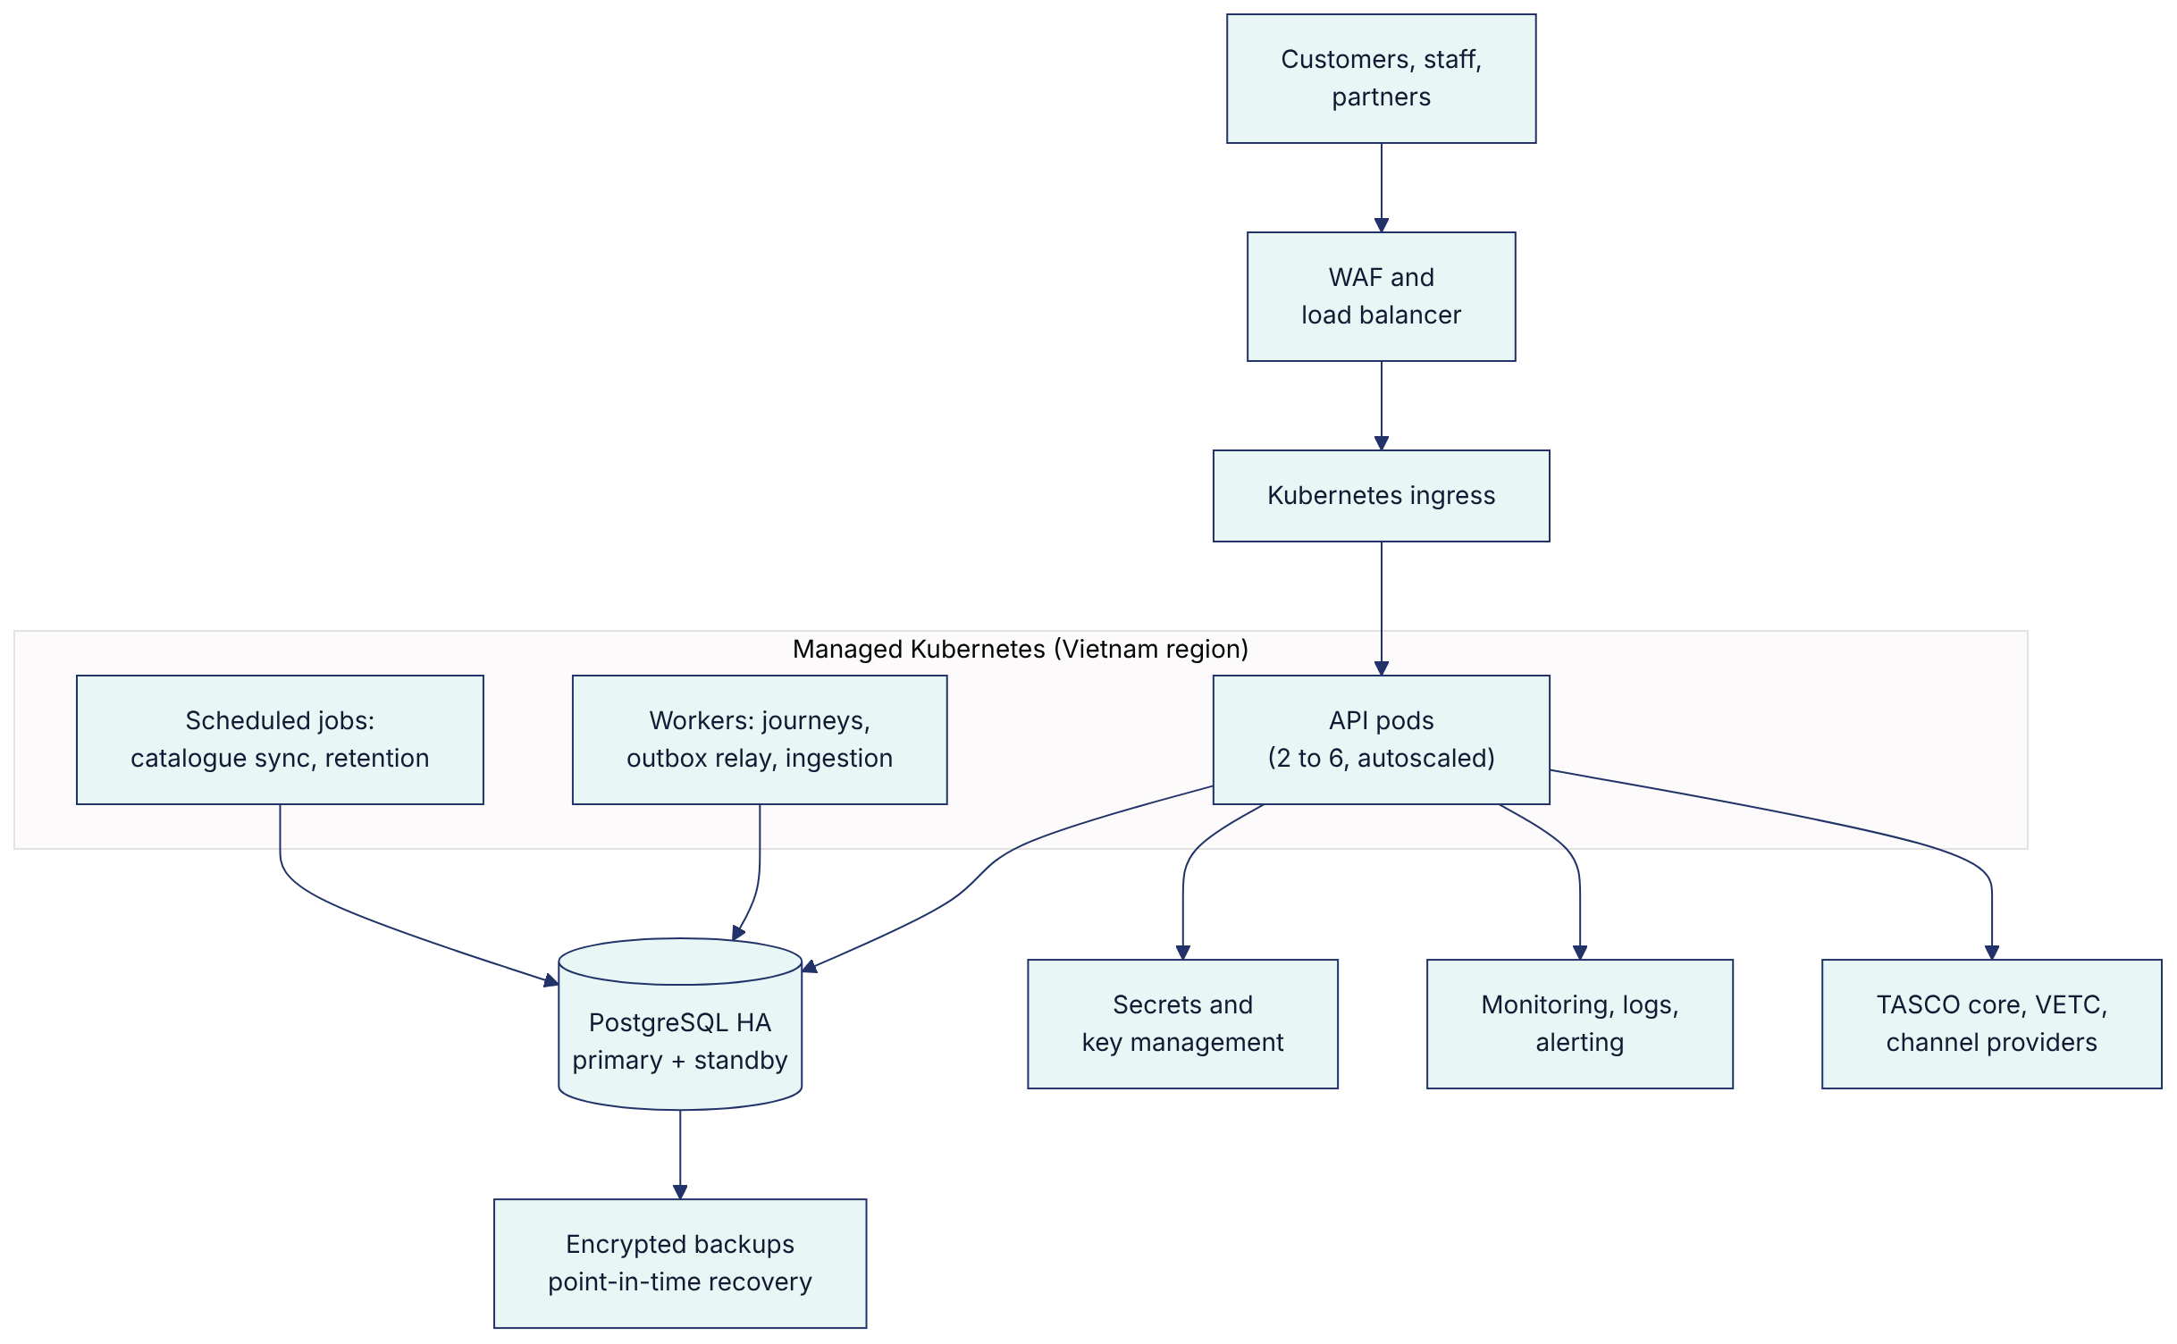

13.2 Environments
Environment | Purpose | Data
Development | Daily engineering | Synthetic only
SIT and UAT | Integration testing with TASCO and VETC sandboxes; user acceptance | Synthetic or masked
Pre-production | Performance and security testing, release rehearsal | Masked
Production | Live service | Real, encrypted
Releases move through a CI/CD pipeline that runs lint, all automated tests, coverage gates, dependency and secret scanning, container scanning, static analysis and a dynamic security scan before deployment. Database changes are versioned migrations applied automatically before each release.

13.3 Resilience and recovery
Measure | Target
Availability of customer purchase path | 99.9% monthly
Recovery point objective | 15 minutes or less
Recovery time objective | 4 hours or less
Backups | Encrypted, point-in-time recovery for 35 days, restore tested quarterly
Application | At least two replicas across zones, rolling deployments, pod disruption budgets

14. Security and privacy
Insurance platforms hold exactly the kind of data that attackers and regulators care about. We have built security into every layer, aligned to OWASP ASVS Level 2 and zero-trust principles.
Area | Controls in place
Identity and access | Role-based and attribute-based access control across 13 roles; two-factor authentication for privileged users; separation of duties (for example, the author of a rule cannot approve it); account lockout; forced password change; token revocation
Data protection | AES-256-GCM encryption of personal fields with key rotation; blind indexes so encrypted data can still be searched; TLS everywhere; data minimisation on ingestion
Application security | Parameterised queries only; strict content security policy; output encoding; rate limiting; idempotency on payments; request size limits; trusted-proxy handling
Secrets | No secrets in code; injected from a secrets manager; separate keys per environment
Audit | Append-only, hash-chained audit trail protected by database triggers; daily verification
Privacy | Purpose-based consent; consent centre for customers; data-subject access, correction and erasure; retention rules; data lineage
AI governance | The voice assistant's script is versioned and approved; it discloses that it is automated; scores are explainable; humans make the final sales contact
Assurance | Static analysis, dependency and container scanning, secret scanning, dynamic scanning in CI; independent penetration test before go-live

15. Scalability and performance
The platform is stateless at the application tier, so capacity grows by adding pods. The database is the main scaling concern, and we have designed for it: indexed columns for every query path, paging for large result sets, batch ingestion in chunks, background workers for journeys and events, and a read replica for reporting at full scale.
Measure | Today (single instance, test environment) | Pilot target | Full-scale target
API throughput | About 337 requests per second | 50 per second sustained | 300 per second sustained
API response time (95th percentile) | About 103 ms | Under 300 ms | Under 300 ms
Vehicles under management | Synthetic test set | 100,000 | 6 million
Daily journey evaluations |  | 100,000 | 6 million
Ingestion | 5,000 records per batch | Initial load within one day | Full base within one weekend; daily changes within one hour
Full-scale capacity will be proven by load tests in pre-production during the scale phase, before the base is extended beyond the pilot.

16. Implementation approach

16.1 How we will work
We will deliver in four stages, each with a clear exit. Discovery confirms the decisions that only TASCO and VETC can make: the core integration path, data sharing, legal positions and pilot design. Build and integrate runs in four two-week sprints, each ending in a demonstration on the integration sandboxes. Test and go-live covers system integration testing, user acceptance, security testing and a rehearsed cut-over. Hypercare keeps the delivery team on hand for the first four weeks of live operation.
Because the platform already exists, sprints are spent on adapters, data, configuration and hardening rather than on building screens. Business rules such as scoring weights, journey timings, message wording and benefits are configured with TASCO's product team in the rules studio during the sprints, not specified on paper and handed over.

16.2 MVP scope
In scope for the MVP | Not in the MVP (scale phase or later)
Integration with TASCO core: catalogue sync, live rating, bind and issue, daily policy extract | Claims system-to-system integration (first notice handled by queue in the MVP)
VETC: initial data load and daily changes, tag-activation events, app web view with signed links, push, wallet debit and refund, reconciliation | VETC single sign-on, Zalo mini app, live feed of all VETC events
Zalo ZNS and SMS brandname for approved templates | Additional messaging channels
One voice AI vendor, Vietnamese script, plate-first verification, telesales handoff | Multiple voice vendors, outbound voice at full scale
Journeys: renewal, conquest, new vehicle, lapsed recovery, cross-sell | A/B testing framework, machine-learning score calibration
Products: TNDS (one to three years), personal accident per seat, physical damage with inspection | Further products
One partner live on the partner API | Partner self-service onboarding at scale
Staff console (Vietnamese and English) and customer app (Vietnamese), configured to TASCO branding | Fleet portal and consolidated invoicing
Production hardening, security testing, runbooks, training, cut-over and 4 weeks of hypercare | Data warehouse feed
Pilot cohort of 50,000 to 100,000 vehicles with a control group | Full 6 million vehicle base

17. Timeline
The plan below assumes contract signature by 30 October 2026 and work starting on 2 November 2026. Week 13 falls in late January 2027, just before Tết. Drivers travel home for the holiday, and this is when vehicles are inspected and insurance is checked at the roadside, which makes it a good moment to launch. It is also a period when staff are scarce. We therefore propose a controlled soft launch to the first part of the cohort in week 13, a change freeze over the holiday with 24-hour on-call cover, and a ramp-up to the full pilot cohort after Tết.
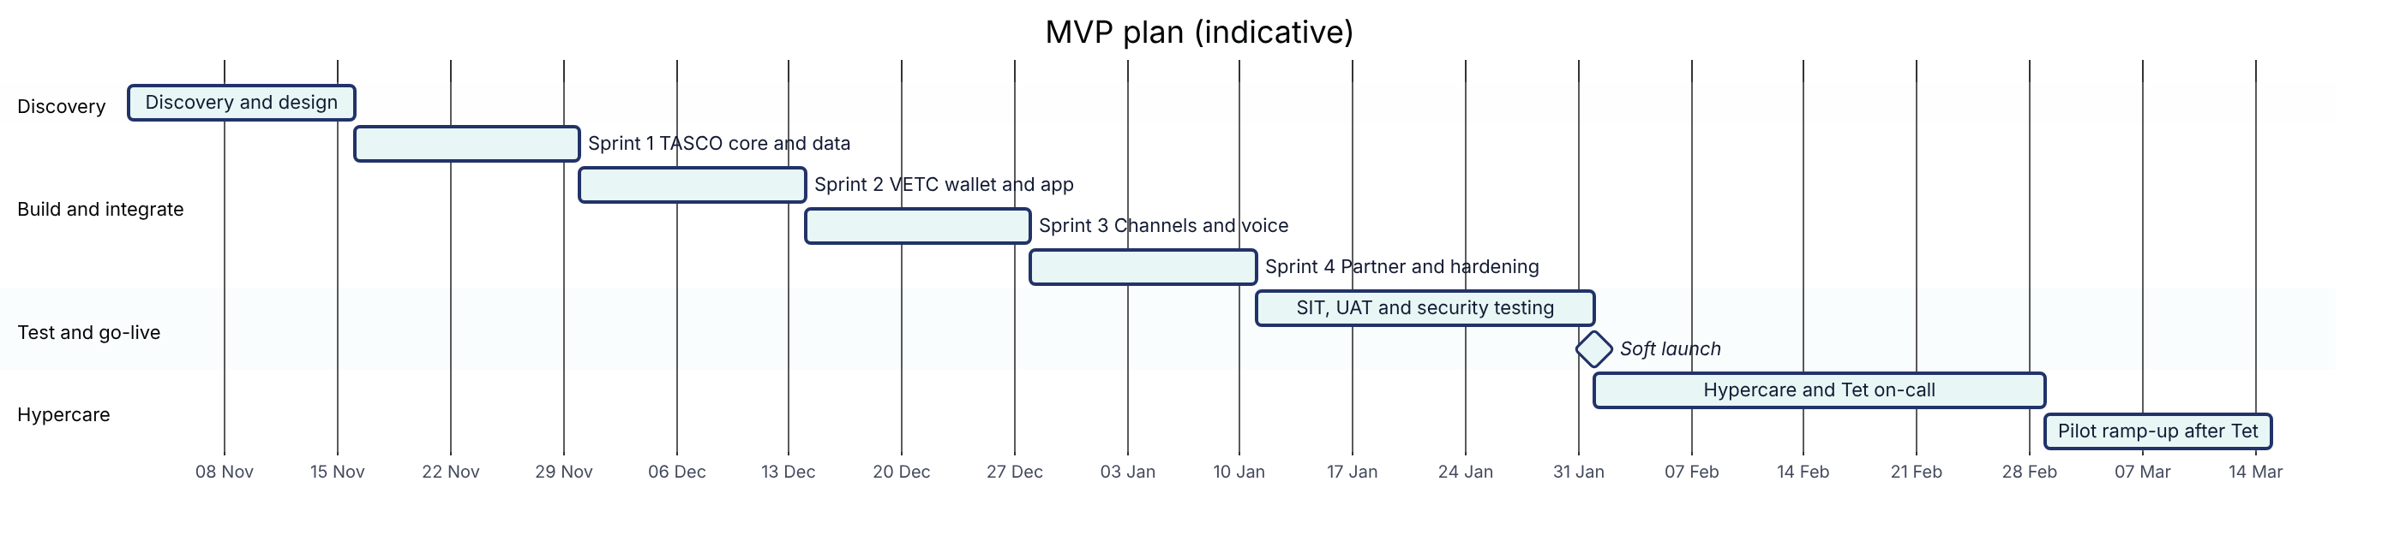
Milestone | Week | Date (indicative) | Evidence
M0 Mobilisation | 0 | 30 October 2026 | Contract signed; team onboarded
M1 Discovery complete | 2 | 13 November 2026 | Discovery report, integration specifications and pilot design signed off
M2 Integrated build | 10 | 8 January 2027 | End-to-end demonstration on sandboxes: core rating and issue, wallet debit, Zalo message, voice call
M3 Acceptance | 13 | 29 January 2027 | UAT signed off; no open critical or high security findings
M4 Pilot live and hypercare complete | 17 | 26 February 2027 | Pilot live; four weeks within service levels
The pilot read-out, with conversion measured against the control group, is planned about 12 weeks after go-live (early May 2027). That is long enough to cover a full renewal cycle of 45 days and to measure the conquest and new-vehicle journeys properly.

18. Strategy for adoption and roll-out
Technology alone will not move own-channel sales. The pilot is designed to answer three questions with evidence: does the platform increase policies sold, does it repair data, and do customers trust it?
Pilot design. We recommend one or two provinces with a mix of urban and inter-provincial drivers, for example Hà Nội and Bình Dương. Within the cohort, a randomly selected control group of around 10% receives business as usual, so that the effect of the platform can be separated from seasonality and partner activity.
Success criteria. We propose the following, to be confirmed in discovery.
Measure | Pilot target
Vehicles with a usable expiry date | From about 10% to at least 35% of the cohort
Own-channel TNDS conversion | Significantly above the control group (statistically tested)
Policies bought in the app | At least 60% of own-channel sales
Time from tapping "Confirm and pay" to e-certificate | Under 60 seconds for 95% of purchases
Complaints about contact | Fewer than 1 per 1,000 customers contacted
Compliance breaches (copy, consent, contact window) | Zero
Availability of the purchase path | 99.9%
Roll-out after the pilot. If the targets are met, the base is extended province by province, with capacity tests before each step. Partners are brought onto the API in waves, starting with those whose customers overlap least with VETC's own channels.
Marketing and communications. TASCO and VETC own customer communications. We will provide the message templates, the copy guard and the measurement, and we recommend launching with a simple promise: "Renew in the VETC app in one minute, with roadside help included."

19. Training and change management
Audience | Format | Content | When
Telesales agents and supervisors | Classroom and practice in UAT, half a day | Handoff inbox, customer 360 view, sending quotes to the app, scripts that respect the no-discount rule | Week 12
Campaign managers | Workshop, one day | Leads, journeys, voice campaigns, dashboards | Week 11
Product rule authors and compliance approvers | Workshop, one day | Rules studio: drafting, simulation, approval, rollback | Weeks 9 to 11
Data stewards | Workshop, half a day | Data-quality queue, corrections with evidence, lineage | Week 11
Claims handlers and partner managers | Session, two hours each | Claims queue; partner onboarding, keys and statements | Week 12
TASCO IT and support | Technical handover, two days | Architecture, deployment, monitoring, runbooks, incident handling | Weeks 12 to 13
Partner staff | Integration guide and sandbox | Partner API | From week 8
Training is supported by role-based user manuals (14 manuals are already written), short how-to videos recorded during UAT, and in-app help. We train a group of super users at TASCO who then support their colleagues. Change management covers clear communication of the new ways of working, especially for telesales: their role shifts from cold calling to closing warm, verified leads.

20. Testing and quality assurance
Quality is built into the platform. Today it has 238 automated tests, covering unit, integration, API, security and functional tests, with 99.5% line coverage. There is also a functional test for every user-story scenario. For the MVP we add the following.
Test stage | What it covers | Owner | Exit criterion
Unit and component | New adapters and configuration | iorta TechNXT | Coverage gates met (at least 80%; currently above 99%)
Contract tests | Each TASCO core and VETC interface against its specification | iorta TechNXT with TASCO and VETC IT | All contracts pass in the sandboxes
System integration (SIT) | End-to-end flows across core, wallet, push, Zalo, SMS and voice | iorta TechNXT | All critical flows pass; reconciliation clean
Performance | Pilot volumes with headroom; ingestion of the cohort | iorta TechNXT | Targets in section 15 met
Security | Static and dynamic scanning, dependency and container scanning, focused manual testing of authentication, payment and partner API | iorta TechNXT; independent test recommended | No open critical or high findings
Accessibility | WCAG 2.2 AA checks on the customer app and console | iorta TechNXT | No blocking issues
User acceptance (UAT) | Business scenarios run by TASCO users | TASCO, supported by iorta TechNXT | Sign-off by the TASCO product owner
Operational acceptance | Backup and restore, failover, monitoring, runbooks | iorta TechNXT with TASCO IT | Restore and failover rehearsed
A test-case workbook with conditions, scenarios, expected results and actual results is maintained throughout and handed over at acceptance.

21. Production support
After hypercare, we offer a managed service that keeps the platform healthy and lets TASCO's business teams keep improving it.
Priority | Example | Response | Restoration or workaround
P1 Critical | Customers cannot buy; suspected data breach | 30 minutes, 24 hours a day, 7 days a week | 4 hours
P2 High | A journey run fails; one integration is down | 2 business hours | 1 business day
P3 Medium | A defect with a workaround | Next business day | Next scheduled release
P4 Low | A question or small enhancement | 3 business days | Planned
Business hours are 08:00 to 17:30 Vietnam time, Monday to Friday, excluding public holidays. The service includes monitoring and alerting, security patching, monthly releases, support for rule changes, a quarterly restore test, a monthly service report and a quarterly business review with TASCO. Support is provided in English and Vietnamese.

22. Governance
Forum | How often | Who attends | Purpose
Steering committee | Monthly | TASCO and VETC sponsors, iorta TechNXT engagement lead | Direction, budget, milestones, risks, pilot results
Product council | Every two weeks | TASCO product owner, VETC lead, iorta TechNXT analyst and architect | Priorities, rule changes, scope decisions
Sprint review | Every two weeks | Product owner and key users | Demonstration against acceptance criteria
Change control | As needed | Product owner and engagement lead | Assess and approve changes to scope, price or time
Compliance checkpoint | Each release | TASCO compliance | Customer wording, consent, privacy, audit evidence

23. Team and engagement model

23.1 Delivery team
The MVP team is small and senior, with an engagement manager accountable to TASCO for the whole delivery. The business analyst also acts as insurance subject-matter expert and works side by side with TASCO's product owner. Discovery and go-live are run on site in Hà Nội; build sprints are delivered from our offshore centre with daily overlap during Vietnam business hours.
Role | Discovery | Build | Test and go-live | Hypercare | Total person-days
Engagement manager | 5 | 20 | 7.5 | 2 | 34.5
Solution architect | 10 | 20 | 3.75 |  | 33.75
Business analyst and insurance SME | 10 | 40 | 15 | 5 | 70
UX and conversation designer | 5 | 10 |  |  | 15
Senior engineer (integration lead) | 5 | 40 | 15 | 10 | 70
Engineers (backend and frontend) |  | 80 | 15 | 10 | 105
QA engineer |  | 40 | 22.5 |  | 62.5
DevSecOps engineer |  | 20 | 7.5 | 5 | 32.5
Total | 35 | 270 | 86.25 | 32 | 423.25

23.2 Engagement options
We offer two ways to contract the MVP. Both deliver the same scope and timeline.
Option A, fixed price (recommended). A fixed price for the MVP, paid against milestones. TASCO has full budget certainty, and the delivery risk sits with us.
Option B, shared outcome. A lower fixed price, plus a technology service fee for each policy issued digitally through the platform during the first 12 months after go-live, subject to a cap. This option suits TASCO if it prefers to link part of the cost to results. The fee would be structured as a technology service fee per processed transaction, not as commission, and must not affect the premium the customer pays. TASCO legal should confirm this structure.

24. Commercial proposal
All prices are in US dollars. For reference, amounts are also shown in Vietnamese dong at USD 1 = VND 26,000; invoices can be issued in either currency at a rate agreed at contract.

24.1 MVP price
Item | USD
Delivery effort at our standard rate card (423.25 person-days, section 23.1) | 107,485
Accelerator credit: reuse of the existing TASCO Growth Platform | (12,685)
MVP fixed price (Option A) | 94,800
Perpetual licence to the platform for TASCO's use, including source code | Included
Up to three on-site visits to Hà Nội (discovery, UAT and go-live) | Included
90-day warranty from go-live | Included
Change reserve held by TASCO (used only with TASCO's approval) | 5,200
Total within TASCO's MVP budget | 100,000
The MVP fixed price is approximately VND 2.46 billion.

24.2 Payment milestones
Milestone | Trigger | Share | Option A (USD) | Option B (USD)
M0 Mobilisation | Contract signed, team onboarded | 15% | 14,220 | 11,220
M1 Discovery complete | Discovery report and pilot design signed off | 15% | 14,220 | 11,220
M2 Integrated build | End-to-end demonstration on sandboxes | 25% | 23,700 | 18,700
M3 Acceptance | UAT signed off; no open critical or high security findings | 25% | 23,700 | 18,700
M4 Pilot live | Go-live plus four weeks of hypercare within service levels | 20% | 18,960 | 14,960
Total |  | 100% | 94,800 | 74,800
Under Option B, a technology service fee of VND 10,000 per policy issued digitally through the platform applies for 12 months after go-live, capped at USD 50,000. It is invoiced quarterly from the platform's audited transaction records.

24.3 After the MVP (optional, priced now for transparency)
Service | Basis | Price (USD)
Scale phase: full 6 million vehicle base, VETC single sign-on, Zalo mini app, live VETC event feed, inspection booking, fleet portal, data warehouse feed, claims integration, score calibration, A/B testing, further partners | Time and materials, about six months, capped at 590 person-days | Up to 147,500
Managed service (section 21) | Monthly, 12-month initial term, includes 40 hours of minor enhancements per month | 6,900 per month
Enhancement pool | Drawn down at the rate card, by work order | 48,000 per year (budgetary)

24.4 Rate card (for changes and additional work)
Role | Daily rate (USD)
Engagement manager | 380
Solution architect | 360
Business analyst and insurance SME | 260
Senior engineer or DevSecOps engineer | 260
UX and conversation designer | 230
Engineer | 210
QA engineer | 190

24.5 Commercial terms
Prices exclude value-added tax and any foreign contractor tax; the applicable tax treatment for software services will be confirmed with TASCO's tax advisers and applied as required by Vietnamese law. Invoices are payable within 30 days. Third-party usage costs are paid by TASCO or VETC directly to the providers: cloud infrastructure, voice AI minutes, Zalo ZNS and SMS messages, and any independent penetration test. We will help TASCO select providers and negotiate these costs. Prices are valid for 90 days from the date of this proposal.

25. Total cost of ownership
The table shows the expected cost to TASCO over three years if the pilot succeeds and the platform is scaled to the full base. Year 1 runs from November 2026 to October 2027.
USD | Year 1 | Year 2 | Year 3 | Three years
MVP (fixed price) | 94,800 |  |  | 94,800
Scale phase (capped) | 147,500 |  |  | 147,500
Managed service | 55,200 | 82,800 | 85,284 | 223,284
Enhancement pool (optional) |  | 48,000 | 48,000 | 96,000
Cloud infrastructure in Vietnam | 25,150 | 40,800 | 42,024 | 107,974
Total | 322,650 | 171,600 | 175,308 | 669,558
Approximately, VND | 8.39 bn | 4.46 bn | 4.56 bn | 17.41 bn
Year 3 includes a 3% annual increase on the managed service and infrastructure. If TASCO stops after the pilot and keeps the platform running at pilot scale, year-1 cost is about USD 168,150.
Infrastructure is estimated at about USD 1,650 per month at pilot scale (three application nodes, a high-availability PostgreSQL pair, backups, load balancer and firewall, monitoring and non-production environments). At full scale it is about USD 3,400 per month, with more nodes, a larger database and a reporting replica. Usage costs for messages and voice minutes depend on volume; at full scale in the base case they are about VND 2.2 billion a year for messaging and VND 1.2 billion for voice.
How this compares. Building an equivalent platform from scratch would typically take 12 to 15 months and cost USD 450,000 to 650,000 before running costs, with no working software for TASCO to test during the first year. A global CRM and marketing-cloud stack licensed for six million contacts usually costs more each year in licences alone than our full three-year TCO, and would still need insurance-specific logic, Vietnamese channels and a core integration built on top. These comparisons are indicative market ranges.

26. Benefits and business case

26.1 Benefits
For | Benefit
TASCO's business | New own-channel sales, renewal and new business, from an audience TASCO already reaches; cross-sell of personal accident and physical damage cover; a data asset that improves every year
Customers | Renewal at the right time in one tap, honest and regulated pricing, help on the road, a verifiable e-certificate, and fewer unwanted calls
VETC | More value from the app and wallet, and a new reason for drivers to engage
Telesales | Warm, verified leads with context instead of cold lists
Partners | Faster quoting and issuance through the API, with transparent commission
Compliance and risk | Approved wording only, consent and contact rules enforced by the system, and a tamper-evident audit trail
IT | Modern, documented, portable platform; business changes without releases; no vendor lock-in

26.2 The numbers
Our business case model (document 01, section 12) estimates outcomes at full scale. Every input is an assumption to be replaced with pilot results, but the base case shows the order of magnitude.
Measure (illustrative, base case, year 1 at full scale) | Value
TNDS policies through own channels and the partner API | About 140,000
TNDS net premium | About VND 79.4 billion (USD 3.05 million)
Cross-sell premium | About VND 6.9 billion
Variable acquisition cost per policy | About VND 37,000 (6.6% of net premium)
Cost of qualifying calls by the voice assistant | About VND 1.2 billion, against about VND 13.4 billion for the same calls by telesales
Platform cost in year 2 (from section 25) | About VND 4.46 billion, about 5% of base-case premium
Two points stand out. First, the saving from the voice assistant alone is larger than the annual cost of running the platform. Second, the most important driver of results is data repair: every ten-point increase in the share of vehicles with a usable expiry date adds about VND 13 billion of premium in the base case. That is why data repair comes first in the plan.
We are careful not to overstate this. Some policies sold through the platform would have been sold by partners anyway. The pilot's control group measures how much of the uplift is genuinely new, and the decision to scale should rest on that measurement.

27. Risks and mitigations
Risk | Impact | Mitigation
TASCO core does not expose a rating API in time | Live pricing delayed | Interim path: approved tariff tables in the platform with core re-rating at issue (section 12.1); decision in week 2
Integration sandboxes or credentials are late | Milestone M2 delayed | Simulated adapters already exist, so build continues; dates move day for day by agreement
Legal positions take time (data sharing, consent wording, loyalty) | Features held back | Conservative defaults; features stay switched off until approved
VETC data quality is lower than expected | Fewer actionable vehicles | Data repair is the first journey; customer self-declaration of expiry; steward queue
Customers distrust the voice assistant | Low call completion | Plate-first design, disclosure, app-first journeys, calls only with consent, script approved by compliance
Launch close to Tết | Operational strain | Soft launch, change freeze and 24-hour on-call cover over the holiday
Channel conflict with partners | Partner resistance | Channel waterfall rules and the partner API make partners part of the solution
Scope growth during the MVP | Budget pressure | Clear MVP boundary; change control; USD 5,200 reserve under TASCO's control

28. Assumptions and dependencies
- TASCO provides access to its core system's catalogue, rating and issuance interfaces (or agrees the interim path) and a sandbox by the end of week 2, with production access by week 10.
- VETC provides a data extract for the pilot cohort, tag-activation events, the app web view and push, and wallet debit and refund interfaces with a sandbox by the end of week 2.
- TASCO contracts the voice AI vendor, Zalo official account and SMS brandname directly; we help with selection and integration.
- TASCO legal confirms the regulatory positions in section 2.3 during discovery.
- TASCO and VETC provide decision-makers within agreed turnaround times (five business days for sign-offs).
- The pilot cohort is no larger than 100,000 vehicles in one or two provinces.
- The infrastructure provider is chosen in discovery, and TASCO pays for it directly.
- Acceptance is against the agreed user-story acceptance criteria for the MVP scope.

29. What we need from TASCO and VETC
Role | Commitment
TASCO product owner | About half time throughout; decisions on scope, rules and acceptance
TASCO core system lead | Interface specifications, sandbox, support during integration testing
VETC data and integration lead | Data extract, events, app, push and wallet interfaces; about half time in discovery and build
TASCO compliance and legal | Confirmation of regulatory positions; approval of customer wording and the voice script
TASCO telesales lead and agents | UAT and pilot participation
TASCO IT security | Security requirements, access approvals, penetration test scope

30. Intellectual property, warranty and exit
Licence. TASCO receives a perpetual, royalty-free licence to use, modify and run the platform for the business of TASCO Insurance and the Tasco group, together with the complete source code and documentation. iorta TechNXT keeps ownership of the underlying platform and may improve it for other clients, without ever using TASCO data.
What TASCO owns. TASCO's data, its rule sets and configuration, its content and branding, and the adapters written specifically for TASCO's and VETC's systems.
Warranty. For 90 days after go-live, we fix at our own cost any defect where the platform does not meet the accepted acceptance criteria.
Exit and transition. If TASCO decides to move support to its own team or another partner, we provide a structured knowledge transfer at the rate card, and all data can be exported in open formats. The platform has no proprietary runtime and no licence keys.

31. Next steps
- Walk-through of the working platform with TASCO's evaluation team in UAT, at a date of TASCO's choosing in October.
- Clarification session on this proposal, the core integration path and the pilot design.
- Early access to information that shortens discovery: TASCO core interface documentation and a sample of VETC data (masked).
- Contract signature by 30 October 2026, to start on 2 November and have the pilot live before Tết.
We would be glad to present this proposal in person in Hà Nội.

Appendix A. Glossary
Term | Meaning
TNDS | Compulsory motor third-party civil liability insurance (Bảo hiểm trách nhiệm dân sự bắt buộc)
PA_SEAT | Personal accident cover per vehicle seat (voluntary add-on)
MOTOR_PD | Physical damage cover for the vehicle (voluntary add-on)
Golden record | The single, best-quality profile for one vehicle, built from all sources
NBA | Next best action for a vehicle, chosen by rules
Journey | A timed sequence of contacts across channels with a defined goal
ZNS | Zalo Notification Service, for transactional messages through a Zalo official account
FNOL | First notice of loss: the first report of an accident or claim
Maker-checker | Four-eyes control: one person drafts a change and a different person approves it
SIT and UAT | System integration testing and user acceptance testing
RPO and RTO | Recovery point objective (maximum data loss) and recovery time objective (maximum downtime)

Appendix B. Supporting documents
The following documents are supplied with this proposal, in Word and PDF.
Area | Documents
Business | Business context and growth strategy; functional requirements specification; non-functional requirements; user stories and acceptance criteria; requirements traceability matrix; personas and journey maps; commercials and engagement model
Architecture | Solution, integration, deployment and infrastructure, data, and security architecture; AI governance; 13 architecture decision records; OpenAPI specification
Quality | Test strategy; test case catalogue; performance and capacity test plan; UAT plan; test cases and results workbook
Operations | Runbook and support guide; monitoring and alerting; disaster recovery and business continuity; production readiness checklist; go-live and hypercare plan; release and change management
Delivery | Project plan; delivery methodology; RACI; risk register; knowledge transfer plan; change management and training
User experience | Design system; UX standards and accessibility; journey maps and information architecture; usability testing plan
Manuals | User manual; role-based manuals; partner API guide; customer app guide

