

Joe Restaurant

Module Software Engineering 2, DT228 Bsc in Computer Science, Dublin Institute of Technology

Iosif Bogdan Dobos (C16735789)

Student Name: Iosif Bogdan Dobos
Student Number: C16735789
Lecturer’s Name: Richard Lawlor
Module: Software Engineering 2
Submission Date: 5th May 2018

Introduction
For This assignment I choose to do the restaurant case study. The system that I have developed is mainly used to support day-to-day operations of a restaurant by improving the process of making reservations and allocation tables to customers.

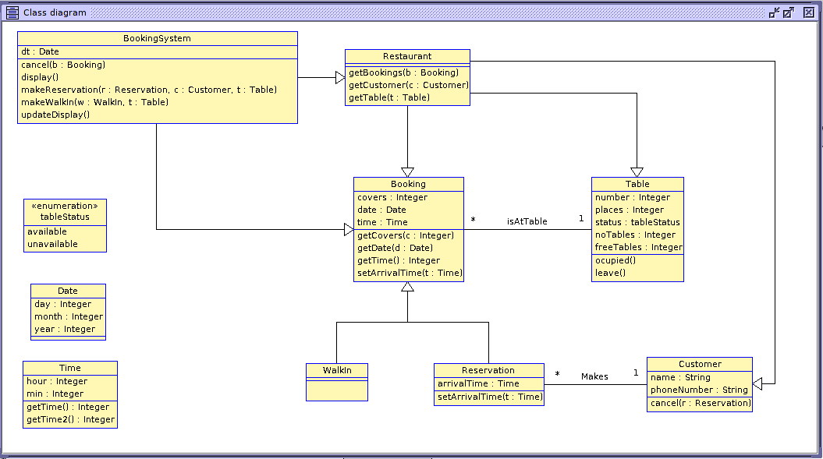
Class Diagram

Class diagram after implementing OCL

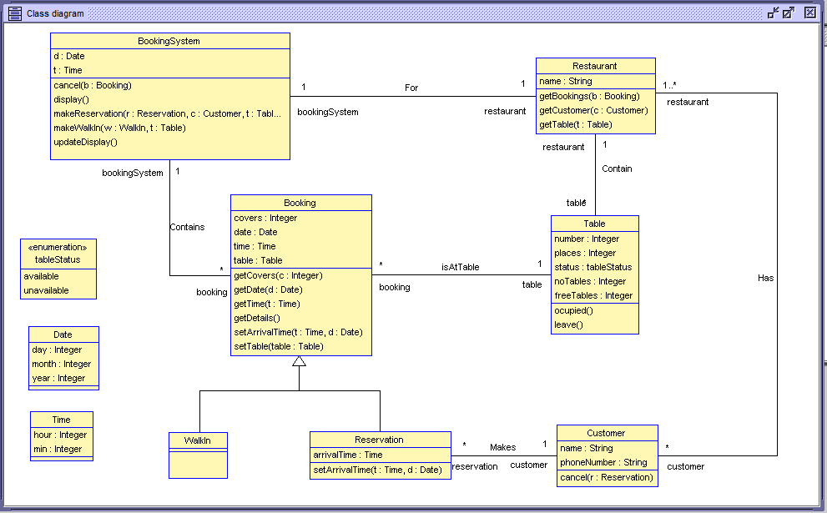

Sequence Diagram
Customer makes reservation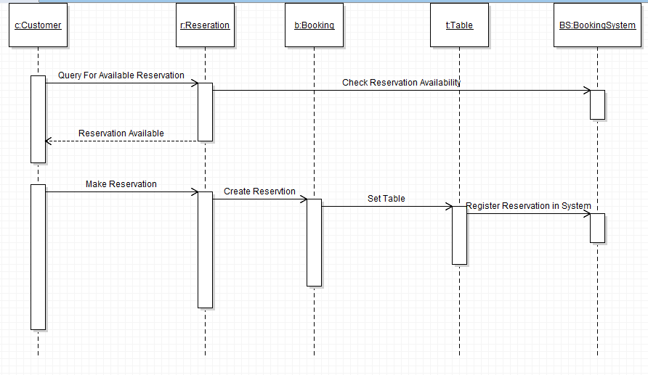
Customer walks into restaurant
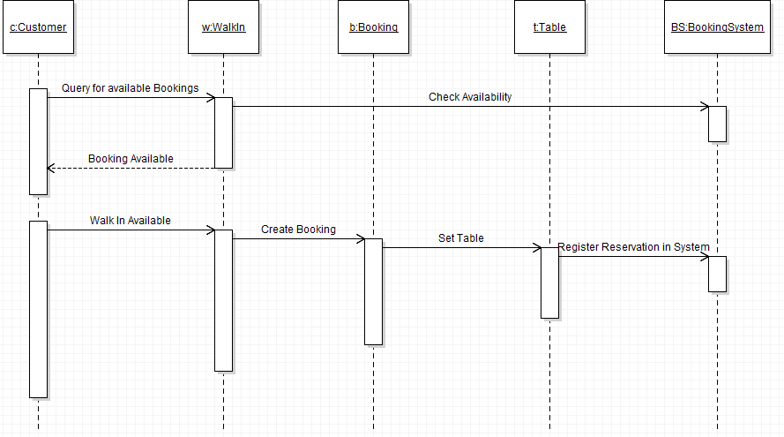

Use Implementation
In the Restaurant case study, customers can make reservation to the restaurant for dinner. In order to do the reservation customers must provide some information like the name to make the reservation for and a phone number to be contacted. Before making a reservation tables from the restaurant needs to be available to make the reservation possible. Also, we need to check customers who walks to make reservation for them as well in order to avoid customers to have dinner at the same table and time. All this reservation that are made are stored in the Booking System.

Date and Time information required
Because in the restaurant model, when making a reservation the time and date for is crucial and as in USE there is no built-in date and time data types, I have created myself two different table where I stored the date and time for the specific day and I can use it as a data type for implementing the booking system. I called this two table Date and Time and I assign to it some attributes as shown in the diagram bellow.

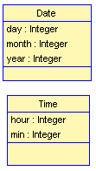
When a reservation needs to be make, a Date and Time object has to be created and when the arrival time needs to be set, it will be assign to that respective object. For example, I need to make a reservation on my system on 05/05/2018 at 20:0. The time and date will be made as follows:

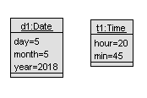
After I stored this values in my model, I can use this date for setting arrival time and storing date and time for a reservation.
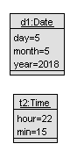
Another example can be a reservation on 06/05/2018 at 22:15 --->
Because people can make lots of errors, they can accidentally insert
wrong values. Values like hour 25 should not be correct because there is no
hour 25 in a day, or the number of minutes shouldn’t be bigger than 60, day
should be between 1 and 31, month between 1 and 12 and year shouldn’t be
greater than current year as we do not want to make reservations in past.
For all this mistakes that can occur, I have create some pre conditions every time when an object of this time is created. Let’s take an example.
We create the object d and t: Date and Time in the first example from above. We want to use the information when we make a booking. When assign the d and t values to arrivalTime from booking, I have to use !operner and !opexit to check the preconditions so there will be no mistakes in my model.
The preconditions are the following:
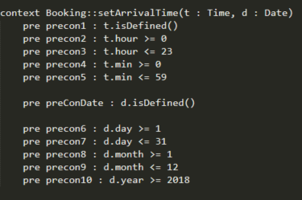
The way needs to be check the pre-condition are like:
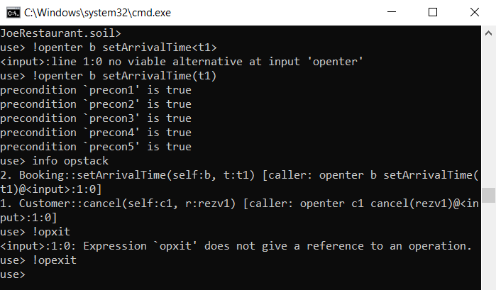
All conditions are true here, because the values are between the limits they are supposed to be. I have created another object that will make the pre-condition to be false:

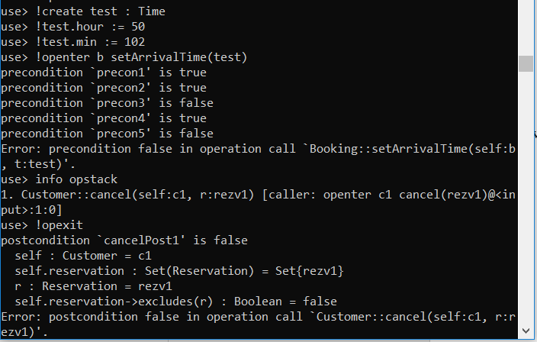
As its shows in the diagram above the precon3 and precon5 are false due to the fact that the time is not in 24-hour range and the minutes are not in the 60 range which make the preconditions to be false.

Make reservation
I have created a restaurant object with 10 tables on it, and on the diagram bellow is shown the tables assign to booking system.
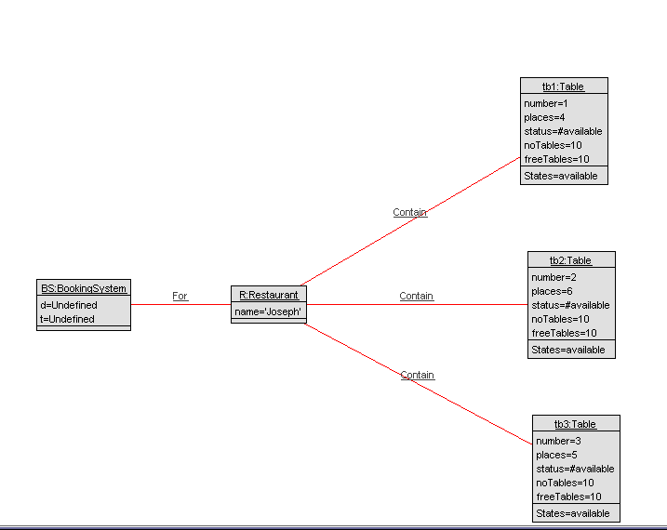

After I did this, I am going to create a reservation rezv1 for a customer c1 on the Date and Time I have created above d and t.
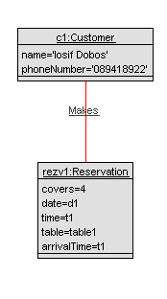
Next I have checked the precondition for make reservation connected to the Booking System. The precondition are as follows:
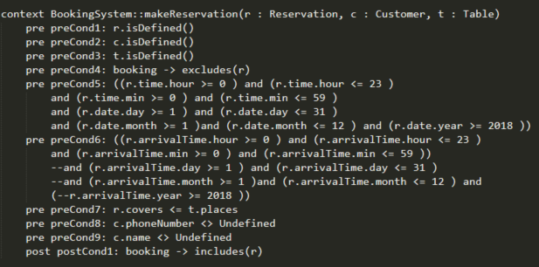

Checking the preconditions with !openter and !opexit as follow:

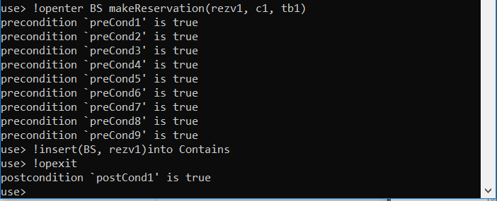

Register Walk In

In a walk-in situation, there is no need for a name or a phone number of the customer to make the reservation. If there are available tables in the restaurant then they can be allocated to any people.
In order to register this in my restaurant model, I have to create a Walk-in object, which inherits from booking, and register it in the system with openter and opexit.

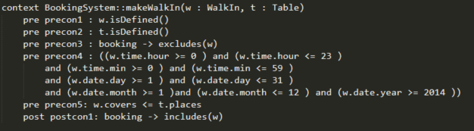

After executing openter and opexit I got the walk in registred successful.

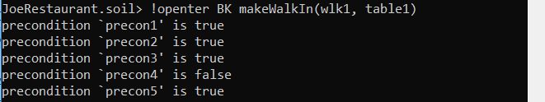

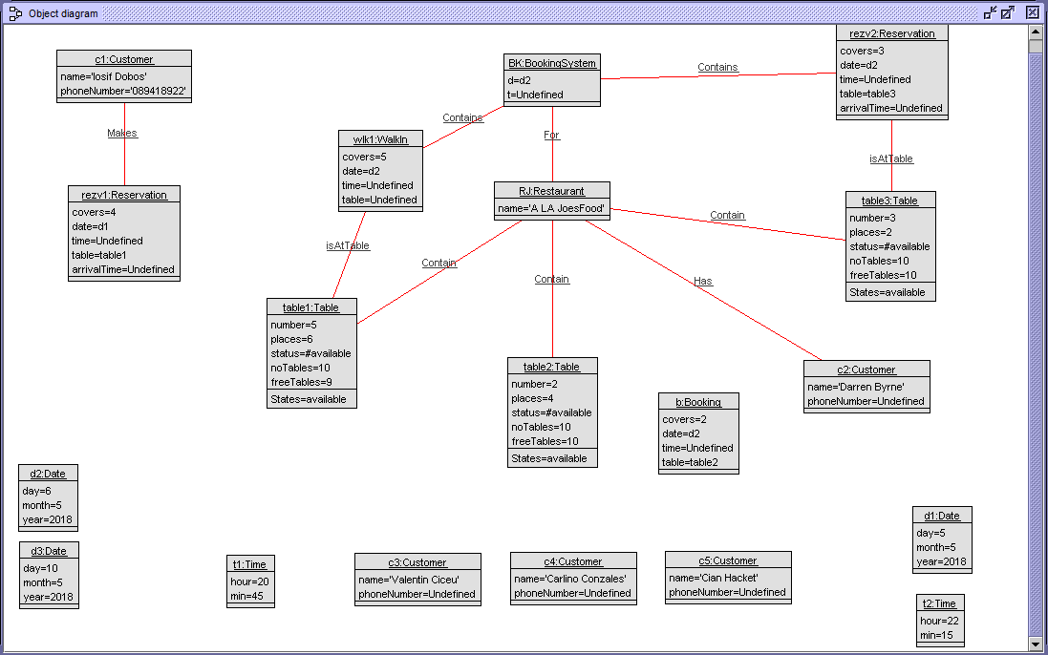

Cancel Booking
I can also cancel Bookings from my system. Just for showing that this is working, I will cancel the rez1 reservation, and I will create that again.
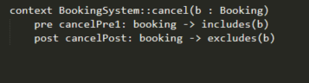
Testing cancel booking in use:

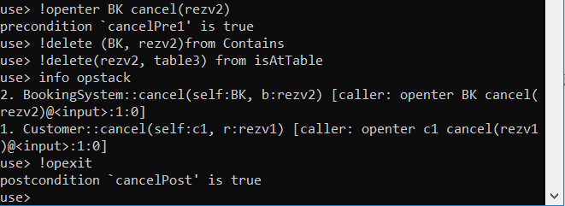

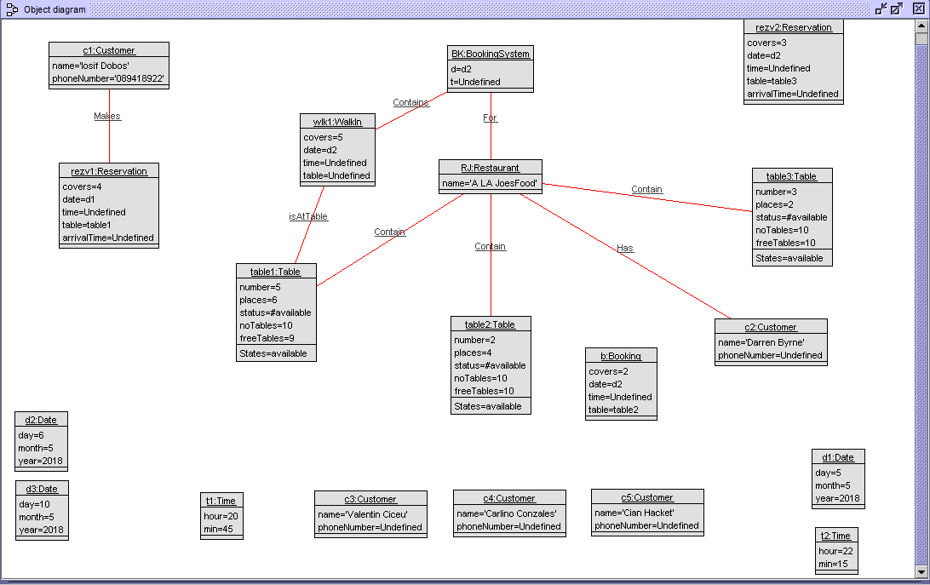

Populate model with more Reservations
I will now create some more reservations, one for each table so I can make some more invariants after this.
Each time when I will add a reservation in the system, I will check it with openter and opexit.
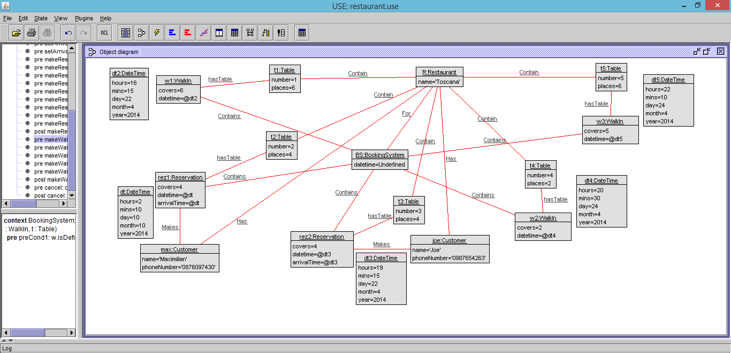
The next image is showing the sequence diagram view, object count view, link count view and class invariant view. The sequence diagram can be extended pressing right click > Show all Commands in USE.
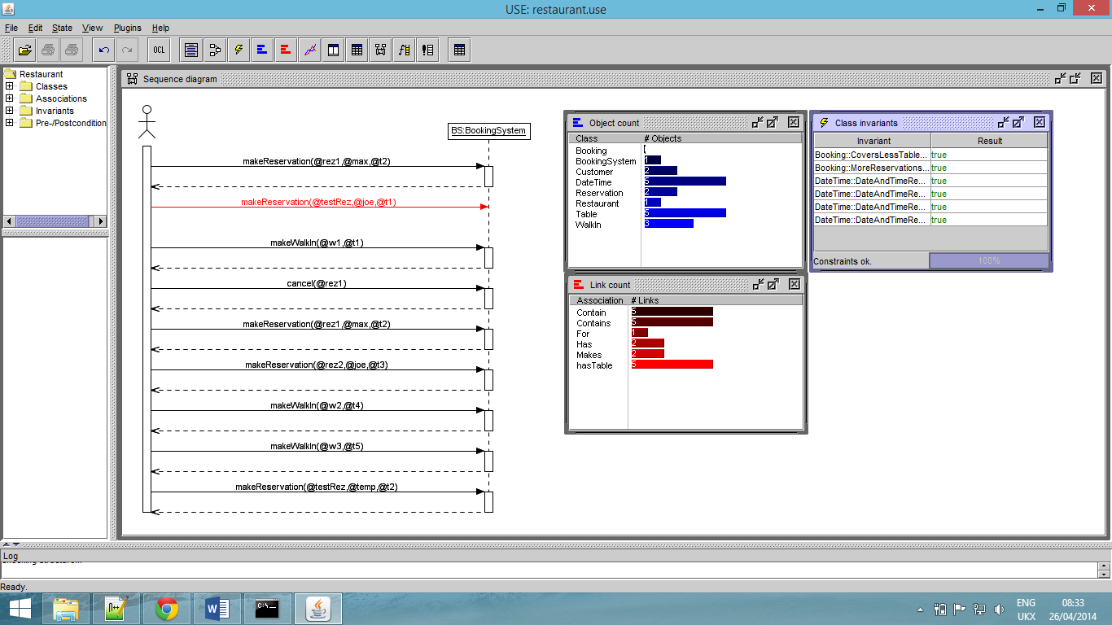
Invariants
- Number of Covers Less than Table Capacity
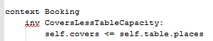

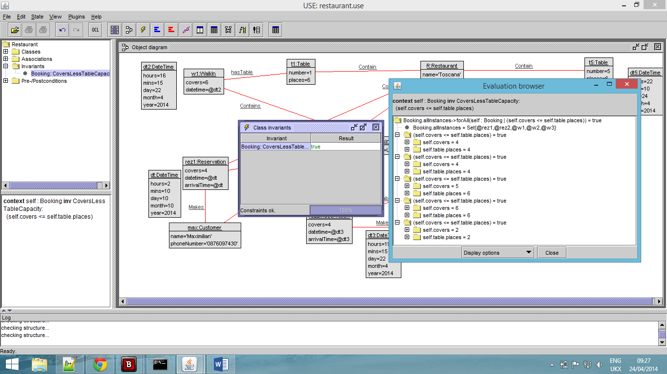
This will be true if all tables have less covers than their capacity. For my object diagram from above, this invariant will be true.
I will now change one reservation to vane more covers than table capacity to see the difference. Rez1 has 4 covers and they have table 2 with 4 places. I will now increase the number of covers from that reservation so the invariant will be false.
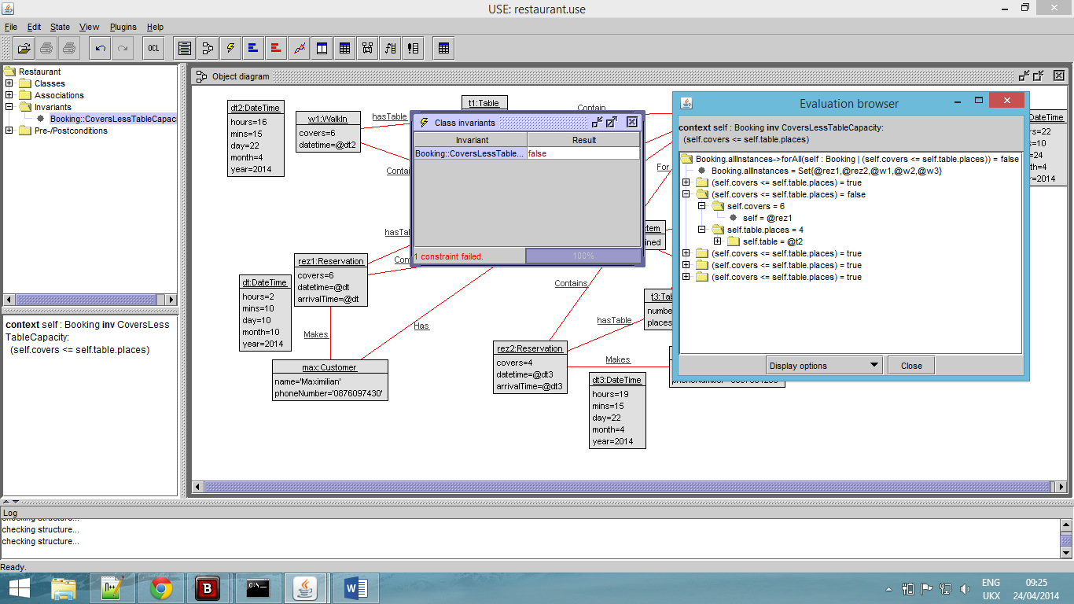
- Another invariant could be: There cannot be more reservations at the same time for the same table in the restaurant (It should be impossible to double book a table). This invariant looks like this:
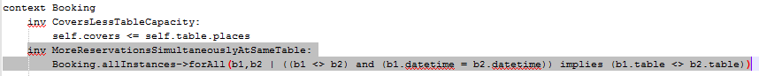

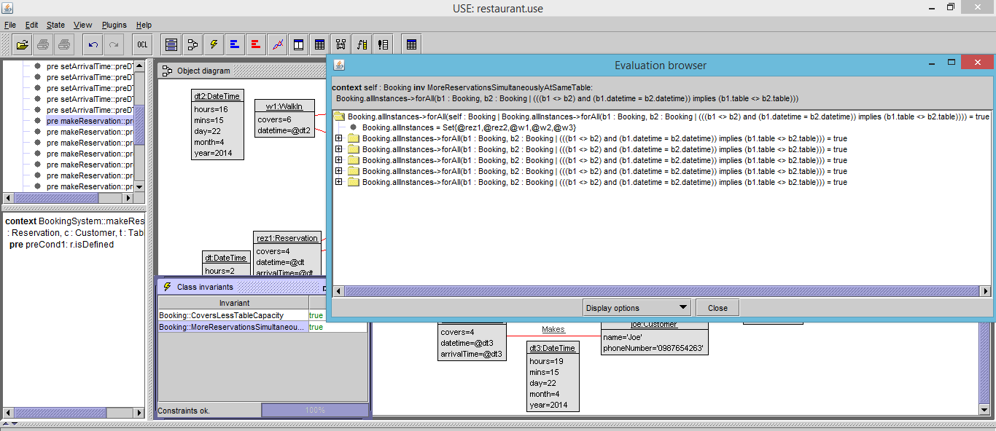
This s showing the invariant value when it meets the requirements.
To negate this invariant I will create a temporary customer that will make a reservation at the same time and table as max Customer. The invariant should be false this time.

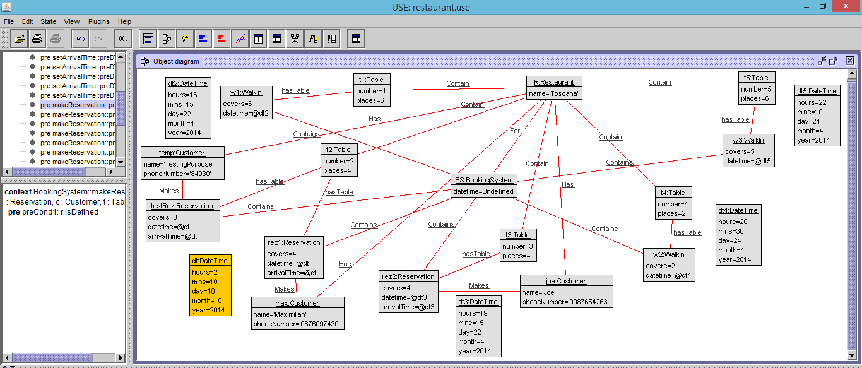

I pointed on the object diagram what is wrong and what is making the invariant to be false.

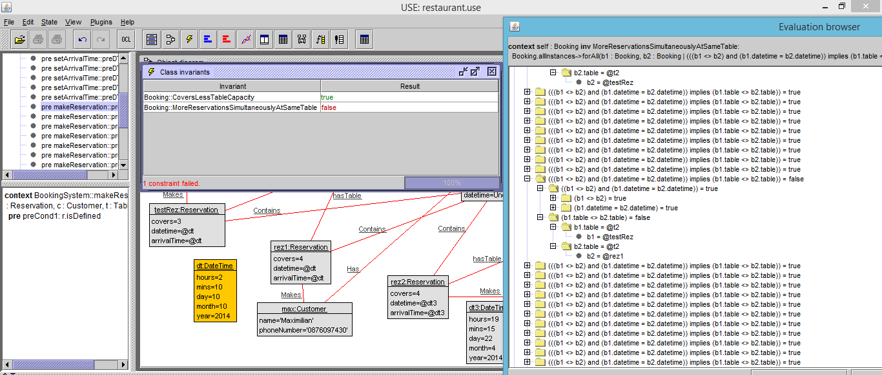

All the Invariants can also be checked in command prompt:

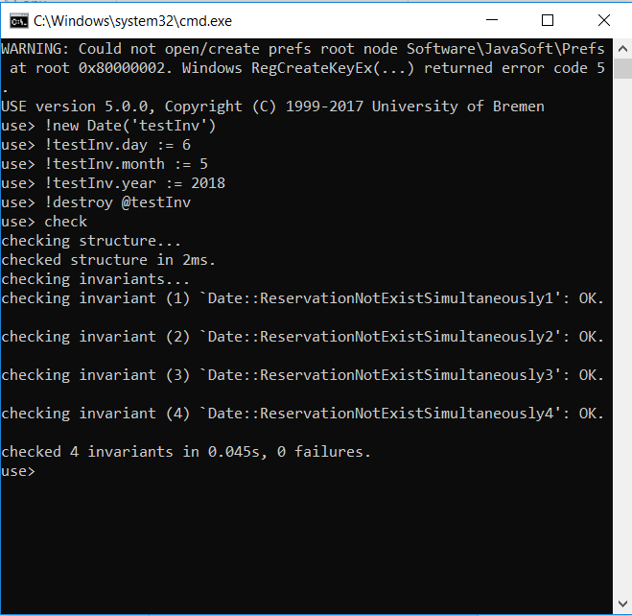

Design Patterns

My restaurant model is assumed to be implemented as a desktop application: with single user and normal input and output devices like mouse, keyboard, screen etc.
In this model there is the Application Layer and Presentation layer. The Presentation layer it is used to present data to the application layer in an accurate, well-defined and standardized format, also is checking the application layer for updates. The presentation layer mainly translates data between the application layer and the network format. The Application layer is the one that directly interacts with the user.

Adapter Design Pattern

Also known as Wrapper. Converts the interface of a class in another interface clients expect.
In my restaurant model I am using the Adapter pattern for the booking class. The Walk In and Reservation classes inherits from the Booking class so the system can be adapted. If no reservations are done for some tables when clients walk in the restaurant the walk in can be easily implemented instead of a reservation.
When a reservation is registered in the system, the user of this model has to create the reservation and the customer object in order to make the booking.

A reservation can be cancelled and instead of that, a walk in can be placed if exists
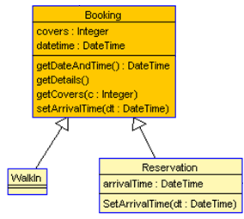

Observer Design Pattern
The Observer pattern allows changes to one object, application, to be communicated to others by presentation without assuming what the other objects are.
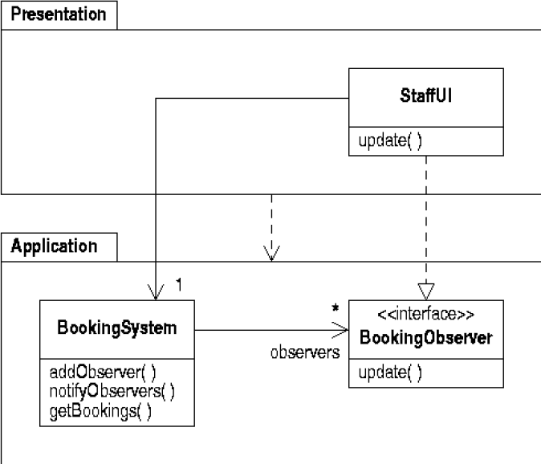
The Observer Pattern Structure is:

In the Restaurant model, the Booking System class represents a whole-part hierarchy of objects.

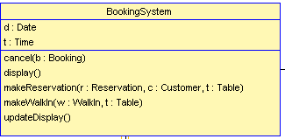
Clients are able to ignore the difference between compositions of objects and individual objects. They will treat all objects in the composite structure uniformly.

