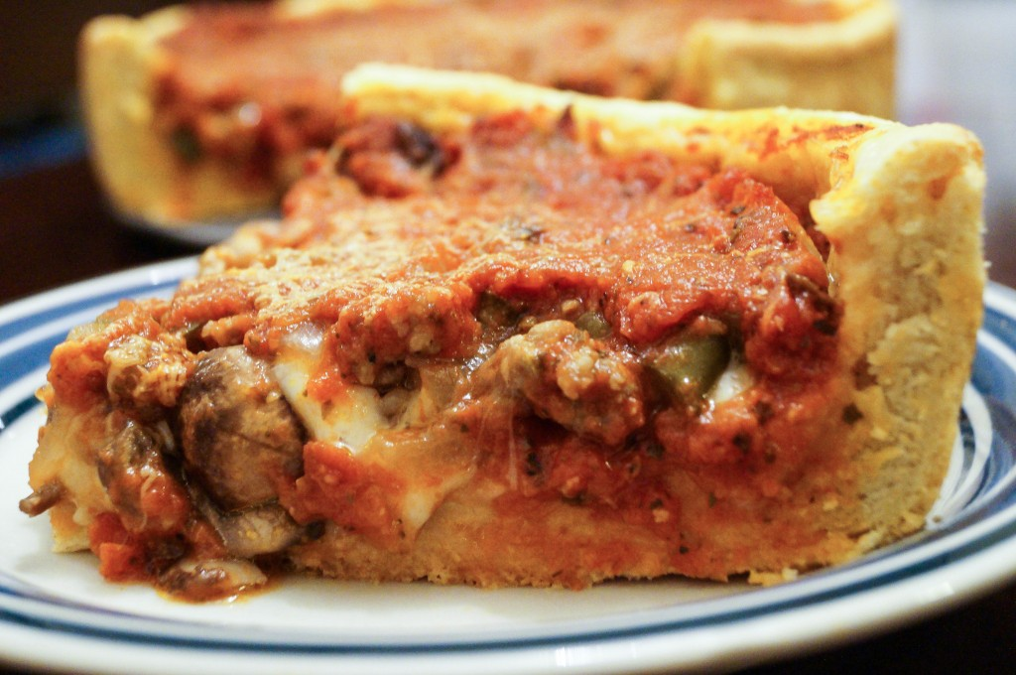

The Impact of Social Safety Factors with Considerations for Commercial Decisions

Paul Coen, Southern Illinois University
KirkLeroy J. Powell, Southern Illinois University

Abstract: A look at the various clustering methodologies used in social safety factors to determine locality specific geographic zones. Many independent repositories of data for large urban centers exist in disconnected formats. Our study takes an in depth analysis of these factors inside Chicago, considered to be one of the least safest cities in the United States, to determine if a correlation exists within subspace dimensionality and if that correlation can be causal proof to influence commercial decisions by applying clustering techniques on several layers to identify specific regions and time frames that create the highest level of uncertainty in decision making and representing this analysis in with a real-time data feed to create visually identifiable pockets of hostility, aggression, etc. This research will attempt to suggest improvements to techniques in processing data flow from urban communities and potentially reveal opportunities to improve upon known clustering methodologies

Keywords: DBSCAN, Mean-Shift, Panda, preprocessing, Sow & Grow, Spectral Clustering, subspace
DOI: [TODO: I have no idea what this is?]

1 Introduction

Our research topic originated from a consideration of how known factors might be influencing the patrons of commercial restaurants and how we can best relay that information to potential customers in a real-time data flow. We began with a rudimentary analysis of social factors that could be considered to affect eating habits; health codes, menu options, access to the internet, rental rates, condom distribution, family planning services, homeless shelters, abandoned buildings, political districts, etc. Our research and accompanying project are limited in scope and depth due to the natural constraints of class time and semester length. As such, we truncated our options for data sets based on their availability, scope of data, and plausible application within our project parameters. We derived that crime statistics, food safety, and [third set goes here] were optimal pools of information that satisfied our query requirements. Our data sets are all tied by their longitude and latitude, making the result sets optimal for image mapping on a hand held device, such as within a cell phone app. The benefit of mapping meant that the clustering algorithms in data mining were best suited for our analysis. We used data preprocessing decisions that constitute reasonable arbitrary exclusions. We then built a data processing tool in Python using open-sourced libraries to apply the known algorithms of traditional data mining techniques.

2 Tools

Our project is publicly available on Github:

https://github.com/IotaDraconis/Is_It_Safe_To_Eat_In_Chicago

Markdown is the best and simplest way to construct ReadMe files on a project:
https://github.com/adam-p/markdown-here/wiki/Markdown-Cheatsheet

We used Python, version 3.6.5, to build a data processing tool. Some of the essential libraries available through Python are only accessible in version 3 and above.

MatPlotLib 3.0.0:
https://matplotlib.org/

A set of known data mining algorithms is available at:
http://scikit-learn.org/stable/modules/clustering.html#clustering

DBSCAN

Spectral Clustering

Mean-Shift

3 Data Sets

One can access all the data sets used in this project at:

Chicago Crime Dataset: https://data.cityofchicago.org/Public-Safety/Crimes-2001-to-present/ijzp-q8t2 saved as crime.csv in the /datasets directory

Chicago Food Inspections Dataset: https://data.cityofchicago.org/Health-Human-Services/Food-Inspections/4ijn-s7e5 saved as food_inspections.csv in the /datasets directory

4 Data Preprocessing

The /code/prepare.py file is designed to automate the data preprocessing step in alignment with the expectations of the /code/main.py file used to process data sets. There is no ideal minimum size for the data sets. It is reasonable to assume that as the size of a data set increases the sampling of the information will likewise increase in value as well. The intent of the preprocessing set was to isolate the data attributes necessary for useful clustering. Our initial theory of breaking down Chicago into a grid for a predetermined number of centroids was assisted by the discovery of the latitude & longitude of the crimes was available in the crime data set. This truncated block-by-block reference was sufficient for a generalized understanding of geographical locations within and about the city. We quickly adopted this as a prerequisite for subsequent data sets in order to link them in a truly meaningful way.
As we worked through the massive crime data set provided by the city, we found that several of the columns were redundant or irrelevant. The data is trimmed by isolating the geographical point, the types of crimes (as identified by code, if an arrest made, and its classification as ‘domestic’), and the date the crime occurred. We wrote a python script to perform this action on our data set preparing it for the clustering algorithms. Additionally, to compare the different subspaces of data sets, we applied a range modification to balance the data. We used a range from 0 to 1.

5 Clustering Methods

6 Conclusions & Recommendations

7 References

Outline:

- Introduction
- Tools
  - Github
  - Markdown
  - Python
    - Panda
    - MatPlotLib
  - Scikit-learn.org
- Data Sets
- Data Preprocessing
- Clustering methods
  - DBSCAN
  - Spectral Clustering
  - Che’s special algorithm
  - Mean-Shift
- Conclusions & Recommendations
  - Benefits of known algorithms
  - Weaknesses of known algorithms
  - Opportunities for improvement in research
  - Commercial applications
- References

