Interstate 80 West – From Davenport
- Take Interstate 80 west to exit 246
- Make a right onto Highway 1, also known as N. Dodge now, and go south a little over 2 miles to Burlington
- Make a right on to Burlington and go a little less than a mile west to S. Capitol Dr.
- Make a right onto S. Capitol and another right into the parking garage. The S. Capitol street sign is missing for some reason so look for a sign that says S. Capitol Parking Garage (big green sign)

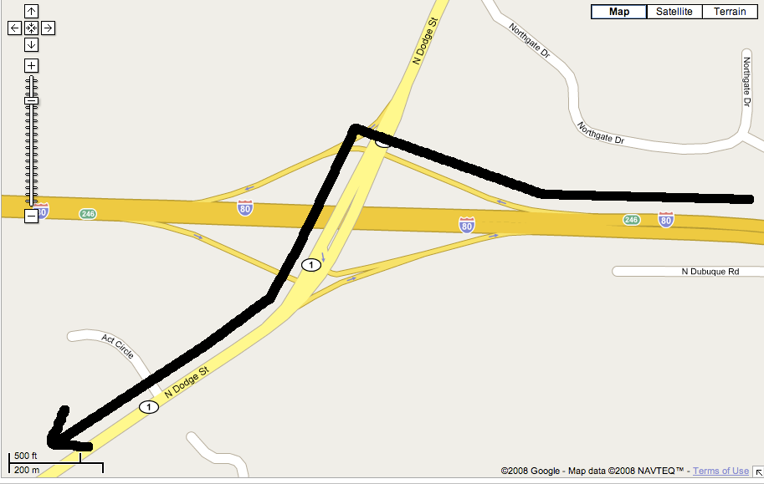
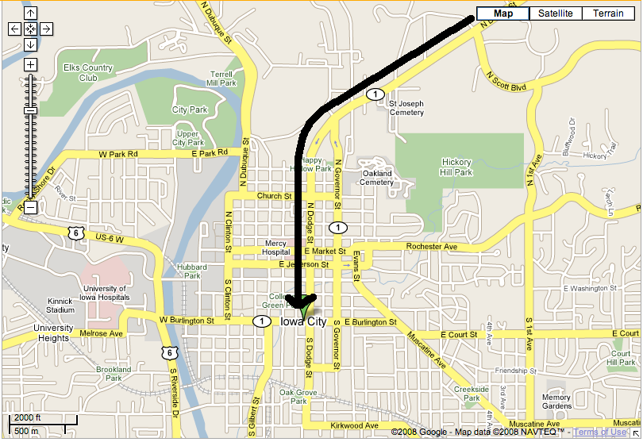

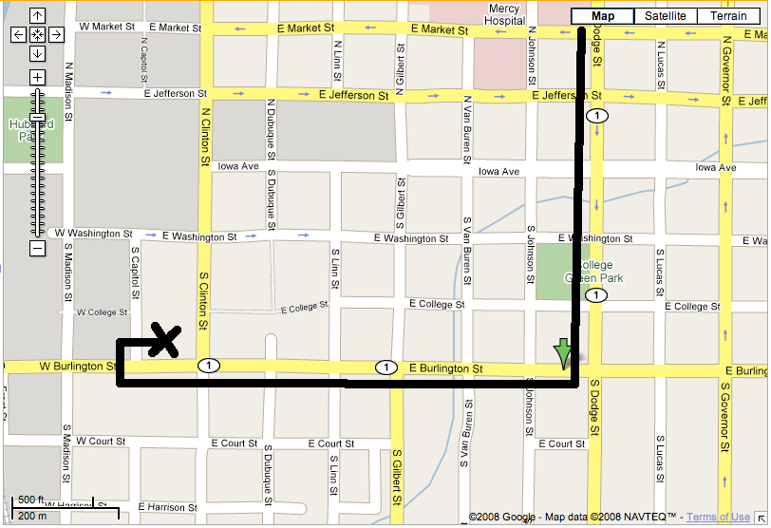

Highway 1 South - Dubuque
- Cross Interstate 80 and continue on Highway 1, also known as N. Dodge now, for 2 miles to Burlington
- Make a right on to Burlington and go a little less than a mile west to S. Capitol Dr.
- Make a right onto S. Capitol and another right into the parking garage. The S. Capitol street sign is missing for some reason so look for a sign that says S. Capitol Parking Garage (big green sign)

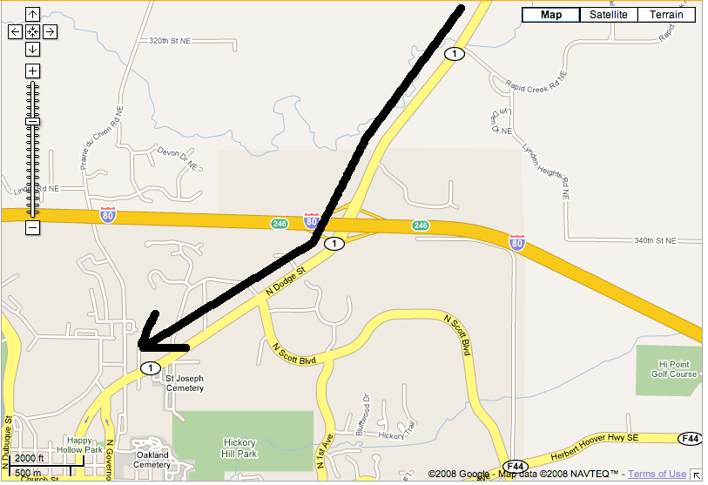

Interstate 80 East - Des Moines
- Take 80 east to exit 242
- Go south on 1st Avenue one mile to Highway 6
- Make a left onto Highway 6 and head go around 2.5, following the bend, to S. Grand/W. Burlington
- Make a left onto Burlington and go about half mile to S. Capitol Dr.
- Make a left onto S. Capitol and then a quick right into the parking garage. The S. Capitol street sign is missing for some reason so look for a sign that says S. Capitol Parking Garage (big green sign)

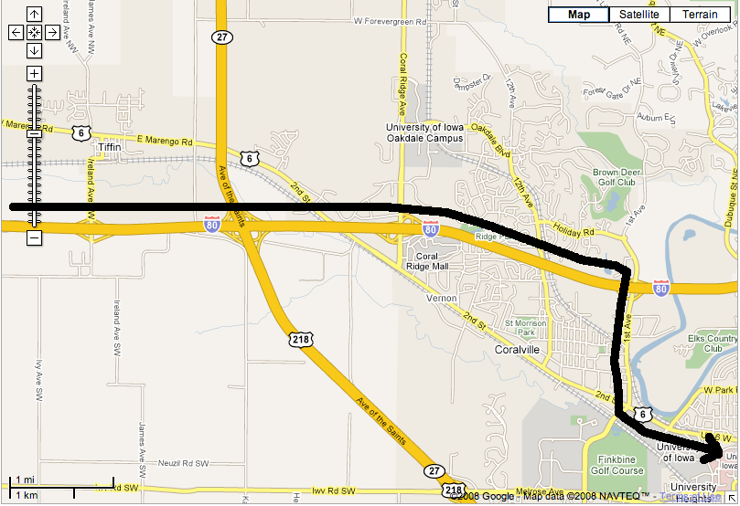

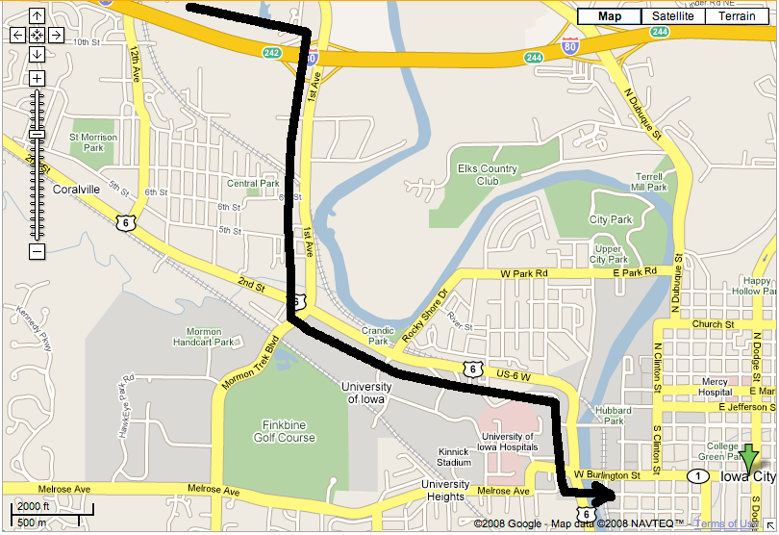
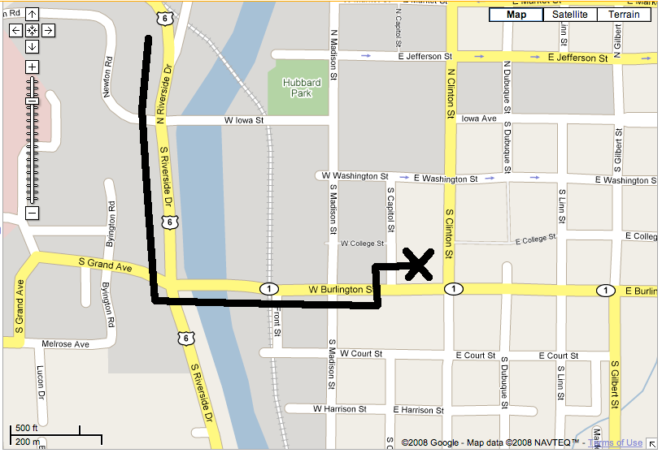
380 South – Cedar Rapids
- Take Interstate 380 south until Interstate 80 East exit 0A.
- Take 80 East about 3 miles to exit 242
- Go south on 1st Avenue one mile to Highway 6
- Make a left onto Highway 6 and go around 2.5 miles, following the bend, to S. Grand/W. Burlington
- Make a left onto Burlington and go about half mile to S. Capitol Dr.
- Make a left onto S. Capitol and then a quick right into the parking garage. The S. Capitol street sign is missing for some reason so look for a sign that says S. Capitol Parking Garage (big green sign)

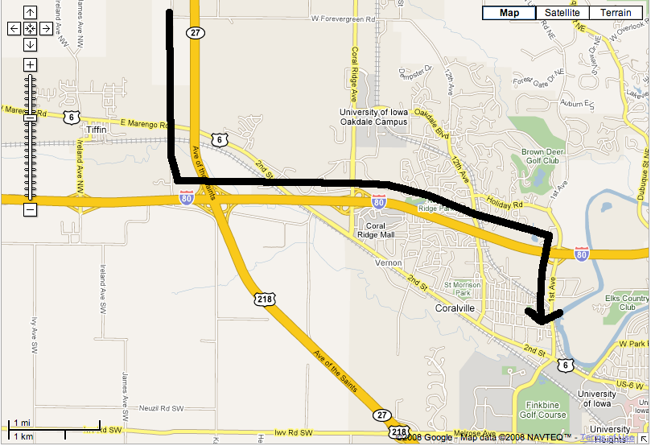

218 North – Mt. Pleasant
- Take 218 North until exit 91
- Turn right on Highway 1 and go about 2.5 miles to Riverside Dr.
- Turn left onto Riverside Dr. and go 0.7 miles to S. Grand/W. Burlington
- Turn right onto Burlington and go about half mile to S. Capitol Dr.
- Make a left onto S. Capitol and then a quick right into the parking garage. The S. Capitol street sign is missing for some reason so look for a sign that says S. Capitol Parking Garage (big green sign)

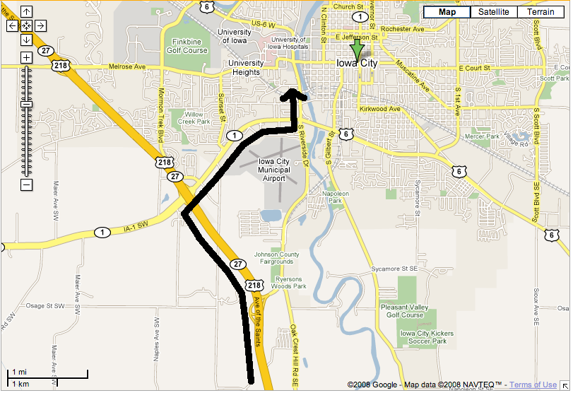

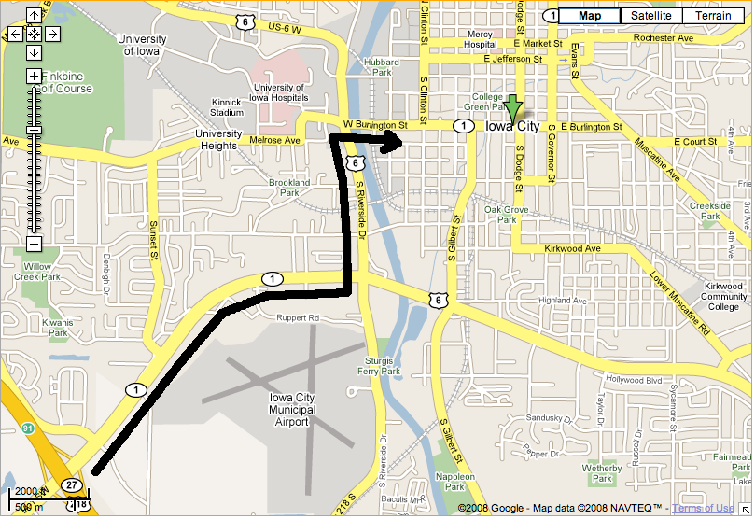
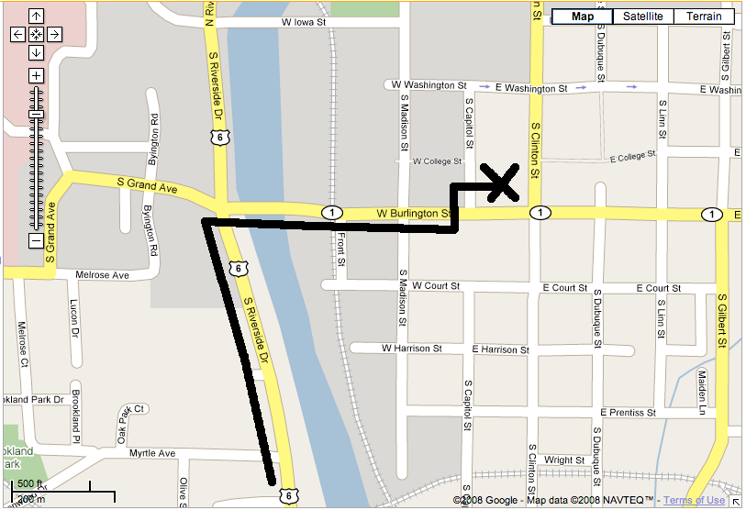
6 West – West Liberty
- Take Highway 6 west to S. Gilbert St.
- Turn right onto Gilbert and go about 0.8 miles to Burlington
- Turn left onto Burlington and about 0.3 miles to S. Capitol Dr.
- Make a right onto S. Capitol and enter the parking garage. The S. Capitol street sign is missing for some reason so look for a sign that says S. Capitol Parking Garage (big green sign)
