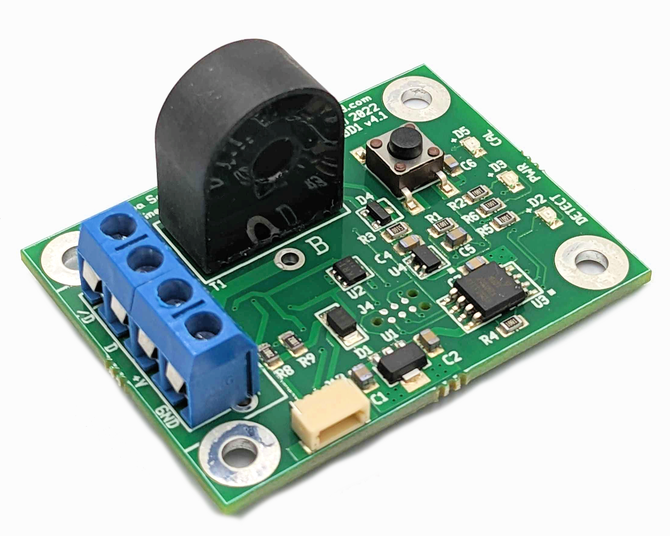


Iowa Scaled Engineering
ATOM™ DCC Block Detectors
The ATOM is an isolated, reliable, easy-to-install, single-channel DCC block detector. Compatible with a wide variety of other block detectors on the market, the ATOM provides two open collector outputs (one for detection, one for no detection) with optional pull-up resistors and features one touch sensitivity adjustment. Because the Based on a current transformer, the detector maintains isolation between your track and signal systems.
For those invested in C/MRI, we offer an alternate version (CKT-BD1-CMRI) that replaces the screw terminals with a plug that connects directly into Dr. Chubb's detector motherboard (ODMB) and provides full compatibility with the DCCOD.

Features
- Single button sensitivity adjustment (no fiddling with tiny potentiometers!)
- Isolated using a current transformer
- Highly sensitive (1ma, or ~10k ohms) yet resistant to false detection
- Two opposite polarity, open-collector outputs (40V / 250mA capable)
- Optional onboard output pull-up resistors
- Powered from 5V to 24VDC
- Onboard detection indicator LED
- 0.4s turn on and 2.5s turn off delay
- Choice of terminal blocks, wires, or C/MRI DCCOD compatible connector – plugs into C/MRI detector motherboards!

Typical Applications
- Detect block occupancy for signal systems
- Activate grade crossing signals
- Trigger sounds
- Occupancy indicators on hidden track

Electrical Connections
There are three options for connecting to the ATOM block detector: terminal blocks, an optional JST-style cable (available separately), or an optional Molex connector that makes the ATOM compatible with C/MRI-style detector motherboards.
The ATOM needs 5 to 24V of clean DC power. When using the terminal blocks, power should be supplied to the +V (positive) and GND (negative) terminals.
Please do not use old power packs as a source of “DC” power. Their DC outputs are usually unfiltered and generally have peak voltages that far exceed the nominal voltage listed. Often these peaks are 35+ volts, and far more than enough to destroy low voltage electronics.

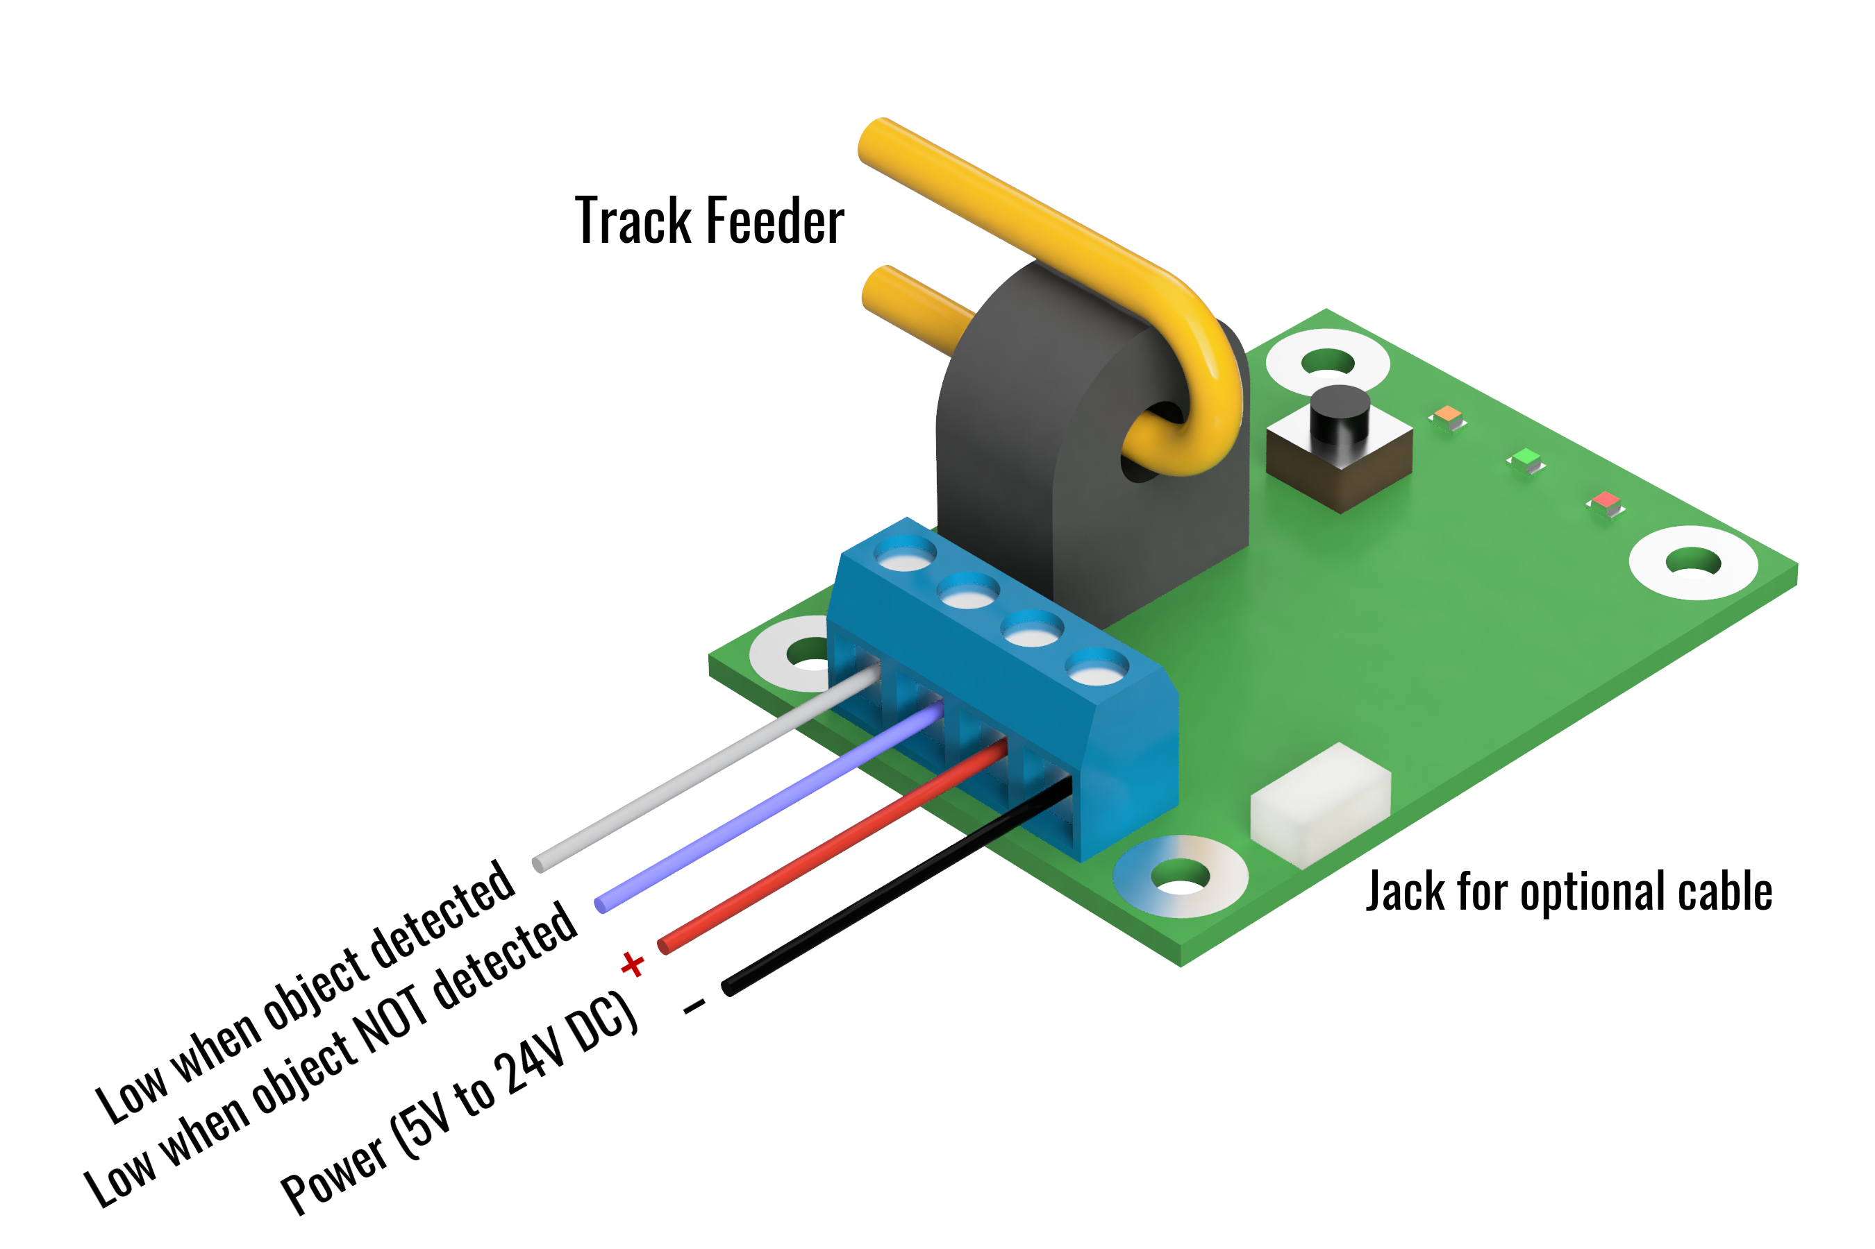
If using the optional cable, power should be applied to the red (positive) and black (negative/ground) wires. The Molex connector on the C/MRI version provides power automatically when plugged into a compatible motherboard.
The /D terminal (or white wire when using the JST-style cable) will conduct current to ground/negative when a train is detected within the block. The D terminal (or blue wire when using the JST-style cable) will conduct current to ground/negative when a train is NOT detected within the block.
In order for the ATOM to work, a block of track needs to be electrically isolated, at least on one rail, from the blocks around it. (We recommend that both rails are isolated for each block, and that dedicated feeders run to each, as this eliminates potential sources of interference.) The feeders for only one of the isolated rails need to run through the center hole in the black “tombstone” current transformer on the ATOM. The track feeder should only pass through the hole one time, as shown by the yellow wire in the diagram.
Normally the two outputs are in an “open drain” configuration, meaning they act like a switch to ground – either they conduct current or they look like an open circuit. Do not exceed 40V on either of the two output terminals. Also, do not attach loads that will draw more than 250mA of current or the output transistors may be damaged.
If your application requires pull-up resistors, such as for connecting to a logic-level input, short jumpers JP1 and/or JP2 using a blob of solder to enable the on-board 10k pull-up resistors. These resistors pull the D and /D outputs up to the +V voltage. JP1 is for the D terminal (or the blue wire) and JP2 is for the /D terminal (or the white wire).

Operation
When the detector is powered, the green “PWR” light should be illuminated.
During normal operation, when the ATOM senses enough current to trip, the red DETECT light will turn on. There is a slight turn-on delay of 0.4s and a 2.5s turn-off delay to eliminate glitching.
The ATOM comes factory calibrated to start detecting at 1mA of current so that just a single 10k resistor wheelset will trigger detection. Most users will not need to recalibrate the detectors. However, if the DETECT light is on while your track block is empty, you may need to calibrate out leakage current.
If your block is empty and the red DETECT light is on, first make sure that your block is truly isolated from others and that no equipment is sitting on the block. Wiring mistakes or a piece of equipment sitting on the rails can often be mistaken for detection issues.
Once you’re sure of that, you may just need to recalibrate the leakage current. An empty block theoretically draws no current. However, capacitance between track feeders as well as ballast and other scenery materials in contact with the rails can cause additional leakage currents to flow. This may not happen initially, but may occur with seasonal humidity variations, as ballast will naturally soak up humidity and your leakage current may rise.
The ATOM can quickly compensate for up to 10mA of leakage current. If you do need to adjust for sensitivity Press and hold the pushbutton on the ATOM. You should see the orange CAL light start to blink slowly. Once the CAL light stays on solid, release the switch. Within a few seconds, the CAL light should blink rapidly three times and the red DETECT light should go out, indicating that the calibration was a success. If the DETECT light does not go off, it is likely that you have either an error in your DCC wiring or excessively high leakage current in the block.

C/MRI and Circuitron-Style Motherboards
In order to use the detector with C/MRI-style detector motherboards, a Molex 09-48-1054 (5 position, right angle female connector) must be soldered on to the end of the PCB. Holding the PCB with the connector holes on the left, a 5 position connector should be installed in the lower five holes.
Circuitron makes a compatible motherboard with an additional pin for the high when detecting output (D). For those, a Molex 09-48-1064 (6 position, right angle female connector) should be used and attached in all six holes.
In addition to the connector, a short wire needs to be soldered between the holes labeled A and B, passing through the current transformer hole only once. This will carry DCC track power, so 16 gauge or larger stranded copper wire is recommended.

Open Design
Iowa Scaled Engineering is committed to creating open designs that users are free to build, modify, adapt, improve, and share with others.
The design of the ATOM hardware is open source hardware, and is made available under the terms of the Creative Commons Attribution-Share Alike v3.0 license, a copy of which is available from: https://creativecommons.org/licenses/by-sa/3.0/
Design files can be found on the Iowa Scaled Engineering website:
https://www.iascaled.com/store/CKT-BD1
The official Iowa Scaled Engineering firmware for the ATOM is free software: you can redistribute it and/or modify it under the terms of the GNU General Public License as published by the Free Software Foundation, either version 3 of the License, or (at your option) any later version. A copy of the GNU GPL can be found at: https://www.gnu.org/licenses/gpl.html
New firmware can be flashed into the ATOM using J4. The six land pads implement the standard AVR 6-pin ISP header on a connector compatible with the Tag-Connect TC2030 cable. Stable releases of firmware and source code can be found on the Iowa Scaled Engineering website.

Ordering Information
Model | Description
CKT-BD1 | ATOM block detector with terminal blocks.
CKT-BD1-CMRI | ATOM block detector with C/MRI compatible Molex connector installed.
CBL-24SH0404 | 24” 4-position JST-style cable with stripped and tinned wires.

Document Revisions
Dec 2, 2022 – Initial version published

