CKT-BD1 DCC Block Detector (version 4)

The CKT-BD1 is an isolated, reliable, easy-to-install, single-channel DCC block detector. Compatible with a wide variety of other block detectors on the market, the CKT-BD1 provides two open collector outputs (one for detection, one for no detection) with optional pull-up resistors and automatic sensitivity adjustment. Based on a current transformer, the detector maintains isolation between your track and signal systems.

For those invested in C/MRI, we offer an optional connector that replaces the screw terminals with a plug that connects directly into Dr. Chubb's detector motherboard (ODMB) and provides full compatibility with the DCCOD.

Features
- Automatic sensitivity adjustment (no fiddling with tiny potentiometers!)
- Isolated using a current transformer
- Highly sensitive (10k ohms)
- Two opposite polarity, open-collector outputs (40V / 250mA capable)
- Optional onboard output pull-up resistors
- Powered from 5V to 24V
- Choice of terminal blocks, wires, or C/MRI DCCOD compatible connector – plugs into C/MRI detector motherboards!

Typical Applications
- Detect block occupancy for signal systems
- Activate grade crossing signals
- Trigger sounds
- Occupancy indicators on hidden track

Electrical Connections
There are three options for connecting to the CKT-BD1: terminal blocks, an optional JST-style cable (available separately), or an optional Molex connector that makes the CKT-BD1 compatible with C/MRI-style detector motherboards.

The CKT-BD1 needs 5-24V of clean DC power. When using the terminal blocks, power should be supplied to the +V (positive) and GND (negative) terminals.
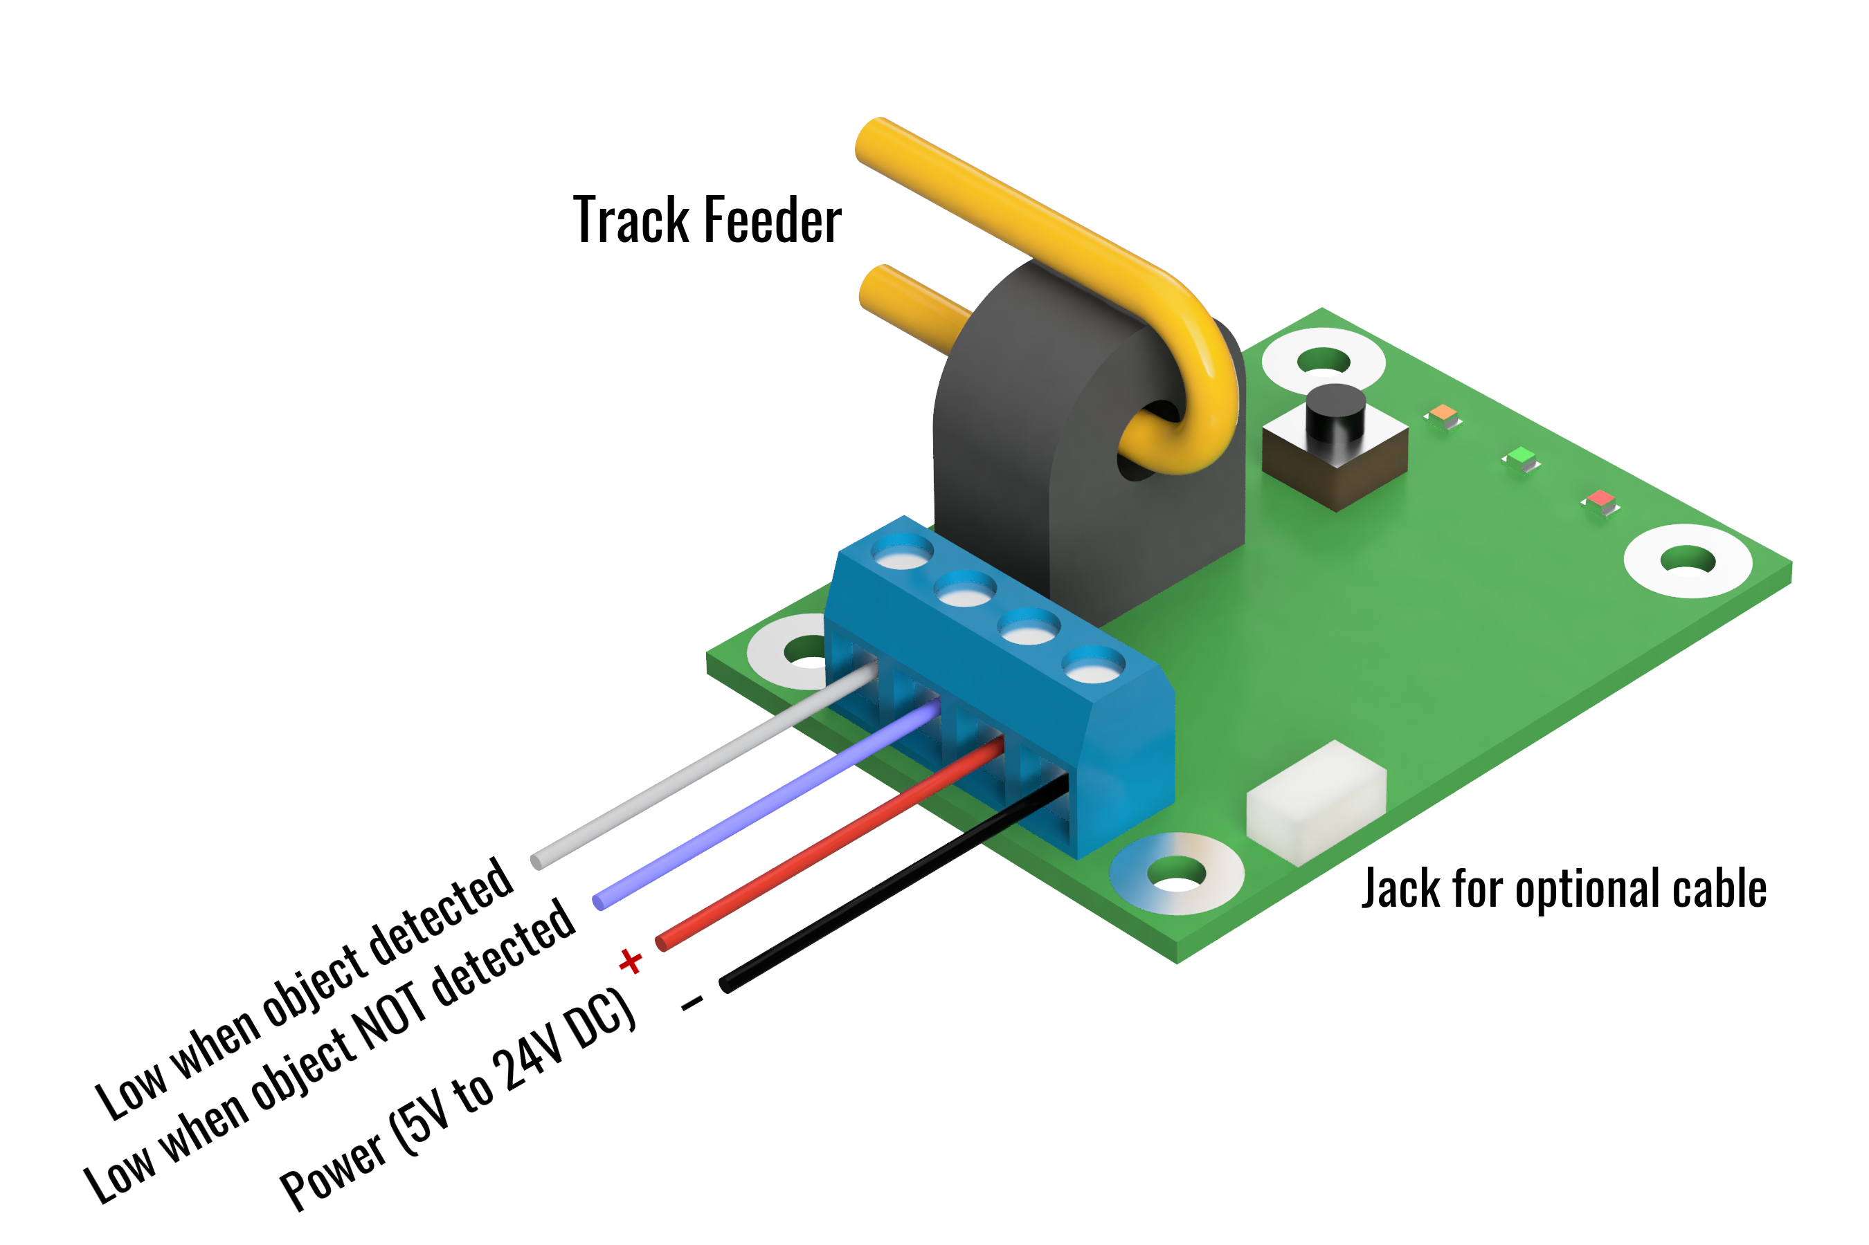
If using the optional cable, power should be applied to the red (positive) and black (negative/ground) wires. The Molex connector provides power automatically when plugged into a compatible motherboard.

Please do not use old power packs as a source of “DC” power. Their DC outputs are usually unfiltered and generally have peak voltages that far exceed the nominal voltage listed. Often these peaks are 35+ volts, and far more than enough to destroy low voltage electronics.

The /D terminal (or white wire when using the JST-style cable) will conduct current to ground/negative when a train is detected within the block. The D terminal (or blue wire when using the JST-style cable) will conduct current to ground/negative when a train is NOT detected within the block.

In order for the BD1 to work, a block of track needs to be electrically isolated, at least on one rail, from the blocks around it. (We recommend that both rails are isolated for each block, and that dedicated feeders run to each, as this eliminates potential sources of interference.) The feeders for only one of the isolated rails need to run through the center hole in the black “tombstone” current transformer on the CKT-BD1.

Normally the two outputs are in an “open drain” configuration, meaning they act like a switch to ground – either they conduct current or they look like an open circuit. Do not exceed 40V on either of the two output terminals.

If your application requires pull-up resistors, such as for connecting to a logic-level input, appropriate ¼ watt resistors can be installed in R8 (for the D terminal or the blue wire) and R9 (for the /D terminal or the white wire). 4.7k to 10k ohms is the recommended value, but your needs may vary based on application.

Operation
When the detector is powered, the green “PWR” light should be illuminated.

During normal operation, when the CKT-BD1 senses enough current to trip, the red DETECT light will turn on. There is a slight turn-on delay of 0.4s and a 2.5s turn-off delay to eliminate glitching.

When the track is empty, the red DETECT light should remain off. If it does not, first make sure that your block is truly isolated from others and that no equipment is sitting on the block. Once you’re sure of that, you may just need to recalibrate the leakage current. The CKT-BD1 comes factory calibrated to start detecting at 1mA of current so that just a single 10k resistor wheelset will trigger detection. However, capacitance between track feeders as well as ballast and other scenery materials in contact with the rails can cause additional leakage currents to flow. This may not happen initially, but may occur with seasonal humidity variations, as ballast will naturally soak up humidity and your leakage current may rise.

The CKT-BD1 can quickly compensate for up to 10mA of leakage current. Press and hold the pushbutton on the CKT-BD1. You should see the orange CAL light start to blink slowly. Once the CAL light stays on solid, release the switch. Within a few seconds, the CAL light should blink rapidly three times and the red DETECT light should go out, indicating that the calibration was a success. If the DETECT light does not go off, it is likely that you have either an error in your DCC wiring or excessively high leakage current in the block.

C/MRI-Style Motherboards
In order to use the detector with C/MRI-style detector motherboards, a Molex 09-48-2051 or similar connector must be soldered on to the end of the PCB. In addition, a short wire needs to be soldered between the holes on either side of the current transformer. This will carry DCC track power, so at least 16 gauge stranded wire is recommended.

Open Design
Iowa Scaled Engineering is committed to creating open designs that users are free to build, modify, adapt, improve, and share with others.

The design of the CKT-BD1 hardware is open source hardware, and is made available under the terms of the Creative Commons Attribution-Share Alike v3.0 license, a copy of which is available from: https://creativecommons.org/licenses/by-sa/3.0/

Design files can be found on the Iowa Scaled Engineering website:
https://www.iascaled.com/store/CKT-BD1

The official Iowa Scaled Engineering firmware for the CKT-BD1 is free software: you can redistribute it and/or modify it under the terms of the GNU General Public License as published by the Free Software Foundation, either version 3 of the License, or (at your option) any later version. A copy of the GNU GPL can be found at: https://www.gnu.org/licenses/gpl.html

New firmware can be flashed into the CKT-BD1 J4. The six land pads implement the standard AVR
6-pin ISP header on a connector compatible with the Tag-Connect TC2030 cable. Stable releases of firmware and source code can be found on the Iowa Scaled Engineering website.

Ordering Information

Model | Description
CKT-BD1 | CKT-BD1 block detector with terminal blocks.
CBL-24SH0404 | 24” 4-position JST-style cable with stripped and tinned wires.
CKT-BD1-CMRI | CKT-BD1 block detector with C/MRI compatible Molex connector installed.

