
CKT-DCCSA

The Run-N-Smooth PowerKeeper is a micro-size stay alive module that improves the running quality of N-scale and space-constrained DCC locomotives. With integrated protection circuitry and built using micro capacitors, the Run-N-Smooth PowerKeeper provides a simple, easy, and safer alternative for small installations.
Features
● Ultra small for N-scale locomotives
● 940uF typical capacitance
● Integrated protection circuitry
● Safer tantalum polymer capacitors

For more information, please visit:

https://www.iascaled.com/store/CKT-DCCSA

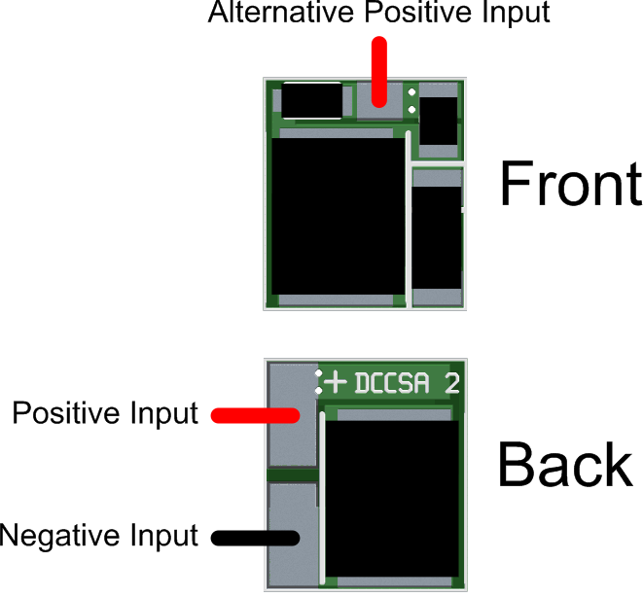

Installation

www.iascaled.com

