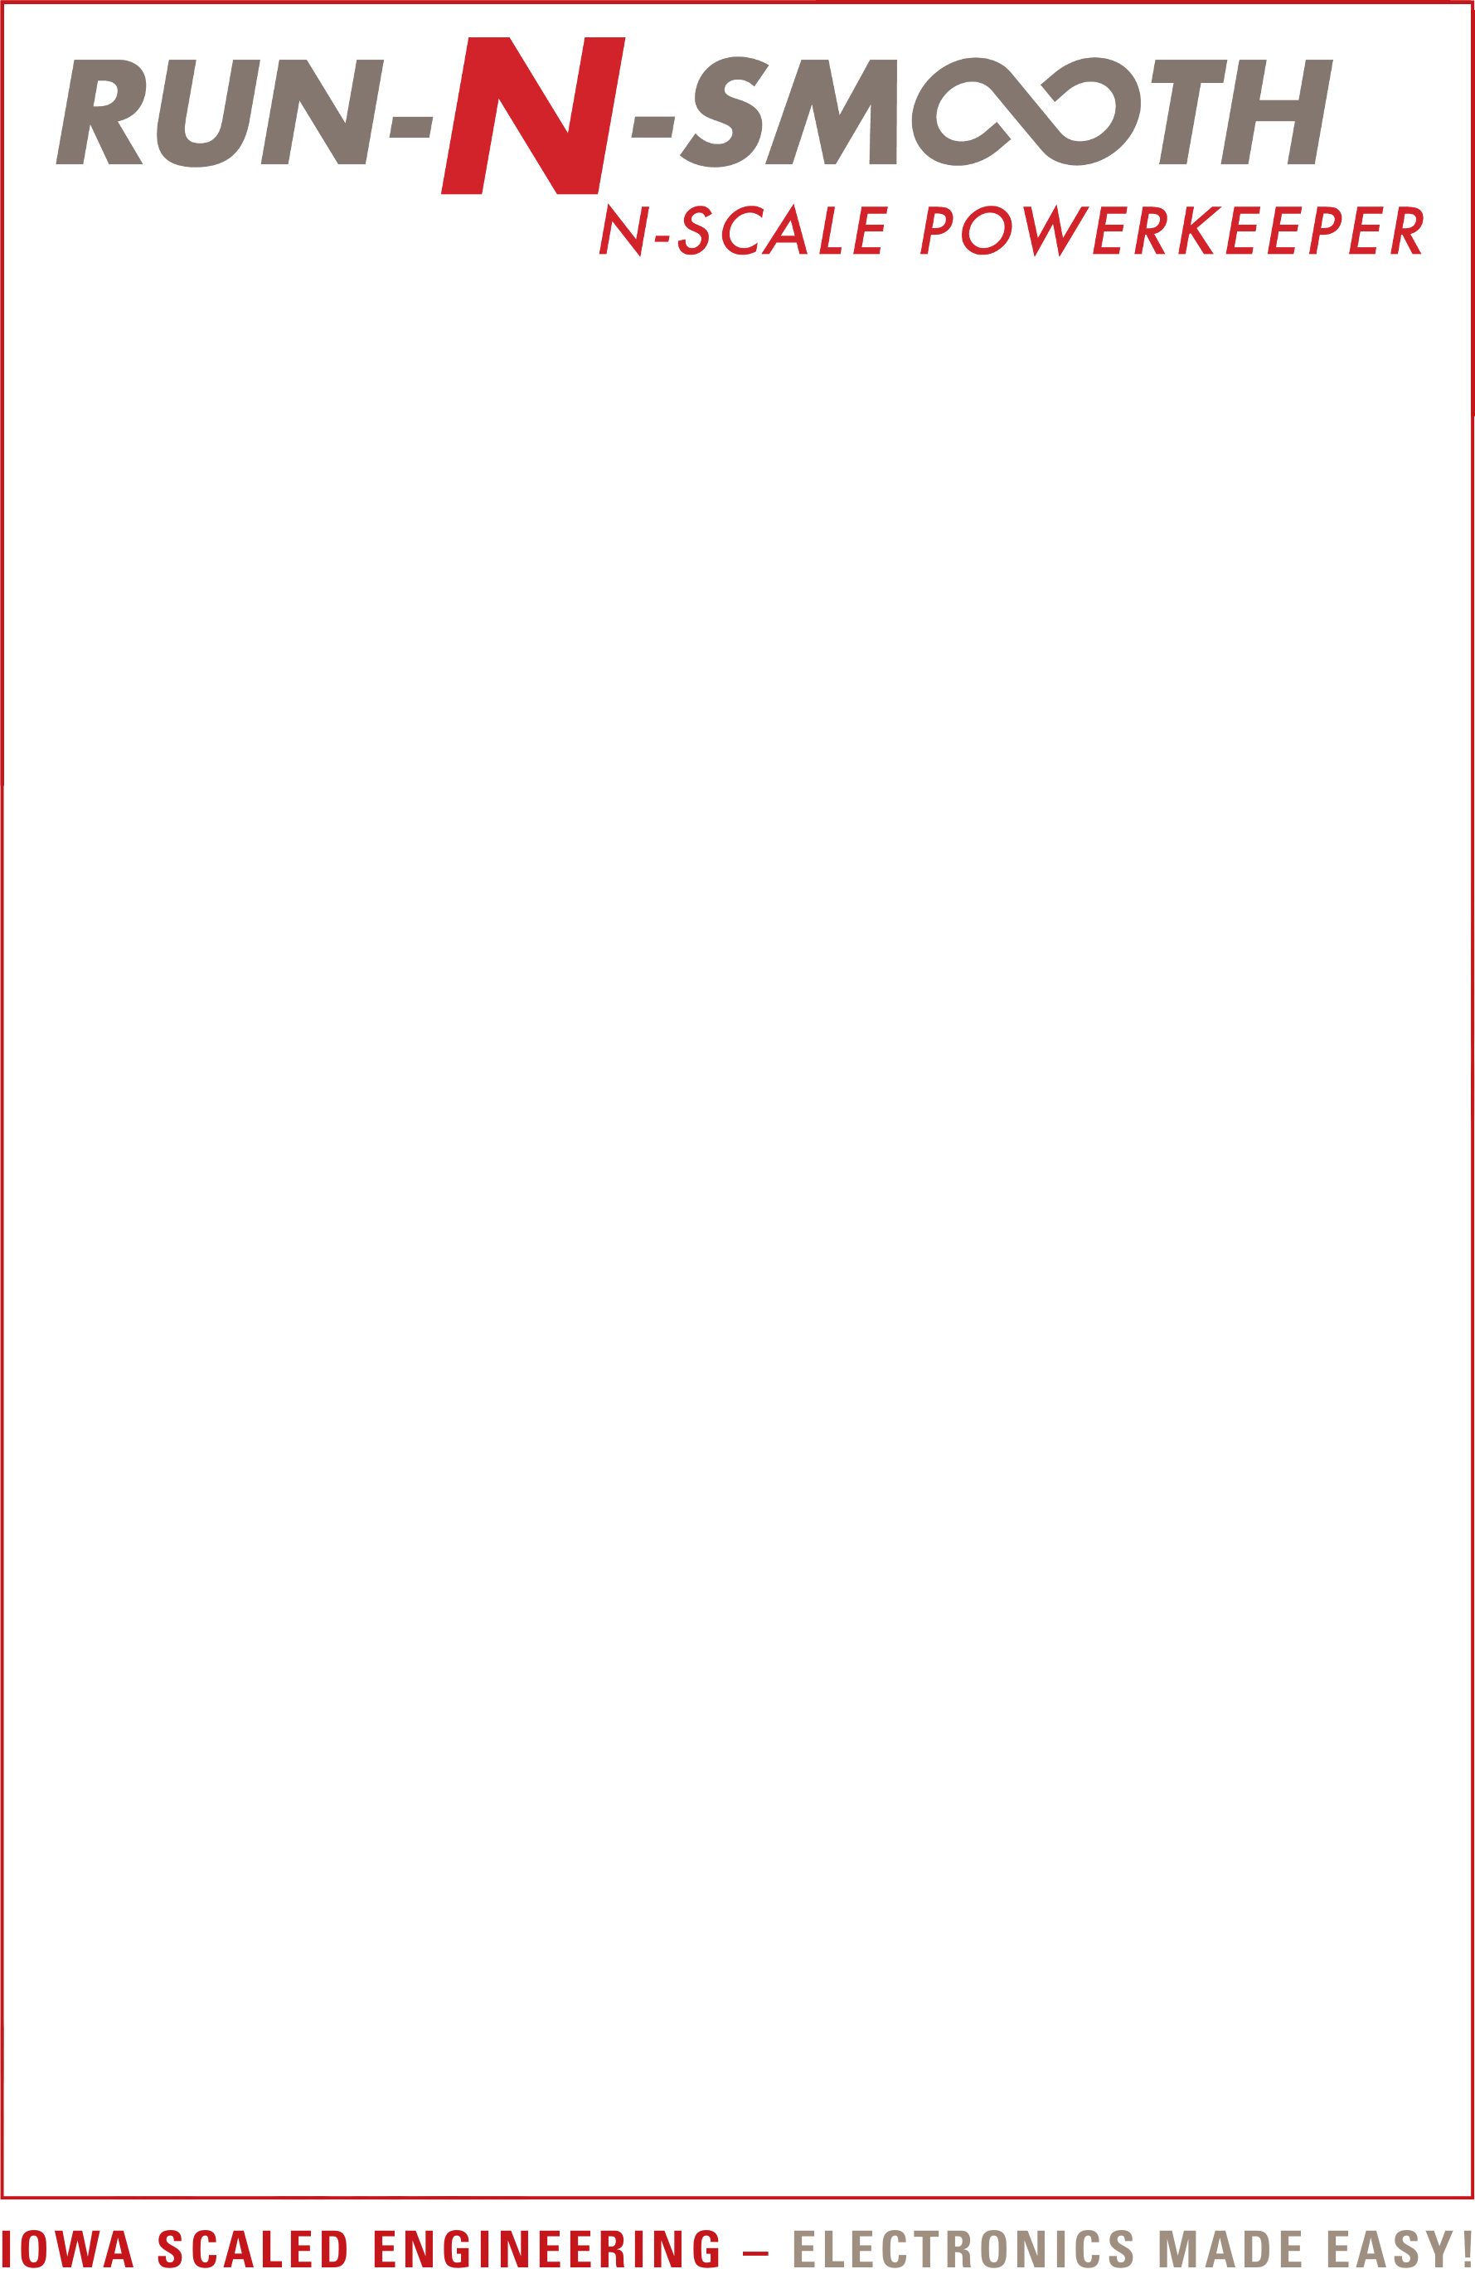
The Run-N-Smooth PowerKeeper is a micro-size stay alive module that improves the running quality of N-scale and space-constrained DCC locomotives. Integrated protection circuitry and micro-capacitors provide a simple, easy, and safer alternative for small installations.

Features
• Ultra small for N-scale locomotives
• 940uF typical capacitance
• Integrated protection circuitry
• Safer tantalum polymer capacitors

For more information, please visit:
https://www.iascaled.com/store/CKT-DCCSA

www.iascaled.com
CKT-DCCSA
$19.00
The Run-N-Smooth PowerKeeper is a micro-size stay alive module that improves the running quality of N-scale and space-constrained DCC locomotives. Integrated protection circuitry and micro-capacitors provide a simple, easy, and safer alternative for small installations.

Features
• Ultra small for N-scale locomotives
• 940uF typical capacitance
• Integrated protection circuitry
• Safer tantalum polymer capacitors

For more information, please visit:
https://www.iascaled.com/store/CKT-DCCSA

www.iascaled.com
CKT-DCCSA
$19.00
The Run-N-Smooth PowerKeeper is a micro-size stay alive module that improves the running quality of N-scale and space-constrained DCC locomotives. Integrated protection circuitry and micro-capacitors provide a simple, easy, and safer alternative for small installations.

Features
• Ultra small for N-scale locomotives
• 940uF typical capacitance
• Integrated protection circuitry
• Safer tantalum polymer capacitors

For more information, please visit:
https://www.iascaled.com/store/CKT-DCCSA

www.iascaled.com
CKT-DCCSA
$19.00
The Run-N-Smooth PowerKeeper is a micro-size stay alive module that improves the running quality of N-scale and space-constrained DCC locomotives. Integrated protection circuitry and micro-capacitors provide a simple, easy, and safer alternative for small installations.

Features
• Ultra small for N-scale locomotives
• 940uF typical capacitance
• Integrated protection circuitry
• Safer tantalum polymer capacitors

For more information, please visit:
https://www.iascaled.com/store/CKT-DCCSA

www.iascaled.com
CKT-DCCSA
$19.00

