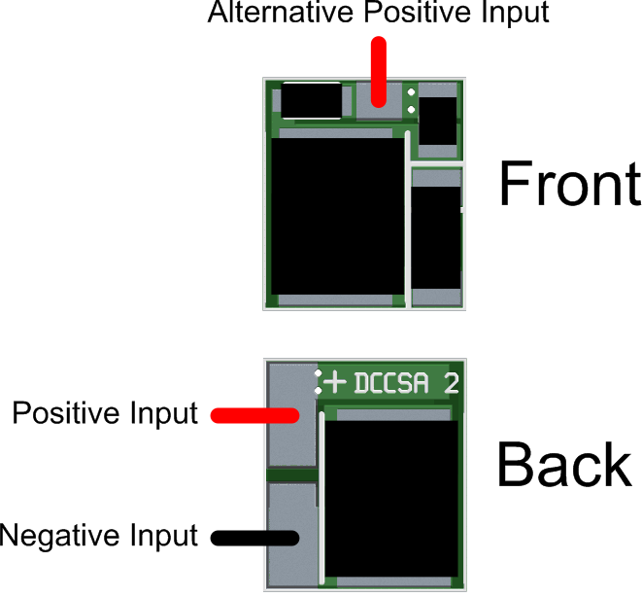

Installation

Installation

Installation

Installation

